Association between Iliotibial Band Syndrome Status and Running Biomechanics in Women

A Dissertation Presented for the
Doctor of Philosophy
Degree
The University of Tennessee, Knoxville

Eric Henri Foch
August 2013

Copyright © 2013 by Eric Henri Foch.
All rights reserved.

ACKNOWLEDGEMENTS

Clare, through your mentorship, you have given me the confidence to go out and be an independent researcher. Thank you. I truly appreciated it when we were sitting in the lab earlier this semester and you said that over the past few months we have developed a relationship as two colleagues would. I would also like to thank Dr. Jeff Reinbolt, Dr. Gene Fitzhugh, and Dr. Songning Zhang for their insight towards this project. Jeff, I would like to thank you in particular for working with me as much as you did on our modeling paper, as well as our conversations we had. Your insight and energy are inspiring. Lastly, I would like to thank Jake and Trey. Jake, you are the man. Trey, I would still be collecting runners for my first year study if it had not been for your selfless nature to help me recruit runners, much obliged kind sir.
ABSTRACT

Iliotibial band syndrome (ITBS) is common knee overuse injury that is twice as likely to afflict women compared to men. Etiological factors associated with ITBS include atypical biomechanics during running, as well as iliotibial band flexibility and hip abductor muscle weakness. This dissertation implemented a combination of discrete and continuous analyses to identify lower-extremity and trunk movement patterns that may be associated with ITBS injury status in female runners with current ITBS, previous ITBS, and controls. Three studies were conducted. Study 1 examined discrete joint and segment biomechanics during running, iliotibial band mechanics via musculoskeletal modeling and dynamic simulation, and hip physiological measures. Study 2 examined lower-extremity, as well as trunk – pelvis inter-segmental coupling variability using a vector coding technique. Study 3 characterized entire kinematic and kinetic waveforms using a principal components analysis approach. The findings of these studies can be summarized as follows: 1) runners with current ITBS lean their trunk more towards the stance limb than runners with previous ITBS and controls; 2) runners with previous ITBS exhibit less isometric hip abductor strength compared to controls; 3) runners with previous ITBS were more variable in frontal plane pelvis motion relative to the trunk and thigh compared to runners with current ITBS and controls; 4) a more complex movement pattern exists within pelvis and hip motion during running that cannot be explained in the first three principal components. Collectively, this information can be used by clinicians to address hip abductor muscle weakness and atypical pelvis/hip motion during running in female runners with current ITBS and previous ITBS.
TABLE OF CONTENTS

PART 1 1
Introduction, Literature Review, and Methods 1
CHAPTER 1 2
Introduction 2
Discrete Variables Associated with ITBS 3
Modeling and Simulation of the Iliotibial Band during Running 6
Hip Muscle Strength 7
Continuous Methods to Investigating ITBS 7
Principal Components Analysis 9
Purpose: Study 1 10
Hypotheses 10
Purpose: Study 2 11
Hypotheses 11
Purpose: Study 3 11
Hypotheses 12
Assumptions 12
Delimitations 12
Limitations 13
CHAPTER II 14
Literature Review 14
Abstract 14
Iliotibial Band Anatomy 15
Iliotibial Band Syndrome 15
Discrete Biomechanical Factors Associated with ITBS 17
Hip Muscle Strength 33
Continuous Methods to Investigating ITBS 36
Principal Components Analysis 46
Summary of Literature Review 49
CHAPTER III 52
Methods 52
Participant Details 52
Power Analysis 53
Data Collection 53
Data Analysis: Study 1 58
Data Analysis: Study 2 63
Data Analysis: Study 3 65
References 68
PART 2 80
CHAPTER IV 80
Iliotibial Band Syndrome Status Affects Running Biomechanics and Hip Physiological Measures 80
Abstract 81
Introduction: 83
Methods: 86
Results: 92
Discussion: 93
References 103
PART 3 108
CHAPTER V 108
Influence of Iliotibial Band Syndrome on Coordination Variability During Running 108
Abstract 109
Introduction 110
Methods 112
Results 117
Discussion 118
Acknowledgments 122
References 128
PART 4 132
CHAPTER VI 132
Exploring the Influence of Iliotibial Band Syndrome on Running Biomechanics via Principal Components Analysis 132
Abstract 133
Introduction 134
Methods 136
Results 142
Discussion 144
References 176
CONCLUSION 180
Study 1 180
Study 2 180
Study 3 181
Future Directions 181
Impact on Clinicians and Runners 182
APPENDIX 183
Appendix A: Informed Consent 184
Appendix B: Flyer 186
Appendix C: Physical Activity Readiness and Running Health History Questionnaires 187
Appendix D: Reliability Test 189
Ober Test Data between Days. 190
Isometric Hip Abductor Strength Data between Days. 191
Appendix E: Participant Demographics 192
Appendix F: Results 193
Appendix G: Angle and Moment Waveforms during the Stance Phase of Running 203
Appendix H: Statistical Analysis 208
VITA 239
LIST OF TABLES

Table 2-1. Mean (standard deviation) of participant demographics in the current 100
Table 2-2. Mean (standard deviation) of peak joint and segment biomechanics during the stance phase of overground running in runners with current iliotibial band syndrome (ITBS), previous (ITBS), and controls. Moment is expressed as external moment. 101
Table 3-1. Mean (standard deviation) of participant demographics in the current iliotibial band syndrome (ITBS), previous ITBS, and control groups. 123
Table 3-2. The mean (standard deviation) for frontal plane coupling variability for each of the four periods of stance during overground running in runners with current iliotibial band syndrome (ITBS), previous ITBS, and controls. 124
Table 3-3. The mean (standard deviation) for transverse plane coupling variability for each of the four periods of stance during overground running in runners with current iliotibial band syndrome (ITBS), previous ITBS, and controls. 125
Table 4-1. Mean (standard deviation) of participant demographics in the current iliotibial band syndrome (ITBS), previous ITBS, and control groups. 148
Table 4-2. The first three principal components (PC) and Q-critical (Q_{α}) for the angle and moment waveforms during the stance phase of overground running. 149
Table 4-3. The mean (standard deviation) for the principal component (PC) scores of the three retained PCs for each waveform of interest during overground running in runners with current iliotibial band syndrome (ITBS), previous ITBS, and controls. The P value indicates the main effect. 150

LIST OF FIGURES

Figure 1-1. Phase-plane of rearfoot angle on the horizontal axis and its first derivative on the vertical axis for a single trial. 37
Figure 1-2. The normalized phase-plane where φ is the normalized phase angle. 38
Figure 1-3. Generic representation of in- and out-of-phase relationships for two segments in the sagittal, frontal, and transverse planes (Adapted from Seay et al., 2011). 40
Figure 1-4. Relative motion plot of the transverse plane knee angle and frontal plane rearfoot angle during the stance phase of running. 43
Figure 1-5. Coupling angle (γ) from the relative motion plot. Horizontal, vertical, and off-axes indicate the coupling angle’s spatial relationship between proximal and distal segment or joint motion (Adapted from Chang et al., 2008). 44
Figure 1-6. Position of the participant during the Ober test. 55
Figure 1-7. Placement of HDD during the hip abductor strength. 57
Figure 2-1. Trunk lateral flexion during the stance phase of overground running among runners with current iliotibial band syndrome (ITBS) (dashed line), previous ITBS (dashdot line), and controls (solid line). 102
Figure 3-1. Ensemble curves of trunk contralateral/ipsilateral flexion– pelvis contralateral drop/elevation coupling angle in runners with current iliotibial band syndrome (ITBS) (dashed line), previous ITBS (dashdot line), and controls (solid line) during overground running. The stance phase was divided into 4 periods. 126
Figure 3-2. Ensemble curves of pelvis contralateral drop/elevation – thigh abduction/adduction coupling angle in runners with current iliotibial band syndrome (ITBS) (dashed line), previous ITBS (dashdot line), and controls (solid line) during overground running. The stance phase was divided into 4 periods. 127
Figure 4-1 The first three principal component (PC) contributions to the frontal plane trunk angle exhibited by runners with current iliotibial band syndrome (ITBS) (dashed line), previous ITBS (dashdot line) and controls (solid line) during the stance phase of running. Additionally, the percent variance explained by PC1 (dot), PC2 (dashdot), PC3 (dashed), and overall percent variance explained by the first 3 PCs (solid) is displayed. 151
Figure 4-2. The first three principal component (PC) contributions to the frontal plane pelvis angle exhibited by runners with current iliotibial band syndrome (ITBS) (dashed line), previous ITBS (dashdot line) and controls (solid line) during the stance phase of running. Additionally, the percent variance explained by PC1 (dot), PC2 (dashdot), PC3 (dashed), and overall percent variance explained by the first 3 PCs (solid) is displayed. 156
Figure 4-3. The first three principal component (PC) contributions to the frontal plane hip angle exhibited by runners with current iliotibial band syndrome (ITBS) (dashed line), previous ITBS (dashdot line) and controls (solid line) during the stance phase of running. Additionally, the percent variance explained by PC1 (dot), PC2 (dashdot), PC3 (dashed), and overall percent variance explained by the first 3 PCs (solid) is displayed. 161
Figure 4-4. The first three principal component (PC) contributions to the frontal plane knee moment exhibited by runners with current iliotibial band syndrome (ITBS) (dashed line), previous ITBS (dashdot line) and controls (solid line) during the stance phase of running. Additionally, the percent variance explained by PC1 (dot), PC2 (dashdot), PC3 (dashed), and overall percent variance explained by the first 3 PCs (solid) is displayed. 166
Figure 4-5. The first three principal component (PC) contributions to the transverse plane knee angle exhibited by runners with current iliotibial band syndrome (ITBS) (dashed line), previous ITBS (dashdot line), and controls (solid line) during the stance phase of running. Additionally, the percent variance explained by PC1 (dot), PC2 (dashdot), PC3 (dashed), and overall percent variance explained by the first 3 PCs (solid) is displayed. 171

Introduction, Literature Review, and Methods

CHAPTER 1

Introduction

Running is a popular form of exercise. However, approximately half of all runners experience an injury each year with the knee being the most common location of occurrence (Taunton et al., 2002). Furthermore, females are twice as likely as males to experience the knee overuse injury iliotibial band syndrome (ITBS) (Taunton et al., 2002). Etiological factors associated with ITBS may include discrete joint and segment biomechanics (Ferber et al., 2010; Grau et al., 2011; Miller et al., 2007; Noehren et al., 2007), iliotibial band flexibility (Grau et al., 2011), hip abduction strength (Beers et al., 2008; Fredericson et al., 2000; Grau et al., 2008), lower-extremity coordination patterns (Hein et al., 2012; Miller et al., 2008), and iliotibial band mechanics (Hamill et al., 2008; Miller et al., 2007). In addition to biomechanical differences among runners with current ITBS, previous ITBS, and controls, men and women exhibit different lower-extremity running biomechanics (Ferber et al., 2003). The aforementioned investigations either included both genders (Beers et al., 2008; Fredericson et al., 2000; Grau et al., 2011; Hein et al., 2012; Miller et al., 2007; Miller et al., 2008) or only women (Ferber et al., 2010; Hamill et al., 2008; Noehren et al., 2007). Due to differences in lower-extremity running biomechanics exhibited between men and women, only female runners will be investigated in this dissertation.
The iliotibial band is a biarticular structure. It crosses the lateral hip and knee joints with the femur serving as the link between joints. Therefore, the iliotibial band functions are to provide stability for the lateral hip and knee, as well as resist hip adduction and knee internal rotation (Fredericson et al., 2000). ITBS was believed to develop due to repetitive sagittal plane knee motion which would cause friction between the iliotibial band and lateral femoral epicondyle (Noble, 1979; Noble, 1980; Orava, 1978; Orchard et al., 1996; Renne, 1975). Based on the results of a recent anatomical investigation, this hypothesis has been challenged (Fairclough et al., 2006). The iliotibial band moves medially when the knee is flexed at 30° as a consequence of tibial internal rotation (Fairclough et al., 2006). Furthermore, the iliotibial band has a tendon-like enthesis at the femoral epicondyle. Consequently, frictional forces may not be experienced by the iliotibial band (Fairclough et al., 2006). Instead, compression of the iliotibial band against a highly innervated layer of adipose tissue around the lateral femoral epicondyle may be the source of pain and inflammation associated with ITBS (Fairclough et al., 2006).

Discrete Variables Associated with ITBS

Hip Joint Biomechanics
The iliotibial band stabilizes the hip by reducing hip adduction (Fredericson et al., 2000). Several hip variables have been investigated in relation to ITBS. There are conflicting results reported in the literature regarding the association between hip adduction angle and ITBS (Ferber et al., 2010; Grau et al., 2011; Miller et al., 2007; Noehren et al., 2007). Furthermore, runners with current ITBS exhibit decreased frontal plane hip range of motion and abduction velocity compared to controls (Grau et al., 2011). Additionally, runners who later develop ITBS exhibit greater femoral external rotation compared to controls (Noehren et al., 2007). It remains unknown whether static alignment of the pelvis and femur plays a role in peak hip adduction angle exhibited during the stance phase of running.
Knee Joint Biomechanics

The iliotibial band crosses the lateral side of the knee joint. Therefore, atypical knee biomechanics may be associated with ITBS. Frontal plane knee motion such as knee adduction could affect the internal knee abduction moment (Powers, 2010). Since the iliotibial band is a lateral stabilizer of the knee, increased knee adduction may cause the iliotibial band to elongate. Furthermore, increased knee adduction would increase the distance between the resultant ground reaction force and knee joint center. Thus, a greater internal knee abduction moment would result which could increase the tensile strain experienced on the iliotibial band (Powers, 2010). The internal knee abduction moment has not been investigated in the ITBS literature but warrants future research. In the transverse plane, runners with previous (Ferber et al., 2010) and who later develop ITBS (Noehren et al., 2007) exhibit greater knee internal rotation compared to controls. Although repetitive knee joint flexion and extension has been associated with the develop of ITBS (Noble, 1980; Orchard et al., 1996; Renne, 1975), there is little support in the literature to substantiate this notion (Grau et al., 2011; Miller et al., 2007; Noehren et al., 2007; Orchard et al., 1996). Based on current findings in the literature, it appears that transverse plane knee joint biomechanics are indeed associated with ITBS.

Rearfoot Biomechanics

Atypical rearfoot motion may have aberrant effects on the iliotibial band. Increased rearfoot eversion coupled with talar adduction would increase tibial internal rotation (Lundberg et al., 1989). This would cause the iliotibial band to experience an increase in strain (Noehren et al., 2007). However, rearfoot eversion is similar in runners with current (Grau et al., 2011), previous (Ferber et al., 2010), and who later develop ITBS (Noehren et al., 2007) compared to controls. Interestingly, runners with previous ITBS exhibit greater internal inversion moment compared to controls (Ferber et al., 2010). Since rearfoot eversion was similar between groups, it is unclear why inversion moment differed. In the transverse plane, foot adduction is greater in runners with previous ITBS compared to controls (Miller et al., 2007). Overall, the results in the literature remain equivocal when implicating a distal mechanism as an etiological factor associated with ITBS.
Trunk and Pelvis Segment Biomechanics

It has been postulated that the proximal kinematic factors contralateral pelvic drop and contralateral trunk flexion may affect iliotibial band mechanics (Powers, 2010). During stance, increased contralateral pelvic drop along with contralateral trunk flexion would increase the internal knee abduction moment (Powers, 2010). This may result in a greater tensile strain experienced in the iliotibial band (Powers, 2010). This hypothesis has yet to be examined in the literature.

Ground Reaction Force

Atypical loading patterns experienced by the musculoskeletal system during running may result in overuse injury (Cavanagh and Lafortune, 1980; James et al., 1978). Runners with current ITBS exhibit similar vertical GRF loading peaks and loading rate, as well as similar medio-lateral GRF as controls (Messier et al., 1995). However, maximum braking force is less in runners with ITBS compared to controls (Messier et al., 1995). Yet, to examine GRF without consideration of joint moments may be inadequate to understanding the etiology of ITBS (Messier et al., 1995).

Modeling and Simulation of the Iliotibial Band during Running
Thus far, the aforementioned ITBS studies have related joint biomechanics to the mechanics of the iliotibial band. With the advent of musculoskeletal modeling and dynamic simulation software, the effect of running biomechanics on the iliotibial band may lead to a better understanding of the etiology of ITBS. Runners with previous ITBS exhibit increased iliotibial band strain compared to controls (Miller et al., 2007). In a related study, runners who later develop ITBS exhibit increased iliotibial band strain rate compared to controls (Hamill et al., 2008). Interestingly, hip adduction and knee internal rotation were not correlated with iliotibial band strain and strain rate (Hamill et al., 2008). This suggests that relating peak angles and iliotibial band mechanics at a single time frame may inadequately describe any relationship between the aforementioned measures.

Hip Muscle Strength
Hip muscle strength has been postulated to affect peak hip joint angles assumed during the stance phase of running. Increased hip adduction may be due to hip abductor weakness or postural alignment. There are conflicting results in the literature regarding hip abductor strength being different between runners with current and no history of ITBS (Beers et al., 2008; Fredericson et al., 2000; Grau et al., 2008). In the aforementioned investigations, hip abduction strength was measured using a hand-held dynamometer (Beers et al., 2008; Fredericson et al., 2000) and a mechanical dynamometer (Grau et al., 2008). A hand-held dynamometer is reliable measure of isometric hip abduction strength (Bohannon, 1986). Further work is required to determine if hip abduction strength differences exist among runners with current ITBS, previous ITBS and controls.

Continuous Methods to Investigating ITBS
The aforementioned investigations compared running biomechanics in runners with current ITBS, previous ITBS, and who later develop ITBS compared to controls using discrete analyses. Thus, each variable is reduced to a single data point. No insight is gained about the coordination patterns between segments or joints. The variability exhibited between inter-segmental or inter-joint coordination patterns may be associated with overuse running injury (Hamill et al., 1999). Variability allows for flexibility within human motion (Hamill et al., 1999; Kelso, 1995). By measuring variability in inter-segmental and inter-joint coordination patterns, information is obtained that would characterize the body’s behavioral dynamics during running. Potentially, runners with current ITBS and previous ITBS exhibit differences in variability compared to controls. Two measures that can be used to quantify variability are continuous relative phase (CRP) and vector coding.
Continuous Relative Phase

A decrease in variability could lead to increased stress and strain placed on the soft tissue, thus, resulting in overuse injury (Hamill et al., 1999). There are conflicting results in the literature implicating a reduced CRP variability as a biomechanical risk factor associated with ITBS (Hein et al., 2012; Miller et al., 2008). It was postulated that too much or too little variability may be related to previous ITBS (Miller et al., 2008).
Vector Coding

Determining coordination pattern variability via vector coding is advantageous compared to CRP. Only the relative motion between two joints or segments is used in calculating variability in vector coding, whereas CRP also includes the time dependent component velocity. Therefore, vector coding may yield a more intuitive result. Vector coding has not been used to quantify coordination variability in ITBS studies. However, vector coding has been implemented in previous overuse running investigations (Heiderscheit et al., 2002; Seay et al., 2011). Runners with current patellofemoral pain syndrome, as well as runners with current, previous, and no history of low back pain exhibit differences in coordination variability (Heiderscheit et al., 2002; Seay et al., 2011). Overall, there is evidence to support inter-segmental coordination patterns exist in overuse running injuries. Therefore, examining inter-segmental coordination via vector coding in runners with current ITBS and previous ITBS compared to controls is warranted. Although both CRP and vector coding allow for a complete analysis of running biomechanics compared to discrete analysis, the variables are selected a priori. A more comprehensive analysis of the data set may provide a better understanding of the effect ITBS status has on running biomechanics.

Principal Components Analysis
The aforementioned ITBS investigations have selected discrete dependent variables based on how running biomechanics may affect iliotibial band mechanics. However, there may be underlying movement patterns that have not been investigated but may be related to the etiology of ITBS. An analysis that has been used to examine lower-extremity movement differences among active populations is principal component analysis (Nigg et al., 2012; O'Connor and Bottum, 2009). PCA is sensitive enough to determine age differences in the dominant movement patterns in running (Nigg et al., 2012). Additionally, differences in lower-extremity joint patterns during a single-leg cutting motion were detected between females and males that a discrete kinematic analysis did not identify (O'Connor and Bottum, 2009). PCA may be a valuable tool when comparing running biomechanics among runners with current ITBS and previous ITBS compared to controls. Establishing typical variations in joint angle and moment waveforms may aid in screening for injury risk. Waveforms that are similar among groups determined by discrete analyses may indeed be different in runners with current ITBS and previous ITBS compared to controls.

Purpose: Study 1
The purpose of the first study was to determine whether ITBS injury status (current or previously injured) resulted in differences in discrete biomechanics during running and hip physiological measures compared to healthy controls.

Hypotheses
- Running biomechanics among runners with current ITBS, previous ITBS, and healthy controls will be similar in peak:
- Trunk contralateral flexion.
- Contralateral pelvic drop.
- Hip adduction angle.
- External knee adduction moment.
- Knee internal rotation angle.
- Iliotibial band flexibility among runners with current ITBS, previous ITBS, and healthy controls will be similar.
- Isometric hip abductor strength among runners with current ITBS, previous ITBS, and healthy controls will be similar.
- Iliotibial band mechanics among runners with current ITBS, previous ITBS, and healthy controls will be similar in:
- Peak iliotibial band strain.
- Peak iliotibial band strain rate.
- There will be no correlation between peak hip adduction angle and isometric hip abductor strength among runners.
- There will be no correlation between peak hip adduction angle and iliotibial band flexibility among runners.

Purpose: Study 2
The purpose of the second study was to determine whether ITBS injury status (current or previously injured) resulted in differences in inter-segmental and inter-joint coordination variability compared to healthy controls.

Hypotheses
- Lower-extremity, trunk – pelvis coordination variability among runners with current ITBS, previous ITBS, and healthy controls will be similar in:
- Trunk contralateral/ipsilateral flexion – pelvis contralateral drop/elevation.
- Pelvis contralateral drop/elevation – thigh abduction/adduction.
- Thigh abduction/adduction – shank abduction/adduction.
- Thigh internal/external rotation – shank internal/external rotation.
- Knee flexion/extension – foot abduction/adduction.
- Shank internal/external rotation – rearfoot inversion/eversion.

Purpose: Study 3
The purpose of the third study was to determine whether ITBS injury status (current or previously injured) resulted in differences in running kinematics and kinetics compared to healthy controls using a principal component analysis approach.

Hypotheses
- Frontal plane trunk angle, pelvis angle, hip angle, and knee moment, as well as transverse plane knee angle will be similar among runners with current ITBS, previous ITBS, and healthy controls will be similar using a principal component analysis approach.

Assumptions
- The motion capture cameras and force plate used to collect marker position and ground reaction force data, respectively, are valid and reliable systems.
- The Ober test is a valid and reliable measure of iliotibial band flexibility.
- A hand-held dynamometer is a valid and reliable measure of isometric hip abductor strength.
- The gait model is a valid representation of the musculoskeletal system.

Delimitations
- The participants in this study will consist of female runners between the ages of 18-45.
- All runners will meet a minimum weekly mileage criterion based on whether they currently have ITBS or are free from lower-extremity injury.
- Runners with current ITBS and previous ITBS will report they have been diagnosed by a health care professional (physician, physical therapist, or certified athletic trainer).
- With the exception of the group of runners with current ITBS, participants will be free of lower-extremity injury for at least a month prior to data collection.
- Movement tasks will be limited to overground running, the Ober test, and isometric hip abduction strength test.

Limitations
- The results of these studies will be limited to female runners with current ITBS, previous ITBS, and controls.
- Overground running trials will be performed in a biomechanics laboratory. Therefore, participants biomechanics during running may not be the same as exhibited in their typical running environment.

CHAPTER II

Literature Review

Abstract
Iliotibial band syndrome (ITBS) is a common overuse running injury that is twice as likely to be sustained by female runners compared to male runners. Biomechanical risk factors associated with ITBS include running pattern, iliotibial band flexibility, and hip abduction strength. To date, no investigation has compared biomechanics during running, iliotibial band flexibility, and hip abductor strength among women with current ITBS, previous ITBS, and controls. Participants completed five overground running trials. A nine camera motion capture system synchronized with a force plate recorded data during overground running trials. After the running trials, iliotibial band flexibility was assessed via the Ober test. Lastly, hip abduction strength was measured using a hand-held dynamometer. Kinematic data were processed using a joint coordinate systems method. Custom software was used to extract discrete dependent variables. Additional custom programs were written to compute, iliotibial mechanical variables, as well as inter-segmental coordination variability and principal component scores. Discrete biomechanics, iliotibial band flexibility, and hip abduction strength were compared among groups using a one-way analysis of variance (ANOVA). A one-way multivariate analysis of variance (MANOVA) was used to assess group differences in lower-extremity and trunk – pelvis inter-segmental coupling variability. Additionally, a one-way MANOVA assessed differences in principal component scores of the retained principal components for each waveform among groups. An alpha value of 0.05 was set for all tests.
The primary objective of this dissertation is to identify differences that exist in running biomechanics among female runners with current ITBS, previous ITBS, and healthy controls. The results will better inform clinicians how to treat and potentially prevent ITBS in runners. This literature review will: 1) discuss theories of the development of ITBS based on iliotibial band anatomy, 2) identify joint and segment biomechanics, as well as iliotibial band mechanics associated with ITBS, 3) identify potential sources of disagreement in results among ITBS studies, 4) describe data analysis techniques that have yet to be implemented in the ITBS literature and provide justification on why they should be used, and 5) provide a biomechanical rationale for the variables of interest.

Iliotibial Band Anatomy
The iliotibial band consists of dense fibrous connective tissue that receives part of the origin of the tensor fascia lata and gluteus maximus (Fairclough et al., 2006; Renne, 1975). It traverses down the lateral thigh while anchored to the femur by the lateral intermuscular septum (Fairclough et al., 2006; Renne, 1975). The iliotibial band has a tendon like enthesis at the lateral femoral epicondyle and inserts onto Gerdy’s tubercle located on the antero-lateral aspect of the tibia (Fairclough et al., 2006). The iliotibial band’s functions are to stabilize the lateral hip and knee, as well as resist hip adduction and knee internal rotation (Fredericson et al., 2000).

Iliotibial Band Syndrome
There has been a long held belief that ITBS results from repetitive knee joint flexion and extension which causes the iliotibial band to rub over the lateral femoral epicondyle (Noble, 1979; Noble, 1980; Orava, 1978; Orchard et al., 1996; Renne, 1975). In this scenario, the iliotibial band becomes inflamed from either repeated rubbing against the lateral femoral epicondyle or inflammation of the bursa over the epicondyle (Renne, 1975). Recently, this mechanism of injury has been challenged (Fairclough et al., 2006; Fairclough et al., 2007). The iliotibial band is anchored to the distal end of the femur with a tendon like entheses at the femoral epicondyle. Therefore, it is unlikely that the band moves antero-posteriorly over the epicondyle during knee joint flexion and extension (Fairclough et al., 2006). Because there is no shearing motion, frictional forces of the iliotibial band in the epicondylar region may not occur (Fairclough et al., 2006; Fairclough et al., 2007). Instead, it has been proposed that the iliotibial band moves medially when the knee is flexed at 30° (Fairclough et al., 2006). This is most likely due to passive tibial internal rotation during knee flexion (Fairclough et al., 2006) as a consequence of the screw-home mechanism (Piazza and Cavanagh, 2000). The iliotibial band could compress a layer of adipose tissue that is deep to the iliotibial band around its fibrous attachments to the femur (Fairclough et al., 2006). Compression of adipose tissue containing blood vessels, nerve endings, and Pacinian corpuscles may be the source of pain and inflammation associated with ITBS (Fairclough et al., 2006; Fairclough et al., 2007). Therefore, medio-lateral iliotibial band motion may be a biomechanical risk factors associated with ITBS.

Discrete Biomechanical Factors Associated with ITBS

Discrete Hip Variables Associated with ITBS

The iliotibial band stabilizes the hip by resisting hip adduction (Fredericson et al., 2000). Greater peak hip adduction angle is exhibited in runners in who later develop ITBS (ITBS: 14.1° (2.5), Con: 10.6° (5.1)) (Noehren et al., 2007) and those with previous ITBS (ITBS: 10.4° (4.4), Con: 7.9° (5.8)) (Ferber et al., 2010) compared to controls. Conversely, runners currently with ITBS have a smaller peak hip adduction angle (ITBS: 9° (3), Con: 13° (4)) compared to controls (Grau et al., 2011). Hip adduction angle has also been reported to be similar in runners with previous ITBS compared to controls (Miller et al., 2007). However, specific hip adduction values were not reported. In addition to decreased peak hip adduction angle, runners with current ITBS exhibit decreased frontal plane hip range of motion (ITBS: 9° (4), Con: 13° (4)) and hip abduction velocity (ITBS: 132 deg∙s⁻¹ (41), Con: 190 deg∙s⁻¹ (53)) compared to controls (Grau et al., 2011). An increased hip adduction angle would be expected to increase the eccentric demand of the hip abductor musculature (Noehren et al., 2007). This may result in an increased internal hip abduction moment. However, peak hip abduction moment is similar between runners with previous and who later develop ITBS compared to controls (Ferber et al., 2010; Noehren et al., 2007). Perhaps, it is the magnitude of the hip abductor moment during early stance rather than the stance phase peak that is different between groups. Furthermore, it has been postulated that smaller peak hip adduction and frontal plane range of motion in runners with current ITBS compared to controls may be due to a tight iliotibial band (Grau et al., 2011). Runners with current ITBS indeed had a positive Ober’s test, which is an indicator iliotibial band tightness (Grau et al., 2011). However, runners with previous ITBS exhibit similar iliotibial band flexibility compared to controls (Miller et al., 2007). Iliotibial band tightness has not been reported in runners who later develop ITBS (Noehren et al., 2007). A tight iliotibial band may limit frontal plane hip motion. Based on the literature, it is unclear if peak hip adduction angle is a biomechanical risk factor associated with ITBS. Furthermore, runners with current ITBS may have limited frontal plane hip range of motion and velocity due to a tight iliotibial band. In addition to medio-lateral motion of the hip, transverse plane motion of the hip or femur may result in iliotibial band compression around the femoral epicondyle.
Transverse plane hip kinematics have not been reported in the ITBS literature. However, femoral rotation may influence iliotibial band mechanics since it can contribute to knee internal rotation. Increased knee internal rotation may cause the iliotibial band to compress against a layer of highly innervated fat, thus, causing pain (Fairclough et al., 2006). Knee internal rotation can result from either femoral external rotation or tibial internal rotation. Hip internal rotation angle has not been reported in ITBS investigations. Femoral external rotation is greater in runners who later develop ITBS compared to controls (ITBS: -4.6° (6.9), Con: 1.3° (7.5)) (Noehren et al., 2007). Controls exhibit a positive femoral rotation value which indicates the femur is internally rotated. Increased femur external rotation resulted in greater knee internal rotation (Noehren et al., 2007). Thus, femoral external rotation may be a biomechanical risk factor associated with ITBS. Besides secondary plane biomechanics, sagittal plane motion hip motion has also been examined in ITBS studies.
Only one study investigating etiological factors associated with ITBS has reported sagittal plane hip kinematics (Grau et al., 2011). Yet, no rationale was stated as to why sagittal plane hip kinematics may affect the iliotibial band. Nevertheless, peak hip flexion angle is similar (ITBS: 32° (6), Con: 31° (4)) in runners with current ITBS compared to controls (Grau et al., 2011). Additionally, sagittal plane hip range of motion is similar (ITBS: 45° (5), Con: 44° (3)) between runners with current and no history of ITBS (Grau et al., 2011). However, hip flexion velocity is less (ITBS: 30 deg∙s⁻¹ (76), Con: 119 deg∙s⁻¹ (93)) in runners with current ITBS compared to controls (Grau et al., 2011). Hip joint kinetics were not reported in the aforementioned investigation. Decreased hip flexion velocity may be a compensatory mechanism to limit lower-extremity motion in runners with current ITBS (Grau et al., 2011). However, no previous anatomical or biomechanical investigation has indicated that sagittal plane hip motion is associated with ITBS.
Discrete Knee Variables Associated with ITBS

Frontal plane knee motion such as an increased knee adduction could affect the tensile strain experienced on the iliotibial band. During running, the resultant ground reaction force (GRF) vector passes medially to the knee joint (Powers, 2010). If the knee adduction angle is increased, then the moment arm between the resultant GRF vector and knee is increased. This would cause a larger internal knee abduction moment. A larger internal knee abduction moment would result in greater tensile strain placed on the iliotibial band (Powers, 2010). Interestingly, no study has compared frontal plane knee kinematics or kinetics in runners with current ITBS or previous ITBS compared to controls. Therefore, future studies should investigate frontal plane knee moment in these groups of runners. In addition to frontal plane knee biomechanics, transverse plane knee mechanics may affect the iliotibial band.
Increased knee internal rotation may put the iliotibial band in a structurally compromising position. When the knee is flexed at 30° during stance, the iliotibial band may become compressed against the femoral epicondyle as a consequence of tibial internal rotation (Fairclough et al., 2006). Runners with previous ITBS (ITBS: 1.8° (5.9), Con: -1.1° (4.9)) and who later develop ITBS (ITBS: 3.9° (3.7), Con: 0.02° (4.6)) exhibit greater knee internal rotation than controls (Ferber et al., 2010; Noehren et al., 2007). Knee internal rotation has not been reported in runners with current ITBS compared to controls. Knee external rotation moment is similar in runners with previous ITBS (ITBS: -0.09 Nm∙kg⁻¹ (0.06), Con: -0.09 Nm∙kg⁻¹ (0.05)) and those who later develop ITBS (ITBS: -0.12 Nm∙kg⁻¹ (0.12), Con: -0.09 Nm∙kg⁻¹ (0.05)) compared to controls (Ferber et al., 2010; Noehren et al., 2007). Knee external rotation moment has not been reported in runners with current ITBS. In the transverse plane, knee internal rotation angle and may play a role in the development of ITBS. Yet, it appears that increased knee internal rotation is due to femoral external rotation and not tibial internal rotation (Noehren et al., 2007). Perhaps, the focus of ITBS investigations should be on proximal factors that affect iliotibial band mechanics. Knee internal rotation is also coupled with knee flexion, therefore, sagittal plane knee motion may be related it the etiology of ITBS.
Sagittal plane knee joint biomechanics have long been thought to play a role in the development of ITBS (Miller et al., 2007; Noble, 1980; Orchard et al., 1996; Renne, 1975). Repetitive knee joint flexion and extension would cause the iliotibial band to rub over the femoral epicondyle (Noble, 1980; Orchard et al., 1996; Renne, 1975). It was postulated that at approximately 30° of knee flexion the distal fibers of the iliotibial band compress and slide over the femoral epicondyle (Noble, 1980; Orchard et al., 1996). More recent work suggests that at 30° of knee flexion, the iliotibial band can become compressed over the femoral epicondyle as a consequence of tibial internal rotation (Fairclough et al., 2006). However, there is little evidence in the literature that suggests knee flexion is associated with ITBS. Runners who later develop ITBS do not exhibit differences in knee flexion at heel-strike (ITBS: -11.8° (4.8), Con: -14.4° (6.0)) (Noehren et al., 2007). Runners currently with ITBS exhibit no difference in knee flexion between limbs at heel-strike (Affected leg: -21.4° (4.3), Unaffected leg: -21.5° (4.5)) and peak knee flexion (Affected leg: -53.3° (4.0), Unaffected leg: -56.3° (4.0)) (Orchard et al., 1996). However, runners with previous ITBS exhibit greater knee flexion at heel-strike (ITBS: -12.5° (3.6), Con: -7.7° (3.8)) compared to controls (Miller et al., 2007). A greater knee flexion angle at heel-strike could increase the amount of stance time the iliotibial band is impinged against the femoral epicondyle (Miller et al., 2007). Sagittal plane knee moments have not been reported in ITBS studies. Overall, there is no compelling evidence that sagittal plane knee kinematics are associated with ITBS. It appears that the knee motion in secondary planes offers a more robust explanation of the role of knee joint biomechanics in the development of ITBS. Furthermore, rearfoot motion will affect how the tibia moves relative to the femur at the knee joint. Consequently, increased rearfoot motion may have implications in the development of ITBS.
Discrete Rearfoot Variables Associated with ITBS

Rearfoot motion may influence kinematics and kinetics at the knee joint (McClay and Manal, 1998). Consequently, atypical rearfoot foot motion may have deleterious effects on the iliotibial band. An increase in rearfoot eversion coupled with talar adduction would result in increased tibial internal rotation (Lundberg et al., 1989). Because the iliotibial band inserts onto the antero-lateral tibia, tibial internal rotation would cause the iliotibial band to elongate (Noehren et al., 2007). Despite a logical anatomical argument to investigate rearfoot motion, the support in the ITBS literature is lacking. Additionally, no differences were reported in peak rearfoot eversion angle between runners with current (ITBS: 11° (3), Con: 12° (3) (Grau et al., 2011); ITBS: 3.8° (0.8), Con: 2.2° (0.8) (Messier et al., 1995)), previous (ITBS: 8.9° (3.2), Con: 10.0° (3.2)) (Ferber et al., 2010) and who later develop ITBS (ITBS: 9.7° (3.3), Con: 11.6° (2.5)) (Noehren et al., 2007) compared to controls. Runners with previous ITBS exhibit a greater rearfoot inversion moment (ITBS: 0.14 Nm/kg, Con: 0.09 Nm/kg (0.08)) compared to controls (Ferber et al., 2010). It is unclear why frontal plane rearfoot moment differences exist between runners with previous ITBS and controls since rearfoot angle is similar. Examining rearfoot kinematics in isolation may not be sufficient to detect distal biomechanical differences exhibited between ITBS populations and healthy runners. In healthy runners, there is greater frontal plane rearfoot motion relative to transverse plane shank motion in the rearfoot and shank coupling (Pohl and Buckley, 2008; Pohl et al., 2007). Rearfoot eversion-tibial internal rotation is not a 1:1 relationship and varies between participants (Ferber et al., 2010; Lundberg et al., 1989). Perhaps, examining rearfoot eversion/inversion and tibial internal/external rotation coordination patterns would reveal differences among runners with current ITBS and previous ITBS compared to controls. Overall, the literature remains equivocal in implicating rearfoot motion and moment as biomechanical risk factors associated with ITBS. In addition to investigating frontal plane rearfoot motion, transverse plane motion of the foot should be considered when investigating the etiology of ITBS.
In runners with previous ITBS, peak foot adduction is greater (ITBS: 2.6° (7.6), Con: -6.1° (7.9)) compared to controls (Miller et al., 2007). A negative foot adduction angle indicates that controls exhibited foot abduction during stance. Kinetics were not recorded in the aforementioned study. No other study has investigated transverse plane foot kinematics and kinetics in ITBS populations. The relationship between foot progression angle and the internal knee abduction moment has been examined in knee osteoarthritis populations (Lynn and Costigan, 2008; Rutherford et al., 2010; Wang et al., 1990). When the foot segment is adducted, the moment arm between the resultant GRF and knee joint center is decreased. Therefore, a smaller external knee adduction moment would result. A smaller knee adduction moment would decrease the tensile strain experienced in the iliotibial band (Powers, 2010). A link between foot progression angle and frontal plane knee moment has not been made in ITBS populations. In addition to frontal and transverse plane rearfoot biomechanics, plantarflexion and dorsiflexion motion has also been investigated in ITBS.
Sagittal plane ankle kinematics have been variables of interest in several ITBS investigations (Grau et al., 2011; Miller et al., 2007; Orchard et al., 1996). Yet, no anatomical or biomechanical justification was provided as to why plantarflexion and dorsiflexion would affect iliotibial band mechanics. Dorsiflexion angle at heel-strike (Affected: 24.6° (12.8), Unaffected: not reported) and minimum dorsiflexion (Affected: -1.4° (5.0), Unaffected: not reported) is similar between runners’ affected and unaffected legs (Orchard et al., 1996). Dorsiflexion angle (ITBS: 20° (2), Con: 20° (2)), as well as ankle range of motion (ITBS: 53° (5), Con: 53° (7)) were similar in runners with current ITBS (Grau et al., 2011). Based on findings of anatomical and biomechanical studies, factors associated with ITBS appear to occur primarily in frontal plane hip and transverse knee motions (Fairclough et al., 2006; Fairclough et al., 2007; Ferber et al., 2010; Noehren et al., 2007).
Discrete Pelvis and Trunk Variables Associated with ITBS

Fontal plane pelvis and trunk motion may affect iliotibial band mechanics. If the contralateral pelvis were to drop during stance, then the trunk may move with the pelvis away from the stance limb (Powers, 2010). Contralateral trunk and pelvis motion would increase the moment arm of the resultant GRF vector from the knee joint center (Powers, 2010). The increased moment arm may result in an increased external knee adduction moment. A greater adduction moment could increase the tensile strain placed on the iliotibial band (Powers, 2010). Although pelvis and trunk kinematics have not been examined in ITBS investigations, they have been reported in a recent PFPS investigation (Noehren et al., 2012). Contrary to the investigators’ hypotheses, neither contralateral pelvic drop nor lateral trunk flexion were different between female runners with PFPS and controls (Noehren et al., 2012). There was a large effect for greater lateral trunk flexion in runners with PFPS compared to controls (Noehren et al., 2012). However, runners in both groups leaned the trunk towards the stance limb. Frontal plane knee moments were not reported in the aforementioned study. If both frontal plane pelvis and trunk kinematics were similar between groups, then knee moments may have been similar too. Future ITBS studies should focus on the relationship between GRF and joint and segment kinematics.
GRF Variables Associated with ITBS

Inherently, running places repetitive loads on the body. If a runner’s GRF profile is atypical, then the runner may be predisposed to overuse running injury (Cavanagh and Lafortune, 1980; James et al., 1978). Runners with ITBS exhibit similar peak vertical GRF (ITBS: 2.43 Body Weight (BW) (0.04), Con: 2.48 BW (0.03)) and vertical loading rate (ITBS: 54.32 BW∙s⁻¹ (1.78), Con: 49.11 BW∙s⁻¹ (2.43)) as controls (Messier et al., 1995). Normalized maximum braking force is less (ITBS: 0.35 BW (0.01), Con: 0.39 BW (0.01) in runners with ITBS compared to controls (Messier et al., 1995). Peak medial (ITBS: 0.09 BW (0.01), Con: 0.09 BW (0.01)) and lateral GRF (ITBS: 0.08 BW (0.01), Con: 0.10 BW (0.01)) were similar between runners with ITBS and controls (Messier et al., 1995). It was postulated that a shorter stride may result in a decreased braking force (Messier et al., 1995). A reduced stride length may reduce the risk of another overuse running injury such as tibial stress fracture (Edwards et al., 2009). The relationship between stride length and the antero-posterior GRF has not been reported in the ITBS literature. Furthermore, the authors concluded that examining GRF without considering joint moments may be insufficient to detecting differences in running biomechanics associated with ITBS (Messier et al., 1995). To date, only one study has compared GRF values in an ITBS population compared to controls (Messier et al., 1995). It is unknown whether the influence of decreased braking force plays a role in the development of ITBS. Further work is needed to determine if a relationship exists between peak braking force and knee moments.
Potential Reasons for Conflicting Results in the ITBS Literature

If there is one consistent finding between ITBS studies, then it is that the findings are inconsistent. Identifying potential reasons for conflicting results should provide insight as to why differences in the literature exist. Perhaps, the most important factor for reported differences between studies is current injury status of the ITBS groups. The ITBS groups were currently healthy in studies that found hip adduction and knee internal rotation angle to be greater in the ITBS groups compared to controls (Ferber et al., 2010; Noehren et al., 2007). However, the results of one ITBS retrospective investigation found no differences in hip adduction (Miller et al., 2007).
Lack of agreement in implicating hip adduction as a biomechanical risk factor associated with ITBS among the aforementioned investigations may be due to studies’ sample size. Sixteen runners comprised one study (Miller et al., 2007) which may have not been a large enough sample to detect between group differences. On the other hand, sample sizes ranged from 36-70 participants in related investigations (Ferber et al., 2010; Noehren et al., 2007). Runners who later develop ITBS exhibit 3.5° (2.6) (p = 0.01) greater hip adduction compared to controls (Noehren et al., 2007). Runners with previous ITBS exhibit 2.5° (1.5) (p = 0.05) great hip adduction compared to controls (Ferber et al., 2010). Specific hip adduction values were not reported between runners with previous ITBS compared to controls (Miller et al., 2007).
In the abovementioned investigations, runners either ran overground in standard laboratory footwear (Ferber et al., 2010; Noehren et al., 2007) or on a treadmill wearing their own shoes (Miller et al., 2007). Yet, both hip adduction and knee internal rotation are statistically similar in treadmill versus overground running (Riley et al., 2008). Therefore, this likely did not influence the results of the studies. In a related study, runners with ITBS exhibited decreased peak hip adduction compared to controls while running barefoot overground (Grau et al., 2011). Differences in frontal and transverse plane tibial movement patterns are small in magnitude between barefoot and shod running (Eslami et al., 2007; Stacoff et al., 2000). However, a complete lower extremity kinematic analysis has not been reported in barefoot versus shod running. Without the kinematic data, it cannot be stated whether the kinematics of barefoot and shod running are similar. This may limit the utility of comparing studies with participants running barefoot to those with shod runners.
In addition to injury status and running surface, gender differences may have contributed to differences in findings between studies. Previous investigations have included both male and female runners (Grau et al., 2011; Miller et al., 2007) or only female runners (Ferber et al., 2010; Noehren et al., 2007). No study has reported if males and females with previous ITBS exhibit different running biomechanics than controls. Healthy female runners exhibit greater peak stance hip adduction angles compared to males (Ferber et al., 2003). Greater variability within groups from unknown source(s) may mask between group differences. In particular, it is important to establish whether runners with previous and current ITBS have similar running biomechanics when other factors considered here are controlled. If differences between groups of runners with differing ITBS status exist, then interventions can be more appropriately designed to help eliminate injury recurrence. Finally, the studies mentioned thus far have not related joint biomechanics to the mechanics of the iliotibial band. Understanding how running biomechanics directly affects iliotibial band mechanics may lead to a more complete understanding of ITBS.
Modeling and Simulation of Iliotibial Band Mechanics during Running

Contrary to previously held assumptions of sagittal plane knee joint factors being related to ITBS (Miller et al., 2007; Noble, 1980; Orchard et al., 1996; Renne, 1975), frictional movement of the iliotibial band over the femoral epicondyle likely does not occur (Fairclough et al., 2006; Fairclough et al., 2007). The inability of the iliotibial band to move antero-posteriorly is due to its tendon like entheses at the femoral epicondyle (Fairclough et al., 2006). If there is no shearing motion, then frictional forces of the iliotibial band in the epicondylar region may not occur (Fairclough et al., 2006; Fairclough et al., 2007). Instead, it has been proposed that the iliotibial band can move medio-laterally (Fairclough et al., 2006). Between the iliotibial band and femoral epicondyle, there is a layer of adipose tissue containing blood vessels, Pacinian corpuscles, and free nerve endings (Fairclough et al., 2006). Pacinian corpuscles found in nerve endings are mechanoreceptors that detect changes is pressure (Reznik et al., 1998). If the iliotibial band compresses Pacinian corpuscles in addition to free nerve endings, then the pain associated with ITBS may result. Medio-lateral motion of the iliotibial band would compress the adipose tissue. Furthermore, repetitive knee flexion coupled with tibial internal rotation may also cause compression resulting pain and inflammation of the iliotibial band (Fairclough et al., 2006; Fairclough et al., 2007).
It has been postulated that kinematics such as greater hip adduction and knee internal rotation would result in greater iliotibial band strain (Noehren et al., 2007). Increased hip adduction angle could place greater tensile strain on the iliotibial band. Whereas increased knee internal rotation angle could place greater torsional strain on the iliotibial band. A combination of tensile and torsional loading may result in greater iliotibial band strain than either of these types of loading patterns separately (Fairclough et al., 2006). This finding suggests that knee motion outside of the sagittal plane may be related to ITBS (Noehren et al., 2007). A lower-extremity model that included an iliotibial band has been used to simulate experimental running data in runners with previous and who later develop ITBS compared to controls (Hamill et al., 2008; Miller et al., 2007). Runners with previous ITBS exhibit increased iliotibial band strain (ITBS: 8.5% (1.2), Con: 7.5% (0.6)) compared to controls (Miller et al., 2007). This finding was partially supported in a prospective investigation involving female runners who later developed ITBS (ITBS: 9.0% (3.4), Con: 7.7% (3.7); ES = 0.51, p = 0.06) (Hamill et al., 2008). Additionally, iliotibial band strain rate is greater in runners who later develop ITBS compared to controls (Hamill et al., 2008). Strain rate was not reported in a related investigation (Miller et al., 2007). Since the iliotibial band is a composed primarily of collagen, it is viscoelastic and exhibits non-linear behavior during loading similar to tendon (Hamill et al., 2008). Therefore, iliotibial band strain rate can be related to the tension in the tissue (Hamill et al., 2008). As indicated by an animal model of the patellar tendon (Yamamoto and Hayashi, 1998), increased strain rate would increase iliotibial band tension (Hamill et al., 2008). An increase in iliotibial band tension may increase the risk of ITBS (Hamill et al., 2008). The kinematic data for the simulation study (Hamill et al., 2008) were the same data reported in a previous ITBS investigation (Noehren et al., 2007). Yet, neither peak hip adduction nor knee internal rotation angle were correlated to iliotibial band strain or strain rate. It was concluded that peak hip adduction and knee internal rotation angles provide only weak, indirect indication of peak strain magnitude and rate in the iliotibial band (Hamill et al., 2008). Perhaps, iliotibial strain is related to iliotibial band flexibility.
Assessment of Iliotibial Band Tightness: Ober and modified Ober Tests

A tight iliotibial band has been implicated as a risk factor exhibited in runners currently with ITBS (Grau et al., 2011; Lavine, 2010). Two tests implemented to assess iliotibial band flexibility are the Ober test and modified Ober test (Reese and Bandy, 2003). Test results can be quantified using either a subjective binary method or an objective continuous method (Ferber et al., 2010). A binary method would determine iliotibial band flexibility as being either positive, indicating a tight iliotibial band, or negative, indicating good iliotibial band flexibility (Ferber et al., 2010). However, a subjective clinical measure is challenging to apply within evidence-based practice (Hootman, 2004). Therefore, quantifying iliotibial band flexibility with a continuous measure such as thigh angle provides more detailed description of iliotibial band flexibility. Both the Ober and modified-Ober tests are performed while the patient lies on her non-affected side of an examination table. The examiner passively abducts and extends the thigh of the limb of interest to align it with the trunk (Reese and Bandy, 2003). The examiner holds the medial side of the leg and allows the thigh to passively adduct (Reese and Bandy, 2003). When comparing tests, it is the position of the knee of the test limb that differs. For the Ober test, the patient’s test knee is flexed at 90° (Reese and Bandy, 2003). On the other hand, for the modified Ober test, the patient’s test knee is extended (0°) (Reese and Bandy, 2003). Both tests are a reliable measure for iliotibial band flexibility (Reese and Bandy, 2003). But the modified Ober test allows for greater hip adduction range of motion than the Ober test (Reese and Bandy, 2003). Therefore, the two tests should not be used interchangeably. Interestingly, anatomical studies have determined the iliotibial band tightens as the knee is extended (Terry et al., 1986; Wang and Walker, 1973). Thus, having the knee extended would limit hip adduction. One possibility of increased hip adduction from the modified-Ober test might be the examiner’s inability to control pelvis motion (Reese and Bandy, 2003). If the knee is extended, then a greater passive torque could be applied to the iliotibial band which would pull on the pelvis (Reese and Bandy, 2003). For an accurate measure of iliotibial band flexibility, transverse plane pelvis and hip motion must not occur. By having the knee fully extended, the modified-Ober test may be more challenging to perform compared to the Ober test. Therefore, to test iliotibial band flexibility, the Ober test should be implemented utilizing an inclinometer to measure thigh angle objectively.
Summary of Discrete Variables Associated with ITBS

The literature reports contradictory results in kinematic differences exhibited among runners with current ITBS, previous ITBS, and who later develop ITBS compared to controls. Runners with previous ITBS and runners who later develop ITBS exhibit an increased peak hip adduction angle during stance compared to controls (Ferber et al., 2010; Noehren et al., 2007). However, the results of one retrospective investigation found no differences in hip adduction between groups (Miller et al., 2007). Furthermore, currently injured runners exhibit decreased hip adduction compared to controls (Grau et al., 2011). Perhaps, runners with current ITBS assume a smaller peak hip adduction angle due to a tight iliotibial band (Grau et al., 2011).
At the knee, it appears that transverse plane knee motion and not sagittal plane motion differences are related to ITBS. Runners with previous ITBS and who later develop ITBS exhibit greater knee internal rotation compared to controls (Ferber et al., 2010; Noehren et al., 2007). Surprisingly, frontal plane knee kinematics and kinetics have not been investigated in ITBS populations. It has been postulated that an increased internal knee abduction moment would increase the tensile strain on the iliotibial band (Powers, 2010).
Distally, it has been suggested that an increased rearfoot eversion may increase internal tibial rotation. Yet, no study has found rearfoot eversion differences between runners with current ITBS, previous ITBS, and who later develop ITBS compared to controls (Ferber et al., 2010; Grau et al., 2011; Noehren et al., 2007). However, runners with previous ITBS exhibit an increased internal rearfoot inversion moment compared to controls (Ferber et al., 2010). Since rearfoot eversion angle was similar between groups, it is not clear why runners with previous ITBS exhibit a larger internal inversion moment compared to controls. Indeed, it appears that frontal plane hip and transverse plane knee differences exist among runners with current, previous, and who later develop ITBS compared to controls (Ferber et al., 2010; Grau et al., 2011; Noehren et al., 2007). This is in agreement with the results of an anatomical investigation that concluded secondary plane motion would affect the tensile and torsional strains experienced in the iliotibial band (Fairclough et al., 2006). Furthermore, iliotibial band strain rate is greater in runners who later develop ITBS compared to controls (Hamill et al., 2008). This may indicate that a kinematic time component is associated with the etiology of ITBS. Additionally, iliotibial band strain is greater in runners with previous ITBS compared to controls (Miller et al., 2007). Increased hip adduction may increase tensile strain experienced in the iliotibial band.

Hip Muscle Strength
An increased peak hip adduction angle during the stance phase of running may be related to hip abductor muscle weakness. However, discrepancies exist in the literature in regards to hip abduction strength as being a factor associated with ITBS. Runners with ITBS demonstrated weaker hip abductors in both limbs than controls (Fredericson et al., 2000). Additionally, the affected limb is weaker than the unaffected limb (Fredericson et al., 2000). Injured runners were enrolled in a hip abductor strengthening program (Fredericson et al., 2000). All currently injured runners completed six weeks of rehabilitation which targeted hip abductors via side-lying hip abduction and standing pelvic drop exercises (Fredericson et al., 2000). After the intervention, the injured runners exhibited similar isometric hip abduction strength to controls. Hip abductor strength in controls was only measured at baseline. Additionally, twenty-two of the twenty-four runners were symptom free and returned to running following the intervention (Fredericson et al., 2000). There was no recurrence of injury at the six month follow-up for twenty-two of the runners with ITBS (Fredericson et al., 2000).
A cross-over design study also found similar results to Fredericson et al.’s study. Hip abductor torque was less in the affected limb compared to the unaffected limb in runners with ITBS (Beers et al., 2008). After a six week hip abduction strengthening program, hip abduction strength was similar between limbs and pain was reduced in female and male runners with ITBS (Beers et al., 2008). In the aforementioned investigations, side-lying hip abduction and standing pelvic stabilization exercise were performed (Beers et al., 2008; Fredericson et al., 2000). Additional exercises were added as runners progressed in the intervention (Beers et al., 2008). It appears that a six week strength training program that targets hip abductor musculature increases hip abduction strength (Beers et al., 2008; Fredericson et al., 2000). This may lead to a resolution of pain due to ITBS. The aforementioned investigations did not perform a gait analysis before and after the intervention and only reported isometric hip abduction strength. It is unknown whether running biomechanics changed as a result of the strength training intervention. Furthermore, it is unclear if strengthening the hip abductors in runners who exhibit muscle weakness compared to healthy runners may be worthwhile to prevent ITBS in both females and males.
Runners with current ITBS exhibit similar isometric hip abductor strength compared to controls (Grau et al., 2008). Additionally, concentric and eccentric hip abduction, as well as peak hip adduction strength was similar between groups (Grau et al., 2008). Differences in results among studies are not clear. All three studies included both male and female participants. Hip abduction strength was measured via a hand-held dynamometer while participant were side-lying on an examination table (Beers et al., 2008; Fredericson et al., 2000) and a mechanical dynamometer (Grau et al., 2008). A hand-held dynamometer is a reliable way to measure hip abductor strength (Bohannon, 1986) with the mechanical dynamometer being the gold standard. To conclude, decreased hip abduction strength may be associated with ITBS. It is unclear whether hip abductor weakness is a result of ITBS or a risk factor for developing ITBS. Prospective investigations are needed to determine the role of hip strength in the development of ITBS. It has been suggested that deficiencies in muscle strength may play a role in lower-extremity inter-segmental variability during running (Miller et al., 2008). Perhaps, muscle imbalances contribute to coordination pattern variability between segments and joints in runners with current ITBS and previous ITBS compared to controls.

Continuous Methods to Investigating ITBS

Continuous Relative Phase

The ITBS investigations mentioned thus far have compared differences in discrete stance phase variables of a single joint or segment between runners with current, previous, and who later develop ITBS compared to controls (Ferber et al., 2010; Grau et al., 2011; Miller et al., 2007; Noehren et al., 2007). By only quantifying discrete values of a single joint or segment, waveforms during stance are reduced to a single data point. Additionally, discrete data points do not provide any information about the coordination patterns between segments or joints. It has been proposed that variability of inter-segmental or inter-joint coordination patterns may be associated with overuse running injury (Hamill et al., 1999). Variability allows for changes in coordination patterns to establish flexibility within the human body (Hamill et al., 1999; Kelso, 1995). A measure of variability would provide insight to characterizing a system’s behavioral dynamics which can allow for differentiating between healthy and pathological running. Continuous relative phase (CRP) variability is a method to analyze inter-segmental coordination variability in runners with current ITBS and previous ITBS compared to controls (Hein et al., 2012; Miller et al., 2008). To have a comprehensive understanding of how measures of variability differ in ITBS populations compared to controls CRP will be reviewed.
CRP measures the relative phase between body segments or joints throughout the entire movement cycle (Hamill, et al., 1999). CRP is determined by plotting the position waveform of one segment or joint angle versus the angular velocity of that segment or joint in the phase-plane (Fig. 1-1) (Hamill et al., 1999).
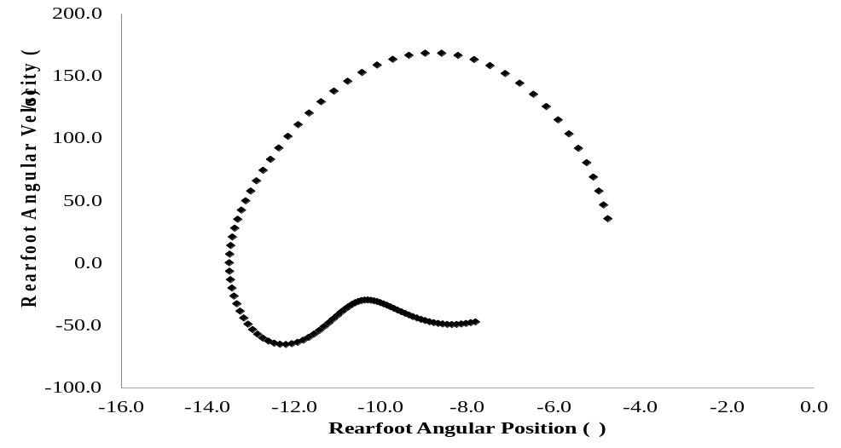
Figure 1-1. Phase-plane of rearfoot angle on the horizontal axis and its first derivative on the vertical axis for a single trial.

However, the components of the phase-plane should be normalized to account for amplitude and frequency differences between segment or joint motions (Hamill et al., 2000; Peters et al., 2003). By normalizing the phase-plane, the origin of the angular position is located in the middle of the joint’s range of motion (Fig. 1-2) (Hamill et al., 1999). On the vertical axis, the largest positive velocity is normalized to 1 and largest negative value is normalized to -1 (Hamill et al., 1999). Zero velocity is located at the origin of the phase-plane (Hamill et al., 1999). Additionally, the horizontal axis is normalized to 100 percent of the stance phase to 101 data points. If the data are not normalized, then the variability of CRP is affected (Hamill et al., 2000). Two data points will exhibit a greater difference in phase angle the closer the points are to the center of the phase-plane (Wheat and Glazier, 2006). Therefore, if data in the phase-plane are not normalized, then an inaccurately high variability is exhibited in segments or joints with small movement amplitudes (Wheat and Glazier, 2006). From the phase-plane, the phase angle is computed by taking the arctangent of the velocity divided by position at each time frame (Hamill et al., 1999). The CRP is computed as the difference between normalized phase angles of two segments or joints:
$$CRP\left(t\right)=φ_{proximal segment}-φ_{distal segment } (1)$$
where t is the CRP measure for each time point and φ is the normalized phase angle of the respective segment (Hamill et al., 1999).
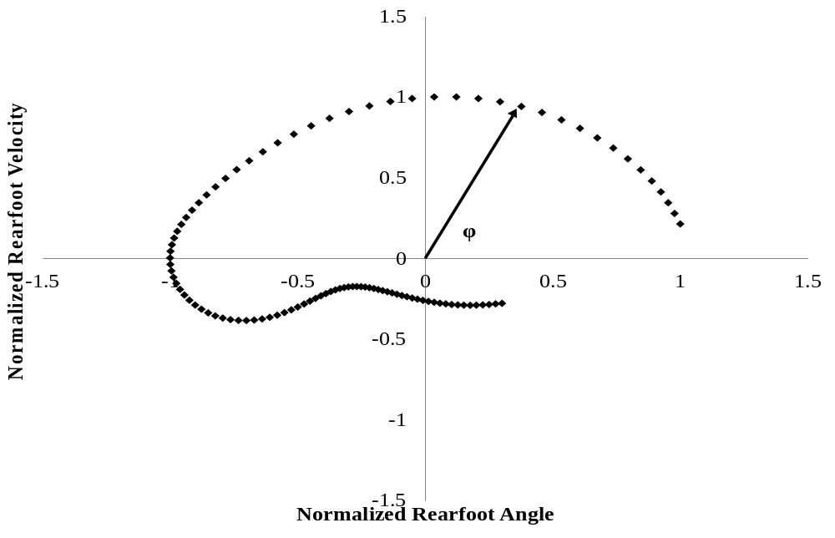
Figure 1-2. The normalized phase-plane where φ is the normalized phase angle.

The CRP represents the spatial relationship from which the coordination between two segments or joints can be identified (Fig. 1-3). A CRP of 0° indicates the two segments are in-phase. When CRP increases, the segments are out-of-phase. At a CRP of 180° this indicates anti-phase coupling. Additionally, a positive CRP indicates a greater phase angle of the proximal segment. Conversely, a negative CRP indicates a greater phase angle of the distal segment. The variability of CRP for each participant is computed as the average standard deviation at each time point across the number of trials. (Hamill et al., 1999)
CRP variability has been measured in runners with current ITBS (Hein et al., 2012) and previous ITBS compared to controls (Miller et al., 2008). CRP variability was similar for all of the inter-joint couplings between runners with ITBS compared to controls (Hein et al., 2011). However, runners with previous ITBS were more variable in: knee flexion/extension – foot abduction/adduction over the complete stride cycle, knee flexion/extension – foot abduction/adduction during swing, and in knee flexion/extension – foot abduction/adduction during stance compared to controls (Miller et al., 2008). Additionally, runners with previous ITBS are less variable in tibia internal/external – foot inversion/eversion at heel-strike compared to controls (Miller et al., 2008). Low coordination pattern variability in measures related to frontal plane thigh motion could indicate weak hip abductor musculature (Miller et al., 2008). However, hip abductor strength was not collected. It was proposed that differences in coordination patterns between groups were compensatory mechanisms used to limit patterns that were painful when the runners with previous ITBS were injured (Miller et al., 2008).

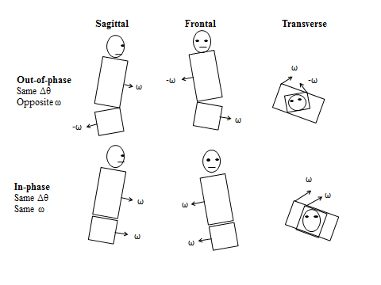
Figure 1-3. Generic representation of in- and out-of-phase relationships for two segments in the sagittal, frontal, and transverse planes (Adapted from Seay et al., 2011).

In related studies, it also has been postulated that runners currently with PFPS exhibit limited coordination patterns compared to healthy runners in order to minimize pain (Hamill et al., 1999; Heiderscheit et al., 2002). It was concluded that variability should fall within a certain range in order to minimize the potential for injury or re-injury (Miller et al., 2008). In general, the two studies that used CRP variability to compare running biomechanics between runners with previous and current ITBS selected different couplings. No justification was offered for selecting couplings of interest: hip flexion/extension – knee flexion/extension, hip abduction/adduction – knee flexion/extension, knee flexion/extension – ankle plantarflexion/dorsiflexion, and knee flexion/extension – rearfoot inversion/eversion (Hein et al., 2011). However, in a similar study, coupling pairs were selected based on their potential to cause iliotibial band strain as reported in the literature: thigh abduction/adduction – tibia internal/external rotation, thigh abduction/adduction – rearfoot inversion/eversion, tibia internal/external rotation – foot inversion/eversion, knee flexion/extension – foot abduction/adduction, and knee abduction/adduction – rearfoot inversion/eversion (Miller et al., 2008). Additional experimental design differences between studies included footwear and running surface. Runners were shod and wearing their own shoes while running on a treadmill (Miller et al., 2008). Conversely, runners ran barefoot exhibiting a rearfoot strike pattern during overground running (Hein et al., 2011). During running, barefoot and shod CRP angles at heel-strike are different in forefoot abduction/adduction – rearfoot inversion/eversion but similar for the remainder of stance (Eslami et al., 2007). However, transverse plane forefoot motion and frontal plane rearfoot coupling could not indicate the amount of tibial rotation between barefoot and shod running (Eslami et al., 2007). Further work is needed to determine if inter-segmental coupling differences exist between barefoot and shod running. Additionally, inter-segmental coupling and variability has not been compared between overground and treadmill running. Overall, variability differences appear to exist between runners with previous ITBS and controls but potentially not between runners with current ITBS and controls. Furthermore, too much variability or too little variability may be related to previous ITBS. Although CRP is one method to determining coordination variability, interpreting a measure that is a function of position and velocity is challenging. Furthermore, CRP is a measure that normalizes angle and angular velocity waveforms that have already been normalized. Perhaps, the waveforms have been “over-normalized.” Thus, the CRP measure no longer truly indicates the behavior of the original kinematics. If only the magnitude of variability in inter-segmental and inter-joint coordination is of interest, then using CRP does not present an issue. However, the results of applied biomechanics research should produce information that a clinician can use in practice to help treat a patient. In addition to CRP, another continuous method to quantify coordination has been implemented which may yield a more intuitive result.
Vector Coding

Vector coding quantifies the relative motion of inter-segmental and inter-joint coordination using angle-angle plots. This continuous method has not been used to evaluate coordination patterns and variability in ITBS populations. However, vector coding has been used to determine if coordination and variability differences exist in runners with PFPS (Heiderscheit et al., 2002), current shank or foot injury (Ferber et al., 2005), and current and previous low back pain (Seay et al., 2011) compared to controls. Runners with current PFPS exhibit decreased thigh external/internal rotation – shank external/internal rotation at heel-strike (Heiderscheit et al., 2002). No differences were exhibited between runners with current shank and foot injuries compared to controls (Ferber et al., 2005). However, the variety of running injuries could have added inter-subject variability in the data (Ferber et al., 2005). This likely decreased the power to detect between group differences (Ferber et al., 2005). Runners with current and previous low back pain exhibit a decrease is trunk flexion/extension – pelvic anterior/posterior tilt compared to controls (Seay et al., 2011). Additionally, runners with previous low back pain exhibited a decrease in trunk external/internal rotation – pelvis external/internal rotation compared to controls (Seay et al., 2011). Overall, there is evidence that inter-segmental coordination differs between runners with current and previous overuse running injury compared to controls. Therefore, examining inter-segmental coordination via vector coding in runners with current ITBS and previous ITBS compared to controls is warranted.
To implement vector coding, the relative motion plot is constructed (Fig. 1-4). Coordinates represent the relative positions of segments or joints at each time point during stance.

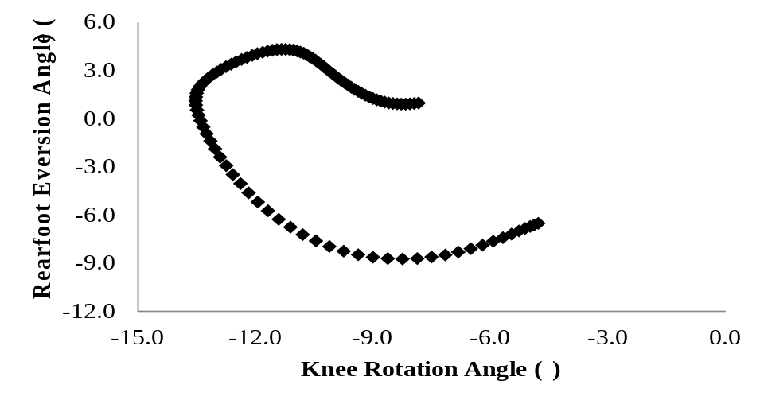
Figure 1-4. Relative motion plot of the transverse plane knee angle and frontal plane rearfoot angle during the stance phase of running.
From the relative motion plot, the orientation of the vector between two adjacent points relative to the right horizontal defines the coupling angle (γ) (Fig. 1-5) (Chang et al., 2008).
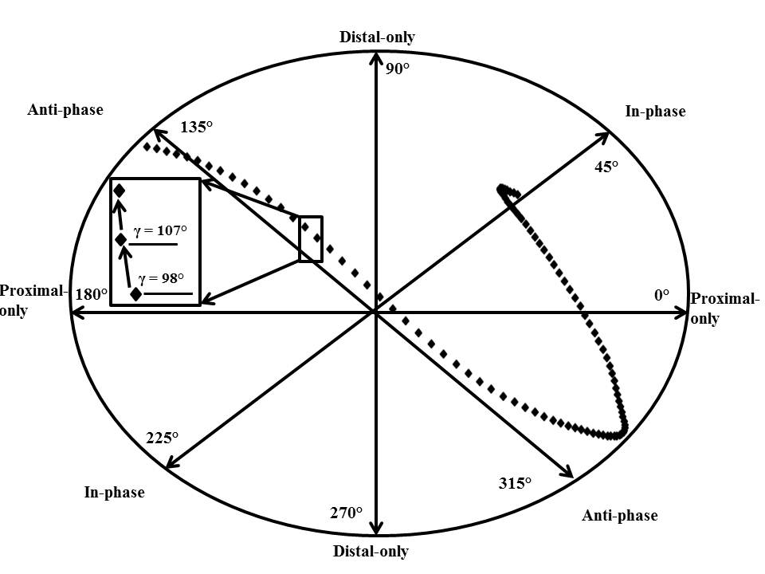
Figure 1-5. Coupling angle (γ) from the relative motion plot. Horizontal, vertical, and off-axes indicate the coupling angle’s spatial relationship between proximal and distal segment or joint motion (Adapted from Chang et al., 2008).

The coupling angle is directional. With a 0° to 360° range, there is no absolute zero value because 0° and 360° are the same point (Batschelet, 1981). Therefore, it is classified as a circular variable and computed using circular statistics (Chang et al., 2008; Hamill et al., 2000; Heiderscheit et al., 2002; Seay et al., 2011). Circular variables can be angles that measure direction which makes them cyclic (Batschelet, 1981). These variables do not act like length or time which are linear variables. Therefore, the data points’ mean cannot be found by simply taking the average of the data points (Batschelet, 1981). The mean sine and cosine of each direction of the relative motion angle is used to find the mean coupling angle for the horizontal and vertical vectors (Hamill et al., 2000). However, a scenario could occur where coupling angles within a subject across trials can fall between 316° and 360° or 0° and 44° both of which indicate a proximal segment motion phase. Averaging the coupling angle across trials may lead to an erroneous interpretation of the coupling angle. To avoid this issue, coupling angle can be defined:
$$γ_{j,i}=\left|\tan^{-1}\left(\frac{y_{j,i+1}- y_{j,i}}{x_{j,i+1}-x_{j,i}}\right) \right| (2)$$
where, 0° ≤ γ ≤ 90°, and i is a time point of the jth trial (Dierks and Davis, 2007; Ferber et al., 2005). From the coupling angle, three coordination patterns can be identified. A coupling angle of 45° indicates an equal amount of proximal and distal segment motion. An angle less than 45° indicates greater proximal segment motion relative to the distal segment. Whereas, an angle greater than 45° indicates greater distal segment motion relative to the proximal segment. The mean standard deviation of the coupling angle can be computed across trials. To quantify coupling variability, mean standard deviation is compared among groups.
A decrease in variability could lead to increased stress and strain placed on a localized area of soft tissue thereby leading to overuse injury (Hamill et al., 1999). Ultimately, the purpose of quantifying variability is that it could be a useful diagnostic measure to differentiate between healthy and pathological coordination patterns exhibited during running (Seay et al., 2011). For injured runners who exhibit decreased variability, clinicians can recommend to run on an uneven soft surface like a trail or alternate between running in two different pairs of shoes. This may reduce the incidence of the same loading patterns experienced by the musculoskeletal system, compared to habitually running on a flat concrete path in the same shoes. Therefore, determining if variability differences exist in runners with current ITBS and previous ITBS compared to healthy runners indeed merits investigating. Although using a continuous measure allows for a more complete analysis of running biomechanics, the variables of interest are selected a priori. Consequently, a large portion of the kinematic and kinetic data is still left unanalyzed. The unanalyzed data may hold the critical information that would discriminate variations in gait patterns among runners with current ITBS and previous ITBS compared to controls. A more comprehensive analysis should be utilized to make full use of the entire data set.

Principal Components Analysis
An analysis that has gained recent use in research studies of running (Nigg et al., 2012) and cutting movements (Kipp et al., 2011; O'Connor and Bottum, 2009) is principal component analysis (PCA). A PCA is a multivariate analysis that attempts to represent a data set using only a few variables that maximally preserves the variance in the data (Chau, 2001). For running, a PCA can break down the motion into its dominant movement components. In a data set that includes a high number of variables, some of the variables may be redundant. Variables that are deemed redundant are variables that are highly correlated with one another (Jolliffe, 2002). Using x-y-z marker coordinate data, PCA has been used to determine if differences exist between sex and age movement patterns in runners (Nigg et al., 2012). PCA is sensitive enough to detect differences due to age in dominant movement patterns (Nigg et al., 2012). Furthermore, age, but not sex, affected the dominant movements of running (Nigg et al., 2012). Additional research has been done using PCA as a measure to analyze the variation in joint angles and moments during stance of a cutting motion (Kipp et al., 2011; O'Connor and Bottum, 2009). Rapid hip flexion during the first half of stance of a single-leg land-and-cut maneuver is associated with greater knee abduction torque in currently healthy female participants (Kipp et al., 2011). In a related study, females exhibited less knee internal rotation during late stance and exhibited a greater hip knee adduction moment overall compared to males (O'Connor and Bottum, 2009). Establishing typical variations in joint motions and moments may aid in screening for lower-extremity injury risk. Implementing a PCA may be beneficial when comparing running biomechanics in runners with current ITBS and previous ITBS compared to controls. For example, hip abduction moment has been a variable of interest in previous ITBS investigations but is similar among groups (Ferber et al., 2010; Noehren et al., 2007). Perhaps, the contribution of hip abduction moment the primary modes of variation in running movement pattern differs among runners with current ITBS and previous ITBS compared to controls. Yet, a discrete analysis cannot identify these differences between groups. Thus, implementing a PCA in runners with current, previous, and no history of ITBS is warranted.
In a PCA, principal components represent the eigenvectors of the covariance matrix of each variable (Jolliffe, 2002). The eigenvectors indicate the primary directions of the variance in the data (Boyer et al., 2012). A PCA that is based on a covariance matrix gives greater weight to variables that have larger movement amplitudes, for example, sagittal plane joint rotations during running (Jolliffe, 2002). However, if the units of measurement for the variables are different, then they need to be standardized (Astephen and Deluzio, 2005). From the covariance matrix, the principal components are determined. If there are n variables in the data set, then there are n principal components. The first principal component accounts for the largest amount of total variance. It will be correlated with at least some of the variables. The second principal component thru the n^{th} principal component will have two characteristics. First, the second component will account for the variance that was not accounted for by the first component. Therefore, it will be correlated with some of the variables that did not exhibit a high correlation with the first principal component. Second, the second principal component will have zero correlation with the first principal component. The PCA will continue with this procedure for all principal components. (SAS, 2002-2005) However, for most analyses, it is the first few principal components which accounts for a significant proportion of the variance (Jolliffe, 2002). In the gait literature, the amount of variance explained by the retained principal components ranges from 85% (Gaudreault et al., 2011), 90% (Deluzio and Astephen, 2007; Kirkwood et al., 2011), and 95% (Nigg et al., 2012). Retaining the number of principal components that account for 90% of the total variation of the running data is sufficient to characterize it. Once the retained components are determined, the covariance matrix is projected into the new space that is defined by these n retained principal components. Thus, the principal component score for each variable is obtained.
To determine differences among groups, the principal component scores represent the distance and direction each participant’s trial is from the average waveform (Wrigely et al., 2005). The principal components account for the source of variance in the waveform. The variance can include differences in overall amplitude, relative magnitudes of peaks in a waveform, or timing of peaks in a waveform during the stance phase of running (O'Connor and Bottum, 2009; Wrigley et al., 2005). It is the principal component scores that are then statistically analyzed to find differences among groups of runners with previous and current ITBS compared to controls.

Summary of Literature Review
ITBS has been the focus of a relatively small number of investigations examining the biomechanics of running injury. In general, there does appear to be agreement in the literature on some biomechanical variables that may be etiological factors associated with ITBS. Female runners with previous ITBS or who later develop ITBS exhibit increased peak hip adduction, knee internal rotation, iliotibial band strain, and strain rate compared to controls. It remains equivocal if iliotibial band flexibility and hip abduction strength differences are exhibited between runners with current ITBS and controls. Further research is needed to determine if differences in iliotibial band flexibility and hip abductor strength are associated with ITBS. Additionally, no study has compared how frontal plane motion of the pelvis and trunk affects the knee moments in runners with current ITBS and previous ITBS compared to controls. Increased contralateral trunk lateral flexion may increase the tensile strain on the iliotibial band. It is unknown if iliotibial band strain and strain rate differences exist between runners with current ITBS and controls. Determining if discrete proximal and lower-extremity biomechanics are different between runners with current ITBS and previous ITBS compared to controls warrants further research.
In addition to discrete variables, examining inter-segmental coordination variability may be another measure to detect differences in running biomechanics between runners with current ITBS and previous ITBS compared to controls. Runners with previous ITBS exhibit more variability in knee flexion/extension – foot abduction/adduction throughout the stance phase but less variability of tibia internal/external – foot inversion/eversion at heel-strike. These results suggest that the amount of variability exhibited during running should fall within range. Furthermore, inter-segmental coordination of the frontal plane trunk and pelvis motion, as well as trunk and hip joint motion has not been established in runners with current ITBS and previous ITBS compared to controls.
Although PCA has gained use in running and single-leg landing and cutting research, it has not been applied in ITBS studies. A comprehensive analysis of kinematic and kinetic waveforms may be sensitive enough to detect group differences where discrete and coordination pattern analyses would not. Additionally, there may be biomechanical factors that discriminate between runners with current ITBS and previous ITBS compared to controls that have not been investigated previously.

CHAPTER III

Methods

This chapter will provide participant details and data collection protocol and then describe how the data will be analyzed for the three separate manuscripts.

Participant Details
Twenty-seven female runners 18 to 45 years old participated in this study. Participants were recruited using a variety of approaches. Runners with previous ITBS and controls were recruited at local races, running clubs, and training meetings. Snow ball sampling was implemented. This is performed by asking participants who completed the study to pass along the investigator’s contact information if they knew potential participants. Contacts were made with local clinicians at their place of work who were willing to distribute study information to participants with ITBS. All currently injured runners self-reported that they had been diagnosed by a physician, physical therapist, or athletic trainer. Additionally, flyers were posted around the University of Tennessee’s campus and the surrounding area. For all potential participants, if a major lower extremity injury had occurred in the past, such as an ACL tear, then they were not allowed to participate. Furthermore, participants were excluded if they answered ‘yes’ to any question on the Physical Activity Readiness-Questionnaire (PAR-Q) (Thomas et al., 1992). Participants were divided into three sub-groups: currently with ITBS but running a minimum 6 miles per week (Noehren et al., 2011), runners with previous ITBS and currently running a minimum of 15 miles per week, and controls with no history of knee overuse injury running a minimum of 15 miles per week. Participants with current or previous ITBS reported that had been diagnosed by a health care professional with ITBS. Additionally, participants with current ITBS will report pain experienced during a typical run on a verbal analog scale of 0 to 10. A zero indicates no pain during running, whereas a 10 indicates severe pain.

Power Analysis
Sample size was determined a priori (α = 0.05, β = 0.20, desired effect size = 0.7) for an one-way analysis of variance (ANOVA) using a power analysis program, G*Power 3 (Faul et al., 2007). The results of the power analysis indicated that a minimum sample size of twenty-four participants was needed.

Data Collection
Approval for all procedures was obtained from the Institution’s Human Subjects Review Board prior to the commencement of this study. Participants gave their written informed consent before participating. Then, participants completed an online survey which included a Physical Activity Readiness Questionnaire (PAR-Q) and a custom running health history questionnaire (Appendix A). If a participant answered ‘yes’ to any question on the PAR-Q, then they were thanked for their time and their participation in the study ended.
Participant Preparation

Participants wore running shorts, a tank-top or v-cut sleeveless shirt, and a neutral laboratory gait sandal (Bite Footwear, Redmond, WA, USA) for the overground running trials (Barnes et al., 2010). Participants stood on a foot placement template while spherical reflective markers were placed bilaterally on the lower-extremity and trunk (McIlroy and Maki, 1997). Bilateral lower-extremity data were collected for all participants Trunk motion was quantified from markers placed directly on the skin over the manubrium, sternal body, spinous process of the seventh cervical vertebra, and spinous process of the tenth thoracic vertebra. Molded thermoplastic shells with four non-collinear markers were positioned over the posterior pelvis and laterally on the proximal thigh and distal shank (Cappozzo et al., 1997). The shells were attached with neoprene wraps and hook and loop tape (Manal et al., 2000). Rearfoot motion was quantified by attaching three non-collinear markers to the heel. Anatomical markers were placed over bony landmarks on participants to define the joint coordinate systems (Grood and Suntay, 1983). Anatomical markers were: acromion processes, superior aspect of the iliac crests, greater trochanters, lateral and medial femoral epicondyles, lateral and medial malleoli, and the first and fifth metatarsal heads. The static calibration trial was recorded while participants stood on the foot placement template with weight equally distributed on both feet. After the calibration trial, all anatomical markers were detached from the skin.
Overground Running Trials

Overground running trials were performed along a 17 m runway at a velocity of 3.5 ± 0.18 m∙s⁻¹. A nine-camera motion capture system sampling at 120 Hz recorded trunk and lower extremity position data during the running trials (Vicon, Oxford Metrics, Centennial, CO, USA). A force plate (AMTI, Inc., Watertown, MA, USA) sampling at 1200 Hz was synchronized with the motion capture system and collected stance phase ground reaction force data. Running velocity was monitored by two photocells placed three meters apart in the middle of the runway linked to a timer. Participants practiced running until they were able to land consistently on the force plate without targeting while within the desired running velocity range. Five acceptable trials were collected.
Physiological Measures

Following the overground running trials, iliotibial band flexibility was assessed using the Ober test (Piva et al., 2005). The investigator followed this established protocol and was instructed by a certified athletic trainer on how to perform the test correctly. To assess intra-rater reliability, the intra-class correlation coefficient (ICC(3, k)) was computed. Ten participants were invited back to the laboratory on a separate day to measure iliotibial band flexibility (Appendix B). An ICC value of 0.839 indicated good intra-rater reliability. Right iliotibial band flexibility was measured for controls. ITBS flexibility was measured in both limbs for runners with current ITBS and previous ITBS. Participants lay on an examination table. They positioned (Fig 1-6.) themselves on their left side with the shoulders and pelvis perpendicular to table (Piva et al., 2005).
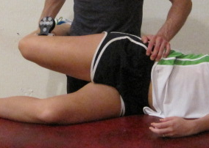
Figure 1-6. Position of the participant during the Ober test.

To stabilize the pelvis, the hip and knee of the lower extremity touching the table were flexed (Piva et al., 2005). The skin was marked 5 cm proximal to the lateral knee joint to indicate placement for the digital inclinometer (Lafayette Instrument Company, Lafayette, IN, USA). The range of the inclinometer is 360° with a resolution of 1°. The inclinometer was secured to a solid base to provide a stable measuring surface. The inclinometer was placed over the marked skin and fastened with elastic bandage tape. While standing behind the participant, the researcher stabilized the pelvis with his hand (Piva et al., 2005). The researcher passively abducted and then extended the hip to align the hip with the trunk (Piva et al., 2005). Participants were instructed to relax the muscles of the lower extremity while allowing the thigh to passively drop toward the table (Piva et al., 2005). The shank was supported by the researcher during the test in order to allow the limb to fall with control. The end position of the thigh adduction motion was indicated by lateral tilt of the pelvis, when thigh adduction motion stopped, or both (Reese and Bandy, 2003). The angle measured by the inclinometer was recorded. The test was performed three times (Gajdosik et al., 2003). The mean angle of the three tests was computed.
After completing the Ober test, hip abductor strength was assessed using a hand-held dynamometer (HHD) (Lafayette Instrument Company, Lafayette, IN, USA). A HHD is a common clinical tool used to measure hip abductor strength. To assess intra-rater reliability, the intra-class correlation coefficient (ICC(3, k)) was computed. Ten participants were invited back to the lab on a separate day to measure hip abductor strength (Appendix B). An ICC value of 0.839 indicated good intra-rater reliability. Participants were side-lying on an examination table with a pillow placed between the legs (Fig. 1-7) (Ireland et al., 2003). The trunk was stabilized by wrapping a strap superior to the iliac crest and firmly securing it under the table (Ireland et al., 2003). The center of the force pad of the HHD was placed 5 cm superior to lateral knee joint (Ireland et al., 2003). The dynamometer used detects isometric force ranging from 0 to 136.1 kg with an accuracy of ± 1%. A second belt secured the dynamometer to the test site by firmly fastening it around the leg and underside of the table (Ireland et al., 2003).
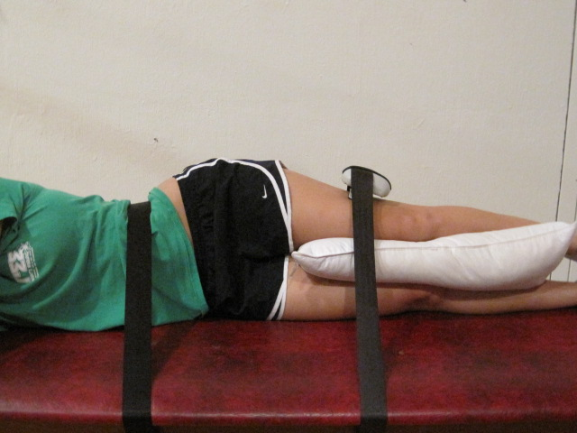
Figure 1-7. Placement of HDD during the hip abductor strength.

The researcher positioned his hand over the HDD to stabilize it during the test. Before each trial, the dynamometer was zeroed (Ireland et al., 2003). Participants were instructed to abduct their leg with maximal effort for 5 seconds (Ireland et al., 2003). One practice trial was given to familiarize participants with the test and three additional trials were collected with 15 seconds of rest given between trials (Ireland et al., 2003). The peak force value was recorded after each trial. Hip abductor strength was normalized to body weight and height (Fredericson et al., 2000). The dynamometer moment arm was measured as the distance from the greater trochanter to the point of application of the HHD on the leg. The greater trochanter provides a reliable location of the height of hip joint center location (Weinhandl and O'Connor, 2010). Hip abductor strength was calculated as the average isometric force multiplied by the distance between the greater trochanter to the HHD. A dimensionless measure of strength was then computed (Fredericson et al., 2000):
$$\%\left(BM x h\right)=Strength\left(kg×m\right)×\left(\frac{100}{BM \left(kg\right)×h \left(m\right)}\right) (1)$$

where BM is the participant’s mass in kg, h is the participant’s height in m.

Data Analysis: Study 1
Discrete biomechanical variables have been the primary method to describe differences between groups during running in previous ITBS investigations. To compare our results with the literature, lower extremity joint biomechanics and iliotibial band strain and strain rate will be compared among runners with current ITBS and previous ITBS and healthy controls. Assessing iliotibial band flexibility and hip abductor strength among groups may aid in interpretation of the exhibited running biomechanics.
Discrete Variables

Running data were processed in Visual 3D (C-Motion, Rockville, MD, USA). Two residual analyses were performed using a custom computer program (LabVIEW, National Instruments, Austin, TX, USA) with marker trajectory and analog data. From the residual analyses, low-pass filter cut-off frequencies were identified that retained 95% of the trajectory and force plate signals. Both marker coordinates and moment data were low-passed filtered with a fourth order Butterworth digital filter at 8Hz (Bisseling and Hof, 2006). A vertical ground reaction force threshold of 20 N indicated the onset and termination of stance. Lower-extremity and trunk angles were determined using a Cardan X-y-z (medio-lateral, antero-posterior, longitudinal) rotation sequence. Inertial parameters (segment center of mass locations and radii of gyration) for the lower extremity and trunk were defined using de Leva’s female model (de Leva, 1996). Lower extremity inverse dynamics were calculated using a standard Newton-Euler approach. All moments were computed as internal moments and normalized by body mass. Discrete dependent variables of interest included peak: hip adduction angle, thigh external rotation angle, knee abduction moment, knee internal rotation angle, knee internal rotation velocity, rearfoot inversion moment, contralateral pelvic drop, and contralateral trunk flexion. A custom computer program (MATLAB, MathWorks, Natick, MA, USA) extracted discrete values for the kinematic and kinetic variables of interest during the first 60% of stance (Ferber et al., 2010).
The thigh angle indicated by the inclinometer during the Ober test was averaged among three trials and served as the measure of iliotibial band flexibility. Hip abduction strength was the average peak isometric hip abductor torque among the three trials. Pelvic width to femoral length ratio was computed using anatomical marker coordinates collected during the static trial. The pelvic width was defined as the distance between the iliac crest markers. Pythagoras’s theorem was implemented using the vertical and horizontal coordinates of the greater trochanter and lateral epicondyle markers to calculate femoral length.
Modeling and Dynamic Simulation of Iliotibial Band during Running

For each participant, three overground running trials were processed in Visual3D. The anthropometric model used for the simulation analysis was the same female de Leva model used for the discrete joint and segment biomechanics analyses with one modification. The thorax/abdomen or trunk segment was constructed to meet the requirements of importing a motion file from Visual3D into OpenSim. In order to have the trunk oriented correctly when imported into the simulation software, adjustments to the definition of the trunk segment were made. The proximal end of the trunk must form a joint with the pelvis, thus was defined by the iliac crest markers. Therefore, the distal end of the trunk was defined by the acromion processes. With this modification, the vertical axis of the trunk segment’s coordinate system was now directed inferiorly and the antero-posterior axis directed posteriorly. The trunk segment’s coordinate system was modified within the “Segments Properties” tab in Visual3D to be coincident with the local coordinate systems of the pelvis and lower extremity.
After the model was constructed, motion files which contain the inverse kinematic and ground reaction force data for participants individual trials were imported into OpenSim 2.4 (Delp et al., 2007). A three-dimensional musculoskeletal model with 23 degrees-of-freedom and 92 muscle-tendon actuators was scaled to match each participant’s anthropometrics (Delp et al., 2007). Joints of the lower-extremity were modeled in the following manner: the hips were ball-and-socket joints, the knee consisted of planar joints, and the ankles were revolute joints. The head and torso were included in the musculoskeletal model and articulated with the pelvis via a ball-and-socket joint. Arms were not included in the model; however, their mass was added to the head and torso segment mass. The iliotibial band was then added to the scaled model following the tensor fascia latae’s path. The iliotibial band encloses the tensor fascia latae and attaches to Gerdy’s tubercle on the tibia (Fairclough et al., 2006). The reference length of the iliotibial band was determined as the tensor fascia latae’s length during the static calibration trial (Hamill et al., 2008; Miller et al., 2007). A wrap sphere object was defined at the height of the lateral femoral epicondyle (Hamill et al., 2008; Miller et al., 2007). The sphere’s surface was flush with the surface of the lateral femoral epicondyle to prevent the iliotibial band from penetrating through the femur during running. The iliotibial band was modeled as a muscle with only a passive contractile component and an optimal muscle fiber length equal to each participant’s iliotibial band reference length. To track participant’s running motion, joint moments were calculated using a residual reduction algorithm (RRA) (Delp et al., 2007). Because of errors in data collection techniques and modeling assumptions, the experimentally derived ground reactions and moments are dynamically inconsistent with model kinematics (Kuo, 1998). Yet, it is demanded that Newton’s second law of motion is satisfied:
$${\overset{⃑}{F}}_{External}= \sum_{i=1}^{Segments}{m_{i}}{\overset{⃑}{a}}_{i}-{\overset{⃑}{F}}_{Residual} (9)$$
where, ${\overset{⃑}{F}}_{External}$ is the experimentally collected ground reaction force minus the body weight vector, ${\overset{⃑}{a}}_{i}$ is the translational acceleration of the center of mass of the ith body segment, $m_{i}$ is the mass of the ith body segment, and ${\overset{⃑}{F}}_{Residual}$ is the residual force (Delp et al., 2007). RRA uses the experimentally derived inverse dynamics result and reduces the magnitude of the force and moment residuals (Delp et al., 2007; Hamner et al., 2010). This is done first by computing the residuals and averaging them for the duration of the stance phase of the running trials. Using the residuals’ averages, RRA slightly alters the model mass parameters (Delp et al., 2007). Joint motions for all degrees of freedom are actuated by idealized joint moments to track the motion (Delp et al., 2007). Additionally, three residual forces and moments are applied to a segment (generally, the pelvis), to control the six degrees of freedom between the model and ground (Delp et al., 2007).
Using the kinematic output from the RRA, iliotibial band length during the stance phase of running was computed using the Analyze Tool. This tool is used to analyze an existing simulation that was computed using RRA. The benefit of using the Analyze Tool, besides saving computation time, is that the simulation can be analyzed without modifying the simulation. The generalized coordinates, or joint angles, computed from RRA are used to compute the iliotibial band’s length at each time frame during the simulation. Using a custom computer program (MATLAB, MathWorks, Natick, MA, USA) iliotibial band strain was calculated by finding the change in length of the band during stance and dividing by its resting length at each time frame. Strain rate was computed using the finite difference method. Peak iliotibial band strain and strain rate were measured at peak knee flexion during stance (Hamill et al., 2008), as well as the peak strain and strain rates during the entire stance phase.

Study 1: Statistical Analysis

Mean and standard deviations were determined for the discrete joint and segment variables, iliotibial band strain, iliotibial band strain rate, iliotibial band flexibility, and hip abductor strength for each participant and then within the three groups.
Variables were compared among groups using a one-way analysis of variance (ANOVA). Post hoc Fisher’s least significant difference test was used to determine where any significant differences existed among dependent variables. Pearson’s correlation coefficients were computed between peak hip adduction angle during running and iliotibial band flexibility and isometric hip abductor strength. Statistical analysis was performed using PASW 20.0 (SPSS Inc., Chicago, IL). An alpha level of 0.05 was set for all statistical tests.

Data Analysis: Study 2
The first study examined joint and segment biomechanics, as well as iliotibial band mechanics among runners with current ITBS and previous ITBS compared to healthy controls. Focusing on the variability of inter-segmental and inter-joint coordination patterns may lead to a better understanding of the etiology of ITBS.
Segment and joint angles during the stance phase of running were time normalized to 101 points. Inter-segmental coordination was determined from segment relative motion (angle-angle) plots (Chang et al., 2008). To provide a more detailed description of coupling variability during the stance phase of running, the relative motion plots were broken down into four periods (Ferber et al., 2005). These four periods were chosen based on a previous investigator’s methods (Ferber et al., 2005). The first period was defined from heel-strike to initial loading (~ 0 – 20% of stance). Period two was defined from the end of phase one to full weight acceptance (~ 20 – 50% of stance). Period three was defined from the end of phase 2 to half the distance to toe-off (~50 – 75% of stance). Period four was defined from the end of phase three to toe-off. From the relative motion plot, the orientation of a vector between two adjacent points relative to the right horizontal axis was determined (Chang et al., 2008). Coupling angle was determined over 0° ≤ γ ≤ 90° (Dierks and Davis, 2007; Ferber et al., 2005). In-phase (γ = 45°) segment couplings rotate an equal amount in the same direction, for example, contralateral pelvic drop and contralateral trunk flexion. An angle less than 45° indicates greater trunk (proximal) segment motion relative to the pelvis (distal) segment. Whereas, an angle greater than 45° indicates greater pelvis segment motion relative to the trunk segment.
Couplings of interest were: frontal plane trunk ipsilateral/contralateral flexion – pelvis contralateral drop/elevation, pelvis contralateral drop/elevation – thigh abduction/adduction, thigh abduction/adduction – shank abduction/adduction, thigh internal/external rotation – shank internal/external rotation, knee flexion/extension – foot abduction/adduction, and shank internal/external rotation – rearfoot inversion/eversion. A custom computer program (MATLAB, MathWorks, Natick, MA, USA) was used to perform all calculations.
Study 2: Statistical Analysis

From the vector coded trials, participant’s mean and standard deviation at each frame across five trials were computed for each coupling angle. The six couplings were: contralateral/ipsilateral flexion – pelvis contralateral drop/elevation, pelvis contralateral drop/elevation – thigh abduction/adduction, thigh abduction/adduction – shank abduction/adduction, thigh internal/external rotation – shank internal/external rotation, knee flexion/extension – foot abduction/adduction, and shank internal/external rotation – rearfoot inversion/eversion. The mean of the coupling angles standard deviation was then computed for each period of stance (Ferber et al., 2005).The mean of the standard deviations served as the measure of variability. To quantify coupling angle variability, mean standard deviation for each participant was compared among groups.
Multivariate analysis of variance (MANOVA) was used to assess group differences. A MANOVA was performed on the variability in the six coupling angles for the four phases of stance. Post hoc Fisher’s least significant difference test was used to determine where any significant differences existed among couplings during the four bins of stance. Statistical analysis was performed using PASW 20.0 (SPSS Inc., Chicago, IL). An alpha level of 0.05 was set for all statistical tests.

Data Analysis: Study 3
In Study 3, a multivariate analysis approach was used to examine variations in angle and moments waveforms during the stance phase of overground running. Stance phase kinematic and kinetic time series waveforms were normalized to 101 points. The average of the five trials for each participant was calculated for each joint and segment rotation. Five waveforms were of interest: frontal plane, trunk, pelvis, and hip angles and knee moment, as well as transverse plane knee angle. Moments were expressed as internal moments and normalized to body mass and height (O'Connor and Bottum, 2009). The 101 time normalized data points comprised the columns and 27 participants comprised the rows of each waveform data matrix ($X_{27×101})$. The mean was computed for each column of the respective matrix. Then, the column mean was subtracted from each row (participant). The covariance matrix$(C_{101×101})$ for each waveform matrix was computed. PCA were performed using an eigenvector decomposition method of each covariance matrix. The PCA produced the eigenvectors ($V_{101×101})$ eigenvalues ($L_{1×101})$. The eigenvector matrix consisted of the coefficients for each of the 101 principal components which defined a new coordinate space for the original waveform data (Wrigley et al., 2006). Principal component score matrices ($Z_{27×101})$ were computed by multiplying the mean-centered input matrix by the transpose of the eigenvector matrix:
$$Z_{27×101}=(X_{27 ×101}-\left(1_{27 ×1}×{\overline{x}}_{1 ×101}\right))×{V^{'}}_{101 ×101} (1)$$
where ${\overline{x}}_{1 ×101}$ is each time normalized data point. The principal component scores represented the contribution of each principal component loading vector to individual participant’s waveform (Astephen et al., 2008).
To interpret how principal components contributed to movement variability, percent variance explained ($r_{ji}^{2}$ ) was computed for the ith principal component and the jth time point:
$$r_{ji}^{2}= \frac{V_{ji}\sqrt{L_{i}}}{c_{j}} ×100\% (2)$$
where c_{j} is the standard deviation of C at a given data point of the waveform (Wrigley et al., 2006). PCA calculations were performed in MATLAB (MathWorks, Natick, MA, USA).

Study 3: Statistical Analysis

The first three principal components for each waveform were retained (Astephen et al., 2008). To assess group differences, principal component scores of the retained components for each waveform were analyzed among groups using a one-way multivariate analysis of variance (MANOVA) (O'Connor and Bottum, 2009). Group was the independent variable. The waveforms analyzed were: frontal plane trunk, pelvis, and hip angles and knee moment, as well as transverse plane knee angle. Post hoc Fisher’s least significant difference test was used to determine where any significant differences existed among dependent variables. All statistical analyses were performed using PASW (20.0, SPSS Inc., Chicago, IL, USA). An alpha value of 0.05 was set for all tests.

References
Astephen, J.L., Deluzio, K.J., Caldwell, G.E., Dunbar, M.J., Hubley-Kozey, C.L., 2008. Gait and neuromuscular pattern changes are associated with differences in knee osteoarthritis severity levels. Journal of Biomechanics 41, 868-876.
Barnes, A., Wheat, J., Milner, C.E., 2010. Use of gait sandals for measuring rearfoot and shank motion during running. Gait and Posture 32, 133-135.
Batschelet, E., 1981. Circular Statistics in Biology. Academic Press, New York.
Beers, A., Ryan, M., Kasubuchi, Z., Fraser, S., Taunton, J.E., 2008. Effects of Multi-modal Physiotherapy, Including Hip Abductor Strengthening, in Patients with Iliotibial Band Friction Syndrome. Physiotherapy Canada 60, 180-188.
Bisseling, R.W., Hof, A.L., 2006. Handling of impact forces in inverse dynamics. Journal of Biomechanics 39, 2438-2444.
Bohannon, R.W., 1986. Test-retest reliability of hand-held dynamometry during a single session of strength assessment. Physical Therapy 66, 206-209.
Boyer, K.A., Federolf, P., Lin, C., Nigg, B.M., Andriacchi, T.P., 2012. Kinematic adaptations to a variable stiffness shoe: mechanisms for reducing joint loading. Journal of Biomechanics 45, 1619-1624.
Cappozzo, A., Cappello, A., Della Croce, U., Pensalfini, F., 1997. Surface-marker cluster design criteria for 3-D bone movement reconstruction. IEEE Transactions on Biomedical Engineering 44, 1165-1174.
Cavanagh, P.R., Lafortune, M.A., 1980. Ground reaction forces in distance running. Journal of Biomechanics 13, 397-406.
Chang, R., Van Emmerik, R., Hamill, J., 2008. Quantifying rearfoot-forefoot coordination in human walking. Journal of Biomechanics 41, 3101-3105.
Chau, T., 2001. A review of analytical techniques for gait data. Part 1: Fuzzy, statistical and fractal methods. Gait and Posture 13, 49-66.
de Leva, P., 1996. Adjustments to Zatsiorsky-Seluyanov's segment inertia parameters. Journal of Biomechanics 29, 1223-1230.
Delp, S.L., Anderson, F.C., Arnold, A.S., Loan, P., Habib, A., John, C.T., Guendelman, E., Thelen, D.G., 2007. OpenSim: open-source software to create and analyze dynamic simulations of movement. IEEE Transactions on Biomedical Engineering 54, 1940-1950.
Deluzio, K.J., Astephen, J.L., 2007. Biomechanical features of gait waveform data associated with knee osteoarthritis: an application of principal component analysis. Gait and Posture 25, 86-93.
Dierks, T.A., Davis, I., 2007. Discrete and continuous joint coupling relationships in uninjured recreational runners. Clinical Biomechanics 22, 581-591.
Edwards, W.B., Taylor, D., Rudolphi, T.J., Gillette, J.C., Derrick, T.R., 2009. Effects of stride length and running mileage on a probabilistic stress fracture model. Medicine and Science in Sports Exercise 41, 2177-2184.
Eslami, M., Begon, M., Farahpour, N., Allard, P., 2007. Forefoot-rearfoot coupling patterns and tibial internal rotation during stance phase of barefoot versus shod running. Clinical Biomechanics 22, 74-80.
Fairclough, J., Hayashi, K., Toumi, H., Lyons, K., Bydder, G., Phillips, N., Best, T.M., Benjamin, M., 2006. The functional anatomy of the iliotibial band during flexion and extension of the knee: implications for understanding iliotibial band syndrome. Journal of Anatomy 208, 309-316.
Fairclough, J., Hayashi, K., Toumi, H., Lyons, K., Bydder, G., Phillips, N., Best, T.M., Benjamin, M., 2007. Is iliotibial band syndrome really a friction syndrome? Journal of Science and Medicine in Sport 10, 74-76; discussion 77-78.
Faul, F., Erdfelder, E., Lang, A.G., Buchner, A., 2007. G*Power 3: a flexible statistical power analysis program for the social, behavioral, and biomedical sciences. Behavior Research Methods 39, 175-191.
Ferber, R., Davis, I.M., Williams, D.S., 3rd, 2003. Gender differences in lower extremity mechanics during running. Clinical Biomechanics 18, 350-357.
Ferber, R., Davis, I.M., Williams, D.S., 3rd, 2005. Effect of foot orthotics on rearfoot and tibia joint coupling patterns and variability. Journal of Biomechanics 38, 477-483.
Ferber, R., Kendall, K.D., McElroy, L., 2010. Normative and critical criteria for iliotibial band and iliopsoas muscle flexibility. Journal of Athletic Training 45, 344-348.
Ferber, R., Noehren, B., Hamill, J., Davis, I.S., 2010. Competitive female runners with a history of iliotibial band syndrome demonstrate atypical hip and knee kinematics. Journal of Orthopaedic and Sports Physical Therapy 40, 52-58.
Fredericson, M., Cookingham, C.L., Chaudhari, A.M., Dowdell, B.C., Oestreicher, N., Sahrmann, S.A., 2000. Hip abductor weakness in distance runners with iliotibial band syndrome. Clinical Journal of Sports Medicine 10, 169-175.
Fredericson, M., Cookingham, C.L., Chaudhari, A.M., Dowdell, B.C., Oestreicher, N., Sahrmann, S.A., 2000. Hip abductor weakness in distance runners with iliotibial band syndrome. Clinical Journal of Sports Medicine 10, 169-175.
Gajdosik, R.L., Sandler, M.M., Marr, H.L., 2003. Influence of knee positions and gender on the Ober test for length of the iliotibial band. Clinical Biomechanics 18, 77-79.
Gaudreault, N., Mezghani, N., Turcot, K., Hagemeister, N., Boivin, K., de Guise, J.A., 2011. Effects of physiotherapy treatment on knee osteoarthritis gait data using principal component analysis. Clinical Biomechanics 26, 284-291.
Grau, S., Krauss, I., Maiwald, C., Axmann, D., Horstmann, T., Best, R., 2011. Kinematic classification of iliotibial band syndrome in runners. Scandanavian Journal of Medicine & Science in Sports 21, 184-189.
Grau, S., Krauss, I., Maiwald, C., Best, R., Horstmann, T., 2008. Hip abductor weakness is not the cause for iliotibial band syndrome. Internation Journal of Sports Medicine 29, 579-583.
Grood, E.S., Suntay, W.J., 1983. A joint coordinate system for the clinical description of three-dimensional motions: application to the knee. Journal of Biomedical Engineering 105, 136-144.
Hamill, J., Haddad, J.M., McDermott, W.J., 2000. Issues in quantifying variability fom a dynamical systems perspective. Journal of Applied Biomechanics 16, 407-418.
Hamill, J., Miller, R., Noehren, B., Davis, I., 2008. A prospective study of iliotibial band strain in runners. Clinical Biomechanics 23, 1018-1025.
Hamill, J., van Emmerik, R.E., Heiderscheit, B.C., Li, L., 1999. A dynamical systems approach to lower extremity running injuries. Clinical Biomechanics 14, 297-308.
Hamner, S.R., Seth, A., Delp, S.L., 2010. Muscle contributions to propulsion and support during running. Journal of Biomechanics 43, 2709-2716.
Heiderscheit, B.C., Hamill, J., Van Emmerik, R.E.A., 2002. Variability of stride characterisitics and joint coordination among individuals with unilateral patellofemoral pain. Journal of Applied Biomechanics 18, 110-121.
Hein, T., Schmeltzpfenning, T., Krauss, I., Maiwald, C., Horstmann, T., Grau, S., 2012. Using the variability of continuous relative phase as a measure to discriminate between healthy and injured runners. Human Movement Science 31, 683-694.
Hootman, J.M., 2004. Editorial: New Section in JAT: Evidence-Based Practice. Journal of Athletic Training 39, 9.
James, S.L., Bates, B.T., Osternig, L.R., 1978. Injuries to runners. American Journal of Sports Medicine 6, 40-50.
Jolliffe, I.T., 2002. Principal Components Analysis. Springer-Verlag, New York, NY.
Kelso, J.A., 1995. Dynamic Patterns: the Self-Organization of Brain and Behaviour. MIT Press, Cambrige.
Kipp, K., McLean, S.G., Palmieri-Smith, R.M., 2011. Patterns of hip flexion motion predict frontal and transverse plane knee torques during a single-leg land-and-cut maneuver. Clinical Biomechanics 26, 504-508.
Kirkwood, R.N., Resende, R.A., Magalhaes, C.M., Gomes, H.A., Mingoti, S.A., Sampaio, R.F., 2011. Application of principal component analysis on gait kinematics in elderly women with knee osteoarthritis. Revista Brasileira de Fisioterapia 15, 52-58.
Kuo, A.D., 1998. A least-squares estimation approach to improving the precision of inverse dynamics computations. Journal of Biomedical Engineering 120, 148-159.
Lavine, R., 2010. Iliotibial band friction syndrome. Current Reviews in Musculoskeletal Medicine 3, 18-22.
Lun, V., Meeuwisse, W.H., Stergiou, P., Stefanyshyn, D., 2004. Relation between running injury and static lower limb alignment in recreational runners. British Journal of Sports Medicine 38, 576-580.
Lundberg, A., Svensson, O.K., Bylund, C., Goldie, I., Selvik, G., 1989. Kinematics of the ankle/foot complex--Part 2: Pronation and supination. Foot and Ankle 9, 248-253.
Lynn, S.K., Costigan, P.A., 2008. Effect of foot rotation on knee kinetics and hamstring activation in older adults with and without signs of knee osteoarthritis. Clinical Biomechanics 23, 779-786.
Manal, K., McClay, I., Stanhope, S., Richards, J., Galinat, B., 2000. Comparison of surface mounted markers and attachment methods in estimating tibial rotations during walking: an in vivo study. Gait and Posture 11, 38-45.
McClay, I., Manal, K., 1998. A comparison of three-dimensional lower extremity kinematics during running between excessive pronators and normals. Clinical Biomechanics 13, 195-203.
McIlroy, W.E., Maki, B.E., 1997. Preferred placement of the feet during quiet stance: development of a standardized foot placement for balance testing. Clinical Biomechanics 12, 66-70.
Messier, S.P., Edwards, D.G., Martin, D.F., Lowery, R.B., Cannon, D.W., James, M.K., Curl, W.W., Read, H.M., Jr., Hunter, D.M., 1995. Etiology of iliotibial band friction syndrome in distance runners. Medicine and Science in Sports Exercise 27, 951-960.
Miller, R.H., Lowry, J.L., Meardon, S.A., Gillette, J.C., 2007. Lower extremity mechanics of iliotibial band syndrome during an exhaustive run. Gait and Posture 26, 407-413.
Miller, R.H., Meardon, S.A., Derrick, T.R., Gillette, J.C., 2008. Continuous relative phase variability during an exhaustive run in runners with a history of iliotibial band syndrome. Journal Applied Biomechanics 24, 262-270.
Miller, R.H., Meardon, S.A., Derrick, T.R., Gillette, J.C., 2008. Continuous relative phase variability during an exhaustive run in runners with a history of iliotibial band syndrome. Journal of Appled Biomechanics 24, 262-270.
Nigg, B.M., Baltich, J., Maurer, C., Federolf, P., 2012. Shoe midsole hardness, sex and age effects on lower extremity kinematics during running. Journal of Biomechanics 45, 1692-1697.
Noble, C.A., 1979. The treatment of iliotibial band friction syndrome. British Journal of Sports Medicine 13, 51-54.
Noble, C.A., 1980. Iliotibial band friction syndrome in runners. American Journal of Sports Medicine 8, 232-234.
Noehren, B., Davis, I., Hamill, J., 2007. ASB clinical biomechanics award winner 2006 prospective study of the biomechanical factors associated with iliotibial band syndrome. Clinical Biomechanics 22, 951-956.
Noehren, B., Pohl, M.B., Sanchez, Z., Cunningham, T., Lattermann, C., 2012. Proximal and distal kinematics in female runners with patellofemoral pain. Clinical Biomechanics 27, 366-371.
Noehren, B., Scholz, J., Davis, I., 2011. The effect of real-time gait retraining on hip kinematics, pain and function in subjects with patellofemoral pain syndrome. British Journal of Sports Medicine 45, 691-696.
O'Connor, K.M., Bottum, M.C., 2009. Differences in cutting knee mechanics based on principal components analysis. Medicine and Science in Sports Exercise 41, 867-878.
Orava, S., 1978. Iliotibial tract friction syndrome in athletes--an uncommon exertion syndrome on the lateral side of the knee. British Journal of Sports Medicine 12, 69-73.
Orchard, J.W., Fricker, P.A., Abud, A.T., Mason, B.R., 1996. Biomechanics of iliotibial band friction syndrome in runners. American Journal of Sports Medicine 24, 375-379.
Pantano, K.J., White, S.C., Gilchrist, L.A., Leddy, J., 2005. Differences in peak knee valgus angles between individuals with high and low Q-angles during a single limb squat. Clinical Biomechanics 20, 966-972.
Peters, B.T., Haddad, J.M., Heiderscheit, B.C., Van Emmerik, R.E., Hamill, J., 2003. Limitations in the use and interpretation of continuous relative phase. Journal of Biomechanics 36, 271-274.
Piazza, S.J., Cavanagh, P.R., 2000. Measurement of the screw-home motion of the knee is sensitive to errors in axis alignment. Journal of Biomechanics 33, 1029-1034.
Piva, S.R., Goodnite, E.A., Childs, J.D., 2005. Strength around the hip and flexibility of soft tissues in individuals with and without patellofemoral pain syndrome. Journal of Orthopaedic and Sports Physical Therapy 35, 793-801.
Pohl, M.B., Buckley, J.G., 2008. Changes in foot and shank coupling due to alterations in foot strike pattern during running. Clinical Biomechanics 23, 334-341.
Pohl, M.B., Messenger, N., Buckley, J.G., 2007. Forefoot, rearfoot and shank coupling: effect of variations in speed and mode of gait. Gait and Posture 25, 295-302.
Portney, L., Watkins, M., 2000. Foundations of Clinical Research: Applications to Practice. Appleton & Lange, Norwalk.
Powers, C.M., 2010. The influence of abnormal hip mechanics on knee injury: a biomechanical perspective. Journal of Orthopaedic and Sports Physical Therapy 40, 42-51.
Reese, N.B., Bandy, W.D., 2003. Use of an inclinometer to measure flexibility of the iliotibial band using the Ober test and the modified Ober test: differences in magnitude and reliability of measurements. Journal of Orthopaedic and Sports Physical Therapy 33, 326-330.
Renne, J.W., 1975. The iliotibial band friction syndrome. Journal of Bone and Joint Surgery 57, 1110-1111.
Reznik, M., Thiry, A., Fridman, V., 1998. Painful hyperplasia and hypertrophy of pacinian corpuscles in the hand: report of two cases with immunohistochemical and ultrastructural studies, and a review of the literature. American Journal of Dermatopathology 20, 203-207.
Riley, P.O., Dicharry, J., Franz, J., Della Croce, U., Wilder, R.P., Kerrigan, D.C., 2008. A kinematics and kinetic comparison of overground and treadmill running. Medicine and Science in Sports Exercise 40, 1093-1100.
Rutherford, D.J., Hubley-Kozey, C.L., Stanish, W.D., 2010. The neuromuscular demands of altering foot progression angle during gait in asymptomatic individuals and those with knee osteoarthritis. Osteoarthritis and Cartilage 18, 654-661.
SAS, I.I., 2002-2005. SAS OnlineDoc 9.1.3. Principal Component Analysis.
Seay, J.F., Van Emmerik, R.E., Hamill, J., 2011. Influence of low back pain status on pelvis-trunk coordination during walking and running. Spine 36, E1070-1079.
Stacoff, A., Nigg, B.M., Reinschmidt, C., van den Bogert, A.J., Lundberg, A., 2000. Tibiocalcaneal kinematics of barefoot versus shod running. Journal of Biomechanics 33, 1387-1395.
Taunton, J.E., Ryan, M.B., Clement, D.B., McKenzie, D.C., Lloyd-Smith, D.R., Zumbo, B.D., 2002. A retrospective case-control analysis of 2002 running injuries. British Journal of Sports Medicine 36, 95-101.
Terry, G.C., Hughston, J.C., Norwood, L.A., 1986. The anatomy of the iliopatellar band and iliotibial tract. American Journal of Sports Medicine 14, 39-45.
Thomas, S., Reading, J., Shepard, R.J., 1992. Revision of the Physical Activity Readiness Questionnaire (PAR-Q). Canadian Journal of Sports Science 17, 338-349.
Wang, C.J., Walker, P.S., 1973. The effects of flexion and rotation on the length patterns of the ligaments of the knee. Journal of Biomechanics 6, 587-596.
Wang, J.W., Kuo, K.N., Andriacchi, T.P., Galante, J.O., 1990. The influence of walking mechanics and time on the results of proximal tibial osteotomy. J Bone and Joint Surgery. American Volume. 72, 905-909.
Weinhandl, J.T., O'Connor, K.M., 2010. Assessment of a greater trochanter-based method of locating the hip joint center. Journal of Biomechanics 43, 2633-2636.
Wheat, J.S., Glazier, P.S., 2006. Movement System Variability. Human Kinetics, Champaign.
Wrigley, A.T., Albert, W.J., Deluzio, K.J., Stevenson, J.M., 2005. Differentiating lifting technique between those who develop low back pain and those who do not. Clinical Biomechanics 20, 254-263.
Wrigley, A.T., Albert, W.J., Deluzio, K.J., Stevenson, J.M., 2006. Principal component analysis of lifting waveforms. Clinical Biomechanics 21, 567-578.
Yamamoto, N., Hayashi, K., 1998. Mechanical properties of rabbit patellar tendon at high strain rate. Biomedical Materials and Engineering 8, 83-90.

CHAPTER IV

Iliotibial Band Syndrome Status Affects Running Biomechanics and Hip Physiological Measures

Abstract
Purpose: Iliotibial band syndrome (ITBS) is a common overuse knee injury that is twice as likely to afflict women compared to men. Lower-extremity and trunk biomechanics during running, as well as hip abductor strength and iliotibial band flexibility are factors believed to be associated with ITBS. The purpose of this cross-sectional study was to determine if differences in lower-extremity and trunk biomechanics during running exist among runners with current ITBS, previous ITBS, and controls. Additionally, we sought to determine if isometric hip abductor strength and iliotibial band flexibility were different among groups. Methods: Twenty-seven female runners participated in the study. Participants were divided into three equal groups: current ITBS, previous ITBS, and controls. Overground running trials, isometric hip abductor strength, and iliotibial band flexibility were recorded for all participants. Each participant’s anthropometric data were used to scale a musculoskeletal model that included the iliotibial band. Iliotibial band strain and strain rate were computed from dynamic simulations of running. Discrete joint and segment biomechanics, physiological measures, and iliotibial band variables were analyzed using a one-way analysis of variance (ANOVA). Results: Runners with current ITBS exhibited greater trunk ipsilateral flexion compared to runners with previous ITBS and controls. Hip abductor strength was less in runners with previous ITBS but not current ITBS compared to controls. Lastly, runners with current ITBS exhibited less iliotibial band flexibility compared to runners with previous ITBS and controls. Conclusion: Runners with current ITBS may lean their trunk more towards the stance limb to reduce the demand on lateral hip stabilizers. Hip abductor strength weakness may be a result of ITBS. After ITBS symptoms have subsided, runners with previous ITBS exhibit decreased isometric hip abductor strength compared to runners with current ITBS and controls.

Introduction:
Paragraph Number 1 Running is a popular form of exercise for over 32 million Americans (33). Despite running’s health benefits such as bone stimulation (17,37) and muscle endurance (8), the likelihood that a runner will sustain a lower-extremity injury is indeed high. Previous prospective investigations report an injury incidence ranging from 51% to 85 % over six to twenty month periods (4,19,20). Of the possible locations for an injury to occur, the knee is the most commonly injured site accounting for 25% to 42 % of all reported running injuries (4,35). Iliotibial band syndrome (ITBS) is second only to patellofemoral pain syndrome as the most common knee overuse injury experienced by runners (35). Furthermore, women are two times more likely to develop ITBS than men (35).
Paragraph Number 2 The iliotibial band functions to stabilize the lateral hip, as well as resist hip adduction (13). Therefore, frontal plane hip kinematics has been investigated in previous ITBS studies (12,14,24,25,27). Runners with current ITBS exhibit smaller peak hip adduction angles than healthy runners (14). A decrease in hip adduction angle may be due to a tight iliotibial band (14). Runners who later developed ITBS exhibit increased hip adduction angles compared to controls (27). The literature remains equivocal in associating previous ITBS with increased peak hip adduction angle (12,24). Investigators suggest that an increase in hip adduction angle may be due to weak hip musculature (12,27). However, there are conflicting results implicating hip abductor weakness as an etiological factor associated in runners with current ITBS (13,15). To date, hip abductor strength and running biomechanics have not been measured together in the same ITBS investigation. Consequently, it is difficult to determine if any relationship exists between peak hip adduction angle and hip abductor strength in runners with current ITBS or previous ITBS.
Paragraph Number 3 In addition to limiting frontal plane hip motion, the iliotibial band serves to stabilize the lateral knee and resist knee internal rotation (13). During knee flexion, the knee internally rotates as a result of the screw-home mechanism. As a result, the iliotibial band moves medially (9). Excessive knee internal rotation may compress a highly innervated layer of adipose tissue that lies between the iliotibial band and femoral epicondyle (9,10). This compression may be a source of pain associated with ITBS. Runners with previous ITBS and runners who later developed ITBS exhibit greater knee internal rotation than controls (12,27). Knee internal rotation has not been reported in runners with current ITBS. A combination of increased knee internal rotation and hip adduction may increase iliotibial band strain during the stance phase of running (27). Thus, atypical knee and hip kinematics may be associated with the etiology of ITBS. However, joint biomechanics provides only indirect information about the status of the iliotibial band during running.
Paragraph Number 4 Musculoskeletal modeling and simulation can complement biomechanical analyses of lower-extremity joints to investigate how running pattern affects the iliotibial band. Lower-extremity musculoskeletal models that included the iliotibial band have approximated iliotibial band strain and strain rate during the stance phase of running (16,23,24). Runners with previous ITBS exhibit increased iliotibial band strain compared to controls (24). Additionally, iliotibial band strain rate is greater in runners who later developed ITBS compared to controls (16). An issue presented to researchers modeling the iliotibial band is determining an anatomically correct path. Existing models appear to be inconsistent with the anatomy of the iliotibial band (23,24). In the original model, the iliotibial band path includes an attachment site at the greater trochanter (24). However, there is no evidence of a direct anatomical attachment at the greater trochanter (2). The later model had an attachment to the lateral intermuscular septum rather than the greater trochanter (23). Based on a previous anatomical investigation, the iliotibial band encloses the tensor fascia latae (2). By modeling the iliotibial band to follow the tensor fascia latae, this may provide a path which more closely represents the anatomical path of the iliotibial band.
Paragraph Number 5 In addition to lower-extremity biomechanics, proximal factors such as contralateral pelvic drop and trunk contralateral flexion may affect iliotibial band strain (31). During stance, increased contralateral pelvic drop along with trunk lateral flexion away from the stance limb would increase the moment arm between the resultant ground reaction force and knee joint. This may increase the external knee adduction moment resulting in a greater tensile strain experienced in the iliotibial band (31). In single-leg standing, increasing contralateral pelvic drop indeed increases the external knee adduction moment (34). How frontal plane pelvis and trunk angles affect the frontal plane knee moment during running has not been established in runners with current ITBS and previous ITBS compared to controls.
Paragraph Number 6 The purpose of this cross-sectional investigation was to determine if biomechanics during running, as well as physiological measures, differ among female runners with current ITBS, previous ITBS, and controls. It was hypothesized that runners with current ITBS and previous ITBS would exhibit greater peak values during running than controls in: trunk contralateral flexion, contralateral pelvic drop, hip adduction angle, knee internal rotation angle, external knee adduction moment, and iliotibial band strain and strain rate. Second, it was hypothesized that hip abductor strength and iliotibial band flexibility would be less in runners with current ITBS and previous ITBS than controls. We also hypothesized that peak hip adduction during the stance phase of running would be correlated with iliotibial band flexibility and hip abductor strength.

Methods:
Paragraph Number 7 Participants. Prior to commencement of this study approval for procedures was granted by the university’s Institutional Review Board. Participants provided informed written consent. All participants were women between the ages of 18 and 45 years. A running injury history questionnaire was completed by all participants. Twenty-seven participants were equally divided into three groups (Table 1): current ITBS, previous ITBS, and controls. Participants with current ITBS or previous ITBS reported they had been diagnosed by a healthcare professional (physical therapist, physician, or certified athletic trainer). Participants in the previous ITBS group had completed rehabilitation of their injury and had been running without any pain over the lateral knee region for at least one month (median 20 months; range 2-96 months) prior to data collection. A minimum weekly mileage criterion also had to be met by all participants. Women with previous ITBS and controls were currently running at least 24 km∙wk⁻¹. Participants with current ITBS were running at least 10 km∙wk⁻¹ (28) and had been experiencing ITBS symptoms, specifically, pain over the lateral femoral epicondylar region during running (median: 12 months; range: 1 - 84 months). Runners with current ITBS reported the level of lateral knee pain at the end of their past seven runs on a 100 mm visual analog scale (47 ± 19 mm). Additional exclusion criteria included participants answering ‘yes’ to any question on the Physical Activity Readiness-Questionnaire (PAR-Q) (36) or reporting a major lower-extremity injury.
Paragraph Number 8 Data Collection. Participants completed a three-dimensional biomechanical analysis of running. All participants wore running shorts, a tank-top to allow placement of trunk markers on the skin, and neutral laboratory footwear (Bite Footwear, Redmond, WA) (1). Passive reflective markers were placed unilaterally on the lower-extremity, as well as on the pelvis and trunk. Data were collected on the right side for controls. Kinematic and kinetic data were collected on the currently or previously injured lower-extremity in the ITBS groups. If both sides were currently or previously injured, then data from the right side were collected. Anatomical coordinate systems were defined by placing markers over the: acromion processes, superior aspect of the iliac crests, greater trochanters, lateral and medial femoral epicondyles, lateral and medial malleolli, and the first and fifth metatarsal heads. To record trunk motion during the overground running trials, markers were placed on the skin over the manubrium, sternal body, seventh cervical vertebra, and tenth thoracic vertebra. Thermoplastic shells with four non-collinear markers were positioned over the posterior pelvis and posterolaterally on the proximal thigh and distal shank (5). The thigh and shank shells were attached to their respective segments via neoprene wraps and hook and loop tape (21). During the static calibration trial, participants stood on a template with weight equally distributed on both feet (22). After the calibration trial was recorded, all anatomical markers were removed.
Paragraph Number 9 A nine-camera motion capture system (Vicon, Oxford Metrics, Centennial, CO) sampling at 120 Hz recorded lower-extremity and trunk position data. For the overground running trials, participants ran along a 17 m runway at a velocity of 3.5 ± 0.18 m∙s⁻¹. A force plate (AMTI, Inc., Watertown, MA) sampling at 1200 Hz located in the middle of the runway was synchronized with the motion capture system. To monitor running velocity, two photocells linked to a timer were placed on either side of the force plate three meters apart. Participants practiced running at the given velocity until they were able to land consistently on the force plate without targeting.
Paragraph Number 10 Following the overground running trials, iliotibial band flexibility was measured via the Ober test (29). To assess intra-rater reliability, ten participants were invited back to the laboratory on a separate day to re-measure iliotibial band flexibility. The intra-class correlation coefficient (ICC(3, k)) was 0.839 which indicated good reliability (30). Participants were side-lying on an examination table with the shoulders and pelvis perpendicular to table. To stabilize the pelvis, the hip and knee of the lower-extremity touching the table were slightly flexed. The skin was marked 5 cm proximal to the lateral knee joint to indicate placement for the digital inclinometer (Lafayette Instrument Company, Lafayette, IN). The inclinometer was placed over the marked skin and fastened with elastic bandage tape. While standing behind the participant, the researcher stabilized the pelvis with his hand. The researcher passively abducted and then extended the hip to align the hip with the trunk. Participants were instructed to relax the muscles of the lower-extremity while allowing the thigh to passively drop toward the table. The shank was supported by the researcher during the test in order to allow the limb to fall with control. The end position of the thigh adduction motion was indicated by lateral tilt of the pelvis, when thigh adduction motion stopped, or both (32). The angle measured by the inclinometer was recorded. The test was performed three times.
Paragraph Number 11 After completing the Ober test, hip abductor strength was assessed using a hand-held dynamometer (HHD) (Lafayette Instrument Company, Lafayette, IN) (18). Intra-rater reliability was measured for the hip abductor strength test on the same ten participants who were invited to come back to the lab to re-measure iliotibial band flexibility. The intra-class correlation coefficient (ICC(3, k)) was 0.869 which indicated good intra-tester reliability (30). Participants were side-lying on an examination table with a pillow placed between the legs. The center of the force pad of the HHD was placed 5 cm superior to lateral knee joint. A second belt secured the dynamometer to the test site by firmly fastening it around the leg and underside of the table. The researcher positioned his hand over the HDD to stabilize it during the test. Before each trial, the dynamometer was reset to zero. Participants were instructed to abduct their leg with maximal effort for 5 seconds. One practice trial was given to familiarize participants with the test. Three test trials were collected with 15 seconds of rest given between trials. The peak force value was recorded after each trial. Hip abductor strength was normalized to body mass and height. The dynamometer moment arm was measured as the distance from the greater trochanter to the point of application of the HHD on the leg. The greater trochanter provides a reliable location of the height of hip joint center location (38). Hip abductor strength was calculated as the average isometric force multiplied by the distance between the greater trochanter to the HHD. A dimensionless measure of strength was then computed (13):
$$\%\left(BM x h\right)=Strength \left(kg×m\right)×\left(\frac{100}{BM \left(kg\right)×h \left(m\right)}\right) (1)$$

where BM is the participant’s mass in kg, h is the participant’s height in m.
Paragraph Number 12 Data Analysis. A residual analysis was implemented using marker trajectories of pilot overground running data to determine a filter cut-off frequency that retained 95% of the signal (LabVIEW, National Instruments, Austin, TX) (39). The kinematic and ground reaction force data were low-pass filtered at 8 Hz using 4th order Butterworth filters. Filtering kinematic and ground reaction force data with the same cut-off frequency ensures segment accelerations will correspond with the ground reaction forces (3). Data were processed in Visual3D (C-Motion, Rockville, MD). Joint angles were determined using the right-hand rule with a Cardan X-y-z (medio-lateral, antero-posterior, vertical) rotation sequence (40). Segment angles were computed with respect to the global coordinate system. Lower-extremity and trunk inertial parameters were defined using regression equations and the participants’ anthropometric data (6). Lower-extremity inverse dynamics were calculated using a standard Newton-Euler approach. All moments were computed as external moments and normalized by body mass and height. Variables of interest from the overground running trials were trunk contralateral flexion, contralateral pelvic drop, hip adduction angle, knee internal rotation, and external knee adduction moment. Variables were extracted during the first 60% of stance using custom-written software (MATLAB, Mathworks, Natick, MA) (12).
Paragraph Number 13 The thigh angles indicated by the inclinometer during the Ober test were averaged among three trials and served as the measure of iliotibial band flexibility. Hip abductor strength was the average peak isometric hip abductor torque among the three trials..
Paragraph Number 14 To generate participant-specific simulations, inverse kinematics of overground running trials were computed in Visual3D and the motion files were imported into OpenSim using the Visual3D export plug-in (7). A three-dimensional musculoskeletal model was scaled to match each participant’s anthropometrics. Then, the iliotibial band was added to the scaled model. The iliotibial band’s path was defined along the path of tensor fascia latae. To track the stance phase of participants’ overground running trials, joint kinematics were calculated using a residual reduction algorithm. This algorithm adjusts the model mass parameters and kinematics using the residual averages to make the joint kinematics dynamically consistent with the measured ground reaction forces and moments. Joint kinematics was tracked by idealized modeled joint moments (7). Lastly, iliotibial band length data were extracted during the stance phase of running and percent iliotibial band strain and strain rate were computed (MATLAB, Mathworks, Natick, MA). Percent iliotibial band strain rate was computed via the 1st central difference method. Peak strain and strain rate values were extracted during stance.
Paragraph Number 15 Statistical Analysis. Means and standard deviations were determined for the discrete joint and segment biomechanical variables, iliotibial band strain and strain rate, hip abductor strength, and iliotibial band flexibility for each participant and then within the three groups. The dependent variables: trunk contralateral flexion, contralateral pelvic drop, hip adduction angle, knee internal rotation, external knee adduction moment, iliotibial band strain and strain rate, hip abductor strength, and iliotibial band flexibility were compared among groups using a one-way analysis of variance (ANOVA) with group as the factor. After analyzing the data, it was observed that participants did not exhibit a trunk contralateral flexion pattern during the stance phase of running. Therefore, trunk ipsilateral flexion was also compared among groups via a one-way ANOVA. Post hoc Fisher’s least significant difference test was used where a main effect was found, to determine differences among groups. Pearson correlation coefficients were computed to determine any relationships which existed between peak hip adduction angle and iliotibial band flexibility and hip abductor strength. Statistical analyses were performed using PASW 20.0 (IBM SPSS Statistics Inc., Chicago, IL). An alpha level of 0.05 was set for all statistical tests.

Results:
Paragraph Number 16 Runners with current ITBS exhibited greater trunk ipsilateral flexion compared to runners with previous ITBS (P = 0.032) and controls (P = 0.016) (Table 2-1; Fig. 1). However, contralateral pelvic drop was similar among groups. Peak joint biomechanics and iliotibial band mechanics were similar among runners with current ITBS, previous ITBS, and controls during the stance phase of overground running.
Paragraph Number 17 Decreased isometric hip abductor strength is associated with previous ITBS (F = 4.146; P = 0.028). Post hoc tests revealed that runners with current ITBS exhibited similar isometric hip abductor strength compared to controls (current ITBS: 7.2 (2.2) %BM*h; controls: 8.8 (3.3) %BM*h; P = 0.209). However, runners with previous ITBS exhibited less hip abductor strength (5.3 (1.9) %BM*h) than controls (P = 0.008). Hip abductor strength was similar between runners with current ITBS and previous ITBS (P = 0.126). Lastly, there was no correlation between isometric hip abductor strength and peak hip adduction angle during the stance phase of running (r = 0.262; P = 0.186).
Paragraph Number 18 Current ITBS injury status affects iliotibial band flexibility (P = 0.001). Runners with current ITBS demonstrated less iliotibial band flexibility than runners with previous ITBS (current ITBS: 15 (6) °; previous ITBS: 22 (6) °; F = 8.832; P = 0.002) and controls (controls: 23 (2) °; P = 0.001). Additionally, runners with previous ITBS and controls were similar in iliotibial band flexibility (P = 0.796). There was no correlation between iliotibial band flexibility and peak hip adduction angle during the stance phase of overground running (r = -0.11; P = 0.956).

Discussion:
Paragraph Number 19 No previous investigation has compared biomechanics during running, hip abductor strength, and iliotibial band flexibility among female runners with current ITBS, previous ITBS, and controls. Therefore, the purpose of this study was to determine if differences exist in secondary plane biomechanics during running, hip abductor strength, and iliotibial band flexibility among the three groups. In addition to lower-extremity joint biomechanics, we investigated pelvis and trunk position during running as a previous investigator postulated it may affect iliotibial band strain (31). Contrary to our hypotheses, there were no differences in peak lower-extremity joint and segment biomechanics among runners with current ITBS, previous ITBS, and controls. Collectively, this may explain why peak iliotibial band strain and strain rate were similar during running among groups. At the trunk, runners with current ITBS leaned more towards the stance limb than runners with previous ITBS and controls. Isometric hip abductor strength was less in runners with current ITBS and previous ITBS compared to controls. Lastly, runners with current ITBS exhibited less flexibility than runners with previous ITBS and controls.
Paragraph Number 20 It was hypothesized that ITBS injury status would cause runners to assume different peak hip adduction angles during the stance phase of running. However, peak hip adduction was similar among groups. This finding is in agreement with a previous retrospective study that found no difference in hip adduction angle between runners with previous ITBS and controls (24). However, previous studies have also reported that hip adduction is greater in runners who later developed ITBS and with previous ITBS (12,27) but less in runners with current ITBS compared to controls (14). Differences in results among investigations may be due to gender differences in participant inclusion criteria. Both women and men were included previous studies (14,24). However, peak hip adduction angle is different during overground running between healthy male and female runners (11). By including both genders in the same group, the ability to accurately detect a relationship between hip adduction and ITBS may be limited. Thus, hip adduction angle may not be a primary biomechanical risk factor associated with ITBS in female runners.
Paragraph Number 21 No significant differences were observed in peak knee internal rotation among runners with current ITBS, previous ITBS, and controls. This is contrary to previous studies that reported women who later developed ITBS and women with previous ITBS exhibit greater knee internal rotation than controls (12,27). In the present study, runners with previous ITBS exhibited over two degrees more internal rotation than controls. However, as indicated by the large standard deviations, the inter-subject variability of knee internal rotation was high within all groups. Large standard deviations in transverse plane knee motion may be caused by limitations inherent in using optoelectric motion capture to determine skin mounted marker location (26). Using tracking marker clusters to track thigh and shank motion helps reduce the effect of soft tissue artifact, but it is still present. Therefore, the relatively small transverse plane motion during the stance phase of running should be interpreted with caution.
Paragraph Number 22 In contrast to our hypothesis, all runners leaned their trunk more towards the stance limb. Furthermore, we did not find a difference in contralateral pelvic drop among groups. It was expected that a combination of trunk contralateral flexion and contralateral pelvic drop would shift the center of mass away from the stance limb. This would increase the external knee adduction moment (31). Since all runners leaned the trunk more towards the stance limb, it is not surprising that the external knee adduction moment was similar among groups. Additionally, runners with current ITBS exhibited greater trunk ipsilateral flexion than runners with previous ITBS and controls. Although trunk motion has not been examined previously in runners with ITBS, it has been reported in women with patellofemoral pain syndrome (PFPS) (28). Female runners with and without PFPS exhibit trunk ipsilateral flexion (28). Furthermore, runners with current PFPS tend to lean their trunk more towards the stance limb than controls (P = 0.071; d = 1.74). This finding is similar to ours. In agreement with the present investigation, contralateral pelvic drop was similar between groups (28). Trunk lean towards the stance limb exhibited by runners with current ITBS may be an attempt to limit frontal plane joint moments.
Paragraph Number 23 Contrary to our hypotheses iliotibial band strain and strain rate were not different among groups. In agreement with our findings, runners who later developed ITBS exhibited similar iliotibial band strain compared to controls in a previous study (16). However, iliotibial band strain was greater in runners with previous ITBS compared to controls in an earlier study (24). The previous ITBS studies used an iliotibial band model that was different to the model in the current investigation. The different model definition likely explains why our strain values were approximately 5-7% less than those reported previously. However, the results of a recent dynamic simulation of healthy runners found strain values of about 3.3 (0.6) % which is closer to the average 1.9 (1.0)% strain values reported in the current study (23). Since lower-extremity biomechanics were similar among groups, a lack difference in iliotibial band mechanics was expected.
Paragraph Number 24 Interestingly, runners with current ITBS exhibited similar hip abductor strength compared to controls. However, as hypothesized, runners with previous ITBS exhibited less isometric hip abductor strength than controls. The literature differs on implicating isometric hip abductor strength as factor associated with ITBS. Consistent with a previous study, runners with current ITBS exhibited similar hip abductor strength compared to controls (15). Conversely, another investigation reported hip abductor strength was less in runners with current ITBS compared to controls (13). Isometric hip abductor strength in female runners with previous ITBS has not been reported previously. During overground running, runners with current ITBS position their trunk more towards the stance limb. This may reduce the required frontal plane hip moment during running and consequently contribute to hip abductor muscle weakness over time. Decreased hip abductor strength in runners with previous ITBS may be a residual effect of ITBS. Therefore, targeting hip abductor weakness via strength training may benefit both current and previously injured runners.
Paragraph Number 25 Runners with current ITBS exhibited less iliotibial band flexibility than controls. Although thigh inclination values were not reported in a previous study, runners with current ITBS exhibited a positive Ober’s test, which also indicates a tight iliotibial band (14). Additionally, runners with previous ITBS exhibited similar flexibility compared to controls which is consistent with the literature (24). Collectively, the results of the current and past studies indicate that a tight iliotibial band is associated with current ITBS. Furthermore, a tight iliotibial band may have additional implications related to the etiology of ITBS. A tight iliotibial band may be a consequence of trunk ipsilateral flexion. Hip abductor musculature may experience increased muscle contraction during the stance phase of running to maintain trunk position. Since the iliotibial band is also a lateral hip stabilizer, the iliotibial band may become tight as well. During running, this may reduce the frontal plane joint moments in the lower-extremity generated by the position of the trunk’s center of mass. Positioning the trunk more towards the stance limb may decrease the demand required on the hip abductors to control hip and pelvis motion. Overtime, this may result in hip abductor weakness and a tight iliotibial band. However, since this is a cross-sectional study, a cause and effect relationship cannot be established.
Paragraph Number 26 Limitations of the current study should be noted. First, the trunk was modeled as a single segment. Tracking markers were placed on the thorax which indicated trunk motion as a whole. Since the trunk remains predominantly upright during running, this marker set provides an adequate representation of trunk position. Second, the iliotibial band model used was scaled to represent participants’ segment and height properties but not individual anatomy. However, with the exception of the currently injured group our participants were healthy young adults without history of major lower-extremity injury. Thus, the standard model was likely an adequate representation of underlying anatomy. Additionally, the iliotibial band was modeled without a contractile element. The iliotibial band encloses the tensor fascia latae which can contract. Therefore, strain values computed may be an underestimate of the actual strain exhibited in the iliotibial band during running. Third, hip abductor strength was measured during a maximal isometric task and not a dynamic test such as an isokinetic test using a dynamometer. Potentially, the rate of hip abductor strength development during a dynamic test would provide additional insight on strength differences in runners with current ITBS, previous ITBS, and controls.
Paragraph Number 27 This is the first study that included female runners with current ITBS, previous ITBS, and controls. In addition to collecting overground running data, isometric hip abductor strength, and iliotibial band flexibility data were measured. Lower-extremity joint and segment biomechanics, as well as iliotibial band mechanics were similar among groups. However, runners with current ITBS leaned their trunk more towards their stance limb than runners with previous ITBS and controls. Additionally, runners with previous ITBS exhibited less isometric hip abductor strength than controls. As expected, runners with current ITBS exhibited less iliotibial band flexibility. Runners with current ITBS may lean their trunk more towards the stance limb to reduce the demand on lateral hip stabilizers. Hip abductor weakness may be a result of ITBS. After ITBS symptoms have subsided, runners with previous ITBS exhibit decreased isometric hip abductor strength compared to runners with current ITBS and controls.

Table 2-1. Mean (standard deviation) of participant demographics in the current
iliotibial band syndrome (ITBS), previous ITBS, and control groups.

 | Current ITBS | Previous ITBS | Controls
Age (years) | 26.2 (7.9) | 24.3 (4.7) | 25.1 (7.2)
Height (m) | 1.64 (0.04) | 1.68 (0.04) | 1.70 (0.05)
Mass (kg) | 53.3 (3.7) | 61.7 (9.9) | 57.2 (6.2)
Weekly distance run (km∙wk⁻¹) | 34.8 (23.5) | 42.8 (24.5) | 43.8 (21.9)

Table 2-2. Mean (standard deviation) of peak joint and segment biomechanics during the stance phase of overground running in runners with current iliotibial band syndrome (ITBS), previous (ITBS), and controls. Moment is expressed as external moment.
 | Current ITBS | Previous ITBS | Controls | F value | P value
Trunk contralateral flexion (°) | 0.9 (1.8) | -0.4 (1.4) | -0.3 (1.4) | 2.239 | 0.128
Trunk ipsilateral flexion (°) | 5.3 (1.5)^{α} | 3.7 (1.6)^{α,β} | 3.5 (1.4)^{β} | 3.975 | 0.032
Contralateral pelvic drop (°) | -6.7 (2.8) | -4.7 (3.2) | -6.1 (1.5) | 1.285 | 0.295
Hip adduction angle (°) | 16.6 (2.5) | 13.9 (2.9) | 16.4 (1.9) | 3.084 | 0.064
Knee internal rotation (°) | 4.0 (6.1) | 5.2 (7.6) | 3.0 (5.3) | 0.284 | 0.755
External knee adduction moment (N/kg∙m⁻¹) | 0.5 (0.1) | 0.6 (0.2) | 0.7 (0.3) | 0.840 | 0.444
Iliotibial band strain (%) | 2.0 (1.2) | 2.4 (1.2) | 1.7 (1.0) | 0.504 | 0.610
Iliotibial band strain rate (%∙s⁻¹) | 55.8 (6.7) | 60.5 (14.9) | 60.2 (5.7) | 0.169 | 0.845

^{α,β} Significant difference between groups indicated

Figure 2-1. Trunk lateral flexion during the stance phase of overground running among runners with current iliotibial band syndrome (ITBS) (dashed line), previous ITBS (dashdot line), and controls (solid line).

References
1. Barnes A, Wheat J, Milner CE. Use of gait sandals for measuring rearfoot and shank motion during running. Gait Posture. 2010;32:133-5.
2. Birnbaum K, Siebert CH, Pandorf T, Schopphoff E, Prescher A, Niethard FU. Anatomical and biomechanical investigations of the iliotibial tract. Surg Radiol Anat. 2004;26:433-46.
3. Bisseling RW, Hof AL. Handling of impact forces in inverse dynamics. J Biomech. 2006;39:2438-44.
4. Bovens AM, Janssen GM, Vermeer HG, Hoeberigs JH, Janssen MP, Verstappen FT. Occurrence of running injuries in adults following a supervised training program. Int J Sports Med. 1989;10 Suppl 3:S186-90.
5. Cappozzo A, Cappello A, Della Croce U, Pensalfini F. Surface-marker cluster design criteria for 3-D bone movement reconstruction. IEEE Trans Biomed Eng. 1997;44:1165-74.
6. de Leva P. Adjustments to Zatsiorsky-Seluyanov's segment inertia parameters. J Biomech. 1996;29:1223-30.
7. Delp SL, Anderson FC, Arnold AS, Loan P, Habib A, John CT, Guendelman E, Thelen DG. OpenSim: open-source software to create and analyze dynamic simulations of movement. IEEE Trans Biomed Eng. 2007;54:1940-50.
8. Dolinsky VW, Jones KE, Sidhu RS, Haykowsky M, Czubryt MP, Gordon T, Dyck JR. Improvements in skeletal muscle strength and cardiac function induced by resveratrol during exercise training contribute to enhanced exercise performance in rats. J Physiol. 2012;590:2783-99.
9. Fairclough J, Hayashi K, Toumi H, Lyons K, Bydder G, Phillips N, Best TM, Benjamin M. The functional anatomy of the iliotibial band during flexion and extension of the knee: implications for understanding iliotibial band syndrome. J Anat. 2006;208:309-16.
10. Fairclough J, Hayashi K, Toumi H, Lyons K, Bydder G, Phillips N, Best TM, Benjamin M. Is iliotibial band syndrome really a friction syndrome? J Sci Med Sport. 2007;10:74-6; discussion 77-8.
11. Ferber R, Davis IM, Williams DS, 3rd. Gender differences in lower extremity mechanics during running. Clin Biomech. 2003;18:350-7.
12. Ferber R, Noehren B, Hamill J, Davis IS. Competitive female runners with a history of iliotibial band syndrome demonstrate atypical hip and knee kinematics. J Orthop Sports Phys Ther. 2010;40:52-8.
13. Fredericson M, Cookingham CL, Chaudhari AM, Dowdell BC, Oestreicher N, Sahrmann SA. Hip abductor weakness in distance runners with iliotibial band syndrome. Clin J Sport Med. 2000;10:169-75.
14. Grau S, Krauss I, Maiwald C, Axmann D, Horstmann T, Best R. Kinematic classification of iliotibial band syndrome in runners. Scand J Med Sci Sports. 2011;21:184-9.
15. Grau S, Krauss I, Maiwald C, Best R, Horstmann T. Hip abductor weakness is not the cause for iliotibial band syndrome. Int J Sports Med. 2008;29:579-83.
16. Hamill J, Miller R, Noehren B, Davis I. A prospective study of iliotibial band strain in runners. Clin Biomech 2008;23:1018-25.
17. Huang TH, Chang FL, Lin SC, Liu SH, Hsieh SS, Yang RS. Endurance treadmill running training benefits the biomaterial quality of bone in growing male Wistar rats. J Bone Miner Metab. 2008;26:350-7.
18. Ireland ML, Willson JD, Ballantyne BT, Davis IM. Hip strength in females with and without patellofemoral pain. J Orthop Sports Phys Ther. 2003;33:671-6.
19. Lun V, Meeuwisse WH, Stergiou P, Stefanyshyn D. Relation between running injury and static lower limb alignment in recreational runners. Br J Sports Med. 2004;38:576-80.
20. Macera CA, Pate RR, Powell KE, Jackson KL, Kendrick JS, Craven TE. Predicting lower-extremity injuries among habitual runners. Arch Intern Med. 1989;149:2565-8.
21. Manal K, McClay I, Stanhope S, Richards J, Galinat B. Comparison of surface mounted markers and attachment methods in estimating tibial rotations during walking: an in vivo study. Gait Posture. 2000;11:38-45.
22. McIlroy WE, Maki BE. Preferred placement of the feet during quiet stance: development of a standardized foot placement for balance testing. Clin Biomech. 1997;12:66-70.
23. Meardon SA, Campbell S, Derrick TR. Step width alters iliotibial band strain during running. Sports Biomech. 2012;11:464-472.
24. Miller RH, Lowry JL, Meardon SA, Gillette JC. Lower extremity mechanics of iliotibial band syndrome during an exhaustive run. Gait Posture. 2007;26:407-13.
25. Miller RH, Meardon SA, Derrick TR, Gillette JC. Continuous relative phase variability during an exhaustive run in runners with a history of iliotibial band syndrome. J Appl Biomech. 2008;24:262-70.
26. Miranda DL, Rainbow MJ, Crisco JJ, Fleming BC. Kinematic differences between optical motion capture and biplanar videoradiography during a jump-cut maneuver. J Biomech. 2013;46:567-73.
27. Noehren B, Davis I, Hamill J. ASB clinical biomechanics award winner 2006 prospective study of the biomechanical factors associated with iliotibial band syndrome. Clin Biomech 2007;22:951-6.
28. Noehren B, Pohl MB, Sanchez Z, Cunningham T, Lattermann C. Proximal and distal kinematics in female runners with patellofemoral pain. Clin Biomech. 2012;27:366-71.
29. Piva SR, Goodnite EA, Childs JD. Strength around the hip and flexibility of soft tissues in individuals with and without patellofemoral pain syndrome. J Orthop Sports Phys Ther. 2005;35:793-801.
30. Portney L, Watkins M. Foundations of Clinical Research: Applications to Practice. 3rd ed. Upper Saddle River (NJ): Prentice Hall; 2008, 514 p.
31. Powers CM. The influence of abnormal hip mechanics on knee injury: a biomechanical perspective. J Orthop Sports Phys Ther. 2010;40:42-51.
32. Reese NB, Bandy WD. Use of an inclinometer to measure flexibility of the iliotibial band using the Ober test and the modified Ober test: differences in magnitude and reliability of measurements. J Orthop Sports Phys Ther. 2003;33:326-30.
33. Statistics USBoL. Table no. 1249. Participation in Selected Sports Activities: 2009. Washington, D.C.: U.S. Census Bureau; 2012. Available from:U.S. Census Bureau.
34. Takacs J, Hunt MA. The effect of contralateral pelvic drop and trunk lean on frontal plane knee biomechanics during single limb standing. J Biomech. 2012;45:2791-6.
35. Taunton JE, Ryan MB, Clement DB, McKenzie DC, Lloyd-Smith DR, Zumbo BD. A retrospective case-control analysis of 2002 running injuries. Br J Sports Med. 2002;36:95-101.
36. Thomas S, Reading J, Shepard RJ. Revision of the Physical Activity Readiness Questionnaire (PAR-Q). Can J Sport Sci. 1992;17:338-349.
37. Turner CH, Warden SJ, Bellido T, Plotkin LI, Kumar N, Jasiuk I, Danzig J, Robling AG. Mechanobiology of the skeleton. Sci Signal. 2009;2:pt3.
38. Weinhandl JT, O'Connor KM. Assessment of a greater trochanter-based method of locating the hip joint center. J Biomech. 2010;43:2633-6.
39. Winter DA. Biomechanics and Motor Control of Human Movement. 4th ed. Hoboken (NJ): John Wiley & Sons, Inc.; 2009, 70-73 p.
40. Wu G, Cavanagh PR. ISB recommendations for standardization in the reporting of kinematic data. J Biomech. 1995;28:1257-61.

CHAPTER V

Influence of Iliotibial Band Syndrome on Coordination Variability During Running

Abstract
Iliotibial band syndrome (ITBS) is common knee overuse injury that affects approximately 8% of runners annually. Discrete secondary plane lower-extremity and trunk biomechanical factors may be associated with the etiology of ITBS. Additionally, inter-segmental coupling variability across the stance phase of running may affect the iliotibial band. Therefore, the purpose of this cross-sectional investigation was to determine if differences existed in lower-extremity and trunk – pelvis inter-segmental coupling variability among runners with current ITBS, previous ITBS, and controls. Overground running trials were collected in 27 female runners (9 per group). Inter-segmental coupling variability was computed via vector coding during the stance phase of overground running. Coupling variability was compared among groups during four separate periods of stance. Multivariate analysis of variance (MANOVA) was performed to assess coupling variability differences among groups in the lower-extremity and trunk – pelvis couplings of interest. Runners with previous ITBS were more variable in frontal plane trunk – pelvis and pelvis – thigh couplings during weight acceptance and late stance than runners with current ITBS and controls. Visual inspection of the coupling angle plots indicated that runners in all groups exhibited more pelvis motion relative to the adjacent segment. Therefore, runners with ITBS were more variable in pelvis motion relative to runners with current ITBS and controls. An increase in variability may indicate inconsistent neuromuscular control of hip abductor musculature in runners with previous ITBS.

Introduction
Iliotibial band syndrome (ITBS) affects approximately 8% of runners annually [1]. Differences in the gait pattern between runners with ITBS and healthy runners have been investigated [2-5]. Runners who later developed ITBS and runners with previous ITBS exhibit increased peak hip adduction and knee internal rotation angles compared to controls [2, 5]. Atypical secondary plane hip and knee kinematics may have a deleterious effect on the iliotibial band. Increased peak hip adduction and knee internal rotation angles may cause increased iliotibial band strain during the stance phase of running [2, 5]. In addition to examining joint biomechanics in isolation, previous investigators have examined coupling variability in coordination patterns between lower-extremity segments [6, 7]. A lack of coupling variability may indicate an injury state in which runners produce limited coordination patterns in an attempt to minimize pain [6]. Consequently, decreased coupling variability may result in repetitive stress placed on the iliotibial band causing further injury.
Inter-segmental or inter-joint coordination patterns can be determined via a number of algorithms from which coupling variability can be obtained. In the running literature, vector coding and continuous relative phase are commonly implemented [6-9]. The vector coding technique determines a coupling angle between adjacent points on an angle-angle plot [8]. From the coupling angle, coordination patterns exhibited during running can be defined based on standard anatomical movement terminology. The continuous relative phase technique is determined via the difference between the position-velocity phase-plane of two segments or joints [6]. However, the continuous relative phase measure should only be implemented when the kinematic waveform exhibits sinusoidal behavior [10]. With the exception of hip joint motion, lower-extremity movement during running is non-sinusoidal [11]. Furthermore, a measure that is a function of both position and velocity may not provide an easy to interpret result [12]. To offer an intuitive description of the coordination patterns and coupling variability exhibited during running, vector coding may be more appropriate.
To date, continuous relative phase is the only method implemented to determine coupling variability during running in the ITBS literature [7, 9]. An association between lower-extremity coupling variability and ITBS remains equivocal [7, 9]. Several different couplings have been investigated. Runners with previous ITBS exhibit more variability in knee flexion/extension – foot abduction/adduction coordination during stance than controls [7]. Additionally, runners with previous ITBS are less variable in shank internal/external rotation – rearfoot inversion/eversion at heel-strike compared to controls [7]. Limited coupling variability may be a compensatory mechanism used by runners with previous ITBS to prevent coordination patterns that were painful when previously injured [7]. Whereas, more variability may indicate a lack of control in lower-extremity coupling [7]. In a related study, runners with current ITBS were similar in all examined lower-extremity couplings during stance compared to controls [9]. The two couplings that were different between runners with previous ITBS and controls in the earlier study [7] were not examined [9]. Comparisons of coupling variability between runners with and without ITBS must be based on the functional anatomy of the iliotibial band to gain insight into injury mechanisms. The iliotibial band functions to stabilize the lateral hip and knee, as well as resist hip adduction and knee internal rotation [13]. Therefore, inter-segmental coordination in the secondary planes of motion may influence iliotibial band strain [9]. Although several lower-extremity couplings have been examined, pelvis-trunk kinematics remains uninvestigated in the ITBS literature. However, frontal plane trunk – pelvis motion may affect iliotibial band strain. In-phase trunk – pelvis coupling away from the stance limb would increase the moment arm between the resultant ground reaction force and knee joint. This may increase the external knee adduction moment, thereby, resulting in greater iliotibial band strain [14]. Thus, coupling variability between these segments should also be considered.
The purpose of this cross-sectional study was to determine if coupling variability is related to ITBS status. Specifically, we investigated whether inter-segmental coupling variability differences exist within the lower-extremity, as well as between the trunk and pelvis. Comparisons were made among runners with current ITBS, previous ITBS, and controls. We hypothesized that lower-extremity and trunk – pelvis coupling variability differ among runners with current ITBS, previous ITBS, and controls during the stance phase of overground running.

Methods

2.1. Participant Details
Approval for all procedures was obtained from the Institution’s Human Subjects Review Board before the start of this study. Twenty-seven female participants between the ages of 18 and 45 years gave their written informed consent. Participants were recruited from the local running community. Participants were divided into three equal sub-groups: currently with ITBS and running a minimum of 10 km∙wk⁻¹ [15], runners with previous ITBS and running a minimum of 24 km∙wk⁻¹, and controls with no history of any knee injury and running a minimum of 24 km∙wk⁻¹ (Table 3-1). A running injury history questionnaire was completed by each participant. A participant was excluded if a major lower-extremity injury had occurred in the past. Furthermore, participants were excluded if they answered ‘yes’ to any question on the Physical Activity Readiness-Questionnaire [16]. Runners with current ITBS and previous ITBS reported that they had been diagnosed by a health care professional (medical doctor, physical therapist, or athletic trainer). Runners with current ITBS reported how long they had been experiencing ITBS symptoms, specifically, pain over the lateral epicondylar region during running (median: 12 months; range: 1 - 84 months). Runners with current ITBS reported the level of lateral knee pain at the end of their past seven runs on a 100 mm visual analog scale (47 ± 19 mm). Lastly, the previous ITBS group reported how long since they last experienced ITBS symptoms (median: 20 months; range 2-96 months).
2.2. Experimental Protocol
Participants wore running shorts, a tank top, and neutral laboratory footwear (Bite Footwear, Redmond, WA) [17]. While standing on a foot placement template [18], spherical reflective markers were placed unilaterally on the lower-extremity and trunk. Right side lower-extremity data were collected on controls. The currently or previously injured side was collected on runners with current ITBS or previous ITBS. If both knees were currently or previously injured, then data were collected on the right side. Markers were placed on the participant to define the anatomical coordinate systems. Anatomical markers were placed over the: acromion processes, superior aspects of the iliac crests, greater trochanters, lateral and medial femoral epicondyles, lateral and medial malleoli, and the first and fifth metatarsal heads. Trunk motion was quantified from markers placed on the skin over the manubrium, sternal body, spinous process of the seventh cervical vertebra, and spinous process of the tenth thoracic vertebra. Molded thermoplastic shells with four non-collinear markers were positioned over the posterior pelvis and posterolaterally on the proximal thigh and distal shank [19]. The thigh and shank shells were attached to the segments with neoprene wraps and Velcro® [20]. Rear-foot motion was quantified by attaching three non-collinear markers to the skin of the heel. A static calibration trial was recorded while participants stood on the foot placement template with weight equally distributed on both feet. Following the calibration trial, all anatomical markers were removed.
Overground running trials were performed along a 17 m runway at a velocity of 3.5 ± 0.18 m∙s⁻¹. Running velocity was monitored by two photocells placed 3 meters apart in the middle of the runway and linked to a timer. Lower-extremity and trunk markers were recorded using a nine-camera motion capture system (Vicon, Oxford Metrics, Centennial, CO) sampling at 120 Hz. One force plate (AMTI, Inc., Watertown, MA) sampling at 1200 Hz was synchronized with the motion capture system and collected ground reaction force data. Participants practiced running in the laboratory until they were able to land consistently on the force plate without targeting. Five acceptable trials were collected.

2.3. Data Processing
Data were processed in Visual3D (C-Motion, Rockville, MD). Marker trajectories and ground reaction force data were low-pass filtered at 8 Hz using 4th order Butterworth filters [21]. Joints angles during stance were determined using a Cardan X-y-z (medio-lateral, antero-posterior, vertical) rotation sequence [22]. Segment angles were determined with respect to the lab coordinate system. A vertical ground reaction force threshold of 20 N was used to determine the onset and end of stance.
Stance phase segment and joint angles were time normalized to 101 points. Coordination patterns were determined from relative motion plots. To provide a more detailed description of coupling variability during the stance phase of running, the relative motion plots were broken down into four periods. These four periods were chosen following previous protocols investigating coupling variability during stance [23, 24]. The first period was defined from heel-strike to initial loading (~ 0 – 20% of stance; weight acceptance). Period two was defined from the end of phase one to full weight acceptance (~ 20 – 50% of stance). Period three was defined from the end of phase 2 to half the distance to toe-off (~50 – 75% of stance). Period four was defined from the end of phase three to toe-off (late stance). From the relative motion plot, the orientation of a vector between two adjacent points relative to the right horizontal axis was determined. Proximal segment motion was plotted on the horizontal axis and distal segment motion on the vertical axis of the relative motion plot [23, 25]. The coupling angle was defined:

$$γ_{j,i}=\left|\tan^{-1}\left(\frac{y_{j,i+1}- y_{j,i}}{x_{j,i+1}-x_{j,i}}\right) \right| (1)$$
where, 0° ≤ γ ≤ 90°, and i is a time point of the jth trial [23, 24].
From the coupling angle, three coordination patterns can be identified. A coupling angle of 45° indicates an equal amount of proximal and distal segment motion. An angle less than 45° indicates greater proximal segment motion relative to the distal segment. Whereas, an angle greater than 45° indicates greater distal segment motion relative to the proximal segment. A custom computer program (MATLAB, MathWorks, Natick, MA, USA) was used to compute all calculations.
2.4. Statistical Analysis

From the vector coded trials, each participant’s standard deviation of the coupling angle was computed on a frame-by-frame basis across five trials for each coupling. The standard deviation of the coupling angle served as the measure of variability. The six couplings were: trunk contralateral/ipsilateral flexion – pelvis contralateral drop/elevation, pelvis contralateral drop/elevation – thigh abduction/adduction, thigh abduction/adduction – shank abduction/adduction, thigh internal/external rotation – shank internal/external rotation, knee extension/flexion – foot abduction/adduction, and shank internal/external rotation – rearfoot inversion/eversion. The mean of the standard deviation of the coupling angle was then computed for each of the four periods of stance for each participant. Mean standard deviation was compared among groups. A multivariate analysis of variance (MANOVA) was performed on the variability in each of the six coupling angles during the four periods of stance among the groups. When the MANOVA revealed a significant multivariate effect, a one-way ANOVA was performed for each period of stance with group as the factor. Post hoc Fisher’s least significant difference (LSD) test was used where a main effect was found, to determine differences among groups. Statistical analysis was performed using PASW 20.0 (IBM SPSS Statistics Inc., Chicago, IL). An alpha level of 0.05 was set for all statistical tests.

Results
Variability in each coupling was analyzed using one-way MANOVA, among groups design. The MANOVA revealed a significant multivariate effect for trunk contralateral/ipsilateral flexion – pelvis contralateral drop/elevation coupling variability (Wilks’ lambda = 0.483, F(8, 42) = 2.301; P = 0.038; Table 3-2). Since a significant among groups effect was detected by the MANOVA, further analysis was performed on the data. One-way ANOVA revealed significant main effects for trunk contralateral/ipsilateral flexion – pelvis contralateral drop/elevation coupling variability during period one of stance (F(2, 24) = 6.003; P = 0.008), as well as period four of stance (F(2, 24) = 4.240; P = 0.0027). However, the analysis failed to reveal a significant effect for coupling variability in period 2 (F(2, 24) = 0.364; P = 0.698) and period 3 (F (2,24) = 0.127; P = 0.882). Post hoc test showed that during period one of stance runners with previous ITBS exhibited more coupling variability than runners with current ITBS (P = 0.024) and controls (P = 0.003). Additionally, runners with previous ITBS were more variable during period four of stance than runners with current ITBS (P = 0.14) and controls (P = 0.025).
There was a significant multivariate effect for pelvis contralateral drop/elevation – thigh abduction/adduction coupling variability (Wilks’ lambda = 0.295, F(8, 42) = 4.409; P = 0.001). One-way ANOVA revealed significant main effects in pelvis contralateral drop/elevation – thigh abduction/adduction coupling variability during period one of stance (F(2, 24) = 11.525: P < 0.001), as well as period four of stance (F(2, 24) = 5.065; P = 0.015). However, the analysis failed to reveal a significant effect for period 2 (F(2, 24) = 0.086; P = 0.918) and period 3 (F (2,24) = 0.236; P = 0.792). Post hoc test indicated that runners with previous ITBS exhibited more coupling variability than runners with current ITBS (P = 0.001) and controls (P = 0.003) during period one of stance. Additionally, runners with previous ITBS were more variable during period four of stance than runners with current ITBS (P < 0.001) and controls (P = 0.001).
The one-way MANOVA failed to reveal a significant multivariate effect for the remaining lower-extremity couplings (Table 3-3). Thigh abduction/adduction – shank abduction/adduction coupling variability was similar among groups (Wilks’ lambda = 0.601, F(8, 42) = 1.521; P = 0.179). Thigh abduction/adduction – shank abduction/adduction coupling variability was similar among groups (Wilks’ lambda = 0.563, F(8, 42) = 1.747; P = 0.116). Knee extension/flexion – foot abduction/adduction coupling variability was similar among group (Wilks’ lambda = 0.765, F(8, 42) = 0.751; P = 0.647). Lastly, shank internal/external rotation – rearfoot inversion/eversion was similar among groups (Wilks’ lambda = 0.876, F(8,42) = 0.361; P = 0.935).

Discussion
Atypical lower-extremity and trunk – pelvis inter-segmental coupling variability during the stance phase of running may be detrimental to the iliotibial band. Therefore, the purpose of this study was to determine if inter-segmental coupling variability was different among runners with current ITBS, previous ITBS, and controls. Runners with previous ITBS exhibited greater frontal plane trunk – pelvis coupling variability during weight acceptance and late stance compared to runners with current ITBS and controls. Additionally, runners with previous ITBS were more variable in frontal plane pelvis – thigh motion during weight acceptance and late stance compared to runners with current ITBS and controls. Coupling variability was similar among groups in the other investigated coupling patterns.
Greater frontal plane trunk – pelvis and pelvis – thigh coupling variability in runners with previous ITBS compared to runners with current ITBS and controls was observed. Contrary to what was expected, there was no difference in coupling variability between runners with current ITBS and controls. The relationship between trunk – pelvis and pelvis – thigh coupling variability via vector coding has not been reported during running. As observed in the frontal plane trunk – pelvis and pelvis – trunk coupling angle plot, the coupling angle patterns were similar among all groups. In particular, runners exhibited greater pelvis motion relative to the trunk and thigh during periods one and four of stance. Increased variability may be due to pelvis rather than the adjacent segment’s motion. The trunk and thigh do not remain motionless, rather moves less than the pelvis. However, trunk and thigh variability would also influence coupling angle variability. As proposed by a previous investigator, a decrease in inter-segmental variability may indicate a guarded gait strategy to limit painful coordination patterns during running [6]. Runners with current ITBS were indeed less variable than runners with previous ITBS. However, variability between runners with current ITBS and controls was similar. An increase in coupling variability may indicate a lack of neuromuscular control of hip abductor musculature in runners with previous ITBS. Runners with previous ITBS exhibit similar peak hip abductor moment compared to controls during the stance in overground running [2]. Perhaps, the timing and not magnitude of hip abductor muscle activation is more important to maintaining consistent coupling variability. Since muscle activation was not recorded in the present investigation, we can only speculate that hip abductor muscle firing patterns were different among groups.
Contrary to our hypotheses both knee extension/flexion – foot abduction/foot adduction as well as shank external/internal rotation – rearfoot eversion/inversion were similar among groups. In a previous study, variability was greater in knee extension/flexion – foot toe in/toe out in runners with previous ITBS compared to controls [7]. Conversely, shank external/internal rotation – rearfoot eversion/inversion variability was less in runners with previous ITBS compared to controls [7]. However, direct comparisons between the past and current investigation are difficult due to methodological differences in computing variability. The present study examined variability by implementing a vector coding technique to compute the coupling angle. The coupling angle is derived using only position data. The previous study used the continuous relative phase to compute the phase angle [7]. To compute the continuous relative phase between segments, segment velocity must also be computed. Since there is no time-derivative component to the coupling angle, vector coding and continuous relative phase measure variability differently. Vector coding was chosen in the current study given the non-sinusoidal nature of the kinematic waveforms examined [10, 11].
There were no differences in frontal plane and transverse plane thigh – shank coupling variability, contrary to our expectations. Frontal plane thigh – shank coupling has not been previously investigated during running. Similar to patellofemoral pain syndrome (PFPS), biomechanical factors associated with ITBS include atypical discrete secondary plane hip kinematics. Furthermore, the iliotibial band functions to stabilize the lateral hip and knee [13]. While pain was not recorded in runners with current ITBS during data collection, participants did report that pain over the lateral epicondylar region did not occur until after running a few miles. It is possible that differences in thigh – shank coupling variability exist but are not present at the start of a run when pain is minimal or absent. Perhaps, a pain threshold must be reached by the runner to cause a change in coupling variability.
Limitations to the current study are noted. Muscle activation patterns of hip abductor musculature were not recorded. Muscle activity data would provide insight on how runners with current ITBS, previous ITBS, and healthy runners control pelvis motion. Due to the cross-sectional nature of this study, a causal relationship cannot be established between inter-segmental coupling variability and ITBS status. A prospective study would be necessary to identify whether variability in coupling patterns changes during running before, during, and after ITBS.
In conclusion, runners with previous ITBS exhibited greater variability in frontal plane trunk – pelvis and pelvis – thigh couplings during weight acceptance and late stance compared to runners with current ITBS and controls. Further inspection of the coupling angle plots revealed that there was more pelvis motion during stance relative to the trunk and thigh segments. Thus, the observed variability differences among groups are likely due to pelvis motion variability. An increase in variability may indicate a inconsistent neuromuscular control of hip abductor musculature in runners with previous ITBS.

Acknowledgments
The authors would like to acknowledge Joe Hamill for providing us with a

template for performing vector coding.

Table 3-1. Mean (standard deviation) of participant demographics in the current iliotibial band syndrome (ITBS), previous ITBS, and control groups.
 | Current ITBS | Previous ITBS | Controls
Age (years) | 26.2 (7.9) | 24.3 (4.7) | 25.1 (7.2)
Height (m) | 1.64 (0.04) | 1.68 (0.04) | 1.70 (0.05)
Mass (kg) | 53.3 (3.7) | 61.7 (9.9) | 57.2 (6.2)
Weekly distance run (km∙wk⁻¹) | 34.8 (23.5) | 42.8 (24.5) | 43.8 (21.9)

Table 3-2. The mean (standard deviation) for frontal plane coupling variability for each of the four periods of stance during overground running in runners with current iliotibial band syndrome (ITBS), previous ITBS, and controls.
Couplings | Period of  Stance | Current ITBS | Previous ITBS | Controls | P  value
Trunk ipsilateral/contralateral flexion – Pelvis contralateral drop/elevation (°) | 1  2  3  4 | 6.5 (3.1) ^{α}  11.3 (5.9)  6.3 (3.8)  6.4 (3.4) ^{α} | 9.8 (3.5) ^{α,β}  13.5 (4.9)  7.1 (5.4)  12.2 (5.8) ^{α,β} | 5.1 (2.0) ^{β}  13.1 (6.8)  6.0 (3.9)  6.9 (5.3) ^{β} | 0.038
Pelvis contralateral drop/elevation – Thigh abduction/adduction (°) | 1  2  3  4 | 6.9 (2.4) ^{α}  15.2 (6.2)  9.5 (4.5)  9.4 (4.3) ^{α} | 14.8 (4.9) ^{α,β}  15.7 (5.1)  10.8 (6.2)  16.6 (5.7) ^{α,β} | 7.6 (3.9) ^{β}  16.3 (5.2)  9.2 (4.2)  9.6 (6.2) ^{β} | 0.001
Thigh abduction/adduction –  Shank abduction/adduction (°) | 1  2  3  4 | 13.5 (5.3)  19.4 (6.4)  17.9 (6.9)  13.8 (4.9) | 17.9 (7.6)  17.7 (3.6)  14.8 (3.2)  18.7 (6.9) | 14.6 (5.4)  17.8 (3.1)  18.6 (5.3)  12.9 (5.9) | 0.179

^{α,β} Significant difference between groups indicated

Table 3-3. The mean (standard deviation) for transverse plane coupling variability for each of the four periods of stance during overground running in runners with current iliotibial band syndrome (ITBS), previous ITBS, and controls.
Couplings | Period of  Stance | Current ITBS | Previous ITBS | Controls | P  value
Thigh external/internal rotation –  Shank external/internal rotation (°) | 1  2  3  4 | 14.2 (7.5)  17.0 (5.9)  12.4 (1.4)  9.6 (4.1) | 16.9 (7.6)  15.9 (5.2)  17.2 (4.7)  12.5 (5.5) | 13.1 (5.4)  18.1 (4.3)  18.7 (5.2)  12.6 (4.4) | 0.116
Knee extension/flexion –  Foot abduction/adduction (°) | 1  2  3  4 | 3.9 (1.5)  9.2 (2.9)  3.1 (0.7)  6.1 (3.7) | 4.3 (1.8)  9.5 (2.9)  4.6 (3.0)  8.5 (3.2) | 4.6 (2.3)  8.2 (1.6)  3.1 (0.7)  8.5 (3.2) | 0.647
Shank external/internal rotation –  Rearfoot inversion/eversion (°) | 1  2  3  4 | 9.8 (6.0)  13.8 (5.8)  9.4 (3.9)  7.3 (3.6) | 10.5 (3.9)  15.3 (3.7)  9.8 (4.1)  7.7 (4.1) | 9.3 (4.4)  16.7 (4.1)  10.7 (5.4)  7.2 (2.8) | 0.935

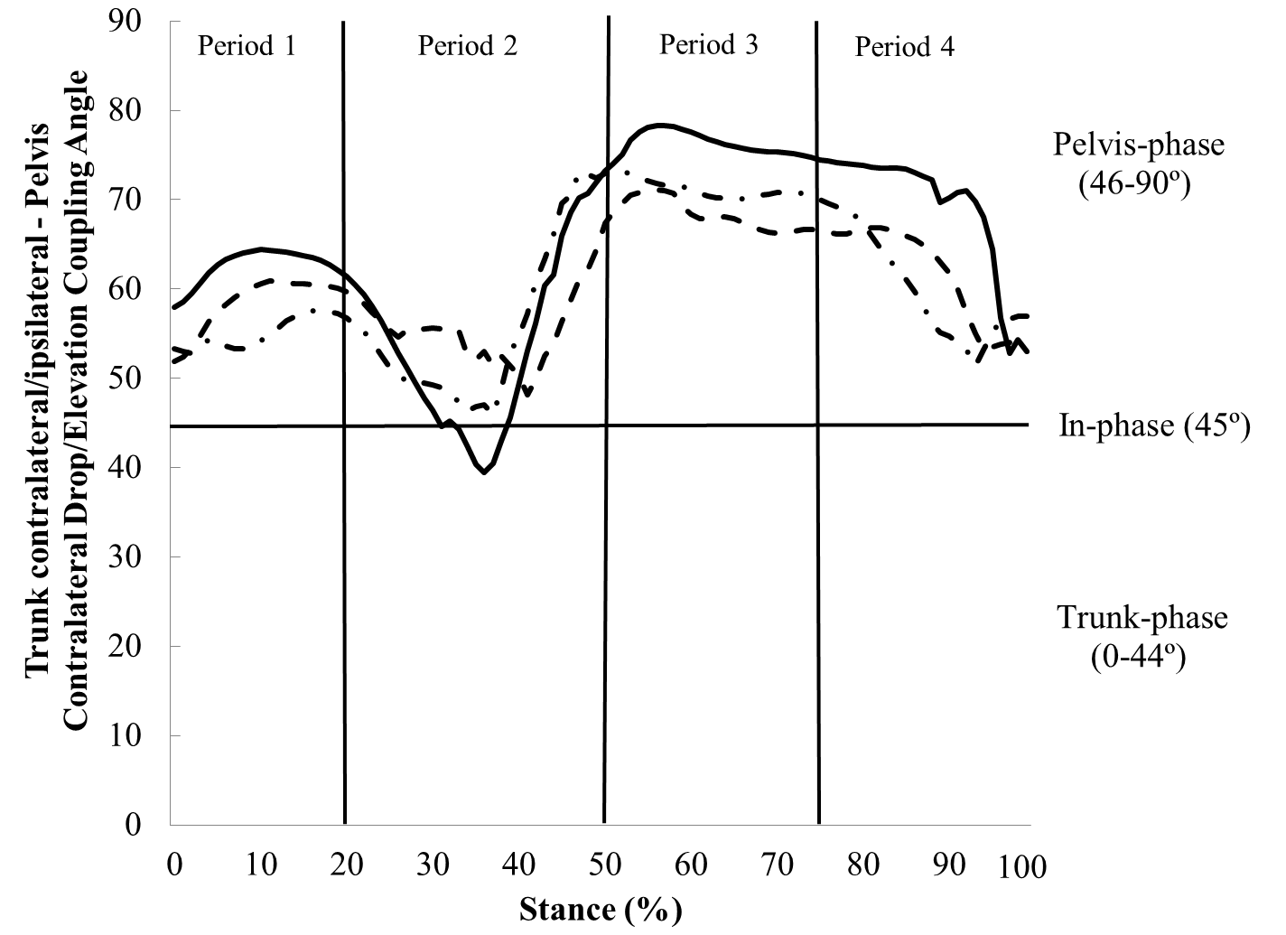
Figure 3-1. Ensemble curves of trunk contralateral/ipsilateral flexion– pelvis contralateral drop/elevation coupling angle in runners with current iliotibial band syndrome (ITBS) (dashed line), previous ITBS (dashdot line), and controls (solid line) during overground running. The stance phase was divided into 4 periods.

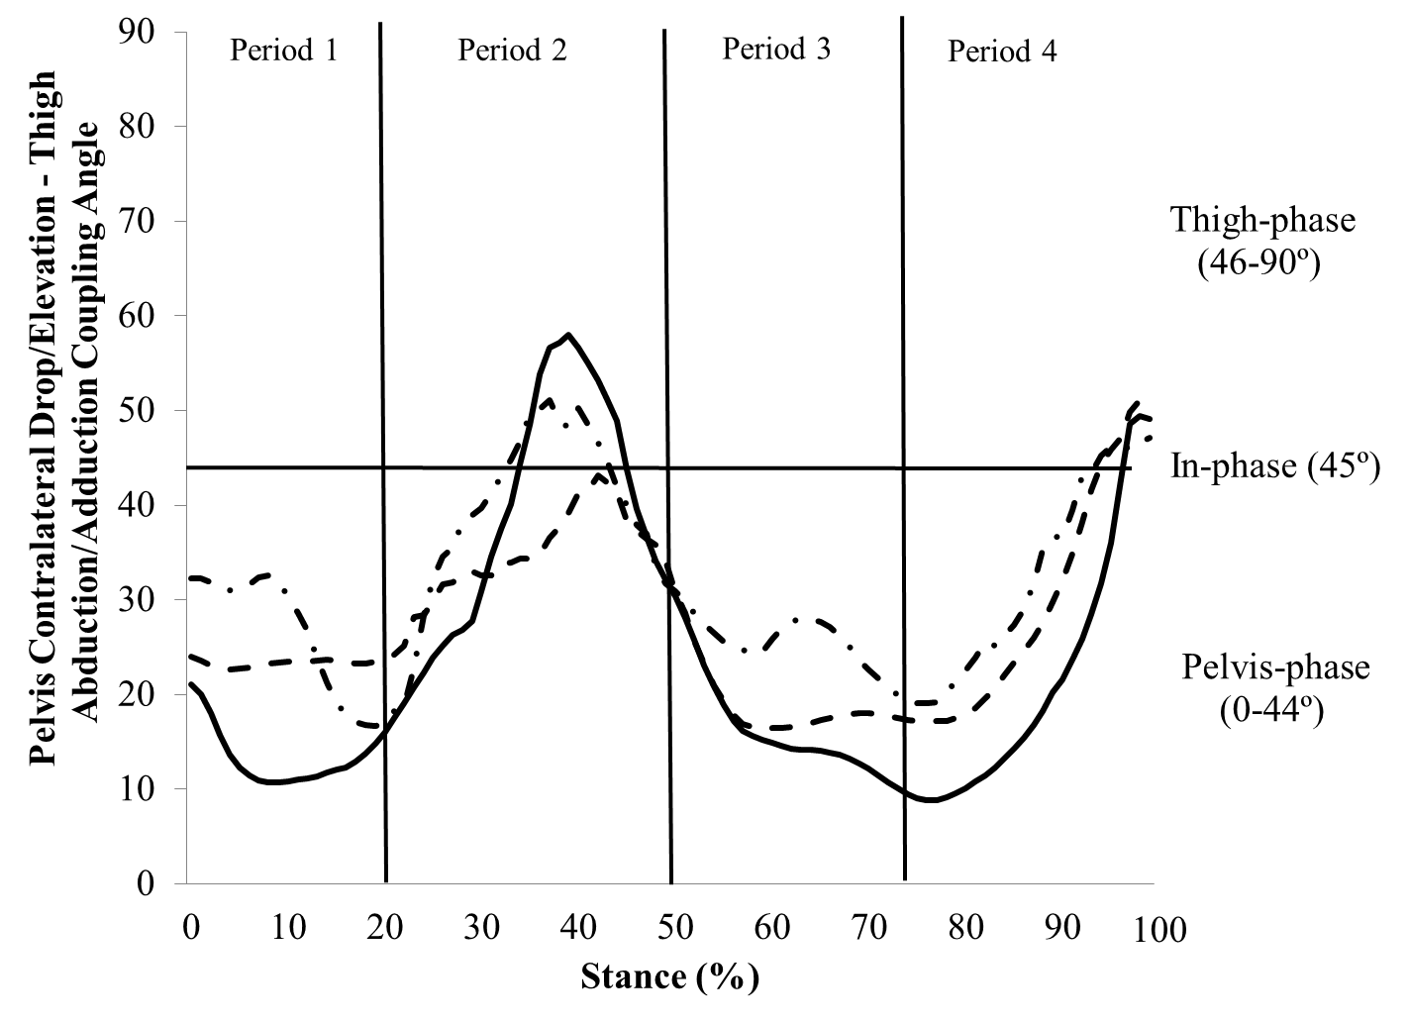
Figure 3-2. Ensemble curves of pelvis contralateral drop/elevation – thigh abduction/adduction coupling angle in runners with current iliotibial band syndrome (ITBS) (dashed line), previous ITBS (dashdot line), and controls (solid line) during overground running. The stance phase was divided into 4 periods.

References
[1] Taunton JE, Ryan MB, Clement DB, McKenzie DC, Lloyd-Smith DR, Zumbo BD. A retrospective case-control analysis of 2002 running injuries. British Journal of Sports Medicine 2002;36(2):95-101.
[2] Ferber R, Noehren B, Hamill J, Davis IS. Competitive female runners with a history of iliotibial band syndrome demonstrate atypical hip and knee kinematics. Journal of Orthopaedic and Sports Physical Therapy 2010;40(2):52-8.
[3] Grau S, Krauss I, Maiwald C, Axmann D, Horstmann T, Best R. Kinematic classification of iliotibial band syndrome in runners. Scandanavian Journal of Medicine & Science in Sports 2011;21(2):184-9.
[4] Miller RH, Lowry JL, Meardon SA, Gillette JC. Lower extremity mechanics of iliotibial band syndrome during an exhaustive run. Gait and Posture 2007;26(3):407-13.
[5] Noehren B, Davis I, Hamill J. ASB clinical biomechanics award winner 2006 prospective study of the biomechanical factors associated with iliotibial band syndrome. Clinical Biomechanics 2007;22(9):951-6.
[6] Hamill J, van Emmerik RE, Heiderscheit BC, Li L. A dynamical systems approach to lower extremity running injuries. Clinical Biomechanics 1999;14(5):297-308.
[7] Miller RH, Meardon SA, Derrick TR, Gillette JC. Continuous relative phase variability during an exhaustive run in runners with a history of iliotibial band syndrome. Journal of Applied Biomechanics 2008;24(3):262-70.
[8] Heiderscheit BC, Hamill J, Van Emmerik REA. Variability of stride characterisitics and joint coordination among individuals with unilateral patellofemoral pain. Journal of Applied Biomechanics 2002;18(2):110-21.
[9] Hein T, Schmeltzpfenning T, Krauss I, Maiwald C, Horstmann T, Grau S. Using the variability of continuous relative phase as a measure to discriminate between healthy and injured runners. Human Movement Science 2012;31(3):683-94.
[10] Diedrich FJ, Warren WH, Jr. Why change gaits? Dynamics of the walk-run transition. Journal of Experimental Psychology: Human Perception and Performance 1995;21(1):183-202.
[11] Heiderscheit BC, Hamill J, Van Emmerik REA. Variability of stride characterisitics and joint coordination among individuals with unilateral patellofemoral pain. Journal of Applied Biomechanics 2002;18(110-21.
[12] Field-Fote EC, Tepavac D. Improved intralimb coordination in people with incomplete spinal cord injury following training with body weight support and electrical stimulation. Physical Therapy 2002;82(7):707-15.
[13] Fredericson M, Cookingham CL, Chaudhari AM, Dowdell BC, Oestreicher N, Sahrmann SA. Hip abductor weakness in distance runners with iliotibial band syndrome. Clinical Journal of Sports Medicine 2000;10(3):169-75.
[14] Powers CM. The influence of abnormal hip mechanics on knee injury: a biomechanical perspective. Journal of Orthopaedic and Sports Physical Therapy 2010;40(2):42-51.
[15] Noehren B, Pohl MB, Sanchez Z, Cunningham T, Lattermann C. Proximal and distal kinematics in female runners with patellofemoral pain. Clinical Biomechanics 2012;27(4):366-71.
[16] Thomas S, Reading J, Shepard RJ. Revision of the Physical Activity Readiness Questionnaire (PAR-Q). Canadian Journal of Sport Sciences 1992;17(4):338-49.
[17] Barnes A, Wheat J, Milner CE. Use of gait sandals for measuring rearfoot and shank motion during running. Gait and Posture 2010;32(1):133-5.
[18] McIlroy WE, Maki BE. Preferred placement of the feet during quiet stance: development of a standardized foot placement for balance testing. Clinical Biomechanics 1997;12(1):66-70.
[19] Cappozzo A, Cappello A, Della Croce U, Pensalfini F. Surface-marker cluster design criteria for 3-D bone movement reconstruction. IEEE Transactions on Biomedical Engineering 1997;44(12):1165-74.
[20] Manal K, McClay I, Stanhope S, Richards J, Galinat B. Comparison of surface mounted markers and attachment methods in estimating tibial rotations during walking: an in vivo study. Gait and Posture 2000;11(1):38-45.
[21] Bisseling RW, Hof AL. Handling of impact forces in inverse dynamics. Journal of Biomechanics 2006;39(13):2438-44.
[22] Wu G, Cavanagh PR. ISB recommendations for standardization in the reporting of kinematic data. Journal of Biomechanics 1995;28(10):1257-61.
[23] Dierks TA, Davis I. Discrete and continuous joint coupling relationships in uninjured recreational runners. Clinical Biomechanics 2007;22(5):581-91.
[24] Ferber R, Davis IM, Williams DS, 3rd. Effect of foot orthotics on rearfoot and tibia joint coupling patterns and variability. Journal of Biomechanics 2005;38(3):477-83.
[25] Chang R, Van Emmerik R, Hamill J. Quantifying rearfoot-forefoot coordination in human walking. Journal of Biomechanics 2008;41(14):3101-5.

CHAPTER VI

Exploring the Influence of Iliotibial Band Syndrome on Running Biomechanics via Principal Components Analysis

Abstract
Iliotibial band syndrome (ITBS) is a common knee overuse injury among runners. Atypical discrete trunk and lower-extremity biomechanics during running may be associated with the etiology of ITBS. Examining discrete data points limits the interpretation of a waveform to a single value. Characterizing entire kinematic and kinetic waveforms may provide additional insight to biomechanical factors associated with ITBS. Therefore, the purpose of this cross-sectional investigation was to determine whether ITBS injury status in female runners resulted in differences in kinematics and kinetics compared to controls using a principal components analysis (PCA) approach. Twenty-seven participants comprised three groups: current ITBS, previous ITBS, and controls. Principal component scores were retained for the first three principal components and were analyzed using one-way multivariate analysis of variance (MANOVA). The Q-statistic was calculated to determine if the retained principal components adequately reconstructed the waveforms for each participant. The retained principal components accounted for 94%-99% of the total variance within each waveform. No differences in the retained principal component scores for any of the waveforms were observed among groups. The Q-statistic indicated frontal plane trunk angle and knee moment, as well as transverse plane knee angle waveforms were adequately reconstructed in the majority (74%-96%) of participants. However, pelvis and hip angle waveforms were not adequately reconstructed (3%-11%) despite retaining 94% and 96% of the waveforms’ variance. This finding suggests a more complex movement pattern exists within pelvis and hip motion during running that cannot be explained in the first three principal components.

Introduction
Iliotibial band syndrome (ITBS) is a common knee overuse injury afflicting approximately 8% of runners annually (Taunton et al., 2002). It has been postulated that ITBS results from repetitive friction of the iliotibial band sliding over the lateral femoral epicondyle during knee flexion and extension (Noble, 1980; Orchard et al., 1996; Renne, 1975). Based on a previous anatomical investigation, the notion of ITBS being a friction syndrome has been challenged (Fairclough et al., 2006; Fairclough et al., 2007). Instead of limiting sagittal plane knee motion, the iliotibial band serves to stabilize the lateral hip and knee, as well as resist hip adduction and knee internal rotation (Fredericson et al., 2000). Therefore, secondary plane hip and knee biomechanics must be examined to determine differences in running pattern between runners with and without ITBS. Identifying biomechanical factors associated with the etiology of ITBS is crucial in order for the eventual design of effective rehabilitation interventions.
Three-dimensional kinematic and kinetic gait analysis is a robust method to quantitatively analyze running biomechanics. Previous studies have compared secondary plane peak hip and knee angles between runners of varying ITBS injury status via discrete analyses. (Ferber et al., 2010; Grau et al., 2011; Miller et al., 2007; Noehren et al., 2007). Runners who later develop ITBS and with previous ITBS exhibit increased hip adduction and knee internal rotation angles compared to controls (Ferber et al., 2010; Noehren et al., 2007). However, hip adduction was also found to be similar between runners with current ITBS and controls (Miller et al., 2007). Furthermore, runners with current ITBS exhibit smaller hip adduction angles compared to controls (Grau et al., 2011). Knee internal rotation has not been reported in runners with current ITBS. To date, no study has examined hip and knee joint angles among runners with current ITBS, previous ITBS, and controls.
In addition to lower-extremity joint biomechanics association with ITBS, it has been postulated that pelvis and trunk motion away from the stance limb would increase the internal knee abduction moment. An increase in peak knee abduction moment may increase the tensile strain experienced by soft tissue crossing the lateral knee joint such as the iliotibial band. (Powers, 2010) The aforementioned frontal plane variables have not been reported in runners with current ITBS or previous ITBS.
A discrete analysis is not sensitive to differences in the underlying movement pattern within a biomechanical waveform. Potentially, a more comprehensive analysis of biomechanical waveforms would be able to characterize differences during running among runners with different ITBS injury status. Thus, a principal component analysis (PCA) which captures the time-varying movement pattern of a waveform may potentially provide deeper understanding of injury risk factors (Kipp et al., 2011). Previous research has shown that a discrete analysis was not able to discriminate between workers who develop low back pain and those who did not (Wrigley et al., 2005). Yet, variables derived from a principal component analysis (PCA) were able to identify differences in kinematic and kinetic lifting technique before low back pain developed (Wrigley et al., 2005). Additionally, PCA was able to detect differences in knee biomechanics during a run and cut task between genders that a discrete analysis did not (O'Connor and Bottum, 2009). The results of these studies support the argument that a PCA may provide a more sensitive analysis than a discrete analysis allowing for a better understanding of running biomechanics associated with ITBS. Therefore, the purpose of this cross-sectional investigation was to determine whether ITBS injury status in female runners resulted in differences in kinematics and kinetics compared to controls using a PCA approach.

Methods

2.1. Participant Details

Approval for all procedures was granted by the Institutional Review Board. Twenty-seven female runners between the ages of 18 and 45 provided informed written consent prior to participating. Participants were excluded if they answered ‘yes’ to any question on a Physical Activity Readiness – Questionnaire (Thomas et al., 1992) or previously sustained a major lower-extremity injury. A running history questionnaire was then completed by each participant. Based on the results of the running questionnaire, participants were divided into three groups. Twenty-seven participants were equally divided into three groups: current ITBS, previous ITBS, and controls (Table 4-1). All participants had to meet a minimum weekly mileage criterion. Runners with current ITBS were running a minimum of 10 km∙wk⁻¹ (Noehren et al., 2012). Runners with previous ITBS but were pain running free for at least one month prior to data collection were running a minimum of 24 km∙wk⁻¹. Runners with no history of any knee injury and running a minimum of 24 km∙wk⁻¹ comprised the control group. Runners with current ITBS and previous ITBS reported that they had been diagnosed by a health care professional (medical doctor, physical therapist, or athletic trainer). Lastly, runners with current ITBS reported the level of lateral knee pain at the end of their past seven runs on a 100 mm visual analog scale (47 ± 19 mm).
2.2. Data Collection
Participants wore running shorts and a tank-top, as well as neutral laboratory footwear (Bite Footwear, Redmond, WA, USA) for the overground running trials (Barnes et al., 2010). Passive reflective markers were placed on the right lower-extremity for controls. Data were collected on the currently or previously injured lower-extremity in the ITBS groups. If both sides were currently or previously injured, then data from the right side were collected. Joint coordinate systems were defined by placing passive reflective markers over anatomical landmarks on the lower-extremity of interest and trunk. The anatomical landmarks were: acromion processes, iliac crests, greater trochanters, lateral and medial femoral epicondyles, lateral and medial malleolli, and first and fifth metatarsal heads. Molded thermoplastic shells with four non-collinear markers were positioned over the posterior pelvis and postero-laterally on the proximal thigh and distal shank (Cappozzo et al., 1997). The shells on the thigh and shank were secured to the segment via neoprene wraps and hook and loop tape (Manal et al., 2000). Rear-foot motion was indicated by placement of three non-collinear markers directly on the heel. Markers were placed on the manubrium, sternal body, seventh cervical vertebra, and tenth thoracic vertebra to indicate trunk motion. A static calibration trial was recorded with participants standing on a foot placement template (McIlroy and Maki, 1997). After the calibration trial was recorded, all anatomical markers were removed.
Overground running trials were collected while participants ran along a 17 m runway at a velocity of 3.5 ± 0.18 m∙s⁻¹. A nine-camera motion capture system (Vicon, Oxford Metrics, Centennial, CO, USA) sampling at 120 Hz recorded marker trajectories. a force plate located in the middle of the runway was Synchronized with the motion capture system (AMTI, Inc., Watertwon, MA, USA) and sampled at 1200 Hz. To monitor running velocity, two photocells linked to a timer were placed three meters apart on either side of the force plate. Five acceptable trials were collected, in which participants maintained the specified running velocity and landed on the force plate without altering their stride.
2.3. Data Reduction
A residual analysis using marker trajectories of pilot overground running data was implemented to determine a filter cut-off frequency that retained 95% of the signal (LabVIEW, National Instruments, Austin, TX, USA) (Winter, 2009). Data were reduced in Visual3D (C-Motion, Rockville, MD, USA). Kinematics and ground reaction forces were filtered with a 4th order Butterworth filter at a cut-off frequency of 8 Hz. Filtering kinematic and kinetic data with the same cut-off frequency ensures segment accelerations will correspond with the ground reaction forces (Bisseling and Hof, 2006). Joints angles were determined using a six degree of freedom approach with a Cardan X-y-z (medio-lateral, antero-posterior, vertical) rotation sequence (Wu and Cavanagh, 1995). Pelvis and trunk segments were computed with respect to the laboratory coordinate system. Segment inertial parameters were computed for each participant based on measured anthropometrics and regression equations (de Leva, 1996). Inverse dynamics were computed using a standard Newton-Euler approach. Moments were expressed as internal moments and were normalized to body mass and height (O'Connor and Bottum, 2009). A vertical ground reaction force threshold of 20 N was used to determine the onset and end of stance. The five waveforms of interest were: frontal plane trunk, pelvis, and hip angles and frontal plane knee moment, as well as transverse plane knee angle.
2.4. Principal Components Analysis
Stance phase of the overground running trials was time normalized to 101 points. The angle and moment data for each participant were ensemble averaged. For each of the five angle and moment waveforms of interest, a data matrix was created. The 101 data points comprised the columns and 27 participants comprised the rows of each waveform data matrix ($X_{27×101})$. The PCA approach used in the current investigation was based on a previously described methodology (Wrigley et al., 2006). The mean was computed for each column of the respective matrix. Then, the column mean was subtracted from each row (participant). The mean centered matrices were transformed into principal components using an eigenvector decomposition method on the input’s covariance matrix $(C_{101×101})$. The PCA produced the eigenvectors ($V_{101×101})$ and eigenvalues ($L_{1×101})$. The eigenvector matrix consisted of the coefficients for each of the 101 principal components which defined a new coordinate space for the original waveform data (Wrigley et al., 2006). The eigenvalue matrix indicated the relative contribution each principal component had on the total variance in the data. For each matrix, the first three principal components explain the majority of the variance of the waveform and were analyzed further. Principal component score matrices ($Z_{27×101})$ were then computed by multiplying the mean-centered input matrix by the transpose of the eigenvector matrix:
$$Z_{27×101}=(X_{27 ×101}-\left(1_{27 ×1}×{\overline{x}}_{1 ×101}\right))×{V^{'}}_{101 ×101} (1)$$
where ${\overline{x}}_{1 ×101}$ is each time normalized data point. The principal component scores represented how closely a runner’s waveform matched the shape of its respective principal component (Robbins et al., 2013).
To determine if the retained principal components adequately represented the original data, a residual analysis was performed using the Q-statistic (Jackson, 1991). The Q-statistic is the sum of the squares of the residuals between participants’ original waveform and the reconstructed curve based on the retained principal component (Wrigley et al., 2006). A Q-critical value (Q_{α}) was calculated using an alpha level of 0.05 from a t-distribution (Wrigley et al., 2006). Q-critical indicated if the number of retained components adequately reconstructed the original data (Jackson, 1991). For each participant, a Q-statistic value lower than Q_{α} indicated that the original data were adequately represented by the retained principal components (Jackson, 1991).
To interpret how the retained principal components contributed to movement variability, percent variance explained ($r_{ji}^{2}$ ) was computed for the ith principal component and the jth time point:
$r_{ji}^{2}= \frac{V_{ji}\sqrt{L_{i}}}{c_{j}} ×100\%$ (2)
where c_{j} is the standard deviation of C at a given data point of the waveform (Wrigley et al., 2006). Differences in timing and magnitudes of the relative contribution of a principal component can be visually observed of the percent variance explained figures. Each principal component can explain one of three unique sources of variance of the waveform. Principal components explain differences in overall magnitude of waveform, relative magnitudes of waveform peaks, and differences in timing (O'Connor and Bottum, 2009; Wrigley et al., 2006). Furthermore, the first principal component explains differences in overall amplitude of waveforms among groups (Robbins et al., 2013). Temporal and magnitude differences among principal components within each segment and joint waveform are described to provide a detailed characterization of the retained principal components. Waveform matrix construction and all PCA calculations were performed using custom software (MATLAB, MathWorks, Natick, MA, USA).
2.5. Statistical Analysis
To assess group differences, principal component scores of the retained components for each waveform were analyzed among groups using a one-way multivariate analysis of variance (MANOVA) (Wrigley et al., 2006). Group was the independent variable. When the MANOVA revealed a significant multivariate effect, a one-way ANOVA was performed for each period of stance. Post hoc Fisher’s least significant difference (LSD) test was used where a main effect was found, to determine differences among groups. The waveforms analyzed were: frontal plane trunk, pelvis, and hip angles, knee moment, as well as transverse plane knee angle. Statistical analysis was performed using PASW 20.0 (IBM SPSS Statistics Inc., Chicago, IL, USA). An alpha value of 0.05 was set for all tests.

Results
The first three principal components accounted for 94.4% - 99.3% of the total variance in the five biomechanical waveforms of interest (Table 4-2). All waveforms were reconstructed using the scores and coefficients of the first three principal components. The Q-statistic indicated that 3.7%-99.3% of participants’ ensemble angle waveforms were sufficiently described by the retained principal components. Frontal plane trunk angle and knee moment, as well as transverse plane knee angle were adequately described in the majority of participants. However, frontal plane pelvis and hip angles were not adequately reconstructed by the retained principal components. Therefore, secondary plane hip and pelvis angles are sensitive to the variation in waveforms among runners that is contained in 3% - 4% of the unexplained variance of the retained principal components.
Retained principal component scores for each waveform were analyzed using one-way MANOVA, among groups design. The analysis failed to reveal a significant multivariate effect for frontal plane trunk angle principal component scores (Wilks’ lambda = 0.664, F (6, 44) = 1.668; P = 0.152) (Table 4-3; Fig. 4-1). Principal component one captured the variation of peak trunk ipsilateral flexion that occurs near mid-stance of running. Whereas principal components two and three explained the variance of the minimum trunk angles during early (<20%) and late (>80%) stance.
The MANOVA failed to reveal a significant multivariate effect for frontal plane pelvis angle principal component scores (Wilks’ lambda = 0.736, F (6, 44) = 1.212; P = 0.318) (Fig. 4-2). Principal component one captured the variance explained from approximately 30%-70% of the stance phase of running. From heel-strike to near mid-stance, the contralateral pelvis drops until it reaches a minimum value and then begins to elevate. Principal components two and three explained the variance while the pelvis assumed a more neutral position during early and late stance. Additionally, during late stance (>80%), principal component three captured the variance of the pelvis in an elevated position.
The MANOVA failed to reveal a significant multivariate effect for frontal plane hip angle principal component scores (Wilks’ lambda = 0.728, F (6, 44) = 1.260; P = 0.295) (Fig. 4-3). Principal component one captured the variance of peak hip adduction. While the hip joint was abducting during approximately 60%-80% of stance, principal component two accounted for this mode of variance. Lastly, principal component three accounted for changes in directions of hip joint motion. Near mid-stance as the hip motion changes from adduction to abduction, the variance explained by principal component three increases. Additionally, as the rate of hip abduction decreases near toe-off, again the variance explained by principal component three increases.
The MANOVA failed to reveal a significant multivariate effect for frontal plane knee moment principal component scores (Wilks’ lambda = 0.659, F (6, 44) = 1.701; P = 0.143) (Fig. 4-4).Principal component one captured the variance of the overall magnitude of the peak knee abduction moment which occurs near mid-stance. Principal component two appears to have an inverse relationship with the relative timing of principal component three. Specifically, during the first 10% of stance, the variance explained by principal component two decreases. Conversely, the variance explained by principal component three accounts for a majority of the variance of the three retained components. Additionally during the first 10% of stance, the slope of the knee abduction moment is negative and decreases sharply which is explained by principal component three. However, near late stance, the variance explained by principal component two increases. This corresponds with a positive and more gradual slope of the frontal plane knee moment curve.
The MANOVA failed to reveal a significant multivariate effect for transverse plane knee angle principal component scores (Wilks’ lambda = 0.937, F (6, 44) = 0.242; P = 0.960) (Fig. 4-5).Principal component one explained the majority of the overall magnitude of the variance of transverse plane knee rotation, in particular when the knee was internally rotated. Principal component two explained the variance of steep positive slope while the knee exhibited knee internal rotation during early stance (<20%). Principal component three contributed to the variance as the knee transitioned from externally rotating to internally during the last 10% of stance.

Discussion
PCA is a powerful tool that can be used to reduce the number of variables within a waveform to just three to explain joint and segment motion patterns during running. Therefore, the purpose of this study was to determine if using a PCA approach can detect differences in trunk and lower-extremity waveforms during running among women with current ITBS, previous ITBS, and controls. The waveforms used for input in their respective PCA were biomechanical factors associated with ITBS as indicated by discrete analyses and a previous author’s hypothesis. Lower-extremity and trunk retained principal component scores were similar among runners with current ITBS, previous ITBS, and controls.
Recently, PCA has been implemented to gain greater insight on potential biomechanical factors associated with lower-extremity injury and pathology (Astephen et al., 2008; Kipp et al., 2011; O'Connor and Bottum, 2009). A PCA approach applied to investigating ITBS may explain why conflicting results exist regarding discrete factors associated with ITBS (Ferber et al., 2010; Grau et al., 2011; Miller et al., 2007; Noehren et al., 2007). Frontal plane trunk and knee moment, as well as transverse plane knee angle waveforms were similar among runners with current ITBS, previous ITBS, and controls. The trunk and knee angle waveforms reconstructed using the retained principal components replicated the waveforms reported previously in the literature (Ferber et al., 2010; Noehren et al., 2007; Noehren et al., 2012). Frontal plane knee moment during running has not been depicted elsewhere. The first three principal components accounted for the majority of the frontal plane trunk and knee moment, as well as transverse plane knee angle variance (94.3%-99.3%). The Q-statistic was computed for each waveform to determine how well the retained components reconstructed the waveform for each participant (O'Connor and Bottum, 2009; Robbins et al., 2013). Determining the Q-statistic is similar to performing a residual analysis to determine filter cut-off frequencies for kinematic and kinetic data (O'Connor and Bottum, 2009). Selecting too low of a cut-off frequency is comparable to retaining too few principal components. In the current study, trunk and knee waveforms were adequately reconstructed in the majority of participants (74.1%-96.3%). Our finding that the underlying pattern of the waveform was similar among groups extends to the observation that the waveform was adequately reconstructed most participants on an individual basis. This suggests that frontal plane trunk and knee, as well as transverse plane knee biomechanics are not likely candidates for risk factors associated with ITBS.
Principal component scores for the retained components in frontal plane pelvis and hip angle waveforms were similar among runners with current ITBS, previous ITBS, and controls. Indeed, the majority of the variance was retained for pelvis and hip angle waveforms by the first three principal components (96.3%-97.5%). However, the three retained components could not adequately reconstruct participants’ individual waveforms (3.7%-11.1%). Retaining an inadequate number of principal components to reconstruct frontal plane pelvis and hip waveforms should not affect the functional interpretation of their retained components. The variance explained by the retained components is present in the pelvis and hip angle waveforms regardless if the original waveform can be adequately constructed for each participant (O'Connor and Bottum, 2009). This indicates that for pelvis and hip motion there is a more complex structure to the movement pattern that cannot be accounted for by the retained principal components. Furthermore, this may help explain why there are conflicting findings implicating hip adduction angle as a biomechanical risk factor associated with ITBS.
In conclusion, no differences were observed in the retained principal components in trunk and lower-extremity waveforms thought to be associated with ITBS among groups. However, the potential to use PCA to determine underlying movement patterns during running is exciting. The Q-statistic indicated frontal plane trunk angle and knee moment, as well as transverse plane knee angle waveforms were adequately reconstructed in the majority of participants. However, pelvis and hip angle waveforms were not adequately reconstructed despite retaining 94% and 96% of the waveforms’ variance. This finding suggests a more complex movement pattern exists within pelvis and hip motion during running that cannot be explained in the first three principal components.

Table 4-1. Mean (standard deviation) of participant demographics in the current iliotibial band syndrome (ITBS), previous ITBS, and control groups.
 | Current ITBS | Previous ITBS | Controls
Age (years) | 26.2 (7.9) | 24.3 (4.7) | 25.1 (7.2)
Height (m) | 1.64 (0.04) | 1.68 (0.04) | 1.70 (0.05)
Mass (kg) | 53.3 (3.7) | 61.7 (9.9) | 57.2 (6.2)
Weekly distance run (km∙wk⁻¹) | 34.8 (23.5) | 42.8 (24.5) | 43.8 (21.9)

Table 4-2. The first three principal components (PC) and Q-critical (Q_{α}) for the angle and moment waveforms during the stance phase of overground running.
 | PC (%)
Waveforms | PC1 | PC2 | PC3 | Total | < Q_{α} (%)
Frontal plane trunk angle | 65.9 | 29.0 | 4.4 | 99.3 | 96.3
Frontal plane pelvis angle | 74.3 | 16.7 | 6.5 | 97.5 | 11.1
Frontal plane hip angle | 59.7 | 29.3 | 7.3 | 96.3 | 3.7
Frontal plane knee moment | 85.4 | 4.9 | 4.1 | 94.4 | 74.1
Transverse plane knee angle | 83.8 | 8.9 | 4.9 | 97.6 | 77.8

Table 4-3. The mean (standard deviation) for the principal component (PC) scores of the three retained PCs for each waveform of interest during overground running in runners with current iliotibial band syndrome (ITBS), previous ITBS, and controls. The P value indicates the main effect.
Waveforms | Retained  PC | Current ITBS | Previous ITBS | Controls | P value
Frontal plane trunk angle | PC1 | 8.2 (11.8) | -3.4 (10.8) | -4.8 (11.8) | 0.152
Frontal plane trunk angle | PC2 | 2.5 (10.4) | -2.7 (7.8) | 0.3 (6.3)
Frontal plane trunk angle | PC3 | -0.7 (2.7) | 1.1 (3.4) | -0.4 (3.6)
Frontal plane pelvis angle | PC1 | -9.3 (20.5) | 9.9 (25.6) | -0.6 (14.6) | 0.318
Frontal plane pelvis angle | PC2 | 0.1 (9.1) | -1.7 (13.1) | 1.6 (8.7)
Frontal plane pelvis angle | PC3 | -1.8 (7.1) | 1.3 (5.0) | -3.1 (6.2)
Frontal plane hip angle | PC1 | -7.1 (23.7) | 15.1 (23.2) | -7.9 (15.6) | 0.295
Frontal plane hip angle | PC2 | -0.2 (21.2) | -0.8 (13.4) | 0.9 (15.0)
Frontal plane hip angle | PC3 | 1.2 (10.7) | 1.5 (7.4) | -2.7 (5.7)
Frontal plane knee moment | PC1 | -0.5 (1.1) | -0.2 (1.6) | 0.7 (2.1) | 0.151
Frontal plane knee moment | PC2 | -0.1 (0.3) | 0.2 (0.4) | -0.1 (0.5)
Frontal plane knee moment | PC3 | -0.1 (0.5) | 0.2 (0.3) | -0.1 (0.1)
Transverse plane knee angle | PC1 | -1.6 (59.5) | -5.9 (64.9) | 7.6 (59.1) | 0.960
Transverse plane knee angle | PC2 | -2.6 (17.4) | 5.2 (22.6) | -2.5 (18.8)
Transverse plane knee angle | PC3 | 1.8 (12.9) | 0.8 (18.8) | -2.5 (11.3)

Figure 4-1 The first three principal component (PC) contributions to the frontal plane trunk angle exhibited by runners with current iliotibial band syndrome (ITBS) (dashed line), previous ITBS (dashdot line) and controls (solid line) during the stance phase of running. Additionally, the percent variance explained by PC1 (dot), PC2 (dashdot), PC3 (dashed), and overall percent variance explained by the first 3 PCs (solid) is displayed.

Figure 4-1 Continued
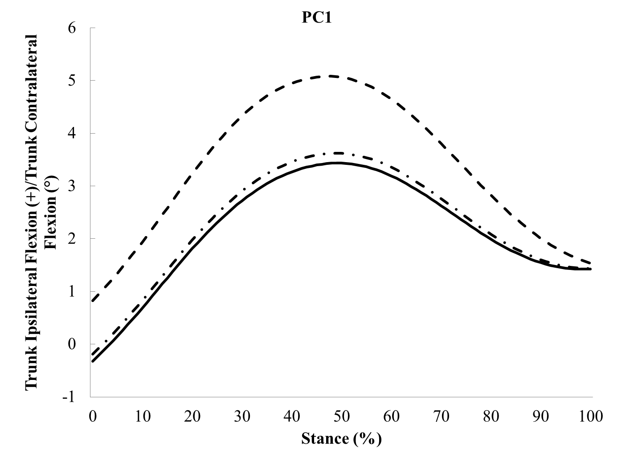

Figure 4-1
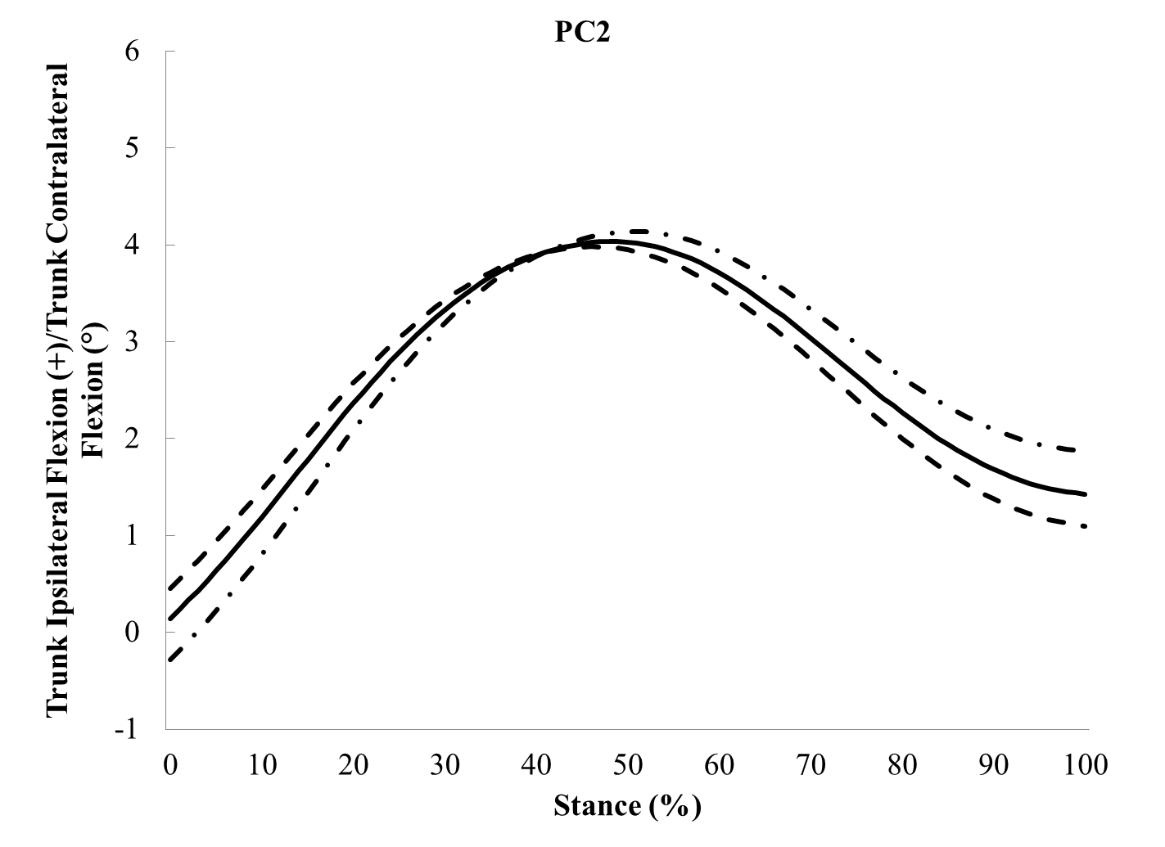

Figure 4-1
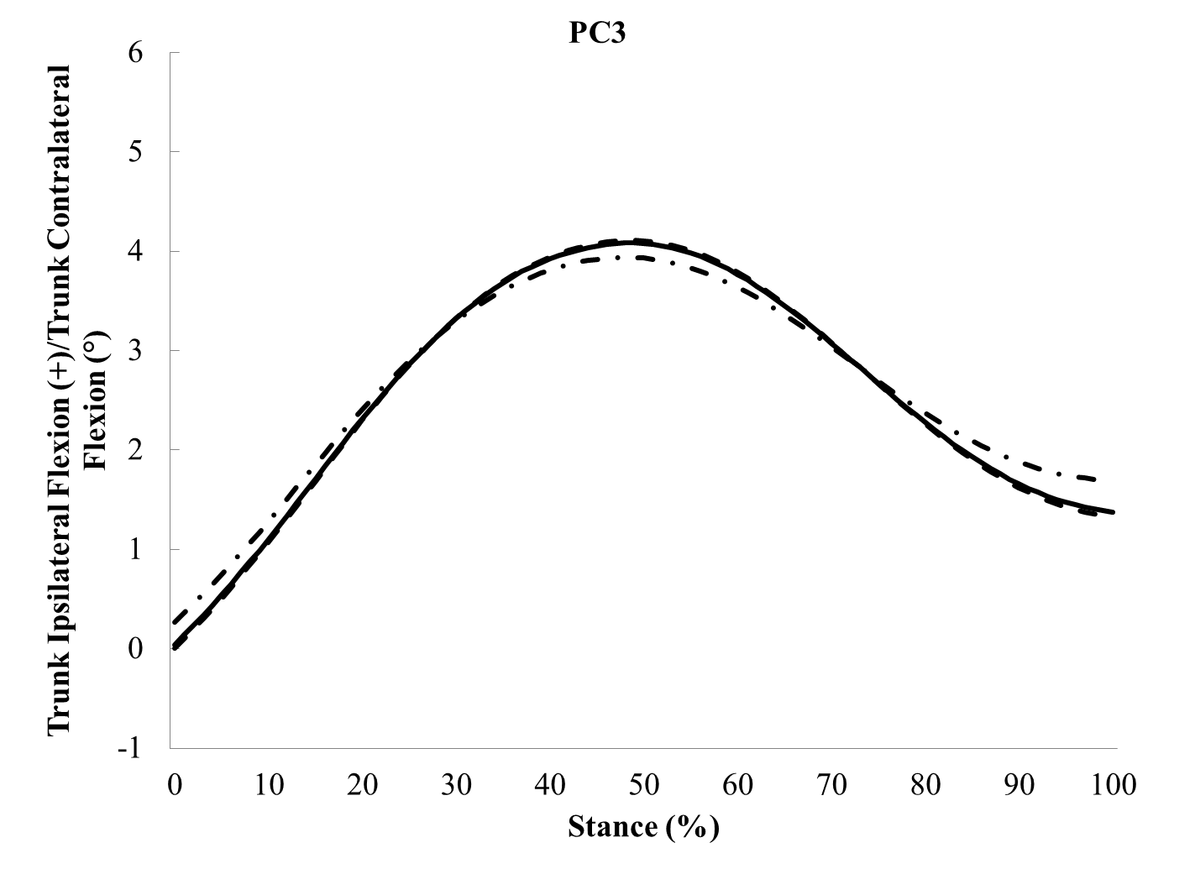

Figure 4-1
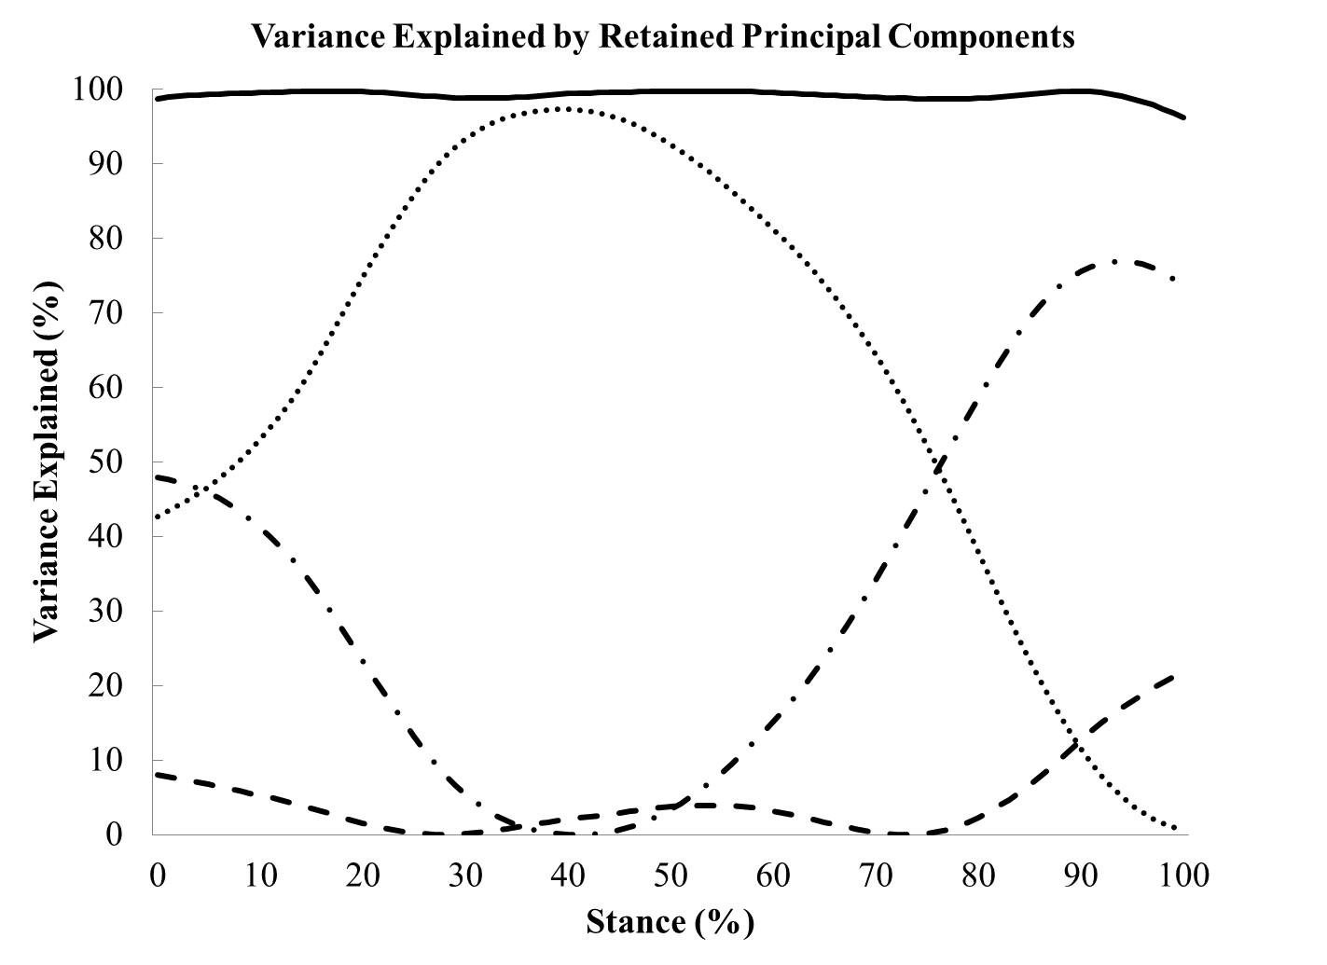

Figure 4-2. The first three principal component (PC) contributions to the frontal plane pelvis angle exhibited by runners with current iliotibial band syndrome (ITBS) (dashed line), previous ITBS (dashdot line) and controls (solid line) during the stance phase of running. Additionally, the percent variance explained by PC1 (dot), PC2 (dashdot), PC3 (dashed), and overall percent variance explained by the first 3 PCs (solid) is displayed.

Figure 4-2
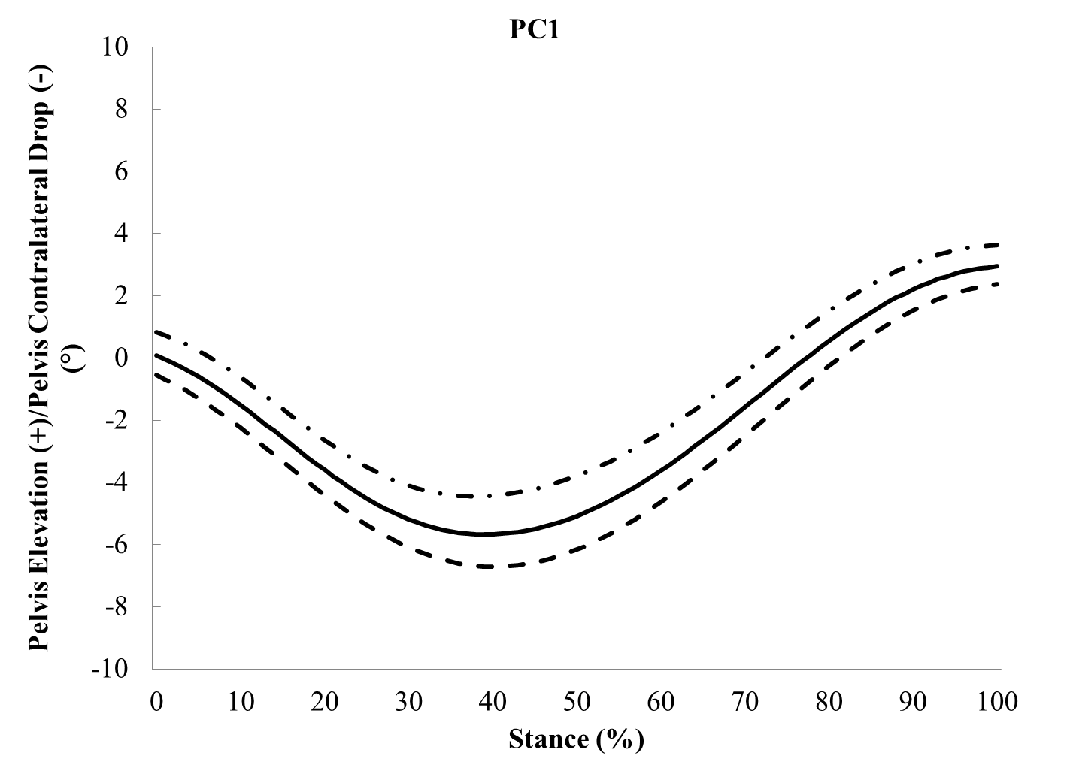

Figure 4-2
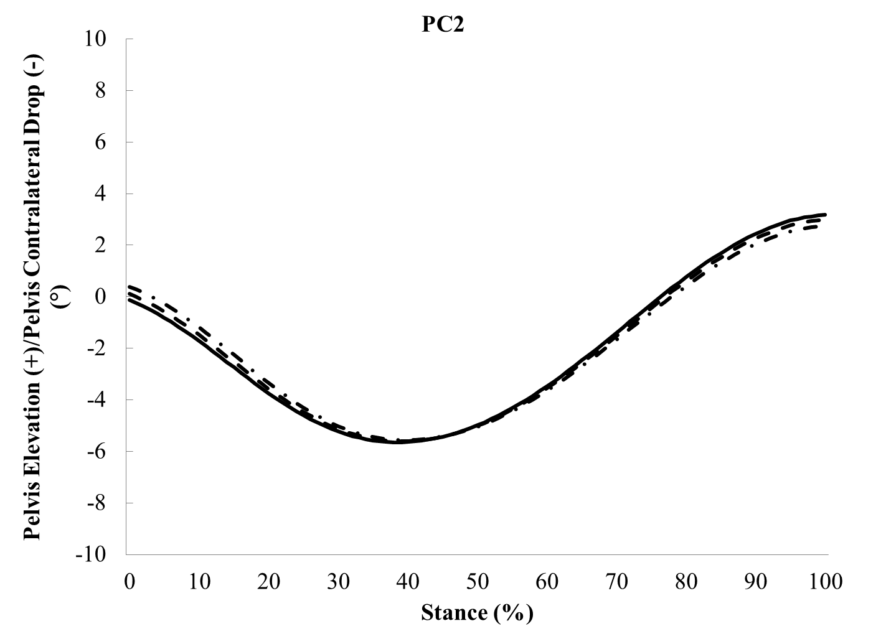

Figure 4-2
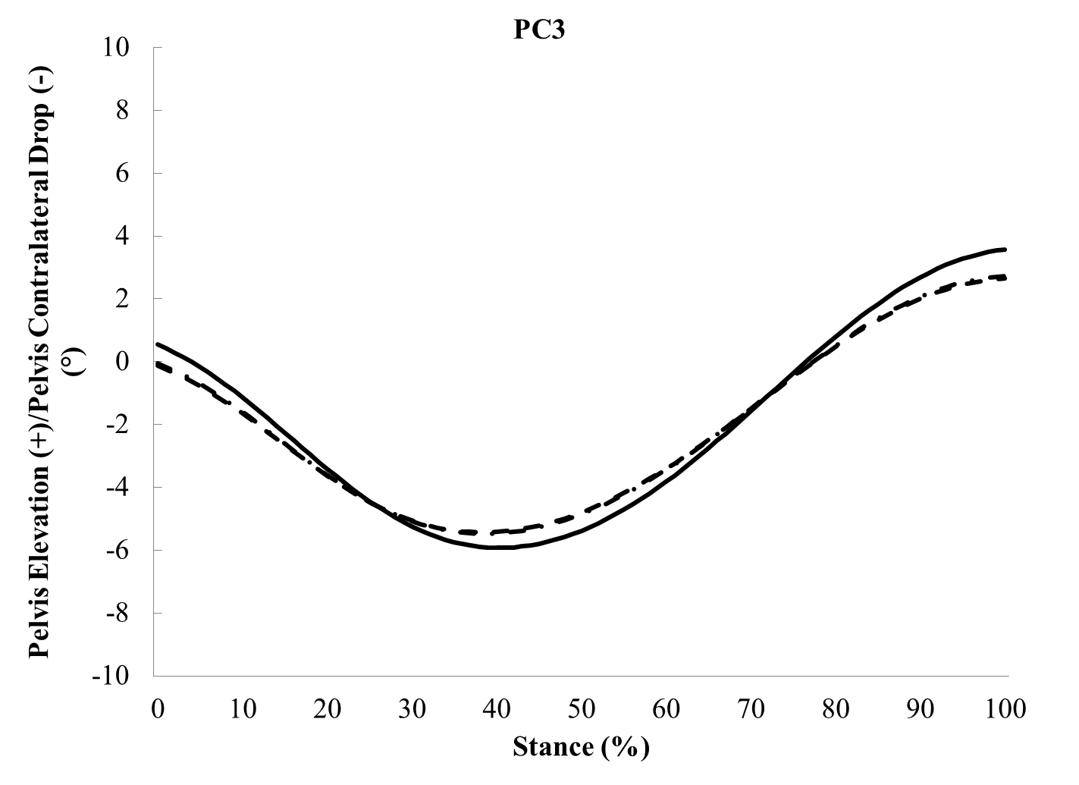

Figure 4-2
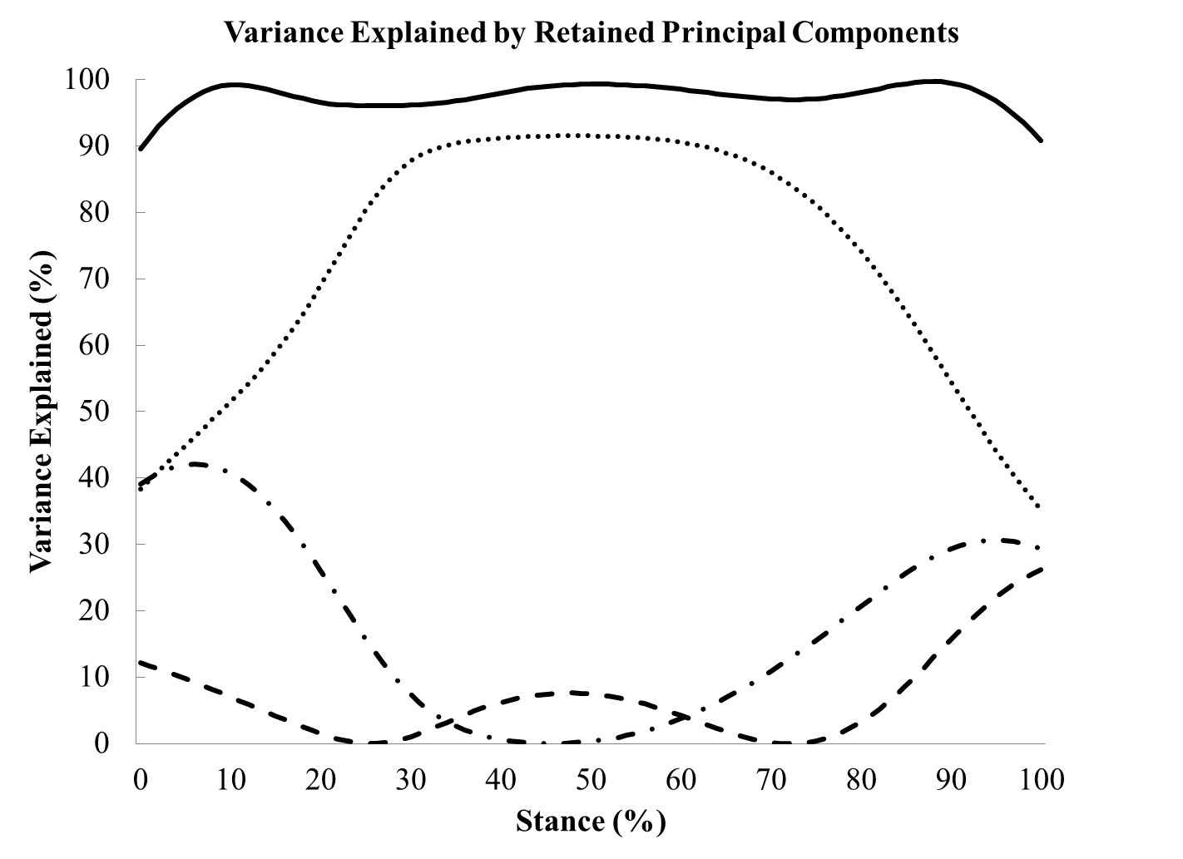

Figure 4-3. The first three principal component (PC) contributions to the frontal plane hip angle exhibited by runners with current iliotibial band syndrome (ITBS) (dashed line), previous ITBS (dashdot line) and controls (solid line) during the stance phase of running. Additionally, the percent variance explained by PC1 (dot), PC2 (dashdot), PC3 (dashed), and overall percent variance explained by the first 3 PCs (solid) is displayed.

Figure 4-3
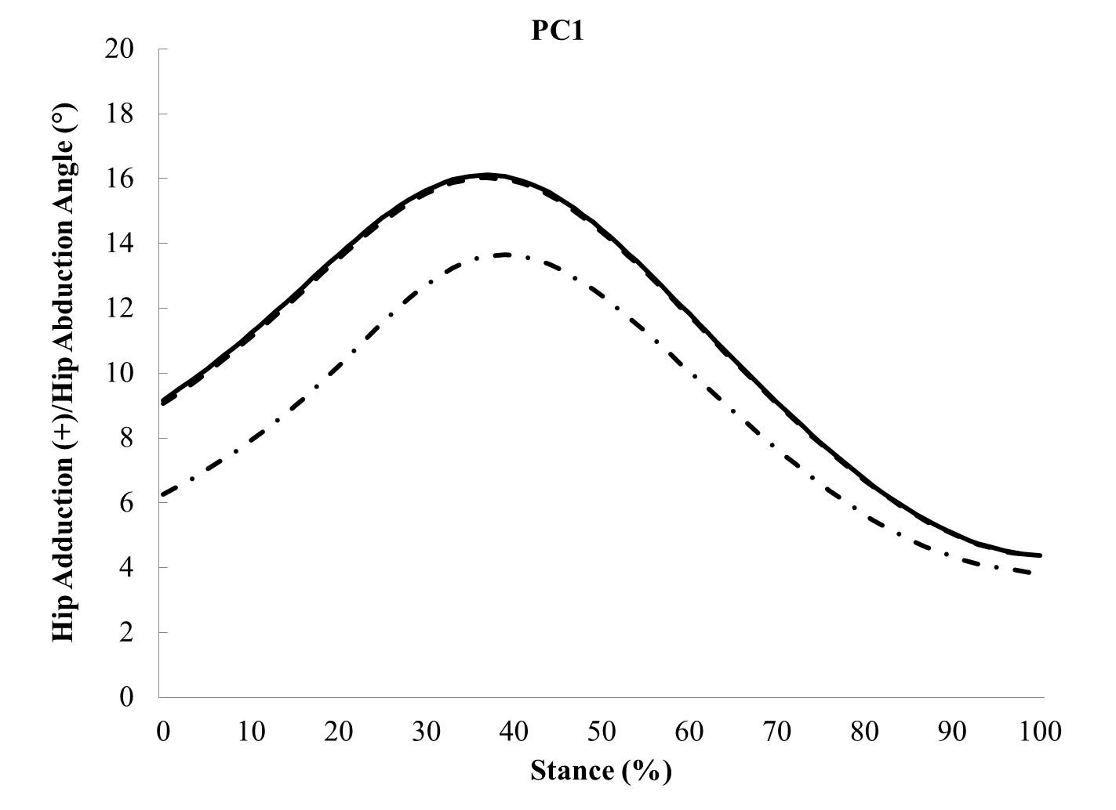

Figure 4-3
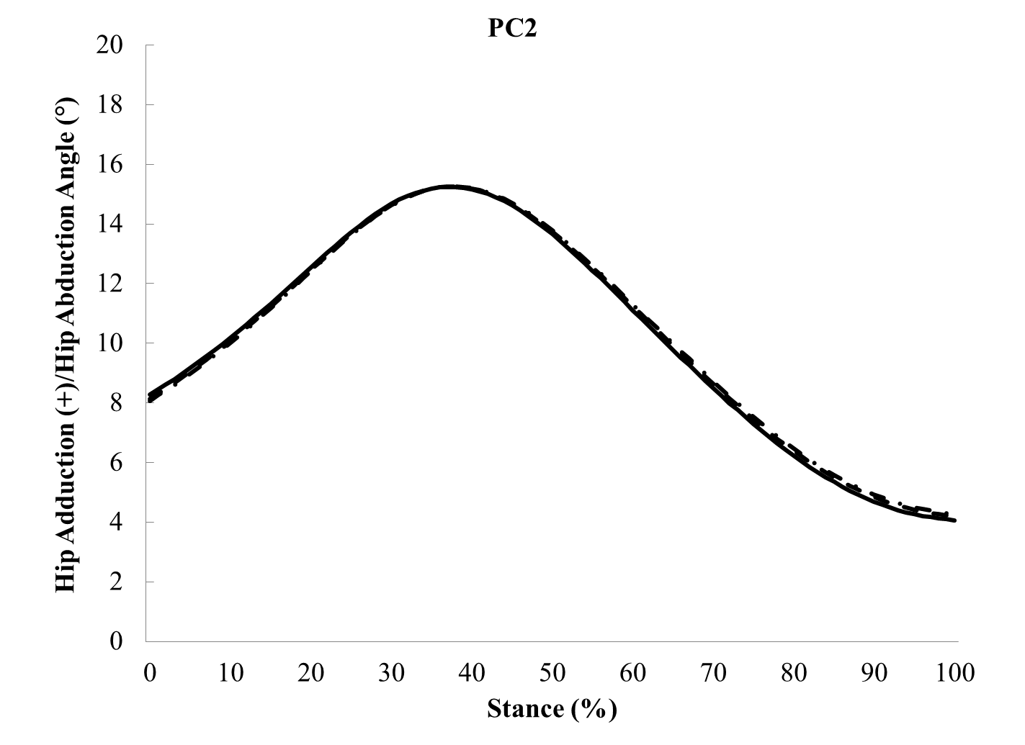

Figure 4-3
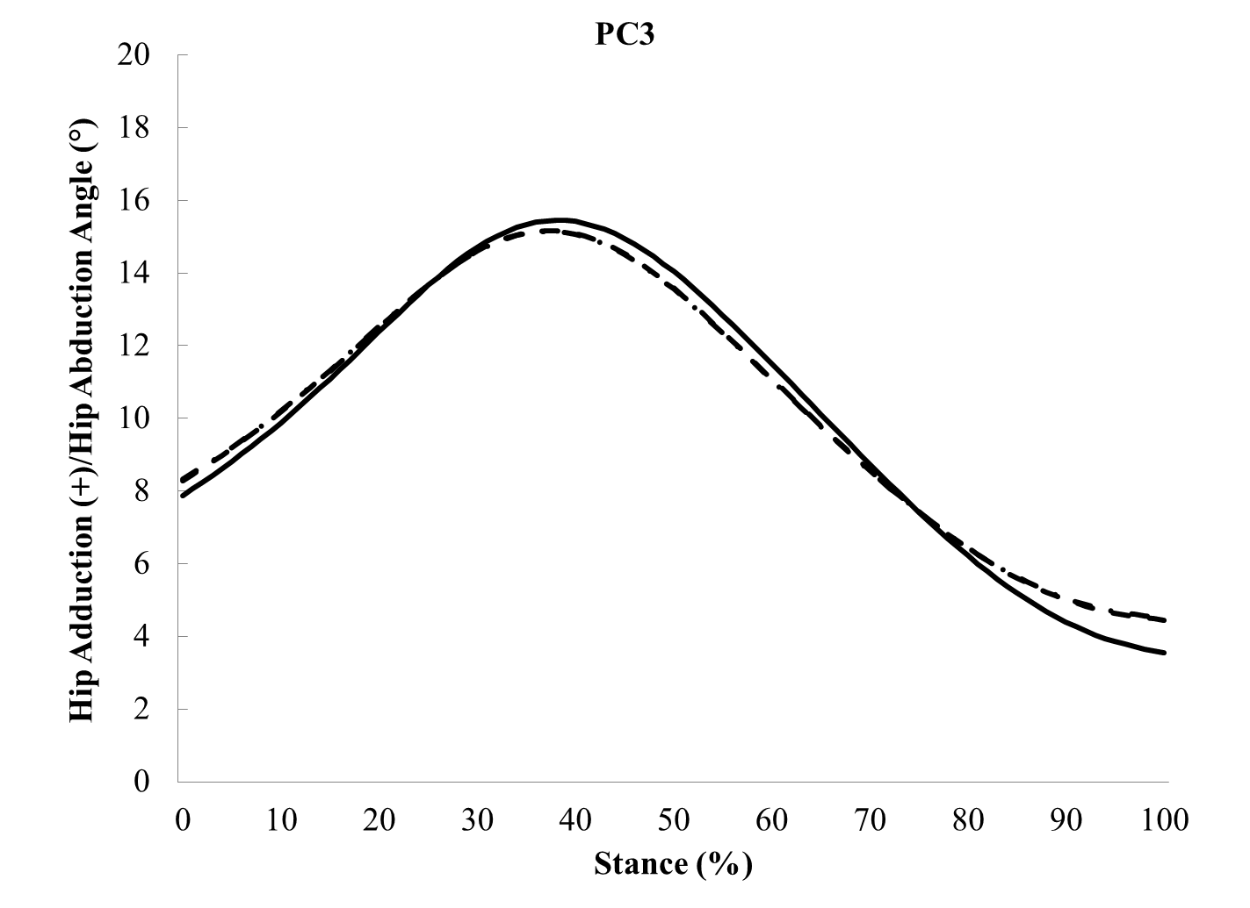

Figure 4-3
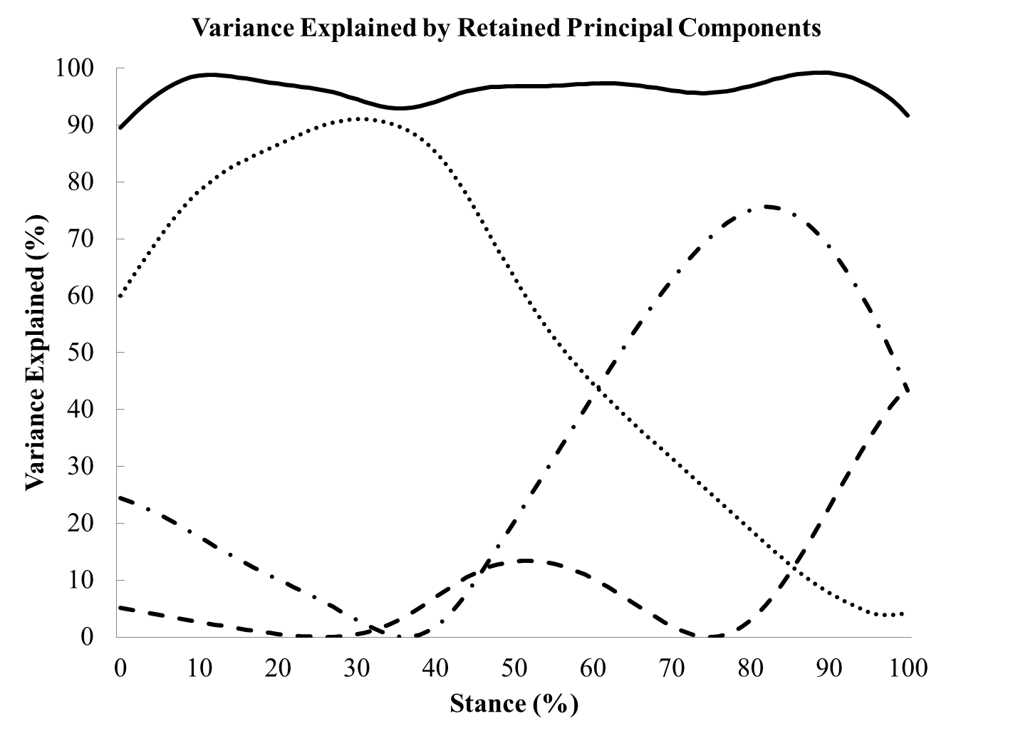

Figure 4-4. The first three principal component (PC) contributions to the frontal plane knee moment exhibited by runners with current iliotibial band syndrome (ITBS) (dashed line), previous ITBS (dashdot line) and controls (solid line) during the stance phase of running. Additionally, the percent variance explained by PC1 (dot), PC2 (dashdot), PC3 (dashed), and overall percent variance explained by the first 3 PCs (solid) is displayed.

Figure 4-4
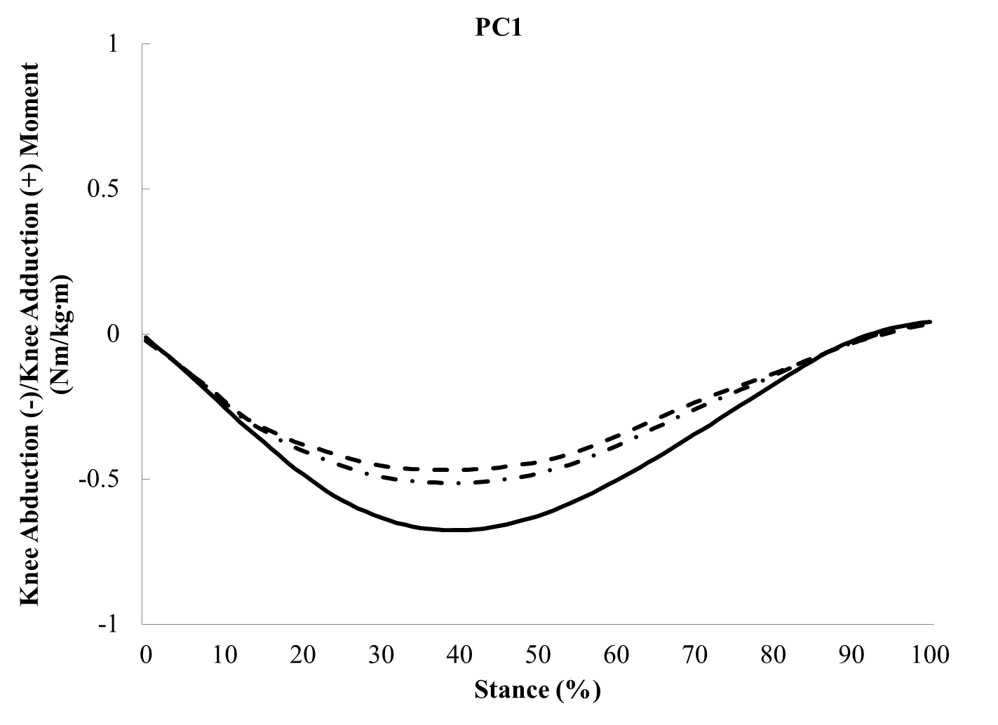

Figure 4-4
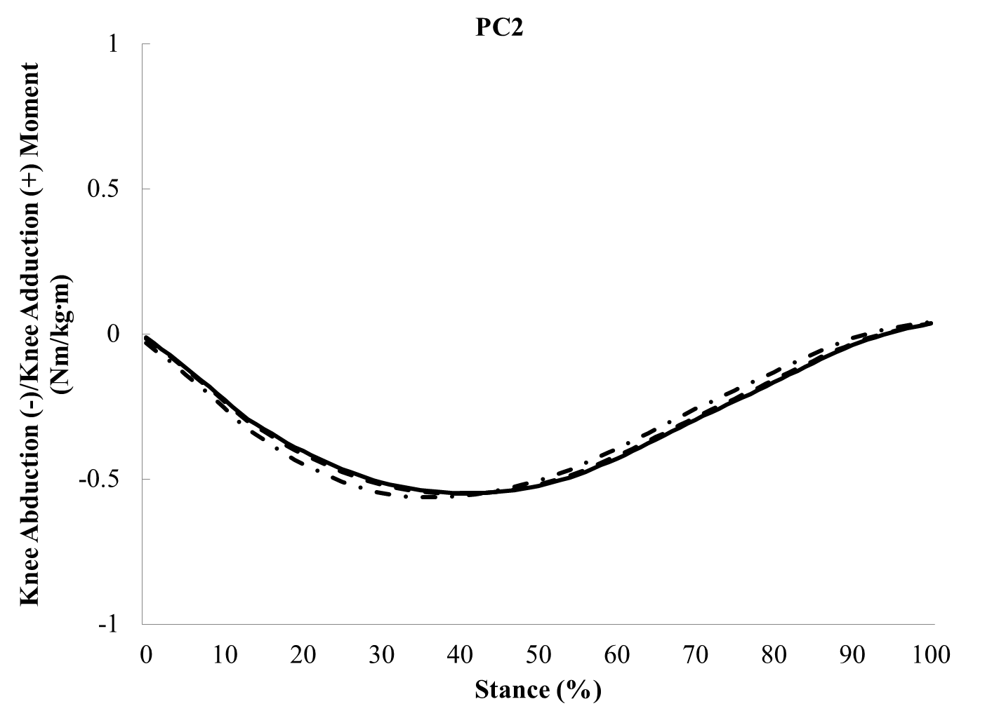

Figure 4-4
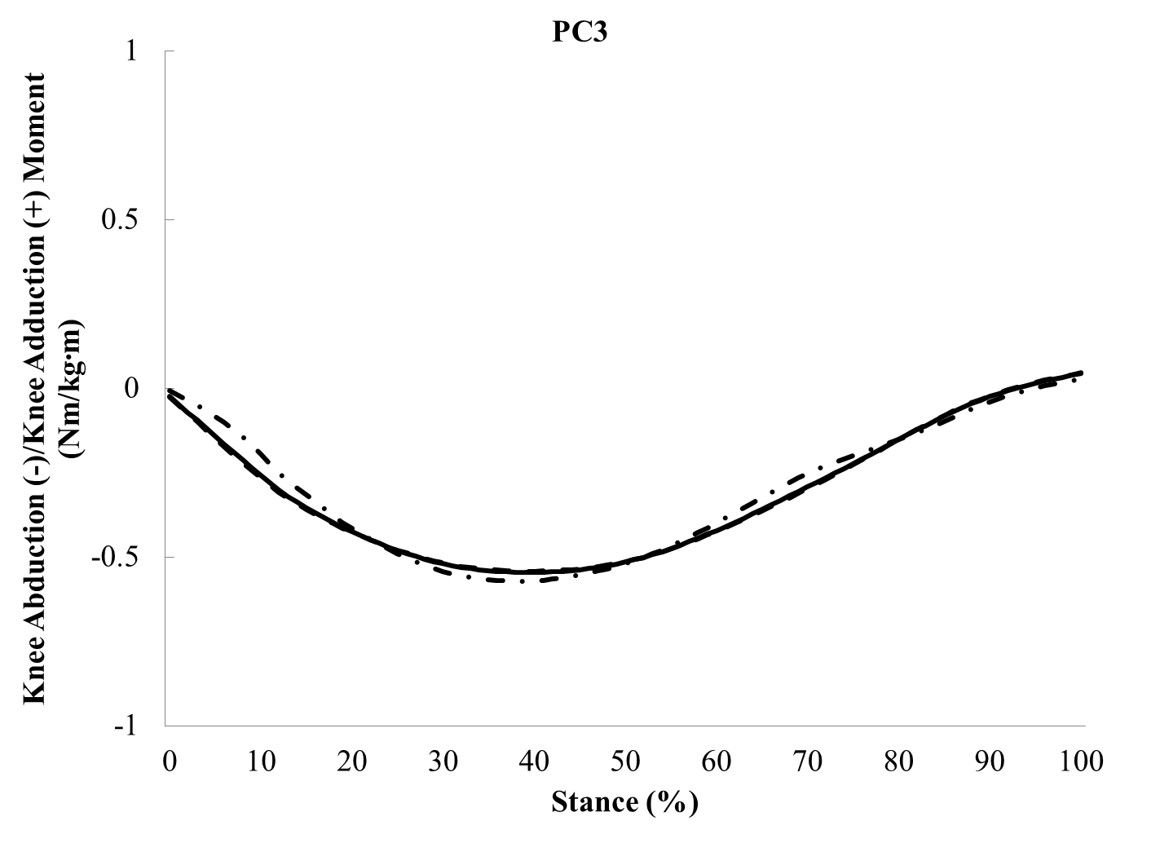

Figure 4-4
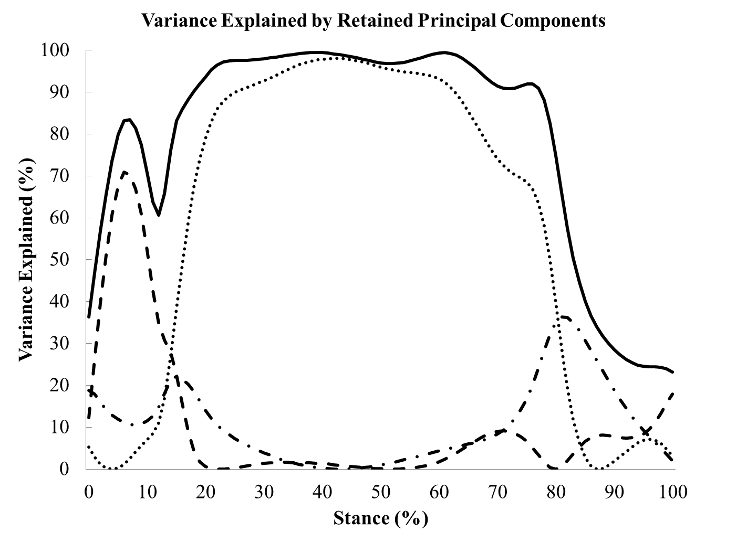

Figure 4-5. The first three principal component (PC) contributions to the transverse plane knee angle exhibited by runners with current iliotibial band syndrome (ITBS) (dashed line), previous ITBS (dashdot line), and controls (solid line) during the stance phase of running. Additionally, the percent variance explained by PC1 (dot), PC2 (dashdot), PC3 (dashed), and overall percent variance explained by the first 3 PCs (solid) is displayed.

Figure 4-5
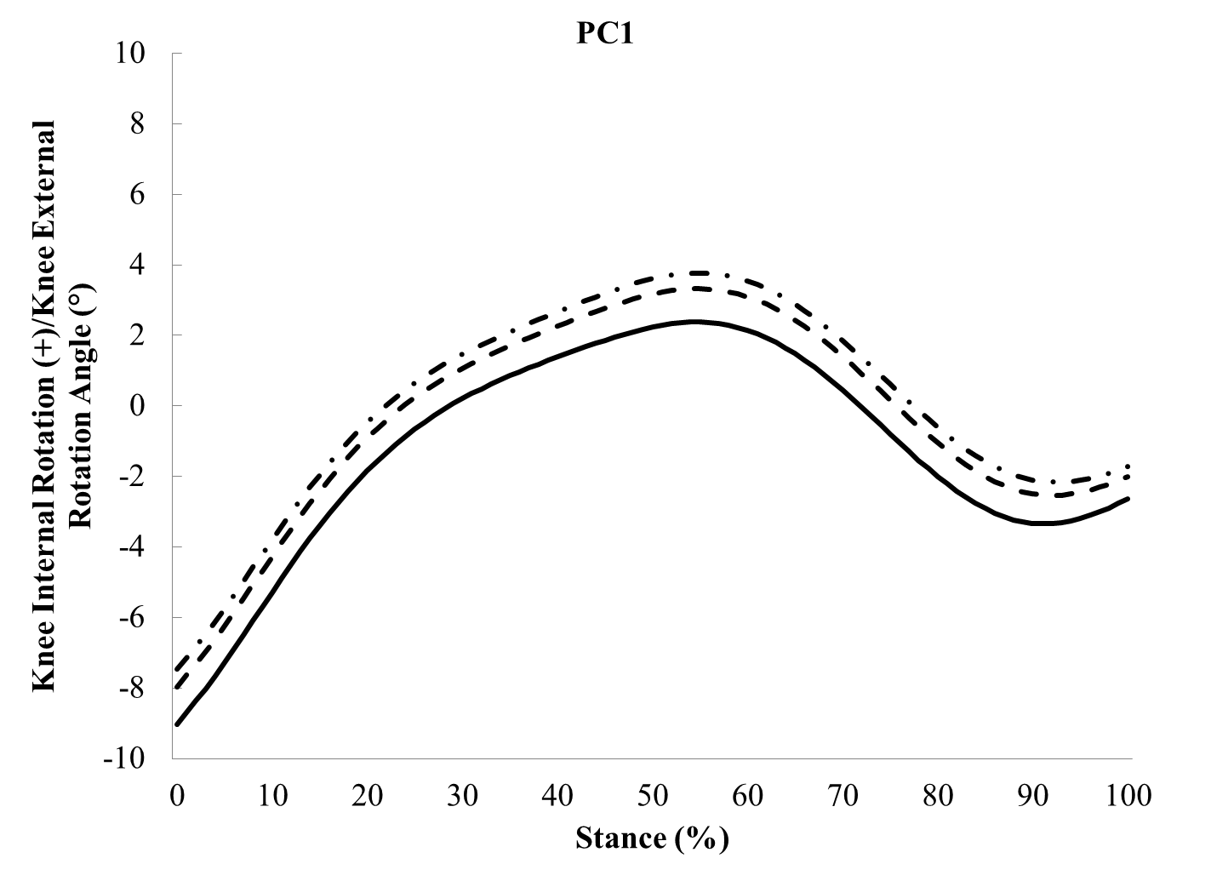

Figure 4-5
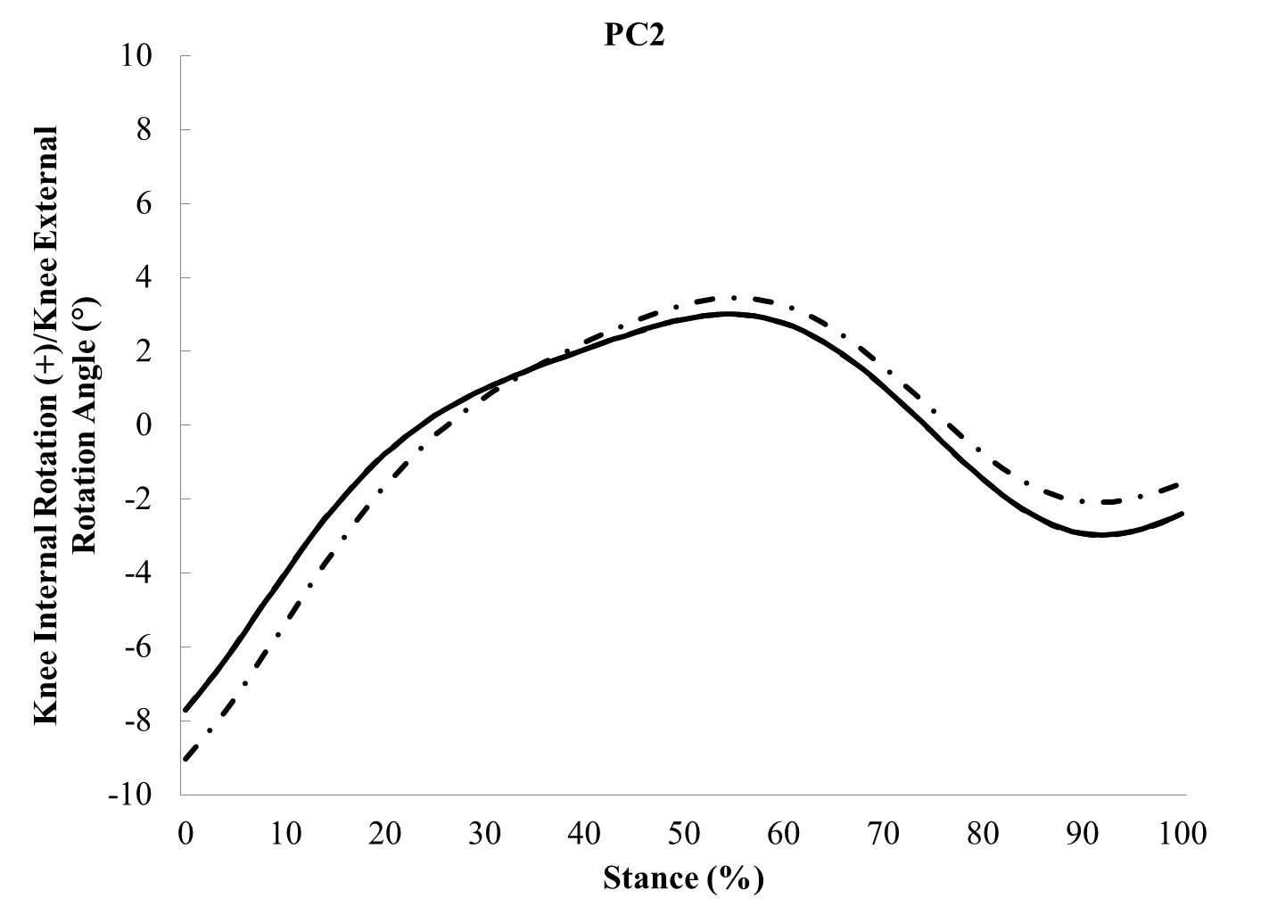

Figure 4-5
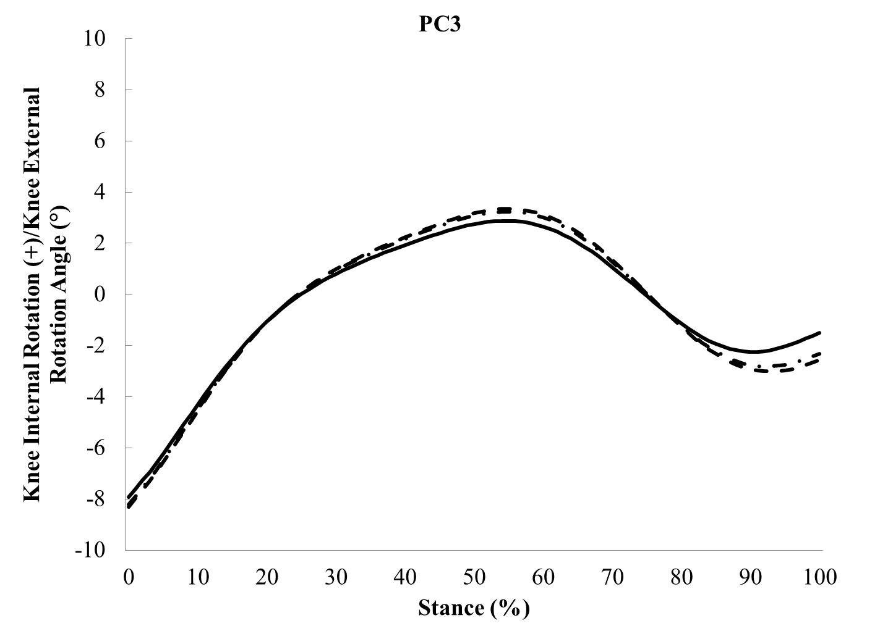

Figure 4-5
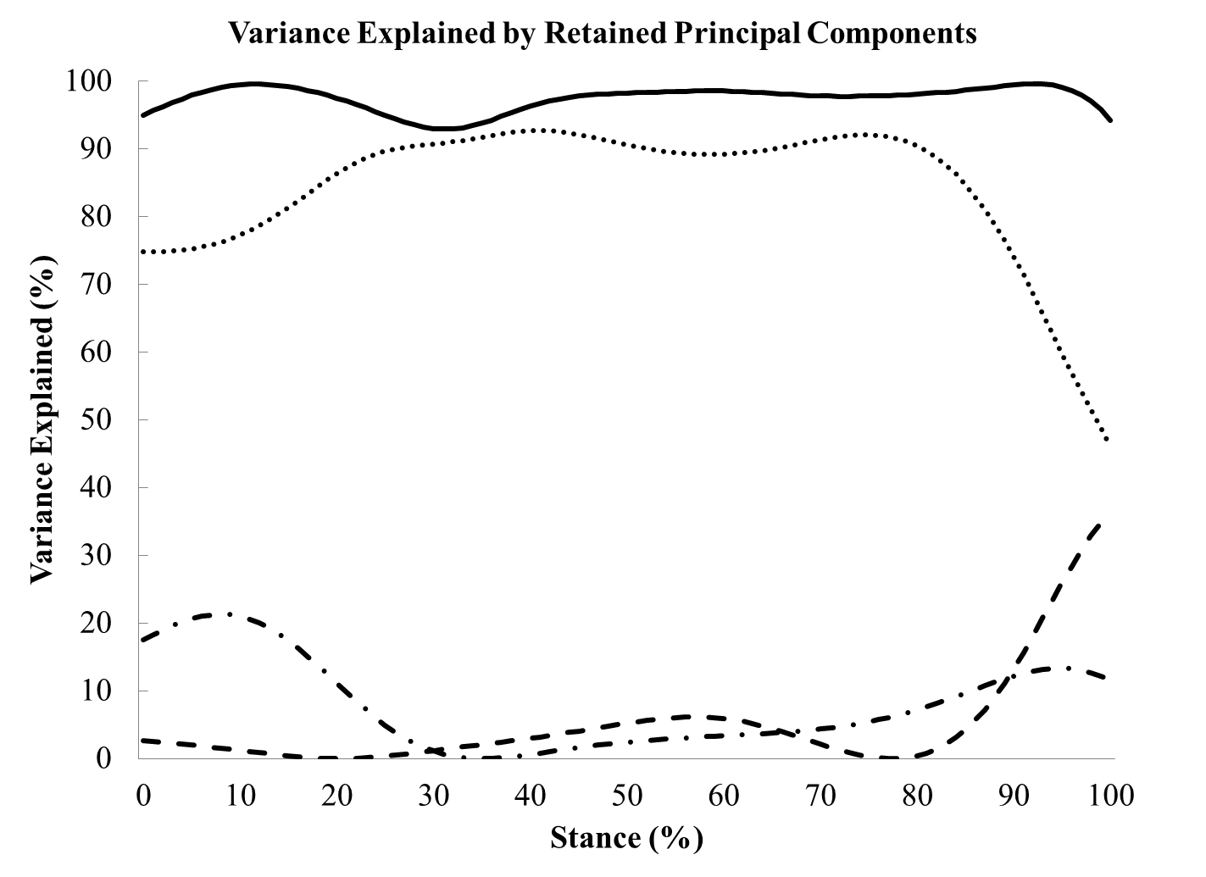

References
Astephen, J.L., Deluzio, K.J., Caldwell, G.E., Dunbar, M.J., Hubley-Kozey, C.L., 2008. Gait and neuromuscular pattern changes are associated with differences in knee osteoarthritis severity levels. Journal of Biomechanics 41, 868-876.
Barnes, A., Wheat, J., Milner, C.E., 2010. Use of gait sandals for measuring rearfoot and shank motion during running. Gait and Posture 32, 133-135.
Bisseling, R.W., Hof, A.L., 2006. Handling of impact forces in inverse dynamics. Journal of Biomechanics 39, 2438-2444.
Cappozzo, A., Cappello, A., Della Croce, U., Pensalfini, F., 1997. Surface-marker cluster design criteria for 3-D bone movement reconstruction. IEEE Transactions on Biomedical Engineering 44, 1165-1174.
de Leva, P., 1996. Adjustments to Zatsiorsky-Seluyanov's segment inertia parameters. Journal of Biomechanics 29, 1223-1230.
Fairclough, J., Hayashi, K., Toumi, H., Lyons, K., Bydder, G., Phillips, N., Best, T.M., Benjamin, M., 2006. The functional anatomy of the iliotibial band during flexion and extension of the knee: implications for understanding iliotibial band syndrome. Journal of Anatomy 208, 309-316.
Fairclough, J., Hayashi, K., Toumi, H., Lyons, K., Bydder, G., Phillips, N., Best, T.M., Benjamin, M., 2007. Is iliotibial band syndrome really a friction syndrome? Journal of Science and Medicine in Sport 10, 74-76; discussion 77-78.
Ferber, R., Noehren, B., Hamill, J., Davis, I.S., 2010. Competitive female runners with a history of iliotibial band syndrome demonstrate atypical hip and knee kinematics. Journal of Orthopaedic and Sports Physical Therapy 40, 52-58.
Fredericson, M., Cookingham, C.L., Chaudhari, A.M., Dowdell, B.C., Oestreicher, N., Sahrmann, S.A., 2000. Hip abductor weakness in distance runners with iliotibial band syndrome. Clinical Journal of Sports Medicine 10, 169-175.
Grau, S., Krauss, I., Maiwald, C., Axmann, D., Horstmann, T., Best, R., 2011. Kinematic classification of iliotibial band syndrome in runners. Scandanavian Journal of Medicine & Science in Sports 21, 184-189.
Jackson, J.E., 1991. A User's Guide to Principal Components. John Wiley & Sons Inc., New York.
Kipp, K., McLean, S.G., Palmieri-Smith, R.M., 2011. Patterns of hip flexion motion predict frontal and transverse plane knee torques during a single-leg land-and-cut maneuver. Clinical Biomechanics 26, 504-508.
Manal, K., McClay, I., Stanhope, S., Richards, J., Galinat, B., 2000. Comparison of surface mounted markers and attachment methods in estimating tibial rotations during walking: an in vivo study. Gait and Posture 11, 38-45.
McIlroy, W.E., Maki, B.E., 1997. Preferred placement of the feet during quiet stance: development of a standardized foot placement for balance testing. Clinical Biomechanics 12, 66-70.
Miller, R.H., Lowry, J.L., Meardon, S.A., Gillette, J.C., 2007. Lower extremity mechanics of iliotibial band syndrome during an exhaustive run. Gait and Posture 26, 407-413.
Noble, C.A., 1980. Iliotibial band friction syndrome in runners. American Journal of Sports Medicine 8, 232-234.
Noehren, B., Davis, I., Hamill, J., 2007. ASB clinical biomechanics award winner 2006 prospective study of the biomechanical factors associated with iliotibial band syndrome. Clinical Biomechanics 22, 951-956.
Noehren, B., Pohl, M.B., Sanchez, Z., Cunningham, T., Lattermann, C., 2012. Proximal and distal kinematics in female runners with patellofemoral pain. Clinical Biomechanics 27, 366-371.
O'Connor, K.M., Bottum, M.C., 2009. Differences in cutting knee mechanics based on principal components analysis. Medicine and Science in Sports Exercise 41, 867-878.
Orchard, J.W., Fricker, P.A., Abud, A.T., Mason, B.R., 1996. Biomechanics of iliotibial band friction syndrome in runners. American Journal of Sports Medicine 24, 375-379.
Powers, C.M., 2010. The influence of abnormal hip mechanics on knee injury: a biomechanical perspective. Journal of Orthopaedic and Sports Physical Therapy 40, 42-51.
Renne, J.W., 1975. The iliotibial band friction syndrome. Journal of Bone and Joint Surgery 57, 1110-1111.
Robbins, S.M., Astephen Wilson, J.L., Rutherford, D.J., Hubley-Kozey, C.L., 2013. Reliability of principal components and discrete parameters of knee angle and moment gait waveforms in individuals with moderate knee osteoarthritis. Gait and Posture.
Taunton, J.E., Ryan, M.B., Clement, D.B., McKenzie, D.C., Lloyd-Smith, D.R., Zumbo, B.D., 2002. A retrospective case-control analysis of 2002 running injuries. British Journal of Sports Medicine 36, 95-101.
Thomas, S., Reading, J., Shepard, R.J., 1992. Revision of the Physical Activity Readiness Questionnaire (PAR-Q). Canadian Journal of Sport Sciences 17, 338-349.
Winter, D.A., 2009. Biomechanics and Motor Control of Human Movement. John Wiley

& Sons, Inc., Hoboken (NJ).

Wrigley, A.T., Albert, W.J., Deluzio, K.J., Stevenson, J.M., 2005. Differentiating lifting technique between those who develop low back pain and those who do not. Clinical Biomechanics 20, 254-263.
Wrigley, A.T., Albert, W.J., Deluzio, K.J., Stevenson, J.M., 2006. Principal component analysis of lifting waveforms. Clin Biomech (Bristol, Avon) 21, 567-578.
Wu, G., Cavanagh, P.R., 1995. ISB recommendations for standardization in the reporting of kinematic data. Journal of Biomechanics 28, 1257-1261.

CONCLUSION

Study 1

Runners with current ITBS exhibited greater trunk ipsilateral flexion compared to runners with previous ITBS and controls. Hip abductor strength was less in runners with previous ITBS compared to controls. Lastly, runners with current ITBS exhibited less iliotibial band flexibility compared to runners with previous ITBS and controls. Runners with current ITBS may lean their trunk more towards the stance limb to reduce the demand on lateral hip stabilizers. Hip abductor strength weakness may be a result of ITBS. After ITBS symptoms have subsided, runners with previous ITBS exhibit decreased isometric hip abductor strength compared to runners with current ITBS and controls.

Study 2

Runners with previous ITBS were more variable in frontal plane trunk – pelvis and pelvis – thigh couplings during weight acceptance and late stance than runners with current ITBS and controls. Visual inspection of the coupling angle plots indicated that runners in all groups exhibited more pelvis motion relative to the adjacent segment. Therefore, runners with ITBS were more variable in pelvis motion relative to runners with current ITBS and controls. An increase in variability may indicate inconsistent neuromuscular control of hip abductor musculature in runners with previous ITBS.

Study 3

No differences in the retained principal component scores for any of the waveforms were observed among groups. The Q-statistic indicated frontal plane trunk angle and knee moment, as well as transverse plane knee angle waveforms were adequately reconstructed in the majority (74%-96%) of participants. However, pelvis and hip angle waveforms were not adequately reconstructed (3%-11%) despite retaining 94% and 96% of the waveforms’ variance. This finding suggests a more complex movement pattern exists within pelvis and hip motion during running that cannot be explained in the first three principal components.

Future Directions

This dissertation examined biomechanics during running in female runners with current ITBS, previous ITBS, and controls. Our analysis of the data was limited to examining biomechanics during running in a non-fatigued state. Participants in the currently injured group reported that pain during running generally occurred after four to five miles of running. Examining whether biomechanics during running change between a non-fatigued and fatigued state may reveal differences among groups in peak joint and segment biomechanics that may deleteriously effect the iliotibial band. Furthermore, runners with current ITBS may exhibit a limited coupling variability when running with pain at the end of a run. In addition to examining joint and segment biomechanics, the timing of hip abductor musculature activation may elucidate whether neuromuscular control differences exist in runners with current ITBS, previous ITBS, and controls. Measuring muscle activity of the hip abductors via electromyography techniques should be considered for future studies.

Impact on Clinicians and Runners
Although ITBS is the second most commonly reported overuse running injury, relatively little research exists in the running literature on ITBS. Both hip and pelvis biomechanics during running and hip abductor strength are believed to be factors associated with ITBS. However, no study has measured biomechanics during running and hip abductor strength concurrently in female runners with current ITBS, previous ITBS, and controls. Based on this dissertation’s results, both pelvis variability and hip abductor strength weakness appear to be associated with previous ITBS. Potentially, hip abductor weakness is a result of ITBS. After runners with current ITBS return to pain free running, they may develop a different movement pattern in the hip-pelvis complex. As a result, the neuromuscular control of the hip-pelvis complex may be altered resulting in hip abductor weakness. Therefore, clinicians must emphasize to their patients the importance of continuing therapy such as hip strengthening even after returning to running pain-free. In addition to hip strengthening exercises, clinicians must focus on teaching patients proper biomechanics during running when they are able to begin running again. Focusing on proper hip and pelvis positioning during running may allow for a consistent neuromuscular control pattern. Potentially, runners with previous ITBS may be able to decrease pelvis variability and increase hip abductor strength. A combination of hip abductor strengthening and establishing consistent pelvis control during running may decrease the likelihood of a recurrence of ITBS.

APPENDIX

Appendix A: Informed Consent

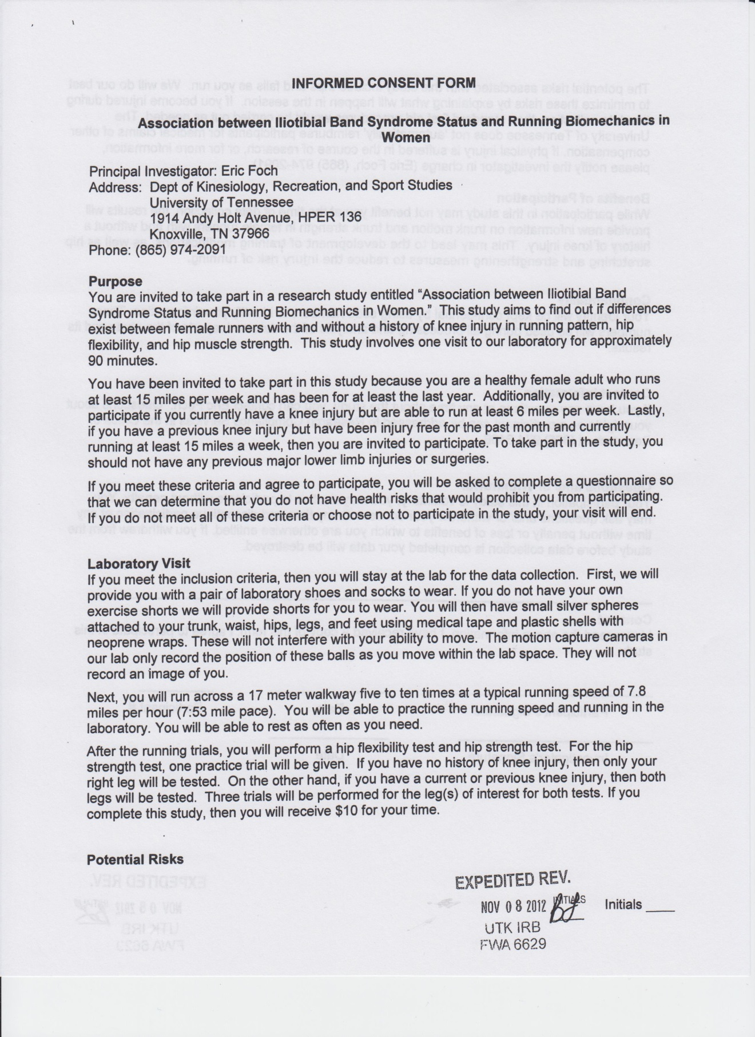


Appendix B: Flyer



Appendix C: Physical Activity Readiness and Running Health History Questionnaires

PARQ
- Has your doctor ever said that you have a heart condition and that you should only do physical activity recommended by a doctor? Yes or No
- Do you feel pain in your chest when you do physical activity? Yes or No
- In the past month, have you had chest pain when you were not doing physical activity? Yes or No
- Do you lose your balance because of dizziness or do you ever lose consciousness? Yes or No
- Do you have a bone or joint problem (for example, back, knee or hip) that could be made worse by a change in your physical activity? Yes or No
- Is your doctor currently prescribing drugs (for example, water pills) for your blood pressure or heart condition? Yes or No
- Do you know of any other reason why you should not do physical activity? Yes or No
Running History Survey
- Where did you hear about the study?
- Researcher
- Clinic
- Flyer
- Word of Mouth
- What is your sex? Male or Female
- What is your age?
- What is your height (inches)?
- What is your weight (pounds)?
- What leg would you use to kick a ball? Right Left No Preference
- How many years have you been running?
- How many miles did you run in the past seven days?
- Was the last seven days representative of your typical weekly running mileage? Yes or No
- How many miles do you run in a typical week?
- Have you ever experienced knee pain due to running that caused you to alter your regular training schedule on at least one occasion? Yes or No
- Which of your knees have been injured? Right Left
- Did your knee pain cause you to reduce your weekly mileage total or stop running for a period of time? Yes or No
- Have you ever been diagnosed by a doctor, athletic trainer, or physical therapist with a knee injury(s)? Yes or No
- Which of the following knee injuries have you ever been diagnosed by a doctor, athletic trainer, or physical therapist?
- Anterior Knee Pain (Patellofemoral Pain Syndrome)
- Runner's Knee (Iliotibial Band Friction Syndrome)
- Patellar Tendonitis/Tendonosis
- Quadriceps Tendonitis/Tendonosis
- Patellar Bursitis
- Other Knee Injury
- If you checked "Other Knee Injury" for the above question, please specify the type of knee injury.
- Have you experienced knee injury(s) caused by running more than once? Yes or No
- If you previously had a knee injury(s), then how long was your regular training routine modified? And did you receive treatment from a doctor, physical therapist, or athletic trainer?
- How many months has it been since you last experienced knee pain?
- Are you currently running with knee pain? Yes or No
- How long have you currently been receiving treatment for your knee pain from a physical therapist, medical doctor, or athletic trainer?
- Have you ever experienced any other type of injury, e.g. lower back pain, hip pain, thigh muscle strains, ankle sprains, foot pain, Achilles tendonitis/tendonosis, stress fracture, torn ACL? Yes or No
- Please specify the type of injury(s) you have experienced.
Thank you for completing the Running History Survey.

Appendix D: Reliability Test

To asses intra-rater reliability of the Ober test and hip abductor strength test, a subset of participants (n = 10) were invited to come back to the lab at a later date to have the tests performed again. Intraclass correlation coefficients (ICC (3, k)) assessed the relationship between the mean inclinometer angles and hip strength measures from each testing session. Absolute agreement above 0.75 was considered good while ≤ 0.75 was considered poor (Portney and Watkins, 2000). For the Ober Test, the intraclass correlation coefficient (ICC(3, k)) was 0.839 which indicated good reliability. For the hip abductor strength test, the intraclass correlation coefficient (ICC(3, k)) was 0.869 which indicated good intra-tester reliability.

Ober Test Data between Days.
Ober Test
Participant | Day 1 | Day 2
1 | 28 | 26
2 | 21 | 21
3 | 26 | 27
4 | 21 | 24
5 | 24 | 21
6 | 16 | 17
7 | 28 | 22
8 | 23 | 25
9 | 22 | 21
10 | 20 | 19

Intraclass Correlation Coefficient
 | Intraclass Correlation^{b} | 95% Confidence Interval |  | F Test with True Value 0
 | Intraclass Correlation^{b} | Lower Bound | Upper Bound | Value | df1 | df2 | Sig
Single Measures | .722ª | .223 | .923 | 5.955 | 9 | 9 | .007
Average Measures | .839^{c} | .365 | .960 | 5.955 | 9 | 9 | .007
Two-way mixed effects model where people effects are random and measures effects are fixed.
a. The estimator is the same, whether the interaction effect is present or not.
b. Type A intraclass correlation coefficients using an absolute agreement definition.
c. This estimate is computed assuming the interaction effect is absent, because it is not estimable otherwise.

Isometric Hip Abductor Strength Data between Days.
Isometric Hip Abductor Strength
Participant | Day 1 | Day 2
1 | 15.0 | 18.5
2 | 16.9 | 20.2
3 | 20.4 | 24.8
4 | 19.0 | 21.2
5 | 15.7 | 18.9
6 | 18.3 | 18.9
7 | 10.4 | 8.8
8 | 13.8 | 15.4
9 | 16.2 | 11.7
10 | 22.7 | 22.0

Intraclass Correlation Coefficient
 | Intraclass Correlation^{b} | 95% Confidence Interval |  | F Test with True Value 0
 | Intraclass Correlation^{b} | Lower Bound | Upper Bound | Value | df1 | df2 | Sig
Single Measures | .769ª | .344 | .936 | 8.219 | 9 | 9 | .002
Average Measures | .869^{c} | .512 | .967 | 8.219 | 9 | 9 | .002
Two-way mixed effects model where people effects are random and measures effects are fixed.
a. The estimator is the same, whether the interaction effect is present or not.
b. Type A intraclass correlation coefficients using an absolute agreement definition.
c. This estimate is computed assuming the interaction effect is absent, because it is not estimable otherwise.

Appendix E: Participant Demographics

Participant Demographics
Participant | Group | Side | Age (yr) | Height (m) | Body Mass (kg) | Weekly Mileage (mi)
1 | Control | Right | 20 | 1.60 | 47.3 | 20
2 | Control | Right | 19 | 1.64 | 62.7 | 15
3 | Control | Right | 18 | 1.76 | 66.6 | 15
4 | Control | Right | 26 | 1.67 | 57.1 | 40
5 | Control | Right | 26 | 1.65 | 50.2 | 15
6 | Control | Right | 20 | 1.71 | 53.1 | 15
7 | Control | Right | 41 | 1.77 | 61.2 | 30
8 | Control | Right | 29 | 1.66 | 54.9 | 45
9 | Control | Right | 27 | 1.72 | 61.3 | 50
10 | Current | Right | 33 | 1.71 | 57.6 | 19
11 | Current | Left | 34 | 1.61 | 53.1 | 50
12 | Current | Right | 20 | 1.65 | 49.4 | 15
13 | Current | Left | 40 | 1.64 | 54.4 | 6
14 | Current | Right | 29 | 1.70 | 56.0 | 6
15 | Current | Left | 19 | 1.58 | 48.4 | 40
16 | Current | Right | 20 | 1.63 | 55.1 | 16
17 | Current | Left | 19 | 1.63 | 48.5 | 22
18 | Current | Right | 22 | 1.60 | 57.4 | 20
19 | Previous | Right | 27 | 1.70 | 64.2 | 15
20 | Previous | Right | 24 | 1.64 | 53.8 | 50
21 | Previous | Right | 24 | 1.71 | 61.2 | 15
22 | Previous | Right | 27 | 1.60 | 58.1 | 27
23 | Previous | Right | 22 | 1.72 | 60.1 | 15
24 | Previous | Left | 18 | 1.69 | 62.5 | 30
25 | Previous | Left | 33 | 1.66 | 86.0 | 19
26 | Previous | Right | 26 | 1.66 | 52.7 | 53
27 | Previous | Right | 18 | 1.71 | 56.4 | 15
Control Mean |  |  | 25.1 | 1.70 | 57.2 | 27.2
Control SD |  |  | 7.2 | 0.05 | 6.2 | 13.6
Current ITBS Mean |  |  | 26.2 | 1.64 | 53.3 | 21.6
Current ITBS SD |  |  | 7.9 | 0.04 | 3.7 | 14.6
Previous ITBS Mean |  |  | 24.3 | 1.68 | 61.7 | 26.6
Previous ITBS SD |  |  | 4.7 | 0.04 | 9.9 | 15.2

Appendix F: Results

Discrete Segment Variables

Discrete Segment Dependent Variables
Participant | Group | Trunk Contralateral  Flexion (°) | Trunk Ipsilateral  Flexion (°) | Contralateral  Pelvic Drop (°)
1 | Control | -0.3 | 2.7 | -8.5
2 | Control | -0.8 | 3.8 | -6.9
3 | Control | -0.9 | 2.1 | -5.9
4 | Control | 0.5 | 3.4 | -4.9
5 | Control | 0.2 | 2.4 | -6.7
6 | Control | -1.8 | 3.6 | -6.4
7 | Control | 1.1 | 6.3 | -5.4
8 | Control | -2.6 | 2.2 | -6.8
9 | Control | 1.9 | 5.2 | -2.9
10 | Current | 2.2 | 5.2 | -8.1
11 | Current | 0.9 | 5.3 | -2.1
12 | Current | -1.7 | 4.1 | -8.9
13 | Current | 1.0 | 3.4 | -4.8
14 | Current | 2.0 | 4.1 | -3.9
15 | Current | 2.9 | 8.0 | -6.7
16 | Current | -1.8 | 6.3 | -11.1
17 | Current | -0.1 | 4.8 | -8.8
18 | Current | 3.3 | 6.9 | -5.9
19 | Previous | -2.2 | 2.1 | -6.8
20 | Previous | 1.6 | 4.5 | -4.3
21 | Previous | -0.3 | 4.2 | -3.3
22 | Previous | -0.1 | 2.8 | -4.4
23 | Previous | -1.8 | 2.4 | -4.8
24 | Previous | 1.42 | 4.7 | -1.7
25 | Previous | -1.9 | 6.2 | -2.3
26 | Previous | 0.2 | 1.6 | -2.7
27 | Previous | -0.8 | 5.2 | -12.4
Control Mean |  | -0.3 | 3.5 | -6.1
Control SD |  | 1.3 | 1.3 | 1.6
Current ITBS Mean |  | 1.0 | 5.3 | -6.7
Current ITBS SD |  | 1.9 | 1.5 | 2.8
Previous ITBS Mean |  | -0.4 | 3.8 | -4.7
Previous ITBS SD |  | 1.4 | 1.6 | 3.2

Discrete Joint Variables

Discrete Segment Dependent Variables
Participant | Group | Hip Adduction Angle (°) | Knee Internal Rotation (°) | Knee Adduction Moment (Nm/kg∙m)
1 | Control | 16.3 | 4.4 | 0.5
2 | Control | 15.5 | 10.5 | 0.6
3 | Control | 18.1 | -6.2 | 0.5
4 | Control | 17.4 | 4.7 | 0.5
5 | Control | 17.6 | 3.7 | 0.8
6 | Control | 15.4 | -0.2 | 1.2
7 | Control | 14.7 | 7.5 | 0.8
8 | Control | 13.4 | -3.4 | 1.1
9 | Control | 19.7 | 5.7 | 0.1
10 | Current | 16.7 | -1.1 | 0.5
11 | Current | 16.7 | 0.0 | 0.7
12 | Current | 17.0 | 12.8 | 0.6
13 | Current | 16.1 | 4.3 | 0.6
14 | Current | 18.3 | 3.9 | 0.3
15 | Current | 11.3 | -5.1 | 0.5
16 | Current | 16.1 | 0.7 | 0.7
17 | Current | 21.2 | 12.4 | 0.5
18 | Current | 16.6 | 7.9 | 0.6
19 | Previous | 16.3 | 9.9 | 0.7
20 | Previous | 12.3 | 10.1 | 0.9
21 | Previous | 13.1 | 11.2 | 0.5
22 | Previous | 15.8 | -3.4 | 0.6
23 | Previous | 13.7 | -7.8 | 0.9
24 | Previous | 11.7 | -0.7 | 0.3
25 | Previous | 12.8 | 10.0 | 0.4
26 | Previous | 10.1 | 13.7 | 0.4
27 | Previous | 20.1 | 4.1 | 0.7
Control Mean |  | 16.4 | 3.0 | 0.7
Control SD |  | 2.5 | 5. | 0.5
Current ITBS Mean |  | 16.6 | 4.0 | 0.5
Current ITBS SD |  | 2.6 | 6.1 | 0.1
Previous ITBS Mean |  | 14.0 | 5.2 | 0.6
Previous ITBS SD |  | 3.0 | 7.6 | 0.2

Physiological Measures

Physiological Measures
Participant | Group | Iliotibial Band Flexibility (°) | Isometric Hip Abductor Strength (% BM*m) | Pelvic Width/ Femoral Length
1 | Control | 21 | 20.0 | 0.85
2 | Control | 26 | 19.2 | 0.84
3 | Control | 21 | 19.2 | 0.83
4 | Control | 20 | 36.2 | 0.79
5 | Control | 26 | 41.8 | 0.84
6 | Control | 24 | 19.8 | 0.76
7 | Control | 24 | 29.2 | 0.78
8 | Control | 23 | 22.5 | 0.92
9 | Control | 23 | 14.9 | 0.80
10 | Current | 11 | 12.1 | 0.86
11 | Current | 7 | 23.1 | 0.84
12 | Current | 22 | 18.6 | 0.79
13 | Current | 15 | 18.4 | 0.77
14 | Current | 17 | 20.9 | 0.79
15 | Current | 8 | 17.8 | 0.81
16 | Current | 23 | 22.3 | 0.75
17 | Current | 18 | 16.6 | 0.77
18 | Current | 15 | 13.4 | 0.80
19 | Previous | 16 | 19.8 | 0.78
20 | Previous | 28 | 11.7 | 0.87
21 | Previous | 24 | 13.2 | 0.85
22 | Previous | 21 | 23.4 | 0.91
23 | Previous | 23 | 13.2 | 0.76
24 | Previous | 24 | 10.0 | 0.84
25 | Previous | 14 | 7.9 | 1.05
26 | Previous | 24 | 15.2 | 0.77
27 | Previous | 29 | 17.8 | 0.84
Control Mean |  | 24.7 | 23 | 0.82
Control SD |  | 9.0 | 2 | 0.05
Current ITBS Mean |  | 18.4 | 15 | 0.80
Current ITBS SD |  | 3.8 | 5 | 0.04
Previous ITBS Mean |  | 14.7 | 22 | 0.85
Previous ITBS SD |  | 4.9 | 4 | 0.09

Iliotibial Band Mechanics

Iliotibial Band Mechanics
Participant | Group | Iliotibial Band Strain (%) | Iliotibial Band Strain Rate (%∙s⁻¹)
1 | Control | 0.6 | 56.8
2 | Control | 2.6 | 54.4
3 | Control | 0.8 | 56.3
4 | Control | 1.3 | 61.6
5 | Control | 3.7 | 69.0
6 | Control | 2.5 | 64.2
7 | Control | 1.6 | 52.1
8 | Control | 3.2 | 59.3
9 | Control | 1.1 | 47.8
10 | Current | 3.2 | 64.6
11 | Current | -0.5 | 54.0
12 | Current | 3.2 | 65.5
13 | Current | 2.1 | 47.8
14 | Current | 1.9 | 50.2
15 | Current | 1.6 | 59.2
16 | Current | 3.1 | 68.2
17 | Current | 1.7 | 60.5
18 | Current | 2.1 | 53.1
19 | Previous | 2.9 | 47.3
20 | Previous | 2.8 | 61.4
21 | Previous | 2.0 | 76.0
22 | Previous | 2.8 | 81.8
23 | Previous | 0.5 | 44.4
24 | Previous | 1.8 | 55.7
25 | Previous | 4.7 | 75.5
26 | Previous | 1.7 | 40.6
27 | Previous | 2.8 | 61.4
Control Mean |  | 1.9 | 57.9
Control SD |  | 1.1 | 6.4
Current ITBS Mean |  | 2.0 | 58.1
Current ITBS SD |  | 1.2 | 7.2
Previous ITBS Mean |  | 2.4 | 60.5
Previous ITBS SD |  | 1.2 | 14.9

Frontal Plane Trunk – Pelvis Coupling Variability

Trunk – Pelvis Coupling Variability
Participant | Group | Period 1 | Period 2 | Period 3 | Period 4
1 | Control | 2.7 | 17.5 | 1.9 | 10.0
2 | Control | 3.6 | 11.2 | 8.7 | 5.1
3 | Control | 5.6 | 19.9 | 4.0 | 8.8
4 | Control | 2.8 | 5.7 | 2.6 | 3.3
5 | Control | 4.8 | 7.4 | 3.4 | 2.2
6 | Control | 5.9 | 15.8 | 12.3 | 18.8
7 | Control | 8.8 | 10.6 | 9.8 | 4.0
8 | Control | 5.0 | 5.3 | 2.4 | 8.2
9 | Control | 7.2 | 24.9 | 9.3 | 2.3
10 | Current | 5.8 | 7.0 | 4.0 | 3.6
11 | Current | 8.5 | 7.3 | 8.3 | 4.3
12 | Current | 5.4 | 4.6 | 5.2 | 2.0
13 | Current | 4.7 | 7.1 | 9.3 | 11.6
14 | Current | 11.8 | 20.4 | 4.6 | 10.0
15 | Current | 3.6 | 7.8 | 2.4 | 5.8
16 | Current | 10.3 | 16.6 | 14.5 | 10.1
17 | Current | 2.3 | 11.1 | 2.7 | 3.5
18 | Current | 5.8 | 19.5 | 5.9 | 6.7
19 | Previous | 11.5 | 18.5 | 5.8 | 11.3
20 | Previous | 5.0 | 8.4 | 2.6 | 8.7
21 | Previous | 9.9 | 12.2 | 8.1 | 15.0
22 | Previous | 14.6 | 12.1 | 5.2 | 16.9
23 | Previous | 5.9 | 11.8 | 3.4 | 9.2
24 | Previous | 5.9 | 21.4 | 18.2 | 18.1
25 | Previous | 10.2 | 5.5 | 13.6 | 17.5
26 | Previous | 11.7 | 16.7 | 3.3 | 9.7
27 | Previous | 13.8 | 14.9 | 3.4 | 3.3
Control Mean |  | 5.2 | 13.1 | 6.0 | 6.9
Control SD |  | 2.0 | 6.8 | 3.9 | 5.3
Current ITBS Mean |  | 6.5 | 11.3 | 6.3 | 6.4
Current ITBS SD |  | 3.1 | 5.9 | 3.8 | 3.4
Previous ITBS Mean |  | 9.8 | 13.5 | 7.1 | 12.2
Previous ITBS SD |  | 3.5 | 4.9 | 6.4 | 5.0

Frontal Plane Pelvis – Thigh Coupling Variability

Pelvis – Thigh Coupling Variability
Participant | Group | Period 1 | Period 2 | Period 3 | Period 4
1 | Control | 6.5 | 21.4 | 9.1 | 15.0
2 | Control | 6.1 | 12.5 | 7.0 | 8.2
3 | Control | 6.3 | 20.4 | 7.5 | 6.9
4 | Control | 4.5 | 12.1 | 5.1 | 4.9
5 | Control | 5.4 | 10.9 | 3.4 | 3.2
6 | Control | 4.4 | 14.7 | 12.0 | 23.2
7 | Control | 16.0 | 21.8 | 17.1 | 10.4
8 | Control | 6.7 | 10.0 | 9.8 | 9.4
9 | Control | 12.4 | 22.7 | 12.6 | 5.2
10 | Current | 8.4 | 8.3 | 4.6 | 7.4
11 | Current | 6.6 | 12.7 | 8.7 | 5.5
12 | Current | 5.7 | 5.9 | 7.0 | 4.1
13 | Current | 7.6 | 18.7 | 11.6 | 9.3
14 | Current | 9.3 | 27.1 | 19.3 | 18.2
15 | Current | 11.1 | 17.3 | 8.8 | 8.6
16 | Current | 3.6 | 15.1 | 12.7 | 7.3
17 | Current | 5.4 | 13.8 | 7.4 | 13.0
18 | Current | 4.5 | 17.9 | 5.7 | 11.2
19 | Previous | 14.9 | 21.6 | 13.3 | 15.2
20 | Previous | 8.7 | 6.2 | 6.5 | 15.0
21 | Previous | 18.2 | 11.0 | 7.4 | 11.8
22 | Previous | 16.5 | 17.2 | 14.9 | 23.4
23 | Previous | 9.2 | 10.6 | 5.2 | 19.9
24 | Previous | 8.3 | 18.9 | 22.6 | 19.5
25 | Previous | 18.5 | 17.7 | 16.3 | 23.0
26 | Previous | 21.2 | 18.6 | 6.4 | 15.8
27 | Previous | 17.9 | 19.1 | 4.7 | 5.5
Control Mean |  | 7.6 | 16.3 | 9.3 | 9.6
Control SD |  | 3.9 | 5.2 | 4.2 | 6.1
Current ITBS Mean |  | 6.9 | 15.2 | 9.5 | 9.4
Current ITBS SD |  | 2.4 | 6.2 | 4.5 | 4.3
Previous ITBS Mean |  | 14.8 | 14.8 | 10.8 | 16.6
Previous ITBS SD |  | 4.8 | 5.5 | 6.2 | 5.7

Transverse Plane Shank – Rearfoot Coupling Variability

Shank – Rearfoot Coupling Variability
Participant | Group | Period 1 | Period 2 | Period 3 | Period 4
1 | Control | 12.0 | 20.3 | 19.4 | 6.6
2 | Control | 9.2 | 10.3 | 4.8 | 5.8
3 | Control | 4.1 | 16.4 | 6.8 | 10.6
4 | Control | 3.7 | 14.0 | 4.6 | 2.7
5 | Control | 12.5 | 15.3 | 7.1 | 6.7
6 | Control | 7.7 | 12.9 | 14.8 | 8.4
7 | Control | 17.8 | 18.8 | 14.1 | 7.1
8 | Control | 9.9 | 18.5 | 15.5 | 4.9
9 | Control | 6.7 | 23.6 | 8.8 | 11.9
10 | Current | 9.7 | 12.5 | 5.0 | 8.6
11 | Current | 3.9 | 3.5 | 6.7 | 4.0
12 | Current | 3.0 | 9.2 | 6.6 | 6.7
13 | Current | 9.4 | 10.9 | 7.4 | 4.5
14 | Current | 16.6 | 17.0 | 15.1 | 14.6
15 | Current | 4.1 | 19.6 | 15.3 | 8.6
16 | Current | 8.8 | 11.6 | 12.8 | 9.8
17 | Current | 21.0 | 19.4 | 8.1 | 5.5
18 | Current | 11.6 | 20.9 | 7.6 | 3.3
19 | Previous | 12.4 | 16.0 | 11.7 | 3.0
20 | Previous | 7.9 | 12.2 | 14.8 | 3.9
21 | Previous | 8.9 | 9.7 | 4.4 | 7.5
22 | Previous | 8.8 | 19.6 | 5.5 | 4.7
23 | Previous | 13.2 | 20.0 | 11.5 | 9.2
24 | Previous | 7.4 | 12.0 | 15.3 | 14.3
25 | Previous | 13.1 | 15.0 | 8.0 | 10.7
26 | Previous | 4.9 | 14.6 | 11.4 | 12.2
27 | Previous | 18.0 | 19.0 | 5.7 | 4.0
Control Mean |  | 9.3 | 16.7 | 10.6 | 7.2
Control SD |  | 4.4 | 4.1 | 5.3 | 2.8
Current ITBS Mean |  | 9.8 | 13.8 | 9.4 | 7.2
Current ITBS SD |  | 6.0 | 5.8 | 3.9 | 3.6
Previous ITBS Mean |  | 10.5 | 15.3 | 9.8 | 7.7
Previous ITBS SD |  | 3.9 | 3.6 | 4.1 | 4.1

Sagittal Plane Knee – Transverse Plane Foot Coupling Variability

Knee – Foot Coupling Variability
Participant | Group | Period 1 | Period 2 | Period 3 | Period 4
1 | Control | 3.3 | 7.1 | 3.3 | 1.4
2 | Control | 3.9 | 6.1 | 3.4 | 6.5
3 | Control | 2.8 | 7.0 | 2.7 | 7.4
4 | Control | 4.7 | 8.4 | 2.4 | 4.3
5 | Control | 3.2 | 8.1 | 3.4 | 3.2
6 | Control | 6.0 | 9.0 | 2.9 | 11.4
7 | Control | 10.1 | 11.3 | 3.7 | 6.8
8 | Control | 3.8 | 7.0 | 4.7 | 8.0
9 | Control | 3.6 | 9.4 | 4.1 | 11.3
10 | Current | 4.5 | 4.7 | 1.9 | 6.2
11 | Current | 3.7 | 9.5 | 3.6 | 5.1
12 | Current | 1.9 | 9.0 | 2.4 | 4.7
13 | Current | 5.9 | 10.6 | 3.1 | 4.1
14 | Current | 4.7 | 8.9 | 3.4 | 12.1
15 | Current | 4.4 | 13.2 | 3.4 | 3.4
16 | Current | 1.2 | 7.8 | 3.3 | 12.8
17 | Current | 5.2 | 6.1 | 4.4 | 2.3
18 | Current | 3.9 | 13.4 | 2.8 | 4.6
19 | Previous | 3.9 | 8.0 | 5.2 | 5.2
20 | Previous | 2.6 | 9.1 | 2.2 | 9.9
21 | Previous | 2.0 | 8.7 | 2.4 | 11.9
22 | Previous | 3.2 | 7.5 | 3.0 | 8.1
23 | Previous | 7.8 | 6.2 | 2.5 | 3.9
24 | Previous | 5.3 | 9.6 | 8.5 | 13.6
25 | Previous | 6.1 | 9.7 | 10.7 | 10.0
26 | Previous | 3.3 | 16.3 | 2.8 | 6.0
27 | Previous | 4.8 | 10.5 | 4.5 | 8.0
Control Mean |  | 4.6 | 8.1 | 3.4 | 6.7
Control SD |  | 2.3 | 1.5 | 0.7 | 3.4
Current ITBS Mean |  | 3.9 | 9.2 | 3.1 | 6.1
Current ITBS SD |  | 1.5 | 2.9 | 0.7 | 3.7
Previous ITBS Mean |  | 4.3 | 9.5 | 4.6 | 8.5
Previous ITBS SD |  | 1.8 | 2.8 | 3.0 | 3.2

Frontal Plane Thigh– Shank Coupling Variability

Frontal Plane Thigh – Shank Coupling Variability
Participant | Group | Period 1 | Period 2 | Period 3 | Period 4
1 | Control | 17.0 | 18.9 | 15.5 | 17.2
2 | Control | 7.7 | 12.4 | 11.9 | 10.9
3 | Control | 14.5 | 22.8 | 15.7 | 7.2
4 | Control | 18.9 | 16.7 | 13.6 | 10.5
5 | Control | 8.1 | 15.8 | 17.4 | 6.9
6 | Control | 23.4 | 19.9 | 27.2 | 25.8
7 | Control | 11.1 | 17.1 | 20.1 | 15.5
8 | Control | 18.7 | 21.0 | 26.1 | 9.0
9 | Control | 11.6 | 15.7 | 20.1 | 13.8
10 | Current | 7.8 | 20.0 | 16.8 | 14.6
11 | Current | 6.6 | 6.8 | 7.1 | 4.6
12 | Current | 8.2 | 17.2 | 7.4 | 11.1
13 | Current | 20.0 | 13.4 | 24.0 | 13.2
14 | Current | 22.9 | 26.4 | 21.8 | 17.3
15 | Current | 9.6 | 23.4 | 20.9 | 13.8
16 | Current | 20.1 | 21.6 | 27.9 | 22.8
17 | Current | 11.5 | 18.4 | 18.5 | 15.0
18 | Current | 15.2 | 27.0 | 17.5 | 11.5
19 | Previous | 23.2 | 21.7 | 14.1 | 19.7
20 | Previous | 28.6 | 13.5 | 13.6 | 26.5
21 | Previous | 13.9 | 20.5 | 16.6 | 6.6
22 | Previous | 15.9 | 19.8 | 13.0 | 23.5
23 | Previous | 10.0 | 14.2 | 13.4 | 10.3
24 | Previous | 16.0 | 12.1 | 19.9 | 23.0
25 | Previous | 13.6 | 19.6 | 15.9 | 25.5
26 | Previous | 29.9 | 20.8 | 8.7 | 18.9
27 | Previous | 9.6 | 17.1 | 17.7 | 14.7
Control Mean |  | 14.5 | 17.8 | 18.6 | 12.9
Control SD |  | 5.4 | 3.1 | 5.3 | 5.9
Current ITBS Mean |  | 13.5 | 19.4 | 17.9 | 13.8
Current ITBS SD |  | 6.1 | 6.4 | 6.9 | 4.9
Previous ITBS Mean |  | 17.9 | 17.7 | 14.8 | 18.7
Previous ITBS SD |  | 7.6 | 3.6 | 3.2 | 6.9

Transverse Plane Thigh– Shank Coupling Variability

Transverse Plane Thigh – Shank Coupling Variability
Participant | Group | Period 1 | Period 2 | Period 3 | Period 4
1 | Control | 19.2 | 20.5 | 19.9 | 14.4
2 | Control | 18.6 | 15.1 | 18.4 | 11.8
3 | Control | 11.0 | 17.8 | 10.8 | 14.3
4 | Control | 5.2 | 17.9 | 10.8 | 8.1
5 | Control | 13.8 | 15.9 | 20.0 | 4.8
6 | Control | 8.2 | 18.4 | 18.1 | 11.1
7 | Control | 21.1 | 21.1 | 22.3 | 18.6
8 | Control | 10.7 | 10.5 | 21.6 | 12.2
9 | Control | 10.3 | 25.9 | 26.8 | 18.2
10 | Current | 15.2 | 14.9 | 11.9 | 10.3
11 | Current | 9.6 | 12.8 | 12.9 | 5.4
12 | Current | 4.7 | 12.7 | 12.2 | 7.2
13 | Current | 7.1 | 12.8 | 11.3 | 4.6
14 | Current | 20.3 | 12.9 | 10.4 | 14.8
15 | Current | 6.9 | 20.6 | 14.2 | 8.9
16 | Current | 17.2 | 20.9 | 14.8 | 13.4
17 | Current | 25.8 | 15.3 | 11.6 | 15.3
18 | Current | 21.2 | 30.1 | 12.1 | 6.3
19 | Previous | 14.0 | 22.0 | 25.3 | 12.4
20 | Previous | 11.6 | 15.0 | 14.0 | 11.4
21 | Previous | 9.3 | 10.1 | 17.4 | 9.8
22 | Previous | 16.0 | 21.7 | 15.6 | 5.7
23 | Previous | 30.6 | 14.9 | 12.0 | 13.4
24 | Previous | 15.8 | 21.2 | 11.6 | 22.9
25 | Previous | 16.2 | 18.1 | 22.6 | 16.1
26 | Previous | 10.7 | 7.7 | 16.5 | 15.4
27 | Previous | 28.5 | 13.0 | 19.8 | 5.0
Control Mean |  | 13.1 | 18.1 | 18.7 | 12.6
Control SD |  | 5.4 | 4.3 | 5.1 | 4.4
Current ITBS Mean |  | 14.2 | 17.0 | 12.3 | 9.6
Current ITBS SD |  | 7.4 | 5.9 | 1.3 | 4.0
Previous ITBS Mean |  | 16.9 | 15.9 | 17.2 | 12.5
Previous ITBS SD |  | 7.6 | 5.1 | 4.7 | 5.5

Appendix G: Angle and Moment Waveforms during the Stance Phase of Running

Trunk Ipsilateral Flexion

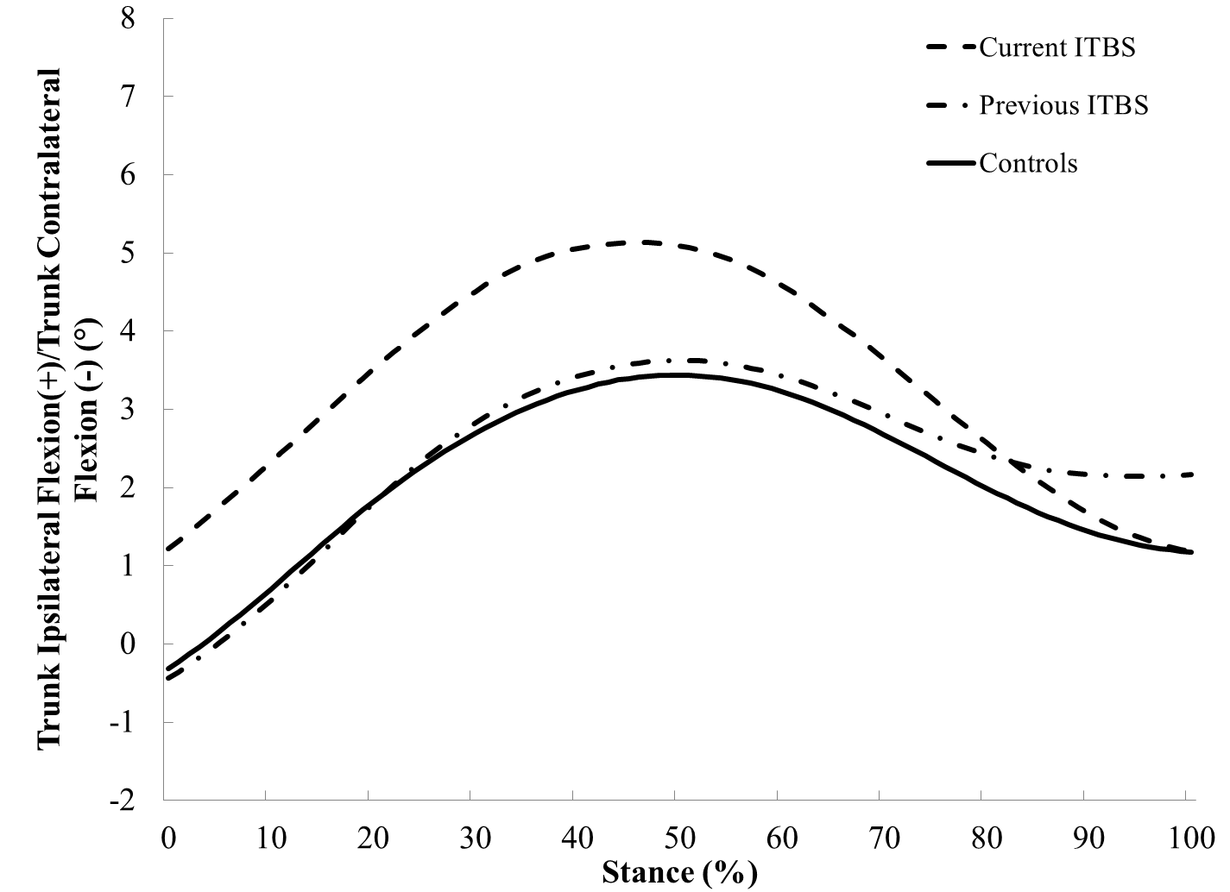

Contralateral Pelvic Drop

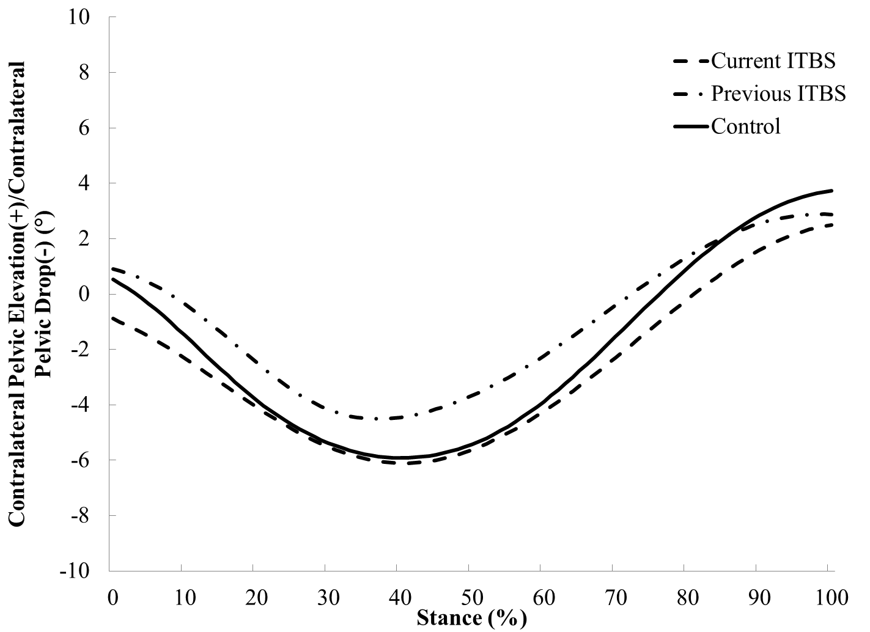

Hip Adduction Angle

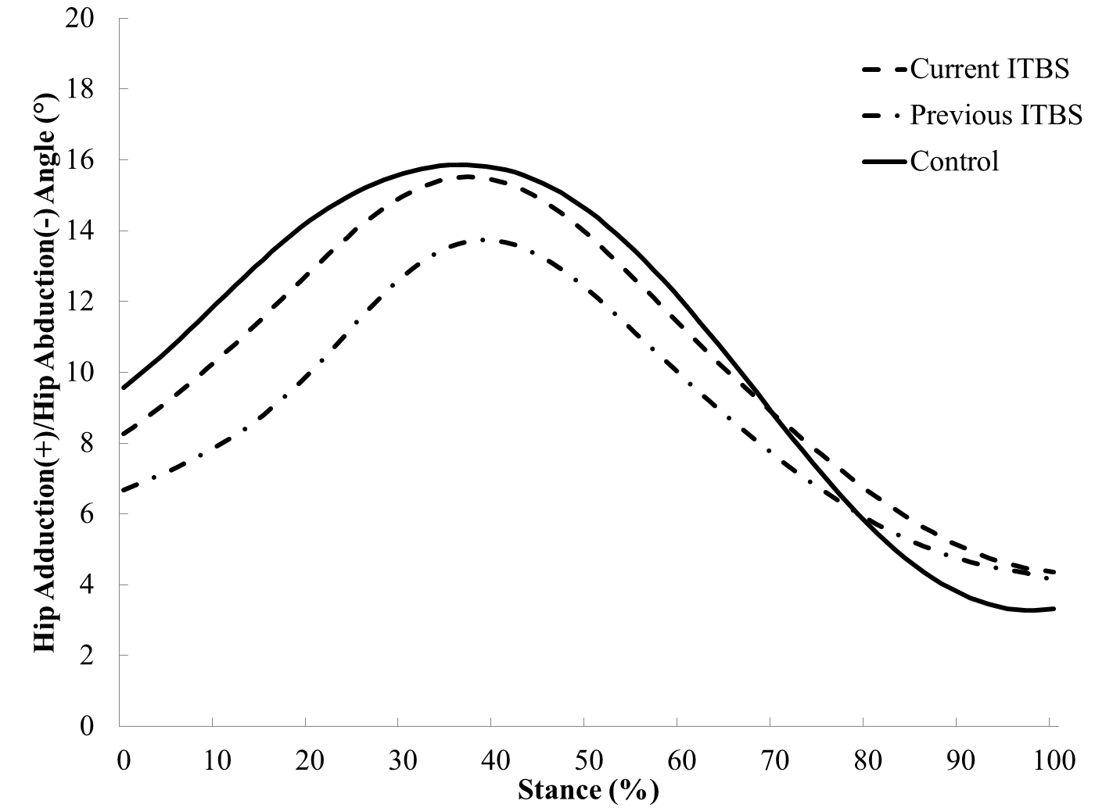

External Knee Adduction Moment

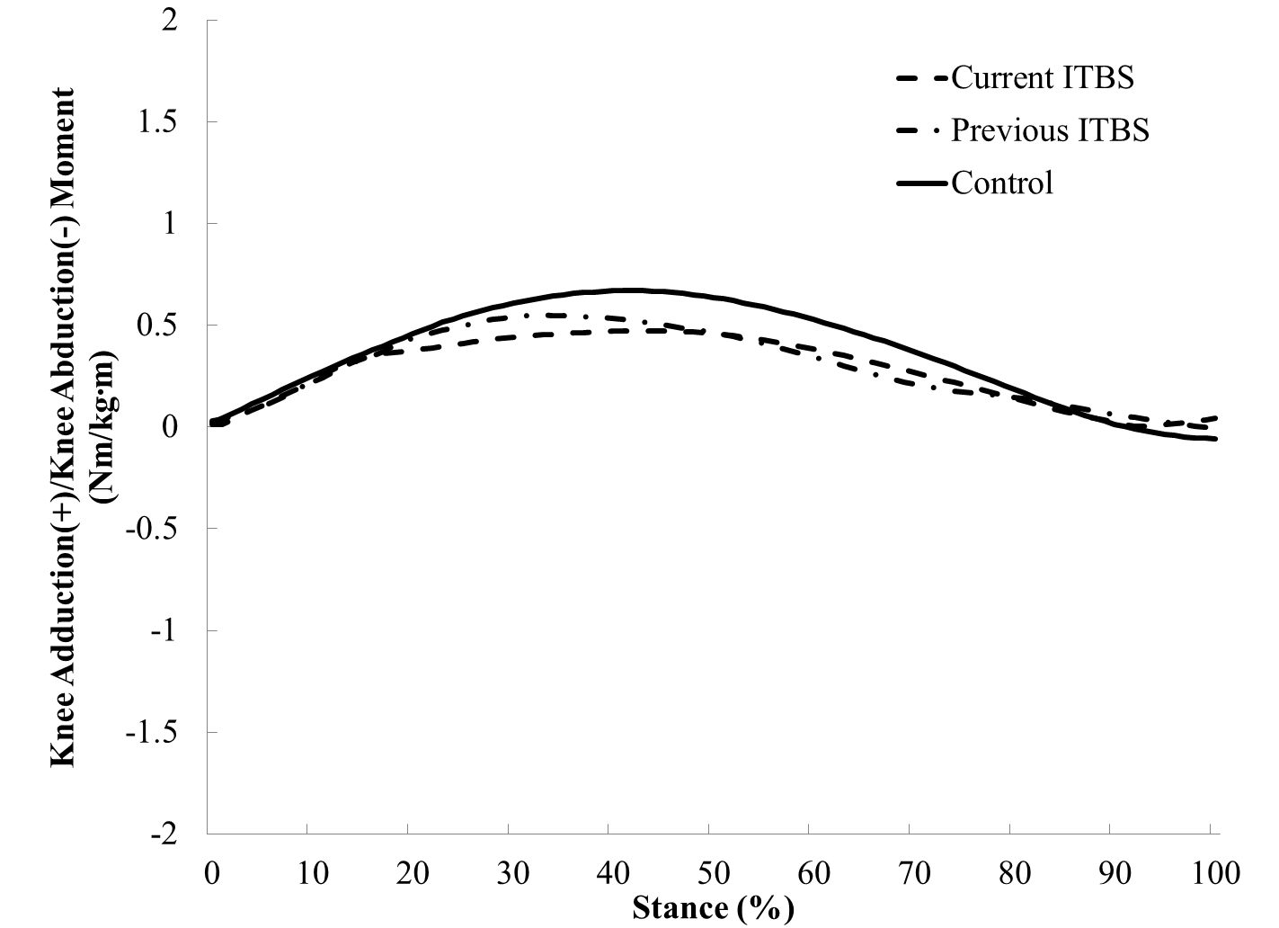

Knee Internal Rotation Angle

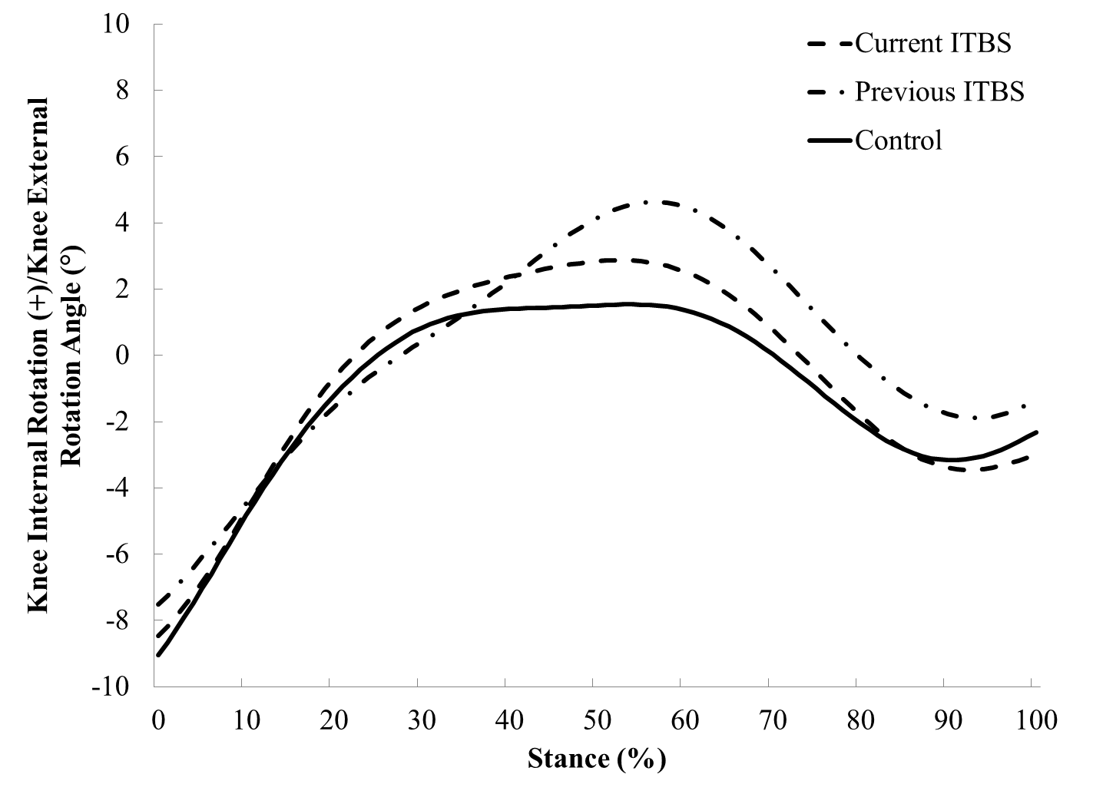

Appendix H: Statistical Analysis

Trunk Contralateral Flexion

ANOVA
trk_y_ang_min
 | Sum of Squares | df | Mean Square | F | Sig.
Between Groups | 10.907 | 2 | 5.454 | 2.239 | .128
Within Groups | 58.468 | 24 | 2.436
Total | 69.375 | 26

Multiple Comparisons
Dependent Variable: trk_y_ang_min
LSD
(I) group | (J) group | Mean Difference (I-J) | Std. Error | Sig. | 95% Confidence Interval
 |  |  |  |  | Lower Bound | Upper Bound
1 | 2 | -1.28111 | .73578 | .094 | -2.7997 | .2375
1 | 3 | .12556 | .73578 | .866 | -1.3930 | 1.6441
2 | 1 | 1.28111 | .73578 | .094 | -.2375 | 2.7997
2 | 3 | 1.40667 | .73578 | .068 | -.1119 | 2.9252
3 | 1 | -.12556 | .73578 | .866 | -1.6441 | 1.3930
3 | 2 | -1.40667 | .73578 | .068 | -2.9252 | .1119

Trunk Ipsilateral Flexion

ANOVA
trk_y_ang_max
 | Sum of Squares | df | Mean Square | F | Sig.
Between Groups | 17.790 | 2 | 8.895 | 3.975 | .032
Within Groups | 53.703 | 24 | 2.238
Total | 71.493 | 26

Multiple Comparisons
Dependent Variable: trk_y_ang_max
LSD
(I) group | (J) group | Mean Difference (I-J) | Std. Error | Sig. | 95% Confidence Interval
 |  |  |  |  | Lower Bound | Upper Bound
1 | 2 | -1.8200* | .7052 | .016 | -3.275 | -.365
1 | 3 | -.2167 | .7052 | .761 | -1.672 | 1.239
2 | 1 | 1.8200* | .7052 | .016 | .365 | 3.275
2 | 3 | 1.6033* | .7052 | .032 | .148 | 3.059
3 | 1 | .2167 | .7052 | .761 | -1.239 | 1.672
3 | 2 | -1.6033* | .7052 | .032 | -3.059 | -.148
*. The mean difference is significant at the 0.05 level.

Contralateral Pelvic Drop

ANOVA
pel_drop_ang
 | Sum of Squares | df | Mean Square | F | Sig.
Between Groups | 17.982 | 2 | 8.991 | 1.285 | .295
Within Groups | 167.868 | 24 | 6.995
Total | 185.850 | 26

Multiple Comparisons
Dependent Variable: pel_drop_ang
LSD
(I) group | (J) group | Mean Difference (I-J) | Std. Error | Sig. | 95% Confidence Interval
 |  |  |  |  | Lower Bound | Upper Bound
1 | 2 | .6344 | 1.2467 | .615 | -1.939 | 3.208
1 | 3 | -1.3244 | 1.2467 | .299 | -3.898 | 1.249
2 | 1 | -.6344 | 1.2467 | .615 | -3.208 | 1.939
2 | 3 | -1.9589 | 1.2467 | .129 | -4.532 | .614
3 | 1 | 1.3244 | 1.2467 | .299 | -1.249 | 3.898
3 | 2 | 1.9589 | 1.2467 | .129 | -.614 | 4.532

Hip Adduction Angle

ANOVA
hip_add_ang
 | Sum of Squares | df | Mean Square | F | Sig.
Between Groups | 39.418 | 2 | 19.709 | 3.084 | .064
Within Groups | 153.355 | 24 | 6.390
Total | 192.773 | 26

Multiple Comparisons
Dependent Variable: hip_add_ang
LSD
(I) group | (J) group | Mean Difference (I-J) | Std. Error | Sig. | 95% Confidence Interval
 |  |  |  |  | Lower Bound | Upper Bound
1 | 2 | -.2011 | 1.1916 | .867 | -2.660 | 2.258
1 | 3 | 2.4567 | 1.1916 | .050 | -.003 | 4.916
2 | 1 | .2011 | 1.1916 | .867 | -2.258 | 2.660
2 | 3 | 2.6578* | 1.1916 | .035 | .198 | 5.117
3 | 1 | -2.4567 | 1.1916 | .050 | -4.916 | .003
3 | 2 | -2.6578* | 1.1916 | .035 | -5.117 | -.198
*. The mean difference is significant at the 0.05 level.

External Knee Adduction Moment

ANOVA
kne_add_mom
 | Sum of Squares | df | Mean Square | F | Sig.
Between Groups | .098 | 2 | .049 | .840 | .444
Within Groups | 1.405 | 24 | .059
Total | 1.503 | 26

Multiple Comparisons
Dependent Variable: kne_add_mom
LSD
(I) group | (J) group | Mean Difference (I-J) | Std. Error | Sig. | 95% Confidence Interval
 |  |  |  |  | Lower Bound | Upper Bound
1 | 2 | -.14778 | .11406 | .207 | -.3832 | .0876
1 | 3 | -.07778 | .11406 | .502 | -.3132 | .1576
2 | 1 | .14778 | .11406 | .207 | -.0876 | .3832
2 | 3 | .07000 | .11406 | .545 | -.1654 | .3054
3 | 1 | .07778 | .11406 | .502 | -.1576 | .3132
3 | 2 | -.07000 | .11406 | .545 | -.3054 | .1654

Knee Internal Rotation Angle

ANOVA
kne_rot_ang
 | Sum of Squares | df | Mean Square | F | Sig.
Between Groups | 23.238 | 2 | 11.619 | .284 | .755
Within Groups | 981.973 | 24 | 40.916
Total | 1005.211 | 26

Multiple Comparisons
Dependent Variable: kne_rot_ang
LSD
(I) group | (J) group | Mean Difference (I-J) | Std. Error | Sig. | 95% Confidence Interval
 |  |  |  |  | Lower Bound | Upper Bound
1 | 2 | -1.0078 | 3.0154 | .741 | -7.231 | 5.216
1 | 3 | -2.2678 | 3.0154 | .459 | -8.491 | 3.956
2 | 1 | 1.0078 | 3.0154 | .741 | -5.216 | 7.231
2 | 3 | -1.2600 | 3.0154 | .680 | -7.483 | 4.963
3 | 1 | 2.2678 | 3.0154 | .459 | -3.956 | 8.491
3 | 2 | 1.2600 | 3.0154 | .680 | -4.963 | 7.483

Iliotibial Band Flexibility

ANOVA
itb_flexibility
 | Sum of Squares | df | Mean Square | F | Sig.
Between Groups | 359.185 | 2 | 179.593 | 8.832 | .001
Within Groups | 488.000 | 24 | 20.333
Total | 847.185 | 26

Multiple Comparisons
Dependent Variable: itb_flexibility
LSD
(I) group | (J) group | Mean Difference (I-J) | Std. Error | Sig. | 95% Confidence Interval
 |  |  |  |  | Lower Bound | Upper Bound
1 | 2 | 8.000* | 2.126 | .001 | 3.61 | 12.39
1 | 3 | .556 | 2.126 | .796 | -3.83 | 4.94
2 | 1 | -8.000* | 2.126 | .001 | -12.39 | -3.61
2 | 3 | -7.444* | 2.126 | .002 | -11.83 | -3.06
3 | 1 | -.556 | 2.126 | .796 | -4.94 | 3.83
3 | 2 | 7.444* | 2.126 | .002 | 3.06 | 11.83
*. The mean difference is significant at the 0.05 level.

Isometric Hip Abductor Strength

ANOVA
habd_strength
 | Sum of Squares | df | Mean Square | F | Sig.
Between Groups | 54.931 | 2 | 27.466 | 4.146 | .028
Within Groups | 158.997 | 24 | 6.625
Total | 213.928 | 26

Multiple Comparisons
Dependent Variable: habd_strength
LSD
(I) group | (J) group | Mean Difference (I-J) | Std. Error | Sig. | 95% Confidence Interval
 |  |  |  |  | Lower Bound | Upper Bound
1 | 2 | 1.5656 | 1.2133 | .209 | -.939 | 4.070
1 | 3 | 3.4878* | 1.2133 | .008 | .984 | 5.992
2 | 1 | -1.5656 | 1.2133 | .209 | -4.070 | .939
2 | 3 | 1.9222 | 1.2133 | .126 | -.582 | 4.426
3 | 1 | -3.4878* | 1.2133 | .008 | -5.992 | -.984
3 | 2 | -1.9222 | 1.2133 | .126 | -4.426 | .582
*. The mean difference is significant at the 0.05 level.

Iliotibial Band Strain

ANOVA
itb_strain_max
 | Sum of Squares | df | Mean Square | F | Sig.
Between Groups | 1.301 | 2 | .650 | .504 | .610
Within Groups | 30.984 | 24 | 1.291
Total | 32.285 | 26

Multiple Comparisons
Dependent Variable: itb_strain_max
LSD
(I) group | (J) group | Mean Difference (I-J) | Std. Error | Sig. | 95% Confidence Interval
 |  |  |  |  | Lower Bound | Upper Bound
1 | 2 | -.1111 | .5356 | .837 | -1.217 | .994
1 | 3 | -.5111 | .5356 | .349 | -1.617 | .594
2 | 1 | .1111 | .5356 | .837 | -.994 | 1.217
2 | 3 | -.4000 | .5356 | .462 | -1.505 | .705
3 | 1 | .5111 | .5356 | .349 | -.594 | 1.617
3 | 2 | .4000 | .5356 | .462 | -.705 | 1.505

Iliotibial Band Strain Rate

ANOVA
itb_strain_rate_max
 | Sum of Squares | df | Mean Square | F | Sig.
Between Groups | 35.490 | 2 | 17.745 | .169 | .845
Within Groups | 2519.333 | 24 | 104.972
Total | 2554.823 | 26

Multiple Comparisons
Dependent Variable: itb_strain_rate_max
LSD
(I) group | (J) group | Mean Difference (I-J) | Std. Error | Sig. | 95% Confidence Interval
 |  |  |  |  | Lower Bound | Upper Bound
1 | 2 | -.1667 | 4.8298 | .973 | -10.135 | 9.802
1 | 3 | -2.5111 | 4.8298 | .608 | -12.479 | 7.457
2 | 1 | .1667 | 4.8298 | .973 | -9.802 | 10.135
2 | 3 | -2.3444 | 4.8298 | .632 | -12.313 | 7.624
3 | 1 | 2.5111 | 4.8298 | .608 | -7.457 | 12.479
3 | 2 | 2.3444 | 4.8298 | .632 | -7.624 | 12.313

Correlation of Peak Hip Adduction Angle during Running and Iliotibial Band Flexibility

Correlations
 |  | hip_add_ang | itb_flexibility
hip_add_ang | Pearson Correlation | 1 | -.011
hip_add_ang | Sig. (2-tailed) |  | .956
hip_add_ang | N | 27 | 27
itb_flexibility | Pearson Correlation | -.011 | 1
itb_flexibility | Sig. (2-tailed) | .956
itb_flexibility | N | 27 | 27

Correlation of Peak Hip Adduction Angle during Running and Isometric Hip Abductor Strength

Correlations
 |  | hip_add_ang | habd_strength
hip_add_ang | Pearson Correlation | 1 | .262
hip_add_ang | Sig. (2-tailed) |  | .186
hip_add_ang | N | 27 | 27
habd_strength | Pearson Correlation | .262 | 1
habd_strength | Sig. (2-tailed) | .186
habd_strength | N | 27 | 27

Frontal Plane Trunk – Pelvis Coupling Variability

Multivariate Tests
 | Value | F | Hypothesis df | Error df | Sig.
Pillai's trace | .547 | 2.072 | 8.000 | 44.000 | .059
Wilks' lambda | .483 | 2.301ª | 8.000 | 42.000 | .038
Hotelling's trace | 1.005 | 2.513 | 8.000 | 40.000 | .026
Roy's largest root | .937 | 5.155^{b} | 4.000 | 22.000 | .004
Each F tests the multivariate effect of group. These tests are based on the linearly independent pairwise comparisons among the estimated marginal means.
a. Exact statistic
b. The statistic is an upper bound on F that yields a lower bound on the significance level.

Multiple Comparisons
LSD
Dependent Variable | (I) group | (J) group | Mean Difference (I-J) | Std. Error | Sig. | 95% Confidence Interval
 |  |  |  |  |  | Lower Bound | Upper Bound
trk_pel_bin1_var | 1 | 2 | -1.311 | 1.3928 | .356 | -4.186 | 1.564
trk_pel_bin1_var | 1 | 3 | -4.678* | 1.3928 | .003 | -7.552 | -1.803
trk_pel_bin1_var | 2 | 1 | 1.311 | 1.3928 | .356 | -1.564 | 4.186
trk_pel_bin1_var | 2 | 3 | -3.367* | 1.3928 | .024 | -6.241 | -.492
trk_pel_bin1_var | 3 | 1 | 4.678* | 1.3928 | .003 | 1.803 | 7.552
trk_pel_bin1_var | 3 | 2 | 3.367* | 1.3928 | .024 | .492 | 6.241
trk_pel_bin2_var | 1 | 2 | 1.878 | 2.8115 | .511 | -3.925 | 7.680
trk_pel_bin2_var | 1 | 3 | -.356 | 2.8115 | .900 | -6.158 | 5.447
trk_pel_bin2_var | 2 | 1 | -1.878 | 2.8115 | .511 | -7.680 | 3.925
trk_pel_bin2_var | 2 | 3 | -2.233 | 2.8115 | .435 | -8.036 | 3.569
trk_pel_bin2_var | 3 | 1 | .356 | 2.8115 | .900 | -5.447 | 6.158
trk_pel_bin2_var | 3 | 2 | 2.233 | 2.8115 | .435 | -3.569 | 8.036
trk_pel_bin3_var | 1 | 2 | -.278 | 2.0997 | .896 | -4.611 | 4.056
trk_pel_bin3_var | 1 | 3 | -1.022 | 2.0997 | .631 | -5.356 | 3.311
trk_pel_bin3_var | 2 | 1 | .278 | 2.0997 | .896 | -4.056 | 4.611
trk_pel_bin3_var | 2 | 3 | -.744 | 2.0997 | .726 | -5.078 | 3.589
trk_pel_bin3_var | 3 | 1 | 1.022 | 2.0997 | .631 | -3.311 | 5.356
trk_pel_bin3_var | 3 | 2 | .744 | 2.0997 | .726 | -3.589 | 5.078
trk_pel_bin4_var | 1 | 2 | .567 | 2.1918 | .798 | -3.957 | 5.090
trk_pel_bin4_var | 1 | 3 | -5.222* | 2.1918 | .025 | -9.746 | -.698
trk_pel_bin4_var | 2 | 1 | -.567 | 2.1918 | .798 | -5.090 | 3.957
trk_pel_bin4_var | 2 | 3 | -5.789* | 2.1918 | .014 | -10.313 | -1.265
trk_pel_bin4_var | 3 | 1 | 5.222* | 2.1918 | .025 | .698 | 9.746
trk_pel_bin4_var | 3 | 2 | 5.789* | 2.1918 | .014 | 1.265 | 10.313
Based on observed means.
The error term is Mean Square(Error) = 21.619.

Frontal Plane Pelvis – Thigh Coupling Variability
Multivariate Tests
 | Value | F | Hypothesis df | Error df | Sig.
Pillai's trace | .716 | 3.066 | 8.000 | 44.000 | .008
Wilks' lambda | .295 | 4.409ª | 8.000 | 42.000 | .001
Hotelling's trace | 2.347 | 5.867 | 8.000 | 40.000 | .000
Roy's largest root | 2.330 | 12.818^{b} | 4.000 | 22.000 | .000
Each F tests the multivariate effect of group. These tests are based on the linearly independent pairwise comparisons among the estimated marginal means.
a. Exact statistic
b. The statistic is an upper bound on F that yields a lower bound on the significance level.

Multiple Comparisons
LSD
Dependent Variable | (I) group | (J) group | Mean Difference (I-J) | Std. Error | Sig. | 95% Confidence Interval
 |  |  |  |  |  | Lower Bound | Upper Bound
pel_thi_bin1_var | 1 | 2 | .678 | 1.8266 | .714 | -3.092 | 4.448
pel_thi_bin1_var | 1 | 3 | -7.233* | 1.8266 | .001 | -11.003 | -3.463
pel_thi_bin1_var | 2 | 1 | -.678 | 1.8266 | .714 | -4.448 | 3.092
pel_thi_bin1_var | 2 | 3 | -7.911* | 1.8266 | .000 | -11.681 | -4.141
pel_thi_bin1_var | 3 | 1 | 7.233* | 1.8266 | .001 | 3.463 | 11.003
pel_thi_bin1_var | 3 | 2 | 7.911* | 1.8266 | .000 | 4.141 | 11.681
pel_thi_bin2_var | 1 | 2 | 1.078 | 2.6087 | .683 | -4.306 | 6.462
pel_thi_bin2_var | 1 | 3 | .622 | 2.6087 | .814 | -4.762 | 6.006
pel_thi_bin2_var | 2 | 1 | -1.078 | 2.6087 | .683 | -6.462 | 4.306
pel_thi_bin2_var | 2 | 3 | -.456 | 2.6087 | .863 | -5.840 | 4.929
pel_thi_bin2_var | 3 | 1 | -.622 | 2.6087 | .814 | -6.006 | 4.762
pel_thi_bin2_var | 3 | 2 | .456 | 2.6087 | .863 | -4.929 | 5.840
pel_thi_bin3_var | 1 | 2 | -.244 | 2.3800 | .919 | -5.156 | 4.668
pel_thi_bin3_var | 1 | 3 | -1.522 | 2.3800 | .528 | -6.434 | 3.390
pel_thi_bin3_var | 2 | 1 | .244 | 2.3800 | .919 | -4.668 | 5.156
pel_thi_bin3_var | 2 | 3 | -1.278 | 2.3800 | .596 | -6.190 | 3.634
pel_thi_bin3_var | 3 | 1 | 1.522 | 2.3800 | .528 | -3.390 | 6.434
pel_thi_bin3_var | 3 | 2 | 1.278 | 2.3800 | .596 | -3.634 | 6.190
pel_thi_bin4_var | 1 | 2 | .200 | 2.5646 | .938 | -5.093 | 5.493
pel_thi_bin4_var | 1 | 3 | -6.967* | 2.5646 | .012 | -12.260 | -1.673
pel_thi_bin4_var | 2 | 1 | -.200 | 2.5646 | .938 | -5.493 | 5.093
pel_thi_bin4_var | 2 | 3 | -7.167* | 2.5646 | .010 | -12.460 | -1.873
pel_thi_bin4_var | 3 | 1 | 6.967* | 2.5646 | .012 | 1.673 | 12.260
pel_thi_bin4_var | 3 | 2 | 7.167* | 2.5646 | .010 | 1.873 | 12.460
Based on observed means.
The error term is Mean Square(Error) = 29.598.
*. The mean difference is significant at the .05 level.

Sagittal Plane Knee – Transverse Plane Foot Coupling Variability

Multivariate Tests
 | Value | F | Hypothesis df | Error df | Sig.
Pillai's trace | .247 | .774 | 8.000 | 44.000 | .627
Wilks' lambda | .765 | .751ª | 8.000 | 42.000 | .647
Hotelling's trace | .291 | .726 | 8.000 | 40.000 | .667
Roy's largest root | .217 | 1.194^{b} | 4.000 | 22.000 | .341
Each F tests the multivariate effect of group. These tests are based on the linearly independent pairwise comparisons among the estimated marginal means.
a. Exact statistic
b. The statistic is an upper bound on F that yields a lower bound on the significance level.

Multiple Comparisons
LSD
Dependent Variable | (I) group | (J) group | Mean Difference (I-J) | Std. Error | Sig. | 95% Confidence Interval
 |  |  |  |  |  | Lower Bound | Upper Bound
kne_fot_bin1_var | 1 | 2 | .667 | .8964 | .464 | -1.183 | 2.517
kne_fot_bin1_var | 1 | 3 | .267 | .8964 | .769 | -1.583 | 2.117
kne_fot_bin1_var | 2 | 1 | -.667 | .8964 | .464 | -2.517 | 1.183
kne_fot_bin1_var | 2 | 3 | -.400 | .8964 | .659 | -2.250 | 1.450
kne_fot_bin1_var | 3 | 1 | -.267 | .8964 | .769 | -2.117 | 1.583
kne_fot_bin1_var | 3 | 2 | .400 | .8964 | .659 | -1.450 | 2.250
kne_fot_bin2_var | 1 | 2 | -1.089 | 1.1905 | .369 | -3.546 | 1.368
kne_fot_bin2_var | 1 | 3 | -1.356 | 1.1905 | .266 | -3.813 | 1.102
kne_fot_bin2_var | 2 | 1 | 1.089 | 1.1905 | .369 | -1.368 | 3.546
kne_fot_bin2_var | 2 | 3 | -.267 | 1.1905 | .825 | -2.724 | 2.190
kne_fot_bin2_var | 3 | 1 | 1.356 | 1.1905 | .266 | -1.102 | 3.813
kne_fot_bin2_var | 3 | 2 | .267 | 1.1905 | .825 | -2.190 | 2.724
kne_fot_bin3_var | 1 | 2 | .256 | .8701 | .772 | -1.540 | 2.051
kne_fot_bin3_var | 1 | 3 | -1.244 | .8701 | .166 | -3.040 | .551
kne_fot_bin3_var | 2 | 1 | -.256 | .8701 | .772 | -2.051 | 1.540
kne_fot_bin3_var | 2 | 3 | -1.500 | .8701 | .098 | -3.296 | .296
kne_fot_bin3_var | 3 | 1 | 1.244 | .8701 | .166 | -.551 | 3.040
kne_fot_bin3_var | 3 | 2 | 1.500 | .8701 | .098 | -.296 | 3.296
kne_fot_bin4_var | 1 | 2 | .556 | 1.6213 | .735 | -2.791 | 3.902
kne_fot_bin4_var | 1 | 3 | -1.811 | 1.6213 | .275 | -5.157 | 1.535
kne_fot_bin4_var | 2 | 1 | -.556 | 1.6213 | .735 | -3.902 | 2.791
kne_fot_bin4_var | 2 | 3 | -2.367 | 1.6213 | .157 | -5.713 | .980
kne_fot_bin4_var | 3 | 1 | 1.811 | 1.6213 | .275 | -1.535 | 5.157
kne_fot_bin4_var | 3 | 2 | 2.367 | 1.6213 | .157 | -.980 | 5.713
Based on observed means.
The error term is Mean Square(Error) = 11.829.

Transverse Plane Shank – Rearfoot Coupling Variability

Multivariate Tests
 | Value | F | Hypothesis df | Error df | Sig.
Pillai's trace | .126 | .370 | 8.000 | 44.000 | .931
Wilks' lambda | .876 | .361ª | 8.000 | 42.000 | .935
Hotelling's trace | .140 | .351 | 8.000 | 40.000 | .940
Roy's largest root | .126 | .694^{b} | 4.000 | 22.000 | .604
Each F tests the multivariate effect of group. These tests are based on the linearly independent pairwise comparisons among the estimated marginal means.
a. Exact statistic
b. The statistic is an upper bound on F that yields a lower bound on the significance level.

Multiple Comparisons
LSD
Dependent Variable | (I) group | (J) group | Mean Difference (I-J) | Std. Error | Sig. | 95% Confidence Interval
 |  |  |  |  |  | Lower Bound | Upper Bound
shk_rf_bin1_var | 1 | 2 | -.500 | 2.3066 | .830 | -5.261 | 4.261
shk_rf_bin1_var | 1 | 3 | -1.222 | 2.3066 | .601 | -5.983 | 3.538
shk_rf_bin1_var | 2 | 1 | .500 | 2.3066 | .830 | -4.261 | 5.261
shk_rf_bin1_var | 2 | 3 | -.722 | 2.3066 | .757 | -5.483 | 4.038
shk_rf_bin1_var | 3 | 1 | 1.222 | 2.3066 | .601 | -3.538 | 5.983
shk_rf_bin1_var | 3 | 2 | .722 | 2.3066 | .757 | -4.038 | 5.483
shk_rf_bin2_var | 1 | 2 | 2.833 | 2.1687 | .204 | -1.643 | 7.309
shk_rf_bin2_var | 1 | 3 | 1.333 | 2.1687 | .544 | -3.143 | 5.809
shk_rf_bin2_var | 2 | 1 | -2.833 | 2.1687 | .204 | -7.309 | 1.643
shk_rf_bin2_var | 2 | 3 | -1.500 | 2.1687 | .496 | -5.976 | 2.976
shk_rf_bin2_var | 3 | 1 | -1.333 | 2.1687 | .544 | -5.809 | 3.143
shk_rf_bin2_var | 3 | 2 | 1.500 | 2.1687 | .496 | -2.976 | 5.976
shk_rf_bin3_var | 1 | 2 | 1.256 | 2.1195 | .559 | -3.119 | 5.630
shk_rf_bin3_var | 1 | 3 | .844 | 2.1195 | .694 | -3.530 | 5.219
shk_rf_bin3_var | 2 | 1 | -1.256 | 2.1195 | .559 | -5.630 | 3.119
shk_rf_bin3_var | 2 | 3 | -.411 | 2.1195 | .848 | -4.786 | 3.963
shk_rf_bin3_var | 3 | 1 | -.844 | 2.1195 | .694 | -5.219 | 3.530
shk_rf_bin3_var | 3 | 2 | .411 | 2.1195 | .848 | -3.963 | 4.786
shk_rf_bin4_var | 1 | 2 | -.100 | 1.6633 | .953 | -3.533 | 3.333
shk_rf_bin4_var | 1 | 3 | -.533 | 1.6633 | .751 | -3.966 | 2.899
shk_rf_bin4_var | 2 | 1 | .100 | 1.6633 | .953 | -3.333 | 3.533
shk_rf_bin4_var | 2 | 3 | -.433 | 1.6633 | .797 | -3.866 | 2.999
shk_rf_bin4_var | 3 | 1 | .533 | 1.6633 | .751 | -2.899 | 3.966
shk_rf_bin4_var | 3 | 2 | .433 | 1.6633 | .797 | -2.999 | 3.866
Based on observed means.
The error term is Mean Square(Error) = 12.449.

Transverse Plane Thigh – Shank Coupling Variability

Multivariate Tests
 | Value | F | Hypothesis df | Error df | Sig.
Pillai's trace | .475 | 1.714 | 8.000 | 44.000 | .122
Wilks' lambda | .563 | 1.747ª | 8.000 | 42.000 | .116
Hotelling's trace | .708 | 1.771 | 8.000 | 40.000 | .112
Roy's largest root | .594 | 3.269^{b} | 4.000 | 22.000 | .030
Each F tests the multivariate effect of group. These tests are based on the linearly independent pairwise comparisons among the estimated marginal means.
a. Exact statistic
b. The statistic is an upper bound on F that yields a lower bound on the significance level.

Multiple Comparisons
LSD
Dependent Variable | (I) group | (J) group | Mean Difference (I-J) | Std. Error | Sig. | 95% Confidence Interval
 |  |  |  |  |  | Lower Bound | Upper Bound
thi_shk_z_bin1_var | 1 | 2 | -1.100 | 3.2485 | .738 | -7.804 | 5.604
thi_shk_z_bin1_var | 1 | 3 | -3.844 | 3.2485 | .248 | -10.549 | 2.860
thi_shk_z_bin1_var | 2 | 1 | 1.100 | 3.2485 | .738 | -5.604 | 7.804
thi_shk_z_bin1_var | 2 | 3 | -2.744 | 3.2485 | .407 | -9.449 | 3.960
thi_shk_z_bin1_var | 3 | 1 | 3.844 | 3.2485 | .248 | -2.860 | 10.549
thi_shk_z_bin1_var | 3 | 2 | 2.744 | 3.2485 | .407 | -3.960 | 9.449
thi_shk_z_bin2_var | 1 | 2 | 1.122 | 2.4342 | .649 | -3.902 | 6.146
thi_shk_z_bin2_var | 1 | 3 | 2.156 | 2.4342 | .385 | -2.868 | 7.179
thi_shk_z_bin2_var | 2 | 1 | -1.122 | 2.4342 | .649 | -6.146 | 3.902
thi_shk_z_bin2_var | 2 | 3 | 1.033 | 2.4342 | .675 | -3.991 | 6.057
thi_shk_z_bin2_var | 3 | 1 | -2.156 | 2.4342 | .385 | -7.179 | 2.868
thi_shk_z_bin2_var | 3 | 2 | -1.033 | 2.4342 | .675 | -6.057 | 3.991
thi_shk_z_bin3_var | 1 | 2 | 6.367* | 1.9343 | .003 | 2.374 | 10.359
thi_shk_z_bin3_var | 1 | 3 | 1.544 | 1.9343 | .432 | -2.448 | 5.537
thi_shk_z_bin3_var | 2 | 1 | -6.367* | 1.9343 | .003 | -10.359 | -2.374
thi_shk_z_bin3_var | 2 | 3 | -4.822* | 1.9343 | .020 | -8.814 | -.830
thi_shk_z_bin3_var | 3 | 1 | -1.544 | 1.9343 | .432 | -5.537 | 2.448
thi_shk_z_bin3_var | 3 | 2 | 4.822* | 1.9343 | .020 | .830 | 8.814
thi_shk_z_bin4_var | 1 | 2 | 3.033 | 2.2219 | .185 | -1.552 | 7.619
thi_shk_z_bin4_var | 1 | 3 | .156 | 2.2219 | .945 | -4.430 | 4.741
thi_shk_z_bin4_var | 2 | 1 | -3.033 | 2.2219 | .185 | -7.619 | 1.552
thi_shk_z_bin4_var | 2 | 3 | -2.878 | 2.2219 | .208 | -7.464 | 1.708
thi_shk_z_bin4_var | 3 | 1 | -.156 | 2.2219 | .945 | -4.741 | 4.430
thi_shk_z_bin4_var | 3 | 2 | 2.878 | 2.2219 | .208 | -1.708 | 7.464
Based on observed means.
The error term is Mean Square(Error) = 22.216.
*. The mean difference is significant at the .05 level.

Principal Component Scores: Frontal Plane Trunk Angle

Multivariate Tests
 | Value | F | Hypothesis df | Error df | Sig.
Pillai's trace | .353 | 1.643 | 6.000 | 46.000 | .157
Wilks' lambda | .664 | 1.668ª | 6.000 | 44.000 | .152
Hotelling's trace | .481 | 1.685 | 6.000 | 42.000 | .149
Roy's largest root | .421 | 3.231^{b} | 3.000 | 23.000 | .041
Each F tests the multivariate effect of group. These tests are based on the linearly independent pairwise comparisons among the estimated marginal means.
a. Exact statistic
b. The statistic is an upper bound on F that yields a lower bound on the significance level.

Multiple Comparisons
LSD
Dependent Variable | (I) group | (J) group | Mean Difference (I-J) | Std. Error | Sig. | 95% Confidence Interval
 |  |  |  |  |  | Lower Bound | Upper Bound
pc1_trk_y_ang | 1 | 2 | -12.9705* | 5.41320 | .025 | -24.1428 | -1.7982
pc1_trk_y_ang | 1 | 3 | -1.4592 | 5.41320 | .790 | -12.6315 | 9.7131
pc1_trk_y_ang | 2 | 1 | 12.9705* | 5.41320 | .025 | 1.7982 | 24.1428
pc1_trk_y_ang | 2 | 3 | 11.5113* | 5.41320 | .044 | .3390 | 22.6836
pc1_trk_y_ang | 3 | 1 | 1.4592 | 5.41320 | .790 | -9.7131 | 12.6315
pc1_trk_y_ang | 3 | 2 | -11.5113* | 5.41320 | .044 | -22.6836 | -.3390
pc2_trk_y_ang | 1 | 2 | -2.2139 | 3.93272 | .579 | -10.3306 | 5.9028
pc2_trk_y_ang | 1 | 3 | 2.9972 | 3.93272 | .453 | -5.1196 | 11.1139
pc2_trk_y_ang | 2 | 1 | 2.2139 | 3.93272 | .579 | -5.9028 | 10.3306
pc2_trk_y_ang | 2 | 3 | 5.2111 | 3.93272 | .198 | -2.9057 | 13.3278
pc2_trk_y_ang | 3 | 1 | -2.9972 | 3.93272 | .453 | -11.1139 | 5.1196
pc2_trk_y_ang | 3 | 2 | -5.2111 | 3.93272 | .198 | -13.3278 | 2.9057
pc3_trk_y_ang | 1 | 2 | .2610 | 1.52957 | .866 | -2.8959 | 3.4179
pc3_trk_y_ang | 1 | 3 | -1.5124 | 1.52957 | .333 | -4.6693 | 1.6445
pc3_trk_y_ang | 2 | 1 | -.2610 | 1.52957 | .866 | -3.4179 | 2.8959
pc3_trk_y_ang | 2 | 3 | -1.7734 | 1.52957 | .258 | -4.9303 | 1.3835
pc3_trk_y_ang | 3 | 1 | 1.5124 | 1.52957 | .333 | -1.6445 | 4.6693
pc3_trk_y_ang | 3 | 2 | 1.7734 | 1.52957 | .258 | -1.3835 | 4.9303
Based on observed means.
The error term is Mean Square(Error) = 10.528.
*. The mean difference is significant at the .05 level.

Principal Component Scores: Frontal Plane Pelvis Angle

Multivariate Tests
 | Value | F | Hypothesis df | Error df | Sig.
Pillai's trace | .284 | 1.267 | 6.000 | 46.000 | .291
Wilks' lambda | .736 | 1.212ª | 6.000 | 44.000 | .318
Hotelling's trace | .331 | 1.157 | 6.000 | 42.000 | .347
Roy's largest root | .174 | 1.336^{b} | 3.000 | 23.000 | .287
Each F tests the multivariate effect of group. These tests are based on the linearly independent pairwise comparisons among the estimated marginal means.
a. Exact statistic
b. The statistic is an upper bound on F that yields a lower bound on the significance level.

Multiple Comparisons
LSD
Dependent Variable | (I) group | (J) group | Mean Difference (I-J) | Std. Error | Sig. | 95% Confidence Interval
 |  |  |  |  |  | Lower Bound | Upper Bound
pc1_pel_y_ang | 1 | 2 | 8.7497 | 9.76593 | .379 | -11.4062 | 28.9055
pc1_pel_y_ang | 1 | 3 | -10.4899 | 9.76593 | .293 | -30.6458 | 9.6660
pc1_pel_y_ang | 2 | 1 | -8.7497 | 9.76593 | .379 | -28.9055 | 11.4062
pc1_pel_y_ang | 2 | 3 | -19.2395 | 9.76593 | .060 | -39.3954 | .9164
pc1_pel_y_ang | 3 | 1 | 10.4899 | 9.76593 | .293 | -9.6660 | 30.6458
pc1_pel_y_ang | 3 | 2 | 19.2395 | 9.76593 | .060 | -.9164 | 39.3954
pc2_pel_y_ang | 1 | 2 | 1.4975 | 4.94237 | .764 | -8.7030 | 11.6981
pc2_pel_y_ang | 1 | 3 | 3.3669 | 4.94237 | .502 | -6.8337 | 13.5674
pc2_pel_y_ang | 2 | 1 | -1.4975 | 4.94237 | .764 | -11.6981 | 8.7030
pc2_pel_y_ang | 2 | 3 | 1.8693 | 4.94237 | .709 | -8.3312 | 12.0699
pc2_pel_y_ang | 3 | 1 | -3.3669 | 4.94237 | .502 | -13.5674 | 6.8337
pc2_pel_y_ang | 3 | 2 | -1.8693 | 4.94237 | .709 | -12.0699 | 8.3312
pc3_pel_y_ang | 1 | 2 | -4.8949 | 2.91527 | .106 | -10.9118 | 1.1219
pc3_pel_y_ang | 1 | 3 | -4.4222 | 2.91527 | .142 | -10.4391 | 1.5946
pc3_pel_y_ang | 2 | 1 | 4.8949 | 2.91527 | .106 | -1.1219 | 10.9118
pc3_pel_y_ang | 2 | 3 | .4727 | 2.91527 | .873 | -5.5441 | 6.4895
pc3_pel_y_ang | 3 | 1 | 4.4222 | 2.91527 | .142 | -1.5946 | 10.4391
pc3_pel_y_ang | 3 | 2 | -.4727 | 2.91527 | .873 | -6.4895 | 5.5441
Based on observed means.
The error term is Mean Square(Error) = 38.245.

Principal Component Scores: Frontal Plane Hip Angle

Multivariate Tests
 | Value | F | Hypothesis df | Error df | Sig.
Pillai's trace | .280 | 1.251 | 6.000 | 46.000 | .299
Wilks' lambda | .728 | 1.260ª | 6.000 | 44.000 | .295
Hotelling's trace | .361 | 1.263 | 6.000 | 42.000 | .295
Roy's largest root | .324 | 2.482^{b} | 3.000 | 23.000 | .086
Each F tests the multivariate effect of group. These tests are based on the linearly independent pairwise comparisons among the estimated marginal means.
a. Exact statistic
b. The statistic is an upper bound on F that yields a lower bound on the significance level.

Multiple Comparisons
LSD
Dependent Variable | (I) group | (J) group | Mean Difference (I-J) | Std. Error | Sig. | 95% Confidence Interval
 |  |  |  |  |  | Lower Bound | Upper Bound
pc1_hip_y_ang | 1 | 2 | -.8236 | 10.03627 | .935 | -21.5375 | 19.8902
pc1_hip_y_ang | 1 | 3 | -23.0200* | 10.03627 | .031 | -43.7339 | -2.3062
pc1_hip_y_ang | 2 | 1 | .8236 | 10.03627 | .935 | -19.8902 | 21.5375
pc1_hip_y_ang | 2 | 3 | -22.1964* | 10.03627 | .037 | -42.9103 | -1.4826
pc1_hip_y_ang | 3 | 1 | 23.0200* | 10.03627 | .031 | 2.3062 | 43.7339
pc1_hip_y_ang | 3 | 2 | 22.1964* | 10.03627 | .037 | 1.4826 | 42.9103
pc2_hip_y_ang | 1 | 2 | 1.1615 | 7.95491 | .885 | -15.2566 | 17.5797
pc2_hip_y_ang | 1 | 3 | 1.7634 | 7.95491 | .826 | -14.6547 | 18.1816
pc2_hip_y_ang | 2 | 1 | -1.1615 | 7.95491 | .885 | -17.5797 | 15.2566
pc2_hip_y_ang | 2 | 3 | .6019 | 7.95491 | .940 | -15.8162 | 17.0200
pc2_hip_y_ang | 3 | 1 | -1.7634 | 7.95491 | .826 | -18.1816 | 14.6547
pc2_hip_y_ang | 3 | 2 | -.6019 | 7.95491 | .940 | -17.0200 | 15.8162
pc3_hip_y_ang | 1 | 2 | -3.9421 | 3.86891 | .318 | -11.9272 | 4.0429
pc3_hip_y_ang | 1 | 3 | -4.2111 | 3.86891 | .287 | -12.1961 | 3.7739
pc3_hip_y_ang | 2 | 1 | 3.9421 | 3.86891 | .318 | -4.0429 | 11.9272
pc3_hip_y_ang | 2 | 3 | -.2690 | 3.86891 | .945 | -8.2540 | 7.7161
pc3_hip_y_ang | 3 | 1 | 4.2111 | 3.86891 | .287 | -3.7739 | 12.1961
pc3_hip_y_ang | 3 | 2 | .2690 | 3.86891 | .945 | -7.7161 | 8.2540
Based on observed means.
The error term is Mean Square(Error) = 67.358.
*. The mean difference is significant at the .05 level.

Principal Component Scores: Frontal Plane Knee Moment

Multivariate Tests
 | Value | F | Hypothesis df | Error df | Sig.
Pillai's trace | .367 | 1.721 | 6.000 | 46.000 | .138
Wilks' lambda | .659 | 1.701ª | 6.000 | 44.000 | .143
Hotelling's trace | .479 | 1.676 | 6.000 | 42.000 | .151
Roy's largest root | .376 | 2.880^{b} | 3.000 | 23.000 | .058
Each F tests the multivariate effect of group. These tests are based on the linearly independent pairwise comparisons among the estimated marginal means.
a. Exact statistic
b. The statistic is an upper bound on F that yields a lower bound on the significance level.

Multiple Comparisons
LSD
Dependent Variable | (I) group | (J) group | Mean Difference (I-J) | Std. Error | Sig. | 95% Confidence Interval
 |  |  |  |  |  | Lower Bound | Upper Bound
pc1_knee_y_mom | 1 | 2 | 1.2582 | .78701 | .123 | -.3661 | 2.8826
pc1_knee_y_mom | 1 | 3 | .9872 | .78701 | .222 | -.6371 | 2.6115
pc1_knee_y_mom | 2 | 1 | -1.2582 | .78701 | .123 | -2.8826 | .3661
pc1_knee_y_mom | 2 | 3 | -.2711 | .78701 | .734 | -1.8954 | 1.3532
pc1_knee_y_mom | 3 | 1 | -.9872 | .78701 | .222 | -2.6115 | .6371
pc1_knee_y_mom | 3 | 2 | .2711 | .78701 | .734 | -1.3532 | 1.8954
pc2_knee_y_mom | 1 | 2 | -.0713 | .18881 | .709 | -.4610 | .3184
pc2_knee_y_mom | 1 | 3 | -.3039 | .18881 | .121 | -.6936 | .0858
pc2_knee_y_mom | 2 | 1 | .0713 | .18881 | .709 | -.3184 | .4610
pc2_knee_y_mom | 2 | 3 | -.2326 | .18881 | .230 | -.6223 | .1571
pc2_knee_y_mom | 3 | 1 | .3039 | .18881 | .121 | -.0858 | .6936
pc2_knee_y_mom | 3 | 2 | .2326 | .18881 | .230 | -.1571 | .6223
pc3_knee_y_mom | 1 | 2 | .0360 | .16734 | .832 | -.3094 | .3814
pc3_knee_y_mom | 1 | 3 | -.2850 | .16734 | .101 | -.6303 | .0604
pc3_knee_y_mom | 2 | 1 | -.0360 | .16734 | .832 | -.3814 | .3094
pc3_knee_y_mom | 2 | 3 | -.3210 | .16734 | .067 | -.6663 | .0244
pc3_knee_y_mom | 3 | 1 | .2850 | .16734 | .101 | -.0604 | .6303
pc3_knee_y_mom | 3 | 2 | .3210 | .16734 | .067 | -.0244 | .6663
Based on observed means.
The error term is Mean Square(Error) = .126.

Principal Component Scores: Transverse Plane Knee Angle

Multivariate Tests
 | Value | F | Hypothesis df | Error df | Sig.
Pillai's trace | .064 | .253 | 6.000 | 46.000 | .956
Wilks' lambda | .937 | .242ª | 6.000 | 44.000 | .960
Hotelling's trace | .066 | .232 | 6.000 | 42.000 | .964
Roy's largest root | .049 | .379^{b} | 3.000 | 23.000 | .769
Each F tests the multivariate effect of group. These tests are based on the linearly independent pairwise comparisons among the estimated marginal means.
a. Exact statistic
b. The statistic is an upper bound on F that yields a lower bound on the significance level.

Multiple Comparisons
LSD
Dependent Variable | (I) group | (J) group | Mean Difference (I-J) | Std. Error | Sig. | 95% Confidence Interval
 |  |  |  |  |  | Lower Bound | Upper Bound
pc1_knee_z_ang | 1 | 2 | 9.2399 | 28.87179 | .752 | -50.3486 | 68.8283
pc1_knee_z_ang | 1 | 3 | 13.5739 | 28.87179 | .642 | -46.0145 | 73.1624
pc1_knee_z_ang | 2 | 1 | -9.2399 | 28.87179 | .752 | -68.8283 | 50.3486
pc1_knee_z_ang | 2 | 3 | 4.3341 | 28.87179 | .882 | -55.2544 | 63.9225
pc1_knee_z_ang | 3 | 1 | -13.5739 | 28.87179 | .642 | -73.1624 | 46.0145
pc1_knee_z_ang | 3 | 2 | -4.3341 | 28.87179 | .882 | -63.9225 | 55.2544
pc2_knee_z_ang | 1 | 2 | .0693 | 9.29064 | .994 | -19.1057 | 19.2442
pc2_knee_z_ang | 1 | 3 | -7.7172 | 9.29064 | .414 | -26.8921 | 11.4577
pc2_knee_z_ang | 2 | 1 | -.0693 | 9.29064 | .994 | -19.2442 | 19.1057
pc2_knee_z_ang | 2 | 3 | -7.7865 | 9.29064 | .410 | -26.9614 | 11.3885
pc2_knee_z_ang | 3 | 1 | 7.7172 | 9.29064 | .414 | -11.4577 | 26.8921
pc2_knee_z_ang | 3 | 2 | 7.7865 | 9.29064 | .410 | -11.3885 | 26.9614
pc3_knee_z_ang | 1 | 2 | -4.2717 | 6.93172 | .544 | -18.5781 | 10.0346
pc3_knee_z_ang | 1 | 3 | -3.2710 | 6.93172 | .641 | -17.5773 | 11.0354
pc3_knee_z_ang | 2 | 1 | 4.2717 | 6.93172 | .544 | -10.0346 | 18.5781
pc3_knee_z_ang | 2 | 3 | 1.0008 | 6.93172 | .886 | -13.3056 | 15.3072
pc3_knee_z_ang | 3 | 1 | 3.2710 | 6.93172 | .641 | -11.0354 | 17.5773
pc3_knee_z_ang | 3 | 2 | -1.0008 | 6.93172 | .886 | -15.3072 | 13.3056
Based on observed means.
The error term is Mean Square(Error) = 216.220.

VITA

Eric Foch was born on the north side of Chicago. He completed his B.S. degree in Exercise Science at the University of Northern Colorado. Eric moved back home where he completed his M.S. degree in Motor Control and Biomechanics at the University of Illinois at Chicago. Eric then moved on to pursue the degree of Doctor of Philosophy under the mentorship of Clare Milner, PhD at the University of Tennessee. He wrote and successfully defended his dissertation. On the 31st of May 2013, Eric will begin his post-doctoral fellowship at Boston University.

