Targeting Difficult Multiplication Problems: Increasing Multiplication Fact Fluency Through a Learning Trials Intervention

A Dissertation Presented for the
Doctor of Philosophy
Degree
The University of Tennessee, Knoxville

Kelly McCullough Thompson
August 2017
Dedication
This dissertation is dedicated in loving memory of my best friend and mother, Kathy McCullough, for her unconditional love and support throughout my educational career. She continually pushed me to be the best version of myself and to follow God’s will for my life. I miss you every day mom and I know you would be so proud.

Acknowledgement
First, I would like to thank my committee members, Dr. Christopher Skinner, Dr. Merilee McCurdy, Dr. Mari Coleman-Lopatic, and Dr. Tara Moore, for their advice and guidance in the development of my dissertation. Their suggestions and recommendations were greatly appreciated. A special thanks to my mentor, Dr. Christopher Skinner, who spent countless hours helping to edit and revise this dissertation and for his support and encouragement throughout my time at the University of Tennessee.
I am very thankful for the students and staff at Newport Grammar School who graciously welcomed me into their school the past two years. I extend a sincere thank you to Mrs. Julie Souder for allowing me to work with her students and for being incredibly flexible and understanding during data collection. It was a pleasure working with Mrs. Souder and I am grateful for her time and support without which this dissertation would not have been possible.
I would also like to thank my loving husband, Brent, for his support and encouragement in all of my academic endeavors. You help me to stay grounded and focused on what is important. I am so thankful for you and the wonderful father you are to Bennett.

Abstract
The acquisition of basic math facts is a necessity for elementary school students as it fosters skill development as math concepts increase in difficulty. Specifically, by the end of the fifth grade, students are expected to have mastered all basic one-digit by one-digit multiplication problems. Many students, however, do not become fluent with multiplication facts, particularly the most difficult basic facts (i.e., digits 6-9). The current study was designed to determine if a computer-based learning trials program could enhance automaticity with difficult multiplication facts. Further, we investigated whether the computer program targeting difficult facts could enhance fluency across all basic multiplication facts.
A multiple-baseline across student design was used to evaluate the effectiveness of this intervention. Three students participated in the study where they were assessed on their automaticity for each difficult multiplication problem as well as their overall basic multiplication fact fluency. Visual analysis of results suggests that the computer program enhanced the number of rapid and accurate responding for these difficult multiplication problems across at least two students. Visual analysis was supplemented with statistical analysis, which suggested that the intervention enhanced automaticity on difficult facts with two of the three students. With respect to fluency across all problems, these data provided no evidence that the computer program targeting difficult problems enhanced fluency, as the data on fluency was not interpretable because of high within-student variability.
Survey data revealed that students found the intervention acceptable. Findings of the current study have theoretical and applied implications. Study limitations and directions for future research are discussed.

Table of Contents

Chapter 1 1
Basic Math Facts 5
Fluency and Automaticity. 6
Difficult basic math facts 7
Mastery of basic facts 9
Learning hierarchy 10
Theoretical Models of Fluency 12
Cognitive 12
Behavioral and choice 14
Effort 16
Fluency-induced spirals 17
Affective 17
Math Fluency Interventions 19
Taped Problems 19
Cover-Copy-Compare 21
Computer-Based Flashcards for Reading 24
Advantages of Computer-Based Flash Card Interventions 24
Purpose of the Current Study 26
Research Questions 27
Chapter II 28
Participants and Setting 29
Informed Consent 29
Materials and Measures 30
Design, Dependent Variables, and Independent Variables 31
Design 31
Dependent variables 32
Procedures 33
General procedures 33
Pretesting and baseline. 34
Intervention 35
Interscorer Agreement, Procedural Integrity, and Social Validity 36
Interscorer agreement 36
Procedural integrity 37
Social validity 37
Chapter III 38
Number Automatic 39
Visual analysis of Automaticity Data 40
Effect size calculation of automaticity data 41
Number Correct 42
Visual analysis of number correct data 42
Effect size calculation of number problems correct data 43
Fluency 44
Visual analysis of fluency data 44
Effect size calculation of fluency data 45
Student Acceptability 46
Chapter IV 47
Methodological Limitations 49
Increasing automaticity during baseline 49
Variability on fluency measure 50
Target problems 51
Researcher effects 52
Limitations to external validity 52
Theoretical Implications and Future Research 52
Future Research and Applied Implications 53
Summary and Concluding Remarks 56
References 57
Appendices 70
Appendix A 71
Appendix B 82
Appendix C 83
Appendix D 89
Appendix E 90
Appendix F 91
Appendix G 92
Appendix H 94
Appendix I 96
Appendix J 98
Vita 100

List of Tables
Table I. Characteristics of reinforcement for choosing to complete
math assignments 71
Table II. Descriptive statistics and effect size estimates for number of problems automatic from baseline to intervention 72
Table III. Descriptive statistics and effect size estimates for number of problems correct from baseline to intervention 73
Table IV. Descriptive statistics and effect size estimates for digits correct per minute from baseline to intervention 74
Table V. Tau-U calculations for number of difficult problems automatic 75
Table VI. Tau-U calculations for number of difficult problems correct 76
Table VII. Tau-U calculations for digits correct per minute 77
Table VIII. Student acceptability survey 78

List of Figures
Figure 1. Number of difficult problems automatic on consecutive days 79
Figure 2. Number of difficult problems correct 80
Figure 3. Digits correct per minute 81

Chapter 1
Literature Review

Mathematics performance has been a topic of concern and an area targeted for improvement over the years, however, students continue to display difficulties with math concepts and basic math facts (National Center for Education Statistics, 2013). In the 1990s, after years of education reform and revisions to standards, the National Science Foundation developed a program designed to integrate the subjects of science, technology, engineering, and math (STEM) in an effort to improve student success in these areas. STEM programs aim to provide students with quality instruction in these areas in a fun and engaging manner so they may become inspired by science, technology, engineering, and mathematics (US Department of Education, 2015). Because students often struggle with these subject areas, increased exposure was designed to increase instructional time as well as peak interest in the material.
Despite efforts to develop effective STEM programs that move toward these goals, recent national reports indicate a lack of confidence in these programs among the American people. For example, a recent Pew Research Center report (2014) indicated that only 29% of Americans believe that the United States’ K-12 STEM education program is above average or among the best in the world. Another survey through the same research organization was conducted to evaluate the opinions of scientist members of the American Association for the Advancement of Science on STEM education programs (Pew, 2014). Of the scientist members polled, only 16% rated the U.S. K-12 STEM education to be the best or above average, while 46% reported that they believe the K-12 STEM education in the U.S. to be below average.
Specifically related to mathematics, the development of new educational programs and standards has not appeared to increase national math rankings or general perceptions of U.S. math education. Standardized test results over the past two decades appear to explain reasons for low the confidence in STEM mathematics instruction by scientists as well as by the general population. Students in the U.S. are scoring higher on national mathematics assessments than in previous years, however, when compared internationally, U.S. students’ scores are still well behind many advanced industrial nations (National Center for Education Statistics, 2013; Pew, 2014).
The Programme for International Student Assessment (PISA) is conducted every three years in numerous developed and developing countries. PISA measures a number of academic skills among 15-year-old students, including mathematics ability. Specifically related to math, PISA defines mathematically literate students as ones who “recognize the role that mathematics plays in the world in order to make well-founded judgments and decisions needed by constructive, engaged and reflective citizens” (PISA, 2012). Recent PISA results (2012), placed the United States 35th out of a total 64 countries in mathematical literacy and among the members of the Organization for Economic Cooperation and Development, who sponsor the PISA initiative, the U.S. ranks 27th out of 34.
Since 1995, the Trends in International Mathematics and Science Study (TIMSS), tests students in grades four and eight every four years. This research allows for the examination of trends in mathematics performance over time. Most recent results of this study (2011) reveal that the United States’ fourth- and eighth-grade math performance has steadily increased since 1995. The National Assessment of Educational Progress (NAEP) (2013) also shows that U.S. students have made large math gains since 1990; however, results of these two studies should be interpreted with caution. Data reveal that while eighth-grade student scores have continued to show slight increases, math scores of students in fourth-grade have remained the same in recent years (Trends in International Mathematics and Science Study, 2011; National Assessment of Educational Progress, 2013). In 2013, the average fourth-grade NAEP math score was 242 on a 0-to-500 point scale, a 29-point increase from 1990 (National Assessment of Educational Progress, 2013). Since 2007, however, the average fourth-grade math score has increased by only 2 points and the average eighth-grade score has increased by only 4 points.
In order for the United States to compete internationally with regard to math education and math test scores, improvements need to be made. President Obama (2009) spoke to the National Academy of Sciences Meeting about STEM education and the importance of raising the United States’ math ranking in comparison to other developed countries. President Obama (2009) stated that “through a commitment to scientific research and innovation American students will move…from the middle to the top of the pack in science and math over the next decade – for we know that the nation that out-educates us today will out-compete us tomorrow.”
While STEM mathematics education focuses on exposure to broad math concepts, much of the math instructional time in elementary school classrooms is focused on basic math skills. A great deal of time is spent teaching the fundamentals of mathematics (Porter, 1989), however, the National Center for Education Statistics (2013) reports that only 42% of fourth grade students are at or above the proficient level in math and 17% of fourth grade students score below the basic range. This means that 17% of fourth-grade students lack even partial mastery of the concepts and skills needed for each grade level and only 42% of fourth-grade students display competency over subject matter (i.e., application to real world situations, analytical skills necessary for the subject). Despite efforts to increase the United States’ math rankings among other developed countries, it appears that currents efforts have not made a large impact and more needs to be done in order to increase mathematics proficiency.
Basic Math Facts
By the end of the fifth grade, elementary school students are expected to have learned and mastered the basic math facts. It is essential for students to become proficient with these basic skills as they allow for the completion of more complex mathematics problems in future years (Cooke & Reichard, 1996; Resnick, 1983). Basic math facts include one-digit by one-digit addition, subtraction, and multiplication problems. For example, the multiplication problem 3 x 5 is a basic math fact because each numeral in the problem is only one digit. The multiplication problem 15 x 9 is not considered a basic math fact, as higher order math skills and thinking are required to solve the problem. Because basic math skills build upon one another and are necessary for solving more complex problems, students not only need to learn how to solve these basic mathematics computation facts, but students must also be able to arrive at the correct answers rapidly (Deno & Mirkin, 1977; Haring & Eaton, 1978; Shapiro, 1996). Without automatic and fluent responding to the basic math facts, students continue to fall further behind as they are expected to quickly solve more complex mathematics problems in later years (Gagne, 1983; Hasselbring, Goin, & Bradsford, 1987).
Because mathematics skill development is hierarchical in nature, meaning that basic math skills form the foundation for more advanced math tasks (Codding et al., 2007), it is important for students to become automatic with the basic math facts. Previous researchers have found that students who are able to quickly complete basic math facts are also better able to quickly complete advanced math tasks and display greater success in school (Skinner, Fletcher, & Henington, 1996). Students who fail to become automatic with these basic skills often employ time consuming counting strategies (e.g., finger counting), which interfere with the development of automatic and fluent responding (McCallum, Skinner, & Hutchins, 2004; Poncy, Skinner, & O’Mara, 2006; Poncy, Skinner, & Jaspers, 2007). Students who learn to solve facts using counting strategies may become dependent on these procedures which can decrease the likelihood of developing the ability to respond automatically (McCallum et al., 2004; Poncy et al., 2006).
When students are not able to respond automatically and rapidly to simple steps within larger problems, they may become frustrated as they are not able to complete assignments within given time constraints, and therefore, fail to receive reinforcement for their effort (Bliss et al., 2010). Students who are dysfluent with basic math facts (Poncy, McCallum, & Schmitt, 2010) are also more likely to avoid math tasks, further decreasing the number of opportunities to practice math skills. In contrast, students who are fluent responders with basic math facts are more likely to meet advanced math objectives, display decreased levels of math anxiety, and find complex math problems less frustrating (Bliss et al., 2010; Cates & Rhymer, 2003; Poncy et al., 2010; VanDerHeyden et al., 2004).
Fluency and Automaticity. The terms automaticity and fluency are not interchangeable (Skinner & Daly, 2010). Automaticity refers to a students' ability to respond to a specific fact (e.g., 5 x 5 = ___) rapidly, accurately and with minimal effort or cognitive resources (Hasselbring et al., 1987; Poncy et al., 2007; Poncy et al., 2010). Fluency is used to describe fast, accurate academic responding (Haring & Eaton, 1978) and is a necessary skill to develop across skill and subject areas (e.g., fluent in the 5's of multiplication facts, see Poncy et al., 2010). Fluent responding is a direct result of becoming automatic with each specific fact in a particular area (Skinner & Daly, 2010).
Automaticity refers to the ability to quickly recognize the answer to a specific problem with little cognitive effort or attention. During the early stages of learning math facts, students may be accurate with specific facts, but are often slow and inconsistent in their responses. As students become automatic with certain facts they are able to expend less effort and solve facts more quickly. Once a student masters a set of basic facts (e.g., the 6’s in multiplication), a student can be said to be fluent in this area. It is important that students become fluent with their multiplication facts as this leads to solving problems more quickly, with less effort, and being better prepared for future more complex tasks. While it is important to become automatic and fluent with all basic math facts, researchers have found that some basic math facts are more difficult for students to learn.
Difficult basic math facts. Fluency is built by becoming automatic with specific facts; however, students do not become automatic with all math facts at the same time. Typically, as students develop fluency, they develop automaticity with some math facts (e.g., 2 x 2 = __) but not others (e.g., 8 x 6 = __). Researchers have found that some multiplication facts are more difficult to learn than others. This is a result of the multiplication problem-size effect. The multiplication problem-size effect describes a phenomenon whereby the difficulty of mental arithmetic problems increases as the numerical size of the operands increase (Ashcraft & Guillaume, 2009; Prado et al., 2013). For example, single-digit multiplication problems involving larger numbers (e.g., 8 x 7; 9 x 6) take a longer amount of time to solve and are more likely to be solved with errors than problems involving smaller numbers (e.g., 3 x 2; 4 x 3) (Prado et al., 2013). Although the origin of this phenomenon remains unclear; researchers posit that the multiplication problem-size effect may result from difficulty retrieving answers to large problems from long-term memory (Ashcraft, 1992; Campbell & Graham, 1985; Siegler, 1988) or from differences in strategy choices used for solving small vs. large problems (Lefevre et al., 1996; Penner-Wilger, Leth-Steensen, & Lefevre, 2002).
The difficulty to retrieve answers to large multiplication problems as compared to small problems from long-term memory may be a result of exposure and practice (Hamann & Ashcraft, 1986). The more times a student sees a certain problem solved correctly, the more likely they themselves will be to solve the problem correctly. Conversely, if a student is rarely exposed to a particular math fact, the probability of providing a correct answer is low. Hamann and Ashcraft (1986) assessed the frequency of simple addition problems in textbooks. Researchers found that problems with operands of 2, 3, or 4, occurred far more frequently than problems with operands of 5-9, suggesting that problems containing larger values are underrepresented in textbooks. Small problems are more prevalent in textbooks and on assignments, thus students have more practice with these items. Because larger multiplication facts are less likely to be practiced, they are often associated with several other candidate or incorrect answers (Campbell & Graham, 1985). For example, the problem 9 x 8 may be associated with the correct answer (i.e., 72), but it may also be associated with other incorrect answers from the multiplication table. Small multiplication problems, which are more often practiced, are less likely to be associated with interfering incorrect answers because students have had more exposure to the problem and the subsequent correct response. The answers to small multiplication problems may be more easily retrieved from long-term memory and may be more differentiated in memory than the answers to larger one-digit multiplication problems (Prado et al., 2013).
Researchers also suggest that the differences in correctly solving large vs. small multiplication problems may result from strategy choice (Lefevre et al., 1996; Penner-Wilger et al., 2002). Specifically, researchers posit that the difference is a result of larger problems requiring more steps and using procedural calculation (e.g., decomposition, transformation) whereas smaller problems are more frequently solved by retrieval (Dowker, 2005; Prado et al., 2013). Procedural calculations include finger counting, counting by the specific number (e.g., 8 + 8 + 8 for 8 x 3), and attempting to solve the problem using known answers (e.g., 7 x 8 = 8 x 8 - 8) (Prado et al., 2013). These procedural strategies are time consuming and often result in more errors as compared to direct retrieval (Prado et al., 2013). Due to the number of steps involved in procedural calculations, the probability that students will arrive at the incorrect answer increases. Direct retrieval eliminates the need for procedural calculation and is more often associated with the correct answer.
Mastery of basic facts. Basic skills are a component of more complex skills. For example, a student must first know that 2 + 2 = 4 before they can begin to attempt to solve the problem 432 + 152. Because these basic skills are the building blocks of more complex concepts, it is fundamental that students first become automatic with the basic facts before moving to more complicated problems (Codding et al., 2007; Cooke & Reichard, 1996; Deno & Mirkin, 1978; Haring & Eaton, 1978; Resnick, 1983; Shapiro, 1996). Students should become automatic and fluent with all basic one-digit multiplication facts during the elementary school years, including the more difficult larger one-digit problems. The mastery of the basic math facts is critical for success in later years (Skinner et al., 1996).
Automaticity with basic facts leads to increased opportunities for responding (Skinner & Schock, 1995). Students who are able to complete basic skills quickly and with ease have more opportunities to practice these skills because it takes them less time to complete each problem and it is also easier to integrate these skills when completing more complex tasks. The faster students are able to complete basic skills, the more opportunities they have to practice complex skills; thus furthering their mathematical knowledge (Skinner & Schock, 1995). Likewise, the more opportunities a student has to respond, the greater their skill development. When a student is able to practice to the point of over-learning, they are able to refine their skills in a particular area. Once a student becomes automatic with a set basic math facts, they can claim fluency with those basic math facts (Hasselbring et al., 1987; Poncy et al., 2007; Poncy et al., 2006; Skinner & Daly, 2010). Fluency with components of a skill leads to ease with more complex skills.
Learning hierarchy. Haring and Eaton (1978) proposed a four stage instructional hierarchy for the learning of new skills. This learning hierarchy suggests that accuracy alone (i.e., whether or not a student responds correctly) may not be the most appropriate measure of mathematical achievement (Cates & Rhymer, 2003). Haring and Eaton’s four stages of learning include: a) acquisition, b) fluency, c) generalization and d) adaptation. The first stage of the learning hierarchy is acquisition. The main focus of this stage is on the production of the correct answer regardless of the amount of time it takes for the student to arrive at the correct answer. Acquisition is achieved when the student is able to respond correctly to a given problem. In this stage, because time is not a component, accuracy is a good measure of student performance.
Fluency is the second stage of the learning hierarchy. Once a student masters the acquisition stage, it is important for the student to be able to provide answers quickly, correctly, and without much effort (Haring & Eaton, 1978; Lindsley, 1996). For example, a student has acquired the basic math fact of 2 + 2 = 4 when they answer correctly regardless of how long it takes the student to arrive at this answer. The student then must advance to the fluency stage, which calls for quick, correct responses. During this stage, accuracy is no longer an appropriate measure for student performance because there is no time component. A rate measure is more appropriate. It is important to determine not only how many problems the student solved correctly, but also how long it took the student to solve a given set of problems. Stated another way, the rate measure determines how many problems the student can solve correctly in a given amount of time. Digits correct per minute (DCPM) is often the dependent variable used to measure fluency (Cates & Rhymer, 2003; Deno & Mirkin, 1977; Haring & Eaton, 1978). In calculation DCPM, students are often given one minute to complete as many problems as they can. Researchers then count the number of digits placed in the correct position for each equation and this results in the DCPM.
After fluency is established, learning then progresses to the generalization stage where the student is able to perform the behavior under different conditions than those which were used during training (Haring & Eaton, 1978). Most often for young children, this generalization is the ability to provide verbal as well as written responses when presented with a stimulus (Cates & Rhymer, 2003). For example, a student has mastered generalization when they can provide a written response to the stimulus 3 + 5 after being trained to provide verbal responses. Therefore, a student who is able to provide responses both verbally and written to the same stimulus has achieved generalization.
Adaptation is the final stage of the learning hierarchy whereby students are able to modify learned responses to fit various situations (Haring & Eaton, 1978). Adaptation is a higher-level skill that requires students to adapt their mathematical knowledge beyond acquisition, fluency and generalization and apply their knowledge to unique situations. For example, a student who is able to provide a quick, fluent written response of “4” multiple times during a longer division problem (e.g., 88/2 = 44) has achieved adaptation (Cates & Rhymer, 2003).
Theoretical Models of Fluency
Cognitive. The ability to fluently recall answers to basic math facts is a critical skill to possess in order to begin to apply higher-order math skills (Hasselbring, Lott, & Zydney, 2005) because humans have a limited working memory capacity. The number of pieces of information with which individuals can attend to at one time is limited. The Director of the Institute for Education Sciences (IES), Grover Whitehurst, stated in his launch of the federal Math Summit (2003) that “cognitive psychologists have discovered that humans have fixed limits on the attention and memory that can be used to solve problems. One way around these limits is to have certain components of a task become so routine and over-learned that they become automatic.”
The cognitive rationale for fluency suggests that students who are able to solve basic math facts automatically may have more cognitive resources (e.g., attention, working memory) available to apply to learning more advanced math objectives (Bliss et al., 2010; McCallum et al., 2004; Wong, 1986). Students who fail to become proficient at the basic math skills use more of their limited cognitive resources on solving smaller tasks within the larger problem, which can result in insufficient available cognitive resources needed to solve more complex problems. These students often become frustrated, fail to finish assignments, have higher levels of math anxiety, and avoid math-related activities (Billington, Skinner, & Cruchon, 2004; Cates & Rhymer, 2003; McCurdy, Skinner, Grantham, Watson, & Hindman, 2001; Skinner, 2002).
Researchers have found that poor math fact automaticity impedes participation in math class discussions (Woodward & Baxter, 1997), successful mathematics problem solving (Pellegrino & Goldman, 1987), and even the development of everyday life skills (Loveless, 2003). In contrast, automatic math-fact retrieval has shown to be a strong predictor of performance on mathematics achievement tests (Royer, Tronsky, Chan, Jackson, & Merchant, 1999). Students who must pause or count on their fingers to solve basic math facts have less working memory available to compute higher-level concepts than students who can automatically recall answers to basic math facts. For example, multiple-digit division is a higher-level skill that requires the use of more basic skills. During multiple-digit division, students must monitor their place in the problem to ensure they solve it correctly. A student who is focused on the counting strategies to subtract or multiply during the division process has less attention and working memory resources available to apply to solving the division problem and more energy is focused on solving the basic skills within the larger problem. Students who employ these time-consuming counting techniques and who are not automatic with the basic skills often fail to grasp the concepts involved in the more complex, higher level concepts.
Because there are limits to working memory, the basic facts within a problem need to be developed to the point of automaticity (Hasselbring et al., 2006). When students become automatic at the basic skills within more difficult problems, their limited cognitive resources are free to focus on the more complex task at hand. If the automatic retrieval of basic facts does not develop, the development of higher-level concepts may be severely delayed (Resnick, 1983). When students are focused on the basic facts within the problem they perform at a much slower rate, and must put forth much more effort than those students who are automatic with the basic facts. Becoming fluent with the basic facts allows a student’s limited cognitive resources to be used elsewhere as needed. Emphasis in schools should be placed on developing automatic and accurate recall on the basic math facts (Hasselbring et al., 2006).
Behavioral and choice. Students who are able to accurately and rapidly respond to basic math facts are able to complete complex items more quickly (Skinner et al., 1996) based on the cognitive theory of limited working memory. Furthermore, because some students are able to complete problems quickly, they receive more opportunities to practice, which can enhance generalization and discrimination skills on more complex math tasks (Skinner & Schock, 1995). Within the subject of reading, Skinner (1998) found that students who are fluent in reading are more likely to choose to read than those students who are not fluent. This makes logical sense as individuals tend to enjoy engaging in activities that they excel in and individuals tend to shy away from activities in which they perform poorly. Skinner (1998) proposed that students are more likely to engage in reading depending upon how rewarding the reading experience is to them.
Similar principles can be applied to math. Students will choose to perform tasks that require little effort, and will not choose not to engage in tasks that require more effort. For example, a student who is good at math and can perform math tasks with ease may actually choose to engage in math activities (Skinner, Pappas, & Davis, 2005). Consider two students, Automatic Amy and Count-By Chris to understand how reward strength is affected by the number of math problems solved in a given amount of time. Table 1 summarizes data from two students on math problem completion rate. Automatic Amy is able to complete 100 basic math fact problems in 3 min while Count-By Chris often uses his finger to count and can only complete 50 basic math fact problems in 3 min. Table 1 indicates three characteristics of reinforcement (i.e., quality, rate, and immediacy) that increase the likelihood of each student choosing to engage in math assignments.
The quality of the reinforcer is what the student receives for their effort and influences the strength of the reward (Daly, Neugebauer, Chafouleas, & Skinner, 2015). Higher-quality rewards (e.g., 20-dollar bill), generally, are more preferable to lower-quality rewards (e.g., 1-dollar bill). As Figure 1 indicates, Automatic Amy receives an ‘A’ for her work while Count-By Chris receives a ‘C.’ Even though Count-By Chris put forth a great deal of effort to complete the problems, he did not receive a high quality reward in terms of letter grade because he is dysfluent and often makes errors on his math assignments due to a lack of automaticity and the use of procedural counting strategies. Automatic Amy, however, did not have to put forth as much effort because she has become automatic with these facts. She received a high quality reward (i.e., an ‘A’) for her work even though she put forth little effort in terms of cognitive resources. Amy’s access to higher quality rewards in less time makes her more likely to choose to engage in math assignments than Chris because the reward strength is worth the effort (Daly et al., 2015).
The immediacy of the reward is also influential in reward strength and choosing to engage in tasks. Automatic Amy completed all of her work in 3 min and received reinforcement after those 3-min in terms of satisfaction of completion and praise when she turned in her paper to her teacher. She received a high-quality reward (i.e., an ‘A’) in a short amount of time. Count-By Chris, however, did not finish all of his work in the allotted 3 minutes and therefore must complete the problems for homework. His access to a reward is delayed (if he even receives one from the teacher the following day) and his quality of reward is low (i.e., a ‘C’). Also, due to his inability to complete the assignment in class and his completion of extra work at home, he may not be able to engage in other rewarding activities (e.g., after-school sports, favorite TV show). Because Automatic Amy received the higher-quality reward much faster than Count-By Chris, she is again more likely to choose to engage in math tasks because she received the high-quality reward quickly.
The rate of reinforcement is also influential in determining whether a student will choose to engage in a particular task. Rate of reinforcement refers to the number of reinforcements a student receives per minute and is often in proportion to the matching law (Tallman & Gray, 1990). The matching law suggests that a person’s response rate to a particular scenario will be proportionate to the amount/duration of reinforcement delivered (Neef, Mace, Shea, & Shade, 1992). Research suggests that students find satisfaction in completing problems and that solving problems is itself rewarding (Deci, Koestner, & Ryan, 2001). Every time Automatic Amy completed one problem on the assignment she received reinforcement for her effort. This rate of reinforcement is much higher than the rate of reinforcement that Count-By Chris received. In the same amount of time (i.e., 3 min), Count-By Chris received reinforcement for the completion of 50 math problems whereas Automatic Amy received reinforcement for completing 100 problems (Skinner, 2002). It takes Count-By Chris a longer amount of time to solve each problem, which reduces his rate of reinforcement. With a reduced quality of reward, delayed access to the reward, and a lower rate of reinforcement, it may come as no surprise that Count-By Chris would not choose to complete math assignments, while Automatic Amy may choose to complete them.
Effort. Students are most likely to choose behaviors that require the least amount of effort when given the choice between two tasks with equivalent rewards (Friman & Poling, 1995). The amount of effort required is often measured in terms of time it takes to complete the task (Daly et al., 2015). The previous example in Table 1 suggests that Count-By Chris had to expend much greater effort than Automatic Amy to receive the same reward (i.e., completion of assignment). The less effort required for a behavior, the more likely a student is to engage in a particular task. When students become automatic at specific math facts the amount of effort required to complete those problems decreases. As students become automatic at a large set of math facts, their fluency then increases and it takes them less time and effort to complete their work. This reduction in effort makes students more likely to choose to work on math assignments. Students who are slow at completing basic math facts are less likely to complete math-related assignments and much less likely to engage in math-related activities for pleasure due to the amount of effort necessary for completion.
Fluency-induced spirals. Engaging in math related activities can be a cognitively demanding activity. Because it is not possible to force a person to engage in these activities, they must choose to do so on their own (Daly et al., 2015). When a student chooses to engage in math tasks, their math skills are enhanced and they become more skilled at math. As described above, the amount of effort required to perform a particular activity is an important factor in choosing to engage in particular tasks. That is, the more effort required to complete a math assignment, the less likely a person is to choose to complete math assignment.
Students who are weak in math may get caught in a downward spiral. Their weak skills reduce the probability of engaging in math related activities, thus hindering further skill development (Daly et al., 2015). Conversely, students who are better at solving math assignments are more likely to choose to engage in math tasks because they are more rewarding and require less effort (Skinner, 1998; Stanovich, 1986). These students will continue to improve their skills thus promoting skill development and increasing the gap between the low and high performers.
Affective. Cates and Rhymer (2003) suggest a relationship between mathematics anxiety and math fluency. Specifically, they posit that higher rates of mathematics anxiety lead to significantly lower math fluency rates across all mathematical operations tests. To test this theory Cates and Rhymer conducted a study to investigate the extent to which level of math anxiety may be related to the fluency stage of Haring and Eaton’s (1978) learning hierarchy and to extend previous research on this relationship by using more complex math problems (i.e., problems that required carrying and were longer than simple 1 digit by 1 digit problems). Participants included 52 students enrolled at a university. Students were first given a test to measure their initial level of mathematics anxiety and two groups were formed (high anxiety and low anxiety). Students were then presented with 5 math probes and were told they would have 1 min to complete each assessment.
Fluency was measured using the number of digits correct per minute (Shapiro, 1996) across all five probes. Results supported previous studies examining the relationship between math anxiety and math fluency; however they found that this relationship is more complex than was once presented. They found that mathematics anxiety may be related to the level of learning (i.e., fluency) as opposed to accuracy (Cates & Rhymer, 2003). Specifically, results indicated that students with low math anxiety completed more digits correct per minute than students with high math anxiety; however there were no differences between students with low or high math anxiety on the accuracy of the digits that were completed.
This suggests that mathematics anxiety may be more related to the fluency stage of Haring and Eaton’s (1978) instructional hierarchy, rather than the acquisition stage. Students with a higher level of math anxiety were not any less accurate, but they were less fluent. This is an important finding as students who display increased levels of anxiety with math fact performance are less likely to have high levels of math fact fluency. Addressing math anxiety is an important component of developing math fact fluency and consideration should be made into students’ stages of learning. Cates and Rhymer (2003) suggest that academic skill development exceed beyond simple acquisition and that over learning material to the point of automaticity and fluency may decrease math anxiety.
Math Fluency Interventions
Although educators acknowledge the importance of fluent math fact responding (National Council of Teachers of Mathematics, 2009; National Mathematics Advisory Panel, 2008), developing math-fact automaticity can be challenging as no consensus exists as to the methods that should be used to teach these skills (Poncy et al., 2010). While no one specific method is agreed upon by all educators to enhance basic math fact automaticity, researchers agree that characteristics of successful interventions include the opportunity for high rates of active, accurate, academic (AAA) responding (Greenwood, Delquadri, & Hall, 1984; Skinner, Bamberg, Smith, & Powell, 1993; Skinner, Belfiore, Mace, Williams, & Johns, 1997).
Taped Problems. Taped problems (TP) intervention, developed by McCallum et al. (2004), is a variation of the taped words intervention. Taped words has been used to enhance rapid, accurate sight-word reading whereas taped problems, using similar procedures, is designed to enhance math fact automaticity and fluency (Freeman & McLaughlin, 1984). During the taped problems intervention, students listen to an audio recording of specific math problems (e.g., 4 x 3) and attempt to write the correct answer to the problems on a corresponding piece of paper before the audio recording provides the correct answer. In essence, students are attempting to "beat the tape" (McCallum et al., 2004). If students write down an incorrect answer to a problem, they are instructed to cross out their original answer and write the correct response after the recording provides the correct answer. Because students are immediately provided with the correct answer they are not practicing and rehearsing incorrect problem/answer combinations. For example, a student presented with the problem 8 x 7 who believes the answer is 65 will continue to answer incorrectly until he or she is corrected and made aware of his or her error. If the student practices the incorrect pairing of problem/answer for an extended period of time, it will become more difficult for the student to learn the correct answer to the problem. The immediate, corrective feedback provided within taped problems should encourage repeated correct, rather than incorrect, responding (Skinner & Shapiro, 1989; Skinner & Smith, 1992).
Various problem and answer pairs are administered within each taped problems audio recording. Researchers who developed TP constructed three sets of 21 or 22 problems. Audiotapes were created for each of the sets by reading the problems and their answers into the tape. Each set of problems and answers was repeated four or five times in random order. Researchers used progressive time delay procedures to establish the interval between the presentation of the problem and answer and varied the intervals between problem and answer as new problems were provided (McCallum et al., 2004). During the initial series of math fact problems for each set, the interval in between the presentation of the problem and answer was kept very brief, as there was no time delay between the answer and the problem. The second time the set was read there was a 3-second time delay between reading the problem and providing the answer to allow the student to provide an answer. The third set was read with a 5-second time delay between reading the problem and supplying the answer. Readings 4 and 5 included 2- and 1-second delays, respectively.
The time delay in McCallum et al.'s initial series of math fact problem and answers was kept brief to discourage the use of procedural problem solving procedures (e.g., finger counting) and to reduce errors (Miller et al., 2011; Wolery, Bailey, & Sugai, 1988). The two subsequent time delays for problem sets lengthened response intervals between the problem and the presentation of the correct answer. These delays were used to allow students enough time to write their answer to the problem on TP answer sheets. The final two delays were kept brief to encourage automatic (i.e., within 2-5s) responding and recall.
Time delay procedures are designed promote independent responding to antecedent stimuli. Because some students fail to respond or respond inaccurately to the initial antecedent (McCallum et al., 2004), the addition of artificial prompts to promote active, accurate, academic (AAA) responding are useful. Artificial prompts are delivered after the designated response interval time delay. These artificial prompts may include simply stating the problem and the answer for the student to repeat back or reinforcement that the student answered correctly thus reinforcing independent accurate responses. These prompts are designed to occasion subsequent accurate responses to the natural antecedent stimulus as the stimulus control is transferred from accurate responding to the artificial prompts (e.g., the answer provided by the recording) to accurate responding to the naturally occurring antecedent stimulus (McCallum et al., 2004).
In McCallum et al.'s (2004) initial study, the taped words intervention was modified to target division fact fluency with progressive time delay. Results indicated rapid increases in digits correct per minute with the introduction of the taped problems intervention as compared to baseline suggesting taped problems was successful in increasing division fact fluency for the student assessed. TP intervention has not only been shown to be effective among individuals (McCallum et al., 2004), but also class wide (Carroll, Skinner, Turner, McCallum, & Masters, 2006; McCallum, Skinner, Turner, & Saecker, 2006; Poncy et al., 2007; Windingstad, Skinner, Rowland, Cardin, & Fearrington, 2009).
Cover-Copy-Compare. Researchers have found that the cover-copy-compare (CCC) intervention is effective in increasing performance across subjects. CCC has been shown to be effective at increasing geography awareness among elementary students with learning disorders (Skinner, Belfiore, & Pierce, 1992) and increasing mathematics performance in general education students (Skinner, Shapiro, Turco, Cole, & Brown, 1992), students with behavior disorders (Skinner, Ford, & Yunker, 1991), and elementary students with learning disabilities (Stading, Williams, & McLaughlin, 1996). The CCC intervention can be used effectively for a wide range of academic subject areas. For the purposes of the current study, discussion will focus on the use of CCC with math.
Procedures for CCC include creating a worksheet with blank columns across the page. In the left-most column the math problem and answer are written for the student. The subsequent columns are left blank providing space for the student to write his or her answer and engage in practice. The CCC intervention begins with the student studying the correctly written math problem and answer on the left side of the worksheet. After studying the problem, the student folds the paper from the left to cover the item and attempts to write the problem and answer previously studied in the next column to the right. The student then uncovers the original problem and answer and compares the individual’s response to the stimulus. If the student’s response and the stimulus match, the student moves on to the next item. If the student’s response and the stimulus do not match, however, the student once again studies the stimulus, covers the stimulus after studying and attempts to write the problem and answer once more. This procedure continues until the last response written by the student matches the stimulus. The immediate self-evaluation component of CCC prevents the student from practicing inaccurate responses and ensures that the last response within each learning trial is correct (Skinner, McLaughlin, & Logan, 1997).
Becker, McLaughlin, Weber, and Gower (2009) evaluated the effects of CCC on increasing the number of correct answers while decreasing the number of incorrect answers for a fourth grade student with a learning disability in math. An ABC single case design was used to evaluate CCC and CCC plus error drill on the rate of see-to-write multiplication facts (Lindsley, 1991). Baseline procedure consisted of a one-minute timed assessment sheet with 90 multiplication facts. During the CCC phase, the student was given a CCC worksheet similar to the one described above that contained 10 multiplication facts for the student to complete. After the student completed the CCC worksheet, the one-minute 90-problem assessment sheet was given. The CCC plus error drill consisted of the same procedures as the CCC phase with the addition of a review of errors made by the participant on the probe sheet. Missed problems were repeated out loud as well as written down several times.
Becker et al. (2009) found an overall increase in correct responses and a gradual decrease in errors for the student. During baseline the student averaged 34 digits correct with an average error rate of 56. The CCC phase increased the student’s digits correct to a mean of 54 with an error rate of 35. During the CCC plus error drill phase, the number of digits correct further increased to a mean of 83 with an error rate of 6. Results of this study indicate the effectiveness of the CCC procedure alone as well as combined with the added error drill component.
Skinner et al. (1991) compared the effects of verbal responding CCC and written responding CCC on written mathematics fact accuracy and fluency. Results showed increased written multiplication accuracy and fluency for both procedures; however greater increases were seen when students used aloud-verbal CCC. In this study, students who responded aloud completed almost three times more CCC learning trials than students who completed written CCC. The increase in learning trials under verbal CCC may have caused the difference in written accuracy and fluency as these students were able to engage in more practice. Students also reported to preferring the verbal responding to the written responding.
Because students can engage in an increased number of learning trials during CCC, students begin to over-learn facts which has been shown to increase maintenance (Ivarie, 1986). Also, researchers have found that CCC leads to response generalization whereby the verbal CCC responses result in increased accuracy, fluency, and maintenance of written responses (Cuvo, Ahsley, Marso, Zhang, & Fry, 1995; Skinner et al., 1993; Skinner et al., 1997).
Computer-Based Flashcards for Reading. The use of flash cards on increased student learning in reading is well documented (Hilton-Monger, Hopkins, Skinner, & McCane-Bowling, 2011; Hopkins, Hilton, & Skinner, 2011; Yaw et al., 2011; Yaw et al., 2014). Flash cards can be used in a wide variety of subject areas and research has shown the use of flash cards can enhance rapid and accurate sight-word reading (Browder & Xin, 1998; Hilton-Mounger et al., 2011; Kodak, Fisher, Clements, & Bouxsein, 2011; Nist & Joseph, 2008; Yaw et al., 2011). The flash card instruction is modeled after a traditional stimulus-response-stimulus (S-R-S) learning trial (Albers & Greer, 1991; Browder & Lalli, 1991) whereby a stimulus is presented (typically a word) which prompts the student to then read the word. The prompt is followed by a response interval for the student to read the word and a second stimulus, typically including response-contingent feedback.
To increase the number of learning trials a student receives, researchers have evaluated computer-based interventions using flash-card-like procedures. Yaw et al. (2014) evaluated the effects of two computer-based flash card sight-word reading interventions with varied response intervals. Participants included students in a self-contained special education classroom. Using an adapted alternating treatments design, Yaw et al. developed a computer-based sight-word reading (CBSWR) system through Microsoft PowerPoint. Two CBSWR interventions were created, one with a 5-s delay between the presentation of a word on the computer screen and the audio recording of the word being played and another with a 1-s delay between the word presentation and the audio recording. Students were exposed to both the 5-s and the 1-s CBSWR interventions each for 3 min. After the intervention, a sight-word reading assessment was given. Although both CBSWR interventions lasted for 3 min, the number of learning trials per session was 90 for 1-s words and only 30 for 5-s words. Increasing the number of learning trials in the same amount of time leads to increases in the amount of practice opportunities, which is the primary method for improving fluency (Haring & Eaton, 1978; Johnson & Layng, 1994). Advantages of Computer-Based Flash Card Interventions
With the widespread use of computers, computer-based interventions are becoming more frequently used in the classroom (Duhon, House, & Stinnett, 2012). There are many benefits to the use of computers for educational purposes including delivering individualized instruction to students, efficiently implementing interventions with immediate feedback, and monitoring student progress without teacher involvement. Furthermore, researchers have found higher motivation levels (Heimann, Nelson, Tjus, & Gillberg 1995; Moore & Calvert, 2000) and decreases in behavior problems during computer-based instruction (Chen & Bernard-Opitz, 1993).
Many students who are academically behind their peers are not failing to learn, but failing to learn at an appropriate learning rate (Yaw, 2014). Therefore, it is important to precisely measure learning rates when evaluating interventions (Skinner, 2008, 2010). Self-paced computer-based interventions allow students to receive a greater number of practice learning trials in the same amount of time as other pencil and paper interventions. Specifically, verbal responding to these computer based flash card programs increases the number of learning trials in a fixed amount of time as verbal responding takes less time than written responding (Skinner et al., 1991). For example, a student completing a computer-based intervention that automatically progresses to the next math problem every 3s for 5 min would have more learning opportunities than a student practicing paper and pencil math problems during that same 5 min. Because computer-based interventions allow for more learning trials students are able to receive more practice and therefore the rates of learning for computer-based interventions are much greater than those of other interventions.
With computer-based interventions, students generally say their answers out loud rather than writing down their answers to problems. Skinner et al. (1997) found that verbal responding resulted in larger increases in learning rate than written responding. Verbal responding is more efficient (takes less time) and allows for more learning trials within a fixed period of time (Skinner et al., 1991). This increases efficiency, the pace of the intervention, and increases learning, as learning is not halted by the fine motor task of writing which may be difficult for some students. Increasing the number of learning trials can increase accuracy (Albers & Greer, 1991; Skinner et al., 1997) only if students are practicing accurate responding (Skinner et al., 1997). Computer-based flash card interventions allow for an increased number of student response rates thereby increasing learning trial rates while providing immediate corrective feedback to ensure accurate responding.
Purpose of the Current Study
The purpose of the current study was to develop a computer-based learning trials intervention specifically targeting automaticity on the most difficult single digit multiplication problems in an attempt to increase overall single-digit multiplication fact fluency in fourth-grade students. Students completed a computer-based intervention that specifically targets the most difficult one-digit multiplication problems (i.e., 6-9s). Students were assessed on their automaticity for each difficult multiplication problem as well as their overall basic multiplication fact fluency.
The intervention combined components of taped problems, cover-copy-compare, and computer-based flashcards to aid in fluency building procedures. The intervention allowed for immediate corrective feedback so that students were not practicing incorrect facts. This also prevented practicing errors and ensured that the last problem-answer pair the student heard was the correct one (Skinner et al., 1992). This intervention was designed to occasion high rates of accurate, automatic, academic responding, which is necessary for fluency building. The use of the automated computer program also prevented the use of counting strategies as it only allows the student a short amount of time to answer (Miller et al., 2011; Wolery et al., 1988). We hoped to determine if the intervention program targeting the more difficult single digit multiplication problems would also have an effect on the fluency of all multiplication problems.
Research Questions
Specific research questions addressed in the study include:
- Will students increase automaticity on the more difficult basic multiplication problems as a result of the computer-based intervention?
- Will students increase fluency for all single-digit multiplication problems as a result of the computer-based intervention specifically targeting the more difficult basic multiplication problems?

Chapter II
Method

Participants and Setting
The study was conducted in a rural elementary school in the Southeastern United States serving students in grades Pre-Kindergarten through 8th grade. Participants included students in a general education fourth grade classroom ranging from 9 to 10 years of age. The general education classroom comprised 19 students, 10 girls and 9 boys.
Students were selected for participation in the study first by teacher referral and second through pretesting to meet inclusion criteria. The teacher was asked to provide the names of students who were not receiving supplemental help for math, but who were also not excelling in the subject. The researcher wanted to assess students who are considered average by the teacher with regard to their math fact ability. Students meeting this criterion then underwent pretesting to meet inclusion criteria. In order for students to be included in the study, they must have a score of less than 50% on automaticity of difficult multiplication problems. From the students pre-tested and meeting inclusion criteria, three students were randomly selected to participate in the study.
The three students, two boys and one girl, were selected for inclusion in the study. Participants were given fake names in order to maintain confidentiality. For the remainder of the manuscript, the participants will be referred to as Jack, Sawyer, and Kate. All three students were Caucasian and were eight or nine years old at the time of the study. The primary researcher was a fourth year doctoral student in School Psychology.
Informed Consent
Before any data collection began, informed consent forms were obtained from the director of schools, the principal of the elementary school, and the university institutional review board. After these consents were obtained, the primary researcher had the teacher send home parental consent forms informing parents of the study and asking for permission for their child to participate. Parental consent forms were obtained before students participate in any aspect of the study. No data were collected until all parental consent forms were returned stating that each student was allowed to participate. Students with signed consent forms were also briefed regarding the procedures of the study and were asked for their verbal and signed assent. The students were informed that they could stop participating at any time without consequence and return to their classroom.
Materials
Materials included a laptop to display two slideshows and an assessment form. Both slideshoes were created in Microsoft PowerPoint. The first slideshow, referred to as the difficult problem slideshow, consisted only of difficult multiplication facts with no problem solutions included. There are 10 unique difficult multiplication facts (see Appendix A) and this slideshow presented these facts in random order two times with the inverses presented when the set was repeated. The student had 2 s to provide an answer to the problem on the screen before the slideshow automatically advanced to the next multiplication problem. The researcher had a corresponding response sheet with the problems in order of appearance to record students’ exact verbal responses.
The second slideshow, referred to as the intervention slideshow, consisted of the difficult multiplication facts with their corresponding visual and audio answers. Ten distinct slideshows were created so students would not begin to memorize to order of the problems. Each slideshow consisted of the 10 distinct multiplication problems repeated 4 times in random order with the numerator and denominator inverted as the problems were repeated. For each distinct problem, one multiplication problem appeared on the screen at a time. The student then had 2 s to attempt to say the answer before the answer appeared on the screen and was heard through audio recording. Once the answer appeared, the student was instructed to repeat the problem and the answer and had 3 s to do so before the next problem appeared.
The assessment sheet is referred to as the ‘fluency assessment. The assessment sheet consisted of 40 problems and was created using an online math worksheet generator. These 40 problems consisted of one-digit multiplication facts using the numbers 1-10 (see Appendix B for fluency assessment sheets). Five distinct assessment sheets were created with random problems in presented in random order on each sheet to ensure students did not memorize the order of problems. The problems were presented in 8 rows with 5 problems in each row and included space for the student to record answers. Each of the five distinct assessment sheets contained different randomly selected problems.
Design, Dependent Variables, and Independent Variables
Design. A multiple-baseline across student design was used to evaluate the effectiveness of this intervention. The difficult problem slideshow and the fluency assessment were for pretesting, during baseline, and throughout the intervention phase. The intervention slideshow was only used when students were in the intervention phase. All students with signed parental consent forms were first pretested to ensure they met inclusion criteria (i.e., less than 50% automaticity for difficult multiplication problems). Students were identified as being automatic with a fact when they were able to respond accurately within 2 s two days in a row to the same fact.
Students who met inclusion criteria were then placed in the baseline phase where they first completed the fluency assessment sheet and then the difficult problem slideshow. Students continued in baseline until a stable, flat trend appeared in responses. After baseline was established, one student at a time was randomly selected to begin the intervention phase. Intervention included the fluency assessment, the intervention slideshow, and the difficult problem slideshow. Once an upward trend was seen in the first student’s responses on automaticity of difficult problems and DC/M on fluency assessment, the next student was introduced to the intervention. The same procedure continued with the third student.
Dependent variables. The number automatic was the first dependent variable of interest. Automaticity with a fact was determined when a student was able to respond accurately to a given fact within 2 s on two consecutive days. Automaticity was assessed through the difficult problem slideshow. Students potentially were able to become automatic with 16 difficult multiplication problems (this includes inverses of problems, see Appendix C for list). Students’ automaticity of difficult facts was assessed every day during baseline and before the intervention during the intervention phase.
Number of problems correct was also collected through the automaticity assessment. Number of problems correct was calculated as the number of difficult problems answered correctly within 2 s each day. Problems were considered correct regardless of whether they were answered correctly the previous day. Number of problems correct was assessed through a difficult problem PowerPoint slideshow every day during baseline and before the intervention during the intervention phase.
Digits correct per minute (DC/M) was collected on the fluency assessment. DC/M was collected on the fluency assessment each day during pretesting and baseline and then every other day during the intervention phase. Digits correct (DC) refers to the number of digits that are written in the correct place on the fluency assessment. The use of digits correct rather than assessing the correct answer allowed students to receive partial credit for their answers. For example, in scoring the problem 8 x 9, the answer 72 was scored as 2 digits correct because the number 7 and the number 2 were written in the correct place. However an answer of 92 or 78 for that same problem was scored as 1 digit correct because only 1 digit was written in the correct place. After calculating the DC for each fluency assessment, the primary researcher multiplied the number correct by 2 since the students only had 30s to complete the assessment and digits correct is typically reported per minute.
Procedures
General procedures. The study took place in an elementary school at a quiet table in the back of the students’ classroom. The teacher and other students were present during the study, however other students were directed to not talk to the students when engaging in activities related to the study. Students were called to the table where all materials were already set up. The study took place as soon as school started each morning, approximately 8:10, and the first student involved in the study to arrive in the classroom was first to begin for the day. The order that students were assessed differed each day depending on which student was first to get to school.
The students were seated at a round table in the back of the classroom and the primary researcher sat beside them. A laptop and an assessment sheet were already sitting on the table when the student was seated. The assessment sheet was facedown so students were not able to see the problems or study ahead of time and the laptop was closed.
Rapport was established as students were seated at the table and on the first day of data collection the primary researcher explained the general procedures to each student. Each student was told that they would be completing some multiplication problems. They were told that they would be answering some questions out loud and other questions with a pencil and paper. Students were informed that they would see problems on a computer screen and that they were not allowed to touch the computer because the problems appeared automatically. Each student was also told that they could stop at any point and go back to class. They were told that their answers to these problems would not affect their grade in school.
After the required components were administered for the day (e.g., fluency assessment and difficult problem slideshow in baseline and fluency assessment, intervention slideshow, and difficult problem slideshow in intervention phase) students were instructed that they could return to their classroom. The primary researcher walked each student back to his or her classroom and took the next student out of class. The same procedures were followed with the remaining two students. During baseline, each student was out of class for approximately 5 min and during the intervention phase each student was out of class for approximately 10 min.
Pretesting and baseline. Students were first pretested to meet inclusion criteria. Only students with automaticity of less than 50% on the difficult problems continued in the intervention. Automaticity was met when a student accurately responded to a difficult multiplication problem within 2 s on two consecutive days. Pretesting included students only completing the difficult problem slideshow.
During baseline, students completed both the fluency assessment and the difficult problem slideshow. The fluency assessment was administered first followed by the difficult problem slideshow. On the fluency assessment, each student was told to write his or her answer to each problem in the order in which it is presented on the assessment sheet and to do his or her best work. They were told to start at the beginning and to answer questions across the page before going to the next row. The primary researcher pointed to where they were supposed to begin and the order in which they were to solve the problems. Students were told that they would have 30 s to solve the problems on the assessment sheet. Exact instructions were as follows: “When I say begin, start at the top of the page. Answer all problems across the page. When you have finished this row go to the next row. Answer each question in order. Do not skip any problems. You will have 30 seconds to answer as many problems as you can. When I say ‘stop’ put your pencil down. Do you have any questions?” The consultant immediately collected the fluency assessment after the timer went off.
The student was then presented with the difficult problem slideshow to assess automaticity on difficult multiplication facts. Before the slideshow began, two practice problems were presented on the computer to ensure that students knew how they were to respond. Students were told that a fact would appear on the screen and that they would have 2 s to provide a response before another fact automatically appeared. The practice problems were 1 + 1 and 2 + 2. After the primary researcher ensured that each student understood the directions, the difficult problem slideshow was started. Each fact was presented on the screen one at a time for two seconds. During these two seconds the student was instructed to provide an answer to the problem. The primary researcher had a corresponding response sheet with problems in order of appearance. The researcher wrote down exact student responses to be scored for automaticity.
Baseline procedures lasted approximately 5 min for each student. Students remained in baseline until no more increases were seen in either their automaticity on the difficult problem slideshow or their DC/M on the fluency assessment. One student at a time was moved from baseline to intervention. Once the first student was moved to the intervention phase, the remaining two students were assessed everyday until they moved to the intervention phase.
Intervention. The first student that began the intervention was randomly selected and moved from the baseline phase to the intervention phase. During the intervention, each student first completed the fluency assessment using the same procedures that were used during baseline.
Immediately after the fluency assessment was completed, the student was presented with the intervention slideshow. The student was told that multiplication problems would appear on the screen and that they were to try and beat the slideshow by saying the answer before it was shown on the screen and heard through audio recording. Each problem appeared on the screen for 2s before the answer was displayed and heard. The student was then instructed to repeat the entire problem and the correct answer once it appeared whether or not they had responded correctly before it appeared. The students had 3s to repeat the problem and the correct answer before the next problem appeared automatically. Sample problems were used on the first day of the intervention slideshow to ensure students understood the directions and how they were supposed to respond. The computer intervention slideshow automatically advanced through the problems and lasted approximately 4 min. The researcher was present during intervention as to ensure active participation.
Before the presentation of the intervention slideshow, the students were assessed on their automaticity using the same difficult problem slideshow used during pretesting and baseline. The same procedures described during baseline were used. The difficult problem slideshow was always presented before the intervention slideshow. Once the intervention session was completed, the laptop was removed and the student was allowed to return to his or her classroom. The same intervention procedures were followed with the other students after baseline criteria for each student was met.
Interscorer Agreement, Procedural Integrity, and Social Validity
Interscorer agreement. The primary researcher scored student responses on the difficult problem slideshow and the fluency assessment. A second researcher also independently scored photocopies of 20% of the fluency assessments. A second researcher also listened to audio recording of the difficult problem slideshow and independently scored 20% of student responses for automaticity. Percent interscorer agreement was calculated by examining the scoring for each problem and dividing the number of agreements by the number of agreements and disagreements and multiplying the fraction by 100. Percent interscorer agreement was 100% for all assessments.
Procedural integrity. A second researcher also collected procedural integrity data for intervention sessions. The second researcher was present during intervention 20% of sessions during each phase. A checklist listing the steps of the intervention (see Appendix D) was provided for the second researcher to complete. The researcher was instructed to put a checkmark next to each step the primary researcher performed correctly. Procedural integrity for the intervention was 100%.
Social validity. A social validity scale was given to each student after the intervention was completed to assess if students liked the intervention, thought the intervention was effective, and it they believed their classmates would enjoy the intervention (see Table 8). Social validity ratings were high among all students.

Chapter III
Results

Three dependent variables were analyzed: number of difficult problems (i.e., digits 6 through 9) learned to the point of automaticity, number of difficult problems correct, and fluency for digits correct per minute across the larger pool of multiplication facts (i.e., digit 2 through 9, excluding 5). In order for difficult problems to be considered learned to the point of automaticity, students had to answer the problem correctly, within 2 seconds, and across two consecutive assessments. For difficult problems to be considered correct, students had to answer correctly within 2 seconds only during that assessment. Both the number of problems automatic and the number of problem correct were collected each session. The final dependent variable, fluency, was scored as digits correct per minute. Fluency probes were administered every session and lasted 30 seconds. A digit was considered correct if the correct digit was written in the proper place for each equation. Because students had 30 seconds to complete fluency assessment, DC/M was calculated by multiplying the number of digits correct by two to obtain a per-minute score.
For each dependent variable, repeated measures graphs were constructed and analyzed. Visual analysis focused on within series and across phase comparisons of level, trends, and viability. Across series comparisons were used to assess for threats to internal validity. Effect size calculations were conducted using Hedges’ g (Hedges, 1981) and statistical significance calculations were conducted using Tau-U. Hedges’ g was calculated by comparing the differences in means of baseline and intervention phases divided by the average, pooled standard deviations corresponding to the two means. Tau-U calculations also analyzed phase contrasts for each student and controlled for increasing baseline trends.
Number Automatic
Jack, Sawyer and Kate’s progress during the intervention is displayed in Figure 1. Table 2 provides the phase means, standard deviations, and range scores for each phase. Additionally, Table 2 provides an effect size measure, Hedges g, and Table 5 provides another effect size measure, Tau-U. Because automaticity required students to answer a problem correct within 2 seconds across consecutive assessments, no automaticity data is provided for the first assessment session. Also, the first assessment session was excluded from calculations of means, standard deviations, ranges, and effect sizes.
Visual analysis of automaticity data. As displayed in Figure 1, Jack had the lowest baseline levels of automaticity for difficulty problems. Over the first two baseline points, Jack was not automatic on any problems. On the fourth assessment (third baseline point), Jack became automatic on 1 problem and on the fifth assessment (fourth baseline point); Jack became automatic on 2 problems. Thus, there is a small increasing trend for automaticity for baseline. During baseline Jack averaged 0.8 problems automatic, with a range of 0 to 2 problems automatic.
Immediately after the intervention was applied, Jack became automatic at another problem. As the intervention phase continued, Jack showed an increase in automaticity, however this increase was not steady and the increases were small. Even though Jack had the most exposure to the intervention, he finished with the least number of problems learned to the point of automaticity (see Table 2).
Visual analysis of Sawyer's baseline automaticity data shows a large increase in automaticity at the time the intervention was applied to Jack (between the fifth and sixth sessions). While this may be indicative of a carryover effect, the increase was not maintained and he displayed a decreasing trend over the final three assessment sessions. Overall, Sawyer's baseline data displayed more variance than Jack's (see means and SD in Table 2). Additionally, Sawyer's baseline data are cyclical, a slightly decreasing trend is followed by a large increase, and then a decreasing trend followed by a slight increase.
Immediately after the intervention was applied, the increasing trend from baseline became larger and was followed by a stable increasing trend over the first four intervention sessions. Following two decreasing days, Sawyer's automaticity increased to his highest level (12 problems automatic) over the final two intervention sessions.
Visual analysis of Kate’s baseline data shows an unstable upward trend with a large amount of variance (see means and SD in Table 2). Over the first two baseline points, Kate became automatic on 3 problems (her lowest amount) with slight increases and decreases over the next 3 baseline points. On session 7, baseline data increased to 8 problems automatic with a decreasing trend over the next 3 baseline points and then an increasing trend over the following three sessions (data points 10-12). Kate reached a high of 10 problems automatic with a slight decrease before intervention implementation. During baseline, Kate averaged 5.9 problems automatic with a range of 3 to 10 problems automatic.
Immediately after the intervention was applied, Kate showed a slight increase and then a slight decrease in automaticity. As the intervention phase continued, Kate showed a steady increase in automaticity over the final three sessions. Even though Kate had the least exposure to the intervention, she finished with the most problems learned to the point of automaticity (see Table 2).
Effect size and significance calculation of automaticity data. In addition to visual analysis of Figure 1, statistical analysis was also used to calculate effect size (ES) for problem automaticity between baseline and intervention phases. Large Hedges’ g effect sizes were seen across all three students (see Table 2) suggesting an improvement in number of problems automatic for each student from baseline to intervention phases. For Jack, an effect size estimate of 2.8 was obtained from baseline to intervention. An effect size estimate of 2.7 was obtained for Sawyer from baseline to intervention. Finally, effect size between baseline and intervention phase for Kate was 2.3.
Tau-U calculations were also performed to analyze trends between baseline and intervention phases for problem automaticity after controlling for observed increasing baseline data. Statistically significant results (i.e., p < 0.05) in the number of problems automatic were found for Jack and Sawyer (see Table 5). No statistically significant results were found (p=0.56) between Kate’s baseline and intervention phases for problems automatic suggesting that there was no difference in her performance between phases.
Number Correct
Jack, Sawyer and Kate’s progress during the intervention is displayed in Figure 2. Table 3 provides the phase means, standard deviations, and range scores for each phase. Additionally, Table 3 provides an effect size measure, Hedges g, and Table 6 provides Tau-U, a test of statistical significance. Number correct only analyzed progress within each session and did not take into account if the student responded correctly on 2 consecutive sessions; therefore data is provided for all sessions.
Visual analysis of number correct data. As displayed in Figure 2, Jack had the lowest baseline levels of number of problems correct. Over the first two baseline sessions, Jack did not have any problems correct. On session 3, he acquired 1 problem correct and a slight increasing baseline trend was observed over the following 3 sessions. Jack averaged 1.4 problems correct during baseline with a range of 0 to 4 problems correct.
Immediately after intervention was applied, Jack’s data remained stable over the first two sessions with an increasing trend in the following two sessions. Jack’s intervention data show a slight increasing trend over sessions 8 through 12 with a decrease in number correct for session 10. Jack’s intervention data are cyclical (increasing trend, followed by a decreasing trend). On session 17, Jack reached a high of 10 problems correct followed by a large decrease. Even though Jack had the most exposure to the intervention, he displayed the lowest levels of problems correct.
Visual analysis of Sawyer’s baseline data shows large amounts of variance (see Table 3). Sawyer showed large gains and decreases in problems correct over the first 5 baseline sessions. As baseline continued, Sawyer showed a slight decreasing trend in problems correct.
On the second day after the intervention was implemented, there was a large increase in Sawyer’s number of problems correct (session 12). During intervention, Sawyer showed an overall increasing trend in problems correct, with variability between sessions. Sawyer averaged 11.4 problems correct out of a possible 16.
Visual analysis of Kate’s baseline shows a large amount of variance. Over the first 5 sessions, there is a stable, flat trend with a large increase in problems correct on session 6 when intervention was applied to Jack. This may suggest a carryover effect; however, there is a decreasing trend over the next 3 sessions. Kate also showed an increase in baseline problems correct at the same time the intervention was applied to Sawyer, however, there is a decrease in problems correct the following session.
The second day after the intervention was applied, Kate began to show large increases in problems correct. From sessions 15 to 18, Kate’s intervention data shows a steady increase in problems correct where she reached the maximum number of problems correct (16) on the last day of intervention.
Effect size and significance calculation of number problems correct data. Statistical analysis for number of problems correct showed large effect sizes between intervention and baseline phases for all three students (see Table 3). Effect sizes were calculated using Hedges g. Analyses show large effect sizes from baseline to intervention phases for number of problems correct for Jack, Sawyer, and Kate of 2.8, 2.7, and 2.1, respectively. Large effect sizes suggest the intervention was effective in increasing students’ number of problems correct.
Tau-U calculations were also performed (see Table 6) to analyze the difference between phases when controlling for increasing baseline trends. Results showed statistically significant differences in the number of difficult problems correct between baseline and intervention phases for Jack and Sawyer, p < 0.05. No statistically significant difference was found in Kate’s performance for problems correct between baseline and intervention phases.
Fluency – DC/M
Jack, Sawyer and Kate’s fluency progress during the intervention is displayed in Figure 3. Table 4 provides the phase means, standard deviations, and range scores for each phase. Additionally, Table 4 provides an effect size measure, Hedges g, and Table 7 provides another statistical significance measure, Tau-U. Fluency data is calculated as DC/M and was collected every session.
Visual analysis of fluency data. As displayed in Figure 3, Jack had the lowest overall levels of fluency. On the first day of baseline data collection, he had 5 DC/M. During the first four days of baseline, an increasing trend is seen in Jack’s DC/M performance with a sharp decrease on baseline assessment 5. Jack’s average baseline fluency was 17.6 with a range of 4 to 36.
Immediately after the intervention was applied, Jack’s fluency score slightly decreased. Throughout the intervention, Jack’s fluency performance was variable with no clear pattern. His DC/M appears to be somewhat cyclical with slight increases followed by decreasing performance over assessment sessions 7 through 14. The last 3 days of intervention show an increasing trend in fluency performance with a peak of 40 DC/M on the final day of the intervention.
Visual analysis of Sawyer’s baseline fluency performance shows an increasing trend over the first 5 baseline assessment sessions with a large decrease in performance on session 6 and subsequent increase on session 7. Jack showed decreasing performance over the next two sessions with a slight increase on the final fluency assessment of baseline.
Immediately after the intervention was applied, Sawyer’s fluency performance decreased from baseline levels. His performance over the first 4 intervention assessment sessions shows an increasing trend, however, his overall performance does not exceed baseline levels. A decreasing trend is seen in the final two days of fluency intervention performance.
Visual analysis of Kate’s baseline fluency performance shows a great amount of variability (see Table 4). Her baseline fluency scores show an overall increasing trend for the first 7 assessment sessions. A large decrease in DC/M was seen between sessions 7 and 9 with a subsequent overall increasing trend in the following 4 sessions. Kate’s baseline DC/M average was 42.7.
Immediately after the intervention was applied Kate’s fluency scores increased slightly followed by a decrease in performance on the next assessment session (session 15). There was an increasing trend in Kate’s DC/M from session 15 to 17 where she reached a peak performance of 64 DC/M.
Effect size and significance calculation of fluency data. Statistical analysis of each student’s DC/M was calculated using Hedges g to obtain an effect size between baseline and intervention phases. A large effect size of 1.5 was obtained for Kate suggesting the intervention produced increases in Kate’s overall fluency performance between baseline and intervention. Small effect sizes were calculated from baseline to intervention phases for Jack and Sawyer of 0.5 and 0.4, respectively.
Tau-U calculations were also performed to examine phase contrasts in fluency data for each student (see Table 7). Increasing baseline trends were controlled for in the Tau-U calculation and no statistically significant results were found.
Student Acceptability
Table 8 reports student acceptability responses taken on the final day of the intervention. Students were given an experimenter-written questionnaire and asked to read the questions and circle the smiley face corresponding to their feelings about the intervention for each item. Students either marked very much, don’t care, or not at all. Student responses indicated an overall positive view of the intervention in improving multiplication performance and willingness to engage in the intervention.

Chapter IV
Discussion

Researchers have found that single-digit multiplication problems involving larger numbers (e.g., 7 x 9; 8 x 6) often take a longer amount of time to complete and are more likely to be solved with errors than problems containing smaller numbers (Ashcraft & Guillaume, 2009; Prado et al., 2013). Although larger problems may be more difficult to learn, students are expected to master and become automatic with all one-digit basic multiplication facts by the end of elementary school (Cooke & Reichard, 1996; Resnick, 1983). When students are able to solve basic multiplication problems fluently and automatically they expend less cognitive resources, solve problems more rapidly, increase opportunities to practice, choose to do additional math work, and display decreased levels of math anxiety as compared to students who solve basic multiplication problems slowly (Cates & Rhymer, 2003; Skinner, Pappas, & Davis, 2005). Finally, those who are automatic with basic facts may learn more advanced math concepts more rapidly because their limited cognitive resources are not being overly taxed performing basic computation tasks (LaBerge & Samuels, 1974).
Standardized test scores and national reports suggest that students are not fluent with basic facts leading to adverse effects on learning progress and for more complex material (National Assessment of Educational Progress, 2013; National Center for Educational Statistics, 2013). The lack of fluency with basic facts may be a result of the failure to become automatic with difficult facts. Previous researchers have shown that computer flashcard learning slideshows help to enhance automaticity in reading (Hilton-Monger, Hopkins, Skinner, & McCane-Bowling, 2011; Hopkins, Hilton, & Skinner, 2011; Yaw et al., 2011; Yaw et al., 2014) and have found that these stimulus-response-stimulus learning trials have led to increases in students’ rapid and accurate sight-word reading (Browder & Xin, 1998; Hilton-Mounger et al., 2011; Kodak, Fisher, Clements, & Bouxsein, 2011; Nist & Joseph, 2008; Yaw et al., 2011). The current study was designed to determine if a computer-based learning trials slideshow could enhance automaticity with difficult multiplication facts. Further, we investigated whether the slideshow targeting difficult facts enhances fluency across all basic multiplication facts.
Consistent with previous research, results suggest the slideshow enhanced automaticity with difficult multiplication facts. Visual analysis of results suggests that the slideshow enhanced the number of rapid and accurate responding for these difficult multiplication problems across at least two students. Because increasing trends in baseline provided evidence that testing effects contaminated current findings, visual analysis was supplemented with statistical analysis, which suggested that the intervention enhanced automaticity on difficult facts with two of the three students. With only two replications of an effect, these results do not provide clear evidence that the slideshow enhanced math fact automaticity.
With respect to fluency across all problems, these data provide no evidence that the slideshow targeting difficult problems enhanced fluency. While there was evidence that testing effects influenced automaticity data, the data on fluency was not interpretable because of high within-student variability. As displayed in Figure 3, Jack, Sawyer, and Kate’s fluency data is inconsistent across baseline assessments. Several factors may have led to this variability in student data including brevity of the fluency assessments, the sequence of problems attempted among assessments, and idiosyncratic difficulty of problems.
Methodological Limitations
Increasing automaticity during baseline. The findings of the current study should be considered in light of several methodological limitations. First, testing effects may have contaminated the findings. Testing effects occur when the assessment process alters student performance. Previous researchers have found that repeated assessments enhance academic performance (Skinner & Shapiro, 1989). The increased opportunities to respond via automaticity assessment and fluency assessments may have been enough to lead to increases in student automaticity during baseline.
For the current study, testing effects may have been exacerbated because we chose to target problems that had been targeted a year earlier in students' curriculum. Previous researchers using slideshows for reading found that students who learned words, but did not maintain them over the summer, re-learned the words rapidly with just repeated testing (Yaw et al., 2014). Even though no answers were provided during the baseline phase, the students were presented with previously learned problems, which may have contributed to the probability of testing effects causing increasing performance on target facts.
Variability on fluency measure. Variability of the fluency data is another limitation of the current study and several factors may have contributed to it. First, the use of a 30-second assessment may have led to the variability in fluency data. Rationale for keeping fluency assessments brief included reducing time students spent completing assessments and reducing testing effects; however, using these brief assessments may have enhanced variability.
A 30-second time limit was given for students to complete each fluency assessment. Due to the brevity of the assessment, students were only able to attempt approximately the first 12 problems, which varied across assessment sheets. The randomly generated assessment sheets contained randomly sequenced one-digit multiplication problems and some problems may have been more difficult than other problems for each student. Because students were told to attempt all problems in the order presented (i.e., they could not skip problems), the random sequence of problems meant that one assessment could contain many difficult problems in the beginning, while another could contain many easy problems. With only 30 s allotted to work on problems, the sequencing of problems likely enhanced the variability.
The 30 s assessment may have also served as an intervention, in and of itself. Previous research on explicit timing suggests that brief, timed independent work can enhance performance. When students are provided a brief amount of time to work, they may work quicker and more accurately than when given longer amounts of time (Rhymer et al., 2002; Rhymer & Morgan, S. K. 2005). This suggests that the 30 s assessment alone may have enhanced student performance without the use of the computer intervention slideshow.
Target problems. The types of problems targeted within the slideshow are another limitation of the current study. Based on previous research (Ashcraft & Guillaume, 2009; Prado et al., 2013), we assumed that the one-digit multiplication problems including digits 6-9 were the most difficult for these students. These larger multiplication facts were used in the creation of the automaticity intervention slideshow in an attempt to increase fluency across all single digit multiplication problems. Although, much research has guided the claims that students struggle most with these larger basic facts, idiosyncratic factors were not assessed. Other multiplication problems may have been more difficult for individual students. No assessments were made to make sure that the problems that were targeted were the hardest problems for each student.
Also, the number of problems targeted was not varied or manipulated. The current study targeted all 16 difficult problems at one time, which may have been too many at once for some students. For example, the failure for Jack to become automatic with many of the difficult problems may have been a result of the large set size (Poncy et al., 2015). Future researchers should conduct more studies to determine how set size influences learning across students and interventions. In the current study, a smaller set size (e.g., eight problems) may have enhanced Jack’s automaticity. Flow-list procedures (see Yaw et al., 2014) could be applied where automatic problems are replaced with new problems, which would keep the set size smaller.
Researcher effects. The current study also assessed students on an individual basis. Because of this, students may have been more engaged in the intervention and performed differently than if the researcher had not been present. Students may have put forth more effort during the intervention and assessments because the researcher was present. Also, students may have been more embarrassed when they responded incorrectly to a problem and may have been more reluctant to guess for fear of getting an answer wrong in front of the researcher.
Limitations to external validity. Several limitations to external validity should be considered when examining results of the current study. The use inclusion of only three students, from one classroom and grade level, limits the generalizability of the current findings. Also, because no maintenance, follow-up, or generalization phases were conducted in the current study, results are limited.
Theoretical Implications and Future Research
Theoretical implications from the findings of the current study provide directions for future researchers. The current study expanded research on the use of short response intervals to increase automaticity rates and discourage the use of procedural problem solving procedures (Miller et al., 2011; Wolery, Bailey, & Sugai, 1988). Consistent with previous research, the short response interval prevented students from attempting to use counting strategies (e.g., finger counting). Students were required to rely on direct recall of the facts rather than employing a strategy to solve the problems. Future research should determine if preventing procedural strategies enhances automaticity.
It is possible that some interventions are more suited for initial learning while other interventions may better influence re-learning. Students in the current study were re-learning material rather than learning the information for the first time. Future research should examine whether the use of other strategies (e.g., explicit timing and providing feedback on assessment) are sufficient to enhance automaticity when students are re-learning. Because students had previously learned these math facts, perhaps providing immediate feedback to each item may not be necessary and other procedures (e.g., explicit timing) may be more effective and efficient (Codding et al., 2007.
Future Research and Applied Implications
Although testing effects may have contaminated the findings of the current study, they also have applied implications. The increases in baseline data from testing effects suggest the possibility of simply using repeated assessments to enhance student performance. The use of a group pretest-posttest design where repeated measures are not used may be beneficial to test this hypothesis. This would reduce the impact of testing effects and may be particularly important when students are re-learning material. For example, students could be randomly assigned to experimental and control groups where the experimental group receives the slideshow and the control group only receives 30 second assessments. While it may be possible to solely run repeated assessments, the failure for some students in the current study to make large gains in automaticity still supports the use of SRS learning trials in some instances. For example, Jack did not show large improvements in automaticity for difficult problems, which suggests that for some students repeated assessments may not be enough.
Future researchers should conduct similar studies at the beginning of the school year, as students often regress over the summer, but may re-learn by merely being asked to complete computation problems that require single-digit by single-digit math. Another direction for future research is to address idiosyncratic testing effects, idiosyncratic learning, and idiosyncratic item sets. Although previous research indicates that students have the most difficulty with the larger multiplication problems (Ashcraft & Guillaume, 2009; Prado et al., 2013), future researchers should assess idiosyncratic factors. Individualizing the slideshow to each student would allow students to gain more practice with the problems that they struggle with most. Students may differ as to which facts are the most difficult and it may be beneficial to tailor the slideshow to meet the needs of each student rather than using a pre-classified set of difficult problems for all students to review.
The current study was designed to increase practice and automaticity rates for the 16 unique single-digit multiplication problems with numerals six through nine. All 16 problems remained in the learning trials slideshow throughout the entire intervention. Even when students reached automaticity for a specific problem, it remained within the slideshow for student review. Future research should examine the effects of removing problems once student mastery is achieved. The number of items to target at once should also be examined by future researchers. Perhaps a smaller set size may lead to greater gains in fluency and automaticity. This would allow students more practice on fewer items and when automaticity is achieved for those items they could be replaced with other problems. This may have been particularly beneficial for the student (Jack) who did not have large gains in the current study.
Future researchers should also investigate ways to reduce variability on fluency assessments. For example, future research should be conducted allowing students to finish all problems, without timing. This may reduce variability between assessments. During untimed assessments, students could be told at preset intervals to circle the problem they are on to assess rate of completion. Another way to reduce variability and enhance learning may be to give feedback on fluency assessments, fluency improvements, and reinforcement for performance to ensure students are giving their best performance on every assessment.
Future researchers may want to examine the effects of class wide implementation of the intervention. With class wide implementation, students would need to write their answers rather than say them aloud to ensure active participation and for teacher review. This may be problematic for students who have difficulty writing quickly. Also, if the current study is implemented class wide, it would not be possible to apply idiosyncratic problem list or flow list procedures. Although it would be impossible to tailor the slideshow for each student, if the most difficult problems are targeted the intervention could be beneficial to many students.
Future researchers should examine the effects of brief assessments versus longer assessments on reliability and validity. In the current study, students were given 30 s to complete the assessment. Each assessment sheet contained different problems and some students spent more time on certain problems than others. Because problems were randomized on each assessment, there is great variability among scores for each student depending on the day. Future research should assess if longer assessments would decrease variability among assessments.
One final point to consider is that student acceptability of the slideshow was high and students indicated that they felt that the slideshow helped to improve their multiplication problem success. These data are important because the slideshow was designed to be completed without adult prompting and supervision. Future researchers should evaluate the effects of this slideshow on student behavior (e.g., choosing to work on slideshow without prompting) and investigate procedures designed to enhance acceptability (e.g., provide feedback). We did not assess teacher acceptability. Teacher acceptability ratings are needed to better gauge teachers’ perceptions of the slideshow as well as their willingness to implement.
Summary and Concluding Remarks
Students often fail to maintain skills over the summer, thus educators should not assume that students will enter their classrooms being automatic at skills they recently learned, but have not had sufficient time to practice. While math curricula are often developed in a spiral fashion where it repeats concepts from the previous year, it may also be important to spiral curricula to address math fact automaticity deficits that occur over the summer. Future researchers should determine if it is possible to reduce the time required to re-learn these facts by targeting difficult problems and by developing and applying efficient, acceptable procedures.

References

Albers, A. & Greer, D. (1991). Is the three-term contingency trial a predictor of effective instruction? Journal of Behavioral Education, 1(3), 337-354.
Ashcraft, M. H. (1992). Cognitive arithmetic: A review of data and theory. Cognitive Instruction, 44, 75-106.
Ashcraft, M. H., & Guillaume, M. M. (2009). Mathematical cognition and the problem size effect. Psychology of Learning and Motivation, 51, 121-151.
Becker, A., McLaughlin, T. F., Weber, K. P., & Gower, J. (2009). The effects of copy, cover, and compare with and without error drill on multiplication fact fluency and accuracy. Electronic Journal of Research in Educational Psychology, 18, 747-760.
Billington, E.J., Skinner, C.H., & Cruchon, N. M. (2004). Improving sixth-grade students' perceptions of high-effort assignments by assigning more work: Interaction of additive interspersal and assignment effort on assignment choice. Journal of School Psychology, 42, 477-490.
Bliss, S. L., Skinner, C. H., McCallum, E., Saecker, L. B., Rowland, E., & Brown, K. S. (2010). Does a brief post-treatment assessment enhance learning? An inverstigation of taped problems on multiplication fluency. Journal of Behavioral Education.
Browder, D. M. & Lalli, J. S. (1991). Review of research on sight word instruction. Research in Developmental Disabilities, 12(3), 203-228.
Browder, D. M. & Xin, Y. P. (1998). A meta-analysis and review of sight word research and its implications for teaching functional reading to individuals with moderate and severe disabilities. The Journal of Special Education, 32(3), 130-153.
Campbell, L. I. D., & Graham, D. J. (1985). Mental multiplication skill: Structure, process and acquistion. Can. J. Psychology, 39, 338-366.
Campbell, J. I., & Xue, Q. (2001). Cognitive arithmetic across cultures. Journal of Experimental Psychology Gen., 130, 299-315.
Cates, G. L., & Rhymer, K. N. (2003). Examining the relationship between math anxiety and math performance. An instructional hierarchy perspective. Journal of Behavioral Education, 12, 23-34.
Carroll, E., Skinner, C. H., Turner, H., McCallum, E., & Masters, S. (2006). Evaluating and comparing responsiveness to two interventions designed to enhance math-fact fluency. School Psychology Forum: Research in Practice, 1, 1-18.
Chen, S. H. & Bernard-Opitz, V. (1993). Comparison of personal and computer-assisted instruction for children with autism. Mental Retardation, 31(6), 368-376.
Codding, R. S., Shiyko, M., Russo, M., Birch, S., Fanning, E., & Jaspen, D. (2007). Comparing mathematics interventions: Does initial level of lfuency predict intervention effectiveness? Journal of School Psychology, 45, 603-617.
Cooke, N. L., & Reichard, S. M. (1996). The effects of different interspersal drill ratios on acquistion and generalization of multiplication and division facts. Education and Treatment of Children, 19, 124-142.
Cuvo, A. J., Ashley, K. M., Marso, K. J., Zhang, B. J., & Fry, T. A. (1995). Effect of response practice variables on learning spelling and sight vocabulary. Journal of Applied Behavior Analysis, 28, 155-173.
Daly, E. J., Neugebauer, S., Chafouleas, S., Skinner, C. H. (2015). Interventions for reading problems: Designing and evaluating effective strategies. New York, NY: The Guilford Press.
Deci, E. L., Koestner, R., Ryan, R. M. (2001). Extrinsic rewards and intrinsic motivation in education: Reconsidered once again. Review of Educational Research, 71(1), 1-27.
Deno, S. L., & Mirkin, P. K. (1977). Data-based modification: A manual. Reston, VA: Council for Exceptional Children.
Dowker, A. (2005). Individual Differences in Arithmetic. Hove: Psychology Press.
Duhon, G. J., House, S. H., Stinnett, T. A. (2012). Evaluating the generalization of math fact fluency gains across paper and computer performance modalities. Journal of School Psychology, 50(3), 335-345.
Freeman, T. J., & McLaughlin, T. F. (1984). Effects of a taped-words treatment procedure on learning disabled students' sight-word reading. Learning Disability Quarterly, 7, 49-54.
Friman, P. C. & Poling, A. (1995). Making life easier with effort: Basic findings and applied research on response effort. Journal of Applied Behavioral Analysis, 28(4), 583-590.
Gagne, R. M. (1983). Some issues in the psychology of mathematics instruction. Journal for Research in Mathematics Education, 14,7-18.
Greenwood, C. R., Delquadri, J., & Hall, R. V. (1984). Opportunity to respond and student academic performance. In W. L. Heward, T. E. Heron, J. Trap-Porter, & D. S. Hill (Eds.), Focus on behavior analysis in education (pp. 58-88). Columbus, OH: Charles Merrill.
Hamann, M. S., & Ashcraft, M. H. (1986). Textbook presentations of the basic addition facts. Cognitive Instruction, 3, 173-192.
Haring, N. G., & Eaton, M. D. (1978). Systematic instructional procedures: An instructional hierarchy. In N. G. Haring, T. C. Lovitt, M. D. Eaton, & C. L. Hansen (Eds.), The fourth R: Research in the classroom (pp. 23-40). Columbus, OH: Merrill.
Hasselbring, T.S., Goin, L. I., & Bransford, J. D. (1987). Developing fluency. Teaching Exceptional Children, 1, 30-33.
Hasselbring, T., Lott, A., & Zydney, J. (2005). Technology-supported math instruction for students with disabilities: Two decards of research and development. Retrieved December 12, 2005, from http://www.citeducation.org/mathmatrix/default.asp
Hedges, G. (1981). Distribution theory for Glass’s estimator of effect size and related estimators. Journal of Educational and Behavioral Statistics, 6, 107-128.
Heimann, M., Nelson, K. E., Tjus, T., & Gillberg, C. (1995). Increasing reading and communication skills in children with autism through an interactive multimedia computer program. Journal of Autism and Developmental Disorders, 25(5), 459-480.
Hilton-Monger, A. N., Hopkins, M. B., Skinner, C. H. and McCane-Bowling. 2011. Enhancing sight word reading in second-grade students using a computer-based sight-word reading system. Journal of Evidence-Based Practices in the Schools, 12: 205–218.
Hopkins, M. B., Hilton, A. N. and Skinner, C. H. 2011. Implementation guidelines: How to design a computer-based sight-word reading system using Microsoft® PowerPoint®. Journal of Evidence-Based Practices in the School, 2: 219–222.
Ivarie, J. J. (1986). Effects of proficiency rates of later performance of a recall and writing behavior. Remedial and Special Education, 7, 25-30.
Johnson, K. R. & Layng, T. V. (1994). The morningside model of generative instruction. In R. Gardner, D. Sainato, J. Cooper, T. Heron, W. Heward, J. Eshleman, T. Grossi (Eds.) Behavior analysis in education: Focus on measurably superior instruction (p. 173-197). Belmont, CA: Thomson Brooks/Cole Publising Co.
Kodak, T., Fisher, W. W., Clements, A., Bouxsein, K. J. (2011). Effects of computer-assisted instruction on correct responding and procedural integrity during early intensive behavioral intervention. Research in Autism Spectrum Disorders, 5(1), 640-647.
LaBerge, D., & Samuels, S. J. Toward a theory of automatic information processing in reading. Cognitive Psychology, 6(2), 293-323.
Lefevre, J.- A., & Liu, J. (1997). The role of experience in numerical skill: Multiplication performance in adults from Canada and China. Math Cognition, 3, 31-62.
Lefevre, J.- A., Bisanz, J., Daley, K. E., Buffone, L., Greenham, S. L., & Sadesky, G. S. (1996). Multiple routes to solution of single-digit multiplcation problems. Journal of Experimental Psychology, 125, 284-306.
Lindsley, O. R. (1991). Precision teaching’s unique legacy from B. F. Skinner. Journal of Behavioral Education, 1(2), 253-266.
Lindsley, O. R. (1996). The four free-operant freedoms. The Behavior Analyst, 19(2), 199-210.
Loveless, A. M. (2003). The interaction between primary teachers’ perceptions of ICT and their pedagogy. Education and Information Technologies, 8(4), 313-326.
McCallum, E., Skinner, C. H., & Hutchins, H. (2004). The taped-problems intervention: Increasing division fact fluency using a low-tech self-managed time-delay intervention. Journal of Applied School Psychology, 20(2), 129-147.
McCallum, E., Skinner, C. H., Turner, H. C., & Saecker, L. B. (2006). Increasing multiplication fact fluency using a low-tech, class-wide, time-delay intervention. School Psychology Review, 35, 419-435.
McCurdy, M., Skinner, C. H., Grantham, K., Watson, T. S., & Hindman, P. M. (2001). Increasing on-task behavior in an elementary student during mathematics seatwork by interspersing additional brief problems. School Psychology Review, 30, 23-32.
Moore, M. & Calvert, S. (2000). Brief report: Vocabulary acquisition for children with Autism: Teacher or computer instruction. Journal of Autism and Developmental Disorders, 30(4), 359-362.
National Assessment of Educational Progress. (2013). The nation’s report card: 2013 Mathematics. Retrieved from http://www.nationsreportcard.gov/reading_math_2013/#/
National Center for Educational Statistics. (2013). The nation's report card: Mathematics 2013. Washington, DC: U.S. Department of Education.
National Council of Teachers of Mathematics. (2000). Principles and standards for school mathematics. Reston, VA: National Council of Teachers of Mathematics.
National Mathematics Advisory Panel. (2008). Foundations for success: the final report of the National Mathematics Advisory Panel. Washington, DC: U.S. Department of Education.
Neef, N. A., Mace, F. C., Shea, M. C., & Shade, D. Effects of reinforcer rate and reinforcer quality on time allocation: Extensions of matching theory to educational settings. Journal of Applied Behavior Analysis, 25(3), 691-699.
Nist, L. & Joseph, L. M. (2008). Effectiveness and efficiency of flashcard drill instructional methods on urban first-graders’ word recognition, acquisition, maintenance, and generalization. School Psychology Review, 37(3), 294-308.
Obama, B. (2009, April 7). Remarks by the President at the National Academy of Sciences annual meeting. Retrieved from https://www.whitehouse.gov/the-press-office/remarks-president-national-academy-sciences-annual-meeting
Pellegrino, J. W. & Goldman, S. R. (1987). Information processing and elementary mathematics. Journal of Learning Disabilities, 20(1), 23-32.
Penner-Wilger, M., Leth-Steensen, C., & Lefevre, J. A. (2002). Decomposing the problem-size effect: A comparison of response time distributions across cultures. Memory and Cognition, 30, 1160-1167.
Pew Research Center. (2014). Scientists’ even more positive about U.S. scientific achievements, medical treatment than public, and even more negative about K-12 STEM education. Retrieved from http://www.pewinternet.org/2015/01/29/public-and-scientists-views-on-science-and-society/pi_2015-01-29_science-and-society-02-03/
Programme for International Student Assessment (PISA). (2012). PISA 2012 results in focus: What 15 year olds know and what they can do with what they know. Retrieved from http://www.oecd.org/pisa/keyfindings/pisa-2012-results-overview.pdf
Poncy, B. C., McCallum, E., & Schmitt, A. J. (2010). A comparison of behavioral and constructivist interventions for increasing math-fact fluency in a second-grade classroom. Psychology in the Schools, 47(9), 917-930.
Poncy, B. C., Skinner, C. H., & Jaspers, K. E. (2007). Evaluating and comparing interventions designed to enhance math-fact accuracy and fluency: Cover, copy, and compare versus taped problems. Journal of Behavioral Education, 16, 27-37.
Poncy, B. C., Skinner, C. H., & O'Mara, T. (2006). Detect, practice, and repair (DPR): The effects of a class-wide intervention on elementary students' math-fact fluency. Journal of Evidence Based Practices for Schools, 7, 47-68.
Poncy, B. C., Solomon, G. E., Duhon G. J., Skinner, C. H., Moore, K., Simons, S., & (Oct. 2015).
An analysis of learning rate and curricular scope: Caution when choosing academic interventions based on aggregated Outcomes. School Psychology Review, 44, 289-305.
Porter, A. (1989). A curriculum out of balance: The case of elementary school mathematics. Educational Researcher, 18(5), 9-15.
Prado, J., Lu, J., Liu, L., Dong, Q., Zhou, X., & Booth, J. R. (2013). The neural bases of the multiplication problem-size effect across countries. Frontiers in Human Neuroscience, 7(189), 1-14.
Resnick, L. (1983). A developmental theory of number understanding. In H. Ginsburg (Ed.), The development of mathematical thinking (pp. 109-151). New York: Academic Press.
Rhymer, K. N., Skinner, C. H., Jackson, S., McNeill, S., Smith, T., & Jackson, B. (2002). The 1-minute explicit timing intervention: The influence of mathematics problem difficulty. Journal of Instructional Psychology, 29(4), 305-311.
Rhymer, K. N., & Morgan, S. K. (2005). Comparison of the explicit timing and interspersal interventions: Analysis of problem completion rates, student preference, and teacher acceptability. Journal of Behavioral Education, 14, 283-303. doi: 10.1007/s10864-005-8651-9
Royer, J. M., Tronsky, L. N., Chan, Y., Jackson, S. J., & Merchant, H. (1999). Math fact retrieval as the cognitive mechanism underlying gender differences in math test performance. Contemporary Educational Psychology, 24, 181-266.
Shapiro, E. S. (1996). Academic skills problems: Direct assessment and intervention (2nd ed.). New York: Guilford Press.
Siegler, R. S. (1988). Strategy choice procedures and the development of multiplication skill. Journal of Experimental Psychology General, 117, 258-275.
Skinner, C. H. (1998). Preventing academic skills deficits. In T.S. Watson & F. Gresham (Eds.), Handbook of child behavior therapy: Ecological considerations in assessment, treatment, and evaluation (pp. 61-83). New York, NY: Plenum.
Skinner, C. H. (2002). An empirical analysis of interspersal research: Evidence, implications and applications of the discrete task completion hypothesis. Journal of School Psychology, 40, 347-368.
Skinner, C. H. (2008). Theoretical and applied implications of precisely measuring learning rates. School Psychology Review, 37(3), 309-314.
Skinner, C. H., & Shapiro, E. S. (1989). A comparison of taped-words and drill interventions on reading fluency in adolescents with behavior disorders. Education-and-Treatment-of-Children, 12, 123-133.
Skinner, C. H., & Smith, E. S. (1992). Issues surrounding the use of self-managed interventions for increasing academic performance. School Psychology Review, 21, 202-210.
Skinner, C. H., Bamberg, H. W., Smith, E. S., & Powell, S. S. (1993). Cognitive cover, copy, and compare: Subvocal responding to increase rates of accurate division responding. Remedial and Special Education, 14, 49-56.
Skinner, C. H., Belfiore, P. J., & Pierce, N. (1992). Cover, copy, and compare: Increasing geography accuracy in students with behavior disorders. School Psychology Review, 21(1), 73-81.
Skinner, C. H., Ford, J. M., & Yunker, B. D. (1991). A comparison of instructional response requirements on the multiplication performance of behaviorally disordered students. Behavioral Disorders, 17(1), 56-65.
Skinner, C. H., McLaughlin, T. F., & Logan, P. (1997). Cover, copy, and compare: A self-managed academic intervention effective across skills, students, and settings. Journal of Behavioral Education, 7(3), 295-306.
Skinner, C. H., Pappas, D. N., & Davis, K. A. (2005). Enhancing academic engagement: Providing opportunities for responding and influencing students to choose to respond. Psychology in the Schools, 42, 389-403.
Skinner, C. H., Shapiro, E. S., Turco, T. L., Cole, C. L., & Brown, D. K. (1992). A comparison of self- and peer- delivered immediate corrective feedback on multiplication performance. Journal of School Psychology, 30(2), 101-116.
Skinner, C. H., Belfiore, P. J., Mace, H. W., Williams, S., & Johns, G. A. (1997). Altering response topography to increase response efficiency and learning rates. School Psychology Quarterly, 12, 54-64.
Skinner, C. H., & Daly, E. J. (2010). Improving generalization of academic skills: Commentary on the special issue. Journal of Behavioral Education, 19, 106-115.
Skinner, C. H., & Schock, H. H. (1995). Best practices in mathematics assessment. In A. Thomas & J. Grimes (Eds.), Best practices in school psychology (3rd ed., pp. 731-740). Washington, DC: National Association of School Psychologists.
Skinner, C. H., Fletcher, P. A., & Henington, C. (1996). Increasing learning trial rates by increasing student response rates. School Psychology Quarterly, 11, 313-325.
Stading, M., Williams, R. L., & McLaughlin, T. F. (1996). Effects of a copy, cover, and compare procedure on multiplication facts mastery with a third grade girl with learning disabilities in a home setting. Education and Treatment of Children, 19(4), 425-434.
Stanovich, K. E. (1986). Matthew effects in reading: Some consequences of individual differences in the acquisition of literacy. Reading Research Quarterly, 21(4), 360-407.
Tallman, I. & Gray, L. N. (1990). Choices, decisions, and problem-solving. Annual Review of Sociology, 16, 405-433.
Trends in International Mathematics and Science Study (TIMMS). (2011). Trends in International Mathematics and Science Study (TIMSS). Retrieved from https://nces.ed.gov/timss/results11.asp
U.S. Department of Education. (2015). Science, Technology, Engineering and Math: Education for Global Leadership. Retrieved from http://www.ed.gov/stem
VanDer Heyden, M., Broussard, C., Fabre, M., Stanley, J., Legendre, J., & Creppell, R. (2004). Development and validation of curriculum-based measures of math performance for preschool children. Journal of Early Intervention, 27, 27-41.
Whitehurst, G. (2003). Papers and presentations, mathematics and science initiative. Retrieved from http://www2.ed.gov/rschstat/research/progs/mathscience/whitehurst.html
Windingstad, S., Skinner, C. H., Rowland, E., Cardin, E., & Fearrington, J. Y. (2009). Extending research on a math fluency building intervention: Applying taped problems in a second-grade classroom. Journal of Applied School Psychology, 25(4), 364-381.
Wolery, M., Bailey, D. B., & Sugai, G. M. (1988). Effective teaching: Principles and procedures of applied behavior analysis with exceptional students. Boston: Allyn and Bacon.
Woodward, J. & Baxter, J. (1997). The effects of an innovative approach to mathematics on academically low-achieving students in inclusive settings. Exceptional Children, 63(3), 373-388.
Wong, B. Y. L. (1986). Problems and issues in definition of learning disabilities. In J. K. Torgesen & B. Y. L. Wong (Eds.), Psychological and educational perspectives on learning disabilities (pp. 3-26). New York: Academic Press.
Yaw, J., Skinner, C. H., Parkhurst, J., Taylor, C., Booher, J., & Chambers, K. (2011). Extending research on a computer-based sight word reading intervention to a student with autism. Journal of Behavioral Education, 20, 44-54.
Yaw, J., Skinner, C. H., Skinner, A. L., Maurer, K., Cihak, D., Wilhoit, B., Delisle, J., Booher, J. (2014). Measurement scale influences in the evaluation of sight-word reading interventions. Journal of Applied Behavior Analysis, 47, 360-379.

Appendices

Appendix A
Tables and Figures
Table 1
Characteristics of Reinforcement for Choosing to Complete Math Assignments
 | Automatic Amy | Count-By Chris
Complete Problems | 100 | 50
Time | 3 minutes | 3 minutes
Quality | A grade | C grade
Rate | 1.8 | 3.6
Immediacy | Praise at completion (3 min) | Completion next day (may not receive praise)

Table 2
Descriptive Statistics and Effect Size Estimates for Number of Problems Automatic from Baseline to Intervention (ES)

 | Baseline | Intervention | ES
 | M (SD)  Range | M (SD)  Range | g
Jack | 0.75 (0.96)  2 | 4.31 (1.25)  4 | 2.82
Sawyer | 3.11 (2.26)  6 | 9.25 (2.12)  6 | 2.65
Kate | 5.92 (2.23)  7 | 11.4 (2.30)  6 | 2.31

Table 3
Descriptive Statistics and Effect Size Estimates for Number of Problems Correct from Baseline to Intervention (ES)

 | Baseline | Intervention | ES
 | M (SD)  Range | M (SD)  Range | g
Jack | 1.40 (1.67)  4 | 6.38 (1.71)  6 | 2.79
Sawyer | 5.10 (2.13)  7 | 11.36 (2.32)  7 | 2.69
Kate | 7.54 (2.79)  9 | 13.40 (2.07)  5 | 2.12

Table 4
Descriptive Statistics and Effect Size Estimates for Digits Correct per Minute from Baseline to Intervention (ES)

 | Baseline | Intervention | ES
 | M (SD)  Range | M (SD)  Range | g
Jack | 17.60 (11.87)  32 | 22.77 (9.00)  28 | 0.50
Sawyer | 28.40 (10.86)  38 | 24.00 (9.91)  28 | 0.40
Kate | 42.77 (9.75)  30 | 57.2 (5.93)  16 | 1.54

Table 5
Tau-U Calculations for Number Difficult Problems Automatic

Baseline vs Intervention | TAU | TAUb | VARs  (Var-Tau) | SD | SDtau | Z | P-Value | CI 85% | CI 90%
Jack | 0.88 | 0.89 | 312 | 17.66 | 0.34 | 2.60 | 0.01 | 0.40<>1.37 | 0.33<>1.44
Sawyer | 0.86 | 0.87 | 432 | 20.78 | 0.29 | 2.98 | 0.00 | 0.45<>1.28 | 0.39<>1.34
Kate | 0.18 | 0.19 | 360 | 18.97 | 0.32 | 0.58 | 0.56 | -0.27<>0.64 | -0.34<>0.70
Weighted Average | 0.64 | --- | (0.18) | --- | --- | 3.54 | 0.00 | 0.38<>0.91 | 0.34<>0.94

Table 6
Tau-U Calculations for Number Difficult Problems Correct

Baseline vs Intervention | TAU | TAUb | VARs  (Var-Tau) | SD | SDtau | Z | P-Value | CI 85% | CI 90%
Jack | 0.83 | 0.84 | 411.67 | 20.29 | 0.31 | 2.66 | 0.01 | 0.38<>1.28 | 0.32<>1.34
Sawyer | 0.88 | 0.88 | 506.67 | 22.51 | 0.28 | 3.11 | 0.00 | 0.47<>1.28 | 0.41<>1.34
Kate | 0.17 | 0.17 | 411.67 | 20.29 | 0.31 | 0.54 | 0.59 | -0.28<>0.62 | -0.34<>0.68
Weighted Average | 0.63 | --- | (0.17) | --- | --- | 3.63 | 0.00 | 0.35<>0.89 | 0.35<>0.92

Table 7
Tau-U Calculations for Digits Correct per Minute

Baseline vs Intervention | TAU | TAUb | VARs  (Var-Tau) | SD | SDtau | Z | P-Value | CI 85% | CI 90%
Jack | 0.26 | 0.27 | 411.67 | 20.29 | 0.31 | 0.84 | 0.40 | -0.19<>0.71 | -0.25<>0.78
Sawyer | -0.39 | -0.39 | 506.67 | 22.51 | 0.28 | -1.38 | 0.17 | -0.79<>0.02 | -0.85<>0.08
Kate | 0.45 | 0.46 | 411.67 | 20.29 | 0.31 | 1.43 | 0.15 | -0.00<>0.90 | -0.07<>0.96
Weighted Average | 0.09 | --- | (0.17) | --- | --- | 0.51 | 0.61 | -0.16<>0.34 | -0.20<>0.38

Table 8
Student Acceptability Survey and the Number and Percent of Students Who Responded Very Much, Don’t Care, or Not at All

 | Very Much | Don’t Care | Not At All
How much did you like using the computer program? | 3 (100%) | 0 | 0
How much do you think the computer program helped you learn hard multiplication facts? | 3 (100%) | 0 | 0
How much do you think the computer program helped you learn all multiplication facts? | 3 (100%) | 0 | 0
How much do you think other students in your class would like to use the computer program? | 2 (67%) | 1 (33%) | 0

Figure 1
Number of Difficult Problems Automatic on Consecutive Days
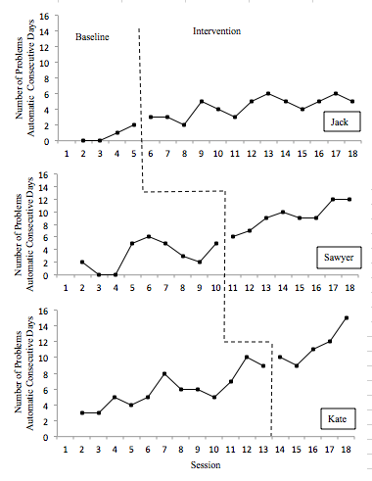

Figure 2
Number of Difficult Problems Correct
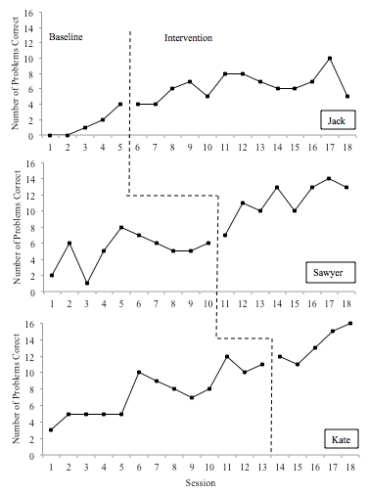

Figure 3
Digits Correct per Minute
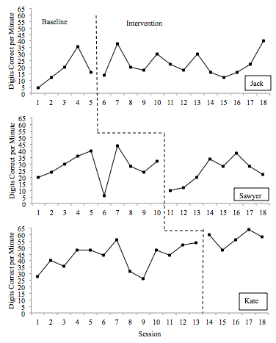

Appendix B
Unique Difficult Multiplication Problems ¹
- 6 x 6 = 36
- 6 x 7 = 42
- 6 x 8 = 48
- 6 x 9 = 54
- 7 x 7 = 49
- 7 x 8 = 56
- 7 x 9 = 63
- 8 x 8 = 64
- 8 x 9 = 72
- 9 x 9 = 81

¹ All multiplication problems were presented to students vertically. Problems are presented horizontally in appendices to conserve space.

Appendix C
All- Type Assessment Sheets
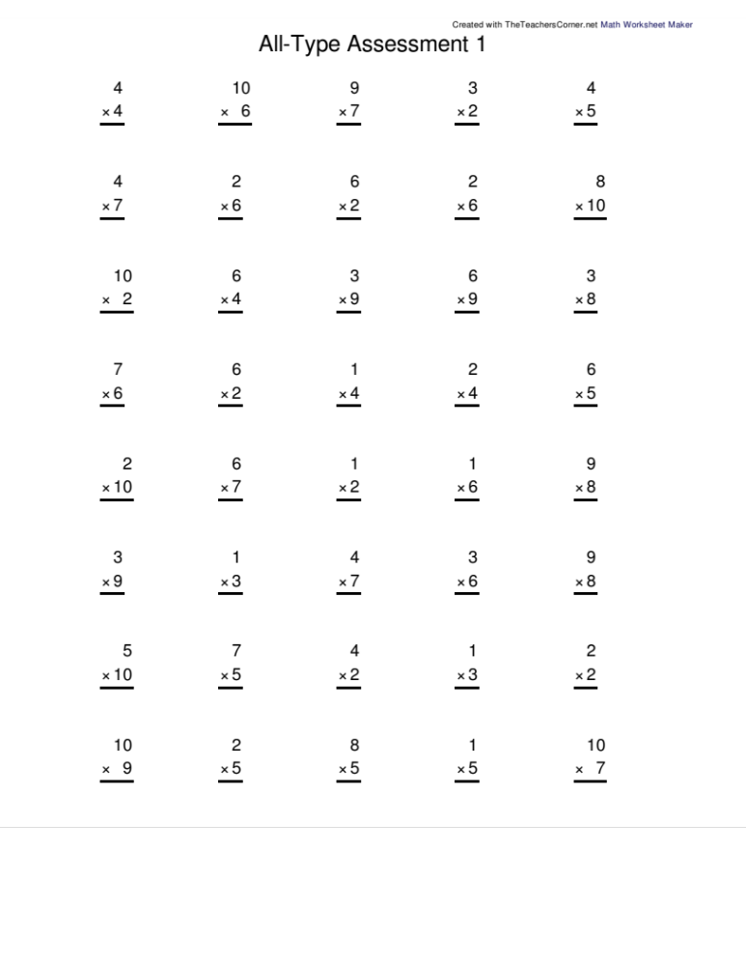

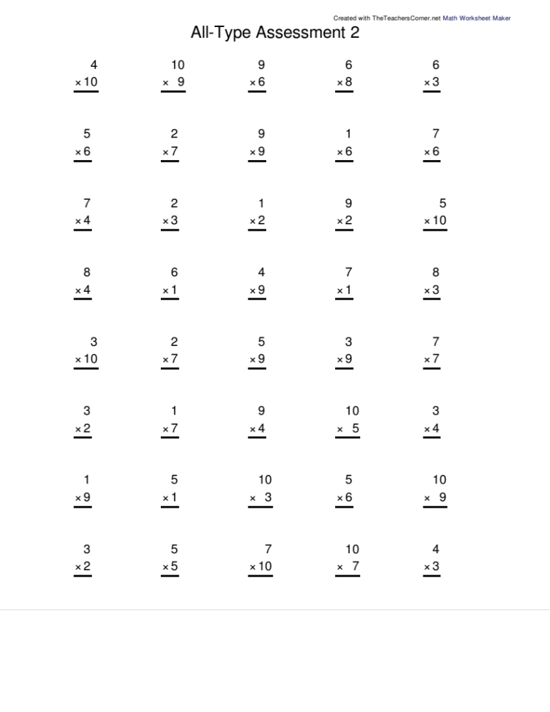

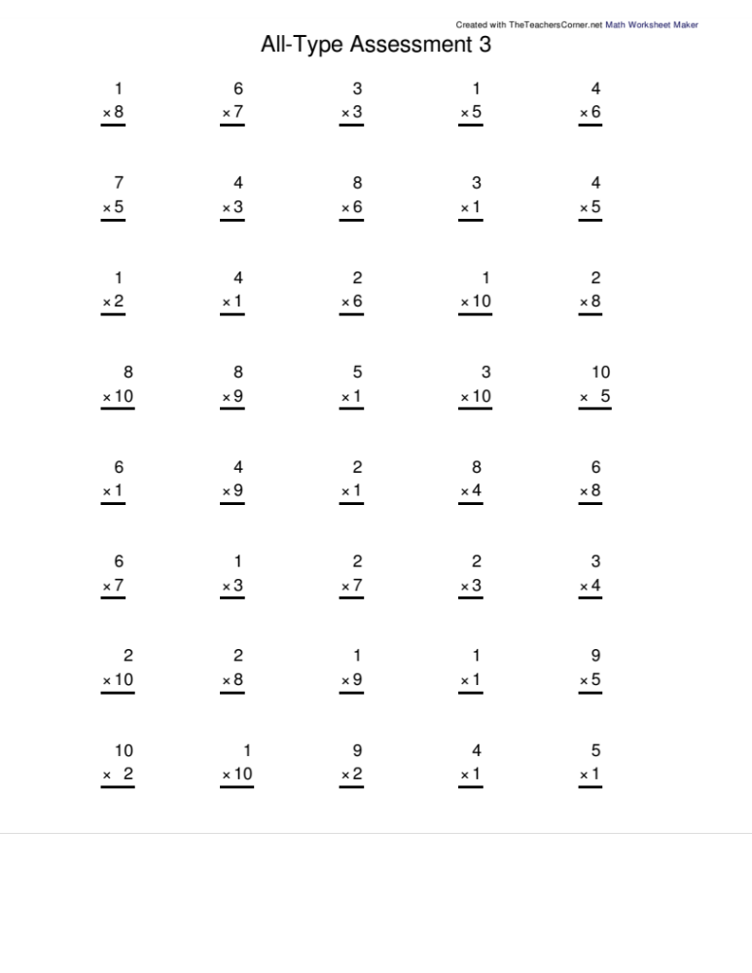
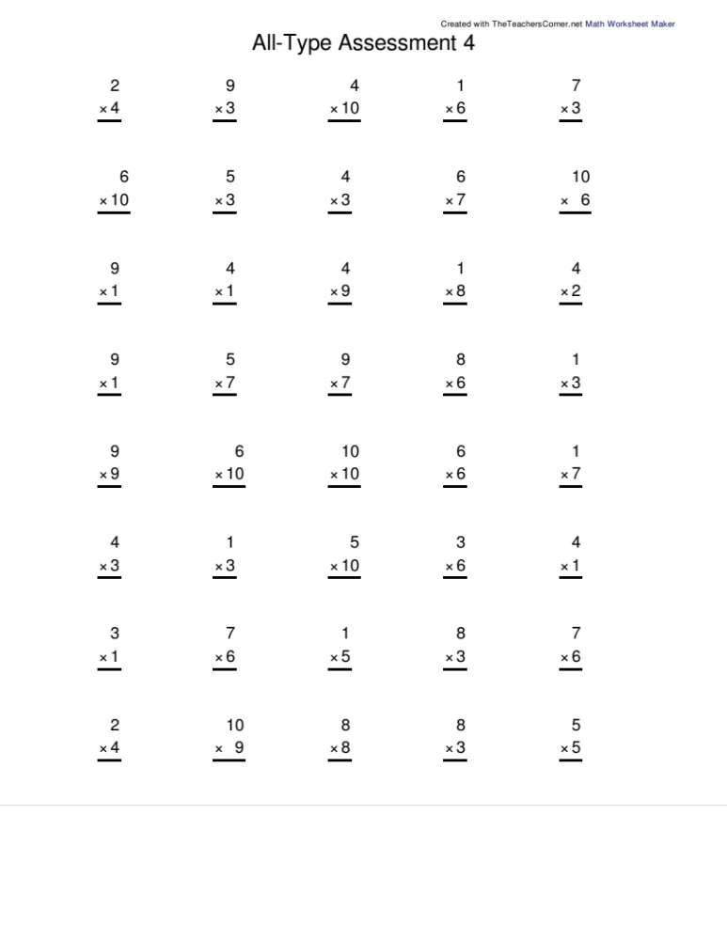
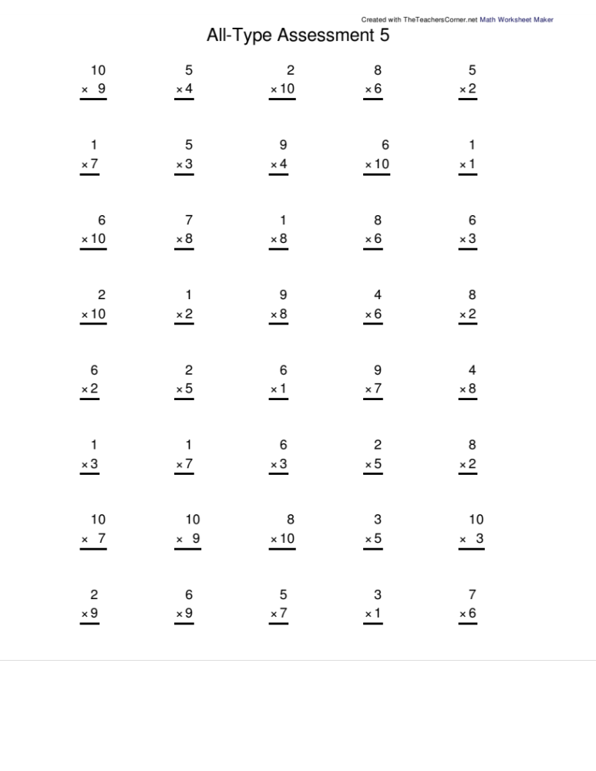

Appendix D
Difficult Multiplication Problems for Automaticity (includes inverses)
- 6 x 6 = 36
- 6 x 7 = 42
- 6 x 8 = 48
- 6 x 9 = 54
- 7 x 7 = 49
- 7 x 8 = 56
- 7 x 9 = 63
- 8 x 8 = 64
- 8 x 9 = 72
- 9 x 9 = 81
- 7 x 6 = 42
- 8 x 6 = 48
- 9 x 6 = 54
- 8 x 7 = 56
- 9 x 7 = 63
- 9 x 8 = 72

Appendix E
Procedural Integrity Checklist

- ______ The experimenter set up a work area containing a laptop, assessment sheet and two chairs.
- ______ The experimenter instructed the student to sit in his/her chair of choice.
- ______ The student presented with the fluency assessment.
- ______ Directions were read to the student before beginning assessment.
- ______ Student was only given 30 seconds to complete assessment and assessment sheet was collected at the end of 30 seconds.
- ______ The laptop was presented and (if in intervention phase) correct intervention file was presented and instruction was provided if needed.
- _______ The student attempted to answer the problem before the presentation of the answer.
- _______ The researcher opened the automaticity computer program
- _______ Instructions were given if necessary for completion of the automaticity computer program.
- _______ Researcher had corresponding response sheet to write student answers.
- _______ Researcher wrote down student answers to the automaticity computer program.
- _______ All materials were collected after completion.

Appendix F
Student Acceptability Survey

 | Very Much | Don’t Care | Not at All
How much did you like using the computer program? |  |  | 
How much do you think the computer program helped you learn hard multiplication facts?
How much do you think the computer program helped you learn all multiplication facts?
How much would do you think other students in your class would like to use to computer program?

Appendix G
Parental Consent Form

Dear Parent,

My name is Kelly Thompson and I am in my fourth year in the School Psychology doctoral program at the University of Tennessee. I am supervised by Dr. Christopher H. Skinner, a professor at the University of Tennessee and Dr. Carolyn Blondin, the School Psychologist at Newport Grammar School.
Currently, I am working on research designed to help students learn math multiplication facts. If you agree to allow your child to participate, I will work with your child on a program designed to teach students difficult multiplication problems through repetition. The program takes approximately 5 minutes to administer and is directly related to school curriculum. After the completion of the program each day, your child’s knowledge will be assessed with two- 30-second multiplication quizzes. Your child’s participation in no way affects their grades in school.
All of your child’s information will be kept confidential and scores will not be able to be linked to their name. Although results of my research may be shared with others through professional publications or presentation, your child’s name will never be revealed. Instead of listing your child's name with their performance data, we will give your child a pseudo name.
If you have any questions about this study or consent form, feel free to contact me, Kelly Thompson at (770) 365-6156. If you agree to allow your child to participate in this research, please check the appropriate box and sign the form in the space provided for parental signature or legal guardian.
If you have any questions about your rights as a research participant, please contact the UT Office of Research Compliance Officer at (865) 974-7697.

Thank you for your and your child’s time and consideration,

Kelly Thompson
University of Tennessee, Educational Psychology and Counseling
Knoxville, TN 37996
(770) 365-6156
kmccull9@vols.utk.edu

Check One

_______ I DO agree to allow my child to participate in this research.

_______ I DO NOT agree to allow my child to participate in this research.

Child’s Name: _____________________________________

Signature: _________________________________________ Date: __________________
Parent or Legal Guardian

Appendix H
Principal Consent Letter

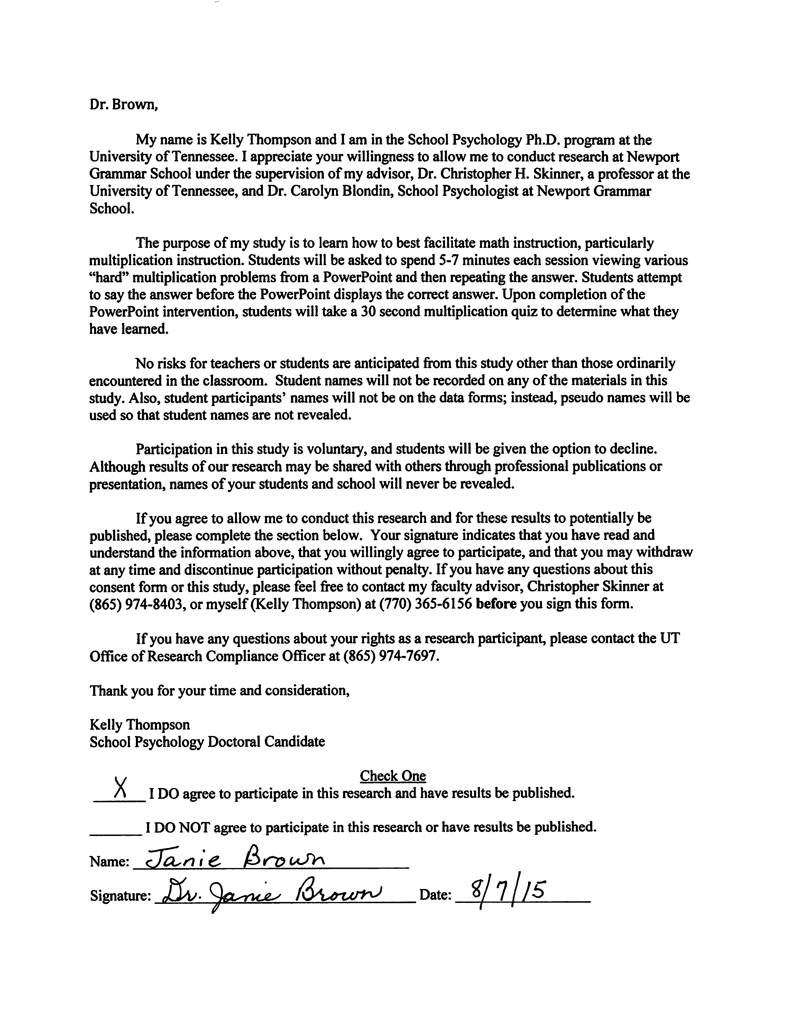
Appendix I
Director of Schools Consent Letter

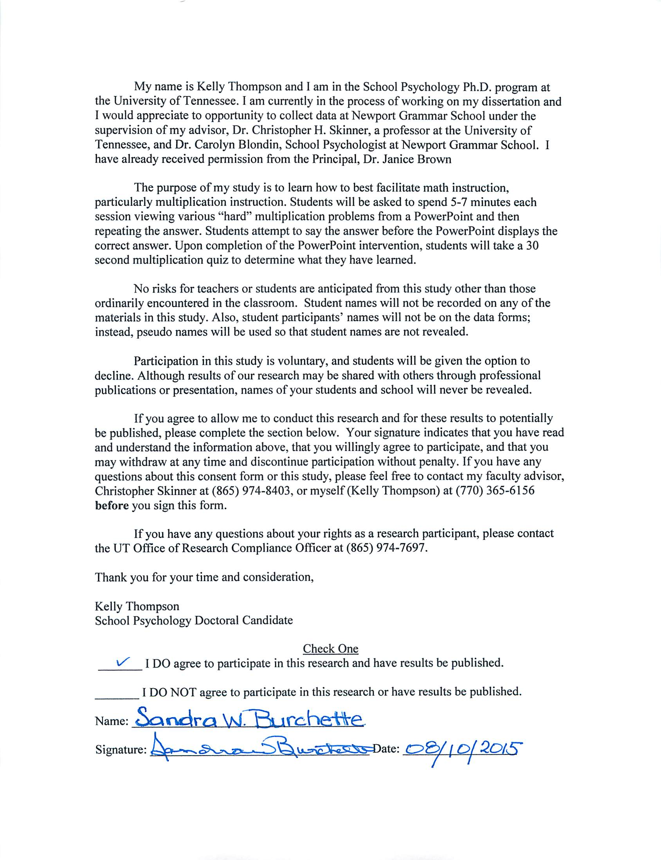
Appendix J
IRB Approval


October 12, 2015
Kelly Thompson UTK - Educational Psychology & Counseling
Re: UTK IRB-15-02548-XP Study Title: Copy of Promoting Math Fact Automaticity through Use of a Taped Problems Computer
Program Dear Ms. Thompson:
The Administrative Section of the UTK Institutional Review Board (IRB) reviewed your application for the above referenced project. It determined that your application is eligible for expedited review under 45 CFR 46.110(b)(1), category (7). The IRB has reviewed these materials and determined that they do comply with proper consideration for the rights and welfare of human subjects and the regulatory requirements for the protection of human subjects. Therefore, this letter constitutes full approval by the IRB of your application version 1.1, as submitted. This approval includes only Dr. Skinner and Kelly Thompson. Please submit a Form 2 for review and approval before others (for example, co-raters) participate in data collection. Approval of this study will be valid from October 12, 2015 to October 11, 2016.
In the event that subjects are to be recruited using solicitation materials, such as brochures, posters, web-based advertisements, etc., these materials must receive prior approval of the IRB. Any revisions in the approved application must also be submitted to and approved by the IRB prior to implementation. In addition, you are responsible for reporting any unanticipated serious adverse events or other problems involving risks to subjects or others in the manner required by the local IRB policy.
Finally, re-approval of your project is required by the IRB in accord with the conditions specified above. You may not continue the research study beyond the time or other limits specified unless you obtain prior written approval of the IRB.
Sincerely,
Colleen P. Gilrane, PhD Chair

Vita
Kelly Thompson was born in Atlanta, Georgia and grew up in Marietta, Georgia. She graduated with a B.S. in Psychology and a B.A. in Sociology from the University of Georgia in 2012. In 2012, Kelly entered the University of Tennessee’s School Psychology Ph.D. Program. She graduated with an M.S. in Applied Educational Psychology from the University of Tennessee in December of 2014. Kelly will receive her Ph.D. in School Psychology in August 2017 following the completion of a year-long internship with Tennessee Internship Consortium in Knoxville, Tennessee.

