Title Page

Acknowledgments
There is no way to express all of the gratitude and appreciation I have for everyone who has helped me along this journey, but I would like to try. First, I would like to thank Dr. Edwards for the largest learning experience I have ever encountered. The list of things I will take away from my time here is longer than I ever imagined. You have taught me not only the inner workings of research and graduate school, but also how to be a better speaker, teacher, and role model. Your tough love approach has given me insight into just how much I am capable of accomplishing. I never imagined I would be where I am today and thank you for helping me get here. I would also like to thank Dr. Voy for being my co-mentor. If it weren’t for you and Dr. Edwards wanting to collaborate, I would not have had the opportunity to pursue this project. Thanks for the insight into the adipose world and for your encouragement. Thanks also to my committee members, Drs. F. Neal Schrick and Niama Moustaid-Moussa.
I would like to thank all of the wonderful friends I have made while living in Tennessee. You all helped me adjust to a new city and made me feel “at home”. I would also like to thank my Tennessee church family at First Baptist Knoxville who supported me from the very beginning and encouraged me throughout my time here.
I would next like to give a special thanks to all of the Animal Science graduate students. You all kept me laughing the past two years and were always available to talk when I needed you. Kim Nagle, I cannot thank you enough for everything you taught me my first year here. You helped me through my transition from North Carolina to Tennessee and into graduate school and always helped me stay positive. I consider you to be the “big sister” I never had, and will never forget the good times, inside jokes, and 320 experiences.
I cannot thank Megan Goodwin, Leah Hooper, and Will Mayfield enough for helping me in my sample collection. I know those EARLY mornings and long days were not very fun, but I could not have done it without you. Thanks for keeping me sane on those stressful collection days! Leah and Megan are also very special to me because I have been able to get to know them well while they were working in the lab during my first year here. I want to thank them for their friendship, kindness, encouragement, and support.
Another set of ladies that deserve many thanks are the JARTU lab ladies. Dr. Louisa Rispoli, Brooke Middlebrooks, Dr. Becca Payton, and Lezlee Dice have all contributed in teaching me the ins and outs of the laboratory and all it entails. Louisa and Becca, thank you for teaching me the many lab techniques I needed to complete my research. I thank you for your patience when I asked a million questions and for your expertise when things were not working. I am convinced Louisa has the “magic touch” needed to fix any piece of equipment that is being ornery. A big thanks to Becca for running RIAs on my samples! Brooke, thank you for teaching me how to slice, search, and make media, introducing me to qPCR, and for always being an amazing and supportive friend. You helped me get through one of my lowest points along this journey and helped me realize the importance of persevering. Lezlee, you have been an incredible office-mate and a true friend. I have enjoyed our conversations and appreciate your help in double checking my math, conversions, and other technical questions. I can’t forget the ladies in Dr. Voy’s lab either. Thank you, Bo and Suchita, for all of your help with blood assays and teaching me how to isolate RNA. You two have always been so kind and helpful, and I truly appreciate it!
I need to extend my extreme appreciation and gratitude to everyone at Southeastern Provision LLC. Without the support of Mr. Brantley and everyone working there, I would not have been able to collect samples and would have, therefore, not been able to do my research project. Jennifer and Pam, thank you for always greeting me with a smile and being genuinely interested in how I was doing. Paul, Jason, and Carl, thank you for helping me get the black cows through and for bending over backwards to help me whenever I needed it. I want to give a huge thanks to Carlos, without whom I would not have been able to collect reproductive tracts or visceral fat. He always kept me smiling, even during my stressful collection days. Thanks also to Mario for helping Leah and Megan collect blood on every “gorda negra” (fat & black). Thank you to all the guys working on the kill floor for playing fun music and making me laugh.
To my family and all of my friends back at home, I want to say thank you and I love you all. I know your encouraging words and prayers played a large role in getting me through this experience. You have been so kind to continue to stay in touch with me, even while I was out of state, and I am so grateful for your friendship.
The most important person who has gotten me through this experience is my incredible husband, Justin. I know it has been a bumpy road living in two different states for the past two years. Despite the distance, you never stopped encouraging, supporting, loving, and pushing me. You were always available to listen when I needed to vent and worked your hardest to keep a smile on my face. You so willingly gave up your breaks to come to Tennessee and came with me to the slaughterhouse to body condition score cows for my project. I wouldn’t have been able to collect all my samples without you! Every time I was discouraged, you helped me to be proud of what I had accomplished and somehow got me back on track. Words cannot describe how thankful I am for your vital role in my journey here and I am so blessed to get to spend the rest of my life with you.
Abstract

Table of Contents

List of Tables

List of Figures

List of Abbreviations

Literature Review

Obesity and its Effects on Reproduction
Obesity is a worldwide problem that continues to increase in incidence. Its prevalence is greatest in developed and developing countries, where access to high-fat food and a sedentary lifestyle are becoming more common (reviewed by Norman and Clark, 1998). There are a number of diseases associated with obesity, such as type II diabetes mellitus, osteoarthritis, cardiovascular disease, and sleep apnea (reviewed by Norman and Clark, 1998). The risk factors and diseases associated with obesity are detrimental to the individuals affected, thus creating emotional strains and physical suffering. In addition to emotional and physical impacts, obesity also creates an extreme economic impact. In the United States alone, overweight and obesity-related healthcare costs are approximately $100 billion per year (Tsai et al., 2011) and result mostly from costs required to treat the associated diseases (Finkelstein et al., 2009). Finkelstein et al. (2009) estimate that the medical spending for an obese individual is $1,429 more per year than someone of normal weight.
Along with its contribution to many health risks and healthcare costs, obesity negatively affects fertility across species. One general reproductive effect many obese women experience is menstrual abnormalities (Cedergren, 2004). In terms of fertility, pregnancy rates in women decline by 0.84 for every unit increase in body mass index (BMI) (Ferlitsch et al., 2004). Also, obese women are also more likely to have abortions and miscarriages as compared to normal weight women (Bellver et al., 2003; Cedergren, 2004; Cnattingius et al., 1998; Lashen et al., 2004; Wang et al., 2002). Some possible mechanisms for the reproductive dysfunction caused by obesity have been discovered in many of the obese women who undergo in vitro fertilization (IVF). For example, oocyte quality decreases in overweight women compared to normal weight women (Wittemer et al., 2000). In the mouse model, which has been paralleled to humans, the time to oocyte maturation is delayed in diet-induced obese mice (Jungheim et al., 2010). Another species whose reproductive function is affected by obesity is cattle. Over-conditioned cows experience decreased pregnancy rates, decreased first service conception rates (Houghton et al., 1990), retained fetal membranes (Morrow, 1976), and decreased embryonic cell number (Leroy et al., 2010). Add more here about other species… Although the mechanisms for these reproductive dysfunctions have not been identified, the literature suggests that adipose tissue and its role as an endocrine gland could be contributing to the problem.
Reproductive dysfunction has also been related to obesity in males, though not as highly as in females. One reason for this is that the effects in obese males are less evident than in females. When studied, obesity altered spermatogenesis, or the production of spermatozoa (Hammoud et al., 2006). Increasing body mass index (BMI) is, in most studies, inversely related to normal motile sperm (Hammoud et al., 2008a; Hammoud et al., 2008b; Kort et al., 2006), sperm concentration (Hammoud et al., 2008a; Hammoud et al., 2008b), and total sperm count (Hammoud et al., 2006; Hammoud et al., 2008a). Many of these problems can be explained by the endocrine environment found in obese men. This environment is characterized by decreased testosterone and gonadotropin (follicle-stimulating hormone and luteinizing hormone) levels, as well as increased estrogen levels (Hammoud et al., 2006). Many, if not all, of the fertility problems and reproductive dysfunctions seen in obese men can be attributed, at least partly, to this unusual hormone environment.
Adipose Tissue as an Endocrine Organ
Obesity is characterized by an excess accumulation of adipose tissue. While adipose mainly functions to store (Ahima, 2006) and release energy when the body requires it (Kim and Moustaid-Moussa, 2000), it also functions to secrete hormones (Ahima, 2006). In this regard, adipose tissue can be classified as an endocrine organ (reviewed by Mitchell et al., 2005). The secreted products vary between the different adipose depots in the body, and the targeted tissues of these products also vary (reviewed by Wozniak et al., 2009). For example, secreted products from epicardial adipose work toward local inflammation, while products from muscular adipose relate to insulin resistance (reviewed by Wozniak et al., 2009). The hormones secreted by adipose tissue, adipokines, help the body maintain proper energy balance (reviewed by Bohler et al., 2010), and regulate metabolism and food intake (reviewed by Mitchell et al., 2005).
Some of the most well-known adipokines include leptin and adiponectin. Leptin tells the body where it stands in energy status (reviewed by Bohler et al., 2010). For example, levels increase when the human/animal is full, thus regulating food intake (CITATION). Leptin levels also increase with obesity in both circulation and in tissues (reviewed by Mitchell et al., 2005). However, unlike leptin, adiponectin levels decrease with obesity. Adiponectin is an insulin-sensitizing agent that also acts in reducing fatty acid oxidation in the liver as well as reducing the activity of some gluconeogenic enzymes (reviewed by Mitchell et al., 2005).
Two less-commonly known/studied adipokines are resistin and visfatin. Resistin levels in circulation have not been definitively related to obesity because levels vary between studies (reviewed by Mitchell et al., 2005). Resistin’s role, while currently unclear, seems to vary between species and might relate to insulin resistance (reviewed by Bohler et al., 2010). Visfatin has insulin-like properties (reviewed by Bohler et al., 2010) such as lowering blood glucose and binding to insulin receptors (reviewed by Campos et al., 2008). Levels are directly proportional to the amount of visceral adipose in both mice and humans (reviewed by Bohler et al., 2010).
While the adipokines provide overall functions to the body, they also affect reproductive tissues and events. Many adipokines have receptors located in reproductive tissues (reviewed by Mitchell et al., 2005), providing a route for reproductive effects. Some adipokines are actually expressed within reproductive structures. For example, leptin and adiponectin expression was found in similar patterns in the rat ovary and oviduct (Archanco et al., 2007). Aside from expression in reproductively important tissues, adipokines have reproductive effects. Leptin acts in the regulation of gonadotropin secretion and steroidogenesis, which are crucial classes of hormones to reproductive function (reviewed by Campos et al., 2008). Adiponectin also plays a role in hormone regulation, upregulating progesterone and estradiol in the rat ovary (Chabrolle et al., 2007). Some negative reproductive effects exist for adipokines as well. For example, leptin administration in FSH-primed rats caused a significant decrease in ovulation compared to those receiving saline (Duggal et al., 2002).
The role that adipose tissue plays as an endocrine gland helps explain the effects seen on reproduction and fertility. While some adipokines are beneficial to reproduction, others have a negative impact. Depending on the location of the adipose tissue as compared to the reproductive tracts, adipokines could be directly affecting reproductive systems.
Possibility for Adipose to Produce Reproductive Hormones
As a newly discovered function, adipose tissue’s ability to secrete hormones has the potential to impact the body’s endocrine status. Either by close proximity in a paracrine manner, or at a distance in an endocrine manner, adipose-secreted products can affect many tissue types. The most well-known functions of adipose are related to metabolism and energy balance; however, adipose seems to have more roles to be discovered. One possible new function of adipose tissue involves reproduction. Few studies have been published on the presence of reproductive hormone transcripts in adipose tissue (see Table 1).
One lab group that has discovered reproductive hormone transcripts in adipose tissue used humans as their subjects. Yang et al. (2003) studied abdominal omental adipose from a 59-year-old woman using cDNA microarray from Expressed Sequence Tags (EST) libraries. They then performed semi-quantitative reverse transcriptase-polymerase chain reaction (RT-PCR) on visceral adipose tissue from 11 subjects of varying ages and sexes to validate their findings. The reproductive hormone transcripts present in the adipose included follicle-stimulating hormone beta subunit (FSH-β), luteinizing hormone beta subunit (LH-β), corticotropin releasing hormone (CRH), and fallotein, also known as platelet-derived growth factor C. While the researchers aimed to discover novel genes related to obesity and insulin resistance, their findings on reproductive hormones were serendipitous. Fallotein was validated by RT-PCR; however they did not validate the other hormone transcripts or mention the possible implications of these findings.
A very similar study was published in 2005 by Yang et al., which had the same materials and methods as their 2003 study. The purpose of this study was to discover important function genes in visceral adipose tissue. Fallotein was the only reproductive hormone transcript found

Table 1: Is Adipose a Reproductive Endocrine Gland?
Citation | Research or Review | Study Objective | Tissue Location | Species | Age | Method or Procedural Analysis | Transcriptomes of Reproductive Hormones Present | Comments
Yang et al., 2003. Biochemical and Biophysical Research Communications. vol. 300, 839-846 | Research | Novel genes related to obesity and insulin resistance | Abdominal omental | Human | 59 years | cDNA microarray from EST¹ libraries and RT-PCR* | FSH-β²  LH-β³  Fallotein*  CRH⁴
  Microarray done using adipose from one woman. RT-PCR on VAT⁵ of 11 subjects of varying ages and both sexes. Serendipitous findings; no effort to validate all transcripts
Yang et al., 2005. Endocrine. vol. 26, no.1, 45-54 | Research | New, important function genes in visceral adipose tissue | Abdominal omental | Human | 59 years | cDNA microarray from EST¹ libraries and RT-PCR* | Fallotein*
  Microarray done using adipose from one woman. RT- PCR on VAT⁵ of 11 subjects of varying ages and both sexes. Serendipitous findings; no effort to validate all transcripts
Hausman et al., 2008. Domestic Animal Endocrinology. vol. 35, 24-34 | Research | Factors secreted by adipose that might regulate puberty and growth in pigs | Outer and middle subcutaneous | Pig | 90, 150, and 210 days | cDNA microarray from 560 pig gene sequences and RT-PCR** | Follistatin**  Relaxin | First study to show Follistatin gene expression in adipose tissue
Hausman et al., 2006. J. Anim. Sci. vol. 84, 1666-1681 | Research | Factors secreted by adipose that might regulate puberty and growth in pigs | Subcutaneous | Pig | Neonatal and fetal (90 and 105 d gestation) | cDNA microarray from 560 pig gene sequences | FSH-β²  LH-β³  Follistatin***  Relaxin***  CRH⁴ | No effort to validate all transcripts
Barb et al., 2005. Domestic Animal Endocrinology. vol. 29, 186-192 | Review | Leptin and its effects on reproduction in the pig | Not stated | Pig | Not stated | Microarray analysis | FSH-β²  LH-β³  Fallotein*  CRH⁴  CGA⁶ | Tabular data only; no discussion or mention of implications
 |  |  | Preadipocyte cell-cultured media | Bryde’s whale | Not Stated | Proteomic analysis of cell culture media | Relaxin
 |  |  |  | Goat | Not Stated | Proteomic analysis of cell culture media | Prolactin
Flanagan et al., 2009. J Clin Endocrinol Metab. vol. 94, 3003-3009 | Research | Role of follistatin in adipose tissue | Subcutaneous and omental | Human | Middle aged (average 40) | qPCR and Western Blot | Follistatin | WAT secreted follistatin in vitro, mRNA levels higher in subcutaneous than omental
Zinger et al., 2003. J Clin Endocrinol Metab. vol. 88, 689-696 | Research | Prolactin expression and secretion in breast tissues | Breast | Human | Middle aged (average 40) | RT-PCR, PRL bioassay | Prolactin | PRL synthesized and secreted by breast adipose tissue
Hugo et al., 2008. J Clin Endocrinol Metab. vol. 93, 4006-4012 | Research | Prolactin release by adipose | Subcutaneous and omental | Human | Middle aged (average 40s) | Bioassay for PRL secreted in cell culture media | Prolactin | PRL secreted in time-dependent manner in vitro from subcutaneous and omental adipose tissue
* Fallotein was the only transcript validated by semi-quantitative reverse transcriptase-polymerase chain reaction
** Follistatin transcript validated by real time reverse transcriptase-polymerase chain reaction in middle subcutaneous adipose
*** Identified in either proteomic or conventional protein assays
¹Expressed Sequence Tags, ²Follicle-stimulating Hormone β-subunit, ³Luteinizing Hormone β-subunit, ⁴Corticotropin Releasing Hormone, ⁵Visceral Adipose Tissue, ⁶Glycoprotein hormones alpha chain

by cDNA microarray and RT-PCR using the methods from the 2003 study. While this lab group utilized humans for their research, a different group has looked at a different species.
In 2006, Hausman et al. published an article on their research using pigs as a model to study adipose secreted factors. This study utilized neonatal and fetal pigs (90 and 105 days gestation) and tested subcutaneous adipose tissue. cDNA microarray from 560 pig gene sequences was performed, but no PCR was used for validation of reproductive hormones. Similar to the Yang et al., 2003 paper, Hausman et al. (2006) found FSH-β, LH-β, and CRH transcripts, as well as follistatin and relaxin transcripts in the adipose. Follistatin and relaxin were identified in either proteomic or conventional protein assays. This showed that adipose not only contained the transcripts, but translated them into secreted proteins. No effort was made to validate the presence of the transcripts with RT-PCR, nor was there any discussion on the significance of these results. They classified their reproductive hormone findings simply as novel or unusual gene expression.
Using the pig again as a model, Hausman et al. (2008) studied outer and middle subcutaneous adipose tissue from 90-, 150-, and 210-day-old subjects. cDNA microarray from 560 pig gene sequences was performed along with real-time reverse transcriptase-polymerase chain reaction (RT-PCR). Two reproductive hormones, follistatin and relaxin, were found present using the microarray; however, only follistatin was validated by RT-PCR. This study tried to discover factors secreted by adipose that might relate puberty and growth in pigs. While the overall nature of this study was reproductive, little discussion was made about what the presence of these hormone transcripts could mean reproductively. This study was, however, the first to show follistatin gene expression in adipose tissue.
In a review paper on leptin and its effects on reproduction in the pig, tabular data showed FSH-β, LH-β, fallotein, CRH, and glycoprotein hormones alpha chain (CGA) transcripts in adipose tissue (reviewed by Barb et al., 2005). The data did not specify the age of the subjects or the depot from which adipose was taken. There was also data present in the review that identified the presence of relaxin from Bryde’s whale and prolactin from goat preadipocyte in cell-cultured media. This review did not discuss this data any further than presenting it in a table. It also did not mention any possible connections between these findings and reproduction.
In 2009, Flanagan et al., published an article on the role of follistatin in human white adipose tissue and obesity. They collected subcutaneous and omental adipose tissue from obese and non-obese women undergoing surgery with average ages of 43 and 40 years, respectively. RNA isolated from these adipose samples was converted to cDNA to use in qPCR for assessing follistatin mRNA levels. They also extracted protein from the adipose samples and ran Western blots to detect the follistatin protein. These research efforts showed that white subcutaneous adipose tissue contains mRNA for follistatin and that the levels decrease with obesity. Follistatin mRNA levels were also higher in subcutaneous compared to visceral adipose tissue. The Western blot results showed a presence of follistatin protein in the adipose samples. Efforts were also made to determine to what extent adipose secretes follistatin in vitro. This study showed that not only does adipose tissue secrete follistatin, but that the secretion levels increase over time. While this 2009 study adds to our growing understanding of adipose and it’s secretion of reproductive hormones, it did not mention anything about the implications this would have on reproduction. They focused on the role of follistatin in adipogenesis and obesity.
In efforts to study the effects of prolactin in human breast tissue on breast cancer, Zinger et al., (2003) showed that breast adipose tissue contains the transcripts for prolactin. They also showed that breast adipose tissue secretes prolactin in a time-dependent manner and that this prolactin resulted from de novo synthesis. This study was performed on adipose tissue samples from women undergoing breast reduction surgeries or mastectomies with an average age of 42 years. While they were focused on prolactin’s effects on breast cancer, they did mention that prolactin could have other local effects and suggested further studies to determine if results hold true in other species. No effort was made to discuss any possible effects of prolactin secretion from adipose tissue on reproduction.
In summary, there are very few studies that have shown reproductive transcripts present in adipose tissue. While the Yang and Hausman groups utilized pigs and humans, no studies have used cows as their model. While the findings were generally unexpected, none of the groups discussed what their findings might mean or if discussed, did not relate them to reproduction. The possible link between adipose and infertility has been glanced over and warrants attention and research.

Adipose Associated with the Reproductive Tract
Adipose tissue is located in specific regions throughout the body. Some of these depots include subcutaneous, which is beneath the skin, perirenal, which surrounds the kidneys, and visceral, which surrounds the organs in the abdomen. While these adipose depots are commonly known and discussed, little is reported on adipose associated with reproductive tracts.
While the literature is generally lacking in evidence of the association of adipose in the reproductive tracts, one paper does address this topic. In the male mouse, adipose tissue is associated closely with the epididymis. Caesar et al. (2010) characterized this adipose tissue and compared it to other depots in the body. The adipocytes comprising the epididymal adipose were larger than those in other depots. Also, the control of gene expression differed between epididymal and other depots (Caesar et al., 2010). This supports the notion that not all adipose is the same. Additionally, Caesar and coworkers (2010) discovered functional differences between the proximal and distal epididymal adipose tissue. It could be that the adipose closest to the epididymis has characteristics that support epididymal function.
While Caesar et al. (2010) showed that adipose associates with the reproductive tract in male mice, little evidence is available for females. In a 2003 paper by Jankowska et al. looking at the broad ligament of cows, they mentioned having to remove adipose tissue in order to visualize the vessels. While this does not characterize the adipose associated with the female reproductive tract, it does provide evidence that adipose is present. Adipose tissue in critical locations, such as near the oviducts and ovaries, could provide a route for endocrine or paracrine hormone delivery. In endocrine delivery, the hormones enter the bloodstream and are then delivered to their target tissue. In paracrine delivery, hormones are delivered directly to neighboring cells. Adipose-secreted products, such as possibly reproductive hormones, could be using either route to access reproductive tissues.

Possible Routes for Hormone Transport in Reproductive Tissues
Literature suggests a local endocrine environment between the uterus, ovary, and oviduct in pigs and cows (Jankowska, 2003; Kotwica et al., 1983; Stefanczyk-Krzymowska et al., 2002). There are vessels and lymphatic tissue in the mesosalpinx, mesovarium, and mesometrium, structures that support the oviduct, ovary, and uterus, respectively. Stefańczyk-Krzymowska et al. showed a higher concentration of progesterone in local vasculature of the uterus compared to the systemic blood concentrations in pigs (2002). In 1983, Kotwica et al. found that ³H-PGF-2α injected into the uterus was able to reach the ovary via the mesosalpinx. This provides a possible local route for hormones to travel amongst reproductive tissues. If the adipose tissue associated with the reproductive tract is producing and secreting reproductive hormones, this local endocrine transport system could be a route for those hormones to have effects separate from hormones in systemic circulation.
Implications of Over Secretion of Reproductive Hormones
The implications of adipose secreting reproductive hormones could explain why obesity has such a negative impact on reproduction. The hormones outlined in Table 1 are absolutely necessary to maintain reproductive function. Luteinizing hormone (LH) and follicle-stimulating hormone (FSH) support many functions in the ovary such as ovulation, follicular growth, and formation of the corpus luteum. Prolactin is necessary around the time of parturition for stimulating milk letdown. Follistatin acts to suppress FSH, as well as preventing binding interaction of activin and myostatin (Flanagan et al., 2009). Since activin is important in follicular development, FSH secretion, and insulin secretion, too much follistatin has negative effects on reproductive function (Flanagan et al., 2009).
If adipose located around the reproductive tract is secreting these reproductive hormones, they could be acting on local receptors such as the ovary, oviduct, or uterus. They could also be traveling into the bloodstream, which might have an effect through that route as well. Over secretion of certain hormones in obese individuals could cause problems reproductively. For example, high levels of LH have been shown to reduce fertilization rates (Homburg, 1998; Stanger and Yovich, 1985; Watson et al., 1993), decrease the outcome of pregnancy (Watson et al., 1993), increase miscarriage (Homburg, 1998; Regan et al., 1990), and alter normal oocyte development in women (Stanger and Yovich, 1985; Tarlatzis et al., 1995). Also, high FSH levels (greater than 15 mIU/ml) were associated with reduced pregnancy rates and increased miscarriage in women undergoing in vitro fertilization, with levels greater than 25 mIU/ml having the most extreme rates (Scott et al., 1989).
Along with the gonadotropins, prolactin and follistatin have been shown to have negative consequences on reproductive function when found in high concentration. Increased prolactin levels may inhibit the cyclic secretion patterns of FSH and LH, can decrease the gonadotropin stimulation of the ovaries (Corenblum et al., 1976), and decrease progesterone production from the corpus luteum, causing a short luteal phase (Del Pozo et al., 1979). Follistatin, when in high concentrations, has been shown to arrest folliculogenesis in the ovaries (Eldar-Geva et al., 2001).
The negative consequences associated with the over secretion of these reproductive hormones could help explain part of the link between obesity and infertility. Much of the infertility problems seen when these hormones are in high concentrations parallel the infertility problems associated with obesity. Providing that these hormones are produced from adipose tissue, an overly fatty state would give rise to increased hormone levels. Whether by an endocrine, paracrine, or autocrine manner, the previously mentioned reproductive hormones would likely alter reproductive processes or the endocrine milieu which controls them.

Research Chapter
Introduction
Obesity is a worldwide problem that continues to increase in incidence. Associated diseases include diabetes mellitus, cardiovascular disease, and osteoarthritis (reviewed by Norman and Clark, 1998), costing the United States over $100 billion per year (Finkelstein et al., 2009; Tsai et al., 2011). Along with contributing to many health risks, obesity negatively affects fertility. For example, pregnancy rates in women decline by 0.84 for every unit increase in body mass index (BMI) (Ferlitsch et al., 2004). Obesity also decreases oocyte quality (Wittemer et al., 2000) and increases the rate of abortions and miscarriages in women (Bellver et al., 2003; Cedergren, 2004; Cnattingius et al., 1998; Lashen et al., 2004; Wang et al., 2002). In addition to humans, obesity affects fertility in other species. For example, over-conditioned cows experience decreased pregnancy rates, decreased first service conception rates (Houghton et al., 1990), retained fetal membranes (Morrow, 1976), and decreased embryonic cell number (Leroy et al., 2010).
The problems associated with the obese state, including fertility, may be due to the role adipose tissue plays as an endocrine gland. While adipose tissue is most commonly known to store (Ahima, 2006) and release energy when the body requires it (Kim and Moustaid-Moussa, 2000), it also functions to secrete hormones (Ahima, 2006). Adipokines, the hormones secreted by adipose tissue, help the body maintain proper energy balance (Bohler et al., 2010) and regulate metabolism and food intake (reviewed by Mitchell et al., 2005). Many adipokines have receptors located in reproductive tissues (reviewed by Mitchell et al., 2005) and can have reproductive effects. For example, leptin administration in FSH-primed rats caused a significant decrease in ovulation compared to those receiving saline (Duggal et al., 2002). Also, leptin has an important role in male reproductive function because leptin-deficient male mice have low steroid hormone levels (Caprio et al., 2001).
In addition to indirectly affecting reproduction through adipokines, adipose tissue has the potential to, and in some species does, secrete hormones primarily important for reproductive and lactation success. Though not necessarily part of their study design, two microarray studies in human abdominal adipose tissue showed the presence of reproductive hormone transcripts in the adipose of a middle-aged woman (Yang et al., 2005; Yang et al., 2003). Barb et al. and Hausman et al. had similar findings in neonatal and young pigs (Barb et al., 2005; Hausman et al., 2008; Hausman et al., 2006) These hormone transcripts include luteinizing hormone beta-subunit (LHβ), follicle stimulating hormone beta-subunit (FSHβ), follistatin, prolactin, and the glycoprotein hormones alpha-chain (CGA). In 2009, Flanagan et al. demonstrated the presence of the follistatin (FST) transcript in human subcutaneous and omental adipose tissue, as well as evidence that adipose tissue secretes the protein hormone in vitro. There are also studies in humans showing prolactin (PRL) synthesis and secretion by breast adipose tissue (Zinger et al., 2003) and subcutaneous and visceral adipose tissue (Hugo et al., 2008). This evidence suggests that adipose tissue may play a role as a reproductive endocrine organ that could affect local hormone levels in reproductively important tissues. Due to the vascularity seen in adipose tissue, there are potential methods of delivery to local tissues, should hormones be secreted.
While there is evidence of this possible new reproductive role for adipose tissue in humans and pigs, no efforts have been made to investigate this occurrence in cattle. The hypothesis was that bovine adipose tissue contains the transcripts for and is secreting reproductive hormones that could, in turn, be directly affecting reproductive functions. The overall objective was to determine the extent to which adipose tissue in the bovine produces reproductive hormones. As a first step to this approach, the extent to which adipose tissue associates with the reproductive tract was determined. In addition, adipose tissue among the reproductive tract was quantified by weighing. After establishing that adipose tissue is present on reproductive tracts, the next step in testing the hypothesis was to determine the presence of reproductive hormone transcripts in subcutaneous, visceral, peri-renal, and mesosalpinx adipose depots. Protein studies were later performed for prolactin and LH to determine whether the transcripts were being translated. Histological studies of the adipose tissue found on the reproductive tract were compared to that in the subcutaneous depot for adipocyte size. Blood samples were also evaluated to determine the metabolic/nutritional and reproductive status of the cows utilized.

Materials and Methods
Adipose Association
Presence of Adipose Tissue on Bovine Reproductive Tracts
Due to the scarce amount of literature highlighting reproductive adipose tissue, it was important to determine the prevalence of such adipose in the bovine. Bovine reproductive tracts were collected from a local abattoir (Southeastern Provision, LLC, Bean Station, TN, USA) (22 tracts total). * Work on this section…sub-headings…after talking to Edwards about outline * Tracts were observed, photographed, and given a score based on the general amount of adipose tissue present (score 1-5, 1 – minimal or none, 2 – slight, 3 – moderate, 4 – very abundant, 5 - copious). Scores were assigned to the adiposity of the mesometrium and mesosalpinx, the broad ligament supporting the uterus and oviduct, respectively.
Abundance of Adipose Tissue on Bovine Reproductive Tracts
Next efforts were to determine the amount of adipose tissue present within the reproductive tract. Bovine reproductive tracts were collected in order to weigh adipose tissue located in mesosalpinx and mesometrium locations. Adipose tissue was dissected out and weighed according to its location (i.e. left mesosalpinx, left mesometrium, right mesosalpinx, and right mesometrium). This was repeated three times, focusing only on the mesosalpinx depot, due to its intimate relationship with the oviduct. (Figure)
Abundance of LHB, LEP, FST, PRL, & CGA Transcripts in Adipose Tissue Obtained from a Non-Descript Pool of Cows
The presence of adipose tissue among reproductive tracts provided a possible source for adipose tissue-produced reproductive hormones. Because others have noted reproductive hormone transcripts in adipose tissue from other species, including pigs (Barb et al., 2005; Hausman et al., 2008; Hausman et al., 2006) and humans (Yang et al., 2005; Yang et al., 2003), the next step was to determine whether similar transcripts are present bovine adipose tissue. Reproductive hormone transcripts of interest included LHβ, CGA, PRL, and FST, with leptin (LEP) serving as a control.
Sample Collection
All samples were collected at a local abattoir, as previously noted. Cow breeds were limited to beef breeds (Angus and Hereford) and each cow was given a body condition score from 1-9 (1=thin and 9=fat) in the holding pen. Adipose had to be present in subcutaneous (behind left shoulder at 6th rib), visceral (in the omentum covering the rumen), peri-renal (surrounding the kidney), and mesosalpinx (below the oviduct) depots.
Two small pieces of each adipose depot were snap frozen in 1.5 mL microcentrifuge tubes using a Cool Box (Biocision, Mill Valley, CA, USA) at -80°C. Frozen adipose samples were placed at -80°C until future use.
Extraction, Quantification, and Quality Assessment of RNA
RNA extraction from frozen adipose samples utilized the RNeasy® Lipid Tissue Mini Kit (QIAGEN Inc.; Valencia, CA, USA) as per the manufacturer’s protocol, with minor modifications. Due to low RNA concentrations in adipose tissue, twice the amount of tissue and lysis reagent was run through each column. This helped to maximize RNA yield. Quality and concentration were determined by the NanoDrop® ND-1000 (Thermo Scientific; Wilmington, DE, USA), and Agilent 2100 Bioanalyzer using a Nano Chip (Agilent; Santa Clara, CA, USA).
cDNA Conversion and qPCR
Methods were performed as per Payton et al., 2011, with modifications. Quantitative PCR analysis (qPCR) was used to determine the relative abundance of reproductively important hormone transcripts within adipose tissue depots. Primers were designed using Fast PCR (Version 6.1) from bovine sequences in GenBank (Table). As an exogenous control used to normalize relative abundance, green fluorescent protein (GFP) was spiked into RNA samples at a ratio of 50 pg per 2.5 μg of adipose RNA. Reverse transcription (RT) was performed with 500 ng of oligo d(t) primers (Fermentas), 400 units of MMLV-RT (Promega), 500nM dNTP mix (Fisher Scientific), and 50 units Superase-in (Ambion) in 1X MMLV buffer to a final volume of 50 μl. RT reactions were then diluted 1:1 with Tris pH 7.4. Due to low RNA concentrations, some samples could not accommodate these specifications and, therefore, were reverse transcribed with the same GFP:RNA ratio, but not diluted. One μl RNA from each depot was reverse transcribed (one reaction per cow) in the absence of enzyme and tested with 18S primers to assess genomic contamination (RT-).
PCR products were sequenced to ensure specificity of primers. Relative quantification was performed using Power SYBR Green PCR Master Mix (Applied Biosystems) in a 25 μl volume. 50 ng total RNA from each sample was analyzed in duplicate in a 7300 ABI Real-Time PCR System (Applied Biosystems) for 45 cycles at either 58, 60, or 61°C (see Table) for 30 sec and 72°C for 30 sec followed by a dissociation curve.

Abundance of LHB, LEP, FST, PRL, & CGA Transcripts in Adipose Tissue Obtained from “Thin” and “Fat” Cows
Once establishing the presence of reproductive hormone transcripts in a random pool of cows, it was important to examine the levels present in adipose from cows with thin and fat body conditions.

Sample Criteria and Collection
Sample collection was performed as previously stated, using Angus and Angus-cross breeds only, with the addition of blood samples being taken at exsanguination for plasma and serum. Cows were given a general age by their teeth, except for 3 whose ages were known. Also, there had to be a functional corpus luteum on the ovary to indicate cyclicity and cows had to be open (not pregnant). Samples were collected from two categories of body condition: thin and fat. Thin cows had a body condition score of 3, while fat cows had a body condition score of 5 or greater.
Four small pieces of each adipose depot (as stated previously) were snap frozen in 1.5 mL microcentrifuge tubes using a Cool Box (Biocision, Mill Valley, CA, USA) at -80°C. Two pieces (when available) of each adipose depot were placed into 10% Formalin to fix. Pictures were taken of each reproductive tract and ovaries were removed for staging. Representative pictures were also taken for the other adipose depots. Frozen adipose samples were placed at -80°C until future use. Serum and plasma blood tubes were spun (2,000 rpm for 20 minutes at 4°C). Serum and plasma were frozen at -20°C until future use.
Extraction, Quantification, and Quality Assessment of RNA, cDNA Conversion, and qPCR
RNA was extracted from adipose samples as previously described. cDNA conversion and qPCR methods also follow as previously described. Control tissue RNA was run for each gene to provide a “positive” and “negative” comparison. Bovine pituitary RNA served as the positive control for each gene except FST, which utilized ovary RNA. Bovine muscle RNA served as the negative control for PRL and CGA, while the others used bovine kidney RNA. A pool was created with 5 μl of RT from each adipose sample, as well as each control sample. A 4-point serial dilution of this pool was created and run on each plate to check primer efficiency. Efficiencies were calculated from the curve and used to adjust Ct values before analysis. GFP was used to normalize each gene of interest. Inter- and intra-assay coefficients of varience (CV) were calculated between samples and between plates.
Abundance of LHB, LEP, FST, PRL, & CGA Transcripts in Mesosalpinx Tissue vs. Mesosalpinx Adipose Tissue
As previously noted, bovine mesosalpinx adipose tissue is sandwiched between two layers of peritoneal cells of the mesosalpinx. Due to impractical methods of obtaining pure mesosalpinx adipose samples for maintaining RNA integrity, samples collected for qPCR studies likely contained these peritoneal cells. To investigate the true origin of reproductive hormone transcripts, mesosalpinx tissue samples and corresponding mesosalpinx adipose tissue samples were collected from five Angus or Angus-cross cows, as per previous sample collection methods. All cows were fat, with body condition scores from 5-7. RNA isolation, RT, and qPCR methods were as previously described.
Detection of Prolactin and LH in Adipose Tissue
While transcript studies are crucial in efforts to investigate hormone production by adipose tissue, protein studies are necessary to see if protein hormones are actually being produced.
Protein Extraction
Protein was extracted from adipose tissue samples by homogenization in modified RIPA buffer (1% SDS). Complete Mini protease inhibitor cocktail tablets (Roche Applied Science, Indianapolis, IN, USA) were added to RIPA before tissue processing. 400 μl of RIPA was added per 100 mg of adipose tissue, which was homogenized on ice using a Power Gen 125 with 5x95 mm Generator (Fisher Scientific). Homogenates were then rocked at 4°C for 30 minutes, followed by a 10 minute spin at 10,000g 4°C. Infranatant was removed using an 18 gauge, 1.5” needle and 1 mL syringe. Protein concentration was determined by the FluoroProfile Protein Quantification Kit (Sigma, Saint Louis, MI, USA) as per manufacturer’s protocol.
Western Blotting
Protein amount was maximized per cow and loaded equally across depots on 1.5 mm 12% SDS-PAGE gels. Protein was transferred to PVDF membrane and then western blot was performed using the Snap ID system (Millipore, Billerica, MA, USA). Membranes were blocked using a 1:1 ChemiBLOCKER (Millipore, Billerica, MA, USA) and TBST mixture (0.1% Tween). Bovine anti-prolactin primary antibody (NIDDK National Hormone and Peptide Program) was used at 1:40,000 with the secondary antibody being a 1:40,000 goat anti-rabbit IgG horse radish peroxidase (HRP) conjugate. Millipore Luminata Forte HRP Substrate was added in maximal quantity and for maximal time before exposing membrane to film for one hour and 15 minutes. (LH antibody dilutions…)
Histological Characterization and Adipocyte Size of Subcutaneous vs. Mesosalpinx Adipose Tissue
In order to visualize the cellularity and determine adipocyte size, histological studies were performed on mesosalpinx and subcutaneous adipose tissue. Subcutaneous adipose trends follow closely with body condition scores and, therefore, this sample was used as a control. Adipose samples from each of the 10 cows (see Sample Criteria and Collection) were fixed in 10% formalin. Slides were prepared and stained by Jim Wesley (Ridge Microtome) for histological analysis, as previously described (Luna et al., 1968). Images were taken on a Nikon Eclipse E600 at the 10X objective. Adipocyte size was determined by the use of Image-J software. To correct for a halo effect from the light source, blank background images from each slide were added to each respective image. Images were converted to black and white (8-bit) and threshold was adjusted to maximize contrast between cell walls and background. The “close-“ binary operation was applied to each image to smooth edges and fill in small holes. Adipocytes were counted for size using the ROI manager and “wand” tool. Approximately 50 cells were counted per picture.

Blood Parameters
Blood samples were utilized to help determine metabolic/nutritional status and reproductive cyclicity of the 10 cows. Serum non-esterified fatty acids (NEFA) levels were assessed by the Wako NEFA-HR(2) Microtiter Procedure (Wako Diagnostics, Richmond, VA, USA) as per the manufacturer’s protocol, with minor modifications. Average intra-assay coefficient of variance (CV) was 1.098%. Serum beta-hydroxybutyrate (β-HB) levels were assessed by the BioVision β-hydroxybutyrate Assay Kit (BioVision, Mountain View, CA, USA) as per the manufacturer’s protocol. Average intra-assay CV was 1.394%. Serum glucose levels were measured using the OneTouch® Ultra 2 glucose meter and Ultra test strips as per the manufacturer’s protocol. Serum progesterone levels were assessed by the Coat-A-Count® Radioimmunoassay (RIA) (Siemens, Tarrytown, NY, USA). Average intra-assay CV was 3.93%. Serum prolactin levels were assessed by a bovine-specific RIA, as per Bernard et al., 1993. Average intra-assay CV was 6.96%, while average inter-assay CV was 7.21%. Plasma insulin levels were assessed by a Bovine Insulin ELISA (Alpco Diagnostics, Salem, NH, USA) as per manufacturer’s protocol with an intra-assay CV of 1.397%. Leptin was assessed by....
Statistical Analysis
Blood variable data were analyzed as a completely randomized design (CRD) using mixed ANOVA model in SAS (SAS 9.2, SAS Institute, Cary, NC, USA) with a fixed effect of treatment.
Results
Prevalence of Adipose Tissue on Bovine Reproductive Tracts
To evaluate the extent to which adipose tissue associates with the reproductive tract, 60 bovine reproductive tracts were collected over 5 days. 75% of the tracts had adipose associated with at least one oviduct (45/60), 56.1% of the tracts had adipose associated with both oviducts (32/57, 3 tracts had one oviduct cut off), and 25% of the tracts had no adipose associated with the oviducts (15/60). Figure XE is a representative image of the adipose seen associated with the oviduct.
Abundance of Adipose Tissue in Mesosalpinx
The average single mesosalpinx adipose weight was 1.4540 ± 0.2817 g (mean ± standard error of the mean). The average total mesosalpinx adipose weight was 2.7107 ± 0.7588 g. Figure X illustrates average mesosalpinx adipose weights by collection date.

Preliminary qPCR Study
Just graphs from this study??…Do I include them all? 2 per page? 1 per page? All together in one figure?
Features of total RNA from Bovine Adipose Tissue
*Table with mean concentration, RIN, rRNA ratio, etc for adipose RNA samples
*Becca will help me with this - compare features between “fat” and “thin” groups
qPCR results (graphs)
Protein results (pretty blots for PRL & LH)
Histology results: adipocyte size table and pictures
Blood parameter results
The blood variables examined are important for determining nutritional, metabolic, and reproductive status of the animals utilized. Plasma insulin levels ranged from 0.1 to 0.3452 ng/mL (SEM here?), which is very consistent with the fasted levels seen at X amount of time in ________ et al. Serum glucose levels ranged from 82-392 mg/dL (SEM?). (very wide range) Serum NEFA levels ranged from 0.01374 to 0.02746 mM (SEM?). Serum BHB ranged from 6.4873 to 22.6377 nM (SEM?). Serum Progesterone ranged from 3.1 to 13 ng/mL (SEM?). Serum Prolactin ranged from 12.3 to 308.3 ng/mL (SEM?). When comparing fat and thin cows, there were no treatment differences for any blood variable. (Table 3)
Glucose levels seemed higher than normal, especially considering cows were in a fasted state, having not eaten for approximately 12-24 hours before slaughter. These unusually high levels could be due, in part, to the high amount of stress endured during the slaughter process. (glucose at exsanguination paper…) NEFA levels were very low… Discuss! βHB levels were also low, even for fasted levels (citation). Discuss! Progesterone levels confirmed that each cow was cycling (>2 ng/mL), further supporting the stage of the ovaries upon collection. Prolactin levels varied greatly, likely due to varying stages of lactation for the group of cows. As lactation status was not observed upon collection, it can only be assumed that cows were not in similar lactation periods.

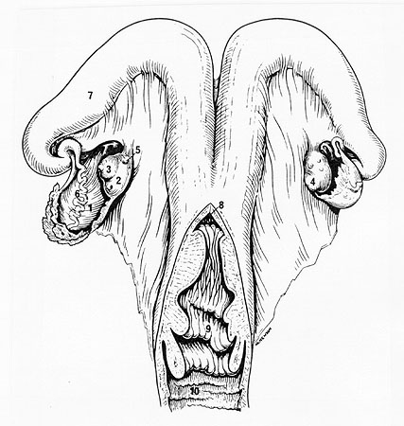
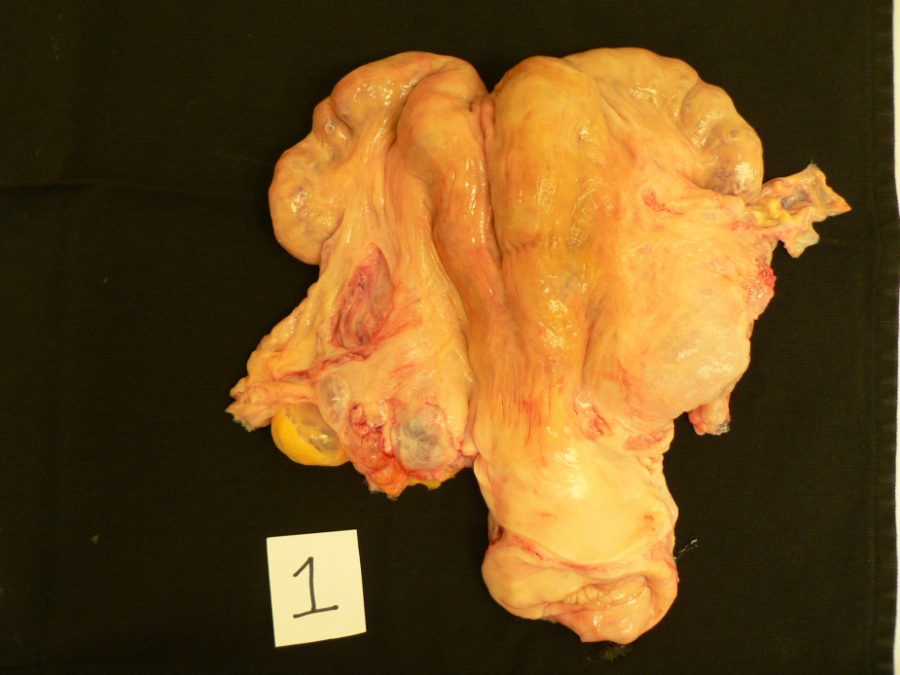
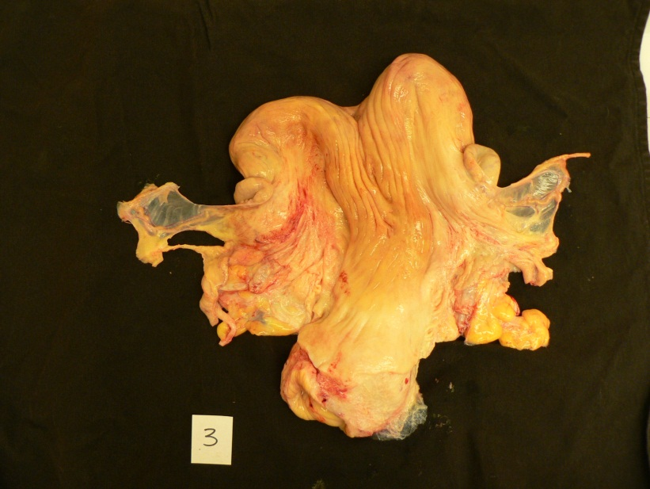
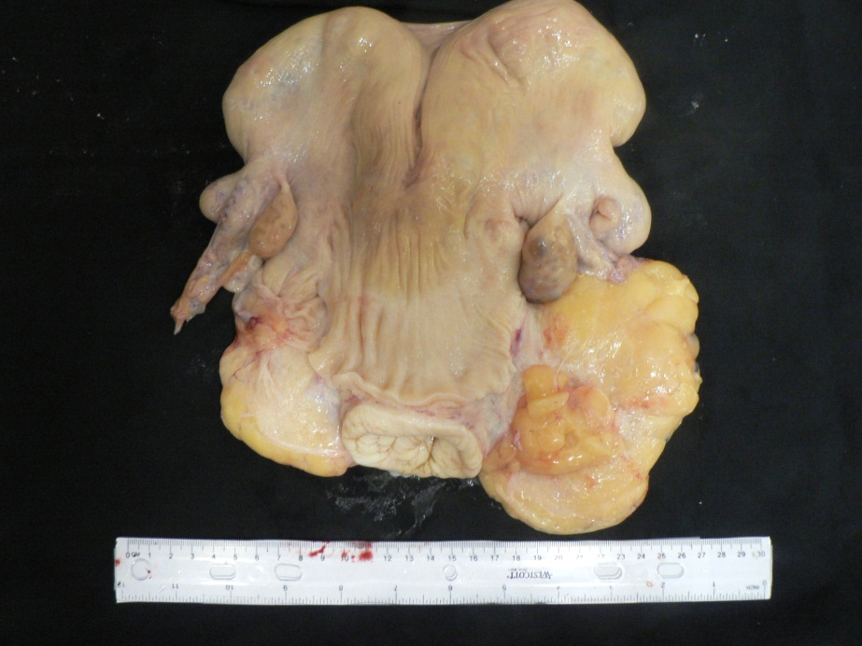
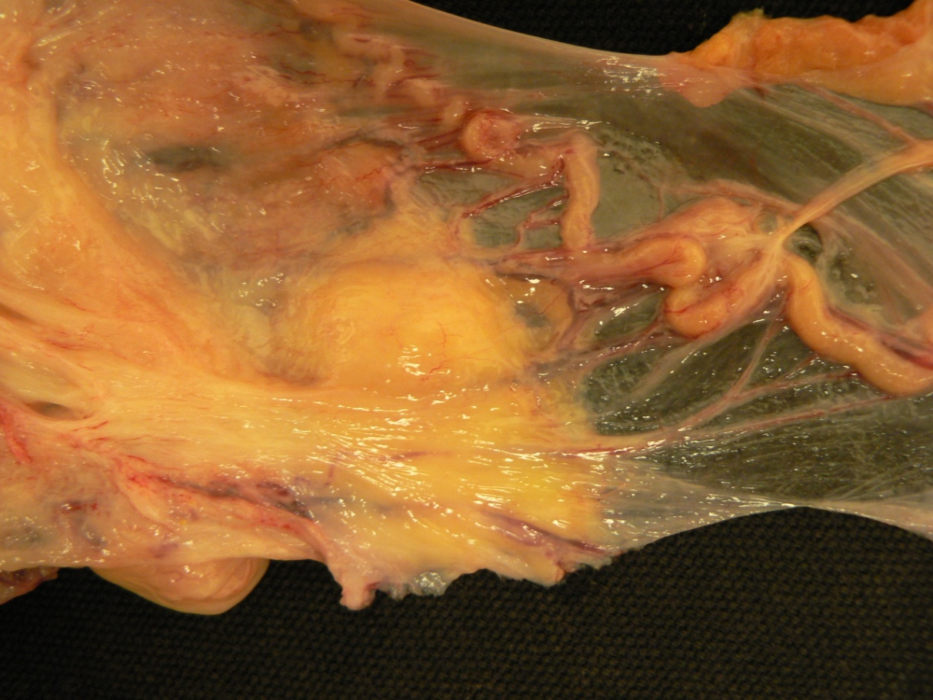
A
B
C
D
E

Figure __ Representative images of bovine reproductive adipose. Panel A depicts bovine reproductive anatomy, with arrows denoting mesosalpinx area. (from John Parrish…how to cite?) Panel B, C, and D represent tracts with an adipose score of 1, 3, and 5, respectively. Panel E highlights the vascularity and relationship between the oviduct and mesosalpinx adipose tissue.

Table 2 Sequences of primers used for qPCR amplification of genes of interest
Gene | GenBank accession number | Forward primer (5' --> 3') | Reverse primer (5' --> 3') | Product size (bp) | Final primer concentration (nM) | Annealing Temperature (°C)
18S rRNA | AY779625 | aagacggaccagagcgaaag | ggtcggaactacgacggtatct | 100 | 200 | 60
CGA | NM_173901 | agaacatcacctcggaagct | cactcggtgtggttctccac | 94 | 200 | 60
FST | NM_175801 | aacctaccgcaacgaatgtg | cagaaaacatcccgacaggtc | 108 | 200 | 61
LEP | NM_173928 | aggatgacaccaaaaccctc | agtccaaaccagtgaccctc | 102 | 400 | 58
LHB | NM_173930 | acccaatggtctccttccccgt | gtggtcacaggccaagggtt | 107 | 200 | 58
PRL | NM_173953 | cccttcctaccccggaagat | ggtcattccaggagcgcagcaa | 96 | 400 | 60
GFP | --- | caacttcaagacccgccaca | tctggtaaaaggacagggcca | 102 | 750 | 58, 60, or 61

Table 2 Features of Total RNA from Bovine Adipose Tissue (from my 10 cows)
Depot | Average Concentration (ng/ul) | Average 260/280 Ratio | Average RIN | Average rRNA Ratio
S | 296.67 ± 57.27 | 2.063 ± 0.008 | 7.43 ± 0.130 | 1.16 ± 0.049
V | 407.59 ± 109.79 | 2.076 ± 0.009 | 6.97 ± 0.216 | 1.02 ± 0.054
K | 200.45 ± 54.44 | 2.032 ± 0.012 | 7.55 ± 0.283 | 1.16 ± 0.086
M | 718.20 ± 77.88 | 2.081 ± 0.008 | 6.68 ± 0.187 | 0.97 ± 0.068

Becca will help me with this…

Non-Descript Pool of Cows (not sure how this data should be presented)
Table 3: Blood Parameters
 |  | Treatment
Variables of Interest | n | BCS = 3 | BCS ≥ 5 | SEM | p-value
Insulin (ng/mL) | 10 | 0.1365 | 0.2092 | 0.02961 | 0.1208
Glucose (mg/dL) | 9 | 123.00 | 195.80 | 42.5783 | 0.2666
Leptin | 9
NEFA (mMol) | 9 | 0.01895 | 0.01760 | 0.002266 | 0.6866
β-HB (nMol) | 9 | 12.7600 | 11.8497 | 3.0415 | 0.8387
Progesterone (ng/mL) | 9 | 4.475 | 7.660 | 1.447 | 0.1641
Prolactin (ng/mL) | 9 | 139.28 | 107.50 | 53.6658 | 0.6885

There were no differences in any blood parameter between treatments.
Bibliography
Ahima, R. S. 2006. Adipose tissue as an endocrine organ. Obesity 14: 242-249.
Archanco, M., J. Gomez-Ambrosi, M. Tena-Sempere, G. Frühbeck, and M. A. Burrell. 2007. Expression of leptin and adiponectin in the rat oviduct. Journal of Histochemistry & Cytochemistry 55: 1027.
Barb, C. R., G. J. Hausman, and K. Czaja. 2005. Leptin: A metabolic signal affecting central regulation of reproduction in the pig. Domestic Animal Endocrinology 29: 186-192.
Bellver, J. et al. 2003. Obesity and the risk of spontaneous abortion after oocyte donation. Fertility and Sterility 79: 1136-1140.
Bernard, J., A. Chestnut, B. Erickson, and F. Kelly. 1993. Effects of prepartum consumption of endophyte-infested tall fescue on serum prolactin and subsequent milk production of Holstein cows. Journal of dairy science 76: 1928-1933.
Bohler, H., Jr., S. Mokshagundam, and S. J. Winters. 2010. Adipose tissue and reproduction in women. Fertility and Sterility 94: 795-825.
Caesar, R. et al. 2010. A Combined Transcriptomics and Lipidomics Analysis of Subcutaneous, Epididymal and Mesenteric Adipose Tissue Reveals Marked Functional Differences. Plos One 5: e11525.
Campos, D. B., M. F. Palin, V. Bordignon, and B. D. Murphy. 2008. The 'beneficial' adipokines in reproduction and fertility. International Journal of Obesity 32: 223-231.
Caprio, M., E. Fabbrini, A. M. Isidori, A. Aversa, and A. Fabbri. 2001. Leptin in reproduction. Trends Endocrin Met 12: 65-72.
Cedergren, M. I. 2004. Maternal morbid obesity and the risk of adverse pregnancy outcome. Obstetrics and Gynecology 103: 219-224.
Chabrolle, C., L. Tosca, and J. Dupont. 2007. Regulation of adiponectin and its receptors in rat ovary by human chorionic gonadotrophin treatment and potential involvement of adiponectin in granulosa cell steroidogenesis. Reproduction 133: 719.
Cnattingius, S., R. Bergstrom, L. Lipworth, and M. S. Kramer. 1998. Prepregnancy weight and the risk of adverse pregnancy outcomes. New England Journal of Medicine 338: 147-152.
Corenblum, B., N. Pairaudeau, and A. B. Shewchuk. 1976. Prolactin hypersecretion and short luteal phase defects. Obstetrics and Gynecology 47: 486-488.
Del Pozo, E. et al. 1979. Prolactin and deficient luteal function. Obstetrics & Gynecology 53: 282.
Duggal, P. S. et al. 2002. Effects of leptin administration and feed restriction on thecal leucocytes in the preovulatory rat ovary and the effects of leptin on meiotic maturation, granulosa cell proliferation, steroid hormone and PGE(2) release in cultured rat ovarian follicles. Reproduction 123: 891-898.
Eldar-Geva, T., I. Spitz, N. Groome, E. Margalioth, and R. Homburg. 2001. Follistatin and activin A serum concentrations in obese and non-obese patients with polycystic ovary syndrome. Human Reproduction 16: 2552.
Ferlitsch, K. et al. 2004. Body mass index, follicle-stimulating hormone and their predictive value in in vitro fertilization. Journal of Assisted Reproduction and Genetics 21: 431-436.
Finkelstein, E. A., J. G. Trogdon, J. W. Cohen, and W. Dietz. 2009. Annual Medical Spending Attributable To Obesity: Payer- And Service-Specific Estimates. Health Affairs 28: W822-W831.
Flanagan, J. N. et al. 2009. Role of follistatin in promoting adipogenesis in women. Journal of Clinical Endocrinology & Metabolism 94: 3003.
Hammoud, A. O., M. Gibson, C. M. Peterson, B. D. Hamilton, and D. T. Carrell. 2006. Obesity and male reproductive potential. Journal of andrology 27: 619.
Hammoud, A. O., M. Gibson, C. M. Peterson, A. W. Meikle, and D. T. Carrell. 2008a. Impact of male obesity on infertility: a critical review of the current literature. Fertility and Sterility 90: 897-904.
Hammoud, A. O. et al. 2008b. Male obesity and alteration in sperm parameters. Fertility and Sterility 90: 2222-2225.
Hausman, G. J., C. R. Barb, and R. G. Dean. 2008. Patterns of gene expression in pig adipose tissue: Insulin-like growth factor system proteins, neuropeptide Y (NPY), NPY receptors, neurotrophic factors and other secreted factors. Domestic Animal Endocrinology 35: 24-34.
Hausman, G. J. et al. 2006. Secreted proteins and genes in fetal and neonatal pig adipose tissue and stromal-vascular cells. Journal of Animal Science 84: 1666-1681.
Homburg, R. 1998. Adverse effects of luteinizing hormone on fertility: fact or fantasy. Baillieres Clinical Obstetrics and Gynaecology 12: 555-563.
Houghton, P., R. Lemenager, L. Horstman, K. Hendrix, and G. Moss. 1990. Effects of body composition, pre-and postpartum energy level and early weaning on reproductive performance of beef cows and preweaning calf gain. Journal of Animal Science 68: 1438.
Hugo, E. R., D. C. Borcherding, K. S. Gersin, J. Loftus, and N. Ben-Jonathan. 2008. Prolactin release by adipose explants, primary adipocytes, and LS14 adipocytes. Journal of Clinical Endocrinology & Metabolism 93: 4006.
Jankowska, K. 2003. The localization and connections of suboviductal lymphatic vessels in the bovine uterine broad ligament. Polish journal of veterinary sciences 6: 253.
Jungheim, E. S. et al. 2010. Diet-Induced Obesity Model: Abnormal Oocytes and Persistent Growth Abnormalities in the Offspring. Endocrinology 151: 4039-4046.
Kim, S., and N. Moustaid-Moussa. 2000. Secretory, endocrine and autocrine/paracrine function of the adipocyte. Journal of Nutrition 130: 3110S-3115S.
Kort, H. I. et al. 2006. Impact of body mass index values on sperm quantity and quality. Journal of andrology 27: 450.
Kotwica, J. et al. 1983. A new route of prostaglandin F-2 [alpha] transfer from the uterus into the ovary in swine. Anim Reprod Sci 5: 303-309.
Lashen, H., K. Fear, and D. W. Sturdee. 2004. Obesity is associated with increased risk of first trimester and recurrent miscarriage: matched case-control study. Human Reproduction 19: 1644-1646.
Leroy, J. et al. 2010. The effect of nutritionally induced hyperlipidaemia on in vitro bovine embryo quality. Human Reproduction 25: 768.
Luna, L. G., Armed Forces Institute of Pathology (U.S.), and Armed Forces Institute of Pathology (U.S.). 1968. Manual of histologic staining methods of the Armed Forces Institute of Pathology. 3d ed. Blakiston Division, New York,.
Mitchell, M., D. T. Armstrong, R. L. Robker, and R. J. Norman. 2005. Adipokines: implications for female fertility and obesity. Reproduction 130: 583-597.
Morrow, D. A. 1976. Fat cow syndrome. Journal of dairy science 59: 1625-1629.
Norman, R. J., and A. M. Clark. 1998. Obesity and reproductive disorders: a review. Reproduction Fertility and Development 10: 55-63.
Payton, R. R., L. A. Rispoli, A. M. Saxton, and J. L. EDWARDS. 2011. Impact of Heat Stress Exposure During Meiotic Maturation on Oocyte, Surrounding Cumulus Cell, and Embryo RNA Populations. Journal of Reproduction and Development 57: 481-491.
Regan, L., E. J. Owen, and H. S. Jacobs. 1990. Hypersecretion of luteinizing-hormone, infertility, and miscarriage. Lancet 336: 1141-1144.
Scott, R. T. et al. 1989. Follicle-stimulating-hormone levels on cycle day-3 predictive of invitro fertilization outcome. Fertility and Sterility 51: 651-654.
Stanger, J. D., and J. L. Yovich. 1985. Reduced invitro fertilization of human oocytes from patients with raised basal luteinizing-hormone levels during the follicular phase. British Journal of Obstetrics and Gynaecology 92: 385-393.
Stefanczyk-Krzymowska, S., T. Krzymowski, B. Wasowska, and J. Chlopek. 2002. Retrograde transfer of ovarian steroid hormones to the ovary in the porcine periovarian vascular complex. Experimental Physiology 87: 361-371.
Tarlatzis, B. et al. 1995. The prognostic value of basal luteinizing hormone: follicle-stimulating hormone ratio in the treatment of patients with polycystic ovarian syndrome by assisted reproduction techniques. Human Reproduction 10: 2545.
Tsai, A., D. Williamson, and H. Glick. 2011. Direct medical cost of overweight and obesity in the USA: a quantitative systematic review. Obesity Reviews 12: 50-61.
Wang, J. X., M. J. Davies, and R. J. Norman. 2002. Obesity increases the risk of spontaneous abortion during infertility treatment. Obesity Research 10: 551-554.
Watson, H. et al. 1993. Hypersecretion of luteinizing-hormone and ovarian-steroids in women with recurrent early miscarriage. Human Reproduction 8: 829-833.
Wittemer, C., J. Ohl, M. Bailly, K. Bettahar-Lebugle, and I. Nisand. 2000. Does body mass index of infertile women have an impact on IVF procedure and outcome? Journal of Assisted Reproduction and Genetics 17: 547-552.
Wozniak, S. E., L. L. Gee, M. S. Wachtel, and E. E. Frezza. 2009. Adipose Tissue: The New Endocrine Organ? A Review Article. Digestive Diseases and Sciences 54: 1847-1856.
Yang, Y. S. et al. 2005. Structure and functional analysis of unclassified genes strongly expressed in human visceral adipose tissue. Endocrine 26: 45-54.
Yang, Y. S. et al. 2003. The gene expression profiling of human visceral adipose tissue and its secretory functions. Biochemical and Biophysical Research Communications 300: 839-846.
Zinger, M., M. McFarland, and N. Ben-Jonathan. 2003. Prolactin expression and secretion by human breast glandular and adipose tissue explants. Journal of Clinical Endocrinology & Metabolism 88: 689.

Vita
Megan Gray MacDougal was born on February 3, 1988 in Raleigh, North Carolina. She attended Leesville Road High School and graduated in 2006, after which she attended North Carolina State University. She graduated with a B.S. degree in Animal Science in 2010 and then began graduate school at the University of Tennessee under the direction of Drs. J. Lannett Edwards and Brynn Voy. In _______ of 2012, Megan graduated with a M.S. degree in Animal Science with a concentration in reproductive physiology.

