To the Graduate Council:

I am submitting herewith a thesis written by Manh Vu entitled “Optimizing the performance of a glass-ceramic storage phosphor as an imaging plate for medical use” I have examined the final electronic copy of this thesis for form and content and recommend that it be accepted in partial fulfillment of the requirements for the degree of Master of Science, with a major in Materials Science and Engineering.

Jacqueline A. Johnson, Major Professor

We have read this thesis
and recommend its acceptance:

Charles E. Johnson

Zhongren Yue

Accepted for the Council:

Carolyn R. Hodges

Vice Provost and Dean of the Graduate School

(Original signatures are on file with official student records.)

Optimizing the performance of a glass-ceramic storage phosphor as an imaging plate for medical use

A Thesis Presented for the
Master of Science
Degree
The University of Tennessee, Knoxville

Manh Vu
May 2010

Copyright © 2011 by Manh Vu
All rights reserved.

To my parents
ACKNOWLEDGEMENTS

This thesis is based upon studies of ZBLAN glasses during August 2009 to January 2011 at Department of Materials Science and Engineering, The University of Tennessee Space Institute, Tullahoma, Tennessee.

I would like to thank my advisor Dr. Jacqueline A. Johnson for all of her continuous guidance and support in successfully carrying out this work. I am very grateful for the help and patience of her husband, Dr. Charles E. Johnson over last year. His experience in research and such considerable knowledge have been invaluable.

I would also like to thank Dr. Zhongren Yue for the help, intellectual and his participation in my Thesis Committee. I am so grateful to Dr. George M. Murray for the guidance, advice and useful discussions in my research.

I am grateful to Dr. Yuzi Liu and Dr. Amanda Petford-Long of Argonne National Laboratory for the TEM analysis. Alexander Terekhov, Kathleen Lansford, and Doug Warnberg provided useful technical assistance.

I express my heartfelt thanks to my friends Amy Marquardt, Matthew Dede, Chris Forrester, Lee Leonard, Jason King and Deepak Rajput for their support during my time at UTSI

ABSTRACT

Europium-doped-fluorochlorozirconate glass ceramics, known as ZBLAN, were produced in a glove box which has a controlled environment of argon gas. Their properties after different thermal processing and different amounts of europium-doping were investigated. After annealing the ZBLAN glass, BaCl₂ nanoparticles are precipitated in the glass matrix. These ceramic glass storage phosphors are strong candidates for replacing traditional x-ray screen film system and commercial storage phosphor (Agfa MD-30).

Differential scanning calorimetry (DSC) was used to determine the annealing temperature and the crystallization of BaCl₂, and the orthorhombic peak of BaCl₂. X-ray diffraction (XRD) and photoluminescence (PL) show that the hexagonal phase of BaCl₂ was formed upon the low annealing temperature around 250 °C to 280 °C for 5 minutes. The orthorhombic phase of BaCl₂ was formed at higher annealing temperatures, around 290 °C and above. Secondary ion mass spectroscopy (SIMS) was used to determine adsorbed/diffused oxygen content of the glass. The weight loss of fluorine and chlorine is 3-5 % and was determined using ion chromatography (IC). The concentration of other cations was determined using inductively coupled plasma spectroscopy (ICP). Transmission electron microscopy (TEM) was used to take high resolution pictures and verify the composition of BaCl₂ nanoparticles. The relative concentration of Eu²⁺ to Eu³⁺ of heated EuCl₃ and ZBLAN was studied using Mossbauer spectroscopy. The oxidation of Eu²⁺ to Eu³⁺ was also observed during the experiment. This study has reinforced the strong potential for application of glass-ceramic storage phosphors for medical imaging.

TABLE OF CONTENTS

Chapter Page

CHAPTER I 1
Introduction and background 1
1.1 Introduction 1
1.2 Commercial Storage Phosphor vs. Traditional Film-screen System 1
1.3 Image Qualities of Glass-ceramic storage phosphor 4
CHAPTER II 6
Experimental details 6
2.1 Sample Preparation 6
2.2 Differential Scanning Calorimetry 10
2.3 X-Ray Diffraction 11
2.4 Secondary Ion Mass Spectroscopy 14
2.5 Phosphorimetry 16
2.6 Ion Chromatography and Inductive Coupling Plasma 16
2.7 Transmission Electron Microscopy 17
2.8 Mössbauer Spectroscopy 20
CHAPTER III 21
Results and Analysis 21
3.1 Differential Scanning Calorimetry 21
3.2 X-Ray Diffraction 25
3.3 Secondary Ion Mass Spectroscopy 28
3.4 Phosphorimetry 34
3.5 Ion Chromatography – Inductive Coupling Plasma 39
3.6 Transmission Electron Microscopy 43
3.7 Mössbauer Spectroscopy 46
CHAPTER IV 52
Conclusions and Recommendations 52
APPENDIX 54
LIST OF REFERENCES 57
VITA 59

LIST OF TABLES

Table Page

Table 1 Composition of the ZBLAN glasses for 2 mole % europium series and 5 mole % europium series. 7
Table 2 Heating steps of the furnace 8
Table 3 DSC data: glass transition, crystallization and peak temperature of 2 series 2 mole % and 5 mole % europium doping 24
Table 4 Fluorine to oxygen ratio on the surface and inside 4 glass samples 29
Table 5 Concentrations of aluminum, barium, europium, indium, aluminum, lanthanum, sodium and zirconium of in ZBLAN glass sample JJ093 39
Table 6 Concentrations of aluminum, barium, europium, indium, aluminum, lanthanum, sodium and zirconium of in ZBLAN glass sample JJ094 40
Table 7 Concentrations of aluminum, barium, europium, indium, aluminum, lanthanum, sodium and zirconium of in ZBLAN glass sample JJ095 40
Table 8 Concentrations of aluminum, barium, europium, indium, aluminum, lanthanum, sodium and zirconium of in ZBLAN glass sample JJ096 41

LIST OF FIGURES

Figure Page

Figure 1 Principle of film-screen system vs. BaFBr doped with Eu²⁺ [4] 3
Figure 2 a) Schematic of electron hole pair generation, b) Schematic of photostimulated luminescent emission (PSL). 3
Figure 3 Cycle of re-use storage phosphor plate [5] 4
Figure 4 Comparison of images qualities of traditional film on the left vs. the glass ceramic storage phosphor on the right [4]. 5
Figure 5 Comparison of image qualities of glass ceramic storage phosphor vs. Commercial product Agfa MD-30 [6] 5
Figure 6 Graph heating steps of furnace 8
Figure 7 Glove box connected to the furnace on the left 9
Figure 8 Crucible is heated inside the furnace 9
Figure 9 Before annealing ZBLAN glass sample on the left, the same sample after annealing at 290 °C. 10
Figure 10 DSC 200 F3 Maia®, Differential Scanning Calorimeter [8] 10
Figure 11 Crucible sealing press with exchangeable inserts and crucible 11
Figure 12 Bragg scattering from two successive planes. 12
Figure 13 Philips X’Pert sample chamber 13
Figure 14 Gallium beam bombard the sample surface [9] 15
Figure 15 SIMS samples holder 15
Figure 16 Secondary Ion Mass Spectroscopy 15
Figure 17 Dionex Automated Sampler 17
Figure 18 South Bay Technology polishing tool. 18
Figure 19 Rectangular sample and copper grid 19
Figure 20 Original Dimpler 500i [13] 19
Figure 21 Plot of typical DSC data with the heating rate 10 K/min 21
Figure 22 DSC graphs: the series of ZBLAN glass samples with 2 mole % of mixture EuCl₂ and EuCl₃ doping;(a) 2 mole % of EuCl₂ (b) 1.6 mole % of EuCl₂ and 0.4 mole % of EuCl₃ (c) 1.2 mole % of EuCl₂ and 0.8 mole % of EuCl₃ (d) 0.8 mole % of EuCl₂ and 1.2 mole % EuCl₃ (e) 0.4 mole %EuCl₂ and 1.6 mole % of EuCl₃ (f) 2 mole % of EuCl₃ 23
Figure 23 DSC graphs: the series of ZBLAN glass samples with 5 mole % of mixture EuCl₂ and EuCl₃ doping; ; (a) 5 mole % of EuCl₂ (b) 2.5 mole % of EuCl₂ and 2.5 mole % of EuCl₃ (c) 5 mole % of EuCl₃ 24
Figure 24 X-ray diffraction patterns of 5 different samples at 300°C. 26
Figure 25 X-ray diffraction of sample JJ 092 with 2% of EuCl₃ annealing from 250 °C to 290 °C for 5min 27
Figure 26 Fluorine distribution both inside and on the surface of sample JJ083 30
Figure 27 SIMS spectra of sample JJ083 for both surface (top) and inside (bottom) 30
Figure 28 Fluorine distribution both inside and on the surface of sample ZBLAN 76 31
Figure 29 SIMS spectra of sample ZBLAN 76 for both surface (top) and inside (bottom) 31
Figure 30 Fluorine distribution for both inside and on the surface of sample pour 5 32
Figure 31 SIMS spectra of sample Pour 5 for both surface (top) and inside (bottom) 32
Figure 32 Fluorine distribution for both inside and on the surface of sample N04.02.22 33
Figure 33 SIMS spectra of sample N04.02.22 for both surface (top) and inside (bottom) 33
Figure 34 Photoluminescence test under UV light on ZBLAN glass sample doped with 2 % Eu²⁺ after annealing at different temperatures for 5 min. 35
Figure 35 Photoluminescence spectroscopy of sample JJ 093 (a), (b) and (c) were annealed at 280°C, 290°C, and 300°C respectively for 5 min. 36
Figure 36 Photoluminescence spectroscopy of sample JJ 094 (a), (b) and (c) were annealed at 280°C, 290°C, and 300°C respectively for 5 min. 36
Figure 37 Photoluminescence spectroscopy of sample JJ 095 (a), (b) and (c) were annealed at 280°C, 290°C, and 300°C respectively for 5 min. 37
Figure 38 Photoluminescence spectroscopy of sample JJ 096 (a), (b) and (c) were annealed at 280°C, 290°C, and 300°C respectively for 5 min. 37
Figure 39 Photoluminescence spectroscopy of samples JJ092, JJ093, JJ094, JJ095, and JJ096, annealed at 300 °C for 5 min. 38
Figure 40 A typical graph of ion chromatography measurement for concentrations of fluoride and chloride. 42
Figure 41 (a) dark field image, (b) amorphous diffraction rings, and (c) bright field image of ZBLAN glass sample JJ 094. 44
Figure 42 High resolution image of ZBLAN JJ 094 after heat treatment 44
Figure 43 High resolution image of ZBLAN N05.02.41 after heat treatment 45
Figure 44 Mossbauer spectra of EuCl₃ heated at 700 °C for an hour by time. 47
Figure 45 Percentage of Eu²⁺ in EuCl₃ heated over time. The data was fitted by $y=81.1exp-t10.6- 17$ with t is the number of day. 48
Figure 46 Mossbauer spectra of (a) purity of EuCl₃, (b) purity of EuCl₂, (c) EuCl₂ after heated contain EuCl₂+EuCl₃, (d) mixture of Eu₂O₃+EuCl₃, and (e) purity of Eu₂O₃ 49
Figure 47 Mossbauer spectra of ZBLAN glass with 5 mole % Eu-doping. The sample of the top spectrum was doped with 5 mole % EuCl₂. The sample of the bottom spectrum was doped with 2.5 mole % EuCl₂ and 2.5 mole % EuCl₃ 50
Figure 48 Mössbauer Apparatus 55
Figure 49 Mössbauer sample holder 56

CHAPTER I

Introduction and background

1.1 Introduction

The medical and photovoltaic industries have great interest in fluorozirconate-based glass ceramics. Fluorozirconate-based glass ceramics, which are doped with rare-earths, could be used for medical imaging, down-converting top layers or up-converting back layers of solar cells for enhancing their efficiency. Glass-ceramic storage phosphor materials are the most successful digital detectors for replacing traditional film-screen systems in medical imaging applications [1]. The advantages of glass-ceramic storage phosphors are mostly due to their large dynamic range, easy portability, and lower cost [2]. Increased sensitivity of the glass-ceramic storage phosphor can reduce the x-ray dose to lower levels while maintaining the high image quality. The spatial resolution of the glass-ceramic storage phosphor strongly depends on the readout process. Various studies have been developed to minimize light scattering during the readout process to improve the spatial resolution of glass-ceramic storage phosphor image plates.

1.2 Commercial Storage Phosphor vs. Traditional Film-screen System

Figure 1 below describes the principle difference between the tradition film-screen system and the storage phosphor for medical imaging. X-rays were first discovered in 1895 and were used immediately in conventional x-rays imaging. When a photographic film is x-irradiated, a special phosphor coating on the film glows and exposes the film. The x-ray image becomes visible after appropriate chemical processing of the film much like a regular photograph. The energy and wavelength of the x-rays allow them to pass through the soft tissue part of the body more easily, while passing through bones, clogged blood vessels, or dense matter is more difficult. The differences in brightness and contrast create an image of internal body structures.

Storage phosphors are commercially the most successful digital detectors for replacing film-screen systems before the innovation of its competitor, a glass-ceramic storage phosphor. X-ray storage phosphors contain crystallites imbedded in an organic binder. When the storage phosphor is x-irradiated, it can convert ionizing radiation into stable electron-hole pairs in these crystallites [3]. The defect generated should be stable at room temperature to make sure the image information is stored until it is read out (approximately 4-6 hours). The digital images can be read out by scanning a laser beam to activate recombination of the electron-hole pairs, which leads to photostimulated luminescent emission (PSL). Furthermore, storage phosphor image plates are compatible with X-ray equipment already in place. Reading devices are durable and can be centrally located to help increase access and reduce costs.

In Figure 2a, an electron is stimulated from the valence band (VB) to the conduction band (CB) due to incoming x-rays. Its relaxed energy level traps and creates an electron-hole pair. In Figure 2b, the incoming laser beam helps an electron get out of the energy level trap to recombine with the hole.

Figure 3 describes the cycle for using a storage phosphor plate. After the image is stored on a storage phosphor plate, it is sent to a reading device. The signal is enhanced using a photo multiplier tube and the digital image is saved in the computer. The storage phosphor plate can then be erased under a halogen lamp. The whole processes take a few minutes and the storage phosphor plate is ready to be used for the next patient.

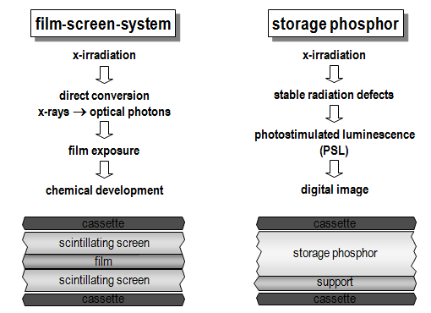
Figure 1 Principle of film-screen system vs. BaFBr doped with Eu²⁺ [4]

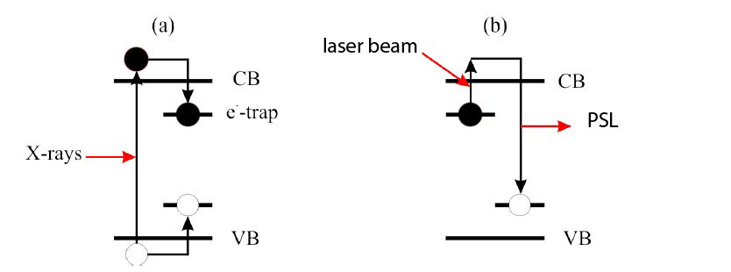
Figure 2 a) Schematic of electron hole pair generation, b) Schematic of photostimulated luminescent emission (PSL).

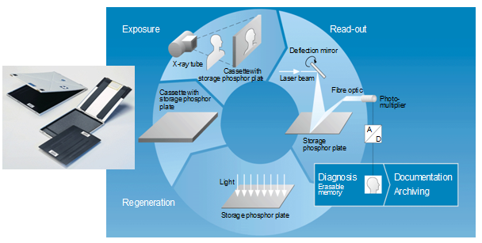
Figure 3 Cycle of re-use storage phosphor plate [5]

1.3 Image Qualities of Glass-ceramic storage phosphor

In Figure 4, the pictures were taken under several conditions to compare the image qualities of the traditional x-ray film vs. the glass-ceramic storage phosphor. Because the glass-ceramic storage phosphor can store the image in a digital format, the image can be easily corrected for brightness and contrast by analysis software. On the other hand, the image qualities of the traditional films cannot be improved easily.

The glass-ceramic storage phosphors with precipitated BaCl₂ nanoparticles have increased spatial resolution when compared to the BaFBr: Eu²⁺ storage phosphor. The enhanced spatial resolution is attributed to the size of the BaCl₂ nanoparticles, which are much smaller than the size of crystallites imbedded in the organic binder. The size of nanoparticles BaCl₂ can be observed under transmission electron microscopy. In Figure 5, both of the images were taken under the same condition. The parallel grids on the left image can be identified easily while the right image is blurred. The ceramic image plate outperforms the commercial product in spatial resolution.

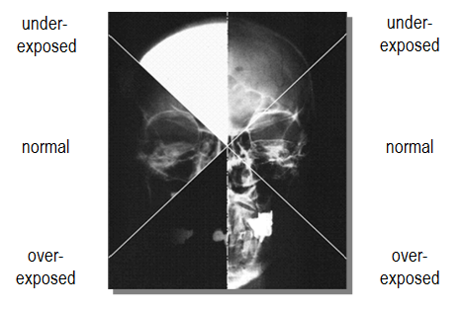
Figure 4 Comparison of images qualities of traditional film on the left vs. the glass ceramic storage phosphor on the right [4].

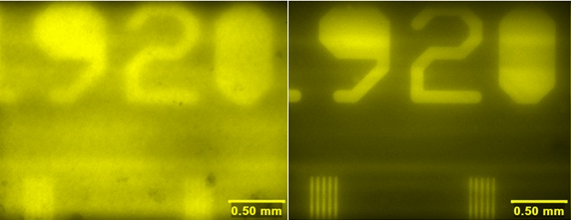
Figure 5 Comparison of image qualities of glass ceramic storage phosphor vs. Commercial product Agfa MD-30 [6]

CHAPTER II

Experimental details

ZBLAN glasses were produced in a glove box which is filled with argon gas. Characteristics of the glasses were studied by differential scanning calorimetry (DSC), X-ray diffraction (XRD), ion-chromatography, inductively coupled plasma spectroscopy, photoluminescence, and Mössbauer spectroscopy. Secondary ion mass spectrometry (SIMS) was used to further understand how the fluoride to oxygen ratio impacts the storage ability of the glasses. Transmission electron microscopy was used to study the growth of nanoparticles in the glass matrix.

2.1 Sample Preparation

Eu-doped fluorochlorozirconate glasses are based on a modified ZBLAN composition, listed in Table 1. Sealed chemical bottles (Aldrich Chemical Company, Milwaukee, WI) were opened inside the glove box (LABmaster SP, MBRUAN). The amount of oxygen and moisture in the glove box were monitored and maintained under 0.1 ppm. Samples were prepared by a two-step method. In the first melt, ZrF₄, NaF, AlF₃, LaF₃, and InF₃ were mixed in a platinum crucible inside the glove box. The crucible was covered with a lid to reduce chemical vaporization and placed inside a tub furnace (OTF 1220X, MTI Corporation) which is connected to the side of the glove box, as shown in Figure 7. The batches were melted according to the steps in Table 2. At the end of the fifth step, the platinum crucible was taken out of the tube furnace, and then BaCl₂, EuCl₂, and EuCl₃ were added for the second melt. At the end of the eighth step, the glass was then poured into a brass mold, which was pre-heated to 200°C. The melt in the pre-heated mold was then slowly cooled to room temperature over a time span of four hours. The two-step melting procedure has been shown to decrease the loss of chlorides in the glass and produce the desired phase transition. [7]

The glass samples were cut into pieces of about 1 cm × 1 cm × 1.6 mm (thickness) before they were annealed in a tube furnace filled with air to form BaCl₂ nanoparticles. The samples were annealed from 250°C to 300°C with 10°C steps. The annealing times were varied at 4, 5, 6 and 7 min at each annealing temperature to compare and study the optimal anneaing temperature and time of each sample.

Figure 9 shows the first attempt to scale-up the glass-ceramic storage phosphor to 6.5 mm × 3.25 mm × 1.6 mm. It took more than one hour to anneal the large plate at 290°C to form BaCl₂ nanoparticles in the glass matrix. The glass-ceramic storage phosphor becomes translucent after annealing.

Table 1 Composition of the ZBLAN glasses for 2 mole % europium series and 5 mole % europium series.

Sample | ZrF₄ | BaCl₂ | NaF | AlF₃ | LaF₃ | InF₃ | EuCl₂ | EuCl₃
JJ 071 | 51.00 | 20.00 | 20.00 | 3.00 | 3.50 | 0.50 | 2.00 | 0.00
JJ 092 | 51.00 | 20.00 | 20.00 | 3.00 | 3.50 | 0.50 | 0.00 | 2.00
JJ 093 | 51.00 | 20.00 | 20.00 | 3.00 | 3.50 | 0.50 | 1.60 | 0.40
JJ 094 | 51.00 | 20.00 | 20.00 | 3.00 | 3.50 | 0.50 | 1.20 | 0.80
JJ 095 | 51.00 | 20.00 | 20.00 | 3.00 | 3.50 | 0.50 | 0.80 | 1.20
JJ 096 | 51.00 | 20.00 | 20.00 | 3.00 | 3.50 | 0.50 | 0.40 | 1.60
JJ 112 | 51.00 | 17.00 | 20.00 | 3.00 | 3.50 | 0.50 | 5.00 | 0.00
JJ 113 | 51.00 | 17.00 | 20.00 | 3.00 | 3.50 | 0.50 | 0.00 | 5.00
JJ 114 | 51.00 | 17.00 | 20.00 | 3.00 | 3.50 | 0.50 | 2.50 | 2.50

Table 2 Heating steps of the furnace

Step | Time/ min | Temperature / °C
1 | 15 | 400
2 | 75 | 400
3 | 115 | 800
4 | 175 | 800
5 | 195 | 745
6 | 255 | 745
7 | 260 | 700
8 | 265 | 700
9 | 265 | RT

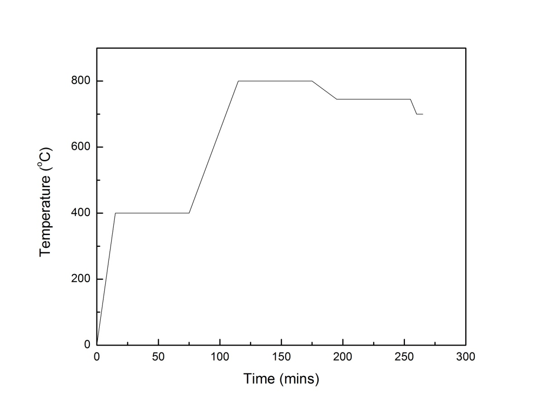
Figure 6 Graph heating steps of furnace

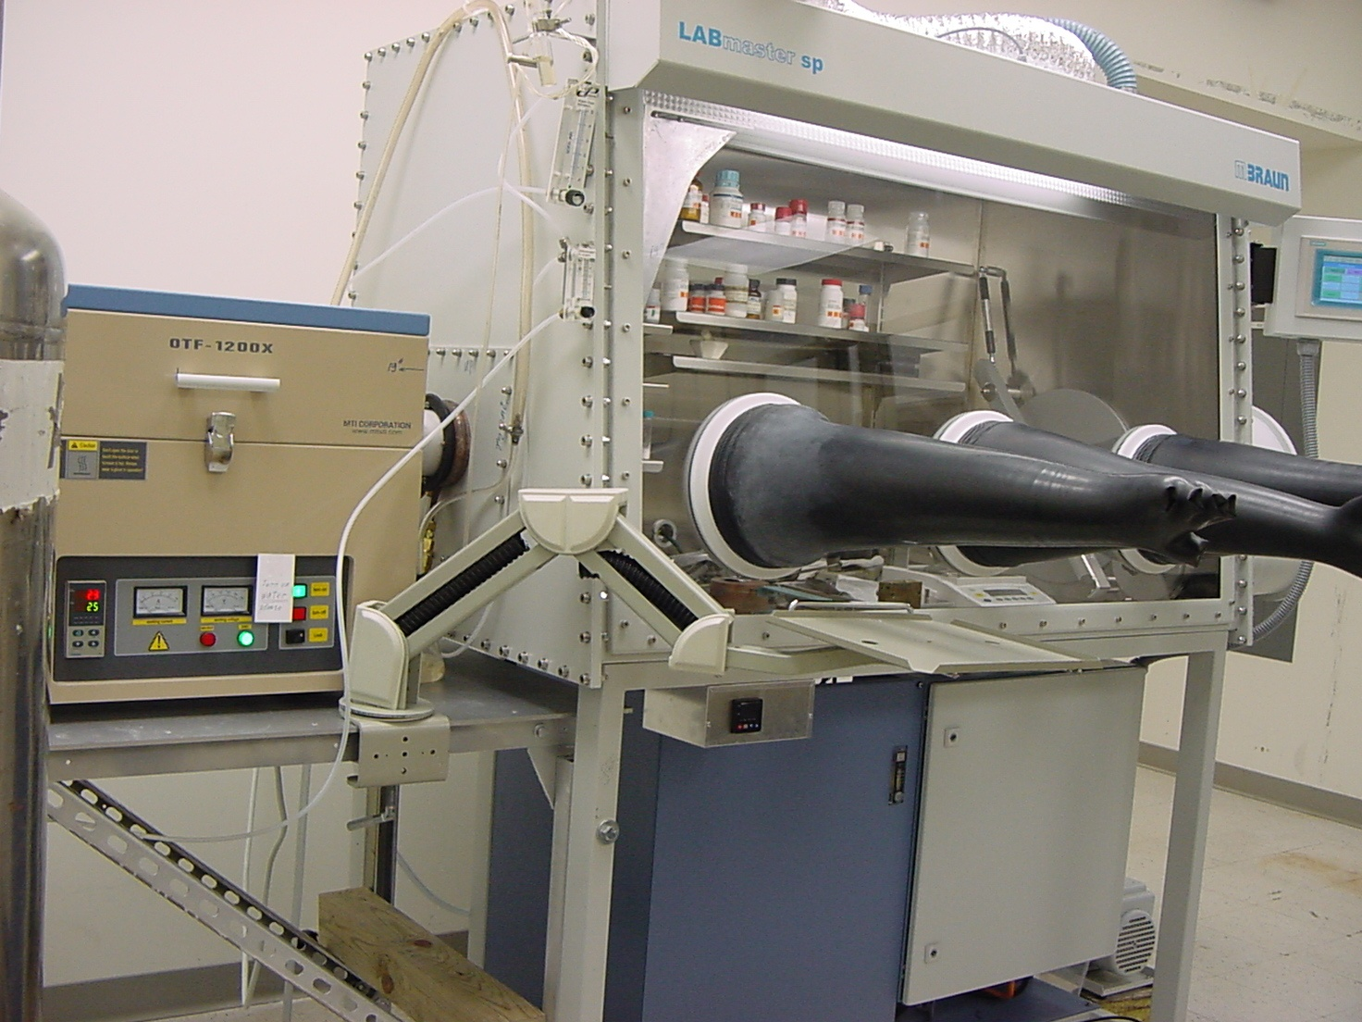
Figure 7 Glove box connected to the furnace on the left

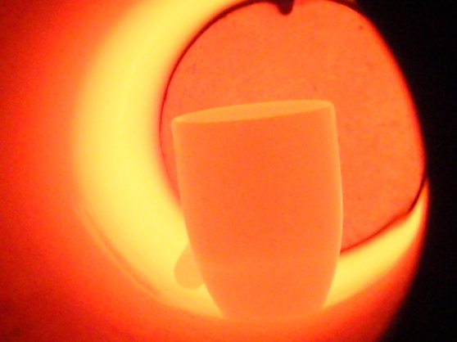
Figure 8 Crucible is heated inside the furnace

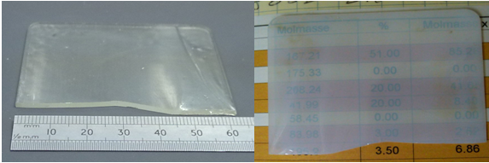
Figure 9 Before annealing ZBLAN glass sample on the left, the same sample after annealing at 290 °C.

2.2 Differential Scanning Calorimetry

The glass transition temperature, crystallization temperature and melting temperature were measured using the DSC 200 F3 Maia® (Netzsch) Differential Scanning Calorimeter with temperature range of -170°C to 600°C. The weight of the samples, crucibles and lids were recorded. A typical DSC measurement is performed with a constant heating rate of 10 K/min.

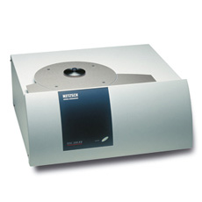
Figure 10 DSC 200 F3 Maia®, Differential Scanning Calorimeter [8]

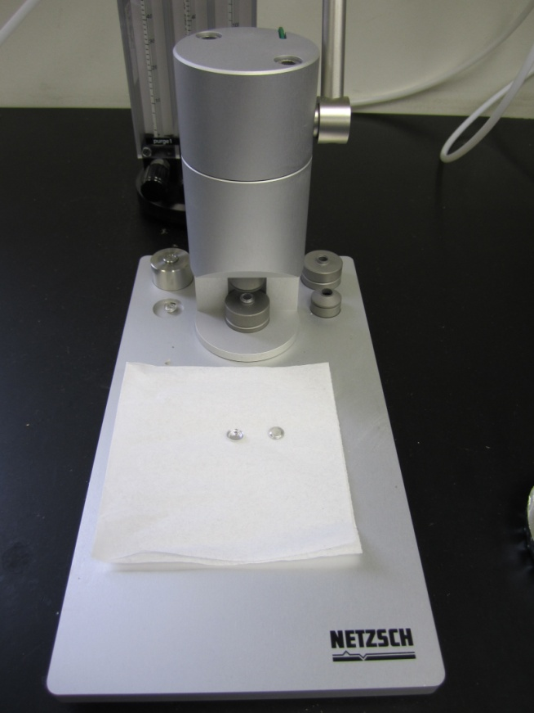
Figure 11 Crucible sealing press with exchangeable inserts and crucible

2.3 X-Ray Diffraction

X-ray diffraction (XRD) was performed on ZBLAN glasses to obtain structural information such as lattice structure, chemical composition, and crystallite sizes. The experiment follows Bragg’s Law. Waves scattered from the two Bragg planes in phase will create constructive and destructive interference. The interatomic spacing and distance between the lattice planes, d, can be calculated using the Bragg equation.
$$n∙λ=2 ∙d∙sin⁡θ$$

The experiments were performed by the Philips X’Pert XRD instrument with an x-ray tube using a tungsten anode and Copper Kα target. The instrument was set to collect the counts from an angle of 20° degrees to 80° degrees, with step size 0.01° degree and time per step, 4s. The total time for the measurement is around 12 hours. JADE 9.1 Software and Crystallography Database were used to analyze the lattice structure and chemical composition of the glasses.

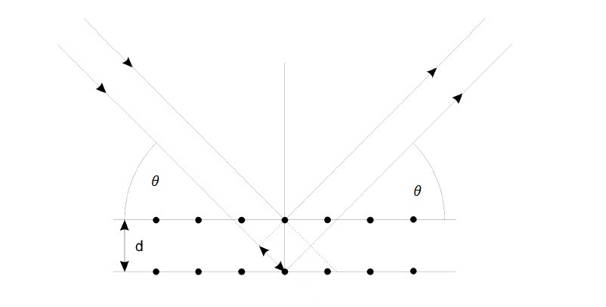
Figure 12 Bragg scattering from two successive planes.

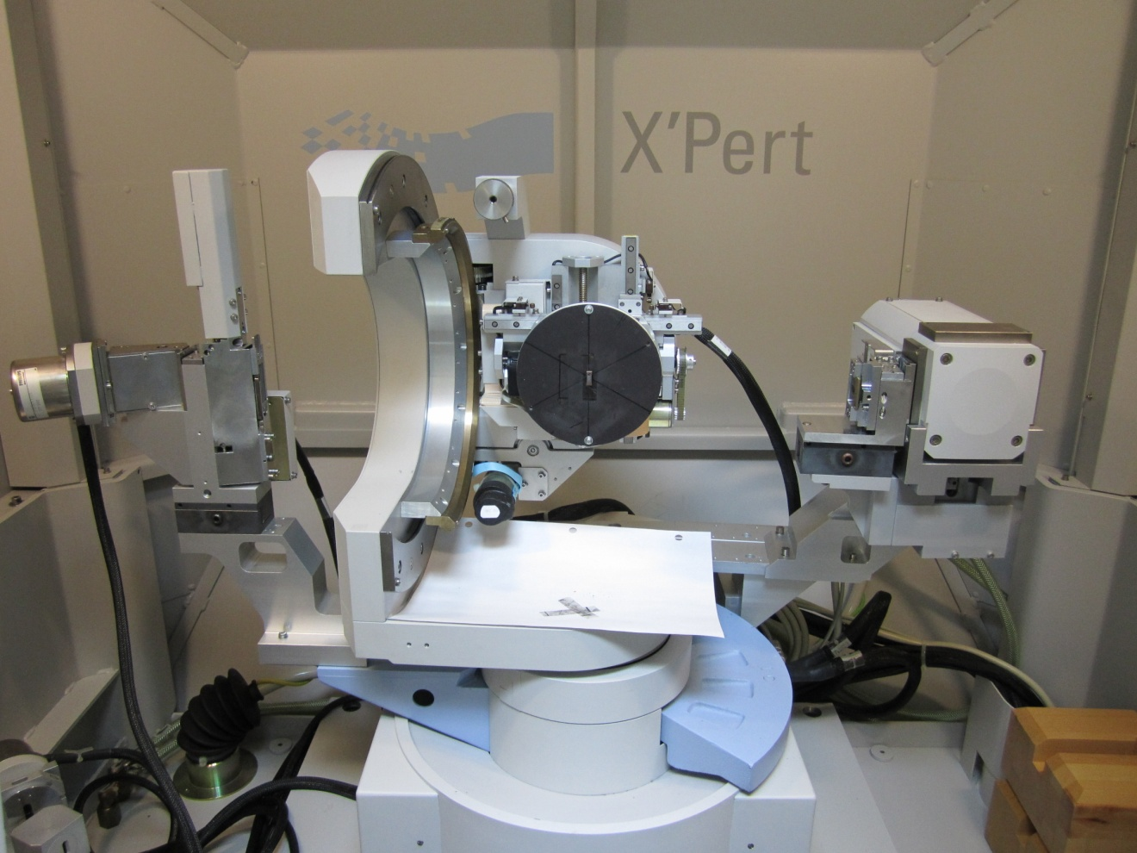
Figure 13 Philips X’Pert sample chamber

2.4 Secondary Ion Mass Spectroscopy

Secondary ion mass spectroscopy is one of the most sensitive techniques to detect impurities on the surface of bulk samples. In Figure 14, the surface of a sample is bombarded with heavy and high energy Gallium ions. The beam sputters neutral and charged species from the surface; including atoms, clusters of atoms and molecular fragments. The pressure inside the sample chamber is maintained around ${10}^{-10}$ Torr to ensure a clean working environment. In our system, the quadrupole mass analyzer was used as a detector. The quadrupole mass analyzer is known to be more sensitive in a lower mass range.

The ratio of fluorine to oxygen in our ZBLAN glass samples were calculated base on the area under the curves of secondary ion mass spectroscopy. Samples were cut into plates with dimensions of 4 mm × 3 mm × 1.6 mm (thickness). The samples were cleaned using anhydrous ethanol and placed inside a vacuum oven for two hours to eliminate ambient moisture from the samples. Samples were prepared by two different methods to ascertain which method would yield the best results. In the first method, the samples were attached to the sample holder by carbon tape. The top surface of each of the samples was sputter coated with a thin layer of platinum to increase the ability of a specimen to conduct electricity and emit secondary ions. In the second method, a conducting collar was placed on top of uncoated samples. An electron beam is directed to the edge of the collar to offset the samples acquiring a positive charge due to Gallium ion bombardment.

The presence of oxygen and fluorine was measured on the surface and inside the samples after fracturing. Data was collected at five different areas per sample to obtain a more representative result.

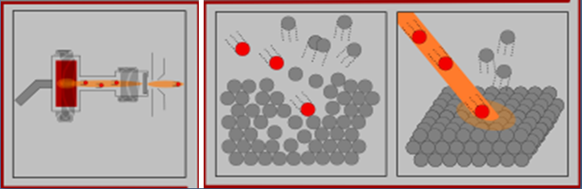
Figure 14 Gallium beam bombard the sample surface [9]
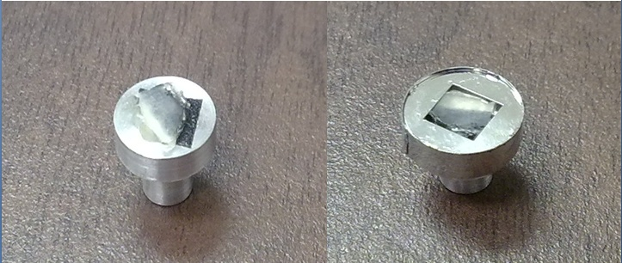
Figure 15 SIMS samples holder
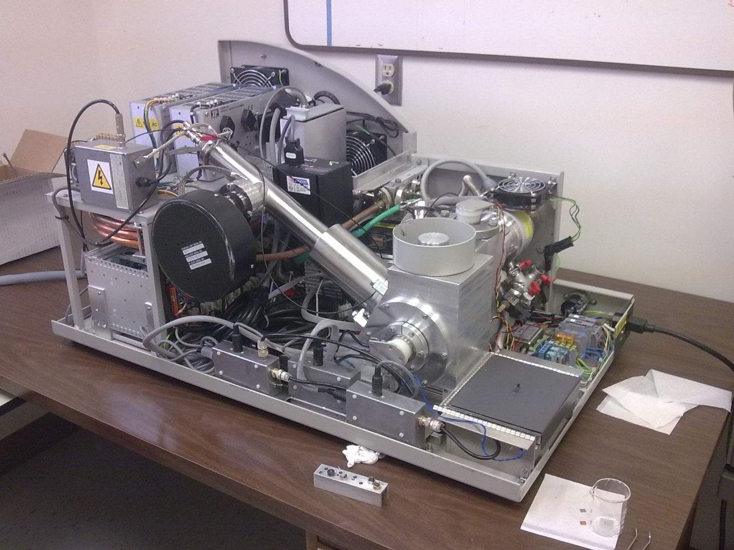
Figure 16 Secondary Ion Mass Spectroscopy

2.5 Phosphorimetry

Luminescence spectra of europium doped glasses were obtained using a PTI QM3 spectrofluorimeter (Birmingham, NJ). The data was analyzed using FeliX32 Version 1.2. Samples varied by different annealing conditions that included time of annealing and concomitant temperatures to further understand the optimal annealing condition. The higher annealing temperature and the longer annealing time are, the higher the degree of nucleation of BaCl₂ crystallites inside the glass matrix is. As a result, more crystallites incorporate Eu²⁺ and hence increase the fluorescence intensity [10]. However, a higher annealing temperature and a longer annealing time also lead to a larger degree of crystal growth and result in bigger nanoparticles. It leads to the decreasing in spatial resolution of a ceramic-glass storage phosphor.

2.6 Ion Chromatography and Inductive Coupling Plasma

The process of preparing the sample is undergoing high heating temperature; vaporization of chemical elements is inevitable. An Ion chromatography Dionex-ICS 100 and Dionex Automated Sampler (Sunnyvale, CA) were utilized to measure concentration of fluoride and chloride ions of as made samples. Inductively coupled plasma spectroscopy, Perkin Elmer Plasma 40 Emission Spectrometer was used to determine concentration of aluminum, barium, europium, indium, aluminum, lanthanum, sodium and zirconium.

The solution of ion chromatography measurement was prepared by the following steps. 5 g of anhydrous sodium carbonate and 0.5 g of powered ZBLAN glass sample were mixed inside a platinum crucible [11]. The crucible was placed in a furnace with a controlled argon gas atmosphere which was heated to 450°C for 30 mins, and then the temperature was raised to 950°C in an inert argon atmosphere. The crucible was removed from the furnace after 30 mins at 950°C and cooled down to room temperature. The final product was ground into a fine power. The powder was digested in a one liter bottle of high-purity water and was stirred overnight in order to allow all the sodium fluoride to pass through the solution. The solution was filtered through a 1.5 μm membrane filter and diluted into different concentrations for the ion chromatography measurement. Dionex chloride standard 1000 g/l and fluoride standard 1000 g/l were used for calibration.

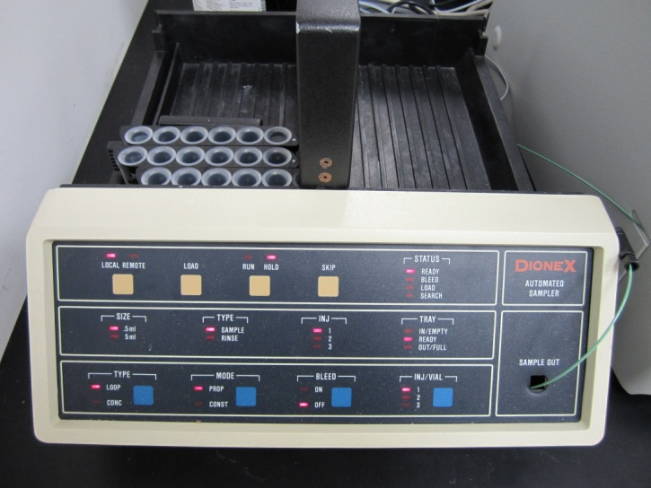

Figure 17 Dionex Automated Sampler

2.7 Transmission Electron Microscopy

In-situ transmission electron microscopy was used to further understand the growth mechanism of nanoparticles inside a glass matrix under various heating conditions of ZBLAN glasses. The size and the composition of the nanoparticles were also analyzed.

Samples were prepared with enormous care and patience. A diamond saw was used to cut samples into small rectangles of 3mm × 3mm × 1.6 mm (thickness), which were then mounted on a metal block using a crystal bone. The sample was mechanically polished to approximately 50 μm using successively finer grades of silicon carbide polishing paper, ending with hand polishing on 1200/2500P grade diamond polishing paper. The sample was removed from the metal block and glued on a 3 mm diameter SPI copper grid to give mechanical stability. The sample and the grid were mounted on top of a block of glass and further thinned down to approximately 20 μm using the Original Dimpler 500i (VCR Group). The slowest rotation mode and the gentle force were used to dimple the sample. Knowing the refractive index of ZBLAN glass is around 1.5 [12], optical microscopy (Zeiss Axioskop) was used to determine the thickness of the samples. In the final step, the sample was removed from the glass block by soaking in acetone for 2 hours. Low temperature ion milling XLA 2000 (VCR Group) was used to mill down the sample until holes were created. The temperature was maintained at -50°C, with a voltage of 5000 to 6000 V and the current of gun A and B was approximately 2-3 mA. The sample was kept in the membrane box inside a nitrogen glove box until the TEM experiment was conducted.

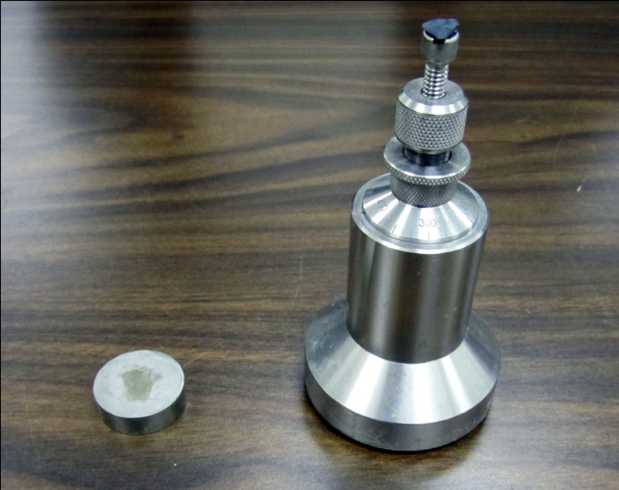
Figure 18 South Bay Technology polishing tool.
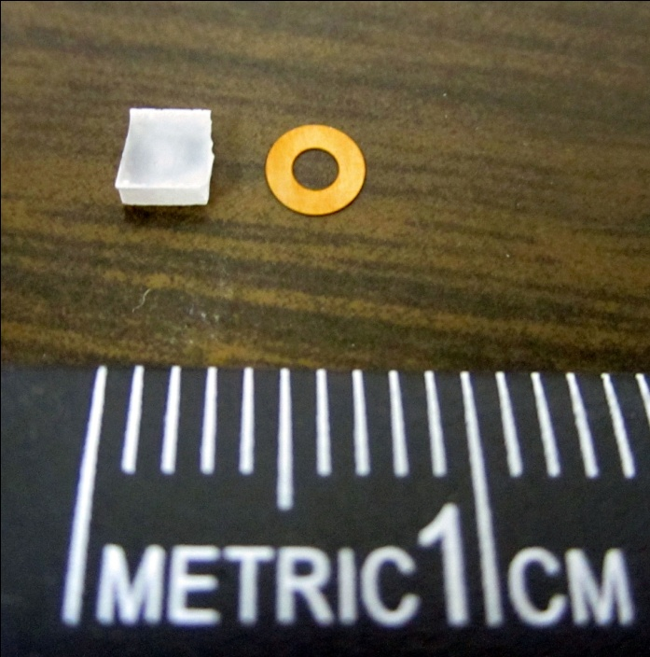
Figure 19 Rectangular sample and copper grid

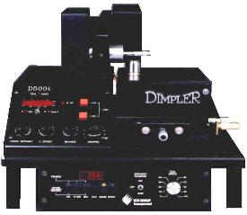
Figure 20 Original Dimpler 500i [13]

2.8 Mössbauer Spectroscopy

The Mössbauer Effect was discovered in 1957 by R. Mössbauer. He discovered that a nucleus of Ir in a solid can sometimes emit and absorb gamma rays without recoil. Since his discovery, there have been a number of other isotopes exhibiting the same properties including Eu and Fe. This discovery was rewarded with the Nobel Prize in Physics in 1961. Mossbauer spectroscopy is generally not an appropriate technique for measuring the total concentration of a certain nuclide. However, the relative concentration of different chemical forms of the Mossbauer atom can frequently be obtained, such as the relative concentration of oxidation stages for one element [14]. The relative concentration of Eu²⁺ to Eu³⁺ in ZBLAN glass samples was investigated using a SEE Co (Minneapolis, MN) Mössbauer Spectrometer (Figure 48, Figure 49). Mossbauer spectra were acquired by W302 software and analyzed by Mössbauer spectral analysis software which uses simple Lorentzian functions.

CHAPTER III

Results and Analysis

3.1 Differential Scanning Calorimetry

DSC was used to determine the annealing temperature of ZBLAN glasses. The temperature of hexagonal and orthorhombic crystallite BaCl₂ was also identified in the measurement. A typical DSC measurement of ZBLAN glass with a constant heating rate of 10K/min is shown in Figure 21. The glass transition temperature, T_{g}, is correlated to the melting temperature, T_{m}, by the “two-third rule” T_{g}/T_{m} = 2/3 which applies for a large volume of liquid [15]. The crystallization of BaCl₂, T_{x1}, the crystallization of glass matrix, T_{x2}, and the melting temperature T_{m} are identified using the onset method of the first crystallization [16-18].

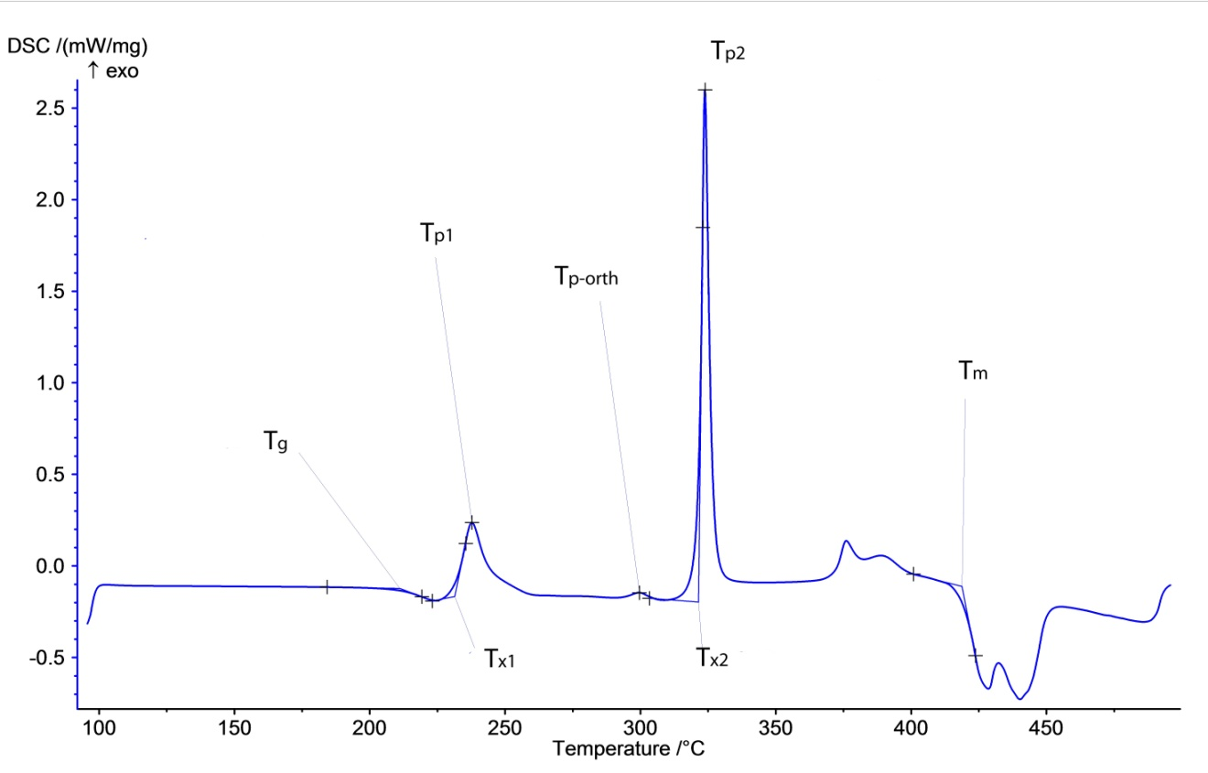
Figure 21 Plot of typical DSC data with the heating rate 10 K/min

The DSC data results show in Figure 22 and Table 3 for T_{g} of the europium 2 mole % series is around 210 ± 5°C. In the europium 2 mole % series, higher Eu³⁺-doping lead to the increase in crystallization temperature of the second peak.

Figure 23 shows T_{g} of europium 5 mole % series is around 213 ± 2°C. In the europium 5 mole % series, the higher Eu²⁺-doping is, the higher crystallization temperature (T_{x2}) and peak temperature of the second peak (T_{p2}) are.

The crystallization temperature of BaCl₂, T_{x1}, does not change a lot with the increasing of Eu²⁺ -doping and Eu-doping as well. The second crystallization peak (T_{x2}) is associated with crystallization of the whole glass matrix.

Table 3, the orthorhombic peak of BaCl₂ (T_{p-orth}) is around 300 ± 10 °C for both of 2 mole % and 5 mole % europium doping series.

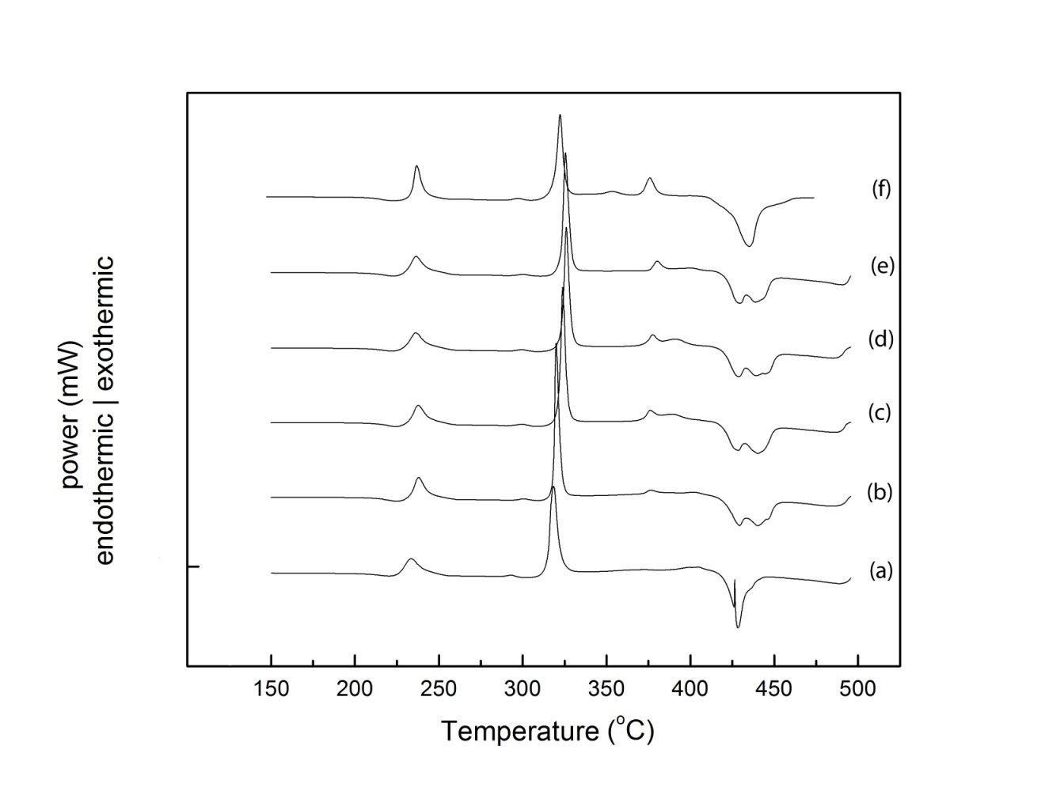
Figure 22 DSC graphs: the series of ZBLAN glass samples with 2 mole % of mixture EuCl₂ and EuCl₃ doping;(a) 2 mole % of EuCl₂ (b) 1.6 mole % of EuCl₂ and 0.4 mole % of EuCl₃ (c) 1.2 mole % of EuCl₂ and 0.8 mole % of EuCl₃ (d) 0.8 mole % of EuCl₂ and 1.2 mole % EuCl₃ (e) 0.4 mole %EuCl₂ and 1.6 mole % of EuCl₃ (f) 2 mole % of EuCl₃

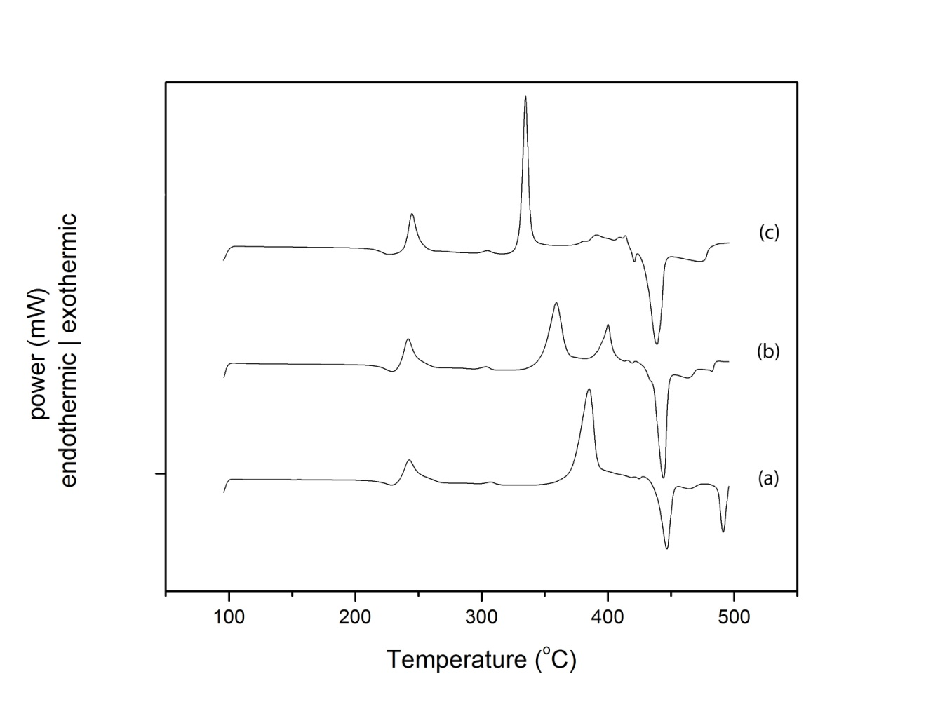
Figure 23 DSC graphs: the series of ZBLAN glass samples with 5 mole % of mixture EuCl₂ and EuCl₃ doping; ; (a) 5 mole % of EuCl₂ (b) 2.5 mole % of EuCl₂ and 2.5 mole % of EuCl₃ (c) 5 mole % of EuCl₃

Table 3 DSC data: glass transition, crystallization and peak temperature of 2 series 2 mole % and 5 mole % europium doping

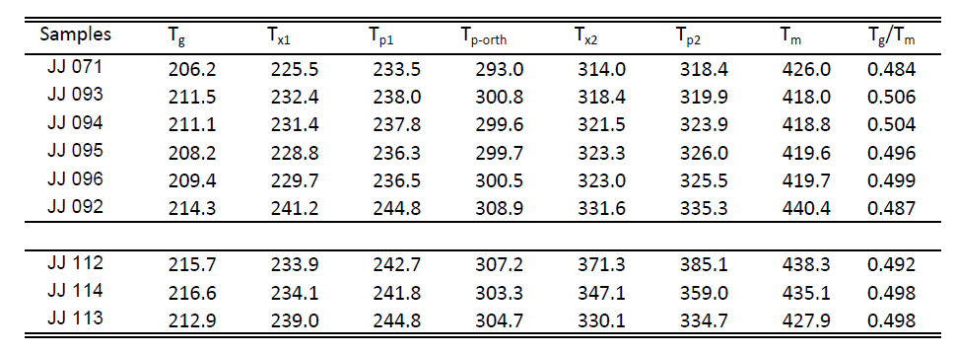

3.2 X-Ray Diffraction

The crystallographic structure of the nanoparticles is determined by x-ray diffraction. At critical annealing temperature, the orthorhombic phase of BaCl₂ is formed inside the glass matrix. The storage phosphor effect was attributed to the orthorhombic phase of BaCl₂ [1, 3]. X-ray diffraction will help to verify the existing of hexagonal and orthorhombic phase of BaCl₂ in ZBLAN glasses matrix after annealed.

Figure 24 shows the x-ray diffraction patterns of 5 samples with different composition of EuCl₂ and EuCl₃ which were annealed at 300°C in 5 mins. The XRD line pattern of the crystal BaCl₂ hexagonal phase of, PDF # 45-1313, is at the top of the graph. The XRD line pattern of the crystal BaCl₂ orthorhombic phase, PDF # 24-0094, is at the bottom of the graph. The software analysis Materials Dada Jade 9.1 was used to find and match the structural phase for the spectra. The BaCl₂ orthorhombic phase was the best possible match for the spectra.

Figure 25 shows the x-ray diffraction of sample JJ 092 at 5 different annealing temperatures from 250 °C to 290 °C to find the critical temperatures where most of BaCl₂ nanoparticles convert from hexagonal to orthorhombic phase. The higher the annealing temperature is, the more BaCl₂ transforms from the hexagonal phase into the orthorhombic phase.

The XRD results show that the higher the annealing temperature, the more BaCl₂ nanoparticles in hexagonal phase convert into orthorhombic phase. The results consistent to DSC analysis.

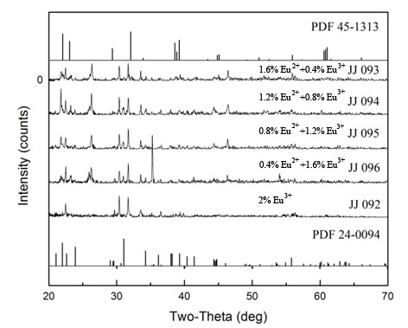
Figure 24 X-ray diffraction patterns of 5 different samples at 300°C.

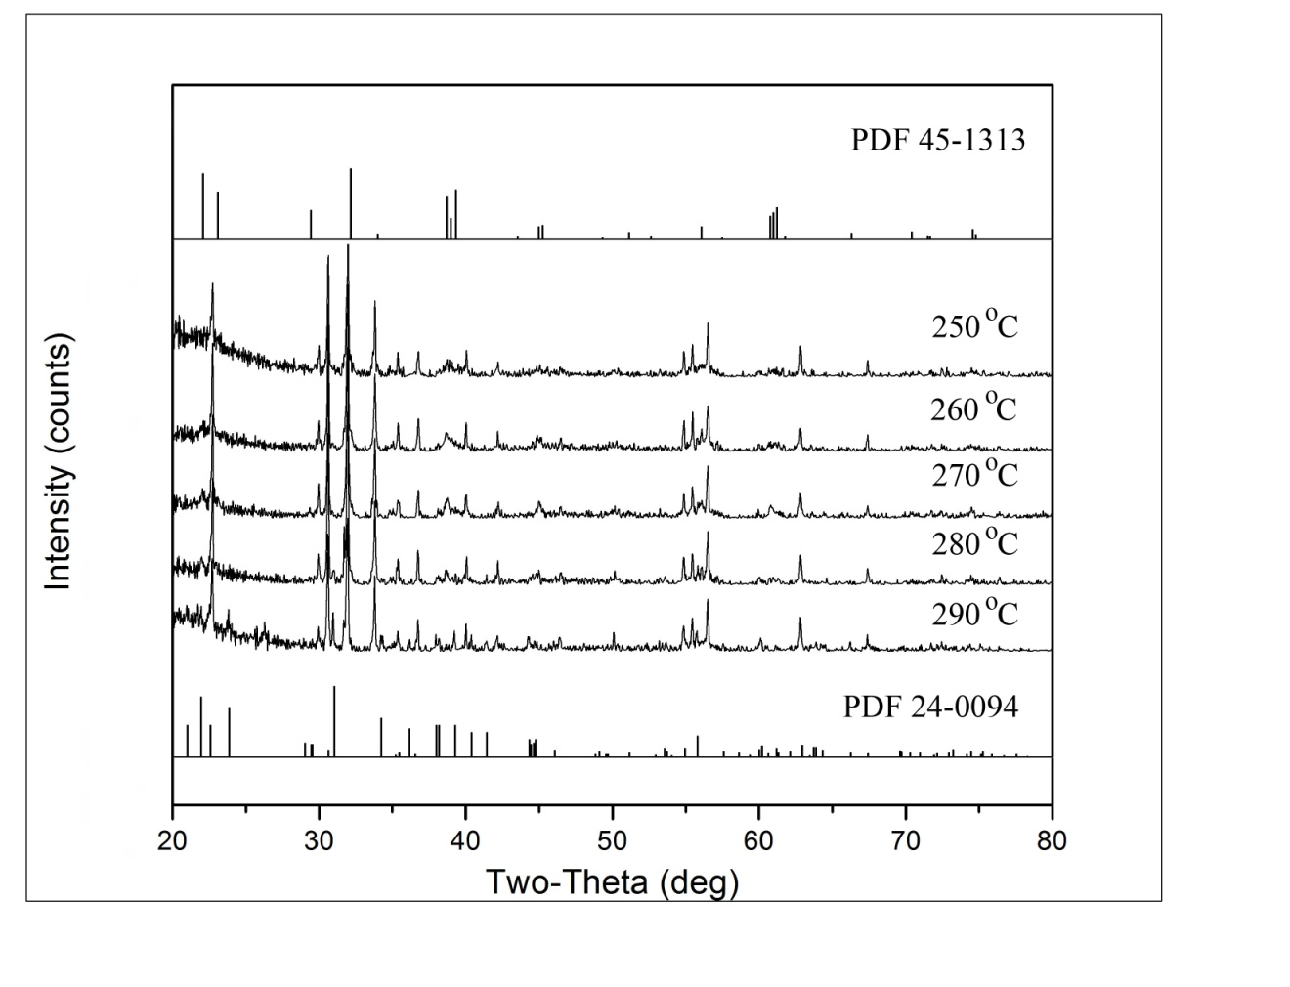
Figure 25 X-ray diffraction of sample JJ 092 with 2% of EuCl₃ annealing from 250 °C to 290 °C for 5min

3.3 Secondary Ion Mass Spectroscopy

The present of oxygen may oxide Eu²⁺ and reduce the performance of ZBLAN glass. Secondary ion mass spectroscopy was utilized to estimate the present of oxygen and calculated the ratio of fluorine to oxygen content in the glass samples. Samples were selected from four different groups. Sample JJ083 was prepared at University of Tennessee Space Institute using a glove box which was filled with argon gas. The amount of oxygen and moisture in the glove box atmosphere was maintained below 0.1 ppm. Sample ZBLAN 76 was prepared in Germany using a glove box that was filled with nitrogen gas. Sample Pour 5 was prepared by Dr. Richard Weber from Illinois using a glove box which is filled with nitrogen gas. Sample N04.02.22 was prepared in Australia and was exposed to oxygen gas for 15 minutes to reduce the black precipitates in the sample and improve the quality of the glass.

The first approach consisting of coating the sample with platinum was not very successful due to an inadequate vacuum in the sputter coater. The sputter coater was also contaminated by previous use of graphite.

The second approach of using uncoated samples with a conducting collar gave better results [19, 20]. Each sample was scanned in negative ion mode from 2 to 50 amu with step size 0.1 and dwell time 0.05 s. Figure 26 shows the distribution of fluoride content both on the surface and inside of sample JJ083. The brighter region (inside of the sample), where the surface layer was scraped off, shows relatively more fluoride than oxygen. Figure 27 shows a strong peak at 16 amu (oxygen), 19 amu (fluorine) and 35.5 amu (chlorine) for the mass spectrum of the surface of the sample. This shows there is more oxygen on the surface of the sample than inside the sample. The ratio of fluorine to oxygen was calculated by the using ratio of the area under of the curves. The intensity of the peak for the surface is not strong as the intensity for the peak inside. These reasons were attribute to the strong bonding on the surface comparing to internal bonding. Analogous results are shown in Figure 28, Figure 30, Figure 32 and Figure 29, Figure 31, Figure 33.

Table 4 shows that the results are consistent with sample preparation. Sample JJ083 shows the least amount of oxygen due to the procedure in which the sample was prepared in a highly monitored atmosphere with less than 0.1 ppm of oxygen and moisture. Sample N04.02.22 shows the most oxygen due to the introduction of oxygen flow during synthesis to improve the quality of the glass. Sample ZBLAN 76 and Pour 5 show higher oxygen due to the nitrogen gas environment and less sophisticated glove box. Most the oxygen of those samples concentrate on the surface, it attributed for the contact of the sample on the molds. Moreover, ZBLAN glasses are very hydrophilic and absorbed ambient moisture.

Table 4 Fluorine to oxygen ratio on the surface and inside 4 glass samples

Ratio F/O | JJ 083 | ZBLAN 76 | Pour 5 | N04.02.22
Surface | 2 | 7 | 6 | 6
Inside | 18 | 18 | 13 | 10

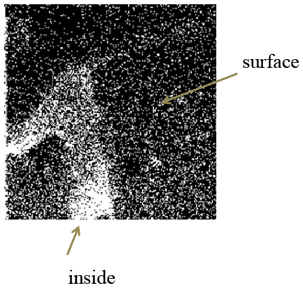
Figure 26 Fluorine distribution both inside and on the surface of sample JJ083
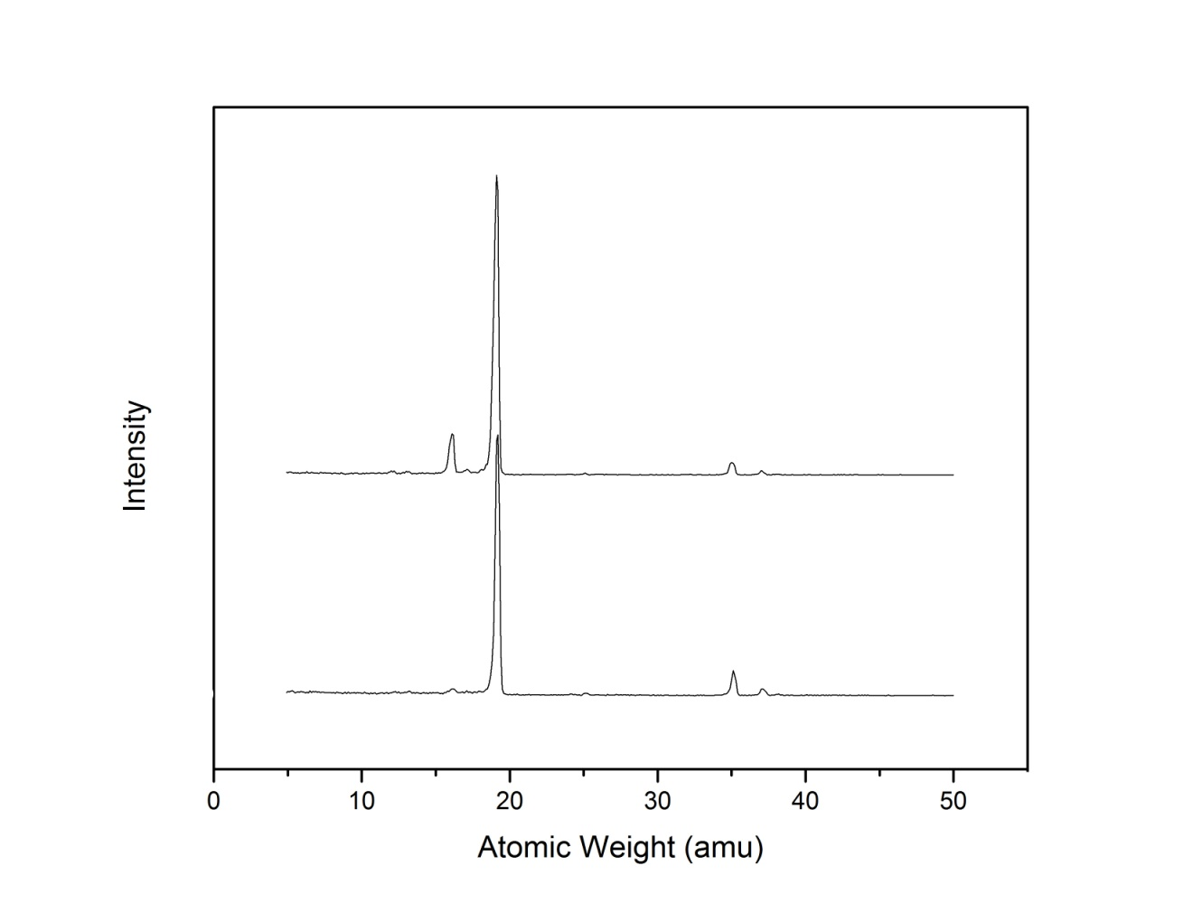
Figure 27 SIMS spectra of sample JJ083 for both surface (top) and inside (bottom)

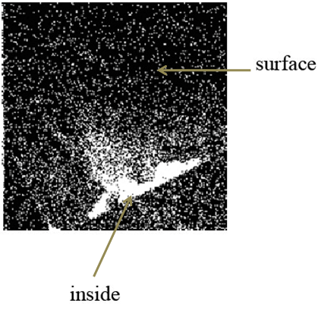
Figure 28 Fluorine distribution both inside and on the surface of sample ZBLAN 76
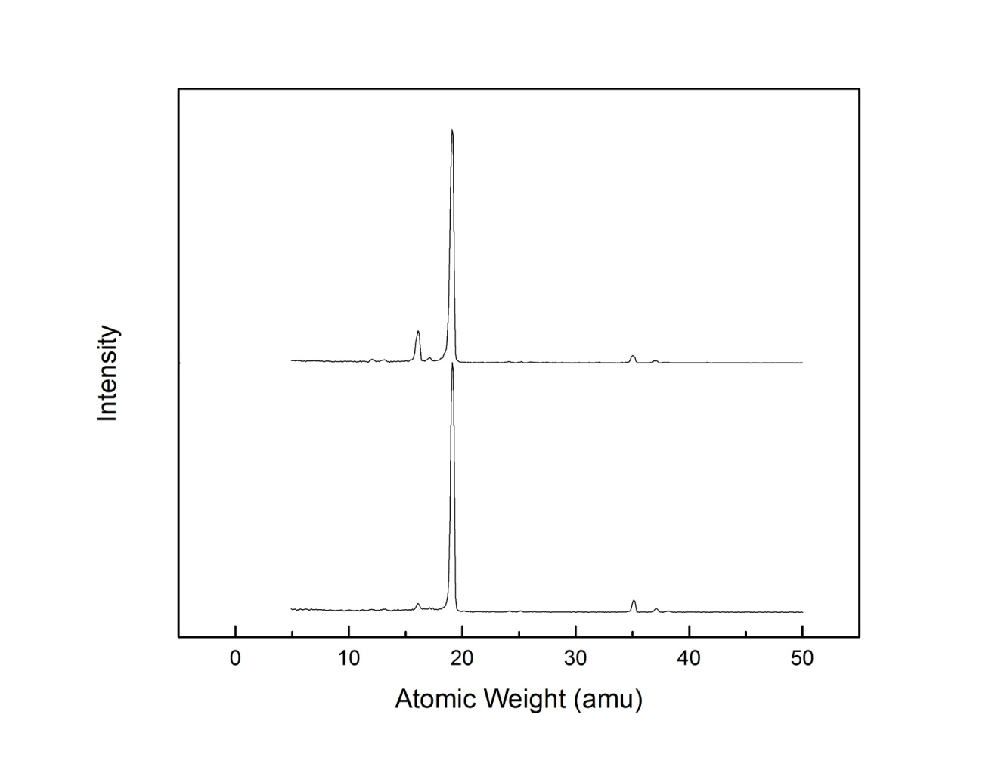
Figure 29 SIMS spectra of sample ZBLAN 76 for both surface (top) and inside (bottom)
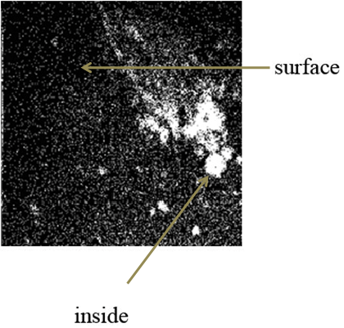
Figure 30 Fluorine distribution for both inside and on the surface of sample pour 5
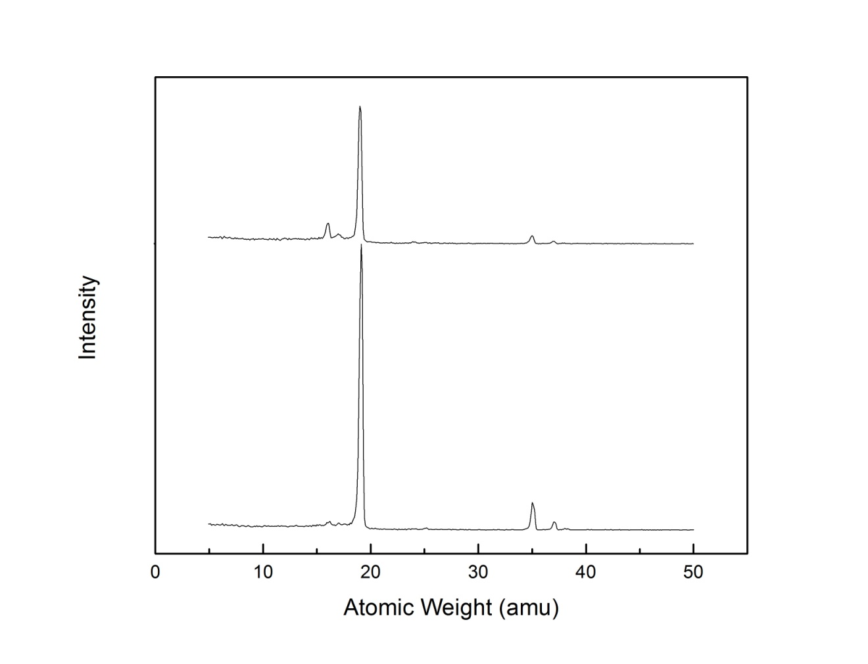
Figure 31 SIMS spectra of sample Pour 5 for both surface (top) and inside (bottom)
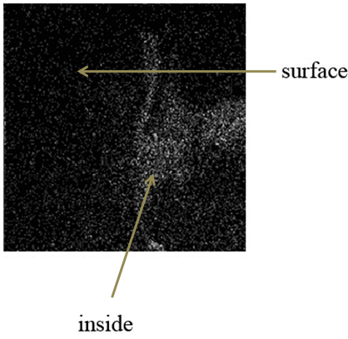
Figure 32 Fluorine distribution for both inside and on the surface of sample N04.02.22

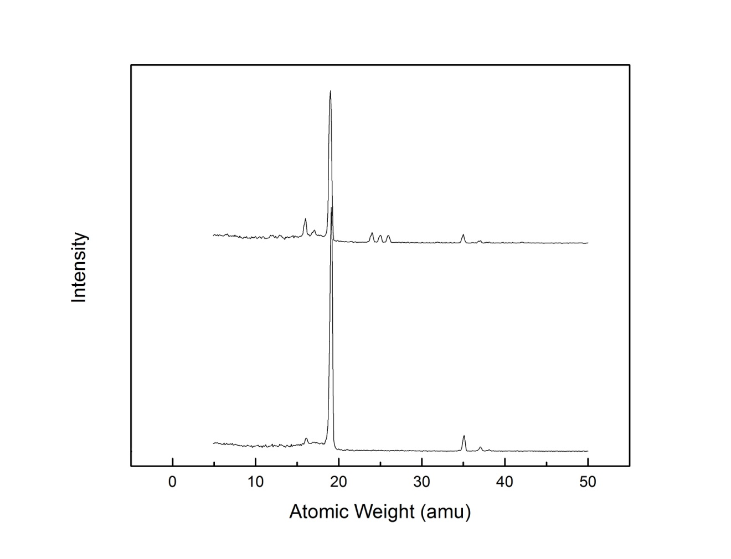
Figure 33 SIMS spectra of sample N04.02.22 for both surface (top) and inside (bottom)

3.4 Phosphorimetry

Annealed ZBLAN glass samples were tested under UV light, shown in Figure 34. This study helps to determine the performance of the glass as imaging plate. The samples on the left are annealed at 300°C and are glowing violets which were mostly ceramics. The samples on the right are annealled at lower temperature 280°C and glowing blue. The samples on the right still look transparent.

Figure 35 shows photoluminescence of sample JJ 093 prepared with 1.6 mole % EuCl₂ and 0.4 mole % EuCl₃ doped fluorochlorozirconate based glass excited at 285 nm. The peak around ~ 410 nm is shifted to around ~ 400 nm when the annealing temperature is increased. This shift is attributed to the transformation of a hexagonal phase of BaCl₂ into an orthorhombic phase of BaCl₂ [16, 21]. The peak around ~ 470 nm is attributed to the mixture of hexagonal and orthorhombic phases [22, 23]. The intensity of the peak around ~ 400 nm increased when the annealing temperature is increased. The same effect is also observed with sample JJ094, JJ095 and JJ096 which are shown in Figure 36-Figure 38

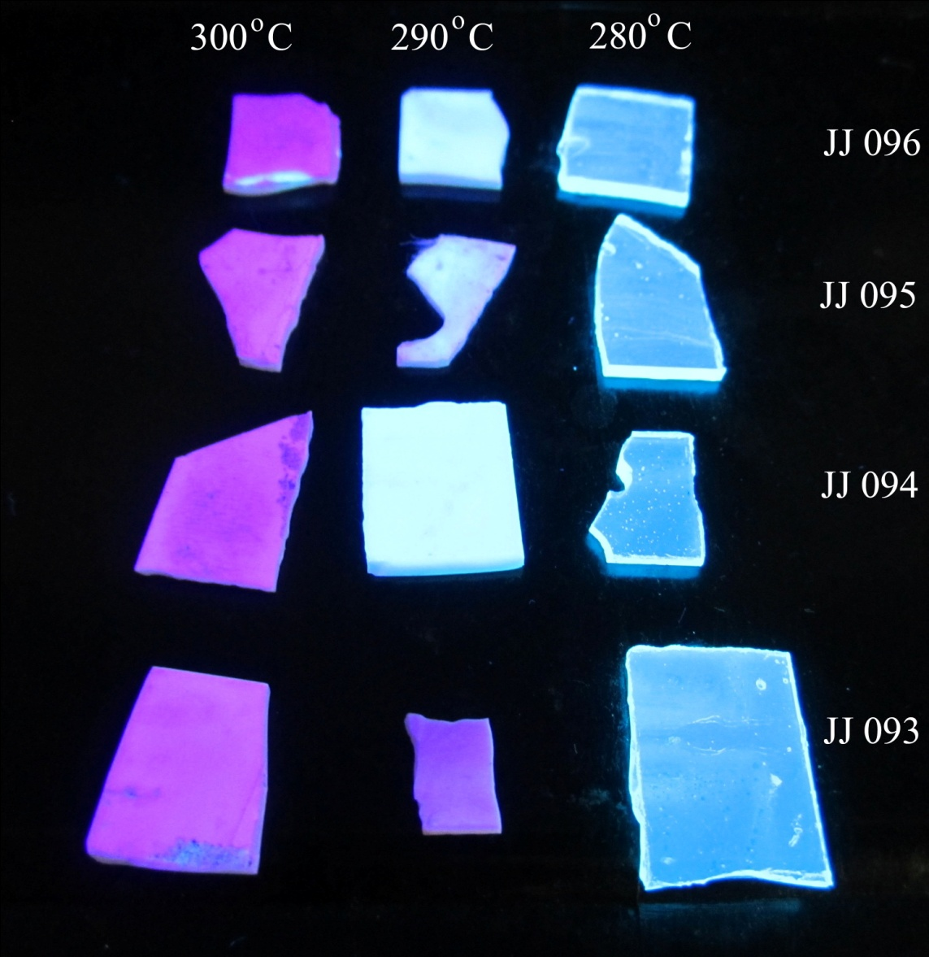

Figure 34 Photoluminescence test under UV light on ZBLAN glass sample doped with 2 % Eu²⁺ after annealing at different temperatures for 5 min.
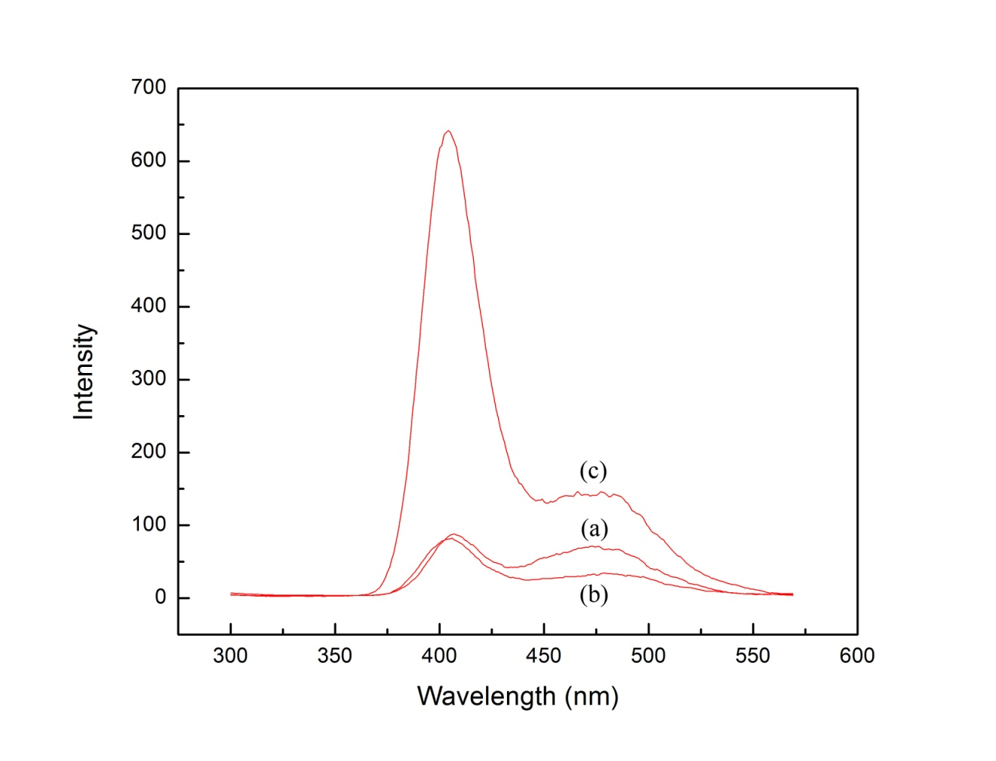
Figure 35 Photoluminescence spectroscopy of sample JJ 093 (a), (b) and (c) were annealed at 280°C, 290°C, and 300°C respectively for 5 min.
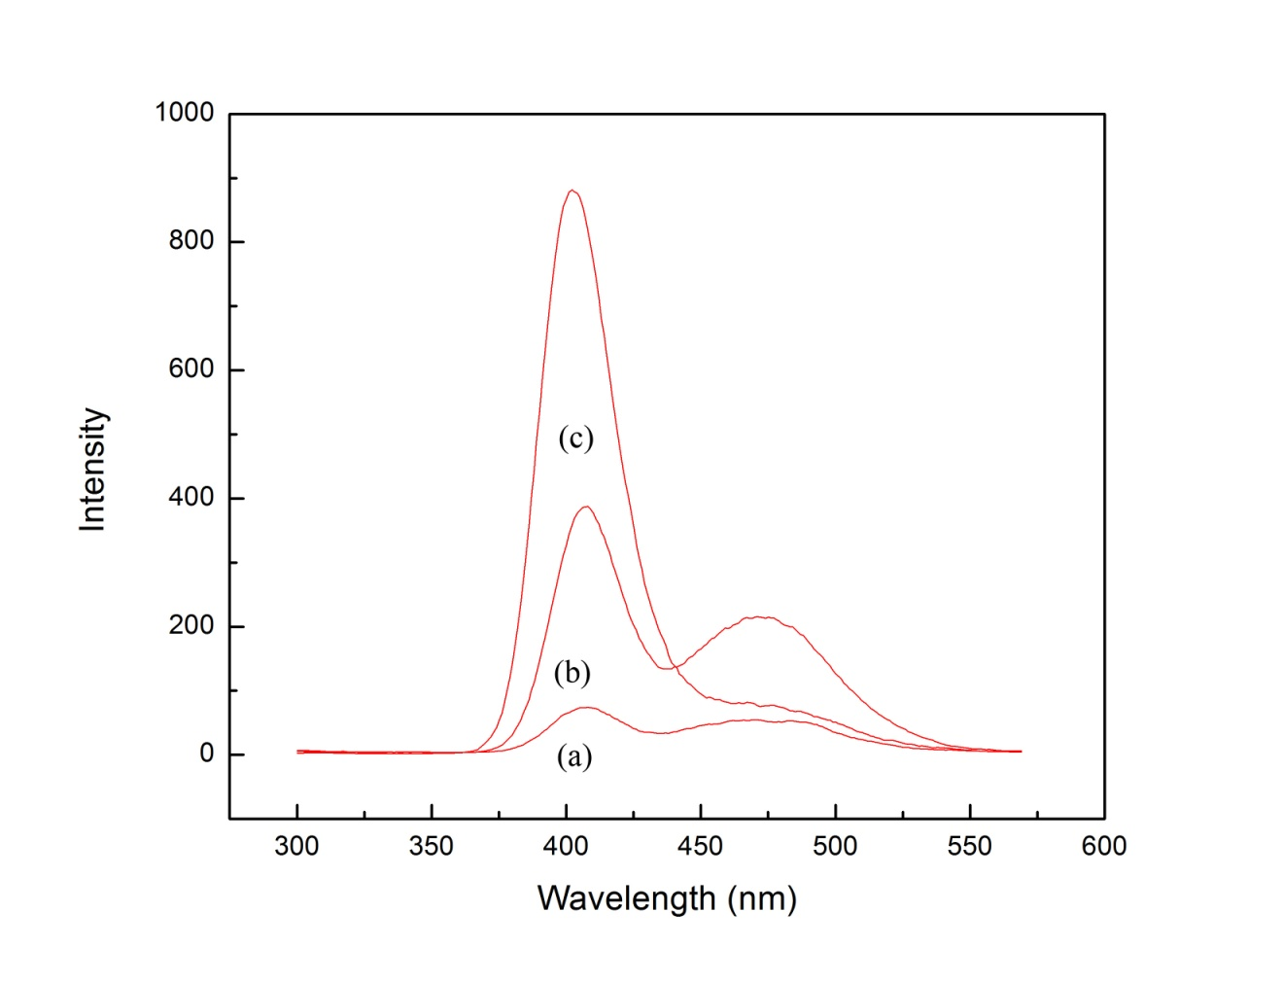
Figure 36 Photoluminescence spectroscopy of sample JJ 094 (a), (b) and (c) were annealed at 280°C, 290°C, and 300°C respectively for 5 min.

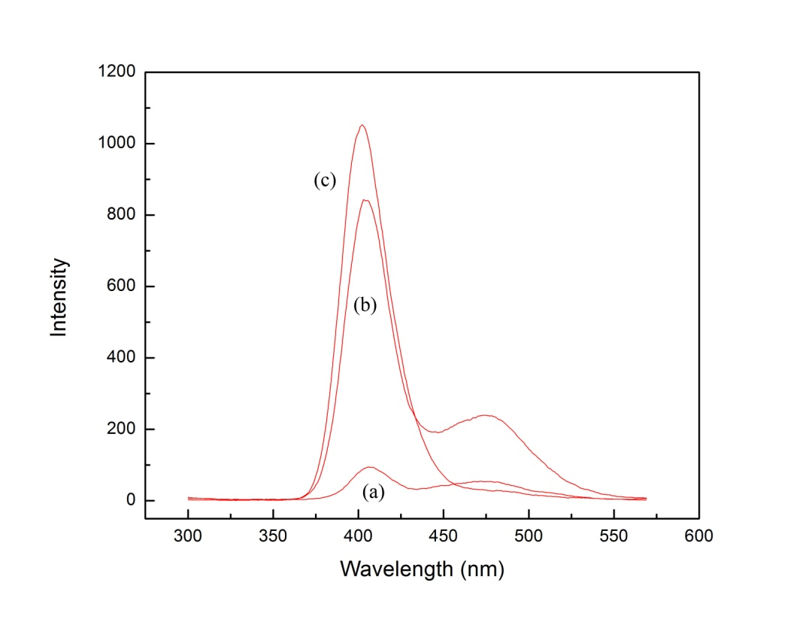
Figure 37 Photoluminescence spectroscopy of sample JJ 095 (a), (b) and (c) were annealed at 280°C, 290°C, and 300°C respectively for 5 min.
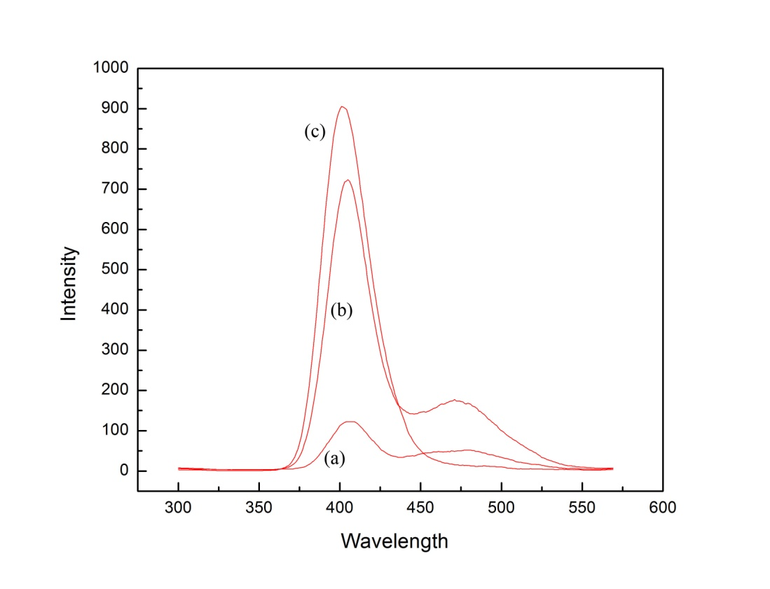
Figure 38 Photoluminescence spectroscopy of sample JJ 096 (a), (b) and (c) were annealed at 280°C, 290°C, and 300°C respectively for 5 min.
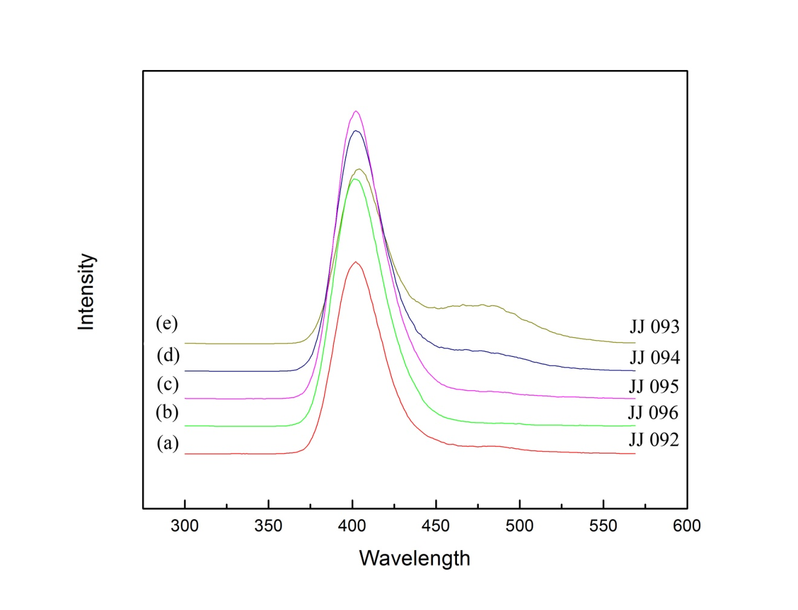
Figure 39 Photoluminescence spectroscopy of samples JJ092, JJ093, JJ094, JJ095, and JJ096, annealed at 300 °C for 5 min.

Figure 39 shows the comparison of photoluminescence among 5 different samples. The intensity of the peak around ~ 400 nm strongly depends on the annealing time and amount of Eu²⁺ in the samples. The peak around ~ 470 nm diminishes when the annealing temperature reaches 300 °C. That is explained by the hexagonal phase transforming into the orthorhombic phase at a high enough temperature. Moreover, five samples have different concentration of doping Eu²⁺ and Eu³⁺ but they does not show the different in the intensity of the fluorescent. These conclude that part of the Eu³⁺ doping converts into Eu²⁺. Small concentration of Eu²⁺ can give out high the intensity of the fluorescent.

3.5 Ion Chromatography – Inductive Coupling Plasma

During the sample preparation process, the crucible was heated to high temperature. The vaporization of the chemical elements is inevitable. Ion chromatography and inductive coupling plasma were used to determine the weight loss of each element. The concentration of aluminum, barium, europium, indium, aluminum, lanthanum, sodium and zirconium were determined by inductively coupled plasma atomic emission spectrometry. The concentration found in the sample was compared with the expected values from Table 1. This comparison helps to detect whether any component is partially volatilized during manufacturing [11]. Furthermore, the uniformity of the glass can be evaluated by measuring different part of the sample. Table 5Table 8 shows the cationic concentration in the samples JJ 093, JJ 094, JJ 095 and JJ096 that were measured using inductively coupled plasma, respectively. The mole percentage was found to be very close to the expected value. The weight loss of cationic is very reasonable.

Table 5 Concentrations of aluminum, barium, europium, indium, aluminum, lanthanum, sodium and zirconium of in ZBLAN glass sample JJ093

Element | Found (mg/g) | Found (millimole/gram) | Found (moles %) | Expected (moles %)
Al | 4.134 | 0.15 | 2.3 | 3.0
Ba | 198.65 | 1.45 | 21.7 | 20.0
Eu | 23.595 | 0.16 | 2.3 | 2.0
In | 0.5023 | 0.00 | 0.1 | 0.5
La | 35.845 | 0.26 | 3.9 | 3.5
Na | 34.97 | 1.52 | 22.8 | 20.0
Zr | 284.5 | 3.12 | 46.8 | 51.0
 |  | 6.66 | 100.0 | 100.0

Table 6 Concentrations of aluminum, barium, europium, indium, aluminum, lanthanum, sodium and zirconium of in ZBLAN glass sample JJ094

Element | Found (mg/g) | Found (millimole/gram) | Found (moles %) | Expected (moles %)
Al | 3.985 | 0.15 | 2.2 | 3.0
Ba | 196.9 | 1.43 | 21.8 | 20.0
Eu | 22.53 | 0.15 | 2.3 | 2.0
In | 0.5102 | 0.00 | 0.1 | 0.5
La | 35.28 | 0.25 | 3.9 | 3.5
Na | 34.555 | 1.50 | 22.9 | 20.0
Zr | 280.75 | 3.08 | 46.9 | 51.0
 |  | 6.57 | 100.0 | 100.0

Table 7 Concentrations of aluminum, barium, europium, indium, aluminum, lanthanum, sodium and zirconium of in ZBLAN glass sample JJ095

Element | Found (mg/g) | Found (millimole/gram) | Found (moles %) | Expected (moles %)
Al | 3.996 | 0.15 | 2.2 | 3.0
Ba | 197.5 | 1.44 | 21.8 | 20.0
Eu | 22.745 | 0.15 | 2.3 | 2.0
In | 0.4711 | 0.00 | 0.1 | 0.5
La | 35.34 | 0.25 | 3.9 | 3.5
Na | 34.67 | 1.51 | 22.9 | 20.0
Zr | 282.5 | 3.10 | 46.9 | 51.0
 |  | 6.60 | 100.0 | 100.0

Table 8 Concentrations of aluminum, barium, europium, indium, aluminum, lanthanum, sodium and zirconium of in ZBLAN glass sample JJ096

Element | Found (mg/g) | Found (millimole/gram) | Found (moles %) | Expected (moles %)
Al | 4.735 | 0.18 | 2.7 | 3.0
Ba | 195.1 | 1.42 | 21.7 | 20.0
Eu | 22.54 | 0.15 | 2.3 | 2.0
In | 0.613 | 0.01 | 0.1 | 0.5
La | 35.24 | 0.25 | 3.9 | 3.5
Na | 34.53 | 1.50 | 22.9 | 20.0
Zr | 278.85 | 3.06 | 46.6 | 51.0
 |  | 6.56 | 100.0 | 100.0

Figure 40 shows a typical graph of ion chromatography measurement for anionic concentrations of fluoride and chloride. The expected value for fluoride and chloride were calculated based on the Table 1. Figure 40 A typical graph of ion chromatography measurement for concentrations of fluoride and chloride. The concentration of fluoride and chloride were measured using ion chromatography and compared to expected values.
For a typical ZBLAN glass sample, the weight loss of fluoride is around 3-5 %. The weight loss of chloride is 3-5 %.

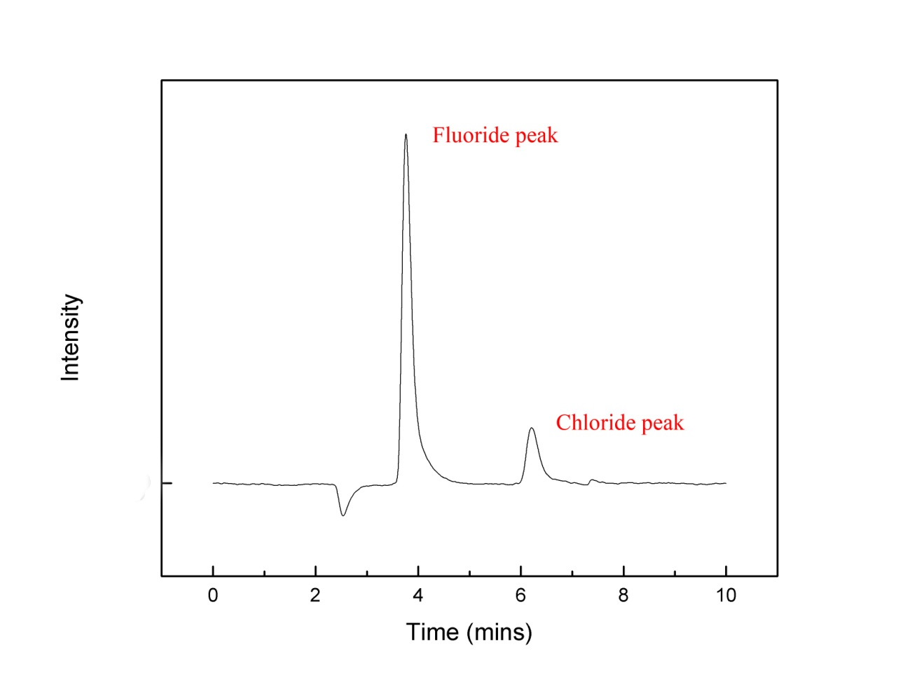
Figure 40 A typical graph of ion chromatography measurement for concentrations of fluoride and chloride.

3.6 Transmission Electron Microscopy

The transmission electron microscopy was used to observe the formation and the propagation of nanoparticles BaCl₂ under various heating conditions. It has been shown consistent results to other techniques.

During subsequent ion milling, the amorphous matrix may undergo partial crystallization (phase transition). For that reason, special caution was made to prevent crystallization during the ion milling. Figure 41 shows how the relative uniform contrast indicates that the sample is in amorphous state before the in situ experiment. The detailed forming of the nanostructure of BaCl₂ in the glass matrix was examined using high-resolution transmission electron microscopy.

The sample was slowly heated from room temperature to 300 °C to observe the forming of BaCl₂ nanoparticles. The results were consistent with our DSC and XRD study. It was found that the nanoparticles only start to form when the annealing temperature is around 250-260 °C which is agreed to our DSC and XRD study. The crystallization starts propagating to larger areas when the annealing temperature increases which corresponds to higher photoluminescence intensity as the annealing temperature increases. As a result, larger BaCl₂ nanoparticles are formed. Figure 42 shows small crystal areas inside the white square box were observed under high-resolution TEM. Figure 43 shows sample N05.02.41 after annealing and the formation of a crystal area of ~500nm.

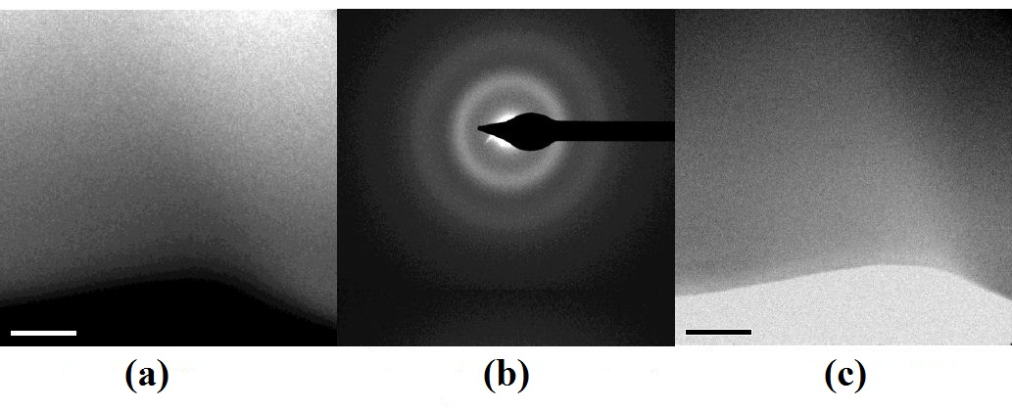
Figure 41 (a) dark field image, (b) amorphous diffraction rings, and (c) bright field image of ZBLAN glass sample JJ 094.

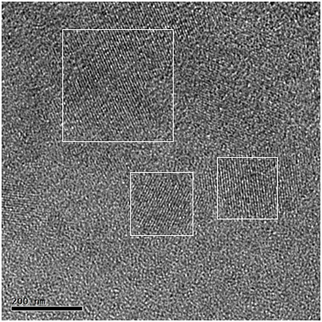
Figure 42 High resolution image of ZBLAN JJ 094 after heat treatment

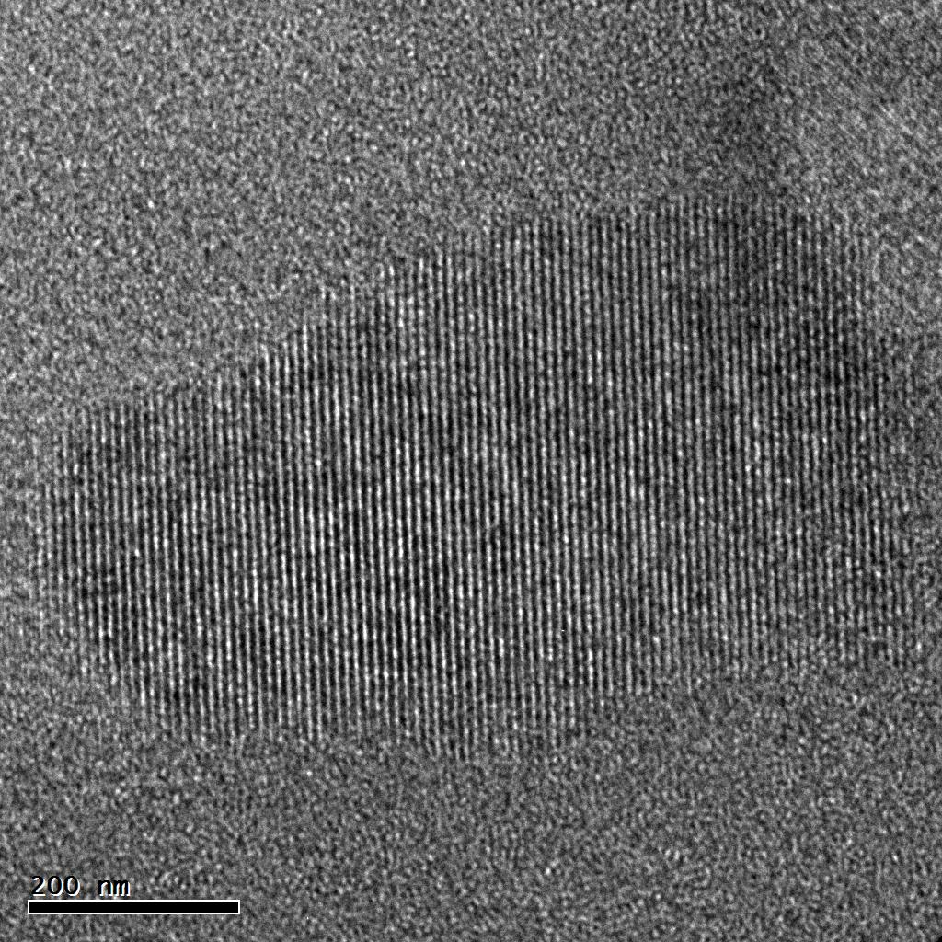
Figure 43 High resolution image of ZBLAN N05.02.41 after heat treatment

3.7 Mössbauer Spectroscopy

Eu³⁺ is the stable oxidation stage of europium, Eu²⁺ easily oxide to Eu³⁺ with the present of moisture or oxygen. EuCl₂/EuF₂ is important chemical to form glass-ceramic storage phosphors, but it is around twenty times more expensive comparing to EuCl₃/EuF₃.The experiment is set up to demonstrate the ability of producing EuCl₂ from EuCl₃ in the laboratory environment.

Sealed bottles of 99.9% purity of EuCl₃ (Aldrich Chemical Company, Milwaukee, WI) were opened inside the glove box (LABmaster SP, MBRUAN). Europium (III) chloride, when heated under argon gas at 750 °C for one hour, allowing the following reaction to occur [24]

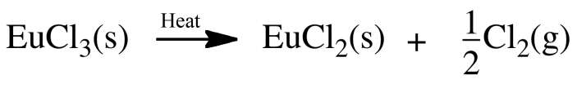

The melting point of EuCl₃ is 625 °C [25, 26] which is lower than the heating temperature. After heating EuCl₃, the final product changed from a white to dark grey color. Eu³⁺ and Eu²⁺ are known to have an isomer shift around 0 mm/s and -13 mm/s, respectively [27].The relative area under the peaks represents the relative presence of Eu²⁺ and Eu³⁺ in samples. The longer the samples were exposed to air, the more Eu²⁺ oxidized to become Eu³⁺. Figure 44 shows the increasing concentration of Eu³⁺ and the decreasing concentration of Eu²⁺ in the sample over time. The lower the concentration of Eu²⁺, the weaker the interaction between Eu²⁺-Eu²⁺ is. It leads to the broader linewidth of Eu²⁺ over time in Figure 44.

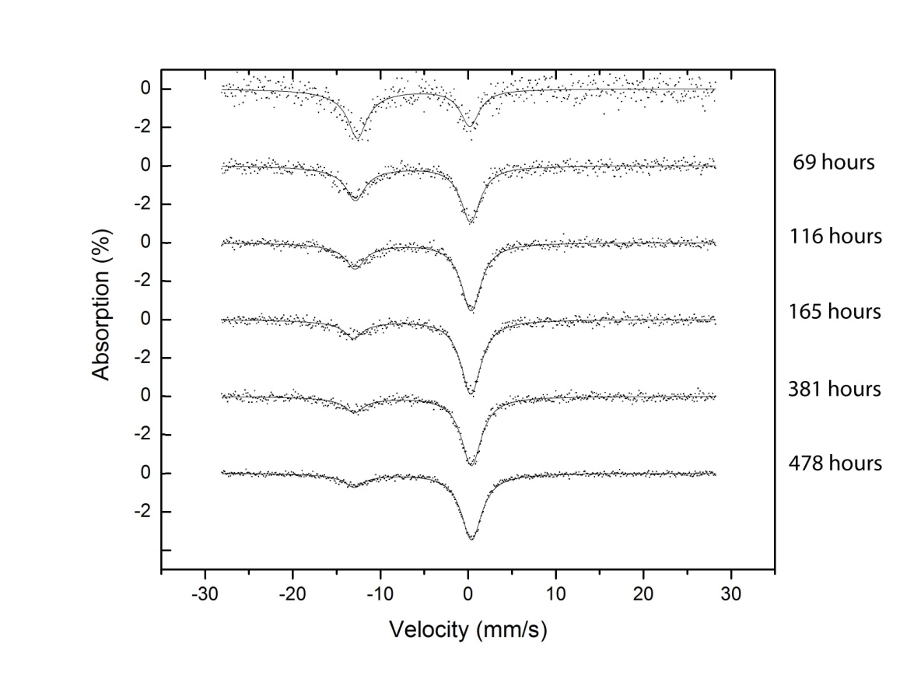
Figure 44 Mossbauer spectra of EuCl₃ heated at 700 °C for an hour by time.

Figure 45 shows the decrease in concentration of Eu²⁺ in heated EuCl₃ fine powder. The oxidation rate of Eu²⁺ follows a negative exponential curve
$y=81.1\exp\left(-\frac{t}{10.6}\right)- 17$ (is discussing with Dr. Charles), which is consistent with our hypothesis that the less Eu²⁺ on a surface layer and the thicker oxide layer is the longer and the more difficult it is for moisture and oxygen to penetrate the samples. Moreover, the fitting also describe that eventually all the Eu²⁺ will oxide and become Eu³⁺ which is agreed with our expectation.

Figure 45 Percentage of Eu²⁺ in EuCl₃ heated over time. The data was fitted by $y=81.1\exp\left(-\frac{t}{10.6}\right)- 17$ with t is the number of day.

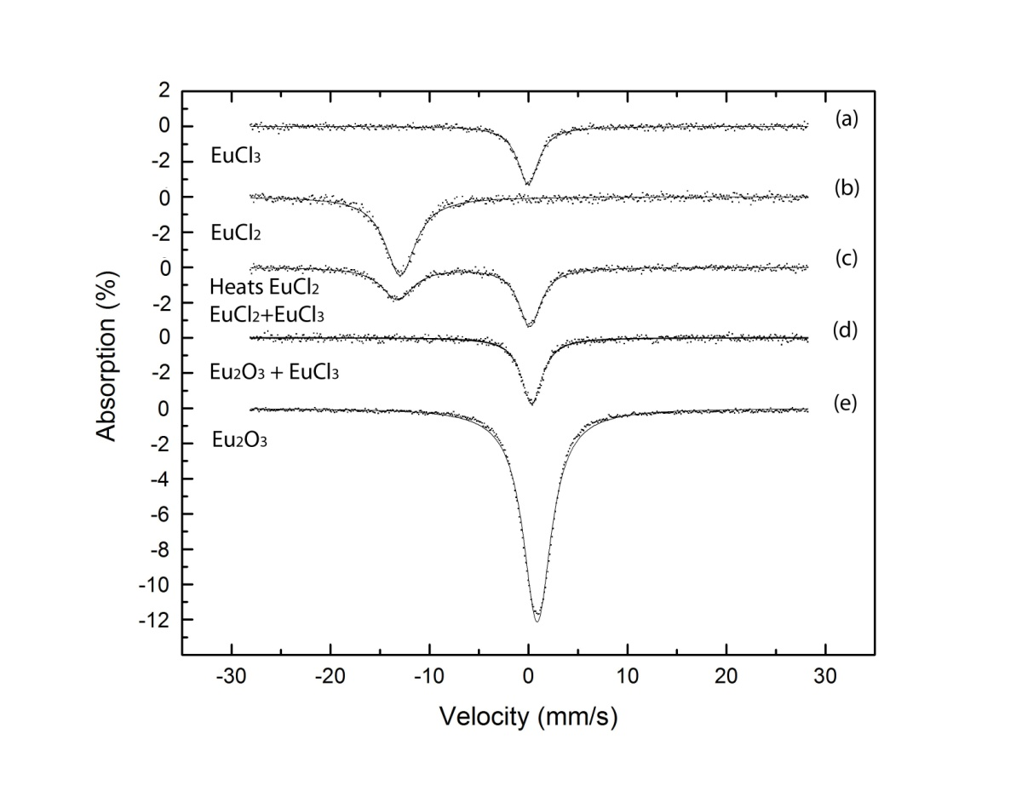
Figure 46 Mossbauer spectra of (a) purity of EuCl₃, (b) purity of EuCl₂, (c) EuCl₂ after heated contain EuCl₂+EuCl₃, (d) mixture of Eu₂O₃+EuCl₃, and (e) purity of Eu₂O₃

EuCl₃ purity out of the box is shown in Figure 46a with chemical shift 0 mm/s, EuCl₂ purity out of the box is shown in Figure 46b with chemical shift 1 mm/s, agreed to the reference [27]. Figure 46c shows the mixture of Eu²⁺ and Eu³⁺ after heated. Figure 46d shows the oxidation of EuCl₂ to a mixture of EuCl₃ and Eu₂O₃. EuCl₂ is in the unstable state and has the intendancy to oxide to Eu³⁺. When Eu²⁺ oxide to Eu³⁺, it contacted with the oxygen and moisture from the atmosphere and became Eu₂O₃. The chemical shift of Eu₂O₃ is known to be around +1 mm/s. The chemical shift of EuCl₃ is known to be around 0 mm/s [27]. In Figure 46d, the chemical shift of the peak is around 0.8 mm/s. It is consistent to our hypothesis that the peak was made up by EuCl₃ with chemical shift 0 mm/s and Eu₂O₃ with chemical shift 1 mm/s.
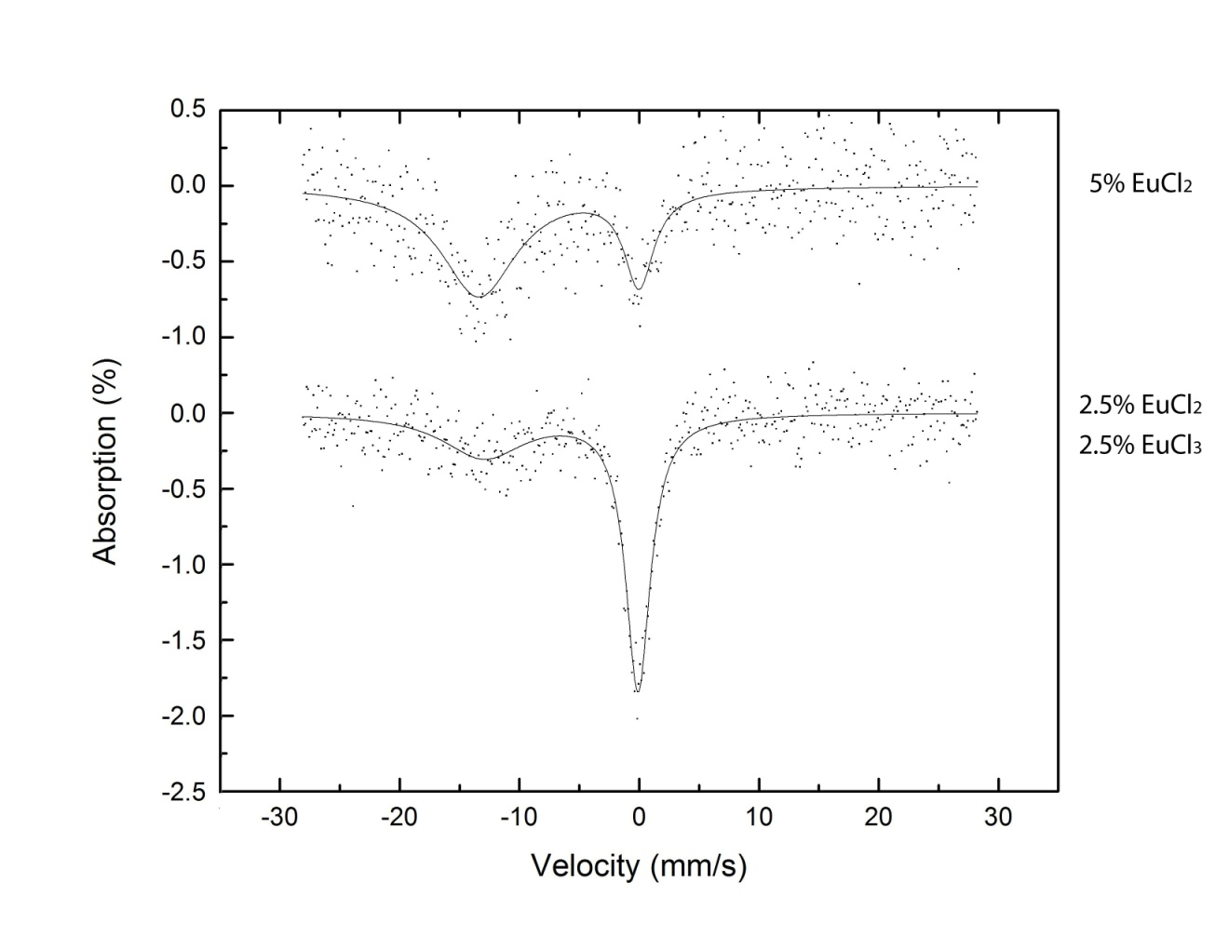
Figure 47 Mossbauer spectra of ZBLAN glass with 5 mole % Eu-doping. The sample of the top spectrum was doped with 5 mole % EuCl₂. The sample of the bottom spectrum was doped with 2.5 mole % EuCl₂ and 2.5 mole % EuCl₃

The more europium doping in ZBLAN glass samples, the easier it is to observe Mossbauer effect. But it is also harder to form glass and impact the quality of the glass samples. The less europium doping in ZBLAN glass samples, the harder it is to observe Mossbauer effect, because heavy Zirconium in the glass sample will block the most of the gamma ray. The 5 mole % doping of Eu was made to study the ratio of Eu²⁺/Eu³⁺ in the glass samples.

Figure 47 shows Mossbauer spectra of ZBLAN glass plates with 5 mole % Eu-doping. The ZBLAN glass samples were cut into plates of 10mm × 10mm × 1.6mm (thickness). The plates were mechanically polished to a thickness of ~ 150 μm. Thin glass plates were inserted in polythene bags and mounted on the sample holder in the Mossbauer instrument.

The top spectrum shows a sample that was doped with 5 mole % EuCl₂. The ratio of the areas under the peaks for Eu²⁺ and Eu³⁺ is 78:22. This indicates that 22% of Eu²⁺ oxidized to Eu³⁺. The bottom spectrum shows a sample that was doped with 2.5 mole % EuCl₂ and 2.5 mole % EuCl₃. The ratio of the areas under the peaks for Eu²⁺ and Eu³⁺ is 37:63, indicating 13% of the Eu²⁺ oxidized to Eu³⁺. The study shows that Eu²⁺ might exchange electrons with other elements to oxide to Eu³⁺ even during careful sample preparation procedure.

CHAPTER IV

Conclusions and Recommendations

Europium-doped ZBLAN glasses were studied to optimize the performance as an image plate for medical application. For this study purpose, the molar content of Europium-doping level, the annealing time and temperature were varied. BaCl₂ nanoparticles were formed upon annealing. The annealing temperature was determined based on DSC measurement. XRD measurements show the formation of hexagonal BaCl₂ nanoparticles within the glass matrix of all samples at low annealing temperature and in short annealing time. The hexagonal BaCl₂ nanoparticles start convert into orthorhombic BaCl₂ nanoparticles at higher temperature and in longer annealing time.

Photoluminescence study also confirms the transformation from hexagonal phase of BaCl₂ nanoparticles to orthorhombic phase. As a result, the shift of the peak around ~ 410 nm to ~ 400 nm and the diminishing of the peak around ~ 470 nm are attributed for the transformation of the hexagonal phase to orthorhombic phase of BaCl2 nanoparticles.
The study of secondary ion mass spectroscopy concluded that the samples, which were made at UTSI, contained low amount of oxygen. Oxygen which was found on the surface of those samples, attributed for the contact of the brass mold to atmosphere outside the glove box. The study of ion chromatography and inductive coupled plasma show that the loss of fluoride, chloride and other cations are reasonable.

Transmission electron microscopy was used to observe the growing of BaCl₂ nanoparticles. The size of BaCl₂ nanoparticles is bigger at longer annealing time. BaCl₂ nanoparticles were formed uniformly across the samples.

Mossbauer spectroscopy study confirmed that part of Eu2⁺ doping in ZBLAN glass oxide into Eu³⁺ which reduces the luminescence of the image plate. 99.99 % purity of EuCl₃ was heated to convert Eu³⁺ into Eu²⁺. After an hour heating EuCl₃ at 700° C, around 60% of Eu²⁺ and 40% of Eu³⁺ were collected. Eu²⁺ can be produced from Eu³⁺ in the laboratory environment to reduce the cost.

For future study, in situ x-ray diffraction should be considered to study the phase transformation of BaCl₂ nanoparticles. In situ XRD would help to determine the best annealing time and temperature. In situ Mossbauer study would help to determine the ratio of Eu²⁺/ Eu³⁺ upon heating temperature. Low temperature Mossbauer would help to determine the ratio of Eu²⁺/ Eu³⁺ at very low oxidation condition.

APPENDIX

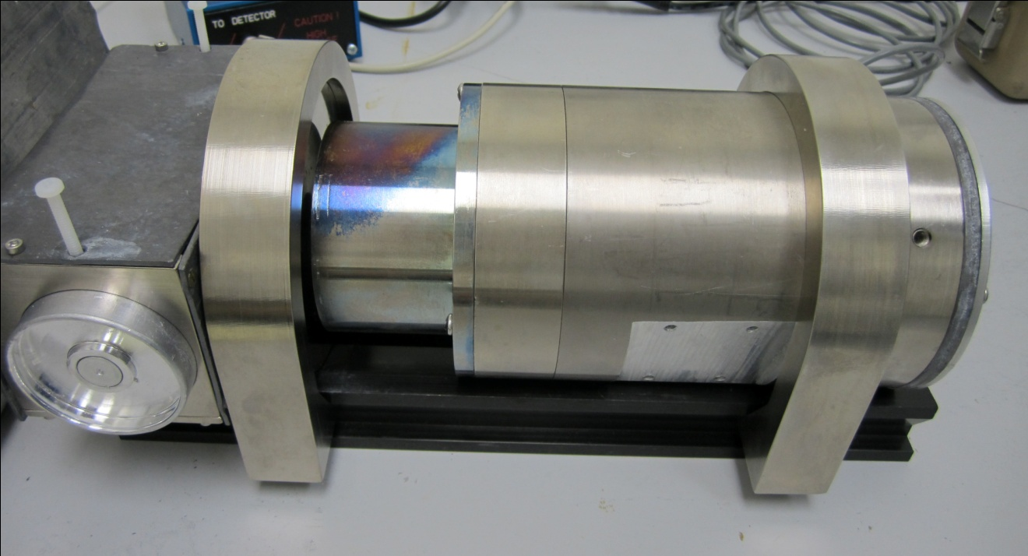

Figure 48 Mössbauer Apparatus
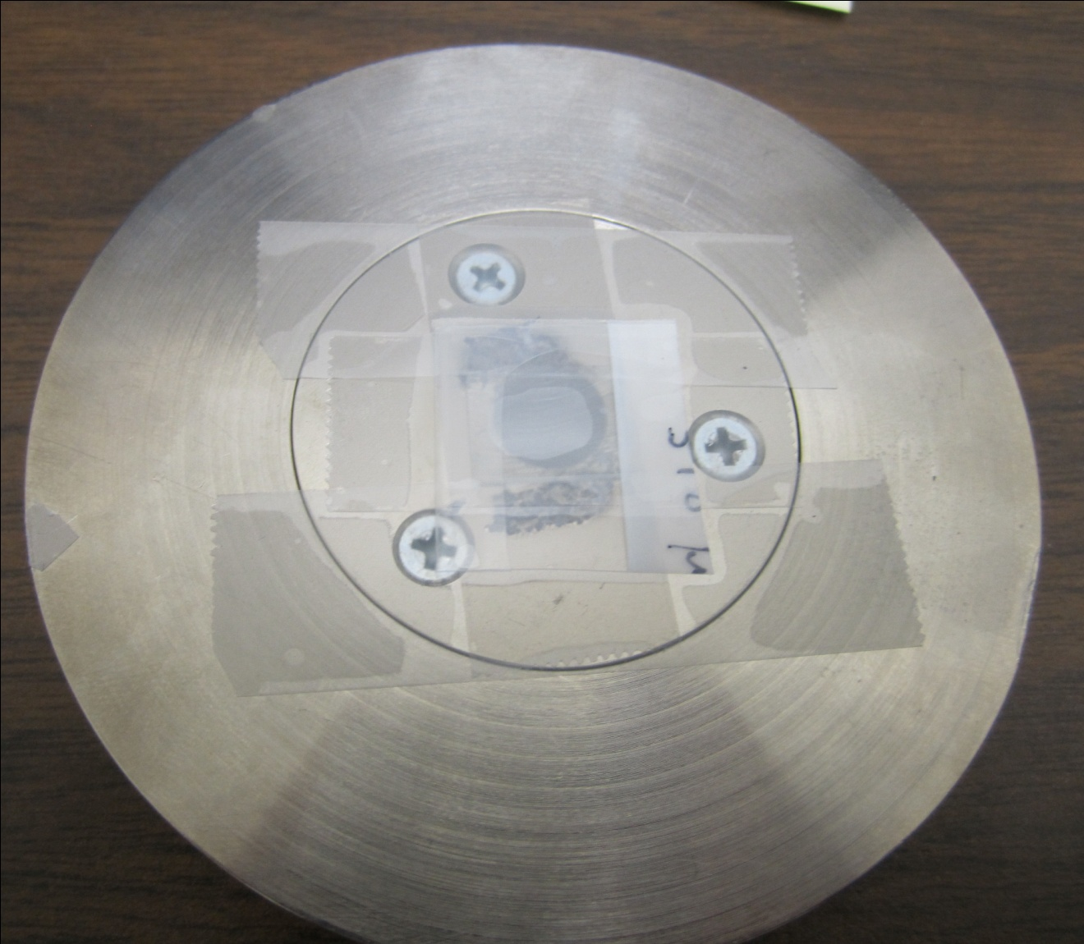

Figure 49 Mössbauer sample holder

LIST OF REFERENCES

1. Schweizer, S. and J.A. Johnson, Fluorozirconate-based glass ceramic X-ray detectors for digital radiography. Radiation Measurements, 2007. 42(4-5): p. 632-637.
2. Chen, G., et al., Insights into phase formation in fluorochlorozirconate glass-ceramic storage phosphors. Applied Physics Letters, 2006. 88(19).
3. Schweizer, S., et al., New developments in X-ray storage phosphors. Radiation Measurements, 2004. 38(4-6): p. 633-638.
4. Schweizer, S. 2006 [cited 2011 Jan-20]; Available from: http://fb6www.uni-paderborn.de/ag/ag-schweizer/research/x-ray_storage_phosphors.html.
5. Schweizer, S. 2011; Available from: http://fb6www.uni-paderborn.de/ag/ag-schweizer/research.html.
6. Schweizer, S., et al., Multi-functionality of fluorescent nanocrystals in glass ceramics. Radiation Measurements, 2010. 45(3-6): p. 485-489.
7. J.A. Johnson, M.V., J.K.R. Weber, 2011.
8. Group, N. The cost-effective starter instrument for quality assurance. [cited 2011 Jan-21]; Available from: http://www.netzsch-thermal-analysis.com/en/products/detail/pid,1.html.
9. Twisp. SIMS instrument scheme. 2006 [cited 2011 Jan-21]; Available from: http://en.wikipedia.org/wiki/File:SIMS_instrument_scheme_600x600.png.
10. Johnson, J.A., et al., Eu-activated fluorochlorozirconate glass-ceramic scintillators. Journal of Applied Physics, 2006. 100(3).
11. Abollino, O., et al., Determination of zirconium, barium, lanthanum, aluminium, sodium, hafnium and fluorine in fluorozirconate glasses - Development of different dissolution procedures and analytical techniques. Fresenius Journal of Analytical Chemistry, 1992. 343(6): p. 482-487.
12. Harrington, J.A. Infrared Fiber Optics. [cited 2011 Mar 8]; Available from: http://irfibers.rutgers.edu/pdf_files/ir_fiber_review.pdf.
13. SPI. [cited 2011 Jan 24]; Available from: http://www.2spi.com/catalog/instruments/dimpler.shtml.
14. Mossbauer spectroscopy, ed. D.P.E. Dickson and F.J. Berry1986, Cambridge ; New York: Cambridge ; New York : Cambridge University Press.
15. Kauzmann, W., THE NATURE OF THE GLASSY STATE AND THE BEHAVIOR OF LIQUIDS AT LOW TEMPERATURES. Chemical Reviews, 1948. 43(2): p. 219-256.
16. Schweizer, S., et al., Photostimulated luminescence from fluorochlorozirconate glass ceramics and the effect of crystallite size. Journal of Applied Physics, 2005. 97(8).
17. Paßlick, C., et al., Crystallization behavior of rare-earth doped fluorochlorozirconate glasses. Journal of Non-Crystalline Solids. In Press, Corrected Proof.
18. Paßlick, C., et al., Differential scanning calorimetry investigations on Eu-doped fluorozirconate-based glass ceramics. Journal of Non-Crystalline Solids, 2010. 356(52-54): p. 3085-3089.
19. Ji, L., et al., Combined electron and focused ion beam system for improvement of secondary ion yield in secondary ion mass spectrometry instrument. Applied Physics Letters, 2006. 89(16).
20. Ji, Q., et al., Combined electron- and ion-beam imprinter and its applications. Applied Physics Letters, 2004. 85(20): p. 4618-4620.
21. Kobayasi, T., et al., FLUORESCENCE LIFETIME AND QUANTUM EFFICIENCY FOR 5D- 4F TRANSITIONS IN EU2+ DOPED CHLORIDE AND FLUORIDE-CRYSTALS. Journal of Luminescence, 1980. 21(3): p. 247-257.
22. Edgar, A., et al., Structural phase changes in barium bromide nano-crystals in a fluorobromozirconate glass-ceramic x-ray storage phosphor. Journal of Physics-Condensed Matter, 2001. 13(28): p. 6259-6269.
23. Secu, M., et al., Photostimulated luminescence from a fluorobromozirconate glass-ceramic and the effect of crystallite size and phase. Journal of Physics-Condensed Matter, 2003. 15(7): p. 1097-1108.
24. Ball, J., et al., A MOSSBAUER-SPECTROSCOPY STUDY OF AN ANHYDROUS NON-STOICHIOMETRIC EUROPIUM(III) CHLORIDE PHASE. Journal of the Less-Common Metals, 1983. 95(1): p. 161-170.
25. MacFarlane, D.R., et al., In situ generation of Eu2+ in glass-forming melts. Journal of Non-Crystalline Solids, 1999. 257: p. 53-58.
26. Coey, J.M.D., A. McEvoy, and M.W. Shafer, MOSSBAUER STUDY OF EUROPIUM IN FLUOROZIRCONATE GLASS. Journal of Non-Crystalline Solids, 1981. 43(3): p. 387-392.
27. Grandjean, G.J.L.a.F., Mossbauer spectroscopy applied to inorganic chemistry, in Modern Inorganic chemistry. p. 513-590.

VITA

Manh Vu was born in Hanoi, Vietnam on April 24, 1985. He graduated from Hanoi-Amsterdam High School, one of the most prestigious schools in the nation, specializing in Physics. He then continued his study in United States and received his Bachelor of Science Degree in Physics and Mathematics from Coe College in 2009. In fall 2009, he joined the University of Tennessee at Space Institute to pursue his Master of Science Degree in Materials Science. He worked closely as a graduate assistant of Doctor Jacqueline Anne Johnson.

