Power Outage Vulnerability During Winter Storms: A Comprehensive Assessment of Infrastructure, Society and Storm Dynamics

A Dissertation Presented for the

Doctor of Philosophy

Degree

The University of Tennessee, Knoxville

Alexandra Claire Kahl

May 2025

Copyright © 2025 by Alexandra C. Kahl
All rights reserved.

DEDICATION

I dedicate this dissertation to my parents, Jeffrey Kahl and Kathi Kahl.

ACKNOWLEDGEMENTS

I would like to express my sincere gratitude to my advisors Dr. Liem Tran and Dr. Budhendra Bhaduri, for their support and guidance throughout my time as a PhD student. Their mentorship and supervision have pushed me to be a better researcher. I am continuously inspired by Dr. Tran’s work ethic and his passion in mentoring students. I am also grateful for Dr. Bhaduri’s sage career advice.
I would like to thank my committee members Dr. Melissa Dumas and Dr. Nikki Luke for their support throughout my PhD. Dr. Dumas mentored me for an undergraduate internship during my time at Virginia Tech. Her initial support and belief in me gave me the confidence to pursue my PhD. Dr. Luke provided much needed guidance regarding the socioeconomic aspects of this research.
I have so much gratitude to my friends who have encouraged me throughout this process. The Graduate Society of Women Engineers provided me with lasting friendships and a support system to weather the challenges of graduate school. I am particularly grateful to my friend and mentor, Marc Fialkoff. Marc has encouraged me and helped me find my identity as a researcher.

ABSTRACT

Severe winter storms are impacting areas of the Southern United States where populations and infrastructure are not equipped to withstand low temperatures, high winds, snow and ice precipitation. Failure of electric infrastructure during winter storms creates long term outage events. In this dissertation we examine power outage vulnerability during severe winter storms, focusing on three key aspects: infrastructure contribution to outage susceptibility, socioeconomic characteristics of at-risk populations and storm characteristics for outage prediction.
Nighttime lights images can be used to detect power outages at fine spatial scales. We utilized nighttime lights data during Winter Storm Uri to identify census block level power outages throughout Houston, TX. Our census block power outages and infrastructure characteristics were used as inputs into a machine learning model, to assess the impact of infrastructure on outage susceptibility. This approach produced a census block level outage likelihood dataset for Houston, TX, which can inform grid hardening and outage preparedness measures.
In our next study, we connected our outage likelihood dataset with socio-economic characteristics to identify common characteristics of individuals in outage prone areas. We developed an individually oriented synthetic population of Houston, TX and clustered it with outage likelihood through self-organizing maps. Our results highlight the intersectionality of power outage vulnerability, which we used to inform targeted policy and planning recommendations.
Our final study addresses the critical need for improved outage prediction during severe winter storms. Current storm summaries and near real-time radar data lack explicit links between storm characteristics and power outages. We developed radar-based storm characteristics, based on landscape ecology principles, to quantify spatial and temporal changes within winter storm dynamics. We found a meaningful connection between our radar-based storm characteristics and found that storm characteristics were successful in outage prediction. These findings enhance existing outage platforms by adding predictive capabilities to support proactive planning and situational awareness for federal emergency agencies.
By assessing extreme events through infrastructure vulnerability, social vulnerability and storm characterization we are able to provide a wholistic view of outage vulnerability. Our results will inform planning and policy recommendations that will improve disaster response and preparedness.

TABLE OF CONTENTS
Chapter 1 Introduction 1
1.1 Problem Statement 1
1.2 Research Questions 5
1.3 Organization 6
1.4 Theoretical Underpinnings of this Research: Disaster Resilience 6
1.4.1 Initial Roots of Disaster Resilience 6
1.4.2 Defining Disaster Resilience 7
1.4.3 R4 Framework 9
1.4.4 TOSE Framework 11
1.4.5 Disaster Resilience of Place Model 12
1.4.6 Comparison of Disaster Resilience Frameworks and Connections to this Dissertation 14
1.5 Background 17
1.5.1 Extreme Winter Weather 17
1.5.2 Power Outage Vulnerability and Outage Likelihood 18
1.5.3 Impact of Physical Characteristics on Power Outage Vulnerability 19
1.5.4 Impact of Socioeconomic Characteristics on Power Outage Vulnerability 21
1.5.5 Self Organizing Maps to Identify Vulnerable Populations 25
1.5.6 Spatial Microsimulation Modeling to Identify Individual Level Characteristics 28
1.5.7 Radar Data for Extreme Winter Weather 32
1.5.8 Applying Landscape Ecology to Radar Data 35
1.5.9 Power Outage Assessment 40
1.5.10 MaxEnt for Outage Likelihood 44
1.5.11 Negative Binomial Regression to Connect Outages and Winter Storms 47
1.6 Connecting Research Questions and Methods 49
1.7 Study Area: Houston and Winter Storm Uri 49
References 52
Chapter 2 Addressing Power Outage Susceptibility with MaxEnt Model 78
Abstract 79
2.1 Introduction 80
2.2 Methods 82
2.2.1 Overview 82
2.2.2 Nighttime Lights Data 83
2.2.3 Direct vs. Proxy Variables 83
2.2.4 Selected Variables 85
2.2.5 Processing Nighttime Lights 86
2.2.6 Identifying Primarily Outage Census Blocks 88
2.2.7 Processing Variables for MaxEnt 88
2.2.8 MaxEnt Mathematical Background 89
2.2.9 Adapting MaxEnt from Species Distribution to Outage Distribution 89
2.2.10 Training and Testing Process 90
2.2.11 Parameter Selection 91
2.2.12 Validating with County Level Data 92
2.3 Results and Discussion 93
2.3.1 MaxEnt Model Performance 93
2.3.2 Spatial Distribution of Outage Likelihood 95
2.3.4 Variable Contribution to Outage Likelihood 96
2.3.5 Comparison with County Level Outages 102
2.3.6 Summary 103
2.4 Conclusion 104
References 106
APPENDIX A: Response Curves for Remaining Variables 111
Chapter 3 Assessing individual level power outage vulnerability through synthetic populations 117
Abstract 118
3.1 Introduction 120
3.2 Methods 123
3.2.1 Overview 123
3.2.2 Outage Likelihood Dataset 123
3.2.3 Synthetic Population Development 123
3.2.4 Variable Selection 125
3.2.5 Assigning Individual Vulnerability Profiles 126
3.2.6 Generating a Neighborhood Typology of Social Vulnerability 130
3.2.7 Interpreting Final UrbanPop Clusters 132
3.2.8 Utilizing Self Organizing Maps to Cluster Population Characteristics and Outage Likelihood 134
3.3 Results and Discussion 134
3.3.1 Comprehensive Vulnerability throughout Houston 134
3.3.2 Summary of Self Organizing Maps Results 140
3.3.3 Potential Planning and Policy Interventions Informed by SOM Results 141
3.3.4 Tailor Emergency Communication 143
3.3.5 Establish Community Hubs for Resource Distribution and Shelter 146
3.3.6 Seek Out Proactive Community Engagement 149
3.3.7 Summary of Policy and Planning Recommendations 152
3.4 Conclusion 153
REFERENCES 155
Chapter 4 Connecting Winter Storm Dynamics with Power Outages through radar based stormscape metrics approach 166
Abstract 167
4.1 Introduction 169
4.2 Methods 172
4.2.1 Data 172
4.2.2 Storm Identification Process 172
4.2.3 Utilizing Landscape Ecology to Analyze Winter Storm Uri 174
4.2.4 Calculating Stormscape Metrics 176
4.2.5 Selecting Stormscape Metrics for Our Final Model 177
4.2.6 Connecting Stormscape Metrics and Outages 179
4.2.7 Producing Power Outage Estimates 183
4.3 Results and Discussion 183
4.3.1 Assessing the Correlation Between Stormscape Metrics and Outages 184
4.3.2 Impact of Spatial Autocorrelation 189
4.3.3 Limitations of Applying Stormscape Metrics Exclusively to Winter Storm Uri 191
4.3.4 An Example of Integrating Stormscape Metrics into an Existing Outage Awareness Platform 192
4.4 Conclusion 196
References 199
APPENDIX A: Descriptions of Landscape Metrics 206
Chapter 5 CONCLUSION 209
5.1 Summary and Value of Research 209
5.1.1 Question 1: How do infrastructure conditions contribute to outage susceptibility by using machine learning techniques to identify vulnerabilities in the electricity network? 210
5.1.2 Question 2: What common socioeconomic characteristics are associated with outage prone areas? 211
5.1.3 Question 3: How can integrating radar-based storm characteristics with outage patterns enhance real time and short-term power outage prediction? 211
5.2 Contextualizing Research within Disaster Resilience 212
5.4 Limitations within this Dissertation 215
5.5 Future Research Directions 217
5.5.1 Study Area Expansion 217
5.5.2 Incorporating Rural Areas 218
5.5.3 Accounting for Outage Restoration Time 218
5.5.4 Expanding Stormscape Metrics Beyond Winter Storms 219
VITA 220

LIST OF TABLES

Table 1.1 Comparison of R4, TOSE and DROP frameworks. 15
Table 2.1 Detailed information on each dataset used for the infrastructure variables in the MaxEnt model, including source, data type and spatial scale. 87
Table 2.2 AUC for each training and testing runs. Both the training and testing runs achieved AUC values close to or above 0.7. This indicates good model performance. 95
Table 3.1 Variables collected from PUMs 127
Table 4.1 Reflectivity values and associated precipitation (NOAA, 2023). 176
Table 4.2 Final metrics that connect conceptually with Winter Storm Uri and pass p-value and VIF thresholds. 180
Table 4.3 Quantitative impacts and connections between individual metrics and outages at the whole storm (W) and county level (C). 185

LIST OF FIGURES
Figure 1.1 The resilience triangle, plotting infrastructure quality and time to recover (Carlson, 2012). 9
Figure 1.2 Workflow connecting each research question to supporting methods. 50
Figure 2.1 Workflow illustrating the steps to process nighttime lights satellite imagery and infrastructure data to model power outage likelihood using MaxEnt. Steps include data collection, pre-processing, and MaxEnt model implementation. 84
Figure 2.2 MaxEnt terminology and equivalent terms used in this study, providing an analogy between species distribution modeling and power outage modeling using MaxEnt. 90
Figure 2.3 MaxEnt AUC results of 0.758. An AUC above 0.7 highlights good model performance and variable prediction. 94
Figure 2.4 Outage likelihood across Houston, highlighting areas with extreme risk in the city center and lower risk in suburban areas. 97
Figure 2.5 Jackknife test for evaluating the relative importance of infrastructure variables on outages. 98
Figure 2.6 Distribution line density response curves highlighting outage likelihood. A) Density with average of other variables. B) Density with correlations of other variables 100
Figure 2.7 Relationship between tree coverage and outage likelihood. Outage likelihood decreases as tree coverage increases. 100
Figure 2.8 As the proximity to schools increases, outage likelihood decreases. A) Outage likelihood plateaus from 0-0.5 miles then decreases as distance to schools increases. B) Outage likelihood initially increases from 0-0.5 miles from schools then sharply declines and plateaus at the 3-mile threshold. 102
Figure 2.9 Outage likelihood decreases as distance to hospital increases. A) Outage likelihood increases and then decreases steadily. B) Outage likelihood increases from 0-2 miles then sharply declines. 103
Figure 2.10 Impact of substation proximity on outage likelihood. A) Outage likelihood increases in census blocks further from substations. B) Outage likelihood decreases in census blocks further from substations. 112
Figure 2.11 Response curves for nursing home proximity show opposite trends. A) Outage likelihood decreases from 0-1.5 miles. Then increases sharply as the distance to the nearest nursing home increases to 5 miles. B) Outage likelihood decreases as distance to the nearest nursing home increases. 112
Figure 2.12 Response curves for power station proximity show differing trends. A) Outage likelihood decreases continually as distance to the nearest power station increases. B) Outage likelihood hovers near 0.6 from 0-5 miles from the nearest power station, then sharply decreases. 113
Figure 2.13 Relationship between police station proximity and outage likelihood. A) Outage likelihood increases when the distance to the nearest police station is from 1-5 miles. Then decreases as distance increases up to 8 miles. B) Outage likelihood hovers near 0.63 miles from the police station, then continually decreases. 115
Figure 2.14 Differing trends between the two response curves indicate variable dependence in fire station proximity. 115
Figure 2.15 Both response curves show a similar relationship between generator proximity and outage likelihood. 116
Figure 3.1 Overarching process for creating a synthetic population. We query the data, assign individual profiles based on demographics and create clusters of similar individuals. 125
Figure 3.2 Multiple correspondence analysis shows how two different individuals will score amongst many variables. 129
Figure 3.3 Neighborhood typology of social vulnerability for Harris County, TX, defined by five distinct individual vulnerability profiles. 133
Figure 3.4 Qualitative descriptions of the neighborhood typology labels. 135
Figure 3.5 Clusters throughout Houston. Background colors are used to distinguish clusters. Each cluster contains pie charts indicating the strength of each variable within the cluster. 136
Figure 3.6 Social vulnerability typologies in Harris County, TX, categorized into five distinct profiles. These classifications highlight disparities in outage resilience and response capacity. 137
Figure 4.1 Example near real time radar image. 173
Figure 4.2 Workflow for tracking Winter Storm Uri across the U.S. 175
Figure 4.3 Comparison of negative binomial and spatial lag power outage estimates. 190
Figure 4.4 Outage estimates for all Texas counties. Most counties are experiencing medium outage risk with 40-60% of customers under an outage. 194
Figure 4.5 Current EAGLE-I interface displaying radar data and counties under various weather watches/warnings. 195
Figure 4.6 Outage predictions integrated within the EAGLE-I interface. Users can view the estimated maximum outage for their county with respect to radar data and winter weather warnings/watches. 197

Introduction

1.1 Problem Statement
This dissertation explores the drivers and social impacts of electric grid power outages during winter storms. Extreme winter weather brings low temperatures, high winds, snow and ice, which can damage electricity generation and transmission infrastructure leading to widespread and long-term outages (Campbell, 2012; Lin et al., 2021). As climate change progresses and affects precipitation patterns, winter storm occurrence and severity are expected to increase, leading to greater power outages (Klinger et al., 2014). This dissertation examines power outage vulnerability during severe winter storms by focusing on three key aspects: (1) assessing how infrastructure conditions contribute to outage susceptibility, (2) identifying which communities are most at risk based on their exposure to power outage vulnerability, and (3) improving real-time and short-term predictions by enhancing the connection between storm dynamics and power outages to strengthen response efforts. By addressing these interrelated issues, this research aims to provide a more holistic understanding of outage risk and response strategies during winter storms.
Damages from extreme winter weather cost the United States (U.S.) an average of $313 million annually, not accounting for social impacts, including hospitalizations and displacement (Zaryckik, 2018). Beyond financial consequences, the energy infrastructure vulnerability translates directly into tangible threats to public health and safety. Extreme winter weather and associated power outages poses a risk to health and safety, particularly for children, the elderly and low-income populations (Lin et al., 2021; Zanocco et al., 2022).
Electricity outages, caused by extreme weather infrastructure vulnerabilities, have significant social implications. Electricity outages do not impact all populations equally, and pose disproportionate risks to the extremely young, elderly or low-income populations (Benevolenza, 2019). During power outages U.S. households cannot access safe indoor temperatures, store food and medication, or power medical devices (Carley et al., 2024; Castellanos et al., 2023). Low-income households have less resources to respond during a power outage (Dugan et al., 2023). They are less able to relocate or purchase emergency supplies, and face increased financial burdens from food spoilage (Dugan et al., 2023). Power outages have been linked to an increase in emergency department visits particularly for the elderly and children (Cruz-Cana and Mead, 2019). Elderly and chronically ill populations face increased risks from failed medical equipment and may miss crucial care if health facilities do not have electricity to provide treatments (Casey et al., 2020; Molinari, 2017). Children are particularly susceptible to carbon monoxide poisoning from improper generator use during outages (Casey et al., 2020; Cruz-Cana and Mead, 2019; Molinari, 2017). Understanding not only where power outages occur, but the socio-economic implications are key to ensure timely outage restoration and ensure disaster response resources are fully accessible. Utilities often prioritize outage response based on number of outages or population (Coleman et al., 2023), which does not account for the ability of individual communities to withstand outages. As winter storms continue to impact the energy sector, without advances in outage preparedness and disaster response, we will continue to see health and safety impacts, as well as costly infrastructure damage.
Fine-scale power outage data (i.e., at the census tract or block level) is not widely available, which creates challenges for effective emergency response. Previous studies predict outages from extreme weather events; however, they do not address how likely or why outages occur at the census tract or census block level (Levin et al., 2020; Xu et al., 2023). This lack of detailed spatial data hinders utilities and emergency responders from proactively allocating resources and planning effectively. This creates challenges in supporting long term outage management. More work must be done to understand and predict the spatial distribution of power outages. Utilities and emergency responders need accurate pre-event information regarding where outages are likely to occur for efficient response (Lee et al., 2023). Proactive emergency planning is also hindered by little understanding of what incoming winter weather means for outage risk.
Previous extreme weather literature focuses largely on improved understanding and prediction of hurricanes, tornadoes and flooding, as well as the social and infrastructure impacts of these threats. Many studies have connected wind, temperature and precipitation of hurricanes with outages (Tonn et al., 2016). Winter storms come with a specific set of challenges. Low temperatures, snow and ice accretion associated with winter storms can damage infrastructure from the generation to the distribution point, which causes cascading failures throughout the electric grid (Coleman et al., 2023; Lacroix and Manwell, 2000; Tomaszewski et al., 2019). Current winter storms research focuses on storm identification and very short-term weather forecasting (up to 2 hours in advance) using near real time radar data, which is not easily connected with outages. (Munoz et al., 2018). This creates challenges for emergency responders to predict outage risk from incoming winter storms, thus hindering proactive emergency planning (Lee et al., 2023).
This dissertation contributes to disaster resilience and power outage vulnerability literature by addressing winter storm characteristics, infrastructure characteristics and socioeconomic characteristics. First, previous research has connected power outages with meteorological variables (Campbell, 2012; Dumas et al., 2022; Tonn et al., 2016; Watson et al., 2022). However, the connection between winter storm characteristics and power outages could be improved. By establishing a connection between storm characteristics and power outages, we can enhance preparedness strategies and response mechanisms for winter storm-related outages. Secondly, fine spatial outage datasets are available at the census tract or census block level. These datasets are commonly overlaid with socioeconomic variables, highlighting what types of people are impacted (Xu et al., 2023). Additional research is needed to connect outages with contributing factors that make some areas more susceptible to outages. This knowledge gap impedes targeted mitigation efforts and equitable resource allocation during restoration processes. Lastly, Current datasets link socioeconomic characteristics to outages by overlaying them (Hsu et al.,2023). Many of these socioeconomic datasets represent aggregate variables, which do not account for how individuals or households respond to outages (Hsu et al., 2023). More research must be done to connect individual socioeconomic characteristics with outages to identify common characteristics of communities in outage prone areas.
Addressing the three knowledge gaps identified is crucial for enhancing disaster preparedness and ensuring equitable disaster response in the context of extreme winter weather impacts on the electric grid. These challenges are interconnected and have significant implications for power outage prediction, planning, and restoration. By improving our understanding of winter storm impacts, refining spatial outage data, and incorporating socioeconomic factors into outage prediction models, we can enhance the resilience of the electric grid and ensure more equitable outcomes during extreme weather events. This comprehensive approach will enable utilities and emergency responders to better allocate resources, prioritize restoration efforts, and mitigate the disproportionate impacts on vulnerable communities.

1.2 Research Questions
This dissertation examines power outage vulnerability during severe winter storms by addressing three interconnected aspects. We identify the following research questions
- How do infrastructure conditions contribute to outage susceptibility by using machine learning techniques to identify vulnerabilities in the electricity network?
- What common socioeconomic characteristics are associated with outage prone areas?
- How can integrating radar-based storm characteristics with outage patterns enhance real time and short-term power outage prediction?
By linking these elements, this research provides a comprehensive approach to understanding outage risk and strengthening response strategies during winter storms.

1.3 Organization
The following section presents a literature review on disaster resilience theories and frameworks. We also include a background section reviewing power outage vulnerability and the technical methods relevant to this dissertation, including power outage assessment, landscape ecology, MaxEnt and regression methods. Chapters 2-4 represent individual research work that supports each research question. Chapter 5 argues the novel contributions and advancements made through this dissertation.

1.4 Theoretical Underpinnings of this Research: Disaster Resilience

1.4.1 Initial Roots of Disaster Resilience
Resilience, a concept introduced in 1973 to describe ecological systems' ability to absorb changes while persisting, has since evolved to encompass the capacities of individuals, communities, and infrastructure across various fields (Holling 1973). Resilience became popular within hazard mitigation literature when Mileti, 1999, suggested that building disaster resilient communities could be a new approach to coping with natural disasters (Burby, 1998; Godschalk, 2003). Disaster resilience became integrated in disaster management and planning in the early 2000s (Burby et al., 2000). In 2001 the United Nations Commission on Sustainable Development emphasized disaster risk reduction policies that enable communities to become more disaster resilient (Mayunga, 2009). Resilience became even more integrated in hazards and disasters when the International Federation of Red Cross and Red Crescent Societies' 2004 World Disaster Report dedicated its focus specifically to the topic of building resilient communities (Mayunga, 2009).
In the realm of disaster research, particularly following Hurricane Katrina in 2005, resilience has gained prominence as a means of enhancing physical and human systems' capacity to respond to and recover from extreme events (Linnenluecke and Griffiths, 2010; Norris et al., 2008; Tiernan et al., 2019). This concept encompasses both inherent strength (the ability to function during non-crisis times) and adaptive resilience (flexibility and strength during and after a disaster) (Tsao and Ni, 2015). Throughout this discussion, we will focus on different definitions for disaster resilience and key conceptual frameworks.

1.4.2 Defining Disaster Resilience
One of the first definitions of disaster resilience in the natural hazards domain defined resilience as the measure of a systems or sub-system’s capacity to absorb and recover from hazardous events (Timmerman, 1981). Subsequent definitions of resilience vary depending on the system being described and whether the focus is on pre or post event.
Resilience definitions focusing on the period after the event emphasize the ability to adapt and absorb changes, while still maintaining its function (Tiernan et al., 2019). Norris et al., 2008, provides a good definition of resilience after the fact, “We define resilience as: a process linking a set of adaptive capacities to a positive trajectory of functioning and adaptation after a disturbance…. resilience emerges from a set of adaptive capacities”. Conversely, definitions focusing on time periods before and after the event emphasize both preparedness and response strategies, as well as recovering in the shortest feasible amount of time. Resilience of infrastructure systems is important to ensure consistent access to electricity, water, transportation and communication.
Resilience definitions related to infrastructure systems focus on the ability of the system to persist during external stressors (Tiernan et al., 2019). Resilient systems can remain stable in the face of external stressors, recover from a major disruption and adapt to new circumstances (Holling, 2001; Thompson et al., 2009; Tiernan et al., 2019). Definitions of infrastructure resilience emphasize minimizing the magnitude, impact and duration of disruptions to infrastructure systems. Critical infrastructure resilience feeds into a community’s ability to recover from a disruptive event. Definitions of community resilience emphasize the ability of a community to return to absorb a disturbance while maintaining essential functions and to quickly return to a normal state (Norris et al., 2008).
The field of natural hazards has many diverse definitions of disaster resilience. Early definitions focus primarily on built system resilience, while definitions post 2000 emphasize the role of the community (Timmerman, 1981; Wildavsky, 1991; Maguire and Hagan, 2007). Despite these differences, several key themes are present throughout disaster resilience definitions. First, the ability to adapt to changing conditions and evolving threats is a central concept, often referred to as adaptive capacity (Boston College, 2024; Department for International Development, 2011). Secondly, definitions frequently highlight the capacity to absorb, withstand, and recover from shocks or disturbances in a timely and efficient manner. Many definitions stress the importance of maintaining essential functions and structures during and after a disaster (Department for International Development, 2011; National Research Council, 2011). The concept of transformation is also prevalent, suggesting that resilient systems can not only recover but potentially improve in response to disasters (Boin and McConnell, 2007). Preparedness and anticipation of potential hazards are often mentioned as crucial components (Tiernan et al., 2019). Definitions typically apply resilience across multiple levels, from individuals to entire societies. Many definitions view resilience as a dynamic process rather than a fixed outcome, emphasizing continuous learning and improvement. Finally, the integration of social, economic, and environmental factors in building resilience is commonly recognized, reflecting a holistic approach to disaster management (Bruneau et al., 2003).
For the purposes of this dissertation, we adopt the following definition of disaster resilience, “the ability of an entity — asset, organization, community, region — to anticipate, resist, absorb, respond to, adapt to, and recover from a disturbance” (Carlson et al., 2012). This allows us to evaluate the resilience of critical infrastructure systems and communities and analyze time periods before, during and after adverse events. Next, we discuss common theories and frameworks for measuring and evaluating disaster resilience.

1.4.3 R4 Framework

Critical infrastructure systems, including water, communication, transportation and electricity, plan an integral role in disaster response and recovery, and are at the heart of disaster resilience. Consequences of failure of critical infrastructure systems include physical damage, negative economic impacts, deaths and injuries (Tierney and Bruneau, 2007). Previous research argues that resilience can be measured by the functionality of an infrastructure system after a disaster and by how long it takes for the system to return to pre disaster levels of performance (Tierney and Bruneau, 2007). The resilience triangle and the R4 framework are popular avenues to evaluate disaster resilience. The resilience triangle plots resilience as a function of infrastructure quality and time to recovery (Tierney and Bruneau, 2007; Carlson et al., 2012). A smaller triangle indicates higher resilience (Tierney and Bruneau, 2007). A benefit of the resilience triangle is that it accounts for all stages of disaster resilience (Figure 1.1). It accounts for the period before the disaster where a system or community can test its preparedness measures and mitigate consequences and during the event when systems or communities can respond and adapt. The resilience triangle provides a visualization for how long it takes the system or community to recover and return to a normal state. Resilience can be divided into 4 key components: 1) Robustness, 2) Redundancy, 3) Resourcefulness, 4) Rapidity (Tierney and Bruneau, 2007). Robustness represents the ability of critical infrastructure systems to withstand shocks without significant loss of performance (Bruneau et al., 2003; Carlson et al., 2012; 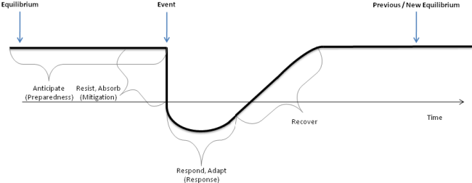Figure 1.1 The resilience triangle, plotting infrastructure quality and time to recover (Carlson, 2012).
Guiliani et al., 2016). Redundancy addresses the extent to which elements are substitutable within a system. Backup energy generation is an example (Tierney and Bruneau, 2007; Nowell et al., 2016; La Porte & Consolini, 1991). Robustness and redundancy focus on the technical elements of critical infrastructure systems. While resourcefulness and rapidity incorporate elements of the wider community. Resourcefulness measures the ability to diagnose and prioritize problems and initiate solutions (Tierney and Bruneau, 2007; Zona et al., 2020). This can include mobilizing materials, finances and spreading information. Resourcefulness can be impacted by socioeconomic factors of the surrounding community, as financial capacity, education, social networks and government support can impact how well a community can mobilize resources. Lastly, rapidity addresses the ability to restore functionality in a timely way (Tierney and Bruneau, 2007; Zona et al., 2020). Quantifying how quickly a community can fix damaged critical infrastructure systems (Tierney and Bruneau, 2007).

1.4.4 TOSE Framework
Developed alongside the R4 framework is the TOSE Framework. Previous literature has identified four dimensions of resilience; 1) technical, 2) organizational, 3) social, and 4) economic (Tang et al., 2022; Bruneau et al., 2003; Tierney and Bruneau, 2007; Tierney, 2008). The technical dimension refers to the physical properties of infrastructure systems and their ability to resist damage and loss of function (Bruneau et al., 2003). Examples of the technical dimension include electric, water, transportation and communication infrastructure (Bruneau et al., 2003). The organization dimension refers to the capacity of emergency management organizations to protect critical facilities and carry out disaster related functions (Bruneau et al., 2003; Tang et al., 2022). The organizational dimension is exemplified throughout emergency response plans, leadership structures and decision making processes (Bruneau et al., 2003). The social dimension evaluates a community’s ability to reduce social impacts following the loss of key services (Bruneau et al., 2003; Tang et al., 2022). Social indicators commonly include poverty, education level and linguistic isolation (Tierney and Bruneau, 2007). The economic piece accounts for the strength of local economies and the ability to reduce economic losses following a disaster (Bruneau et al., 2023; Tang et al., 2022). Both the social and economic pieces address the ability of a community to identify and access options for coping with a disaster (Tierney and Bruneau, 2007).
The TOSE and R4 Frameworks are often utilized together to provide a comprehensive approach to assessing disaster resilience (Tierney and Bruneau, 2007). This approach enables a more systematic and quantitative understanding of resilience, moving beyond qualitative conceptualizations. It provides a tool for researchers and policymakers to establish needs, set priorities, and make informed decisions to enhance community resilience to seismic events.

1.4.5 Disaster Resilience of Place Model
The Disaster Resilience of Place (DROP) model incorporates social systems, the built environment and natural systems as attributes that influence and interact with community resilience (Cutter et al., 2008; Tiernan et al., 2018; Mavhura et al., 2021; Siebeneck et al., 2015). Social systems include the population's demographic characteristics (age, race, income, education), social networks, governance structures, and community organizations (Mavhura et al., 2021; Siebeneck et al., 2015). These factors influence a community's ability to prepare for, respond to, and recover from disasters. Built systems refer to the infrastructure (transportation, communication, water, energy), housing stock, and land use patterns of the community (Cutter et al., 2008; Siebeneck et al., 2015). The quality and robustness of the built environment directly affect the community's ability to withstand and recover from disasters (Cutter et al., 2008). Lastly, natural systems encompass the natural hazards that the place is exposed to (e.g., floods, earthquakes, hurricanes) (Cutter et al., 2008; Siebeneck et al., 2015). The DROP model specifically incorporated the natural environment, because it was developed to focus exclusively on natural hazards (Cutter et al., 2008). Including the social, natural and built environment allows for the incorporation of institutional, infrastructure and ecological components as aspects of resilience (Adger, 2006; Bruneau et al., 2003; Tiernan et al., 2018)
The DROP model starts with inherent vulnerability and resilience associated with the characteristics of existing built, social and natural systems of a place (Cutter et al., 2008; Cutter et al., 2010; Mavhura et al., 2021). These inherent characteristics impact the frequency, duration, intensity and magnitude of the hazard event (Cutter et al., 2010). Inherent conditions also impact how well each system can absorb impacts and cope with the hazard event (Cutter et al., 2008; Mavhura et al., 2021). Coping responses allow a community to respond to immediate event impacts, including emergency response plans, evacuation plans and information dissemination (Cutter et al., 2008). Once coping responses are exhausted the remaining impacts are felt and the systems can either absorb or adapt to remaining impacts (Cutter et al., 2008).
The DROP model presents resilience as a dynamic process that depends on pre-event conditions, disaster severity, time between hazard events and external factors (Cutter et al., 2008; Cutter et al., 2010). In summary, the DROP model provides a conceptual framework for understanding and measuring disaster resilience at the local level by considering the interactions between social, built, and natural systems, and how they contribute to a community's ability to withstand and recover from disasters (Tiernan et al., 2018; Cutter, 2008; Cutter et al., 2010).

1.4.6 Comparison of Disaster Resilience Frameworks and Connections to this Dissertation

The R4, TOSE and Disaster Resilience of Place (DROP) frameworks each provide their own conceptualization of disaster resilience (Table 1.1). The R4 framework emphasizes critical infrastructure resilience and its ability to withstand and recover quickly from natural hazards. A major advantage of the R4 framework is that it provides a measurable aspect of system performance through the resilience triangle. However, a major drawback of the R4 framework is that it is most successfully applied to infrastructure and does not account for the social, economic or organizational components of resilience. The TOSE framework takes a more comprehensive approach, as it incorporates physical infrastructure, governmental impacts and economic losses. The DROP framework is similar to the TOSE as it also accounts for social systems and natural and built environments. The DROP framework is more place specific than the TOSE framework, as it accounts for hazard characteristics and antecedent conditions. Each of these frameworks has its own merits and we must consider how aspects of each can support this dissertation.
The R4 framework connects well with our use of MaxEnt modeling to identify areas that are most susceptible to outages. The principles of the R4 framework will be seen throughout Chapter 2. Within our MaxEnt model we focus exclusively on physical infrastructure, including the electricity network and critical facilities, which aligns well with the R4 framework. Our goal is to identify physical factors that contribute to power outage vulnerability. By understanding these factors, our MaxEnt model could inform which factors contribute to the robustness of critical infrastructure throughout Houston.

Table 1.1 Comparison of R4, TOSE and DROP frameworks.
Framework | Components | Unique attributes
R4 | Physical/critical infrastructure | Measures ability to withstand physical forces and speed of recovery.
TOSE | Physical infrastructure, emergency management organizations, societal impacts, economic losses | Considers socioeconomic characteristics and community leadership.
DROP | Pre-existing conditions, built environment, hazard characteristics, social systems | Considers pre-existing vulnerabilities, considers specific hazard impacts and assesses long term adaptive capacity.

More robust areas would be less susceptible to outages. We also address the concept of redundancy through incorporating hospitals, nursing homes and schools. The resilience triangle, plotting infrastructure quality and time to recover (Carlson, 2012). These facilities often have backup power systems, providing another level of redundancy to the physical infrastructure system.
We observe a strong connection with the TOSE framework in our social vulnerability work in Chapter 3. In Chapter 3, we use the results from our MaxEnt model as input for our clustering scheme, which accounts for the technical aspect of the TOSE framework. The socioeconomic characteristics discussed in Chapter 3 include economic sensitivity, linguistic isolation and social capital. Social capital refers to the networks, relationships, and trust within a community that enable collective action and resource sharing during power outage events (Adger, 2003; Dzialek et al., 2016; Nikkanen et al., 2021). All of which impacts the ability of a community to organize during a prolonged outage event and to withstand economic losses, which account for the social, organizational and economic pieces of the TOSE framework. The TOSE framework combines technical and social aspects of resilience, which we emulate through our use of Self Organizing Maps (SOMs) to cluster socioeconomic characteristics and outage likelihoods from the MaxEnt model.
Lastly, we incorporate aspects of the DROP framework in Chapter 4. The DROP framework emphasizes how the built environment interacts with characteristics of the natural hazard. We account for characteristics of the natural hazard developing metrics to characterize winter storm dynamics, which provide additional insight into spatial and temporal storm changes. We connect these characteristics with power outages, which show a connection between the natural hazard and built environment.
Each of the frameworks discussed provides their own conceptualization of disaster resilience and can be seen throughout this dissertation. While the discussed frameworks view disaster resilience broadly, this dissertation focuses on a subset of disaster resilience, power outage vulnerability. In the next section, we define extreme winter weather, discuss power outage vulnerability and provide context for the technical methods used throughout the dissertation.

1.5 Background

1.5.1 Extreme Winter Weather
It is important to discuss how we define extreme winter weather events throughout this dissertation. First, we must distinguish between severe weather and extreme weather. Severe weather often has a narrow definition. The National Weather Service characterizes severe weather as winds of at least 56 miles per hour and/or hail at least 1 inch in diameter (National Weather Service, 2025). Whereas extreme weather has a broader definition. Extreme weather events are often defined as temperatures, snow and ice accumulation occurring in an area’s highest or lowest 10% of historical measurements (Herring, 2020). Not only are the meteorological variables severe, but they occur in locations where temperatures below a certain threshold or snowfall above a certain threshold does not occur often, therefore the area is not prepared (Shepherd, 2023). Winter Storm Uri is a prime example of a recent extreme winter weather event. Previous literature has worked to track and characterize extreme weather events, which is particularly relevant to disaster resilience literature. A disaster is defined as a potentially traumatic event that is collectively experienced, has an acute onset and is time delimited (McFarlane and Norris, 2006; Norris et al., 2008). Below we discuss power outage vulnerability during winter storms.

1.5.2 Power Outage Vulnerability and Outage Likelihood

Throughout this dissertation I define power outage vulnerability as the susceptibility of certain populations to experience more frequent, longer lasting or more severe power outages, and their ability to respond to these outages. Vulnerability is used to describe aspects of social systems that weaken or limit their ability to perform their intended purpose or provide intended services when exposed to threats or hazards (Holmgren and Molin, 2005).
Throughout this dissertation, mainly in Chapter 2, I utilize the phrase “outage likelihood”. It is important to distinguish between outage likelihood and outage vulnerability. In this context, I define outage likelihood as the tendency for an outage to occur in a particular place. Outage likelihood is derived from our MaxEnt model, which produces the likelihood that an outage is present at a given location.
In this dissertation outage vulnerability is the propensity to be harmed by a power outage and encompasses socioeconomic characteristics. Whereas outage likelihood, is a specific, quantitative estimate of outage susceptibility that I apply to a specific area.
The impacts of power outages are determined by the duration of the disturbance, weather conditions and characteristics of the affected area (Hawker et al., 2024). This dissertation focuses on the role of characteristics of the affected area in vulnerability, specifically infrastructure characteristics and socioeconomic characteristics of the population.

1.5.3 Impact of Physical Characteristics on Power Outage Vulnerability
Previous literature has found that power outage vulnerability can be attributed to characteristics of the electricity network and surrounding environment (Maliszewski and Perrings, 2012; Maliszewski et al., 2012). Previous research has identified many built environment factors related to outages. Environmental conditions, land use and infrastructural characteristics all contribute to physical power outage vulnerability (Maliszewski and Perrings, 2012; Maliszewski et al., 2012).
Previous literature has identified tree and vegetation coverage as a major contributor to physical power outage vulnerability (Novembri, 2024). Trees are one of the top causes of electric distribution system outages (Appelt and Goodfellow, 2004; Novembri, 2024; Taylor et al., 2022). During winter storms with high winds and heavy snow and ice accumulation outages caused by trees increase to 90 percent (Taylor et al., 2022). Therefore, areas with overhead distribution lines that are more exposed to larger, heavier and more abundant trees or vegetation will be most vulnerable to outage during severe winter weather events (Maliszewski and Perrings, 2012; Taylor et al., 2022).
In addition to dense vegetation, some areas experience more frequent and prolonged outages due to inaccessible locations and congested urban environments (Maliszewski and Perrings, 2012). Certain areas may be difficult to reach, which can delay repair crews and extend restoration times. Densely populated or built-up areas often have limited space for repair crews to operate, making their work more challenging and time-consuming (Maliszewski and Perrings, 2012).
Electric infrastructure characteristics can also impact power outage vulnerability. For example, underground distribution lines will be less vulnerable to high winds, fall tree limbs, snow and ice accretion than overhead distribution lines (Chow et al., 1996; Maliszewski and Perrings, 2012). Additionally, older electric infrastructure will be less likely to withstand winter storm damage (Capacci et al., 2022). Older infrastructure is more susceptible to failure and may need replacement during power outages (Capacci et al., 2022; Little, 2012). Additionally, the configuration of electric power distribution can impact power outage vulnerability.
Electric power distribution systems can either be looped or radial. Radial systems, which are simpler and more common, distribute power in a single direction from a central source to multiple endpoints, resembling a tree-like structure (Kersting et al., 1999). Radial systems are less resilient to power outages, as a fault in one area will impact all following areas, which can cause widespread outages (Kersting et al., 1999). In contrast, looped systems provide multiple paths for electricity to flow, which allows electricity to be re-routed if one path fails (Kersting et al., 1999; Maliszewski and Perrings, 2012).
The physical characteristics discussed above represent only half of the contributors to power outage vulnerability. Demographics of the affected population also play a key role in determining vulnerability.

1.5.4 Impact of Socioeconomic Characteristics on Power Outage Vulnerability
In disaster management, the idea of social vulnerability emerged in the 1970s (Dugan et al., 2023). Researchers realized how vulnerable a community depends on social and economic factors, not just infrastructure and technology (Dugan et al., 2023; Flanagan et al., 2011). Sensitivity and adaptive capacity influence individual vulnerability. Sensitivity refers to the degree to which people can be harmed and adaptive capacities refers to the ability of that person to moderate the effects of a disaster (Burton, 2010; Dugan et al.,2023). High social vulnerability can stem from a lack of assets (monetary or knowledge), political power and social networks, as well as physical limitations (Nikkanen et al., 2021). Social vulnerability and disparities in responding to disasters are exemplified through power outages.
Power outages do not impact all people equally, with various socioeconomic characteristics linked to increased health risks, lack of preparation, and limited means to evacuate during outages (Dugan et al., 2023). Previous literature has shown that social disparities exist throughout the power system and that disadvantaged populations suffer more frequent and longer power outages (Dugan et al., 2023; Lievanos, 2017; Mitsova et al., 2018; Rodriguez et al., 2022). Similarly, research following Hurricane Harvey in Houston found that low-income households, racial minorities, and families with young children experienced more hardship during power outages (Coleman et al., 2020). Previous research has found a link between poverty and unsafe indoor temperatures, food spoilage, and disrupted healthcare services during power outages (Dugan et al., 2023).
Prolonged outages disrupt household heating and coolting systems, which create unsafe indoor temperatures. Households experiencing poverty often live in homes with poor energy efficiency and poor insulation, and are less able to afford backup power solutions (i.e., generators), which increases their exposure to extreme temperatures during outages (Jessel et al., 2019). Low income households commonly experience longer outage restoration times, which increases the likelihood of food spoilage and potentially placing a greater financial burden on these households (Chakalian et al., 2019; Mitsova et al., 2018). These findings underscore the need for improved understanding of common characteristics associated with power outage vulnerability.
Previous studies have shown that African American and Hispanic communities experienced more severe power outages (Peterson et al., 2024). A strong history of systemic racism and discrimination has contributed to African American and Hispanic communities experiencing worse outcomes during power outages. Racist housing policies, such as redlining, have historically confined African American populations to lower resourced areas (Rothstein, 2017). As a result, African Americans have a greater likelihood of living in older homes with inadequate energy infrastructure and energy inefficient appliances (Hernandez et al., 2014; Hernandez, 2016). This contributes to greater power outage vulnerability amongst African American and Hispanic communities.
Age and certain health conditions have been associated with increased power outage vulnerability (Cruz-Cano and Mead, 2019). Age has been shown to be a significant factor in determining an individual’s ability to withstand long term outages (Cruz-Cano and Mead, 2019; Dugan et al., 2023). Extremely young and elderly populations are more sensitive to extreme indoor temperatures (American Academy of Pediatrics, 2021; Dugan et al., 2023). Additionally, elderly populations are more likely to rely on electricity dependent medical devices, which will be compromised during a power outage (Molinari et al., 2017). Individuals with underlying respiratory, cardiovascular or renal disease also face increased risks during power outages, as they may not be able to access health services for regular treatments (Casey et al., 2020; Dugan et al., 2023). Those with limited mobility and nursing home residents are also more vulnerable, as they are less able to evacuate and access emergency resources (Dugan et al., 2023; Casey et al., 2020). Age and health conditions are only a few of the factors shown to impact power outage vulnerability.
Income, educational attainment and linguistic isolation have been associated with disaster preparedness, or lack thereof (Dugan et al., 2023). Poverty and low educational attainment have been linked to a low likelihood of disaster preparation (Dugan et al., 2023; Kohn et al., 2013). Low educational attainment has been shown to limit access to information and limit the means to understand emergency communication (Dugan et al., 2023; Kohn et al., 2013). Low educational attainment has also been linked to fewer occupational opportunities and higher unemployment, thus exacerbating the low educational attainment to low-income cycle (Zeise and Blumenfeld, 2021).
Linguistics isolation has also been shown to exacerbate power outage vulnerability. Individuals experiencing linguistic isolation face greater challenges in accessing emergency communications, which limits their preparedness (Wilhelmi et al., 2013). Households that are linguistically isolated may not receive evacuation or shelter in place orders in time (Wilhelmi et al., 2013; Zeise and Blumenfeld, 2021). Previous studies have found that households with at least one member who did not speak English experienced increased stress during power outages (Chakalian et al., 2019; Dugan et al., 2023).
Lastly, social capital has been shown to impact vulnerability to power outages (Nikkanen et al., 2012). Social capital is a less straightforward determinant of vulnerability. Social capital refers to the networks, relationships, and trust within a community that enable collective action and resource sharing during power outage events (Adger, 2003; Dzialek et al., 2016; Nikkanen et al., 2021). It plays a critical role in enhancing community capacity to prepare for, respond to, and recover from natural hazards and long-term power outages effectively (Nikkanen et al., 2021; Onuma et al., 2017). Strong social networks and community relationships have been found to improve access to emergency resources and financial aid. Individuals with few social ties typically receive less assistance (Nikkanen et al., 2021; Onuma et al., 2017). Single parent households and linguistic isolation are often associated with lower social capital, these populations may have limited resources and less external assistance to withstand power outages (Nikkanen et al., 2021; Onuma et al., 2017).
Power outages have significant health and safety consequences that impact certain populations more than others (Dugan et al., 2023). Age, health, income, educational attainment, linguistic isolation and social capital are all key factors that can increase power outage vulnerability (Dugan et al., 2023). There is a strong connection between power outage vulnerability and poverty. Lower income neighborhoods have historically experienced less infrastructure investment and have older, less reliable energy infrastructure, which is less resilient during natural hazards (Brown et al., 2020). Aging electric grids, lack of backup power and older homes associated with poverty lead to a 6.1% longer power outage duration in low income communities (Ganz et al., 2023). Improved understanding of disadvantaged populations and where they are located can help ensure equitable outage restoration and emergency resource allocation.

1.5.5 Self Organizing Maps to Identify Vulnerable Populations
Self-Organizing Maps (SOMs) were originally developed by Tuevo Kohonen in the 1980s and have become widely used clustering problems, data analysis and visualization of high dimensional datasets (Ponmalia et al., 2019; Kohonen, 2013). SOMs provide a mapping for high dimensional data to a lower dimensional lattice. SOMs are related to classical vector quantization (VQ), which compresses large, multidimensional datasets (Kohonen, 2013). The input data is divided into a finite set of regions and each region is represented by a codebook vector (Kohonen, 2013; Forgy, 1965). Codebook vectors represent the average of a cluster of datapoints (Kohonen, 2013). They allow a large set of similar datapoints to be represented by a single vector. SOMs resemble VQ, except codebook vectors are referred to as models (Kohonen, 2013). A key difference is that the models in SOMs, which correspond to codebook vectors, become spatially and globally ordered (Kohonen, 2013; Kohonen, 1982; Kohonen, 1990; Kohonen, 2001). The central idea of SOMS is that “every input data item shall select the model that matches best with the input item, and this model, as well as a subset of its spatial neighbors in the grid, shall be modified for better matching” (Kohonen, 2013). Essentially, if two nodes are near each other in the grid space then they should have similar input data (Ponmalai et al., 2019).
SOMs have two key components, the input layer which consists of the high dimensional input data and the output layer which consists of a grid of nodes (neuron) (Kohonen, 2013). Rectangular and hexagonal grids have been used to define the output layer. Previous literature has found that the hexagonal grid is better for visualization and can better fit clusters of data (Ponmalai et al., 2019; Kohonen, 2014; Kohonen, 2001). Typically, the number of nodes is determined as 5√n, where n is number of data points within the input layer (Ponmalai et al., 2019, Kohonen, 2001).
Each node has a weight vector and lattice vector associated with it, which represent the location of the node in the input space and in the grid. The weight vectors are the models that represent clusters of the input data (Kohonen, 1990). The SOM process begins with the competitive learning stage (Van Hulle, 2012). First, the weight vectors of the output nodes are initialized, which is often performed through random initialization (Ponmalai et al., 2019, Kohonen, 1990). During random initialization weight vectors are initialized with random values, which demonstrate the organizing power of the SOM. (Ponmalai et al., 2019).
Then each input data is presented to the SOM and the weight vector matching the selected input must be identified. All nodes compete to see which node’s weights are most similar to the input data point (Bernard et al., 2020). This is often decided by calculating the Euclidean distance between the input data point and every weight vector (Kohonen, 1990). The minimum distance defines the winner, which is considered the Best Matching Unit (BMU). Then the SOM process moves into the cooperative stage.
During the cooperative stage, a neighborhood of nodes around the BMU is identified (Van Hulle, 2012, Kohonen, 1990). The size of the neighborhood around the BMU is a crucial parameter and it decreases over time (Kohonen, 1990). At first the neighborhood might encompass a significant portion of the grid, but as training progresses the neighborhood will shrink (Kohonen, 1990). Once the neighborhood size is determined, the weights of the BMU and neighboring nodes are updated to become more similar to the input data (Bernard et al., 2020, Kohonen, 1990). The competitive and cooperative process are repeated as different input data points are presented to the SOM.
SOMs are particularly valuable because they retain principal features of the input data (Guthikonda, 2005). Relationships between input data are preserved when transformed into an SOM network, which is very useful in visualizing complex data (Guthikonda, 2005). SOMs are a good option for datasets with high variable correlation (Ponmalai et al., 2019).
Previous studies have successfully used SOMs to identify areas of high social vulnerability and to identify the most relevant variables to characterize vulnerability in each cluster (Maharani et al., 2016; Birkman and Wisner, 2006)). Self-organizing maps are a key tool in the growing effort to quantify social vulnerability. Quantifying vulnerability is key for effective disaster risk management and improving resilience (Maharani et al., 2016; Birkman and Wisner, 2006). Studies utilizing SOMs have found that high proportions of female inhabitants, elderly population and high population density are key driving factors affecting social vulnerability to natural hazards (Maharani et al., 2016). Previous studies have found success in using SOMs to examine the influence of vulnerability indicators and rank fine spatial regions in terms of disaster risk (Chen et al., 2019). Therefore, we will apply self-organizing maps to identify common characteristics of individuals within outage prone areas within this dissertation.

1.5.6 Spatial Microsimulation Modeling to Identify Individual Level Characteristics
Incorporating socioeconomic characteristics is key to assessing social vulnerability to power outages. Models of social vulnerability are commonly used to support policy interventions during emergencies and disasters (Tuccillo and Spielman, 2022; Hummel et al., 2018). Social vulnerability indexes are commonly used to quantify vulnerability to natural hazards (Tuccillo and Spielman, 2022; Flanagan et al., 2011). Although popular, social vulnerability indexes are not without drawbacks. Social vulnerability indexes commonly use aggregate variables, which do not account for how individuals or households experience hazards differently or how they withstand impacts differently (Tuccillo and Spielman, 2022; Turner et al., 2003). Spatial microsimulation modeling (SMSM) bridges this gap, as it accounts for individual and collective behavior. SMSM combines traditional microsimulation modeling and time geography (Campbell, 2023; Tuccillo et al., 2023).
Spatial microsimulation models combine microsimulation and time geography paradigms to study social systems and individual behaviors in space and time (Campbell, 2023; Tuccillo et al., 2023). SMSM bridges the gap between microsimulation modeling (MSM), which examines changes in social systems due to social and economic policies or population dynamics, and time geography, which focuses on individual movements and interactions within space and time (Tuccillo et al., 2023; Miller, 2017; Arnold et al., 2019). Interactions between space and time are accounted for through analysis of individuals’ patterns of life and through creating daytime and nighttime populations (Miller, 2017; Tuccillo et al., 2023). SMSMs enable the creation of realistic, geolocated synthetic populations for small areas, which highlights existing disparities and the effects of natural hazards and policies on individuals (Tuccillo et al., 2023). The development of SMSMs has led to significant advancement in transportation planning, spatial epidemiology and human activity modeling (Tuccillo et al., 2023; Wheaton et al., 2009). SMSMs combine the individual specificity of MSM with time geography’s attention to social interaction, individual exposures and resource access (Campbell, 2023). For these reasons, we employ spatial microsimulation modeling to evaluate individual vulnerability to outages throughout this dissertation.
This dissertation utilizes UrbanPop as its SMSM framework, which provides multiple advantages compared to other SMSMs. Previous frameworks do not produce daytime and nighttime synthetic populations, because of limited demographic resolution (Tuccillo et al., 2023). UrbanPop is able to include more individual attributes through its use of Penalized Maximum Entropy Dasymetric Model (P-MEDM) (Tuccillo et al., 2023). P-MEDM allows UrbanPop to create synthetic populations with many individual attributes by leveraging uncertainty in American Community Survey (ACS) estimates (Tuccillo et al., 2023). UrbanPop’s increased demographic resolution allows it to combine individual specificity with daytime and nighttime neighborhood environments to produce more realistic synthetic populations (Tuccillo et al., 2023).
UrbanPop creates synthetic populations by combining population synthesis, P-MEDM and a simulation of human activity (Tuccillo et al., 2023). First, UrbanPop utilizes Public-Use Microdata Sample (PUMS) and P-MEDM to estimate occurrence probabilities of households and individuals at the census block group level (Tuccillo et al., 2023). Then, UrbanPop places individual at probable nighttime locations (i.e., homes) and probably daytime locations (i.e., workplaces or schools). Individuals are characterized by matching descriptors from the PUMS to people and households generated from P-MEDM occurrence probabilities (Tuccillo et al., 2023).
UrbanPop has capabilities to assess how people move and travel, as well as develop daytime and nighttime locations (Tuccillo et al., 2023). However, this dissertation is less focused on how people move and travl and mainly uses UrbanPop to create a nighttime synthetic population. UrbanPop’s synthetic populations can describe individuals based on composite profiles of multiple variables, which provides a more wholistic view of the individual and allows us to compare types of individuals (Tuccillo et al., 2023). These profile themes are defined using Affinity Propagation clustering.
Affinity Propagation clusters data by identifying a subset of representative example data points. Exemplars are singular data points that represent all other points within the same cluster (Frey and Dueck, 2007; Zhang et al., 2014). Other methods begin with a set of random exemplars and then iteratively refine the set (Simanullang et al., 2020). Affinity Propagation takes measures of similarity between data points as an input, which ensures that the initial set is a good solution (Simanullang et al., 2020; Zhang et al., 2014). The core idea of Affinity Propagation is to treat each data point as a node in a network and then transmit messages between these nodes to identify a good set of exemplars (Frey and Dueck, 2007; Simanullang et al., 2020).
The affinity propagation process begins by taking in similarities between data points. Similarity refers to how well one data point is suited to be the exemplar (i.e., how well does it represent) another data point (Frey and Dueck, 2007; Simanullang et al., 2020). Exemplars are chosen through a message passing procedure between data points. There are two types of messages shared between data points, responsibility and availability (Zhang et al., 2014).
Responsibility messages are sent from the data point to the candidate exemplar and contain evidence detailing how well data point “x” is suited to be the exemplar for data point “y”, while considering other exemplar candidates (Frey and Dueck, 2007; Zhang et al., 2014). Availability messages are sent from the candidate exemplar to the data point. These messages provide evidence for how appropriate it would be for point “y” to choose point “x” as its exemplar (Frey and Dueck, 2007; Zhang et al., 2014). The evidence provided in both methods is compiled with respect to other potential exemplars (Frey and Dueck, 2007).
Affinity Propagation provides a number of advantages. First, it automatically determines the number of clusters based on the dataset, therefore the user does not have to specify the number of clusters (Frey and Dueck, 2007). Additionally, previous literature has found that affinity propagation finds clusters with less error and less time than other clustering methods (Frey and Dueck, 2007). This dissertation utilizes affinity propagation clustering to create clusters of many different risk factors affecting individual susceptibility to outages.

1.5.7 Radar Data for Extreme Winter Weather
Radar data is used to identify and forecast extreme weather events, produce storm summaries and enhance severe weather warnings. Since the 1960s the National Oceanic and Atmospheric Administration (NOAA) National Severe Storms Laboratory (NSSL) has played an important role in the development of modern weather radar (NOAA, 2004). Advancements in radar technology during World War II led to the use of radar technology in weather and storm identification (Whiton et al., 1998). In 1956, the National Weather Service (NWS) developed their flagship radar, the WSR-57, to improve hurricane and tornado warning services (Whiton et al., 1998). Weather observation was revolutionized in 1964 through the addition of the Doppler Radar. The Doppler radar allowed scientists to measure motion inside of storms for the first time, which revolutionized extreme weather identification (NOAA, 2004). Researchers studying data from an Oklahoma tornado detected a small circulation before the tornado touched down (NOAA, 2004). This discovery helped forecasters provide earlier warnings to the public. Doppler radar paved the way for early storm identification (NOAA, 2004). Early storm identification involved hand identification of storms within radar images. Radar images were observed one by one and areas with strong hooks and bow echoes were marked to represent storms and supercells (Johnson et al., 1998). This process is time-consuming and cannot keep up with the dynamic radar data now available (Johnson et al., 1998). As a result, a variety of automated methods for storm identification have been developed.
In 1988 a network of doppler radars, the Weather Surveillance Radar Doppler (WSR-88D), was deployed (Johnson et al., 1998). This advancement provided nationwide coverage, Doppler capabilities, and development of severe weather detection algorithms (Johnson et al., 1998). Widespread implementation of Doppler radar allowed for the development of tools to detect hail, severe thunderstorms, other severe weather and to track the movement of storms (Johnson et al., 1998). Early algorithms used cross correlation and centroid techniques to identify and track storms. Cross correlation uses the reflectivity field to determine the general motion of the entire radar image. Early centroid techniques used intensity weighted centroids to identify storm location. Improvements on the WSR-88D continued into the late 1990s (Johnson et al., 1998).
Further improvement came in the 1990s with the deployment of Next-Generation Radar (NEXRAD), which provided improved resolution and sensitivity (Diehl et al., 2005; Huber and Trapp, 2009). Implementation of NEXRAD allowed for analysis of cold fronts and other storm scale features that had previously not been visible on radar (Serafin and Wilson, 2000).
Today, NEXRAD data is provided in near real time through the National Weather Service and is used for forecasting and nowcasting of extreme weather. It is important to distinguish between forecasting, nearcasting and nowcasting. Forecasting predicts weather over longer time periods (i.e., days or weeks), which produces broader, longer-term predictions with less short-term detail (Lin et al., 2020). Nearcasting provides predictions within 6-12 hours and nowcasting provides very short-term predictions between 2-6 hours (Lin et al., 2020; Mass, 2012). Shorter term weather forecasts are more accurate (Keqi 2022; Mass,2012).
Nowcasting is used when rapidly updated, high-resolution observations are needed, usually for thunderstorms, tornadoes, hail and winter precipitation (Schmid et al., 2019). Radar systems, like NEXRAD, are extremely important for nowcasting, because they make it possible to estimate precipitation rates and amounts, observe the 3-D structure of the storm and track storm movement (Schmid et al., 2019). Methods for nowcasting include extrapolation of radar precipitation echoes and analysis of radar images for storm structure and severity (Hu, 2014; Lin et al., 2020). Existing nowcasting techniques incorporate multiple data sources, including radar, satellite and meteorological observations (Lin et al., 2020). Nowcasting and near real time radar data allows for anticipation of short-term weather severity for a particular area, which has many applications within emergency management (Keqi, 2022, Mass 2012).
The availability of near real time radar data paved the way for nowcasting and improved short term weather forecasts, which provide more accurate information to federal emergency response agencies. Near real time radar data is appropriate for applications that need precipitation estimates as soon as possible, such as weather, flood and crop forecasting (Mass, 2012; NASA, 2025). Near real time radar data plays a vital role in providing timely information on incoming storms to inform disaster preparation, resource distribution and restoration efforts (Chen et al., 2018; Lou et al., 2016). Federal emergency response agencies use near real time radar data to monitor and track severe weather events (Lou et al., 2016). Near real time radar data allows emergency response agencies to plan proactively and issue warnings, deploy resources and coordinate response efforts prior to severe weather impact (Lee et al., 2024).
Severe weather predictions are divided into severe weather watches and severe weather warnings. Watches represent the potential of severe weather and serve to increase public awareness of potential threats (Schmid et al., 2019). While, warnings represent the imminent occurrence, with high certainty, of severe weather and are issued for a specific location and time (Schmid et al., 2019). Warnings serve as a public announcement to protect one’s property and oneself (Schmid et al., 2019). The key difference between watches and warnings is that watches are a forecast, whereas warnings are a nowcast (Schmid et al., 2019). Forecasters at the National Weather Service use radar data to develop watches and warnings, as well as storm summaries. However, these resources do not provide insight into inner storm dynamics. This is a gap that can be filled by looking at other fields. Landscape ecology is an area that researchers can pull from to improve winter storm characterization.

1.5.8 Applying Landscape Ecology to Radar Data
The beginnings of modern landscape ecology can be linked to a 1983 workshop in Allerton Park, Illinois (With, 2019). Ecologists and geographers met to discuss opportunities for landscape ecology. This workshop marked a pivotal moment for landscape ecology, where a new paradigm focusing on the relationship between landscape pattern and ecological processes was established (With, 2019). Modern landscape ecology can be defined as the study of interactions between living organisms and the environment, or landscape, in which they live (Frazier et al., 2017; Turner et al., 2001). Patterns within the landscape (i.e., land cover types) impact organisms, population dynamics and ecosystem structure (Johnson et al., 1992; With 2019). Thus, a major emphasis of landscape ecology is the interdependent relationships between spatial heterogeneity and ecological processes (Risser et al., 1984; Turner et al., 2001).
Two important characteristics distinguish landscape ecology from other areas of ecology. First, landscape ecology emphasizes the importance of spatial configuration on ecological processes (Turner et al., 2001; Wiens, 1985). This is the idea that if configuration of the landscape changes, then ecological processes will change (Turner et al., 2001; Wiens, 1985). Secondly, landscape ecology utilizes broader spatial extents than traditionally studied in ecology (Turner et al., 2001). A landscape is defined as an area of land that is spatially heterogeneous in at least one factor of interest (Forman and Godron, 1986; Turner et al., 2001). Landscapes are further divided into classes and patches. Classes are distinct categories throughout the landscape, such as land cover types, habitat types, vegetation types (Forman and Godron, 1986; Turner et al., 2001). Patches are contiguous areas of the same class, for example an agricultural field. Classes and patches represent the structure of the landscape (Forman and Godron, 1986; Turner et al., 2001).
Landscape ecology has three core elements: 1) landscape structure, 2) landscape function, 3) landscape change (Hobbs, 1997). Landscape structure is the spatial relationship between landscape elements (classes and patches). Structure can be represented as patch size, shape, class type and connectivity of the landscape. Function can be represented as organism and resource movement throughout the landscape (Hobbs, 1997). Structure and function have a direct relationship, each impacting the other (Hobbs, 1997). Whereas landscape change is affected by both structure and function. A cornerstone of landscape ecology is how to detect and quantify patterns within landscape structure and how to quantify landscape change across space and time (Turner et al., 2001).
Landscape metrics are a set of indices commonly used to quantify landscape patterns. Landscape metrics allows us to monitor changes over time, compare smaller areas within the landscape, and make predictions about future landscape transformations (Turner et al., 2001). By quantifying spatial patterns through these metrics, we gain valuable insights into the dynamics and potential evolution of landscapes (Turner et al., 2001). Landscape metrics are divided into three levels: 1) landscape (representing the entire study area), 2) Class (representing a specific landscape category) and 3) Patch (representing contiguous cells of the same class) (Cardille, 2002; Gokyer, 2013). Patch level metrics account for individual patches, one contiguous group of cells, throughout the landscape (Cardille, 2002; Gokyer, 2013). These metrics measure patch size, shape and edge length. Class metrics are used to summarize all patches of a particular type. Class metrics are calculated either by averaging all patches or through a weighted average that gives higher weights to larger patches (Cardille, 2002; Gokyer, 2013). They are commonly used to evaluate the composition and configuration of specific habitat types (Cardille, 2002; Gokyer, 2013). Finally, landscape level metrics analyze the composition and configuration of the entire landscape (total spatial area) and account for all patches and classes. Landscape metrics are commonly divided into two categories: 1) Composition and 2) Configuration (McGarigal and Marks 1995, Gustafson 1998).
Composition metrics assess the types and amounts of different classes present throughout the landscape (Gardner et al., 1987; Turner et al., 2001). They do not incorporate any spatial aspects and do not address the arrangement or location of patches (Gardner et al 1987; Turner et al., 2001). Proportion is a common example of a composition metric. Proportion quantifies the percentage of each class within a landscape, influencing how cells cluster and revealing the prevalence of different categories across the area (Turner et al., 2001). Abundance of each class type is assessed through dominance and diversity metrics (Romme, 1982). Diversity refers to how evenly proportions of classes are distributed. Whereas dominance metrics assess the extent to which one class occupies most of the landscape (Turner et al., 2001). Diversity and dominance metrics are inversely related (Turner et al., 2001). For example, as one class characterizes more and more of the landscape, diversity tends to decrease (Turner et al., 2001). These metrics provide valuable insights into landscape composition and can be used to monitor changes, compare different areas, and make predictions about landscape dynamics.
Unlike composition, configuration metrics do account for spatial aspects. Configuration metrics quantify spatial arrangement of patches and classes throughout the landscape (Turner et al., 2001). Configuration metrics assess patch characteristics, including number size and shape. They also quantify spatial relationships, like the number of patches per hectare, average nearest neighbor distances between patches and connectivity between patches (Cardille et al., 2002). Configuration metrics are also used to assess how spread out or clustered together patches of the same class are, providing insight into the spatial distribution of each class (O’Neill et al 1988; Li and Reynolds 1993).
Results for landscape metrics can be influenced by categorization of data, spatial resolution and size of the landscape. Different results will occur based on different categorization schemes for the same dataset (Turner et al., 2001). Changes in the spatial resolution, extent or size of the landscape will also impact landscape metrics results (Turner et al., 2001). Despite these caveats, landscape metrics are essential for understanding how landscape structure affects ecological processes, species movement, and ecosystem functions. They provide quantitative measures that can be used to analyze landscape patterns, assess habitat fragmentation, and inform conservation planning and land management decisions.
Landscape metrics have been used in habitat analysis, water quality evaluation, urban planning and transportation network planning (Cardille et al., 2002; Frazier et al., 2017). Landscape metrics have also been used to determine the relationship between landscape fragmentation and ice storm damage. Previous research found a significant relationship between ice storm damage and patch isolation (Pasher et al., 2006). However, further work is needed to push landscape metrics toward natural hazard analysis, as that aspect of the literature is limited. More research needs to be done to confirm the association of patch isolation, and other metrics, with ice storm damage (Pasher et al., 2006). This dissertation applies landscape ecology research to winter storms as an avenue to connect winter storms and power outages.

1.5.9 Power Outage Assessment
Extreme winter weather brings low temperatures, high winds, snow and ice precipitation, which can damage generation and transmission infrastructure, such as wind and solar generation, transmission and distribution lines (Coleman et al., 2023; Lacroix and Manwell, 2000; Tomaszewski et al., 2019). Low temperatures, snow and ice accumulation all pose threats to wind turbines. Low temperatures can cause steel and composite materials within wind turbines to crack and deteriorate (Dutta and Hui, 1997; Lacroix and Manwell, 2000). While snow and ice accretion damages wind turbine blades and rotors. Damage to wind turbines eliminates energy production, which can lead to cascading failures throughout the electricity network. Extreme winter weather also poses a considerable threat to transmission and distribution lines (Dutta and Hui, 1997; Lacroix and Manwell, 2000).
Low temperatures cause wet snow or freezing rain to deposit on transmission and distribution lines (Tomaszewski et al., 2019). Prolonged ice accretion can cause transmission and distribution lines to gallop, short circuit or collapse, which causes outages (Solangi, 2018). High winds associated with winter storms can also cause transmission or distribution lines to gallop, damaging the lines and causing subsequent outages (Solangi, 2018). Significant damage to generation and transmission infrastructure can lead to widespread outages (Lin et al., 2021). Understanding where these outages occur is key for accurate response and restoration.
There are challenges in monitoring power outage locations. Household level power outage data is not available due to privacy concerns and utility reported data varies widely due to different tracking standards and methods, which contributes to data inconsistencies (Xu et al., 2023). As a result, nighttime lights displaying artificial light on earth’s surface have become an alternative tool to detect power outages.
Nighttime lights data was first collected in the early 1970s by the Defense Meteorological Satellite Program (DMSP) (Goodwin, 2023, Levin et al., 2020). DMSP launched the Sensor Aerospace vehicle electronics package (SAP), which captured initial nighttime lights images. By 1976 the DMSP launched the Operational Linescan Sensor (OLS), which allows for further nighttime lights images (Goodwin, 2023; Levin et al 2020). These images had limited use until the 1990s when they became available digitally (Goodwin, 2023).
By 1997 the Earth Observation Group began producing nighttime lights using DMSP imagery (Levin et al., 2020). Nighttime lights data was drastically improved through the launch of the Suomi National Polar-orbiting Partnership satellite (SNPP) in 2011 (Levin et al., 2020, Miller et al., 2012). SNPP was equipped with the Visible Infrared Imaging Radiometer Suite (VIIRS), which was fitted with a specific sensor designed for measuring nighttime lights, referred to as the Day/Night Band (Levin et al., 2020, Miller et al., 2012). The VIIRS Day/Night Band captures night light at visible and near-infrared wavelengths (Goodwin, 2023). The VIIRS DNB has multiple advantages over DMSP imagery, as it is more sensitive to faint traces of light and has a finer spatial resolution (Goodwin, 2023). DMSP imagery had a spatial resolution of 2.7 km, while VIIRS DNB has a spatial resolution of 740 meters (Goodwin, 2023; Elvidge et al., 2013). The VIIRS Day/Night Band provides significant improvement in data availability and quality, which allows for the use of nighttime lights data in power outage detection.
Earlier studies used VIIRS DNB data to detect power outages post Hurricane Sandy and derecho storms in 2012 (Cao et al., 2013). VIIRS DNB data proved to be effective in detecting power outages through light loss. Power outages identified through VIIRS DNB data aligned with utility data, which demonstrated the ability of DNB data to detect outages independently (Cole et al., 2017). Additional studies classified pixels in VIIRS DNB images as “pixels with electricity” and “pixels with outage” (Cao et al., 2013; Cole et al., 2017). Detecting individual outages from DNB data was unsuccessful, as the error rate was 62%, due to atmospheric effects and cloud cover in the data (Mann et al., 2016). Other studies found more success when combining VIIRS DNB data with additional datasets. Cole et al., 2017 divided post event radiance by a pre-event 90-day composite to calculate percentage of nighttime light. They combined the percentage of nighttime light with population data and utility reported outages (Cole et al., 2017). This study produced moderate accuracy between predicted and observed values. Although studies like this are limited if utility data are not available (Cole et al., 2017). Cloud cover, atmospheric effects, moonlight and coarse 742-meter resolution limited applications for VIIRS DNB data, until NASA developed its Black Marble algorithm (Goodwin, 2023).
Data from VIIRS DNB is sometimes compromised by cloud cover or artifacts that impede the ability to perform time series analysis on the images. As a result, NASA developed an algorithm that provides nighttime light images at 500-meter resolution, which allows users to detect a variety of human activities (Goodwin et al., 2023). NASA’s algorithm corrects for atmospheric effects, cloud cover, terrain, vegetation and snow (Roman et al., 2018). The Black Marble algorithm combines surface reflectance, surface albedo and lunar irradiance values to produce nighttime lights estimates (Goodwin et al., 2023; Roman et al., 2018). The algorithm also uses temporal gap filling to reduce data gaps in time series data. This algorithm enables the production of high-quality, consistent nighttime lights data that have improved power outage monitoring capabilities (Roman et al., 2018).
NASA’s Black Marble nighttime lights data has been used to detect power outages and track outage restoration post hurricane. Previous studies identified and tracked outages across Puerto Rico after Hurricane Maria. Nighttime lights radiance pre-hurricane was compared to nighttime lights radiance during and after the hurricane to calculate percentage of recovery (Roman et al., 2019). Overall, an 80% reduction in nighttime lights was calculated and outage restoration was tracked in near real time (Roman et al., 2019). This dataset was successful in detecting power outages because of its “turning off the moon” strategy (Wang et al., 2018). NASA’s algorithm, which systematically accounts for sources of uncertainty and measurement error, allows nighttime lights to map disaster driven power losses (Wang et al., 2018). Power outages were successfully detected across Puerto Rico and New York post hurricane (Roman et al., 2019). Since this initial study, utilizing nighttime lights data to detect power outages has become more popular.
The most recent studies have used Black Marble nighttime lights data to estimate power outages post winter storm. Winter Storm Uri, in February 2021 spurred interest in utilizing nighttime lights for power outage detection during Winter Storms (Xu et al., 2023). Previous studies have compared images during Winter Storm Uri to images prior to Winter Storm Uri to identify power outages (Xu et al., 2023). They calculate pre and post storm radiance. Previous studies have selected pixels with z-scores two or more standard deviations below the mean as outage locations (Xu et al., 2023). Previous studies have produced outage maps of Winter Storm Uri at the 500 meter and census block group scale.
Utilization of nighttime lights for power outage detection has progressed from early images from the Defense Meteorological Satellite Program to higher quality images from the VIIRS DNB. NASA’s Black Marble product revolutionized nighttime lights data by providing free, daily, nighttime lights images free of cloud cover and atmospheric effects to the public. Nighttime lights have been used to detect power outages after hurricanes, derechos and winter storms. Time frame and image pre-processing varies between studies; however, a common thread is that most studies compare a pre-event baseline to post or during event images to calculate changes in nighttime lights and identify outages. Previous studies have overlaid socioeconomic variables with nighttime lights outage maps. We expand on this by applying a machine learning technique.

1.5.10 MaxEnt for Outage Likelihood
Species distribution models (SDMs) combine data on species presence with environmental variables to generate species distributions and suitability estimates (Elith et al., 2011). Species distribution and suitability estimates provide insight into where the species can live, thrive and reproduce (Phillips et al., 2006). Species distribution models have been used to support conservation decisions, provide insight into habitat loss and invasive species (Alsamadisi et al., 2020). MaxEnt is one of the most popular tools for species distribution niche modeling, because of its successful predictive accuracy, easy to use software and strong statistical performance for small and large sample sizes (Merow et al., 2013; Wisz et al., 2008). Historically, MaxEnt has been used to estimate species density across a given landscape. MaxEnt predicts the species occurrence rate at the cell level, as well as predict the species probability in each cell (Fithian et al., 2012; Merow et al., 2013; Royle et al., 2012).
The goal of MaxEnt is to estimate a species probability distribution that is the most spread out or closest to uniform, while respecting a set of constraints that represent incomplete information about the target species distribution (Phillips et al., 2006). MaxEnt takes three types of data; the landscape of interest, presence points and covariates (independent variables) (Elith et al., 2011). The landscape of interest is defined by the user and represents the geographic boundaries of the species (Elith et al., 2011). Presence points are points within the landscape that the species is known to occur. Covariates include variables that are relevant to habitat suitability (i.e., temperature or land cover) (Elith et al., 2011; Phillips et al., 2006). Covariates represent the information available about the target distribution and create constraints (Elith et al., 2011; Phillips et al., 2006).
MaxEnt calculates two probability densities. First, MaxEnt calculates the probability density for all presence points, which shows the most common covariate values where species are found (Elith et al., 2011; Merow et al., 2013; Phillips et al., 2006). Background points are sampled across the landscape and a probability density of background points across covariates is calculated (Dudik et al 2004). The probability density of the presence points characterizes the environment where the species is located, while the probability density of the background points characterizes the entire landscape (Dudik et al., 2004). MaxEnt chooses the distribution that minimizes the entropy between the two probability densities (Elith et al., 2011), which is considered MaxEnt’s raw output. Finally, MaxEnt performs a logistic transformation on the raw output, which provides the likelihood that a species is present at a given location (Phillips et al., 2008). MaxEnt has been used for countless species distribution studies since its development, but since 2013 has undergone improvements.
In 2013 methodological issues relating to MaxEnt were detected, including selecting appropriate evaluation data, detecting overfitting and tuning program settings (Radosavlejevic et al., 2013). Quantifying discriminatory overfitting and utilizing k-fold cross validation improved the performance of MaxEnt (Radosavlejevic et al., 2013). Since its improvement MaxEnt has been expanded to fields outside of species distribution.
Recent literature using MaxEnt has moved past traditional species modeling and integrated MaxEnt into hazard mapping and risk assessment. MaxEnt has been used to assess the vulnerability of agriculture under different climate change scenarios (Parker et al., 2019). Land cover, temperature, precipitation and fire hotspots were used as variables that can impact agricultural areas (Parker et al., 2019). Using MaxEnt allowed researchers to identify which agricultural areas in Vietnam and Uganda were most impacted by climatic hazards (Parker et al., 2019). MaxEnt’s spatial vulnerability capabilities were further expanded through integration with flood risk mapping. Urban density, quality of buildings and location of critical infrastructure were used as inputs in MaxEnt (Eini et al., 2020). Social factors including education employment, immigration status and age were also incorporated (Eini et al., 2020). Output of the MaxEnt model showed that MaxEnt produced reliable results and was successful in identifying flood vulnerable areas (Eini et al., 2020). We expand on previous literature by applying MaxEnt to power outages.

1.5.11 Negative Binomial Regression to Connect Outages and Winter Storms
Negative binomial regression is a type of generalized linear model commonly used when the dependent variable is count or rate data (Zwilling, 2013). Negative binomial regression models the relationship between predictor variables and a count or rate dependent variable (Zwilling, 2013). Negative binomial regression is typically expressed as the log of y relevant to the intercept (B0), variables (X) and coefficients (B) (Hilbe, 2011; Zwilling, 2013).
$$Log\left(y\right)=B_{0}+ B_{1}X_{1}+B_{2}X_{2}+B_{3}X_{3}…$$
Negative binomial regression includes an extra parameter that allows it to model overdispersion, making it suitable for datasets where the variance exceeds the mean (Gardner et al., 1995; Johnson and Hilbe, 2011; Ver Hoef and Boveng, 2007). This extra parameter accounts for the possibility that the true event rate may vary between observations, even with identical predictor values (Gardner et al., 1995; Johnson and Hilbe, 2011; Ver Hoef and Boveng, 2007). Poisson regression assumes that all differences among observations can be explained by the log-linear model, which is not always accurate due to unobserved predictors (Gardner et al., 1995). In contrast, negative binomial regression incorporates a random component that accounts for unexplained variation (Gardner et al., 1995; Johnson and Hilbe, 2011; Ver Hoef and Boveng, 2007).
An alternative to the negative binomial model is the Quasi-Poisson model. Quasi-Poisson models assume that the variance is a linear function of the mean, which lends it to use with over dispersed count data (Edmondson et al., 2022; McCullagh, 1999; Ver Hoef and Boveng, 2007; Wedderburn, 1974). Quasi-Poisson models are appropriate for datasets with mild overdispersion. However, if the variance is substantially greater than the mean then negative binomial models are typically preferred (Ver Hoef and Boveng, 2007).
Negative binomial regression has been successfully used in estimating power outages resulting from natural hazards, particularly hurricanes (Liu et al., 2005). Studies have used this model to connect the expected number of outages with variables such as maximum wind gust and electric grid characteristics (Liu et al., 2005). Comparisons between negative binomial and Poisson regression for power outage estimation have shown that the negative binomial model performs better, as indicated by lower standard deviation of residuals, lower Cook's distance of outliers, and lower Akaike Information Coefficient (Fanucchi et al., 2016).
Given its ability to model over dispersed datasets and its proven effectiveness in predicting power outages, negative binomial regression is a valuable tool for this type of analysis. This dissertation expands on previous literature by applying negative binomial regression to estimate power outages using radar-based winter storm characteristics, thus accounting for deeper storm dynamics than traditional meteorological variables.

1.6 Connecting Research Questions and Methods
Each of the methods discussed above is used to investigate one of the research questions listed in section 1.2. Each research question and supporting methods are shown in Figure 1.2.

1.7 Study Area: Houston and Winter Storm Uri
We apply the techniques discussed above to Houston, TX and Winter Storm Uri. We chose to focus on Houston, TX, because of the energy infrastructure failures and
and socioeconomic disparities. Prolonged cold temperatures caused natural gas lines to freeze and damaged wind turbines (Xu et al., 2023). Damage at the generation point led to cascading failures throughout Texas’s electric grid. Millions of Houston residents were left without power for nearly two weeks. Impacts from Winter Storm Uri resulted in 58 weather related deaths, road closures and food chain disruption and unmet basic needs for millions of people (Rodriguez et al., 2021).

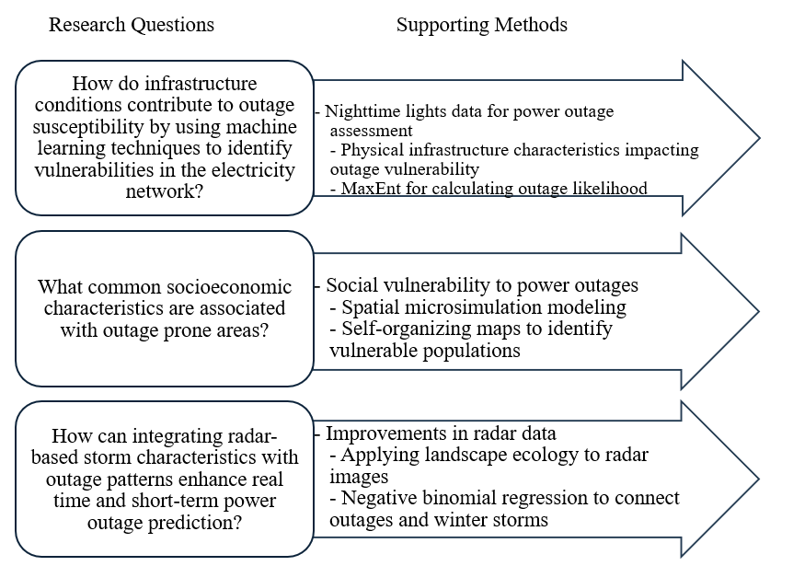
Figure 1.2 Workflow connecting each research question to supporting methods.

Previous research has found that a history of systemic racism, discrimination and divestment has caused low income, Black and Hispanic communities to experience more power outages and disproportionate power outage impacts (Hernandez, 2016; Peterson et al., 2024). Energy infrastructure failures and socioeconomic disparities allow us to study power outage likelihood and the impact of socioeconomic characteristics on outage likelihood throughout Houston.
Winter Storm Uri is unique in its geographic extent and severity. Uri swept through the Pacific Northwest, Southwest and Southeast, impacting a much larger area than typical winter storms (Machemer, 2021). Winter Storm Uri’s low temperatures, high winds and ice accretion highlight the extreme winter weather that Southwest and Southeast states could continue to experience in the future. Improved understanding of Winter Storm Uri could improve resilience to future winter storms.

References
Adger, W. (2006). Vulnerability. Global Environmental Change, 16(3), 268-281. https://doi.org/10.1016/j.gloenvcha.2006.02.006
Adger, W. (2003). Social Capital, Collective Action and Adaptation to Climate Change. Economic Geography, 79(4), 387-404. https://doi.org/10.1111/j.1944-8287.2003.tb00220.x
Allen-Dumas, M., Lee, S., & Chinthavali, S. (2022). Analysis of Correlation between Cold Weather Meteorological Variables and Electricity Outages. 2022 IEEE International Conference on Big Data, 3398-3401. https://doi.org/10.1109/BigData55660.2022.10020733.
Alsamadisi, A., Tran, L., & Papes, M. (2020). Employing inferences across scales: Integrating spatial data with different resolutions to enhance Maxent models. Ecological Modelling, 415. https://doi.org/10.1016/j.ecolmodel.2019.108857.
American Academy of Pediatrics. (2021). Extreme Temperatures: Disaster Management Resources.https://www.aap.org/en/patient-care/disasters-and-children/disaster-management-resources-by-topic/extreme-temperatures/
Appelt, P., & Goodfellow, J. (2004). Research on how trees cause interruptions - applications to vegetation management. Rural Electric Power Conference. https://doi.org/10.1109/REPCON.2004.1307064.
Arnold, K., Harrison, W., Heppenstall, A., & Gilthorpe, M. (2019). DAG-informed regression modelling, agent-based modelling and microsimulation modelling: a critical comparison of methods for causal inference. International Journal of Epidemiology, 48(1), 243-253. https://doi.org/10.1093/ije/dyy260
Benevolenza, M. & DeRigne, L. (2019). The impact of climate change and natural disasters on vulnerable populations: A systematic review of literature. Journal of Human Behavior in the Social Environment, 29(2), 266-281. https://doi.org/10.1080/10911359.2018.1527739
Bernard, Y., Hueber, N., & Girau, B. (2020). A Fast Algorithm to Find Best Matching Units in Self-Organizing Maps. International Conference on Artificial Neural Networks. https://doi.org/10.1007/978-3-030-61616-8_66
Birkmann, J., & Wisner, B. (2006). Measuring the unmeasurable the challenge of vulnerability. United Nations University Institute for Environment and Human Security. https://collections.unu.edu/view/UNU:1872
Boin, A., & McConnell, A. (2007). Preparing for Critical Infrastructure Breakdowns: The Limits of Crisis Management and the Need for Resilience. Journal of Contingencies and Crisis Management, 15(1), 1-66. https://doi.org/10.1111/j.1468-5973.2007.00504.x
Bruneau, M., Chang, S., Eguchi, R., Lee, G., O’Rourke, T., Reinhorn, A., Shinozuka, M., Tierney, K., Wallace, W., Winterfeldt, D. (2003). A Framework to Quantitatively Assess and Enhance the Seismic Resilience of Communities. Earthquake Spectra, 19(4), 733-752. https://doi.org/10.1193/1.1623497
Burby, R., ed. (1998). Cooperating with nature: Confronting natural hazards with land-use planning for sustainable communities. Joseph Henry/National Academy Press, Washington, D.C. https://doi.org/10.17226/5785
Burby, R., Deyle, R., Godschalk, D., & Olshansky, R. (2000). Creating Hazard Resilient Communities Through Land-Use Planning. Natural Hazards Review, 1(2), 65-136. https://doi.org/10.1061/(ASCE)1527-6988(2000)1:2(99)
Burton, C. (2010). Social Vulnerability and Hurricane Impact Modeling. Natural Hazards Review, 11(2). https://doi.org/10.1061/(ASCE)1527-6988(2010)11:2(58)
Campbell, M. (2023). Spatial Microsimulation. A Short Explainer. Social Science Research Network. http://dx.doi.org/10.2139/ssrn.4565410
Campbell, R. (2012). Weather-Related Power Outages and Electric System Resiliency. Congressional Research Service. https://digital.library.unt.edu/ark:/67531/metadc122249/
Cao, C., Shao, X., & Uprety, S. (2013). Detecting light outages after severe storms using the S-NPP/VIIRS day/night band radiances. IEEE Geoscience and Remote Sensing Letters, 10(6), 1582-1586. https://doi.org/10.1109/LGRS.2013.2262258
Capacci, L., Biondini, F., & Frangopol, D. (2022). Resilience of aging structure and infrastructure systems with emphasis on seismic resilience of bridges and road networks: review. Resilient Cities and Structures, 1(2), 23-41. https://doi.org/10.1016/j.rcns.2022.05.001
Cardille, J., & Turner, M. (2002). Understanding Landscape Metrics I. In: Gergel, S.E., Turner, M.G. (eds) Learning Landscape Ecology. Springer, New York, NY. https://doi.org/10.1007/0-387-21613-8_7
Carley, S., Bansal, S., Harak, C., Khan, P., Konisky, D. & Simon, K. (2024). The electricity cost burden of durable medical equipment in the United States. Scientific Reports, 14. https://doi.org/10.1038/s41598-024-82464-x
Carlson, L., Bassett, G., Buehring, W., Collins, M., Folga, S., Haffenden, B., Petit, F., Phillips, J., Verner, D., & Whitfield, R. (2012). Resilience: Theory and Applications. Argonne National Laboratory. https://doi.org/ 10.2172/1044521
Casey, J., Fukurai, M., Hernandez, D., Balsari, S. & Kiang, M. (2020). Power Outages and Community Health: a Narrative Review. Environmental Disasters, 7, 271-383. https://doi.org/10.1007/s40572-020-00295-0
Castellanos, S., Potts, J., Tiedmann, H., Alverson, S., Glazer, Y., Robinson, A., Russo, S., Harmon, D., Kenopurum, D., Kenopurum, B., Weisz, M., Acuna, F., Stephens, K., Faust, K. & Webber, M. (2023). A synthesis and review of exacerbated inequities from February 2021 winter storm (Uri in Texas and the risks moving forward. Progress in Energy, 5(1). https://doi.org/10.1088/2516-1083/aca9b4
Chakalian, P., Kurtz, L., & Hondula, D. (2019). After the lights go out: household resilience to electrical grid failure following hurricane Irma. Natural Hazards Review, 20(4). https://doi.org/10.1061/(ASCE)NH.1527-6996.000033
Chen, H., & Chandrasekah, V. (2018). Real-Time Wind Velocity Retrieval in the Precipitation System Using High-Resolution Operational Multi-Radar Network. Remote Sensing of Aerosols, Clouds and Precipitation, 315-339. https://doi.org/10.1016/B978-0-12-810437-8.00015-3
Chow, M., Taylor, L., & Chow, M. (1996). Time of outage restoration analysis in distribution systems. IEEE Transactions on Power Delivery, 11(3), 1652-1658. https://doi.org/10.1109/61.517530
Cole, T., Wanik, D., Molthan, A., Roman, M., & Griffin, R. (2017). Synergistic Use of Nighttime Satellite Data, Electric Utility Infrastructure, and Ambient Population to Improve Power Outage Detections in Urban Areas. Remote Sensing, 9(3). https://doi.org/10.3390/rs9030286
Coleman, N., Esmalian, A., Lee, C., Gonzales, E., Koirala, P., & Mostafavi, A. (2023). Energy inequality in climate hazards: Empirical evidence of social and spatial disparities in managed and hazard-induced power outages. Sustainable Cities and Society, 92. https://doi.org/10.1016/j.scs.2023.104491
Coleman, N., Esmalian, A., & Mostafavi, A. (2020). Equitable Resilience in Infrastructure Systems: Empirical Assessment of Disparities in Hardship Experiences of Vulnerable Populations during Service Disruptions. Natural Hazards Review, 21(4). https://doi.org/10.1061/(ASCE)NH.1527-6996.0000401
Cruz-Cano, R., Mead, E. (2019). Causes of excess deaths in Puerto Rico after hurricane Maria: a time-series estimation, American Journal of Public Health, 109 (7), 1050–1052, https://doi.org/10.2105/AJPH.2019.305015
Cutter, S., Barnes, L., Berry, M., Burton, C., Evans, E., Tate, E., Webb, J. (2008). A place-based model for understanding community resilience to natural disasters. Global Environmental Change, 18(4), 598-606. https://doi.org/10.1016/j.gloenvcha.2008.07.013
Cutter, S., Burton, C., & Emrich, C. (2010). Disaster Resilience Indicators for Benchmarking Baseline Conditions. Journal of Homeland Security and Emergency Management, 7(1). https://doi.org/10.2202/1547-7355.1732
Department for International Development. (1999). Sustainable livelihoods guide sheets. London, UK: Department for International Development.
Diehl, R., & Larkin, R. (2005). Introduction to the WSR-88D (NEXRAD) for ornithological research. Proceedings of the Third International Partners in Flight Conference.
https://doi.org/10.2737/PSW-GTR-191
Dudík, M., Phillips, S., Schapire, R. (2004). Performance Guarantees for Regularized Maximum Entropy Density Estimation. In: Shawe-Taylor, J., Singer, Y. (eds) Learning Theory. Springer, Berlin, Heidelberg. https://doi.org/10.1007/978-3-540-27819-1_33
Dugan, J., Byles, D. & Mohaghegi, S. (2023). Social vulnerability to long-duration power outages. International Journal of Disaster Risk Reduction, 85. https://doi.org/10.1016/j.ijdrr.2022.103501
Dutta, P., & Hui, D. (1997). Effects of Cold Regions Environment on Structural Composites. Proceedings of the International Conference on Advanced Technology in Experimental Mechanics, Japan Society of Mechanical Engineers.
Dzialek, J., Biernacki, W., Fieden, L., Listwan-Franczak, K., & Franczak, P. (2016). Universal or context-specific social vulnerability drivers - understanding flood preparedness in southern Poland. International Journal of Disaster Risk Reduction, 19, 212-223. https://doi.org/10.1016/j.ijdrr.2016.08.002
Edmondson, M., Luo, C., Islam, M., Sheils, N., Buresh, J., Chen, Z., Bian, J., & Chen, Y. (2022). Distributed Quasi-Poisson regression algorithm for modeling multi-site count outcomes in distributed data networks. Journal of Biomedical Informatics, 131. https://doi.org/10.1016/j.jbi.2022.104097
Eini, M., Kaboli, H., Rashidian, M., & Hedayat, H. (2020). Hazard and vulnerability in urban flood risk mapping: Machine learning techniques and considering the role of urban districts. International Journal of Disaster Risk Reduction, 50. https://doi.org/10.1016/j.ijdrr.2020.10168
Elith, J., Phillips, S., Hastie, T., Dudík, M., Chee, Y., & Yates, C. (2011) A statistical explanation of MaxEnt for ecologists. Diversity and Distributions, 17(1), 43-57. https://doi.org/10.1111/j.1472-4642.2010.00725.x
Elvidge, C.., Baugh, K., Zhizhin, M., & Hsu, F. (2013). Why VIIRS data are better than DMSP for mapping nighttime lights. Proceedings of the Asia-Pacific Advanced Network, 35, 62-69. http://dx.doi.org/10.7125/APAN.35.7
Fanucchi, R., Bessani, M., Camillo, M., London, J., & Maciel, C. (2016). Failure rate prediction under adverse weather conditions in an electric Distribution System using Negative Binomial Regression. 016 17th International Conference on Harmonics and Quality of Power (ICHQP). https://doi.org/10.1109/ICHQP.2016.7783464
Fithian, W., & Hastie, T. (2012). Finite-Sample Equivalence in Statistical Models for Presence-Only Data. The annals of applied statistics, 7(4), 1917–1939. https://doi.org/10.1214/13-AOAS667
Flanagan, D., Gregory, E., Hallisey, E., Heitgerd., & Lewis, B. (2011). A Social Vulnerability Index for Disaster Management. Journal of Homeland Security and Emergency Management, 8(1). https://doi.org/10.2202/1547-7355.1792
Forgy, E. (1965). Cluster analysis of multivariate data: efficiency vs. interpretability of classifications. Biometrics, 21, 768-769.
Forman, R., & Godron, M. (1986). Landscape ecology. John Wiley and Sons Ltd., New York.
Frazier, A., Kedron, P. (2017). Landscape Metrics: Past Progress and Future Directions. Current Landscape Ecology Reports, 2, 63–72. https://doi.org/10.1007/s40823-017-0026-0
Frey, B., & Dueck, D. (2007). Clustering by Passing Messages Between Data Points. Science, 315(5814), 972-976. https://doi.org/10.1126/science.1136800
Ganz, S., Duan, C., & Ji, C. (2023). Socioeconomic vulnerability and differential impact of severe weather-induced power outages. PNAS Nexus, 2(10). https://doi.org/10.1093/pnasnexus/pgad295
Gardner, R., Milne, B., Turner, M., & O’Neill, R. (1987). Neutral models for the analysis of broad-scale landscape patterns. Landscape Ecology 1, 19–28. https://doi.org/10.1007/BF02275262
Gardner, W., Mulvey, E., & Shaw, E. (1995). Regression analysis of counts and rates: Poisson, overdispersed Poisson, and negative binomial models. Psychological Bulletin, 118, 392-404. https://doi.org/10.1037/0033-2909.118.3.392
Godschalk, D. (2003). Urban Hazard Mitigation: Creating Resilient Cities. Natural Hazards Review, 4(3). https://doi.org/10.1061/(ASCE)1527-6988(2003)4:3(136)
Gokyer, E. (2013). Understanding Landscape Structure Using Landscape Metrics. Advances in Landscape Architecture. http://dx.doi.org/10.5772/55758.
Goodwin, E. (2023). Estimation of winter storm power outages using nighttime lights and machine learning (Order No. 30574947). Available from ProQuest Dissertations & Theses Global. (2877262157). Retrieved from https://utk.idm.oclc.org/login?url=https://www.proquest.com/dissertations-theses/estimation-winter-storm-power-outages-using/docview/2877262157/se-2
Guiliani, L., Revez, A., Sparf, J., Jayasena, S., & Faber, M. (2016). Social and technological aspects of disaster resilience. International Journal of Strategic Property Management, 20(3), 277-290. https://doi.org/10.3846/1648715X.2016.1185477
Gustafson, E. (1998). Quantifying landscape spatial pattern: what is the state of the art? Ecosystems 1, 143–156. https://doi.org/10.1007/s100219900011
Guthikonda, S. (2005). Kohonen Self-Organizing Maps. Wittenberg University.
Hernández, D., Aratani, Y. & Jiang, Y. (2014). Energy Insecurity among Families with Children. New York: National Center for Children in Poverty, Columbia University Mailman School of Public Health.
Hernandez, D. (2016). Understanding ‘energy insecurity’ and why it matters to health. Social Science and Medicine, 167, 1-10. https://doi.org/10.1016/j.socscimed.2016.08.029Get rights and content
Herring, D. (2020). What is an "extreme event"? Is there evidence that global warming has caused or contributed to any particular extreme event? National Oceanic and Atmospheric Administration. https://www.climate.gov/news-features/climate-qa/what-extreme-event-there-evidence-global-warming-has-caused-or-contributed
Hilbe, J. (2011). Negative Binomial Regression, 2nd ed., New York: Cambridge University Press. https://doi.org/10.1017/CBO9780511973420
Hobbs, R. (1997). Future landscapes and the future of landscape ecology. Landscape and Urban Planning, 37(1),1-9. https://doi.org/10.1016/S0169-2046(96)00364-7
Holling, C. (1973). Resilience and Stability of Ecological Systems. Annual Review of Ecology and Systematics, 4(1), 1-23. https://doi.org/10.1146/annurev.es.04.110173.000245
Holling, C. (2001). Understanding the complexity of economic, ecological, and social systems. Ecosystems, 4(5), 390-405. https://doi.org/10.1007/s10021-001-0101-5
Hsu, F., Tanejo, J., Carvallo, J., Shah, Z. (2021). Frozen Out in Texas: Blackouts and Inequity. The Rockefeller Foundation. https://www.rockefellerfoundation.org/insights/grantee-impact-story/frozen-out-in-texas-blackouts-and-inequity/
Hu, H. (2014). An algorithm for converting weather radar data into GIS polygons and its application in severe weather warning systems. International Journal of Geographical Information Science, 28(9), 1765–1780. https://doi.org/10.1080/13658816.2014.898767
Huber, M., & Trapp, J. (2008). A Review of NEXRAD Level II: Data, Distribution, and Applications. Journal of Terrestrial Observation, 1 (2), 6-15. https://docs.lib.purdue.edu/jto/vol1/iss2/art4
Hummel, M., Wood, N., Schweikert, A., Stacey, M., Jones, J., Barnard, P., & Erikson, L. (2018). Clusters of community exposure to coastal flooding hazards based on storm and sea level rise scenarios-implications for adaptation networks in the San Francisco Bay region. Regional Environmental Change, 18, 1343-1355. https://doi.org/10.1007/s10113-017-1267-5
Jessel, S., Sawyer, S., & Hernandez, D. (2019). Energy, Poverty, and Health in Climate Change: A Comprehensive Review of an Emerging Literature. Frontiers in Public Health, 7. https://doi.org/10.3389/fpubh.2019.00357
Johnson, T., & Hilbe, J. (2011) Negative Binomial Regression, second edition. Psychometrika 77, 611–612 (2012). https://doi.org/10.1007/s11336-012-9263-
Johnson, J. & MacKeen, P., Witt, A., Mitchell, E., Stumpf, G., & Eilts, Thomas, K. (1998). The Storm Cell Identification and Tracking Algorithm: An Enhanced WSR-88D Algorithm. Weather and Forecasting,13(2). 263-276. https://doi.org/10.1175/1520-0434(1998)013<0263:TSCIAT>2.0.CO;2
Johnson, A., Milne, B., & Wiens, J. (1992). Diffusion in fractal landscapes: simulations and experimental studies of tenebrionid beetle movements. Ecology 73(6), 1968–1983. https://doi.org/10.2307/1941448
Kersting, W., Phillips, W., Doyle, R. (1999). Distribution feeder reliability studies. IEEE Transactions on Industry Applications, 35(2), 319-323. https://doi.org/10.1109/28.753623
Keqi, Z. (2022). Application of Doppler Radar in Short-Term Near-Term Weather Forecast. International Journal of Science and Engineering Applications, 11(10), 145-147. https://doi.org/10.7753/IJSEA1110.1007
Klinger, C., Landeg, O., & Murray, V. (2014). Power Outage, Extreme Events and Health: a Systematic Review of the Literature from 2011-2012. PLOS Currents, 6. https://doi.org/10.1371/currents.dis.04eb1dc5e73dd1377e05a10e9edde673
Kohn, S., Eaton, J., Feroz, S., Bainbridge, A., Hoolachan, J., & Barnett, D. (2013). Personal Disaster Preparedness: An Integrative Review of the Literature. Disaster Medicine and Public Health Preparedness, 6, 217-231. https://doi.org/10.1001/dmp.2012.47
Kohonen, T. (1982). Self-organized formation of topologically correct feature maps. Biological Cybernetics, 43(1), 59-69. https://doi.org/10.1007/BF00337288
Kohonen, T. (1990). The self-organizing map. Proceedings of the IEEE, 78(9), 1464-1480. https://doi.org/10.1109/5.58325
Kohonen, T. (2001). Self-organizing maps. Springer. https://doi.org/10.1007/978-3-642-56927-2
Kohonen, T. (2013). Essentials of the self-organizing map. Neural Networks, 37, 52-65. https://doi.org/10.1016/j.neunet.2012.09.018
Lacroix, A., & Manwell, J. (2000) An analytical method for assessing the power requirements of wind turbine blade anti-icers. American Institute of Aeronautics & Astronautics. https://doi.org/ 10.2514/6.2001-34
Lee, S., Chinthavali, S., Bhusal, N., Stenvig, N., Tabassum, A., & Kuruganti, T. (2023). Quantifying the power system resilience of the US power grid through weather and power outage data mapping. IEEE Access, 12, 5237-5255. https://doi.org/10.1109/ACCESS.2023.3347129
La Porte, T., & Consolini, P. (1991). Working in practice but not in theory: Theoretical challenges of high-reliability organizations. Journal of Public Administration Research and Theory, 1(1), 19-47. https://doi.org/10.1093/oxfordjournals.jpart.a037070
Levin, N., Kyba, C., Zhang, Q., Miguel, A., Roman, M., Li, X., Portnov, B., Molthan, A., Jechow, A., Miller, S., Wang, Z., Shrestha, R. & Elvidge, C. (2020). Remote sensing of night lights: A review and an outlook for the future. Remote Sensing of Environment, 237. https://doi.org/10.1016/j.rse.2019.111443.
Li, H., & Reynolds, J. (1993) A new contagion index to quantify spatial patterns of landscapes. Landscape Ecology, 8, 155–162. https://doi.org/10.1007/BF00125347
Lievanos, R., & Horne, C. (2017). Unequal resilience: The duration of electricity outages. Energy Policy, 108, 201-211. https://doi.org/10.1016/j.enpol.2017.05.058
Lin, H., Tasi, C., Liou, J., Chen, Y., Lin, C., Lin, L., & Chung, K. (2020). Multi-Weather Evaluation of Nowcasting Methods Including a New Empirical Blending Scheme. Atmosphere, 11(11). https://doi.org/10.3390/atmos11111166
Lin, S., Zhang, W., Sheridan, S., Mongillo, M., DiRenzo, S., Stuart, N., Stern, E., Birkhead, G., Dong, G., Wu, S., Chowdhury, S., Primeau, M., Hao, Y & Romeiko, X. (2021). The immediate effects of winter storms and power outages on multiple health outcomes and the time windows of vulnerability. Environmental Research, 196. https://doi.org/10.1016/j.envres.2021.110924
Linnenluecke, M., & Griffiths, A. (2010). Beyond Adaptation: Resilience for Business in Light of Climate Change and Weather Extremes. Business and Society, 49(3), 477-511. https://doi.org/10.1177/0007650310368814
Little, R. (2012). Managing the Risk of Aging Infrastructure. International Risk Governance Council. https://www.dnfsb.gov/content/irgc-paper-managing-risk-aging-infrastructure
Liu, H., Davidson, R., Rosowsky, D., & Stedinger, J. (2005). Negative Binomial Regression of Electric Power Outages in Hurricanes. Journal of Infrastructure Systems, 11(4). https://doi.org/10.1061/(ASCE)1076-0342(2005)11:4(258)
Lou, Y., Clark, D., Marks, P., Muellerschoen, R., & Wang, C. Onboard Radar Processor Development for Rapid Response to Natural Hazards. IEEE Journal of Selected Topics in Applied Earth Observations and Remote Sensing, 9(6), 2770-2776. https://doi.org/10.1109/JSTARS.2016.2558505
Machemer, T. (2021). How Winter Storm Uri Impacted the United States. Smithsonian Magazine. https://www. smithsonianmag. com/smart-news/how-winter-storm-uri-hasimpacted-us-180977055
Maguire, B., & Hagan, P. (2007). Disasters and communities: Understanding social resilience. Australian Journal of Emergency Management, 22(2), 16-20. https://search.informit.org/doi/10.3316/informit.839750155412061
Maharani, Y., Lee, S., & Ki, S. (2016). Social vulnerability at a local level around the Merapi volcano. International Journal of Disaster Risk Reduction, 20, 63-77. https://doi.org/10.1016/j.ijdrr.2016.10.012
Maliszewski, P., Larson, E., & Perrings, C. (2012). Environmental determinants of unscheduled residential outages in the electrical power distribution of Phoenix, Arizona. Reliability Engineering & System Safety, 99, 161-171. https://doi.org/10.1016/j.ress.2011.10.011
Maliszewski, P., & Perrings, C. (2012). Factors in the resilience of electrical power distribution infrastructures. Applied Geography, 32(2), 668-679. https://doi.org/10.1016/j.apgeog.2011.08.001
Mann, L., Melaas, K., & Malik, A. (2016). Using VIIRS Day/Night Band to measure electricity supply reliability: Preliminary results from Maharashtra, India. Remote Sensing, 8(9), Article 711. https://doi.org/10.3390/rs8090711
Mavhura, E., Manyangadze, T., & Arya, K. (2021). A composite inherent resilience index for Zimbabwe: An adaptation of the disaster resilience of place model. International Journal of Disaster Risk Reduction, 57. https://doi.org/10.1016/j.ijdrr.2021.102152
Mass, C. (2012). Nowcasting: The Promise of New Technologies of Communication, Modeling, and Observation. Bulletin of the American Meteorological Society, 93(6). https://doi.org/10.1175/BAMS-D-11-00153.1
Mayunga, J. (2009). Measuring the Measure: A multi-dimensional scale model to measure community disaster resilience in the U.S. gulf coast region (Publication No. 337060). [Doctoral Dissertation, Texas A & M University]. ProQuest Dissertations & Theses Global
McCullagh, P., & Nelder, J. (1999). Generalized linear models. 2nd Edition, Chapman and Hall. https://doi.org/10.1201/9780203753736
McFarland, A., & Norris, F. (2006). Definitions and concepts in disaster research. In F. Norris, S. Galea, M. Friedman, & P. Watson (Eds.), Methods for disaster mental health research (pp. 3–19). New York: Guilford Press.
McGarigal, K., &, Marks, B. (1995). FRAGSTATS. Spatial analysis program for quantifying landscape structure. USDA Forest Service General Technical Report PNW-GTR-351. Portland, OR: U.S. Department of Agriculture, Forest Service, Pacific Northwest Research Station. https://doi.org/10.2737/PNW-GTR-351
Merow, C., Smith, M., & Silander, J. (2013). A practical guide to MaxEnt for modeling species’ distributions: what it does, and why inputs and settings matter. Ecography, 36(10), 1058-1069. https://doi.org/10.1111/j.1600-0587.2013.07872.x
Miller, H. (2017). Time geography and space-time prism. In International Encyclopedia of Geography (eds D. Richardson, N. Castree, M.F. Goodchild, A. Kobayashi, W. Liu and R.A. Marston). https://doi.org/10.1002/9781118786352.wbieg0431
Mileti, D. (1999). Disasters by Design: A reassessment of natural hazards in the United States. Joseph Henry Press. https://doi.org/10.17226/5782
Mitsova, D., Esnard, A., Sapat, A., & Lai, B. (2018). Socioeconomic vulnerability and electric power restoration timelines in Florida: the case of Hurricane Irma. Natural Hazards, 94(2), 689-709. https://doi.org/10.1016/j.enpol.2017.05.058
Molinari, N., Chen, B., Krishna, N. & Morris, T. (2017). Who’s at risk when the power goes out? The at-home electricity-dependent population in the United States, 2012. Journal of Public Health Management and Practice, 23 (2), 152–159, https://doi.org/10.1097/PHH.0000000000000345.
Munoz, C., Wang, L., & Willems, P. (2018). Enhanced object-based tracking algorithm for convective rain storms and cells. Atmospheric Research, 201, 144-158. https://doi.org/10.1016/j.atmosres.2017.10.027
NASA. (2025). What is the difference between "Near Real-time" (NRT) and "Production" / "Research" data? National Aeronautics and Space Administration. https://gpm.nasa.gov/resources/faq/what-difference-between-near-real-time-nrt-and-production-research-data
NOAA. (2006). Weather Radar Development. National Oceanic and Atmospheric Administration. https://celebrating200years.noaa.gov/transformations/weather/radar.html
National Research Council. (2006). Facing hazards and disasters: Understanding the human dimension. Washington, D.C.: The National Academic Press. https://doi.org/10.17226/11671
National Weather Service. (2025). Severe Weather Definitions. https://www.weather.gov/bgm/severedefinitions
Nikkanen, M., Rasanen, A., & Juhola, S. (2021). The influence of socioeconomic factors on storm preparedness and experienced impacts in Finland. International Journal of Disaster Risk Reduction, 55. https://doi.org/10.1016/j.ijdrr.2021.102089
Norris, F., Stevens, S., Pfefferbaum, B., Wyche., & Pfefferbaum, R. (2008). Community Resilience as a Metaphor Theory, Set of Capabilities, and Strategy for Disaster Readiness. American Journal of Community Psychology, 41, 127-150. https://doi.org/10.1007/s10464-007-9156-6
Nowell, B., Bodkin, C., & Bayoumi, D. (2016). Redundancy as a strategy in disaster response systems: A pathway to resilience or a recipe for disaster? Journal of Contingencies and Crisis Management, 25, 123-135. https://doi.org/10.1111/1468-5973.12178
Novembri, J. (2004). Utility vegetation management-final report. Technical Report, Federal Energy Regulatory Commission. https://www.ferc.gov/sites/default /files/2020-04/uvm-final-report_0.pdf
O’Neill, R., Krummel, J., Gardner, R., Sugihara, G., Jackson, B., DeAngelis, D., Milne, B., Turner, M., Zygmunt, B., Christensen, S., Graham, R., & Dale, V. (1988). Indices of landscape pattern. Landscape Ecology, 1(3), 153–162. https://doi.org/10.1007/BF00162741
Onuma, H., Shin, K., & Managi, S. (2017). Household preparedness for natural disasters: impact of disaster experience and implications for future disaster risks in Japan. International Journal of Disaster Risk Reduction, 21, 27-37. https://doi.org/10.1016/j.ijdrr.2016.11.004
Parker, L., Bourgoin, C., Martinez Valle, A., Laderach, P. (2019). Vulnerability of the agricultural sector to climate change: The development of a pan- tropical Climate Risk Vulnerability Assessment to inform sub-national decision making. PLOS ONE, 14(3). https://doi.org/10.1371/journal.pone.0213641
Pasher, J., & King, D. (2006). Landscape Fragmentation and Ice Storm Damage in Eastern Ontario Forests. Landscape Ecology, 21. 477-483. https://doi.org/10.1007/s10980-005-5244-x
Peterson, S., Clark, S., Shelly, M., & Horn, S. (2024). Assessing the household burdens of infrastructure disruptions in Texas during Winter Storm Uri. Natural Hazards, 120, 7605-7104. https://doi.org/10.1007/s11069-024-06480-w
Phillips, S., Anderson, R., & Schapire, R. (2006). Maximum entropy modeling of species geographic distributions. Ecological Modelling, 190(3), 231-259. https://doi.org/10.1016/j.ecolmodel.2005.03.026
Phillips, S., & Dudik, M. (2008). Modeling of species distributions with Maxent: new extensions and a comprehensive evaluation. Ecography, 31,161-175. https://doi.org/10.1111/j.0906-7590.2008.5203.x
Ponmalai, R., & Kamath, C. (2019). Self-Organizing Maps and Their Applications to Data Analysis. Lawrence Livermore National Laboratory. https://doi.org/10.2172/1566795
Radosavljevic, A., & Anderson, R. (2013). Making better MAXENT models of species distributions: complexity, overfitting and evaluation. Journal of Biogeography, 41,629-643. https://doi.org/10.1111/jbi.12227
Risser, P., Karr, J., & Forman, R. (1984) Landscape ecology: directions and approaches. Illinoise National Historic Survey Special Publication No. 2. https://www.biodiversitylibrary.org/page/60984942
Rodriguez, AW., Shafieezadeg, A., & Yilmaz, A. (2022). How important are socioeconomic factors for hurricane performance of power systems? An analysis of disparities through machine learning. IEEE Conference on Power Systems Technology. https://doi.org/10.1109/POWERCON53406.2022.9930015
Rodriguez, S., Walker, F., & Martin, C. (2021). Winter Storm Uri’s Impacts on Houston Neighborhoods Show Why It’s Urgent to Build Equity into Climate Resilience. Urban Institute. https://www.urban.org/urban-wire/winter-storm-uris-impacts-houston-neighborhoods-show-why-its-urgent-build-equity-climate-resilience
Román, M., Wang, Z., Sun, Q., Kalb, V., Miller, S.D., Molthan, A., Shultz, L., Bell, J., Stokes, E.K., Pandey, B., Seto, K.C., Hall, D., Oda, T., Wolfe, R.E., Lin, G., Golpayegani, N., Devadiga, S., Davidson, C., Sarkar, S., Praderas, C., & Masuoka, E.J. (2018). NASA’s Black Marble nighttime lights product suite. Remote Sensing of Environment, 210, 113-143. https://doi.org/10.1016/j.rse.2018.03.017
Romme, W. (1982). Fire and landscape diversity in subalpine forests of Yellowstone National Park. Ecological Monographs, 52(2), 199–221. https://doi.org/10.2307/1942611
Rothstein, R. (2017). The Color of Law: A Forgotten History of How Our Government Segregated America.. New York ; London: Liveright publishing corporation, a division of W.W. norton & company, 2017. (First edition ed.). New York ; London: Liveright Publishing Corporation, a division of W.W. Norton & Company.
Royle, J., Chandler, R., Yackulic, C., & Nichols, J. (2012). Likelihood analysis of species occurrence probability from presence-only data for modelling species distributions. Methods in Ecology and Evolution, 3, 545-554. https://doi.org/10.1111/j.2041-210X.2011.00182.x
Schmid, F., Wany, Y., & Harou, A. (2019). Nowcasting Guidelines - A Summary. World Meteorological Organization. https://library.wmo.int/idurl/4/55666
Serafin, R., & Wilson, J. (2000). Operational Weather Radar in the United States: Progress and Opportunity. Bulletin of the American Meteorological Society, 81(3), 501-518. https://doi.org/10.1175/1520-0477(2000)081
Shepherd, M. (2023). Severe weather or extreme weather - what’s the difference? Forbes. https://www.forbes.com/sites/marshallshepherd/2023/10/29/severe-weather-or-extreme-weatherwhats-the-difference/
Siebeneck, L., Arlikatti, S., & Andrew, S. (2015). Using provincial baseline indicators to model geographic variations of disaster resilience in Thailand. Natural Hazards, 79, 955-975. https://doi.org/10.1007/s11069-015-1886-4
Simanullang, J., Zarlis, M., & Zamzami, E. (2020). Performance Improvement of Clustering Affinity Propagation Method using Principal Component Analysis. Journal of Physics. Conference Series, 1566(1). https://doi.org/10.1088/1742-6596/1566/1/012126
Solangi, A. (2018). Icing Effects on Power Lines and Anti-icing and De-icing Methods. [Master’s thesis, University of Norway] UiT Munin. https://munin.uit.no/handle/10037/14198
Tang, Y., Wie, B., Varga, L., Dolan, T., & Li, Q. (2022). An integrated framework for managing fire resilience of metro station system: Identification, assessment and optimization. International Journal of Disaster Risk Reduction, 77. https://doi.org/10.1016/j.ijdrr.2022.103037
Taylor, W., Watson, P., Cerrai, D., & Anagnostou, E. (2022). Dynamic modeling of the effects of vegetation management on weather related power outages. Electric Power Systems Research, 207. https://doi.org/10.1016/j.epsr.2022.107840
Thompson, I., Mackney, B., McNulty, S., & Mosseler, A. (2009). Forest Resilience, Biodiversity and Climate Change: a synthesis of the biodiversity/resilience/stability relationship in forest ecosystems. Secretariat of the Convention on Biological Diversity, 43, 1-67. https://research.fs.usda.gov/treesearch/36775
Tiernan, A., Drennan, L., Nalau, J., Onyango, E., Morrissey, L., & Mackey, B. (2018). A review of themes in disaster resilience literature and international practice since 2012. Policy Design and Practice, 2(1), 53-74. https://doi.org/10.1080/25741292.2018.1507240
Tierney, K., & Bruneau, M. (2007). Conceptualizing and Measuring Resilience: A Key to Disaster Loss Reduction. TR News. https://doi.org/10.17226/895
Tierney, K. (2008). Structure and Process in the Study of Disaster Resilience. In 14th World Conference on Earthquake Engineering.
Timmerman, P. (1981). Vulnerability, resilience and the collapse of society. Environmental Monograph, 1(1). https://doi.org/10.1002/joc.3370010412
Tomaszewski, M., Ruszczak, B., Michalski, P., & Zator, S. (2019). The study of weather conditions favorable to the accretion of icing that pose a threat to transmission power lines. International Journal of Critical Infrastructure Protection, 25, 139-151. https://doi.org/10.1016/j.ijcip.2019.04.001.
Tonn, G., Guikema, S., Ferreira, C., & Quiring, S. (2016). Hurricane Isaac: A Longitudinal Analysis of Storm Characteristics and Power Outage Risk. Risk analysis: an official publication of the Society for Risk Analysis, 36(10), 1936–1947. https://doi.org/10.1111/risa.12552
Tsai, C., & Ni, C. (2015) Vulnerability, resilience, and the adaptive cycle in a crisis-prone tourism community. Tourism Geographies, 18(1), 80-105. https://doi.org/10.1080/14616688.2015.1116600
Tuccillo, J., & Spielman, S. (2022). A Method for Measuring Coupled Individual and Social Vulnerability and Hazards. Annals of the American Association of Geographers, 122(6), 1702-1725. https://doi.org/10.1080/24694452.2021.1989283
Turner, B., Kasperson, R., Matson, P., McCarthy, J., Correl, R., Christensen, L., Eckley, N., Kasperson, J., Luers, A., Martello, M., Polsky, C., Pulsipher., & Schiller, A. (2003). A framework for vulnerability analysis in sustainability science. Biological Sciences, 100(14), 8074-8079. https://doi.org/10.1073/pnas.1231335100
Tuccillo, J., Stewart, R., Rose, A., Trombley, N., Moehl, J., Nagle, N., & Bhaduri, B. (2023). UrbanPop: A spatial microsimulation framework for exploring demographic influences on human dynamics. Applied Geography, 151. https://doi.org/10.1016/j.apgeog.2022.102844
Turner, M., Gardner, R., & O’Neill, R. (2001). Landscape Ecology in Theory and Practice: Pattern and Process. Springer, New York. https://doi.org/10.1007/978-1-4939-2794-4
Van Hulle, M. (2012). Self-organizing Maps. Handbook of natural computing, 1, 585-622. https://doi.org/10.1007/978-3-540-92910-9_19
Ver Hoef, J., & Boven, P. (2007). Quasi-poisson vs. Negative Binomial Regression: How Should We Model Overdispersed Count Data? Ecology. 88. 2766-2772. https://doi.org/10.1890/07-0043.1
Wang, Z., Roman, M., Sun, Q., Molthan, A., Schultz, L., & Kalb, V. (2018). Monitoring Disaster-Related Power Outages Using NASA Black Marble Nighttime Light Product. The International Archives of the Photogrammetry, Remote Sensing and Spatial Information Sciences, 42, 1853-1856. https://doi.org/10.5194/isprs-archives-XLII-3-1853-2018
Watson, P., Spaulding, A., Koukoula, M., & Anagnostou, E. (2022). Improved quantitative prediction of power outages caused by extreme weather events. Weather and Climate Extremes, 37. ,https://doi.org/10.1016/j.wace.2022.100487.
Wedderburn, R. (1974). Quasi-Likelihood Functions, Generalized Linear Models and the Gauss-Newton Method. Biometrika, 61(3), 439-447. https://doi.org/10.2307/2334725
Wheaton, W., Cajka, J., Chasteen, B., Wagener, D., Cooley, P., Ganapathi, L., Roberts, D., & Allpress, J. (2009). Synthesized Population Databases: A US Geospatial Database for Agent-Based Models. Methods report (RTI Press), 10. https://doi.org/10.3768/rtipress.2009.mr.0010.0905
Whiton, R., Smith, P.., Bigler, S., Wilk, K., & Harbuck, A. (1998). History of Operational Use of Weather Radar by U.S. Weather Services. Part I: The Pre-NEXRAD Era. Weather and Forecasting, 13(2), 219-243. https://doi.org/10.1175/1520-0434(1998)013<0219:HOOUOW>2.0.CO;2
Wiens, J., Crawford, C., & Gosz, J. (1985). Boundary Dynamics: A Conceptual Framework for Studying Landscape Ecology Systems. Oikos 45(3), 421-427. https://doi.org/10.2307/3565577
Wildavsky, A. (1991). Searching for safety. New Brunswick: Transaction Books. https://doi.org/10.1177/0270467690010004
Wilhelmi, O., & Morss, R. (2013). Integrated Analysis of societal vulnerability in an extreme precipitation event: A Fort Collins case study. Environmental Science and Policy, 26, 49-62, https://doi.org/10.1016/j.envsci.2012.07.005
Wisz, M., Hijmans, R., Li, J., Peterson, A., Graham, C., & Guisan, A. (2008), Effects of sample size on the performance of species distribution models. Diversity and Distributions, 14, 763-773. https://doi.org/10.1111/j.1472-4642.2008.00482.x
With, K. (2019). Essentials of Landscape Ecology. Oxford University Press. https://doi.org/10.1093/oso/9780198838388.001.0001
Xu, J., Qiang, Y., Cai, H. & Zou, L. (2023). Power outage and environmental justice in Winter Storm Uri: an analytical workflow based on nighttime light remote sensing. International Journal of Digital Earth, 16(1), 2259-2278. https://doi.org/10.1080/17538947.2023.2224087
Zanocco, C., Flora, J. & Boudet, H. (2022). Disparities in self-reported extreme weather impacts by race, ethnicity, and income in the United States. PLOS Climate, 1(6). https://doi.org/10.1371/journal.pclm.0000026
Zaryckik, C.M., (2018). Projecting changes in societally impactful north-eastern U.S. snowstorms. Geophysical Research Letters, 45, 12067012075. https://doi.org/10.1029/2018GL079820
Zeise, L., & Blumenfeld, J. (2021). CalEnviroScreen 4.0. State of California Office of Environmental Health Hazard Assessment. https://oehha.ca.gov/calenviroscreen
Zhang, X., Furtlehner, C., Germain-Renaud, C., & Sebag, M. (2014). Data Stream Clustering with Affinity Propagation. IEEE Transactions on Knowledge and Data Engineering, 26(7), 1644–1656. https://doi.org/10.1109/TKDE.2013.146
Zona, A., Kammouh, O., & Cimellaro, G. (2020). Resourc efulness quantification approach for resilient communities and countries. International Journal of Disaster Risk Reduction, 46. https://doi.org/10.1016/j.ijdrr.2020.101509
Zwilling, M. (2013). Negative Binomial Regression. The Mathematica Journal. https://dx.doi.org/10.3888/tmj.15-6.

Addressing Power Outage Susceptibility with MaxEnt Model

A version of this chapter was submitted for publication by Alexandra C. Kahl, Liem T. Tran and Budhendra L. Bhaduri:
Kahl, A.C., Tran, L.T., Bhaduri, B.L. (2024). Addressing Power Outage Susceptibility with MaxEnt Model [Manuscript in review].
Alexandra Kahl performed all data analysis and conducted all methods, as well as drafted the paper. Budhendra Bhaduri and Liem Tran contributed to the research question, methodological guidance and manuscript editing.

Abstract
Understanding the spatial distribution of power outage likelihood is crucial for enhancing outage preparedness and disaster response. However, publicly available power outage data at specific administrative levels, such as census tracts or census blocks, remains limited. To bridge this gap, we derive simulated outage likelihood values by implementing maximum entropy (MaxEnt) models, which estimate the likelihood of power outages at the census block level in Houston, TX.
Our model utilizes nighttime light data to estimate power outage likelihood at the census block level. Nighttime light outages during Winter Storm Uri (February 11-18, 2021) serve as inputs for the MaxEnt machine learning model. Additionally, we incorporate data on energy transmission, generation, hospitals, emergency services, and tree coverage as predictor variables within MaxEnt.
Results show that the model performs relatively well with a mean area under the curve of 0.758, surpassing the common threshold for model evaluation of 0.70. Power line density, tree coverage and proximity to schools are the most influential variables in power outage likelihood (contributing percentages are 73.0%, 7.1% and 5.2%, respectively). Using MaxEnt prediction, we generate outage likelihood of values ranging from 0 and 1 for each census block.
This study presents a novel methodology for processing nighttime lights and expands the application of MaxEnt in power outage likelihood analysis. Our findings provide valuable insights into which census tracts are most susceptible to power outages during extreme weather events, aiding in disaster preparedness and response planning.
Keywords: nighttime lights, outage, resilience, winter storm
Notice: This manuscript has been authored by UT-Battelle, LLC, under contract DE-AC05-00OR22725 with the US Department of Energy (DOE). The US government retains and the publisher, by accepting the article for publication, acknowledges that the US government retains a nonexclusive, paid-up, irrevocable, worldwide license to publish or reproduce the published form of this manuscript, or allow others to do so, for US government purposes. DOE will provide public access to these results of federally sponsored research in accordance with the DOE Public Access Plan (https://www.energy.gov/doe-public-access-plan).

2.1 Introduction
Long-term power outages disrupt daily life and can even be fatal (Kabir et al., 2023). In the U.S., infrastructure in the Southeast and Southwest is vulnerable to winter storms, often leading to widespread blackouts (Coleman et al., 2023). Emergency responders need precise data on outage patterns to improve disaster preparedness. However, existing research focuses on detecting outages rather than predicting their likelihood or identifying key risk factors (Levin et al., 2020; Xu et al., 2023).
Nighttime lights data have been used to map urban areas, estimate population, monitor conflicts, and more recently, to estimate power outages (Levin et al., 2020; Xu et al., 2023). Recent studies have worked to estimate power outages at finer spatial scales, including the census tract level (Hsu et al., 2021). Previous work has created maps of nighttime lights outages and overlaid them with socioeconomic variables, which provides insight into the people that are most impacted (Hsu et al., 2021). However, these studies do not address what factors contribute to power outages. Emergency responders could benefit from a dataset detailing how likely census blocks are to experience an outage based on electricity network and other infrastructure characteristics.
To fill this gap, we applied a machine learning model to examine the link between nighttime lights outages and preexisting infrastructure. While past studies identified affected populations, our study focuses on the infrastructure characteristics of outage-prone areas. We aim to understand why some census blocks experience more outages by analyzing the role of the electricity network, critical infrastructure, and tree coverage. Using Winter Storm Uri’s impact on Houston, TX, we assess infrastructure influences on outages through MaxEnt. MaxEnt is one of the most popular machine learning tools for species and environmental niche modeling, because of its successful predictive accuracy (Merow et al., 2013). Particularly, MaxEnt can predict pixel-level species occurrence rate and the likelihood of species occurrence (Fithian and Hastie, 2012; Merow et al., 2013; Royle et al., 2012). Recent literature has extended MaxEnt into hazard mapping and risk assessment (Javidan et al., 2021; Liu et al., 2022), for example, to assess agriculture vulnerability and flood hazards (Harshasimha and Bhatt., 2023; Norallahi and Kaboli., 2021; Parker et al.,2019). MaxEnt has yet to be adapted for power outage likelihood modeling. Applying MaxEnt enables us to assess outage probability based on preexisting infrastructure and environmental factors, broadening our understanding of their impact and generating generalizable outage likelihood results.
Our nighttime lights outages are used as inputs to our MaxEnt machine learning model. Nighttime lights data provides outage locations during Winter Storm Uri and MaxEnt tells us how likely outages are to occur there again. Our census block level outage likelihood dataset has practical applications to inform disaster preparedness, outage restoration priorities and resource allocation. This paper is organized as follows: 1) first we detail our process for deriving census block level outages, 2) we then build a machine learning model to assess variable contribution to outage likelihood, and 3) we identify census blocks most likely to experience outages in Houston, TX.

2.2 Methods

2.2.1 Overview
We selected Houston as our study area since its electric generation and transmission infrastructure were not winterized, making it vulnerable to extreme cold events. Analyzing outage likelihood in Houston provides insights into potential risks for other southern cities. Our workflow started by processing nighttime lights images before and during Winter Storm Uri, which we used to derive outage points at the census block level. Then we incorporated preexisting infrastructure characteristics to use as environmental factors in MaxEnt. Factors included substation locations, transmission and distribution line density and proximity to emergency services. Lastly, we input our outage points and variables into our MaxEnt outage likelihood model (Figure 2.1).

2.2.2 Nighttime Lights Data
To assess outages across Houston, we used NASA's Black Marble VNP46A2 Daily Moonlight-adjusted Nighttime Lights product (Roman et al., 2018; Tian et al., 2022). This dataset is derived from the Visible Infrared Imaging Radiometer Suite (VIIRS) aboard the Suomi National Polar-Orbiting Partnerships satellite, which collects daily measurements of nocturnal visible and near-infrared light at a 500-meter resolution (Roman et al., 2018).
The Black Marble algorithm processes raw data to account for external factors impacting nighttime lights data quality, including terrain effects, cloud cover, stray light effects and missing data (Roman et al., 2018). We used the VNP46A2 nighttime lights dataset, which corrects for common uncertainties such as atmospheric conditions and missing data (Roman et al., 2018; Wang et al., 2021). Angular and atmospheric effects are the most common source of uncertainty in Black Marble products (Wang et al., 2021). The VNP46A2 product accounts for short term variation in lunar conditions, view angles and view time. Specifically, we used the BRDF corrected band, which is identified as a “high quality retrieval” (Wang et al., 2021).

2.2.3 Direct vs. Proxy Variables
We examined preexisting infrastructure characteristics—such as age, location, and density—that increase outage likelihood in certain census blocks. To categorize these factors, we divided our variables into two classes: direct and proxy. Direct variables, like

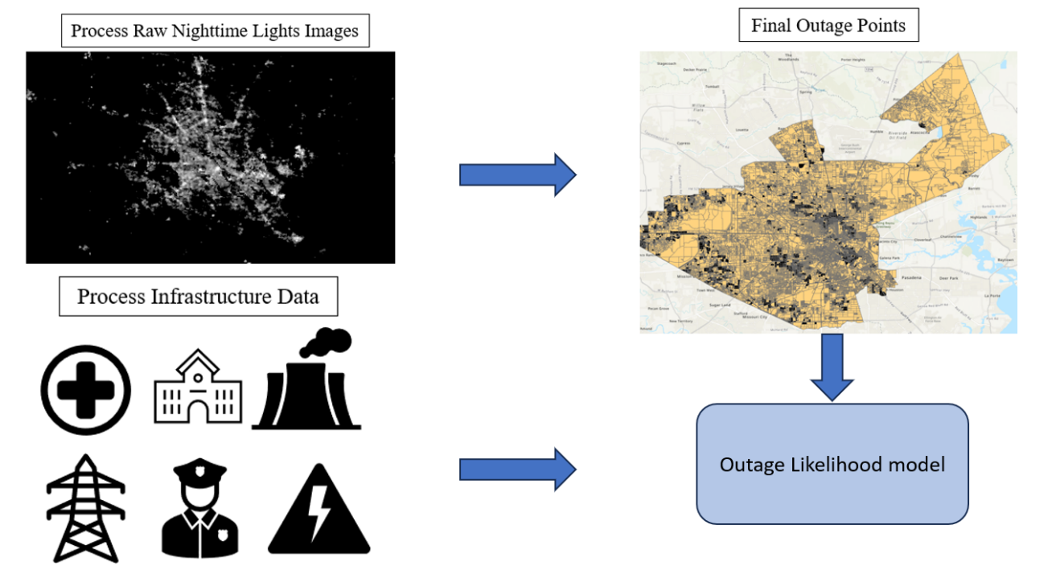
Figure 2.1 Workflow illustrating the steps to process nighttime lights satellite imagery and infrastructure data to model power outage likelihood using MaxEnt. Steps include data collection, pre-processing, and MaxEnt model implementation.

ice accretion, immediately cause outages by damaging distribution lines. Proxy variables do not directly cause outages but influence infrastructure quality and restoration priority, affecting outage susceptibility. For example, proximity to hospitals or nursing homes does not cause outages but may lead to faster restoration due to their critical status (Maliszewski and Perrings, 2012). We focused on proxy variables, as they remain constant across storm types and can inform emergency response priorities, unlike meteorological factors, which vary by storm and do not reveal infrastructure vulnerabilities. Our analysis incorporated data on emergency services, critical infrastructure, and the electric grid.

2.2.4 Selected Variables
To account for the role of emergency services in outage preparedness and response we utilized point locations of fire stations and local law enforcement stations (Table 2.1). Emergency services distribute resources, assist in power restoration, and support the 911 system. Census blocks closer to these facilities may receive aid more quickly.
The Federal Emergency Management Agency (FEMA) designates schools, hospitals, nursing homes and long-term care facilities as critical infrastructure, prioritizing them for outage restoration (FEMA, 2019). Nursing homes and long-term care facilities are prioritized due to their importance to the community and individuals with power dependent medical equipment or devices (FEMA, 2019). Schools are considered a critical social service and provide relocation for households. (Table 2.1). We utilized FEMA high priority datasets to account for the “halo” effect, wherein neighborhoods close to high priority infrastructure experience fewer outages and faster outage restoration (FEMA, 2019).
We incorporated generation, substation, transmission line and distribution line data to account for the impact of electricity network density and quality on outage likelihood (Table 2.1). Generator age and planned retirement data influence the likelihood that the generator receives regular maintenance and will be able to withstand severe weather (Little, 2012). Substations and transmission lines were incorporated, because utilities rank them high for priority for restoration (FEMA, 2019). There is not a publicly available dataset for distribution lines, as a result we used road data as a proxy for distribution line location and density (Table 2.1). To assess the impact of falling tree limbs on distribution lines we collected tree coverage data from the MultiResolution Land Characteristics (MRLC) Consortium (Table 2.1).

2.2.5 Processing Nighttime Lights

We analyzed nighttime lights pixels within Houston city limits to focus on urban areas, excluding less urban parts of Harris County. To develop a baseline of Houston’s “normal” outage condition, we downloaded nighttime lights images from Global Imagery Browse Services (GIBS). These images, available in H5 format, covered the Houston city limits and were downloaded for December 1, 2020 – January 31, 2021. We labeled these images as “pre-Uri”. To distinguish Uri-related outages from routine brownouts or maintenance outages, we created two baseline rasters: one representing the mean of all pre-Uri images and the other representing the standard deviation. To account for outages
Table 2.1 Detailed information on each dataset used for the infrastructure variables in the MaxEnt model, including source, data type and spatial scale.
Dataset | Source | Owner | Data Type | Spatial Scale | Direct vs. Proxy
Emergency Services
Fire Stations | HIFLD | U.S. Geological Survey | Point Shapefile | Continental U.S., Puerto Rico, U.S. Virgin Islands | Proxy
Local Law Enforcement | HIFLD | U.S. Dept. of Justice- Bureau of Justice Statistics | Point Shapefile | Continental U.S. and Puerto Rico | Proxy
FEMA Priority
Hospitals | HIFLD | Oak Ridge National Laboratory | Point Shapefile | U.S. Guam, American Samoa, Northern Mariana | Proxy
Nursing Homes | HIFLD | Oak Ridge National Laboratory | Point Shapefile | Continental U.S. | Proxy
Schools | HIFLD | Oak Ridge National Laboratory | Point Shapefile | U.S and U.S territories | Proxy
Electric Utility Network
Generators | Energy Information Administration | Energy Information Administration | Point Shapefile | U.S and  U.S. Territories | Proxy
Substations | Oak Ridge National Laboratory | Oak Ridge National Laboratory | Point Shapefile | U.S and  U.S. Territories | Proxy
Transmission Lines | HIFLD | Oak Ridge National Laboratory | Line Shapefile | U.S and  U.S. Territories | Proxy
Roads (distribution lines) | Tiger Line | United States Census Bureau | Line Shapefile | U.S and  U.S. Territories | Proxy
Environmental Data
Table 2.1 (continued) Detailed information on each dataset used for the infrastructure variables in the MaxEnt model, including source, data type and spatial scale.
Tree Coverage | MRLC | MRLC | Raster | Continental United States | Direct

during Winter Storm Uri, we downloaded nighttime lights images from February 11, 2021, to February 20, 2021, and labeled them as “storm rasters”. We compared each storm raster to the pre-Uri baseline raster. Outage cells were identified as those three standard deviations below the baseline mean. We produced binary rasters for February 11 -20, 2021 where outage cells are identified as 1 and non-outage cells are identified as 0.

2.2.6 Identifying Primarily Outage Census Blocks

We overlaid each binary raster with census blocks to determine the proportion of each census block covered by an outage cell (Liu et al., 2024). Census blocks were classified as experiencing an outage if at least 70% of their area was covered by an outage cell, approximating that 70% of the population was affected. Latitude and longitude coordinates of each outage census block were exported to a csv file, forming the MaxEnt presence points dataset.

2.2.7 Processing Variables for MaxEnt

To prepare data for MaxEnt, we standardized all variable shapefiles to the same extent. Within each census block, we calculated line density and proximity for all point features. To assess the density of transmission lines and distribution lines across census blocks we used the line density tool to create density rasters. We also calculated the distance of each census block to the closest fire station, law enforcement station, hospital, nursing home, school, generator and substation. This provides information on which census tracts are closest to critical infrastructure. We incorporated tree coverage by creating a tree coverage raster to match the extent of Houston, TX.

2.2.8 MaxEnt Mathematical Background

MaxEnt is a machine learning method based on the principle of maximum entropy (Phillips et al., 2006). Entropy refers to how much “choice” is involved in distribution or selection of an event. Maximum entropy refers to a probability distribution with no unfounded constraints. As a tool MaxEnt seeks to produce a species distribution that respects constraints, while maintaining maximum entropy (Phillips et al., 2006). As a machine learning method MaxEnt incorporates entropy equations. The entropy of a probability distribution is defined as:
$$H\left(\hat{π}\right)= - Σ\hat{π}\left(x\right)ln\hat{π}(x)$$
Entropy takes the most natural log of the number of elements in X. MaxEnt starts with this but restricts the empirical feature so that they will be close to their empirical values (Phillips et al., 2006). MaxEnt distribution is defined as:
$\hat{π}$ [-ln( qλ) ]

2.2.9 Adapting MaxEnt from Species Distribution to Outage Distribution

We used MaxEnt to calculate outage likelihood based on outage presence points and explanatory variables. Maxent is typically used to study species distribution by comparing environmental characteristics at species occurrence points to the total environment (Phillips et al., 2006). MaxEnt takes three data types: 1) landscape (the whole study area), 2) predictor variables (typically precipitation or land cover) and 3) species occurrence points (Elith et al., 2011). In our study, Houston, TX, served as the landscape, while predictor variables included infrastructure proximity, tree coverage, generators, and transmission line attributes (Figure 2.2). We utilized MaxEnt as a machine learning method to evaluate outage likelihood across Houston with respect to electricity generation and emergency services infrastructure. Utilizing MaxEnt allowed us to quantify how likely an outage is to occur based on power grid infrastructure characteristics (Fithian and Hastie et al., 2012; Merow et al., 2013; Royle et al., 2012). Through using MaxEnt we expanded the understanding of grid infrastructure impacts on power outages.
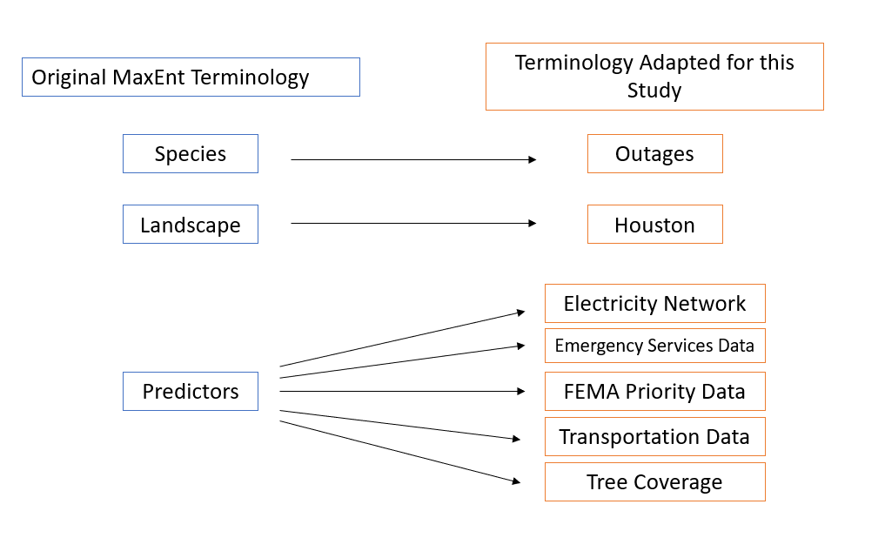
Figure 2.2 MaxEnt terminology and equivalent terms used in this study, providing an analogy between species distribution modeling and power outage modeling using MaxEnt.

2.2.10 Training and Testing Process

To assess the model’s predictive performance, we used K-fold partitioning, cross validation, to split the presence points into 80% for the training set and 20% for the testing set. To test the performance of the training data, we split the presence data into 5 equal groups or “folds”, which we used to create training models by eliminating folds one by one. We chose the cross-validation approach because it addresses the effects of spatial autocorrelation.
To evaluate testing results we used a receiver operating characteristic curve (ROC), which plots true positive and false positive classification rates. True positive is on the Y axis and shows the proportion of presence points that are correctly classified. False positive is plotted on the X axis and shows the proportion of background points that are incorrectly classified as presence. The ROC curve allowed us to determine how well the model distinguished presence points from background points.

2.2.11 Parameter Selection

To estimate the bias of each predictor variable, we used the jackknife test. The jackknife test runs the MaxEnt model, while excluding one variable at a time to highlight how the model performs without that variable (Sinharay, 2010). Then the model is run again, but this time it is removing all variables except one (Sinharay, 2010), which indicates whether the variable has a greater effect when it is included or excluded from the model. We utilized the jackknife test because it provides variable importance measurements, takes variable correlation into account and avoids algorithm dependence (Sinharay, 2010).
We ran the MaxEnt model for only one day, February 18, 2021, because it had the most outage points. Instead of analyzing multiple days, we focused on one because MaxEnt results across different days are not directly comparable. Day-to-day storm outages can stem from varying causes (e.g., shifting weather conditions), and without knowing the exact cause of each outage (e.g., downed power lines), comparisons become challenging. Given these limitations, we selected the day with the most severe weather. The MaxEnt modeling process involved data splitting, incorporating predictor variables, and selecting model parameters.
MaxEnt offers several output formats: raw, cumulative, logistic, and cloglog (Phillips et al., 2006). We used the cloglog output to generate outage likelihood values (0-1) for each census block. This shows which census blocks are more likely to experience an outage. We divided the cloglog output into five bins: extremely high, high, medium, low and extremely low. We separated the data using the equal interval method. Equal interval emphasizes the value of one part relative to the whole. We chose the equal interval method because it emphasizes one census block’s outage likelihood relative to the rest of Houston. This allowed us to visualize which census blocks are most likely to experience an outage, compared to the rest of Houston. We compared infrastructure characteristics of high outage likelihood census blocks to infrastructure characteristics of low outage likelihood census blocks.

2.2.12 Validating with County Level Data

To verify that observed nighttime lights reductions are caused by power outages, rather than other factors (i.e., poor data quality), we compared our nighttime lights outages to county level outages. County level outages were made available through the Environment for Analysis of Geo-Located Information (EAGLE-I). EAGLE-I was developed by the Department of Energy (DoE) to provide county level outage reports at 15-minute increments (Brelsford et al., 2024). EAGLE-I collects and synthesizes outage data from participating electric utilities and state emergency management agencies (Brelsford et al., 2024). To estimate county level outages, EAGLE-I models county customer counts based on population, utility customer totals, and utility service area, using this to scale the utility outage data to the county level (Brelsford et al., 2024).
EAGLE-I reported total county level outages in Houston for every 15 minutes throughout the duration of Winter Storm Uri (Brelsford et al., 2024). We calculated the average EAGLE-I reported outages for February 18, 2021, and compared that average to our total nighttime lights outages. This comparison allowed us to validate our nighttime lights outages against direct utility reports.

2.3 Results and Discussion

2.3.1 MaxEnt Model Performance
Our MaxEnt model achieved an Area Under the Curve (AUC) of 0.758, which represents how well our model differentiates outage points from background points (Figure 2.3). AUC is a common model evaluation metric, where values below 0.5 indicate performance worse than random, 0.5 represents random performance, and 0.7 or higher suggests reliable predictive capability (Li et al., 2017). Previous studies have considered AUC values between 0.7 and 0.9 acceptable for prediction (Dai et al., 2022). With an AUC of 0.758, our model demonstrates good performance, supporting the use of MaxEnt for power outage likelihood studies.
MaxEnt compares locations where outages occurred with the rest of Houston to identify patterns. It assigns a probability score to each location, predicting how likely an

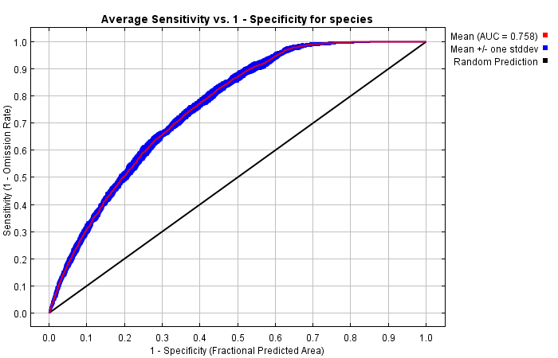
Figure 2.3 MaxEnt AUC results of 0.758. An AUC above 0.7 highlights good model performance and variable prediction.

outage is based on infrastructure characteristics. Mean AUC for training runs utilizing 80% of the data is0.793 and mean AUC of testing runs utilizing 20% of the data is 0.688 (Table 2.2). Four of the testing runs produced an AUC greater than 0.7. A mean AUC close to 0.7 indicates that our model performs relatively well at the validation points.

2.3.2 Spatial Distribution of Outage Likelihood
Each census block is assigned a likelihood score from 0 and 1 indicating a very low to very high outage likelihood. This allows us to identify the most outage-prone areas in Houston. Low-likelihood areas are primarily in Northeast Houston, with another cluster

Table 2.2 AUC for each training and testing runs. Both the training and testing runs achieved AUC values close to or above 0.7. This indicates good model performance.
Replicate Number | Training Data AUC | Test Data AUC
Run 1 | 0.810 | 0.523
Run 2 | 0.793 | 0.685
Run 3 | 0.792 | 0.686
Run 4 | 0.791 | 0.730
Run 5 | 0.794 | 0.705
Run 6 | 0.788 | 0.752
Run 7 | 0.794 | 0.686
Run 8 | 0.793 | 0.676
Run 9 | 0.789 | 0.752
Run 10 | 0.792 | 0.685
near the western city limits (Figure 2.4). In contrast, higher outage likelihood is concentrated is concentrated in Central and South Houston, as well as the far western edge. Census blocks with extremely low outage likelihood are clustered together, while those with high to extremely high likelihood are more dispersed (Figure 2.4).

2.3.4 Variable Contribution to Outage Likelihood
To identify the most important variables, we used the jackknife test. Our MaxEnt model ranked distribution line density, proximity to schools and proximity to hospitals as the top three most important variables (Figure 2.5). Variable contribution analysis produced similar results, with distribution line density (73%), tree coverage (7.1%), and proximity to schools (5.2%) as the top contributors, collectively accounting for 85.3% of the model. In addition to assessing variable importance, we also evaluated variable independence.
We produce partial dependence plots for each MaxEnt variable. MaxEnt produces two sets of plots, one with the variable in question and an average of other variables and one with the variable in question and the full range of other variable values. This allows us to see how each variable is impacted by all other variables. If we see a variable change drastically once the full range of other variables is included, then we know that variable is not dependent and will not be a good predictor of outage likelihood.
Below, we analyze partial dependence plots for distribution line density, tree coverage, proximity to schools, and proximity to hospitals, as these were identified as the most important variables by the jackknife test and variable contribution analysis. Partial dependence plots for remaining variables are available in Appendix A.

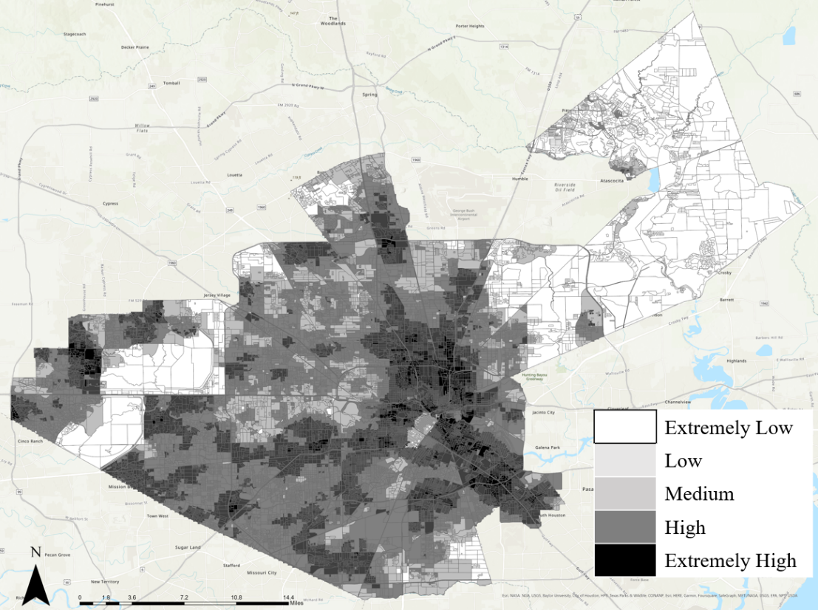
Figure 2.4 Outage likelihood across Houston, highlighting areas with extreme risk in the city center and lower risk in suburban areas.

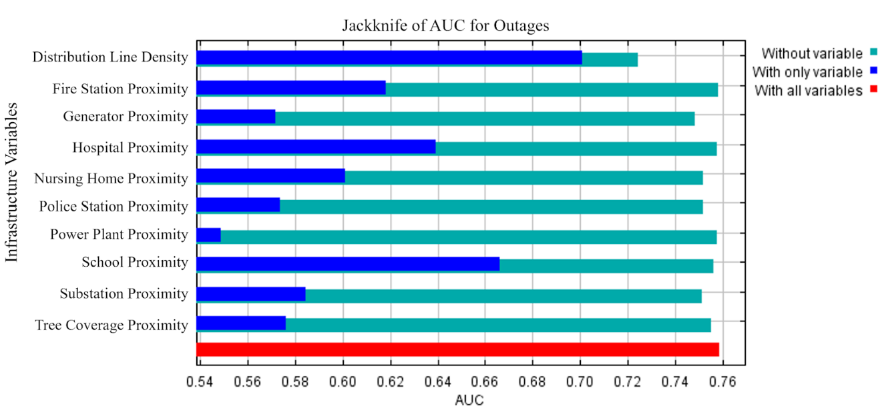
Figure 2.5 Jackknife test for evaluating the relative importance of infrastructure variables on outages.

Response curves for Distribution Line Density highlight the impact of distribution line density on outage likelihood (Figure 2.6). For Distribution Line Density, high outage likelihood occurred between 1,500 and 2,400 miles per sq. mile (Figure 2.6, A). The highest outage likelihood occurred at 2,378 miles per sq mile. At 2,400 miles of distribution line per square mile there is a sharp decrease in outage likelihood. Outage likelihood levels off at 0.1 at 2,532 miles of distribution line density (Figure 2.6, A).
We observe a similar trend between the two response curves. The similarity in trend shows that distribution line density is an independent factor in outage likelihood (Figure 2.6). Independence from other variables and correlation with a wide range of outage likelihood values (0.1-0.8) shows that distribution line density is an influential factor in outage likelihood. Although it is subjectively well known that areas with more distribution lines will experience more outages, we still find scientific value in our results. Census blocks with higher outage likelihood in Houston have an older distribution network, whereas areas with lower outage likelihood had many distribution lines replaced in 2018 (Harris County Flood Control District, 2018). This underscores the critical role of infrastructure age in outage susceptibility.
For tree coverage the highest outage likelihood (0.5) occurred at 0-10% tree canopy (Figure 2.7, A). As tree canopy increases to 30% or greater outage likelihood continually decreases. Typically, increased tree coverage would result in more outages. We observe the opposite effect in Houston, which can be explained through considering other factors. Census blocks with higher tree coverage coincide with areas of newer infrastructure and higher income. Higher income census blocks are more likely to have a

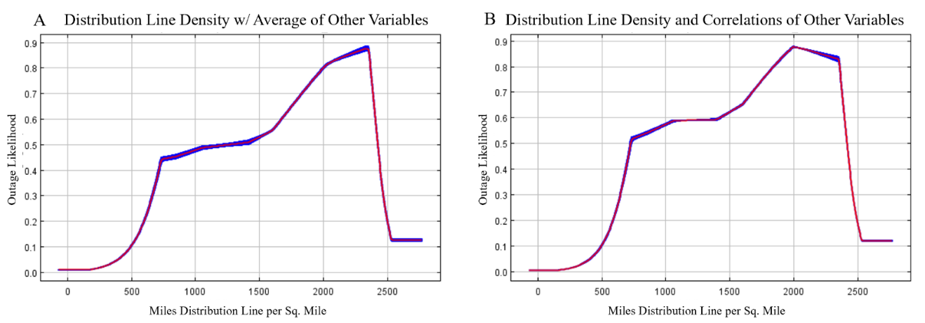
Figure 2.6 Distribution line density response curves highlighting outage likelihood. A) Density with average of other variables. B) Density with correlations of other variables

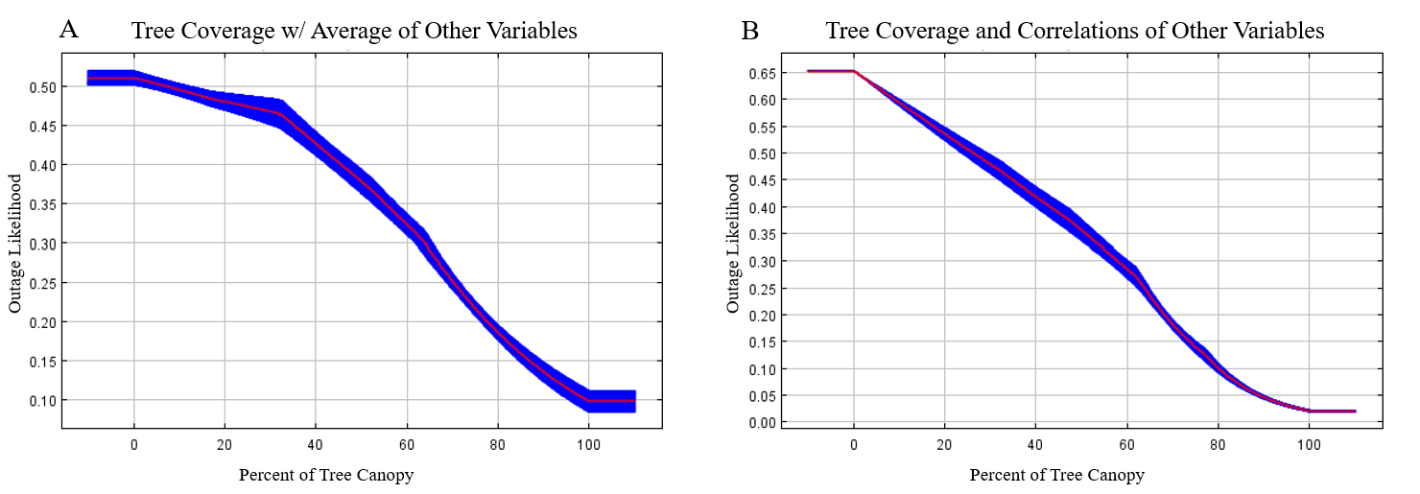
Figure 2.7 Relationship between tree coverage and outage likelihood. Outage likelihood decreases as tree coverage increases.

newer utility network and underground distribution lines that would not be impacted by falling tree limbs. This could be why increased tree coverage is associated with lower outage likelihood. Conversely, census blocks with lower tree coverage are associated with higher population density and lower income (Olin, 2021). Although tree coverage is lower in this area it could have a greater impact because these census blocks are more likely to have an older utility network and above ground distribution lines. While we do not use income and population density as a proxy for tree coverage, we would be remiss not to acknowledge the connection between tree coverage and income (McDonald et al., 2021; Schwarz et al., 2015). To further explore this relationship, we analyze response curves. Both response curves indicate an inverse relationship between tree coverage and outages. The similarity in trend between indicates that tree coverage is not heavily
influenced by other variables, and, therefore, a good indicator of outage likelihood (Figure 2.7).
At close proximity to the nearest school (0-0.5 miles), outage likelihood is relatively high ranging from 0.52-0.54 (Figure 2.8, A). As distance to the nearest school increases from 0.6-3.5 miles there is a continuous decline in outage likelihood. Beyond 3.5 miles from the nearest school outage likelihood levels off and remains low near 0.05.
We observe a slight change in the response curve when correlations with other variables are included. As the distance to the nearest school increases to 0.25 miles outage likelihood sharply increases to 0.75 (Figure 2.8, B). The overall trend between the two response curves is largely similar, which indicates that school proximity is independent of other factors and influential in power outage likelihood.

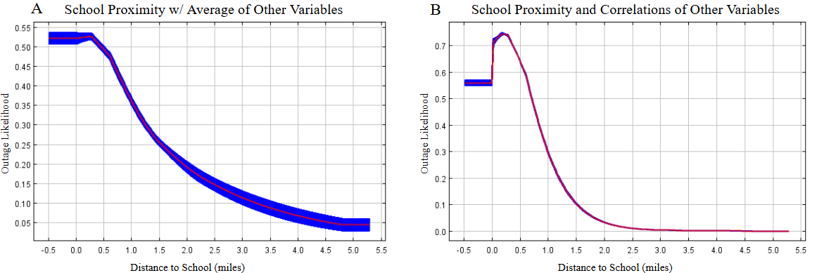
Figure 2.8 As the proximity to schools increases, outage likelihood decreases. A) Outage likelihood plateaus from 0-0.5 miles then decreases as distance to schools increases. B) Outage likelihood initially increases from 0-0.5 miles from schools then sharply declines and plateaus at the 3-mile threshold.

For hospital proximity, the highest outage likelihood occurred 0-2 miles from the nearest hospital (Figure 2.9, A). We observe a steady decrease in outage likelihood as distance to the nearest hospital increases. Outage likelihood plateaus at 0.2, 14 miles from the nearest hospital. When correlations with other variables are included outage likelihood increases to 0.75 when distance to the nearest hospital is between 0-2 miles (Figure 2.9, B). We observe a steeper decline in outage likelihood as distance from the nearest hospital increases from 2-8 miles. Both response curves show the same general trend, which indicates that proximity to hospitals is an independent factor in outage likelihood. However, its overall significance is low, contributing only 1.8% to the MaxEnt model.

2.3.5 Comparison with County Level Outages
On February 18, 2021, we identified 4,879 nighttime lights outages, while EAGLE-I
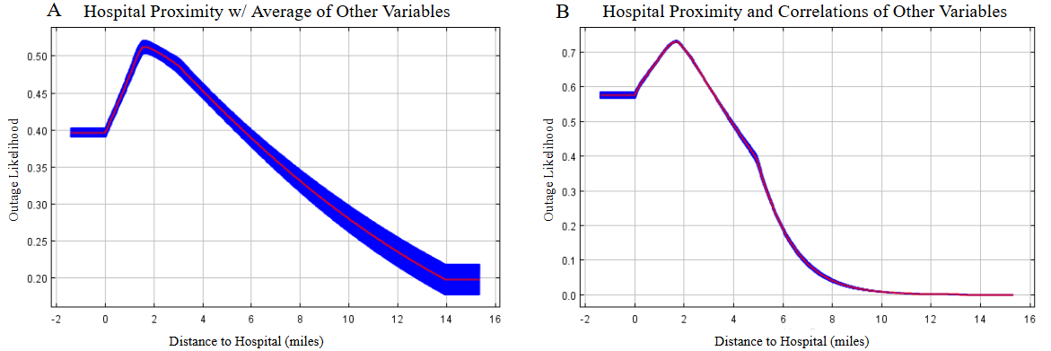
Figure 2.9 Outage likelihood decreases as distance to hospital increases. A) Outage likelihood increases and then decreases steadily. B) Outage likelihood increases from 0-2 miles then sharply declines.

reported an average of 4,072 outages—a 17% difference. This discrepancy may stem from EAGLE-I’s reliance on utility-reported data, which can include outdated outage maps due to inconsistencies in web parsing and a lack of standardization in utility reporting.

2.3.6 Summary
Our model’s AUC of 0.758 demonstrates its effectiveness in differentiating outage points from background points, reinforcing the applicability of MaxEnt in outage likelihood studies. The results indicate that census blocks with high outage likelihood are concentrated in Central and Southern Houston, areas characterized by dense development and historically underserved communities. Conversely, census blocks with low outage likelihood are predominantly located in Northeast Houston, where infrastructure investments and newer power grids may contribute to greater resilience. The model was able to identify where outages are likely as well as the key contributing factors. Distribution line density (73.0%), tree coverage (7.1%), and proximity to schools (5.2%) drive outage likelihood. These findings highlight the link between direct and proxy variables in outage likelihood.
Results of our MaxEnt model quantify outage likelihood, identify the most high risk census blocks across Houston and quantify infrastructure contributions to outage likelihood, which provide insight for targeted interventions to enhance grid resilience. Aging electric grid infrastructure has contributed to diminishing reliability during extreme weather (Klass et al., 2024). Our evaluation of distribution line density, proximity to substations and outage likelihood dataset provide insight into opportunities for grid hardening and newer infrastructure in Central and South Central Houston. Our outage likelihood map provides insight into areas that could benefit from backup generators, additional emergency supplices and dedicated outage response teams during extreme winter storms. Improved understanding of outage likelihood can also inform outage restoration priorities for Houston utilities. Our results can inform infrastructure investments to enhance electric grid resilience and improve emergency preparedness across Houston.

2.4 Conclusion
This study presents a novel outage likelihood dataset, showing how infrastructure characteristics influence outages. Our MaxEnt model (AUC = 0.758) confirms distribution line density, tree coverage, and school proximity as key factors. These findings support using MaxEnt to map outage likelihood and inform disaster preparedness.
Our MaxEnt model confirms the impact of preexisting infrastructure on outage likelihood, identifying key variables and their influence. Higher distribution line density increases outage likelihood, highlighting opportunities for grid hardening in Houston. Surprisingly, greater tree coverage correlates with lower outage likelihood, aligning with higher-income areas and newer infrastructure. These insights underscore the value of our MaxEnt model in outage analysis.
Future research will focus on incorporating additional variables that can impact outage susceptibility directly related to outages, including maintenance schedules, age and demand. This will help create a more comprehensive model, incorporating both direct and proxy variables. Additionally, further refinement of the data used in development of MaxEnt – including improved methods to represent distribution lines and connect generators and power plants to transmission lines and substations- will enhance the accuracy of our outage likelihood model.
This study identifies high-risk infrastructure factors, allowing emergency planners to prioritize upgrades and pre-position resources in vulnerable areas. Our results can inform electricity infrastructure improvments, allocation of emergency resources and outage restoration priorities. Using machine learning, it improves upon previous nighttime lights research to generate a generalizable outage likelihood dataset, supporting disaster planning and outage preparedness.

References
Brelsford, C., Tennille, S., Myers, A., Chinthavali, S., Tanasakul, V., Denman, M., Coletti, M., Grant, J., Lee, S., Allen, K., Johnson, E., Huihui, J., Hamaker, A., Newby, S., Medlen, K., Maguire, D., Stahl, C., Moehl, J., Redmon, D., Sanyal, J., & Bhaduri, D. (2024). A dataset of recorded electricity outages by United States county 2014–2022. Scientific Data 11. https://doi.org/10.1038/s41597-024-03095-5
Coleman, N., Esmalian, A., Lee, C., Gonzales, E., Koirala, P., & Mostafavi, A. (2023). Energy inequality in climate hazards: Empirical evidence of social and spatial disparities in managed and hazard-induced power outages. Sustainable Cities and Society, 92. https://doi.org/10.1016/j.scs.2023.104491
Elith, J., Phillips, S., Hastie, T., Dudík, M., Chee, Y., & Yates, C. (2011) A statistical explanation of MaxEnt for ecologists. Diversity and Distributions, 17(1), 43-57. https://doi.org/10.1111/j.1472-4642.2010.00725.x
FEMA. (2019). Healthcare Facilities and Power outages. Federal Emergency Management Agency.
Fithian, W., & Hastie, T. (2012). Finite-Sample Equivalence in Statistical Models for Presence-Only Data. The annals of applied statistics, 7(4), 1917–1939. https://doi.org/10.1214/13-AOAS667
Harris County Flood Control District. (2018). 2018 Bond Program. Harris County Flood Control District. https://www.hcfcd.org/2018-bond-program
Harshasimha, A. & Bhatt, C. (2023). Flood Vulnerability Mapping Using MaxEnt Machine Learning and Analytical Hierarchy Process (AHP) of Kamrup Metropolitan District, Assam. Environmental Science Proceedings, 25(1) https://doi.org/10.3390/ECWS-7-14301
Hsu, F., Tanejo, J., Carvallo, J., Shah, Z. (2021). Frozen Out in Texas: Blackouts and Inequity. The Rockefeller Foundation. https://www.rockefellerfoundation.org/insights/grantee-impact-story/frozen-out-in-texas-blackouts-and-inequity/
Javidan, N., Kavian, A., Pourghasemi, H., Conoscenti, C., Jafarian, Z., & Rodrigo-Comino, J. (2021). Evaluation of multi-hazard map produced using MaxEnt machine learning technique. Scientific Reports, 11. https://doi.org/10.1038/s41598-021-85862-7
Kabir, E., Guikema, S.., & Quiring, S. (2023). Power outage prediction using data streams: An adaptive ensemble learning approach with a feature- and performance-based weighting mechanism. Risk Analysis, 44, 686-704. https://doi.org/10.1111/risa.14211
Klass, A., Macey, J., Welton, S., & Wiseman, H. (2024). The Key to Electric Grid Reliability: Modernizing Governance. Kleinman Center for Energy Policy. https://kleinmanenergy.upenn.edu/research/publications/the-key-to-electric-grid-reliability-modernizing-governance/
Lee, S., Chinthavali, S., Bhusal, N., Stenvig, N., Tabassum, A., & Kuruganti, T. (2023). Quantifying the power system resilience of the US power grid through weather and power outage data mapping. IEEE Access, 12, 5237-5255. https://doi.org/10.1109/ACCESS.2023.3347129
Levin, N., Kyba, C., Zhang, Q., Miguel, A., Roman, M., Li, X., Portnov, B., Molthan, A., Jechow, A., Miller, S., Wang, Z., Shrestha, R. & Elvidge, C. (2020). Remote sensing of night lights: A review and an outlook for the future. Remote Sensing of Environment, 237. https://doi.org/10.1016/j.rse.2019.111443.
Liu, C., Wang, C., Xu, Y., Liu, C., Li, M., Zhang, D., Liu, G., Li, W., Zhang, Q., & Li, Q. (2022). Correlation Analysis Between Nighttime Light Data and Socioeconomic Factors on Fine Scales. IEEE Geoscience and Remote Sensing Letters, 19, 1–5. https://doi.org/10.1109/LGRS.2022.3166281
Little, R. (2012). Managing the Risk of Aging Infrastructure. International Risk Governance Council.
McDonald, R., Biswas, T., Sachar, C., Housman, I., Boucher, T., Balk, D., Nowak, D., Spotswood, E., Stanley, C., & Leyk, S. (2021) The tree cover and temperature disparity in US urbanized areas: Quantifying the association with income across 5,723 communities. PLOS ONE 16(4). https://doi.org/10.1371/journal.pone.0249715
Merow, C., Smith, M., & Silander, J. (2013). A practical guide to MaxEnt for modeling species’ distributions: what it does, and why inputs and settings matter. Ecography, 36(10), 1058-1069. https://doi.org/10.1111/j.1600-0587.2013.07872.x
Norallahi, M., & Kaboli, S. (2021). Urban flood hazard mapping using machine learning models: GARP, RF, MaxEnt and NB. Natural Hazards 106, 119–137. https://doi.org/10.1007/s11069-020-04453-3
Olin, Andy. (2020). Map of Houston area’s distressed and prosperous ZIP codes shows ongoing and growing inequality. Kinder Institute for Urban Research. https://kinder.rice.edu/urbanedge/map-houston-areas-distressed-and-prosperous-zip-codes-shows-ongoing-and-growing
Parker, L., Bourgoin, C., Martinez Valle, A., Laderach, P. (2019). Vulnerability of the agricultural sector to climate change: The development of a pan- tropical Climate Risk Vulnerability Assessment to inform sub-national decision making. PLOS ONE, 14(3). https://doi.org/10.1371/journal.pone.0213641
Phillips, S., Anderson, R., & Schapire, R. (2006). Maximum entropy modeling of species geographic distributions. Ecological Modelling, 190(3), 231-259. https://doi.org/10.1016/j.ecolmodel.2005.03.026
Román, M., Wang, Z., Sun, Q., Kalb, V., Miller, S.D., Molthan, A., Shultz, L., Bell, J., Stokes, E.K., Pandey, B., Seto, K.C., Hall, D., Oda, T., Wolfe, R.E., Lin, G., Golpayegani, N., Devadiga, S., Davidson, C., Sarkar, S., Praderas, C., & Masuoka, E.J. (2018). NASA’s Black Marble nighttime lights product suite. Remote Sensing of Environment, 210, 113-143. https://doi.org/10.1016/j.rse.2018.03.017
Royle, J., Chandler, R., Yackulic, C., & Nichols, J. (2012). Likelihood analysis of species occurrence probability from presence-only data for modelling species distributions. Methods in Ecology and Evolution, 3, 545-554. https://doi.org/10.1111/j.2041-210X.2011.00182.x
Schwarz, K., Fragkias, M.., Boone, C., Zhou, W., McHale, M., Gove, J., O’Neill-Dunne, J., McFadden, R., Buckley, G., Childers, D., Ogden, L., Pincetl, S., Pataki, D., Whitmer, A., & Cadenasso, M. (2015). Trees Grow on Money: Urban Tree Canopy Cover and Environmental Justice. PLOS ONE 10(4). https://doi.org/10.1371/journal.pone.0122051
Sinharay, S. (2010). Jackknife Methods. In: Peterson P, Baker E, McGaw B (Eds) International Encyclopedia of Education (3rd edn). Elsevier, Oxford, 229–231. https://doi.org/10.1016/B978-0-08- 044894-7.01338-5
Tian, L., Zhe, Z., Wang, Z., Roman, M., Kalb, V., &, Zhao, Y. (2022). Continuous monitoring of nighttime light changes from daily NASA’s Black Marble product suite. (2022). Remote Sensing of Environment, 282. https://doi.org/10.1016/j.rse.2022.113269
Wang, Z., Roman, M., Kahl, V., Miller, S., Zhang, J., & Shrestha, R. (2021). Quantifying uncertainties in nighttime light retrievals from Suomi-NPP and NOAA-20 VIIRS Day/Night Band data. Remote Sensing of Environment, 263. https://doi.org/10.1016/j.rse.2021.112557
Xu, J., Qiang, Y., Cai, H. & Zou, L. (2023). Power outage and environmental justice in Winter Storm Uri: an analytical workflow based on nighttime light remote sensing. International Journal of Digital Earth, 16(1), 2259-2278. https://doi.org/10.1080/17538947.2023.2224087

APPENDIX A: Response Curves for Remaining Variables
Below we discuss infrastructure variables that contributed significantly less to the MaxEnt model or proved to be unreliable indicators of outage likelihood. Response curves for Substation Proximity highlight dependence on other variables. Power outage likelihood increases as distance from the substation increases (Fig 2.10, A). However, the influence of other variables causes power outage likelihood to decrease as distance from the substation increases (Fig 2.10, B). The significant change in trend upon incorporating other variables shows that substation proximity is not independent, and therefore not a reliable predictor of outage likelihood.
We observe similar results for Nursing Home proximity. When correlations with other variables are incorporated, the relationship between outage likelihood and nursing home proximity changes from a direct to inverse relationship. Combining response curves, percent contribution and permutation importance provides a complete view of nursing home proximity. Nursing home proximity has a percent contribution of 2.3% and permutation importance of 8%. The higher permutation importance value shows that nursing home proximity masks the influence of other variables and when nursing home proximity is omitted other variables are more influential. Trend changes show that nursing home proximity is dependent on other variables (Fig 2.11, A and Fig 2.11, B). Nursing home proximity is not an influential variable in power outage likelihood.
We also observe changes in trend for power station proximity and police station proximity. Outage likelihood gradually declines as distance from power stations increases (Fig 2.12, A). When correlations with other variables are considered, outage likelihood

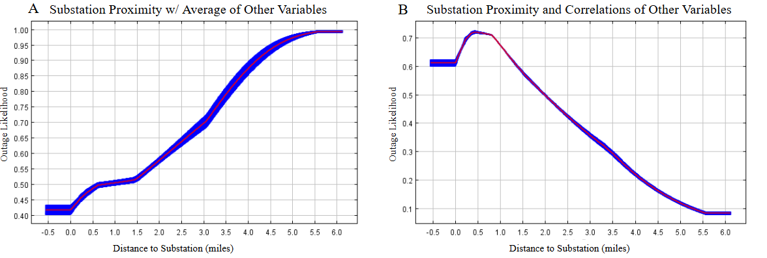
Figure 2.10 Impact of substation proximity on outage likelihood. A) Outage likelihood increases in census blocks further from substations. B) Outage likelihood decreases in census blocks further from substations.

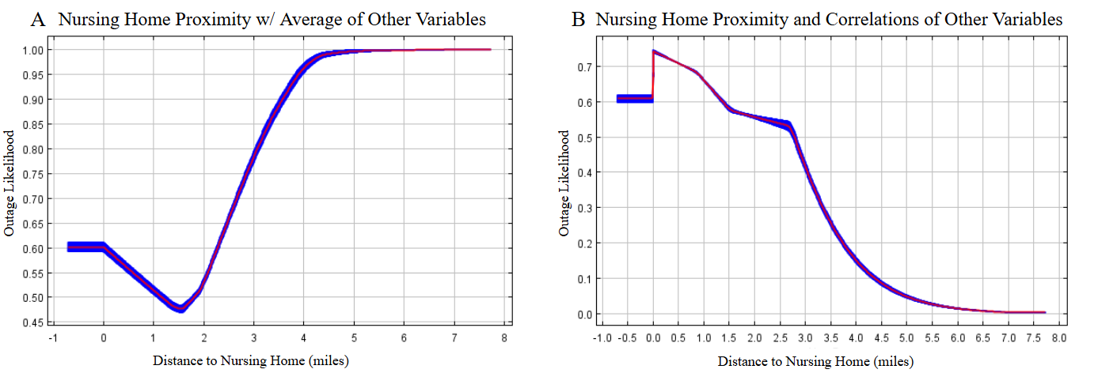
Figure 2.11 Response curves for nursing home proximity show opposite trends. A) Outage likelihood decreases from 0-1.5 miles. Then increases sharply as the distance to the nearest nursing home increases to 5 miles. B) Outage likelihood decreases as distance to the nearest nursing home increases.

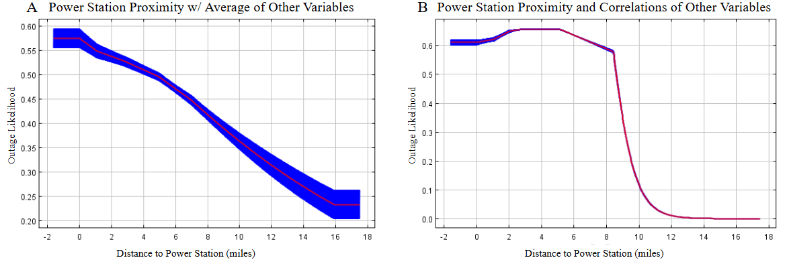
Figure 2.12 Response curves for power station proximity show differing trends. A) Outage likelihood decreases continually as distance to the nearest power station increases. B) Outage likelihood hovers near 0.6 from 0-5 miles from the nearest power station, then sharply decreases.

initially plateaus and then sharply decreases (Fig 2.12, B). The change in trend shows that power station proximity is influenced by other variables. Based on its dependence on other variables we determine that power station proximity is not an influential factor in outage likelihood.
Power outage likelihood increases when the distance to the police station is between 1-5.5 miles. As distance increases past 5.5 miles outage likelihood sharply declines and plateaus to 0.3 at 9 miles (Fig 2.13, A). We observe a different trend when correlations with other variables are considered. Outage likelihood remains relatively stable at 0.65 when the distance to the police station is between 0-3 miles. At 3 miles outage likelihood steadily decreases until plateauing at 0.05 at 9 miles (Fig 2.13, B). There is a significant difference in trend between the two response curves, therefore we determine that police station proximity is dependent on other variables and not highly influential in outage likelihood.
We also find that proximity to fire stations is dependent on other variables. As distance to the nearest fire station increases from 0-2.5 miles we observe a sharp decrease in outage likelihood. At 2.5 miles outage likelihood increases steadily to 0.52 (Fig 2.14, A). Outage likelihood continues to decrease when correlations with other variables are included and decreases to nearly 0 when the distance to the nearest fire station increases from 2.5-4 miles (Fig 2.14, B).
For proximity to electricity generators the highest outage likelihood (0.65) occurred at 3 miles from the nearest generator (Fig 2.15, A). We observe a significant decline in outage likelihood at 10 miles from the nearest generator. From 3-4.5 miles outage likelihood decreases to 0.5. When the distance to the nearest generator reaches 4.5 miles, outage likelihood steadily increases to 0.65, again (Fig 2.15, B). The trend does not dramatically change with the addition of other variable correlations, which shows that generator proximity is not dependent on other variables and is a reliable indicator of outage likelihood.

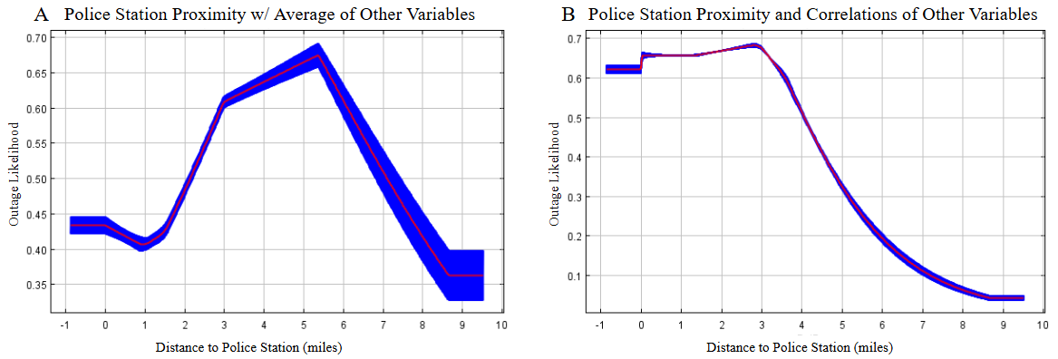
Figure 2.13 Relationship between police station proximity and outage likelihood. A) Outage likelihood increases when the distance to the nearest police station is from 1-5 miles. Then decreases as distance increases up to 8 miles. B) Outage likelihood hovers near 0.63 miles from the police station, then continually decreases.

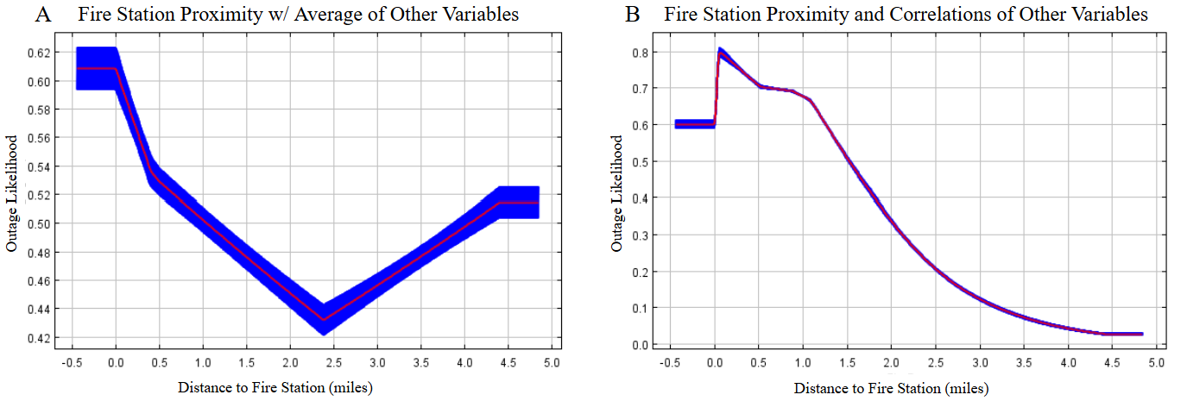
Figure 2.14 Differing trends between the two response curves indicate variable dependence in fire station proximity.

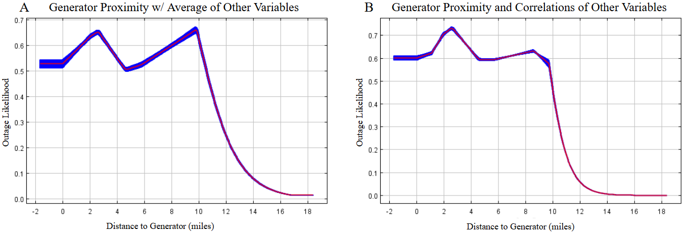
Figure 2.15 Both response curves show a similar relationship between generator proximity and outage likelihood.

Assessing individual level power outage vulnerability through synthetic populations

A version of this chapter was submitted for publication by Alexandra C. Kahl, Joseph V. Tucillo, Katherine N. Luke, Liem T. Tran and Budhendra L. Bhaduri:
Kahl, A.C., Tucillo, J.V., Luke, K.N., Tran, L.T., Bhaduri, B.L. (2024). Assessing Individual Level Power Outage Vulnerability through Synthetic Populations. [Manuscript in review].
Alexandra Kahl performed developed the research question, completed clustering methods and drafted the paper. Joseph Tucillo completed UrbanPop methods and edited the paper. Nikki Luke provided guidance regarding energy justice concepts. Budhendra Bhaduri and Liem Tran contributed to the research question, methodological guidance and manuscript editing.

Abstract

Extreme weather power outages disproportionately impact vulnerable populations, but existing data does not fully capture how socioeconomic factors contribute to infrastructure vulnerability. This study addresses this gap by developing a comprehensive power outage vulnerability dataset for Houston, Texas, integrating synthetic population modeling with census tract-level outage likelihood focusing on Winter Storm Uri.
Using Public Use Microdata from the American Community Survey (2015–2019) and Oak Ridge National Laboratory’s UrbanPop framework, we constructed a synthetic population to evaluate intersecting social vulnerabilities at the individual level. Multiple Correspondence Analysis (MCA) identified vulnerability profiles tied to risk factors such as independent living difficulty (e.g., disability, age >65), economic sensitivity (low income, unemployment), and linguistic isolation. Affinity Propagation clustering and distance-based Redundancy Analysis (dbRDA) revealed eight distinct neighborhood typologies, highlighting spatial disparities in healthcare access and preexisting health conditions that exacerbate outage impacts.
Results demonstrate that individuals facing overlapping vulnerabilities—particularly those in linguistically isolated or economically disadvantaged households—reside in areas with the highest outage likelihood. These findings challenge aggregate-scale analyses by emphasizing intersectionality in vulnerability, where multidimensional risks amplify susceptibility. We propose three policy interventions to address power outage vulnerability: (1) multilingual emergency communication strategies, (2) community resilience hubs for resource distribution, and (3) participatory engagement frameworks to integrate marginalized voices in planning. This novel methodology advances energy equity research by coupling infrastructure resilience with individual-level social vulnerability, offering actionable pathways to mitigate disparities in disaster preparedness and response.
Keywords: synthetic population, outage likelihood, social vulnerability, energy insecurity Notice: This manuscript has been authored by UT-Battelle, LLC, under contract DE-AC05-00OR22725 with the US Department of Energy (DOE). The US government retains and the publisher, by accepting the article for publication, acknowledges that the US government retains a nonexclusive, paid-up, irrevocable, worldwide license to publish or reproduce the published form of this manuscript, or allow others to do so, for US government purposes. DOE will provide public access to these results of federally sponsored research in accordance with the DOE Public Access Plan (https://www.energy.gov/doe-public-access-plan).

3.1 Introduction
From February to March 2021, Texas was devastated by winter storm Uri. A lack of winter-weather safeguards caused a massive shutdown of Texas's energy infrastructure, leaving at least 4 million people without electricity or clean water (Tang, 2021). This led to a widespread public health crisis, resulting in loss of life and serious illness (Grineski et al., 2023). Analysis of the Winter Storm Uri demonstrates that power outages were most severe in low income and minority communities throughout Houston (Castellanos et al., 2023). Previous studies have connected outages with aggregate socioeconomic variables at the county or census tract level (Hsu et al., 2021). However, this creates a gap in accounting for how individuals and households respond to power outages. For emergency managers, precise understanding of individual power outage vulnerability is key to identifying and reaching at risk populations, effective emergency communication and resource allocation.
Previous research has observed the connection between existing energy insecurities and vulnerabilities during power outages. Energy insecurity refers to the inability to adequately meet household energy needs (Hernandez, 2016; Jessel et al., 2019). Poor housing quality, energy inefficient windows and appliances often contribute to high electricity bills in low income households and constitute the physical energy insecurity (Hernandez, 2016; Jessel et al., 2019). Economic energy insecurity refers to the disproportionate financial burden of high energy costs on low income households (Hernandez, 2016). Economic energy insecurity is often linked to financial hardship, unstable employment and low wages (Hernandez, 2016; Prenovost and Youngblood, 2012; Romich et al., 2007). Often coinciding with economic energy insecurity is energy burden.
Energy burden occurs when minority and low income households spend a greater portion of their income on energy bills than the average household. (Lu and Ren, 2023; Siksnelyte-Butkiene, 2021). Low-income and minority populations have the highest instance of energy burden in Houston (Castellanos et al., 2023). High energy burden impacts disaster response, as these household will have less disposable income for emergency preparedness. Households experiencing high energy burden are less able to purchase backup generators, replace spoiled groceries and pay repair costs during and after disasters (Casey et al., 2020).
Power outages can lead to spoiled food, disruptions to work, education and healthcare, which perpetuate the cycle of energy insecurities. Older adults, minority and low income households are least likely to have a three day supply of food, water or own a generator in preparation of power outages (Casey et al., 2020). These households also have less financial resources to evacuate during long term power outages. Existing energy insecurities exacerbated by power outages worsen consequences for medically vulnerable and disadvantaged populations while highlighting issues of energy burden, energy insecurity, and representation in decision-making processes (Dominianni et al., 2018; Dugan et al., 2023; McCauley and Heffron, 2018; Molinari et al., 2017; Sotolongo et al., 2021). This underscores the need for fine spatial understanding and quantifying such vulnerabilities, as well as incorporating them into policy and planning measures (Dugan et al., 2023).
Previous studies have utilized nighttime lights satellite imagery to quantify outages at a fine spatial scale across Houston (Nejat et al., 2022; Shah et al., 2023) and overlaid them with socioeconomic characteristics from the American Community Survey. These studies have connected outages with aggregate demographic variables at the county, census tract or census block level (Hsu et al., 2021). Aggregate population attributes do not always account for the many different types of people living in an area, which is referred to as a cross-level inference problem (Luke and Stamatakis, 2012; Tuccillo et al., 2023). If individual and household attributes are not accurately accounted for then it will be challenging to accurately depict and work to mitigate power outage vulnerability (Luke and Stamatakis, 2012; Tuccillo et al., 2023).
To address this gap, we developed an individually oriented synthetic population for Houston. Utilizing a synthetic population allows us to account for how individuals and households respond to power outages. To account for power outages, we utilized a census tract level outage likelihood dataset developed from nighttime lights images taken during Winter Storm Uri and infrastructure characteristics. We connect individual level characteristics of our synthetic population to outage likelihood. By using individual level data, we produce more granular results, which provide insight into how multiple characteristics impact power outage vulnerability. Our research objectives are as follows; show the connection between synthetic population characteristics and outage likelihood, identify and map the most power outage vulnerable populations throughout Houston, and provide examples of how our vulnerability results can inform planning and policy interventions.

3.2 Methods

3.2.1 Overview

We combined infrastructure and demographic vulnerability to provide a comprehensive understanding of outage vulnerability throughout Houston. We utilized synthetic population development and machine learning methods to evaluate differences in energy outcomes throughout Houston, TX.

3.2.2 Outage Likelihood Dataset
We utilized an outage likelihood dataset that combines nighttime lights data and infrastructure data to produce outage likelihood values at the census block level throughout Houston. This allowed us to account for the role of electricity infrastructure location and density, as well as proximity to critical services (i.e., hospitals, police stations and nursing homes) in outage susceptibility (Kahl et al., 2024).

3.2.3 Synthetic Population Development
We utilized synthetic population modeling instead of traditional population aggregates to develop coupled profiles of individual and neighborhood vulnerability (census tract). We chose to utilize synthetic populations because traditional population aggregates create a cross-level inference problem (Tuccillo et al., 2023). A cross-level inference problem refers to the issue with using area variables, such as median age or percent poverty to make incorrect assumptions about individual capabilities (Tuccillo and Spielman, 2022). Aggregated variables at the census tract or county scale do not account for how individuals and households respond to disasters (Tuccillo and Spielman, 2022).
Utilizing a synthetic population allowed us to accurately capture individual and household demographics. Additionally, synthetic populations allowed us to explore unique areas of vulnerability that are often not available at the aggregated scale, such as disability prevalence or limited mobility (Tuccillo et al., 2023). Our overall process for creating a synthetic population began with querying Public Use Microdata from the American Community Survey 2015 – 2019 5-Year Estimates (Figure 3.1). We utilized data from 2015-2019 due to data collection disruption during COVID-19, impacting more recent ACS data.
We utilized Public Use Microdata (PUMS) from the American Community Survey (ACS) to create a complete, virtual representation of the population of Houston. This enabled us to examine linkages between individual and social vulnerability in the context of energy outages. PUMs data is available for almost every question on the ACS survey, supporting the creation of tailored representations of social vulnerability. PUMs data is available at the household and individual level and is disclosure protection enabled, so individuals cannot be identified (Tuccillo, 2023; Tuccillo and Spielman, 2022).
We generated a synthetic population for Houston using Oak Ridge National Laboratory’s UrbanPop framework (Tuccillo et al., 2023). UrbanPop features utilities for processing and harmonizing ACS PUMS and Summary File (SF) data to produce realistic synthetic

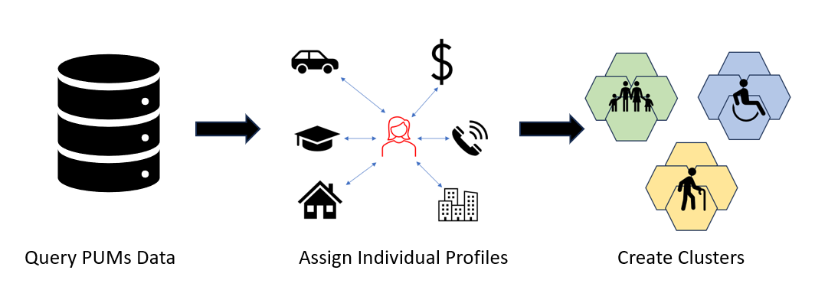
Figure 3.1 Overarching process for creating a synthetic population. We query the data, assign individual profiles based on demographics and create clusters of similar individuals.

representations of the population of each census tract within Houston.

3.2.4 Variable Selection
The synthetic population was attributed by a variety of individual risk factors including housing stock, race, income, unemployment, educational attainment, single caregiver households, mobility, and linguistic isolation. Variables were compiled to evaluate how well an individual can implement alleviation measures in the event of an outage or energy disaster. Social vulnerability indicators were commonly divided into categories or components, such as concentration of vulnerable populations determined by educational attainment, linguistic isolation, and poverty (Zeise and Blumenfeld, 2021). Vulnerable populations also included those with conditions (e.g., chronic illness) that make it difficult to perform basic tasks alone (Waisel, 2013).

3.2.5 Assigning Individual Vulnerability Profiles
We used composites of risk factors described in Table 3.1, to characterize circumstances of individuals in each census tract’s synthetic population that could contribute to
differential energy insecurities. The collective circumstances of individuals in each census tract uncover their propensity for varying social and health impacts of power outages.
Our method of assigning individual vulnerability profiles overcomes a “curse of dimensionality” problem. Rather than describing the circumstances of individuals exhaustively using the variables in Table 3.1, we attempted to represent various broad themes expected to most closely affect individuals in their daily lives (e.g., “Living Arrangement Sensitivity” as a latent condition linked to risk factors like youth dependents, single-parent households, and household crowding). To achieve this, we performed a multiple correspondence analysis (MCA) on the PUMS data linked to the synthetic population for Houston. MCA provides a lower-dimensional representation of our selected risk factors by assigning them numeric categories through optimal scaling, then performing principal components analysis (PCA) (Abdi and Valentin, 2007; Le et al., 2008). This then allowed us to tag individuals in the synthetic population with vulnerability profiles defined by the associated categories in Table 3.1.
We assigned vulnerability profiles to individuals based on their mappings in MCA dimensions 1 and 2 – which account for the bulk of the variance in the model – and how they aligned with the mappings of the selected risk factors (Figure 3.2). For example, the red individual is associated with an “Independent Living Difficulty” profile
Table 3.1 Variables collected from PUMs
Variable | Category
Occupied housing units | Housing units
Population living in group quarters (i.e. nursing home) | Population
Employment status (employed vs. unemployed) | Employment
Employed through the military | Employment
Race | Race
Poverty | Poverty
Married | Household type
Male household w/o spouse | Household type
Female household w/o spauls | Household type
Householders living alone | Household type
Householders living with non-family members | Household type
Detached (single family) home | Units
How many dwelling units (if attached home) | Units
Mobile housing | Units
Boat, RV, van | Units
Number of bedrooms | Bedrooms
Under 19 with disability | Disability
Table 3.1 (continued) Variables collected from PUMS.
Under 19 without disability | Disability
Age 19-64 with disability | Disability
Age 19-64 without disability | Disability
Age 65+ with disability | Disability
Age 65+ without disability | Disability
Veteran and educational attainment | Education
Nonveteran and educational attainment | Education
Age of resident | Age
Number of people and number of vehicles per household | Mobility
Race and associated English proficiency. | Linguistic isolation

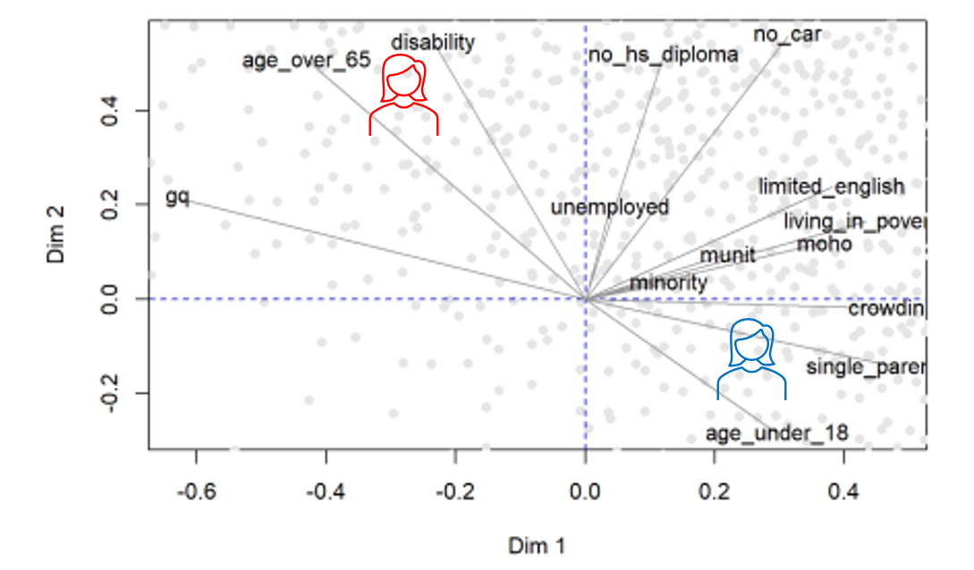
Figure 3.2 Multiple correspondence analysis shows how two different individuals will score amongst many variables.

that describes positional alignment with “Age over 65” and “Disability” variables. Comparatively, the blue individual, more closely aligned with a combination of youth status, crowding, and single-parent households, is tagged with the “Living Arrangement Sensitivity” profile. The profile themes were defined using Affinity Propagation clustering on the cosine similarities among the variable mappings (Frey and Dueck, 2007). We used the outer vector mappings of risk factors within each cluster to bound each theme in the MCA space (e.g., the space covered by the vectors for “Group Quarters” to “Disability” and including “Age over 65” is labeled as “Independent Living Difficulty”).

3.2.6 Generating a Neighborhood Typology of Social Vulnerability
We developed a neighborhood typology for Houston by comparing the synthetic populations within each census tract via the selected risk factors. Through this process, we created an affinity matrix describing similarities among each census tract in terms of their individual makeup (Tuccillo, 2021). Census tracts with similar profiles will cluster closer together.
We utilized Affinity Propagation clustering and distance based Redundancy Analysis (dbRDA) to distinguish neighborhood typologies. Affinity propagation clustering identifies exemplars, which represent many data points, and groups similar data points around them (Simanullang et al., 2020; Zhang et al., 2014). This methods allowed us to quickly identify clusters of similar census tracts. Then we confirmed that our clusters are distinct through distance based Redundancy Analysis (dbRDA). dbRDA evaluates whether our predefined clusters explain patterns in dissimilarity, which allows us to determine whether the clusters reflect meaningful patterns within the neighborhood typologies.
We defined a number of distinct census tract clusters, k, from 2-15 based on distinctness of the cluster labels relative to the affinity matrix. We applied Affinity Propagation clustering at each value of k and evaluated the average silhouette width (ASW) of the resulting labels. We selected k = 8 clusters as the local maximum ASW with the greatest number of labels, providing a sufficiently large number of meaningfully distinct census tract types.
We evaluated the census tract labels in several ways. First, we performed a visual inspection using an iso-map defined by 3 nearest neighbors to verify the distinctness of clusters in a lower dimensional space. Our isomap showed that points in each cluster tend to be located near points in that same cluster and there are clear divisions between each cluster with little mixing. This provided evidence of meaningful labeling in terms of within- and between-cluster attributes.
We also inspected cluster distinctness through distance-based Redundancy Analysis (dbRDA) performed on a distance matrix D computed from our similarity matrix S as D = 1 – (S / max(S)). This performs an ANOVA-like permutation test for distance-based Redundancy Analysis (dbRDA). ANOVA tests are based on the ratio of variation between groups of the population versus variation within each group. This showed how much of the overall variation amongst the population comes from between or within groups. dBRDA uses non-Euclidean dissimilarity indices, like Manhattan or Bray-Curtis distance, to calculate the dissimilarity between clusters. The dbRDA F-test under 999 permutations proved significant (p < 0.001), providing further evidence of meaningful distinction of social characteristics among our cluster labels.
We evaluated whether the cluster labels were meaningful against external validation criteria linked to population health indicators. This allowed us further insight into healthcare access and poor health conditions throughout Houston, which worsens the effects of an outage during winter storms. Specifically, we evaluated the cluster labels against the Centers for Disease Control and Prevention (CDC) PLACES dataset, which provides modeled health outcomes at the census tract level across the United States. Variables included in the CDC PLACES dataset are chronic disease prevalence (i.e., coronary heart disease), prevention practices (i.e., cholesterol screening), health risk behaviors (i.e., smoking), disability and health status (PLACES, 2023). We performed a redundancy analysis (RDA) on our clusters and the CDC PLACES dataset. The RDA yielded a coefficient of variation of 0.68 (permutation F-test p < 0.001), indicating moderately strong correspondence between the cluster labels and health outcomes. Finally, we produced 8 distinct clusters throughout Houston. Each cluster represented the average vulnerability of individuals within each census tract (Figure 3.3).

3.2.7 Interpreting Final UrbanPop Clusters
We described the neighborhood typology relative to five individual vulnerability profiles identified from the PUMS data on the selected risk factors: Independent Living Sensitivity, Built Environment and Economic Sensitivities, Communication and Livelihood Sensitivities, and Living Arrangement Sensitivity, as well as the presence of few selected risk factors. Figure 3.3 provides average profile scores of individuals by vulnerability profile for each neighborhood category. These scores represented the percentage difference in the average prevalence of individual vulnerability profiles within a given neighborhood category relative to their average prevalence for Houston as a whole. For example, the Economic/Housing/Mobility Sensitivities profile in Cluster 3 has a score of 91, indicating an average prevalence of individuals tagged with that profile in those areas that is 91% greater than the average for Harris County. Conversely, a negative score indicates a decreased average prevalence of individuals linked to a vulnerability profile relative to other clusters. In Figure 3.3, we also organized labels by average

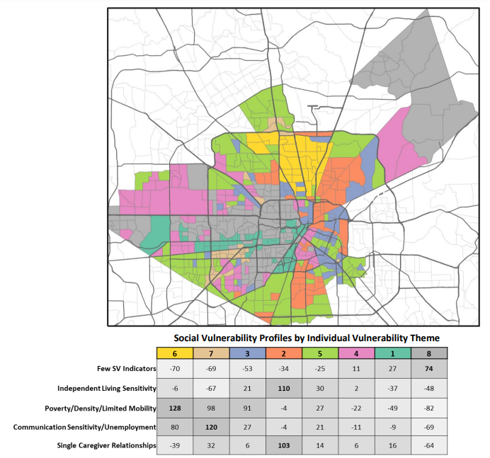
Figure 3.3 Neighborhood typology of social vulnerability for Harris County, TX, defined by five distinct individual vulnerability profiles.

prevalence of the “Few Risk Factors” profile and used bold text to denote the maximum score for an individual vulnerability profile across all neighborhood clusters. We developed qualitative descriptions of each cluster (Figure 3.4) for ease of interpretation.
The neighborhood typology enabled us to understand the heterogeneity of social vulnerability for census tracts comprising Houston. We leveraged this information in combination with our outage likelihood dataset to assess impacts to these areas during Winter Storm Uri. With the completed clustering scheme, we then proceeded to evaluate differences in neighborhood-level outcomes of Winter Storm Uri against census tract level outage likelihood data.

3.2.8 Utilizing Self Organizing Maps to Cluster Population Characteristics and Outage Likelihood
We used Self Organizing Maps (SOMs) to link Houston’s neighborhood typology with outage likelihood data. This allowed us to account for socioeconomic characteristics and infrastructure quality in determining vulnerability. We utilized SOMs because of their ability to preserve relationships between variables, which allowed us to understand how multiple risk factors and outage likelihood interact to impact vulnerability (Guthikanda, 2005).

3.3 Results and Discussion

3.3.1 Comprehensive Vulnerability throughout Houston
Our SOM produced five clusters, each cluster represents the intersection of individual vulnerability profiles and outage likelihood (Figure 3.5). Cluster 1 has the highest weights for Independent Living Sensitivity and Single Caregiver Relationships. Outage
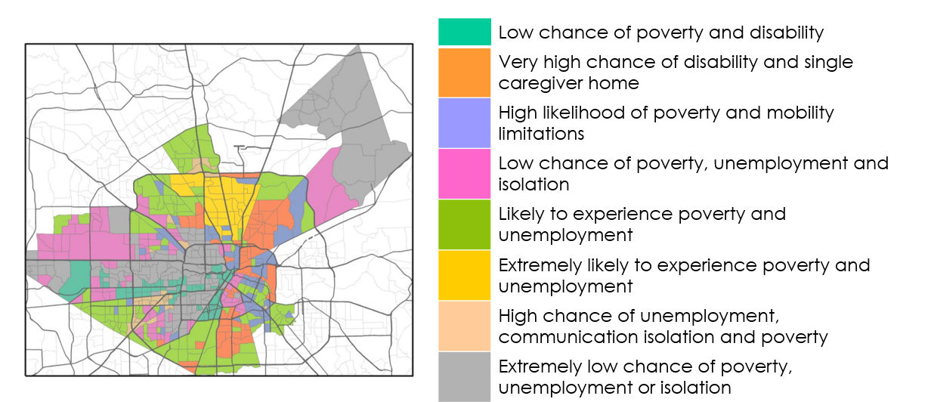
Figure 3.4 Qualitative descriptions of the neighborhood typology labels.

multiple risk factors and outage likelihood interact to impact vulnerability (Guthikanda, 2005).

likelihood is the second highest weight in Cluster 1. Cluster 2 shows high weights for Outage Likelihood and Poverty/Density/Limited Mobility. Outage likelihood is by far the highest weight in Cluster 3. Unemployment/Communication Sensitivity and Poverty/Density/Limited Mobility have the highest weights for Cluster 4, with Outage Likelihood having the second highest weight. Lastly, Cluster 5 shows low weights for all variables. We map each cluster across Houston to better understand the spatial distribution of outage vulnerability (Figure 3.6). Clusters created by our SOMs account for outage likelihood and UrbanPop vulnerability profiles (profiles shown in Figures 3.3 and 3.4). Below we discuss the combined vulnerability of our SOM clusters, considering both outage likelihood and vulnerability profiles. In this context, we define power outage vulnerability as the combination of preexisting high outage likelihood coupled with

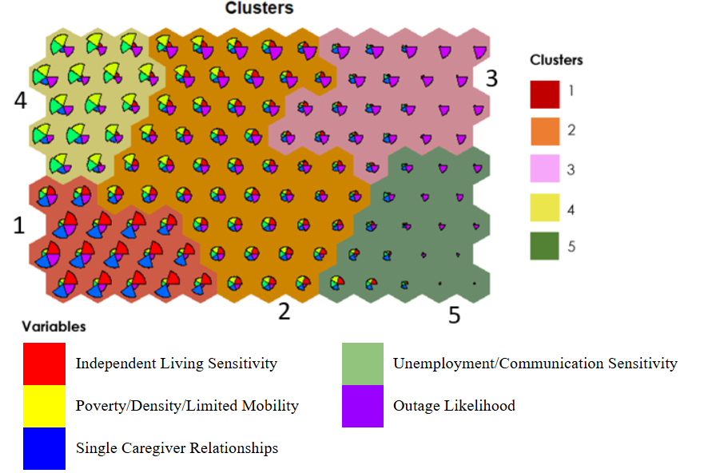
Figure 3.5 Clusters throughout Houston. Background colors are used to distinguish clusters. Each cluster contains pie charts indicating the strength of each variable within the cluster.

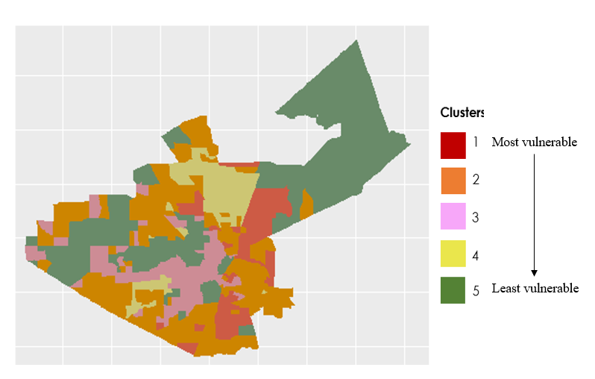
Figure 3.6 Social vulnerability typologies in Harris County, TX, categorized into five distinct profiles. These classifications highlight disparities in outage resilience and response capacity.

socioeconomic disadvantages.
Cluster 1 census tracts have a high outage likelihood (60- 80% likely to experience an outage) and have the highest weights for the Independent Living Sensitivity and Single Caregiver Relationships profiles. These census tracts on average have populations that are +103% and +110% more likely to experience Independent Living Sensitivity and Single Caregiver Relationships. Vulnerability profiles show that Cluster 1’s life expectancy is 72 years, which is low relative to the other neighborhood categories. This could signal the presence in such areas of more homebound individuals, who are less likely to evacuate or access emergency supplies during a prolonged outage event. Outage impacts on individuals in these census tracts are compounded as they will be least likely to access emergency services and more likely to have complex medical needs. Similar vulnerabilities are seen in Clusters 2 and 4.
Census tracts in clusters 2 and 4 have a 60-100% outage likelihood and have high weights for Poverty/Densities/Limited Mobility profile, +27% and +128% average profile score, respectively. Cluster 4 also has a +80% score for Unemployment/Communication Sensitivity. Individuals living in these census tracts are likely to have low-income, low broadband access and greater challenges accessing emergency communications, which makes them less able to respond to power outages and more likely to experience disproportionate impacts.
Census tracts with the highest power outage vulnerability are Clusters 1 and 2, located in Central and South-Central Houston. These areas are majority Hispanic and have some of the lowest median incomes (Olin, 2020). Populations in these census tracts primarily speak English as a second language, which puts them at a disadvantage for accessing emergency communications and resources during a winter storm (Olin, 2020). Low-income populations are less likely to have extra income to evacuate in the case of extreme weather, afford the loss of food medication due to power outages, or be able to afford spikes in electricity prices as many saw in the aftermath of Uri (Peterson et al., 2024). These communities are more vulnerable to negative effects from long-term outages. Our results highlight the stark divide between high and low-income areas in Houston.
Clusters 3 and 5 are the least vulnerable clusters. Individuals in these clusters are -49 and -82% less likely to experience Poverty/Density/Limited Mobility, -37% and -48% less likely to experience Independent Living Sensitivity. The major difference between these two clusters is that census tracts in cluster 3 have an 80-100% outage likelihood, while census tracts in cluster 5 have a 0-20% outage likelihood. Census tracts in cluster 3 are in an area with older electric infrastructure, thus making this cluster more physically vulnerable. However, despite having a high outage likelihood, individuals in cluster 3 are less vulnerable than individuals in clusters 1 and 2, as they experience less socio-economic difficulties.
Cluster 5's lower vulnerability, as indicated by its negative average profile scores across all individual vulnerability categories, highlights its relative resilience compared to other clusters. This resilience is further reflected in the cluster's favorable health and socioeconomic outcomes, such as higher life expectancy, better access to healthcare, and lower prevalence of economic and housing sensitivities, which collectively contribute to its reduced susceptibility to power outage impacts.
Individuals in cluster 5 have the highest average life expectancy of 80 and 81 years relative to other clusters. From the CDC PLACES data, we also observe that cluster 5 has the highest average rates of healthcare and preventative care access. Improved health outcomes in cluster 5 could be linked to their increased average prevalence of individuals tagged with the “Few Risk Factors,” which in turn aligns with lower instances of poverty and unemployment relative to other areas of Houston. The prevalence of individuals with the Economic/Housing/Mobility Sensitivities profile for Cluster 5 is also considerably lower than the remainder of Harris County (49% and 82%, respectively), indicating areas of higher relative affluence. Such areas are less likely to be impacted by economic and health consequences from long-term outages.

3.3.2 Summary of Self Organizing Maps Results
Our Self Organizing Maps identified five distinct clusters across Houston's census tracts, each with unique vulnerability profiles. Clusters 1, 2, and 4 emerge as the most vulnerable areas, characterized by high outage likelihoods (60-100%) coupled with significant socioeconomic challenges. Cluster 1 is particularly sensitive to independent living issues and single caregiver relationships, while Clusters 2 and 4 show high levels of poverty, population density, limited mobility, and communication sensitivity. These areas, primarily located in Central and South-Central Houston, are predominantly Hispanic with lower median incomes, facing compounded risks during power outages due to language barriers, limited resources, and reduced ability to respond effectively (Olin, 2020).
In contrast, Clusters 3 and 5 demonstrate lower vulnerability, with Cluster 5 showing the most resilience across all measured factors. While Cluster 3 still faces high outage likelihood (80-100%), its population experiences fewer socioeconomic difficulties. Cluster 5 stands out with the lowest outage likelihood (0-20%) and negative scores across all vulnerability profiles, indicating better health outcomes, higher life expectancy, and greater access to healthcare and preventative services. This cluster analysis reveals a stark divide in Houston between high and low-income areas, highlighting the uneven distribution of power outage vulnerability and its potential impacts on different communities.

3.3.3 Potential Planning and Policy Interventions Informed by SOM Results
The results of the SOM exercise shed light on which census tracts house outage vulnerable individuals and what characteristics they share. We use individual level data, which allows us to generate more granular results and create more targeted interventions. It is important to consider how our results can inform policy and planning interventions for outage preparedness and response. We identify potential avenues for our results to inform planning and policy interventions.
We review existing best practices that begin with an assessment of community needs and have an aspect of flexibility. It is key to apply community assessment approaches in the early stages of policy and planning development. Engaging local communities allows for an accurate understanding of energy needs and challenges during outages and avoids incorrect assumptions regarding energy demands and aspirations of local communities (Tomei and Gent, 2015; Gan and Miao, 2024). There is a need for flexible and dynamic approaches that change as community needs change (Tomei and Gent, 2015). Our results also show who should be prioritized for outreach and advanced planning, namely that low-income, minority, and linguistically isolated communities are more likely to experience outages during extreme events. As a result of more frequent outages, these communities are more likely to experience negative economic and health impacts. This highlights failures of community engagement and representation in planning, our recommendations aim to redress the disproportionate harm these communities experience from the energy system. We evaluate current policy and propose new policies that alleviate the financial burden and negative health effects of long-term outages, as well as provide vulnerable communities with tools to respond to outages in the future.
Energy policies sometimes fail because they do not consider differences in how people are affected by the energy system or consider how engagement can reach a range of stakeholders (Gan and Miao, 2024). Incorporating feedback from residents in decision making and incorporating low-income communities into the planning process for new energy infrastructure or policies is key for successful policy implementation (MacIntyre et al., 2019). This approach is proactive and takes community input into account for policies and plans that will affect the energy future. When properly implemented, efforts to engage residents in the process of energy planning will ensure that all stakeholders, particularly low-income or minority groups, are engaged throughout the entirety of the policymaking (Gan and Miao, 2024). Failing to account for process can impact a policy through inconsistency, political apathy and stagnation (MacIntyre et al., 2019). Policy inconsistency makes it challenging for policies to persist for long periods of time or through administration changes (MacIntyre et al., 2019). This can create apathy toward the engagement process (MacIntyre et al., 2019). If policies continually fail and are discarded, community stakeholders may consider it unwise to participate in future community engagement processes.
Efforts must also focus on improving energy outcomes to address disparities in the benefits and burdens of the energy system. In Houston, we found that vulnerable communities experienced a significantly greater outage likelihood, therefore experiencing greater energy insecurity. Resources to withstand power outages or investments to harden energy infrastructure can support these communities and correct disparities in energy burden. Taking these pillars into account to improve energy access throughout Houston post-Winter Storm Uri, we offer several recommendations.

3.3.4 Tailor Emergency Communication
We suggest public officials tailor communication efforts to be most effective by identifying vulnerable communities. Not all communities receive information and news in the same way or through the same outlets (Sheppard et al., 2012). Census tracts we identify as high vulnerability also correspond with areas of high linguistic isolation. We must consider how linguistic isolation presents challenges for risk communication.
First, we recommend making existing communication channels more accessible. The Texas Advisory and Notification System (TXANS) is a mobile notification tool that alerts users of severe weather conditions (ERCOT, 2023). During Winter Storm Uri, TXANS notifications were only available in English. This provides a barrier for communities with high linguistic isolation to receive information. As of October 2023, TXANS notifications are available in Spanish (ERCOT, 2023), however, not all alert systems are available in multiple, other languages that are prevalent in Houston such as Vietnamese and Chinese (City of Houston, 2014).
The City of Houston provides emergency alerts through its own system, Alert Houston (City of Houston, 2025). Alert Houston notifies users of severe weather; however, it is only available in English (City of Houston, 2025). We recommend providing Spanish as an option for emergency alert systems to better reach the Hispanic community.
To encourage use of Alert Houston we recommend that city officials forge relationships with community leaders (religious leaders, teachers, business owners) to gain trust within the community. When one community is disproportionately affected by a severe weather event, they can become distrustful of communities that fared better (Spialek et al., 2020). This occurred during Hurricane Harvey when the Hispanic community was disproportionately impacted and studies found social distrust between Houston communities (Spialek et al., 2020). The Hispanic community was also disproportionately impacted by outages during Winter Storm Uri. This demonstrates that it is imperative for city officials to forge relationships with Hispanic community leaders to encourage use of communication systems. Forging relationships with Hispanic community leaders will also encourage development of new communication pathways.
We find support for this recommendation through risk communication literature. Previous studies have found that proper communication before, during and after a severe weather event is key to mitigating health risks (Sheppard et al., 2012). There are three key components to effectively communicating with vulnerable populations: 1) understanding the characteristics of the audience, 2) who delivers the message, 3) adapting to communication changes (Sheppard et al., 2012).
We account for the characteristics of the audience by recommending that communications are provided in Spanish. Although the City of Houston is responsible for emergency alerts, we recommend that city officials connect with community leaders in Central and South Central Houston. These leaders could be teachers, religious leaders or another trusted community official. We recommend that city officials contact these leaders directly to share severe weather reports and information on emergency services. These leaders will then be able to disseminate information to their community. This strategy ensures more inclusive processes by providing access to communication avenues and information.
It is important to acknowledge barriers in effectively tailoring emergency communication. Technological, social and organizational barriers can hinder communication between crisis response (i.e., first responders, public organizations, government agencies) and the public (Fischer et al., 2016). Technological barriers refer to the technology used in emergency communication, while social barriers arise because of differences between individuals and response organizations (Fischer et al., 2016; Manjo and Baker, 2007). Lastly, organizational barriers create communication issues between and within different response organizations (Fischer et al., 2016; Manjo and Baker, 2007). Technological barriers occur because some community members may struggle with adopting new emergency communication technologies (i.e., apps) and social media makes it challenging to verify information (Aedo et al., 2010; Chatfield et al., 2014; Fischer et al., 2016).
Difference between responders and the communities they are trying to reach can lead to social barriers. These differences include language barriers, religious or cultural differences and lack of trust regarding unfamiliar responders (Fischler et al., 2016; Manjo and Baker, 2007; Perry, 2007). This underscores the importance of building relationships between vulnerable communities, government officials and emergency responders prior to winter storms. Organizational barriers to effective communication include insufficient information sharing, inadequate data sources and limited resources (Day et al., 2009; Fischer et al., 2016; Kapucu et al., 2010). Overall, multiple barriers present themselves in creating effective communication for vulnerable populations. Disinformation within social media, distrust regarding emergency responders and limited resources all pose barriers to developing new, effective communication channels.

3.3.5 Establish Community Hubs for Resource Distribution and Shelter
We recommend creating community resilience hubs as an avenue to improve power outage outcomes in vulnerable areas throughout Houston. Establishing these hubs can be done as part of the recovery process. Winter Storm Uri highlighted household challenges in maintaining safe temperatures, storing food, storing medicine and powering medical devices (Castellanos et al., 2023). We recommend establishing community hubs as part of the recovery process to prevent disproportionate health impacts during future disasters (Davies and Sidoti, 2024; McShane and Coffey, 2022). Community hubs refer to large commercial or public buildings (i.e., libraries or public schools) (McShane and Coffey, 2022; Murphy et al., 2025). These buildings are likely to have generators and are more prepared to withstand outages than residential buildings. Community hubs can serve as an area for house residents, store food and medicine at safe temperatures and power medical devices during severe events (McShane and Coffey, 2022; Murphy et al., 2025).
Our results highlight which areas are most likely to experience compound impacts from socioeconomic vulnerability and high outage likelihood during the storm and recovering after. Emergency resources during the storm include food and water assistance, generators, transportation and relocation assistance. Our map highlights areas with increased outage likelihood and populations with fewer resources (Figure 3.6). This information can be used to identify areas most in need of generators, food and water assistance during an outage. This will allow the city officials, first responders and nonprofits to prioritize resource distribution. These results and recommendations allow for targeted, more effective response during a severe event. We recommend comparing our results to maps of locations that can be used for emergency resource distribution (i.e., churches, schools, hospitals) (Singleton et al., 2022). We draw inspiration from the success of community hubs in other cities to establish similar hubs throughout Houston.
City officials should plan and ensure that distribution locations have supplies available prior to the storm. We find the basis for this recommendation in New Orlean’s response to Hurricane Ida. Supply distribution locations were available in vulnerable areas; however, they did not open until one week after the storm (Singleton et al.,2022). This left residents without supplies during crucial days (Singleton et al., 2022). We can learn from this by encouraging Houston officials to create a plan to ensure that churches and schools are stocked with supplies prior to the storm. We recommend using the communication tools discussed in section 3.3.4 to ensure that vulnerable communities are aware of available resources. New Orleans has also developed successful community hubs. The Together New Orleans Community Lighthouse project has established 10 solar powered community hubs. Together New Orleans has retrofitted churches, health centers and community centers with solar panels so that they can provide safe indoor temperatures, charging stations, lights and food during emergencies (Chavez, 2023).
Baltimore has an established Community Resiliency Hub program with the goal of increasing community capacity to respond to natural hazards (Baltimore Office of Sustainability, 2024). In Baltimore nonprofits, community organizations and the city government have come together to fund and operate the hubs (Baltimore Office of Sustainability, 2024). There are 12 community hubs throughout Baltimore, which are strategically placed in the most vulnerable neighborhoods (Baltimore Office of Sustainability, 2024). Baltimore’s community hubs have distributed food and water, provided power during outages and provided safe indoor temperatures during heat waves (Brey, 2021).
Baltimore’s and New Orlean’s success in deploying community hubs can be attributed to the wide range of organizations involved. In both instances government representatives, non-profits and city government worked together to create, fund and deploy the hubs. Through establishing a partnership with community and religious organizations the City of Houston can also establish community hubs.
Establishing a community hub requires coordination and financial resources, as there are multiple barriers that can limit hub implementation. A major barrier to the success of community hubs and their ability to reach the intended community are whether they are place based rather than place focused (Hart and Connolly, 2021; McShane and Coffey, 2022) . Place based approaches respond to the complex and interrelated issues of specific geographic areas and use shared stewardship and accountability to engage with the community (Dart, 2018; McShane and Coffey, 2022). In this case a community hub would be done with rather than done to the community that it serves (Ball et al., 2012). This creates a barrier as top down approaches to establishing a community hub are often faster and more efficient, but lack the nuance of place based approaches.
Another major barrier is assigning appropriate ownership and management, particularly financial responsibilities, of the hub. The cost to build or retrofit and maintain a community hub can be prohibitive. It can be challenging to determine what entity is in charge of financially supporting the endeavor, whether that is the city government or non profit organizations. Baltimore found success in establishing partnerships between the city government and nonprofits, but this can be challenging if communication channels are not previously established (Fischer et al., 2016).

3.3.6 Seek Out Proactive Community Engagement
Communities that are socially or economically disadvantaged often lack access to energy system services, are excluded from participation in decision making and experience a disproportionate share of power outages (Tapio et al., 2024; Tarekegne et al., 2021). Incorporating these communities into the decision-making process is key to mitigating the negative impacts of power outages (Rickenbacker et al., 2019) and to the success of new energy planning and policy measures. To engage power outage vulnerable populations identified in Central and South Central Houston (clusters 1, 2 and 4) we recommend utilizing community engagement techniques.
Traditional outreach relies on members of the community to affirmatively participate in outreach activities (Harkness, 2013). Those who lack access to information, face limited mobility or linguistic barriers may be unaware or unable to participate (Harkness, 2013). We observe many individuals with these characteristics living in census tracts with high outage likelihood. Increased social and physical vulnerability makes it all the more important to engage these individuals in the decision-making process.
Community engagement is a strategic process of working collaboratively with groups connected by geography, interests, or affiliations to address issues affecting their well-being (Silberberg et al., 2011). It is guided by principles of inclusiveness, empowerment, and trust-building, using diverse tools and strategies to foster sustainable change (Silberberg et al., 2011). Combining science from various disciplines and the art of adapting methods to fit specific communities, it involves partnerships and coalitions to mobilize resources, influence systems, and improve policies and practices (Silberberg et al., 2011). Though complex and resource-intensive, effective community engagement is essential for addressing challenges and making informed decisions that benefit communities (Silberberg et al., 2011). Effective community engagement methods are cyclical, incorporating feedback in all phases of planning and decision making. The first step to community engagement is to identify key stakeholders and their interests.
In this case, stakeholders are any group of people who may be affected by severe winter storms and ensuing power outages. Key stakeholders include neighborhood community groups, individual energy consumers (i.e., individual households), particularly poorer communities, communities of color and those with chronic health conditions (Tapio et al., 2024; Cranmer et al., 2023; Gonzalez et al., 2023). Many of these key stakeholders are represented in clusters 1, 2 and 4. Identifying stakeholders can help city officials identify partners that can act as bridges to the community, such as teachers, religious or business leaders (Harkness, 2013). Establishing these partnerships will be key for improving emergency communication, as stated in section 3.3.1 and establishing community hubs. Stakeholders and their interests must be continually evaluated throughout the engagement process.
Identifying interests is often more challenging than identifying stakeholders. A stakeholder’s wants are the tip of the iceberg, and the interests are miles underneath the surface. Interests related to winter storm vulnerability can be economic, environmental or health and safety related. Stakeholder interests can be addressed through a variety of community engagement strategies.
Community engagement tools used largely depend on the level at which facilitators want to engage the community (Tamarack Institute, 2017). Low-level engagement serves to inform the community of outside decisions, mid-level engagement encourages the community to collaborate with experts and high-level engagement empowers the community to make their own decisions (MFSH, 2008). Previous studies have used public meetings, surveys, focus groups and interviews to reach vulnerable populations.
We recommend utilizing public meetings, surveys and focus groups to develop new communication pathways and forge development of community hubs, both of which will enhance resilience during power outages (Harkness, 2013; Levite et al., 2023). Each of these strategies will provide insight into struggles individuals face in Central and South-Central Houston in accessing emergency communications and allow them to have input in locations for potential community hubs. Enacting community engagement strategies will enhance the likelihood of success for new energy resilience planning and policy measures and ensure that power outage mitigation measures are accessible for those who need them (Levite et al., 2023). Since Winter Storm Uri Houston has utilized surveys to gauge recovery needs of impacted populations (Project Recovery, 2021).
Implementing effective community engagement strategies often requires professional help, experience and nuance, as there are many challenges (Ramsbottom et al., 2018). Lack of community trust toward the governing body conducting the engagement is a major barrier to success (Gamboa-Maldonado et al., 2012; Ramsbottom et al., 2018). Lack of trust often stems from past injustices and continuing inequities, which could impact how minority communities in clusters 1, 2 and 4 are willing trust community engagement processes (Gamboa-Maldonado et al., 2012; Ramsbottom et al., 2018). Additional, barriers include lack of resources and funding. Engagement techniques can become a burden on the community if they are not paired with an increase in resources (Allen, 2006; Gupta, 2011; Ramsbottom et al., 2018).

3.3.7 Summary of Policy and Planning Recommendations
Our work emphasizes the importance of targeted strategies to mitigate power outage vulnerability in Houston during severe weather events. Key recommendations include: (1) tailoring emergency communication by offering alerts in multiple languages (specifically Spanish, Vietnamese, and Chinese), and building trust through partnerships with community leaders to disseminate information effectively; (2) establishing community resilience hubs in accessible locations to provide essential resources such as food, medicine storage, and power for medical devices during outages, drawing inspiration from successful models in Baltimore and New Orleans; and (3) proactively engaging vulnerable populations in the decision-making process through public meetings, surveys, and focus groups to understand their specific needs and ensure that energy resilience planning and policies are inclusive and effective. The overarching goal is to mitigate the disproportionate impacts of power outages on socially and economically disadvantaged communities by improving communication, resource access, and community involvement in resilience efforts.

3.4 Conclusion
This study highlights the intersectionality of power outage vulnerability by connecting multiple individually oriented synthetic population characteristics and outage likelihood. The connection between disadvantaged socioeconomic characteristics and high-power outage vulnerability is proven through our self-organizing maps results. Our clustering scheme produced maps of comprehensive power outage vulnerability throughout Houston by combining infrastructure-based outage likelihood and socio-economic characteristics.
Census tracts with high outage likelihoods (60-100%) are clustered with individuals who are more likely to experience poverty, limited mobility, unemployment and communication sensitivities, compared to the rest of Houston. We also observe a high level of linguistic isolation in these census tracts. Individuals in these census tracts are more likely to be homebound, experience low broadband access and face challenges accessing emergency communications, resources or evacuating. Social vulnerability coupled with living in an outage prone area places these individuals at risk for disproportionate health and economic impacts during power outage events.
Our results can be used to inform planning and policy interventions. Existing energy policies sometimes fail because they do not account for differences in how people are affected by power outages. Our results utilize individual level data which allows us to enhance existing policies by providing more targeted interventions. This improvement will enable improved emergency communication and community engagement with vulnerable communities, thus mitigating the impact of extreme winter weather and associated power outages.
Future research will focus on extending our methods to additional cities and rural areas. This expansion will help determine which individually oriented socioeconomic characteristics are associated with high outage likelihood across multiple geographies and which are place specific. Additionally, our current work focuses on outage occurrence, incorporating restoration time will provide insight into ongoing outage impacts and socio-economic characteristics.
This work advances the understanding of power outage vulnerability by addressing how individuals and households respond to power outages. Previous work utilized aggregate variables, which do not account for all types of individual characteristics. Our work highlights the intersectionality of power outage vulnerability by grouping multiple socioeconomic characteristics with outage likelihood.

References
Aedo, I., Díaz, P., Carroll, J., Convertino, G. & Rosson, M. (2010). End-user oriented strategies to facilitate multi-organizational adoption of emergency management information systems. Information Processing & Management 46 (1), 11–21. https://doi.org/10.1016/j.ipm.2009.07.002Get rights and content
Allen, K. (2006). Community-based disaster preparedness and climate adaptation: local capacity building in the Philippines. Disasters, 30(1), 81–101. https://doi.org/10.1111/j.1467-9523.2006.00308.x
Ball, S., Maguire, M., & Braun, A. (2011). How Schools Do Policy: : Policy Enactments in Secondary Schools (1st ed.). Routledge. https://doi.org/10.4324/9780203153185
Baltimore Office of Sustainability. (2024). The Baltimore City Community Hub Resiliency Program. https://www.baltimoresustainability.org/baltimore-resiliency-hub-program/
Bouzarovski, S. (2018). Understanding Energy Poverty, Vulnerability and Justice. In: Energy Poverty. Palgrave Macmillan, Cham. https://doi.org/10.1007/978-3-319-69299-9_2
Brey, J. (2021). Resiliency hubs help Baltimore plan for climate emergency in vulnerable neighborhoods, Next City, Philadelphia, PA.
Castellanos, S., Potts, J., Tiedmann, H., Alverson, S., Glazer, Y., Robinson, A., Russo, S., Harmon, D., Kenopurum, D., Kenopurum, B., Weisz, M., Acuna, F., Stephens, K., Faust, K. and Webber, M. (2023). A synthesis and review of exacerbated inequities from February 2021 winter storm (Uri) in Texas and the risks moving forward. Progress in Energy, 5(1). https://doi.org/10.1088/2516-1083/aca9b4
Casey, J., Fukurai, M., Hernandez, D., Balsari, S. & Kiang, M. (2020). Power Outages and Community Health: a Narrative Review. Environmental Disasters, 7, 271-383. https://doi.org/10.1007/s40572-020-00295-0
Chatfield, A., & Brajawidagda, U. (2013). Twitter early tsunami warning system: A case study in Indonesia's natural disaster management. Proceedings of the 46th Hawaii International Conference on System Sciences (HICSS), 2050–2060. https://doi.org/ 10.1109/HICSS.2013.579
Chavez, R. (2023, January 9). Louisiana is building electricity hubs to power communities after a disaster. Here’s how they work. Public Broadcasting Service. https://www.pbs.org/newshour/nation/louisiana-is-building-electricity-hubs-to-power-communities-after-a-disaster-heres-how-they-work
City of Houston. (2025). Alert Houston. Emergency Operations Center. https://houstonemergency.org/home-5/
City of Houston. (2014). Top 25 Languages Spoken in Houston. https://www.houstontx.gov/ispeakhouston/top25HoustonLanguages2014.pdf
Cranmer, Z., Steinfeld, L., Miranda, J., & Stohler, T. (2023). Energy distributive injustices: Assessing the demographics of communities surrounding renewable and fossil fuel power plants in the United States. Energy Research & Social Science, 100. https://doi.org/10.1016/j.erss.2023.103050
Dart, J. (2018). Place-based evaluation framework: a guide for evaluation of place-based approaches in Australia. Department of Social Services (Australia). https://apo.org.au/node/246351
Davies, J., & Sidoti, F. (2024). The role of community service organizations in disaster resilience: The Hub project. Australian Journal of Emergency Management, 39(3), 57-61.
Day, J. M., Junglas, I., & Leiser, I. (2009). Information flow impediments in disaster relief supply chains. Journal of the Association for Information Systems 10 (8), 637–660. https://aisel.aisnet.org/jais/vol10/iss8/1/
Dominianni, C., Ahmed, M., Johnson, S., Blum, M., Ito, K., Lane, K. (2018). Power outage preparedness and concern among vulnerable New York City residents. Journal of Urban Health, 95(5), 716–726. https://doi.org/10.1007/s11524-018-0296-9
Dugan, J., Byles, D. & Mohaghegi, S. (2023). Social vulnerability to long-duration power outages. International Journal of Disaster Risk Reduction, 85. https://doi.org/10.1016/j.ijdrr.2022.103501
ERCOT. (May 31, 2023). ERCOT Launches Grid Notification Tool [Press Release]. https://www.ercot.com/news/release/2023-05-31-ercot-launches-grid
ERCOT. (Oct 30, 2023). Texas Advisory and Notification System (TXANS) Now Available in Spanish Language [Press Release]. https://www.ercot.com/news/release/2023-10-30-texas-advisory-and
Fischer, D., Possega, O., & Fischbach, K. (2016). Communication Barriers in Crisis Management: A Literature Review. European Conference on Information Systems. https://aisel.aisnet.org/ecis2016_rp/168
Frey, B., & Dueck, D. (2007). Clustering by Passing Messages Between Data Points. Science, 315(5814), 972-976. https://doi.org/10.1126/science.1136800
Gamboa-Maldonado, T., Marshak, H., Sinclair, R., Montogomery, S., Dyjack, D. (2012). Building capacity for community disaster preparedness: a call for collaboration between public environmental health and emergency preparedness and response programs. Journal of Environmental Health, 75(2), 24-29.
Gan, H. & Miao, L. (2024). Politics and governance in the era of urban energy transition: Shaping public policies and empowering sustainable urban futures. Sustainable Cities and Society, 106. https://doi.org/10.1016/j.scs.2024.105373
Gonzalez, D., Nardone, A., Nguyen, A., Morello-Frosch, R., & Casey, J. (2023). Historic redlining and the siting of oil and gas wells in the United States. Journal of Exposure Science & Environmental Epidemiology, 33, 76-83, https://doi.org/10.1038/s41370-022-00434-9
Grineski, S., Collins, T., Chakraborty, J., Goodwin, E., Aun, J., & Ramos, K. (2023). Social Disparities in the Duration of Power and Piped Water Outages in Texas After Winter Storm Uri. American Journal of Public Health, 113(1), 30-34. https://doi.org/10.2105/AJPH.2022.307110
Gupta, R. (2011). Enhancing community partnerships during a public health emergency: the school-located vaccination clinics model in Kanawha County, WV during the 2009 influenza A (H1N1) pandemic. The West Virginia medical journal, 107(6), 28–34. https://www.thefreelibrary.com/Enhancing+community+partnerships+during+a+public+health+emergency%3a...-a0275852538
Guthikonda, S. (2005). Kohonen Self-Organizing Maps. Wittenberg University.
Harkness, A. (2013). Engaging Vulnerable populations in health impact assessment. Georgia Institute of Technology.
Hart, A., & Connolly, J. (2021). Commonwealth place-based policies for addressing geographically concentrated disadvantage: a typology and critical analysis. Australian Journal of Public Administration, 81(1). http://dx.doi.org/10.1111/1467-8500.12498.
Hernandez, D. (2016). Understanding ‘energy insecurity’ and why it matters to health. Social Science & Medicine, 167, 1-10. https://doi.org/10.1016/j.socscimed.2016.08.029
Hsu, F., Tanejo, J., Carvallo, J., Shah, Z. (2021). Frozen Out in Texas: Blackouts and Inequity. The Rockefeller Foundation. https://www.rockefellerfoundation.org/insights/grantee-impact-story/frozen-out-in-texas-blackouts-and-inequity/
Jessel, S., Sawyer, S., & Hernandez, D. (2019). Energy, Poverty, and Health in Climate Change: A Comprehensive Review of an Emerging Literature. Frontiers in Public Health, 7. https://doi.org/10.3389/fpubh.2019.00357
Kahl, A.C., Tran, L.T., Bhaduri, B.L. (2024). Addressing Power Outage Susceptibility with MaxEnt Model [Manuscript in review].
Kapucu, N., Arslan, T., Collins, M. (2010). Examining intergovernmental and interorganizational response to catastrophic disasters: Toward a network-centered approach. Administration & Society 42 (2), 222–247. https://doi.org/10.1177/0095399710362517
Lu, S., & Ren, J. (2023). A comprehensive on energy poverty: definition, measurement, socioeconomic impact and its alleviation for carbon neutrality. Environment, Development and Sustainability https://doi.org/10.1007/s10668-023-04143-7
Luke, D., & Stamatakis, K. (2012). Systems Science Methods in Public Health: Dynamics, Networks, and Agents. Annual Review of Public Health, 33, 357-376.https://doi.org/10.1146/annurev-publhealth-031210-101222
MacIntyre, E., Khanna, S., Darychuk, A., Copes, R. & Schwartz, B. (2019). Evidence synthesis- Evaluating risk communication during extreme weather and climate change: a scoping review. Health Promotion and Chronic Disease Prevention in Canada, 39(4), 142-156. https://doi.org/10.24095/hpcdp.39.4.06
Manoj, B., & Baker, A. (2007). Communication challenges in emergency response. Communications of the ACM 50 (3), 51–53. https://dl.acm.org/doi/fullHtml/10.1145/1226736.1226765
Manitoba Family Services and Housing (MFSH) (2008) Community Engagement Framework May 2008 [Online]. Available at http://www.gov.mb.ca/fs/ce/pubs/community_engagement_framework_May08.pdf
McCauley, D., & Heffron, R. (2018). Just transition: Integrating climate, energy and environmental justice. Energy Policy,119, 1-7 https://doi.org/10.1016/j.enpol.2018.04.014
McShane, I., & Coffey, B. (2022). Rethinking community hubs: community facilities as critical infrastructure. Current Opinion in Environmental Sustainability, 54. https://doi.org/10.1016/j.cosust.2022.101149
Molinari, N., Chen, B., Krishna, N. & Morris, T. (2017). Who’s at risk when the power goes out? The at-home electricity-dependent population in the United States, 2012. Journal of Public Health Management and Practice, 23 (2), 152–159, https://doi.org/10.1097/PHH.0000000000000345.
Murphy, P., Kinkhabwala, Y., Kwoka, B., Nunez, Y., Dillon, A., Amezcua-Smith, A., & Krieger, E. (2025). Modeling and design of solar + storage-powered community resilience hubs across California. Risk Analysis, 45(1). https://doi.org/10.1111/risa.14341o
Nejat, A., Solitare, L., Pettitt, E. & Mohsenian-Rad, H. (2022). Equitable community resilience: The Case of Winter Storm Uri in Texas. International Journal of Disaster Risk Reduction, 77 https://doi.org/10.1016/j.ijdrr.2022.103070
Olin, A. (2020). Map of Houston area's distressed and prosperous ZIP codes shows ongoing and growing inequality. Rice Kinder Institute for Urban Research.
Perry, M. (2007). Natural disaster management planning: A study of logistics managers responding to the tsunami. International Journal of Physical Distribution & Logistics Management 37 (5), 409–433. https://doi.org/10.1108/09600030710758455
Peterson, S., Clark, S., & Shelly, M. (2024). Assessing the household burdens of infrastructure disruptions in Texas during Winter Storm Uri. Natural Hazards, 120, 7065-7104.https://doi.org/10.1007/s11069-024-06480-w
PLACES. Centers for Disease Control and Prevention. Accessed [2023]. https://www.cdc.gov/places
Prenovost, M., & Youngblood, D. (2012). Traps, Pitfalls, and Unexpected Cliffs on the Path Out of Poverty. Poverty & Public Policy, 2(2), 53-82. https://doi.org/10.2202/1944-2858.1053
Project Recovery. (2021). Winter Storm Uri Programs and Resources. HarrisRecovery. https://www.harrisrecovery.org/Winter-Storm-Uri
Ramsbottom, A., O’Brien, E., Ciotti, L., & Takas, J. (2018). Enablers and Barriers to Community Engagement in Public Health Emergency Preparedness: A literature review. Journal of Community Health, 43, 412-420. https://doi.org/10.1007/s10900-017-0415-7
Rickenbacker, H., Brown, F., & Bilec, M. (2019). Creating environmental consciousness in underserved communities. Sustainable Cities and Society, 47. https://doi.org/10.1016/j.scs.2019.101473Get rights and content
Romich, J., Simmelink, J., & Holt, S. (2007). When Working Harder Does Not Pay: Low-Income Working Families, Tax Liabilities, and Benefit Reductions. Families in Society, 88(3), 418-426. https://doi.org/10.1606/1044-3894.3651
Shah, Z., Carvallo, J., Hsu, F., & Taneja, J. (2023). The inequitable distribution of power interruptions during the 2021 Texas winter storm Uri. Environmental Research, Infrastructure and Sustainability, 3(2). https://doi.org/10.1088/2634-4505/acd4e7
Sheppard, B., Janoske, M. & Liu, B. (2012). Understanding risk communication theory: a guide for emergency managers and communicators. Human Factors/Behavioral Sciences Division, Science and Technology Directorate, U.S. Department of Homeland Security.
Siksnelyte-Butkiene, I., Streimikiene, D., Lekavicius, V., & Balezentis, T. (2021). Energy poverty indicators: A systematic literature review and comprehensive analysis of integrity. Sustainable Cities and Society, 67.https://doi.org/10.1016/j.scs.2021.102756
Silberberg, M., Cook, J., Drescher, C., McCloskey, D., Weaver, S., & Zieghan, L. (2011). Principles of community engagement. NIH publication.
Simanullang, J., Zarlis, M., & Zamzami, E. (2020). Performance Improvement of Clustering Affinity Propagation Method using Principal Component Analysis. Journal of Physics. Conference Series, 1566(1). https://doi.org/10.1088/1742-6596/1566/1/012126
Singleton, C., Chaparro, M., O'Malley, K., Fuster, M., & Rose, D. (2022). Emergency food distribution efforts in New Orleans, LA after Hurricane Ida. Frontiers in Public Health, 10. https://doi.org/10.3389/fpubh.2022.968552
Sotolongo, M., Kuhl, L., & Baker, S. (2021). Using environmental justice to inform disaster recovery: Vulnerability and electricity restoration in Puerto Rico. Environmental Science & Policy, 122, 59-71. https://doi.org/10.1016/j.envsci.2021.04.004
Spialek, M., Houston, J., Shin, H., Okker-Edging, K., & Suzuki, V. (2020). Individual disaster communication in the Latinx community after Hurricane Harvey: The role of disaster exposure, perceived discrimination stress and social trust. Communication Monographs, 88(3), 330-349. https://doi.org/10.1080/03637751.2020.1851038
Tamarack Institute. (2017). Index of Community Engagement Techniques. https://cdn2.hubspot.net/hubfs/316071/Resources/Tools/Index%20of%20Engagement%20Techniques.pdf
Tang, F. (2021). Winter Storm Reveals Inequities in the Built Environment Along Lines of Race and Class. Texas Architect, Houston.
Tapio, R., Homer, H., Mongird, K., & Eisdorfer, J. (2024). Folding community engagement into decision making: A continuous process to increase equity in the energy system. The Electricity Journal, 37(7). https://doi.org/10.1016/j.tej.2024.107442
Tarekegne, B., Pennell, G., Prezuiso, D., O’Neil, R. (2021). Review of Energy Equity Metrics. Pacific Northwest National Laboratory, PNNL.
Tomei, J., & Gent, D. (2015). Equity and the energy trilemma: Delivering sustainable energy access in low-income communities. International Institute for Environment and Development: London, UK.
Tuccillo, J. (2021). An Individual-Centered Approach for Geodemographic Classification. GIScience 2021 Short Paper Proceedings. https://doi.org/10.25436/E2H59M
Tuccillo, J., & Spielman, S. (2022). A Method for Measuring Coupled Individual and Social Vulnerability and Hazards. Annals of the American Association of Geographers, 122(6), 1702-1725. https://doi.org/10.1080/24694452.2021.1989283
Tuccillo, J., Stewart, R., Rose, A., Trombley, N., Moehl, J., Nagle, N., & Bhaduri, B. (2023). UrbanPop: A spatial microsimulation framework for exploring demographic influences on human dynamics. Applied Geography, 151. https://doi.org/10.1016/j.apgeog.2022.102844
Waisel, D. B. (2013). Vulnerable populations in healthcare. Current opinion in anesthesiology, 26(2), 186-92. https://doi.org/10.1097/ACO.0b013e32835e8c17
Zeise, L., & Blumenfeld, J. (2021). CalEnviroScreen 4.0. California Office of Environmental Health Hazard Assessment, Sacramento.
Zhang, X., Furtlehner, C., Germain-Renaud, C., & Sebag, M. (2014). Data Stream Clustering with Affinity Propagation. IEEE Transactions on Knowledge and Data Engineering, 26(7), 1644–1656. https://doi.org/10.1109/TKDE.2013.146

Connecting Winter Storm Dynamics with Power Outages through radar based stormscape metrics approach

A version of this chapter was submitted for publication by Alexandra C. Kahl, Liem T. Tran, Melissa Allen-Dumas and Budhendra L. Bhaduri:
Kahl, A.C., Tran, L.T., Dumas, M.A., Bhaduri, B.L. (2024). Connecting Winter Storm Dynamics with Power Outages through Radar Based Stormscape Metrics Approach [Manuscript in review].
Alexandra Kahl developed research questions, completed methods and drafted the paper. Liem Tran provided guidance regarding landscape ecology and landscape metrics concepts. Budhendra Bhaduri, Liem Tran and Melissa Dumas contributed to the research question, methodological guidance and manuscript editing.

Abstract

Severe winter storms pose a significant threat to energy infrastructure, necessitating improved outage prediction for proactive planning. Current storm summaries and near real time radar data do not explicitly link storm characteristics with power outages. To bridge this gap, we developed a specific set of storm characteristics called "stormscape metrics," based on landscape ecology principles, quantifying spatial and temporal changes in near real-time radar imagery. These stormscape metrics characterize storm area, shape and aggregation. The objective of this study is to show the connection between stormscape metrics and power outages.
We applied stormscape metrics to Winter Storm Uri (February 14-16, 2021) using base reflectivity radar images and a systematic process to track Uri’s evolution. We use a negative binomial regression model to connect stormscape metrics and county level power outages. A negative binomial model is the best choice because our dependent variable is rate data, representing the percentage of customers under an outage, and the variance is greater than the mean.
Results indicate that stormscape metrics representing the product of total storm area and high precipitation areas are associated with an increase in outages. Metrics representing the diversity of reflectivity classes, storm complexity and spatial dispersion are also associated with an increase in outages. Using our negative binomial model we produced county level power outage estimates.
This study provides evidence of the connection between stormscape metrics and outages. Our findings provide valuable insights into which stormscape metrics are associated with severe power outages. Current outage awareness platforms report outages in real time and overlay outages with radar images. Our model can enhance existing outage awareness platforms by taking in radar images and producing power outage estimates before the storm hits. This will take existing outage awareness platforms from simply reporting outages to a predictive tool, which can enhance emergency planning and situational awareness for federal emergency agencies.
Keywords: landscape metrics, outage, resilience, winter storm
Notice: This manuscript has been authored by UT-Battelle, LLC, under contract DE-AC05-00OR22725 with the US Department of Energy (DOE). The US government retains and the publisher, by accepting the article for publication, acknowledges that the US government retains a nonexclusive, paid-up, irrevocable, worldwide license to publish or reproduce the published form of this manuscript, or allow others to do so, for US government purposes. DOE will provide public access to these results of federally sponsored research in accordance with the DOE Public Access Plan (https://www.energy.gov/doe-public-access-plan).

4.1 Introduction
Energy infrastructure in the U.S., especially in the Southeast and Southwest, is increasingly vulnerable to severe storms during winter (Coleman et al., 2023). Winter storms with low temperatures, heavy precipitation, and high winds are likely to cause extensive infrastructure damage and power outages (Dumas et al., 2022; Lee et al., 2024), highlighting the urgent need for robust storm preparedness and response strategies. Previous literature has connected meteorological variables, such as precipitation, storm surge and wind speed, with outages (Campbell, 2012; Dumas et al., 2022; Tonn et al., 2016; Watson et al., 2022). However, there is a gap in connecting characteristics of the storm itself to power outages. An improved connection between storms and power outages could provide opportunities for proactive outage planning and response. For electric utilities and federal emergency agencies, precise understanding of winter storms and projected impact on outages is crucial to mitigate these impacts and ensure faster recovery (Chand and McEntire, 2023). To address this critical need for improved storm-related outage prediction and response, federal agencies rely on tools to analyze power outages in real-time.
Federal emergency programs rely on near real time storm data to prepare for widespread disruptions, prioritize resource distribution and restoration efforts (Lee et al., 2023; Murphy and Gardoni, 2007). To support these efforts, the Department of Energy (DoE) developed the Environment for Analysis of Geo-Located Energy Information (EAGLE-I) tool, now managed by Oak Ridge National Laboratory, to track outages in real-time (Brelsford et al., 2024). EAGLE-I is a GIS-based platform that provides 15-minute updates on utility customer outages at the county level (Abdelmalak et al., 2023; Brelsford et al., 2024). By integrating weather forecasts, EAGLE-I enhances situational awareness of outage risks from natural hazards (Abdelmalak et al., 2023; Brelsford et al., 2024; Lee et al., 2023). EAGLE -I maps radar data across the U.S., but it does not include any quantitative information regarding the radar data, nor does it correlate radar images with expected outages.
Federal users of EAGLE-I could benefit from more detailed quantitative information to supplement current outage awareness tools (Watson et al., 2022). While the National Weather Service provides qualitative storm summaries for 1–2-day outlooks, these lack specific measurements of storm size and size of severe precipitation areas (Call, 2008; Glahn and Ruth, 2003). Near real-time radar improves short-term predictions and enhances severe weather warnings (Keqi, 2022; Lin et al., 2020; Mass, 2012). However, it does not include correlation of these warnings or realized weather to power outages and restoration capacity (Lee et al., 2024). A clear connection between the storm and power outages is needed.
To address this gap, we developed a set of metrics based on characteristics found in near real time weather radar images that show promise for estimating power outages due to oncoming winter weather. To test these metrics, we applied them to Winter Storm Uri as a case study. We chose Winter Storm Uri, because it demonstrated the vulnerability of the Southwest and Southwest electricity infrastructure to severe winter weather (Lo Prete et al., 2023). Uri left 15 million people without electricity and caused significant damage to electricity infrastructure (Castellanos et al., 2023; Dumas et al., 2022). The metrics developed here correlate spatial and temporal patterns in radar imagery with power outages as reported by EAGLE-I partners.
Our developed metrics are based on landscape indices used to quantify characteristics and changes within a geographical landscape (Gokyer, 2013; McGarigal and Marks, 1995) applied instead to characteristics and changes in radar imagery. These “stormscape” metrics quantify detailed spatial and temporal changes within approaching and imminent storms. Our research objectives are as follows; show the connection between stormscape metrics and outages, estimate power outages based on storm characteristics, show a specific example of how stormscape metrics can be used alongside existing outage awareness tools to support power outage estimation.

4.2 Methods

4.2.1 Data
We downloaded base reflectivity radar images of Winter Storm Uri from the Iowa Environmental Mesonet (Figure 4.1). The GeoTIFF images cover the contiguous U.S. at 5-minute intervals from February 14-16, 2021, capturing the storm's movement from the Pacific Northwest through the Southwest and up the East Coast.
We utilized outage estimates at the county level to represent the damage by the storm to the utility sector. The data were made available by EAGLE-I, calculated by the ratio of customers experiencing an outage to total customers during Winter Storm Uri. We replaced any missing or unreliable data points with the mean outage of neighboring counties. Outage estimates provide insight into the worst-case scenario for each county and are used as the dependent variable for this study.

4.2.2 Storm Identification Process

We developed a systematic process to identify and track Winter Storm Uri’s changes in size, shape, and aggregation every 5 minutes from 12:00 AM on February 14, 2021, to 8:30 AM on February 16, 2021 (Figure 4.2). First, we characterized Winter Storm Uri’s initial extent on February 14, 2021, 12:00 AM through the following steps:

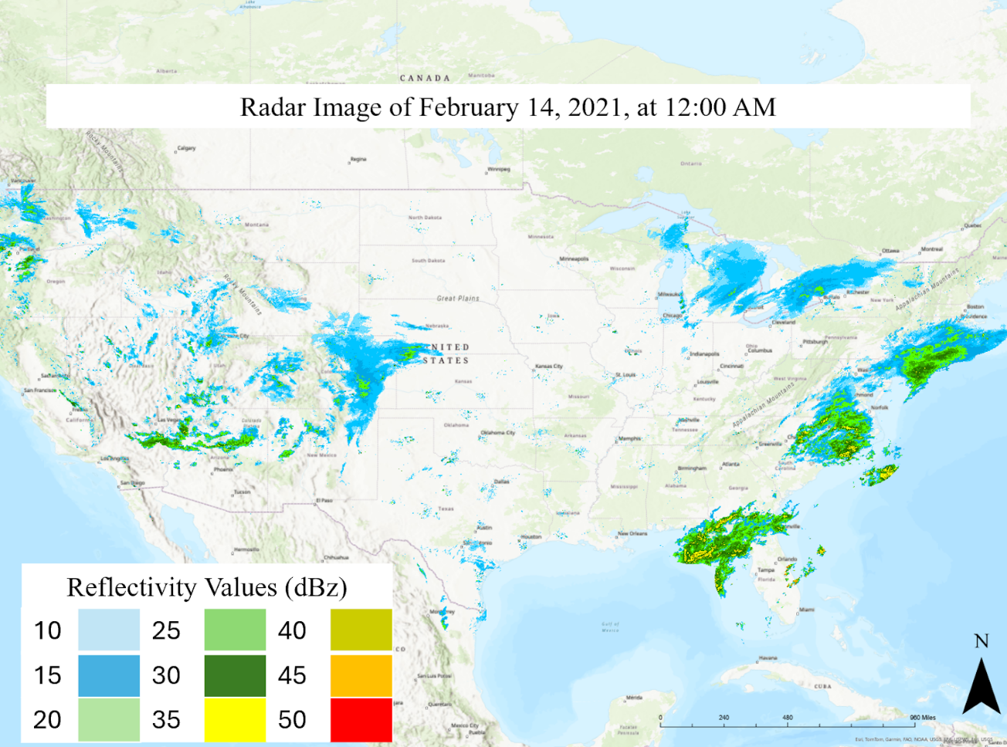
Figure 4.1 Example near real time radar image.

- Identified the largest contiguous area of high precipitation severity in our first radar image.
- Built a 5-mile buffer around the initial area.
- Expanded the buffer until the storm’s area did not increase by more than 1%, thus defining Winter Storm Uri’s initial extent.
To identify Uri in subsequent radar images, we performed the following steps:
  - Overlaid the initial extent with the next radar image (February 14, 2021, 12:05 AM)
  - All cells that bordered or overlapped with the initial extent were used to define Uri’s new extent.
  - We repeated this process for all radar images, each time using the previous image to define the next image’s extent.

4.2.3 Utilizing Landscape Ecology to Analyze Winter Storm Uri
From the cells in the radar images, we developed metrics based on indices used for monitoring landscape ecology changes. Landscape ecology is the study of the interactions between living organisms and the environment, or landscape, in which they live. Patterns within the landscape (i.e., land cover types) impact organisms, population dynamics and ecosystem structure (Frazier et al., 2017; Johnson et al., 1992; Turner et al., 2001; With 2019). Changes within landscape patterns can impact biodiversity and ecosystem health (Johnson et al., 1992; Turner et al., 2001; Wiens, 1985; With, 2000). Thus, landscape ecologists seek to quantify changes within landscape patterns. Landscape metrics are a set of indices used to quantify characteristics and changes within the landscape (McGarigal and Marks 1995, Gokyer, 2013).
Landscape metrics are divided into three types: 1) landscape (representing the entire study area), 2) Class (representing cells of a specific value) and 3) Patch (representing contiguous cells of the same value) (Cardille, 2002; Gokyer, 2013; Gustafson, 1998; McGarigal and Marks 1995). The innermost cells within patches are considered core areas, as they have no neighboring cells of a different class. Both patches and core areas provide insight into the aggregation of the landscape. Aggregation refers to how clustered or isolated patches of the same class are throughout

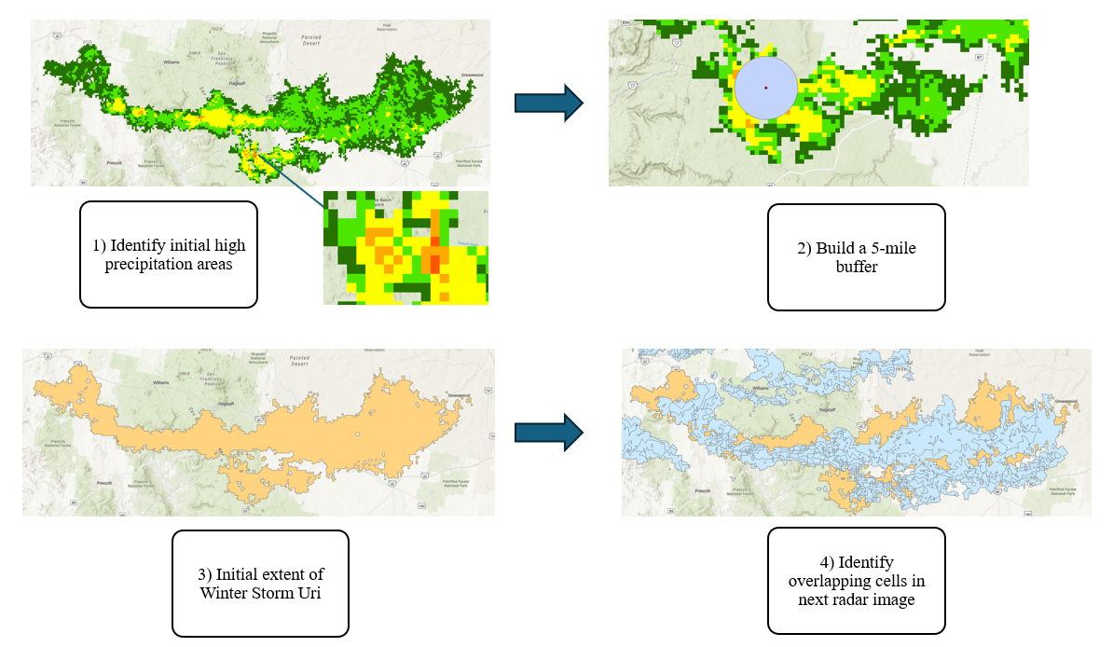
Figure 4.2 Workflow for tracking Winter Storm Uri across the U.S.

the landscape (O’Neill et al 1988; Li and Reynolds 1993). We apply concepts from landscape ecology to Winter Storm Uri.
Our landscape is the extent of Winter Storm Uri, which we refer to as the stormscape. We apply landscape metrics to quantify changes within Winter Storm Uri and refer to them as stormscape metrics. Stormscape metrics apply landscape metric indices to Winter Storm Uri's extent rather than to a physical landscape. A traditional landscape is composed of cells of varying land cover values. Our stormscape is composed of cells of varying reflectivity values, which allows us to apply landscape metrics to the stormscape. To analyze the storm, we classified continuous reflectivity values into discrete classes. Raw reflectivity values, ranging from 0 to 75 dBz (NOAA, 2023), were grouped based on associated precipitation severity, wind speed, and weather intensity (Table 4.1) (Austin, 1987; Gorokhovich and Villarini,2005). Each cell throughout the stormscape is grouped into a reflectivity class. Groups of contiguous cells of the same reflectivity class represent patches within the stormscape.

4.2.4 Calculating Stormscape Metrics
We characterized the storm at two levels: 1) whole storm system and 2) the area of the storm directly over a county. The storm affected each county over multiple time steps, resulting in a set of multiple values for each stormscape metric for a county. To summarize these metrics, we calculated the mean of those values for each county. However, traditional metrics are not designed to capture dynamic changes within
Table 4.1 Reflectivity values and associated precipitation (NOAA, 2023).
Reflectivity values (dBz) | Precipitation rate (in/hr) | Precipitation intensity
0 -20 | 0.01 | Very light precipitation
25 - 40 | 0.05 -0.45 | Light precipitation
45 -50 | 0.45 - 1.90 | Moderate precipitation, some hail
55 - 60 | 1.90 - 8.00 | Heavy precipitation, some snow, ice or hail
65 - 75 | 16 + | Extremely heavy precipitation, heavy hail, ice or snow

the storm system. Unlike geographical landscapes, Winter Storm Uri’s stormscape size, and the size of each reflectivity class changed rapidly. We developed composite metrics that considered both the entire storm system’s size and reflectivity class size.
We calculated the total area of the storm (Ta) and the areas of each class (Ta_{i}), where “i” equals class 0-20 dBz, 25-40 dBz, 45-50 dBz, 55-60 dBz or 65-75 dBz. To account for the size of the whole storm and the size of one class at the same time we multiplied Ta by Ta_{i}, which yielded TaTa_{i}.
TaTa_{i} = Ta * Ta_{i}
We also account for the proportion of the storm occupied by each class by calculating the ratio of Ta_{i} to Ta.
Ta_{i}_pct = Ta_{i} / Ta

4.2.5 Selecting Stormscape Metrics for Our Final Model
We produced hundreds of stormscape metrics, but not all could be included in our final model. We systematically selected metrics with the strongest correlation to power outages and the least collinearity for our final model. The broad steps of our approach include: 1) Divide metrics into groups, 2) Calculate each metric’s correlation with outages, 3) Remove metrics with high collinearity.
We divided metrics into 4 groups; shape, area, aggregation and core area, each group addressed a unique aspect of Winter Storm Uri. Shape metrics describe the shape of patches by quantifying area and perimeter. Shape metrics are useful as long, narrow patches could have different characteristics than square patches (Forman and Godron, 1986) Area metrics describe the size of classes and patches. Area metrics can be used to characterize the composition of the stormscape and the dominance of each reflectivity class. Core metrics describe the inner cells of a patch (i.e. these cells do not border cells of any other reflectivity class). Lastly, aggregation metrics describe the spatial configuration of all patches within a class. They allow us to quantify if patches within each class are clustered together or spread out throughout the stormscape. Detailed descriptions of individual metrics are in Table 4.2.
By evaluating metrics at the group level, we ensured that all aspects of Winter Storm Uri were included in our final model. We compared metrics within groups based on their correlation with outages and multicollinearity.
To determine which metrics were most strongly correlated with outages, we conducted a univariate negative binomial regression. In this model, each metric served as an independent variable, with outage percentage as the dependent variable. We utilized negative binomial regression because our dependent variable is treated as rate data and the variance of our dataset exceeds the mean, which makes negative binomial regression the best choice (Johnson and Hilbe, 2011; Gardner et al., 1995). We excluded metrics that showed a statistically insignificant relationship (p value < 0.05) with outages. We also excluded metrics that did not account for at least 10% of the model's deviance. Using these thresholds, we identified the top three metrics in each category that showed the strongest correlation with outages. Then we evaluated each set of top three metrics for collinearity.
To account for multicollinearity, we calculated the Variance Inflation Factor (VIF) for each set of top three metrics (Belsey et al., 1980; Murray et al., 2012). VIF is calculated by running a regression with each predictor variable as the dependent variable and all others as the independent variable. We dropped metrics with a VIF greater than 10, as any score above 10 represents signs of serious multicollinearity (Craney and Surles, 2002; O’Brien, 2007). This allowed us to identify 1-2 key metrics from each group (Table 4.2).

4.2.6 Connecting Stormscape Metrics and Outages
We investigated the relationship between stormscape metrics and power outages across counties using a generalized linear regression model. The percentage of power outages in each county was treated as rate data, reflecting the proportion of customers experiencing outages. Poisson regression is commonly used for rate data; however, it assumes equal mean and variance. For our dataset, the variance exceeds the mean; therefore, we employed the more appropriate negative binomial model (Gardner et al., 1995; Ver Hoef and Boveng, 2007). In our initial negative binomial model, outage percentage served as the dependent variable and stormscape metrics served as the independent variables (see Table 4.2). All variables were significant, except Proportion of 25-40 Area, Proportion of 45-50 Area, Proportion of 55-60 Area and Proportion of 65-75 Area. We removed all insignificant variables and constructed a final negative binomial model, using only significant variables.
$$\log\left(y\right)= B_{0}+B_{1}X_{1}+B_{2}X_{2}+ϵ$$
Our final negative binomial model produced residuals, which represent the difference between observed and predicted outage percentages. To account for the effect of spatial autocorrelation in our data, we used the residuals as inputs for a spatial simultaneous autoregressive model.
Table 4.2 Final metrics that connect conceptually with Winter Storm Uri and pass p-value and VIF thresholds.
Metric | Abbreviation | Description | Level
Split of 45-50 dBz cells | 45-50_Split_W | Quantifies fragmentation of all 45-50 dBz patches | W
Patch Density of 25-40 dBz cells | 25-40_PD_W | Number of 25-40 dBz patches per 100 hectares of the stormscape. | W
Cohesion of 65-75 cells | 65-75_COH_W | Measures the physical connectedness of all 65-75 dBz patches | W
Aggregation of 65-75 cells | 65-75_AGG_W | Quantifies how clustered 65-75 dBz patches are based on shared edges between patches. | W
Aggregation of 25-40 cells | 25-40_AGG_W | Quantifies how clustered 25-40 dBz patches are based on shared edges between patches. | W
Number of Disjunct Core Areas | NDCA_C | A core area is the innermost group of cells within a patch (i.e., they do not share any edges with cells of different classes). Patches of irregular shape can have multiple core areas. NDCA measures patch composition and shape. | C
Table 4.2 (continued) Final metrics that connect conceptually with Winter Storm Uri and pass p-value and VIF thresholds.
Patch Richness | PR_C | Number of reflectivity classes present. | C
Number of Patches of 25-40 cells | 25-40_NP_C | Total count of 25-40 dBz patches throughout the stormscape. | C
Total Area * 25-40Area | 25-40_TATAi_W | The size of the total storm area and the area of all 25-40 dBz cells at the same time. | W
Total Area * 45-50Area | 45-50TATAi_W | The size of the total storm area and the area of all 45-50 dBz cells at the same time. | W
Total Area * 55-60 Area | 55-60_TATAi_W | The size of the total storm area and the area of all 55-60 dBz cells at the same time. | W
Total Area * 65-75Area | 65-75_TATAi_W | The size of the total storm area and the area of all 65-75 dBz cells at the same time. | W
Proportion of 25-40 Area | Pro_25-40 | The percentage of the total storm area occupied by 25-40 dBz cells. | W
Table 4.2 (continued) Final metrics that connect conceptually with Winter Storm Uri and pass p-value and VIF thresholds.
Proportion of 45-50 Area | Pro_45-50 | Percentage of the total storm area occupied by 45-50 dBz cells. | W
Proportion of 55-60 Area | Pro_55-60 | Percentage of the total storm area occupied by 55-60 dBz cells. | W
Proportion of 65-75 Area | Pro_65-70 | Percentage of the total storm area occupied by 65-70 dBz cells. | W
Total Area | TA | Total area of the whole storm system in hectares. | W

We selected a spatial simultaneous autoregressive model, because it accounted for spatial lag and spatial error (Kissling and Carl, 2008; Pebesma and Bevand, 2023). Spatial lag occurs when the dependent variable in one location is influenced by the dependent variable in surrounding locations (Anselin, 2022; Dall’erba et al., 2010; Lam and Souza, 2019; Pebesma and Bevand, 2023). The term, pWy, captures the spatial lag effect.
y = pWy + Xβ + ϵ
Spatial error accounts for spatial correlation between error terms (Anselin, 2022).
The term, u, is the spatially correlated error term and represents the spatial autoregressive coefficient and the weighted average of neighboring error values (Anselin, 2022; Pebesma and Bevand, 2023).
y = Xβ + u, where u = λWu + ϵ
Utilizing a spatial simultaneous autoregressive model allowed us to account for both spatial lag and spatial error effects in one equation (Pebesma and Bevand, 2023). Incorporating residuals into the spatial simultaneous autoregressive model allowed us to quantify the portion of outage variance explained by spatial dependencies, separate from that explained by stormscape metrics.
y = pW1y + Xβ + u, u = λW2u + ϵ

4.2.7 Producing Power Outage Estimates
Our negative binomial model takes in county level outage data, which allowed us to produce county level power outage estimates. We predicted power outages for February 15, 2021, at 10:35 AM during Winter Storm Uri, as this data was not included in our original negative binomial model. We produced stormscape metrics, represented as X, and integrated these metrics with our negative binomial model’s intercept and coefficients, represented as B₀ and B_{x}.
$y=\exp\left(B_{0}\right)*\exp\left(X_{1}B_{1}\right)*exp⁡(X_{2}B_{2}$)…
We estimated power outages for each county affected by Uri on February 15 at 10:35 AM using our negative binomial model. To account for the effects of spatial autocorrelation, we used our outage estimates as input for a spatial lag model. We selected a spatial lag model because it will account for the impact of neighboring county outages. We compared outage estimates from both the spatial lag and negative binomial models, selecting the higher estimate for each county.

4.3 Results and Discussion

4.3.1 Assessing the Correlation Between Stormscape Metrics and Outages
Our stormscape metrics reduce the deviance by 18.9% compared to the null model, suggesting a meaningful but not exhaustive relationship with outage counts. Since storm characteristics are only one factor influencing outages, this result is expected. While the overall explanatory power is moderate, every stormscape metric in our model is statistically significant (Table 4.3), reinforcing their importance in understanding outage patterns. The following section examines how specific stormscape metrics are associated with increases or decreases in outage likelihood.
A 1% increase in TA_W is associated with a reduction in outages by a factor of 1.068, while a 5% increase corresponds to a reduction by a factor of 1.394, assuming all other metrics remain constant. This result indicates that storm severity and associated damage are not necessarily determined by storm size alone. A larger storm may predominantly consist of light precipitation cells, resulting in lower outage impacts. Therefore, assessing the proportion of high-reflectivity cells within the storm is crucial for accurately anticipating winter storm severity.
45-50_TaTai_W is significantly associated with an increase in outages. A 1% increase in 45-50_TaTai_W corresponds to a 1.034-fold increase in outages, while a 5% increase corresponds to a 1.168-fold increase. Similarly, 25-40_TaTai_W is associated with an increase in outages, though its impact is slightly lower than that of 45-50_TaTai_W. A 1% increase in 25-40_TaTai_W leads to a 1.031-fold increase in outages, while a 5% increase corresponds to a 1.168-fold increase.

Table 4.3 Quantitative impacts and connections between individual metrics and outages at the whole storm (W) and county level (C).
Variable | Estimate | Std.Error | Z value | Pr(>|z|)
45-50_Split_W | 2.116 | 0.454 | 4.67 | 3.1 e-6
25-40_PD_W | -7.648 | 0.889 | -8.60 | 2.0 e-16
65-75_COH_W | 1.292 | 0.299 | 4.32 | 1.6e-5
65-75_AGG_W | -1.620 | 0.338 | -4.79 | 1.7e-6
25-40_AGG_W | -7.065 | 0.891 | -7.93 | 2.2 e-15
NDCA_C | -2.184 | 0.356 | -6.13 | 8.5 e -10
PR_C | 1.694 | 0.360 | 4.71 | 2.5 e -6
25-40_NP_C | 0.842 | 0.226 | 3.72 | 0.00020
25-40_TaTai_W | 3.120 | 1.133 | 2.75 | 0.00591
45-50_TaTai_W | 3.360 | 0.882 | 3.81 | 0.00014
55-60_TaTai_W | -1.637 | 0.778 | -2.10 | 0.03546
65_75_TaTai_W | 0.449 | 0.224 | 2.00 | 0.04528
Ta_W | -6.653 | 1.151 | -5.78 | 7.4 e-9

Unexpectedly, 65-75_TaTai_W, which represents extreme precipitation, including hail, ice, and snow, has a smaller impact on outages compared to 45-50_TaTai_W and 25-40_TaTai_W. A 1% increase in 65-75_TaTai_W results in only a 1.004-fold increase in outages, while a 5% increase raises outages by just 1.022, assuming all other metrics remain constant. This suggests that while extreme precipitation is a key factor, it may not be the primary driver of outage severity. Additionally, we observe an unexpected trend in the impact of 55-60_TaTai_W on outages, which warrants further investigation.
While 25-40_TaTai_W, 45-50_TaTai_W, and 65-75_TaTai_W are all associated with an increase in outages, 55-60_TaTai_W exhibits an inverse relationship, indicating a decrease in outages. A 1% increase in 55-60_TaTai_W corresponds to a 1.016-fold reduction in outages, while a 5% increase results in a 1.085-fold reduction, assuming all other metrics remain constant.
This counterintuitive finding may be explained by the timing of 55-60_TaTai_W peaking at 12:15 AM on February 16. By that time, Winter Storm Uri had moved into the northeastern U.S., where electric infrastructure is generally more resilient to winter weather conditions. As a result, the same reflectivity levels that contributed to outages in other regions may have had a diminished impact in this area due to improved grid preparedness and adaptive measures. Additionally, aggregation metrics also exhibited a negative correlation with outages, further suggesting that the spatial distribution of storm intensity plays a significant role in outage likelihood.
We initially hypothesized that higher aggregation metrics would be associated with an increase in outages. However, our results indicate the opposite trend: both 65-75_AGG_W and 25-40_AGG_W are associated with a reduction in outages. A 1% increase in 65-75_AGG_W corresponds to a 1.016-fold decrease in outages, while a 5% increase results in a 1.084-fold decrease. Notably, 25-40_AGG_W exhibits a much stronger negative correlation with outages. A 1% increase in 25-40_AGG_W leads to a 1.073-fold reduction in outages, while a 5% increase corresponds to a 1.423-fold reduction, assuming all other metrics remain constant.
In contrast to 65-75_AGG_W and 25-40_AGG_W, which are associated with a decrease in outages, 65-75_COH_W shows a positive correlation with outage frequency. A 1% increase in 65-75_COH_W corresponds to a 1.013-fold increase in outages, while a 5% increase results in a 1.066-fold increase, assuming all other metrics remain constant. This trend aligns with our findings for fragmentation metrics, which also exhibit a positive association with outages, suggesting that increased storm complexity and spatial dispersion contribute to greater infrastructure disruptions.
The metric 45-50_Split_W is positively associated with an increase in outages. A 1% increase in 45-50_Split_W corresponds to a 1.021-fold increase in outages, while a 5% increase results in a 1.111-fold increase, assuming all other metrics remain constant. This trend suggests that a greater spatial dispersion of Class 45-50 cells leads to a broader geographic distribution of moderate to heavy precipitation, which may contribute to more widespread infrastructure disruptions. Additionally, our findings indicate that patch-level metrics, in general, are associated with increased outage occurrences, reinforcing the importance of spatial storm characteristics in predicting outage risk.
Among all patch-level metrics, PR_C exhibits the strongest association with outages. A 1% increase in PR_C corresponds to a 1.017-fold increase in outages, while a 5% increase results in a 1.088-fold increase, assuming all other metrics remain constant. Similarly, 25-40_NP_C also shows a positive correlation with outages, though its effect is less pronounced. A 1% increase in 25-40_NP_C leads to a 1.008-fold increase in outages, while a 5% increase raises outages by a factor of 1.042. In contrast, NDCA_C and 25-40_PD_W demonstrate an inverse relationship with outages, suggesting that greater patch density and core area stability may mitigate outage risk.
A 1% increase in NDCA_C is associated with a 1.022-fold decrease in outages, while a 5% increase corresponds to a 1.115-fold reduction, assuming all other metrics remain constant. Among all metrics, 25-40_PD_W demonstrates the strongest negative correlation with outages. A 1% increase in 25-40_PD_W results in a 1.079-fold decrease in outages, while a 5% increase leads to a 1.465-fold reduction. These findings suggest that higher patch density and greater core area stability contribute to improved infrastructure resilience, potentially mitigating the risk of widespread power disruptions.
A 1% increase in all stormscape metrics corresponds to a 1.48-fold increase in outages, while a 5% increase results in a significantly higher 7.27-fold increase. For instance, if 10% of customers initially experience an outage, a 1% increase in stormscape metrics would indicate a more intense storm with heavier precipitation, raising the outage rate to 11.4%. A 5% increase in stormscape metrics would reflect a much more severe storm with substantially greater precipitation, potentially increasing outages to 72%. These findings underscore how quickly winter storms can escalate in severity, leading to widespread power disruptions. While our negative binomial model establishes a strong relationship between stormscape metrics and outages, further analysis is needed to account for the effects of spatial autocorrelation and other study limitations.

4.3.2 Impact of Spatial Autocorrelation
Our spatial simultaneous autoregressive model (SAC) incorporates residuals- the difference between the estimated and observed values- from our negative binomial model to account for remaining spatial autocorrelation. The spatial error coefficient, lambda (0.87538; p-value<5%), indicates strong spatial autocorrelation, suggesting that unobserved factors influence the negative binomial residuals. Since lambda is close to one, incorporating spatial effects is essential for accurately estimating power outages.
To account for spatial effects in power outages, we used a spatial lag model that incorporates neighboring counties' influence. Even counties not directly impacted by the storm can experience outages due to shared utilities and distribution lines. Integrating this model with our negative binomial estimates improved accuracy. For example, Harris County’s predicted outage rate increased from 37% to 47% when neighboring counties' impact was included (Figure 4.3). Surrounding counties, all within the 40–60% outage range, contributed to this rise. This approach provides a more comprehensive understanding of regional outage vulnerability.

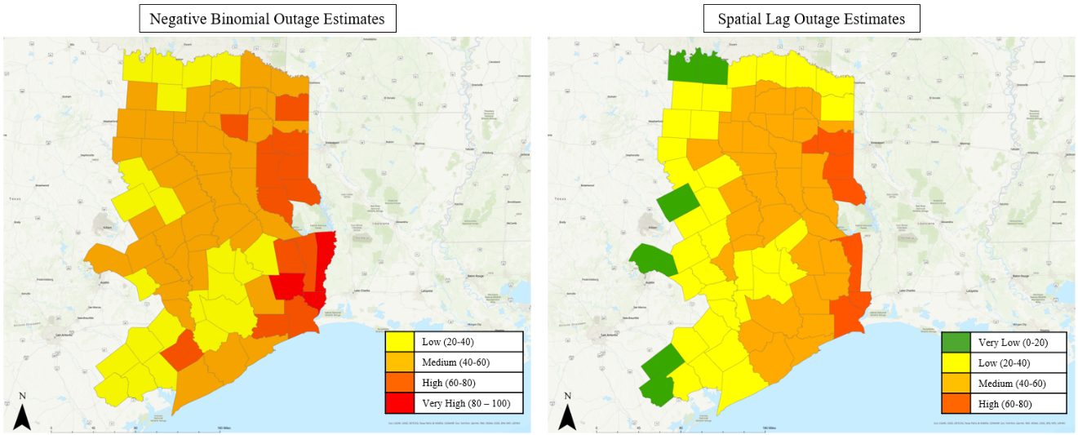
Figure 4.3 Comparison of negative binomial and spatial lag power outage estimates.

4.3.3 Limitations of Applying Stormscape Metrics Exclusively to Winter Storm Uri
Figure 4 Comparison of negative binomial and spatial lag power outage estimates.
Our analysis establishes a connection between stormscape metrics and power outages. However, we have not yet examined how specific stormscape metrics relate to key meteorological variables such as wind speed, the convergence of cold and warm fronts, and low temperature factors that directly contribute to outages. Additionally, we have not connected stormscape metrics to distinct components of the electric grid. For instance, power generation is likely most affected by temperature extremes, such as freezing gas lines and turbine blade icing (Lo Prete et al., 2023). Transmission infrastructure is more vulnerable to a combination of ice accumulation and high winds (Hawker et al., 2024; McManus et al., 2008), while increased electricity demand during severe winter weather places additional stress on the grid as building occupants rely more heavily on heating systems. Further research is necessary to establish these connections and refine predictive models that integrate both meteorological and grid-specific variables.
It is important to acknowledge that our analysis of stormscape metrics is specific to Winter Storm Uri. The applicability of these metrics to other winter weather events remains uncertain, as different storms may exhibit distinct structural and meteorological characteristics. Consequently, while our findings provide valuable insights, they should not be interpreted as a universally applicable tool for predicting outages. However, this study establishes a methodological framework for leveraging stormscape metrics to assess potential outage impacts based on radar imagery. By integrating near-real-time meteorological variable predictions, future research can enhance the predictive capabilities of this approach, enabling a more comprehensive assessment of outage risks across a broader range of winter storms.

4.3.4 An Example of Integrating Stormscape Metrics into an Existing Outage Awareness Platform
We propose EAGLE-I as an initial venue to deploy our stormscape metrics and power outage estimation. EAGLE-I reports outages in 15-minute increments at the county level and provides outage reports during a severe weather event. EAGLE-I relies on outage reporting from individual utilities and state emergency management agencies (Abdelmalak et al., 2023; Brelsford et al., 2024). At the time of Winter Storm Uri, EAGLE-I collected data from 339 electric utilities, accounting for 86% of electric utility customers across the U.S. EAGLE-I takes in data from utilities and uses it to develop a county level outage estimate (Abdelamalak et al., 2023; Brelsford et al., 2024).
To determine how much a county is under an outage, EAGLE-I developed modeled county customer estimates. A customer can be an electric meter, building, household or business (Abdelmalak et al., 2023; Brelsford et al 2024). County customers are estimated using county population, utility customer total and utility service area (Brelsford et al., 2024). This yields an estimated total of electricity customers per county.
EAGLE-I collects utility data by parsing utility online outage maps and synthesizes them to the county scale (Brelsford et al., 2024). Current uses of EAGLE-I include determining electricity service vulnerability and quantifying variability in grid resilience (Abdelmalak et al., 2023). EAGLE-I is not predictive, so its primary focus is not winter storm power outage estimation or prediction. Our work fills this gap by providing outage estimates based on our stormscape metrics.
We organized outage estimates into Very Low, Low, Medium, High and Very High categories for ease of interpretation by EAGLE I users (Figure 4.4). To validate our outage estimates, we compared them to the EAGLE I 15 minute county level outages. Our model produces outage estimates that are considerably higher than EAGLE I data. To build our initial negative binomial model we used the maximum percentage of customers experiencing an outage during Winter Storm Uri. Therefore, our model was trained on higher outage data than most of the 15 minute county outage data. Our model’s estimates are likely higher than the EAGLE I data because our model predicts the maximum outage.
Our work is valuable because it provides outage estimation capabilities, which are not currently available within EAGLE I. Currently, EAGLE I maps weather radar data and weather watches/warnings from NOAA, but it does not connect radar data or warnings with predicted outages (Figure 4.5). Our outage estimates can be integrated with EAGLE I’s radar maps show the potential damage associated with the radar data and winter storm warnings/watches (Figure 4.6). EAGLE I users can track radar data across the U.S. and assess their risk through our outage estimates. By incorporating our outage predictions into EAGLE I we provide users with the opportunity to plan proactively for winter storm damage and inform outage preparedness and response. EAGLE I’s radar maps show the potential damage associated with the radar data and winter storm warnings/watches (Figure 4.6). EAGLE I users can track radar data across the U.S. and assess their risk

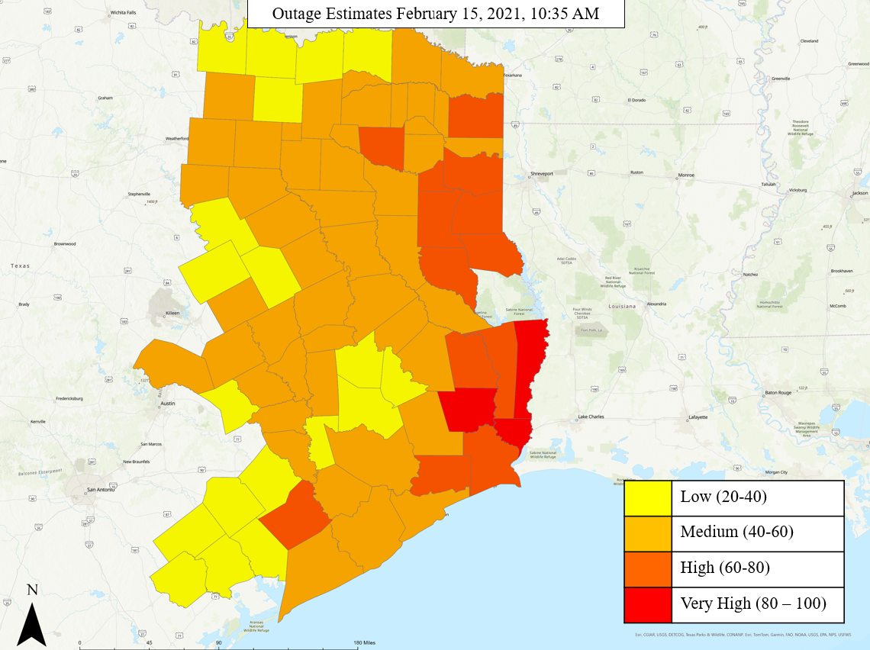
Figure 4.4 Outage estimates for all Texas counties. Most counties are experiencing medium outage risk with 40-60% of customers under an outage.

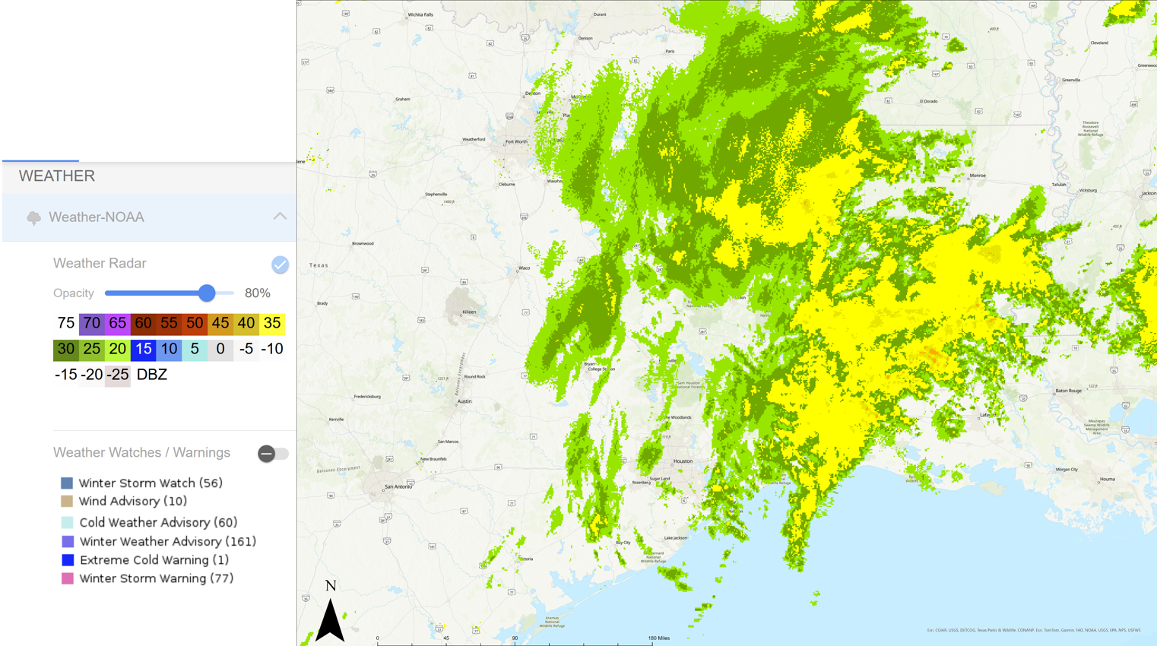
Figure 4.5 Current EAGLE-I interface displaying radar data and counties under various weather watches/warnings.
through our outage estimates (Figure 4.6). By incorporating our outage predictions into EAGLE I we provide users with the opportunity to plan proactively for winter storm damage and inform outage preparedness and response (Figure 4.6).

4.4 Conclusion
This study establishes a clear connection between stormscape metrics and power outages, demonstrating their potential for improving outage estimation capabilities. We have shown that stormscape metrics, particularly the product of total storm area and high reflectivity class areas, are significantly associated with increases in outages. Additionally, the aggregation of high reflectivity cells and the diversity of reflectivity classes contribute to outage likelihood. Our findings highlight the predictive power of stormscape metrics and their potential to address a critical gap in existing outage awareness platforms, which primarily focus on real-time outage reporting rather than predictive estimation.
The connection between stormscape metrics and outages is proven through our negative binomial model results. Increases in the product of the total storm area and area of high reflectivity classes are associated with an increase in outages. Aggregation of high reflectivity cells and an increase in the number of reflectivity classes present are also associated with an increase in outages. We showcased the predictive power of our work by estimating county level outages based on stormscape metrics. Current outage awareness platforms focus on the present and do not estimate power outages, while our work fills this gap.
A key application for our work lies in its integration with existing platforms such

Figure 4 Current EAGLE-I interface displaying radar data and counties under various weather watches/warnings.
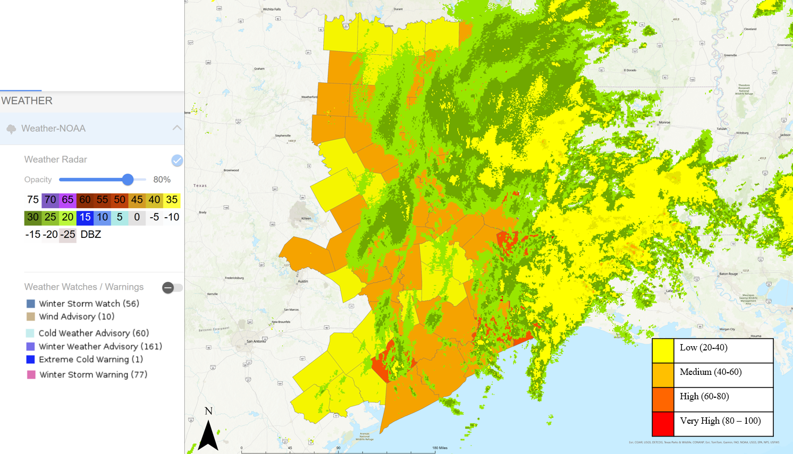
Figure 4.6 Outage predictions integrated within the EAGLE-I interface. Users can view the estimated maximum outage for their county with respect to radar data and winter weather warnings/watches.

as EAGLE-I. Currently, EAGLE-I provides real-time outage reports during severe weather events but lacks predictive capabilities. By incorporating stormscape-based outage estimation, this system can enhance disaster preparedness by allowing emergency responders and federal agencies to anticipate outages before they occur. This improvement would enable more efficient resource allocation and response strategies, ultimately mitigating the impact of extreme winter weather on affected communities.
Future research will focus on testing our stormscape metrics for prediction farther in advance. Nowcasting provides weather forecasts 2 hours in advance. We aim to improve our outage prediction to align with current standards of nowcasting. We will also focus on extending the use of stormscape metrics to a broader range of storm events, including additional winter storms and convective systems. This expansion will help determine whether stormscape metrics exhibit similar predictive behavior across different storm types. Additionally, further refinement of our methodology, including the integration of near-real-time meteorological variables and electric grid vulnerability data, will enhance the robustness and applicability of outage estimation models.
By advancing our understanding of the relationship between storm structure and power outages, this work lays the foundation for more proactive and data-driven disaster response strategies. Continued development of stormscape-based predictive models has the potential to significantly improve outage awareness, emergency planning, and infrastructure resilience in the face of extreme weather events.

References
Abdelmalak, M., Cox, J., Ericson, S., Hotchkiss, E., & Benidris, M. (2023). Quantitative Resilience-Based Assessment Framework Using EAGLE-I Power Outage Data. IEEE Access, 11, 7682-7697. https://doi.org/10.1109/ACCESS.2023.3235615.
Anselin, L. (2022). Spatial econometrics. In Handbook of Spatial Analysis in the Social Sciences. Cheltenham, UK: Edward Elgar Publishing. https://doi.org/10.4337/9781789903942.00014
Belsley D., Kuh E., & Welsch R. (1980) Regression Diagnostics: Identifying Influential Data and Sources of Collinearity, New York: John Wiley & Son. https://doi.org/10.1002/0471725153
Brelsford, C., Tennille, S., Myers, A., Chinthavali, S., Tanaskul, T., Denman, M., Coletti, M., Grant, J., Lee, S., Allen, K., Johnson, E., Huihui, J., Hamaker, A., Newby, S., Medlen, K., Maguire, D., Stahl, C., Moehl, J., Redmon, D., Sanyal, J., & Bhaduri, B. (2024). A dataset of recorded electricity outages by United States county 2014-2022. Scientific Data, 11. https://doi.org/10.1038/s41597-024-03095-5
Call, D. (2009). An Assessment of National Weather Service Warning Procedures for Ice Storms. Weather and Forecasting, 24(1), 104-120. https://doi.org/10.1175/2008WAF2007111.1
Campbell, M. (2023). Spatial Microsimulation. A Short Explainer. Social Science Research Network. http://dx.doi.org/10.2139/ssrn.4565410
Campbell, R. (2012). Weather-Related Power Outages and Electric System Resiliency. Congressional Research Service. https://digital.library.unt.edu/ark:/67531/metadc122249/
Cardille, J., & Turner, M. (2002). Understanding Landscape Metrics I. In: Gergel, S.E., Turner, M.G. (eds) Learning Landscape Ecology. Springer, New York, NY. https://doi.org/10.1007/0-387-21613-8_7
Castellanos, S., Potts, J., Tiedmann, H., Alverson, S., Glazer, Y., Robinson, A., Russo, S., Harmon, D., Kenopurum, D., Kenopurum, B., Weisz, M., Acuna, F., Stephens, K., Faust, K. & Webber, M. (2023). A synthesis and review of exacerbated inequities from February 2021 winter storm (Uri in Texas and the risks moving forward. Progress in Energy, 5(1). https://doi.org/10.1088/2516-1083/aca9b4
Chand, M., & McEntire. D. (2024). The February 2021 Winter Storm and its impact on Texas infrastructure: Lessons for communities, emergency managers, and first responders. Risk, Hazards, & Crisis in Public Policy 15, 308–327. https://doi-org.utk.idm.oclc.org/10.1002/rhc3.12282
Craney, T., & Surles, J. (2002). Model-Dependent Variance Inflation Factor Cutoff Values. Quality Engineering, 14(3), 391–403. https://doi.org/10.1081/QEN-120001878
Allen-Dumas, M., Lee, S., & Chinthavali, S. (2022). Analysis of Correlation between Cold Weather Meteorological Variables and Electricity Outages. 2022 IEEE International Conference on Big Data, 3398-3401. https://doi.org/10.1109/BigData55660.2022.10020733.
Dall`erba, S., Buliung, R.., Gallo, J., Páez, A. (2009). Progress in Spatial Analysis: Methods and Applications. Springer Nature. https://doi.org/10.1007/978-3-642-03326-1
Formon, R., and Godron, M. (1986). Landscape Ecology. John Wiley, New York.
Frazier, A., Kedron, P. (2017). Landscape Metrics: Past Progress and Future Directions. Current Landscape Ecology Reports, 2, 63–72. https://doi.org/10.1007/s40823-017-0026-0
Gardner, W., Mulvey, E., & Shaw, E. (1995). Regression analysis of counts and rates: Poisson, overdispersed Poisson, and negative binomial models. Psychological Bulletin, 118, 392-404. https://doi.org/10.1037/0033-2909.118.3.392
Glahn, H., & Ruth, D. (2003). The New Digital Forecast Database of the National Weather Service. Bulletin of the American Meteorological Society, 84(2), 195-202. https://doi.org/10.1175/BAMS-84-2-195
Gokyer, E. (2013). Understanding Landscape Structure Using Landscape Metrics. Advances in Landscape Architecture. http://dx.doi.org/10.5772/55758.
Gustafson, E. (1998). Quantifying landscape spatial pattern: what is the state of the art? Ecosystems 1, 143–156. https://doi.org/10.1007/s100219900011
Hawker, G., Bell, K., MacIver, C., & Bialek, J. (2024). Management of extreme weather impacts on electricity grids: An international review. Progress in Energy, 6. https://doi.org/10.1088/2516-1083/ad3f6a
Johnson, T., & Hilbe, J. (2011) Negative Binomial Regression, second edition. Psychometrika 77, 611–612 (2012). https://doi.org/10.1007/s11336-012-9263-
Johnson, A., Milne, B., & Wiens, J. (1992). Diffusion in fractal landscapes: simulations and experimental studies of tenebrionid beetle movements. Ecology 73(6), 1968–1983. https://doi.org/10.2307/1941448
Keqi, Z. (2022). Application of Doppler Radar in Short-Term Near-Term Weather Forecast. International Journal of Science and Engineering Applications, 11(10), 145-147. https://doi.org/10.7753/IJSEA1110.1007
Kissling, W. and Carl, G. (2008), Spatial autocorrelation and the selection of simultaneous autoregressive models. Global Ecology and Biogeography, 17, 59-71. https://doi.org/10.1111/j.1466-8238.2007.00334.x
Lam, C., & Souza, P. (2019). Estimation and Selection of Spatial Weight Matrix in a Spatial Lag Model. Journal of Business & Economic Statistics, 38(3), 693–710. https://doi.org/10.1080/07350015.2019.1569526
Lee, J., Lee, S., Paal, S., & Chinthavali, S. (2024). A Generalized Outage Prediction Model for Various Types of Extreme Climate Events in Texas. IEEE International Conference on Big Data (Print), 4162–4166. https://doi.org/10.1109/BigData62323.2024.10825479
Lee, S., Chinthavali, S., Bhusal, N., Stenvig, N., Tabassum, A., & Kuruganti, T. (2023). Quantifying the power system resilience of the US power grid through weather and power outage data mapping. IEEE Access, 12, 5237-5255. https://doi.org/10.1109/ACCESS.2023.3347129
Li H., & Reynolds, J. (1993). A new contagion index to quantify spatial patterns of landscapes. Landscape Ecology, 8, 155–162. https://doi.org/10.1007/BF00125347
Lin, H., Tsai, C., Liou, J., Chen, Y., Lin, C., Lin, L., & Chung, K. (2020). Multi-Weather Evaluation of Nowcasting Methods Including a New Empirical Blending Scheme. Atmosphere, 11(11), 1166. https://doi.org/10.3390/atmos11111166
Lo Prete, C., & Blumsack, S. (2023). Enhancing the reliability of bulk power systems against the threat of extreme weather: lessons from the 2021 Texas electricity crisis. Economics of Energy & Environmental Policy, 12(2). https://doi.org/10.5547/2160-5890.12.2.clop
Mass, C. (2012). Nowcasting: The Promise of New Technologies of Communication, Modeling, and Observation. Bulletin of the American Meteorological Society, 93(6). https://doi.org/10.1175/BAMS-D-11-00153.1
McGarigal, K., &, Marks, B. (1995). FRAGSTATS. Spatial analysis program for quantifying landscape structure. USDA Forest Service General Technical Report PNW-GTR-351. Portland, OR: U.S. Department of Agriculture, Forest Service, Pacific Northwest Research Station. https://doi.org/10.2737/PNW-GTR-351
McManus, G., Piltz, S., Sperry, S., McPherson, R., Gartside, A., McClain, D., Meyer, T., Fetsche, C., Shafer, M. (2008). Development and Testing of an Ice Accumulation Algorithm. In 17th Annual Conf. on Applied Meteorology 2008.
Murphy, C., & Gardoni, P. (2007). Determining Public Policy and Resource Allocations Priorities for Mitigating Natural Hazards: A Capabilities-based Approach. Science and Engineering Ethics, 13, 489-504. https://doi.org/10.1007/s11948-007-9019-4
Murray, L., Nguyen, H., Lee, Y., Remmenga, M., & Smith, D. (2012). VARIANCE INFLATION FACTORS IN REGRESSION MODELS WITH DUMMY VARIABLES. Conference on Applied Statistics in Agriculture. https://doi.org/10.4148/2475-7772.1034
National Oceanic Atmospheric Administration. (2023, August 11). Radar images: Reflectivity | National Oceanic and Atmospheric Administration. https://www.noaa.gov/jetstream/reflectivity
Pebesma, E., & Bivand, R. (2023). Spatial Data Science: With Applications in R (1st ed.). s. Chapman and Hall/CRC. https://doi.org/10.1201/9780429459016
O’Brien, R. (2007). A Caution Regarding Rules of Thumb for Variance Inflation Factors. Quality & Quantity, 41, 673-690. https://doi.org/10.1007/s11135-006-9018-6
O’Neill, R., Krummel, J., Gardner, R., Sugihara, G., Jackson, B., DeAngelis, D., Milne, B., Turner, M., Zygmunt, B., Christensen, S., Graham, R., & Dale, V. (1988). Indices of landscape pattern. Landscape Ecology, 1(3), 153–162. https://doi.org/10.1007/BF00162741
Tonn, G., Guikema, S., Ferreira, C., & Quiring, S. (2016). Hurricane Isaac: A Longitudinal Analysis of Storm Characteristics and Power Outage Risk. Risk analysis: an official publication of the Society for Risk Analysis, 36(10), 1936–1947. https://doi.org/10.1111/risa.12552
Turner, M., Gardner, R., & O’Neill, R. (2001). Landscape Ecology in Theory and Practice: Pattern and Process. Springer, New York. https://doi.org/10.1007/978-1-4939-2794-4
Ver Hoef, J., & Boven, P. (2007). Quasi-poisson vs. Negative Binomial Regression: How Should We Model Overdispersed Count Data? Ecology. 88. 2766-2772. https://doi.org/10.1890/07-0043.1
Watson, P., Spaulding, A., Koukoula, M., & Anagnostou, E. (2022). Improved quantitative prediction of power outages caused by extreme weather events. Weather and Climate Extremes, 37. ,https://doi.org/10.1016/j.wace.2022.100487.
Wiens, J., Crawford, C., & Gosz, J. (1985). Boundary Dynamics: A Conceptual Framework for Studying Landscape Ecology Systems. Oikos 45(3), 421-427. https://doi.org/10.2307/3565577
With, K. (2019). Essentials of Landscape Ecology. Oxford University Press. https://doi.org/10.1093/oso/9780198838388.001.0001

APPENDIX A: Descriptions of Landscape Metrics
We applied landscape metrics, algorithms that quantify spatial characteristics of patches, classes and entire landscape mosaics, to the stormscape. Below we provide a more detailed description and calculation of each metric.
Split: Split measures the fragmentation of reflectivity classes during Winter Storm Uri. It indicates how dispersed or concentrated each class is across the storm’s area. For example, if Class 25-40 dBz has a Split of 1, it's a single, continuous area. If Class 55-60 dBz has a Split of 65, it's more fragmented and spread across the storm. Split is calculated by dividing the total landscape area by the sum of squared patch areas for each class.
SPLIT = $\frac{A^{2}}{\sum_{j = 1}^{n}{} a_{ij}^{2}}$
Patch Density (PD): Patch Density (PD) measures the number of patches for a specific reflectivity class per 100 hectares of the storm area. PD helps quantify how dispersed or concentrated different reflectivity classes are within the storm, providing insights into its structure and intensity distribution. Higher PD values indicate greater fragmentation and spatial heterogeneity. For example, if Class 25-40 dBz has a PD of 15, it means there are 15 patches of this class per 100 hectares of the storm area. PD is calculated by dividing the number of patches in a class by the total storm area, then converting to patches per 100 hectares.
Patch Density = $\frac{N}{A}$ * 10000*100

Cohesion: Cohesion quantifies how connected the patches are within a specific class, which provides insight into the configuration and spatial arrangement of that class. Higher cohesion values indicate that patches are closer together and more aggregated. Lower cohesion values suggest patches are more isolated and dispersed. For example, if class 25-40 dBz has a cohesion value of 25, while class 65-75 dBz has a cohesion value of 75 that shows that class 65-75 is more aggregated and concentrated in one area of the storm. Cohesion approaches 0 for isolated patches and increases as patches become more clustered. Calculation is calculated by calculating 1 minus the quotient of the sum of patch perimeters divided by the product of patch perimeters and patch area. Then multiplying by 1 minus the quotient of 1 over the square root of the total area. The result is multiplied by 100 to convert to a percentage.
Cohesion = 1 - ($\frac{\sum_{j = 1}^{n}{} p_{ij}}{\sum_{j = 1}^{n}{}p_{ij}\sqrt{a_{ij}}}) *(1-\frac{1}{\sqrt{Total Area}}{)^{-1}}^{}*100$
Aggregation Index (AI): Aggregation index measures the spatial connectivity of patches within a class by measuring the number of shared sides between cells. AI provides insight into how clustered or dispersed a class is throughout the landscape. For example, if class 65-75 dBz has an AI value of 0 this indicates that no 65-75 dBz cells are adjacent to each other and the class is maximally dispersed throughout Winter Storm Uri. AI is calculated by dividing the number of shared sides between cells within a class by the maximum possible number of shared sides.
AI = $(\frac{g_{ii}}{Max g_{ii}})$ *100

Number of Disjunct Core Areas (NDCA): A core area is a group of cells within a patch that have no neighboring cells of a different class. NDCA represents the number of core areas within a patch. This metric describes patch area and shape, as larger and more irregular patches will have a greater core area. NDCA is calculated by identifying the number of core areas within each patch and then calculating the sum of all core areas for that particular class.
$$NDCA =\sum_{j = 1}^{n}{}n_{ij}$$
Patch Richness (PR): Patch Richness represents the number of classes present within the landscape. For example, Winter Storm Uri has a PR of 2 throughout February 14, 2021, but as the storm becomes more severe and patches of 55-60 and 65-75 dBz grow, PR increased to 4.
Number of Patches (NP): Number of Patches represents how many patches per class are present within the landscape.
Total Area (TA): Total area provides insight into how the size of Winter Storm Uri evolves as it travels across the U.S. TA is calculated by dividing the total area in square meters by 10,000 to convert to hectares.
TA = $Area(\frac{1}{10000})$
Product of Total Area and Class Area (TaTai): TaTai metrics are calculated by multiplying the total area (TA) of Winter Storm Uri with the class area (CA) of a specific class. This provides insight into the relationship between storm size and storm severity.
$TaTai = TA * {CA}_{55-60}$

CONCLUSION
This chapter provides an overall summary of the research and the value of each study. We discuss how our contributions fit into the broader context of disaster resilience research. In addition, we discuss future research directions to expand on the work detailed in this dissertation.

5.1 Summary and Value of Research
The impetus for this research was the widespread power outages resulting from Winter Storm Uri in February of 2021. Widespread power outages during Winter Storm Uri left millions of people without electricity or clean water, resulting in loss of life and illness. Consequences of Winter Storm Uri highlighted the vulnerability of electricity infrastructure to winter storm damage, as well as the vulnerability of children, the elderly and low-income populations to negative economic and health impacts during power outages. There is a need to improve our understanding of outage risk and response strategies to severe winter storms, to prevent loss of life and economies during future winter storms. The main purpose of this dissertation is to examine power outage vulnerability during severe winter storms. This study assessed power outage vulnerability through three interconnected aspects, incorporating infrastructure characteristics, socioeconomic demographics and inner storm dynamics to provide a comprehensive picture of outage vulnerability. Results from this dissertation can inform and improve emergency response, outage preparedness and outage awareness, thus mitigating consequences of power outages during future severe winter storms. Key findings and value of the three major research questions for this research are presented below.

5.1.1 Question 1: How do infrastructure conditions contribute to outage susceptibility by using machine learning techniques to identify vulnerabilities in the electricity network?

In Chapter 2 we evaluated how infrastructure conditions contribute to outage susceptibility by using machine learning methods to identify vulnerabilities in the electricity network. We presented a method of using MaxEnt to evaluate the impact of preexisting infrastructure characteristics (i.e., distribution line density, proximity to hospitals, nursing homes, schools, tree coverage, substation and generator locations) on outage likelihood. Our MaxEnt model identified distribution line density, tree coverage, and school proximity as the three most important factors in outage susceptibility. Higher distribution line density is associated with increases in outage likelihood. Whereas increased tree coverage is linked with lower outage likelihood corresponding with areas of high income and new infrastructure.
Chapter 2 provides value through its use of MaxEnt and development of an outage likelihood dataset. Our work in Chapter 2 contributes to the literature by identifying factors that contribute to outage likelihood, building on previous studies that focused on connecting socio-economic variables with outages. Secondly, Chapter 2 produced a census block level outage likelihood dataset for Houston, which was previously not available. Our outage likelihood dataset provides insight into census tracts that could benefit from grid hardening measures and can inform emergency response priorities. Overall, we addressed our research question by identifying key infrastructure characteristics that do and do not contribute significantly to outage susceptibility. We also mapped outage susceptibility with respect to these characteristics across Houston.

5.1.2 Question 2: What common socioeconomic characteristics are associated with outage prone areas?

In Chapter 3, we assessed which communities were most at risk of power outages by examining common socioeconomic characteristics and clustering them with outage likelihood. Power outages do not impact all communities equally, as some individuals have less resources to respond to power outages than others. Thus, one of the major focuses of this dissertation was to identify common characteristics of individuals living in outage prone census tracts throughout Houston. We developed an individually oriented synthetic population for Houston, TX, which we clustered with our outage likelihood dataset. This method allowed us to identify individual power outage vulnerabilities. We found that individuals experiencing multiple disadvantages, including poverty, limited mobility, unemployment and communication sensitivities live in the most outage prone census tracts. These findings highlight the intersectionality of power outage vulnerability. Individuals experiencing this “perfect storm” of socioeconomic disadvantages coupled with high outage likelihood are more likely to experience challenges in accessing emergency communications, resources of evacuating during winter storms. Chapter 3 identifies the most vulnerable census tracts throughout Houston, which can inform resource allocation, outage restoration priorities and emergency management. We successfully addressed our research question, which is shown by our identification of multiple characteristics of individuals living in outage prone areas.

5.1.3 Question 3: How can integrating radar-based storm characteristics with outage patterns enhance real time and short-term power outage prediction?

In Chapter 4 we enhanced near real time and short-term power outage prediction by integrating radar-based storm characteristics with power outage patterns. Electric utilities and federal emergency management agencies rely on a precise understanding of winter storms and potential outages to prepare and ensure fast recovery. An improved connection between inner winter storm dynamics and power outages could support proactive outage planning. We applied concepts from landscape ecology to develop a set of stormscape metrics that detail spatial and temporal changes within winter storms. Chapter 4 demonstrates the predictive capability of stormscape metrics for estimating county-level power outages, addressing a critical gap in current outage awareness platforms that focus on real-time reporting. In Chapter 4 we incorporated the relationship between inner winter storm dynamics and power outages. Results from Chapter 4 have the potential to inform disaster preparedness and mitigate the power outage vulnerabilities identified in Chapters 2 and 3.
Research question 3 is successfully addressed through Chapter 4. We provide an initial case for the value of radar-based storm characteristics in outage predictions.

5.2 Contextualizing Research within Disaster Resilience
The novel methodologies and research findings throughout this dissertation have made multiple contributions to the broader field of disaster resilience. First, Chapter 2 contributes to a growing body of work utilizing MaxEnt for natural hazards. Previous studies have utilized MaxEnt for flood vulnerability. Whereas we applied MaxEnt toward determining outage likelihood, and infrastructure characteristics contributing to power outage vulnerability. Our successful application of MaxEnt for power outage vulnerability research provides further evidence that MaxEnt can be applied to natural hazards, beyond its original species distribution roots.
In Chapter 3, we identified common characteristics associated with individual power outage vulnerability and highlighted the intersectionality of power outage vulnerability. The granular results produced in Chapter 3 are particularly valuable to the field of social vulnerability within disaster resilience. Many studies within social vulnerability literature utilize aggregate socioeconomic variables at the county or census tract level. Aggregate variables do not always accurately depict how individuals and households respond to disasters. By utilizing an individually oriented synthetic population we can explore individual responses to disasters, which provide more granular results.
Results from Chapter 3 are particularly important as they directly contribute to energy insecurity research by addressing disproportionate impacts of power outages on vulnerable populations. Chapter 3 reveals nuanced characteristics of those most at risk, highlighting that households with independent living difficulties, linguistic isolation and low income face a convergence of vulnerabilities. The outage vulnerability map produced in Chapter 3 contributes to the growing effort to spatialize energy insecurity, as an avenue to inform policy making. Chapter 3 provides further context to this issue by examining individual level power outage vulnerabilities and using them to inform planning and policy interventions. Chapter 3’s use of quantitative results to inform planning and policy recommendations highlights the need for interdisciplinary research within the disaster resilience field to develop actionable solutions.
Chapter 4 fits within the storm characterization and prediction aspects of disaster resilience. Chapter 4 provides novel use for near real time radar data. Previous work has connected meteorological variables with outages. Chapter 4 builds upon previous literature through its development of stormscape metrics. This approach provides a new framework for quantifying spatial and temporal changes within winter storms. Predictive capabilities of stormscape metrics provide opportunities for advancement within outage awareness. The development of a negative binomial regression model linking stormscape metrics to county-level power outages offers a predictive capability that enhances current outage awareness platforms. This predictive element could significantly enhance proactive planning and response strategies for utilities and emergency agencies.
The three studies put forth within this dissertation provide novel contributions individually, but when viewed together they underscore key concepts of disaster resilience frameworks. In Chapter 1 we discussed the R4, TOSE and DROP frameworks. This dissertation underscores the key concepts of these disaster frameworks. In Chapter 2, we found that the age of the distribution network played a significant role in outage susceptibility. Older distribution networks are less able to withstand physical stressors from natural hazards and are therefore less robust. The improved outage prediction capabilities and understanding of outage likelihood can enhance response and recovery efforts, thus improving the rapidity aspect of the R4 framework.
The TOSE Framework emphasized the interaction between physical systems, society and government. Our work in Chapter 3 further explores the connection between physical systems and social demographics by clustering our infrastructure-based outage likelihood dataset with socioeconomic characteristics. Results from our clustering scheme underscore results from previous TOSE studies, in that income and linguistic isolation are key in determining a community’s ability to withstand adverse effects. We incorporate the organization aspect of the TOSE framework by discussing how the Houston government and emergency management agencies can develop policies to improve outcomes in outage vulnerable populations.
Disaster resilience frameworks often have multiple dimensions, often focusing on physical infrastructure, society, the natural environment and financial assets. Many frameworks state the interconnectedness of these dimensions, and discuss that resilience and recovery depend on stability within each dimension. The work put forth in this dissertation underscores the need for comprehensive methods to reduce power outage vulnerability and improve disaster resilience. We incorporated the built environment in Chapter 2, social vulnerabilities in Chapter 3 and accounted for the natural environment in Chapter 4. Our comprehensive evaluation of power outage vulnerability fits well within the umbrella of previous disaster resilience frameworks.

5.4 Limitations within this Dissertation
Although this dissertation provides novel insights, it is not without its limitations. Within this section we discuss the challenges and limitations of our work. In Chapter 2, we experienced challenges related to data quality. We were unable to obtain age estimates for substations or generators, nor were we able to obtain maintenance schedules for this infrastructure. Data regarding exact age and maintenance would have provided further insight into the impact of infrastructure quality on outage susceptibility.
We utilized the VNP46A2 dataset for power outage detection. Within this dataset the angular effect within nighttime lights data significantly influences the accuracy of daily measurements, which could impact power outage detection. Impacts of the angular effect are present and unmodified within this dataset, it is possible these effects could impact our power outage detection. However, the main goal of this research was to assess the role of preexisting characteristics in outage likelihood and validating the angular effect of nighttime lights imagery is outside the scope of this research. In the time since this study was conducted, a new dataset (VNP46A4) was developed. Angular effects within the VNP46A4 dataset are partially mitigated, which provides advantages for outage detection.
In Chapter 3, there are limitations within our synthetic population. Our synthetic population primarily accounts for individual characteristics. Aspects including social networks and informal support systems account for social currency, which is a much harder aspect to measure. The variables incorporated in our synthetic population do not explicitly quantify an individual’s access to social networks, community organizations and support. Although, one could argue that linguistic isolation, mobility, single caregiver households and income could be used to infer levels of social currency.
Additionally, improvements could be made in our planning and policy recommendations. Our recommendations are supported by clustering results and examples from other communities. These recommendations could be bolstered by interviews with Houston residents and leaders, which would provide improved context.
Lastly, we identify multiple limitations within Chapter 4. We applied our stormscape metrics only to Winter Storm Uri. To have more confidence in the predictive capabilities of our stormscape metrics we would need to apply them to many more winter storms. Currently, our stormscape metrics stand alone, as we have not connected them to meteorological variables related to winter storms. These key meteorological variables directly contribute to outages and connecting our stormscape metrics with them could improve outage prediction.

5.5 Future Research Directions
Results from these three studies demonstrated the importance of considering electricity network and critical infrastructure, socioeconomic characteristics and inner storm characteristics to develop a comprehensive understanding of power outage vulnerabilities. There are multiple opportunities for future research to expand on the work presented in this dissertation, which are discussed below.

5.5.1 Study Area Expansion
We utilized Houston and Winter Storm Uri as an initial test bed for methods in this dissertation. Although applied specifically to Houston, the MaxEnt method, synthetic population development and clustering scheme could be applied to other cities or counties. Future research will focus on applying our methods in Chapters 2 and 3 to additional geographies. Additional studies would provide more confidence in Maxent’s ability to determine outage likelihood. Secondly, applying the synthetic population and clustering scheme to multiple cities would allow us to identify common characteristics of vulnerable individuals that persist across many locations. This could provide insight into common factors contributing to vulnerability across diverse geographies.

5.5.2 Incorporating Rural Areas

This dissertation focused on power outage vulnerability within an urban area. However, this research could have valuable applications within rural areas. Extending the nighttime lights processing method to rural areas would provide insight into how well power outages can be detected in areas where fewer lights are present during non-storm periods.
Additionally, rural areas face unique challenges. Rural areas could have fewer options for temporary housing and relocation and sparse health clinics and grocery stores. These unique characteristics could impact individual power outage vulnerability. Future research could develop a synthetic population for rural areas and compare differences in common characteristics of vulnerable individuals in urban versus rural areas.

5.5.3 Accounting for Outage Restoration Time
This dissertation evaluated vulnerability to power outage occurrence. To provide a more complete view of power outage vulnerability, future research could connect individually oriented socioeconomic characteristics with outage restoration time. This will highlight what characteristics are associated with individuals who wait the longest to have their electricity restored. Expanding our research to incorporate outage restoration time, as well as outage occurrence, will allow us to explore another aspect of power outage vulnerability.

5.5.4 Expanding Stormscape Metrics Beyond Winter Storms
We believe that there is a significant opportunity to expand our work on stormscape metrics. To further prove the validity of stormscape metrics we must apply them to additional winter storms. Future research could apply stormscape metrics to more winter storms over the Southwest and Southeast, such as Winter Storm Enzo. Applying stormscape metrics to additional winter storms over similar geographic areas will allow us to detect patterns in which the same stormscape metrics are associated with an increase in outages. Further future research could apply stormscape metrics to other types of storms, including convective storms. Branching into other types of storms will help determine if stormscape metrics exhibit similar predictive behavior across multiple storm types.

VITA

Alexandra Kahl was born on September 8, 1998, in Mount Jackson, Virginia, where she spent most of her childhood. In 2016, Alexandra attended Virginia Polytechnic Institute and State University for her Bachelor of Science in Environmental Policy and Planning. At Virginia Tech, Alexandra became interested in how environmental problems and people collide and completed internships at Oak Ridge National Laboratory. She continued her education at Virginia Tech and completed a master’s degree in urban and regional planning.
In August 2020, Alexandra moved to Knoxville, Tennessee, to pursue her PhD at the University of Tennessee. With the help of her advisors, she was able to work on real world problems and produce research that has an impact on disaster resilience.

