Chapter 5. Environmental Correlations

The evaluation of the active US Forest Service Model revealed ineffective variables defining the high and medium probability zones as gain values were either equivocal or disproportionate between the zones. The active predictive model does effectively demarcate areas of low probability suggesting that upland terrain away from permanent water sources was an adverse environmental setting for both prehistoric and historic populations or for conditions allowing good preservation or recognition of sites. Through the analysis of a multitude of nominal, ordinal, and ratio environmental variables, statistically valuable environmental corollaries can be included within a new model (Table 5.1).

Table 5.1. Environmental Variables Examined to Pattern Site Locations in the Study Area on the Kisatchie National Forest.
Variable Descriptionª | Variable | Data Type | Interval | Statistical Test
Distance from grouped poorly drained soil | dpoor | ratio | 5-m, 30-m | M-W
Distance from grouped well drained soil | dwell | ratio | 5-m, 30-m | M-W
Distance from frequently flooded soil | floodf | ratio | 5-m, 30-m | M-W
Distance from freq/occasionally flooded soil | floodfo | ratio | 5-m, 30-m | M-W
Distance from highway | hwy | ratio | 5-m, 30-m | M-W
Distance from any road | roadall | ratio | 5-m, 30-m | M-W
Distance from stream | stream | ratio | 5-m, 30-m | M-W
Distance from stream rank 1 | srank1 | ratio | 5-m, 30-m | M-W
Distance from stream rank 2 | srank2 | ratio | 5-m, 30-m | M-W
Distance from stream rank 3 | srank3 | ratio | 5-m, 30-m | M-W
Distance from stream rank 4 | srank4 | ratio | 5-m, 30-m | M-W
Distance from stream rank 5 | srank5 | ratio | 5-m, 30-m | M-W
Distance from stream rank 6 | srank6 | ratio | 5-m, 30-m | M-W
Distance from stream rank 7 | srank7 | ratio | 5-m, 30-m | M-W
Distance from stream rank 8 | srank8 | ratio | 5-m, 30-m | M-W
Distance from stream rank 9 | srank9 | ratio | 5-m, 30-m | M-W
Distance from seasonal stream | sseas | ratio | 5-m, 30-m | M-W
Distance from permanent stream | sperm | ratio | 5-m, 30-m | M-W
Distance from major drainage | drain | ratio | 5-m, 30-m | M-W
Distance from wetland | wetl | ratio | 5-m, 30-m | M-W
Surface aspect (deviation from north, degrees) | aspect | ratio | 5-m, 30-m | M-W
Surface slope (% grade) | slope | ratio | 5-m, 30-m | M-W
Elevation | elev | ratio | 5-m, 30-m | M-W
Soil surface texture | stexture | nominal | -- | Chi
Soil drainage class | sdrain | ordinal | -- | Chi
ª Statistical tests using these environmental variables examine the differences between sites and random points in the Kisatchie
National Forest study area. M-W is the Mann-Whitney rank-sum test; Chi is the chi-square test.

The statistical tests used to determine the value of each corollary include the chi-square test (ordinal) and the Mann-Whitney rank-sum test (ratio). As described in Chapter 3 of this study, the chi-square test is employed to evaluate nominal and ordinal data for significance, in this case on the variables of soil drainage and soil surface texture. The Mann-Whitney rank-sum test is used for ratio data such as distance to water and percent slope, etc.
Three sets of tests are conducted within this analysis to determine the extent of environmental associations for archaeological sites on the Kisatchie National Forest. The first test compares the entire site sample (n = 3,986) for the study area with a random sample of 3,986 points, which represent the background environmental parameters. Figures 5.1 to 5.5 display the distribution of known archaeological sites and randomly sampled background points over the Kisatchie National Forest study area. Appendix A contains figures displaying the distribution of prehistoric and historic archaeological sites across each ranger district.

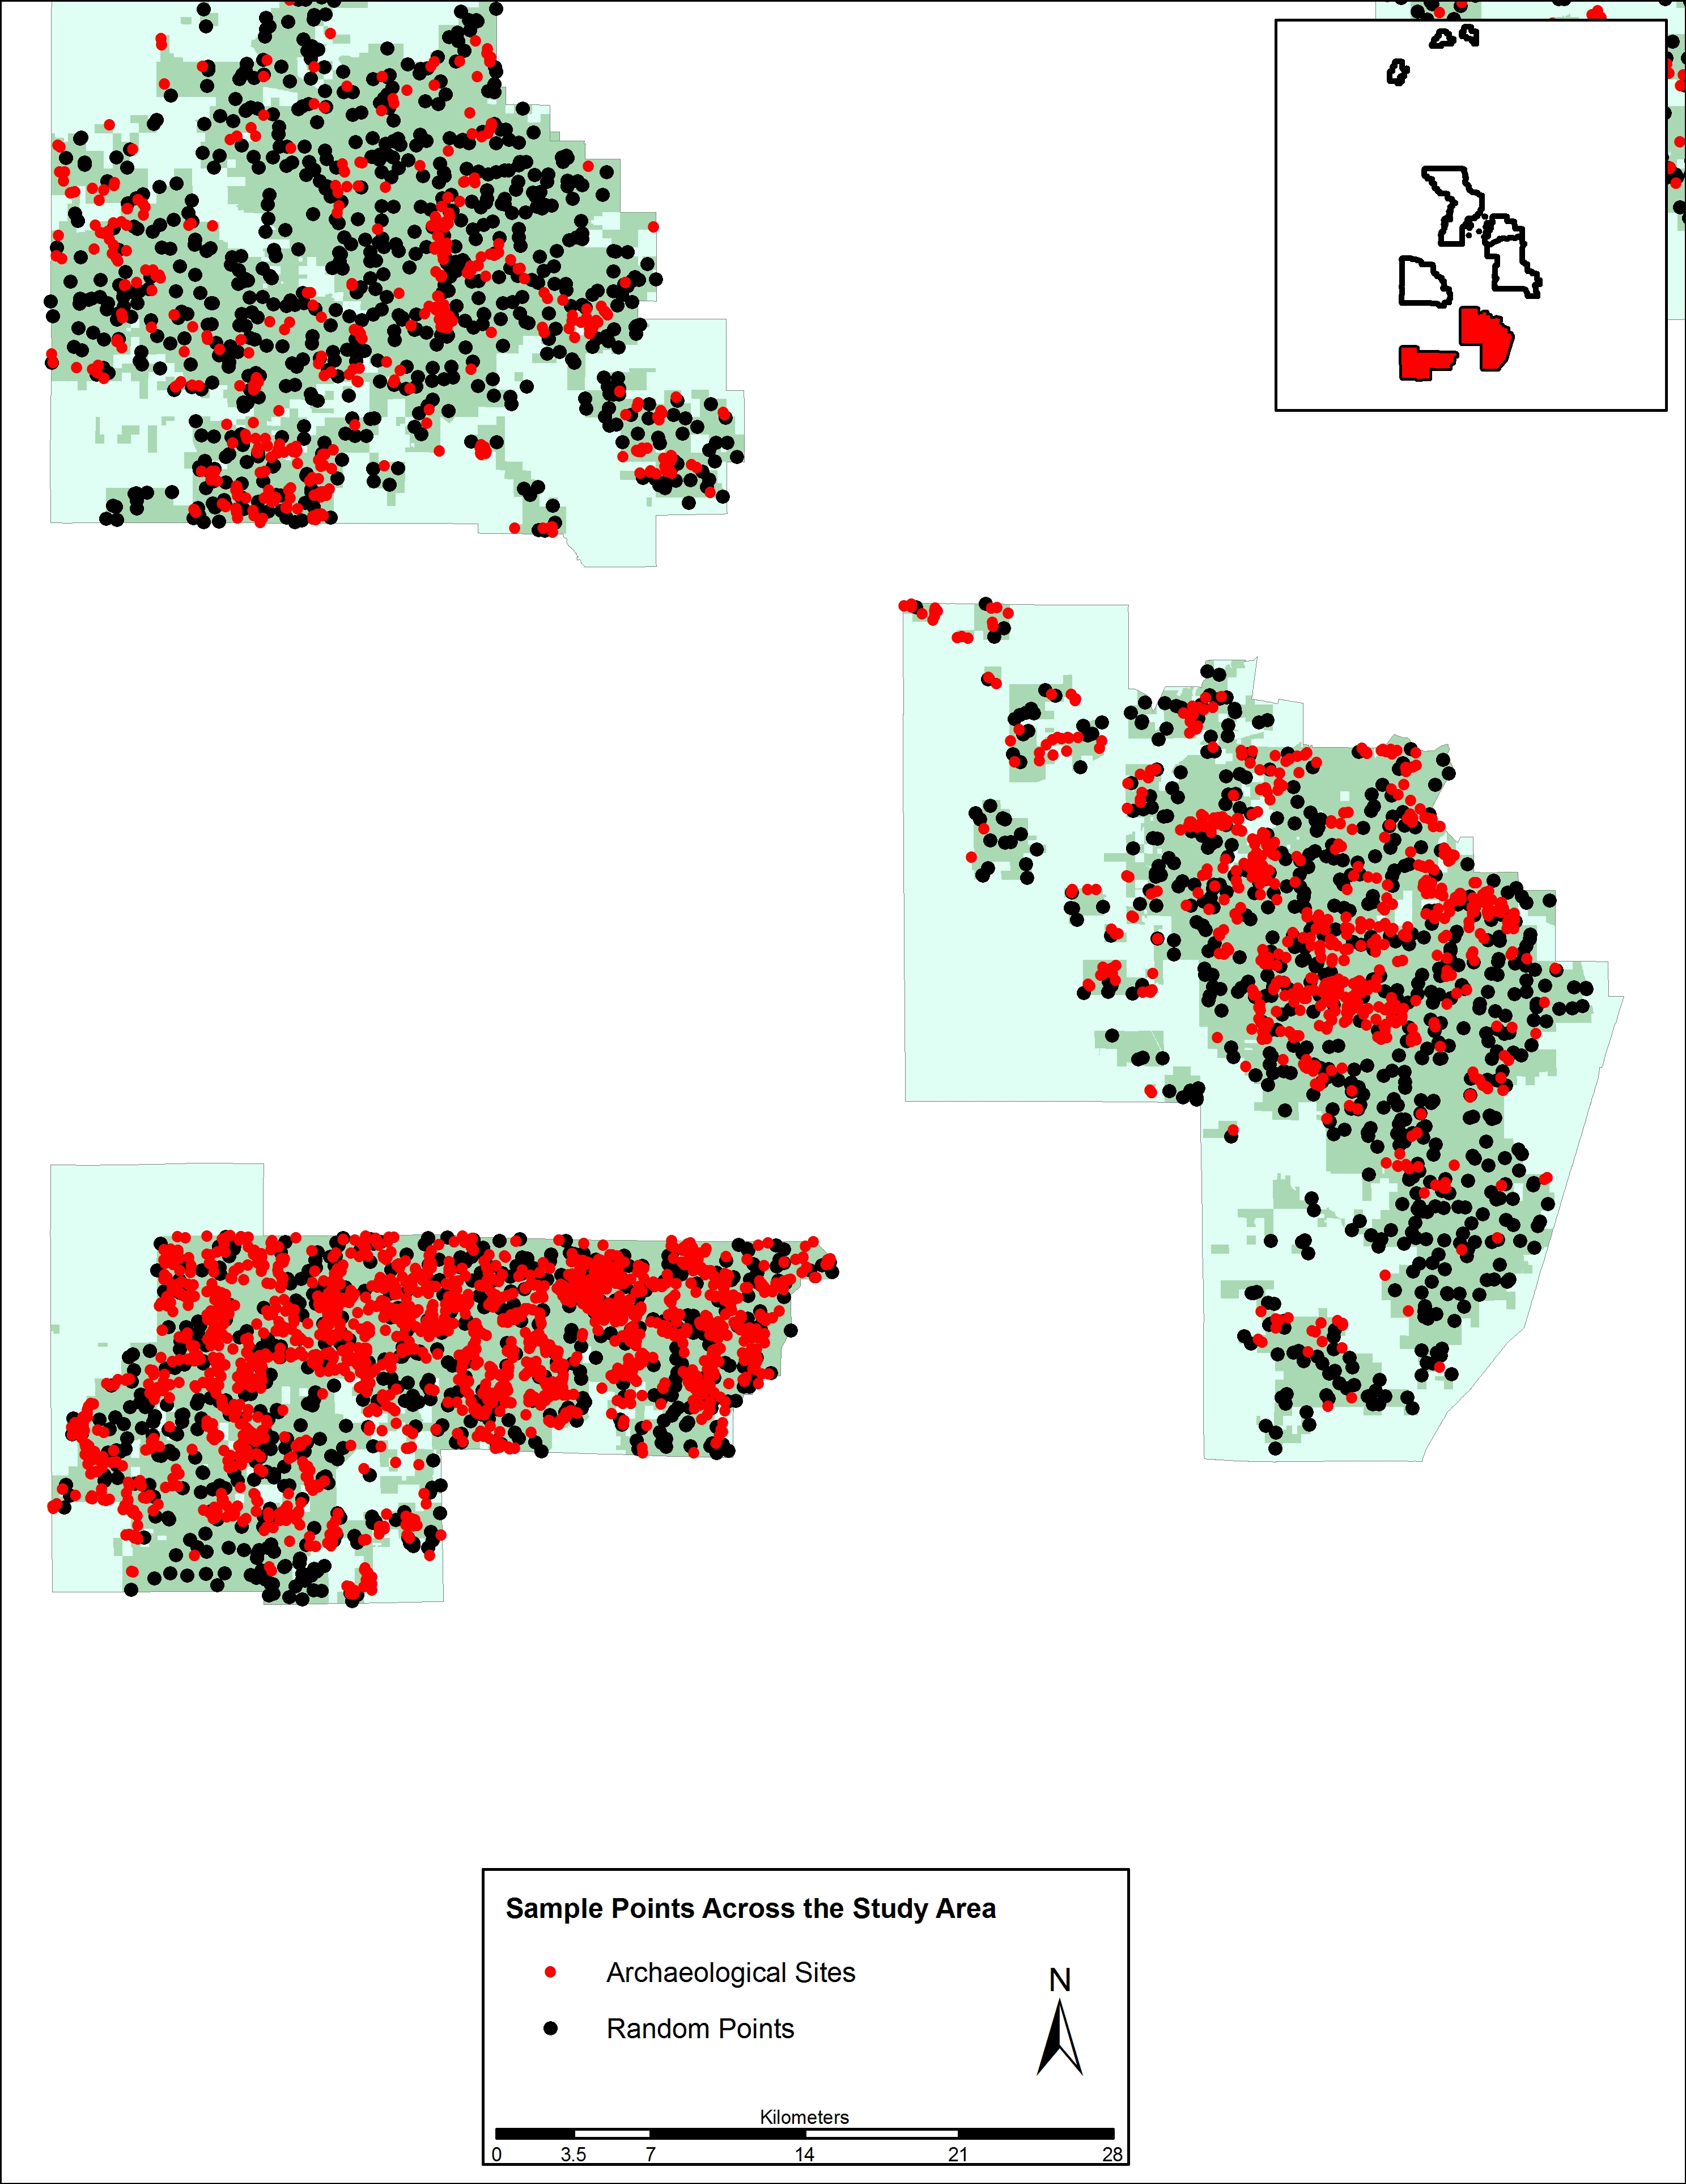
Figure 5.1. Distribution of all archaeological sites and randomly sampled points across the Calcasieu District of the Kisatchie National Forest study area.

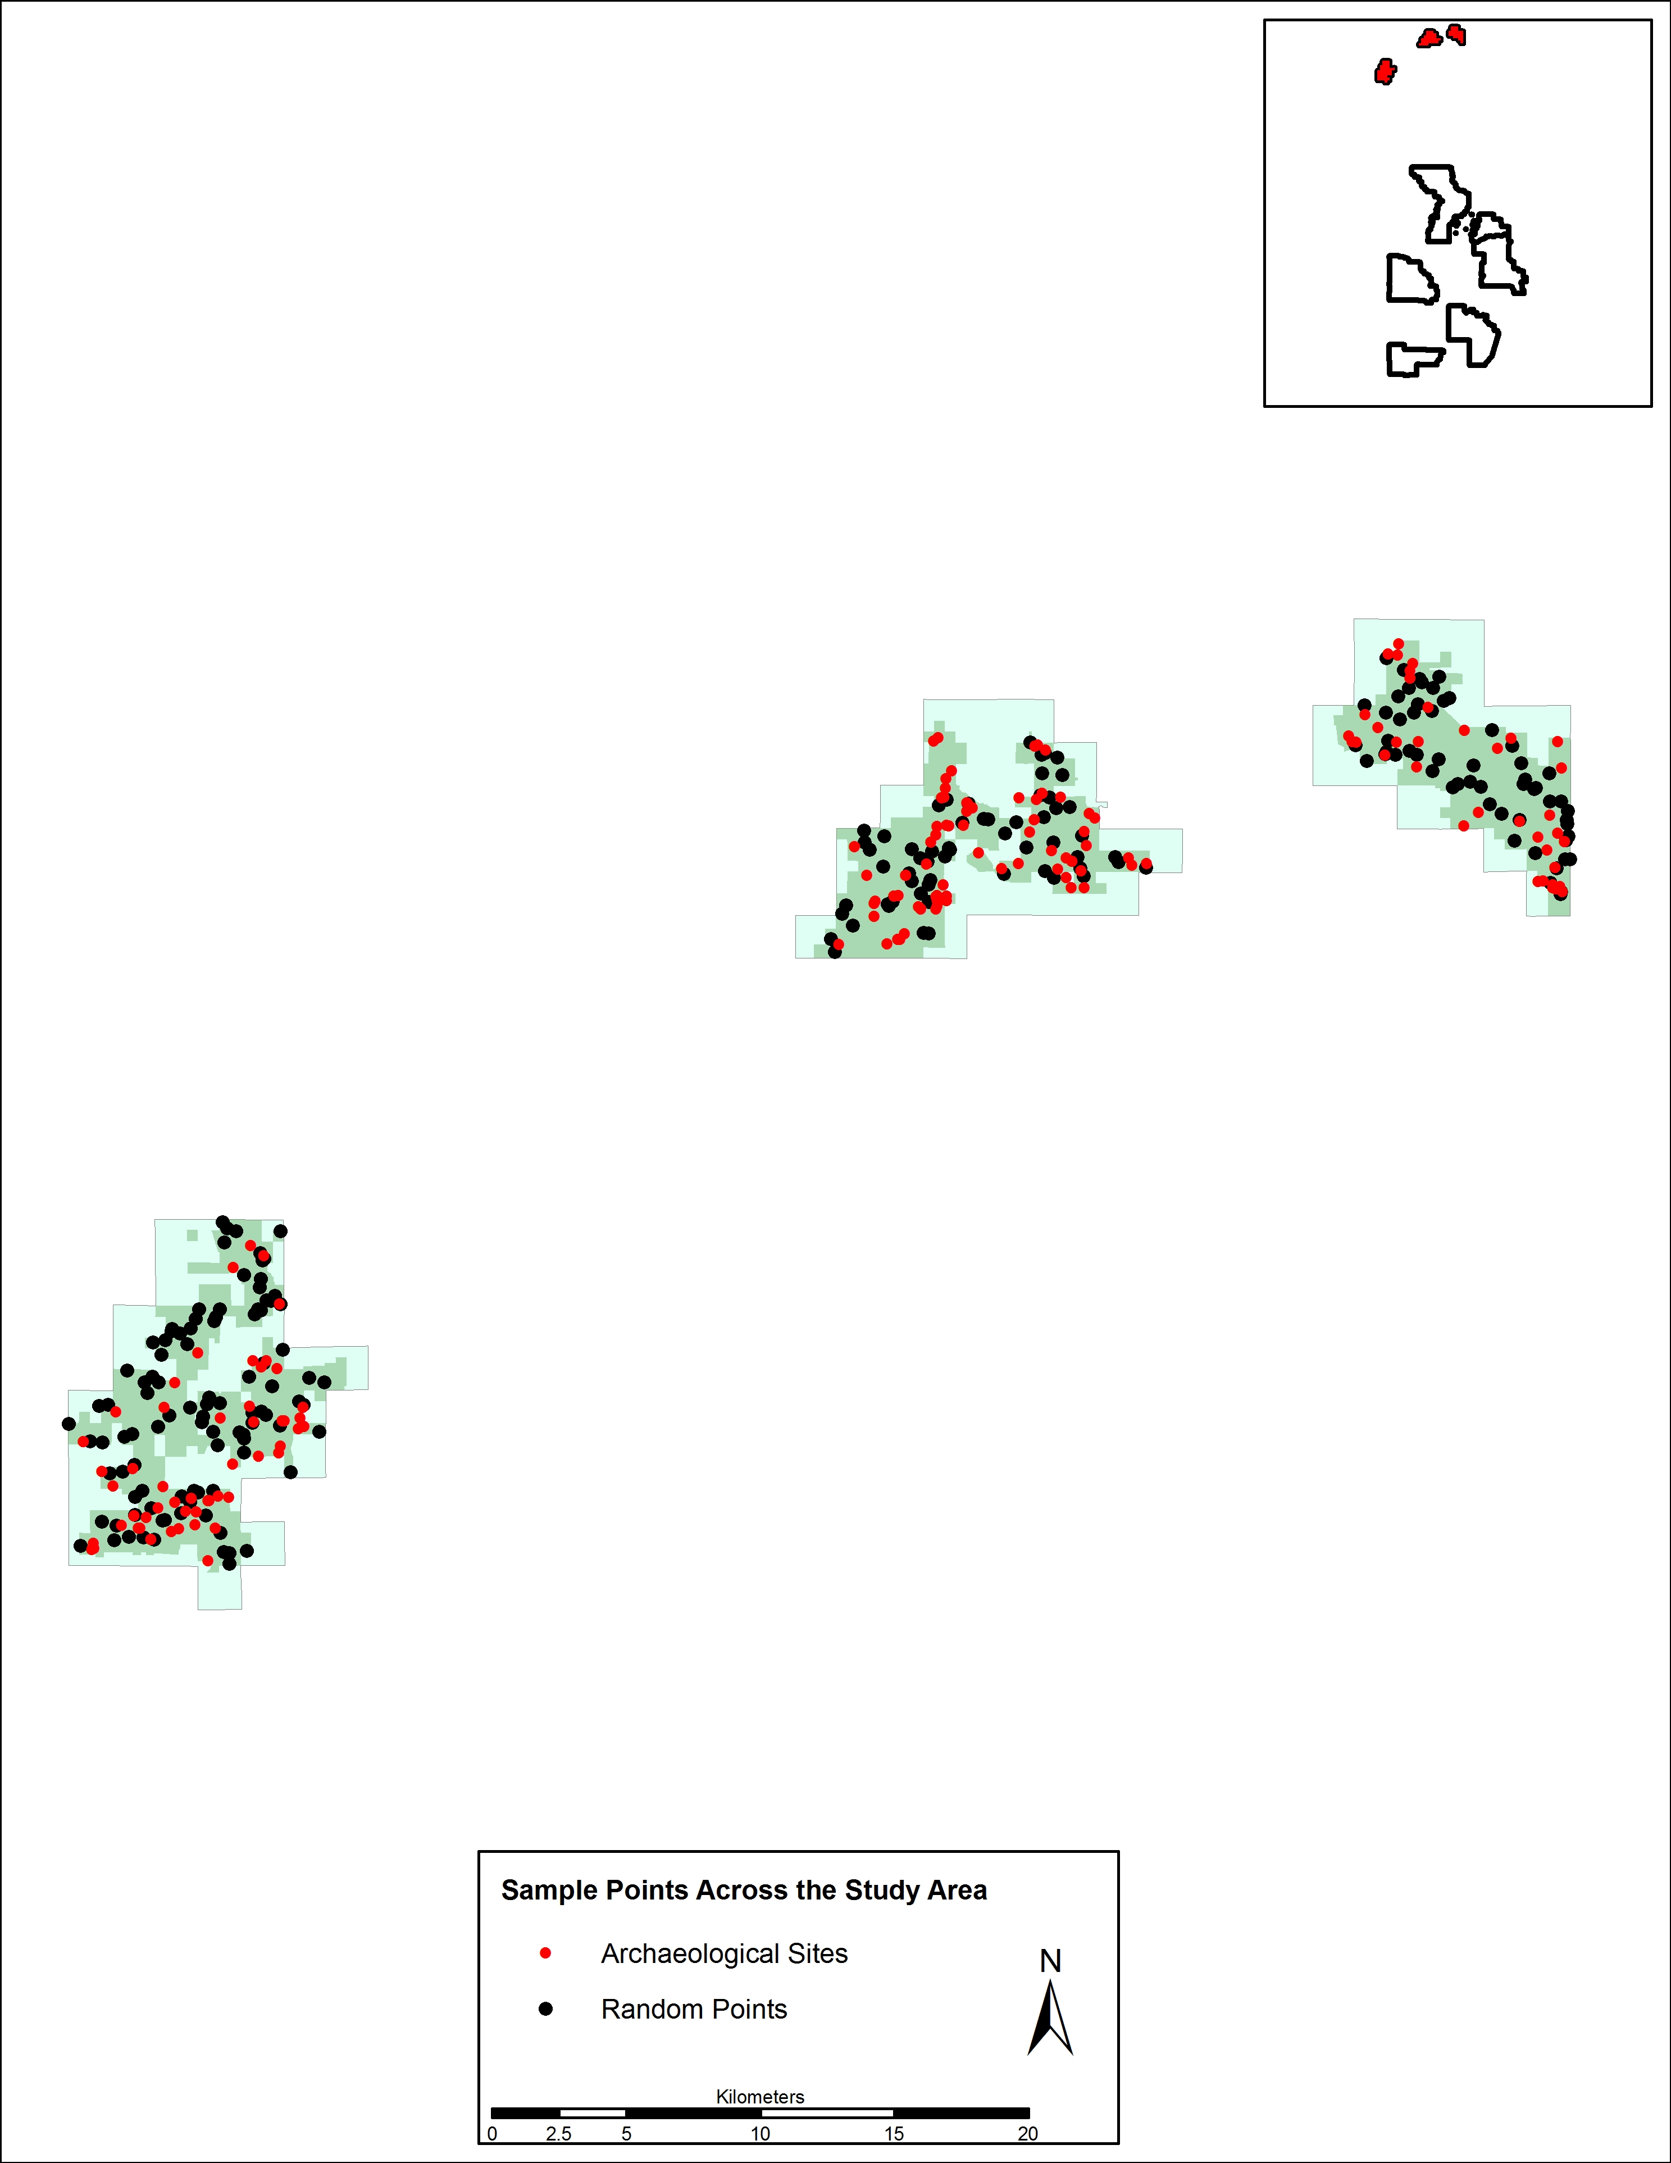
Figure 5.2. Distribution of all archaeological sites and randomly sampled points across the Caney District of the Kisatchie National Forest study area.

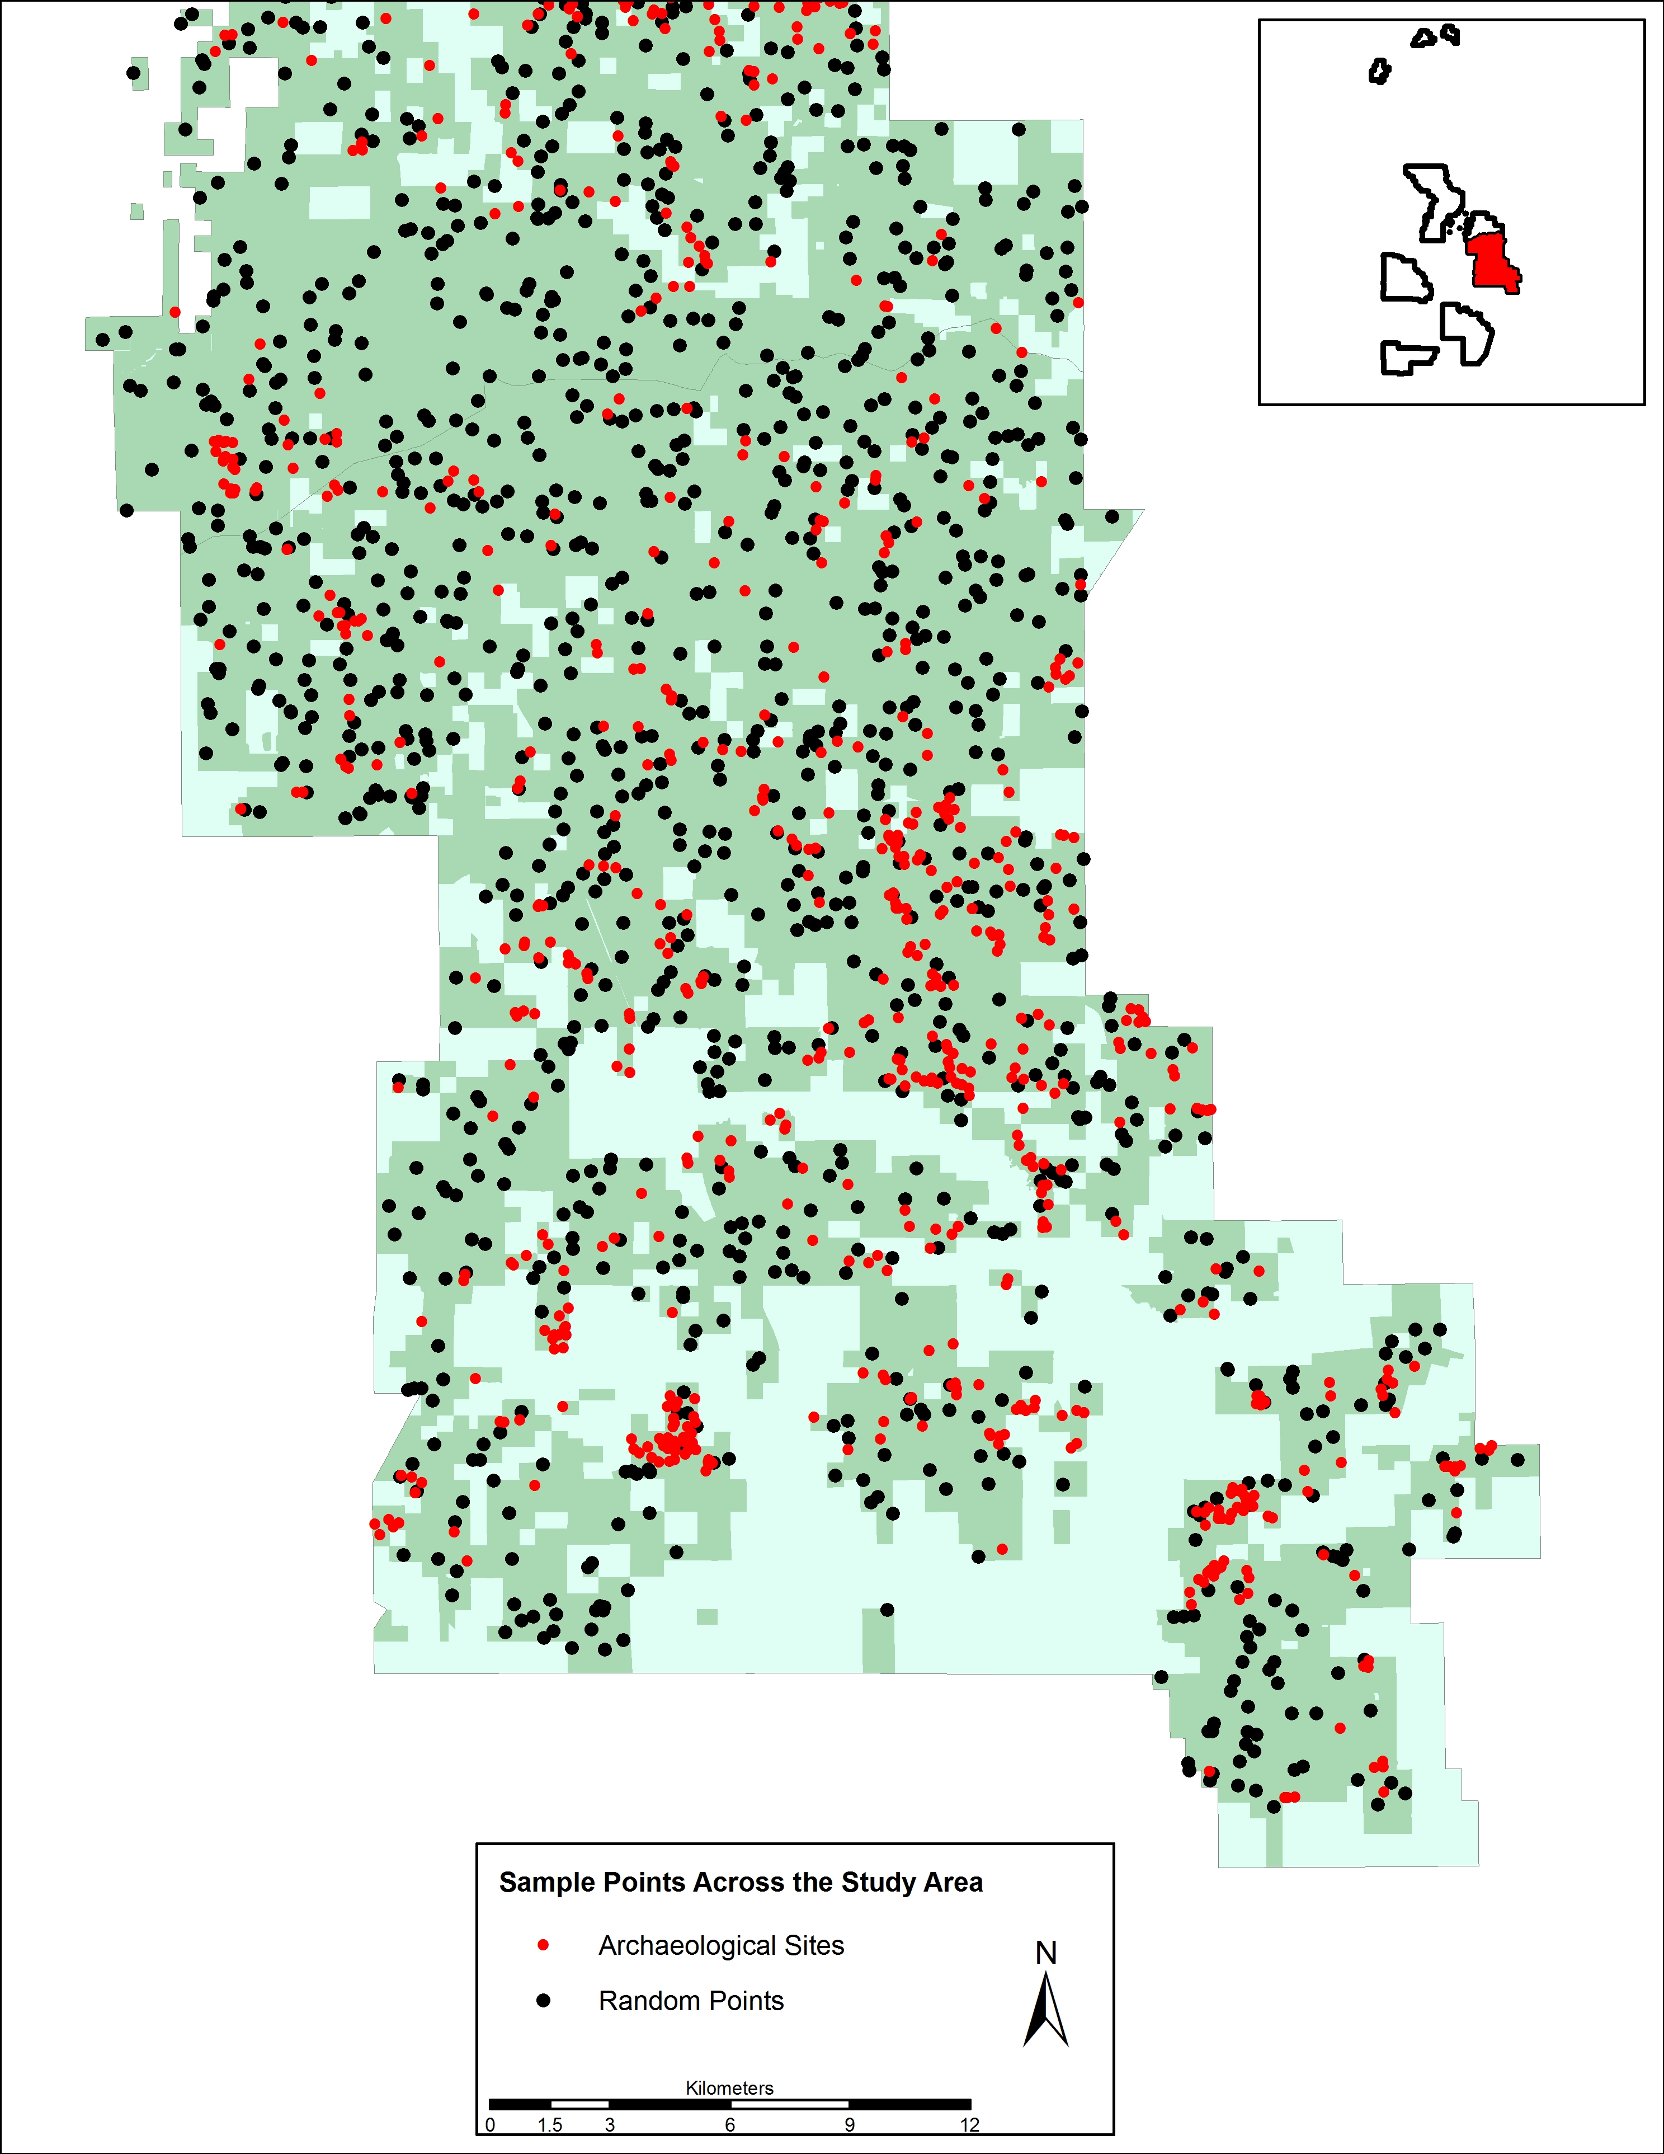
Figure 5.3. Distribution of all archaeological sites and randomly sampled points across the Catahoula District of the Kisatchie National Forest study area.

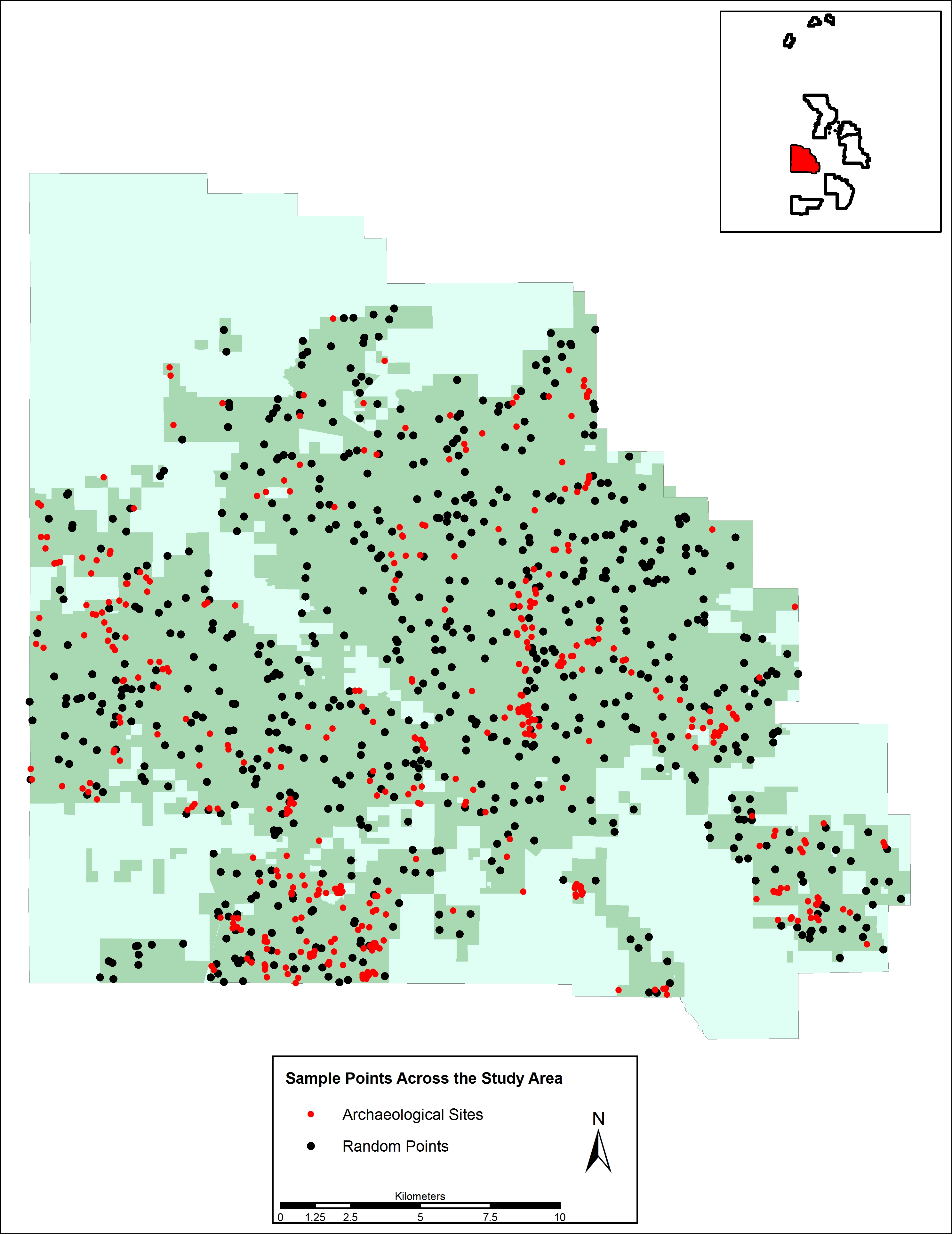

Figure 5.4. Distribution of all archaeological sites and randomly sampled points across the Kisatchie District of the Kisatchie National Forest study area.

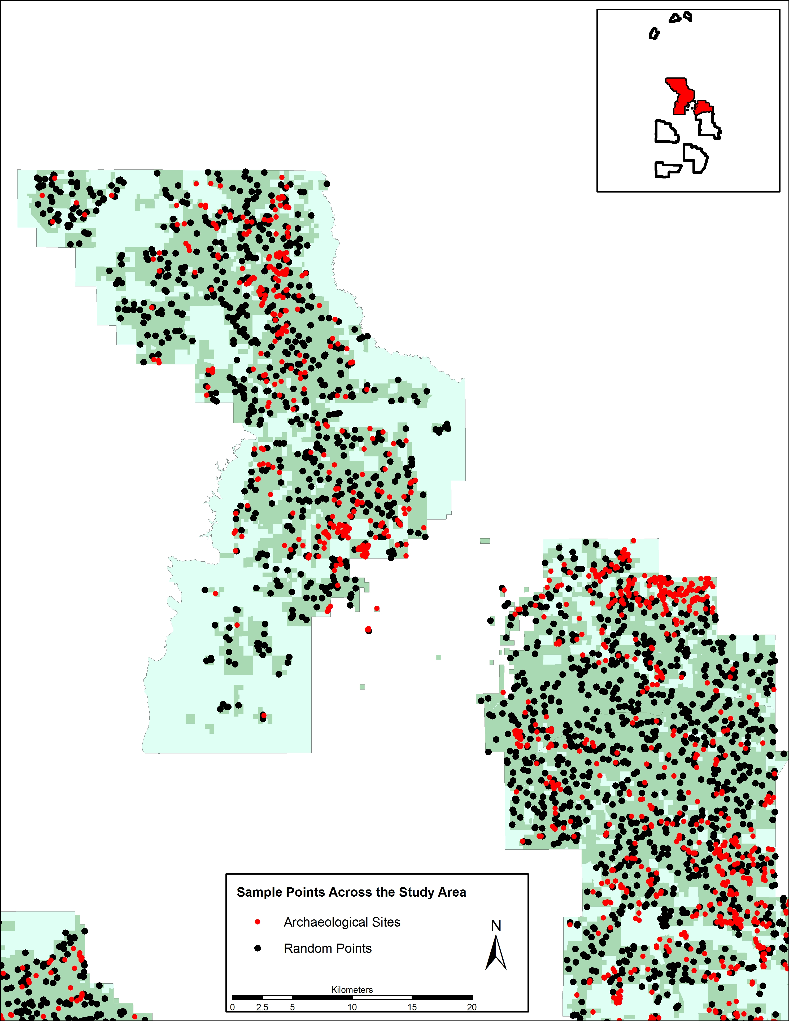

Figure 5.5. Distribution of all archaeological sites and randomly sampled points across the Winn District of the Kisatchie National Forest study area.

The second test explores geographic variation in the environmental associations of sites by evaluating the sites within each discontiguous ranger district. The third test is a refined extension of the first test, where temporal subsets (i.e. prehistoric and historic) are compared against an appropriate number of randomly sampled points. Both the second and third test results are discussed within subsequent sections of this chapter.
Two non-ratio variables, soil drainage class and soil surface texture, were statistically evaluated by comparing the expected and observed site frequencies for each class or texture. The observed site frequencies were tabulated within a GIS, while the expected site frequencies were calculated by coverage percent (detailed in Chapter 3). Both chi-square values and gains are used to evaluate the importance of these variables (Tables 5.2 and 5.3).

Table 5.2. Test Statistics of Soil Drainage Class for All Archaeological Sites across the Entire Study Area.

Drainage Class | Area (m²) | % of Area | Expected Sites | Observed Sites | % of Sites | χ2 | Gain
Excessively drained | 121427904 | 4.9 | 194.6 | 200 | 5.0 | 0.1 | 0.03
Well drained | 814258590 | 32.7 | 1305.0 | 1591 | 39.9 | 62.7 | 0.18
Moderately well drained | 840758368 | 33.8 | 1347.5 | 1160 | 29.1 | 26.1 | -0.16
Somewhat poorly drained | 294400469 | 11.8 | 471.8 | 261 | 6.5 | 94.2 | -0.81
Poorly drained | 405846011 | 16.3 | 650.4 | 764 | 19.2 | 19.8 | 0.15
No data | 10398117 | 0.4 | 16.7 | 10 | 0.3 | 2.7 | -0.67
Total | 2487089459 | 100.0 | 3986.0 | 3986 | 100.0 | 205.6 | -
df = 5, α = .05, sig of χ2 ≥ 11.1

Table 5.3. Test Statistics of Soil Surface Texture for All Archaeological Sites across the Entire Study Area.

Drainage Class | Area (m²) | % of Area | Expected Sites | Observed Sites | % of Sites | χ2 | Gain
Loam | 110391882 | 4.4 | 176.9 | 111 | 2.8 | 24.6 | -0.59
Silt loam | 686410098 | 27.6 | 1100.1 | 998 | 25.0 | 9.5 | -0.10
Sandy loam | 1423941804 | 57.3 | 2282.1 | 2293 | 57.5 | 0.1 | 0.00
Loamy sand | 229709297 | 9.2 | 368.1 | 550 | 13.8 | 89.8 | 0.33
Clay | 26237966 | 1.1 | 42.1 | 24 | 0.6 | 7.7 | -0.75
No data | 10398412 | 0.4 | 16.7 | 10 | 0.3 | 2.7 | -0.67
Total | 2487089459 | 100.0 | 3986.0 | 3986 | 100.0 | 134.3 | -
df = 5, α = .05, sig of χ2 ≥ 11.1

Each soil drainage class contains significant differences between the observed and expected values based on percent coverage except for the excessively drained class and no data categories with a χ² value of 0.1 and 2.7 respectively (see Table 5.2). The well drained soil drainage class represents a higher than expected density of archaeological sites with a high gain value of 0.18. The moderately well drained and somewhat poorly drained classes represent a reduced density of sites with regards to the well drained class. This suggests that for the known sites in the study area, there is a direct relationship between the extent of soil drainage and the likelihood for a site to occur or be discovered. This general trend is then falsified with the high gain value for the poorly drained soil drainage class. One possible explanation for this greater density of archaeological sites in poorly drained soils is for specific subsistence-based activities that benefit from decreased soil drainage (e.g. marsh resources).
Soil surface texture contains only two significant χ2 values and therefore does not lend itself toward predicting archaeological site locations. Soil surface texture is an important characteristic that governs the water movement, nutrient availability, and the erosion potential of that soil (Soil Survey Staff 2011). While theoretically appearing to be a significant factor in controlling site locations, soil surface texture is perhaps too broad of an attribute. Sites located on soils with loamy sand textures are highly statistically significant with a χ² value of 89.8 and a gain of 0.33 (see Table 5.3). This single texture category does provide evidence of preferential selection towards the settlement or use of landscapes with loamy sand soils—likely due to drainage and soil fertility.
Table 5.4. Descriptive Statistics for All Archaeological Sites and Random Sample Points across the Entire Study Area (30-meter cells).
Variableª | N | Mean | Std. Deviation | Minimum | Maximum
dpoor | 7972 | 270 | 444 | 0 | 4246
dwell | 7972 | 47 | 149 | 0 | 2205
floodf | 7972 | 327 | 354 | 0 | 2813
floodfo | 7972 | 327 | 353 | 0 | 2783
hwy | 7972 | 1604 | 1251 | 0 | 8111
roadall | 7972 | 174 | 184 | 0 | 3036
stream | 7972 | 75 | 72 | 0 | 1110
srank1 | 7972 | 126 | 120 | 0 | 1184
srank2 | 7972 | 212 | 172 | 0 | 1495
srank3 | 7972 | 399 | 314 | 0 | 2568
srank4 | 7972 | 851 | 691 | 0 | 5407
srank5 | 7972 | 1695 | 1186 | 0 | 8298
srank6 | 7972 | 3695 | 2360 | 0 | 12923
srank7 | 7972 | 12864 | 16930 | 0 | 96277
srank8 | 7972 | 40020 | 22248 | 0 | 107619
srank9 | 7972 | 64129 | 28062 | 3059 | 122082
sseas | 7972 | 99 | 99 | 0 | 1110
sperm | 7972 | 285 | 255 | 0 | 2597
drain | 7972 | 166 | 147 | 0 | 1315
wetl | 7972 | 3564 | 3200 | 0 | 23419
aspect | 7972 | 174 | 103 | 0 | 360
slope | 7972 | 5 | 3 | 0 | 27
elev | 7972 | 62 | 18 | 20 | 139
ª Emboldened variables represent those selected for further temporal and geographic analysis

Table 5.5. Mann-Whitney Rank-Sum Results for All Archaeological Sites and random sample points across the Entire Study Area (30-meter cells).
Variableª | Site Class | N | Mean Rank | Sum of Ranks
dpoor | Site | 3986 | 3798.52 | 15140911.00
 | Random Point | 3986 | 4174.48 | 16639467.00
dwell | Site | 3986 | 3914.71 | 15604024.50
 | Random Point | 3986 | 4058.29 | 16176353.50
floodf | Site | 3986 | 3524.68 | 14049363.00
 | Random Point | 3986 | 4448.32 | 17731015.00
floodfo | Site | 3986 | 3526.23 | 14055572.00
 | Random Point | 3986 | 4446.77 | 17724806.00
hwy | Site | 3986 | 4103.45 | 16356352.50
 | Random Point | 3986 | 3869.55 | 15424025.50
roadall | Site | 3986 | 4104.11 | 16358989.50
 | Random Point | 3986 | 3868.89 | 15421388.50
stream | Site | 3986 | 3826.31 | 15251664.50
 | Random Point | 3986 | 4146.69 | 16528713.50
srank1 | Site | 3986 | 4010.42 | 15985519.00
 | Random Point | 3986 | 3962.58 | 15794859.00
srank2 | Site | 3986 | 3768.03 | 15019382.50
 | Random Point | 3986 | 4204.97 | 16760995.50
srank3 | Site | 3986 | 3599.98 | 14349535.50
 | Random Point | 3986 | 4373.02 | 17430842.50
srank4 | Site | 3986 | 3669.79 | 14627793.00
 | Random Point | 3986 | 4303.21 | 17152585.00
srank5 | Site | 3986 | 3773.36 | 15040595.50
 | Random Point | 3986 | 4198.70 | 16731810.50
srank6 | Site | 3986 | 3899.99 | 15545364.00
 | Random Point | 3986 | 4073.01 | 16235014.00
srank7 | Site | 3986 | 3937.79 | 15696049.00
 | Random Point | 3986 | 4035.21 | 16084329.00
srank8 | Site | 3986 | 4476.34 | 17842707.00
 | Random Point | 3986 | 3496.66 | 13937671.00
srank9 | Site | 3986 | 4532.97 | 18068417.00
 | Random Point | 3986 | 3440.03 | 13711961.00
sseas | Site | 3986 | 3919.08 | 15621466.50
 | Random Point | 3986 | 4053.92 | 16158911.50
sperm | Site | 3986 | 3448.86 | 13747165.00
 | Random Point | 3986 | 4524.14 | 18033213.00
drain | Site | 3986 | 3638.71 | 14503916.00
 | Random Point | 3986 | 4334.29 | 17276462.00
wetl | Site | 3986 | 3722.24 | 14836845.50
 | Random Point | 3986 | 4250.76 | 16943532.50
aspect | Site | 3986 | 4001.89 | 15951539.50
 | Random Point | 3986 | 3971.11 | 15828838.50
slope | Site | 3986 | 4143.25 | 16514975.00
 | Random Point | 3986 | 3829.75 | 15265403.00
elev | Site | 3986 | 4186.23 | 16686326.50
 | Random Point | 3986 | 3786.77 | 15094051.50
ª Emboldened variables represent those selected for further temporal and geographic analysis

Table 5.6. Significance of the Mann-Whitney Rank-Sum Results for All Archaeological Sites and Random Sample Points across the Entire Study Area Compared to All Random Sample Points (30-meter cells).
Variable | Mann-Whitney U | Wilcoxon W | Z | Asymp. Sig. (2-tailed)
dpoor | 7194820.0 | 15140911.0 | -7.363 | .000
dwell | 7657933.5 | 15604024.5 | -3.580 | .000
floodf | 6103272.0 | 14049363.0 | -17.949 | .000
floodfo | 6109481.0 | 14055572.0 | -17.889 | .000
hwy | 7477934.5 | 15424025.5 | -4.537 | .000
roadall | 7475297.5 | 15421388.5 | -4.568 | .000
stream | 7305573.5 | 15251664.5 | -6.260 | .000
srank1 | 7848768.0 | 15794859.0 | -.930 | .353
srank2 | 7073291.5 | 15019382.5 | -8.479 | .000
srank3 | 6403444.5 | 14349535.5 | -14.996 | .000
srank4 | 6681702.0 | 14627793.0 | -12.287 | .000
srank5 | 7094504.5 | 15040595.5 | -8.251 | .000
srank6 | 7599273.0 | 15545364.0 | -3.356 | .001
srank7 | 7749958.0 | 15696049.0 | -1.890 | .059
srank8 | 5991580.0 | 13937671.0 | -19.004 | .000
srank9 | 5765870.0 | 13711961.0 | -21.200 | .000
sseas | 7675375.5 | 15621466.5 | -2.626 | .009
sperm | 5801074.0 | 13747165.0 | -20.864 | .000
drain | 6557825.0 | 14503916.0 | -13.507 | .000
wetl | 6890754.5 | 14836845.5 | -10.252 | .000
aspect | 7882747.5 | 15828838.5 | -.597 | .550
slope | 7319312.0 | 15265403.0 | -6.081 | .000
elev | 7147960.5 | 15094051.5 | -7.749 | .000
ª Grouping variable: site vs random point. Emboldened variables represent those selected for further temporal and
geographic analysis

Table 5.7. Descriptive Statistics for All Archaeological Sites and Random Sample Points across the Entire Study Area (5-meter cells).
Variableª | N | Mean | Std. Deviation | Minimum | Maximum
dpoor | 7972 | 261 | 441 | 0 | 4226
dwell | 7972 | 43 | 146 | 0 | 2201
floodf | 7972 | 317 | 352 | 0 | 2795
floodfo | 7972 | 317 | 351 | 0 | 2794
hwy | 7972 | 1612 | 1251 | 0 | 8120
roadall | 7972 | 179 | 184 | 0 | 3030
stream | 7972 | 79 | 72 | 0 | 1110
srank1 | 7972 | 129 | 120 | 0 | 1199
srank2 | 7972 | 215 | 172 | 0 | 1485
srank3 | 7972 | 403 | 314 | 0 | 2585
srank4 | 7972 | 854 | 690 | 0 | 5425
srank5 | 7972 | 1699 | 1186 | 0 | 8285
srank6 | 7972 | 3699 | 2360 | 0 | 12903
srank7 | 7972 | 12867 | 16931 | 5 | 96291
srank8 | 7972 | 40024 | 22249 | 10 | 107638
srank9 | 7972 | 64107 | 28031 | 3050 | 120668
sseas | 7972 | 103 | 99 | 0 | 1108
sperm | 7972 | 290 | 255 | 0 | 2585
drain | 7972 | 172 | 148 | 0 | 1315
wetl | 7972 | 3552 | 3200 | 0 | 23406
aspect | 7972 | 175 | 102 | 0 | 360
slope | 7972 | 23 | 18 | 0 | 177
elev | 7972 | 202 | 60 | 64 | 460
ª Emboldened variables represent those selected for further temporal and geographic analysis

Table 5.8. Mann-Whitney Rank-Sum Results for All Archaeological Sites and Random Sample Points across the Entire Study Area (5-meter cells).
Variableª | Site Class | N | Mean Rank | Sum of Ranks
dpoor | Site | 3986 | 3798.93 | 15142537.50
 | Random Point | 3986 | 4174.07 | 16637840.50
dwell | Site | 3986 | 3911.10 | 15589645.00
 | Random Point | 3986 | 4061.90 | 16190733.00
floodf | Site | 3986 | 3524.88 | 14050174.50
 | Random Point | 3986 | 4448.12 | 17730203.50
floodfo | Site | 3986 | 3525.39 | 14052193.50
 | Random Point | 3986 | 4447.61 | 17728184.50
hwy | Site | 3986 | 4103.25 | 16355566.00
 | Random Point | 3986 | 3869.75 | 15424812.00
roadall | Site | 3986 | 4105.17 | 16363208.00
 | Random Point | 3986 | 3867.83 | 15417170.00
stream | Site | 3986 | 3851.31 | 15351336.00
 | Random Point | 3986 | 4121.69 | 16429042.00
srank1 | Site | 3986 | 4011.98 | 15991756.50
 | Random Point | 3986 | 3961.02 | 15788621.50
srank2 | Site | 3986 | 3771.06 | 15031437.00
 | Random Point | 3986 | 4201.94 | 16748941.00
srank3 | Site | 3986 | 3599.95 | 14349390.50
 | Random Point | 3986 | 4373.05 | 17430987.50
srank4 | Site | 3986 | 3668.76 | 14623694.00
 | Random Point | 3986 | 4304.24 | 17156684.00
srank5 | Site | 3986 | 3773.15 | 15039756.00
 | Random Point | 3986 | 4198.91 | 16732650.00
srank6 | Site | 3986 | 3899.86 | 15544833.00
 | Random Point | 3986 | 4073.14 | 16235545.00
srank7 | Site | 3986 | 3937.68 | 15695590.50
 | Random Point | 3986 | 4035.32 | 16084787.50
srank8 | Site | 3986 | 4476.37 | 17842798.50
 | Random Point | 3986 | 3496.63 | 13937579.50
srank9 | Site | 3986 | 4532.83 | 18067868.50
 | Random Point | 3986 | 3440.17 | 13712509.50
sseas | Site | 3986 | 3923.84 | 15640445.00
 | Random Point | 3986 | 4049.16 | 16139933.00
sperm | Site | 3986 | 3449.75 | 13750707.50
 | Random Point | 3986 | 4523.25 | 18029670.50
drain | Site | 3986 | 3644.75 | 14527954.00
 | Random Point | 3986 | 4328.25 | 17252424.00
wetl | Site | 3986 | 3722.50 | 14837872.00
 | Random Point | 3986 | 4250.50 | 16942506.00
aspect | Site | 3986 | 4026.04 | 16047813.50
 | Random Point | 3986 | 3946.96 | 15732564.50
slope | Site | 3986 | 4143.29 | 16515164.50
 | Random Point | 3986 | 3829.71 | 15265213.50
elev | Site | 3986 | 4191.05 | 16705512.50
 | Random Point | 3986 | 3781.95 | 15074865.50
ª Emboldened variables represent those selected for further temporal and geographic analysis

Table 5.9. Significance of the Mann-Whitney Rank-Sum Results for All Archaeological Sites and Random Sample Points across the Entire Study Area Compared to All Random Sample Points (5-meter cells).
Variableª | Mann-Whitney U | Wilcoxon W | Z | Asymp. Sig. (2-tailed)
dpoor | 7196446.5 | 15142537.5 | -7.345 | .000
dwell | 7643554.0 | 15589645.0 | -3.760 | .000
floodf | 6104083.5 | 14050174.5 | -17.938 | .000
floodfo | 6106102.5 | 14052193.5 | -17.918 | .000
hwy | 7478721.0 | 15424812.0 | -4.529 | .000
roadall | 7471079.0 | 15417170.0 | -4.604 | .000
stream | 7405245.0 | 15351336.0 | -5.245 | .000
srank1 | 7842530.5 | 15788621.5 | -.989 | .323
srank2 | 7085346.0 | 15031437.0 | -8.358 | .000
srank3 | 6403299.5 | 14349390.5 | -14.996 | .000
srank4 | 6677603.0 | 14623694.0 | -12.327 | .000
srank5 | 7093665.0 | 15039756.0 | -8.259 | .000
srank6 | 7598742.0 | 15544833.0 | -3.361 | .001
srank7 | 7749499.5 | 15695590.5 | -1.894 | .058
srank8 | 5991488.5 | 13937579.5 | -19.005 | .000
srank9 | 5766418.5 | 13712509.5 | -21.195 | .000
sseas | 7694354.0 | 15640445.0 | -2.431 | .015
sperm | 5804616.5 | 13750707.5 | -20.823 | .000
drain | 6581863.0 | 14527954.0 | -13.259 | .000
wetl | 6891781.0 | 14837872.0 | -10.242 | .000
aspect | 7786473.5 | 15732564.5 | -1.534 | .125
slope | 7319122.5 | 15265213.5 | -6.083 | .000
elev | 7128774.5 | 15074865.5 | -7.935 | .000
ª Grouping variable: site vs random point. Emboldened variables represent those selected for further temporal and
geographic analysis

Differing analysis scales or resolutions were employed for the initial evaluation of the 23 environmental correlates of past human settlement. Table 5.4 characterizes the descriptive statistics while Tables 5.5 and 5.6 represent the test statistic results for the variables as processed into 30-m-by-30-m cell rasters, while Tables 5.7-5.9 reflect the variables as processed into 5-m-by-5-m cell rasters. The comparison of 30-m to 5-m variable resolution attempts to evaluate the effect such scales have on the modeling process. For the initial 22 ratio variables considered, which include some redundant variables, each variable was statistically assigned significance with respect to its influence on the location of archaeological sites and random sample points using the Mann-Whitney Rank-Sum test. Any variable that contained incomplete data for a given site or sampled point was removed from the test statistics analysis through a test-by-test procedure. The test results show statistical significance for all variables except aspect and several stream rank categories.
Additional Mann-Whitney rank-sum tests (Tables 5.10 to 5.13) are conducted for key variables with the removal of zero values from consideration. Environmental variables such as distance from frequently flooded areas (floodf), distance from varying drained soils (dpoor/dwell), and distance from wetlands (wetl) are statistically skewed when considering the distance values of zero, which indicates the location of sites or random points within the same raster cell as the environmental variable, thus possessing a zero value.
Table 5.10. Mann-Whitney Rank-Sum Results for All Archaeological Sites and Random Sample Points across the Entire Study Area Excluding Values of Zero (30-meter cells).
Variable | Site Class | N | Mean Rank | Sum of Ranks
dpoor | Site | 2965 | 2638.95 | 7824473.00
dpoor | Random Point | 2902 | 3235.46 | 9389305.00
dwell | Site | 1032 | 905.94 | 934933.50
dwell | Random Point | 1094 | 1212.13 | 1326067.50
floodf | Site | 3327 | 2922.57 | 9723394.00
floodf | Random Point | 3462 | 3849.01 | 13325261.00
wetl | Site | 3954 | 3678.06 | 14543049.50
wetl | Random Point | 3944 | 4221.63 | 16650101.50

Table 5.11. Significance of the Mann-Whitney Rank-Sum Results for All Archaeological Sites and Random Sample Points across the Entire Study Area Compared to All Random Sample Points Excluding Values of Zero (30-meter cells).
Variableª | Mann-Whitney U | Wilcoxon W | Z | Asymp. Sig. (2-tailed)
dpoor | 3427378.00 | 7824473.00 | -13.50 | .000
dwell | 401905.50 | 934933.50 | -11.59 | .000
floodf | 4187266.00 | 9723394.00 | -19.48 | .000
wetl | 6724014.50 | 14543049.50 | -10.59 | .000
a Grouping variable: site vs random point

Table 5.12. Mann-Whitney Rank-Sum Results for All Archaeological Sites and Random Sample Points across the Entire Study Area Excluding Values of Zero (5-meter cells).
Variable | Site Class | N | Mean Rank | Sum of Ranks
dpoor | Sites | 2968 | 2636.93 | 7826420.50
dpoor | Random Point | 2900 | 3239.04 | 9393225.50
dwell | Sites | 1028 | 901.97 | 927230.00
dwell | Random Point | 1096 | 1213.07 | 1329520.00
floodf | Sites | 3319 | 2927.98 | 9717976.00
floodf | Random Point | 3467 | 3839.14 | 13310315.00
wetl | Sites | 3955 | 3678.38 | 14548010.00
wetl | Random Point | 3944 | 4222.37 | 16653040.00

Table 5.13. Significance of the Mann-Whitney Rank-Sum Results for All Archaeological Sites and Random Sample Points across the Entire Study Area Compared to All Random Sample Points Excluding Values of Zero (5-meter cells).
Variableª | Mann-Whitney U | Wilcoxon W | Z | Asymp. Sig. (2-tailed)
dpoor | 3420424.50 | 7826420.50 | -13.61 | .000
dwell | 398324.00 | 927230.00 | -11.68 | .000
floodf | 4208436.00 | 9717976.00 | -19.15 | .000
wetl | 6725020.00 | 14548010.00 | -10.60 | .000
a Grouping variable: site vs random point

The results of the analysis excluding values of zero (Tables 5.22 - 5.24) maintain statistical significance for the variables. For each variable, the location of known archaeological sites is within closer proximity to said variable than compared to the randomly sampled points. The results when excluding zero values suggest that sites are located further from areas expressing the variable than when the analysis includes sites located within the area exhibiting a zero value. For example, the results of distance from grouped poorly-drained soils (dpoor) suggest that sites located in grouped well-drained soils are located closer to poorly-drained soils than expected by chance (i.e. distribution of randomly sampled points). However, the reanalysis excluding zero values suggests these sites are located at greater distance than previously calculated while still remaining significant. The same logic can be applied to the remaining reanalyzed variables, though distance to wetland (wetl) is relatively unchanged. The other 18 variables were not considered for reanalysis as there was not an expectation for sites or random points to bias the measure by falling within the variable area (i.e. within a roadway, within a stream, etc.).
In consideration of the appropriateness and significance of the initial 22 ratio variables, stream rank (srank1-9) proved too detailed a category, though information was gained through this detail that would not be noticed within the grouped variable category of seasonal stream (stream rank < 3) and permanent stream (stream rank ≥ 3). The dense distribution of recorded streams of rank 1 for both the 30-meter and 5-meter resolutions does not assign statistical significance to the role of srank1 and the location of known archaeological sites as compared with a random sample of points. Furthermore, stream ranks of greater than six tend to be of a rarity within the west-central region of Louisiana. The significance of these grouped variables is secondary to that of grouped stream ranks (i.e. permanent stream and seasonal stream) which prove more important within this modeling effort. Stream rank is therefore removed from further analyses in favor of seasonal stream (sseas) and permanent stream (sperm). Additionally, the major drainage variable (drain) is similar to, but less effective than the permanent stream variable and therefore is also not considered further.
Soil flooding class variables such as frequently flooding soils (floodf) and frequently and occasionally flooding soils (floodfo) produce similarly significant results, though there is no marked advantage to include the occasional flooding soil class as no sites have been discovered in these zones, which cover a limited portion of the study area. The frequently and occasionally flooded soil class (floodfo) is a major aspect of the definition for medium or indeterminate probability zone within the active US Forest Service model (Fort Polk 1995 Predictive Model). For this analysis, the frequently flooded soil class (floodf) is preferred as it contains the same quantity of sites (n = 670) while covering less land area.
The variable for major highways (hwy) lacks relevance for the distribution of known sites as compared to all roadways (roadall). Roadways provide a greater likelihood for site discovery by chance due to modern traffic. While major highways offer increased traffic capacity, the limited overlap between the study area and the network of major highways does not translate into a greater likelihood for site discovery or for the patterning of historic settlement. Major highways did not convey statistical significance for any temporal or geographic subset of the data. As such, all roadways (roadall) is preferred.
Several prominent trends appear within the study area that relate to the environmental characteristics of sites and random points. While further temporal and geographical evaluations of the environmental variables are needed before revising or developing a predictive model for the Kisatchie National Forest, some general observations can be remarked upon:
- Archaeological sites are located significantly closer to frequently flooded soils (floodf) relative to the distribution of randomly sampled points. Similarly, distance to grouped poorly drained soils (dpoor) and distance to grouped well drained soils (dwell) produce patterns suggesting a greater propensity for sites to be located at shorter distances to the variables relative to random points. The intersections of drainage ecotones as well as flooding ecotones contain a higher than expected proportion of sites. The ability to exploit multiple ecotones confers a benefit to both prehistoric and historic populations.
- Known archaeological sites tend to cluster around streams with greater frequency than randomly sampled points. Even more significant is the location of archaeological sites and random points with respect to permanent streams only (sperm). Hydrological factors serve a prominent role within the active US Forest Service model (FPPM 1995), and upon initial testing the assigned prominence is appropriate.
- Wetlands (wetl) appear to attract human activity as known archaeological sites are located significantly closer to areas of recorded wetlands than the random sample of points. Wetlands offer a unique array of biota, which appears to have attracted past populations.
- Sampled surface areas with greater slope tend to contain archaeological sites, while the randomly sampled points are mostly distributed within areas of reduced slope—a seemingly counterintuitive trend. Site locations within the study area exhibit higher than anticipated percent slopes suggesting the selection of areas above the flat bottomlands that are prone to flooding while remaining within close proximity to streams. Erosion’s role in exposing artifacts offers an alternative interpretation of the significance of greater slope, as greater artifact visibility translates to greater likelihood for discovery.
- Supporting the hypothesis that sites tend to cluster on steeper slopes above lowlands, the known archaeological sites lie at greater elevations relative to the random background points. Sites average an elevation of 207 m while the randomly sampled points average an elevation of 198 m.
- In theory, roadways provide a greater likelihood for site discovery by chance due to modern traffic. The results of the Mann-Whitney rank-sum test suggests the contrary, that archaeological sites are typically located a greater distance from roads (roadall) than the randomly sampled points. It should be noted that this pattern only holds when considering all site types, as historic sites exhibit a different distribution.
- The analyzed environmental variable of aspect possesses no significance with respect to the background sample of random points and known archaeological sites. Aspect seems evenly distributed for both datasets. The same negative correlation does not apply to the variable of major highway (hwy), yet it fails in appropriateness due to its limited occurrence within the study area. Stream rank conveys too detailed of a set of variables while failing to offer more value than distance to permanent stream (sperm) or distance to seasonal stream (sseas).

While these observations hold for the entire dataset, greater value may be extracted by examining the environmental variables across geographic and temporal subsets. As with the examination of the active US Forest Service Model in Chapter 4, the Caney District and the central cluster of Calcasieu, Catahoula, Kisatchie, and Winn Districts will be analyzed separately to determine the influence of environmental variation within the Kisatchie National Forest. Variation is also expected between the prehistoric and historic subsets of archaeological sites. Cultural and subsistence differences would likely influence the distribution of sites across the Forest within the prehistoric component, and especially between the prehistoric and historic components.
The lack of any effect upon variable significance between the 30-m and 5-m raster cell scales implies the equality between these two resolutions for this study area (see Table 5.6 and 5.9) As several variables, most notably Aspect, fluctuated towards significance from the 30-m scale (Z = -.597, p = .550) to the 5-m scale (Z = -1.534, p = -.125), the 5-m scale resolution is accepted as the standard for the remaining analysis (see Table 5.6 and 5.9).

Geographic Correlation of Environmental Variable and Archaeological Site Location

The correlation of environmental variable and archaeological site location for the entire study area proved significant for 10 of the 11 emboldened variables selected for further analysis with the exception of Aspect (see Table 5.9). Separating the study area into the Caney District to the north and the central cluster of Calcasieu, Catahoula, Kisatchie, and Winn Districts, this secondary test attempts to determine the effect of environmental variation within the Forest study area while considering smaller ranges that may encompass less environmental variance and in turn produce greater or reduced significance for the analyzed variables. As the Caney Ranger District lies approximately 140 kilometers north of the centerpoint for the central cluster of ranger districts (i.e. Winn, Catahoula, Kisatchie, and Calcasieu Districts), the random background points and known archaeological sites and their environmental characteristics are evaluated independently for the central cluster and the Caney District (see Figure 5.1 for Caney and central cluster areas). As discussed in Chapter 4, the level IV ecoregion overlays served as the criteria for selecting the Caney District as an outlier. As the results analyses of environmental variables by district conform to the results of the Caney District and the central cluster of ranger districts, only the geographic area subsets are discussed here.
The random sample points were generated for the entire study area and then extracted by study area subset along with recorded archaeological sites. This sampling technique produces slightly disproportionate quantities of random points to recorded sites when extracted. The central cluster study area contains 3,825 archaeological sites and 3,770 random background points while the Caney study area contains 161 archaeological sites and 216 random background points.

Table 5.14. Descriptive Statistics for All Archaeological Sites and Random Sample Points across the Central Cluster Subset of the Study Area (5-meter cells).
Variable | N | Mean | Std. Deviation | Minimum | Maximum
dpoor | 7595 | 223 | 306 | 0 | 2260
dwell | 7595 | 44 | 148 | 0 | 2201
floodf | 7595 | 321 | 354 | 0 | 2795
roadall | 7595 | 181 | 186 | 0 | 3030
stream | 7595 | 78 | 72 | 0 | 1110
sseas | 7595 | 102 | 98 | 0 | 1108
sperm | 7595 | 289 | 256 | 0 | 2585
wetl | 7595 | 3335 | 2641 | 0 | 17039
aspect | 7595 | 175 | 102 | 0 | 360
slope | 7595 | 23 | 18 | 0 | 177
elev | 7595 | 201 | 59 | 64 | 399

Table 5.15. Mann-Whitney Rank-Sum Results for All Archaeological Sites and Random Sample Points across the Central Cluster Subset of the Study Area (5-meter cells).
Variable | Site Class | N | Mean Rank | Sum of Ranks
dpoor | Site | 3825 | 3607.78 | 13799766.00
 | Random Point | 3770 | 3990.99 | 15046044.00
dwell | Site | 3825 | 3729.56 | 14265572.50
 | Random Point | 3770 | 3867.44 | 14580237.50
floodf | Site | 3825 | 3338.84 | 12771052.50
 | Random Point | 3770 | 4263.86 | 16074757.50
roadall | Site | 3825 | 3918.54 | 14988397.00
 | Random Point | 3770 | 3675.71 | 13857413.00
stream | Site | 3825 | 3665.16 | 14019251.00
 | Random Point | 3770 | 3932.77 | 14826559.00
sseas | Site | 3825 | 3739.01 | 14301729.00
 | Random Point | 3770 | 3857.85 | 14544081.00
sperm | Site | 3825 | 3279.61 | 12544513.50
 | Random Point | 3770 | 4323.95 | 16301296.50
wetl | Site | 3825 | 3529.54 | 13500493.00
 | Random Point | 3770 | 4070.38 | 15345317.00
aspect | Site | 3825 | 3831.25 | 14654530.50
 | Random Point | 3770 | 3764.27 | 14191279.50
slope | Site | 3825 | 3942.92 | 15081664.50
 | Random Point | 3770 | 3650.97 | 13764145.50
elev | Site | 3825 | 4007.28 | 15327848.50
 | Random Point | 3770 | 3585.67 | 13517961.50

Table 5.16. Significance of the Mann-Whitney Rank-Sum Results for All Archaeological Sites across the Central Cluster Subset of the Study Area Compared to All Random Sample Points (5-meter cells).
Variableª | Mann-Whitney U | Wilcoxon W | Z | Asymp. Sig. (2-tailed)
dpoor | 6482541.0 | 13799766.0 | -7.690 | .000
dwell | 6948347.5 | 14265572.5 | -3.507 | .000
floodf | 5453827.5 | 12771052.5 | -18.411 | .000
roadall | 6749078.0 | 13857413.0 | -4.826 | .000
stream | 6702026.0 | 14019251.0 | -5.318 | .000
sseas | 6984504.0 | 14301729.0 | -2.362 | .018
sperm | 5227288.5 | 12544513.5 | -20.754 | .000
wetl | 6183268.0 | 13500493.0 | -10.748 | .000
aspect | 7082944.5 | 14191279.5 | -1.331 | .183
slope | 6655810.5 | 13764145.5 | -5.802 | .000
elev | 6409626.5 | 13517961.5 | -8.379 | .000
ª Grouping variable: site vs random point

Table 5.17. Mann-Whitney Rank-Sum Results for All Archaeological Sites and Random Sample Points across the Central Cluster Subset of the Study Area Excluding Values of Zero (5-meter cells).
Variable | Site Class | N | Mean Rank | Sum of Ranks
dpoor | Site | 2830 | 2485.68 | 7034461.00
dpoor | Random Point | 2732 | 3087.94 | 8436242.00
dwell | Site | 1002 | 874.73 | 876476.50
dwell | Random Point | 1046 | 1167.97 | 1221699.50
floodf | Site | 3189 | 2794.93 | 8913034.50
floodf | Random Point | 3306 | 3685.03 | 12182725.50
wetl | Site | 3795 | 3493.19 | 13256638.00
wetl | Random Point | 3736 | 4043.12 | 15105108.00

Table 5.18. Significance of the Mann-Whitney Rank-Sum Results for All Archaeological Sites the Central Cluster Subset of the Study Area Compared to All Random Sample Points Excluding Values of Zero (5-meter cells).
Variableª | Mann-Whitney U | Wilcoxon W | Z | Asymp. Sig. (2-tailed)
dpoor | 3028596.00 | 7034461.00 | -13.98 | .000
dwell | 373973.50 | 876476.50 | -11.22 | .000
floodf | 3826579.50 | 8913034.50 | -19.13 | .000
wetl | 6053728.00 | 13256638.00 | -10.98 | .000
a Grouping variable: site vs random point

The results of the analysis for the all archaeological sites across the central cluster subset of the study area are relatively undifferentiated from the results for the entire study area. Again, only the aspect variable fails to produce a statistically significant difference between sites and random points (see Table 5.16). Several variables underwent further analysis with values of zero being excluded from the Mann-Whitney rank-sum test (variables not emboldened in initial test). The results share the interpretations of the test as run on the entire study area.

Table 5.19. Descriptive Statistics for All Archaeological Sites and Random Sample Points across the Caney Subset of the Study Area (5-meter cells).
Variable | N | Mean | Std. Deviation | Minimum | Maximum
dpoor | 377 | 1031 | 1266 | 0 | 4226
dwell | 377 | 37 | 110 | 0 | 760
floodf | 377 | 232 | 274 | 0 | 1340
roadall | 377 | 145 | 132 | 0 | 764
stream | 377 | 94 | 70 | 0 | 437
sseas | 377 | 125 | 106 | 0 | 593
sperm | 377 | 313 | 233 | 0 | 1015
wetl | 377 | 7933 | 7485 | 0 | 23406
aspect | 377 | 180 | 105 | 0 | 359
slope | 377 | 20 | 16 | 0 | 89
elev | 377 | 231 | 75 | 105 | 460

Table 5.20. Mann-Whitney Rank-Sum Results for All Archaeological Sites and Random Sample Points across the Caney Subset of the Study Area (5-meter cells).
Variable | Site Class | N | Mean Rank | Sum of Ranks
dpoor | Site | 161 | 201.74 | 32480.00
 | Random Point | 216 | 179.50 | 38773.00
dwell | Site | 161 | 179.62 | 28918.50
 | Random Point | 216 | 195.99 | 42334.50
floodf | Site | 161 | 185.60 | 29881.50
 | Random Point | 216 | 191.53 | 41371.50
roadall | Site | 161 | 181.37 | 29201.00
 | Random Point | 216 | 194.69 | 42052.00
stream | Site | 161 | 193.12 | 31092.50
 | Random Point | 216 | 185.93 | 40160.50
sseas | Site | 161 | 190.07 | 30600.50
 | Random Point | 216 | 188.21 | 40652.50
sperm | Site | 161 | 175.51 | 28256.50
 | Random Point | 216 | 199.06 | 42996.50
wetl | Site | 161 | 200.66 | 32306.50
 | Random Point | 216 | 180.31 | 38946.50
aspect | Site | 161 | 196.82 | 31688.50
 | Random Point | 216 | 183.17 | 39564.50
slope | Site | 161 | 197.42 | 31785.00
 | Random Point | 216 | 182.72 | 39468.00
elev | Site | 161 | 189.57 | 30520.00
 | Random Point | 216 | 188.58 | 40733.00

Table 5.21. Significance of the Mann-Whitney Rank-Sum Results for All Archaeological Sites across the Caney Subset of the Study Area Compared to All Random Sample Points (5-meter cells).
Variableª | Mann-Whitney U | Wilcoxon W | Z | Asymp. Sig. (2-tailed)
dpoor | 15337.0 | 38773.0 | -1.966 | .049
dwell | 15877.5 | 28918.5 | -2.060 | .039
floodf | 16840.5 | 29881.5 | -.526 | .599
roadall | 16160.0 | 29201.0 | -1.173 | .241
stream | 16724.5 | 40160.5 | -.634 | .526
sseas | 17216.5 | 40652.5 | -.164 | .870
sperm | 15215.5 | 28256.5 | -2.076 | .038
wetl | 15510.5 | 38946.5 | -1.794 | .073
aspect | 16128.5 | 39564.5 | -1.203 | .229
slope | 16032.0 | 39468.0 | -1.296 | .195
elev | 17297.0 | 40733.0 | -.087 | .931
ª Grouping variable: site vs random point

Table 5.22. Significance of the Mann-Whitney Rank-Sum Results for All Archaeological Sites across the Caney Subset of the Study Area Compared to All Random Sample Points Excluding Values of Zero (5-meter cells).
Variable | Site Class | N | Mean Rank | Sum of Ranks
dpoor | Sites | 138 | 158.36 | 21854.00
dpoor | Random Point | 168 | 149.51 | 25117.00
dwell | Sites | 26 | 27.21 | 707.50
dwell | Random Point | 50 | 44.37 | 2218.50
floodf | Sites | 130 | 133.48 | 17353.00
floodf | Random Point | 161 | 156.11 | 25133.00
wetl | Sites | 160 | 192.88 | 30861.50
wetl | Random Point | 208 | 178.05 | 37034.50

Table 5.23. Mann-Whitney Rank-Sum Results for All Archaeological Sites and Random Sample Points across the Caney Subset of the Study Area Excluding Values of Zero (5-meter cells).
Variableª | Mann-Whitney U | Wilcoxon W | Z | Asymp. Sig. (2-tailed)
dpoor | 10921.00 | 25117.00 | -0.87 | .384
dwell | 356.50 | 707.50 | -3.21 | .001
floodf | 8838.00 | 17353.00 | -2.28 | .023
wetl | 15298.50 | 37034.50 | -1.33 | .185
a Grouping variable: site vs random point.

The test statistics of the Mann-Whitney rank-sum test produced only three significant values representing differences between archaeological sites and random background points in the Caney District for distance to grouped poorly drained soils, distance to grouped well drained soils, and distance to permanent stream (see Table 5.21). The significant environmental variables change with further analysis excluding values of zero from the Mann-Whitney rank-sum test. Distance to poorly drained soils is no longer significant while distance to frequently flooded soils becomes significant with the test-by-test removal of zero values (Tables 5.22 to 5.23). Distance to well drained soils increases in significance while remaining significant with sites on average located closer relative to random background points. Sites are also located closer to frequently flooded soils and permanent streams than the randomly sampled points. Neither slope nor elevation has any significant effect on the location of known sites, suggesting a differently utilized topography.
While there is a marked difference in sample size between the Caney and central cluster subsets, the results of the Mann-Whitney rank-sum suggest either the development of two models or the consideration of variables appropriate across both study area subsets. The effectiveness of each environmental variable must also be examined temporally between historic and prehistoric sites.

Temporal Correlation of Environmental Variables and Archaeological Site Location

Extending over 12,000 years, prehistory in North America encompasses both great temporal breadth and in turn, cultural variation. In contrast, the historical record covers an abbreviated span with sites located in proximity to modern features upon the landscape such as roadways. Creating a successful model to forecast the locations of both prehistoric and historic sites relies on understanding the relationship between each temporal category and the environment. The following set of tests compares the distribution of prehistoric and historic sites with respect to the selected environmental variables.
Two non-ratio variables, soil drainage class and soil surface texture, were statistically evaluated by comparing the expected and observed site frequencies for each class or texture for both prehistoric and historic sites (see Tables 5.24 and 5.25). The observed site frequencies were tabulated within a GIS, while the expected site frequencies were calculated by coverage percent (detailed in Chapter 3). Both chi-square values and gains are used to evaluate the importance of these variables.

Table 5.24. Test Statistics of Soil Drainage Class for Prehistoric Archaeological Sites across the Entire Study Area.

Drainage Class | Area (m²) | % of Area | Expected Sites | Observed Sites | % of Sites | χ2 | Gain
Excessively drained | 121427904 | 4.9 | 111.5 | 110 | 4.8 | 0.0 | -0.01
Well drained | 814258590 | 32.7 | 747.8 | 922 | 40.4 | 40.6 | 0.19
Moderately well drained | 840758368 | 33.8 | 772.1 | 677 | 29.6 | 11.7 | -0.14
Somewhat poorly drained | 294400469 | 11.8 | 270.4 | 149 | 6.5 | 54.5 | -0.81
Poorly drained | 405846011 | 16.3 | 372.7 | 420 | 18.4 | 6.0 | 0.11
No data | 10398117 | 0.4 | 9.5 | 6 | 0.3 | 1.3 | -0.59
Total | 2487089459 | 100.0 | 2284.0 | 2284 | 100.0 | 114.1 | -
df = 5, α = .05, sig of χ2 ≥ 11.1

Table 5.25. Test Statistics of Soil Drainage Class for Historic Archaeological Sites across the Entire Study Area.

Drainage Class | Area (m²) | % of Area | Expected Sites | Observed Sites | % of Sites | χ2 | Gain
Excessively drained | 121427904 | 4.9 | 14.6 | 12 | 4.0 | 0.5 | -0.22
Well drained | 814258590 | 32.7 | 98.2 | 115 | 38.3 | 2.9 | 0.15
Moderately well drained | 840758368 | 33.8 | 101.4 | 102 | 34.0 | 0.0 | 0.01
Somewhat poorly drained | 294400469 | 11.8 | 35.5 | 37 | 12.3 | 0.1 | 0.04
Poorly drained | 405846011 | 16.3 | 49.0 | 34 | 11.3 | 4.6 | -0.44
No data | 10398117 | 0.4 | 1.3 | 0 | 0.0 | 1.3 | -
Total | 2487089459 | 100.0 | 300.0 | 300 | 100.0 | 9.2 | -
df = 5, α = .05, sig of χ2 ≥ 11.1

Only three of the soil drainage class variables contain significant differences between the observed and expected values based on percent coverage respectively for the prehistoric test (Table 5.24), while the historic test produced no variables of significance (Table 5.25). The well drained and somewhat poorly drained soil drainage classes are highly significant while the moderately well drained class also represents a significant value. The well drained soil drainage class contains a marginally higher than expected density of prehistoric archaeological sites with a high gain value of 0.19 (Table 5.24), which is a slight increase from the gain value (0.18 to 0.19) when considering all archaeological sites (Table 5.2). The converse is true when considering the site density for both the moderately well drained and somewhat poorly drained classes. This suggests that for the known sites in the study area, there is a direct relationship between the extent of soil drainage and the likelihood for a site to occur or be discovered. The presence of well drained soils is a good indicator of increased probability for prehistoric site discovery. While drainage class is appropriate for prehistoric sites, it does not lend itself toward predicting historic site locations.
Soil surface texture contains three significant χ2 values—all within the prehistoric (Table 5.26) and none within the historic (Table 5.27). While statistically significant with a positive gain, the number of sites (n = 274) located within areas of loamy sand surface texture as opposed to the number of expected sites (n = 211) does not provide overwhelming evidence for preference of this surface texture. The converse holds for loam and silt loam soil surface textures. Considering the poor results of the variable class when considering all sites as well as the poor results for the prehistoric and historic tests, soil surface texture does not translate effectively to site location prediction.

Table 5.26. Test Statistics of Soil Surface Texture for Prehistoric Archaeological Sites across the Entire Study Area.

Drainage Class | Area (m²) | % of Area | Expected Sites | Observed Sites | % of Sites | χ2 | Gain
Loam | 110391882 | 4.4 | 101.4 | 63 | 2.8 | 14.5 | -0.61
Silt loam | 686410098 | 27.6 | 630.4 | 533 | 23.3 | 15.0 | -0.18
Sandy loam | 1423941804 | 57.3 | 1307.7 | 1389 | 60.8 | 5.1 | 0.06
Loamy sand | 229709297 | 9.2 | 211.0 | 274 | 12.0 | 18.8 | 0.23
Clay | 26237966 | 1.1 | 24.1 | 19 | 0.8 | 1.1 | -0.27
No data | 10398412 | 0.4 | 9.5 | 6 | 0.3 | 1.3 | -0.59
Total | 2487089459 | 100.0 | 2284.0 | 2284 | 100.0 | 55.9 | -
df = 5, α = .05, sig of χ2 ≥ 11.1

Table 5.27. Test Statistics of Soil Surface Texture for Historic Archaeological Sites across the Entire Study Area.

Drainage Class | Area (m²) | % of Area | Expected Sites | Observed Sites | % of Sites | χ2 | Gain
Loam | 110391882 | 4.4 | 13.3 | 17 | 5.7 | 1.0 | 0.22
Silt loam | 686410098 | 27.6 | 82.8 | 71 | 23.7 | 1.7 | -0.17
Sandy loam | 1423941804 | 57.3 | 171.8 | 173 | 57.7 | 0.0 | 0.01
Loamy sand | 229709297 | 9.2 | 27.7 | 39 | 13.0 | 4.6 | 0.29
Clay | 26237966 | 1.1 | 3.2 | 0 | 0.0 | 3.2 | -
No data | 10398412 | 0.4 | 1.3 | 0 | 0.0 | 1.3 | -
Total | 2487089459 | 100.0 | 300.0 | 300 | 100.0 | 11.7 | -
df = 5, α = .05, sig of χ2 ≥ 11.1

Significant differences are apparent when comparing the distribution of prehistoric and historic sites with respect to the selected environmental variables. Distance to well drained soils (dwell) and distance to seasonal streams (sseas) are the only two variables that express no significant differences between prehistoric and historic site locations. Historic sites in general tend to be located at greater distance from hydrologic features such as streams, wetlands, and frequently flooded soils. Historic sites also tend to be located at greater elevations on surfaces of reduced percent slope relative to prehistoric sites. Importantly, historic sites tend to cluster around roads, which is a notably absent variable within the active US Forest Service Model (FPPM 1995).

Table 5.28. Descriptive Statistics for Prehistoric and Historic Archaeological Sites across the Entire Study Area (5-meter cells).
 | Prehistoric (n = 2284) |  |  |  | Historic (n = 300)
Variable | Mean | Std. Dev. | Min. | Max. | Mean | Std. Dev. | Min. | Max.
dpoor | 206 | 335 | 0 | 3340 | 322 | 552 | 0 | 3987
dwell | 26 | 90 | 0 | 1440 | 39 | 167 | 0 | 1573
floodf | 249 | 313 | 0 | 1966 | 335 | 331 | 0 | 1687
roadall | 184 | 136 | 0 | 997 | 136 | 134 | 0 | 680
stream | 70 | 54 | 0 | 490 | 88 | 64 | 0 | 440
sseas | 98 | 84 | 0 | 700 | 102 | 83 | 0 | 484
sperm | 214 | 192 | 0 | 1191 | 329 | 234 | 5 | 1773
wetl | 2980 | 2624 | 0 | 21433 | 3845 | 3349 | 5 | 18605
aspect | 175 | 103 | 0 | 360 | 190 | 99 | 0 | 358
slope | 24 | 18 | 0 | 177 | 20 | 14 | 0 | 83
elev | 198 | 59 | 68 | 379 | 210 | 58 | 83 | 448

Table 5.29. Mann-Whitney Rank-Sum Results for Prehistoric and Historic Archaeological Sites across the Entire Study Area (5-meter cells).
Variable | Site Class | N | Mean Rank | Sum of Ranks
dpoor | Prehistoric Site | 2284 | 1275.97 | 2914310.50
 | Historic Site | 300 | 1418.37 | 425509.50
dwell | Prehistoric Site | 2284 | 1294.43 | 2956482.50
 | Historic Site | 300 | 1277.79 | 383337.50
floodf | Prehistoric Site | 2284 | 1263.32 | 2885414.50
 | Historic Site | 300 | 1514.69 | 454405.50
roadall | Prehistoric Site | 2284 | 1330.04 | 3037819.00
 | Historic Site | 300 | 1006.67 | 302001.00
stream | Prehistoric Site | 2284 | 1266.81 | 2893393.00
 | Historic Site | 300 | 1488.09 | 446427.00
sseas | Prehistoric Site | 2284 | 1284.79 | 2934462.00
 | Historic Site | 300 | 1351.19 | 405358.00
sperm | Prehistoric Site | 2284 | 1242.72 | 2838369.00
 | Historic Site | 300 | 1671.50 | 501451.00
wetl | Prehistoric Site | 2284 | 1267.95 | 2896006.50
 | Historic Site | 300 | 1479.38 | 443813.50
aspect | Prehistoric Site | 2284 | 1279.60 | 2922609.00
 | Historic Site | 300 | 1390.70 | 417211.00
slope | Prehistoric Site | 2284 | 1314.35 | 3001969.00
 | Historic Site | 300 | 1126.17 | 337851.00
elev | Prehistoric Site | 2284 | 1277.37 | 2917505.50
 | Historic Site | 300 | 1407.72 | 422314.50

Table 5.30. Significance of the Mann-Whitney Rank-Sum Results for Prehistoric and Historic Archaeological Sites across the Entire Study (5-meter cells).
Variableª | Mann-Whitney U | Wilcoxon W | Z | Asymp. Sig. (2-tailed)
dpoor | 304840.5 | 2914310.5 | -3.131 | .002
dwell | 338187.5 | 383337.5 | -.479 | .632
floodf | 275944.5 | 2885414.5 | -5.496 | .000
roadall | 256851.0 | 302001.0 | -7.058 | .000
stream | 283923.0 | 2893393.0 | -4.830 | .000
sseas | 324992.0 | 2934462.0 | -1.449 | .147
sperm | 228899.0 | 2838369.0 | -9.359 | .000
wetl | 286536.5 | 2896006.5 | -4.615 | .000
aspect | 313139.0 | 2922609.0 | -2.425 | .015
slope | 292701.0 | 337851.0 | -4.107 | .000
elev | 308035.5 | 2917505.5 | -2.845 | .004
ª Grouping variable: prehistoric site vs historic site

Discussion
The temporal differences are not enough to advocate for multiple temporal models, while the geographic differences appear more significant. The Caney District produces significantly different associations between the environmental variables and site location with respect to the central cluster area. A model should first be developed for the entire sample, and if the gain values of the high and medium probability zone do not carry the appropriate values for the Caney District, a second model should be produced for the Caney District. Appendix B contains the results of a combined temporal and geographic correlation of environmental variables and archaeological site location. Results of the variables evaluated for this chapter will be implemented within the next chapter.

