Ecological and Geochemical Factors Underlying the Distribution of the Aerobic Methane-Oxidizing Microbial Community in Aquatic Systems

A Dissertation Presented for the

Doctor of Philosophy

Degree

The University of Tennessee, Knoxville

Jennifer Ann Baily

August 2025

Copyright © 2025 by Jennifer A. Baily
All rights reserved.

ACKNOWLEDGEMENTS
Thank you to my parents, Alan and Nancy Baily, for supporting me throughout my entire scientific and life journey. Without you two I certainly would never have gotten this far. To Dad, thank you for always sharing my excitement for the wonders of science. To Mom, thank you for making sure that I never get too lost in my own head and in my fears.
Thank you to my friends that have cheered me on along the way, with special thanks to Sarina Mitchell—who has always been there when I needed her most—and to Sydney Zheng—for sticking with me for over a decade and from across the country.
Thank you to my primary advisor, Dr. Karen Lloyd for making my graduate journey possible, for introducing me to the wonderful world of aerobic methanotrophs, and for providing invaluable scientific and professional mentorship. Thank you for encouraging me to be the best possible scientist I could be.
Thank you to Dr. Wilhelm for stepping up to help mentor me during the last year and a half. You helped me stay grounded and on track while I was hundreds of miles away from the rest of my lab group, for which I will be forever grateful.
Thank you to my mentors from the Virginia Military Institute—Drs. Wade Bell, Emily Lilly, and Richard Rowe—for your invaluable mentorship and guidance.
Thank you to my wonderful cats, Zander and Floss, for being yourselves.
Finally, one more thanks to everyone who has aided me, supported me, guided me, and cared for me during this journey. I do not know that I can every truly convey in words the impact you have had on me.

ABSTRACT
Methane gas plays an important role in both modulating global temperatures and in providing carbon to deep-sea ecosystems. Aerobic methanotrophs, microbes that oxidize methane into more labile compounds, mitigate its global warming potential and make methane-derived carbon accessible to entire ecosystems. While capable of oxidizing methane without assistance from other microbes, a growing body of evidence suggests that nonmethanotrophic methylotrophs—bacteria that cannot oxidize methane but can oxidize other single-carbon compounds like methanol—may aid in this process, leading to higher rates of methane oxidation. While much research has been conducted investigating how aerobic methanotrophs alone respond to changing environmental conditions, how co-occurring nonmethanotrophic methylotrophs also respond to those conditions is often overlooked. It is also unclear what factors influence the taxonomic and functional distribution of the aerobic methane-oxidizing community on a fine-scale in natural ecosystems.
My dissertation utilizes two culture-independent techniques—16S rRNA gene amplicon sequencing and shotgun metagenomics—to investigate how biotic and geochemical factors combine to influence the structure and capabilities of naturally occurring aerobic methane-oxidizing communities. First, I review current knowledge regarding aerobic methanotrophs and their proposed syntrophic partner species that aid in the process of methane oxidation, the nonmethanotrophic methylotrophs. Then, novel in situ incubation technology is used to study how aerobic methanotrophs and nonmethanotrophic methylotrophs in a methane-rich lake each respond to natural variations in geochemistry and in turn affect the methane oxidation rate constant. Next, the community structure, response to geochemical and physical environmental factors, and spatiotemporal stability of the overall prokaryotic community and specifically of the aerobic methane-oxidizing community is investigated throughout two North Atlantic seep fields over two years. Finally, the functional potential of the microbial community within those two seep fields is assessed within the recovered metagenome-assembled genomes and functional roles that Methylophilaceae, Thioglobaceae, and Nitrosopumilaceae may play in the aerobic methane-oxidizing community is determined.

TABLE OF CONTENTS
CHAPTER I: INTRODUCTION 1
References 18
Appendix I: Main Figures 30
CHAPTER II: Determining drivers of methane oxidation in an in situ microbial aerobic methane-oxidizing community in a freshwater lake 31
Abstract 33
Introduction 34
Methods 37
Results 45
Discussion 53
Conclusion 62
References 65
Appendix IIA: Main Figures and Tables 77
Appendix IIB: Supplemental Material 84
CHAPTER III: spatiotemporal stability, geochemical drivers, and syntrophic interactions in the aerobic methane-oxidizing community of the T1 seep field 101
Abstract 103
Introduction 104
Methods 109
Results 117
Discussion 130
Conclusion 143
References 146
Appendix IIIA: Main Figures and Tables 164
Appendix IIIB: Supplemental Material 177
Chapter IV: Investigating functional potential across neighboring North atlantic methane seep fields 192
Abstract 194
Introduction 195
Methods 198
Results 202
Discussion 212
Conclusion 222
References 224
Appendix IVA: Main Figures and Tables 237
Appendix IVB: Supplemental Material 243
Chapter V: CONCLUSION 255
VITA 265

LIST OF TABLES
Table 2-1. Experimental set-up summary 77
Table 2-S1. Summary of geochemical and microbial time zero data 85
Table 2-S2. Summary of correlations between the rarefied and non-rarefied 16S rRNA gene amplicon proportion time zero data 86
Table 2-S3. Summary of correlations between the rarefied and non-rarefied 16S rRNA gene amplicon proportion time series data 87
Table 2-S4. qPCR Primers used 88
Table 2-S5. One-way ANOVA comparing the 16S rRNA gene amplicon relative abundances of the aerobic methanotrophs and nonmethanotrophic methylotrophs in Jordan Lake by family 89
Table 2-S6. Tukey’s HSD multiple comparisons performed on the one-way ANOVA from Table 2-S5 89
Table 2-S7. Summary of aerobic methane oxidation rate constant correlations with variables measured at the beginning of each incubation 91
Table 2-S8. Summary of geochemical correlations with the qPCR and amplicon relative abundance of Methylococcaceae 92
Table 2-S9. Summary of correlations between the geochemical parameters and 16S rRNA gene amplicon relative abundance of key families 92
Table 2-S10. Summary of model statistics of the best linear models for each family 93
Table 2-S11. Summary of all multiple regression results of the best linear models for each family 93
Table 2-S12. Summary statistics of each model in the pool of possible models for each family 95
Table 2-S13. Correlations between geochemical predictors 97
Table 3-1. Summary of CTD cast data 165
Table 3-2. Comparison of the average relative abundances of the twenty most abundant phyla across years and environments 168
Table 3-3. Summary of Methylomonadaceae reads across environments 172
Table 3-4. Summary of Methylophilaceae reads across environments 176
Table 3-S1. Comparison of the average relative abundances of the twenty most abundant families across sites and environments 186
Table 3-S2. Permutational multivariate analysis of variance (PERMANOVA) test results for water and sediment samples 186
Table 3-S3. Permutational multivariate analysis of dispersion (PERMDISP) test results for water and sediment samples for type 187
Table 3-S4. PERMANOVA test results for water column samples 187
Table 3-S5. PERMANOVA test results for water column samples with methane 187
Table 3-S6. PERMANOVA test results for water column samples with only methane 188
Table 3-S7. PERMDISP test results for water column samples with year 188
Table 3-S8. PERMDISP test results for water column samples for site 188
Table 3-S9. PERMANOVA test results for sediment samples 190
Table 3-S10. PERMDISP test results for sediment samples for core number 190
Table 3-S11. PERMANOVA test results for sediment samples 191
Table 3-S12. Summary of Spearman’s rank correlations between Methylomonadaceae and Methylophilaceae with the measured geochemical variables in the water column 191
Table 3-S13. Summary of normality of errors test results for simple family models 191
Table 4-1. Basic statistics of analyzed bins 237
Table 4-2. Geochemical and physical properties of water samples 237
Table 4-3. Distribution of KEGG Brite categories across unique KOs found in each sample 239
Table 4-S1. Metagenomic read trimming statistics 243
Table 4-S2. Assembly statistics 243
Table 4-S3. Detailed bin statistics 244
Table 4-S4. Taxonomy of analyzed bins 245

LIST OF FIGURES
Figure 1-1. Aerobic methane and methanol oxidation common pathway 30
Figure 2-1. A comparison of the mean 16S rRNA gene amplicon relative abundance of aerobic methanotrophs and nonmethanotrophic methylotrophs in Jordan Lake by family 78
Figure 2-2. Correlations between the aerobic methane oxidation first-order rate constant or 16S rRNA gene amplicon relative abundance of Methylococcaceae, and qPCR relative abundance of Methylococcaceae 79
Figure 2-3. Initial relative 16S rRNA gene amplicon abundance of methanotrophic and methylotrophic families correlated with initial geochemical parameters 80
Figure 2-4. Modeled effects of continuous-by-continuous two-way interactions on the 16S rRNA gene amplicon abundance of Methylococcaceae and Methylophilaceae 81
Figure 2-5. 16S rRNA gene amplicon Relative Abundance Data from the Summer Incubations 82
Figure 2-6. 16S rRNA gene amplicon relative abundance data from the fall incubations 83
Figure 2-S1. Geochemical data from the November 2021 incubations 84
Figure 2-S2. October 2020 Sterivex filters from all three incubations 86
Figure 2-S3. Qualitative comparison of the shifts in relative abundance of Methylococcaceae 90
Figure 2-S4. Comparison between the relative abundance of Methylocystaceae 91
Figure 2-S5. Johnson-Neyman interval plots for the multiple regressions with continuous-by-continuous interaction terms 94
Figure 2-S6. Predicted effects of continuous-by-continuous two-way interactions on Methylomonadaceae and Methylacidiphilaceae 98
Figure 2-S7. 16S rRNA gene amplicon relative abundance data for nonmethanotrophic methylotrophs from the summer incubations 99
Figure 2-S8. 16S rRNA gene amplicon relative abundance of the dried algae (Arthrospira PCC-7345) 100
Figure 3-1. Map of the sampling sites on the continental shelf off the coast of Virginia, USA 164
Figure 3-2. Geochemical data associated with water column microbiological samples 166
Figure 3-3. Geochemical data associated with sediment microbiological samples 167
Figure 3-4. Families with the twenty highest average relative abundances across the water column and sediment samples 169
Figure 3-5. NMDS plots of water and sediment and just water samples 170
Figure 3-6. Correlation between the total relative abundance of Methylomonadaceae and Methylophilaceae in the water column 171
Figure 3-7. Network correlation analysis of ASVs at T1 and WC 173
Figure 3-8. Relative abundance of all ASVs taxonomically identified to belong to the family Methylomonadaceae 174
Figure 3-9. Relative abundance of all ASVs taxonomically identified to belong to nonmethanotrophic methylotrophs 175
Figure 3-S1. Rarefaction curves of samples with a sequencing depth of 1,000 reads or greater 177
Figure 3-S2. Downcast Profile of CTD cast #3 from the August 2022 R/V Hugh R. Sharp cruise. 178
Figure 3-S3. Geochemical data associated with water column microbiological samples from 2023 179
Figure 3-S4. DNA concentrations of the water column samples by depth 180
Figure 3-S5. DNA concentrations of the sediment samples by core subsection depth (cmbsf) 181
Figure 3-S6. Alpha diversity metrics for all water column and sediment 182
Figure 3-S7. Alpha diversity metrics for all water column samples 183
Figure 3-S8. Alpha diversity metrics for all water column samples from 2023 184
Figure 3-S9. Phyla with the twenty highest average relative abundances across the water column and sediment samples 185
Figure 3-S10. NMDS plots of sediment samples 189
Figure 3-S11. Average dispersion from median for each sediment core 190
Figure 4-1. Circular Phylogram of all analyzed MAGs across sites 238
Figure 4-2. Ternary plot of the relative abundance of all KO hits found in the assembly from each sample 239
Figure 4-3. Functional pathway completeness of each sample 240
Figure 4-4. KEGG Ortholog pathway completeness by MAG 241
Figure 4-5. Methanol metabolism genes possessed by the sole Methylophilaceae MAG (bin_8) 242
Figure 4-S1. Ternary plot of the absolute abundance of all KO hits found in each sample 246
Figure 4-S2. KOfam gene function annotations by MAG 247
Figure 4-S3. Pfam gene function annotations by MAG 247
Figure 4-S4. COG20 gene function annotations by MAG 248
Figure 4-S5. Distribution of COG20 functional pathways across MAGs 249
Figure 4-S6. Distribution of COG20 functional categories across MAGs 250
Figure 4-S7. Distribution of KEGG BRITE functional hierarchies across MAGs 251
Figure 4-S8. Distribution of KEGG functional modules across MAGs 252
Figure 4-S9. Distribution of KEGG classes across MAGs 253
Figure 4-S10. Pentose phosphate pathway genes possessed by the sole Methylophilaceae MAG (bin_8) 254

LIST OF ATTACHMENTS
Pairwise PERMANOVA Results with P_{adj} (pairwise_sediment_p-values.csv)
Network Correlation Clusters for T1 and WC ASVs (network_clusters.zip)
Contig Splits and Associated KEGG Ortholog numbers (KO_and_splits.zip)

CHAPTER I: INTRODUCTION

Methane is a chemical highly relevant to climate warming and photochemistry as well as to carbon cycling in natural ecosystems (Saunois et al., 2020; Mar et al., 2022; Ruff et al., 2015). Well-known as a greenhouse gas, methane is estimated to have as much as 32 times the global warming potential as carbon dioxide over a one hundred year period (Etminan et al., 2016). Though methane rapidly degrades in the atmosphere relative to carbon dioxide, most of the worst impacts of methane occur rapidly, so much so that forcing its oxidation to carbon dioxide immediately would mitigate 97% of its hundred year global warming potential (Nisbet-Jones et al., 2021). Once in the atmosphere, some of the photochemical reactions methane can undergo will produce ozone gas, which has detrimental health and environmental impacts such as reducing human lung function and damaging plant leaves (Mar et al., 2022).
Not all effects of methane are negative. For instance, methane is an ample source of organic carbon that can fuel robust and diverse seafloor ecosystems (Ruff et al., 2015). The water column and sediments adjacent to oceanic methane seeps—locations on the seafloor where methane-rich fluids and sometimes gas bubbles are released into the overlying water column (Boetius and Wenzhöfer, 2013)—support significantly more macrofaunal and microbial biomass than background sites (Ruff et al., 2015). Further, macrofauna that do not consume much methane-derived carbon can still often be found at methane seeps, using them as breeding grounds and shelter (Levin et al., 2016).
The one thing that unites the mitigation of the negative effects of methane and the promotion of its positive impacts is its oxidation. Conversion into carbon dioxide drastically reduces its climatological impact and conversion into more labile forms of organic carbon enable it to be consumed and utilized by a wide range of organisms (Nisbet-Jones et al., 2021; Levin et al., 2016). Some microbes, such as aerobic methanotrophs, can directly oxidize methane, converting some of it into carbon dioxide and the rest into biomass (Yu and Chistoserdova, 2017). These microbes serve as critical natural methane sinks, as such understanding the factors that contribute to that consumption of methane is very important.
Aerobic Methanotroph Taxonomy, Distribution, and Physiology
Aerobic methanotrophs are bacteria capable of oxygen-dependent methane oxidation, which they perform in order to acquire energy and build biomass (Yu and Chistoserdova, 2017). All aerobic methanotrophs can survive solely off of the oxidation of methane; most are obligate and cannot metabolize other carbon sources aside from other single-carbon compounds such as methanol (Hanson and Hanson, 1996). Other aerobic methanotrophs are facultative, meaning they can subsist on other multi-carbon compounds such as smaller alkanes and organic acids (Haque et al., 2020). It should be noted that facultative aerobic methanotrophs are still obligate aerobes—their facultative nature exclusively relates to their dependence on methane and other single-carbon compounds as sources of carbon and energy. All confirmed facultative aerobic methanotrophs belong to the class Alphaproteobacteria. By consuming methane, these bacteria act as important natural methane sinks and controls on climate change, reducing the overall amounts of methane that reach the atmosphere (Bornemann et al., 2016; Taubert et al., 2019; Yu and Chistoserdova, 2017).
All currently known aerobic methanotrophs belong to either the classes Gammaproteobacteria or Alphaproteobacteria or to the phylum Verrucomicrobia (Knief, 2015). Most aerobic methanotroph species are Gammaproteobacteria, belonging to one of three families: Methylococcaceae, Methylothermaceae, and Methylomonadaceae, the latter two of which were recently taxonomically split from Methylococcaceae (Knief, 2015; Orata et al., 2018). Fewer belong to the alphaproteobacterial families Methylocystaceae and Beijerinckiaceae. Fewer still belong to Verrucomicrobia, all cultured examples of which are acidophiles—and often also thermophiles—from the family Methylacidiphilaceae (Knief, 2015). These aerobic methanotrophs are frequently isolated from locations such as volcanic soils and hot springs (Khadem et al., 2011). Before the advent of nucleic acid-based techniques such as PCR and 16S rRNA gene amplicon sequencing, aerobic methanotrophs were classified by physiology and biochemistry—like the arrangement of intracellular membranes and how formaldehyde was assimilated—as Types I, II, and X rather than phylogenetically; however, with the discovery of a wider range of aerobic methanotrophs that do not neatly conform to these categories, this way of referring to aerobic methanotrophs is falling out of use (Knief, 2015). As all currently known aerobic methanotrophs originate from the aforementioned three taxonomic groups and most of them can be found within the same handful of families, this dissertation will use taxonomic classifications instead.
Methane-rich terrestrial, freshwater, and marine habitats all host a variety of aerobic methanotrophs (Knief, 2015). Halotolerant aerobic methanotrophs are mostly gammaproteobacterial and therefore most aerobic methanotrophs found in marine waters and sediments belong to this class (Semrau et al., 2010). Various members of Methylococcaceae and Methylomonadaceae, have been found in shallow sediments (Taubert et al., 2019; Nascimiento et al., 2020), microbial mats (Heijs et al., 2005; Savvichev et al., 2018), and the overlying water column (de Groot et al., 2024a; Gründger et al., 2021) at seeps sites across the globe. In colder North Atlantic and Arctic waters, the most abundant aerobic methanotrophs tend to belong to the genera Milano-WF1B-03, Methyloprofundus, and Marine methylotrophic group 2, as well as Methyloceanibacter, a genus from the class Alphaproteobacteria (Venetz et al., 2024; de Groot et al., 2024a; de Groot et al., 2024b; Gründger et al., 2021). Terrestrial soils host all three major taxonomic groups, whereas freshwater systems such as lakes are primarily inhabited by aerobic methanotrophs from either of the proteobacterial classes (Knief, 2015). Many freshwater aerobic methanotrophs, such as Methyloparacoccus spp. and some Methylocystis spp., either exclusively or predominantly inhabit freshwater habitats (Vekeman, 2019; Knief, 2015).
Despite requiring oxygen for methane oxidation, aerobic methanotrophs can be highly tolerant of microoxic or hypoxic conditions, often being found at the oxic-anoxic interface where methane concentrations are greater than higher up in the oxic water or sediment layer (Guerrero-Cruz et al., 2021). The relationship between aerobic methanotrophs and oxygen may be more complicated than merely tolerating low concentrations of oxygen for increased access to the methane that is usually sourced from anoxic environments. Communities of aerobic methanotrophs from methane-rich, seasonally hypoxic marine waters and from bioreactor sludge consume less methane as oxygen concentrations increase, exhibiting the highest rates of methane oxidation when the incubation is microoxic (Steinle et al., 2015; Zhu et al., 2017). One explanation for these results may lie with the difficulty in regulating aerobic methane oxidation under high oxygen concentrations. When incubated in 25-35% oxygen headspace, aerobic methanotrophs rapidly accumulate formaldehyde, a toxic intermediate of aerobic methane oxidation (Costa et al., 2001). All measured metabolic activity ceased once formaldehyde concentrations reached 7 mM just 18 hours after the incubations began, a concentration that is ~45 times higher than the 0.153 mM formaldehyde threshold for acute toxicity for aquatic life (Lalonde et al., 2015). Further work is needed to ascertain whether or not oxygen, independent of methane concentrations, affects aerobic methanotroph distribution in natural settings and what mechanism may underlie such a response. Regardless, aerobic methanotrophs are mostly found in the water column and shallow sediments at freshwater (Bornemann et al., 2016; He et al., 2012) and marine sites (Steinle et al., 2015; Taubert et al., 2019).
All aerobic methanotrophs use the same core pathway to oxidize methane (Fig. 1-1) (Costa et al., 2001; Hanson and Hanson, 1996; Khadem et al., 2011; van Grinsven, et al., 2020): methane to methanol, methanol to formaldehyde, formaldehyde to biomass incorporation pathways, formaldehyde to formate, and formate to carbon dioxide. Methane and oxygen are converted into methanol and water by either a particulate or soluble methane monooxygenase (pMMO or sMMO) (Hanson and Hanson, 1996). Most aerobic methanotrophs only encode pMMO, such as all verrucomicrobial aerobic methanotrophs (Sharp et al., 2012; Kruse et al., 2019) and most of those from the two proteobacterial classes, with a handful of proteobacterial aerobic methanotrophs possessing both pMMO and sMMO or sMMO alone (Knief, 2015; Khider et al., 2021). It should be noted that pMMO and sMMO are completely unrelated enzymes, with pMMO being membrane-bound and having a copper active site and sMMO being cytoplasmic and having an iron active site, even though they catalyze the same general reaction. The structure of pMMO is very similar to that of ammonia monooxygenase (Hanson and Hanson, 1996), so similar in fact that low levels of conversion of the other reactant (ammonia for pMMO and methane for ammonia monooxygenase) has been observed by pMMO and ammonia monooxygenase, leading to speculation that ammonia-oxidizing microbes may act as an incidental methane sink (Siegbahn, 2024; Jones and Morita, 1983). There are also two types of methanol dehydrogenase (MDH)—the enzyme that converts methanol to formaldehyde—XoxF- or MxaF-type, which are dependent on lanthanides (ex. lanthanum) or calcium (Yu and Chistoserdova, 2017). Formaldehyde, despite its toxicity, is a critical step in the aerobic methane oxidation pathway as it can divert into biomass synthesis pathways or continue with energy generation (Hanson and Hanson, 1996). The two biomass synthesis pathways that accept formaldehyde are the ribulose monophosphate and serine pathways, which respectively begin with the enzymes hexulose-6-phosphate synthase or serine hydroxymethyltransferase and in turn result in glyceraldehyde-3P or 2-phosphoglycerate. The enzymes formaldehyde dehydrogenase (FADH) and formate dehydrogenase (FDH) complete the energy generation pathway via the end production of carbon dioxide (Costa et al., 2001).

Impact of Aerobic Methanotrophs on Global Climate and on Ecosystems
Oceans currently contribute comparatively little to the global methane budget, producing 1-13% of natural net methane emissions (Saunois et al., 2020). In contrast, lakes emit 6-16% of natural net methane emissions, yet account for only 0.9% of Earth’s surface area (Borrel et al., 2011), whereas oceans cover approximately 70% of it (Knittel and Boetius, 2009). This disparity in emissions can likely be attributed to some combination of differing rates of methane flux into the water column and the efficiency of the methanotrophic microbes found in high methane locations, with anaerobic methanotrophs in marine seeps estimated to consume over 90% of methane produced in those anoxic sediments (Knittel and Boetius, 2009) and aerobic methanotrophs in oxygenated benthic boundary layers and shallow sediments capable of consuming between 66-83% of the remainder (Sommer et al., 2006). However, a recent study suggests that anaerobic methanotrophs may consume little methane in methane-rich sediments if those sediments also have high organic loading—potentially due to inhibitory concentrations of hydrogen in such sediments—which suggests that in such environments aerobic methanotrophs may play an even greater role in minimizing natural methane fluxes to the atmosphere (Lapham et al., 2024). Aerobic methanotroph populations in freshwater lakes, on the other hand, vary widely in terms of efficiency, with measured methane oxidation rates ranging between as low as 10 nM/day to as high as 840 µM/day (Donis et al., 2017; Rudd and Hamilton, 1975).
However, as global ocean temperatures rise due to climate change and methane hydrate in the sediments subsequently begin to melt and release more methane, anaerobic methanotrophs will likely be only able to consume less than 5% of these new predicted emissions (Stranne et al., 2022). It is less clear how freshwater systems will respond as while there is clear evidence to suggest biological methanogenesis rates will increase with temperature (Lavergne et al., 2021) there is evidence to suggest that anaerobic methanotrophs in freshwater sediments may be able to compensate for this comparatively minor increase in methane (Fuchs et al., 2016). Thus, it is extremely important to study aerobic methanotroph communities in the sediment and water column to better understand what biotic and abiotic factors influence them.
Aerobic methanotrophs further play important roles in sustaining the microbiome and macrofauna of methane seeps. Photosynthetically-derived carbon becomes scarcer and more recalcitrant with depth in the ocean, leading to comparatively low carbon availability at the seafloor (Henson et al., 2012; Martin et al., 1987). At methane seeps, conversion of methane into more labile organic compounds by aerobic methanotrophs makes the large amount of carbon trapped in methane accessible to higher trophic levels, turning methane seeps into seafloor oases (Ruff et al., 2015). Bathymodiolin mussels shape the benthic landscape around seeps and can be almost completely comprised of methane-derived carbon (Turner et al., 2020). Many other deep-sea macrofauna, including fish, arthropods, and echinoderms, living near seeps also consume this methane-derived carbon (Demopoulos et al., 2019). A whole host of other animals, including octopuses, use methane seeps as spawning grounds (Drazen et al., 2003), including commercially important species such as the red crab (Chaceon quinquedens) (Turner et al., 2020).
Possible Syntrophy with Nonmethanotrophic Methylotrophs
The energetics of aerobic methane oxidation are favorable enough that aerobic methanotrophs do not require syntrophic partner species—which can engage in interspecies electron or metabolite transfer to make a given biochemical reaction more energetically feasible—in order to facilitate methane oxidation, as is often the case with archaeal anaerobic methanotrophs (Yu and Chistoserdova, 2017). Nevertheless, despite their ability to grow and oxidize methane alone, a growing body of evidence accumulated over the past few decades suggests that aerobic methanotrophs may engage in some type of syntrophy with nonmethanotrophic methylotrophs. These bacteria oxidize single-carbon or methylated compounds but lack the ability to oxidize methane themselves (Garrity et al., 2015; Chistoserdova and Kalyuzhnaya, 2018). Many obligate nonmethanotrophic methylotrophs, such as those from the family Methylophilaceae, that consume molecules like methanol and formate use the same pathway that aerobic methanotrophs use to oxidize methane, but simply lack an MMO enzyme (Fig. 1-1) (Beck et al., 2014; Krause et al., 2017). As the ability to oxidize methanol and other single-carbon compounds is scattered throughout many different bacterial families, identification of nonmethanotrophic methylotrophs in datasets is challenging (Chistoserdova and Kalyuzhnaya, 2018). Identification by taxonomy alone is possible with some groups, such as the family Methylophilaceae, where all the cultured members are nonmethanotrophic methylotrophs (Garrity et al., 2015). Bacteria from the family Methylophilaceae are generally the only nonmethanotrophic methylotrophs shown to exhibit syntrophy with aerobic methanotrophs to date (Krause et al., 2017; Beck et al., 2013; van Grinsven et al., 2020; Jeong and Kim, 2019)
While frequently found together in methane-rich sites, this natural co-occurrence was initially assumed to be due to a one-way relationship, whereby nonmethanotrophic methylotrophs scavenge single-carbon intermediates leaking out of neighboring aerobic methanotrophs (Yu and Chistoserdova, 2017). Carbon is transferred from aerobic methanotrophs to nonmethanotrophic methylotrophs, as has been demonstrated numerous times by carbon-13 stable isotope tracing from incubations of saltwater and freshwater communities (Radajewski et al., 2000; Taubert et al., 2019; Beck et al., 2013). However, this interaction is likely not incidental as previously assumed. Krause et al. (2017) demonstrated that aerobic methanotrophs only exude methanol into their surroundings in the presence of nonmethanotrophic methylotrophs, switching between types of MDHs to do so (XoxF-type to retain methanol, MxaF-type to release a portion of it). Even when heavily supplemented with lanthanum chloride to favor the transcription of XoxF-type MDH, transcription is still heavily biased towards MxaF-type MDH in the presence of either species of nonmethanotrophic methylotroph tested despite pure cultures of the aerobic methanotrophs exhibiting even higher levels of XoxF-type MDH transcription than usual. Combined, these results suggest that not only is methanol one of the primary molecules transferred between these two groups, but that aerobic methanotrophs deliberately cultivate the presence of nonmethanotrophic methylotrophs via the provision of methanol. Aerobic methanotrophs and nonmethanotrophic methylotrophs also sometimes grow in mixed clusters together when co-cultured (van Grinsven et al., 2020).
What benefit aerobic methanotrophs receive is currently unclear. However, aerobic methanotrophs exhibit higher rates of methane oxidation when in co-culture with nonmethanotrophic methylotrophs than when in pure culture (Jeong and Kim, 2019), suggesting that nonmethanotrophic methylotrophs either directly aid in the process of methane oxidation or help sustain a larger population of aerobic methanotrophs to in turn consume that methane. Oxygen may play a role in the syntrophy, as the ratio of both groups, as well as which specific genera of each group dominates, varies under different oxygen tensions (Hernandez et al., 2015; Beck et al., 2013). It is unknown if this syntrophy occurs more frequently in pairs of genera that prefer low or high oxygen concentrations or if it occurs at the same rate across oxygen preferences but provides substantially more benefit to aerobic methanotrophs in one condition over another. As such, investigating exactly what benefit aerobic methanotrophs receive from nonmethanotrophic methylotrophs—if at all—when this syntrophic interaction occurs in nature, and how it realistically impacts methane oxidation rates is important to understanding the character and behavior of naturally occurring aerobic methane-oxidizing communities.
Problems with Methane Oxidation Rate and Methanotroph Environmental Surveys
Ex situ rate determination experiments—whereby methane concentrations are measured in laboratory or shipboard incubations inoculated by naturally-occurring communities of methane-oxidizing bacteria—form the backbone of current knowledge regarding natural environmental aerobic methane oxidation rates (D’Ambrosio and Harrison et al., 2021), in large part due to the considerable difficulties associated with performing in situ methane measurements (Pack et al., 2011; Leonte et al., 2017). Seawater incubations in particular often see methane oxidation rates that either are significantly lower than those calculated from the same sites using in situ isotope tracer methods (Leonte et al., 2017) or exhibit a lag in observed rates until weeks into the incubations (Chan et al., 2019). These results suggest that aerobic methanotrophs harvested from the water column undergo an initial adaptation period to their new environmental conditions. Once adapted, it is unclear whether or not the observed rates reflect how much methane the natural community of aerobic methanotrophs has oxidized or whether they mostly reflect the alterations to their environment after being delivered shipboard, including pressure, temperature, water movement, and other changes. Some studies, such as Chan et al. (2019) spike their incubations with so much methane that those incubations end up containing hundreds of micromolar more methane than the natural communities have ever experienced, further casting doubt into the applicability of the incubation results. The utilization of in situ techniques to observe how both aerobic methane oxidation rates and aerobic methanotroph populations respond to environmental conditions is therefore critical to understanding what biotic and abiotic factors meaningfully influence both in nature.
Environmental surveys of the aerobic methane-oxidizing community also often suffer from flaws in their experimental design and data analysis. Many oceanic and lake studies of methane-rich sites neglect to meaningfully address the nonmethanotrophic methylotrophs present in the community beyond noting their presence or fail to mention them at all, even when they possess the 16S rRNA gene amplicon or metagenomic libraries to do so (Gründger et al., 2021; Mau et al., 2020; Rissanen et al., 2021; Samad and Bertilsson, 2017).
Unclear Function of Ancillary Members of Marine Seep Communities
In a diverse natural microbial community, it is often unclear which species contribute to aerobic methane oxidation, supporting the aerobic methanotrophs at the core of the community, and which simply co-occur in the same area and may incidentally benefit from the dissolved organic carbon output by aerobic methanotrophs. While aerobic methanotrophs and nonmethanotrophic methylotrophs have been firmly identified to be core members of these natural aquatic communities (Taubert et al., 2019), several other microbes in the same study were also identified to take up carbon-13, meaning that they can comparatively quickly access and consume organic carbon processed by the aerobic methanotrophs. These groups included bacteria from the orders Nitrospirales—nitrifiers with the enzyme nitrite oxidoreductase (Mueller et al., 2023)—and Rhodobacterales—likely facultative methylotrophs (Taubert et al., 2019). The incorporation of carbon from labelled methane is a good start to identifying which microbes are at least somewhat involved in the network, but only works for bacteria and archaea that can be cultured or can be confidently sustained in mixed incubations. This technique is difficult to apply to the majority of microbes inhabiting or adjacent to methane seeps as many bacteria and archaea identified from seawater metagenomes are uncultured to the phylum level and over half are uncultured to the genus level, (Lloyd et al., 2018). Culture-independent techniques such as metagenomics and metatranscriptomics can provide valuable data that enhance our ability to discern which microbes have enzymes capable of processing the more common compounds generated by aerobic methanotrophs and what other metabolic functions they are capable of that could in turn support the co-occurring aerobic methanotrophs. While several studies apply metagenomic techniques to oceanic methane seeps, it is not uncommon to see these studies limited to functional assessments of all the DNA sequences acquired from a site (Vigneron et al., 2017). Instead, to identify potential members of the aerobic methane-oxidizing community, functional genes from individual metagenome-associated genomes (MAGs) must be assessed in addition to those present across the entire co-assembly. Common microbes at seeps such as the ammonia-oxidizing archaea from the family Nitrosopumilaceae and the potentially either autotrophic or heterotrophic Thioglobaceae (Cramm et al., 2021) are prime candidates for such analysis because they may comprise such large proportions of the overall community and can potentially mediate communally important biochemistry (Wright and Lehtovirta-Morley, 2023; Morris and Spietz, 2022).
Dissertation Overview
Throughout the subsequent chapters of this dissertation, culture-independent techniques are used to investigate the aerobic methane oxidizing communities present in the freshwater, methane-rich Jordan Lake in NC, USA and seep fields in the Mid-Atlantic Bight off the coast of Virginia and Delaware to ascertain how geochemical factors, such as oxygen and methane concentrations, influence the distribution of the aerobic methane-oxidizing communities, search for evidence of the proposed syntrophy between aerobic methanotrophs and nonmethanotrophic methylotrophs occurring in nature, and assess interactions between co-occurring bacteria and archaea in these communities. In addition, novel technology such as a recently developed in situ incubation system (Hudspeth et al., 2024) and fine-scale sampling schemes are employed to circumvent common issues with the experimental designs of aerobic methane oxidation measurements.
In Chapter II, 16S rRNA gene amplicon sequencing is employed to assess how aerobic methanotrophs and nonmethanotrophic methylotrophs in Jordan Lake, NC respond to natural variations in methane, oxygen, and temperature over the course of a year as well as during in situ methane oxidation rate determination experiments. Results from this work suggest that the aerobic methanotrophs responsible for the majority of methane oxidation in this system have little ability to regulate their methane consumption rates. Further, the relative 16S rRNA gene amplicon sequence abundances of obligate aerobic methanotrophs exhibit a strongly negative correlation with increasing oxygen concentrations and minimal correlation to methane concentrations, suggesting that oxygen has negative effects on aerobic methanotrophs independent of methane.
In Chapter III, 16S rRNA gene amplicon surveys are performed on samples obtained from thorough water column and sediment surveys of the T1 methane seep field on the Mid-Atlantic Bight conducted over two years, with water from an additional seep site near the Washington submarine canyon sampled in the second year. Aerobic methanotroph and nonmethanotrophic methylotroph populations in the water column exhibit a strong, consistent positive correlation with each other, which is suggestive of potentially syntrophic interactions occurring between the two groups. The specific species distribution of aerobic methanotrophs and nonmethanotrophic methylotrophs across the water column and sediments suggests they originate from different sources and associate together in the water column. Depth below sea level and oxygen concentration are the strongest factors that appear to drive overall prokaryotic community composition in the water column, whereas methane concentration is insignificant.
Chapter IV analyzes metagenomes as well as specific MAGs derived from T1 and WC in order to determine how functional diversity is spread across and throughout the sites as well as within the specific bacteria and archaea present there. In addition, analysis of specific MAGs was performed to better understand the metabolic potential of microbes previously identified to be highly abundant at these sites as well as look for genes that may facilitate syntrophy. While MAGs show clear patterns of distribution across sites, functional diversity is remarkably stable. MAGs also display clear and consistent patterns of functional distribution that even point to metabolic differences in closely related microbes. Genes that could be reasonably employed to benefit aerobic methanotrophs and facilitate their syntrophy with the dominant nonmethanotrophic methylotrophs in the water column at these seeps have also been identified.
The research chapters presented here advance our understanding of how aerobic methane-oxidizing communities, not just the aerobic methanotrophs within them, respond to shifting environmental conditions. It further provides new results regarding whether or not aerobic methanotrophs and nonmethanotrophic methylotrophs engage in syntrophic interactions in natural systems while investigating the potential mechanisms and drivers behind this potential syntrophy.

References
Beck DA, Kalyuzhnaya MG, Malfatti S, Tringe SG, Glavina Del Rio T, Ivanova N, Lidstrom ME, Chistoserdova L. 2013. A metagenomic insight into freshwater methane-utilizing communities and evidence for cooperation between the Methylococcaceae and the Methylophilaceae. PeerJ 1:e23.
Beck DA, McTaggart TL, Setboonsarng U, Vorobev A, Kalyuzhnaya MG, Ivanova N, Goodwin L, Woyke T, Lidstrom ME, Chistoserdova L. 2014. The expanded diversity of methylophilaceae from Lake Washington through cultivation and genomic sequencing of novel ecotypes. PLoS One 9:e102458.
Boetius A, Wenzhöfer F. 2013. Seafloor oxygen consumption fuelled by methane from cold seeps. Nat Geosci 6:725-734.
Bornemann M, Bussmann I, Tichy L, Deutzmann J, Schink B, Pester M. 2016. Methane release from sediment seeps to the atmosphere is counteracted by highly active Methylococcaceae in the water column of deep oligotrophic Lake Constance. FEMS Microbiol Ecol 92:fiw123.
Borrel G, Jezequel D, Biderre-Petit C, Morel-Desrosiers N, Morel JP, Peyret P, Fonty G, Lehours AC. 2011. Production and consumption of methane in freshwater lake ecosystems. Res Microbiol 162:832-47.
Chan EW, Shiller AM, Joung DJ, Arrington EC, Valentine DL, Redmond MC, Breier JA, Socolofsky SA, Kessler JD. 2019. Investigations of Aerobic Methane Oxidation in Two Marine Seep Environments: Part 2—Isotopic Kinetics. Journal of Geophysical Research: Oceans 124:8392-8399.
Chistoserdova L, Kalyuzhnaya MG. 2018. Current Trends in Methylotrophy. Trends Microbiol 26:703-714.
Cramm MA, Neves BM, Manning CCM, Oldenburg TBP, Archambault P, Chakraborty A, Cyr-Parent A, Edinger EN, Jaggi A, Mort A, Tortell P, Hubert CRJ. 2021. Characterization of marine microbial communities around an Arctic seabed hydrocarbon seep at Scott Inlet, Baffin Bay. Sci Total Environ 762:143961.
Costa C, Vecherskaya M, Dijkema C, Stams AJM. 2001. The effect of oxygen on methanol oxidation by an obligate methanotrophic bacterium studied by in vivo 13C nuclear magnetic resonance spectroscopy. J Ind Microbiol Biotechnol 26:9-14.
D'Ambrosio SL, Harrison JA. 2021. Methanogenesis exceeds CH4 consumption in eutrophic lake sediments. Limnology and Oceanography Letters 6:173-181.
de Groot TR, Menoud M, van Bleijswijk J, van Leeuwen SM, van der Molen J, Hernando-Morales V, Czerski H, Maazallahi H, Walter S, Rush D, Röckmann T, Niemann H. 2024a. Tidal and seasonal influence on cold seep activity and methanotroph efficiency in the North Sea. Communications Earth & Environment 5.
de Groot TR, Kalenitchenko D, Moser M, Argentino C, Panieri G, Lindgren M, Dølven KO, Ferré B, Svenning MM, Niemann H. 2024b. Methanotroph activity and connectivity between two seep systems north off Svalbard. Frontiers in Earth Science 12.
Demopoulos AWJ, McClain-Counts JP, Bourque JR, Prouty NG, Smith BJ, Brooke S, Ross SW, Ruppel CD. 2019. Examination of Bathymodiolus childressi nutritional sources, isotopic niches, and food-web linkages at two seeps in the US Atlantic margin using stable isotope analysis and mixing models. Deep Sea Research Part I: Oceanographic Research Papers 148:53-66.
Donis D, Flury S, Stockli A, Spangenberg JE, Vachon D, McGinnis DF. 2017. Full-scale evaluation of methane production under oxic conditions in a mesotrophic lake. Nat Commun 8:1661.
Drazen JC, Goffredi SK, Schlining B, Stakes DS. 2003. Aggregations of egg-brooding deep-sea fish and cephalopods on the Gorda Escarpment: a reproductive hot spot. Biol Bull 205:1-7
Etminan M, Myhre G, Highwood EJ, Shine KP. 2016. Radiative forcing of carbon dioxide, methane, and nitrous oxide: A significant revision of the methane radiative forcing. Geophys Res Lett 43:12614–12623.
Fuchs A, Lyautey E, Montuelle B, Casper P. 2016. Effects of increasing temperatures on methane concentrations and methanogenesis during experimental incubation of sediments from oligotrophic and mesotrophic lakes. Journal of Geophysical Research: Biogeosciences 121:1394-1406.
Garrity GM, Bell JA, Lilburn T. 2015. Methylophilaceae fam. nov, p 1-1, Bergey's Manual of Systematics of Archaea and Bacteria doi:10.1002/9781118960608.fbm00185.
Gründger F, Probandt D, Knittel K, Carrier V, Kalenitchenko D, Silyakova A, Serov P, Ferré B, Svenning MM, Niemann H. 2021. Seasonal shifts of microbial methane oxidation in Arctic shelf waters above gas seeps. Limnol Oceanogr 66:1896-1914.
Guerrero-Cruz S, Vaksmaa A, Horn MA, Niemann H, Pijuan M, Ho A. 2021. Methanotrophs: Discoveries, Environmental Relevance, and a Perspective on Current and Future Applications. Front Microbiol 12:678057.
Hanson RS, Hanson TE. 1996. Methanotrophic Bacteria. Microbiol Rev 60:439-471.
Haque MFU, Xu HJ, Murrell JC, Crombie A. 2020. Facultative methanotrophs - diversity, genetics, molecular ecology and biotechnological potential: a mini-review. Microbiology 166:894-908.
He R, Wooller MJ, Pohlman JW, Quensen J, Tiedje JM, Leigh MB. 2012. Diversity of active aerobic methanotrophs along depth profiles of arctic and subarctic lake water column and sediments. ISME J 6:1937-1948.
Heijs SK, Damste JS, Forney LJ. 2005. Characterization of a deep-sea microbial mat from an active cold seep at the Milano mud volcano in the Eastern Mediterranean Sea. FEMS Microbiol Ecol 54:47-56.
Henson SA, Sanders R, Madsen E. 2012. Global patterns in efficiency of particulate organic carbon export and transfer to the deep ocean. Global Biogeochemical Cycles 26.
Hernandez ME, Beck DA, Lidstrom ME, Chistoserdova L. 2015. Oxygen availability is a major factor in determining the composition of microbial communities involved in methane oxidation. PeerJ 3:e801.
Hudspeth ZW, Morningstar JL, Mendlovitz HP, Baily JA, Lloyd KG, Martens CS. 2024. In situ aerobic methane oxidation rates in a stratified lake. Limnol Oceanogr doi:10.1002/lno.12583.
Jeong SY, Kim TG. 2019. Development of a novel methanotrophic process with the helper micro-organism Hyphomicrobium sp. NM3. J Appl Microbiol 126:534-544.
Jones RD, Morita RY. 1983. Methane oxidation by Nitrosococcus oceanus and Nitrosomonas europaea. Appl Environ Microbiol 45(2):401-410.
Khadem AF, Pol A, Wieczorek A, Mohammadi SS, Francoijs KJ, Stunnenberg HG, Jetten MS, Op den Camp HJ. 2011. Autotrophic methanotrophy in verrucomicrobia: Methylacidiphilum fumariolicum SolV uses the Calvin-Benson-Bassham cycle for carbon dioxide fixation. J Bacteriol 193:4438-46.
Khider MLK, Brautaset T, Irla M. 2021. Methane monooxygenases: central enzymes in methanotrophy with promising biotechnological applications. World J Microbiol Biotechnol 37:72.
Knief C. 2015. Diversity and Habitat Preferences of Cultivated and Uncultivated Aerobic Methanotrophic Bacteria Evaluated Based on pmoA as Molecular Marker. Front Microbiol 6:1346.
Knittel K, Boetius A. 2009. Anaerobic oxidation of methane: progress with an unknown process. Annu Rev Microbiol 63:311-34.
Krause SM, Johnson T, Samadhi Karunaratne Y, Fu Y, Beck DA, Chistoserdova L, Lidstrom ME. 2017. Lanthanide-dependent cross-feeding of methane-derived carbon is linked by microbial community interactions. Proc Natl Acad Sci U S A 114:358-363.
Kruse T, Ratnadevi CM, Erikstad HA, Birkeland NK. 2019. Complete genome sequence analysis of the thermoacidophilic verrucomicrobial methanotroph "Candidatus Methylacidiphilum kamchatkense" strain Kam1 and comparison with its closest relatives. BMC Genomics 20:642.
Lalonde BA, Ernst W, Garron C. 2015. Formaldehyde concentrations in discharge from land based aquaculture facilities in Atlantic Canada. Bull Environ Contam Toxicol 94:444-447.
Lapham LL, Lloyd KG, Fossing H, Flury S, Jensen JB, Alperin MJ, Rehder G, Holzhueter W, Ferdelman T, Jørgensen BB. 2024. Methane leakage through the sulfate–methane transition zone of the Baltic seabed. Nat Geosci 17:1277-1283.
Lavergne C, Aguilar-Munoz P, Calle N, Thalasso F, Astorga-Espana MS, Sepulveda-Jauregui A, Martinez-Cruz K, Gandois L, Mansilla A, Chamy R, Barret M, Cabrol L. 2021. Temperature differently affected methanogenic pathways and microbial communities in sub-Antarctic freshwater ecosystems. Environ Int 154:106575.
Leonte M, Kessler JD, Kellermann MY, Arrington EC, Valentine DL, Sylva SP. 2017. Rapid rates of aerobic methane oxidation at the feather edge of gas hydrate stability in the waters of Hudson Canyon, US Atlantic Margin. Geochimica et Cosmochimica Acta 204:375-387.
Levin LA, Baco AR, Bowden DA, Colaco A, Cordes EE, Cunha MR, Demopoulos AWJ, Gobin J, Grupe BM, Le J, Metaxas A, Netburn AN, Rouse GW, Thurber AR, Tunnicliffe V, Van Dover CL, Vanreusel A, Watling L. 2016. Hydrothermal Vents and Methane Seeps: Rethinking the Sphere of Influence. Frontiers in Marine Science 3.
Lloyd KG, Steen AD, Ladau J, Yin J, Crosby L. 2018. Phylogenetically Novel Uncultured Microbial Cells Dominate Earth Microbiomes. mSystems 3.
Mar KA, Unger C, Walderdorff L, Butler T. 2022. Beyond CO2 equivalence: The impacts of methane on climate, ecosystems, and health. Environmental Science & Policy 134:127-136.
Martin JH, Knauer GA, Karl DM, Broenkow WW. 1987. VERTEX: carbon cycling in the northeast Pacific. Deep Sea Res 34(2):267-285.
Mau S, Tu T-H, Becker M, dos Santos Ferreira C, Chen J-N, Lin L-H, Wang P-L, Lin S, Bohrmann G. 2020. Methane Seeps and Independent Methane Plumes in the South China Sea Offshore Taiwan. Frontiers in Marine Science 7.
Morris RM, Spietz RL. 2022. The Physiology and Biogeochemistry of SUP05. Ann Rev Mar Sci 14:261-275.
Mueller AJ, Daebeler A, Herbold CW, Kirkegaard RH, Daims H. 2023. Cultivation and genomic characterization of novel and ubiquitous marine nitrite-oxidizing bacteria from the Nitrospirales. ISME J 17:2123-2133.
Nascimento JR, Easson CG, Jurelevicius DA, Lopez JV, Bidone ED, Sabadini-Santos E. 2020. Microbial community shift under exposure of dredged sediments from a eutrophic bay. Environ Monit Assess 192:539.
Nisbet-Jones PBR, Fernandez JM, Fisher RE, France JL, Lowry D, Waltham DA, Woolley Maisch CA, Nisbet EG. 2022. Is the destruction or removal of atmospheric methane a worthwhile option? Philos Trans A Math Phys Eng Sci 380:20210108.
Orata FD, Meier-Kolthoff JP, Sauvageau D, Stein LY. 2018. Phylogenomic Analysis of the Gammaproteobacterial Methanotrophs (Order Methylococcales) Calls for the Reclassification of Members at the Genus and Species Levels. Front Microbiol 9:3162.
Pack MA, Heintz MB, Reeburgh WS, Trumbore SE, Valentine DL, Xu X, Druffel ERM. 2011. A method for measuring methane oxidation rates using lowlevels of 14C-labeled methane and accelerator mass spectrometry. Limnol Oceanogr Methods 9:245-260.
Radajewski S, Ineson P, Parekh NR, Murrell JC. 2000. Stable-isotope probing as a tool in microbial ecology. Nature 403:646-649.
Rissanen AJ, Saarela T, Jantti H, Buck M, Peura S, Aalto SL, Ojala A, Pumpanen J, Tiirola M, Elvert M, Nykanen H. 2021. Vertical stratification patterns of methanotrophs and their genetic controllers in water columns of oxygen-stratified boreal lakes. FEMS Microbiol Ecol 97:fiaa252.
Rudd JWM, Hamilton DP. 1975. Factors controlling rates of methane oxidation and the distribution of the methane oxidizers in a small stratified lake. Arch Hydrobiol 75:522-538.
Ruff SE, Biddle JF, Teske AP, Knittel K, Boetius A, Ramette A. 2015. Global dispersion and local diversification of the methane seep microbiome. Proc Natl Acad Sci U S A 112:4015-20.
Samad MS, Bertilsson S. 2017. Seasonal Variation in Abundance and Diversity of Bacterial Methanotrophs in Five Temperate Lakes. Front Microbiol 8:142.
Saunois M, Stavert AR, Poulter B, Bousquet P, Canadell JG, Jackson RB, Raymond PA, Dlugokencky EJ, Houweling S, Patra PK, Ciais P, Arora VK, Bastviken D, Bergamaschi P, Blake DR, Brailsford G, Bruhwiler L, Carlson KM, Carrol M, Castaldi S, Chandra N, Crevoisier C, Crill PM, Covey K, Curry CL, Etiope G, Frankenberg C, Gedney N, Hegglin MI, Höglund-Isaksson L, Hugelius G, Ishizawa M, Ito A, Janssens-Maenhout G, Jensen KM, Joos F, Kleinen T, Krummel PB, Langenfelds RL, Laruelle GG, Liu L, Machida T, Maksyutov S, McDonald KC, McNorton J, Miller PA, Melton JR, Morino I, Müller J, Murguia-Flores F, Naik V, Niwa Y, Noce S, O’Doherty S, Parker RJ, Peng C, Peng S, Peters GP, Prigent C, Prinn R, Ramonet M, Regnier P, Riley WJ, Rosentreter JA, Segers A, Simpson IJ, Shi H, Smith SJ, Steele LP, Thornton BF, Tian H, Tohjima Y, Tubiello FN, Tsuruta A, Viovy N, Voulgarakis A, Weber TS, van Weele M, van der Werf GR, Weiss RF, Worthy D, Wunch D, Yin Y, Yoshida Y, Zhang W, Zhang Z, Zhao Y, Zheng B, Zhu Q, Zhu Q, Zhuang Q. 2020. The Global Methane Budget 2000–2017. Earth Syst Sci Data 12:1561-1623.
Savvichev AS, Kadnikov VV, Kravchishina MD, Galkin SV, Novigatskii AN, Sigalevich PA, Merkel AY, Ravin NV, Pimenov NV, Flint MV. 2018. Methane as an Organic Matter Source and the Trophic Basis of a Laptev Sea Cold Seep Microbial Community. Geomicrobiology Journal 35:411-423.
Semrau JD, DiSpirito AA, Yoon S. 2010. Methanotrophs and copper. FEMS Microbiol Rev 34:496-531.
Sharp CE, Stott MB, Dunfield PF. 2012. Detection of autotrophic verrucomicrobial methanotrophs in a geothermal environment using stable isotope probing. Front Microbiol 3:303.
Siegbahn PEM. 2024. Mechanisms for Methane and Ammonia Oxidation by Particulate Methane Monooxygenase. J Phys Chem B 128:5840-5845.Sommer et al., 2006
Steinle L, Graves CA, Treude T, Ferré B, Biastoch A, Bussmann I, Berndt C, Krastel S, James RH, Behrens E, Böning CW, Greinert J, Sapart C-J, Scheinert M, Sommer S, Lehmann MF, Niemann H. 2015. Water column methanotrophy controlled by a rapid oceanographic switch. Nat Geosci 8:378-382.
Sommer S, Pfannkuche O, Linke P, Luff R, Greinert J, Drews M, Gubsch S, Pieper M, Poser M, Viergutz T. 2006. Efficiency of the benthic filter: Biological control of the emission of dissolved methane from sediments containing shallow gas hydrates at Hydrate Ridge. Global Biogeochemical Cycles 20.
Stranne C, O’Regan M, Hong W-L, Brüchert V, Ketzer M, Thornton BF, Jakobsson M. 2022. Anaerobic oxidation has a minor effect on mitigating seafloor methane emissions from gas hydrate dissociation. Communications Earth & Environment 3.
Taubert M, Grob C, Crombie A, Howat AM, Burns OJ, Weber M, Lott C, Kaster AK, Vollmers J, Jehmlich N, von Bergen M, Chen Y, Murrell JC. 2019. Communal metabolism by Methylococcaceae and Methylophilaceae is driving rapid aerobic methane oxidation in sediments of a shallow seep near Elba, Italy. Environ Microbiol 21:3780-3795.
Turner PJ, Ball B, Diana Z, Fariñas-Bermejo A, Grace I, McVeigh D, Powers MM, Van Audenhaege L, Maslakova S, Young CM, Van Dover CL. 2020. Methane Seeps on the US Atlantic Margin and Their Potential Importance to Populations of the Commercially Valuable Deep-Sea Red Crab, Chaceon quinquedens. Frontiers in Marine Science 7.
van Grinsven S, Sinninghe Damsté JS, Harrison J, Polerecky L, Villanueva L. 2020. Nitrate promotes the transfer of methane‐derived carbon from the methanotroph Methylobacter sp. to the methylotroph Methylotenera sp. in eutrophic lake water. Limnol Oceanogr 66:878-891.
Vekeman B. 2019. Methyloparacoccus, p 1-9, Bergey's Manual of Systematics of Archaea and Bacteria. doi:10.1002/9781118960608.gbm01413.
Venetz J, Zygadlowska OM, Dotsios N, Wallenius AJ, van Helmond N, Lenstra WK, Klomp R, Slomp CP, Jetten MSM, Veraart AJ. 2024. Seasonal dynamics of the microbial methane filter in the water column of a eutrophic coastal basin. FEMS Microbiol Ecol 100.
Vigneron A, Alsop EB, Cruaud P, Philibert G, King B, Baksmaty L, Lavallee D, B PL, Kyrpides NC, Head IM, Tsesmetzis N. 2017. Comparative metagenomics of hydrocarbon and methane seeps of the Gulf of Mexico. Sci Rep 7:16015.
Wright CL, Lehtovirta-Morley LE. 2023. Nitrification and beyond: metabolic versatility of ammonia oxidising archaea. ISME J 17:1358-1368.Yu Z, Chistoserdova L. 2017. Communal metabolism of methane and the rare Earth element switch. J Bacteriol 199:e00328-17.
Zhu J, Xu X, Yuan M, Wu H, Ma Z, Wu W. 2017. Optimum O(2):CH(4) Ratio Promotes the Synergy between Aerobic Methanotrophs and Denitrifiers to Enhance Nitrogen Removal. Front Microbiol 8:1112.

Appendix I: Main Figures

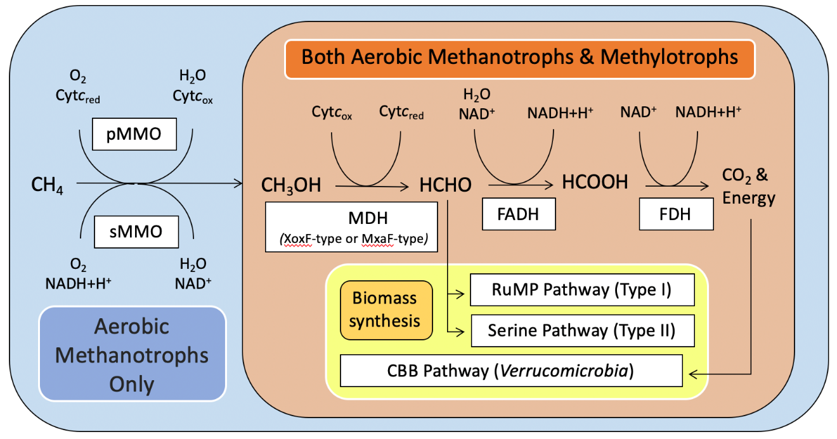
Figure 1-1. Aerobic methane and methanol oxidation common pathway. Aerobic methanotrophs and nonmethanotrophic methylotrophs generally utilize the same biochemical pathway to metabolize either methane or methanol(Hanson and Hanson, 1996). The sole difference between the versions utilized by either group is that only aerobic methanotrophs possess a type of methane monooxygenase, which converts methane into methanol. Adapted from Costa et al. (2001), Hanson and Hanson (1996), Khadem et al. (2011), and van Grinsven et al. (2020). Key: CH₄ = Methane, CH₃OH = Methanol, HCHO = Formaldehyde, HCOOH = Formate, CO₂ = Carbon Dioxide, O₂ = Oxygen, H₂O = Water, H⁺ = Hydrogen ion, and Cyt_{c} = Cytochrome c. “Red” = Reduced and “Ox” = Oxidized.

CHAPTER II: Determining drivers of methane oxidation in an in situ microbial aerobic methane-oxidizing community in a freshwater lake

Publication Note
A version of this chapter is being prepared for submission at Frontiers in Microbiology:
Jennifer A. Baily, Zachary W. Hudspeth, Joshua L. Morningstar, Howard P. Mendlovitz, Christopher S. Martens, and Karen G. Lloyd. “Determining drivers of methane oxidation in an in situ microbial aerobic methane-oxidizing community in a freshwater lake.” Front. Microbiol. (in prep).
JAB performed all of the DNA extractions, quantitative PCR assays, processing of 16S rRNA gene amplicon raw sequence reads, 16S rRNA gene amplicon analysis, model generation, and statistical analysis.
JAB and KGL wrote and edited the manuscript.
ZWH, JLM, HPM, and CSM operated the in situ incubation devices, collected and processed geochemical data, and calculated the first order rate constant of methane oxidation.
All authors participated in the collection of biological samples.

Abstract
Aerobic methanotrophs and nonmethanotrophic methylotrophs drive methane cycling in oxic freshwater lakes. Most knowledge about this system comes from ex situ rate experiments, laboratory cultures, and snapshot natural abundances. We investigated their population dynamics and aerobic methane oxidation (MOx) rate constants in situ in Jordan Lake, a methane-rich freshwater lake in NC, USA, under changing environmental conditions and in short incubations to determine how these populations interact with their environment as they oxidize methane. We assessed relative abundance with 16S rRNA gene amplicon community composition and quantitative PCR of particulate methane monooxygenase subunit A (pmoA), comparing them to methane, oxygen, temperature, and in situ MOx rate constants. Methylococcaceae, whose cultured members are obligate aerobic methanotrophs, strongly and negatively correlate with oxygen (Amplicon: R² = 0.69, P < 0.001; pmoA: R² = 0.83, P < 0.001) but not with methane. Nonmethanotrophic methylotrophs and facultative aerobic methanotrophs are abundant (up to 15.4% of amplicons), but do not correlate with either parameter. Methylococcaceae correlate better than all other families in the methane-oxidizing community with the first-order MOx rate constants (Amplicon: R² = 0.73, P < 0.001; pmoA: R² = 0.93, P < 0.001). Changes in the methanotrophic community across time course measurements were inconsistent between experiments but replicable within a single experiment. The lack of response to ammonium and organic carbon additions suggest other factors may drive community shifts. Our results suggest Methylococcaceae primarily drive MOx in Jordan lake. If so, oxygen may play an important role in modulating methanotrophic removal of methane.

Introduction
Methane is a powerful greenhouse gas, estimated to have up to 32 times the global warming potential—or ability to retain atmospheric heat—as carbon dioxide over a hundred year period (Etminan et al., 2016). About 35-50% of the methane that enters the atmosphere comes from natural sources, such as wetlands and lakes (Saunois et al., 2020). Aerobic methanotrophs, bacteria that oxidize methane into methanol to either generate cellular energy or synthesize biomass, are critical methane sinks, mitigating the amount of methane released into the atmosphere by natural sources (Bornemann et al., 2016; Taubert et al., 2019; Yu and Chistoserdova, 2017). Much of what is known about these organisms comes from laboratory studies, as they grow well in cultures. Therefore, many questions remain about how they function in natural environmental settings.
Obligately aerobic methanotrophs are in the classes Gammaproteobacteria, Alphaproteobacteria, and the phylum Verrucomicrobia (Knief, 2015) and inhabit the oxygenated upper sediment and overlying water column at methane-rich sites (Bornemann et al., 2016; He et al., 2012; Steinle et al., 2015). Using either particulate or soluble methane monooxygenase (pMMO or sMMO), they convert methane into methanol and then formaldehyde, from which it is either incorporated into biomass or further converted into formate to generate energy via the production of carbon dioxide (Hanson and Hanson, 1996). How rapidly these bacteria oxidize methane varies widely by location, with published rates from freshwater lakes ranging from less than 10 nM/day to over 840 µM/day (Donis et al., 2017; Rudd and Hamilton, 1975). Little is known about what controls this large variation in methane consumption rate in natural environments; therefore understanding the influence of environmental factors could strengthen predictions of future rates as the climate changes.
Aerobic methanotrophs may engage in syntrophy with nonmethanotrophic methylotrophs, bacteria that consume methylated or single-carbon compounds other than methane, many of which are from the family Methylophilaceae (Yu and Chistoserdova, 2017). These organisms frequently co-occur in natural systems and aerobic methanotrophs have been observed to transfer carbon to nonmethanotrophic methylotrophs in laboratory settings (Taubert et al., 2019; Radajewski et al., 2000; Krause et al., 2017). This interspecies carbon transfer likely benefits aerobic methanotrophs as well, since the presence of nonmethanotrophic methylotrophs has been shown to increase the rate of methane removal by a co-cultured population of aerobic methanotrophs, though the exact mechanism behind this is unknown (Jeong and Kim, 2019). Furthermore, it is unclear how often nonmethanotrophic methylotrophs engage in syntrophy with aerobic methanotrophs, whether doing so is a preferred method of acquiring carbon or an interaction nonmethanotrophic methylotrophs only engage in when alternate food sources are unavailable.
Many aerobic methanotrophic mixed communities have been observed to prefer microaerophilic conditions (Steinle et al., 2017; Zhu et al., 2017). There is some evidence that they may cooperate with nonmethanotrophic methylotrophs under high oxygen stress (Beck et al., 2013). However, the ways in which aerobic methanotrophs, nonmethanotrophic methylotrophs, and their effects on aerobic methane oxidation rates are affected by oxygen, methane, or temperature have not been assessed in situ. Due to the technological limitations of quantifying methane concentrations in situ, most aerobic methane oxidation measurements associated with microbiological data are made from ex situ incubations with few timepoints (Steinle et al., 2017; Hernandez et al., 2015). Rate constants quantify the ability of a community to increase its consumption rate in response to increases in methane and can therefore be more informative about the aerobic methanotrophic community’s capacity for methane oxidation than the instantaneous rate, which varies based on the methane concentration. Understanding how environmental variables impact co-occurring populations of aerobic methanotrophs and nonmethanotrophic methylotrophs, as well as the rate constant for aerobic methane oxidation in a natural environmental setting and how any potential syntrophy between the two groups progresses during aerobic methane oxidation is critical to examining how aerobic methane-oxidizing communities contribute to environmental methane removal.
Here we use Jordan Lake, NC as a natural laboratory to explore how environmentally relevant ranges of temperature, methane, and oxygen, and the presence of potential syntrophic partners affect the bacteria involved in aerobic methane oxidation in the preexisting, naturally-associating freshwater communities and how they in turn influence the first-order rate constant, or k, of aerobic methane oxidation. Our goals are to assess in situ 1) which families of bacteria correlate with the first-order rate constant of aerobic methane oxidation, 2) how the abiotic factors of oxygen, methane, and temperature affect the populations of both aerobic methanotrophs and nonmethanotrophic methylotrophs, 3) how the populations of aerobic methanotrophs and nonmethanotrophic methylotrophs change during an in situ aerobic methane oxidation rate determination experiment, and 4) if the addition of external N or C sources can disrupt any observed correlation between the aerobic methanotrophs and nonmethanotrophic methylotrophs. These questions were tested in Jordan Lake, NC using a one-of-a-kind in situ incubation system, the “iBag”, described in Hudspeth et al. (2024a).
We hypothesize that the most abundant family of aerobic methanotrophs in the lake will correlate best with the first-order rate constant of aerobic methane oxidation, that methane concentration will be the primary geochemical factor correlating with the abundance of all aerobic methanotroph families, that the populations of aerobic methanotrophs and nonmethanotrophic methylotrophs will exhibit distinct growth patterns, and that additions of external N or C sources will disrupt nonmethanotrophic methylotroph growth patterns.

Methods
Study Site
All incubations were performed at Crosswinds Boating Center, Jordan Lake, NC, USA (35° 44' 36.9" N 79° 00' 28.8" W). Jordan Lake is a man-made, seasonally stratified, eutrophic, freshwater lake. Multiple iBag in situ incubation systems were suspended at 3.5 m water depth off of the Center’s dock, where water depth was approximately 4.0 m. Working at this depth was chosen in order to avoid disturbing the sediment and contaminating the incubation with the sediment microbiome while reaching the highest possible ambient methane concentrations. The first set of incubations was performed in October 2020; three more incubation sets between June and July 2021; and two more during October and November 2021.
In Situ Incubation System
The iBag system is described in detail in Hudspeth et al. (2024a). Briefly, it consists of a ~21 L mylar gas-tight incubation bag, connected via polyethylene tubing and a pump to an Aanderaa (AADI) Series 4430 oxygen optode and a Franatech GmbH Laser Methane sensor. After flushing ambient lake water through the system for at least an hour until recorded values stabilize, the system is shut off from the outside water and oxygen and methane concentrations are measured continuously in the recirculating water over 18-70 hours to the point where oxygen was depleted.
Geochemistry
All geochemical data (oxygen, methane, temperature, and first-order rate constants) from the experiments conducted from October 2020 through October 2021 were first reported in Hudspeth et al. (2024a). For consistency, the November 2021 geochemical data were processed the same way as the rest of the geochemical data for the incubations. To summarize, concentrations of dissolved oxygen and methane, as well as temperature, were measured once per minute for the entire duration of each experiment. Modeled initial methane and oxygen concentrations were used in order to standardize values across experiments and account for different baseline settings across methane lasers. An exponential fit for aerobic methane oxidation was determined by a non-linear least squares regression via Levenberg-Marquadt method and a linear fit was determined for oxygen consumption using a linear least squares regression. In two experiments the oxygen decrease became exponential when dried algae powder was added (October 2021 and November 2021) (Fig. 2-S1). The initial oxygen concentrations for those experiments were estimated by performing a linear fit on the data recorded prior to the addition of the powder or from a projection of the first few hours of the incubation. The first-order rate constant values for aerobic methane oxidation were calculated from those exponential fits. Data for the time zero points (initial populations) of each incubation analyzed in this paper are listed in Table 2-S1.
Biological Sample Collection & Treatments
Biological samples were taken by attaching a 60 mL BD Luer-LokTM sterile syringe to a three-way stopcock valve at the end of the sampling port. Two replicate syringes were taken for each timepoint, rinsing the syringe twice with incubation fluids before the sample was taken. The sample water was filtered through a 0.22 micron Sterivex-GV Pressure filter (Fig. 2-S2) for DNA extraction. During this process, the systems were lifted to the surface of the water for access to the sampling port but remained submerged for temperature regulation. The DNA samples were immediately frozen and kept so until they were delivered to the University of Tennessee for storage in a -80°C freezer and DNA was extracted a few months later. A total of 125 biological samples were collected, 16 of which were “time zero” samples that captured well-mixed, unincubated lake water just as the incubations were closed off from the lake.
Incubations were performed as described in Table 2-1. Ammonium and dried algae powder (GNC earth GeniusTM Spirulina) were added to incubations from some experiments.
DNA Extraction
DNA extractions on the Sterivex filters were performed with a modified version of the phenol-chloroform extraction that was adapted for use with Sterivex filters (Vetriani et al.,1999; Wright et al., 2009). The samples were treated with lysozyme (100 mg/mL), proteinase K (20 mg/mL), and sodium dodecyl sulfate (20%) for chemical cell lysis. DNA was purified with phenol-chloroform and then precipitated with sodium acetate (3 M), isopropanol (100%), and ethanol (70%). Tris buffer was used to elute the resulting DNA. DNA concentrations were then measured with a QubitTM 4 Fluorometer using the QubitTM 1X High Sensitivity dsDNA Assay kit (Invitrogen). Negative controls, consisting of 60 mL of ultrapure water filtered through a new Sterivex, were processed in parallel with the samples. They were prepared either when new extraction reagents were used or when beginning extractions from a new sample set (i.e., from October 2020, June/July 2021, or October/November 2021).
16S rRNA Gene Amplicon Processing and Analysis
An Illumina MiSeq platform was used to generate amplicons of the V4 region of the 16S rRNA gene with primers 515f (GTGYCAGCMGCCGCGGTAA) and 806R (GGACTACNVGGGTWTCTAAT) (Caporaso et al., 2011; Parada et al., 2016; Apprill et al., 2015) at the University of Tennessee Genomics Core in Knoxville, TN. The dada2 pipeline was used to process the resulting reads into amplicon sequence variants (ASVs) and to then classify them using the SILVA reference set 138 (Callahan et al., 2016, Quast et al., 2013). All chloroplast, mitochondria, and added algae (Arthrospira PCC-7345) reads were removed from the overall dataset before analysis. Library sizes per sample post-processing ranged from 36,256 – 207,552 reads and yielded 15,545 ASVs overall. ASVs were normalized to total library size to obtain the relative abundance. A parallel analysis was conducted with rarified samples (randomly selecting a subset of reads so all libraries are the same size before normalizing to library size) and found large and statistically significant correlations between the rarified and the non-rarified datasets (Tables 2-S2 & 2-S3), indicating that proceeding with the rarefied dataset would provide minimal benefit over proceeding with the original dataset. ASVs taxonomically classified at the family level or lower were assigned to different functional guilds by assessing the range of functional guilds present in a given ASV’s family or genus. Aerobic methanotroph and nonmethanotrophic methylotroph ASVs were separated by type and then clustered by family. Taxonomic classifications were confirmed by checking the established literature; the families Methylocystaceae and Beijerinckiaceae were collapsed together by the SILVA reference set 138 (Quast et al., 2013) and sequences from genera established to belong to Methylocystaceae (Methylocystis and Methylosinus) were manually separated from the rest of the Beijerinckiaceae sequences. Families were excluded from further analysis if over 15% of their ASVs were in the negative controls or were present in fewer than 10% of samples.
Quantitative PCR
A QuantiNovaTM SYBR Green® PCR kit was used to perform qPCR. Table 2-S4 lists the targeted sequences and primers (Sharp et al., 2012; Kolb et al., 2003; Kubo et al., 2012). qPCR was performed using a BioRad DNA Engine Opticon® 2 Real-Time PCR Detector, with an initial denaturation step of 95°C for 2 minutes and 2-step cycling for 35 cycles of 5 seconds of denaturation at 95°C and 10 seconds of annealing and extension at 60°C. RNAse-free water included with the kit was used as negative controls. Positive controls were either synthesized genes purchased from Eurofins Genomics or amplified to ng/µL concentrations from Jordan Lake water. Melt curve analysis was performed and samples exhibiting primer dimers were considered to have not amplified (Ct > 35 cycles).
Data Analysis
All 16S rRNA gene amplicon relative abundance data and qPCR-measured relative abundance data (family-specific pmoA gene copies divided by bacterial 16S rRNA gene copies) were log₁₀-transformed before statistical analysis to meet assumptions of normality of errors. Statistical analysis and graphical representation of the population dynamics of the microbial groups of interest and the geochemical variables were performed in R version 4.0.3 (R Core Team, 2020) with RStudio (R Studio Team, 2020).
Correlations
Pearson’s product-moment correlation was the type of correlation used. Samples with missing data for one or more variables were excluded from analysis. Two-tailed t-tests were performed to determine the significance of the correlation coefficient estimates.
The 16S rRNA gene amplicon relative abundances of Methylococcaceae and Methylocystaceae were correlated with their relative abundance as measured by qPCR (family-specific pmoA gene copies divided by bacterial 16S rRNA gene copies) from both the initial populations and across the October 2020 incubations to assess whether the 16S rRNA gene amplicon relative abundances of multiple taxa could be compared across or throughout experiments (Lloyd et al., 2020; McLaren et al., 2022). Correlations were performed between the three geochemical variables and the 16S rRNA gene amplicon relative abundances of families of interest in the initial populations and between the first-order rate constant values of aerobic methane oxidation and the initial 16S rRNA gene amplicon abundances or the 16S rRNA gene amplicon abundances averaged across the incubations. The qPCR-measured relative abundances from the initial time populations of both Methylococcaceae and Methylocystaceae were correlated with the first-order rate constant and the qPCR-measured relative abundances of Methylococcaceae were correlated with the three geochemical variables.
Multiple Regression
Multiple regression was used to assess the effects of the three geochemical variables on the 16S rRNA gene amplicon relative abundance of each family of interest. Samples with missing data for one or more variables were excluded from analysis. Predictors were assessed for collinearity prior to analysis by calculating the variance inflation factor (VIF) for a model of random, simulated normal data with all three predictors variables. If VIF was above 10 or |r| > 0.7, the more environmentally relevant variable would be kept for further modeling (Dormann et al., 2013); however, the VIF never reached this threshold for any pairs of variables and as such none were excluded from analysis. Model selection was performed manually from a pool of models that accounted for all possible combinations of predictors and allowed for interactions between any two predictors in the model (two-way interactions). Three-way interactions were not permitted. “Hinged” interactions, two or more two-way interactions that share a variable (i.e., an oxygen-temperature interaction and an oxygen-methane interaction in the same model), were also excluded. The best models had the lowest corrected Akaike Information Criterion (AICc) and Bayesian Information Criterion (BIC) scores. Model residuals were visually assessed for normality. Models within ~2 AICc and BIC units of the best model were assessed to determine if they explained substantially more variation (adjusted R² higher than that of the best model by >= 0.05) than the best model. Adjusted R², which reduces the bias introduced by having different numbers of predictors, is used instead of R² (Westfall and Arias, 2020).
Population dynamics
The shifts in 16S rRNA gene amplicon relative abundance of the groups of interest coupled with oxygen and methane concentrations during the in situ incubations were plotted versus experimental duration and assessed qualitatively. Statistical differences between the means of the initial abundance data were assessed by performing a Tukey’s HSD test on a one-way ANOVA.
Software
R Packages used for statistical analysis were: fBasics (Wuertz et al., 2020), car (Fox and Weisenberg, 2019), olsrr (Hebbali, 2020), survey (Lumley, 2023), interactions (Long, 2019), jtools (Long, 2022), tidyverse (Wickham et al., 2019), dplyr (Wickham et al., 2023), and multcompView (Graves et al., 2023). R Packages used for processing the 16S rRNA gene amplicon reads were: dada2 (Callahan et al., 2016), phyloseq (McMurdie and Holmes, 2013), Biostrings (Pagès et al., 2020), microbiome (Lahti and Shetty, 2019), rioja (Juggins, 2022), and microbiomeutilities (Shetty and Lahti, 2021).

Data Availability
All geochemical data and the code used to analyze and process it can be found at GitHub at https://github.com/zhudspeth/JordanLakePaper (Hudspeth et al., 2024a, Hudspeth et al., 2024b). Complete R scripts containing all the steps to reproduce our 16S rRNA gene amplicon analysis, model generation and selection, and statistical analysis along with all geochemical and microbiological data analyzed in this study are available at GitHub at https://github.com/JBaily/Jordan_Lake_20-21. FASTQ files containing the 16S rRNA gene sequences can be found in the NCBI Sequence Read Archive under the Accession ID PRJNA1117504 (https://www.ncbi.nlm.nih.gov/sra/PRJNA1117504).

Results
Aerobic Methane-Oxidizing Community Composition during Consumption
During each incubation, methane was consumed at an exponential rate, first-order with respect to methane concentrations (Hudspeth et al., 2024a). Consumption ceased either when no more methane was left in the system or when the iBag system became anoxic. Oxygen concentrations decreased linearly, except when dried algae was added. In those two cases, the rate of oxygen consumption, but not that of methane consumption, increased exponentially post-addition (Fig. 2-S1). Aerobic methanotrophs and nonmethanotrophic methylotrophs from the following families were detected at all timepoints, in order of decreasing amplicon relative abundance: Methylacidiphilaceae, Methylophilaceae, Methylocystaceae, Methylococcaceae, and Methylomonadaceae (Tukey’s HSD test on a one-way ANOVA) (Fig. 2-1, Tables 2-S5 & 2-S6). Cultured genera within Methylococcaceae, Methylomonadaceae, Methylacidiphilaceae, and Methylocystaceae are aerobic methanotrophs (Knief, 2015) and cultured genera of Methylophilaceae are nonmethanotrophic methylotrophs (Salcher et al., 2015). Further, the dominant genera from Methylococcaceae and Methylomonadaceae in this system, which are Methyloparacoccus and Methylomonas respectively, are obligate (Vekeman, 2019; Bowman et al., 2014). Methylocystis, the dominant genus from Methylocystaceae in Jordan lake, is known to contain several facultative species (Haque et al., 2020). However, no Methylacidiphilaceae 16S rRNA sequences could be identified past the family level, indicating they may have a different physiology than the genera that have been cultured in this family, which are thermophilic aerobic methanotrophs (Knief, 2015).
Assessing Potential for Methanotrophy with pmoA Genes
We surveyed for the presence of pMMO subunit A (pmoA) genes from the families of Methylococcaceae, Methylocystaceae, Methylomonadaceae, and Methylacidiphilaceae using quantitative PCR (qPCR) (Table 2-S4) (Sharp et al., 2012, Kolb et al., 2003). These primers were based on the pmoA genes from the genera of Methylococcus, Methylosinus, Methylobacter/Methylosarcina, and Methylacidiphilum, respectively. All primer sets amplified in the positive controls with the exception of the primer set targeting Methylomonadaceae, which never amplified.
Standard curves for Methylococcaceae pmoA comprised of eight 10x dilutions and ranged in concentration from 3.42 x 10⁸ - 3.42 x 10¹ copies/µL, resulting in cycle threshold (Ct) values between 6.08-30.17 cycles. Standard curves for Methylocystaceae pmoA comprised of seven 10x dilutions and ranged in concentration from 2.04 x 10⁹ - 2.04 x 10² copies/µL, resulting in Ct values between 4.50-27.57 cycles. Amplification for pmoA was observed for both of these primer sets in the initial population samples of almost all Jordan Lake experiments. Both incubations from the November 2021 experiment and one incubation from the October 2021 experiment exhibited no pmoA amplification with either primer set. The Ct values for Jordan Lake samples amplified with Methylococcaceae pmoA primers range between 23.77-30.01 cycles, whereas the negative controls do not reach the threshold until after 35 cycles. Similarly, the Ct values for Jordan Lake samples amplified with Methylocystaceae pmoA primers are between 21.31-30.00 cycles, with the negative controls also not reaching the threshold until after 35 cycles.
Though the Methylacidiphilaceae pmoA primers amplified the Methylacidiphilum infernorum pmoA sequences used for the standard curve, which was comprised of three 10x dilutions that ranged in concentration from 3.27 x 10⁹ - 3.27 x 10⁷ copies/µL and resulted in Ct values between 11.38 and 30.39, no amplification of the primer set targeting Methylacidiphilaceae pmoA was observed in the initial populations of any Jordan Lake incubation. All Jordan Lake samples and negative controls had Ct values greater than 35 cycles, despite this group being very abundant in 16S rRNA gene amplicon analyses.
Assessing Quantitativeness of 16S rRNA Gene Amplicon Relative Abundance
To determine whether primer bias affected our ability to compare relative amounts of taxa across different 16S rRNA gene amplicon datasets, we compared these values to qPCR-measured relative abundances of Methylococcaceae and Methylocystaceae (family-specific pmoA gene copies divided by bacterial 16S rRNA gene copies). The qPCR and amplicon relative abundances of Methylococcaceae have a strong, positive correlation (R² = 0.89, t(10) = 8.95, P < 0.001) across the initial populations of all incubations (Fig. 2-2C). The correlation between the qPCR and amplicon relative abundances across all timepoints of the October 2020 experiment was also positive (R² = 0.49, t(11) = 3.27, P = 0.007) (Fig. 2-S3), with those abundance shifts throughout this incubation qualitatively agreeing. Therefore, relative abundance of Methylococcaceae in the initial populations can be compared quantitatively across 16S rRNA gene amplicon datasets (Lloyd et al., 2020). As these correlations indicate that the background population does not alter primer bias across the initial population samples, this principle can be extended to all other taxa in the community (McLaren et al., 2022).
While the qPCR and amplicon relative abundances of Methylocystaceae (Fig. 2-S4) correlate similarly across all timepoints of the October 2020 experiment (R² = 0.59, t(11) = 4.02, P = 0.002), there was no correlation across the initial populations (R² = 0.26, t(10) = 1.86, P = 0.09). The lack of correlation among the initial populations but not across one set of incubations can likely be accounted for by the chosen primer set for Methylocystaceae having been designed for the genus Methylosinus instead of the genus Methylocystis, which dominates the family in Jordan Lake. Methylosinus is present in only two of the initial populations–given the likely higher binding affinity of this primer set for the pmoA sequence of Methylosinus compared to that of Methylocystis, its pmoA sequence likely amplifies disproportionately well in qPCR. It is also possible some species of Methylocystis present in Jordan Lake have differing binding affinities for the primer sets and their absence or presence (ex. Methylocystis heyeri is only present in detectable quantities during the fall months) has a similar biasing effect on the qPCR amplification.
Correlations of Initial Populations of Methylotrophs and Methanotrophs with Geochemistry
We correlated environmental geochemical measurements with initial starting populations for each incubation to assess how the populations are impacted by naturally occurring shifts in those parameters and how starting populations in turn affect aerobic methane oxidation. Changes in relative abundance over the time course of each experiment are presented separately in the time course results section. The values for the first-order rate constants of aerobic methane oxidation, oxygen and methane concentrations, and temperatures of all incubations aside from those performed in November 2021 were first reported in Hudspeth et al. (2024a).
Aerobic methane oxidation first-order rate constant values correlate most strongly and positively with the relative 16S rRNA gene amplicon abundances of Methylococcaceae from the initial populations (R² = 0.73, t(14) = 6.20, P < 0.001) (Fig. 2-2A, Table 2-S7). The qPCR relative abundance of Methylococcaceae also exhibits a similarly strong correlation with the first-order rate constant of aerobic methane oxidation (R² = 0.93, t(10) = 11.69, P < 0.001) (Fig. 2-2B, Table 2-S8). This family consists of obligate aerobic methanotrophs; the majority of our sequences in this family were from the genus Methyloparacoccus. Further evidence that these Methylococcaceae 16S rRNA gene sequences represent aerobic methanotrophs comes from the fact that Methylococcaceae-specific primers for pmoA amplified across all experiments, except the November 2021 experiment where no pmoA primer sets amplified. All other methanotrophic and methylotrophic families, except Methylophilaceae, weakly correlate with the first-order rate constant (Table 2-S7). In contrast, Methylophilaceae does not correlate at all.
Only obligate aerobic methanotrophs Methylococcaceae (R² = 0.69, t = -5.52, and P < 0.001) and Methylomonadaceae (R² = 0.35, t = -2.72, and P = 0.017) correlate with oxygen, both negatively (Fig. 2-3). Aerobic methanotrophs Methylococcaceae and Methylocystaceae correlate negatively with temperature (R² = 0.31, t = -2.51, and P = 0.025; R² = 0.84, t = -8.43, and P < 0.001). The qPCR relative abundances of Methylococcaceae correlate similarly with the three geochemical variables; negatively with oxygen, negatively with temperature, and not at all with methane (Table 2-S8).
The presumed nonmethanotrophic methylotroph Methylacidiphilaceae correlates positively with temperature (R² = 0.81, t = 7.81, and P < 0.001). Methylophilaceae do not significantly correlate with either of the other two geochemical variables (Oxygen: t = -1.49 and P = 0.16. Temperature: t = -0.933 and P = 0.37). None of the five methanotrophic or methylotrophic families significantly correlate with the methane. All amplicon correlations are listed in Table 2-S9 or Figure 2-3.
To investigate which of these correlations are significant for the relative abundance of methanotrophic and methylotrophic families when the effect of multiple variables is considered, linear models were constructed via multiple regression for the 16S rRNA gene amplicon relative abundance of each of the five methanotrophic and methylotrophic families in the initial populations (Tables 2-S10 & 2-S11). The best models for the obligate aerobic methanotrophs, Methylococcaceae (Adjusted R² = 0.89, F(3,12) = 42.08, P < 0.001) and Methylomonadaceae (Adjusted R² = 0.73, F(4,11) = 42.08, P < 0.001), contain the predictors of methane concentration, oxygen concentration, and the two-way interaction between those predictors, with temperature also for Methylomonadaceae. Temperature is the sole significant predictor for Methylocystaceae (Adjusted R² = 0.84, F(1,14) = 71.10, P < 0.001) and has a negative effect on the relative abundance. Both Methylophilaceae (Adjusted R² = 0.81, F(2,13) = 42.08, P < 0.001) and Methylacidiphilaceae (Adjusted R² = 0.85, F(3,12) = 30.01, P < 0.001), the nonmethanotrophic methylotrophs, have best models that contain oxygen concentration, temperature, and the two-way interaction between those two predictors (Fig. 2-S5, Table 2-S12). None of the geochemical predictors exhibited collinearity (Table 2-S13).
Combined Effects of Oxygen and Methane
Based on the linear models, the interaction between the relative abundance of both Methylococcaceae and Methylomonadaceae and oxygen and methane concentrations changes slightly depending on the concentration of the other gas (Figs. 2-4A,B). Oxygen has a strong negative effect on Methylococcaceae and Methylomonadaceae when methane concentrations are above 297 nM and 312 nM, respectively. As methane concentrations diminish, this negative effect weakens until oxygen is predicted to have a positive effect on relative abundance below methane concentrations of 225 nM and 234 nM, respectively, although there were not enough data points below these methane concentrations to test this model output robustly. Though methane accounts for much less of the overall variation than oxygen does, it has a positive effect on the relative abundance when oxygen is below 146 µM and 148 µM and a negative effect when it is above 195 µM and 219 µM, respectively (Fig. 2-S6A,B).
The combined effects of oxygen and methane suggests that obligate aerobic methanotrophs are most abundant in environments with low oxygen and high methane concentrations (Figs. 2-4A,B).
Combined Effects of Oxygen and Temperature
Oxygen and temperature interact to influence the relative abundance of Methylophilaceae and Methylacidiphilaceae. For Methylophilaceae, temperature has a negative effect when the oxygen concentration is below 182 µM and a positive effect above 226 µM (Figs. 2-4C,D), whereas oxygen has a negative effect below 23.6°C and a positive effect above 26.1°C.
For Methylacidiphilaceae, temperature is never predicted to have a negative effect on the relative abundance regardless of the oxygen concentration but has a positive effect when oxygen concentrations are above 79.9 µM (Fig. 2-S6C). Oxygen is predicted to have a negative effect on its relative abundance below 21.4°C and a positive effect above 49.4°C, although no data points were available above this temperature, so this is simply a model prediction.
Growth Dynamics during Aerobic Methane Oxidation
All five methanotrophic and non-methanotrophic methylotrophic families had 16S rRNA gene amplicon relative abundance patterns that were repeatable across replicate incubations in both the summer (Fig. 2-5) and fall (Fig. 2-6), with the nonmethanotrophic methylotrophs exhibiting similar growth patterns despite their differences in magnitude (Fig. 2-S7). The populations of nonmethanotrophic methylotrophs from both Methylophilaceae and Methylacidiphilaceae initially grow and then decline as the incubation water becomes hypoxic. Aerobic methanotrophs either decline initially or maintain a stable population size. Nonmethanotrophic methylotrophs are more abundant than the aerobic methanotrophs at the start of each incubation (Fig. 2-1) and the gap between them tends to increase over time. Methylacidiphilaceae is always the most abundant, reaching up to 15% of the total prokaryotic population in one incubation (Fig. 2-5, row 2 and column 2).
Ammonium (~21 or ~42 µM) and dried algae (8.43 ± 0.02 g) were added to some of the summer and fall incubations, respectively. Though the addition of the dried algae powder accelerated oxygen respiration, neither of the additions had any noticeable effect on the population dynamics of any of the families of interest or aerobic methane oxidation rates.

Discussion
Our results show that the changes in populations of aerobic methane-oxidizing microbes in a stratified freshwater lake measured in situ are closely related to natural variations in dissolved gas concentrations and temperature. By not removing the microbial community from their natural environment and minimally altering the geochemical and physical conditions they were exposed to, we were able to couple natural variations in their population dynamics to their in situ capacity to consume methane.
We found two families of obligate aerobic methanotrophs (Methylococcaceae, mostly from the genus Methyloparacoccus, and Methylomonadaceae, mostly from the genus Methylomonas) (Knief, 2015; Bowman, 2014). We also found one family of facultative aerobic methanotrophs (Methylocystaceae, mostly from the genus Methylocystis) (Haque et al., 2020). For nonmethanotrophic methylotrophs, we found Methylophilaceae–with “Candidatus Methylopumilus”, which is an obligate methylotroph, being the most abundant genus (Salcher et al., 2015). Methylacidiphilaceae, whose cultured genera are thermophilic aerobic methanotrophs (Knief, 2015), could not be identified past the family level, suggesting they may have a different physiology from their cultured genera. We assessed their potential for aerobic methanotrophy by amplifying the pmoA gene with primers specific to Methylacidiphilaceae (Sharp et al., 2012). None of these primers produced pmoA products, even though the primer sets designed to amplify the pmoA genes of Methylococcaceae and Methylocystaceae resulted in amplification. Since pmoA encodes a critical subunit of the pMMO enzyme and the other members of Methylacidiphilaceae do not have any genes for the rarer sMMO enzyme (Sharp et al., 2012; Kruse et al., 2019), we conclude that it is unlikely that the Methylacidiphilaceae in Jordan Lake oxidize methane and are thereby most likely nonmethanotrophic methylotrophs, not aerobic methanotrophs. This conclusion agrees with previous reports of closely related uncultured genera in mesophilic environments that lack pmoA genes (Sharp et al., 2014). However, we caution that this designation is merely the one most strongly supported by the lines of evidence available to us, both from the literature and our own observations, and thus is not definitive.
We tracked changes in the relative abundance of 16S rRNA gene amplicons of each of these families. Amplicon data can be used to track changes in relative abundance of organisms across similar samples where the biases for or against each taxonomic group are similar across samples (Lloyd et al., 2020). Other work suggests that, to ensure that large shifts in background communities do not alter the taxon-specific bias across similar samples, one can compare amplicon results to qPCR results for one taxon, which will then be applicable for all other taxa because they share the same background communities (McLaren et al., 2022). We found that the abundance of the aerobic methanotroph Methylococcaceae relative to the rest of the microbial population was consistent when measured with 16S rRNA gene amplicons vs. qPCR (Fig. 2-2C), meaning the relative abundance for this family and all the others can be compared across all samples using 16S rRNA gene amplicons.
Drivers of Aerobic Methane Oxidation
All three families of aerobic methane oxidizers at least weakly correlate with the first-order rate constants for aerobic methane oxidation, suggesting they all may be involved in this process. The obligate aerobic methanotroph family Methylococcaceae has the strongest correlation by far (Fig. 2-2A, Table 2-S7, R² = 0.73, P < 0.001), even though it is not the most abundant group of aerobic methanotrophs as we had initially hypothesized. This suggests that the abundance of Methylococcaceae may be a large factor in determining the ability of the lake to consume methane. The tight coupling between Methylococcaceae relative abundance and the first-order rate constant values may also explain why the rate constant correlates negatively with oxygen concentrations (Hudspeth et al., 2024), since Methylococcaceae is oxygen averse (see below). If correct, this would mean that Methylococcaceae are the primary drivers of aerobic methanotrophy in Jordan Lake over the time period measured, more so than Methylomonadaceae, Methylocystaceae, or any of the nonmethanotrophic methylotrophs present. The potential of Methylococcaceae to be the primary drivers of aerobic methanotrophy should be investigated further, as they are broadly distributed in freshwater habitats (Knief, 2015) and have also been identified as the most abundant group of aerobic methanotrophs in multiple other freshwater lakes (Bornemann et al., 2016; Beck et al., 2013; Rissanen et al., 2021).
Sensitivity of Obligate Aerobic Methanotrophs to Oxygen
Given the tight correlation of Methylococcaceae with the values for the first-order rate constant of aerobic methane oxidation, we examined whether these bacteria–along with the other members of the aerobic methane-oxidizing community present in the lake–correlate with temperature or the concentrations of oxygen and methane. Both of the obligate aerobic methanotrophic families exhibit strong negative correlations with oxygen concentration (Fig. 2-3), in contrast to our hypothesis that they would correlate most strongly with methane. The best-fit linear models also suggest that oxygen alone accounts for over half of all variation in relative abundance for Methylococcaceae and a little less than a quarter of all variation in relative abundance for Methylomonadaceae (Table 2-S11). This agrees well with previous observations that these bacteria exhibit microaerophilic tendencies both in mixed culture and in the environment (Steinle et al., 2017; Zhu et al., 2017; Rissanen et al., 2021; Reis et al., 2020). The most common explanation for microaerophily in aerobic methanotrophs is that methane concentrations increase at oxic-anoxic interfaces, so cells that tolerate low oxygen concentrations can function closer to anoxic sources of methane (Kuivila et al., 1988). However, our data suggest that methane only correlates with aerobic methanotrophs once the negative effect with oxygen is accounted for (Fig. 2-4), suggesting that oxygen aversion, rather than proximity to high methane concentrations in anoxic environments, drives their microaerophily. These results agree with previous studies that have found little to no correlation between aerobic methanotrophic biomass and methane concentrations (Reis et al., 2020; Samad and Bertilsson, 2017).
There are several possible explanations for why higher oxygen concentrations are detrimental to aerobic methanotrophs. First, oxygen inhibits nitrogenase and could cause nitrogen-limitation that can be alleviated by the addition of over 20 µM ammonium (Rudd, et al., 1976). However, we observed no response to additions of ammonium well above that threshold (~21 µM or ~42 µM) in the in situ incubations, suggesting these communities are not nitrogen-limited (Fig. 2-5). This is consistent with high dissolved total nitrogen values at this site (mean of 0.93 mg/L) (NC Division of Water Resources, 2021). Finally, the Methylococcaceae in Jordan Lake likely lack nitrogenase, since cultures of the largest genus present from this family, Methyloparacoccus do not have it (Nguyen et al., 2019).
A second reason could be oxygen toxicity from reactive oxygen species (Steinle et al., 2017), however, cultured genera of Methylococcaceae and Methylomonadaceae (Methyloparacoccus and Methylomonas) contain catalase and superoxide dismutase, which may detoxify and may thereby mitigate the effects of reactive oxygen species (Nguyen et al., 2019; Hoefman et al., 2014).
The possibility that fits best with our observations is that aerobic methanotrophs accumulate more of their toxic metabolic intermediate formaldehyde under high oxygen conditions, as has been observed in cultures (Costa et al., 2001). Formaldehyde is highly cytotoxic, capable of severely damaging both the proteins and DNA of bacteria (Chen et al., 2016), but is also a necessary intermediate of aerobic methanotrophy (Hanson and Hanson, 1996).
Oxygen Insensitivity in Nonmethanotrophic Methylotrophs and Facultative Aerobic methanotrophs
Even though nonmethanotrophic methylotrophs and facultatively aerobic methanotrophs also make toxic formaldehyde intermediates during the oxidation of methanol (Chistoserdova et al., 2009), we found that neither methane nor oxygen by themselves are significant predictors of their relative abundance. Instead, temperature or temperature plus oxygen best predict their abundance (Figs. 2-4C,D; Table 2-S11). Facultative aerobic methanotrophs may consume an alternate compound like ethanol, thereby avoiding the formaldehyde production associated with methane oxidation (Haque et al., 2020). Although the nonmethanotrophic methylotrophs could avoid formaldehyde production through the use of other methylated substrates such as trimethylamine (Martinez-Gomez et al., 2013), it is usually only a supplement to the methanol consumption pathway (Salcher et al., 2015). It is possible that the uptake of methanol can be better-regulated than the uptake of methane, since methanol is a polar compound which likely undergoes active transport into the cell (Patra et al., 2006; Agrawal and Flores, 1987). Such regulation may afford nonmethanotrophic methylotrophs better metabolic control under high oxygen concentrations.
Temperature Response
The linear models suggest that the negative correlation of Methylococcaceae with temperature is an indirect effect of the correlation of temperature with oxygen, which has a tighter negative correlation with Methylococcaceae. The negative effect of temperature on Methylocystis (Fig. 2-4C) is surprising, since cultures of this genus tend to prefer warmer temperatures between 25 - 37°C (Jung et al., 2020), and these bacteria are facultative methanotrophs, which lack the strong aversion to oxygen. It is possible that competition with other microbes for food sources during the warmer months manifests as a negative response to temperature (Hudari et al., 2020; van Bodegom et al., 2001). The strong positive correlation between nonmethanotrophic methylotrophic Methylacidiphilaceae and temperature likely results from a greater metabolism at higher temperatures, or the presence of fresher organic matter in spring and summer months.
The other nonmethanotrophic methylotroph family Methylophilaceae does not react to temperature alone, however, it responds positively with temperature when oxygen is high and negatively with temperature when oxygen is low (Figs. 2-4C,D). This may be because in summer months, it is decoupled from a syntrophy with obligate aerobic methanotrophs and instead relies on photosynthetically-derived organic matter, allowing its metabolism to increase with the temperature. In colder months where photosynthetic organic matter is less available (Tonetta and Petrucio, 2020), it may partner with obligate methanotrophs and therefore follow along their negative relationship to temperature.
Time Series
We found that aerobic methanotroph (Methylococcaceae, Methylomonadaceae, and Methylocystaceae) abundance patterns over the course of in situ methane oxidation incubations are replicable within each incubation experiment but vary greatly across multiple experiments (Figs. 2-5 & 2-6). They also do not consistently change in relative abundance after oxygen drops below 20 µM. This could be because their metabolic activity is decoupled from measurable biomass changes over these timescales. The consistency between replicate incubations within individual experiments suggests that relative abundance changes were not random; however, the inconsistency across different experiments suggests that other factors we did not measure were driving the observed population changes.
Only the nonmethanotrophic methylotrophs consistently grow until oxygen is nearly consumed at the end of the incubations. They start declining once oxygen decreases below 20 µM, suggesting they require oxygen, as expected of obligate aerobes (Doronina et al., 2014). The growth patterns of both families closely mirror each other across the simultaneous incubations of each experiment, with the exception of the July 2021 incubations (Figs. 2-5E,F). The consistency in behavior of both Methylophilaceae and Methylacidiphilaceae within nearly all experiments suggests that the similar factors act on both groups, supporting our hypothesis that the Methylacidiphilaceae found in Jordan Lake are nonmethanotrophic methylotrophs like Methylophilaceae.
These results combined partially support our hypothesis, as both methanotrophs and nonmethanotrophic methylotrophs exhibit repeatable growth patterns during simultaneous incubations, implying non-random factors driving the observed behavior, although these patterns differed between experiments.
No effects were observed for the addition of either ammonium or dried algae relative unamended controls. The insensitivity of both groups to ammonium implies that they are either not N-limited or do not use ammonium, as discussed above. The lack of response to dried algae suggests that nonmethanotrophic methylotrophs preferentially consume single-carbon compounds over the complex algal necromass; however, the dried algae stimulates the rest of the microbial community, as the rate of oxygen consumption rapidly accelerates when the dried algae is added (Fig. 2-S1). This consumption trend is also observed in the relative abundance of 16S rRNA gene amplicons associated with the dried algae (Arthrospira PCC-7345), which spike immediately post-addition and decrease rapidly thereafter, as would be expected if some microbes are breaking down organic matter from the added algal necromass (Fig. 2-S8). This suggests that the activity of the broader heterotrophic community has little immediate impact on the aerobic methane-oxidizing community.

Conclusion
Our results suggest that the ability of an aerobic methane-oxidizing community to respond to methane may be largely determined by the population size of the dominant aerobic methanotrophs, Methylococcaceae, implying that this clade is primarily responsible for aerobic methane oxidation in Jordan Lake despite not being the most abundant aerobic methanotrophs present. The other more abundant group of aerobic methanotrophs, Methylocystaceae, engage in facultative methanotrophy, so they may not be as tightly linked to methane oxidation rates as the obligate aerobic methanotrophs. Methylophilaceae are likely the key nonmethanotrophic methylotrophs in this community and the members of Methylacidiphilaceae in our study we believe are also likely nonmethanotrophic methylotrophs as they have abundance patterns consistent with those of Methylophilaceae and lack the pmoA gene, even though other genera from this family are aerobic methanotrophs (Knief, 2015).
Aerobic methanotrophs have been shown in previous studies (Zhu et al., 2017) to prefer microaerophily in culture and an association with low oxygen concentrations in situ; our results provide the first support for obligate aerobic methanotrophs actively preferring low oxygen concentrations in situ, to the point where it is likely one of the dominant factors influencing their abundance, with methane exerting comparably minimal effects. This preference has also been observed on a finer taxonomic degree of family groups rather than the bulk group of Type I methanotrophs overall. We further report novel findings that suggest the way in which oxygen concentrations dictate the population sizes of specific families of obligate aerobic methanotrophs (Methylococcaceae and Methylomonadaceae) are linked to how they metabolize methane. Building upon results from previous studies (Costa et al., 2001), it may be that oxygen dysregulates the pathway of aerobic methanotrophy enough to drive the accumulation of toxic levels of formaldehyde in natural settings. Facultative aerobic methanotrophs may avoid this toxicity by swapping to alternative metabolic pathways when conditions are unfavorable and nonmethanotrophic methylotrophs may lessen the amount of formaldehyde produced by consuming the methanol that aerobic methanotrophs excrete (Krause et al., 2017). Moreover, the tight linkage of our in situ rate constant of aerobic methane oxidation and the population size of the family Methylococcaceae suggest that aerobic methane oxidation is primarily driven by the abundance of the dominant aerobic methanotrophs and not metabolic shifts. Combined with the data concerning the relationship between the abundance of Methylococcaceae and oxygen concentrations, this provides a clear mechanism by which oxygen can modulate the amount of methane a given methane-oxidizing community can remove from the environment. Together, these conclusions suggest that obligate aerobic methanotrophic bacteria from the family Methylococcaceae are the primary drivers of in situ aerobic methane oxidation in this eutrophic freshwater lake and their ability to remove this methane may be limited in fully oxygenated conditions.
Acknowledgements
Major funding for this work came from the NSF Chemical Oceanography Program (OCE-1948720), additional funding came from NSF MG&G (OCE-215015), NSF FRES (EAR-2121670), and US DOE (DE-SC0020369). The funders had no role in the study design, selection of experimental methods, data collection, data interpretation, or decision to submit this work for publication.

References
Agrawal P, and Flores, G.E. 1987. A study of methanol transport uptake by a methanol‐utilizing bacterium L3 in a batch bioreactor. Biotechnol Bioeng 33:104-114.
Apprill A, McNally S, Parsons R, Weber L. 2015. Minor revision to V4 region SSU rRNA 806R gene primer greatly increases detection of SAR11 bacterioplankton. Aquat Microb Ecol 75:129-137.
Beck DA, Kalyuzhnaya MG, Malfatti S, Tringe SG, Glavina Del Rio T, Ivanova N, Lidstrom ME, Chistoserdova L. 2013. A metagenomic insight into freshwater methane-utilizing communities and evidence for cooperation between the Methylococcaceae and the Methylophilaceae. PeerJ 1:e23.
Bornemann M, Bussmann I, Tichy L, Deutzmann J, Schink B, Pester M. 2016. Methane release from sediment seeps to the atmosphere is counteracted by highly active Methylococcaceae in the water column of deep oligotrophic Lake Constance. FEMS Microbiol Ecol 92:fiw123.
Bowman JP. 2014. The Family Methylococcaceae. In Rosenberg E, DeLong EF, Lory S, Stackebrandt E, Thompson F (ed), Alphaproteobacteria and Betaproteobacteria. Springer, Berlin, Heidelberg. doi:10.1007/978-3-642-30197-1.
Callahan BJ, McMurdie PJ, Rosen MJ, Han AW, Johnson AJ, Holmes SP. 2016. DADA2: High-resolution sample inference from Illumina amplicon data. Nat Methods 13:581-583.
Caporaso JG, Lauber CL, Walters WA, Berg-Lyons D, Lozupone CA, Turnbaugh PJ, Fierer N, Knight R. 2011. Global patterns of 16S rRNA diversity at a depth of millions of sequences per sample. Proc Natl Acad Sci U S A 108:4516-4522.
Chen NH, Djoko KY, Veyrier FJ, McEwan AG. 2016. Formaldehyde Stress Responses in Bacterial Pathogens. Front Microbiol 7:257.
Chistoserdova L, Kalyuzhnaya MG, Lidstrom ME. 2009. The expanding world of methylotrophic metabolism. Annu Rev Microbiol 63:477-499.
Costa C, Vecherskaya M, Dijkema C, Stams AJM. 2001. The effect of oxygen on methanol oxidation by an obligate methanotrophic bacterium studied by in vivo 13C nuclear magnetic resonance spectroscopy. J Ind Microbiol Biotechnol 26:9-14.
Donis D, Flury S, Stockli A, Spangenberg JE, Vachon D, McGinnis DF. 2017. Full-scale evaluation of methane production under oxic conditions in a mesotrophic lake. Nat Commun 8:1661.
Dormann CF, Elith J, Bacher S, Buchmann C, Carl G, Carré G, Marquéz JRG, Gruber B, Lafourcade B, Leitão PJ, Münkemüller T, McClean C, Osborne PE, Reineking B, Schröder B, Skidmore AK, Zurell D, Lautenbach S. 2013. Collinearity: a review of methods to deal with it and a simulation study evaluating their performance. Ecography 36:27-46.
Doronina N, Kaparullina E, Trotsenko Y. 2014. The Family Methylophilaceae. In Rosenberg E, DeLong EF, Lory S, Stackebrandt E, Thompson F (ed), Alphaproteobacteria and Betaproteobacteria. Springer, Berlin, Heidelberg.
Etminan M, Myhre G, Highwood EJ, Shine KP. 2016. Radiative forcing of carbon dioxide, methane, and nitrous oxide: A significant revision of the methane radiative forcing. Geophys Res Lett 43:12614–12623.
Fox J, Weisenberg S. 2019. An R Companion to Applied Regression, Sage, Thousand Oaks, CA. https://socialsciences.mcmaster.ca/jfox/Books/Companion/.
Graves S, Piepho H-P, Selzer L, Dorai-Raj S. 2023. multcompView: Visualizations of Paired Comparisons, https://CRAN.R-project.org/package=multcompView.
Hanson RS, Hanson TE. 1996. Methanotrophic Bacteria. Microbiol Rev 60:439-471.
Haque MFU, Xu HJ, Murrell JC, Crombie A. 2020. Facultative methanotrophs - diversity, genetics, molecular ecology and biotechnological potential: a mini-review. Microbiology 166:894-908.
He R, Wooller MJ, Pohlman JW, Quensen J, Tiedje JM, Leigh MB. 2012. Diversity of active aerobic methanotrophs along depth profiles of arctic and subarctic lake water column and sediments. ISME J 6:1937-1948.
Hebbali A. 2020. olsrr: Tools for Building OLS Regression Models, https://CRAN.R-project.org/package=olsrr.
Hernandez ME, Beck DA, Lidstrom ME, Chistoserdova L. 2015. Oxygen availability is a major factor in determining the composition of microbial communities involved in methane oxidation. PeerJ 3:e801.
Hoefman S, van der Ha D, Iguchi H, Yurimoto H, Sakai Y, Boon N, Vandamme P, Heylen K, De Vos P. 2014. Methyloparacoccus murrellii gen. nov., sp. nov., a methanotroph isolated from pond water. Int J Syst Evol Microbiol 64:2100-2107.
Hudari MSB, Vogt C, Richnow HH. 2020. Effect of Temperature on Acetate Mineralization Kinetics and Microbial Community Composition in a Hydrocarbon-Affected Microbial Community During a Shift From Oxic to Sulfidogenic Conditions. Front Microbiol 11:606565.
Hudspeth ZW, Morningstar JL, Mendlovitz HP, Baily JA, Lloyd KG, Martens CS. 2024. In situ aerobic methane oxidation rates in a stratified lake. Limnol Oceanogr doi:10.1002/lno.12583.
Hudspeth ZW, Morningstar JL, Mendlovitz HP, Baily JA, Lloyd KG, Martens CS. 2024. Code and data from “In situ aerobic methane oxidation rates in a stratified lake.” GitHub https://github.com/zhudspeth/JordanLakePaper (reference no. 465a96d).
Jeong SY, Kim TG. 2019. Development of a novel methanotrophic process with the helper micro-organism Hyphomicrobium sp. NM3. J Appl Microbiol 126:534-544.
Juggins S. 2022. rioja: Analysis of Quaternary Science Data, https://CRAN.R-project.org/package=rioja.
Jung GY, Rhee SK, Han YS, Kim SJ. 2020. Genomic and Physiological Properties of a Facultative Methane-Oxidizing Bacterial Strain of Methylocystis sp. from a Wetland. Microorganisms 8:1719.
Knief C. 2015. Diversity and Habitat Preferences of Cultivated and Uncultivated Aerobic Methanotrophic Bacteria Evaluated Based on pmoA as Molecular Marker. Front Microbiol 6:1346.
Kolb S, Knief C, Stubner S, Conrad R. 2003. Quantitative detection of methanotrophs in soil by novel pmoA-targeted real-time PCR assays. Appl Environ Microbiol 69:2423-2429.
Krause SM, Johnson T, Samadhi Karunaratne Y, Fu Y, Beck DA, Chistoserdova L, Lidstrom ME. 2017. Lanthanide-dependent cross-feeding of methane-derived carbon is linked by microbial community interactions. Proc Natl Acad Sci U S A 114:358-363.
Kruse T, Ratnadevi CM, Erikstad HA, Birkeland NK. 2019. Complete genome sequence analysis of the thermoacidophilic verrucomicrobial methanotroph "Candidatus Methylacidiphilum kamchatkense" strain Kam1 and comparison with its closest relatives. BMC Genomics 20:642.
Kubo K, Lloyd KG, J FB, Amann R, Teske A, Knittel K. 2012. Archaea of the Miscellaneous Crenarchaeotal Group are abundant, diverse and widespread in marine sediments. ISME J 6:1949-1965.
Kuivila KM, Murray JW, Devol AH, Lidstrom ME, Reimers CE. 1988. Methane cycling in the sediments of Lake Washington. Limnol Oceanogr 33:571-581.
Lahti L, Shetty S. 2019. microbiome R package, https://microbiome.github.io.
Lloyd KG, Bird JT, Buongiorno J, Deas E, Kevorkian R, Noordhoek T, Rosalsky J, Roy T. 2020. Evidence for a Growth Zone for Deep-Subsurface Microbial Clades in Near-Surface Anoxic Sediments. Appl Environ Microbiol 86:e00877-20.
Long JA. 2019. interactions: Comprehensive, User-Friendly Toolkit for Probing Interactions, https://CRAN.R-project.org/package=interactions.
Long JA. 2022. jtools: Analysis and Presentation of Social Scientific Data, https://CRAN.R-project.org/package=jtools.
Lumley T. 2023. survey: analysis of complex survey samples, https://CRAN.R-project.org/package=survey.
Martinez-Gomez NC, Nguyen S, Lidstrom ME. 2013. Elucidation of the role of the methylene-tetrahydromethanopterin dehydrogenase MtdA in the tetrahydromethanopterin-dependent oxidation pathway in Methylobacterium extorquens AM1. J Bacteriol 195:2359-2367.
McLaren MR, Nearing JT, Willis AD, Lloyd KG, Callahan BJ. 2022. Implications of taxonomic bias for microbial differential-abundance analysis. bioRxiv doi:10.1101/2022.08.19.504330.
McMurdie PJ, Holmes S. 2013. phyloseq: An R package for reproducible interactive analysis and graphics of microbiome census data. PLoS ONE 8:e61217.
NC Division of Water Resources. 2021. Study for the ongoing assessment of Everett Jordan Lake, including identification of select emerging compounds. Water Sciences Division, Intensive Survey Branch, Raleigh, NC. https://www.deq.nc.gov/water-quality/environmental-sciences/isu/2020-jordan-lake-report.
Nguyen AD, Kim D, Lee EY. 2019. A comparative transcriptome analysis of the novel obligate methanotroph Methylomonas sp. DH-1 reveals key differences in transcriptional responses in C1 and secondary metabolite pathways during growth on methane and methanol. BMC Genomics 20:130.
Pagès H, Aboyoun P, Gentleman R, DebRoy S. 2020. Biostrings: Efficient manipulation of biological strings, https://bioconductor.org/packages/Biostrings.
Parada AE, Needham DM, Fuhrman JA. 2016. Every base matters: assessing small subunit rRNA primers for marine microbiomes with mock communities, time series and global field samples. Environ Microbiol 18:1403-1414.
Patra M, Salonen E, Terama E, Vattulainen I, Faller R, Lee BW, Holopainen J, Karttunen M. 2006. Under the influence of alcohol: the effect of ethanol and methanol on lipid bilayers. Biophys J 90:1121-1135.
Quast C, Pruesse E, Yilmaz P, Gerken J, Schweer T, Yarza P, Peplies J, Glockner FO. 2013. The SILVA ribosomal RNA gene database project: improved data processing and web-based tools. Nucleic Acids Res 41:D590-D596.
R Core Team. 2020. R: A language and environment for statistical computing, Vienna, Austria. https://www.R-project.org/.
R Studio Team. 2020. RStudio: Integrated Development Environment for R, RStudio, PBC, Boston, MA. https://rstudio.com/.
Radajewski S, Ineson P, Parekh NR, Murrell JC. 2000. Stable-isotope probing as a tool in microbial ecology. Nature 403:646-649.
Reis PCJ, Thottathil SD, Ruiz-Gonzalez C, Prairie YT. 2020. Niche separation within aerobic methanotrophic bacteria across lakes and its link to methane oxidation rates. Environ Microbiol 22:738-751.
Rissanen AJ, Saarela T, Jantti H, Buck M, Peura S, Aalto SL, Ojala A, Pumpanen J, Tiirola M, Elvert M, Nykanen H. 2021. Vertical stratification patterns of methanotrophs and their genetic controllers in water columns of oxygen-stratified boreal lakes. FEMS Microbiol Ecol 97:fiaa252.
Rudd JWM, Hamilton DP. 1975. Factors controlling rates of methane oxidation and the distribution of the methane oxidizers in a small stratified lake. Arch Hydrobiol 75:522-538.
Rudd JWM, Furutani A, Flett RJ, Hamilton RD. 1976. Factors controlling methane oxidation in shield lakes: The role of nitrogen fixation and oxygen concentration. Limnol Oceanogr 21:357-364.
Salcher MM, Neuenschwander SM, Posch T, Pernthaler J. 2015. The ecology of pelagic freshwater methylotrophs assessed by a high-resolution monitoring and isolation campaign. ISME J 9:2442-2453.
Samad MS, Bertilsson S. 2017. Seasonal Variation in Abundance and Diversity of Bacterial Methanotrophs in Five Temperate Lakes. Front Microbiol 8:142.
Saunois M, Stavert AR, Poulter B, Bousquet P, Canadell JG, Jackson RB, Raymond PA, Dlugokencky EJ, Houweling S, Patra PK, Ciais P, Arora VK, Bastviken D, Bergamaschi P, Blake DR, Brailsford G, Bruhwiler L, Carlson KM, Carrol M, Castaldi S, Chandra N, Crevoisier C, Crill PM, Covey K, Curry CL, Etiope G, Frankenberg C, Gedney N, Hegglin MI, Höglund-Isaksson L, Hugelius G, Ishizawa M, Ito A, Janssens-Maenhout G, Jensen KM, Joos F, Kleinen T, Krummel PB, Langenfelds RL, Laruelle GG, Liu L, Machida T, Maksyutov S, McDonald KC, McNorton J, Miller PA, Melton JR, Morino I, Müller J, Murguia-Flores F, Naik V, Niwa Y, Noce S, O’Doherty S, Parker RJ, Peng C, Peng S, Peters GP, Prigent C, Prinn R, Ramonet M, Regnier P, Riley WJ, Rosentreter JA, Segers A, Simpson IJ, Shi H, Smith SJ, Steele LP, Thornton BF, Tian H, Tohjima Y, Tubiello FN, Tsuruta A, Viovy N, Voulgarakis A, Weber TS, van Weele M, van der Werf GR, Weiss RF, Worthy D, Wunch D, Yin Y, Yoshida Y, Zhang W, Zhang Z, Zhao Y, Zheng B, Zhu Q, Zhu Q, Zhuang Q. 2020. The Global Methane Budget 2000–2017. Earth Syst Sci Data 12:1561-1623.
Sharp CE, Stott MB, Dunfield PF. 2012. Detection of autotrophic verrucomicrobial methanotrophs in a geothermal environment using stable isotope probing. Front Microbiol 3:303.
Sharp CE, Smirnova AV, Graham JM, Stott MB, Khadka R, Moore TR, Grasby SE, Strack M, Dunfield PF. 2014. Distribution and diversity of Verrucomicrobia methanotrophs in geothermal and acidic environments. Environ Microbiol 16:1867-1878.
Shetty S, Lahti L. 2021. microbiomeutilities: Utilities for Microbiome Analytics, https://microsud.github.io/microbiomeutilities/.
Steinle L, Graves CA, Treude T, Ferré B, Biastoch A, Bussmann I, Berndt C, Krastel S, James RH, Behrens E, Böning CW, Greinert J, Sapart C-J, Scheinert M, Sommer S, Lehmann MF, Niemann H. 2015. Water column methanotrophy controlled by a rapid oceanographic switch. Nat Geosci 8:378-382.
Steinle L, Maltby J, Treude T, Kock A, Bange HW, Engbersen N, Zopfi J, Lehmann MF, Niemann H. 2017. Effects of low oxygen concentrations on aerobic methane oxidation in seasonally hypoxic coastal waters. Biogeosciences 14:1631-1645.
Taubert M, Grob C, Crombie A, Howat AM, Burns OJ, Weber M, Lott C, Kaster AK, Vollmers J, Jehmlich N, von Bergen M, Chen Y, Murrell JC. 2019. Communal metabolism by Methylococcaceae and Methylophilaceae is driving rapid aerobic methane oxidation in sediments of a shallow seep near Elba, Italy. Environ Microbiol 21:3780-3795.
Tonetta D, Petrucio MM. 2020. Seasonal changes in primary production and respiration in a subtropical lake undergoing eutrophication. Environ Monit Assess 192:565.
van Bodegom P, Stams F, Mollema L, Boeke S, Leffelaar P. 2001. Methane oxidation and the competition for oxygen in the rice rhizosphere. Appl Environ Microbiol 67:3586-3597.
Vekeman B. 2019. Methyloparacoccus, p 1-9, Bergey's Manual of Systematics of Archaea and Bacteria. doi:10.1002/9781118960608.gbm01413.
Vetriani C, Jannasch HW, MacGregor BJ, Stahl DA, Reysenbach AL. 1999. Population Structure and Phylogenetic Characterization of Marine Benthic Archaea in Deep-Sea Sediments. Appl Environ Microbiol 65:4375-4384.
Westfall PH, Arias, A. L. 2020. R-squared, adjusted R-squared, the F test, and multicollinearity. In (ed), Understanding regression analysis: A conditional distribution approach. CRC Press, Boca Raton, FL.
Wickham H, Averick M, Bryan J, Chang W, McGowan LDA, François R, Grolemund G, Hayes A, Henry L, Hester J, Kuhn M, Pedersen TL, Miller E, Bache SM, Müller K, Ooms J, Robinson D, Seidel DP, Spinu V, Takahashi K, Vaughan D, Wilke C, Woo K, Yutani H. 2019. Welcome to the “tidyverse”. J Open Source Softw 4:1686.
Wickham H, François R, Henry L, Müller K, Vaughan D. 2023. dplyr: A Grammar of Data Manipulation. R package version 1.1.4, https://CRAN.R-project.org/package=dplyr.
Wright JJ, Lee S, Zaikova E, Walsh DA, Hallam SJ. 2009. DNA extraction from 0.22 microM Sterivex filters and cesium chloride density gradient centrifugation. J Vis Exp 31:e1352.
Wuertz D, Setz T, Chalabai Y. 2020. fBasics: Rmetrics - Markets and Basic Statistics, https://CRAN.R-project.org/package=fBasics.
Yu Z, Chistoserdova L. 2017. Communal metabolism of methane and the rare Earth element switch. J Bacteriol 199:e00328-17.
Zhu J, Xu X, Yuan M, Wu H, Ma Z, Wu W. 2017. Optimum O(2):CH(4) Ratio Promotes the Synergy between Aerobic Methanotrophs and Denitrifiers to Enhance Nitrogen Removal. Front Microbiol 8:1112.

Appendix IIA: Main Figures and Tables

Table 2-1. Experimental set-up summary. Unless otherwise noted, additions were performed at 0 hours.
Experiment | Duration (hours) | Sampling Timepoints (hours) | Replicates | Additions | Initial Concentration of Addition
October 2020 | 50 | 0, 1, 2, 5, 8, 21, 32, & 50 | 3 | None | N/A
June 2021 - 1 | 70 | 0, 3, 7, 15, 24, 32, 40, 63, & 70 | 3 (1 control, 2 with additions) | Ammonium | 20.5 & 21.9 µM
June 2021 - 2 | 54 | 0, 4, 7, 10, 19, 31, 44, & 54 | 3 (1 control, 2 with additions) | Ammonium | 43.4 & 45.2 µM
July 2021 | 45 | 0, 3, 6, 19, 32, & 45 | 2 (1 control, 1 with additions) | Ammonium | 38.4 µM
October 2021 | 61 | 0, 24, 39, & 61 | 3 (All with additions at ~39 and ~48 hrs) | Dried algae powder | 0.07 g/L (~39 hrs), 0.33 g/L (~48 hrs)
November 2021 | 18 | 0, 5, 9, & 18 | 2 (Both with additions) | Dried algae powder | 0.401 g/L

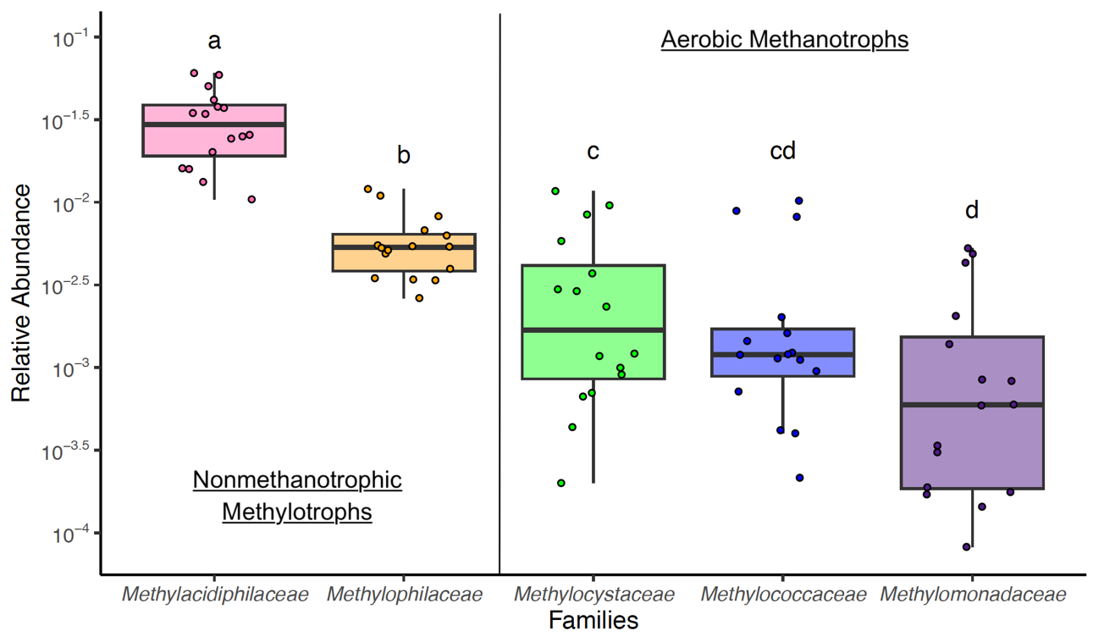
Figure 2-1. A comparison of the mean 16S rRNA gene amplicon relative abundance of aerobic methanotrophs and nonmethanotrophic methylotrophs in Jordan Lake by family. Statistical differences between the relative abundance means were assessed by performing a Tukey’s HSD test on a one-way ANOVA. Boxplots show mean, ±SE, and range.

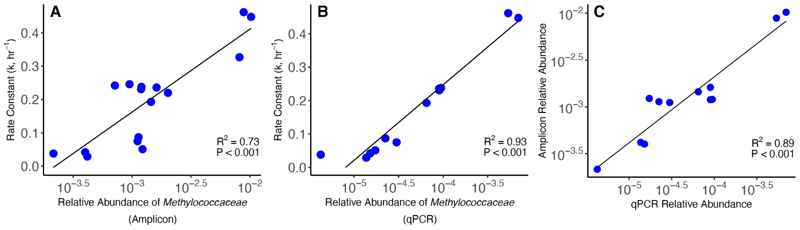
Figure 2-2. Correlations between the aerobic methane oxidation first-order rate constant,16S rRNA gene amplicon relative abundance of Methylococcaceae, and qPCR relative abundance of Methylococcaceae. Correlation between the 16S rRNA gene amplicon relative abundance and the first-order rate constant (R² = 0.73, t(14) = 6.20, P < 0.001) (A), between the qPCR relative abundance of Methylococcaceae ​​(Methylococcaceae pmoA gene copies / Bacterial 16S rRNA gene copies) and the first-order rate constant (R² = 0.93, t(10) = 11.69, P < 0.001) (B), and between the 16S rRNA gene amplicon and qPCR relative abundances of Methylococcaceae (R² = 0.89, t(10) = 8.95, P < 0.001) (C). All are Pearson’s product-moment correlations.

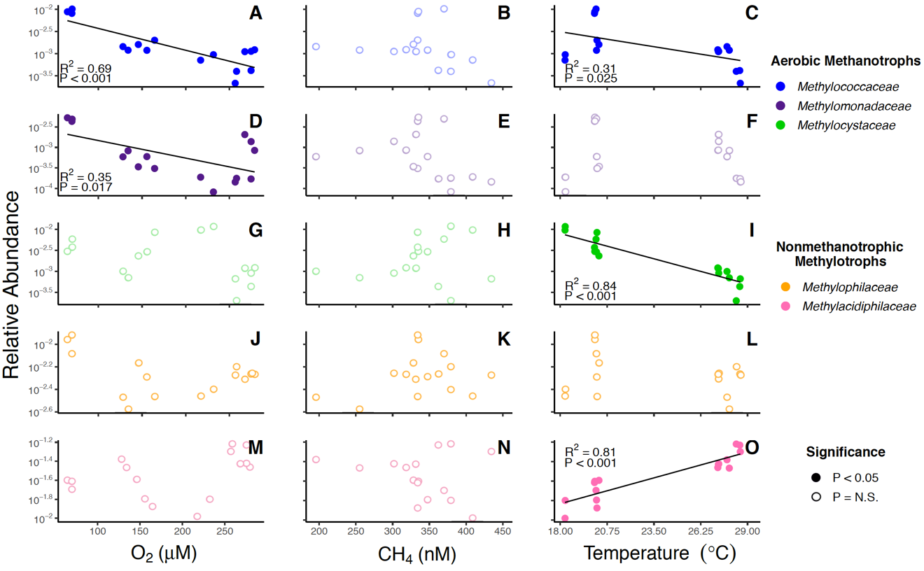
Figure 2-3. Initial relative 16S rRNA gene amplicon abundance of methanotrophic and methylotrophic families correlated with initial geochemical parameters. Correlations with Methylococcaceae (A, B, C), Methylomonadaceae (D, E, F), Methylocystaceae (G, H, I), Methylophilaceae (J, K, L), and Methylacidiphilaceae (M, N, O) are represented. Geochemical parameters are initial oxygen concentration (first column), initial methane concentration (second column), and initial temperature (third column). Correlations Most families significantly correlate with either temperature or oxygen, but none significantly correlate with methane. Trendlines are only present for significant correlations. All are Pearson’s product-moment correlations. Correlations listed in Table 2-S9.

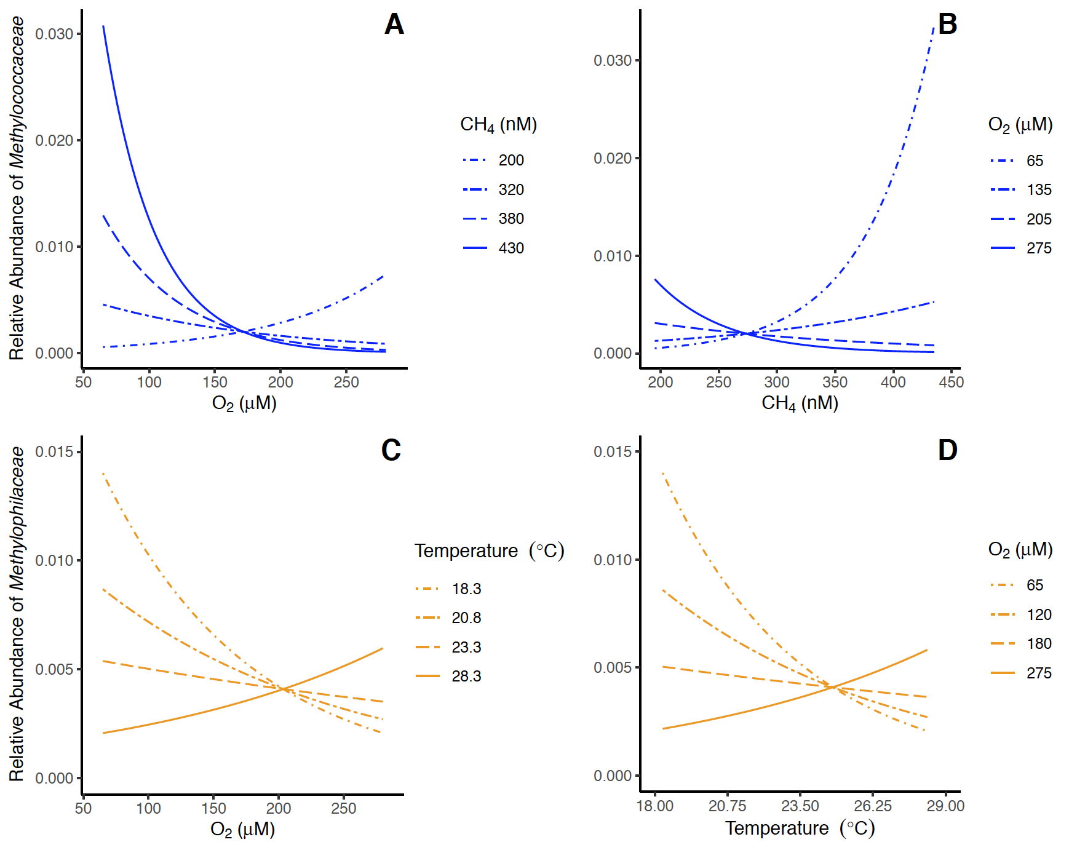
Figure 2-4. Modeled effects of continuous-by-continuous two-way interactions on the 16S rRNA gene amplicon abundance of Methylococcaceae and Methylophilaceae. The predicted effects of oxygen concentration (A) and methane concentration (B) on Methylococcaceae modulated by the other variable. The predicted effects of oxygen concentration (C) and temperature (D) on Methylophilaceae modulated by the other variable. Each line represents the effect of the x axis variable when the reciprocal variable is held constant at one of four values for the effect is significantly different from zero.

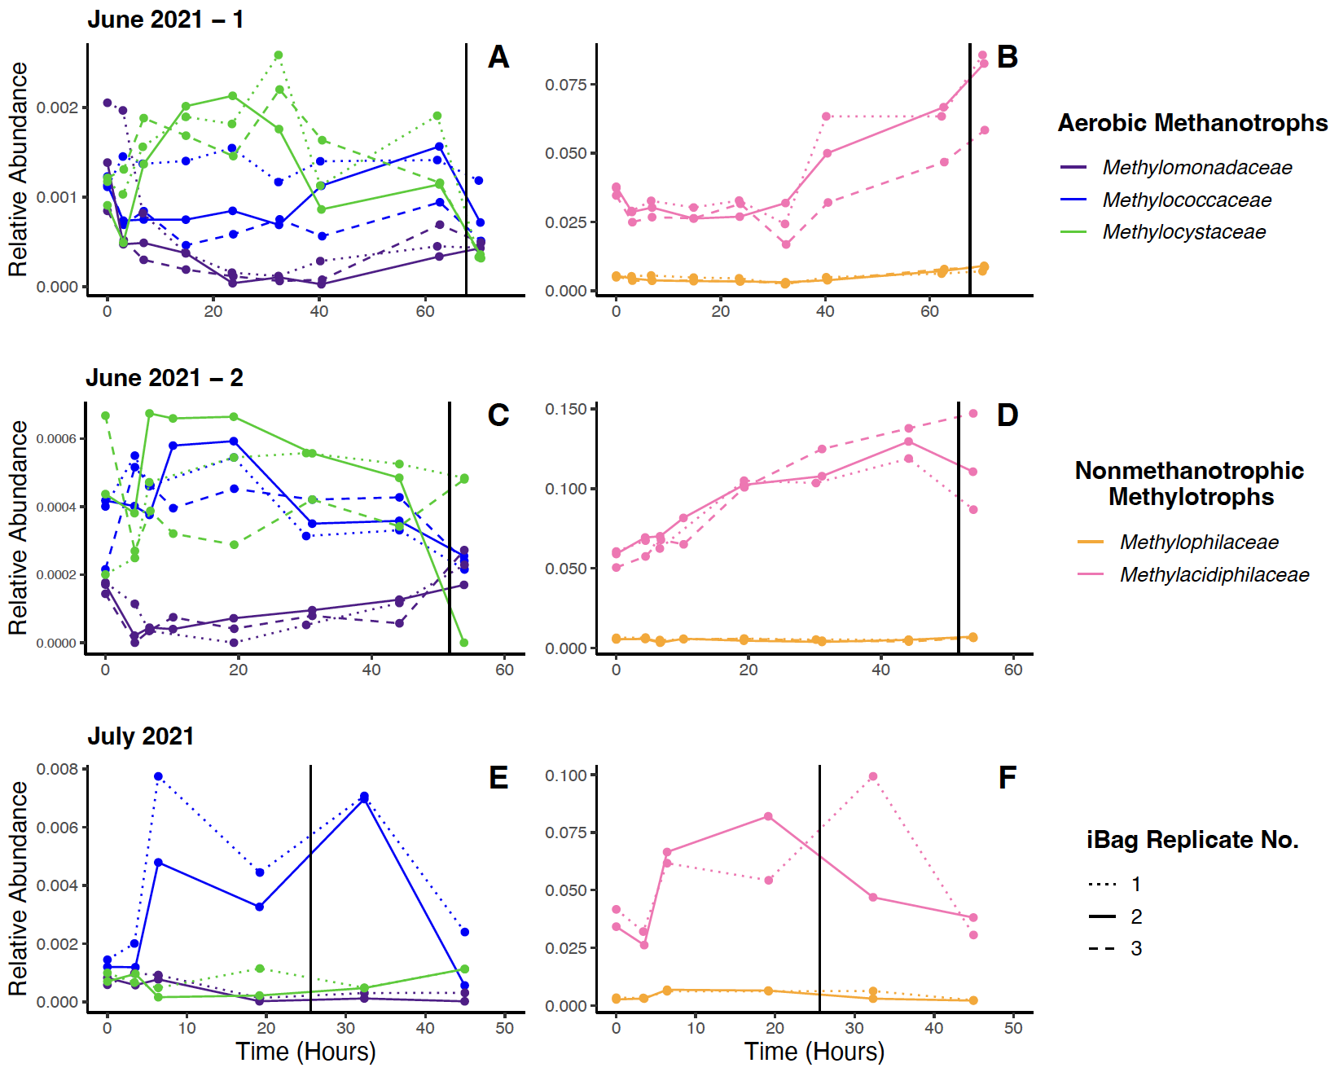
Figure 2-5. 16S rRNA gene amplicon relative abundance data from the summer incubations. Three sets of in situ incubations were performed during the Summer months: one in June 2021 (A,B), a second in June 2021 (C,D), and one in July 2021 (E,F). Incubations ended shortly after becoming anoxic. Vertical lines indicate when oxygen concentrations fell below 20 µM. Immediately after starting the incubations, ammonium was added to the first and third iBags deployed, with the second serving as a control. The ammonium concentrations of the iBags that received ammonium in the first June 2021 experiment rose to ~21 µM and those that did in the other two experiments rose to ~42 µM. The 16S rRNA gene amplicon relative abundance of aerobic methanotrophs (A,C,E) and the nonmethanotrophic methylotrophs (B,D,F) by family are shown.

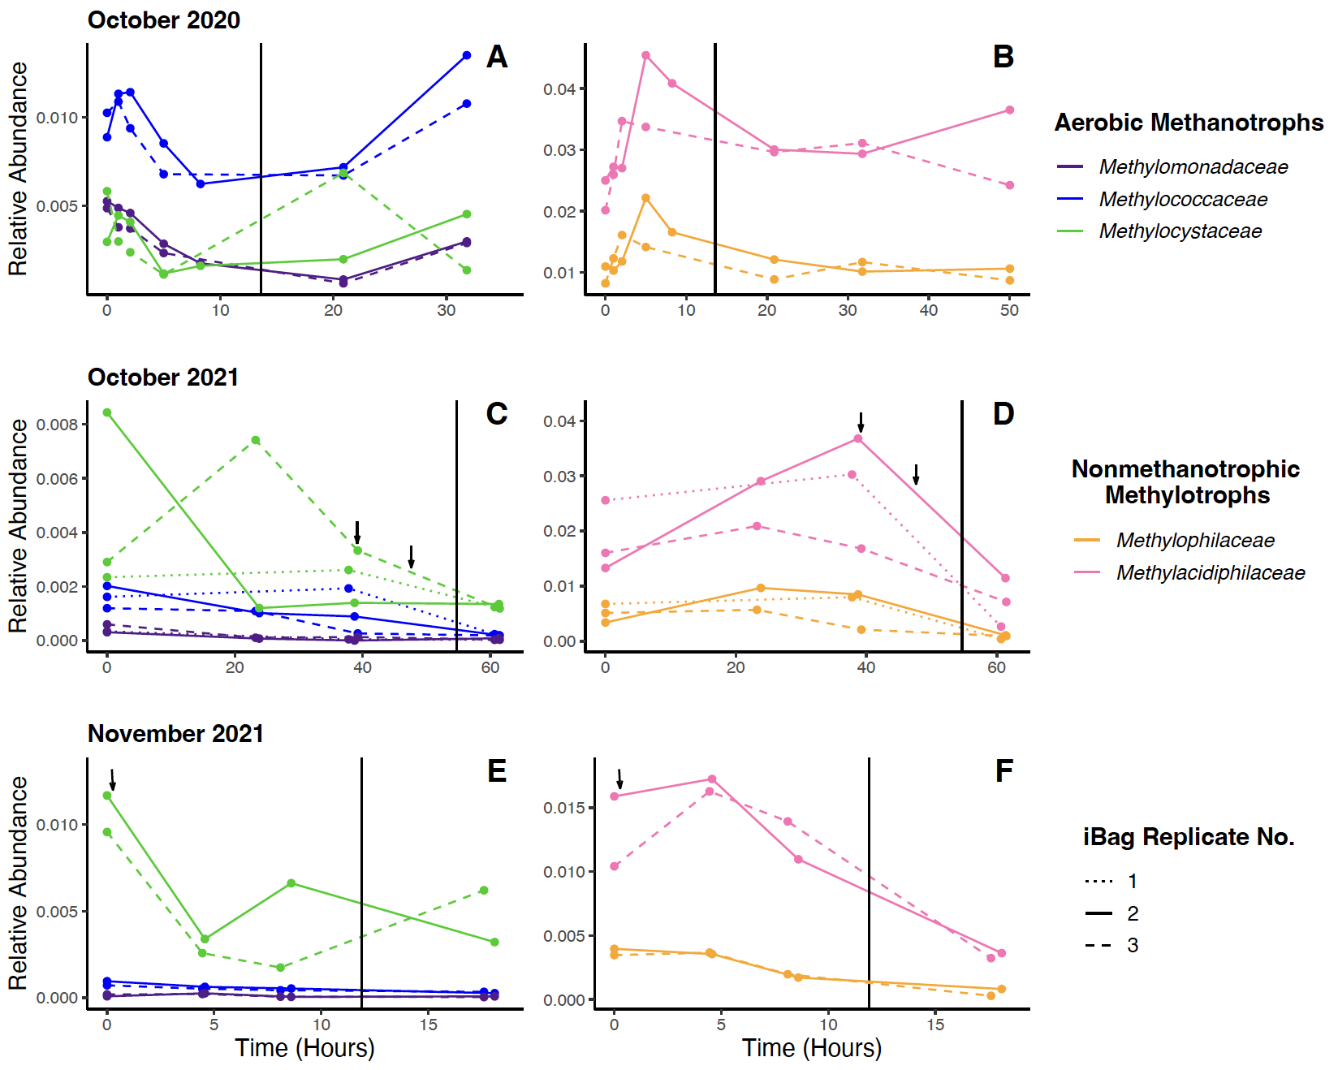
Figure 2-6. 16S rRNA gene amplicon relative abundance data from the fall incubations. Three sets of in situ incubations were performed during the Fall months: one in October 2020 (A,B), one in October 2021 (C,D), and one in November 2021 (E,F). Incubations ended shortly after becoming anoxic–vertical lines indicate when oxygen concentrations fell to 20 µM. The October 2020 experiment was unamended; dried algae were added to all replicates of the October 2021 experiment at ~39.16 hours and 47.61 hours, at initial concentrations of 0.07 g/L and 0.33 g/L, respectively; and it was also added to the November experiment at ~0.275 hours, at initial concentrations of 0.40 g/L. Additions are indicated by the arrows. The 16S rRNA gene amplicon relative abundance of aerobic methanotrophs (A,C,E) and the nonmethanotrophic methylotrophs (B,D,F) by family are shown.

Appendix IIB: Supplemental Material
For all statistical analysis, amplicon and qPCR derived relative abundances are log₁₀-transformed to meet assumptions of normality or normality of errors. qPCR relative abundance is pmoA gene copies from the assessed family / Bacterial 16S rRNA gene copies and amplicon relative abundance is the proportion of the 16S rRNA gene amplicon library belonging to that family.
All geochemical data can be found in Hudspeth et al. (2024a) and online at https://github.com/zhudspeth/JordanLakePaper (Hudspeth et al., 2024b).

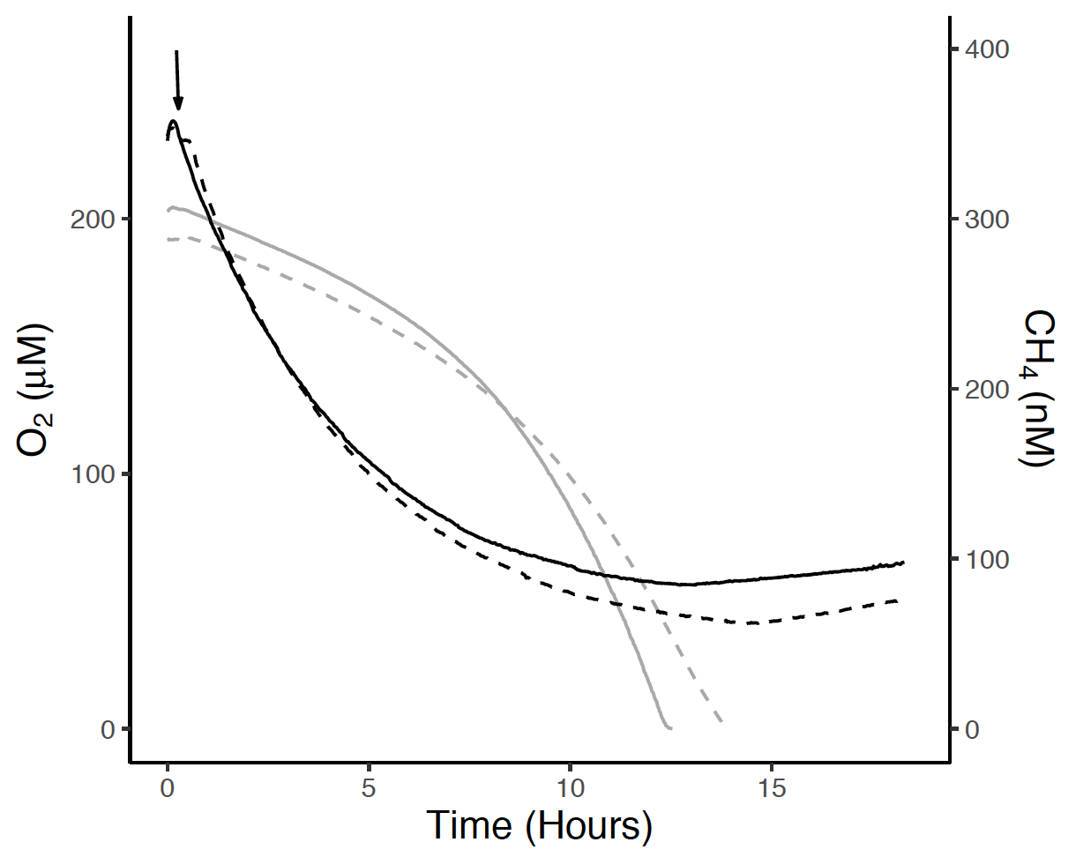
Figure 2-S1. Geochemical data from the November 2021 incubations. Oxygen (grey) and methane (black) concentrations over the course of the two incubations. Data collected once per minute and therefore are represented in line format. Arrow indicates the addition of algal powder. Oxygen consumption is exponential post-addition instead of linear, whereas methane consumption remains first-order with respect to its concentration.
Table 2-S1. Summary of geochemical and microbial time zero data. Geochemical data from experiments conducted between 10/26/20 through 10/29/21 were first published in Hudspeth et al. (2024a).
Date | iBag Replicate # | Geochemistry |  |  |  | Microbial Relative Abundance
Date | iBag Replicate # | Rate Constant (hr^-1) | Modeled Initial Methane (nM) | Modeled Initial Oxygen (µM) | Temperature (°C) | Methylococcaceae | Methylomonadaceae | Methylocystaceae | Methylophilaceae | Methylacidiphilaceae
2020-10-26 | 1 | 0.327 | 334.07 | 69.53 | 20.01 | 0.0082 | 0.0043 | 0.0037 | 0.0120 | 0.0243
2020-10-26 | 2 | 0.462 | 334.60 | 64.40 | 20.024 | 0.0089 | 0.005 | 0.0030 | 0.0110 | 0.0250
2020-10-26 | 3 | 0.448 | 369.88 | 69.80 | 20.099 | 0.0102 | 0.0049 | 0.0058 | 0.0082 | 0.0202
2021-06-25 | 1 | 0.075 | 331.44 | 267.80 | 27.287 | 0.0011 | 0.0021 | 0.0012 | 0.0049 | 0.0373
2021-06-25 | 2 | 0.087 | 301.60 | 275.02 | 27.308 | 0.0011 | 0.0014 | 0.0009 | 0.0055 | 0.0378
2021-06-25 | 3 | 0.051 | 318.03 | 279.03 | 27.253 | 0.0012 | 0.0008 | 0.0012 | 0.0054 | 0.0346
2021-06-29 | 1 | 0.042 | 378.98 | 258.31 | 28.339 | 0.0004 | 0.0002 | 0.0002 | 0.0063 | 0.0605
2021-06-29 | 2 | 0.029 | 362.09 | 274.93 | 28.544 | 0.0004 | 0.0002 | 0.0004 | 0.0054 | 0.0590
2021-06-29 | 3 | 0.038 | 434.36 | 256.78 | 28.575 | 0.0002 | 0.0001 | 0.0007 | 0.0053 | 0.0505
2021-07-10 | 2 | 0.193 | 195.16 | 128.08 | 27.794 | 0.0014 | 0.0006 | 0.0010 | 0.0034 | 0.0417
2021-07-10 | 3 | 0.238 | 254.92 | 133.95 | 27.93 | 0.0012 | 0.0008 | 0.0007 | 0.0026 | 0.0342
2021-10-29 | 1 | 0.236 | 327.93 | 145.69 | 20.268 | 0.0016 | 0.0003 | 0.0023 | 0.0068 | 0.0256
2021-10-29 | 2 | 0.220 | 333.83 | 164.36 | 20.153 | 0.0020 | 0.0003 | 0.0084 | 0.0034 | 0.0133
2021-10-29 | 3 | 0.231 | 347.38 | 155.51 | 20.127 | 0.0012 | 0.0006 | 0.0029 | 0.0051 | 0.0160
2021-11-03 | 2 | 0.246 | 379.15 | 231.80 | 18.287 | 0.0010 | 0.0001 | 0.0117 | 0.0040 | 0.0159
2021-11-03 | 3 | 0.242 | 408.75 | 217.12 | 18.276 | 0.0007 | 0.0002 | 0.0096 | 0.0035 | 0.0104

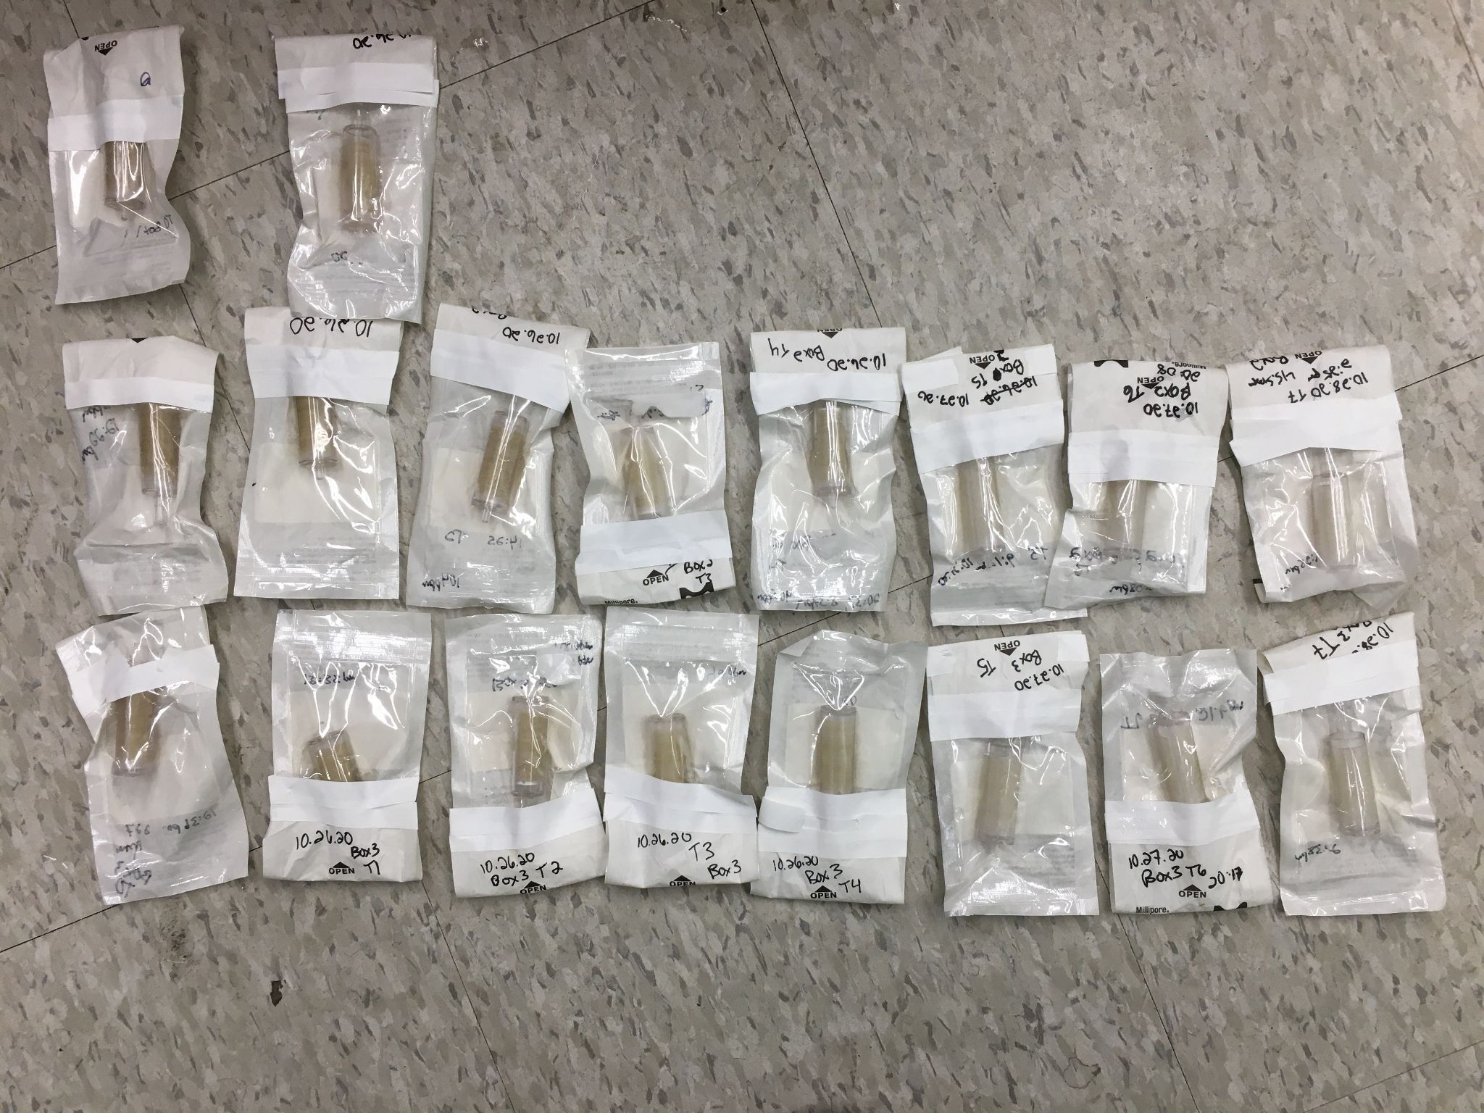
Figure 2-S2. October 2020 Sterivex filters from all three incubations. Top row: incubation 1, Middle row: incubation 2, and Bottom row: incubation 3 in order of sampling time (left to right). The color of the Sterivex filters lightens noticeably as the incubations progress, with the first samples being colored a dark brown and the final ones being off-white. This loss of pigment could be due to the death and consumption of the photosynthetic organisms within the incubations, which are both likely to be pigmented and to die off as the incubation progresses due to the opacity of the incubation vessels.

Table 2-S2. Summary of correlations between the rarefied and non-rarefied 16S rRNA gene amplicon proportion time zero data.
Group | Family | R² | T | P value
Obligate Methanotroph | Methylococcaceae | 0.98 | 24.85 | 5.57E-13
Obligate Methanotroph | Methylomonadaceae | 0.98 | 25.41 | 4.10E-13
Facultative Methanotroph | Methylocystaceae | 0.98 | 29.23 | 5.97E-14
Nonmethanotrophic Methylotroph | Methylophilaceae | 0.97 | 21.26 | 4.70E-12
Nonmethanotrophic Methylotroph | Methylacidiphilaceae | 0.995 | 53.72 | < 2.2e-16

Table 2-S3. Summary of correlations between the rarefied and non-rarefied 16S rRNA gene amplicon proportion time series data.
Incubation Set | Group | Family | R² | t | P value
October 2020 | Obligate Methanotroph | Methylococcaceae | 0.97 | 23.44 | 5.94E-13
October 2020 | Obligate Methanotroph | Methylomonadaceae | 0.99 | 33.94 | 1.34E-15
October 2020 | Facultative Methanotroph | Methylocystaceae | 0.99 | 32.39 | 2.68E-15
October 2020 | Nonmethanotrophic Methylotroph | Methylophilaceae | 0.99 | 32.40 | 2.67E-15
October 2020 | Nonmethanotrophic Methylotroph | Methylacidiphilaceae | 0.98 | 25.40 | 9.63E-14
October 2021 | Obligate Methanotroph | Methylococcaceae | 0.90 | 19.18 | 2.08E-08
October 2021 | Obligate Methanotroph | Methylomonadaceae | 0.72 | 15.87 | 3.43E-05
October 2021 | Facultative Methanotroph | Methylocystaceae | 0.99 | 30.53 | 6.99E-15
October 2021 | Nonmethanotrophic Methylotroph | Methylophilaceae | 0.98 | 41.67 | 5.14E-13
October 2021 | Nonmethanotrophic Methylotroph | Methylacidiphilaceae | 0.99 | 61.52 | 4.11E-15
November 2021 | Obligate Methanotroph | Methylococcaceae | 0.94 | 11.27 | 4.61E-16
November 2021 | Obligate Methanotroph | Methylomonadaceae | 0.91 | 5.97 | 3.17E-14
November 2021 | Facultative Methanotroph | Methylocystaceae | 0.97 | 34.14 | < 2.2e-16
November 2021 | Nonmethanotrophic Methylotroph | Methylophilaceae | 0.99 | 25.00 | < 2.2e-16
November 2021 | Nonmethanotrophic Methylotroph | Methylacidiphilaceae | 0.99 | 35.48 | < 2.2e-16
June 2021(First) | Obligate Methanotroph | Methylococcaceae | 0.84 | 11.27 | 2.74E-11
June 2021(First) | Obligate Methanotroph | Methylomonadaceae | 0.95 | 22.14 | < 2.2e-16
June 2021(First) | Facultative Methanotroph | Methylocystaceae | 0.94 | 19.67 | < 2.2e-16
June 2021(First) | Nonmethanotrophic Methylotroph | Methylophilaceae | 0.97 | 27.93 | < 2.2e-16
June 2021(First) | Nonmethanotrophic Methylotroph | Methylacidiphilaceae | 0.995 | 73.08 | < 2.2e-16
June 2021 (Second) | Obligate Methanotroph | Methylococcaceae | 0.50 | 4.55 | 0.000174
June 2021 (Second) | Obligate Methanotroph | Methylomonadaceae | 0.74 | 7.71 | 1.48E-07
June 2021 (Second) | Facultative Methanotroph | Methylocystaceae | 0.85 | 10.90 | 4.21E-10
June 2021 (Second) | Nonmethanotrophic Methylotroph | Methylophilaceae | 0.91 | 14.32 | 2.61E-12
June 2021 (Second) | Nonmethanotrophic Methylotroph | Methylacidiphilaceae | 0.995 | 67.84 | < 2.2e-16
Table 2-S3 continued.
Incubation Set | Group | Family | R² | T | P value
July 2021 | Obligate Methanotroph | Methylococcaceae | 0.99 | 30.77 | 1.57E-13
July 2021 | Obligate Methanotroph | Methylomonadaceae | 0.81 | 7.56 | 4.12E-06
July 2021 | Facultative Methanotroph | Methylocystaceae | 0.86 | 8.81 | 7.66E-07
July 2021 | Nonmethanotrophic Methylotroph | Methylophilaceae | 0.93 | 13.23 | 6.42E-09
July 2021 | Nonmethanotrophic Methylotroph | Methylacidiphilaceae | 0.99 | 50.80 | 2.44E-16

Table 2-S4. qPCR Primers used.
Target Gene | Specificity | Positive Control Amplified | Samples Amplified | Probe/  primer | Sequence  (5’ – 3’) | Reference
pmoA | Methylacidiphilum | Yes | No | V170F | GGATWGATTGGAAAGATMG | Sharp et al., 2012
 |  |  |  | V613b | GCAAARCTYCTCATYGTWCC | Sharp et al., 2012
pmoA | Methylococcus | Yes | Yes | A189F | GGNGACTGGGACTTCTGG | Kolb et al., 2003
 |  |  |  | Mc468R | GCSGTGAACAGGTAGCTGCC | Kolb et al., 2003
pmoA | Methylobacter/ Methylosarcina | No | No | A189F | GGNGACTGGGACTTCTGG | Kolb et al., 2003
 |  |  |  | Mb601R | ACRTAGTGGTAACCTTGYAA | Kolb et al., 2003
pmoA | Methylosinus | Yes | Yes | II223F | CGTCGTATGTGGCCGAC | Kolb et al., 2003
 |  |  |  | II646R | CGTGCCGCGCTCGAC CATGYG | Kolb et al., 2003
16s rRNA | Most Bacteria | Yes | Yes | BAC340F | TCCTACGGGAGGCAGCAGT | Kubo et al., 2012
 |  |  |  | Bac515R | CGTATTACCGCGGCTGCTGGCAC | Kubo et al., 2012
Table 2-S5. One-way ANOVA comparing the 16S rRNA gene amplicon relative abundances of the aerobic methanotrophs and nonmethanotrophic methylotrophs in Jordan Lake by family.
Type | Sum of Squares | df | Mean Square | F | P value
Between Groups | 137.37 | 4 | 34.34 | 35.61 | < 2E-16
Residuals | 72.34 | 75 | 0.96
Total | 209.71 | 79

Table 2-S6. Tukey’s HSD multiple comparisons performed on the one-way ANOVA from Table 2-S5. Confidence interval is abbreviated as CI. Mean difference, standard error, and CI bounds are reported as log₁₀ transformed.
Group 1 | Group 2 | Mean Difference | Standard Error | P value (adjusted) | Lower Bound of CI | Upper Bound of CI
Methylacidiphilaceae | Methylophilaceae | 1.66 | 0.93 | 8.31E-5 | 0.69 | 2.63
Methylacidiphilaceae | Methylocystaceae | 2.71 | 0.93 | < 2E-16 | 1.74 | 3.68
Methylacidiphilaceae | Methylococcaceae | 3.00 | 0.93 | < 2E-16 | 2.03 | 3.97
Methylacidiphilaceae | Methylomonadaceae | 3.80 | 0.93 | < 2E-16 | 2.83 | 4.77
Methylophilaceae | Methylocystaceae | 1.05 | 0.93 | 0.028 | 0.08 | 2.02
Methylophilaceae | Methylococcaceae | 1.34 | 0.93 | 0.002 | 0.37 | 2.31
Methylophilaceae | Methylomonadaceae | 2.14 | 0.93 | 3.00 E-7 | 1.17 | 3.11
Methylocystaceae | Methylococcaceae | 0.30 | 0.93 | 0.91 | -0.68 | 1.27
Methylocystaceae | Methylomonadaceae | 1.09 | 0.93 | 0.019 | 0.12 | 2.06
Methylococcaceae | Methylomonadaceae | 0.80 | 0.93 | 0.16 | -0.17 | 1.77

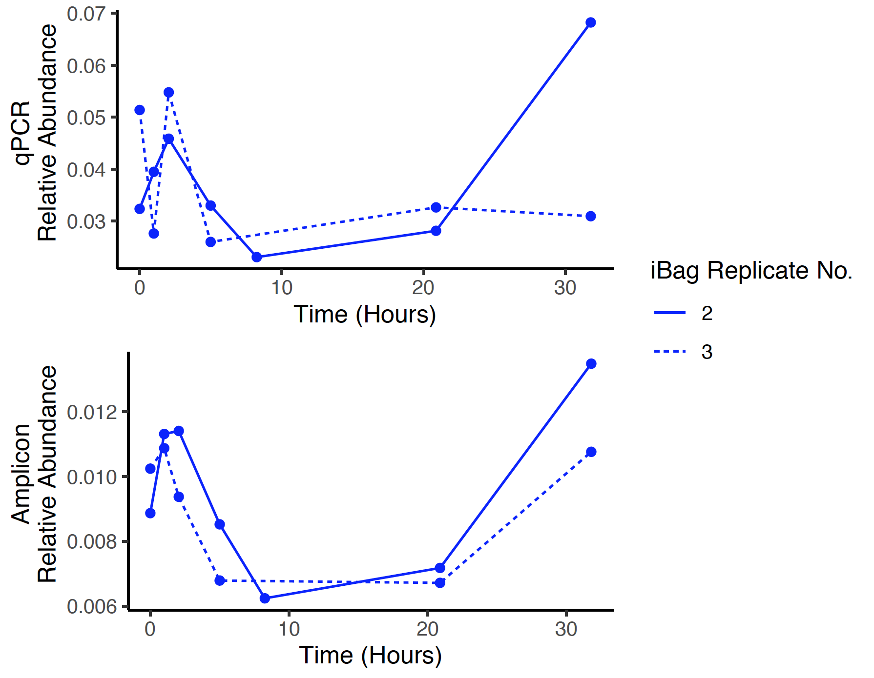
Figure 2-S3. Qualitative comparison of the shifts in relative abundance of Methylococcaceae. Relative abundance calculated from qPCR (top) and from 16S rRNA gene amplicon sequencing (bottom). Though the correlation between the two datasets only has an R² of 0.49 (t = 3.28, df = 11, P = 0.007), the overall trend exhibited is similar across the data sets, indicating that qualitative analysis of the amplicon data set should not be biased.

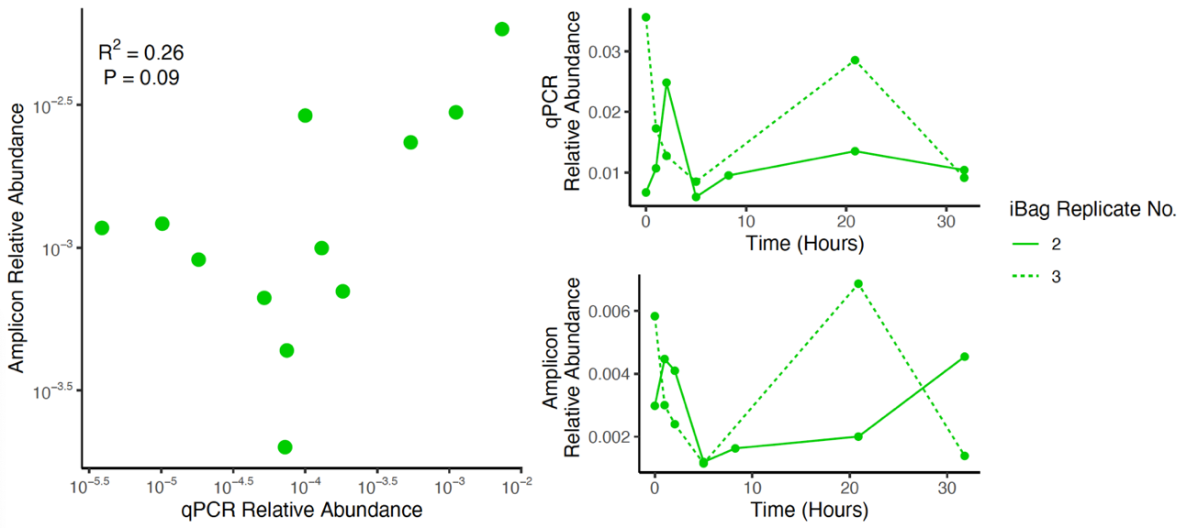
Figure 2-S4. Comparison between the relative abundance of Methylocystaceae. Correlation between relative abundance measured by qPCR and 16S rRNA gene amplicon sequencing across the initial populations of the incubations (left). There is no correlation between the Methylocystaceae relative abundances as measured by qPCR and 16S rRNA gene amplicon sequencing (R² = 0.26, t = 1.86, df = 10, P = 0.09). Qualitative comparison of the shifts in relative abundance of Methylococcaceae (right) as measured by qPCR (top) and 16S rRNA gene amplicon sequencing. Though the correlation between the two datasets only has an R² of 0.59 (t = 4.02, df = 11, P = 0.002), the overall trend exhibited is similar across the data sets, indicating that qualitative analysis of the amplicon data set should not be biased.

Table 2-S7. Summary of aerobic methane oxidation rate constant correlations with variables measured at the beginning of each incubation. All Pearson’s product-moment correlations have 14 degrees of freedom. Significant correlations are bolded.
Family | Type | R² | T | P value
Methylococcaceae | Initial | 0.73 | 6.20 | 2.32E-05
Methylococcaceae | Average | 0.47 | 3.50 | 0.004
Methylomonadaceae | Initial | 0.30 | 2.47 | 0.027
Methylomonadaceae | Average | 0.32 | 2.58 | 0.022
Methylocystaceae | Initial | 0.45 | 3.37 | 0.005
Methylocystaceae | Average | 0.52 | 3.90 | 0.002
Methylophilaceae | Initial | 0.14 | 1.49 | 0.16
Methylophilaceae | Average | 0.07 | 0.99 | 0.34
Methylacidiphilaceae | Initial | 0.38 | -2.90 | 0.012
Methylacidiphilaceae | Average | 0.21 | -1.94 | 0.073
Table 2-S8. Summary of geochemical correlations with the qPCR and amplicon relative abundance of Methylococcaceae. Results of Pearson product-moment correlation between the qPCR relative abundance of Methylococcaceae (Methylococcaceae pmoA gene copies / Bacterial 16S rRNA gene copies) and the three geochemical variables (oxygen, methane, and temperature) along with the first-order rate constant of aerobic methane oxidation (MO_{x}). Correlations have 10 degrees of freedom. Statistically significant correlations are bolded.
Variable | R² | t | P value
Oxygen | 0.83 | -7.03 | 3.57E-05
Methane | 0.08 | -0.92 | 0.38
Temperature | 0.63 | -4.12 | 2.07E-03
MO_{x} Rate Constant | 0.93 | 11.69 | 3.74E-07

Table 2-S9. Summary of correlations between the geochemical parameters and 16S rRNA gene amplicon relative abundance of key families. Results of Pearson product-moment correlation between the 16S rRNA gene amplicon relative abundance of the key families and the three geochemical variables. Correlations have 14 degrees of freedom. Statistically significant correlations are bolded.
Family | Variable | R² | t | P value
Methylococcaceae, obligate methanotroph | Oxygen | 0.69 | -5.52 | 7.57E-05
Methylococcaceae, obligate methanotroph | Methane | 0.08 | -1.08 | 0.30
Methylococcaceae, obligate methanotroph | Temperature | 0.31 | -2.51 | 0.025
Methylomonadaceae, obligate methanotroph | Oxygen | 0.35 | -2.72 | 0.017
Methylomonadaceae, obligate methanotroph | Methane | 0.12 | -1.37 | 0.19
Methylomonadaceae, obligate methanotroph | Temperature | 0.01 | -0.45 | 0.66
Methylocystaceae, facultative methanotroph | Oxygen | 0.15 | -1.78 | 0.097
Methylocystaceae, facultative methanotroph | Methane | 0.04 | 0.76 | 0.46
Methylocystaceae, facultative methanotroph | Temperature | 0.84 | -8.43 | 7.39E-07
Methylophilaceae, nonmethanotrophic methylotroph | Oxygen | 0.14 | -1.49 | 0.16
Methylophilaceae, nonmethanotrophic methylotroph | Methane | 0.07 | 1.02 | 0.32
Methylophilaceae, nonmethanotrophic methylotroph | Temperature | 0.06 | -0.93 | 0.37
Methylacidiphilaceae, nonmethanotrophic methylotroph (inferred) | Oxygen | 0.16 | 1.59 | 0.13
 | Methane | 0.28 | -0.74 | 0.47
 | Temperature | 0.81 | 7.81 | 1.82E-06
Table 2-S10. Summary of model statistics of the best linear models for each family.
Family | Adjusted R² | F | Df | P
Methylococcaceae | 0.8915 | 42.08 | 3, 12 | 1.21E-06
Methylomonadaceae | 0.7262 | 10.95 | 4, 11 | 7.89E-04
Methylocystaceae | 0.8355 | 71.1 | 1, 14 | 7.39E-07
Methylophilaceae | 0.8072 | 21.93 | 2, 13 | 3.68E-05
Methylacidiphilaceae | 0.853 | 30.01 | 3, 12 | 7.36E-06

Table 2-S11. Summary of all multiple regression results of the best linear models for each family.
Family | Predictor | Standardized Slope ± SE | F | df | P value
Methylococcaceae | Oxygen | 1.936e-02 ± 4.355e-03 | 84.20 | 1, 12 | 8.99E-07
Methylococcaceae | Methane | 1.214e-02 ± 2.337e-03 | 0.14 | 1, 12 | 0.72
Methylococcaceae | Oxygen:Methane | -7.089e-05 ± 1.265e-05 | 31.40 | 1, 12 | 1.15E-04
Methylomonadaceae | Oxygen | 3.492e-02 ± 8.740e-03 | 12.88 | 1, 11 | 4.25E-03
Methylomonadaceae | Methane | 2.265e-02 ± 5.315e-03 | 0.14 | 1, 11 | 0.72
Methylomonadaceae | Oxygen:Methane | -1.225e-04 ± 2.640e-05 | 21.53 | 1, 11 | 7.26E-04
Methylomonadaceae | Temperature | 8.202e-02 ± 2.827e-02 | 8.41 | 1, 11 | 0.014
Methylocystaceae | Temperature | -0.10905 ± 0.01293 | 71.10 | 1.14 | 7.39E-07
Methylophilaceae | Oxygen | -1.485e-02 ± 1.923e-03 | 6.27 | 1, 12 | 0.028
Methylophilaceae | Temperature | -1.222e-01 ± 1.714e-02 | 0.18 | 1, 12 | 0.68
Methylophilaceae | Oxygen:Temperature | 6.005e-04 ± 8.098e-05 | 54.98 | 1, 12 | 8.11E-06
Methylacidiphilaceae | Oxygen | -5.376e-03 ± 2.121e-03 | 1.42 | 1, 12 | 0.26
Methylacidiphilaceae | Temperature | 1.010e-02 ± 1.891e-02 | 68.76 | 1, 12 | 2.60E-06
Methylacidiphilaceae | Oxygen:Temperature | 2.121e-04 ± 8.932e-05 | 5.64 | 1, 12 | 0.035

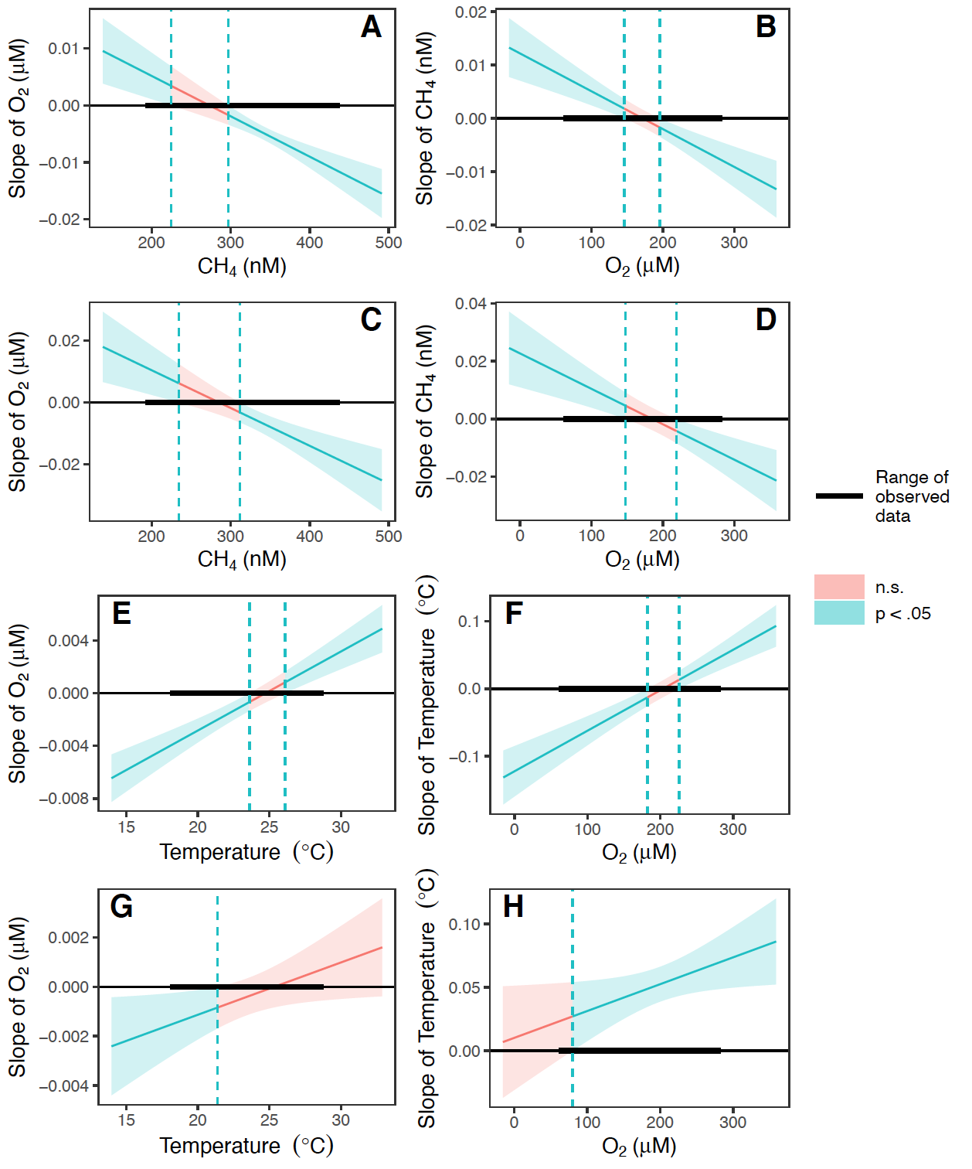
Figure 2-S5. Johnson-Neyman interval plots for the multiple regressions with continuous-by-continuous interaction terms. Oxygen and methane interactions in the Methylococcaceae model (A, B). Oxygen and methane interactions in the Methylomonadaceae model (C, D). Oxygen and temperature interaction in the Methylophilaceae model (E, F). Oxygen and temperature interaction in the Methylacidiphilaceae model (G, H).

Table 2-S12. Summary statistics of each model in the pool of possible models for each family. Best models are bolded. Residual degrees of freedom apply to each specific term added to the model. The corrected Akaike information criterion (AICc) and the Bayesian information criterion (BIC) are presented. The best models had the lowest AICc and/or BIC, often having the highest adjusted R² value as well.
Family | Model | Residual df | Adjusted R² | AICc | BIC
Methylomonadaceae | Intercept | 1,15 | -- | 31.77 | 32.39
Methylomonadaceae | Oxygen | 1,14 | 0.2995 | 28.04 | 28.36
Methylomonadaceae | Methane | 1,14 | 0.0559 | 32.82 | 33.16
Methylomonadaceae | Temperature | 1,14 | -0.06 | 34.61 | 34.93
Methylomonadaceae | Oxygen + Methane | 1,13 | 0.28 | 30.89 | 30.35
Methylomonadaceae | Oxygen + Temperature | 1,13 | 0.31 | 30.21 | 29.66
Methylomonadaceae | Methane + Temperature | 1,13 | 0.04 | 35.48 | 34.93
Methylomonadaceae | Oxygen + Methane + (O2:CH4) | 1,12 | 0.56 | 26.24 | 24.11
Methylomonadaceae | Oxygen + Temperature + (O2:Temperature) | 1,12 | 0.50 | 28.19 | 26.06
Methylomonadaceae | Oxygen + Methane + Temperature | 1,12 | 0.26 | 34.50 | 32.36
Methylomonadaceae | Oxygen + Methane + Temperature + (O2:CH4) | 1,11 | 0.73 | 22.49 | 17.79
Methylomonadaceae | Oxygen + Methane + Temperature + (O2:Temperature) | 1,11 | 0.63 | 27.38 | 22.68
Methylocystaceae | Intercept | 1,15 | -- | 27.96 | 28.58
Methylocystaceae | Oxygen | 1,14 | 0.13 | 27.77 | 28.09
Methylocystaceae | Methane | 1,14 | -0.03 | 30.39 | 30.70
Methylocystaceae | Temperature | 1,14 | 0.82 | 2.16 | 2.48
Methylocystaceae | Oxygen + Methane | 1,13 | 0.20 | 28.90 | 28.35
Methylocystaceae | Oxygen + Temperature | 1,13 | 0.82 | 5.16 | 4.61
Methylocystaceae | Methane + Temperature | 1,13 | 0.82 | 5.34 | 4.80
Methylocystaceae | Oxygen + Methane + Temperature | 1,12 | 0.8262 | 7.47 | 5.33

Table 2-S12 continued.
Family | Model | Residual df | Adjusted R² | AICc | BIC
Methylococcaceae | Intercept | 1,15 | -- | 25.45 | 26.07
Methylococcaceae | Oxygen | 1,14 | 0.66 | 10.04 | 10.38
Methylococcaceae | Methane | 1,14 | 0.01 | 27.25 | 27.57
Methylococcaceae | Temperature | 1,14 | 0.26 | 22.59 | 22.92
Methylococcaceae | Oxygen + Methane | 1,13 | 0.64 | 13.63 | 13.08
Methylococcaceae | Oxygen + Temperature | 1,13 | 0.66 | 12.84 | 12.29
Methylococcaceae | Methane + Temperature | 1,13 | 0.45 | 20.42 | 19.87
Methylococcaceae | Oxygen + Methane + (O2:CH4) | 1,12 | 0.89 | -2.58 | -4.71
Methylococcaceae | Oxygen + Temperature + (O2:Temperature) | 1,12 | 0.73 | 12.25 | 10.12
Methylococcaceae | Oxygen + Methane + Temperature | 1,12 | 0.65 | 16.35 | 14.21
Methylococcaceae | Oxygen + Methane + Temperature + (O2:CH4) | 1,11 | 0.89 | 2.75 | -1.94
Methylococcaceae | Oxygen + Methane + Temperature + (O2:Temperature) | 1,11 | 0.86 | 5.66 | 0.96
Methylacidiphilaceae | Intercept | 1,15 | -- | 2.33 | 2.96
Methylacidiphilaceae | Oxygen | 1,14 | 0.09 | 2.75 | 3.07
Methylacidiphilaceae | Methane | 1,14 | -0.03 | 4.79 | 5.11
Methylacidiphilaceae | Temperature | 1,14 | 0.80 | -21.43 | -21.11
Methylacidiphilaceae | Oxygen + Methane | 1,13 | 0.15 | 4.23 | 3.69
Methylacidiphilaceae | Oxygen + Temperature | 1,13 | 0.80 | -19.04 | -19.58
Methylacidiphilaceae | Methane + Temperature | 1,13 | 0.79 | -18.22 | -18.76
Methylacidiphilaceae | Oxygen + Temperature + (O2:Temperature) | 1,12 | 0.85 | -20.83 | -22.97
Methylacidiphilaceae | Oxygen + Methane + Temperature | 1,12 | 0.82 | -17.46 | -19.60
Methylacidiphilaceae | Oxygen + Methane + Temperature + (O2:Temperature) | 1,11 | 0.84 | -15.75 | -20.45

Table 2-S12 continued.
Family | Model | Residual df | Adjusted R² | AICc | BIC
Methylophilaceae | Intercept | 1,15 | -- | -5.14 | -4.52
Methylophilaceae | Oxygen | 1,14 | 0.07505 | -4.41 | -4.10
Methylophilaceae | Methane | 1,14 | 0.002836 | -3.21 | -2.89
Methylophilaceae | Temperature | 1,14 | -0.008722 | -3.03 | -2.71
Methylophilaceae | Oxygen + Methane | 1,13 | 0.1809 | -3.91 | -4.45
Methylophilaceae | Oxygen + Temperature | 1,13 | 0.006624 | -0.82 | -1.37
Methylophilaceae | Methane + Temperature | 1,13 | -0.04 | -0.10 | -0.64
Methylophilaceae | Methane + Temperature + (CH4:Temperature) | 1,12 | 0.27 | -2.70 | -4.84
Methylophilaceae | Oxygen + Temperature + (O2:Temperature) | 1,12 | 0.81 | -23.97 | -26.10
Methylophilaceae | Oxygen + Methane + Temperature | 1,12 | 0.17 | -0.56 | -2.70
Methylophilaceae | Oxygen + Methane + Temperature + (CH4:Temperature) | 1,11 | 0.33 | 0.01 | -4.68
Methylophilaceae | Oxygen + Methane + Temperature + (O2:Temperature) | 1,11 | 0.79 | -18.74 | -23.44

Table 2-S13. Correlations between geochemical predictors. None exhibited collinearity as defined in the methods. All had 14 degrees of freedom.
Predictors | R² | T | P value
Oxygen & Temperature | 0.30 | 2.43 | 0.029
Oxygen & Methane | 0.09 | 1.17 | 0.26
Methane & Temperature | 0.08 | -1.13 | 0.28

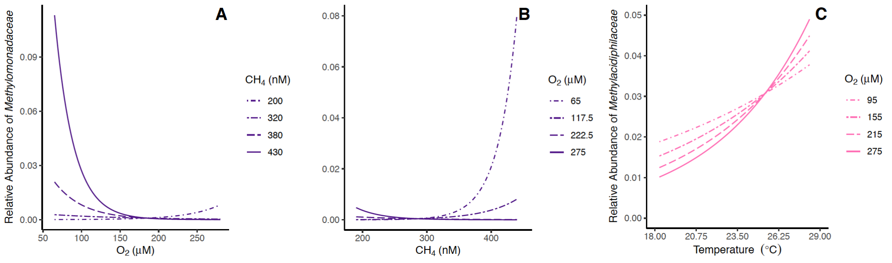
Figure 2-S6. Predicted effects of continuous-by-continuous two-way interactions on Methylomonadaceae and Methylacidiphilaceae. The predicted effect of oxygen modulated by methane and methane modulated by oxygen, respectively, on Methylomonadaceae 16S rRNA gene amplicon relative abundance (A,B). Temperature is set to 19.656°C, the average temperature recorded at the start of the fall incubations. The predicted effect of temperature modulated by oxygen on Methylacidiphilaceae 16S rRNA gene amplicon relative abundance (C). The predicted effect of oxygen modulated by temperature on Methylacidiphilaceae 16S rRNA gene amplicon relative abundance is not shown, as oxygen significantly affects the 16S rRNA gene amplicon abundance for only ~3 of the 10.3℃ range of temperatures observed in this study and the effect does not meaningfully vary within that range.

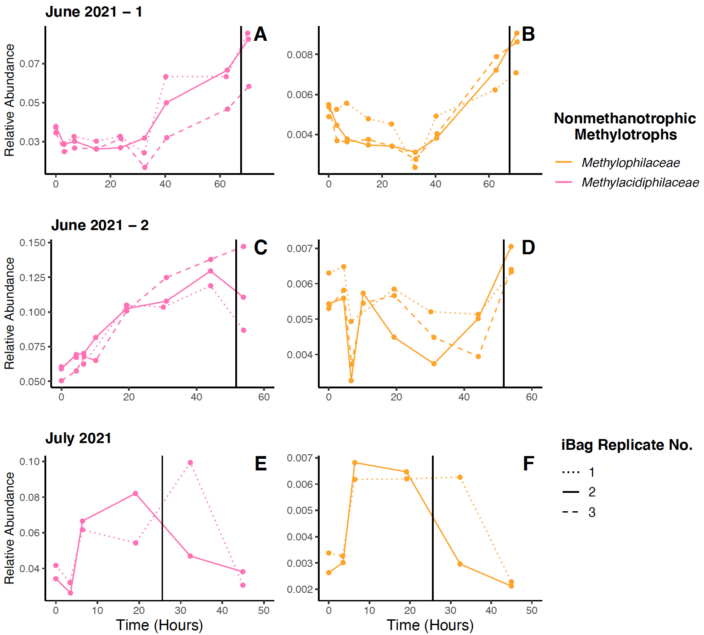
Figure 2-S7. 16S rRNA gene amplicon relative abundance data for nonmethanotrophic methylotrophs from the summer incubations. Three sets of in situ incubations were performed during the Summer months: one in June 2021 (A,B), a second in June 2021 (C,D), and one in July 2021 (E,F). Incubations ended shortly after becoming anoxic. Immediately after starting the incubations, ammonium was added to the first and third iBags deployed, with the second serving as a control. The iBags that received ammonium in the first June 2021 experiment received ~21 µM and those that did in the other two experiments received ~42 µM. The 16S rRNA gene amplicon relative abundance of Methylacidiphilaceae (A,C,E) and Methylophilaceae (B,D,F) are shown. Vertical lines indicate when oxygen concentrations fell below 20 µM.

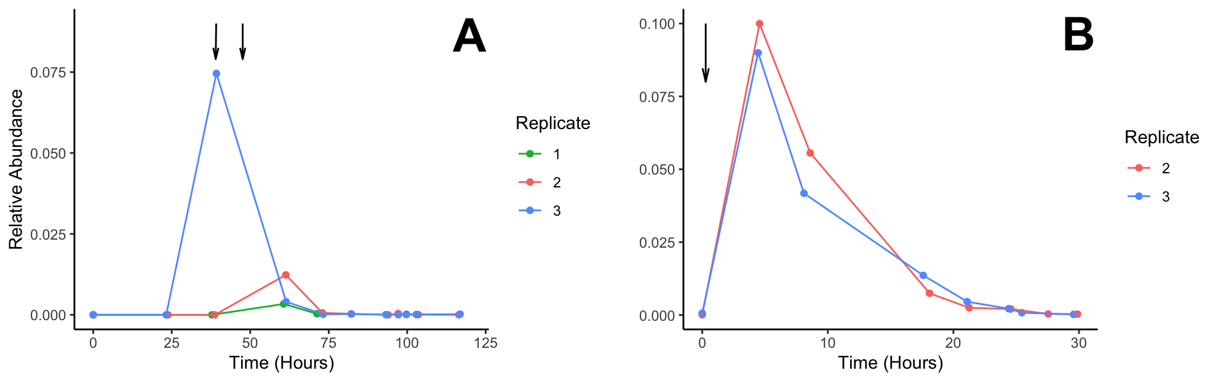
Figure 2-S8. 16S rRNA gene amplicon relative abundance of the dried algae (Arthrospira PCC-7345). 16S rRNA gene amplicon sequences over time in the October 2021 (A) and the November 2021 incubation sets (B). The 16S rRNA gene amplicon relative abundance spikes immediately after addition and then is consumed at an increasing rate over time, nearly vanishing over the course of each incubation. (A) First arrow indicates when two capsules were added to the incubations at ~39.16 hours. This occurred prior to sampling for replicates 1 and 2, but before sampling for replicate 3. The second arrow indicates when ten capsules were added at ~47.61 hours for all three replicates. (B) The arrow indicates when twelve capsules were added at ~0.2750 hours.

CHAPTER III: spatiotemporal stability, geochemical drivers, and syntrophic interactions in the aerobic methane-oxidizing community of the T1 seep field

Publication Note
A version of this chapter is being prepared for submission with the following authors:
Jennifer A. Baily, Gage R. Coon, Sarina Mitchell, Fumnanya Abuah, Leketha C. Williams, Zachary W. Hudspeth, Howard P. Mendlovitz, Carolyn D. Ruppel, Christopher S. Martens, and Karen G. Lloyd.
JAB performed all of the DNA extractions, processing of 16S rRNA gene amplicon raw sequence reads, 16S rRNA gene amplicon analysis, statistical analysis, and wrote the current manuscript.
JAB, GRC, SM, and FA collected sediment for biological and geochemical samples.
JAB, GRC, SM, and LCW collected geochemical measurements from sediment samples.
JAB and SM collected geochemical measurements from water samples.
JAB, SM, KGL, FM, and GRC collected water for biological and geochemical samples.
KGL, CSM, and CDR identified methane seep locations and provided guidance on sampling schemes.
ZWH, HPM, and CSM operated the methane sensor to validate methane seep locations.
JAB and KGL edited the manuscript.

Abstract
Thousands of methane seeps dot the seafloor globally, the majority of which have never had their associated microbial community characterized. Little is currently understood about how the overall prokaryotic, and specifically aerobic methane-oxidizing community, are distributed throughout an entire seep field. Investigating these communities is crucial to understanding just how broadly studies of individual methane seep fields can be applied and further how robust these communities are to perturbations. We investigated those questions at the T1 seep field on the continental slope of the Mid-Atlantic Bight and a neighboring, unnamed seep field adjacent to the Washington submarine canyon (WC) by collecting water and sediment samples via CTD and multicorer and then performing 16S rRNA gene amplicon and geochemical analysis. Aerobic methanotrophs from Methylomonadaceae and nonmethanotrophic methylotrophs from Methylophilaceae are the primary representatives of their respective groups in the water column (~100% and 96.38%, respectively), with sediment communities exhibiting greater diversity. The relative abundances of these two families across the seep field exhibits a strong positive correlation (R = 0.84, P < 0.001) throughout the entire water column and an even stronger correlation below 100 meters below sea level (R = 0.88, P < 0.001). This trend is present across both seep fields and years, further suggesting that these two groups may be engaging in syntrophy as they have done ex situ. Methylomonadaceae diversity on the genus level drastically decreases between the sediment and water column, with almost exclusively sequences from the genus Milano-WF1B-03 being recovered in the water column when nine genera are present in substantial abundance in the sediments, suggesting environmental filtering strongly limits which sediment aerobic methanotrophs can seed the water column community. The absence of any Methylophilaceae sequences in sediment samples suggests that they may need to associate together in the water column with their partner aerobic methanotrophs that originate in the sediment. Depth in the water column (PERMANOVA: R² = 0.18, P = 0.001) and depth below the sea floor (PERMANOVA: R² = 0.08, P = 0.001), for the water column and sediment respectively, drive the most variation in the overall prokaryotic communities out of all of the measured parameters, with oxygen accounting for the second most variation in the water column (PERMANOVA: R² = 0.08, P = 0.001). Methane, in contrast, does not significantly account for any of the community variation in either environment, suggesting that while the presence of sufficient methane may impact the structure of microbial communities, increasing methane concentrations beyond that point has little impact. While there is minor variation in community diversity across the T1 and WC, as well as across years, the communities overall are very stable in terms of alpha diversity, beta diversity, and the dominant members of their populations.

Introduction
Marine methane seeps are characterized by the leakage of methane-rich fluids and sometimes gas bubbles from the seabed into the overlying water column (Boetius and Wenzhöfer, 2013). Though oceans contribute little to the global atmospheric methane budget in comparison to other natural sites like lakes, they are still responsible for 1-13% of natural methane emissions, releasing up to 65 Tg of methane per year into oceanic waters (Saunois et al., 2020). Methane seeps further play important ecological and geochemical roles in the oceanic biosphere as microbes that feed on this released methane, called methanotrophs, convert it into more labile forms of organic carbon (Hanson and Hanson, 1996). This carbon in turn supports robust and diverse communities of micro- (Ruff et al., 2015) and macrofauna (Vedenin et al., 2020; Åström et al., 2017) in and around seep fields, turning them into subsurface islands of biodiversity. Some of the species that either utilize the seep fields as spawning or hunting grounds are commercially valuable, such as the Red Crab (Chaceon quinquedens) on the North Atlantic continental shelf (Turner et al., 2020). Further, the conversion of methane to carbon dioxide by methane seep microbial communities has the potential to impact deepwater ocean acidification (Garcia-Tigreros et al., 2020).
Marine aerobic methanotrophs, which inhabit the oxygenated water column and upper sediment layers, predominantly belong to the class Gammaproteobacteria, formerly referred to as Type I aerobic methanotrophs (Knief, 2015). The overwhelming majority of aerobic methanotrophs found at marine seeps belong to the order Methylococcales (Ruff et al., 2015). While aerobic methanotrophs comprise a range of proportions of the overall prokaryotic community at seeps, from as low as 0.3% (Gründger et al., 2021) and to as high as 9-12% (Venetz et al., 2024) being common, their abundance is much lower at nearby background sites (Hansman et al., 2017; Tavormina et al., 2010; Savvichev et al., 2018).
Though capable of oxidizing methane in pure culture, aerobic methanotrophs may engage in potentially syntrophic interactions, such as interspecies electron or metabolite transfer, with nonmethanotrophic methylotrophs (bacteria that do not consume methane but do consume other single-carbon compounds such as methanol) that could impact their ability to oxidize methane (Yu and Chistoserdova, 2017). While the exact mechanism by which methanotrophs benefit from this interaction is unclear, it likely aids their ability to oxidize methane, as aerobic methanotrophs co-cultured with nonmethanotrophic methylotrophs exhibit higher rates of methane oxidation in comparison to their counterparts in monoculture (Jeong and Kim, 2019). Few studies concerned with marine aerobic methanotrophs discuss the presence and composition of the co-occurring populations of nonmethanotrophic methylotrophs, but the vast majority of marine nonmethanotrophic methylotrophs belong to either Methylophagaceae or Methylophilaceae (Gründger et al., 2021). However, only nonmethanotrophic methylotrophs belonging to Methylophilaceae have been observed to engage in syntrophy with aerobic methanotrophs (Radajewski et al., 2000; Krause et al., 2017; Taubert et al., 2019). All studies to date concerning these interactions have been performed ex situ, so it is unclear if this interaction occurs in natural settings, how consistently it occurs, and to what extent it impacts aerobic methane oxidation rates across oceanic methane seeps.
While most studies of microbial populations at methane seeps tend to focus on sediments (Ruff et al., 2015; Taubert et al., 2019), many exist that also or exclusively sample the overlying water column or microbial mats (Tavormina et al., 2008; Savvichev et al., 2018). Broadly, the microbial communities of the water column and sediment tend to differ vastly from each other even when they are directly adjacent (Zinger et al., 2011). Communities at methane seeps seem to follow this trend, with some studies finding distinct types of aerobic methanotrophs in the water column (Tavormina et al., 2008; Tavormina et al., 2010) and others reporting overlap between sediment and mat communities (Savvichev et al., 2018). It is currently assumed that the water column community is directly seeded with methanotrophs from the sediment community by the ebullition common at seeps (Schmale et al., 2015), but it is unclear which species of aerobic methanotrophs are delivered this way and whether they survive long enough in the water column to consume significant amounts of methane.
What abiotic factors influence the distribution of aerobic methanotrophs across a seep field is also unclear, in part due to common sampling schemes for methane seep surveys. While more aerobic methanotrophs tend to be present at sites with high concentrations of methane as opposed to those without (Tavormina et al., 2010; Savvichev et al., 2018) and tend to be more abundant closer to the seafloor (de Groot et al., 2024a), it is unclear how those factors affect aerobic methanotroph abundance and diversity throughout an individual seep field. Most studies either sample a few locations adjacent to one seep (Venetz et al., 2024) or sample seeps within different seep fields (de Groot et al., 2024b). Those that do sample across the same region tend to do so on a larger scale (ex. over 100’s of km²) (Gründger et al., 2021) that would miss finer scale variation. While methane seep communities do seem to change over the course of a given year (Steinsdóttir et al., 2022; Venetz et al., 2024), further evidence suggests that they return to a similar state each year (Gründger et al., 2021). If this tendency to return to a baseline community on a yearly basis remains true for the microbial community overall or for both the aerobic methanotroph and nonmethanotrophic methylotroph populations on such a fine geospatial scale is also unknown.
The North Atlantic continental shelf off the Eastern coast of the United States of America hosts thousands of methane seeps, including those in our study site, the T1 seep field (Skarke et al., 2014; Ruppel et al., 2024). This seep field ranges between the depths of 150 and 520 meters (m) below sea level just north of the Washington submarine canyon within the Mid-Atlantic Bight, with most of the active seepage occurring in sediments between 250 to 350 m deep. While this area had been shown to contain many methane seeps, prior to 2024 none had been identified at such shallow depths. Though thousands of seep sites have been identified, very little is known about the microbiology and geochemistry of the water column and sediments of any of these sites, including the T1 seep field. However, nearby deeper seeps (> 1,000 m deep) host robust communities of bathymodiolin mussels, keystone species in seep macrofaunal communities that rely almost entirely upon the methane-derived carbon labilized by methanotrophic microbes (Turner et al., 2020).
In this study we used 16S rRNA gene amplicon sequencing to characterize the aerobic methane-oxidizing community at the T1 seep field, sampling vertically throughout and horizontally across the water column and sediments over the course of two years at two sites: the T1 seep field (T1) and adjacent to the Washington submarine canyon (WC). This technique was selected for our study as it would enable us to view the community diversity, both in terms of membership and relative abundance, in-depth across hundreds of samples. Our goals were to determine the temporal stability of the aerobic methane-oxidizing community at the seep field, how consistent the community is across neighboring seep fields, the taxonomic identity of the aerobic methanotrophs and nonmethanotrophic methylotrophs present, how stable the potential assemblages of those two microbes together are, and which geochemical factors influence the distribution of the microbial community within a seep field.

Methods
Site Description
Water and sediment samples were collected over the course of two cruises from two sites within an active upper slope methane seep fields just north of (T1) and adjacent to (WC) Washington submarine canyon on the U.S. Atlantic margin (Fig. 3-1). The surveys were performed on the R/V Hugh R. Sharp in August 2022 over the course of two weeks and on the R/V Savannah in September 2023 over the course of one week. Site T1 was sampled during both cruises, whereas Site WC was only sampled during the 2023 cruise on the R/V Savannah. T1 is roughly 19.6 km² in size, between 37.5263, -074.3385 and 37.5622, -074.2782 and WC is roughly 1.2 km² in size, between 37.3800, -074.4498 and 37.3890, -074.4364. The average seafloor depth was ~306 m at T1 and ~357 m at WC, with the seafloor at either site ranging between ~150 to ~520 m and ~320 to ~410 m, respectively. The average sampling depth in the water column was 304.99 m (T1) and 352.40 m (WC) below sea level, with samples taken in the water column between depths of 26.02 - 806.02 m and 320.05 – 394.30 m below sea level, respectively. A Simrad EK80 echofinder was used to hydroacoustically assess for the presence of active bubbling. Active bubble seepage was observed coming from sediments into the water column at both sites. No seepage was observed in sediments in deeper water, either further down the shelf or in the adjacent submarine canyons. Footage of the seabed at T1 taken on the R/V Savannah cruise with a GoPro camera attached to a leg of a multicorer showed the presence of swarms of shrimp, scattered anemones and fishes, small rock outcroppings, and other unidentified invertebrate life.
Water and Sediment Sampling
A total of 211 water and 88 sediment samples were collected across 39 CTD casts and 18 sediment cores. On both cruises, all water samples were collected with 10 L or 8 L Niskin bottles attached to a Sea Bird Electronics (SBE) 32 carousel. Samples were taken vertically and horizontally across the sites, where the carousel and bottles were either lowered and raised while the ship remained stationary with dynamic positioning or where they were pulled passively by the currents for sample collection to facilitate the goal of broadly sampling bottom waters across the seep sites.
Locations selected for sediment sampling were identified to have high ambient methane concentration in the overlying water column, measurements of which were performed by a Franatech GmbH laser methane sensor attached to a submerged mini-lander. Sediment cores of an average length of 10.2 cm were collected on the R/V Hugh R. Sharp using a multicorer (MC-800). Cores were horizontally sliced every 2 cm and these sections were used for biological and geochemical subsampling.
Oceanographic Data
An SBE 911 CTD plus unit on the R/V Hugh R. Sharp and an SBE 9 datalogger R/V Savannah respectively were used to record physiochemical data throughout the water column during casts of the CTD. The following data collected by the CTD was used for further analysis: depth (m), pressure (db), temperature (℃), salinity (PSU), inferred chlorophyll content (mg/m³), and dissolved oxygen (µmol/L). Latitude and longitude were recorded using NOAA’s Shipboard Computer System (SCS 4.6) software. Height above the seafloor was calculated by subtracting the depth of the CTD rosette from the true depth of the seafloor. True depth of the seafloor was either obtained from the NOAA EX1903L2 multibeam dataset (NOAA, 2019) for the T1 site data or estimated using the NOAA Bathymetric Data Viewer (https://www.ncei.noaa.gov/maps/bathymetry/ accessed on 4/11/2024) for WC site data. Maps of the site were made with the R package “marmap” (Pante et al., 2023) from data retrieved from the ETOPO 2022 15 Arc-Second Global Relief Model (NOAA, 2022).
Methane
Samples for methane concentration measurements during the R/V Hugh R. Sharp cruise were prepared using a modified version of the protocol used in Coon et al. (2023). Cut-off or regular 5 mL syringes were used to collect 4 mL of either sediment or water for methane measurements on the R/V Hugh R. Sharp cruise. This sample was placed inside a glass serum vial along with 1 mL of 0.1 M potassium hydroxide. The vials were then sealed shut with a butyl rubber stopper and an aluminum crimp seal, shaken to mix the potassium hydroxide and sample to stop biological activity, and then stored upside-down until measurement to mitigate methane leakage. On the R/V Savannah cruise, methane measurements for water column and sediment samples were taken immediately. For water samples, 40 mL of water was mixed with 20 ml of helium gas. For sediment samples, 3 mL of sediment was mixed with 56 mL of helium gas.
Methane concentrations were measured for each sample from the R/V Hugh R. Sharp cruise with an Agilent 7890 gas chromatograph with a flame ionization detector at the University of Tennessee, Knoxville as described in Chen et al. (2024) and onboard the ship with an SRI Instruments Model 8610c gas chromatograph for each sample from the R/V Savannah cruise. Samples were vigorously shaken for two minutes prior to measurement. A standard curve of 8, 101, and 967 ppm and 0, 9.67, 96.7, and 967 ppm, respectively, was used to convert the readouts into ppm concentrations. Those concentrations were converted into µM concentrations using the formula provided in Coon et al. (2023).
Porosity
1 mL of sediment from each section was placed in a 2 mL plastic screw cap tube for porosity measurements. The tubes were permitted to dry for at least 2 weeks at room temperature and were weighed before and after being dried. Porosity was calculated using the formula provided in Coon et al. (2023).
Sulfide and Sulfate
10 mL of sediment for each section was placed in a 15 mL falcon tube and centrifuged at 5,000 x g in for 5 minutes. 1 mL of the porewater was allocated for sulfide analysis; it was placed inside a 2 mL tube with 250 µL of 1% zinc chloride. Sulfide concentrations were determined with an adapted Cline assay as described in Coon et al. (2023). 500 µL of the porewater was allocated for sulfate analysis and placed in a 2 mL tube with 100 µL of 10% hydrochloric acid to drive off sulfide and prevent it from oxidizing into sulfate. Sulfate concentrations were determined with an ion chromatograph as per Coon et al. (2023).
Biological Samples
Fluid from the water column samples was pushed through a 0.22 µm Sterivex-GV pressure filter for downstream DNA extraction. Two replicates were taken for each sample. On the R/V Hugh R. Sharp cruise, 120 mL of fluid was manually pushed through the filter with a 60 mL BD Luer-LokTM sterile syringe. On the R/V Savannah cruise, 180 mL (casts 1-4) or 300 mL (casts 4-24) of fluid was pushed through the filter using a peristaltic pump. Sediments for DNA extraction were collected from the sections with a cut-off 10 mL syringe. After sampling, the filters and sediments were immediately frozen on board the ship, transported back to the University of Tennessee on dry ice, and then stored in a -80°C freezer until the DNA was extracted.
DNA Extraction
DNA was extracted from the water column samples with the method described by Baily et al. (in prep – [Ch. II]), a modified version phenol-chloroform extraction adapted for Sterivex filters (Vetriani et al., 1999; Wright et al., 2009). To summarize, DNA was extracted from sediment samples with a phenol-chloroform extraction protocol modified for low-yield samples (Fullerton et al., 2021, Vetriani et al., 1999). The samples were physically lysed by repeated freezing and thawing and then chemically lysed with lysozyme (100 mg/mL), proteinase K (20 mg/mL), and sodium dodecyl sulfate (20%). DNA was purified with phenol chloroform, precipitated with sodium acetate (3 M), isopropanol (100%), and ethanol (70%), and eluted with 30 µL Tris buffer for increased end concentrations. DNA concentrations were then quantified with a QubitTM 4 Fluorometer using the QubitTM 1X High Sensitivity dsDNA Assay kit (Invitrogen). Thirteen blanks of ultrapure water were filtered through a fresh Sterivex filter and were processed in parallel with the water column samples. Two blanks of ultrapure water with equivalent mass to the initial mass of the sediment to be extracted were processed in parallel with them.
DNA Purification
Due to the presence of amplification inhibitors in the eluted sediment sample DNA, all sediment sample DNA was further treated with steps 12 through 16 from the Qiagen RNeasy PowerSoil Total RNA Kit and then with the RNeasy Powersoil DNA Elution Kit. Resulting DNA was requantified with a QubitTM 4 Fluorometer using the QubitTM 1X High Sensitivity dsDNA Assay kit (Invitrogen). Sediment samples were then tested for amplification by qPCR. Sediment samples likely to successfully amplify were sent for sequencing.
16S rRNA gene amplicon sequencing and processing
The V4 region of the 16S rRNA gene with primers 515f (GTGYCAGCMGCCGCGGTAA) and 806R (GGACTACNVGGGTWTCTAAT) (Caporaso et al., 2011; Parada et al., 2016; Apprill et al., 2015) was sequenced on an Illumina Miseq at the University of Tennessee Genomics Core in Knoxville, TN. The dada2 pipeline was used to process the resulting reads into amplicon sequence variants (ASVs) and to then classify them using the SILVA reference set 138 (Callahan et al., 2016; Quast et al., 2013). Chloroplast and mitochondrial reads were removed from the dataset. Library sizes per sample post-processing ranged from 3 – 282,916 reads and yielded 48,182 ASVs overall. Samples with fewer than 50 reads were completely excluded from analysis, leaving 267 samples remaining, and samples with fewer than 1,000 reads were excluded from diversity analyses, leaving 256 samples. Relative abundance was calculated by dividing the read abundance of each ASV by the total library size of that sample. ASVs assessed to be contamination with the R package decontam (Davis et al., 2017) removed from the dataset. ASVs taxonomically classified at the family level or lower were assigned to different functional guilds by assessing the range of functional guilds present in a given ASV’s family or genus.
Microbial Community Analysis
Diversity metrics calculated for samples with more than 1,000 total reads using the R package phyloseq (McMurdie and Holmes, 2013) as rarefaction curves for such samples plateau before reaching that sequencing depth (Fig. 3-S1). Observed, Shannon, and Simpson were the diversity metrics used. Significance was determined using a Kruskal-Wallis test. Non-metric multidimensional scaling ordination was performed on a Bray-Curtis dissimilarity matrix. 95% confidence intervals for a given population, PERMANOVA tests, and PERMDISP tests were calculated using the R package vegan (Oksanen et al., 2025). Pairwise PERMANOVA test were performed with the R package pairwiseAdonis (Martinez-Arbizu, 2017). Predictors were assessed for collinearity prior to performing PERMANOVA and PERMDISP tests by assessing the correlation between untransformed variables (Dormann et al., 2013). If |r| > 0.7, the more environmentally relevant variable would be retained for testing with PERMANOVA and PERMDISP. This threshold was reached with the variables pair depth below sea level and temperature and depth below sea level was retained. Core number was retained for sediment samples over Julian day and depth below sea level as well. All plots were visualized using the R package ggplot2 (Wickham, 2016). Normality of raw data was assessed by visual inspection of a tailored normal quantile-quantile plot generated by the R package fBasics (Wuertz et al., 2020). Normality of errors for linear models was assessed using the R package “olsrr” (Hebbali, 2020).
Correlations of just microbiological data were two-sided Pearson’s product-moment correlations on untransformed data. Correlations of microbiological and geochemical data were Spearman’s rank correlations, as several geochemical variables did not conform to normality assumptions. Significance of Pearson’s product-moment correlations was determined through two-tailed t-tests and the significance of Spearman’s rank correlations was determined through asymptotic t-tests. Network correlation analysis was performed using the R package igraph (Csárdi and Nepusz, 2006; Csárdi et al., 2025) and tidygraph (Pederson, 2024). ASVs analyzed were present in at least half of all water or sediment samples. Correlations displayed were spearman rank correlations above |R| = 0.85.
Software
All forms of data analysis were performed in R version 4.3.2 (R Core Team 2023) with RStudio (RStudio Team, 2022). Additional R packages used are dplyr (Wickham et al., 2023), Biostrings (Pagès et al., 2020), and tibble (Müller and Wickham, 2023).

Results
We investigated two methane seep field sites on the continental slope off of the coast of Delaware, USA in the Northern Atlantic Ocean (Fig. 3-1). The first site is located within the T1 methane seep field in between the Washington and Accomac submarine canyons, just southwest of the “Pick Up Sticks” methane seep field (Ruppel et al., 2024; Skarke et al., 2014). The second site is located on the southern side of the Washington submarine canyon, just outside the rim. Only T1 was visited in August 2022 and both sites were visited in September 2023. Active methane seepage was observed at both sites and currents moved at approximately 2 knots. All microbiological samples taken from WC were taken from depths deeper than 315 meters (m) below sea level. The ranges of oxygen concentrations, temperatures, salinities, and inferred chlorophyll content as well as the maximum depth below sea level reached of each cast can be found in Table 3-1. Water column profiles were similar for each cast, such as from CTD cast 3 in 2022 (Fig. 3-S2). The thermocline generally occurred between 10 to 50 m deep.
Water Column Geochemistry Paired with Microbiological Analysis
The methane concentration, oxygen concentration, salinity, temperature, and inferred chlorophyll content associated with each microbiological water column sample are displayed in Figure 3-2, plotted against depth below sea level. Values for T1 and WC in 2023 are differentiated in Figure 3-S2. These profiles follow common oceanic water column trends, with oxygen concentrations seeing a local minimum at depth (Figs. 3-2A & 3-S2A), methane concentrations range between < 0 µM and 33.42 µM with the highest values being closest to the seep sediments (Figs. 3-2B & 3-S2B), temperature (Figs. 3-2C & 3-S2C) and salinity (Figs. 3-2D & 3-S2D) decreasing with depth below sea level, salinity seeing a shallow local maximum, and inferred chlorophyll content being highest at the surface before rapidly declining (Figs. 3-2E & 3-S3E). DNA yields tend to decrease with depth in the water column, though sees a small uptick between 250 – 400 m deep (Fig. 3-S4).
Methane concentrations are as low as < 0 µM at T1 and 0.01 µM in WC and as high as 33.42 µM in T1 and 6.49 µM in WC (Figs. 3-2B & 3-S3B). Sampling occurred below and above the thermocline, so the thermocline is not represented in the temperature data. Salinity is unusually low at 59.78 m deep at T1 in 2023, suggesting this particular parcel of surface water is more heavily influenced by rainwater input than the rest.
While ultimately similar, there are distinct changes in geochemical factors, particularly oxygen concentration, over time at T1 controlling for depth, potentially due to sampling in August in 2022 versus September in 2023 (Fig. 3-2). Though not directly comparable due to different sampling depth ranges, T1 and WC are more similar to each other than T1 in 2023 is to T1 in 2022, suggesting that both sites are predominantly influenced by the same currents and water masses (Fig. 3-S3).
Sediment Geochemistry Paired with Microbiological Analysis
The porosity and methane, sulfide, and sulfate concentrations associated with each microbiological sediment sample from 2022 are displayed in Figure 3-3, plotted against depth. Porosity tends to decrease with burial (Fig. 3-3A). Methane concentrations in the sediment samples are orders of magnitude greater than those in the overlying water column, with many over 100 µM (Fig. 3-3B). Several of the cores (2, 3, 5, 6, 11, 12, 13, & 17) fall into a “low methane” group, with methane concentrations < 16 µM, whereas almost all the rest that had methane measurements taken (14, 15, 18, 19, & 20) fall in to a “medium methane” group where most of the subsections of a given core have at least one methane concentration higher than 75 µM. The only exception is core 4, which mostly follows the trend of the “low methane” cores but reaches 49.67 µM methane . Sulfide concentrations stay below 30 µM in all cores, except in cores 18, 19, and 20 where they increase after 6 cmbsf, reaching concentrations of at least 70 µM sulfide (Fig. 3-3C). Sulfate concentrations remain consistent downcore, with almost all core subsections having concentrations between 25 to 29 mM sulfate (Fig. 3-3D). The slight accumulation of sulfide in the lower subsections of some cores suggests that small amounts of sulfate reduction may be taking place, but not enough to significantly impact the much larger reservoirs of sulfate in these sediments. On the other hand, sulfate reduction may not be occurring at all and instead the sulfide is diffusing up from deeper in the sediment column. DNA yields drop precipitously as depth below the seafloor increases, with DNA concentrations reaching as high as 118 ng/µL at an average 1 cmbsf but no higher than half that just one centimeter deeper downcore (Fig. 3-S5).
Prokaryotic Community Diversity
About 19.5 million 16S rRNA gene amplicon reads remained after quality control and filtering of the total 23 million in both the sediment and water datasets. After contaminant removal, 48,182 ASVs are present in total, with 17,273 from the water column, 32,220 from the sediment, and 1,311 present in both. Rarefaction curves of nearly all samples plateau well before the allowed reads reach the total reads of a given sample, suggesting that our analysis encompasses most of the community diversity at our sampling locations (Fig. 3-S1).
Sediment microbial communities (Observed = 1430.66, Shannon = 5.97, Simpson = 0.99) consistently display higher average alpha diversity than water column microbial communities (Observed = 751.82, Shannon = 5.00, Simpson = 0.98) in all indices tested (Kruskal-Wallis test: Observed – H(1) = 18.026, P < 0.001; Shannon – H(1) = 49.273, P < 0.001; Simpson – H(1) = 73.149, P < 0.001), indicating that the sediment community has significantly more ASVs, more rare ASVs, and fewer high abundance species than the water column community (Fig. 3-S6). When comparing the water column community across both years, the Observed and Simpson diversity indices are not significantly different (Kruskal-Wallis test: H(1) = 0.621, P = 0.43; H(1) = 1.914, P = 0.17), with the averages being 891.16 and 0.98 in 2022 and 634.01 and 0.98 in 2023, respectively (Fig. 3-S7). The Shannon index, however, is significantly higher on average in the 2022 samples (Shannon: 5.12) than the 2023 samples (Shannon: 4.90) (Kruskal-Wallis test: H(1) = 21.977, P < 0.001), suggesting a higher prevalence of rare or less common ASVs in the 2022 water column. This result is likely a byproduct of the sampling scheme enacted in 2022, with more samples being taken higher up in the water column (~100 to 200 m below sea level) and away from the seep field bottom water. These mid-column microbial communities are likely mixes of surface water and bottom water communities and thus have a higher proportion rare members in their population due to that mixing. Alpha diversity is similar between the 2023 samples taken at T1 and WC, with the Observed and Shannon diversity indices not being significantly different (Observed: H(1) = 0.661, P = 0.42; Shannon: H(1) = 2.472, P = 0.12), their averages being 652.33 and 4.93 at T1 and 597.86 and 4.84 at WC (Fig. 3-S8). The Simpson diversity index is slightly higher at T1 than at WC (Kruskal-Wallis test: H(1) = 4.917, P = 0.03), with the average at T1 being 0.978 and the average at WC being 0.976. This result suggests that WC is slightly more dominated by common species than T1 is.
The prokaryotic community composition in the water column is similar across both sampling years yet varies from that of the sediment. At the kingdom level, the water column reads are on average ~2/3 Bacteria and ~1/3 Archaea, whereas the sediment reads are overwhelmingly dominated by Bacteria (~19/20) with minor amounts of Archaea (~1/20). The twenty most abundant phyla across the dataset exist in the water column reads in similar average relative abundances over the two years, but in very different average relative abundances in the sediment reads (Table 3-2; Fig. 3-S9). While some phyla such as Actinobacteriota, Bacteroidota and Bdellovibrionota have comparable average relative abundance in both the water column and sediment reads, the rest of the most abundant phyla do not, often seeing differences of an order of magnitude or more between the sediment and water column. In contrast, the average relative abundance of the dominant phyla in the water column rarely differ by more than a single percentage point between the reads from 2022 samples and the reads from 2023 samples, suggesting a high degree of stability in the overall water column population across years. These phyla account for the majority of all reads, accounting for over 99% of all water column reads and over 90% of all sediment reads.
Out of the twenty most abundant families recovered from the seep sediments and water column (Fig. 3-4; Table 3-S1), only four families are present in the sediment and water column communities at similar average relative abundances. The remaining sixteen families are either far more abundant in the water column on average than in the sediment or the reverse. Furthermore, the gap in coverage of the overall community widens at the family level, with these twenty families accounting for roughly 3/4 of all water column reads and only ~1/3 of all sediment reads. Although the relative amounts of taxa in 16S rRNA gene amplicon libraries is incapable of capturing absolute abundance (Gloor et al., 2017), the repeatably large differences in relative abundances of the most prevalent phylogenetic groups imply large differences in the microbial communities of the sediments and water column at both sites.
Members of Methylomonadaceae, formerly thought to belong to the family Methylococcaceae, are known to be obligate aerobic methanotrophs (Orata et al., 2018; Bowman, 2016) and are commonly the dominant family of aerobic methane-oxidizers in the water column at marine methane seeps (Mau et al., 2020; Venetz et al., 2024; Gründger et al. 2021). They are also the most abundant aerobic methanotrophs found at T1 and WC (~100% and 99.99% of all identified aerobic methanotroph reads in the water column and sediment, respectively). Methylophilaceae are nonmethanotrophic methylotrophs, primarily obligate but a few facultative, and thus likely part of the wider aerobic methane-oxidizing community (Garrity et al., 2015; Taubert et al., 2019). The only nonmethanotrophic methylotrophs known to exhibit syntrophy ex situ with aerobic methanotrophs belong to this family particularly to genera such as Methylophilus and Methylotenera (Krause et al., 2017; Yu and Chistoserdova, 2017). Nitrosopumilaceae consists of ammonia-oxidizing archaea (Wright and Lehtovirta-Morley, 2023); the bacterial counterparts to these archaea have been shown to incidentally oxidize methane into methanol while oxidizing ammonia (Jones and Morita, 1982), though this has yet to be observed in this family. Regardless, ammonia oxidation, the first step of nitrification, is critical to environmental nitrogen cycling (Cao et al., 2011). The genus Candidatus Nitrosopumilus is well represented at these seep sites and may be one of the few microbial species capable of dark oxygen production (Kraft et al., 2022). Some Nitrospinaceae oxidize nitrite in marine environments, further contributing to nitrogen cycling at these seeps (Spieck and Bock, 2015). In the sediments, obligate anaerobes such as those from Desulfosarcinaceae (SEEP-SRB1) can reduce sulfate, thiosulfite, and/or sulfite (Watanabe et al., 2020). Many of the other highly abundant taxa are likely heterotrophs engaged in the degradation of dissolved organic matter, such as Pirellulaceae in the sediments (Lage et al., 2022) and SAR11 and SAR86 clades in the water column (Grote et al., 2012; Hoarfrost et al., 2020). However, the role of other bacteria like Thioglobaceae are unclear, due to the largest group—SUP05—being comprised of both autotrophs and heterotrophs (Morris and Spietz, 2022), making it difficult to predict the role they play in this environment. Further, the overwhelming majority of ASVs even from well-characterized taxa are uncultured to at least the species or genus level, leaving uncertainty as to the exact functions they may be performing.
Other taxa present in the sediments in more trace quantities include methanogenic archaea such as those from Methanosarcinales, Methanocellales, Methanofastidiosales, Methanobacteriales, and Methanomassiliicoccales (Buan, 2018; Nobu et al., 2016); sulfate-reducing bacteria such as those from Desulfatiglandaceae, Desulfocapsaceae, and Desulfobulbaceae (Galushko and Kuever, 2021a; Galushko and Kuever, 2021b; Galushko and Kuever, 2020); and sulfur-oxidizers such as those from the genus Sulfurovum (Wang et al., 2023).
Beta Diversity
NMDS ordination of a Bray-Curtis dissimilarity matrix shows the prokaryotic communities form highly separated clusters based on environment (sediment vs water column), with the 95% confidence intervals of the population distribution of each sample type showing no signs of overlap (Fig. 3-5A). This clustering pattern is statistically significant and driven by environment (PERMANOVA: Pseudo-F(1, 254) = 205.59, P < 0.001, permutations = 999) and can alone account for 45% of the variation across samples (Table 3-S1). Dispersion is, however, also significantly different across environments (PERMDISP: Pseudo-F(1, 254) = 116.79, P < 0.001) (Table 3-S3) and PERMANOVA can be slightly more prone to rejecting the null hypothesis when the smaller population has greater dispersion than the larger population (Sample number ratio [sediment/water]: 0.32; Group dispersion ratio [sediment/water]: 1.99) (Anderson and Walsh, 2013). However, as the phenomenon of adjacent sediment and water column communities being distinct is well-known (Zinger et al., 2011), the observed difference in communities here is likely real and not an artifact of dispersion.
The water column community further appears to be primarily influenced by depth in the water column as opposed to other factors such as sampling year or sample site (Fig. 3-5B). There is little clustering of samples by year, with heavy overlap between the 95% confidence intervals of population distribution of each sample year. PERMANOVA test results indicate most factors tested (year, site, oxygen concentration, inferred chlorophyll content, salinity, time of day, and Julian day) while significant explain less than 6% of the total water column population variation each (Table 3-S4), whereas depth explains ~18.1% of the variation (PERMANOVA: Pseudo-F(1 ,191) = 91.651, P < 0.001, permutations = 999). Oxygen concentration explains the next largest amount of the overall population variation at 7.6% (PERMANOVA: Pseudo-F(1 ,191) = 38.588, P < 0.001, permutations = 999). Methane concentration, however, when tested by PERMANOVA against samples with measured methane concentrations is insignificant, regardless of whether it is tested against the other possible factors (PERMANOVA: Pseudo-F(1 ,153) = 1.387, P = 0.19, permutations = 999) or alone (PERMANOVA: Pseudo-F(1 ,169) = 1.226, P = 0.23, permutations = 999) (Table 3-S5 & Table 3-S6). Height above the seafloor is significant but only explains less than 2% of the population variation (Table 3-S5). There is also heterogenous dispersion across years (PERMDISP: Pseudo-F(1, 198) = 38.238, P < 0.001) (Table 3-S7) and sites (PERMDISP: Pseudo-F(1, 198) = 16.468, P < 0.001) (Table 3-S8) in the water column communities. The small differences in community composition across years is questionable given this result, as the smaller group has higher dispersion (Year: Sample number ratio [2022/2023]: 0.87; Group dispersion ratio [2022/2023]: 1.67). However, the incidence of false rejections of the null hypothesis decrease as the ratio between group sizes shrinks (Anderson and Walsh, 2013). As the ratio between group sample numbers is close to 1 and there are some observable differences in alpha diversity across sample year (Fig. 3-S8), these small differences in community composition may be real. In the case of sample site, the larger group has greater dispersion (Site: Sample number ratio [A/B]: 4.41; Group dispersion ratio [A/B]: 1.73), thus leading PERMANOVA to less likely to reject the null hypothesis and therefore not liable to artificially inflate the significance of the results. As such, there are slight, but real differences in the populations across seep sites.
The primary influences on sediment core community composition seem to be which core the sample came from (PERMANOVA: Pseudo-F(15, 36) = 1.497, P < 0.001, permutations = 999) and the average depth below the seafloor (PERMANOVA: Pseudo-F(1, 36) = 5.254, P < 0.001, permutations = 999) (Fig. 3-S10, Table 3-S9). However, pairwise comparisons fail to show any of the individual comparisons as significant after P value adjustment (pairwise_sediment_p-values.csv). There is heterogeneous dispersion across the sediment cores (PERMDISP: Pseudo-F(15, 37) = 3.371, P = 0.004) (Table 3-S10, Fig. 3-S11), which combined with the lack of noticeable separation between the 95% confidence intervals of each core population and the lack of significant pairwise comparisons suggest that the population differences shown by the PERMANOVA results are due to differences in dispersion rather than differences in the centroids or average community composition of each core. Methane, sulfate, and sulfide concentrations were also tested against sediment community composition for the cores that had all three measurements and all three do not account for a significant proportion of the variation (PERMANOVA, permutations = 999: Methane – Pseudo-F(1 ,22) = 1. 1.016, P = 0.39; Sulfate – Pseudo-F(1 ,22) = 0.954, P = 0.48; Sulfide – Pseudo-F(1, 22) = 1.238, P = 0.18) (Table 3-S11).
Trends in the Aerobic Methane Oxidizing Community
Within the water column community, the relative abundances of the dominant families of obligate aerobic methanotrophs (Methylomonadaceae) and obligate nonmethanotrophic methylotrophs (Methylophilaceae) exhibit a very strong, positive correlation with each other (R = 0.84, df = 201, t = 21.959, P < 0.001) (Fig. 3-6). These two families are most abundant between ~250 and ~350 m below sea level (Fig. 3-6A). This bivariate trend in relative abundance extends through all depths until above ~100 m, where Methylomonadaceae nearly vanish from the microbial community and Methylophilaceae relative abundance decouples from the relative abundance of Methylomonadaceae, reaching relative abundances up to 0.01. The correlation between the relative abundances of these aerobic methanotrophs (Methylomonadaceae) and nonmethanotrophic methylotrophs (Methylophilaceae) increases in strength when excluding samples above 100 m below sea level (R = 0.88, df = 190, t = 25.037, P < 0.001) (Fig. 3-6B). The ratio of the relative abundance of Methylomonadaceae to the relative abundance of Methylophilaceae below 100 m is 9.24. These two families correlate best at T1 in 2022 (R = 0.90, df = 91, t = 19.233, P < 0.001), but still exhibit a strong positive correlation at T1 in 2023 (R = 0.78, df = 71, t = 10.506, P < 0.001) and at WC in 2023 (R = 0.68, df = 35, t = 4.4634, P < 0.001) (Figs. 3-6C,D). The tendency of these two families to maintain consistent proportions relative to each other below 100 m deep and their decoupling in shallower depths is suggestive of symbiotic and potentially syntrophic interactions related to the oxidation of methane in deeper waters. In contrast, the relative abundances of the dominant groups of aerobic methanotrophs and nonmethanotrophic methylotrophs in the sediment, Methylomonadaceae and Methyloligellaceae, only correlate weakly (R = 0.25, df = 62, t = 2.0129, P = 0.048).
This degree of correlation is further rare amongst the microbes present at T1 and WC (Fig. 3-7). Out of the 48,182 ASVs present, only 27 in the water column and 11 in the sediment exhibit correlations above |R| = 0.85. The only aerobic methanotrophs and nonmethanotrophic methylotrophs among these are the most abundant ASVs of Methylomonadaceae (Milano-WF1B-03) and Methylophilaceae in the water column (Fig. 3-7A; network_clusters.zip). These two ASVs do not correlate as strongly with any of the other ASVs at the sites. None of the sediment correlations of this strength are between ASVs that belong to any known aerobic methanotroph or nonmethanotrophic methylotroph taxa (Fig. 3-7B).
The water column is overwhelmingly dominated (99.93% of all Methylomonadaceae reads; Table 3-3) by the uncultured genus Milano-WF1B-03 (Fig. 3-8A,B) across both years and sites, with the sediment containing a more diverse and even population of Methylomonadaceae genera (Fig. 3-8C). In the sediment, Milano-WF1B-03 is most abundant in shallower subsections (1-2.5 cmbsf), though occasionally present in deeper subsections. The aerobic methanotroph population is overall most diverse in that range as well, with pltb-vmat-59, Methylobacter, and unidentified genera being the most prevalent in the deeper subsections. The uncultured candidate genus pltb-vmat-59 is the most abundant overall in the sediments. Several other genera of Methylomonadaceae (IheB2-23, Marine Methylotrophic group 2, Methylobacter, Methylomarinum, Methyloprofundus, pLW-20, and unclassified genera) are present at both sites as well (Table 3-3), along with trace amounts of the mostly methanotrophic family Methylacidiphilaceae (water: ,~0.00% Sediment: 0.01%) (Knief, 2015). All of the cultured and uncultured candidate genera of Methylomonadaceae within the water column and sediment communities here have been observed at marine methane seeps or at marine environments in general in prior studies (Mau et al., 2020; Fradet et al., 2016; Flynn et al., 2016).
While all cultured representatives of Methylacidiphilaceae are aerobic methanotrophs (Knief, 2015), environmental studies suggest the presence of a novel clade within this family incapable of oxidizing methane (Sharp et al., 2014), so the Methylacidiphilaceae here are considered to be aerobic methanotrophs.
The nonmethanotrophic methylotroph population is more diverse than that of the aerobic methanotrophs, spanning five families: Methylophilaceae, Methyloligellaceae, Methylophagaceae, Beijerinckiaceae (Methylorubrum-Methylobacterium sp.), and Rhodocyclaceae (Methyloversatilis sp.) (Garrity et al., 2015; Vekeman et al., 2016; Boden, 2019; Ardley and Green, 2023; Lu et al., 2012). As there is no further classification beyond the genus level, Methyloceanibacter sp. from the family Methyloligellaceae are considered nonmethanotrophic methylotrophs here as all but one species is not capable of direct methane oxidation (Vekeman et al., 2016). Nevertheless, one family is predominant in each environment: Methylophilaceae in the water column and Methyloligellaceae in the sediment (Fig. 3-9, Table 3-4). Methylorubrum-Methylobacterium sp. is the second most abundant group in both environments, sporadically occurring at various depths either beneath sea level or below the seafloor. Interestingly, Methylophilaceae is completely absent in the sediments despite comprising both such a large proportion of the nonmethanotrophic methylotroph community and a notable proportion of the overall prokaryotic community in the water column. Even sediment samples that have been broadly excluded from analysis due to possessing fewer than 50 total reads lack any reads from Methylophilaceae, suggesting it is at minimum not endemic to the sediments at these sites.
Though Methylomonadaceae and Methylophilaceae correlate with several of the measured geochemical variables (Table 3-S12), it is difficult to assess how much variance each variable accounts for as linear models for each family constructed from these variables do not meet assumptions of normality of errors (Table 3-S13), suggesting that the relationships between some of these geochemical variables and families may not be linear.

Discussion
In this study we investigate the spatiotemporal stability of the T1 seep field water column community, comparing it across years and with the neighboring Washington submarine canyon seep field just ~16 km away. Here we seek to elucidate which geochemical factors may influence the microbial distribution within these two fields. We further hone in on the aerobic methane-oxidizing community, assessing evidence consistent with presence of syntrophic interactions and of a sediment reservoir for the water column methane-oxidizing community.
Spatiotemporal Microbial Stability of the Water Column
Despite being approximately 16 km away from each other, the water column communities of T1 and WC are very similar, with only a small amount of variability within the water column samples attributable to site (Fig. 3-S8, Table 3-S2). This result is not surprising considering that it likely takes ~4 hours for a parcel of water at WC to travel to T1 at the current speeds we measured. However, it should be noted these results suggest the microbial community changes little during its time in transit. Simpson’s diversity metrics suggest that WC is slightly more dominated by common species than T1 (Fig. 3-S8). This could suggest the environmental conditions and nutrient availabilities at WC are more consistent, with its location just on the inner lip of the submarine canyon providing some shielding from overlying currents. Overall, the similarity of the microbial communities at these sites suggests that seep field locations with the same predominant current influences (Hoarfrost et al., 2019) and with higher than background concentrations of methane (Cummings et al., 2023) will possess similar water column microbial communities. As such, it would not be surprising to see that seep fields on the stretch of continental slope between the Norfolk and Baltimore submarine canyons would also host similar water column microbial communities, particularly the adjacent “Pick Up Sticks” seep field (Ruppel et al., 2024; Skarke et al., 2014). More broadly, stringent sampling routines within seep fields or in neighboring seep fields may be unnecessary to capture the broad character of the water column community at nearby sites. However, care should be taken to identify submarine features or currents near seep sites that may impact a site’s source water or rate of water movement before assuming a high degree of similarity between the water column communities (Ciraolo et al., 2023).
The T1 seep field also exhibits a high degree of temporal stability. Though the site was sampled over a year apart, there are very few differences in the microbial community alpha diversity (Fig. 3-S7), beta diversity (Fig. 3-5B, Table 3-S4), and overall composition (Figs. 3-4 & 3-S9). While minor diversity differences can be attributed to sampling year, these pertain to the frequency of rarer members of the community and are likely due to differences in sampling schemes across years. More samples in 2022 were taken from shallower, mid-column depths than in 2023, which likely would lead to the observed higher average Shannon’s diversity in 2022 as microbial communities there are mixes of surface water and bottom water communities instead of stable seep-associated communities (Figs. 3-S7 & 3-2). Slightly less community variance is attributable to sampling year than sampling site (1.0% vs 1.5%; Table 3-S4), with both still being significant. However, this effect has minimal impact on the relative abundance of the most abundant families and phyla, suggesting that what variance is observed minimally impacts the functional character of the water column community (Figs. 3-4 & 3-S9). Time of day and whether samples were taken on the same or subsequent days further have little effect on community variation, each explaining less than 1% of total variation. This stability across a range of temporal scales is likely in part due to the minimal influence of seasonality on the T1 and WC seep fields and their distance from the air-water interface, unlike with shallower marine sites (Steinsdóttir et al., 2022; Venetz et al., 2024). Though deeper marine seeps can be influenced by shifts in current location—and assumptions of temporal stability of a given seep field need to consider the location of local currents (Steinle et al., 2015)—the prokaryotic community at T1 appears to have been stable over 2022 and 2023.
Given that sediment and water column communities tend to host widely different microbial communities at seeps (Tavormina et al., 2008; Tavormina et al., 2010) and in the ocean at large (Zinger et al., 2011; Walsh et al., 2015), it is unsurprising that the sediment and water column microbial communities are significantly different at T1 and WC (Figs. 3-4, 3-5A, & 3-S9; Tables 3-2, 3-S1, & 3-S2). Higher alpha diversity in the sediments in comparison to the water column agrees with previous findings as well (Li et al., 2023) (Fig. 3-S6). There is distinct partitioning of microbes known to be heavily involved in biogeochemical cycling between the two environments, with nitrogen cyclers like Nitrosopumilaceae (Wright and Lehtovirta-Morley, 2023) and Nitrospinaceae (Spieck and Bock, 2015) primarily inhabiting the water column and sulfur cyclers like Desulfosarcinaceae (Watanabe et al., 2020) in the sediments (Figs. 3-4 & 3-S9; Tables 3-2 & 3-S1). This pattern is common in marine sediments and water columns (Semedo et al., 2015; Ruff et al., 2013).
Geochemical Influences on the Seep Microbial Community
Of all the physical and geochemical factors measured, depth in the water column explains the most community variation by far (18.1%) (Table 3-S4; Fig. 3-5B). Oxygen concentration explains the second highest amount of the variation (7.6%), with salinity and inferred chlorophyll content explaining less than 5.5%. Notably, methane does not significantly explain any of the observed variation in the water column community, either when tested alone or alongside the rest of the tested variables (Tables 3-S6 & 3-S5). Depth in the water column and oxygen concentration are well-established factors that affect microbial population structure in pelagic environments (Walsh et al., 2015; Liu et al., 2023; Li et al., 2024; Long et al., 2021), though studies on seep fields tend to have been limited in scope, focusing exclusively on aerobic methanotrophs alone (Tavormina et al., 2010; Venetz et al., 2024), or only examining sediment communities (van der Kamp et al., 2019; Cummings et al., 2023). Depth in the water column can act as a proxy for the availability of dissolved and particulate organic matter derived from the surface photosynthetic community in other waters (Liu et al., 2023) and as such depth in the water column above methane seep fields may further act as a proxy for the gradient in photosynthetically-derived carbon and seep-derived carbon.
Our finding that oxygen exhibits a significant but subordinate effect on community structure in comparison to depth in the water column has been previously reported in the literature at non-seep sites in the Indian Ocean (Li et al., 2024) (Table 3-S4). Oxygen concentrations in the water column at the T1 and WC seep fields never dipped below 80 µM, yet we still see this influence of oxygen despite only having a local oxygen minimum instead of a true Oxygen Minimum Zone (OMZ) that is anoxic or hypoxic (Fig. 3-2A). This effect may at least partly result from the impact of oxygen concentration on dominant microbial populations, such as those of the ammonia-oxidizing archaea from Nitrosopumilaceae—the most abundant family at T1 and WC. Marine ammonia-oxidizing archaea have been shown to respond negatively to ambient oxygen concentrations, though over a much wider range of concentrations than those observed in our study (<10 µM to >275 µM vs. 90 µM to 210 µM) (Molina et al., 2020) (Fig. 3-2A). Our result suggests that comparatively minor variations in oxygen concentrations may have real biological implications for seep field microbial communities and perhaps pelagic marine communities broadly.
The lack of correlation between the microbial community composition and methane is a particularly intriguing finding, as prior studies of methane seep microbiomes report that methane is one of the critical factors driving differences in between seep and non-seep communities (Cummings et al., 2023; Li et al., 2021) (Tables 3-S5 & 3-S6). Other studies noted differences between seep and non-seep communities without explicitly testing the effect of methane (Vigneron et al., 2017; Ruff et al., 2015). Our results are consistent with our prior work in Jordan Lake, NC (Baily et al., in prep – [Ch. II]) (Fig. 2-3), where we sampled the exact same location several times over two years, and results reported in freshwater systems (Reis et al., 2020; Samad and Bertilsson, 2017) where methane is found to either have minimal or no impact on aerobic methanotroph distribution in the water column. One way to reconcile these seemingly opposing findings lies within the different choices in sampling schemes, as our study is unique in the thoroughness with which we sample throughout small regions within seep fields. The presence or absence of methane above some as of yet unknown threshold may catalyze the formation of the characteristic seep field microbiome, enabling the growth and activity of aerobic methanotrophs and thereby the establishment o f a microbial community that can take advantage of their presence. However, increasing the concentrations of dissolved methane beyond that threshold may have progressively smaller impacts on the overall structure of the water column community, leading to distinct microbial communities between seep and non-seep sites but no distinguishable effect of methane concentration within seep fields. This general principle may also hold true for sediment communities, as we found methane did not explain a significant proportion of the sediment community diversity either (Table 3-S11).
Sediment communities at T1 have more spatial heterogeneity at the sub-meter scale than those in the water column, although microbial communities at the same sediment depths are similar across the seep field (Fig. 3-S10; Tables 3-S9 & 3-S11). Microbial mobility, physical mixing, and nutrient input are inherently restricted in sediments as opposed to in the open water, allowing for the creation of adjacent microenvironments that may favor distinct sets of microbes in one core subsection and another set in the next subsection. Depth below the seafloor has also been shown to affect community distribution in shallow deep-sea cores such as these (Lloyd et al., 2010). However, the three chemical species measured in this study (methane, sulfate, and sulfide) did not significantly account for any of the observed variation (Table 3-S11). Methane potentially did not contribute due the same reason why it did not affect diversity in the water column, despite seep and non-seep cores exhibiting distinct differences (Cummings et al., 2023). Sulfate and sulfide likely did not have any impact on community diversity despite being relevant to marine sediment communities because of how little sulfate concentration varied within the sampled cores (> 24 mM and < 31 mM as opposed to ranging from completed depleted up to 28 mM in Lloyd et al., 2010) and how low sulfide concentrations were overall (< 150 µM as opposed to concentrations above 1 mM in Coon et al., 2023) (Fig. 3-3). Methane may not have reached high enough concentrations in the sediment to significantly impact the microbial community, as methane seep sediments often have concentrations of methane consistently greater than 1 mM as well (Lloyd et al., 2010). However, this argument is weakened by the “medium methane” cores do not noticeably separate out from the “low methane” cores (Fig. 3-S10). Other geochemical factors such as total nitrogen, organic matter, conductivity, and oxygen concentration can also be important determinants of microbial community composition (Li et al., 2023; Hoshino et al., 2020) in general marine sediments and seep sediments (i.e., ampharetid worms, clam beds, microbial mats, etc.) (Cummings et al., 2023), so we likely did not measure the main drivers of sediment diversity at T1.
Aerobic Methane-Oxidizing Community
The composition and distribution of members of the aerobic methane-oxidizing community display trends with strong implications for natural syntrophic interactions between aerobic methanotrophs and nonmethanotrophic methylotrophs. The dominant aerobic methanotrophs (Methylomonadaceae) and nonmethanotrophic methylotrophs (Methylophilaceae) correlate with unprecedented strength in the water column as a whole (Fig. 3-6A; R = 0.84, P < 0.001) and even more strongly deeper than 100 m (Fig. 3-6B; R = 0.88, P < 0.001). This correlation is robust to time and physical distance (Figs. 3-6C,D), suggesting this consistent covariance of these two groups of bacteria is a staple feature of the aerobic methane-oxidizing community at the T1 and WC seep fields and potentially this segment of the Mid-Atlantic bight at large. The rarity of such strong correlations between microbes at T1 and WC suggests unique behavior relative to the rest of the microbial community (Fig. 3-7). If there are syntrophic interactions occurring between these two groups of microbes in the water column, this sort of strong, positive correlation is what we would expect to see, particularly as nonmethanotrophic methylotrophs of Methylophilaceae form tight clusters with its aerobic methanotroph partner population when co-cultured together and engaging in carbon transfer (van Grinsven et al., 2020). Further, when growing in clusters with their aerobic methanotroph partner, the nonmethanotrophic methylotrophs are notably outnumbered, which is consistent with the ratio of ~9 to 1 (Methylomonadaceae: Methylophilaceae) we see here below 100 m deep (Fig. 3-6). That study also noted nonmethanotrophic methylotroph-only clusters as well, which supports our observation of increased relative abundance of Methylophilaceae above 100 m deep decoupled from decreased Methylomonadaceae relative abundance. If syntrophic interactions truly are taking place at these seep fields, then conditions below ~100 m favor this syntrophy, whereas those above ~100 m do not. Potential drivers for the breakdown of syntrophy in shallower waters could be the lack of methane in the upper water column or some other factor killing off the aerobic methanotrophs, with the nonmethanotrophic methylotrophs subsisting off of the byproducts of surface photosynthetic communities; the nonmethanotrophic methylotrophs abandoning their syntrophic partner in favor of a more accessible carbon and/or energy source; or some combination of both. Given the proximity of the air-water interface, the ways in which it influences these shallow waters should be investigated to identify potential causative agents behind the shift in these abundance trends. At minimum, Methylophilaceae are abundant in the absence of aerobic methanotrophs in the water column, whereas the reverse is not true for Methylomonadaceae. Whether these two families are engaging in syntrophy cannot be conclusively answered without assessing their activity through methods such as metatranscriptomics or radiotracer experiments; however, our data provide the strongest support possible with 16S rRNA gene amplicon libraries for the syntrophy observed ex situ between aerobic methanotrophs and nonmethanotrophic methylotrophs occurring in situ as well.
Aerobic methanotrophs and nonmethanotrophic methylotrophs at T1 and WC exhibit distinct distribution patterns between the water column and the sediment (Figs. 3-8 & 3-9). Overwhelmingly, aerobic methanotrophs across both environments belong to the family Methylomonadaceae, all the cultured examples of which are obligate aerobic methanotrophs (Orata et al., 2018; Bowman, 2016) (Fig. 3-8; Table 3-3). However, there is a stark reduction in diversity of Methylomonadaceae from the sediment to the water column, where 99.93% of all reads belong to the uncultured genus Milano-WF1B-03. The most abundant genus in the sediment—pltb-vmat-59, also uncultured—only accounts for just over a third of all Methylomonadaceae sequences recovered from the sediment. Three Methylomonadaceae genera—including pltb-vmat-59—are only present in the sediment. Furthermore, all of the five other Methylomonadaceae genera present in the water column alongside Milano-WF1B-03 each account for less than 0.05% of Methylomonadaceae sequences recovered. As Milano-WF1B-03 are also found in the sediment, the sediment may act as a reservoir for these organisms, reseeding the water column through physical or biological perturbation or by sticking to gas bubbles emitted from the seep sediments (Schmale et al., 2015). Perturbation, at minimum, is a mechanism of transport agnostic to bacterial species identity—assuming minimal biofilm formation—and a study by Jordan et al. (2020) explicitly demonstrated that other genera found in T1 sediments, such as pltb-vmat-59 and Marine Methylotrophic Group 2, are transported into the water column by gas bubbles. Given there should not be a significant transport bias towards Milano-WF1B-03, Milano-WF1B-03 must have some advantage over the other genera that permit them to gain a foothold in the water column and subsist there while the other genera die off. Regardless, the lack of diversity among water column aerobic methanotrophs is concerning in relation to the stability of aerobic methane oxidation at T1 and WC; if environmental conditions shift in such a way that leads to the collapse of the Milano-WF1B-03 population, there does not appear to be any other endemic aerobic methanotrophs species at these seep fields that can survive well enough in the water column to fill that niche of water column methane oxidation.
The challenging condition that these aerobic methanotrophs face in the water column may be elevated oxygen concentrations. Under high oxygen conditions, the core metabolic pathway aerobic methanotrophs use to oxidize becomes dysregulated, leading the accumulation of the toxic intermediate formaldehyde to the point where all measurable cell activity ceases, likely indicating cell death (Costa et al., 2001). In Lake Grevelingen, a former estuary turned saltwater lake, the relative abundance of Milano-WF1B-03 has been repeatedly observed be the dominant aerobic methanotroph genus in oxic waters as opposed to anoxic waters, where a greater variety of genera from Methylomonadaceae occur (Venetz et al., 2023; Venetz et al., 2024). Steinle et al. (2015) tested the effect of oxygen on natural marine aerobic methane-oxidizing communities by incubating bottom water from Eckernförde Bay (Baltic Sea) obtained in February 2014 (in situ 442 µM O₂) and in June 2014 (in situ 161 µM O₂) under oxygen concentrations ranging from 0 to 220 µM oxygen. They found that while both incubations exhibited significantly lower rates of methane oxidation as oxygen concentrations increased, the February incubation community—which was exposed to very high oxygen concentrations—exhibited only slight decreases in the methane oxidation rate whereas the June incubation—which saw very low oxygen concentrations—community saw precipitous drops in the rate as oxygen increased. This implies that some aerobic methanotrophs in natural populations can oxidize methane under higher oxygen concentrations than others. Milano-WF1B-03 may be one such species and have adaptions that reduce the rate of formaldehyde accumulation under increasing oxygen concentrations or export the excess formaldehyde. They may also be able to tolerate higher oxygen concentrations by engaging in syntrophy with the nonmethanotrophic methylotrophs from Methylophilaceae. Altering oxygen concentrations is known to shift which pair of aerobic methanotrophs and nonmethanotrophic methylotrophs are dominant in a given incubation (Yu et al., 2017; Hernandez et al., 2015) and nonmethanotrophic methylotrophs could consume excess methanol produced by the aerobic methanotrophs before it can be converted into formaldehyde. While oxygen may play a role in influencing the abundance of Milano-WF1B-03, it is likely more complicated than a simple linear relationship, given the lack of normality of residuals for the multiple regression (Table 3-S13).
The water column and sediment are each dominated by nonmethanotrophic methylotrophs from Methylophilaceae (Garrity et al., 2015) and Methyloligellaceae (Vekeman et al., 2016), respectively (Table 3-4, Fig. 3-9). While there is a greater range of nonmethanotrophic methylotrophs in both environments than aerobic methanotrophs, the most notable part of this distribution is the complete absence of any reads associated with Methylophilaceae in the sediment libraries—all of the other nonmethanotrophic methylotrophs are either present in both environments or just in the sediment. Samples that were excluded from broader analysis due to extremely low read count do not contain any Methylophilaceae sequences in their libraries either. At the very least this result means that Methylophilaceae distribution in the sediments is highly heterogenous, but also may mean that Methylophilaceae are truly entirely absent from the sediments at T1. In this case, Methylophilaceae populations would need to reach the seep field by some other mechanism aside from gas bubble transport from the sediments, such as being carried in by the currents or macrofauna or by primarily growing and dividing in situ in the water column. Regardless, Methylophilaceae needing to utilize a mechanism of transport other than gas bubble transport to reach the water column at T1 and WC further suggests the observed correlation between them and Methylomonadaceae is a byproduct of deliberate syntrophic interactions instead of merely diffusing from a common source as they would both need to associate de novo at each depth to stabilize at the consistent ratio we observe them at.

Conclusion
In this study we sought to assess the spatiotemporal stability of two seep fields in the Mid-Atlantic Bight by engaging in thorough sampling across these seep fields over the course of two years. We also investigated which geochemical and physical factors drive microbial community structure within the water column and sediments and further explored the aerobic methane-oxidizing community for any signs of syntrophic interactions and the origins of its members.
We conclude that the water column seep prokaryotic community is very stable, with time and distance having minimal impact on its structure (Figs 3-4, 3-5B, & 3-S9). Instead, depth below sea level and oxygen concentrations account for the largest proportions of the variation among the variables we measured; though these only account for <50% of the community variability, suggesting that other factors are important as well (Table 3-S4). Sediment microbial communities, which were significantly different than those in the water column, exhibit high heterogeneity across the seep field but undergo similar community composition changes with depth in the sediment (Figs. 3-5A, 3-S9, & 3-S10; Table 3-S2) . Notably, methane concentration does not significantly correlate with community structure in either the water column or sediment, suggesting that methane concentrations act as more of a threshold condition for population shifts rather than a continuous influence, with microbial populations changing substantially once a certain concentration of methane is reached but progressively less as more methane is accumulated or lost. Incubations, in situ or otherwise, of these microbial populations should be performed under varying methane concentrations in order to determine this threshold or if the effect of methane is being obscured in this dataset due to its constant flux in the water column. Since water currents across the sites moved at ~2 knots, containing or following the same parcel of water using techniques such as in situ incubations or Lagrangian sampling schemes may help disentangle the effect of geochemical factors on these communities.
The unprecedentedly strong correlation between the dominant aerobic methanotrophs (Methylomonadaceae) and nonmethanotrophic methylotrophs (Methylophilaceae) in the water column, along with the likely different origins of these families at the T1 and WC seep fields, is highly suggestive of syntrophic interactions between the two groups. As such, this work the first to provide in situ support for syntrophic interactions between aerobic methanotrophs and nonmethanotrophic methylotrophs occurring in natural settings (Fig. 3-6). Furthermore, the overwhelming dominance of the genus Milano-WF1B-03 in the water column at T1 and WC suggests it possesses unique adaptations that enable it to best colonize the water column out of all the aerobic methanotroph species hosted by the sediments (Fig. 3-8; Table 3-3). The collapse of this dominant population due to environmental disruptions could leave an extended period of little to no water column methane oxidation at these seep fields as there are no other substantial aerobic methanotroph populations in the water column that could rebound and fill that niche.

Acknowledgements
Thank you to Dr. Laura Lapham for providing us with her SRI Instruments Model 8610c gas chromatograph for our use on the R/V Savannah cruise. Funding for this work came from the NSF Chemical Oceanography Program (OCE-1948720).

References
Anderson MJ, Walsh DCI. 2013. PERMANOVA, ANOSIM, and the Mantel test in the face of heterogeneous dispersions: What null hypothesis are you testing? Ecol Monogr 83:557-574.
Apprill A, McNally S, Parsons R, Weber L. 2015. Minor revision to V4 region SSU rRNA 806R gene primer greatly increases detection of SAR11 bacterioplankton. Aquat Microb Ecol 75:129-137.
Ardley JK, Green PN, Dedysh S. 2023. Methylorubrum, p 1-12, Bergey's Manual of Systematics of Archaea and Bacteria doi:10.1002/9781118960608.gbm02024
Åström EKL, Carroll ML, Ambrose WG, Sen A, Silyakova A, Carroll J. 2017. Methane cold seeps as biological oases in the high‐Arctic deep sea. Limnol Oceanogr 63.
Baily JA, Hudspeth ZW, Morningstar JL, Mendlovitz HP, Martens CS, Lloyd KG. Determining drivers of methane oxidation in an in situ microbial aerobic methane-oxidizing community in a freshwater lake. In prep. Front Microbiol.
Boden R. 2019. Methylophaga, p 1-16, Bergey's Manual of Systematics of Archaea and Bacteria doi:10.1002/9781118960608.gbm01218.pub2.
Boetius A, Wenzhöfer F. 2013. Seafloor oxygen consumption fuelled by methane from cold seeps. Nat Geosci 6:725-734.
Bowman JP. 2016. Methylococcaceae, p 1-8, Bergey's Manual of Systematics of Archaea and Bacteria doi:10.1002/9781118960608.fbm00225.pub2.
Buan NR. 2018. Methanogens: pushing the boundaries of biology. Emerg Top Life Sci 2:629-646.
Callahan BJ, McMurdie PJ, Rosen MJ, Han AW, Johnson AJ, Holmes SP. 2016. DADA2: High-resolution sample inference from Illumina amplicon data. Nat Methods 13:581-583.
Cao H, Hong Y, Li M, Gu JD. 2011. Phylogenetic diversity and ecological pattern of ammonia-oxidizing archaea in the surface sediments of the western Pacific. Microb Ecol 62:813-23.
Caporaso JG, Lauber CL, Walters WA, Berg-Lyons D, Lozupone CA, Turnbaugh PJ, Fierer N, Knight R. 2011. Global patterns of 16S rRNA diversity at a depth of millions of sequences per sample. Proc Natl Acad Sci U S A 108:4516-4522.
Chen G, Yang Y, Yan J, Loffler FE. 2024. Metabolite cross-feeding enables concomitant catabolism of chlorinated methanes and chlorinated ethenes in synthetic microbial assemblies. ISME J 18.
Ciraolo AC, Snelgrove PVR, Algar CK. 2023. Habitat heterogeneity effects on microbial communities of the Gulf of Maine. Deep Sea Research Part I: Oceanographic Research Papers 197.
Coon GR, Duesing PD, Paul R, Baily JA, Lloyd KG. 2023. Biological methane production and accumulation under sulfate-rich conditions at Cape Lookout Bight, NC. Frontiers in Microbiology 14.
Costa C, Vecherskaya M, Dijkema C, Stams AJM. 2001. The effect of oxygen on methanol oxidation by an obligate methanotrophic bacterium studied by in vivo 13C nuclear magnetic resonance spectroscopy. J Ind Microbiol Biotechnol 26:9-14.
Csárdi G, Nepusz T. 2006. The igraph software package for complex network research. InterJournal 1695. https://igraph.org.
Csárdi G, Nepusz T, Traag V, Horvát Sz, Zanini F, Noom D, Müller K. 2025. igraph: network analysis and visualization in R. doi:10.5281/zenodo.7682609. R package version 2.1.4. https://CRAN.R-project.org/package=igraph.
Cummings S, Ardor Bellucci LM, Seabrook S, Raineault NA, McPhail KL, Thurber AR. 2023. Variations and gradients between methane seep and off-seep microbial communities in a submarine canyon system in the Northeast Pacific. PeerJ 11:e15119.
Davis NM, Proctor D, Holmes SP, Relman DA, Callahan BJ. 2017. Simple statistical identification and removal of contaminant sequences in marker-gene and metagenomics data. bioRxiv, 221499. doi:10.1101/221499.
de Groot TR, Menoud M, van Bleijswijk J, van Leeuwen SM, van der Molen J, Hernando-Morales V, Czerski H, Maazallahi H, Walter S, Rush D, Röckmann T, Niemann H. 2024a. Tidal and seasonal influence on cold seep activity and methanotroph efficiency in the North Sea. Communications Earth & Environment 5.
de Groot TR, Kalenitchenko D, Moser M, Argentino C, Panieri G, Lindgren M, Dølven KO, Ferré B, Svenning MM, Niemann H. 2024b. Methanotroph activity and connectivity between two seep systems north off Svalbard. Frontiers in Earth Science 12.
Demopoulos AWJ, McClain-Counts JP, Bourque JR, Prouty NG, Smith BJ, Brooke S, Ross SW, Ruppel CD. 2019. Examination of Bathymodiolus childressi nutritional sources, isotopic niches, and food-web linkages at two seeps in the US Atlantic margin using stable isotope analysis and mixing models. Deep Sea Research Part I: Oceanographic Research Papers 148:53-66.
Dormann CF, Elith J, Bacher S, Buchmann C, Carl G, Carré G, Marquéz JRG, Gruber B, Lafourcade B, Leitão PJ, Münkemüller T, McClean C, Osborne PE, Reineking B, Schröder B, Skidmore AK, Zurell D, Lautenbach S. 2013. Collinearity: a review of methods to deal with it and a simulation study evaluating their performance. Ecography 36:27-46.
Flynn JD, Hirayama H, Sakai Y, Dunfield PF, Klotz MG, Knief C, Op den Camp HJ, Jetten MS, Khmelenina VN, Trotsenko YA, Murrell JC, Semrau JD, Svenning MM, Stein LY, Kyrpides N, Shapiro N, Woyke T, Bringel F, Vuilleumier S, DiSpirito AA, Kalyuzhnaya MG. 2016. Draft Genome Sequences of Gammaproteobacterial Methanotrophs Isolated from Marine Ecosystems. Genome Announc 4.
Fradet DT, Tavormina PL, Orphan VJ. 2016. Members of the methanotrophic genus Methylomarinum inhabit inland mud pots. PeerJ 4:e2116.
Fullerton KM, Schrenk MO, Yücel M, Manini E, Basili M, Rogers TJ, Fattorini D, Di Carlo M, d’Errico G, Regoli F, Nakagawa M, Vetriani C, Smedile F, Ramírez C, Miller H, Morrison SM, Buongiorno J, Jessen GL, Steen AD, Martínez M, de Moor JM, Barry PH, Giovannelli D, Lloyd KM. 2021. Effect of tectonic processes on biosphere-geosphere feedbacks across a convergent margin. Nat Geosci 14:301-306.
Galushko A, Kuever J, Whitman WB. 2020. Desulfobulbaceae, p 1-4, Bergey's Manual of Systematics of Archaea and Bacteria doi:10.1002/9781118960608.fbm00194.pub2.
Galushko A, Kuever J, Whitman WB. 2021. Desulfatiglandaceae, p 1-3, Bergey's Manual of Systematics of Archaea and Bacteria doi:10.1002/9781118960608.fbm00325.
Galushko A, Kuever J, Whitman WB. 2021b. Desulfocapsaceae, p 1-6, Bergey's Manual of Systematics of Archaea and Bacteria doi:10.1002/9781118960608.fbm00332.
Garcia‐Tigreros F, Leonte M, Ruppel CD, Ruiz‐Angulo A, Joung DJ, Young B, Kessler JD. 2021. Estimating the Impact of Seep Methane Oxidation on Ocean pH and Dissolved Inorganic Radiocarbon Along the U.S. Mid‐Atlantic Bight. Journal of Geophysical Research: Biogeosciences 126.
Garrity GM, Bell JA, Lilburn T. 2015. Methylophilaceae fam. nov, p 1-1, Bergey's Manual of Systematics of Archaea and Bacteria doi:10.1002/9781118960608.fbm00185.
Gloor GB, Macklaim JM, Pawlowsky-Glahn V, Egozcue JJ. 2017. Microbiome Datasets Are Compositional: And This Is Not Optional. Front Microbiol 8:2224.
Grote J, Thrash JC, Huggett MJ, Landry ZC, Carini P, Giovannoni SJ, Rappe MS. 2012. Streamlining and core genome conservation among highly divergent members of the SAR11 clade. mBio 3.
Gründger F, Probandt D, Knittel K, Carrier V, Kalenitchenko D, Silyakova A, Serov P, Ferré B, Svenning MM, Niemann H. 2021. Seasonal shifts of microbial methane oxidation in Arctic shelf waters above gas seeps. Limnol Oceanogr 66:1896-1914.
Hansman RL, Thurber AR, Levin LA, Aluwihare LI. 2017. Methane fates in the benthos and water column at cold seep sites along the continental margin of Central and North America. Deep Sea Research Part I: Oceanographic Research Papers 120:122-131.
Hanson RS, Hanson TE. 1996. Methanotrophic Bacteria. Microbiol Rev 60:439-471.
Hebbali A. 2020. olsrr: Tools for Building OLS Regression Models, https://CRAN.R-project.org/package=olsrr.
Hernandez ME, Beck DA, Lidstrom ME, Chistoserdova L. 2015. Oxygen availability is a major factor in determining the composition of microbial communities involved in methane oxidation. PeerJ 3:e801.
Hoarfrost A, Balmonte JP, Ghobrial S, Ziervogel K, Bane J, Gawarkiewicz G, Arnosti C. 2019. Gulf Stream Ring Water Intrusion on the Mid-Atlantic Bight Continental Shelf Break Affects Microbially Driven Carbon Cycling. Frontiers in Marine Science 6.
Hoarfrost A, Nayfach S, Ladau J, Yooseph S, Arnosti C, Dupont CL, Pollard KS. 2020. Global ecotypes in the ubiquitous marine clade SAR86. ISME J 14:178-188.
Hoshino T, Doi H, Uramoto GI, Wormer L, Adhikari RR, Xiao N, Morono Y, D'Hondt S, Hinrichs KU, Inagaki F. 2020. Global diversity of microbial communities in marine sediment. Proc Natl Acad Sci U S A 117:27587-27597.
Jeong SY, Kim TG. 2019. Development of a novel methanotrophic process with the helper micro-organism Hyphomicrobium sp. NM3. J Appl Microbiol 126:534-544.
Jones RD, Morita RY. 1983. Methane oxidation by Nitrosococcus oceanus and Nitrosomonas europaea. Appl Environ Microbiol 45(2):401-410.
Jordan SFA, Treude T, Leifer I, Janssen R, Werner J, Schulz-Vogt H, Schmale O. 2020. Bubble-mediated transport of benthic microorganisms into the water column: Identification of methanotrophs and implication of seepage intensity on transport efficiency. Sci Rep 10:4682.
Knief C. 2015. Diversity and Habitat Preferences of Cultivated and Uncultivated Aerobic Methanotrophic Bacteria Evaluated Based on pmoA as Molecular Marker. Front Microbiol 6:1346.
Kraft B, Jehmlich N, Larsen M, Bristow LA, Könneke M, Thamdrup B, Canfield DE. 2022. Oxygen and nitrogen production by an ammonia-oxidizing archaeon. Science 375:97-100.
Krause SM, Johnson T, Samadhi Karunaratne Y, Fu Y, Beck DA, Chistoserdova L, Lidstrom ME. 2017. Lanthanide-dependent cross-feeding of methane-derived carbon is linked by microbial community interactions. Proc Natl Acad Sci U S A 114:358-363.
Lage OM, Cao R, Vitorino I, Øvreås L, Dedysh SN. 2022. Pirellulaceae, p 1-7, Bergey's Manual of Systematics of Archaea and Bacteria doi:10.1002/9781118960608.fbm00402.
Li X, Dai Z, Di P, Feng J, Tao J, Chen D, Li N, Li Y. 2021. Distinct Bottom-Water Bacterial Communities at Methane Seeps With Various Seepage Intensities in Haima, South China Sea. Frontiers in Marine Science 8.
Li X, Meng Z, Chen K, Hu F, Liu L, Zhu T, Yang D. 2023. Comparing diversity patterns and processes of microbial community assembly in water column and sediment in Lake Wuchang, China. PeerJ 11:e14592.
Li J, Xie N, Liu X, Bai M, Hunt DE, Wang G. 2024. Oxygen levels differentially attenuate the structure and diversity of microbial communities in the oceanic oxygen minimal zones. Sci Total Environ 948:174934.
Liu S, Hu R, Strong PJ, Saleem M, Zhou Z, Luo Z, Wu Y, He Z, Wang C. 2023. Vertical connectivity of microbiome and metabolome reveals depth-dependent variations across a deep cold-seep water column. Environ Res 239:117310.
Lloyd KG, Albert DB, Biddle JF, Chanton JP, Pizarro O, Teske A. 2010. Spatial structure and activity of sedimentary microbial communities underlying a Beggiatoa spp. mat in a Gulf of Mexico hydrocarbon seep. PLoS One 5:e8738.
Long AM, Jurgensen SK, Petchel AR, Savoie ER, Brum JR. 2021. Microbial Ecology of Oxygen Minimum Zones Amidst Ocean Deoxygenation. Front Microbiol 12:748961.
Lu H, Kalyuzhnaya M, Chandran K. 2012. Comparative proteomic analysis reveals insights into anoxic growth of Methyloversatilis universalis FAM5 on methanol and ethanol. Environ Microbiol 14:2935-45.
Martinez-Arbizu, P. 2017. pairwiseAdonis: Pairwise multilevel comparison using adonis. R package version 0.4. https://github.com/pmartinezarbizu/pairwiseAdonis.
Mau S, Tu T-H, Becker M, dos Santos Ferreira C, Chen J-N, Lin L-H, Wang P-L, Lin S, Bohrmann G. 2020. Methane Seeps and Independent Methane Plumes in the South China Sea Offshore Taiwan. Frontiers in Marine Science 7.
McMurdie PJ, Holmes S. 2013. phyloseq: An R package for reproducible interactive analysis and graphics of microbiome census data. PLoS ONE 8:e61217.
Molina V, Belmar L, Levipan HA, Ramírez-Flandes S, Anguita C, Galán A, Montes I, Ulloa O. 2020. Spatiotemporal Distribution of Key Pelagic Microbes in a Seasonal Oxygen-Deficient Coastal Upwelling System of the Eastern South Pacific Ocean. Frontiers in Marine Science 7.
Morris RM, Spietz RL. 2022. The Physiology and Biogeochemistry of SUP05. Ann Rev Mar Sci 14:261-275.
Müller K, Wickham H. 2023. tibble: simple data frames. R package version 3.2.1. https://CRAN.R-project.org/package=tibble.
National Oceanic and Atmospheric Administration (NOAA). 2019. Multibeam collection for EX1903L2: Multibeam data collected aboard NOAA Ship OKEANOS EXPLORER (R337) from 20-Jun-19 to 12-Jul-19, Cape Canaveral, FL to Norfolk, Virginia. NOAA National Centers for Environmental Information. https://www.ngdc.noaa.gov/ships/okeanos_explorer/EX1903L2_mb.html. [04/25/25].
National Oceanic and Atmospheric Administration (NOAA). 2022. ETOPO 2022 15 Arc-Second Global Relief Model. NOAA National Centers for Environmental Information. https://doi.org/10.25921/fd45-gt74. Accessed [07/10/25].
Nobu MK, Narihiro T, Kuroda K, Mei R, Liu WT. 2016. Chasing the elusive Euryarchaeota class WSA2: genomes reveal a uniquely fastidious methyl-reducing methanogen. ISME J 10:2478-87.
Oksanen J, Simpson G, Blanchet F, Kindt R, Legendre P, Minchin P, O'Hara R, Solymos P, Stevens M, Szoecs E, Wagner H, Barbour M, Bedward M, Bolker B, Borcard D, Borman T, Carvalho G, Chirico M, De Caceres M, Durand S, Evangelista H, FitzJohn R, Friendly M, Furneaux B, Hannigan G, Hill M, Lahti L, McGlinn D, Ouellette M, Ribeiro Cunha E, Smith T, Stier A, Ter Braak C, Weedon J. 2025. vegan: Community Ecology Package. R package version 2.7-0, https://vegandevs.github.io/vegan/.
Orata FD, Meier-Kolthoff JP, Sauvageau D, Stein LY. 2018. Phylogenomic Analysis of the Gammaproteobacterial Methanotrophs (Order Methylococcales) Calls for the Reclassification of Members at the Genus and Species Levels. Front Microbiol 9:3162.
Pagès H, Aboyoun P, Gentleman R, DebRoy S. 2020. Biostrings: Efficient manipulation of biological strings. https://bioconductor.org/packages/Biostrings.
Pante E, Simon-Bouhet B, Irisson JO. 2023. Marmap: Import, plot and analyze bathymetric and topographic data. R package version 1.0.10. https://CRAN.R-project.org/package=marmap.
Parada AE, Needham DM, Fuhrman JA. 2016. Every base matters: assessing small subunit rRNA primers for marine microbiomes with mock communities, time series and global field samples. Environ Microbiol 18:1403-1414.
Pedersen T. 2024. tidygraph: a tidy API for graph manipulation. R package version 1.3.1. https://CRAN.R-project.org/package=tidygraph.
Quast C, Pruesse E, Yilmaz P, Gerken J, Schweer T, Yarza P, Peplies J, Glockner FO. 2013. The SILVA ribosomal RNA gene database project: improved data processing and web-based tools. Nucleic Acids Res 41:D590-D596.
R Core Team. 2023. R: A language and environment for statistical computing, Vienna, Austria. https://www.R-project.org/.
Radajewski S, Ineson P, Parekh NR, Murrell JC. 2000. Stable-isotope probing as a tool in microbial ecology. Nature 403:646-649.
R Studio Team. 2022. RStudio: Integrated Development Environment for R, RStudio, PBC, Boston, MA. https://rstudio.com/.
Reis PCJ, Thottathil SD, Ruiz-Gonzalez C, Prairie YT. 2020. Niche separation within aerobic methanotrophic bacteria across lakes and its link to methane oxidation rates. Environ Microbiol 22:738-751.
Ruff SE, Arnds J, Knittel K, Amann R, Wegener G, Ramette A, Boetius A. 2013. Microbial communities of deep-sea methane seeps at Hikurangi continental margin (New Zealand). PLoS One 8:e72627.
Ruff SE, Biddle JF, Teske AP, Knittel K, Boetius A, Ramette A. 2015. Global dispersion and local diversification of the methane seep microbiome. Proc Natl Acad Sci U S A 112:4015-20.
Ruppel CD, Skarke AD, Miller NC, Kidiwela MW, Kluesner J, Baldwin W. 2024. Methane seeps on the U.S. Atlantic margin: An updated inventory and interpretative framework. Mar Geol 471.
Samad MS, Bertilsson S. 2017. Seasonal Variation in Abundance and Diversity of Bacterial Methanotrophs in Five Temperate Lakes. Front Microbiol 8:142.
Saunois M, Stavert AR, Poulter B, Bousquet P, Canadell JG, Jackson RB, Raymond PA, Dlugokencky EJ, Houweling S, Patra PK, Ciais P, Arora VK, Bastviken D, Bergamaschi P, Blake DR, Brailsford G, Bruhwiler L, Carlson KM, Carrol M, Castaldi S, Chandra N, Crevoisier C, Crill PM, Covey K, Curry CL, Etiope G, Frankenberg C, Gedney N, Hegglin MI, Höglund-Isaksson L, Hugelius G, Ishizawa M, Ito A, Janssens-Maenhout G, Jensen KM, Joos F, Kleinen T, Krummel PB, Langenfelds RL, Laruelle GG, Liu L, Machida T, Maksyutov S, McDonald KC, McNorton J, Miller PA, Melton JR, Morino I, Müller J, Murguia-Flores F, Naik V, Niwa Y, Noce S, O’Doherty S, Parker RJ, Peng C, Peng S, Peters GP, Prigent C, Prinn R, Ramonet M, Regnier P, Riley WJ, Rosentreter JA, Segers A, Simpson IJ, Shi H, Smith SJ, Steele LP, Thornton BF, Tian H, Tohjima Y, Tubiello FN, Tsuruta A, Viovy N, Voulgarakis A, Weber TS, van Weele M, van der Werf GR, Weiss RF, Worthy D, Wunch D, Yin Y, Yoshida Y, Zhang W, Zhang Z, Zhao Y, Zheng B, Zhu Q, Zhu Q, Zhuang Q. 2020. The Global Methane Budget 2000–2017. Earth Syst Sci Data 12:1561-1623.
Savvichev AS, Kadnikov VV, Kravchishina MD, Galkin SV, Novigatskii AN, Sigalevich PA, Merkel AY, Ravin NV, Pimenov NV, Flint MV. 2018. Methane as an Organic Matter Source and the Trophic Basis of a Laptev Sea Cold Seep Microbial Community. Geomicrobiology Journal 35:411-423.
Schmale O, Leifer I, Deimling JSv, Stolle C, Krause S, Kießlich K, Frahm A, Treude T. 2015. Bubble Transport Mechanism: Indications for a gas bubble-mediated inoculation of benthic methanotrophs into the water column. Continental Shelf Research 103:70-78.
Semedo M, Lopes E, Baptista MS, Oller-Ruiz A, Gilabert J, Tomasino MP, Magalhaes C. 2021. Depth Profile of Nitrifying Archaeal and Bacterial Communities in the Remote Oligotrophic Waters of the North Pacific. Front Microbiol 12:624071.
Sharp CE, Smirnova AV, Graham JM, Stott MB, Khadka R, Moore TR, Grasby SE, Strack M, Dunfield PF. 2014. Distribution and diversity of Verrucomicrobia methanotrophs in geothermal and acidic environments. Environ Microbiol 16:1867-1878.
Skarke AS, Ruppe, CD, Kidiwela M, Kodis M, Danforth W, Baldwin W. 2024. U.S. Atlantic margin cold seeps database from multibeam water column imagery, 2011-2016: South Atlantic Bight to Georges Bank. NOAA National Centers for Environmental Information. https://doi.org/10.25921/xm5q-p940 [2025-03-02].
Spieck E, Bock E. 2015. Nitrospina, p 1-7, Bergey's Manual of Systematics of Archaea and Bacteria doi:10.1002/9781118960608.gbm01028.
Steinle L, Graves CA, Treude T, Ferré B, Biastoch A, Bussmann I, Berndt C, Krastel S, James RH, Behrens E, Böning CW, Greinert J, Sapart C-J, Scheinert M, Sommer S, Lehmann MF, Niemann H. 2015. Water column methanotrophy controlled by a rapid oceanographic switch. Nat Geosci 8:378-382.
Steinsdottir HGR, Schauberger C, Mhatre S, Thamdrup B, Bristow LA. 2022. Aerobic and anaerobic methane oxidation in a seasonally anoxic basin. Limnol Oceanogr 67:1257-1273.
Taubert M, Grob C, Howat AM, Burns OJ, Pratscher J, Jehmlich N, von Bergen M, Richnow HH, Chen Y, Murrell JC. 2017. Methylamine as a nitrogen source for microorganisms from a coastal marine environment. Environ Microbiol 19(6):2236-2257.
Taubert M, Grob C, Crombie A, Howat AM, Burns OJ, Weber M, Lott C, Kaster AK, Vollmers J, Jehmlich N, von Bergen M, Chen Y, Murrell JC. 2019. Communal metabolism by Methylococcaceae and Methylophilaceae is driving rapid aerobic methane oxidation in sediments of a shallow seep near Elba, Italy. Environ Microbiol 21:3780-3795.
Tavormina PL, Ussler W, 3rd, Orphan VJ. 2008. Planktonic and sediment-associated aerobic methanotrophs in two seep systems along the North American margin. Appl Environ Microbiol 74:3985-95.
Tavormina PL, Ussler W, 3rd, Joye SB, Harrison BK, Orphan VJ. 2010. Distributions of putative aerobic methanotrophs in diverse pelagic marine environments. ISME J 4:700-10.
Turner PJ, Ball B, Diana Z, Fariñas-Bermejo A, Grace I, McVeigh D, Powers MM, Van Audenhaege L, Maslakova S, Young CM, Van Dover CL. 2020. Methane Seeps on the US Atlantic Margin and Their Potential Importance to Populations of the Commercially Valuable Deep-Sea Red Crab, Chaceon quinquedens. Frontiers in Marine Science 7.
van de Kamp J, Hook SE, Williams A, Tanner JE, Bodrossy L. 2019. Baseline characterization of aerobic hydrocarbon degrading microbial communities in deep-sea sediments of the Great Australian Bight, Australia. Environ Microbiol 21:1782-1797.
van Grinsven S, Sinninghe Damsté JS, Harrison J, Polerecky L, Villanueva L. 2020. Nitrate promotes the transfer of methane‐derived carbon from the methanotroph Methylobacter sp. to the methylotroph Methylotenera sp. in eutrophic lake water. Limnol Oceanogr 66:878-891.
Vedenin AA, Kokarev VN, Chikina MV, Basin AB, Galkin SV, Gebruk AV. 2020. Fauna associated with shallow-water methane seeps in the Laptev Sea. PeerJ 8:e9018.
Vekeman B, Kerckhof FM, Cremers G, de Vos P, Vandamme P, Boon N, Op den Camp HJ, Heylen K. 2016. New Methyloceanibacter diversity from North Sea sediments includes methanotroph containing solely the soluble methane monooxygenase. Environ Microbiol 18:4523-4536.
Venetz J, Zygadlowska OM, Lenstra WK, van Helmond N, Nuijten GHL, Wallenius AJ, Dalcin Martins P, Slomp CP, Jetten MSM, Veraart AJ. 2023. Versatile methanotrophs form an active methane biofilter in the oxycline of a seasonally stratified coastal basin. Environ Microbiol 25:2277-2288.
Venetz J, Zygadlowska OM, Dotsios N, Wallenius AJ, van Helmond N, Lenstra WK, Klomp R, Slomp CP, Jetten MSM, Veraart AJ. 2024. Seasonal dynamics of the microbial methane filter in the water column of a eutrophic coastal basin. FEMS Microbiol Ecol 100.
Vetriani C, Jannasch HW, MacGregor BJ, Stahl DA, Reysenbach AL. 1999. Population Structure and Phylogenetic Characterization of Marine Benthic Archaea in Deep-Sea Sediments. Appl Environ Microbiol 65:4375-4384.
Vigneron A, Alsop EB, Cruaud P, Philibert G, King B, Baksmaty L, Lavallee D, B PL, Kyrpides NC, Head IM, Tsesmetzis N. 2017. Comparative metagenomics of hydrocarbon and methane seeps of the Gulf of Mexico. Sci Rep 7:16015.
Walsh EA, Kirkpatrick JB, Rutherford SD, Smith DC, Sogin M, D'Hondt S. 2016. Bacterial diversity and community composition from seasurface to subseafloor. ISME J 10:979-89.
Wang J, Zheng Q, Wang S, Zeng J, Yuan Q, Zhong Y, Jiang L, Shao Z. 2023. Characterization of two novel chemolithoautotrophic bacteria of Sulfurovum from marine coastal environments and further comparative genomic analyses revealed species differentiation among deep-sea hydrothermal vent and non-vent origins. Frontiers in Marine Science 10.
Watanabe M, Galushko A, Fukui M, Kuever J, Whitman WB. 2021. Desulfosarcinaceae, p 1-4, Bergey's Manual of Systematics of Archaea and Bacteria doi:10.1002/9781118960608.fbm00329.
Wickham, H. 2016. ggplot2: Elegant Graphics for Data Analysis. https://ggplot2.tidyverse.org.
Wickham H, François R, Henry L, Müller K, Vaughan D. 2023. dplyr: A Grammar of Data Manipulation. R package version 1.1.4, https://CRAN.R-project.org/package=dplyr.
Wright JJ, Lee S, Zaikova E, Walsh DA, Hallam SJ. 2009. DNA extraction from 0.22 microM Sterivex filters and cesium chloride density gradient centrifugation. J Vis Exp 31:e1352.
Wright CL, Lehtovirta-Morley LE. 2023. Nitrification and beyond: metabolic versatility of ammonia oxidising archaea. ISME J 17:1358-1368.
Wuertz D, Setz T, Chalabai Y. 2020. fBasics: Rmetrics - Markets and Basic Statistics, https://CRAN.R-project.org/package=fBasics.
Yu Z, Beck DAC, Chistoserdova L. 2017. Natural Selection in Synthetic Communities Highlights the Roles of Methylococcaceae and Methylophilaceae and Suggests Differential Roles for Alternative Methanol Dehydrogenases in Methane Consumption. Front Microbiol 8:2392.
Yu Z, Chistoserdova L. 2017. Communal metabolism of methane and the rare Earth element switch. J Bacteriol 199:e00328-17.
Zinger L, Amaral-Zettler LA, Fuhrman JA, Horner-Devine MC, Huse SM, Welch DB, Martiny JB, Sogin M, Boetius A, Ramette A. 2011. Global patterns of bacterial beta-diversity in seafloor and seawater ecosystems. PLoS One 6:e24570.

Appendix IIIA: Main Figures and Tables
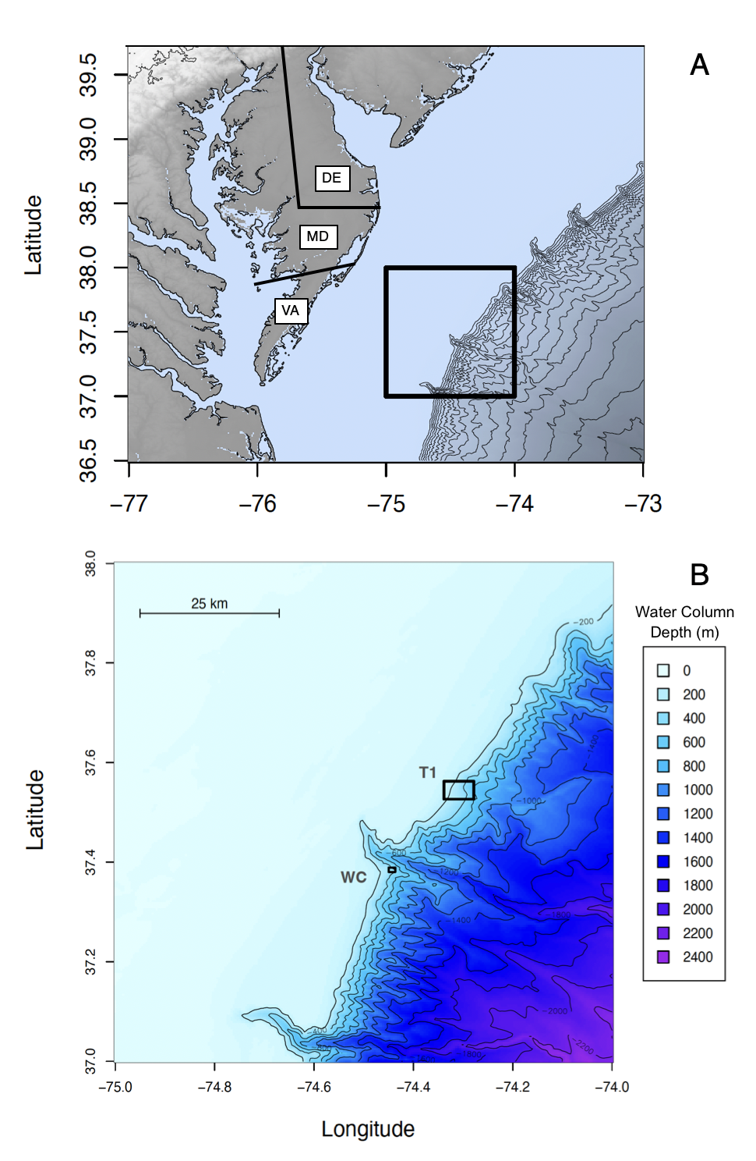
Figure 3-1. Map of the sampling sites on the continental shelf off the coast of Virginia, USA. Both sites are located on the slope of the continental shelf, with T1 being between 37.5263, -074.3385 and 37.5622, -074.2782 and WC being between 37.3800, -074.4498 and 37.3890, -074.4364. Maps were created with data from the NOAA ETOPO 2022 15 arc second relief model (NOAA, 2022). Contours drawn every 200 m below sea level. A) Broader view of the Mid-Atlantic Bight (blue/grey) and nearby landmasses (brown/white). Area in the black square is magnified in B. Rough state borders of Virginia, Maryland, and Delaware are outlined on the Delmarva peninsula. B) Magnified view of the Mid-Atlantic Bight. Sites T1 and WC are indicated by the two black boxes on the map near the corresponding site names. WC is directly adjacent to the Washington submarine canyon. Depth in water column is indicated by color, with lighter blues signifying shallower water and purple indicating deeper water.

Table 3-1. Summary of CTD cast data. All casts listed had at least one microbiological sample. For each cast, the maximum depth below sea level reached, the range of oxygen concentrations, the range of temperatures, the range of salinities, and the range of inferred chlorophyll concentrations are reported. The first half lists the casts performed on the R/V Hugh R. Sharp in 2022 and the latter half lists the casts performed on the R/V Savannah in 2023.
R/V Hugh R. Sharp (2022)
Cast # | Maximum Depth (m) | Oxygen (µM) | Temperature (℃) | Salinity (PSU) | Inferred Chlorophyll (mg/m³)
1 | 294 | 92 - 571 | 8 – 27 | 32 - 36 | -0.09 - 1.58
2 | 378 | 95 - 746 | 7 – 27 | 32 - 36 | -0.09 - 2.06
3 | 385 | 98 - 320 | 7 – 27 | 32 - 36 | -0.08 - 1.82
5 | 337 | 115 - 322 | 8 – 27 | 32 - 35 | -0.06 - 2.01
6 | 158 | 119 - 332 | 11 – 27 | 32 - 36 | -0.08 - 1.63
7 | 521 | 116 - 447 | 6 – 27 | 32 - 36 | -0.09 - 1.47
8 | 292 | 119 - 237 | 8 – 27 | 32 - 36 | -0.09 - 1.18
9 | 248 | 119 - 251 | 10 – 28 | 32 - 36 | -0.08 - 1.71
10 | 286 | 122 - 276 | 8 – 28 | 31 - 36 | -0.08 - 1.11
12 | 298 | 122 - 145 | 8 – 10 | 35 - 35 | -0.08 - -0.04
14 | 299 | 134 - 135 | 9 – 9 | 35 - 35 | -0.08 - -0.04
15 | 288 | 115 - 234 | 8 – 27 | 32 - 36 | -0.09 - 1.28
16 | 284 | 118 - 241 | 9 – 27 | 32 - 36 | -0.08 - 1.18
17 | 286 | 110 - 269 | 9 – 28 | 32 - 36 | -0.09 - 1.47
18 | 165 | 123 - 326 | 13 – 27 | 32 - 36 | -0.08 - 1.49
20 | 170 | 130 - 245 | 11 – 27 | 32 - 36 | -0.08 - 1.58
R/V Savannah (2023)
Cast # | Maximum Depth (m) | Oxygen (µM) | Temperature (℃) | Salinity (PSU) | Inferred Chlorophyll (mg/m³)
1 | 287 | 87 - 205 | 9 – 28 | 33 - 36 | -0.08 - 2.21
3 | 298 | 85 - 211 | 10 – 28 | 33 - 36 | -0.08 - 2.03
4 | 300 | 88 - 195 | 9 – 26 | 34 - 44 | -0.08 - 1.94
7 | 286 | 88 - 190 | 10 – 17 | 33 - 41 | -0.08 - 1.57
8 | 306 | 87 - 185 | 10 – 27 | 32 - 36 | -0.08 - 2.82
9 | 298 | 87 - 186 | 9 – 27 | 33 - 36 | -0.08 - 2.95
10 | 302 | 87 - 186 | 9 – 27 | 33 - 36 | -0.08 - 3.16
11 | 298 | 87 - 194 | 10 – 27 | 33 - 36 | -0.08 - 3.40
13 | 341 | 87 - 173 | 8 – 28 | 33 - 36 | -0.08 - 1.91
14 | 392 | 86 - 170 | 9 – 28 | 34 - 36 | -0.08 - 1.45
15 | 305 | 87 - 156 | 10 – 22 | 34 - 37 | -0.08 - 0.57
16 | 302 | 87 - 190 | 10 – 27 | 31 - 40 | -0.08 - 3.47
17 | 293 | 87 - 168 | 10 – 26 | 33 - 43 | -0.08 - 1.88
18 | 291 | 87 - 194 | 9 – 28 | 31 - 36 | -0.50 - 11.37
19 | 301 | 87 - 177 | 10 – 25 | 34 - 41 | -0.08 - 0.75
20 | 305 | 87 - 190 | 10 – 26 | 32 - 36 | -0.08 - 4.05
21 | 303 | 87 - 189 | 10 – 26 | 32 - 36 | -0.08 - 5.17
22 | 301 | 87 - 195 | 10 – 26 | 32 - 44 | -0.08 - 5.30
24 | 356 | 87 - 190 | 9 – 26 | 32 - 36 | -0.08 - 2.49
25 | 327 | 87 - 192 | 10 – 26 | 32 - 36 | -0.08 - 2.92
26 | 346 | 87 - 173 | 9 – 17 | 33 - 44 | -0.08 - 2.49
27 | 381 | 87 - 100 | 9 - 12 | 35 - 36 | -0.08 - 0.02

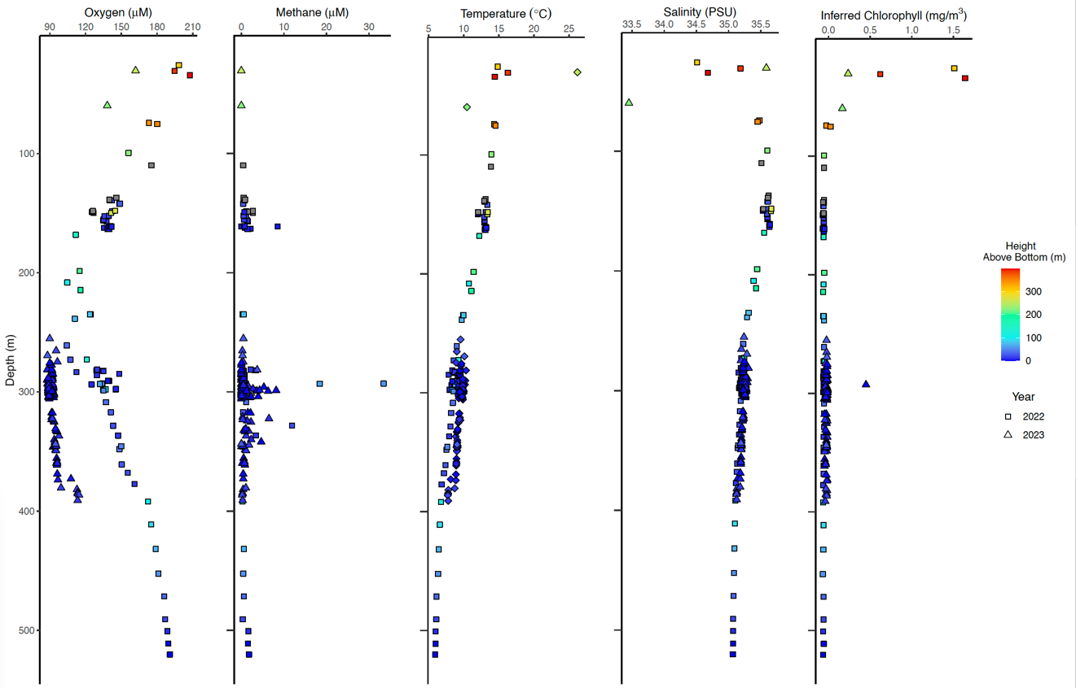
Figure 3-2. Geochemical data associated with water column microbiological samples. Sampling year of each point is indicated by shape (Square – 2022, Triangle – 2023), with all CTD casts from both T1 and WC displayed. Color indicates the height off of the seafloor (altimetry) that a given sample was collected at. Cooler colors indicate a sample was taken closer to the seafloor and warmer colors indicate that a sample was taken higher up in the water column and closer to the ocean surface. From left to right, data displayed are oxygen concentration (µM), methane concentration (µM), temperature (℃), salinity (PSU), and inferred chlorophyll (mg/m³).

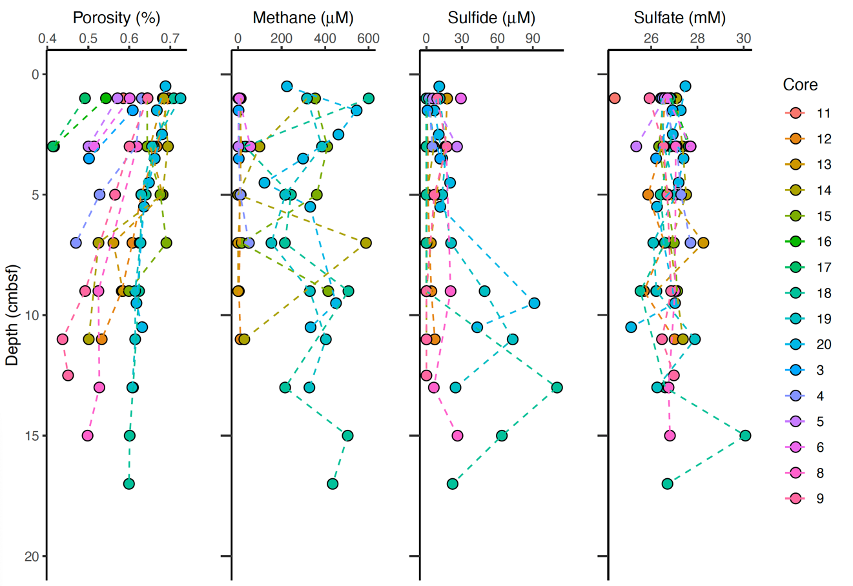
Figure 3-3. Geochemical data associated with sediment microbiological samples. All sediment samples are from 2022 and from site T1. Each sample is colored according to which core it originated from. From left to right, data displayed are porosity (%), methane (µM), sulfide (µM), and sulfate (mM).

Table 3-2. Comparison of the average relative abundances of the twenty most abundant phyla across years and environments. Average relative abundances summing all reads belonging to the same phylum from samples of a given category and dividing that by the total number of reads from samples of a given category. These twenty phyla account for 99.45% of all 2022 water column reads, 99.59% of all 2023 water column reads, and 90.83% of all sediment reads.
Phylum | Average Relative Abundance
Phylum | Water – 2022 | Water – 2023 | Sediment – 2022
Proteobacteria | 43.99% | 43.96% | 17.25%
Crenarchaeota | 29.23% | 30.53% | 3.35%
Actinobacteriota | 3.44% | 2.82% | 5.54%
SAR324 clade (Marine Group B) | 3.19% | 3.18% | 0.09%
Thermoplasmatota | 3.84% | 4.23% | 0.13%
Nitrospinota | 2.27% | 2.19% | 0.79%
Desulfobacterota | 0.20% | 0.26% | 14.71%
Bacteroidota | 3.32% | 4.13% | 3.30%
Marinimicrobia (SAR406 clade) | 3.88% | 3.81% | 0.04%
Chloroflexi | 1.92% | 0.75% | 12.20%
Verrucomicrobiota | 1.19% | 1.20% | 2.22%
Myxococcota | 0.18% | 0.13% | 4.05%
Cyanobacteria | 0.43% | 0.46% | 0.07%
Planctomycetota | 1.16% | 1.17% | 13.94%
Acidobacteriota | 0.18% | 0.13% | 9.47%
Gemmatimonadota | 0.15% | 0.08% | 0.93%
Firmicutes | 0.07% | 0.09% | 0.59%
NB1-j | 0.13% | 0.12% | 1.91%
Bdellovibrionota | 0.46% | 0.23% | 0.23%
Margulisbacteria | 0.22% | 0.12% | 0.01%

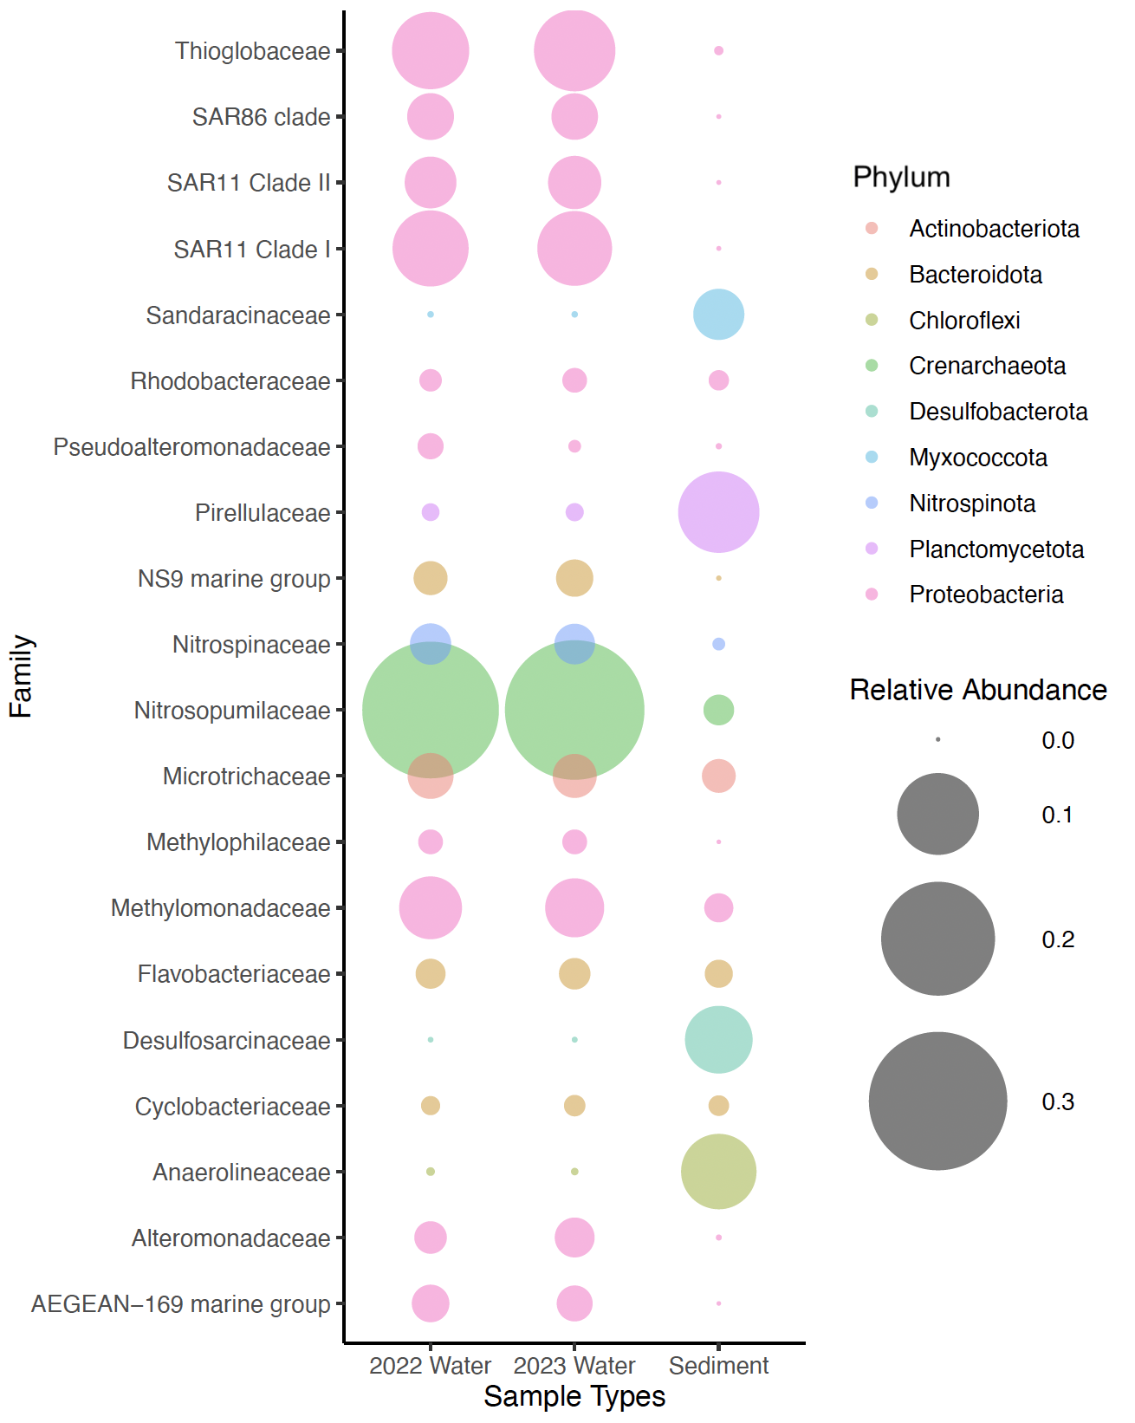
Figure 3-4. Families with the twenty highest average relative abundances across the water column and sediment samples. The bubble size scales proportionally to the average relative abundance of its corresponding taxonomic group within either the 2022 water column samples, the 2023 water column samples, or the sediment samples. Color indicates the phylum of the family.

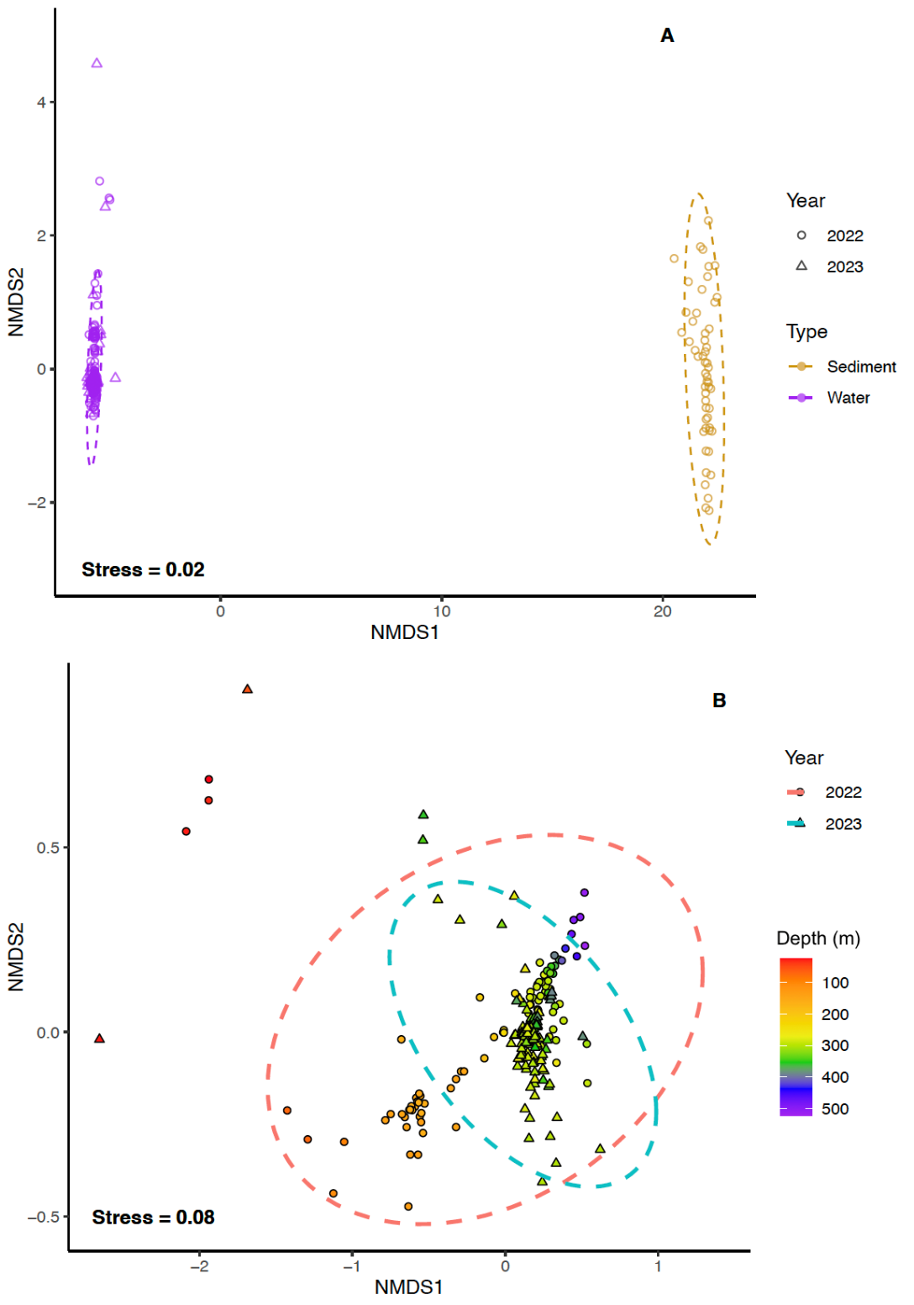
Figure 3-5. NMDS plots of water and sediment and just water samples. NMDS is based on Bray-Curtis dissimilarity matrices using samples with 1,000 or more reads. The 95% confidence interval for the standard deviation of a group is depicted by dashed lines. Circles represent samples from 2022 and triangles represent samples from 2023. A) NMDS comparing all samples based on type. Points represent samples are colored by environment (brown – sediment, purple – water). 95% confidence intervals calculated based on and colored by environment. Ordination stress is 0.02. B) NMDS comparing all water samples by year. Points represent samples and are colored by depth in the water column (m), with warmer tones indicating shallower depth and cooler tones indicating deeper depths. 95% confidence intervals are calculated based on sample collection year and are colored thusly (red – 2022, blue 2023). Ordination stress is 0.08.
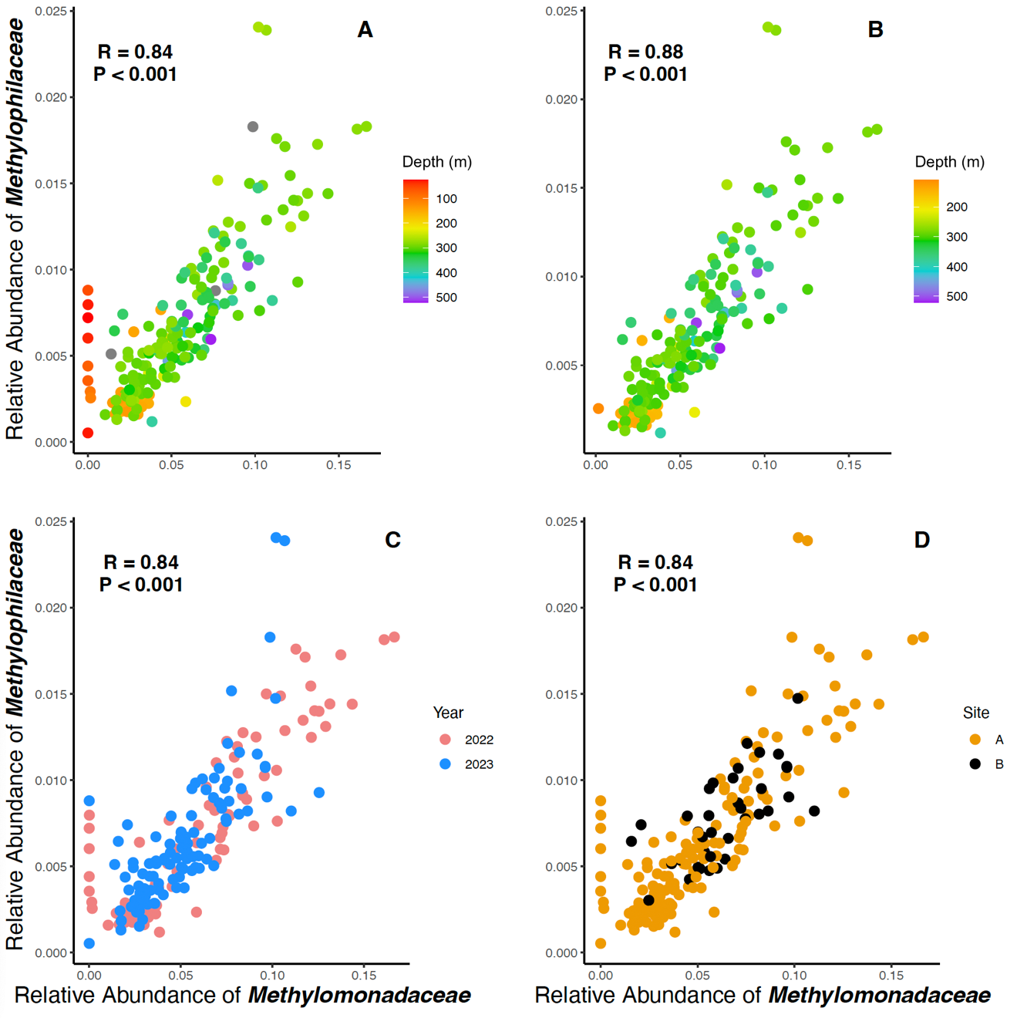
Figure 3-6. Correlation between the total relative abundance of Methylomonadaceae and Methylophilaceae in the water column. Pearson’s product-moment correlation is significant (A, C, D: R = 0.84, df = 201, t = 21.959, P < 0.001) (B: R = 0.88, df = 190, t = 25.037, P < 0.001). A) Samples colored by depth in the water column (m), with warmer tones indicating shallower depth and cooler tones indicating deeper depths. B) Subset of water column samples taken from below 100 m deep. Samples colored by depth in the water column (m), with warmer tones indicating shallower depth and cooler tones indicating deeper depths. C) Samples colored by collection year (red – 2022, blue – 2023). D Samples colored by site (orange – Site T1, black – WC).

Table 3-3. Summary of Methylomonadaceae reads across environments. Total number of reads taxonomically identified to be and the relative abundance of genera belonging to the family Methylomonadaceae in the water column and sediment are represented.
Genus | Water Column |  | Sediment
Genus | Total Reads | Relative Abundance | Total Reads | Relative Abundance
Milano-WF1B-03 | 825700 | 99.93% | 3383 | 14.63%
IheB2-23 | 357 | 0.04% | 339 | 1.47%
Marine Methylotrophic Group 2 | 78 | 0.01% | 2220 | 9.60%
pLW-20 | 50 | 0.01% | 474 | 2.05%
Methyloprofundus | 35 | ~0.00% | 757 | 3.27%
pItb-vmat-59 | 0 | 0% | 8459 | 36.58%
Methylobacter | 0 | 0% | 4981 | 21.54%
Methylomarinum | 0 | 0% | 168 | 0.73%
NA | 44 | 0.01% | 2344 | 10.14%

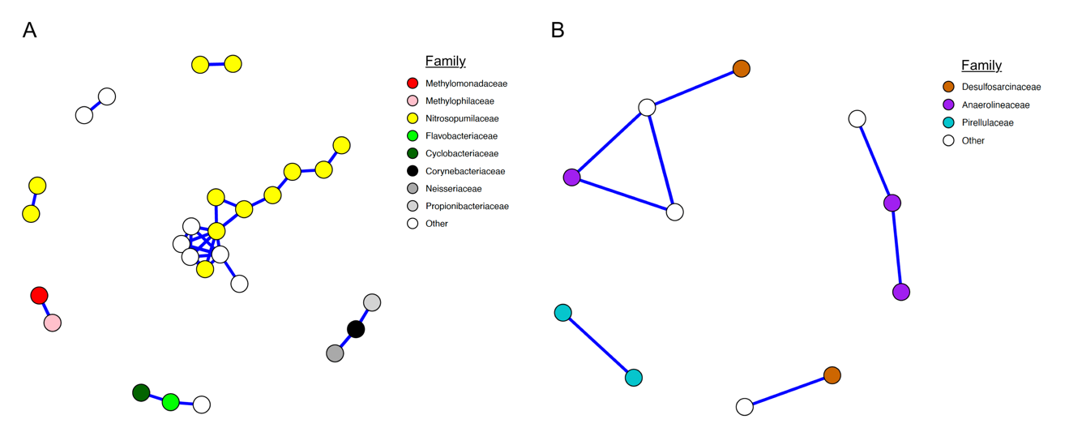
Figure 3-7. Network correlation analysis of ASVs at T1 and WC. Network plots of A) water column ASVs and B) sediment ASVs. Displayed correlations are Spearman’s rank correlations and above |0.85|. Positive correlations are indicated by blue lines and negative correlations are indicated by orange lines. ASVs are colored by family, with white indicating that the ASVs could not be taxonomically identified at the family level.

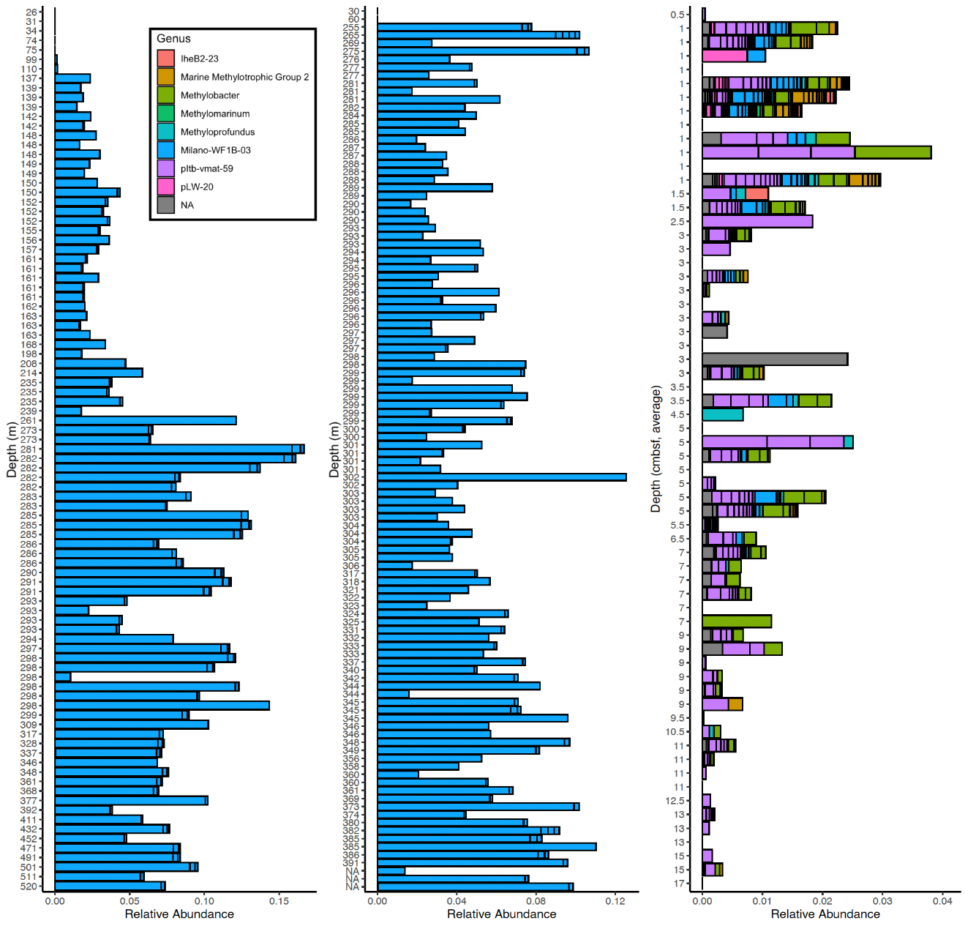
Figure 3-8. Relative abundance of all ASVs taxonomically identified to belong to the family Methylomonadaceae. Each subset of a bar indicates one ASV, which are colored by genus. NA indicated no assigned genus. Samples ordered by depth, with shallowest samples at the top and deepest ones at the bottom. NA on y-axis indicates depth data not collected. Left) Water column samples from 2022, depth is meters below sea level (m). Middle) Water column samples from 2023, depth is meters below sea level (m). Right) For sediment samples, depth is the average depth below the seafloor of the core subsection the sample was taken from (cmbsf).

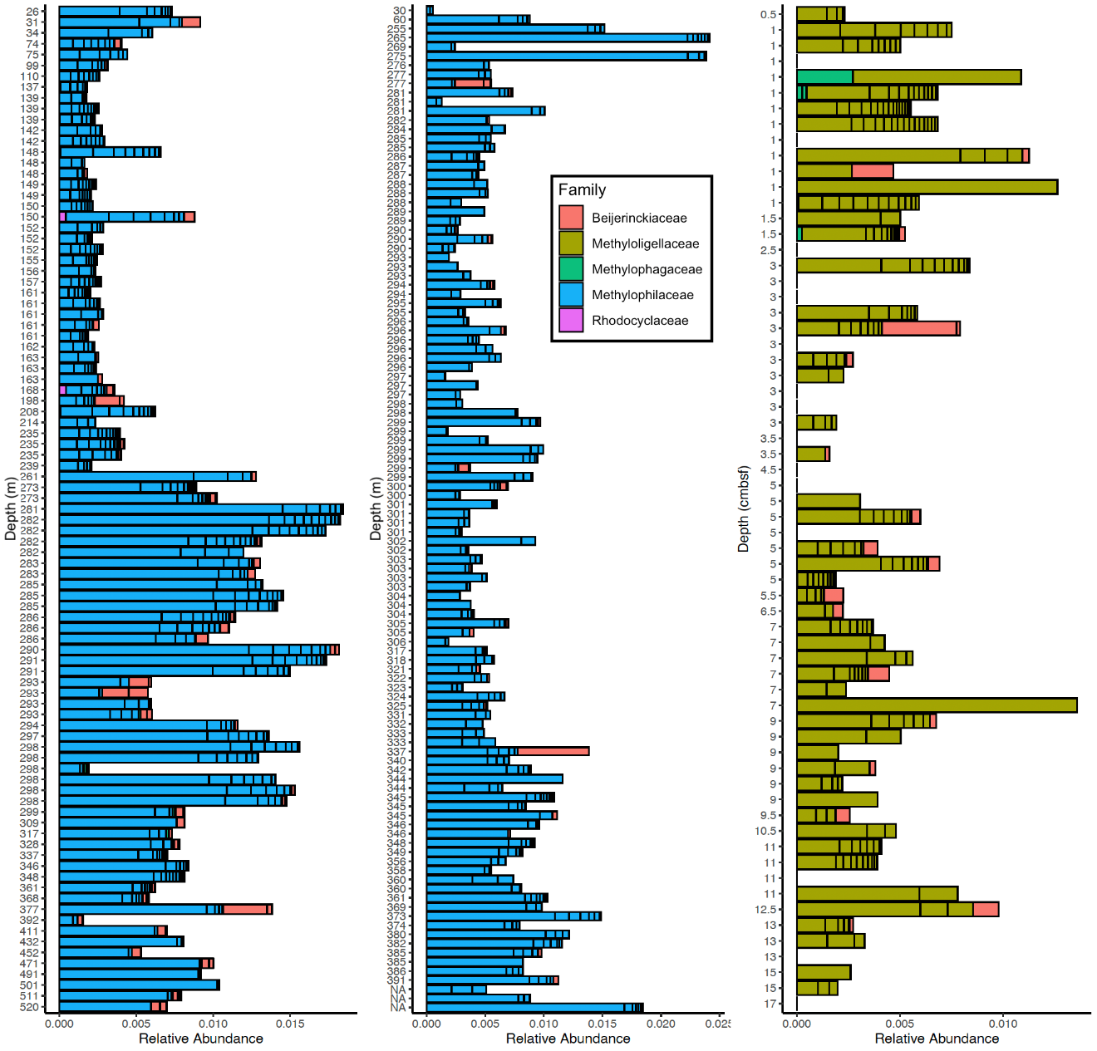
Figure 3-9. Relative abundance of all ASVs taxonomically identified to belong to nonmethanotrophic methylotrophs. Each subset of a bar indicates one ASV, which are colored by family. The families Beijerinckiaceae and Rhodocyclaceae only represent ASVs identified to be Methylorubrum-Methylobacterium sp. and Methyloversatilis sp., respectively. Samples ordered by depth, with shallowest samples at the top and deepest ones at the bottom. NA on y-axis indicates depth data not collected. Left) Water column samples from 2022, depth is meters below sea level (m). Middle) Water column samples from 2023, depth is meters below sea level (m). Right) For sediment samples, depth is the average depth below the seafloor of the core subsection the sample was taken from (cmbsf).

Table 3-4. Summary of Methylophilaceae reads across environments. The total number of reads taxonomically identified to be and the relative abundance of nonmethanotrophic methylotrophs in the water column and sediment are represented.
Group | Water Column |  | Sediment
Group | Total Reads | Relative Abundance | Total Reads | Relative Abundance
Methylophilaceae | 105776 | 96.38% | 0 | 0%
Methyloligellaceae | 54 | 0.05% | 9330 | 93.40%
Methylorubrum-Methylobacterium sp. | 3486 | 3.18% | 597 | 5.98%
Methyloversatilis sp. | 95 | 0.09% | 0 | 0%
Methylophagaceae | 339 | 0.31% | 62 | 0.62%

Appendix IIIB: Supplemental Material
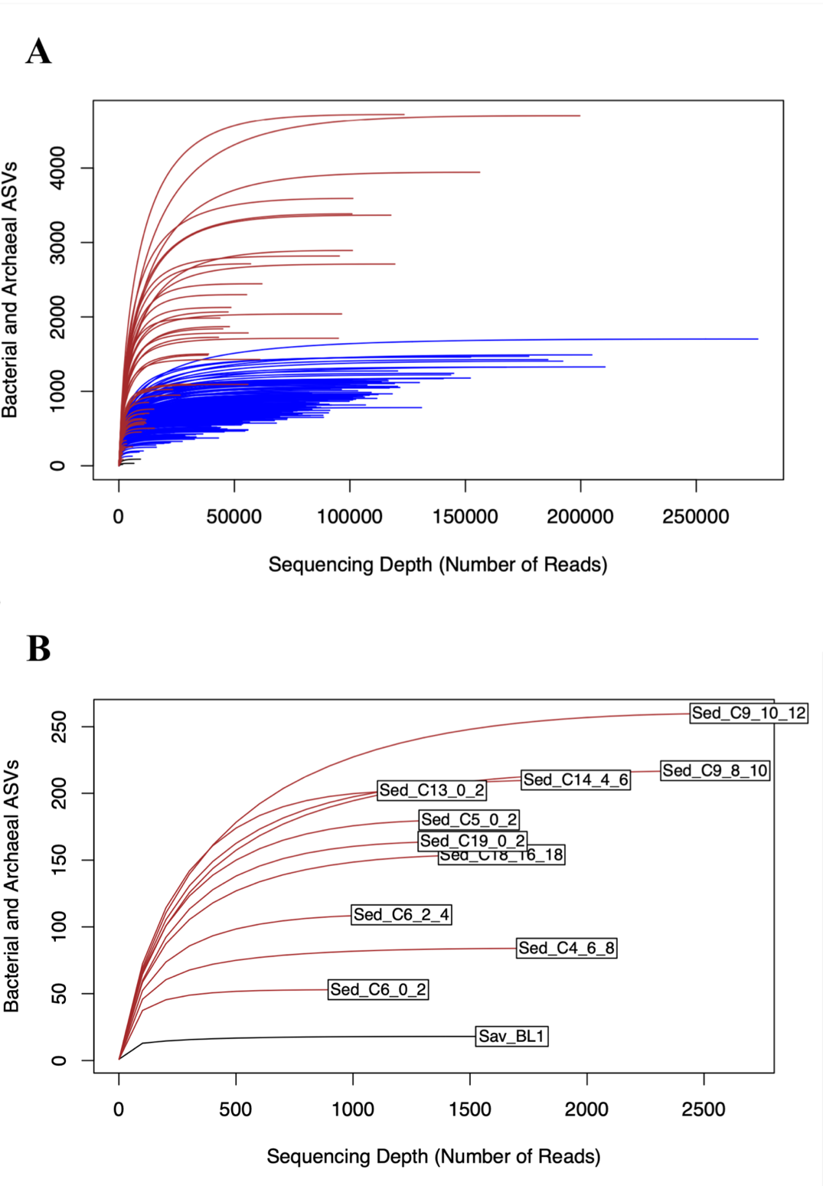
Figure 3-S1. Rarefaction curves of samples with a sequencing depth of 1,000 reads or greater. Rarefaction curves are colored by sample type (black – blank, blue – water, brown – sediment). A) Rarefaction curves of all samples. B) Rarefaction curve of all samples with sequencing depths between 1,000 and 2,500 reads. This subset of rarefaction curves mostly level out before reaching their maximum sequencing depth.

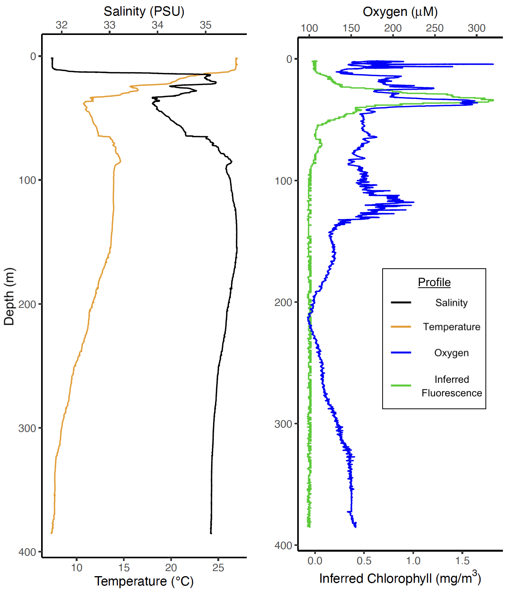
Figure 3-S2. Downcast Profile of CTD cast #3 from the August 2022 R/V Hugh R. Sharp cruise. Data collected using an SBE 911 CTD plus unit with an SBE9 datalogger. Left) Salinity (black) and temperature (orange) profiles. Right) Oxygen (blue) and inferred chlorophyll content (green) profiles.
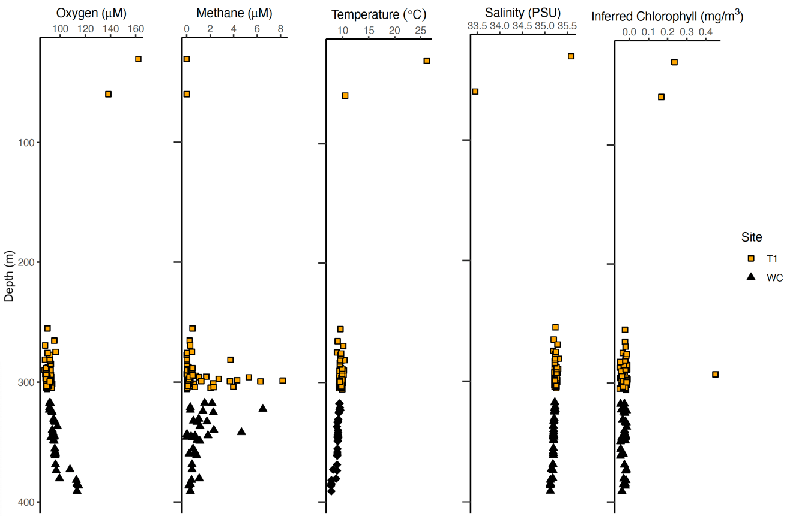
Figure 3-S3. Geochemical data associated with water column microbiological samples from 2023. Sampling site of each point is indicated by (Orange – T1, Black – Site WC). From left to right, data displayed are oxygen concentration (µM), methane concentration (µM), temperature (℃), salinity (PSU), and inferred chlorophyll (mg/m³).

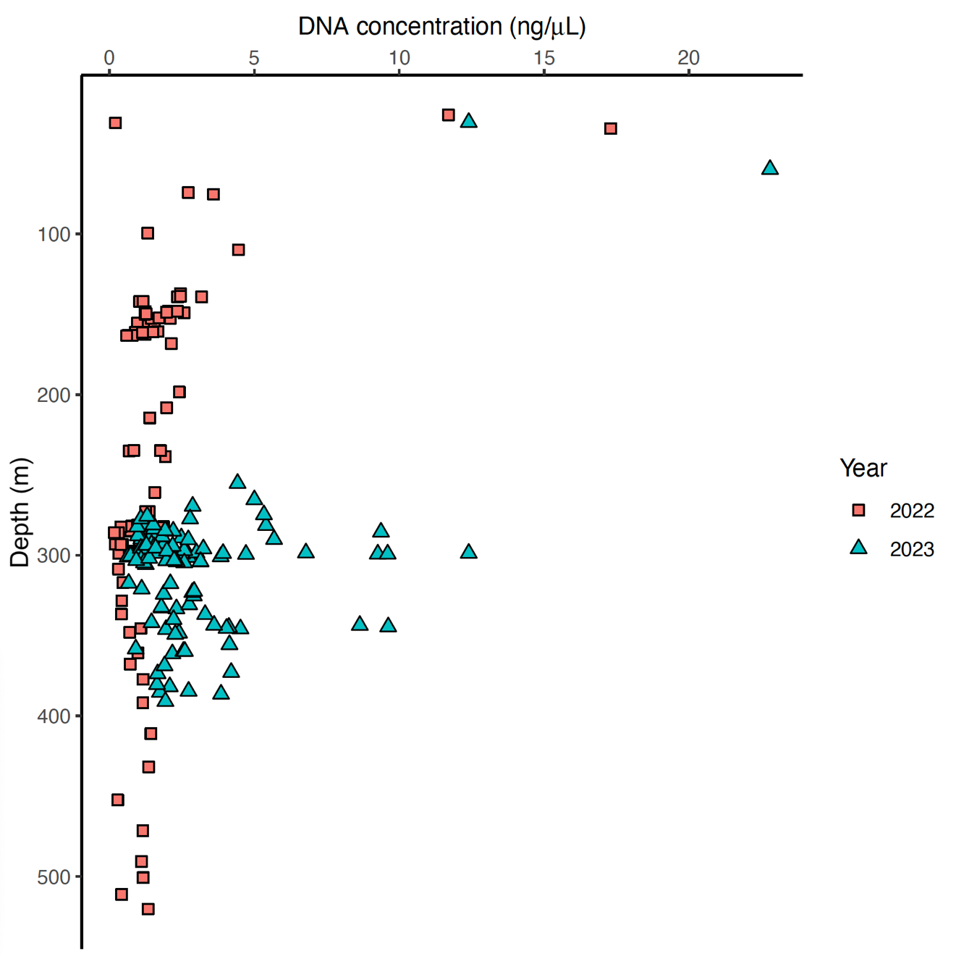
Figure 3-S4. DNA concentrations of the water column samples by depth. Samples are colored by collection year (red – 2022, blue 2023). Samples collected in 2022 had a total filtered volume of 120 mL, whereas samples collected in 2023 had a total filtered volume of 300 mL.

Figure 3-S5. DNA concentrations of the sediment samples by core subsection depth (cmbsf). Samples are colored by collection year (red – 2022).

Figure 3-S6. Alpha diversity metrics for all water column and sediment. Only samples with > 1,000 reads included. Samples are colored by environment (brown – sediment, purple – water column). From left to right, diversity indices are Observed (richness), Shannon, and Simpson. Sediment samples have greater diversity than water column samples in all metrics (Kruskal-Wallis test: Observed – H(1) = 18.026, P < 0.001; Shannon – H(1) = 49.273, P < 0.001; Simpson – H(1) = 73.149, P < 0.001).

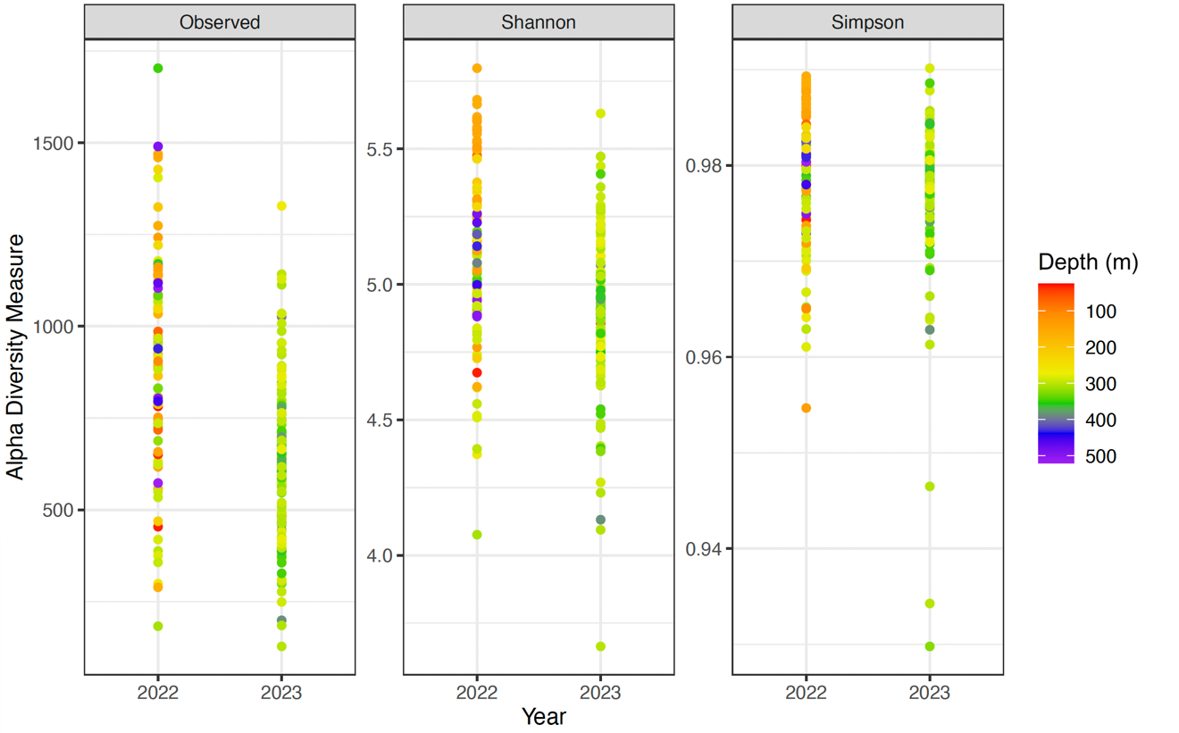
Figure 3-S7. Alpha diversity metrics for all water column samples. Only samples with > 1,000 reads included. Samples colored by depth in the water column (m), with warmer tones indicating shallower depth and cooler tones indicating deeper depths and are separated by collection year. From left to right, diversity indices are Observed (richness), Shannon, and Simpson. There is no significant difference in the Observed diversity index (Kruskal-Wallis test: H(1) = 0.621, P = 0.43) and Simpson diversity index (Kruskal-Wallis test: H(1) = 1.914, P = 0.17) across collection years. The Shannon diversity index was significantly higher in the 2022 samples than in the 2023 samples (Kruskal-Wallis test: H(1) = 21.977, P < 0.001).

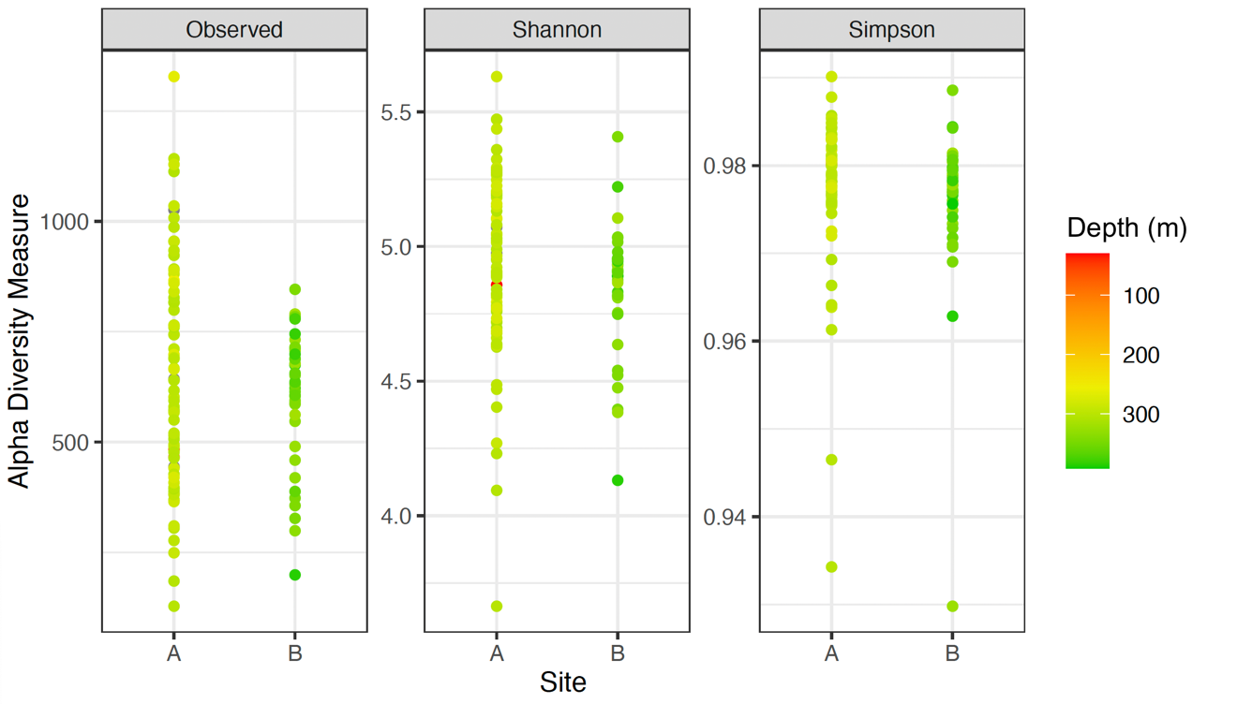
Figure 3-S8. Alpha diversity metrics for all water column samples from 2023. Only samples with > 1,000 reads included. Samples colored by depth in the water column (m), with warmer tones indicating shallower depth and cooler tones indicating deeper depths and are separated by sample site. From left to right, diversity indices are Observed (richness), Shannon, and Simpson. There is no significant difference in the Observed diversity index (Kruskal-Wallis test: H(1) = 0.66093, P = 0.42) and Shannon diversity index (Kruskal-Wallis test: H(1) = 2.4716, P = 0.12) across collection years. The Simpson diversity index was significantly higher in the 2022 samples than in the 2023 samples (Kruskal-Wallis test: H(1) = 4.9171, P = 0.03).

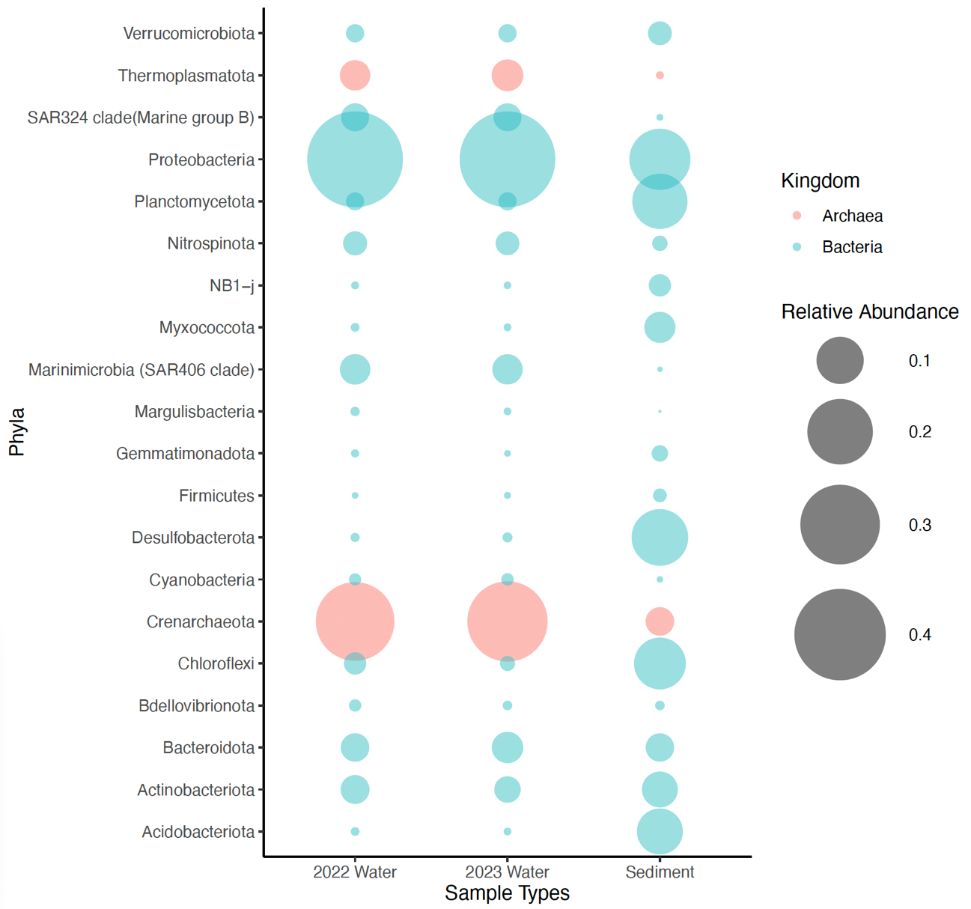
Figure 3-S9. Phyla with the twenty highest average relative abundances across the water column and sediment samples. The size of the bubble scales proportionally to the average relative abundance of its corresponding taxonomic group within either the 2022 water column samples, the 2023 water column samples, or the sediment samples. Color indicates the kingdom of the phylum.

Table 3-S1. Comparison of the average relative abundances of the twenty most abundant families across sites and environments. Average relative abundances summing all reads belonging to the same family from samples of a given category and dividing that by the total number of reads from samples of a given category. These twenty phyla account for 72.55% of all 2022 water column reads, 74.41% of all 2023 water column reads, and 34.16% of all sediment reads. ~0.00% indicates that while 16S rRNA gene amplicons belonging to a family are present in given set of samples, those reads collectively accounted for less than 0.005% of the total reads in that set of samples. 0.00% indicates that no reads belonging to a given family are present in a given set of samples.
Family | Relative Abundance
Family | Water – 2022 | Water – 2023 | Sediment – 2022
Thioglobaceae | 8.85% | 9.90% | 0.04%
Methylomonadaceae | 5.69% | 4.97% | 1.01%
Nitrosopumilaceae | 29.2% | 30.5% | 1.15%
Microtrichaceae | 2.87% | 2.61% | 1.44%
Alteromonadaceae | 1.31% | 2.09% | ~0.00%
SAR11 Clade I | 8.57% | 8.25% | ~0.00%
SAR86 clade | 2.99% | 2.96% | ~0.00%
Nitrospinaceae | 2.26% | 2.19% | 0.11%
Methylophilaceae | 0.69% | 0.69% | 0.00%
Pseudoalteromonadaceae | 0.78% | 0.11% | ~0.00%
SAR11 Clade II | 3.74% | 3.97% | ~0.00%
NS9 marine group | 1.45% | 1.79% | ~0.00%
Flavobacteraceae | 1.09% | 1.22% | 0.93%
Anaerolinaceae | 0.03% | 0.01% | 8.41%
Sandaracinaceae | 0.01% | 0.01% | 3.64%
AEGEAN-169 marine group | 1.83% | 1.65% | 0.00%
Cyclobacteraceae | 0.36% | 0.48% | 0.44%
Rhodobacteraceae | 0.54% | 0.68% | 0.42%
Desulfosarcinaceae | ~0.00% | ~0.00% | 6.68%
Pirulellaceae | 0.30% | 0.31% | 9.89%

Table 3-S2. Permutational multivariate analysis of variance (PERMANOVA) test results for water and sediment samples. Model: Bray-Curtis distance matrix ~ Type. The “Type” variable stands for environment. Df is degrees of freedom and pseudo-F is the pseudo-F statistic calculated by PERMANOVA. Number of permutations performed is 999.
Parameter | Df | Sum of Squares | R² | Pseudo-F | P (>pseudo-F)
Type | 1 | 26.522 | 0.44733 | 205.59 | 0.001
Residual | 254 | 32.768 | 0.55267
Total | 255 | 59.290 | 1.00000

Table 3-S3. Permutational multivariate analysis of dispersion (PERMDISP) test results for water and sediment samples for type. Model: Bray-Curtis distance matrix ~ Type. The “Type” variable stands for environment. Df is degrees of freedom and pseudo-F is the pseudo-F statistic calculated by PERMDISP. Number of permutations performed is 999.
Parameter | Df | Sum of Squares | Mean of Squares | Pseudo-F | P (>pseudo-F)
Type | 1 | 2.7676 | 2.7676 | 116.79 | 0.001
Residual | 254 | 6.0193 | 0.0237

Table 3-S4. PERMANOVA test results for water column samples. Model: Bray-Curtis distance matrix ~ Site + Depth + Oxygen + Year + Fluorescence + Salinity + Time_of_Day + Julian day. Df is degrees of freedom and pseudo-F is the pseudo-F statistic calculated by PERMANOVA. Number of permutations performed is 999.
Parameter | Df | Sum of Squares | R² | Pseudo-F | P (>pseudo-F)
Site | 1 | 0.2601 | 0.01460 | 7.3893 | 0.001
Depth | 1 | 3.2258 | 0.18114 | 91.6514 | 0.001
Oxygen | 1 | 1.3571 | 0.07620 | 38.5583 | 0.001
Year | 1 | 0.1660 | 0.00932 | 4.7155 | 0.003
Fluorescence | 1 | 0.2840 | 0.01595 | 8.0700 | 0.001
Salinity | 1 | 0.5313 | 0.02983 | 15.0943 | 0.001
Time_of_Day | 1 | 0.1037 | 0.00583 | 2.9476 | 0.019
Julian_Day | 1 | 0.1728 | 0.00970 | 4.9085 | 0.004
Residual | 191 | 6.7225 | 0.37748
Total | 199 | 17.8088 | 1.00000

Table 3-S5. PERMANOVA test results for water column samples with methane and height above bottom. Model: Bray-Curtis distance matrix ~ Methane + Oxygen + Depth + Site + Year + Salinity + Fluorescence + Time_of_Day + Julian day + height above bottom. Df is degrees of freedom and pseudo-F is the pseudo-F statistic calculated by PERMANOVA. Number of permutations performed is 999.
Parameter | Df | Sum of Squares | R² | Pseudo-F | P (>pseudo-F)
Methane | 1 | 0.0454 | 0.00391 | 1.3868 | 0.186
Oxygen | 1 | 0.7459 | 0.06423 | 22.7918 | 0.001
Depth | 1 | 1.6562 | 0.14261 | 50.6085 | 0.001
Site | 1 | 0.2540 | 0.02187 | 7.7613 | 0.001
Year | 1 | 0.1482 | 0.01277 | 4.5301 | 0.003
Salinity | 1 | 0.3274 | 0.02819 | 10.0033 | 0.001
Fluorescence | 1 | 0.0536 | 0.00461 | 1.6364 | 0.162
Time_of_Day | 1 | 0.0936 | 0.00806 | 2.8615 | 0.015
Julian_Day | 1 | 0.1965 | 0.01692 | 6.0040 | 0.002
Height_Above | 1 | 0.2302 | 0.01982 | 7.0353 | 0.001
Residual | 153 | 5.0069 | 0.43114
Total | 163 | 11.6130 | 1.00000

Table 3-S6. PERMANOVA test results for water column samples with only methane. Model: Bray-Curtis distance matrix ~ Methane. Df is degrees of freedom and pseudo-F is the pseudo-F statistic calculated by PERMANOVA. Number of permutations performed is 999.
Parameter | Df | Sum of Squares | R² | Pseudo-F | P (>pseudo-F)
Methane | 1 | 0.0922 | 0.0072 | 1.2261 | 0.23
Residual | 169 | 12.7122 | 0.9928
Total | 170 | 12.8044 | 1.00000

Table 3-S7. PERMDISP test results for water column samples with year. Model: Bray-Curtis distance matrix ~ Year. Df is degrees of freedom and pseudo-F is the pseudo-F statistic calculated by PERMDISP. Number of permutations performed is 999.
Parameter | Df | Sum of Squares | Mean of Squares | Pseudo-F | P (>pseudo-F)
Year | 1 | 0.7743 | 0.77425 | 38.238 | 0.001
Residual | 198 | 4.0091 | 0.02025

Table 3-S8. PERMDISP test results for water column samples for site. Model: Bray-Curtis distance matrix ~ Site. Df is degrees of freedom and pseudo-F is the pseudo-F statistic calculated by PERMDISP. Number of permutations performed is 999.
Parameter | Df | Sum of Squares | Mean of Squares | Pseudo-F | P (>pseudo-F)
Site | 1 | 0.3997 | 0.39970 | 16.468 | 0.001
Residual | 198 | 4.8059 | 0.02427

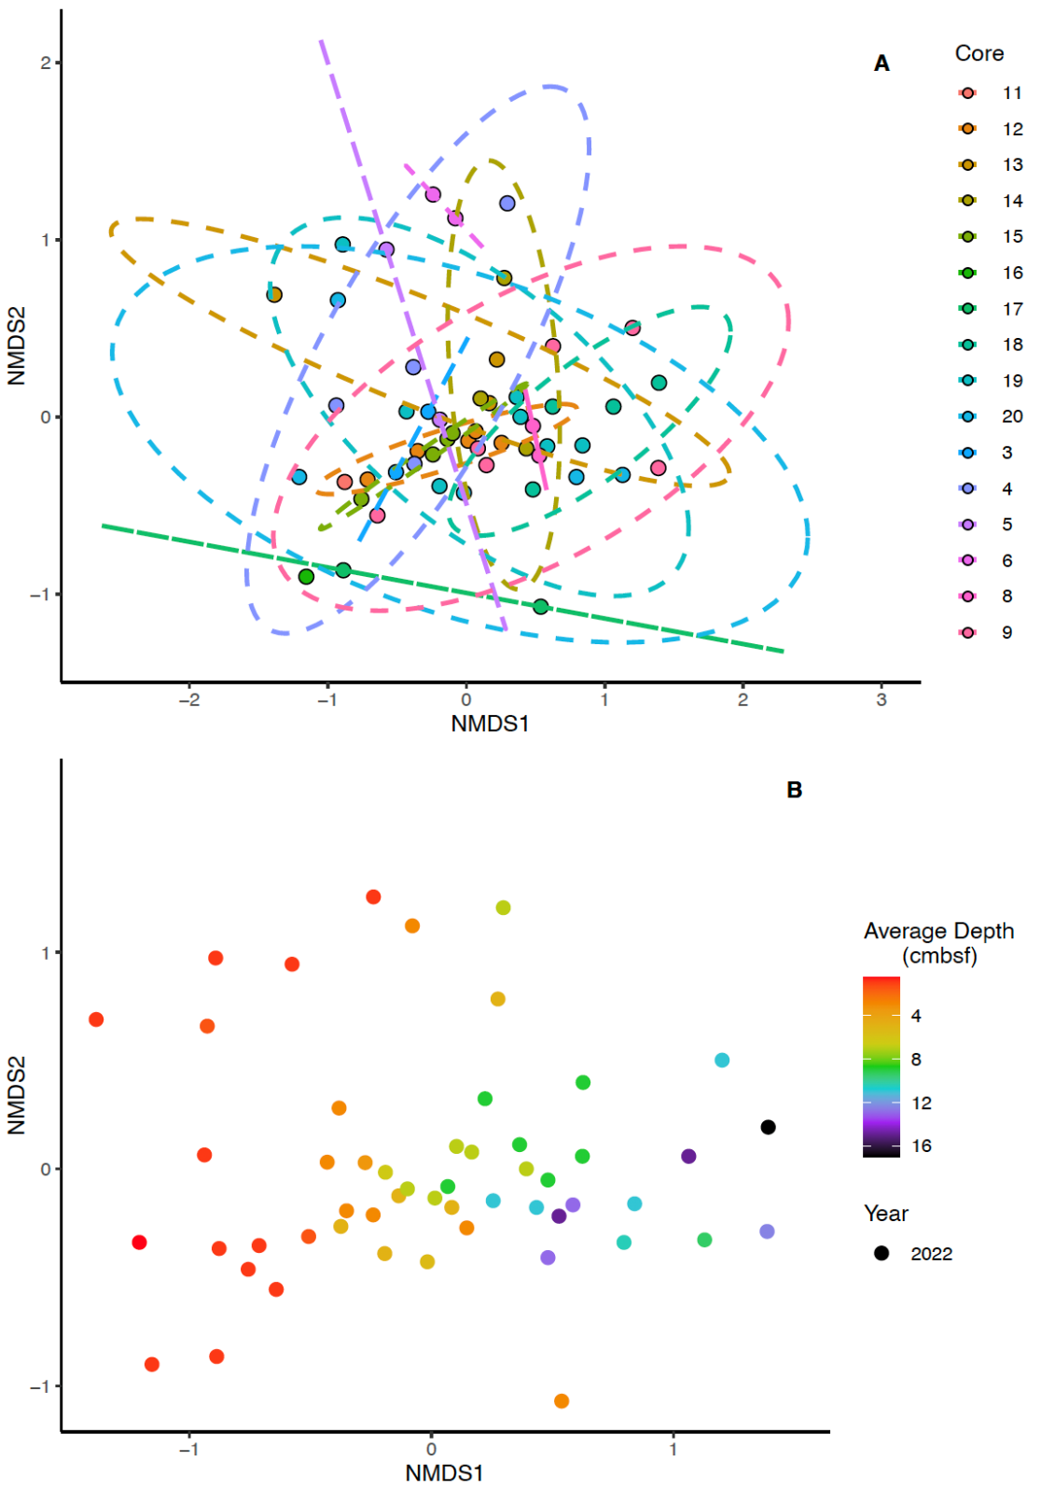
Figure 3-S10. NMDS plots of sediment samples. NMDS based on Bray-Curtis dissimilarity matrices using samples with 1,000 or more reads. The 95% confidence interval for the standard deviation of a group is depicted by dashed lines. Ordination stress is 0.13. A) NMDS comparing sediment samples based on core number. Samples and confidence intervals are colored by core number. 95% confidence intervals calculated based on core number. B) NMDS comparing sediment samples by average depth below the seafloor. Points represent samples and are colored by average depth below the seafloor (cmbsf), with warmer tones indicating shallow depths and cooler tones indicating deeper depths.

Table 3-S9. PERMANOVA test results for sediment samples. Model: Bray-Curtis distance matrix ~ Average Depth + Core. Df is degrees of freedom and pseudo-F is the pseudo-F statistic calculated by PERMANOVA. Number of permutations performed is 999.
Parameter | Df | Sum of Squares | R² | Pseudo-F | P (>pseudo-F)
Avg_Depth | 1 | 1.1107 | 0.07658 | 5.2541 | 0.001
Core | 15 | 4.7481 | 0.32736 | 1.4974 | 0.001
Residual | 36 | 7.6103 | 0.52470
Total | 52 | 14.5042 | 1.00000

Table 3-S10. PERMDISP test results for sediment samples for core number. Model: Bray-Curtis distance matrix ~ Core. Df is degrees of freedom and pseudo-F is the pseudo-F statistic calculated by PERMDISP. Number of permutations performed is 999.
Parameter | Df | Sum of Squares | Mean of Squares | Pseudo-F | P (>pseudo-F)
Core | 15 | 0.59008 | 0.039339 | 3.3713 | 0.004
Residual | 37 | 0.43174 | 0.011669

Figure 3-S11. Average dispersion from median for each sediment core. Cores without a prefix were collected in 2022 with a multicorer. Cores with a distance of “0” had only one sample with more than 1,000 total reads.

Table 3-S11. PERMANOVA test results for sediment samples. Model: Bray-Curtis distance matrix ~ Average Depth + Core + Methane + Sulfide + Sulfate. Df is degrees of freedom and pseudo-F is the pseudo-F statistic calculated by PERMANOVA. Number of permutations performed is 999.
Parameter | Df | Sum of Squares | R² | Pseudo-F | P (>pseudo-F)
Avg_Depth | 1 | 0.7924 | 0.07704 | 4.1300 | 0.001
Core | 12 | 3.3311 | 0.32385 | 1.4468 | 0.001
Methane | 1 | 0.1950 | 0.01896 | 1.0163 | 0.387
Sulfate | 1 | 0.1830 | 0.01779 | 0.9538 | 0.484
Sulfide | 1 | 0.2376 | 0.02310 | 1.2383 | 0.183
Residual | 22 | 4.2210 | 0.41037
Total | 38 | 10.2860 | 1.00000

Table 3-S12. Summary of Spearman’s rank correlations between Methylomonadaceae and Methylophilaceae with the measured geochemical variables in the water column. Number of samples with a given geochemical variable measured is represented by “n”. Bold rows are significant.
Family | Geochemical variable | N | Spearman’s rho | S statistic | P value
Methylomonadaceae | Depth | 200 | 0.48 | 688,529 | < 0.001
Methylomonadaceae | Inferred Chlorophyll | 200 | -0.09 | 1,448,899 | 0.22
Methylomonadaceae | Salinity | 200 | -0.64 | 2,186,193 | < 0.001
Methylomonadaceae | Oxygen | 200 | 0.14 | 1,152,549 | 0.06
Methylomonadaceae | Methane | 174 | 0.18 | 720,554 | 0.018
Methylomonadaceae | Julian Day | 200 | -0.05 | 1,396,666 | 0.50
Methylomonadaceae | Time of Day | 200 | 0.09 | 1,213,925 | 0.21
Methylomonadaceae | Height above bottom | 193 | -0.02 | 1218971 | 0.81
Methylophilaceae | Depth | 200 | 0.37 | 841,716 | < 0.001
Methylophilaceae | Inferred Chlorophyll | 200 | 0.08 | 1,242,792 | 0.34
Methylophilaceae | Salinity | 200 | -0.71 | 2,282,936 | < 0.001
Methylophilaceae | Oxygen | 200 | 0.18 | 1,099,030 | 0.013
Methylophilaceae | Methane | 174 | 0.12 | 774,753 | 0.12
Methylophilaceae | Julian Day | 200 | -0.05 | 1,399,855 | 0.48
Methylophilaceae | Time of Day | 200 | 0.18 | 1,087,454 | 0.009
Methylophilaceae | Height above bottom | 193 | 0.08 | 1,103,482 | 0.27

Table 3-S13. Summary of normality of errors test results for simple family models.
Family | Test | Test Statistic | P value
Methylomonadaceae | Shapiro-Wilk | 0.9413 | 0.0000
Methylomonadaceae | Kolmogorov-Smirnov | 0.1174 | 0.0218
Methylomonadaceae | Cramer-von Mises | 52.0944 | 0.0000
Methylomonadaceae | Anderson-Darling | 2.7164 | 0.0000
Methylophilaceae | Shapiro-Wilk | 0.8828 | 0.0000
Methylophilaceae | Kolmogorov-Smirnov | 0.1621 | 0.0004
Methylophilaceae | Cramer-von Mises | 54.2968 | 0.0000
Methylophilaceae | Anderson-Darling | 4.4731 | 0.0000

Chapter IV: Investigating functional potential across neighboring North atlantic methane seep fields

Publication Note
A version of this chapter is being prepared for submission with at least the following authors:
Jennifer A. Baily and Karen G. Lloyd.
JAB performed all of the DNA extractions, processing of metagenomic raw reads, analysis of the co-assembly and metagenome-assembled genomes, and wrote the current manuscript.
JAB and KGL edited the manuscript.

Abstract
Marine methane seeps play important roles in sustaining deep-sea communities. How community functional potential changes between neighboring seep fields as well as what roles the many uncultured microbial species, genera, and phyla they host is unclear. We used shotgun metagenomics on water from the T1 seep field and a nearby seep field adjacent to the Washington submarine canyon in the Mid-Atlantic Bight to assess how the functional potential of the seep microbial community shifts across neighboring sites, years, and over depth in the water column and further examined recovered metagenome-assembled genomes (MAGs) from microbial species of interest. While there are distinct patterns amongst read recruitment of the MAGs based upon depth in the water column, the distribution of KEGG Ortholog hits and metabolic pathway completeness across samples is very consistent with no distinct patterns. The recovered MAGs display consistent clustering across several methods of assessment of functional potential, clustering in ways that reflect both phylogeny and potential functional differences within related groups. Though highly abundant at both sites, recovered Thioglobaceae MAGs suggest that these Thioglobaceae consume methylamine and do not directly interface with the methane-oxidizing community. Functional annotations of the sole Methylophilaceae MAG recovered indicate that it is capable of methanol oxidation, as is typically assumed, and suggests a novel potential mechanism for syntrophy mediation in the form of type IV pili genes.

Introduction
Marine methane seeps host a biodiverse community of macro- (Vedenin et al., 2020; Åström et al., 2017) and microfauna (Ruff et al., 2015). While the organisms that inhabit methane seeps make use of some photosynthetically-derived carbon, these communities have higher biomass and biodiversity than other deep-sea and seafloor communities because they are heavily supplemented with methane-derived carbon. Aerobic methanotrophs play a critical role in seep communities, by capturing methane and incorporating its carbon into their biomass, aerobic methanotrophs make that carbon accessible to the broader seep community (Taubert et al., 2019).
While capable of oxidizing methane without partner species, a growing body of evidence suggests that nonmethanotrophic methylotrophs—bacteria that oxidize single-carbon compounds other than methanol—may assist aerobic methanotrophs in this process (Yu and Chistoserdova, 2017). Not only does the co-culturing nonmethanotrophic methylotrophs with aerobic methanotrophs enhance the rate of methane oxidation (Jeong and Kim, 2019), but aerobic methanotrophs also undergo distinct transcriptional shifts in the presence of co-cultured nonmethanotrophic methylotrophs to facilitate the transfer of methanol to these other microbes even under unfavorable conditions, as demonstrated in Krause et al. (2017). It is unclear what exact benefit aerobic methanotrophs receive from nonmethanotrophic methylotrophs, though it could relate to tolerating oxic conditions and avoiding a buildup of formaldehyde within the cell (Costa et al., 2001). Other microbes, such as those belonging to Nitrospirales and Rhodobacterales, have demonstrated the ability to rapidly uptake carbon processed by aerobic methanotrophs, but it is unclear if their presence directly benefits the aerobic methanotrophs they siphon carbon from or if they merely take advantage of the carbon source aerobic methanotrophs provide (Taubert et al., 2019). Investigating naturally-occurring, marine methane-oxidizing communities is critical to ascertain which category these microbes fall under.
It is further important to understand how broadly results from preexisting methane seep studies can be applied, whether within the same methane seep field or between neighboring ones. While Baily et al., (in prep – [Ch. III]) demonstrated that the water columns of neighboring methane seep fields with similar geochemical profiles host microbial communities that are highly similar on a taxonomic level—even when kilometers apart—it is not clear if the functional character of the communities is also so stable.
16S rRNA gene amplicon environmental surveys are a common technique employed in order to investigate the microbial communities hosted by methane seeps (Gründger et al., 2021; de Groot et al., 2024). However, interpreting these results in the context of metabolic function or the functional similarity between communities is challenging. Comparatively few marine microbes have been cultured (Wang et al., 2021) or taxonomically classified (Lloyd et al., 2018). Functional prediction tools such as PICRUST2 and Tax4Fun2 can extrapolate function from 16S rRNA gene amplicon datasets, but still are limited by preexisting knowledge of the microbial groups present (Toole et al., 2021). Whether a given microbe is similar metabolically to its close relatives cannot be assumed, as the presence or absence of a handful of genes can enable the ability of a microbe to perform an ecologically relevant function. For instance, all members of genus Methyloceanibacter are nonmethanotrophic methylotrophs, with the exception of M. methanica, which is an aerobic methanotroph (Vekeman et al., 2016). As such, shotgun metagenomic approaches are necessary to best both investigate the metabolic potential of microbial species of interest and to assess how broader functional character shifts across sites and all recovered metagenome-assembled genomes (MAGs).
The T1 seep field (T1) is located continental slope of the Mid-Atlantic Bight and is also ~16 km away from an unnamed seep field adjacent to the Washington submarine canyon (WC) (Baily et al., in prep – [Ch. III]). To complement prior taxonomic work done in this seep field, we investigated the water column at both of these sites using shotgun metagenomics to both determine how the functional character of the microbial community shifts across sites, years, and depths below sea level and to ascertain the role played by notable microbes identified in the water column. The specific families of interest investigated are Methylophilaceae, putative nonmethanotrophic methylotrophs (Beck et al., 2014) that correlate strongly and positively with the dominant aerobic methanotrophs in the water column (Baily et al., in prep – [Ch. III]) (Fig. 3-6); Thioglobaceae, which can be either autotrophic or heterotrophic (Morris and Spietz, 2022) and uncategorized varieties of which are highly abundant at both sites (Baily et al., in prep – [Ch. III]) (Table 3-S1); and Nitrosopumilaceae, putative ammonia-oxidizing archaea (Wright and Lehtovirta-Morley, 2023) that may be able to incidentally oxidize methane (Siegbahn, 2024; Jones and Morita, 1983).

Methods
Site Description
Water samples were collected from active upper slope methane seep fields north of Washington Canyon on the U.S. Atlantic margin in August 2022 and 2023. The sampling sites were the T1 seep field (T1) and an unnamed seep field adjacent to the Washington submarine canyon (WC). Both sites were as described in Baily et al., (in prep – [Ch. III]). Three samples were collected for metagenomic sequencing: one from (37.5413, -74.3359) at 149.08 meters (m) deep from T1 in 2022 (T1-22), one from (37.5359, -74.3068) at 298.5 m deep from T1 in 2023 (T1-23), and one at (37.3856, -74.4426) at 344.55 m deep from WC in 2023 (WC-23).
Biological and Geochemical Sampling
All three samples were collected with 10 L (2022) or 8 L (2023) Niskin bottles attached to a Sea Bird Electronics (SBE) 32 carousel. Oceanographic data (depth [m], pressure [db], temperature [℃], salinity [PSU], inferred chlorophyll [mg/m³], and dissolved oxygen [µmol/L]) were collected using an SBE 911 CTD plus unit with an SBE9 datalogger during the CTD casts and latitude and longitude were recorded using the NOAA’s Shipboard Computer System (SCS 4.6) software. True depth of the seafloor was estimated using the NOAA Bathymetric Data Viewer (https://www.ncei.noaa.gov/maps/bathymetry/ accessed on 4/11/2024). A Simrad EK80 echofinder was used to hydroacoustically assess for both methane ebullition and the presence of large schools of smaller fish or populations of macroscopic planktonic organisms.
Geochemical data associated with each metagenomic sample (methane, sulfide, sulfate, porosity) were calculated as described in Baily et al., (in prep – [Ch. III]), modified from the procedures in Coon et al. (2023).
Biological Sample Processing
As described in Baily et al., (in prep – [Ch. III]), fluid from the water column samples was pushed through a 0.22 µm Sterivex-GV pressure filter for downstream DNA extraction, with 120 mL of fluid manually being pushed through the filter with a 60 mL BD Luer-LokTM sterile syringe in 2022 and 180 mL of fluid was pushed through the filter using a peristaltic pump in 2023. All filters were immediately frozen post-sampling and kept so below -20℃ until extraction at the University of Tennessee.
DNA Extraction
DNA was extracted as described in Baily et al., (in prep – [Ch. III]) from the water column samples (Vetriani et al., 1999; Wright et al., 2009). Samples underwent physical lysis (repeated freezing and thawing), chemical lysis (treated with lysozyme [100 mg/mL], proteinase K [20 mg/mL], and sodium dodecyl sulfate [20%]), phenol chloroform purification, precipitation (sodium acetate (3 M), isopropanol (100%), and ethanol (70%)), and elution (30 µL Tris buffer). DNA concentrations were then quantified with a QubitTM 4 Fluorometer using the QubitTM 1X High Sensitivity dsDNA Assay kit (Invitrogen). DNA was sent to Novogene (CA, USA) for shotgun metagenomic sequencing on an Illumina NovaSeq X Plus.
Metagenome Processing
Read quality control, adapter trimming, and removal of unpaired reads was performed on the raw reads with Trimmomatic (version 0.39) (Bolger et al., 2014) with the following settings (LEADING – 3, TRAILING – 3, SLIDINGWINDOW – 4:15, and MINLEN: 36). Illumina adapters (P5 & P7) were also trimmed from the raw reads with the following settings (seedMismatches – 2, palindromeClipThreshold – 30, simpleClipThreshold – 10, minAdapterLength – 2, keepBothReads – TRUE). All three samples were processed individually for this step.
Assembly, binning, and bin refinement was performed through the Metawrap pipeline (version 1.3.2) (Uritskiy et al., 2018). Reads from all samples were assembled together into contigs as a co-assembly with Megahit (v1.1.3) (Li et al., 2015) with in the “meta-sensitive” mode, which allows for k-mers of sizes 21, 31, 41, 51, 61, 71, 81, 91, and 99. Three binning programs were used: CONCOCT (version 1.0.0) (Alneberg et al., 2014), maxbin2 (version 2.0) (Wu et al., 2016), and metabat2 (version 2.12.1) (Kang et al., 2015). The Metawrap bin refinement module was used to consolidate the bins generated by each binning program, generate BAM coverage files for each sample, and to filter out bins with a completion score of >50% and a contamination score of < 20% (Uritskiy et al., 2018). Completion was defined by Metawrap as the percent of single-copy conserved genes (SCCGs) present in a MAG and contamination was defined by Metawrap as the ratio of those SCCGs found to the number of distinct SCCGs in the genome (Uritskiy et al., 2018). A contamination threshold of 20% was selected instead of 10%, as is established in Bowers et al. (2017) as the maximum usual threshold, to expand analysis to four additional Nitrosopumilaceae MAGs. MAGs were then classified by the standards outlined in Bowers et al. (2017) as high, medium, or low quality, with the low quality contamination threshold elevated to 20% (Table 4-1).
Taxonomic and Functional Analysis
Taxonomic classification, open-reading frame prediction, and functional annotation was performed through the Anvi’o v8 pipeline (Eren et al., 2020). Open reading frame prediction was performed using Prodigal v2.6.3 (Hyatt et al., 2010). Bins were taxonomically classified against the Genome Taxonomy Database (GTDB) release 214.1 (Parks and Hugenholtz, 2024; Parks et al., 2021) and open reading frames were functionally annotated with NCBI’s COG20 database (Galperin et al., 2021) by DIAMOND v2.1.8 (Buchfink et al., 2021). Hidden Markov Models (HMMs) were generated with hmmsearch 3.4 (Eddy, 2011). Further functional annotations were performed with the KEGG KOfam (default Anvi’o v8 release version) (Aramaki et al., 2020) and the EBI Pfam databases (version 36) (Paysan-Lafosse et al., 2025). The program “anvi-estimate-metabolism” was used to estimate the completeness of metabolic pathways across MAGs (Veseli et al., 2025).
For individual MAGs and each sample, prokaryotic open-reading frames were predicted by Prokka v1.14.6 (Seeman, 2014). GhostKOALA was used for gene annotation with bacterial and archaeal KEGG Orthologs (Kanehisa et al., 2016). Metabolic pathway completeness for samples was estimated and visualized with KEGGDecoder v1.3 (Graham et al., 2018).
In R version 4.3.2 (R Core Team 2023) with RStudio (RStudio Team, 2022), ternary plots of KO hits were generated with the R package “ggtern” (Hamilton and Ferry, 2018). Metabolic pathway reconstructions for individual MAGs were generated with the R package “pathview” (Luo and Brouwer, 2013). The following accessory R packages were used for data processing and visualization: viridis (Garnier et al., 2024), dplyr (Wickham et al., 2023), tidyr (Wickham et al., 2024), ggplot2 (Wickham, 2016), and tokenizers (Mullen et al., 2018).

Results
Geochemistry Associated with Metagenomic Co-Assembly
The geochemical and physical parameters measured for each individual water sample indicated that the parcels of water sampled from T1 (T1-22 and T1-23) are different from one another, whereas both samples from 2023 (T1-23 and WC-23) are quite similar to each other (Table 4-2). The waters T1-23 and WC-23 were taken from were cooler, had lower concentrations of oxygen, and had higher methane concentrations than water T1-22 was taken from. All three samples were taken from water less than 20 m above the seafloor and had comparable salinity and inferred chlorophyll content. Each sample came from a different depth in the water column: 149.08 m (T1-22), 289.50 m (T1-23), and 344.5 m (WC-23).
Co-Assembly and Metagenome-Assembled Genomes
All metagenomic reads that passed quality control and trimming from all samples were assembled together into a metagenomic co-assembly (Table 4-S1). A total of 3,073,495 contigs make up this co-assembly, containing 1,671,931,854 base pairs. Each contig is between 200 and 692,384 base pairs long, with the contigs on average being 544 base pairs long with an N50 of 532 base pairs (Table 4-S2). The total 431 MAGs generated from this co-assembly were refined into 46 MAGs that met the thresholds of having over 50% completion and less than 20% contamination (Table 4-S3). Most of the MAGs are medium quality, with 8 being high quality (Table 4-1). The GTDB-Tk taxonomic estimates of these MAGs are provided in Table 4-S4, with bacterial MAGs estimated to belong to either Gammaproteobacteria (n = 19), Acidimicrobiia (n = 10), SAR324 (n = 2), Alphaproteobacteria (n = 2), Marinisomatia (n = 1), Nitrospinia (n = 1), Bacteroidia (n = 1), Verrucomicrobiae (n = 1) or Rhodothermia (n = 1) and archaeal MAGs estimated to belong to either Poseidoniia (n = 6) or Nitrososphaeria (n = 5). Two MAGs are unable to be classified beyond being bacterial. Out of the gammaproteobacterial MAGs, 4 belong to the family Thioglobaceae, which contains both autotrophic and heterotrophic species (Morris and Spietz, 2022), and 1 to the family Methylophilaceae, which contains many obligate or restricted nonmethanotrophic methylotrophs (Beck et al., 2014). The Thioglobaceae MAGs are either identified to belong to the genus Pseudothioglobus or to no known genus at all. All MAGs from Nitrososphaeria belong to Nitrosopumilus or Nitrosopelagicus, both genera containing ammonia-oxidizing archaea (Wright and Lehtovirta-Morley, 2023; Santoro et al., 2015).
T1-22, the shallowest sample, sees nearly double the number of single nucleotide variants (SNVs) as the other two samples, which each have similar numbers of SNVs (Fig. 4-1). In contrast WC-23 sees the most insertion-deletions (indels), with the other two having less than a third of them.
Comparison of MAG and Functional Distributions Across Sites
Most MAGs, regardless of quality, recruit metagenomic reads from all three samples (Fig. 4-1). One group of MAGs is most abundant in WC-23 and T1-23 and another is most abundant in T1-22. Those most abundant in WC-23 and T1-23 have a wider range of taxonomic variation, representing 9 different phyla, than those most abundant in T1-22, which only represent 6 phyla. Furthermore, with the sole exception of bin_17 (Phylum: Proteobacteria, Family: Vibrionaceae), the abundance of reads from T1-23 and WC-23 mapped to each MAG are highly similar across both samples. There are some small differences in the levels of read recruitment for each MAG when comparing T1-23 and WC-23, but it is minimal in comparison to the differences in read recruitment for each MAG between either of those two samples and T1-22. The one Methylophilaceae MAG (bin_8) and one of the five Nitrosopumilaceae MAGs (bin_35) are most abundant in those two deeper samples, whereas the rest of the Nitrosopumilaceae MAGs and all of the Thioglobaceae MAGs are most abundant in shallower sample.
However, this clear divergence in the taxonomic composition across samples does not quite carry over into gene function. A total of 465,503 KO hits were identified across the co-assembly, all belonging to one of 4,856 unique KOs. Around double the KO hits come from the T1-22 assembly compared to the T1-23 and WC-23 assemblies (222,244 vs 140,252 and 103,007, respectively). A total of 41,767,921 reads map to T1-22, whereas 25,229,461 and 39,732,662 reads map to T1-23 and WC-23 (Fig. 4-1). Differences in the number of total reads mapped may account for the disparity in total number of KO hits between T1-22 and T1-23, but this is unlikely the case for WC-23, as despite having the fewest KO hits it has almost as many reads mapped as T1-22. Furthermore, these KO hits account for 30.4% and 31.8% of potential open reading frames identified in T1-22 and T1-23, respectively, but only account for 16.1% of potential open reading frames identified in WC-23.
The majority of the distinct KOs have roughly the same relative abundance in each of the three samples (Fig. 4-2), though T1-22 contains more total hits for many of the shared KOs (Fig. 4-S1). Out of all the KOs, 70.1% are present in all three samples, 13.9% are present in only two, and the remaining 15.9% are present in only one sample. T1-22 has the most unique KO hits at 432, as opposed to the 124 unique hits in T1-23 and 219 in WC-23. Around two thirds of the unique KOs fall into one of four KEGG BRITE functional hierarchies: enzymes, transporters, viral proteins, and secretion systems (Table 4-3). No complete KEGG pathways are represented by the unique KOs, with most of the enzymes scattering across a wide range of metabolic pathways. Further, some KOs representing metabolically related annotations are only present in different samples. For instance, porD and kgd are only found in T1-22, aarC is only found in WC-23, and pycA and frdB are only found in T1-23, yet all are involved in the citric acid (TCA) cycle (Kelly and Hughes, 2001; Lan and Wei, 2016; Lai et al., 2006; Mullins et al., 2008). This split of metabolically related genes across samples combined with the low amounts of DNA sequenced to create each read library suggest that some of the observed KO absences in one or both samples may be spurious and due to low sampling depth rather than being truly missing from one or two of the locations. However, if these absences persist with greater sampling depth or great disparities emerge in the prevalence of TCA genes across samples, it could suggest some of the many TCA cycle variants are more common in the prokaryotic community from one location over another (Steinhauser et al., 2012).
No clear patterns of functional distribution emerge across samples when comparing biochemical pathway completeness (Fig. 4-3). Though KEGGDecoder functional completeness occasionally mischaracterizes which genes belong to which biochemical pathway or functional gene category (i.e., not including xoxF as a methanol dehydrogenase in both the alcohol dehydrogenase category or as an option for the utilized methanol dehydrogenase in the methane oxidation pathway category), it is useful for comparing the distributions of the functions and genes it does account for. Ultimately, 133 of the 177 pathways (75.1%) and genes assessed by KEGGDecoder exhibit the same degree of completion across all three samples. Of the remaining 44 pathways and genes, 14 exhibit identical degrees of completion between T1-22 and WC-23, 10 between T1-22 and T1-23, and 8 between T1-23 and WC-23, with the rest each having different levels of completion across all three samples. Incomplete critical pathways, such as those for the synthesis of amino acids like valine and isoleucine, suggest that greater sequencing depth is needed to fully capture the metagenomic potential of each site.
Functional Distribution Across MAGs
KO pathway completeness (Fig. 4-4) as well as the distribution of KOfam gene function annotations (Fig. 4-S2), Pfam gene function annotations (Fig. 4-S3), COG20 gene function annotations (Fig. 4-S4), COG20 pathways (Fig. 4-S5), COG20 categories (Fig. 4-S6), KEGG BRITE functional hierarchies (Fig. 4-S7), KEGG modules (Fig. 4-S8), and KEGG classes (Fig. 4-S9) across the MAGs are all remarkably consistent. Archaeal and bacterial MAGs tend to separate out into their own clusters. MAGs from the same families group mostly closely together across functional assessment methods as well, such as is the case for those from Nitrosopumilaceae (bin_47, bin_2, bin_39, bin_35, and bin_6), Poseidoniaceae (bin_18, bin_26, bin_41, bin_43, bin_10, and bin_49), and Thioglobaceae (bin_54, bin_27, bin_40, and bin_37), for example, or even orders in the cases of Actinomycetota (bin_36, bin_34, bin_15, bin_16, and bin_20) and SAR324 (bin_22 and bin_33) (Figs. 4-S3, 4-S6B, & 4-S7). When these MAGs do separate by functional categories, they still group closely with other members of their families, sometimes even separating out by genera. For instance, the two Thioglobaceae MAGs from the genus Pseudothioglobus (bin_54 and bin_27) and the two Thioglobaceae MAGs from an unknown genus (bin_40 and bin_37) each cluster together even when not clustering with the MAGs from the other genera from their family (Figs. 4-4, 4-S2, 4-S4, 4-S5A, & 4S-8). The phylum Proteobacteria also has subgroups with functional similarities. The Pseudoalteromonas sp. and Alteromonas sp. MAGs (bin_7 and bin_28) and the Vibrio sp. and Halomonas sp. MAGs (bin_17 and bin_9) each nearly always cluster together and frequently these two groups also cluster together despite belonging to a range of families and orders (Figs. 4-4 & Figs. 4S-2 through 4S-9).
These trends persist with KEGG Classes, COG20 Categories, and COG20 Pathways (broader functional categories than the rest) based on presence/absence or by frequency within a given MAG. However, these functional categories see the most divergences from previously established clustering trends. The diverging MAGs frequently have the highest levels of contamination (predicted from SCCGs) in their typical clusters; as is the case with bin_27 in the Thioglobaceae cluster as seen in the clusters by KEGG Class frequency (Fig. 4-S9B), KEGG Class presence/absence (Fig. 4-S9A), and by COG20 pathway frequency (Fig. 4-S5); and with bin_2 by KEGG Class frequency (Fig. 4-S9B) in the Nitrosopumilaceae cluster. COG20 categories clustered presence/absence are unique, as they are so ubiquitously present across the MAGs that there is not enough variation in the dataset to meaningfully define differences, leading to overly broad clusters (Fig. 4-S6A). However, these divergences are more common and more extreme when clustering by the frequency of a given functional category than the presence/absence of it.
Specific Functional Capacity of Families of Interest
A full reporting of KO gene annotations along with their associated contig splits for each MAG of interest can be found in KO_and_splits.zip. All KO gene annotations for each sample can also be found in in KO_and_splits.zip.
Methylophilaceae
The sole Methylophilaceae MAG recovered from the co-assembly is a nonmethanotrophic methylotroph capable of oxidizing methanol (Fig. 4-5). The genes for a XoxF-type methanol dehydrogenase, three separate subunits of a formate dehydrogenase, and both genes required to convert the resulting formaldehyde into fructose-9-phosphate and thereby incorporate biomass via the RuMP pathway are annotated in this MAG (Hanson and Hanson, 1996; Beck et al., 2014). Additionally, a gene (mxaC) with unknown specific function shown to be required for methanol oxidation in another nonmethanotrophic methylotroph is annotated in this MAG (Toyama et al.,1998). Though lacking annotations for genes encoding enzymes that convert formaldehyde into formate, it is likely that those genes are present in the complete genome of this microbe but did not make it into this dataset since the total MAG completeness is below than 100%. The core pentose phosphate pathway is complete as well, with the MAG possessing annotations for all of the genes from it and the Entner-Doudoroff pathway needed for the conversion of fructose-6-phosphate into glyceraldehyde-3-phosphate, which can then be incorporated into biomass (Fig. 4-S10) (Sprenger, 1995; Peekhaus and Conway, 1998; Hanson and Hanson, 1996). While this MAG lacks annotations for critical genes involved in the serine formaldehyde assimilation pathway, like genes for hydroxypyruvate reductase, it does possess an annotation for glyA, which encodes serine hydroxymethyltransferase—the first enzyme in that pathway (Hanson and Hanson, 1996). Enzymes related to the oxidation of methylamines, on the other hand, are completely absent from this MAG (Latypova et al., 2010).
This MAG contains four genes that encode critical proteins of type IV pili, which is involved in syntrophy between other microbial species (Yin et al., 2020): pilT, pilC, pilD, and pilY1. pilT encodes the retraction ATPase responsible for pilus retraction (Adams et al., 2019), pilC encodes the platform protein through which the retraction and extension ATPases interface with the pili, pilD encodes a prepilin peptidase that prepares pilin for polymerization once in the periplasm (Melville and Craig, 2013), and pilY1 encodes an adhesive protein implicated in other functions such as pilus motility regulation and mechanosensing (Guo et al., 2024). None of these proteins encode major or minor pilins (Melville and Craig, 2013). Genes for Type IV pili have been previously recovered from the genomes of other nonmethanotrophic methylotrophs from this family (Kalyuzhnaya et al., 2010; Kalyuzhnaya et al., 2008).
Like many other members of Methylophilaceae, the annotations of this MAG contain over 60% of the genes required to facilitate assimilatory nitrate reduction (nasC, nasD, and nasE) and thus is considered capable of performing this reaction. Other nitrogen cycling genes annotated include nitrate/nitrite transporters and NADH nitrite reductases (nirB), which have also been identified in other Methylophilaceae (Beck et al., 2014; van Grinsven et al., 2020).
Nitrosopumilaceae
As all but one of the Nitrosopumilaceae MAGs have contamination between 10-20% from heterogeneous genomes, analysis of specific gene annotations is restricted to just genes involved in nitrogen and single-carbon compound metabolism in order to mitigate the effect of that potential contamination on analysis.
Only one of the five MAGs—bin_35 (Nitrosopumilus sp.)—contains any genes (pmoC-amoC) annotated as being one of the three subunits of ammonia monooxygenase (Wright and Lehtovirta-Morley, 2023). It also contains an annotated gene that encodes carbamate kinase. Otherwise, both of the other Nitrosopumilus sp. MAGs contain one gene copy annotated as glnA, which encodes glutamate synthetase and has been found in all characterized Nitrosopumilaceae thus far. The two Nitrosopelagicus sp. MAGs contain no gene annotations related to nitrogen metabolism.
Three of these MAGs contain no gene annotations for any gene involved in the metabolism of methane, methanol, or methylamine. The two MAGs that do, bin_35 and bin_39, are identified as Nitrosopumilus sp. and encode pmoC-amoC and the formate dehydrogenase iron-sulfur subunit respectively. The former is likely simply amoC and only incidentally capable of methane oxidation, as both particulate methane monooxygenase and ammonia monooxygenase are similar enough in structure that both can incidentally catalyze the other reaction (Siegbahn, 2024; Jones and Morita, 1983). Due to their similarity, it is likely difficult for these two genes to be confidently distinguished one from the other, leading to their grouping under the same annotation.
Thioglobaceae
The Pseudothioglobus (bin_54 and bin_27) MAGs and one of the unknown genus MAGs (bin_37) possess annotations for all subunits of methylamine-glutamate N-methyltransferase (mgsABC) (Latypova et al., 2010). These MAGs possess between one to three copies of any of these three annotations. Both unknown genus MAGs (bin_37 and bin_40) as well as bin_27 have one to two annotations for the A subunit of methylglutamate dehydrogenase (mgdA), but none of them possess annotations for any of the other subunits. Both MAGs from the unknown genus have one annotation each for two of the three genes (frmA and frmB) involved in glutathione-dependent formaldehyde metabolism (Hopkinson et al., 2015). None of the Pseudothioglobus MAGs have annotations for any of the three genes. All Thioglobaceae MAGs in turn have one or two gene annotations associated with formate dehydrogenase subunits. While three out of the four MAGs possess all subunits of methylamine-glutamate N-methyltransferase—the first enzyme in the methylamine oxidation pathway—this pathway is not complete in any of the MAGs as none have annotations for 60% or more of the required genes (Latypova et al., 2010). Notably, both Pseudothioglobus MAGs and the unknown genus MAG bin_37 have annotations for 54.5% of the involved genes, just one gene under the threshold for completion.
All Thioglobaceae MAGs have between three to five annotations for the gene mttB, which encodes one subunit of trimethylamine methyltransferase (Paul et al., 2000). This particular gene is believed to encode the trimethylamine methyltransferase that transfers a methyl group from trimethylamine to the corrinoid protein MttC, encoded by the third subunit. Neither mtbA or mttC are present in any of the Thioglobaceae MAGs.
Further, three of the four MAGs possess annotations for oxoglutarate dehydrogenase, which is part of the citric acid cycle that present in heterotrophic members of the Thioglobaceae family but not the autotrophic ones (Morris and Spietz, 2022).

Discussion
In this study, we investigate the distribution of microbial functional potential across the T1 and WC methane seep fields in the Northern Atlantic using MAGs generated from water at these sites. We focus on MAGs from the families Methylophilaceae, Thioglobaceae, and Nitrosopumilaceae, assessing how these MAGs that correspond to highly abundant 16S rRNA gene amplicons from these sites and may be capable of conducting key biochemistry contribute to or simply interface with the aerobic methane-oxidizing community hosted by these two sites.
Distribution of MAGs and Functional Potential across Sites
Potential patterns in read recruitment suggest that the recovered MAGs show distinct distributions across T1 and WC (Fig. 4-1). T1-22 read recruitment patterns are divergent from observed with T1-23 and WC-23, with the latter two exhibiting minimal differences between each other. At minimum, this indicates that the bottom water communities in deeper bottom waters across T1 and WC are nearly indistinguishable from each other, at least for the observed species. Previously, sampling year was found to account for little microbial community variation in comparison to other factors such as depth in the water column and oxygen concentrations (Table 3-S5) (Baily e al., in prep), so it is more likely that the similarity in those key factors across T1-23 and WC-23 is what drives the similarity, instead of different sampling years driving the difference between those two samples and T1-22 (Table 4-2). Depth in the water column, though varying across samples, appears to drive community variation at T1 and WC in similar ways, with microbial communities collected from around ~300 m and ~350 m deep being very similar to each other in non-metric multidimensional scaling plots compared to those communities collected from ~150 m deep. Regardless, these read recruitment distribution patterns align with those 16S rRNA gene amplicon library results reported in Baily et al. (in prep – [Ch. III]).
Within the greater co-assembly, there are interesting patterns in the distribution of SNVs and indels found across sites (Fig. 4-1). The high amount of SNVs in T1-22 could suggest that this section of the water column experiences less selective pressure against random mutants than the other two parts of the water column if many of those SNVs result in nonsynonymous substitutions in coding or regulatory regions, potentially due to less restricted access to carbon and other nutrients via closer proximity to the surface photosynthetic community (Henson et al., 2012; Martin et al., 1987). The increased abundance of indels at WC-23 in comparison to the T1 samples could suggest that, despite the overall similarity between T1 and WC, that both seep fields host overlapping but distinct ranges of microbial strains.
Both metrics used to assess the distribution of functional genes across samples, KO hits (Figs. 4-2 & 4-S1) and functional pathway completeness (Fig. 4-3), suggest there is minimal variation in the overall functional character of the microbial community across and within both sites. The majority of unique KOs comprise roughly the same proportion of potential open reading frames across all three samples (Fig. 4-2). When these KOs are classified by KEGG Brite functional hierarchies, each category comprises similar proportions of all KOs across sites (Table 4-3). Though 15.9% of all unique KOs are only found in one sample, many these KOs belong to common microbial metabolic pathways (i.e., TCA cycle: porD, kgd, aarC, frdB, and pycA) (Kelly and Hughes, 2001; Lan and Wei, 2016; Lai et al., 2006; Mullins et al., 2008), suggesting their absence in other samples is due to low sequencing depth rather than true absence. Interestingly, the proportion of open reading frames annotated varies between T1 and WC, with samples from the former having 30.4% and 31.8% annotated and the latter only having 16.1%. Given the similar amounts of reads mapped to T1-22 and WC-23 (Fig. 4-1), this is likely not a byproduct of WC-23 having much lower DNA input than T1-22 or T1-23. Rather, these unidentified open reading frames may be eukaryotic as only bacterial and archaeal KOs were annotated.
There are no notable patterns in which functional pathways are present or how complete they are across samples (Fig. 4-3). While many common pathways are complete across sites (i.e., mixed acid fermentation and the CBB cycle), a few are not, like those for isoleucine and valine synthesis. Again, this suggests that while we did capture a reasonable proportion of the metagenomic material across the sites, further sequencing is required to completely capture all the variation present.
Distribution of Functional Potential across MAGs
Metabolic pathway completion and the distribution of functional genes exhibit across samples and MAGs, with these trends emerging consistently regardless of annotation database used (Figs. 4-4 & 4-S2 through 4-S9). Regardless of annotation method used, the MAGs recovered from T1 and WC cluster in remarkably similar patterns. For example, frequently all Nitrosopumilaceae, Thioglobaceae, and Poseidoniaceae MAGs cluster out by family and all Actinomycetota MAGs cluster together as well (Figs. 4-S3, 4-S6B, & 4-S7). When these clusters do separate out, they do so into distinct subgroups, as is the case with the Pseudothioglobus and unknown genus Thioglobaceae MAGs (Figs. 4-4, 4-S2, 4-S4, 4-S5A, & 4-S8). The reproduction of taxonomic affiliation by functional gene content suggests that the allowed < 20% contamination does not significantly bias the functional gene content present in each MAG (Table 4-1). Furthermore, as each gene database and functional categorization method searches for a different possible range of functions and genes, these consistent groupings within taxonomic groups suggest that closely related MAGs possess a similar range of genes and are capable of performing many of the same functions. However, the consistent functional subgroups that form within families such as Thioglobaceae suggest this method can still tease out closely related microbes that possess different functional roles, even if many of their genes overlap. Broader functional categories also see these same clusters (Figs 4-S9, 4-S6, & 4-S5), though divergences are more common due to either minimal variation in presence/absence (Fig. 4-S6A) or via contamination altering the frequency of those categories in higher contamination MAGs (i.e., bin_2 in the Nitrosopumilaceae cluster).
Methylophilaceae MAGs
The sole Methylophilaceae MAG recovered from T1 and WC is a methanol oxidizer like the rest of the species in the family and possess other traits common to this family, such as the RuMP biomass incorporation pathway and the assimilatory nitrate reduction pathway (Figs. 4-5 & 4-S10) (Beck et al., 2014; van Grinsven et al., 2020; Hanson and Hanson, 1996). Given the extremely strong correlation between Methylophilaceae and the dominant aerobic methanotrophs at T1 and WC with amplicon data (Baily et al., in prep – [Ch. III]) (Fig. 3-6), confirming the assumption that these microbes are nonmethanotrophic methylotrophs that oxidize methanol specifically is critical to correctly inferring how these two groups may be interacting and what may be causing this correlation. Interestingly, despite possessing only annotations for XoxF-type methanol dehydrogenase (MDH) structural genes, the recovered Methylophilaceae MAG also possess an annotation for mxaC, which has been previously identified to be critical for methanol oxidation in Methylobacterium extorquens AM1, a facultative nonmethanotrophic methylotroph (Toyoma et al., 1998). However, though similarly named to mxaFI, which encode the major and minor subunits of the MxaF-type methanol MDH (Chistoserdova et al., 2009), the mxaC gene does not encode any structural portion of the MxaF-type MDH and its specific function is currently unknown (Toyoma et al., 1998). While unknown at the time, Methylobacterium extorquens AM1 requires xoxF to oxidize methanol despite also possessing genes for MxaF-type MDH (Skovran et al., 2011). Annotations for both xoxF and mxaC being present in the same nonmethanotrophic methylotroph suggests that mxaC may play some critical role in facilitating methanol oxidation by XoxF-type MDHs instead of MxaF-type MDHs instead. The presence of mxaC was first reported in 1995 (Morris et al., 1995) and all further work on this gene appears to have been published before the turn of the century (Arps et al., 1995; Toyoma et al., 1998). As such, mxaC represents a novel target for research concerning the activity of XoxF-type methanol dehydrogenases.
The identification of type IV pilin annotated genes in this MAG suggests the possibility for a novel syntrophic mechanism that may be employed as aerobic methanotrophs and nonmethanotrophic methylotrophs cooperate to oxidize methane. Methylophilaceae have been previously identified to possess a complete set of genes for type IV pili (Kalyuzhnaya et al., 2010; Kalyuzhnaya et al., 2008), so even though this MAG does not contain all of the required gene annotations they may simply have not been captured by this dataset. In addition to facilitating cell-to-cell adhesion, which would help form mixed species clusters of aerobic methanotrophs and nonmethanotrophic methylotrophs as observed in van Grinsven et al. (2020), they can also facilitate direct interspecies electron transfer (Yin et al., 2020; Lovley, 2017). The initial step in methane oxidation requires energy instead of producing it, as is the case with the other non-biomass forming steps (Hanson and Hanson, 1996) (Fig. 1-1). The other two reactants—oxygen and methane—are small, nonpolar gasses, thus their entry into the cell and intracellular concentrations are difficult to regulate. If aerobic methanotrophs could transfer some portion of the electrons generated by methane oxidation to their syntrophic partners, they could reduce their standing pool of available electrons—the third reactant required for the oxidation of methane and oxygen into methanol—and thereby throttle the conversion of methane to methanol by lowering the concentration of that reactant.
As aerobic methanotrophs are prone to accumulating lethal concentrations of intracellular formaldehyde under high oxygen conditions (Costa et al., 2001), this transfer of electrons could supplement the documented release of methanol—the direct precursor to formaldehyde—in reducing the amount of formaldehyde accumulated. Nonmethanotrophic methylotrophs could benefit from this influx of electrons as it could facilitate the transport of the released methanol into their periplasm, as the polar nature of this compound likely make it require active transport into a given cell (Patra et al., 2006; Agrawal and Flores, 1987). Aerobic methanotrophs such as Methyloprofundus sp. (Hirayama et al., 2022) and Methylobacterium oryzae (Kwak et al., 2014; Rani et al., 2021) also have been reported to possess type IV pili, which could further facilitate this potential electron transfer.
Nitrosopumilaceae MAGs
The low levels of completion and high levels of contamination in all but one Nitrosopumilaceae MAG mean that limited conclusions can be drawn from the specific content of these MAGs (Table 4-S3 & 4-S4). However, their consistent clustering by functional gene content and distinct separation from other closely related archaea from Poseidoniaceae suggests that the redundancy in SCCGs for these MAGs may be due to several distinct species or strains being erroneously merged into one larger MAG. In that case, the gene annotations for these MAGs would be truly found in T1 and WC Nitrosopumilaceae, but just not always together in the same archaea.
Regardless, very few genes related to nitrogen metabolism are annotated in these MAGs, with only one Nitrosopumilus sp. MAG with an annotation for any of the subunits of ammonia monooxygenase and two with annotations for glutamate synthase, both of which all cultured Nitrosopumilaceae to date possess (Wright and Lehtovirta-Morley, 2023). This low number of nitrogen-related gene annotations is likely in large part due to the low levels of completion for these MAGs (Table 4-S3 & 4-S4). However, this result serves as a reminder that the ability of Nitrosopumilaceae species to oxidize ammonia should not be taken for granted and such MAGs should be carefully assessed for their ability to oxidize ammonia before making such claims. If they do not oxidize ammonia as other cultured members of this family do, these Nitrosopumilaceae then cannot act as an additional, incidental sink of methane as speculated (Siegbahn, 2024; Jones and Morita, 1983).

Thioglobaceae MAGs
Unlike Methylophilaceae, the Thioglobaceae at T1 and WC are unlikely to interact with the direct products of aerobic methane oxidation and most likely instead feed on other sources of organic carbon available in the water column. All four MAGs lack any annotations for genes related to either type of methanol dehydrogenase and lack annotations for most of the other genes in the methanol oxidation pathway as well (KO_and_splits.zip). They do however, possess a myriad of annotations for genes involved in methylamine oxidation. While the methylamine oxidation pathway cannot be said to be complete for any of the four Thioglobaceae MAGs, three of the four MAGs are one gene annotation away from reaching the 60% threshold for pathway completeness and thus additional sequencing effort will very likely yield Thioglobaceae MAGs that can be said to possess the methylamine oxidation pathway. Methylamines are ubiquitous in oceanic environments, originating from the degradation of organic matter like amino acids and other nitrogenous osmolytes (Fitzsimmons et al., 2023). As such, while methane-derived carbon may incidentally end up in methylamines as when those microbes that do rapidly uptake it eventually die their carbon becomes available to the broader microbial community, methylamines are not directly byproducts of methane oxidation by aerobic methanotrophs. A variety of marine microbes utilize methylamines as a source of nitrogen and sometimes also carbon (Taubert et al., 2017). In this way the T1 and WC Thioglobaceae could make the nitrogen accessible once again to the broader microbial community and aerobic methanotrophs specifically by converting it back into ammonia.
Shotgun metagenomics also provided critical insight into the metabolism of these MAGs that would be impossible to gain from 16S rRNA gene amplicon surveys alone. All four MAGs are heterotrophic, not autotrophic, as evidenced by the presence of oxoglutarate dehydrogenase annotations, which are both present in all heterotrophic Thioglobaceae and absent in all autotrophic Thioglobaceae identified to date (Morris and Spietz, 2022). If these MAGs contained gene annotations that suggested they were autotrophs instead, they could have represented an alternate source of organic carbon at the seep fields given their high prevalence throughout the water column (Fig. 4-1) (Baily et al., in prep – [Ch. III]) (Table 3-S1). As they are likely not, aerobic methanotrophs remain as important a source of organic carbon as ever.
Curiously, all Thioglobaceae MAGs possess three to five annotations of the gene mttB, which ostensibly encodes for one subunit of trimethylamine methyltransferase (Paul et al., 2000). However, no annotations are present for any of the other two subunits in any of the MAGs. They could merely not be captured in this dataset, as each MAG is between 51% to 98% complete (Table 4-S3), and heterotrophic Thioglobaceae are known to sometimes metabolize trimethylamines (Morris and Spietz, 2022). However, the high prevalence of this particular gene annotation could suggest that the gene is actually a mislabeled glycine betaine methyltransferase (mtgB) instead, which is highly abundant in marine bacteria (Ticak et al., 2014). Glycine betaine is a common compatible solute used by bacteria in saltwater environments and can be degraded via glycine betaine methyltransferase to obtain nitrogen, carbon, and energy when no longer needed.

Conclusion
This study assesses the distribution of functional genes across both sites and recovered MAGs in addition to closely examining the roles notable microbial families may play in the broader microbial community and the aerobic-methane oxidizing community specifically. Though MAGs distribute across samples as expected based upon prior 16S rRNA gene amplicon results (Fig. 4-1) (Baily et al., in prep – [Ch. III]), functional gene and pathways are similarly abundant or complete across sites (Figs. 4-2 & 4-3). The clustering of MAGs by either the presence/absence or frequency of gene annotations and functional categories frequently recapitulates phylogenetic relationships, suggesting that those MAGs that follow those trends play similar functions in the broader microbial community (Figs. 4-4 & 4-S2 through 4-S9). The consistent subgroups that sometimes emerge from those clusters suggest that this method is not completely subject to phylogeny and can detect functional differences between related MAGs when present. Methylophilaceae at these sites have the genetic capacity to oxidize methanol, further having several genes that have implications for the functioning of XoxF-type MDHs and for how these nonmethanotrophic methylotrophs can mediate syntrophy with aerobic methanotrophs (Figs. 4-5 & 4-S10). The consistent clustering of Nitrosopumilaceae MAGs by function despite their overall high levels of contamination suggest the presence of several unique Nitrosopumilaceae strains co-occurring across these sites and lack of nitrogen metabolism genes in these MAGs suggest that these archaea should be closely scrutinized in future work to ensure they possess the nitrogen metabolism genes common in this family. Finally, Thioglobaceae here are heterotrophs likely capable of oxidizing methylamine. Further, despite their prevalence are they unlikely to directly link into the aerobic methane-oxidizing community.
Acknowledgements
Funding for this work came from the NSF Chemical Oceanography Program (OCE-1948720).

References
Adams DW, Pereira JM, Stoudmann C, Stutzmann S, Blokesch M. 2019. The type IV pilus protein PilU functions as a PilT-dependent retraction ATPase. PLoS Genet 15:e1008393.
Agrawal P, and Flores, G.E. 1987. A study of methanol transport uptake by a methanol‐utilizing bacterium L3 in a batch bioreactor. Biotechnol Bioeng 33:104-114.
Alneberg J, Bjarnason BS, de Bruijn I, Schirmer M, Quick J, Ijaz UZ, Lahti L, Loman NJ, Andersson AF, Quince C. 2014. Binning metagenomic contigs by coverage and composition. Nat Methods 11:1144-6.
Aramaki T, Blanc-Mathieu R, Endo H, Ohkubo K, Kanehisa M, Goto S, Ogata H. 2020. KofamKOALA: KEGG Ortholog assignment based on profile HMM and adaptive score threshold. Bioinformatics 36:2251-2252.
Arps PJ, Speer BS, Kim YM, Lidstrom ME. 1995. The mxaAKL genes of Methylobacter albus BG8. Microbiol 141:2995-3004.
Åström EKL, Carroll ML, Ambrose WG, Sen A, Silyakova A, Carroll J. 2017. Methane cold seeps as biological oases in the high‐Arctic deep sea. Limnol Oceanogr 63.
Baily JA, Coon GR, Mitchell S, Abuah F, Williaims LC, Hudspeth ZW, Mendlovitz HP, Ruppel CD, Martens CS, Lloyd KG. In prep. Spatiotemporal stability, geochemical drivers, and syntrophic interactions in the aerobic methane-oxidizing community of the T1 seep field
Beck DA, McTaggart TL, Setboonsarng U, Vorobev A, Kalyuzhnaya MG, Ivanova N, Goodwin L, Woyke T, Lidstrom ME, Chistoserdova L. 2014. The expanded diversity of methylophilaceae from Lake Washington through cultivation and genomic sequencing of novel ecotypes. PLoS One 9:e102458.
Bolger AM, Lohse M, Usadel B. 2014. Trimmomatic: a flexible trimmer for Illumina sequence data. Bioinformatics 30:2114-20.
Bowers RM, Kyrpides NC, Stepanauskas R, Harmon-Smith M, Doud D, Reddy TBK, Schulz F, Jarett J, Rivers AR, Eloe-Fadrosh EA, Tringe SG, Ivanova NN, Copeland A, Clum A, Becraft ED, Malmstrom RR, Birren B, Podar M, Bork P, Weinstock GM, Garrity GM, Dodsworth JA, Yooseph S, Sutton G, Glockner FO, Gilbert JA, Nelson WC, Hallam SJ, Jungbluth SP, Ettema TJG, Tighe S, Konstantinidis KT, Liu WT, Baker BJ, Rattei T, Eisen JA, Hedlund B, McMahon KD, Fierer N, Knight R, Finn R, Cochrane G, Karsch-Mizrachi I, Tyson GW, Rinke C, Genome Standards C, Lapidus A, Meyer F, Yilmaz P, Parks DH, et al. 2017. Minimum information about a single amplified genome (MISAG) and a metagenome-assembled genome (MIMAG) of bacteria and archaea. Nat Biotechnol 35:725-731.
Buchfink B, Reuter K, Drost HG. 2021. Sensitive protein alignments at tree-of-life scale using DIAMOND. Nat Methods 18:366-368.
Chistoserdova L, Kalyuzhnaya MG, Lidstrom ME. 2009. The expanding world of methylotrophic metabolism. Annu Rev Microbiol 63:477-499.
Coon GR, Duesing PD, Paul R, Baily JA, Lloyd KG. 2023. Biological methane production and accumulation under sulfate-rich conditions at Cape Lookout Bight, NC. Frontiers in Microbiology 14.
Costa C, Vecherskaya M, Dijkema C, Stams AJM. 2001. The effect of oxygen on methanol oxidation by an obligate methanotrophic bacterium studied by in vivo 13C nuclear magnetic resonance spectroscopy. J Ind Microbiol Biotechnol 26:9-14.
de Groot TR, Menoud M, van Bleijswijk J, van Leeuwen SM, van der Molen J, Hernando-Morales V, Czerski H, Maazallahi H, Walter S, Rush D, Röckmann T, Niemann H. 2024a. Tidal and seasonal influence on cold seep activity and methanotroph efficiency in the North Sea. Communications Earth & Environment 5.
Eddy SR. 2011. Accelerated Profile HMM Searches. PLoS Comput Biol 7:e1002195.
Eren AM, Kiefl E, Shaiber A, Veseli I, Miller SE, Schechter MS, Fink I, Pan JN, Yousef M, Fogarty EC, Trigodet F, Watson AR, Esen OC, Moore RM, Clayssen Q, Lee MD, Kivenson V, Graham ED, Merrill BD, Karkman A, Blankenberg D, Eppley JM, Sjodin A, Scott JJ, Vazquez-Campos X, McKay LJ, McDaniel EA, Stevens SLR, Anderson RE, Fuessel J, Fernandez-Guerra A, Maignien L, Delmont TO, Willis AD. 2021. Community-led, integrated, reproducible multi-omics with anvi'o. Nat Microbiol 6:3-6.
Fitzsimons MF, Tilley M, Cree CHL. 2023. The determination of volatile amines in aquatic marine systems: A review. Anal Chim Acta 1241:340707.
Galperin MY, Wolf YI, Makarova KS, Vera Alvarez R, Landsman D, Koonin EV. 2021. COG database update: focus on microbial diversity, model organisms, and widespread pathogens. Nucleic Acids Res 49:D274-D281.
Garnier S, Ross N, Rudis R, Camargo AP, Sciaini M, Scherer C. 2024. viridis(Lite) - Colorblind-Friendly Color Maps for R. viridis package version 0.6.5. https://cran.r-project.org/web/packages/viridis/citation.html
Graham ED, Heidelberg JF, Tully BJ. 2018. Potential for primary productivity in a globally-distributed bacterial phototroph. ISME J 12:1861-1866.
Gründger F, Probandt D, Knittel K, Carrier V, Kalenitchenko D, Silyakova A, Serov P, Ferré B, Svenning MM, Niemann H. 2021. Seasonal shifts of microbial methane oxidation in Arctic shelf waters above gas seeps. Limnol Oceanogr 66:1896-1914.
Guo S, Chang Y, Brun YV, Howell PL, Burrows LL, Liu J. 2024. PilY1 regulates the dynamic architecture of the type IV pilus machine in Pseudomonas aeruginosa. Nat Commun 15:9382.
Hamilton NE, Ferry M. 2018. ggtern: Ternary Diagrams Using ggplot2. Journal of Statistical Software 87.
Hanson RS, Hanson TE. 1996. Methanotrophic Bacteria. Microbiol Rev 60:439-471.
Henson SA, Sanders R, Madsen E. 2012. Global patterns in efficiency of particulate organic carbon export and transfer to the deep ocean. Global Biogeochemical Cycles 26.
Hirayama H, Takaki Y, Abe M, Imachi H, Ikuta T, Miyazaki J, Tasumi E, Uematsu K, Tame A, Tsuda M, Tanaka K, Matsui Y, Watanabe HK, Yamamoto H, Takai K. 2022. Multispecies Populations of Methanotrophic Methyloprofundus and Cultivation of a Likely Dominant Species from the Iheya North Deep-Sea Hydrothermal Field Appl Environ Microbiol 88(2):e00758-21.
Hopkinson RJ, Leung IK, Smart TJ, Rose NR, Henry L, Claridge TD, Schofield CJ. 2015. Studies on the Glutathione-Dependent Formaldehyde-Activating Enzyme from Paracoccus denitrificans. PLoS One 10:e0145085.
Hyatt D, Chen GL, Locascio PF, Land ML, Larimer FW, Hauser LJ. 2010. Prodigal: prokaryotic gene recognition and translation initiation site identification. BMC Bioinformatics 11:119.
Jeong SY, Kim TG. 2019. Development of a novel methanotrophic process with the helper micro-organism Hyphomicrobium sp. NM3. J Appl Microbiol 126:534-544.
Jones RD, Morita RY. 1983. Methane oxidation by Nitrosococcus oceanus and Nitrosomonas europaea. Appl Environ Microbiol 45(2):401-410.
Kalyuzhnaya MG, Lapidus A, Ivanova N, Copeland AC, McHardy AC, Szeto E, Salamov A, Grigoriev IV, Suciu D, Levine SR, Markowitz VM, Rigoutsos I, Tringe SG, Bruce DC, Richardson PM, Lidstrom ME, Chistoserdova L. 2008. High-resolution metagenomics targets specific functional types in complex microbial communities. Nat Biotechnol 26:1029-34.
Kalyuzhnaya MG, Beck DA, Suciu D, Pozhitkov A, Lidstrom ME, Chistoserdova L. 2010. Functioning in situ: gene expression in Methylotenera mobilis in its native environment as assessed through transcriptomics. ISME J 4:388-98.
Kanehisa M, Sato Y, Morishima K. 2016. BlastKOALA and GhostKOALA: KEGG Tools for Functional Characterization of Genome and Metagenome Sequences. J Mol Biol 428:726-731.
Kang DD, Froula J, Egan R, Wang Z. 2015. MetaBAT, an efficient tool for accurately reconstructing single genomes from complex microbial communities. PeerJ 3:e1165.
Kelly DJ, Hughes NJ. 2001. The Citric Acid Cycle and Fatty Acid Biosynthesis. In: Mobley HLT, Mendz GL, Hazell SL, editors. Helicobacter pylori: Physiology and Genetics. Washington (DC): ASM Press; 2001. Chapter 12. Available from: https://www.ncbi.nlm.nih.gov/books/NBK2413/
Krause SM, Johnson T, Samadhi Karunaratne Y, Fu Y, Beck DA, Chistoserdova L, Lidstrom ME. 2017. Lanthanide-dependent cross-feeding of methane-derived carbon is linked by microbial community interactions. Proc Natl Acad Sci U S A 114:358-363.
Kwak MJ, Jeong H, Madhaiyan M, Lee Y, Sa TM, Oh TK, Kim JF. 2014. Genome information of Methylobacterium oryzae, a plant-probiotic methylotroph in the phyllosphere. PLoS One 9:e106704.
Lai H, Kraszewski JL, Purwantini E, Mukhopadhyay B. 2006. Identification of pyruvate carboxylase genes in Pseudomonas aeruginosa PAO1 and development of a P. aeruginosa-based overexpression system for alpha4- and alpha4beta4-type pyruvate carboxylases. Appl Environ Microbiol 72:7785-92.
Lan EI, Wei CT. 2016. Metabolic engineering of cyanobacteria for the photosynthetic production of succinate. Metab Eng 38:483-493.
Latypova E, Yang S, Wang YS, Wang T, Chavkin TA, Hackett M, Schafer H, Kalyuzhnaya MG. 2010. Genetics of the glutamate-mediated methylamine utilization pathway in the facultative methylotrophic beta-proteobacterium Methyloversatilis universalis FAM5. Mol Microbiol 75:426-39.
Li D, Liu CM, Luo R, Sadakane K, Lam TW. 2015. MEGAHIT: an ultra-fast single-node solution for large and complex metagenomics assembly via succinct de Bruijn graph. Bioinformatics 31:1674-6.
Lloyd KG, Steen AD, Ladau J, Yin J, Crosby L. 2018. Phylogenetically Novel Uncultured Microbial Cells Dominate Earth Microbiomes. mSystems 3.
Lovley DR. 2017. Electrically conductive pili: Biological function and potential applications in electronics. Curr Opin Electrochem 4(1):190-198.
Luo W, Brouwer C. 2013. Pathview: an R/Bioconductor package for pathway-based data integration and visualization. Bioinformatics 29:1830-1.
Martin JH, Knauer GA, Karl DM, Broenkow WW. 1987. VERTEX: carbon cycling in the northeast Pacific. Deep Sea Res 34(2):267-285.
Melville S, Craig L. 2013. Type IV pili in Gram-positive bacteria. Microbiol Mol Biol Rev 77:323-41.
Morris CJ. Kim YM, Perkins KE, Lidstrom ME. 1995. Identification and nucleotide sequences of mxaA, mxaC, mxaK, mxaL, and mxaD genes from Methylobacterium extorquens AM1. J Bacteriol 177(23):6825-6831.
Morris RM, Spietz RL. 2022. The Physiology and Biogeochemistry of SUP05. Ann Rev Mar Sci 14:261-275.
Mullen AL, Benoit K, Keyes O, Selivanov D, Arnold J. 2018. Fast, Consistent Tokenization of Natural Language Text. J Open Source Softw 3.
Mullins EA, Francois JA, Kappock TJ. 2008. A specialized citric acid cycle requiring succinyl-coenzyme A (CoA):acetate CoA-transferase (AarC) confers acetic acid resistance on the acidophile Acetobacter aceti. J Bacteriol 190:4933-40.
Parks DH, Chuvochina M, Rinke C, Mussig AJ, Chaumeil PA, Hugenholtz P. 2022. GTDB: an ongoing census of bacterial and archaeal diversity through a phylogenetically consistent, rank normalized and complete genome-based taxonomy. Nucleic Acids Res 50:D785-D794.
Parks and Hugenholtz, 2024. Genome Taxonomy Database r214.1. https://www.gbif.org/dataset/a97f36e5-ded1-49cc-bdec-ac6170fc7b9c/metrics.
Patra M, Salonen E, Terama E, Vattulainen I, Faller R, Lee BW, Holopainen J, Karttunen M. 2006. Under the influence of alcohol: the effect of ethanol and methanol on lipid bilayers. Biophys J 90:1121-1135.
Paul L, Ferguson DJ, Krzycki JA. 2000. The Trimethylamine Methyltransferase Gene and Multiple Dimethylamine Methyltransferase Genes of Methanosarcina barkeri Contain In-Frame and Read-Through Amber Codons. J Bacteriol 182(9):2520-2529.
Paysan-Lafosse T, Andreeva A, Blum M, Chuguransky SR, Grego T, Pinto BL, Salazar GA, Bileschi ML, Llinares-Lopez F, Meng-Papaxanthos L, Colwell LJ, Grishin NV, Schaeffer RD, Clementel D, Tosatto SCE, Sonnhammer E, Wood V, Bateman A. 2025. The Pfam protein families database: embracing AI/ML. Nucleic Acids Res 53:D523-D534.
Peekhaus N, Conway T. 1998. What’s for Dinner?: Entner-Doudoroff Metabolism in Escherichia coli. J Bacteriol 180(14):3495-3502.
R Core Team. 2023. R: A language and environment for statistical computing, Vienna, Austria. https://www.R-project.org/.
Rani V, Bhatia A, Kaushik R. 2021. Inoculation of plant growth promoting-methane utilizing bacteria in different N-fertilizer regime influences methane emission and crop growth of flooded paddy. Sci Total Environ 775:145826.
R Studio Team. 2022. RStudio: Integrated Development Environment for R, RStudio, PBC, Boston, MA. https://rstudio.com/.
Ruff SE, Biddle JF, Teske AP, Knittel K, Boetius A, Ramette A. 2015. Global dispersion and local diversification of the methane seep microbiome. Proc Natl Acad Sci U S A 112:4015-20.
Santoro AE, Dupont CL, Richter RA, Craig MT, Carini P, McIlvin MR, Yang Y, Orsi WD, Moran DM, Saito MA. 2015. Genomic and proteomic characterization of "Candidatus Nitrosopelagicus brevis": an ammonia-oxidizing archaeon from the open ocean. Proc Natl Acad Sci U S A 112:1173-8.
Seemann T. 2014. Prokka: rapid prokaryotic genome annotation. Bioinformatics 30:2068-9.
Siegbahn PEM. 2024. Mechanisms for Methane and Ammonia Oxidation by Particulate Methane Monooxygenase. J Phys Chem B 128:5840-5845.
Skovran E, Palmer AD, Rountree AM, Good NM, Lidstrom ME. 2011. XoxF is required for expression of methanol dehydrogenase in Methylobacterium extorquens AM1. J Bacteriol. 193(21):6032-6038. doi: 10.1128/JB.05367-11.
Sprenger GA. 1995. Genetics of pentose-phosphate pathway enzymes of Escherichia coli K-12. Arch Microbiol 164:324-330.
Steinhauser D, Fernie AR, Araújo WL. 2012. Unusual cyanobacterial TCA cycles: not broken just different. Trends Plant Sci 17(9):P503-P509.
Taubert M, Grob C, Howat AM, Burns OJ, Pratscher J, Jehmlich N, von Bergen M, Richnow HH, Chen Y, Murrell JC. 2017. Methylamine as a nitrogen source for microorganisms from a coastal marine environment. Environ Microbiol 19:2246-2257.
Taubert M, Grob C, Crombie A, Howat AM, Burns OJ, Weber M, Lott C, Kaster AK, Vollmers J, Jehmlich N, von Bergen M, Chen Y, Murrell JC. 2019. Communal metabolism by Methylococcaceae and Methylophilaceae is driving rapid aerobic methane oxidation in sediments of a shallow seep near Elba, Italy. Environ Microbiol 21:3780-3795.
Ticak T, Kountz DJ, Girosky KE, Krzycki JA, Ferguson DJ, Jr. 2014. A nonpyrrolysine member of the widely distributed trimethylamine methyltransferase family is a glycine betaine methyltransferase. Proc Natl Acad Sci U S A 111:E4668-76.
Toole DR, Zhao J, Martens-Habbena W, Strauss SL. 2021. Bacterial functional prediction tools detect but underestimate metabolic diversity compared to shotgun metagenomics in southwest Florida soils. Appl Soil Ecol 168.
Toyama H, Anthony C, Lidstrom ME. 1998. Construction of insertion and deletion mxa mutants of Methylobacterium extorquens AM1 by electroporation. FEMS Microbiol Let 166:1-7.
Uritskiy GV, DiRuggiero J, Taylor J. 2018. MetaWRAP-a flexible pipeline for genome-resolved metagenomic data analysis. Microbiome 6:158.
van Grinsven S, Sinninghe Damsté JS, Harrison J, Polerecky L, Villanueva L. 2020. Nitrate promotes the transfer of methane‐derived carbon from the methanotroph Methylobacter sp. to the methylotroph Methylotenera sp. in eutrophic lake water. Limnol Oceanogr 66:878-891.
Vedenin AA, Kokarev VN, Chikina MV, Basin AB, Galkin SV, Gebruk AV. 2020. Fauna associated with shallow-water methane seeps in the Laptev Sea. PeerJ 8:e9018.
Vekeman B, Kerckhof FM, Cremers G, de Vos P, Vandamme P, Boon N, Op den Camp HJ, Heylen K. 2016. New Methyloceanibacter diversity from North Sea sediments includes methanotroph containing solely the soluble methane monooxygenase. Environ Microbiol 18:4523-4536.
Veseli I, Chen YT, Schechter MS, Vanni C, Fogarty EC, Watson AR, Jabri B, Blekhman R, Willis AD, Yu MK, Fernàndez-Guerra A, Füssel J, Erern MA, 2025. Microbes with higher metabolic independence are enriched in human gut microbiomes under stress. eLife 12:RP89862.
Vetriani C, Jannasch HW, MacGregor BJ, Stahl DA, Reysenbach AL. 1999. Population Structure and Phylogenetic Characterization of Marine Benthic Archaea in Deep-Sea Sediments. Appl Environ Microbiol 65:4375-4384.
Wickham H. 2016. ggplot2: Elegant Graphics for Data Analysis. https://ggplot2.tidyverse.org.
Wickham H, François R, Henry L, Müller K, Vaughan D. 2023. dplyr: A grammar of data manipulation. R package version 1.1.4, https://CRAN.R-project.org/package=dplyr.
Wickham H, Vaughan D, Girlich M. 2024. tidyr: Tidy messy data. R package version 1.3.1, https://CRAN.R-project.org/package=tidyr.
Wright JJ, Lee S, Zaikova E, Walsh DA, Hallam SJ. 2009. DNA extraction from 0.22 microM Sterivex filters and cesium chloride density gradient centrifugation. J Vis Exp 31:e1352.
Wright CL, Lehtovirta-Morley LE. 2023. Nitrification and beyond: metabolic versatility of ammonia oxidising archaea. ISME J 17:1358-1368.
Wu YW, Simmons BA, Singer SW. 2016. MaxBin 2.0: an automated binning algorithm to recover genomes from multiple metagenomic datasets. Bioinformatics 32:605-7.
Yin Q, Gu M, Hermanowicz SW, Hu H, Wu G. 2020. Potential interactions between syntrophic bacteria and methanogens via type IV pili and quorum-sensing systems. Environ Int 138:105650.
Yu Z, Chistoserdova L. 2017. Communal metabolism of methane and the rare Earth element switch. J Bacteriol 199:e00328-17.

Appendix IVA: Main Figures and Tables

Table 4-1. Basic statistics of analyzed bins. Completeness is defined as the percent of bacterial or archaeal SCCGs present in a MAG and contamination is defined as the ratio of total identified SCCGs to the number of distinct SCCGs identified in a MAG.
Quality | Completeness | Contamination | Number
High | >90% | <5% | 8
Medium | >50% | <10% | 24
Low* | >50% | <20% | 14

Table 4-2. Geochemical and physical properties of water samples. All samples were taken within 20 m of the seafloor.
Name | Year | Site | Depth Below Surface (m) | Temperature  (℃) | Salinity (PSU) | Inferred Chlorophyll content (mg/mL) | O₂ (µM) | CH₄ (µM)
T1-22 | 2022 | T1 | 149.08 | 12.00 | 35.53 | -0.06 | 125.13 | 0.708
T1-23 | 2023 | T1 | 298.50 | 9.48 | 35.23 | -0.03 | 92.37 | 4.301
WC-23 | 2023 | WC | 344.55 | 9.04 | 35.20 | -0.02 | 95.09 | 1.807

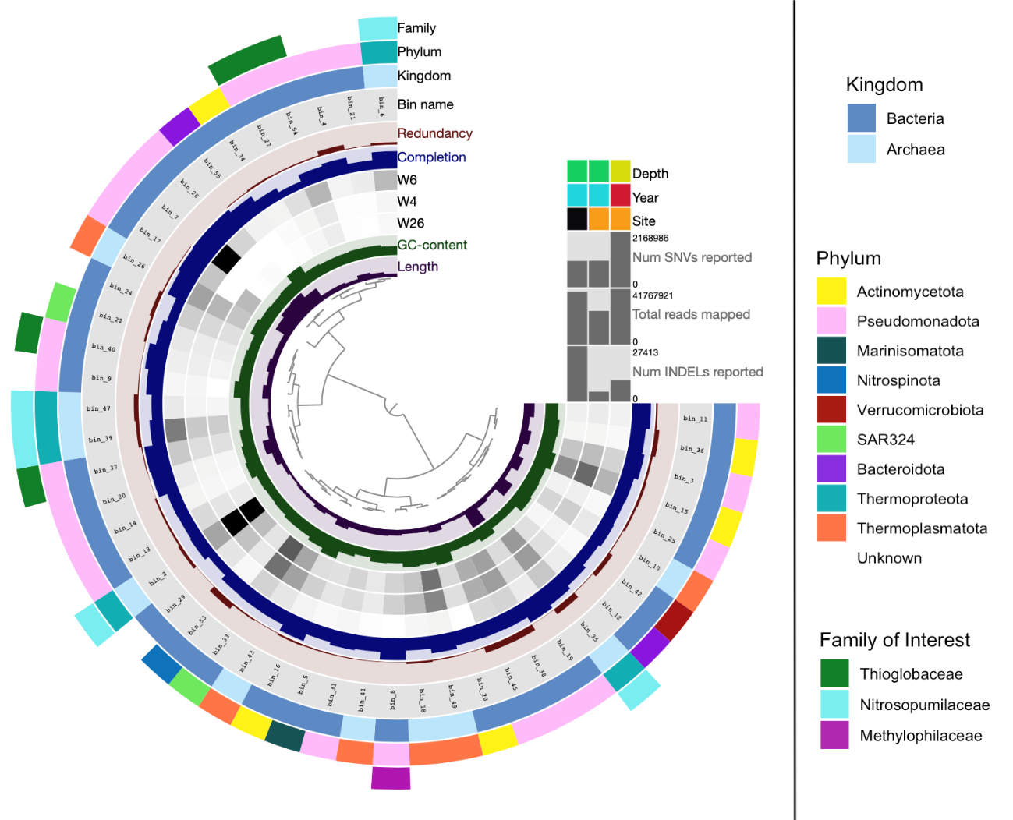

Figure 4-1. Circular Phylogram of all analyzed MAGs across sites. MAGs are grouped by abundance in each sample. In order of innermost to outermost, the rings represent: base pair length of the metagenome, ratio of GC to AT (max: 75%), abundance in samples WC-23, T1-23, and T1-22, percent of SCCGs present (Completion), ratio of copies of SCCGs found to the number of distinct SCCGs in the MAG (Redundancy [contamination]), name of the MAG (bin_name), the kingdom of the MAG (Kingdom), the phylum of the MAG (Phylum), and if the MAG belongs to one of the three families of interest (Family). For kingdom, light blue signifies Archaea, whereas dark blue indicates Bacteria. For phylum, white indicates that the MAG could not be assigned a phylum, whereas all other colors correspond to the phylum indicated in the key. For family of interest, white signifies the MAG either could not be taxonomically assigned to a family or could be assigned but did not belong to a family of interest. Thioglobaceae is indicated by dark green, Nitrosopumilaceae by dark aquamarine, and Methylophilaceae by magenta. Additional data (depth in water column [<200 m: green, >200 m: yellow], year [2022: red, 2023: blue], and site [T1: orange, WC: black]) is indicated by the grid in the upper right quadrant and corresponds to the sample it vertically aligns with. Barplots respectively indicate the total number of single nucleotide variants (SNVs), of reads mapped, and of insertions or deletions (indels) found to or in each sample, from this MAGs and from all contigs not included in this MAGs.
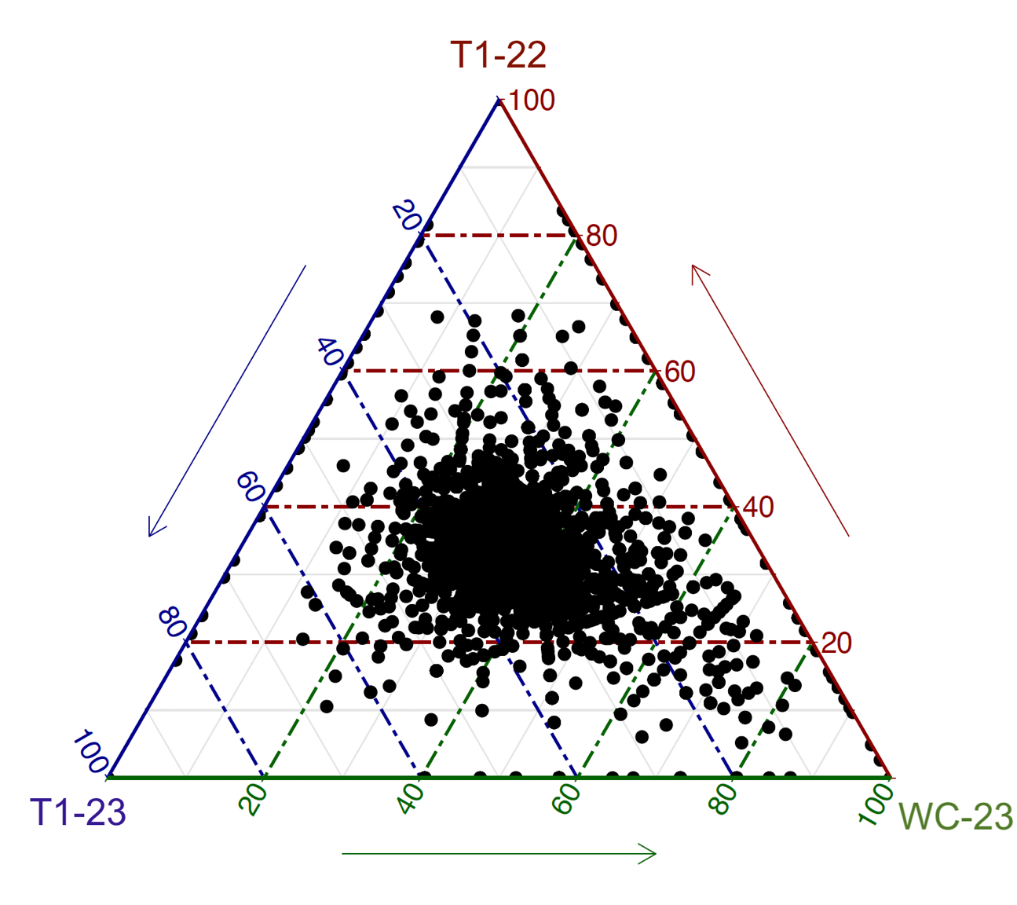
Figure 4-2. Ternary plot of the relative abundance of all KO hits found in the assembly from each sample. Each dot represents one unique KO and each side of the ternary plot corresponds to how abundant that KO’s hits in that sample in comparison to how abundant they are in the other two samples. The closer a dot is to one corner, the greater the proportion of its hits originate from that sample is. Dots in a corner represent KOs that are only found in one sample and dots on the edges of the ternary plot represent KOs that are only found in two of the samples.

Table 4-3. Distribution of KEGG Brite categories across unique KOs found in each sample.
Sample | Number of Unique KOs | Enzymes (%) | Transporters (%) | Viral Proteins (%) | Secretion Systems (%) | Other (%)
T1-22 | 432 | 39.4 | 15.5 | 4.6 | 7.6 | 32.9
T1-23 | 124 | 29.8 | 17.7 | 12.1 | 4.8 | 35.4
WC-23 | 219 | 40.0 | 16.4 | 17.4 | 3.2 | 33.0

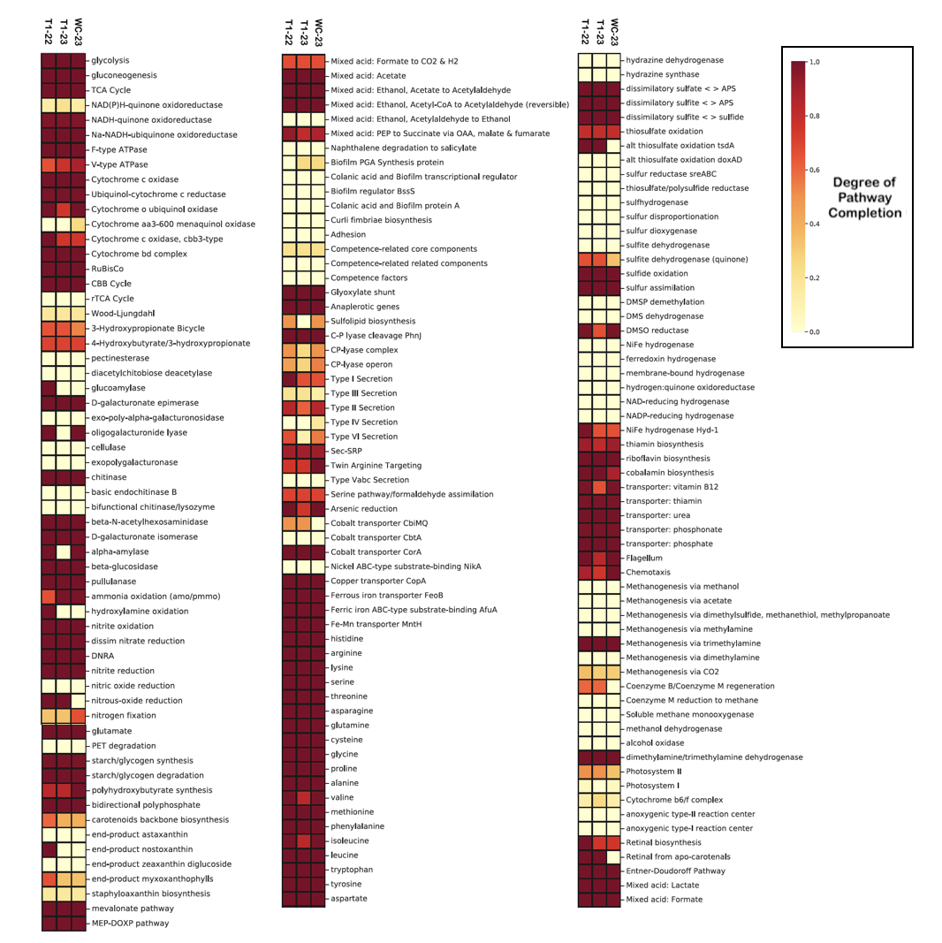
Figure 4-3. Functional pathway completeness of each sample. Color indicates proportion of pathway complete as assessed by KEGGDecoder v1.3, with dark indicating complete pathways and pale yellow indicating pathways with no genes present.

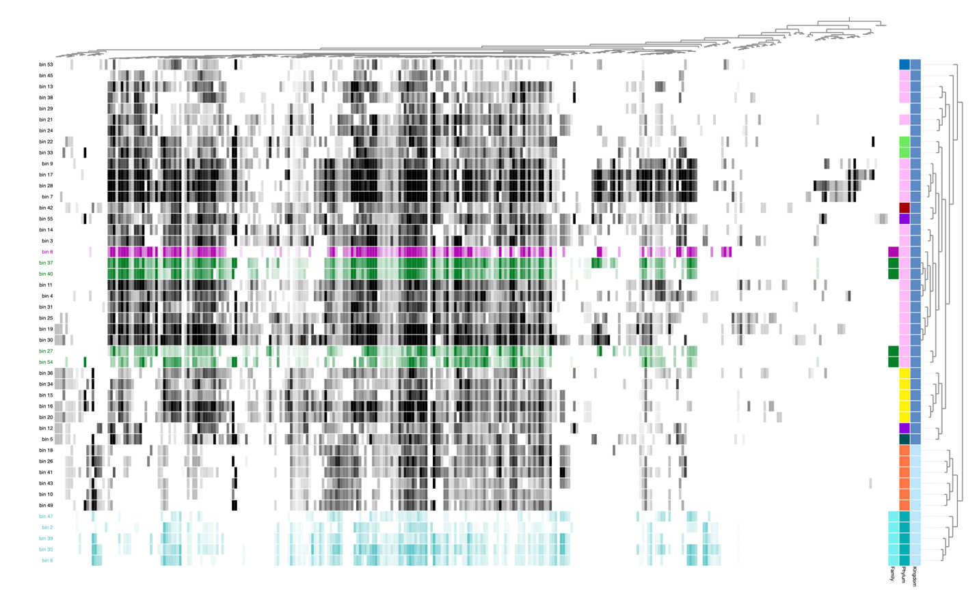
Figure 4-4. KEGG Ortholog pathway completeness by MAG. Each row represents one MAG and each column represents one KEGG functional pathway. Functions are grouped by similar distributions across MAGs and MAGs are grouped by similarity in pathway completeness. The squares on the right indicate if the MAG belongs to a family of interest, the phylum, and the kingdom of the MAG. For kingdom, light blue signifies Archaea, whereas dark blue indicates Bacteria. For phylum, white indicates that the MAG could not be assigned a phylum, whereas all other colors correspond to the phylum indicated in the key. For family of interest, white signifies the MAG either could not be taxonomically assigned to a family or could be assigned but did not belong to a family of interest. Families of interest are colored (magenta – Methylophilaceae, dark green – Thioglobaceae, aquamarine blue – Nitrosopumilaceae, black – other). The intensity of each cell indicates how complete the pathway is (i.e., white indicates genes for the pathway are completely absent, black/dark green/magenta/dark aquamarine indicates all required genes are present). Cells are also colored by family of interest, where MAGs not belonging to a family of interest are colored black.

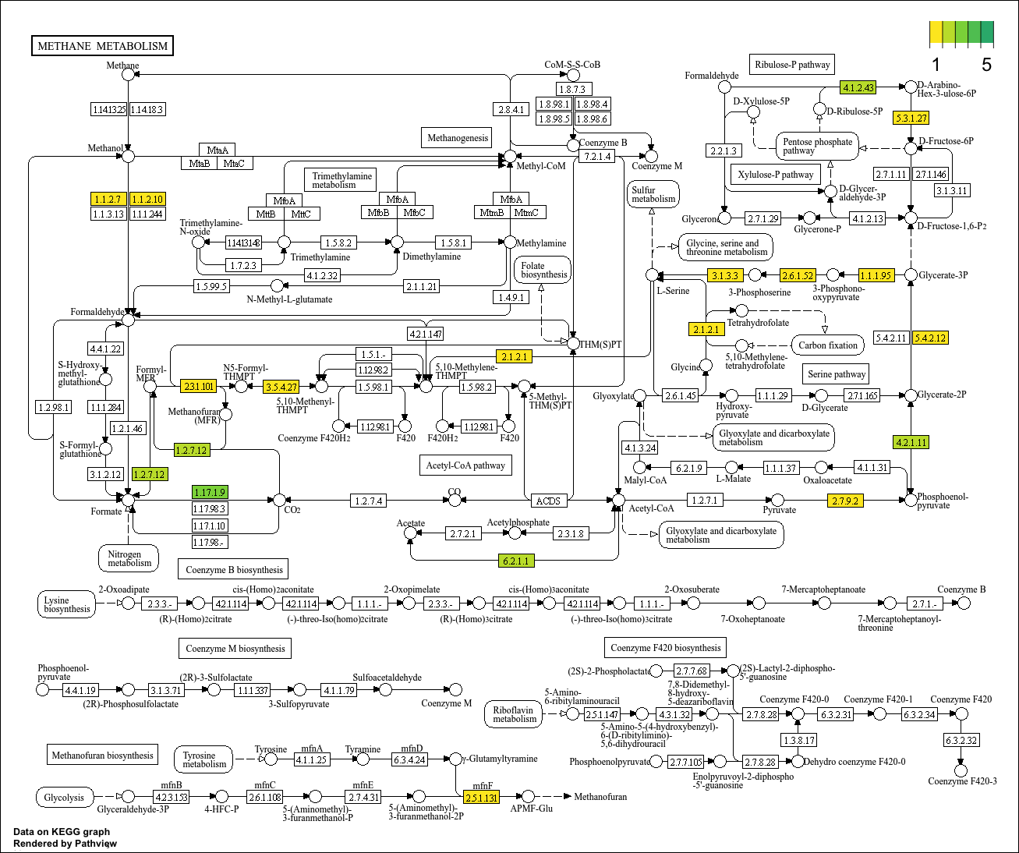
Figure 4-5. Methanol metabolism genes possessed by the sole Methylophilaceae MAG (bin_8). Colors indicate the number of annotated genes that belong to a given enzyme category, with yellow indicating 1 copy and dark green indicating 5, with white signifying none at all. Note that multiple copies could either be multiple copies of the same gene, copies of genes for the different subunits, or a mix of both.

Appendix IVB: Supplemental Material

Table 4-S1. Metagenomic read trimming statistics.
Name | Number of Input Pairs | Both Surviving | Forward Only Surviving | Reverse Only Surviving | Both Dropped
T1-22 | 28,286,750 | 97.26% | 1.55% | 0.82% | 0.36%
T1-23 | 17,361,469 | 97.40% | 1.43% | 0.84% | 0.33%
WC-23 | 23,688,932 | 96.88% | 1.94% | 0.87% | 0.32%

Table 4-S2. Assembly statistics. The co-assembly is used for all downstream analyses and individual assemblies are generated for comparison.
Name | Number of Contigs | Number of Base Pairs | Minimum Number of Base Pairs | Maximum Number of Base Pairs | Average Contig Length | N50 of Contig Length
T1-22 | 1,554,661 | 877,297,496 | 200 | 716,394 | 564 | 568
T1-23 | 1,048,178 | 582,733,309 | 200 | 130,624 | 555 | 563
WC-23 | 1,517,178 | 790,921,036 | 200 | 159,366 | 521 | 520
Co-assembly | 3,073,495 | 1,671,931,854 | 200 | 692,384 | 544 | 532

Table 4-S3. Detailed bin statistics. Completeness is defined as the percent of bacterial or archaeal SCCGs present in a MAG and contamination is defined as the ratio of total identified SCCGs to the number of distinct SCCGs identified in a MAG. N50 is the length of the smallest contig needed to get half of all base pairs in the MAG when counting base pairs from contigs in decreasing size order.
Bin # | Completeness | Contamination | GC Content | N50 | Size (bp)
7 | 100.0% | 1.531% | 0.410 | 332670 | 4500932
17 | 98.10% | 1.575% | 0.441 | 32349 | 3736876
28 | 97.65% | 2.126% | 0.445 | 20556 | 4712778
37 | 97.18% | 1.324% | 0.433 | 34108 | 1571535
8 | 96.87% | 0.534% | 0.430 | 52882 | 1349670
30 | 95.68% | 3.174% | 0.503 | 12317 | 3157728
40 | 93.65% | 2.487% | 0.427 | 10394 | 1275605
19 | 90.49% | 1.913% | 0.493 | 22385 | 4550144
16 | 86.24% | 6.780% | 0.689 | 6839 | 2153117
35 | 82.79% | 13.10% | 0.319 | 8859 | 1322703
6 | 77.08% | 3.478% | 0.335 | 4626 | 753664
55 | 76.41% | 2.185% | 0.733 | 2633 | 3354272
26 | 76.26% | 5.635% | 0.519 | 5062 | 1394003
3 | 73.05% | 3.936% | 0.520 | 5049 | 2464238
11 | 73.05% | 2.739% | 0.463 | 5837 | 2521127
9 | 70.03% | 2.646% | 0.569 | 2135 | 2025173
33 | 69.60% | 4.201% | 0.422 | 2974 | 1372851
31 | 66.24% | 4.819% | 0.302 | 8260 | 1496621
20 | 65.88% | 5.982% | 0.679 | 3407 | 1661973
12 | 63.74% | 0.555% | 0.324 | 8099 | 910680
4 | 61.63% | 12.61% | 0.405 | 1843 | 1629854
49 | 61.08% | 2.861% | 0.557 | 4261 | 1072497
41 | 60.17% | 4.0% | 0.442 | 4500 | 1488485
14 | 59.32% | 14.10% | 0.556 | 2566 | 1953684
22 | 58.94% | 12.77% | 0.416 | 2257 | 1869582
10 | 58.58% | 1.866% | 0.540 | 9110 | 1075852
15 | 56.62% | 7.535% | 0.675 | 2260 | 1394082
45 | 56.50% | 19.49% | 0.349 | 2017 | 735858
27 | 56.06% | 9.823% | 0.385 | 3118 | 1159224
29 | 55.72% | 5.462% | 0.359 | 5710 | 712963
5 | 55.35% | 6.593% | 0.402 | 2936 | 1443804
21 | 54.46% | 3.927% | 0.397 | 4692 | 1230534
25 | 53.94% | 4.084% | 0.512 | 3439 | 2637871
39 | 53.29% | 10.11% | 0.309 | 1993 | 754052
43 | 52.98% | 1.733% | 0.535 | 4956 | 910020
36 | 52.80% | 10.91% | 0.548 | 2687 | 1590341
2 | 52.26% | 15.29% | 0.336 | 1626 | 494201
47 | 52.10% | 17.15% | 0.312 | 2140 | 550994
24 | 51.97% | 18.96% | 0.367 | 3152 | 1438522
18 | 51.93% | 12.12% | 0.591 | 2616 | 1006285
54 | 51.27% | 2.122% | 0.383 | 3345 | 868432
13 | 50.88% | 5.561% | 0.367 | 3368 | 914982
42 | 50.70% | 16.33% | 0.590 | 1314 | 3412759
34 | 50.48% | 6.068% | 0.424 | 2756 | 1162328
38 | 50.39% | 14.44% | 0.376 | 2406 | 854899
53 | 50.29% | 16.79% | 0.424 | 1371 | 781236
Table 4-S4. Taxonomy of analyzed bins. Taxonomic levels of kingdom, phylum, family, and genus are displayed. Empty spaces indicate that bin could not be identified down to that taxonomic level.
Bin | Kingdom | Phylum | Family | Genus
bin_36 | Bacteria | Actinomycetota | TK06 | UBA2110
bin_28 | Bacteria | Pseudomonadota | Alteromonadaceae | Alteromonas
bin_7 | Bacteria | Pseudomonadota | Alteromonadaceae | Pseudoalteromonas
bin_37 | Bacteria | Pseudomonadota | Thioglobaceae | DUCF01
bin_11 | Bacteria | Pseudomonadota | Pseudohongiellaceae | UBA9145
bin_8 | Bacteria | Pseudomonadota | Methylophilaceae | GCA-2401735
bin_53 | Bacteria | Nitrospinota | Nitrospinaceae | Nitromaritima
bin_17 | Bacteria | Pseudomonadota | Vibrionaceae | Vibrio
bin_19 | Bacteria | Pseudomonadota | HTCC2089 | UBA9926
bin_16 | Bacteria | Actinomycetota | MedAcidi-G1 | S20-B6
bin_40 | Bacteria | Pseudomonadota | Thioglobaceae | DUCF01
bin_3 | Bacteria | Pseudomonadota | UBA868 | REDSEA-S09-B13
bin_38 | Bacteria | Pseudomonadota | SAR86 | AEGEAN-183
bin_30 | Bacteria | Pseudomonadota | Rhodobacteraceae | CABZJG01
bin_31 | Bacteria | Pseudomonadota | GCA-002718135 | AG-337-I02
bin_9 | Bacteria | Pseudomonadota | Halomonadaceae | Halomonas
bin_20 | Bacteria | Actinomycetota | MedAcidi-G1 | UBA9410
bin_4 | Bacteria | Pseudomonadota | Nitrosomonadaceae | GCA-2721545
bin_45 | Bacteria | Pseudomonadota | SAR86 | AEGEAN-183
bin_15 | Bacteria | Actinomycetota | MedAcidi-G1 | UBA9410
bin_54 | Bacteria | Pseudomonadota | Thioglobaceae | Pseudothioglobus
bin_14 | Bacteria | Pseudomonadota | UBA868 | UBA868
bin_5 | Bacteria | Marinisomatota | TCS55 | TCS55
bin_12 | Bacteria | Bacteroidota | BACL11 | DUAL01
bin_22 | Bacteria | SAR324 | NAC60-12 | Arctic96AD-7
bin_42 | Bacteria | Verrucomicrobiota | Akkermansiaceae | Roseibacillus
bin_33 | Bacteria | SAR324 | NAC60-12 | Arctic96AD-7
bin_25 | Bacteria | Pseudomonadota | HTCC2089 | UBA9659
bin_13 | Bacteria | Pseudomonadota | SAR86 | AEGEAN-183
bin_34 | Bacteria | Actinomycetota | MedAcidi-G1 | MedAcidi-G1
bin_26 | Archaea | Thermoplasmatota | Thalassarchaeaceae | MGIIb-O1
bin_21 | Bacteria | Pseudomonadota | UBA11654 | UBA11654
bin_39 | Archaea | Thermoproteota | Nitrosopumilaceae | Nitrosopumilus
bin_55 | Bacteria | Bacteroidota | Rubricoccaceae | Rubrivirga
bin_29 | Bacteria
bin_49 | Archaea | Thermoplasmatota | Thalassarchaeaceae | Thalassarchaeum
bin_35 | Archaea | Thermoproteota | Nitrosopumilaceae | Nitrosopumilus
bin_6 | Archaea | Thermoproteota | Nitrosopumilaceae | Nitrosopelagicus
bin_47 | Archaea | Thermoproteota | Nitrosopumilaceae | Nitrosopelagicus
bin_2 | Archaea | Thermoproteota | Nitrosopumilaceae | Nitrosopumilus
bin_43 | Archaea | Thermoplasmatota | Thalassarchaeaceae | MGIIb-O1
bin_18 | Archaea | Thermoplasmatota | Thalassarchaeaceae | Thalassarchaeum
bin_10 | Archaea | Thermoplasmatota | Thalassarchaeaceae | Thalassarchaeum
bin_24 | Bacteria
bin_27 | Bacteria | Pseudomonadota | Thioglobaceae | Pseudothioglobus
bin_41 | Archaea | Thermoplasmatota | Poseidoniaceae | MGIIa-K1

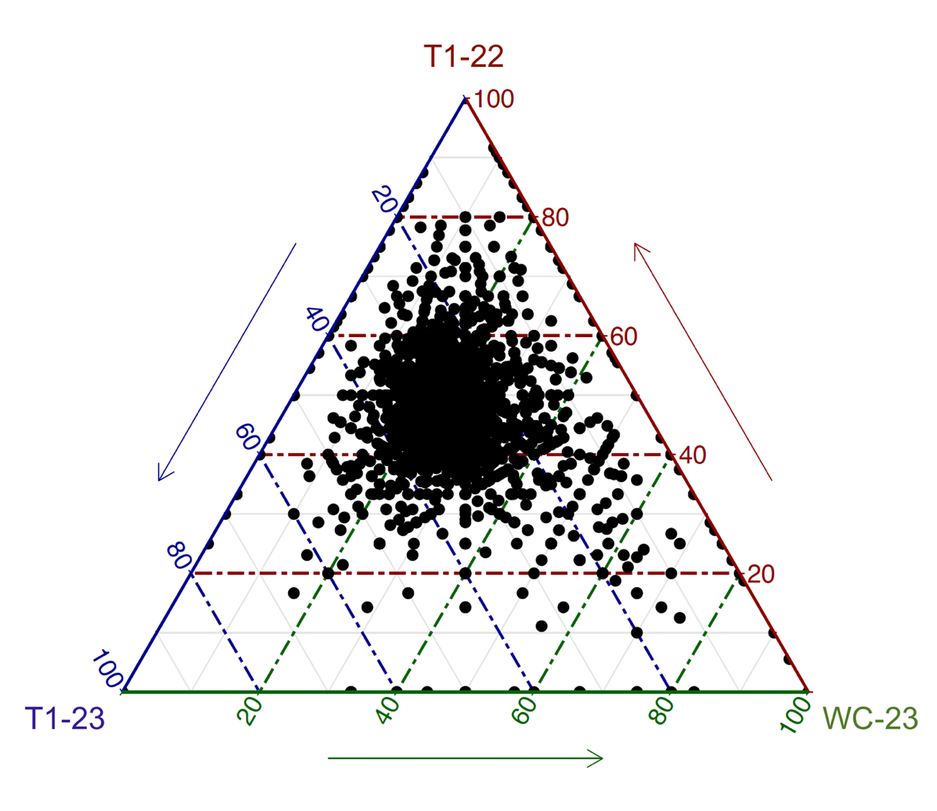
Figure 4-S1. Ternary plot of the absolute abundance of all KO hits found in each sample. Each dot represents one unique KO and each side of the ternary plot corresponds to what percentage of that KO’s hits are found in that sample. The closer a dot is to one corner, the more of its hits originate from that sample. Dots in a corner represent KOs that are only found in one sample and dots on the edges of the ternary plot represent KOs that are only found in two of the samples.

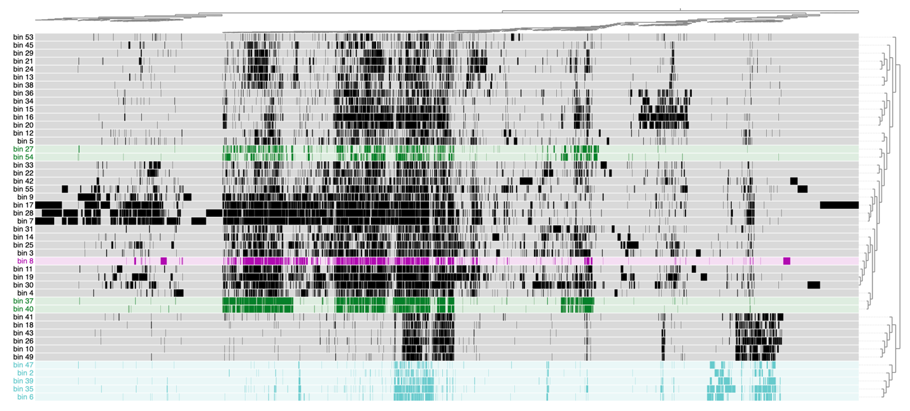
Figure 4-S2. KOfam gene function annotations by MAG. Each row represents one MAG and each column represents one unique KOfam gene function annotation. KOfam gene function annotations are grouped by similar presence/absence distributions across MAGs and MAGs are grouped by similarity in the presence/absence of KOfam gene function annotations. Cells are colored by family of interest (magenta – Methylophilaceae, dark green – Thioglobaceae, aquamarine blue – Nitrosopumilaceae, black – other), where MAGs not belonging to a family of interest are colored black. A colored cell indicates the presence of that KOfam gene function annotation in that particular MAG, whereas grey indicates the absence of that KOfam gene function annotation.

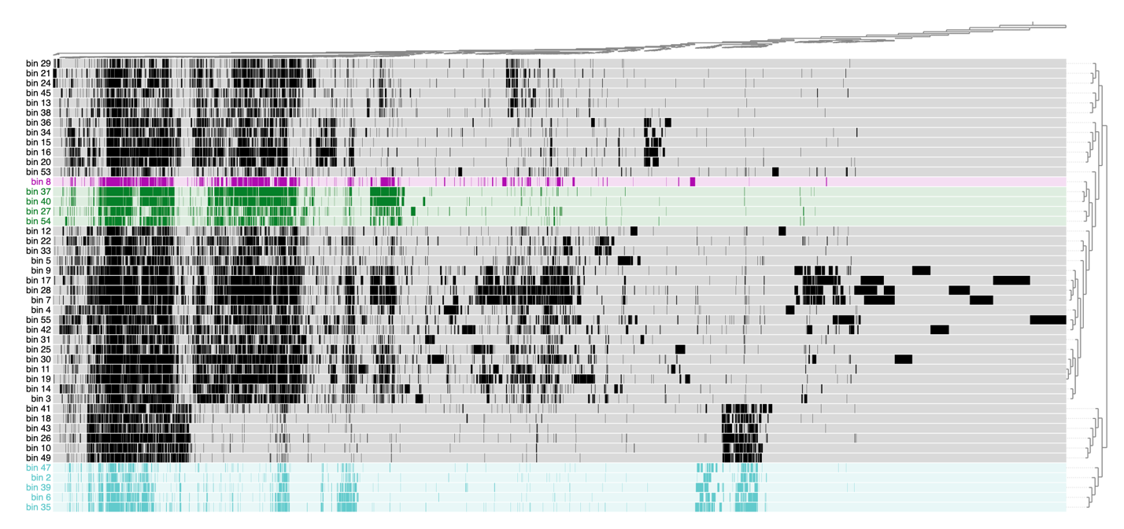
Figure 4-S3. Pfam gene function annotations by MAG. Each row represents one MAG and each column represents one unique Pfam gene function annotation. Pfam gene function annotations are grouped by similar presence/absence distributions across MAGs and MAGs are grouped by similarity in the presence/absence of Pfam gene function annotations. Cells are colored by family of interest (magenta – Methylophilaceae, dark green – Thioglobaceae, aquamarine blue – Nitrosopumilaceae, black – other), where MAGs not belonging to a family of interest are colored black. A colored cell indicates the presence of that Pfam gene function annotation in that particular MAG, whereas grey indicates the absence of that Pfam gene function annotation.
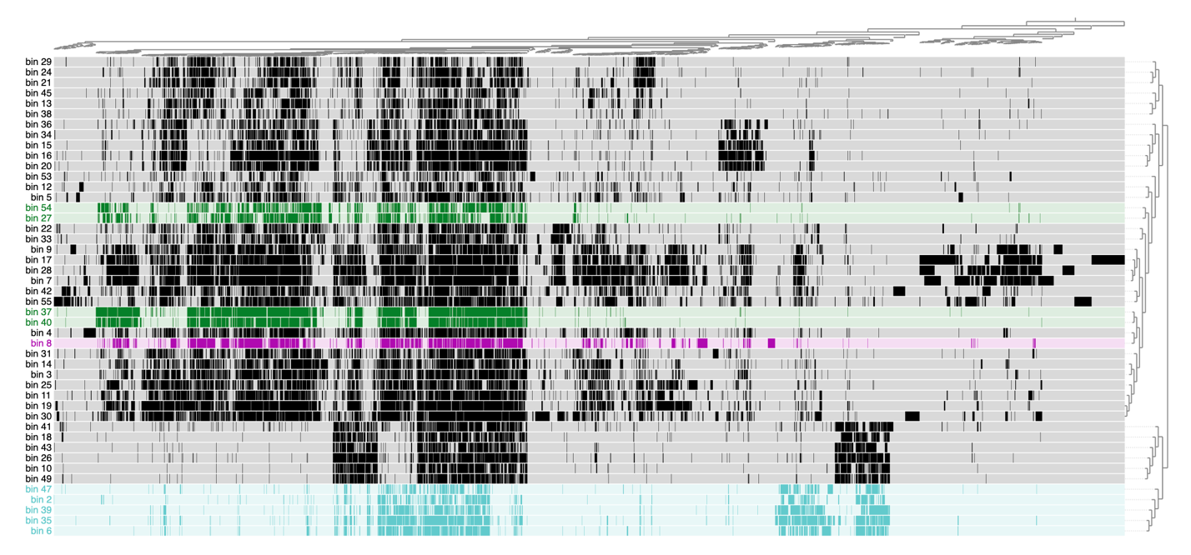
Figure 4-S4. COG20 gene function annotations by MAG. Each row represents one MAG and each column represents one unique COG20 gene function annotation. COG20 gene function annotations are grouped by similar presence/absence distributions across MAGs and MAGs are grouped by similarity in the presence/absence of COG20 gene function annotations. Cells are colored by family of interest (magenta – Methylophilaceae, dark green – Thioglobaceae, aquamarine blue – Nitrosopumilaceae, black – other), where MAGs not belonging to a family of interest are colored black. A colored cell indicates the presence of that COG20 gene function annotation in that particular MAG, whereas grey indicates the absence of that COG20 gene function annotation.

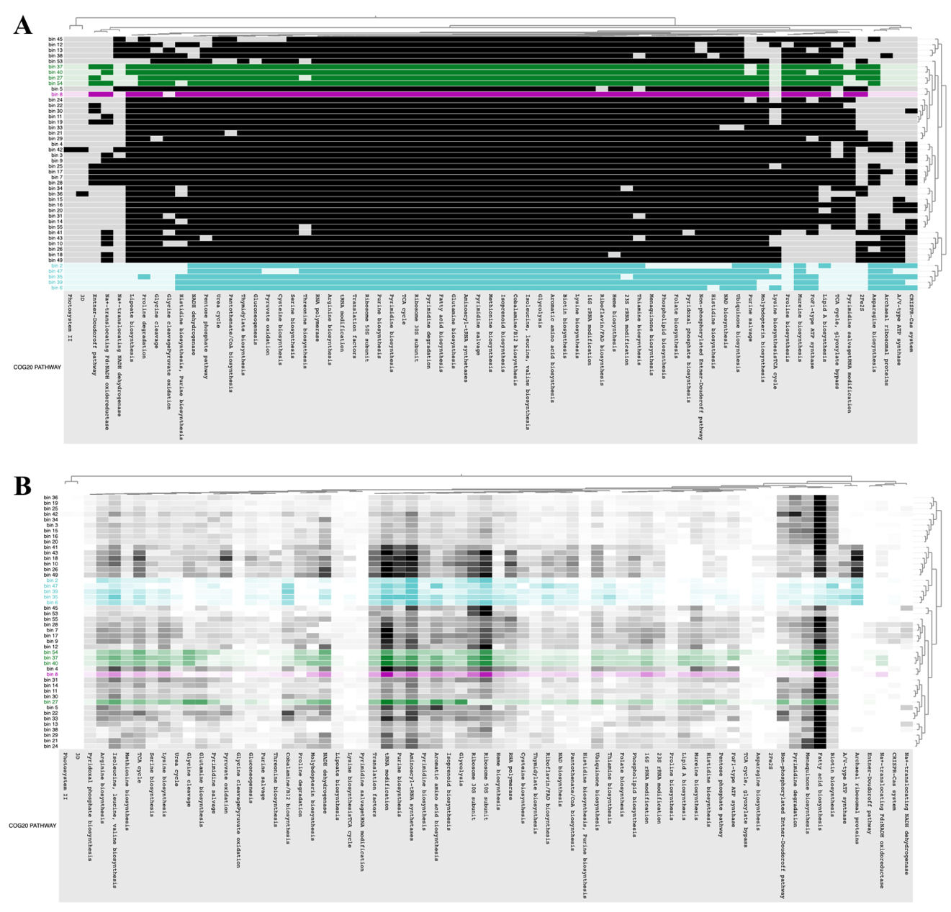
Figure 4-S5. Distribution of COG20 functional pathways across MAGs. Each row represents one MAG and each column represents one unique COG20 functional pathway. Cells are colored by family of interest (magenta – Methylophilaceae, dark green – Thioglobaceae, aquamarine blue – Nitrosopumilaceae, black – other), where MAGs not belonging to a family of interest are colored black. A) COG20 functional pathways are grouped by similar presence/absence distributions across MAGs and MAGs are grouped by similarity in the presence/absence of COG20 functional pathway. A colored cell indicates the presence of that COG20 functional pathway in that particular MAG, whereas grey indicates the absence of that COG20 functional pathway. B) COG20 functional pathways are grouped by similar distribution frequencies across MAGs and MAGs are grouped by similarity in the frequencies of the COG20 functional pathways. The intensity of each cell indicates how frequent the pathway is in the MAG (i.e., white indicates genes belonging the pathway are completely absent and progressively darker shades of black/grey, green, magenta, and aquamarine indicate the increased frequency of genes belonging to the pathway).
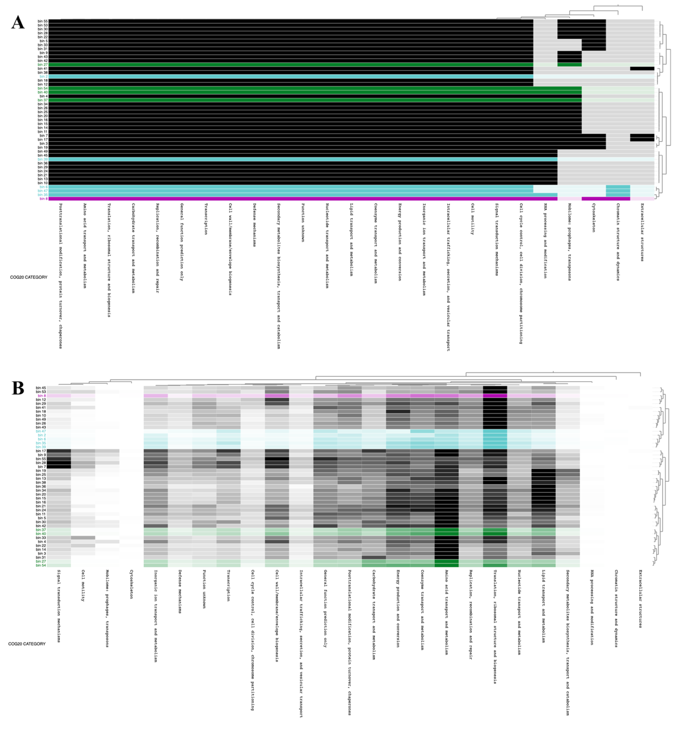
Figure 4-S6. Distribution of COG20 functional categories across MAGs. Each row represents one MAG and each column represents one unique COG20 functional category. Cells are colored by family of interest (magenta – Methylophilaceae, dark green – Thioglobaceae, aquamarine blue – Nitrosopumilaceae, black – other), where MAGs not belonging to a family of interest are colored black. A) COG20 functional categories are grouped by similar presence/absence distributions across MAGs and MAGs are grouped by similarity in the presence/absence of COG20 functional categories. A colored cell indicates the presence of that COG20 functional category in that particular MAG, whereas grey indicates the absence of that COG20 functional category. B) COG20 functional categories are grouped by similar distribution frequencies across MAGs and MAGs are grouped by similarity in the frequencies of the COG20 functional categories. The intensity of each cell indicates how frequent the category is in the MAG (i.e., white indicates genes belonging the category are completely absent and progressively darker shades of black/grey, green, magenta, and aquamarine indicate the increased frequency of genes belonging to the category).

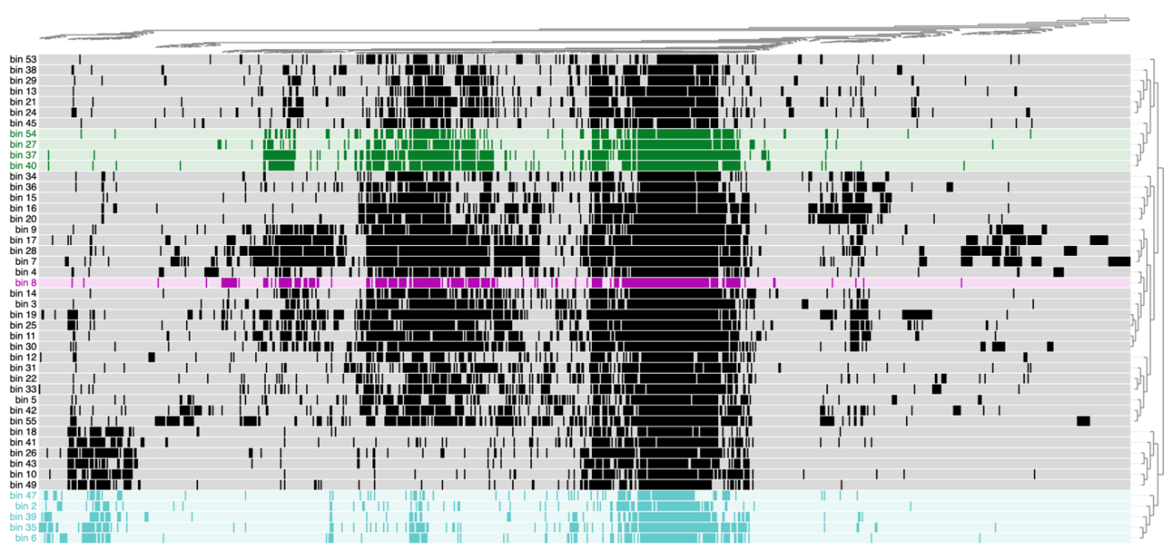
Figure 4-S7. Distribution of KEGG BRITE functional hierarchies across MAGs. Each row represents one MAG and each column represents one unique KEGG BRITE functional hierarchy. Cells are colored by family of interest (magenta – Methylophilaceae, dark green – Thioglobaceae, aquamarine blue – Nitrosopumilaceae, black – other), where MAGs not belonging to a family of interest are colored black. A) KEGG BRITE functional hierarchies are grouped by similar presence/absence distributions across MAGs and MAGs are grouped by similarity in the presence/absence of KEGG BRITE functional hierarchies. A colored cell indicates the presence of that KEGG BRITE functional hierarchy in that particular MAG, whereas grey indicates the absence of that KEGG BRITE functional hierarchy. B) KEGG BRITE functional hierarchies are grouped by similar distribution frequencies across MAGs and MAGs are grouped by similarity in the frequencies of the KEGG BRITE functional hierarchies. The intensity of each cell indicates how frequent the hierarchy is in the MAG (i.e., white indicates genes belonging the hierarchy are completely absent and progressively darker shades of black/grey, green, magenta, and aquamarine indicate the increased frequency of genes belonging to the hierarchy).

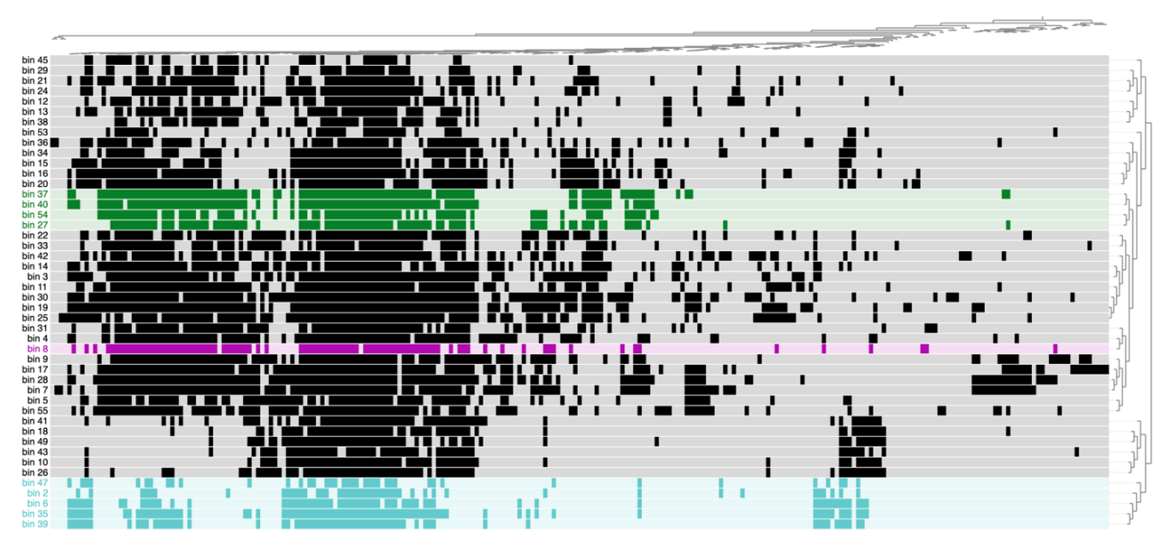
Figure 4-S8. Distribution of KEGG functional modules across MAGs. Each row represents one MAG and each column represents one unique KEGG functional module. Cells are colored by family of interest (magenta – Methylophilaceae, dark green – Thioglobaceae, aquamarine blue – Nitrosopumilaceae, black – other), where MAGs not belonging to a family of interest are colored black. A) KEGG functional modules are grouped by similar presence/absence distributions across MAGs and MAGs are grouped by similarity in the presence/absence of KEGG functional modules. A colored cell indicates the presence of that KEGG functional module in that particular MAG, whereas grey indicates the absence of that KEGG functional module. B) KEGG functional modules are grouped by similar distribution frequencies across MAGs and MAGs are grouped by similarity in the frequencies of the KEGG functional modules. The intensity of each cell indicates how frequent the module is in the MAG (i.e., white indicates genes belonging the module are completely absent and progressively darker shades of black/grey, green, magenta, and aquamarine indicate the increased frequency of genes belonging to the module).
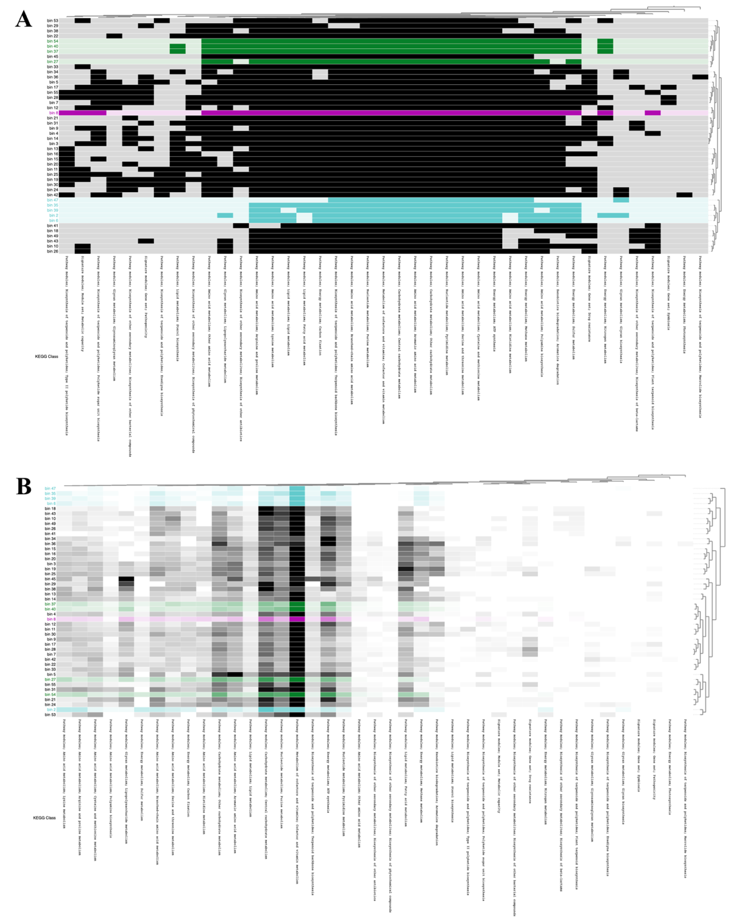

Figure 4-S9. Distribution of KEGG classes across MAGs. Each row represents one MAG and each column represents one unique KEGG class. Cells are colored by family of interest (magenta – Methylophilaceae, dark green – Thioglobaceae, aquamarine blue – Nitrosopumilaceae, black – other), where MAGs not belonging to a family of interest are colored black. A) KEGG classes are grouped by similar presence/absence distributions across MAGs and MAGs are grouped by similarity in the presence/absence of KEGG classes. A colored cell indicates the presence of that KEGG class in that particular MAG, whereas grey indicates the absence of that KEGG class. B) KEGG classes are grouped by similar distribution frequencies across MAGs and MAGs are grouped by similarity in the frequencies of the KEGG classes. The intensity of each cell indicates how frequent the class is in the MAG (i.e., white indicates genes belonging the class are completely absent and progressively darker shades of black/grey, green, magenta, and aquamarine indicate the increased frequency of genes belonging to the class).

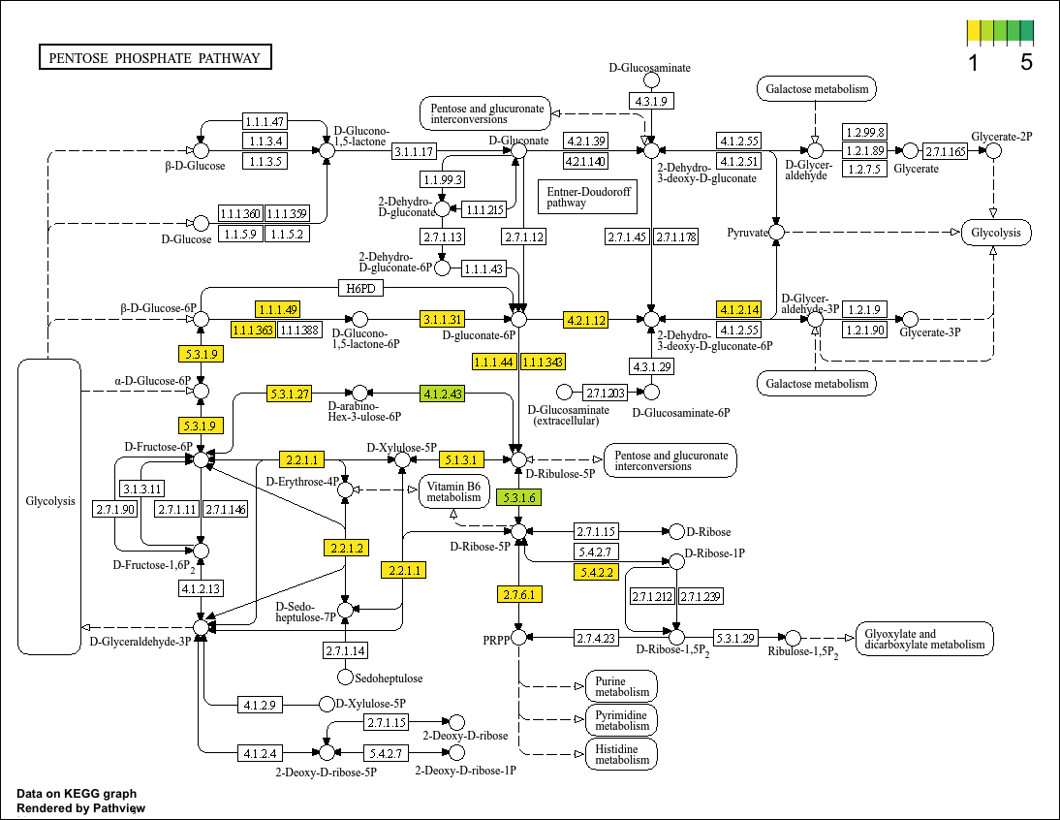
Figure 4-S10. Pentose phosphate pathway genes possessed by the sole Methylophilaceae MAG (bin_8). Colors indicate the number of annotated genes that belong to a given enzyme category, with yellow indicating 1 copy and dark green indicating 5, with white signifying none at all. Note that multiple copies could either be multiple copies of the same gene, copies of genes for the different subunits, or a mix of both.

Chapter V: CONCLUSION

The aerobic methane-oxidizing community converts methane into more labile organic carbon and carbon dioxide in oxygenated sediments and water columns across the globe. This body of work investigates how the aerobic methane-oxidizing community—comprising of these two groups of bacteria and more—respond collectively to changing environmental conditions and how these microorganisms in turn might influence their environment. This work further interrogates natural methane-oxidizing communities in order to see if aerobic methanotrophs and nonmethanotrophic methylotrophs may engage in symbiotic or even syntrophic interactions in natural systems and for insights into how these interactions may be mediated. One important focus of this work is the role of nonmethanotrophic methylotrophs, particularly from Methylophilaceae, as they are often overlooked yet stand to play a critical role supporting aerobic methanotrophs as they oxidize methane. A combination of in situ incubations, fieldwork, and the in silico techniques of 16S rRNA gene amplicon surveys and shotgun metagenomics are used to investigate these microbial communities.
Chapter II explores how a naturally co-occurring community of aerobic methanotrophs and nonmethanotrophic methylotrophs from a freshwater lake respond to the natural range of environmental conditions seen in that lake and in turn how they work together to oxidize methane. The relative abundance of the dominant obligately aerobic methanotrophic family Methylococcaceae is tightly correlated with the rate constant of aerobic methane oxidation, suggesting that not only is this family responsible for the majority of the oxidation observed in this lake but that they have little ability to regulate their per cell methane oxidation. The obligate aerobic methanotrophs like Methylococcaceae respond negatively to oxygen concentration, an effect that is worsened at higher methane concentrations, whereas facultative aerobic methanotrophs and nonmethanotrophic methylotrophs respond differently or not at all to it. Methane on its own fails to either correlate with or explain even marginal amounts of the observed variances in relative abundance of any group of interest. These results collectively suggest that obligate aerobic methanotrophs exhibit genuine aversion to oxygen instead of merely tolerating hypoxic conditions for access to higher methane concentrations. Broadly, this chapter has implications for why aerobic methanotrophs distribute throughout the water column as is typically observed and for how changes in the oxygen status of a given lake may impact its rates of methane removal.
Chapter III investigates the spatiotemporal stability of the overall prokaryotic community and aerobic methane-oxidizing community in general at North Atlantic methane seep fields, further determining which geochemical and physical factors affect distribution within the seep fields and scrutinizing the methane-oxidizing community for signs of syntrophy. The water column prokaryotic community proves to be very stable across both physical distance (between sites) and across years, with only minimal or insignificant differences in alpha diversity, beta diversity, and taxonomic composition being observed. Depth in the water column and oxygen concentrations prove to be the strongest factors measured that drive community composition, with methane concentration being the only completely insignificant factor measured. The insignificance of methane within seep communities suggests that while it may be important for seeding these communities, beyond an unknown concentration threshold more of it does not meaningfully change the community character. Given these results, less thorough sampling may be sufficient to reasonably capture the character of the water column microbiome of a marine methane seep and the microbiomes of nearby seeps may be reasonably similar, assuming they are all subject to the same current influences. The aerobic methane-oxidizing community shows strong signs of the aerobic methanotroph-nonmethanotrophic methylotroph syntrophy, with the dominant families of both in the water column (Methylomonadaceae and Methylophilaceae, respectively) correlating very strongly and positively throughout the water column. This correlation is further exhibited across both sites and both sampling years, implying it is robust and could indicate the presence of mixed-species clusters in the water column. Both groups, however, appear to have different origins, with the Methylomonadaceae genera in the water column also being found in the sediments, whereas Methylophilaceae are completely absent from every sediment core taken. This difference in origin implies the consistent ratios of both families in the water column to be the result of in situ association between both families. Methylomonadaceae, despite being comprised of several fairly abundant genera in the sediment, are overwhelmingly dominated by Milano-WF1B-03 (>99% of aerobic methanotroph sequences) in the water column, implying some kind of selective pressure in the water column at T1 and WC that favors this genus alone over the rest of the genera present in the sediment. Dominance to this extent adds inherent instability to the methane oxidation potential of this community, as an unfavorable environmental shift could lead to population collapse with no reservoir of alternative water column aerobic methanotrophs to fill the gap. This study has implications for both how future methane seep surveys can be conducted as well as how the aerobic methane-oxidizing and wider prokaryotic communities distribute within seeps and if syntrophy is occurring within the aerobic methane-oxidizing community in nature.
Finally, Chapter IV approaches the T1 and WC methane seep fields from the perspective of functional distribution rather than taxonomic distribution. Though recovered MAGs divide into two groups based upon which samples they are most abundant in, this pattern does not carry over to metrics of functional distribution across both seep fields over the sampling years. All samples contain very similar KEGG Orthologs along with having similar functional pathway completeness, suggesting that—at least below 150 m deep where aerobic methanotrophs are present—the functional character of the microbial community exhibits little variation, even across years and sites that are ~16 km apart. The recovered MAGs exhibit similar clustering by functional similarity across several different metrics. When these cluster do break down, they separate out into consistent subgroups. Collectively, this suggests that biochemical functions largely shift across taxa, but that some families that are present—such as Thioglobaceae—contain species or strains performing different overall functions. The presence of type IV pilin genes suggests a new avenue of investigation for the syntrophy between aerobic methanotrophs and nonmethanotrophic methylotrophs whereby electron transport between the two groups via type IV pilins could serve to manually throttle the first step of methane oxidation when it would otherwise be detrimentally overactive. While Methylophilaceae at T1 and WC are confirmed to be capable of methanol metabolism, the Nitrosopumilaceae are not confirmed to be capable of ammonia oxidation, which may bear closer investigation in future studies. The Thioglobaceae at these seep sites are heterotrophs and likely simply coexist with the aerobic methane-oxidizing community, only indirectly receiving carbon derived from this community instead of interacting directly with aerobic methanotrophs to access this carbon as nonmethanotrophic methylotrophs do.
In summary, nonmethanotrophic methylotrophs are a critical part of aerobic methane-oxidizing communities and their presence should not be overlooked in natural populations. Aerobic methanotroph distribution in freshwater systems may be a direct effect of oxygen gradients rather than methane gradients. Methane may have limited influence on microbial community structures once a certain threshold concentration is reached and then be less important than other factors like depth in the water column or oxygen concentrations. Aerobic methanotrophs and nonmethanotrophic methylotrophs exhibit signs of syntrophic interactions in deep-sea methane seep water column communities but not in freshwater ones, which may be a byproduct of nonmethanotrophic methylotrophs preferentially associating with photosynthetic communities over aerobic methanotrophs when the option is available. Further, my research in the T1 and WC seep fields provides both some of the first evidence demonstrating that the aforementioned syntrophy may occur in nature and not just ex situ, as well as indicating a potentially new dimension to how that syntrophy could be mediated and what specific benefit fostering it may provide to aerobic methanotrophs.
Collectively, this work helps fill in the blanks of the current model of aerobic methanotroph—nonmethanotrophic methylotroph syntrophy. Obligate aerobic methanotrophs likely engage in syntrophy with nonmethanotrophic methylotrophs to avoid the consequences of high oxygen concentrations, chiefly the buildup of toxic concentrations of formaldehyde. In environments where a stable community of aerobic methanotrophs and nonmethanotrophic methylotrophs is able to form, such as at the T1 and WC seep fields on the Mid-Atlantic Bight as demonstrated in Chapter III, aerobic methanotrophs can tolerate comparatively high concentrations of oxygen above ~100 µM. Otherwise, aerobic methanotroph population sizes plummet at concentrations of oxygen above this threshold, as shown in Jordan Lake in Chapter II where aerobic methanotrophs correlate most strongly with geochemical variables instead. The comparative susceptibility of obligate aerobic methanotrophs to the buildup of toxic levels of formaldehyde is a byproduct of how easily oxygen and methane pass through the lipid bilayer, which is not an issue for facultative aerobic methanotrophs that can swap to an alternative metabolic strategy and for nonmethanotrophic methylotrophs that consume polar methylated molecules that requires active transport.
The presence of type IV pilins, as identified in Chapter IV, in the metagenome of the dominant nonmethanotrophic methylotrophs of the stable aerobic methane-oxidizing population found at the T1 and WC seeps fields suggests a mechanism by which aerobic methanotrophs can leverage the presence of nonmethanotrophic methylotrophs to mitigate their rate of formaldehyde accumulation. By passing electrons to their syntrophic partners, aerobic methanotrophs can remove one of the three reactants required for the conversion of methane into methanol, thereby limiting the production of the precursor to formaldehyde. If this occurs, then the export of methanol into their surroundings may further reduce the pool of methanol available to become formaldehyde. Nonmethanotrophic methylotrophs would benefit from both of these exports as it increases the concentration of a preferred carbon source and provides energy to fuel the active transport of this carbon source into the cell.
Combined, these hypotheses suggest the necessity of a paradigm shift regarding how this syntrophic interaction is viewed. Consistently across both Jordan Lake and the Mid-Atlantic Bight in Chapters II and III, nonmethanotrophic methylotrophs can thrive in the absence of aerobic methanotrophs, whereas the reverse does not occur in either environment. Aerobic methanotrophs do not hold the power in their syntrophic interactions by gatekeeping access to critical sources of carbon for nonmethanotrophic methylotrophs; rather, aerobic methanotrophs can only thrive when they manage to cultivate a population of partner nonmethanotrophic methylotrophs. In turn, these nonmethanotrophic methylotrophs do not always associate with aerobic methanotrophs nonpreferentially—when coexisting with the comparatively highly productive photosynthetic communities in shallow waters, nonmethanotrophic methylotrophs abandon aerobic methanotrophs entirely, thriving while aerobic methanotrophs vanish from the overall microbial community. Areas that see a reduction in available organic matter may in turn see increased rates of aerobic methane oxidation and an expansion of territory for aerobic methanotrophs throughout the water column as nonmethanotrophic methylotroph reestablish syntrophy with them. In turn, regions subject to increased eutrophication may see less efficient methane capture and increased rates of methane emissions into the atmosphere.
More work must be done to investigate these hypotheses, both in terms of broader surveys of the distribution of the members of the aerobic methane-oxidizing community across environments and of culture work to investigate the mechanisms proposed here. While the ratio of aerobic methanotrophs to nonmethanotrophic methylotrophs is consistent throughout the Mid-Atlantic Bight seep fields studied here, it is unclear if this is a broader feature of marine aerobic methane-oxidizing communities across the globe since it has not yet been investigated broadly. More thorough environmental surveys and investigations into preexisting datasets should reveal more about the biotic and abiotic factors that govern this potential syntrophy and under what conditions it breaks down. Culture work is critical to enhancing our understanding of this syntrophy. Ideally, the effect of oxygen on pure cultures of aerobic methanotrophs and co-cultures of aerobic methanotrophs and nonmethanotrophic methylotrophs should be tested to see if this syntrophy causes enhanced oxygen tolerance in aerobic methanotrophs. Modulating the amount of alternative carbon sources available to these pure and co-cultures should also show if nonmethanotrophic methylotrophs only resort to their syntrophy with aerobic methanotrophs when alternative sources of organic carbon are less available. Knocking out the type IV pilin genes of both groups and co-culturing mixes of knockouts and unaltered strains under the same ranges of oxygen concentrations should further reveal whether interspecies electron transfer plays a role in the syntrophy. Further, using microscopy on co-cultures and natural samples of these two groups should clarify if type IV pilins are involved at least in the capacity that they help clusters of the two species stay together in the water column. As such, while this work reveals potentially key pieces of the puzzle underlying the syntrophy between aerobic methanotrophs and nonmethanotrophic methylotrophs, much work needs to be done to verify these proposed mechanisms and interactions.

VITA
Jennifer Ann Baily was born in Fairfax, Virginia and spent her childhood in Loudoun county, Virginia. She applied for and attended Thomas Jefferson High School for Science and Technology, where she enjoyed learning about oceanography, biology, and astronomy. While in high school she obtained her 1st and 2nd degree black belts in Taekwondo and competed in the National Ocean Sciences bowl with her team. Her interest in biological oceanography started early, keeping several freshwater and saltwater reef aquariums through middle school and high school.
In order to challenge herself outside her comfort zone of academics and to grow as a person, she attended the Virginia Military Institute for college. There she obtained her Bachelor of Science degree in Biology with a minor in mathematics in three years and conducted independent research into the gut microbiome of tardigrades under the mentorship of Dr. Emily Lilly. Dr. Lilly and her other scientific mentors—Dr. Wade Bell and Dr. Richard Rowe—encouraged her interest in microbiology. In 2020, she graduated second amongst that year’s graduating class and went on to join Dr. Karen Lloyd’s lab at the University of Tennessee, Knoxville, where she was introduced to the wonderful world of aerobic methanotrophs and methane metabolism. She participated in three fieldwork expeditions, one to Cape Lookout Bight, NC, and two to methane seep fields on the Northern Atlantic continental slope. She was also incredibly fortunate to have the opportunity to travel to Europe twice to present her work internationally at conferences in Denmark and Spain. While in graduate school, she also discovered her love for teaching and thoroughly enjoyed her time instructing major and non-major students laboratory techniques.
In her free time, Jennifer enjoys reading, knitting, origami and puzzles in addition cuddling cats, whether they be her own cats Zander and Floss or those at the Young Williams Animal Center where she volunteers. She looks forward to pursuing a career in either science research or undergraduate science education and also hopes to jump back into the world of marital arts, start keeping aquariums again, and finally figure out how to knit socks (as well as explore other forms of needlework).

