450 kVp High Dynamic Range
Radiographic Inspection of Rail Welds

A Thesis Presented for the
Master of Science
Degree
The University of Tennessee, Knoxville

David C. Hellmann
August 2023
DEDICATION

I ultimately dedicate this work to God and to His glory.
I also dedicate this work to my wife, Ashley, and my son, Benedict, for their undying support and love.

ACKNOWLEDGEMENTS

I would like to thank Dr. Liesenfelt, Dr. Hayward, and Dr. Howard for their support and guidance.

ABSTRACT

The railroad industry is a vital supply line for a multitude of indispensable industries in the United States, and maintaining a safe and efficient railway systems is of vital importance. Despite a good record of safety, roughly 1000 train derailments occurred in the United States in 2022, and broken rail welds are among the top causes. The utilization of high energy x-ray sources was investigated to determine rail weld integrity and determine minimum flaw size detection limit. A 450 kVp and 3, 6, 9, and 15 MVp x-ray sources were characterized using MCNP6.2 as possible candidates as x-ray sources for world radiographic testing. Each source was then implemented into angular and energy dependent source definitions for use in later simulations. The 450 kVp source was determined to provide sufficient x-ray energy and fluence to provide adequate signal for the Varex 4343 scintillator detector panel. Next, 141 railway was modeled in simulation space and various geometries and filters were investigated to reduce scatter and maintain a quality image. An 18° tilt to the rail section and 1 mm lead filter resulted in sufficient scatter reduction while maintaining sufficient signal strength. This configuration allowed for the detection of spherical voids in the head of the rail down to a diameter of 1.5 mm in simulation space. Further image processing allowed for the detection of an even smaller 0.5 mm void by utilizing an image subtraction method. Finally, factors correcting for beam symmetry and photon attenuation were collected. Initial simulation results provided sufficient confidence to move forward to real world testing.

Table of Contents
CHAPTER 1 INTRODUCTION 1
Railroads in the United States 1
Industry Statistics 1
Rail Safety 1
Proposed Research 2
CHAPTER 2 BACKGROUND INFORMATION 3
X-Ray Radiography 3
History of X-ray Radiography 3
X-ray Production 4
X-ray Interactions in Matter 8
Radiographic X-ray Detectors 10
The Monte Carlo Method 11
CHAPTER 3 X-RAY SOURCE CHARACTERIZATION 12
450 kVp Source Characterization 12
Beam Spectrum and Profiles 12
Angular Dependent Source Implementation 14
3, 6, 9, and 15 MVp Source Characterization 14
Target Optimization 14
Transmission Target Spectra and Angular Dependence 16
Angular and Energy Dependent Source Implementation 16
CHAPTER 4 SIMULATION BASED SYSTEM OPIMIZATION 19
Rail Simulation and Optimization 19
Simulation Geometry 19
Spectral Engineering 21
Attenuation Correction 24
CHAPTER 5 RESULTS AND DISCUSSION 26
Source Characterization 26
450 kVp Beam Spectrum and Profiles 26
3, 6, 9, and 15 MVp Target Optimization 26
Transmission Target Energy and Angular Dependence 31
3 MVp Source Characterization 31
6 MVp Source Characterization 31
9 MVp Source Characterization 35
15 MVp Source Characterization 35
System Optimization 35
Source Selection and Initial Simulations 35
Spectral Engineering 38
Attenuation Correction 45
Step Wedge Signal and Scatter Characterization 48
CHAPTER 6 CONCLUSIONS AND FUTURE WORK 54
Conclusions 54
Future Work 55
LIST OF REFERENCES 57
APPENDIX 59
VITA 66

LIST OF TABLES
Table 1. 450 kVp energy spectrum piecewise fit coefficients…………………………... 59
Table 2. 450 kVp beam heel profile polynomial fit…………..…………………………. 60
Table 3. 450 kVp beam flatness profile polynomial fit…………………………………. 60
Table 4. 3 MVp key angles energy spectra polynomial fits……………………………. . 61
Table 5. 6 MVp key angles energy spectra polynomial fits……………………………. . 62
Table 6. 9 MVp key angles energy spectra polynomial fits…………………………… . . 63
Table 7. 15 MVp key angles energy spectra polynomial fits…..……………………… . . 64
Table 8. Step wedge thickness intensity plot polynomial fits…………………………. . . 65

List of Figures
Figure 1. Bremsstrahlung x-ray energy spectrum [5]………………………….…… … …. 6
Figure 2. Angular distribution of bremsstrahlung produces x-rays [6]…..…………… … . 6
Figure 3. Reflection x-ray source diagram [7]…………………… ……………………….7
Figure 4. X-ray interaction method likelihood dependent on x-ray energy and atomic number. [8] ………………………………………………………… ……………………..9
Figure 5. 450 kVp source simulation geometry…………………… …………………….13
Figure 6. Transmission source electron simulation geometry………… … … … ………...15
Figure 7. (a) Target geometry (b) side view of entire tally sphere (c) zoomed in side view of 0°-1° to 10°-11° annular tally regions and (b-d) front view of 0°-1° to 7°-8° annular tally regions………………………………………… ……………………………………17
Figure 8. Initial railway simulation geometry……………………………………………20
Figure 9. Air voids and line pair gauge geometry… …… …… …… …… ……………….22
Figure 10. Air voids geometry………………………………… …… …… ……………...22
Figure 11. Line pair gauge geometry………………………… …… …………………….22
Figure 12. Simulated filter geometry…………………… …… …… …………………….23
Figure 13. Step wedge simulation geometry……………………………………….…….25
Figure 14. Offset step wedge simulation geometry… …… …… …… …………………...25
Figure 15. 450 kVp source x-ray distribution…………… …… …………………………27
Figure 16. 450 kVp energy spectrum and fit…… …… …… …… … …………………….28
Figure 17. 450 kVp beam heel profile and curve fit………… …… …… ………………..28
Figure 18. 450 kVp beam flatness profile and curve fit…… … …… …… …… …………29
Figure 19. Comparison of simulation beam heel and implemented source beam heel.….29
Figure 20. 9 MVp target thickness yield……………… …………………………………30
Figure 21. 15 MVp target thickness yield…………… …………………………………..30
Figure 22. Transmission targets angular probabilities [/sp/MeV]… … … … …………….32
Figure 23. Transmission targets angular probabilities [log(/sp)]… ……………….……..32
Figure 24. Forward 0°-1° energy spectra for {0.45, 3, 6, 9, 15} MVp… …… .…………33
Figure 25. 3 MVp key angles energy spectra……… … … … …………… ………………33
Figure 26. 6 MVp key angles energy spectra…………… …… …… …… …… …………34
Figure 27. 9 MVp key angles energy spectra………………… …… …… …… ………… 36
Figure 28. 15 MVp key angles energy spectra…………… …… ………………………. . 36
Figure 29. Initial *FMESH image…… …… …… …… …………………………………. 37
Figure 30. (A) FMESH transmission image and (B) scatter image … … … …… ………. . 39
Figure 31. (A) Non-filtered *FMESH image and (B) filtered *FMESH image .………. ..40
Figure 32. Filtered rail head intensity profile… … ……… …… …… ……………………41
Figure 33. Filtered rail head voids intensity profile… …………….……………………..41
Figure 34. Filtered vs unfiltered F2,E energy spectrum……… …… …… …… …… ……42
Figure 35. Filtered transmission image with CLAHE filter …… …… …………………. .43
Figure 36. Solid and Void rail Difference Image …… ………… …………… ….…… …. 44
Figure 37. Step wedges filtered transmission image…… …… ……… …… ……… …….46
Figure 38. Filtered step wedge and offset step wedge intensity plot. ……… …… ………47
Figure 39. Filtered step wedge minima curve fits….…………………………………….47
Figure 40. (A) Unfiltered step wedge signal *FMESH image and (B) unfiltered step wedge scatter *FMESH image……………………………………………………….…..49
Figure 41. (A) Filtered step wedge signal *FMESH image and (B) filtered step wedge scatter *FMESH image …………………………………… ……………………….……. 50
Figure 42. (A) Step wedge signal difference *FMESH image and (B) step wedge scatter difference *FMESH image …… …………… ……………………….…….…….……… 51
Figure 43. Difference of signal difference and scatter difference *FMESH images ……. 52
Figure 44. Signal to scatter ratio (SSR) dependance on steel thickness …… ……… …… 53

Chapter 1
Introduction

Railroads in the United States

Industry Statistics
There are approximately 140,000 miles of railroad track in the United States and rail companies operate in 49 states. The railway industry is a vital network that supports many other industries in the U.S. economy including agriculture, energy, automotive and manufacturing. In 2020, the national railroad system moved roughly 19.3 billion tons of freight, and the Federal Highway Administration forecasts a 30% increase to 25.1 billion tons by the year 2040 [1]. It accounts for roughly 40% of the long-distance freight volume in the United States when measured by ton-miles [1]. Rail travel is also one of the most fuel-efficient methods of moving freight over land. On average, railways can move one ton of freight 500 miles on a single gallon of fuel which is 3-4 times more efficient than trucks [1]. The industry employs approximately 52,000 people as of March 2023 [1].

Rail Safety
Railroads are considered to be one of the safest methods of freight transportation, despite recent high profile events such as the chemical spill in East Palestine, Ohio. The rail industry has seen a dramatic drop in railway safety incidents over the previous few decades. Railroads across the board have seen a 44% decrease in mainline accidents since 2000 with derailments showing a 31% drop over that same time period [1]. The Association of American Railroads defines derailments as, “Any time a single rail car wheel leaves the rail, whatever the reason”[2]. Track-caused and equipment-caused accidents have decreased by 55% and 21% respectively, also since 2000 [1]. While the railroad industry has seen dramatic improvements, there were still 927 class 1 freight train derailments in 2022. Of these incidents, 219 or 24% took place on the main lines while the remaining 706 or 76% occurred in rail yards [2].

Research Undertaken

Broken rail welds are one of the leading causes of track-caused derailments, and federal agencies and private companies have invested heavily in methods of detecting weld flaws [3]. The most popular current rail inspection methods utilize ultra-high frequency mechanical vibrations and induced eddy currents to detect possible flaws. While this method has a proven track record, improvements in non-destructive testing of rails can be accomplished. The research conducted was a feasibility study of utilizing high energy x-ray radiography as a method of rail inspection. Careful selection of x-ray source, detector system and proper technique can produce full, high-definition images of rail sections which a user or software could analyze to find defects. This would greatly aid safety personnel in the search for rail flaws before they lead to larger problems, which would decrease the environmental and economic impacts of train derailments. The research consisted of using MCNP 6.2 to characterize a series of high energy x-ray sources which could be used in real world applications. Next, the source, detector, filters, and setup geometry were optimized in simulation space. Finally, the minimum resolvable defect size was investigated with the optimized system and image processing techniques.

Chapter 2
Background Information

X-Ray Radiography

History of X-ray Radiography
X-rays were first discovered by Wilhelm Conrad Roentgen in 1895 by accident. He was originally experimenting with his cathode ray tube to see if the generated light would shine through a thick black paper covering. After the covering was put into place, the tube was turned on and Roentgen noticed a screen covered with barium platinocyanide began to glow across the room. He understood that the cathode rays had a short range and could not have been the cause of the glowing screen. He concluded that a new type of radiation previously unknown was originating from the cathode ray tube, and he named this new type of radiation the x-ray. Roentgen received the Nobel Prize in physics in 1901 for his discovery.
The announcement of a new type of radiation excited both scientists and the public and immense efforts were undertaken to understand the x-ray. Very quickly, researchers understood that denser materials were better at blocking x-rays. Doctors took advantage of this fact and quickly started using x-rays and films as diagnostic tools. The very first diagnostic x-ray was taken of a young boy’s broken wrist in 1886. Researchers also experimented with various devices that would produce x-rays. Famous inventors of the time such as Thomas Edison attempted to create a reliable source. Eventually, William Coolidge produced the Coolidge vacuum tube which could create a stable beam of x-rays and adjust the energy and intensity of the beam. His design has served as the blueprint for reflection style x-ray tubes even to today.
Over the next 120 years, the technology of producing and detecting x-rays advanced and new applications were discovered. New accelerator designs allowed for the use of higher energy x-rays to image thicker and denser materials. Detectors moved from film-based systems where only a single image could be taken at a time to digital detector panels that can take multiple images in rapid succession. In the 1970’s, computed tomography (CT) was developed and allowed for a full 3-D reconstruction of an object from a series of x-rays. Today, radiography is utilized in a multitude of industries such as medical, manufacturing, and security.

X-ray Production
X-rays are a form of electromagnetic radiation that originates from outside of a nucleus. Electromagnetic radiation produced from a nucleus undergoing nuclear decay is referred to as a gamma ray and it can also be utilized in radiography. X-rays can be produced through two methods. The first is through subjecting a charged particle with high kinetic energy to a dramatic deceleration which causes the particles kinetic energy to be converted to electromagnetic radiation. This is referred to as bremsstrahlung which is German for “braking radiation”. The second method comes from orbital electrons falling from a higher energy level to an empty lower energy level. The difference in binding energy is released as electromagnetic radiation which is called a characteristic x-ray since each isotope has a distinct set of electron orbital shells which results in a unique set of possible x-ray energies.
Modern x-ray sources utilize bremsstrahlung as the primary method of producing x-rays. They accelerate electrons to a high kinetic energy and then crash them into a high Z target like tungsten. As the electrons interact with target nuclei and slow down, they release their kinetic energy as x-rays. High Z targets are advantageous for generating x-rays through bremsstrahlung because the yield of photons is directly proportional to the Z of the target as shown in equation 1. [4]

$Y≅\frac{6x{10}^{-4}ZT}{1+6x{10}^{-4}ZT}$ [1]

Y refers to the total amount of initial kinetic energy of an electron ,T, that is converted to radiation energy, and Z represents the atomic number of the target material. As an example, a 6 MeV electron crashing into an aluminum target would convert approximately 4.5% of the kinetic energy to radiative energy where a tungsten target would convert roughly 21% to radiative energy.
Bremsstrahlung produced x-rays are poly-energetic which means the x-rays produced have a range of energies. The maximum energy that a bremsstrahlung produced x-ray can have is equal to the kinetic energy of the electron but most have less. A sample distribution of bremsstrahlung produced x-rays is shown in figure 1 [5]. The figure also shows that characteristic x-rays are also produced in the target from electrons getting knocked out of an orbital shell and higher up electrons falling to fill their place.
The direction in which the bremsstrahlung x-rays are produced also can vary with the energy of the electrons. Higher energy electrons tend to produce x-rays in a more forward direction than lower energy electrons. Figure 2 shows an angular distribution of x-rays produced by various beam energies [6]. In the figure, the 100 keV electron beam has an almost even distribution around the entire target, but the 10 and 20 MeV electron beams have an extreme forward direction bias.
Modern x-ray sources utilize two types of target configurations which are a reflection target design and a transmission target design. A reflection target design is an older design that originated in the Coolidge x-ray tube but is still widely used in lower energy x-ray sources today. The design consists of a negatively charged cathode and a positively charged anode on opposing sides of the vacuum tube. A filament located near the cathode is heated and electrons are given off via thermionic emission. The liberated electrons are accelerated away from the cathode and towards the anode. The electrons crash into the target on the anode at an oblique angle which converts a fraction of the kinetic energy into x-rays which then can escape through a window in the shell of the vacuum tube. A sample diagram of a reflection style target can be found in figure 3 [7].
The second style of x-ray sources are transmission style targets which are typically used for higher energy sources in the MV range. The invention of the microwave generator in World War II allowed for a continuous and stable source of
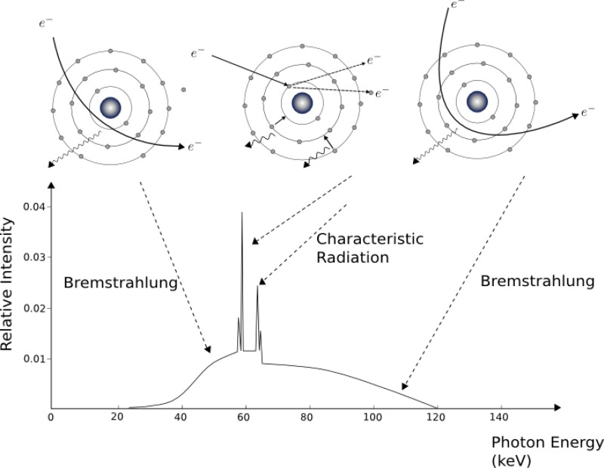
Figure 1. Bremsstrahlung x-ray energy spectrum [5]

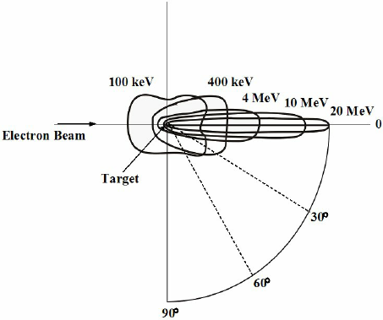
Figure 2. Angular distribution of bremsstrahlung produced x-rays [6]
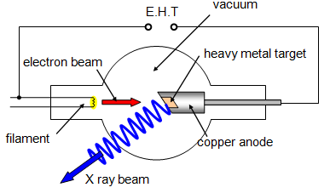
Figure 3. Reflection x-ray source diagram [7]

microwaves. Designers found that by directing these microwaves through a properly formed guide tube, electrons can be accelerated by “riding” the microwaves to energies into the MeV range. The MeV range electrons are then directed to a target that converts some of their kinetic energy to x-rays. The high energy x-rays are primarily generated in the forward direction and a vast majority are able to punch through the target and escape the other side. These types of x-ray sources are utilized when taking radiographic images of larger and denser objects since the x-ray will contain the required energy to maintain a strong signal after passing through the object of interest.

X-ray Interactions in Matter
High energy x-rays primarily interact with material through three methods: the photoelectric effect, Compton scattering, and pair production. The photoelectric effect refers to an interaction where an x-ray is absorbed completely by a target orbital electron and liberates the electron. All of the x-ray’s energy is transferred to liberating the electron from the potential well and the kinetic energy of the liberated electron. Compton scattering describes the process of an x-ray interacting with a target electron and transferring some of its energy, but not all. Both the x-ray and electron are scattered in different directions with different energies. Pair production refers to the process where a high energy x-ray interacts with the field of an atomic nucleus and converts entirely from an x-ray to a position-electron pair. The pair production process only occurs when the x-ray energy exceeds the threshold energy of 1.022 MeV which is twice the rest mass energy of an electron.
The likelihood of each interaction to occur is dependent on the energy of the x-ray and the target atomic number. Figure 4 shows the energy and target combinations where each interaction is dominant [8]. The first curve shows the combinations of x-ray energy and target atomic number where the photoelectric effect is equally as likely to happen as

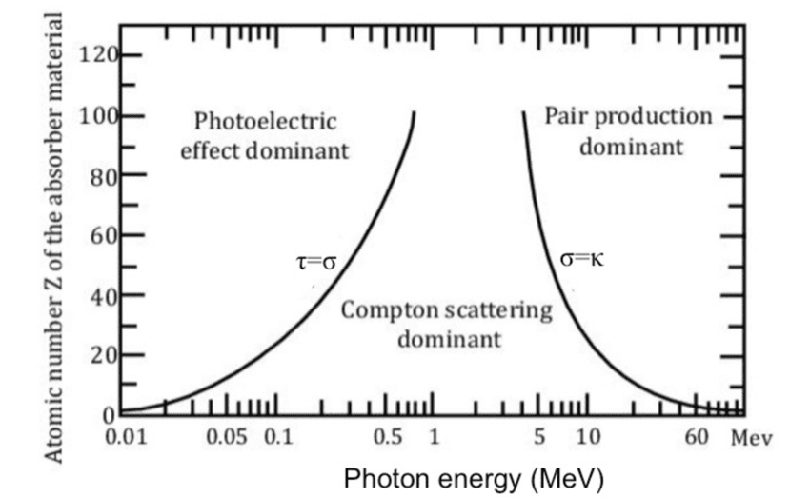
Figure 4. X-ray interaction method likelihood dependent on x-ray energy and atomic number. [8]

Compton scattering. The second curve shows the combinations where Compton scattering, and pair production are equally likely to occur. According to the figure, Compton scattering is dominant in low Z materials where the photoelectric effect and pair production are dominant in higher Z materials. The photoelectric effect tends to dominate with lower energy x-rays and pair production dominates in higher energies. Compton scattering dominates in the energy ranges between where the other two processes dominate. All three processes cause the transmission signal in radiography to decrease while also increasing the scatter noise. X-ray energy, detector system and filters must be carefully selected in order to maintain a high signal to noise ratio.

Radiographic X-ray Detectors
The first detectors used in radiography were photographic films and they are still in use today. Modern films are embedded with silver halide crystal grains which are ionized when exposed to x-rays. Areas of higher x-ray flux have more ionized crystal grains than low flux areas. Through a chemical process, these ionized crystals are converted to an opaque material which creates the image in the film. X-ray films are referred to as negative images since the darker areas are regions that experienced a higher x-ray flux than brighter areas which are transparent.
Modern radiographic x-ray panels utilize electronic detectors which convert radiation energy into charge that can be collected and analyzed. This is done in two primary methods: ionizing a semiconductor material or ionizing a scintillating material. A semiconductor detector gets ionized by an x-ray and creates an electron-electron hole pair. These pairs are subjected to a strong electric field and migrate away from each other to a point of collection. The collected electron-electron hole pairs are converted to an electronic signal that can be processed to determine the type of radiation and energy of the particle. For radiographic purposes, the flux of x-rays is the dominate characteristic of measurement. Scintillator detectors use a scintillating material that produces a flash of light when ionized. The photons produced in the flash of light enter a photomultiplier tube that converts the photons to an amplified charge signal than can then be analyzed.

Monte Carlo Simulation

The Monte Carlo method is a computation method that involves repeated sampling to achieve a numerical result and is used extensively in simulating radiation interactions. A program such as MCNP 6.2 samples from a series of nuclear interaction data libraries [9]. It creates a particle in a specified origin point and assigns an initial direction and energy. The program will then walk through a series of interactions guided by a “role of the dice” and the probabilities for each reaction contained in the data libraries. After each interaction the program rerecords the particles position, direction, and energy. This data is used to calculate the next interaction or end the particle history if it reaches a low energy cutoff or problem boundary. A large number of particles must be simulated in order to achieve a small statistical uncertainty.
Monte Carlo methods are extremely powerful and can take into account the many underlying physics concepts guiding the reactions of particles. This strength comes at a cost because these calculations are extremely computationally expensive, and some simulations can take days or weeks to complete. As with any other computer calculation, the result is only as good as the input. Therefore, special attention must be paid to each input parameter to produce a useful result.

Chapter 3
X-Ray Source Characterization

450 kVp Source Characterization

Beam Spectrum and Profiles
The 450 kVp X-ray source was modeled after the Comet MesoFocus 450 source [10] with a tungsten target angled at 20° with respect to the electron beam, a 40° x 40° illumination field, and a 60 mm distance between focal spot and the outside of the 5.0-mm-thick Be window as shown in Figure 5. In simulation space, the source was modeled as a 205.212 mm radius vacuum cylinder with the 4.25-mm-thick tungsten target inside. The outside of the 5 mm thick beryllium window was placed 60 mm from the focal spot. This simulation geometry replicated tube parameters and achieved the correct 40° x 40° illumination field. All other surrounding systems contained in the MesoFocus tube such as the copper cooling jacket were not simulated. A 300-µm-thick Gd₂O₂S:Pr (GOS) scintillator modeled after the Varex 4343 industrial detector panel [11] was placed 14.0 cm below the outside of the beryllium window. The space below the beryllium window was simulated as air at STP in order to replicate air scatter. An F2 tally plane with the E-card tally modifier for 450 1 keV bins recorded the energy spectrum at the detector plane, and a (40 x 40 cm) (1000 x 1000 pixels) *FMESH4 energy deposition tally in the GOS captured the illumination field profile relative to a standard flat panel imager. This simulation was computationally intensive and required roughly 25.5 billion electrons over a 30-day period on 64-core nodes of the University of Tennessee Nuclear Engineering Department high performance computing cluster. The fmesh image was then extracted using Python 3.9 [12] and converted to multiple text images and rendered in color with Fiji/ImageJ [13].

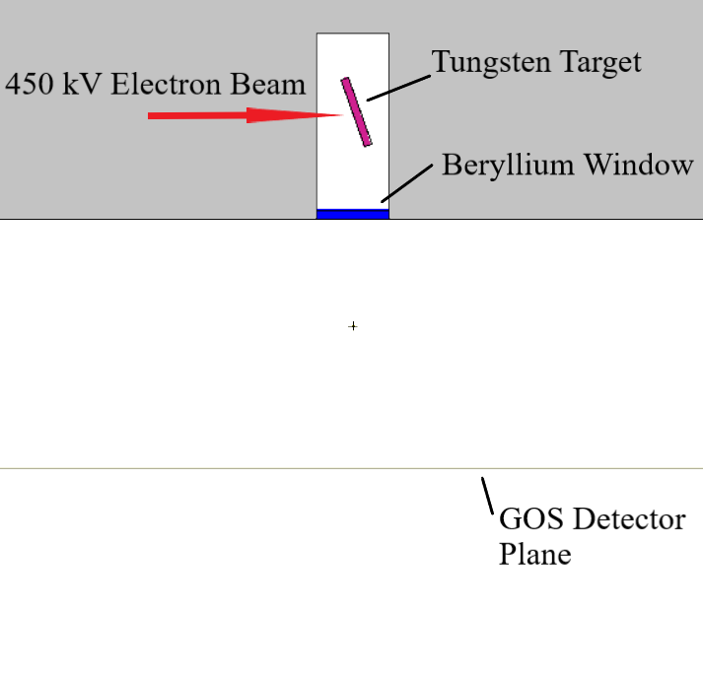
Figure 5. 450 kVp source simulation geometry

Angular Dependent Source Implementation
The angular probabilities which account for the beam heel were implemented into a source definition for use in further simulations. This requires defining an origin point from which all the particles will originate using the POS function, and a reference vector using the VEC function. Next, the angular dependance is established by utilizing the DIR function with the corresponding DI and DP distribution functions which defines a series of starting angles in refence to VEC. Finally, the energy distribution was implemented using the ERG function with the corresponding DI and DP distribution functions which sets a series of possible particle initial energies and assigns a probability to each. A cancelling cylinder was placed around the source location to limit the photons to a 40° x 40° cone beam which made the source definition computationally inefficient because only roughly 11% of photons contributed to a usable beam.

3, 6, 9, and 15 MVp Source Characterization

Target Optimization
The Varex Linatron M9A [14] was the model for the 6 and 9 MVp sources, and the Varex K15 [15] was the model for the 15 MVp source. Due to the proprietary nature of the exact target specifications of the linacs, the ideal thicknesses for tungsten-equivalent targets were reverse engineered. A series of optimization simulations in MCNP6.2 were performed consisting of cylindrical targets with thicknesses ranging from 1.00-4.00 mm in 0.25 mm increments. A 30° tally cone was placed in front of the target to calculate X-ray yield, and each simulation utilized one million source electrons. An example simulation geometry for the 2.00 mm target thickness is shown in Figure 6.

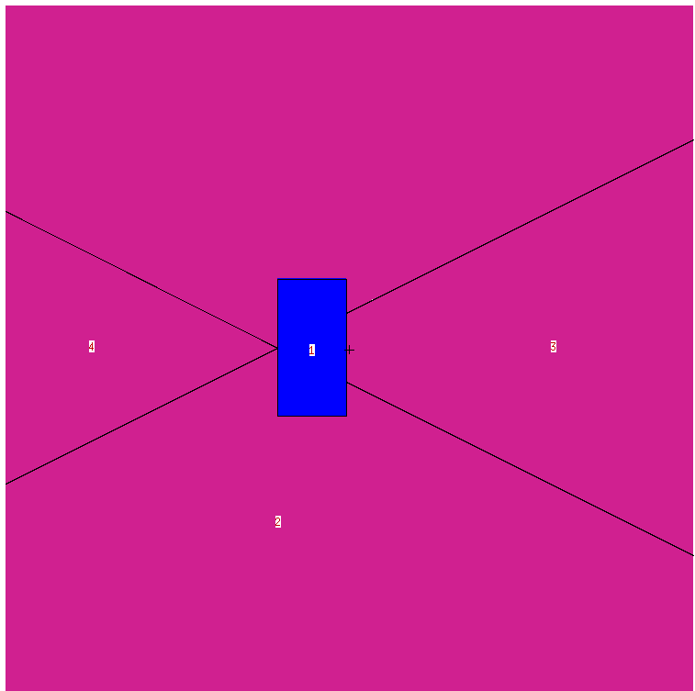
Forward Tally Cone
2.00 mm
Electron Beam
Figure 6. Transmission source electron simulation geometry

Transmission Target Spectra and Angular Dependence
The angular and energy dependent X-ray spectra from the transmission mode linear accelerator targets were acquired using a series of stacked cones within a sphere to create annular tallying volumes for each solid angle from 0°-180° in 1° increments, as shown in Figure 7a-7d. Each annular tallying volume was further subdivided into up to 10-keV wide energy groups for up to 1500 energy bins as in the 15 MV simulation. The target with the ideal thickness was placed in the center of the sphere with an electron beam directed at its center. The target was assumed to be just the tungsten target with no other surrounding support systems such as the copper cooling jacket. Each simulation was computationally intensive, simulating approximately 2.5 billion electrons during roughly 350-hour simulations on 64-core nodes of the cluster. Each spectrum was then extracted, and a series of curves were fit to the energy spectra at key angles.

Angular and Energy Dependent Source Implementation
The angular probability and energy spectrum for each annular region was then implemented into a source definition for each energy. The annular regions and corresponding angular probabilities were produced using the standard DIR distribution definition. The FDIR function was utilized to make the energy distribution dependent on the direction of the source particle. A sample of the source definition is shown below.

SDEF PAR=P POS=0.0 0.0 0.0 VEC=1 0 0 DIR=D999 ERG FDIR D888

The above source definition creates a photon source originating from the (0,0,0) cartesian coordinate position with the source pointed along the positive x-axis. The direction term (DIR=D999) establishes the angular dependency where D999 contains an SI999 card with the cosines of all integer angles from 0° to 180° with respect to the positive x axis and the SP999 card contains the probabilities of a particle originating in each annular region. The original angular probability tally results for each annular region need to be weighted by the surface area of the respective region before being
(a)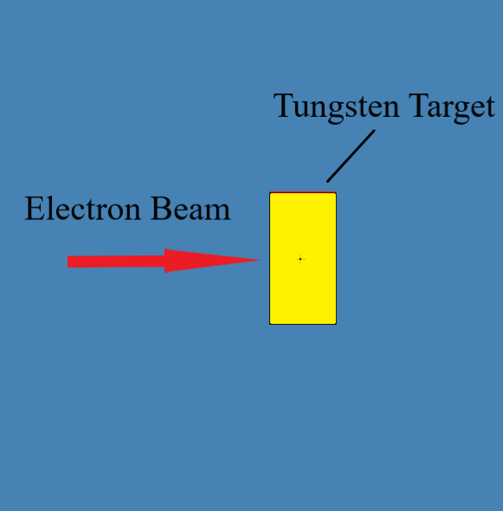 (b)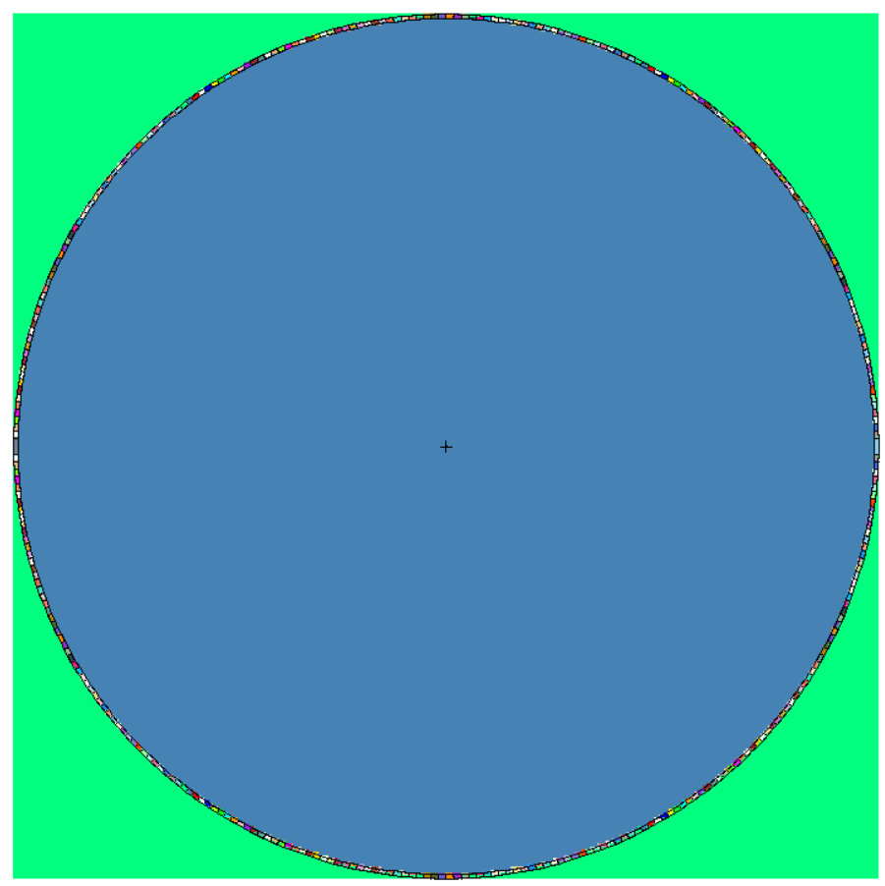
1.375 mm
(c)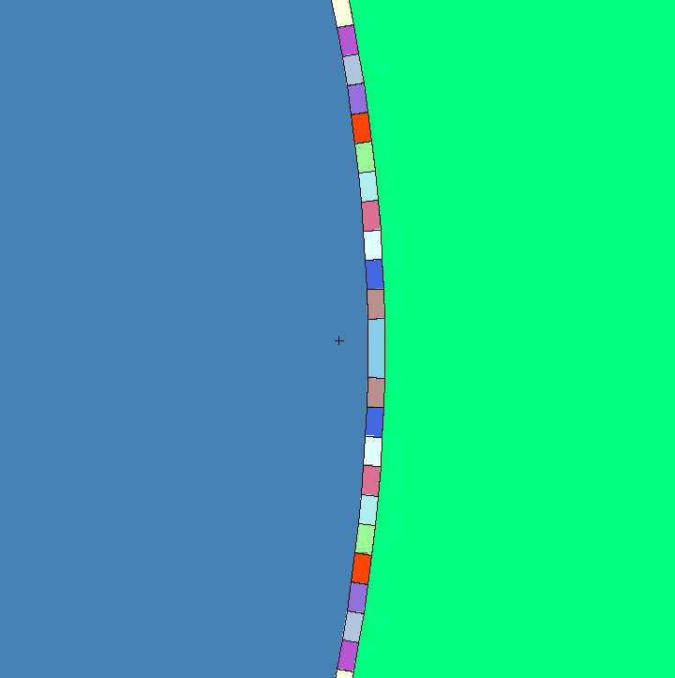 (d)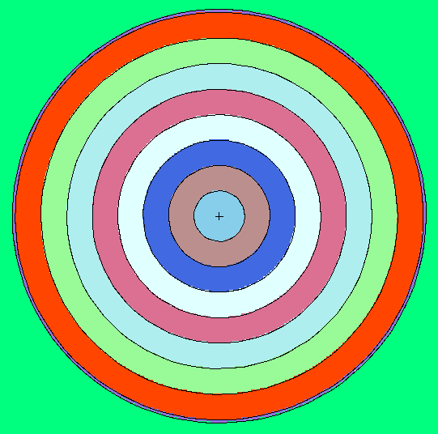
Figure 7. (a) Target geometry (b) side view of entire tally sphere (c) zoomed in side view of 0°-1° to 10°-11° annular tally regions and (b-d) front view of 0°-1° to 7°-8° annular tally regions

implemented into the SP999 card in the source definition. Without the weighting, the smaller annular regions of the new source definitions will be overrepresented and vice versa for the larger annular regions. Next, the energy term (ERG FDIR D888) makes the
energy spectrum distribution dependent on the originating direction of the particle. The D888 distribution contains a DS888 card where each entry is the naming number of the energy distribution corresponding to the annular region in the DIR distribution that shares the same location on each respective list. The DS888 card is followed by a series of SI and SP cards that represent the energy spectrum for each annular region. For example, a photon originates at (0,0,0) and is given an original direction in the 5-6° annular region. MCNP will use the location of the 5-6° annular region from the DIR distribution and find the same location on the DS888 card. This entry on the DS888 card contains the name of the energy distribution that corresponds to the 5-6° annular region. MCNP will then find the SI and SP cards of the same name and use them as the energy distribution.

Chapter 4
Simulation Based System Optimization

Rail Simulation and Optimization

Simulation Geometry
The 450 kVp source was selected as the ideal source due to its smaller size compared to the transmission target style sources and the x-rays still carry sufficient energy to penetrate the rail. The railway chosen to be modeled in simulation space is a 141-railway which weighs approximately 141 lbs per yard of rail length and is the heaviest and thickest railway found in America. It represents the worst-case scenario for radiological investigation with the widest section of the base measuring 6 inches or 152.4 mm thick and the head measuring approximately 3 inches or 77.8 mm thick. Engineering design drawings of the 141 railway were acquired and the geometry of the rail was modeled in MCNP6.2. The rail material was modeled after the carbon steel definition as defined in the Compendium of Material Composition Data for Radiation Transport Modeling from the Pacific Northwest National Laboratory [16]. The rail was oriented laterally with respect to the beam direction such that it would replicate a side image of a railway section and was given a 10° angle such that the head of the rail was closer to the source. This reduces the path length of the x-rays through the thickest parts of the rail, reduces scatter, and maintains a higher transmission signal. The 300-µm-thick GOS detector panel was placed 10 cm behind the centerline of the railway, and a (42.7 cm x 42.7 cm) (3052 x 3052 pixels) *FMESH mesh energy deposition tally was placed inside the GOS detector panel to replicate the Varex 4343 pixel geometry. A *f2 tally plane and E modifier with 1 keV bins was placed at the front of the detector panel to capture the image energy spectrum. The 450 kVp source was placed 37 cm in front of the centerline of the railway to ensure full coverage of the entire railway. An example of the simulation geometry can be found in figure 8.
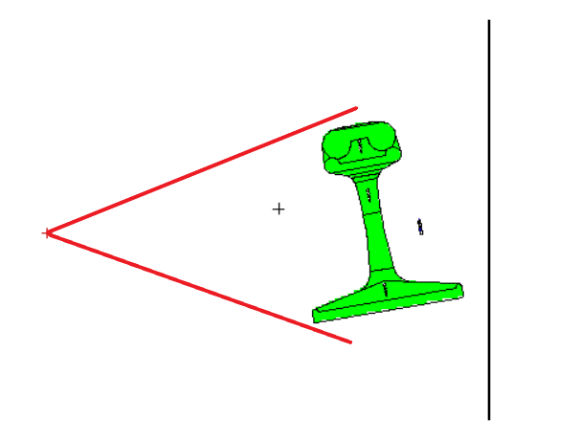
450 kVp X-ray Beam
Line Pair Gauge
GOS Detector Panel
Figure 8. Initial railway simulation geometry

The capabilities of the system were tested by including various sized spherical vacuum voids in the head, web, and base of the rail which ranged in size from 3.0 mm to 0.5 mm diameter in 0.5 mm increments. A line pair gauge was placed 4.5 cm behind the web section of the rail as to not be directly in line with the voids along the beam path. The tungsten rods were modeled in a polycarbonate plastic housing and ranged in size from 1.0 mm to 0.0625 mm diameter with a gap between the rods equal in size to the rod diameter. Images of the voids in the simulation geometry are shown in figures 9 and 10 and the simulation geometry of the line pair gauge is shown in figure 11.

Spectral Engineering
Initial simulation *FMESH images failed to show voids in the head and base areas of the railway though the voids in the web and the line pair gauge were visible. To correct this, scattered x-rays needed to be characterized in order to filter them out. Another simulation was created using a solid railway section with no voids and no line pair gauge and two *FMESH tallies to capture the transmission and scattered detector panel images. The first used an INC=0 modifier which only counts photons that had no previous interactions which resulted in the transmission image. The second tally used the INC=1 INFINITE modifier which counts only photons that had at least one interaction which resulted in a scatter image. The two resulting images allowed for the comparison of areas of the rail where scattered x-rays were the dominate signal.
Filters were then investigated to reduce the scatter noise which was saturating the detector since initial simulations did not include any filters prior to the GOS detector panel. The Varex 4343 detector panel contains a 1 mm thick copper build up filter in front of the GOS panel which was added to the simulation geometry. Next, a 1 mm thick lead filter was added to reduce the intensity of scattered photons. The 1 mm thickness was selected because it is the thickness that reduces the intensity of 150 keV photons by approximately 1 order of magnitude. An image of the updated detector panel with filters geometry can be found in figure 12.
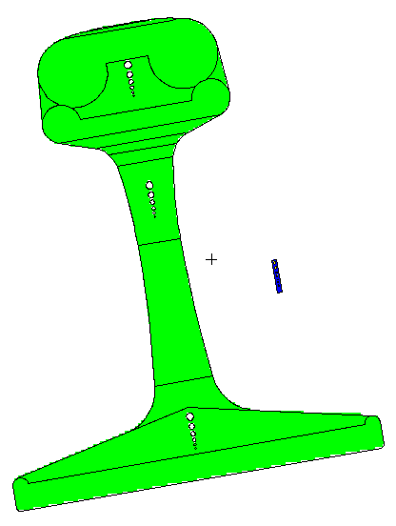

Line Pair Gauge

Air Voids

Figure 9. Air voids and line pair gauge geometry

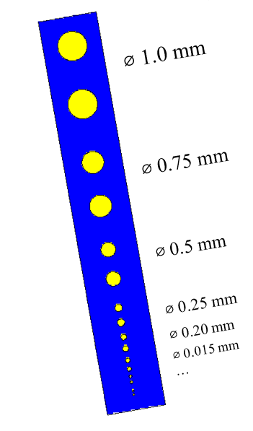
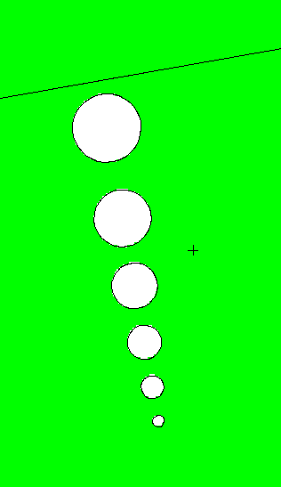

⌀ 3.0 mm

⌀ 2.5 mm

⌀ 2.0 mm

⌀ 1.5 mm

⌀ 1.0 mm

⌀ 0.5 mm

Figure 10. Air voids geometry Figure 11. Line pair gauge geometry
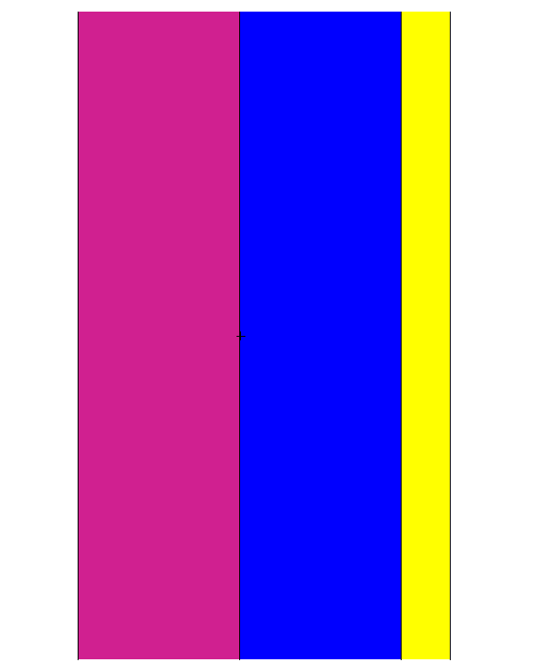
1 mm Cu
300 µm GOS
1 mm Pb
Figure 12. Simulated filter geometry

Attenuation Correction
The attenuation of photons through a thick material can be modeled using equation 2.

$N\left(x\right)= N_{0}e^{-μx}$ [2]

N is the number of x-rays, µ is the attenuation coefficient and x is the distance traveled in the material. This works well for hand calculations, but it is a simplification. In reality the attenuation of photons does not follow an exact exponential decay function and thus needs to be accounted for in order to accurately estimate void size in thick material. To do this, a simulation was conducted using the 450 kVp x-ray source energy spectrum but the cone beam was replaced with a cylindrical beam. The 1 mm thick filters and GOS detector panel with FMESH and f2 with E modifier tallies as mentioned above were kept. The railway section was replaced with a carbon steel step wedge with thicknesses ranging from 10-110 cm in 10 cm increments and 2.0 cm tall steps. The resulting intensity for each step in the *FMESH image can be plotted, and the non-simplified attenuation curve can be obtained. Also, an offset step wedge was placed next to the original step wedge with thicknesses ranging from 8-108 cm in 10 cm increments. The step wedges simulation geometry can be found in figure 13 and figure 14.

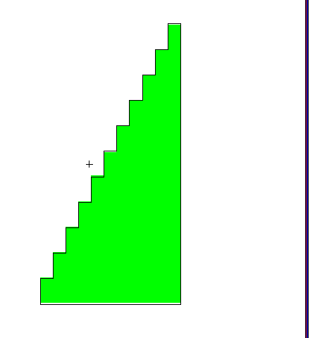
110 cm
100 cm
90 cm
80 cm
70 cm
60 cm
50 cm
40 cm
30 cm
20 cm
10 cm
Figure 13. Step wedge simulation geometry

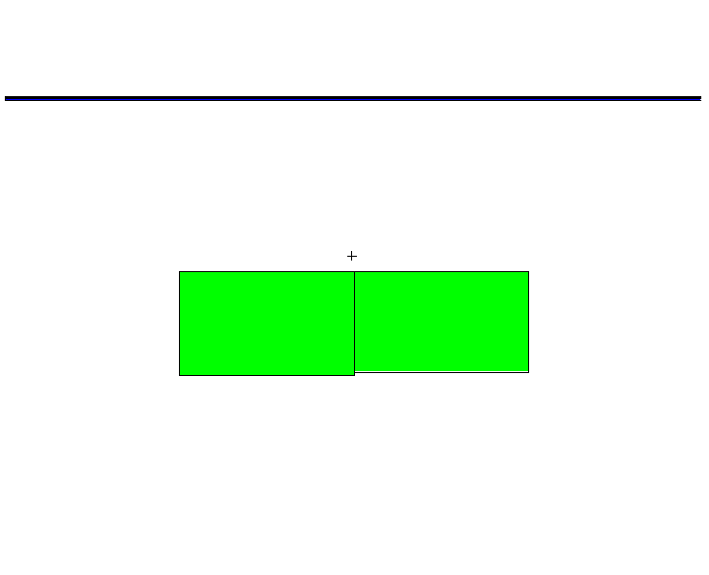
48 cm
50 cm
Figure 14. Offset step wedge simulation geometry

Chapter 5
Results and Discussion

Source Characterization

450 kVp Beam Spectrum and Profiles
The fmesh image of the X-ray distribution from the 450 kVp simulation can be found in Figure 15. The F2,E tallies of the 450 kVp 40° illumination field resulted in the spectrum and curve fit shown in Figure 16. The simulated 450 kVp spectra unveils the many expected low energy characteristic X-rays and an absorption edge around 70 keV. Table 1 in the appendix shows the polynomial coefficients for the fit shown in Figure 16. The *FMESH4 tally image segmented orthogonally resulted in both the beam heel profile and the perpendicular beam flatness profile and their respective fits shown in Figures 17 and 18, respectively. Table 2 in the appendix shows the polynomial fits for the beam heel and flatness profiles. The beam flatness curve and the beam heal curve reveal that the beam is not expected to have the same intensity across the entire illumination field. This simulated data can be used to correct detector output. Figure 19 shows the comparison between the beam heel profile from the source characterization simulation and the implemented source definition.

3, 6, 9, and 15 MVp Target Optimization
A 1.375 mm W-equivalent target yielded the maximum number of X-rays in the forward 30 degree cone for the M9A operating at 9 MV while 1.750 mm W-equivalent target yielded the maximum amount of X-rays for the K15 in the forward 30° cone. A 1.375-mm-thick target was also used for the 3 and 6 MVp sources. Curves showing X-ray yield versus target thicknesses for the 9 MVp and 15 MVp simulations are shown in Figure 20 and Figure 21 respectively.
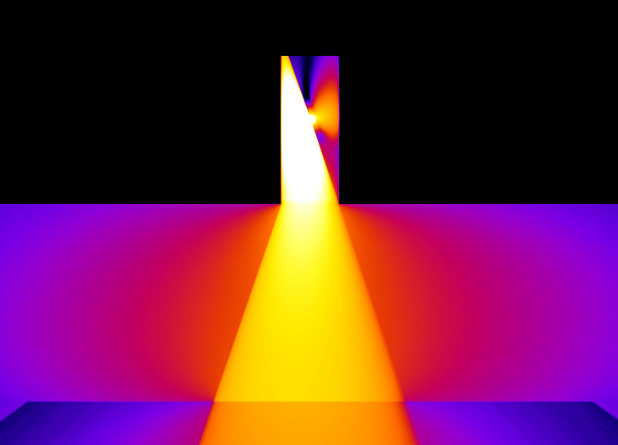
-8.15 | Log(x-ray/electron) | -4.90

Figure 15. 450 kVp source x-ray distribution

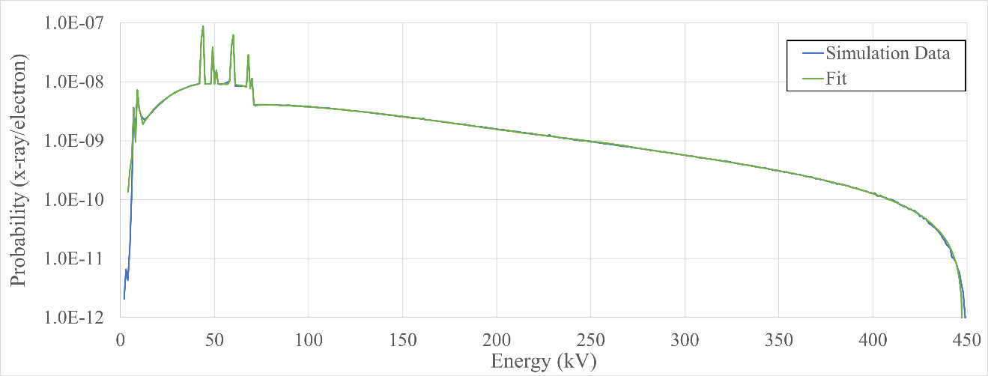
Figure 16. 450 kVp energy spectrum and fit

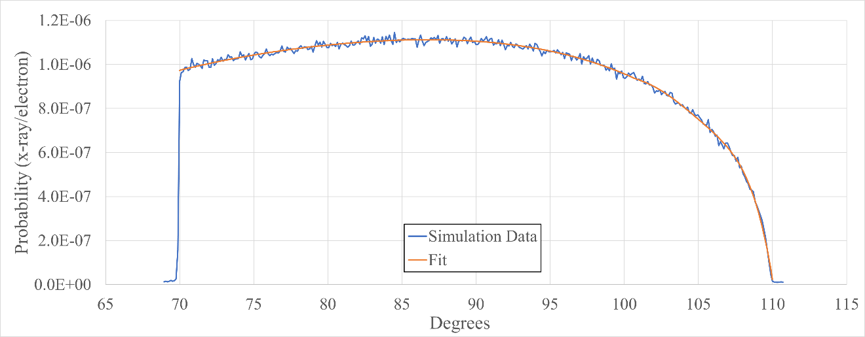
Figure 17. 450 kVp beam heel profile and curve fit

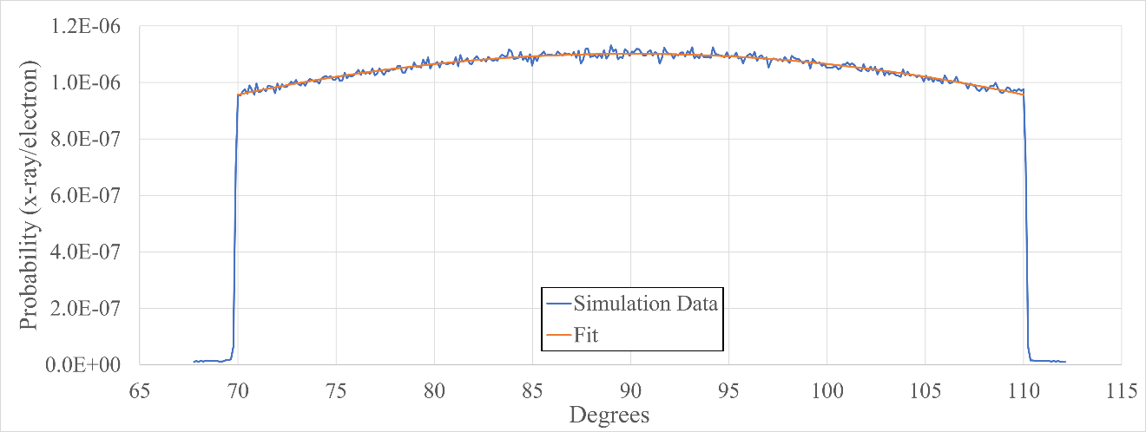
Figure 18. 450 kVp beam flatness profile and curve fit

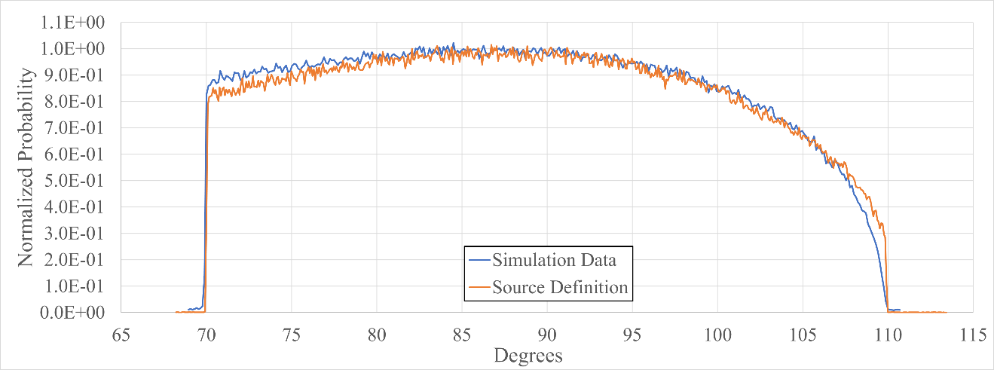
Figure 19. Comparison of simulation beam heel and implemented source beam heel

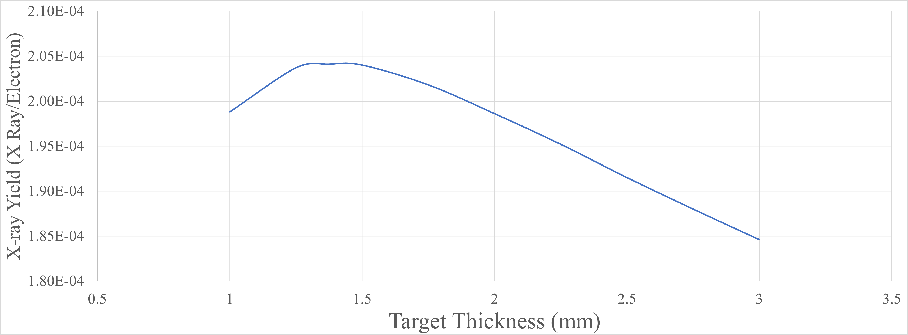
Figure 20. 9 MVp target thickness yield

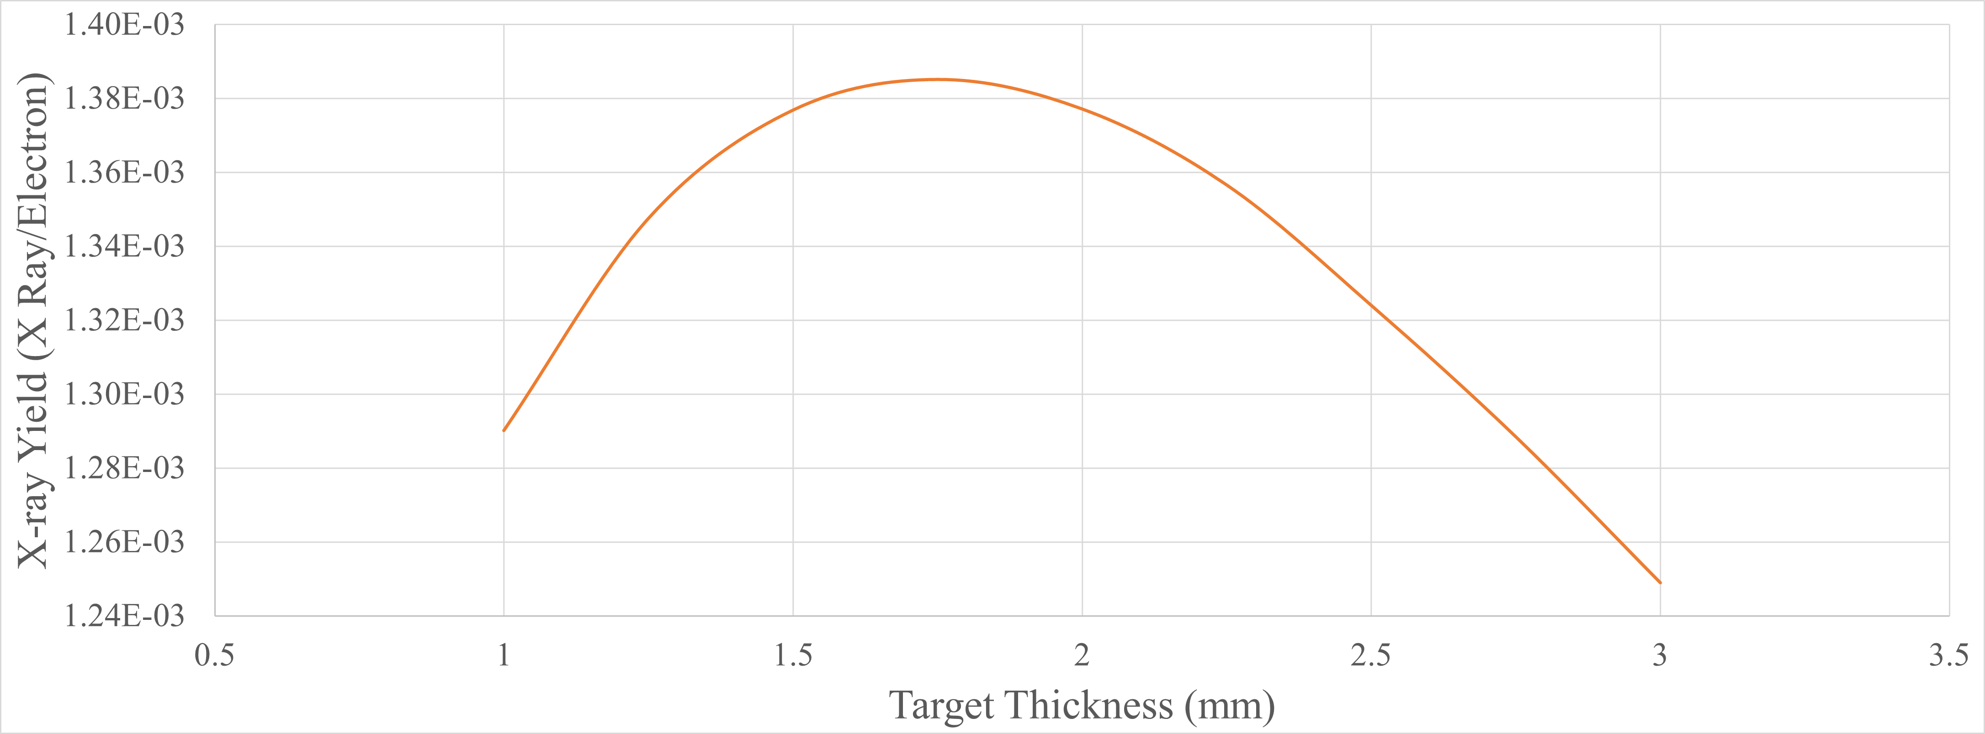
Figure 21. 15 MVp target thickness yield

Transmission Target Energy and Angular Dependence
Each annular region tallied the yield of x-rays in said annular region per source electron. Figures 22 and 23 show the x-ray yield angular dependance of the transmission targets. The polar plots show the increasing yield of x-rays from the transmission targets as the energies increase and how much more forward scattered the higher energy (9 and 15 MVp) sources are compared to those of lower energies (3 and 6 MVp). Figure 24 shows the energy spectra from each source in the forward 0°-1° annular region. The data shows that as the energies decrease, the target is expected to produce many more side- and back-scattered x-rays. In fact, the 6 and 9 MVp sources are expected to have more backscatter than the 15 MVp source, even though the overall yield from the 15 MVp source is much higher. It must be noted though that the backscattered x-rays from the 15 MVp source are expected to be much higher energy than the 6 or 9 MVp backscattered x-rays. These can be important considerations when designing shielding around a source.

3 MVp Source Characterization
Key angles were selected to perform curve fits namely 0°, 5°, 10°, 45°, 90° and 180°. The spectrum for each of these angles is shown in Figure 25. The polynomial piecewise curve fits for each spectrum are shown in Table 4 in the appendix. Figure 25 clearly shows the backscattered direction shares almost the same intensity as the forward direction but does have a lower average energy. This information can be useful in shielding designs for lower energy transmission sources.

6 MVp Source Characterization
Key angles were selected to perform curve fits namely 0°, 5°, 10°, 45°, 90° and 180°. The spectrum for each of these angles is shown in Figure 26. The polynomial piecewise curve fits for each spectrum are shown in Table 5 in the appendix. Figure 26 shows that bremsstrahlung produced x-rays tend to be more forward scattered as the

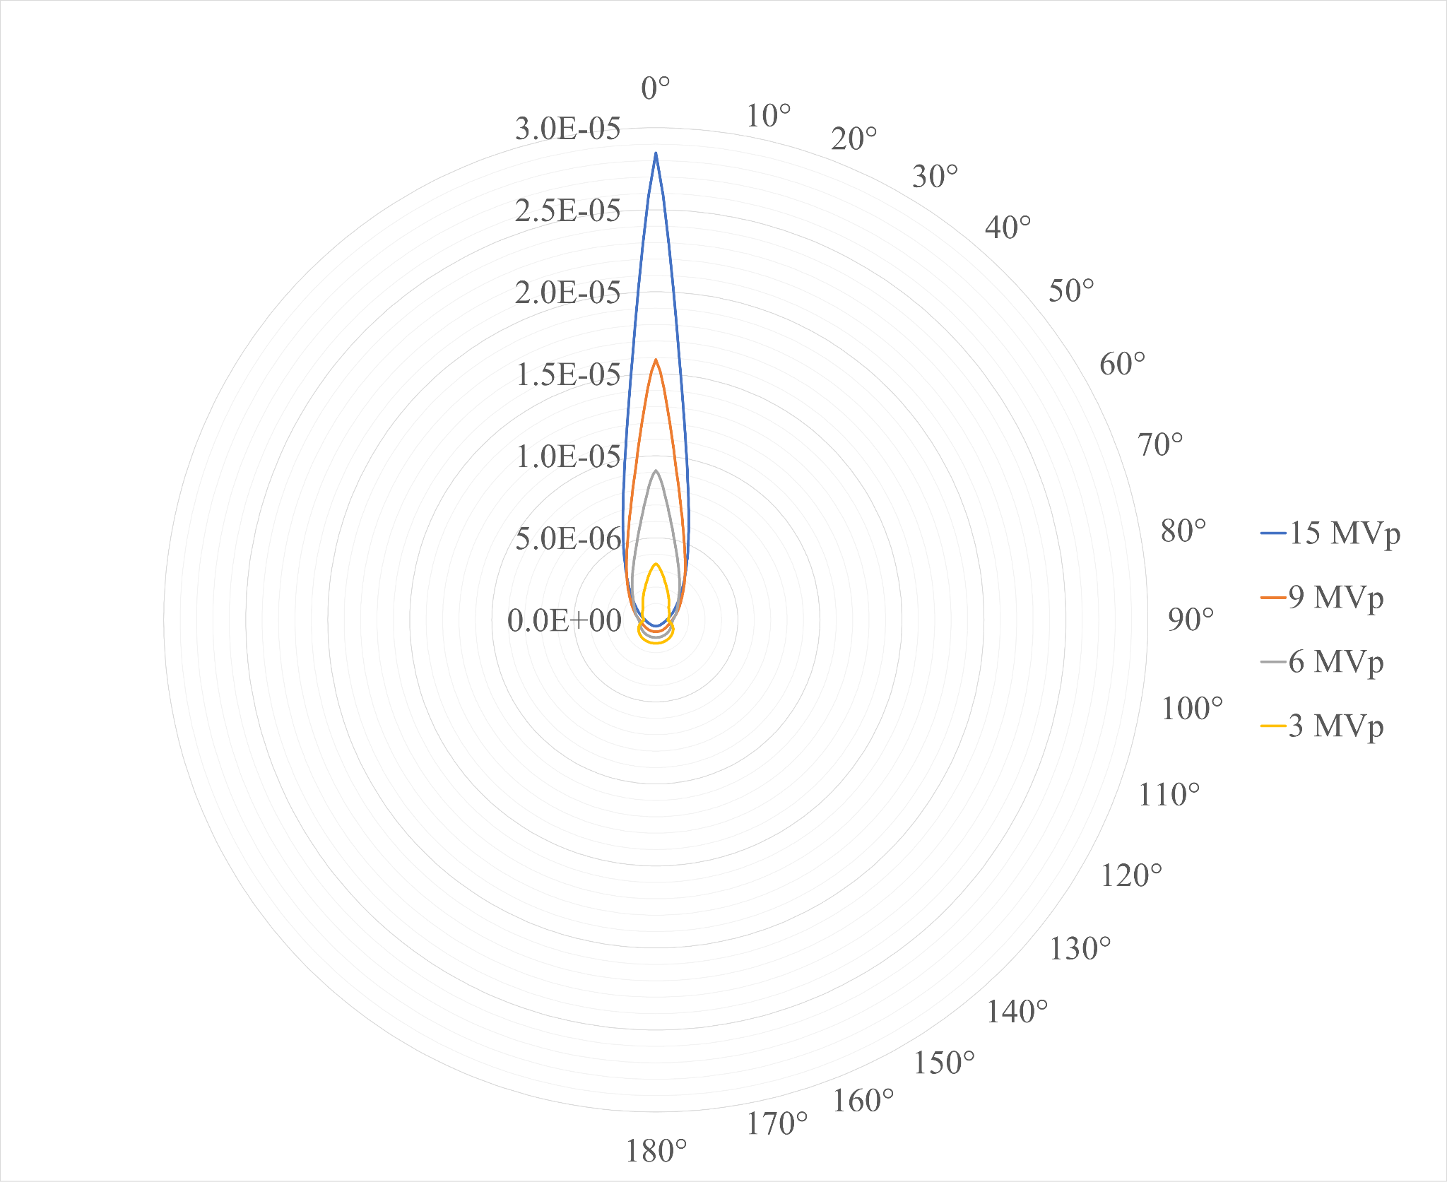
Figure 22. Transmission targets angular probabilities [/sp/MeV]

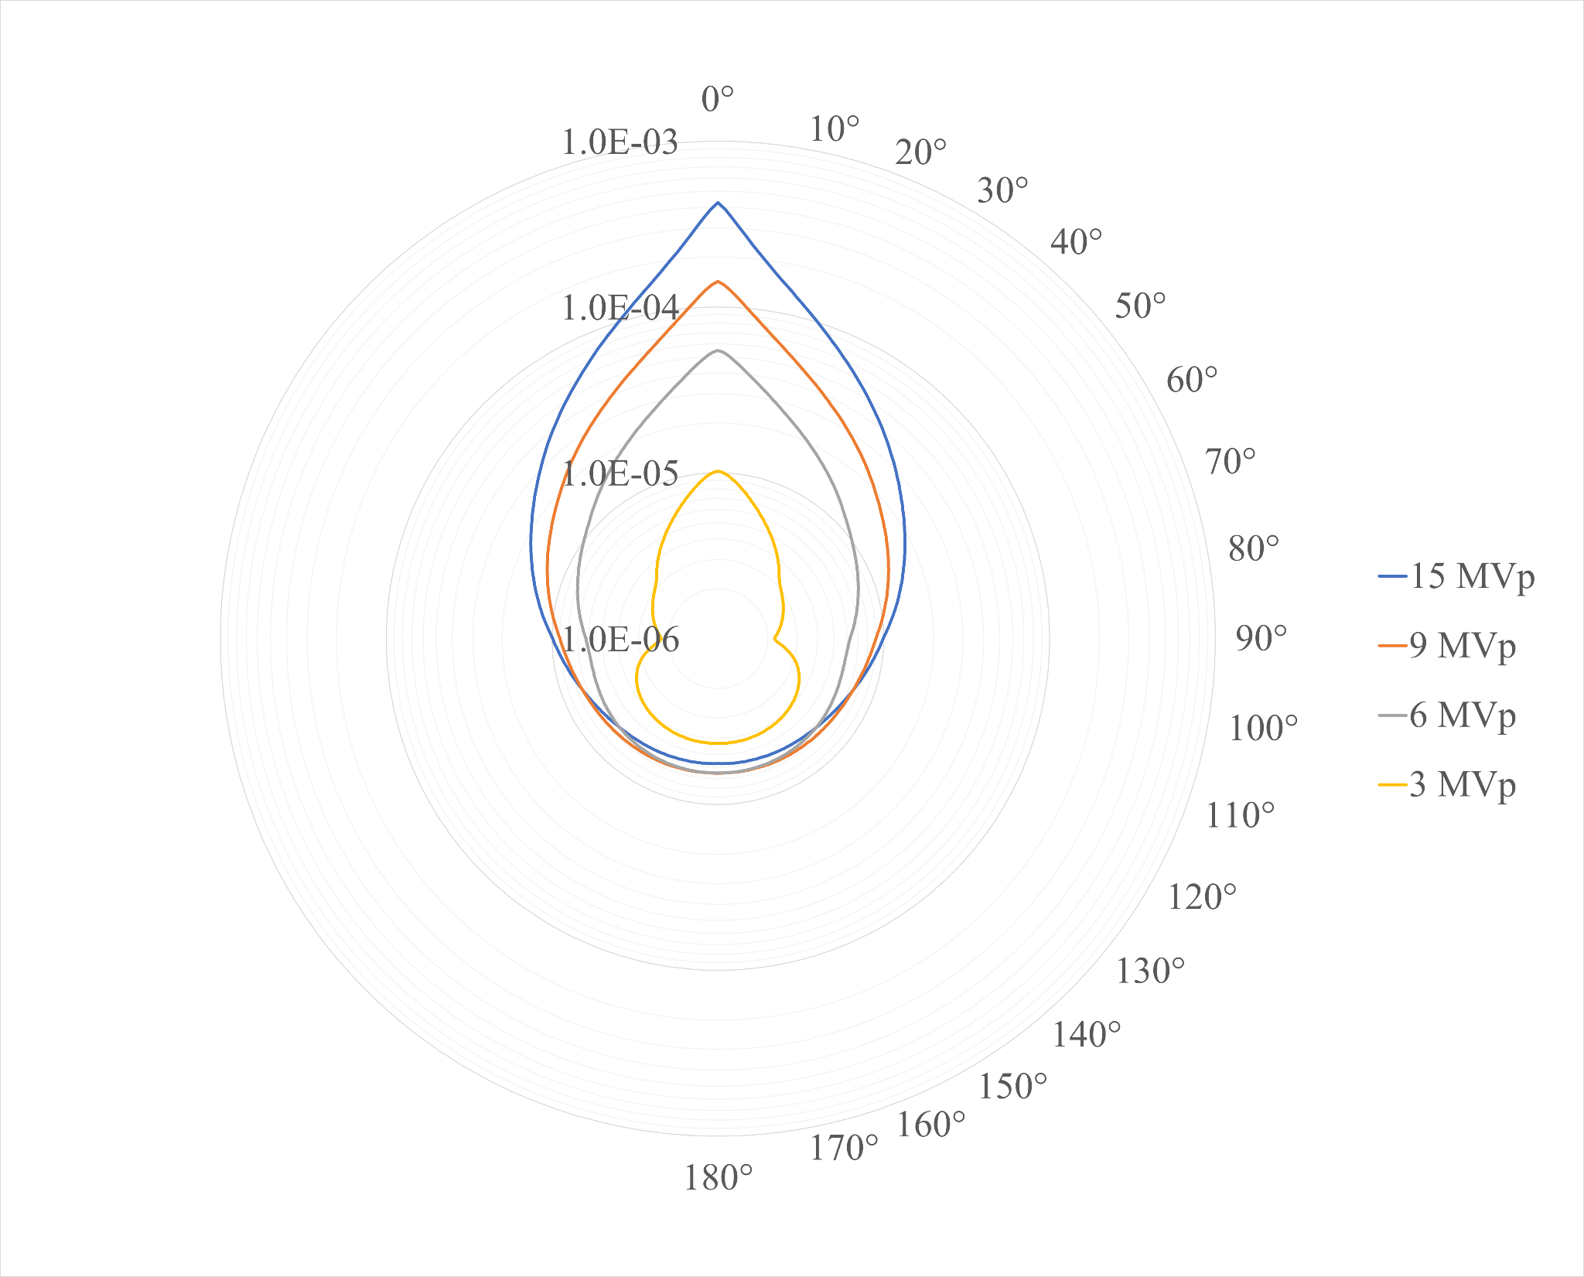
Figure 23. Transmission targets angular probabilities [log(/sp)]
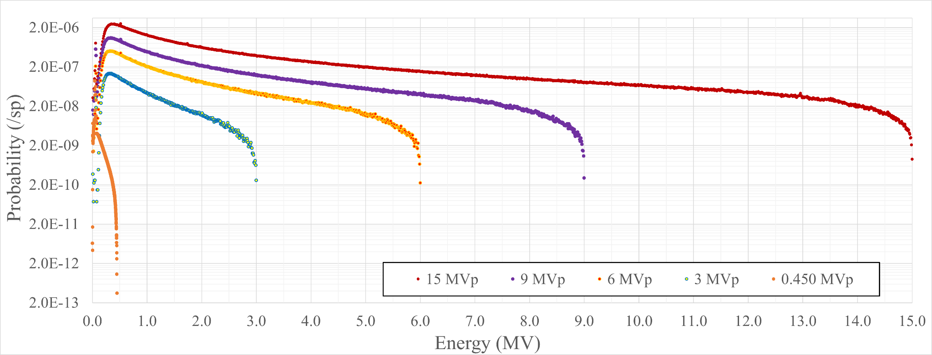
Figure 24. Forward 0°-1° energy spectra for {0.45, 3, 6, 9, 15} MVp

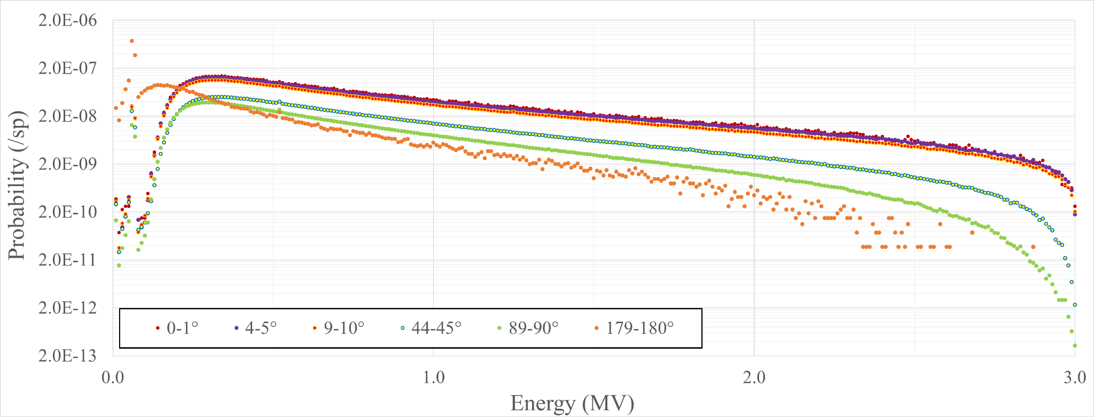
Figure 25. 3 MVp key angles energy spectra

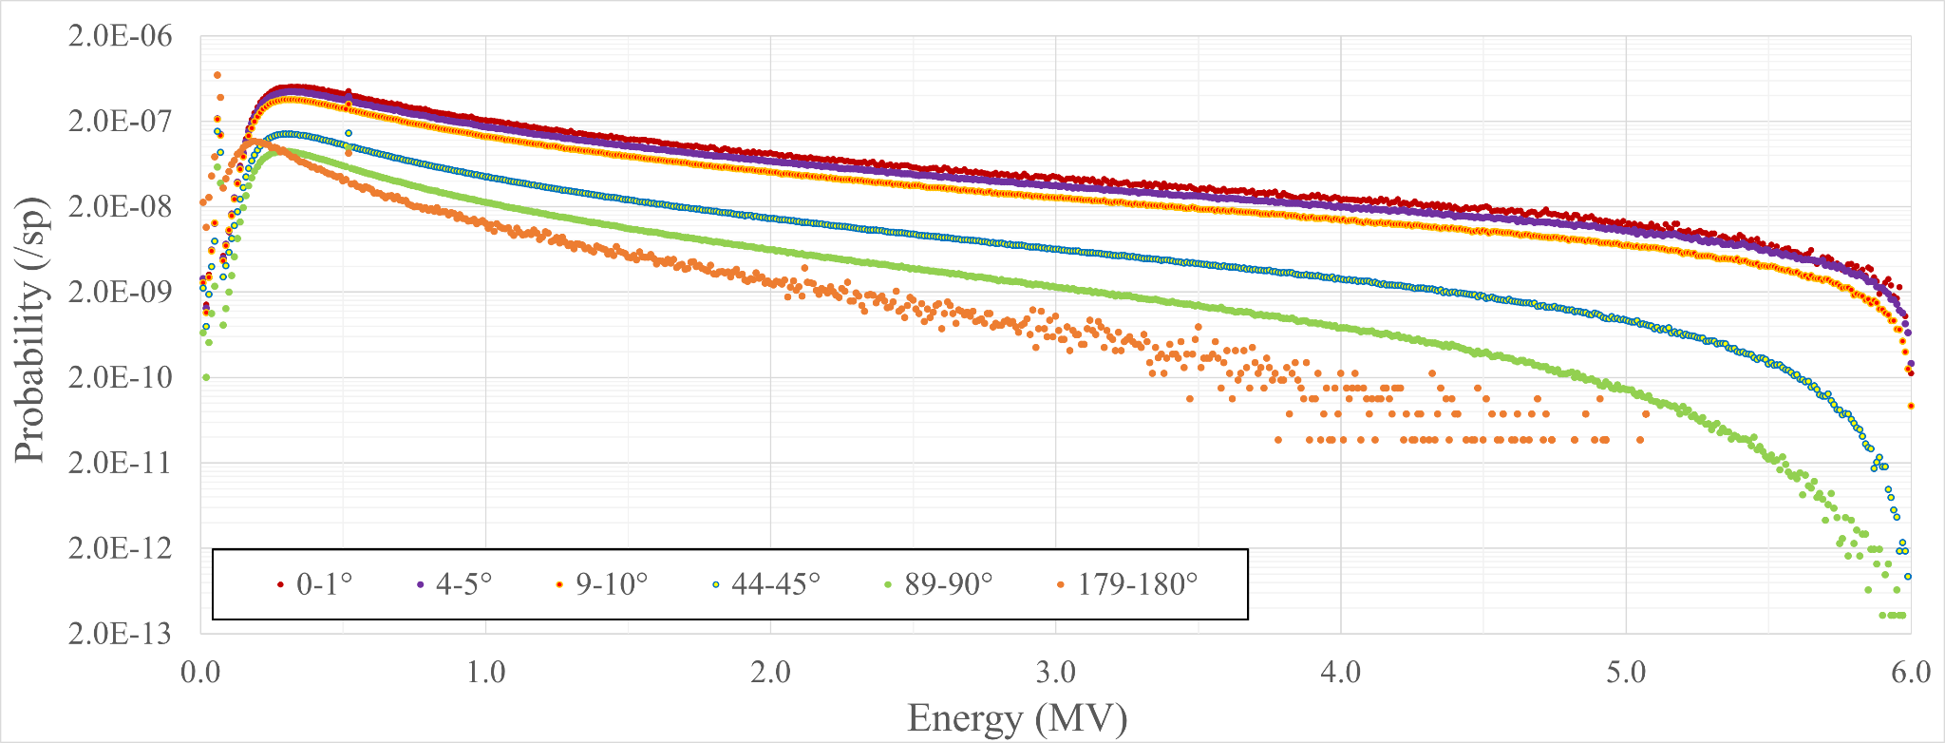
Figure 26. 6 MVp key angles energy spectra

energy increases. Unlike the 3 MeV key angles plot, the forward directions have a much higher overall intensity than the backscattered angles.

9 MVp Source Characterization
Key angles were selected to perform curve fits, namely 0°, 5°, 10°, 45°, 90° and 180°. The spectrum for each of these angles is shown in Figure 27. The polynomial piecewise curve fits for each spectrum are shown in Table 6 in the appendix.

15 MVp Source Characterization
Key angles were selected to perform curve fits namely 0°, 5°, 10°, 45°, 90° and 180°. The spectrum for each of these angles is shown in Figure 28. The polynomial piecewise curve fits for each spectrum are shown in Table 7 in the appendix.

System Optimization

Source Selection and Initial Simulations
The 450 kVp source was selected as the most likely source to be successfully implemented in a real-world design. The smaller size would allow for easier implementation into existing equipment, and an initial simulation of the railway with voids and line pair gauge was performed and the resulting *FMESH image is shown in figure 29. The image shows sufficient x-ray fluence to create an image where the line pair gauge and voids in the web are visible, but the voids in the head and base are not visible.

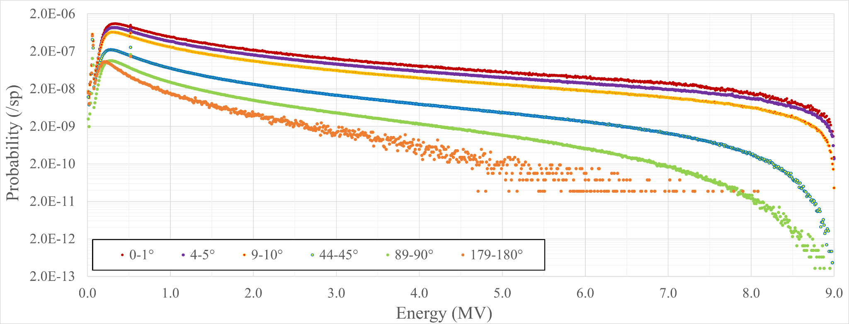
Figure 27. 9 MVp key angles energy spectra

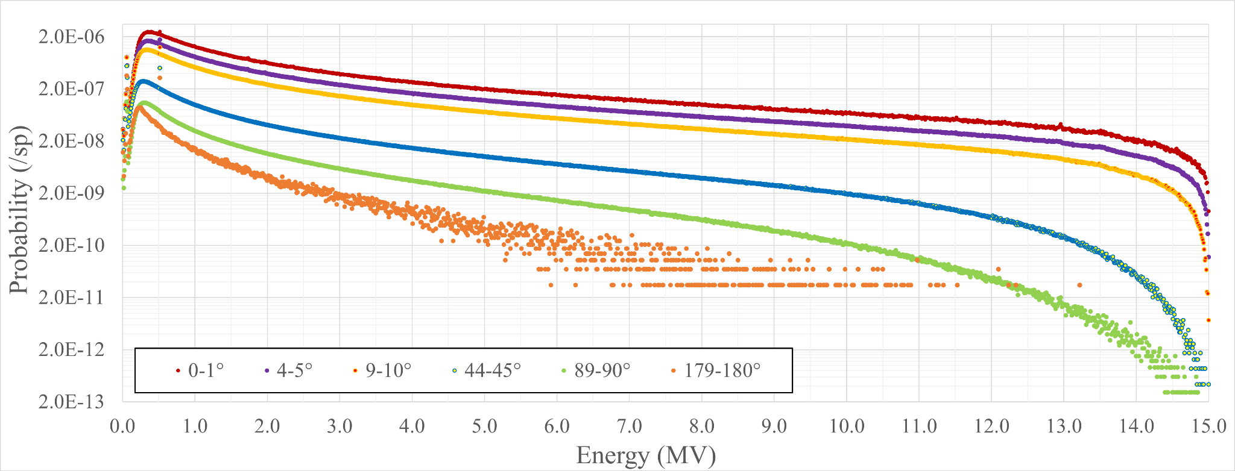
Figure 28. 15 MVp key angles energy spectra

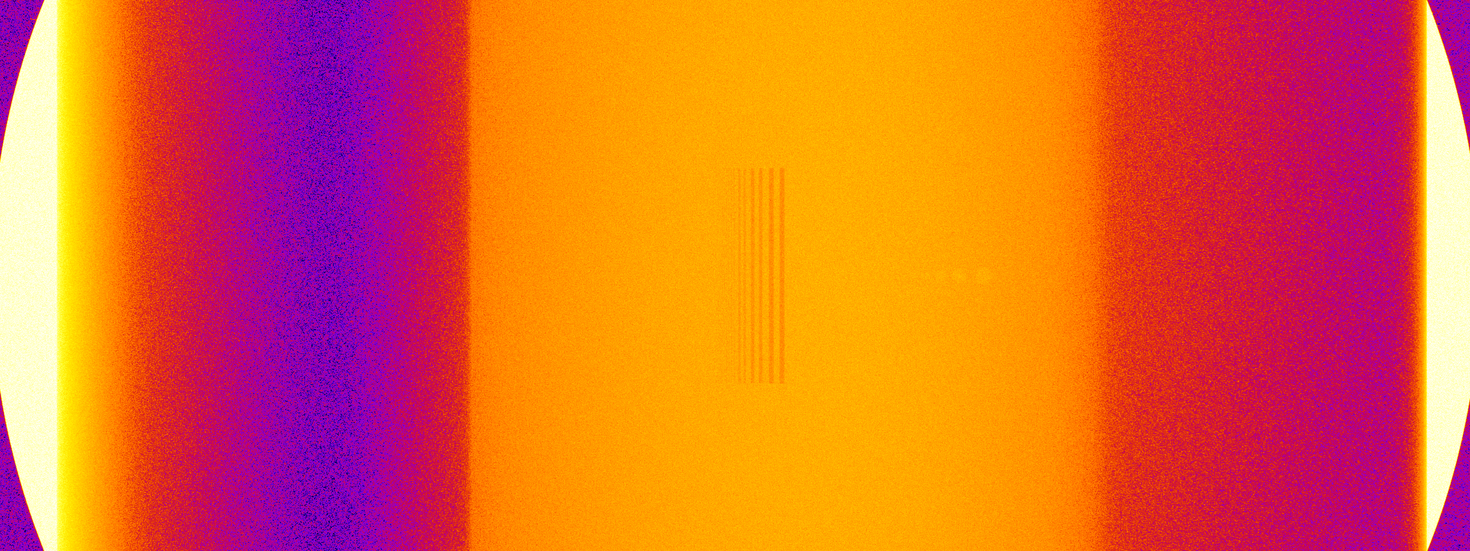
Line Pair Gauge
Web Air Voids
Figure 29. Initial *FMESH image

Spectral Engineering
Since the initial *FMESH image failed to show the voids in the head and base of the rail, the scatter signal must be characterized. The resulting transmission image from the FMESH INC simulation with a solid railway section is shown in figure 30 A and the resulting scatter image is shown in figure 30 B. The highlighted sections in figure 30 B show the areas where the scatter signal has a greater intensity than the transmission image which causes the loss of detail in those areas.
Transmission images from a non-filtered head view simulation and a filtered head view simulation of a railway section with voids are shown in figures 31 A and 31 B respectively. Key differences between the two images are the greatly reduced amount of scatter coming through the web and the middle of the head. Second, the air voids in the
head are visible in the filtered image. This proves the 1 mm Pb and 1 mm Cu filters are able to increase the SNR enough to produce a quality image in simulation space. The relative intensity plot for the filtered head view image is shown in figure 32 where one can easily discern the 3.0-, 2.5-, and 2.0-mm air voids. Figure 33 shows an enlarged view of the intensity plot at the air voids, and the 1.5 mm air void is visible graphically. A greater number of particles could be simulated to reduce statistical uncertainty further to investigate if the 1.0-, and 0.5 mm voids would be visible.
The energy spectra measured in the unfiltered and filtered head simulations are shown in figure 34. The plot shows the large decrease in low energy x-ray intensity which corresponds to a drop in scattered photon intensity. The higher energy x-rays which are considered to be non or only slightly scattered suffer only a small decrease in intensity. This plot exemplifies that while a filter does reduce the total signal reaching the detector, it preferentially removes the noise over the transmission image.
An Enhance Local Contrast (CLAHE) filter was applied to the filtered transmission image which makes the voids easier to discern as seen in figure 35. Another simulation was conducted with a solid rail piece and the resulting image was subtracted from figure 31B to see the differences of intensity between the solid rail and the rail with voids. The resulting difference image is shown in figure 36.

(A)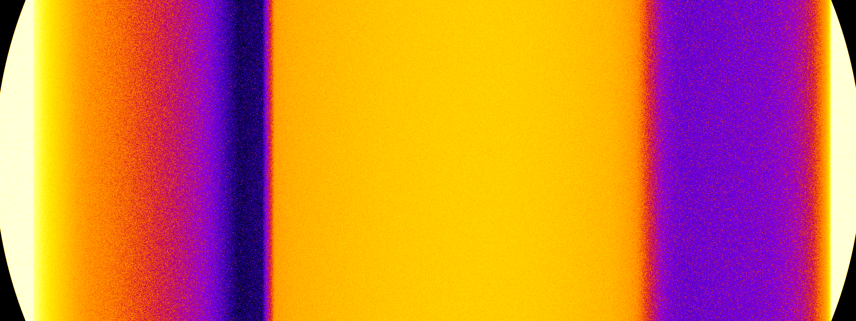 (B) 
-8.75 | Log(/x-ray) | -3.75

Figure 30. (A) FMESH transmission image and (B) scatter image

(A)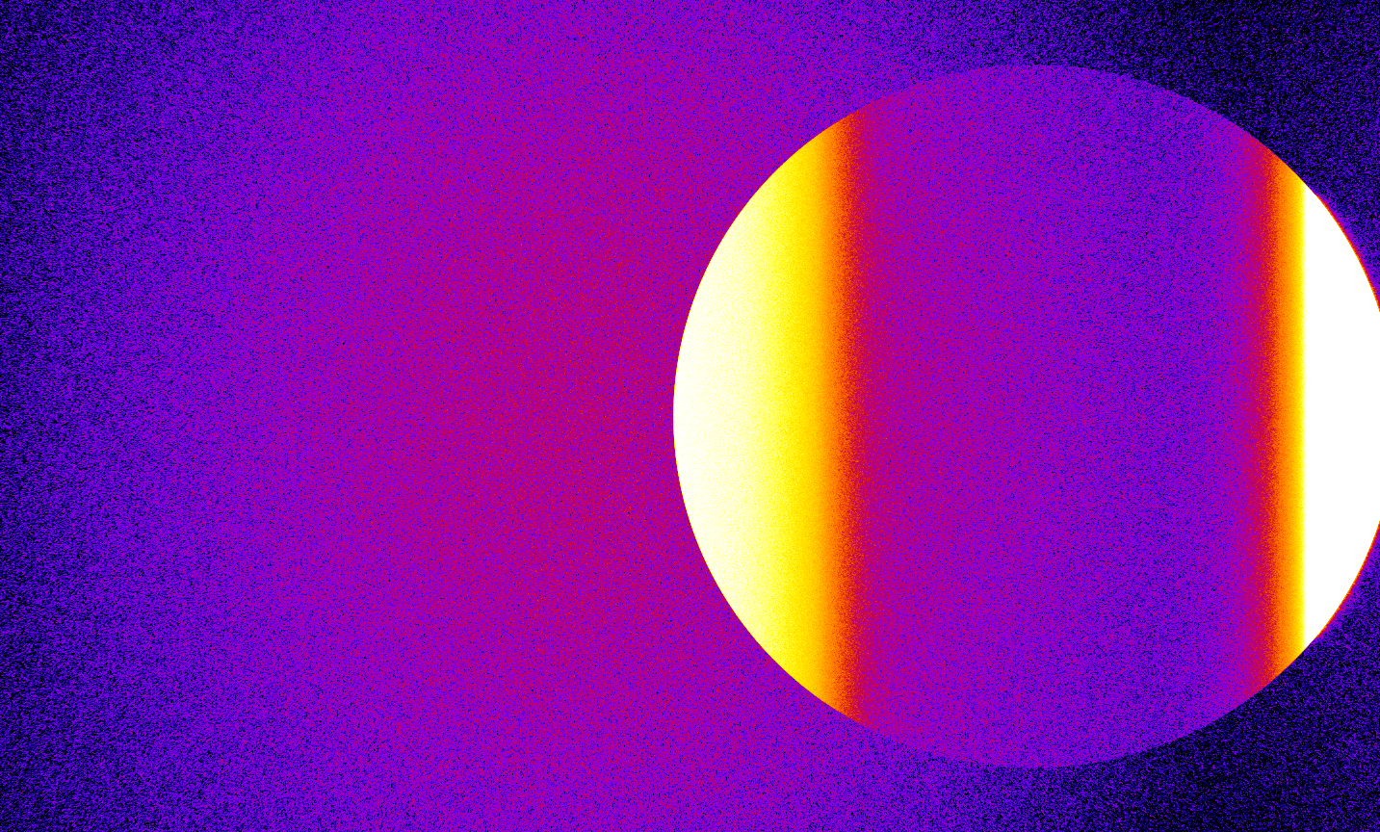 (B)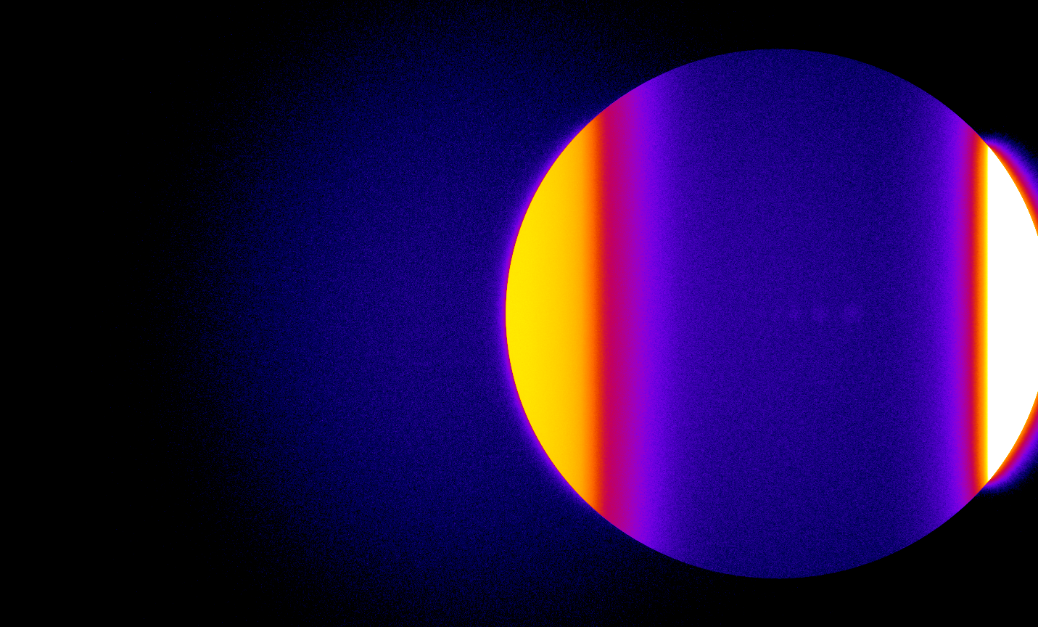
-6.25 | Log(/x-ray) | -4.00

Figure 31. (A) Non-filtered *FMESH image and (B) filtered *FMESH image

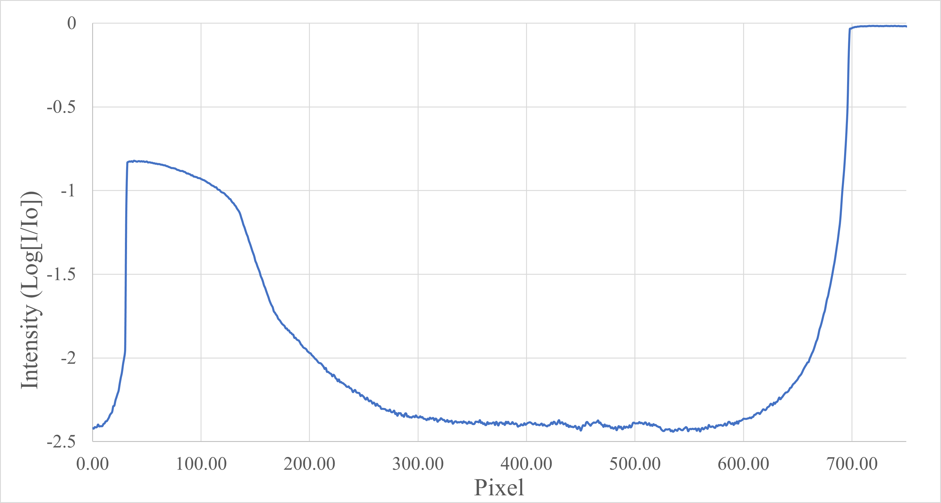
Figure 32. Filtered rail head intensity profile

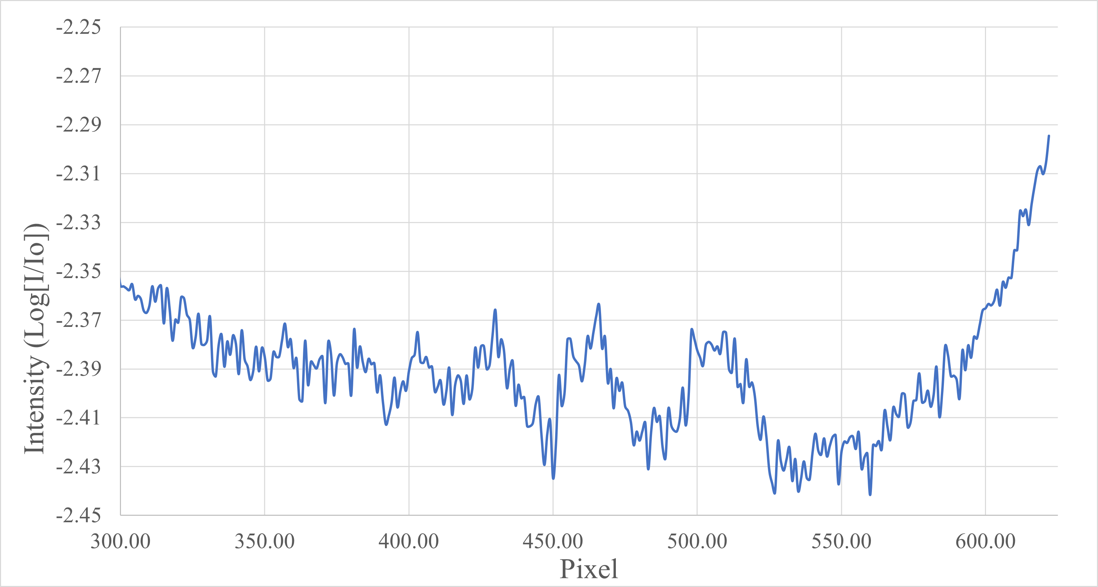
1.5 mm
2.0 mm
2.5 mm
3.0 mm
Figure 33. Filtered rail head voids intensity profile

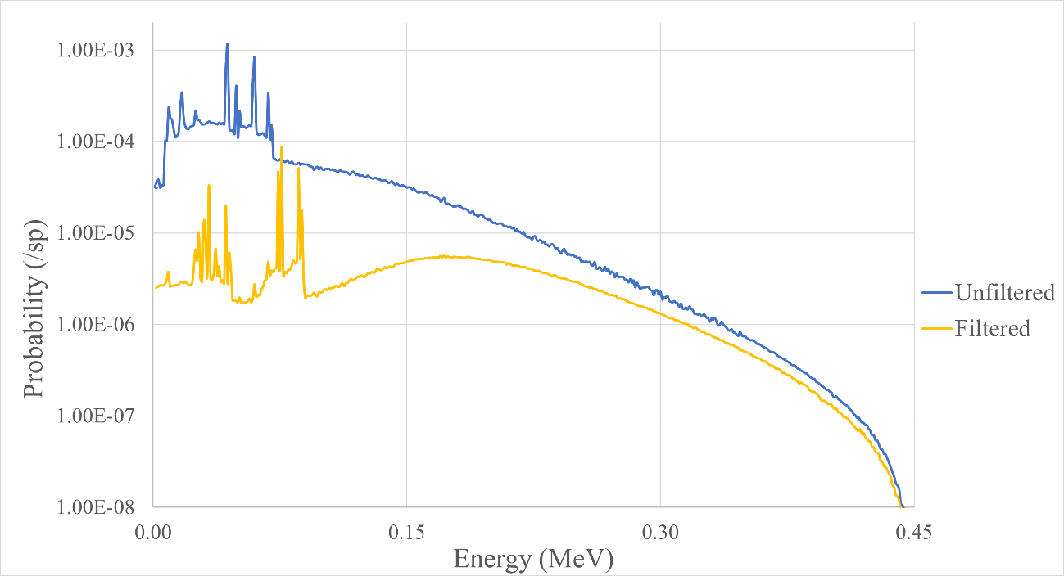
Figure 34. Filtered vs unfiltered F2,E energy spectrum

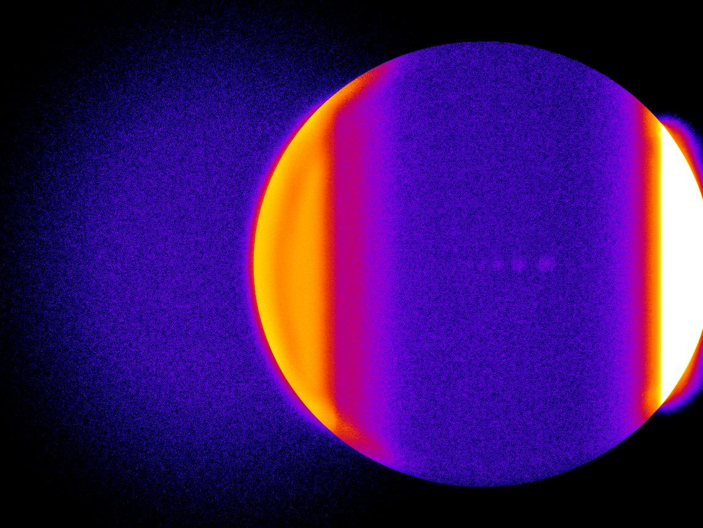
Figure 35. Filtered transmission image with CLAHE filter

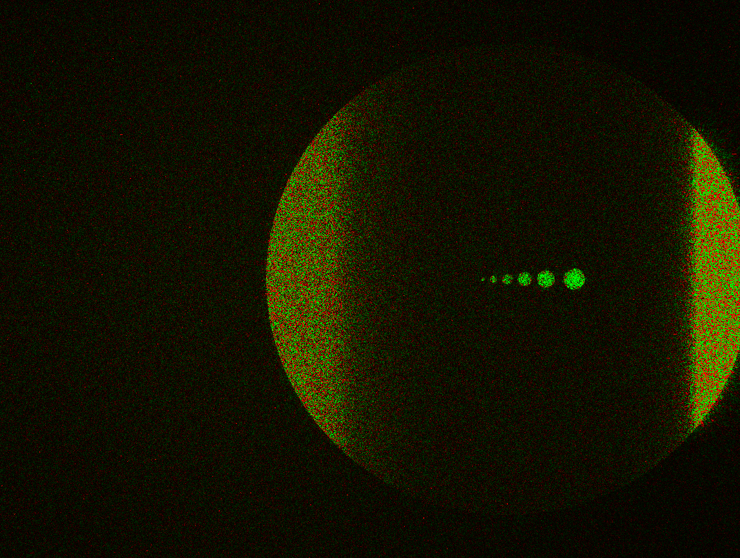
Figure 36. Solid and Void rail Difference Image

Both the CLAHE and difference images make the voids easier to distinguish. One can see the 2.0 mm void in the head in the CLAHE image, but the difference images makes the 0.5 mm void visible. The difference image shows the better result but does require an image of a rail with no internal defects or variation in outside contour which may be difficult in real world practice.

Attenuation Correction
Figure 37 displays the filtered transmission image through the step wedges, and figure 38 shows the relative intensity plot of the transmission image for the step wedge
and offset step wedge. The brown line in figure 37 indicates where the offset step wedge transmission intensity was measured for figure 38 and the green line indicates where the
step wedge transmission intensity was measured. Figure 38 displays the dependance of intensity difference based on thickness variation. For instance, the 10 cm step wedge thickness corresponds to the 8 cm offset step wedge thickness which is a 20% difference, and the 100 cm step wedge thickness corresponds to the 98 cm offset step wedge thickness which is a 2% difference. The intensities of the step wedge and offset step wedge in the 100 cm thickness is distinguishable which indicates that the simulated system can distinguish a 2% difference in thickness. Further investigation with thicker step wedges could find the lower thickness differentiation limit.
The minima for each thickness in figure 38 were found and plotted in figure 39. A linear and a 2nd order polynomial curve fits were fitted to the minima and figure 39 shows the 2nd order polynomial fit matches the data more precisely than the linear fit. This attenuation correction factor will be useful when estimating the size of voids through in thicker sections of the rail. Fit coefficients and R² values for the linear and 2nd order polynomial fits are shown in table 8 in the appendix.

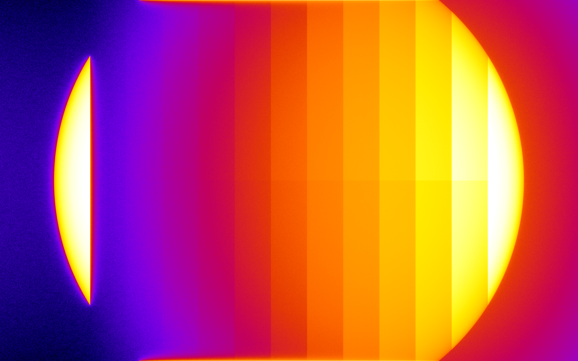
-17.25 | Ln(/x-ray) | -10.25
Figure 37. Step wedges filtered transmission image
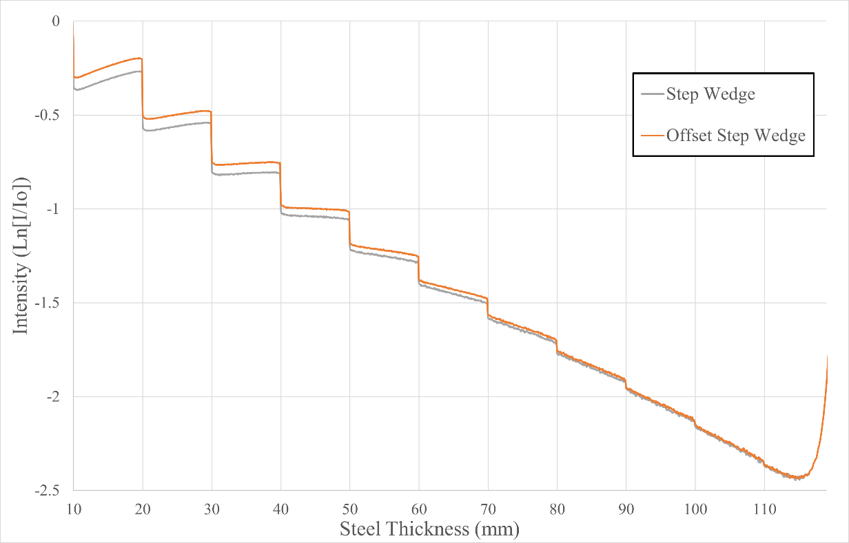
Figure 38. Filtered step wedge and offset step wedge intensity plot

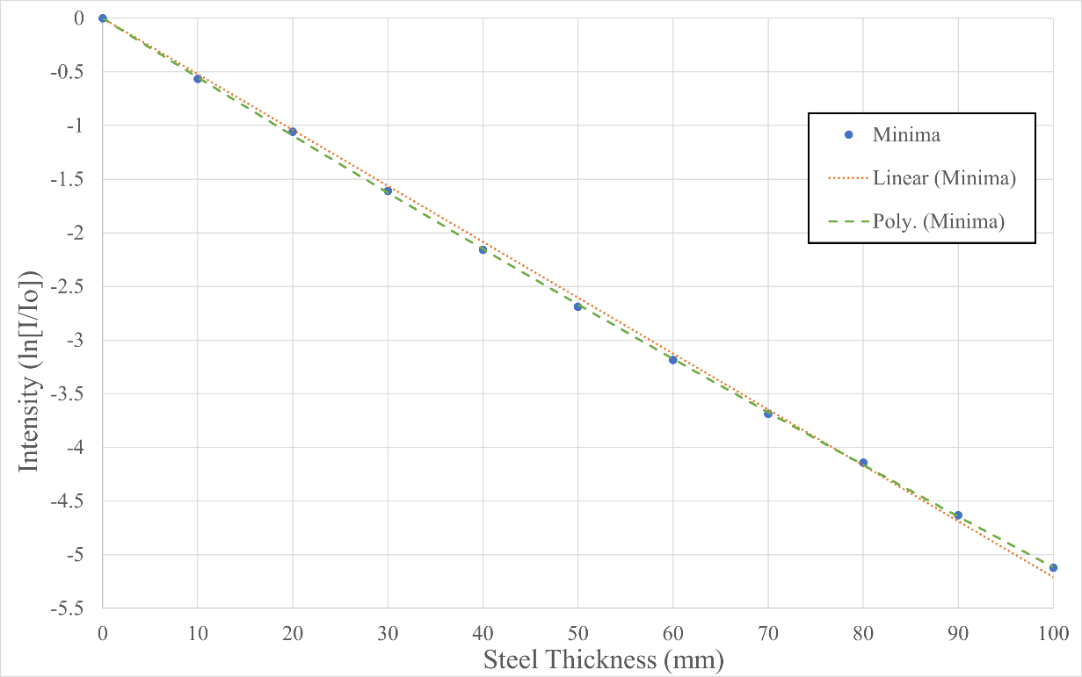
Figure 39. Filtered step wedge minima curve fits

Step Wedge Signal and Scatter Characterization
The performance of the filter was investigated by comparing the signal and scatter images in both the filtered and unfiltered configurations. The unfiltered signal and scatter images are shown in figure 40 A and 40 B respectively and the filtered signal and scatter images are shown in figure 41 A and 41 B respectively. Intensity difference images were created by subtracting the filtered signal image from the unfiltered signal image and filtered scatter image from the unfiltered scatter image. The resulting difference images of the signal and scatter are shown in figure 42 A and 42B respectively. Figure 43 displays a final difference image by subtracting the scatter difference image from the signal difference image. The areas in green in figure 43 show steel thicknesses where the filter removed a greater amount of scatter intensity than signal intensity and vice versa for the areas in red. According to the image, radiographs taken of steel thicknesses greater than 40 mm benefit from the use of the 1 mm lead filter whereas radiographs taken of steel thicknesses less than 40 mm would be hindered.
Another way to analyze the utility of the filter is by dividing the unfiltered signal image by the unfiltered scatter image and the filtered signal image by the filtered scatter image which results in a signal to scatter ratio (SSR). Figure 44 shows the SSR dependance on steel thickness in both the filtered and unfiltered configurations. Once again, the plot shows that a filter is advantageous when generating radiographs of steel thicker than 38 mm, but is detrimental when the steel is thinner than 38 mm.

(A) (B)
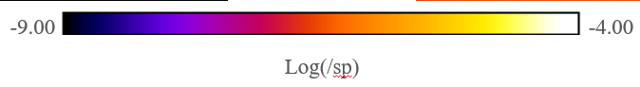
Figure 40. (A) Unfiltered step wedge signal *FMESH image and (B) unfiltered step wedge scatter *FMESH image
(A) (B)
Figure 41. (A) Filtered step wedge signal *FMESH image and (B) filtered step wedge scatter *FMESH image

(A) (B)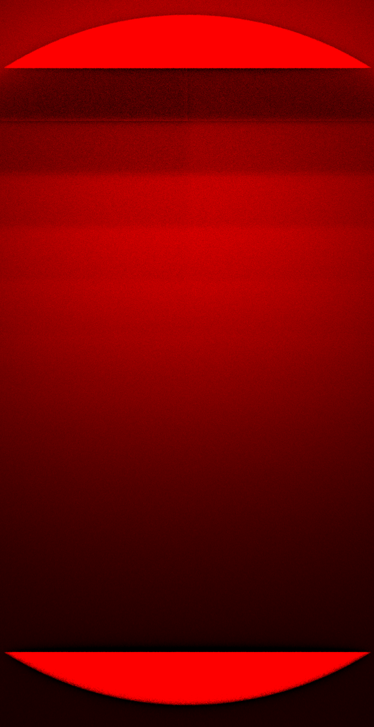
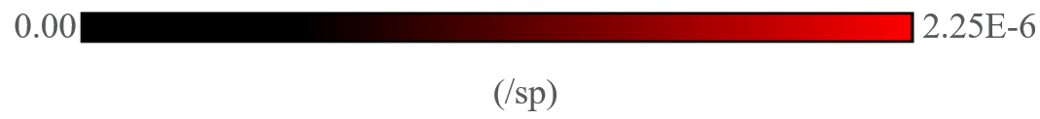
Figure 42. (A) Step wedge signal difference *FMESH image and (B) step wedge scatter difference *FMESH image


10 mm
20 mm
30 mm
40 mm
50 mm
60 mm
70 mm
80 mm
90 mm
100 mm
110 mm

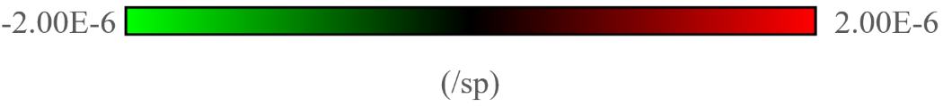
Figure 43. Difference of signal difference and scatter difference *FMESH images

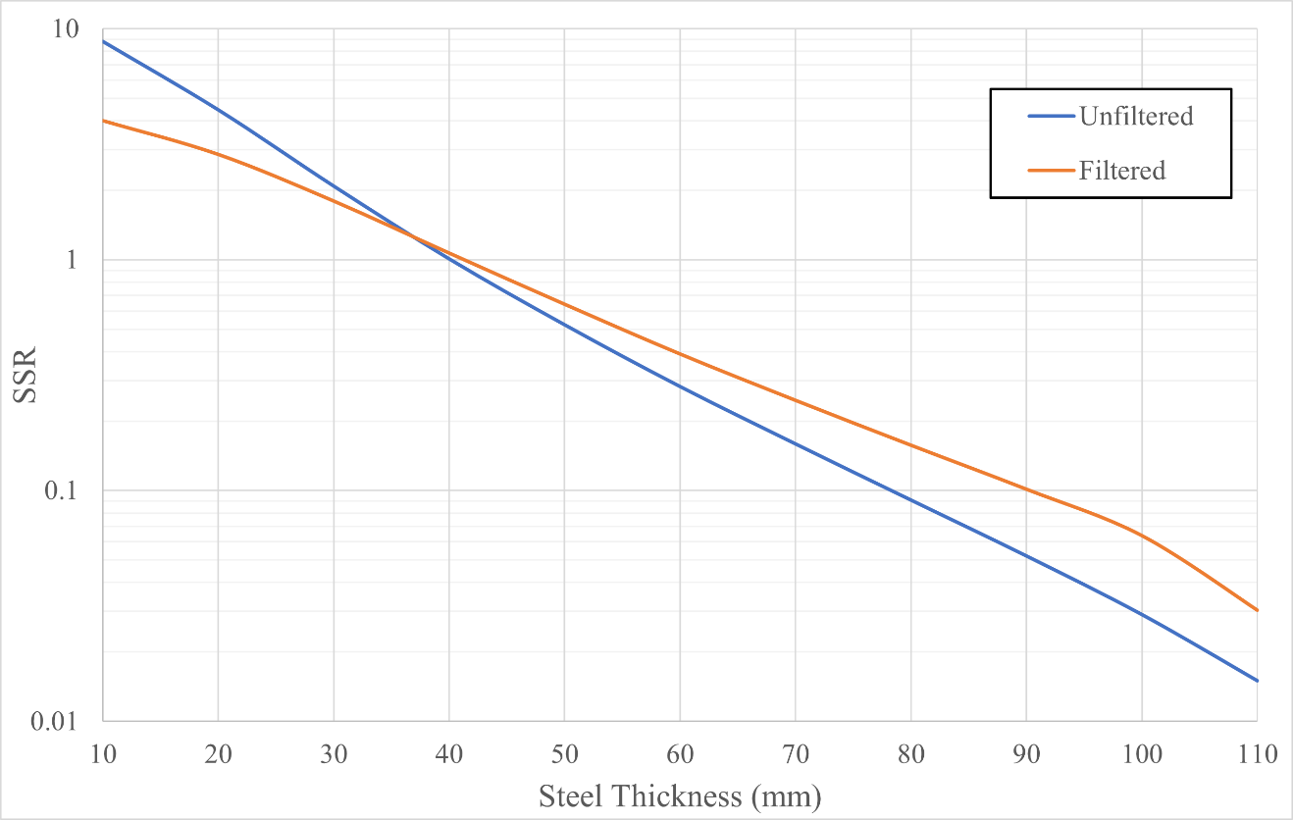
Figure 44. Signal to scatter ratio (SSR) dependance on steel thickness

Chapter 6
Conclusions and Future Work

Conclusions
The United States railroad network is a key driver in economic activity. Millions of tons of freight and people are safely and efficiently transported across the nation every year. Despite a safe track record, train derailments still happen with nearly 1000 occurring in 2022. Train derailment can result in a massive loss of capital and catastrophic damage to surrounding areas. New technology must be investigated to detect early signs of weld failure to prevent future derailments from occurring. The feasibility of utilizing high energy x-ray sources to characterize weld integrity was investigated.
A 450 kVp, and a 3, 6, 9 and 15 MVp x-ray systems were investigated as potential sources. Each source was characterized in simulations space using MCNP 6.2 and angular and energy dependent source definitions were created for each. The 450 kVp source was found to provide sufficient x-ray energy and fluence to create an image through a 141-railway section in simulation space. Air voids in the head, web, and base of the rail were modeled along with a line pair gauge to test the capabilities of the simulated system configuration. Initial images showed the voids in the web and the line pair gauge were visible but the voids in the head and web were obscured and not detectable. Further simulations characterized the transmission and scatter signal coming through the different parts of the rail. The greater intensity of scatter signal coming through the head and web was hiding the transmission image in those areas.
Next, filters were investigated with the goal of reducing the scatter noise and reveal the complete transmission image. A 1 mm Cu and 1 mm Pb filter were placed in front of the simulated detector and resulting images showed a greatly reduced scatter signal such that the voids in the head of the rail as small as 2.0 mm became visible. An intensity profile plot was created which showed that the 1.5 mm void was visible graphically. The addition of a CLAHE filter improved the visibility of the voids in the head and the utilizing the difference image technique revealed all the voids including the 0.5 mm diameter void. Finally, a step wedge and offset step wedge replaced the rail section in a final simulation to plot the intensity of x-rays through various thicknesses of carbon steel and characterize the effect of the filter. The intensities from each step were plotted on a natural log scale, and a 2nd order polynomial curve fit was performed to find an attenuation correction factor which will be used to estimate void size from signal intensity. A series of difference images and a signal to scatter ratio plot were created to examine the effect of the filter at different steel thicknesses. They revealed the filter provided a benefit in steel greater than 38 mm thick but was a hinderance in steel less than 38 mm thick.

Future Work

This feasibility study provided sufficient confidence to move forward with real world testing of real railway weld sections. A Comet MesoFocus 450 kVp and Varex 4343 scintillator detector panel have been acquired and a test stand is being constructed. The work done in simulation space can be improved upon. Each simulation could have been improved with more particles simulated and more run time. This would improve the image quality and reduce statistical uncertainty.
More radiography techniques can also be investigated in the future. The current simulated system only takes a static cross-sectional view of the rail section and the voids. This compresses the three-dimensional nature of the rail section into a two-dimensional image. Therefore, voids can be observed in the rail but the exact depth of the voids in the rail is unknown. Taking two images of the railway from different angles would allow for the calculation of the exact location of rail welds and unmask multiple voids that may have been inline in the first image. Dual energy radiography should also be investigated in the future. Utilizing two x-ray energies allows for the characterization of material within the railway by characterizing differences in intensity of the two x-ray energy beams. This could uncover defects in manufacturing from finding deposits of contaminated material.

                - List of References
[1] Association of American Railroads, Freight Rail Facts & Figures. 2023. Accessible: https://www.aar.org/facts-figures
[2] Association of American Railroads, Train Derailments. 2023. Accessible: https://www.aar.org/charts
[3] Federal Railroad Administration Office of Safety Analysis, Train Accidents and Rates. 2023. Accessible: https://safetydata.fra.dot.gov/OfficeofSafety/publicsite /Query/TrainAccidentsFYCYWithRates.aspx
[4] Turner, James E. Atoms, Radiation, and Radiation Protection. 3rd Ed. 2007. p 146.
[5] Berger M, Yang Q, Maier A. X-ray Imaging. 2018 Aug 3. In: Maier A, Steidl S, Christlein V, et al., editors. Medical Imaging Systems: An Introductory Guide [Internet]. Cham (CH): Springer; 2018. Figure 7.8, X-ray spectrum of a tungsten tube. The peaks correspond to the characteristic radiation; the continuous part of the spectrum represents the Bremsstrahlung. Available from: https://www.ncbi.nlm.nih.gov/books/NBK546155/ doi: 10.1007/978-3-319-965208_7
[6] Hahn, Chang & Kim, Im-Soon & Park, S. & Kim, W. & Moon, B. & Ha, Sung Yong & Ahn, B. & Ha, Y. & Jung, C. & Jung, S. & Cho, B.. (2007). First observation of signals due to KAERI's 10 MeV electron beam by using GEM detectors. Journal of The Korean Physical Society - J KOREAN PHYS SOC. 50. 10.3938/jkps.50.961. Figure 12, Schematic illustration of the spatial distribution of X-ray photons caused by the Bremsstrahlung around a thin target.
[7] X-ray Genorator, PhysicsOpenLab. 2017; Accessible: https://physicsopenlab.org/2017/10/24/x-ray-generator/
[8] Radiation Interactions, Oncology Medical Physics. 2023; Accessible: https://oncologymedicalphysics.com/radiation-interactions/
[9] C. J. Werner, et al. MNCP Users Manual: Version 6.2,” (2017).LA-U-17-29981.
[10] X-ray Module: MesoFocus 450, Comet X-ray. 2022; Accessible: https://xray.comet.tech/en/download-center.
[11] XRD 4343N, Varex Imaging. (2018); Accessible: https://www.vareximaging.com/solutions/4343n/
[12] Python Language Reference ver 3.11. Python Software Foundation. (2023); Accessible: https://www.python.org/.
[13] T. Ferreira, W. Rasband, ImageJ User Guide, (2012); Accessible, https://imagej.nih.gov/ij/docs/guide/.
[14] Linatron M9 & M9A: Modular high-energy X-ray Source. Varian Medical Systems, (2022); Accessible: https://www.vareximaging.com/wp-content/uploads/2022/01/Linatron-M9_100071889-Rev-A.pdf.
[15] Linatron K: Modular high-energy X-ray Source. Varex Imaging (2022); Accessible: https://www.vareximaging.com/wp-content/uploads/2022/01/Linatron-K15-Rev-4-11-6-2017.pdf.
[16] RJ McConn Jr., CJ Gesh, RT Pagh, RA Rucker, and RG Williams III. Compendium of Material Composition Data for Radiation Transport Modeling: Revision 1. (2011), PNNL-15870 Rev. 1

                - Appendix
Table 1. 450 kVp energy spectrum piecewise fit coefficients
E[keV] | C₄E⁴ | C₃E³ | C₂E² | C₁E¹ | C₀
0-44 |  | -1.00956476E-13 | 6.57128382E-12 | 1.35493269E-10 | -5.04562718E-10
7 |  |  |  |  | 3.61713E-09
9 |  |  |  |  | 7.30014E-09
10 |  |  |  |  | 3.40356E-09
11 |  |  |  |  | 2.64861E-09
43 |  |  |  |  | 5.20133E-08
44 |  |  |  |  | 8.81668E-08
45-70 |  | -3.20328906E-13 | 5.08354871E-11 | -2.69297303E-09 | 5.67384504E-08
49 |  |  |  |  | 3.81298E-08
51 |  |  |  |  | 1.57607E-08
58 |  |  |  |  | 1.01704E-08
59 |  |  |  |  | 3.93712E-08
60 |  |  |  |  | 6.23555E-08
68 |  |  |  |  | 2.85413E-08
70 |  |  |  |  | 1.13356E-08
71-275 | -4.97758392E-18 | 3.88286335E-15 | -1.03386358E-12 | 9.11463373E-11 | 1.58472295E-09
276-450 | 2.27842281E-19 | -3.75413056E-16 | 2.41587289E-13 | -7.45003628E-11 | 9.46615020E-09

Table 2. 450 kVp beam heel profile polynomial fit
Angle | C₅E⁵ | C₄E⁴ | C₃E³ | C₂E² | C₁E¹ | C₀ | R²
70°-100.5° |  | -4.63883210E-13 | 1.46330333E-10 | -1.77461764E-08 | 9.86702466E-07 | -2.01932712E-05 | 0.914
100.6°-110° | -4.60530531E-11 | 2.38115765E-08 | -4.92376277E-06 | 5.08969775E-04 | -2.63008751E-02 | 5.43526361E-01 | 0.983

Table 3. 450 kVp beam flatness profile polynomial fit
Angle | C₅E⁵ | C₄E⁴ | C₃E³ | C₂E² | C₁E¹ | C₀ | R²
70°-110° |  |  |  | -3.61857379E-10 | 6.51347591E-08 | -1.82941301E-06 | 0.942

Table 4. 3 MVp key angles energy spectra polynomial fits
Select 3 MVp Angular Spectra [𝛾/e⁻]
 | E[keV] | C₅E⁵ | C₄E⁴ | C₃E³ | C₂E² | C₁E¹ | C₀ | R²
0° | 150-400 |  |  | 9.26926994E-06 | -1.15579362E-05 | 4.58903048E-06 | -4.53909343E-07 | 0.994
0° | 410-1500 |  |  | -6.31930616E-08 | 2.65147308E-07 | -4.06826427E-07 | 2.48035010E-07 | 0.996
0° | 1510-3000 |  |  | -3.41698419E-09 | 2.71596406E-08 | -8.22750282E-08 | 9.52341611E-08 | 0.992
5° | 150-400 |  |  | 6.45076165E-06 | -9.01293523E-06 | 3.82774460E-06 | -3.85723312E-07 | 0.995
5° | 410-1500 |  |  | -6.76091397E-08 | 2.77985816E-07 | -4.14210320E-07 | 2.43470750E-07 | 1.000
5° | 1510-3000 |  |  | -4.56927815E-09 | 3.50316578E-08 | -9.86942547E-08 | 1.04785323E-07 | 0.999
10° | 150-380 |  |  | -7.38050636E-07 | -2.44543890E-06 | 1.85741856E-06 | -2.05404950E-07 | 0.990
10° | 390-1450 |  |  | -6.21627567E-08 | 2.53170117E-07 | -3.72711275E-07 | 2.15485825E-07 | 1.000
10° | 1460-3000 |  |  | -3.93550097E-09 | 3.02898912E-08 | -8.52437233E-08 | 8.98795874E-08 | 0.999
45° | 150-380 |  |  | -1.79636523E-06 | 1.11669877E-07 | 5.42328783E-07 | -7.53235406E-08 | 0.992
45° | 390-1470 |  |  | -3.06307243E-08 | 1.24896422E-07 | -1.82694049E-07 | 1.02272632E-07 | 1.000
45° | 1480-2960 |  |  | -1.15671605E-09 | 9.97117130E-09 | -3.07823126E-08 | 3.37649481E-08 | 1.000
90° | 150-400 |  |  | 3.75518366E-06 | -4.45451849E-06 | 1.66828959E-06 | -1.62522705E-07 | 0.997
90° | 410-1500 |  |  | -2.64859399E-08 | 1.05738650E-07 | -1.47725897E-07 | 7.61639706E-08 | 0.999
90° | 1510-2970 | -2.75415693E-10 | 3.62389715E-09 | -1.90454746E-08 | 5.11166641E-08 | -7.23389070E-08 | 4.45835666E-08 | 1.000
180° | 150-450 |  | -3.09877955E-05 | 4.06924961E-05 | -1.87862809E-05 | 3.34535753E-06 | -1.14102532E-07 | 0.996
180° | 460-1320 | -2.24183849E-08 | 1.45373587E-07 | -3.81875632E-07 | 5.13028896E-07 | -3.60926827E-07 | 1.11624563E-07 | 0.987
180° | 1330-2880 |  |  | -6.62713626E-10 | 5.61806822E-09 | -1.59292270E-08 | 1.51095959E-08 | 0.940

Table 5. 6 MVp key angles energy spectra polynomial fits
Select 6 MVp Angles Spectra [𝛾/e⁻]
 | E[keV] | C₅E⁵ | C₄E⁴ | C₃E³ | C₂E² | C₁E¹ | C₀ | R²
0° | 150-500 |  |  | 2.85413836E-05 | -3.63414504E-05 | 1.47228472E-05 | -1.41975948E-06 | 0.996
0° | 510-2500 |  | 3.67220755E-08 | -2.92739882E-07 | 8.96383722E-07 | -1.31314645E-06 | 8.77588148E-07 | 0.999
0° | 2510-6000 |  |  | -1.25917815E-09 | 1.85210653E-08 | -1.01524898E-07 | 2.14918278E-07 | 0.996
5° | 150-450 |  |  | 2.60709657E-05 | -3.28710811E-05 | 1.31447892E-05 | -1.25325823E-06 | 0.997
5° | 460-2500 |  | 3.68986296E-08 | -2.86424237E-07 | 8.52461407E-07 | -1.20999001E-06 | 7.79233835E-07 | 1.000
5° | 2510-6000 |  |  | -1.17396796E-09 | 1.71982381E-08 | -9.22873655E-08 | 1.88852778E-07 | 0.999
10° | 150-400 |  |  | 8.19097097E-06 | -1.56037100E-05 | 7.53763675E-06 | -7.21056795E-07 | 0.993
10° | 410-2500 |  | 3.30902029E-08 | -2.53089375E-07 | 7.39150799E-07 | -1.02341605E-06 | 6.36263730E-07 | 1.000
10° | 2501-6000 |  |  | -8.68872427E-10 | 1.29148214E-08 | -6.99396410E-08 | 1.42598132E-07 | 0.999
45° | 150-400 |  |  | 6.17060189E-06 | -8.76651129E-06 | 3.69558064E-06 | -3.45010346E-07 | 0.995
45° | 410-2240 |  | 1.33693189E-08 | -1.05689496E-07 | 3.15027028E-07 | -4.35065057E-07 | 2.56680683E-07 | 1.000
45° | 2250-6000 |  | 8.32466086E-11 | -1.59736131E-09 | 1.18845824E-08 | -4.21556457E-08 | 6.22271734E-08 | 1.000
90° | 150-380 |  |  | 7.63273028E-06 | -8.94912858E-06 | 3.30609692E-06 | -3.04156022E-07 | 0.997
90° | 390-3370 | -2.38460001E-09 | 2.82861112E-08 | -1.31163255E-07 | 2.99844957E-07 | -3.47072919E-07 | 1.74493909E-07 | 0.983
90° | 3380-6000 | -1.31123952E-11 | 3.19818678E-10 | -3.13951176E-09 | 1.57656703E-08 | -4.14799443E-08 | 4.69272678E-08 | 0.999
180° | 150-360 |  |  | 1.28223318E-05 | -1.14411426E-05 | 3.01300451E-06 | -1.35680147E-07 | 0.984
180° | 370-1570 |  | 7.28404860E-08 | -3.54565136E-07 | 6.51765261E-07 | -5.52082805E-07 | 1.94687562E-07 | 0.997
180° | 1580-2870 |  |  | -7.02238640E-10 | 6.76151369E-09 | -2.24503878E-08 | 2.61933253E-08 | 0.945
180° | 2880-5730 |  | 9.57964564E-12 | -2.29527095E-10 | 2.05469309E-09 | -8.15291398E-09 | 1.21093719E-08 | 0.824

Table 6. 9 MVp key angles energy spectra polynomial fits
Select 9 MVp Angles Spectra [𝛾/e⁻]
 | E[keV] | C₅E⁵ | C₄E⁴ | C₃E³ | C₂E² | C₁E¹ | C₀ | R²
0° | 150-390 |  |  | 5.49863195E-05 | -7.09799129E-05 | 2.91212112E-05 | -2.76861699E-06 | 0.996
0° | 400-2800 |  | 4.62322460E-08 | -4.14265518E-07 | 1.41806080E-06 | -2.31413960E-06 | 1.74761778E-06 | 0.999
0° | 2810-9000 |  |  | -8.00064998E-10 | 1.68273011E-08 | -1.28679792E-07 | 3.78191473E-07 | 0.998
5° | 150-490 |  |  | 4.64495667E-05 | -5.86507774E-05 | 2.34735135E-05 | -2.16624828E-06 | 0.997
5° | 500-2810 |  | 4.84350275E-08 | -4.11629231E-07 | 1.33076652E-06 | -2.03943064E-06 | 1.43631405E-06 | 1.000
5° | 2820-9000 |  |  | -6.15780438E-10 | 1.30369252E-08 | -9.93899037E-08 | 2.87598467E-07 | 0.999
10° | 150-330 |  |  | 1.95559961E-05 | -3.06444850E-05 | 1.35798084E-05 | -1.19748303E-06 | 0.995
10° | 340-2750 |  | 3.97151253E-08 | -3.32869529E-07 | 1.05771557E-06 | -1.58334216E-06 | 1.07513004E-06 | 1.000
10° | 2760-8940 |  |  | -3.95562240E-10 | 8.50785629E-09 | -6.59422926E-08 | 1.92184933E-07 | 0.999
45° | 150-300 |  |  | 1.58038527E-05 | -1.77743377E-05 | 6.30443495E-06 | -4.99857706E-07 | 0.998
45° | 310-2450 |  | 1.50612268E-08 | -1.26558477E-07 | 3.98262873E-07 | -5.76950455E-07 | 3.59864266E-07 | 0.999
45° | 2460-8830 | -2.57041746E-12 | 9.67641563E-11 | -1.44131997E-09 | 1.08641865E-08 | -4.32842159E-08 | 7.71645416E-08 | 1.000
90° | 150-440 |  |  | 1.00548631E-05 | -1.11943819E-05 | 3.93878748E-06 | -3.34354850E-07 | 0.998
90° | 450-2500 | -3.83386046E-09 | 4.32832175E-08 | -1.91201996E-07 | 4.16903498E-07 | -4.61621133E-07 | 2.25686971E-07 | 0.940
90° | 2510-8830 | -1.14032784E-12 | 3.96506991E-11 | -5.60644642E-10 | 4.13085742E-09 | -1.63631194E-08 | 2.85614739E-08 | 1.000
180° | 150-360 |  |  | 1.69391469E-05 | -1.54457432E-05 | 4.33445052E-06 | -2.83002561E-07 | 0.980
180° | 370-2000 | -2.68445702E-08 | 1.93312016E-07 | -5.52308073E-07 | 7.93444619E-07 | -5.92702380E-07 | 2.00139236E-07 | 0.997
180° | 2010-5120 | -2.13803037E-11 | 4.69638014E-10 | -4.09781682E-09 | 1.79713335E-08 | -4.05578437E-08 | 3.91980743E-08 | 0.967
180° | 5120-9000 |  | 7.14998965E-13 | -2.57308290E-11 | 3.46922442E-10 | -2.07768837E-09 | 4.66524202E-09 | 0.588

Table 7. 15 MVp key angles energy spectra polynomial fits
Select 15 MVp Angles Spectra [𝛾/e⁻]
 | E[keV] | C₅E⁵ | C₄E⁴ | C₃E³ | C₂E² | C₁E¹ | C₀ | R²
0° | 150-440 |  |  | 5.71251530E-05 | -9.40681680E-05 | 4.70503550E-05 | -4.96088935E-06 | 0.994
0° | 450-3290 |  | 4.52257251E-08 | -4.99716270E-07 | 2.09076223E-06 | -4.13149840E-06 | 3.79392244E-06 | 0.999
0° | 3300-15000 | -5.34557505E-12 | 2.79044057E-10 | -5.94843630E-09 | 6.54864002E-08 | -3.86987822E-07 | 1.08163672E-06 | 0.999
5° | 150-390 |  |  | 5.37266617E-05 | -7.79191773E-05 | 3.54642296E-05 | -3.51881938E-06 | 0.995
5° | 400-3350 |  | 4.53909576E-08 | -4.57460591E-07 | 1.74710510E-06 | -3.15358844E-06 | 2.64415590E-06 | 1.000
5° | 3360-15000 | -3.91600766E-12 | 2.04099192E-10 | -4.30359411E-09 | 4.64543687E-08 | -2.66754208E-07 | 7.14987355E-07 | 1.000
10° | 150-390 |  |  | -1.22750448E-05 | -1.24417079E-05 | 1.27477130E-05 | -1.27150502E-06 | 0.995
10° | 400-3190 |  | 2.56184717E-08 | -2.74916192E-07 | 1.10465001E-06 | -2.05908120E-06 | 1.72903088E-06 | 0.999
10° | 3200-14900 | -1.87420078E-12 | 1.01599965E-10 | -2.23112380E-09 | 2.50772125E-08 | -1.49933881E-07 | 4.15783523E-07 | 1.000
45° | 150-400 |  |  | 1.49403363E-05 | -1.78802351E-05 | 6.66520485E-06 | -5.14977050E-07 | 0.998
45° | 410-3270 | -3.31112326E-09 | 4.37102332E-08 | -2.26071145E-07 | 5.80133306E-07 | -7.67867498E-07 | 4.72051069E-07 | 0.999
45° | 3280-8980 |  | 1.22705283E-11 | -3.91518450E-10 | 4.85257051E-09 | -2.88326311E-08 | 7.41657043E-08 | 1.000
45° | 8990-14860 | -3.76751679E-13 | 2.32432143E-11 | -5.68015099E-10 | 6.95146941E-09 | -4.35343954E-08 | 1.15396444E-07 | 0.999
90° | 150-420 |  |  | 6.29805810E-06 | -7.82430001E-06 | 3.03297444E-06 | -2.68456137E-07 | 0.996
90° | 430-3100 | -3.78241442E-09 | 4.23361156E-08 | -1.85197619E-07 | 3.99783285E-07 | -4.39578790E-07 | 2.17140952E-07 | 0.999
90° | 3110-8730 |  | 5.63014055E-12 | -1.68737603E-10 | 1.94978789E-09 | -1.06216281E-08 | 2.41287275E-08 | 1.000
90° | 8740-14850 |  | 2.02596681E-14 | -3.01182196E-12 | 1.06765261E-10 | -1.44606902E-09 | 6.80775403E-09 | 0.998
180° | 150-380 |  |  | 1.72430945E-05 | -1.62635859E-05 | 4.80280250E-06 | -3.69216672E-07 | 0.973
180° | 390-2830 | -1.98296404E-09 | 2.34604338E-08 | -1.07453335E-07 | 2.39324289E-07 | -2.64584401E-07 | 1.24068080E-07 | 0.994
180° | 2840-8590 |  | 2.56697278E-12 | -7.80413299E-11 | 8.98415124E-10 | -4.70014751E-09 | 9.60415426E-09 | 0.915
180° | 8600-14680 |  |  | -1.92335453E-13 | 8.15927729E-12 | -1.15397064E-10 | 5.44153008E-10 | 0.261

Table 8. Step wedge thickness intensity plot polynomial fits
Equation | T² | T | R²
2nd Order Poly | 4.359226E-05 | -5.552290E-02 | 9.998942E-01
Linear |  | -5.209780E-02 | 9.996858E-01

                - Vita
David Hellmann attended Northern Kentucky University where he received a Bachelor of Art in Physics with a minor in Mathematics in 2019. He then went on to the University of Tennessee where he completed a Bachelor of Science in Nuclear Engineering with a radiological concentration in 2021. David stayed at the University of Tennessee to pursue a Masters in Medical Physics and graduated in 2023.

