Redox-Active Polymerization Catalysts and Their Applications

A Thesis Presented for the

Master of Science

Degree

The University of Tennessee, Knoxville

Nicholas M. Shawver

August 2023
Copyright © 2023 by Nicholas M. Shawver
All rights reserved.

ACKNOWLEDGEMENTS
I would like to convey my sincerest respect and gratitude to my advisor, Prof. Brian Long, for his mentorship and support throughout the past three years. To Long Group members past and present, the Long days were easier with your constant jokes and strong support. I want to thank my unspeakably supportive family: my wife and rock, Day, my parents, my brother, and friends for putting up with long rants, occasional senselessness, and advice through this journey. Finally, I would like to thank Mr. Michael Rathe for convincing me to stay in high school chemistry, for without him I would not be where I am today.

ABSTRACT
Traditional monomer-catalyst systems are reliable means to produce polymers with well-defined architectures but are limited to bulk material properties dictated by the system chosen. Recently however, a new class of catalysts have emerged which feature redox activity and can impart advanced architectures via redox events either at ferrocenyl moieties appended directly to the ligand scaffold or the active metal center itself. Recently, groups have explored avenues such as on-off kinetic control and block copolymerization of a host of cyclic esters, carbonates, acrylates, and olefins. Interestingly, however, is the prospect of selectively tuning the tacticity of a polymer through modulation of the redox moiety. Reports of electron donation and withdrawal have been widely reported and show that indeed the tacticity of a resulting polymer is directly dependent on the substituents appended to the ligand, but not how those differences can be used together to create advanced polymeric architectures.
This thesis provides a history and introduction to redox catalysis for ring-opening polymerization (ROP), its limitations, and our attempts to expand the field of redox-active catalysis to include olefin polymerizations using tetradentate [ONNO], zirconium-centered precatalysts. These precatalysts, with ferrocenyl units symmetrically appended to the ligand are then used to polymerize 1-hexene in low yield.

TABLE OF CONTENTS
Chapter 1. Introduction: A History and Overview of Redox Active Polymerization Catalysts…….. 1
Abstract 2
Introduction 3
1. Redox-Switchable Polymerization Using Chemical Oxidants and Reductants 5
1.1. Ligand-Centered Redox-Switching using Group IV Transition-Metal Catalysts 7
1.1.1. Symmetric Ligand Scaffolds 8
1.1.2. Asymmetric Ligand Scaffolds 13
1.1.3. Mechanism and Rationale for Redox Switchability 15
1.2. Ligand-Centered Redox-Switching using non-Group IV Transition-Metal Catalysts 18
1.3. Metal-Centered Redox-Switchable ROP Catalysts 21
2. External Redox Modulation 24
2.1. Electrochemical Redox-Switching ROP 26
3. Summary and Outlook 30
Chapter 2. Redox Active Catalysts for Olefin Polymerization 43
Abstract 44
Introduction 44
Results and Discussion 50
Conclusion and Future Work 55
Experimental 56
Chapter 3. Conclusion and Outlook 71
Appendices 72
Appendix A Supporting Information – Chapter 2 73
Appendix B Heteroleptic Aluminum Allyls as Initiators for Lactide Polymerization 84
Abstract 85
Introduction 86
Results and Discussion 89
Synthesis of Aluminum Allyl NHC Adducts 89
Crystallographic Results. 93
Solid-State Structure of [(IDipp)AlCl₂A′]. 93
Solid-State Structure of [(IMes)AlClA′₂]. 95
Polymerization Results 95
Appendix References 99
Vita 104

LIST OF TABLES
Table 2.1 Polymerization of 1-hexene using precatalysts 17 and 18.ª 52
Table B.1. Results of Polymerization with L-Lactide. 97
LIST OF FIGURES
Figure 1.1. Simplified overview of redox-switchable catalysis for the chemoselective ring-opening polymerization of cyclic esters and epoxides. 6
Figure 1.2. Examples of redox-switchable catalysts bearing symmetric ligand scaffolds. 9
Figure 1.3. In situ oscillation of catalytic activity during a L-lactide polymerization using catalyst 1, which was oxidized using AgOTf and reduced using Fe(Cp*)₂. Reproduced from ref 33. Copyright 2006 American Chemical Society. 9
Figure 1.4. Proposed ligand isomerization of catalyst 2 from its β-cis form to either its trans or α-cis form. 11
Figure 1.5. Asymmetric Ti- and Zr-based catalysts bearing [ONN] Schiff base-type ligands. 14
Figure 1.6. Mechanistic pathway for the polymerization of LA using simplified catalyst 4b that was used for computational investigations. Adapted from ref 51. Copyright 2017 American Chemical Society. 17
Figure 1.7. Select examples of non-Group IV-centered redox-switchable catalysts. 19
Figure 1.8. Selected examples of redox-switchable catalysts that featuring redox-active, active metal sites. 23
Figure 1.9. a) Chemoselective polymerization of LA and CHO using either catalyst 15_{red} or 15_{ox}, as well as b) the synthesis of PLA-PCHO block copolymers via in situ redox switching of catalyst 15. 25
Figure 1.10. Electrochemical switching of catalyst 15 and polymerization of L-LA and CHO. Adapted from ref 25. Copyright 2018 American Chemical Society. 27
Figure 1.11. Catalyst systems used for electrochemically modulated, redox-switchable ROP. 29
Figure 2.1. [ONNO]-type precatalysts used in this work. 47
Figure 2.2. Effects of steric bulk at the coordination site. 47
Figure 2.3. Proposed coordination site hindrance for (a) 19 and (b) 19_{ox}. 49
Figure 2.4. Synthetic scheme for 18-L. 51
Figure 2.5. Cyclic voltammogram of 18 (0.01 mmol) recorded at a scan rate of 100 mV/s in dichloromethane (5 mL), (nBu)₄NPF₆ (0.20 M), (E_{1/2} = -0.774 V) versus Fc/Fc⁺. 52
Figure 2.6. Routes attempted to synthesize precatalyst 19. 54
Figure A.1. ¹H-NMR (500 MHz, 25 ºC, C₆D₆) of 3-(1-adamantyl)-5-ethynylferrocenyl-2-hydroxy-benzaldehyde. 74
Figure A.2. ¹³C-NMR (500 MHz, 25 ºC, C₆D₆) of 3-(1-adamantyl)-5-ethynylferrocenyl-2-hydroxy-benzaldehyde. 75
Figure A.3. ¹H-NMR (500 MHz, 25 ºC, C₆D₆) of N,N’-bis(2-(1-adamantyl)-4-ethynylferrocenylphenol)-ethylenediamine.¹ 76
Figure A.4. ¹H-NMR (500 MHz, 25 ºC, C₆D₆) of L1. 77
Figure A.5. ¹H-NMR (500 MHz, 25 ºC, C₆D₆) of 2. 78
Figure A.6. ¹³C-NMR (500 MHz, 25 ºC, C₆D₆) of 2. 79
Figure A.7. ¹H-NMR (500 MHz, 25 ºC, C₆D₆) of 2_{ox}. 80
Figure A.8. ¹H-NMR (500 MHz, 25 ºC, CDCl₃) of 2-hydroxy-3-iodo-5-methylbenzaldehyde. 81
Figure A.9. ¹³C-NMR (500 MHz, 25 ºC, CDCl₃) of 2-hydroxy-3-iodo-5-methylbenzaldehyde. 82
Figure A.10. Raw GPC data of 1-hexene polymerization using 1. 83
Figure B.1. (a) Repeating unit of polylactide (PLA) and (b) L-lactide. 88
Figure B.2. Structures of NHC adducts R = 2,6-diisopropylphenyl or 2,4,6-trimethylphenyl: (a) [(NHC)AlCl₃]; (b) [(NHC)AlCl₂A′]; and (c) [(NHC)AlClA′₂]. 90
Figure B.3. Thermal ellipsoid plot (50% level) of [(IDipp)AlCl₂A′]. 94
Figure B.4. Thermal ellipsoid plot (50% level) of [(IMes)AlClA′₂]. 96
Figure B.5. Conversion as a function of time for various [(NHC)AlCl_{3‑n}A′_{n}] complexes, [AlA′₃], and [Al(O^{i}Pr)₃]. 97

LIST OF ABBREVIATIONS

AB……………..N,N-dimethylanilinium tetrakis(pentafluorophenyl)borate
Ad……………...adamantyl group
Bn……………...benzyl group
CHCl₃………….chloroform, solvent
CV……………..cyclic votammogram/cyclic voltammetry
Đ……………….polymer dispersity
DCM…………...dichloromethane, solvent
EA……………..ethyl acetate, solvent
ED……………..electron donating (group)
EthFc…………..ethynylferrocene group
EW..….………..electron withdrawing (group)
Fc……………....ferrocene
GPC……………gel permeation chromatography
HOAc………….acetic acid
LDA……………lithium diisopropylamide
Me……………..methyl group
MeCN………….acetonitrile, solvent
M_{n}……………...number-averaged molecular weight
M_{w}……………..weight-averaged molecular weight
MgSO₄…………magnesium sulfate
MeOH………….methanol, solvent
NaBAr^{f}…………sodium tetrakis (3,5-bis(trifluoromethyl)phenyl)borate
ROP……………ring opening polymerization(s)
TEA……………triethylamine
THF..…………..tetrahydrofuran, solvent
WCA…………..weakly-coordinating anion

Introduction: A History and Overview of Redox Active Polymerization Catalysts

A version of this chapter was originally published by Nicholas M. Shawver, Alicia M. Doerr, and Brian K. Long:

Nicholas M. Shawver, Alicia M. Doerr, Brian K. Long. “A Perspective on Redox-Switchable Ring-Opening Polymerization.” J. Polym. Sci. 2023, 61 (5), 361-371.

I collected all references, generated all figures (except Figures 1.1, 1.4, and 1.6), and composed the initial draft of the manuscript. Alicia Doerr and I contributed equally to all other aspects of preparing and completing this manuscript. Professor Brian Long advised this work and aided in the preparation of the manuscript.

Abstract
A polymer’s properties and functionality are directly related to the constituent monomers from which it was synthesized, the order in which these monomers are assembled, and the degree to which monomers are enchained. Furthermore, a standing challenge in the field of polymer synthesis is to provide temporal polymerization control that can be leveraged to access a variety of advanced polymer architectures. Though many polymer classes are attractive for various applications, polyesters have drawn considerable recent interest due to the potential of these materials to provide biodegradable alternatives to other, often petroleum derived, polymeric materials that create concerning, long-term environmental impacts. Many of these biodegradable polyesters can be produced via the transition-metal catalyzed ring-opening polymerization of cyclic ester and cyclic ether monomers. Through researchers’ quest to access precise and well-defined polyesters via ring-opening polymerization, an intriguing class of stimuli-responsive catalysts have emerged. More specifically, catalyst systems have been developed in which their electronic nature may be modulated via either ligand-based or active metal site-based redox-switchability. These redox-switchable catalysts have been shown to exhibit altered chemoselectivity and kinetic modulation as a function of catalyst redox-state. Herein, we will discuss the beginnings, select recent advancements, and an outlook on the field of redox-switchable ring-opening polymerizations.

Introduction
The widespread use of consumer plastics has exponentially grown since the mid-1900s; however, their ever-increasing demand and ubiquity in everyday life has led to global production reaching over 400 million tons in 2015.¹ Polymers and plastics are often classified based upon the functionality of the monomers from which they are derived, including: polyolefins, acrylics, silicones, and polyesters, just to name a few. Of these major polymer classes, polyolefins are the most widely produced and used polymers in the world, a fact that can be attributed to their derivation from cheap and abundant monomeric feedstocks, as well as their vast array of accessible thermal and mechanical properties. Though polyolefins provide low-cost and robust materials for countless consumer applications, they are also long-lived materials that necessitate large energy input or land area to dispose of, thus creating a large environmental risk factor.² In contrast, polyesters are of significant interest due to their facile degradation via ester cleavage along the polymer backbone, often imparting biodegradability and a finite lifetime for some variants. Such properties make polyesters key candidates for polyolefin alternatives for a multitude of applications.³⁻⁶
Polylactide (or poly(lactic acid)) (PLA) and poly(ε-caprolactone) (PCL) are prototypical examples of commercially relevant and biodegradable polyesters. These polymers are traditionally synthesized via ring-opening polymerization (ROP) of their respective cyclic-ester monomers using transition metal-based catalysts such as tin(II) 2-ethylhexanoate (SnOct₂).⁷⁻¹³ While SnOct₂ and other transition-metal catalysts have been proven to offer a reasonable degree of polymerization control and fast kinetics, researchers continue to pursue advanced catalyst species that offer better and/or unique opportunities to imbue ROPs with greater polymerization control and precision. One such example is through the development of redox-switchable catalysis (RSC). RSC offers a pathway by which the selectivity and/or activity a catalytic system may be modulated through the oxidation or reduction of either the ligand scaffold or its active metal center.¹⁴ Because of this, researchers have shown that observed changes in the catalytic activity and selectivity as a function of redox state can be directly attributed to changes in the electron density at, or around, the active metal center.¹⁵
The seminal example of RSC was reported by Wrighton and coworkers in 1995 who developed a rhodium-bisphosphinocobaltocene complex that was found to be approximately 16 times more active for the hydrogenation of cyclohexene in its reduced state than in its oxidized state.¹⁶ Following their report the field of RSC grew rapidly, eventually expanding into the field of transition-metal catalyzed polymerization methodologies which include: ROP, coordination-insertion polymerization of olefins, ring opening metathesis polymerization, and controlled free radical polymerization. These developments have changed how scientists think about tailored polymer synthesis, resulting in a field of research that is no longer confined to a one-catalyst, one-polymer paradigm, but instead allow for monomer chemoselectivity (Figure 1.1) as well as provide access to advanced polymer architectures, such as block copolymers and cyclic homopolymers.¹⁷⁻²⁸ The following perspective is meant to provide a brief overview of the field of redox-switchable ROP. Though this is not intended to be an all-encompassing review, it will highlight the origins and recent advances in the field, as well as provide insights into remaining challenges and opportunities.^{19, 29-33}

Redox-Switchable Polymerization Using Chemical Oxidants and Reductants
Chemically-modulated RSC can be subdivided into two primary regimes based upon the location of the intended redox event: 1) ligand-centered, in which the redox moieties are incorporated into the ligand scaffold; 2) metal-centered, in which a redox-active metal center is used. For ligand-centered RSC, ferrocenyl moieties (and analogues thereof) represent the most commonly used redox-active group due to its established and well- behaved redox chemistry.³⁴ Furthermore, the redox half-wave potential of many ferrocene to ferrocenium (Fc/Fc⁺) transitions is readily accessed by a variety of commercially available chemical oxidants and reductants.^{15, 34-36} These redox agents include, but are not limited to, oxidizing agents such as silver triflate (AgOTf), silver tetrakis(3,5-bis(trifluoromethyl)phenyl) borate (AgBAr^{F}), ferrocenium hexafluorophosphate (FcPF₆), acetylferrocenium tetrakis(3,5-bis(trifluoromethyl)phenyl) borate (^{Ac}FcBAr^{F}),
Figure 1.1. Simplified overview of redox-switchable catalysis for the chemoselective ring-opening polymerization of cyclic esters and epoxides.

and ferrocenium tetrakis(3,5-bis(trifluoromethyl)phenyl) borate (FcBAr^{F}), as well as, reducing agents such as cobaltocene (CoCp₂) and decamethylferrocene (Fe(Cp*)₂).³⁷
Though ligand-centered RSC offers certain advantages, such as flexibility in the placement of redox-active sites distal or proximal to the active metal center, the inclusion of one or more redox-active moieties on a catalyst’s ligand scaffold can be synthetically challenging, often adding multiple steps to the synthetic process. To avoid this issue, and in some cases to leverage the synthetic ease of using previously reported catalytic species, researchers often elect to use catalysts in which the active metal center is inherently redox-active. Examples include catalysts bearing cerium and iron active metal centers, which are both redox-active and are also the site of monomer coordination and insertion.

1.1. Ligand-Centered Redox-Switching using Group IV Transition-Metal Catalysts
Transition metal-based ROP catalysts bearing tetradentate [ONNO] salen-type ligands have frequently been employed in the literature.³⁸⁻⁴⁷ It has been found that the electronic nature of these ligands can dramatically influence catalytic reactivity, which has been demonstrated through extensive studies. For example, Gibson and Long reported a library of Ti-centered [ONNO] salen-type complexes bearing either electron-withdrawing (EW) or electron-donating (ED) pendant groups. It was discovered that catalysts bearing more electron-rich ligands polymerized racemic lactide (rac-LA) up to three times faster than analogous catalysts bearing EW groups.⁴⁸ Based on this understanding of how ligand electronic character impacts catalytic activity, researchers soon began to design and develop a wide variety of redox-switchable ROP catalysts bearing either symmetric or asymmetric ligand scaffolds that feature redox-active moieties. These ligand-based redox sites could then be electronically tuned, in situ, via the simple addition or removal of one or more electrons.

1.1.1. Symmetric Ligand Scaffolds
In 2006, Gibson and N. Long reported the first redox-active ROP catalyst, a [ONNO] salen-type catalyst bearing two ferrocenyl moieties bound to titanium, 1_{red} (Figure 1.2).³⁴ They found that the reactivity of this catalyst could be widely varied (k_{red}/k_{ox} ≈ 30) via oxidation and reduction of the ligand’s ferrocenyl moieties, wherein reduced catalyst 1_{red} is polymerization active and oxidized catalyst 1_{ox} is in a near dormant state (Figure 1.3). The observed change in catalytic activity was hypothesized to arise due to modulation of the electron density around the active metal center upon oxidation or reduction of the ferrocenyl substituted ligand, although the exact mechanistic rationale was not well understood at that time.
Following this seminal work, the groups of Diaconescu and B. Long each independently examined the redox-switchable behavior of a variety of other group IV transition metal-based catalysts bearing redox-active ferrocenyl moieties about their symmetric ligand scaffolds.^{35, 36, 49-54} As an example, B. Long and coworkers probed the effects that redox-active moiety proximity to the active metal center has on catalytic behavior through the development of salfen catalyst 2, wherein the redox-active ferrocenyl moiety is positioned close to the active metal site in the backbone of an [ONNO] type ligand comprised of imine moieties.³⁶ They found that the native catalyst 2_{red} exhibited virtually no ROP activity for L-lactide (L-LA), whereas the oxidized species, 2_{ox}, was
Figure 1.2. Examples of redox-switchable catalysts bearing symmetric ligand scaffolds.

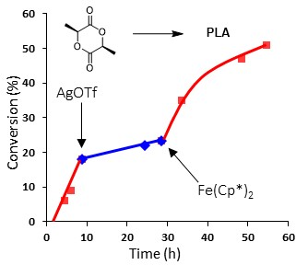
Figure 1.3. In situ oscillation of catalytic activity during a L-lactide polymerization using catalyst 1, which was oxidized using AgOTf and reduced using Fe(Cp*)₂. Reproduced from ref 33. Copyright 2006 American Chemical Society.
highly active. Unexpectedly, this behavior was opposite to that which was observed using catalyst 1. However, when these experiments were reproduced so as that the oxidation and reduction of catalyst 2 were performed in the presence of monomer, the catalyst exhibited
a complete flip in polymerization activity, exhibiting appreciable polymerization in the reduced state (2_{red}) and becoming virtually inactive in its oxidized state (2_{ox}). Further investigations using cyclic voltammetry (CV) and detailed ¹H NMR spectroscopic analysis suggest that a geometry change from the unusual β-cis form to either the α-cis or trans forms occurs when catalyst 2 is oxidized and reduced in the presence of monomer (Figure 1.4). In contrast, oxidation and reduction of this catalyst species in the absence of monomer appeared to be bereft of any ligand geometry change. Diaconescu and coworkers would later observe similar geometry switching behavior for the structurally related Zr complex 3.⁵⁵ These results were important as they highlight that ligand coordination geometry about the active metal center may not be fixed during polymerization, and that ligand coordination mode may be influenced by the polymerization conditions chosen (solvent type, monomer choice, temperature, etc).
To investigate the effect that conjugation within the ligand scaffold has on catalytic activity and redox-switchability of these systems, Diaconescu and coworkers developed catalyst 3, a Zr-centered salfen, which is the fully conjugated analogue of 4.⁵⁴ The ROP activity of both catalysts were tested for a variety of cyclic ester and ether monomers, including L-LA, cyclohexene oxide (CHO), δ-valerolactone (VL), β-butyrolactone (BL), trimethylene carbonate (TMC), propylene oxide (PO), and propylene carbonate (PC).^{49-51, 54} Of the monomers tested, L-LA and CHO stood out as highly active and orthogonal
Figure 1.4. Proposed ligand isomerization of catalyst 2 from its β-cis form to either its trans or α-cis form.

partners for both catalysts with the native species (3_{red} and 4_{red}), exhibiting activity for the polymerization of L-LA while inactive for the polymerization of CHO. Conversely, the oxidized species (3_{ox} and 4_{ox}) exhibited the opposite behavior showing inactivity for the polymerization of L-LA and high activity for the polymerization of CHO. Moreover, both catalysts 3 and 4 were used to access well-defined di- and triblock copolymers of PLA and PCHO via in situ redox switching experiments in the presence of both LA and CHO.⁵⁰⁻⁵⁴
When comparing their ROP activity, it was found that catalyst 3_{red} polymerized L-LA at a faster rate than 4_{red}. ⁴⁹ In contrast, 3_{ox} was noted to polymerize CHO more slowly than 4_{ox}. These results indicate that variation to the degree of conjugation within the ligand scaffold play a notable role in the ROP activity of these redox-switchable catalysts.
Diaconescu and coworkers also investigated the Ti- and Zr-based redox-switchable ROP catalysts 5 and 6, which bear identical symmetric tetradentate [OSSO] ligands, for the polymerization of a variety of monomers, including LA, CL, VL, TMC, and CHO.^{49, 52, 53} When Ti-based catalyst 5 was compared to its Zr-based analogue 6, the authors found that both systems exhibited lower activity in their oxidized states than their native, reduced states for the ROP of LA.⁵² However, when comparing their activity for the ROP of CL, opposite trends in activity were observed, wherein catalyst 6_{red} was more active than its oxidized analogue 6_{ox}, and oxidized catalyst 5_{ox} was more active than reduced 5_{red}.
Interestingly, catalyst 5 was the first reported system capable of producing a one-pot block copolymer of LA and CL via in situ redox-switching, while also producing block copolymers of LA and CHO with excellent block definition. ⁴⁹ To achieve this latter feat, catalyst 5_{red} was mixed into a monomer mixture of LA and CHO. Due to catalyst 5’s preference to consume LA over CHO, LA was selectively polymerized, reaching 90 % monomer conversion. At this point, a chemical oxidant was introduced into the reaction mixture, yielding oxidized catalyst 5_{ox} and continuing to extend the polymer chain by consuming the CHO monomer present. It was found that copolymerization of the inactive monomer in each block was negligible during each respective polymerization segement.⁵²

1.1.2. Asymmetric Ligand Scaffolds
In 2020, B. Long and coworkers reported a series of tridentate Schiff base-type catalysts (7-8) bearing one redox-active ferrocenyl moiety to further examine how systematic changes in redox-active ROP catalyst ligand scaffold design affect catalytic activity and redox-switchability (Figure 1.5).³⁵ Tridentate [ONN] Schiff base-type ligands were chosen for this study due to their structural similarity to catalyst 1, straightforward synthesis, and because they have been previously studied as ROP catalysts in conjunction with various other metal centers such as In, Zn, Ca, Sn, and Ni.15, 22, 25, 26, 31, 35, 36, 56-64 The catalytic activity and redox-switchability of catalyst 7 was compared to that of the analogous [ONNO] salen-type catalyst 1, which bears two redox-active moieties, to determine how number of redox-active moieties and ligand denticity affect catalytic performance. It was found that reduced catalyst 7_{red} was more active for the ROP of L-LA than oxidized 7_{ox}; however, deleterious side reactions occurring during oxidation and reduction reactions prevented repeatable redox-switching and accurate comparison to symmetric catalyst 1_{red}.¹⁵

Figure 1.5. Asymmetric Ti- and Zr-based catalysts bearing [ONN] Schiff base-type ligands.

In contrast to the Ti containing catalyst 7, which suffered from undesirable side reactions during redox events, its Zr analogue 8 (Figure 1.5) was found to be free of those same side-reactions. Kinetic investigations using catalyst 8 for the ROP of L-LA revealed that the reduced, asymmetric catalyst 8_{red} was significantly faster than its oxidized analogue 8_{ox} and exhibited a similar overall rate constant for L-LA polymerization as symmetric catalyst 1_{red}, albeit only having a single redox active site. Furthermore, 8_{red} exhibited a significantly higher native state catalytic activity than catalyst 7_{red}, suggesting that the identity of the catalysts’ active metal center plays an important role in both the overall catalytic activity and redox-switchability.¹⁵

1.1.3. Mechanism and Rationale for Redox Switchability
While all the studies highlighted above describe differentiation in polymerization behavior based on changes in the ferrocenyl oxidation state, which was routinely hypothesized to be due to changes in electron density at the active metal site, little experimental or computational evidence existed that would confirm how these changes in redox state altered catalytic activity and selectivity, at a fundamental level. In 2017, Diaconescu and coworkers computationally studied the mechanistic details of LA polymerization using a Zr-based [ONNO] salan-type catalyst 4b (Figure 1.6), which is a simplified analogue of catalyst 4, to further understand the fundamental rationale for redox-switchability.⁵¹
Because catalyst 4b is coordinatively saturated, some portion of the ligand is believed to dissociate to open a monomer coordination site. It is hypothesized that this could occur through the dissociation of one or more nitrogen donors as the strength of a Zr-O bond renders the dissociation of a monoanionic alkoxide ligand unlikely. This is supported by Diaconescu’s calculated structures that show dissociation of both nitrogen donors from the metal center to facilitate coordination of the monomer. Once a coordination site is open, polymerization proceeds via coordination of monomer to the metal center (Zr-II) (Figure 1.6), followed by nucleophilic attack of the metal alkoxide at the carbonyl of the monomer, which breaks the carbonyl C=O double bond to yield intermediate Zr-III. The ester oxygen then coordinates the metal center followed by reformation of the carbonyl π-bond and breaking of the ester C-O single bond to open the ring and form the chelated, 8-membered metallacyclic intermediate Zr-IV.
This intermediate rearranges so that the carbonyl oxygen of the newly inserted LA is chelated to the metal center to form a relatively more stable metallacyclopentane intermediate, Zr-V. The carbonyl must then dissociate from the Zr-metal center to provide intermediate Zr-VI for coordination and insertion of another LA monomer, and subsequent polymerization, to occur. For the reduced catalyst 4b_{red}, the most stable intermediate for the first insertion of LA was shown to be intermediate Zr-VI, wherein the ring-opened LA unit has been inserted between the Zr-center and the alkoxide ligand. Following the first monomer coordination and insertion, propagation was similarly expected to be energetically favored, which agrees well with experimental observations.
In contrast, it was found that oxidized catalyst 4b_{ox} features a more electron withdrawing ferrocenium moiety that decreases electron-density at the metal center and results in increased electrophilicity, ultimately strengthening the coordination between the
Figure 1.6. Mechanistic pathway for the polymerization of LA using simplified catalyst 4b that was used for computational investigations. Adapted from ref 51. Copyright 2017 American Chemical Society.

carbonyl group and the active Zr center. Due to the Zr-O bond strength of 4b_{ox}, all intermediates and transition states of the initial monomer coordination and insertion were calculated to be lower in energy than the analogous intermediates and transition states of initiation using 4b_{red}. However, the energy of the metallacyclopentane intermediate Zr-V is dramatically lowered, becoming the thermodynamically favored intermediate and theorized resting state. Moreover, these calculations reveal that dissociation of the metallacyclopentane carbonyl group from intermediate Zr-V to yield intermediate Zr-VI is disfavored by ~7 kcal/mol, therefore making subsequent polymer chain propagation using oxidized catalyst 4b_{ox} disfavored. In sum, these computational results suggest that oxidized catalyst 4b_{ox} should be inactive for the polymerization of LA, whereas reduced catalyst 4b_{red} should be polymerization active, which agrees well with experimental observations.

1.2. Ligand-Centered Redox-Switching using non-Group IV Transition-Metal Catalysts
In addition to the plethora of group IV metal centered redox-switchable ROP catalysts developed since the seminal report by Gibson and N. Long in 2006, researchers have also examined a variety of redox-switchable catalysts that bear other, non-group IV, transition metal centers. These include complexes featuring Y, In, Al, La, and Zn as their active metal centers.^{22, 65-69} As an example, Diaconescu and coworkers were the first to explore non-group IV metal-centered redox-switchable polymerization catalysts with the development of alkoxy ligated In- and Y-based catalysts bearing phosfen ligands (catalysts 9 and 10, respectively) (Figure 1.7).⁶⁶ The ROP activity and redox-switchability of both catalysts were tested using the monomers L-LA and TMC. It was found that the reduced
Figure 1.7. Select examples of non-Group IV-centered redox-switchable catalysts.

Y-centered catalyst 9_{red} was more active for the polymerization of both L-LA and TMC than its oxidized analogue 9_{ox}. Conversely, the In-based reduced catalyst 10_{red} exhibited opposite behavior towards the polymerization of TMC, wherein the oxidized catalyst 10_{ox} was found to be more active than reduced species 10_{red}. These observations suggest that reactivity changes resulting from oxidation and reduction of ligand-based ferrocenyl moieties can be heavily metal-center-dependent, despite bearing identical ligands. Based on DFT calculations of these catalysts, it was hypothesized that changes in the electrophilicity of the active metal center, as well as changes in the activation energies of the migratory insertion and/or ring-opening steps of the polymerization, cause these differences in observed catalytic activity.¹⁵
Aluminum-based redox-switchable catalysts have also been of keen interest as ROP catalysts due to their ease of synthesis, inexpensive synthetic precursors, and strong Lewis acidity. These features have led to the development of several redox-switchable catalysts that feature Al-based active metal sites for the ROP of a variety of cyclic monomers. These include examples bearing [ONNO] salen-type and [OSSO]-type ligands, such as catalyst 11 (Figure 1.7).^{22, 65, 68} These studies have not only shown that Al-centered redox-switchable catalysts exhibit different polymerization activity between their native and oxidized states for L-LA, CHO, and CL, but they can also exhibit chemoselective and orthogonal polymerization behavior between monomers, a feature that is of extreme importance to the one-pot synthesis of well-defined block copolymers via in situ redox-switching. Lastly, DFT computational methods have similarly been employed to gain a better mechanistic understanding of how these Al-centered complexes exhibit redox-switchability.^{22, 65}
Recently, Otten and coworkers have reported the first ligand-centered redox-switchable ROP catalyst that utilizes the redox chemistry of a purely organic ligand instead of employing common ferrocenyl moieties. Therein, a Zn-centered formazanate catalyst 12 (Figure 1.7) was developed and evaluated for the ROP of LA.⁶⁹ The formazanate ligand was chosen due to its ready availability, tunability via chemical modification, and low cost, providing an attractive platform for the development of redox-switchable ROP catalysts that are not limited to the presence of a metal ion for oxidation and reduction. When tested for the ROP of LA, the native catalyst 12_{ox} exhibited negligible activity, whereas the reduced species 12_{red} was polymerization active for LA. This activity differentiation was utilized to perform in situ redox-based “on/off” switching during the polymerization of LA, and exhibited excellent reversibility. Kinetic and spectroscopic analyses were conducted to provide mechanistic insight into the role of the ligand in redox-switching, initiation of polymerization, and formation of cyclic PLA.

1.3. Metal-Centered Redox-Switchable ROP Catalysts
Diaconescu, Cantat, and coworkers developed the first metal-centered redox-switchable ROP catalyst, 13, which used a cerium active metal center and a symmetric [ONNO] salen-type ligand (Figure 1.8.)³⁸ When tested, 13_{red} was found to polymerize L-LA faster than its oxidized analogue 13_{ox}. Furthermore, it was observed that the polymerization could be modulated between active and inactive states repeatedly through in situ redox-switching experiments. These results provided proof-of-principle results that redox-active ligand scaffolds are not necessary for the formation of redox-switchable ROP catalysts, but that the active metal site can simultaneously serve as the point of redox modulation and coordination-insertion polymerization. Soon thereafter, Okuda and coworkers would also investigate Ce-based redox-switchable ROP catalysts bearing [OSSO]bisphenolate ligands, 14 (Figure 1.8).⁵⁷⁻⁵⁹ When tested for the polymerization of meso-LA, 14_{ox} was found to be approximately 60× more active than reduced catalyst 14_{red}. The researchers hypothesize that this differentiation in ROP activity is due to the larger ionic radius of Ce^{III}, thereby leading to more thermodynamically favorable coordination and insertion of monomer.
In addition to Ce, Fe has also been of particular interest in the field of metal-centered redox-active ROP catalysts.^{57, 70} In 2013, the Byers and coworkers examined the redox-switching behavior of the Fe-centered bis(imino)pyridine catalyst 15 (Figure 1.8) for the ROP of rac-LA.⁵⁷ In the presence of an alcohol initiator, 15_{red} exhibited higher ROP activity for rac-LA than its oxidized analogue, 15_{ox}. Moreover, the researchers showed that the catalyst system could undergo multiple consecutive in situ redox-switches with little to no change in ROP activity, polymer molecular weight, or dispersity. Catalyst 15’s monomer scope was then expanded to investigate potential chemoselectivity and its potential for one-pot, block copolymerizations.²³ Upon evaluating a variety of monomers, CHO emerged as a highly active and orthogonal partner to LA with the oxidized catalyst 15_{ox} exhibiting higher ROP activity for CHO than the reduced catalyst 15_{red (}Figure 1.9a). This orthogonal behavior was then harnessed to access PLA-PCHO and PCHO-PLA block copolymers via one-pot, in situ redox-switching copolymerizations and having excellent
Figure 1.8. Selected examples of redox-switchable catalysts that featuring redox-active, active metal sites.

definition between blocks (Figure 1.9b).
Lastly, the orthogonal monomer reactivity observed for catalyst 15 between LA and various epoxide-based monomers was harnessed to develop the first example of redox-triggered crosslinking using an epoxy-substituted lactide-based monomer.⁷⁰ It was found that reduced catalyst 15_{red} selectively polymerized the cyclic diester portion of the monomer to obtain an epoxide-functionalized polyester. However, addition of an oxidant resulted in the in situ formation of catalyst 15_{ox} which would then selectively crosslink via ROP to produce a polymer network. The reverse activity could also be exhibited, wherein the epoxide moieties could first be polymerized using 15_{ox} followed by catalyst reduction and crosslinking of the cyclic diester functionalities.

2. External Redox Modulation
Thought he vast majority of all redox-switchable ROP catalysts developed since 2006 have been modulated via the addition of chemical oxidants and reductants before, or during, polymerization, researchers have now expanded their efforts to develop new methods by with redox-switching can be achieved without the need to add chemical agents. One alternative stimulus that has shown particular promise is electrochemistry. Supplying the redox potentials needed to achieve redox-switchable polymerization behavior via electrochemistry offers multiple potential advantages over those requiring the addition of chemical reagents. Examples of these advantages include: 1) eliminating the need to add stoichiometric quantities of redox reagents, 2) reducing possible side reactions associated
Figure 1.9. a) Chemoselective polymerization of LA and CHO using either catalyst 15_{red} or 15_{ox}, as well as b) the synthesis of PLA-PCHO block copolymers via in situ redox switching of catalyst 15.

with added chemical reagents or the buildup of their byproducts, 3) reducing the concentration of metal impurities that must be removed from the final polymer, 4) electrochemistry is more easily programmable, 5) more practical for polymerization requiring elevated pressures of gaseous monomers, and 6) providing access to a notably wider range of achievable, and selectable redox potentials.²⁵

2.1. Electrochemical Redox-Switching ROP
The seminal report of an electrochemically switchable (“e-switchable”) ROP was presented by Byers and coworkers in 2018, when they expanded their investigation of their Fe-centered bis(imino)pyridine catalyst 15.²⁵ When tested for the ROP polymerizations L-LA and CHO, they found that the native catalyst 15_{red} was active for the polymerization of L-LA, but inactive for the polymerization of CHO, which is consistent with experimental observations made when redox-switching was performed via the addition of chemical redox agents.^{23,} ²⁵ Oxidized catalyst 15_{ox} was then generated by applying a voltage of 3.7 V (vs. Li⁺/Li), and was found to be polymerization inactive for L-LA and active for the polymerization of CHO. Leveraging this orthogonal chemoselectivity between L-LA and CHO based on catalyst redox state, electrochemical switching was performed in situ (Figure 1.10), enabling access to PLA-PCHO block copolymers with precise temporal control between blocks.
Following this work, Diaconescu and coworkers found that catalyst 4 was also able to undergo in situ electrochemical redox-switching (Figure 1.11).⁵⁰ They found that catalyst 4 exhibited similar “on/off” polymerization activity trends and chemoselectivity using electrochemical redox-switching for the polymerization of LA and CHO, as was
Figure 1.10. Electrochemical switching of catalyst 15 and polymerization of L-LA and CHO. Adapted from ref 25. Copyright 2018 American Chemical Society.

found via the addition of chemical oxidants and reductants for the polymerization of LA and CHO.^{24, 50} Therein, native species 4_{red} was active for the polymerization for LA and inactive for CHO, but upon electrochemical switching to oxidized catalyst 4_{ox}, the catalyst was then rendered virtually inactive for the polymerization of LA and active for the polymerization of CHO. Harnessing this orthogonal behavior, in situ electrochemical redox-switching experiments were used to oscillate catalytic chemoselectivity and synthesize di- to –tetra block copolymers of LA and CHO under both sequential addition and one-pot conditions. Lastly, they expanded the monomer classes amenable to this catalyst to also include BL and obtain ABC-type copolymers via in situ electrochemical redox-switching.
Recently, Pang, Chen, and coworkers reported a heterometallic Co-Mn salen-type complex 16 for the ROP of LA and the ring-opening copolymerization (ROCOP) of CO₂ and epoxides (Figure 11b).⁷¹ It was found that in the native Co^{II}-Mn^{II} redox-state (16_{red}), the catalyst was active for the ROP of LA, but inactive for the ROCOP of CO₂ and epoxides. Conversely, upon electrochemical oxidation to yield the oxidized Co^{III}-Mn^{III} catalyst system 16_{ox}, opposite behavior was observed in which the catalyst was inactive for the ROP of LA and active for the ROCOP of CO₂ and epoxides. Utilizing this orthogonal activity, PLA and poly(propylene carbonate) multiblock copolymers were synthesized via one-pot electrochemical redox switching reactions, as well as, tri-block copolymers of LA and either epichlorohydrin or glycidyl methacrylate.

Figure 1.11. Catalyst systems used for electrochemically modulated, redox-switchable ROP.

3. Summary and Outlook
Researchers continually strive to access new and advanced polymer structures with programmed thermomechanical, solution-state, and rheological properties. In a quest to access these well-defined materials, external stimuli modulated polymerizations offer a unique opportunity by which dynamic catalyst systems may be used to elicit highly specific and selective transformations. When applied to redox-active polymerization catalysts, external stimuli may be used to toggle a catalyst’s redox state, in situ, resulting in modulated reactivity, selectivity, polymerization kinetics, and even chemoselectivity. Herein, we have summarized several major developments within the field of redox-switchable ROP, though this perspective should not be taken as an all-encompassing review. Through these developments, redox-switchable ROP has enabled researchers to modulate catalytic polymerization kinetics through the in-situ oxidation and/or reduction of either redox-active ligands or redox-active metal-centers, resulting in “on/off” switching type polymerization behavior. It has also been shown that redox-switching events can be used to modulate catalytic chemoselectivity, which can then be harnessed for the formation of advanced polymer architectures, such as block copolymers.
Despite these advances, if we are to enable access to even more sophisticated polymeric materials, such as sequence regulated polymers, an even higher degree of control will be necessary. Some ways that this may be accomplished include: 1) accessing redox-switchable catalyst systems with three or more accessible redox-states, 2) increasing the library of applicable monomers that exhibit orthogonal activity, 3) designing catalyst systems that are responsive to two or more orthogonal stimuli to provoke more than one discrete switching behavior, 4) developing catalysts with two or more distinct active centers that may be oscillated independently of each other, and 5) developing catalysts that may be modulated between varying polymerization mechanisms. Lastly, we envision that utilizing techniques, such as redox switchable ROP, to impart spatiotemporal control over the polymerization process may provide the critical chemistry required by many existing and future applications, such as 3D printing, patterning, or lithography.⁷²⁻⁷⁵
References
1. Beckman, E. The World of Plastics, In Numbers. https://theconversation.com/the-world-of-plastics-in-numbers-100291 (accessed 01/20).
2. Ragauskas, A. J.; Williams, C. K.; Davison, B. H.; Britovsek, G.; Cairney, J.; Eckert, C. A.; Frederick, W. J.; Hallett, J. P.; Leak, D. J.; Liotta, C. L.; Mielenz, J. R.; Murphy, R.; Templer, R.; Tschaplinski, T., The Path Forward for Biofuels and Biomaterials. Science 2006, 311 (5760), 484-489.
3. Calabia, B. P.; Tokiwa, Y.; Ugwu, C. U.; Aiba, S., Biodegradation. In Poly(Lactic Acid), Auras, R.; Lim, L.-T.; Selke, S. E. M.; Tsuji, H., Eds. 2010; pp 423-430.
4. Hiraishi, A., Environmental Applications. In Poly(Lactic Acid), Auras, R.; Lim, L.-T.; Selke, S. E. M.; Tsuji, H., Eds. 2010; pp 477-486.
5. Perego, G.; Cella, G. D., Mechanical Properties. In Poly(Lactic Acid), Auras, R.; Lim, L.-T.; Selke, S. E. M.; Tsuji, H., Eds. 2010; pp 141-153.
6. Suzuki, S.; Ikada, Y., Medical Applications. In Poly(Lactic Acid), Auras, R.; Lim, L.-T.; Selke, S. E. M.; Tsuji, H., Eds. 2010; pp 443-456.
7. Madhavan Nampoothiri, K.; Nair, N. R.; John, R. P., An overview of the recent developments in polylactide (PLA) research. Bioresource Technology 2010, 101 (22), 8493-8501.
8. Gupta, A. P.; Kumar, V., New emerging trends in synthetic biodegradable polymers – Polylactide: A critique. European Polymer Journal 2007, 43 (10), 4053-4074.
9. Coulembier, O.; Degée, P.; Hedrick, J. L.; Dubois, P., From controlled ring-opening polymerization to biodegradable aliphatic polyester: Especially poly(β-malic acid) derivatives. Progress in Polymer Science 2006, 31 (8), 723-747.
10. Müller, R.-J.; Kleeberg, I.; Deckwer, W.-D., Biodegradation of polyesters containing aromatic constituents. Journal of Biotechnology 2001, 86 (2), 87-95.
11. Williams, C. K., Synthesis of functionalized biodegradable polyesters. Chemical Society Reviews 2007, 36 (10), 1573-1580.
12. Connor, E. F.; Nyce, G. W.; Myers, M.; Möck, A.; Hedrick, J. L., First Example of N-Heterocyclic Carbenes as Catalysts for Living Polymerization: Organocatalytic Ring-Opening Polymerization of Cyclic Esters. Journal of the American Chemical Society 2002, 124 (6), 914-915.
13. Pretula, J.; Slomkowski, S.; Penczek, S., Polylactides-Methods of synthesis and characterization. Adv Drug Deliv Rev 2016, 107, 3-16.
14. Kim, T.-J.; Kim, S.-K.; Kim, B.-J.; Hahn, J. S.; Ok, M.-A.; Song, J. H.; Shin, D.-H.; Ko, J.; Cheong, M.; Kim, J.; Won, H.; Mitoraj, M.; Srebro, M.; Michalak, A.; Kang, S. O., Half-Metallocene Titanium(IV) Phenyl Phenoxide for High Temperature Olefin Polymerization: Ortho-Substituent Effect at Ancillary o-Phenoxy Ligand for Enhanced Catalytic Performance. Macromolecules 2009, 42 (18), 6932-6943
15. Doerr, A. M.; Burroughs, J. M.; Legaux, N. M.; Long, B. K., Redox-switchable ring-opening polymerization by tridentate ONN-type titanium and zirconium catalysts. Catalysis Science & Technology 2020, 10 (19), 6501-6510.
16. Lorkovic, I. M.; Duff, R. R.; Wrighton, M. S., Use of the Redox-Active Ligand 1,1'-Bis(diphenylphosphino)cobaltocene To Reversibly Alter the Rate of the Rhodium(I)-Catalyzed Reduction and Isomerization of Ketones and Alkenes. Journal of the American Chemical Society 1995, 117 (12), 3617-3618.
17. Matyjaszewski, K., Macromolecular engineering by controlled/living ionic and radical polymerizations. Macromolecular Symposia 2001, 174 (1), 51-68.
18. Blanco, V.; Leigh, D. A.; Marcos, V., Artificial switchable catalysts. Chemical Society Reviews 2015, 44 (15), 5341-5370.
19. Chen, C., Redox-Controlled Polymerization and Copolymerization. ACS Catalysis 2018, 8 (6), 5506-5514.
20. Chen, M.; Chen, C., Controlling the Ring-Opening Polymerization Process Using External Stimuli. Chinese journal of Chemistry 2020, 38 (3), 282-286.
21. Kaiser, J. M.; Long, B. K., Recent developments in redox-active olefin polymerization catalysts. Coordination Chemistry Reviews 2018, 372, 141-152.
22. Wei, J.; Riffel, M. N.; Diaconescu, P. L., Redox Control of Aluminum Ring-Opening Polymerization: A Combined Experimental and DFT Investigation. Macromolecules 2017, 50 (5), 1847-1861.
23. Biernesser, A. B.; Delle Chiaie, K. R.; Curley, J. B.; Byers, J. A., Block Copolymerization of Lactide and an Epoxide Facilitated by a Redox Switchable Iron‐Based Catalyst. Angewandte Chemie International Edition 2016, 55 (17), 5251-5254.
24. Hern, Z. C.; Quan, S. M.; Dai, R.; Lai, A.; Wang, Y.; Liu, C.; Diaconescu, P. L., ABC and ABAB Block Copolymers by Electrochemically Controlled Ring-Opening Polymerization. Journal of the American Chemical Society 2021, 143 (47), 19802-19808.
25. Qi, M.; Dong, Q.; Wang, D.; Byers, J. A., Electrochemically Switchable Ring-Opening Polymerization of Lactide and Cyclohexene Oxide. Journal of the American Chemical Society 2018, 140 (17), 5686-5690.
26. Darensbourg, D. J.; Karroonnirun, O., Ring-Opening Polymerization of Lactides Catalyzed by Natural Amino-Acid Based Zinc Catalysts. Inorganic Chemistry 2010, 49 (5), 2360-2371.
27. Supej, M. J.; McLoughlin, E. A.; Hsu, J. H.; Fors, B. P., Reversible redox controlled acids for cationic ring-opening polymerization. Chemical Science 2021, 12 (31), 10544-10549.
28. Guillaume, S. M.; Kirillov, E.; Sarazin, Y.; Carpentier, J.-F., Beyond Stereoselectivity, Switchable Catalysis: Some of the Last Frontier Challenges in Ring-Opening Polymerization of Cyclic Esters. Chemistry - A European Journal 2015, 21 (22), 7988-8003.
29. Wei, J.; Diaconescu, P. L., Redox-Switchable Ring-Opening Polymerization with Ferrocene Derivatives. Accounts of Chemical Research 2019, 52 (2), 415-424.
30. Teator, A. J.; Lastovickova, D. N.; Bielawski, C. W., Switchable Polymerization Catalysts. Chemical Reviews 2016, 116 (4), 1969-1992.
31. Darensbourg, D. J.; Choi, W.; Karroonnirun, O.; Bhuvanesh, N., Ring-Opening Polymerization of Cyclic Monomers by Complexes Derived from Biocompatible Metals. Production of Poly(lactide), Poly(trimethylene carbonate), and Their Copolymers. Macromolecules 2008, 41 (10), 3493-3502.
32. Jia, Y.; Sun, Z.; Hu, C.; Pang, X., Switchable Polymerization: A Practicable Strategy to Produce Biodegradable Block Copolymers with Diverse Properties. ChemPlusChem 2022, 87 (9), e202200220.
33. Walsh, D. J.; Hyatt, M. G.; Miller, S. A.; Guironnet, D., Recent Trends in Catalytic Polymerizations. ACS Catalysis 2019, 9 (12), 11153-11188.
34. Gregson, C. K. A.; Gibson, V. C.; Long, N. J.; Marshall, E. L.; Oxford, P. J.; White, A. J. P., Redox Control within Single-Site Polymerization Catalysts. Journal of the American Chemical Society 2006, 128 (23), 7410-7411.
35. Doerr, A. M.; Burroughs, J. M.; Legaux, N. M.; Long, B. K., Advances in Polymerizations Modulated by External Stimuli. Catalysis Science & Technology 2020, 10 (19), 6501-6510.
36. Brown, L. A.; Rhinehart, J. L.; Long, B. K., Effects of Ferrocenyl Proximity and Monomer Presence during Oxidation for the Redox-Switchable Polymerization of l-Lactide. ACS Catalysis 2015, 5 (10), 6057-6060.
37. Connelly, N. G.; Geiger, W. E., Chemical Redox Agents for Organometallic Chemistry. Chemical Reviews 1996, 96 (2), 877-910.
38. Broderick, E. M.; Guo, N.; Wu, T.; Vogel, C. S.; Xu, C.; Sutter, J.; Miller, J. T.; Meyer, K.; Cantat, T.; Diaconescu, P. L., Redox control of a polymerization catalyst by changing the oxidation state of the metal center. Chemical Communications 2011, 47 (35), 9897-9899.
39. Cameron, P. A.; Jhurry, D.; Gibson, V. C.; White, A. J. P.; Williams, D. J.; Williams, S., Controlled polymerization of lactides at ambient temperature using [5-Cl-salen]AlOMe. 1999, 20 (12), 616-618.
40. Cross, E. D.; Allan, L. E. N.; Decken, A.; Shaver, M. P., Aluminum salen and salan complexes in the ring-opening polymerization of cyclic esters: Controlled immortal and copolymerization of rac-β-butyrolactone and rac-lactide. 2013, 51 (5), 1137-1146.
41. Hormnirun, P.; Marshall, E. L.; Gibson, V. C.; Pugh, R. I.; White, A. J. P., Study of ligand substituent effects on the rate and stereoselectivity of lactide polymerization using aluminum salen-type initiators. PNAS 2006, 103 (42), 15343-15348.
42. Balasanthiran, V.; Chisholm, M. H.; Durr, C. B.; Gallucci, J. C., Single-site bismuth alkoxide catalysts for the ring-opening polymerization of lactide. Dalton Transactions 2013, 42 (31), 11234-11241.
43. Majerska, K.; Duda, A., Stereocontrolled Polymerization of Racemic Lactide with Chiral Initiator: Combining Stereoelection and Chiral Ligand-Exchange Mechanism. Journal of the American Chemical Society 2004, 126 (4), 1026-1027.
44. Du, H.; Pang, X.; Yu, H.; Zhuang, X.; Chen, X.; Cui, D.; Wang, X.; Jing, X., Polymerization of rac-Lactide Using Schiff Base Aluminum Catalysts: Structure, Activity, and Stereoselectivity. Macromolecules 2007, 40 (6), 1904-1913.
45. Chisholm, M. H.; Patmore, N. J.; Zhou, Z., Concerning the relative importance of enantiomorphic site vs. chain end control in the stereoselective polymerization of lactides: reactions of (R,R-salen)- and (S,S-salen)–aluminium alkoxides LAlOCH2R complexes (R = CH3 and S-CHMeCl). Chemical Communications 2005, (1), 127-129.
46. Hormnirun, P.; Marshall, E. L.; Gibson, V. C.; Pugh, R. I.; White, A. J. P., Study of ligand substituent effects on the rate and stereoselectivity of lactide polymerization using aluminum salen-type initiators. 2006, 103 (42), 15343-15348.
47. Isnard, F.; Lamberti, M.; Lettieri, L.; D'Auria, I.; Press, K.; Troiano, R.; Mazzeo, M., Bimetallic salen aluminum complexes: cooperation between reactive centers in the ring-opening polymerization of lactides and epoxides. Dalton Transactions 2016, 45 (40), 16001-16010.
48. Gregson, C. K. A.; Blackmore, I. J.; Gibson, V. C.; Long, N. J.; Marshall, E. L.; White, A. J. P., Titanium–salen complexes as initiators for the ring opening polymerisation of rac-lactide. Dalton Transactions 2006, (25), 3134-3140.
49. Wang, X.; Thevenon, A.; Brosmer, J. L.; Yu, I.; Khan, S. I.; Mehrkhodavandi, P.; Diaconescu, P. L., Redox Control of Group 4 Metal Ring-Opening Polymerization Activity toward l-Lactide and ε-Caprolactone. Journal of the American Chemical Society 2014, 136 (32), 11264-11267.
50. Quan, S. M.; Wang, X.; Zhang, R.; Diaconescu, P. L., Redox Switchable Copolymerization of Cyclic Esters and Epoxides by a Zirconium Complex. Macromolecules 2016, 49 (18), 6768-6778.
51. Quan, S. M.; Wei, J.; Diaconescu, P. L., Mechanistic Studies of Redox-Switchable Copolymerization of Lactide and Cyclohexene Oxide by a Zirconium Complex. Organometallics 2017, 36 (22), 4451-4457.
52. Lowe, M. Y.; Shu, S.; Quan, S. M.; Diaconescu, P. L., Investigation of redox switchable titanium and zirconium catalysts for the ring opening polymerization of cyclic esters and epoxides. Inorganic Chemistry Frontiers 2017, 4 (11), 1798-1805.
53. Xu, X.; Luo, G.; Hou, Z.; Diaconescu, P. L.; Luo, Y., Theoretical insight into the redox-switchable activity of group 4 metal complexes for the ring-opening polymerization of ε-caprolactone. Inorganic Chemistry Frontiers 2020, 7 (4), 961-971.
54. Dai, R.; Diaconescu, P. L., Investigation of a zirconium compound for redox switchable ring opening polymerization. Dalton Transactions 2019, 48 (9), 2996-3002.
55. Dai, R.; Lai, A.; Alexandrova, A. N.; Diaconescu, P. L., Geometry Change in a Series of Zirconium Compounds during Lactide Ring-Opening Polymerization. Organometallics 2018, 37 (21), 4040-4047.
56. Li, M.; Zhang, P.; Chen, C., Light-Controlled Switchable Ring Opening Polymerization. Macromolecules 2019, 52 (15), 5646-5651.
57. Biernesser, A. B.; Li, B.; Byers, J. A., Redox-Controlled Polymerization of Lactide Catalyzed by Bis(imino)pyridine Iron Bis(alkoxide) Complexes. Journal of the American Chemical Society 2013, 135 (44), 16553-16560.
58. Fang, Y.-Y.; Gong, W.-J.; Shang, X.-J.; Li, H.-X.; Gao, J.; Lang, J.-P., Synthesis and structure of a ferric complex of 2,6-di(1H-pyrazol-3-yl)pyridine and its excellent performance in the redox-controlled living ring-opening polymerization of ε-caprolactone. Dalton Transactions 2014, 43 (22), 8282-8289.
59. Sauer, A.; Buffet, J.-C.; Spaniol, T. P.; Nagae, H.; Mashima, K.; Okuda, J., Switching the Lactide Polymerization Activity of a Cerium Complex by Redox Reactions. ChemCatChem 2013, 5 (5), 1088-1091.
60. Jung, H.-J.; Chang, C.; Yu, I.; Aluthge, D. C.; Ebrahimi, T.; Mehrkhodavandi, P., Coupling of Epoxides and Lactones by Cationic Indium Catalysts To Form Functionalized Spiro-Orthoesters. ChemCatChem 2018, 10 (15), 3219-3222.
61. Ebrahimi, T.; Mamleeva, E.; Yu, I.; Hatzikiriakos, S. G.; Mehrkhodavandi, P., The Role of Nitrogen Donors in Zinc Catalysts for Lactide Ring-Opening Polymerization. Inorganic Chemistry 2016, 55 (18), 9445-9453.
62. J. B. L. Gallaway, J. R. K. M., A. Decken and M. P. Shaver, Can. J. Chem., 2012, 90, 419–426., Ring-opening polymerization of rac-lactide and ε-caprolactone using zinc and calcium salicylaldiminato complexes. Canadian Journal of Chemistry-Revue Canadienne De Chimie 2012, 90 (5), 419-426.
63. Nimitsiriwat, N.; Gibson, V. C.; Marshall, E. L.; Elsegood, M. R. J., The Reversible Amination of Tin(II)-Ligated Imines: Latent Initiators for the Polymerization of rac-Lactide. Inorganic Chemistry 2008, 47 (12), 5417-5424.
64. Tsai, C.-Y.; Cheng, F.-Y.; Lu, K.-Y.; Wu, J.-T.; Huang, B.-H.; Chen, W.-A.; Lin, C.-C.; Ko, B.-T., Dinuclear and Trinuclear Nickel Complexes as Effective Catalysts for Alternating Copolymerization on Carbon Dioxide and Cyclohexene Oxide. Inorganic Chemistry 2016, 55 (16), 7843-7851.
65. Kosuru, S. R.; Chang, Y.-L.; Chen, P.-Y.; Lee, W.; Lai, Y.-C.; Ding, S.; Chen, H.-Y.; Chen, H.-Y.; Chang, Y.-C., Ring-Opening Polymerization of ε-Caprolactone by Using Aluminum Complexes Bearing Aryl Thioether Phenolates: Labile Thioether Chelation. Inorganic Chemistry 2022, 61 (9), 3997-4008.
66. Broderick, E. M.; Guo, N.; Vogel, C. S.; Xu, C.; Sutter, J.; Miller, J. T.; Meyer, K.; Mehrkhodavandi, P.; Diaconescu, P. L., Redox Control of a Ring-Opening Polymerization Catalyst. Journal of the American Chemical Society 2011, 133 (24), 9278-9281.
67. Hermans, C.; Rong, W.; Spaniol, T. P.; Okuda, J., Lanthanum complexes containing a bis(phenolate) ligand with a ferrocene-1,1′-diyldithio backbone: synthesis, characterization, and ring-opening polymerization of rac-lactide. Dalton Transactions 2016, 45 (19), 8127-8133.
68. Lai, A.; Hern, Z. C.; Diaconescu, P. L., Switchable Ring-Opening Polymerization by a Ferrocene Supported Aluminum Complex. ChemCatChem 2019, 11 (16), 4210-4218.
69. de Vries, F.; Otten, E., Reversible On/Off Switching of Lactide Cyclopolymerization with a Redox-Active Formazanate Ligand. ACS Catalysis 2022, 12 (7), 4125-4130.
70. Delle Chiaie, K. R.; Yablon, L. M.; Biernesser, A. B.; Michalowski, G. R.; Sudyn, A. W.; Byers, J. A., Redox-triggered crosslinking of a degradable polymer. Polymer Chemistry 2016, 7 (28), 4675-4681.
71. Huang, Y.; Hu, C.; Pang, X.; Zhou, Y.; Duan, R.; Sun, Z.; Chen, X., Electrochemically Controlled Switchable Copolymerization of Lactide, Carbon Dioxide, and Epoxides. 2022, 61 (20), e202202660.
72. Dolinski, N. D.; Page, Z. A.; Callaway, E. B.; Eisenreich, F.; Garcia, R. V.; Chavez, R.; Bothman, D. P.; Hecht, S.; Zok, F. W.; Hawker, C. J., Solution Mask Liquid Lithography (SMaLL) for One-Step, Multimaterial 3D Printing. 2018, 30 (31), 1800364.
73. Schwartz, J. J.; Boydston, A. J., Multimaterial actinic spatial control 3D and 4D printing. Nature Communications 2019, 10 (1), 791.
74. Ma, Y.; Kottisch, V.; McLoughlin, E. A.; Rouse, Z. W.; Supej, M. J.; Baker, S. P.; Fors, B. P., Photoswitching Cationic and Radical Polymerizations: Spatiotemporal Control of Thermoset Properties. Journal of the American Chemical Society 2021, 143 (50), 21200-21205.
75. Sullivan, K. P.; Werner, A. Z.; Ramirez, K. J.; Ellis, L. D.; Bussard, J. R.; Black, B. A.; Brandner, D. G.; Bratti, F.; Buss, B. L.; Dong, X.; Haugen, S. J.; Ingraham, M. A.; Konev, M. O.; Michener, W. E.; Miscall, J.; Pardo, I.; Woodworth, S. P.; Guss, A. M.; Román-Leshkov, Y.; Stahl, S. S.; Beckham, G. T., Mixed plastics waste valorization through tandem chemical oxidation and biological funneling. Science 2022, 378 (6616), 207-211.

Redox Active Catalysts for Olefin Polymerization

Abstract

The development of redox-active polymerization catalysts has brought a new paradigm that allows for researchers to access a greater diversity of polymeric properties from a single catalytic system. These redox events have been featured in both metal- and ligand-centered catalysts which are amenable to a wide variety of cyclic ester and carbonate monomers, however the focus has begun to shift to focus on olefin polymerization due to their readily-available monomer feedstock, wide variety of accessible material properties, and ubiquity in everyday consumer products. Here, we aim to expand the scope of redox-switchable catalysis to include higher α-olefins such as 1-hexene, and the implications thereof.

Introduction
Polyolefins are traditionally produced through heterogeneous polymerization using Ziegler-Natta style chromium-, vanadium-, or titanium-based catalysts.^{1, 2} Their limitations lie in their composition, however, and are difficult to study mechanistically due to their multi-site nature. This undesirable feature was a primary driver that led researchers to develop homogeneous, single-site precatalysts using early transition metal-based metallocenes, which have been praised for their high activity, tailorable tacticity, and ability to produce relatively narrow dispersity polyolefins.^{3, 4} Since the development of single-site metallocene catalysts, numerous other generations of transition metal-based precatalysts and catalysts, commonly referred to as post-metallocenes, have opened many new avenues for both practical and academic use. For example, the post-metallocene era has aided scientists to better understand how both ligand-based electronic donation/withdrawal, as well as steric interactions, play an integral role in a given catalyst’s overall performance.⁵⁻⁷
Over the past two decades researchers have continued to better understand the factors that control catalytic activity, reactivity, and selectivity within multiple polymerization mechanisms. One way this control has been imparted is through the development of redox-active, or redox-switchable catalysts. The field of redox-switchable catalysts was initially developed for small molecule chemistry by Wrighton and coworkers, but was soon thereafter expanded into the field of ring-opening polymerizations by Gibson and N. Long.^{8, 9} Additionally, the redox-activity of such system is useful for their “on/off” polymerization activity and, serendipitously, orthogonal monomer reactivity allowing for block copolymerizations. This field of knowledge, however, has been primarily limited to cyclic esters and carbonates until two groups independently developed catalysts for olefin polymerization featuring redox characteristics.
The Chen group introduced a series of heteroscorpionate Pd and Ni systems that copolymerized ethylene and methyl acrylate (MA) but eventually succumb to MA poisoning.¹⁰ Similarly, the B. Long group developed a nickel-centered α-diimine system sensitive to chemical reduction which introduced greater electron density around the metal center leading to drastically slowed conversion, as well as tailored copolymerizations of 1-hexene and ethylene.^{11, 12} It is as the confluence of these two ideas, the post-metallocene catalysis and redox activity, that we introduce this project.
One particular catalyst/ligand system that drew our attention are the organometallic species developed by Kol and coworkers who have performed extensive studies on “[ONNO]-type” precatalysts for olefin polymerization (precatalyst 17 in Figure 2.1 is a representative example). As a whole, the ligands employed are readily prepared by one-pot Mannich condensation of the appropriately-substituted phenol, an N,N’-dimethyl amine, and formaldehyde.¹³ This [ONNO] ligand motif was chosen due to its facile synthetic requirements and their notoriety for yielding catalysts that may polymerize many higher α-olefins, such as propylene, in a living or controlled fashion with moderate tacticity control.
In contrast to the catalysts developed by Gibson and N. Long that rely on coordination and insertion of activated carbonyls for the ring-opening polymerization of cyclic monomers (e.g. lactones and lactide), the family of [ONNO]-type precatalysts for the polymerization of higher α-olefins requires activation via protonolysis to become polymerization active. In general, it is known that an activated catalyst’s function can be tuned by even a seemingly small alteration to the ligands stabilization of the active center via electronic donation or withdrawal. Previously, many groups have used precatalyst 17 (Figure 2.1), and analogues thereof, to polymerize α-olefins with varying success. As an example, the aforementioned [ONNO] precatalysts developed by Kol and coworkers exhibit increased activity for poly(1-hexene) as the nature of the substituent ortho to the phenoxide in the general trend Me ~ ^{t}Bu > Cl.¹⁴⁻¹⁷ In addition, they follow a trend in which increasing steric bulk of the ligand provides more regio- and stereoregular monomer coordination that leads to enriched polyolefin tacticity. The bulkier ^{t}Bu group is illustrated in Figure 2.2a, and the smaller chloride substituent in Figure 2.2b.¹⁴⁻¹⁹
Figure 2.1. [ONNO]-type precatalysts used in this work.

Figure 2.2. Effects of steric bulk at the coordination site.

One way we envisioned that we might impart redox-activity to these [ONNO]-type olefin polymerization catalysts is through the incorporation of ferrocenyl (Fc) and ethynylferrocenyl (EthFc) moieties. These redox-active moieties have been incorporated into various ligand systems, including [ONNO]-, [ONN]-, and [OPPO]-based ligands, as well as various others.^{10, 12, 20-38} In these examples the redox moiety is either singly-incorporated (i.e. bridging the nitrogen backbone), or doubly-incorporated (i.e. appended para to phenoxide group).^{9, 23, 39, 40} As an example, B. Long and coworkers recently published a singly-substituted para-EthFc moiety onto an [ONN]-type catalyst to probe how the quantity of redox-active groups impacts ring-opening polymerization of lactide.²⁸
In this work, we sought to develop olefin polymerization precatalysts 18 and 19 (Figure 2.1) in which EthFc groups have been appended in two strategic positions around the ligand scaffold. Therein, precatalyst 18 features EthFc groups distal to the phenoxide moiety, as has been used in redox-active [ONNO]-type ligands, while precatalyst 19 places tits redox-active moieties proximal to the metal center, providing the opportunity for both electronic changes and having greater steric bulk near the active metal center. Such increased steric restrictions near the active metal site has been shown to affect polymer tacticity.^{13-15, 19, 41} Additionally, upon oxidation we envision that 19_{ox} may provide even greater tacticity control due to the presence of two large WCAs, which is hypothesized pictorially in Figure 2.3. In order to understand how the steric effects could be combined with redox-activity, two studies are proposed to probe the effects of both redox active moiety proximity to the metal site (i.e. catalyst 18 versus 19, Figure 2.1) and the impact

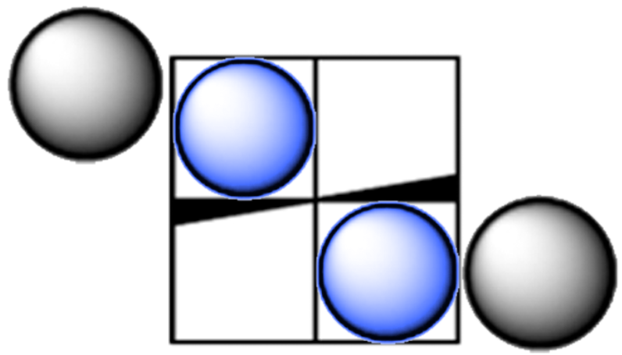

a.

b.

Figure 2.3. Proposed coordination site hindrance for (a) 19 and (b) 19_{ox}.

that increased steric restrictions (i.e. catalyst 17 versus 19, Figure 2.1) have on olefin polymerization activity.

Results and Discussion
The procedure and characterization of precatalyst 17-L have been previously reported by Tshuva et al. and modified by Busico and coworkers.^{13, 17} The route to 18-L was more involved, however, and was taken step-by-step, illustrated in Figure 2.4. In short, 2-adamantyl-4-iodophenol was prepared by Friedel-Crafts alkylation of 4-iodophenol, which then underwent ortho-formylation to afford 3-adamantyl-5-iodo-salicylaldehyde.⁴²
This was then coupled to previously prepared EthFc followed by reductive amination with ethylene diamine. The final methylation was done in two steps: first, the benzoxazine was formed and subsequently reduced with sodium borohydride (NaBH₄).
Cyclic voltammetry (CV) was taken to probe the redox-activity of each precatalyst. CV of precatalyst 18 (Figure 2.5) showed half wave potential of -0.744 V, with respect to a Fc/Fc⁺ standard, indicating that chemical oxidation was possible. Based on this half-wave potential, AgOTf was chosen as an appropriate oxidant and CoCp₂ was chosen as the reductant as they both provide the electrochemical potential necessary for the Fc/Fc⁺ transition.⁴³
Precatalyst 17 behaved as reported for the polymerization of 1-hexene, yielding viscous poly(1-hexene) with molecular weight data collected in Table 2.1. Surprisingly however is the performance of 18 which showed very poor polymerization activity, contrary to our previous hypothesis; although the distal portions of the ligands surrounding
Figure 2.4. Synthetic scheme for 18-L.

Figure 2.5. Cyclic voltammogram of 18 (0.01 mmol) recorded at a scan rate of 100 mV/s in dichloromethane (5 mL), (nBu)₄NPF₆ (0.20 M), (E_{1/2} = -0.774 V) versus Fc/Fc⁺.

Table 2.1 Polymerization of 1-hexene using precatalysts 17 and 18.ª

Entry | Precatalyst | Polymer yield (%) | M_{n}^{b} (kg/mol) | Đ^{b}
1 | 17 | 30.6 ± 0.5 | 30.6 ± 1.3 | 2.3 ± 0.5
2 | 18 | 2.0 ± 0.1 | w.i.p.^{c} | w.i.p.^{c}
3 | 18_{ox} | w.i.p.^{c} | w.i.p.^{c} | w.i.p.^{c}

ªPolymerization conditions: 10.0 μmol, 3 mL of 1-hexene, 1 mL of DCM, initiated with one equivalent of AB at 20 °C, t_{rxn} = 3 h. ^{b}Determined using triple detection GPC operating at 160 °C in 1,2,4-trichlorobenzene. ^{c}Work in progress, currently awaiting results.
17 and 18 should be sterically identical the drastic decrease in activity has been attributed to the greater degree of electron donation from the EthFc moieties on 18, as compared with the distal methyl group on 17. Substantial molecular weight information was unable to be obtained by HT-GPC of the polymers resultant of 18 or 18_{ox}.
Multiple routes to access precatalyst 19 via cross-coupling reactions to append EthFc to 2-hydroxy-3-iodo-5-methylbenzaldehyde were largely unsuccessful, though they were tried at multiple points in the procedure (Figure 2.6). We originally set out to follow the route used for 18-L with different a different substrate but identical conditions (Figure 2.6a). Further coupling attempts were made at the beginning of the synthetic route using
commercially available 2-iodo-4-methylphenol (Figure 2.6b), and near the end after the reductive amination (Figure 2.6c).
Next, the reaction conditions were altered systematically (Figure 2.6c). The first alteration was substituting diisopropylethylamine for triethylamine, since they have both been employed as the scavenger in the past with nearly identical results.⁴⁴ While this was not an exhaustive study, many bases (pyridine, diethyl/diisopropylamine, piperidine) have been reported albeit with significantly lower yield.⁴⁴ Temperature modifications were also explored ranging from room temperature to reflux. The final modification attempted was incorporating higher catalyst loading, five to ten mole percent with respect to Pd to no avail.
The effects of certain reaction parameters such as base, temperature, time, and catalyst/ catalyst loading have been the subject of many organic synthesis papers. It is important to note that there are a variety of Pd precatalysts available, at varying
Figure 2.6. Routes attempted to synthesize precatalyst 19.

temperatures and times for high conversion cross couplings reported.^{26, 44, 45} At the present time this is believed to be due to steric limitations of organometallic intermediates, however more work should be done to improve upon this.

Conclusion and Future Work
In summary, we have developed, synthesized, and characterized 18, a redox active precatalyst analog of 17 for α-olefin polymerization, albeit with drastically low activity. A few further studies could help to better understand the full scope of this project. First, as previously reported the nature of the metal plays a distinct role in polymerization
activity. Kol and coworkers have shown that titanium-centered precatalysts produce higher levels of isotacticity under the same conditions when compared to Zr, and similar but opposite results when compared to Hf.^{15, 46, 47} In order to achieve these results the metal host, Zr(Bn)₄, should be substituted for Ti(Bn)₄ or Hf(Bn)₄,reacted with the appropriate ligand, and isolated in the same manner as described below. These studies should also include redox studies to help understand polymerization activity as well as the tacticity effects.
The monomer coordination strength directly plays a role in multiple facets of a catalyst’s function. As such it would be interesting to understand the effects of the redox moieties through a mechanistic investigation using low-temperature NMR studies in conjunction with theoretical studies. First it will be necessary to achieve polymerization activity using these precatalysts, then with kinetic data we can determine the rate at which polymerization occurs. Further elucidation of activity using theoretical calculations would benefit by providing binding energies of monomer and catalyst, studies of binding energies between native and oxidized species.
To round off the story, the route to access 19 should be optimized. The cross-coupling step to append EthFc to the modified salicylaldehyde has been attempted at various stages of the procedure, all however returning nothing but starting material. At present it is thought due to the phenol prohibiting the organometallic intermediates from interacting. This should be a facile step as hydroxyl groups are ED and aldehydes are EW providing optimal direction for substitution to occur. Once complete, the route should proceed as with 18: reductive amination using ethylenediamine followed by methylation with formaldehyde and NaBH₄ workup, and subsequent metalation to afford 19.

Experimental
General Remarks: All reactions sensitive to air or moisture were carried out under nitrogen atmosphere using standard Schlenk or glove box techniques. Solvents were dried on an Innovative Technology PureSolve system and dried using three freeze-pump-thaw cycles. All reagents and solvents were purchased from Sigma-Millipore, Fisher Scientific, Acros Organics, Strem Chemicals, Oakwood Chemical, or synthesized via previous literature methods. NMR spectra were acquired on a Varian Mercury Vx 300 MHz or Varian VNMRS 500 MHz instrument and referenced to the appropriate solvent. Polymers were characterized using a Malvern High Temperature OMNISEC GPC equipped with a TSK gel column with 1,2,4-trichlorobenzene as the eluent at 150 ºC. Molecular weight and dispersity data are reported using triple detection: refractive index, viscometer, low-angle light scattering and right-angle light scattering.

Synthesis of 2-(1-adamantyl)-4-methylphenol:
To a flask was added 4-methylphenol (2.773 g, 25.6 mmol), 1-adamantanol (4.098 g, 26.9 mmol), and DCM (20 mL). In a separate flask sulfuric acid (1.5 mL, 98 % in water) and glacial acetic acid (6.5 mL) were mixed, added to DCM solution dropwise, and allowed to stir for 18 h at room temperature. The reaction mixture was diluted with water (150 mL) basified with saturated sodium bicarbonate, extracted with DCM (3x50 mL), washed with water (3x50 mL), dried over anhydrousMgSO₄, and solvent removed under vacuum. The crude product was purified via flash chromatography (95:5 hexanes:EA, R_{f}=0.35) to give a white solid (4.545 g, 73%).

Synthesis of 17-L:
To a flask was added 2-(1-adamantyl)-4-methylphenol (1.374 g, 5.67 mmol), N,N’-dimethylethylenediamine (0.2 mL, 2.84 mmol), formaldehyde (0.43 mL, 5.67 mmol, 67 % by weight in water), and MeOH (15 mL). The mixture was allowed to reflux for two hours, during which time a stark white precipitate formed. After cooling, the solid was filtered, washed with ice-cold MeOH and dried. (3.72 g, 65.6 %). All characterization matched previous literature.

Synthesis of Ethynylferrocene:
Acetylferrocene (5 g, 21.92 mmol) was added to a Schlenk flask, degassed under vacuum, and nitrogen atmosphere introduced. 50 mL THF was added, solution cooled to -78 ºC followed by the dropwise addition of LDA (1.5 eq, 2 M in THF/heptane/ethylbenzene), and allowed to stir for one hour. 3.3 mL of diethylchlorophosphate were added and stirred for an hour, then warmed to room temperature and stirred for an additional hour. The solution was then cooled to -78 ºC, 2.3 eq LDA was added dropwise, and stirred for an hour, then warmed to room temperature and allowed to stir for two hours. The reaction was hydrolyzed, extracted with DCM (3x50 mL), organic layers pooled and dried over anhydrous MgSO₄, solvent removed under vacuum yielding deep red oil. The crude product was purified via flash chromatography (90:10 hexanes:EA, R_{f}=0.75) to give a dark red crystalline solid (3.79 g, 61%). All characterization matched previous literature.

Synthesis of 2-(1-adamantyl)-4-iodophenol:
To a flask was added 4-iodophenol (5 g, 22.7 mmol), 1-adamantanol (3.46 g, 22.7 mmol) and DCM (15 mL). In a separate flask sulfuric acid (1.5 mL, 98 % in water) and glacial acetic acid (6.5 mL) were mixed, added to DCM solution dropwise, and allowed to stir for 18 h at room temperature. The reaction mixture was diluted with water (150 mL) basified with saturated sodium bicarbonate, extracted with DCM (3x50 mL), washed with water (3x50 mL), dried over anhydrous MgSO₄, and solvent removed under vacuum to yield a red-orange solid. The crude product was purified via flash chromatography (95:5 hexanes:EA, R_{f}=0.35) to give a yellow-green solid (4.10 g, 52%). All characterization matched previous literature.

Synthesis of 3-(1-adamantyl)-2-hydroxy-5-iodobenzaldehyde:
To a pressure tube was added paraformaldehyde (0.185 g, 6.16 mmol), magnesium chloride (0.533 g, 5.56 mmol), trimethylamine (0.8 mL, 5.56 mmol), and 2-(1-adamantyl)-4-iodophenol (1 g, 2.8 mmol) dissolved in 10 mL THF in the glovebox. The tube was heated to 80 ºC for 18 h, cooled, acidified, and extracted with CHCl₃. The organic layers were washed with water (3x25 mL) and brine (3x25 mL). The crude product was purified via flash chromatography (95:5 hexanes:EA, R_{f}=0.35) to give a dark red crystalline solid (4.10 g, 52%). All characterization matched previous literature.

Synthesis of 3-(1-adamantyl)-5-ethynylferrocenyl-2-hydroxy-benzaldehyde:
Ethynylferrocene (1.81 g, 8.63 mmol) and 3-(1-adamantyl)-2-hydroxy-5-iodobenzaldehyde (3 g, 7.85 mmol) were added to an oven-dried Schlenk flask and degassed, then dissolved in THF (50 mL). To a separate Schlenk flask was added Pd(PPh₃)₂Cl₂ (0.551 g, 0.785 mmol), copper iodide (3.7 mg, 0.196 mmol) in the glovebox and cycled onto the Schlenk line. The ethynylferrocene solution was transferred via cannula. TEA (8 mL) was added, the flask heated to 70 ºC and allowed to stir for 48 h. The reaction mixture was filtered through Celite, and purified via flash chromatography (90:10 hexanes:DCM, R_{r}=43) to give orange solid. ¹H-NMR (500 MHz, C₆D₆) δ (ppm): 1.70 (s, 6H), 1.97-2.07 (m, 11H), 4.0 (t, 2H), 4.15 (s, 4H), 4.57 (t, 2H), 7.07 (s, 1H), 7.64 (s, 1H), 9.07 (s, 1H), 12.32 (s, 1H). ¹³C-NMR (500 MHz, C₆D₆) δ (ppm): 37.18, 37.39, 40.15, 66.14, 69.33, 70.39, 71.77, 85.77, 87.77, 115.59, 120.93, 134.96, 137.31, 139.07, 161.36, 196.80.

Synthesis of N,N’-bis(2-(1-adamantyl)-4-ethynylferrocenylphenol)-ethylenediamine:
3-(1-adamantyl)-5-ethynylferrocenyl-2-hydroxy-benzaldehyde (1 g, 2.15 mmol) was dissolved in ethanol (25 mL, 95%), ethylenediamine (0.07 mL, 1.07 mmol) was added along with formic acid (ten drops) and stirred for four hours. The resulting solid was filtered and washed with ice-cold ethanol, dried under vacuum. The solid was then dissolved in THF and MeOH (60 and 20 mL, respectively). NaBH₄ (4.5 g, in excess) was added in portions and the solution was allowed to stir for 18 h. The solvent was removed under vacuum, the crude solid dissolved in DCM, then washed with water (2x50 mL) and brine (2x50 mL), dried over MgSO₄, and solvent removed under vacuum to give an orange solid (1.16 g, 1.18 mmol). ¹H-NMR (500 MHz, C₆D₆) δ (ppm): 1.23 (m, 4H), 1.85 (m, 16H), 2.11 (s, 9H), 2.34 (s, 12H), 3.21 (s, 4H), 3.98 (t, 4H), 4.16 (s, 10H), 4.60 (t, 4H), 7.13 (s, 2H), 7.67 (s, 2H).

Synthesis of 18-L:
N,N’-(ethylenediamino)-bis(2-adamantyl-4-ethynylferrocenylphenol) (1 g, 1.02 mmol) was dissolved in MeCN (8.5 mL), to which was added formaldehyde (0.8 mL, 37 % by weight in water) and glacial acetic acid (1.5 mL) and stirred for one hour at room temperature. The solution was extracted with DCM (3x25 mL), washed with saturated NaHCO₃ (2x30 mL) and solvent removed. The solid was then dissolved in THF and MeOH (20 mL each), NaBH₄ (4.5 g) was added in portions, and the solution was stirred for 18 h. Solvent was removed, dissolved in DCM (50 mL), and washed with water (3x25 mL), dried over anhydrous MgSO₄ and solved removed to yield a brown solid (0.5 g, 49.78 %). ¹H-NMR (500 MHz, C₆D₆) δ (ppm): 1.70 (s, 4H), 1.82 (d, 20H), 2.11 (s, 6H), 2.32 (s, 12 H), 3.15 (m, 4H), 3.98 (s, 4H), 4.16 (s, 10 H), 4.27 (s, 2H), 4.58 (t, 4H), 7.12 (s, 2H), 7.65 (s, 2H).

Synthesis of 2-hydroxy-3-iodo-5-methylbenzaldehyde:
In a glovebox 2-iodo-4-methylphenol (2 g, 8.544 mmol), paraformaldehyde (0.628 g, 18.778 mmol), magnesium chloride (1.626 g, 17.088 mmol), TEA (2.4 mL, 16.088 mmol), and THF (20 mL) were added to a pressure tube, heated to 80 ºC for 18 h. After cooling to room temperature the mixture was acidified, extracted with CHCl₃ (3x15 mL), dried over anhydrous MgSO₄, solvent removed, and the crude solid purified via flash chromatography (90:10 hexanes:EA, R_{f} = 0.28), yielding a pale yellow solid (1.5741 g, 70.2 %). ¹H-NMR (500 MHz, CDCl₃) δ (ppm): 2.32 (s, 3H), 7.34 (s, 1H), 7.82 (s, 1H), 9.71 (s, 1H), 11.59 (s, 1H). ¹³C-NMR (500 MHz, CDCl₃) δ (ppm): 19.98, 85.28, 120.22, 131.35, 134.13, 146.94, 158.46, 196.03.

Synthesis of Tetrabenzylzirconium:
To a Schlenk flask was added ZrCl₄ (0.5 g, 2.15 mmol), a swivel frit and second flask attached, and cycled onto a Schlenk line. Diethyl ether (15 mL) was added, the flask wrapped in aluminum foil, cooled to -78 ºC, benzylmagnesium chloride (6.6 mL, 1.3 M in diethyl ether) was added dropwise, warmed to room temperature and stirred for 18 h. The solvent was removed in vacuo, hexanes (20 mL) was added and the solution stirred for 3 h at 60 ºC, after which the solution was filtered, solvent removed in vacuo yielding a bright yellow solid (0.9 g, 1.97 mmol). All characterization matched previous literature.

General precatalyst synthesis:
Tetrabenzylzirconium (0.10 mmol) was added to a vial and dissolved in toluene (10 mL). To a separate vial was added the appropriate ligand (0.10 mmol) and toluene (10 mL), and subsequently added dropwise to the tetrabenzylzirconium vial, transferred to a Schlenk tube, and heated to 60 ºC for two hours under inert atmosphere. The solution was cooled to room temperature, solvent removed in vacuo, and crystallized by layering DCM/pentane.

General procedure for 1-hexene polymerizations:
To a vial was added precatalyst (10 μmol), 1-hexene (3 mL), and magnetic stir bar. AB (10 μmol) was dissolved in DCM (1 mL) in a separate vial and subsequently added to the hexane solution and allowed to stir under inert atmosphere. After three hours, the polymerization was quenched with MeOH (10 mL), polymer collected and dried to constant weight under vacuum.

References
1. Sailors, H. R.; Hogan, J. P., History of Polyolefins. Journal of Macromolecular Science: Part A - Chemistry 1981, 15 (7), 1377-1402.
2. Seymour, R. B., History of Polyolefins. In: Seymour R.B., Cheng T. (eds) Advances in Polyolefins. Springer: Boston, MA, 1987.
3. Alt, H. G.; Köppl, A., Effect of the Nature of Metallocene Complexes of Group IV Metals on Their Performance in Catalytic Ethylene and Propylene Polymerization. Chemical Reviews 2000, 100 (4), 1205-1222.
4. Gibson, V. C.; Spitzmesser, S. K., Advances in Non-Metallocene Olefin Polymerization Catalysis. Chemical Reviews 2003, 103 (1), 283-316.
5. Kaminsky, W.; Funck, A.; Hahnsen, H., New application for metallocene catalysts in olefin polymerization. Dalton Trans 2009, (41), 8803-10.
6. Keim, W., Oligomerization of Ethylene to α-Olefins: Discovery and Development of the Shell Higher Olefin Process (SHOP). Angewandte Chemie International Edition 2013, 52 (48), 12492-12496.
7. Makio, H.; Terao, H.; Iwashita, A.; Fujita, T., FI Catalysts for Olefin Polymerization—A Comprehensive Treatment. Chemical Reviews 2011, 111 (3), 2363-2449.
8. Lorkovic, I. M.; Duff, R. R.; Wrighton, M. S., Use of the Redox-Active Ligand 1,1'-Bis(diphenylphosphino)cobaltocene To Reversibly Alter the Rate of the Rhodium(I)-Catalyzed Reduction and Isomerization of Ketones and Alkenes. Journal of the American Chemical Society 1995, 117 (12), 3617-3618.
9. Gregson, C. K. A.; Gibson, V. C.; Long, N. J.; Marshall, E. L.; Oxford, P. J.; White, A. J. P., Redox Control within Single-Site Polymerization Catalysts. Journal of the American Chemical Society 2006, 128 (23), 7410-7411.
10. Chen, M.; Yang, B.; Chen, C., Redox-Controlled Olefin (Co)Polymerization Catalyzed by Ferrocene-Bridged Phosphine-Sulfonate Palladium Complexes. 2015, 54 (51), 15520-15524.
11. Anderson, W. C.; Long, B. K., Modulating Polyolefin Copolymer Composition via Redox-Active Olefin Polymerization Catalysts. ACS Macro Letters 2016, 5 (9), 1029-1033.
12. Anderson, W. C.; Rhinehart, J. L.; Tennyson, A. G.; Long, B. K., Redox-Active Ligands: An Advanced Tool To Modulate Polyethylene Microstructure. Journal of the American Chemical Society 2016, 138 (3), 774-777.
13. Tshuva, E. Y., Goldberg, I., Kol, M., Isospecific Living Polymerization of 1-Hexene by a Readily Available Nonmetallocene C2-Symmetrical Zirconium Catalyst. J. Am. Chem. Soc. 2000, (122), 10706-10707.
14. Tshuva, E. Y., Goldberg, I., Kol, M., Goldschmidt, Z., Zirconium Complexes of Amine-Bis(phenolate) Ligands as Catalysts for 1-Hexene Polymerization: Peripheral Structural Parameters Strongly Affect Reactivity. Organometallics 2001, 20, 3017-3028.
15. Segal, S., Goldberg, I., Kol, M., Zirconium and Titanium Diamine Bis(phenolate) Catalysts for r-Olefin Polymerization: From Atactic Oligo(1-hexene) to Ultrahigh-Molecular-Weight Isotactic Poly(1-hexene). Organometallics 2005, 24, 200-202.
16. Cipullo, R.; Busico, V.; Fraldi, N.; Pellecchia, R.; Talarico, G., Improving the Behavior of Bis(phenoxyamine) Group 4 Metal Catalysts for Controlled Alkene Polymerization. Macromolecules 2009, 42 (12), 3869-3872.
17. Busico, V.; Cipullo, R.; Friederichs, N.; Ronca, S.; Talarico, G.; Togrou, M.; Wang, B., Block Copolymers of Highly Isotactic Polypropylene via Controlled Ziegler−Natta Polymerization. Macromolecules 2004, 37 (22), 8201-8203.
18. Yeori, A., Goldberg, I., Kol, M., Cyclopolymerization of 1,5-Hexadiene by Enantiomerically-Pure Zirconium Salan Complexes. Polymer Optical Activity Reveals r-Olefin Face Preference. Macromolecules 2007, 40, 8521-8523.
19. Yeori, A., Goldberg, I., Shuster, M., Kol, M., Diastereomerically-Specific Zirconium Complexes of Chiral Salan Ligands: Isospecific Polymerization of 1-Hexene and 4-Methyl-1-pentene and Cyclopolymerization of 1,5-Hexadiene. J. Am. Chem. Soc. 2006, 128, 13062-13063.
20. Gregson, C. K. A.; Blackmore, I. J.; Gibson, V. C.; Long, N. J.; Marshall, E. L.; White, A. J. P., Titanium–salen complexes as initiators for the ring opening polymerisation of rac-lactide. Dalton Transactions 2006, (25), 3134-3140.
21. Brown, L. A.; Rhinehart, J. L.; Long, B. K., Effects of Ferrocenyl Proximity and Monomer Presence during Oxidation for the Redox-Switchable Polymerization of l-Lactide. ACS Catalysis 2015, 5 (10), 6057-6060.
22. Wang, X.; Thevenon, A.; Brosmer, J. L.; Yu, I.; Khan, S. I.; Mehrkhodavandi, P.; Diaconescu, P. L., Redox Control of Group 4 Metal Ring-Opening Polymerization Activity toward l-Lactide and ε-Caprolactone. Journal of the American Chemical Society 2014, 136 (32), 11264-11267.
23. Quan, S. M.; Wang, X.; Zhang, R.; Diaconescu, P. L., Redox Switchable Copolymerization of Cyclic Esters and Epoxides by a Zirconium Complex. Macromolecules 2016, 49 (18), 6768-6778.
24. Quan, S. M.; Wei, J.; Diaconescu, P. L., Mechanistic Studies of Redox-Switchable Copolymerization of Lactide and Cyclohexene Oxide by a Zirconium Complex. Organometallics 2017, 36 (22), 4451-4457.
25. Lowe, M. Y.; Shu, S.; Quan, S. M.; Diaconescu, P. L., Investigation of redox switchable titanium and zirconium catalysts for the ring opening polymerization of cyclic esters and epoxides. Inorganic Chemistry Frontiers 2017, 4 (11), 1798-1805.
26. Xu, X.; Luo, G.; Hou, Z.; Diaconescu, P. L.; Luo, Y., Theoretical insight into the redox-switchable activity of group 4 metal complexes for the ring-opening polymerization of ε-caprolactone. Inorganic Chemistry Frontiers 2020, 7 (4), 961-971.
27. Dai, R.; Diaconescu, P. L., Investigation of a zirconium compound for redox switchable ring opening polymerization. Dalton Transactions 2019, 48 (9), 2996-3002.
28. Doerr, A. M.; Burroughs, J. M.; Legaux, N. M.; Long, B. K., Redox-switchable ring-opening polymerization by tridentate ONN-type titanium and zirconium catalysts. Catalysis Science & Technology 2020, 10 (19), 6501-6510.
29. Broderick, E. M.; Guo, N.; Vogel, C. S.; Xu, C.; Sutter, J.; Miller, J. T.; Meyer, K.; Mehrkhodavandi, P.; Diaconescu, P. L., Redox Control of a Ring-Opening Polymerization Catalyst. Journal of the American Chemical Society 2011, 133 (24), 9278-9281.
30. Hermans, C.; Rong, W.; Spaniol, T. P.; Okuda, J., Lanthanum complexes containing a bis(phenolate) ligand with a ferrocene-1,1′-diyldithio backbone: synthesis, characterization, and ring-opening polymerization of rac-lactide. Dalton Transactions 2016, 45 (19), 8127-8133.
31. Wei, J.; Riffel, M. N.; Diaconescu, P. L., Redox Control of Aluminum Ring-Opening Polymerization: A Combined Experimental and DFT Investigation. Macromolecules 2017, 50 (5), 1847-1861.
32. Lai, A.; Hern, Z. C.; Diaconescu, P. L., Switchable Ring-Opening Polymerization by a Ferrocene Supported Aluminum Complex. 2019, 11 (16), 4210-4218.
33. Yang, B.; Pang, W.; Chen, M., Redox Control in Olefin Polymerization Catalysis by Phosphine–Sulfonate Palladium and Nickel Complexes. 2017, 2017 (18), 2510-2514.
34. Anderson, W. C.; Park, S. H.; Brown, L. A.; Kaiser, J. M.; Long, B. K., Accessing multiple polyethylene grades via a single redox-active olefin polymerization catalyst. Inorganic Chemistry Frontiers 2017, 4 (7), 1108-1112.
35. Zhao, M.; Chen, C., Accessing Multiple Catalytically Active States in Redox-Controlled Olefin Polymerization. ACS Catalysis 2017, 7 (11), 7490-7494.
36. Mundil, R.; Wilson, L. E.; Schaarschmidt, D.; Císařová, I.; Merna, J.; Long, N. J., Redox-switchable α-diimine palladium catalysts for control of polyethylene topology. Polymer 2019, 179, 121619.
37. Abubekerov, M.; Shepard, S. M.; Diaconescu, P. L., Switchable Polymerization of Norbornene Derivatives by a Ferrocene-Palladium(II) Heteroscorpionate Complex. 2016, 2016 (15-16), 2634-2640.
38. Zou, W.; Pang, W.; Chen, C., Redox control in palladium catalyzed norbornene and alkyne polymerization. Inorganic Chemistry Frontiers 2017, 4 (5), 795-800.
39. Gibson, V. C.; Long, N. J.; Oxford, P. J.; White, A. J. P.; Williams, D. J., Ferrocene-Substituted Bis(imino)pyridine Iron and Cobalt Complexes: Toward Redox-Active Catalysts for the Polymerization of Ethylene. Organometallics 2006, 25 (8), 1932-1939.
40. Wei, J.; Diaconescu, P. L., Redox-Switchable Ring-Opening Polymerization with Ferrocene Derivatives. Accounts of Chemical Research 2019, 52 (2), 415-424.
41. Press, K.; Cohen, A.; Goldberg, I.; Venditto, V.; Mazzeo, M.; Kol, M., Salalen titanium complexes in the highly isospecific polymerization of 1-hexene and propylene. Angew Chem Int Ed Engl 2011, 50 (15), 3529-32.
42. Akselsen, Ø. W.; Skattebøl, L.; Hansen, T. V., ortho-Formylation of oxygenated phenols. Tetrahedron Letters 2009, 50 (46), 6339-6341.
43. Connelly, N. G.; Geiger, W. E., Chemical Redox Agents for Organometallic Chemistry. Chemical Reviews 1996, 96 (2), 877-910.
44. Souffrin, A.; Croix, C.; Viaud-Massuard, M.-C., Efficient and General Protocol for Sonogashira Cross-Coupling Reactions of Maleimides. European Journal of Organic Chemistry 2012, 2012 (13), 2499-2502.
45. Elangovan, A.; Wang, Y.-H.; Ho, T.-I., Sonogashira Coupling Reaction with Diminished Homocoupling. Organic Letters 2003, 5 (11), 1841-1844.
46. Sergeeva, E.; Kopilov, J.; Goldberg, I.; Kol, M., Dithiodiolate ligands: group 4 complexes and application in lactide polymerization. Inorg Chem 2010, 49 (9), 3977-9.
47. Cohen, A.; Kopilov, J.; Lamberti, M.; Venditto, V.; Kol, M., Same Ligand, Different Metals: Diiodo−Salan Complexes of the Group 4 Triad in Isospecific Polymerization of 1-Hexene and Propylene. Macromolecules 2010, 43 (4), 1689-1691.

Conclusion and Outlook

The polymerization of α-olefins has traditionally been achieved using heterogeneous catalysts which are typically multisite in nature proving difficult to understand mechanistically. The last two decades, however, have brought about a host of new single-site catalysts which allow for facile investigation and selective tunability. In addition, redox moieties provide a more refined level of control due to the “two-for-one” nature. Early examples of redox-active catalysts featured EthFc units which show on/off activity and later lead to orthogonal monomer copolymerizations of cyclic esters.
Adjacent to this research groups were working towards understanding how olefin polymerizations were affected based on the presence of ED/EW groups for the hallmark [ONNO]-type systems. Ferrocene units have been added systematically to the ligand scaffold to provide both ED/EW activity in a single system, and has been appended in a variety of combinations and proximities.
To contribute to this field 18 was characterized via traditional techniques, but showed scant polymerization activity in either redox state, and at this time it is unclear why this happened. It should be that both 17 and 18 should exhibit nearly identical steric environments due to the way in which each ligand binds to the metal center. However, the electronic environments could play enough of a role in monomer binding that prohibits insertion of the monomer and thus is left in an equilibrium between coordinated monomer and open active site. Conversely, 18_{ox} may be able to provide sufficient electron withdrawal which allows for coordination of the monomer but does not allow for insertion.

Appendices

Supporting Information – Chapter 2

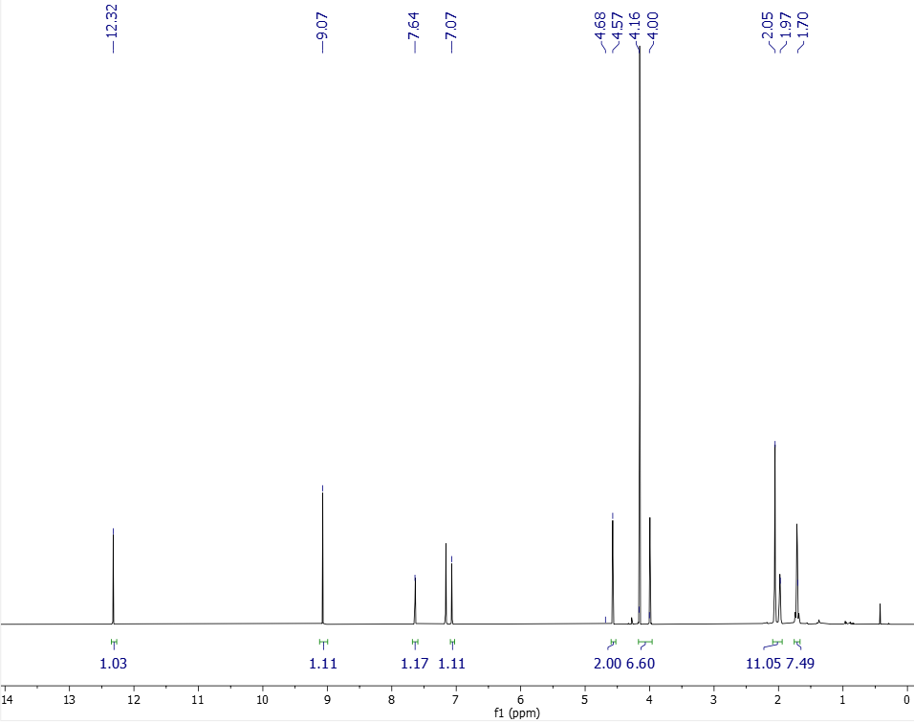
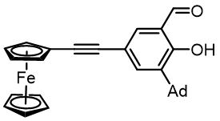
Figure A.1. ¹H-NMR (500 MHz, 25 ºC, C₆D₆) of 3-(1-adamantyl)-5-ethynylferrocenyl-2-hydroxy-benzaldehyde.

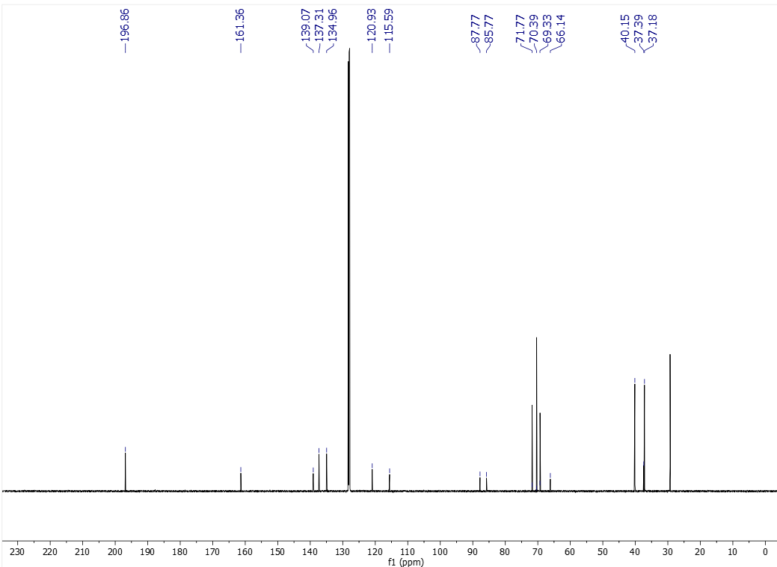

Figure A.2. ¹³C-NMR (500 MHz, 25 ºC, C₆D₆) of 3-(1-adamantyl)-5-ethynylferrocenyl-2-hydroxy-benzaldehyde.

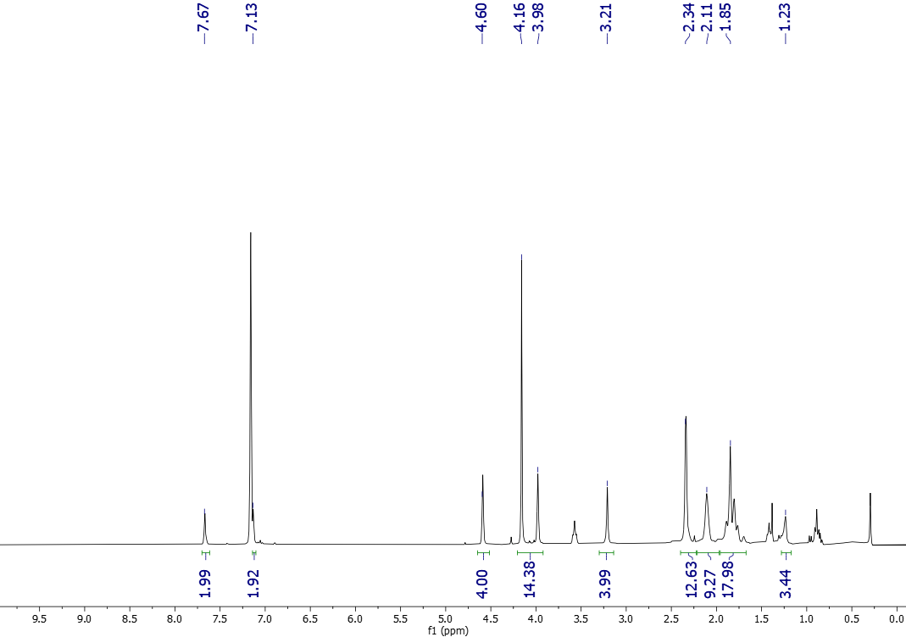
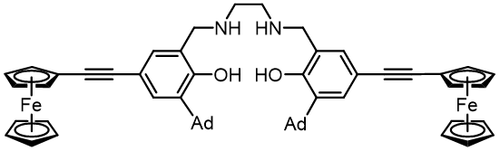

Figure A.3. ¹H-NMR (500 MHz, 25 ºC, C₆D₆) of N,N’-bis(2-(1-adamantyl)-4-ethynylferrocenylphenol)-ethylenediamine.¹

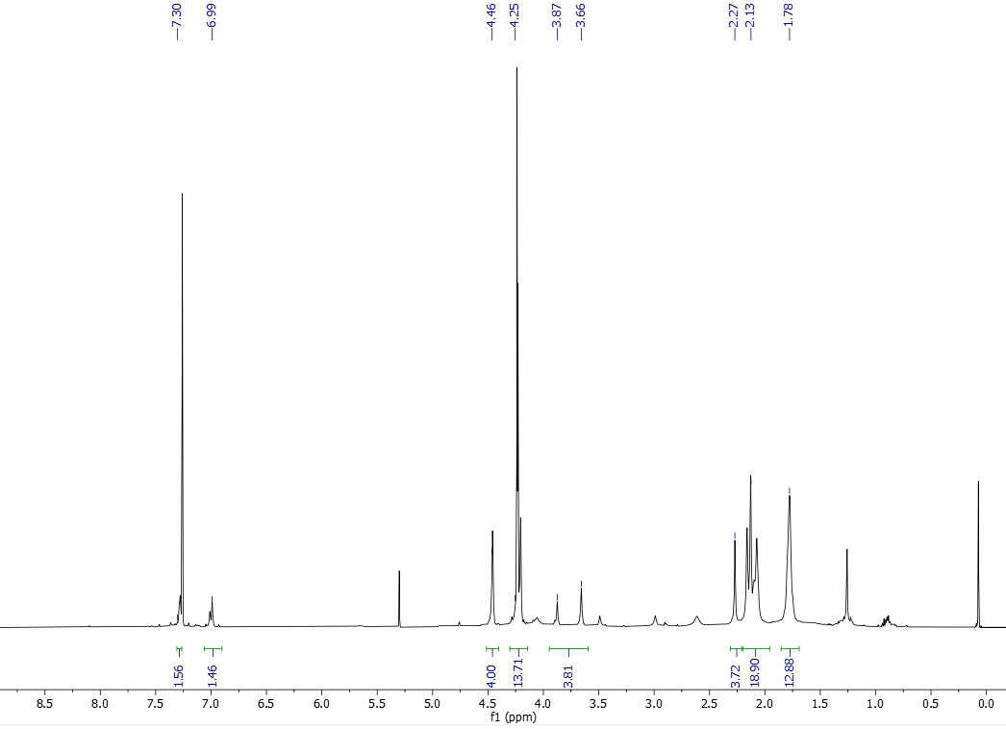

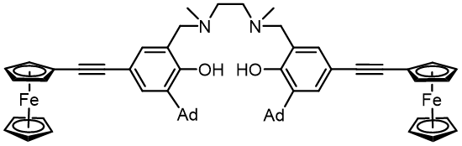

Figure A.4. ¹H-NMR (500 MHz, 25 ºC, C₆D₆) of L1.

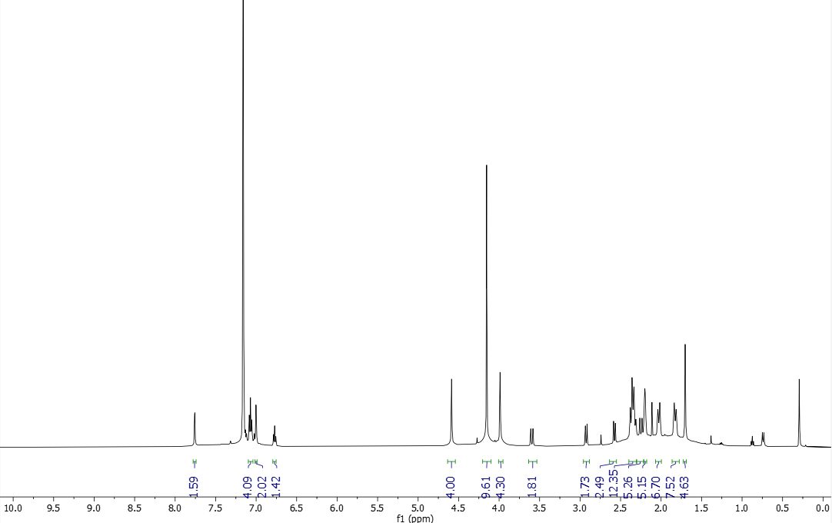
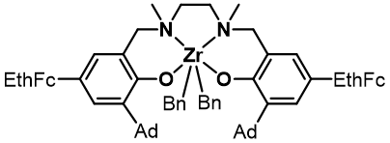

Figure A.5. ¹H-NMR (500 MHz, 25 ºC, C₆D₆) of 2.

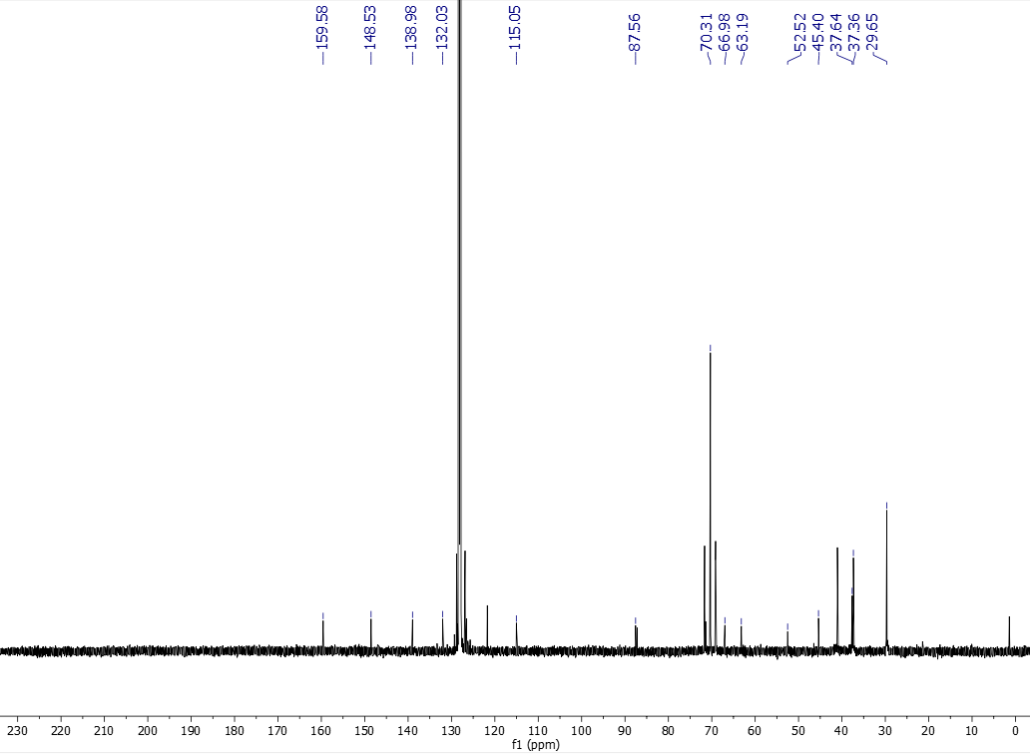
Figure A.6. ¹³C-NMR (500 MHz, 25 ºC, C₆D₆) of 2.

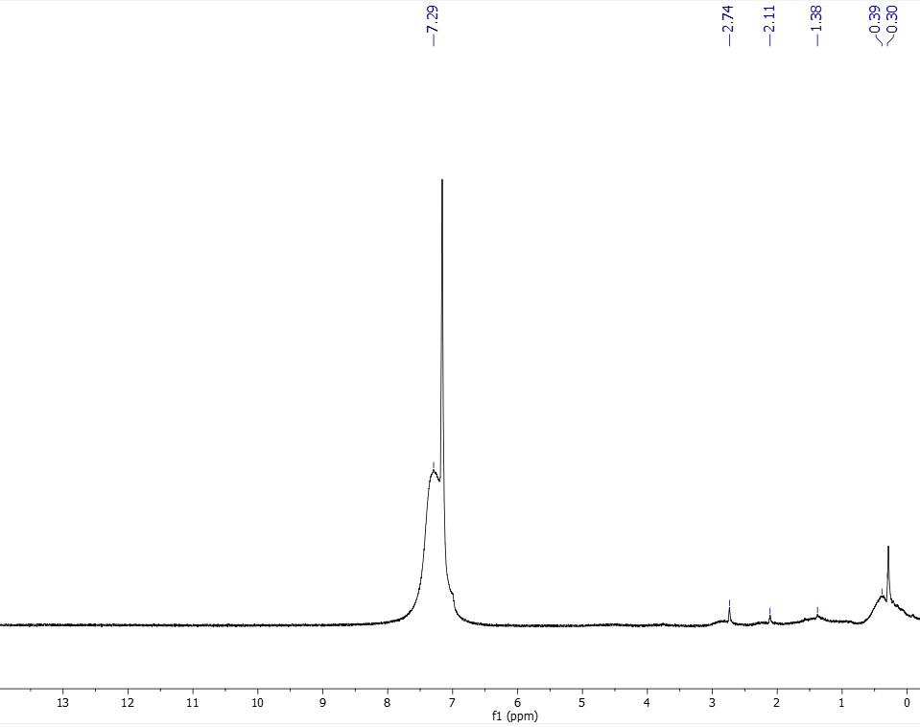
Figure A.7. ¹H-NMR (500 MHz, 25 ºC, C₆D₆) of 2_{ox}.

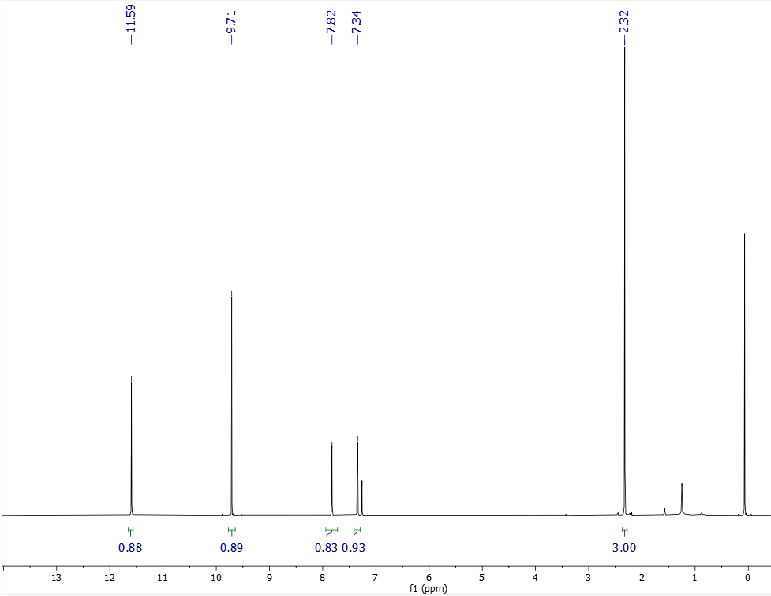
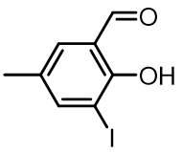
Figure A.8. ¹H-NMR (500 MHz, 25 ºC, CDCl₃) of 2-hydroxy-3-iodo-5-methylbenzaldehyde.

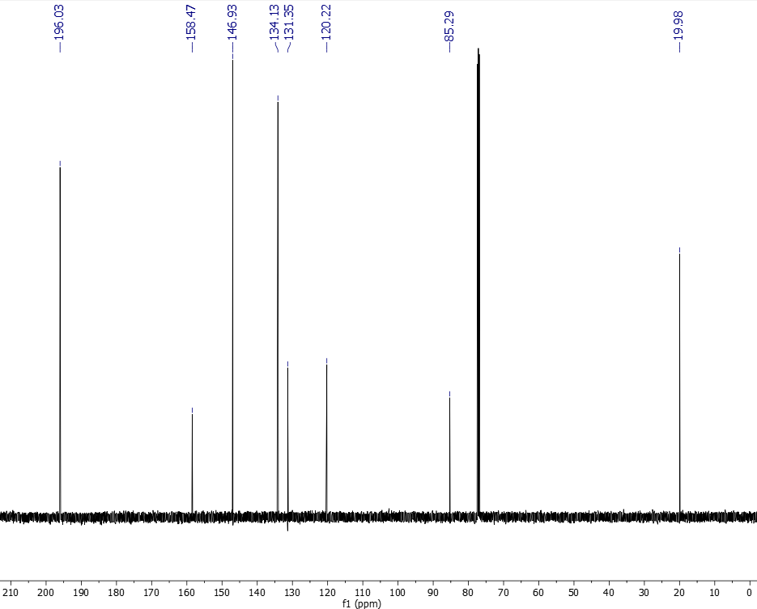

Figure A.9. ¹³C-NMR (500 MHz, 25 ºC, CDCl₃) of 2-hydroxy-3-iodo-5-methylbenzaldehyde.

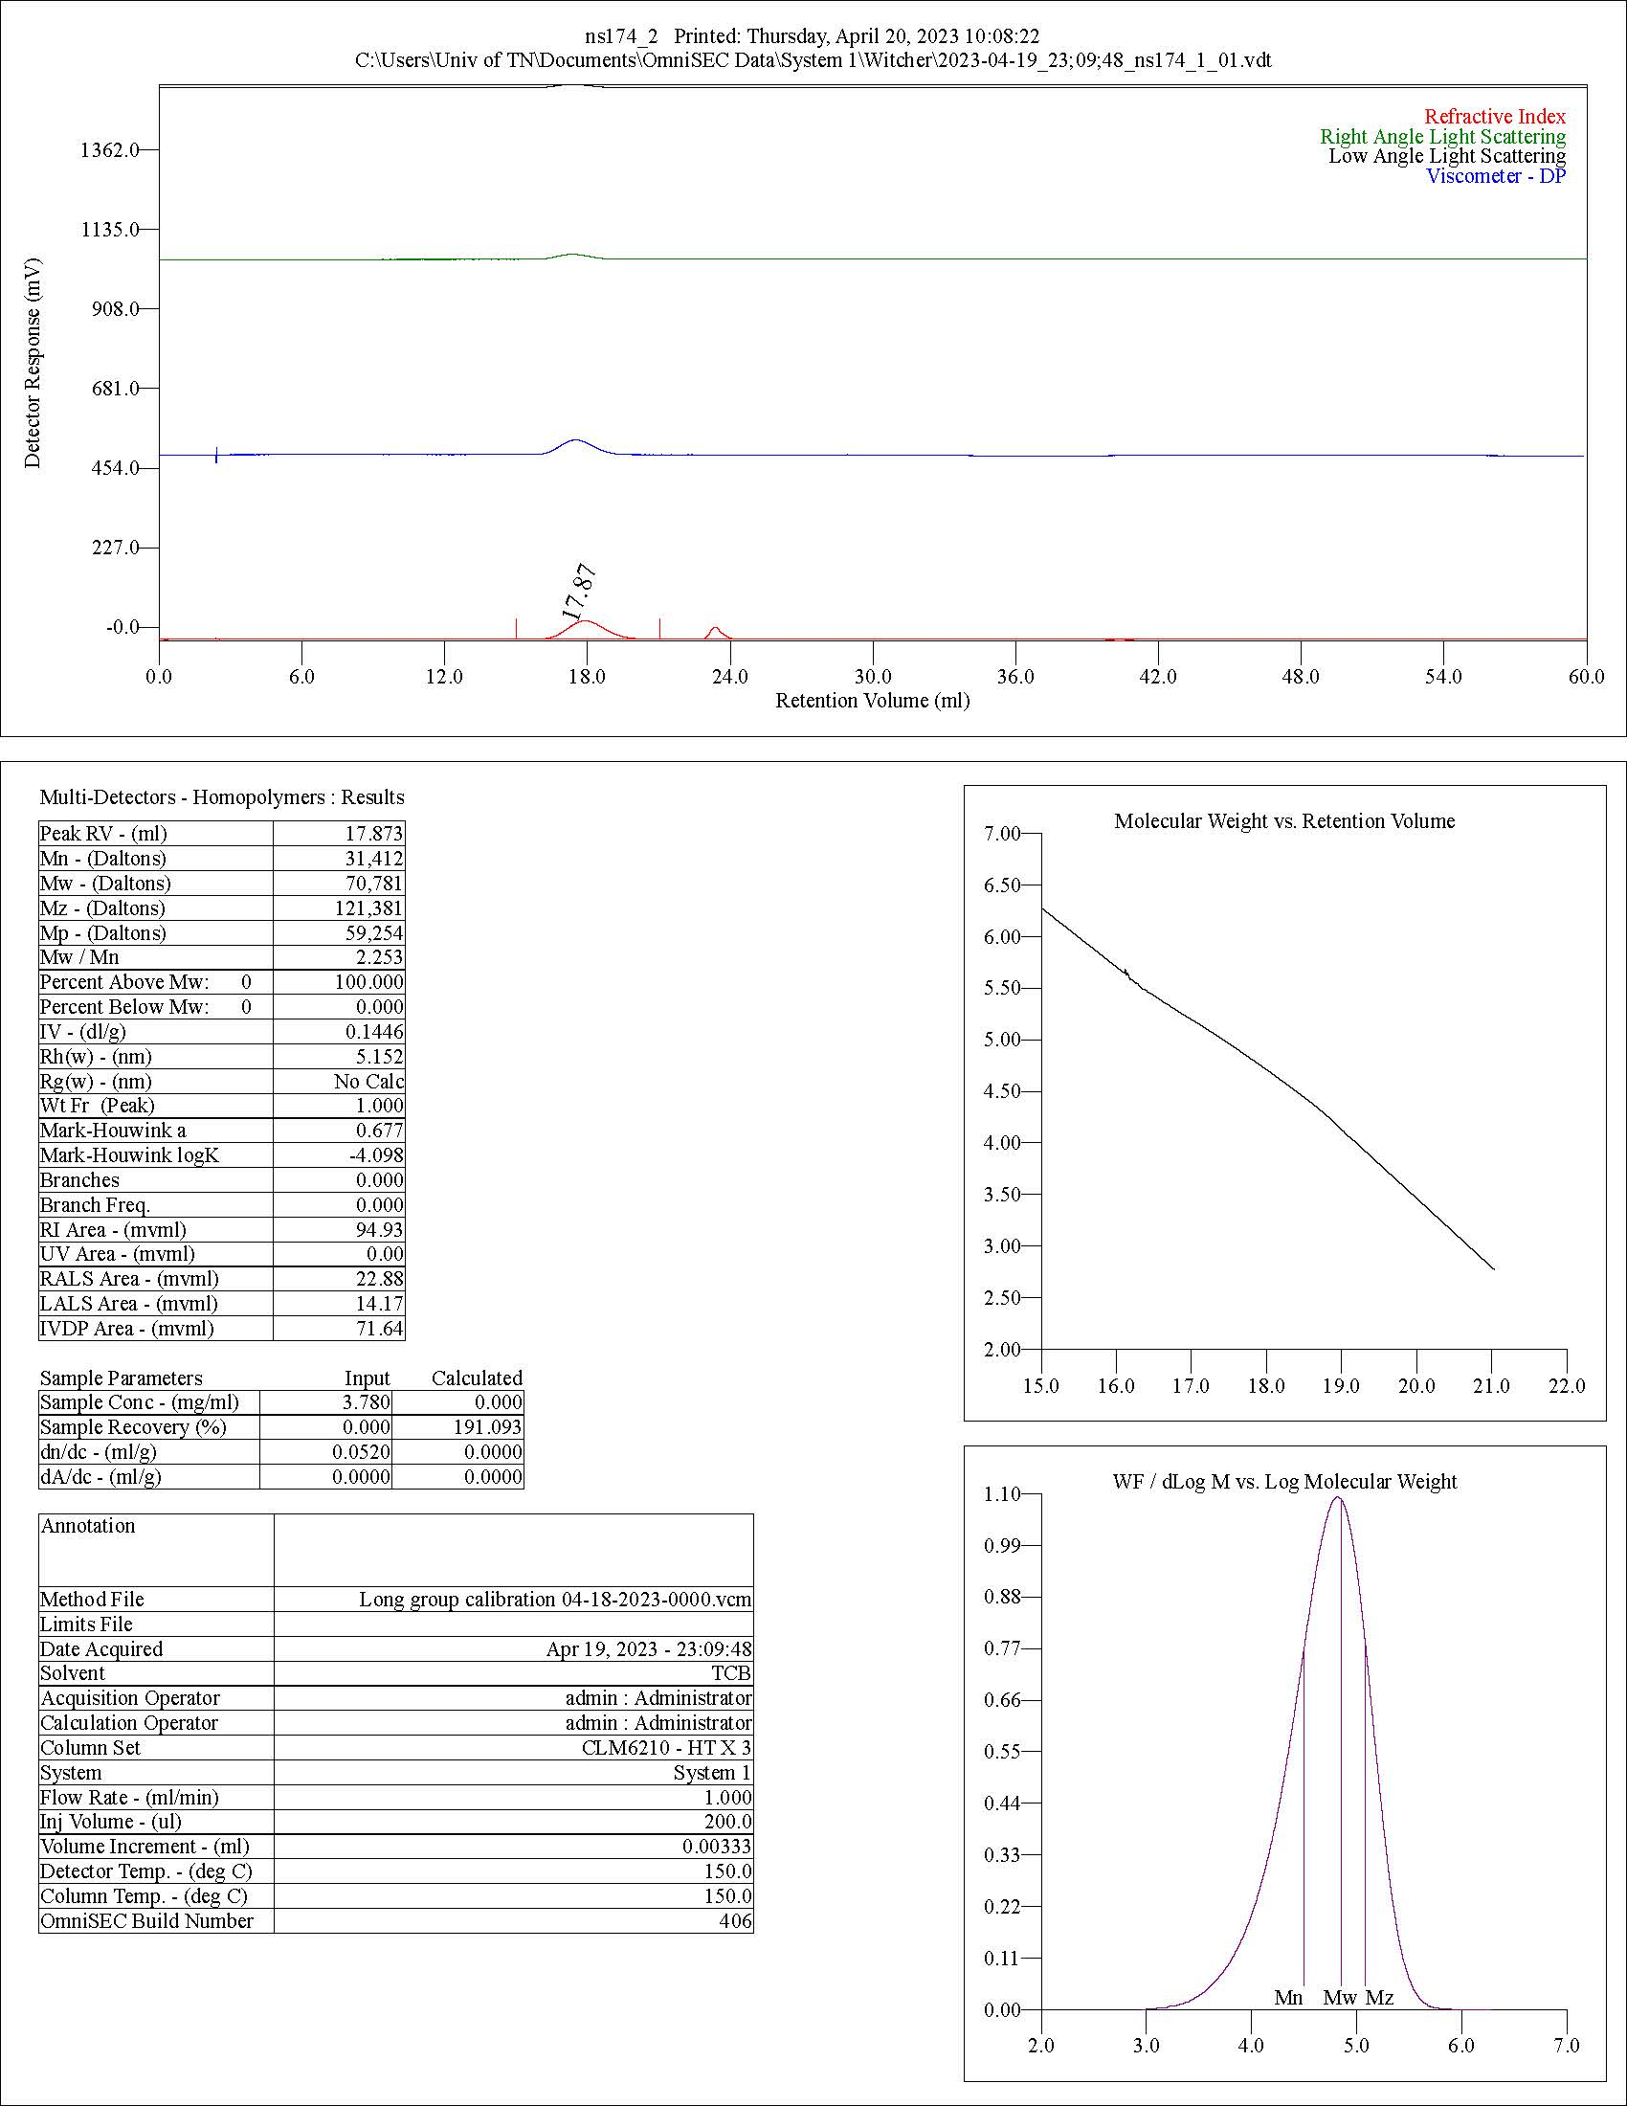
Figure A.10. Raw GPC data of 1-hexene polymerization using 1.

Heteroleptic Aluminum Allyls as Initiators for Lactide Polymerization

A version of this chapter was originally published by Lauren E. Wenger, Nicholas M. Shawver, William W. Brennessel, Brian K. Long, and Timothy P. Hanusa:

Wenger, L. E.; Shawver, N. M.; Brennessel, W. W.; Long, B. K.; Hanusa, T. P., Heteroleptic Aluminum Allyls as Initiators for Lactide Polymerization. Organometallics 2022, 41 (23), 3718-3723.

Lauren Wenger was responsible for all synthesis and spectroscopic measurements. I was responsible for running all polymerizations, characterizing the resultant polymers via GPC and NMR, and performing end group analysis via ¹H-NMR spectroscopy. William Brennessel was responsible for X-ray data collection of complexes. Brian Long was responsible for overseeing and advising on polymerization data and reviewing the manuscript. Timothy Hausa was responsible for supervising the project, funding, writing the original draft, and reviewing and editing the manuscript.

Abstract
Organoaluminum complexes with the formula [(NHC)AlCl_{3‑n}A′_{n}] (NHC = IMes (IMes = 1,3-bis(2,4,6trimethylphenyl)imidazol-2-ylidene) or IDipp (IDipp = 1,3-bis(2,6-diisopropylphenyl)imidazol-2-ylidene); A′ = [1,3-(SiMe₃)₂C₃H₃]−; n = 0−2) were synthesized either through solution or mechanochemical methods. Although an NHC adduct with [AlA′₃] did not form, [(IDipp)AlCl₂A′] and [(IMes)AlClA′₂] were obtained and X-ray crystallography confirmed their construction around Al in a distorted tetrahedral environment. The [(NHC)AlCl_{3‑n}A′_{n}] complexes, [AlA′₃], and [Al(O^{i}Pr)₃] (as a reference) were examined for their ability to polymerize L-lactide via ring-opening polymerization to produce polylactide. All of them did so with varying degrees of effectiveness. Of the organoaluminum species, the [(NHC)AlCl₃] complexes were very weak initiators, and [AlA′₃] the most effective, producing polymer molecular weights up to 49 kDa (M_{w}), with the mixed chloro/allyl complexes in between. All initiators were slower than [Al(O^{i}Pr)₃].

Introduction
Despite a millennia-long history,1 mechanochemistry has only recently emerged as an increasingly applicable tool for organometallic synthesis under solvent-free conditions.² Initiated by the absorption of mechanical energy, often by grinding and ball milling,³ mechanochemical reactions represent “green chemistry” techniques by reducing solvent waste and offering shorter reaction times, enhanced yields, and improved selectivity when compared to analogous solution-based approaches.⁴ One of the greatest benefits of mechanochemically based synthesis is the potential access it provides to new types of molecular structures, including low-coordinate metal complexes.⁵
Unsolvated organometallics constitute one class of such low-coordinate complexes. For example, the parent tri(allyl) aluminum complex exists only in the form of solvent adducts [Al(C₃H₅)₃·S] (S = THF, pyridine, OPPh₃).⁶ Attempts to form the potentially more reactive unsolvated complex with either the unsubstituted or substituted allyl ligand, [1,3(SiMe₃)₂C₃H₃]⁻ (= [A′]⁻), with solution-based syntheses have not been successful.^{2b,7} In contrast, a mechanochemical approach, in which the reagents are ground without a solvent, is effective and leads to the isolation of [AlA′₃] in high yield.^{2b} As an additional benefit, the mechanochemically produced complex displays greater reactivity in a stoichiometric context than the solvated counterpart, a feature that could potentially contribute to higher reactivity in catalytic reactions.⁴
To this aim, we sought to prepare new initiators for lactide polymerization. Polylactide (PLA) is a biodegradable plastic alternative (Figure B.1a)that is sourced from renewable sources including corn and sugar beets.⁸ PLA can be used for packaging, drug delivery, and biomedical applications,⁹ and has steadily grown in popularity in recent decades. Despite its increasing adoption, there are still issues with PLA’s physical properties and processing characteristics that are highly sensitive to the polymerization conditions. Such issues have kept its cost relatively high and prevented PLA from becoming a commodity polymer.¹⁰
Although low-molecular-weight PLA can be generated by direct polycondensation of lactic acid,⁹ higher-molecular weight PLA is routinely accessed via a milder alternative route employing the ring-opening polymerization (ROP) of lactide (Figure B.1b).¹¹ Since the first report of aluminum isopropoxide as an initiator of ROP in 1991,¹² aluminum complexes have played a major role in the development of this initiator class.^{12,13} Investigations have examined the effect of steric bulk at the aluminum center and the strength of metal−ligand bonds, and considerable work has been conducted with polydentate N- or O-donor ligands, with both aluminum and other early main-group metals.¹⁴ In contrast, organoaluminum initiators are much less explored, comprising mainly β-diketiminate-aluminum species with methyl or ethyl ligands, sometimes including mixed chloro/alkyl species. Several homoleptic organoaluminums [AlR₃] (R = Me, Et, ^{i}Bu, and octyl) have been examined as potential ROP initiators and their reactivity
Figure B.1. (a) Repeating unit of polylactide (PLA) and (b) L-lactide.

compared with [Al(O^{i}Pr)₃]. Although conversion of L-lactide is slower with [AlR₃] species than with isopropoxide, molecular weights can be higher by almost a factor of two.¹³ As a complement to this work, we here report the result of generating and employing bulky allyl aluminum complexes as ROP initiators.

Results and Discussion
Synthesis of Aluminum Allyl NHC Adducts. Heteroleptic aluminum complexes [(NHC)AlCl_{3‑n}A′_{n}] (NHC = N-heterocyclic carbene) were prepared by various solution and mechanochemical methods, although not all methods worked for every combination of ligands. For the trichloro species [(NHC)AlCl₃] (Figure B.2a), the solution route described by Schödel¹⁵ was adapted for the present work (eq B.1; NHC = IDipp (1,3-bis(2,6-diisopropylphenyl)imidazol-2-ylidene) or IMes (1,3-bis(2,4,6-trimethylphenyl)imidazol-2-ylidene))
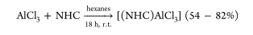
(B.1)
An analogous preparation involved grinding the reagents in a planetary mill (PM) (eq B.2). The reactions gave quantitative yields and were complete in shorter times than the solution-based routes, which is a commonly encountered benefit of mechanochemically initiated reactions.^{2c}
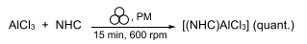
(B.2)
Preparation of the mono(allyl) [(NHC)AlCl₂A′] (Figure B.2b) complexes could be performed with either solution or mechanochemical methods. For the solution route, the
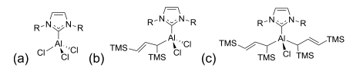
Figure B.2. Structures of NHC adducts R = 2,6-diisopropylphenyl or 2,4,6-trimethylphenyl: (a) [(NHC)AlCl₃]; (b) [(NHC)AlCl₂A′]; and (c) [(NHC)AlClA′₂].

NHC was dissolved in toluene, and then AlCl₃ was added. After allowing the solution to stir for 15 min, K[A′] was added, and the combined mixture was allowed to stir for an additional 3 h. The mixture was then filtered to remove KCl and the filtrate evaporated to give a dark orange oil that solidified on standing over several days, providing [(NHC)AlCl₂A′] in high yield (96% to quant.).
The mechanochemical equivalent could be done in one step, combining NHC, AlCl₃, and K[A′] and then grinding the mixture for 15 min in a mixer mill (MM) (or 5 min in a planetary mill at 300 rpm) (eq 3.3). The ground mixture was extracted with a minimal amount of toluene, the extract filtered, and dried. This approach generated more byproducts than the solution route, although their formation could be suppressed to some extent by prechilling the grinding jar in liquid nitrogen before milling. A cleaner product in roughly 56−80% yield was obtained in this way.
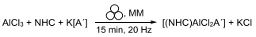
(3.3)
Under certain conditions, and only when using the solution route to form [(IMes)AlCl₂A′], small crystals of the mesitylaminium salt N-(2-(mesitylamino)-3,5-bis(trimethylsilyl)pent-4-en-1-yl)-mesitylaminium chloride were obtained. It was identified through its single-crystal X-ray structure, which, although definitive as to composition, is of connectivity only quality. Its formation apparently involves attack of the [A′]⁻ ion on the C=C double bond of IMes, but we have not been able to reproduce it consistently, and so cannot more precisely describe the exact conditions required for its formation.
Attempts to form bis(allyl) complexes [(NHC)AlClA′₂] (Figure B.2c) by extension of the previously used methods, i.e., mixing NHC, AlCl₃, and 2 equiv. of K[A′] under either solution or mechanochemical conditions (including variations in time, temperature, solvent, and milling conditions), produced only the mono(allyl) aluminum species and the protonated allyl ligand (i.e., the propene HA′). Instead, these complexes had to be accessed by combining (NHC)·HCl with the mechanochemically generated [AlA′₃],^{2b} producing HA′ as a byproduct (eq 3.4). Removal of the HA′ under vacuum gave [(NHC)AlClA′₂] complexes in moderate yield, ca. 35−40%.
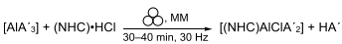
(3.4)
To complete the series of complexes, synthesis of [(NHC)AlA′₃] adducts was attempted by combining [AlA′₃] with NHCs (eq 3.5). Even under forcing conditions that were more energetic than those used for the other adducts, the attempted reactions yielded only starting material
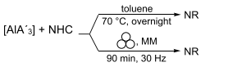
(3.5)
We hypothesized that steric crowding may be responsible for the failure to form [(NHC)AlA′₃] adducts. To examine this possibility, an estimate of the congestion in the coordination sphere of aluminum was generated with the Solid-G program¹⁶ on DFT-optimized models of [AlA′₃] and [(IMes)AlA′₃]. The G_{complex} value represents the net coverage so that regions of the coordination sphere where the projections of the ligands overlap are counted only once; for [AlA′₃], the G_{complex} value is 79.7%. Although IMes coordinates to [AlA′₃] in the gas-phase approximation, the G_{complex} value is pushed to 97.8%. There is no absolute cut-off value for stable structures, but the very high amount of steric congestion that would be encountered in such an adduct would likely discourage stable adduct formation, particularly in the condensed phase. Note also that the calculated Al−C_{allyl} distances have lengthened by 0.06 Å in the hypothetical [(IMes)AlA′₃] complex, and the Al−C_{carbene} distance is 2.157 Å, which is longer (and presumably weaker) than the comparable 2.07−2.10 Å distances found for the other NHC−Al complexes described here.
The NMR spectra for the [(NHC)AlCl_{3‑n}A′_{n}] (n = 1,2) complexes display resonances consistent with η¹-bound A′ ligands, indicating that the molecules are not fluxional. This is in contrast to the [AlA′₃] complex, which although displaying η¹-bound ligands in the solid state, is highly fluxional in solution, with the A′ ligands giving the appearance of being π-bound down to −70 °C (e.g., only one signal is observed for the otherwise inequivalent trimethylsilyl groups).^{2b}
Crystallographic Results. The IDipp version of [(NHC)AlCl₂A′] was highly crystalline, forming crystals with little effort. In contrast, the IMes analogue was amorphous, and Xray quality crystals were not obtained. Interestingly, the situation was reversed in the [(NHC)AlClA′₂] case, and suitable crystals of [(IMes)AlClA′₂] were obtained, as discussed below.
Solid-State Structure of [(IDipp)AlCl₂A′]. Colorless crystals of [(IDipp)AlCl₂A′] were grown from toluene over several days. The asymmetric unit contains one molecule in a general position. One isopropyl group was modeled as disordered over two sites (0.51:0.49) (Figure B.3). The aluminum lies in the center of a distorted tetrahedron, coordinated by the two chlorines, the IDipp carbene, and an η¹-bonded A′ ligand. The Al−C_{carbene} bond length
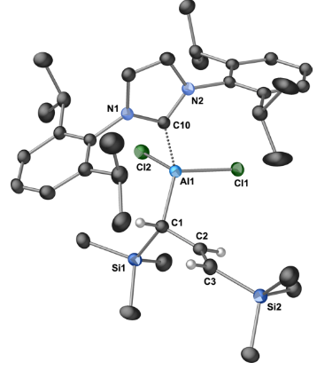
Figure B.3. Thermal ellipsoid plot (50% level) of [(IDipp)AlCl₂A′]. For clarity, one conformation of the disordered isopropyl group is omitted, as are all hydrogens except those on the C₃ section of the A′ ligand. Selected bond distances (Å) and angles (deg): Al1−Cl1, 2.1533(9); Al1−Cl2, 2.1544(9); Al1−C1, 1.989(3); Al1−C10, 2.069(3); C1−C2, 1.492(4); C2−C3, 1.337(4); Cl1−Al1−Cl2, 106.02(4); Cl1−Al1−C1, 110.01(8); Cl2−Al1−C1, 116.44(9); C1−Al1−C10, 114.79(10); Cl1−Al1−C10, 109.06(7); and Cl2− Al1−C10, 99.74(7).

of 2.069(3) Å is within the typical range of 2.008−2.118 Å found for similar compounds,¹⁷ and is slightly elongated from that found in [(IDipp)AlCl₃] (2.018(2) Å).¹⁸ Compared to the [AlA′₃] complex, the Al− C_{allyl} bond is barely longer (1.989(3) vs 1.964(2) Å), despite the higher coordination number in [(IDipp)AlCl₂A′].^{2b} The average Al−C_{allyl} bonds are slightly lengthened from those in [(IDipp)AlCl₃] (2.154 and 2.128 Å, respectively).¹⁸
Solid-State Structure of [(IMes)AlClA′₂]. Colorless crystals of [(IMes)AlClA′₂] were grown from hexanes over several weeks (Figure B.4). As in the structure of [(IDipp)AlCl₂A′], the Al in [(IMes)AlClA′₂] is in a distorted tetrahedral environment. Probably reflecting the increased steric bulk of the ligands, the distances of aluminum to the ligands are slightly longer than those in [(IDipp)AlCl₂A′]. For example, the aluminum−carbene distance (2.105 Å) is longer than in [(IDipp)AlCl₂A′] (2.069 Å) by 0.036 Å. Similarly, the Al−Cl bond (2.197(1) Å) has increased by 0.043 Å from the Al−Cl distance in [(IDipp)AlCl₂A′] (2.154 Å, ave.).
Polymerization Results. Polymerization results are presented in Table B.1 and Figure B.5. As a summary of the data, [AlA′₃] was the most active allyl initiator of L-lactide. Among the [(NHC)AlCl_{3‑n}A′_{n}] complexes, reactivity dropped with increasing number of chloride ligands. Even when only chlorides were present, which do not usually initiate lactide polymerization, low (3−4%) conversion was observed. The most likely source of initiation in these cases may be from small amounts of adventitious water that acts as an external initiating species; however, we were unable to conclusively show this (attempts to analyze the end-groups were not definitive).¹⁹ The identity of the NHC was not consistently associated with the more active (highest % conversion) initiator; e.g., in the monochloro
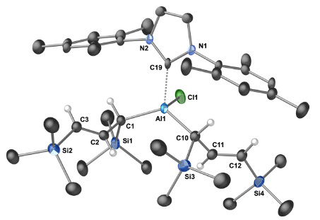
Figure B.4. Thermal ellipsoid plot (50% level) of [(IMes)AlClA′₂]. For clarity, all hydrogens except those on the C₃ section of the A′ ligands are omitted. Selected bond distances (Å) and angles (deg): Al1−Cl1, 2.197(1); Al1−C1, 1.992(3); Al1−C10, 1.996(3); Al1−C19, 2.105(4); C1−C2, 1.489(5); C2−C3, 1.325(5); C10−C11, 1.505(6); C11−C12, 1.324(4); Cl1−Al1−C1, 104.4(1); Cl1−Al1−C10, 108.6(1); Cl1-Al−C19, 96.2(1); C1-Al−C10, 112.6(2); C1-Al−C19, 112.0(1); and C10-Al−C19, 109.6(2).

Table B.1. Results of Polymerization with L-Lactide.
Initiator | Conv. (%) | M_{n} (kDa) | M_{w} (kDa) | Đ (M_{w}/M_{n})
[AlA′₃] | 80.5 | 22.8 | 48.8 | 2.1
[(IMes)AlClA′₂] | 47.3 | 9.3 | 50.1 | 5.4
[(IDipp)AlClA′₂] | 35.9 | 7.9 | 16.3 | 2.1
[(IDipp)AlCl₂A′] | 17.7 | 7.4 | 27.7 | 3.6
[(IMes)AlCl₂A′] | 6.0 | 10.2 | 16.6 | 1.6
[(IDipp)AlCl₃] | 4.0 | 7.4 | 27.7 | 3.7
[(IMes)AlCl₃] | 3.4 | 8.8 | 18.4 | 2.1
[Al(O^{i}Pr)₃]^{b} | 96.7 | 18.7 | 66.0 | 3.4

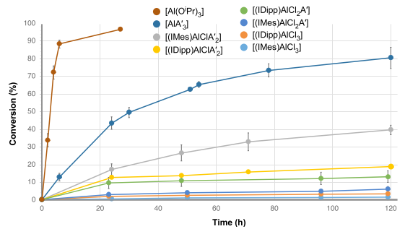

Figure B.5. Conversion as a function of time for various [(NHC)AlCl_{3‑n}A′_{n}] complexes, [AlA′₃], and [Al(O^{i}Pr)₃].

species [(NHC)AlClA′₂], the IMes complex was more reactive, whereas with the dichloro compounds [(NHC)AlCl₂A′], the IDipp variant displayed higher conversion. A similar flip was found with polydispersity values (Đ) in which the IMes complex of the monochloro species [(NHC)AlClA′₂] provided PLA with a slightly lower dispersity (Đ = 1.6 vs 2.0), whereas with the dichloro [(NHC)AlCl₂A′] compounds, the IDipp variant displayed substantially better control (Đ = 2.1 vs 5.4). All polymerizations were generally slow, most were not complete at 120 h.
The coordination number (CN) of aluminum may play a role in the polymerization rate in that a highly coordinated metal center would have to displace ligands to become active. For example, aluminum isopropoxide forms clusters of trimers and tetramers in solution, in which the aluminum has a CN of 4 or 5 in the trimer and 4 or 6 in the tetramer.²⁰ Penczek and co-workers have observed that trimeric [Al(OiPr)₃]₃ is much faster than tetrameric [Al(OiPr)₃]₄ in the ROP of L-lactide, at least partially reflecting the lower metal CN in the trimer.²¹ Analogously, a structural element of [AlA′₃] that may contribute to its activity is its 3-coordinate metal center. This is a relatively uncommon feature in “[AlR₃]” complexes (many such complexes are found as dimers in the solid state, with CN for the metal of four).²² The low CN for aluminum may help accelerate the catalytic ROP process, much as it assists in its stoichiometric reactivity.

Appendix References
1. Takacs, L., Quicksilver from cinnabar: The first documented mechanochemical reaction? JOM 2000, 52, 12-13. 10.1007/s11837-000-0106-0
2. (a) James, S. L.; Adams, C. J.; Bolm, C.; Braga, D.; Collier, P.; Friščić, T.; Grepioni, F.; Harris, K. D. M.; Hyett, G.; Jones, W.; Krebs, A.; Mack, J.; Maini, L.; Orpen, A. G.; Parkin, I. P.; Shearouse, W. C.; Steed, J. W.; Waddell, D. C., Chem. Soc. Rev. 2012, 41, 413. ; (b) Rightmire, N. R.; Hanusa, T. P.; Rheingold, A. L., Mechanochemical Synthesis of [1,3-(SiMe3)2C3H3]3(Al,Sc), a Base-Free Tris(allyl)aluminum Complex and Its Scandium Analogue. Organometallics 2014, 33, 5952–5955. 10.1021/om5009204; (c) Do, J.-L.; Friščić, T., Mechanochemistry: A Force of Synthesis. ACS Cent. Sci. 2017, 3, 13-19. 10.1021/acscentsci.6b00277
3. McNaught , A. A.; Wilkinson, A., IUPAC Compendium of Chemical Technology (the Gold Book). 2nd ed.; Blackwell Scientific: Oxford, 1997.
4. Tan, D.; García, F., Main group mechanochemistry: from curiosity to established protocols. Chem. Soc. Rev. 2019, 48, 2274-2292. 10.1039/C7CS00813A
5. Hernández, J. G.; Bolm, C., Altering Product Selectivity by Mechanochemistry. J. Org. Chem. 2017, 82, 4007-4019. 10.1021/acs.joc.6b02887
6. Lichtenberg, C.; Robert, D.; Spaniol, T. P.; Okuda, J., Bis(allyl)aluminum Cation, Tris(allyl)aluminum, and Tetrakis(allyl)aluminate: Synthesis, Characterization, and Reactivity†. Organometallics 2010, 29, 5714-5721. 10.1021/om100809h
7. (a) Grignard, V.; Jenkins, R. L., The organoaluminium compounds: ethyl dliodide and diethyl iodide of aluminium. Bull. Soc. Chim. Fr. 1925, 37, 1376-85. ; (b) Rainier, J. D.; Cox, J. M., Aluminum- and Boron-Mediated C-Glycoside Synthesis from 1,2-Anhydroglycosides. Org. Lett. 2000, 2, 2707-2709. 10.1021/ol006286u; (c) Majumder, U.; Cox, J. M.; Johnson, H. W. B.; Rainier, J. D., Total Synthesis of Gambierol: The Generation of the A–C and F–H Subunits by Using a C-Glycoside Centered Strategy. Chem.–Eur. J. 2006, 12, 1736-1746. 10.1002/chem.200500993; (d) Picotin, G.; Miginiac, P., Reaction of allylic aluminum reagents with 1,3-dithienium tetrafluoroborate and with 2-chloro-1,3-dithiane: preparation of 2-substituted 1,3-dithianes. J. Org. Chem. 1985, 50, 1299-1301. 10.1021/jo00208a030; (e) Shen, K.-H.; Yao, C.-F., Novel and Efficient Method for the Allylation of Carbonyl Compounds and Imines Using Triallylaluminum. J. Org. Chem. 2006, 71, 3980-3983. 10.1021/jo052385f; (f) Shen, K. H.; Liu, J. T.; Wu, Y. R.; Yao, C. F., Conjugate Addition of Triallylaluminum to α,β‐Unsaturated Nitroalkenes to Produce 4,5‐Unsaturated Nitroalkenes. Synth. Commun. 2007, 37, 3677-3687. 10.1080/00397910600978184; (g) Shen, K.-H.; Kuo, C.-W.; Yao, C.-F., An efficient of Grignard-type procedure for the preparation of gem-diallylated compound. Tetrahedron Lett. 2007, 48, 6348-6351. http://dx.doi.org/10.1016/j.tetlet.2007.07.008; (h) Kulkarni, N. A.; Yao, C.-F.; Chen, K., On the scope of diastereoselective allylation of various chiral glyoxylic oxime ethers with allyltributylstannane in the presence of a Lewis acid and triallylaluminum. Tetrahedron 2007, 63, 7816-7822. http://dx.doi.org/10.1016/j.tet.2007.05.091
8. Puaux, J.-P.; Banu, I.; Nagy, I.; Bozga, G., A Study of L-Lactide Ring-Opening Polymerization Kinetics. Macromol. Symp. 2007, 259, 318-326. https://doi.org/10.1002/masy.200751336
9. Masutani, K.; Kimura, Y., PLA Synthesis. From the Monomer to the Polymer. In Poly(lactic acid) Science and Technology: Processing, Properties, Additives and Applications, Jiménez , A.; Peltzer, M.; Ruseckaite, R., Eds. Royal Society of Chemistry: Cambridge, 2014; pp 1-36.
10. Balaji, A. B.; Pakalapati, H.; Khalid, M.; Walvekar, R.; Siddiqui, H., Natural and synthetic biocompatible and biodegradable polymers. In Biodegradable and Biocompatible Polymer Composites, Shimi, N. G., Ed. Elsfevier: Duxford, CB22 4QH, UK, 2018; pp 3-32.
11. (a) Dechy-Cabaret, O.; Martin-Vaca, B.; Bourissou, D., Controlled Ring-Opening Polymerization of Lactide and Glycolide. Chem. Rev. (Washington, DC, United States) 2004, 104, 6147-6176. ; (b) Kamber, N. E.; Jeong, W.; Waymouth, R. M.; Pratt, R. C.; Lohmeijer, B. G. G.; Hedrick, J. L., Organocatalytic Ring-Opening Polymerization. Chem. Rev. (Washington, DC, United States) 2007, 107, 5813-5840. 10.1021/cr068415b
12. Dubois, P.; Jacobs, C.; Jerome, R.; Teyssie, P., Macromolecular engineering of polylactones and polylactides. 4. Mechanism and kinetics of lactide homopolymerization by aluminum isopropoxide. Macromolecules 1991, 24, 2266-2270. 10.1021/ma00009a022
13. Yoo, J. Y.; Kim, Y.; Ko, Y. S., Ring-opening polymerization behavior of L-lactide catalyzed by aluminum alkyl catalysts. J. Ind. Eng. Chem. 2013, 19, 1137-1143. https://doi.org/10.1016/j.jiec.2012.12.010
14. Gao, J.; Zhu, D.; Zhang, W.; Solan, G. A.; Ma, Y.; Sun, W.-H., Recent progress in the application of group 1, 2 & 13 metal complexes as catalysts for the ring opening polymerization of cyclic esters. Inorrg. Chem. Front. 2019, 6, 2619-2652. 10.1039/C9QI00855A
15. Schödel, F.; Bolte, M.; Wagner, M.; Lerner, H.-W., NHC Supersilyl Silver Complex [Ag(IPr)SitBu3] as a Promising Agent for Substitution Reactions. Z. Anorg. Allg, Chem. 2020, 646, 264-267. https://doi.org/10.1002/zaac.201900304
16. Guzei, I. A.; Wendt, M., An improved method for the computation of ligand steric effects based on solid angles. Dalton Trans. 2006, 3991-3999. 10.1039/b605102b
17. Romain, C.; Fliedel, C.; Bellemin-Laponnaz, S.; Dagorne, S., NHC Bis-Phenolate Aluminum Chelates: Synthesis, Structure, and Use in Lactide and Trimethylene Carbonate Polymerization. Organometallics 2014, 33, 5730-5739. 10.1021/om5004557
18. Mikhaylov, V. N.; Kazakov, I. V.; Parfeniuk, T. N.; Khoroshilova, O. V.; Scheer, M.; Timoshkin, A. Y.; Balova, I. A., The carbene transfer to strong Lewis acids: copper is better than silver. Dalton Trans. 2021, 50, 2872-2879. 10.1039/D1DT00235J
19. Turova, N. Y.; Kozunov, V. A.; Yanovskii, A. I.; Bokii, N. G.; Struchkov, Y. T.; Tarnopol'skii, B. L., Physico-chemical and structural investigation of aluminium isopropoxide. J. Inorg. Nucl. Chem. 1979, 41, 5-11. https://doi.org/10.1016/0022-1902(79)80384-X
20. Kowalski, A.; Duda, A.; Penczek, S., Polymerization of l,l-Lactide Initiated by Aluminum Isopropoxide Trimer or Tetramer. Macromolecules 1998, 31, 2114-2122. 10.1021/ma971737k
21. Cowley, A. R.; Downs, A. J.; Marchant, S.; Macrae, V. A.; Taylor, R. A.; Parsons, S., Crystal Structures of Tris(tert-butyl)boron, -aluminum, -gallium, and -indium: Nonplanarity of the AlC3 Skeleton and Evidence of Inter- and Intramolecular “Agostic” or Hyperconjugative Interactions. Organometallics 2005, 24, 5702-5709. 10.1021/om050572y
22. (a) Kan, C.; Ge, J.; Ma, H., Aluminum methyl, alkoxide and α-alkoxy ester complexes supported by 6,6′-dimethylbiphenyl-bridged salen ligands: synthesis, characterization and catalysis for rac-lactide polymerization. Dalton Trans. 2016, 45, 6682-6695. 10.1039/C5DT04633E; (b) Wei, Y.; Song, L.; Jiang, L.; Huang, Z.; Wang, S.; Yuan, Q.; Mu, X.; Zhu, X.; Zhou, S., Aluminum complexes with Schiff base bridged bis(indolyl) ligands: synthesis, structure, and catalytic activity for polymerization of rac-lactide. Dalton Trans. 2019, 48, 15290-15299. 10.1039/C9DT02724F

Vita
Nick was born in Jupiter, FL on 22 December 1992. After graduating from A. W. Dreyfoos School of the Arts in 2011 and a brief academic hiatus he attended the University of Central Florida, receiving his Bachelor of Science degree in Chemistry and minor in Mathematics in May 2020. He then began his graduate studies at The University of Tennessee, Knoxville in August 2020, during which time he engaged and married his wife, Dalyn. In his free time, he enjoys tending to his small cactus farm, cooking too much food, and trekking through the wilderness.

