ENERGY MANAGEMENT STRATEGIES
FOR SECOND LIFE BATTERY ENERGY STORAGE SYSTEMS
IN GRID APPLICATIONS

A Thesis Presented for the
Master of Science
Degree
The University of Tennessee, Knoxville

Elizabeth C. Sutton
December 2024

ABSTRACT
Energy storage for power systems has been gaining interest recently as the penetration of renewable energy increases. Not only is it essential for the integration of renewable energy into the grid, but it can also provide many other services such as energy arbitrage, voltage support, and frequency regulation. The demand for batteries that are suitable for use in grid storage applications could be met by second life electric vehicle batteries that will be retired in the coming years. This thesis provides a comprehensive examination of Battery Energy Storage Systems (BESS), starting with the fundamental concepts of batteries and the implications of aging and lifecycle management on performance and reliability. The critical components of a BESS, including Battery Management Systems (BMS), Energy Management Systems (EMS), and Power Conversion Systems (PCS) are reviewed, highlighting their roles in optimizing system performance.
A simulation model of a BESS is developed to study the effects of energy management strategies on the cost of energy while using a BESS. The model can perform 4 operations – timed peak shaving, setpoint peak shaving, load leveling, and load shifting. Studies using this model show that the shape of the load impacts which energy management strategy is most suitable. The number of peaks, duration, and time of day it occurs should be considered when determining the best method. This model allows for any load, irradiance, and pricing structure to be input for easy evaluation. A 40 kW BESS building block is designed, constructed, and tested as part of a joint project with Volkswagen. Each of the main components is selected based on functionality and cost. After component testing, each part is integrated into a test system. The final system demonstrates a fully working state machine with grid connected, islanded, standby, and fault states. In the future, the BMS and measurement devices need to be integrated with the system to complete the building block.
Table of Contents
Chapter One Introduction and Background 1
1.1. Batteries 3
1.1.1. Structure 3
1.1.2. Aging 6
1.1.3. Lifecycle 8
Chapter Two Literature Review 13
2.1. Battery Energy Storage Systems (BESS) Overview 13
2.1.1. Battery Management System 18
2.1.2. Energy Management System 22
2.1.3. Modeling 23
2.2. BESS Applications 30
2.2.1. Energy Arbitrage 30
2.2.2. Renewable Smoothing 36
2.2.3. Voltage Support 36
2.2.4. Frequency Regulation 37
2.2.5. Reliability 38
2.3. Optimal Sizing 38
2.4. Economics 40
2.5. Chapter Summary 42
Chapter Three Battery Energy Storage System Model 43
3.1. Overview 43
3.1.1. Component Models 43
3.1.2. Energy Management Strategy Modes 44
3.1.3. Economic Calculations 47
3.2. Energy Management System 49
3.3. Results 55
3.4. Chapter Summary 65
Chapter Four Second Life Battery Energy Storage System Design 67
4.1. Overview 67
4.2. Power Conversion System 69
4.2.1. Selection 70
4.2.2. Testing 72
4.3. Battery Management System 74
4.3.1. Selection 74
4.3.2. Testing 75
4.4. Auxiliary Power System 80
4.5. Communication and Controls 82
4.5.1. HMI 85
4.5.2. LabVIEW Programming 87
4.6. State Transition Diagram 94
4.7. Chapter Summary 100
Chapter Five Conclusions 101
List of References 103
VITA 107

LIST OF TABLES

Table 2.1. Modeling method for components of a BESS based on timescale [21] 24
Table 4.1. Voltage, current, and power based on possible battery stack configurations 73
Table 4.2. Auxiliary power requirements 83
Table 4.3. Comparison of different sizes of auxiliary power systems 83
Table 4.4. BESS states and corresponding component statuses 96

LIST OF FIGURES
Fig. 1.1. Degradation mechanisms in Li-ion batteries [7] 9
Fig. 1.2. Electric-vehicle (EV) battery life cycle [1] 11
Fig. 2.1. Active battery capacity in CAISO balancing area (2018-2024) [14] 14
Fig. 2.2. Energy management model of a fuel cell and PV array system [24] 29
Fig. 2.3. Load profile of a large-scale ESS with peak shaving [42] 32
Fig. 2.4. Load profile of a large-scale ESS with load leveling [42] 35
Fig. 3.1. Peak shaving setpoint mode with a sample load 46
Fig. 3.2. Timed peak shaving for 6 hours using a sample load 46
Fig. 3.3. Load shifting of a sample load 48
Fig. 3.4. Simulink model for calculating total cost of energy when using a BESS 50
Fig. 3.5. Controls and display of presented BESS model 52
Fig. 3.6. State machine diagram for the energy management system of the BESS model 54
Fig. 3.7. The impact of increasing peak shaving duration beyond on-peak hours 56
Fig. 3.8. Demand and usage charge reduction by peak shaving with a sample load 58
Fig. 3.9 (a) Peak shaving at 300 kW for 3 hours (b) Peak shaving at 100 kW for 3 hours 60
Fig. 3.10. Optimal load level setpoint for a month-long industrial load profile 62
Fig. 3.11. Spectrum of energy management strategies based on difference between setpoint values [42] 62
Fig. 3.12. Cost reduction from energy management strategies for a month-long industrial load profile 64
Fig. 3.13. Cost reduction from energy management strategies for sample load with BESS 64
Fig. 4.1. BESS one line diagram 68
Fig. 4.2. DC coupled PCS topology 71
Fig. 4.3. AC coupled PCS topology 71
Fig. 4.4. PCS component testing setup 73
Fig. 4.5. Low voltage BMS lab setup wiring diagram 76
Fig. 4.6. 11S battery connection to a 16S BMS 76
Fig. 4.7. Low voltage BMS lab setup 77
Fig. 4.8. BMS balance test results for (a) Stack Current (b) Cell Voltage (c) Balance Count 79
Fig. 4.9. Auxiliary power system topology 81
Fig. 4.10. PCS communication board layout 84
Fig. 4.11. Wiring diagram for communication between cRIO and PCS and SEL-751 84
Fig. 4.12. HMI implemented in LabVIEW using cRIO-9871 86
Fig. 4.13. Establishing communication between the controller and (a) SEL-751 (b) PCS 88
Fig. 4.14. Entering grid connected state from any state other than standby 90
Fig. 4.15. Entering grid connected state from standby state 90
Fig. 4.16. Entering islanded from any state other than standby 90
Fig. 4.17. Entering islanded from any state other than standby 90
Fig. 4.18. (a) Disable (b) standby (c) fault reset button logic 92
Fig. 4.19. PCS status indicator logic 93
Fig. 4.20. Fault message display logic 93
Fig. 4.21. BESS state transition diagram 95
Fig. 4.22. BESS hardware testing setup in lab 97
Fig. 4.23. BESS testing setup wiring diagram 98
Fig. 4.24. Island to Standby and Standby to Island transition testing 99
Fig. 4.25. Island to Grid Connected transition testing 99

Introduction and Background
Due to the rise in popularity of electric vehicles (EVs), in the next few decades, a great number of EV batteries will become available for secondary purposes as degradation impacts their performance in driving applications. Batteries in EVs are put through extreme conditions, including both high and low temperatures, hundreds of partial cycles a year, high charge rates, and inconsistent discharge rates [1]. These conditions can lead to rapid degradation of the batteries in the first five years of their lifetime; most EV batteries are designed to exceed the manufacturer’s warranty of 8-10 years while maintaining greater than 70-80% of the original battery capacity. The servicing of the vehicle fleet will generate used batteries that no longer meet the warranty requirements but can still be used in second life applications [1]. Terawatt-hours of these degraded batteries will be retired from vehicles in the next few decades, so a plan needs to be developed for how to utilize them once their first life ends [1].
There are currently three main options for batteries once removed from electric vehicles. The first option is disposal. When batteries are damaged, after a wreck for instance, disposal is the safest option. Disposal is also common in areas that have limited infrastructure for repurposing the batteries, although most places have regulations that prevent mass disposal of batteries. Another issue with this option is it requires additional mining for materials because the battery materials are not recycled, which has great socio-economic concerns including destruction of land, contamination of water supplies, increase in hazardous waste, desertification, and habitat destruction [2].
The second option is to recycle the batteries. Many rare and precious metals are used in EV batteries, so recycling is one option to recover these materials ethically. But the recycling process can be inefficient and dangerous. Additionally, mining can be cheaper than recycling in some parts of the world. Recycling could incur an economic loss of up to $1560/ton when compared to mining and disposal [3]. Therefore, if this option is to gain popularity, a new, cost-effective process to safely recover the precious materials will need to be developed.
The last option is reusing the batteries. These batteries have many possible applications, but stationary grid storage is one of the more common uses because it can provide value to the energy market in the form of ancillary services such as energy arbitrage. Like the other methods, reuse has its own challenges. The cost of new batteries continues to decrease at a faster rate than the cost of remanufacturing [1]. The cost gap needs to be sufficiently large to justify the use of second life EV batteries with worse performance over the new batteries. Another concern is the variability in second life batteries. Batteries can be produced, tested, and used in the exact same way but still have different characteristics because aging varies in each cell. This means extensive testing is required, and many batteries will not be reusable due to noticeable differences in capacity and internal resistance.
Reusing batteries could help solve other issues concerning the lack of energy storage. At present, the electric power system could benefit from a significant increase in energy storage. Because electricity demands vary daily and seasonally, generators have been designed to match the peak demand, resulting in a system that runs at 20% over the estimated demand and uses only an average of 55% of the installed capacity in one year [4]. Energy storage systems could inject energy to the grid during peak hours. Then less generation would be needed for reserves, allowing generators to constantly run closer to full capacity. Another benefit of energy storage systems is the integration of renewable energy. Renewable energy such as solar and wind are intermittent and vary throughout the day, but energy storage can smooth the power injected into the grid that is generated from the renewable energy sources to make it easier to use in the electric power system. Also, without storage, the power must be used when generated or it is lost [4]. Because solar and wind peak hours do not align with the peak demand hours, a large portion of this power would be curtailed or wasted without energy storage. Grid storage would be an ideal application for second life batteries because its cycling is much less rigorous than EV applications, and demand for grid storage is increasing rapidly.

Batteries

Structure
Batteries consist of individual cells that are connected in series and parallel to reach a desired voltage and current. This grouping is called a module. Each module typically contains 50-100 cells, but this can vary from manufacturer to manufacturer [5]. To provide sufficient power, these modules are also arranged in series and parallel configurations to form stacks. This structure is favored for many reasons. The modular approach allows for flexibility in the design of systems with different voltages and capacities. It also enables modules or in some cases individual cells to be replaced after a failure instead of the entire battery. Furthermore, smaller cells are typically easier to manufacture, transport, and handle due to the weight of the batteries. Finally, the method of using small cells increases the total surface area of the batteries, making it easier to manage temperature. Various cell types have been developed, each offering distinct advantages and disadvantages.
The three most popular cell types are cylindrical, prismatic, and pouch. Cylindrical cells have active layers wrapped around a core, all of which is encased in a metallic cylindrical shell [6]. The terminals are positioned at opposite ends of the shell. The prismatic cells are in casings. Similarly, the active layers of prismatic cells are wrapped around a core, but the terminals are on the outer edges of a rigid, rectangular, metallic casing [6]. Unlike the others, the pouch cell is not in a rigid case. The active layers are either in layered or folded sheets encased in a flexible aluminum foil housing [6]. The poles are foil tabs that are led to the exterior of the pouch. Of these cell types, cylindrical has the greatest energy density and standardization. Prismatic cells are most sustainable because of the ease of demounting and disassembling. And pouch cells have the advantage of the lowest cost [6].
Batteries are classified as primary or secondary, where primary batteries can only be fully discharged once, and secondary batteries can be charged and discharged repeatedly [5]; thus, EV batteries are secondary type. Charging is done by converting electric energy to chemical energy through a chemical reaction called oxidation, and discharging converts chemical energy to electric energy through reduction [5].
A battery consists of three key components: the electrodes, electrolyte, and separator. Oxidation happens at the negative electrode called the anode. In this reaction, the anode donates electrons which are then accepted by the positive electrode, the cathode, during reduction [5]. The electrolyte is a medium for the ions to move between the anode and cathode. The separator’s role is to prevent the anode and cathode from contacting one another. When an external circuit is applied to the battery, electrons flow from the anode to the cathode through that circuit. Simultaneously, the positive ions are flowing through the electrolyte in the same direction. This causes the potential difference from the chemical energy to become balanced as the battery is discharged [5]. In the charging process, the flow of electrons is reversed by applying a voltage, which allows the energy to be converted back to chemical energy.
The anode, cathode, and electrolyte can be constructed from different materials that contribute to different properties of the battery. The anode material influences the specific capacity, efficiency, stability, and conductivity of the battery, while the cathode material influences the voltage and chemical stability [5]. The electrolyte material is chosen to prevent reactions with the electrode material while remaining stable and highly conductive [5]. The combination of anode and cathode materials determines the cell’s voltage [5]. For example, the voltage of lithium-ion batteries is higher than the voltage of lead acid batteries because of the reactivity of the elements involved [5].
Lead acid is one of the more mature and widespread battery chemistries among large scale BESSs [4]. The anode is lead, cathode is lead oxide, and electrolyte is sulfuric acid. These batteries can supply high surge currents and are inexpensive compared to other batteries, but they have a short cycle life, low energy density, and tend to be bulky [5].
There are a few nickel-based batteries that use an aqueous electrolyte such as potassium hydroxide. Both Nickel-Cadmium (Ni-Cd) batteries and Nickel Metal Hydride (NMH) batteries use nickel hydroxide as the cathode, but Ni-Cd uses cadmium hydroxide as the anode whereas NMH uses a hydrogen absorbing alloy [5]. Nickel batteries offer high capacity, long cycle life, and quick recharge times; however, the expensive nature of nickel mining and production makes these batteries pricier than many alternatives [5]. These batteries have mostly been phased out of use in EVs, but they are still used in some hybrid EVs.
Sodium sulfur is one of the newer developments in battery technology. It uses sodium as the anode, sulfur as the cathode, and a ceramic as the electrolyte [5]. These batteries are great for very high temperatures while also having a high energy density and efficiency [5]. Sodium sulfur batteries are still relatively new, though, so the technology is not as mature as others. Research still needs to be done on the safety, lifetime, and environmental impact of these batteries.
Lithium-ion (Li-ion) batteries are some of the most popular batteries for consumer electronics because of their high specific energy and operating power. The energy density of lithium-ion batteries is almost double that of NMH batteries [7]. Li-ion batteries include several different chemistries such as Lithium Cobalt Oxide, Lithium Manganese Oxide, Lithium Iron Phosphate, and Lithium Nickel Manganese Cobalt Oxide. Each type varies slightly in specific energy, operating temperatures, lifecycle, etc., but each involves the intercalation of lithium ions resulting in similar characteristics [7]. Li-ion is the most used battery for electric vehicle applications because its specific power and energy are the highest of traditional secondary batteries [8]. Additionally, it has high efficiency, low maintenance cost, and low self-discharge. One issue with Li-ion is the small charge and discharge tolerances. The batteries can quickly become dangerous by causing fires or explosions if overcharged or over discharged, unlike most other batteries that only damage themselves [9]. To protect from this, Li-ion batteries typically require a battery management system (BMS) that monitors cell voltages and temperatures.

Aging
Aging is shown through decreased performance, reliability, and lifespan. Battery aging involves different processes depending on the operating mode of the battery. Degradation resulting from repeated charging and discharging of the battery is known as cycle aging. Degradation that occurs when the battery is not in use is referred to as calendar aging [8]. In most cases, both types of aging are present, but one is usually dominant based on the application. For example, EV batteries spend more time idle than cycling, so calendar aging is more prevalent [10]. Calendar aging and cycle aging are related and compounded by each other, as both contribute to the chemical and physical degradation of the same battery components [7].
Aging is usually characterized by increasing internal resistance and capacity fade. Internal resistance of the battery can be difficult to measure because Li-ion batteries are not purely ohmic devices, but capacity fade can be easy to measure if the battery specifications are known [11]. The internal resistance and capacity fade may indicate different states of health, so both should be considered and weighed by importance.
Aging can be both chemical and physical. Chemical degradation is mostly caused by electrolyte and binder decomposition and reduction, solid electrolyte interphase (SEI) formation, active material dissolution, and loss of lithium [7]. Long term chemical degradation corresponds to worse electrical performance. Mechanical degradation is largely due to volume changes and stress from the active materials of the anode or cathode within lithium intercalation [7]. Both chemical and mechanical aging are worsened by previous aging. Once aging begins, it tends to accelerate [7].
Solid electrolyte interphase formation is credited as the strongest cause of aging on the anode. It is caused by reactions between the negative electrode and the electrolyte, resulting in the decomposition of the reductive electrolyte as well as the loss of lithium [7]. The product of this reaction is deposited on the anode in a film called SEI, which increases the internal resistance and contributes to capacity fading. After the initial growth of SEI, electrolyte reduction is restricted. However, the growth will continue at a slower rate for the rest of the battery lifetime. Lower potentials of the anode and higher temperatures encourage this SEI growth [7].
Lithium plating is one of the more dangerous aging mechanisms. It is the precipitation of lithium metal on the anode surface when the potential of the anode is less than the potential of the metallic lithium [7]. Lithium ions will deposit on this lithium metal instead of the anode. Lithium plating is accompanied by formation of lithium dendrites which can tear the separator and cause a short circuit [7]. Lithium plating commonly occurs when the intercalation rate of lithium ions to the carbon anode is slow or the lithium-ion diffusion to the anode surface is fast [7]. Lower temperatures slow the rate of intercalation, and high currents increase the speed of the diffusion to the surface of the anode, causing lithium plating [7].
One degradation method can cause or exacerbate other types of aging, complicating the study of isolated effects of any single degradation mechanism [7]. Additionally, there are far more than the described aging mechanisms including micro-cracking, surface layer formation, binder decomposition, and structural disordering [7]. Fig. 1.1 shows an overview of all described degradation mechanisms.

Lifecycle
The lifecycle of a lithium-ion battery starts with manufacturing for its intended purpose. Then it is used for its first life — EVs, consumer electronics, grid storage, etc. — until the capacity declines to an unsuitable level. Usually, this point is when the capacity remaining is about 80% of the capacity at the time of manufacturing [8].
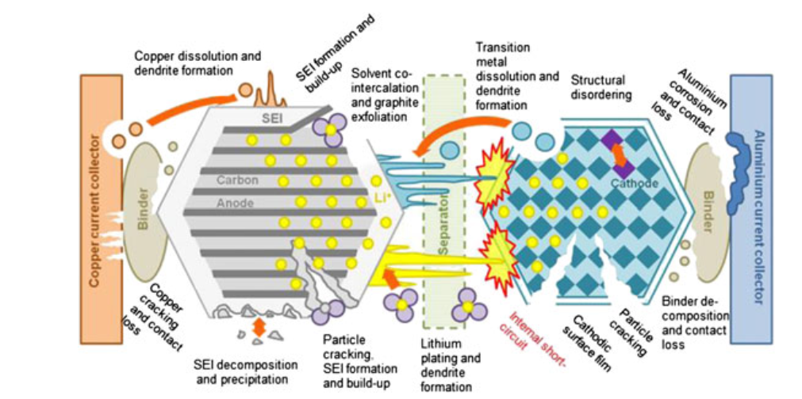
Fig. 1.1. Degradation mechanisms in Li-ion batteries [7]

Once that threshold is hit, the battery can either be recycled or reused and then later recycled to recover costs. Finally, it will be disposed of. This cycle is shown in Fig. 1.2. To optimize the life of these batteries, measuring the state of health (SOH) and understanding aging mechanisms is crucial. SOH is a measure of a battery’s degradation and remaining capacity compared to its initial conditions. In both the first and second life, steps should be taken to keep the batteries at optimal conditions to limit aging. For example, lithium plating is accelerated at lower temperatures, and SEI growth is accelerated at higher temperatures [7]. So, maintaining an optimal temperature between the two extremes can limit aging. The same is true for state of charge (SOC), the measure of remaining energy, usually expressed in percentages. Low SOC causes corrosion on the current collector, and high SOC causes SEI growth, electrolyte and binder decomposition, and porosity changes [7]. Reference [12] suggests storing batteries in the range 20-25°C and operating in the range 18-35°C to limit the rate of aging. The SOC should be kept around 40-50% during storage and 30-70% during cycling. The energy demand may require a higher depth of discharge. Therefore, the value of a deeper discharge cycle should be weighed against the value of slower aging to determine how to operate the battery. Many other factors contribute to aging such as depth of discharge and c-rate.
Typically, lower depth of discharge lends itself to slower aging. C-rate does not necessarily directly impact aging. However, higher C-rates correspond to higher temperatures, which can cause accelerated aging [12]. But with proper temperature control, higher C-rates can be achieved without increasing the rate of aging.

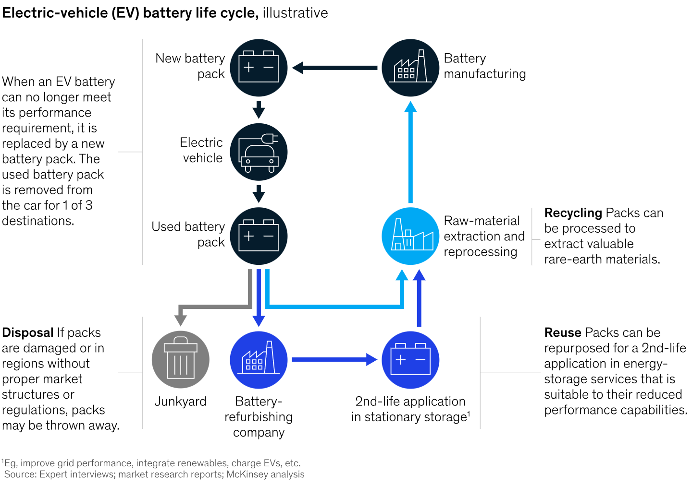
Fig. 1.2. Electric-vehicle (EV) battery life cycle [1]

Taking these steps can prolong battery health and allow for better predictions regarding when they should be removed from their initial application and recycled, reused, or disposed of during their second life. In Chapter 1, an introduction was given on battery lifecycles, structures, chemistry, and aging mechanisms.
Chapter 2 will review literature focusing on BESSs including an in-depth discussion of the main components as well as how they are modeled. This chapter also describes the different grid applications that BESSs can be used for and the economic value. Chapter 3 presents a BESS model that is used to study how different energy management strategies could affect the economic benefit of the BESS. Chapter 4 is a review of the design, construction, and testing of a second-life BESS demonstration at the University of Tennessee, Knoxville.

Literature Review

Battery Energy Storage Systems (BESS) Overview
Energy storage systems can have many different configurations, owners, and operators, from large utility owned and operated systems to small behind-the-meter systems [13]. Sometimes an aggregator operates the system for a separate owner. Industrial and commercial customers can be the owners or individuals can be the owners of private home systems. Each energy storage system is different because it caters to the owners’ needs. If it is industry owned, the system will likely be operated in a way that will decrease their energy bill, such as energy arbitrage, to avoid high demand charges or time of use charges. If it is utility owned, it could be operated to ease stress on the power system during high demand times. Many times, these goals agree with each other and would see similar operating patterns; however, some situations may see an owner operating in unique ways.
The number of projects and the total capacity of battery energy storage has been dramatically increasing since 2019. In June 2024, the active battery capacity in the California ISO balancing area amounted to 11,100 MW with standalone systems accounting for 42% of the total. Fig. 2.1 shows the change of BESS power and energy capacity in recent years where hybrid and co-located systems are batteries combined with other generation technologies at a single point of interconnection. In CAISO, battery storage is the fastest growing resource and accounts for 45% of the total capacity in the interconnection queue [14].
The main two configurations of a BESS are centralized architecture and distributed architecture [13, 15].
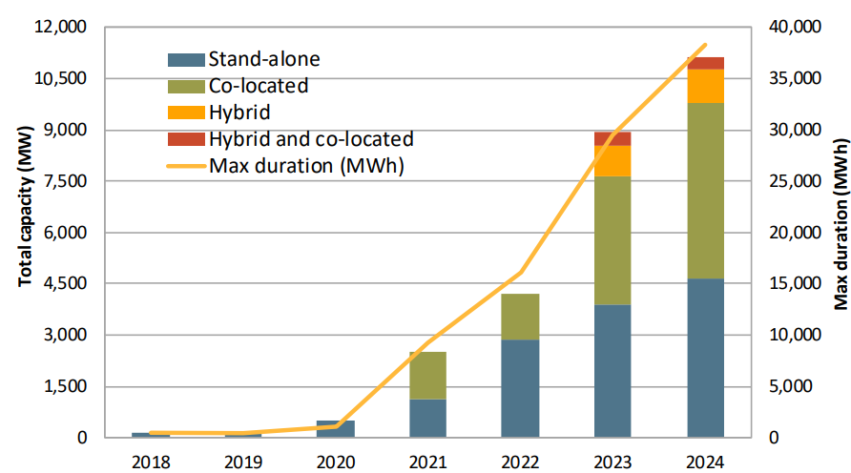
Fig. 2.1. Active battery capacity in CAISO balancing area (2018-2024) [14]

In a conventional centralized architecture, the BESS will have four components: battery stack, battery management system (BMS), power conversion system (PCS), and supervisory system control [4,15]. Several batteries connected in parallel are linked to a centralized PCS. The entire unit is usually 1 MWh or larger and uses cells with a larger capacity to avoid having too many cells. One of the issues with this configuration is circulating current between the battery modules because of slight differences in internal resistance and capacity in the parallel battery modules [13]. The modular approach has the same components, but it integrates the battery pack with the power electronics into one block. Then each battery module can be operated independently.
The most expensive component is the battery pack, typically housed in a weather-resistant container with one or more racks of battery modules. The choice of battery type depends on the application. Mid-range systems most commonly use lithium-ion and lead-acid batteries. Lithium-ion is preferred for its high energy density, while lead-acid offers a longer lifespan and lower cost. Vanadium redox flow batteries are often employed in smaller-scale systems due to their lower energy density but longer cycle life. Small-scale systems include residential and community projects around 100 kW, whereas large or grid-scale systems can reach several megawatts [15].
The BMS monitors and protects the battery at both the cell and stack levels. It ensures that each cell's voltage remains within a range appropriate for the battery's chemistry, preventing both overvoltage and undervoltage in individual cells and the overall stack [9]. The BMS measures the voltage, current, and temperature of the battery. Using just these three parameters, it ensures the battery’s safety [4]. If the BMS detects dangerous conditions, it will isolate the battery using fuses and breakers. Most BMSs only have control over the current, so disconnecting the battery and charging individual cells is the extent of its capabilities [4]. Another role of the BMS is to balance the cells. Battery cells all experience slight variations, which worsen with age. The capacity fades and resistance increases at different rates in each cell. When this happens, charging and discharging the pack will lead to some cells having different voltages than others [16]. It is important to keep all voltages equal in each cell to avoid overcharge and overdischarge while not sacrificing capacity. Thus, the BMS is a necessary device to ensure the safety and effectiveness of the entire system.
The PCS is a crucial component of the BESS that can determine the performance of the system. Because batteries are a direct current (DC) device, a PCS is needed to integrate with the alternating current (AC) power grid. The PCS is the device that handles the power conversion and power exchange between the batteries and the grid. It receives commands from the supervisory control that tells it how to operate at any given time [15]. The battery and PCS must be configured such that the operating voltages and currents are compatible for the BESS. The PCS can either be a single-stage DC/AC converter or a two-stage DC/DC and DC/AC converter [15]. When using a modular approach, each PCS has fewer batteries which are typically in a series configuration. The advantages of this include elimination of equalization circuits for the battery cells as well as the ease of commissioning and decommissioning of batteries [15]. Additionally, each cell is easier to manage because there is finer control, leading to a longer battery lifetime and better capacity utilization. The two-stage converter allows for DC coupling that will make the AC converter design easier since it is no longer affected by the fluctuating battery voltage. Overall, the two-stage converter allows for more flexibility because the battery’s DC voltage is not a limitation, but it is more expensive. The issue with the modular approach is that it is less efficient than the central architecture and there are technical and economic challenges with having more converters [13].
The supervisory control is sometimes referred to as the energy management system (EMS). It determines where and how to dispatch energy. In the case of a BESS with only one battery stack, it decides whether to charge or discharge the battery, the power level, and the time and duration. If there are multiple energy storage devices, it also determines which devices should be used and which should be idle. It can be interfaced with the market, customer, and utility [13]. In a centralized architecture, the EMS gives active and reactive power commands to each storage device. In a distributed system, the active and reactive power needs can be calculated locally [13]. To decide how to operate, the EMS can use many different optimization algorithms. The owner of the BESS decides what should be optimized, but in most cases, the goal is to minimize cost [17]. Another possible case would be minimizing battery usage to prevent cycle aging.
Another important element to consider is communication. All devices must be able to communicate effectively to operate efficiently and safely. The EMS needs to send power commands to the PCS, while the BMS must inform the EMS about the battery's operating conditions. To facilitate this, each component must have a communication interface. Commercial systems typically utilize Modbus/TCP due to its simplicity and flexibility [13]. This protocol is commonly equipped on most commercial devices, allowing for easy integration into a comprehensive system. Each device assigns specific registers for data that can be read from and written to by other devices. Another widely used communication protocol is Distributed Network Protocol (DNP3), which is employed in SCADA systems and offers greater robustness. In more complex setups, numerous devices may utilize different communication methods, making it essential to use software like VOLTTRON, which can interface with various protocols [13].
A BESS can operate in two modes: grid connected or islanded. In grid connected mode, the BESS is interfaced to the electric power grid. In this state the batteries may or may not be dispatched. In islanded mode, the PCS operates in a grid forming mode. The BESS could be the only power source in the formed microgrid. Operating in multiple modes is beneficial as it enables the BESS to adapt to different needs. If there is a power outage, the BESS can be isolated and operate as a microgrid to keep critical loads powered. If the battery charge is low, it can be used in grid connected mode to charge the battery and remain in a healthy SOC range. Many systems operate in grid connected mode primarily but can island if needed for backup power. Transitioning between the two modes can be challenging. Overcurrent transients need to be avoided, but power should not be lost at any point during the transition. Algorithms can detect which mode the system is operating in and automatically transition when all requirements are met [18]. It typically requires measurements of voltage, current, and frequency. Some algorithms using multiple phase locked loops are proposed in [18]. Overall, the ability of a BESS to seamlessly transition between grid-connected and islanded modes not only enhances its operational flexibility but also ensures reliability in delivering power during both normal and emergency conditions.

Battery Management System
The BMS provides an essential service by predicting the SOC and SOH to keep the battery healthy and safe [4]. To achieve this in a larger grid-connected system, a complex architecture of power electronics is needed to connect the battery and BMS into the overall system. Complex algorithms are also necessary to account for nonlinearities, constraints, and objectives in real time [4]. One BMS architecture is a tiered design that monitors at multiple levels—cells, modules, and packs—providing flexibility for both fine and system-level control.
BMSs can have varying amounts of control. Some BMSs can take commands from the supervisory control and communicate with the PCS to carry out the command. Some BMSs have the supervisory control built in, so the BMS performs the calculations to determine what actions to take to preserve the battery’s life. Other BMSs do not interface with the PCS, but instead can only disconnect the battery from the PCS. In this architecture, the supervisory control communicates with the BMS and the PCS separately. The optimization and objective calculations are done in the supervisory control while the BMS only ensures the battery cells and stack remain governed by temperature, voltage, and current constraints.
Monitoring of the stack is always done during operation by any BMS regardless of its architecture. It is responsible for reading voltage, current, and temperature of the battery as well as any commands from the supervisory control [4]. This information is used to calculate SOC and SOH by various methods.
SOC cannot be directly measured. The two most common methods to measure SOC are OCV-SOC curves and coulomb counting. The OCV-SOC curve method measures the open circuit voltage to determine the SOC based on initial battery tests [4]. This is easier to do for batteries with a more linear relationship between charge and voltage such as lead acid batteries [4] [8]. Additionally, as the battery ages, the cell reaches the fully charged voltage quicker than other cells. This can become dangerous because there is a risk of overcharging other cells. The coulomb counting method involves accurately measuring the current to calculate the charge and comparing it to the full capacity of the cell [4]. As the battery ages, the full capacity of the battery will decrease. To account for this, the SOC should be calibrated over time. Another issue with this method is the difficulty of accurately measuring the current. Any error with coulomb counting is compounded over time. To achieve greater accuracy, a combination of both methods should be used.
The SOH is more complicated to estimate. The two factors most associated with aging in a battery are the internal resistance and the capacity [8]. Internal resistance increases with age; however, measuring it can prove difficult. Lithium-ion batteries are not purely resistive devices, so the inductive and capacitive elements complicate the measurement of internal resistance [11].
Additionally, some batteries exhibit a weak correlation between internal resistance and age. For instance, certain nanophosphate Li-ion batteries do not demonstrate a strong link between capacity fade and internal resistance [4]. This correlation is important because both capacity fade and increased internal resistance are age indicators. Since the resistance is not always enough to demonstrate age, capacity fade should also be monitored.
A complete discharge and charge cycle while monitored and controlled can give a very accurate estimation of the SOH by measuring the capacity and comparing it to the initial capacity [4]. However, this method requires removing it from the system which can incur an economic loss as it is unable to perform its primary function.
Another crucial role of the BMS is balancing the batteries’ cells. Battery cells become unbalanced because their internal impedances and self-discharge rates vary due to manufacturing methods [19]. Additionally, because of their position in the stack, cells are subjected to different environments such as ambient temperature. These differences lead to variations in effective charge and discharge among cells. In lithium-ion batteries, this can be hazardous, as overcharging can result in fires and explosions [9]. Conversely, undercharging other cells to prevent overcharging is inefficient. To avoid both scenarios, various equalization methods are employed to balance the cells.
Cell balancing can be separated into two categories: passive and active. Passive cell balancing dissipates energy from the highest charged cells to match the SOC of the lower charged cells using parallel components such as shunt resistors [19]. Typically, this is done after fully charging the stack but can also occur during other charge and discharge stages. Passive balancing is rarely used during discharge, as it can lead to greater capacity loss than not balancing at all [16]. The passive method generates heat and loses power, so its effectiveness is limited. Though, it is commonly seen in commercial products because of the low cost and ease of implementation.
Active balancing is a method that reallocates energy between higher charged cells and lower charged cells until all are at equal SOCs. Multiple methods could be used to do this in BESSs. The most common method is energy reallocation, where the energy in the higher charged cells is transferred to the lower charged cells through an interface circuit [19]. This can be done from cell to cell or cell to string. Many circuit topologies for reallocation active balancing have been studied such as adjacent, nonadjacent, direct cell-cell, and mixed topologies [19].
Active balancing has been a growing research topic because of its reliability, efficiency, scalability, and flexibility, but the simplicity and low cost of passive balancing is difficult to match. Factors such as efficiency, temperature, balancing time, number of components, complexity, and cost should all be taken into consideration when choosing a balancing method.

Energy Management System
The Energy Management System (EMS) serves as the central control unit for the entire system. It oversees the controls, communications, optimization algorithms, monitoring, and safety of the entire system [13]. While other components have some responsibility in these areas, the EMS integrates all components by communications and commands.
While the BMS is responsible for maintaining battery safety, the EMS reads the SOC from the BMS and instructs the PCS to make necessary adjustments. If the SOC approaches 100%, the EMS commands the PCS to stop charging. Ideally, the BMS should never need to intervene if the EMS functions correctly.
The EMS also monitors voltage and current sensors within the system, allowing it to shut down the system in unsafe conditions unrelated to the battery. Additionally, the EMS serves as a backup safety measure in the event of BMS failure. Most components are designed with self-protection mechanisms, like the BMS ensuring the safety of the battery and itself during faults. However, if the BMS fails, the EMS can detect the battery's voltage and current and shut down the system if necessary [4].
Moreover, systems are typically designed to withstand various types of abuse, such as shock, vibration, and short circuits. For short circuits, fuses and circuit breakers monitored by the EMS are implemented [4]. Other safety measures, like pressure release systems or thermal isolation methods, may also be included in specific designs.
While system monitoring is essential for preventing and mitigating failures, it also helps to identify the best operational method. The goal of most optimization problems in BESSs is either to minimize cost of energy or to maximize lifetime of the battery [20]. SOC and SOH are crucial to determine optimal charge and discharge patterns for either case, so the EMS must reliably monitor these variables.
The EMS should determine the best way to operate based on optimization equations. These algorithms are designed based on the need of the system as defined by the owner. Some common energy management techniques are peak shaving, load leveling, and load shifting. The energy management method used is decided by the owner and operator by considering the cost, complexity, and battery wear.

Modeling
Modeling and simulating BESSs is crucial for understanding and designing a full system. Even simple models can accurately provide insights into sizing and operation, including battery usage patterns, charging and discharging duration and power levels, as well as potential cost savings.
Most BESS models consist of a battery, power electronic interface, load, and a controller. The complexity of each of these components can vary depending on the application. The more complex the model is, the more accurate the results will be. However, complex models require significantly more time to execute. The time scale is the most important factor in deciding the complexity of the model [21]. A simulation lasting just a few seconds can be much more complex, as the overall time to execute remains manageable. Simulations over longer time scales, spanning days or months, must be much simpler to execute within a few minutes. Table 2.1 shows the recommended modeling methods of BESSs at different time scales, where the complexity of each component can be controlled independently.

Table 2.1. Modeling method for components of a BESS based on timescale [21]
Timescales | Applications in Power | Modeling Method
Timescales | Applications in Power | Battery | PCS | Controller
1. Short time scale (milliseconds to seconds) | UPS  Motor starting  Power system harmonics | High order | Detail model | Detail model
2. Medium time scale (seconds to minutes) | Angle and voltage stability  Primary frequency control  Secondary frequency control  Low voltage ride through | Reduced order | Detail model | Detail model
3. Medium-to-long time scale (minutes to hours) | Ramping and load following  Peak shaving & load leveling  Tertiary frequency control  Output smoothing  Emergency back-up power  Black-start | Equivalent source and impedance | Average value model | Simplified model
4. Long time scale (hours to days) | Daily peak shaving  Daily load leveling | Power command with inertial response | Average value model | Economic dispatch model

Depending on the application, some component models should be detailed, and others can be simplified or even omitted. The commonly modeled components include the battery, PCS, controller, grid, and load [21]. The grid and load are typically very simple three phase sources and loads. Most of the computational effort should be in the battery, PCS, and EMS.
The battery can be modeled by electrochemical models, equivalent circuit models, or empirical models. The electrochemical model is the most complicated of the three. It aims to represent the physical phenomena that occurs in the battery cells as they charge and discharge [4]. More complex models will also account for aging of the cells. Electrochemical models focus on the chemical reactions taking place in the cell as well as the equilibrium conditions. This method of modeling is very accurate, but costs time and requires detailed knowledge of the cell.
The equivalent circuit model is one of the more common methods of modeling because it balances accuracy and time. The battery is modeled by representing the chemical and physical reactions by circuit components. A voltage source or capacitor can represent the potential difference between the anode and cathode, and an RC circuit can represent the internal impedance. Extensive research has been devoted to equivalent circuit models of batteries, resulting in many different models including internal resistance and Thevenin models [21]. Complexity even varies among these models. An internal resistance model consists of just internal resistance and a voltage source, making it very easy to implement. More advanced models may include resistance, concentration and activation polarization, impedance, and self-discharge and overcharge branches [21]. Though it is less accurate than the electrochemical model, it reduces the computational effort and remains accurate enough for most applications. In fact, many commercial controllers integrated in BMSs will use equivalent circuit models.
The last method is empirical modeling. It uses mathematical correlation between BESS variables and electrochemical processes to replicate BESS operation [4]. Typically, when designing one of these models, the variables of interest are the current, voltage, and SOC. Once the BESS is implemented in hardware, the model's accuracy can be assessed, enabling adjustments to its parameters for a more precise representation of the battery [4]. One disadvantage of empirical models is that measurements of one battery does not translate well to other batteries. Additionally, the accuracy of these models is compromised to reduce computation time. In some applications, minimizing computation time is a significant concern to obtain timely results. Other applications require greater precision to study aspects of the battery, such as aging and temperature, making empirical models unsuitable. In most cases, time scale is the deciding factor on how complex the model should be.
The PCS in a BESS is usually a two-stage converter with a DC-DC converter to control battery current, a DC-AC converter to control the current taken from or injected to the grid, and a large DC link capacitor between the two. If the PCS is the focus of the study, the model should be sufficiently detailed, such as a switching model. It will be the most computationally intensive, but it will give the most accurate results [21]. A smaller time scale is better for these models. The average model can be used for a less complex, but still accurate simulation. This is useful for when the PCS is of interest in the study but is not necessarily the focus. The average model is still computationally intensive, so it is best to avoid directly modeling the PCS in very large time scales [21]. Instead, the BESS is often modeled based on overall power flow rather than detailed individual components in very large time scales.
Numerous methods exist for modeling EMSs, depending largely on how the owner and operator of the BESS wish to optimize the system. Regardless of any other goals, the EMS must ensure that the generation always meets the load. Then the operator can consider load priority, pricing variations, renewable availability, etc. Most EMSs or controllers are programmed by optimization or objective functions. For example, [22] proposes a design for an EMS that minimizes error between the output and optimal profile. Reference [23] writes an optimization objective for a model that minimizes the total operating cost of the system. Similarly, [20] uses an optimization problem that minimizes a community’s energy cost. Reference [24] formulates an algorithm that ensures a PV array operates as the primary source to meet the demand, and a fuel cell can match the difference between the demand and PV output.
Once one or more objectives are determined, the constraints must be identified. Many grid-connected systems have the constraint that energy cannot flow back onto the grid. Another constraint, often determined by the user, is the SOC range. For example, many users constrain the battery SOC between 20% and 80%. The primary constraint is that the power generated must always equal the load. There are constraints placed on the battery, load, transactions, and the entire ESS. Equations should be written for all the constraints and optimization objectives.
Optimization objectives can be solved in multiple ways, but the most common method is linear programming or mixed integer linear programming (MILP). This is a mathematical optimization technique for solving complex problems [25]. Many platforms, such as MATLAB and Gurobi, can perform this operation, making it a popular method. Another method for solving these problems is genetic algorithms, which are based on natural selection and used to solve constrained and unconstrained optimization problems. Reference [25] finds that MILP outperforms genetic algorithms in optimization but has a greater computational cost.
Another option is to use a state flow chart to determine energy management methods. This can also be done in many different programs including MATLAB Stateflow. This still involves setting constraints, but they are written out graphically instead. It also requires states to be defined at all points, unlike linear programming. Reference [24] uses this method to carry out the PV optimization problem as seen in Fig. 2.2. This method is simple to execute and troubleshoot because of the real time viewing ability in MATLAB while the code is being executed. Fig. 2.2 shows a constraint of the SOC remaining between 20% and 90% as well as a constraint on the hydrogen tank size. The state flow method is less straightforward than linear programming and is generally not as optimized; however, it offers more direct controls and conditions.
Another aspect of energy management is monitoring and forecasting. Uncertain conditions such as renewable energy output, loads, and failures should be predicted and used as an input to the algorithms. Many models of EMSs use historical data to determine the next action of the BESS, but a working controller needs to be able to forecast the load to determine what next action should be taken. Some methods of forecasting include traditional point forecasting techniques derived from probabilistic prediction and interval prediction in probabilistic forecasting. These can then be formulated into a mathematical expression and input into the optimization problem. Forecasting can also be done by data driven methods or by deep learning models. This is also a tradeoff between accuracy and computational energy.

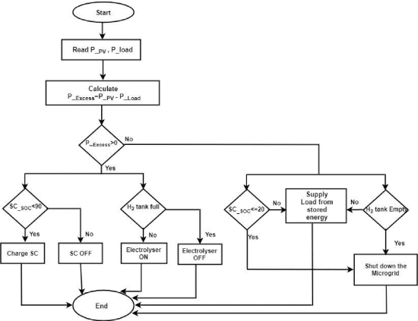
Fig. 2.2. Energy management model of a fuel cell and PV array system [24]

Even simpler models and algorithms can be utilized for EMSs if optimization is not prioritized. Optimization is valuable because it can save money, prevent damage, reduce aging, etc. However, BESSs can operate with a simple approach while still saving money. One method is scheduling. In cases where there is little renewable energy and the load is known or consistent, scheduling is a viable option. Effort would not be wasted on forecasting already known loads or generation. Constraints for SOC and energy flow should still be accounted for, but a simple schedule of when to turn on and off the battery can be directly programmed. While more money could potentially be saved if using an optimization function, the simplicity of this method is attractive to smaller, simpler projects.

BESS Applications
Energy storage has many applications, such as energy arbitrage, upgrade deferral, frequency regulation, voltage support, inertia emulation, black start, reserves, and many more [26]. Although all these options are possible, it is important to identify which application is most advantageous at any given time, as all cannot be done at once. The BESS owner is likely to select the application that offers the greatest monetary value. That may be using the battery as a reserve to avoid down time of critical loads. In other cases, it could be energy arbitrage to avoid large fees from the utilities. These applications and their value for the grid will be discussed.

Energy Arbitrage
Energy arbitrage is the act of purchasing energy when prices are low, usually when demand is low, and selling when prices are high, during peak demand times [26]. This practice saves money for the owner of the BESS, but it also helps utilities by decreasing demand and aiding in generation during high demand times, overall reducing stress on the power system. There are three main methods of energy arbitrage: peak shaving, load shifting, and load leveling.
Peak Shaving:
Peak shaving smooths out the daily demand by charging during off-peak times, also known as valleys, and discharging during peak demand times, reducing the peak demand charge [27]. This can be seen in Fig 2.3. This is one of the most popular methods of energy arbitrage because the peak demand accounts for a majority of a monthly electric bill at most utilities. Reducing this peak, even by a small percentage, can see large savings. Additionally, peak shaving does not typically require a large battery capacity because the battery is only discharged for a couple of hours at a time. However, larger batteries can achieve greater peak reductions, resulting in increased cost savings. Peak shaving can also be combined with renewable energy generation. The energy generated from solar during midday can be stored and discharged at peak demand periods, typically in the early evening [28].
A household’s peak hours usually coincide with the grid’s peak hours [27]. In the summer, this occurs in the early evening when people return home after work and turn on the air conditioning, lights, appliances, etc. In winter this occurs in the morning and late evening when the demand for heating increases. Predicting the time of the peak is crucial for peak shaving.
Peak shaving can be done by a few different methods. One option is to use a predefined shave level based on the maximum load. If the demand is above a certain level, the battery is discharged so the grid supplies up to that defined level [27]. Due to the difficulty of load forecasting, these limits may result in the largest peak being missed. The battery may be discharged during small peaks and left with a low SOC by the time the largest peak is seen [29].
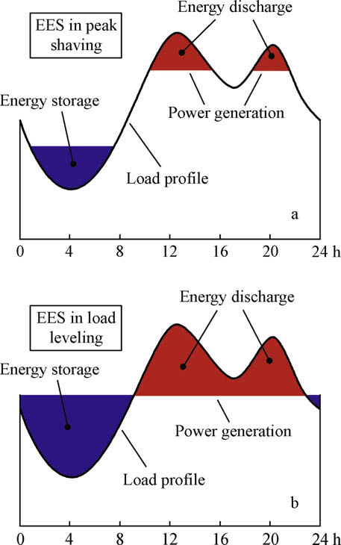
Fig. 2.3. Load profile of a large-scale ESS with peak shaving [42]

Therefore, this method is most useful if the load profile is already known or easily predictable. Optimal discharge and charge levels could easily be found for a known load, and peak shaving
would work ideally. However, the exact load profile is rarely known, and the hard limits could result in an even larger cost.
Another method of peak shaving is using predefined time slots. The most common time of the peak is set as the time to discharge, and the battery is set to charge in off-peak times [30]. This method has similar concerns because the peak may not always reside in that time frame. For consistent, predictable loads, this method is still likely to save money.
The value of peak shaving is limited by the battery capacity, charge and discharge power limits, and the load characteristics. Many studies focus on optimizing peak shaving power levels and the associated cost savings. One of the concerns is whether historical data, statistical analysis, and machine learning predictive loads used for these studies are accurate enough for these models to be conclusive [27].
Load Shifting:
Load shifting is another type of energy arbitrage. It works like peak shaving, with the battery charging during low-demand periods and discharging during peak demand. The difference is that the load is not smoothed. The entire peak is shifted to a time when cost is lower rather than just cutting off the top of the peak [31]. This is especially useful when combined with photovoltaic generation because the peak load can be shifted to midday when solar output is at a maximum. Without storage, some PV generation may be wasted because the generation peak does not align with the demand peak [4]. Load shifting enables full utilization of this PV energy.
A downside of load shifting is the need for large battery capacity. At a minimum it should be equivalent to the entire peak being shifted [32]. This makes it impractical for large-scale systems, as high battery costs require significant benefits to justify the investment.
Load shifting is most applicable when the time of usage cost is significant [32]. Most energy pricing weighs peak power usage significantly more than time of usage. In the case that the peak power is less significant, load shifting would be the dominant method in reducing cost.
Small systems with renewable energy integration in areas with time-of-use pricing benefit most from load shifting. However, it is less widely adopted and researched compared to alternatives like peak shaving and load leveling due to its relative value. Inefficient load shifting can raise energy costs [32]. Like peak shaving, load forecasting is necessary. Inaccurate predictions may lead to larger peaks, resulting in economic losses from poor optimization.
Load Leveling:
As shown in Fig. 2.4, load leveling uses BESS charging and discharging to mitigate or level variations in the original load [33]. This can be done hourly, daily, or yearly. The accuracy of load leveling can be measured by how close the leveled loads are to the reference value. Reference [33] uses the mean square error to evaluate the performance of daily and yearly loads with different BESS sizes.
A larger BESS size will have better load leveling performance; however, this improvement gradually decreases as BESS size increases [33]. This is because typically large load variations are short in duration, so a small BESS can significantly decrease costs. Once these variations are leveled, a larger BESS can further decrease costs by lowering the level more.

Fig. 2.4. Load profile of a large-scale ESS with load leveling [42]

This, however, requires a longer duration, therefore the level cannot be decreased significantly enough to see much cost reduction.
In certain energy markets, load leveling may not be the most cost-effective option. In the Korean case studied by [33], optimizing for cost reduction increased the mean square error,
indicating that BESS operation introduced greater variation from the original load. Markets without peak demand charges prioritize time-of-use pricing, making load leveling less suitable since peak demand may already occur during low-cost periods.

Renewable Smoothing
As an effort to displace fossil fuels and reduce greenhouse gas emissions, renewable energy sources are becoming increasingly prevalent in the electric power system. However, renewable energy is intermittent. Every couple of minutes power from PV and wind turbines can fluctuate [28]. This problem is exacerbated as scale and penetration is increased. Energy storage can increase the reliability and utilization of renewable energy by smoothing the power before it is injected to
the grid. BESSs are useful for this purpose because they are fast responding.

Voltage Support
The voltage in a power system varies based on power flow and line impedance. For example, if the power generated is greater than the load, the power flow will reverse resulting in a higher voltage at the end of the feeder [26]. A BESS can use both active and reactive power control, called volt-watt and volt-var respectively, to help regulate the voltage. In overvoltage situations, the BESS can absorb real power. During undervoltage situations, the BESS can inject real power [34]. Additionally, compensators having the capability of reactive power support can be more effective.
The AC-DC converter in a BESS’s PCS can be used for reactive power support if it is not being operated at its full capacity [34]. In this case, the PCS would not be operated at unity power factor. However, as discussed, the economical choice is not always to operate at full capacity, so reactive power control is a reasonable expectation in a BESS depending on the market.

Frequency Regulation
In addition to affecting the voltage, the imbalance of generation and load causes the power system’s frequency to deviate from its nominal value [26]. Control strategy of a BESS can also be used in frequency regulation.
One method is inertia emulation, which is especially important for systems with high penetration of renewables. Inertia refers to the energy stored in rotating mass, typically in traditional generators. The stored energy is useful for slowing changes in frequency. Wind and solar are interfaced to the power system with converters that decouple grid frequency from a generator’s spinning mass. Because renewable energy sources do not typically have rotating mass, replacing traditional fossil fuel sources leads to a lower inertia response in the electric power system [26]. A BESS can imitate this inertia by charging or discharging in reaction to any sudden change in frequency [26]. To be effective, the BESS needs to be able to discharge high power in a short duration. The location of the BESS also plays a part in how effective its inertia emulation is.
Virtual droop control for frequency regulation is another application for a BESS. Droop control can be used as a primary frequency response that attempts to balance the generation and demand and prevent the frequency from dropping any more. To achieve this, the BESS must have sufficient reserves capacity [35]. Droop control can reduce the steady-state frequency deviation while constantly promoting frequency recovery of the power system [36].

Reliability
One benefit of a BESS is its improvement of system reliability. During outages, a BESS is capable of isolating from the grid, also known as islanding. Then the battery can supply loads independently. For sensitive or critical loads, this can save money and effort. Once power is restored, the BESS can resynchronize to the grid. Additionally, it can energize lines and provide black start capability to help restore systems [26].
Similarly, the BESS can be used as reserves. If a generator goes offline, the BESS can supply power as a backup. Unlike traditional power system reserves, a BESS does not need to be online or operating to be ready and can respond rapidly when needed [26].

Optimal Sizing
To design an efficient BESS, it is crucial to determine the optimal size that meets all desired functions without being excessively large. Otherwise, money and resources may be wasted. Sizing includes energy capacity and power capability. The optimal size of a BESS is dependent on many factors. The first being the application that the BESS is designed for. In most cases, a BESS is used for energy arbitrage, which requires a large energy capacity [17]. On the other hand, some BESSs are designed primarily for other ancillary services, such as frequency regulation, which benefits from higher power capacity rather than energy capacity.
Even within energy arbitrage, optimal BESS size can vary. Peak shaving requires the least amount of energy capacity, while load shifting requires the most. The larger the energy capacity of the BESS, the more money it can save using energy arbitrage, however these methods have diminishing returns [33]. For peak shaving, once the peak is lowered to the level of the average, the cost cannot decrease much more. For load leveling, when all peaks are leveled, the next step is to lower the leveled power reference. This process demands increasingly large capacities for relatively small gains [33]. Load shifting is the form of energy arbitrage that benefits the most from a large capacity, however, the cost of the BESS must be offset by the value from decreased energy cost [32]. And because load shifting puts great stress on the batteries from constant use, battery aging must be accounted for in this value comparison. The essence of optimal sizing is finding the point of maximum value gained when considering marginal cost.
The BESS application must be clearly defined to accurately determine optimal sizing. Little research on the topic of determining the best BESS application for different load types has been conducted. For the most part, the owner of the BESS knows whether energy arbitrage or another ancillary service is preferred. If energy arbitrage is preferred, peak shaving is usually the chosen method because of the low investment cost associated with its smaller required capacity [27]. However, some markets and conditions may see more value from load leveling or load shifting. The larger sized BESS paired with these energy arbitrage techniques could be more valuable. This is why research should be conducted on optimal BESS sizing in all applications.
The size of the load must also be considered. A larger load necessitates a larger BESS to achieve a comparable percentage reduction in costs, as a smaller BESS may be insufficient to fully shave peaks associated with a large load [33]. Therefore, daily energy demand should be considered when determining the BESS size. Additionally, demand increases over time should be anticipated and accounted for to ensure the system is future-proofed.
The penetration of renewable energy in the system is another important factor to consider when sizing the system. PV and the BESS should be designed to complement each other. If the PV is too large for the BESS to accommodate, then some energy may be curtailed, which is wasteful. If the BESS is not fully utilizing its capacity, then more PV could have to be installed to further lower energy cost [37].
Overall, the goal of optimal sizing is to realize the most efficient and cost-effective BESS. That involves knowing the use case, load size, renewable penetration, and energy market pricing. Larger capacities open opportunities for greater control and further savings but are expensive. Finding the smallest size BESS that can perform all desired functions reliably is one way BESS owners can minimize investment cost and breakeven time.

Economics
The cost of a BESS consists of initial investment, operation cost, and maintenance cost. The initial investment includes the cost of the main components such as the PCS, BMS, EMS, and most expensively, the batteries. It also includes infrastructure and interconnection costs. Operation and maintenance costs cover the cost of capacity loss and inefficiencies of the batteries from aging as well as repairing and upgrading costs. Other costs might include interest on loans, e-waste disposal costs, etc. Overall, BESSs remain an expensive investment.
The decreasing price of new lithium-ion batteries can help alleviate some of the financial burden, and second life batteries can lower that cost even more. Battery prices have been decreasing year after year. In 2023, the US Department of Energy’s National Renewable Energy Laboratory projects lithium-ion battery costs for utility scale BESS to decrease by 51% by 2050. Many factors can influence the evolution of costs in the future, including market demand, supply chain constraints, other sectors such as EVs, and material cost and availability [38]. Second life batteries would likely still be cheaper in most of these scenarios. When returned to the manufacturer or owner of the batteries after their first life, these batteries are available at only the cost of transportation. The difficulty then lies in assessing the performance and sorting the batteries. As battery prices continue to decline, the cost of assessing second-life batteries may render them less appealing.
Even with lower battery costs, new BESS development and construction is still expensive, so the gained value must outweigh the costs enough to encourage new development. Reference [39] proposes a cost benefit model of BESS that considers these costs and evaluates economic indicators including investment payback period, net present value, and internal rate of return. The conclusion of this study is that under current policy and economic conditions, peak shaving from offshore wind with BESS cannot recover costs and obtain reasonable income to justify the investment. However, when the government subsidizes peak shaving, the economic investment becomes worth it [39].
One of the key factors of whether a BESS will be profitable or not is the energy market it is in. As reference [39] describes, government subsidies and incentives can impact the value of a BESS. Additionally, the rate structure of the utilities is crucial to deciding whether the investment would be financially advantageous. Rate structures vary from utility to utility. One structure is just a flat rate. Electricity always costs the same $/kW. Others have time-of-use structures where electricity is more expensive during periods of high demand and cheaper during periods of low demand. On top of their standard rates, many utilities charge a peak demand fee where the highest metered demand of the month is charged at a $/kW rate. Some charge a separate peak demand fee for on-peak and off-peak hours [40]. These rates change per season, time of day, and building classification. Understanding these rates and how energy arbitrage can be used in conjunction with them is the first step in determining the most economical operational method of a BESS.

Chapter Summary
BESSs are used for a variety of applications including energy arbitrage, voltage support, frequency regulation, and reserves. They can address recent challenges for the electric power grid, such as renewable energy integration and inertia emulation. A typical BESS includes batteries, PCS, BMS, and EMS, each playing a role in the safe operation of the BESS. Modeling of BESSs can further the research on optimal sizing and operation for economic benefits, extending battery life, or providing ancillary services.
The primary challenges associated with BESSs include high initial investment costs and aging of batteries, leading to decreased system value. Aging batteries also make effective measurement and control essential for maintaining system safety, especially given the risks associated with lithium-ion batteries. These batteries must be monitored and protected from overcharging and over-discharging to prevent potential fires and explosions. Addressing these challenges is vital for the widespread adoption of BESSs, which is necessary if the electric power grid is to become a renewable energy dominated system.

Battery Energy Storage System Model

Overview

Component Models
A BESS was modeled in Simulink to evaluate the economic benefit of different energy management strategies. This model was adapted from Jonathon Lesage’s “Microgrid-EMS-Optimization” simulation which includes both a heuristic approach using a state machine and an optimization-based approach to minimize costs [43]. As the goal is to study the outcome of common energy management strategies, the optimization approach was removed, and the state machine was redesigned to perform the common methods of energy arbitrage.
The components have been slightly altered to closer match a BESS design that will be presented in chapter 4, but they remain mostly the same as the original model. The utility point of connection is modeled as a three-phase source with a 13.8 kV voltage and 60 Hz frequency. The base load is modeled by a three-phase series RLC load, and a variable load is modeled by a three-phase dynamic load that can be imported from a file. This makes it easy to switch between load profiles. A solar array is also modeled by a three-phase dynamic load with an input of the irradiance profile, which makes it possible to quickly switch between sunny and cloudy days.
The battery is the most complicated of the components modeled. It takes 3 inputs — the mode, reactive power reference, and the active power reference. The mode is whether the system is islanded or not, which is a command given to a breaker at the utility point of connection. The reactive power reference can be set by a constant, though it is usually 0. The active power reference is the output from the energy management system. The parameters that can be changed are the line-to-line voltage, frequency, rated power, rated capacity, system efficiency, charge limits, and initial SOC.
First, the charge limits of the battery are checked. The SOC is calculated by multiplying the apparent power of the battery by the charge or discharge efficiency depending on the sign. It is then integrated and converted to a percentage of the rated capacity. If the SOC is greater than or equal to the upper charge limit and the power reference is negative, meaning the battery would be charging, the power output is switched to 0. Likewise, if the SOC is less than the lower charge limit and the power reference is positive, the power output is switched to 0. Otherwise, the PQ references are passed to a three-phase dynamic load that represents a battery inverter that is current controlled. If the BESS is islanded, the battery is modeled by a three-phase voltage source.
Each of the components was designed to be simple to minimize computation time. The simulation time varies depending on the load input, but these simulations usually cover days to months to effectively evaluate the cost using energy management strategies.

Energy Management Strategy Modes
Energy arbitrage was chosen as the main ancillary service to investigate because of its popularity in BESS operation. The BESS model can operate in 4 modes: 1) peak shaving setpoint, 2) timed peak shaving, 3) load leveling, and 4) load shifting. These modes are more fully described in the following paragraphs.
Peak shaving can be done by two methods, so these modes were separated. One method of peak shaving includes setpoints. An upper setpoint sets a maximum power that the grid will supply. The rest of the power is provided by the BESS. For example, if the setpoint is 400 kW but the load demands 500 kW, the BESS will discharge 100 kW. Any time the load exceeds 400 kW, the BESS will attempt to deliver the difference. However, the SOC and BESS power ratings will practically limit how much power the battery will provide despite what it demanded by the setpoint and load.
To charge the battery, a lower setpoint is required. The lower setpoint sets a minimum power that the grid will supply. If the power is below that threshold, the grid will charge the battery of the BESS up to that setpoint. For example, if the setpoint is 150 kW, but the load demands no power, the battery will be charged at 150 kW until the SOC limit is reach or the load surpasses the threshold. Fig. 3.1 shows both the charge and discharge of the BESS with a sample load using the peak shave setpoint mode.
The other option for peak shaving is timed. In this mode, a constant charging power, discharging power, peak shaving start time, and duration are chosen. This method is common in BESSs because of its simplicity to control as well as the benefit with time-of-use pricing structures. The start time is typically chosen to align with the on-peak of the utility rates, and the duration is chosen to account for the top of the peak (typically a few hours). Charging occurs at the chosen charge start time until the BESS reaches its upper SOC limit. Fig. 3.2 shows 6 hours of peak shaving at 175 kW. The initial SOC is set to the upper limit, so the BESS is not charged.
The load leveling mode attempts to keep the power supplied by the generators in the grid constant by having the upper and lower setpoint equal. If the level setpoint is set to 300 kW, the grid will charge the battery if the load is lower than the threshold, and the battery will discharge if the load is higher than the threshold. Load leveling requires a large capacity. Otherwise, the SOC limits will be hit quickly, and the grid power will not be leveled.
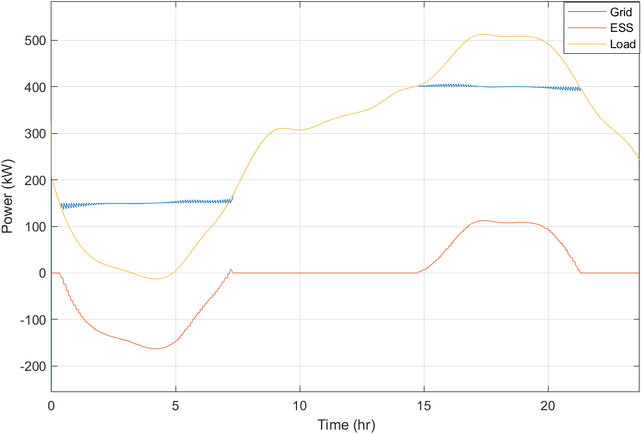
Fig. 3.1. Peak shaving setpoint mode with a sample load
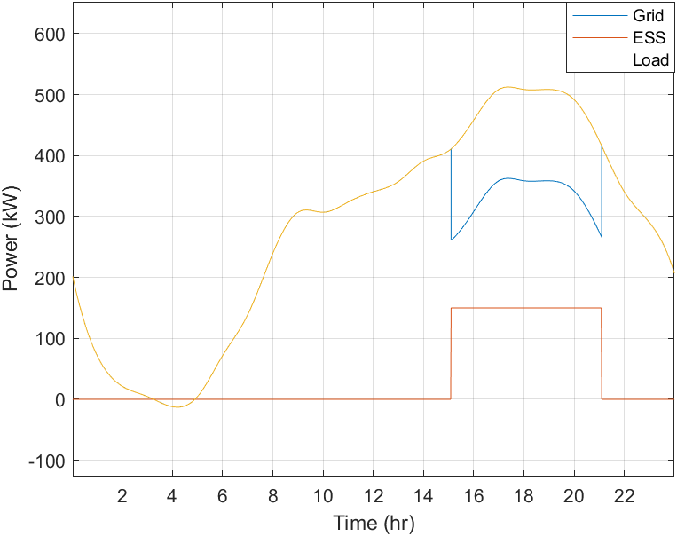
Fig. 3.2. Timed peak shaving for 6 hours using a sample load
In the case that the capacity of the BESS is not large enough, load leveling will look like peak shaving after reaching SOC limits.
The fourth mode available in the simulation is load shifting. This attempts to move the entire peak to the off-peak time. Like load leveling, this requires a very large capacity of energy storage. The simulation performs load shifting by switching the upper and lower setpoints. The upper setpoint will be less than the lower setpoint. If the load is under a certain threshold, the BESS will charge to the larger setpoint. If the load is above a certain threshold, the BESS will discharge to the smaller setpoint. This results in the peak being shifted to the time of lower demand, as seen in Fig. 3.3.

Economic Calculations
This model includes economic computation to determine the monetary value of the system in different operations. Pricing structures vary by utility. Some used a fixed rate where the price per kWh is the same regardless of time of day or season. Others use time variable pricing where on-peak times, usually 2-8 pm, are about three times as expensive as off-peak times. Most commercial customers also have demand charge, where they are charged for the highest kW usage in the billing period. This accounts for 30-70% of the total electric bill. Adding more complexity, some rates are also tiered, meaning that the more electricity used, the more expensive (or in some structures cheaper) electricity costs.
This simulation uses the pricing structure of the Electric Power Board of Chattanooga (EPB) to determine the bill for the system including the BESS. These rates include a time-of-use structure with a demand charge. EPB also has a tiered structure, but the loads that were studied do not reach the next tier, so these are not implemented.
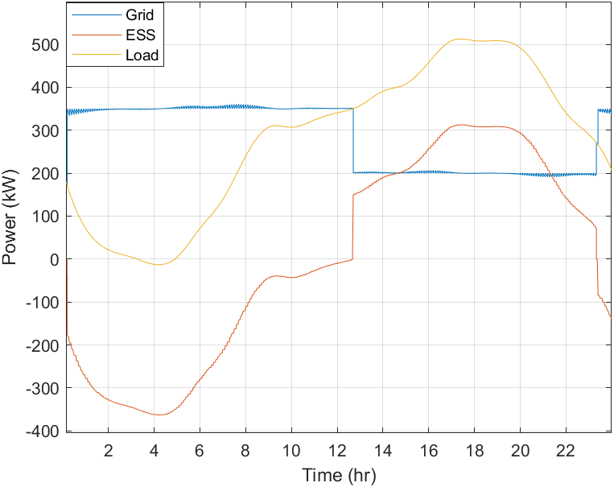
Fig. 3.3. Load shifting of a sample load

The customer class chosen is the Large Commercial (GSB) class. In the summer, this corresponds to an on-peak demand charge of $10.87 per kW and an additional $5.46 per kW maximum demand charge. In most cases these peaks are the same, but sometimes the largest peak occurs during the off-peak time. The usage charge is 6.65¢ per kWh during on-peak, and 4.159¢ per kWh during off-peak. The implementation of the pricing structure into the Simulink model is shown in Fig. 3.4.
First, the time is used to determine whether it is during the on-peak or off-peak. EPB sets the summer on-peak as 2-8 pm. If the time is between these hours, it is determined to be on-peak. The maximum of the on-peak grid provided power is determined and multiplied by the on-peak demand charge. The overall maximum grid provided power is determined and multiplied by the maximum demand charge. For the usage charge, the grid provided power is multiplied by the corresponding time-of-use charge. Then all the charges are added together. These values can easily be changed for different rate structures, and other charges can be added such as fuel adjustments and administration fees.
With each of these elements of the simulation considered, the money saved using the BESS can be evaluated. This allows for the study of many different factors of a BESS such as capacity, power rating, energy management strategy, etc.

Energy Management System
Initially the model had a simple energy management system that would charge at a specified time during the night, and discharge in the afternoon. Essentially, it was a timed peak shave with PV. This was reconstructed to perform the 4 modes described in the previous section.

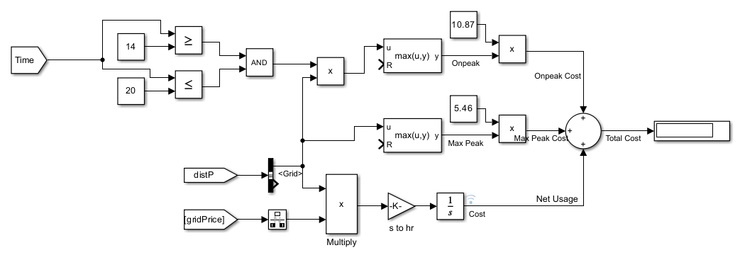
Fig. 3.4. Simulink model for calculating total cost of energy when using a BESS

The service controls can be seen in Fig. 3.5. The ESS switch turns the ESS on or off by opening the breaker at the utility point-of-connection. The mode can be selected in the “Group” box. Shave, Level, and Shift are each controlled by the High_Value and Low_Value inputs; these are the setpoints. For shaving, High_Value should be greater than Low_Value. For leveling, they should be equal. And for shifting, High_Value should be less than Low_Value. Timed PS is controlled by the “Timed Peak Shaving Controls” in the box below. Pmax sets the discharge power and Pmin sets the charge power. PS start time sets the hour of the day that peak shaving begins. PS duration sets the number of hours of peak shaving. The PV irradiance profile can be selected from the drop-down menu. Last, the shaded box at the bottom of Service Controls is the total cost for that billing period under the set conditions. The other shaded boxes display the maximum and on-peak values and costs. This is beneficial because it shows whether the peak was shaved to the setpoint or if it reached SOC limits. It also shows how much of the total cost is from the demand charge.
The EMS is designed as a state machine in MATLAB Stateflow. There are 3 main states – Idle, Charging, and Discharging. The operation within these states and the transitions between them are determined by the selected mode and accompanying parameters. The idle state is used when no action should be taken from the battery. This can be when the load is already met by PV or grid and the battery is at its maximum SOC. It can also be when the load is not beyond either of the thresholds for charging and discharging.
The charging state is used to charge the battery from PV and the grid. It starts by setting the battery power command to the difference between the PV plus the low setpoint and the load.

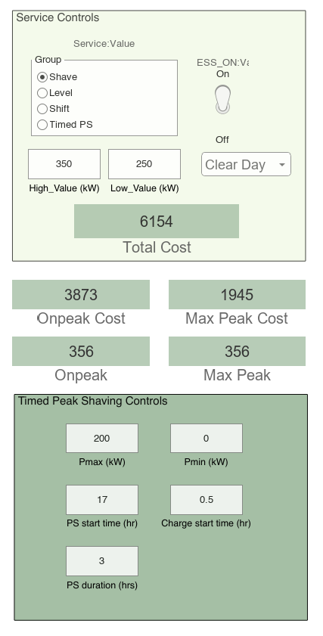
Fig. 3.5. Controls and display of presented BESS model

This results in the grid charging the battery up to the difference between the low setpoint and PV generation. If the PV generation is greater than the load, the substate is transitioned to SolarPrimary. This charges the battery with the excess solar generation only.
The discharging state commands the battery to discharge when the load is greater than the high setpoint. It first enters the Primary state where the battery command is set to the difference between the load and high setpoint, while factoring in the PV generation. While the battery stays within its SOC limits, the grid only provides up to the high setpoint. If the PV generation can reduce the load to below the high setpoint, the battery command is set to 0.
If the mode is timed peak shaving, the charging and discharging states are ignored. The system remains in the idle state until the simulation reaches the charging start time. Then the battery is commanded to charge with power Pmin until it is fully charged, or the peak shave start time is reached. After the peak shaving duration ends, the system returns to the idle state and repeats the cycle the next day.
The transitions between these states can be complex because the conditions are different for each mode. For example, when transitioning from charging to discharging, the load must be greater than the high setpoint for load leveling and peak shaving. But the load must be greater than the low setpoint for load shifting. Therefore, the transition complexity increases with each added mode. Additionally, the SOC limits must be checked when entering or exiting the charging and discharging states, and the impact of PV must be considered whenever the load is compared to a setpoint. All these transitions can be seen in Fig. 3.6. The output from the EMS is only the battery power command, Pcmd, which is the Pref input to the ESS.
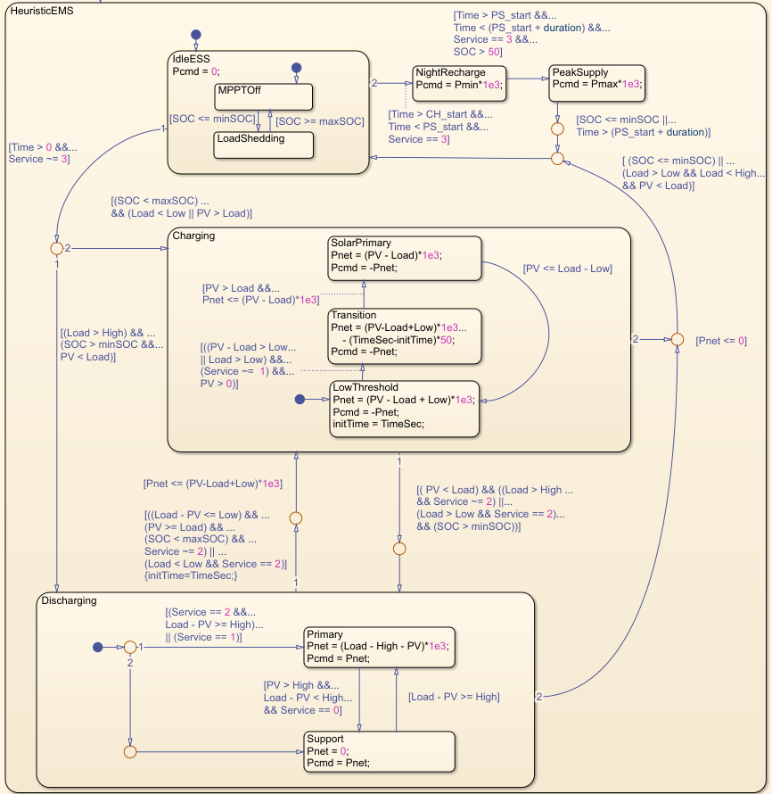
Fig. 3.6. State machine diagram for the energy management system of the BESS model

From there, the battery logic is handled by the ESS model as described in section 3.1.1. With this EMS implemented, each energy management strategy can be studied using any load profile, irradiance profile, battery capacity, etc.

Results
Because timed peak shaving is one of the simplest energy management strategies, it is commonly used in stationary BESS projects. There are many factors to consider regarding how to control a timed peak shaving system including power level, duration, and start time. Assuming the BESS capacity is already sized, the power level and duration are inversely proportional. The power level would be the capacity, accounting for SOC limitations, divided by the duration. Intuitively, the duration of peak shaving would be centered around the peak, however if the peak is skewed, the duration would need to be shifted in the direction of the skew.
Like skewing, the defined on-peak hours by the utility are another important factor to consider when deciding start time of a timed peak shave. If the peak is not centered in the on-peak hours or the duration is too long, the duration may exceed the on-peak hours.
Depending on the pricing structure, this may be an inefficient use of resources. Fig. 3.7 shows an example of this. In the studied pricing structure, the on-peak hours are 2-8 pm, only 6 hours. The two graphs in Fig 3.7 are for the same capacity, load, SOC limits, etc. The only difference is the duration and power level. With a duration of 8 hours, the power level must be greater to use the same amount of capacity as a duration of 9 hours.
The results show that the cost using 8 hours of peak shaving is lower than the cost using 9 hours. Though the longer duration does decrease the peak value, that peak is not in the on-peak hours as defined by the utility.
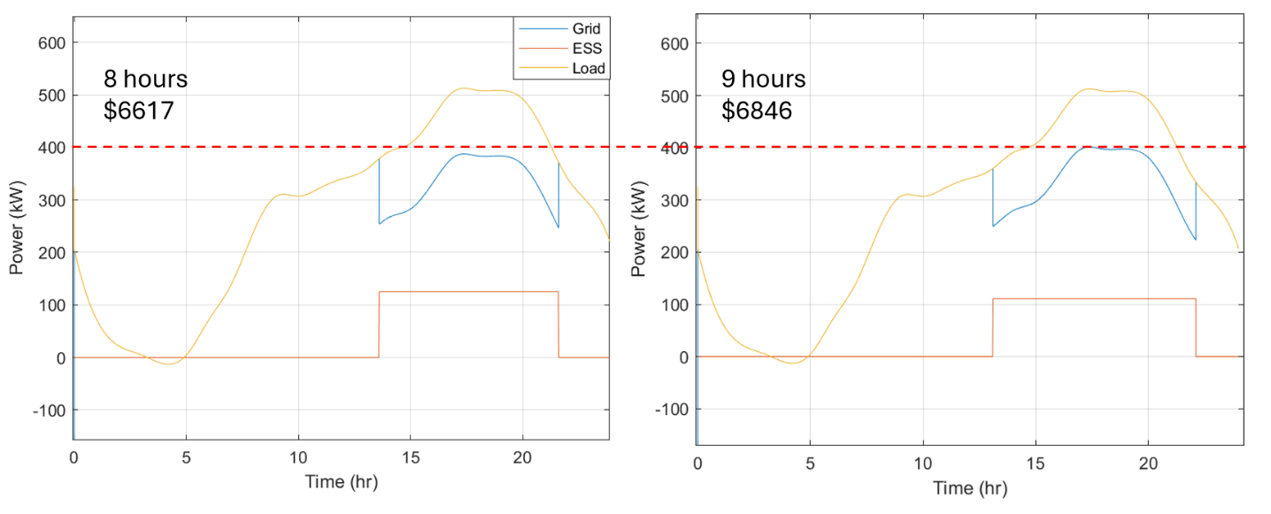
Fig. 3.7. The impact of increasing peak shaving duration beyond on-peak hours

That would be considered the “maximum peak” because it is in the off-peak hours. Because the power level is lower for the 9-hour duration, the on-peak is decreased less.
The on-peak demand charge is usually more significant than the maximum demand charge. Therefore, the pricing structure and the load shape should be considered before deciding when and how much to peak shave.
A similar approach was taken to find the optimal number of hours of peak shaving for several different capacities. The lowest cost was found for each number of hours of peak shaving by sweeping through start times. This was done for 0 through 12 hours duration. The process was repeated for 0.5 MWh, 0.75 MWh, 1 MWh, 1.25 MWh, and 1.5 MWh capacities. Fig. 3.8 shows the results of the simulations. The graph in Fig 3.8 shows the reduction of the peak cost. The total cost would also include usage charges, fuel cost adjustments, and administration charges. The significance of the demand charge and the usage charge for a month are largely dependent on the load. The cost of the demand charge and the usage charge are about equal in the load profiles used in these simulations. The administration charge is a flat charge of about $2,000 per month, and the fuel adjustment charges vary greatly from month to month. Considering all the different charges, the peak accounts for 30-40% of the total bill in this pricing structure.
The reduction of peak costs can be a significant decrease to the entire bill. The reduction of the demand charge alone will decrease the total cost by up to 10%. This does not include how much would be reduced by the usage charge.
Fig. 3.8 demonstrates many important characteristics to consider when determining how long to peak shave and what capacity of BESS to use. The load used is the same as shown in Fig. 3.7. Its peak is flat at the top and lasts for about 3 hours.
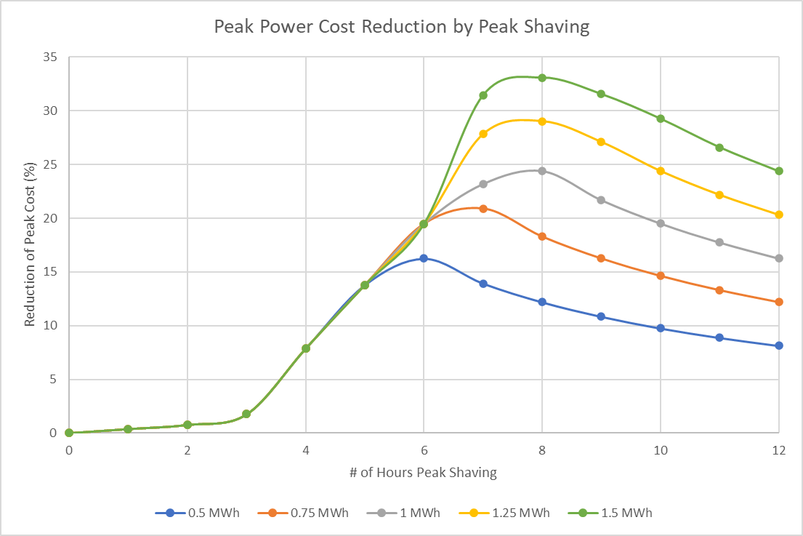
Fig. 3.8. Demand and usage charge reduction by peak shaving with a sample load

As seen in the results, little to no money is saved when discharging for less than 3 hours. However, once the peak is shaved for longer than 3 hours, the savings start to increase linearly. The cost reduction then hits a maximum when the capacity of the BESS begins to limit the power that can be delivered with increased duration. From 0.5 MW to 1.5 MW, each capacity hits this maximum between 6 and 8 hours. The duration at which the maximum of each BESS capacity is reached is the optimal number of hours to peak shave.
The reduction of cost increases with increasing capacity. An increase of 250 kWh corresponds to an increase of about 5 percentage points in peak cost reduction. However, this is only true if it is being operated optimally. For example, all capacities will have the savings if the BESS is peak shaving for 5 hours or less. Fig. 3.9 demonstrates why this happens. In this simulation, both are peak shaving for 3 hours. Fig. 3.9(a) has a capacity of 900 kWh, so it will discharge 300 kW for 3 hours. Fig. 3.9(b) has a 300 kWh capacity, so it can only discharge 100 kW per hour. Even though the first simulation has 3 times the capacity, they save the same amount of money. This is because the peak is not decreased further by the greater capacity. The peak for both is at the time peak shaving is initiated. If the load peak is steeper and has a shorter duration, the capacity could have a greater impact with shorter durations.
A 24-hour load profile is helpful to understand these concepts, but billing is done in monthly cycles. Therefore, looking at a full month will give a more accurate representation of the challenges and benefits of using a BESS. A facility in Chattanooga, Tennessee, that is considering a new BESS installation provided a load profile to be analyzed. This load profile is for the month of April. One benefit of using this load profile is that the cost analysis in the simulation was compared to and verified from their electric bill.
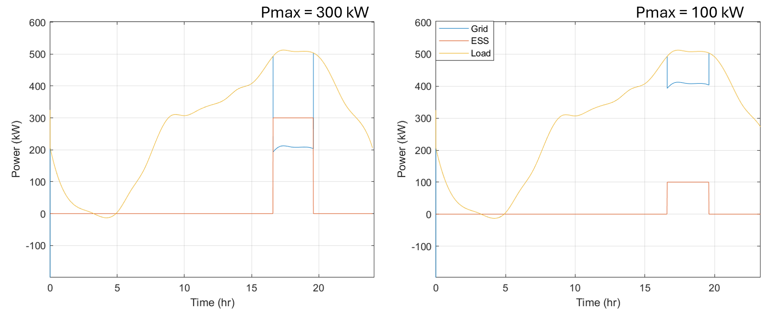
Fig. 3.9 (a) Peak shaving at 300 kW for 3 hours (b) Peak shaving at 100 kW for 3 hours

It is not as cyclical as many residential and commercial loads might be, which makes load forecasting difficult. On some days, the highest peak is at midnight. Other days it is at 2 pm. Because of this, timed peak shaving is not an appropriate energy management strategy for this load profile.
Load leveling was a promising energy management strategy because the battery would always be charging between peaks. This would ensure the BESS is always ready for the next peak regardless of whether it was predicted or not. The challenge with this strategy is when large peaks are too close together, the battery will not have time to recharge before the next peak, so the SOC will hit its lower limit. Finding the best level setpoint can prevent this from happening. Fig. 3.10 shows the optimal load level point for 3 capacities of BESSs. The level points were swept through to find the lowest cost for each capacity. As the capacity increases, the level point can be set lower, which will decrease the demand charge further.
The three energy management strategies that have been discussed can be thought of as a spectrum. One end of the spectrum is peak shaving, where the distance between the high and low setpoint is a large positive value. The other end of the spectrum is load shifting, where the distance between the high and low setpoint is a large negative value. Load leveling is directly in the middle, where the difference is 0. This spectrum can be seen in Fig. 3.11. The red represents the high value, and the blue represents the low value. A larger capacity is needed when further to the left on the spectrum.
To find the best energy management strategy for a specific load profile, several points along the spectrum were chosen. The lowest cost for each of these differences was found by sweeping through setpoints.
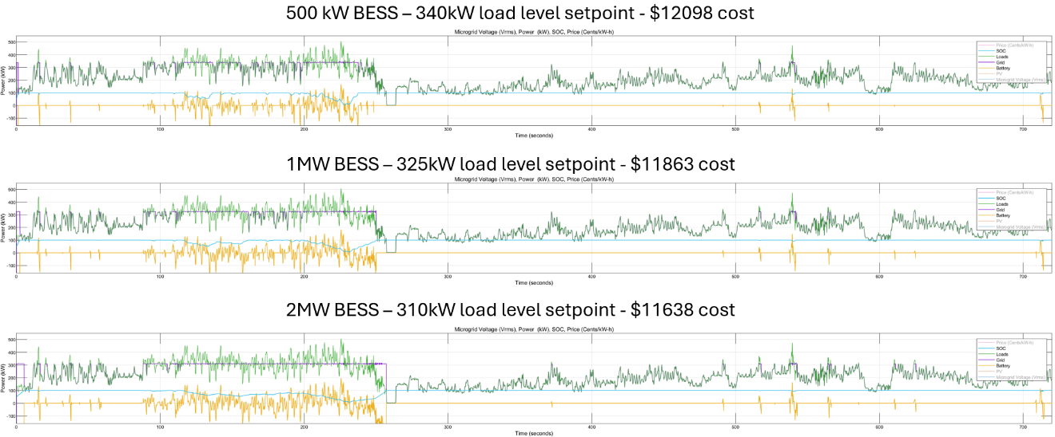
Fig. 3.10. Optimal load level setpoint for a month-long industrial load profile

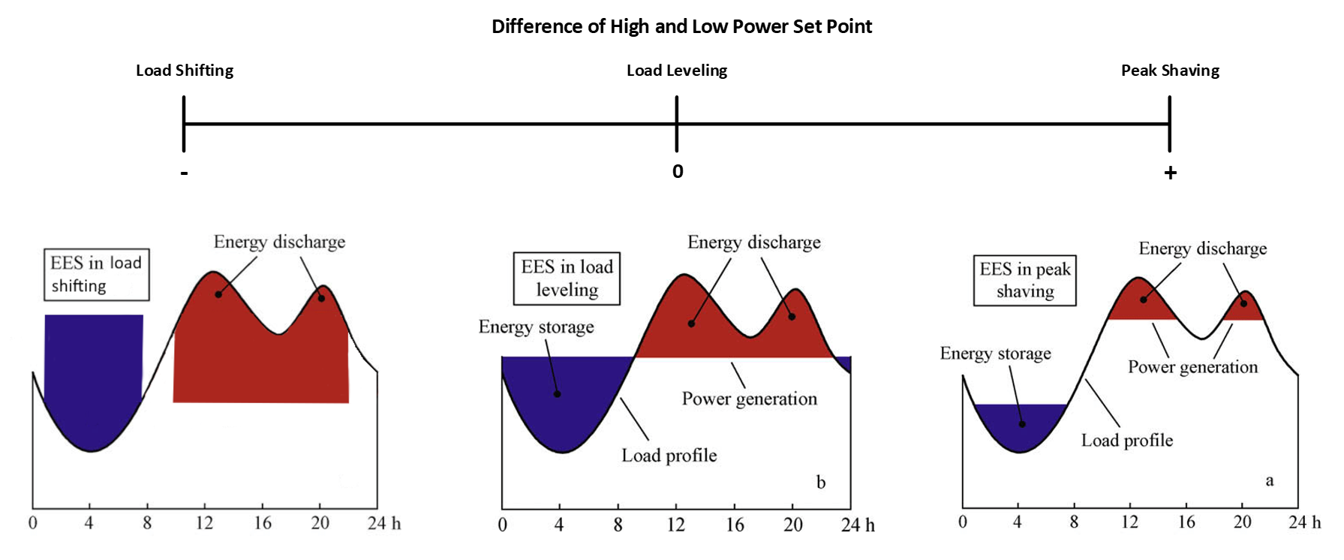
Fig. 3.11. Spectrum of energy management strategies based on difference between setpoint values [42]

How far down the spectrum to test depends on the capacity and the load. For the month-long simulation with a 500 kWh capacity, the range went from -80 kW to 300 kW as seen in Fig 3.12.
Load leveling is the optimal strategy for this profile since the results shows that the cost is most reduced at 0 difference between the high and low setpoints. The cost reduction decreases as the difference shifts to the right side of the spectrum with peak shaving because the peaks are not being shaved as low. The cost reduction sharply drops as the difference becomes negative with load shifting because the 500 kWh capacity is not large enough to support the energy management strategy. Load shifting requires the largest capacity since it must accommodate almost entire peaks. The SOC limits are hit much quicker using load shifting, so less money can be saved.
The same process was repeated for the sample 24-hour load. Fig. 3.13 shows the cost reduction for the different energy management strategies of this load. Because this load only has one true peak, peak shaving can reduce the cost by the same amount as load leveling. The optimal high setpoint remains the same during the flat section of the graph. The low setpoint is decreased as the difference increases. When this distance increases too much, the BESS uses too little of its capacity, limiting its ability to reduce costs. The peak is 512 kW, so if the distance is around 500 kW, there will be little to no savings. As the difference becomes more negative, the capacity begins to limit the difference that can be achieved before hitting the SOC limits. The larger capacities can accommodate larger differences, but it will still hit the SOC limits before the 512 kW difference. Based on Fig. 3.13, the best energy management strategy for the sample load profile would be peak shaving. While load leveling has the same cost reduction, it uses more battery capacity. Less capacity is used the further to the right of the graph.
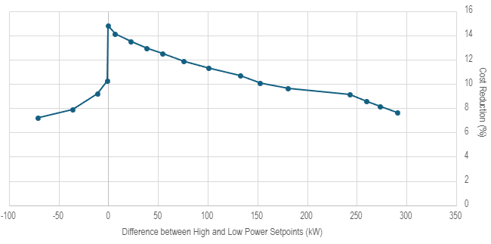
Fig. 3.12. Cost reduction from energy management strategies for a month-long industrial load profile

Fig. 3.13. Cost reduction from energy management strategies for sample load with BESS

Minimizing the capacity usage will extend the lifetime of the battery because cycle aging would be decreased. Therefore, the largest difference that is at the maximum cost reduction is the best operating point.
Larger capacities have a larger potential to reduce costs. With an increase of 500 kWh capacity, the BESS can reduce the costs by 10 percentage points more. However, many factors should be considered besides cost reduction as discussed in the next paragraphs.
A 2 MWh system would save over twice as much as a 500 kWh system, but the cost of a system this large would be a much greater investment. The payback period should be weighed against the possible savings. If the payback period is greater than 5-10 years, the investment is likely not worth it because the batteries will need to be replaced around that time.
The amount of battery usage also needs to be considered. While using the full extent of the battery usually means a more efficient use of available resources, it also ages the battery quicker. Replacing the battery more often incurs costs that may be greater than the value obtained from cycling the battery more often.

Chapter Summary
In this chapter, a BESS model for large time scale simulations was presented. It includes simple empirical models of all the major components as well as a detailed energy management system state machine. An economic model was constructed based on EPB’s large commercial pricing structure. This allows for a direct cost comparison of different energy management strategies and setpoints.
Finally, 3 main topics were explored using the model. First, the demand and usage charge reduction by peak shaving for different durations was studied. For the sample load profile, 6-8 hours is the optimal duration to peak shave depending on the capacity, but this varies with different loads. Next, the optimal point for load leveling of a month-long load profile is found. Load leveling was determined to be the best strategy because of the proximity of the peaks as well as the unpredictable nature of the load. Finally, the optimal energy management strategy for cost reduction was found for the two different load profiles.
While only applicable for these load profiles, any load profile and pricing structure can easily be input to the simulation to find the best operation method for any system, saving time and money for those designing and operating BESSs.

Second Life Battery Energy Storage System Design

Overview
Volkswagen Group of America’s battery engineering lab in Chattanooga, TN is considering installing a BESS at their facility. The main idea is to explore reusing old EV batteries from the ID.4 by converting them in a BESS to give them a second life. The goal of this project is for teams from The University of Tennessee Knoxville (UTK) and Volkswagen (VW) to work together to design and potentially build a modular BESS. If built, the BESS could be used to learn about the aging behavior of EV batteries in second life, as well as lowering the lab’s energy bill and potentially provide backup power. This chapter will discuss the work that has been done so far in the project.
Fig. 4.1 shows a one-line diagram of the system. The main components depicted on the diagram are the battery, PCS, BMS, controllers, Human Machine Interface (HMI), and auxiliary power. The selection and testing of these components will be discussed in more detail in sections 4.2 through 4.6.
The system is designed to connect to the building’s 3-phase 480 V connection. As this design is for one building block, the power rating is only 40 kW with a battery voltage of 550-820V.
Protections are important in a system like this for both the safety of the system and the users. There are several relays and power meters planned throughout the system to ensure its safety.
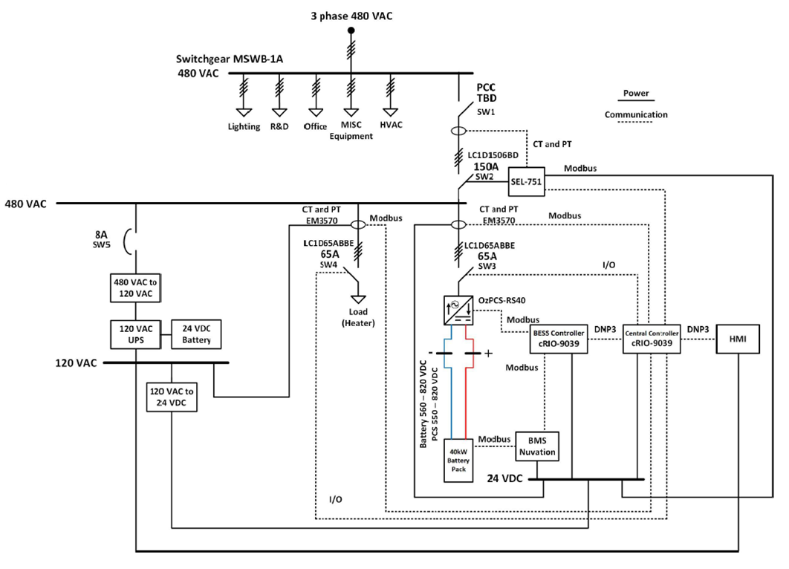
Fig. 4.1. BESS one line diagram

SW1, shown in Fig. 4.1, is used to isolate the system from the grid. SW2 is controlled by the BESS for islanding and connecting to the grid. SW3 will isolate the battery from the load and grid. This can be done when maintenance is needed or when BESS support is unneeded. The auxiliary power is protected by an 8 A breaker. This can be switched on and off manually if there is an islanding situation that may last longer than the BESS can provide power for, and the user wants to conserve the battery’s energy.
A summary of the BESS operation is that the 40 kW battery power is converted to AC by the PCS. The BESS controller commands the PCS to operate in either grid connected mode, islanded mode, standby mode, or disabled mode. The controller also tells the PCS how much power to provide. If it is in islanded mode, this is based on the load demand. If it is grid connected, the active and reactive power is defined by the user through the HMI. The HMI is an interface through a PC that allows the user to control how the system is operated and read the status of voltage, current, power, frequency, state, etc. The PCS output is connected to the BESS’s 480 VAC bus that powers the load. This bus can also receive power from the building’s power. The auxiliary power is converted from the 3-phase 480 VAC to single phase 120 VAC. This is used to power the HMI. The 120 VAC is converted to 24 VDC to power all other components such as the PCS, BMS, and controllers.

Power Conversion System
The PCS is responsible for the power conversion between the battery and the BESS’s AC bus. It's important that the PCS is selected with operating voltage and power levels compatible with the battery.

Selection
The power capacity of a single PCS determines the number of PCSs that need to be in parallel, but choosing a PCS with a higher power level will decrease implementation effort and complexity. With a smaller capacity per single battery stack, more of the capacity can be utilized, and there is a lower safety risk. The downside of this is the cost is higher.
Three main topologies of commercial PCSs were examined. The first, as seen in Fig. 4.2, is DC-coupled. Each battery stack has its own DC-DC converter linked to the DC bus. This DC bus connects to a DC-AC converter that interfaces with the grid. The DC-DC converters can be arranged in either series or parallel configurations. Next is an AC coupled PCS with a common AC link. Each stack has its own DC-DC converter and DC-AC converter. The last topology is similar, but a single PCS has both the DC-DC and DC-AC converters embedded into one device. This can be seen in Fig. 4.3. There are other possible topologies of PCSs, but these are the most common in commercially available PCSs.
A list of available commercial PCSs was compiled. To determine which is the best for the BESS, a price per kilowatt was found for each. First, the amount of energy the batteries can provide when configured for each PCS must be determined. There are 2 potential battery modules. One has 8 cells in series and 3 in parallel, and the other has 12 in series and 2 in parallel. The current for both modules is calculated using a 1/3-C charge rate and 80% of the original capacity. Using the nominal voltage and calculated current, the power is found. This is used to determine the batteries power capabilities for different numbers of batteries used in each string.

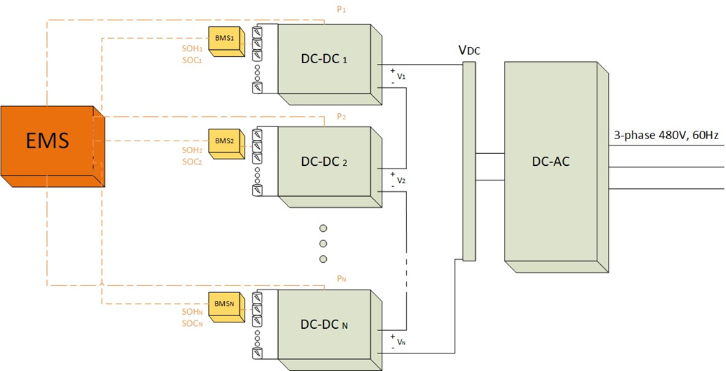
Fig. 4.2. DC coupled PCS topology

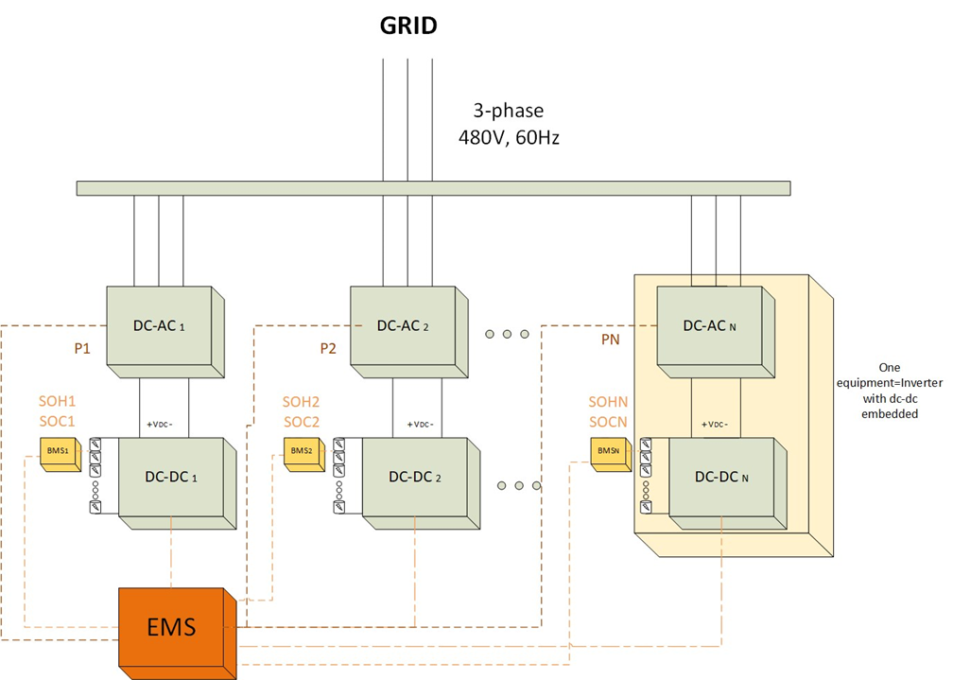
Fig. 4.3. AC coupled PCS topology

Table 4.1 shows the voltage limits, power, and current for both modules depending on the number of modules in series. Battery 1 is the 8S3P module, and battery 2 is the 12S2P module.
Each of the commercial PCS options was examined to find DC bus voltage, power limits, and price. The number of modules needed to stay in the operating range of each PCS is determined, which determines the amount of power that can be utilized by the battery. Some of the inverters’ power limits are below the power limit from the battery, so these are not chosen. Finally, the number of inverters and DC-DC converters needed were determined by assuming a 500 kW system for direct comparison between topologies. The price of each option is calculated, and the lowest cost per kilowatt is chosen. This was the Oztek RS-40 using the 8S3P modules. It is a 40 kVA AC-coupled PCS that has an embedded DC-DC converter. The voltage range is 550-820V. One benefit is that because the PCS power rating is only 40 kW, each building block would have one stack of 24 modules connected to it. Then 12 PCSs would be in parallel to reach the approximately 500 kW assumption.

Testing
The first step in testing was to download the Power Studio software that is used to configure and control the PCS. All configurations were made to voltage, current, power, etc. from the provided software. Due to limitations in the lab, the demo was tested at 208 V. A 15 kW, 500 Vdc power supply was used in place of the battery system for both safety and convenience. A 40 kW heater was used as the load. A diagram of the testing configuration is shown in Fig. 4.4.

Table 4.1. Voltage, current, and power based on possible battery stack configurations
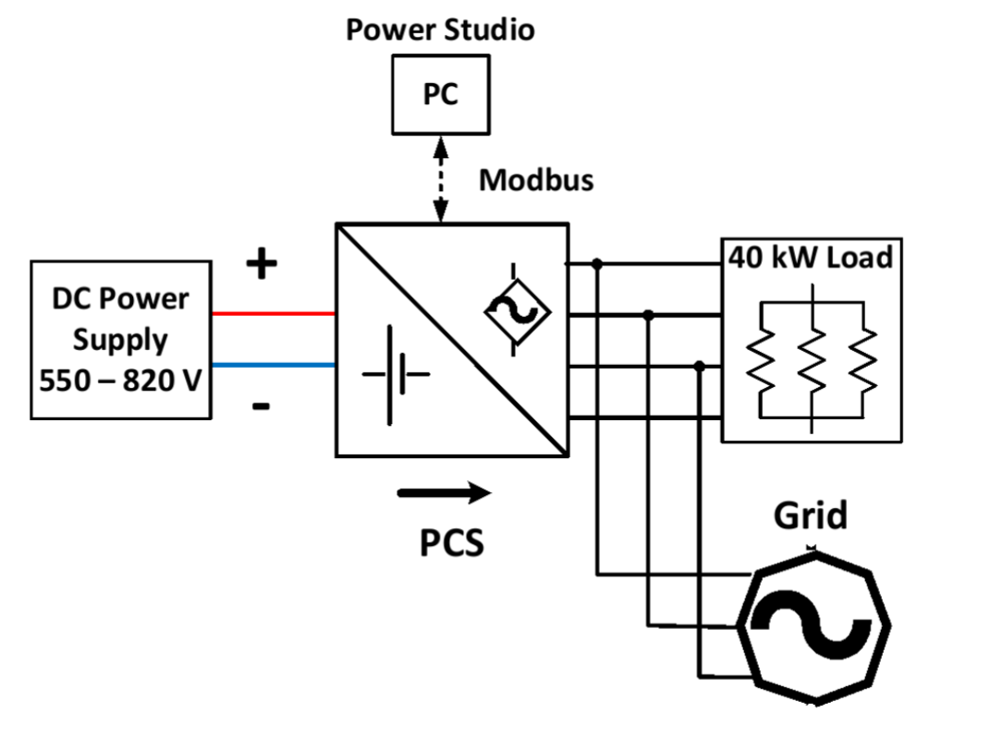
Fig. 4.4. PCS component testing setup
Once the PCS was confirmed to perform all the basic functions such as grid connect, island, disable, fault reset, etc., the control and communication were implemented. Many of the functions of the PCS were tested again after this implementation to ensure that all faults, warnings and statuses could be read with the proper communication method. The implementation of the controls and communications are described in section 4.5. The test procedure and results can be seen in section 4.6 as it was tested as part of the state machine tests.

Battery Management System
The BMS is responsible for many tasks. It should protect against over-charge, over-discharge, over-current, short circuit, extreme temperatures, etc. It also must balance the cells of every module and communicate with the central controller.

Selection
A list of BMS companies was compiled. The important parameters to consider are the number of channels, voltage limits, communication protocols, balancing methods, and SOC and SOH estimation. The list was narrowed down based on which products meet the project specifications and if their companies will communicate with the project team. From there, 2 companies remained – Orion BMS2 and Nuvation G5. Each has all the features required for the system. The Orion BMS uses a remote cell tap module to be used for more than 180 cells. This would amount to 23 battery modules per BMS. The Nuvation has a cell interface per 24 cells that interfaces with one switchgear. The switchgear can support a maximum of 20 cell interfaces. Each cell interface can be connected to 3 battery modules, so 60 modules can be connected to one switchgear.
Either of the two options would work in this project, but the Nuvation G5 was chosen for its included features such as a battery disconnect unit, its extensive documentation, and its good reputation among established BESS companies.
The Nuvation BMS has a low voltage option that can be used with up to 16 cells. This BMS was purchased and tested to gain familiarity with the software, set up, and control before receiving the G5. This will make the installation of the full BESS on site easier.

Testing
To test the BMS, the Nuvation set up guide was followed. The components needed are 3 contactors, a precharge resistor, current shunt, fuses, and a 12-16S battery. All cables were ordered with the Nuvation BMS. These are all included within the switchgear of the G5, so this is only necessary for the low voltage BMS setup. The wiring diagram can be seen in Fig. 4.5. The chosen battery was a 10 Ah 12S2P 43.2V Li-ion battery from MaxAmps. Because the number of battery cells does not match the total number of cells of the BMS, the cells were split into two groups. Each group must have a minimum of 11 V. The unused cell inputs in the lower group must be tied to cell 8, and the unused cell inputs in the upper group must be connected to cell 16. This configuration for 11S is shown in Fig. 4.6. For the 12S battery used, 6 cells are in the top group, and six cells are in the bottom group. The hardware setup is shown in Fig. 4.7.
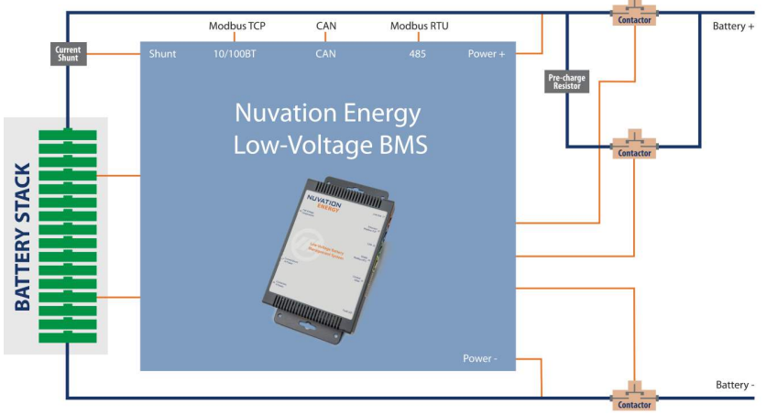
Fig. 4.5. Low voltage BMS lab setup wiring diagram [43]
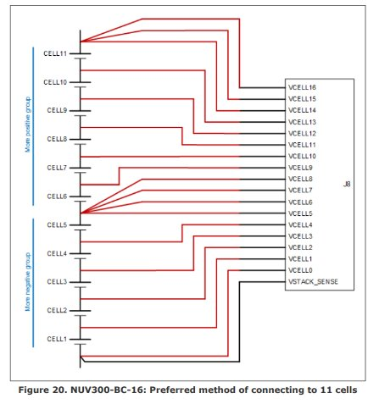
Fig. 4.6. 11S battery connection to a 16S BMS [43]
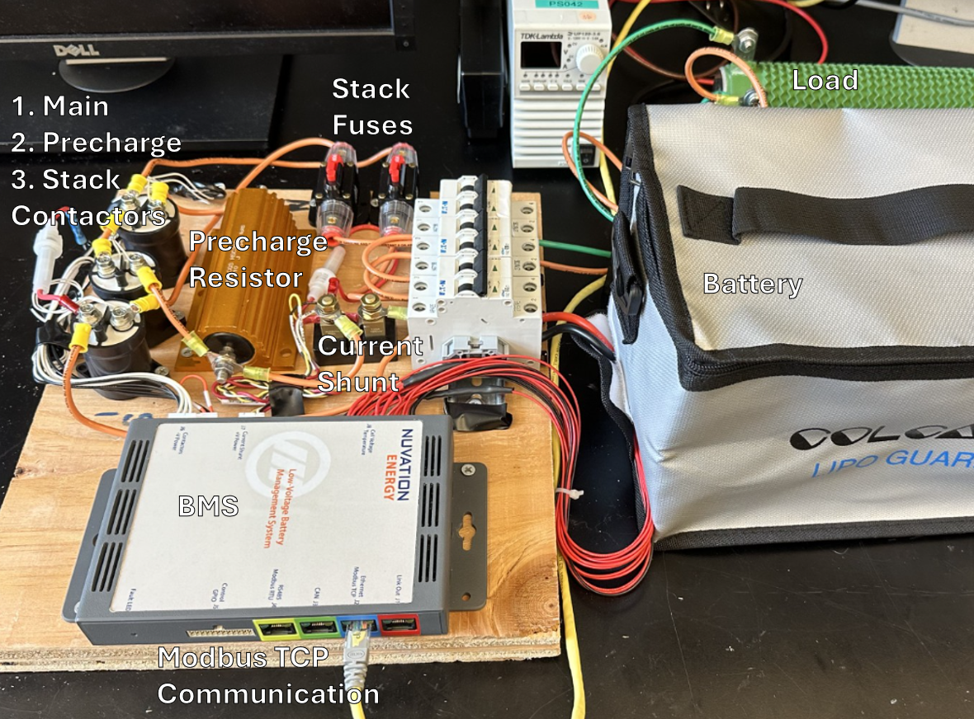
Fig. 4.7. Low voltage BMS lab setup

Once the BMS was set up, the functions were tested. Communication was established through Modbus TCP. This was tested by connecting and reading basic battery measurements and verifying with a multimeter. Next, the fault conditions were verified. Each fault condition can be configured in the configuration file. For testing purposes, the high cell voltage limit was set to be below the cell’s voltage to ensure it would trip the high cell voltage fault. This was repeated for the high stack voltage fault. Then the low cell voltage limit was set above the cell’s voltage to ensure it would trip the low cell voltage fault. Then, this was repeated for the low stack voltage fault. Each fault, such as voltage and current faults, were tested similarly.
Faults can be seen on several pages of the BMS software. The dashboard shows faults through the BMS status symbol. It also shows cell voltage and temperature meters. If in the red section of the meter, a fault has occurred and the battery is disconnected. Additionally, the cell detail tab shows which cells have over- or under-voltage.
The battery SOC was calibrated by fully charging and discharging the battery. The user inputs battery voltage limits. An SOC-OCV curve can also be input in the configuration file for a more accurate estimation. The BMS records the charge when at the high and low voltage limits during the charge and discharge to configure the battery SOC.
The cell balancing was tested by changing the delta voltage threshold for balancing in the configuration file. The delta was changed to 5 mV. If the difference between a given cell voltage and the minimum cell voltage is greater than 5 mV, the cell will be discharged until it is within the threshold. Balancing can be done while the battery is charging or idle, but not while discharging. The results of this test can be seen in Fig. 4.8.
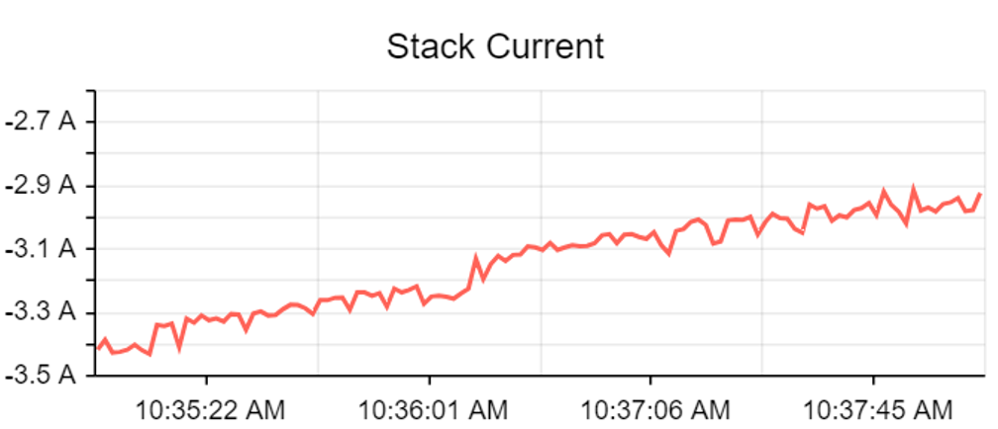
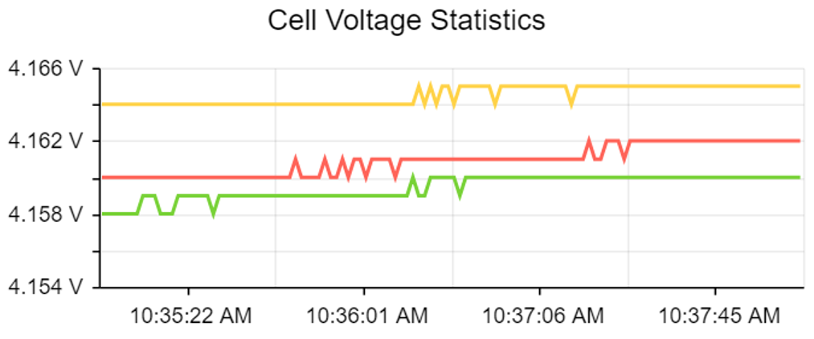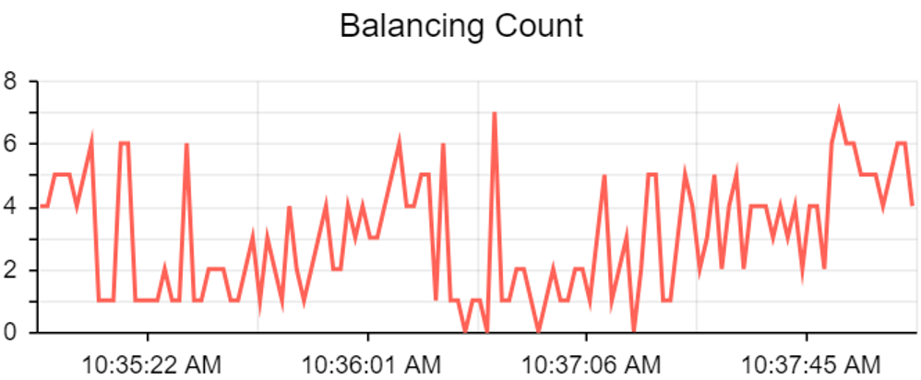

Fig. 4.8. BMS balance test results for (a) Stack Current (b) Cell Voltage (c) Balance Count

The stack current is decreasing as the battery gets closer to full charge. Once past a voltage threshold of 4.15 V, the cells are balanced. While the difference between the cells is greater than 5 mV, the high cells are discharged. At the end of the test, the cells are within 5 mV of each other, so balancing is finished.
The main functions of the BMS have been implemented in a lab setup to understand how to use the software and change the configurations. Set up and testing can be completed more easily in the full system with this knowledge. The SOH estimation is not included in the low voltage BMS, so this function will need to be learned with the high voltage system.

Auxiliary Power System
The auxiliary power system provides power to all subsystems that need it. The input is 3-phase 480 VAC from the BESS, and the output is 120 VAC and 24 VDC. The auxiliary power system should provide uninterruptable power to controllers for a recommended 2 hours in the event of a power outage.
The chosen topology for the auxiliary power system, as seen in Fig. 4.9, converts the BESS’s 480 VAC to 120 VAC. The 120 VAC UPS accommodates both the 24 VDC and 120 VAC loads. The 120 VAC supplies the HMI and is converted to 24 VDC to power the remaining loads. The benefit of this topology is that the power is not converted back and forth between AC and DC like other considered topologies.
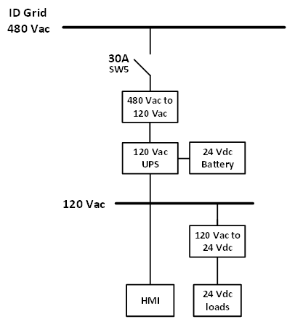
Fig. 4.9. Auxiliary power system topology

First, the power requirements for each component are determined from their datasheets. This can be seen in Table 4.2. The total power requirement for all components is about 600 W. Once this was determined, the parts were selected. Two options were considered – a 1.5 kVA and 3 kVA transformer. With the larger transformer, a larger UPS with a higher battery capacity can be used, allowing for a longer runtime. The tradeoff is that it costs twice as much. The comparison of the two options is shown in Table 4.3. Based on the price and runtime, the 1.5 kVA transformer was chosen. The runtime was decided to be less important than the cost. The one-hour runtime difference could not justify the increased cost and space.

Communication and Controls
The controller manages the operation and performance of the system. Its primary function is managing interactions with the grid, such as frequency regulation and demand response, and energy management. In the building block demonstration built for this project, the focus of the controller is to provide a user interface or HMI to monitor and control the system directly.
The chosen controller is the National Instruments cRIO-9309; although for testing the NI cRIO-9871 was used as that was on hand in the lab. A digital input/output card, the NI cRIO-9375, is used with the controller to control the relays. LabVIEW 2020 was used to program the controller to communicate through Modbus RS-485.
To interface the cRIO with the PCS, a communication board is designed. This allows the DB15 connector from the PCS to connect to the DB9 connector on the cRIO. The layout for this board is shown in Fig. 4.10. Similarly, a breakout board is used to interface the cRIO to the feeder protection relay, the SEL-751. This is connected using the half duplex method. The wiring diagram for communication can be seen in Fig. 4.11.
Table 4.2. Auxiliary power requirements
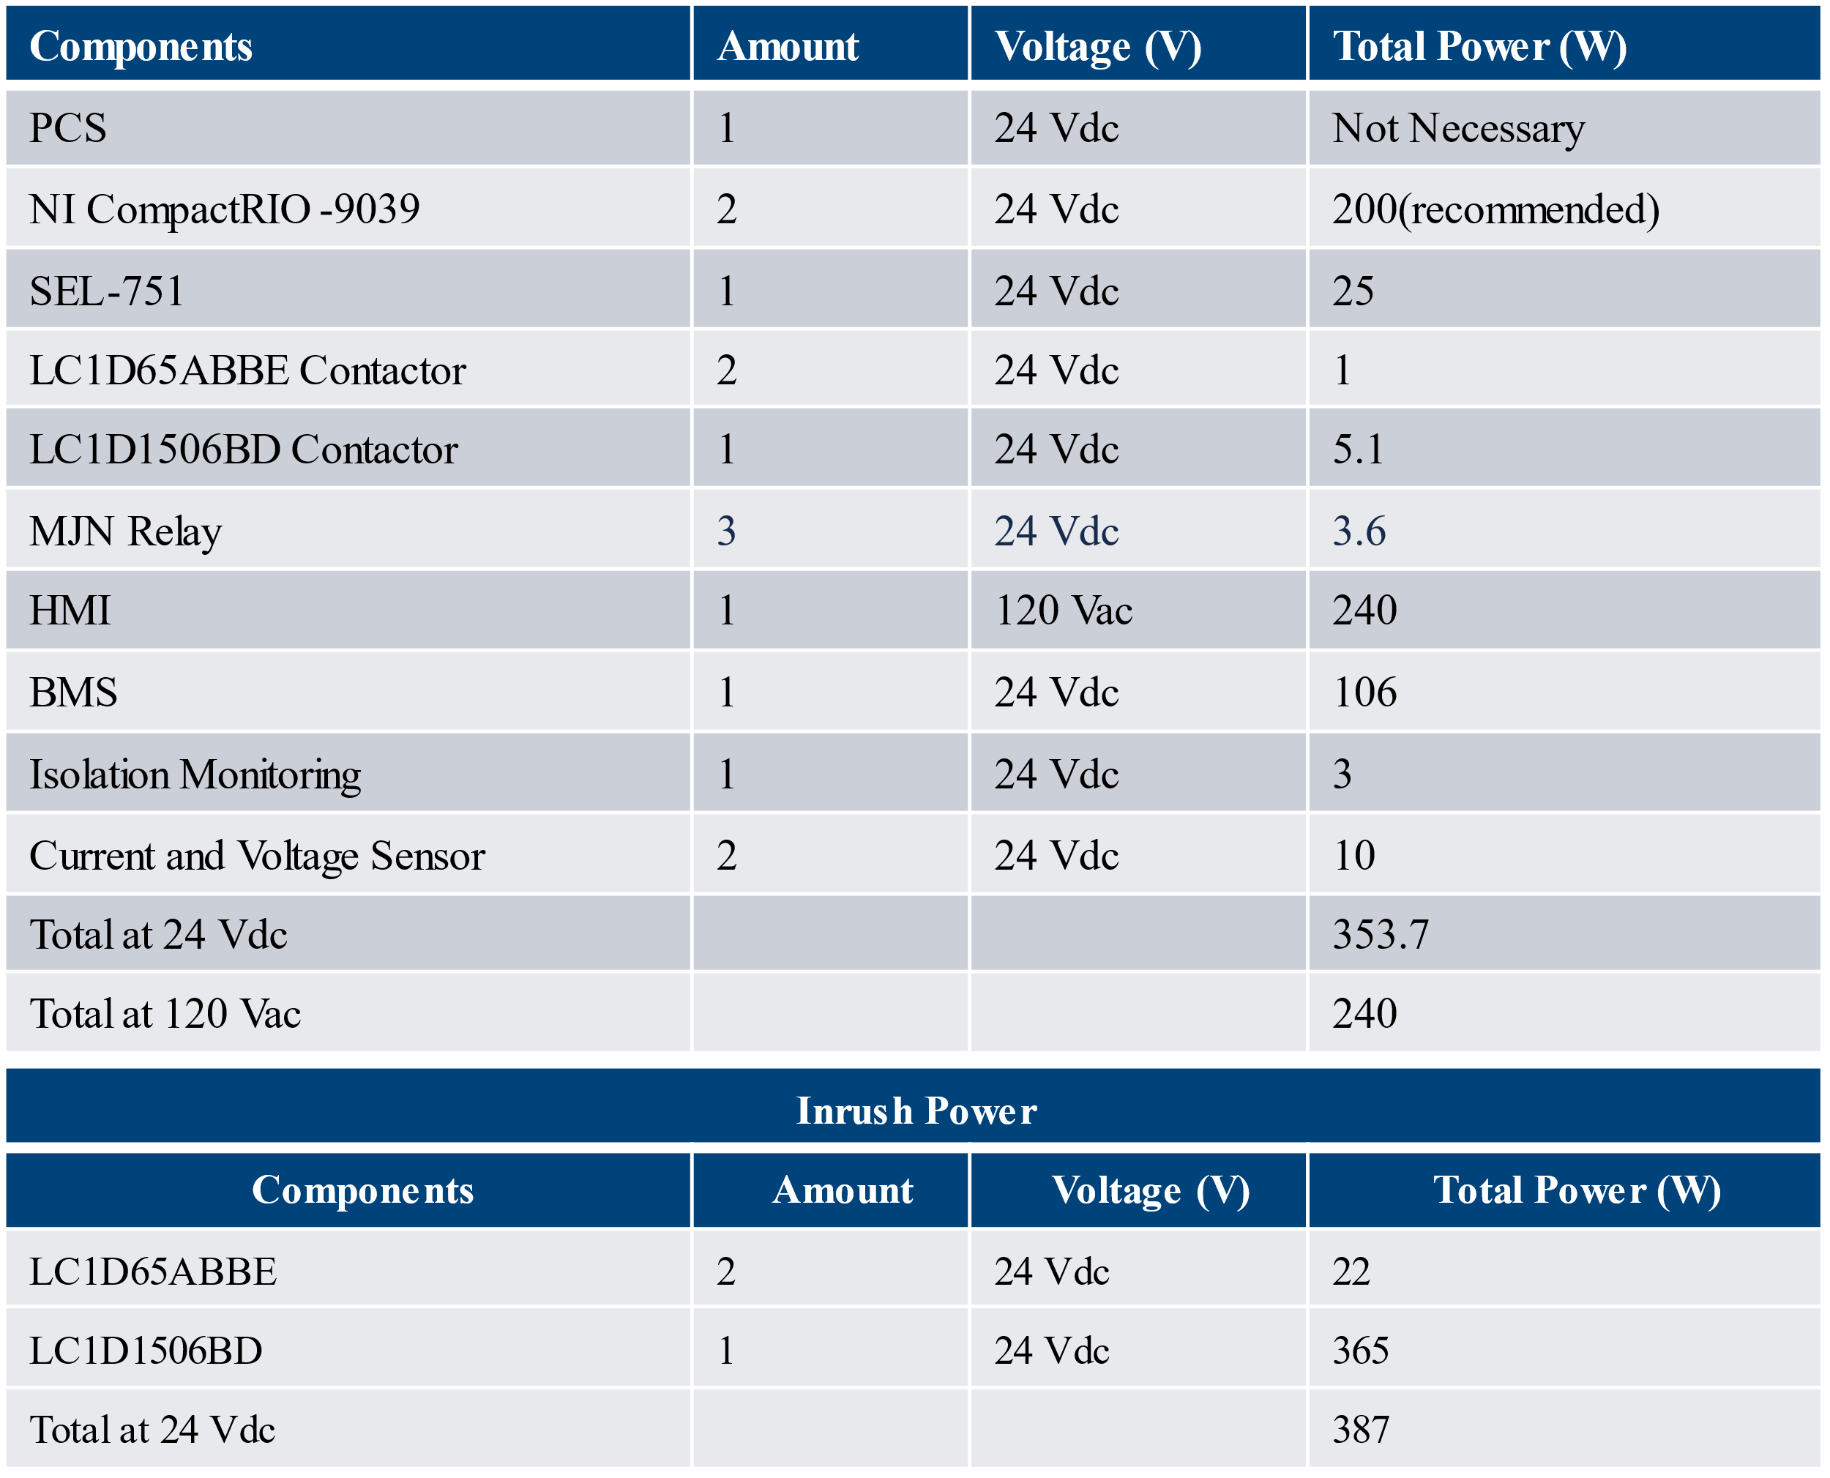

Table 4.3. Comparison of different sizes of auxiliary power systems
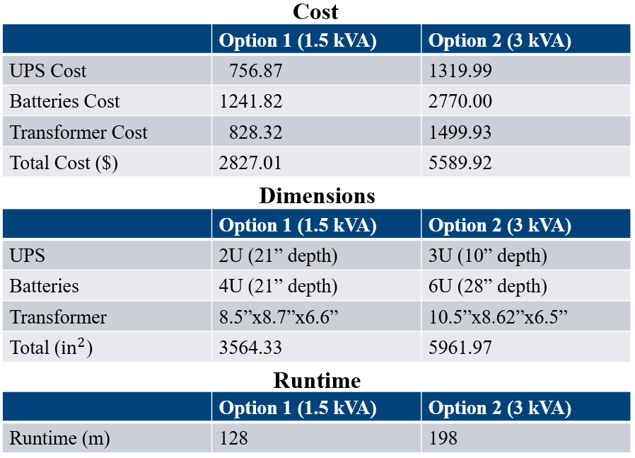
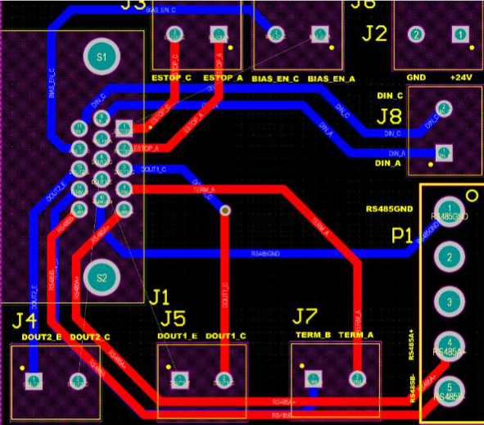
Fig. 4.10. PCS communication board layout

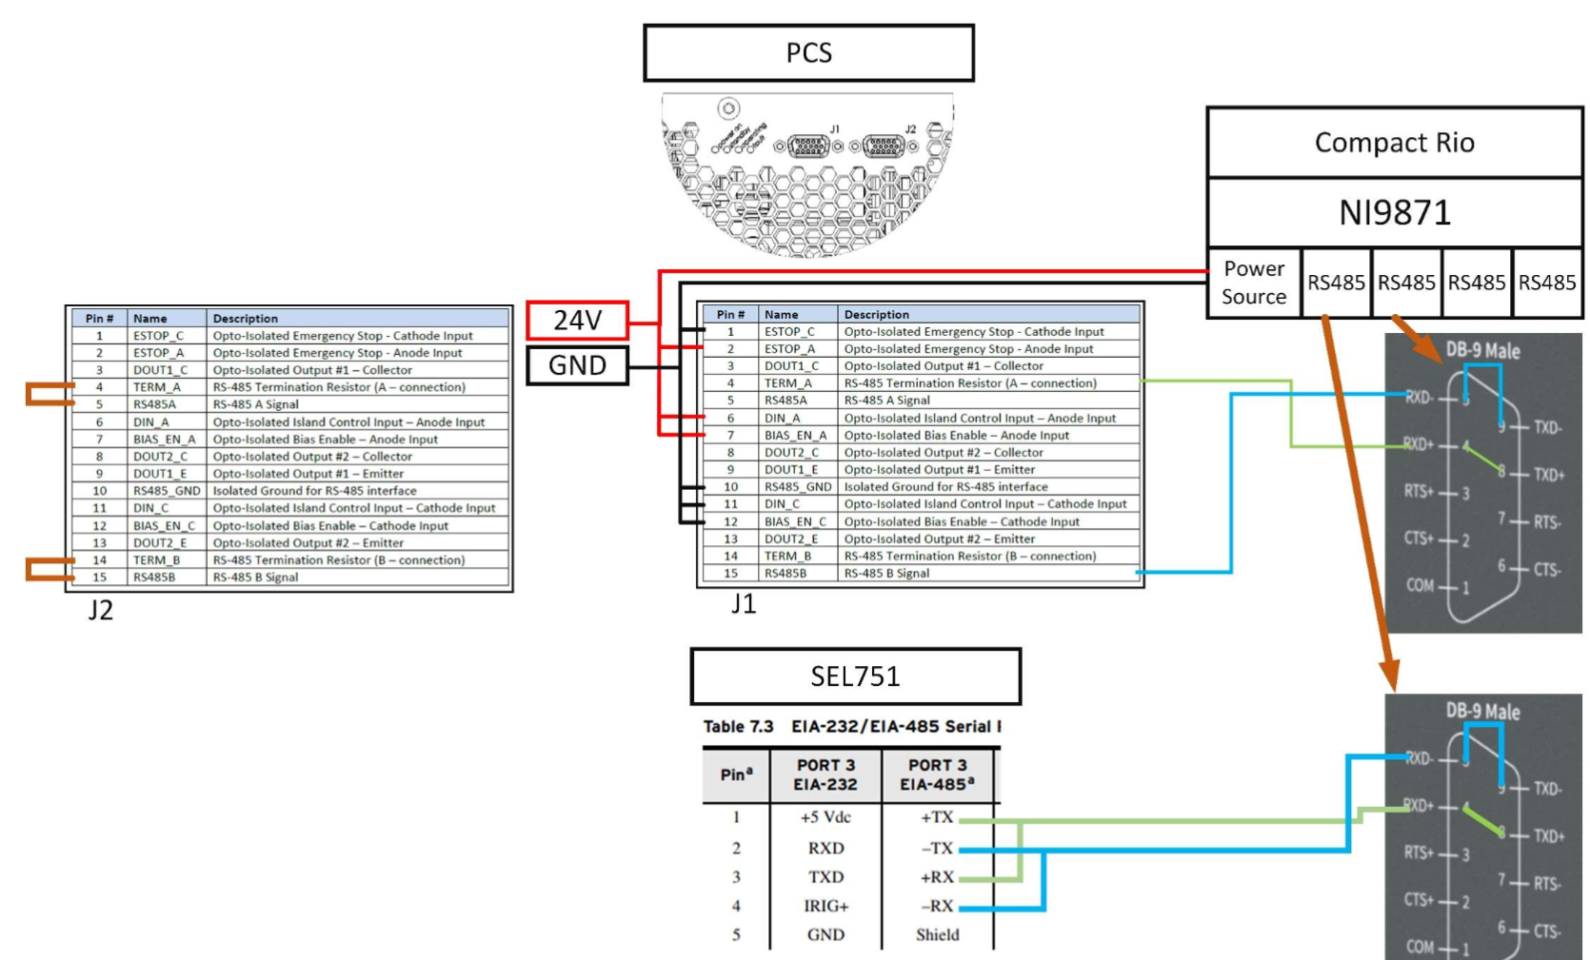
Fig. 4.11. Wiring diagram for communication between cRIO and PCS and SEL-751

HMI
The HMI is the display that allows the user to monitor and control the system. The implemented HMI can be seen in Fig. 4.12. It includes 4 charts, PCS status indicators and commands, a fault display, and active and reactive power controls. Future work would include BMS status indicators.
- Run Button
The arrow labeled 1 in Fig. 4.12 is the start button. Running the program will open a pop-up window showing the cRIO connecting to the PC and downloading the Labview code. Once successfully connected, the grid on the HMI will disappear and the graphs begin to populate with data. An indicator with the state of the PCS will turn on.
- Charts
The charts will collect data when the code is running. If paused or stopped, the graphs will stop collecting data, and the last minute of data will be displayed. The graphs always display the last minute of data. The data collected is for frequency, line to line voltage, active power, and DC voltage.
- PCS Status Indicator
The PCS status lights up the indicator corresponding to the current state of the PCS. Only 5 states are shown, but the PCS has 18 possible states. When in one of the states not represented, none of the indicators will be lit. The unrepresented states are transition states, so they should not be in these states for long. The exception would be the charge wait state. In this state, the PCS waits until the AC voltage is below 10 V for islanded or a valid grid is detected for grid connected.
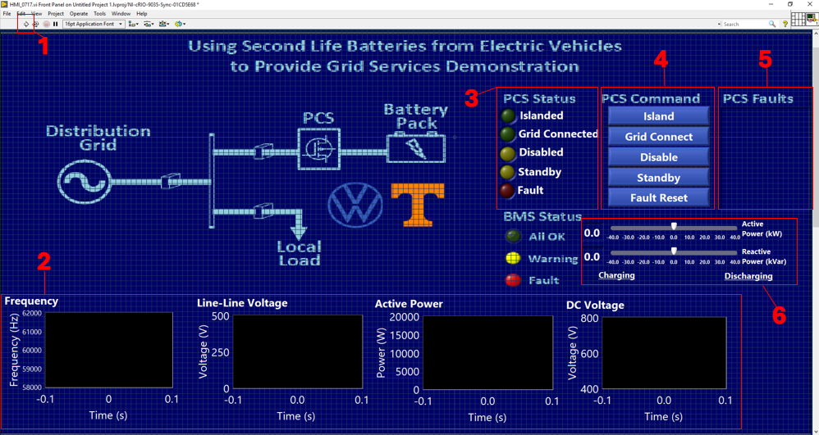
Fig. 4.12. HMI implemented in LabVIEW using cRIO-9871

- PCS Commands
There are five buttons that can be used to control the system. If in a different state, the island button will disable the PCS, open the relay using the SEL-751, and reconfigure and connect the PCS to run in islanded mode. The grid connect button works similarly. It disables the PCS, closes the relay using the SEL-751, and reconfigures and connects the PCS to run in grid connected. Disabled opens both the AC and DC contactors in the PCS. Standby closes both AC and DC contactors in the PCS but does not give the command to grid connect or island yet. Fault reset clears the fault list if those faults are no longer present.
- PCS Fault Display
All PCS faults are displayed here. Resetting the fault will clear this message if the fault has been fixed. Otherwise, the fault message will persist. If there are multiple faults, they will all be shown in the same message.
- Power Sliders
Active and reactive power can be set to both positive and negative values, though negative power/charging has not been tested since a power supply was used in place of batteries. The exact power can also be set by textbox.

LabVIEW Programming
The Labview code and HMI were implemented on the cRIO. The first step was to establish communication with the PCS and SEL-751. To control the SEL-751 and PCS from the cRIO, a serial master must be established in LabVIEW. The PCS is slave ID 1 and the SEL-751 is slave ID 2. Every read and write command for these devices must be connected to the corresponding “master out” port. These connections are shown in Fig. 4.13(a) and (b).
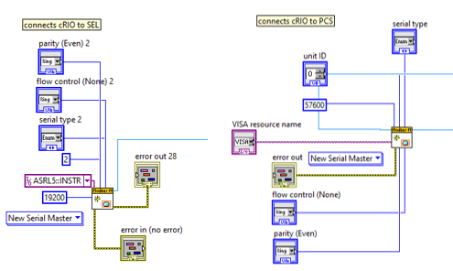
Fig. 4.13. Establishing communication between the controller and (a) SEL-751 (b) PCS

Various checks are made to determine how transitions should be executed. The state is checked to see if it is in the standby state, then the mode is checked. If it is in standby and grid tie is one check. The other check is if it is in standby and islanded. Both checks are used in the PCS command logic for entering grid connected or islanded to avoid disabling the PCS if it is already correctly configured. There is also a disabled check which is used to determine how to enter standby since it can be done with two different commands based on the previous state.
The button presses use similar logic. It checks to see if the button is pressed, and the state is not currently in the state of the button pressed. This is to avoid disabling the PCS unnecessarily when the button is pressed while already in that state.
When the PCS is not in the correct configuration for grid connected (mode = 1), clicking the grid connect button will disable the PCS, close the relay using the SEL-751 trip command, reconfigure by setting the mode to 0, start the PCS, and exit standby. If the PCS is already in the correct mode, but in standby, all the steps before exit standby can be skipped. This avoids unnecessary disabling of the PCS. These two scenarios are shown in Fig. 4.14 and 4.16.
When the PCS is not in the correct configuration for islanded (mode = 0), clicking the island button will disable the PCS, open the relay using the SEL-751 target reset command, reconfigure by setting the mode to 1, start the PCS, and exit standby. If the PCS is already in the correct mode, but in standby, all the steps before exit standby can be skipped. This avoids unnecessary disabling of the PCS. These two scenarios are shown in Fig. 4.16 and 4.17.
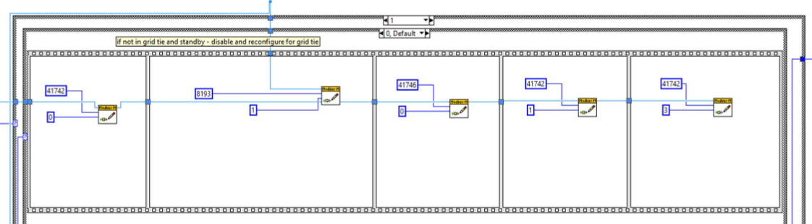
Fig. 4.14. Entering grid connected state from any state other than standby
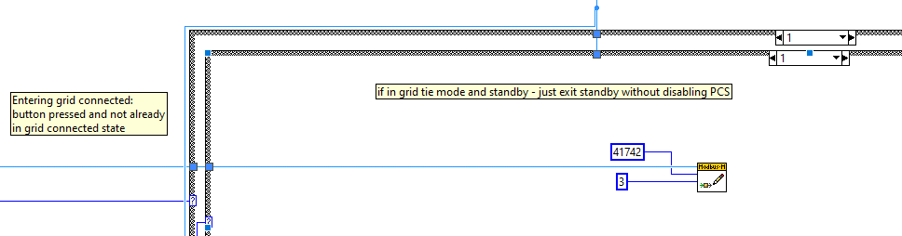
Fig. 4.15. Entering grid connected state from standby state

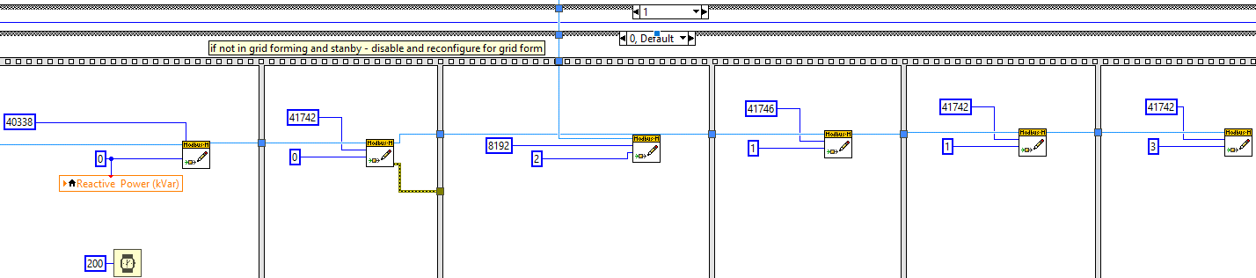
Fig. 4.16. Entering islanded from any state other than standby

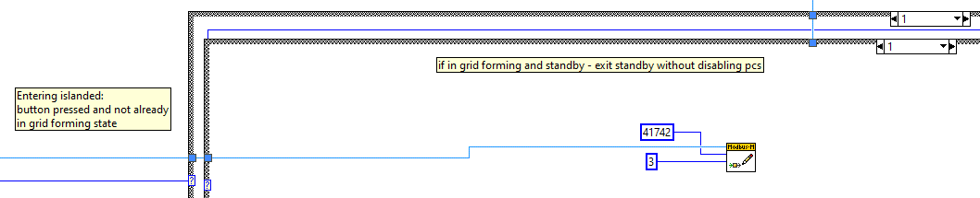
Fig. 4.17. Entering islanded from any state other than standby
Disable can be entered from any state, so no check is necessary besides whether the button is pressed. It gives the command to the PCS to change state to disabled. The fault reset similarly can be done from any state. Writing 1 to that register will clear the fault register if the fault has been resolved. The standby command requires a check of whether it is in disabled or not. When in the disabled state, to enter standby the start command is given. From there, a charge wait and charge are completed before entering standby. From any other state, the enter standby command is given. This logic can be seen in Fig. 4.18.
To display the status, the state is read as shown in Fig. 4.19. The state is compared to the 5 possible PCS states that are shown on the HMI – Islanded, Grid Connected, Standby, Disabled, and Fault. If the state is equal to that number, the indicator is lit.
The registers for active power, frequency, average line to line voltage, and dc voltage are read and output to a chart and a text display. The last minute is shown on the graph by setting chart history length to 600. Frequency is a 32-bit register, and Modbus uses 16 bit, so 2 registers are read and the index of the array is selected to display the frequency.
The active and reactive powers are set using a slider input. The PCS power command is in units of hundredths of a percent. To convert this to kilowatts, the input is scaled by 25, since 100% is 40 kW and $40×25=1000$, or 100%.
The fault messages are output by reading the two fault registers, as shown in Fig. 4.20. If either register is not 0, then the number of that register is converted into a Boolean array. Each index is read, and if that index is true, then the fault corresponding to that bit is added to a string. Every fault bit that is true of the 32 possible bits is added to one string which is then output to the fault display on the HMI. This string is cleared when the fault reset button is pressed.
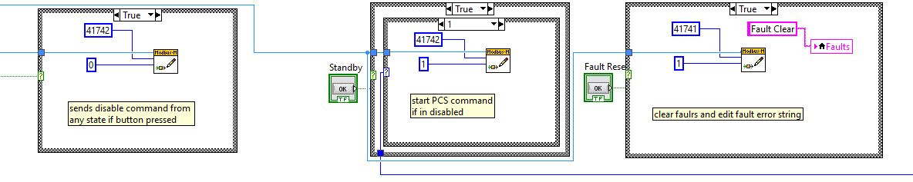

Fig. 4.18. (a) Disable (b) standby (c) fault reset button logic

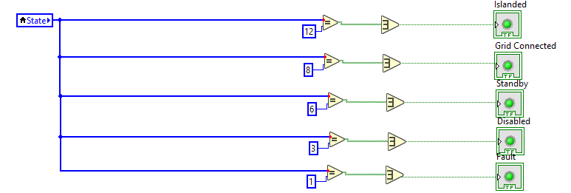
Fig. 4.19. PCS status indicator logic

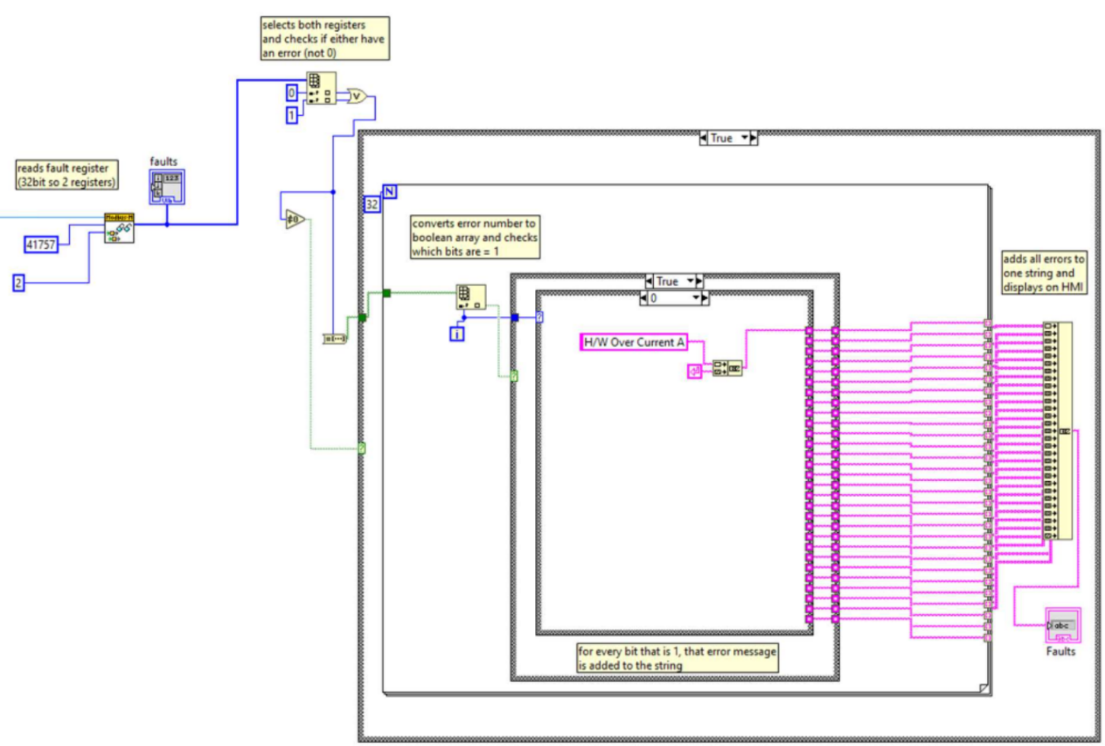
Fig. 4.20. Fault message display logic

State Transition Diagram
A state transition diagram was drawn to show the different states of the system and the transitions between them. There are 7 states as shown in Fig. 4.21. The grid connected state is when switches 2 and 3 are closed. The BESS is connected to the grid, and the battery can be charged or discharged. The islanded state is when switch 2 is open and switch 3 is closed. In this state, the battery powers the BESS. The user can manually transition between these states by remotely opening or closing the relays. The system could also seamlessly transition between these two states if a change in grid conditions is detected with the addition of an IO card.
The standby state is divided into grid connected and islanded depending on the PCS configuration and the status of switch 2. The functionality of this state is the same regardless. Switch 3 is opened, so the battery is disconnected from the AC bus but ready to be dispatched. The user can switch between these states as shown in section 4.5.2.
The fault states are also determined by the PCS and switch 2 configuration. If a fault occurs, the system will directly transition to the fault state regardless of the previous state. The fault must be manually reset. To transition to long term storage, switch 2 is opened, and the bias disable command is given to the PCS. The auxiliary power system is shut off by opening switch 5. Each state and the status of all switches are shown in Table 4.4.
Each state and the transitions between were tested by entering and exiting the states from all possible configurations. The test setup can be seen in Fig. 4.22. This setup differs from the final building block design because auxiliary power, central controller, and BMS have not been integrated yet. The wiring diagram for the lab setup is shown in Fig. 4.23. The results for all transitions to and from the Island state can be seen in Fig. 4.24 and 4.25.
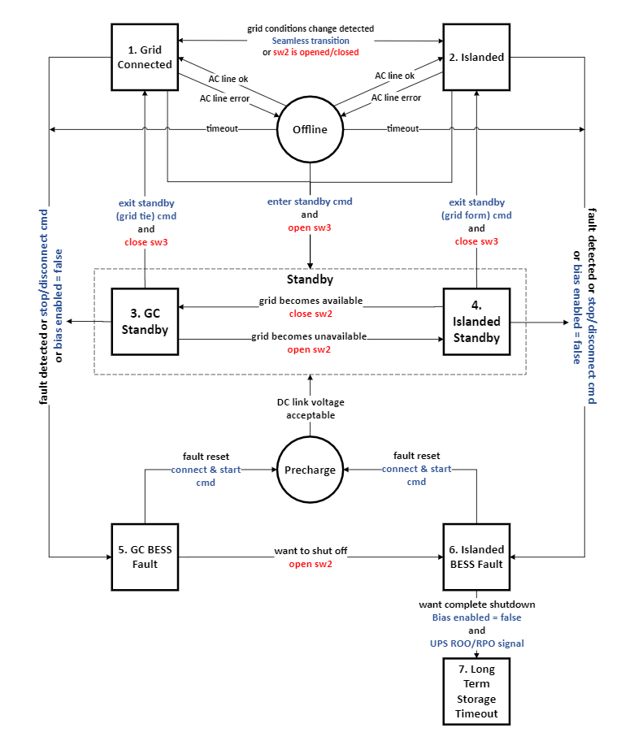
Fig. 4.21. BESS state transition diagram

Table 4.4. BESS states and corresponding component statuses

 |  | Component Aux Power |  |  | Switch Status
Mode # | Grid | HMI | Central  Controller  cRIO-9039 | BESS  Controller  cRIO-9039 | SW1  600A | SW2  150A  SEL751 | SW3  Smart  Relay | SW4  Smart  Relay | SW5  Aux.  Power
1 | Yes | Grid | Grid | Grid | C | C | C | C | C
2 | No | BESS/  UPS | BESS/  24VDC | BESS/  24VDC | O | O | C | C | C
3 | Yes | Grid | Grid | Grid | C | C | O | C | C
4 | No | UPS | 24 VDC | 24 VDC | O | O | O | O | C
5 | Yes | Grid | Grid | Grid | C | C | O | C | C
6 | No | UPS | 24 VDC | 24 VDC | O | O | O | O | C
7 | No | None | None | None | O | O | O | O | O

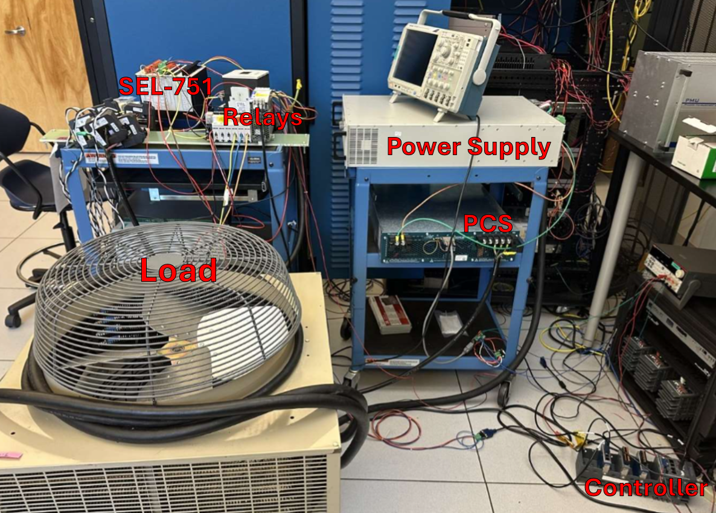
Fig. 4.22. BESS hardware testing setup in lab

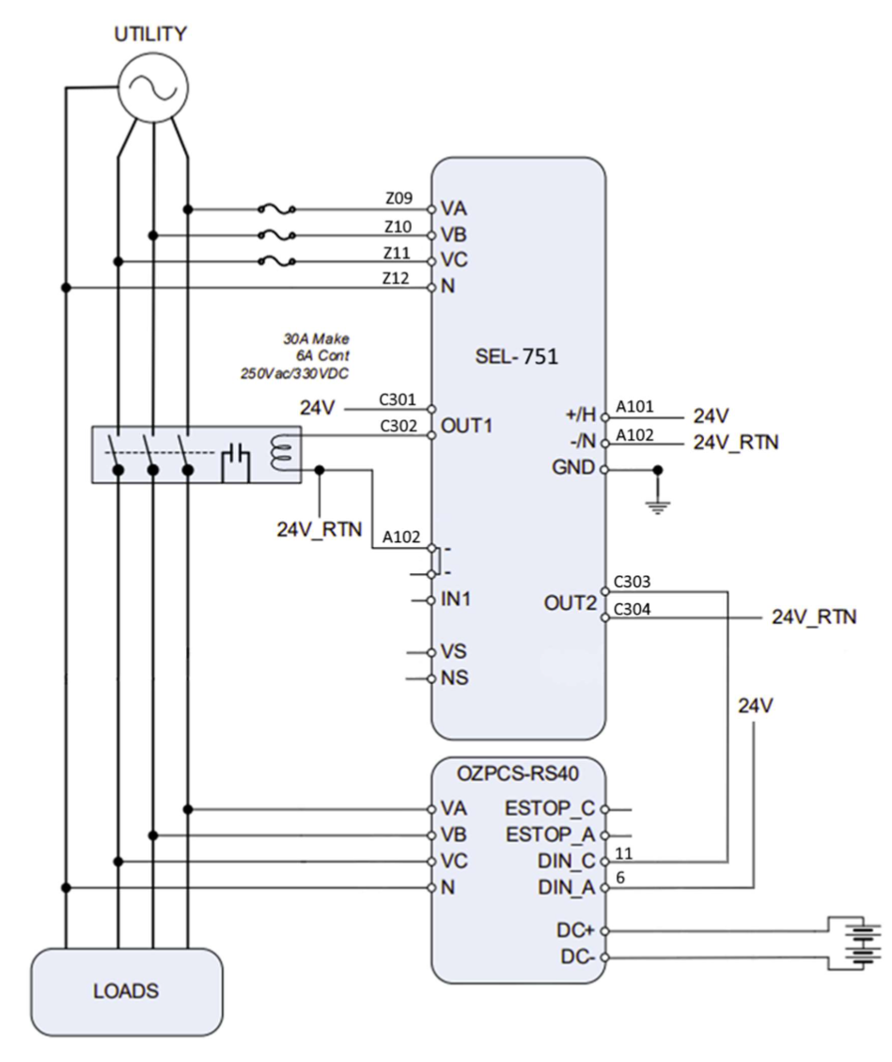
Fig. 4.23. PCS and SEL-751 testing setup wiring diagram [44]
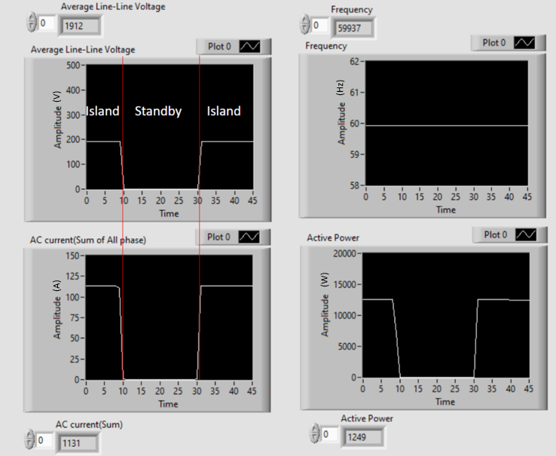
Fig. 4.24. Island to Standby and Standby to Island transition testing

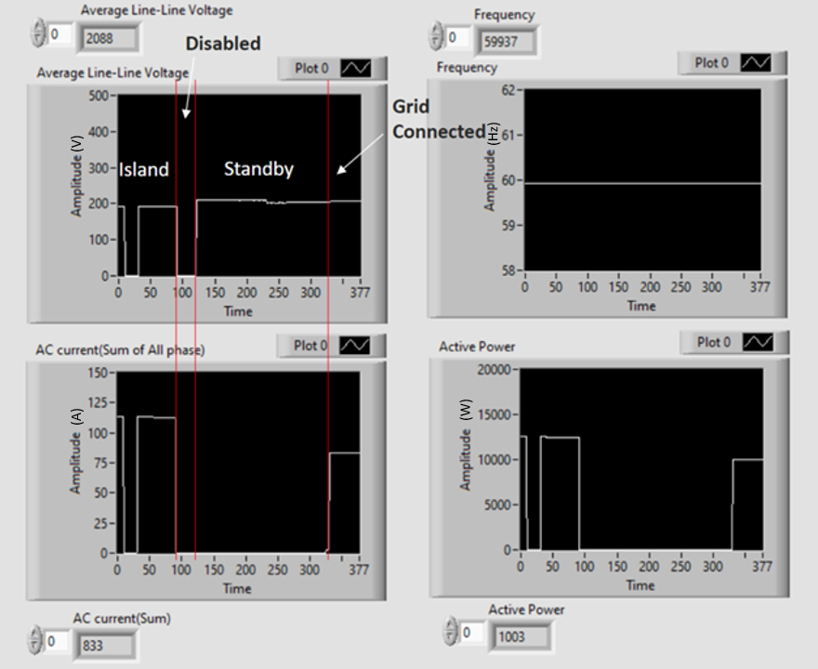
Fig. 4.25. Island to Grid Connected transition testing

Chapter Summary
This chapter provides a comprehensive overview of the VW/UTK modular BESS design, beginning with a one-line diagram that outlines the system's key components, communication protocols, and protective measures.
The selection and testing of the PCS are discussed, highlighting the criteria for component choice and the performance metrics evaluated during testing. Similarly, the BMS selection and testing of a low voltage version of the selection are described.
Next, the design of the auxiliary power system is addressed, focusing on the power budget. The chapter also covers communication design that uses a cRIO to communicate with both the SEL-751 and PCS.
A state transition diagram is presented, illustrating the 7 operational states of the system, including the conditions and methods for transitioning between them. The implementation of these transitions is achieved through LabVIEW programming, which is discussed in detail.
Overall, this chapter covers the critical elements of the VW/UTK second life battery energy storage system design, emphasizing the integration of components and the systematic approach taken to construct and test a BESS building block.

Conclusions
Battery energy storage is a useful tool for the power system because of the many services it can provide such as energy arbitrage, renewable smoothing, voltage support, frequency regulation, etc. These ancillary services can increase the reliability of the power system and save money for the owner of the BESS.
However, battery aging is a concern for these systems. Calendar aging and cycle aging contribute to a decreased capacity over time. To prevent this, tools such as BMSs and EMSs are used to lessen degradation and more effectively use the batteries’ capacity. Modeling and simulations can determine how to operate these systems to minimize costs and aging.
The work presented in chapter 3 demonstrates how energy management strategies can be used to lower energy bills. A model was built in Simulink to simulate 4 different energy management strategies. Using 2 different loads, the impact of these strategies on the energy cost under EPB’s pricing structure are analyzed.
There are three main takeaways from the results of the simulation. The first is that the load shape greatly impacts the best energy management strategy. If the load has one peak, peak shaving will be optimal, but if there are many smaller peaks, load leveling may be more beneficial because it ensures that the battery is charged enough to accommodate the next peak. The next observation is that the capacity of the battery limits the type of energy management. Load shifting requires the largest capacity, and peak shaving requires the smallest. Some capacities are incapable of providing enough energy to load shift or load level, but even small capacities can save money by peak shaving. One more observation is that the boundaries of the on-peak and off-peak hours defined by the utility are important to determine the best operation of the BESS. Though a longer duration of peak shaving would decrease the peak value, if the peak is not within the on-peak hours savings could be increased more by increasing the power level rather than the duration.
Chapter 4 presents the design and testing of a 40 kW BESS building block. Each component was selected, tested and integrated into a test system. The controller is mostly programmed to operate as described in the state machine. The testing demonstrated that all states and each transition can be achieved with no faults or warnings. There is still more work to be done on this system. The BMS, auxiliary power system, and seamless transition still need to be implemented. Once the test system is working as desired, the system could be scaled to 500 kW or greater.
The simulation can provide more insight into how BESSs can benefit an electric power system. One way to improve upon the model would be to include battery aging effects. Then the cost of aging batteries can be compared to the savings from the energy management strategies. Other possible research into this topic could include using different pricing structures to see how they impact the energy management strategy choice. Additionally, implementing PV generation would help to determine optimal sizing of systems that include it. The operation with behind-the-meter generation would be different since the battery charging time would line up with maximum generation. Testing different system configurations, loads, and pricing structures would provide more insight into the value BESSs can provide to the power system.

List of References
[1] | H. Engel, P. Hertzke and G. Siccardo "Second-life EV batteries: The newest value pool in energy storage," McKinsey Center for Future Mobility, 2019.
[2] | D. Đorđević, "The infuence of exploration activities of a potential lithium mine to the environment in Western Serbia," Scientific Reports, 2024, 10.1038/s41598-024-68072-9.
[3] | A. Pražanová, Z. Plachý, J. Uřičář, P. Dominik, J. Kočí and K. Vaclav, "Sustainability Challenges: The Circular Economy Dilemma in Lithium-Ion Battery Cell Electrochemical Discharging Processes," 2024 47th International Spring Seminar on Electronics Technology (ISSE), pp. 1-4, 2024.
[4] | M. T. Lawder et al., "Battery Energy Storage System (BESS) and Battery Management System (BMS) for Grid-Scale Applications," in Proceedings of the IEEE, vol. 102, no. 6, pp. 1014-1030, June 2014, doi: 10.1109/JPROC.2014.2317451
[5] | A. K. M. Ahasan Habib, S. M. A. Motakabber and M. I. Ibrahimy, "A Comparative Study of Electrochemical Battery for Electric Vehicles Applications," 2019 IEEE International Conference on Power, Electrical, and Electronics and Industrial Applications (PEEIACON), Dhaka, Bangladesh, 2019, pp. 43-47, doi: 10.1109/PEEIACON48840.2019.9071955.
[6] | J. Full, J. Wanner, S. Kiemel, R. Miehe, M. Weeber and A. Sauer, "Comparing Technical Criteria of Various Lithium-Ion Battery Cell Formats for Deriving Respective Market Potentials," 2020 IEEE Electric Power and Energy Conference (EPEC), Edmonton, AB, Canada, 2020, pp. 1-6, doi: 10.1109/EPEC48502.2020.9320122.
[7] | M. M. Kabir, "Degradation mechanisms in Li-ion batteries: a state-of-the-art review," International Journal of Energy Research, 2017, doi: 10.1002/er.3762.
[8] | E. Hossain, D. Murtaugh, J. Mody, H. M. R. Faruque, M. S. Haque Sunny and N. Mohammad, "A Comprehensive Review on Second-Life Batteries: Current State, Manufacturing Considerations, Applications, Impacts, Barriers & Potential Solutions, Business Strategies, and Policies," in IEEE Access, vol. 7, pp. 73215-73252, 2019, doi: 10.1109/ACCESS.2019.2917859
[9] | R. Kempener and E. Borden, “Battery storage for renewables: Market status and technology outlook,” International Renewable Energy Agency, Tech. Rep., Jan. 2015.
[10] | A. Gismero, D. -I. Stroe and E. Schaltz, "Calendar Aging Lifetime Model for NMC-based Lithium-ion Batteries Based on EIS Measurements," 2019 Fourteenth International Conference on Ecological Vehicles and Renewable Energies (EVER), Monte-Carlo, Monaco, 2019, pp. 1-8, doi: 10.1109/EVER.2019.8813635.
[11] | Y. Liu, Y. G. Liao and M. -C. Lai, "Effects of Depth-of-Discharge, Ambient Temperature, and Aging on the Internal Resistance of Lithium-Ion Battery Cell," 2021 International Conference on Electrical, Computer and Energy Technologies (ICECET), Cape Town, South Africa, 2021, pp. 1-5, doi: 10.1109/ICECET52533.2021.9698495.
[12] | Y. H. A. Alamri, "State of Health Estimation for Second-Use Electric Vehicle Batteries in Grid Applications," Master's Thesis, University of Tennessee, 2024. https://trace.tennessee.edu/utk_gradthes/11362
[13] | R. H. Byrne, T. A. Nguyen, D. A. Copp, B. R. Chalamala and I. Gyuk, "Energy Management and Optimization Methods for Grid Energy Storage Systems," in IEEE Access, vol. 6, pp. 13231-13260, 2018, doi: 10.1109/ACCESS.2017.2741578.
[14] | CAISO, "2023 Special Report on Battery Storage," 2024.
[15] | R. Hidalgo-León et al., "A survey of battery energy storage system (BESS), applications and environmental impacts in power systems," 2017 IEEE Second Ecuador Technical Chapters Meeting (ETCM), Salinas, Ecuador, 2017, pp. 1-6, doi: 10.1109/ETCM.2017.8247485.
[16] | Linfeng Zheng, Jianguo Zhu and Guoxiu Wang, "A comparative study of battery balancing strategies for different battery operation processes," 2016 IEEE Transportation Electrification Conference and Expo (ITEC), Dearborn, MI, USA, 2016, pp. 1-5, doi: 10.1109/ITEC.2016.7520204.
[17] | Y. Zhang, A. Anvari-Moghaddam, S. Peyghami, T. Dragičević, Y. Li and F. Blaabjerg, "Optimal sizing of behind-the-meter BESS for providing stackable services," 2022 IEEE 13th International Symposium on Power Electronics for Distributed Generation Systems (PEDG), Kiel, Germany, 2022, pp. 1-6, doi: 10.1109/PEDG54999.2022.9923222.
[18] | B. Terzić, O. Bego, M. Despalatović, G. Majić, A. Kriletić and M. Blajić, "Grid-connected and Islanded Control of Energy Storage Converter," 2021 International Conference on Electrical Drives & Power Electronics (EDPE), Dubrovnik, Croatia, 2021, pp. 196-200, doi: 10.1109/EDPE53134.2021.9604106.
[19] | N. Ghaeminezhad, Q. Ouyang, X. Hu, G. Xu and Z. Wang, "Active Cell Equalization Topologies Analysis for Battery Packs: A Systematic Review," in IEEE Transactions on Power Electronics, vol. 36, no. 8, pp. 9119-9135, Aug. 2021, doi: 10.1109/TPEL.2021.3052163.
[20] | M. Elkazaz, M. Sumner and D. Thomas, "A Hierarchical Centralized Community Energy Management System Using a Model Predictive Controller," 2020 International Conference on Smart Grids and Energy Systems (SGES), Perth, Australia, 2020, pp. 801-806, doi: 10.1109/SGES51519.2020.00148.
[21] | Bingyu Sang, Jinhang Hu, Guanjun Li, Jinhua Xue and Jilei Ye, "Equivalent modeling method of battery energy storage system in multi-time scales," 2016 IEEE 8th International Power Electronics and Motion Control Conference (IPEMC-ECCE Asia), Hefei, 2016, pp. 252-256, doi: 10.1109/IPEMC.2016.7512294.
[22] | V. A. Freire, J. J. Márquez, C. Bordons, A. Zafra-Cabeza and L. V. R. de Arruda, "Energy Management System for Microgrid Considering Operational Faults in Power Supply," 2020 International Conference on Smart Energy Systems and Technologies (SEST), Istanbul, Turkey, 2020, pp. 1-6, doi: 10.1109/SEST48500.2020.9203115.
[23] | Y. Chen, Y. Liu, T. Zhang and M. Zhai, "A Multi-Time Scale Robust Energy Management Scheme for Grid-Connected Micro-Grid," 2018 IEEE International Conference on Energy Internet (ICEI), Beijing, China, 2018, pp. 287-291, doi: 10.1109/ICEI.2018.00059.
[24] | D. N. Luta and A. K. Raji, "Energy management system for a remote renewable fuel cell system," 2019 International Conference on the Domestic Use of Energy (DUE), Wellington, South Africa, 2019, pp. 20-24.
[25] | A. Mohan, S. Singh, K. Thirumala and G. S. Ilango, "A Comparative Study on Genetic Algorithm and Mixed Integer Linear Programming based Optimal Home Energy Management System," 2023 IEEE International Conference on Power Electronics, Smart Grid, and Renewable Energy (PESGRE), Trivandrum, India, 2023, pp. 1-6, doi: 10.1109/PESGRE58662.2023.10405071.
[26] | Boles, Jessica Danielle, "Battery Energy Storage Emulation for Power System Applications. " Master's Thesis, University of Tennessee, 2017.  https://trace.tennessee.edu/utk_gradthes/4859
[27] | G. Karmiris, T. Tengner, "Peak Shaving Control Method for Energy Storage,"ABB AB, Corporate Research Center, Västerås, Sweden, 2013.
[28] | N. Ertugrul, "Battery storage technologies, applications and trend in renewable energy," 2016 IEEE International Conference on Sustainable Energy Technologies (ICSET), Hanoi, Vietnam, 2016, pp. 420-425, doi: 10.1109/ICSET.2016.7811821.
[29] | S. Suthar, N. Kumar and N. M. Pindoriya, "Cost-Effective Energy Management of Grid-Connected PV and BESS: A Case Study," 2019 IEEE Innovative Smart Grid Technologies - Asia (ISGT Asia), Chengdu, China, 2019, pp. 4122-4127, doi: 10.1109/ISGT-Asia.2019.8881426.
[30] | Y. Ding, Q. Xu, Y. Huang, "Optimal sizing of user-side energy storage considering demand management and scheduling cycle," Electric Power Systems Research, vol 184, 2020, https://doi.org/10.1016/j.epsr.2020.106284.
[31] | Y. Wang, W. Saad, N. B. Mandayam and H. V. Poor, "Load Shifting in the Smart Grid: To Participate or Not?," in IEEE Transactions on Smart Grid, vol. 7, no. 6, pp. 2604-2614, Nov. 2016, doi: 10.1109/TSG.2015.2483522.
[32] | S. Sharda, M. Singh, K. Sharma, "Demand side management through load shifting in IoT based HEMS: Overview, challenges and opportunities," Sustainable Cities and Society,  vol 65, 2021, https://doi.org/10.1016/j.scs.2020.102517.
[33] | H. T. Kim, Y. G. Jin and Y. T. Yoon, "An Economic Analysis of Load Leveling with Battery Energy Storage Systems (BESS) in an Electricity Market Environment: The Korean Case," Energies, vol. 12, no. 9, April 2019, doi: 10.3390/en12091608.
[34] | M. L. Lima, L. V. Pinheiro, J. G. Oliveira, J. A. G. Archetti and L. W. Oliveira, "Control methodologies for energy storage systems to support voltage in distribution grids with photovoltaic insertion," 2021 Brazilian Power Electronics Conference (COBEP), João Pessoa, Brazil, 2021, pp. 1-7, doi: 10.1109/COBEP53665.2021.9684033.
[35] | K. V. Vidyanandan and N. Senroy, "Primary frequency regulation by deloaded wind turbines using variable droop," in IEEE Transactions on Power Systems, vol. 28, no. 2, pp. 837-846, May 2013, doi: 10.1109/TPWRS.2012.2208233.
[36] | L. Deng, L. Huang, H. Cai, Y. Hu, M. Liao and Y. Huang, "Effect of Battery Energy Storage System Frequency Regulation on Frequency Characteristic of Power Systems," 2022 IEEE International Conference on Power Systems and Electrical Technology (PSET), Aalborg, Denmark, 2022, pp. 353-358, doi: 10.1109/PSET56192.2022.10100534.
[37] | C. Wang, L. Tian, F. Zhang and L. Cheng, "Optimal Sizing of Photovoltaic and Battery Energy Storage of Electric Vehicle Charging Station Based on Two-part Electricity Pricing," 2020 IEEE Sustainable Power and Energy Conference (iSPEC), Chengdu, China, 2020, pp. 1379-1384, doi: 10.1109/iSPEC50848.2020.9351007.
[38] | Cole, Wesley and Akash Karmakar. 2023. Cost Projections for Utility-Scale Battery Storage: 2023 Update. Golden, CO: National Renewable Energy Laboratory. NREL/TP-6A40-85332. https://www.nrel.gov/docs/fy23osti/85332.pdf.
[39] | B. Chen, K. Xiang, Q. Su, F. Lin, W. Zhang and T. Huang, "Economic benefit evaluation and incentive strategy research on Wind energy and BESS jointly participating in peak shaving auxiliary service market," 2019 4th IEEE Workshop on the Electronic Grid (eGRID), Xiamen, China, 2019, pp. 1-5, doi: 10.1109/eGRID48402.2019.9092630.
[40] | A. Khalid, N. Javaid, A. Mateen "Enhanced Time-of-Use Electricity Price Rate Using Game Theory," Electronics, vol. 8, no. 1, 2019, https://doi.org/10.3390/electronics8010048.
[41] | A. B. El-Fawair, K. M. Al-Aubidy and M. A. Al-Khawaldeh, "Energy Management in Microgrids with Renewable Energy Sources and Energy Storage System," 2023 20th International Multi-Conference on Systems, Signals & Devices (SSD), Mahdia, Tunisia, 2023, pp. 801-806, doi: 10.1109/SSD58187.2023.10411198.
[42] | H. Chen, T. N. Cong, W. Yang, C. Tan, "Progress in electrical energy storage system: A critical review," Progress in Natural Science, vol 19, no. 3, 2009, pp. 291-312, https://doi.org/10.1016/j.pnsc.2008.07.014.
[43] | “Low-voltage battery management system - nuvation energy,” Nuvation Energy - Battery Management Systems for Large-Scale Energy Storage, https://nuvationenergy.com/battery-management-systems/low-voltage-battery-management-system/.
[44] | “40kVA power conversion system RS40 - Oztek: Trystar,” Oztek, https://oztekcorp.com/all-products/ozpcs-rs40/.

VITA
Elizabeth Sutton was born in Memphis, Tennessee. After moving to East Tennessee, she graduated from Maryville High School in 2019. She completed her Bachelor of Science in Electrical Engineering from the University of Tennessee-Knoxville in May of 2023 and entered the Master of Science program that summer. Throughout her undergraduate degree, she was involved with the Center for Ultra-Wide-Area Electric Energy Transmission Networks (CURENT) as an undergraduate research assistant. Additionally, she served as chairs of many student groups such as Systers, Tau Beta Pi, and the UTK IEEE PELS student branch. She remained in the same research group when starting her graduate studies, which focused on energy management strategies and ancillary services for battery energy storage systems.

