CONSTRAINED MULTI-GROUP PROJECT ALLOCATION USING MAHALANOBIS DISTANCE

A Dissertation Presented for the
Doctor of Philosophy
Degree
The University of Tennessee, Knoxville

Abdulaziz S. Alkabaa
December 2016

Copyright © 2016 by Abdulaziz S. Alkabaa
All rights reserved.

DEDICATION

I dedicate this dissertation for my parents and family for their endless love and scarify.

ACKNOWLEDGEMENTS

Thank you all for your help. However, this page is optional.
ABSTRACT

Optimal allocation is one of the most distinguished research areas in mathematical programming that deals with binary integer variables in many problems. The allocation of constrained multi-group projects to be developed in a given planning horizon with solution approach is a challenged problem in any classification scheme. The main goal of this dissertation effort is to develop an analytical approach for selecting projects that would be most attractive from an economic point of view to be developed or allocated among several options, such as in-house engineers and private contractors (in transportation projects). A relevant limiting resource in addition to the availability of funds is the in-house manpower available.
The concept of Mahalanobis distance will be used and optimized as the classification criterion for the project allocation purpose, which is a generalization of the Euclidean distance by taking into account the correlation of the project characteristics. The desirability of a given project to be allocated to an option is defined in terms of its Mahalanobis distance to that group. Ideally, each project should be allocated to its closest option. This, however, may not be possible because of the available levels of each relevant resource.
The allocation process is formulated mathematically using Binary Integer Programming models considered for the purpose of achieving the optimal project allocations. The first formulation maximizes the dollar value of benefits derived by the travelling public from those projects being implemented subject to a budget, total sum of Mahalanobis distances, and in-house manpower constraints. The second formulation minimizes the total sum of Mahalanobis distances subject to a budget and the in-house manpower constraints.
The proposed solution methodology for the BIP models is based on the well-known Branch-and-Bound method. In particular, one of the contributions in this dissertation is to propose a novel strategy for branching variables and node selection that consistent with allocation priorities among different projects to improve the solution performances. The suggested allocation process includes: multiple allocation groups; multiple constraints; different model formulations for Binary Integer Programming. Numerical experiments with different projects and options are given to illustrate the application of our systematic approach.
TABLE OF CONTENTS

CHAPTER I INTRODUCTION 1
Background 2
Problem Statement 5
Contributions of this Study 7
Organization of the Dissertation 8

CHAPTER II LITERATURE REVIEW 9
Project Selection and Resource Allocation 9
Classification Approach using MD 15
MD Applications 18
Branch-and-Bound Strategies and Their Impact on Solution Performance 21
Conclusions 26

CHAPTER III OVERALL CONCEPTUAL APPROACH 29
Heading 2 4
Heading 3 4
Heading 3 4
Heading 2 4
Heading 3 4
Heading 3 4
MD Computation 4
Heading 2 4
Branch and Bound 8

CHAPTER IV MATHEMATICAL MODEL AND PROPOSED METHODOLOGY 47
Model Formulation 47
CHAPTER V Conclusions and Recommendations 4

CHAPTER IV Results and Discussion 4
Heading 2 4
CHAPTER V Conclusions and Recommendations 4

LIST OF REFERENCES 4
APPENDIX 4
VITA 4

LIST OF TABLES

Table 1. Table title. 4

LIST OF FIGURES

Figure 1: Number of Relevant Articles in Different Areas from the Year of 1930 to 2015 26
Figure 2: Representation of Constrained Multi-Group Project Allocation using MD 50
Figure 3. Shapes. 66

CHAPTER I
INTRODUCTION

Undoubtedly, the most significant factor affecting research and development (R&D) project selection and resource allocation in any organization (such as a government agency or a company) is the approach to decision-making. In R&D research perspective, successful decisions depend on the selection methodology as well as allocation criterion for prioritizing projects [1]. Therefore, a variety of methods and techniques have been developed and documented in the relevant literature for the last 50 years [1, 2]. A lack of methodology for making an optimal decision among competitive choices can lead to large organizational obligations and other serious manifold risks in business environments. Hence, project selection can be related to competitive markets of governmental agencies and companies [3].
Due to the limitation or scarcity of significant resources, numerous organizations do not have the capability to construct all engineering activities or projects in a given planning horizon. As a result, many organizations outsource a percentage of projects to one of several contractors or agencies. In this case, the classical problem of a single project allocation is neither applicable nor appropriate and thus will be considered as a multi-group project allocation decision making problem. Although this type of problem is very common in the real world, to the best of my knowledge, it has not been addressed in the research literature, resulting in our attention being focused on this critical issue.
The problem of developing an analytical approach for selecting and allocating the most suitable projects among a group of candidate projects, from an economic point of view and subject to limited resources, is a challenge faced by every decision maker. Typically, project that generates high levels of benefits without exceeding available resources are selected for funding. This dissertation is concerned with developing an effective analytical decision-support approach for selecting and allocating projects among a group of different options in such a way that a specified performance measure is optimized, subject to some relevant constraints. Experiments show that this methodology provides precise allocation and great scalability with respect to variations in the size of instances processed and the degree of resource constraints.

Background
Many industrialized countries spend more than 2% of their Gross Domestic Product (GDP) on R&D activities [4]. For example, in 2013, the United States spent 2.742% (432.583 billion dollars) of its GDP; in 2014, Japan spent 3.583% (159.220 billion dollars); and China spent 2.046 % (344.678 billion dollars) [5]. Thus, it can be inferred that R&D is vital in the business world and is a key to many organizations’ success [6]. From a R&D perspective, project selection and resource allocation are defined in terms of constrained optimization problems [1, 3, 7, 8,]. Given a set of project proposals among several available projects, the goal is to develop a project selection methodology to aid a decision maker in selecting a subset of these projects subject to relevant limiting resources, such as budgets, manpower, and construction equipment, and facilities. Project selection problems may consider a variety of objectives dependent on the decision making’s purpose [3]. In most cases, the objective of this selection process’s objective is to maximize benefits and minimize costs of the project [7]. To address R&D project selection and resource-allocation problems, various methods have been utilized, including benefit measurements, mathematical programming, decision and game theory, simulation models, heuristics, and cognitive emulation [9]. Fahrni and Spätig’s study [10] provides different approaches for determining the most applicable technique for a specific situation.
Mathematical programming has been widely used for selecting R&D projects. This method can be represented and solved by means of different programming models, such as Linear Programming (LP), Non-Linear Programming (NLP), Dynamic Programming (DP), Goal Programming (GP), and Stochastic Programming (SP) [9]. These models have been used in many research studies involving single or multiple objective functions. Numerous integer programming (IP) applications are derived using LP where the divisibility assumption must be relaxed. Project selection decision problems involve numerous interrelated yes-or-no decisions, where the variables are naturally integer and assumed binary (0 or 1). Therefore, these types of decision problems become BIP and are widely used to aid with project selection problems [12]. Some algorithms in the literature provide solutions to IP and to Mixed Linear Integer Programming (MLIP) models, such as cutting plane and B&B algorithms. According to Taha [13] page No. (370 and 384) :
“Although neither method is consistently effective computationally, experience shows that the B&B method is far more successful than the cutting-plane method, …. To date, and despite over 40 years of research, there does not exist a computer code that can solve ILP consistently. Nevertheless…, B&B is more reliable. Cutting-plane methods are generally difficult and uncertain, and the round off error presents a serious problem. ”
B&B algorithms are coded by all ILP commercial solvers. The project-allocation problem considered in this dissertation is a Nondeterministic Polynomial (NP)-hard problem [14]. Therefore, the execution time required to solve the problem increases exponentially as the problem enlarges [15]. The critical rules affecting the B&B’s solution performances are the branching and node selection strategies, which can have a significant impact on the solution algorithms’ efficiency [16]. Many modern IP solvers (such as CPLEX, LINDO, MATLAB, and Xpress-MP) provide users the capability of changing these strategies. Although many R&D project selection and resource-allocation problems are discussed in the literature, no research literature has been devoted to the branching strategies, which indeed can help users achieve better solutions in terms of B&B quality and performance. This absence of research led to exploring novel branching and node-selection strategies in this dissertation.
The process of allocating a project among several available options is not precisely presented the literature; however, it has been shown as a project-management decision problem of assigning several projects to project managers. The literature in this area focuses on two streams: project-assignment methodologies and criteria [17]. It can be inferred that the methodologies’ performance in terms of project assignment is mainly influenced by the assignment criteria, which contribute to the project’s success and effectiveness in allocating decisions. Although a potential correlation between project characteristics affects classifier’s performance and accuracy, no research in the literature has addressed this specific consideration in project-assignment and R&D problems. Instead, some R&D studies have focused on the importance the interdependence and interaction between projects or resources [18, 19]. Subsequently, a reliable classification criterion or tool to deal with correlated variables is needed to handle this issue. For this reason, the concept of Mahalanobis Distance (MD) [20] was introduced for the classification scheme to deal with similarity of an observation to the other group. Many applications-based MDs have been widely proposed and studied in the field of decision and classification problems, such as manufacturing, business, healthcare, and ecology [21]. The concept of MD classification criterion has been compared with many classifiers in several studies for the purposes of classifying correlated multivariate data, classifier accuracy, and effectiveness improvements [22-25]. Chapter 2 examines various relevant studies in R&D project selection and classification, solution methodologies, B&B strategies, and MD and their applications.

Problem Statement
This study proposes an analytical constrained multi-allocation approach that allows project managers or decision makers to group several projects into predefined categories that represent most-appropriate option for developing the projects. Specifically, the proposed procedure indentifies the projects to be developed and assign them to the best fitting option. Typically, these options may correspond to doing a project in-house or outsourcing it to one of a group of private contractors, as in transportation projects. It is assumed that a panel of experts provides joint expertise to identify ideal projects, from the project quotations' database, for each allocation option (in-house and private contractors). In other words, the purpose of identifying these ideal projects for each corresponding option is to provide an index for each specific option.
In general, each project has a cost and a dollar value of benefits. The scope of each project is defined in terms of several factors or characteristics that may be correlated with one another. In order to identify how each project best matches each allocation option, for allocating each project to one of the options, the statistical concept known as MD, which is a generalization of the Euclidean Distance (ED) taking into account the correlation between the project characteristics, will be used as the classification criterion. In brief, MD measures the statistical distance from each project to each allocation option that has been identified by the panel of experts. The reader is referred to Chapter 3 for MD overview and applications.
Because the project-allocation problems involve determining whether or not a project is selected for developing, the variables are represented naturally integer and may assume binary (0 or 1); that is, the choices with decision variables restricted to two values: 1 for allocating and 0 for otherwise. Consequently, the allocation process in this dissertation is formulated as a binary integer programming (BIP) model that contains only binary variables.
Two different BIP formulations are proposed to aid in assigning projects to either in-house or private contractors. The first formulation maximizes the dollar value of benefits while ensuring that projects are allocated to the best option consistent with available funds and in-house manpower. The second model allocates projects to the best options subject to available budget and in-house manpower. These BIP models' proposed solution methodology is based on the Branch-and-Bound (B&B) algorithm. In particular, one of this dissertation’s contributions is proposing novel strategies for branching variables and node selection consistent with allocation priorities among different projects to improve the solution performances’ efficiency in different measurements. For illustration purposes, the proposed project’s allocation methodology and the corresponding mathematical models are applied to the State Department of Transportation (DOT) to aid project-management decision makers in optimizing project allocation (to either option: in-house or several private contractors). We run numerical experiments with several different combinations of projects and options to demonstrate our allocation approach and then analyze the solution results. The application study shows that efficiency of the solution performances using the proposed B&B branching variables and node selection strategies outperforms the best of the default strategies that MATLAB provides. Moreover, this approach can improve project-allocation decisions by using the two models that provide different conclusions.

Contributions of this Study
This dissertation is intended to add the following contributions:
- Development of a MD project selection and multi-choice classification approach with multiple-resource constraints. Specifically, this new approach is proposed to improve the quality and accuracy of the best fitting allocation process. As we will show in the Literature Review, Chapter 2.
- Improve the B&B methodology significantly by formulating a novel branching strategy based on a specific variables ranking according to MD values to enhance solution performances (i.e., absolute gap between the internally calculated upper and lower bound on the objective function, relative gap in percentage, computer run time, and number of explored nodes in the B&B tree). As we will see in the Literature Review, Chapter 2 and in the Results and analysis, Chapter 5.

Organization of the Dissertation
This dissertation is divided into seven chapters. This first chapter has introduced this study’s general problem and challenges. Chapter 2 contains a review of the literature pertaining to R&D project selections and resource allocations, as well as project assignments, MD classifications and applications, and branching strategies in the B&B algorithm. Chapter 3 presents the overall conceptual approach of the multi-project allocation-based MD, including the definition of MD and B&B variable and node selection methods. Chapter 4 discusses this study’s proposed methodology, including the mathematical model formulation and the proposed branching strategy. Chapter 5 describes the computation design and application of the developed model and solution procedure for selecting and allocating transportation projects among multiple options. Also included is an assessment of the solution procedure’s performance for the mathematical models using the B&B algorithm. Results and analysis obtained from the methodology are presented in Chapter 6. Chapter 7 includes a summary and conclusions and suggests further related-research possibilities. References and appendices are available at the end of this document.

CHAPTER II
LITERATURE REVIEW

The intent of this chapter is to provide an understanding of the previous research and literature relevant to project selection and allocation problems and to discover methodologies, optimization means and criteria, modeling approaches, and solution procedures that have been considered in each related study. This chapter is divided into four major sections. The first section defines the problem of interest and describes the modeling approach and the solution methodology used. The second section discusses the classification approach using the concept of MD and its applications in different disciplines. The third section presents B&B strategies that have been used and their impact on the solution performance. The last section is the conclusion, which summarizes the chapter.

Project Selection and Resource Allocation

Since Mottley and Newton in 1959 [An interactive approach…] proposed the concept of project selection and resource allocation, an evolutionary process has resulted in developing and reporting numerous quantitative methods and models in the literature. Although several methodologies for R&D project selection exist, a vital way of formulating scientific decision-making problems is mathematical models [Making project selection…]. Moreover, the majority of the resource-allocation problems have been widely studied using mathematical programming [A branch and bound algorithm…].
Usually, much of a modeling technique focuses on how to effectively propose a methodological approach to selecting a set of projects from a project portfolio that meets different resource requirements in order to arrive at an optimum portfolio of R&D projects. However, less attention has been devoted to how these models can provide the best-fitting allocation as well as perform in a sophisticated situation (i.e., when numerous variables and constraints increase a problem’s size). The survey study in this section shades the light on various modeling approaches with different applications in R&D project selection and resource allocation.
Loosely speaking, any project selection and allocation model depends on the type of problem. Researchers have proposed many efficient approaches. For example, Beaujon et al. [11] develop a mathematical model that is formulated by using mixed- integer programming and solving it using specific heuristic methodology to select projects to include in an R&D portfolio that provides the maximum expected benefits, subject to a wide variety of constraints, e.g., capital, headcount, strategic intent, etc. The paper addresses two important issues regarding the formulation of the project selection models: (1) allowing for partly funded projects in the portfolio (i.e., projects that proceed at an interval due to insufficient funding with the rest being held for future funding), resulting in solving the problem using linear programming; and (2) assigning a score to each project for the purpose of valuing projects and accounting for potential risk. This model’s distinguishing factor is the set of constraints; specifically, this model allows the possessed skills of the research staff to be considered, such as research background in various categories, number of skilled staff needed to be involved in developing particular projects, and category of skills required.
Benli and Yavuz [Making project selection decisions:..] propose a BIP model to select projects that maximize total net present value subject to budget constraints and other secondary conditions in the Turkish armed forces’ ten-year planning horizon. Different computational data sets were randomly created to simulate the real data and run the model for optimality and performance testing. Ten random problems were run; these problems varied from 908 projects to 1,067 projects, approximately 10,000 variables, and 2,500 constraints. CPLEX 4.0.7 software ran the simulated data models. CPLEX 6.5.3 software executed the actual data models. The average solution time for different model sizes is 140.26 seconds with a maximum difference of 1.97% between the global optimum LP relaxation and the integer optimal solution reached.
Hall et al. [A model for making project…] present another BIP model for making project-funding decisions. This model is used to select projects related to reducing smoking for funding at the United States’ National Cancer Institute. A federal targeted budget and private funds are allocated to some states in the U.S. over a seven-year period. In order to distinguish among the projects’ importance, each project is ranked based on scoring criterion. This model is chosen to maximize the rank-function score for the projects subject to important constraints of available budget and other smoking-prevalence criteria. Containing 23 variables and 14 constraints, the model is solved in LINDO software version 5.0. The results provide lists of different solution based on various budgetary levels and preference-score ranges, thus enabling decision makers to choose the most appropriate solution.
Kozanidis and Melachrinoudis’ paper [A branch and bound algo] is one of the most interesting in the field of multi-choice constraint problems. The proposed model is a single-resource allocation problem used as a decision-making tool to assist transportation management in assigning limited funds to highway-safety projects classified as continuous and discrete improvements. This model is considered a generalization of the linear multiple-choice knapsack and the 0-1 knapsack problems. .Several model properties are proposed to design a B&B solution algorithm. Specifically, the original B&B algorithm of solving the linear multiple-choice knapsack is adopted to fit with this specific problem, improve the solution efficiency, and lower the required memory space for the number of explored nodes in the tree. The algorithm solves the LP relaxation at each node in the B&B tree by replacing the binary constraints with bound constraints; the bounding is between 0 and 1 and uses the relationship between the optimal solutions of parent and children nodes in branching order and node selection. These techniques for solving the B&B algorithm are used to reduce significantly the time required for branching and solving each node in the tree.
Liberatore [AN EXPERT SUPPORT SYSTEM …] proposes an expert support system for industrial projects based on an analytical hierarchy process (AHP) designed to relate strategic planning, mission, and objectives to specific criteria for selecting R&D projects. To consider the tradeoffs between project benefits and costs, two methods are suggested for -resource allocation. The first method is taking the ratio of the renormalized project priority, which represents the sum of the project's benefits, to the estimated cost of funding the project. The rated projects are ranked and then selected in descending order based on their priority-cost ratio until the R&D budget is depleted. The second method is formulating the resource allocation problem by using the BIP that maximizes the total project priority over all funded projects subject to a budget constraint. The author proposes other constraints that can be considered in the model to ensure certain factors, such as a minimum or maximum number of selected projects to be funded and different budgetary levels for each strategy.
Technically speaking, the available methodologies for project selection and resource allocation can be applied to the majority of project types. However, relevant constraints, procedures, and requirements differ accordingly. For instance, Güney et al. [A mathematical model and solution…] investigates various heuristic and algorithm solution quality and performance for selecting advertisements that influence social network members. BIP formulates the problem mathematically for the purpose of minimizing the total cost of selecting influences subject to lower bound on the probability of influencing the member number that can be assigned to a particular advertisement. The proposed model is BIP, which any commercial IP solver can solve. However, such a problem’s difficulty is known to be NP-hard, and theoretical approximation’s complexity is present. Moreover, one of the parameter coefficients may take any value other than a binary; in this case, obtaining an exact solution becomes computationally difficult. Accordingly, two heuristic approaches are proposed in the solution. Lagrangean relaxation and greedy heuristics are used and are compared to several optimum solutions that are obtained from a commercial IP solver, random selection method, and highest-degree selection method. Each method is computed with different problem sizes and evaluated in terms of results, percent deviation, and CPU times.
As discussed above, the techniques and approaches of the concept of constrained project allocation are widely applied in many disciplines. Various studies have extended this approach by accommodating specific conditions under which it is applied in education and human resources (HR). For example, Anwar and Bahaj [Student project allocation] address the problem of allocating class projects to university students. In many university departments, a list of projects is offered to students from which they can select more than one project. Typically, each project is supervised by only one lecturer and assigned to only one student within a department. In addition, this paper considers another modeling approach of allocating a group project to students supervised by one or more lecturers. The paper shows two molding approaches and formulates them using BIP. The first model is formulated for individual project allocation to minimize the number of projects each lecturer supervises, subject to project-allocation restrictions. The second model is constructed for handling group projects that allocate a group of students to a project (i.e., a project may be allocated to more than one student). This model is intended to maximize the students' choice of project preferences subject to the number of project and lecturer constraints. The first model is solved by using dynamic programming and is implemented using LINGO 6.0.
Another well-known area of interest in HR is modeling a decision-support framework for project managers’ assignments. This problem investigates the development of different procedures and criteria for optimally allocating project managers to the best--matching projects, such as a project manager of new-product projects in manufacturing industries. In addition to optimal allocation, studies provide significant information on performance and effects on projects, project managers in leading projects to success, and organizations. Patanakul et al. [A Decision Support Model…] develop a decision support approach to assign new projects or reassign ongoing projects to project managers. The problem is formulated by BIP and considers project priorities, levels of matching between project managers and projects, and relevant organizational and personal limitations. The objective function in this model takes into account project requirements, project managers’ effectiveness, and project contributions to the organizational mission.

Classification Approach using MD

Classification concept is defined as the process of separating or allocating various objects into several predefined classes, which can be defined by business rules, class boundaries, or some mathematical function [3]. In general, two types of classification problems are considered in the research: (1) binary classification on only one target variable and (2) multiple classifications on more than one target variable. In statistical analysis and data mining, many techniques are used for classification. However, lack of available implementation for many classifiers is a major drawback in any classification purpose [4]. In addition, the classification problem becomes very complex when numerous variables must be considered, especially when a correlation or dependency between variables may exist. Consequently, a more reliable criterion or measurement that handles correlated variables is necessary to address this issue. For this reason, in 1936, P. C. Mahalanobis introduced the concept of MD [5] for classifying a multivariate observation's similarity to the other group members' centroid or overall mean. The MD answers the question of how a multivariate observation is allocated to best matching groups or classes.
Since the MD concept originated, hundreds of studies have been conducted in many fields. For example, Huei-Chung Wang et al. [6] develop a classification method based on the Mahalanobis-Taguchi System (MTS) [7], initially proposed by Genichi Taguchi, who is well known for his extraordinary and controversial ideas and methods in the field of design and experiment analysis. The MTS combines MD, orthogonal arrays (OAs), and the signal-to-noise (SN) ratio. The study demonstrates MTS’s effectiveness with two kinds of correlated multivariate datasets, Fisher iris and credit card, for the purpose of measuring the prediction accuracy in multi-dimensional data sets. By incorporating the MD, the results show that the MTS outperforms another well-known classifier by approximately 2.2 % in terms of classification accuracy rate for both datasets.
Bing Long et al. [8] present a novel approach for diagnosing incipient faults in analog circuits using a classification algorithm of particle swarm optimization based on the MD. The MD is used to classify samples from two different fault classes and to train and test specific classifiers for any two fault classes of analog circuits. The near-optimal solution is achieved, by using MD in the classification algorithm, with a high recognition rate, and the time consumption is reduced by 98% compared to that of the optimal feature vector algorithm. The Euclidean distance (ED) is also compared to the MD in stability and optimality with an experimental study investigating MD’s advantage in selecting the near-optimal feature vectors. The results show that ED’s classification accuracy is 93.8%, whereas it increases in MD to 97.8%.
Cho et al. [A hybrid approach based on the combination] propose a hybrid approach for predicting manufacturing firms’ bankruptcy based on the combination of variable selection methods and MD. The algorithm of case-based reasoning approach is presented; and different experiments apply this algorithm with MD, ED, logistic regression, neural network, and decision tree models. For illustration purposes, 1000 Korean manufacturing firms are classified as bankrupt or healthy (non-bankrupt). The classification process uses the distance matrix of MD and ED to measure the distance between the reference data set and the evaluation data set. The results show that the classifier algorithm using MD effectively outperforms other models in the correct classification ratios with an average of 73.6% and with the lowest misclassification error rate.
Srinivasaraghavan and Allada [Application of mahalanobis…] develop a contemporary methodology that aids in providing a quantitative leanness measure by comparing a company against exemplar industry standards to facilitate continuous improvement. A survey is conducted to assess an organization’s lean state by using several lean characteristics. The industries are classified into two groups: advanced lean (normal) and average/below (abnormal). Abnormality is considered to be due to either bad conditions or considerably perfect conditions. To distinguish between normal and abnormal categories with its abnormality conditions, the Mahalanobis Taguchi Gram-Schmidt System (MTGS) is used to for this reason. The proposed MTGS measures the distance from a defined reference datum to each data point in each group and identifies those points that are out of Mahalanobis space, outliers. The study also presents an optimization approach to obtain the most effective information or variables needed in evaluating abnormal industries' level of lean implementation and then tests MD’s impact as well.
Arathi and Govardhan [Effect of Mahalanobis Distance on Time Series] compare the classification accuracy and performance of MD and ED by incorporating them into a discriminate algorithm in time series data. The suggested technique is intended to evaluate the similarity or dissimilarity between two time series sequences (i.e., unlabeled time series should be allocated to a predefined group). The major advantages and disadvantages of ED and MD are described. For example, ED is unsophisticated in computation and does not require many details. However, it has some shortcomings. It requires the data to be standardized when variables are measured in different scales; both sequences have the same length; it does not consider the correlation between the data variables; and it is sensitive to noise. On the other hand, MD accounts for data correlation by occupying the covariance in its equation; it does not require the data to be standardized, even if the variables are determined or measured in different scales; and it provides the same ED measurement when variables are uncorrelated. The study conducts comparison experiments on various datasets to assess how the classification algorithm with MD and ED is able to differentiate between any two classes. The experimental results show the proposed methodology with MD increases the accuracy around 10%-15% more than in ED and decreases the time complexity by 15%-22%.

MD Applications
The initial motivation for developing the MD was to analyze and classify human skulls into groups, based on different properties. Since then, many distinguished applications based on MD have been developed in different areas, such as, engineering, manufacturing, chemical research, healthcare engineering, pattern recognitions, businesses, etc. We list few applications in the literature as follows:
- Product Manufacturing [16]
Consider a manufacturer produces a commercial product, for example, a car or computer that is characterized by a number of parameters (price, size, etc) with a verity of possible uses or types of uses, for instance, work, family, etc. The manufacturer has datasets from the market research on a number of items bought with specific parameters by customers with the intended use. Therefore, the manufacturer will use the MD for the purpose of product design phases for measuring how much close each intended use of different product items to the product's parameters based on the customer preferences. If the manufacturer wants to produce or design an optimal product that serves different types of users, it should consider points that minimize the sum of the MDs for all items, with each one of them multiplied by a suggested weight that depends on different factors associated with the interest of the manufacturer for each type of user.
- Face Recognition [17]
In the purpose of classification face images that include frontal views of faces with different facial expressions, lighting conditions, and occlusions, the MD is used to improve the classification performance in face recognition and to measure the similarity between the faces and to classify or recognize the samples.
- Composition of Pharmaceutical Products [16]
Pharmaceutical companies produce drugs that consist of a number of active compounds developed for treating different diseases. These companies have historical data recorded on their database on the most proper concentration of the different active compounds based on patient records for each of the known diseases. With these data, the company can find the different MDs corresponding to each different type of disease and classify the most appropriate compounds to different diseases. Subsequently, they are used to characterize and optimize the drug products.

- Financial Applications in Forecasting [18]
Information that can be used to asses forecasts can be provided by MD. In this application, a multivariate point forecast from a prediction model, whose accuracy is to be evaluated using true observations. Choosing the mean squared error (MSE) as the loss function, the MSE-matrix determines the shape of the confidence region that denoted by the MD. The lower the MD between observation and prediction, the better the forecast. In contrast, the higher values of the MD could be taken as an indication against the reliability of the forecasting model.
- Product Manufacturing [9]
Suppose a manufacturer produces a commercial product, for example, a car or computer that is characterized by a number of properties (price, size, etc) with a verity of possible uses or types of uses, for instance, work, family, etc. The manufacturer has datasets from the market research on a number of items bought with specific parameters by customers with the intended use. The MD will be used in the product designing phases, that is: it measures how much close each intended use of different product items to the product's parameters based on the customer preferences.
- Breast Tumor classifications [10]
In the diagnostic processes of breast tumors, the Mammography is widely used for identifying tissue types, benignant or malignant. Every image for each tissue has common shape factors for barest tissues that are recognized by specialists and medical software. The MD concept is integrated with another method to be used in biomedical computer software to assign each breast image from the Mammography to lesion categories.

- Business Applications in Forecasting [11]
Measuring forecasting models can be evaluated by MD. In this application, the accuracy of a forecasting model is assessed by measuring the MD between the multivariate predicted point and a point of a true observation. Therefore, the lower the MD between observation and prediction points, the better the forecasting model and vise versa.

Branch-and-Bound Strategies and Their Impact on Solution Performance

In 1960, Land and Doig developed the first B&B algorithm for general MILP and pure ILP. Later, in 1965, Balas developed an additive algorithm for solving ILP problems with BIP. The B&B algorithm solves these problems by dividing the search space and generating a sequence of sub-problems. The branching strategy is the heart of the B&B algorithm and is considered one of the most significant factors affecting solution performance [Branching rule revisited]. Therefore, we focus on two critical questions about the B& B algorithm many research studies have explored but that remain unanswered [15]:
- Which specific variable in branching should be branched first?
- In selecting the next branching node or sub-problem, which node should we begin to solve?
Because both questions are unanswered, the research in this area is still ongoing. However, ensuring computations could differ dramatically with different branching strategies. Consequently, the result in the B&B trees differs greatly in size and in computer time required to find an optimal solution [19]. The main reason we use the B&B algorithm is that its technique provides a flexible structure in which we can design any problem type, such as BIP. Moreover, many options are available in B&B that can be used in designing an efficient algorithm and that can substantially affect the solution performance.
Many studies and books cover B&B’s concepts, applications, and techniques and address how this algorithm is flexible to accommodate different integer programming, such as pure IP, MIP, nonlinear MIP and IP, and BIP [ Improved branch and bound algo…][Branching rules revisited]. However, the literature review in this section is restricted to B&B strategies that can improve the algorithm’s solution performance in various ways. For example, Borchers [Improved branch and bound algo…] investigates how branching strategies with a proposed heuristic can effectively improve the B&B algorithm’s speed in finding the optimal solution and reduce the memory storage the experimental codes use. Two branching strategies are used in the study: (1) a depth-first strategy, which is intended to choose the next sub-problem or node that was most recently created for obtaining a quick fathoming; and (2) a fixed-order strategy, which aims to rank branching variables in specific order before solving any nodes, thus reducing the constraints’ size. The suggested techniques are coded in IBM's Optimization Subroutine Library for different examples of capacitated facility-allocation problems and other problems. Computational results show that the branching strategies for some problems enhance the CPU time by approximately 20% less than the algorithm without suggested strategies or default strategies.
Koch et al. [Mixed integer programming library…] survey a comprehensive description of 87 real-world instances available in the Mixed Integer Problem Library (MIPLIB) (2010) and run those problems on different solvers to assess performance. All of the instances in the MIPLIB are combined into a large group of IP problems in academia and industries. The paper emphasizes that the most important contribution to the CPU time needed to solve the IP problems considered is attributed to the B&B tree’s size. Many factors may significantly influence the solver behavior, such as input format, constraint orders, differences in model formulation, problem size of adding or removing redundant variables or constraints, and bounds. Consequently, all the relevant research effort is done to propose an effective methodology or code that aims to reduce the number of nodes in B&B that must be evaluated. The paper also notes that the effective branching strategy can be implemented by determining the order in which candidate variables are considered to be branched.
Wang et al. [Unreliable supplier selection..] propose two B&B approaches, among different methods, to model and solve the well-known supply chain problem of supplier selection and order quantity allocation. The MIP model formulation for this model is intended to minimize the expected total costs associated with order placement, order quantity, and penalties subject to order quantity upper- and lower-bound restrictions. The first B&B aims to branch on the binary decision variables of supplier selection choices. The second B&B is proposed to branch on the order quantity from the supplier. Both models are coded and solved in MATLAB R2011a with different problem sizes for modeling evaluation and performance testing. Computational studies show that the second B&B method is better than the first for various performance measures, such as the number of searched nodes and the computation time by performing approximately less than the first B&B method by 84% and 40%, respectively.
Achterberg et al. [Branching rules revisited] present a new branching strategy that combines well-known branching rules. The new strategy’s branching technique, reliability branching, aims to assign a score to un-branched variables that have not been used in the branching process a certain number of times. This technique’s purpose is assessing the impact on the quality of the gap between sub-problem and parent. This gap ultimately affects the B&B tree’s size and the solution time. The study compares this strategy with different branching rules, such as most infeasible branching, pseudo-cost branching, strong branching, hybrid strong/pseudo-cost branching, and pseudo-cost branching with strong branch initialization. A numerical experiment is conducted on instances from MIPLIB 2003 and Mittelmann and run on CEPLEX and SIP. The branching strategies’ performance is evaluated in CPU time and B&B nodes and shows that these strategies provide different measures. The research concludes that the new branching rule remarkably improves solution performance.
In one of the most significant application studies on branching rules and their considerable impact on solution performance, Murkute [ A computational study of branching…]investigates the capacitated multi-commodity fixed-charge network flow (MCFCNF) MIP problem. This research links a new branching strategy to the amount of information branching variables provide in the B&B tree’s initial levels and determines if there is a relationship between the variables and a problem characteristic of arc utilization. The new rule of selecting next branching variables involves the following steps: (1) combining all feasible solutions, (2) selecting a group of candidate variables, (3) calculating each candidate’s percentage of contribution to the feasible solution, (4) assigning scores based on the contributions’ impact, and (5) branching according to the variables' scores. A comparison study was conducted on 20 instances and applied on two IP mathematical solvers, SCIP and GLPK, to evaluate the proposed approach compared to other branching strategies, using different measures, such as CPU time, searched nodes, and optimal solution gap. Computational results show substantial variations in the solution performance among different branching strategies.
Atamtürk and Savelsbergh [Integer-programming software…] emphasized in their research study that the core of any efficient IP solver is the LP-based B&B method. This study provides various important options in the B&B algorithm that are available to the users and describes how its settings can significantly affect the B&B method’s behavior. These options include the choices of node selection, branching rules, cut generation, preprocessing, and heuristics. Furthermore, the research compares the following options in different IP solvers: CPLEX; LINDO; and Xpress-MP. Computational experiments are conducted on different instances from MIPLIP 2003 to compare and measure the B&B solution performance among the options provided in the solver’s default settings and the user’s options settings. For comparison purposes, various performance measures are considered to assess each solver’s capability, such as CPU time, number of searched nodes in the B&B tree, and solution gap between global optimal and best reached bound in the B&B tree. Each solver’s performance shows different results. Therefore, these results imply that the user control in the B&B options can significantly affect the algorithm performance. Users may improve the B&B method by selecting specific settings that best fit their problem types. The paper also addresses major challenges that might be encountered in the B&B algorithm and discusses possible features that may improve the solution quality. Additional references for relevant literature are provided in this paper.

Conclusions

This chapter provided a review of relevant literature in R&D project selection and resource allocation, MD classification criterion and its performance, and B&B strategies and their effects on the algorithm performance. As displayed in Figure 1, the relevant areas in our problem have been remarkably increasing during the last 25 years with total of 2458 articles were published in project selection and resource allocation, 3458 in the area of MD, and 21865 research studies in B&B from the year of 1991 to 2015.

Figure 1: Number of Relevant Articles in Different Areas from the Year of 1930 to 2015

The literature review investigated the concept of selecting the most attractive projects; however, allocating them among different options subject to scarce resources was not addressed in the literature. Moreover, integrating classification criteria to be used in an optimization model for allocating projects to the best-fitting options is not applied or studied in the relevant works. Although many methods for solving IP are discussed in the literature, no one of them is consistently effective computationally. In practice, the B&B method’s capability and reliability have been proven more than that of other IP methods [15].
The key findings in the literature regarding the methods and models for R&D project selection and resource allocation involve two areas: (1) the methodologies that provide decision managers optimal project selection and allocation criteria and (2) the effective means of solving these methods [An extension]. Unfortunately, the majority, if not all, of the available proposed models have several gaps [An expert…, modeling and solving, research and development, recent advancements...]. First, they do not support the project allocation on more than one option with specific classification criteria; thus, no model is available for optimal project allocation to the best-fitting options. Second, many models do not explicitly incorporate the supporting staff’s expertise and data from previously completed projects; hence, these kinds of models’ decision tools do not realistically provide R&D managers the required flexibility to structure a relationship between allocation criteria and options. Finally, the models are ineffective for solving problems with both decision variables and constraints of appreciable size. That is, they are unable to handle large problems.
The literature review reveals that the majority of the research in the transportation project classification deals with binary choices. The constrained project classification problem in this dissertation is a typical combinatorial optimization problem, so it becomes a Nondeterministic Polynomial (NP)-hard problem. However, new technological improvements and developments in IP solvers and hardware processors provide the best ways to improve any IP algorithm’s performance.
Based on this dissertation’s literature review, the following gaps and findings exist:
- Despite the significant R&D project selection and resource allocation mathematical models and approaches available in the literature, no study has been developed or reported in the literature based on the MD minimization with multiple resource constraints in the R&D project selection area.
- All research in B&B strategy has focused on general MIP problems and has shown that these strategies can significantly affect solution times (Atamtürk & Savelsbergh, 2005). To the best of our knowledge, these strategies have not been computationally analyzed in relation to pure BIP problems. Hence, we are among the first who propose and apply new B&B branching strategies in BIP and evaluate the algorithm performances.
- This dissertation adds to the literature of project management, B&B strategies, and MD applications by presenting a novel project selection and resource-allocation approach that not only finds the best-fitting project allocation among multiple options but also proposes another remarkable improvement in B&B algorithm performance based on specific branching variables with the minimum of MD measures.

CHAPTER III

OVERALL CONCEPTUAL APPROACH

As discussed in Chapter 2, all the methods that have been widely studied and applied to model the process of project selections and resource allocations totally depend on the problem types. We have also noted that these models can be applied with relevant adjustments in any kind of project and organization. In order to understand the procedures of assigning projects to multiple options based the MD concept, the process involved in our model must be described. The solution procedure for the constrained project selection and allocation in this dissertation involves major assumptions.
First, each project is represented by several properties or measurements, multivariate, which may be interdependent.
Second, a database containing recent historical project details that have been developed by either allocation option (in-house or private contractors) is available.
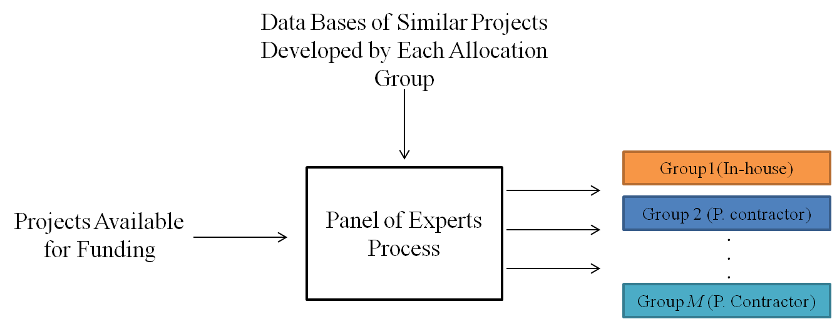
Third, each allocation option is highly represented or formed with a selected project sample, form the data bases, by a panel of experts. The process of this assumption is outlined in Figure 2.

Figure 2: Process of Determining Allocation Options

The panel of experts, in the third assumption, consists of a group of people from different departments, such as purchasing, engineering, planning, etc. This panel uses the information available from the suggested projects for funding (inputs) with the information in the database containing similar projects most recently involving each option (in-house and contractors) to produce reference project samples for each option (output). These samples are used in the MD computation. Specifically, MD measures how each input project best matches every option (output) to be allocated.
Fourth, a percentage of project funding or completion is not allowed (i.e., a selected project is fully funded and completed by the available resources).
Fifth, the degree of risk and the possibility of failure in project completion are omitted in our study.
Finally, the interdependent chronological relationship, of project or resource between each other is not considered (i.e., starting and finishing any project is not necessarily reliant or depended the status of other projects or activities).
The department of project management handles projects in any business environment or governmental sector. Regardless of variations in project types, each project in R&D usually progresses in three primary phases [R&D project portfolio…] as follows:
- Project proposal submittal
- Project proposal and scope evaluation
- Decision-making regarding project funding and relevant resources
This process is illustrated in Figure 3, which provides a clear picture of the step we concentrate on in this dissertation.

Figure 3: R&D Project Primary Phases

As shown in Figure 3, our contributions focus on providing decision makers and managers decision-support methodology for selecting optimal projects to be funded subject to resource and budget constraints, as well as identifying projects most suitable for either in-house development or private contractors’ use.
This chapter will discuss the proposed tools (i.e., MD definition and equations) involved in the project-funding decision-making phase. Moreover, a compendium of the B&B algorithm is provided as a solution methodology for our proposed project-selection and resource- allocation models.

Mahalanobis Distance

The concept of the MD has been widely used in different statistical areas that consider multivariate observations, such as classification, cluster, and outlier detection techniques. MD is considered a more powerful distance measure than other methods, such as ED, because it considers different scales in multivariate observation variables or characteristics and the potential correlation among them.

Definition

The MD is a measurement of statistical distance between an n-dimensional point (multivariate) with coordinates, variables, given by an n-variant vector 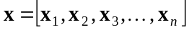 and a space's center (overall mean) represented by a reference sample’s mean vector 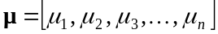. This measurement is defined in the following equation:
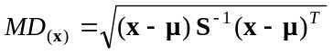 (1)

where is the covariance matrix of a reference sample, which is given in Eq. (2):
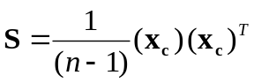 (2)
where X is the data matrix containing n objects (observations) in the rows measured for p variables (characteristics). X_{c} is the column-centered data matrix. In the case of two vector variables, 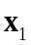and 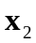, the variance–covariance matrix is
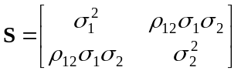 (3)
where 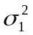 and 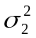 are the variances of the values of the two vector variables, and , respectively; 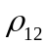 is the correlation's coefficient between them; and 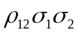 is the covariance between the two vector variables ( i.e., the covariance measures the level of relationship between two variables). The covariance matrix is a p-by-p square matrix that contains variables' variances in the diagonal elements of the and the covariance between any two variables in the off-diagonal elements. The inverse of the covariance 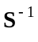 matrix is given in the following equation:
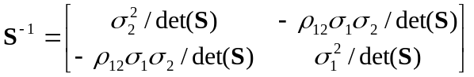 (4)
where 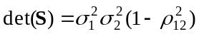is the determinant of the covariance matrix.
Note when the two variables in Eq. (4) are uncorrelated (i.e., 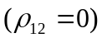 or (=)), the Eq.(1) is reduced to the formula for the ED as in Eq. (5) and the covariance matrix becomes the identity matrix.
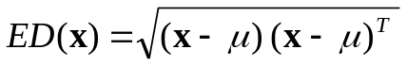 (5)
Consequently, the ED does not consider the correlation between the of the random variable's components. For this reason, the MD is frequently used in statistics because it fits better than the ED if the sample is not distributed with spherical symmetry around the center, in other words it is correlated.

MD Graphical Representation

In order to illustrate the concept of MD and provide better understanding of its function in project classification, the concepts of MD and ED are graphically displayed in Figure 4. Specifically, Figure 4 shows the major difference between these distances regarding the correlation between the variables of an observation (multi-dimensional point).
In general, each circle on the left and its typical circle shapes on the right represent a multivariate or multi-dimensional point (in our case, projects). More specifically, the colored small points inside these circles denote to the characteristics (variables) that indentify each project scope.

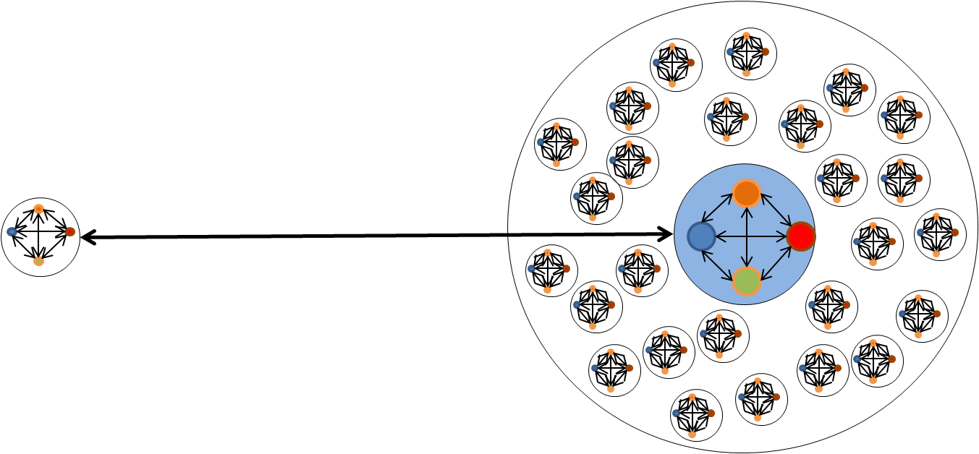

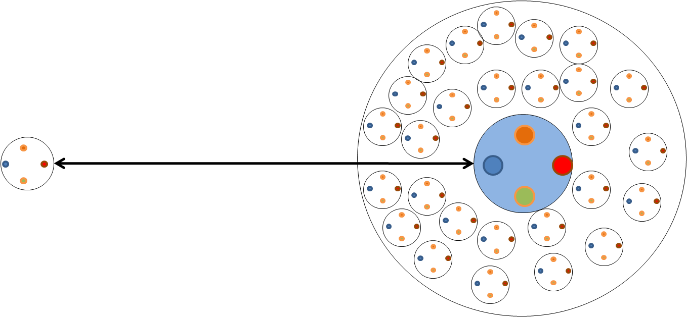
2-1 MD representation

2-2 ED representation

Figure 4: MD and ED Graphical Representations
The biggest two circles on the right represent a multivariate space (reference samples in our scope). The circles in the center of the two biggest circles on right represent a special multivariate point, which is the overall mean or centroid of the multivariate space.
The colored small points inside the circles, in MD, are interconnected, representing a correlation between variables that is accounted for in this specific distance measure. On the other hand, the connections between variables in ED graph are not considered (i.e., the relationship between project's variables is not accounted for in this distance). Therefore, we can clearly describe the MD as a distance between a multivariate point and a multivariate space centroid accounting for a correlation with a multivariate point characteristic.

MD Computation Example

For illustration purpose, suppose we have two groups of datasets: A and B. A represents the dataset for multivariate observations, and B the reference sample. The two groups can be represented in matrix form as 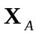for group A, and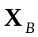 for group B. The data matrices of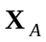and is n-by-m, where n is the number of observations and m is the dimension of the data (variables or factors). The MD computation requires both matrices to have the same number of column dimension m (variables); nevertheless, they may have different numbers of rows n (observations). Furthermore, matrix must contain more rows than columns.
The MD measures the distance between each observation n in and the reference sample, which results in MD n-by-1.

Computation steps

Let 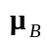be the vectors of means for group B, which contains the same number of elements and variables. The simulated data in Table 1 are be used in illustrating the steps in computing the MD.
Table 1: Simulated and Standardized Data for MD Illustration
Observation  No. | Dataset |  |  |  | Centered Data
Observation  No. |  |  | 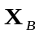 |  | 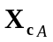
Observation  No. | 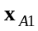 | 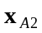 | 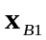 | 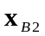 | 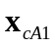 |  | 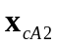
1 | 1 | 1 | 0.53 | -0.11 | 0.38 |  | 0.13
2 | 1 | -1 | 1.83 | 2.98 | 0.38 |  | -1.87
3 | -1 | 1 | -2.25 | -1.72 | -1.62 |  | 0.13
4 | -1 | -1 | 0.86 | 0.75 | -1.62 |  | -1.87
5 |  |  | 0.31 | 0.59
6 |  |  | -1.31 | -1.26
7 |  |  | -0.43 | -0.44
8 |  |  | 0.34 | 0.95
9 |  |  | 3.57 | 3.83
10 |  |  | 2.76 | 3.11
Mean |  |  | 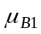  0.6248 | 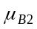  0.8691

Group A has n_{A} = 5 observations and group B has n_{B} = 10 observations. Each observation in either group has two values (two variables or factors are possibly correlated). In Table 1, bold-faced symbols represent vectors or matrices: 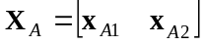,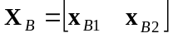,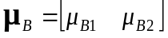.
The raw data in Table 1 have been transformed into centered data matrix X_{c} and will be used in MD computation by subtracting from each value in 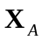 the mean of its corresponding column in 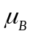 (i.e., for observation in group A, 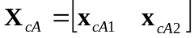, 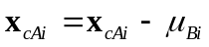, $∀$ i = 1, 2).
The MD's computational steps are outlined below:
Step 1
The covariance matrix for the reference sample, group B, is computed as in Eq. (2)
From the data given in Table 1, 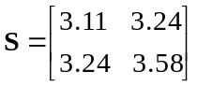
Step 2
The inverse of the covariance matrix 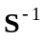 is calculated as given in Eq. (4)
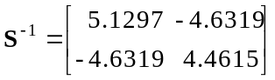
Step3
The MD between each observation in A and the reference sample in B are ready to be computed from Eq. (1). For example, we pick the first observation in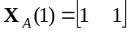
For the given data point,
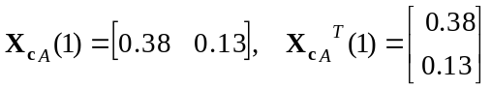, and
Therefore, using Eq. (1),
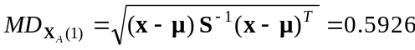
In order to understand the difference between the concepts of MD and ED, we display both measures in a graphical representation and address how considering the correlation between variables affects on the distance measurements as well [ MATLAB].
In this example, all the MDs and EDs are calculated for described in Table 1.

The results for MD and ED calculations are summarize them in Table 2 below.
Table 2: Comparing between MD and ED
Observation Data | MD | ED
[ 1 1 ] | 0.5926 | 0.4013
[ 1 -1 ] | 4.7816 | 1.9061
[ -1 1 ] | 3.9419 | 1.6264
[ -1 -1 ] | 0.9979 | 2.4733
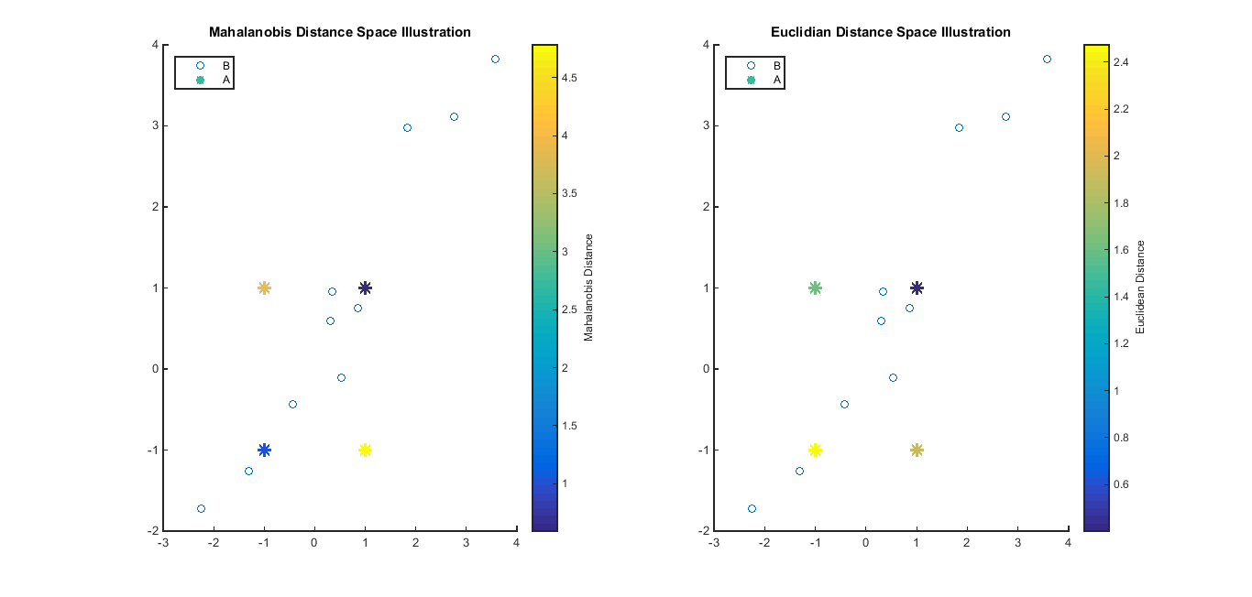
Figure 5: MD and ED Illustrations

The results of MD and ED in Table 2 show that the observations in with identical values in their variables have the minimum distances to the reference sample 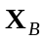 in MD compared to the observations with different values in their variables. In contrast, the ED results with similar and opposite values in the observations' variables do not indicate any distance interpretation to the reference sample in ED space. The MD results have more meanings in distance interpretation than ED because the MD accounts for the correlation and the scales between the observation's variables. As a result, the observations with identical or opposite values are clearly more distinguished and meaningful than the all results in ED regardless its observations' coordinates, similar or different. Moreover, Figure 5 further interprets the distances between every observation and the reference sample in MD and ED spaces. Consequently, MD has successfully shown how close each observation in is to the reference sample; thus, it is very efficient and reliable classification criterion.
The overall conceptual approach of measuring the MD between each project and multiple allocation options in this dissertation is illustrated in Figure 6. The steps in measuring the MD between a given project and allocation options are summarized below:
- Given a set of project characteristics or variables, define the scope of a project n in set n= 1, 2, …, N.
- Identify a group of typical projects m or reference samples (selected by a panel of experts) for each allocated option in set m= 1, 2, …, M.
- Compute the mean and the covariance matrix for each option in set m.
- Calculate the MD between each project n and the mean in each option m.

Figure 6: Illustration of Project Allocation Using MD Classification Criterion
Typically, each project allocation option in this dissertation has different MD space (i.e., inverse covariance matrix, standard deviations, and overall mean in set m). Therefore, every project has an equivalent m numbers of MD, with a total of ($n×m$) total number of MDs for all projects.
Generally speaking, the desirability of a given project n to be allocated to an option in set m is defined in terms of its MD to that option. In an ideal world, each project should be allocated to its closest option (minimum MD). This scenario, however, may not be possible depending on the available levels of each relevant resource that should be considered in the MD project-allocation process. The availability levels represent the MD as a constrained distance that should satisfy other conditions. Accordingly, the constrained MD is what we study in this dissertation.

Branch-and-Bound Overview

The B&B algorithm is used in this dissertation as the methodology for solving our problem of interests. Specifically, B&B method solves the suggested mathematical models of allocating projects to either in-house or private contractors subject to relevant constraints as stated in Chapter 1. This section will present an overview of the major steps in B&B and show our concentration's possition in this method. Comprehensive descriptions of B&B technique are available in various resources, including [ Taha, Liberman, constraint integer, solving constraint,].
In brief, the B&B algorithm handles not only the problems of solution infeasibility, which the integrality constraint causes in an IP problem, but also the extremely large feasible points in the feasible region through splitting (branching) the solution region into two or more divisions (sub-problems or nodes).
Such branching reduces the whole region, for optimizing, into smaller ones; thus, the solutions in these sub-problems are much easier and efficient in CPU time and effort than solving the entire region at once. The further growth in the branching process by dividing the whole feasible region into smaller regions creates a B&B solution tree, which consists of the main root representing the original or initial problem and the nodes corresponding to the sub-problems. Each node is solved consecutively in a similar manner: by dividing the feasible region in each sub-problem (parent) into other sub-problems (child nodes) until the best integer solution is obtained. Figure 7 depicts the general BIP B&B search tree.
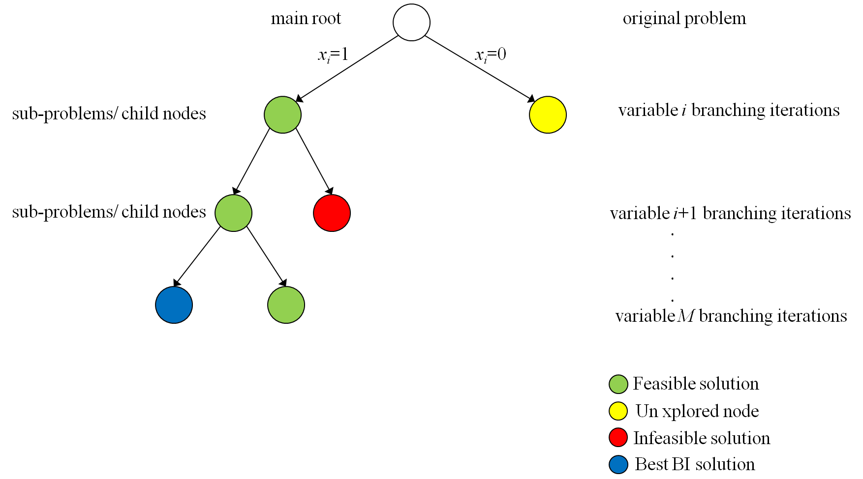

Figure 7: B&B Search Tree for BIP Problem in Two-Branching Case
To comprehend the B&B tree's construction for the BIP model, we represent the mathematical model form in Eq. (6) as follows:
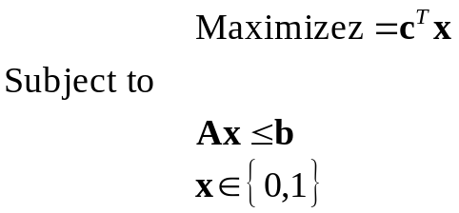 (6)
where z is the objective function (it could be in a minimization form), is the column vector of the variables' coefficients, represents the column vector of the decision variables (binary), the matrix  is the constraint's coefficients, and the column vector is the quantity of the resources available. The last constraint 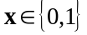 declares that all the variables must be binary.
The B&B method’s first step is solving the original BIP problem’s LP relaxation, which the main root node portrays in the tree. The LP relaxation solution involves deleting one set of constraints (BI) that makes the problem difficult to solve and substituting the decision variables with other constraint that has an upper bound of 1 and lower bound of 0. Specifically, the optimal LP relaxation solution provides the upper bound for all feasible solutions, including the original BIP feasible solution (i.e., the optimal solution of the BIP original problem ≤ optimal solution for LP relaxation).
The next step is splitting (branch) the LP relaxation feasible region into two sub-problems by fixing one of the decision variables at a value of (x_{i}=0) for one sub-problem and at a value of (x_{i}=1) for the other sub-problem and then solving each sub-problem using LP relaxation. Typically, continuing this process will generate parents that represent sub-problems and child nodes, which are also sub-problems derived from their parents in every branching iteration level as shown in Figure 7.
One of the most efficient and important steps in the B&B algorithm is called fathoming or pruning a sub-problem, (i.e., abandoning particular sub-problems from further exploration or branching). This step avoids solving every sub-problem in the B&B search tree; otherwise, an exponential number of sub-problems can result. There are three conditions for pruning a node:
- If a sub-problem’s alternative best known optimal BI solution is found at a specific iteration level, the bound that the LP relaxation finds for a sub-problem is less than or equal to the best BI objective value. That is, a node should be pruned if its LP relaxation is found in the search tree, whether its solution is BI or continues feasible ≤ best- known BI optimal solution.
- The LP relaxation for a sub-problem has no feasible solution.
- The optimal solution of a sub-problem’s LP relaxation satisfies the BI constraint and its relaxed and non-relaxed objective solutions are equal.
As discussed in the aforementioned chapters, BIP mathematically models the project selection and resource allocation; namely, each variable in or project takes only a binary value (1=allocate and 0=otherwise) also corresponding to the two branching. This scenario, however, may not be the case in this dissertation because we have multi-group project allocation (in-house and contractors) and each project should be allocated at most to only one classification option. In other words, the traditional B&B tree shown in Figure 7 is different in our allocation problem because every project is enumerated for each possible allocation among the available options. Therefore, the total number of branching in the B&B search tree equals (M ^{N}), where M represents the total number of options and N is the number total number of projects. To explain the B&B search tree's structure for the project allocation on multi-group problems, Figure 8 provides a snapshot of the tree with an example of allocating the total number of N projects on at most one of the three options (A, B, or C). In this Figure that each node has four branches corresponding to the possible allocation solution; not allocate at all; or allocated on option A, B, or C. The dramatic expansion and the search tree's complexity are clearly depicted as the problem's size increases (i.e., the number of projects and allocation options increases).

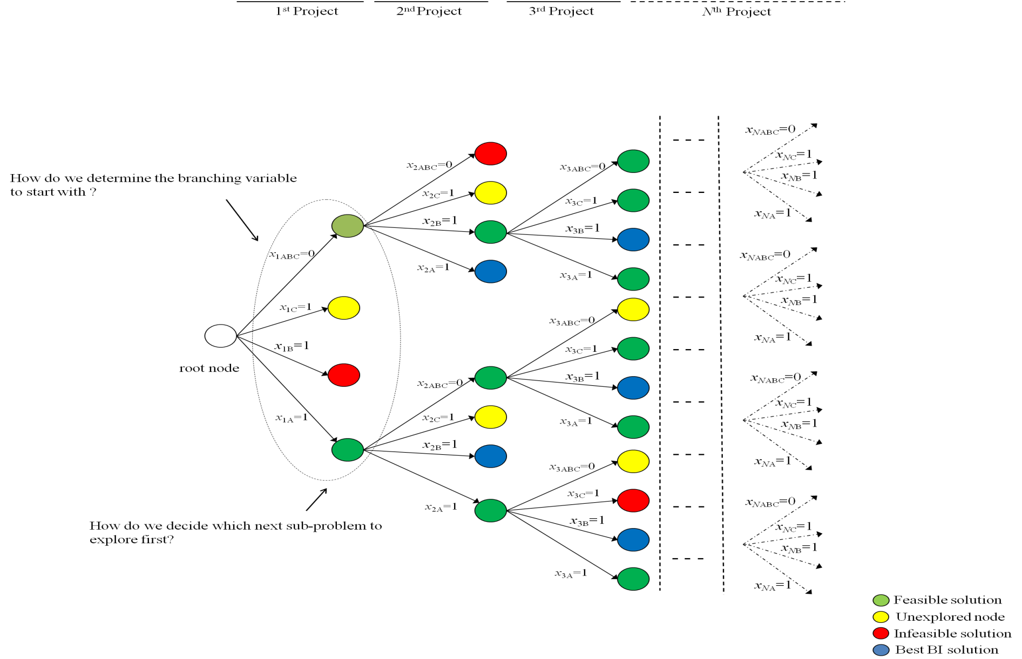

Figure 8: B&B Search Tree with more than Two Branches for BIP Problem in Multi-Group Project Allocation
The effects on CPU time, memory storage, and the solution gap's quality in the B&B method are obviously linked to the size of the tree. Undoubtedly, the branching strategies play a key factor in the B&B algorithm by significantly improving the solution performance and also speeding up the process of finding an optimal solution and node fathoming. No specific strategies work best for all problem types; otherwise no new strategies are required in this area. Therefore, creating new branching strategies on variables and choosing branching nodes to be explored during the next iteration greatly enhance the B&B algorithm’s quality and bring our attention to contribute in proposing new branching strategy in this study.

Conclusion

This chapter has discussed MD, the classification criterion’s cornerstone used to allocate projects among multiple options, and has introduced the applied algorithm’s structure in solving the models, B&B. The modeling approach for the constrained multi-group project allocation based on MD ensures assigning projects to their best option while maintains relevant resources. The core contributions of our solution approach in this dissertation are the following:
- Proposing models for selecting and allocating projects
- Enhancing the optimal solution’s quality by proposing clever branching strategies with node selections that can work efficiently with large problems.
- Improving the B&B algorithm’s solution performance
We will show in the following chapters our proposed branching strategies and their effect on the B&B solution performances.

CHAPTER IV

MATHEMATICAL MODEL AND PROPOSED METHODOLOGY

The analytical decision-support approach of selecting and allocating projects to either in-house or private contractors, multi-group, subject to relevant resources or constraints is formulated mathematically by two different BIP models. These models can be conceptually used as optimization procedures for constrained project selection and allocation problems. Each model, however, provides different type of measures of performance or optimization criteria that will be discussed in this chapter. The B&B method is used to solve the mathematical models with proposed branching strategies that can improve the efficiency of the algorithm performance as well as handling a large problem size.
This chapter is divided in three sections. The mathematical model formulation is described in the first section, the proposed methodology in branching strategies is discussed in the second section, and conclusion of the chapter is given in the last section.

Model Formulation

Generally, any decision-making problem that concerns about project selections and allocations involves only two choices that correspond to yes (allocate)-or-no (not to allocate) decisions. In this dissertation, these two choices represent whether or not to develop individual projects by the available contractors. The corresponding mathematical description of the two choices can be represented by decision variables that can take binary or Boolean (0 and 1) values. Thus, the mathematical formulation of our problem in this dissertation is BIP.

Model Assumptions
The required modeling assumptions for the constrained project allocations and selections problem are as follows:
- Each project in set n has an implementation cost that is equal in in-house and private contractors.
- Each project in set n has a dollar value of benefit derived from the projects being developed that is equal in in-house and private contractors.
- All projects in set n cannot be accomplished by the in-house manpower.
- Two different levels of in-house manpower (man-hours) are assumed and varied when projects in set n are assigned to in-house or private contractors. This manpower can be used to either develop projects internally (in-house) or to supervise outsourced projects (private contractors).
- The in-house manpower when projects in set n are allocated to in-house option is the project completion time.
- The in-house manpower when projects in set n are assigned to one of the private contractors becomes a supervision time and assumed to be equal in all private contractor options.
- The budget available is not sufficient to fund all projects in set n.
- There is no limit for the number of projects to be allocated in any option. However, each project in set n is allowed to be assigned to at most one of either option ( in-house or private contractors)

Optimization Criteria
In this dissertation, the project selection for funding is driven by the specified measure of performance. We consider two types of measures of performance to be optimized:
- The total dollar value of benefits from those projects selected for funding.
- The total value of MDs of the allocated projects.
The first choice determines a subset of the projects to be funded that generates optimum benefits, while the second choice will result in a project classification that intends to allocate each project to its closest option.
As we mentioned in Chapter 1, this study purposes two BIP models for the project selections and allocations. The first mathematical formulation (model 1) maximizes the dollar value of benefits derived by the public from those projects (transportation projects) being executed subject to a budget, total sum of MDs, and in-house manpower constraints. The second mathematical formulation (model 2) minimizes the total sum of MDs subject to a budget and the in-house manpower constraints.

Notation and Definitions
The mathematical molding for the project selections and allocations in this dissertation is formulated using the following notation:
N number of projects
M number of private contractors
B Available budget
c_{1n} cost of project n when done in-house
c_{in} cost of project n when done by private contractor i
b_{n} economic benefit from project n
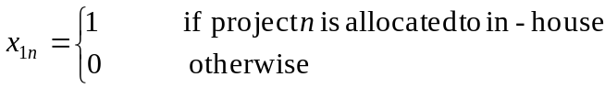
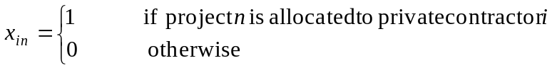
d_{1n} MD of project n to in-house option
d_{in} MD of project n to private contractor i option
W Upper bound on total sum of MDs
T Total manpower (man-hours) available
t_{1n} man-hours for finishing project n allocated to in-house option
t_{in} man-hours for supervising of project n allocated to private contractor i
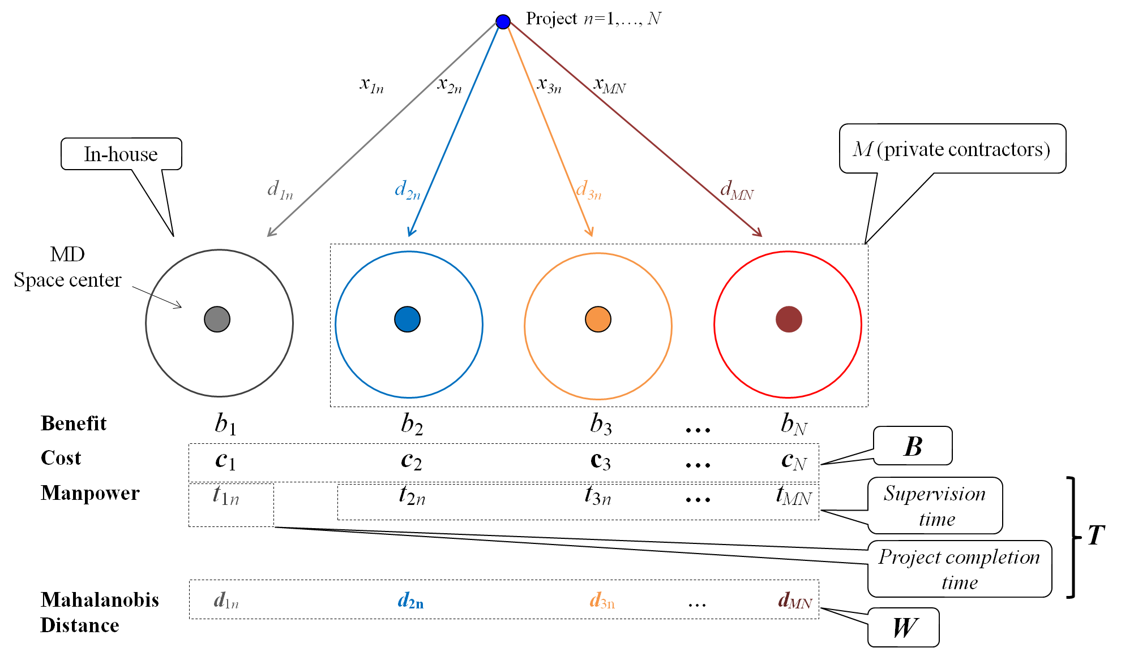

Figure 9: Representation of Constrained Multi-Group Project Allocation using MD
Figure 9 displays the systematic in the project allocation in the proposed models. In this figure, each project has the following characteristics:
- A binary decision variable that is represented by (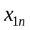=1 or =0), for in-house allocation, and (=0 or 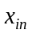=0), for private contractor allocations.
- Total number of M +1 MDs that measure the MDs between each project n and allocation options (in-house _{d1n} and private contractors _{din}). These MDs are minimized as an objective in model 2. The summation _{d1n} and _{din} for all N projects and M +1 options represents the MDs upper bound W.
- Dollar value of project benefits b_{n} that is intended to be maximized in model 1.
- Project cost c_{n} which is in total, for all N projects, > the available budget represented by B.
- In-house man-hours required to finish project n when allocated to in-house option represented by t_{1n} and the amount of time needed to supervise project n when outsourced to private contractors denoted by t_{in}. The total sum of t_{1n} is > the available man-hours T, in a transportation agency, to execute all N projects.

Model 1

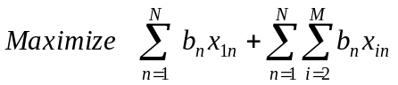 (7)
Subject to:
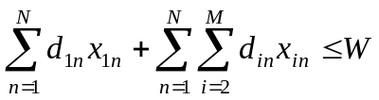 (8)

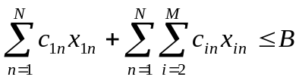 (9)

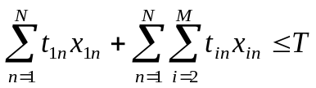 (10)

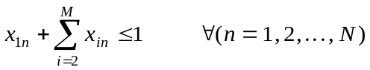 (11)

(12)
In the model 1 formulation, the objective function (7) gives the total benefit derived from the projects selected for funding is to be maximized. Constraint (8) formulates upper bound conditions for the total value associated with MDs for those projects selected for funding. The budget constraint (9) specifies a maximum level of funds available. Equation (10) enforces an amount of in-house manpower available to be utilized in in-house projects, when the optimal solution allocates project n to in-house option, or supervising projects, when the most attractive project n is assigned to any one of private contractors i. The restriction on assigning each project n to at most one allocation option is given in equation (11). Constraint (12) declares the binary decision variables.
In order to reach the most attractive optimal solution that ensures best project allocations, the model is solved by an initial value of W, which a solution is feasible, and then keeps solving the model again by reducing W gradually until the solution becomes infeasible. The least value of W that makes the solution feasible is considered to be the best upper bound of MDs summation that provide best optimal solution that concentrates more on project allocations. Further, this methodology can be also done by more complicated technique, such as Fibonacci search, search algorithm, golden section search, etc.

Model 2

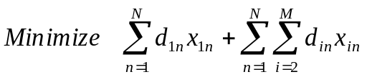 (13)
Subject to:
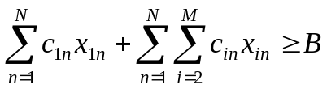 (14)

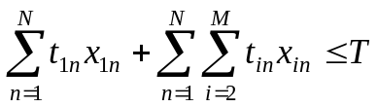 (15)

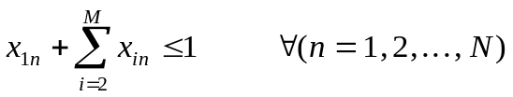 (16)

(17)

The objective function (13) minimizes the total sum of all MDs for allocated projects. It is noted that this objective function cannot be minimized to zero because of the constraint structures in budget (14) and time (15). Equation (15) assures that all selected project in the optimal solution will be less than or equal the upper bound total time T available for the in-house manpower. Otherwise, the solution will be infeasible for both formulations. To be tight in an optimal binary integer solution, available budget B in constraint (14) must be less than or equal the total cost of all projects selected for funding. Otherwise, the actual budget spent will exceed the specified lower bound B.
In practical applications, various scenarios or strategies of project selections and allocations are highly required over a specified range of B. The model for these strategies determines how a change in budgetary level of B can provide transportation departments with several project selection and allocation strategies for in-house versus private contractors. This strategic approach can also be considered when using model 1 formulation. Furthermore, model formulation 2 can also include an upper bound on money that will be spent as in (18):
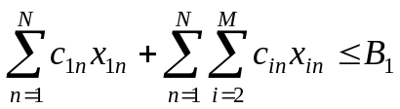 (18)

where 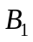represents the amount of budget available to sufficiently fund all projects.
After we have described the structures and the details for the models 1 and 2 above, we summarize various comparisons between these models and show what each one can provide in Table 3.

Branch-and-Bound Algorithm

Definition
There are some algorithms in the literature that provide solutions to IP and Mixed Linear integer programming (MLIP) models, such as, cutting plane and branch-and-bound (B&B) algorithms. The first B&B algorithm was developed in 1960 by A. Land and G. Doig for the general MILP and pure ILP. Later, in 1965, E. Balas developed an additive algorithm for solving ILP problems with BIP. The B&B algorithm solves these problems by dividing the search space and generating a sequence of sub-problems.

Two questions remain unanswered regarding B&B algorithm [15]:
- Which variable in branching should be branched first?
- In selecting the next branching node or sub-problem, which node should we begin to solve?
The answers to the both questions are open and the research in this area is still hot, however ensuring computations could differ dramatically with strategies. Consequently, the result in trees differs greatly in size and the computer time required in finding an optimal solution [19]. The main reason of why we use the B&B algorithm, because it lies on the flexibility in how to design a specific algorithm for any given type of problem such as BIP with specific branching strategies.

Proposed B&B Algorithm Strategies
The B&B strategies for each iteration in our proposed algorithm are described as follows:
- Branching
Branching arcs from the main node (corresponding to the main problem having all feasible solutions) to two nodes that correspond to two sub-problems. The formed tree will continue growing branches iteration by iteration. The variable used to do this branching at any iteration is done by assigning values (1 and 0) to only one variable. Our proposed branching strategies for choosing which variable to split and which nodes to explore in the algorithm are as follows:

- Start branching at each node or sub-problem from the decision variables 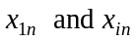 that has the minimum of the MD, given that the optimal solution for its LP relaxation is maximized (minimized if the problem is a minimization) binary integer solution called Z*, if the solution is not optimal, repeat the step with the next MD minimum until achieving the Z*. We come up with this rule, because it tests which of the candidate variable gives the maximum bound and minimum gap between the upper and lower bound to improve the solution performance in fastest way and helps to reduce the size of the tree and the dimension of the decision variables with the help of the MDs that contribute in our model structure and classification. This branching strategy can be represented as in Eq.(17).

(17)

- Choosing the branching node whose parent has the smallest (largest if the problem is a maximization) objective value Z*. We select this rule because it is tighten with the variable branching strategy and gives a quick fathoming and less depth. This node searching strategy can be represented as in Eq.(18).

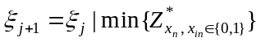 (18)
Where indicates the branching node and j represents the sequence branching node.

- Bounding
For sub-problems, we choose one of them and attempt to solve the linear programming relaxation (LP relaxation) by deleting one set of constraints(integrity) that makes the problem difficult to solve and substitute with other constraints that has an upper bound of 1 and lower bound of 0, that is, . If the sub-problem can be solved and the solution is binary integer feasible, that is, , then its objective value provides an upper bound and this solution should be stored as the best feasible solution found so far for the whole problem and called Z* ; if the solution is not binary integer values, then it defines two new sub-problems. Branching continues in this manner until there are no more nodes can be branched.
- Fathoming
A sub-problem is fathomed or dismissed if any one of the following conditions is satisfied:
- The upper bound found by the relaxed sub-problem is less (in the case if alternative optimal solution of a sub-problem is found so far Z*) than or equal (if no alternative optimal solution is requested) the objective function value of the best known feasible solution.
- The LP relaxation has no feasible solution.
- The optimal solution of the LP relaxed sub-problem satisfies the constraints of the unreleased sub-problem and its relaxed and non-relaxed objective solutions are equal.
The process of variable selection strategy that determines which candidate variables to branch is summarized as follows:
- Order each variable of x_{1n} and x_{in} for every individual project n based on its d_{1n} and d_{in} in an ascending order.
- Compute the MD average on each project with respect to its allocation.
- Reorder all projects based on their MD average in an ascending order.
- Do other necessary variables reorganize in the objective function and other constraints that correspond to the changing in steps 2 and 3.
- Start the B&B algorithm by branching on the ordered MDs.

Tables and figures embedded within the text must be placed on either the same page as the first mention in the text, or on the page following the first mention of the text. Large tables and figures must be placed on a separate page. Table 1 is larger than ½ a page and must be placed on its own page. The page before the table/figure must be a full page of text, unless it happens to end the chapter. This applies even if a paragraph must be broken across pages.

Heading 2

Tables and figures may be placed on separate pages regardless of size. You should not “break” text and leave white space on text pages -- instead, simply continue the text (even if it is a new paragraph or new section) until that page is filled. The only time there should be a significant amount of white space on a page is when it is the last page of the chapter. You can leave white space on pages that just have tables or figures.

Heading 3
Tables and figures may also be placed in an appendix at the end of the thesis/dissertation. If you do this, be sure to note that the tables/figures are located in the appendix. This can be done either parenthetically or with footnotes. You may place all tables and figures in an appendix, or just a few. If you choose to place all tables and figures in the appendix, you can note that “All tables and figures are located in the appendix” after the first mention of a table or figure.

Heading 3
Table numbers and titles should be placed above the tables. Figure numbers and titles should be placed below. The font for tables must match the font for the body of the text, although it can be smaller (as long as it is consistent – so if your normal text is 12 pt, and you make of your figure captions is 10pt, ALL of your figure captions must be 10pt). All tables must have at least 2 columns and a heading row. Tables must also have at least 3 grid lines. These lines include the line above the table, the line below the heading row, and the line below the table.

The font inside tables should match the font in the rest of the document. The font INSIDE figures can differ from the font for the body of the text. However, the font for the figure number and title must match the font for the body of the text. You may use color figures or black and white.
of the most significant heuristic methods for solving the R&D is the Genetic Algorithm (GA). A study by Bo Shi et al. [A hybired genatic] presented an integrated BIP model in with a genetic algorithm (GA) to overcome these problems. Taguchi Method was employed in the design of the GA parameters to increase the efficiency of the proposed method. integrated with zero-one integer programming model has proposed with

However, the correlation between project characteristics has not been studied and included in the .

Unfortunately, research and development are very difficult to manage, since the defining feature of research is that the researchers do not know in advance exactly how to accomplish the desired result. As a result, higher R&D spending does not guarantee "more creativity, higher profit or a greater market share".^{[3]}
Research is also the most risky financing area because both the development of an invention and its successful realization carries uncertainty factors including the profitability of the invention.^{[4]} One way of reducing the uncertainty of researching know-hows is to obtain already researched know-hows.^{[5]}

The US Departments of Transportation (DOT) is in the seventh top ranking of the estimated total outlays of the federal budget with an approximate average of 98.5 billion dollars in the year 2015 with an estimated increase of 3% in each fiscal year and a total of 277.1 billion dollars spending by combining federal, state, and local governments [1]. The total amount of federal government invests in transportation improvements is about 60% from the spending amount in each year [2]. Subsequently, this budget should be ideally managed and utilized in the most economically feasible manner with an optimal methodology for allocation purposes. Accordingly, an analytical approach with different optimal solutions is highly required to be developed and implemented to aid the decision makers and project managers for choosing the best decision. However most of current research in the literature has not been devoted to view the optimization of the classification problems from the side of incorporating a historical dataset with mathematical modeling.

The MD has been combined with Taguchi System (MTS) which is developed by Dr. Taguchi for the principle of diagnosis and forecasting method for multidimensional data [].

but multicollinearity is still a serious problem due to the fact that the information provided by the four variables as a whole is overlapped.

Furthermore, it is often considered as a major challenge problem and one of the critical factors that leads any organization to succeed [A decsion support model…]. Therefore, the classification criteria are the hurt of project assignment framework.

When a researcher or data analyzer faces to the classification of a data set, he/she usually applies the classifier which he/she expects to be \the best one that fits the problem. The project allocation among different options in this dissertation

The complexity of the B&B algorithm is

Heading 3
Use of styles is helpful in generating a table of contents. This sample document uses the headings to automatically generate the table of contents, list of tables, and list of figures.

Heading 3
Once you use styles to generate the lists, you can update them quickly and easily.

Heading 2

Don’t forget to submit your thesis/dissertation to the thesis/dissertation consultant by the preliminary review deadline (this specific deadline can be found here: http://gradschool.utk.edu/ddategraduation.shtml)

MD Computation
hello
Table 3. Table title.

Column One | Column Two
Table data  Table data  Table data  Table data  Table data  Table data  Table data  Table data  Table data  Table data  Table data  Table data  Table data  Table data  Table data  Table data  Table data  Table data  Table data  Table data  Table data  Table data  Table data  Table data | Table data  Table data  Table data  Table data  Table data  Table data  Table data  Table data  Table data  Table data  Table data  Table data  Table data  Table data  Table data  Table data  Table data  Table data  Table data  Table data  Table data  Table data  Table data  Table data

CHAPTER III
Materials and Methods

Heading 2

Heading 3
Don’t forget to refer to all tables/figures by number within the text. Once you have mentioned a table/figure, you must place it on the same or next page. For instance, if you mention Figure 1 on page 33, the actual figure should be placed on page 33 (if it is small), or by itself on page 34 (if it will take up more than half of the page).

Heading 3
Blah blah blah.

Heading 2

Heading 3
Things and stuff, stuff and things.

Heading 3
More things and stuff and words and information.

Heading 2

Keep writing. You’re almost there!

Blah blah blah. Blah blah blah. Blah blah blah. Blah blah blah. Blah blah blah. Blah blah blah. Blah blah blah. Blah blah blah. Blah blah blah. Blah blah blah. Blah blah blah. Blah blah blah. Blah blah blah. Blah blah blah. Blah blah blah. Blah blah blah. Blah blah blah. Blah blah blah. Blah blah blah. Blah blah blah.
Blah blah blah. Blah blah blah. Blah blah blah. Blah blah blah. Blah blah blah. Blah blah blah. Blah blah blah. Blah blah blah. Blah blah blah. Blah blah blah.

CHAPTER X
formulation

Branch and Bound

Heading 3
Don’t forget to refer to all tables/figures by number within the text. Once you have mentioned a table/figure, you must place it on the same or next page. For instance, if you mention Figure 1 on page 33, the actual figure should be placed on page 33 (if it is small), or by itself on page 34 (if it will take up more than half of the page).

Heading 3
Blah blah blah.

Heading 2

Heading 3
Things and stuff, stuff and things.

Heading 3
More things and stuff and words and information.

Heading 2

Keep writing. You’re almost there!

Blah blah blah. Blah blah blah. Blah blah blah. Blah blah blah. Blah blah blah. Blah blah blah. Blah blah blah. Blah blah blah. Blah blah blah. Blah blah blah. Blah blah blah. Blah blah blah. Blah blah blah. Blah blah blah. Blah blah blah. Blah blah blah. Blah blah blah. Blah blah blah. Blah blah blah. Blah blah blah.
Blah blah blah. Blah blah blah. Blah blah blah. Blah blah blah. Blah blah blah. Blah blah blah. Blah blah blah. Blah blah blah. Blah blah blah. Blah blah blah.

Figure 10. Shapes.

tab
CHAPTER IV
Results and Discussion

Another chapter, and I’ve run out of things to say. I hope that a template will help some of you. Remember that consistency is the most important thing. You may use any spacing style or font as long as you use it consistently. It should also be legible and able to be seen on any computer (so stick with Times New Roman, Arial, etc.). Rules for placement of tables and figures are more specific (see previous pages, or consult the Guide to Preparation of ETDs: http://web.utk.edu/~thesis/Guide11.pdf). Good luck with your writing!

Heading 2

Write stuff here. Now!

Chapter kngds s dgk k
xcxfdfsdf

LIST OF REFERENCES
[Remove this note, but DO NOT REMOVE THIS PAGE, AND/OR DO NOT PUT CITATIONS ON THIS PAGE – you can change “List of References” to “References”, “Works Cited”, “Bibliography”, etc., but this is the ONLY text that should be on this page. The first citation should start at the top of the NEXT page.]

- Liberatore, M.J., “An extension of the analytic hierarchy process for industrial R&D project selection and resource allocation”. Engineering Management, IEEE, 1987(1): p. 12-18.
- Henriksen, A.D. and A.J. Traynor, “A practical R&D project-selection scoring tool. Engineering Management, IEEE Transactions on, 1999. 46(2): p. 158-170.
- Tofighian, A.A. and B. Naderi, Modeling and solving the project selection and scheduling. Computers & Industrial Engineering, 2015. 83: p. 30-38..
- Yaxu, L. and E. ZHANG, R&D project portfolio Selection Model with Interaction Effect.
- OECD (2016), Gross domestic spending on R&D (indicator). doi: 10.1787/d8b068b4-en (Accessed on 15 February 2016).
- Ghorbani, S. and M. Rabbani, A new multi-objective algorithm for a project selection problem. Advances in Engineering Software, 2009. 40(1): p. 9-14.
- Chen, J. and R. G. Askin, “Project selection, scheduling and resource allocation with time dependent returns” European Journal of Operational Research, 2009. 193:p.23-34.
- Liberatore, M.J., “An Expert Support System For R&D Project Selection”. Mathematical computational Modeling, 1988.11: p. 260-265.
- Heidenberger, K. and C. Stummer, Research and development project selection and resource allocation: a review of quantitative modelling approaches. International Journal of Management Reviews, 1999. 1(2): p. 197-224.
- P. Fahrni and M. Sp¨atig, “An application-oriented guide to R&D project selection and evaluation methods,” R&D Manage, 1990 20 (2): p. 155–171.
- Taylor III, B.W., L.J. Moore, and E.R. Clayton, R&D project selection and manpower allocation with integer nonlinear goal programming. Management science, 1982. 28(10): p. 1149-1158.
- Hiller, S. F. and G. J. Lieberman, “Introduction to Operations Research,” 7th ed., New Jersey: McGraw-Hill, (2007).
- Taha, A. H., “Operations Research: An Introduction,” 8th ed., New York: Pearson Prentice Hall, (2001).
- Kozanidis, G. and E. Melachrinoudis, A branch & bound algorithm for the 0-1 mixed integer knapsack problem with linear multiple choice constraints. Computers & Operations Research, 2004. 31(5): p. 695-711.
- Murkute, S., A Computational study of branching rules for multi-commodity fixed-charged network flow problems. 2013.
- Atamtürk, A. and M.W.P. Savelsbergh., “Integer-Programming Software Systems,” Annals of Operations Research, 2005. 140(1), p. 67-124.
- Patanakul, P., D. Miloseviç, and T. Anderson. Assigning projects to project managers in a multiple-project management environment: A pilot study of a decision support model. in Management of Engineering and Technology, 2003. PICMET'03. Technology Management for Reshaping the World. Portland International Conference on. 2003. IEEE.
- Carazo, A.F., T. Gómez, J. Molina, A. J. Hernández-Díaz, F. M. Guerrero, and R. Caballero, “Solving a comprehensive model for multiobjective project portfolio selection” Computers & operations research, 2010. 37(4): p. 630-639.
- Schmidt, R.L., A model for R&D project selection with combined benefit, outcome and resource interactions. Engineering Management, IEEE Transactions on, 1993. 40(4): p. 403-410.
- Mahalanobis, P. C., “The Generalised Distance in Statistics,” Proceedings of the National Institute of Science of India, 1936 2 (1): p. 49–55.
- Criado, C., N. Alamo, H. Rabal, and N. Cap, Decision and classification problems using Mahalanobis statistical distance. FSKD, 2011: p. 1012-1016.
- Taguchi, G., S. Chowdury, and Wu, Y., The Mahalanobis-Taguchi System, McGraw-Hill Press, New York (2001).
- Su, C.-T. and Y.-H. Hsiao, An evaluation of the robustness of MTS for imbalanced data. IEEE Transactions on Knowledge & Data Engineering, 2007(10): p. 1321-1332.
- Srinivasaraghavan, J. and V. Allada, “Application of Mahalanobis Distance as a Lean Assessment Metric,” Int’l J. Advanced Manufacturing Technology, 2006 (29): p. 1159-1168.
- Riho, T., A. Suzuki, J. Oro, K. Ohmi, and H. Tanaka, “The Yield Enhancement Methodology for Invisible Defects Using the MTS Method,” IEEE Trans. Semiconductor Manufacturing, 2005 18 (4): p. 561-568.
- Das, P. and S. Datta, “Exploring the Effects of Chemical Composition in Hot Rolled Steel Product Using Mahalanobis Distance Scale under Mahalanobis Taguchi System,” Computational Materials Science, 2006.

APPENDIX
[Remove this note, but DO NOT REMOVE THIS PAGE, AND/OR DO NOT PUT APPENDIX MATERIAL ON THIS PAGE – you can change “Appendix” to “Appendices” if you would like, but this is the ONLY text that should be on this page. The actual appendix material should start at the top of the NEXT page.]
You’ll put appendix material here. This section is optional. You can place tables and figures in the appendix if you like. If you choose this option, you should indicate that tables and figures are in the appendix after the first mention in the text. You can place some tables/figures in the text and others in the appendix.

VITA

Jane X. Doe was born. She wrote a thesis. She graduated. She followed instructions and wrote her vita in third person and paragraph form (as opposed to a resume or CV), which made her thesis consultant very happy. This page is required.

