Analysis of Cattle Producer Surveys about Horn Fly Management and Expected Progeny Differences

A Thesis Presented for the

Master of Science

Degree

The University of Tennessee, Knoxville

Katy Smith

May 2021

Copyright © 2021 by Katy Smith.
All rights reserved.

DEDICATION

Even though this page is optional
I dedicate my work to you.

ACKNOWLEDGEMENTS

Thank you all for your help. However, this page is optional.

ABSTRACT

This is a sample Word document that can be used as a template in formatting your thesis/dissertation. It cannot exceed 350 words.

If you use any special characters (including superscripts and subscripts) in your abstract, you must write out the term in plain English in square brackets immediately following the first use of the character. For example: H2O [water] and µ [micron]. This has nothing to do with how common the term is in your field of study-- our catalogers have to enter the abstract in our records using a plain text format that cannot accommodate the special characters, but has no problem with word substitutes.

PREFACE

This page is optional.

TABLE OF CONTENTS

CHAPTER 1: INTRODUCTION 1
CHAPTER 2: EVALUATION OF FARM DEMOGRAPHICS AND PRODUCER PERCEPTIONS THAT INFLUENCE COW-CALF PRODUCER HORN FLY (DIPTERA: MUSCIDAE) MANAGEMENT COSTS IN TENNESSEE AND TEXAS 2
Abstract 4
Introduction 5
Literature Review 5
Methods 5
Survey 5
Econometric Model 5
Explanatory Variables Included in the Models and Their Hypothesized Signs 5
Results 5
Survey Descriptive Statistics 5
Factors Affecting Producers’ Horn Fly Management Costs: Ordinary Least Squares Regression 5
Factors Affecting Producers’ Horn Fly Management Costs: Quantile Regression 5
Discussion 5
CHAPTER 3: TENNESSEE CATTLE PRODUCER PREFERENCES FOR BULL EXPECTED PROGENY DIFFERENCES (EPDS) 6
Abstract 8
Introduction 9
Literature Review 9
Industry Overview 9
Selection of Breeding Stock 9
Relevant Studies 9
Methods 9
Survey Design 9
Econometric Model 9
Explanatory Variables Included in the Models and Their Hypothesized Signs 9
Results 9
Survey Descriptive Statistics 9
Factors Affecting Producers’ Preferences for Genomic Enhanced EPDs 9
Willingness to Pay 9
Discussion 9
CONCLUSION 10
Heading 2 10
References 11
Appendices 12
Appendix A: Tables 13
Appendix B: Figures 15
Appendix C: Surveys 17
Tennessee and Texas Horn Fly Survey 18
Genomic Enhanced EPD Survey 37
VITA 121

LIST OF TABLES

Table 1. Table title. 8
Table 2: This Is The Second Table 8

LIST OF FIGURES

Figure 1. Shapes. 8

CHAPTER 1: INTRODUCTION

CHAPTER 2:
EVALUATION OF FARM DEMOGRAPHICS AND PRODUCER PERCEPTIONS THAT INFLUENCE COW-CALF PRODUCER HORN FLY (DIPTERA: MUSCIDAE) MANAGEMENT COSTS IN TENNESSEE AND TEXAS

A version of this chapter was originally published by Jane X. Doe and Juanita Q. Vera:
Jane X. Doe, Juanita Q. Vera. “Towards A Theory of Page Rage.” Journal of Infomatic Bloat 221 (2009): 102-105.

The student must add a brief explanatory statement at the beginning of each article, stating how the article was revised and/or detailing the student’s involvement in the article. Any co-researchers should be identified and their role clarified as part of this statement.

Abstract
The United States livestock industry loses an estimated 1.75 billion dollars annually due to horn flies (Haematobia irritans (L.)), making them a widespread and significant pest of livestock. These ectoparasites feed on the blood of their host 20-40 times per day, which can cause blood loss, introduce pathogens, and decrease weight gains and milk production in cattle. Research suggests that proper horn fly management supports increased weight gains in cattle, leading to positive returns for producers; however, little research exists regarding cattle producers’ horn fly management decisions and their associated costs. Tennessee and Texas cow-calf producers were surveyed to estimate their horn fly management costs per animal and identify factors influencing this cost. Results indicate that the average horn fly management costs per animal in Tennessee and Texas are $9.50 and $12.35, respectively. Tobit regression results indicate that producers who have a college degree, raise Angus cattle, perceive a high intensity of flies to be a problem, agree that horn flies jeopardize cow comfort, or reported having farms with more total acres were associated with lower horn fly management costs per animal. Meanwhile, producers who reported horn flies present on the backs and withers of their cattle, were more likely to spend more on horn fly management per animal. Results indicate that management decisions vary by location and that farm demographics and producer perceptions influence horn fly management costs.

Introduction

Tables and figures embedded within the text should be placed on either the same page as the first mention in the text, or on the page following the first mention of the text. Large tables and figures should be placed on a separate page. For instance, Table 1 is larger than ½ a page and therefore is placed on its own page. The page before the table/figure should be a full page of text, unless it happens to occur at the end of the chapter. This applies even if a paragraph must be broken across pages.

Tables and figures may be placed on dedicated pages even if they are small. You should try to avoid leaving large blocks of white space on text pages, but you can leave white space on pages that just have tables or figures.

Literature Review

Methods

Survey

Econometric Model

Explanatory Variables Included in the Models and Their Hypothesized Signs

Results

Survey Descriptive Statistics

Factors Affecting Producers’ Horn Fly Management Costs: Ordinary Least Squares Regression

Factors Affecting Producers’ Horn Fly Management Costs: Quantile Regression

Discussion

CHAPTER 3:
TENNESSEE CATTLE PRODUCER PREFERENCES FOR BULL EXPECTED PROGENY DIFFERENCES (EPDS)
A version of this chapter was originally published by Jane X. Doe and Juanita Q. Vera:
Jane X. Doe, Juanita Q. Vera. “Towards A Theory of Page Rage.” Journal of Infomatic Bloat 221 (2009): 102-105.

The student must add a brief explanatory statement at the beginning of each article, stating how the article was revised and/or detailing the student’s involvement in the article. Any co-researchers should be identified and their role clarified as part of this statement.

Abstract
The Tennessee cattle industry generated over half a billion dollars in 2017 cash receipts, making it the state’s second-largest agricultural commodity. Tennessee cattle farms, on average, have less than 30 head of cattle and nearly 90% of all cattle are finished outside the state. Genomic enhanced expected progeny differences (GE-EPDs), which combine expected progeny differences (EPDs) with DNA information, are available for cow-calf producers when selecting bulls. GE-EPDs typically have improved accuracy scores associated with the bull’s listed EPDs. The goal of this research was to determine Tennessee cow-calf producer preferences for bull EPDs and determine if they place a higher value on GE-EPDs than EPDs. We also examined how farm demographics and producer preferences influence producers’ willingness to pay (WTP) for bulls.
In Spring 2020, 1,245 Tennessee cattle producers responded to a Qualtrics web survey regarding their preferences for bulls with varying EPDs or GE-EPDs. Participants were provided nine hypothetical bull choice sets and were asked to list their maximum bid for each bull. A between-subjects design was utilized where half of the participants bid on bulls with listed GE-EPDs and half the participants bid on bulls with listed EPDs. Preliminary ordinary least square (OLS) regression results indicate that producers were willing to pay more for the following bull EPDs as their EPD values increased: calving ease direct, weaning weight, docility, mature weight, ribeye area, and carcass weight. However, cattle producers were not willing to pay more for bulls if they saw bulls listed with GE-EPDs compared to EPDs. This indicates producers did not place an increased value on improved EPD accuracy levels provided by the GE-EPDs. Results also identified farm and farmer characteristics associated with producer WTP for bulls.

Introduction

Literature Review

Industry Overview

Selection of Breeding Stock

Relevant Studies

Methods

Survey Design

Econometric Model

Explanatory Variables Included in the Models and Their Hypothesized Signs

Results

Survey Descriptive Statistics

Factors Affecting Producers’ Preferences for Genomic Enhanced EPDs

Willingness to Pay

Discussion

CONCLUSION

This is the conclusion for the entire document. It can be a numbered chapter or it can stand alone. If you did not make your introduction a chapter and give it a number, you should not make the conclusion a numbered chapter. If you DID call your Introduction “Chapter 1”, you should give your conclusion a chapter number.

Heading 2
Write here.

References

Appendices

Appendix A: Tables

You can place appendix material for this chapter here, or you can collect all of your appendix material into one major appendix section at the end of the document (after the references if you are collecting them for the entire dissertation, but before the vita). If you have one appendix section, the heading for this section should be treated as a major heading, and this heading should get its own page that precedes the first page of actual appendix material. But if you are collecting the appendix material at the end of each chapter, they do not need a title page – so the first line of appendix material can be placed directly under the heading “Appendix”.

Table 2: This Is The Second Table

Appendix B: Figures

You can place appendix material for this chapter here, or you can collect all of your appendix material into one major appendix section at the end of the document (after the references if you are collecting them for the entire dissertation, but before the vita). If you have one appendix section, the heading for this section should be treated as a major heading, and this heading should get its own page that precedes the first page of actual appendix material. But if you are collecting the appendix material at the end of each chapter, they do not need a title page – so the first line of appendix material can be placed directly under the heading “Appendix”.

Table 2: This Is The Second Table

Appendix C: Surveys

Tennessee and Texas Horn Fly Survey

Default Question Block

FLIES & CATTLE PRODUCTION

Thank you for participating in this survey about flies and cattle production.

The survey is conducted by University of Tennessee Institute of Agriculture researchers and will take about 15 minutes to complete. Your participation is voluntary, and information you share will be confidential.

If you have questions about the survey, please contact Susan Schexnayder at schexnayder@utk.edu or (865) 974-5495. If you have questions about your rights as a survey participant, contact the UT Institutional Review Board Staff at utkirb@utk.edu or (865) 974-7697.

To start, click the orange button, below-right.
Then use the orange button after you complete each page.

Many thanks!

Enter your Survey ID number here.

BACKGROUND

Are you 18 years old or older?


 Yes No

In which segment of the beef cattle industry are you primarily involved?

 Purebred Breeder
Commercial Producer of feeder calves and yearlings - by natural service
 Commercial Producer of feeder calves and yearlings - by artificial insemination  Stocker or Background Operations
 Cattle Finisher
None of the above (if you select this, you will be exited from the survey)

What percent of your calves do you produce in each calving season?

Spring
0

Fall
0

Total
0

In what state is your cattle operation located?

Tennessee Texas
Oklahoma Other

In what county is your operation primarily located?

In 2016, how many stockers did you purchase?

At the end of July 2017, how many bulls, cows, and calves were in your herd?
(If you manage herds separately on different pastures, please aggregate all herds here.)

 Bulls Cows  Calves

How many cattle did you finish in 2016?

PRESENCE OF FLIES

Please evaluate the intensity of the fly problem at peak fly season on each of these body parts of your cattle.
(Consider any flies and assume the pictures represent a steer or cow, depending on your operation type.)

No Problem
Minor Problem
Moderate Problem
Serious Problem
Very Intense Problem

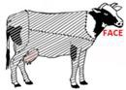
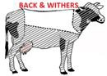



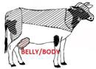



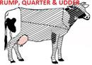

No Problem
Minor Problem
Moderate Problem
Serious Problem
Very Intense Problem

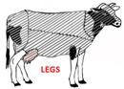

In what months are flies most abundant on your animals? (check all that apply)

 January February March  April
May June July August
September October November December
Don't know

Please indicate the severity of each of these behaviors and outcomes in your herd.

Swishing tails
Licking backs or twitching flanks Stomping
Kicking at bellies Bunching of the herd Reduced grazing time
Failed to achieve anticipated weight gains
Occurs infrequently or mildly






Occurs occasionally or moderately

Occurs frequently or
intensely Don't know











Pink eye Mastitis
Other
Occurs infrequently or mildly



Occurs occasionally or moderately

Occurs frequently or
intensely Don't know






The pictures below represent various intensities of horn flies. At what intensity do you consider horn flies a problem?

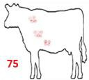

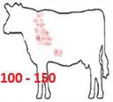

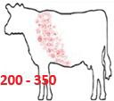

How confident are you that you know what type of flies are on your cattle?

 Not confident
Slightly confident
Moderately confident  Extremely confident

Block 1

HORN FLY RESISTANCE

Throughout this survey, we define "horn fly resistant animal" as an animal with few to minimal flies present, noticeable, or feeding on the animal. It also means that animal traits you select for would be unaffected by the addition of the horn fly resistance trait, so that the horn fly-resistant cattle and your current cattle are the same weight and have IDENTICAL muscling, gains, health, and other traits.

ABOUT HORN FLIES AND CATTLE
Horn flies are a pest of cattle, inflict painful bites to draw 20-30 blood meals per day, and have the following effects:
- Animals' defensive behaviors when horn flies are present interrupt adequate rest and food consumption
- Calves protected from horn flies have weaning weights 10-50 pounds more than unprotected calves with 200 or more flies
- Stockers and replacement heifers protected from horn flies have weights 16-18% above unprotected animals
- Horn flies can transmit bacteria that cause mastitis.

HORN FLY RESISTANCE
Throughout this survey, we define "horn fly resistant animal" as an animal with few to minimal flies present, noticeable, or feeding on the animal. It also means that animal traits you select for would be unaffected by the addition of the horn fly resistance trait, so that the horn fly-resistant cattle and your current cattle are the same weight and have IDENTICAL muscling, gains, health, and other traits.

Block 3

VALUE OF HORN FLY RESISTANCE IN THE CATTLE HERD

Assuming it would be profitable to make your entire herd resistant to horn flies, would you be interested in doing so?

Yes No

Assuming all other factors in your operation remained the same, but your entire herd was resistant to horn flies, how do you think your cattle operation would be affected?

Slide each bar to indicate the % change you expect. (Please move the slider even if you return it to "0" so an answer will be recorded.)

Profitability would
change
% change expected
0 5 10 15 20 25 30 35 40 45 50
Not Applicable




Cow comfort would
change

Average weight gain
would change

Assume you are purchasing a bull for breeding. Which bull would you purchase?

A bull for $5,000

A bull that is resistant to horn flies for $5,500 Neither

For what reason did you choose neither?

Assume you are purchasing a bull for breeding. Which bull would you purchase?

 A bull for $3,000

A bull that is resistant to horn flies for $4,500 Neither

For what reason did you choose neither?

Assume you are purchasing straws of semen for breeding cattle. Which type of semen would you purchase?

 Semen for $20
Semen for $20 that is resistant to horn flies  Neither

For what reason did you choose neither?

Assume you are purchasing a stocker steer at 500 pounds. Which type of steer would you purchase?

A steer for $150/cwt.

 A steer for $165/cwt that is resistant to horn flies Neither

For what reason did you choose neither?

Assume you are purchasing a steer at 800 pounds for finishing. Which type of steer would you purchase?

 A steer for $140/cwt.
 A steer for $155/cwt that is resistant to horn flies Neither

For what reason did you choose neither?

VALUE OF HORN FLY RESISTANCE RELATIVE TO OTHER BRED TRAITS

Please evaluate the importance of these traits when you are selecting animals of the breed(s) you typically raise.














Not important
Importance
Slightly Moderately
important
important
Very important
Growth rate
Feed efficiency/average daily gain Body measurements
Carcass quality
Conformation or structural soundness

Of the traits you just evaluated, which TWO (2) are most important in your selection?

Growth rate
Feed efficiency/average daily gain Body measurements
Carcass quality
Conformation or structural soundness

VALUE OF HORN FLY RESISTANCE RELATIVE TO OTHER BRED TRAITS

Please evaluate the importance of these Expected Progeny Difference (EPD) traits when you are selecting bulls or sires of the breeds you typically raise.









Not important
Importance
Slightly Moderately
important
important
Very important
Reproductive performance or fertility Maternal ability
Birth weight Growth rate
Feed efficiency/average daily gain
Body measurements


Not important
Importance
Slightly Moderately
important
important
Very important
Longevity Carcass quality
Conformation or structural soundness

Of the traits you just evaluated, which TWO (2) are most important in your selection?

Reproductive performance or fertility Maternal ability
Birth weight  Growth rate
Feed efficiency/average daily gain
Body measurements Longevity
Carcass quality
Conformation or structural soundness

Assuming horn fly resistance was a possible trait, how would you evaluate it when you are selecting bulls or sires of the breeds you typically raise?

Horn fly resistance
Importance



Not important Slightly important Moderately important Very important

Assuming horn fly resistance was a possible trait, how would you evaluate it when you are selecting cattle of the breeds you typically raise?

Horn fly resistance
Importance


Not important Slightly important Moderately important Very important

CURRENT MANAGEMENT & TREATMENT FOR HORN FLY

What methods do you use to manage horn fly populations and predation on your cattle herds? Please indicate your usage of each method.
























Use of each control method
Never Tried
used but stopped
Use it to prevent outbreak
Use it to Use it to prevent respond to & respond to outbreak outbreak
Applying insecticides (ex. pour-on) to animal
Applying organic insecticides (ex. pour- on) to animal
Applying ear tags to animals
Feeding an insecticide bolus to animal
Feeding insecticide to animal (feed through)
Manipulating manure Composting manure aerobically
Use of beneficial insects or parasites
Mechanical control (ex. walkthrough fly trap)
Other Other
Other

Please estimate your total spending in 2016 for all horn fly management, control, and treatment for your entire herd. (Please include labor costs in your estimate.)

How would you assess the effectiveness of horn fly insecticides today compared to five years ago?

Effectiveness compared to five years ago
much less

somewhat less

slightly less

as effective


slightly more


somewhat more

much more

If you discontinued all horn fly management and treatment, what effects on your operation would you expect?

Slide each bar to indicate the % change you expect. (Please move the slider even if you return it to its starting point so an answer will be recorded.)

% change expected
-50 -40 -30 -20 -10 0 10 20 30 40 50
Profitability would
change
Not Applicable




Cow comfort would
change

Average weight gain
would change

PREFERENCE FOR DELIVERY OF TRAIT

Assume each delivery method listed below could be used to deliver traits you indicated were most important in your animals: ${q://QID76/ChoiceGroup/SelectedChoices}.
Please assess each delivery method, indicating the degree to which you would consider using it.

The trait would be present via selective breeding in the animals I purchase
This trait would be present via gene editing in the animals I purchase
I would purchase and use vaccines or injectables for use on my livestock
I would purchase and use bolus(es) for my livestock

I would not consider using this method







I might consider using this method







I would likely consider using this method

I would certainly consider using this
method Don't know







PREFERENCE FOR DELIVERY OF TRAIT

Assume each delivery method listed below could be used to deliver traits you indicated were most important in your animals: ${q://QID77/ChoiceGroup/SelectedChoices}.
Please assess each delivery method, indicating the degree to which you would consider using it.

The trait would be present via selective breeding in the bulls or sire semen I purchase
This trait would be present via gene editing in the bulls or sire semen I purchase
I would purchase and use vaccines or injectables for use on my livestock
I would purchase and use bolus(es) for my livestock

I would not consider using this method







I might consider using this method







I would likely consider using this method

I would certainly consider using this
method Don't know







Although scientists do not yet know the genetic mechanism for horn fly resistance, there are reasonable prospects that it may be identified and available for incorporation into cattle herds. Please assess each delivery method below for delivering the trait of horn fly resistance, indicating the degree to which you would consider using it.

The trait would be present via selective breeding in the animals I purchase

I would not consider using this method

I might consider using this method



I would likely consider using this method

I would certainly consider using this
method Don't know



This trait would be present via gene editing in the animals I purchase
I would purchase and use vaccines or injectables for use on my livestock
I would purchase and use bolus(es) for my livestock

I would not consider using this method





I might consider using this method





I would likely consider using this method

I would certainly consider using this
method Don't know





Although scientists do not yet know the genetic mechanism for horn fly resistance, there are reasonable prospects that it may be identified and available for incorporation into cattle herds. Please assess each delivery method below for delivering the trait of horn fly resistance, indicating the degree to which you would consider using it.

The trait would be present via selective breeding in the bulls or sires I purchase
This trait would be present via gene editing in the bulls or sires I purchase
I would purchase and use vaccines or injectables for use on my livestock
I would purchase and use bolus(es) for my livestock

I would not consider using this method





I might consider using this method





I would likely consider using this method

I would certainly consider using this
method Don't know





What benefits and drawbacks did you consider in assessing these potential delivery mechanisms?

Indicate the degree to which you agree with each statement about the impact of horn flies on you and your herd.

Horn flies impose significant financial impact on my operation.
Potential for reduced weight gain and uncertain quality impacts from horn flies introduce financial uncertainty in my operation.
Additional labor needed to address horn flies is burdensome.
Horn flies jeopardize cow comfort.
Consumer concern about pesticides is a consideration of mine when I select management options for horn flies.
Strongly disagree





Somewhat disagree





Somewhat agree

Strongly
agree Don't know










Please rank your veterinary livestock pests according to the impact they have on your operation. Drag each pest to its proper position.
One (1) indicates the pest having the greatest impact.

House flies Lice Stable flies

Ticks Face flies Horn flies
Cattle grubs/heel fly

INFORMATION SOURCES

How have you learned about flies and management options? (Check all that apply)

Extension services (ex. website, trainings, agent, and publications) Producer groups (ex. Texas & Southwestern Cattle Raisers Assoc.) Popular press articles (ex. Drovers Beef Magazine, Cattle Today) Industry representative (salesperson)
Other farmers
Other, please describe:

Indicate your likelihood of using various formats and delivery mechanisms for learning about fly types, risks, and fly management options and costs, including horn fly resistant cattle.

Not at all likely Slightly likely Moderately likely Very likely
Website providing
information and   decision support
An app providing
information and    decision support
Instructional video
online (e.g., available    via YouTube)
Interactive learning
modules online    (distance education)


Print articles in popular press
Direct training through
workshops (offered by
Extension)

FARM AND FARMER DEMOGRAPHICS

What breeds are used in your herd?

 Angus  Hereford
Simmental Charolais Holstein
Crossbred; please describe breeds Other; please describe breeds

Are you a USDA certified organic producer?


 No Yes

How many acres did you farm in 2016? (include leased land)

Pasture Hay Cropland

Total acreage farmed

In what year were you born?

What gender are you?

What is your highest level of education?

 Less than high school  High school graduate
 Some college or technical school/associate's degree  College degree or higher

Which of the following best describes your farming business?

Sole Proprietorship Partnership
 Corporation

Other; please describe

What percent of your 2016 farm income do you estimate came from your beef cattle operations?

 0% to 9.99%
 10% to 19.99%
20% to 29.99%
 30% to 39.99%
40% to 49.99%
50% to 59.99%
 60% to 69.99%
 70% to 79.99%
80% to 89.99%
90% to 100%

What share of your total household income was from off-farm employment in 2016?

None 1 - 25%
26 - 50%

51 - 75%

76 - 100%

Which category best reflects your total household income (from both farm and non-farm sources) for 2016? Remember, all information is held strictly confidential.

 Less than $10,000 $10,000 - $29,999  $30,000 - $49,999 $50,000 - $99,999  $100,000 - $149,999  $150,000 - $199,999 $200,000 - $249,999 $250,000 - $499,999
$500,000 or greater

Powered by Qualtrics

Genomic Enhanced EPD Survey

Default Question Block

Before You Begin...
We are University of Tennessee researchers conducting a survey to examine Tennessee beef cattle farmer preferences for expected progeny differences (EPDs), genomic enhanced (GE) EPDs and physical bull characteristics as well as genomic tests for feeder cattle. You are part of a group of beef cattle farmers from across the state being invited to assist us by completing a short survey. The survey results will be valuable to producers who are interested in EPDs, GE EPDS, physical characteristics of bulls, and considering adoption of genomic tests for feeder cattle. As an industry participant, your views are important to the study.

Your participation in this study is voluntary; you may decline to participate without penalty. If you decide to participate, you may withdraw from the study at any time without penalty. If you withdraw from the study before data collection is completed your data will be destroyed.
Clicking the accept button at the bottom of this screen constitutes your consent to participate. There are no foreseeable risks other than those encountered in everyday life from participation in this study.

You can be assured we will take measures to protect the c onfidentiality of your
r esponses. Data will be stored securely and will be made available only to persons conducting the study. No reference will be made in oral or written reports which could link participants to the study. Your name or other identifying information will not be linked with your responses. University of Tennessee research protocols prohibit the release of your name or personal information to any other agency or individual. The list of those invited to participate in the study will be destroyed after responses are collected. Finally, only summary results from the survey will be publicly reported. Only researchers involved in the study will have access to the survey data.

Please do not hesitate to contact us if you have any questions or concerns. Thank you for taking time out of your busy schedule to help us! The survey takes about 15 minutes to complete. If you have questions at any time about the study or the procedures, you
may contact the researchers listed below. If you have questions about your rights as a

participant, you may contact the University of Tennessee IRB Compliance Officer at utkirb@utk.edu or (865) 974-7697.

Research Team
Dr. Karen DeLong, kdelong39@utk.edu Dr. Andrew Griffith, agriff14@utk.edu Dr. Chris Boyer, cboyer3@utk.edu
Dr. Kim Jensen, kjensen@utk.edu
Dr. Charley Martinez, cmart113@utk.edu Katy Smith, katvsmit@vols.utk.edu

Department of Agricultural & Resource Economics The University of Tennessee
Phone: (865) 974-7231


 Accept: I consent to continue with the survey Reject: I do not consent to continue with the survey

Background

Are you 18 years old or older?

 1. Yes
 2. No

Did you raise cattle in 2019?

 1. Yes

2. No

Are you a primary decision maker for the beef cattle operation?

 1. Yes
 2. No (If not, please forward this link to the person who is a primary decision maker for the beef cattle operation. Thanks!)

Is your farm located in Tennessee?

 Yes
 If no, where?

In what county is your farm located? (Click on the name of your county in the drop down box.)

In which segment of the beef cattle industry are you Primarily involved in (check all that apply)?

 1. Purebred Breeder
 2. Commercial Producer of feeder calves and yearlings -- by natural service
 3. Commercial Producer of feeder calves and yearlings -- by artificial insemination
 4. Stocker or Background operations
5. Market Feeder Cattle
 6. Cattle finisher
7. None of the above (if you select this, you will be exited from the survey)

What percent of your cows calve in each of the following seasons?

Winter (December-February)
0

Spring (March-May)
0

Summer (June-August)
0

Fall (September-November)
0

Total
0

Bull Questions

How much did you pay for the last bull you purchased?

$

Bull Selection

Please rate the importance of the following information i n your bull selection decision for your herd.

 | Not Important |  |  | Moderately Important |  |  | Very Important
 | (1) | (2) | (3) | (4) | (5) | (6) | (7)
Ultrasound Information |                     
Expected Progeny Differences (EPDs)
Accuracy of EPDs
Genomic Enhanced EPDs
Performance Test results (Bull Test Station)
Bull's appearance on day of sale
Bull Seller's Reputation
Structural soundness (feet and legs) on sale day
Rib shape (volume/capacity) of bull on sale day
Hip height on sale day
Docility on sale day
Value of EPDs

Which do you value more?


Expected Progeny Differences (EPDs)

Phenotypic Data (i.e. physical appearance of the animal -- size, color, etc.)


I value both options equally

How would you rate the importance of these EPDs in your bull purchasing decisions? (These are Angus EPDs)

Birth Weight EPD Maternal Milk EPD
Residual Average Daily Gain EPD
Calving Ease Direct EPD
Foot Score EPD
$W
Weaning Weight EPD Docility EPD
Ribeye Area EPD Carcass Weight EPD Mature Weight EPD
Heifer Pregnancy EPD
Not Important
(1) (2) (3)































Moderately Important
(4) (5) (6)


































Very important
(7) N/A




















Sample Bulls

We would like to ask you about your willingness to pay for bulls with differing EPD’s. In the next series of questions, you will be asked to choose from 9 bulls with differing EPD’s. This will help us better understand your preferences, as a cattle producer, for these traits in bulls.

Directions: Imagine you are at a bull auction, and you are only going to purchase one of the nine bulls which are available for sale. At the bottom of each bull’s information is a place for you to list your maximum bid for each bull. This is the most you would be willing to pay for the bull. You will be able to look at all nine bulls and scroll through them and enter your bids for them.

Non GE Block 1
What Can EPDs Tell Us?

Expected Progeny Differences (EPD): EPDs provide estimates of the genetic value of an animal as a parent. EPDs are calculated for birth, growth, maternal, and carcass traits and are reported in the same unit of measurement as the trait. EPD values may be directly compared only between animals of the same breed.

Accuracy: the reliability that can be placed on the EPD. A higher value for accuracy means there is an improved accuracy of the EPD. Accuracy can range in value from 0 to 1.
Accuracy is impacted by the number of progeny and ancestral records included in the analysis.

EPDs That Will Appear on the Bid Sheet:

Calving Ease Direct EPD (CED): is expressed as a difference in percentage of unassisted births, with a higher value indicating greater calving ease in first-calf heifers. It predicts the average difference in ease with which a sire’s calves will be born when he is bred to first-calf heifers.

Weaning Weight EPD (WW): expressed in pounds, is a predictor of a sire’s ability to transmit weaning growth to his progeny compared to that of other sires.

Docility EPD (DOC): is expressed as a difference in yearling cattle temperament, with a higher value indicating more favorable docility. It predicts the average difference of progeny from a sire in comparison with another sire’s calves. In herds where temperament problems are not an issue, this expected difference would not be realized.

Maternal Milk EPD (MILK): is a predictor of a sire's genetic merit for milk and mothering ability as expressed in his daughters compared to daughters of other sires. In other words, it is that part of a calf's weaning weight attributed to milk and mothering ability.

Mature Weight EPD (MW): expressed in pounds, is a predictor of the difference in mature weight of the daughters of a sired compared to the daughters of other sires.

Carcass Weight EPD (CW): expressed in pounds, is a predictor of the differences in hot carcass weight of a sire’s progeny compared to progeny of other sires.

Ribeye Area EPD (RE): expressed in square inches, is a predictor of the difference in ribeye area of a sire's progeny compared to progeny of other sires.

Weaned Calf Value ($W): An index, expressed in dollars per head, to predict profitability differences in progeny due to genetics from birth to weaning. Included traits are birth weight, weaning weight, milk, and mature cow weight.

The highlighted EPDs (described above) will vary among the bulls you are to bid on, while all others are assumed to be at the averages provided in the table below.

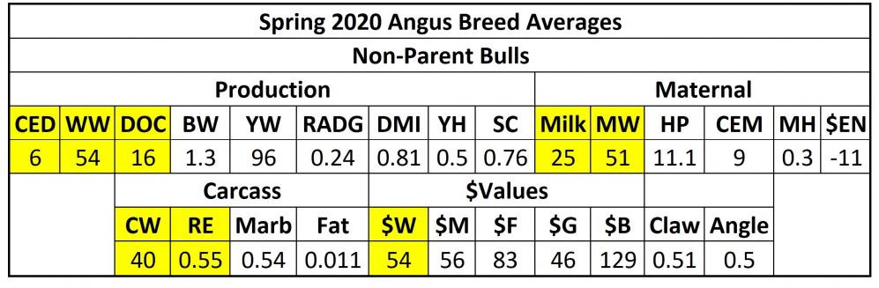

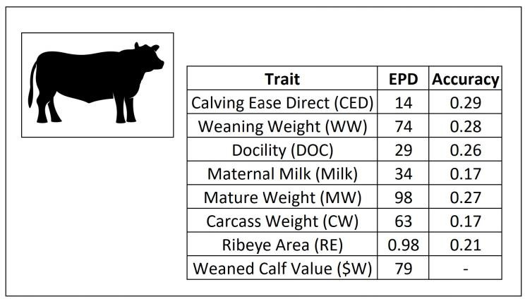
What is your maximum bid for this bull?
$
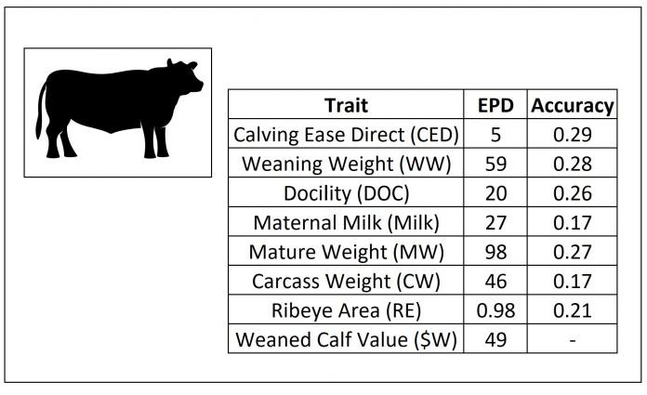
What is your maximum bid for this bull?
$
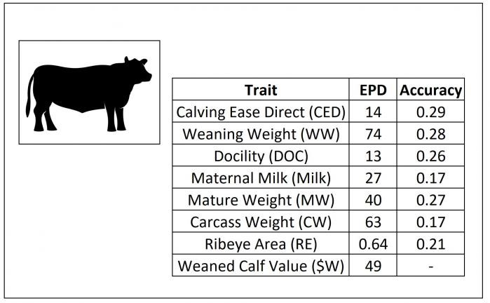
What is your maximum bid for this bull?

$

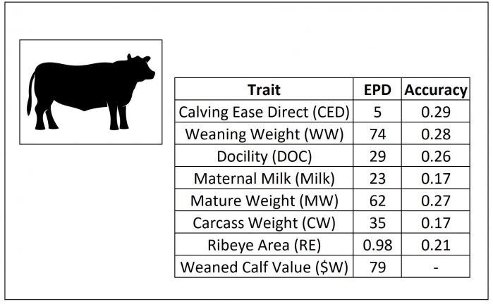

What is your maximum bid for this bull?

$

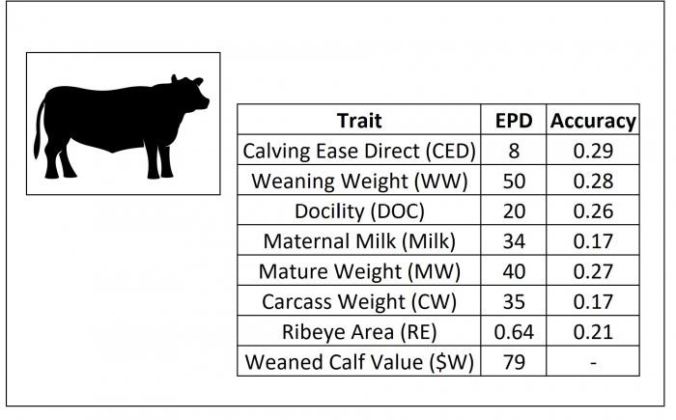
What is your maximum bid for this bull?

$

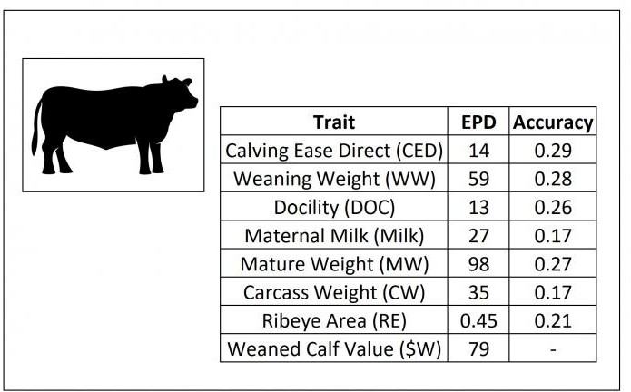

What is your maximum bid for this bull?

$
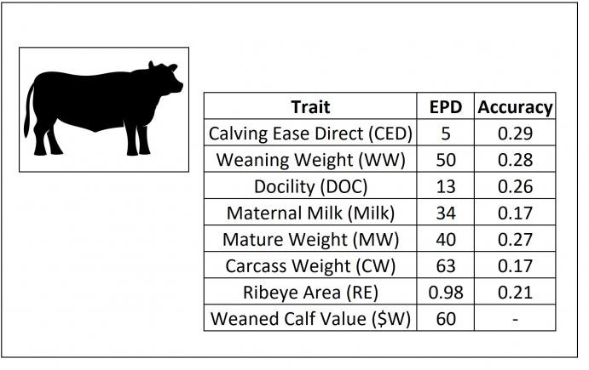

What is your maximum bid for this bull?

$

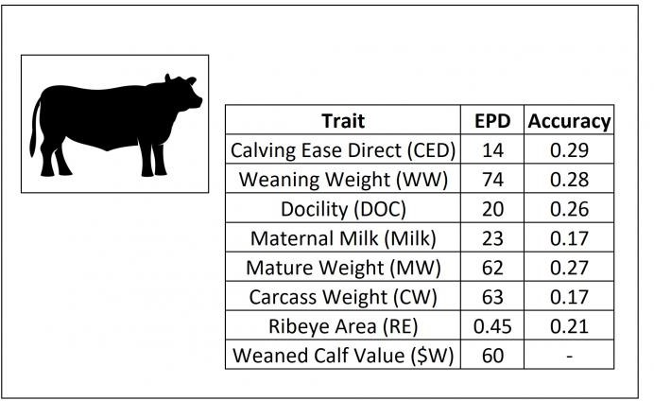

What is your maximum bid for this bull?

$
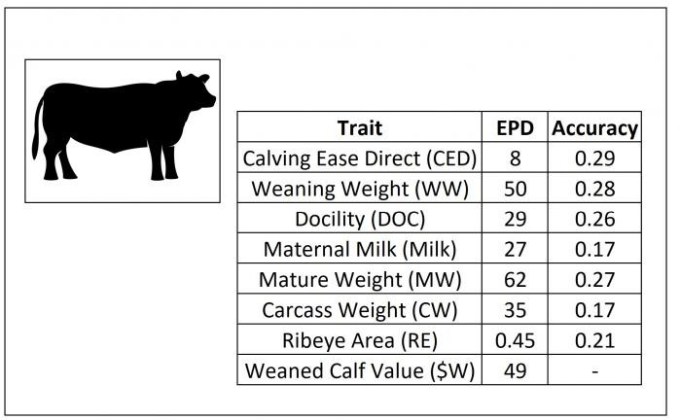

What is your maximum bid for this bull?

$

Non GE Block 2
What Can EPDs Tell Us?

Expected Progeny Differences (EPD): EPDs provide estimates of the genetic value of an animal as a parent. EPDs are calculated for birth, growth, maternal, and carcass traits and are reported in the same unit of measurement as the trait. EPD values may be directly compared only between animals of the same breed.

Accuracy: the reliability that can be placed on the EPD. A higher value for accuracy means there is an improved accuracy of the EPD. Accuracy can range in value from 0 to 1.
Accuracy is impacted by the number of progeny and ancestral records included in the analysis.

EPDs That Will Appear on the Bid Sheet:

Calving Ease Direct EPD (CED): is expressed as a difference in percentage of unassisted births, with a higher value indicating greater calving ease in first-calf heifers. It predicts the average difference in ease with which a sire’s calves will be born when he is bred to first-calf heifers.

Weaning Weight EPD (WW): expressed in pounds, is a predictor of a sire’s ability to transmit weaning growth to his progeny compared to that of other sires.

Docility EPD (DOC): is expressed as a difference in yearling cattle temperament, with a higher value indicating more favorable docility. It predicts the average difference of progeny from a sire in comparison with another sire’s calves. In herds where temperament problems are not an issue, this expected difference would not be realized.

Maternal Milk EPD (MILK): is a predictor of a sire's genetic merit for milk and mothering ability as expressed in his daughters compared to daughters of other sires. In other words, it is that part of a calf's weaning weight attributed to milk and mothering ability.

Mature Weight EPD (MW): expressed in pounds, is a predictor of the difference in mature weight of the daughters of a sired compared to the daughters of other sires.

Carcass Weight EPD (CW): expressed in pounds, is a predictor of the differences in hot carcass weight of a sire’s progeny compared to progeny of other sires.

Ribeye Area EPD (RE): expressed in square inches, is a predictor of the difference in ribeye area of a sire's progeny compared to progeny of other sires.

Weaned Calf Value ($W): An index, expressed in dollars per head, to predict profitability differences in progeny due to genetics from birth to weaning. Included traits are birth weight, weaning weight, milk, and mature cow weight.

The highlighted EPDs (described above) will vary among the bulls you are to bid on, while all others are assumed to be at the averages provided in the table below.

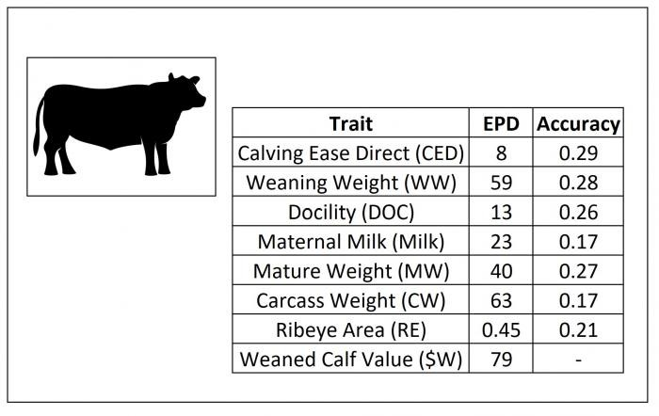
What is your maximum bid for this bull?

$
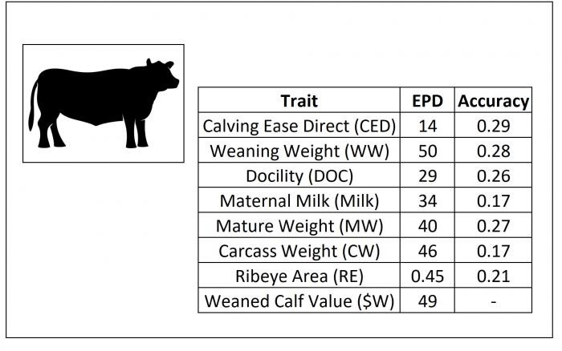
What is your maximum bid for this bull?

$

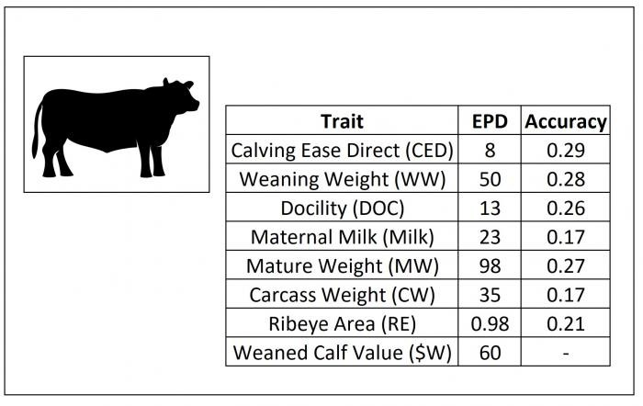
What is your maximum bid for this bull?

$

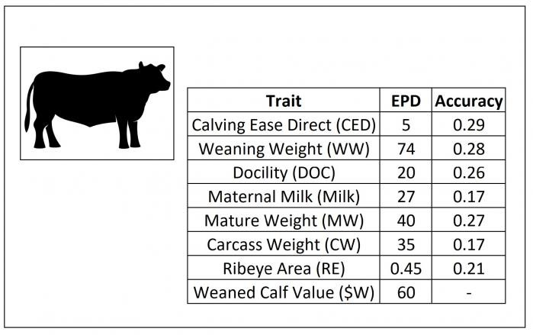
What is your maximum bid for this bull?

$

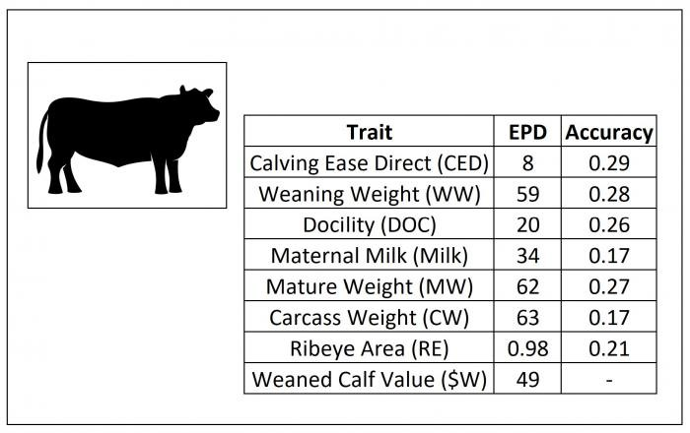
What is your maximum bid for this bull?

$

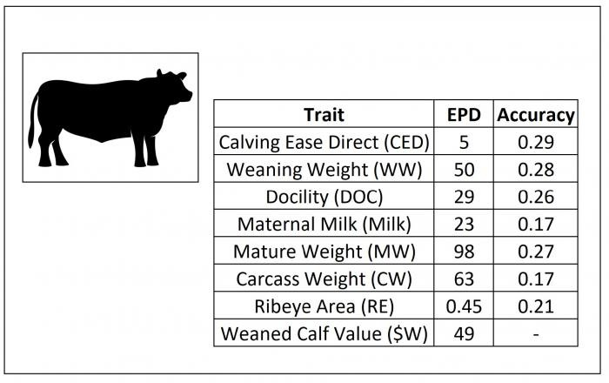

What is your maximum bid for this bull?

$

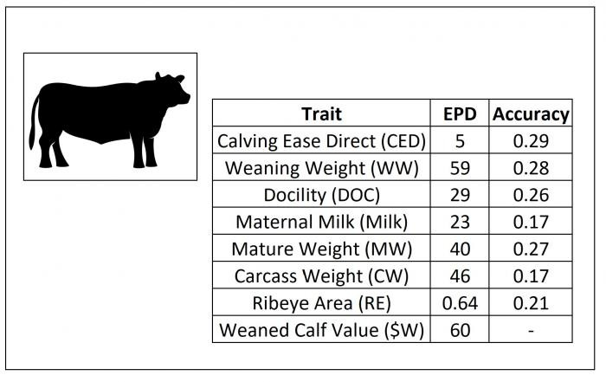
What is your maximum bid for this bull?

$

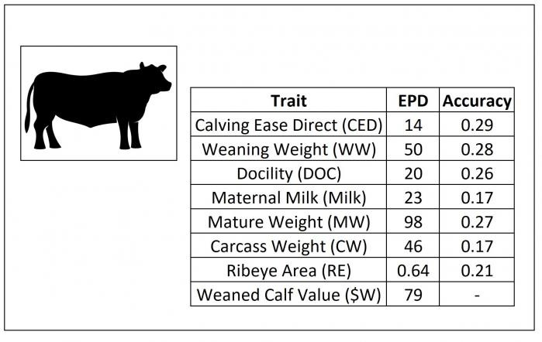
What is your maximum bid for this bull?

$
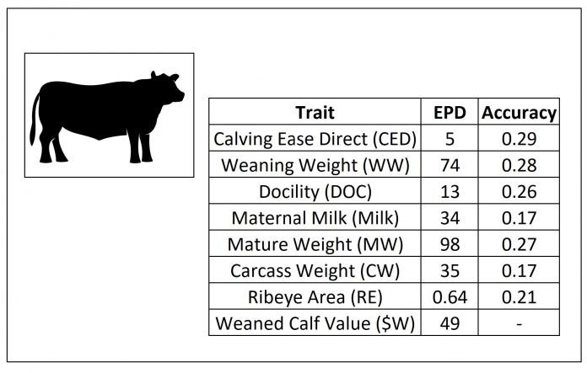
What is your maximum bid for this bull?

$

Non GE Block 3
What Can EPDs Tell Us?

Expected Progeny Differences (EPD): EPDs provide estimates of the genetic value of an animal as a parent. EPDs are calculated for birth, growth, maternal, and carcass traits and are reported in the same unit of measurement as the trait. EPD values may be directly compared only between animals of the same breed.
Accuracy: the reliability that can be placed on the EPD. A higher value for accuracy means there is an improved accuracy of the EPD. Accuracy can range in value from 0 to 1.
Accuracy is impacted by the number of progeny and ancestral records included in the analysis.

EPDs That Will Appear on the Bid Sheet:

Calving Ease Direct EPD (CED): is expressed as a difference in percentage of unassisted births, with a higher value indicating greater calving ease in first-calf heifers. It predicts the average difference in ease with which a sire’s calves will be born when he is bred to first-calf heifers.

Weaning Weight EPD (WW): expressed in pounds, is a predictor of a sire’s ability to transmit weaning growth to his progeny compared to that of other sires.

Docility EPD (DOC): is expressed as a difference in yearling cattle temperament, with a higher value indicating more favorable docility. It predicts the average difference of progeny from a sire in comparison with another sire’s calves. In herds where temperament problems are not an issue, this expected difference would not be realized.

Maternal Milk EPD (MILK): is a predictor of a sire's genetic merit for milk and mothering ability as expressed in his daughters compared to daughters of other sires. In other words, it is that part of a calf's weaning weight attributed to milk and mothering ability.

Mature Weight EPD (MW): expressed in pounds, is a predictor of the difference in mature weight of the daughters of a sired compared to the daughters of other sires.

Carcass Weight EPD (CW): expressed in pounds, is a predictor of the differences in hot carcass weight of a sire’s progeny compared to progeny of other sires.

Ribeye Area EPD (RE): expressed in square inches, is a predictor of the difference in ribeye area of a sire's progeny compared to progeny of other sires.

Weaned Calf Value ($W): An index, expressed in dollars per head, to predict profitability differences in progeny due to genetics from birth to weaning. Included traits are birth weight, weaning weight, milk, and mature cow weight.

The highlighted EPDs (described above) will vary among the bulls you are to bid on, while all others are assumed to be at the averages provided in the table below.

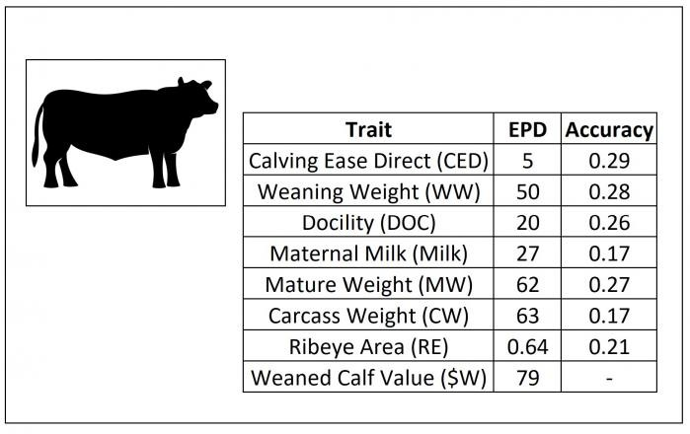
What is your maximum bid for this bull?

$

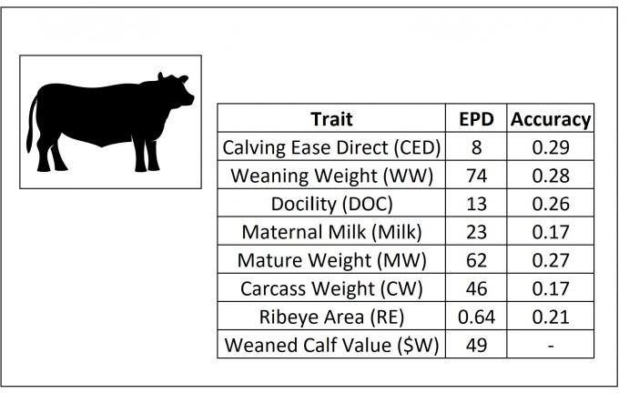
What is your maximum bid for this bull?

$
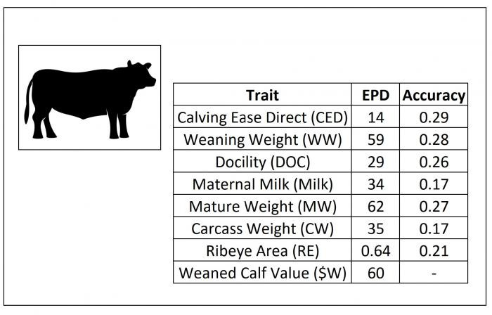
What is your maximum bid for this bull?

$

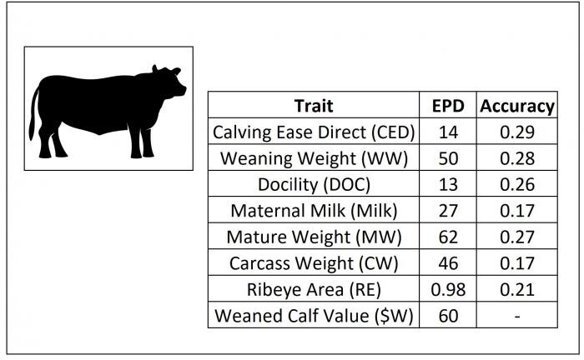

What is your maximum bid for this bull?

$

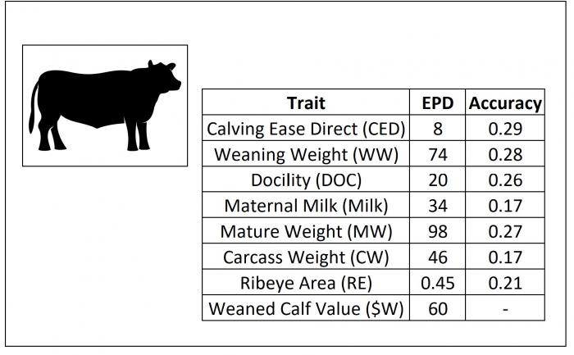
What is your maximum bid for this bull?

$

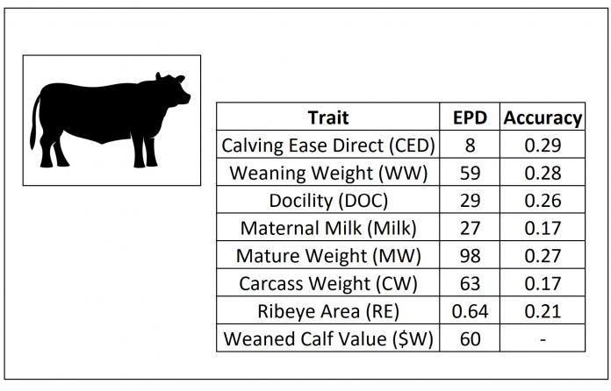
What is your maximum bid for this bull?

$
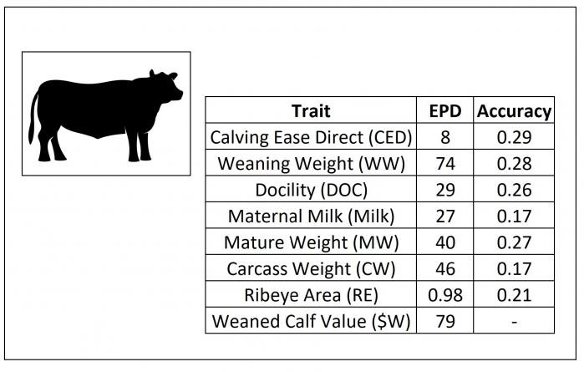
What is your maximum bid for this bull?

$

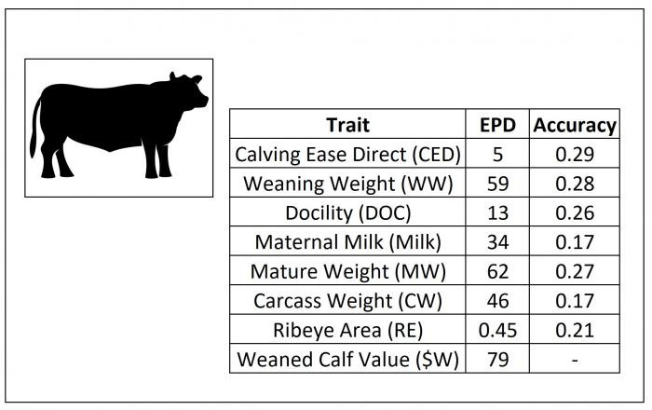

What is your maximum bid for this bull?

$

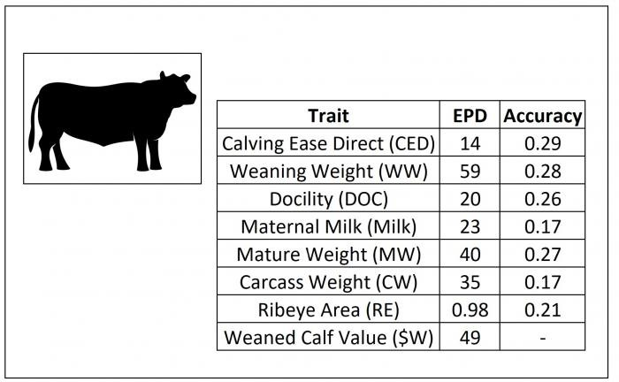
What is your maximum bid for this bull?

$

GE Block 1

What Can EPDs Tell Us?

Expected Progeny Differences (EPD): EPDs provide estimates of the genetic value of an animal as a parent. EPDs are calculated for birth, growth, maternal, and carcass traits and are reported in the same unit of measurement as the trait. EPD values may be directly compared only between animals of the same breed.

Accuracy: the reliability that can be placed on the EPD. A higher value for accuracy means there is an improved accuracy of the EPD. Accuracy can range in value from 0 to 1.
Accuracy is impacted by the number of progeny and ancestral records included in the analysis.

Genomic Enhanced Expected Progeny Differences (GE-EPD): GE-EPDs are considered to be the best estimate of an animal’s genetic worth as a parent. These values make use of known pedigree, performance, and genomic information about an animal, its progeny (offspring), and other relatives.

Adding a genomic test to GE-EPDs:

Enhances predictability of current selection tools Increases EPD accuracy on young animals
Characterizes genetics for traits where it's difficult to measure the animal’s own performance (e.g., carcass traits in breeding stock or maternal traits in bulls)
Allows EPDs to be calculated for animals that may have had blank boxes previously (e.g., single animal contemporary groups, or those without an EPD for a specific trait).

EPDs That Will Appear on the Bid Sheet:

Calving Ease Direct EPD (CED): is expressed as a difference in percentage of unassisted births, with a higher value indicating greater calving ease in first-calf heifers. It predicts the average difference in ease with which a sire’s calves will be born when he is bred to first-calf heifers.

Weaning Weight EPD (WW): expressed in pounds, is a predictor of a sire’s ability to transmit weaning growth to his progeny compared to that of other sires.

Docility EPD (DOC): is expressed as a difference in yearling cattle temperament, with a higher value indicating more favorable docility. It predicts the average difference of progeny from a sire in comparison with another sire’s calves. In herds where temperament problems are not an issue, this expected difference would not be realized.

Maternal Milk EPD (MILK): is a predictor of a sire's genetic merit for milk and mothering ability as expressed in his daughters compared to daughters of other sires. In other words, it is that part of a calf's weaning weight attributed to milk and mothering ability.

Mature Weight EPD (MW): expressed in pounds, is a predictor of the difference in mature weight of the daughters of a sired compared to the daughters of other sires.

Carcass Weight EPD (CW): expressed in pounds, is a predictor of the differences in hot carcass weight of a sire’s progeny compared to progeny of other sires.

Ribeye Area EPD (RE): expressed in square inches, is a predictor of the difference in ribeye area of a sire's progeny compared to progeny of other sires.

Weaned Calf Value ($W): An index, expressed in dollars per head, to predict profitability differences in progeny due to genetics from birth to weaning. Included traits are birth weight, weaning weight, milk, and mature cow weight.

The highlighted EPDs (described above) will vary among the bulls you are to bid on, while all others are assumed to be at the averages provided in the table below.

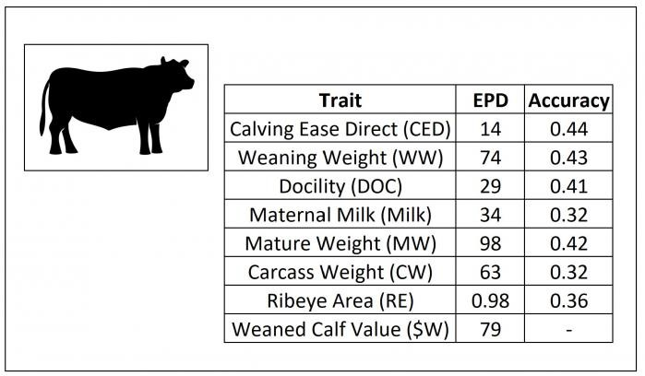
What is your maximum bid for this bull?

$

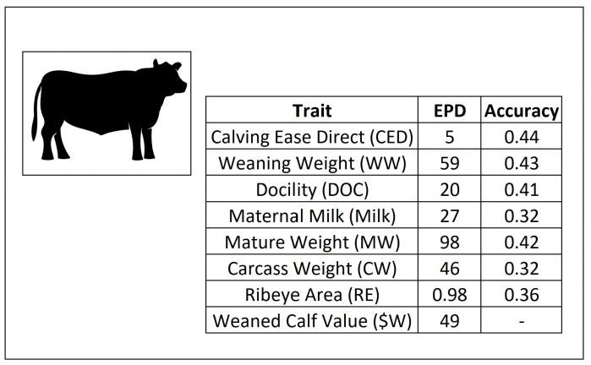
What is your maximum bid for this bull?

$
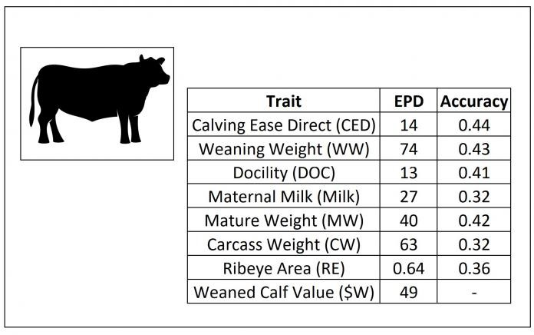

What is your maximum bid for this bull?

$

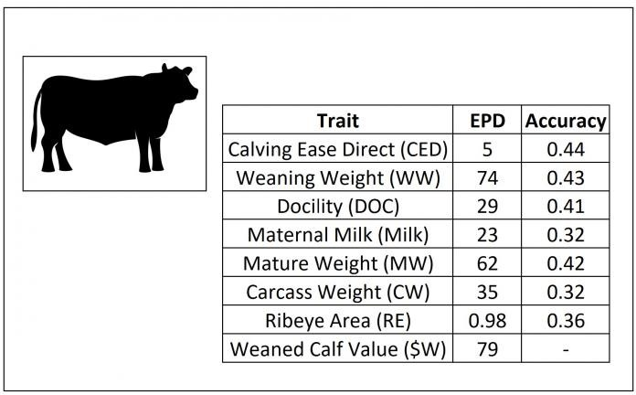
What is your maximum bid for this bull?

$
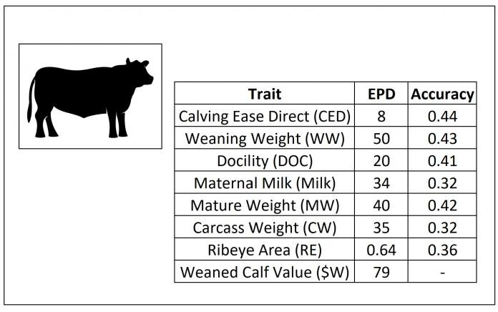
What is your maximum bid for this bull?

$

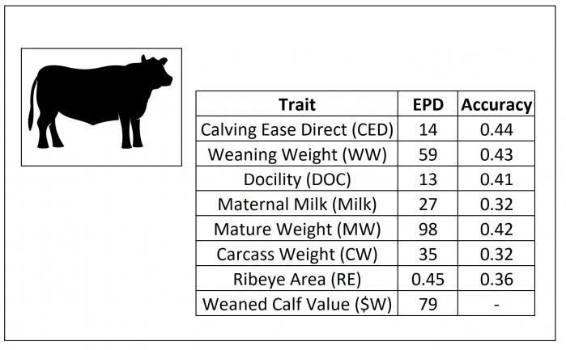
What is your maximum bid for this bull?

$

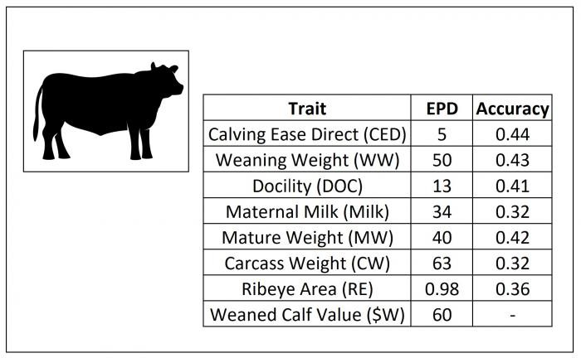
What is your maximum bid for this bull?

$

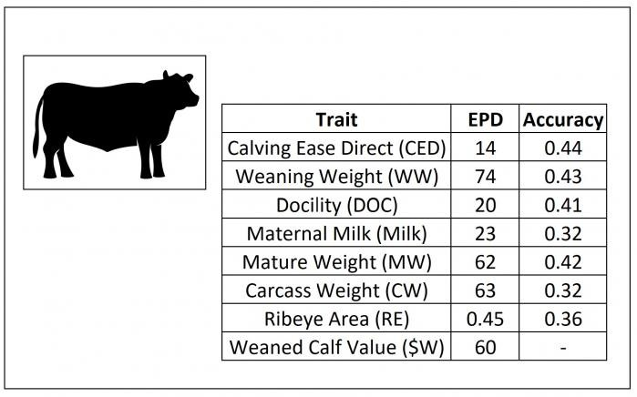
What is your maximum bid for this bull?

$
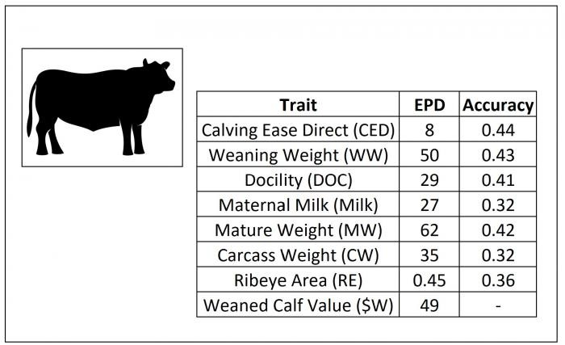
What is your maximum bid for this bull?

$

GE Block 2

What Can EPDs Tell Us?

Expected Progeny Differences (EPD): EPDs provide estimates of the genetic value of an animal as a parent. EPDs are calculated for birth, growth, maternal, and carcass traits and are reported in the same unit of measurement as the trait. EPD values may be directly compared only between animals of the same breed.

Accuracy: the reliability that can be placed on the EPD. A higher value for accuracy means there is an improved accuracy of the EPD. Accuracy can range in value from 0 to 1.
Accuracy is impacted by the number of progeny and ancestral records included in the analysis.

Genomic Enhanced Expected Progeny Differences (GE-EPD): GE-EPDs are considered to be the best estimate of an animal’s genetic worth as a parent. These values make use of known pedigree, performance, and genomic information about an animal, its progeny (offspring), and other relatives.

Adding a genomic test to GE-EPDs:

Enhances predictability of current selection tools Increases EPD accuracy on young animals
Characterizes genetics for traits where it's difficult to measure the animal’s own performance (e.g., carcass traits in breeding stock or maternal traits in bulls)
Allows EPDs to be calculated for animals that may have had blank boxes previously (e.g., single animal contemporary groups, or those without an EPD for a specific trait).

EPDs That Will Appear on the Bid Sheet:

Calving Ease Direct EPD (CED): is expressed as a difference in percentage of unassisted births, with a higher value indicating greater calving ease in first-calf heifers. It predicts the average difference in ease with which a sire’s calves will be born when he is bred to first-calf heifers.

Weaning Weight EPD (WW): expressed in pounds, is a predictor of a sire’s ability to transmit weaning growth to his progeny compared to that of other sires.

Docility EPD (DOC): is expressed as a difference in yearling cattle temperament, with a higher value indicating more favorable docility. It predicts the average difference of progeny from a sire in comparison with another sire’s calves. In herds where temperament problems are not an issue, this expected difference would not be realized.

Maternal Milk EPD (MILK): is a predictor of a sire's genetic merit for milk and mothering ability as expressed in his daughters compared to daughters of other sires. In other words, it is that part of a calf's weaning weight attributed to milk and mothering ability.

Mature Weight EPD (MW): expressed in pounds, is a predictor of the difference in mature weight of the daughters of a sired compared to the daughters of other sires.

Carcass Weight EPD (CW): expressed in pounds, is a predictor of the differences in hot carcass weight of a sire’s progeny compared to progeny of other sires.

Ribeye Area EPD (RE): expressed in square inches, is a predictor of the difference in ribeye area of a sire's progeny compared to progeny of other sires.

Weaned Calf Value ($W): An index, expressed in dollars per head, to predict profitability differences in progeny due to genetics from birth to weaning. Included traits are birth weight, weaning weight, milk, and mature cow weight.

The highlighted EPDs (described above) will vary among the bulls you are to bid on, while all others are assumed to be at the averages provided in the table below.

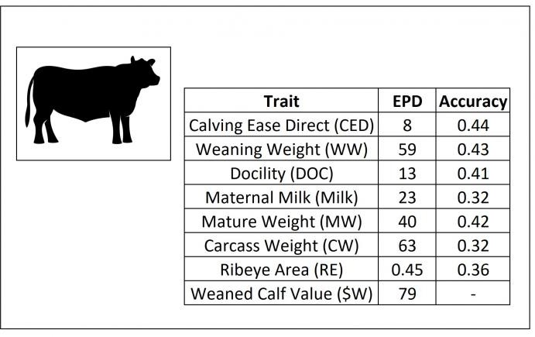
What is your maximum bid for this bull?

$

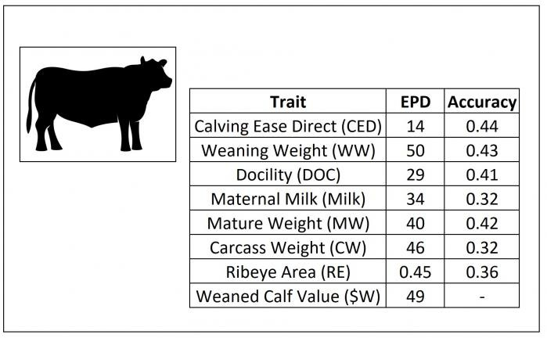
What is your maximum bid for this bull?

$

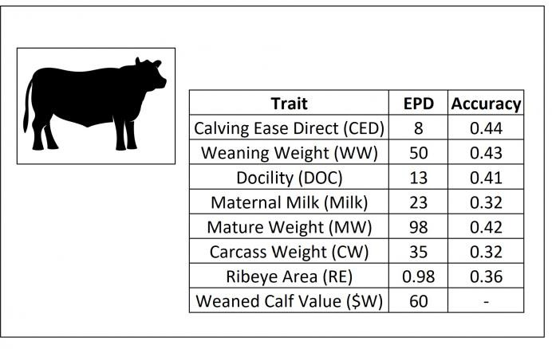
What is your maximum bid for this bull?

$

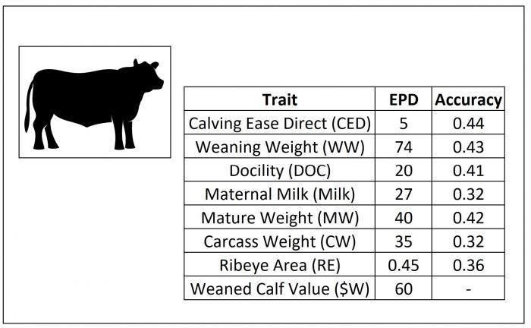
What is your maximum bid for this bull?

$

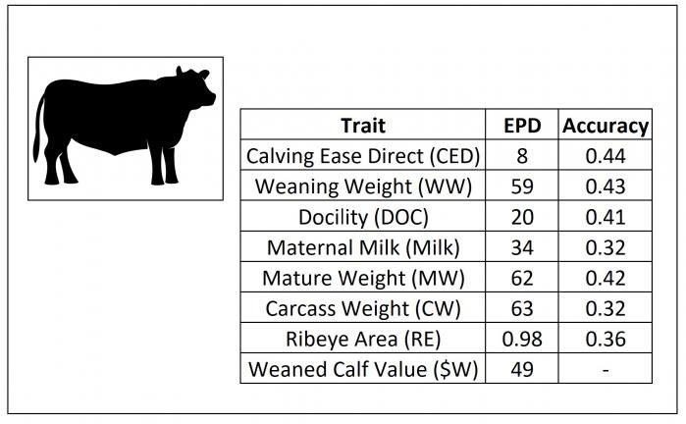
What is your maximum bid for this bull?

$

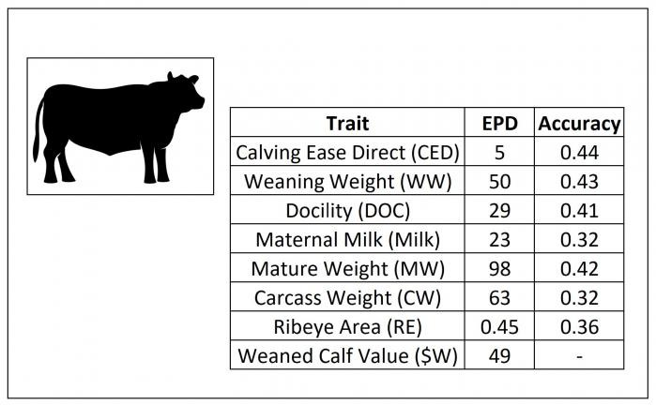
What is your maximum bid for this bull?

$

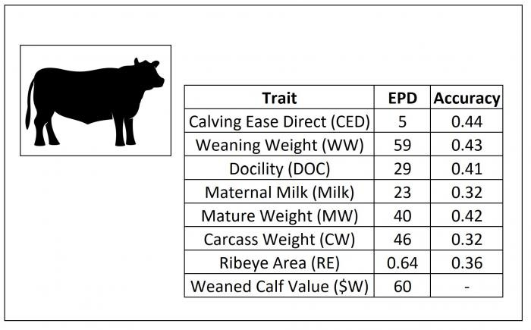

What is your maximum bid for this bull?

$

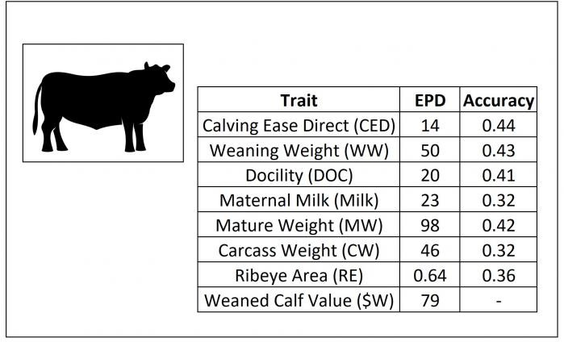
What is your maximum bid for this bull?

$

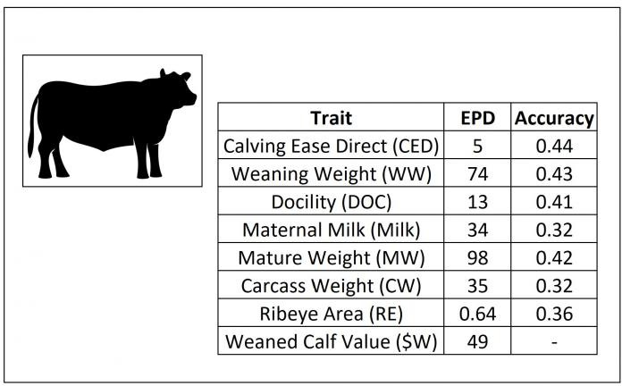
What is your maximum bid for this bull?

$

GE Block 3
What Can EPDs Tell Us?

Expected Progeny Differences (EPD): EPDs provide estimates of the genetic value of an animal as a parent. EPDs are calculated for birth, growth, maternal, and carcass traits and are reported in the same unit of measurement as the trait. EPD values may be directly compared only between animals of the same breed.

Accuracy: the reliability that can be placed on the EPD. A higher value for accuracy means there is an improved accuracy of the EPD. Accuracy can range in value from 0 to 1.
Accuracy is impacted by the number of progeny and ancestral records included in the analysis.

Genomic Enhanced Expected Progeny Differences (GE-EPD): GE-EPDs are considered to be the best estimate of an animal’s genetic worth as a parent. These values make use of known pedigree, performance, and genomic information about an animal, its progeny (offspring), and other relatives.

Adding a genomic test to GE-EPDs:

Enhances predictability of current selection tools Increases EPD accuracy on young animals
Characterizes genetics for traits where it's difficult to measure the animal’s own performance (e.g., carcass traits in breeding stock or maternal traits in bulls)
Allows EPDs to be calculated for animals that may have had blank boxes previously (e.g., single animal contemporary groups, or those without an EPD for a specific trait).

EPDs That Will Appear on the Bid Sheet:

Calving Ease Direct EPD (CED): is expressed as a difference in percentage of unassisted births, with a higher value indicating greater calving ease in first-calf heifers. It predicts the average difference in ease with which a sire’s calves will be born when he is bred to first-calf heifers.

Weaning Weight EPD (WW): expressed in pounds, is a predictor of a sire’s ability to transmit weaning growth to his progeny compared to that of other sires.

Docility EPD (DOC): is expressed as a difference in yearling cattle temperament, with a higher value indicating more favorable docility. It predicts the average difference of progeny from a sire in comparison with another sire’s calves. In herds where temperament problems are not an issue, this expected difference would not be realized.

Maternal Milk EPD (MILK): is a predictor of a sire's genetic merit for milk and mothering ability as expressed in his daughters compared to daughters of other sires. In other words, it is that part of a calf's weaning weight attributed to milk and mothering ability.

Mature Weight EPD (MW): expressed in pounds, is a predictor of the difference in mature weight of the daughters of a sired compared to the daughters of other sires.

Carcass Weight EPD (CW): expressed in pounds, is a predictor of the differences in hot carcass weight of a sire’s progeny compared to progeny of other sires.

Ribeye Area EPD (RE): expressed in square inches, is a predictor of the difference in ribeye area of a sire's progeny compared to progeny of other sires.

Weaned Calf Value ($W): An index, expressed in dollars per head, to predict profitability differences in progeny due to genetics from birth to weaning. Included traits are birth weight, weaning weight, milk, and mature cow weight.

The highlighted EPDs (described above) will vary among the bulls you are to bid on, while all others are assumed to be at the averages provided in the table below.

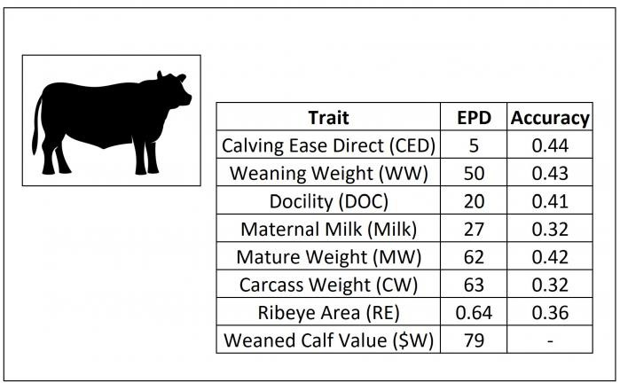
What is your maximum bid for this bull?

$

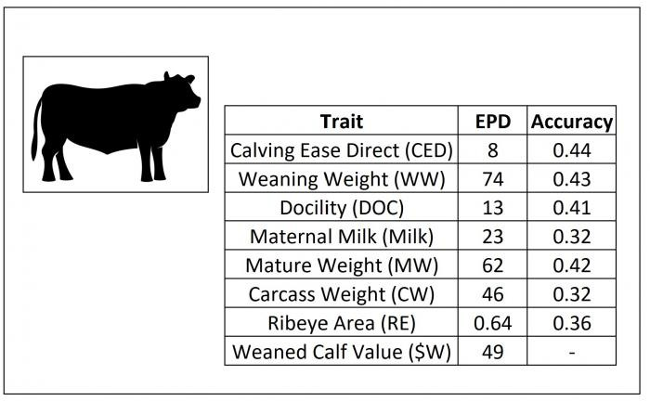
What is your maximum bid for this bull?

$
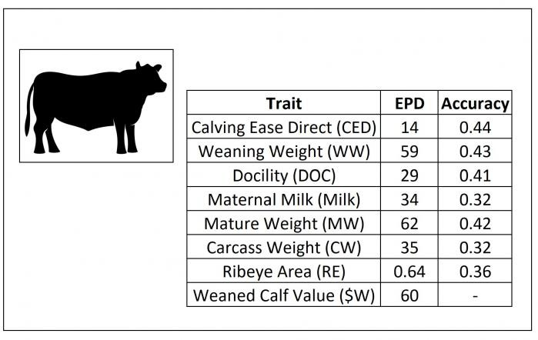

What is your maximum bid for this bull?

$

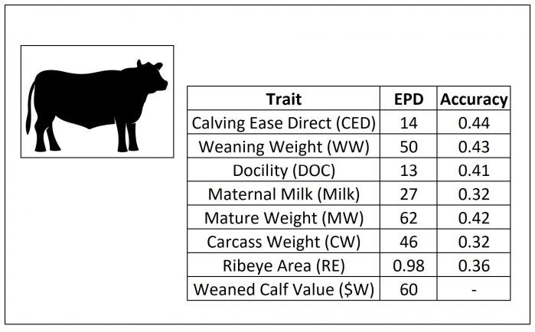
What is your maximum bid for this bull?

$

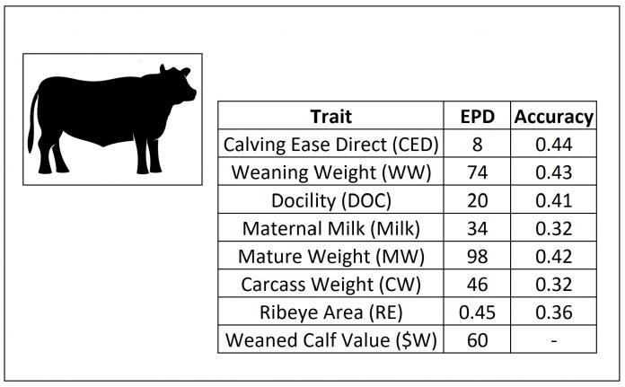
What is your maximum bid for this bull?

$

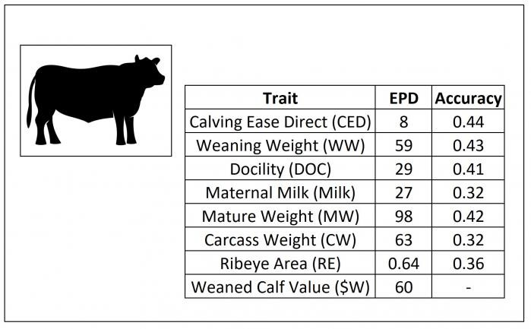
What is your maximum bid for this bull?

$
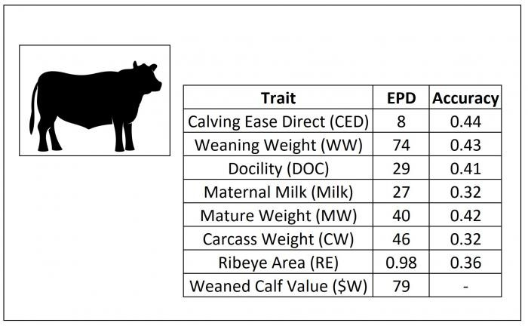
What is your maximum bid for this bull?

$

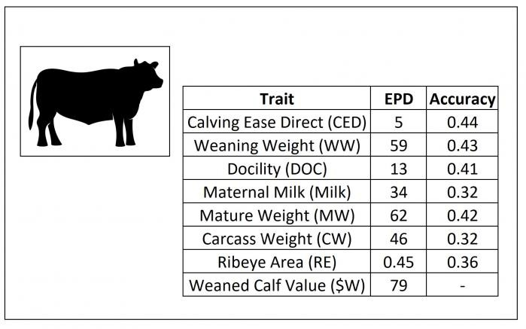
What is your maximum bid for this bull?

$
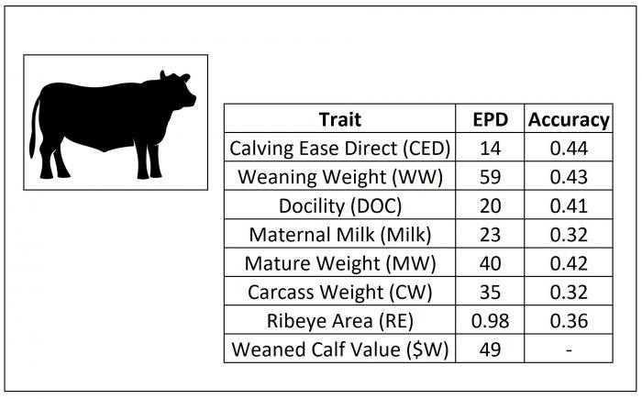

What is your maximum bid for this bull?

$

Feeder Cattle Genomic Test.

When do you market your cattle (check all that apply)?

 At weaning

After a stocker or backgrounder stage Retain ownership through finishing

Genomic tests are available to use on feeder calves to determine how well they will perform in the feedlot. For example, these feeder cattle genomic tests can provide 1-10 scores on several traits to allow producers to rank cattle based on their operation goals.

Performance traits include: Carcass Traits include:
- Residual Feed Intake (1) Tenderness
- Average Daily Gain (2) Marbling
- Weaning Weight (3) Ribeye Area
- Yearling Weight (4) Fat Thickness
- Hot Carcass Weight

Would you be interested in using these feeder cattle genetic tests to market your steers and heifers?

 Yes No

Would you be interested in using these feeder cattle genetic tests to determine which heifers to use as replacement heifers?


 Yes No

With respect to these feeder cattle genomic tests, we are interested in what you might be willing to pay for these tests to use on your feeder cattle. The test currently ranges in price from $17 per head to $37 per head. What is the maximum amount per head you would be willing to pay for these genetic tests?

$

With respect to these genomic tests, we are interested in what you might be willing to pay for these tests to use on your replacement heifers. The test currently ranges in price from $17 per head to $37 per head. What is the maximum amount per head you would be willing to pay for these genetic tests?

$

What percentage of your feeder cattle would you consider having tested with the newly available genetic tests?

%

What percentage of your replacement heifers would you consider having tested with the newly available genetic tests?

%

Please check all of the reasons why you would be willing to pay for genetic testing of your feeder cattle.

 To determine whether to retain ownership of my animal.  To receive information on the genetic merit of my animal.  To use the information to market my cattle.
 To determine whether to retain my replacement heifer.


Other

UT Bull Test and TN Ag Enhancement

Have you purchased bulls from the UT Bull Test?


 Yes No

Assuming both bulls were identical in all other ways, would you pay more for a bull from the UT Bull Test compared to a bull from other bull auctions?

 Yes No

Have you purchased a bull that qualifies for the Tennessee Agricultural Enhancement Genetics Cost-Sharing Program before?


 Yes No

If a bull qualifies for the Tennessee Agricultural Enhancement Genetics Cost-Sharing Program, does this make you more likely to purchase the bull?

 Yes No

About Your Farm

For the next few questions, we are going to ask you for information about your farm.

Which of the following best describes your farming business?

 Sole Proprietorship  Partnership
 Corporation
 Other (please describe)

How many head of the following types of cattle were in your care on January 1, 2020?

Brood Cows
Beef Replacement Heifers Unweaned Calves
Home-raised Weaned Calves (preconditioned<90 days, backgrounders >=90 days)
Bulls (herd sires)
Purchased Stockers/Backgrounders Dairy Cows
Dairy Replacement Heifers Other
Please describe other

What sire breeds are used in your herd? (Select all that apply)

 Black Angus  Hereford

 Simmental Charolais
Crossbred, please describe breeds Other, please describe breeds

How many acres did you farm in 2019?

Pastue Hay
Harvested Cropland Woodland Grazed Woodland Not Grazed Other
Please describe other
About You

For the next few questions, we are going to be asking you information about yourself.

In what year did you become a primary farm business decision maker?

In what year were you born?

What gender are you?

 Male  Female
 Prefer not to disclose

What is your highest level of education?

 Less than High School  High School Graduate
 Some College or Technical School  Technical School Diploma
 Associate's Degree
 Bachelor's Degree
Master's Degree
Doctorate
 Other

Prefer not to answer

What is your race?


 White Hispanc

 Native American  African American  Asian
Other

 Prefer not to answer

Which category best reflects your total taxable household income (from both farm and non- farm sources) for 2019? Remember, all financial and other information is held strictly confidential.

 Less than $10,000  $10,000-$29,999
 $30,000-$49,999 $50,000-$99,999
 $100,000-$149,999 $150,000-$199,999 $200,000-$249,999 $250,000-$499,999

 $500,000 or greater Prefer not to disclose

What percent of your total taxable household income (both farm and non-farm sources) for 2019 do you estimate came from farming?

 0% to 19.99%
 20% to 39.99%
 40% to 59.99%
 60% to 79.99%
 80% to 100.00%

Prefer not to disclose
What percent of your 2019 farm income do you estimate came from your beef cattle operations?
 0% to 19.99%
 20% to 39.99%
 40% to 59.99%
 60% to 79.99%
 80% to 100.00%
 Prefer not to disclose

On average, how many hours per week do you spend working:

On Farm?
Off Farm?
I obtain information used in making my beef cattle business decisions from the following sources (check all that apply):

 University of Tennessee Extension service (ex: meetings, conferences, and publications)
 Other state Extension services (ex: meetings, conferences, and publications)
 State or local producer groups (ex: Tennessee Cattlemen’s Association)
 National producer groups (ex: National Cattlemen’s Beef Association, R-CALF)
Registered Beef Cattle Associations (ex: American Angus Association, American Simmental Association)
 Popular press articles (ex: Drovers, Beef Magazine, Cattle Today, Southeast Farm Press, etc.) Television programming (RFD TV)
 United States Department of Agriculture (NASS, AMS, NRCS, FSA, etc.)  Livestock marketing associations
 Livestock market owners and operators Seed stock producers

Other cattle farmers  Internet sites
Other, Please describe:

Have you completed UT Extension's Master Beef Producer program


Yes

No

What is your willingness to take risks in the following activities with 1 indicating 'not at all willing to take risks' and 10 indicating 'very willing to take risks'? (Please indicate one rating for each activity)

Overall financial matters
Financial matters related to the beef cattle business
Herd management practices
Adopting new farm technologies
Finding new market outlets
Retaining ownership

Not at all willing to take risks (1)












2 3 4 5 6 7 8 9











































Very willing to take risks (10)








Please provide any additional comments you may have about this study, beef cattle EPD use in purchasing bulls, or beef cattle industry research needs

Powered by Qualtrics

VITA

Jane X. Doe was born. She wrote a thesis. She graduated. She followed instructions and wrote her vita in third person and paragraph form (as opposed to a resume or CV), which made her thesis consultant very happy. This page is required.

