A FRAMEWORK FOR ESTIMATING HYBRID MANUFACTURING COSTS

A Thesis Presented for the
Master of Science
Degree
The University of Tennessee, Knoxville

Nathan Joel Wilson
May 2024

Copyright © 2024 by Nathan J. Wilson
All rights reserved.

I would like to dedicate this work to my ever loyal and supportive wife for whom I am entirely and completely grateful. Words cannot quantify the work and effort she has put into enabling me to further my education. From moving across the country, to raising our child, she has given her heart and soul to helping me achieve my goals.

ACKNOWLEDGEMENTS

I would like to thank my professor, Dr. Tony Schmitz for giving me the chance to attend the University of Tennessee. He took a chance on me, a dual master’s degree student, and provided me the opportunity to research a topic that blended my love for engineering and business. He was patient and understanding while coaching me throughout the course of my master’s program. While our time working together was short, his examples of hard work, leadership, dedication, compassion, and overall concern for the well-being of his students will be my constant teachers for a long time to come.

Additionally, I would like to thank all the other wonderful students and people I had the chance to work with. Timothy No, Rob Patterson, Josh Kincaid, Eli Charles, Tyler Poon, and Gregory Corson were all especially helpful and patient with my barrages of emails as I gathered data for this thesis. They and all the other students working at the MTRC were exemplary demonstrations of professionalism, hard work, and intelligence. I am grateful for the opportunity to have collaborated with them.

And lastly, I would like to thank the University of Tennessee for providing me with a program that fit me and my family’s needs. Being a part of the UT family is a blessing I did not know I was missing. It has been a joy and an honor to attend this institution where I learned the importance of “shadowing” myself to “give light to others.”

“He that beareth a torch shadoweth himself that he may give light to others.”

- Volunteer Creed

ABSTRACT

Based on its potential to reduce lead times, hybrid manufacturing, which often includes both additive manufacturing and machining processes, is receiving more attention from manufacturers as they seek to increase their supply chain resilience and efficiency. A new solid-state additive manufacturing method, referred to as additive friction stir deposition (AFSD), has shown the potential to become an important process for hybrid manufacturing. To justify the selection of a hybrid manufacturing approach, the cost needs to be estimated for comparison to conventional approaches. This thesis proposes a suite of cost models that include AFSD, powder bed fusion (PBF), wire arc additive manufacturing (WAAM), fused filament fabrication (FFF), structured light scanning (SLS), milling, and turning, which can be combined in hybrid manufacturing process planning. The cost models are applied to three case studies and cost estimates are compared for hybrid and conventional (machining-only) manufacturing approaches.

TABLE OF CONTENTS

Chapter 1 Introduction and General Information 1
Research Objective 1
Definition of Scope 2
Cost Modeling Approaches 2
Accounting Definitions 3
Chapter 2 Background and Literature Review 4
Hybrid Manufacturing 4
Manufacturing Processes 5
AFSD 5
WAAM 6
PBF 6
FFF 7
SLS 7
Conventional Machining Methods 8
Chapter 3 Methodology 9
Literature Review 9
Validation with Subject Matter Experts 9
Case Studies 9
Chapter 4 Cost Models 10
Limitations 10
AM Cost Models 11
AFSD 11
FFF 12
PBF 13
WAAM 14
Metrology Cost Models 16
SLS 16
Subtractive Process Cost Models 16
Milling and Turning 16
Chapter 5 Case Studies 19
Hexagon-Cylinder 19
Hybrid Manufacturing 19
Conventional Three-axis Milling 31
Discussion 37
Engine Block 37
Hybrid Manufacturing Process 38
Conventional Three and Five-axis Milling 44
Discussion 50
Machine Tool Crossbeam 55
Chapter 6 Conclusion 61
List of References 62
Appendices 69
Appendix A – Hexagon-cylinder: Hybrid method MATLAB code 70
Appendix B – Hexagon-cylinder: Conventional method MATLAB code 85
Appendix C – Engine block: Hybrid method MATLAB code 90
Appendix D – Engine block: Conventional method MATLAB code 105
Appendix E – Machine tool crossbeam: Hybrid method MATLAB code 114
Appendix F – Machine tool crossbeam: Third party quotes 119
Vita 122

LIST OF TABLES

Table 5.1 AFSD cost model variables, values, and units for the hexagon-cylinder. 23
Table 5.2. AFSD cost model summary. 24
Table 5.3. SLS cost model variables, values, and units for the hexagon-cylinder. 27
Table 5.4. SLS cost model summary. 28
Table 5.5. Milling cost model variables, values, and units for the hexagon-cylinder (produced by hybrid manufacturing). 29
Table 5.6. Milling cost model summary. 30
Table 5.7. Turning cost model variables, values, and units for the hexagon-cylinder. 32
Table 5.8. Turning cost model summary. 33
Table 5.9. Total combined costs listed by manufacturing process. 33
Table 5.10. Total combined costs listed by spend category. 33
Table 5.11. Conventional milling cost model variables, values, and units for the hexagon-cylinder (produced by three-axis milling). 34
Table 5.12. Conventional milling summary. 35
Table 5.13. Input values for the SLS calculator taken from both SLS procedures and combined for simplicity. 41
Table 5.14. Cost summary and breakdown for the SLS processes. 41
Table 5.15. Engine block AFSD cost model inputs. 43
Table 5.16. AFSD cost summary and breakdown. 43
Table 5.17. Engine block three-axis mill input variables. 46
Table 5.18. Engine block five-axis mill input variables. 47
Table 5.19. three-axis milling cost breakdown and summary. 48
Table 5.20. five-axis milling cost breakdown and summary. 48
Table 5.21. Hybrid manufacturing combined total cost broken down by manufacturing process. 48
Table 5.22. Hybrid manufacturing combined total cost broken down by cost categories. 49
Table 5.23. Conventional three-axis milling cost model input parameters. 51
Table 5.24. Conventional five-axis milling cost model input parameters. 52
Table 5.25. Conventional three-axis milling cost breakdown and summary. 53
Table 5.26. Conventional five-axis milling cost breakdown and summary. 53
Table 5.27. Total conventional cost by manufacturing process. 53
Table 5.28. Conventional manufacturing costs by category. 54
Table 5.29. WAAM cost model input variables, values, and units for the machine tool crossbeam. 59
Table 5.30. WAAM cost summary and breakdown. 60
Table 5.31. WAAM cost estimate comparison. 60

LIST OF FIGURES

Figure 5.1.The final hexagon-cylinder produced using hybrid manufacturing (AFSD, SLS, milling, and turning) with a 150 mm (5.9”) ruler for scale. 20
Figure 5.2. Toolpaths with feedstock reload locations are shown for the hexagon. 22
Figure 5.3. Toolpaths and feedstock reload locations are shown for the (a) cylinder with (b) an expanded view. 22
Figure 5.4. Hexagon preform (a) during and (b) after deposition. 22
Figure 5.5. The cylinder preform is displayed (a) during and (b) after deposition. 23
Figure 5.6. A structured light scan of the hexagon preform (deposited on a baseplate) was aligned to the CAD model to define the machining coordinate system. 26
Figure 5.7. Machining toolpaths for (left) hexagon and (right) baseplate after inverting the part. 26
Figure 5.8. (Left) hexagon milling with face mill and (right) inverted part after milling was complete. 26
Figure 5.9. (Left) preform clamped in machine spindle prior to turning and (right) after turning operations for the outside and inside diameters were completed. 27
Figure 5.10. (Left) The first setup showing milling tool paths to machine the hexagon geometry from wrought stock. (Right) The second setup showing milling tool paths to machine the cylindrical geometry. 34
Figure 5.11. Original Mitsubishi engine block with fiducial stickers utilized in the SLS scan. 39
Figure 5.12. (Left) SLS scan of the Mitsubishi engine block. (Right) SLS scan transferred to STL format. 39
Figure 5.13. CAD model derived from the SLS scan of the original Mitsubishi engine block. 39
Figure 5.14. AFSD tool path with feedstock reload locations. 40
Figure 5.15. AFSD deposition pre SLS scan with cut baseplate and fiducial stickers. 40
Figure 5.16. SLS scan of AFSD deposition to establish coordinate system for machining tool paths. 40
Figure 5.17. Preform post three-axis milling. Notice the predrilled holes coming out of the bottom surface. The fiducial stickers are left over from SLS process. 45
Figure 5.18. Five-axis CNC machining of the preform. 45
Figure 5.19. Final product after all machining processes. 45
Figure 5.20. (Left) CAD model of the original machine tool cross beam. (Right) Physical representation of the crossbeam. 56
Figure 5.21. CAD rendering of the proposed design for the machine tool crossbeam. 56
Figure 5.22. The medUSA WAAM machine features three GMAW welders fastened to robotic arms that operate simultaneously. 56
Figure 5.23. The five prefabricated build plates upon which the material was deposited. 58
Figure 5.24. Final product at 77% completion. Notice the warpage between the part and the build table. 58

Chapter 1
Introduction and General Information

With increased attention paid to supply chain resilience globally, reducing lead times is becoming progressively more important [1]. Greater focus has been placed on hybrid manufacturing processes as a potential solution for reducing costs related to lead times as well as improving supply chain efficiency and agility [2]. In this context, hybrid manufacturing represents a combination of two or more conventional manufacturing processes [3]. Due to the large number of manufacturing processes, it can be difficult to accurately estimate part production cost without access to process-specific cost models for all manufacturing processes included in the hybrid manufacturing plan. Many such process specific cost models have been published, but not with the intent of being used in a hybrid manufacturing format. A few hybrid manufacturing cost estimation frameworks have been published, but a unified framework with accurate, detailed models is not currently available [4][5].

This thesis provides a suite of seven process specific cost models that can be adapted and used for many different hybrid manufacturing sequences. The processes are additive friction stir deposition (AFSD), wire arc additive manufacturing (WAAM), powder bed fusion (PBF), fused filament fabrication (FFF), measurement of the preform using structured light scanning (SLS), and the conventional machining operations milling and turning. Prior to presenting the cost models the research objective and scope are provided, as well as background information and a literature review.

Research Objective

While performing the literature review on manufacturing cost models, a few research gaps were identified. First, there are no prior publications detailing AFSD or SLS cost models. Second, though there are some WAAM cost models, this process has not been documented as thoroughly as more well-known additive manufacturing processes like FFF or PBF. With regards to hybrid manufacturing, a few frameworks for estimating costs have been created (see chapter 2), but they are either too general or only cover two or three processes [4][5][6][7]. While cost models exist for most of the processes included in this thesis, since each model has a different approach for evaluating costs, it would be difficult to combine them into a single hybrid manufacturing format. For example, one cost model may estimate energy costs, but ignore depreciation and maintenance costs. Another model could do the opposite. Without a uniform cost estimation framework, it is difficult to combine cost models for hybrid manufacturing sequences.

The goal of this thesis is to provide the necessary framework by offering a suite of manufacturing cost models that are cohesive in approach, simple to use, accurate, and adaptable to many hybrid processes. These cost models could be used as a tool for further research in evaluating the economic viability of hybrid manufacturing processes. It could also be useful for companies or research labs that want to perform sensitivity analyses on specific input variables or processes. As manufacturing technology advances, these cost models could be used to evaluate the economic impact of these technological developments.

Definition of Scope

The purpose of this thesis is to create and present a cost estimation framework to: 1) enable a cost-based selection of hybrid manufacturing process sequences; and 2) guide future fundamental and applied research and development activities conducted by academia and industry. To support this agenda, Chapter 5 details three case studies that show how these cost models can be used to evaluate and compare costs. The purpose of these case studies is demonstrational and not intended to critique the processes evaluated. As such, sensitivity analyses and comprehensive industry evaluations are outside the scope. The framework can be expanded, adapted, or further developed to aid in performing these tasks as part of future work.

As the aim of this thesis is to develop cost models for manufacturing processes, only production costs are included in the cost models. For example, because machine use and wear are directly associated with each part production, depreciation costs are incorporated into the cost models. Conversely, since administrative costs are not directly associated with each part they are not considered. Additionally, though important, pre and post manufacturing activities such as path programming and clean-up are not considered.

Further, the goal of the framework is to provide cost models that are as accurate as possible, while still being convenient to implement. Generally, more variables increase accuracy at the expense of usability. The opposite is also typically true. The cost models are based on the specific activities performed in each manufacturing process. While it is possible to develop comprehensive, physics-based models, for simplicity and ease of use, only key variables are considered. Where possible, equations for predicting process outcomes are provided. The capability to use measured values is also provided.

Cost Modeling Approaches

The accurate calculation of production costs is vital to the success of manufacturing companies [8]. Various methods and models are available. Examples include traditional cost modeling, activity-based cost modeling (ABC), and parametric cost modeling [9]. For hybrid manufacturing, activity-based and parametric cost modeling are well-suited to describing and predicting the costs incurred by part production [4]. Parametric cost modeling uses statistical methods to evaluate the relationship between inputs including part size, volume, material type, and production cost. It identifies which variables most affect production cost [8]. To do this it requires a dataset of inputs from past parts. ABC modeling, on the other hand, considers the specific activities undergone in each process, often using physics in cost estimating equations [10]. Because all that is required to use ABC costing are input values specific to the part being made, it is extremely flexible and usable. As the goal of this thesis is to provide a tool that can be utilized in a wide variety of applications, and parametric cost modeling would have required each user to have a data set of past parts with specific input variables, ABC was selected as the cost modeling approach this thesis.

ABC was introduced to address the difficulty of attributing indirect costs to individual parts [11]. Traditional costing methods only evaluate direct labor and materials costs. ABC accounts for both direct and indirect costs in part production [12]. As noted, ABC is process-dependent and relies on the physics of each manufacturing process to predict the corresponding costs more accurately [10]. ABC makes it possible to attribute indirect costs to each part produced.

Various cost models have been published applying these principles to hybrid manufacturing. Langmaak et al. used ABC to construct their “generic factory cost model [4].” While their cost model was built to estimate costs for a certain part, it demonstrates the utility of ABC in hybrid manufacturing. Oyesola et al. and Manogharan et al. also used an ABC approach for their hybrid cost models [5][6]. Parametric cost modeling lends itself to building specific tools for specific situations, but in creating generic and flexible cost models for hybrid manufacturing, ABC is the most widely accepted and utilized [10].

Accounting Definitions

Managerial accounting is chiefly concerned with gathering information needed for decision-making [13]. In contrast to financial accounting, which is focused on creating financial reports for people outside the organization, managerial accounting is intended for internal use. Because the cost models presented here are useful for internal decision-making, principles from managerial accounting were applied.

In managerial accounting, there is a difference between product costs and period costs. Product costs are those directly related to production. This could include material, labor, facility rental, and utilities, for example. Period costs are those that do not directly apply to production, such as insurance, marketing, sales, and salaries of support personnel, for example. The focus of this thesis is estimating the cost of making a specific part using hybrid manufacturing. Because period costs do not contribute directly to part production costs, they are not considered here.

Production costs are divided into two categories: direct costs and indirect costs. Direct costs are defined as any cost that can be directly traced for each part. Examples include material and labor costs since these values are exactly known. In contrast, indirect costs are classified as those that are not conveniently traceable but still contribute to the overall manufacturing cost for a selected part. Typical examples include space use, energy use, depreciation, and maintenance. Not only are these costs challenging to quantify for each part, but they are also subjective, particularly for depreciation and maintenance [14]. The exact depreciation cannot be known but can still represent a significant cost [4]. For the cost models presented in this thesis, energy will actually be considered as a direct cost since many labs and manufacturing plants have the capability of tracking energy consumption.

Chapter 2
Background and Literature Review

A literature review is presented for: hybrid manufacturing, AFSD, WAAM, PBF, FFF, SLS, machining, and turning. For the individual manufacturing processes, the focus of the literature review is prior cost modeling research. Because AFSD is a newer technology, background on the technology is included.

Hybrid Manufacturing

Hybrid manufacturing is any combination of two or more manufacturing processes to produce a single part [3]. The processes can be separated into additive and machining (subtractive) categories [6], where their combination can reduce lead times and improve supply chain efficiency [16]. Additive manufacturing (AM) processes, such as AFSD, WAAM, PBF, and FFF, increase manufacturing agility and flexibility by producing complex geometries without dies, molds, or tooling [15][17]. Additive processes can also be more energy efficient and reduce material use relative to traditional manufacturing processes [18]. Subtractive manufacturing, such as computer numerical control (CNC) milling and turning, complements these processes by achieving the surface finish and part tolerances that additive processes cannot match, in general [19]. Prior research has shown that additive and machining processes can be used in a variety of combinations [17][20][21][22]. In some instances, measurements processes are incorporated into hybrid manufacturing sequences [22], which improves process efficiency by the addition of metrology to enable coordinate systems transfer between additive and machining processes [21][23][24][25]. Additionally, metrology is used to assess the part quality [25]. With the growing quantity and popularity of hybrid methods, it is becoming increasingly important to quantify their economic impact.

Various attempts at capturing the costs of hybrid manufacturing processes have been made.
In 2013, Langmaak et al. created two cost estimation tools, one for general factory cost, and one for specific aerospace part cost [4]. In 2016, Manogharan et al. developed a hybrid process cost model that incorporated AM, CNC machining, and beam melting (EBM) [6]. Oyesola et al. provided a general equation to analyze manufacturing costs for hybrid processes including both additive and subtractive manufacturing [5]. While these equations are useful and include all aspects of the manufacturing process (e.g., material preparation, shipping costs, inventory costs), they lack the accuracy provided by process specific formula. The goal of this thesis is to build on prior efforts by presenting a framework for calculating hybrid manufacturing costs. This is achieved by constructing process specific cost models that can then be combined in various hybrid processes. The cost models are sufficiently rigorous to yield sufficient accuracy, while remaining simple enough for convenient implementation.

Manufacturing Processes

The processes included in this section are AFSD, WAAM, PBF, FFF, SLS, milling, and turning. The focus is the prior cost modeling research for each process. Because AFSD is a newer technology, background on the process is included.

AFSD

AFSD is a solid-state metal additive process first developed by Schultz and Creehan [26]. At that time, it was known as friction stir fabrication. AFSD publications appeared in 2009 with the dissertation of Gray [27], followed by an introductory paper by Schultz and Creehan in 2013 [28] and a thesis by Calvert in 2015 [29]. The pace of publication increased after 2017 following the first peer-reviewed article on AFSD microstructure by Rivera [30]. A related AFSD process has also been reported [31].

AFSD builds on prior deposition and welding techniques, such as friction surfacing (FS) and friction stir welding (FSW) [32]. In AFSD, a rotating shoulder applies torque to a square feedstock rod which is pressed against a substrate [33]. Friction between the feedstock and the substrate causes heating, typically to 60% to 90% of the feedstock melt temperature, at which point the feedstock begins to flow into a gap between the substrate and the base of the tool shoulder. Further friction between the base of the shoulder and the feedstock causes feedstock-substrate mixing and additional heating. A deposition track is formed as the deposition head traverses across the substrate. AFSD machines provided by MELD Manufacturing (an L3 was applied in this study) use feedstock sizes on the order of 10 mm square and 300 mm in length, producing approximately 40 mm wide depositions [34]. Typical shoulder rotation rates are between 200 rpm and 1000 rpm, layer thicknesses are a few millimeters or less, and traverse and feedstock feed rates approximately 1 mm/s [35].

As a solid-state method, AFSD presents unique differences to melt-based techniques, such as directed energy deposition (DED) and laser power bed fusion (LPBF). These rely on the melting and solidification of metal powders to form parts. The associated phase change can produce defects such as cracking and porosity [36][37]. AFSD avoids such solidification problems, enabling the printing of non-weldable alloys. A wide variety of metals have been successfully deposited by AFSD. Aluminum is the most common with demonstrations of 2024 [38], 2050 [39], 2219 [40], 5083 [41], 6061 [42], 6063 [43], 7020 [44], 7050 [45], and 7075 [46] alloys. Magnesium alloys AZ31B [47] and WE43 [48] have been deposited. Pure copper [49], 110 Cu [50], Inconel 625 [51], and stainless steels 304 [52], 316 [35], and 316L [53] have also been demonstrated. There are opportunities for metal matrix composites (MMC) enabled by the inherent mixing within the process as demonstrated with nanodiamonds [54], graphene nanoplatelets [55], and silicon carbide [56].

While still a developing technology, there is growing interest in large-scale production using AFSD. For example, the Jointless Hull Program has constructed the largest metal 3D printer in the world with AFSD as the enabling technology [57]. Widespread use of AFSD within industry will require economic justification and, therefore, cost modeling. There have been no prior publications on cost estimation for this manufacturing process.

WAAM

WAAM enables large part production due to its high deposition rates [58]. WAAM uses an electric arc to melt the solid wire feedstock for each layer of deposition. The surface quality is lower for this process relative to PBF, for example, but post deposition CNC milling or turning can achieve accurate geometry and the required surface finish [59].

The earliest WAAM cost model was developed by William et al. in 2015. While it was an important start to the literature, the cost model only considered material costs [60]. All other costs were consolidated into single variables. The next WAAM cost model was developed by Cunnigham et al. in 2017 [61]. It was an activity-based cost model that incorporated the multiple phases that contribute to final cost (substrate preparation, deposition, heat treatment, and machining). Priarone et al. in 2019 reported the first life cycle inventory (LCI) model for WAAM. To include environmental impact, an energy estimation model was presented [59]. However, the remaining costs were again simplified. Kokare et al. in 2022 presented another activity-based cost model that focused on material and labor costs [62]. Cunha, also in 2022, presented a cost model that incorporated material, labor, energy, and cover gas costs [7].

Interest in WAAM’s economic impact is increasing, as demonstrated by recent publications. Cunha’s cost model is detailed but does not include a method for calculating indirect costs. The cost model presented here expands prior efforts and is compatible with other processes to participate in hybrid manufacturing.

PBF

PBF uses a laser to melt selected regions of a thin metal powder layer [63]. After the fusion is complete, another thin layer of powder is spread over the previously sintered particles and the process is repeated, until the part reaches its final size [64]. This process can produce good material quality, most geometries, and does not require the use of supports [65].

There are various cost models available in the literature that consider different variables and factors [66]. The cost models proposed by Ruffo et al. serve as the basis for many other cost models. These models describe batching instances [67]. In 2013, Rickenbacher et al. considered pre and post processing elements, as well as the PBF process [68]. Di et al. introduced overhead costs, such as maintenance and administration, while Barclift et al. added the calculation of material depreciation for the unfused powder [69][70]. Ma et al. presented a simplified cost model considering only material, labor, and machine costs [71]. Though not considered in their cost model, they also estimated process energy consumption. To build on these prior efforts, the cost model presented in this thesis includes indirect costs, energy consumption, and powder depreciation.

FFF

FFF or Fused Deposition Modeling (FDM) describe a 3D printing process where filament material is deposited through a heated extruder [72]. The melted material is deposited layer by layer to obtain the desired part geometry. Originally patented in the 1980’s, this is one of the most widely used additive manufacturing processes [73]. It is compatible with a large variety of materials, allowing it to be used in a wide range of applications [74]. Compared to other AM processes such as PBF, the surface quality and speed are relatively low [75]. FFF also requires the use of support structures that need to be removed upon completion of the print.

Alexander et al. published one of the first FFF cost models in 1998. The authors first created a generic AM cost model and then showed how it could be tailored to fit specific AM processes including FFF [76]. The purpose of creating these models was to demonstrate the relationship between cost, build shape, and orientation. The cost model incorporates prebuild, build, and post-processing activities.

In general, most cost models presented as FFF models are generic AM cost models. The few that are specific to FFF are simplified and generally aligned with specific research projects to perform various tests or analyses. Urbanic et al. developed a FFF cost framework that included labor cost and time estimation through prebuild, build, and post-processing [77]. Another published cost model considers only material and energy costs [78].

The FFF cost model presented in this thesis complements the prior work while calculating manufacturing costs only. Additionally, because the cost model is to be used in the hybrid manufacturing framework, some variables have been simplified to be consistent with the other cost models.

SLS

SLS is used to generate 3D models from existing physical objects [79] It does this by projecting a pattern of light onto the part surface and using two cameras to measure the light pattern distortion and infer the part geometry [80]. Using the scan information, computer software is used to construct a 3D model of the part. In a production setting, fiducials can be added to the part to transfer the part coordinate system to computer aided manufacturing (CAM) software for tool path generation and, finally, to the CNC machining center [81]. Prior work has shown that using fiducials with SLS can be used to create a digital scan of a part created by additive manufacturing [82]. Dvorak et al. applied this process to hybrid manufacturing by using SLS to scan a WAAM preform [82]. The scan was then used to create a digital model and coordinate system, which were then used to generate CNC milling tool paths. The milling process was completed to create the final part.

Due to the growing use of SLS in hybrid manufacturing, the costs of the process cannot be ignored. SLS machines can cost upwards of $100k and can require a significant amount of time (labor) to perform measurements [84]. Some hybrid manufacturing processes necessitate multiple scans which can be time consuming, making it more vital to have a way to estimate SLS cost [85]. There are no previously published cost models for SLS. The SLS cost model presented in this thesis will enable more accurate hybrid manufacturing cost estimation.

Conventional Machining Methods

CNC machining is the conventional method for manufacturing discrete parts in several industries. Machining processes include milling and turning operations. Milling involves a stationary workpiece and a rotating cutting tool, while turning includes a rotating workpiece and a stationary cutting tool. CNC machining indicates the tool motions are automated using tool paths defined by computer code.

The literature for machining cost estimation is extensive. The focus for each model and framework differs slightly depending on the intent and purpose of the research. Tseng et al. estimated machining costs on a per feature basis [Tseng 200]. Zdeblick proposed a method of capturing the failure probability of tool or manufacturing process and incorporating it into a cost model [Zdeblick]. Bengtsson et al. modeled total life cycle costs of machine tool usage with a focus on accurately understanding all costs associated with machining [Bengtsson]. General equations are widely used, including cost factors such as labor, material, energy, tool, and indirect costs [59][60][7]. Some models use empirical data, while others estimate values such as machining time using the material removal rate (MRR), or tool wear using Taylor-type tool life equations [89].

The cost model presented in this thesis allows for the use of empirical data or equations. The equations are based on Tlusty [89]. Both milling and turning cost models are provided in Chapter 4.

Chapter 3
Methodology
To develop and test the cost models, three primary methods were applied: literature review, interviewing and revising with subject matter experts, and completing case studies. Implementing the methods in case studies helps provide validation by demonstrating their application for actual process sequences.

Literature Review

A literature review was first conducted for FFF since it is a well-documented and researched manufacturing process. Literature review on the other processes was then performed to understand prior approaches and accepted practices. Additionally, gaps in the research were identified. Sources included scientific journals, graduate dissertations and theses, and manufacturing textbooks.

A literature review of accounting and manufacturing cost modeling methods was also conducted to provide background information and validation on the cost modeling approach used in this thesis. This research informed the cost models detailed in chapter 4.

Validation with Subject Matter Experts

To further develop and validate the cost modeling approach, interviews with an accounting expert were conducted. This helped shape the direction and approach of the cost models. The first cost model to follow this process was FFF. Once developed and improved with the accounting expert, the same methods and approaches were applied to the other cost models.

Upon the development of cost models for each of the seven processes, further guidance was sought from manufacturing subject matter experts. They were able to provide feedback and constructive advice. The feedback was incorporated to improve the cost models, increasing their quality and validity.

Case Studies

Case studies were conducted to test the usability and utility of the cost models. Subjects using less well documented manufacturing processes like AFSD and WAAM were chosen both to add to the literature and to gain experience in applying cost models to these processes. Benefits of conducting these case studies include identifying areas for improvement in the cost models, exploring the utility of the cost models, and providing validation.

Chapter 4
Cost Models
The goal for these hybrid manufacturing cost models is to accurately predict costs on a part-by-part basis. Because hybrid manufacturing is flexible by nature, the cost models must also be flexible to best accommodate the various manufacturing process combinations. Each of the process models stands alone and may be used in any combination or order to estimate cost for the selected sequence of hybrid manufacturing processes.

The cost model structure includes both direct and indirect costs; see Eqs. 1-3, where in some cases, the total cost can be decreased when recycling cost recovery is available. Direct costs are divided into material, labor, energy, and tool costs. It’s important to note that energy costs are typically classified as indirect costs because they can be difficult to quantify. However, since energy consumption measurements are becoming more common (current measurement to determine power, for example), energy use is classified as a direct cost in this study. Additionally, tool costs and recycling cost recovery are only included in the subtractive process cost models. Indirect costs include contributions from depreciation, maintenance, and space use.

Total costs = Direct costs + Indirect costs – Recycling cost recovery (1)
Direct costs= Material costs + Labor costs + Energy costs + Tool costs (2)
Indirect costs = Depreciation costs + Maintenance costs + Space costs (3)

Each of the cost models follow the general format outlined in Eqs. 1-3. Because the processes differ, formulas unique to each process are included. Cost models for AFSD, PBF, FFF, WAAM, SLS, turning, and milling are provided in the following sections.

Limitations

As with all cost models, there are limitations associated with the models presented in this chapter. The goal of these cost models is to be both accurate and rigorous, while enabling convenient implementation. To balance the two, decisions were made on costs to include and costs to exclude. For example, programming time, cleaning time, lead time, batching, and the creation of test parts were not included. This was to limit complexity, while emphasizing the costs directly associated with production.

Additionally, cost models are included for seven processes only. Other common manufacturing activities such as sawing, water jetting, polishing, heat treating, painting, etc. are not included. However, the framework provides a basis for extending the analyses to include other processes. It is important to note, a limitation for all cost models is that their accuracy is dependent on the quality of the input variables. Inaccurate inputs will lead to inaccurate cost estimations.

AM Cost Models

AFSD

The AFSD cost model includes the total build cost, C_{AFSD}, the direct build cost, C_{,dir} , and the indirect build cost, C_{b,ind}. See Eqs. 4-6.

$C_{AFSD}=C_{b,dir}+C_{b, ind}$ (4)
$C_{b,dir}=C_{mat}+C_{lab}+C_{enr}$ (5)
$C_{b, ind}=C_{space}+C_{dep}+C_{maint}$ (6)

The direct build costs include material costs, C_{mat}, labor costs, C_{lab}, and energy costs, C_{enr}. Indirect costs include space costs C_{space}, depreciation costs, C_{dep}, and maintenance costs, C_{maint}.

$C_{mat}={(n}_{bar}∙c_{bar})+c_{baseplate}+c_{gas}$ (7)
$n_{bar}=\frac{V_{part}}{V_{bar}}$ (8)
$V_{bar}=A_{bar}{∙L}_{bar}$ (9)
$c_{gas}=\frac{t_{print}∙{F∙V}_{tnk}∙c_{g}}{L_{tnk}}$ (10)

Material costs include the deposited material, the baseplate, and the cover gas; see Eq. 7, where the deposited material cost is the number of feedstock bars, n_{bar}, multiplied by the cost per bar, c_{bar}. If the number of feedstock bars is not provided by the program generating the deposition paths, n_{bar} can be estimated by dividing the part volume, V_{part}, by the bar volume, V_{bar}, which is determined from the product of its cross-sectional area and length. The baseplate cost, c_{baseplate}, is its purchase price, although it may be reused multiple times. For estimating cover gas costs, c_{gas}, t_{print} represents print (deposition) time, F is a correction factor used to account for simplifications that may be applied for time estimates (such as infinite acceleration of machine axes), V_{tnk} is the gas canister volume, c_{g} is the cost of the cover gas per unit volume, and L_{tnk} is the average time a full gas tank will last based on the expected application rate. Note that cover gas is not required for all alloy systems. When it is not required, c_{gas} is zero.
$C_{lab}=(t_{setup}+t_{sup}){∙r}_{lab}$ (11)

Labor costs include setup time, t_{setup}, and supervision time, t_{sup}. The sum of these times is multiplied by the labor wage rate, r_{lab}, as shown in Eq. 11. Supervision time is typically the same as print time. Depending on the amount of attention the machine requires, however, the two variables may differ. This equation neglects the time to generate the part program that defines the machine motions during deposition. Because part program generation is a one-time cost, it applies only to the first part produced. The associated programming labor cost can be prorated over the number of parts produced if desired. In that case, the Eq. 11 labor cost model can be updated.

$C_{enr}= t_{print}∙F∙c_{enr-rate}$ (12)

The energy cost, C_{enr}, in Eq. 12 includes c_{enr-rate}, which represents the cost per unit of electricity ($/kW-hr, for example) and r_{enr} represents the rate of energy usage (kW-hr, for example).

Space cost is estimated in Eq. 13, where U_{space,mat} represents the space used by the stored material, U_{space,mach} is the space used by the machine, c_{space,fix} is the fixed cost of the space, and p_{space,fix} is the period of the fixed space payments in units of time. In Eqs. 14-16, c_{equi,i} represents initial cost of the equipment (or machine), v_{sal} is the amount the machine could be sold for at the end of its useful life (salvage value), and L_{exp} is the life expectancy of the machine. Depreciation cost is calculated using the straight-line depreciation method.

$C_{space}=\frac{c_{space,fix}}{p_{space,fix}}{∙t}_{print}∙F∙\frac{U_{space,mach}+U_{space,mat}}{U_{space,tot}}$ (13)
$C_{dpr}=t_{print}∙F∙\frac{c_{equ,i}-v_{sal}}{L_{exp}}$ (14)
$C_{maint}=\frac{c_{maint}}{L_{maint}}{∙t}_{print}∙F$ (15)

Maintenance costs are typically incurred over a set time period. To allocate these costs on a per part basis the accrued maintenance cost, c_{maint}, is divided by the time it took to accrue this cost, L_{maint}. Multiplying this by the print time and time correction factor assigns a portion of the costs to that part. See Eq. 15.

FFF

The FFF cost model consists of C_{FFF}, the FFF build cost, C_{b,dir}, and C_{b,ind} which respectively represent FFF direct and indirect costs. See Eqs. 16-18.

$C_{FFF}=C_{b,dir}+C_{b, ind}$ (16)
$C_{b,dir}=C_{mat}+C_{lab}+C_{enr}$ (17)
$C_{b, ind}=C_{space}+C_{dep}+C_{maint}$ (18)

Direct costs are made up of material costs, C_{mat}, labor costs, C_{lab}, and energy costs, C_{enr}. Material costs can be calculated one of two ways. First, by multiplying the final part mass, m_{part}, by the per unit mass cost of filament, c_{m}. See Eq. 19. For the second method of calculating material cost, multiply the final volume of the part, V_{part}, by the density of the filament, r_{mat}, and the per unit mass cost of the filament. See Eq. 20.

$C_{mat}=m_{part}∙c_{m}$ (19)
$C_{mat}=ρ_{mat}∙V_{part}∙c_{m}$ (20)

Labor costs consist of setup time, t_{setup}, supervision time, t_{sup}, and the labor wage rate, r_{lab}. See Eq. 21. This equation does not account for the time it takes to design the part or to generate the code the machine uses during part creation. Both activities are only applicable to the first time a part is made, as such they are not included in this cost model. Another element not included in this equation is the post-processing time. Often with FFF parts, it will require some manual post processing the form of sanding or trimming supports. Because this thesis is focused chiefly on hybrid manufacturing, it is assumed that the post-processing methods of choice will be milling and turning, the cost models of which can be found in Eqs. 59-73.

$C_{lab}=(t_{setup}+t_{sup})∙r_{lab}∙F$ (21)

Energy costs are estimated in Eq. 22, where t_{print} is print time, F is the time correction factor, C_{enr-rate} is the per unit cost of energy, and r_{enr} is the energy use rate.

$C_{enr}=t_{print}∙F{∙C}_{enr-rate}∙r_{enr}$ (22)

For maintenance and depreciation costs the formulas are the same as AFSD. See Eqs. 14-15. Space costs are calculated in Eq. 23 using the same variables defined in the AFSD section.

$C_{space}=\frac{c_{space,fix}}{p_{space,fix}}{∙t}_{print}∙F∙\frac{U_{space,mach}}{U_{space,tot}}$ (23)

PBF

The PBF cost model is comprised of total powder bed fusion costs, C_{PBF}, direct build costs, C_{b,dir}, and indirect build costs, C_{b,ind}. Like the FFF cost model, direct costs include material, labor and energy costs, while indirect costs include space, depreciation, and maintenance costs.

$C_{PBF}=C_{b,dir}+C_{b, ind}$ (24)
$C_{b,dir}=C_{mat}+C_{lab}+C_{enr}$ (25)
$C_{b, ind}=C_{space}+C_{dep}+C_{maint}$ (26)

Material costs are estimated in Eq. 27, using the cost of material used during the print, c_{mat,usage}, the depreciation cost of the extra powder not used, c_{mat,dpr} , and the cost of the cover gas, c_{gas}, needed. The material usage costs are estimated using the part mass, m_{part} , support mass, m_{support}, and the cost of material per unit mass, c_{mat,used}. Because not all the powder is used during the printing process, some of it can be recycled and used for the next print. However, the material powder has a finite number of cycles it can withstand before it needs to be discarded. The formula for estimating material depreciation costs per cycle (or print) is adapted from Barclift et al [70], where c_{mat,vir} is the per unit cost of virgin material (material never run through a cycle), S_{mat} is the salvage value of the material (if reselling it), m_{total} is the total mass of powder spread onto the print bed, m_{part} is the part mass, m_{support} is the support mass, U_{max} is the max useful life of virgin material, and u is the number of cycles the powder has underwent. Some labs do not keep track of powder cycling as it is difficult to do, and they do not anticipate reselling the powder. In this case, c_{mat,dpr} would be zero. The total mass of powder on the print bed can be estimated using the surface area of the print bed, A_{bed}, the height of the part in the printed orientation, h_{part}, and the density of the material, r_{mat}.

$C_{mat}=c_{mat,usage}+c_{mat,dpr}+c_{gas}$ (27)
$c_{mat,usage}=(m_{part}+m_{support})∙c_{mat,used}$ (28)
$c_{mat,dpr}=(c_{mat,vir}-S_{mat})∙(m_{total}-m_{part}-m_{support})∙\frac{U_{max}-u+1}{\frac{1}{2}∙U_{max}∙(U_{max}+1)}$ (29)
$m_{total}=A_{bed}{∙h}_{part}∙ρ_{mat}$ (30)

The cover gas costs are estimated using Eq. 31, with variables identical to equation 10. For labor costs variables definitions, see Eq. 21.

$c_{gas}=\frac{t_{print}∙{F∙V}_{tnk}∙c_{g}}{L_{tnk}}$ (31)
$C_{lab}=(t_{setup}+t_{sup})∙r_{lab}∙F$ (32)

Energy costs are estimated using the machine warmup time, t_{warmup}, multiplied by its respective energy usage rate, r_{warmup}, and adding the print time and cooling time, t_{cool}, with their respective energy usage rates, r_{print}, and r_{cool}. This total will be multiplied be the per unit cost of energy.

$C_{enr}=(t_{warmup}∙r_{warmup}+t_{print}∙F∙r_{print}+t_{cool}∙r_{cool})∙c_{enr-rate}$ (33)

For depreciation and maintenance costs see Eqs. 14-15. Space cost is estimated similar to the previous models, but in this case includes warmup time and cooling time in addition to the print time and the time correction factor.

$C_{space}=\frac{c_{space,fix}}{p_{space,fix}}∙(t_{warmup}+t_{print}+t_{cool})∙F∙\frac{U_{space,mach}}{U_{space,tot}}$ (34)

WAAM

Total wire arc additive manufacturing, C_{WAAM} is made up of direct and indirect build costs. For a breakdown of these costs, see Eqs. 35-37.

$C_{WAAM}=C_{b,dir}+C_{b, ind}$ (35)
$C_{b,dir}=C_{mat}+C_{lab}+C_{enr}$ (36)
$C_{b, ind}=C_{space}+C_{dep}+C_{maint}$ (37)

The material cost is comprised of feed wire cost, c_{wire}, and cover gas cost, c_{gas}. Wire cost can be estimated with the wire material density, r_{w}, volume of the final part, V_{part}, and the per unit cost of the wire, c_{w}. Cover gas cost is estimated with the gas flow rate, q_{gas}, deposition time, t_{dep}, time correction factor, per unit cost of wire. Another optional way of calculating the cover gas cost can be found in Eq. 41. The variables are defined in Eq. 10.

$C_{mat}=c_{wire}+c_{gas}$ (38)
$c_{wire}=ρ_{w}∙V_{part}∙c_{w}$ (39)
$c_{gas}=q_{gas}∙t_{dep}∙F∙c_{g}$ (40)
$c_{gas}=\frac{t_{dep}∙{F∙V}_{tnk}∙c_{g}}{L_{tnk}}$ (41)

Labor cost can be estimated by using Eq. 42, with variables previously defined in Eq. 21.

$C_{lab}=(t_{setup}+t_{sup})∙r_{lab}$ (42)

Energy cost is broken down into two parts, the welder energy usage, c_{enr,weld}, and the robot’s energy usage, c_{enr,rbt}. The cost of the welder’s energy usage can be approximated using the material’s specific energy consumption, SEC, deposition rate, deposition time, time correction factor, and the cost per unit of energy. If not known, the SEC can be estimated using the welding supply current, I, welding supply voltage, V, the welder’s electrical conversion efficiency, b, wire material density, wire feed rate, f, and the wire diameter, d. If not known, the deposition rate can be found using the wire density, the average cross-sectional area for the weld bead, A, and the torch feed rate, F_{rt}. Another method of calculating the rate of deposition substitutes wire feed rate and wire diameter for A and F_{r,}; see Eq. 47. When estimating deposition time, use the final part volume, V_{part}, wire feed rate, and wire diameter. Along with deposition time, the time correction factor, and the cost per unit of energy, the cost of the robot’s energy usage also requires the rate at which the robot uses energy, r_{enr-rbt}. See Eq. 49.

$C_{enr}=c_{enr,weld}+c_{enr, rbt}$ (43)
$c_{enr,weld}=SEC∙r_{dep}∙t_{dep}∙F∙c_{enr-rate}$ (44)
$SEC=\frac{(4∙I∙V)}{β∙ρ_{w}∙f∙π∙d^{2}}$ (45)
$r_{dep}=ρ_{w}∙A∙F_{rt}$ (46)
$r_{dep}=\frac{ρ_{w}∙f∙π∙d^{2}}{4}$ (47)
$t_{dep}=\frac{4∙V_{part}}{f∙π∙d^{2}}$ (48)
$c_{enr,rbt}=t_{dep}∙F∙c_{enr-rate}∙r_{enr,rbt}$ (49)

For space and maintenance costs see Eqs. 15 and 23 substituting deposition time, t_{dep}, for print time, t_{print}. Depreciation costs are calculated using deposition time, the time correction factor, the initial cost of welder and related equipment, c_{equ,i}, its salvage value, v_{sal}, and life expectancy, L_{exp,equ}. Likewise, the initial cost of the robot, c_{rbt,i}, its salvage value, v_{sal}, and life expectancy, L_{exp,rbt}, are required to account for the total cost of depreciation.

$C_{dpr}=t_{dep}∙F∙(\frac{c_{equ,i}-v_{sal}}{L_{exp,equ}}+\frac{c_{rbt,i}-v_{sal,rbt}}{L_{exp,rbt}})$ (50)

Metrology Cost Models

SLS

The SLS cost, C_{SLS}, is separated into direct, C_{SLS,dir}, and indirect, C_{SLS,ind}, costs. See Eqs. 51-53.

$C_{SLS}= C_{SLS,dir}+ C_{SLS,ind}$ (51)
$C_{SLS,dir}= C_{mat}+ C_{lab}+C_{enr}$ (52)
$C_{SLS,ind}= C_{space}+C_{dpr}+C_{maint}$ (53)

Material costs for SLS are comprised of the number, n_{stick}, and cost of stickers, c_{stick}, that are often used to serve as fiducials that connect one image to the next in the instrument software, as well as the amount of spray that is often used to reduce reflectively and increase image quality; see Eq. 54 The spray mass, m_{spray}, can be calculated by weighing the spray container before and after the SLS process. Alternately, the mass can be estimated using the part surface area, SA_{part}, volume of spray it takes to cover a unit area, V_{spray}, and the spray density, ρ_{spray}. SLS labor costs include setup time, t_{setup}, scan time, t_{scan}, the number of scans, n_{scan}, time spent analysing and adjusting the digital model, t_{analysis}, cleaning time to remove the spray coating and stickers, t_{clean}, and the labor wage rate as shown in Eq. 56. While the rest of the cost models neglect cleaning time, it is included here because the next manufacturing process cannot commence until the stickers have been removed and the part is prepared for the next process. The energy cost is calculated using Eq. 57 using previously defined variables.

$C_{mat}=n_{stick}∙c_{stick}+m_{spray}∙ c_{spray}$ (54)
${m_{spray}=SA}_{part}∙V_{spray}∙ρ_{spray}$ (55)
$C_{lab}=\left(t_{setup }+t_{scan}∙n_{scan}+t_{analysis}+t_{clean}\right)∙r_{lab}$ (56)
$C_{enr}= r_{enr}∙c_{enr-rate}∙t_{scan}∙n_{scan}$ (57)

SLS depreciation and maintenance costs are calculated using Eqs. 14-15, substituting total scanning time ($t_{scan} ∙ n_{scan})$for t_{print}. The SLS space cost is calculated using Eq. 58.

$C_{space}=\frac{c_{space,fix}}{p_{space,fix}}∙t_{scan}∙n_{scan}∙F∙\frac{U_{space,mach}}{U_{space,tot}}$ (58)

Subtractive Process Cost Models

Milling and Turning

Since milling and turning have similar cost models, they will be represented together where the subscript x may be substituted for milling or turning; see Eqs. 59-61. Specific equations for both are also included because hybrid manufacturing applications may include one or both processes [23].

$C_{x}= C_{x,dir}+ C_{x,ind}-P_{recy}$ (59)
$C_{x,dir}= {C_{mat}+C}_{tool}+C_{lab}+C_{enr}$ (60)
$C_{x,ind}= C_{space}+C_{dpr}+C_{maint}$ (61)

In Eq. 59, C_{x} denotes the total cost where either mill or turn can be inserted in place of x. The same x substitution applies for C_{x,dir} (direct costs) or C_{x,ind} (indirect costs). Tool cost, C_{tool}, and recycling cost recovery, P_{recy}, are included in Eqs. 59-60. Material recycling is not always conducted or available. In this case P_{recy} will be zero. C_{mat} is the purchase cost of the workpiece material when the workpiece is not created by additive manufacturing; see Eq. 60. If the workpiece was created using additive manufacturing, its cost is calculated using another model and C_{mat} is zero for the machining cost calculation.

$C_{tool}=\frac{\left(t_{ch}∙r_{lab}+c_{tool}\right)∙t_{x}∙F}{T}$ (62)
$T (milling)=C∙v^{-n}∙f_{t}^{-p}∙b^{-q}$ (63)
$T (turning)=C ∙v^{-p}∙f_{r}^{-q}$ (64)

Tool cost is unique to each machining operation and is dependent on factors such as tool life, material, workpiece material, etc. It is estimated in Eq. 62 by dividing the total cost of replacing a tool by the estimated life of the tool. The time to change the tool, t_{ch}, labor wage rate, and the initial purchase price of each tool used, c_{tool}, make up the tool changing cost. It is important to note that there may be more than one tool required for a large part with significant material removal. Multiplying this sum by machining time, t_{x}, and the time adjustment factor, and dividing by the Taylor-type tool life, T, gives the total tool cost. The tool life may be estimated using Eq. 63 for milling and Eq. 64 for turning. In these equations, v is the cutting speed, f_{t} is the feed per tooth, b is the axial depth of cut, f_{r} is the feed per revolution, and C, p, and q are constants that depend on the material-tool-process combination [89].

It is important to note that during a CNC machining process multiple tools may be used to produce the desired part geometry. Each tool will have its own parameters and inputs that need to be considered. For simplicity, this cost model uses the variables for the most relevant tool (e.g., the tool that removes the most material or requires the largest cycle time). This sacrifices some accuracy but simplifies the cost model.

$MRR (miling)=a_{mill}∙b∙f_{t}∙mN$ (65)
$MRR \left(turning\right)=v ∙a_{turn} ∙f_{r}$ (66)

The mean material removal rate, MRR, is shown in Eq. 65 for milling and Eq. 66 for turning. This describes the volume of material removed per unit time. In these equations, a_{mill} is the radial depth of cut, b is the axial depth of cut, m is the number of teeth, N is the spindle speed, and a_{turn} is the turning depth of cut.

$t_{x}=\frac{V_{rem}}{MRR}$ (67)

The machining time (t_{x}) can be estimated using the CAM software prediction. If this time is not available, Eq. 67 can be applied as an estimate, where V_{rem} is the volume of material to be removed.

$C_{enr}=r_{enr}∙c_{enr-rate}$ (68)
$r_{enr}=K_{s}∙MRR∙t_{x}∙F$ (69)

Equation 68 describes how to estimate energy costs following the same format as the equations previously presented. When the rate of energy usage cannot be measured, it can be estimated using Eq. 69, where K_{s} is the specific cutting force. This estimation is approximate since MRR depends on the machining parameters, which vary during a selected part program, and there are other electrical components within the machine that also consume energy. Eqs. 68-69 are applicable to both milling and turning.

$C_{lab}=\left(t_{setup}+t_{x}∙F\right)∙r_{lab}$ (70)

The labor cost is calculated using Eq. 70 and applies to both machining processes. As mentioned previously, the time spent programming the tool paths is not considered.

$C_{space}=\frac{c_{space,fix}}{p_{space,fix}}{∙t}_{x}∙F∙\frac{U_{space,mach}}{U_{space,tot}}$ (71)

Space cost is calculated reusing variables from previous equations, substituting t_{x} for t_{print}. For the remaining indirect costs (maintenance and depreciation), Eqs. 14-15 are applied, again substituting t_{x} for t_{print}.

$P_{recy}= m_{mat,rem}∙p_{coll}{∙r}_{sell}$ (72)
$m_{mat,rem}= \frac{V_{rem}}{{10}^{9}}∙ρ_{mat,rem}$ (73)

Some manufacturing facilities have the capability of collecting and recycling waste material from the machining processes. Cost recovery from these efforts, P_{recy}, is calculated using the mass removed, m_{mat,rem}, the percent of the material that is reclaimed, p_{coll}, and the price per mass at which it can be sold, r_{sell}. If the mass of the material to be removed is not readily available, it can be estimated using the volume and density, r_{mat,rem}, of the material removed. Eqs. 72-73 apply to both turning and milling processes.

Chapter 5
Case Studies
To demonstrate the use and application of these cost models while showcasing the abilities of hybrid manufacturing, case studies are presented. To explore the potential benefits of hybrid manufacturing and demonstrate the use of these cost models, cost comparisons are conducted in each case study comparing the cost of hybrid manufacturing and conventional manufacturing methods. Three case studies are provided: an aluminum hexagon-cylinder produced using AFSD, SLS, milling, and turning; an aluminium engine block produced using AFSD, SLS, and milling; and a steel machine tool cross beam produced using WAAM. The MATLAB code for each of these case studies is in Appendices A-E.

Hexagon-Cylinder

A hexagon-cylinder geometry (see Fig. 5.1) was selected as a case study subject since its hybrid manufacturing process sequence includes AFSD, SLS, three-axis CNC milling, and two-axis CNC turning. It can also be made using three-axis milling only, which provides a cost comparison for evaluating the potential benefits of hybrid manufacturing. For this case study, a physical part was produced using hybrid manufacturing methods and digital tool paths were created for three-axis milling the part from wrought stock to provide the cost comparison.

For the hybrid manufacturing process, 6061-T6 aluminum bars were deposited using AFSD. The corresponding preform geometry was measured using SLS to generate machining tool paths using CAM software. Both milling and turning were applied to achieve the final part dimensions. This section details the manufacturing process and application of the cost models. A description of the tool paths and application of the milling cost model for the milling-only solution is also provided.

Hybrid Manufacturing

AFSD

AFSD of the hexagon-cylinder geometry implemented alternating deposition and machining steps in a two-sided strategy. The hexagon was first deposited on one side of the baseplate. After scanning, the hexagon was then machined using three-axis milling, including the incorporation of the baseplate into the part. It was then inverted for the subsequent cylinder deposition on the bottom of the hexagon (the other side of the original baseplate). After the cylinder deposition and scanning, turning was used to obtain the final cylinder geometry and surface finish.

For the AFSD process, wrought 6061-T6 aluminum bars (9.5 mm by 9.5 mm by 508 mm) were used. The 6061-T6 aluminum baseplate dimensions were 304.8 mm by 304.8 mm by 25.4 mm. A flat shouldered H-13 steel tool with 9.5 mm by 9.5 mm square cross section

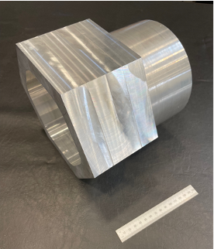
Figure 5.1.The final hexagon-cylinder produced using hybrid manufacturing (AFSD, SLS, milling, and turning) with a 150 mm (5.9”) ruler for scale.

bore for feedstock deposition was selected. The deposition initiation routine following each feedstock reload was operator guided. Each time plastic flow of the feedstock was reached, and steady-state deposition ensued, machine control was transferred to the machine controller. In the hexagon part programs, the first layer spindle speed was 300 rpm, while the spindle speed was 160 rpm for all subsequent layers (due to heat accumulation). The material feed rate was 139. 7 mm/min, and the tool feed rate was 132.1 mm/min. In the cylinder part program, the first layer spindle speed was 275 rpm, while the spindle speed was 115 rpm for all subsequent layers. The same material and tool feed rates as the hexagon deposition were commanded.

The hexagon preform was completed by aligning the baseplate with the machine table, clamping the baseplate to the table using four toe clamps, and then locating the work coordinate system at the substrate’s top corner using an edge finder attached to the machine spindle. The hexagon preform was then deposited by interpolating a single-track deposit along a toolpath that increased by a constant increment with each completed perimeter, producing non-planar layers with a constant 2 mm layer height (see Fig. 5.2). This approach was followed until the desired preform build height was reached. Photographs of the hexagon deposition are displayed in Fig. 5.3.

The preform was removed from the AFSD machine and scanned. This scan was imported into the CAM software and the origin was set at the baseplate corner with coordinate directions aligned to the baseplate sides. The tool paths were generated using this coordinate system. The preform was then transferred to a three-axis CNC milling machine (Haas VF-4) and standard probing routines were used to align the machine coordinate system to the baseplate and part program coordinate system. The hexagon preform was then machined using face milling and contouring operations.

After machining the hexagon, the cylinder deposition was completed by returning the part back to the AFSD machine. For the second side deposition, the part was inverted and clamped in a vise using the hexagon flats. The spindle-mounted edge finder was used to locate the hexagon center and the work coordinate system was set at this location. The cylinder was then deposited using this coordinate system. A helical path was followed to reduce process transients while maintaining a layer height of 2 mm (see Fig. 5.4). The deposition process is shown in Fig. 5.5. The cylinder was built to a height sufficient to completely contain the final part geometry.

To populate the AFSD cost model, the parameters in Table 5.1 were applied. The deposition times and material usage for both depositions were combined into a single value to calculate a total AFSD cost for the hexagon-cylinder. The resulting AFSD cost estimate for this part is $613.32. A summary is provided in Table 5.2.

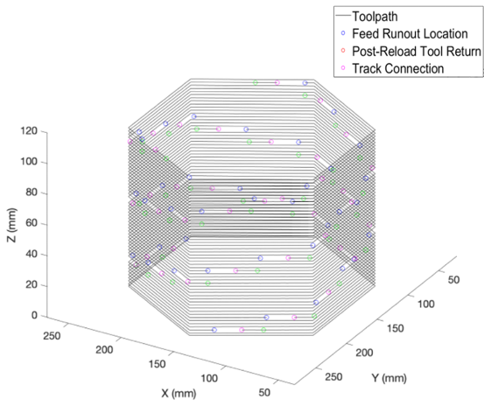
Figure 5.2. Toolpaths with feedstock reload locations are shown for the hexagon.

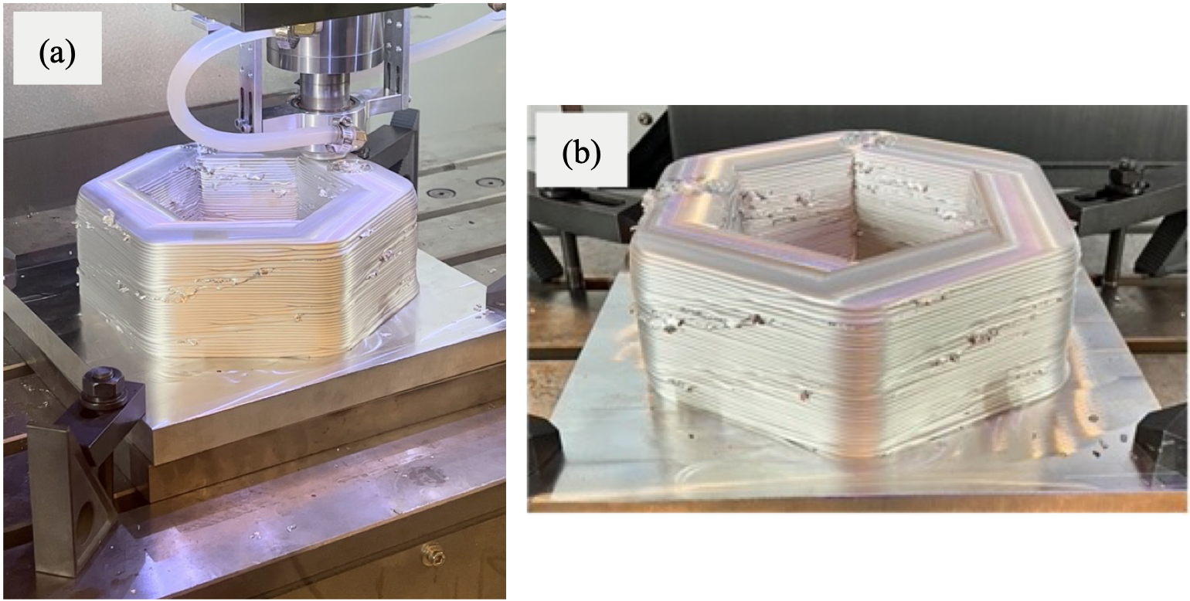
Figure 5.3. Toolpaths and feedstock reload locations are shown for the (a) cylinder with (b) an expanded view.

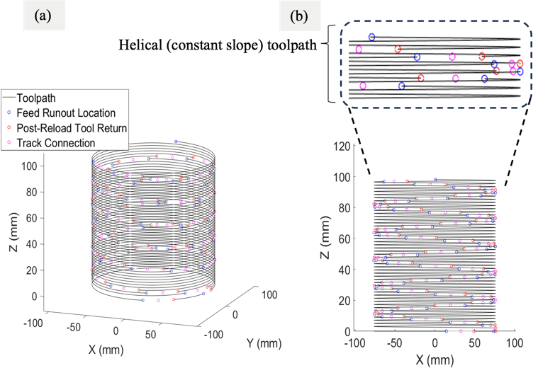
Figure 5.4. Hexagon preform (a) during and (b) after deposition.

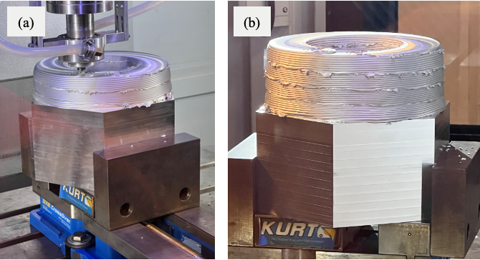
Figure 5.5. The cylinder preform is displayed (a) during and (b) after deposition.

Table 5.1 AFSD cost model variables, values, and units for the hexagon-cylinder.
Variable | Value | Units
n_{bar} | 68 | -
c_{bar} | 1.59 | $
c_{baseplate} | 110.65 | $
c_{gas} | - | $/m³
t_{setup} | 18 | min
t_{sup} | 469 | min
r_{lab} | 40 | $/hr
t_{print} | 469 | min
F | 1 | -
c_{enr-rate} | 0.12 | $/kWh
r_{enr} | 7 | kW
c_{space,fix} | 75,000 | $
p_{space,fix} | 1 | yr
U_{space,mach} | 46.82 | m²
U_{space,mat} | 4.45 | m²
U_{space,tot} | 1393 | m²
c_{equi,i} | 600,000 | $
v_{sal} | 0 | $
L_{exp} | 10 | yr
c_{maint,p} | 0 | $
c_{maint,t} | 8,203 | $
l_{maint,p} | 0 | -
l_{maint,l} | 1 | yr

Table 5.2. AFSD cost model summary.
Cost | Value
Direct build costs | $550.00
Material cost | $218.77
Labor cost | $324.66
Energy cost | $6.57
Indirect build costs | $63.32
Space cost | $2.46
Depreciation cost | $53.54
Maintenance cost | $7.32
Total cost | $613.32

SLS

In this study, a GOM ATOS Q scanner and GOM Inspect software were used to create scans of the part geometry after each deposition. A scan of the AFSD preform was aligned with the desired CAD geometry using an automated best fit algorithm within the GOM Inspect software. See Fig. 5.6. Once aligned, a coordinate system was assigned to the preform for machining tool path generation. Based on the process plan, two scans were required: one after the first deposition (hexagon) and another after the second deposition (cylinder). Additional details are provided in Dvorak et al [20].

Similar to the AFSD cost model, variable totals from both SLS operations were combined into single values to calculate the SLS cost. The values are provided in Table 5.3. Applying Eqs. 16-23 resulted in the total SLS cost of $175.33. Labor is a large fraction of this cost as seen in Table 5.4.

Milling

All three-axis CNC milling operations used a 76.2 mm diameter face mill (Kennametal M4D300L 1108S 100L 175). The operating parameters were: 5115 rpm spindle speed, 3302 mm/min roughing feed rate, and 1397 mm/min finishing feed rate. The milling operations included: 1) facing the hexagon’s top surface; and 2) contouring of the exterior and interior preform sidewalls to the finished hexagon dimensions. The hexagon was then inverted, and the milling operations included: 1) facing the exposed surface of the baseplate; and 2) contouring the baseplate edges to match the hexagon outer dimensions.

Toolpaths for both operations are shown in Fig. 5.7. Special consideration was taken to ensure the hexagon of the first operation aligned with the second by milling in the side of the build plate slightly in the first operation and probing this milled section once the part was inverted. The machining sequence is shown in Fig. 5.8.

The input values for the milling cost model are provided in Table 5.5. The resulting cost estimate for milling the hexagon portion of the part is $58.90. Again, labor costs constitute the largest portion of this value. The cost summary is shown in Table 5.6.

Turning

CNC turning was used for the cylindrical section of the preform. A Haas ST-15 CNC lathe was used to machine the outside and inside diameters of the preform. The preform was clamped in the spindle using a three-jaw chuck and the inside surfaces of the hexagon; see Fig. 5.9. The outside diameter and the front face were turned using a VBMT331 insert (Sandvik 7861072) with a cutting speed of 243.8 m/min and a roughing feed rate of 0.254 mm/rev. The roughing depth of cut was 0.89 mm. A cutting speed of 243.8 m/min and a feed rate of 0.0508 mm/rev were used for the finishing pass. The finish pass depth of cut was 0.13 mm. For the boring operation to machine the internal diameter, a CNGP432 (Kennametal 1785718) insert was used. The same feeds and speeds as well as depths of cut
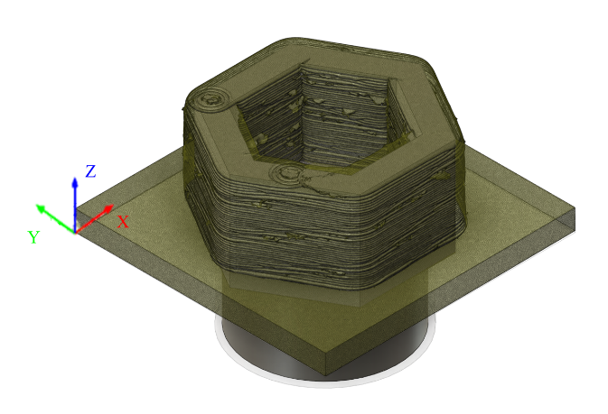
Figure 5.6. A structured light scan of the hexagon preform (deposited on a baseplate) was aligned to the CAD model to define the machining coordinate system.
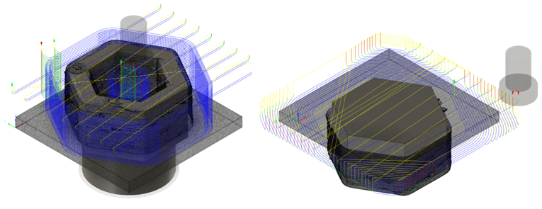
Figure 5.7. Machining toolpaths for (left) hexagon and (right) baseplate after inverting the part.

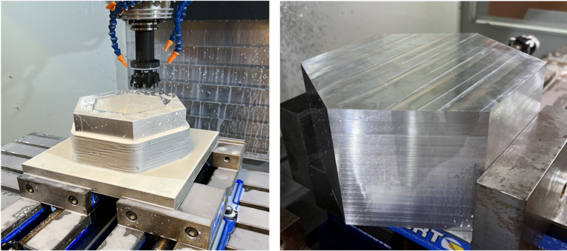
Figure 5.8. (Left) hexagon milling with face mill and (right) inverted part after milling was complete.
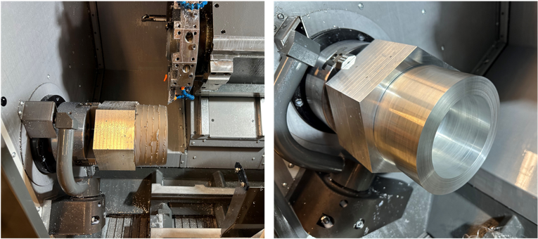
Figure 5.9. (Left) preform clamped in machine spindle prior to turning and (right) after turning operations for the outside and inside diameters were completed.

Table 5.3. SLS cost model variables, values, and units for the hexagon-cylinder.
Variable | Value | Units
n_{stick} | 53+33 | -
c_{stick} | 0.11 | $
m_{spray} | 200 | g
c_{spray} | 0.0875 | $/g
t_{setup,SLS} | 60 | min
t_{scan} | 0.5 | min
n_{scan} | 33+45 | -
t_{analysis} | 60 | min
t_{clean} | 60 | min
r_{lab} | 40 | $/hr
c_{enr-rate} | 0.3 | kW
r_{enr} | 0.12 | $/kWh
c_{space,fix} | 75,000 | $
p_{space,fix} | 1 | yr
U_{space,mach} | 18.95 | m²
U_{space,tot} | 1393 | m²
c_{equi,i} | 70,000 | $
v_{sal} | 0 | $
L_{exp} | 8 | yr
c_{maint,p} | 0 | $
c_{maint,t} | 0 | $
l_{maint,p} | 0 | -
l_{maint,} | 0 | yr

Table 5.4. SLS cost model summary.
Cost | Value
Direct build costs | $172.98
Material cost | $26.96
Labor cost | $146.00
Energy cost | $0.02
Indirect build costs | $2.35
Space cost | $0.76
Depreciation cost | $2.28
Maintenance cost | $0.00
Total cost | $175.33

Table 5.5. Milling cost model variables, values, and units for the hexagon-cylinder (produced by hybrid manufacturing).
Variable | Value | Units
C_{mat} | 0 | $
c_{tool} | 300 | $
t_{ch} | 10 | min
C | 17,500 | -
v | 1224 | m/min
n | 0.025 | -
p | 0.015 | -
f_{t} | 0.122 | mm/min
q | 0.015 | -
V_{rem} | - | mm³
a | 63.5 | mm
b | 25 | mm
m | 4 | teeth
N | 5115 | rpm
t_{setup} | 30 | min
t_{sup} | 35 | min
r_{lab} | 40 | $/hr
t_{mill} | 35 | min
F | 1.5 | -
c_{enr-rate} | 0.12 | $/kWh
r_{enr} | 15.5 | kW
c_{space,fix} | 75,000 | $
p_{space,fix} | 1 | yr
U_{space,mach} | 24.71 | m²
U_{space,tot} | 1393 | m²
c_{equi,i} | 78,295 | $
v_{sal} | 0 | $
L_{exp} | 10 | yr
c_{maint,p} | 0 | $
c_{maint,t} | 2,500 | $
l_{maint,p} | 0 | -
l_{maint,l} | 1 | yr
p_{coll} | 0 | %

Table 5.6. Milling cost model summary.
Cost | Value
Direct build costs | $57.74
Stock material cost | $0.00
Tool cost | $1.11
Labor cost | $55.00
Energy cost | $1.63
Indirect build costs | $2.35
Space cost | $0.13
Depreciation cost | $0.78
Maintenance cost | $0.25
Recycling cost recovery | $0.00
Total cost | $58.90

were used to machine the inner diameter geometry of the preform. The finished part geometry is shown in Fig. 5.9 after the turning operations were completed.

The values for the turning cost model are provided in Table 5.7. The total cost was $160.02, with significant contributions from both labor and tool costs. The cost summary is given in Table 5.8.

Total

Combining the costs from the four processes results in a total of $1,007.59. AFSD contributed 61% of the cost. Table 5.9 lists the costs by manufacturing process. Among cost categories, the largest contributor was labor, which accounted for 65% of the $1,007.59. The next largest category was material, which constituted 24% of the total cost; see Table 5.10.

Conventional Three-axis Milling

Using the same milling parameters, machine, and tools selected for the milling portion of the hybrid manufacturing process, tool paths were created to simulate the production of the hexagon-cylinder by three-axis CNC milling from wrought stock with dimensions of 254 mm x 215.9 mm x 228.6 mm (10” x 8.5” x 9”). The machining process plan included two setups. The hexagon was machined in the first setup and the cylinder side was machined in a second setup.

The first setup used an origin set at the bottom center of the wrought stock face. In this orientation, the hexagon top, outside, and interior were machined. The toolpaths are shown in Fig. 5.10 (left).

The workpiece was inverted for the second setup, so that the top face of the hexagon was in contact with the machine table. In this orientation, the origin was set at the top center as shown in Fig. 5.10 (right). Using the same tool and parameters as the previous setup, facing and contouring operations were defined to achieve the final external and internal dimensions of the cylinder.

Since the same parameters were used to generate the Fig. 5.10 tool paths, the inputs for the milling cost model remain the same as the hybrid manufacturing setup. The only exceptions are milling time, since the entire part is being machined, and material cost since the hexagon-cylinder is machined from solid wrought stock. Using the parameters outlined in Table 5.11, the cost for producing the part using only three-axis milling is $833.60. The summary is provided in Table 5.12.

Table 5.7. Turning cost model variables, values, and units for the hexagon-cylinder.
Variable | Value | Units
C_{mat} | 0 | $
c_{tool} | 20 | $
t_{ch} | 10 | min
C | 4200 | -
v | 243.84 | m/min
p | 1 | -
f_{r} | 0.25 | mm/rev
q | 1.5 | -
V_{rem} | - | mm³
a | 0.89 | mm
t_{setup} | 60 | min
t_{sup} | 90 | min
r_{lab} | 40 | $/hr
t_{turn} | 90 | min
F | 1.5 | -
c_{enr-rate} | 0.12 | $/kWh
r_{enr} | 14.9 | kW
c_{space,fix} | 75,000 | $
p_{space,fix} | 1 | yr
U_{space,mach} | 19.69 | m²
U_{space,tot} | 1393 | m²
c_{equi,I} | 59,195 | $
v_{sal} | 0 | $
L_{exp} | 10 | yr
c_{maint,p} | 0 | $
c_{maint,t} | 1,000 | $
l_{maint,p} | 0 | -
l_{maint,l} | 1 | yr
p_{coll} | 0 | %

Table 5.8. Turning cost model summary.
Cost | Value
Direct build costs | $157.91
Stock Material cost | $0.00
Tool cost | $26.13
Labor cost | $130.00
Energy cost | $1.79
Indirect build costs | $2.12
Space cost | $0.34
Depreciation cost | $1.52
Maintenance cost | $0.26
Recycling cost recovery | $0.00
Total cost | $160.03

Table 5.9. Total combined costs listed by manufacturing process.
Manufacturing process | Estimated cost | % of total
AFSD | $613.32 | 61%
SLS | $175.33 | 17%
Milling | $58.90 | 6%
Turning | $160.03 | 16%
Total | $1,007.59 | 100%

Table 5.10. Total combined costs listed by spend category.
Category | Cost | % of total
Material | $245.73 | 24%
Tool | $27.24 | 3%
Labor | $655.66 | 65%
Energy | $10.01 | 1%
Space | $3.01 | 0%
Depreciation | $58.12 | 6%
Maintenance | $7.83 | 1%
Total | $1,007.59 | 100%
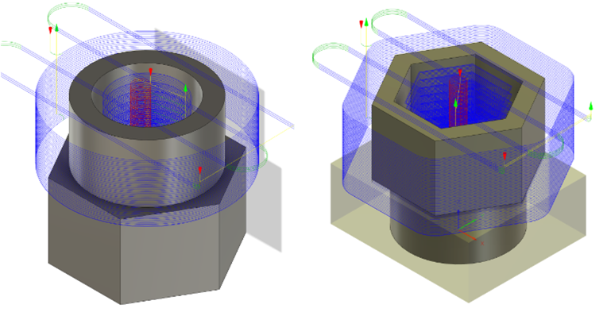
Figure 5.10. (Left) The first setup showing milling tool paths to machine the hexagon geometry from wrought stock. (Right) The second setup showing milling tool paths to machine the cylindrical geometry.

Table 5.11. Conventional milling cost model variables, values, and units for the hexagon-cylinder (produced by three-axis milling).
Variable | Value | Units
C_{mat} | 698 | $
c_{tool} | 300 | $
t_{ch} | 10 | min
C | 17,500 | -
v | 1224 | m/min
n | 0.025 | -
p | 0.015 | -
f_{t} | 0.122 | mm/min
q | 0.015 | -
V_{rem} | - | mm³
a | 63.5 | mm
b | 25 | mm
m | 4 | teeth
N | 5115 | rpm
t_{setup} | 30 | min
t_{sup} | 104 | min
r_{lab} | 40 | $/hr
t_{mill} | 104 | min
F | 1.5 | -
c_{enr-rate} | 0.12 | $/kWh
r_{enr} | 15.5 | kW
c_{space,fix} | 75,000 | $
p_{space,fix} | 1 | yr
U_{space,mach} | 24.71 | m²
U_{space,tot} | 1393 | m²
c_{equi,i} | 78,295 | $
v_{sal} | 0 | $
L_{exp} | 10 yr | yr
c_{maint,p} | 0 | $
c_{maint,t} | 2,500 | $
l_{maint,p} | 0 | part
l_{maint,l} | 1 yr | yr
p_{coll} | 0 | %

Table 5.12. Conventional milling summary.
Cost | Value
Direct build costs | $830.14
Stock material cost | $698.00
Tool cost | $3.30
Labor cost | $124.00
Energy cost | $4.84
Indirect build costs | $3.46
Space cost | $0.39
Depreciation cost | $2.33
Maintenance cost | $0.74
Recycling cost recovery | $0.00
Total cost | $833.60

Discussion

For this case study and these inputs, three-axis milling was less expensive than hybrid manufacturing. Though the hybrid approach reduced material cost by 65%, the conventional method cost $173.98 less. This difference is due to the higher labor costs for hybrid manufacturing. In this case, the hybrid approach is more sensitive to labor rates because it requires more labor, while three-axis milling is more sensitive to material cost. It is anticipated that this trend will continue independent of part geometry. All else remaining the same, as labor rates increase, so will the difference between hybrid and conventional manufacturing methods. However, cost difference between processes is not the only consideration when selecting an approach.

One aspect not examined here is lead time. Though not captured in this cost model, lead time can be directly related to costs [90]. For larger parts, such as the hexagon-cylinder, it is often difficult to find a supplier that can source stock material large enough to completely contain the final part and enable the machining-only solution. For example, a regional material supplier was contacted for the required 254 mm × 215.9 mm × 228.6 mm wrought stock, but that size was not available, and no quote was provided. In this instance, the machining-only part could not have been produced in the same time frame as the hybrid approach part. Even if a supplier is identified, lead times can still be high. This reduces the amount of product a company can sell, delays projects, and prevents businesses from meeting customer requirements. Hybrid manufacturing reduces lead times that may occur when using conventional approaches.

This case study does not definitively determine whether hybrid manufacturing or conventional approaches are preferable. Because there is variation between machines, company capabilities, geographic location, wage rates, and part requirements, for example, costs can vary significantly. This case study demonstrates the utility of the cost model suite by identifying which contributions most strongly affect hybrid manufacturing costs for this specific case. It also provides a demonstrates a possible method for comparing hybrid and conventional manufacturing approaches.

Engine Block

An engine block, modeled after a 2002 Kawasaki Concours 1L 4-cylinder engine, was chosen as a case study because it demonstrates the capabilities of hybrid manufacturing and provides an opportunity to compare costs for traditional and hybrid manufacturing processes. Practically speaking, the military is interested in hybrid manufacturing processes that enable on-site part repair and replacement [91]. Normally, engine blocks are made from highly specialized tooling [92]. For this part, the hybrid process includes SLS, AFSD, and milling operations. This part may also be manufactured using traditional three-axis and five-axis machining making it ideal for comparison. While engine blocks are typically cast, this will serve for the purpose of comparing traditional machining with hybrid.

Hybrid Manufacturing Process

The goal of this project was to take an existing part and replicate it through hybrid manufacturing. To accomplish this, SLS was first performed on the existing engine block to create a digital model. The model was then used to generate AFSD tool paths which allowed for the deposition of 6061-T6 aluminum, chosen for ease of deposition. Post deposition, SLS was again conducted to create a digital model for creating three and five-axis machining tool paths and coordinate alignments, to mill the engine block down to final shape. The details for each of the processes are described below.

SLS

The first step in this case study was to create a digital copy of the Mitsubishi engine block using SLS. In this case a GOM ATOS Q scanner and GOM Inspect software were used to conduct the process and acquire the digital model. Post scanning, the digital model was transferred into a CAD software system where the model could be edited and refined. A coordinate system was assigned, and a solid 3-D model was generated to perform AFSD path planning. See Fig. 5.11-5.13.

Additional SLS scans were required after the AFSD deposition. Using the same setup and software, the AFSD deposition was scanned to create a digital model for machining tool path generation. See Fig. 5.15-5.16. This scan was aligned to the original CAD model, using the built in best fit algorithm in the GOM software. Once aligned the model was assigned a coordinate system to prepare for machining tool path generation.

To apply these SLS processes to the cost models, totals from both procedures were combined as inputs for the cost estimation. The values are provided in Table 5.13. Applying Eqs. 51-58 gave a total SLS cost of $245.74. A summary and breakdown of these is given in Table 5.14.
AFSD

Typically, AFSD part programs can be completed automatically using prewritten MATLBTM code. However, as this as this is a thin-walled part, it was necessary to program the tool paths manually. In this instance, thin-walled parts are defined as parts that require only one bead of material to achieve the nominal thickness. When creating and AFSD part program, a few different factors need to be considered. In this case, since it was programmed manually, choosing a repeatable cross section is important to improve process efficiency. Additionally, selecting a tool path that maximizes the usable material while also minimizing volume is valuable. To ensure a continuous path, overlaps were planned to ensure that the tool would not need to be removed from the workpiece. To view the tool paths, see Fig. 5.14.

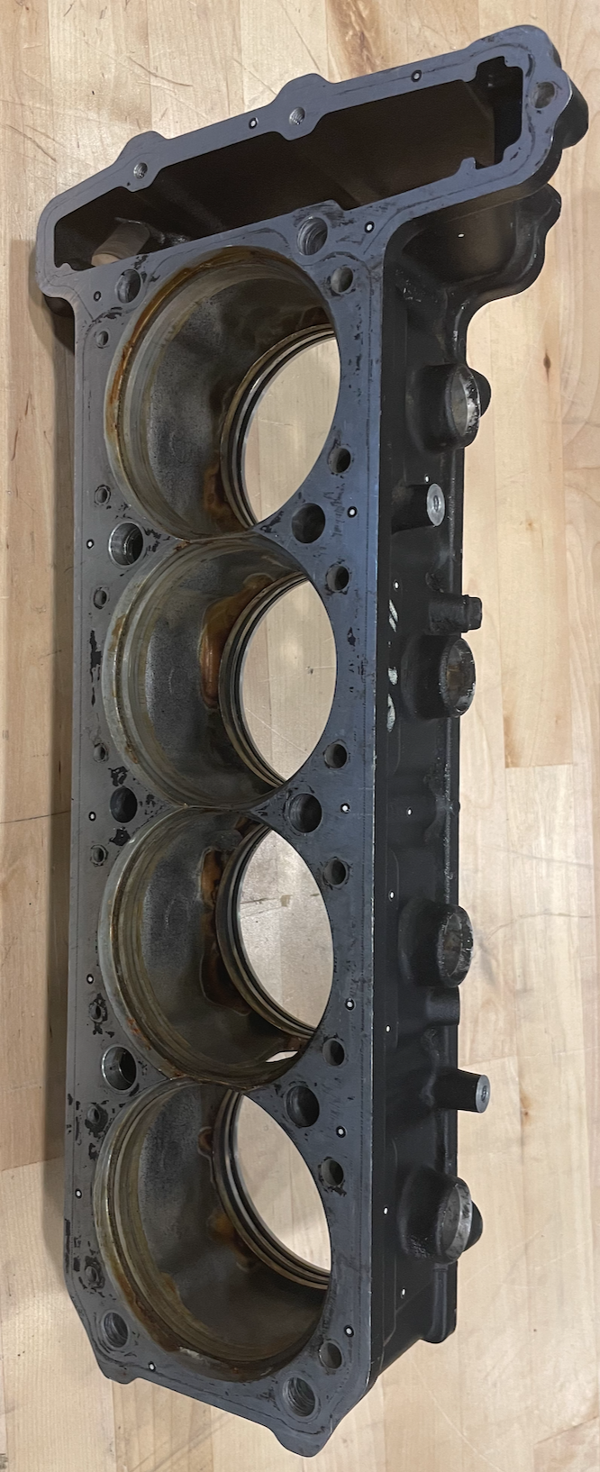
Figure 5.11. Original Mitsubishi engine block with fiducial stickers utilized in the SLS scan.
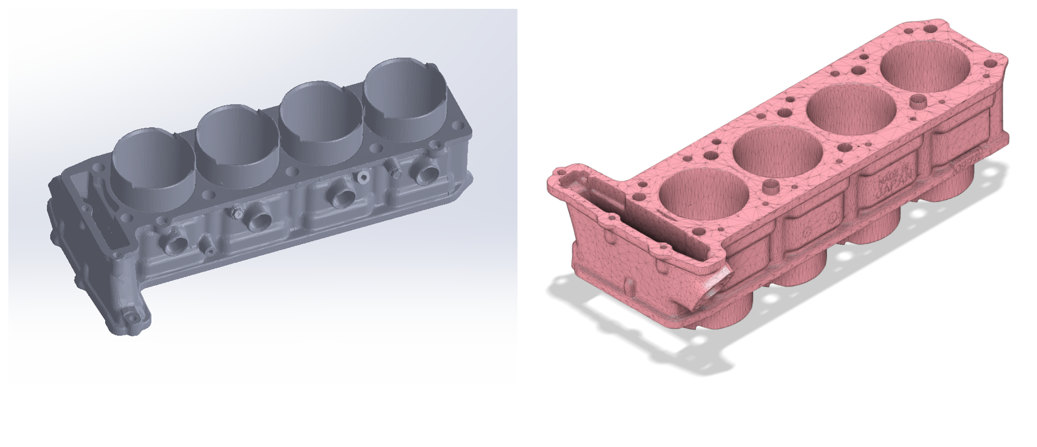
Figure 5.12. (Left) SLS scan of the Mitsubishi engine block. (Right) SLS scan transferred to STL format.

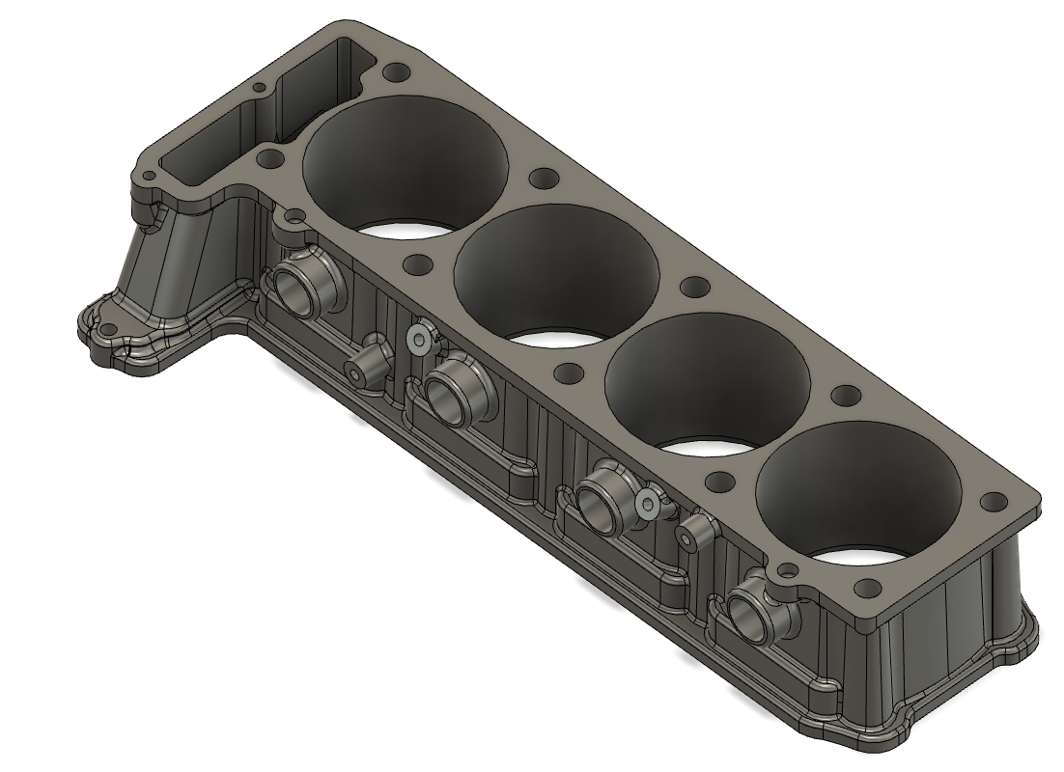
Figure 5.13. CAD model derived from the SLS scan of the original Mitsubishi engine block.

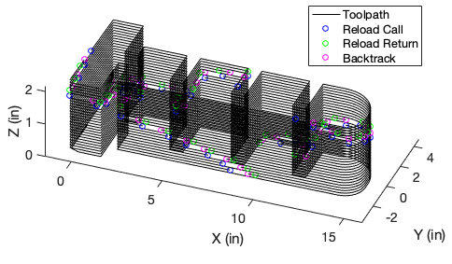
Figure 5.14. AFSD tool path with feedstock reload locations.
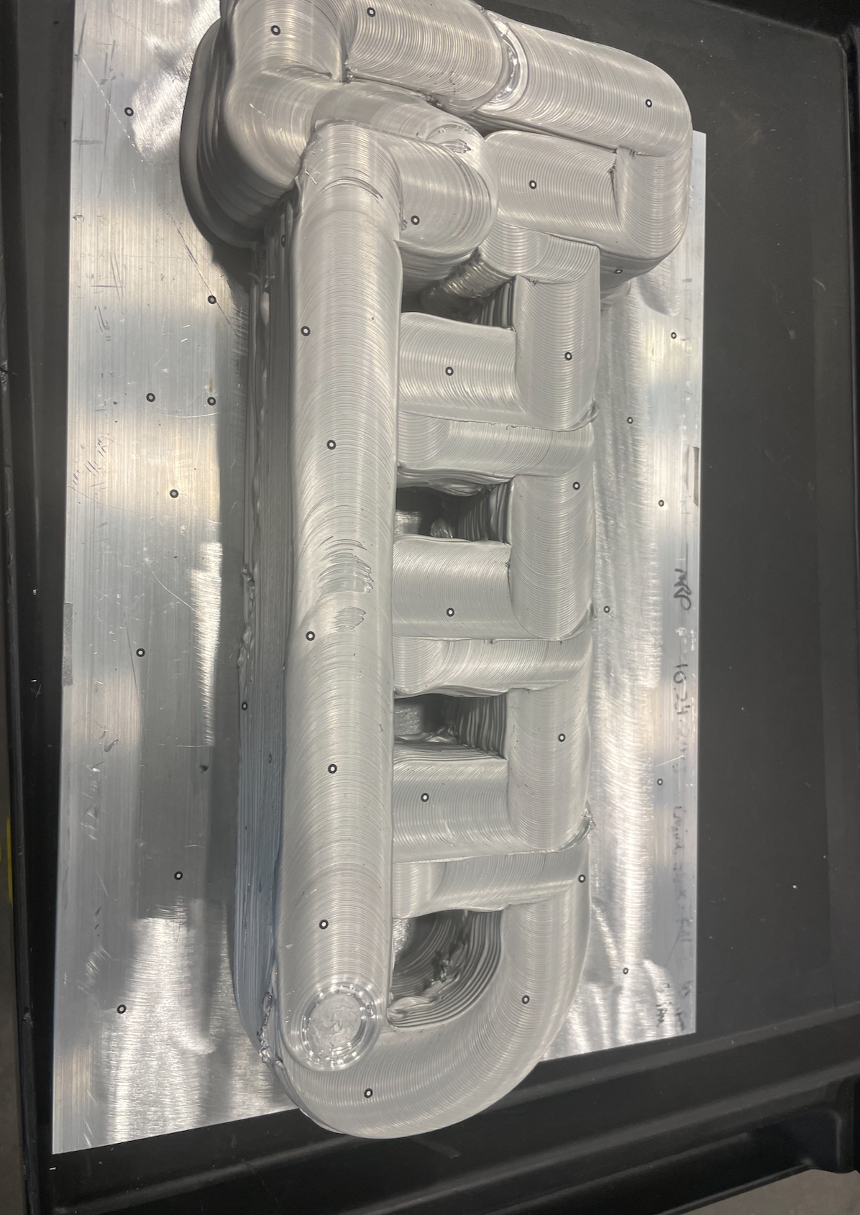
Figure 5.15. AFSD deposition pre SLS scan with cut baseplate and fiducial stickers.
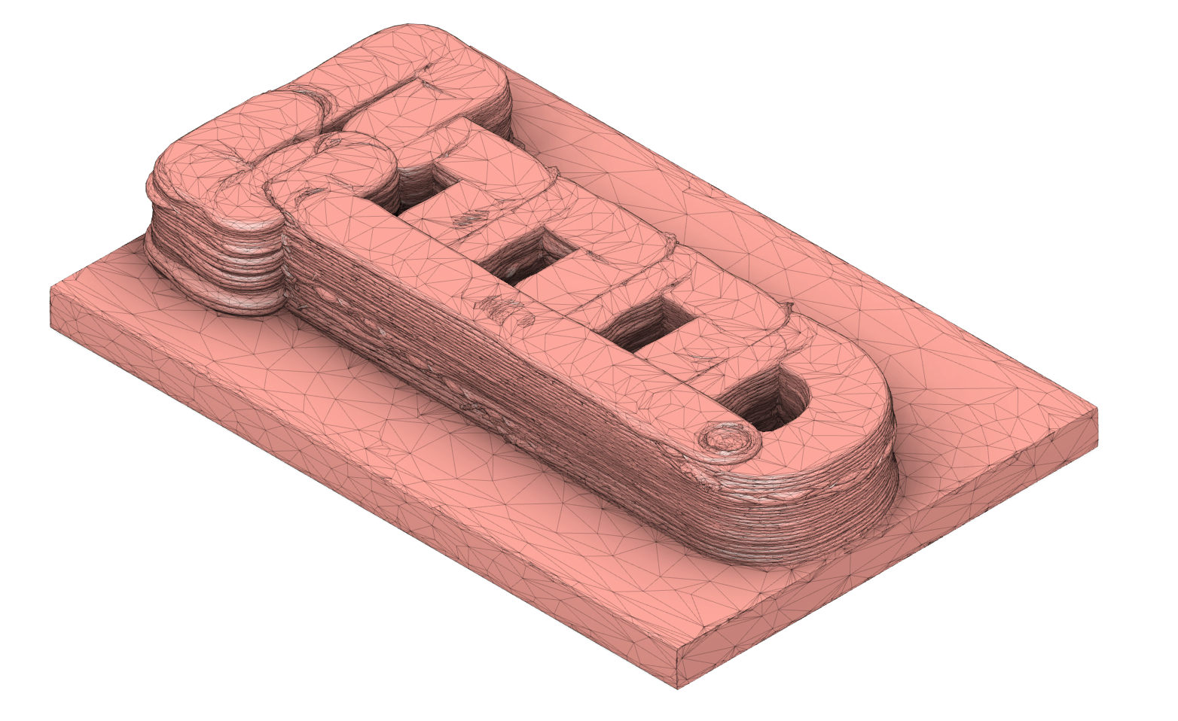
Figure 5.16. SLS scan of AFSD deposition to establish coordinate system for machining tool paths.

Table 5.13. Input values for the SLS calculator taken from both SLS procedures and combined for simplicity.
Variable | Value | Units
n_{stick} | 209 | -
c_{stick} | 0.11 | $
V_{used} | 300 | ml
c_{vol} | 0.1 | $/ml
t_{setup,SLS} | 60 | min
t_{scan} | 0.5 | min
n_{scan} | 200 | -
t_{analysis} | 60 | min
t_{clean} | 30 | min
r_{lab} | 40 | $/hr
c_{enr-rate} | 0.3 | kW
r_{enr} | 0.12 | $/kWh
c_{space,fix} | 75,000 | $
p_{space,fix} | 1 | yr
U_{space,mach} | 18.95 | m²
U_{space,tot} | 1393 | m²
c_{equi,i} | 70,000 | $
v_{sal} | 0 | $
L_{exp} | 8 | yr
c_{maint,p} | 0 | $
c_{maint,t} | 0 | $
l_{maint,p} | 0 | -
l_{maint,} | 0 | yr

Table 5.14. Cost summary and breakdown for the SLS processes.
Cost | Value
Direct build costs | $ 239.72
Material cost | $ 52.99
Labor cost | $ 186.67
Energy cost | $ 0.06
Indirect build costs | $ 6.03
Space cost | $ 0.19
Depreciation cost | $ 5.83
Maintenance cost | $ 0.00
Total cost | $ 245.74
The MELD Manufacturing L3 machine was implemented using 12.7 mm x 12.7 mm cross section aluminum 6061 feedstock. Though not the same material of the original Mitsubishi engine block, aluminum was selected for demonstration purposes. Because this is a discrete feed system, where each feedstock bar is manually loaded, the total estimated deposition time was about 6 hours. If this were a continuous feed system, the estimated deposition time would be about 3.5 hours. For the baseplate, a 610 mm x 305 mm x 25 mm (24 inch x 12 inch x 1 inch) aluminum 6061 build plate was purchased, which was consequently trimmed after the deposition to reduce machining time. See Figure 5.15. As previously mentioned, after machining the build plate, the preform was scanned using SLS to create a digital model for creating milling tool paths. See Figure 5.16.

To estimate the AFSD process costs, the input variables from Table 5.15 were used. The resulting preform AFSD cost estimate is $666.47. See Table 5.16 for a breakdown and summary of these costs.

Three-axis Milling

The three-axis milling process required two different setups, one to create an original flat face for optimal clamping, and the second to finish off the remaining sides. Two different machines were used, a Haas VF-4 for the first setup, and a Haas UMC-1000 for the second setup. Though five-axis capabilities were not specifically required for machining the preform, using the UMC-100 made the process more efficient by reducing the number of required setups from six (one for each face) to two. Because there are two different machines there are two cost calculations for this process, one for each machine.

To begin the process, the AFSD manufactured preform was clamped in a vise. Due to the surface roughness, this was determined to be the best method for securing the deposition to the machine. Standard probing techniques were used to align the machine coordinate system to that of the digital CAD model. Facing operations were then completed on the top of the preform to produce a flat surface for the second setup. Contouring operations were used to expose and finish enough of the top surface to use the dovetail clamps in the next setup. Additionally, screw holes were predrilled to use as reference points for aligning the second setup. The baseplate was then removed using an endmill. See Figure 5.17.

The total estimated machining time for this machining setup was 1 hour and 10 minutes. Because actual machining takes slightly longer than the CAM estimated times, a time correction factor of 1.2 was used to help accommodate for the discrepancy. The remaining cost model input variables can be found in Table 17. The final estimated cost for this three-axis machining process was $120.89. A breakdown and summary of the costs can be seen in Table 5.19.

Table 5.15. Engine block AFSD cost model inputs.
Variable | Value | Units
n_{bar} | 41 | -
c_{bar} | 1.59 | $
c_{baseplate} | 236.91 | $
c_{gas} | - | $/m³
t_{setup} | 90 | min
t_{sup} | 360 | min
r_{lab} | 40 | $/hr
t_{print} | 360 | min
F | 1 | -
c_{enr-rate} | 0.12 | $/kWh
r_{enr} | 7 | kW
c_{space,fix} | 75,000 | $
p_{space,fix} | 1 | yr
U_{space,mach} | 46.82 | m²
U_{space,mat} | 4.45 | m²
U_{space,tot} | 1393 | m²
c_{equi,i} | 600,000 | $
v_{sal} | 0 | $
L_{exp} | 10 | yr
c_{maint,p} | 0 | $
c_{maint,t} | 8,203 | $
l_{maint,p} | 0 | -
l_{maint,l} | 1 | yr

Table 5.16. AFSD cost summary and breakdown.
Cost | Value
Direct build costs | $608.15
Material cost | $302.10
Labor cost | $300.00
Energy cost | $6.05
Indirect build costs | $58.33
Space cost | $2.27
Depreciation cost | $49.32
Maintenance cost | $6.74
Total cost | $666.47

Five-axis Milling

After finalizing the initial three-axis machining process, the partially machined preform was loaded into the Haas UMC-1000 five-axis milling machine using dovetail clamps on the newly machined surfaces. Using standard probing procedures in combination with the predrilled holes from the previous operation, a coordinate system was established, and machining was completed. Each of the remaining five sides of the preform included facing, contouring, and boring operations. See Figure 5.18. To finalize the part, an end mill was used to bore out the piston cylinders. For the final part, see Figure 5.19.

Though not required by part geometry, the five-axis mill enabled more efficient manufacturing by limiting the total amount of setups to two, one for the three-axis machine and one for the five-axis machine. Due to the size of the part, long endmills were required for some operations. The low dynamic stiffness for these tools limited the material removal rate.

Because the two milling setups were performed on different machines, two applications of the cost model are required to accurately predict machining costs. The estimated machining time on the UMC-1000 was 12 hours and 11 minutes. For the remaining cost model input variables, see Table 5.18. The final costs estimate for the five-axis milling setup was $866.92. See Table 5.20 for a cost summary.

Totals

Combining the costs incurred by the four manufacturing costs results in a total hybrid manufacturing cost of $1,900.03. The largest cost contributors were the five-axis milling and AFSD processes representing 46% and 35% of the total combined cost, respectively. See Table 5.21 for a complete breakdown of the total hybrid manufacturing cost by process. Inspecting the total combined cost by spend category shows that labor and material costs are the largest contributors at 72% and 19%, respectively. For further cost breakdown by spend category, see Table 5.22.

Conventional Three and Five-axis Milling

This section describes the machining process used to estimate and compare costs between the conventional and hybrid processes. Due to the limited selection of stock material large enough to encapsulate the engine block, it would necessitate the purchase of large stock. For the selected vendor, the smallest useable stock size of aluminum 6061 was 203 mm x 203 mm x 610 mm (8 inch x 8 inch x 24 inch). Using a band saw, the stock material would then be trimmed down to be 89 mm x 203 mm x 406 mm (3.5 inch x 8 inch x 16 inch) to save milling time and tool wear. Though in many cases, the scrap material could potentially be reused, in this case study, for simplicity, it is assumed that the removed material was unusable.
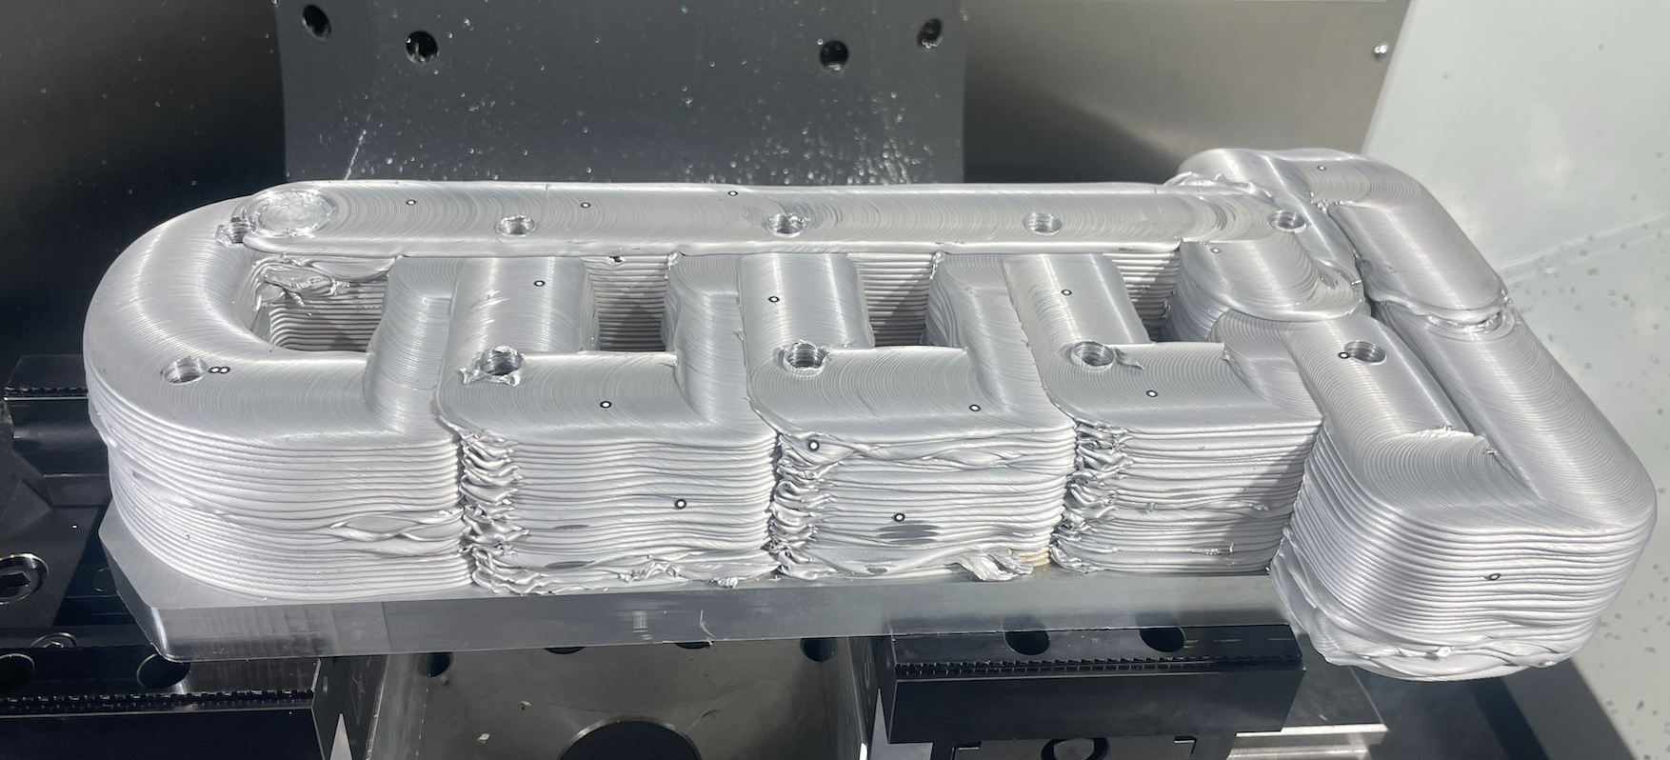
Figure 5.17. Preform post three-axis milling. Notice the predrilled holes coming out of the bottom surface. The fiducial stickers are left over from SLS process.
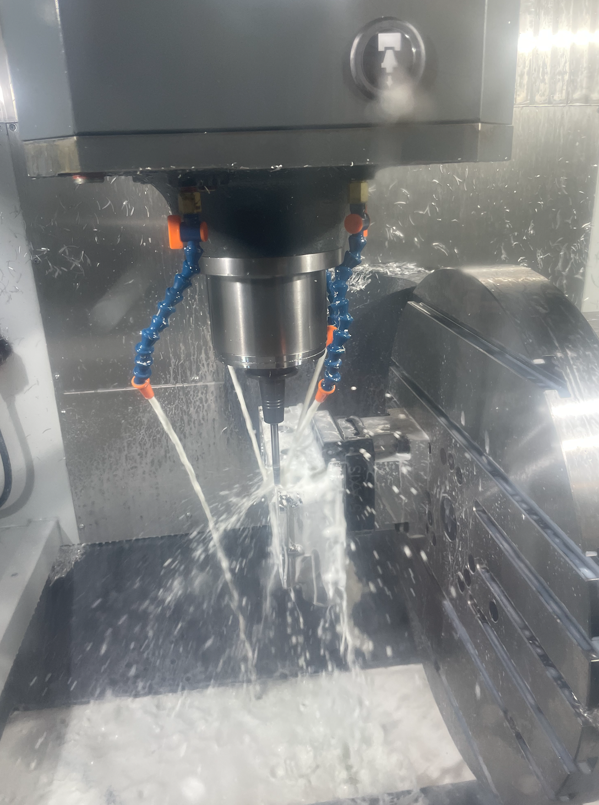
Figure 5.18. Five-axis CNC machining of the preform.
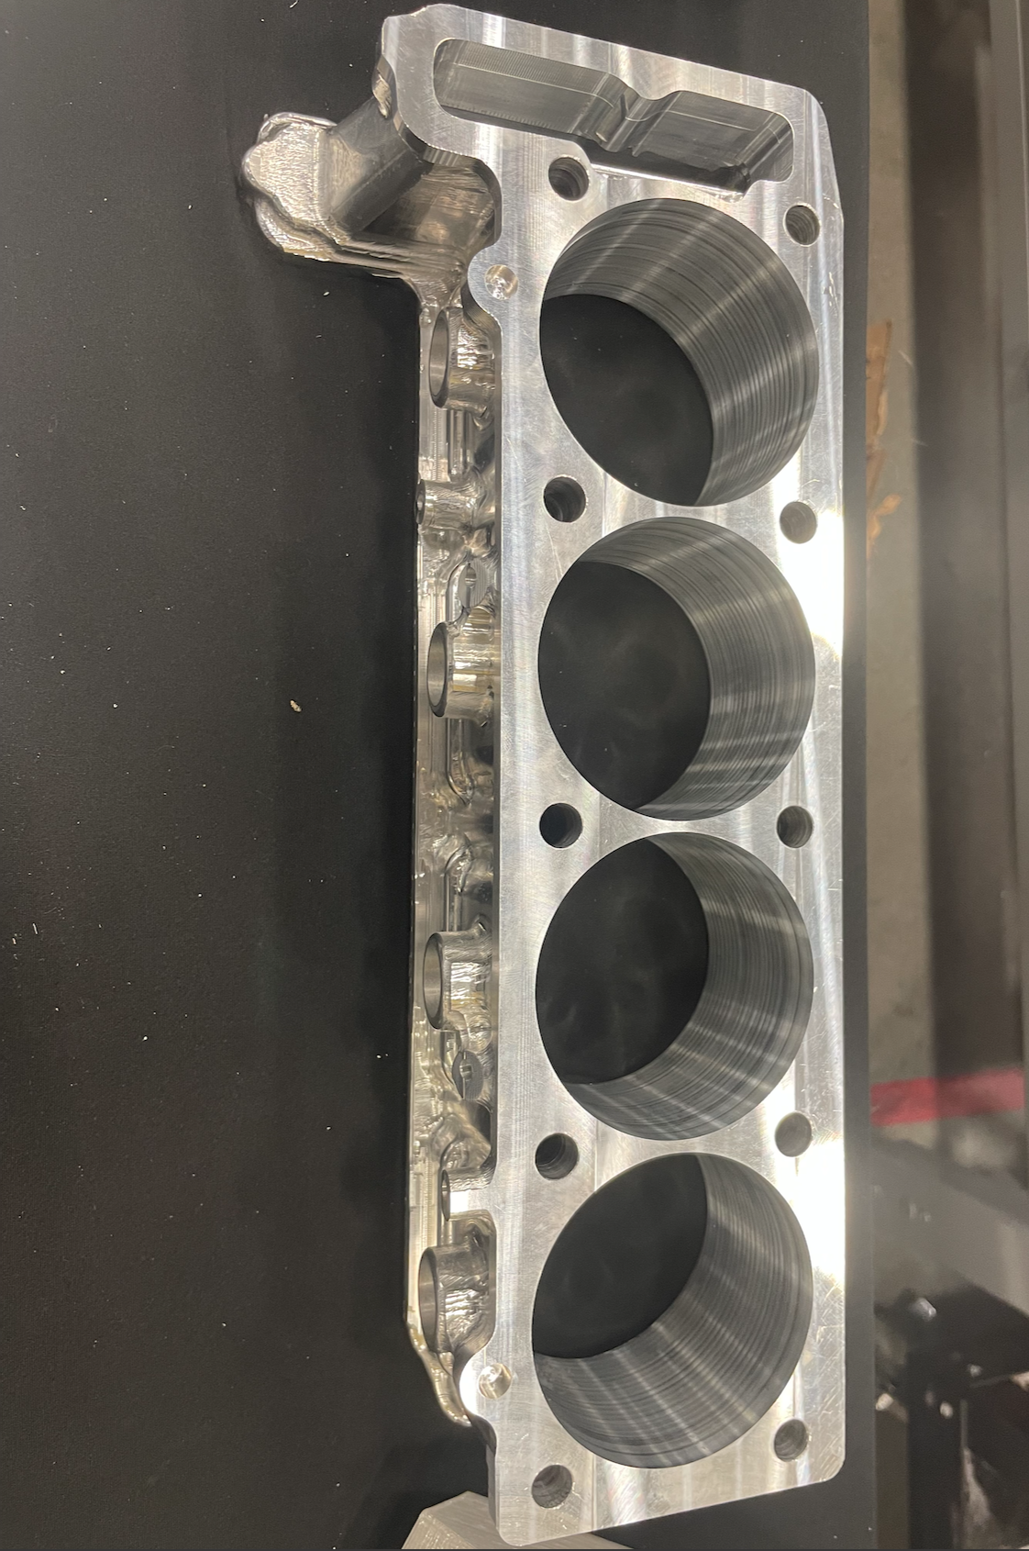
Figure 5.19. Final product after all machining processes.

Table 5.17. Engine block three-axis mill input variables.
Variable | Value | Units
C_{mat} | 0 | $
c_{tool} | 190 | $
t_{ch} | 10 | min
C | 17,500 | -
v | 1.016 | m/min
n | 0.025 | -
p | 0.015 | -
f_{t} | 0.068 | mm
q | 0.015 | -
V_{rem} | - | mm³
a | 1.905 | mm
b | 0.254 | mm
m | 4 | teeth
N | 5000 rpm | rpm
t_{setup} | 90 | min
t_{sup} | 69 | min
r_{lab} | 40 | $/hr
t_{mill} | 69 | min
F | 1.2 | -
c_{enr-rate} | 0.12 | $/kWh
r_{enr} | 15.5 | kW
c_{space,fix} | 75,000 | $
p_{space,fix} | 1 | yr
U_{space,mach} | 24.71 | m²
U_{space,tot} | 1393 | m²
c_{equi,i} | 78,295 | $
v_{sal} | 0 | $
L_{exp} | 10 | yr
c_{maint,p} | 0 | $
c_{maint,t} | 2,500 | $
l_{maint,p} | 0 | -
l_{maint,l} | 1 | yr
p_{coll} | 0 | %

Table 5.18. Engine block five-axis mill input variables.
Variable | Value | Units
C_{mat} | 0 | $
c_{tool} | 135 | $
t_{ch} | 10 | min
C | 17,500 | -
v | 1.016 | m/min
n | 0.025 | -
p | 0.015 | -
f_{t} | 0.0635 | mm
q | 0.015 | -
V_{rem} | - | mm³
a | 0.042 | mm
b | 9.525 | mm
m | 2 | teeth
N | 8000 | rpm
t_{setup} | 60 | min
t_{sup} | 731 | min
r_{lab} | 40 | $/hr
t_{mill} | 731 | min
F | 1.2 | -
c_{enr-rate} | 0.12 | $/kWh
r_{enr} | 18 | kW
c_{space,fix} | 75,000 | $
p_{space,fix} | 1 | yr
U_{space,mach} | 24.71 | m²
U_{space,tot} | 1393 | m²
c_{equi,i} | 216,296 | $
v_{sal} | 0 | $
L_{exp} | 10 | yr
c_{maint,p} | 0 | $
c_{maint,t} | 2,500 | $
l_{maint,p} | 0 | -
l_{maint,l} | 1 | yr
p_{coll} | 0 | %

Table 5.19. three-axis milling cost breakdown and summary.
Cost | Value
Direct build costs | $119.06
Stock material cost | $0.00
Tool cost | $0.88
Labor cost | $115.20
Energy cost | $2.98
Indirect build costs | $1.84
Space cost | $0.21
Depreciation cost | $1.23
Maintenance cost | $0.39
Recycling Profit | $0.00
Total cost | $120.89

Table 5.20. five-axis milling cost breakdown and summary.
Cost | Value
Direct build costs | $813.80
Stock material cost | $0.00
Tool cost | $8.81
Labor cost | $771.00
Energy cost | $33.99
Indirect build costs | $1.84
Space cost | $2.78
Depreciation cost | $45.12
Maintenance cost | $5.22
Recycling Profit | $0.00
Total cost | $866.92

Table 5.21. Hybrid manufacturing combined total cost broken down by manufacturing process.
Manufacturing process | Estimated cost | % of total
SLS | $ 245.74 | 13%
AFSD | $ 666.47 | 35%
three-axis mill | $ 120.89 | 6%
five-axis mill | $ 866.92 | 46%
Total | $ 1,900.03 | 100%

Table 5.22. Hybrid manufacturing combined total cost broken down by cost categories.
Category | Cost | % of total
Material | $ 355.09 | 19%
Tool | $ 9.69 | 1%
Labor | $ 1372.86 | 72%
Energy | $ 43.07 | 2%
Space | $ 5.44 | 0%
Depreciation | $ 101.53 | 5%
Maintenance | $ 12.35 | 1%
Total | $1,900.03 | 100%

Once the stock material was trimmed to a more manageable size, it would be mounted in the Haas VF-4 three-axis milling machine using dovetail clamps. Using a combination of facing and contouring operations, the workpiece would then be roughed to dimensions similar to the AFSD preform. From there, the manufacturing process would be identical to the one described in the previous sections on the three and five-axis milling machines. To demonstrate the capabilities of the cost equations, the additional machining time required for this process was calculated using the MRR and extra volume to be removed. See equations 65 and 67. For a complete list of the parameters used to estimate the costs of this process, see Tables 5.23-5.24. Tables 5.25-5.26 show the summaries for both the three-axis and five-axis milling processes. The final estimated cost for the conventional milling process was $2,141.40 For a cost summary and breakdown see Tables 5.27-5.28.

There are some factors not included in this cost estimate. The costs incurred by using a saw to cut the stock material were not considered. Additionally, lead times were not factored into the cost model. In this case, from the selected vendor, using expedited shipping the stock material was expected to arrive in three days. For some companies or organizations, this lead time can be a deciding factor in making purchasing and manufacturing decisions. This helps demonstrate that cost models, while being helpful tools, do not capture the entire picture and that all variables and information should be taken into consideration when trying to an informed manufacturing decision.

Discussion
The cost breakdowns of the hybrid and conventional manufacturing processes differ in a few significant ways. For the input variables shown in Tables 5.23-5.24, hybrid manufacturing is $241.07 less expensive than the conventional machining process. While hybrid manufacturing is less expensive in this case, that is not always true. As shown in Tables 5.22 and 5.28, hybrid manufacturing cost is 72% labor costs, while labor only accounts for 46% of conventional costs. Since hybrid manufacturing is more labor sensitive, as labor wage rates increase, hybrid manufacturing costs will increase at a faster rate than conventional manufacturing costs.

Another factor worth consideration is the difference between material costs. For this case, material costs contribute to only 19% of hybrid costs while making up 49% conventional manufacturing costs. This suggests increased sensitivity for material costs on the conventional side, however this again might not always be the case. In this case study, it was assumed that the oversized stock material would be cut down to a more manageable size and the extra material would be counted as waste. It is possible that the material could be reused or recycled and would therefore offset some of the material costs. Consequently, manufacturing costs and material costs as an overall percent of conventional costs would reduce.

Table 5.23. Conventional three-axis milling cost model input parameters.
Variable | Value | Units
C_{mat} | 0 | $
c_{tool} | 190 | $
t_{ch} | 10 | min
C | 17,500 | -
v | 1.016 | m/min
n | 0.025 | -
p | 0.015 | -
f_{t} | 0.068 | mm
q | 0.015 | -
V_{rem} | 3,728,057 | mm³
a | 1.905 | mm
b | 0.254 | mm
m | 4 | teeth
N | 5000 rpm | rpm
t_{setup} | 90 | min
t_{sup} | 185 | min
r_{lab} | 40 | $/hr
t_{mill} | 185 | min
F | 1.2 | -
c_{enr-rate} | 0.12 | $/kWh
r_{enr} | 15.5 | kW
c_{space,fix} | 75,000 | $
p_{space,fix} | 1 | yr
U_{space,mach} | 24.71 | m²
U_{space,tot} | 1393 | m²
c_{equi,i} | 78,295 | $
v_{sal} | 0 | $
L_{exp} | 10 | yr
c_{maint,p} | 0 | $
c_{maint,t} | 2,500 | $
l_{maint,p} | 0 | -
l_{maint,l} | 1 | yr
p_{coll} | 0 | %

Table 5.24. Conventional five-axis milling cost model input parameters.
Variable | Value | Units
C_{mat} | 0 | $
c_{tool} | 135 | $
t_{ch} | 10 | min
C | 17,500 | -
v | 1.016 | m/min
n | 0.025 | -
p | 0.015 | -
f_{t} | 0.0635 | mm
q | 0.015 | -
V_{rem} | - | mm³
a | 0.042 | mm
b | 9.525 | mm
m | 2 | teeth
N | 8000 | rpm
t_{setup} | 60 | min
t_{sup} | 731 | min
r_{lab} | 40 | $/hr
t_{mill} | 731 | min
F | 1.2 | -
c_{enr-rate} | 0.12 | $/kWh
r_{enr} | 18 | kW
c_{space,fix} | 75,000 | $
p_{space,fix} | 1 | yr
U_{space,mach} | 24.71 | m²
U_{space,tot} | 1393 | m²
c_{equi,i} | 216,296 | $
v_{sal} | 0 | $
L_{exp} | 10 | yr
c_{maint,p} | 0 | $
c_{maint,t} | 2,500 | $
l_{maint,p} | 0 | -
l_{maint,l} | 1 | yr
p_{coll} | 0 | %

Table 5.25. Conventional three-axis milling cost breakdown and summary.
Cost | Value
Direct build costs | $1269.56
Stock material cost | $1,052.33
Tool cost | $2.35
Labor cost | $208.00
Energy cost | $6.88
Indirect build costs | $4.92
Space cost | $0.56
Depreciation cost | $3.31
Maintenance cost | $1.06
Recycling Profit | $0.00
Total cost | $1,274.49

Table 5.26. Conventional five-axis milling cost breakdown and summary.
Cost | Value
Direct build costs | $813.80
Stock material cost | $0.00
Tool cost | $8.81
Labor cost | $771.00
Energy cost | $33.99
Indirect build costs | $1.84
Space cost | $2.78
Depreciation cost | $45.12
Maintenance cost | $5.22
Recycling Profit | $0.00
Total cost | $866.92

Table 5.27. Total conventional cost by manufacturing process.
Manufacturing process | Estimated cost | % of total
three-axis mill | $ 1,274.49 | 60%
5-axis mill | $ 866.92 | 40%
Total | $ 2,141.40 | 100%

Table 5.28. Conventional manufacturing costs by category.
Category | Cost | % of total
Material | $ 1052.33 | 49%
Tool | $ 11.16 | 1%
Labor | $ 979.00 | 46%
Energy | $ 40.87 | 2%
Space | $ 3.34 | 0%
Depreciation | $ 48.43 | 2%
Maintenance | $ 6.28 | 0%
Total | $2,141.40 | 100%

An important factor not accounted for in the cost models is lead time. Depending on the company and use case, it is possible to attribute financial value to lead time. For some companies that have a large inventory of stock material, the lead time involved in purchasing stock material may not be an issue. However, in that case inventory costs will need to be considered. Hybrid manufacturing offers an advantage here, by not requiring lengthy lead times and minimizing inventory storage space. In this case study, from the vendor selected, the lead time for the stock material to arrive for the conventional manufacturing process would have been three days. In this timeframe, the hybrid process could have finished and shipped the finalized part.

The Mitsubishi engine block proved to be a valuable case study in demonstrating the capabilities of hybrid manufacturing, as well as the flexibility and capabilities of the cost models. For the input variables applied, hybrid manufacturing proved to be both faster and less expensive while providing a part of equal quality to conventional machining methods. Application of the cost models showed how both observed values, in the case of hybrid manufacturing, and predicted values, in the case of conventional manufacturing, could be used to estimate costs. Future work could use these cost models to complete sensitivity analyses, identify opportunities for cost reduction, and optimize the cost of manufacturing processes.

Machine Tool Crossbeam

For the third case study, a machine tool crossbeam was selected. The goal of the project was to redesign and manufacture an existing machine tool cross beam (shown in Figure 5.20) to reduce mass while maintaining stiffness. The new design utilized catenary arches to reduce mass without sacrificing stiffness. See Figure 5.21. The plan was to deposit material, LA 100 from Lincoln Electric, using WAAM. The part would then be scanned using SLS for a digital model to be used in a CAM software. The mating features would be machined using tool paths generated by CAM software. However, due to complications in the deposition stage, the build process was terminated with roughly 77% of the WAAM deposition completed. For more details see, Poon et al. [93]. Regardless of the project's outcome, this case study shows the capabilities and potential of the WAAM process and allows for a cost analysis demonstration.

WAAM

The machine used for this case study, the medUSA, is unique to Oak Ridge National Laboratory (ORNL) [93]. It consists of three gas metal arc welders (GMAW) attached to robotic arms surrounding a single rotary build table. See Figure 5.22. The motion of the robotic arms is coordinated such that all three can deposit material simultaneously. The machine tool crossbeam was the longest part attempted on this machine. After the CAD model was generated, the ORNL software was used to slice the part geometry and generate the tool paths. The ensuing deposition took place over 6 days and resulted in a part that was 77% complete.
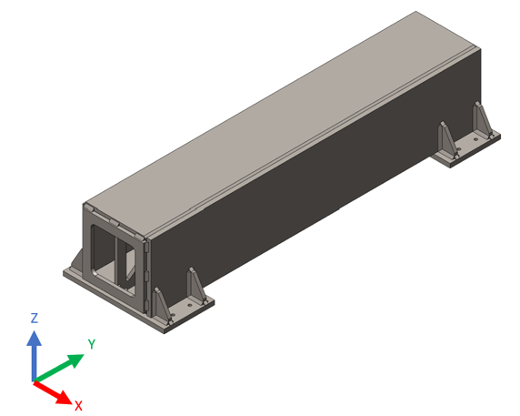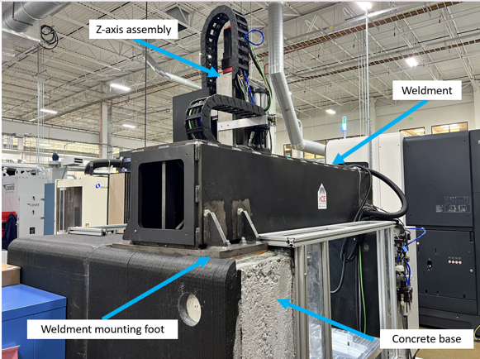

Figure 5.20. (Left) CAD model of the original machine tool cross beam. (Right) Physical representation of the crossbeam.

Figure 5.21. CAD rendering of the proposed design for the machine tool crossbeam.
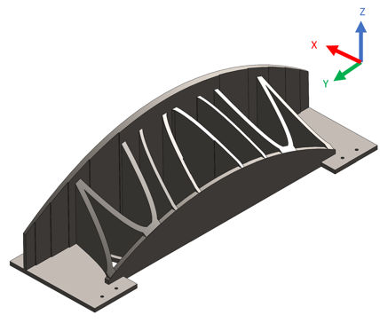

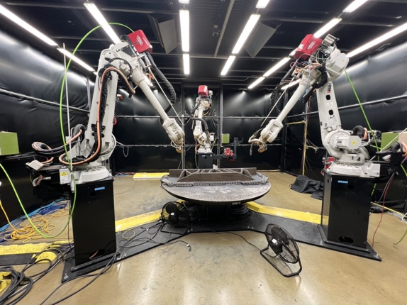
Figure 5.22. The medUSA WAAM machine features three GMAW welders fastened to robotic arms that operate simultaneously.

The setup for this part required a build plate of 2029 mm x 610 mm using A36 steel. As plates of this size are expensive and can have long lead times, it was sectioned into five smaller build plates. See Figure 5.23. Each of these build plates was clamped to the build table. The medUSA then deposited the material directly onto the surface of the build plates allowing them to become the bottom face of the machine tool crossbeam. The intent was to weld the seams of the five build plates after the deposition was finalized; however, because the WAAM process was discontinued due to plate and table distortion, this task was not completed.

There were multiple variables that compounded and led to the print failure. Because the part was so large, as it expanded and contracted due to heating and cooling, it created large residual stresses, despite efforts to deposit material at a slower rate to account for heating and cooling rates. The stresses warped both the crossbeam and the worktable. See Figure 5.24. The deposition was terminated at approximately 77% completion to prevent further damage. For full details see Poon [94].

Though the print ultimately failed, it still proved useful in furthering the knowledge and capabilities of the medUSA, as well as demonstrating the potential of WAAM as a process. It also provided an excellent opportunity to demonstrate the WAAM cost model. As the technology continues to advance, WAAM will become increasingly viable as a rapid manufacturing solution [95].

Using data gathered from the researchers who performed the WAAM process, the following inputs were applied to Eqs. 35-50. See Table 5.19. The values are only for the portion of the part that was constructed. The cost estimation does not include the processes that were not completed. In this case, T_{dep} was unknown, but could be predicted using Eq. 48. The resulting estimated WAAM cost was $26,333.56. For a breakdown of the costs, see Table 5.20.

Though this cost estimation did not account for the entire final part, the resulting cost estimate was significantly more expensive than the bids acquired from various companies (Appendix F). See Table 5.21 for a comparison between the cost estimate and the bids. This discrepancy could be due to several factors. Because the ORNL MDF is a research facility, the labor wage rate is likely significantly higher than at a private manufacturing company. Additionally, in comparison to traditional machining and welding techniques, which have been optimized for manufacturing, WAAM as a manufacturing process is still developing. As technological advances and optimizations are made, the WAAM manufacturing costs could decrease as a result. The cost models do not capture the benefits of lead time. WAAM does not require the extra time manufacturing companies need to procure large workpieces. Many firms are willing to pay a premium for decreased lead times, making WAAM a viable solution.

Figure 5.23. The five prefabricated build plates upon which the material was deposited.
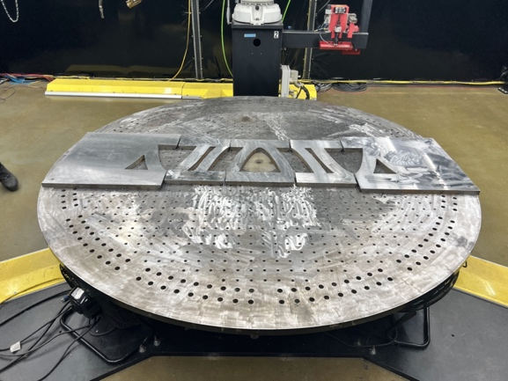

Figure 5.24. Final product at 77% completion. Notice the warpage between the part and the build table.
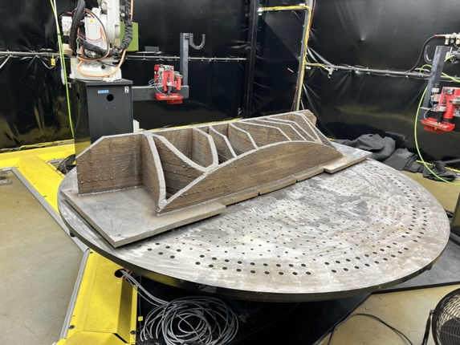

Table 5.29. WAAM cost model input variables, values, and units for the machine tool crossbeam.
Variable | Value | Units
d_{mat} | 7750 | kg/m³
V_{part} | .07 | m³
c_{w} | 19 | $/kg
q_{gas} | .000315 | m³/s
t_{dep} | - | min
F | 1.2 | -
c_{g} | 107.36 | $/m³
V_{tnk} | - | m³
L_{tnk} | - | hrs
t_{tnk} | - | hrs
t_{setup} | 3 | hrs
t_{sup} | 60 | hrs
r_{lab} | 250 | $/hr
num_{wld} | 3 | -
SEC | - | kWh/kg
r_{dep} | 16.74 | kg/hr
r_{enr,wld} | 6.5 | kW
r_{enr,rbt} | 15 | kW
c_{enr-rate} | 0.12 | $/kWh
I | 30 | A
V | 480 | V
B | 0.65 | -
d_{w} | 7750 | kg/m³
f | 169.3 | mm/s
d | 1.12 | mm
A | 9.852e-07 | mm²
F_{rt} | - | m/s
c_{space,fix} | 75,000 | $
p_{space,fix} | 8760 | hrs
U_{space} | 60 | m²
U_{space,tot} | 1393 | m²
c_{equi,i} | 11,000 | $
v_{sal} | - | $
L_{exp,equ} | 15 | yrs
c_{rbt,i} | 150,000 | $
V_{sal,rbt} | - | $
L_{exp,rbt} | 15 | yrs
c_{maint,t} | 15,000 | $
L_{maint,t} | 1 | yr

Table 5.30. WAAM cost summary and breakdown.
Cost | Value | % of total
Direct build costs | $26,179.38 | 99%
Stock material cost | $10,309.08 | 39%
Labor cost | $15,750.00 | 60%
Energy cost | $120.31 | 1%
Indirect build costs | $154.18 | 1%
Space cost | $17.20 | 0%
Depreciation cost | $75.14 | 0%
Maintenance cost | $79.85 | 0%
Total cost | $26,333.56 | 100%

Table 5.31. WAAM cost estimate comparison.
Company | Value | Lead time
WAAM | $26,179.38 | 2-4 weeks
Company #1 | $16,687.00 | 14-16 weeks
Company #2 | $12,460.00 | 12 weeks
Company #3 | $9,318.04 | - weeks

Chapter 6
Conclusion

This thesis described seven different cost models for additive, metrology, and subtractive manufacturing processes, including AFSD, WAAM, PBF, FFF, SLS, milling, and turning. It demonstrated the combination of these cost models in hybrid manufacturing case studies. The hexagon-cylinder case study featured the use of AFSD, SLS, milling, and turning operations. The engine block case study also used AFSD, SLS, and milling. However, the sequence of these operations differed. The machine tool crossbeam case study applied WAAM, although it would have also included machining and SLS if the deposition had been successful. These case studies demonstrated the application of the cost model framework and its implementation for hybrid manufacturing. They also provided a comparison between the costs for hybrid manufacturing and conventional (machining-only) approaches.

While the intent of this thesis was to present and demonstrate the cost models within a unified framework, the suite of cost models has many potential applications. First, as demonstrated in the case studies, the cost models can be useful when comparing hybrid and conventional manufacturing. Second, they could be used to perform cost optimization for factors such as material, labor, and energy. Third, as manufacturing technologies advance, the cost models could be used to evaluate the impact of technological development on product costs. Fourth, sensitivity analyses could be conducted to analyze which parameters affect cost the most for each manufacturing process. Fifth, the effect of machine downtime could be explored. Sixth, they could be used to decide if quoting or producing a particular part is warranted. Other applications are also possible.

While these cost models are robust and useful, they are not without limitations. Future work could include adding cost models for casting, forging, EDM, heat treatment, sawing, binder jetting AM, and water jetting, for example. Additionally, batching capabilities could be explored [13]. This would prove useful in environments where parallel manufacturing is implemented. The model inputs could also be expanded to incorporate programming costs, lead times, test parts, packaging, shipping, and other post productions costs.

The goal of this research was to provide a cost estimation framework for other researchers and manufacturers to implement for hybrid manufacturing processes. Though basic in nature, the cost models are rigorous and based on specific activities for each manufacturing process. Additionally, because they all follow the same strategy and approach, these cost models can accommodate a large variety of hybrid manufacturing sequences. This cost model suite is designed to be easily used, understood, and expanded. Further research, development, and additions to this cost model suite are encouraged. A Matlab™ m-file was created for each of the cost models included in the suite. These m-files automatically calculate product costs based off the inputs given by the user. They include instructions for use and are available for download [96].

List of References
- Abdoli Bidhandi, R. and Valmohammadi, C., 2017. Effects of supply chain agility on profitability. Business Process Management Journal, 23(5), pp.1064-1082.
- Saleeby, K., Feldhausen, T., Love, L. and Kurfess, T., 2020. Rapid retooling for emergency response with hybrid manufacturing. Smart and Sustainable Manufacturing Systems, 4(3).
- Zhu, Z., Dhokia, V.G., Nassehi, A. and Newman, S.T., 2013. A review of hybrid manufacturing processes–state of the art and future perspectives. International Journal of Computer Integrated Manufacturing, 26(7), pp.596-615.
- Langmaak, S., Wiseall, S., Bru, C., Adkins, R., Scanlan, J. and Sóbester, A., 2013. An activity-based-parametric hybrid cost model to estimate the unit cost of a novel gas turbine component. International Journal of Production Economics, 142(1), pp.74-88.
- Oyesola, M.O., Mpofu, K., Mathe, N.R. and Daniyan, I.A., 2020. Hybrid-additive manufacturing cost model: A sustainable through-life engineering support for maintenance repair overhaul in the aerospace. Procedia Manufacturing, 49, pp.199-205.
- Manogharan, G., Wysk, R.A. and Harrysson, O.L., 2016. Additive manufacturing–integrated hybrid manufacturing and subtractive processes: economic model and analysis. International Journal of Computer Integrated Manufacturing, 29(5), pp.473-488.
- CUNHA, T.M.M.R., 2022. A Process-based cost model for wire and arc additive manufacturing.
- Qian, L. and Ben-Arieh, D., 2008. Parametric cost estimation based on activity-based costing: A case study for design and development of rotational parts. International Journal of Production Economics, 113(2), pp.805-818.
- Relich, M. and Pawlewski, P., 2018. A case-based reasoning approach to cost estimation of new product development. Neurocomputing, 272, pp.40-45.
- Scanlan, J., Rao, A., Bru, C., Hale, P. and Marsh, R., 2006. DATUM project: cost estimating environment for support of aerospace design decision making. Journal of aircraft, 43(4), pp.1022-1028.
- Spedding, T.A. and Sun, G.Q., 1999. Application of discrete event simulation to the activity based costing of manufacturing systems. International journal of production economics, 58(3), pp.289-301.
- Akyol, D.E., Tuncel, G. and Bayhan, G.M., 2005. A comparative analysis of activity-based costing and traditional costing. World Academy of Science, Engineering and Technology, 3(12), pp.44-47.
- Hansen, D.R. and Mowen, M.M., 2007. Managerial accounting. South-Western.
- J Tah, J.H.M., Thorpe, A. and McCaffer, R., 1994. A survey of indirect cost estimating in practice. Construction management and economics, 12(1), pp.31-36.
- Strong, D., Kay, M., Conner, B., Wakefield, T. and Manogharan, G., 2018. Hybrid manufacturing–integrating traditional manufacturers with additive manufacturing (AM) supply chain. Additive Manufacturing, 21, pp.159-173.
- West, J., Betters, E. and Schmitz, T., 2023. Limited-constraint WAAM fixture for hybrid manufacturing. Manufacturing Letters, 37, pp.66-69.
- Wippermann, A., Gutowski, T.G., Denkena, B., Dittrich, M.A. and Wessarges, Y., 2020. Electrical energy and material efficiency analysis of machining, additive and hybrid manufacturing. Journal of Cleaner Production, 251, p.119731.
- Lorenz, K.A., Jones, J.B., Wimpenny, D.I. and Jackson, M.R., 2015. A review of hybrid manufacturing. In 2014 International Solid Freeform Fabrication Symposium. University of Texas at Austin.
- Schmitz, T., Costa, L., Canfield, B.K., Kincaid, J., Zameroski, R., Garcia, R., Frederick, C., Rossy, A.M. and Moeller, T.M., 2023. Embedded QR code for part authentication in additive friction stir deposition. Manufacturing Letters, 35, pp.16-19.
- Kincaid, J., Zameroski, R., Charles, E., No, T., Bohling, J., Compton, B. and Schmitz, T., 2023. Hybrid manufacturing by additive friction stir deposition, metrology, CNC machining, and microstructure analysis. Manufacturing Letters, 35, pp.549-556.
- Dvorak, J., Cornelius, A., Corson, G., Zameroski, R., Jacobs, L., Penney, J. and Schmitz, T., 2022. A machining digital twin for hybrid manufacturing. Manufacturing Letters, 33 (Supplement).
- Cornelius, A., Dvorak, J., Jacobs, L., Penney, J. and Schmitz, T., 2021. Combination of structured light scanning and external fiducials for coordinate system transfer in hybrid manufacturing. Journal of Manufacturing Processes, 68, pp.1824-1836.
- Kincaid, J., Zameroski, R., No, T., Bohling, J., Compton, B. and Schmitz, T., 2023, February. Hybrid Manufacturing: Combining Additive Friction Stir Deposition, Metrology, and Machining. In TMS Annual Meeting & Exhibition (pp. 3-13). Cham: Springer Nature Switzerland.
- Kincaid, J., Charles, E., Garcia, R., Dvorak, J., No, T., Smith, S. and Schmitz, T., 2023. Process planning for hybrid manufacturing using additive friction stir deposition. Manufacturing Letters, 37, pp.26-31.
- Dvorak, J., Gilmer, D., Zameroski, R., Cornelius, A. and Schmitz, T., 2023. Freeform Hybrid Manufacturing: Binderjet, Structured Light Scanning, Confocal Microscopy, and CNC Machining. Journal of Manufacturing and Materials Processing, 7(2), p.79.
- Schultz, J. P., and Creehan, K., 2010, Friction stir fabrication. USA Patent US8636194B2.
- Gray, D.T., 2009. Modeling and characterization of friction stir fabricated coatings on Al6061 and Al5083 substrates (Doctoral dissertation, Virginia Tech).
- Kandasamy, K., Renaghan, L.E., Calvert, J.R., Creehan, K.D. and Schultz, J.P., 2013, October. Solid-state additive manufacturing of aluminum and magnesium alloys. In Proceedings of the Materials Science and Technology Conference and Exhibition (p. 59).
- Calvert, J.R., 2015. Microstructure and mechanical properties of WE43 alloy produced via additive friction stir technology (Doctoral dissertation, Virginia Tech).
- Rivera, O.G., Allison, P.G., Jordon, J.B., Rodriguez, O.L., Brewer, L.N., McClelland, Z., Whittington, W.R., Francis, D., Su, J., Martens, R.L. and Hardwick, N., 2017. Microstructures and mechanical behavior of Inconel 625 fabricated by solid-state additive manufacturing. Materials Science and Engineering: A, 694, pp.1-9.
- Tang, W., Yang, X., Tian, C., and Xu, Y., 2022. Microstructural heterogeneity and bonding strength of planar interface formed in additive manufacturing of Al–Mg–Si alloy based on friction and extrusion. International Journal of Minerals, Metallurgy and Materials, 29(9), pp.1755-1769.
- Nicholas, E.D., 2003. Friction processing technologies. Welding in the World, 47, pp.2-9.
- Hang, Z.Y., Jones, M.E., Brady, G.W., Griffiths, R.J., Garcia, D., Rauch, H.A., Cox, C.D. and Hardwick, N., 2018. Non-beam-based metal additive manufacturing enabled by additive friction stir deposition. Scripta Materialia, 153, pp.122-130.
- Beladi, H., Farabi, E., Hodgson, P.D., Barnett, M.R., Rohrer, G.S. and Fabijanic, D., 2022. Microstructure evolution of 316L stainless steel during solid-state additive friction stir deposition. Philosophical Magazine, 102(7), pp.618-633.
- Agrawal, P., Haridas, R.S., Yadav, S., Thapliyal, S., Dhal, A. and Mishra, R.S., 2023. Additive friction stir deposition of SS316: Effect of process parameters on microstructure evolution. Materials Characterization, 195, p.112470.
- Grasso, M. and Colosimo, B.M., 2017. Process defects and in situ monitoring methods in metal powder bed fusion: a review. Measurement Science and Technology, 28(4), p.044005.
- Svetlizky, D., Das, M., Zheng, B., Vyatskikh, A.L., Bose, S., Bandyopadhyay, A., Schoenung, J.M., Lavernia, E.J. and Eliaz, N., 2021. Directed energy deposition (DED) additive manufacturing: Physical characteristics, defects, challenges and applications. Materials Today, 49, pp.271-295.
- Perry, M.E., Griffiths, R.J., Garcia, D., Sietins, J.M., Zhu, Y. and Hang, Z.Y., 2020. Morphological and microstructural investigation of the non-planar interface formed in solid-state metal additive manufacturing by additive friction stir deposition. Additive Manufacturing, 35, p.101293.
- Ghadimi, H., Ding, H., Emanet, S., Talachian, M., Cox, C., Eller, M. and Guo, S., 2023. Hardness Distribution of Al2050 Parts Fabricated Using Additive Friction Stir Deposition. Materials, 16(3), p.1278.
- Rivera, O.G., Allison, P.G., Brewer, L.N., Rodriguez, O.L., Jordon, J.B., Liu, T., Whittington, W.R., Martens, R.L., McClelland, Z., Mason, C.T. and Garcia, L., 2018. Influence of texture and grain refinement on the mechanical behavior of AA2219 fabricated by high shear solid state material deposition. Materials Science and Engineering: A, 724, pp.547-558.
- Jordon, J.B., Allison, P.G., Phillips, B.J., Avery, D.Z., Kinser, R.P., Brewer, L.N., Cox, C. and Doherty, K., 2020. Direct recycling of machine chips through a novel solid-state additive manufacturing process. Materials & Design, 193, p.108850.
- Phillips, B.J., Avery, D.Z., Liu, T., Rodriguez, O.L., Mason, C.J.T., Jordon, J.B., Brewer, L.N. and Allison, P.G., 2019. Microstructure-deformation relationship of additive friction stir-deposition Al–Mg–Si. Materialia, 7, p.100387.
- Babaniaris, S., Jiang, L., Varma, R.K., Farabi, E., Dorin, T., Barnett, M. and Fabijanic, D., 2022. Precipitation in AA6063 produced from swarf using additive friction stir deposition. Additive Manufacturing Letters, 3, p.100096.
- Williams, M.B., Cahalan, L.P., Lopez, J.J., Perez-Andrade, L.I., Leonard, R.T., McDonnell, M.M., Kelly, M.R., Lalonde, A.D., Brewer, L.N., Jordon, J.B. and Allison, P.G., 2023. Dynamic Behavior Characterization of Aluminum Alloy 7020 Manufactured Using the Additive Friction Stir Deposition Process. JOM, pp.1-13.
- Mason, C.J.T., Rodriguez, R.I., Avery, D.Z., Phillips, B.J., Bernarding, B.P., Williams, M.B., Cobbs, S.D., Jordon, J.B. and Allison, P.G., 2021. Process-structure-property relations for as-deposited solid-state additively manufactured high-strength aluminum alloy. Additive Manufacturing, 40, p.101879.
- Yoder, J.K., Griffiths, R.J. and Hang, Z.Y., 2021. Deformation-based additive manufacturing of 7075 aluminum with wrought-like mechanical properties. Materials & Design, 198, p.109288.
- Joshi, S.S., Patil, S.M., Mazumder, S., Sharma, S., Riley, D.A., Dowden, S., Banerjee, R. and Dahotre, N.B., 2022. Additive friction stir deposition of AZ31B magnesium alloy. Journal of Magnesium and Alloys, 10(9), pp.2404-2420.
- McClelland, Z., Avery, D.Z., Williams, M.B., Mason, C.J.T., Rivera, O.G., Leah, C., Allison, P.G., Jordon, J.B., Martens, R.L. and Hardwick, N., 2019. Microstructure and mechanical properties of high shear material deposition of rare earth magnesium alloys WE43. In Magnesium Technology 2019 (pp. 277-282). Springer International Publishing.
- Garcia, D., Hartley, W.D., Rauch, H.A., Griffiths, R.J., Wang, R., Kong, Z.J., Zhu, Y. and Hang, Z.Y., 2020. In situ investigation into temperature evolution and heat generation during additive friction stir deposition: A comparative study of Cu and Al-Mg-Si. Additive Manufacturing, 34, p.101386.
- Priedeman, J.L., Phillips, B.J., Lopez, J.J., Tucker Roper, B.E., Hornbuckle, B.C., Darling, K.A., Jordon, J.B., Allison, P.G. and Thompson, G.B., 2020. Microstructure development in additive friction stir-deposited Cu. Metals, 10(11), p.1538.
- Avery, D.Z., Rivera, O.G., Mason, C.J.T., Phillips, B.J., Jordon, J.B., Su, J., Hardwick, N. and Allison, P.G., 2018. Fatigue behavior of solid-state additive manufactured inconel 625. Jom, 70, pp.2475-2484.
- Griffiths, R.J., Gotawala, N., Hahn, G.D., Garcia, D. and Hang, Z.Y., 2022. Towards underwater additive manufacturing via additive friction stir deposition. Materials & Design, 223, p.111148.
- Martin, L.P., Luccitti, A. and Walluk, M., 2022. Evaluation of additive friction stir deposition of AISI 316L for repairing surface material loss in AISI 4340. The International Journal of Advanced Manufacturing Technology, 121(3-4), pp.2365-2381.
- Wu, B.L., Peng, Y.C., Tang, H.Q., Meng, C.C., Zhong, Y.F., Zhang, F.L. and Zhan, Y.Z., 2023. Improving grain structure and dispersoid distribution of nanodiamond reinforced AA6061 matrix composite coatings via high-speed additive friction stir deposition. Journal of Materials Processing Technology, p.117983.
- Lopez, J.J., Williams, M.B., Rushing, T.W., Confer, M.P., Ghosh, A., Griggs, C.S., Jordon, J.B., Thompson, G.B. and Allison, P.G., 2022. A solid-state additive manufacturing method for aluminum-graphene nanoplatelet composites. Materialia, 23, p.101440.
- Griffiths, R.J., Perry, M.E., Sietins, J.M., Zhu, Y., Hardwick, N., Cox, C.D., Rauch, H.A. and Yu, H.Z., 2019. A perspective on solid-state additive manufacturing of aluminum matrix composites using MELD. Journal of Materials Engineering and Performance, 28, pp.648-656.
- Rodriguez, R.X., Program Overview: Extra-Large, Metal Additive Manufacturing System, Targeted Towards Army Ground Vehicle Systems. In Proceedings of the Ground Vehicle Systems Engineering and Technology Symposium (pp. 13-15).
- Rodrigues, T.A., Duarte, V., Miranda, R.M., Santos, T.G. and Oliveira, J.P., 2019. Current status and perspectives on wire and arc additive manufacturing (WAAM). Materials, 12(7), p.1121.
- Priarone, P.C., Campatelli, G., Montevecchi, F., Venturini, G. and Settineri, L., 2019. A modelling framework for comparing the environmental and economic performance of WAAM-based integrated manufacturing and machining. CIRP Annals, 68(1), pp.37-40.
- Williams, S. and Martina, F., 2015. Wire+ arc additive manufacturing vs. traditional machining from solid: a cost comparison. Mater Sci Technol (UK), 32(1), p.27.
- Cunningham, C.R., Wikshåland, S., Xu, F., Kemakolam, N., Shokrani, A., Dhokia, V. and Newman, S.T., 2017. Cost modelling and sensitivity analysis of wire and arc additive manufacturing. Procedia Manufacturing, 11, pp.650-657.
- Kokare, S., Oliveira, J.P. and Godina, R., 2023. Modelling of Wire Arc Additive Manufactured Product Cost. Procedia Computer Science, 217, pp.1513-1521.
- Baumers, M., Tuck, C., Wildman, R., Ashcroft, I., Rosamond, E. and Hague, R., 2012. Combined build-time, energy consumption and cost estimation for direct metal laser sintering.
- Wippermann, A., Gutowski, T.G., Denkena, B., Dittrich, M.A. and Wessarges, Y., 2020. Electrical energy and material efficiency analysis of machining, additive and hybrid manufacturing. Journal of cleaner production, 251, p.119731.
- Ruffo, M., Tuck, C. and Hague, R., 2006. Empirical laser sintering time estimator for Duraform PA. International journal of production research, 44(23), pp.5131-5146.
- Schröder, M., Falk, B. and Schmitt, R., 2015. Evaluation of cost structures of additive manufacturing processes using a new business model. Procedia Cirp, 30, pp.311-316.
- Ruffo, M., Tuck, C. and Hague, R., 2006. Cost estimation for rapid manufacturing-laser sintering production for low to medium volumes. Proceedings of the Institution of Mechanical Engineers, Part B: Journal of Engineering Manufacture, 220(9), pp.1417-1427.
- Rickenbacher, L., Spierings, A. and Wegener, K., 2013. An integrated cost‐model for selective laser melting (SLM). Rapid Prototyping Journal, 19(3), pp.208-214.
- Di, L. and Yang, Y., 2020. Cost modeling and evaluation of direct metal laser sintering with integrated dynamic process planning. Sustainability, 13(1), p.319.
- Barclift, M., Joshi, S., Simpson, T. and Dickman, C., 2016. Cost modeling and depreciation for reused powder feedstocks in powder bed fusion additive manufacturing.
- Ma, F., Zhang, H., Hon, K.K.B. and Gong, Q., 2018. An optimization approach of selective laser sintering considering energy consumption and material cost. Journal of Cleaner Production, 199, pp.529-537.
- Ali, M.H., Batai, S. and Sarbassov, D., 2019. 3D printing: a critical review of current development and future prospects. Rapid Prototyping Journal, 25(6), pp.1108-1126.
- Sharma, A. and Rai, A., 2022. Fused deposition modelling (FDM) based 3D & 4D Printing: A state of art review. Materials Today: Proceedings, 62, pp.367-372.
- Tagliaferri, V., Trovalusci, F., Guarino, S. and Venettacci, S., 2019. Environmental and economic analysis of FDM, SLS and MJF additive manufacturing technologies. Materials, 12(24), p.4161.
- Durgun, I. and Ertan, R., 2014. Experimental investigation of FDM process for improvement of mechanical properties and production cost. Rapid Prototyping Journal, 20(3), pp.228-235.
- Alexander, P., Allen, S. and Dutta, D., 1998. Part orientation and build cost determination in layered manufacturing. Computer-Aided Design, 30(5), pp.343-356.
- Urbanic, R.J. and Saqib, S.M., 2019. A manufacturing cost analysis framework to evaluate machining and fused filament fabrication additive manufacturing approaches. The International Journal of Advanced Manufacturing Technology, 102, pp.3091-3108.
- Zisopol, D.G., Tănase, M. and Portoacă, A.I., 2023. Innovative Strategies for Technical-Economical Optimization of FDM Production. Polymers, 15(18), p.3787.
- Kincaid, J., Zameroski, R., Charles, E., No, T., Bohling, J., Compton, B. and Schmitz, T., 2023. Hybrid manufacturing by additive friction stir deposition, metrology, CNC machining, and microstructure analysis. Manufacturing Letters, 35, pp.549-556.
- Cornelius, A., Jacobs, L., Lamsey, M., McNeil, L., Hamel, W. and Schmitz, T., 2022. Hybrid manufacturing of Invar mold for carbon fiber layup using structured light scanning. Manufacturing letters, 33(2).
- Cornelius, A., Dvorak, J., Jacobs, L., Penney, J. and Schmitz, T., 2021. Combination of structured light scanning and external fiducials for coordinate system transfer in hybrid manufacturing. Journal of Manufacturing Processes, 68, pp.1824-1836.
- Srinivasan, H., Harrysson, O.L. and Wysk, R.A., 2015. Automatic part localization in a CNC machine coordinate system by means of 3D scans. The International Journal of Advanced Manufacturing Technology, 81, pp.1127-1138.
- Dvorak, J., Cornelius, A., Corson, G., Zameroski, R., Jacobs, L., Penney, J. and Schmitz, T., 2022. A machining digital twin for hybrid manufacturing. Manufacturing Letters, 33(Supplement).
- Rocchini, C.M.P.P.C., Cignoni, P., Montani, C., Pingi, P. and Scopigno, R., 2001, September. A low cost 3D scanner based on structured light. In computer graphics forum (Vol. 20, No. 3, pp. 299-308). Oxford, UK and Boston, USA: Blackwell Publishers Ltd.
- Kincaid, J., Charles, E., Garcia, R., Dvorak, J., No, T., Smith, S. and Schmitz, T., 2023. Process planning for hybrid manufacturing using additive friction stir deposition. Manufacturing Letters, 37, pp.26-31.
- Tseng, Y.J. and Jiang, B.C., 2000. Evaluating multiple feature-based machining methods using an activity-based cost analysis model. The International Journal of Advanced Manufacturing Technology, 16, pp.617-623.
- Zdeblick, W.J., De Vor, R.E. and Kahles, J.F., 1981. A comprehensive machining cost model and optimization technique. CIRP Annals, 30(1), pp.405-408.
- Bengtsson, M. and Kurdve, M., 2016. Machining equipment life cycle costing model with dynamic maintenance cost. Procedia Cirp, 48, pp.102-107.
- Tlusty, J., 2000. Manufacturing Processes and Equipment. (Prentice Hall, NJ).
- Karmarkar, U.S., 1993. Manufacturing lead times, order release and capacity loading. Handbooks in operations research and management science, 4, pp.287-329.
- Valtonen, I., Rautio, S. and Salmi, M., 2022. Capability development in hybrid organizations: enhancing military logistics with additive manufacturing. Progress in Additive Manufacturing, 7(5), pp.1037-1052.
- Nguyen, H., 2005. Manufacturing processes and engineering materials used in automotive engine blocks. Materials Science and Engineering Section B, EGR250, p.1.
- Poon, T., West, J., Betters, E., Smith, S., Tyler, C., Nycz, A., Masuo, C., Schmitz, T., 2024. Machine tool cross beam design, fabrication, and testing using metal big area additive manufacturing. Manufacturing letters. Accepted.
- Poon, T., 2023. Design of machine tool crossbeam using metal big area additive manufacturing.
- Jafari, D., Vaneker, T.H. and Gibson, I., 2021. Wire and arc additive manufacturing: Opportunities and challenges to control the quality and accuracy of manufactured parts. Materials & Design, 202, p.109471.
- https://www.dropbox.com/scl/fi/95j75f6qjkzoo092exn40/MATLAB-cost-models.zip?rlkey=8yd53t173zkh05i60lhwqlb9m&dl=0

Appendices

Appendix A – Hexagon-cylinder: Hybrid method MATLAB code

clc;
clear all;

%% Hexagon Cylinder Cost Model: Hybrid Methods

% This code incorporates the cost models for AFSD, SLS, 3-axis milling, and
% 5-axis milling. It includes a little extra code to sum and display the
% final costs.

% Directions for use: Use the same as any of the individual cost models.
% Each cost model will have instructions for it's own partictular use.

%% FRICTION STIR COST CALCULATOR

% Created by: Nathan Wilson
% Institution: University of Tennessee
% Date: 8/26/23

%% INSTRUCTIONS

% Enter values into parameters section. Don't add or edit anything into the
% formulas section. The final answer will be the estimated cost for this
% specific process. In order to find the overall total cost to make your
% part, you must add up the estimated cost of each process used in the
% making of your part. If you need to do an individual process multiple
% times, simply reenter the new parameters and estimate that new cost.

% You may use the conversions as needed in your parameter entries.

%% CONVERSIONS

sec_min = 60; % seconds per minute
sec_hr = 3600; % seconds per hour
min_hr = 60; % minutes per hour
hr_day = 24; % hours per day
day_wk = 7; % days per week
day_yr = 365; % days per year

hr_wk = hr_day * day_wk; % hours per week
hr_month = hr_day * 30.47; % hours per month (30.47 is average number of days per month)
hr_yr = hr_day * day_yr; % hours per year

min_day = min_hr * hr_day; % minutes per day
min_wk = min_hr * hr_wk; % minutes per week
min_yr = min_day * day_yr; % minutes per year

mm_m = 1000; % millimeters per meter
mm3_m3 = mm_m^3; % cubic milimeters per cubic meter

W_kW = 1000; % watts per kilowatt

%% Parameters

%%%%%%%%%%%%%%%% DIRECT COSTS %%%%%%%%%%%%%%%%

% Pay Attention to the comments. They will tell you if a variable is
% necessary or not depending on your data and the situation. If a variable
% is not applicable enter 0 for the value. Make sure to enter or convert to
% the correct units.

% Material Cost
n_bar = 68; % Bars of stock used (bar) Note: Can be calculated if not readily availible
c_bar = 1.59; % Cost per bar of stock ($/bar)
c_baseplate = 110.65; % Cost of base build plate ($) Note: Assuming the build plate is a stock part
V_part = 0; % Part volume (mm3) Note: Can be calculated using mass and density if not readily availible
m_part = 0; % Part mass (g) Note: Leave 0 if V_part is availible
rho_mat = 0; % Material density (g/mm3) Note: Leave 0 if V_part is availible
A_bar = 0; % Cross-sectional area of feed stock (mm2)
L_bar = 0; % Length per bar of feed stock (mm)
t_print = 469; % Print time (min) Note: Can be estimated value or observed value
F = 1; % Time correction factor
c_g = 0; % Unit cost of cover gas ($/m3) Note: Leave 0 unless using Titanium feedstock
v_tank = 0; % Volume of gas tank (m3) Note: Leave 0 unless using Titanium feedstock
l_tank = 0; % Life time of gas tank (hrs) Note: Leave 0 unless using Titanium feedstock

% Labor Cost
t_setup = 18; % Setup time (min)
t_prog = 0; % Programming time (min)
t_sup = 469; % Supervision time (min) Note: This is how much time is spent at the machine during a print
r_lab = 40; % Labor wage rate ($/hr)

% Energy Cost
c_enr_rate = 0.12; % Cost of electricity ($/kWh)
r_enr = 7; % Rate of energy usage (kW)

%%%%%%%%%%%%%%%% INDIRECT COSTS %%%%%%%%%%%%%%%%

% Space Cost
c_space_fix = 75000; % Total fixed cost of the space ($)
p_space_fix = 1*hr_yr; % Period of fixed space payment (hrs)
U_space_mach = 46.82; % Space utilized by the machine (m2)
U_space_mat = 4.45; % Space utilized for storing material (m2)
U_space_tot = 1393; % Total warehouse space (m2)

% Depreciation Cost
c_equi_i = 600000; % Initial equipment/machine cost ($)
v_sal = 0; % Estimated salvage value ($)
L_exp = 10*hr_yr; % Estimated machine life expectancy (print hrs)

% Maintenance Cost

% Note: Because there may be multiple repairs or maintenence that needs to
% be done on the machine, the variables (cost and frequency period) are put
% into vectors. The first item corresponds to the first part, second to the
% second, and so on. It is important to recognize that there are two
% types of maintencce.

% Time based: Maintenance that is conducted based on time. For example,
% say a certain part on the machine needs to be replaced every 100
% machining hours, the l_maint_t would be 100.

% Part based: Maintenance that is conducted based on the number of pieces
% worked on. For example, say a certain part on the machine needs to be
% replaced every time it works on a new project. The l_maint_p would be 1.
% If it needed to be replace every 10 projects, the l_maint_p would be 10.

% Example:

% c_maint_p = [cost of 1st repair, cost of 2nd, cost of 3rd]
% l_maint_p = [frequency of 1st repair, frequency of 2nd, 3rd]

c_maint_p = [0]; % Estimated cost of maintenance and repairs, part based ($)
l_maint_P = [1]; % Expected frequency of maintenance in parts (# of parts)
c_maint_t = [8203]; % Estimated cost of maintenance and repairs, time based ($)
l_maint_t = [1*hr_yr]; % Expected frequency of maintenance in time (hrs)

%% Formulas

%%%%%%%%%%%%%%%% DIRECT COSTS %%%%%%%%%%%%%%%%

%%% Energy Cost %%%

C_enr = t_print / min_hr * F * c_enr_rate * r_enr; % Cost of energy ($)

%%% Labor Cost %%%

C_lab = (t_setup + t_sup + t_prog) * r_lab/ min_hr; % Labor cost ($)

%%% Material Cost %%%

% n_bar calculation

V_bar = A_bar * L_bar; % Feed stock bar volume (mm3/bar)

if V_part == 0

V_part = m_part/rho_mat; % Part volume (mm^3)

end

if n_bar == 0

n_bar = V_part/V_bar; % Number of bars of stock (Bars)

end

% Gas cost

if l_tank == 0

c_gas = 0; % Cost of gas ($)

else

c_gas = (t_print / min_hr * F * v_tank * c_g)/l_tank; % Cost of gas ($)

end

C_mat = n_bar * c_bar + c_baseplate + c_gas; % Total material cost ($)

%%%%%%%%%%%%%%%% INDIRECT COSTS %%%%%%%%%%%%%%%%

% Space cost

C_space = c_space_fix / p_space_fix * t_print / min_hr * F * (U_space_mach + U_space_mat) / U_space_tot; % Total space usage cost ($)

% Depreciation cost

C_dpr = t_print / min_hr * F * (c_equi_i - v_sal) / L_exp; % Total depreciation cost ($)

% Maintenance cost

C_maint_p = sum((c_maint_p ./ l_maint_P) .* 1); % Maintenance cost ($), assuming 1 part

C_maint_t = sum((c_maint_t ./ l_maint_t) .* t_print ./min_hr .* F); % Maintenance cost ($), based on time

C_maint = C_maint_p + C_maint_t; % Total Maintenance Cost ($)

%%%%%%%%%%%%%%%% TOTALS %%%%%%%%%%%%%%%%

% Direct Build Cost
C_build_dir = C_mat + C_lab + C_enr; % Total direct build costs ($)

% Indirect Build Cost
C_build_ind = C_space + C_dpr + C_maint; % Total indirect build costs ($)

% Build Cost, C_build
C_build = C_build_dir + C_build_ind; % Total build costs ($)

%% Outputs

disp(['FRICTION STIR BUILD COST ']);
fprintf('\n')
fprintf('\n')
disp(['Direct Build Cost']);
fprintf('--------------------------------\n')
disp([' Material Cost: $', num2str(C_mat)]);
disp([' Labor Cost: $', num2str(C_lab)]);
disp([' Energy Cost: $', num2str(C_enr)]);
fprintf(' -----------------------------\n')
disp(['Total Direct Build Cost: $', num2str(round(C_build_dir,2))]);
fprintf('\n')
fprintf('\n')

disp(['Indirect Build Cost']);
fprintf('--------------------------------\n')
disp([' Space Cost: $', num2str(C_space)]);
disp([' Depreciation Cost: $', num2str(C_dpr)]);
disp([' Maintenance Cost: $', num2str(C_maint)]);
fprintf(' -----------------------------\n')
disp(['Total Indirect Build Cost: $', num2str(round(C_build_ind,2))]);
fprintf('\n')
fprintf('---------------------------------------\n')
disp(['Total AFSD Cost: $', num2str(round(C_build,2))]);
fprintf('\n')
fprintf('------------------------------------------------------\n')
fprintf('\n')

%% SLS COST CALCULATOR

% Created by: Nathan Wilson
% Institution: University of Tennessee
% Date: 7/8/23

%% INSTRUCTIONS

% Enter values into parameters section. Don't add or edit anything into the
% formulas section. The final answer will be the estimated cost for this
% specific process. In order to find the overall total cost to make your
% part, you must add up the estimated cost of each process used in the
% making of your part. If you need to do an individual process multiple
% times, simply reenter the new parameters and estimate that new cost.

% You may use the conversions as needed in your parameter entries.

%% CONVERSIONS

sec_min = 60; % seconds per minute
sec_hr = 3600; % seconds per hour
min_hr = 60; % minutes per hour
hr_day = 24; % hours per day
day_wk = 7; % days per week
day_yr = 365; % days per year

hr_wk = hr_day * day_wk; % hours per week
hr_month = hr_day * 30.47; % hours per month (30.47 is average number of days per month)
hr_yr = hr_day * day_yr; % hours per year

min_day = min_hr * hr_day; % minutes per day
min_wk = min_hr * hr_wk; % minutes per week
min_yr = min_day * day_yr; % minutes per year

mm_m = 1000; % millimeters per meter
mm3_m3 = mm_m^3; % cubic milimeters per cubic meter

W_kW = 1000; % watts per kilowatt

%% Parameters

% Enter the turning process parameters here. Pay attention to the units and
% make sure they match the ones specified as the estimation formulas
% include unit conversions. Do not leave any variables blank. If they are
% unkown or not applicable enter 0.

%%%%%%%%%%%%%%%% DIRECT COSTS %%%%%%%%%%%%%%%%

% Labor Cost
t_setup_SLS = 60; % SLS setup time (min)
t_scan = 0.5; % Time per scan (mins/scan)
n_scan = 78; % Number of scans (scans)
t_analysis = 60; % Time spent analyzing/processing results (min)
t_clean = 60; % Clean-up time (min)
r_lab = 40; % Labor wage rate ($/hr)

% Energy Cost
r_enr_SLS = .3; % Rate of energy usage (kW)
c_enr_rate = 0.12; % Cost of electricity ($/kWh)

% Consumables Cost
n_stick = 86; % Number of stickers used (stickers)
c_stick = .11; % Cost per sticker ($/sticker)
m_spray = 200;
A_part = 0; % Surface area of part (mm2)
V_spray = 0; % Volume of spray to cover 1 mm2 (mm3/mm2)
p_spray = 0; % Density of spray (g/mm3)
c_spray = 0.0875; % Cost of spray ($/g)

%%%%%%%%%%%%%%%% INDIRECT COSTS %%%%%%%%%%%%%%%%

% Space Cost
c_space_fix = 75000; % Total fixed cost of the space ($)
p_space_fix = hr_yr; % Period of fixed space payment (hrs per month)
U_space_mach = 18.95; % Space utilized by the machine (m2)
U_space_tot = 1393; % Total warehouse space (m2)

% Depreciation Cost
c_equi_i = 70000; % Initial equipment/machine cost ($)
v_sal = 0; % Estimated salvage value ($)
L_exp = 20000; % Estimated machine life expectancy (SLS hrs)

% Maintenance Cost

% Note: Because there may be multiple repairs or maintenence that needs to
% be done on the machine, the variables (cost and frequency period) are put
% into vectors. The first item corresponds to the first part, second to the
% second, and so on.

%Time Based Maintenance: Maintenance that is conducted based on time. For example,
% say a certain part on the machine needs to be replaced every 100
% machining hours, the l_maint would be 100.

% Example:

% c_maint = [cost of 1st repair, cost of 2nd, cost of 3rd]
% l_maint = [frequency of 1st repair, frequency of 2nd, 3rd]

% Note: It is acceptable to lump all the maintenance costs together into
% one period. Example: Over an entire year there is $1,000 worth of
% maintenance. This $1,000 comprised of various maintenance activities, but
% for simplicity they are lumped together.

% Part-based Maintenance
c_maint_p = [0, 0]; % Estimated cost of maintenance and repairs, part based ($)
L_maint_P = [1, 1]; % Expected frequency of maintenance in parts (# of parts)

% Time-based Maintenance
c_maint_t = [0, 0]; % Estimated cost of maintenance and repairs, time based ($)
L_maint_t = [1, 1]; % Expected frequency of maintenance in time (hrs)

%% Calculations

%%%%%%%%%%%%%%%% DIRECT COSTS %%%%%%%%%%%%%%%%

%%% Labor cost %%%
C_lab = (t_setup_SLS + t_scan * n_scan + t_analysis + t_clean) / min_hr * r_lab; % Labor cost ($)

%%% Energy cost %%%
C_enr = r_enr_SLS * c_enr_rate * t_scan / min_hr * n_scan; % Energy cost ($)

%%% Consumables cost %%%

if m_spray == 0

m_spray = A_part*V_spray*p_spray

end

C_cons = n_stick * c_stick + m_spray * c_spray; % Consumables cost ($)

%%%%%%%%%%%%%%%% INDIRECT COSTS %%%%%%%%%%%%%%%%

%%% Space cost %%%
C_space = c_space_fix / p_space_fix * t_scan / min_hr * n_scan * U_space_mach / U_space_tot; % Space cost ($)

%%% Depreciation cost %%%
C_dpr = t_scan / min_hr * n_scan * (c_equi_i - v_sal) / L_exp; % Depreciation cost ($)

%%% Maintenance cost %%%

C_maint_p = sum((c_maint_p ./ L_maint_P) .* 1); % Maintenance cost ($), part based
C_maint_t = sum((c_maint_t ./ L_maint_t) .* t_scan ./ min_hr .* n_scan); % Maintenance cost ($), time based
C_maint = C_maint_p + C_maint_t; % Total Maintenance Cost ($)

%%%%%%%%%%%%%%%% TOTALS %%%%%%%%%%%%%%%%

% Direct SLS Cost
C_SLS_dir = C_lab + C_enr + C_cons; % Direct SLS Cost ($)

% Indirect SLS Cost
C_SLS_ind = C_space + C_dpr + C_maint; % Indirect SLS Cost ($)

% Total SLS Cost
C_SLS = C_SLS_dir + C_SLS_ind; % Total SLS Cost ($)

%% Outputs

disp('STRUCTURED LIGHT SCANNING COST');
fprintf('\n');

disp('Direct SLS Cost');
fprintf('------------------------\n');
disp([' Labor Cost: $', num2str(C_lab)]);
disp([' Energy Cost: $', num2str(C_enr)]);
disp([' Material Cost: $', num2str(C_cons)]);
fprintf(' ------------------------\n');
disp(['Total Direct SLS Cost: $', num2str(C_SLS_dir)]);
fprintf('\n');
fprintf('\n');

disp('Indirect SLS Cost');
fprintf('------------------------\n');
disp([' Space Cost: $', num2str(C_space)]);
disp([' Depreciation Cost: $', num2str(C_dpr)]);
disp([' Maintenance Cost: $', num2str(C_maint)]);
fprintf(' ------------------------\n');
disp(['Total Indirect SLS Cost: $', num2str(C_SLS_ind)]);
fprintf('\n');
fprintf('\n')

disp(['Totals']);
fprintf('--------------------------------\n')
disp([' Direct SLS Cost: $', sprintf('%.2f', C_SLS_dir)]);
disp([' Indirect SLS Cost: $', sprintf('%.2f', C_SLS_ind)]);
fprintf(' -----------------------------\n')
disp(['Total SLS Cost: $', sprintf('%.2f', C_SLS)]);

fprintf('------------------------------------------------------\n')
fprintf('\n')

%% MILLING COST CALCULATOR

% Created by: Nathan Wilson
% Institution: University of Tennessee
% Date: 8/16/23

%% INSTRUCTIONS

% Enter values into parameters section. Don't add or edit anything into the
% formulas section. The final answer will be the estimated cost for this
% specific process. In order to find the overall total cost to make your
% part, you must add up the estimated cost of each process used in the
% making of your part. If you need to do an individual process multiple
% times, simply reenter the new parameters and estimate that new cost.

% You may use the conversions as needed in your parameter entries.

%% CONVERSIONS

sec_min = 60; % seconds per minute
sec_hr = 3600; % seconds per hour
min_hr = 60; % minutes per hour
hr_day = 24; % hours per day
day_wk = 7; % days per week
day_yr = 365; % days per year

hr_wk = hr_day * day_wk; % hours per week
hr_yr = hr_day * day_yr; % hours per day

min_day = min_hr * hr_day; % minutes per day
min_wk = min_hr * hr_wk; % minutes per week
min_yr = min_day * day_yr; % minutes per year

mm_m = 1000; % millimeters per meter
mm3_m3 = mm_m^3; % cubic milimeters per cubic meter

W_kW = 1000; % watts per kilowatt

%% Parameters

%%%%%%%%%%%%%%%% DIRECT COSTS %%%%%%%%%%%%%%%%

%%% Material Cost %%%

% Note: If the material being machined comes from an additive manufacturing
% process, C_mat will be 0.

C_mat = 0; % Cost of stock material ($)

%%% Tool Cost %%%

t_ch = 10; % Time for tool change (min)
c_tool = 300; % Cost of replacement tool ($)

C = 17500; % Constant that depends on tool-material combination and predetermined wear level
v = 1224; % Cutting velocity (m/min)
n =.025; % Taylor tool life exponent that depends on tool-material combination and predetermined wear level
p = .015; % Velocity exponent that depends on tool-material combination and predetermined wear level
f_t = .08; % Feed per tooth (mm)
q = .015; % Feed rate exponent that depends on tool-material combination and predetermined wear level

V_rem = 10000; % Volume to remove (mm3)
a = 63.5; % Radial depth of cut (mm)
b = 25; % Axial depth of cut (mm)
m = 4; % Number of teeth (teeth/rev)
N = 5115; % Spindle speed (rpm)

%%% Energy Cost %%%

% Note: For t_mill there are two options, either predict machining time
% using the equation, or used the measured time after the procedure is
% done. To switch between the two simply comment and uncomment them
% respectivly. The same principle applies to r_enr. It can either be
% measured or estimated.

c_enr_rate = 0.12; % Cost of electricity ($/kWh)
Ks = 750; % Specific cutting force/power (N/mm2)
MRR = a * b * f_t * m * N; % Material removal rate (mm3/min)
%t_mill = V_rem / MRR; % Estimated Milling time (min)
t_mill = 35; % Measured Milling time (min)
F = 1.5; % Time correction factor
r_enr = 15.5; % Measured rate of energy usage (kW)

%%% Labor Cost %%%

t_setup = .5; % Setup time (hrs)
t_prog = 0; % Programming time (hrs)
r_lab = 40; % Labor wage rate($/hr)

%%%%%%%%%%%%%%%% INDIRECT COSTS %%%%%%%%%%%%%%%%

%%% Space Usage %%%

c_space_fix = 75000; % Total fixed cost of the space ($)
p_space_fix = hr_yr; % Period of fixed space payment (hrs)
u_space = 24.71; % Space utilized by the machine (m^2)
u_space_tot = 1393; % Total warehouse space (m^2)

%%% Depreciation %%%

c_equ_i = 78295; % Initial equipment/machine cost ($)
v_sal = 0; % Estimated salvage value ($)
L_exp = 10*hr_yr; % Estimated machine life expectancy (milling hrs)

%%% Maintenance %%%

% Note: Because there may be multiple repairs or maintenence that needs to
% be done on the machine, the variables (cost and frequency period) are put
% into vectors. The first item corresponds to the first part, second to the
% second, and so on. It is important to recognize that there are two
% types of maintencce.

% Time based: Maintenance that is conducted based on time. For example,
% say a certain part on the machine needs to be replaced every 100
% machining hours, the l_maint_t would be 100.

% Part based: Maintenance that is conducted based on the number of pieces
% worked on. For example, say a certain part on the machine needs to be
% replaced every time it works on a new project. The l_maint_p would be 1.
% If it needed to be replace every 10 projects, the l_maint_p would be 10.

c_maint_p = [0]; % Estimated cost of maintenance and repairs, part based ($)
l_maint_P = [1]; % Expected frequency of maintenance in parts (# of parts)
c_maint_t = [2500]; % Estimated cost of maintenance and repairs, time based ($)
l_maint_t = [hr_yr]; % Expected frequency of maintenance in time (hrs)

%%%%%%%%%%%%%%%% Recycling %%%%%%%%%%%%%%%%

% Note: This can be calculated by using the volume of material removed,
% or by the mass of materia collected. Mass of material collected will be
% more accurate. If that number is not known, simply enter 0.

% Note : p_coll should be the percentage number, not the decimal. For
% example, if we can collect and sell 80% of the removed material, insert
% 80, not .8.

d_mat_rem = 7750; % Density of material (kg/m^3)
m_mat_rem = 0; % Measured mass of material removed (kg)
r_sell = 0.45; % Recycled material sale rate ($/kg)
p_coll = 0; % Percent of waste material collected (%)

%% Formulas

%%%%%%%%%%%%%%%% DIRECT COSTS %%%%%%%%%%%%%%%%

%%% Milling Cost %%%

% Tool Cost

T = C * v^(-n) * f_t^(-p) * b^(-q); % Taylor type tool life (min)
%T = (C * v * f_t^(-p) * b^(-q))^(1/n); % Without knowing the exact exponents solved for T, I need to use this form of the equation for best results
%T = (C/ (v * f_t^(p) * b^(q)))^(1/n)
C_tool = (t_ch * r_lab / min_hr + c_tool) * t_mill * F / T; % Cost of tools in ($)

% Labor Cost

C_lab = (t_setup + t_mill * F / min_hr + t_prog) * r_lab; % Labor cost in ($)

% Energy Cost

if r_enr == 0

r_enr = Ks * MRR / (mm_m) / (sec_min) / W_kW; % Estimated energy usage rate in (kW)
end

C_enr = r_enr * c_enr_rate * t_mill / min_hr * F; % Energy cost in ($)

%%%%%%%%%%%%%%%% INDIRECT COSTS %%%%%%%%%%%%%%%%

%%% Indirect Milling Cost %%%

% Space cost

C_space = c_space_fix / p_space_fix * t_mill / min_hr * F * u_space / u_space_tot; % Space cost ($)

% Depreciation cost

C_dpr = t_mill / min_hr * F * (c_equ_i - v_sal) / L_exp; % Depreciation cost ($)

% Maintenance cost

C_maint_p = sum((c_maint_p ./ l_maint_P) .* 1); % Maintenance cost ($), assuming 1 part

C_maint_t = sum((c_maint_t ./ l_maint_t) .* t_mill ./min_hr .* F); % Maintenance cost ($), based on time

C_maint = C_maint_p + C_maint_t; % Total Maintenance Cost ($)

%%%%%%%%%%%%%%%% RECYCLING %%%%%%%%%%%%%%%%

% Recylcing Profit

% Note: The negative signs in front are to keep up with the signing
% convention. Since profit is oposite of cost, and we are reporting cost as
% a positive number, profit must be negatice.

if m_mat_rem == 0

% Recycling Profit based on volume and density

P_recy = -V_rem / mm3_m3 * d_mat_rem * r_sell * (p_coll / 100); % Profits of recycled material ($), based on volume and density

else

% Recycling Profit based on mass

P_recy = -m_mat_rem * r_sell * (p_coll / 100); % Profits of recycled material ($), based on mass

end

%%%%%%%%%%%%%%%% TOTALS %%%%%%%%%%%%%%%%

% Direct Milling Cost

C_mill_dir = C_mat + C_tool + C_enr + C_lab ; % Direct Milling cost ($)

% Indirect Milling Cost

C_mill_ind = C_space + C_dpr + C_maint; % Indirect Milling cost ($)

% Total Milling Cost

C_mill_total = C_mill_dir + C_mill_ind + P_recy; % Total Milling cost ($)

%% Outputs

disp(['MILLING COST ']);
fprintf('\n')
fprintf('\n')

disp(['Direct Milling Cost']);
fprintf('--------------------------------\n')
disp([' Stock Material Cost: $', sprintf('%.2f', C_mat)]);
disp([' Tool Cost: $', sprintf('%.2f', C_tool)]);
disp([' Labor Cost: $', sprintf('%.2f', C_lab)]);
disp([' Energy Cost: $', sprintf('%.2f', C_enr)]);
fprintf(' -----------------------------\n')
disp(['Total Direct Milling Cost: $', sprintf('%.2f', C_mill_dir)]);
fprintf('\n')
fprintf('\n')

disp(['Indirect Milling Cost']);
fprintf('--------------------------------\n')
disp([' Space Cost: $', sprintf('%.2f', C_space)]);
disp([' Depreciation Cost: $', sprintf('%.2f', C_dpr)]);
disp([' Maintenance Cost: $', sprintf('%.2f', C_maint)]);
fprintf(' -----------------------------\n')
disp(['Total Indirect Milling Cost: $', sprintf('%.2f', C_mill_ind)]);
fprintf('\n')
fprintf('\n')

disp(['Total Recycling Profit: $', sprintf('%.2f', P_recy)]);
fprintf('\n')
fprintf('\n')

disp(['Totals']);
fprintf('--------------------------------\n')
disp([' Direct Milling Cost: $', sprintf('%.2f', C_mill_dir)]);
disp([' Indirect Milling Cost: $', sprintf('%.2f', C_mill_ind)]);
disp([' Profits From Recycling: $', sprintf('%.2f', P_recy)]);
fprintf(' -----------------------------\n')
disp(['Total Milling Cost: $', sprintf('%.2f', C_mill_total)]);

fprintf('------------------------------------------------------\n')
fprintf('\n')

%% TURNING COST CALCULATOR

% Created by: Nathan Wilson
% Institution: University of Tennessee
% Date: 8/16/23

%% INSTRUCTIONS

% Enter values into parameters section. Don't add or edit anything into the
% formulas section. The final answer will be the estimated cost for this
% specific process. In order to find the overall total cost to make your
% part, you must add up the estimated cost of each process used in the
% making of your part. If you need to do an individual process multiple
% times, simply reenter the new parameters and estimate that new cost.

% You may use the conversions as needed in your parameter entries.

%% CONVERSIONS

sec_min = 60; % seconds per minute
min_hr = 60; % minutes per hour
hr_day = 24; % hours per day
day_wk = 7; % days per week
day_yr = 365; % days per year

hr_wk = hr_day * day_wk; % hours per week
hr_yr = hr_day * day_yr; % hours per day

min_day = min_hr * hr_day; % minutes per day
min_wk = min_hr * hr_wk; % minutes per week
min_yr = min_day * day_yr; % minutes per year

mm_m = 1000; % millimeters per meter
mm3_m3 = mm_m^3; % cubic milimeters per cubic meter

W_kW = 1000; % watts per kilowatt

%% Parameters

%%%%%%%%%%%%%%%% DIRECT COSTS %%%%%%%%%%%%%%%%

%%% Material Cost %%%

% Note: If the material being machined comes from an additive manufacturing
% process, C_mat will be 0.

C_mat = 0; % Cost of stock material ($)

%%% Tool Cost %%%

t_ch = 10; % Time for tool change (min)
r_lab = 40; % Labor wage rate ($/hr)
c_tool = 20; % Cost of replacement tool ($)

C_const = 4200; % Constant that depends on tool and material combination
v = 243.84; % Cutting velocity (m/min)
p = 1; % Velocity exponent (typically between 2-6)
fr = 0.25; % Feed per revolution (mm)
q = 1.5; % Feed rate exponent (typically between 1.5-3)

V_rem = 5000; % Volume to remove (mm3)
a = 2; % Depth of cut (mm)

%%% Energy Cost %%%

% Note: For t_turn there are two options, either predict machining time
% using the equation, or used the measured time after the procedure is
% done. To switch between the two simply comment and uncomment them
% respectivly. The same principle applies to r_enr. It can either be
% measured or estimated.

MRR = v * mm_m * a * fr; % Material removal rate in (mm^3/min)
Ks = 250; % Specific cutting force/power (N/mm2)
%t_turn = V_rem / MRR; % Estimated Turning time (min)
t_turn = 90; % Turning time (min)
F = 1.5; % Time correction factor
%r_enr = Ks * MRR / (mm_m) / (sec_min) / W_kW; % Estimated rate of energy usage in (kW)
r_enr = 14.9; % Measured rate of energy usage (kW)
c_enr_rate = 0.12; % Cost of electricity ($/kWh)

%%% Labor Cost %%%

t_setup = 1; % Setup time (hrs)
t_prog = 0; % Programming time (hrs)

%%%%%%%%%%%%%%%% INDIRECT COSTS %%%%%%%%%%%%%%%%

%%% Space Usage %%%

c_space_fix = 75000; % Total fixed cost of the space ($)
p_space_fix = hr_yr; % Period of fixed space payment (hrs)
u_space = 24.71; % Space utilized by the machine (m^2)
u_space_tot = 1393; % Total warehouse space (m^2)

%%% Depreciation %%%

c_equi_i = 59195; % Initial equipment/machine cost ($)
v_sal = 0; % Estimated salvage value ($)
l_exp = 10*hr_yr; % Estimated machine life expectancy (turning hrs)

%%% Maintenance %%%

% Note: Because there may be multiple repairs or maintenence that needs to
% be done on the machine, the variables (cost and frequency period) are put
% into vectors. The first item corresponds to the first part, second to the
% second, and so on. It is important to recognize that there are two
% types of maintencce.

% Time based: Maintenance that is conducted based on time. For example,
% say a certain part on the machine needs to be replaced every 100
% machining hours, the l_maint_t would be 100.

% Part based: Maintenance that is conducted based on the number of pieces
% worked on. For example, say a certain part on the machine needs to be
% replaced every time it works on a new project. The l_maint_p would be 1.
% If it needed to be replace every 10 projects, the l_maint_p would be 10.

c_maint_p = [0]; % Estimated cost of maintenance and repairs, part based ($)
l_maint_P = [1]; % Expected frequency of maintenance in parts (# of parts)
c_maint_t = [1000]; % Estimated cost of maintenance and repairs, time based ($)
l_maint_t = [hr_yr]; % Expected frequency of maintenance in time (hrs)

%%%%%%%%%%%%%%%% RECYCLING %%%%%%%%%%%%%%%%

% Note: This can be calculated by using the volume of material removed,
% or by the mass of materia collected. Mass of material collected will be
% more accurate. If that number is not known, simply enter 0.

% Note : p_coll should be the percentage number, not the decimal. For
% example, if we can collect and sell 80% of the removed material, insert
% 80, not .8.

d_mat_rem = 7750; % Density of material (kg/m^3)
m_mat_rem = 0; % Measured mass of material removed (kg)
r_sell = 0.45; % Recycled material sale rate ($/kg)
p_coll = 0; % Percent of waste material collected (%)

%% Formulas

%%%%%%%%%%%%%%%% DIRECT COSTS %%%%%%%%%%%%%%%%

%%% Direct Turning Cost %%%

% Tool Cost

T = C_const * v^(-p) * fr^(-q); % Taylor type tool life in (min)
C_tool = (t_ch * r_lab / min_hr + c_tool) * t_turn * F / T; % Cost of tools in ($)

% Energy Cost

C_enr = r_enr * c_enr_rate; % Energy cost in ($)

% Labor Cost

C_lab = (t_setup + t_turn * F / min_hr + t_prog) * r_lab; % Labor cost in ($)

%%%%%%%%%%%%%%%% INDIRECT COSTS %%%%%%%%%%%%%%%%

%%% Indirect Turning Cost %%%

% Space cost

C_space = c_space_fix / p_space_fix * t_turn / min_hr * F * u_space / u_space_tot; % Space cost ($)

% Depreciation cost

C_dpr = t_turn / min_hr * F * (c_equi_i - v_sal) / l_exp; % Depreciation cost ($)

% Maintenance cost

C_maint_p = sum((c_maint_p ./ l_maint_P) .* 1); % Maintenance cost ($), assuming 1 part

C_maint_t = sum((c_maint_t ./ l_maint_t) .* t_turn ./min_hr .* F); % Maintenance cost ($), based on time

C_maint = C_maint_p + C_maint_t; % Total Maintenance Cost ($)

%%%%%%%%%%%%%%%% RECYCLING %%%%%%%%%%%%%%%%

% Recylcing Profit

% Note: The negative signs in front are to keep up with the signing
% convention. Since profit is oposite of cost, and we are reporting cost as
% a positive number, profit must be negatice.

if m_mat_rem == 0

% Recycling Profit based on volume and density

P_recy = -V_rem / mm3_m3 * d_mat_rem * r_sell * (p_coll / 100); % Profits of recycled material ($), based on volume and density

else

% Recycling Profit based on mass

P_recy = -m_mat_rem * r_sell * (p_coll / 100); % Profits of recycled material ($), based on measured mass

end

%%%%%%%%%%%%%%%% TOTALS %%%%%%%%%%%%%%%%

% Direct Turning Cost
C_turn_dir = C_mat + C_tool + C_enr + C_lab; % Direct turning cost ($)

% Indirect Turning Cost
C_turn_ind = C_space + C_dpr + C_maint; % Indirect turning cost ($)

% Total Turning Cost
C_turn = C_turn_dir+C_turn_ind+P_recy; % Total turning cost ($)

%% Outputs
disp(['TURNING COST ']);
fprintf('\n')
fprintf('\n')
disp(['Direct Turning Cost']);
fprintf('--------------------------------\n')
disp([' Stock Material Cost: $', sprintf('%.2f', C_mat)]);
disp([' Labor Cost: $', num2str(C_lab)]);
disp([' Energy Cost: $', num2str(C_enr)]);
disp([' Tool Cost: $', num2str(C_tool)]);
fprintf(' -----------------------------\n')
disp(['Total Direct Turning Cost: $', num2str(C_turn_dir)]);
fprintf('\n')
fprintf('\n')

disp(['Indirect Turning Cost']);
fprintf('--------------------------------\n')
disp([' Space Cost: $', num2str(C_space)]);
disp([' Depreciation Cost: $', num2str(C_dpr)]);
disp([' Maintenance Cost: $', num2str(C_maint)]);
fprintf(' -----------------------------\n')
disp(['Total Indirect Turning Cost: $', num2str(C_turn_ind)]);
fprintf('\n')
fprintf('\n')

disp(['Total Recycling Profit: $', sprintf('%.2f', P_recy)]);
fprintf('\n')
fprintf('\n')

disp(['Totals']);
fprintf('--------------------------------\n')
disp([' Direct Turning Cost: $', sprintf('%.2f', C_turn_dir)]);
disp([' Indirect Turning Cost: $', sprintf('%.2f', C_turn_ind)]);
disp([' Profits From Recycling: $', sprintf('%.2f', P_recy)]);
fprintf(' -----------------------------\n')
disp([' Turning Cost: $', sprintf('%.2f', C_turn)]);

fprintf('------------------------------------------------------\n')
fprintf('\n')

%% Grand Totals

Total_Eninge_Cost = C_SLS+C_build+C_mill_total+C_turn;

disp(['Grand Totals']);
fprintf('--------------------------------\n')
disp([' AFSD Cost: $', sprintf('%.2f', C_build)]);
disp([' SLS Cost: $', sprintf('%.2f', C_SLS)]);
disp([' Milling Cost: $', sprintf('%.2f', C_mill_total)]);
disp([' Turning Cost: $', sprintf('%.2f', C_turn)]);

fprintf(' -----------------------------\n')
disp(['Total Engine Cost: $', sprintf('%.2f', Total_Eninge_Cost)]);

Appendix B – Hexagon-cylinder: Conventional method MATLAB code

clc;
clear all;

%% HEXAGON CYLINDER COST CALCULATOR: CONVENTIONAL

% Created by: Nathan Wilson
% Institution: University of Tennessee
% Date: 8/16/23

%% INSTRUCTIONS

% Enter values into parameters section. Don't add or edit anything into the
% formulas section. The final answer will be the estimated cost for this
% specific process. In order to find the overall total cost to make your
% part, you must add up the estimated cost of each process used in the
% making of your part. If you need to do an individual process multiple
% times, simply reenter the new parameters and estimate that new cost.

% You may use the conversions as needed in your parameter entries.

%% CONVERSIONS

sec_min = 60; % seconds per minute
sec_hr = 3600; % seconds per hour
min_hr = 60; % minutes per hour
hr_day = 24; % hours per day
day_wk = 7; % days per week
day_yr = 365; % days per year

hr_wk = hr_day * day_wk; % hours per week
hr_yr = hr_day * day_yr; % hours per day

min_day = min_hr * hr_day; % minutes per day
min_wk = min_hr * hr_wk; % minutes per week
min_yr = min_day * day_yr; % minutes per year

mm_m = 1000; % millimeters per meter
mm3_m3 = mm_m^3; % cubic milimeters per cubic meter

W_kW = 1000; % watts per kilowatt

%% Parameters

%%%%%%%%%%%%%%%% DIRECT COSTS %%%%%%%%%%%%%%%%

%%% Material Cost %%%

% Note: If the material being machined comes from an additive manufacturing
% process, C_mat will be 0.

C_mat = 698; % Cost of stock material ($)

%%% Tool Cost %%%

t_ch = 10; % Time for tool change (min)
c_tool = 300; % Cost of replacement tool ($)

C = 17500; % Constant that depends on tool-material combination and predetermined wear level
v = 1224; % Cutting velocity (m/min)
n =.025; % Taylor tool life exponent that depends on tool-material combination and predetermined wear level
p = .015; % Velocity exponent that depends on tool-material combination and predetermined wear level
f_t = .08; % Feed per tooth (mm)
q = .015; % Feed rate exponent that depends on tool-material combination and predetermined wear level

V_rem = 10000; % Volume to remove (mm3)
a = 63.5; % Radial depth of cut (mm)
b = 25; % Axial depth of cut (mm)
m = 4; % Number of teeth (teeth/rev)
N = 5115; % Spindle speed (rpm)

%%% Energy Cost %%%

% Note: For t_mill there are two options, either predict machining time
% using the equation, or used the measured time after the procedure is
% done. To switch between the two simply comment and uncomment them
% respectivly. The same principle applies to r_enr. It can either be
% measured or estimated.

c_enr_rate = 0.12; % Cost of electricity ($/kWh)
Ks = 750; % Specific cutting force/power (N/mm2)
MRR = a * b * f_t * m * N; % Material removal rate (mm3/min)
%t_mill = V_rem / MRR; % Estimated Milling time (min)
t_mill = 104; % Measured Milling time (min)
F = 1.5; % Time correction factor
r_enr = 15.5; % Measured rate of energy usage (kW)

%%% Labor Cost %%%

t_setup = .5; % Setup time (hrs)
t_prog = 0; % Programming time (hrs)
r_lab = 40; % Labor wage rate($/hr)

%%%%%%%%%%%%%%%% INDIRECT COSTS %%%%%%%%%%%%%%%%

%%% Space Usage %%%

c_space_fix = 75000; % Total fixed cost of the space ($)
p_space_fix = hr_yr; % Period of fixed space payment (hrs)
u_space = 24.71; % Space utilized by the machine (m^2)
u_space_tot = 1393; % Total warehouse space (m^2)

%%% Depreciation %%%

c_equ_i = 78295; % Initial equipment/machine cost ($)
v_sal = 0; % Estimated salvage value ($)
L_exp = 10*hr_yr; % Estimated machine life expectancy (milling hrs)

%%% Maintenance %%%

% Note: Because there may be multiple repairs or maintenence that needs to
% be done on the machine, the variables (cost and frequency period) are put
% into vectors. The first item corresponds to the first part, second to the
% second, and so on. It is important to recognize that there are two
% types of maintencce.

% Time based: Maintenance that is conducted based on time. For example,
% say a certain part on the machine needs to be replaced every 100
% machining hours, the l_maint_t would be 100.

% Part based: Maintenance that is conducted based on the number of pieces
% worked on. For example, say a certain part on the machine needs to be
% replaced every time it works on a new project. The l_maint_p would be 1.
% If it needed to be replace every 10 projects, the l_maint_p would be 10.

c_maint_p = [0]; % Estimated cost of maintenance and repairs, part based ($)
l_maint_P = [1]; % Expected frequency of maintenance in parts (# of parts)
c_maint_t = [2500]; % Estimated cost of maintenance and repairs, time based ($)
l_maint_t = [hr_yr]; % Expected frequency of maintenance in time (hrs)

%%%%%%%%%%%%%%%% Recycling %%%%%%%%%%%%%%%%

% Note: This can be calculated by using the volume of material removed,
% or by the mass of materia collected. Mass of material collected will be
% more accurate. If that number is not known, simply enter 0.

% Note : p_coll should be the percentage number, not the decimal. For
% example, if we can collect and sell 80% of the removed material, insert
% 80, not .8.

d_mat_rem = 7750; % Density of material (kg/m^3)
m_mat_rem = 0; % Measured mass of material removed (kg)
r_sell = 0.45; % Recycled material sale rate ($/kg)
p_coll = 0; % Percent of waste material collected (%)

%% Formulas

%%%%%%%%%%%%%%%% DIRECT COSTS %%%%%%%%%%%%%%%%

%%% Milling Cost %%%

% Tool Cost

T = C * v^(-n) * f_t^(-p) * b^(-q); % Taylor type tool life (min)
%T = (C * v * f_t^(-p) * b^(-q))^(1/n); % Without knowing the exact exponents solved for T, I need to use this form of the equation for best results
%T = (C/ (v * f_t^(p) * b^(q)))^(1/n)
C_tool = (t_ch * r_lab / min_hr + c_tool) * t_mill * F / T; % Cost of tools in ($)

% Labor Cost

C_lab = (t_setup + t_mill * F / min_hr + t_prog) * r_lab; % Labor cost in ($)

% Energy Cost

if r_enr == 0

r_enr = Ks * MRR / (mm_m) / (sec_min) / W_kW; % Estimated energy usage rate in (kW)
end

C_enr = r_enr * c_enr_rate * t_mill / min_hr * F; % Energy cost in ($)

%%%%%%%%%%%%%%%% INDIRECT COSTS %%%%%%%%%%%%%%%%

%%% Indirect Milling Cost %%%

% Space cost

C_space = c_space_fix / p_space_fix * t_mill / min_hr * F * u_space / u_space_tot; % Space cost ($)

% Depreciation cost

C_dpr = t_mill / min_hr * F * (c_equ_i - v_sal) / L_exp; % Depreciation cost ($)

% Maintenance cost

C_maint_p = sum((c_maint_p ./ l_maint_P) .* 1); % Maintenance cost ($), assuming 1 part

C_maint_t = sum((c_maint_t ./ l_maint_t) .* t_mill ./min_hr .* F); % Maintenance cost ($), based on time

C_maint = C_maint_p + C_maint_t; % Total Maintenance Cost ($)

%%%%%%%%%%%%%%%% RECYCLING %%%%%%%%%%%%%%%%

% Recylcing Profit

% Note: The negative signs in front are to keep up with the signing
% convention. Since profit is oposite of cost, and we are reporting cost as
% a positive number, profit must be negatice.

if m_mat_rem == 0

% Recycling Profit based on volume and density

P_recy = -V_rem / mm3_m3 * d_mat_rem * r_sell * (p_coll / 100); % Profits of recycled material ($), based on volume and density

else

% Recycling Profit based on mass

P_recy = -m_mat_rem * r_sell * (p_coll / 100); % Profits of recycled material ($), based on mass

end

%%%%%%%%%%%%%%%% TOTALS %%%%%%%%%%%%%%%%

% Direct Milling Cost

C_mill_dir = C_mat + C_tool + C_enr + C_lab ; % Direct Milling cost ($)

% Indirect Milling Cost

C_mill_ind = C_space + C_dpr + C_maint; % Indirect Milling cost ($)

% Total Milling Cost

C_mill_total = C_mill_dir + C_mill_ind + P_recy; % Total Milling cost ($)

%% Outputs

disp(['TOTAL MILLING COST ']);
fprintf('\n')
fprintf('\n')

disp(['Direct Milling Cost']);
fprintf('--------------------------------\n')
disp([' Stock Material Cost: $', sprintf('%.2f', C_mat)]);
disp([' Tool Cost: $', sprintf('%.2f', C_tool)]);
disp([' Labor Cost: $', sprintf('%.2f', C_lab)]);
disp([' Energy Cost: $', sprintf('%.2f', C_enr)]);
fprintf(' -----------------------------\n')
disp(['Total Direct Milling Cost: $', sprintf('%.2f', C_mill_dir)]);
fprintf('\n')
fprintf('\n')

disp(['Indirect Milling Cost']);
fprintf('--------------------------------\n')
disp([' Space Cost: $', sprintf('%.2f', C_space)]);
disp([' Depreciation Cost: $', sprintf('%.2f', C_dpr)]);
disp([' Maintenance Cost: $', sprintf('%.2f', C_maint)]);
fprintf(' -----------------------------\n')
disp(['Total Indirect Milling Cost: $', sprintf('%.2f', C_mill_ind)]);
fprintf('\n')
fprintf('\n')

disp(['Total Recycling Profit: $', sprintf('%.2f', P_recy)]);
fprintf('\n')
fprintf('\n')

disp(['Totals']);
fprintf('--------------------------------\n')
disp([' Direct Milling Cost: $', sprintf('%.2f', C_mill_dir)]);
disp([' Indirect Milling Cost: $', sprintf('%.2f', C_mill_ind)]);
disp([' Profits From Recycling: $', sprintf('%.2f', P_recy)]);
fprintf(' -----------------------------\n')
disp(['Total Milling Cost: $', sprintf('%.2f', C_mill_total)]);

fprintf('--------------------------------\n')
fprintf('\n')

Appendix C – Engine block: Hybrid method MATLAB code

clc;
clear all;

%% Engine Block Cost Calculator: Hybrid Methods

% This code incorporates the cost models for AFSD, SLS, 3-axis milling, and
% 5-axis milling. It includes a little extra code to sum and display the
% final costs.

% Directions for use: Use the same as any of the individual cost models.
% Each cost model will have instructions for it's own partictular use.

%% FRICTION STIR COST CALCULATOR

% Created by: Nathan Wilson
% Institution: University of Tennessee
% Date: 8/26/23

%% INSTRUCTIONS

% Enter values into parameters section. Don't add or edit anything into the
% formulas section. The final answer will be the estimated cost for this
% specific process. In order to find the overall total cost to make your
% part, you must add up the estimated cost of each process used in the
% making of your part. If you need to do an individual process multiple
% times, simply reenter the new parameters and estimate that new cost.

% You may use the conversions as needed in your parameter entries.

%% CONVERSIONS

sec_min = 60; % seconds per minute
sec_hr = 3600; % seconds per hour
min_hr = 60; % minutes per hour
hr_day = 24; % hours per day
day_wk = 7; % days per week
day_yr = 365; % days per year

hr_wk = hr_day * day_wk; % hours per week
hr_month = hr_day * 30.47; % hours per month (30.47 is average number of days per month)
hr_yr = hr_day * day_yr; % hours per year

min_day = min_hr * hr_day; % minutes per day
min_wk = min_hr * hr_wk; % minutes per week
min_yr = min_day * day_yr; % minutes per year

mm_m = 1000; % millimeters per meter
mm3_m3 = mm_m^3; % cubic milimeters per cubic meter

W_kW = 1000; % watts per kilowatt

%% Parameters

%%%%%%%%%%%%%%%% DIRECT COSTS %%%%%%%%%%%%%%%%

% Pay Attention to the comments. They will tell you if a variable is
% necessary or not depending on your data and the situation. If a variable
% is not applicable enter 0 for the value. Make sure to enter or convert to
% the correct units.

% Material Cost
n_bar = 41; % Bars of stock used (bar) Note: Can be calculated if not readily availible
c_bar = 1.59; % Cost per bar of stock ($/bar)
c_baseplate = 236.91; % Cost of base build plate ($) Note: Assuming the build plate is a stock part
V_part = 0; % Part volume (mm3) Note: Can be calculated using mass and density if not readily availible
m_part = 0; % Part mass (g) Note: Leave 0 if V_part is availible
rho_mat = 0; % Material density (g/mm3) Note: Leave 0 if V_part is availible
A_bar = 0; % Cross-sectional area of feed stock (mm2)
L_bar = 0; % Length per bar of feed stock (mm)
t_print = 360; % Print time (min) Note: Can be estimated value or observed value
F = 1.2; % Time correction factor
c_g = 0; % Unit cost of cover gas ($/m3) Note: Leave 0 unless using Titanium feedstock
v_tank = 0; % Volume of gas tank (m3) Note: Leave 0 unless using Titanium feedstock
l_tank = 0; % Life time of gas tank (hrs) Note: Leave 0 unless using Titanium feedstock

% Labor Cost
t_setup = 90; % Setup time (min)
t_prog = 0; % Programming time (min)
t_sup = 360; % Supervision time (min) Note: This is how much time is spent at the machine during a print
r_lab = 40; % Labor wage rate ($/hr)

% Energy Cost
c_enr_rate = 0.12; % Cost of electricity ($/kWh)
r_enr = 7; % Rate of energy usage (kW)

%%%%%%%%%%%%%%%% INDIRECT COSTS %%%%%%%%%%%%%%%%

% Space Cost
c_space_fix = 75000; % Total fixed cost of the space ($)
p_space_fix = 1*hr_yr; % Period of fixed space payment (hrs)
U_space_mach = 46.82; % Space utilized by the machine (m2)
U_space_mat = 4.45; % Space utilized for storing material (m2)
U_space_tot = 1393; % Total warehouse space (m2)

% Depreciation Cost
c_equi_i = 600000; % Initial equipment/machine cost ($)
v_sal = 0; % Estimated salvage value ($)
L_exp = 10*hr_yr; % Estimated machine life expectancy (print hrs)

% Maintenance Cost

% Note: Because there may be multiple repairs or maintenence that needs to
% be done on the machine, the variables (cost and frequency period) are put
% into vectors. The first item corresponds to the first part, second to the
% second, and so on. It is important to recognize that there are two
% types of maintencce.

% Time based: Maintenance that is conducted based on time. For example,
% say a certain part on the machine needs to be replaced every 100
% machining hours, the l_maint_t would be 100.

% Part based: Maintenance that is conducted based on the number of pieces
% worked on. For example, say a certain part on the machine needs to be
% replaced every time it works on a new project. The l_maint_p would be 1.
% If it needed to be replace every 10 projects, the l_maint_p would be 10.

% Example:

% c_maint_p = [cost of 1st repair, cost of 2nd, cost of 3rd]
% l_maint_p = [frequency of 1st repair, frequency of 2nd, 3rd]

c_maint_p = [0]; % Estimated cost of maintenance and repairs, part based ($)
l_maint_P = [1]; % Expected frequency of maintenance in parts (# of parts)
c_maint_t = [8203]; % Estimated cost of maintenance and repairs, time based ($)
l_maint_t = [1*hr_yr]; % Expected frequency of maintenance in time (hrs)

%% Formulas

%%%%%%%%%%%%%%%% DIRECT COSTS %%%%%%%%%%%%%%%%

%%% Energy Cost %%%

C_enr = t_print / min_hr * F * c_enr_rate * r_enr; % Cost of energy ($)

%%% Labor Cost %%%

C_lab = (t_setup + t_sup + t_prog) * r_lab/ min_hr; % Labor cost ($)

%%% Material Cost %%%

% n_bar calculation

V_bar = A_bar * L_bar; % Feed stock bar volume (mm3/bar)

if V_part == 0

V_part = m_part/rho_mat; % Part volume (mm^3)

end

if n_bar == 0

n_bar = V_part/V_bar; % Number of bars of stock (Bars)

end

% Gas cost

if l_tank == 0

c_gas = 0; % Cost of gas ($)

else

c_gas = (t_print / min_hr * F * v_tank * c_g)/l_tank; % Cost of gas ($)

end

C_mat = n_bar * c_bar + c_baseplate + c_gas; % Total material cost ($)

%%%%%%%%%%%%%%%% INDIRECT COSTS %%%%%%%%%%%%%%%%

% Space cost

C_space = c_space_fix / p_space_fix * t_print / min_hr * F * (U_space_mach + U_space_mat) / U_space_tot; % Total space usage cost ($)

% Depreciation cost

C_dpr = t_print / min_hr * F * (c_equi_i - v_sal) / L_exp; % Total depreciation cost ($)

% Maintenance cost

C_maint_p = sum((c_maint_p ./ l_maint_P) .* 1); % Maintenance cost ($), assuming 1 part

C_maint_t = sum((c_maint_t ./ l_maint_t) .* t_print ./min_hr .* F); % Maintenance cost ($), based on time

C_maint = C_maint_p + C_maint_t; % Total Maintenance Cost ($)

%%%%%%%%%%%%%%%% TOTALS %%%%%%%%%%%%%%%%

% Direct Build Cost
C_build_dir = C_mat + C_lab + C_enr; % Total direct build costs ($)

% Indirect Build Cost
C_build_ind = C_space + C_dpr + C_maint; % Total indirect build costs ($)

% Build Cost, C_build
C_build = C_build_dir + C_build_ind; % Total build costs ($)

%% Outputs

disp(['TOTAL FRICTION STIR BUILD COST ']);
fprintf('\n')
fprintf('\n')
disp(['Direct Build Cost']);
fprintf('--------------------------------\n')
disp([' Material Cost: $', num2str(C_mat)]);
disp([' Labor Cost: $', num2str(C_lab)]);
disp([' Energy Cost: $', num2str(C_enr)]);
fprintf(' -----------------------------\n')
disp(['Total Direct Build Cost: $', num2str(round(C_build_dir,2))]);
fprintf('\n')
fprintf('\n')

disp(['Indirect Build Cost']);
fprintf('--------------------------------\n')
disp([' Space Cost: $', num2str(C_space)]);
disp([' Depreciation Cost: $', num2str(C_dpr)]);
disp([' Maintenance Cost: $', num2str(C_maint)]);
fprintf(' -----------------------------\n')
disp(['Total Indirect Build Cost: $', num2str(round(C_build_ind,2))]);
fprintf('\n')
fprintf('------------------------------------------------------------\n')
disp(['Total FS Cost: $', num2str(round(C_build,2))]);

%% SLS COST CALCULATOR

% Created by: Nathan Wilson
% Institution: University of Tennessee
% Date: 7/8/23

%% INSTRUCTIONS

% Enter values into parameters section. Don't add or edit anything into the
% formulas section. The final answer will be the estimated cost for this
% specific process. In order to find the overall total cost to make your
% part, you must add up the estimated cost of each process used in the
% making of your part. If you need to do an individual process multiple
% times, simply reenter the new parameters and estimate that new cost.

% You may use the conversions as needed in your parameter entries.

%% CONVERSIONS

sec_min = 60; % seconds per minute
sec_hr = 3600; % seconds per hour
min_hr = 60; % minutes per hour
hr_day = 24; % hours per day
day_wk = 7; % days per week
day_yr = 365; % days per year

hr_wk = hr_day * day_wk; % hours per week
hr_month = hr_day * 30.47; % hours per month (30.47 is average number of days per month)
hr_yr = hr_day * day_yr; % hours per year

min_day = min_hr * hr_day; % minutes per day
min_wk = min_hr * hr_wk; % minutes per week
min_yr = min_day * day_yr; % minutes per year

mm_m = 1000; % millimeters per meter
mm3_m3 = mm_m^3; % cubic milimeters per cubic meter

W_kW = 1000; % watts per kilowatt

%% Parameters

% Enter the turning process parameters here. Pay attention to the units and
% make sure they match the ones specified as the estimation formulas
% include unit conversions. Do not leave any variables blank. If they are
% unkown or not applicable enter 0.

%%%%%%%%%%%%%%%% DIRECT COSTS %%%%%%%%%%%%%%%%

% Labor Cost
t_setup_SLS = 60; % SLS setup time (min)
t_scan = 0.5; % Time per scan (mins/scan)
n_scan = 200; % Number of scans (scans)
t_analysis = 60; % Time spent analyzing/processing results (min)
t_clean = 60; % Clean-up time (min)
r_lab = 40; % Labor wage rate ($/hr)

% Energy Cost
r_enr_SLS = .3; % Rate of energy usage (kW)
c_enr_rate = 0.12; % Cost of electricity ($/kWh)

% Consumables Cost
n_stick = 209; % Number of stickers used (stickers)
c_stick = .11; % Cost per sticker ($/sticker)
m_spray = 0; % Mass of spray used (g) Note: Can be calculated if not readily availible, using volume, density, and surface area
A_part = 0; % Surface area of part (mm2)
V_spray = 0; % Volume of spray to cover 1 mm2 (mm3/mm2)
p_spray = 0; % Density of spray (g/mm3)
c_spray = 0.0875; % Cost of spray ($/g)
V_used = 300; % Approximate volume of spray used (ml)
c_vol = 0.1; % Cost per unit volume of spray ($/ml)

%%%%%%%%%%%%%%%% INDIRECT COSTS %%%%%%%%%%%%%%%%

% Space Cost
c_space_fix = 75000; % Total fixed cost of the space ($)
p_space_fix = hr_yr; % Period of fixed space payment (hrs per month)
U_space_mach = 18.95; % Space utilized by the machine (m2)
U_space_tot = 1393; % Total warehouse space (m2)

% Depreciation Cost
c_equi_i = 70000; % Initial equipment/machine cost ($)
v_sal = 0; % Estimated salvage value ($)
L_exp = 20000; % Estimated machine life expectancy (SLS hrs)

% Maintenance Cost

% Note: Because there may be multiple repairs or maintenence that needs to
% be done on the machine, the variables (cost and frequency period) are put
% into vectors. The first item corresponds to the first part, second to the
% second, and so on.

%Time Based Maintenance: Maintenance that is conducted based on time. For example,
% say a certain part on the machine needs to be replaced every 100
% machining hours, the l_maint would be 100.

% Example:

% c_maint = [cost of 1st repair, cost of 2nd, cost of 3rd]
% l_maint = [frequency of 1st repair, frequency of 2nd, 3rd]

% Note: It is acceptable to lump all the maintenance costs together into
% one period. Example: Over an entire year there is $1,000 worth of
% maintenance. This $1,000 comprised of various maintenance activities, but
% for simplicity they are lumped together.

% Time-based Maintenance
c_maint = [0]; % Estimated cost of maintenance and repairs, time based ($)
l_maint = [1]; % Expected frequency of maintenance in time (hrs)

%% Formulas

%%%%%%%%%%%%%%%% DIRECT COSTS %%%%%%%%%%%%%%%%

%%% Labor cost %%%
C_lab = (t_setup_SLS + t_scan * n_scan + t_analysis + t_clean) / min_hr * r_lab; % Labor cost ($)

%%% Energy cost %%%
C_enr = r_enr_SLS * c_enr_rate * t_scan / min_hr * n_scan; % Energy cost ($)

%%% Consumables cost %%%

if m_spray == 0

if V_spray == 0

m_spray = 0;
else

m_spray = A_part*V_spray*p_spray; % if mass of spray is not availible it can be estimated with this equation

end

end

if m_spray == 0

C_cons = n_stick * c_stick + V_used * c_vol; % Consumables cost using spray volume ($)

else

C_cons = n_stick * c_stick + m_spray * c_spray; % Consumables cost using spray mass ($)

end
%%%%%%%%%%%%%%%% INDIRECT COSTS %%%%%%%%%%%%%%%%

%%% Space cost %%%
C_space = c_space_fix / p_space_fix * t_scan / min_hr * n_scan * U_space_mach / U_space_tot; % Space cost ($)

%%% Depreciation cost %%%
C_dpr = t_scan / min_hr * n_scan * (c_equi_i - v_sal) / L_exp; % Depreciation cost ($)

%%% Maintenance cost %%%
C_maint = sum((c_maint ./ l_maint) .* t_scan ./ min_hr .* n_scan); % Maintenance cost ($), time based

%%%%%%%%%%%%%%%% TOTALS %%%%%%%%%%%%%%%%

% Direct SLS Cost
C_SLS_dir = C_lab + C_enr + C_cons; % Direct SLS Cost ($)

% Indirect SLS Cost
C_SLS_ind = C_space + C_dpr + C_maint; % Indirect SLS Cost ($)

% Total SLS Cost
C_SLS = C_SLS_dir + C_SLS_ind; % Total SLS Cost ($)

%% Outputs

% This section displays the totals for all the categories and subcategories

disp('TOTAL STRUCTURED LIGHT SCANNING COST');
fprintf('\n');

disp('Direct SLS Cost');
fprintf('------------------------\n');
disp([' Labor Cost: $', num2str(C_lab)]);
disp([' Energy Cost: $', num2str(C_enr)]);
disp([' Material Cost: $', num2str(C_cons)]);
fprintf(' ------------------------\n');
disp(['Total Direct SLS Cost: $', num2str(C_SLS_dir)]);
fprintf('\n');
fprintf('\n');

disp('Indirect SLS Cost');
fprintf('------------------------\n');
disp([' Space Cost: $', num2str(C_space)]);
disp([' Depreciation Cost: $', num2str(C_dpr)]);
disp([' Maintenance Cost: $', num2str(C_maint)]);
fprintf(' ------------------------\n');
disp(['Total Indirect SLS Cost: $', num2str(C_SLS_ind)]);
fprintf('\n');
fprintf('\n')

disp(['Totals']);
fprintf('--------------------------------\n')
disp([' Direct SLS Cost: $', sprintf('%.2f', C_SLS_dir)]);
disp([' Indirect SLS Cost: $', sprintf('%.2f', C_SLS_ind)]);
fprintf(' -----------------------------\n')
disp(['Total SLS Cost: $', sprintf('%.2f', C_SLS)]);

fprintf('------------------------------------------------------------\n')
fprintf('\n')

%% 3 AXIS MILLING COST CALCULATOR

% Created by: Nathan Wilson
% Institution: University of Tennessee
% Date: 8/16/23

%% INSTRUCTIONS

% Enter values into parameters section. Don't add or edit anything into the
% formulas section. The final answer will be the estimated cost for this
% specific process. In order to find the overall total cost to make your
% part, you must add up the estimated cost of each process used in the
% making of your part. If you need to do an individual process multiple
% times, simply reenter the new parameters and estimate that new cost.

% You may use the conversions as needed in your parameter entries.

%% CONVERSIONS

sec_min = 60; % seconds per minute
sec_hr = 3600; % seconds per hour
min_hr = 60; % minutes per hour
hr_day = 24; % hours per day
day_wk = 7; % days per week
day_yr = 365; % days per year

hr_wk = hr_day * day_wk; % hours per week
hr_yr = hr_day * day_yr; % hours per day

min_day = min_hr * hr_day; % minutes per day
min_wk = min_hr * hr_wk; % minutes per week
min_yr = min_day * day_yr; % minutes per year

mm_m = 1000; % millimeters per meter
mm3_m3 = mm_m^3; % cubic milimeters per cubic meter

W_kW = 1000; % watts per kilowatt

%% Parameters

% Enter the turning process parameters here. Pay attention to the units and
% make sure they match the ones specified as the estimation formulas
% include unit conversions. Do not leave any variables blank. If they are
% unkown or not applicable enter 0.

%%%%%%%%%%%%%%%% DIRECT COSTS %%%%%%%%%%%%%%%%

%%% Material Cost %%%

% Note: If the material being machined comes from an additive manufacturing
% process, C_mat will be 0.

C_mat = 0; % Cost of stock material ($)

%%% Tool Cost %%%

t_ch = 10; % Time for tool change (min)
c_tool = 190; % Cost of replacement tool ($)

C = 17500; % Constant that depends on tool-material combination and predetermined wear level
v = 1.016; % Cutting velocity (m/min)
n =.025; % Taylor tool life exponent that depends on tool-material combination and predetermined wear level
p = .015; % Velocity exponent that depends on tool-material combination and predetermined wear level
f_t = .068; % Feed per tooth (mm)
q = .015; % Feed rate exponent that depends on tool-material combination and predetermined wear level

V_rem = 0; % Volume to remove (mm3)
a = 1.905; % Radial depth of cut (mm)
b = .254; % Axial depth of cut (mm)
m = 4; % Number of teeth (teeth/rev)
N = 5000; % Spindle speed (rpm)

%%% Energy Cost %%%

% Note: For t_mill there are two options, either predict machining time
% using the equation, or used the measured time after the procedure is
% done. To switch between the two simply comment and uncomment them
% respectivly. The same principle applies to r_enr.

c_enr_rate = 0.12; % Cost of electricity ($/kWh)
Ks = 750; % Specific cutting force/power (N/mm2)
MRR = a * b * f_t * m * N; % Material removal rate (mm3/min)
t_mill = 69; % Measured Milling time (min)
%t_mill = V_rem / MRR; % Estimated Milling time (min)
F = 1.2; % Time correction factor
r_enr = 18; % Measured rate of energy usage (kW)
%r_enr = Ks * MRR / (mm_m) / (sec_min) / W_kW; % Estimated energy usage rate in (kW)

%%% Labor Cost %%%

t_setup = 1.5; % Setup time (hrs)
r_lab = 40; % Labor wage rate($/hr)
t_sup = t_mill; % Supervision time (hrs)
%%%%%%%%%%%%%%%% INDIRECT COSTS %%%%%%%%%%%%%%%%

%%% Space Usage %%%

c_space_fix = 75000; % Total fixed cost of the space ($)
p_space_fix = hr_yr; % Period of fixed space payment (hrs)
u_space = 24.71; % Space utilized by the machine (m^2)
u_space_tot = 1393; % Total warehouse space (m^2)

%%% Depreciation %%%

c_equ_i = 78295; % Initial equipment/machine cost ($)
v_sal = 0; % Estimated salvage value ($)
L_exp = 10*hr_yr; % Estimated machine life expectancy (milling hrs)

%%% Maintenance %%%

% Note: Because there may be multiple repairs or maintenence that needs to
% be done on the machine, the variables (cost and frequency period) are put
% into vectors. The first item corresponds to the first part, second to the
% second, and so on.

%Time Based Maintenance: Maintenance that is conducted based on time. For example,
% say a certain part on the machine needs to be replaced every 100
% machining hours, the l_maint would be 100.

% Example:

% c_maint = [cost of 1st repair, cost of 2nd, cost of 3rd]
% l_maint = [frequency of 1st repair, frequency of 2nd, 3rd]

% Note: It is acceptable to lump all the maintenance costs together into
% one period. Example: Over an entire year there is $1,000 worth of
% maintenance. This $1,000 comprised of various maintenance activities, but
% for simplicity they are lumped together.

c_maint = [2500]; % Estimated cost of maintenance and repairs, time based ($)
l_maint = [hr_yr]; % Expected frequency of maintenance in time (hrs)

%%%%%%%%%%%%%%%% Recycling %%%%%%%%%%%%%%%%

% Note: This can be calculated by using the volume of material removed,
% or by the mass of materia collected. Mass of material collected will be
% more accurate. If that number is not known, simply enter 0.

% Note : p_coll should be the percentage number, not the decimal. For
% example, if we can collect and sell 80% of the removed material, insert
% 80, not .8.

d_mat_rem = 7750; % Density of material (kg/m^3)
m_mat_rem = 0; % Measured mass of material removed (kg)
r_sell = 0.45; % Recycled material sale rate ($/kg)
p_coll = 0; % Percent of waste material collected (%)

%% Formulas

%%%%%%%%%%%%%%%% DIRECT COSTS %%%%%%%%%%%%%%%%

%%% Milling Cost %%%

% Tool Cost

T = C * v^(-n) * f_t^(-p) * b^(-q); % Taylor type tool life (min)
C_tool = (t_ch * r_lab / min_hr + c_tool) * t_mill * F / T; % Cost of tools in ($)

% Labor Cost

C_lab = (t_setup + t_sup * F / min_hr) * r_lab; % Labor cost in ($)

% Energy Cost

C_enr = r_enr * c_enr_rate * t_mill / min_hr * F; % Energy cost in ($)

%%%%%%%%%%%%%%%% INDIRECT COSTS %%%%%%%%%%%%%%%%

%%% Indirect Milling Cost %%%

% Space cost

C_space = c_space_fix / p_space_fix * t_mill / min_hr * F * u_space / u_space_tot; % Space cost ($)

% Depreciation cost

C_dpr = t_mill / min_hr * F * (c_equ_i - v_sal) / L_exp; % Depreciation cost ($)

% Maintenance cost

C_maint = sum((c_maint ./ l_maint) .* t_mill ./min_hr .* F); % Maintenance cost ($), based on time

%%%%%%%%%%%%%%%% RECYCLING %%%%%%%%%%%%%%%%

% Recylcing Profit

% Note: The negative signs in front are to keep up with the signing
% convention. Since profit is oposite of cost, and we are reporting cost as
% a positive number, profit must be negatice.

if m_mat_rem == 0

% Recycling Profit based on volume and density

P_recy = -V_rem / mm3_m3 * d_mat_rem * r_sell * (p_coll / 100); % Profits of recycled material ($), based on volume and density

else

% Recycling Profit based on mass

P_recy = -m_mat_rem * r_sell * (p_coll / 100); % Profits of recycled material ($), based on mass

end

%%%%%%%%%%%%%%%% TOTALS %%%%%%%%%%%%%%%%

% Direct Milling Cost

C_mill_dir = C_mat + C_tool + C_enr + C_lab ; % Direct Milling cost ($)

% Indirect Milling Cost

C_mill_ind = C_space + C_dpr + C_maint; % Indirect Milling cost ($)

% Total Milling Cost

C_3_axis_mill_total = C_mill_dir + C_mill_ind + P_recy; % Total Milling cost ($)

%% Outputs

% This section displays the totals for all the categories and subcategories

disp(['TOTAL MILLING COST ']);
fprintf('\n')
fprintf('\n')

disp(['Direct Milling Cost']);
fprintf('--------------------------------\n')
disp([' Stock Material Cost: $', sprintf('%.2f', C_mat)]);
disp([' Tool Cost: $', sprintf('%.2f', C_tool)]);
disp([' Labor Cost: $', sprintf('%.2f', C_lab)]);
disp([' Energy Cost: $', sprintf('%.2f', C_enr)]);
fprintf(' -----------------------------\n')
disp(['Total Direct Milling Cost: $', sprintf('%.2f', C_mill_dir)]);
fprintf('\n')
fprintf('\n')

disp(['Indirect Milling Cost']);
fprintf('--------------------------------\n')
disp([' Space Cost: $', sprintf('%.2f', C_space)]);
disp([' Depreciation Cost: $', sprintf('%.2f', C_dpr)]);
disp([' Maintenance Cost: $', sprintf('%.2f', C_maint)]);
fprintf(' -----------------------------\n')
disp(['Total Indirect Milling Cost: $', sprintf('%.2f', C_mill_ind)]);
fprintf('\n')
fprintf('\n')

disp(['Total Recycling Profit: $', sprintf('%.2f', P_recy)]);
fprintf('\n')
fprintf('\n')

disp(['Totals']);
fprintf('--------------------------------\n')
disp([' Direct Milling Cost: $', sprintf('%.2f', C_mill_dir)]);
disp([' Indirect Milling Cost: $', sprintf('%.2f', C_mill_ind)]);
disp([' Profits From Recycling: $', sprintf('%.2f', P_recy)]);
fprintf(' -----------------------------\n')
disp(['Total 3 Axis Milling Cost: $', sprintf('%.2f', C_3_axis_mill_total)]);

fprintf('------------------------------------------------------------\n')
fprintf('\n')

%% 5 AXIS MILLING COST CALCULATOR

% Created by: Nathan Wilson
% Institution: University of Tennessee
% Date: 8/16/23

%% INSTRUCTIONS

% Enter values into parameters section. Don't add or edit anything into the
% formulas section. The final answer will be the estimated cost for this
% specific process. In order to find the overall total cost to make your
% part, you must add up the estimated cost of each process used in the
% making of your part. If you need to do an individual process multiple
% times, simply reenter the new parameters and estimate that new cost.

% You may use the conversions as needed in your parameter entries.

%% CONVERSIONS

sec_min = 60; % seconds per minute
sec_hr = 3600; % seconds per hour
min_hr = 60; % minutes per hour
hr_day = 24; % hours per day
day_wk = 7; % days per week
day_yr = 365; % days per year

hr_wk = hr_day * day_wk; % hours per week
hr_yr = hr_day * day_yr; % hours per day

min_day = min_hr * hr_day; % minutes per day
min_wk = min_hr * hr_wk; % minutes per week
min_yr = min_day * day_yr; % minutes per year

mm_m = 1000; % millimeters per meter
mm3_m3 = mm_m^3; % cubic milimeters per cubic meter

W_kW = 1000; % watts per kilowatt

%% Parameters

% Enter the turning process parameters here. Pay attention to the units and
% make sure they match the ones specified as the estimation formulas
% include unit conversions. Do not leave any variables blank. If they are
% unkown or not applicable enter 0.

%%%%%%%%%%%%%%%% DIRECT COSTS %%%%%%%%%%%%%%%%

%%% Material Cost %%%

% Note: If the material being machined comes from an additive manufacturing
% process, C_mat will be 0.

C_mat = 0; % Cost of stock material ($)

%%% Tool Cost %%%

t_ch = 10; % Time for tool change (min)
c_tool = 135; % Cost of replacement tool ($)

C = 17500; % Constant that depends on tool-material combination and predetermined wear level
v = 1.016; % Cutting velocity (m/min)
n =.025; % Taylor tool life exponent that depends on tool-material combination and predetermined wear level
p = .015; % Velocity exponent that depends on tool-material combination and predetermined wear level
f_t = .0635; % Feed per tooth (mm)
q = .015; % Feed rate exponent that depends on tool-material combination and predetermined wear level

V_rem = 0; % Volume to remove (mm3)
a = 0.042; % Radial depth of cut (mm)
b = 9.525; % Axial depth of cut (mm)
m = 2; % Number of teeth (teeth/rev)
N = 8000; % Spindle speed (rpm)

%%% Energy Cost %%%

% Note: For t_mill there are two options, either predict machining time
% using the equation, or used the measured time after the procedure is
% done. To switch between the two simply comment and uncomment them
% respectivly. The same principle applies to r_enr.

c_enr_rate = 0.12; % Cost of electricity ($/kWh)
Ks = 750; % Specific cutting force/power (N/mm2)
MRR = a * b * f_t * m * N; % Material removal rate (mm3/min)
t_mill = 731; % Measured Milling time (min)
%t_mill = V_rem / MRR; % Estimated Milling time (min)
F = 1.5; % Time correction factor
r_enr = 15.5; % Measured rate of energy usage (kW)
%r_enr = Ks * MRR / (mm_m) / (sec_min) / W_kW; % Estimated energy usage rate in (kW)

%%% Labor Cost %%%

t_setup = 1; % Setup time (hrs)
r_lab = 40; % Labor wage rate($/hr)

%%%%%%%%%%%%%%%% INDIRECT COSTS %%%%%%%%%%%%%%%%

%%% Space Usage %%%

c_space_fix = 75000; % Total fixed cost of the space ($)
p_space_fix = hr_yr; % Period of fixed space payment (hrs)
u_space = 24.71; % Space utilized by the machine (m^2)
u_space_tot = 1393; % Total warehouse space (m^2)

%%% Depreciation %%%

c_equ_i = 216296; % Initial equipment/machine cost ($)
v_sal = 0; % Estimated salvage value ($)
L_exp = 10*hr_yr; % Estimated machine life expectancy (milling hrs)

%%% Maintenance %%%

% Note: Because there may be multiple repairs or maintenence that needs to
% be done on the machine, the variables (cost and frequency period) are put
% into vectors. The first item corresponds to the first part, second to the
% second, and so on.

%Time Based Maintenance: Maintenance that is conducted based on time. For example,
% say a certain part on the machine needs to be replaced every 100
% machining hours, the l_maint would be 100.

% Example:

% c_maint = [cost of 1st repair, cost of 2nd, cost of 3rd]
% l_maint = [frequency of 1st repair, frequency of 2nd, 3rd]

% Note: It is acceptable to lump all the maintenance costs together into
% one period. Example: Over an entire year there is $1,000 worth of
% maintenance. This $1,000 comprised of various maintenance activities, but
% for simplicity they are lumped together.

c_maint = [2500]; % Estimated cost of maintenance and repairs, time based ($)
l_maint = [hr_yr]; % Expected frequency of maintenance in time (hrs)

%%%%%%%%%%%%%%%% Recycling %%%%%%%%%%%%%%%%

% Note: This can be calculated by using the volume of material removed,
% or by the mass of materia collected. Mass of material collected will be
% more accurate. If that number is not known, simply enter 0.

% Note : p_coll should be the percentage number, not the decimal. For
% example, if we can collect and sell 80% of the removed material, insert
% 80, not .8.

d_mat_rem = 7750; % Density of material (kg/m^3)
m_mat_rem = 0; % Measured mass of material removed (kg)
r_sell = 0.45; % Recycled material sale rate ($/kg)
p_coll = 0; % Percent of waste material collected (%)

%% Formulas

%%%%%%%%%%%%%%%% DIRECT COSTS %%%%%%%%%%%%%%%%

%%% Milling Cost %%%

% Tool Cost

T = C * v^(-n) * f_t^(-p) * b^(-q); % Taylor type tool life (min)
C_tool = (t_ch * r_lab / min_hr + c_tool) * t_mill * F / T; % Cost of tools in ($)

% Labor Cost

C_lab = (t_setup + t_mill * F / min_hr) * r_lab; % Labor cost in ($)

% Energy Cost

C_enr = r_enr * c_enr_rate * t_mill / min_hr * F; % Energy cost in ($)

%%%%%%%%%%%%%%%% INDIRECT COSTS %%%%%%%%%%%%%%%%

%%% Indirect Milling Cost %%%

% Space cost

C_space = c_space_fix / p_space_fix * t_mill / min_hr * F * u_space / u_space_tot; % Space cost ($)

% Depreciation cost

C_dpr = t_mill / min_hr * F * (c_equ_i - v_sal) / L_exp; % Depreciation cost ($)

% Maintenance cost

C_maint = sum((c_maint ./ l_maint) .* t_mill ./min_hr .* F); % Maintenance cost ($), based on time

%%%%%%%%%%%%%%%% RECYCLING %%%%%%%%%%%%%%%%

% Recylcing Profit

% Note: The negative signs in front are to keep up with the signing
% convention. Since profit is oposite of cost, and we are reporting cost as
% a positive number, profit must be negatice.

if m_mat_rem == 0

% Recycling Profit based on volume and density

P_recy = -V_rem / mm3_m3 * d_mat_rem * r_sell * (p_coll / 100); % Profits of recycled material ($), based on volume and density

else

% Recycling Profit based on mass

P_recy = -m_mat_rem * r_sell * (p_coll / 100); % Profits of recycled material ($), based on mass

end

%%%%%%%%%%%%%%%% TOTALS %%%%%%%%%%%%%%%%

% Direct Milling Cost

C_mill_dir = C_mat + C_tool + C_enr + C_lab ; % Direct Milling cost ($)

% Indirect Milling Cost

C_mill_ind = C_space + C_dpr + C_maint; % Indirect Milling cost ($)

% Total Milling Cost

C_5_axis_mill_total = C_mill_dir + C_mill_ind + P_recy; % Total Milling cost ($)

%% Outputs

% This section displays the totals for all the categories and subcategories

disp(['TOTAL MILLING COST ']);
fprintf('\n')
fprintf('\n')

disp(['Direct Milling Cost']);
fprintf('--------------------------------\n')
disp([' Stock Material Cost: $', sprintf('%.2f', C_mat)]);
disp([' Tool Cost: $', sprintf('%.2f', C_tool)]);
disp([' Labor Cost: $', sprintf('%.2f', C_lab)]);
disp([' Energy Cost: $', sprintf('%.2f', C_enr)]);
fprintf(' -----------------------------\n')
disp(['Total Direct Milling Cost: $', sprintf('%.2f', C_mill_dir)]);
fprintf('\n')
fprintf('\n')

disp(['Indirect Milling Cost']);
fprintf('--------------------------------\n')
disp([' Space Cost: $', sprintf('%.2f', C_space)]);
disp([' Depreciation Cost: $', sprintf('%.2f', C_dpr)]);
disp([' Maintenance Cost: $', sprintf('%.2f', C_maint)]);
fprintf(' -----------------------------\n')
disp(['Total Indirect Milling Cost: $', sprintf('%.2f', C_mill_ind)]);
fprintf('\n')
fprintf('\n')

disp(['Total Recycling Profit: $', sprintf('%.2f', P_recy)]);
fprintf('\n')
fprintf('\n')

disp(['Totals']);
fprintf('--------------------------------\n')
disp([' Direct Milling Cost: $', sprintf('%.2f', C_mill_dir)]);
disp([' Indirect Milling Cost: $', sprintf('%.2f', C_mill_ind)]);
disp([' Profits From Recycling: $', sprintf('%.2f', P_recy)]);
fprintf(' -----------------------------\n')
disp(['Total 5 Axis Milling Cost: $', sprintf('%.2f', C_5_axis_mill_total)]);

fprintf('------------------------------------------------------------\n')
fprintf('\n')

%% Grand Totals

Total_Eninge_Cost = C_SLS+C_build+C_3_axis_mill_total+C_5_axis_mill_total;

disp(['Grand Totals']);
fprintf('--------------------------------\n')
disp([' AFSD Cost: $', sprintf('%.2f', C_build)]);
disp([' SLS Cost: $', sprintf('%.2f', C_SLS)]);
disp([' 3 Axis Milling Cost: $', sprintf('%.2f', C_3_axis_mill_total)]);
disp([' 5 Axis Milling Cost: $', sprintf('%.2f', C_5_axis_mill_total)]);

fprintf(' -----------------------------\n')
disp(['Total Engine Cost: $', sprintf('%.2f', Total_Eninge_Cost)]);

Appendix D – Engine block: Conventional method MATLAB code

clear all;
clc;

%% Engine Block Cost Calculator: Conventional Methods

% This code incorporates the code for both the 3-axis and 5-axis milling
% processes. It includes a little extra code sum and display the final
% costs.

% Directions for use: Use the same as any of the individual cost models.
% Each cost model will have instructions for it's own partictular use.

%% 3 AXIS MILLING COST CALCULATOR

% Created by: Nathan Wilson
% Institution: University of Tennessee
% Date: 8/16/23

%% INSTRUCTIONS

% Enter values into parameters section. Don't add or edit anything into the
% formulas section. The final answer will be the estimated cost for this
% specific process. In order to find the overall total cost to make your
% part, you must add up the estimated cost of each process used in the
% making of your part. If you need to do an individual process multiple
% times, simply reenter the new parameters and estimate that new cost.

% You may use the conversions as needed in your parameter entries.

%% CONVERSIONS

sec_min = 60; % seconds per minute
sec_hr = 3600; % seconds per hour
min_hr = 60; % minutes per hour
hr_day = 24; % hours per day
day_wk = 7; % days per week
day_yr = 365; % days per year

hr_wk = hr_day * day_wk; % hours per week
hr_yr = hr_day * day_yr; % hours per day

min_day = min_hr * hr_day; % minutes per day
min_wk = min_hr * hr_wk; % minutes per week
min_yr = min_day * day_yr; % minutes per year

mm_m = 1000; % millimeters per meter
mm3_m3 = mm_m^3; % cubic milimeters per cubic meter

W_kW = 1000; % watts per kilowatt

%% Parameters

% Enter the turning process parameters here. Pay attention to the units and
% make sure they match the ones specified as the estimation formulas
% include unit conversions. Do not leave any variables blank. If they are
% unkown or not applicable enter 0.

%%%%%%%%%%%%%%%% DIRECT COSTS %%%%%%%%%%%%%%%%

%%% Material Cost %%%

% Note: If the material being machined comes from an additive manufacturing
% process, C_mat will be 0.

C_mat = 1052.33; % Cost of stock material ($) https://www.metalsdepot.com/aluminum-products/aluminum-square-bar with expidited shipping

%%% Tool Cost %%%

t_ch = 10; % Time for tool change (min)
c_tool = 190; % Cost of replacement tool ($)

C = 17500; % Constant that depends on tool-material combination and predetermined wear level
v = 1.016; % Cutting velocity (m/min)
n =.025; % Taylor tool life exponent that depends on tool-material combination and predetermined wear level
p = .015; % Velocity exponent that depends on tool-material combination and predetermined wear level
f_t = .068; % Feed per tooth (mm)
q = .015; % Feed rate exponent that depends on tool-material combination and predetermined wear level

V_rem = 0; % Volume to remove (mm3)
a = 1.905; % Radial depth of cut (mm)
b = .254; % Axial depth of cut (mm)
m = 4; % Number of teeth (teeth/rev)
N = 5000; % Spindle speed (rpm)

%%% Energy Cost %%%

% Note: For t_mill there are two options, either predict machining time
% using the equation, or used the measured time after the procedure is
% done. To switch between the two simply comment and uncomment them
% respectivly. The same principle applies to r_enr.

c_enr_rate = 0.12; % Cost of electricity ($/kWh)
Ks = 750; % Specific cutting force/power (N/mm2)
MRR = a * b * f_t * m * N; % Material removal rate (mm3/min)
t_mill = 116+69; % Measured Milling time (min)
%t_mill = V_rem / MRR; % Estimated Milling time (min)
F = 1.2; % Time correction factor
r_enr = 15.5; % Measured rate of energy usage (kW)
%r_enr = Ks * MRR / (mm_m) / (sec_min) / W_kW; % Estimated energy usage rate in (kW)

%%% Labor Cost %%%

t_setup = 1.5; % Setup time (hrs)
r_lab = 40; % Labor wage rate($/hr)

%%%%%%%%%%%%%%%% INDIRECT COSTS %%%%%%%%%%%%%%%%

%%% Space Usage %%%

c_space_fix = 75000; % Total fixed cost of the space ($)
p_space_fix = hr_yr; % Period of fixed space payment (hrs)
u_space = 24.71; % Space utilized by the machine (m^2)
u_space_tot = 1393; % Total warehouse space (m^2)

%%% Depreciation %%%

c_equ_i = 78295; % Initial equipment/machine cost ($)
v_sal = 0; % Estimated salvage value ($)
L_exp = 10*hr_yr; % Estimated machine life expectancy (milling hrs)

%%% Maintenance %%%

% Note: Because there may be multiple repairs or maintenence that needs to
% be done on the machine, the variables (cost and frequency period) are put
% into vectors. The first item corresponds to the first part, second to the
% second, and so on.

%Time Based Maintenance: Maintenance that is conducted based on time. For example,
% say a certain part on the machine needs to be replaced every 100
% machining hours, the l_maint would be 100.

% Example:

% c_maint = [cost of 1st repair, cost of 2nd, cost of 3rd]
% l_maint = [frequency of 1st repair, frequency of 2nd, 3rd]

% Note: It is acceptable to lump all the maintenance costs together into
% one period. Example: Over an entire year there is $1,000 worth of
% maintenance. This $1,000 comprised of various maintenance activities, but
% for simplicity they are lumped together.

c_maint = [2500]; % Estimated cost of maintenance and repairs, time based ($)
l_maint = [hr_yr]; % Expected frequency of maintenance in time (hrs)

%%%%%%%%%%%%%%%% Recycling %%%%%%%%%%%%%%%%

% Note: This can be calculated by using the volume of material removed,
% or by the mass of materia collected. Mass of material collected will be
% more accurate. If that number is not known, simply enter 0.

% Note : p_coll should be the percentage number, not the decimal. For
% example, if we can collect and sell 80% of the removed material, insert
% 80, not .8.

d_mat_rem = 7750; % Density of material (kg/m^3)
m_mat_rem = 0; % Measured mass of material removed (kg)
r_sell = 0.45; % Recycled material sale rate ($/kg)
p_coll = 0; % Percent of waste material collected (%)

%% Formulas

%%%%%%%%%%%%%%%% DIRECT COSTS %%%%%%%%%%%%%%%%

%%% Milling Cost %%%

% Tool Cost

T = C * v^(-n) * f_t^(-p) * b^(-q); % Taylor type tool life (min)
C_tool = (t_ch * r_lab / min_hr + c_tool) * t_mill * F / T; % Cost of tools in ($)

% Labor Cost

C_lab = (t_setup + t_mill * F / min_hr) * r_lab; % Labor cost in ($)

% Energy Cost

C_enr = r_enr * c_enr_rate * t_mill / min_hr * F; % Energy cost in ($)

%%%%%%%%%%%%%%%% INDIRECT COSTS %%%%%%%%%%%%%%%%

%%% Indirect Milling Cost %%%

% Space cost

C_space = c_space_fix / p_space_fix * t_mill / min_hr * F * u_space / u_space_tot; % Space cost ($)

% Depreciation cost

C_dpr = t_mill / min_hr * F * (c_equ_i - v_sal) / L_exp; % Depreciation cost ($)

% Maintenance cost

C_maint = sum((c_maint ./ l_maint) .* t_mill ./min_hr .* F); % Maintenance cost ($), based on time

%%%%%%%%%%%%%%%% RECYCLING %%%%%%%%%%%%%%%%

% Recylcing Profit

% Note: The negative signs in front are to keep up with the signing
% convention. Since profit is oposite of cost, and we are reporting cost as
% a positive number, profit must be negatice.

if m_mat_rem == 0

% Recycling Profit based on volume and density

P_recy = -V_rem / mm3_m3 * d_mat_rem * r_sell * (p_coll / 100); % Profits of recycled material ($), based on volume and density

else

% Recycling Profit based on mass

P_recy = -m_mat_rem * r_sell * (p_coll / 100); % Profits of recycled material ($), based on mass

end

%%%%%%%%%%%%%%%% TOTALS %%%%%%%%%%%%%%%%

% Direct Milling Cost

C_mill_dir = C_mat + C_tool + C_enr + C_lab ; % Direct Milling cost ($)

% Indirect Milling Cost

C_mill_ind = C_space + C_dpr + C_maint; % Indirect Milling cost ($)

% Total Milling Cost

C_3_axis_mill_total = C_mill_dir + C_mill_ind + P_recy; % Total Milling cost ($)

%% Outputs

% This section displays the totals for all the categories and subcategories

disp(['TOTAL MILLING COST ']);
fprintf('\n')
fprintf('\n')

disp(['Direct Milling Cost']);
fprintf('--------------------------------\n')
disp([' Stock Material Cost: $', sprintf('%.2f', C_mat)]);
disp([' Tool Cost: $', sprintf('%.2f', C_tool)]);
disp([' Labor Cost: $', sprintf('%.2f', C_lab)]);
disp([' Energy Cost: $', sprintf('%.2f', C_enr)]);
fprintf(' -----------------------------\n')
disp(['Total Direct Milling Cost: $', sprintf('%.2f', C_mill_dir)]);
fprintf('\n')
fprintf('\n')

disp(['Indirect Milling Cost']);
fprintf('--------------------------------\n')
disp([' Space Cost: $', sprintf('%.2f', C_space)]);
disp([' Depreciation Cost: $', sprintf('%.2f', C_dpr)]);
disp([' Maintenance Cost: $', sprintf('%.2f', C_maint)]);
fprintf(' -----------------------------\n')
disp(['Total Indirect Milling Cost: $', sprintf('%.2f', C_mill_ind)]);
fprintf('\n')
fprintf('\n')

disp(['Total Recycling Profit: $', sprintf('%.2f', P_recy)]);
fprintf('\n')
fprintf('\n')

disp(['Totals']);
fprintf('--------------------------------\n')
disp([' Direct Milling Cost: $', sprintf('%.2f', C_mill_dir)]);
disp([' Indirect Milling Cost: $', sprintf('%.2f', C_mill_ind)]);
disp([' Profits From Recycling: $', sprintf('%.2f', P_recy)]);
fprintf(' -----------------------------\n')
disp(['Total 3 Axis Milling Cost: $', sprintf('%.2f', C_3_axis_mill_total)]);

fprintf('------------------------------------------------------------\n')
fprintf('\n')

%% 5 AXIS MILLING COST CALCULATOR

% Created by: Nathan Wilson
% Institution: University of Tennessee
% Date: 8/16/23

%% INSTRUCTIONS

% Enter values into parameters section. Don't add or edit anything into the
% formulas section. The final answer will be the estimated cost for this
% specific process. In order to find the overall total cost to make your
% part, you must add up the estimated cost of each process used in the
% making of your part. If you need to do an individual process multiple
% times, simply reenter the new parameters and estimate that new cost.

% You may use the conversions as needed in your parameter entries.

%% CONVERSIONS

sec_min = 60; % seconds per minute
sec_hr = 3600; % seconds per hour
min_hr = 60; % minutes per hour
hr_day = 24; % hours per day
day_wk = 7; % days per week
day_yr = 365; % days per year

hr_wk = hr_day * day_wk; % hours per week
hr_yr = hr_day * day_yr; % hours per day

min_day = min_hr * hr_day; % minutes per day
min_wk = min_hr * hr_wk; % minutes per week
min_yr = min_day * day_yr; % minutes per year

mm_m = 1000; % millimeters per meter
mm3_m3 = mm_m^3; % cubic milimeters per cubic meter

W_kW = 1000; % watts per kilowatt

%% Parameters

% Enter the turning process parameters here. Pay attention to the units and
% make sure they match the ones specified as the estimation formulas
% include unit conversions. Do not leave any variables blank. If they are
% unkown or not applicable enter 0.

%%%%%%%%%%%%%%%% DIRECT COSTS %%%%%%%%%%%%%%%%

%%% Material Cost %%%

% Note: If the material being machined comes from an additive manufacturing
% process, C_mat will be 0.

C_mat = 0; % Cost of stock material ($)

%%% Tool Cost %%%

t_ch = 10; % Time for tool change (min)
c_tool = 135; % Cost of replacement tool ($)

C = 17500; % Constant that depends on tool-material combination and predetermined wear level
v = 1.016; % Cutting velocity (m/min)
n =.025; % Taylor tool life exponent that depends on tool-material combination and predetermined wear level
p = .015; % Velocity exponent that depends on tool-material combination and predetermined wear level
f_t = .0635; % Feed per tooth (mm)
q = .015; % Feed rate exponent that depends on tool-material combination and predetermined wear level

V_rem = 0; % Volume to remove (mm3)
a = 0.042; % Radial depth of cut (mm)
b = 9.525; % Axial depth of cut (mm)
m = 2; % Number of teeth (teeth/rev)
N = 8000; % Spindle speed (rpm)

%%% Energy Cost %%%

% Note: For t_mill there are two options, either predict machining time
% using the equation, or used the measured time after the procedure is
% done. To switch between the two simply comment and uncomment them
% respectivly. The same principle applies to r_enr.

c_enr_rate = 0.12; % Cost of electricity ($/kWh)
Ks = 750; % Specific cutting force/power (N/mm2)
MRR = a * b * f_t * m * N; % Material removal rate (mm3/min)
t_mill = 731; % Measured Milling time (min)
%t_mill = V_rem / MRR; % Estimated Milling time (min)
F = 1.5; % Time correction factor
r_enr = 15.5; % Measured rate of energy usage (kW)
%r_enr = Ks * MRR / (mm_m) / (sec_min) / W_kW; % Estimated energy usage rate in (kW)

%%% Labor Cost %%%

t_setup = 1; % Setup time (hrs)
r_lab = 40; % Labor wage rate($/hr)

%%%%%%%%%%%%%%%% INDIRECT COSTS %%%%%%%%%%%%%%%%

%%% Space Usage %%%

c_space_fix = 75000; % Total fixed cost of the space ($)
p_space_fix = hr_yr; % Period of fixed space payment (hrs)
u_space = 24.71; % Space utilized by the machine (m^2)
u_space_tot = 1393; % Total warehouse space (m^2)

%%% Depreciation %%%

c_equ_i = 216296; % Initial equipment/machine cost ($)
v_sal = 0; % Estimated salvage value ($)
L_exp = 10*hr_yr; % Estimated machine life expectancy (milling hrs)

%%% Maintenance %%%

% Note: Because there may be multiple repairs or maintenence that needs to
% be done on the machine, the variables (cost and frequency period) are put
% into vectors. The first item corresponds to the first part, second to the
% second, and so on.

%Time Based Maintenance: Maintenance that is conducted based on time. For example,
% say a certain part on the machine needs to be replaced every 100
% machining hours, the l_maint would be 100.

% Example:

% c_maint = [cost of 1st repair, cost of 2nd, cost of 3rd]
% l_maint = [frequency of 1st repair, frequency of 2nd, 3rd]

% Note: It is acceptable to lump all the maintenance costs together into
% one period. Example: Over an entire year there is $1,000 worth of
% maintenance. This $1,000 comprised of various maintenance activities, but
% for simplicity they are lumped together.

c_maint = [2500]; % Estimated cost of maintenance and repairs, time based ($)
l_maint = [hr_yr]; % Expected frequency of maintenance in time (hrs)

%%%%%%%%%%%%%%%% Recycling %%%%%%%%%%%%%%%%

% Note: This can be calculated by using the volume of material removed,
% or by the mass of materia collected. Mass of material collected will be
% more accurate. If that number is not known, simply enter 0.

% Note : p_coll should be the percentage number, not the decimal. For
% example, if we can collect and sell 80% of the removed material, insert
% 80, not .8.

d_mat_rem = 7750; % Density of material (kg/m^3)
m_mat_rem = 0; % Measured mass of material removed (kg)
r_sell = 0.45; % Recycled material sale rate ($/kg)
p_coll = 0; % Percent of waste material collected (%)

%% Formulas

%%%%%%%%%%%%%%%% DIRECT COSTS %%%%%%%%%%%%%%%%

%%% Milling Cost %%%

% Tool Cost

T = C * v^(-n) * f_t^(-p) * b^(-q); % Taylor type tool life (min)
C_tool = (t_ch * r_lab / min_hr + c_tool) * t_mill * F / T; % Cost of tools in ($)

% Labor Cost

C_lab = (t_setup + t_mill * F / min_hr) * r_lab; % Labor cost in ($)

% Energy Cost

C_enr = r_enr * c_enr_rate * t_mill / min_hr * F; % Energy cost in ($)

%%%%%%%%%%%%%%%% INDIRECT COSTS %%%%%%%%%%%%%%%%

%%% Indirect Milling Cost %%%

% Space cost

C_space = c_space_fix / p_space_fix * t_mill / min_hr * F * u_space / u_space_tot; % Space cost ($)

% Depreciation cost

C_dpr = t_mill / min_hr * F * (c_equ_i - v_sal) / L_exp; % Depreciation cost ($)

% Maintenance cost

C_maint = sum((c_maint ./ l_maint) .* t_mill ./min_hr .* F); % Maintenance cost ($), based on time

%%%%%%%%%%%%%%%% RECYCLING %%%%%%%%%%%%%%%%

% Recylcing Profit

% Note: The negative signs in front are to keep up with the signing
% convention. Since profit is oposite of cost, and we are reporting cost as
% a positive number, profit must be negatice.

if m_mat_rem == 0

% Recycling Profit based on volume and density

P_recy = -V_rem / mm3_m3 * d_mat_rem * r_sell * (p_coll / 100); % Profits of recycled material ($), based on volume and density

else

% Recycling Profit based on mass

P_recy = -m_mat_rem * r_sell * (p_coll / 100); % Profits of recycled material ($), based on mass

end

%%%%%%%%%%%%%%%% TOTALS %%%%%%%%%%%%%%%%

% Direct Milling Cost

C_mill_dir = C_mat + C_tool + C_enr + C_lab ; % Direct Milling cost ($)

% Indirect Milling Cost

C_mill_ind = C_space + C_dpr + C_maint; % Indirect Milling cost ($)

% Total Milling Cost

C_5_axis_mill_total = C_mill_dir + C_mill_ind + P_recy; % Total Milling cost ($)

%% Outputs

% This section displays the totals for all the categories and subcategories

disp(['TOTAL MILLING COST ']);
fprintf('\n')
fprintf('\n')

disp(['Direct Milling Cost']);
fprintf('--------------------------------\n')
disp([' Stock Material Cost: $', sprintf('%.2f', C_mat)]);
disp([' Tool Cost: $', sprintf('%.2f', C_tool)]);
disp([' Labor Cost: $', sprintf('%.2f', C_lab)]);
disp([' Energy Cost: $', sprintf('%.2f', C_enr)]);
fprintf(' -----------------------------\n')
disp(['Total Direct Milling Cost: $', sprintf('%.2f', C_mill_dir)]);
fprintf('\n')
fprintf('\n')

disp(['Indirect Milling Cost']);
fprintf('--------------------------------\n')
disp([' Space Cost: $', sprintf('%.2f', C_space)]);
disp([' Depreciation Cost: $', sprintf('%.2f', C_dpr)]);
disp([' Maintenance Cost: $', sprintf('%.2f', C_maint)]);
fprintf(' -----------------------------\n')
disp(['Total Indirect Milling Cost: $', sprintf('%.2f', C_mill_ind)]);
fprintf('\n')
fprintf('\n')

disp(['Total Recycling Profit: $', sprintf('%.2f', P_recy)]);
fprintf('\n')
fprintf('\n')

disp(['Totals']);
fprintf('--------------------------------\n')
disp([' Direct Milling Cost: $', sprintf('%.2f', C_mill_dir)]);
disp([' Indirect Milling Cost: $', sprintf('%.2f', C_mill_ind)]);
disp([' Profits From Recycling: $', sprintf('%.2f', P_recy)]);
fprintf(' -----------------------------\n')
disp(['Total 5 Axis Milling Cost: $', sprintf('%.2f', C_5_axis_mill_total)]);

fprintf('------------------------------------------------------------\n')
fprintf('\n')

%% Grand Totals

Total_Eninge_Cost = C_3_axis_mill_total+C_5_axis_mill_total;

disp(['Grand Totals']);
fprintf('--------------------------------\n')

disp([' 3 Axis Milling Cost: $', sprintf('%.2f', C_3_axis_mill_total)]);
disp([' 5 Axis Milling Cost: $', sprintf('%.2f', C_5_axis_mill_total)]);

fprintf(' -----------------------------\n')
disp(['Total Engine Cost: $', sprintf('%.2f', Total_Eninge_Cost)]);

Appendix E – Machine tool crossbeam: Hybrid method MATLAB code

clc;
clear all;

%% Machine Tool Crossbeam: Hybrid Method

% This includes only the WAAM portion of the cost estimation since this was
% all that was completed during the manufacturing process.

%% WIRE ARC ADDITIVE MANUFACTURING COST CALCULATOR

% Created by: Nathan Wilson
% Institution: University of Tennessee
% Date: 8/26/23

%% INSTRUCTIONS

% Enter values into parameters section. Don't add or edit anything into the
% formulas section. The final answer will be the estimated cost for this
% specific process. In order to find the overall total cost to make your
% part, you must add up the estimated cost of each process used in the
% making of your part. If you need to do an individual process multiple
% times, simply reenter the new parameters and estimate that new cost.

% You may use the conversions as needed in your parameter entries.

%% CONVERSIONS

sec_min = 60; % seconds per minute
sec_hr = 3600; % seconds per hour
min_hr = 60; % minutes per hour
hr_day = 24; % hours per day
day_wk = 7; % days per week
day_yr = 365; % days per year

hr_wk = hr_day * day_wk; % hours per week
hr_month = hr_day * 30.47; % hours per month (30.47 is average number of days per month)
hr_yr = hr_day * day_yr; % hours per year

min_day = min_hr * hr_day; % minutes per day
min_wk = min_hr * hr_wk; % minutes per week
min_yr = min_day * day_yr; % minutes per year

mm_m = 1000; % millimeters per meter
mm3_m3 = mm_m^3; % cubic milimeters per cubic meter

W_kW = 1000; % watts per kilowatt
%% Parameters

%%%%%%%%%%%%%%%% DIRECT COSTS %%%%%%%%%%%%%%%%

% Material Cost
d_mat = 7750; % Material density (Kg/m3)
V_part = 0.07; % Part volume (m3)
c_w = 19; % Unit cost of wire ($/Kg)
q_gas = 0.000315; % Gas application rate, volumetric flow rate (m3/s) Note: if unknown mark as 0 (equation will estimate)
t_dep = 0; % Deposition time (min) Note: if unknown mark as 0 (equation will estimate)
F = 1.2; % Time correction factor
c_g = 107.36; % Cost of gas per volume ($/m3)
V_tnk = 0; % Volume of gas tank (m3)
L_tnk = 0; % Life time of tank (hrs)
t_tnk = 0; % Time it takes to replace a gas tank (hrs)

% Labor Cost
t_setup = 3; % Machine setup time (hrs)
t_sup = 60; % Supervision time (hrs)
% t_prog = 0; % Programming/Slicing time (hrs)
r_lab = 250; % Labor wage rate ($/hr)

% Energy Cost

num_weld = 3; % Number of active welders
SEC = 0; % Specific energy consumption (kWh/kg) Note: if unknown mark as 0 (equation will estimate)
r_dep = 5.58*num_weld; % Rate of deposition (kg/h)
r_enr_wld = 6.5; % Welder rate of energy usage (kW)
c_enr_rate = 0.12; % Cost of electricity ($/kWh)
I = 30; % Welding supply current (A)
V = 480; % Welding supply voltage (V)
B = 0.65; % Electrical conversion efficiency for welding supply
d_w = 7750; % Wire density (kg/m3)
f = 169.3/mm_m; % Wire feed rate (m/s)
d = 1.12/mm_m; % Wire diameter (m)
A = pi * (d / 2)^2; % Cross-sectional area for weld bead (m2)
F_rt = 0; % Torch feed rate (m/s)
r_enr_rbt = 15; % Robot rate of energy usage (kW)

%%%%%%%%%%%%%%%% INDIRECT COSTS %%%%%%%%%%%%%%%%

% Space cost
c_space_fix = 75000; % Total fixed cost of the space ($)
p_space_fix = hr_yr; % Period of fixed space payment (hrs)
U_space = 60; % Space utilized by the machine (m2)
U_space_tot = 1393; % Total warehouse space (m2)

% Depreciation cost
c_equ_i = num_weld * 3667; % Initial equipment/machine cost ($)
v_sal = 0; % Estimated salvage value ($)
L_exp_equ = 15*hr_yr; % Estimated machine life expectancy (hrs of use)
c_rbt_i = num_weld * 50000; % Initial robot cost ($)
v_sal_rbt = 0; % Robot salvage value ($)
L_exp_rbt = 15*hr_yr; % Life expectancy of robot (hrs of use)

% Maintenance Cost

% Note: Because there may be multiple repairs or maintenence that needs to
% be done on the machine, the variables (cost and frequency period) are put
% into vectors. The first item corresponds to the first part, second to the
% second, and so on. It is important to recognize that there are two
% types of maintencce.

% Time based: Maintenance that is conducted based on time. For example,
% say a certain part on the machine needs to be replaced every 100
% machining hours, the l_maint_t would be 100.

% Part based: Maintenance that is conducted based on the number of pieces
% worked on. For example, say a certain part on the machine needs to be
% replaced every time it works on a new project. The l_maint_p would be 1.
% If it needed to be replace every 10 projects, the l_maint_p would be 10.

% Example:

% c_maint_p = [cost of 1st repair, cost of 2nd, cost of 3rd]
% l_maint_p = [frequency of 1st repair, frequency of 2nd, 3rd]

c_maint_p = [0]; % Estimated cost of maintenance and repairs, part based ($)
l_maint_p = [1]; % Expected frequency of maintenance in parts (# of parts)
c_maint_t = [15000]; % Estimated cost of maintenance and repairs, time based ($)
l_maint_t = [1*hr_yr]; % Expected frequency of maintenance in time (hrs)

%% Formulas

%%%%%%%%%%%%%%%% DIRECT COSTS %%%%%%%%%%%%%%%%

%%% Material Cost %%%

% Estimated Deposition Rate

if r_dep == 0

r_dep = num_weld * d_w * f * pi * d^2 / 4; % Mass deposition rate (kg/h)
% r_dep = num_weld * d_w * A * F_rt; % Mass deposition rate (kg/h)

end

% Note: Mass depostition rate can be estimated with either of these
% two formulas. Umcomment/comment the one desired based off of the
% variables you have readily availible.

% Estimated Deposition Time
if t_dep ==0
t_dep = 4 * V_part / (num_weld * f * pi * d^2) / sec_min; % Volumetric estimation of deposition time (min)
% t_dep = V_part*d_mat/( r_dep); % Mass based estimation of deposition time
end

% Note: Deposition time can be estimated on a volumetric or mass basis depending on what data is readily availilbe.
% Uncomment the mass based estimation if that is prefered to volumetric.

% Wire Cost

c_wire = d_mat * V_part * c_w;

% Gas Cost

if q_gas == 0

c_gas = (V_tnk * c_g + t_tnk * r_lab) * t_dep * F / L_tnk; % Alternative equation for gas usage cost ($)
else

c_gas = q_gas / sec_min * t_dep * F * c_g; % Gas usage cost ($)

end

% Total Material Cost

C_mat = c_wire + c_gas; % Total material cost ($)

%%% Labor Cost %%%

% Total Labor Cost

C_lab = (t_setup + t_sup) * r_lab; % Total labor cost ($)

%%% Energy Cost %%%

% Specific energy consumption

if SEC == 0

SEC = (4 * I * V) / (B * d_w * f * pi * d^2) / (3.6 * 10^6); % Specific energy cosnumption (kWh/kg)

end

% Welding Energy Cost

C_enr_weld = (t_dep * F / min_hr) * c_enr_rate * r_enr_wld; % Welding energy cost ($)
% C_enr_weld = SEC * r_dep / min_hr * (t_dep * F) * c_enr_rate; % Welding energy cost ($)

% Note: Welding energy cost can be estimated with either of these
% two formulas. Umcomment/comment the one desired based off of the
% variables you have readily availible.

% Robot Energy Cost

C_enr_rbt = (t_dep * F / min_hr) * c_enr_rate * r_enr_rbt; % Robot energy cost ($)

% Total Energy cost

C_enr = C_enr_weld + C_enr_rbt; % Total energy cost ($)

%%% Total Direct Build Costs %%%

C_b_dir = C_mat + C_lab + C_enr; % Total direct build costs ($)

%%%%%%%%%%%%%%%% INDIRECT COSTS %%%%%%%%%%%%%%%%

% Space Cost

C_space = c_space_fix / p_space_fix * t_dep /min_hr * F * U_space / U_space_tot; % Space cost ($)

% Depreciation Cost

C_dpr = t_dep / min_hr * F * ((c_equ_i - v_sal) / L_exp_equ + (c_rbt_i - v_sal_rbt) / L_exp_rbt); % Depreciation cost ($)

% Maintenance Cost

C_maint_p = sum((c_maint_p ./ l_maint_p) .* 1); % Maintenance cost ($), assuming 1 part

C_maint_t = sum((c_maint_t ./ l_maint_t) .* t_dep ./min_hr .* F); % Maintenance cost ($), based on time

C_maint = C_maint_p + C_maint_t; % Total Maintenance Cost ($)

% Total Indirect Build Costs

C_b_ind = C_space + C_dpr + C_maint; % Total indirect build costs ($)

%%% Total Build Cost %%%

C_build = C_b_dir + C_b_ind; % Total WAAM cost ($)

%% Outputs

disp(['TOTAL WIRE ARC ADDITIVE MANUFACTURING COST ']);
fprintf('\n')
fprintf('\n')
disp(['Direct Build Cost']);
fprintf('--------------------------------\n')
disp([' Material Cost: $', num2str(C_mat)]);
disp([' Labor Cost: $', num2str(C_lab)]);
disp([' Energy Cost: $', num2str(C_enr)]);
fprintf(' -----------------------------\n')
disp(['Total Direct Build Cost: $', num2str(C_b_dir)]);
fprintf('--------------------------------\n')

fprintf('\n')
disp(['Indirect Build Cost']);
fprintf('--------------------------------\n')
disp([' Space Cost: $', num2str(C_space)]);
disp([' Depreciation Cost: $', num2str(C_dpr)]);
disp([' Maintenance Cost: $', num2str(C_maint)]);
fprintf(' -----------------------------\n')
disp(['Total Indirect Build Cost: $', num2str(C_b_ind)]);
fprintf('--------------------------------\n')

fprintf('\n')
disp(['Total Build Cost: $', num2str(C_build)]);
% Display other outputs as needed

Appendix F – Machine tool crossbeam: Third party quotes

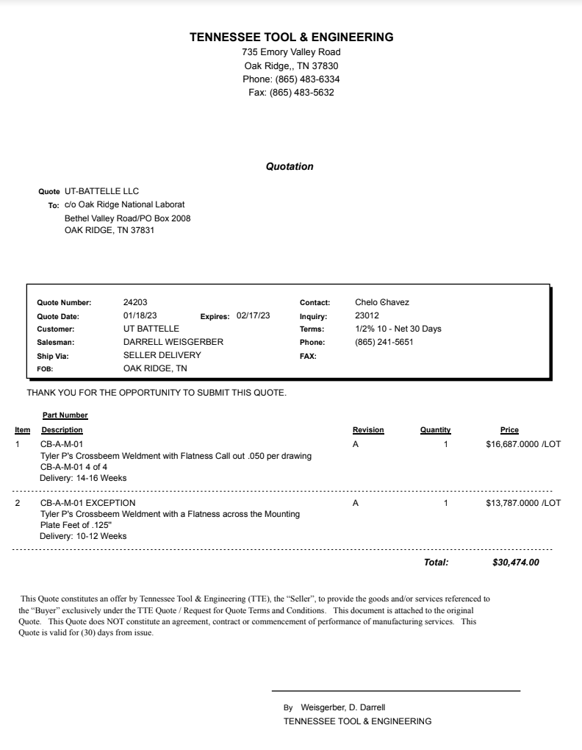

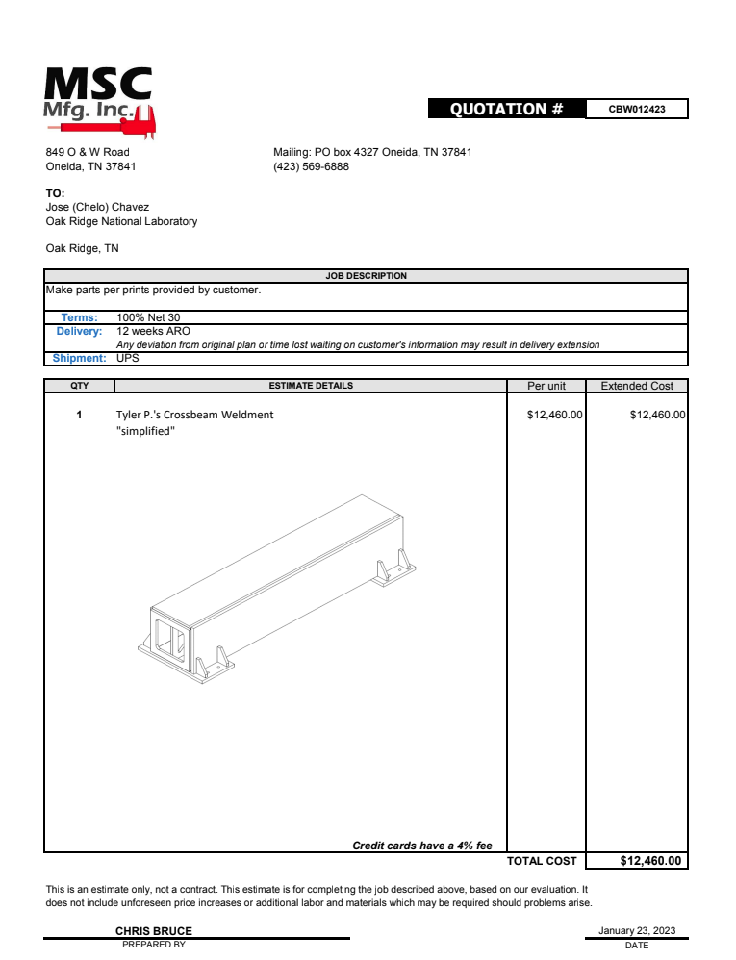

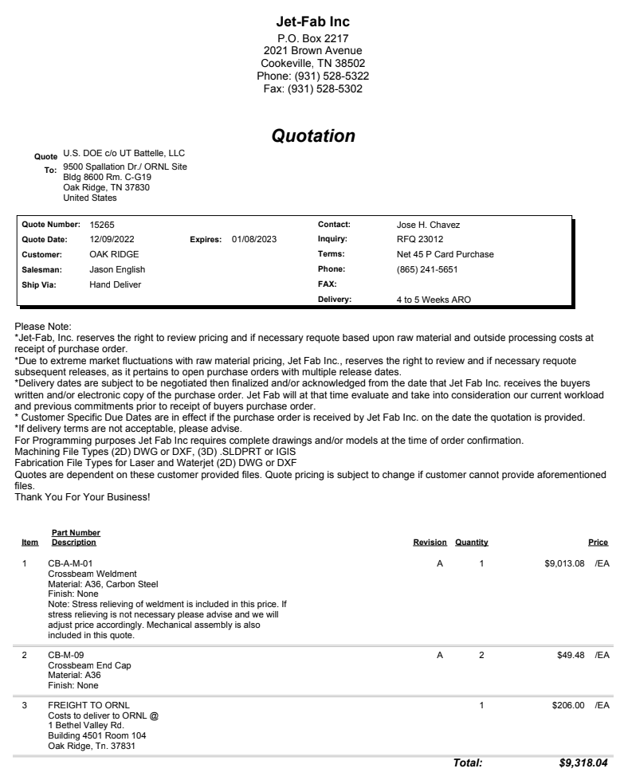

Vita
Nathan J. Wilson was born and raised in Washington state. After graduating with his bachelor’s in mechanical engineering from Brigham Young University, Nathan began attending the University of Tennessee. He is expected to graduate in Spring of 2024 with a dual master’s degree in business administration and mechanical engineering. He currently lives in Knoxville, TN with his wife and baby boy.

