CRITICAL PEDAGOGY AND ACCOUNTABILITY:
AN AUTOETHNOGRAPHIC ANALYSIS OF
RACE AND EMBODIMENT IN TENNESSEE’S
TEACHER EVALUATIONS

A Thesis Presented for the
Master of Arts
Degree
The University of Tennessee, Knoxville

Rebecca C. Napreyeva
August 2021

Copyright © 2021 by Rebecca C. Napreyeva.
All rights reserved.

For Katya.
May you live, learn, and grow in a more perfect world.

ACKNOWLEDGEMENTS

I would like to express my sincerest thanks to Dr. Lisa King for her tireless efforts towards supporting me and guiding me through this project from its conception to completion. I do not believe it would have been possible without Dr. King’s ample guidance and kindness. Thanks are also amply due to Dr. Jeff Ringer and Dr. Katy Chiles, both of whom along with Dr. King helped ensure that the pressures of the COVID-19 pandemic did not derail my research or my progress in my coursework.
Thank you also to my family, most notably my husband Max, who never doubted my ability to succeed in this endeavor. Max’s diligent work ensured that our family remained healthy and happy during unprecedented circumstances. Thank you to my daughter Katya, who sacrificed many hours of playing with her mama so that I could attend Zoom classes and complete my work. Her cheerful exclamations of “Yay mommy, good job!” each time I completed major milestones helped me maintain energy and a positive attitude, as well. Thanks also to my parents, Jim and Gretchen Culp, without whose babysitting I would have never been able to complete my graduate school application with an infant in tow. Thank you to my siblings and their spouses, for letting me bounce my ideas around with them, and for cheering me on from afar throughout our socially distanced year.
Thanks to all of my friends both new and old for their support through this process. Jake Buller-Young and Anita Voorhees—thank you for all of our study sessions and for your kind friendship. Particular thanks are due to all of my former teaching colleagues at Anonymous High School. I regret that I was not able to incorporate your voices into this project. Finally, thank you to all of the students at AHS who shaped my beliefs, career, and ultimately made this project possible, particularly “A.” I hope that you all achieve your goals and dreams.
ABSTRACT

The current social climate within the United States has pushed antiracist pedagogies to the forefront of educational discourse in primary, secondary, and post-secondary institutions. Given the fact that the vast majority of public school teachers in primary and secondary schools are white females, the particular ways they approach the instruction of their minority students is of significant importance, as their cultural perspectives are disproportionately represented in classrooms across the country.
This study uses an autoethnographic approach combined with scholarship in critical pedagogy and critical race theory to examine 1) the particular ways that cultural conflict manifests between white female teachers and their Black students, 2) how the classroom evaluation portion of Tennessee’s accountability model accommodates the tenets of critical pedagogy, and 3) how the incorporation of students’ standardized test scores affects both teachers and Black students.
This study demonstrates the finding drawn from critical race scholarship that in most instances where white female teachers have the intention of furthering social justice for their Black students through educational means, cultural conflict inhibits meaningful progress. It also reveals that one reason for this can be a lack of critical reflection on the part of the teacher. Because this type of critical reflection and instruction must be implemented by the teacher, and the teacher is a representative of a large institutional power structure, this study also reveals that another factor in inhibiting social justice through education is that the incorporation of student TNReady test scores into the teacher’s evaluation score functionally undermines the allowances for critical pedagogy contained in the classroom observation TEAM rubrics.

TABLE OF CONTENTS

Introduction………………………………………………………………………………… 1
Chapter One: Literature Review…………………………………………………………… 9
Overview: Tracing the Connections Among Different Antiracist Pedagogies ………... 10
Applying the Theory in Specific Contexts……………………………………………... 24
What This Means for College Rhetoric and Composition……………………………... 27
Chapter Two: Methodologies……………………………………………………………… 30
Chapter Three: Analysis of the TEAM Rubrics…………………………………………… 43
The TEAM General Educator Rubric: A Breakdown of the Indicators
Through the Lens of Critical Pedagogy………………………………………………... 46
How Do the Scores Look in Actual Practice? ………………………………………… 60
Chapter Four: Analysis of the Incorporation of TNReady Scores…………………………. 69
TNReady Tests and Achievement Gaps……………………………………………….. 74
TVAAS and “What Teachers Can Control”…………………………………………… 77
Conclusion…………………………………………………………………………………. 88
Works Cited………………………………………………………………………………... 95
Appendix…………………………………………………………………………………… 100
Vita…………………………………………………………………………………………. 108
LIST OF FIGURES

Figure 1. Indicators Standards and Objectives and Motivating Students………………….. 48
Figure 2. Indicator Academic Feedback…………………………………………………… 50
Figure 3. Indicator Student Work………………………………………………………….. 52
Figure 4. Indicator Respectful Culture……………………………………………………... 54
Figure 5. Indicator Expectations…………………………………………………………… 58
Figure 6. Author’s scores on Student Work & Assessment………………………………... 61
Figure 7. Author’s scores on Standards & Objectives, Motivating Students, and Presenting
Instructional Content……………………………………………………………... 64
Figure 8. Author’s scores on Expectations, Managing Student Behavior, Environment, and
Respectful Culture……………………………………………………………….. 65
Figure 9. Distribution of scores by weight towards overall evaluation score……………… 79

Introduction

During the hours I sit writing this, isolated and socially-distanced due to the COVID-19 pandemic in the far back corner of my university’s graduate study room, my blue light blocking glasses slip down over my face mask when they’re not fogging up uncontrollably. I often take short breaks to look out the window onto the area between the library and the humanities buildings. There’s a small field where sometimes, if the weather is nice, theatre students practice their stage combat skills, while others throw toys for their dogs to chase and retrieve. There’s also a long, wide walkway called the university mall where a small but steady stream of people file past the three daily religious protesters without making eye contact, because no one has the time or energy to stop and discuss “Is anything really right or wrong?” or “Do evolutionary ideas conflict with the laws of physics?”
If I turn my head to the far left corner of the view provided by the large windows, I can see the main road through campus where many of the big marches take place. Sometimes the crowds of protesters turn down the university mall, banging noisy instruments and chanting in unison. You can’t not hear them; their voices echo off the buildings on either side of the field, amplifying their voices in a very purposeful and effective way. These marches occurred with relative frequency before the pandemic began but, for obvious reasons, it’s usually much quieter now. One day in February 2021 as I sat in this same spot for about four hours straight, I noticed a group of 5-6 cars were honking incessantly as they circled around campus again and again, holding Black Lives Matter signs out of the back windows. It did not have the same news-worthy power as the previous August’s March on UT Knoxville, where the Knox News Sentinel reported that “University of Tennessee athletes from nearly every sport gathered around noon Saturday at the Torchbearer Statue at Circle Park, then marched peacefully in a crowd of more than a thousand people,” but those of us in the graduate study room certainly heard them (Travis Dorman).
It seems to me that protesting and advocating for social change are as much a part of daily life at institutions of education as backpacks, books, and more recently, face masks. The March on UT Knoxville was only one of the hundreds of massive protests for the Black Lives Matter movement in response to the murder of George Floyd, and the reach of these urgent calls for systemic change have cultivated mainstream fervor. This has in turn driven calls for reforming all institutions that have a hand in maintaining systemic racism, including institutions of education. In my opinion, it is well beyond time to respond to those calls with action. As an individual educator, I can certainly use my voice to advocate for changes to policies that function to maintain white supremacy. I can also use my position of reach and influence over young adults in order to educate in ways that promote the critical skills necessary to drive social change. This work represents both of those aims, and although they are personal in nature to me, they are also likely to ring true for many other educators across the nation.
As a graduate teaching associate at the university, I often reflect on my experience as a high school English Language Arts teacher in order to inform how I teach freshman composition. Frequently I borrow instructional strategies that have been effective in the past with slightly younger students and adapt them for my college students. But just as frequently, I realize that some of my former practices really should not be repeated in any form. One example of this nags at my conscience regularly. One of my high school students once wrote in an essay that a character “felt some type of way,” and I wrote in the margin “this doesn’t mean anything.” I don’t even know why I wrote that. I know exactly what that phrase means--that the emotion is complex and difficult to describe in words, which honestly was probably an accurate way to describe the character the student was writing about. Yes, a major part of writing essays is getting students to engage in the types of analytical thought that can find more precise words to describe complex and difficult phenomena. So why didn’t I write that in the margin instead?
Four years have passed since I wrote that, and I actually do not think it’s time to “let it go.” In my mind, the BLM protests of 2020 demonstrate that this is an example of the ways that educators can inadvertently uphold systemic racism in even the minutiae of everyday classroom practices. Scholars have known for decades that prioritizing one dialect over another only functions to maintain damaging social hierarchies. At least since the Conference on College Composition and Communication “Students’ Right to Their Own Language” resolution in 1974, where it was clearly stated that “Language scholars long ago denied that the myth of a standard American dialect has any validity. The claim that any one dialect is unacceptable amounts to an attempt of one social group to exert its dominance over another. Such a claim leads to false advice for speakers and writers, and immoral advice for humans.” Unfortunately, I believe my comment in the margin of that student’s paper falls squarely in line with expectations that prioritize standard English over other Englishes. I wish I could say otherwise, but I cannot.
What bothers me further is how simple it has been to not replicate this problematic belief with my composition students. As the world stands right now, it is also immoral to deny students access to knowledge of the standardized forms of English that they need to function in the careers and professionalized environments that still require it. In my admittedly brief time as a composition instructor, it seems to me that a simple acknowledgment and discussion of this when going over essay rubrics is all it takes to help students see what’s going on with the grammar and language expectations in formal essays. I very much wish I had known more about this back then, as well as other aspects of my teaching that were potentially damaging to students from backgrounds and cultures different from mine. This work represents an attempt to illustrate other situations like this through critical reflection, as well as to work through ways that teachers can use the professional expectations of the state to support all of their students’ needs. Although this presents significant challenges, it seems that being aware of those challenges in the first place is an integral part of being able to address and change the ways that institutions of education currently replicate social hierarchies. My intention in these chapters is to trace how the Tennessee teacher accountability model accommodates English/Language Arts teachers who are seeking to shape their pedagogical decisions towards ameliorating the particular ways that African Americans and other Black individuals have been racialized within public education institutions in the United States post-desegregation.
I begin in Chapter One with a review of literature focused on antiracist pedagogies including critical pedagogy, critical race theory in education, and decolonizing pedagogy. This review is centered on the fact that these pedagogies are not new; they have been developed and debated by scholars for several decades already. Renewed attention surrounding them is pushed in large part by the BLM movement, which has moved antiracist approaches to the front and center of pedagogical discussions. Right now, society seems to be at a point where the major tenets of each of these antiracist approaches to pedagogy currently overlap in many ways. Such overlaps include the ultimate goal of using formal education to further social justice by engaging students’ knowledge of larger social realities with the knowledge that they learn in the classroom. In doing so, each of them advocates for the teacher to use critical analysis throughout all pedagogical decisions and promote the type of real-world connections that can help give students language to describe and understand systemic inequalities. By emphasizing the need for analysis of the embodiment, race, and other intersectional qualities of privilege and power of teachers and students alike, antiracist pedagogies reveal that the vast overrepresentation of white women in the field of teaching means that the cultures and ideologies that teachers bring to the classroom often function to replicate dominant culture and white supremacy, even against intentions to the contrary. It appears that one of the best ways to disrupt this is through constant critical reflection on the part of the teacher, a component that is apparently—as illustrated by my marginal comment on that student’s essay—frequently overlooked within this demographic.
As a white woman and a teacher myself, this literature reveals the painful truth that during my years as a high school English teacher, I myself left out this important component of critical reflection. Because teachers like me are working within a major institutional driver of systemic inequalities—education—it is very difficult to subvert the institution in the ways that antiracist pedagogies describe, especially in the face of structures such as evaluations and accountability models. While I did not knowingly or intentionally support policies that suppress the social justice of my minority students, by falling uncritically in line with the expectations of the state, I unintentionally facilitated the replication of systemic inequality. It is therefore these particular structures that I have chosen to examine in this project.
In Chapter Two, as a key aspect of my methodologies, I reflect on my experiences with the components of the Tennessee state-tested teacher accountability model. I focus on my early struggles with instruction and classroom management, often citing my strained relationship with one particular student, whom I refer to as “A”. In Chapter Three, I combine these reflections with a rhetorical analysis of the Tennessee Educator Acceleration Model (TEAM) Rubrics. I analyze features of the rubrics’ language for their application of the tenets of critical pedagogy, and find that these rubrics seem to support teachers who are seeking to further social justice and ameliorate systemic inequalities through their pedagogical decisions. Although I also find that I was not at that time successfully enacting critical pedagogy, this seems to be due to my own personal lack of critical reflection rather than a problem with the explicitly stated expectations on the TEAM rubrics. Additionally, I find that the rubrics allow for the teacher to make these types of inadvertent mistakes, suggesting that they are practical for the ways that real classrooms function.
In Chapter Four, I examine the other half of the Tennessee teacher accountability model: the incorporation of TNReady test scores. In contrast to the seemingly supportive language of the TEAM rubrics, these standardized tests very much continue the racist narrative of “achievement gaps,” and use questionable data to hold teachers accountable for their pedagogical decisions. In essence, this component of the accountability model functionally undermines the classroom evaluation component, forcing teachers to rely on test data that is very likely beyond their control as half of their overall evaluation score. A great deal of the burden of these standardized tests obviously also falls on the students, which further undermines goals towards social justice for Black individuals.
This work is not comfortable for me. My lack of knowledge of the importance of critical reflection and systems of power is difficult for me to come to terms with now that I better understand how it impacted the lives of my Black students. But this pain and discomfort is a necessary part of antiracist work, and by illustrating here part of my own work towards this, I hope that others like me may see that the end result could be far more joyful than the process is painful. Ibram X Kendi frames his description of this type of pain with hope in his national bestselling book How to be an antiracist: “After taking this grueling journey to the dirt road of anti-racism, humanity can come upon the clearing of a potential future: an antiracist world in all its imperfect beauty. It can become real if we focus on power instead of people, if we focus on changing policy instead of groups of people” (11). Yes, white female teachers like me seem to be key players in replicating white supremacy through education in the United States, but we as individuals are not the sole problem. The problem is in the systems of power that allow individuals to remain ignorant of the ways that they support racist policies in spite of ostensibly rejecting racism. Through critical reflection and purposeful pedagogical decisions, white female teachers can instead be key players in dismantling those powers, even while we work as representatives of the state under “professionalization” systems such as the Tennessee teacher accountability model. Kendi’s words give me hope, along with millions of others in their own personal antiracist work: “We know how to be racist. We know how to pretend to be not racist. Now let’s know how to be antiracist” (11).

Literature Review

It is clear that the current social climate in the United States holds race relations between white and Black individuals at the forefront of many conversations. The events of the summer of 2020, particularly after the murder of George Floyd and the worldwide protests that erupted in response, pushed discussion of race and being Black in this nation into mainstream discussion, with added fervor on what it means to hold white privilege. As a major social institution, it is unsurprising that these conversations are also experiencing a resurgence within public schools, and a push towards implementing antiracist pedagogies is a natural and necessary aspect of this. It is important to note that these pedagogies are not new; research in these areas has been conducted for decades, and so in order to understand the current context of race in education in the United States, it is necessary to look at a broad overview of literature. In the sections that follow, I trace the connections among three major pedagogies focused on race and social justice: critical pedagogy, critical race theory in education, and decolonizing pedagogy. Based on this research, it appears that although there is significant overlap among these approaches, it is essential to take into account the particular ways that different minority groups have been racialized before attempting to implement any antiracist pedagogy. Additionally, critical analysis of race absolutely cannot be limited to those of the students—teachers must take into account the impacts of their own embodiment and positionality as a crucial component of the critical reflection required in all antiracist work.

Overview: Tracing the Connections
Among Different Antiracist Pedagogies
Considering the generally swift nature of pushes for change to pedagogical ideology in the United States, the history of critical pedagogy is long and well established. Widely considered the “father” of critical pedagogy, Paulo Freire describes the traditional instruction model in his seminal book Pedagogy of the Oppressed as “narration sickness”—where the educator’s task is to “…’fill’ the students with the contents of his narration—contents which are detached from reality, disconnected from the totality that engendered them and could give them significance,” (52). This lack of engagement with the myriad details that create a student’s or teacher’s “self” renders the instruction shallow and generally ineffective, and a one-size-fits-all approach to the education of adolescents neglects the embodiment and connection that is at the heart of effective pedagogy.
Critical pedagogy is therefore meant to work against the negative effects of traditional instruction, from within the classroom and on into society. In “Critical Pedagogy: A look at the Major Concepts,” Peter McLaren draws together the ideas of several major critical theorists in order to give the reader an introduction to the issues commonly explored. According to McLaren, a major concept in critical pedagogy is the idea that knowledge learned in school is “…historically and socially rooted and interest bound,” (63). McLaren elaborates on the concept of social construction of knowledge by explaining, “When critical theorists claim that knowledge is socially constructed, they mean that it is the product of agreement of consent between individuals who live out particular social relations (e.g. of class, race, and gender) and who live in particular junctures in time,” (63). According to McLaren, this social construction includes concepts such as different forms of knowledge, types of cultures and cultural forms, hegemony, ideology, prejudices, power/knowledge relations, discourses, curricula, social reproduction, and cultural capital (61-81).
A commonality among these topics is critical pedagogy’s concern with how different individuals work within and respond to education as a social institution. As these concepts overlap and interact, the individual typically reproduces social order—even if he or she attempts resistance. However, it is possible to achieve social justice through schools by helping students attain what Habermas calls “emancipatory knowledge,” which according to McLaren, “…creates the foundation for social justice, equality, and empowerment,” (64). In his introduction to Teachers as Intellectuals: Toward a Critical Pedagogy of Learning, Henry Giroux suggests that reaching this emancipation requires examination of “…the contradictions between the official curriculum, namely the explicit cognitive and affective goals of formal instruction, and the ‘hidden curriculum,’—the unstated norms, values, and beliefs that are transmitted to students through the underlying structure of meaning…”; hidden curriculum is present in “…both the formal content and the social relations of school and classroom life,” and without close examination, has the potential to undermine the goals of social education (23).
Ultimately, critical pedagogy seeks to use education as a means to enact social change. As McLaren lucidly states, “Critical theorists begin with the premise that men and women are essentially unfree and inhabit a world rife with contradictions and asymmetries of power and privilege,” (61). Thus, “…any worthwhile theory of schooling must be partisan. That is, it must be fundamentally tied to a struggle for a qualitatively better life for all through the construction of a society based on nonexploitative relations and social justice,” (McLaren 62).
With such an emphasis on social justice, it is not surprising that many elements from critical pedagogy tend to overlap with those highlighted by scholars in critical race theory (CRT). However, giving appropriate language to those connections has proven to be a more difficult task than would generally be expected. Thandeka K Chapman traces the difficulties of even simply defining “social justice” in “Origins of and Connections to Social Justice in Critical Race Theory in Education”: “The term ‘social justice’ is rarely defined in the field of education. Sadly, the editors of three prominent edited books on social justice, my own included, do not provide definitions of social justice… These texts assume a level of understanding and agreement on the term that does not exist” (102). Chapman cites John Rawls’s admittedly heavily critiqued 1972 articulation of social justice as a binding definition to the issues of access and equity, which “…align with the goals of CRT to eradicate injustice based on undeserved, systemic inequalities” (102).
Though the connection between these goals may not be articulated neatly in current scholarship, it does not appear to be much of a stretch to assert that knowledge of “undeserved, systemic inequalities” can fall under Habermas’s definition of emancipatory knowledge. These systemic inequalities, entrenched into every major institution in our nation, are certainly therefore present in educational institutions across the United States, which makes an examination of the hidden curriculum as defined by Giroux particularly apt towards realizing the types of social change and revolution sought by both CRT and critical pedagogy.
The overlapping of two related but ostensibly separate fields does, however, require analysis of their differences in addition to their similarities. Even in the rare instances where all of the students, their teachers, and the administrators all have similar racial identities, there are still myriad variables to contend with in understanding and eliminating systemic inequalities. Importantly, the majority of schools in the nation do not resemble this uniform description, and this necessitates an intersectional examination of power dynamics and privilege among teacher-student relationships. Zeus Leonardo and Erica Boas explore important aspects of this in “Other Kids’ Teachers: What Children of Color Learn from White Women and What This Says about Race, Whiteness, and Gender.” They argue that because the growing majority of students in the United States are minorities while simultaneously a growing number of public K-12 teachers are white women, it is important to examine white women’s roles in reproducing both patriarchy and racism. Leonardo and Boas trace the historical development of traditional female gender roles to how white female teachers function in modern society:
With well-intentioned White women being in the privileged position of representing the needs and desires of others through charity, politics, and schooling, they have also been granted the power to speak for their students… The White and female teacher speaks to the world for her students and she speaks to the students for the racialized nation state. Determined to ‘make a difference,’ she toils endlessly to effect change in her band of students. Her position as schoolteacher automatically implicates her within the institution of schooling, which maintains a core objective of producing proper citizens for the nation. Like all public schoolteachers, she must represent the state’s interests, and if she does not the stakes are high (320).
This description of White women teachers’ role in upholding systemic racism reveals huge challenges for any educator who intends to use classroom instruction to enact social change. For one, it is undoubtedly an act of subversion for a teacher to actively reveal the inequities produced by the educational institution that employs her, especially when a main core expectation of her position is to teach curriculum designed by the state. This particular problem may be addressed in Giroux’s advocacy of examining both explicit curriculum and hidden curriculum, where much of an institution’s ability to undermine social change lies; however, unless the white female teacher sees herself and her embodiment in the classroom as another important component of the hidden curriculum, she will be unable to successfully subvert anything and will instead continue to be an agent in reproducing the very inequalities she intended to ameliorate.
Leonardo and Boas take inspiration for their title from Lisa Delpit’s seminal book Other People’s Children: Cultural Conflict in the Classroom, and the connections between the two texts are clear. In her introduction, Delpit lucidly describes the problems that differences in culture and race among teachers and students can cause:
We all carry worlds in our heads, and those worlds are decidedly different. We educators set out to teach, but how can we reach the worlds of others when we don’t even know they exist? Indeed, many of us don’t even realize that our own worlds exist only in our heads and in the cultural institutions we have built to support them (xiv).
Like Leonardo and Boas, Delpit shows that the teacher’s race and cultural background have a great deal of influence over her ability to teach diverse student populations. Without reflective exploration of those differences and explicit acknowledgement of the problems that emerge, again, racism is supported and reproduced within systems of education.
Delpit explores this in greater detail than Leonardo and Boas in her book-length analysis of the issue, bringing into the discussion poignant examples of the types of negative effects that policies designed by well-meaning white educators can have on their minority students. One such example comes from Delpit’s reflections on her work with the writing process approach to literacy. This approach advocated for teachers to abandon traditional approaches to teaching writing such as a focus on “skills,” and to instead emphasize other elements of the writing process, including “fluency” and “voice.” Delpit reflects that her work in graduate school taught her that the writing process approach was highly beneficial for teaching young writers, and she dedicated a great deal of energy and effort towards furthering the use of this approach. She was therefore stunned when she later spoke to several fellow Black educators and “They said the whole thing was racist, that the meetings [on developing the writing process approach] were racist, and that the method itself was racist” (17).
This revelation led Delpit to an important conclusion about the cultural impacts of the (mostly) white teachers who advocated for the writing process approach:
In puzzling over these issues, it has begun to dawn on me that many of the teachers of black children have their roots in other communities and do not often have the opportunity to hear the full range of their students’ voices. I wonder how many of Philadelphia’s teachers know that their black students are prolific and ‘fluent’ writers of rap songs. I wonder how many teachers realize the verbal creativity and fluency black kids express every day on the playgrounds of America as they devise new insults, new rope-jumping chants and new cheers. Even if they did hear them, would they relate them to language fluency? Maybe, just maybe, these writing process teachers are so adamant about developing fluency because they have not really had the opportunity to realize the fluency the kids already possess. They hear only silence, they see only immobile pencils. And maybe the black teachers are so adamant against what they understand to be the writing process approach because they hear their students’ voices and see their fluency clearly. They are anxious to move to the next step, the step vital to success in America—the appropriation of the oral and written forms demanded by the mainstream (17-18).
This passage illustrates the importance of the concept that Delpit terms “cultural conflict;” it is not an overt, in-your-face, explicitly racist phenomenon, though it certainly must stem from those same roots. Instead, it is an attempt—led from an exclusively white perspective—to help Black students achieve the same types of writing progress that white students more typically achieve. This is not to say that white students naturally possess more aptitude towards “academic” forms of writing, but rather an acknowledgement that those forms are both determined by and required by dominant institutions inextricably linked to white supremacy, and therefore fall more closely in line with the types of cultural communication that white students are more likely to possess prior to and outside of formal schooling.
This in turn offers important insight on the differences between form and function for white educators who acknowledge the differences in academic “performance”—a complex and problematic concept that I will discuss in great detail later in this work—among demographic groups of students. Delpit’s writing process example notes that the predominantly white promoters of the approach had good intentions for encouraging educators of all sorts to abandon skills-based approaches to teaching writing: “…writing process advocates often give the impression that they view the direct teaching of skills to be restrictive to the writing process at best, and at worst, politically repressive to students already oppressed by a racist educational system” (18). This shows that their intentions were admirable in that they sought to restructure an impactful component of education in a way that they presumed would benefit minority students. However, by relying almost exclusively on input from white educators, the program failed to actually revolutionize anything, and in actuality—just as Leonardo and Boas predict about the impacts of white women with good intentions—continued to reproduce the same inequalities and erasure of Black voices that are rife in traditional approaches to education.
Therefore, because white female voices dominate the field of public education, intentions are meaningless without substantial input from other voices that can more readily disrupt the system. Delpit offers a simple solution: “I further suggest that it is the responsibility of the dominant group members to attempt to hear the other side of the issue; and after hearing, to speak in a modified voice that does not exclude the concern of their minority colleagues” (20). Ultimately, the types of educational reforms and emancipatory knowledge necessary to enact sweeping social change will prove more difficult than honest attempts to listen from dominant groups, so the second half of Delpit’s solution is key. As Delpit, Leonardo, and Boas show, it is easy for white female teachers to rely too heavily on their good intentions without seeing that those intentions may be implicated within systemic racism. They must also modify their voices based on substantial input from minority voices before attempting to enact social change in the classroom.
Towards that end, it is important to note that up to this point, the entirety of my discussion of dominant and minority groups has been facilitated by examples from white and Black individuals. Critical race theorists would be right to point out that this could easily appear to fall under the “Black-white binary,” a highly controversial issue in current scholarship on race. In Critical Race Theory: an Introduction, Richard Delgado and Jean Stefancic describe the Black-white binary:
One of the more contentious issues in American racial thought today is whether the very framework we use to consider problems of race reflects an unstated binary paradigm or mindset. That paradigm, the black-white binary, effectively dictates that nonblack minority groups must compare their treatment to that of African Americans to redress their grievances. The paradigm holds that one group, blacks, constitutes the prototypical minority group. “Race” means, quintessentially, African American. Others, such as Asians, American Indians, and Latinos, are minorities only insofar as their experience and treatment can be analogized to those of blacks (77).
Delgado and Stefancic add that “Binary thinking, which focuses on just two groups, usually whites and one other, can thus conceal the checkerboard of racial progress and retrenchment and hide the way dominant society often casts minority groups against one another to the detriment of both” (81-82). In this way, it is unfortunately possible again for those seeking social change to instead inadvertently further the interests of white supremacy.
However, discussing issues between white people and black people within the cultural and historical contexts of the United States is certainly not completely without merit. Delgado and Stefancic also point out that some theorists maintain that Black-white relations in the US may fall under “exceptionalism,” which “…holds that a group’s history is so distinctive that placing it at the center of analysis is, in fact, warranted,” (79). The chattel enslavement of Black people and all of its modern legacies certainly support the idea that the history of African Americans in this country is distinctive; however, exceptionalism holds the same problematic potential of concealing the racial repression of other minority groups as does the Black-white binary.
Therefore, taking minority groups’ particular concerns into consideration seems to be a more effective way to disrupt the dominant groups’ ability to pit minorities against each other. This is taken into account with differential racialization thesis. According to Delgado and Stefancic, the differential racialization thesis “…maintains that each disfavored group in this country has been racialized in its own individual way and according to the needs of the majority group at particular times in its history” (79). In the interest of thorough acknowledgement of the drawbacks of limiting discussions of race to only Black and white individuals, let us revisit Delgado and Stefancic’s discussion of the Black-white binary:
Like other paradigms, the black-white one allows people to simplify and make sense of a complex reality. And, of course, it is helpful in looking at the historical and ongoing relationship between black and white Americans. The risk is that nonblack minority groups, not fitting into the dominant society’s idea of race in America, become marginalized, invisible, foreign, un-American (80).
Here, Delgado and Stefancic take note of the beneficial aspects of this type of limitation before issuing a strong reminder of the inherent risks to other minority groups, including erasure. Perhaps nowhere is this “invisible” effect more evident than in the case of Indigenous Americans in the United States, whose history and status in our society remains largely ignored, despite also very much fitting the description of distinction involved with exceptionalism.
Towards this end, scholarship on race and education has recently emerged with renewed fervor on decolonizing the classroom. As described in “Decolonization is not a metaphor” by Eve Tuck and K. Wayne Yang, decolonizing pedagogy is aimed specifically towards bringing about social change in the form of repatriation/rematriation of Indigenous peoples and land:
Though the details are not fixed or agreed upon, in our view, decolonization in the settler colonial context must involve the repatriation of land simultaneous to the recognition of how land and relations to land have always already been differently understood and enacted; that is, all of the land, and not just symbolically. This is precisely why decolonization is necessarily unsettling, especially across lines of solidarity (7).
Tuck and Yang argue that to ascribe the term “decolonization” to any and all other types of social justice reduces it to a metaphor with problematic consequences, namely the continued erasure of Indigenous people and the history of violence against them, as well as ascribing innocence to settlers and maintaining the systemic oppression of settler colonialism.
This therefore presents a glaring example of how neglecting to analyze the particular ways that minority groups have been racialized can allow systemic racism to continue and flourish through inadvertently ignoring major aspects of what different minority groups may need in order to accomplish meaningful social reform. An educator may be able to use the methods of critical pedagogy to bring about social changes that would benefit Indigenous minorities, but true social revolution would not be made possible without incorporating and analyzing the particular ways that those Indigenous minorities have been racialized in the United States as well as in other nations of settler colonialism. Tuck and Yang explain the significance of land in settler colonialism:
Land is what is most valuable, contested, required. This is both because the settlers make Indigenous land their new home and source of capital, and also because the disruption of Indigenous relationships to land represents a profound epistemic, ontological, cosmological violence. This violence is not temporally contained in the arrival of the settler but is reasserted each day of occupation. This is why Patrick Wolfe (1999) emphasizes that settler colonialism is a structure and not an event. In the process of settler colonialism, land is remade into property and human relationships to land are restricted to the relationship of the owner to his property. Epistemological, ontological, and cosmological relationships to land are interred, indeed made pre-modern and backward. Made savage (5).
This quote illustrates how deeply land is tied to the racialization of Indigenous people. Settlers—a term that importantly includes the modern-day, primarily white descendants of early settlers—stripped Indigenous people of not only physical land, but also all of their important cultural and spiritual ties to the land. This process denied and continues to deny the personhood of Indigenous people and reduces them to the status of “savages” because their orientation to land does not align with the sanctioned views of land imposed by the settlers. Thus, meaningful social change for Indigenous minorities can only be accomplished through addressing the systemic effects of settler colonialism on Indigenous populations and land ownership.
I have purposely presented here an example of racialization that complicates the ideas of potential solidarity among minority groups presented by Delgado and Stefancic. Settler colonialism is also what brought the ancestors of millions of African Americans to this land as chattel slaves, which in turn brought about the legacies of slavery discussed previously in this chapter as well as later in this work. Discomfort predictably arises when considering the effects of repatriation/rematriation on other minority groups, including African Americans. This is a symptom of the necessarily unsettling nature of decolonization: “Settler colonialism and its decolonization implicates and unsettles everyone” (Tuck and Yang 7).
Despite the potential for conflicting goals and views of positive social change across ethnic minority groups, there is still much to be addressed before reaching this ultimate goal of decolonization, which means that at least for now, many of the goals of critical pedagogy, critical race theory in education, and decolonizing pedagogy currently overlap. Within this overlapping area has emerged a term that highlights the commonalities among all three: antiracist pedagogy. This is a major focus of “Decolonizing our Classrooms Starts With Us” by Terry Kawi, as she opens her article by stating:
Being an antiracist is an active and ongoing practice one engages in for life. It takes patience, reflection, and commitment. I believe that being an antiracist starts with going inward and taking stock of what we feel and know to be true. Only then can we begin to analyze how dominant ideology and white supremacy have shaped our individual beliefs and behaviors… Being an antiracist educator is no different.
Kawi’s tips for practical implementation of antiracist pedagogy stem from these same ideas of patience, reflection, and commitment, and within this she addresses a question which is likely to be posed frequently among the ranks of white educators who consider themselves to be sympathetic to the goals of teaching towards social justice: “But what if I am white? Nobody is asking you to be an expert or to pretend to know more than you do. This question is rooted in you being at the center.” Considering the issues of good intentions among white educators brought up by Delpit, Leonardo, and Boas, it is important that Kawi points out the problematic nature of this question. It is yet another example of how reflection and critical analysis of good intentions among white educators frequently reveals that regardless of intention, systems of oppression are likely to replicate.
In “Decolonizing the Classroom: Step 1,” Michael Seward addresses this replication in his proposed first step alluded to in the title: becoming politically conscious. He echoes and confirms many of the other practical changes teachers can make in their classrooms while working towards decolonization brought up by Kawi before addressing this first step: “Yet the first change must be to become politically conscious. In order to speak the truth to power, one must first enable oneself to see the truth, the truth of the profoundly damaging legacy of colonization,” (Seward). In addition to this statement being a reflection of the types of critical analysis and reflection necessary to implement each type of antiracist pedagogy explored here, Seward points out that this is especially important for teachers of English:
Anyone who teaches English outside of England is part of the colonial project, particularly if the teaching takes place within a sanctioned institution and if the English being taught is a standardized, “official” English. One need only contemplate the role of language and schooling in European colonization of the Americas, Africa, Australia, and Asia to grasp the central function of teaching (particularly teaching English) in colonization.
Other subject areas are certainly not exempt from the damaging effects of institutionalized learning on subjugated populations, but the subject matter of English was itself intended to erase and replace the native languages of Indigenous peoples. Seward addresses the connection between teachers of English and becoming politically conscious lucidly: “A politically conscious teacher acknowledges that one cannot claim to be purely (and innocently) against racism while acting as a functionary for a colonial and racist system (especially when benefitting materially by doing so (i.e., receiving a paycheck)).” Developing an understanding of systems of oppression as well as an explicit understanding of one’s own roles within those systems is another key theme among antiracist pedagogies.
Applying the Theory in Specific Contexts
It seems that indeed there are many commonalities among antiracist pedagogies including critical pedagogy, critical race theory in education, and decolonizing pedagogies. Each orient towards goals of social justice, and emphasize the importance of critical reflection and analysis of one’s embodiment and place within systems of oppression as vital steps for realizing social justice and progress. The questions remaining now are: what does it mean to apply these big, lofty concepts to small, local contexts? What does all of this look like for individual teachers who are actually attempting to implement these concepts into daily instruction? Importantly, how do individual teachers experience the pressures of resisting and undermining institutional powers from within an institution?
In order to make a contribution to this work, I myself am able to explore my perspective of these questions in regards to my own pedagogical practices. Although it would be optimal to conduct interviews with other educators in order to gain a fuller picture, COVID-19 restrictions on conducting this type of research have made this impossible at this time. However, by using the same types of critical reflection and analysis promoted in the literature, I can still take advantage of the significant opportunity to shed light on the experiences of a liberal, white, female English teacher. As pointed out in the literature, my demographic information places me squarely in a category of teachers who have a widespread impact on our nation’s students. The most recent data available from the National Center for Education Statistics indicates that in 2017-2018, 79% of all public school educators were white and 76% overall were female (“Characteristics of Public School Teachers”). Based on this, it is likely that my ample experience with failing to successfully implement antiracist pedagogy is not limited to me, which in turn makes it possible that my individual reflections may speak to common experiences.
As is pointed out in the literature, implementing antiracist pedagogy requires thorough analysis of all components of education and instruction; no details are too small to be implicated in systemic oppression. For the purposes of this project, it seems most beneficial to focus on how teachers are held accountable for their instructional practices, since this covers a broad spectrum of classroom practices including curriculum choices, instructional techniques, discipline, and classroom management. This also has the potential to reveal a great deal about the “professional” expectations of institutions of education, and thus illustrate how teachers work within and respond to these pressures while at the same time attempting to implement antiracist pedagogies.
My overview here also clearly indicates that there are a myriad of variables at play at all times. The complexities involved with analyzing and historicizing racialization are immense, and become even more intricate when intersectionalities such as gender, immigration status, and socioeconomic status are also accounted for. While this is certainly important work, it is unfortunately well beyond the scope of this project. It is therefore my intention in this work to trace how the state accountability model accommodates teachers who are seeking to ameliorate the particular ways that African Americans and other Black individuals have been racialized within public education institutions in the United States post-desegregation, while acknowledging the limitations and problems that this can cause. It is my hope that thorough acknowledgement of this will be sufficient to root my work in the knowledge that other racial minorities are likely to experience racism in American education differently than Black Americans, and therefore guard against the potentially insidious effects of oversimplification.
Despite all their commonalities, there are still significant differences among different types of antiracist pedagogies, and I have therefore chosen to also limit my analysis in this project to the tenets of critical pedagogy. The general language of “race” in the descriptions of critical pedagogy by Giroux and McClaren seems to leave plenty of room for differentiation, while also giving structural freedom to include groups not marginalized based on race, including gender, sexuality, and socioeconomic status. Educators should undoubtedly use this flexibility to further the social justice concerns for all individuals. I acknowledge that critical pedagogy, even with its space for students of all races, statuses, and styles to learn the types of critical thinking they need in order to enact revolutionary social change, neither fully overlaps nor fully addresses the specific needs of Indigenous minorities in the United States in regards to repatriation/rematriation; however, to the point that educators and students are right now in this important work, there are enough similarities to justify this limitation.
Ultimately, this research represents an opportunity to challenge preconceptions among white female educators about the impact of their beliefs, cultures, and bodies on their Black students’ education, while taking into account the professional pressures they experience as employees of the state. As Delgado and Stefancic summarize, “…old patterns of thought die hard. If contextualism and critical theory teach anything, it is that we rarely challenge our own preconceptions, privileges, and the standpoint from which we reason” (84). This certainly seems to be true in my case, as I relied almost exclusively on my good intentions when making pedagogical decisions. If this situation is also true for the majority of other white female teachers, as Delpit, Leonardo, and Boas point out, then perhaps articulating my reflective work within these contexts can demonstrate the urgent need for other individual teachers to begin or continue doing the same type of work themselves.
What This Means for College Rhetoric & Composition
In this project I am specifically addressing the TNReady state tests in English language arts, rather than including other state-tested subjects that also fall under the same evaluation and accountability category. It is important to note that although the locus of my work here is in public K-12 institutions of education, there are many aspects of this project that are directly related to work in rhetoric and composition. One is that there is much research in the field on the effects of writing for standardized tests—such as TNReady— on student writing in post-secondary institutions. This connection between high school and college writing is frequently termed “articulation,” and has much to do with research in writing transfer. In previous work, I have found that there is some consensus among scholars that the explicitly stated goals of “College and Career Readiness” contained in the Common Core State Standards (implemented almost in their entirety under a different name in the state of Tennessee) have the potential to facilitate positive transfer of writing skills between secondary and post-secondary contexts, but that the standardized tests used in conjunction with the standards disrupt that connection. Indeed, several scholars have found that the sweeping use of standardized tests has reciprocal effects on both teachers and students, including how they must interpret and implement the standards. This effect happens because not only are student state test scores used to determine whether those individual students are “college and career ready,” but they are also used to hold teachers accountable for student learning progress, as I will thoroughly examine within this project.
In Writing and School Reform: Writing Instruction in the Age of Common Core and Standardized Testing, Joanne Addison and Sharon James McGee make a convincing case that the CCSS themselves provide a strong basis for writing transfer from high school into college, but that the use of standardized tests and accountability models greatly inhibit this effectiveness in no small part by eroding teachers’ agency over pedagogical decisions. The authors ground their argument by exploring the history of testing and accountability in American education, and find that over the course of a century, no standardized test for writing has been developed that can reliably measure writing development over time. They argue that among individuals and entities who are considered to be sponsors of literacy, testing companies and private foundations currently hold too much influence, and their suggested solution to this is to restore teacher agency over pedagogical decisions (Addison and McGee, “Introduction”).
Other scholars such as Peter Khost concur that CCSS-aligned, standardized assessments are causing difficulties in college composition instruction. He draws his argument from specific language on the sample tests, and finds that the assessments are training K-12 students to misunderstand a great deal about rhetorical situations, particularly through an over-emphasis on logic and a limited understanding of audience. He clearly states: “My complaint about CCSS-aligned high-stakes testing is that it risks training students over many years to adopt a reductive and potentially unethical attitude toward audiences by privileging a monologic, agonistic brand of argumentation” (47). Khost finds that the CCSS requires students to carefully consider rhetorical concepts, but the supposedly CCSS-aligned assessments do not provide students with the context necessary to do so. These examples show that Khost, Addison, and McGee are among scholars in rhetoric and writing who also look heavily towards K-12 English/Language Arts instructional practices in their research on writing within post-secondary institutions. In this way, my analysis of the effects of Tennessee’s state-tested teacher accountability model on pedagogical decisions contain broad potential for consideration within rhetoric and composition.
This broad potential for consideration within college rhetoric and composition includes antiracist pedagogical considerations. If students’ understanding of writing is altered based on how the state tests affect the ways their teachers must instruct their writing, and that understanding of writing is then carried into their college writing, then it is likely that their understanding of the structures of power associated with those same tests is also carried into college classrooms. This effect, which could easily be considered negative transfer, has the potential to impact a myriad of factors within college composition, from student understanding of language, grammar, and dialect to placements in different iterations and levels of composition classes. If the goal of first year composition programs is to prepare students for the types of writing they will need to succeed in college and in their careers, then this is the same “college and career readiness” structure as the CCSS and their aligned standardized tests. Therefore, making knowledge of the systemic problems with the tests is an important factor in both K-12 and higher education.

Methodologies

As I mentioned previously, my intention in these chapters is to trace how the Tennessee teacher accountability model accommodates English/Language Arts teachers who are seeking to shape their pedagogical decisions towards ameliorating the particular ways that African Americans and other Black individuals have been racialized within public education institutions in the United States post-desegregation. Because “professionalization” is a major way that institutional powers are able to control their workers’ actions and reproduce hegemonic social order, the state accountability model necessarily impacts efforts and abilities to use education as a means to drive social change. In order to address this professionalization, I will first provide a rhetorical analysis of the TEAM rubrics for state tested subjects for their potential to accommodate the tenets of critical pedagogy. Then I will critically analyze the incorporation of student TNReady test scores for those scores’ impact on implementing critical pedagogy. As a significant and inextricably linked part of this analysis, I will incorporate critical reflections of my own experiences with this accountability model in an autoethnographic fashion.
This reflective approach is justified by the impact that my demographic details are shown to have on student minorities. As a white heterosexual female, raised in an area of the United States where traditional values and approaches to education, religion, and social issues remain largely unchallenged, teaching in a predominantly white institution, and receiving a paycheck literally from the state, my role as a teacher is set from the beginning to reproduce traditional social structures without consistent and explicit critical reflection. As revealed in the overview of literature, this same cultural setting seems to represent an unspoken dilemma for many teachers who intend to use teaching as a means to further social justice. The National Center for Educational Statistics keeps regular reports of demographic details of educators in the United States, which describe stark realities of the embodied representations and dominant cultures that teachers carry into their classrooms. According to the most recent of these reports, 79% of teachers in American public elementary and secondary schools were white in 2017-18 compared to 7% of teachers in the same time period who were Black, making discrepancies in representation and perspective readily apparent (“Characteristics of Public School Teachers”).
These discrepancies are longstanding in our nation. In the same categories in the years 1999-2000, 84% of teachers were white compared to 8% who were Black (“Characteristics of Public School Teachers”). When these categories are compared to the racial makeup of the students they teach, the discrepancies are cast into such sharp relief that they appear to be juxtaposed. According to a separate report by the National Center for Educational Statistics, white teachers significantly out-represent minority teachers in every category of racial diversity within their schools except those with the highest minority ratios of above 90%—and within this category, white teachers still average 45% of the faculty (Spotlight A: Characteristics of Public School Teachers by Race/Ethnicity). The literature shows that these numbers represent significant cultural conflict and reproduction of both dominant culture and white supremacy, even against the honest intentions of white educators. This effect can partly be attributed to the particular roles of white women in reproducing white supremacy through their perceived roles as caretakers, because they are likely to spend a great deal of their energies focusing on “saving” individual minority students rather than examining the ways that their curriculum, instruction, and beliefs can undermine their efforts and intentions.
I concede that to draw conclusions about such a large group of teachers would require much broader research than my personal reflections can provide. Ideally, I would have conducted qualitative research including interviews with teachers still in the field of public K-12 English/Language Arts after the Black Lives Matter protests in 2020. Doing so would provide more relevant information about the relationships between white teachers and their Black students within more current contexts, as well as a fuller picture of the impacts that the accountability model has made on their pedagogical decisions. However, just as the COVID-19 pandemic generated new contexts and climate towards race in the United States, it has also had widespread impact on how research can be conducted. As I was applying for research approval to interview teachers for this thesis, one governing organization decided to place a blanket denial on all requests to collect new data—including teacher interviews—due to COVID-19 concerns. Due to this sweeping policy, it was necessary for me to change the structure of my work. Although this means that I cannot draw strong conclusions about larger groups of teachers, insight can still be gained from analyzing my experience with these same systems, albeit more limited. Based on the reports cited above as well as in the literature review, it is not unlikely that many other teachers may find that my experiences mirror their own, and this is valuable in and of itself due to the personal reflective nature of antiracist work/practice in general.
Because I worked as a public school English/Language Arts teacher in Tennessee for only three years, my license was labeled as “apprentice,” which during that time period (2015-2018) meant that I was formally observed four times per year. This totals twelve formal classroom observations, which allows me plenty of experience with how these observations functioned and impacted my instructional choices. Additionally, because most of my career was in a high school where classes were on a block schedule (by semester), I worked through a total of six state testing cycles, which also allows me ample experience with how these tests functioned and impacted my instructional choices. Therefore, although there are limitations to analyzing only my own point of view in this project, the insights are still grounded in ample understanding of the impact of these main components of Tennessee’s accountability model on daily classroom instruction.
I acknowledge that I am not individually representative of everyone’s experiences with this model. However, all English/Language Arts teachers in the state of Tennessee have to operate within the same framework, so there is potential for finding commonalities. Exploring my positionality as a white female teacher under these institutional frameworks is useful for exploring how they function in certain circumstances. James Chase Sanchez explores the uses and limitations of using autoethnography in antiracist work in “Towards Reconciliation: Composing Racial Literacy with Autoethnography.” By reflecting on his racial experiences growing up in Grand Saline, Texas, as well as reactions to his work (both his own reactions and the reactions of others), Sanchez is able to pinpoint benefits of autoethnography in work that explores racism: “In terms of anti-racism, autoethnography provides a space for the researcher to combat accepted norms and pinpoint realities of racism that might not always be apparent to most audiences” (113-114). This means that as a researcher, an autoethnographic framework allows me to analyze and challenge the generally accepted (though not without various other significant challenges) frameworks of the state teacher accountability model by examining the easily overlooked details of how it functions on the classroom level.
This type of analysis also offers the benefit of amplifying calls for critical reflection within antiracist pedagogies by providing a framework that requires the researcher to engage with that same critical reflection within their research. According to Sanchez, this means that autoethnography is also necessarily personally impactful on the researcher and can change how they feel about their own racialization or participation in the racialization of others by doing their work (112). For myself personally, this means that I have had to confront many of the ways that I inadvertently helped replicate dominant social order and white supremacy in my former pedagogical decisions, and have changed many of by beliefs and approaches in the way that I approach teaching in my current teaching context (first year composition as a white female at a large, predominantly white state university).
This also points towards a significant limitation of autoethnography. Sanchez points out that this type of research can appear to paint an entire community of individuals in the exact same way, however much the positionality of the researcher is emphasized (107). For my project, this means that because I personally failed to enact antiracist pedagogy as a white, female English teacher at a predominantly white school, some readers may interpret that to mean that all white, female English teachers at that same school, and perhaps others like it, face the exact same problems and struggles. This potential effect is reinforced in my literature review by scholars such as Leonardo, Boas, and Delpit who point out tendencies that describe my former teaching practices in some pretty painfully accurate ways. Sanchez notes that inserting caveats such as “not all white, female teachers accidentally support white supremacy!” is not particularly helpful; that caveat is true, of course, but since that population (of which I am a member) on the whole struggles with exactly that issue, inserting too many caveats to the contrary can dilute the impact of the research by allowing other members of that demographic to assign themselves as one of the “good ones” who does not do that (108-109). Within this work, there are certain areas where I have chosen to include caveats. My hope is that in doing so sparingly, I may be able to minimize the defensiveness that can easily arise when talking about racism within a population that has the opposite intentions, while maintaining emphasis on the established consensus that this is in fact a racist tendency within the white, female teacher population in this nation.
In addition to these considerations, I have also chosen to make the school and county I worked in during the time period of my personal reflections anonymous. Doing so not only offers some protection from generalizations about the white, female teachers in those institutions, but it also protects the students. Because my data on my interactions with my students—particularly A—come in the form of reflections, I am not able to go back and collect more data on their perspectives on the situations I describe. Again, this heightens the impact of my analysis of my own viewpoint, but very much limits how I can interpret theirs. Because critical pedagogy requires a departure from traditional teacher/student relationships, and ultimately it is the students who enact social change rather than the teacher (who is more of a facilitator under this model), this framework presents a significant limitation to how I am able to analyze the tenets of critical pedagogy in this work. Full analysis of how teachers enact critical pedagogy would require additional data on student agency within the classroom, but I do not have such data available and thus am only able to mainly focus on components of critical pedagogy that the teacher has primary agency over, such as critical reflection and designing macro-objectives. This necessarily means that I am not able to provide analysis or data on how the components of the teacher accountability model affect student agency except in ways that are filtered by my own interpretation of their perspectives. This is the same case for the administrators and lead teachers who evaluated me, all of whom were also white and likely held no intention of purposefully perpetuating racist policies. By making these people and these institutions anonymous, my hope is to offset the effect of generalization on the other people involved with my reflections to the furthest extent possible. In this way, Anonymous High School (AHS) can function more as a microcosm for how the state accountability model functioned for me and possibly also for other teachers in similar situations and with similar beliefs.
Tennessee’s model for evaluating teachers in a state-tested subject (such as English/Language Arts) involves two main components, each typically weighted equally in the overall teacher evaluation score. The first is the formal classroom observations conducted using the Tennessee Educator Acceleration Model (TEAM) rubrics. The TEAM General Educator Rubrics include three rubrics: Instruction, Planning, and Classroom Environment. Each of the rubrics is divided into subsections called “indicators,” and there are a total of 21 indicators on the General Educator Rubrics. For my analysis of these rubrics, I will analyze the language of a broad selection of the indicators for their potential to accommodate the tenets of critical pedagogy. As I previously stated, limiting my analysis to critical pedagogy does omit some recent major developments in other antiracist pedagogies; however, due to the scope of this project, limiting my analysis to the specifics of one particular type of antiracist pedagogy is warranted. Additionally, the language of race and other subjugated groups of individuals is broad enough within critical pedagogy to allow teachers and students to apply the same critical concepts to a broad range of social justice needs. Therefore, focusing on analyzing white/Black race relations and progress within the rubrics illustrates concepts that can be beneficial to the education and social justice efforts to many other groups of people as well.
As a framework for my analysis of the TEAM General Educator Rubrics, I will be primarily analyzing the indicators for elements that Giroux distinguishes as “macro-objectives.” In Teachers as Intellectuals: Toward a Critical Pedagogy of Learning, Giroux defines macro-objectives: “Macro-objectives are designed to provide the theoretical building blocks that will enable students to make connections between the methods, content, and structure of a course and its significance to the larger social reality” (48). This type of objective involves much of the hidden curriculum discussed previously in the literature review; it is not limited to explicitly stated objectives for the course, but instead includes all of the unstated curriculum that is present in all pedagogical practices. This unstated curriculum is often where hegemony is best able to reproduce. Giroux defines macro-objectives separately from micro-objectives, but the latter is still a valid and interwoven part of the macro-objectives: “Micro-objectives generally represent the traditional course objectives. They are usually limited by the specificity or narrowness of their purpose, which is shaped by the uniqueness of the course they are designed to serve” (48). Micro-objectives, therefore, include such important factors as standards. While there is also much to analyze in regards to inequality, race, and traditional social structures within those standards (meaning that as a whole, they also contain macro-objectives), the state subject standards are extensive and distinct from the state teacher evaluation model, and would require more extensive research to encompass. They still represent an important part of antiracist analysis and reflection on the part of individual teachers.
My decision to focus my analysis on macro-objectives within the rubrics also comes from Giroux. He continues his discussion of objectives by giving an example of the impact of a significant macro-objective on student learning:
…it is the macro-objectives, rather than the micro-objectives, that warrant analysis… One such important macro-objective centers around helping students to differentiate between the notions of directive and productive knowledge. Productive knowledge is primarily concerned with means… Directive knowledge is a mode of inquiry designed to answer questions that productive knowledge cannot answer… (49).
Again, the types of questions that productive knowledge cannot answer include the significance of the course content to social realities outside of the classroom context, not explicitly stated, but regardless hugely impactful on the reproduction of social order. Giroux continues, explaining:
The importance of this macro-objective [directive knowledge] cannot be overstated. If knowledge is reduced to the mere organization, classification, and computations of data, then its purpose is not questioned and it can be used to serve ends established by someone else. Under such circumstances, students, as well as teachers, are denied the opportunity to examine knowledge critically, and social and political conformity end up masquerading as “acceptable” pedagogy (50).
Giroux’s potent example of directive knowledge as a macro-objective illustrates the importance of focusing analysis in this way. Because macro-objectives connect course content to larger social contexts, they have the capacity to either reproduce or disrupt white supremacy. If unanalyzed, they reproduce it. If analyzed, they can disrupt it. Therefore, focusing my analysis of the TEAM rubrics on macro-objectives that connect student learning to broader social contexts is a logical way to assess the rubrics’ potential to accommodate teachers seeking to enact pedagogical practices aimed towards furthering social justice.
In order to perform this analysis, I have selected six indicators from the TEAM rubrics which explicitly reference connecting aspects of the curriculum and classroom functions to larger social realities. Each of these indicators contain language such as “life experiences,” “personally meaningful,” “feedback from students,” “situations significant in their daily lives both inside and outside of school,” and “respect for one another” which faciliates rhetorical analysis under my chosen frame of macro-objectives. These six indicators are roughly one third of the indicators on the TEAM General Educator rubrics, and I have included indicators from all three of the General Educator rubrics: Instruction, Planning, and Classroom Environment. This selection presents a limitation to my analysis of the indicators. Exhaustive analysis of all 19 indicators could potentially reveal more, but this is outside the scope of this project. The indicators I include represent a sampling of the ways that teachers could potentially look to the TEAM rubrics for language that supports the implementation of antiracist pedagogy in their classrooms. I include images of these selected indicators throughout Chapter Three, and a full copy of the TEAM General Educator rubrics is included in the appendix for reference.
The second main component of the model for teachers in state-tested subjects is their students’ linked scores on the TNReady exams from the Tennessee Comprehensive Assessment Program (TCAP). Generally, these linked scores make up 50% of a teacher’s (in a state-tested subject) overall evaluation score, weighing the results of the test in equal proportion to the teacher’s TEAM classroom observation scores. Teachers are given two measurements based on their students’ test performance. The first is “achievement.” Achievement scores are the traditional way of measuring student performance on standardized tests; this is the score that involves percentiles and compares students’ performance on the test to that of their peers across the state. The state also generates another type of score called “growth,” which weighs more heavily towards the teacher’s evaluation score.
In order to align the types of analysis I am using in both major portions of the teacher evaluation model, I will also focus my analysis of the incorporation of TNReady scores on areas that connect to broader social contexts, namely the tests’ potential effects on the social realities of Black students. As explored in the literature review, this limits my analysis of the accountability model to the particular ways that Black students have been racialized. Additional analysis would be required in order to comment on the significance and impact of critical pedagogy within the model for other racial groups, and still further work would be required to draw conclusions in regards to solidarity among minorities. However, these limitations are justified by their usefulness in providing detailed illustration of the impacts of this aspect of the state’s accountability model on one major racialized group. In other, broader research, this same type of analysis could be performed according to the particular ways that other minority groups have been racialized or marginalized, rendering answers to questions regarding solidarity. Furthermore, in regards to incorporating reflections of my own experience with this evaluation model, Black students represented the largest minority group at both of the institutions in which I taught, suggesting that my reflections may have more “data” to examine there.
Given my chosen theoretical frames and my data, in Chapter Three I analyze the language of the selected indicators and show that the TEAM rubrics explicitly support pedagogical approaches that require the teacher to help students find connections between class objectives and policies to their lives and cultures outside of the classroom. I also reflect on some of the instances where I was not able to successfully enact these types of connections with my students, concentrating on one of my classes that had a more diverse student population than my other classes, including the impactful Black student whom I refer to as “A.” These reflections show that I was neglecting to reflect critically on the differences between my culture and A’s culture, and was therefore unable to instruct him in a meaningful way. Finally, I include excerpts from my observations along with reflections that show how students--including A--have a tacit understanding of power structures work with teacher accountability models. I conclude that in situations similar to this, if the teacher does the necessary critical reflection and uses it to help students make their understanding of power structures explicit, then the TEAM observation rubrics represent an opportunity to shape pedagogical decisions around the tenets of critical pedagogy with apparently state-sanctioned support.
Then in Chapter Four, I turn the focus to the TNReady state tests. First, I examine how professionalization structures such as the Tennessee teacher accountability model can be used to control teachers who would undermine the state’s expectations by drawing from texts from scholars in critical race theory. This analysis at first seemingly counters my findings in Chapter Three; however, I find that this is due to the incorporation of students’ TNReady test scores into the teachers’ overall evaluation score. I demonstrate this by drawing further from the work of critical race theorists in order to reveal the racist nature of the “achievement gap” narrative, still relied on by the state in order to justify continuing to administer the tests. This analysis shows that the tests undermine the antiracist pedagogical efforts supported by the TEAM rubrics. I continue my analysis of the tests by reviewing the questionable nature of the TVAAS growth data using the work of scholars in the field of education and standardized testing. Finally, I connect the systemic problems ignored by the achievement gap narrative to lack of control in TVAAS data by drawing further from critical race scholars. I also incorporate my reflections on the shifts in instructional priorities during testing season, as well as how A and some of my other students experienced the pressures of test preparation. These reflections combined with my analysis show that the state’s efforts toward incorporating standardized testing data into the accountability model undermines the functionality of the critical allowances contained in the TEAM rubrics and actively works against the needs of Black students.

analysis of the team rubrics

Considering that it is the teacher who is evaluated and held accountable for day-to-day classroom practices in the TEAM model, his or her experience of classroom life must be examined as closely as that of the students in order to gain a full picture of TEAM’s aspirations and effects. There are many educator concerns regarding the evaluation system in Tennessee, which mostly seem to stem from how the system is implemented at the school and county levels. As Leonardo, Boas and others point out, it is difficult or nearly impossible for a teacher to undermine a system that gives them their paycheck, and this is particularly true for teachers who interpret the rubrics differently from their supervisors and administrators. I empathize with teachers in this situation, as my first teaching job was not a positive experience. My beliefs, values, and approaches in no way fit with that extremely small, rural, and conservative school environment and culture, and I only lasted one full semester there before I left, rather gracelessly, to find a more comfortable school to teach in. Honestly, this first position was such a negative experience that the threat of expendability galvanized itself into my conception of teaching in K-12 institutions as a career. So although in the following analysis I find that the TEAM rubrics overall support teachers who wish to implement pedagogies geared towards furthering social justice, I also acknowledge that this is likely only true in particular circumstances where they receive ample support from their school environments and administrators.
With this in mind, in the following section I have incorporated reflections exclusively from my second teaching position at Anonymous High School, which I have included with the intention of providing a glimpse of my lived experience with TEAM evaluations. I have purposely included details about my struggles and weaknesses as teacher, as well as a selection of those that my students faced, because these are major concerns that must be contemplated carefully when considering implementing the tenets of critical pedagogy (and, as I argue, the TEAM Educator Rubric, as well).
Because I argue that the TEAM Rubric embraces critical pedagogy and thus the embodiment of the student and teacher within the classroom, some demographic information is also necessary in order to establish a firm base for analysis. The experiences I disclose below took place at Anonymous High School in Tennessee, where I was employed as an English teacher for 2.5 years. The school profile, available on the school’s website, describes the school’s community as located in a middle and upper income area of the city. The city is home to a large state university, and the school’s “...parental community is largely professional in nature drawing from our close proximity to science, engineering, medical, legal, and university arenas.” In addition to this description, it is important to add that the profile also discloses that the student population at this school is approximately 85% white, with just under 20% of its students considered to be economically disadvantaged, and just over 20% on free or reduced lunch. Each of these statistics contribute significantly to the types of student cultural and life experiences that are found within individual classrooms, and the high percentage of middle/upper income and white students has a direct impact on the graduation rate and test scores for the school.
The overall graduation rate at this high school is in the mid-90s, nearly 100%, which is significantly higher than the state average of 89.1% (TN.gov). The vast majority of Anonymous High School students—around 93%—go on to higher education, including four- and two-year institutions and vocational schools, with a majority (about 60% overall) going to four-year institutions. The average composite ACT score for the students is cited on the school website at 23.1, which is higher across the board than the county average (20.7), the state average (19.8), and the national average (21) for the same year. Each of these statistics is significant for what it reflects about the general student body of the school: most of the students are white, from educated and relatively wealthy family backgrounds, and given the profoundly conservative political nature of the area, they are likely to go on to reproduce the same social order in which they were raised. At just under 10% of the total student population, Black/African American students made up the largest minority group at the school. Because the focus of this work is on the how Tennessee’s state accountability model accommodates English/Language Arts teachers who are seeking to ameliorate the particular ways that African Americans and other Black individuals have been racialized within public education institutions in the United States post-desegregation, most of the reflections and examples that follow will center around how I as a white teacher in the predominantly white institution attempted to implement antiracist strategies while working within this evaluation model. I primarily center my reflections around my interactions with my white and Black students, especially one I call A, in order to focus my analysis on this particular type of racialization.
The TEAM General Educator Rubric: A Breakdown of the Indicators
Through the Lens of Critical Pedagogy
As a reminder, critical pedagogy is focused on several key ideas. One is that knowledge learned in school is “…historically and socially rooted and interest bound,” and thus, critical pedagogy focuses heavily on different forms of knowledge, types of cultures and cultural forms, hegemony, ideology, prejudices, power/knowledge relations, discourses, curricula, social reproduction, and cultural capital (McClaren 61-81). Another key idea is critical pedagogy’s concern with how different individuals work within and respond to education as a social institution. As these concepts overlap and interact, the individual typically reproduces social order—even if he or she attempts resistance. However, it is possible to achieve social justice through education by helping students critically analyze what they learn in school from all aspects and angles. Giroux holds that reaching this goal requires examination of “…the contradictions between the official curriculum, namely the explicit cognitive and affective goals of formal instruction, and the ‘hidden curriculum,’—the unstated norms, values, and beliefs that are transmitted to students through the underlying structure of meaning…”(23). Ultimately, critical pedagogy seeks to use education as a means to enact social change. As McLaren lucidly states, “Critical theorists begin with the premise that [humans] are essentially unfree and inhabit a world rife with contradictions and asymmetries of power and privilege,” (61). Thus, “…any worthwhile theory of schooling must be partisan. That is, it must be fundamentally tied to a struggle for a qualitatively better life for all through the construction of a society based on nonexploitative relations and social justice,” (McLaren 62).
An important step towards this ultimate goal is avoiding the use of traditional instructional models that resemble Freire’s description of “narration sickness”—where the educator’s task is to “…’fill’ the students with the contents of his narration—contents which are detached from reality, disconnected from the totality that engendered them and could give them significance,” (52). For my method of analyzing the critical theory present in the indicators of the TEAM rubrics, I have chosen to focus on elements that Giroux distinguishes as macro-objectives, because these are the elements of instruction that connect what students are taught in school to larger social realities. This reveals several important factors about the macro-objectives present in the TEAM rubrics. One, the frequency at which they show up in the indicators suggests that the state of Tennessee places a significant emphasis on helping students to question their roles and places in society. Two, the state acknowledges the importance of the role of the individual teacher in helping students understand more than just the explicit curriculum and course standards.
I will begin with an example of how these two points are made clear within several indicators in the instruction section of the TEAM General Educator Rubric. Figure 1 shows the indicators of Standards and Objectives and Motivating Students. The first bullet point under score 5 for Standards and Objectives requires that the teacher make all learning objectives clear and communicate them explicitly, as well as connect them to the state standards, and reference them repeatedly throughout the lesson. The third bullet point in the same section requires the teacher to design those objectives in a way that connects to students’ previous knowledge, knowledge from other academic disciplines, and knowledge gained from individual life experiences. In order to accomplish this, teachers must design macro-objectives that orient the
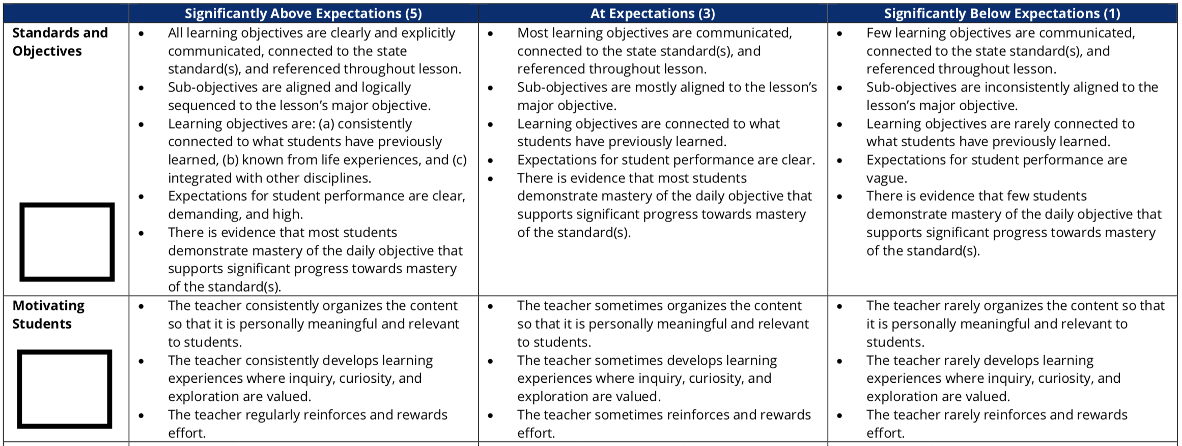
Figure 1: Indicators "Standards and Objectives" and "Motivating Students" from the "Instruction" section of the TEAM General Educator Rubric

standards (micro-objectives) towards real world applications and connection for the students. The choice of how to help students establish those connections is left up to the teacher. This would need to be done in several stages throughout the lesson in order for the teacher to earn a score of 5 for this indicator and for the students to understand that these connections are not merely a shallow attempt at establishing a vague idea of relevancy, but are instead an integral part of the learning process that gives the content meaning within the social structure of society.
The requirements for a score of 5 on the indicator “Motivating Students” allude to the importance of directive knowledge. This indicator also requires that teachers help students establish personal connections, but it goes further in the endeavor to require that the teacher consistently develop “learning experiences where inquiry, curiosity, and exploration are valued.” This should naturally encourage students to ask “Why?” or as Giroux suggests, “For what end?” (49). In order to help students accomplish this, the teacher must also emphasize the questioning and exploration process consistently; it cannot be contained to one isolated part of the lesson, and therefore needs to be a habit established in the course throughout the duration of the semester in order for students to develop a full understanding of the exploration and inquiry aspects of directive knowledge.
Figure 2 shows the Academic Feedback indicator from the Instruction section of the rubric. Here, feedback spans broadly over many aspects of the lesson, including real-time adjustments to the lesson both overall and on an individual level, from both the teacher and students on completed and in-progress assignments, and from students to the teacher about the instruction overall. In order to earn a score of 5, the teacher must consistently engage in each of these aspects in what functions as a cyclical process (teacher to student, student to student, and
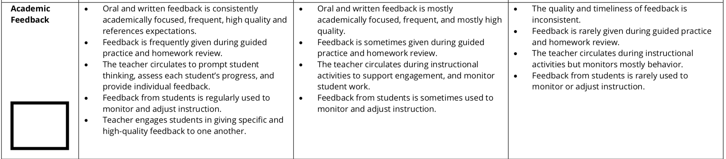
Figure 2: "Academic Feedback" indicator on the "instruction" section of the TEAM General Educator Rubric

student to teacher). This cyclical process would require the teacher to establish an environment in the classroom where students 1) know how to offer helpful feedback, and 2) feel confident and supported enough to do so without fearing negative social consequences. This type of relationship would need to be established as a course-long objective in order to work effectively; as such, feedback and its analytical component lend themselves naturally to questioning established social structures and powers.
In the planning section of the rubric, the requirements for a level 5 score on the Student Work indicator (figure 3) again require the teacher to establish macro-objectives that connect the course-level micro-objectives to social situations on broader levels. The third bullet point specifies that the teacher create assignments that require students to “connect what they are learning to experiences, observations, feelings, or situations significant in their daily lives both inside and outside of school.” In order to do so, the teacher must once again establish a classroom environment where questioning the significance and impact of different types of knowledge is a central focus of the course, from the theoretical level down to individual assignments, whether small or substantial.
At this point in my analysis, it is important to pause and note that the rubrics seem to acknowledge that facilitating a classroom environment that functions on this level and establishes these types of teacher-student-student connections is extremely difficult. Therefore, the expectations for level 3 (at expectations) scores consistently provide leeway for teachers to make mistakes. The expectations are frequently the same in level 3 and level 5 scores for each of these indicators, but qualifiers such as “most” or “sometimes” are added to soften the frequency at which the teacher has been able to incorporate them into the lessons. These qualifiers
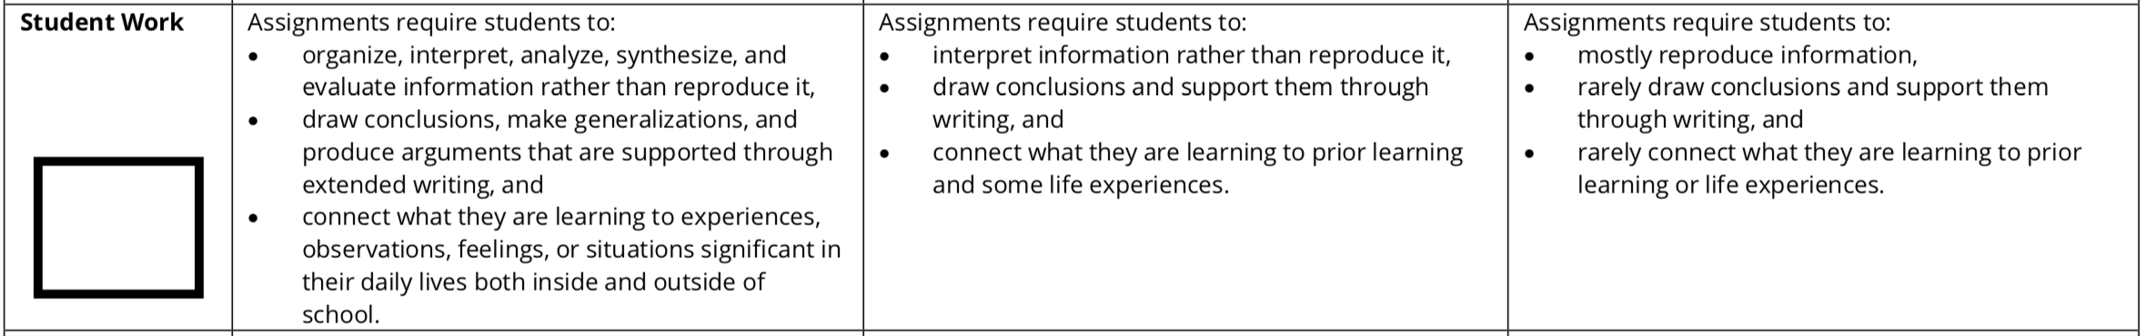
Figure 3: "Student Work" indicator from the "planning" section of the TEAM General Educator Rubric

acknowledge the personhood of the teacher, as mistakes are certainly a part of the educational process, and thus these allowances are included in the level 3 scores, which are categorized as “at expectations.” A teacher who is more experienced or more comfortable with establishing macro-objectives may make fewer mistakes, and could score in the 4-5 range, depending on the effectiveness with which she is able to engage students on these levels. This pattern remains true in the environment section of the rubric, where acknowledgement of teacher mistakes extends to “Teacher-student interactions are generally friendly, but may reflect occasional inconsistencies, favoritism, or disregard for students’ cultures” on the requirements for a level 3 score in Respectful Culture (figure 4).
As any teacher can attest, it is paramount to consider mistakes as a part of teaching. Personally, I can vividly remember periods of time when my mistakes seemed to outnumber my successes, particularly during the first semester of my second year of teaching. In my second semester at Anonymous High School, I found myself struggling to manage a class of 35 students during the final period of the day. This experience was not unique for a novice teacher; the final period of the day is frequently the most difficult to manage, as both the students and teachers are tired and very ready to finish the school day. Compounding the discipline problems in this class were several other factors, including my lack of practice with establishing appropriate authority and presence at the start of the semester. Unfortunately in this particular class, my lack of confidence was readily apparent, and several of the students maintained active feelings of dislike towards me for the remainder of the school year. I know that my feeling about them disliking me is true because one of the students who did like me stayed after school one day to ask my opinion on her poetry. She presented me with a poem in which the theme was students unfairly making
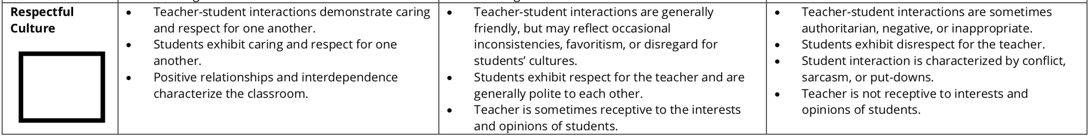
Figure 4: "Respectful Culture" indicator from the "Environment" section of the TEAM General Educator Rubric

fun of various aspects of a teacher whom they did not like. It was clear that the poem was about me.
In addition to all of these issues, the class included a charismatic Black athlete who was retaking this English course due to failing it once previously. I have chosen to refer to this student as “A.” A seemed to find relief from the chaos of his distressing home life by entertaining his friends during class rather than doing his work, and it was clear to me that I would have to work extremely hard to earn his respect. He was not going to bestow it upon me simply because I was his English teacher, a stance which I now understand is fair. He did take it too far, though. One day early in the semester I realized to my horror that he was leaning far back in his chair, cell phone in hand with the camera function open, almost to the ground as I stood next to his desk. He was attempting to take a photograph up my skirt with his phone. Fearful and unsure about pursuing a serious accusation against him without solid proof, I left work that day and many others in tears from overwhelming frustration.
I realize that I did not deserve this type of treatment on any level, and only disclose it here to show how profoundly I struggled to teach this student. A was a minor and did not fully understand the implications of his actions when he attempted to take a picture up my skirt. I do not hold this action against him now, nor did I hold it against him at the time. This incident is an example of him acting out, which he did frequently to varying degrees, and illustrates the depth of difficulties we experienced while trying to work together in class. It is possible that our struggle was at least partially caused by my youth, femininity, and whiteness. Because A had already failed this class once previously, he was assigned to take it again the subsequent year. In instances such as this, it is common for the administration to arrange the student’s schedule to where the class they are retaking is with a specific teacher--one that they believe will be likely to be the best personality fit with the student, rather than choosing the class section based on whichever period works best with their other classes. I was hired at AHS as a replacement teacher mid-semester. The teacher whose position I took over was an older Black woman who had been teaching there for nearly 30 years. She was suddenly needed as an administrator at another school in the area, and I entered as her replacement. It is entirely possible that A thought he would be with her, and then entered into the classroom and found me instead, in painfully stark contrast to her and all the cultural connections that she may have signified. I do not know for certain whether this was a contributing factor, but it is certainly a possibility.
He told me directly multiple times that he did not like my class, and did not want to do my assignments because they were irrelevant for him. My responses along the lines of “I know, I understand, I get it, but you have to know this stuff and pass this class in order to graduate” were never going to resonate with him. I tried with everything I had in my small teaching arsenal to help my students connect the course content to my students’ lives outside school, but without a solid base of mutual trust and respect, that was never going to happen beyond the surface level. Importantly, I had not yet at that time done the critical reflective work necessary to pinpoint the biggest problem. My connections from larger social realities to the course content were not his connections. He was trying to tell me this, but since I had never explicitly thought about the ways that his race and culture were so vastly different from mine, I just did not understand. And since I myself did not understand, I was not capable of establishing an environment within that particular class where reciprocal feedback and respect would be effective elements of my instruction. I established these elements much more easily in other classes—classes that not coincidentally included almost exclusively white students. If A had been aware that he was supposed to be with the previous teacher for this class, perhaps some of his resentment towards me came from the change. Regardless, we were never able to navigate the situation together very well.
Still, I tried my hardest, and attempted to improve my techniques largely on the TEAM rubric’s expectations. The indicators in the environment section include language that more explicitly addresses embodiment and interactions between the teacher and students within the classroom. The requirements for a level 5 score on Expectations (figure 5) indicate that the teacher “demands better performance from every student,” not just those who have historically performed at a high level, and I do think my relentless well-intentioned attempts to help A pass my class at least qualified as this. From Delpit’s research on cultural conflict in the classroom, we know that this type of demand requires the teacher to confront her own biases. This expectation could be explicitly in relation to race—if a white teacher finds upon reflection that she calls more often on the white students to answer questions, then she is displaying a rather obvious bias that students are likely to also notice. But it also applies in less obvious ways to the results of systemic denial of education and opportunities. Perhaps upon reflection the teacher may realize that she calls on the same high-performing individuals time and again. Those high-performers make lessons go more smoothly—it’s easier for a lesson to proceed without a hitch when you can count on someone to answer your questions and knowledge checks appropriately. But it also denies others the opportunity to learn, and over time it adds up in a way that continues the ongoing denial of educational opportunities for certain individuals. This type of bias is more
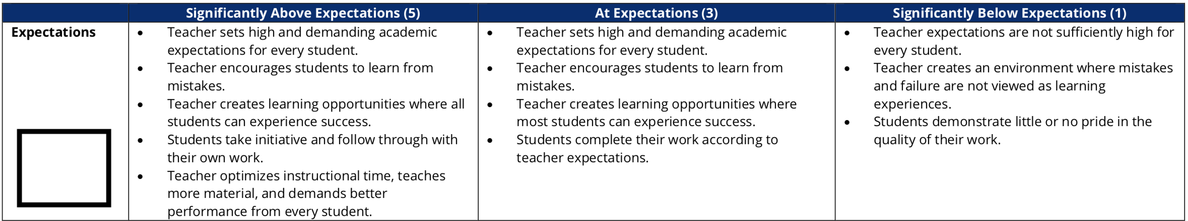
Figure 5: "Expectations" indicator from the "Environment" section of the TEAM General Educator Rubric

difficult to spot, and therefore more difficult to avoid. Furthermore, this indicator requires that the teacher must consistently foster social interactions between all individuals in the class—including herself—where “positive relationships and interdependence characterize the classroom,” according to the final bullet point of the level 5 score for the Respectful Culture indicator (figure 4).
Clearly, these are very high expectations for teachers in K-12 classrooms. The excerpts above are only a few selections from the TEAM rubric that require high levels of engagement with major concepts of critical pedagogy such as critical reflection and connections to knowledge gained outside of the classroom; there are a total of 19 indicators on the General Educator Rubric, each of which requires the teacher to design and implement macro-objectives to some degree. Overall, my analysis of these indicators shows that following a traditional model of classroom structure and instruction will not only result in low levels of learning for the students, but will also earn the teacher concerningly low scores on the TEAM rubrics. In contrast, a teacher who actively engages students with the learning process in ways that assign importance to student individuality and their lives outside of the classroom will earn high scores on the rubrics, and thus will be more likely to help students achieve meaningful learning outcomes. The teacher will be even more likely to achieve these important outcomes if she does not leave out the important component of her own critical reflection on those social realities. This analysis applies across all sections of the TEAM General Educator Rubric—instruction, planning, and environment.

How Do the Scores Look in Actual Practice?
With this in mind, it is important to reflect on the practicality of these rubrics. From my years of interactions with more experienced teachers, one complaint I heard frequently about the TEAM rubrics is that they are so extensive that it is impossible to display one’s skills in each of the indicators during any single observation. There is a definite sense that some teachers feel that the exhaustive requirements are out of touch with how classrooms actually function. At least within the walls of Anonymous High School—where I received ample support and encouragement from my supervisors and administration—the TEAM model felt practical and functional within the classroom. In my experience at AHS, the observations were used as the name (Tennessee Educator Accelerator Model) suggests—as a way to accommodate for the fact that teachers will make mistakes, while providing feedback and a path towards growth. I never encountered an observer at AHS that made me feel as though my scores and/or mistakes would be met with heavy-handed punishment. Anecdotal evidence from fellow teachers suggests to me that this positive method of implementation is not always the case in other school settings, and therefore the conclusions I draw here about practicability are heavily contingent on the institutional environment at AHS.
Figure 6 shows two of the actual scores that I earned on the planning rubric during a formal, announced observation that took place in my fourth period class. I was extremely nervous about this observation; scheduled only one month into the semester, many of the initial difficulties I was having with managing this class were still present, and I was overwhelmed with the feeling of “drowning” familiar to many young teachers. However, as the observation unfolded, I realized that the students—including those who still disliked me, as well as A—were
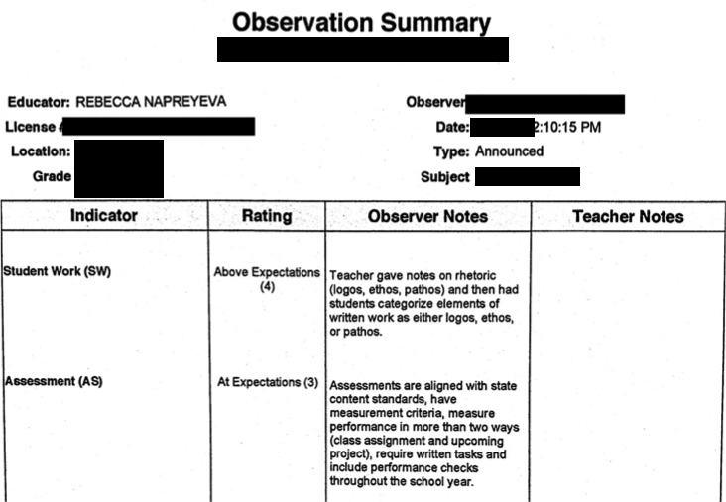
Figure 6: Excerpt from the author's TEAM observation scores for the indicators "student work" and "assessment."

actively participating in the lesson and completing the assignments without objection or interruption. Even more importantly, they were discussing the work with each other and voluntarily answering my questions. It felt like they were reacting to the observer’s presence in the classroom in a way that showed solidarity with me. It was as though the students tacitly understood the potential impact of this observation on my career, and they decided to help me by enacting a temporary “cease fire.” Sometimes students will react this way because the observer is an administrator and they are concerned about being disciplined, but that was not the case for this observation, because a lead teacher rather than a principal conducted it.
Thanks to their consideration, I managed to score level 4 on Instructional Plans, 4 on Student Work, and 3 on Assessment. These are the only indicators for which I received scores during this observation, but the sense of relief that came with earning two scores that were “above expectations” was immense. Even with all my struggles and all my mistakes in that class, I had still managed to make enough progress that they appeared to prefer to help me stay afloat rather than see me fail completely. I used the experience to invoke renewed energy towards establishing stronger relationships with the students in this class, and I believe our efforts together towards this end were successful based on the improvement in their behavior and work by the end of the semester.
From my perspective now, several years later and with more experience, I believe this observation was a missed opportunity to explicitly teach and discuss power relations. They obviously understood the expectations for their behavior, and demonstrated a tacit understanding of how the state’s expectations affect teachers. It was a natural opportunity to discuss how these structures of power function, and to give language to what they already understood. A had been trying to describe these same systems every time he told me my class was not relevant for him, but at the time I did not have clear language for it, either. Reflecting on this now shows me that these connections to larger social realities do not need to be forced; they come up naturally with a great deal of frequency, and if the teacher is critically reflecting on this, then she can conceivably guide her students to do the same with relative ease and support from the TEAM rubrics.
About one month after this announced observation, I watched a principal walk into another one of my classes, take a seat, and open his laptop. This could only mean one thing: this would be my unannounced observation for the semester. The singular feeling of panic and adrenaline that comes along with unannounced observations is difficult to put into words, and the feeling was amplified for me by the fact that this was also my first formal observation with this particular principal as my observer. However, I was not experiencing the same difficulties with behavior in this class as I was in my other (again, not coincidentally, this class was composed almost entirely of white, high-achieving honors students whose backgrounds were almost identical to my own), so I took a deep, calming breath, and commenced with my lesson as planned.
As figures 7 and 8 show, I earned “above expectations” scores on several indicators during this lesson, as well the first two “significantly above expectations” scores of my teaching career. As is common with honors students, they had more inclination towards doing well in their classes. Upon reflection on A’s complaints, I can see that their inclinations probably had more to do with the fact that they understood how passing high school English classes means
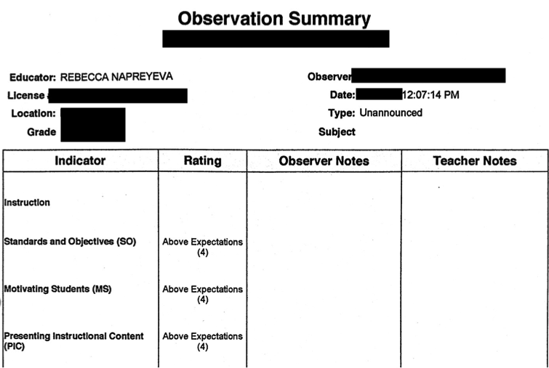
Figure 7: Excerpt from author's scores on the indicators "standards and objectives," "motivating students," and "presenting instructional content."

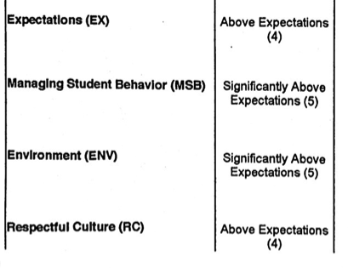
Figure 8: Excerpt from author's scores on indicators "expectations," "managing student behavior," "environment," and "respectful culture."

they can more easily function within our current society, which represents another opportunity I missed for helping my students learn explicit language to describe these systems. Regardless, it was much easier for me to incorporate the high demands of the TEAM rubric into my everyday lessons in this class. However, comparatively easier does not equate with simplicity, and I still
actively worked to improve my relationships and instructional methods in this class. Overall, my TEAM observation scores for that semester averaged level 4. If a struggling novice teacher can implement the demanding requirements of the TEAM rubric with relative success, it is probably fair to say that the rubrics are practical for how classrooms actually function. However, this claim is not without qualification. In classrooms and school situations where teachers do not feel that they receive the same substantial support from their supervisors and administration, it probably does not function in this way. Additionally, it is clearly possible for a teacher to earn high scores based on well-intentioned efforts and still achieve only surface-level mastery at establishing macro-objectives with students whose cultures and social situations outside of the classroom are very different from those of the teacher.
Based on this analysis, it appears that the TEAM Rubrics leave a great deal of room for educators who are seeking to shape their pedagogical decisions around the tenets of critical pedagogy. However, it is also possible for the teacher to engage students in these ways at only the surface level. Engaging in a power struggle with A early in that semester was one of the biggest mistakes I have made so far in my teaching career. Of course he did not see any reason to conform to my expectations of behavior and assignment completion—I had as yet done no reflection on what those assignments and expectations would mean for him as a young Black man “under” the authority of a white young woman. And yet he knew and understood enough about the ways that the state’s expectations functioned that he temporarily conformed so that I would not suffer negative consequences.
One potentially positive aspect of my otherwise misguided views was that I genuinely believed it was my duty to never give up on any student, regardless of the situation. However, I will never forget the look on his face when I suggested he go take a break in the hallway one day. He said to me, “Do you not want me here?” Utterly baffled, I stuttered “…of course I want you here. You just seem very distracted right now.” Upon reflection, he must have been picking up on cues from me that were very contrary to my intentions. From what Delpit reveals about cultural conflict between white teachers and their black students, it does not seem to be much of a leap to assume that many of the teachers that this young man encountered during his time in public school did not seem to want him there. I genuinely did want him there; I definitely did not put so much effort into trying to be a better teacher for this class because I did not want him there. But with all of my clear ignorance about his life and culture, why would he assume I felt differently? And why, without having done any critical reflection on the impact of my classroom management and policies on students like him, did I expect to be perceived differently?
Altogether, this analysis of the TEAM General Educator rubrics reveals several important things. One, at least within the TEAM General Educator rubrics, the state has undoubtedly placed a great deal of emphasis on instructional and classroom methods that emphasize connecting knowledge learned in classrooms with knowledge from students’ and teachers’ broader social and cultural contexts outside the classroom. The language of the six indicators analyzed here aligns closely with the language of macro-objectives as defined by Giroux, and more broadly with the goals and tenets of other antiracist pedagogies, as well. Two, the analysis of my personal TEAM scores shows that even in situations where a teacher is struggling, students demonstrate a great deal of understanding about how structures of power work with the evaluations. This student understanding represents an opportunity to build upon that knowledge and help students towards making that knowledge explicit so that they can further apply it within their own social and cultural contexts. Finally, formal education is still likely to reproduce dominant social order in spite of all of these connections if the teacher—particularly a white female teacher such as myself—is not doing the necessary critical analysis and reflection on her own beliefs and classroom practices.

chapter four
Analysis of the incorporation of tnready scores

As illustrated by the reflections of my struggles in Chapter Three, both students and teachers tacitly know how classroom observations work. The teacher has to perform her role convincingly to the highest degree possible based on the metrics being used to score her—in this case, the TEAM General Educator Rubrics. The students have to support her by participating in the lessons, even though just the bodily presence of the observer alters the classroom dynamic in palpable ways. They know that if they do not participate that the teacher will “get in trouble,” or otherwise face negative consequences in her career. They also know that there could be negative consequences for them, particularly if the observer happens to be an administrator. I certainly never discussed any of these things with my students, but they knew anyway. What neither my students nor I understood at that time is why observations within educational institutions work like this.
In The Undercommons: Fugitive Planning & Black Study, Stefano Harney and Fred Moten explore the ways through which the university reproduces itself as an institution of power. They argue that teaching is labor produced by the university, and as such, teaching is a major means through which cultural hegemonies are continued and solidified (26-27). Harney and Moten write that the university responds to teachers who resist and work against its institutional powers thus:
Like the colonial police force recruited unwittingly from guerrilla neighborhoods, university labor may harbor refugees, fugitives, renegades, and castaways. But there are good reasons for the university to be confident that such elements will be exposed or forced underground. Precautions have been taken, book lists have been drawn up, teaching observations conducted, invitations to contribute made (29-30).
In these ways, the university maintains its power against those who would challenge it with their teaching. This series of strategic checks is designed to maintain teacher “professionalism;” through these capacities, teachers can be deemed “unprofessional” and removed from the university. Harney and Moten’s argument remains unchanged when presented with the ideas of critical pedagogy. They state, “…critical education arrives to support any faltering negligence, to be vigilant in its negligence, to be critically engaged in its negligence” (Harney and Moten 32). For The Undercommons, the university uses critical pedagogy as yet another way to control the professionalism of the very teachers who seek to enact change.
However, Harney and Moten argue that there is also the possibility for subversion through the undercommons and its “maroons” who teach critical thought beyond the limits imposed by the university. In the K-12 system of public education, the institutional powers of the state function in much the same way as those described in The Undercommons. Accountability is the term du jour for this same sense of professionalization—it requires that teachers perform to state imposed standards in order to continue working, and those who work outside of those standards can be disciplined or removed based on the data generated through the state/national accountability model. In “Beyond Accountability: Toward Schools that Create New People for a New Way of Life,” Pauline Lipman describes accountability thus:
Business rhetoric of efficiency, accountability, and performance standards and the redefinition of education to serve the labor market have become the common vocabulary of educational policies across the United States, and increasingly, globally… Test-driven, standardized teaching is one product of this agenda… (365).
Through a detailed analysis of the components of the professional educator evaluation system in the state of Tennessee, it is clear that the situation with accountability is no different here. Though the state does seem to sanction and value connections to social realities and student/teacher knowledge gained from outside the classroom within its TEAM rubrics, the structure of its overall accountability model undermines teachers’ abilities to actually enact it, and those teachers who fail to meet the necessarily conflicting standards are deemed to be “unprofessional.” In other words, the critical pedagogy contained in the evaluation model may indeed function as Harney and Moten suggest—it bolsters the state’s ability to reproduce hegemony. However, I argue that this is due to the state’s vehement insistence on incorporating deeply flawed standardized test data into the overall evaluation.
As a reminder, the current accountability model in Tennessee’s K-12 public schools requires that teachers be evaluated both qualitatively and quantitatively. The Tennessee Educator Acceleration Model (TEAM) is used for formal observation of the teacher’s performance in the classroom, and TNReady exams from the Tennessee Comprehensive Assessment Program (TCAP) are used to measure a teacher’s effectiveness by linking the educator to his or her students’ scores. In my analysis of the language of the TEAM rubrics, I show that they contain language that frequently requires the teacher to engage with macro-objectives as defined by Giroux, and further analysis with additional data would likely reveal additional opportunities for teachers to engage with the tenets of critical pedagogy as defined by the works of McLaren, Giroux, and Friere. Reflections of my own experiences with these observations combined with my actual TEAM scores show that formal observations can be a practical way to implement pedagogies that advocate methods to promote social change in a state-sanctioned way, as long as the teacher is not leaving out the important aspect of her own critical reflection. This seems to hold true in a school environment where the administration interprets the rubrics in a similar way as the teacher and approaches their implementation as a form of teacher and student development (as their name suggests) rather than as a punitive process. When this is the case, this part of the evaluation system may be practically as well as theoretically sound; it acknowledges the teacher as an individual who is working towards long-term and meaningful learning outcomes for her students.
Here, I turn the focus towards the incorporation of TNReady state tests. TEAM observations are not the only component of a teacher’s overall evaluation. In fact, TEAM scores make up only 50% of the teacher’s evaluation score for state-tested subjects. The other 50% is assigned by linking the students’ TNReady test scores to the teacher. There is a significant shift in instruction several weeks before the statewide testing period begins, which for a school that is organized on a block semester like AHS, happens towards the end of each semester. Weekly practice tests and daily test strategy review interrupt carefully designed units. Data review, remedial lesson design, and mandatory test proctor training takes over teacher planning periods. In addition to these disruptions due to test preparation, three to four weeks of class time is further interrupted or lost due to the actual administration of the tests. Each of these factors contribute significantly to the disruption of the semester and year-long progress of the critical pedagogy contained in the TEAM rubrics, and weighing the results of one testing cycle in equal parts with the persistent effort required to enact critical pedagogy diminishes long-term results in favor of high stakes test scores.
Thus, it appears that the voices and concentrated efforts of educators who are actively teaching towards critical pedagogy are in fact being silenced in favor of other stakeholders. Giroux offers a warning about this phenomenon in Teachers as Intellectuals: Toward a Critical Pedagogy of Learning, which is significant enough to revisit:
If knowledge is reduced to the mere organization, classification, and computations of data, then its purpose is not questioned and it can be used to serve ends established by someone else. Under such circumstances, students, as well as teachers, are denied the opportunity to examine knowledge critically, and social and political conformity end up masquerading as “acceptable” pedagogy (49-50).
The inclusion of TNReady test scores in teacher evaluations is functioning in a way that serves unclear and possibly nefarious purposes of persons other than the students and the teachers. It is not possible to truly value critical pedagogy while functionally eroding teacher agency in the classroom. Therefore, the state of Tennessee has sacrificed the effectiveness of critical pedagogy for the sake of incorporating additional data to be used primarily as a measure of accountability. The collection of this data disrupts and conflicts with the standards and objectives outlined in the other half of the evaluation model, and unfortunately, disproportionately affects the specific educational needs of Black students.

TNReady Tests and Achievement Gaps
I argue that the state of Tennessee aspires and professes to value the culture and experiences of teachers and students in the classroom, as demonstrated by the language of the expectations detailed in the TEAM observation rubrics. I also argue that the state’s current system of using TNReady scores in equal parts with the observation scores in the overall accountability model for teachers functions to effectively undermine the valued learning goals of critical pedagogy and teacher/student interactions. It is useful to examine the effects of this contradiction through the lens of critical race theory because the effect of an institution acknowledging the need for varied cultural and individual experiences in the classroom, while at the same time blocking the effectiveness of those professed goals, has heightened consequences for minority students.
According to Delgado and Stefancic, critical race theory holds that “…racism is ordinary, not aberrational—‘normal science,’ the usual way society does business, the common, everyday experience of most people of color in this country,” (8). Delgado and Stefancic also state “…most [critical race theorists] would agree that our system of white-over-color ascendancy serves important purposes, both psychic and material, for the dominant group,” (8). It is well-established that overall, minority students are at a disadvantage when it comes to standardized tests, and that those inequalities are built into the form of the tests as well as the history of students’ educational opportunities. High-stakes tests such as TNReady meet both of Delgado and Stefancic’s assumptions stated above; routine use of tests that are proven to put minority students at a disadvantage represents the ordinary and common nature of racism, especially since the majority of stakeholders do not explicitly acknowledge the presence of this racism. Additionally, the use of the test scores for decisions such as teacher placement, school funding, and student “ability” grouping functions to continue to allot more educational opportunities for white students. Therefore, this lens casts in sharp relief the inequities that are produced by the TNReady tests for the students, which in turn builds the foundation for how incorporating the test scores into the overall evaluation blocks the efforts of classroom teachers.
The critical education that all students—but particularly minority students—need and deserve may be achieved through the implementation of critical pedagogy, yet the state seems to undercut its own efforts towards this end by insisting on including test results that cause further damage to the education of minority students. Standardized testing in general has a well-documented history of fueling the “achievement gap” narrative. The “achievement gap” is an attempt to explore the phenomenon of black students performing lower on standardized tests than white students as broad, overall categories. However, according to Sonya Douglass Horsford and Tenetha J. Grosland in Badges of Inferiority: The Racialization of Achievement in U.S. Education, this attempt is misguided: “…the majority of research on the achievement gap has concentrated on test score variances between black and white students, while ignoring the history of racial exclusion, segregation, and discrimination in U.S. schools” (156). In other words, the achievement gap neglects to examine the systematic roots of the disparities and instead focuses attention on the test scores themselves. This implies that Black students are the problem rather than the generational denial of opportunities for Black students.
Horsford and Grosland argue that the social and political situations that cause and perpetuate differences in test scores between certain groups of students began long before the term “achievement gap” became a household phrase. They trace the achievement gap narrative back to eugenics and “separate but equal” practices in the United States, showing that “…the story of black student underachievement has a deep and unrelenting history,” where “…blacks represented a problem to be studied, analyzed, and relegated as inferior to whites in every way,” (Horsford and Grosland 154). Thus, a narrative of underachievement constructed the realities that continue to deny black students opportunities for equal education, and functions towards those same ends in current educational testing policies. Given the long history of this narrative, it is paradoxical that recent discussion of this phenomenon via the achievement gap narrative neglects to examine its own history in order to address the discrepancies it professes to focus on.
What I mean by that is that the Tennessee Department of Education continues to use monitoring achievement gaps as part of its rationale for administering TNReady tests. Recently, the Tennessee Department of Education updated a document available on their state website titled “FAQ for Assessment and Accountability: COVID-19 Guidance.” Under the question “How will this impact school and district assessments in the 2020-2021 school year?” the state offers the following response:
Understanding student proficiency of our state standards, including learning where they may need additional support, is even more important after an extended interruption in instruction. We expect that achievement gaps we see among certain student groups may be widened in this situation and administering an assessment aligned with our state standards is important to determining the best support for all of our students. For this reason and at this point, we expect to administer TCAP normally in 2020-21 in order to gather important data to move forward as a state (3).
This statement on the surface lacks the insidious tone one would expect from “racism.” However, given what scholars such as Horsford and Grosland have established about achievement gaps, it is clear that below the surface lurks a history of systematic denial of minority students’ access to education and equality. It is used here to justify another cycle of TNReady state tests during a global pandemic in which the United States is the leader in infections and deaths. It is certainly true that minority student groups deserve and need additional support from institutions of education; however, the solution is unlikely to be found within a framework such as the “achievement gap” that ignores the history and causes of the problem.
Perhaps unsurprisingly, this disconnect also fits neatly into Harney and Moten’s model of professionalization. Regardless of its explicitly stated goals, the state of Tennessee assumes a deeply flawed narrative as part of the justification for its desire for standardized test data. This particular justification functions to perpetuate the same systematic racism that it professes to wish to ameliorate, and it uses the same data to hold teachers accountable for “closing the achievement gaps” by incorporating the data into individual teachers’ evaluation scores. How can individual teachers—during the one or two semesters that they are able to spend with their students—close gaps in test scores that are the product of centuries of systematic racism? It is instead a task designed to control “unprofessional” teachers.
TVAAS and “What Teachers Can Control”
TNReady scores are measured in two ways, both of which are included in the 50% portion of the overall evaluation score that is assigned to educators in state-tested subjects. One type of score is called “achievement;” this is the traditional method of standardizing test scores, where students’ performance on the test is compared to that of their peers from across the state. The achievement gap narrative relies largely on this type of score. TNReady attempts to de-emphasize and acknowledge the flawed construction of achievement scores through a second type of score—“growth.” Growth scores are intended to measure students’ performance against their previous year’s standardized test scores in order to compare the change in their individual demonstration of proficiency over time, but it is not without flaws.
The Tennessee Department of Education website for TEAM evaluation describes the system used to measure each type of score from the TNReady tests thus:
The Tennessee Value-Added System (TVAAS) measures the impact schools and teachers have on their students’ academic progress. TVAAS is a powerful tool because it measures how much students grow in a year and shines more light on student progress than solely considering their score on an end of year test. TVAAS allows educators to consider their students’ achievement (their score on the end of year assessment), as well as their growth (the progress students make year to year).
According to the state’s theory, growth scores more closely correspond to individual learning outcomes than achievement scores, and therefore the teacher should have more direct influence over this type of score. The Tennessee Department of Education addresses this in their TEAM description of TVAAS scores, as well: “Educators are only held accountable for things they can control, such as their students’ progress during the school year. Teachers are not held accountable for the things they cannot change, such as their students’ previous achievement. TVAAS only measures what a school can control.” Based on this logic, the state places higher emphasis on growth scores than it does on achievement scores by making growth a larger portion of the overall evaluation score. As shown in figure 9, teachers are typically assigned 15% of their
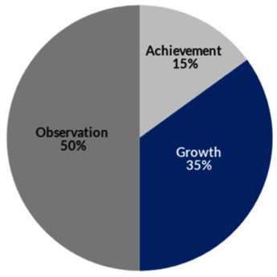
Figure 9: Typical distribution and weights of scores in the overall evaluation score of a teacher in a state-tested subject, such as English.

overall evaluation score based on their students’ achievement scores, and 35% based on their students’ growth scores. Most years, the state offers an override for teachers whose growth score is high (usually 5); in this case, the growth score takes over the entire test score portion of the overall evaluation (weighing 50% rather than 35%).
Growth scores are intended to track individual learning outcomes over time, and they are considered by the state of Tennessee to be a more appropriate measure for teacher accountability than traditional “achievement” scores because in theory, the teacher has more direct influence over growth scores than she does over achievement scores. However, my experience indicates that educators are indeed held accountable for a great deal of variables that they cannot control in regards to TNReady testing data. During the same semester in which I was struggling to figure out how to manage my fourth period class, the state department of education announced several weeks before the beginning of the TNReady exams that due to a testing company error with the servers, the scores would not count against the students. So, I along with all of the other teachers in the state found ourselves in a position where the students knew that they would not be held accountable for their individual scores, but the teachers and the schools remained accountable for them. While discussing this issue with my fourth period class in preparation for Part One of TNReady, one white student heatedly questioned, “If they don’t even count, we shouldn’t even try! Let’s just not really take them!” Thankfully for me, before that idea could gain much momentum, another student (who was Black, and incidentally his mother was also a teacher) replied, “Yes, but they count against Mrs. Napreyeva, and that’s not fair.”
Once again, we see in this example a Black student who understands power structures at work, perhaps better than most. While his beliefs about school generally aligned with my own,
this is likely due to socioeconomic factors. I know from this example as well as his written reflections on his work that he believed school and my class were important for his future success. It is possible that his mom, also a teacher in the same school system, taught him to believe that. So even though it is likely that he understood systemic racism much better than me, it did not cause conflict within the classroom. And as this example illustrates, he probably had a significant impact on the other students in the class. The white student who had suggested that everyone purposely bomb the tests ended up scoring above the 90th percentile.
In addition to the uniquely heartwarming experience of having a teenager advocate for me in front of his peers—especially after such a rocky start to the semester—the conversation illustrated for me just how much agency teachers lack when it comes to state tests. I adhered to the state standards and TEAM rubric expectations to the best of my ability throughout the semester while simultaneously struggling to improve severe problems with my classroom management. I taught the students how to read the state’s writing rubrics, and I graded over 500 essays that semester alone to meet the department’s essay minimums and to ensure that the students had enough writing practice before the state tests. I taught test-taking skills, and devoted hours of my time to reviewing data from practice tests and designing review lessons that targeted the skills and standards that my classes were still struggling with. My colleagues were doing the same, and we collaborated as much as possible, but the burden of preparing for the state tests was still taking over our planning periods, after school hours, and instructional time. Ultimately, we had no knowledge or control over the content of the tests, and we had no control over whether the students would invest effort into taking the exams, either.
This poignant example occurred when the TNReady testing vendor at the time failed to
provide appropriate technology to support online administration of the tests across the state. Valerie Strauss for The Washington Post reported the problems: “Now the vendor is working to get enough paper tests sent to the state so that annual accountability testing can proceed. The timeline for the testing—initially expected to be completed over the next month—is being expanded to accommodate for the trouble.” However, expanding the testing window has severe negative effects on instructional plans and pacing in the classroom, which places many factors that the state labels as “what an educator can control” well out of control. This means that 50% of educators’ evaluation scores would also be out of their control. Strauss continues her report to include reactions from major educator advocacy organizations:
[The National Center for Fair and Open Testing] also noted that it “makes no sense to attach high-stakes consequences to such deeply flawed tools”—a point that Tennessee Educator Association President Barbara Gray reiterated in a statement Monday. Most states in recent years have made student scores on state-mandated standardized tests a component of a teacher’s annual evaluation—even though assessment experts have warned against making such a linkage.
Ultimately, the state was forced to entirely remove test results for that year from individual teacher evaluation scores. However, their reluctance to loosen their grip on obviously flawed data stands in stark contrast to their theory that TVAAS measures only what schools and educators control.
Additionally, TVAAS scores for individual high school teachers, high schools, and districts were still generated that year and used to “informally” increase pressure for the next year’s testing cycle. Several weeks before the next TNReady testing cycle was to begin, my entire department was called into an ominous, mandatory emergency meeting in regards to our literacy growth scores from the previous year, and within days, a county supervisor observed me, unannounced, in my classroom for over 30 minutes in what felt like a direct response to the situation. I was then required to gather data and sample writing assignments from my entire English grade-level cohort as evidence that we were requiring sufficient rigor in preparation for the state tests. Admittedly, no further action was taken against me, and the supervisor reassured me that the visit was informal in nature and that she had also observed other teachers. However, the pressure and outright fear that I felt during that time period were not imaginary. It was a natural response to a tense professional situation created by the state’s reliance on test results that had already been deemed unreliable. Once again, Harney and Moten’s theory holds true—even in a situation where the institution’s power was challenged by sufficiently formidable opponents (TEA and FairTest), their tactics for rooting out “unprofessional” teachers were simply forced to continue behind the scenes.
According to Jim Horn and Denise Wilburn in The Mismeasure of Education, TVAAS has a long history of challenges to its validity (101-121). According to the authors,
Nashville school officials prepared a position paper, “Tennessee Accountability Concerns,” in February (2/11/04) and presented their concerns to the full House Education Committee. Part of the problem appeared to be the test equating issues brought forward by Bock and Wolfe in their 1996 evaluation of TVAAS. Metro officials cited Bock and Wolfe’s (1996) warning about the “imperfect equating” on successive forms of the CTB McGraw-Hill achievement tests contributing to unexplained discrepancies in reported value-added gain scores and the state reported achievement scores as well as large changes in value-added scores from year to year (Horn and Wilburn 103).
Horn and Wilburn argue that the probable explanation for the unexplained changes in growth scores from year to year is student grouping. It is well-established that student grouping, or “social capital,” has profound influence on what students are able to learn—so much so that as Horn and Wilburn point out, the researchers responsible for TVAAS attempted to control for it in their study: “Within the district site for this Ballou, Sanders, and Wright study, in fact, the absence of ‘social and racial stratification’ provided the required contexts for high levels of social capital to be maximized. As such, we could surely expect the SES and demographic factors to be minimized in the resulting value-added scores, which was, indeed, the case” (111). In other words, this means that the original research that resulted in the adoption of TVAAS was conducted in a district where social and racial factors were overall similar for the entire student population, and the researchers acknowledged these elements as contributing factors in the design of their study. Therefore, not accounting for it in the administration of the tests does not appear to make sense.
This problem of TVAAS neglecting to account for peer influence brought up in 1996 and again in 2004 currently remains unchanged. TVAAS continues to omit socio-economic and demographic factors from its calculations. In a document titled “Misconceptions about Value-Added Reporting in Tennessee,” SAS Educator Value Added Assessment System (SAS EVAAS) addresses “Student growth is correlated with certain demographic variables, so TVAAS should control for demographics” as its first “misconception.” The SAS EVAAS document states:
It is widely known that students with certain socioeconomic or demographic (SES/DEM) characteristics tend to score lower, on average, than students with other SES/DEM characteristics, and there is concern that educators serving those students could be systematically disadvantaged in the modeling. However, this adjustment is not statistically necessary for the most sophisticated value-added models, such as those used for TVAAS in the state of Tennessee. This is because TVAAS uses all available testing history for each individual student and does not exclude students who have missing test data. In essence, each student serves as his or her own control, and to the extent that SES/DEM influences persist over time, these influences are already represented in the student’s data (2).
Aside from the fact that this argument still does not address the fact that TNReady tests only began to be administered in the past several years—meaning that “all available data” includes many years of scores from vastly different tests—it also neglects the precarious nature of the lives of many students with less privileged SES/DEM statuses.
In In the Wake: On Blackness and Being, Christina Sharpe presents “the wake” as a way of understanding the contemporary lives of Black people. Sharpe builds on work by Saidiya Hartman to argue that living in the wake comes with an unending stream of “…the precarities of the afterlives of slavery (‘skewed life chances, limited access to health and education, premature death, incarceration, and impoverishment’: Hartman 2007, 6); the precarities of the ongoing disaster of the ruptures of chattel slavery,” (5). For Black students whose lives involve this constant reality, “…the extent that SES/DEM influences persist over time…” does not accurately depict what students must deal with in their daily lives and thus must compete against in order to participate in their own education, nor does it present a realistic picture of what teachers must respond and adjust to in their classroom instruction (SAS EVAAS 2).
Examples of this type of precariousness emerge on a daily basis in public schools, and thus frequently emerged with my students as well. One day, I noticed that A had been using his cell phone for almost the entire duration of my class, and I took the first opportunity I could to quietly and privately ask him to put it away. He responded, “No. I’m texting my uncle about where I’m going to stay tonight.” A literally did not know where he would be sleeping that evening. How could he be expected to participate in my high school English class that day? How is not having a place to sleep at night something that can be considered consistent over time? How is this type of devastating situation something that does not need to be controlled for? A attended high school at a predominantly white institution that was never going to receive extra funding from the state based on “achievement gaps,” and even if it did, funding based on a narrative that denies the systemic roots of the problem was never going to help him find a place to sleep that night. He did not attend school during all of the scheduled TNReady test dates, including the multiple makeup dates. He refused to participate in a test that was so clearly irrelevant for his life, even though he did not have access to academic language or research to describe why he chose not to participate. In one of the few instances that I feel I did something right for A, I just let him use his cell phone that day. Once again, a great deal is outside the control of both students and teachers, yet TVAAS denies this reality. By adopting TVAAS and using its measurements to hold teachers accountable, the state of Tennessee also denies this reality, which stands in stark contrast to the tenets of critical pedagogy that are supported within the TEAM rubrics.

CONCLUSION

Delpit points out in her seminal book Other People’s Children: Cultural Conflict in the Classroom that many teachers’ cultures are mismatched from those of their students, as mine was mismatched from A’s. Although I tried my best to account for this mismatch with the limited tools and understanding I possessed at the time, this type of situation can cause cultural conflict with damaging results that can certainly be interpreted as racism (Delpit xiv). However, as Delpit also points out, “These adults probably are not bad people. They do not wish to damage children; indeed, they likely see themselves as wanting to help. Yet they are totally unable to perceive those different from themselves except through their own culturally clouded vision,” (xiv). I could not see why A insisted that my class was irrelevant to him; I accepted that this was his view, but I could not help him or his classmates work through that with explicit analysis of structures of power and clear language because I did not understand what made it this way. One possible solution to this crucial issue is critical pedagogy, which requires teachers to explicitly acknowledge and explore the varied cultures represented by their students, and to reflect on how their own culture affects their instruction. This can help teachers see through their “culturally clouded vision” and work towards education that benefits students as well as society. Cultural conflict is one potent example of why the teacher’s own critical reflections are such an integral part of this process.
In the best-case scenario, the same phenomenon described by Delpit seems to be happening on a dramatically larger scale within Tennessee’s standardized testing and accountability model. The Tennessee Department of Education acknowledges the different impacts that race and culture can have on students’ abilities to learn meaningfully. They demonstrate this through their ample inclusion of critical pedagogy throughout their TEAM Educator Rubrics, as well as their attempts to allot funding and support to districts and schools who need it the most. However, Tennessee’s attempts towards ameliorating access to quality education for minorities are stunted by its adherence to the problematic achievement gap narrative as well as use of unreliable TVAAS data. Because all students are required to take these standardized tests each year, the negative effects described here—as well as many others not comprehensively covered in this project—directly affect students as well as teachers. Additional data on the student perspective would be helpful towards determining the extent of these effects. When TNReady scores are incorporated into the teachers’ evaluation scores, the state sets in motion a cycle that requires teachers to sacrifice critical pedagogy around testing season for the sake of maintaining “professionalism.” This effectively perpetuates the very inequalities that critical pedagogy seeks to ameliorate through education and solidifies the state’s ability to reproduce dominant culture. Moten and Harney would describe this as purposeful—but regardless of intention, the state of Tennessee allows TNReady data to eclipse comparatively holistic TEAM data within its accountability model, which functionally undermines its own professed aspirations of valuing students’ and teachers’ cultures in the classroom.
This phenomenon is not isolated or unique to the Tennessee accountability model, nor are the negative effects of using test results in this way limited to Black students and other minority individuals. The history of accountability and standardized testing is quite long, stretching back over a hundred years with various implementations, and with no clear consensus on how well it actually works towards achieving its intended outcomes. Addison and McGee trace much of this history and detail how it connects to our current context of sacrificing best practices and sound pedagogical decisions in favor of high-stakes test scores, stating that “…the recurring calls for educational reform that shape so much of our national discourse include standardized testing as one of the primary ways of enacting reform” (22). They continue by detailing how these calls for reform often result in increasing the use of standardized tests, despite substantial doubt as to how well such tests can actually measure or improve educational performance (Addison and McGee 22). This in turn has made standardized test scores “...the most visible and widely available measure of our classrooms” (Addison and McGee 22). Beyond what I have found here about the potential for implementing critical pedagogy in Tennessee classrooms, Addison and McGee’s work shows that standardized test scores are used throughout the nation to the detriment of other important instructional considerations, such as the types of writing teachers assign and “drill”—as often proves necessary in order for students to “perform” for the state tests.
For better or worse, assessment shapes how we understand writing, and because writing is a social activity, it is not neutral. Therefore the way we assess it has social implications. Tony Scott and Asao Inoue develop this relationship of how assessment shapes relationships and power between teachers, students, and institutions in “Assessing Writing Shapes Contexts and Instruction:” “Depending on the institutional setting, teachers and students have varying degrees of agency to determine the character of their work, and teachers and students negotiate their relative authority, in part, through the ways students’ writing is evaluated and the consequences associated with those evaluations…” (30). Scott and Inoue conclude that “Writing assessment can thereby function as an intentional means of controlling the labor and creative latitude of teachers and students” (30-31). This description is eerily similar to what I have revealed about the ways that TNReady tests affect teachers’ pedagogical decisions. By incorporating student test scores into the teacher’s professional evaluation, the state intentionally uses writing assessment to control the labor of teachers and students. Since these particular issues impact how students understand what writing is or can include, the potential impacts on this type of limited understanding of writing are dizzying, even more so for minority students whose cultures and lives outside of the classroom do not neatly align with the expectations of this type of assessment, such as A.
As shown here, assessment also shapes the systems of education and access to meaningful learning that all students, and particularly minority students, must have in order to use the knowledge they gain in our classrooms to further social justice concerns in our society. In this way, Giroux’s warning about reducing knowledge in ways that separates the knowledge from cultural and social significance is highly relevant. With the lack of certainty surrounding the incorporation of test scores, there is a strong likelihood that their inclusion in teacher evaluations is functioning in a way that serves nefarious purposes of persons other than the students and the teachers. It is not possible to truly value diverse cultures and experiences while functionally eroding teacher agency in the classroom. Therefore, the state of Tennessee has sacrificed the effectiveness of embodied teaching practices for the sake of incorporating additional, invalid data.
I often think about the last time I interacted with A. About a year after he failed my class, he was taking the same class for a third time with a different teacher, and he was failing again. This time around, he was with a teacher who had come out of retirement in order to fill the vacancy left by another teacher who decided to leave the profession entirely about six weeks into the semester. The environment was predictably chaotic, because all of the students felt like their original teacher had abandoned them, and she asked for support from the other teachers in any way possible. One day near the end of the semester, I used my planning period to come to her classroom and work individually with A—a tactic which he seemed to appreciate when he was in my class. When I walked in and sat next to him, he said “Hey, Mrs. Napreyeva. What are you doing here?” I told him that I had come to help him with his work because I heard he was failing again, to which he replied, “Yeah, I’m not going to do this work, Mrs. Napreyeva.” I told him we would do the work together, and his only response to that was to sigh. I read the questions to him from his worksheet and reworded them into less academic language. I then wrote down his responses for him, many of which were incorrect. Once we had finished several of his makeup assignments in this fashion, I turned them in to the teacher for him, because I was not convinced that he would do it himself. He waved in my general direction as I exited the classroom, but did not look up from the cell phone in his hand.
I knew then that I was trying harder than he was, but this was alright with me. It is still alright with me. I could see that he needed to pass that English class in order to function more easily in mainstream society, and I did everything I knew how to do at the time in order to help him towards that end. He, on the other hand, could see that he did not necessarily need to function well with mainstream society, and eventually politely tolerated my attempts to drag him through. What I know now is that if I had been able to bridge the divide between our two separate outlooks on the situation by explicitly addressing structures of power, systemic racism, and helping him make actual connections between the course content and his life outside of school, he may have been able to see that his life was not so very far removed from the curriculum. This in turn would have helped me to see that my approaches were often in stark contrast to what I believed I was accomplishing. If I were to return to teaching high school English knowing what I do now about how the accountability model functions, I would lean in heavily on the macro-objectives supported by the TEAM rubrics and use them as structural support to explicitly address the social inequities created and reproduced by the TNReady tests.
Referring back to Kendi’s words on reforming policies that function to maintain racism reminds me that there is hope for the situation: “After taking this grueling journey to the dirt road of anti-racism, humanity can come upon the clearing of a potential future: an antiracist world in all its imperfect beauty. It can become real if we focus on power instead of people, if we focus on changing policy instead of groups of people” (11) Teachers can and should work against the insidious effects of these tests by approaching them with the same strategies advocated for in all areas of instruction according to critical pedagogy. As shown in my reflections, students already understand implicitly how these accountability structures function, which creates a significant opportunity to build upon their prior knowledge of the situations. As an important part of critical reflection and examination of macro-objectives, teachers should work with students to make these effects explicitly known so that students can develop a critical understanding of the ways that the tests are likely to affect their lives inside and outside of the classroom. Unfortunately, in certain school and county environments, this could potentially jeopardize the teacher’s overall evaluation score, which is still closely tied to how some schools and systems hire and maintain teachers’ professional licenses. These important components of how accountability models function cannot be overlooked in the teacher’s own critical reflections and pedagogical decisions. For me personally, however, this work has significantly changed my willingness to work in any school environment that would not provide me with the necessary support to undermine the insidious and hegemonic aspects of institutionalized education. While my conclusion is based on my individual experiences, the problems I faced and observed are not isolated to AHS or my classroom. I offer this analysis as a way to open discussion for other teachers to think through their own relationships to teaching and supporting student agency within the tension between the rubrics and the test scores. Ultimately, if the state will not change its system of accountability any time soon, then undermining it from within by actively following the tenets of critical pedagogy and other antiracist pedagogies should remain the utmost priority among all educators, and particularly those who are most likely to inadvertently allow social inequalities to reproduce.

works cited

Addison, Joanne, and Sharon McGee. Writing and School Reform: Writing Instruction in the Age of Common Core and Standardized Testing. The WAC Clearinghouse, 2017.
Appiah, Kwame A. “The Case for Capitalizing the B in Black.” The Atlantic, 18 June 2020, www.theatlantic.com/ideas/archive/2020/06/time-to-capitalize-blackand-white/613159/.
Chapman, Thandeka K. “Origins of and Connections to Social Justice in Critical Race Theory in Education.” Handbook of Critical Race Theory in Education, Routledge, 2013, pp. 101–112.
“Characteristics of Public School Teachers.” The Condition of Education, National Center for Educational Statistics , May 2020, nces.ed.gov/programs/coe/indicator_clr.asp.
Delgado, Richard, and Jean Stefancic. Critical Race Theory: An Introduction. 3rd ed., New York University Press, 2017.
Delpit, Lisa. Other People's Children: Cultural Conflict in the Classroom. The New Press, 1995.
“FAQ for Assessment and Accountability: COVID-19 Guidance.” Tennessee Department of Education, Tennessee Department of Education, 20 Mar. 2020, www.tn.gov/content/dam/tn/education/accountability/FAQforAssessmentandAccountabilityCOVID19Guidance.pdf.
Freire, Paulo. Pedagogy of the Oppressed. Bloomsbury Academic, 2018.
Giroux, Henry A., et al. Teachers as Intellectuals: Toward a Critical Pedagogy of Learning. Bergin & Garvey, 1988.
Harney, Stefano, and Fred Moten. The Undercommons: Fugitive Planning & Black Study. Minor Compositions, 2013.
Horn, Jim, and Denise Wilburn. The Mismeasure of Education. Information Age Publishing, 2013.
Horsford, Sonya D, and Tanetha J Grosland. “Badges of Inferiority: The Racialization of Achievement in U.S. Education.” Handbook of Critical Race Theory in Education, Routledge, 2013, pp. 153–166.
Kawi, Terry. “Decolonizing Our Classrooms Starts With Us.” PBS Education, Public Broadcasting Association, 3 Aug. 2020, www.pbs.org/education/blog/decolonizing-our-classrooms-starts-with-us.
Kendi, Ibram X. How to Be an Antiracist. One World, 2019.
Khost, Peter H. “’Alas, Not Yours to Have’: Problems with Audience in High-Stakes Writing Tests and the Promise of Felt Sense.” The Journal of the Assembly for Expanded Perspectives on Learning, vol. 21, no. 8, 2016, pp. 47-68.
Leonardo, Zeus, and Erica Boas. “Other Kids' Teachers: What Children of Color Learn from White Women and What This Says about Race, Whiteness, and Gender.” Handbook of Critical Race Theory in Education, Routledge, 2013, pp. 313–324.
Lipman, Pauline. “Beyond Accountability: Toward Schools That Create New People for a New Way of Life.” The Critical Pedagogy Reader, 2nd ed., Routledge, 2009, pp. 364–383.
McLaren, Peter. “Critical Pedagogy: A Look at the Major Concepts.” The Critical Pedagogy Reader, by Antonia Darder et al., 2nd ed., Routledge, 2017, pp. 61–83.
“Misconceptions about Value-Added Reporting in Tennessee.” Tennessee Department of Education, EVAAS, Aug. 2015, www.tn.gov/content/dam/tn/education/data/tvaas/tvaas_common_misconceptions.pdf.
Sanchez, James C. “Towards Reconciliation: Composing Racial Literacy with Autoethnography.” Race, Rhetoric, and Research Methods, by Alexandria L Lockett et al., WAC Clearinghouse, 2021, pp. 91–115.
Scott, Tony. “Assessing Writing Shapes Contexts and Instruction.” Naming What We Know: Threshold Concepts of Writing Studies, edited by Asao B Inoue, Utah State University Press, Boulder, Colorado, 2016, pp. 29–31.
Seward, Michael. “Decolonizing the Classroom: Step 1.” National Council of Teachers of English, NCTE, 11 Apr. 2019, ncte.org/blog/2019/04/decolonizing-the-classroom/.
Sharpe, Christina. In the Wake: On Blackness and Being. Duke University Press, 2016.
Spears, Andy. “Opting Out of TNReady.” Tennessee Education Report, Tennessee Education Report, 29 Mar. 2021, tnedreport.com/2021/03/opting-out-of-tnready/.
“Spotlight A: Characteristics of Public School Teachers by Race/Ethnicity.” Status and Trends in the Education of Racial and Ethnic Groups, Feb. 2019, nces.ed.gov/programs/race indicators/spotlight_a.asp.
Strauss, Valerie. “Tennessee Students Start to Take New 'TNReady' Standardized Test--but Find It Isn't Ready.” The Washington Post, 9 Feb. 2016, https://www.washingtonpost.com/news/answer-sheet/wp/2016/02/09/tennessee-students-start-to-take-new-tnready-standarized-test-but-find-it-isnt-ready/.
“Students' Right to Their Own Language.” Conference on College Composition & Communication, Conference on College Composition & Communication, Apr. 1974, cccc.ncte.org/cccc/resources/positions/srtolsummary.
“TEAM General Educator Rubric.” Tennessee Department of Education. https://team-tn.org/teacher-evaluation/
“Tennessee Maintains Highest Graduation Rate on Record.” TN Department of Education, Department of Education, 1 Oct. 2018, 10:00, www.tn.gov/education/news/2018/ 10/1/tennessee-maintains-highest-graduation-rate-on-record-.html.
Tuck, Eve, and K. Wayne Yang. “Decolonization Is Not a Metaphor.” Decolonization: Indigeneity, Education & Society, vol. 1, no. 1, 2012, pp. 1–40.
“TVAAS.” TEAM Tennessee Educator Accelerator Model, Tennessee Department of Education, team-tn.org/tvaas/.

Appendix

Appendix 1: TEAM General Educator Rubrics

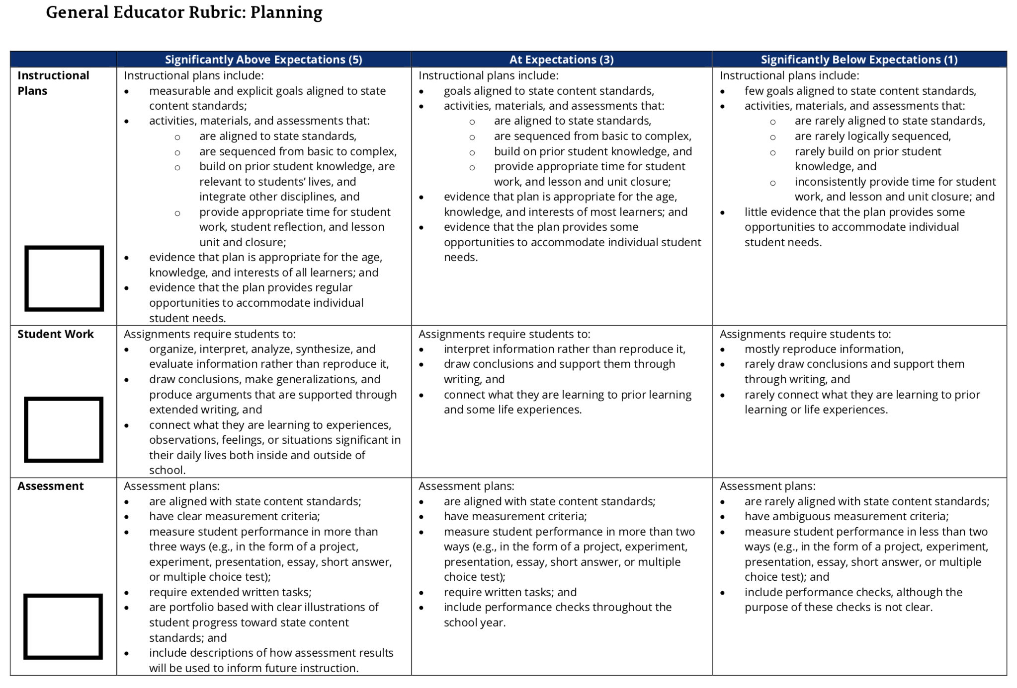

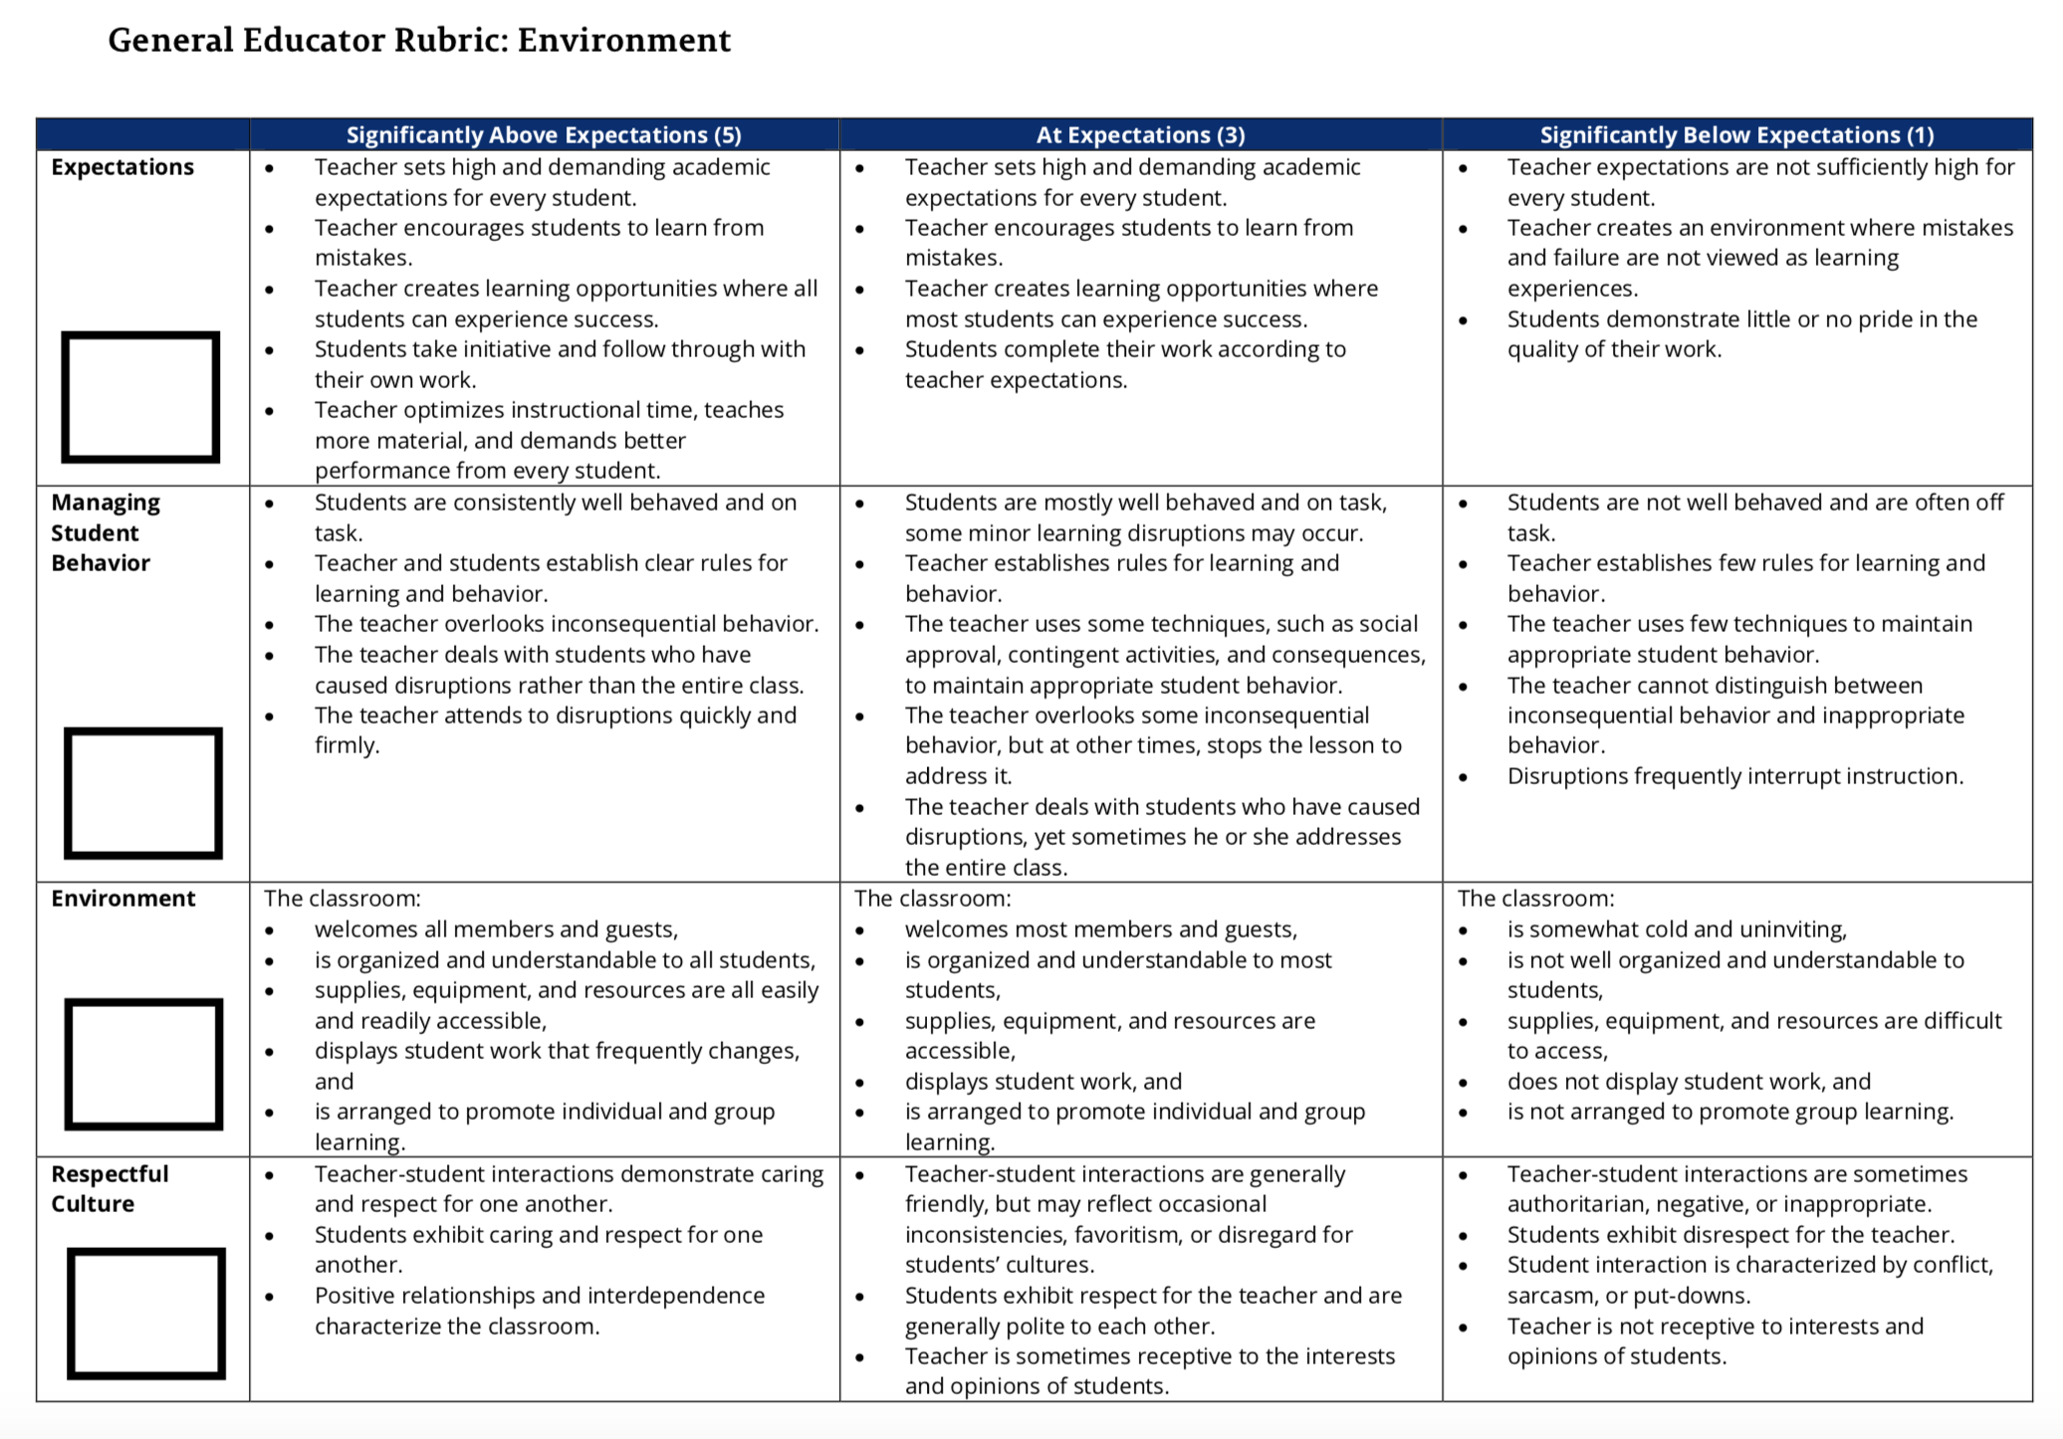

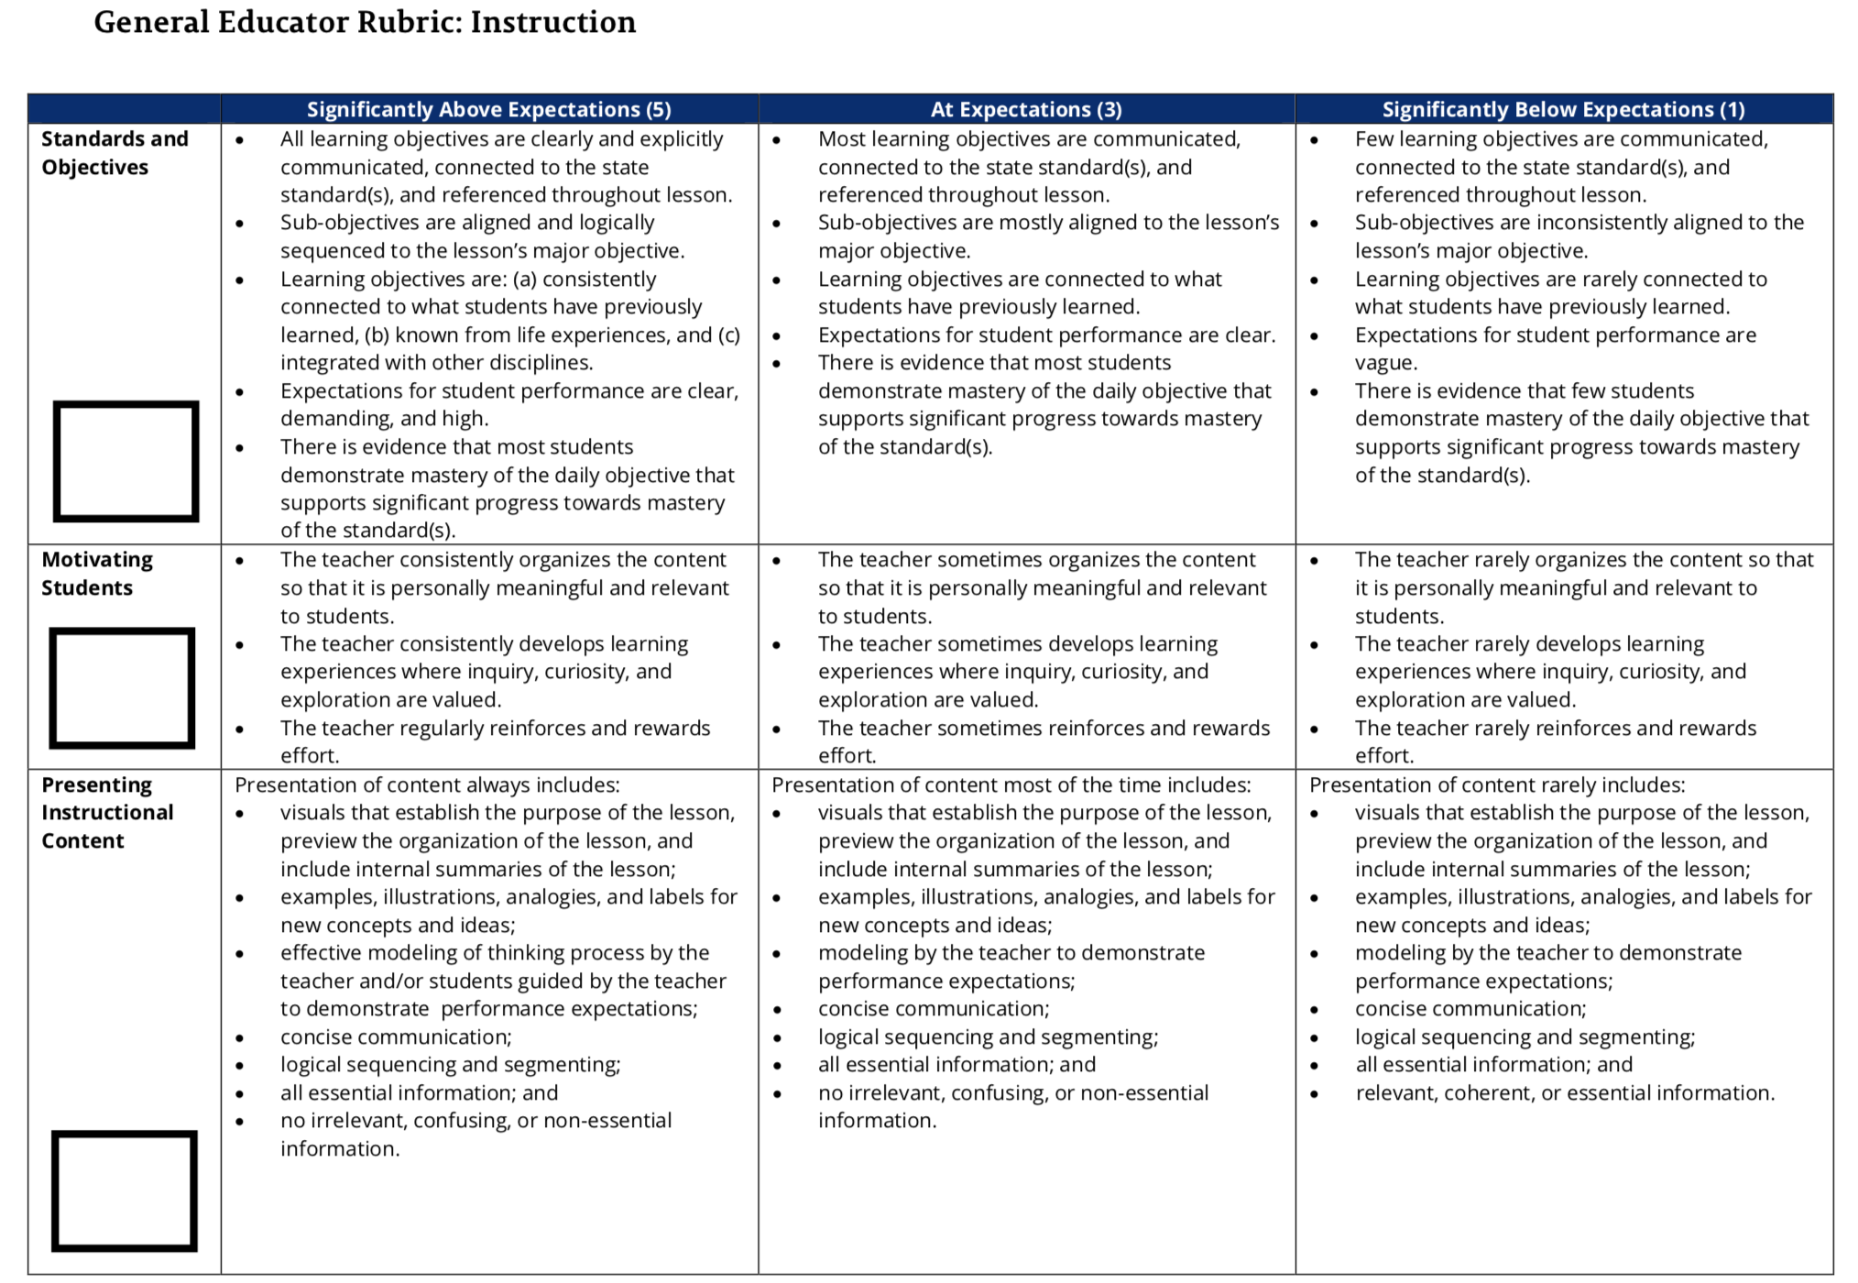

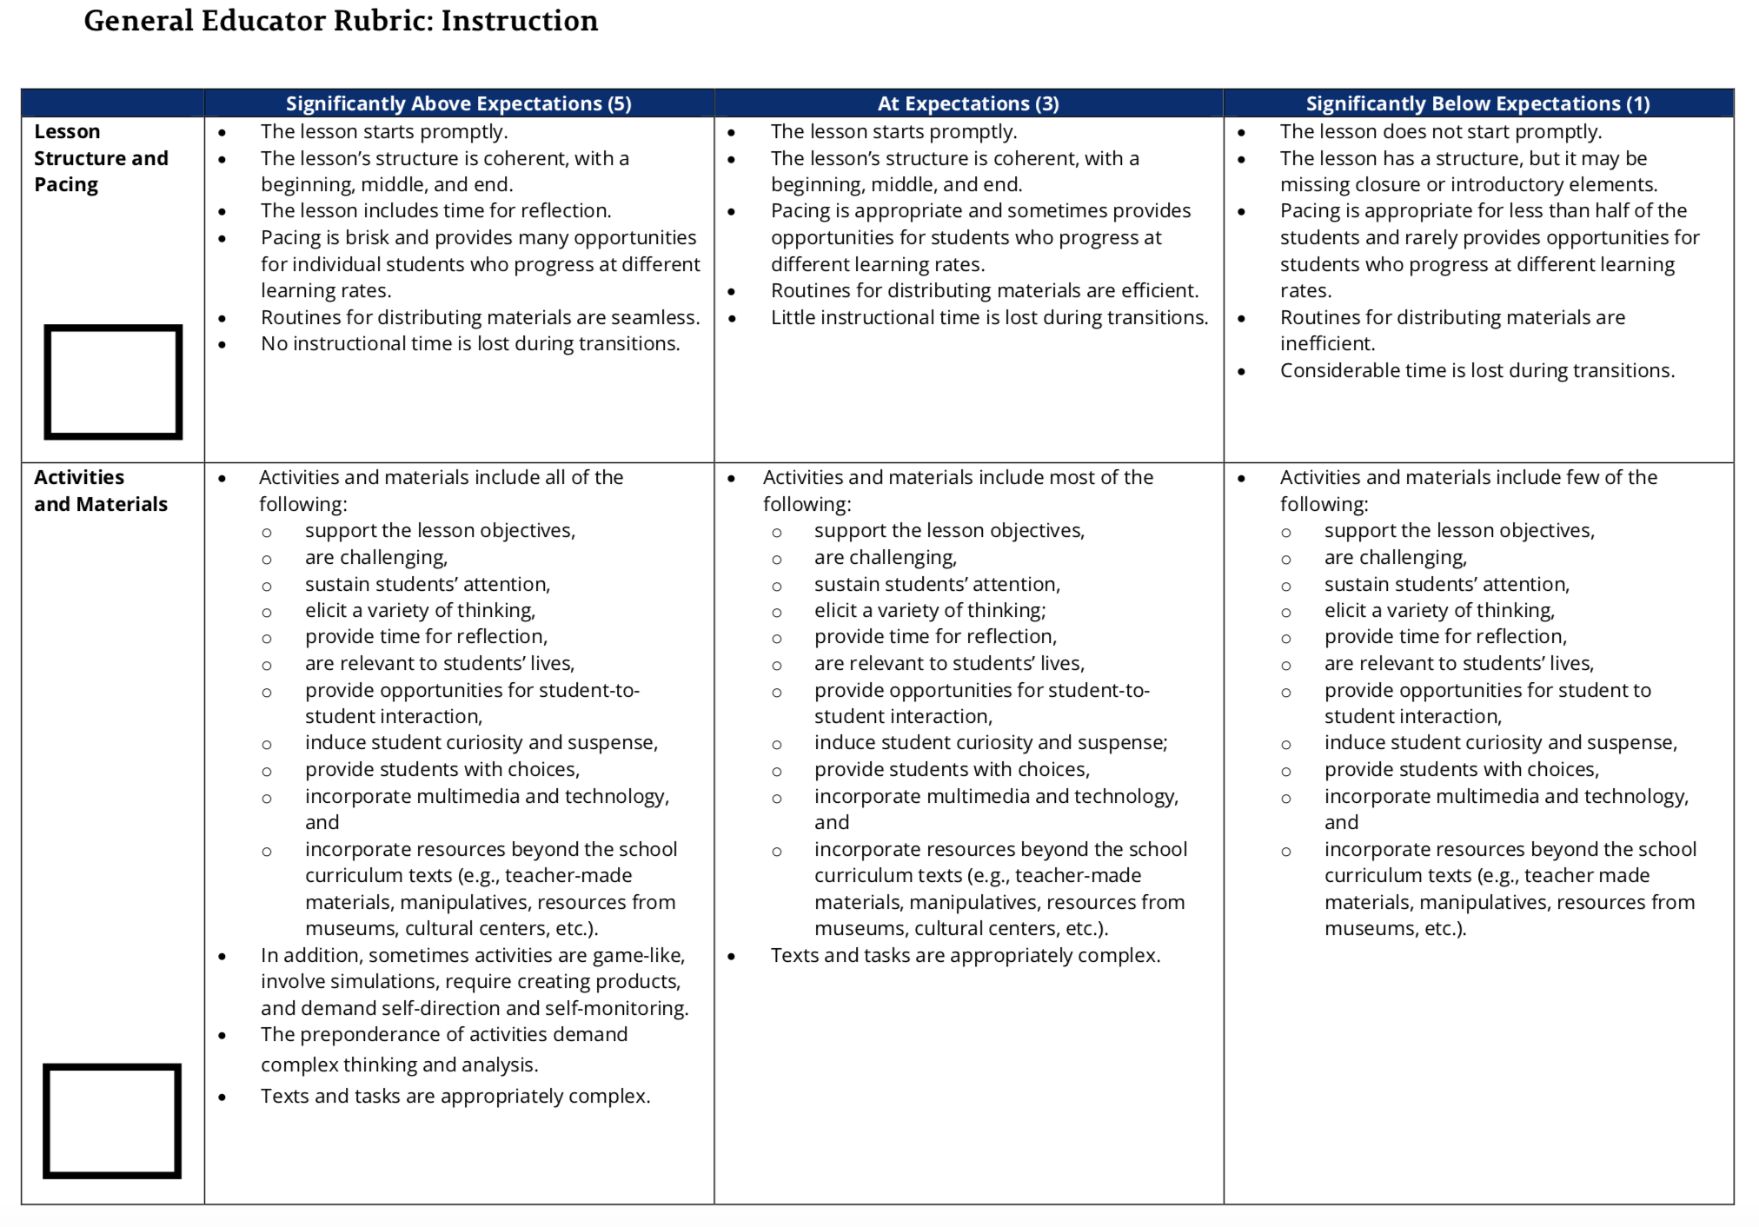

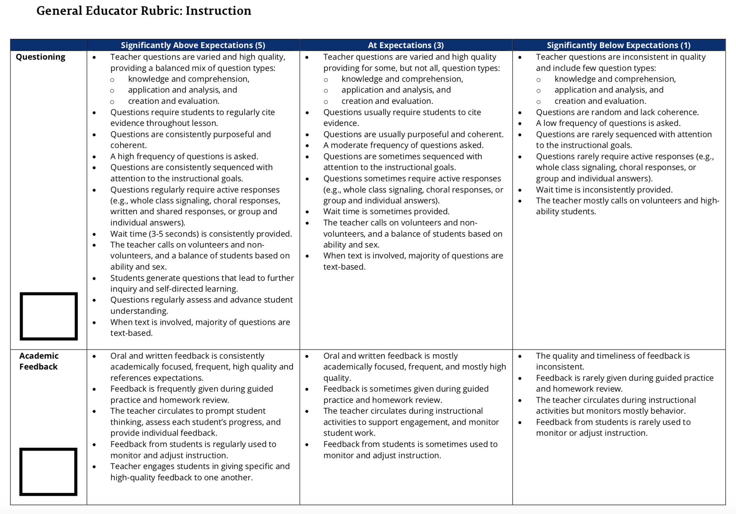

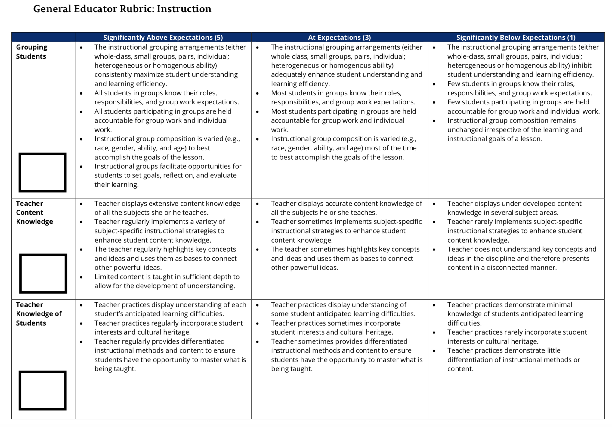

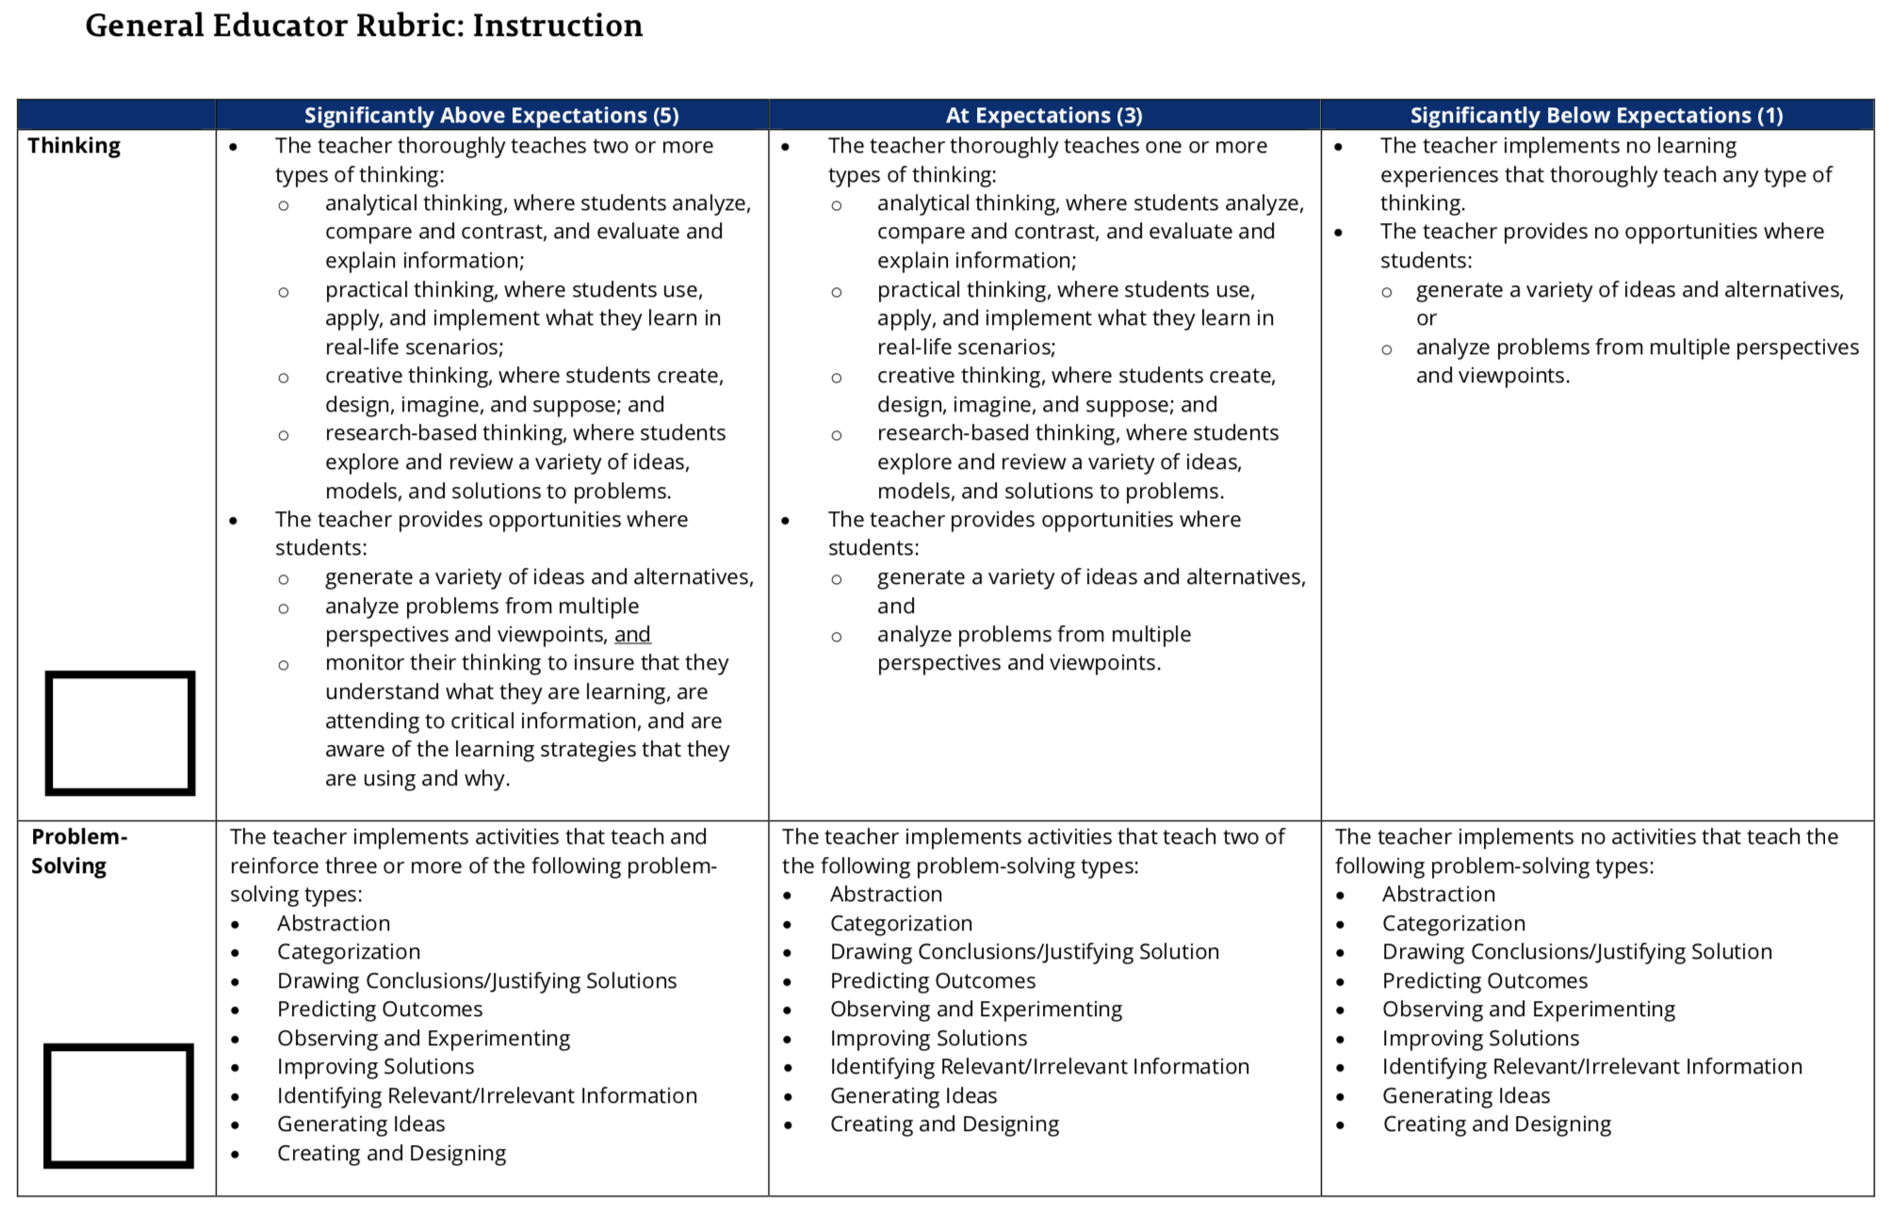
Vita

Rebecca C Napreyeva was born and raised in Johnson City, Tennessee. She earned a Bachelor of Arts from East Tennessee State University and then completed her teaching licensure requirements at Virginia Intermont College. After teaching English Language Arts in several Tennessee public schools for three years, she left to stay home with her young daughter for a few years before pursuing a Master of Arts at the University of Tennessee, Knoxville.

I have chosen to refer to this student as “A” in order to protect his identity. Because the data for this project is in the form of reflections, the student is not able to request a pseudonym for himself, and I have therefore chosen “A” for its positive connotations in the field of education, as well as its lack of racial connotation.
Throughout this work, I have chosen to capitalize “Black” when I use it as a descriptive word for groups of people, but I am not capitalizing “white” in the same situations. There is no general consensus on these capitalization decisions—scholars such as Richard Delgado, Jean Stefancic, and Christina Sharpe capitalize neither “black” nor “white,” whereas others, such as Ibram X Kendi, capitalize both. Kwame Anthony Appiah traces a great deal of this issue in “The Case for Capitalizing the B in Black,” and notes many of the complexities. One such important complexity is in regards to the capitalization habits of white supremacist groups: “White-supremacist websites have been known to capitalize the w in white; by doing the same, do we lend them support? You could argue that it’s the other way round: If the capitalization of white became standard among anti-racists, the supremacists’ gesture would no longer be a provocative defiance of the norm and would lose all force. Supremacists would have to find another way to ennoble themselves.” Because no such general consensus has yet been established, and as a white woman myself, I have chosen for now to acknowledge race as a social construct by capitalizing “Black,” and to distance myself from white supremacy by not capitalizing “white.”
What I mean by this is that individual white female teachers are not individually responsible for creating the systems that replicate racist social hierarchies. Assigning blame to individual people, or groups of people, for the ways that society functions as a whole is unlikely to bring about change, as it promotes defensiveness rather than vulnerability--a necessary component of antiracist work. However, this does not eliminate an individual’s responsibility to actively and consciously work towards undoing those systems and racist social hierarchies, especially those who are in positions that are designed to actively replicate racist systems, such as teachers. Individual white female teachers are still responsible for critically analyzing their own beliefs, policies, and actions, just as all other individuals are. They are also responsible for making changes to their practices based on their own critical analysis.
Anecdotally, teacher complaints against the TEAM rubrics include that they are too extensive for the teacher to realistically demonstrate factors from all of the indicators in any one, single lesson (a full copy of the TEAM General Educator Rubric is available in the appendix for reference; it is undeniably extensive). Complaints also arise about how certain administrators/evaluators have been trained to use the rubrics. Some teachers state that they have been told directly by their observers that no teacher will ever be scored above a 3 on any indicator no matter what they do during the lesson. Additionally, some teachers feel that the rubrics are used in a punitive way that promotes a deficit view of teachers, rather than a way that promotes support and improvement of their work. I did not personally experience these problems while at AHS, apart from occasionally scoring lower than I wished on certain indicators that were not highlighted during certain lessons.
I obtained this description from the school’s website. Because I have chosen to make the school anonymous in this work, it is necessary for me to leave this source uncited, because the name of the school is revealed in the title of the source.
As a reminder, I have chosen to refer to this student as “A” in order to protect his identity. Because the data for this project is in the form of reflections, the student is not able to request a pseudonym for himself, and I have therefore chosen “A” for its positive connotations in the field of education, as well as its lack of racial connotation.
A complete copy of the TEAM General Educator Rubrics is provided in the Appendix.
As I mentioned previously, all of the observers who conducted the observations I cite here were white.
As a reminder, chapters three and four limit analysis of available data to the interactions between a white teacher and her white and Black students. Analysis of the effects of the accountability model on other races would require additional analysis of the particular ways each group has been racialized.
TVAAS predates the TNReady exams, so challenges to the validity of its data go back even further than those brought up by the numerous working errors associated with TNReady in recent years. According to Andy Spears in Tennessee Education Report, the 2015-2016 school year was the first scheduled for fully online TCAP test administration. During the spring of that year, the testing platform experienced frequent crashes due to network outages. Student scores were omitted from final grades (as detailed in Chapter Three), and the testing vendor’s contract was severed. The following year, nearly 10,000 tests were scored incorrectly by the new vendor, and student scores were waived again. In 2018-2019, more network errors caused many of the tests to be cancelled during the testing administration window, and in 2019-2020, the tests were cancelled due to the COVID-19 pandemic (Spears). At AHS, a block schedule school, the tests were administered regardless of these issues during each semester of these years, and scores were generated and used towards accountability measures, whether formally or informally. However, overall, with so little reliable data available, there is no reliable data set against which to compare scores year to year in order to establish concepts such as “growth” or “ learning gaps.”

