Transcriptomic studies of color development and powdery mildew resistance in Cornus dogwood species

A Dissertation Presented for the
Doctor of Philosophy
Degree
The University of Tennessee, Knoxville

Zaklina Pavlovic
May 2023
Acknowledgments

I would like to thank Dr. Robert N. Trigiano for his unconditional support and encouragement throughout my doctoral program. I thank my committee members (Drs. Denita Hadziabdic-Guerry, Margaret E. Staton, Bonney Ownley, and Andreas Nebenfuehr) and Drs. Marzena Nowakowska and Marcin Nowicki for their expertise and support in completing this dissertation. I am also thankful to all my lab members, especially Sarah Boggess and friends in the Department of Entomology and Plant Pathology. This work was supported by the USDA/ ARS (NACA 58-6062-006). The mention of trade names or commercial products in this dissertation is solely to provide specific information, and it does not imply recommendation or endorsement by the University of Tennessee or the U.S. Department of Agriculture.

Abstract

Flowering dogwood (Cornus florida L.) and Asian dogwood (C. kousa F. Buerger ex Hance) are popular understory and deciduous ornamental trees that are mostly found throughout the temperate regions of North America, Europe, and Asia. They are valued for their showy snow-white, pink, and red bracts, red fall foliage, and colorful fruit. Ornamental dogwoods are essential horticultural crops for the economy of Tennessee, Oregon, North Carolina, and Ohio. Tennessee-based growers led the trade and accounted for 24% of US sales of flowering dogwood in 2019, whereas total dogwood sales exceeded USD31 million annually. Although more than 150 cultivars are commercially available for both species, consumer demands for specific traits of interest, such as dark red bract or foliage display, resistance to pathogens, variegated foliage, and dwarf or weeping habit, have not been satisfied. However, time-demanding dogwood cultivar development typically depends on repeated selection for desirable traits. Hence, the following challenges must be overcome: long juvenile period (3 to 5 years), self-incompatibility, inbreeding depression, and high susceptibility of flowering dogwood to two fungal foliar pathogens, dogwood anthracnose and powdery mildew. Therefore, this work was initiated to study the molecular mechanisms underlying anthocyanin and proanthocyanidin pigment biosynthesis; to enhance bract and foliage's desirable red and pink colors by using the RNA-Seq approach to enable the development of functional markers or the application of marker-assisted selection. Fully developed bracts of three cultivars of C. florida and two cultivars of C. kousa were sampled when color was maximally visible and subjected to RNA sequencing. Candidate genes CfMYB2, CfMYB3, and CkMYB2, were found to repress anthocyanin and proanthocyanidin synthesis in flowering and Asian dogwood, whereas CfMYB1 80 and CkMYB1 increased it. Two quantitative trait loci, QTLPM-7 and QTLPM-8, associated with powdery mildew resistance were identified for two consecutive years in C. florida pseudo-F2 population. Finally, recessively inherited Mildew resistance locus o (Mlo) genes, which prevent effective host cell penetration by powdery mildew, were investigated in a time-tuned transcriptome study including four C. florida cultivars of varying resistance to powdery mildew.

Table of Contents
Introduction 1
Chapter 1. Identification of R2R3-MYB Transcription Factors Involved in Flavonoid Biosynthesis Regulation in Cornus florida and C. kousa 7
Abstract 9
Introduction 9
Material and Methods 13
Plant Materials 13
RNA Extraction and Sequencing 13
Quality Control 14
Read Alignment and Gene Quantification 14
Differential Expression Analysis and Functional Enrichment 14
Gene Ontology enrichment analysis 15
Phylogenetic analysis and conserved motif identification 16
Reverse Transcription Quantitative PCR (RT-qPCR) 16
Results 17
Plant Materials Bract Color Variation 17
RNA sequencing and alignment 17
DEGs Involved in Anthocyanin Biosynthesis Pathway 17
Protein function prediction and phylogenetic analysis 18
Validation of RNA-Seq by RT-qPCR 19
Discussion 19
Conclusions 22
Appendix: Tables and Figures 23
Chapter 2. Detection of Quantitative Trait Loci associated with Erysiphe pulchra in pseudo-F2 Cornus florida population 41
Abstract 42
Introduction 42
Material and Methods 45
Population development and assessment of PM resistance to determine the mode of inheritance and QTL associated with PM 45
Genetic map improvement and QTL analysis 46
Results 46
Inheritance of PM Resistance 46
QTL mapping 47
Discussion 47
Appendix: Tables and Figure 53
Chapter 3. Are Mlo Genes a Vital Source of Powdery Mildew Resistance in Flowering Dogwood (Cornus florida)? 58
Abstract 59
Introduction 59
Material and Methods 63
Plant Materials 63
RNA Extraction and Sequencing 64
Quality Control 64
Read Alignment and Gene Quantification 64
Differential Expression Analysis and Functional Enrichment 64
Reverse Transcription Quantitative PCR (RT-qPCR) 65
Results and Discussion 65
Plant Materials and their resistance to PM 65
RNA-Seq data analysis 66
Validation of RNAseq by RT-qPCR 67
Conclusion 68
References 71
Vita 105

List of Tables

Table 1.1. Primers for the five consistently up-or downregulated candidate regulatory and structural genes were designed based on Cornus florida and C. kousa sequences. 23
Table 1.2. Species and accession numbers of MYB proteins used to construct the phylogenetic tree of Cornus florida and C. kousa. 24
Table 1.3. The species and accession numbers of R2R3-MYB repressor proteins used to search for characterized distinctive motifs in MYB repressors, such as EAR with conserved sequence LxLxL. 27
Table 2.1. Segregation data and proposed gene action for powdery mildew resistance in pseudo-F2 Cornus florida population over five years. 53
Table 2.2. QTL statistics for two QTL detected in two consecutive years in Cornus florida, pseudo-F2 population mapping populations segregating for powdery mildew resistance. 54

List of Figures

Figure 1.1. Phenotypes of Cornus florida and C. kousa bracts were used in this study after bract emergence when one (1WK), two (2WK), and four-week-old (4WK) from (A) 'Cloud Nine' (B) 'Cherokee Chief' (C) 'Cherokee Brave' (D) 'Greensleeves' (E) 'Rosy Teacups'. 29
Figure 1.2. Sample clustering of reads from both cultivars mapped to either the transcriptomes of Cornus florida (A, B) or C. kousa (C, D). The 13 transcriptome profiles were separated into five groups of high similarity by bract color and cultivar when mapping reads to either C. florida (A) or C. kousa (C) transcriptome. The samples clustered into five groups 'Cherokee Chief' (red bracts), 'Cherokee Brave' (red bracts), 'Cloud Nine' (white bracts), 'Greensleeves' (light- to- medium green bracts), and 'Rosy Teacups' (light- to- medium pink bracts). The heatmaps of normalized count values across bract color-related differentially expressed genes across the 13 samples suggested higher similarity by species when mapping to C. florida (B) and by color on C. kousa (D). 30
Figure 1.3. Classification of protein families of Cornus florida and C. kousa MYB translated protein sequences (A) CfMYB1 (B) CfMYB2 (C) CfMYB3 (D) CfMYB5 (E) CkMYB1 (F) CkMYB2. 34
Figure 1.4. Phylogeny of Cornus florida and C. kousa MYB Transcription Factors Associated with the Phenylpropanoid Pathway. The tree was constructed using the maximum likelihood method with putative translated amino acid full-length MYB sequences with PhyML (Guindon et al., 2009). Bootstrap values are shown as a percentages (1000 replicates). Candidate R2R3-MYB protein sequences regulating anthocyanin and proanthocyanidin synthesis identified in the study are labeled in red and belong to subgroup 4 (CfMYB2, CfMYB3, and CkMYB2) and 5 (CfMYB1 and CkMYB1), respectively (Stracke et al., 2001; Dubios et al., 2010; Shelton et al., 2012). 37
Figure 1.5. Positional enrichment of Ethylene-responsive element binding factor-associated Amphiphilic Repression (EAR) motif in R2R3-MYB transcription factors of Cornus florida and C. kousa (A) EAR motif in 26 R2R3-MYB sequences. (B) The protein sequence alignment of 26 R2R3-MYB sequences was aligned in Mega11 with the default setting integrated with Muscle program (Stecher et al., 2020; Tamura et al., 2021). Positional enrichment showed EAR motif located at the C-terminal behind MYB R repeat in CfMYB2, CfMYB3, and CkMYB2 protein sequences. 38
Figure 1.6. Validation of differentially expressed genes and expression levels of candidate R2R3-MYB genes designated as CfMYB1 80, CfMYB2, CfMYB3, CkMYB1 and CkMYB2 in the phenylpropanoid metabolism with RT-qPCR in Cornus florida and C. kousa. 39
Figure 1.7. Validation of differentially expressed genes and expression levels of structural genes CHI, CHS, and F3H in Cornus florida (top) and CHI and CHS in C. kousa (bottom) with RT-qPCR. 40
Figure 2.1. Symptoms of powdery mildew on Cornus florida pseudo-F2 individual tree originating from reciprocal crosses between breeding lines 96-6 and 96-7 (A) Merged white patches of mycelia and conidia on the adaxial leaf surface (B) Curled young and mature leaves in late summer. 55
Figure 2.2. Charts for powdery mildew (PM) incidence over six years (2017-2022) in the Cornus florida pseudo-F2 population. 0 represented trees with no apparent disease symptoms and no colonies of PM detected on any leaves, 1 designated plants displaying up to 30 % symptomatic leaf area as light sporulation present on some leaves, 2 represented 30 to 60 % of colonies with moderate sporulation coalescing into large regions, and 3 represented 60 to100 % of abundant sporulation merged into large areas. 56
Figure 2.3. Cornus florida QTL with the largest effect were detected in LG 8 and 9 in two consecutive years, 2017 and 2018 (A) QTL on LG 8 associated with marker CF696C and further designated as QTLPM-7 (B) QTL on LG 9 associated with marker CF290C and further designated as QTLPM-8. 57

List of Attachments

Metadata for all RNASeq samples and NCBI SRA Accession, Cornus florida differentially expressed genes (DEGs), C. kousa DEGs, BINGO results for flowering dogwood, and BINGO results for Asian dogwood (RNA-Seq_data_xlsx)

Introduction

The genus Cornus L. includes about 60 species of trees and shrubs scattered throughout the temperate regions of North America, Europe, and Asia, (Xiang et al., 2006). Cornus species are grouped into the following four subgroups: big-bracted dogwoods (BB), blue or white-fruited dogwoods (BW), cornelian cherries (CC), and dwarf dogwoods (DW) (Fan et al., 2003; Xiang et al. 2006). Exceptional for their showy petaloid bracts, flowering dogwood (Cornus florida L.) belongs to the BB subgroup, subgenus Cynoxylon Raf., which is characterized by four modified leaves (bracts) and red clustered berries (Fan et al., 2003; Xiang et al., 2006). In comparison, Asian dogwood (C. kousa F. Buerger ex Hance F) also belongs to the BB subgroup, subgenus Syncarpea (Nakai) Xiang, distinguished by four modified, petaloid bracts and fused red multi-stoned berries (Fan et al., 2003; Xiang et al., 2006).

Flowering and Asian dogwoods are two of the most popular and economically compelling species among nursery growers and horticulturists. Nurseries in Tennessee account for 24% of the flowering dogwoods sold in the United States ornamental plant market. All dogwood species accounted for more than USD31 million in annual revenue from retail and wholesale sales in the United States (US) (USDA-NASS, 2019). The ornamental value of trees continues to drive consumer demand and, so far, has resulted in the commercial release of more than 150 cultivars (Cappiello and Shadow, 2005; Wadl et al., 2014; Nowicki et al., 2020). However, the ornamental market constantly seeks new traits of interest, such as dark red bracts or foliage display, resistance to pathogens, variegated foliage, and dwarf or weeping habits.

Flowering dogwoods are endemic to the eastern US and distributed from Canada and southern Michigan in the north to northern Florida in the south and east Texas in the west (Mitchell, 1988; Mantooth et al., 2017). Showy snow white, pink or red bracts and red fall foliage display make flowering dogwoods desirable ornamental trees all year round. C. florida blooms appear in the early spring (April- May), forming clustered fruits – drupes, which ripen in the fall. Drupes contain a high level of fat, protein, and available calcium (Thomas, 1969), representing an important source of nutrients for wildlife.

Cornus kousa, Asian dogwoods, also are valued for their spring display of pink, red, or white bracts in May and June, brilliant-red fall foliage, and exfoliating bark, and were introduced from Eastern Asia to the US because of their general high resistance to insects and pathogens, and overall better stress tolerance compared to flowering dogwood (Ranney et al., 1995; Li et al., 2009; Wadl et al., 2014).
Time-demanding dogwood cultivar development typically depends on repeated selection for desirable traits. Hence, it needs to overcome several challenges, such as a long juvenile period (3 to 5 years), self-incompatibility, inbreeding depression, and high susceptibility of flowering dogwood to powdery mildew (PM) and anthracnose (Gunatilleke and Gunatilleke, 1984; Ament et al., 2000; Reed, 2004; Wang et al., 2009; Hadziabdic et al., 2010; Hagan et al., 2011; Wadl et al., 2011; Mantooth et al., 2017). For instance, white-bracted cultivars 'Kay's Appalachian Mist, 'Jean's Appalachian Snow,' and 'Karen's Appalachian Blush' are resistant to dogwood PM (Windham et al., 2003). However, they lack desirable dark red or pink bracts of cultivars belonging to the Cherokee series, such as 'Cherokee Brave,' 'Cherokee Chief,' 'Cherokee Sunset,' and ‘Appalachian Sunrise,’ which are generally considered either moderately or susceptible to dogwood PM (Thurn et al., 2019). Most Asian dogwoods typically lack variation in bracts colors and usually do not display a range of bract colors from white to dark red as flowering dogwoods do (Cappiello and Shadow, 2005; Molnar et al., 2017). However, there are a few cultivars exhibiting dark to bright red or pink bracts, such as 'Rosy Teacups,' 'Miss Satomi,' and 'Rutpink' (Trigiano et al., 2004; Molnar et al., 2017).

Desirable pink or dark red colors in flowering dogwoods bracts are enhanced by anthocyanin biosynthesis (Wadl et al., 2011). Anthocyanins are water-soluble flavonoids in various plant organs, including leaves, bracts, flowers, fruits, stems, and roots (Zhang et al., 2014). More than 600 naturally occurring anthocyanins have been identified in planta (Smeriglio et al., 2016). They differ in their function, such as color, or bioavailability, based on anthocyanidin post-synthesis, which depends on the methylation of core anthocyanidins. C. florida and C. kousa have similar anthocyanin profiles (Vareed et al., 2005). Anthocyanin biosynthesis is highly conserved in both angiosperms and gymnosperms. Two classes of genes control the biosynthesis of anthocyanins and other phenylpropanoid-derived compounds: the structural genes encoding the enzymes participating in the formation of anthocyanins and the regulatory genes network consisting of the following three types of transcription factors (TFs): MYB (v-myb avian myeloblastosis viral oncogene homolog) protein, bHLH (basic helix-loop-helix) protein, and WD repeat protein (WDR) (Allan et al., 2008; Dubos et al., 2010; Zhang et al. 2014). The MYB TF family is one of the largest in plants and regulates various metabolic pathways gene superfamily. It is divided into the following four families: 1R-MYB, 2RMYB (R2R3), 3R- MYB, and 4R-MYB, based on the number of domain repeats. (Lipsick, 1996; Rosinski and Atchley, 1998; Kranz et al., 2000; Dubos et al., 2010; Jiang et al., 2020). R2R3-MYB gene family has been classified into 23 to 90 subgroups (Du et al., 2015; Jiang et al., 2020; Li et al., 2020). Accordingly, each R2R3-MYB subgroup regulates a specific metabolism pathway (Wu et al., 2022). Anthocyanin and proanthocyanidin activators of subgroup 5 require specific bHLH TFs to trigger the transcription of structural genes. However, MYB repressors, which act to reduce anthocyanin biosynthesis, belong exclusively to subgroup 4. Candidate genes controlling anthocyanin synthesis, an essential pigment for bract, flower, and leaf color, have not been identified yet in most ornamental woody plants. In dogwoods, research on flavonoid biosynthesis has been limited and includes studies on quantitative trait loci (QTL) associated with red foliage color and the mode of inheritance. Accordingly, four putative QTL associated with red foliage color were detected in segregating pseudo-F2 population of 94 individuals of flowering dogwood using 255 simple sequence repeat markers (SSRs) (Wadl et al., 2011). Moreover, the segregation of phenotypes of the same population indicated that a complementary gene interaction, a form of epistasis, controls foliage color with a 9:7 two-gene ratio (Wadl et al., 2010).

Although flavonoid pigment biosynthesis is one of the best-studied biological processes in nature and R2R3-MYBs are widely distributed in the plant kingdom, key players involved in phenylpropanoid pathway and anthocyanin, and proanthocyanidin regulation in flowering and Asian dogwood have not been identified. This delays the development of functional markers or the application of marker-assisted selection (MAS) for color in leaves and bracts in dogwood breeding.

Dogwoods are susceptible to a myriad of fungal diseases of different etiologies that produce spots and blights on flowers and leaves, cankers and dieback on twigs and branches, root rots, and result in tree loss (Windham et al., 1997; Windham et al., 2005; Li et al., 2009; Hadziabdic et al., 2010; Mantooth et al., 2017). Most fungal diseases lower esthetic value and fruit production. However, PM, caused by Erysiphe pulchra Cooke & Peck, and dogwood anthracnose, caused by Discula destructiva Redlin are challenging commercial production and cause devastating damage to single trees and entire populations (Mantooth et al., 2017; Wyman et al., 2019). E. pulchra is an obligate biotrophic ascomycete and, in 1994, severely affected nurseries that specialized in dogwood production (Hagan et al. 1998). Resistant cultivars are seen as the best management strategy, and their use eliminates the need for routine fungicide applications that raise biological, economic, and environmental concerns (Windham, 2003; Li et al., 2009; Riaz et al., 2011). Disease signs manifest as circular or irregular white patches of mycelia and conidia on the adaxial leaf surface. Symptoms display light and brown discolorations on leaves, leaf and flower malformation, and decreased plant size, rendering the dogwoods aesthetically undesirable. Consequently, due to the emergence of D. destructiva and E. pulchra pathogens, the management of flowering dogwood diseases and control costs increased from approximately $120/ha/year to $1,975/ha/year (Li et al., 2009). However, the biotrophic nature of this fungus, difficulty in obtaining inoculum, and lack of information on host-pathogen interactions bring additional obstacles to investigating this pathosystem.

Construction of genetic linkage maps and mapping of QTL are effective approaches to studying important traits, such as resistance against PM pathogens, and has been widely applied in cereals, vegetables, fruits, grapevine, and ornamental plants (Young, 1996; Calenge et Durel, 2006; Linde et al., 2006; Ribaut et al., 2009; Yuste-Lisbona et al., 2011; Parikh et al., 2017; Yang et al., 2021; Pfarr Moreau et al., 2022). Four genetic linkage maps have been reported for flowering dogwoods (Wang et al., 2009; Parikh et al., 2017; Pfarr et al., 2022). The first linkage map was generated with 225 SSRs and was constructed using a pseudo-F2 population of 94 individuals derived from honeybee mediated cross between ⧬ 'Appalachian Spring' (putative PM resistant) and ♂ 'Cherokee Brave' (PM moderately resistant). It was a fundamental tool for identifying QTL associated with foliage color in flowering dogwood (Wadl et al., 2011) and QTL related to PM resistance (Parikh et al., 2017). However, constructing a new genetic linkage map for the same population using a genome-by-sequencing (GBS) approach could allow the discovery of thousands of single nucleotide polymorphisms (SNPs) and better marker coverage. Recently, a mapping population of 196 seedlings was developed by crossing two breeding selections, H4AR15P25 (PM resistant) x H4AR15P28 (PM susceptible), using double digest restriction-site-associated DNA sequencing and was phenotyped for PM resistance trait (Pfarr et al., 2022). However, Pfarr et al. (2022) considered F1 progenies as "pseudo-F2" due to allele segregation from mapping populations of highly heterozygous parents, which complicated linkage map construction because of initially unknown linkage phases. Therefore, high-density linkage mapping and identification of QTL associated with PM resistance in C. florida pseudo-F2 population have not yet been constructed and identified.

Recessively inherited loss-of-function Mildew resistance locus o (Mlo) genes alleles confer broad-spectrum PM resistance and become the focal point of Mlo research (Jacott et al., 2021). Mlo inactivation, either as a consequence of natural mlo mutations (transposon insertions, single nucleotide polymorphisms, and small indels) or as a result of gene knock-out or knock-down, leads to early termination of PM pathogenesis based on prepenetration resistance (Jørgensen, 1992; Lyngkjær et al., 2000; Kusch and Panstruga, 2017). Prepenetration resistance includes local cell-wall appositions containing callose, accumulation of the phenol conjugate p-coumaroyl-hydroxyagmatine, and reactive oxygen species, including hydrogen peroxide. The exact biological functions of MLO proteins are still puzzling to scientists. However, for some family members, PM penetration resistance was suggested to be regulated via vesicle fusion events (Collins et al., 2003; Bhat et al., 2005). Mlo and its homologs have been studied in all major land plant lineages. The most important economically agricultural and horticultural crops include apples (Malus domestica Borkh.) (Pessina et al., 2014), barley (Hordeum vulgare L.) (Jorgensen, 1992), grapevine (Vitis vinifera L.) (Feechan et al., 2008), pea (Pisum sativum L.) (Pavan et al., 2011), pepper (Capsicum annum L.) (Zheng et al., 2013), petunia (Petunia hybrida D. Don ex W. H. Baxter) (Jiang et al., 2016), poplar (Populus trichocarpa Torr. & Gray) (Filiz and Vatansever, 2018), rose (Rosa hybrida L.) (Kaufmann et al., 2012), strawberries (Fragaria x ananassa Duchesne) (Jiwan et al., 2013), sweet orange (Citrus sinensis L.) (Liu et al., 2017), tomato (Solanum lycopersicum L.) (Bai et al., 2008), wheat (Triticum aestivum L.) (Wang et al., 2014) and others. Mlos have not been identified in C. florida.

The development of new and advanced molecular tools and genetic maps for plants enabled MAS application to plant breeders to select traits of interest, either controlled by markers of causative mutations, or more often, linked to unknown causative mutations (Ribaut and Hoisington, 1998). Thus, identifying MYBs, Mlos, and QTLs associated with PM will allow functional and DNA marker modeling to screen and select material to develop resistant cultivars more efficiently.

Chapter 1. Identification of R2R3-MYB Transcription Factors Involved in Flavonoid Biosynthesis Regulation in Cornus florida and C. kousa

This chapter is a reformatted version of a manuscript in preparation with the same name in the journal, Planta. The authors are Žaklina Pavlović, Marcin Nowicki, Miriam Payá‐Milans, Marzena Nowakovska, Matthew L. Huff, Margaret E. Staton, Robert N. Trigiano.

My principal contributions were conceptualization, software, validation, formal analysis, investigation, resources, data curation, original draft preparation, visualization, and project administration.

Abstract

Flowering dogwood (Cornus florida L.) and Asian dogwood (C. kousa Buerger ex Hance) are popular deciduous ornamental trees. C. florida is native to a wide range of eastern and southeastern United States, whereas C. kousa originated in Eastern Asia. Both species excel for their showy white, red, or pink bracts, red fall foliage, and colorful fruit. Flavonoid pigment biosynthesis is one of the best-studied biological processes in nature, and it is controlled by two classes of genes: structural genes and transcription factors that function as either positive or negative regulators of flavonoid compounds. For instance, anthocyanin pigments enhance desirable pink or dark red colored bracts in dogwoods, whereas proanthocyanidins protect plants from pathogens and pests. Molecular regulation of anthocyanins and proanthocyanidins is largely unknown in dogwoods, and genes controlling this complex pathway have not been identified yet in both flowering and Asian dogwood. RNA sequencing was employed to investigate this pathway in these two species, and mature bracts of three cultivars of C. florida (white bracts: 'Cloud Nine'; red bracts: 'Cherokee Brave' and 'Cherokee Chief') and two cultivars of C. kousa (light green bracts: 'Greensleeves' and medium pink 'Rosy Teacups') were sampled when color was maximally visible. Differential gene expression analysis identified 1156 differentially expressed genes in C. florida and 1396 in C. kousa. Phylogenetic analysis grouped candidate R2R3-MYB identified in this study in two subgroups, 4 and 5. CfMYB2, CfMYB3, and CkMYB2 belonged to subgroup 4, whereas CfMYB1 and CkMYB1 clustered in subgroup 5. CfMYB2, CfMYB3, and CkMYB2 likely repress anthocyanin and proanthocyanidin synthesis in flowering and Asian dogwood, whereas CfMYB1 80 and CkMYB1 increase it.

Introduction

Flowering dogwood (Cornus florida L.) and Asian dogwood (C. kousa F. Buerger ex Hance) are popular understory and deciduous ornamental trees of the Cornus genus, which include about 60 species of trees and shrubs that are mostly found throughout the temperate regions of North America, Europe, and Asia (Eyde, 1987; Cappiello and Shadow, 2005; Wadl et al., 2014). Native to a wide range of eastern and southeastern United States (US) flowering dogwoods owe their exceptional appeal to showy snow-white, pink, and red bracts, red fall foliage, and drupes (Witte et al., 2000; Cappiello and Shadow, 2005). Asian dogwoods also are valued for their spring display of pink, red, or white bracts, brilliant-red fall foliage, colorful fruits, and exfoliating bark, and were introduced from Eastern Asia to the US because in the mid-1800 of their general high resistance to insects and pathogens and overall better stress tolerance. compared to flowering dogwood in (Ranney et al., 1995; Li et al., 2009, Wadl et al., 2014). Beyond providing nourishment for wildlife due to the high level of fat, protein, and available calcium in fruit (Thomas, 1969), flowering and Asian dogwoods are essential ornamental crops for the economy of Tennessee, Oregon, North Carolina, and Ohio among other states.
Although more than 150 cultivars are commercially available for both species, consumer demands for specific traits of interest, such as dark red bract or foliage display, resistance to pathogens, variegated foliage, and dwarf or weeping habit, have not been satisfied (Cappiello and Shadow, 2005; Witte et al., 2000; Wadl et al., 2014; Nowicki et al., 2020). For instance, white bracted cultivars 'Kay's Appalachian Mist, "Jean's Appalachian Snow,' and 'Karen's Appalachian Blush' are resistant to dogwood powdery mildew (Erysiphe pulchra Cooke & Peck) (Windham et al., 2003). However, they lack desirable dark red or pink bracts of cultivars belonging to the Cherokee series, such as 'Cherokee Brave,' 'Cherokee Chief,' 'Cherokee Sunset', and 'Cherokee Daybreak', which are generally considered either moderately or susceptible to dogwood powdery mildew (Thurn et al., 2019) and ‘Appalachian Sunrise (personal comm. R. N. Trigiano). In contrast, kousa dogwoods typically lack variation in bracts colors and do not display a range of bract colors from white to dark red as flowering dogwoods do (Cappiello and Shadow, 2005; Molnar et al., 2017). 'Rosy Teacups,' 'Miss Satomi,' and 'Rutpink' are among the few cultivars exhibiting dark to bright red or pink bracts (Trigiano et al., 2004; Molnar et al., 2017). Moreover, a hybrid breeding program between C. florida and C. kousa was initiated almost a half-century ago, aiming to enhance ornamental traits and develop attractive landscape trees that do not require extensive maintenance (Molnar et al., 2017).

However, time-demanding dogwood cultivar development typically depends on repeated selection for desirable traits. Hence, several challenges need to be overcome, such as a long juvenile period (3 to 5 years), self-incompatibility, inbreeding depression, and high susceptibility of flowering dogwood to two fungal foliar pathogens, dogwood anthracnose (Discula destructiva Redlin) and powdery mildew (Gunatilleke and Gunatilleke, 1984; Ament et al., 2000; Reed, 2004; Wang et al., 2009; Hadziabdic et al., 2010; Hagan et al., 2011; Wadl et al., 2011; Mantooth et al., 2017).

Most plant pigments belong to flavonoids, which are ubiquitous across the plant kingdom, and typically associated with insect pollination and seed dispersal, hormone signaling, and abiotic and biotic defense (Liu et al., 2015; Cao et al., 2020; Wu et al., 2022). Likewise, desirable pink or dark red colors in flowering and Asian dogwoods bracts are created by anthocyanin pigment biosynthesis. Their anthocyanin profiles are similar, with major anthocyanins as cyanidin 3-O-galactoside and cyanidin 3-O-glucoside, respectively (Vareed et al., 2006). Anthocyanins are specialized flavonoid metabolites found in plants and have a substantial role in conferring defense against plant pathogens and abiotic factors such as UV radiation, drought, or cold (Jin et al., 2000; Yadun and Gould, 2008; Zhang et al., 2019; Gong et al., 2020). Moreover, their impact on plant quality contributes to various plant products' horticultural, industrial, and nutritional value, such as apple (Malus domestica Borkh.) (Lin-Wang et al., 2010; Meng et al., 2016), chrysanthemum (Chrysanthemum morifolium (Ramat.) Hemst.) (Liu et al., 2015), eggplant (Solanum melongena L.) (Zhang et al., 2014), grape (Vitis vinifera L.) (Czemmel et al., 2012), morning glory (Ipomea purporea L.) (Park et al., 2007), petunia (Petunia hybrida D. Don ex W. H. Baxte) (Albert et al., 2009; Albert et al., 2011), royal lily (Lilium regale E. H. Wilson) (Yamagishi et al., 2010), snapdragon (Antirrhinum majus L.) (Naing et al., 2018), strawberry (Fragaria vesca L.) (Aharoni et al., 2001), and others. Their antioxidant activity has recently evoked significant attention in protecting against cancer, strokes, and other chronic human disorders (Zhang et al., 2014; Kodama et al., 2018). Anthocyanins produced by kousa's leaves were found to have anti-obesity effects (Khan et al., 2018).

Proanthocyanidins or condensed tannins activators fulfill various physiological requirements, whereas their astringency properties protect plants from pathogens, insects, and herbivores (Dixon et al., 2004; Rauf et al., 2019). They are structurally correlated to anthocyanins (Zhao et al., 2010) and found in the endothelial layer of the seed coat, flowers, fruits, and leaves of many plants, including berries (black elderberry, blueberry, cranberry) (Krenn et al., 2007), plum, apricot, walnut (Qin et al., 2009), grapes (Souquet et al., 1996), forage legumes (Albert, 2015), coffee (de Colmenares et al., 1998), tea plant (Ahmad et al., 2000). Like anthocyanins, proanthocyanidins have a wide range of beneficial health characteristics, such as antioxidant potency, antibacterial, antiviral and anti-allergenic, among others (Rauf et al., 2019).

The following two classes of genes control the biosynthesis of anthocyanins and other phenylpropanoid-derived compounds: the structural genes encoding the enzymes participating in the formation of anthocyanins and the regulatory genes networks consisting of three types of transcription factors (TFs): MYB (v-myb avian myeloblastosis viral oncogene homolog) proteins, bHLH (basic helix-loop-helix) proteins, and WD repeat protein (WDR) (Allan et al., 2008; Dubos et al., 2010; Zhang et al., 2014). MYB TF family is one of the largest in plants and regulates various metabolic pathways, including responses to abiotic stimuli, regulation of benzenoid, glucosinolate, phenylpropanoid, and terpenoid pathways, and control of developmental and cell differentiation process, e.g., organ formation, cuticle development, and trichome initiation and branching (Shin et al. 2002; Liu et al. 2015; Zhao et al. 2018; Tan et al. 2019 Fichman et al. 2020; Gong et al. 2020). MYB TFs characterize a highly conserved N- terminal DNA-binding domain repeat (R) plus a variable C-terminal regulatory region (C). Each MYB repeat contains approximately 50 amino acids including unique DNA motifs and MYB binding sites. Based on sequence similarities, MYB domain repeats are named R1, R2, and R3 depending on the number of repeats, including 1-4 repeats. Accordingly, the MYB gene superfamily is divided into the following four families: 1R-MYB, 2RMYB (R2R3), 3R- MYB, and 4R-MYB. (Lipsick, 1996; Rosinski and Atchley, 1998; Kranz et al., 2000; Dubos et al., 2010; Jiang et al., 2020). The first plant R2R3-MYB gene, COLOREDI, was identified in Zea mays four decades ago and was essential for enhancing anthocyanin biosynthesis in aleurone tissue (Klempnauer et al., 1982). The constant development of fast and cost-effective next-generation sequencing technologies has enabled the identification of many R2R3-MYB (more than 500) genes across 130 plant species (Morozova and Marra, 2008; Wu et al., 2022).

Although consensus regarding the classification schemes and nomenclature uniformity of R2R3-MYB TFs is still lacking, mainly because of lineage-specific gene loss or expansion, differences in sample coverage, and type of phylogenetic analysis applied, R2R3-MYB TFs have been classified into 23 to 90 subgroups (Du et al., 2015; Jiang et al., 2020; Li et al., 2020). Accordingly, each R2R3-MYB subgroup regulates a specific metabolism pathway (Wu et al., 2022). For instance, anthocyanin and proanthocyanidins activators of subgroup 5 require specific bHLH TFs to activate the transcription of structural genes (Chen et al., 2019; Ma and Constable, 2019, Wu et al., 2022). In contrast, MYB repressors, which act to reduce anthocyanin and proanthocyanidins biosynthesis, belong exclusively to subgroup 4 and contain the N-terminal regions with a DNA-binding domain as well. The N-terminal region of MYBs is highly conserved, and its function usually depends on the C-terminal region's distinct motifs. The C1 LlsrGIDPxT/sHRxI/L region and C2 region pdLNLD/ELxiG/S are referred to as GIDP and EAR motif (Ethylene-responsive element-binding factor associated Amphiphilic Repression motif), respectively. EAR is the most common transcriptional repression motif found in plants. The C3 and C4 motifs are also present in a small segment of the R2R3-MYB structural domain (Ohta et al., 2001, Kagale et al., 2011; Chen et al., 2019; Ma and Constabel, 2020). Most of the identified and functionally characterized MYBs involved in anthocyanin biosynthesis, such as MdMYB1, MdMYBA, and MdMYB3 in apples, ROSEA1, and ROSEA2 in snapdragon, AN2, DPL, and PHZ in petunia positively regulate the transcriptional expression of structural genes involved in this pathway (Moyano et al., 1996; Schwinn et al., 2006; Albert et al., 2011, 2014). Upstream genes (early biosynthetic genes) such as CHI (chalcone isomerase), CHS (chalcone synthase), and F3H (flavanone 3-hydroxylase), are the key enzymes to mediate and regulate anthocyanin biosynthesis, which is branched from the phenylpropanoid pathway. In comparison, DFR (dihydrofavonol 4-reductase), ANS (anthocyanidin synthase), and UFGT (flavonoid 3-O-glucosyltransferase) are downstream genes (late biosynthetic genes) (Pelletier et al., 1999; Takos et al., 2006; Cominelli et al., 2007; Vimolmangkang et al., 2013; Sun et al., 2019).

Although flavonoid pigment biosynthesis is one of the best-studied biological processes in nature and R2R3-MYBs are widely distributed in the plant kingdom, key players involved in phenylpropanoid pathway of anthocyanin and proanthocyanidin regulation in flowering and Asian dogwood have not been identified yet. This delays the development of functional markers or the application of marker-assisted selection in dogwood breeding. Therefore, this work aimed to investigate the global transcription profiles of MYB TFs and structural genes using the RNA sequencing (RNA-Seq) approach within various cultivars to identify candidates that are either positive or negative regulators of the anthocyanin pathway and other flavonoid compounds.

Material and Methods

Plant Materials

Maximally grown bracts (~ four weeks old) were collected from three cultivars of C. florida (white bracts: 'Cloud Nine'; red bracts: 'Cherokee Brave' and 'Cherokee Chief' and two cultivars of C. kousa (light green bracts: 'Greensleeves,' and light to medium pink 'Rosy Teacups') (May 2017). Trees were grown at the University of Tennessee Knoxville, USA greenhouse and were 4-5 years old and disease-free.

RNA Extraction and Sequencing

RNA was extracted using 500 mg of frozen tissue per sample with the GeneAll ® Ribospin™ Plant Total RNA Kit (GeneAll Biotechnology, Seoul, Korea), following the manufacturer's instructions. Bract samples were homogenized using zirconia beads at 6 m/s for 30 sec in a Bead mill 24 (Fisher Scientific). Subsequently, total RNA integrity was assessed with Agilent 2100 Bioanalyzer system using the RNA 6000 Nano LabChip® kit (Agilent Technologies, Palo Alto, CA, USA). Four of the 20 biological replicates collected were below the quality threshold (RIN >=6.0). The 16 RNA samples from three flowering dogwood and two Asian dogwood genotypes were submitted to GeneWiz (South Plainfield, NJ, USA) for library preparation and sequencing by an Illumina HiSeq 2500, which generated 150 bp paired-end reads. All genotypes had at least two biological replicates.

Quality Control

RNA-seq yielded approximately 20–37 million reads per library, which were subjected to error correction using Rcorrector (RNA-Seq error CORRECTOR) (Song and Florea, 2015). Read quality control was performed using FastQC v0.11.4 (Andrews, 2010). Adaptors, short (<30 bases), and low-quality reads were trimmed by skewer version v0.2.2 (Jiang et al., 2014). Subsequently, read quality control was reassessed using FastQC v0.11.4 (Andrews, 2010) (Supplementary Table 1.1.).

Read Alignment and Gene Quantification

The reference genome for flowering and Asian dogwood is not yet available. Therefore, trimmed reads were mapped to C. florida or C. kousa transcriptome (Yu et al., 2017) using Genomic short-read Nucleotide Alignment Program (GSNAP version 2018-01-31) (Wu et al., 2016). Aligned reads were used to generate a gene-specific count matrix across samples using a standalone script provided by HTSeq (Anders et al., 2015), which counts the number of reads mapped to each gene.

Differential Expression Analysis and Functional Enrichment

To identify R2R3-MYB TFs and structural genes involved in anthocyanin biosynthesis, gene counts were analyzed for gene-level differential expression using DESeq2 (Love et al., 2014). This package provides an option to test differential expression by shrinking estimators of the negative binomial distribution. Count results from HTSeq were imported, specifying an experimental design that modeled the bract color as the effect of treatment while adjusting for cultivar or species differences. Genes with zero count across samples were removed. The regularized log transformation function was used to calculate sample distances using t-SNE plots generated using the R package tsne. The wald test was employed to identify differentially expressed genes (DEGs) between two sample classes, red-bracted and non-pigmented. Significantly DEGs were identified with adjusted p-value < 0.05 after multiple testing using the Benjamini-Hochberg method. Heatmaps with the expression profiles of DEGs after mapping to each of the two Cornus species transcriptomes were generated using the R package pheatmap with correlation distances.
TransDecoder v3.0.0 was used to predict encoded peptides based on C. florida and C. kousa transcriptomes. TransDecoder identified all open reading frames (ORFs) that were at least 50 amino acids long in the transcripts. These ORFs were then scanned for homology to known proteins using blastp (Altschul et al. 1990) against the UniProtKB/TrEMBL database (Boutet et al. 2016) for plants and searched against Pfam (Finn et al., 2016) for conserved protein domains with HMMER v3.1b2 (Potter et al., 2018). TransDecoder was rerun with the outputs generated from blastp and HMMER to improve the prediction of coding regions. All predicted peptides were used on InterProScan 5.21-60.0 software to assign gene ontology (GO) terms. Additionally, DEG transcripts were uploaded to the KAAS server for KEGG (Kyoto Encyclopedia of Genes and Genomes) ortholog assignments (Kanehisa and Goto, 2001). Finally, a custom database for the actin, elongation factor 1-alpha, GAPDH, and Cytochrome c oxidase I housekeeping genes in eudicots was used to pull out putative sequences in C. florida and C. kousa transcriptomes.

Gene Ontology enrichment analysis

To gain insights into the functions of the DEGs, genes were annotated and analyzed through GO by AgriGO v2.0 (Tian et al., 2017) using C. florida or C. kousa transcriptome (Yu et al. 2017). BiNGO v3.0.3 (Maere et al., 2005) and Cytoscape v3.3.0. (Shannon et al., 2003) were used to calculate overrepresented GO terms in lists of up- and downregulated DEGs. Significant terms were selected at adjusted p-value < 0.05 (corrected p-values using the Benjamini-Hochberg method). The transcriptome GO term annotations from InterProScan were used as organism annotations. The hypergeometric test and p-values were adjusted by Benjamini and Hochberg method, and the GO terms with false discovery rate (FDR) < 0.05 were regarded as significantly enriched. AgriGO v1.2 (Du et al., 2010) was used to perform a singular enrichment analysis of GO terms in the lists of DEGs. The transcriptome GO term annotations from InterProScan were used as customized annotations of background reference. The calculation used the hypergeometric statistical test method, the Yekutieli multi-test adjustment method for FDR correction under dependency, and a significance level of 0.05. Complete GO was selected as the Gene Ontology type. REVIGO (Supek et al., 2011) was used to summarize and visualize the results of AgriGO.

Phylogenetic analysis and conserved motif identification

Phylogenic relationships of selected R2R3-MYB protein sequences associated with phenylpropanoid pathways from different plant species were inferred using the maximum likelihood method with PhyML v3.0 (Guindon et al., 2010). The evolutionary distances were computed using parsimony method (Steel et al., 2000) and are in the units of the number of amino acid differences per site. This analysis involved 104 translated amino acid sequences and had 768 positions in the final dataset. All ambiguous positions were removed for each sequence pair (pairwise deletion option). Bootstrap values are shown as percentages (1000 replicates). The species and accession numbers of labeled MYB proteins are provided in Table 1.2. Multiple expectation maximization for Motif Elicitation (MEME), an online bioinformatic tool (http://memesuite.org/), has been used to search for characterized distinctive motifs in MYB repressors, such as EAR with conserved sequence LxLxL and SID interacting motif containing GY/FDFLGL conserved sequence. The species and accession numbers of R2R3-MYB repressor proteins are given in Table 1.3.

Reverse Transcription Quantitative PCR (RT-qPCR)

Bracts were collected from three cultivars of C. florida and two cultivars of C. kousa one week after emergence, followed by bract collection two and four weeks after emergence. Samples were collected during the flowering period for three consecutive years (April 2019 – May 2021). Three biological replicates were used for each time point collection. cDNA was prepared from the total RNA extracted from all samples, as previously described (GeneAll Biotechnology), using qScript ™ cDNA SuperMix (Quantabio, Beverly, MA, USA) according to the manufacturer's instructions. Primers for the five consistently up-or downregulated candidate regulatory and five consistently up-or downregulated candidate structural genes were designed based on C. florida and C. kousa sequences, respectively (Table 1.1). Primers were designed using Primer-BLAST NCBI Genbank with amplification lengths between 70 and 200 bp (Table 1.1). Samples were subjected to PerfeCTa SYBR Green Fast Mix (Quantabio, Beverly, MA, USA). A reaction volume of 20 μl contained 1μl of previously diluted cDNA (1:10), 2 μl of gene-specific primers (1 μM each), and 12 μl of SYBR Green Fast Mix. RT-qPCR experiments were performed on QuantStudio™ 6 Flex (Applied Biosystems, Waltham, MA, USA), and the program was run for 40 cycles, each consisting of 15 s at 95 °C and 1 min at 60 °C. Expression levels of mRNAs of interest were normalized for the Glyceraldehyde 3-phosphate dehydrogenase (GAPDH) RNA levels. All samples were run in three technical replicates, and no-template controls were included in all plates.

Results

Plant Materials Bract Color Variation

The variation in anthocyanins content and color intensity in flowering and Asian dogwood cultivars depended on the season, climate, and stage of plant development. Among C. florida red-bracted cultivars used in this study, 'Cherokee Chief' mature bracts exhibited the deepest rose-red blooms with beige to pale green edges and highlights in the center (Figure 1.1. B). 'Cherokee Brave' displayed reddish-pink bracts with a pale green center, which was prevalent in the early stages of development (Figure 1.1. C). 'Cloud Nine' was the only pure white-bracted cultivar, which occasionally had dark purple notches (Figure 1.1. A). Asian dogwood cultivar 'Rosy Teacups' (Figure 1.1. E) manifested light to medium pink bracts, whereas 'Greensleeves' (Figure 1.1. D) produced white bracts with green to creamy highlights.

RNA sequencing and alignment

RNA-Seq was performed with individual libraries for each set of bracts collected from each tree, yielding ﻿∼28 million to ﻿∼ 39.2 million raw reads per library. After the adaptor and low-quality sequences trimming, more than 71% and 74% of total clean reads were successfully mapped to flowering and Asian dogwood transcriptomes, respectively (Supplementary Table 1.1.).

DEGs Involved in Anthocyanin Biosynthesis Pathway

Analysis of differential gene expression between cultivars identified 1156 DEGs in C. florida, of which 615 were upregulated, and 541 were downregulated. (Supplementary Table 1.2.). In C. kousa, 1396 DEGs were identified as DEGs, with 753 upregulated, and 643 downregulated (Supplementary Table 1.3.) based on a log2 fold change direction (log₂FC) ≥ 1 and FDR ≤ 0.05. The sample distances were represented using t-SNE plots and heatmaps to evaluate the overall transcriptomes of three flowering dogwoods (Figure 1.2. A-B) and two Asian dogwood genotypes (Figure 1.2. C-D). The 13 transcriptome profiles were separated into five groups correlated with bract color and cultivar when reads were mapped to either C. florida or C. kousa transcriptome. Therefore, the following clusters were formed: 'Cherokee Chief' (red bracted), 'Cherokee Brave' (red bracted), 'Cloud Nine' (white bracted), 'Greensleeves' (light to medium green), and 'Rosy Teacups' (light to medium pink). GO enrichment analysis was applied to identify the functions and biological pathways involved in the DEGs. Moreover, DEGs for both species were employed for the KEGG pathway enrichment AgriGO v2.0 analysis (Tian et al., 2017), yielding significant GO terms (FDR < 0.05) involved in pathways such as plant hormone signal transduction, metabolic pathways, and membrane transporters belonging to MATE (Multidrug and Toxic Compound Extrusion). This paper's focus was to understand better phenylpropanoid metabolism regulation, mainly anthocyanin, and proanthocyanidin regulation; hence MYB TF as key regulators were further studied. The seven candidates R2R3-MYB genes were identified as differentially expressed at an adjusted p-value or FDR < 0.05 when comparing C. florida red and white-bracted cultivars and C. kousa pink and light green-bracted cultivars. Candidate genes designated as CfMYB1 80, CfMYB2, CfMYB3, CfMYB5 78, CkMYB1, and CkMYB2 were identified as downregulated in C. florida and C. kousa using RNA-Seq. Additionally, structural genes CHI, CHS, and F3'H were downregulated in C. florida and C. kousa, respectively.

Protein function prediction and phylogenetic analysis

InterPro database (Jones et al., 2014) was used for protein and domain sequence classification. Myb-like DNA binding domains were detected in CfMYB1, CfMYB2, CfMYB3, CfMYB5, CkMYB1, and CkMYB2 protein sequences (Figure 1.3). All six sequences belonged to Pfam clan CLO123, which contains a diverse range of DNA-binding domains with a bHLH motif (Finn et al., 2016). Interestingly, the myb-like DNA binding domain was not detected in CfMYB6; therefore, this sequence was not included in further studies.

Phylogenetic analysis of R2R3-MYB TF involved in regulating phenylpropanoid-derived compounds, such as monolignols, anthocyanins, proanthocyanidins, flavanols, and isoflavonoids, was conducted to infer candidate roles of identified C. florida and C. kousa R2R3-MYB genes (Figure 1.4). CfMYB1 and CkMYB1 protein sequences belonged to subgroup 5, to which activators of anthocyanin and proanthocyanidin synthesis are classified. All of these activators harbor R3 repeat [D/E]Lx2[R/K]x3Lx6Lx3R, which is an interacting bHLH motif (Grotewold et al., 2000; Zimmerman et al., 2004). CfMYB2, CfMYB3, and CkMYB2 protein sequences clustered in subgroup 4 (Figure 1.4). Most MYB protein repressors negatively regulate phenylpropanoid metabolism and belong to subgroup 4. In contrast to R2R3-MYB TFs of subgroup 5, the C-terminal of these proteins contains either C1 GDIP or C2 EAR conserved motifs (Jin et al., 2000). MEME, an online tool, was used to search for GDIP and EAR motifs (Figure 1.5. A). CfMYB2, CfMYB3 in C. florida, and CkMYB2 in C. kousa contained EAR pdLNLD/ELxiG/S motif located at C-terminal behind MYB R repeat (Figure 1.4. B). CfMYB5 clustered with AtMYB85 and PtMYB1protein sequences, and both protein sequences are involved in monolignol synthesis (Figure 1.4).

Validation of RNA-Seq by RT-qPCR

Bracts were collected throughout development for more detailed analyses of candidate genes in the phenylpropanoid metabolism. Five R2R3-MYB TFs belonging to subgroups 4 and 5, and five structural genes involved in the flavonoid pathway, were selected for RT-qPCR based on differential gene expression analysis. RT-qPCR showed a similar relative expression pattern to the RNA-seq data with few exceptions (Figure 1.6; Figure 1.7). Relative expression levels of CfMYB1 80 were increased in bracts of 'Cherokee Chief' when two and four weeks old but were decreased in bracts of 'Cherokee Brave' at the same ages. CfMYB2 relative gene expression levels were increased in bracts of 'Cloud Nine' when two weeks old, whereas expression levels of CfMYB3 were significantly up when four weeks old. Therefore, this suggested that their role in anthocyanin synthesis suppression. CkMYB1 was upregulated in bracts of 'Rosy Teacups' when two and four weeks old. However, relative gene expression levels of CkMYB2 were increased in 'Greensleeves' and 'Rosy Teacups' when two weeks old.

Discussion

Ornamental plants are an economically vital component of agriculture and horticulture. Aesthetically important traits such as leaf morphology, flower color, size and scent, bark color, and plant habitat improve the living ambiance and enhance cultivating sentiment (Linde et al., 2007; Wadl et al., 2011; Zheng et al., 2021). The whole-genome sequences and draft genome sequences of 69 ornamental plants were published since 2012 until the end of 2020 (Zheng et al., 2021). However, less than 20 are ornamental trees, and among them, and only a few produced red, pink, or violet blooms, such as Prunus mume Siebold & Zucc. (Zhang et al., 2012), P. serrulate Franch. (Yi et al., 2020), P. yedoensis Matsumura (Baek et al., 2018), Cercis canadensis L. (Stai et al., 2019), Osmanthus fragrans Lour. (Yang et al., 2018), Handroanthus impetiginosus Mart. Ex DC (Silva-Junoir et al., 2018) and Bombax ceiba L. (Gao et al., 2018). Moreover, candidate genes controlling anthocyanin synthesis, an essential pigment for flower and leaf color, have not been identified in most ornamental woody plants. Recently, the anthocyanin profile has been determined in C. canadensis but not the gene machinery orchestrating its production (Veazie et al., 2017). R2R3-MYB TFs fine-tune flavonoid production and their biological functions, such as involvement in developmental and cell differentiation processes, response to environmental stress, and metabolite biosynthesis, and they have been functionally characterized in cereals, vegetables, fruit, and ornamental crops (Du et al., 2009; Dubos et al., 2010; Liu et al., 2015; Wang et al., 2019; Zhang et al., 2019; Ding et al., 2020; Gong et al., 2020; Yan et al., 2020; Yan Yan et al., 2020). Numerous R2R3-MYB TF (61) have been identified in herbaceous ornamental plants such as Petunia sp. (Quattrocchio et al., 1999; Albert et al., 2009; Albert et al., 2011), Rosa sp. (Lin-Wang et al., 2010), Lilium sp. (Nakatsuka et al., 2009; Yamagishi et al., 2010, 2011, 2012, 2016), Antirrhinum sp. (Martin et al., 1991; Moyano and Martinez-Garcia, 1996; Schwinn et al., 2006; Shang et al., 2011), Gerbera sp. (Elomaa et al., 2003) and only one in a woody plant, P. meme (Zhang et al., 2017). Cornus florida and C. kousa are culturally and economically crucial ornamental trees for a few states in the US. However, to our knowledge, structural and regulatory genes controlling the anthocyanins and other phenylpropanoid-derived compounds biosynthesis in flowering and Asian dogwood have not been reported yet.

Our transcriptome study aimed to identify important genes involved in phenylpropanoid metabolite biosynthesis, particularly anthocyanin and proanthocyanidins production, using RNA-Seq and RT-qPCR for validation. Five R2R3-MYB TFs were detected as downregulated in C. florida and only two in C. kousa. Genome-wide studies identified a different number of R2R3-MYB genes in other plant species, such as 126 genes in A. thaliana (Stracke et al., 2001), 192 in Populus (Wilkins et al., 2009), 244 in soybean (Du et al., 2012), and 406 in Gossypium hirsutum L. (Wong et al., 2019). Thus, genome unavailability and mapping to a C. florida and C. kousa leaf transcriptome probably hindered the ability to mine more R2R3-MYB TFs. Downregulation of R2R3-MYB TFs and upstream structural genes CHS, CHI, and F3H might result from sequencing fully physiologically developed bracts (four weeks old). In apples, MdMYB10 orchestrates the synthesis of anthocyanins in the peel, flesh, and color of foliage in the early stage (Espley et al., 2007); whereas MdMYB10b regulates the color of the fruit cortex in later phases (Chagné et al., 2012). Moreover, expression levels of CHS and F3H, key enzymes involved in flavonoid and anthocyanin synthesis, were increased in two weeks old 'Cloud Nine,' 'Cherokee Chief,' and 'Rosy Teacups’. Consistently, late biosynthetic genes were not detected as significantly up- or downregulated. Hence, this confirms previous findings that the anthocyanins content varies greatly depending on the species' genetic background, environmental conditions, and stage of plant development (Wadl et al., 2011; Jaakola, 2013; Mattiolli et al., 2020). On the contrary, Salvatierra et al. (2013) showed that expression levels of early biosynthetic genes are not crucial in the flavonoid pathway for pigment manifestation. Finally, phenylpropanoid biosynthesis is a complex metabolic grid with many branches and alternative metabolic routes (Yan et al., 2020).

Functions and characteristics of R2R3-MYB proteins have been studied extensively, and their comparative phylogenetic analysis brought to light the diversity and conservation in this gene family (Stracke et al., 2001; Wilkins et al., 2009; Du et al., 2012; Wang et al., 2019). Also, studies in soybean and petunia indicated that anthocyanin activators and repressors could be identified by phylogenetic analysis (Elomaa et al., 2003; Albert et al., 2011).
Accordingly, phylogenetic analysis grouped candidate R2R3-MYB proteins identified in this study in two major subgroups, 4 and 5. CfMYB2, CfMYB3, and CkMYB2 clustered in subgroup 4. R2R3-MYB TFs belonging to subgroup 4 negatively regulate phenylpropanoid metabolism. Consistently, repressors of this group were identified in different plant species, including strawberry FaMYB1 (Fragaria x ananassa Duchesne) (Aharoni et al., 2001) and FcMYB1 (Fragaria chiloensis) (Salvatierra et al., 2013), petunia PhMYB27 (Albert et al., 2014), grapevine VvMYBC2-L1/ and VvMYB4-like (Cavallini et al., 2015; Pérez-Díaz et al., 2016), poplar PtrMYB182 and PtrMYB57 (Yoshida et al., 2015; Wan et al., 2017), crabapple MdMYB3 (Tian et al., 2017), peach PpMYB17-20 (Zhou et al., 2016), Chinese narcissus NtMYB2 (Anwar et al., 2018). PhMYB27 is part of the R2R3-MYB, bHLH, and WDR complex and functions as an anthocyanin repressor in petunia petals (Albert et al., 2014). NtMYB2 suppresses red pigmentation in the petals and corona of Chinese narcissus by repressing the transcript levels of structural genes involved in the anthocyanin biosynthesis pathway (Anwar et al., 2018). Likewise, expression levels of CfMYB2 significantly increased in 'Cloud Nine,' the only white-bracted cultivar, when two weeks old, whereas CfMYB3 levels slightly increased in the same cultivar when three weeks old. CfMYB2 showed protein sequence similarity with PhMYB27 from petunia (Aharoni et al., 2001; Albert et al., 2011), which appear to be R2R3-MYB suppressors of structural genes involved in the anthocyanin pathway. Phylogenetically CfMYB3 and CkMYB2 were closest to grapes repressors VVMYBC2- L1 and VVC2rm, which are involved in suppressing anthocyanin and proanthocyanidins production (Cavallini et al., 2015). Surprisingly, CkMYB2 transcript levels increased in both C. kousa cultivars used in this study, which may explain the color variation pink intensity of 'Rosy Teacup' bracts. Finally, in grapes and petunia, R2R3-MYB repressors affect both anthocyanins and proanthocyanidins, thus, suggesting that their role is less specific compared to R2R3-MYB activators (Cavallini et al., 2015; Ma and Constabel, 2019).

CfMYB1 and CkMYB1 belonged to subgroup 5 with other anthocyanin and proanthocyanidins R2R3-MYB activators. In 'Cherokee Chief,' which bracts displayed the darkest red bracts, expression levels of CfMYB1 80 were significantly increased when bracts were two and four weeks old. Also, the expression levels of CkMYB1 were greater in pink bracted cultivar 'Rosy Teacup.' Anthocyanin-encoding genes belonging to subgroup 5 were reported in maize aleurone 1 (C1) (Carey et al., 2004) and purple leaf (PL) (Cone et al., 1993) and in orchid OgMYB1 (Chiou and Yeh, 2008). OgMYB1 is actively expressed during floral development in red sepal and petal tissues, regulating color patterns in Oncidium Gower Ramsey (Chiou and Yeh, 2008). Another R2R3 MYB TFs of the subgroup, proanthocyanidins, are R2R3-MYB TFs regulating proanthocyanidins activation, and were identified in strawberry FaMYB11 (Schaart et al., 2013), lotus LjTT2a, LjTT2b, and LjTT2c (Yoshida et al., 2008), kiwi fruit DkMYB2 and DkMYB4 (Akagi et al., 2009) among others. Proanthocyanidins have not been reported in C. florida and C. kousa. However, CfMYB1 and CkMYB1 showed the highest sequence similarity with LjTT2a, LjTT2b, and LjTT2c. LjTT2c was found to be expressed in various organs, whereas LjTT2b expression was found to be limited to the roots. LjTT2a was expressed in response to environmental stresses (Yoshida et al., 2008).

Conclusions

Our results provided an essential foundation for further analysis of R2R3-MYB TF that may be responsible for anthocyanin and proanthocyanidins suppression or synthesis in mature bracts of C. florida and C. kousa. Thus, future efforts could be directed toward elucidating how these and other candidate genes regulate complex phenylpropanoid metabolism in these species. Moreover, functional characterization of these genes through CRISPR-Cas9, ectopic tobacco expressions, or genetic engineering will enable the development of functional markers or the application of marker-assisted selection in complicated dogwood breeding and allow early selection of red-bracted dogwood cultivars.

Appendix: Tables and Figures

Table 1.1. Primers for the five consistently up-or downregulated candidate regulatory and structural genes were designed based on Cornus florida and C. kousa sequences.
Target transcript | Primer sequence (5' to 3')
CF_F_F3H | GGGAGGTTCAAGAATGCCGA
CF_R_F3H | GACCTTCAGTGGGTACACCG
CF_F_CfMYB1 80 | GTGGGAAGAGTTGTCGCCTT
CF_R_CfMYB1 80 | TCCCAAGAGGTTGTGAAGCC
CF_F_CfMYB2 | CGAACCGACAACGAGGTGAA
CF_R_CfMYB2 | CGCGGTTGCACATGATTTGT
CF_F_CfMYB3 | TGGCAATCGGTGGTCACTTA
CF_R_CfMYB3 | TTTTGAGGCCGAGGACGATT
CF_F_CHS | AGCATCCAATGAGCGTTCCA
CF_R_CHS | TTGATCAGAGCACGTACCCG
CF_F_CHI | CGGAAGCATTGTTGGAGTCG
CF_R_CHI | CCGACCACCTGATCATCACA
F_GAPDH | GACCACTGTTCACTCCAT
R_GAPDH | CAGCCTTGGCAGCTCCAG
CK_F_CHS | CGTCTTGAGCGAGTATGGCA
CK_R_CHS | TGGTCTTGAGCCCTTCCTCT
CK_F_CHI | AAAGGGGTGCCCACCTAAAC
CK_R_CHI | CCACTGGCCGAGGATTTGTA
CK_F_CkMYB1 | GAGTCCGGAGAAGTCCGAAT
CK_R_CkMYB1 | ATCGAATTCGTGTGTGGGGG
CK_F_CkMYB2 | GCAAGCCGTTAGGGTTTTCC
CK_R_CkMYB2 | CCATGCATGTCAACCCGAGA

Table 1.2. Species and accession numbers of MYB proteins used to construct the phylogenetic
tree of Cornus florida and C. kousa.
Species | Labeled MYB
Apple (Malus domestica Borkh.) | MdMYB1 (ADQ27443), MdMYB3 (AEX08668), MdMYB6 (AAZ20429), MdMYB10, MdMYB10  (ACQ45201), MdMYB110a (AFC88038), MdMYBA (BAF80582)
Arabidopsis (Arabidopsis thaliana L.) | AtMYB4 (NP_195574), AtMYB11 (NP_191820), AtMYB12 (NP_182268), AtMYB14 (NP_180676), AtMYB15 (NP_188966), AtMYB46 (NP_196791),  AtMYB58 (NP_173098), AtMYB60 (NP_172358), AtMYB61 (NP_172425), AtMYB63 (NP_178039), AtMYB75 (NP_176057), AtMYB83 (NP_187463), AtMYB85 (NP_567664), AtMYB90 (NP_176813), AtMYB111 (NP_199744), AtMYB113 (NP_176811), AtMYB114  (NP_176812), AtMYB123 (NP_198405)
Asian dogwood (Cornus kousa F. Buerger ex Hance) | CkMYB1 (OP382883), CkMYB2 (OP382884)
Cauliflower (Brassica oleracea L.) | PR (ADP76651)
Chinese bayberry (Myrica rubra Sieb. et Zucc.) | MrMYB1 (ADG21957)
Cider gum (Eucalyptus gunnii Hook) | EgMYB1 (CAE09058), EgMYB2 (CAE09057)
Flowering dogwood (Cornus florida L.) | CfMYB1 (OP382880), CfMYB2 (OP382881), CfMYB3 (OP382882)
Garden chrysanthemum (Chrysanthemum  morifolium (Ramat.) Hemst.) | CmMYB1 (AEO27497)
Gerbera (Gerbera hybrida L.) | GMYB10 (CAD87010)
Grapevine (Vitis spp.) | VlMYBA1-1 (BAC07537), VlMYBA1-2 (BAC07539), VlMYBA1-3 (BAG55463), VlMYBA2 (BAC07540), VvMYBC2-L1  (AFX64995), VvMYBPA1 (CAJ90831), VvMYBPA2 (ACK56131), VvMYBA2 (BAD18978), VvMYBF1 (ACV81697), VvMYB5a (AAS68190), VvMYB5b (AAX51291), VvC2rm (NP_001268133)
Herba epimedii (Epimedium sagittatum Sieb. Et Zucc.) | EsMYBA1 (AGT39059)
Table 1.2. continued
Japanese gentian (Gentiana triflora Pall.) | GtMYBP3 (BAM71801)
Japanese morning glory (Ipomoea nil Roth) | InMYB1 (BAE94388)
Kale (Brassica oleracea L.) | BoPAP1 (ADP76649)
Kiwifruit (Actinidia spp.) | DkMYB2 (BAI49719), DkMYB4 (BAI49721)
Legume (Medicago truncatula Gaertin.) | LAP1 (ACN79541)
Leucaena (Leucaena luciocephalia (Lam.) de Wit) | LlMYB1 (ADY38393)
Lily (Lilium spp.) | LhMYB6 (BAJ05399), LhMYB12 (BAJ05398), LhMYB12-Lat (BAO04194)
Lotus (Lotus japonicus L.) | LjTT2a (BAG12893), LjTT2b (BAG12894), LjTT2c (BAG12895)
Maize (Zea mays L.) | PL (AAA19820), PL-BH (AAA33492), P1 (ABM21535), ZmMYB31  (NP_001105949), ZmMYB42 (ADX60106), ZmMYB-IF35 (AAO48737)
Mangosteen (Garcinia mangostana L.) | GmMYB10 (ACM62751)
Nectarine (Prunus persica (L.) Batsch) | PpMYB10 (ABX79945)
Orange (Citrus sinensis L.) | CsRUBY (AFB73913)
Orchid (Oncidium spp.) | OgMYB1 (ABS58501)
Pear (Pyrus spp.) | PcMYB10 (ABX71487)
Petunia (Petunia hybrida D. Don ex W. H. Baxter) | AN2 (AAF66727), DPL (ADW94950), PHZ (ADW94951), PhMYB27 (AHX24372)
Pine (Pinus taeda L.) | PtMYB1 (AAQ62541), PtMYB4 (AAQ62540)
Poplar (Populus tremula L.) | PtrMYB3 (AGT02395), PttMYB21a (CAD98761), PtMYB134

Table 1.2. continued
Rabbit-foot clover (Trifolium arvense L.) | TaMYB14 (AEG64799)
Red sage (Salvia miltiorrhiza Bunge) | SmMYB39 (AGS55356)
Snapdragon (Antirrhinum majus L.) | AmMYB308 (P81393), AmMYB330 (P81395), ROSEA1 (ABB83826), ROSEA2  (ABB83827), VENOSA (ABB83828)
Sorghum (Sorghum bicolor Moench) | Y1 (AAX44239)
Soybean (Glycine max Merr.) | GmMYB12B2 (AEC13303), GmMYB-G20-1 (BAK24100)
Strawberry (Fragaria x ananassa Duchesne) | FaMYB1 (AAK84064), FaMYB9 (AFL02460), FaMYB10 (ABX79947), FaMYB11
Switchgrass (Panicum virgatum L.) | PvMYB4a (AEM17348)
Tobacco (Nıcotiana tabacum L.) | NtAN2 (ACO52470)
Tomato (Solanum lycopersicum L.) | LeANT1 (AAQ55181)

Table 1.3. The species and accession numbers of R2R3-MYB repressor proteins used to search for characterized distinctive motifs in MYB repressors, such as EAR with conserved sequence LxLxL.
Name | Species | Function | Accessions | References
AmMYB308 | Antirrhinum majus L. | monolignol | P81393 | Wang et al., 2013
AmMYB330 | A. majus | monolignol | P81395 | Wang et al., 2013
AtMYB4 | Arabidopsis thaliana L. | phenylpropanoid | AT4G38620 | Jin et al., 2000
AtMYB7 | A. thaliana | flavanol | AT2G16720 | Fornale et al., 2014
AtMYB60 | A. thaliana | anthocyanin | AT1G08810 | Park et al., 2008
CmMYB1 | Chrysanthemum x morifolium (Ramat.) Hemst. | monolignol | AEO27497 | Zhu et al., 2013
CfMYB2 | Cornus florida L. | proanthocyanidin | OP382881 | Pavlovic et al. (under preparation)
CfMYB2 | C. florida | proanthocyanidin | OP382882 | Pavlovic et al. (under preparation)
CkMYB2 | C. kousa F. Buerger ex Hance F | anthocyanin, proanthocyanidin | OP382884 | Pavlovic et al. (under preparation)
EgMYB1 | Eucalyptus gunni Hook | monolignol | CAE09058 | Paux et al., 2004
FaMYB1 | Fragaria x ananassa Duchesne | anthocyanin, flavanol | AF401220 | Aharoni et al., 2001
FcMYB1 | F. chiloensis Mill. | anthocyanin | ADK56163.1 | Salvatierra et al., 2013
GmMYB100 | Glycine max Merr. | isoflavanol, flavanol | ABH02893.1 | Yan et al., 2015
LlMYB1 | Leucaena leucocephala (Lam.) de Wit | monolignol | ADY3839 | Omer et al., 2013
MdMYB3 | Malus domestica Borkh. | anthocyanin, flavanol | AEX08668 | Tian et al., 2017
MtMYB2 | Medicago truncatula Gaertn. | anthocyanin | XM_003616340 | Jun et al., 2015
PhMYB27 | Petunia hybrida  D. Don ex W. H. Baxter | anthocyanin | KF985023 | Albert et al., 2014

Table 1.3. continued

PhMYBx | P. hybrida | anthocyanin | AHX24371.1 | Albert et al., 2014
PpMYB18 | Prunus persica (L.) Batsch | anthocyanin | ALO81021.1 | Zhou et al., 2016
PvMYB4a | Panicum vulgare L. | monolignol | AEM17348 | Shen et al., 2012
SmMYB39 | Salvia miltiorrhiza Bunge | phenolic acid | AGS55356 | Lu et al., 2014
TaMYB14 | Triticum aestivum L. | proanthocyanidin | AEG64799 | Ma et al., 2011
VvMYBC2-L1 | Vitis vinifera L. | proanthocyanidin | AFX64995 | Huang et al., 2014
VvC2rm | V. vinifera | proanthocyanidin | NP_001268133 | Da Silva et al., 2013
ZmMYB31 | Zea mays L. | monolignol | NP_001105949 | Carey et al., 2004
ZmMYB42 | Z. mays | monolignol | ADX60106 | Carey et al., 2004

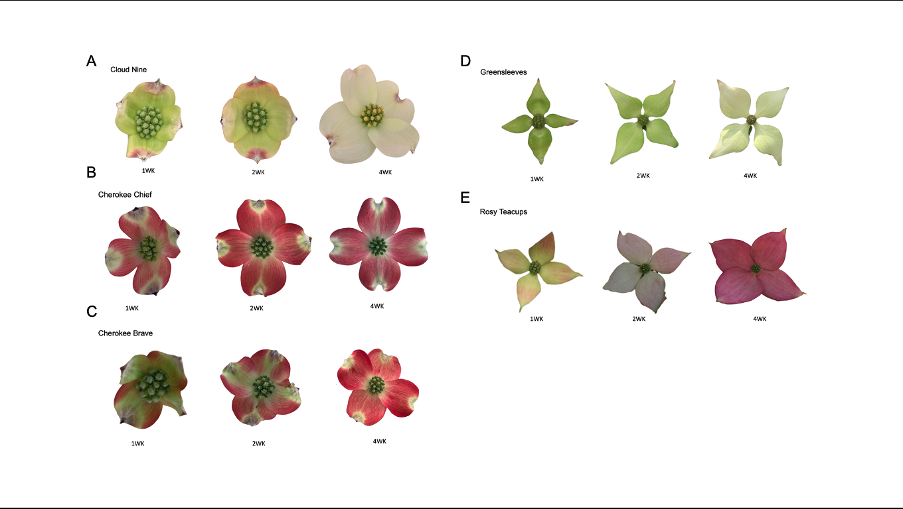

Figure 1.1. Phenotypes of Cornus florida and C. kousa bracts were used in this study after bract emergence when one (1WK), two (2WK), and four-week-old (4WK) from (A) 'Cloud Nine' (B) 'Cherokee Chief' (C) 'Cherokee Brave' (D) 'Greensleeves' (E) 'Rosy Teacups'.

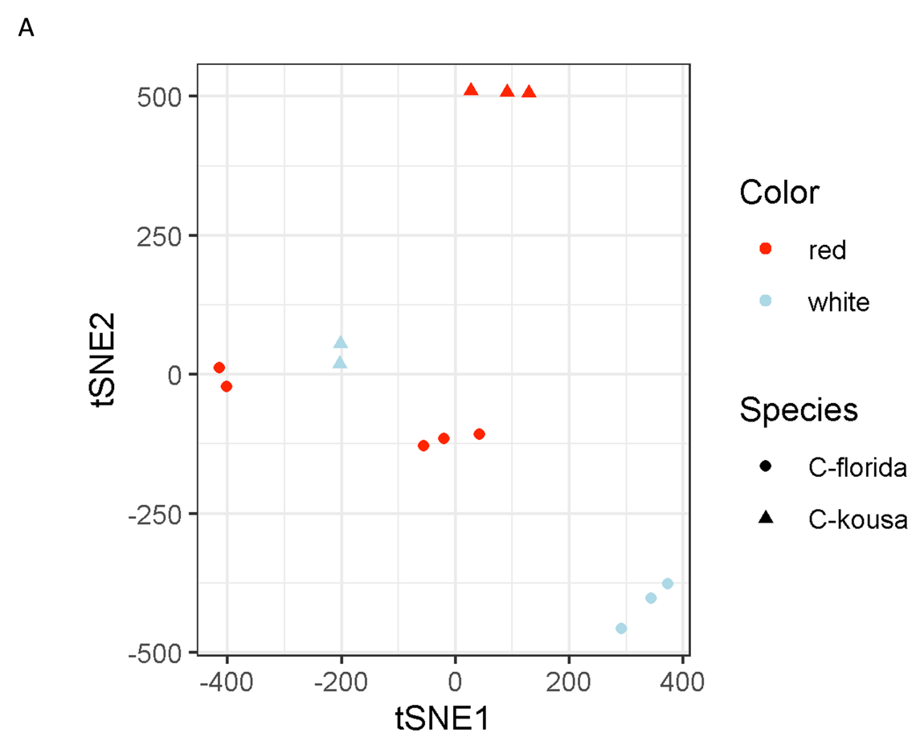
A

Figure 1.2. Sample clustering of reads from both cultivars mapped to either the transcriptomes of Cornus florida (A, B) or C. kousa (C, D). The 13 transcriptome profiles were separated into five groups of high similarity by bract color and cultivar when mapping reads to either C. florida (A) or C. kousa (C) transcriptome. The samples clustered into five groups 'Cherokee Chief' (red bracts), 'Cherokee Brave' (red bracts), 'Cloud Nine' (white bracts), 'Greensleeves' (light- to- medium green bracts), and 'Rosy Teacups' (light- to- medium pink bracts). The heatmaps of normalized count values across bract color-related differentially expressed genes across the 13 samples suggested higher similarity by species when mapping to C. florida (B) and by color on C. kousa (D).

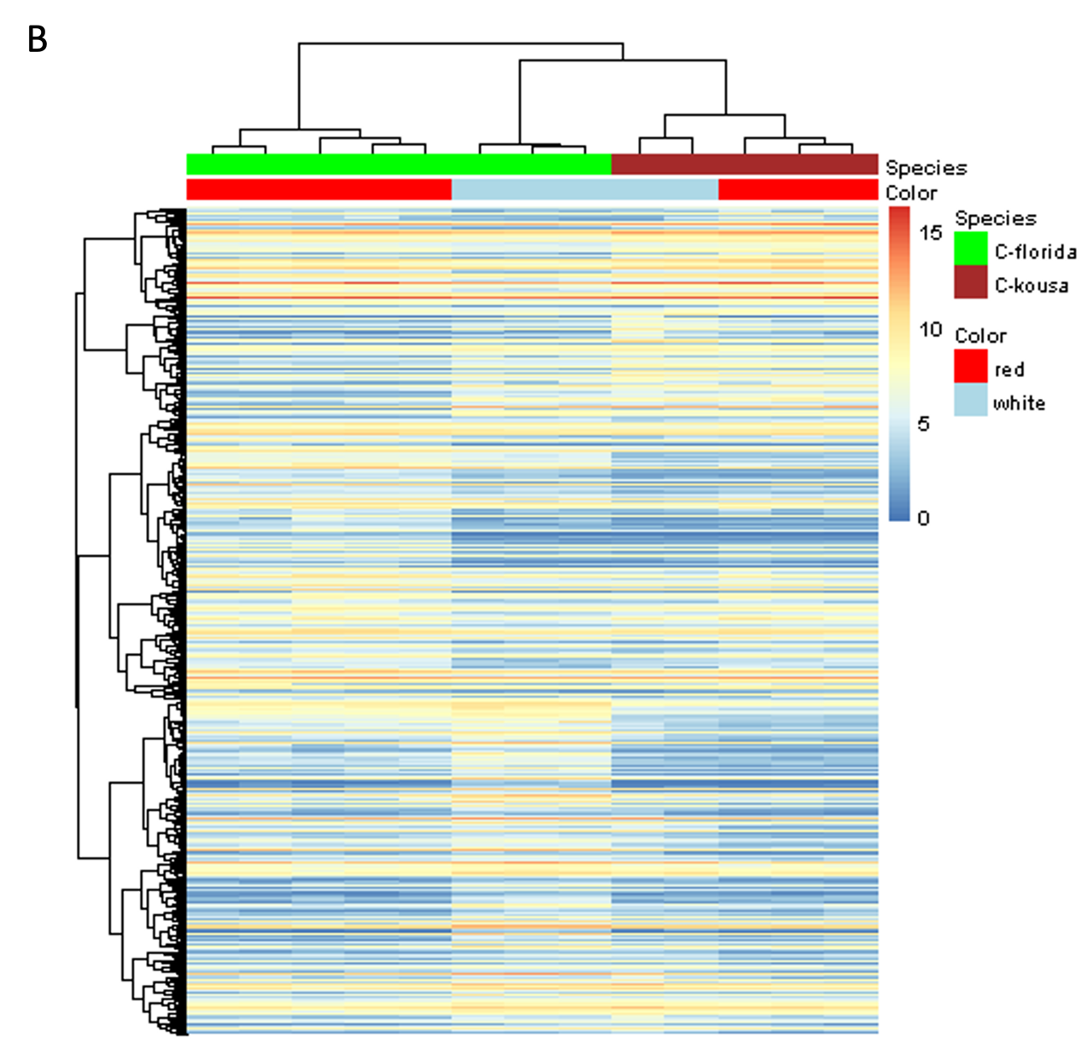
B

Figure 1.2. continued

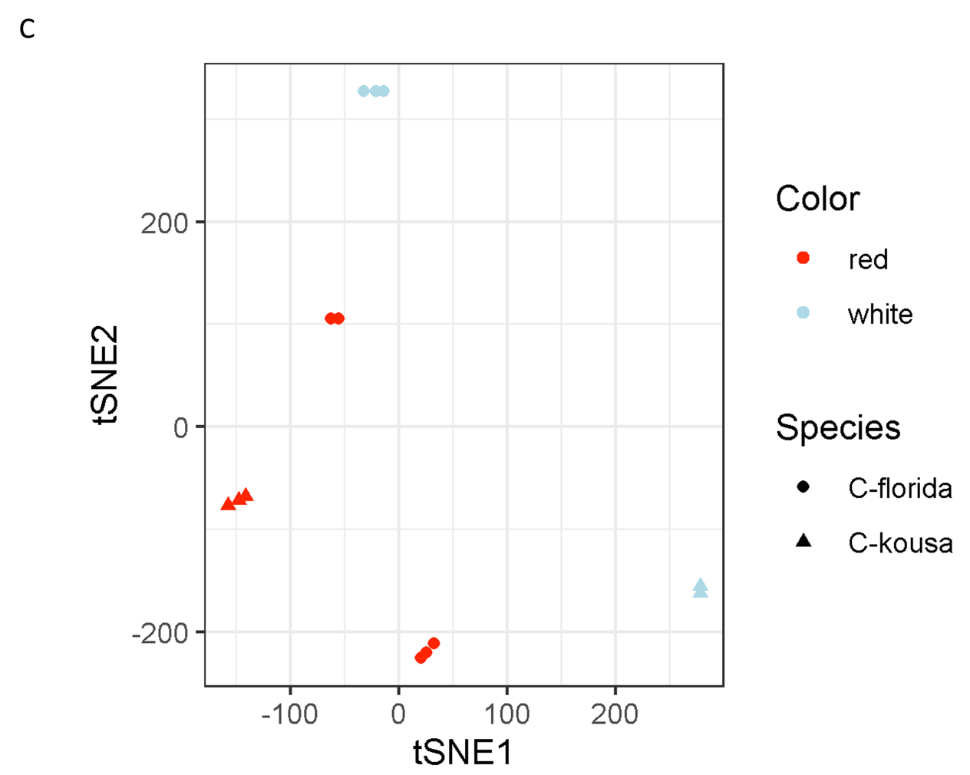
C

Figure 1.2. continued

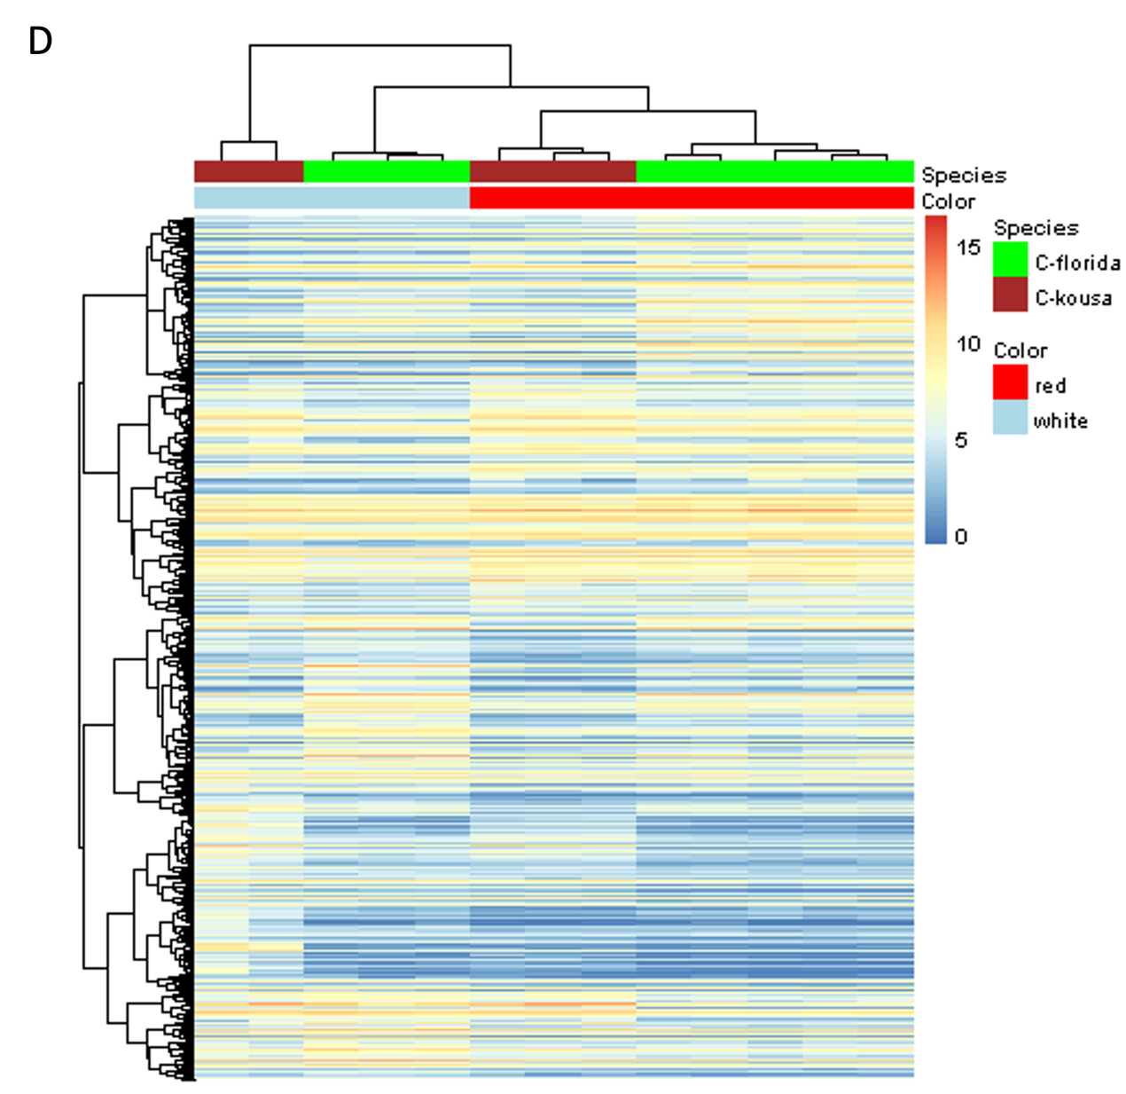
D

Figure 1.2. continued

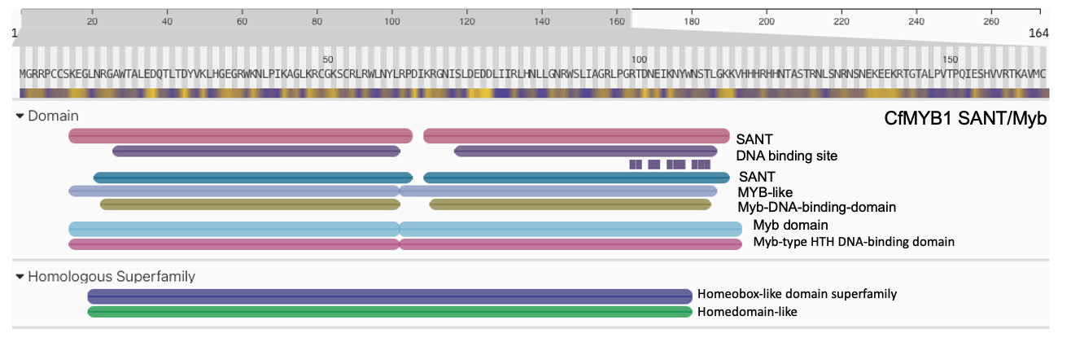
A

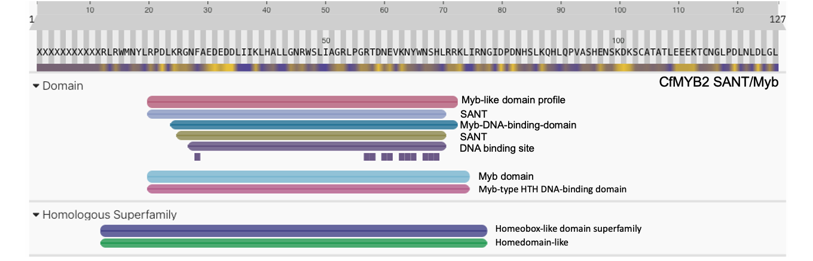
B

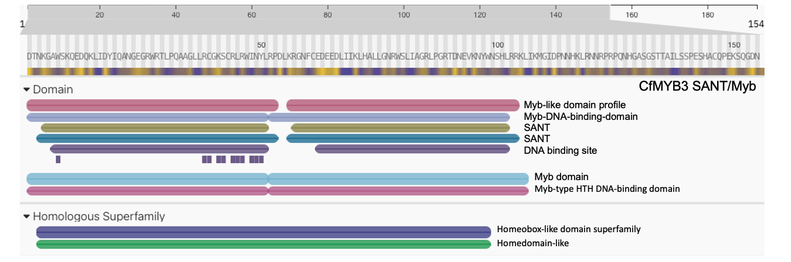
C

Figure 1.3. Classification of protein families of Cornus florida and C. kousa MYB translated protein sequences (A) CfMYB1 (B) CfMYB2 (C) CfMYB3 (D) CfMYB5 (E) CkMYB1 (F) CkMYB2.

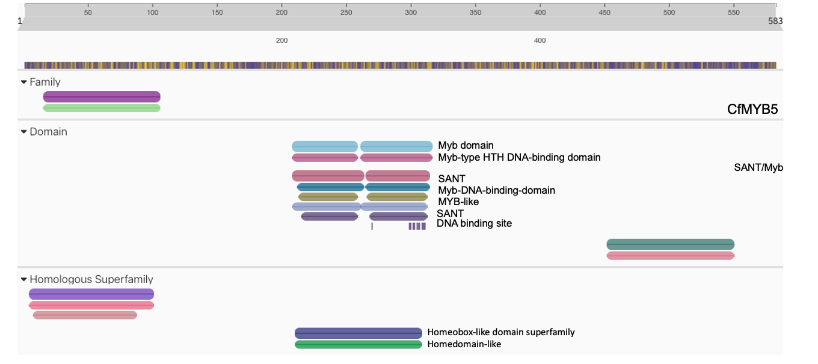
D

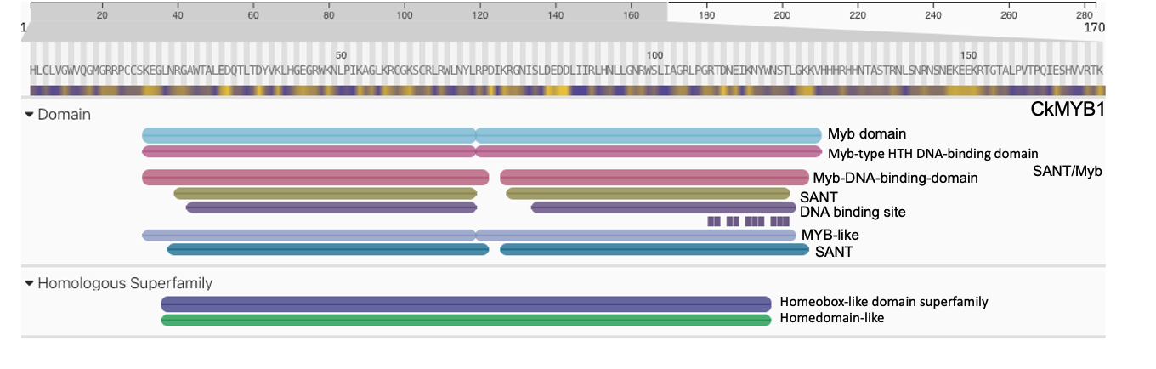
E

Figure 1.3. continued

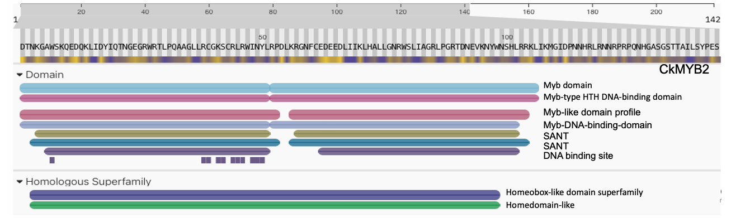
F

Figure 1.3. continued

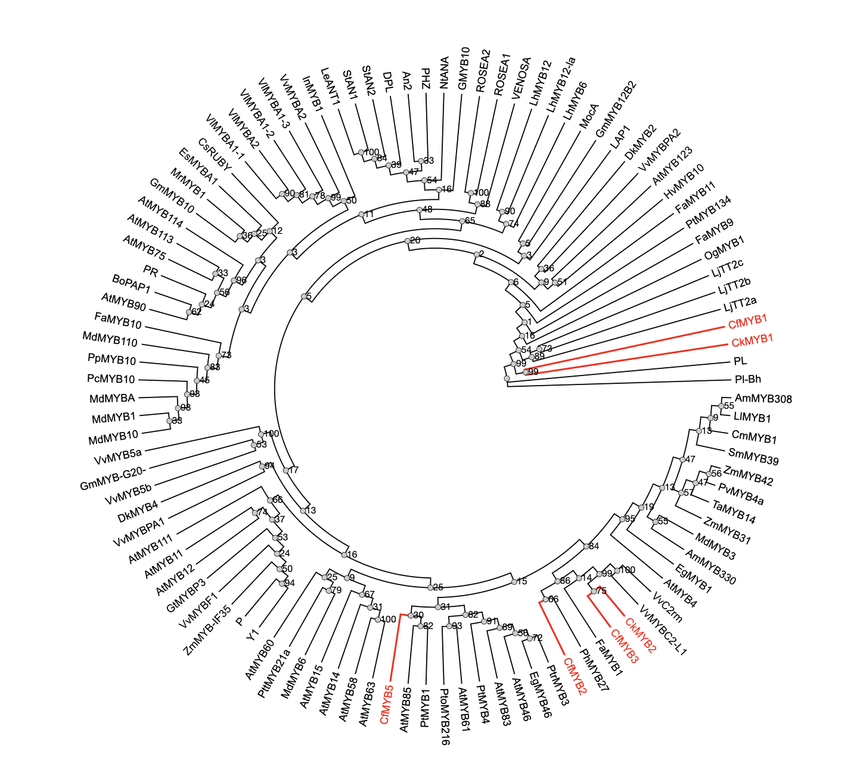

Figure 1.4. Phylogeny of Cornus florida and C. kousa MYB Transcription Factors Associated with the Phenylpropanoid Pathway. The tree was constructed using the maximum likelihood method with putative translated amino acid full-length MYB sequences with PhyML (Guindon et al., 2009). Bootstrap values are shown as a percentages (1000 replicates). Candidate R2R3-MYB protein sequences regulating anthocyanin and proanthocyanidin synthesis identified in the study are labeled in red and belong to subgroup 4 (CfMYB2, CfMYB3, and CkMYB2) and 5 (CfMYB1 and CkMYB1), respectively (Stracke et al., 2001; Dubios et al., 2010; Shelton et al., 2012).

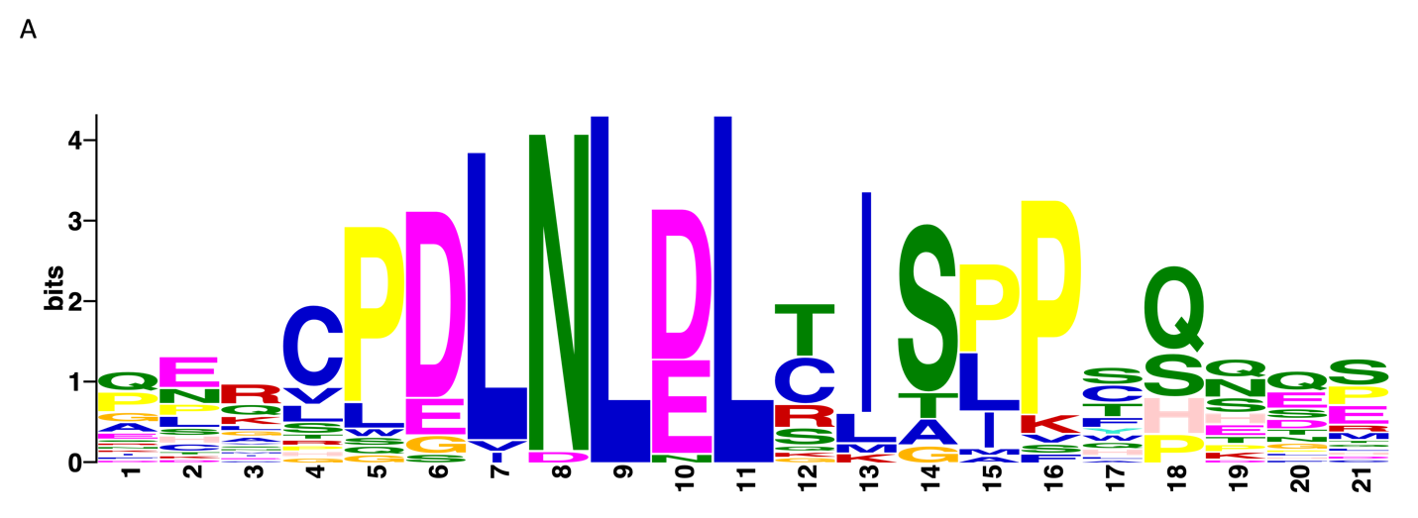
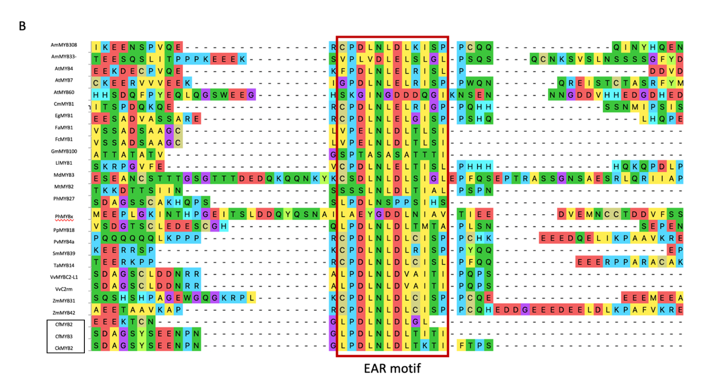

Figure 1.5. Positional enrichment of Ethylene-responsive element binding factor-associated Amphiphilic Repression (EAR) motif in R2R3-MYB transcription factors of Cornus florida and C. kousa (A) EAR motif in 26 R2R3-MYB sequences. (B) The protein sequence alignment of 26 R2R3-MYB sequences was aligned in Mega11 with the default setting integrated with Muscle program (Stecher et al., 2020; Tamura et al., 2021). Positional enrichment showed EAR motif located at the C-terminal behind MYB R repeat in CfMYB2, CfMYB3, and CkMYB2 protein sequences.

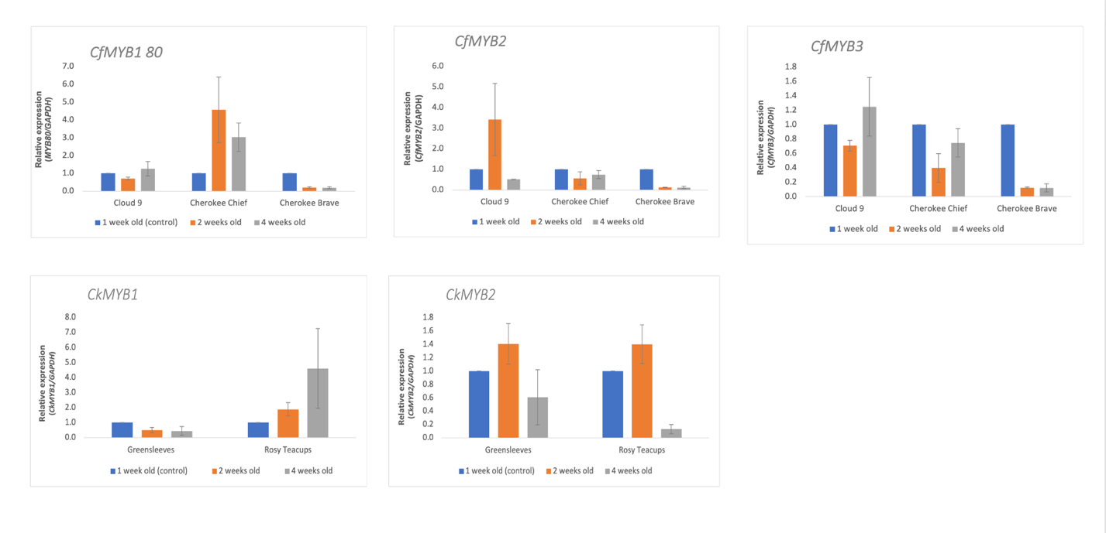

Figure 1.6. Validation of differentially expressed genes and expression levels of candidate R2R3-MYB genes designated as CfMYB1 80, CfMYB2, CfMYB3, CkMYB1 and CkMYB2 in the phenylpropanoid metabolism with RT-qPCR in Cornus florida and C. kousa.

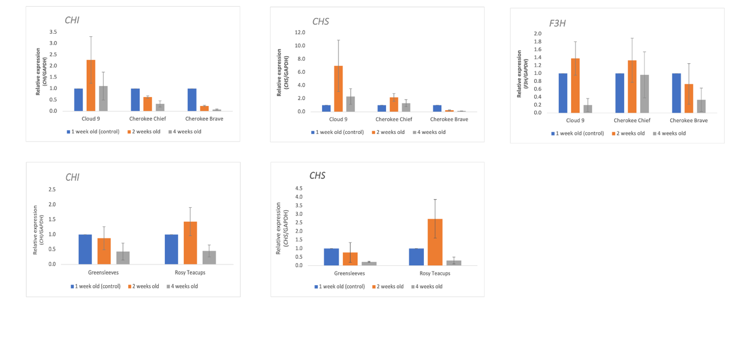

Figure 1.7. Validation of differentially expressed genes and expression levels of structural genes CHI, CHS, and F3H in Cornus florida (top) and CHI and CHS in C. kousa (bottom) with RT-qPCR.

Chapter 2. Detection of Quantitative Trait Loci associated with Erysiphe pulchra in pseudo-F2 Cornus florida population

Abstract

Flowering dogwood (Cornus florida L.) has been one the most popular understory and deciduous ornamental tree native to a wide range of eastern and southeastern United States. The ornamental value of the tree continues to drive consumer demand and, so far, has resulted in the commercial release of more than 150 cultivars. However, the flowering dogwood is generally susceptible to Erysiphe pulchra, the causal agent of dogwood powdery mildew. A practical approach to studying traits such as disease resistance is mapping quantitative trait loci (QTL). In this study, we identified two QTL, QTLPM-7 (R2 = 19%, LOD = 3.6) and QTLPM-8 (R2 = 25.19%, LOD = 4.3), using 255 small sequence repeat markers developed for pseudo-F2 population originating from crossing two C. florida F1 trees created from a cross of ‘Appalachian Spring,’ a putatively powdery mildew resistant cultivar, and ‘Cherokee Brave’ PM moderately resistant cultivar. We collected powdery mildew phenotypic data for the F2 population over six years to determine the mode of inheritance. Our results suggested that the duplicate mode of action, a form of epistasis, controls resistance to powdery mildew.

Introduction

Flowering dogwood (Cornus florida L.) is a popular understory ornamental tree grown in the eastern and southeastern US. It excels for its pink, red, and white petaloid bracts, red fall foliage display, and protein and calcium-rich drupes (Kaveriappa et al., 1997; Cappiello and Shadow, 2005; Wadl et al., 2011). However, the flowering dogwood is susceptible to the fungal disease of different etiologies, such as powdery mildew (PM) caused by Erysiphe pulchra Cooke & Peck and anthracnose caused by Discula destructiva Redlin. Although, for the first time reported in 1884 by Burrill and Earle in Illinois, dogwood PM did not become a widespread disease in the United States of America (US) before the mid-1990. However, ever since, E. pulchra has become a predominant disease of flowering dogwood in landscapes, nurseries, and forests (Daughtrey and Hagan, 2001). Consequently, the emergence of D. destructiva and E. pulchra pathogens altered the management of flowering dogwood, and control costs increased from approximately $120/h/year to $1,975/ha/year (Li et al., 2009).

Genomic and genetic resources to understand or control the damage caused by PMs are still largely lacking; this delays the development of functional markers (FM), or the application of marker-assisted selection (MAS) in cumbersome dogwood cultivar development. The construction of genetic linkage maps and the mapping of quantitative trait loci (QTL) have been used as an effective approach in cereals, vegetables, fruits, grapevine, and ornamental plants for the studies of important traits such as resistance against PM pathogens (Young, 1996; Yuling et al., 2002; Calenge et Durel, 2006; Linde et al., 2006; Buerstmayr et al., 2009; Yuste-Lisbona et al., 2011; Riaz et al., 2011; Parikh et al., 2016; Chen et al., 2021). Microsatellites or simple sequence repeats (SSRs), amplified fragment length polymorphisms (AFLPs), and restriction fragment length polymorphisms (RFLPs) have been widely used as DNA markers in plant genotyping to generate information for gene mapping and tagging, segregation analyses, QTLs, genome-wide association studies (GWAS), and other biological applications (Kalia et al., 2011; Grover and Sharma, 2014; Colasuonno et al., 2021). SSRs are non-coding repetitive DNA sequences containing a 1-6 base pair sequence motif. Although variable, SSRs sequences are characterized by flanking regions, which are conserved within the same species or often within closely related species. Conserved flanking regions, high reproducibility, co-dominance, and high diversity of SSRs sequences make them preferable markers for linkage map construction and MAS (Yang et al., 2019). Inversely, recent advances in next-generation sequencing lowered the cost of DNA sequencing, thus allowing new genotyping-by-sequencing (GBS) methods to proliferate and have opened new opportunities for developing high-throughput identification of markers associated with important agricultural traits. GBS is a simplified reduced-representation sequencing (ddRadseq) approach that includes DNA digestion followed by restriction enzymes to cost-effectively generate large numbers of single nucleotide polymorphisms (SNPs) (Deschamps et al., 2012; Kim et al., 2016; Chung et al., 2017). Advantages such as reduced sample handling, fewer PCRs, no reference genome limits, and multiplexing made the GBS method a unique tool for determining genetic variants in crop research and plant breeding programs (He et al., 2014, Kim et al., 2016, Dwivedi et al., 2017, Chung et al., 2017). SNPs are abundant throughout the genome, heritable, and have a low mutation rate. Thus, they have emerged as the most widely used genotyping markers for genetic studies (Mammadov et al., 2012, He et al., 2014, Kim et al., 2015). Different studies compared SSR over SNP performances. For example, Yang et al. (2017) found that SSR markers with moderate density are more informative for assessing genetic relatedness in maize. Moreover, a comparative analysis of SSRs and SNPs in assessing genetic variation in Juniperus phoenicea ssp. turbinate, showed SSRs to provide higher per-locus information for parentage and assignment studies (Garcia et al., 2018).

Four genetic linkage maps are established for flowering dogwoods. The first linkage map is based on 225 SSRs and was constructed using a "pseudo F₂" population of 94 individuals derived from honeybee mediated cross between C. florida ⧬ 'Appalachian Spring' (PM resistant) and ♂ 'Cherokee Brave' (PM moderately resistant). It was a fundamental tool for identifying QTLs associated with foliage color in flowering dogwood (Wadl et al., 2011) and QTLs associated with PM resistance (Parikh et al., 2017). Recently, a mapping population of 196 seedlings was developed by crossing two breeding selections, H4AR15P25 (PM resistant) x H4AR15P28 (PM susceptible), using double digest restriction-site-associated DNA sequencing, consisting of 2625 marker and 11 linkage groups (LG) (Pfarr et al., 2022). Moreover, Pfarr et al. (2022) constructed a map for selections H4AR15R25 (PM resistant) x Rutgers H4AR15P35 (PM moderately resistant), which included 1788 markers and 11 LG. The maps shared 604 markers and showed good collinearity. The maps were further used for the detection of QTLs associated with PM. H4AR15P25 x H4AR15P35 population had a major QTL (LOD= 11.36 and R²=58.9%) identified on LG 3. Consistently, a minor QTL (LOD = 3.30 and R² = 7.8%) in H4AR15R25 x H4AR15P35 population was also detected on LG 3 (Pfarr et al. 2022). Previously, Parikh et al. (2017) identified QTL on LG4 (LOD = 3.8 and R² = 9.51%), LG8 (LOD = 4.1 and R² = 10.35%), and LG9 (LOD = 5.3 and R² = 13.21%; LOD = 4.5 and R² = 13.48%).

Powdery mildew resistance is a quantitative trait in C. florida, which expression varies among individuals and depends on the cumulative actions of many genes with minor effects as well as is influenced by environmental conditions (Dugo et al., 2005; Perchepied et al., 2005; Linde et al., 2006; Aghnoum et al., 2010; Faino et al., 2012; Parikh et al., 2017). We hypothesized that flowering dogwood resistance to PM is not inherited in a simple Mendelian manner by a single gene because of continuous phenotypic variation observed in a natural population. Thus, this study aimed to uncover the mode of inheritance of PM resistance by phenotyping 141 pseudo-F2 individuals derived from 'Appalachian Spring' and 'Cherokee Brave' (Wang et al., 2009), and to detect major stable and transient QTLs conferring the trait in this population. A better understanding of the genetics of PM resistance in flowering dogwood will provide the basis for the location of candidate genes controlling this important ornamental trait and offer resources to both MAS programs, and functional genomics approaches in dogwoods.

Material and Methods

Population development and assessment of PM resistance to determine the mode of inheritance and QTL associated with PM

Pseudo-F₂ population originating from crossing two C. florida F₁ trees, breeding lines 96-6 and 96-7, derived initially from honeybee mediated cross between ⧬ ‘Appalachian Spring,’ PM putative resistant cultivar, and ♂ ‘Cherokee Brave’ PM moderately resistant cultivar (Wang et al. 2009) was assessed for PM disease severity. Although the population of 250 trees (5-year-old) was initially transferred from the Agricultural Experimental Station of the University of Tennessee, Crossville, to UT Arboretum, Oak Ridge, Tennessee, USA due to harsh environmental conditions such as frost and drought, shallow soil, deer grazing, inbreeding depression, and disease susceptibility to both PM and spot anthracnose, only 141 trees were successfully established in 2017. Therefore, the population of 141 individuals was phenotyped for PM presence over the six years, from 2017 to 2022. Among 141 trees assessed for PM, 71 trees were still viable out of 94 trees initially genotyped (Wang et al., 2009). When the phenotyping started in 2017, the trees were 15 years old. Disease scores were recorded annually on fully expanded leaves in the field after natural infection in mid-August when PM symptom manifestation was at its peak. Disease severity was visually scored using a modified scale adapted from Horsfall and Barratt (1945) and Kloos et al. (2005), where 0 represented trees with no apparent disease symptoms and no colonies of PM detected on any leaves (R), “1” represented plants displaying up to 30 % symptomatic leaf area as light sporulation present on some leaves (MR), “2” represented 30 to 60 % of colonies with moderate sporulation coalescing into large regions (MS), and “3” represented 60 to100 % of abundant sporulation merged into large areas or entire adaxial surface covered with PM of plant foliage exhibiting disease signs and symptoms (S), respectively.

Inheritance of PM Resistance

The inheritance of PM resistance in 141 flowering dogwood pseudo-F₂ trees was analyzed using the chi-square test (χ² test) in Microsoft Excel (Microsoft Office, 2021) to test the goodness-of-fit between observed and expected segregation ratios. The resistant (R) and susceptible (S) categories were defined as R = very resistant, MR= moderately resistant, MS= moderately susceptible, and S= susceptible.

Genetic map improvement and QTL analysis

Mapping population development using reciprocal honeybee-mediated crosses was detailed by Wang et al. (2009). Briefly, SSR markers were defined as follows: 72 markers (maternal marker labeled as ‘B’) dominant in ‘Cherokee Brave’ and null in ‘Appalachian Spring’ (1:1 segregation), and 41 markers (paternal marker labeled as ‘A’) dominant in ‘Appalachian Spring’ and null in ‘Cherokee Brave’ (1:1 segregation), whereas 142 co-dominant markers (labeled as ‘C’) segregated within both parents (1:2:1). Approximately 23 markers were evenly spaced on each of C. florida 11 chromosomes except for slight marker clustering on LGs 5, 7, and 11. Pairwise recombination fractions estimation, genetic map re-estimation using the hidden Markov technology, identification of markers with potentially switched alleles, and investigation of marker orders for a given chromosome while comparing all possible permutations of a sliding window of markers were applied before performing QTL mapping in R/qtl version 1.52 (Broman et al., 2003).

The composite interval mapping (CIM) method was employed for the QTL detection at a walking speed of 1 cM in R/qtl version 1.52 (Broman et al., 2003), as implemented in R version 4.2.1 (R Core Team, 2022). Pseudo-F₂ population originating from crossing two C. florida F₁ breeding lines 96-6 and 96-7 was treated as lines created by repeated selfing F_{t}. Thus, the cross-type was bcsft, whereas 0 was indicated as the number of backcrosses. Data CIM scans were performed for single QTLs using the Haley-Knott regression (HK) and multiple imputation (imp) methods allowing for up to 4 covariate markers within a 10-marker window. The mapping of statistically sound QTLs was determined by the likelihood of odds (LOD) thresholds set by 1000 permutations (α = 0.05) (Churchill and Doerge, 1994). The percent of phenotypic variance explained by each QTL was estimated by using the coefficient of determination (R²) based on Haley-Knott regression (Haley and Knott, 1992).

Results

Inheritance of PM Resistance

Starting in 2017, disease scores were visually collected when PM symptom manifestation was at its peak over six years. Infections levels were lower in 2017, 2020, and 2022 compared to 2018, 2019, and 2021 (Figure 2.2. A-F). In 2017 only 19 trees exhibited moderate PM symptoms (2), and 121 trees did not show any symptoms (0), whereas, in 2018,
only two progenies were scored with the highest disease incidence (3). Infection severity was highest in 2021, with only 22 PM-free genotypes (0) (Fig. 1), compared to 2020, with 130 PM-free trees. In 2022, we experienced significant tree loss (>10), despite lower PM disease incidence.

Dogwood PM resistance was reported to be inherited quantitatively and controlled by loci with additive gene effects (Parikh et al., 2016a; b). However, segregation for PM resistance in the pseudo-F2 population originating from reciprocal crosses between breeding lines 96-6 and 96-7 fit the two-gene model in five of six PM disease-scoring events (2017-2022). The segregation data fit a ratio of 15 resistant (R):1 susceptible (S), indicating that duplicate gene action, a form of dominant epistasis, most likely controls resistance to PM. However, data from 2021 did not provide conclusive evidence for duplicate gene action P > 0.05. Duplicate gene action occurs when the dominant allele at either of two loci can mask the expression of recessive alleles at the two loci. Segregation data and proposed gene action are summarized in Table 2.1.

QTL mapping

Among 11 LG present in C. florida genome (Wang et al., 2009; Pfarr et al., 2022) QTL with the largest effect was detected in LG 8 and 9 in two consecutive years, 2017 and 2018, respectively (Table 3.2). In 2017, QTL analysis showed one significant QTL on LG 8 associated with marker CF696C (further designated as QTLPM-7) (Figure 3.3. A), whereas the LOD threshold was 3.6, and explained 19% of phenotypic variation. The additive effect of QTLPM-7 was -61.2. Furthermore, QTL analysis of 2018 phenotypic data returned significant QTL on LG 9, with LOD score of 4.3 and 25 % of phenotypic variation explained (Figure 3.3. B). Marker CF290C corresponding to QTL on LG 9, was designated as QTLPM-8 and had an additive effect of -1.04. LOD thresholds above 3.0 were not detected in 2019, 2020, 2021, and 2022.

Discussion

Powdery mildew, a paradigm for obligate biotrophic parasites, represents a constant and ubiquitous threat for many monocotyledonous and dicotyledonous plants, including cereals and grapevine vegetables, and ornamental plants (Agrios, 2005; Glawe, 2008). In temperate climates, PM outbreaks of ornamental plants such as sweet cherry (Prunus avium L.) (Olmstead et al., 2001), gerbera daisy (Gerbera hybrida L.) (Kloos et al., 2005), rose (Rosa hybrida L.) (Linde et al., 2006), petunia (Petunia hybrida D. Don ex W. H. Baxter) (Kiss et al., 2008), and flowering dogwood (C. florida) (Li et al., 2009) result in severe economic losses. The simultaneous spread of dogwood PM in a forest, landscape, and nursery planting statewide in Alabama and Tennessee left many nursery fields abandoned, whereas a lack of formal management strategies resulted in the loss of tens of millions of dollars of dogwood (Hagan and Mullen, 1999; Li et al., 2009). Subsequently, E. pulchra emerged as a nationwide disease of flowering dogwood (Daughtrey and Hagan, 2001), and studies conducted by Wyman et al. (2019) showed that dogwood PM was an exotic pathogen recently introduced to North America.

The most economically important traits, such as resistance to PM, for which continuous phenotypic variation in natural populations is observed, are quantitatively inherited. Quantitative inheritance (cumulative, polygenic) is determined by two or more genes present on different loci, which generally have an additive or cumulative effect. Thus, being controlled by many genes and QTL genetic regions, whose gene expression is sensitive to the environment and depends on genetic background and sex (Aust and Hoyningen-Huene, 1986; Windham and Witte, 1998; Kloos et al., 2005; Windham et al., 2005; Sakata et al., 2006; Parikh et al., 2016a; 2016b). The broad sense heritability study in the F1 population derived from four parental crosses (susceptible: ‘Cherokee Princess’ and moderate or resistant: ‘Cherokee Brave, ‘R14 ‘and ‘MI9 ‘) showed that PM phenotypic variance can be attributed to genetic cause (0.9) and not to the environment (Parikh et al., 2016a). Moreover, narrow sense heritability estimates of the same F1 population indicated high narrow sense heritability for PM disease, ranging from 0.74 to 0.89 in three consecutive years attributing variance to additive gene effects (Parikh et al., 2016b). Latter, it suggested that PM phenotypic variance is due to variation in the additive genes effects, indicating the absence of epistatic gene interaction (Parikh et al., 2016a; 2016b). However, our study finds duplicate gene action, a form of dominant epistasis to control resistance to PM in the pseudo-F2 population.

Conversely, the importance of epistasis for quantitative traits has been debated since the nineteen-thirties, when fundamentals of quantitative genetics were established, and it is continued until today (Wright, 1931; Fisher, 1958; Carlborg et al., 2004; Mackay, 2014). Quantitative genetics defines epistasis as the gene interaction between genotypes at two or more loci (Cheverud and Routman, 1994; Falconer, 1996; Lynch and Walsh, 1998), but epistasis also refers to the moderation of the additive or dominant effects of the interacting loci, whereas it either enhances or suppresses a phenotype or changes the direction of the effect (Mackay, 2014). Genetic variance components such as additive, dominance, and epistatic variance depend on allele frequency. Recent years brought genetic technological advancements, which allowed for a better understanding of recombination frequency at a more refined genomic level in different species. Therefore, it has been found that recombination events do not occur randomly on the chromosome, and two patterns follow these events. The first is the presence of crossing-over interference, and the second is the existence of hotspots, representing narrow localizations of higher recombination magnitude (Hillers, 2004). Although different taxa have different mechanisms to control recombination frequency events, hotspots have been observed in plants (Choi and Henderson, 2015), fungal pathogens (Croll et al., 2015), yeasts (Gerton et al., 2000), mammals (Latrille et al., 2017) and birds (Singhal, et al., 2015). For instance, determining genetic variance is not crucial if the study aims to estimate heritability, predict phenotype among genetically correlated individuals, or estimate short-term population response to artificial or natural selection because these are mainly altered by additive variance. However, underlying gene interactions become essential if the goal is to explore gene interaction effects on genetic drift or inbreeding to quantitative traits (Mackay, 2014). Finally, comprehensive studies of model organisms demonstrated that quantitative genetic variation may be undetected and cannot be inferred from analyses of main effects, such as broad or narrow sense heritability (Gerton et al., 2000; Choi and Henderson, 2015, Croll et al., 2015, Singhai, et al., 2015; Latrille et al., 2017)

Complexity of dogwood cultivar development is impairing advanced genetic studies, linkage map construction, and genome-wide association studies due to the highly heterozygous and self-incompatibly outbreeding nature of flowering dogwoods. Furthermore, obtaining a classical dogwood F2 population is impossible and impractical (Reed, 2004). Therefore, few breeding strategies are applied in dogwood population development, such as pseudo-testcross, pseudo-F2, and even F1 population (considered as F2 due to high heterozygosity) (van der Voort et al., 1999; Verde et al., 2005; Lanteri et al., 2006; Lowe and Walker, 2006; Okogbenin et al., 2008; Wang et al., 2008; Honig et al., 2019; Wu et al., 2021). Pseudo-testcross is defined as a single full-sib population created by crossing two outbred parents in which one parent is heterozygous at one locus, and the other parent is homozygous at other loci (Grattapaglia and Sederof, 1994). This strategy is commonly used for QTL mapping; however, it employs markers only segregating in one parent (Cervera et al., 2001; Yin et al., 2004; Wu et al., 2010). The pseudo-F2 strategy was proposed by van der Voort et al. (1999) and allowed the construction of a linkage map for the yellow potato cyst nematode (Globodera rostochiensis) in combination with AFLP markers. Applying this strategy escapes the impracticality of creating F2 population in self-incompatible species or in species in which, homozygous lines are unavailable (Wang et al., 2009). In general, F1 progenies derived from a single progeny of a full-sib population are either selfed like in cassava (Manihot esculenta Crantz) (Okogbenin et al., 2008) or crossed to F1 breeding lines like in flowering dogwood (Wang et al., 2009) and switchgrass (Panicum virgatum L.) (Tornqvist et al., 2018).

Allele recombination is critical for the progress in genomic selection programs, whereas the resolution of genetic mapping and QTL analysis depends on recombination frequency. For instance, decreased recombination in a population will have a slower accumulation of advantageous mutations in evolving filial generations (Muller, 1964; Felsenstein, 1974). Parikh et al. (2016a; b) and Pfarr et al. (2022) considered their F1 population pseudo-F2 because of allele segregation from highly heterozygous parents; whereas Wang et al. (2008) created pseudo-F2 by crossing two F1 trees to, which showed genetic identity at a given locus.

Inheritance of PM resistance in several other horticultural crops including apples (Malus domestica) (Sestras et al., 2011), gerbera (Gerbera hybrida) (Kloos et al., 2005), melons (Cucumis melo L.) (Angelov and Krasteva, 2000; Tetteh et al., 2013), sweet cherry (Prunus avium) (Olmstead and Lang, 2001), was reported to be monogenic. Powdery mildew resistance in mung bean (Vigna radiata Wilczek) is controlled by two dominant genes (Reddy et al., 1994). In contrast, Tiwari et al. (1997) described two single recessive genes to control PM resistance in Canadian pea (Pisum sativum L.) cultivars. Plant disease resistance is classified into two categories, qualitative and quantitative resistance. Qualitative resistance is controlled by a single resistance gene (R), including receptor genes. On the contrary, broad-spectrum resistance (BSR) and durable resistance (DR) is conferred by multiple genes or quantitative trait loci (QTL), and both are advantageous for crop improvement through breeding. BSR is defined as resistance against two or more pathogen species (including sometimes even the majority of races), whereas DR persists during prolonged times shaped by different environmental conditions (Johnson, 1981; Randall et al., 2005; Kou and Wang, 2010).

Multiple QTL associated with PM in C. florida have been identified in two published studies so far and had a variant effect on PM resistance (Parikh et al., 2017; Pfarr et al., 2022). Parikh et al. (2017) detected four QTL in three linkage groups (4, 8, and 9) with either minor or intermediate/major effects. QTL explaining less than 10% of phenotypic variance is considered minor, whereas QTL explaining more 10% phenotypic variance is considered major (Kou and Wang, 2010). Major QTLPM-3 (R2 = 12.48%, LOD = 4.5) and QTLPM-4 (R2 = 13.21%, LOD = 5.3) were either the same or co-linked due to their proximity (LOD peaks were 7 cM apart) (Parikh et al., 2017). Thus, QTL detected in their study explained only a small proportion of the total phenotypic variance, and additional genetic loci were identified in a study conducted by Pfarr et al. (2022). However, the two QTL detected on LG 3, QTLPM-5 (R2 =7.8%, LOD = 3.3) and QTLPM-6 (R2 =58.9%, LOD = 11.36), respectively, also might be at the same locus or co-linked due their similar locations. Interestingly, two QTL found in this study, QTLPM-7 (R2 = 19%, LOD = 3.6) and QTLPM-8 (R2 = 25.19%, LOD = 4.3), coincided with QTL on linkage group 8 and 9 previously published by Parikh et al. (2017). Negative additive effects of both QTL implied that heterozygotes (markers designated with the letter “C”) in the pseudo-F2 population had higher ratings than homozygotes (Wang et al., 2009), and similar results were found by Pfarr et al. (2022). Interestingly, although phenotypic data on PM resistance was collected over the six years (2017-2022), no significant QTL were detected in the following years: 2019, 2020, 2021, and 2022, which may be due to varying disease pressure followed by different environmental conditions such as the amount of rainfall and frost intensity. Latter, confirmed difficulties of working with the obligate parasitic nature of PM pathogens. Likewise, Pfarr et al. (2022) did not detect significant QTL in 2020 due to low disease pressure, whereas Parikh et al. (2017) had only one year of data collection. QTL detection is affected by numerous factors, such as population size, absence of genotypic replication due to difficulty in C. florida propagation, and the quantitative nature of PM disease resistance. For instance, Parikh et al. (2017) found only 41% of 105 tested SSR markers previously developed by Wang et al. (2009) to be polymorphic in their F1 populations containing 147 individuals. On the contrary, Pfarr et al. (2022) constructed the first two high-density C. florida linkage maps using double digest restriction-site associated DNA sequencing-derived (ddRadseq) single nucleotide polymorphisms (SNP), which yielded 2265 markers. However, the F1 H4AR15P25 x H4AR15P35 population had only 84 individuals compared to 196 of the F1 H4AR15P25 x H4AR15P28, whereas a major QTLPM-6 was found in H4AR15P25 x H4AR15P35 population. This study was the only one to employ a pseudo-F2 map population for QTL detection. However, due to harsh environmental conditions, shallow soil, deer grazing, and disease susceptibility to both PM and spot anthracnose, only 71 trees out of 94 genotyped were included in the study, which could have impacted the ability to detect additional QTL. Hence, to complement obtained results, we conducted additional studies, which included ddRadseq, and PM phenotyping of 140 individuals (data unshown). Still, we did not obtain the map that we anticipated, which could have been due to the following factors: the sample’s age, ddRadseq library preparation protocol, and sequence quality (data not shown).

New emerging genotyping technologies such as Target SNP-seq combine multiplex PCR amplification and high throughput sequencing is leading to increased accuracy in SNP genome genotyping with high polymorphism and conserved flanking sequences (Zhang et al., 2020). Target SSR-seq is another advanced methodology involving X Ten platform to capture genome-wide SSRs with stable motifs and flanking regions (Yang et al., 2019). Implementing these and other methods, such as Ion Torrent (Zhang et al., 2017; Onda et al., 2018) and AmpSeq (Yang et al., 2016), lead the way to overcome some of the difficulties related to marker data generation indicated above.

To date, applied dogwood breeding relied on repetitive selection to improve quantitative traits of horticultural importance (Windham and Witte, 1998; Windham et al., 2003; Wadl et al., 2013; Molnar et al., 2017). Although, during the last decade, efforts were made to incorporate MAS into challenging dogwood breeding (Wang et al., 2008; Wang et al., 2009; Wadl et al., 2011; Wadl et al., 2014; Parkih et al., 2017; Yu et al., 2017; Pfarr et al., 2022). MAS employs a DNA marker strategy to detect the presence of new allelic combinations in the genes controlling traits of interest, such as BSR, DR, and tolerance to abiotic stress (Ribaut and Hoisington, 1988; Collard and Mackill, 2008; Xu and Crouch, 2008). Using DNA markers to detect QTL controlling important traits brought one of the most significant advances in the characterization of quantitative traits. However, confirming and validating QTL positions is crucial besides solely identifying QTL. QTL validation involves the application of markers within a 10 cM window spanning and flanking a QTL (Collard and Mackill, 2008; Yang et al., 2019; Zhang et al., 2020). Therefore, the next step towards applying MAS in dogwood breeding based on identified QTL (QTLPM-7 and QTLPM-8) associated with PM requires more studies with various breeding populations over several years to further verify identified QTL.

Appendix: Tables and Figure

Table 2.1. Segregation data and proposed gene action for powdery mildew resistance in pseudo-F2 Cornus florida population over five years.

Dates | Total number (no.) of trees | Powdery mildew resistance |  |  |  | $$χ2$$  (1:1) | P  value | Proposed gene action
Dates | Total number (no.) of trees | No. resistant | No. moderately resistant | No. moderately susceptible | No.  susceptible | $$χ2$$  (1:1) | P  value | Proposed gene action
2017 | 141 | 122 | 0 | 19 | 0 | 9.4 | 0.05 | Duplicate gene action (15:1)
 |  |  |  |  |  | 13.4 | 0.01-0.05 | Dominant epistasis (12:3:1)
2018 | 141 | 126 | 6 | 7 | 2 | 5.62 | 0.05 | Duplicate gene action (15:1)
2019 | 141 | 87 | 34 | 17 | 3 | 4.09 | 0.05 | Duplicate gene action (15:1)
 |  |  |  |  |  | 4.1 | 0.05 | Dominant suppression epistasis (13:3)
2020 | 141 | 131 | 9 | 1 | 0 | 9.4 | 0.01- 0.05 | Duplicate gene action (15:1)
2022 | 133 | 93 | 30 | 9 | 1 | 6.86 | 0.01-0.05 | Duplicate gene action (15:1)

Table 2.2. QTL statistics for two QTL detected in two consecutive years in Cornus florida, pseudo-F2 population mapping populations segregating for powdery mildew resistance.

QTL | Year | LG | Position (cM) | LOD | R² | Marker | Additive Effect
QTLPM-7 | 2017 | 8 | 43.6 | 3.6 | 19% | CF696C | -61.2
QTLPM-8 | 2018 | 9 | 49.7 | 4.3 | 25% | CF290C | -1.04

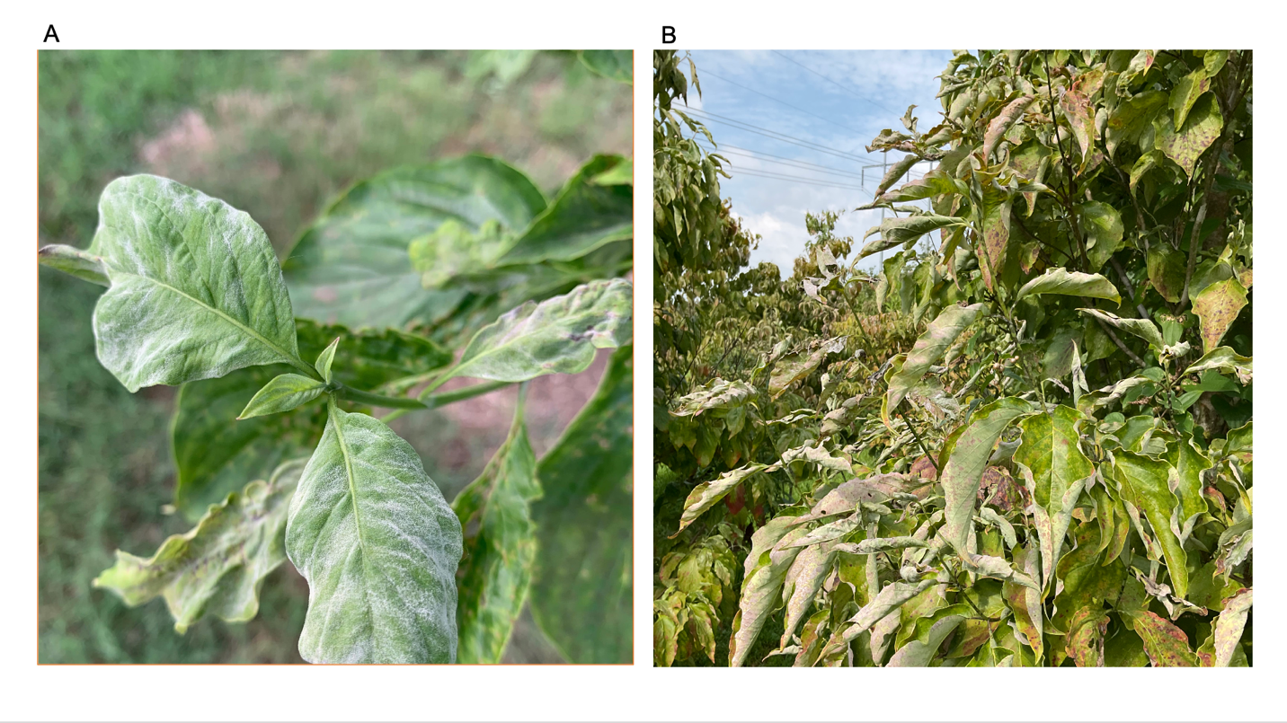

Figure 2.1. Symptoms of powdery mildew on Cornus florida pseudo-F2 individual tree originating from reciprocal crosses between breeding lines 96-6 and 96-7 (A) Merged white patches of mycelia and conidia on the adaxial leaf surface (B) Curled young and mature leaves in late summer.

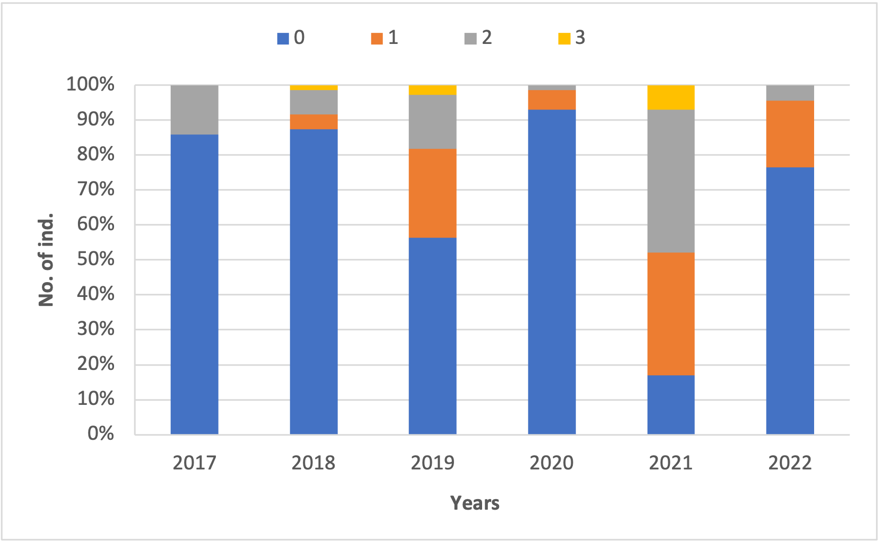

Figure 2.2. Charts for powdery mildew (PM) incidence over six years (2017-2022) in the Cornus florida pseudo-F2 population. 0 represented trees with no apparent disease symptoms and no colonies of PM detected on any leaves, 1 designated plants displaying up to 30 % symptomatic leaf area as light sporulation present on some leaves, 2 represented 30 to 60 % of colonies with moderate sporulation coalescing into large regions, and 3 represented 60 to100 % of abundant sporulation merged into large areas.

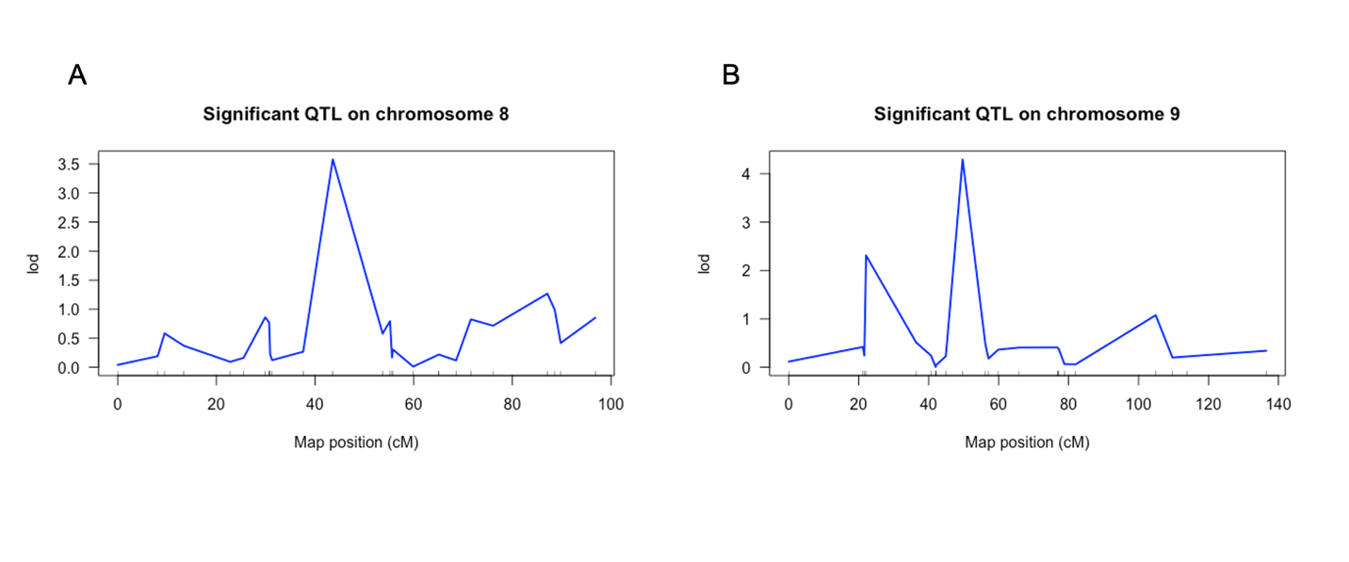

Figure 2.3. Cornus florida QTL with the largest effect were detected in LG 8 and 9 in two consecutive years, 2017 and 2018 (A) QTL on LG 8 associated with marker CF696C and further designated as QTLPM-7 (B) QTL on LG 9 associated with marker CF290C and further designated as QTLPM-8.

Chapter 3. Are Mlo Genes a Vital Source of Powdery Mildew Resistance in Flowering Dogwood (Cornus florida)?

Abstract

Powdery mildews (PMs) are highly specialized plant pathogens of many monocotyledonous and dicotyledonous plants including important crops such as cereals, grapevines, vegetables, and ornamental plants. Erysiphe pulchra Cooke & Peck is a prevalent powdery mildew pathogen of the most popular and economically important dogwood species, Cornus florida. Symptoms on flowering dogwood manifest as circular or irregular white patches consisting of mycelia and conidia on the adaxial leaf surface. Recessively inherited loss-of-function mutation in the gene Mildew resistance locus o (Mlo), initially discovered in barley, confers broad-spectrum powdery mildew resistance. Therefore, the early stages of PM infection are associated with increased transcript abundance of Mlo susceptibility genes, showing a peak six hours after inoculation. Thus, the youngest and fully developed green leaves of disease-free C. florida cultivars Appalachian Blush (resistant), Cherokee Chief (resistance unknown), Cherokee Brave (moderate resistance), and Cloud 9 (very susceptible) were inoculated, and were collected 2-, 6-, 12- and 24-hours post-inoculation. Subsequently, RNA was extracted and prepared for RNA sequencing (RNA-Seq) according to quality requirements. Further downstream analysis for the RNA-Seq experiment for this study was impeded because of erroneous protein genome annotation containing stop codon sequences in the middle of protein sequences. Therefore, data will be reanalyzed upon the availability of a new reference genome for C. florida. Data analysis will include the following RNA-Seq pipeline framework: STAR for read alignment, HTSeq for the gene-specific count, DESeq2 for normalization, visualization, and differential analysis of count data, and Gene Ontology enrichment analysis to identify the functions and biological pathways involved in the differentially expressed genes.

Introduction

Powdery mildew (PM) is a common disease of many monocotyledonous and dicotyledonous plants. Important crops, including cereals, grapevine, vegetables, and ornamental plants, are harmed by this disease (Agrios, 2005). These highly specialized plant pathogens are obligate biotrophic Ascomycetes in the order Erysiphales, which include eighteen genera and approximately 900 described species (Braun and Cook, 2012; Takamatsu,2013; Marmolejo et al., 2018).

Erysiphe pulchra Cooke & Peck is an obligate biotrophic ascomycete, and although its life cycle consists of asexual and sexual stages, the asexual stage is crucial for successful disease development (Martinez-Cruz et al., 2014). Disease presence is easily identified by the formation of typical fungal structures such as circular or irregular white patches of mycelia and conidia on the adaxial leaf surface. The asexual stage comprises the following three developmental phases: (i) conidia germination and primary appressorium formation followed by cuticle and cell wall penetration, (ii) primary haustoria formation and cell accommodation, and (iii) conidia and conidiophores differentiation (Romero et al., 2008; Weβling et al., 2012). Conidia of E. pulchra (28.1 × 14.1μm) are single-celled, non-motile, ovoid to hyaline, and borne on conidiophores singly or in pseudochains (Li et al., 2005). However, only the initial phases of tissue colonization of E. pulchra were investigated in dogwoods. Conidia formed one to four primary tubes by 2 h after inoculation of the host plant, and primary appressorium developed only from one or two of the primary germ tubes. A penetration peg, established under the appressorium, breaks through plant cuticle and cell wall to form haustorium, a specialized feeding structure (Li et al., 2005).

Plants employ two cell defense mechanisms to impede pathogen attacks through both pathogen-induced and constitutive components. Pathogen-associated molecular patterns (PAMP), conserved molecular microbe features, are recognized by cell pattern recognition receptors (PRRs) and result in the activation of plant defense immunity, so-called PRR-triggered immunity (PTI) (Jones and Dangl, 2006). PAMPs trigger mitogen-activate of protein kinases (MAPKS), callose deposition, reactive oxygen species (ROS), and hydrogen peroxide generation (Jones and Dangl, 2006). ROS have direct microbial activity and restrict the pathogen invasion by moderating host cells' redox balance, thereby affecting cell signaling and regulatory functions. The recognition of pathogen effectors by plant resistance proteins, belonging to the polymorphic family of intracellular nucleotide-binding/leucine-rich-repeat (NB-NLR) receptors (Cui et al., 2015) activates the second mechanism of defense, the Effector-Triggered Immunity (ETI). ETI robustness is stronger compared with PTI, and it is correlated with a hypersensitive response (HR), a form of programmed cell death (PCD) (Cui et al., 2015). Plant response to PM pathogen penetration is followed by papilla formation, which is formed directly beneath the attempted fungal penetration site. These papillae are primarily composed of callose agglomerates (a β-1,3- glucan polymer) and other plant-derived components, such as cellulose, hemicellulose, pectin, hydroxyproline rich glycoproteins, hyperglycosylated arabinogalactan-proteins, and lignin (highly complex phenolic polymer) (Zeyen et al., 2002; Celio et al., 2004). However, infection and tissue colonization processes, such as fungal haustorial complex, have not yet been explored in flowering dogwoods. Moreover, PM pathogens penetrate the host cell wall either through enzymatic or mechanical power or both mechanisms to invaginate plant cell membranes and accommodate fungal infection structures (Green et al., 2002). In contrast, these mechanisms have not been elucidated in E. pulchra penetration of dogwood leaves.

The best management strategy to tackle PM infections is the use of resistant cultivars (Windham et al., 2003; Li et al., 2009; Riaz et al., 2011), but dogwood cultivar development is dependent upon repeated selection for desirable traits, such as disease resistance, bract or foliage color, weeping habitat. Discovery of barley plant mutants displaying complete resistance to Blumeria gramins f.sp. hordei (Bgh) opened new opportunities to confer broad-spectrum resistance to PM pathogens eight decades ago (Freisleben and Lein, 1942). Further studies reported that recessively inherited loss-of-function mutation in the gene Mildew resistance locus o (Mlo) conferred resistance to barley plant mutants to essentially all Bgh isolates (Jorgensen, 1992; Büschges et al., 1997). The Mlo gene family codes for a plant-specific type of integral membrane protein harboring a C-terminal cytoplasmic calmodulin-binding domain conferring calcium-dependent calmodulin (Hückelhoven and Panstruga, 2011) with a consensus topology of seven transmembranes domains (Acevedo-Garcia et al., 2014). In planta, Fluorescence Resonance Energy Transfer experiments revealed that calmodulin binding to barley MLO increased ephemerally and locally at pathogen penetration sites between 14 and 24 h post-inoculation (Bhat et al., 2005), enhancing callose deposition, hydrogen peroxide bursts, and mesophyll cell death (Skou, 1984; Piffaneli et al., 2002).

Forward genetic approaches and candidate gene testing, mainly applied in barley and Arabidopsis, allowed a better understanding of molecular components required for PM Mlo-resistance (Acevedo-Garcia et al., 2014; Collins et al., 2003). For instance, barley Ror2 and Arabidopsis PEN1 encode a t-SNARE (Soluble N-ethylmalemide-sensitive factor Attachment protein REceptor) protein member, which was suggested to form a SNARE protein complex, active in the secretion of antimicrobial compounds at fungal penetration sites (Collins et al., 2003; Meyer et al., 2009; Kwaaitaal et al., 2010).

Other two PENETRATION genes, PEN2 and PEN3, encode atypical myrosinase and ATP-binding cassette multidrug transporter, respectively (Lipka et al., 2005; Stein et al., 2006). PEN2 and PEN3 were found to cofunction in the same pathway, whereas it was
proposed that antimicrobial compounds such as indole glucosinolate, synthesized by PEN2 and transported by PEN3, kill the fungus at attempted penetration sites (Bednarek et al., 2009; Acevedo-Garcia et al., 2014). In contrast, the ectopic transient gene expression in single barley leaf epidermal cells indicated that calcium-dependent calmodulin binding to the calmodulin-binding domain residing in the carboxy-terminal region of the Mlo protein enhanced the susceptibility-moderating activity of the Mlo protein (Panstruga, 2004). Other biological functions attributed to Mlos are thigmomorphogenesis, fertilization, and the recognition of the mycorrhizal fungus Rhizophagus irregularis (Ruiz-Lozano et al., 1999; Jacott et al., 2020) and the endophytic fungus Serendipita indica (Hilbert et al., 2019).

Mlo and its homologs have been studied in all major land plant lineages, and the most important agricultural and horticultural crops are apples (Malus domestica Borkh.) (Pessina et al., 2014), barley (Hordeum vulgare L.) (Jorgensen, 1992), grapevine (Vitis vinifera L.) (Feechan et al., 2008), pea (Pisum sativum L.) (Pavan et al., 2011), pepper (Capsicum annum L.) (Zheng et al., 2013), petunia (Petunia hybrida D. Don ex W. H. Baxter) (Jiang et al., 2016), poplar (Populus trichocarpa Torr. & Gray) (Filiz and Vatansever, 2018), rose (Rosa hybrida L.) (Kaufmann et al., 2012), strawberries (Fragaria x ananassa Duchesne) (Jiwan et al., 2013), sweet orange (Citrus sinensis L.) (Liu et al., 2017), tomato (Solanum lycopersicum L.) (Bai et al., 2008), wheat (Triticum aestivum L.) (Wang et al., 2014) and others. Moreover, transcript abundance of Mlo susceptibility genes in apple (Pessina et al. 2014), barley (Piffanelli et al., 2002; Piffanelli et al., 2004), grape (Feechan et al., 2008), pepper (Winterhagen et al., 2008), and tomato (Bai et al., 2008) is associated with early stages of PM infection with a peak about six hours post-inoculation.

Until recently, phylogenetic analyses of MLO medium-sized plant-specific gene family have been restricted to some eudicots and monocots. Moreover, Kusch et al. (2016) defined seven MLO phylogenetic clades, encompassing nearly all major land plant lineages except ferns, whose genomes have not been published (Sessa et al., 2014). Clade I was the most ancient embryophyte MLO clade (Jiwan et al., 2013), whereas its role might be focused on root thigmomorphogenesis and other not elucidated functions in moss and non-seeded plants (Kusch et al., 2016). Furthermore, clades II and IV evolved next in plant evolution with a hypothesized role in seed evolution (Kusch et al., 2016). Clades III, V, and VI are thought to have evolved early in the angiosperm lineage and have been associated with flowering plants. However, Kusch et al. (2016) did not detect any monocot MLO protein belonging to clades V and VI, suggesting secondary loss of these clades in monocots (although grasses (Poaceae) were the only monocot representatives). Additionally, the function of clade IV MLOs appears to coincide with that of clade V MLOs. Hence, barley Mlo (HvMlo) and wheat (Tamlo1A, Tamlo1B, and Tamlo1D) mutant plants belonging to clade IV and Arabidopsis (AtMLO2) mutant plants from clade V share similar phenotypes. HvMlo, Tamlo1A, Tamlo1B, Tamlo1D, and AtMLO2 all display broad-spectrum PM resistance.

Mlo-based resistance is a durable defense mechanism against PM infections in monocotyledonous and dicotyledonous plants and widely employed by plant breeders (Kusch and Panstruga, 2017). Furthermore, identifying Mlo genes and developing DNA markers in flowering dogwood will facilitate cultivar selection for PM resistance, reducing the number of lines that need to be tested. Therefore, the main goal of this study was to identify and monitor Mlo and other candidate genes controlling early disease response to PM in flowering dogwood following E. pulchra inoculation in four cultivars, 'Appalachian Spring,' 'Cherokee Brave,' 'Cherokee Chief,' and 'Cloud 9' using RNA sequencing.

Material and Methods

Plant Materials

The youngest and fully green leaves infected with powdery mildew were collected 2, 6, 12, and 24 hours from four C. florida, 'Appalachian Spring' (resistant to PM), 'Cherokee Brave' (moderately resistant), 'Cherokee Chief' (moderately susceptible) and 'Cloud 9' (susceptible). Leaves with adaxial surface up were inoculated by pressing leaf disks infected by sporulating PM onto the surface of the healthy leaf. All infected leaves were covered with plastic bags without touching the leaf surface. Before inoculation, disease-free trees were transferred to an isolated greenhouse during the experiment, spaced out, and were not moved until symptom manifestation. Symptomatic PM leaves that were used for inoculation were collected from trees, which were shaken to remove old conidia from colonies two days before using symptomatic leaves as a source of inoculum. The inoculum of E. pulchra was maintained in a greenhouse at the University of Tennessee, Knoxville. All trees were grown at the University of Tennessee Knoxville, USA greenhouses, and were 7-8 years old and disease-free at the onset of the study.

RNA Extraction and Sequencing

RNA was extracted from 500 mg of frozen leaf tissue per sample, 2% cetyltrimethyl ammonium bromide (CTAB) solution, precipitated in 2 M LiCl following the instructions found in Zeing and Yang (2002). Leaf samples were homogenized using zirconia beads at 6 m/s, 30 sec in a Bead mill 24 (Fisher Scientific). Subsequently, total RNA integrity was assessed with Agilent 2100 Bioanalyzer system using the RNA 6000 Nano LabChip® kit (Agilent Technologies, Palo Alto, CA, USA). The 48 RNA samples from four flowering dogwood genotypes were submitted to Novogene (Sacramento, CA, USA) for library preparation and sequencing by an Illumina NovaSeq PE150, generating 150 bp paired-end reads. All genotypes had three biological replicates.

Quality Control

RNA-seq yielded approximately 20–37 million reads per library, which were subjected to error correction using Rcorrector (RNA-Seq error CORRECTOR) (Song and Florea, 2015). Read quality control was performed using FastQC v0.11.4 (Andrews, 2010). Adaptors, short (<30 bases), and low-quality reads were trimmed by skewer version v0.2.2 (Jiang et al. 2014). Subsequently, read quality control was reassessed using FastQC v0.11.4 (Andrews, 2010).

Read Alignment and Gene Quantification

The annotated reference genome publication for flowering dogwood is not available; however, Bewick et al. (2020) made available C. florida genome, GFF, and other feature files, including gene, mRNA, and CDS sequences. Trimmed reads were mapped to C. florida fasta file using the read alignment tool STAR (Dobin et al., 2013). Aligned reads were used to generate a gene-specific count matrix across samples using a standalone script provided by HTSeq (Anders et al., 2015), which counts for the aligned reads mapped to the exons.

Differential Expression Analysis and Functional Enrichment

To identify Mlos, R genes and the nucleotide-binding site (NBS) and leucine-rich repeat (LRR) (NBS-LRR) genes involved in PM resistance, gene counts were analyzed for gene-level differential expression using DESeq2 (Love et al., 2014). This package provides an option to test differential expression by shrinking estimators of the negative binomial distribution. Count results from HTSeq were imported, specifying an experimental design that modeled the cultivar disease resistance/susceptibility as the effect of treatment while adjusting for cultivar and time point differences. The principal component analysis (PCA) used the first and second largest sample distances as the first PC and second PC. The Wald test was employed to identify differentially expressed genes (DEGs) between two sample classes, susceptible and resistant. Significantly DEGs were identified with fold change > 2 and adjusted p-value < 0.05 (log2FC 0) after multiple testing using the Benjamini-Hochberg method. Due to poor annotation of available genome and GFF files (Bewick et al., 2020), it was not possible to annotate DEGs. The software package Gene Filtering, Analysis, and Conversion (gFACs) v1.1.1 (Caballero and Wegrzyn, 2019), was used for annotation refining to improve the quality of final models and obtain nucleotide and amino acid fasta files. Subsequently, Eukaryotic Non-Model Transcriptome Annotation Pipeline (EnTAP) v0.10.8-Beta (Hart et al., 2018) was employed to strengthen functional gene annotation accuracy for de novo assembled transcriptomes in non-model eukaryote C. florida. lead

Reverse Transcription Quantitative PCR (RT-qPCR)

RNA from 48 samples used or RNA-Seq will be subjected to real-time qPCR analysis using QuantStudio™ 6 Flex (Applied Biosystems, Waltham, MA, USA). Primers consistently up-or downregulated candidate Mlos and R genes containing the nucleotide-binding site (NBS) and leucine-rich repeat (LRR) (NBS-LRR) genes involved in PM resistance will be designed based on C. florida. Primers will be designed using Primer-BLAST NCBI Genbank with amplification lengths between 70 and 200 bp. Samples will be subjected to PerfeCTa SYBR Green Fast Mix (Quantabio, Beverly, MA, USA). A total reaction volume of 20 μl will contain 1μl of previously diluted cDNA (1:10), 2 μl of gene-specific primers (1 μM each), and 12 μl of SYBR Green Fast Mix. Expression levels of mRNAs of interest will be normalized for the Glyceraldehyde 3-phosphate dehydrogenase (GAPDH) RNA levels. All samples will be run in three technical replicates, and no-template controls will be included in all plates.

Results and Discussion

Plant Materials and their resistance to PM

Flowering dogwood's resistance levels to PM have been mainly evaluated in nurseries or greenhouses and were dependent on the season, climate, and stage of plant development (Hagan et al., 1998; Windham and Witte, 1998; Johnson et al., 2001; Mmbaga et al., 2004; Windham et al., 2005; Li et al. 2007). Histological studies of dogwood PM resistance showed initial unsuccessful fungal penetration and haustorium formation, thus, reducing pathogen infection potential and hindering conidia asexual reproduction (Li et al., 2007). 'Appalachian Spring' is a white-bracted cultivar considered highly resistant to dogwood anthracnose. Although it was found to be susceptible to dogwood PM (Hagan et al., 2011), this cultivar did not exhibit PM symptoms in the greenhouse under strong disease pressure; thus, we considered it resistant. 'Cherokee Brave' is the red-bracted cultivar with higher resistance to PM than other red-blooming C. florida cultivars. However, its resistance in the field is variable and varies from year to year on single trees (Windham et al., 1997; Windham et al., 2003; Windham et al., 2005). 'Cherokee Brave' trees occasionally manifested PM symptoms in the greenhouse. 'Cherokee Chief' is one of the most popular red-bracted dogwood cultivars and is moderately susceptible to PM (Hagan et al., 1998; Mmbaga et al., 2004). Similarly to 'Cherokee Brave' trees, 'Cherokee Chief' trees occasionally displayed PM symptoms in the greenhouse. 'Cloud Nine,' known for its profusion of overlapping white bracts is highly susceptible to PM (Mmbaga et al., 2004; Windham et al., 2005), and all individual trees in the greenhouse exhibited PM symptoms.

RNA-Seq data analysis

The Dogwood Genome Project was initiated in April 2015 (Leebens-Mack, 2021). However, to date, an accurately annotated genome has not been made publicly available (Bewick et al., 2020), thus, limiting genetic and genomic resources for flowering dogwood to the transcriptome (Yan et al., 2017). RNA is the key intermediate between the genome and the proteome, and the RNA-Seq approach became an integral approach to studying the identity and abundance of RNA. RNA-Seq is positioned as a widely used detection technique mainly for transcript quantification, although other uses emerged over time, such as targeted sequencing, single-cell analysis, and detection of isoforms and gene fusion (Hrdlickova et al., 2017; Srivastava et al., 2020). Simultaneously, accurate transcript quantification depends on a few computational aspects including the choice of alignment against transcriptome or genome and mapping methods. Reference genome availability sometimes significantly impacts results compared to read alignment to the transcriptome and allows for discovering new, unannotated transcripts. Recently, Srivastava et al. (2020) studied the accuracy of transcript quantification and the impact of mapping and found that performing spliced alignment to the genome and subsequently to the transcriptome produces divergent results than direct alignment against the transcriptome.

Additional downstream analysis for the RNA-Seq experiment for this study was impeded due to erroneous protein annotation containing stop codon sequences in the middle of protein sequences (Bewick et al., 2020). Therefore, a research group from the University of Tennessee Knoxville initiated a new dogwood sequencing project, encompassing the sequencing of two flowering dogwood cultivars, 'Appalachian Spring' and 'Cherokee Brave,' respectively, using PacBio long-read sequencing technology. Hence, the following analysis segments will be repeated: read alignment and gene quantification, differential expression analysis, and functional enrichment once the genome annotation becomes available. The RNA-Seq pipeline will include bioinformatic tools, such as STAR, for accurate alignment of high-throughput RNA-seq to the genome (Dobin et al., 2013), HTSeq (Anders et al., 2015) to generate a gene-specific count matrix across samples using a standalone script provided, counting reads only mapped to the exons, and DESeq2 for normalization, visualization, and differential analysis of count data (Love et al., 2014), Gene Ontology enrichment analysis to identify the functions and biological pathways involved in the DEGs, Weighted Gene Correlation Network Analysis (WGCNA) used to identify modules of highly correlated genes based on the DESeq2 normalized gene expression (Zhang and Horvath, 2005; Langfelder and Horvath, 2008).

Validation of RNAseq by RT-qPCR

To validate the expression of Mlos and R genes, candidate DEGs will be selected for RT-qPCR. R genes confer resistance to bacterial, fungal, and viral plant pathogens, nematodes, and aphids (Meyers et al., 1999; Ellis et al., 2000). They are characterized by the nucleotide-binding site (NBS) and leucine-rich repeat (LRR) (NBS-LRR) domains. For instance, Pm and Mla NBS-LRR encoding genes conferring resistance to PM were identified in barley (Halterman et al., 2001) and Run and Ren in grapevine (Goyal et al., 2020). Similarly, NBS-LRR genes are functionally involved in the defense response to fungi binding ADP, ATP, and adenylate cyclase activity (Marone et al., 2013). Solanum bulbocastanum Dunal, NBS-LRR RGA2, confers broad resistance to blight caused by Phytophthora infestans (Mont.) de Bary (Song et al., 2003), while RLM1A confers resistance to Leptosphaeria maculans (Sowerby) P. Karst causing black leg in rapeseed (Persson et al., 2009). Finally, further analysis will depend on DEGs obtained by this study.

Conclusion

kfjflfj

f

Flowering (Cornus florida L.) and Asian dogwood (C. kousa F. Buerger ex Hance F) are two of the most attractive and economically compelling species among nursery growers and horticulturists. Their popularity resulted in the commercial release of more than 150 cultivars (Cappiello and Shadow, 2005; Wadl et al., 2014; Nowicki et al., 2020). Dark red bract or foliage display, resistance to pathogens, variegated foliage, and dwarf or weeping habit are among the most popular traits; however, most currently available cultivars do not possess a combination of desirable characteristics (Cappiello and Shadow, 2005; Wadl et al., 2014; Nowicki et al., 2020). Therefore, phytopathologists and plant breeders dedicate themselves to developing new cultivars to satisfy market demands and novel horticultural trends, which rely on repetitive laborious selection (Windham and Witte, 1998; Windham et al., 2003; Wadl et al., 2013; Molnar et al., 2017). However, dogwood cultivar development is a time-demanding undertaking mainly due to the following reasons: long juvenile period (3 to 5 years), self-incompatibility, inbreeding depression, and high susceptibility of flowering dogwood to powdery mildew (PM) and anthracnose (Gunatilleke and Gunatilleke, 1984; Ament et al., 2000; Reed, 2004; Wang et al., 2009; Hadziabdic et al., 2010; Hagan et al., 2011; Wadl et al., 2011; Mantooth et al., 2017). Applying genetics and genomics approaches can significantly facilitate and accelerate dogwood complex breeding; for instance, marker-assisted selection (MAS) uses a DNA marker strategy to target traits of interest. However, MAS application associated with bract color selection and PM resistance has been delayed because of the unavailability of resources and studies on molecular mechanisms underlying these processes in dogwoods.

Hence, our RNA-Seq study on R2R3-MYB transcription factors (TF) controlling flavonoid pigment biosynthesis provides the first insights into genes orchestrating one of the best-studied biological processes in nature in C. florida and C. kousa. Candidate genes, CfMYB1 80 and CkMYB1, were found to be most likely involved in proanthocyanidin synthesis in flowering and Asian dogwood, respectively. Conversely, candidate genes CfMYB2, CfMYB3, and CkMYB2 repress anthocyanin and proanthocyanidin synthesis in flowering and Asian dogwood, respectively. Our results provided an essential foundation for further analysis of R2R3-MYB TF that may be responsible for anthocyanin and proanthocyanidins suppression or synthesis in mature bracts of C. florida and C. kousa.

Erysiphe pulchra Cooke & Peck is a prevalent pathogen of flowering dogwood, which has challenged commercial production and caused devastating damage to single trees and entire populations since its introduction in the mid-1990 (Windham et al., 1997; Daughtrey and Hagan, 2001; Windham et al., 2003). The use of resistant cultivars (Li et al., 2009; Riaz et al., 2011) is the best disease management strategy, but molecular mechanisms involved in PM dogwood penetration and fungal cell accommodation have not been elucidated yet. Recessively inherited loss-of-function mutation in the gene Mildew resistance locus o (Mlo) granted resistance to the most important agricultural and horticultural crops in I was not able to do this with a new tree. PhyML has a few features. I will try to do it for the paper publication using Adobe software. all major land plant lineages (Kusch et al., 2016). Still, their role has, for the first time, been investigated in our RNA-Seq time-sensitive study, which aimed to identify and monitor Mlo and other candidate genes controlling early disease response to PM in flowering dogwood. Mlo-based resistance is a durable defense mechanism against PM infection, and completion of this study upon C. florida genome availability will allow DNA marker development and, subsequently, MAS or functional marker application in selection for PM-resistant dogwood cultivars.

Lastly, we confirmed that PM is not inherited in a simple Mendelian manner by a single gene but by duplicate gene action, a form of dominant epistasis in the pseudo-F2 population developed by Wang et al., 2009. Moreover, we confirmed the presence of two quantitative trait loci (QTL) on chromosomes 8 and 9, designated as QTLPM-7 and QTLPM-8, which explained 19% and 25% of phenotypic variance. This study was the only one to employ a pseudo-F2 map population for QTL detection. Further QTL confirmation and validation will enable the application of the MAS strategy to select PM-resistant breeding lines more efficiently.

References

Agrios, G. N. (2005). Plant pathology. Elsevier. Chicago.
Aghnoum, R., Marcel, T. C., Johrde, A., Pecchioni, N., Schweizer, P., & Niks, R. E. (2010). Basal host resistance of barley to powdery mildew: connecting quantitative trait loci and candidate genes. Molecular plant-microbe interactions, 23(1), 91-102.
Aharoni, A., De Vos, C. H. R., Wein, M., Sun, Z., Greco, R., Kroon, A., Mol, J. N. M., & O’Connell, A. P. (2001). The strawberry FaMYB1 transcription factor suppresses anthocyanin and flavonol accumulation in transgenic tobacco: Strawberry Myb represses flavonoid biosynthesis. The Plant Journal, 28(3), 319–332. https://doi.org/10.1046/j.1365-313X.2001.01154.x
Ahmad, N., Gupta, S., & Mukhtar, H. (2000). Green tea polyphenol epigallocatechin-3-gallate differentially modulates nuclear factor κB in cancer cells versus normal cells. Archives of biochemistry and biophysics, 376(2), 338-346.
Akagi, T., Ikegami, A., Tsujimoto, T., Kobayashi, S., Sato, A., Kono, A., & Yonemori, K. (2009). DkMyb4 Is a Myb Transcription Factor Involved in Proanthocyanidin Biosynthesis in Persimmon Fruit. Plant Physiology, 151(4), 2028–2045. https://doi.org/10.1104/pp.109.146985
Allard, R. W. (1999). Principles of plant breeding. John Wiley & Sons.
Albert, N. W. (2015). Subspecialization of R2R3-MYB repressors for anthocyanin and proanthocyanidin regulation in forage legumes. Frontiers in Plant Science, 6, 1165.
Albert, N. W., Davies, K. M., Lewis, D. H., Zhang, H., Montefiori, M., Brendolise, C., Boase, M. R., Ngo, H., Jameson, P. E., & Schwinn, K. E. (2014). A Conserved Network of Transcriptional Activators and Repressors Regulates Anthocyanin Pigmentation in Eudicots. The Plant Cell, 26(3), 962–980. https://doi.org/10.1105/tpc.113.122069
Albert, N. W., Lewis, D. H., Zhang, H., Irving, L. J., Jameson, P. E., & Davies, K. M. (2009). Light-induced vegetative anthocyanin pigmentation in Petunia. Journal of Experimental Botany, 60(7), 2191–2202. https://doi.org/10.1093/jxb/erp097
Albert, N. W., Lewis, D. H., Zhang, H., Schwinn, K. E., Jameson, P. E., & Davies, K. M. (2011). Members of an R2R3-MYB transcription factor family in Petunia are developmentally and environmentally regulated to control complex floral and vegetative pigmentation patterning: Anthocyanin pigmentation patterning in petunia. The Plant Journal, 65(5), 771–784. https://doi.org/10.1111/j.1365-313X.2010.04465.x
Allan, A. C., Hellens, R. P., & Laing, W. A. (2008). MYB transcription factors that colour our fruit. Trends in Plant Science, 13(3), 99–102. https://doi.org/10.1016/j.tplants.2007.11.012
Altschul, S. F., Madden, T. L., Schäffer, A. A., Zhang, J., Zhang, Z., Miller, W., & Lipman, D. J. (1997). Gapped BLAST and PSI-BLAST: a new generation of protein database search programs. Nucleic acids research, 25(17), 3389-3402.
Ament, M., Windham, M.T., & Trigiano, R.N. (2000). Determination of Parentage of Flowering Dogwood (Cornus Florida) Seedlings Using DNA Amplification Fingerprinting. Arboriculture & Urban Forestry, 26(4), 206–212. https://doi.org/10.48044/jauf.2000.024
Anders, S., Pyl, P. T., & Huber, W. (2015). HTSeq—A Python framework to work with high-throughput sequencing data. Bioinformatics, 31(2), 166–169. https://doi.org/10.1093/bioinformatics/btu638
Andrew, S. (2010). FastQC: A quality control tool for high throughput sequence data. 2010.[Google Scholar
Angelov, D., & Krasteva, L. (2000). Dominant inheritance of downy mildew resistance in melons. In VII Eucarpia Meeting on Cucurbit Genetics and Breeding 510 (pp. 273-276).
Anwar, M., Wang, G., Wu, J., Waheed, S., Allan, A., & Zeng, L. (2018). Ectopic Overexpression of a Novel R2R3-MYB, NtMYB2 from Chinese Narcissus Represses Anthocyanin Biosynthesis in Tobacco. Molecules, 23(4), 781. https://doi.org/10.3390/molecules23040781
Apel, K., & Hirt, H. (2004). REACTIVE OXYGEN SPECIES: Metabolism, Oxidative Stress, and Signal Transduction. Annual Review of Plant Biology, 55(1), 373–399. https://doi.org/10.1146/annurev.arplant.55.031903.141701
Appiano, M., Catalano, D., Santillán Martínez, M., Lotti, C., Zheng, Z., Visser, R. G. F., Ricciardi, L., Bai, Y., & Pavan, S. (2015). Monocot and dicot MLO powdery mildew susceptibility factors are functionally conserved in spite of the evolution of class-specific molecular features. BMC Plant Biology, 15(1), 257. https://doi.org/10.1186/s12870-015-0639-6
Aust, H., & Hoyningen-Huene, J. V. (1986). Microclimate about epidemics of powdery mildew. Annual Review of Phytopathology, 24(1), 491-510.
Baek, S., Choi, K., Kim, G.-B., Yu, H.-J., Cho, A., Jang, H., Kim, C., Kim, H.-J., Chang, K. S., Kim, J.-H., & Mun, J.-H. (2018). Draft genome sequence of wild Prunus yedoensis reveals massive inter-specific hybridization between sympatric flowering cherries. Genome Biology, 19(1), 127. https://doi.org/10.1186/s13059-018-1497-y
Bai, Y., Pavan, S., Zheng, Z., Zappel, N. F., Reinstädler, A., Lotti, C., De Giovanni, C., Ricciardi, L., Lindhout, P., Visser, R., Theres, K., & Panstruga, R. (2008). Naturally Occurring Broad-Spectrum Powdery Mildew Resistance in a Central American Tomato Accession Is Caused by Loss of Mlo Function. Molecular Plant-Microbe Interactions, 21(1), 30–39. https://doi.org/10.1094/MPMI-21-1-0030
Bathke, J., Konzer, A., Remes, B., McIntosh, M., & Klug, G. (2019). Comparative analyses of the variation of the transcriptome and proteome of Rhodobacter sphaeroides throughout growth. BMC Genomics, 20(1), 358. https://doi.org/10.1186/s12864-019-5749-3
Bhakta, H. K., Park, C. H., Yokozawa, T., Tanaka, T., Jung, H. A., & Choi, J. S. (2017). Potential anti-cholinesterase and β-site amyloid precursor protein cleaving enzyme 1 inhibitory activities of cornuside and gallotannins from Cornus officinalis fruits. Archives of Pharmacal Research, 40(7), 836–853. https://doi.org/10.1007/s12272-017-0924-z
Bhat, R. A., Miklis, M., Schmelzer, E., Schulze-Lefert, P., & Panstruga, R. (2005). Recruitment and interaction dynamics of plant penetration resistance components in a plasma membrane microdomain. Proceedings of the National Academy of Sciences, 102(8), 3135–3140. https://doi.org/10.1073/pnas.0500012102
Braun, U., Cook, R. T. A (2012). Taxonomic manual of Erysiphales (powdery mildews). CBS Biodiversity series, 11.
Broman, K. W., Wu, H., Sen, Ś., & Churchill, G. A. (2003). R/qtl: QTL mapping in experimental crosses. bioinformatics, 19(7), 889-890.
Buerstmayr, H., Ban, T., & Anderson, J. A. (2009). QTL mapping and marker-assisted selection for Fusarium head blight resistance in wheat: A review. Plant Breeding, 128(1), 1–26. https://doi.org/10.1111/j.1439-0523.2008.01550.x
Burrill, T. J., & Earle, F. S. (1884). Parasitic Fungi of Illinois: Part II. Erysipheae. Illinois Natural History Survey Bulletin, 2(1-8), 387-432.
Büschges, R., Hollricher, K., Panstruga, R., Simons, G., Wolter, M., Frijters, A., van Daelen, R., van der Lee, T., Diergaarde, P., Groenendijk, J., Töpsch, S., Vos, P., Salamini, F., & Schulze-Lefert, P. (1997). The Barley Mlo Gene: A Novel Control Element of Plant Pathogen Resistance. Cell, 88(5), 695–705. https://doi.org/10.1016/S0092-8674(00)81912-1
Caballero, M., & Wegrzyn, J. (2019). gFACs: gene filtering, analysis, and conversion to unify genome annotations across alignment and gene prediction frameworks. Genomics, proteomics & bioinformatics, 17(3), 305-310.
Calenge, F., & Durel, C.-E. (2006). Both stable and unstable QTLs for resistance to powdery mildew are detected in apple after four years of field assessments. Molecular Breeding, 17(4), 329–339. https://doi.org/10.1007/s11032-006-9004-7
Cao, Y., Li, K., Li, Y., Zhao, X., & Wang, L. (2020). MYB Transcription Factors as Regulators of Secondary Metabolism in Plants. Biology, 9(3), 61. https://doi.org/10.3390/biology9030061
Cappiello, P., & Shadow, D. (2005). Dogwoods: The Genus Cornus. Timber Press.
Carey, C. C., Strahle, J. T., Selinger, D. A., & Chandler, V. L. (2004). Mutations in the pale aleurone color1 Regulatory Gene of the Zea mays Anthocyanin Pathway Have Distinct Phenotypes Relative to the Functionally Similar TRANSPARENT TESTA GLABRA1 Gene in Arabidopsis thaliana [W]. The Plant Cell, 16(2), 450–464. https://doi.org/10.1105/tpc.018796
Carlborg, Ö., & Haley, C. S. (2004). Epistasis: too often neglected in complex trait studies? Nature Reviews Genetics, 5(8), 618-625.
Cavallini, E., Matus, J. T., Finezzo, L., Zenoni, S., Loyola, R., Guzzo, F., Schlechter, R., Ageorges, A., Arce-Johnson, P., & Tornielli, G. B. (2015). The Phenylpropanoid Pathway Is Controlled at Different Branches by a Set of R2R3-MYB C2 Repressors in Grapevine. Plant Physiology, 167(4), 1448–1470. https://doi.org/10.1104/pp.114.256172
Celio, G. J., Mims, C. W., & Richardson, E. A. (2004). Ultrastructure and immunocytochemistry of the host–pathogen interface in poinsettia leaves infected with powdery mildew. 82, 11.
Cervera, M. T., Storme, V., Ivens, B., Gusmao, J., Liu, B. H., Hostyn, V., ... & Boerjan, W. (2001). Dense genetic linkage maps of three Populus species (Populus deltoides, P. nigra and P. trichocarpa) based on AFLP and microsatellite markers. Genetics, 158(2), 787-809.
Chagné, D., Lin-Wang, K., Espley, R. V., Volz, R. K., How, N. M., Rouse, S., Brendolise, C., Carlisle, C. M., Kumar, S., De Silva, N., Micheletti, D., McGhie, T., Crowhurst, R. N., Storey, R. D., Velasco, R., Hellens, R. P., Gardiner, S. E., & Allan, A. C. (2012). An Ancient Duplication of Apple MYB Transcription Factors Is Responsible for Novel Red Fruit-Flesh Phenotypes. Plant Physiology, 161(1), 225–239. https://doi.org/10.1104/pp.112.206771
Chen, C., Zhang, K., Khurshid, M., Li, J., He, M., Georgiev, M. I., Zhang, X., & Zhou, M. (2019). MYB Transcription Repressors Regulate Plant Secondary Metabolism. Critical Reviews in Plant Sciences, 38(3), 159–170. https://doi.org/10.1080/07352689.2019.1632542
Chen, K., Zhou, Y., Li, K., Qi, L., Zhang, Q., Wang, M., & Xiao, J. (2016). A novel three-round multiplex PCR for SNP genotyping with next generation sequencing. Analytical and Bioanalytical Chemistry, 408(16), 4371–4377. https://doi.org/10.1007/s00216-016-9536-6
Chen, L., Hu, B., Qin, Y., Hu, G., & Zhao, J. (2019). Advance of the negative regulation of anthocyanin biosynthesis by MYB transcription factors. Plant Physiology and Biochemistry, 136, 178–187. https://doi.org/10.1016/j.plaphy.2019.01.024
Cheverud, J. M., & Routman, E. J. (1995). Epistasis and its contribution to genetic variance components. Genetics, 139(3), 1455–1461. https://doi.org/10.1093/genetics/139.3.1455
Chiou, C.-Y., & Yeh, K.-W. (2008). Differential expression of MYB gene (OgMYB1) determines color patterning in floral tissue of Oncidium Gower Ramsey. Plant Molecular Biology, 66(4), 379–388. https://doi.org/10.1007/s11103-007-9275-3
Chung, Y. S., Choi, S. C., Jun, T. H., & Kim, C. (2017). Genotyping-by-sequencing: a promising tool for plant genetics research and breeding. Horticulture, Environment, and Biotechnology, 58(5), 425-431.
Churchill, G. A., & Doerge, R. (1994). Empirical threshold values for quantitative trait mapping. Genetics, 138(3), 963-971.
Choi, K., & Henderson, I. R. (2015). Meiotic recombination hotspots—A comparative view. The Plant Journal, 83(1), 52–61. https://doi.org/10.1111/tpj.12870
Colasuonno, P., Marcotuli, I., Gadaleta, A., & Soriano, J. M. (2021). From Genetic Maps to QTL Cloning: An Overview for Durum Wheat. Plants, 10(2), 315. https://doi.org/10.3390/plants10020315
Collins, N. C., Thordal-Christensen, H., Lipka, V., Bau, S., Kombrink, E., Qiu, J. L., ... & Schulze-Lefert, P. (2003). SNARE-protein-mediated disease resistance at the plant cell wall. Nature, 425(6961), 973-977.
Collard, B. C. Y., & Mackill, D. J. (2008). Marker-assisted selection: An approach for precision plant breeding in the twenty-first century. Philosophical Transactions of the Royal Society B: Biological Sciences, 363(1491), 557–572. https://doi.org/10.1098/rstb.2007.2170
Cominelli, E., Gusmaroli, G., Allegra, D., Galbiati, M., Wade, H. K., Jenkins, G. I., & Tonelli, C. (2008). Expression analysis of anthocyanin regulatory genes in response to different light qualities in Arabidopsis thaliana. Journal of Plant Physiology, 165(8), 886–894. https://doi.org/10.1016/j.jplph.2007.06.010
Cone, K. C. (1993). Role of the Regulatory Gene pl in the Photocontrol of Maize Anthocyanin Pigmentation. 10.
Consonni, C., Humphry, M. E., Hartmann, H. A., Livaja, M., Durner, J., Westphal, L., Vogel, J., Lipka, V., Kemmerling, B., Schulze-Lefert, P., Somerville, S. C., & Panstruga, R. (2006). Conserved requirement for a plant host cell protein in powdery mildew pathogenesis. Nature Genetics, 38(6), 716–720. https://doi.org/10.1038/ng1806
Croll, D., Lendenmann, M. H., Stewart, E., & McDonald, B. A. (2015). The Impact of Recombination Hotspots on Genome Evolution of a Fungal Plant Pathogen. Genetics, 201(3), 1213–1228. https://doi.org/10.1534/genetics.115.180968
Cui, H., Tsuda, K., & Parker, J. E. (2015). Effector-Triggered Immunity: From Pathogen Perception to Robust Defense. Annual Review of Plant Biology, 66(1), 487–511 https://doi.org/10.1146/annurev-arplant-050213-040012
Czemmel, S., Heppel, S. C., & Bogs, J. (2012). R2R3 MYB transcription factors: key regulators of the flavonoid biosynthetic pathway in grapevine. Protoplasma, 249(2), 109-118
Da Silva, C., Zamperin, G., Ferrarini, A., Minio, A., Dal Molin, A., Venturini, L., Buson, G., Tononi, P., Avanzato, C., Zago, E., Boido, E., Dellacassa, E., Gaggero, C., Pezzotti, M., Carrau, F., & Delledonne, M. (2013). The High Polyphenol Content of Grapevine Cultivar Tannat Berries Is Conferred Primarily by Genes That Are Not Shared with the Reference Genome. The Plant Cell, 25(12), 4777–4788. https://doi.org/10.1105/tpc.113.118810
Daughtrey, M.L.; Hagan, A.K. (2001). In Diseases of woody ornamentals and trees in nurseries. American Phytopathological Society (APS Press).
Deschamps, S., Llaca, V., & May, G. D. (2012). Genotyping-by-Sequencing in Plants. Biology, 1(3), 460–483. https://doi.org/10.3390/biology1030460
Ding, B., Patterson, E. L., Holalu, S. V., Li, J., Johnson, G. A., Stanley, L. E., Greenlee, A. B., Peng, F., Bradshaw, H. D., Blinov, M. L., Blackman, B. K., & Yuan, Y.-W. (2020). Two MYB Proteins in a Self-Organizing Activator-Inhibitor System Produce Spotted Pigmentation Patterns. Current Biology, 30(5), 802-814.e8. https://doi.org/10.1016/j.cub.2019.12.067
Dixon, R. A., Xie, D., & Sharma, S. B. (2004). Proanthocyanidins – a final frontier in flavonoid research? New Phytologist, 165(1), 9–28. https://doi.org/10.1111/j.1469-8137.2004.01217.x
Dobin, A., Davis, C. A., Schlesinger, F., Drenkow, J., Zaleski, C., Jha, S., Batut, P., Chaisson, M., & Gingeras, T. R. (2013). STAR: Ultrafast universal RNA-seq aligner. Bioinformatics, 29(1), 15–21. https://doi.org/10.1093/bioinformatics/bts635
Du, H., Liang, Z., Zhao, S., Nan, M.-G., Tran, L.-S. P., Lu, K., Huang, Y.-B., & Li, J.-N. (2015). The Evolutionary History of R2R3-MYB Proteins Across 50 Eukaryotes: New Insights Into Subfamily Classification and Expansion. Scientific Reports, 5(1), 11037. https://doi.org/10.1038/srep11037
Du, H., Yang, S.-S., Liang, Z., Feng, B.-R., Liu, L., Huang, Y.-B., & Tang, Y.-X. (2012). Genome-wide analysis of the MYB transcription factor superfamily in soybean. BMC Plant Biology, 12(1), 106. https://doi.org/10.1186/1471-2229-12-106
Du, H., Zhang, L., Liu, L., Tang, X.-F., Yang, W.-J., Wu, Y.-M., Huang, Y.-B., & Tang, Y.-X. (2009). Biochemical and molecular characterization of plant MYB transcription factor family. Biochemistry (Moscow), 74(1), 1–11. https://doi.org/10.1134/S0006297909010015
Du, Z., Zhou, X., Ling, Y., Zhang, Z., & Su, Z. (2010). agriGO: a GO analysis toolkit for the agricultural community. Nucleic acids research, 38(suppl_2), W64-W70.
Dubos, C., Stracke, R., Grotewold, E., Weisshaar, B., Martin, C., & Lepiniec, L. (2010). MYB transcription factors in Arabidopsis. Trends in Plant Science, 15(10), 573–581. https://doi.org/10.1016/j.tplants.2010.06.005
Dugo, M. L., Satovic, Z., Millan, T., Cubero, J. I., Rubiales, D., Cabrera, A., & Torres, A. M. (2005). Genetic mapping of QTLs controlling horticultural traits in diploid roses. Theoretical and applied genetics, 111(3), 511-520.
Dwivedi, S. L., Scheben, A., Edwards, D., Spillane, C., & Ortiz, R. (2017). Assessing and exploiting functional diversity in germplasm pools to enhance abiotic stress adaptation and yield in cereals and food legumes. Frontiers in plant science, 8, 1461.
Ellis, J., Dodds, P., & Pryor, T. (2000). Structure, function and evolution of plant disease resistance genes. Current Opinion in Plant Biology, 3(4), 278–284. https://doi.org/10.1016/S1369-5266(00)00080-7
Elomaa, P., Uimari, A., Mehto, M., Albert, V. A., Laitinen, R. A. E., & Teeri, T. H. (2003). Activation of Anthocyanin Biosynthesis in Gerbera hybrida (Asteraceae) Suggests Conserved Protein-Protein and Protein-Promoter Interactions between the Anciently Diverged Monocots and Eudicots. Plant Physiology, 133(4), 1831–1842. https://doi.org/10.1104/pp.103.026039
Espley, R. V., Hellens, R. P., Putterill, J., Stevenson, D. E., Kutty-Amma, S., & Allan, A. C. (2007). Red colouration in apple fruit is due to the activity of the MYB transcription factor, MdMYB10: A MYB transcription factor controlling apple fruit colour. The Plant Journal, 49(3), 414–427. https://doi.org/10.1111/j.1365-313X.2006.02964.x
EUROPEAN ACADEMIC RESEARCH, VOL. (2014). 3, 30.
Eyde, R. H. (1987). The case for keeping Cornus in the broad Linnaean sense. Systematic Botany, 12(4), 505. https://doi.org/10.2307/2418886
Faino, L., Azizinia, S., Hassanzadeh, B. H., Verzaux, E., Ercolano, M. R., Visser, R. G., & Bai, Y. (2012). Fine mapping of two major QTLs conferring resistance to powdery mildew in tomato. Euphytica, 184(2), 223-234.
Falconer, D. S. (1996). Introduction to quantitative genetics. Pearson Education India.
Fan, C., & Xiang, Q. Y. (2003). Phylogenetic analyses of Cornales based on 26S rRNA and combined 26S rDNA‐MATK‐RBCL sequence data. American journal of botany, 90(9), 1357-1372.
Feechan, A., Jermakow, A. M., Torregrosa, L., Panstruga, R., & Dry, I. B. (2008). Identification of grapevine MLO gene candidates involved in susceptibility to powdery mildew. Functional Plant Biology, 35(12), 1255. https://doi.org/10.1071/FP08173
Felsenstein, J. (1976). The theoretical population genetics of variable selection and migration. Annual review of genetics, 10(1), 253-280
Fenoll, C., Grundler, F. M. W., & Ohl, S. A. (Eds.). (1997). Cellular and molecular aspects of plant-nematode interactions. Kluwer.
Fichman, Y., Zandalinas, S. I., Sengupta, S., Burks, D., Myers, R. J., Azad, R. K., & Mittler, R. (2020). MYB30 Orchestrates Systemic Reactive Oxygen Signaling and Plant Acclimation. Plant Physiology, 184(2), 666–675. https://doi.org/10.1104/pp.20.00859
Filiz, E., & Vatansever, R. (2018). Genome-wide identification of mildew resistance locus O (MLO) genes in tree model poplar (Populus trichocarpa): Powdery mildew management in woody plants. European Journal of Plant Pathology, 152(1), 95–109. https://doi.org/10.1007/s10658-018-1454-3
Finn, R. D., Coggill, P., Eberhardt, R. Y., Eddy, S. R., Mistry, J., Mitchell, A. L., Potter, S. C., Punta, M., Qureshi, M., Sangrador-Vegas, A., Salazar, G. A., Tate, J., & Bateman, A. (2016). The Pfam protein families database: Towards a more sustainable future. Nucleic Acids Research, 44(D1), D279–D285. https://doi.org/10.1093/nar/gkv1344
Fisher, R. A. (1958). The genetical theory of natural selection. Рипол Классик.
Fornalé, S., Lopez, E., Salazar-Henao, J. E., Fernández-Nohales, P., Rigau, J., & Caparros-Ruiz, D. (2014). AtMYB7, a New Player in the Regulation of UV-Sunscreens in Arabidopsis thaliana. Plant and Cell Physiology, 55(3), 507–516. https://doi.org/10.1093/pcp/pct187
Foyer, C. H., & Noctor, G. (2009). Redox Regulation in Photosynthetic Organisms: Signaling, Acclimation, and Practical Implications. Antioxidants & Redox Signaling, 11(4), 861–905. https://doi.org/10.1089/ars.2008.2177
Freisleben, R., & Lein, A. (1942). Über die Auffindung einer mehltauresistenten Mutante nach Röntgenbestrahlung einer anfälligen reinen Linie von Sommergerste. Naturwissenschaften, 30(40), 608-608.
Lein, A. (1942). Über die Auffindung einer mehltauresistenten Mutante nach Röntgenbestrahlung einer anfälligen reinen Linie von Sommergerste. Naturwissenschaften, 30(40), 608-608
Gao, Y., Wang, H., Liu, C., Chu, H., Dai, D., Song, S., Yu, L., Han, L., Fu, Y., Tian, B., & Tang, L. (2018). De novo genome assembly of the red silk cotton tree (Bombax ceiba). GigaScience, 7(5). https://doi.org/10.1093/gigascience/giy051
García, C., Guichoux, E., & Hampe, A. (2018). A comparative analysis between SNPs and SSRs to investigate genetic variation in a juniper species (Juniperus phoenicea ssp. turbinata). Tree Genetics & Genomes, 14(6), 87. https://doi.org/10.1007/s11295-018-1301-x
Gerton, J. L., DeRisi, J., Shroff, R., Lichten, M., Brown, P. O., & Petes, T. D. (2000). Global mapping of meiotic recombination hotspots and coldspots in the yeast Saccharomyces cerevisiae. Proceedings of the National Academy of Sciences, 97(21), 11383–11390. https://doi.org/10.1073/pnas.97.21.11383
Glawe, D. A. (2008). The Powdery Mildews: A Review of the World’s Most Familiar (Yet Poorly Known) Plant Pathogens. Annual Review of Phytopathology, 46(1), 27–51. https://doi.org/10.1146/annurev.phyto.46.081407.104740
Goddard, M. R., Godfray, H. C. J., & Burt, A. (2005). Sex increases the efficacy of natural selection in experimental yeast populations. Nature, 434(7033), 636–640. https://doi.org/10.1038/nature03405
Gong, Q., Li, S., Zheng, Y., Duan, H., Xiao, F., Zhuang, Y., He, J., Wu, G., Zhao, S., Zhou, H., & Lin, H. (2020). SUMOylation of MYB30 enhances salt tolerance by elevating alternative respiration via transcriptionally upregulating AOX1a in Arabidopsis. The Plant Journal, 102(6), 1157–1171. https://doi.org/10.1111/tpj.14689
de Colmenares, N. G., Ramírez‐Martínez, J. R., Aldana, J. O., Ramos‐Niño, M. E., Clifford, M. N., Pékerar, S., & Méndez, B. (1998). Isolation, characterisation and determination of biological activity of coffee proanthocyanidins. Journal of the Science of Food and Agriculture, 77(3), 368-372.
Goyal, N., Bhatia, G., Sharma, S., Garewal, N., Upadhyay, A., Upadhyay, S. K., & Singh, K. (2020). Genome-wide characterization revealed role of NBS-LRR genes during powdery mildew infection in Vitis vinifera. Genomics, 112(1), 312–322. https://doi.org/10.1016/j.ygeno.2019.02.011
Grattapaglia, D., & Sederoff, R. (1994). Genetic linkage maps of Eucalyptus grandis and Eucalyptus urophylla using a pseudo-testcross: mapping strategy and RAPD markers. Genetics, 137(4), 1121-1137.
Green, J. R., Carver, T. L., & Gurr, S. J. (2002). The formation and function of infection and feeding structures. The powdery mildews: a comprehensive treatise, 66-82.
Grotewold, E., Sainz, M. B., Tagliani, L., Hernandez, J. M., Bowen, B., & Chandler, V. L. (2000). Identification of the residues in the Myb domain of maize C1 that specify the interaction with the bHLH cofactor R. Proceedings of the National Academy of Sciences, 97(25), 13579–13584. https://doi.org/10.1073/pnas.250379897
Grover, A., & Sharma, P. C. (2016). Development and use of molecular markers: Past and present. Critical Reviews in Biotechnology, 36(2), 290–302. https://doi.org/10.3109/07388551.2014.959891
Guindon, S., Delsuc, F., Dufayard, J. F., & Gascuel, O. (2009). Estimating maximum likelihood phylogenies with PhyML. In Bioinformatics for DNA sequence analysis (pp. 113-137). Humana Press.
Gunatilleke, C. V. S., & Gunatilleke, I. A. U. N. (1984). Some Observations on the Reproductive Biology of Three Species of Cornus (Cornaceae). Journal of the Arnold Arboretum., 65(3), 419–427. https://doi.org/10.5962/p.185924
Hadziabdic, D., Fitzpatrick, B. M., Wang, X., Wadl, P. A., Rinehart, T. A., Ownley, B. H., Windham, M. T., & Trigiano, R. N. (2010). Analysis of genetic diversity in flowering dogwood natural stands using microsatellites: The effects of dogwood anthracnose. Genetica, 138(9–10), 1047–1057. https://doi.org/10.1007/s10709-010-9490-8
Hagan, A. K., Akridge, J. R., Ducar, J., & Bowen, K. L. (2011). Disease Resistance and Adaptability of Stellar and Flowering Dogwood Cultivars at Two Alabama Sites. Journal of Environmental Horticulture, 29(4), 169–174. https://doi.org/10.24266/0738-2898-29.4.169
Hagan, A. K., Hardin, B., Gilliam, C. H., Keever, G. J., Williams, J. D., & Eakes, J. (1998). Susceptibility of Cultivars of Several Dogwood Taxa to Powdery Mildew and Spot Anthracnose. Journal of Environmental Horticulture, 16(3), 147–151. https://doi.org/10.24266/0738-2898-16.3.147
Hagan, A. K., & Mullen, J. M. (1999). Occurrence of diseases in native stands of flowering dogwood in North Alabama.
Haley, C. S., & Knott, S. A. (1992). A simple regression method for mapping quantitative trait loci in line crosses using flanking markers. Heredity, 69(4), 315–324. https://doi.org/10.1038/hdy.1992.131
Halterman, D., Zhou, F., Wei, F., Wise, R. P., & Schulze-Lefert, P. (2001). The MLA6 coiled-coil, NBS-LRR protein confers AvrMla6-dependent resistance specificity to Blumeria graminis f. sp. hordei in barley and wheat: Mla6-mediated specificity. The Plant Journal, 25(3), 335–348. https://doi.org/10.1046/j.1365-313x.2001.00982.x
Hart, A. J., Ginzburg, S., Xu, M. (Sam), Fisher, C. R., Rahmatpour, N., Mitton, J. B., Paul, R., & Wegrzyn, J. L. (2020). EnTAP: Bringing faster and smarter functional annotation to non‐model eukaryotic transcriptomes. Molecular Ecology Resources, 20(2), 591–604. https://doi.org/10.1111/1755-0998.13106
He, J., Liu, Y., Yuan, D., Duan, M., Liu, Y., Shen, Z., Yang, C., Qiu, Z., Liu, D., Wen, P., Huang, J., Fan, D., Xiao, S., Xin, Y., Chen, X., Jiang, L., Wang, H., Yuan, L., & Wan, J. (2020). An R2R3 MYB transcription factor confers brown planthopper resistance by regulating the phenylalanine ammonia-lyase pathway in rice. Proceedings of the National Academy of Sciences, 117(1), 271–277. https://doi.org/10.1073/pnas.1902771116
Hilbert, M., Novero, M., Rovenich, H., Mari, S., Grimm, C., Bonfante, P., & Zuccaro, A. (2020). MLO Differentially Regulates Barley Root Colonization by Beneficial Endophytic and Mycorrhizal Fungi. Frontiers in Plant Science, 10, 1678. https://doi.org/10.3389/fpls.2019.01678
Honig, J. A., Muehlbauer, M. F., Capik, J. M., Kubik, C., Vaiciunas, J. N., Mehlenbacher, S. A., & J. (2019). Identification and mapping of eastern filbert blight resistance quantitative trait loci in european hazelnut using double digestion restriction site associated DNA sequencing. Journal of the American Society for Horticultural Science, 144(5), 295-304.
Horsfall, J. G. (1945). An improved grading system for measuring plant diseases. Phytopathology, 35, 655.
Hrdlickova, R., Toloue, M., & Tian, B. (2017). RNA‐Seq methods for transcriptome analysis. Wiley Interdisciplinary Reviews: RNA, 8(1), e1364.
Huang, Y., Vialet, S., Guiraud, J., Torregrosa, L., Bertrand, Y., Cheynier, V., This, P., & Terrier, N. (2014). A negative MYB regulator of proanthocyanidin accumulation, identified through expression quantitative locus mapping in the grape berry. New Phytologist, 201(3), 795–809. https://doi.org/10.1111/nph.12557
Hückelhoven, R., & Panstruga, R. (2011). Cell biology of the plant–powdery mildew interaction. Current Opinion in Plant Biology, 14(6), 738–746. https://doi.org/10.1016/j.pbi.2011.08.002
Jaakola, L. (2013). New insights into the regulation of anthocyanin biosynthesis in fruits. Trends in Plant Science, 18(9), 477–483. https://doi.org/10.1016/j.tplants.2013.06.003
Jacott, C. N., Ridout, C. J., & Murray, J. D. (2021). Unmasking Mildew Resistance Locus O. Trends in Plant Science, 26(10), 1006–1013. https://doi.org/10.1016/j.tplants.2021.05.009
Jiang, C.-K., & Rao, G.-Y. (2020). Insights into the Diversification and Evolution of R2R3-MYB Transcription Factors in Plants. Plant Physiology, 183(2), 637–655. https://doi.org/10.1104/pp.19.01082
Jiang, H., Lei, R., Ding, S. W., & Zhu, S. (2014). Skewer: a fast and accurate adapter trimmer for next-generation sequencing paired-end reads. BMC bioinformatics, 15(1), 1-12.
Jiang, P., Chen, Y., & Wilde, H. D. (2016). Reduction of MLO1 expression in petunia increases resistance to powdery mildew. Scientia Horticulturae, 201, 225–229. https://doi.org/10.1016/j.scienta.2016.02.007
Jin, H. (2000). Transcriptional repression by AtMYB4 controls production of UV-protecting sunscreens in Arabidopsis. The EMBO Journal, 19(22), 6150–6161. https://doi.org/10.1093/emboj/19.22.6150
Jiwan, D., Roalson, E. H., Main, D., & Dhingra, A. (2013). Antisense expression of peach mildew resistance locus O (PpMlo1) gene confers cross-species resistance to powdery mildew in Fragaria x ananassa. Transgenic Research, 22(6), 1119–1131. https://doi.org/10.1007/s11248-013-9715-6
Johnson, R. (1981). Durable resistance: definition of, genetic control, and attainment in plant breeding. Phytopathology, 71(6), 567-568.
Johnson, M. P., Hartman, J. R., McNiel, R. E., & Fountain, W. M. (2001). Evaluation of Dogwood and Birch Species and Cultivars for Resistance to Key Insect Pests and Diseases. Journal of Environmental Horticulture, 19(2), 73–78. https://doi.org/10.24266/0738-2898-19.2.73
Jones, J. D. G., & Dangl, J. L. (2006). The plant immune system. Nature, 444(7117), 323–329. https://doi.org/10.1038/nature05286
Jones, P., Binns, D., Chang, H. Y., Fraser, M., Li, W., McAnulla, C., ... & Hunter, S. (2014). InterProScan 5: genome-scale protein function classification. Bioinformatics, 30(9), 1236-1240.
Jorgensen, J. H. (1992). Discovery, characterization and exploitation of Mlo powdery mildew resistance in barley.
Jun, J. H., Liu, C., Xiao, X., & Dixon, R. A. (2015). The Transcriptional Repressor MYB2 Regulates Both Spatial and Temporal Patterns of Proanthocyandin and Anthocyanin Pigmentation in Medicago truncatula. The Plant Cell, tpc.15.00476. https://doi.org/10.1105/tpc.15.00476
Kagale, S., & Rozwadowski, K. (2011). EAR motif-mediated transcriptional repression in plants: An underlying mechanism for epigenetic regulation of gene expression. Epigenetics, 6(2), 141–146. https://doi.org/10.4161/epi.6.2.13627
Kalia, R. K., Rai, M. K., Kalia, S., Singh, R., & Dhawan, A. K. (2011). Microsatellite markers: An overview of the recent progress in plants. Euphytica, 177(3), 309–334. https://doi.org/10.1007/s10681-010-0286-9
Kanehisa, M., & Goto, S. (2000). KEGG: kyoto encyclopedia of genes and genomes. Nucleic acids research, 28(1), 27-30.
Kaufmann, H., Qiu, X., Wehmeyer, J., & Debener, T. (2012). Isolation, Molecular Characterization, and Mapping of Four Rose MLO Orthologs. Frontiers in Plant Science, 3. https://doi.org/10.3389/fpls.2012.00244
Kaveriappa, K. M., Phillips, L. M., & Trigiano, R. N. (1997). Micropropagation of flowering dogwood (Cornus florida) from seedlings. Plant Cell Reports, 16(7), 485-489.
Khan, M. I., Shin, J. H., Shin, T. S., Kim, M. Y., Cho, N. J., & Kim, J. D. (2018). Anthocyanins from Cornus kousa ethanolic extract attenuate obesity in association with anti-angiogenic activities in 3T3-L1 cells by down-regulating adipogeneses and lipogenesis. PLoS One, 13(12), e0208556.
Kim, C., Guo, H., Kong, W., Chandnani, R., Shuang, L.-S., & Paterson, A. H. (2016). Application of genotyping by sequencing technology to a variety of crop breeding programs. Plant Science, 242, 14–22. https://doi.org/10.1016/j.plantsci.2015.04.016
Kiss, L., Jankovics, T., Kovács, G. M., & Daughtrey, M. L. (2008). Oidium longipes, a new powdery mildew fungus on petunia in the USA: A potential threat to ornamental and vegetable solanaceous crops. Plant Disease, 92(5), 818-825.
Kloos, W. E., George, C. G., & Sorge, L. K. (2005). Inheritance of Powdery Mildew Resistance and Leaf Macrohair Density in Gerbera hybrida. HortScience, 40(5), 1246–1251. https://doi.org/10.21273/HORTSCI.40.5.1246
Klempnauer, K. H., Gonda, T. J., & Bishop, J. M. (1982). Nucleotide sequence of the retroviral leukemia gene v-myb and its cellular progenitor c-myb: the architecture of a transduced oncogene. Cell, 31(2), 453-463.
Kodama, M., Brinch-Pedersen, H., Sharma, S., Holme, I. B., Joernsgaard, B., Dzhanfezova, T., Amby, D. B., Vieira, F. G., Liu, S., & Gilbert, M. T. P. (2018). Identification of transcription factor genes involved in anthocyanin biosynthesis in carrot (Daucus carota L.) using RNA-Seq. BMC Genomics, 19(1), 811. https://doi.org/10.1186/s12864-018-5135-6
Kou, Y., & Wang, S. (2010). Broad-spectrum and durability: Understanding of quantitative disease resistance. Current Opinion in Plant Biology, 13(2), 181–185. https://doi.org/10.1016/j.pbi.2009.12.010
Kranz, H., Scholz, K., & Weisshaar, B. (2000). C-MYB oncogene-like genes encoding three MYB repeats occur in all major plant lineages. The Plant Journal, 21(2), 231–235. https://doi.org/10.1046/j.1365-313x.2000.00666.x
Krenn, L., Steitz, M., Schlicht, C., Kurth, H., & Gaedcke, F. (2007). Anthocyanin-and proanthocyanidin-rich extracts of berries in food supplements–analysis with problems. Die Pharmazie-An International Journal of Pharmaceutical Sciences, 62(11), 803-812.
Kumar, S., Stecher, G., & Tamura, K. (2016). MEGA7: Molecular Evolutionary Genetics Analysis Version 7.0 for Bigger Datasets. Molecular Biology and Evolution, 33(7), 1870–1874. https://doi.org/10.1093/molbev/msw054
Kusch, S., & Panstruga, R. (2017). mlo -Based Resistance: An Apparently Universal “Weapon” to Defeat Powdery Mildew Disease. Molecular Plant-Microbe Interactions®, 30(3), 179–189. https://doi.org/10.1094/MPMI-12-16-0255-CR
Kusch, S., Pesch, L., & Panstruga, R. (2016). Comprehensive Phylogenetic Analysis Sheds Light on the Diversity and Origin of the MLO Family of Integral Membrane Proteins. Genome Biology and Evolution, 8(3), 878–895. https://doi.org/10.1093/gbe/evw036
Kwaaitaal, M., Keinath, N. F., Pajonk, S., Biskup, C., & Panstruga, R. (2010). Combined bimolecular fluorescence complementation and Förster resonance energy transfer reveals ternary SNARE complex formation in living plant cells. Plant physiology, 152(3), 1135-1147.
Langfelder, P., & Horvath, S. (2008). WGCNA: An R package for weighted correlation network analysis. BMC Bioinformatics, 9(1), 559. https://doi.org/10.1186/1471-2105-9-559
Lanteri, S., Acquadro, A., Comino, C., Mauro, R., Mauromicale, G., & Portis, E. (2006). A first linkage map of globe artichoke (Cynara cardunculus var. Scolymus L.) based on AFLP, S-SAP, M-AFLP and microsatellite markers. Theoretical and Applied Genetics, 112(8), 1532–1542. https://doi.org/10.1007/s00122-006-0256-8
Latrille, T., Duret, L., & Lartillot, N. (2017). The Red Queen model of recombination hot-spot evolution: a theoretical investigation. Philosophical Transactions of the Royal Society B: Biological Sciences, 372(1736), 20160463.
Lev-Yadun, S., & Gould, K. S. (2008). Role of anthocyanins in plant defence. In Anthocyanins (pp. 22-28). Springer, New York, NY.
Li, C., & Lu, S. (2014). Genome-wide characterization and comparative analysis of R2R3-MYB transcription factors shows the complexity of MYB-associated regulatory networks in Salvia miltiorrhiza. BMC Genomics, 15(1), 277. https://doi.org/10.1186/1471-2164-15-277
Li, L., Fang, Z., Zhou, J., Chen, H., Hu, Z., Gao, L., Chen, L., Ren, S., Ma, H., Lu, L., Zhang, W., & Peng, H. (2017). An accurate and efficient method for large-scale SSR genotyping and applications. Nucleic Acids Research, 45(10), e88–e88. https://doi.org/10.1093/nar/gkx093
Li, P., Wen, J., Chen, P., Guo, P., Ke, Y., Wang, M., Liu, M., Tran, L.-S. P., Li, J., & Du, H. (2020). MYB Superfamily in Brassica napus: Evidence for Hormone-Mediated Expression Profiles, Large Expansion, and Functions in Root Hair Development. Biomolecules, 10(6), 875. https://doi.org/10.3390/biom10060875
Li, Y. H., Windham, M. T., Trigiano, R. N., Fare, D. C., Spiers, J. M., & Copes, W. E. (2005). Spore Germination, Infection Structure Formation, and Colony Development of Erysiphe pulchra on Dogwood Leaves and Glass Slides. Plant Disease, 89(12), 1301–1304. https://doi.org/10.1094/PD-89-1301
Li, Y. H., Windham, M. T., Trigiano, R. N., Fare, D. C., Spiers, J. M., & Copes, W. E. (2007). Evaluation for Resistance to Powdery Mildew in Cornus Species and Hybrids Using a Leaf Disk Assay. Journal of Environmental Horticulture, 25(3), 131–133. https://doi.org/10.24266/0738-2898-25.3.131
Li, Y., Mmbaga, M. T., Windham, A. S., Windham, M. T., & Trigiano, R. N. (2009). Powdery Mildew of Dogwoods: Current Status and Future Prospects. Plant Disease, 93(11), 1084–1092. https://doi.org/10.1094/PDIS-93-11-1084
Lin-Wang, K., Bolitho, K., Grafton, K., Kortstee, A., Karunairetnam, S., McGhie, T. K., Espley, R. V., Hellens, R. P., & Allan, A. C. (2010). An R2R3 MYB transcription factor associated with regulation of the anthocyanin biosynthetic pathway in Rosaceae. BMC Plant Biology, 10(1), 50. https://doi.org/10.1186/1471-2229-10-50
Linde, M., Hattendorf, A., Kaufmann, H., & Debener, T. (2006). Powdery mildew resistance in roses: QTL mapping in different environments using selective genotyping. Theoretical and Applied Genetics, 113(6), 1081-1092.
Lipsick, J. S. (1996). One billion years of Myb. Oncogene, 13(2), 223-235.
Liu, J., Osbourn, A., & Ma, P. (2015). MYB Transcription Factors as Regulators of Phenylpropanoid Metabolism in Plants. Molecular Plant, 8(5), 689–708. https://doi.org/10.1016/j.molp.2015.03.012
Liu, L.-P., Qu, J.-W., Yi, X.-Q., & Huang, H.-H. (2017). Genome-wide Identiﬁcation, Classiﬁcation and Expression Analysis of the Mildew Resistance Locus O (MLO) Gene Family in Sweet Orange (Citrus sinensis). Brazilian Archives of Biology and Technology, 60(0). https://doi.org/10.1590/1678-4324-2017160474
Liu, X. F., Xiang, L. L., Yin, X. R., Grierson, D., Li, F., & Chen, K. S. (2015). The identification of a MYB transcription factor controlling anthocyanin biosynthesis regulation in Chrysanthemum flowers. Scientia Horticulturae, 194, 278-285.
Love, M. I., Huber, W., & Anders, S. (2014). Moderated estimation of fold change and dispersion for RNA-seq data with DESeq2. Genome biology, 15(12), 1-21.
Lowe, K. M., & Walker, M. A. (2006). Genetic linkage map of the interspecific grape rootstock cross Ramsey (Vitis champinii) × Riparia Gloire (Vitis riparia). Theoretical and Applied Genetics, 112(8), 1582–1592. https://doi.org/10.1007/s00122-006-0264-8
Luecken, M. D., & Theis, F. J. (2019). Current best practices in single‐cell RNA‐seq analysis: A tutorial. Molecular Systems Biology, 15(6). https://doi.org/10.15252/msb.20188746
Lynch, M., & Walsh, B. (1998). Genetics and analysis of quantitative traits (Vol. 1, pp. 535-557). Sunderland, MA: Sinauer.
Lyngkjær, M., Newton, A., Atzema, J., & Baker, S. (2000). The barley mlo-gene: an important powdery mildew resistance source. Agronomie, 20(7), 745-756.
Ma, D., & Constabel, C. P. (2019). MYB Repressors as Regulators of Phenylpropanoid Metabolism in Plants. Trends in Plant Science, 24(3), 275–289. https://doi.org/10.1016/j.tplants.2018.12.003
Ma, Q.-H., Wang, C., & Zhu, H.-H. (2011). TaMYB4 cloned from wheat regulates lignin biosynthesis through negatively controlling the transcripts of both cinnamyl alcohol dehydrogenase and cinnamoyl-CoA reductase genes. Biochimie, 93(7), 1179–1186. https://doi.org/10.1016/j.biochi.2011.04.012
Mackay, T. F. C. (2014). Epistasis and quantitative traits: Using model organisms to study gene–gene interactions. Nature Reviews Genetics, 15(1), 22–33. https://doi.org/10.1038/nrg3627
Maere, S., Heymans, K., & Kuiper, M. (2005). BiNGO: A Cytoscape plugin to assess overrepresentation of Gene Ontology categories in Biological Networks. Bioinformatics, 21(16), 3448–3449. https://doi.org/10.1093/bioinformatics/bti551
Mammadov, J., Aggarwal, R., Buyyarapu, R., & Kumpatla, S. (2012). SNP markers and their impact on plant breeding. International journal of plant genomics, 2012.
Mantooth, K., Hadziabdic, D., Boggess, S., Windham, M., Miller, S., Cai, G., ... & Trigiano, R. (2017). Confirmation of independent introductions of an exotic plant pathogen of Cornus species, Discula destructiva, on the east and west coasts of North America. PloS one, 12(7), e0180345.
Marmolejo, J., Siahaan, S. A., Takamatsu, S., & Braun, U. (2018). Three new records of powdery mildews found in Mexico with one genus and one new species proposed. Mycoscience, 59(1), 1-7.
Marone, D., Russo, M., Laidò, G., De Leonardis, A., & Mastrangelo, A. (2013). Plant Nucleotide Binding Site–Leucine-Rich Repeat (NBS-LRR) Genes: Active Guardians in Host Defense Responses. International Journal of Molecular Sciences, 14(4), 7302–7326. https://doi.org/10.3390/ijms14047302
Martin, C., Prescott, A., Mackay, S., Bartlett, J., & Vrijlandt, E. (1991). Control of anthocyanin biosynthesis in flowers of. 13.
Martínez-Cruz, J., Romero, D., Dávila, J. C., & Pérez-García, A. (2014). The Podosphaera xanthii haustorium, the fungal Trojan horse of cucurbit-powdery mildew interactions. Fungal Genetics and Biology, 71, 21–31. https://doi.org/10.1016/j.fgb.2014.08.006
Mattioli, R., Francioso, A., Mosca, L., & Silva, P. (2020). Anthocyanins: A Comprehensive Review of Their Chemical Properties and Health Effects on Cardiovascular and Neurodegenerative Diseases. Molecules, 25(17), 3809. https://doi.org/10.3390/molecules25173809
Meng, R., Zhang, J., An, L., Zhang, B., Jiang, X., Yang, Y., & Zhao, Z. (2016). Expression Profiling of Several Gene Families Involved in Anthocyanin Biosynthesis in Apple (Malus domestica Borkh.) Skin During Fruit Development. Journal of Plant Growth Regulation, 35(2), 449–464. https://doi.org/10.1007/s00344-015-9552-3
Meyers, B. C., Dickerman, A. W., Michelmore, R. W., Sobral, B. W., & Young, N. D. (1999). Plant disease resistance genes encode members of an ancient and diverse protein family within the nucleotide‐binding superfamily. The Plant Journal, 16.
Meyer, D., Pajonk, S., Micali, C., O’Connell, R., & Schulze‐Lefert, P. (2009). Extracellular transport and integration of plant secretory proteins into pathogen‐induced cell wall compartments. The Plant Journal, 57(6), 986-999
Mitchell, W. A. (1988). Flowering dogwood (Cornus florida). US Army Corps of Engineers; July.
Mmbaga, M. T., & Sauve, R. J. (2004). Multiple disease resistance in dogwoods (Cornus spp.) to foliar pathogens. Journal of Arboriculture, 30(2), 101-107.
Molnar, T. J., Muehlbauer, M., Wadl, P. A., & Capik, J. M. (2017). ‘Rutpink’ (Scarlet Fire®) Kousa Dogwood. HortScience, 52(10), 1438–1442. https://doi.org/10.21273/HORTSCI12242-17
Morozova, O., & Marra, M. A. (2008). Applications of next-generation sequencing technologies in functional genomics. Genomics, 92(5), 255–264. https://doi.org/10.1016/j.ygeno.2008.07.001
Moyano, E., & Martínez-Garcia, J. F. (1996). Apparent Redundancy in myb Gene Function Provides Gearing for the Control of Flavonoid Biosynthesis in Antirrhinum Flowers. 14.
Muller, H. J. (1964). The relation of recombination to mutational advance. Mutation Research/Fundamental and Molecular Mechanisms of Mutagenesis, 1(1), 2–9. https://doi.org/10.1016/0027-5107(64)90047-8
Naing, A. H., Ai, T. N., Lim, K. B., Lee, I. J., & Kim, C. K. (2018). Overexpression of Rosea1 From Snapdragon Enhances Anthocyanin Accumulation and Abiotic Stress Tolerance in Transgenic Tobacco. Frontiers in Plant Science, 9, 1070. https://doi.org/10.3389/fpls.2018.01070
Naing, A. H., & Kim, C. K. (2018). Roles of R2R3-MYB transcription factors in transcriptional regulation of anthocyanin biosynthesis in horticultural plants. Plant Molecular Biology, 98(1–2), 1–18. https://doi.org/10.1007/s11103-018-0771-4
Nakatsuka, T., Haruta, K. S., Pitaksutheepong, C., Abe, Y., Kakizaki, Y., Yamamoto, K., Shimada, N., Yamamura, S., & Nishihara, M. (2008). Identification and Characterization of R2R3-MYB and bHLH Transcription Factors Regulating Anthocyanin Biosynthesis in Gentian Flowers. Plant and Cell Physiology, 49(12), 1818–1829. https://doi.org/10.1093/pcp/pcn163
Nelson, W. A., & Crone, E. E. (1999). Genetics and Analysis of Quantitative Traits
Nesi, N., Jond, C., Debeaujon, I., Caboche, M., & Lepiniec, L. (2001). The Arabidopsis TT2 gene encodes an R2R3 MYB domain protein that acts as a key determinant for proanthocyanidin accumulation in developing seed. The Plant Cell, 13(9), 2099-2114.
Nguyen, N. H., Jeong, C. Y., Kang, G., Yoo, S., Hong, S., & Lee, H. (2015). MYBD employed by HY 5 increases anthocyanin accumulation via repression of MYBL 2 in Arabidopsis. The Plant Journal, 84(6), 1192–1205. https://doi.org/10.1111/tpj.13077
Nowicki, M., Houston, L. C., Boggess, S. L., Aiello, A. S., Payá‐Milans, M., Staton, M. E., Hayashida, M., Yamanaka, M., Eda, S., & Trigiano, R. N. (2020). Species diversity and phylogeography of Cornus kousa (Asian dogwood) captured by genomic and genic microsatellites. Ecology and Evolution, 10(15), 8299–8312. https://doi.org/10.1002/ece3.6537
Ohta, M., Matsui, K., Hiratsu, K., Shinshi, H., & Ohme-Takagi, M. (2001). Repression domains of class II ERF transcriptional repressors share an essential motif for active repression. The plant cell, 13(8), 1959-1968.
Okogbenin, E., Marin, J., & Fregene, M. (2008). QTL analysis for early yield in a pseudo F2 population of cassava. African Journal of Biotechnology, 7(2).
Olmstead, J. W., Lang, G. A., & Grove, G. G. (2001). Inheritance of Powdery Mildew Resistance in Sweet Cherry. HortScience, 36(2), 337–340. https://doi.org/10.21273/HORTSCI.36.2.337
Omer, S., Kumar, S., & Khan, B. M. (2013). Over-expression of a subgroup 4 R2R3 type MYB transcription factor gene from Leucaena leucocephala reduces lignin content in transgenic tobacco. Plant Cell Reports, 32(1), 161–171. https://doi.org/10.1007/s00299-012-1350-9
Onda, Y., Takahagi, K., Shimizu, M., Inoue, K., & Mochida, K. (2018). Multiplex PCR Targeted Amplicon Sequencing (MTA-Seq): Simple, Flexible, and Versatile SNP Genotyping by Highly Multiplexed PCR Amplicon Sequencing. Frontiers in Plant Science, 9, 201. https://doi.org/10.3389/fpls.2018.00201
Panstruga, R. (2004). A golden shot: how ballistic single cell transformation boosts the molecular analysis of cereal–mildew interactions. Molecular Plant Pathology, 5(2), 141-148.
Parikh, L., Mmbaga, M. T., Meru, G., Zhang, G., Mackasmiel, L., Wadl, P. A., Wang, X., & Trigiano, R. N. (2017). Quantitative trait loci associated with resistance to powdery mildew in Cornus florida. Scientia Horticulturae, 226, 322–326. https://doi.org/10.1016/j.scienta.2017.08.044
Parikh, L., Mmbaga, M. T., Kodati, S., Blair, M., Hui, D., & Meru, G. (2016a). Broad-sense heritability and genetic gain for powdery mildew resistance in multiple pseudo-F2 populations of flowering dogwoods (Cornus florida L.). Scientia Horticulturae, 213, 216-221.
Parikh, L., Mmbaga, M. T., Kodati, S., & Zhang, G. (2016b). Estimation of narrow sense heritability of powdery mildew resistance in pseudo F2 (F1) population of flowering dogwoods (Cornus florida L). European Journal of Plant Pathology, 145(1), 17-25.
Park, J.-S., Kim, J.-B., Cho, K.-J., Cheon, C.-I., Sung, M.-K., Choung, M.-G., & Roh, K.-H. (2008). Arabidopsis R2R3-MYB transcription factor AtMYB60 functions as a transcriptional repressor of anthocyanin biosynthesis in lettuce (Lactuca sativa). Plant Cell Reports, 27(6), 985–994. https://doi.org/10.1007/s00299-008-0521-1
Park, K.-I., Ishikawa, N., Morita, Y., Choi, J.-D., Hoshino, A., & Iida, S. (2007). A bHLH regulatory gene in the common morning glory, Ipomoea purpurea, controls anthocyanin biosynthesis in flowers, proanthocyanidin and phytomelanin pigmentation in seeds, and seed trichome formation: Epidermal traits controlled by bHLH2. The Plant Journal, 49(4), 641–654. https://doi.org/10.1111/j.1365-313X.2006.02988.x
Paux, E., Tamasloukht, M., Ladouce, N., Sivadon, P., & Grima-Pettenati, J. (2004). Identification of genes preferentially expressed during wood formation in Eucalyptus. Plant Molecular Biology, 55(2), 263–280. https://doi.org/10.1007/s11103-004-0621-4
Pavan, S., Schiavulli, A., Appiano, M., Marcotrigiano, A. R., Cillo, F., Visser, R. G. F., Bai, Y., Lotti, C., & Ricciardi, L. (2011). Pea powdery mildew er1 resistance is associated to loss-of-function mutations at a MLO homologous locus. Theoretical and Applied Genetics, 123(8), 1425–1431. https://doi.org/10.1007/s00122-011-1677-6
Penelope, P.-V., Guoying, M., & Dennis, W. (2017). Anthocyanin Pigments in Redbud (Cercis spp) Flowers. Journal of Horticultural Science and Research, 1(1). https://doi.org/10.36959/745/393
Pelletier, M. K., Burbulis, I. E., & Winkel-Shirley, B. (1999). Disruption of specific flavonoid genes enhances the accumulation of flavonoid enzymes and end-products in Arabidopsis seedlings. Plant molecular biology, 40(1), 45-54.
Pérez-Díaz, J. R., Pérez-Díaz, J., Madrid-Espinoza, J., González-Villanueva, E., Moreno, Y., & Ruiz-Lara, S. (2016). New member of the R2R3-MYB transcription factors family in grapevine suppresses the anthocyanin accumulation in the flowers of transgenic tobacco. Plant Molecular Biology, 90(1–2), 63–76. https://doi.org/10.1007/s11103-015-0394-y
Persson, M., Staal, J., Oide, S., & Dixelius, C. (2009). Layers of defense responses to Leptosphaeria maculans below the RLM1‐and camalexin‐dependent resistances. New Phytologist, 182(2), 470-482.
Perchepied, L., Bardin, M., Dogimont, C., & Pitrat, M. (2005). Relationship between loci conferring downy mildew and powdery mildew resistance in melon assessed by quantitative trait loci mapping. Phytopathology, 95(5), 556-565.
Pessina, S., Pavan, S., Catalano, D., Gallotta, A., Visser, R. G., Bai, Y., Malnoy, M., & Schouten, H. J. (2014). Characterization of the MLO gene family in Rosaceae and gene expression analysis in Malus domestica. BMC Genomics, 15(1), 618. https://doi.org/10.1186/1471-2164-15-618
Pfarr Moreau, E., Honig, J. A., & Molnar, T. J. (2022). High-Density Linkage Mapping and Identification of Quantitative Trait Loci Associated with Powdery Mildew Resistance in Flowering Dogwood (Cornus florida). Horticulturae, 8(5), 405. https://doi.org/10.3390/horticulturae8050405
Piffanelli, P., Ramsay, L., Waugh, R., Benabdelmouna, A., D’Hont, A., Hollricher, K., Jørgensen, J. H., Schulze-Lefert, P., & Panstruga, R. (2004). A barley cultivation-associated polymorphism conveys resistance to powdery mildew. Nature, 430(7002), 887–891. https://doi.org/10.1038/nature02781
Piffanelli, P., Zhou, F., Casais, C., Orme, J., Jarosch, B., Schaffrath, U., Collins, N. C., Panstruga, R., & Schulze-Lefert, P. (2002). The Barley MLO Modulator of Defense and Cell Death Is Responsive to Biotic and Abiotic Stress Stimuli. Plant Physiology, 129(3), 1076–1085. https://doi.org/10.1104/pp.010954
Potter, S. C., Luciani, A., Eddy, S. R., Park, Y., Lopez, R., & Finn, R. D. (2018). HMMER web server: 2018 update. Nucleic Acids Research, 46(W1), W200–W204. https://doi.org/10.1093/nar/gky448
Qin, Y., Che, F., Li, J., & Hu, B. (2009). Analysis of content of proanthocyanidin from featured fruit of Xinjiang. Xinjiang Agricultural Sciences, 46(3), 484-487.
Quattrocchio, F., Wing, J., & Koes, R. (1999). Molecular Analysis of the anthocyanin2 Gene of Petunia and Its Role in the Evolution of Flower Color. 12.
Ranney, T., Grand, L., & Knighten, J. (1995). Susceptibility of Cultivars and Hybrids of Kousa Dogwood to Dogwood Anthracnose and Powdery Mildew. Arboriculture & Urban Forestry, 21(1), 11–16. https://doi.org/10.48044/jauf.1995.003
Rauf, A., Imran, M., Abu-Izneid, T., Patel, S., Pan, X., Naz, S., ... & Suleria, H. A. R. (2019). Proanthocyanidins: A comprehensive review. Biomedicine & Pharmacotherapy, 116, 108999.
Reed, S. M. (2004). Self-incompatibility in Cornus florida. HortScience, 39(2), 335–338. https://doi.org/10.21273/HORTSCI.39.2.335
Reddy, K. S., Pawar, S. E., & Bhatia, C. R. (1994). Inheritance of powdery mildew (Erysiphe polygoni DC) resistance in mungbean (Vigna radiata L. Wilczek). Theoretical and Applied Genetics, 88(8), 945-948.
Riaz, S., Tenscher, A. C., Ramming, D. W., & Walker, M. A. (2011). Using a limited mapping strategy to identify major QTLs for resistance to grapevine powdery mildew (Erysiphe necator) and their use in marker-assisted breeding. Theoretical and Applied Genetics, 122(6), 1059–1073. https://doi.org/10.1007/s00122-010-1511-6
Ribaut, J. M., & Hoisington, D. (1998). Marker-assisted selection: new tools and strategies. Trends in Plant Science, 3(6), 236-239.
Romero, D., Eugenia Rivera, M., Cazorla, F. M., Codina, J. C., Fernández-Ortuño, D., Torés, J. A., Pérez-García, A., & de Vicente, A. (2008). Comparative histochemical analyses of oxidative burst and cell wall reinforcement in compatible and incompatible melon–powdery mildew (Podosphaera fusca) interactions. Journal of Plant Physiology, 165(18), 1895–1905. https://doi.org/10.1016/j.jplph.2008.04.020
Rosinski, J. A., & Atchley, W. R. (1998). Molecular Evolution of the Myb Family of Transcription Factors: Evidence for Polyphyletic Origin. Journal of Molecular Evolution, 46(1), 74–83. https://doi.org/10.1007/PL00006285
Ruiz-Lozano, J. M., Gianinazzi, S., & Gianinazzi-Pearson, V. (1999). Genes involved in resistance to powdery mildew in barley differentially modulate root colonization by the mycorrhizal fungus Glomus mosseae. Mycorrhiza, 9(4), 237–240. https://doi.org/10.1007/s005720050273
Salvatierra, A., Pimentel, P., Moya-León, M. A., & Herrera, R. (2013). Increased accumulation of anthocyanins in Fragaria chiloensis fruits by transient suppression of FcMYB1 gene. Phytochemistry, 90, 25–36. https://doi.org/10.1016/j.phytochem.2013.02.016
Schaart, J. G., Dubos, C., Romero De La Fuente, I., Houwelingen, A. M. M. L., Vos, R. C. H., Jonker, H. H., Xu, W., Routaboul, J., Lepiniec, L., & Bovy, A. G. (2013). Identification and characterization of MYB ‐b HLH ‐ WD 40 regulatory complexes controlling proanthocyanidin biosynthesis in strawberry (Fragaria × ananassa) fruits. New Phytologist, 197(2), 454–467. https://doi.org/10.1111/nph.12017
Schwinn, K., Venail, J., Shang, Y., Mackay, S., Alm, V., Butelli, E., Oyama, R., Bailey, P., Davies, K., & Martin, C. (2006). A Small Family of MYB -Regulatory Genes Controls Floral Pigmentation Intensity and Patterning in the Genus Antirrhinum. The Plant Cell, 18(4), 831–851. https://doi.org/10.1105/tpc.105.039255
Seeram, N. P., Schutzki, R., Chandra, A., & Nair, M. G. (2002). Characterization, Quantification, and Bioactivities of Anthocyanins in Cornus Species. Journal of Agricultural and Food Chemistry, 50(9), 2519–2523. https://doi.org/10.1021/jf0115903
Sessa, E. B., Banks, J. A., Barker, M. S., Der, J. P., Duffy, A. M., Graham, S. W., ... & Wolf, P. G. (2014). Between two fern genomes. GigaScience, 3(1), 2047-217X.
Sestras, A. F., Pamfil, D., Dan, C., Bolboaca, S. D., Jantschi, L., & Sestras, R. E. (2011). Possibilities to Improve Apple Scab ('Venturia inaequalis'(Cke.) Wint.) and Powdery Mildew ['Podosphaera leucotricha'(Ell. Et Everh.) Salm.] Resistance on Apple by Increasing Genetic Diversity Using Potentials of Wild Species. Australian Journal of Crop Science, 5(6), 748-755.
Shang, Y., Venail, J., Mackay, S., Bailey, P. C., Schwinn, K. E., Jameson, P. E., Martin, C. R., & Davies, K. M. (2011). The molecular basis for venation patterning of pigmentation and its effect on pollinator attraction in flowers of Antirrhinum. New Phytologist, 189(2), 602–615. https://doi.org/10.1111/j.1469-8137.2010.03498.x
Shannon, P., Markiel, A., Ozier, O., Baliga, N. S., Wang, J. T., Ramage, D., Amin, N., Schwikowski, B., & Ideker, T. (2003). Cytoscape: A Software Environment for Integrated Models of Biomolecular Interaction Networks. Genome Research, 13(11), 2498–2504. https://doi.org/10.1101/gr.1239303
Shelton, D., Stranne, M., Mikkelsen, L., Pakseresht, N., Welham, T., Hiraka, H., Tabata, S., Sato, S., Paquette, S., Wang, T. L., Martin, C., & Bailey, P. (2012). Transcription Factors of Lotus: Regulation of Isoflavonoid Biosynthesis Requires Coordinated Changes in Transcription Factor Activity. Plant Physiology, 159(2), 531–547. https://doi.org/10.1104/pp.112.194753
Shen, H., He, X., Poovaiah, C. R., Wuddineh, W. A., Ma, J., Mann, D. G. J., Wang, H., Jackson, L., Tang, Y., Neal Stewart, C., Chen, F., & Dixon, R. A. (2012). Functional characterization of the switchgrass (Panicum virgatum) R2R3‐MYB transcription factor PvMYB4 for improvement of lignocellulosic feedstocks. New Phytologist, 193(1), 121–136. https://doi.org/10.1111/j.1469-8137.2011.03922.x
Shin, B., Choi, G., Yi, H., Yang, S., Cho, I., Kim, J., Lee, S., Paek, N.-C., Kim, J.-H., Song, P.-S., & Choi, G. (2002). AtMYB21, a gene encoding a flower-specific transcription factor, is regulated by COP1. The Plant Journal, 30(1), 23–32. https://doi.org/10.1046/j.1365-313X.2002.01264.x
Silva-Junior, O. B., Grattapaglia, D., Novaes, E., & Collevatti, R. G. (2018). Genome assembly of the Pink Ipê (Handroanthus impetiginosus, Bignoniaceae), a highly valued, ecologically keystone Neotropical timber forest tree. GigaScience, 7(1). https://doi.org/10.1093/gigascience/gix125
Singhal, S., Leffler, E. M., Sannareddy, K., Turner, I., Venn, O., Hooper, D. M., ... & Przeworski, M. (2015). Stable recombination hotspots in birds. Science, 350(6263), 928-932.
Skou, J. P. (1982). Callose Formation Responsible for the Powdery Mildew Resistance in Barley with Genes in the ml-o Locus. Journal of Phytopathology, 104(1), 90–95. https://doi.org/10.1111/j.1439-0434.1982.tb00009.x
Skou, J. P., Jørgensen, J. H., & Lilholt, U. (1984). Comparative Studies on Callose Formation in Powdery Mildew Compatible and Incompatible Barley. Journal of Phytopathology, 109(2), 147–168. https://doi.org/10.1111/j.1439-0434.1984.tb00702.x
Smeriglio, A., Barreca, D., Bellocco, E., & Trombetta, D. (2016). Chemistry, pharmacology and health benefits of anthocyanins. Phytotherapy Research, 30(8), 1265-1286.
Song, J., Bradeen, J. M., Naess, S. K., Raasch, J. A., Wielgus, S. M., Haberlach, G. T., Liu, J., Kuang, H., Austin-Phillips, S., Buell, C. R., Helgeson, J. P., & Jiang, J. (2003). Gene RB cloned from Solanum bulbocastanum confers broad spectrum resistance to potato late blight. Proceedings of the National Academy of Sciences, 100(16), 9128–9133. https://doi.org/10.1073/pnas.1533501100
Song, L., & Florea, L. (2015). Rcorrector: Efficient and accurate error correction for Illumina RNA-seq reads. GigaScience, 4(1), 48. https://doi.org/10.1186/s13742-015-0089-y
Souquet, J. M., Cheynier, V., Brossaud, F., & Moutounet, M. (1996). Polymeric proanthocyanidins from grape skins. Phytochemistry, 43(2), 509-512.
Srivastava, A., Malik, L., Sarkar, H., Zakeri, M., Almodaresi, F., Soneson, C., Love, M. I., Kingsford, C., & Patro, R. (2020). Alignment and mapping methodology influence transcript abundance estimation. Genome Biology, 21(1), 239. https://doi.org/10.1186/s13059-020-02151-8
Stai, J. S., Yadav, A., Sinou, C., Bruneau, A., Doyle, J. J., Fernández-Baca, D., & Cannon, S. B. (2019). Cercis: A Non-polyploid Genomic Relic Within the Generally Polyploid Legume Family. Frontiers in Plant Science, 10, 345. https://doi.org/10.3389/fpls.2019.00345
Stecher, G., Tamura, K., & Kumar, S. (2020). Molecular Evolutionary Genetics Analysis (MEGA) for macOS. Molecular Biology and Evolution, 37(4), 1237–1239. https://doi.org/10.1093/molbev/msz312
Steel, M., & Penny, D. (2000). Parsimony, likelihood, and the role of models in molecular phylogenetics. Molecular biology and evolution, 17(6), 839-850.
Stracke, R., Werber, M., & Weisshaar, B. (2001). The R2R3-MYB gene family in Arabidopsis thaliana. Current Opinion in Plant Biology, 4(5), 447–456. https://doi.org/10.1016/S1369-5266(00)00199-0
Sun, W., Ma, Z., Chen, H., & Liu, M. (2019). MYB gene family in potato (Solanum tuberosum L.): genome-wide identification of hormone-responsive reveals their potential functions in growth and development. International journal of molecular sciences, 20(19), 4847.
Supek, F., Bošnjak, M., Škunca, N., & Šmuc, T. (2011). REVIGO Summarizes and Visualizes Long Lists of Gene Ontology Terms. PLoS ONE, 6(7), e21800. https://doi.org/10.1371/journal.pone.0021800
Takamatsu, S., Matsuda, S., & Grigaliunaite, B. (2013). Comprehensive phylogenetic analysis of the genus Golovinomyces (Ascomycota: Erysiphales) reveals close evolutionary relationships with its host plants. Mycologia, 105(5), 1135–1152. https://doi.org/10.3852/13-046
Takos, A. M., Jaffé, F. W., Jacob, S. R., Bogs, J., Robinson, S. P., & Walker, A. R. (2006). Light-Induced Expression of a MYB Gene Regulates Anthocyanin Biosynthesis in Red Apples. Plant Physiology, 142(3), 1216–1232. https://doi.org/10.1104/pp.106.088104
Tamagnone, L., Merida, A., Parr, A., Mackay, S., Culianez-Macia, F. A., Roberts, K., & Martin, C. (1998). The AmMYB308 and AmMYB330 transcription factors from Antirrhinum regulate phenylpropanoid and lignin biosynthesis in transgenic tobacco. The Plant Cell, 10(2), 135-154.
Tamura, K., Stecher, G., & Kumar, S. (2021). MEGA11: Molecular Evolutionary Genetics Analysis Version 11. Molecular Biology and Evolution, 38(7), 3022–3027. https://doi.org/10.1093/molbev/msab120
Tan, H., Man, C., Xie, Y., Yan, J., Chu, J., & Huang, J. (2019). A Crucial Role of GA-Regulated Flavonol Biosynthesis in Root Growth of Arabidopsis. Molecular Plant, 12(4), 521–537. https://doi.org/10.1016/j.molp.2018.12.021
Tetteh, A. Y., Wehner, T. C., & Davis, A. R. (2013). Inheritance of Resistance to the New Race of Powdery Mildew in Watermelon. Crop Science, 53, 8.
Thurn, M., Lamb, E., & Eshenaur, B. (2019). Disease and Insect Resistant Ornamental Plants. 10.
Tian, J., Zhang, J., Han, Z., Song, T., Li, J., Wang, Y., & Yao, Y. (2017). McMYB12 Transcription Factors Co-regulate Proanthocyanidin and Anthocyanin Biosynthesis in Malus Crabapple. Scientific Reports, 7(1), 43715. https://doi.org/10.1038/srep43715
Tian, T., Liu, Y., Yan, H., You, Q., Yi, X., Du, Z., Xu, W., & Su, Z. (2017). agriGO v2.0: A GO analysis toolkit for the agricultural community, 2017 update. Nucleic Acids Research, 45(W1), W122–W129. https://doi.org/10.1093/nar/gkx382
Tiwari, K. R., Penner, G. A., & Warkentin, T. D. (1997). Inheritance of powdery mildew resistance in pea. Canadian Journal of Plant Science, 77(3), 307–310. https://doi.org/10.4141/P96-157
Thomas, W. A. (1969). Accumulation and cycling of calcium by dogwood trees. Ecological Monographs, 39(2), 101-120.
Tornqvist, C. E., Taylor, M., Jiang, Y., Evans, J., Buell, C. R., Kaeppler, S. M., & Casler, M. D. (2018). Quantitative trait locus mapping for flowering time in a lowland× upland switchgrass pseudo‐F2 population. The Plant Genome, 11(2), 170093.
Trigiano, R. N., Ament, M. H., Windham, M. T., & Moulton, J. K. (2004). Genetic profiling of red-bracted Cornus kousa cultivars indicates significant cultivar synonymy. HortScience, 39(3), 489-492.
United States Department of Agriculture (2019). Census of Horticulture Specialities; National Agricultural Statistics Service: Washington, DC, USA.
van der Voort, J. N. A. M. R., van Eck, H. J., van Zandvoort, P. M., Overmars, H., Helder, J., & Bakker, J. (1999). Linkage analysis by genotyping of sibling populations: A genetic map for the potato cyst nematode constructed using a “pseudo-F2” mapping strategy. Molecular and General Genetics MGG, 261(6), 1021–1031. https://doi.org/10.1007/s004380051051
Vareed, S. K., Reddy, M. K., Schutzki, R. E., & Nair, M. G. (2006). Anthocyanins in Cornus alternifolia, Cornus controversa, Cornus kousa and Cornus florida fruits with health benefits. Life Sciences, 78(7), 777–784. https://doi.org/10.1016/j.lfs.2005.05.094
Veazie, P. P., Ma, G., & Werner, D. (2017). Anthocyanin Pigments in Redbud (Cercis spp) Flowers. J Hortic Sci Res, 1(1), 13-18.
Verde, I., Lauria, M., Dettori, M. T., Vendramin, E., Balconi, C., Micali, S., Wang, Y., Marrazzo, M. T., Cipriani, G., Hartings, H., Testolin, R., Abbott, A. G., Motto, M., & Quarta, R. (2005). Microsatellite and AFLP markers in the Prunus persica [L. (Batsch)]×P. ferganensis BC1 linkage map: Saturation and coverage improvement. Theoretical and Applied Genetics, 111(6), 1013–1021. https://doi.org/10.1007/s00122-005-0006-3
Vimolmangkang, S., Han, Y., Wei, G., & Korban, S. S. (2013). An apple MYB transcription factor, MdMYB3, is involved in regulation of anthocyanin biosynthesis and flower development. BMC Plant Biology, 13(1), 176. https://doi.org/10.1186/1471-2229-13-176
Wadl, P. A., Mack, B. M., Beltz, S. B., Moore, G. G., Baird, R. E., Rinehart, T. A., Molnar, T. J., Staton, M. E., Hadziabdic, D., & Trigiano, R. N. (2019). Development of Genomic Resources for the Powdery Mildew, Erysiphe pulchra. Plant Disease, 103(5), 804–807. https://doi.org/10.1094/PDIS-05-18-0719-A
Wadl, P. A., Saxton, A. M., Wang, X., Pantalone, V. R., Rinehart, T. A., & Trigiano, R. N. (2011). Quantitative trait loci associated with red foliage in Cornus florida L. Molecular Breeding, 27(3).
Wadl, P. A., Trigiano, R. N., Rinehart, T. A., & Scheffler, B. E. (2012). Transcriptome sequencing of flowering dogwood (Cornus florida) for development of EST-SSRs. In II International Symposium on Woody Ornamentals of the Temperate Zone 990 (pp. 265-270).409–416. 409–416. https://doi.org/10.1007/s11032-011-9551-4
Wadl, P. A., Wang, X., Pantalone, V. R., & Trigiano, R. N. (2010). Inheritance of red foliage in flowering dogwood (Cornus florida L.). Euphytica, 176(1), 99–104. https://doi.org/10.1007/s10681-010-0219-7
Wadl, P. A., Windham, M. T., Evans, R., & Trigiano, R. N. (2014). Three New Cultivars of Cornus kousa: Empire, Pam’s Mountain Bouquet, and Red Steeple. HortScience, 49(9), 1230–1233. https://doi.org/10.21273/HORTSCI.49.9.1230
Wan, S., Li, C., Ma, X., & Luo, K. (2017). PtrMYB57 contributes to the negative regulation of anthocyanin and proanthocyanidin biosynthesis in poplar. Plant Cell Reports, 36(8), 1263–1276. https://doi.org/10.1007/s00299-017-2151-y
Wang, D., Song, Y., Chen, Y., Yao, W., Li, Z., Liu, W., Yue, S., & Wang, Z. (2013). Metabolic pools of phenolic acids in Salvia miltiorrhiza are enhanced by co-expression of Antirrhinum majus Delila and Rosea1 transcription factors. Biochemical Engineering Journal, 74, 115–120. https://doi.org/10.1016/j.bej.2013.02.014
Wang, L., Tang, W., Hu, Y., Zhang, Y., Sun, J., Guo, X., Lu, H., Yang, Y., Fang, C., Niu, X., Yue, J., Fei, Z., & Liu, Y. (2019). A MYB / bHLH complex regulates tissue‐specific anthocyanin biosynthesis in the inner pericarp of red‐centered kiwifruit Actinidia chinensis cv. Hongyang. The Plant Journal, 99(2), 359–378. https://doi.org/10.1111/tpj.14330
Wang, N., Ma, Q., Ma, J., Pei, W., Liu, G., Cui, Y., Wu, M., Zang, X., Zhang, J., Yu, S., Ma, L., & Yu, J. (2019). A Comparative Genome-Wide Analysis of the R2R3-MYB Gene Family Among Four Gossypium Species and Their Sequence Variation and Association With Fiber Quality Traits in an Interspecific G. hirsutum × G. barbadense Population. Frontiers in Genetics, 10, 741. https://doi.org/10.3389/fgene.2019.00741
Wang, X., Trigiano, R., Windham, M., Scheffler, B., Rinehart, T., & Spiers, J. (2008). Development and characterization of simple sequence repeats for flowering dogwood (Cornus florida L.). Tree Genetics & Genomes, 4(3), 461–468. https://doi.org/10.1007/s11295-007-0123-z
Wang, X., Wadl, P. A., Rinehart, T. A., Scheffler, B. E., Windham, M. T., Spiers, J. M., Johnson, D. H., & Trigiano, R. N. (2009). A linkage map for flowering dogwood (Cornus florida L.) based on microsatellite markers. Euphytica, 165(1), 165–175. https://doi.org/10.1007/s10681-008-9802-6
Wang, Y., Cheng, X., Shan, Q., Zhang, Y., Liu, J., Gao, C., & Qiu, J.-L. (2014). Simultaneous editing of three homoeoalleles in hexaploid bread wheat confers heritable resistance to powdery mildew. Nature Biotechnology, 32(9), 947–951. https://doi.org/10.1038/nbt.2969
Weßling, R., Schmidt, S. M., Micali, C. O., Knaust, F., Reinhardt, R., Neumann, U., Ver Loren van Themaat, E., & Panstruga, R. (2012). Transcriptome analysis of enriched Golovinomyces orontii haustoria by deep 454 pyrosequencing. Fungal Genetics and Biology, 49(6), 470–482. https://doi.org/10.1016/j.fgb.2012.04.001
Wilkins, O., Nahal, H., Foong, J., Provart, N. J., & Campbell, M. M. (2009). Expansion and Diversification of the Populus R2R3-MYB Family of Transcription Factors. Plant Physiology, 149(2), 981–993. https://doi.org/10.1104/pp.108.132795
Windham, M. T., Trigiano, R. N., & Windham, A. S. (2005). Susceptibility of Cornus Species to Two Genera of Powdery Mildew. Journal of Environmental Horticulture, 23(4), 190–192. https://doi.org/10.24266/0738-2898-23.4.190
Windham, M. T., Witte, W. T., & Trigiano, R. N. (2003). Three white-bracted cultivars of Cornus florida resistant to powdery mildew. HortScience, 38(6), 1253-1255.
Windham, M. T., & Witte, W. T. (1998). Naturally Occurring Resistance to Powdery Mildew in Seedlings of Cornus florida. Journal of Environmental Horticulture, 16(3), 173–177. https://doi.org/10.24266/0738-2898-16.3.173
Windham, M. T., Witte, W. T., Trigiano, R. N., Schlarbaum, S., & Windham, A. S. (1997). Reactions of Cornus species to powdery mildew. In Proc. SNA Res. Conf (Vol. 42, pp. 227-231).
Windham, M. T., Witte, W. T., & Trigiano, R. N. (2003). Cornus ﬂorida Resistant to Powdery. 38, 3.
Winterhagen, P., Howard, S. F., Qiu, W., & Kovács, L. G. (2008). Transcriptional up-regulation of grapevine MLO genes in response to powdery mildew infection. American journal of enology and viticulture, 59(2), 159-168.
Wisser, R. J., Sun, Q., Hulbert, S. H., Kresovich, S., & Nelson, R. J. (2005). Identification and Characterization of Regions of the Rice Genome Associated with Broad-Spectrum, Quantitative Disease Resistance. Genetics, 169(4), 2277–2293. https://doi.org/10.1534/genetics.104.036327
Witte, W., Windham, M., Windham, A., Hale, F., Fare, D., & Clatterbuck, W. (2000). Dogwoods for American Gardens. 32.
Wright, S. (1930). The genetical theory of natural selection: a review. Journal of Heredity, 21(8), 349-356.
Wu, S., Yang, J., Huang, Y., Li, Y., Yin, T., Wullschleger, S. D., ... & Wu, R. (2010). An improved approach for mapping quantitative trait loci in a pseudo-testcross: revisiting a poplar mapping study. Bioinformatics and biology insights, 4, BBI-S4153.
Wu, T. D., Reeder, J., Lawrence, M., Becker, G., & Brauer, M. J. (2016). GMAP and GSNAP for genomic sequence alignment: enhancements to speed, accuracy, and functionality. In Statistical genomics (pp. 283-334). Humana Press, New York, NY.
Wu, X., Hulse-Kemp, A., Wadl, P., Smith, Z., Mockaitis, K., Staton, M., Rinehart, T., & Alexander, L. (2021). Genomic Resource Development for Hydrangea (Hydrangea macrophylla (Thunb.) Ser.)—A Transcriptome Assembly and a High-Density Genetic Linkage Map. Horticulturae, 7(2), 25. https://doi.org/10.3390/horticulturae7020025
Wu, Y., Wen, J., Xia, Y., Zhang, L., & Du, H. (2022). Evolution and functional diversification of R2R3-MYB transcription factors in plants. Horticulture research, 9.
Wyman, C. R., Hadziabdic, D., Boggess, S. L., Rinehart, T. A., Windham, A. S., Wadl, P. A., & Trigiano, R. N. (2019). Low Genetic Diversity Suggests the Recent Introduction of Dogwood Powdery Mildew to North America. Plant Disease, 103(11), 2903–2912. https://doi.org/10.1094/PDIS-01-19-0051-RE
Xiang, Q. Y., Thomas, D. T., Zhang, W., Manchester, S. R., & Murrell, Z. (2006). Species level phylogeny of the genus Cornus (Cornaceae) based on molecular and morphological evidence—implications for taxonomy and Tertiary intercontinental migration. Taxon, 55(1), 9-30.
Xu, Y., & Crouch, J. H. (2008). Marker‐Assisted Selection in Plant Breeding: From Publications to Practice. CROP SCIENCE, 48, 17.
Yamagishi, M. (2011). Oriental hybrid lily Sorbonne homologue of LhMYB12 regulates anthocyanin biosyntheses in flower tepals and tepal spots. Molecular Breeding, 28(3), 381–389. https://doi.org/10.1007/s11032-010-9490-5
Yamagishi, M. (2016). A novel R2R3-MYB transcription factor regulates light-mediated floral and vegetative anthocyanin pigmentation patterns in Lilium regale. Molecular Breeding, 36(1), 3. https://doi.org/10.1007/s11032-015-0426-y
Yamagishi, M., Shimoyamada, Y., Nakatsuka, T., & Masuda, K. (2010). Two R2R3-MYB Genes, Homologs of Petunia AN2, Regulate Anthocyanin Biosyntheses in Flower Tepals, Tepal Spots and Leaves of Asiatic Hybrid Lily. Plant and Cell Physiology, 51(3), 463–474. https://doi.org/10.1093/pcp/pcq011
Yamagishi, M., Yoshida, Y., & Nakayama, M. (2012). The transcription factor LhMYB12 determines anthocyanin pigmentation in the tepals of Asiatic hybrid lilies (Lilium spp.) and regulates pigment quantity. Molecular Breeding, 30(2), 913–925. https://doi.org/10.1007/s11032-011-9675-6
Yan, J., Wang, B., Zhong, Y., Yao, L., Cheng, L., & Wu, T. (2015). The soybean R2R3 MYB transcription factor GmMYB100 negatively regulates plant flavonoid biosynthesis. Plant Molecular Biology, 89(1–2), 35–48. https://doi.org/10.1007/s11103-015-0349-3
Yan, S., Chen, N., Huang, Z., Li, D., Zhi, J., Yu, B., Liu, X., Cao, B., & Qiu, Z. (2020). Anthocyanin Fruit encodes an R2R3‐MYB transcription factor, SlAN2‐like, activating the transcription of SlMYBATV to fine‐tune anthocyanin content in tomato fruit. New Phytologist, 225(5), 2048–2063. https://doi.org/10.1111/nph.16272
Yan, Y., Li, C., Dong, X., Li, H., Zhang, D., Zhou, Y., Jiang, B., Peng, J., Qin, X., Cheng, J., Wang, X., Song, P., Qi, L., Zheng, Y., Li, B., Terzaghi, W., Yang, S., Guo, Y., & Li, J. (2020). MYB30 Is a Key Negative Regulator of Arabidopsis Photomorphogenic Development That Promotes PIF4 and PIF5 Protein Accumulation in the Light. The Plant Cell, 32(7), 2196–2215. https://doi.org/10.1105/tpc.19.00645
Yang, J., Zhang, J., Han, R., Zhang, F., Mao, A., Luo, J., Dong, B., Liu, H., Tang, H., Zhang, J., & Wen, C. (2019). Target SSR-Seq: A Novel SSR Genotyping Technology Associate with Perfect SSRs in Genetic Analysis of Cucumber Varieties. Frontiers in Plant Science, 10, 531. https://doi.org/10.3389/fpls.2019.00531
Yang, S., Fresnedo-Ramírez, J., Wang, M., Cote, L., Schweitzer, P., Barba, P., Takacs, E. M., Clark, M., Luby, J., Manns, D. C., Sacks, G., Mansfield, A. K., Londo, J., Fennell, A., Gadoury, D., Reisch, B., Cadle-Davidson, L., & Sun, Q. (2016). A next-generation marker genotyping platform (AmpSeq) in heterozygous crops: A case study for marker-assisted selection in grapevine. Horticulture Research, 3(1), 16002. https://doi.org/10.1038/hortres.2016.2
Yang, X., Xu, Y., Shah, T., Li, H., Han, Z., Li, J., & Yan, J. (2011). Comparison of SSRs and SNPs in assessment of genetic relatedness in maize. Genetica, 139(8), 1045–1054. https://doi.org/10.1007/s10709-011-9606-9
Yang, X., Yue, Y., Li, H., Ding, W., Chen, G., Shi, T., Chen, J., Park, M. S., Chen, F., & Wang, L. (2018). The chromosome-level quality genome provides insights into the evolution of the biosynthesis genes for aroma compounds of Osmanthus fragrans. Horticulture Research, 5(1), 72. https://doi.org/10.1038/s41438-018-0108-0
Yang, Y., Amo, A., Wei, D., Chai, Y., Zheng, J., Qiao, P., Cui, C., Lu, S., Chen, L., & Hu, Y.-G. (2021). Large-scale integration of meta-QTL and genome-wide association study discovers the genomic regions and candidate genes for yield and yield-related traits in bread wheat Theoretical and Applied Genetics, 134(9), 3083–3109. https://doi.org/10.1007/s00122-021-03881-4
Yi, X.-G., Yu, X.-Q., Chen, J., Zhang, M., Liu, S.-W., Zhu, H., Li, M., Duan, Y.-F., Chen, L., Wu, L., Zhu, S., Sun, Z.-S., Liu, X.-H., & Wang, X.-R. (2020). The genome of Chinese flowering cherry (Cerasus serrulata) provides new insights into Cerasus species. Horticulture Research, 7(1), 165. https://doi.org/10.1038/s41438-020-00382-1
Yin, T. M., DiFazio, S. P., Gunter, L. E., Riemenschneider, D., & Tuskan, G. A. (2004). Large-scale heterospecific segregation distortion in Populus revealed by a dense genetic map. Theoretical and applied genetics, 109(3), 451-463
Yang, X., Xu, Y., Shah, T., Li, H., Han, Z., Li, J., & Yan, J. (2011). Comparison of SSRs and SNPs in assessment of genetic relatedness in maize. Genetica, 139(8), 1045-1054
Yoshida, K., Iwasaka, R., Kaneko, T., Sato, S., Tabata, S., & Sakuta, M. (2008). Functional Differentiation of Lotus japonicus TT2s, R2R3-MYB Transcription Factors Comprising a Multigene Family. Plant and Cell Physiology, 49(2), 157–169. https://doi.org/10.1093/pcp/pcn009
Yoshida, K., Ma, D., & Constabel, C. P. (2015). The MYB182 Protein Down-Regulates Proanthocyanidin and Anthocyanin Biosynthesis in Poplar by Repressing Both Structural and Regulatory Flavonoid Genes. Plant Physiology, 167(3), 693–710. https://doi.org/10.1104/pp.114.253674
Young, N. D. (1996). QTL MAPPING AND QUANTITATIVE DISEASE RESISTANCE IN PLANTS. Annual Review of Phytopathology, 34(1), 479–501. https://doi.org/10.1146/annurev.phyto.34.1.479
Yu, Y., Xiang, Q., Manos, P. S., Soltis, D. E., Soltis, P. S., Song, B.-H., Cheng, S., Liu, X., & Wong, G. (2017). Whole-genome duplication and molecular evolution in Cornus L. (Cornaceae) – Insights from transcriptome sequences. PLOS ONE, 12(2), e0171361. https://doi.org/10.1371/journal.pone.0171361
Yuste-Lisbona, F. J., Capel, C., Sarria, E., Torreblanca, R., Gómez-Guillamón, M. L., Capel, J., Lozano, R., & López-Sesé, A. I. (2011). Genetic linkage map of melon (Cucumis melo L.) and localization of a major QTL for powdery mildew resistance. Molecular Breeding, 27(2), 181–192. https://doi.org/10.1007/s11032-010-9421-5
Zeng, Y., & Yang, T. (2002). RNA isolation from highly viscous samples rich in polyphenols and polysaccharides. Plant Molecular Biology Reporter, 20(4), 417–417. https://doi.org/10.1007/BF02772130
Zeyen, R. J., Carver, T. L. W., & Lyngkjær, M. F. (2002). Epidermal cell papillae. The powdery mildews: a comprehensive treatise, 107-125.
Zhang, B., & Horvath, S. (2005). A general framework for weighted gene co-expression network analysis. Statistical applications in genetics and molecular biology, 4(1).
Zhang, J., Yang, J., Zhang, L., Luo, J., Zhao, H., Zhang, J., & Wen, C. (2020). A new SNP genotyping technology Target SNP-seq and its application in genetic analysis of cucumber varieties. Scientific Reports, 10(1), 5623. https://doi.org/10.1038/s41598-020-62518-6
Zhang, P., Wang, R., Ju, Q., Li, W., Tran, L.-S. P., & Xu, J. (2019). The R2R3-MYB Transcription Factor MYB49 Regulates Cadmium Accumulation. Plant Physiology, 180(1), 529–542. https://doi.org/10.1104/pp.18.01380
Zhang, S., Bian, Y., Chen, A., Zheng, H., Gao, Y., Hou, Y., & Li, C. (2017). Developmental validation of a custom panel including 273 SNPs for forensic application using Ion Torrent PGM. Forensic Science International: Genetics, 27, 50-57.
Zhang, Q., Chen, W., Sun, L., Zhao, F., Huang, B., Yang, W., Tao, Y., Wang, J., Yuan, Z., Fan, G., Xing, Z., Han, C., Pan, H., Zhong, X., Shi, W., Liang, X., Du, D., Sun, F., Xu, Z., … Wang, J. (2012). The genome of Prunus mume. Nature Communications, 3(1), 1318. https://doi.org/10.1038/ncomms2290
Zhang, Q., Hao, R., Xu, Z., Yang, W., Wang, J., Cheng, T., Pan, H., & Zhang, Q. (2017). Isolation and functional characterization of a R2R3-MYB regulator of Prunus mume anthocyanin biosynthetic pathway. Plant Cell, Tissue and Organ Culture (PCTOC), 131(3), 417–429. https://doi.org/10.1007/s11240-017-1294-4
Zhang, Y., Butelli, E., & Martin, C. (2014). Engineering anthocyanin biosynthesis in plants. Current Opinion in Plant Biology, 19, 81–90. https://doi.org/10.1016/j.pbi.2014.05.011
Zhang, Y., Hu, Z., Chu, G., Huang, C., Tian, S., Zhao, Z., & Chen, G. (2014). Anthocyanin Accumulation and Molecular Analysis of Anthocyanin Biosynthesis-Associated Genes in Eggplant (Solanum melongena L.). Journal of Agricultural and Food Chemistry, 62(13), 2906–2912. https://doi.org/10.1021/jf404574c
Zhao, J., Pang, Y., & Dixon, R. A. (2010). The mysteries of proanthocyanidin transport and polymerization. Plant physiology, 153(2), 437-443.
Zhao, Y., Cheng, X., Liu, X., Wu, H., Bi, H., & Xu, H. (2018). The Wheat MYB Transcription Factor TaMYB31 Is Involved in Drought Stress Responses in Arabidopsis. Frontiers in Plant Science, 9, 1426. https://doi.org/10.3389/fpls.2018.01426
Zheng, T., Li, P., Li, L., & Zhang, Q. (2021). Research advances in and prospects of ornamental plant genomics. Horticulture Research, 8(1), 65. https://doi.org/10.1038/s41438-021-00499-x
Zheng, Z., Nonomura, T., Appiano, M., Pavan, S., Matsuda, Y., Toyoda, H., Wolters, A.-M. A., Visser, R. G. F., & Bai, Y. (2013). Loss of Function in Mlo Orthologs Reduces Susceptibility of Pepper and Tomato to Powdery Mildew Disease Caused by Leveillula taurica. PLoS ONE, 8(7), e70723. https://doi.org/10.1371/journal.pone.0070723
Zhou, H., Peng, Q., Zhao, J., Owiti, A., Ren, F., Liao, L., ... & Han, Y. (2016). Multiple R2R3-MYB transcription factors involved in the regulation of anthocyanin accumulation in peach flower. Frontiers in plant science, 7, 1557
Zhou, M., Zhang, K., Sun, Z., Yan, M., Chen, C., Zhang, X., Tang, Y., & Wu, Y. (2017). LNK1 and LNK2 Corepressors Interact with the MYB3 Transcription Factor in Phenylpropanoid Biosynthesis. Plant Physiology, 174(3), 1348–1358. https://doi.org/10.1104/pp.17.00160
Song, A., & Chen, F. (2013). The Heterologous Expression of the Chrysanthemum R2R3-MYB Transcription Factor CmMYB1 Alters Lignin Composition and Represses Flavonoid Synthesis in Arabidopsis thaliana. PLoS ONE, 8(6), e65680https://doi.org/10.1371/journal.pone.0065680
Zimmermann, I. M., Heim, M. A., Weisshaar, B., & Uhrig, J. F. (2004). Comprehensive
identification of Arabidopsis thaliana MYB transcription factors interacting with R/B-lik
BHLH proteins: Systematic analysis of MYB/BHLH-interactions. The Plant Journal, 40(1),
22–34 https://doi.org/10.1111/j.1365-313X.2004.02183.x

Vita

Zaklina Pavlovic was born in Belgrade, Serbia, on March 27, 1991. She attended Milos Crnjanski Elementary School and Thirteen Belgrade High School. During primary school, she played tennis and was involved in various officer positions. After graduating high school, as one of the best students of her generation, she obtained a Bachler of Science degree in Phytomedicine, with a concentration in Plant Pathology from the Faculty of Agriculture, Belgrade, Serbia. During her bachelor’s studies, she worked for an international company specializing in plant protection and biological product development. She also obtained her Master of Science Degree in Phytomedicine, with a concentration in Plant Pathology, from the Faculty of Agriculture, University of Belgrade. During her master’s studies was offered a graduate research assistantship in the laboratory of Dr. B. Krstic in the Plant Pathology department and was actively involved in the ongoing laboratory work in the lab. In 2017 she accepted a visiting scholar position in the laboratory of Dr. S. Acimovic at Cornell Cooperative Extension Station, where she worked on several projects. In 2019 she received a graduate research assistantship in the laboratory of Dr. R. N. Trigiano in the Department of Entomology and Plant Pathology to pursue her Doctor of Philosophy in Bioinformatics and Genomics.

