Assessing the Effects of the Spring Hunting Season Start Date on Wild Turkey Reproduction and Hunter Behavior

A Thesis Presented for the
Master of Science
Degree
The University of Tennessee, Knoxville

Joseph O’hearn Quehl
2022

Copyright © Joseph O’hearn Quehl
All rights reserved

Acknowledgements

Preface

Abstract

Table of Contents

List of Tables
Part II.
Table 2.1. Table of links to all sources used to determine season start dates of each state for the given year for Figure 2.1.
Table 2.2. Hypothesized effects of a two-week season delay on wild turkey reproduction and survival parameters, south-middle Tennessee, 2017-2022. Hypotheses are listed in order of their hypothesized level of significance based on ideas proposed in the later start date hypothesis.
Table 2.3. Season start dates of the spring wild turkey hunting season for each county in the study area in Tennessee, 2017-2022.
Table 2.4. AIC table of all models ran for daily nest survival of initial wild turkey nests in south-middle Tennessee from 2017-2022.
Table 2.5. AIC Table of all models ran for daily poult survival using the flush count assumption estimates from radio tagged poults in south-middle Tennessee, 2018-2022. The model names are referring to the models described in Table 2.5.
Table 2.6. AIC Table of all models ran for weekly hen survival throughout the nesting season of hens in south-middle Tennessee from 2017-2022. The model names refer to the models described in Table 2.6.
Table 2.7. Summary table of all wild turkey reproductive rates measured from hens in south-middle Tennessee from 2017-2022, grouped by treatment and before and after the season delay.
Table 2.8. Summarizes all models that were used to assess the effect of the spring wild turkey hunting season start date in south-middle Tennessee on the seven reproductive rates of wild turkeys tested in 2017-2022 with the associated models, p-values and ΔAICc scores for each if applicable.
Part III.
Table 3.1. Table of hypothesized effect the season delay would have on hunter from south-middle Tennessee from 2017-2022.
Table 3.2. Summary table of demographic information of the hunters in Bedford, Giles, Lawrence, Maury or Wayne counties that responded to our survey at least once from 2017-2022.
Table 3. Summary table of all models ran on hunter surveys from 2017-2022 in south-central Tennessee, with method used, significance, and effect attributed by the season delay. Red lettering signifies a decrease and green lettering signifies an increase based on averages and model output.

List of Figures
Part II.
Figure 2.1. Differences in spring wild turkey hunting season start dates from the 2017 season to the 2022/2023 season across all states in the U.S. grouped by earlier, 0-4 (no change), 5-9, 10-14 days later in 2022/2023 with darker green colors representing longer season delays per state. Sources for dates can be found on Table 2.1.
Figure 2.2. Map of 5 study counties with 10 study sites represented by red dots and counties separated by the start date of the spring hunting season in 2021 and 2022.
Figure. 2.3. Line graph of annual spring harvest rates of wild turkeys in No Delay counties (Bedford, and Maury) and Delayed counties (Giles, Lawrence, and Wayne) in Region 2 of south-middle Tennessee from 2005-2022.
Figure 2.4. Nesting rates with 95% confidence intervals of initial nests in south-middle Tennessee from 2017-2022 grouped by treatment before and after the season delay.
Figure 2.5. Nesting chronology of initial wild turkey nests in south-middle Tennessee represented by a violin plot for each treatment before and after the season delay. White diamonds represent peaks in nesting activity for the given time periods and the dark orange box represents the historic hunting season start and end dates while the light green box represents the delayed hunting season start and end dates for 2021 and 2022.
Figure 2.6. Boxplot of initial nest clutch sizes of wild turkey nests in south-middle Tennessee from 2017-2022 organized by county group and before and after the season delay, with the diamonds representing the means for each group.
Figure 2.7. Boxplot of hatchability estimates of initial wild turkey nests from 2017-2022 in south-middle Tennessee separated by treatment with the diamonds representing the means for each treatment before and after the season delay.
Figure 2.8. Bar graph of nest success with 95% confidence intervals of initial wild turkey nests in south-middle Tennessee grouped before the season delay (2017-2020), after the season delay (2021-2022), and total (2017-2022).
Part III.
Figure 3.1. Harvest rates of wild turkeys in five counties in south central TN from 2005-2022 with green lines denoting the three delay study counties (Giles, Lawrence, and Wayne) and orange lines denoting the no delay counties (Bedford and Maury).
Figure 3.2. Conceptual model of structural design used to determine direct effects of the season delay as well as indirect effects on hunter satisfaction. Each blue circle represents a suite of models, and each black arrow represents a separate generalized panel linear model.
Figure 3.3. Hunter effort and hunter efficiency (HE) of hunters in delayed and no delay counties in south-central Tennessee from 2017-2022 with error bars representing 95% confidence intervals.
Figure 3.4. Experiential metric such as number of toms seen per trip, gobbles heard per trip and jakes seen by hunters in south central Tennessee from 2017-2022. Black bars represent 95% confidence intervals.
Figure 3.5. Average hunter satisfaction for hunters during the 2017-2022 spring hunting season in each county group in south central Tennessee. Bars represent 95% confidence interval.

Part I: Introduction

Literature Cited

Part II: Assessing the Relationship between Spring Wild Turkey Hunting Season Dates and Wild Turkey Reproduction

ABSTRACT
Ten states throughout the United States, including five within the Southeast, have delayed their hunting season since 2027 by 5 or more days to address concerns related to potential effects of hunting on wild turkey (Meleagris gallopavo) reproduction. One hypothesis is that if the spring hunting season is too early, there may be insufficient time for males to breed hens before being harvested (Isabelle et al. 2018). We conducted an experiment to evaluate support for this hypothesis. In 2021 and 2022, Tennessee’s Fish and Wildlife Commission experimentally delayed the spring hunting season to open 14 days later than normal in Giles, Lawrence, and Wayne counties. We monitored reproductive rates from 2017 – 2022 in these three counties as well as two other counties, Bedford and Maury, that were not delay. Using a Before-After-Control-Impact design (Green 1979, Smokorowski and Randall 2017), we analyzed nesting rates, clutch size, hatchability, nest success, poult success, and population-scale fecundity using linear mixed-effect models and AIC model selection to determine any relationship between the 14-day delay and reproductive parameters. We detected no relationship (P > 0.05) between the 14-d delay and overall fecundity or any individual reproductive parameter. The traditional Tennessee start date (the nearest Saturday to 1 April) has been in place since 1985, while the turkey harvest has increased exponentially and more recently, has leveled off. Given our results, we see no justification for delaying the start date by 14 days.

INTRODUCTION
Wild turkeys are a conservation success story in the United States where in the 1900’s overharvest and market hunting caused turkeys to become extirpated from much of their range in North America. In the 1950’s, many state agencies and conservation groups began reintroduction efforts by translocating turkeys all throughout their historic range (Lewis 1964). This time period is referred to as the restoration phase. In Tennessee, the restoration phase lasted until 2004, and throughout this time state officials translocated 13,856 wild turkeys from areas within Tennessee and moved them throughout the state. After the restoration phase, wild turkeys could be readily found in all 95 counties in Tennessee and were considered a sustainable and huntable population (Shields et al. 2020).
After the restoration phase in Tennessee, 30,000 – 40,000 turkeys are harvested each spring. Harvest rates were increasing exponentially during the restoration phase but around the end of the restoration phase harvest rates began to fluctuate. In some areas harvest rates are increasing and in other areas harvest rates have been declining in the last 10 years. These declines in harvest were especially apparent in Region 2 (middle Tennessee) from 2010-2016. This has been a concern for Tennessee’s Wildlife Resource Agency officials as it highlights a potential decline in overall wild turkey abundance. Others have shown a decline in reproduction of wild turkeys since 1990 in many states throughout the southeast, Tennessee included (Byrne et al. 2016). Declining populations of wild turkeys is an important issue for managers in Tennessee as well as other states as turkey hunting is a revenue generating activity and has strong cultural ties to the south. Many hypotheses have been proposed as the cause for this potential decline, but one hypothesis has garnered support recently; the later start date hypothesis.
The theory behind the later start date hypothesis is that, if the spring hunting season starts too early, there may be a negative impact on reproduction as gobblers are harvested before all hens are bred (Isabelle et al. 2018). Wild turkeys are the only game bird in the U.S where it is legal to hunt them during the mating season. Since 1990 in Tennessee, the spring hunting season has begun on the Saturday closest to April 1st and ended 44 days later. With a median nest incubation date for initial nests of April 27th, the Tennessee hunting season starts well before the peak in incubation in Tennessee (Johnson et al. 2019). Wild turkeys establish a dominance hierarchy within flocks that correlates with breeding rights (Watts and Stokes 1971). Harvest of dominant males early in the breeding season may disrupt the social hierarchy and disrupt the successful timely breeding of hens (Isabelle et al. 2018). Because of this rationale, delaying the spring hunting season to later in the nesting cycle (i.e. incubation) will lead to an increase in reproduction success. Although from 1990 – 2020, the Tennessee spring hunting season began on the Saturday closest to April 1st, with opening dates ranging from March 29 – April 4 and we have seen populations increase and decrease during this time.
Many states with poor poult per hen ratios during summer surveys and/or declining harvest have recently delayed the spring hunting season start dates. For the 2023 spring hunting season, ten states in the U.S., including 5 southeastern states, have delayed their seasons 6 – 14 d compared to their start dates in 2017 (Figure 2.1; Table 2.1 for sources). For the 2021 and 2022 spring turkey seasons, the Tennessee Fish and Wildlife Commission voted to delay the opening date by 14 d in nine counties with some of the greatest declines in spring harvest over the past 5-10 years (Figure 2.2). Understanding how hunting regulations affect reproduction is a considerable knowledge gap in the field of wild turkey management (Isabelle et al. 2018, Londe et al. 2023). Our objectives were to assess wild turkey reproduction within south-central Tennessee and determine if the start date of the spring hunting season is linked to reproduction. We hypothesized that start date could potentially influence nesting rates, clutch size, hatchability, nest success, poult success, hen survival and overall fecundity within wild turkey flocks (Table 2.2).
STUDY AREA
We conducted our study in five counties in south-middle Tennessee: Bedford, Giles, Lawrence, Maury and Wayne County. We established two focal trapping sites strategically located in the northern and southern portions of in each county where we had access to private and public lands for tracking radio-tagged turkeys (Figure 2.2). Private lands included deciduous forest, pasture/hay fields, coniferous forest, water/human development, row crop, young forest, and early successional communities. Private lands throughout the 10 study sites totaled >29,000 ha and spanned 300 individual landowners. We also worked on Tie Camp WMA (1,325 ha) in Wayne County and Yanahli, WMA (5,200 ha) in Maury County, TN. Tie Camp WMA was managed by Bascom Southern Timber Company for timber production. Yanahhi WMA was managed for deer, wild turkey, and northern bobwhite through various management strategies. . Tie Camp and Yanahli consisted of deciduous forest, coniferous forest, row crop, young forest, and early successional communities. A breakdown and landscape composition of each of these study sites/counties are described in Johnson (2019).
METHODS
We trapped wild turkeys using rocket net box sets based on Delahunt et al. (2011). We baited trap sites with corn and monitored sites with infrared-triggered cameras (Moultrie, Birmingham, AL). We checked trap sites and rebaited every 2-3 days. We also used cameras to monitor flock size, bait-site visitation rates, and the age and sex ratios of flocks visiting the trap sites. Our goal was to transmit ≥10 hens (~5 adults, and ~5 juveniles) at each study site each year.
We banded hens with an aluminum leg band (National Band and Tag Company: style 1242FR8A, Newport, Kentucky). From 2017-2018, we fitted all hens with a VHF transmitter (Advanced Telemetry Systems: Series A1500, Isanti, MN), but starting in 2019, we fit approximately 3 hens per site with a GPS transmitter (Lotek: GPS PinPoint, Wareham, United Kingdom) while the remaining hens received a VHF transmitter. The VHF transmitters weighed 80 grams with a life expectancy of 5.75-years 2102 days, whereas the Lotek GPS transmitters weighed 92 grams and had an expected battery life of 2.54 years. All transmitters were equipped with an 8-hour mortality switch. After processing, each bird was released at the trap site.
We monitored aach radio-tagged hen for movement, nesting activity, and survival. During the non-breeding season of each year (5 August – 1 April), locations of GPS-tagged hens were downloaded weekly; GPS locations were collected at 9:00, 15:00, and 23:59 h (roost location) each day. We triangulated hens with VHF tags twice per week and monitored mortality. When a mortality occurred, we retrieved the carcass and determined cause of death when possible.
Breeding Season Monitoring
Beginning April 1st of each year, we located all hens every other day for nesting activity. GPS transmitters recorded hen location every two hours from 7:00 to 18:00 h and one roost location (23:59 h) every day. VHF tags were equipped with an activity sensor; the radio signal varied if the hen was moving. We confirmed nesting when the hen started incubating a nest. A GPS hen was deemed as incubating when GPS locations formed a ~25-m cluster, and the cluster contained one roost location at the presumed nest site (Yeldell et al. 2017, Mosicki et al. 2022). Hens with VHF tags were deemed incubating when they had decreased movements prior to being inactive during one triangulation (Vangilder et al. 1987, Miller et al. 1998, Thogmartin and Johnson 1999). We walked a 30-m circle around the nest of VHF-tagged hens to estimate the nest location. We monitored nests for incubation from a nearby (100+ m away) observation point and checked every other day to determine if the hen was still incubating the nest. Nest incubation initiation date for VHF-hens was the median date between the last active nest record and the first inactive nest record. For GPS-hens, nest incubation initiation date was the date of the first roost location at the presumed nest site. We estimated hatch date by adding 28 days to the nest incubation initiation date (Spears et al. 2005, Fuller et al. 2013). We monitored nests daily for five days prior to estimated hatch date until the hen was no longer at the nest. If incubation of a nest lasted >32 d, we back-dated nest incubation initiation dates 28 days from the hatch date. Once the hen left the nest for at least 3 h and was >250 m away from the nest, we considered the nest no longer active (Hubbard et al. 1999). We located the nest and determined nest fate (hatch or fail) based on the condition of eggshells (Tyl et al. 2020). Once we located a nest, we recorded clutch size, number of hatched eggs (if applicable), GPS coordinates of the nest, nest vegetation, and a description of the nest.
Brood Monitoring
We trapped poults within 1-8 days post-hatching. Poults were captured by hand after flushing the hen before sunrise while brooding (Hubbard et al. 1999, Johnson 2019). All captured poults were placed in a cooler with a heating pad to keep them warm (Hubbard et al. 1999, Spears et al. 2005). We radio-tagged 1 to 6 poults within each brood captured (Advanced Telemetry Systems: Series A1065, Isanti, MN) by suturing the transmitter to their back (Burkepile et al. 2002, Johnson 2019). The transmitters weighed 1.3 grams and had a life expectancy of 61 days. We released captured poults in the vicinity of the hen at first light to reunite the brood with the hen.
Each tagged poult was monitored for survival by homing and circling to within 30 m of the brood, similar to locating a nest (Hubbard et al. 1999). While circling the hen and brood, we listened for the poult radio signals to determine if they were alive or dead. If the poult transmitters were located near the hen, we assumed the radio-tagged poult was alive. If the poult signal was heard in the area, but not associated with the hen, we homed to the signal to determine if the poult was dead. When a poult mortality occurred, the site was examined and a cause of death was determined based on field sign (Speake et al. 1985, Peoples et al. 1995). A poult was considered missing if the radio signal was not heard during the hen/brood monitoring attempt. For the first seven days post-hatching, tagged poults were monitored daily via circling. After day seven, tagged poults were monitored every other day until day 28 post-hatching. In addition to monitoring via telemetry, we flushed each brood on days 14 and 28 post-hatching (Peoples et al. 1995, Hubbard et al. 1999). We recorded the number of poults and hens when flushed along with date, time, and GPS coordinates of the brood’s location.
Data Analysis
Reproductive rates were monitored and calculated in the five focal counties for six consecutive years, 2017-2022, and were analyzed in a Before-After Control-Impact study design. Giles, Lawrence, and Wayne counties were considered treatment counties affected by the season delay (hereafter, “Delayed Counties”), and Bedford and Maury were control counties (hereafter, “No-Delay Counties”). Reproductive rates from 2017-2020 were considered as before the season delay and rates from 2021-2022 as after the season delay.
We calculated nesting rate, median incubation initiation date, clutch size, hatchability, daily nest survival, poult survival, and weekly hen survival. We only included the initial nesting attempt in these analyses because any potential effects of the two-week delay would be most measurable during the initial nesting attempts. We defined nesting rate (NR) as the proportion of hens that incubated a nest within a given year and was calculated by dividing the number of hens that incubated a nest by the number of hens alive on April 1st of each year (Londe et al. 2023, Norman et al. 2001). Hens that died between 1 April and 1 May were censored from this analysis as they did not have sufficient time to begin incubating a nest once the nesting season started (Thogmartin and Johnson 1999). We defined nest incubation initiation date (IID) as the date that the hen began incubating the nest and was determined by taking the median date between the hens’ last known active status and her first inactive status (incubating) based on tracking data (Johnson 2019). All IID for initial nesting attempts were compiled to determine a peak in nesting activity. Nesting distribution was analyzed using four two-sample Kolmogorov-Smirnov tests to assess changes in nesting distribution. Nesting season length was analyzed and broken into three time periods: entire nesting season (first nest to begin incubation to last day of incubation for all nests); initial nest time period (first initial nest to begin incubation to the last day of incubation for the last initial nest); and the renest time period (first renest to begin incubation to the last day of incubation for the last renest). Clutch size (CS) was determined by the number of eggs found at the nest site. Hatchability (HABY) was the proportion of eggs within a nest to hatch (Londe et al. 2023). We only included nests that hatched in the clutch size and hatchability analysis because disturbance of depredated nests made it impossible to determine the original number of eggs.
For each of the parameters described above, we used linear mixed effect models to look for an interaction between delayed counties before and after the season delay. We used a generalized linear mixed effect model with a quasibinomial error distribution to analyze nesting rate and hatchability. We chose the quasibinomial error distribution because nesting rates and hatchability are binomially distributed ratio data. We analyzed clutch size with a similar model but with a poisson error distribution. We used a poisson error distribution for clutch size because they are discrete count data. We excluded some nests in the clutch size analysis when it was apparent those nests had been disturbed We analyzed nesting chronology using a linear mixed effect model that compared the Julian date of nest incubation initiation dates for initial nests. Julian dates were Box-Cox transformed (lambda = -2) to meet the normality assumption (Sakia 1992). We analyzed all three periods for season length using three general linear models. All models were created and statistically analyzed in Program RStudio (R Core Team 2020).
We calculated daily nest survival, daily poult survival, and weekly hen survival through the nesting season using a staggered entry approach (Pollock et al. 1989) in RMark (Laake 2013). Daily nest survival (DNS) was defined as the probability of a nest surviving a single day during the incubation period (Dinsmore et al. 2002). Daily poult survival (DPS) was the likelihood that a poult survived each day after hatching. Hen survival was calculated across the entire nesting season (April 1 - August 5) and summarized into weekly survival estimates (Pollentier et al. 2014). We used August 5th as an end date because that was our last known incubation date. Survival estimates were modeled using an information-theoretic approach to evaluate potential relationships with covariates (Burnham and Anderson 2002). We only used initial nests for the daily nest survival analysis because initial nests most consistently coincided with the hunting season and incorporated five covariates: hen age, treatment (No Delay vs. Delayed), timing (Before vs. After), year, and Julian date of the nest incubation initiation date. These covariates resulted in ten a priori models for daily nest survival (Table 2.4). Nest success (NS) estimates then were calculated by raising each daily nest survival estimate to the 28th power assuming a 28-day incubation period (Londe et al. 2023). Poult survival was estimated using known-fate models derived from survival data from radio-tagged poults (Hubbard et al. 1999). We calculated daily poult survival using three assumptions: all dead (minimum), where all missing poults were assumed dead the first day they went missing; all alive (maximum), where all missing poults were alive but undetected, and a flush count assumption, which assumed the missing poult was dead if we observed no poults on her 4 week flush or assumed they were alive if we did observe poults. The poult survival analysis included the following covariates: hen age, treatment, timing, year, poult age at time of capture, nest attempt, Julian date of the brood’s hatch date, number of poults at time of trapping, and weight at capture. This analysis resulted in 15 a priori models that we used to estimate daily poult survival (Table 2.5). Daily poult survival estimates were raised to the 28th power to estimate 28-day poult survival (PS, Londe et al. 2023). Hen survival during the nesting season was broken down into 18 weekly survival checks that started on April 1st of each year and ended on August 5th. Known-fate models were used for the analysis, and we censored any individuals who went missing or dropped their transmitter from this analysis. Covariates assessed in hen survival were age at the start of the nesting season, treatment, timing, and year of which resulted in six a-priori models (Table 2.6).
RESULTS
We captured 737 hens from 2017-2022 and we radio-tagged 432 with either a VHF or GPS transmitter. Of the 737 hens captured, there were 609 adults and 115 juveniles, which resulted in 371 radio-tagged adult hens and 61 radio-tagged juveniles. The 432 radio-tagged hens resulted in 623 hen-years monitored for nesting activity with each hen being monitored an average of 1.44 nesting seasons. We monitored 256 radio-tagged hens in delayed counties and 176 radio-tagged hens in no-delay counties from 2017-2022, which resulted in 374 hen-years monitored for nesting activity in delayed counties and 249 in no-delay counties. We monitored 242 hen-years from 2017-2020 and 132 hen-years from 2021-2022 in delayed counties and 158 and 91 in no-delay counties.
Nesting Rates
Nesting rate averaged 0.77 with rates of 0.74 and 0.86 in no-delay counties before and after the season delay. In delayed counties, 0.71 of hens incubated a nest before the delay and 0.85 after (Figure 2.4). The generalized linear model (d.f = 11, n = 12) showed no interaction between treatment groups before and after the delay for nesting rate (P = 0.90), though the nesting rate was greater in all counties in 2021-2022 than in 2017-2020 (P = 0.03).
Nest chronology was documented for 171 initial nests (103 before, 68 after) in no-delay counties and 257 nests (159 before, 98 after) in delayed counties (428 initial nests). Peak initiation of incubation occurred during the third week of April for all groups (Figure 2.5). In no-delay counties, peak incubation occurred on 26 April from 2017-2020, and 23 April in 2021-2022. In delayed counties, the peak occurred on 23 April before the delay and 21 April after the season delay. No-delay and delayed counties both observed peaks in nest incubation about 2-3 days earlier in 2021- 2022. Median nest incubation initiation dates were 27 April (First: 8 April, Last: 14 June, n = 103) for no-delay counties and 27 April (First: 8 April, Last: 19 June, n = 159) in delayed counties before the season delay. After the delay, the median nest incubation date in no-delay counties was 1 May (First: 14 April, Last: 12 June, n = 68) and 23 April (First: 6 April, Last: 3 July, n = 98) in delayed counties. The linear model (d.f = 423, n = 428) showed no significant interaction between treatment groups before and after the delay (P = 0.07). We included age of incubating hen in this model as a fixed effect (P = 0.01). Nest distributions did not differ in delayed counties before and after the season delay (Delayed-Before vs. Delayed-After, P = 0.27). Nest distributions also did not differ between treatment groups before the season delay (Delayed-Before vs. No Delay-Before, P = 0.26) or after the delay (Delayed-After vs. No Delay-After, P = 0.36). The nest distribution in no-delay counties differed before and after the season delay (No Delay-Before vs. No Delay-After, P = 0.02).
The entire nesting season length before the season delay averaged 100 days in no-delay counties and 109 days in delayed counties. After the season delay the entire nesting season lasted 104 days in no-delay counties and 110 days in delayed counties. The initial nest time period lasted 68 days and 88 days in no-delay and delayed counties, respectively. After the delay, the initial nesting period increased to 81 days and 88.5 days, in each respective treatment group. The renesting period lasted 78 days and 81 days before the season delay in no-delay and delayed counties, respectively, then increased to 83 days and 84 days after the season delay in 2021 and 2022. The entire season length model (d.f. = 8, n = 12) showed no change in nesting season length that could be attributed to the season delay (P = 0.71). The initial nest time period did not change (d.f. = 8, n = 12, P = 0.59). The length of renesting also did not change (P = 0.94,d.f. = 8, n = 12). Renesting began 1 May for no-delay counties and 2 May for delayed counties before the season delay and 4 May and 2 May, respectively, after the delay.
We documented clutch size on 97 initial nests, including 60 nests from 2017-2020 (19 no-delay, 41 delayed) and 37 nests from after the delay (9 no-delay, 28 delayed). Mean clutch size for initial nests was 9.8 and 9.1 eggs, respectively, in no-delay and delayed counties before the delay. In 2021-2022, clutch sizes increased to 12.8 and 10.2 in no-delay and delayed counties, respectively (Figure 2.6). The clutch size model for the interaction of before and after the season delay in affected counties (d.f = 96, n = 97) indicated no change (P=0.28). Hatchability averaged 0.86 over all 6 years. Before the delay, the hatching rate was 0.91 in no-delay counties and 0.84 in delayed counties. After the delay, the hatchability was 0.85 in no-delay counties and 0.87 in delayed counties (Figure 2.7). The hatchability model (d.f = 87, n = 88) indicated no difference before and after the season delay (P = 0.27).
Survival Estimates
We estimated daily nest survival using 414 initial nests, including 252 before the season delay and 162 after the delay, with 248 nests occurring in no-delay counties and 166 in delayed counties. Daily nest survival was 0.953 (constant survival, 95% CI: 0.947, 0.958) and equated to 0.254 (95% CI: 0.218, 0.299) nest success. When DNS was modeled with covariates, treatment (no delay vs. delayed) was the best supported model with daily survival estimates of 0.944 (95% CI: 0.934, 0.953) for no-delay counties and 0.9574 (95% CI: 0.951, 0.964) for delayed counties. These daily survival estimates yielded nest success estimates of 0.197 (95% CI: 0.146, 0.256) and 0.295 (95% CI: 0.246, 0.36) in no-delay and delayed counties, respectively. The interaction model (treatment group*timing) was the second ranked model but had little support with ΔAICc of 3.477 and weight of 0.11. All other covariates in the DNS models had little support.
We radio-tagged 183 poults from 2018-2022: 58 poults in no-delay counties and 125 poults in delayed counties. We radio-tagged 81 poults 2018-2020 and 102 poults 2021-2022. Of the 183 poults monitored, 33 poults survived 28 days post hatch and 71 poults’ fates were unknown during the 28-day monitoring period. Poults transmitted in 2017 were excluded because we glued transmitters to the poults’ back and many dropped off. The bracketed approach produced daily survival estimates ranging from 0.923 – 0.977 (all dead – all alive) and 0.10 – 0.523 for the 28-day poult survival estimates. We report estimates from the flush count assumption because it accounts for potential of transmitter failure. Daily poult survival was 0.945 (95% CI: 0.934, 0.953) and poult success was 0.202 (95% CI: 0.149, 0.262) based on the flush count assumption. The interaction model to assess the impact of the season delay had little support and ranked 5/15 (Table 2.8). The top model relating poult daily survival to various covariates was hatch date interacting with year. The beta value for hatch date was 0.00865 (95% CI: -0.022, 0.0393), but overlapped zero suggesting a weak relationship.
We calculated survival for 587 hens throughout the 2017-2022 nesting seasons . We monitored 229 hens before the season delay and 125 after in delay counties and 149 hens before and 84 after the season delay in no-delay counties. Weekly hen survival was 0.982 (95% CI: 0.979, 0.985) and hen nesting-season survival was 0.723 (95% CI: 0.685, 0.757). The top hen survival model included hen age (Table 2.9).Weekly adult survival was 0.981 (95% CI: 0.978, 0.984), and seasonal was 0.723 (95% CI: 0.671, 0.741). Weekly juvenile survival was 0.991 (95% CI: 0.981, 0.996) and seasonal survival was 0.850 (95% CI: 0.711, 0.925). The season delay interaction model was the lowest ranked of the model set (ΔAICc = 6.951, weight = 0.0174).
We documented 159 mortality events during the nesting season for 587 hens monitored 2017-2022. Of these mortality events, 79 (49.7%) were from mammalian predators, 24 (15.1%) from avian predators, 8 (5.0%) from mowers, and 45 (28.3%) undetermined. Of the documented mortalities, 69 (43.4%) occurred during incubation, 43 (27.0%) occurred after a nesting attempt, and 47 (29.6%) occurred before incubation. Of the 69 mortalities while incubating, 37 (53.6%) were caused by mammalian predators, 12 (17.4%) from avian, and 8 (11.5%) from mowing, and 12 (17.4%) undetermined.
DISCUSSION
Our models for all reproductive rates examined did not support the later start date hypothesis and showed no evidence that the later start date for the spring hunting season impacted reproduction. Nesting rates, and clutch sizes were greater in 2021 and 2022 but that was true for all five counties regardless of when the hunting season started. Poult survival and hen survival also showed little support as the interaction model was poorly ranked in both analyses. Nest survival was not related to the season start date but showed some correlation between nest survival and county regardless of the timing of the season delay. The season delay in 2021 and 2022 did not have any significant effect on any reproductive rate. Based on the later start date hypothesis, the top three reproductive rates that we would have expected to see change include nesting chronology, nesting rate, hatchability (Table 2.2).
Nesting Rates
Nesting chronology showed little variation in observed peaks in nest incubation initiation, and median nest incubation initiation dates. The nesting chronology model did not detect any changes attributed to the season delay. We predicted the season delay would cause hens to begin incubating earlier in the year because of the additional time for males to breed, but this did not happen after two years of a two-week delay. Nesting chronology was allowed to vary by age as a fixed effect in our model. Age of hen was the only reliable predictor of nest incubation initiation date. The effect of age has been documented before where adult hens tend to initiate incubation earlier than juveniles (Norman et al. 2001, Londe et al. 2022). Other studies have documented yearly fluctuations in median nest incubation initiation dates, but we did not (Miller et al. 1997, Vanglider and Kurzejeski 1995). Regardless, we did not detect any changes in nesting chronology that could be attributed to the season delay. We recorded peaks in nesting activity around the third week of April across all study sites with only a two-day shift in peak incubation initiation, which would not be biologically significant as it is well within observed year-to-year variation.
Peak nest incubation initiation for delayed counties was April 21st after the season delay. Delaying the season start date to April 15th would move peak hunting pressure (the first week of the season) into the period when most hens were either incubating or in the later stages of egg laying. The length and distribution of nests during the nesting season did not change in relation to the spring hunting season start date, which refutes the hypothesis that nesting would occur earlier in the year or that the distribution of nests would change where more nests would occur concurrently. The only change in nest distribution was in the no-delay counties whose hunting season start date remained the same. All of our models concluded that nesting chronology (including peak nesting, median nest incubation initiation date, length, distribution, or renest timing) was not impacted by season start date .
The nesting rate model failed to detect any differences associated with the season delay. Nesting rates increased after the delay, but this change was observed in all counties regardless of delay status. The factors that influence nesting rate are not well understood, but annual fluctuations are commonly observed within wild turkey populations (Vanglider and Kurzejeski 1995). Changes in hen age ratios could also be responsible because juvenile hens typically nest at lower rates than adult hens (Vanglider and Kurzejeski 1995).
Hatchability did not change in response to the season delay. Based on the later start-date hypothesis, hatchability should have increased because more gobblers were available with more time to breed hens and presumably increase egg fertilization. Although hatchability can be impacted by egg fertilization rates, other factors also can cause an egg to not hatch, such as early embryonic death (Birkhead et al. 2008) or incomplete incubation when the hen leaves the nest early. No research has been done on egg fertilization rates in wild turkeys so it is unknown if unfertilized eggs are a leading cause of unhatched eggs in nest or low hatching rates. Limited sample sizes may have influenced estimates of hatchability because we only calculated it based on successful nests that we had property permission for and could locate the nest bowl.
Clutch size also was unaffected by the season delay. Although clutch sizes in 2021 and 2022 increased compared to clutch sizes in 2017-2020 (P = 0.01), clutch size increased in all counties regardless of season delay. Estimates of clutch size and hatchability for Tennessee are comparable to previous research in the eastern wild turkey’s distribution (Vanglider and Kurzejeski 1995, Tyl et al. 2020, Pollentier et al. 2014, Davis et al. 1995).
Survival Estimates
Daily nest survival varied widely among years and counties but was unrelated to hunting season start date. The best supported nest survival model contained the treatment covariate (Delayed vs. No-delay ) which accounted for 60% of model weight. However, the nest survival interaction model, which included treatment group interacting with before and after the season delay, did not have strong support (ΔAICc of 3.47), indicating nest survival did not increase because of the season delay. Our nest success estimates (S(.) = 0.25) were similar to estimates from other southeastern populations (0.24 LA, Crawford et al. 2021; 0.26 GA, Bakner et al. 2019; and 0.24 SC, Lohr et al. 2020). In our study, it was interesting that we documented greatest nest success in the three southernmost counties, which experienced the greatest decline in harvest since 2010. Greater daily nest survival in those counties could indicate poor poult survival is leading to a declining population and/or that density dependence is a contributing factor where sites with lower hen densities have higher nest success (Byrne et al. 2016).
Julian date of nest incubation initiation, incubating hen age, and year received no support in the nest survival models, contrary to Keever et al. (2022) who reported nests earlier in the year were four times more likely to hatch than nests later in the year. However, Keever et al. (2022) included 1st – 3rd renests in their analysis and did not report effect of timing on survival of initial nests, which is the parameter that would indicate if timing of the opening of turkey season is influential on nest success. We did not observe significant yearly fluctuations in nest survival in our populations. Others have reported large yearly fluctuations in daily nest survival and nest success (Roberts and Porter 1998), but year was among the lowest-ranked covariates (Table 2.4). . We also saw no difference in daily nest survival between nests incubated by adults vs. juveniles, contrary to Norman et al. (2001) who reported juveniles had less reproductive success than adults.
The flush count assumption that incorporated encounter data from flush counts with tagged poult survival information, estimated poult success of 0.2024. Few survival estimates based on monitoring radio-tagged poults have been published and were either comparable (0.24 NY: Roberts et al. 1995) or greater (0.42 IA: Hubbard et al. 1999). Estimates based on flush counts generally have indicated greater poult success estimates than our radio-tagged estimates (0.34 WI, Pollentier et al. 2014; 0.36 GA & SC, Chamberlain et al. 2020; and 0.27 SD, Thompson 2003) though methodological differences may account for difference in survival estimates.
The effect of season delay was a low-ranked model regardless of the assumption used. It improved in rank when poult age was incorporated but never was statistically significant or a top model for any assumption (Table 2.7). Poults are susceptible to thermal conditions and during the heat of summer this can exclude broods from using them so earlier hatched poults could see higher survival rates as thermal conditions on the landscape are more conducive to brood rearing (Nelson et al. 2022). Although hatch date interacting with year was our top model using the flush count assumption, it was not biologically significant because beta values overlapped zero, indicating a weak relationship. Our data indicate the season delay had no effect on poult survival, which is consistent with our data indicating the season start date did not influence timing of nesting.
The interaction model for hen survival through the nesting season was the last-ranked model and was statistically insignificant even when we incorporated age into the model. These results do not support the hypothesis that the spring hunting season in Tennessee prior to the delay was affecting hen survival. A concern that has been expressed about the timing of spring hunting season is that it should align with peak incubation, so hens are less likely to be harvested illegally (Isabelle et al. 2018, Healy 1992). If illegal harvest of hens was negatively associated, we would have seen increased hen survival through the nesting and concurrent hunting season in delayed counties because the hunting season start date (April 15 and 16) more closely aligned with the median and peak incubation initiation dates (April 27 and April 23). During all 6 years of our study, we documented only one case where we suspected one of our hens was harvested illegally during the hunting season, suggesting illegal harvest was not a significant source of hen mortality in our study area.
MANAGEMENT IMPLICATIONS
Our data did not support the hypothesis that the start date of the spring hunting season was affecting reproduction. We suggest returning the spring hunting season back to the beginning of April so that it provides hunters with more opportunity to hunt birds when they are actively gobbling in the beginning of April (Chamberlain et al. 2018). Hunter satisfaction has been shown to correlate with number of gobbles heard so by delaying the hunting season we may have negatively impacted hunter satisfaction in Tennessee (Gruntorad et al. 2020). These recommendations do not only apply to Tennessee but also applies to other states throughout the southeast who have delayed their hunting season to be earlier in the year.
Literature Cited
Bakner, N. W., L. R. Schofield, C. Cedotal, M. J. Chamberlain, and B. A. Collier. 2019. Incubation recess behaviors influence nest survival of wild turkeys. Ecology and Evolution 9: 14053-14065.
Badyeav, A. V. 1995. Nesting habitat and nesting success of eastern wild turkeys in the Arkansas Ozark highlands. The Condor 97: 221-232.
Birkhead, T. R., J. Hall, E. Schut, and N. Hemmings. 2008. Unhatched eggs: methods for discriminating between infertility and early embryo mortality. Ibis 150(3): 508-517.
Bohning-Gaese K., B. Halbe, N. Lemoine, and R. Oberrath. 2000. Factors influencing the clutch size, number of broods and annual fecundity of North American and European land birds. Evolutionary Ecology Research 2: 823-839.
Burkepile, N. A., J. W. Connelly, D. W. Stanley, and K. P. Reese. 2002. Attachment of radiotransmitters to one-day-old sage grouse chicks. Wildlife Society Bulletin 30 (1): 93-96.
Burnham, D. A., and K. P. Anderson. 2002. Model selection and multi‐model inference: a practical information‐theoretic approach. Springer‐Verlag, New York, New York, USA.
Byrne, M. E., and M. J. Chamberlain. 2013. Nesting ecology of wild turkeys in a bottomland hardwood forest. The American Midland Naturalist 170(1): 95-110. https://doi.org/10.1674/0003-0031-170.1.95.
Byrne, M. E., M. J. Chamberlain, and B. A. Collier. 2016. Potential density dependence in wild turkey productivity in the Southeastern United States. Proceedings of the National Wild Turkey Symposium 11: 329-351.
Chamberlain, M. J., B. A. Grisham, J. L. Norris, N. J. Stafford III, F. D. Kimmel, and M. W. Olinde. 2012, Effects of variable spring harvest regimes on annual survival and recovery rates of male wild turkeys in southeast Louisiana. The Journal of Wildlife Management 76(5):907–910; 2012; DOI: 10.1002/jwmg.341.
Chamberlain, M. J., and B. S. Cohen, N. W. Bakner, and B. A. Collier. 2020. Behavior and movement of wild turkeys broods. The Journal of Wildlife Management 84(6):1139–1152. DOI: 10.1002/jwmg.21883.
Chamberlain, M. J., P. H. Wightman, B. S. Cohen, and B. A. Collier. 2018. Gobbling activity of eastern wild turkeys relative to male movements and female nesting phenology in South Carolina. Wildlife Society Bulletin 42(4):632–642. DOI: 10.1002/wsb.932.
Cody, M. L. 1966. A general theory of clutch size. Evolution 20(2): 174-184.
Crawford, J. C., W. F. Porter, M. J. Chamberlain, and B. A. Collier. 2021. Wild turkey nest success in pine dominated forests of the southeastern United States. The Journal of Wildlife Management 85(3):498–507. DOI: 10.1002/jwmg.22009.
Dinsmore, S. J., G. C. White, and F. L. Knopf. 2002. Advanced techniques for modeling avian nest survival. Ecology 83(12): 3476-3488.
Davis, R. J., H. R. Barnhill, D. C. Guynn Jr., and W. M. Baughman. 1995. Wild turkey nesting ecology in the lower coastal plain of South Carolina. Proceedings of the Annual Southeastern Association of Fish and Wildlife Agencies Conference 49: 454-465.
Fuller, A. K., S. M. Spohr, D. J. Harrison and F. A. Servello. 2013. Nest survival of wild turkeys Meleagris gallopavo silvestris in a mixed-use landscape: influences at nest-site and patch scales. Wildlife Biology 19(2): 138-146.
Gonnerman, M., S. Shea, K. Sullivan, P. Kamath, and E. Blomberg. 2022. Variation in eastern wild turkey nesting phenology at their northern range limit. Wildlife Society Bulletin 46:e1278. https://doi.org/10.1002/wsb.1278.
Green, R. H. 1979. Sampling design and statistical methods for environmental bioloigsts. John Wiley & Sons.
Gruntorad, M. P., J. J. Lusk, M. P. Vrtiska and C. J. Chizinski, 2020. Identifying factors influencing hunter satisfaction across hunting activities in Nebraska. Human Dimensions of Wildlife 25(3): 215-231, DOI: 10.1080/10871209.2020.1722866.
Healy, W. M. 1992. The wild turkey: biology and management. Edited: J. G. Dickson. Stackpole Books.
Hubbard, M. W., D. L. Garner, and E. E. Klaas. 1999. Factors influencing wild turkey hen survival in southeastern Iowa. The Journal of Wildlife Management 63 (2): 731-738.
Hubbard, M. W., D. L. Garner and E. E. Klaas. 1999. Wild turkey poult survival in southcentral Iowa. The Journal of Wildlife Management 63: 199-203.
Hughes, T. W., J. L. Tapley, J. E. Kennamer, and C. P. Lehman. 2005. The impacts of predation on wild turkeys. Proceedings of the National Wild Turkey Symposium 9: 117-126.
Isabelle J. L., A. B. Butler, C. Ruth, and K. Lawrey. 2018. Considerations for timing of spring wild turkey hunting seasons in the Southeastern United States. Southeastern Association of Fish and Wildlife Agencies 5: 106-113.
Johnson, V. 2019. Nesting and Brooding Ecology of Eastern Wild Turkey in South-Central Tennessee. Master's Thesis, University of Tennessee. https://trace.tennessee.edu/utk_gradthes/5560.
Keever, A. C., B. A. Collier, M. J. Chamberlain, and B. S. Cohen. 2023. Early nest initiation and vegetation density enhance nest survival in wild turkeys. American Ornithological Society 140: 1-14.
Laake J. 2013. “RMark: An R Interface for Analysis of Capture-Recapture Data with MARK.” AFSC Processed Rep. 2013-01, Alaska Fish. Sci. Cent., NOAA, Natl. Mar. Fish. Serv., Seattle, WA. http://www.afsc.noaa.gov/Publications/ProcRpt/PR2013-01.pdf.
Lavoie, M., P. Blanchette, S. Lariviere, and J. Tremblay. 2017. Winter and summer weather modulate the demography of wild turkeys at the northern edge of the species distribution. The Society of Population Ecology 59: 239-249.
Lewis, J. 1964. Tennessee's turkey management program. Tennessee Game & Fish Commission: 1-8
Lohr, A. K., J. A. Martin, G. T. Wann, B. S. Cohen, B. A. Collier, and M. J. Chamberlain. 2020. Behavioral strategies during incubation influence nest and female survival of wild turkeys. Ecology and Evolution 10: 11752-11765.
Londe, D. W., A. K. Moeller, P. L. Lukacs, S. D. Fuhlendorf, C. A. Davis, D. R. Elmore, and C. M. Chitwood. Review of range-wide vital rates quantifies eastern wild turkey population trajectory. Ecology and Evolution. Accepted.
Miller , D. A., G. A. Hurst, and B.D. Leopold. 1997. Chronology of wild turkey nesting, gobbling, and hunting in Mississippi. The Journal of Wildlife Management 61(3): 840-845.
Miller, D. A., B. D. Leopold and G. A. Hurst. 1998. Reproductive Characteristics of a Wild Turkey Population in Central Mississippi. The Journal of wildlife management 62(3): 903-910.
Moscicki, D. J., J. H. White, J. B. Hardin, M. J. Chamberlain, and B. A. Collier. 2022. Phenology‐specific space use by Rio Grande wild turkeys. Journal of Wildlife Management e22331. https://doi.org/10.1002/jwmg.22331.
Nelson, S. D., A. C. Keever, P. H. Wightman, N. W. Bakner, C. M. Argabright, M. E. Byrne, B. A. Collier, M. J. Chamberlain, and B. S. Cohen. 2022. Fine‐scale resource selection and behavioral tradeoffs of eastern wild turkey broods. Journal of Wildlife Management e22222. https://doi.org/10.1002/jwmg.22222.
Norman, G. W., J. C. Pack, C. I. Taylor, D. E. Steffen, and K. H. Polluck. 2001. Reproduction of eastern wild turkeys in Virginia and West Virginia. The Journal of Wildlife Management 65(1): 1-9.
Peoples, J. C., D. C. Sisson and D. W. Speake. 1995. Mortality of wild turkey poults in coastal plain pine forests. Proceedings of the Annual Conference of the Southeastern Association of Fish and Wildlife Agencies. 49: 448-453.
Pollentier, C. D., S. R. Lutz, S. D. Hull. 2014. Survival and productivity of eastern wild turkey females in contrasting landscapes in Wisconsin. The Journal of Wildlife Management 78(6):985–996; 2014; DOI: 10.1002/jwmg.749.
Pollock, K. H., S. R. Winterstein, C. M. Bunck, and P. D. Curtis. 1989. Survival analyses in telemetry studies: the staggered entry design. Journal of Wildlife Management 53:7–15.
Roberts, S. D., and W. F. Porter. 1988. Influences of temperature and precipitation on survival of wild turkey poults. The Journal of Wildlife Management 62(4):1499-1505.
Roberts, S. D. , J. M. Coffey, and W. F. Porter. 1995. Survival and reproduction of female wild turkeys in New York. The Journal of Wildlife Management 59 (3): 437-447.
RStudio Team. 2020. RStudio: Integrated Development for R. RStudio, PBC, Boston, MA URL http://www.rstudio.com/.
Sakia, R.M. 1992. The Box-Cox Transformation Technique : A Review. Royal Statistical Society. 41(2):169-178. doi.org/10.2307/2348250
Sanders, H. N., Hewitt, D. G., Humberto L Perotto‐Baldivieso, Vercauteren, K. C., & Snow, N. P. 2020. Opportunistic predation of wild turkey nests by wild pigs. Journal of Wildlife Management, 84(2):293-300. doi:http://dx.doi.org/10.1002/jwmg.21797,
Schexnayder, S., A. Griffin and J. M. Fly. 2013. Spring 2012 Tennessee hunting survey. Human Dimensions Research Lab, Department of Forestry, Wildlife and Fisheries, University of Tennessee, Knoxville, TN.
Shields, R., C. Borum, B. Chandler, S. Daniels, B. Elkins, J. Fedderson, T. Lavacot, C. Mullen, D. Stanfield, J. Sweaney, and S. Beam. Turkey management in Tennessee 2020-2025: A strategic plan for the continued management of wild tuekys in Tennessee. Tennessee Wildlife Resources Agency.
Smokorowski, K. E., and R. G. Randall. 2017. Cautions on using the Before-After-Control-Impact design in environmental effects monitoring programs. FACETS 2:212-232 doi:10.1139/facets-2016-0058.
Speake, D. W., R. Metzler, J. McGlincy. 1985. Mortality of Wild Turkey Poults in Northern Alabama. The Journal of Wildlife Management 49(2):472-474. Doi:https://www.jstor.org/stable/3801554.
Spears, B. L., W. B. Ballard, M. C. Wallace, R. S. Phillips, D. P. Holdstock, J. H. Brunjes, R. D. Applegate, M. S. Miller and P. S. Gipson. 2005. Survival of Rio Grande wild turkey Chicks / Sobrevivencia de polluelos de meleagris gallopavo intermedia. Journal of Field Ornithology 76(1): 12-20.
Thogmartin, W. E. and J. E. Johnson. 1999. Reproduction in a declining population of wild turkeys in Arkansas. The Journal of Wildlife Management 63(4): 1281-1290.
Thompson, D. J. 2003. Roosting habitat and poult survival of Merriam’s turkeys in the southern black hills of South Dakota. Master’s Thesis, South Dakota State University.
Tyl, R. M. 2019. Factors influencing survival, productivity, and population growth of eastern wild turkeys in northeastern South Dakota. Thesis, West Virginia University.
Tyl, R. M., C. T. Rota, and C. P. Lehman. 2020. Factors influencing productivity of eastern wild turkeys in northeastern South Dakota. Ecology and Evolution 10: 8838–8854.
Wakefield, C. T., P. H. Wightman, J. A. Martin, B. T. Bond, K. D. Lowrey, B. S. Cohen, B. A. Collier, and M. J. Chamberlain. 2020. Hunting and nesting phenology influence gobbling of wild turkeys. The Journal of Wildlife Management 84(3):448–457. DOI: 10.1002/jwmg.21804.
Watts, R. C., and A. W. Stokes, The social order of turkeys. 1971. Scientific American, 224(6): 112-119.
Whitaker, D. M., J. C. Pack, G. W. Norman, D. F. Stauffer, and S. D. Klopfer. 2005. A range -wide meta-analysis of wild turkey nesting phenology and spring season opening dates. Proceedings of the National Wild Turkey Symposium 9:351–360.
Vangilder, L. D., E. W. Kurzejeski, V. L. Kimmel-Truitt and J. B. Lewis. 1987. Reproductive parameters of wild turkey hens in north Missouri. The Journal of Wildlife Management 51(3): 535-540.
Vanglider, L. D., and E. W. Kurzejeski. 1995. Population ecology of eastern wild turkeys in northern Missouri. Wildlife Monographs 130: 3-50.
Vander Haegen, M. W., W. E. Dodge, M. W. Sayre. 1988. Factors affecting productivity in a northern wild turkey population. The Journal of Wildlife Management 52(1): 127-133.
Yeldell, N. A., B. S. Cohen, A. R. Little, B. A. Collier, and M. J. Chamberlain. 2017. Reproductive ecology, nest site selection, and nest survival or female eastern wild turkeys in pyric landscape. The Journal of Wildlife Management 81:1073–1083.

Appendix

Table 2.1. Table of links to all sources used to determine season start dates of each state for the given year for Figure 2.1.
 | Source for each season
State | 2017 | 2022 | 2023
Alabama | https://www.outdoorlife.com/2017-spring-turkey-forecast/ | NA | https://www.outdooralabama.com/seasons-and-bag-limits/turkey-season
Arizona | https://www.outdoorlife.com/2017-spring-turkey-forecast/ | NA | https://azgfd-portal-wordpress-pantheon.s3.us-west-2.amazonaws.com/wp-content/uploads/archive/2023-Spring-Regulations_220901.pdf
Arkansas | https://www.outdoorlife.com/2017-spring-turkey-forecast/ | NA | https://www.huntingseasonhq.com/arkansas-hunting-seasons/
California | https://www.outdoorlife.com/2017-spring-turkey-forecast/ | NA | https://wildlife.ca.gov/News/californias-spring-wild-turkey-season-fast-approaching1
Colorado | https://www.outdoorlife.com/2017-spring-turkey-forecast/ | NA | https://cpw.state.co.us/Documents/RulesRegs/Brochure/turkey.pdf
Connecticut | https://www.outdoorlife.com/2017-spring-turkey-forecast/ | NA | https://www.huntersguides.com/seasons/connecticut-hunting-seasons
Delaware | https://www.outdoorlife.com/2017-spring-turkey-forecast/ | NA | https://dnrec.alpha.delaware.gov/fish-wildlife/hunting/wild-turkeys/hunting/#:~:text=The%202023%20spring%20wild%20turkey,set%20for%20April%201%2C%202023.
Florida | https://www.outdoorlife.com/2017-spring-turkey-forecast/ | NA | https://myfwc.com/hunting/turkey/hunt-without-quota-permit/#:~:text=The%202023%20spring%20wild%20turkey,and%20runs%20through%20April%2023.
Georgia | https://www.outdoorlife.com/2017-spring-turkey-forecast/ | NA | https://georgiawildlife.com/sites/default/files/wrd/pdf/hunting/2022-23%20Season%20Dates.pdf
Hawaii | https://www.outdoorlife.com/2017-spring-turkey-forecast/ | https://dlnr.hawaii.gov/blog/2022/02/08/nr22-018/ | NA
Idaho | https://www.outdoorlife.com/2017-spring-turkey-forecast/ | NA | https://www.huntingseasonhq.com/idaho-hunting-seasons/
Illinois | https://www.outdoorlife.com/2017-spring-turkey-forecast/ | NA | https://www2.illinois.gov/dnr/hunting/Documents/2023%20Spring%20Turkey%20Hunting%20Information%20Insert%20Final.pdf
Indiana | https://www.outdoorlife.com/2017-spring-turkey-forecast/ | NA | https://www.in.gov/dnr/fish-and-wildlife/hunting-and-trapping/wild-turkey-hunting-biology-and-management/#:~:text=Indiana%20spring%20wild%20turkey%20season,April%2022%20and%2023%2C%202023.
Iowa | https://www.outdoorlife.com/2017-spring-turkey-forecast/ | NA | https://www.iowadnr.gov/Hunting/Turkey-Hunting
Kansas | https://www.outdoorlife.com/2017-spring-turkey-forecast/ | NA | https://ksoutdoors.com/Services/Publications/Hunting/2023-Regulations-SPRING-TURKEY
Kentucky | https://www.outdoorlife.com/2017-spring-turkey-forecast/ | NA | https://fw.ky.gov/Hunt/Pages/Spring-Turkey-Hunting.aspx#:~:text=Hunting%20Dates%20Season%20Dates,the%20first%20Saturday%20in%20April.
Louisiana | https://www.outdoorlife.com/2017-spring-turkey-forecast/ | NA | https://www.wlf.louisiana.gov/assets/Resources/Publications/Regulations/2022-2023-Hunting-Regs-low-res.pdf
Maine | https://www.outdoorlife.com/2017-spring-turkey-forecast/ | NA | https://www.maine.gov/ifw/hunting-trapping/hunting/laws-rules/season-dates-bag-limits.html
Maryland | https://www.outdoorlife.com/2017-spring-turkey-forecast/ | NA | https://dnr.maryland.gov/huntersguide/Documents/Hunting_Seasons_Calendar.pdf
Massachusetts | https://www.outdoorlife.com/2017-spring-turkey-forecast/ | NA | https://www.mass.gov/info-details/wild-turkey-hunting-regulations
Michigan | https://www.outdoorlife.com/2017-spring-turkey-forecast/ | https://www.michigan.gov/dnr/-/media/Project/Websites/dnr/Documents/LED/digests/Spring_Turkey_Digest.pdf?rev=51afcdb379c743f3921091fe3b76d45a | NA
Minnesota | https://www.outdoorlife.com/2017-spring-turkey-forecast/ | NA | https://www.eregulations.com/minnesota/hunting/turkey-hunting-seasons
Mississippi | https://www.outdoorlife.com/2017-spring-turkey-forecast/ | NA | https://www.huntingseasonhq.com/mississippi-hunting-seasons/
Missouri | https://www.outdoorlife.com/2017-spring-turkey-forecast/ | https://mdc.mo.gov/hunting-trapping/species/turkey | NA
Montana | https://www.montanaoutdoor.com/2017/04/shoot-turkey-leave-leg-season-starts-april-8-2017/ | https://fwp.mt.gov/binaries/content/assets/fwp/hunt/regulations/2022/2022-upgbrd-final-web.pdf | NA
Nebraska | https://www.outdoorlife.com/2017-spring-turkey-forecast/ | http://outdoornebraska.gov/wildturkey/ | NA
Nevada | http://epubs.nsla.nv.gov/statepubs/epubs/31428003031750-2017.pdf | NA | https://www.eregulations.com/nevada/hunting/small-game/wild-turkey-regulations
New Hampshire | https://www.outdoorlife.com/2017-spring-turkey-forecast/ | NA | https://www.wildlife.state.nh.us/hunting/hunt-dates.html
New Jersey | https://www.outdoorlife.com/2017-spring-turkey-forecast/ | NA | https://www.huntingseasonhq.com/new-jersey-hunting-seasons/
New Mexico | https://www.outdoorlife.com/2017-spring-turkey-forecast/ | NA | https://www.wildlife.state.nm.us/download/publications/rib/2022/hunting/2022_2023-New-Mexico-Hunting-Rules-and-Info.pdf
New York | https://www.outdoorlife.com/2017-spring-turkey-forecast/ | NA | https://www.dec.ny.gov/outdoor/29461.html
North Carolina | https://www.outdoorlife.com/2017-spring-turkey-forecast/ | NA | https://www.ncwildlife.org/Portals/0/Hunting/Documents/BG%20Season%20Dates/2022-23_Turkey_Season_Dates.pdf?ver=Y-8ttrkgnsy21NjBNr_VoA%3D%3D
North Dakota | https://www.outdoorlife.com/2017-spring-turkey-forecast/ | NA | https://gf.nd.gov/hunting/turkey
Ohio | https://www.outdoorlife.com/2017-spring-turkey-forecast/ | NA | https://ohiodnr.gov/discover-and-learn/safety-conservation/about-ODNR/news/ohio-wildlife-council-approves-2022-23-hunting-seasons#:~:text=Spring%202023%20wild%20turkey%20hunting%20seasons&text=April%2022%2DApril%2030%2C%202023,minutes%20before%20sunrise%20to%20sunset.
Oklahoma | https://www.outdoorlife.com/2017-spring-turkey-forecast/ | NA | https://www.wildlifedepartment.com/hunting/seasons
Oregon | https://www.outdoorlife.com/2017-spring-turkey-forecast/ | NA | https://myodfw.com/game-bird-hunting/seasons
Pennsylvania | https://www.outdoorlife.com/2017-spring-turkey-forecast/ | NA | https://www.pgc.pa.gov/HuntTrap/Law/Pages/2022-23%20Seasons%20and%20Bag%20Limits.aspx
Rhode Island | https://www.outdoorlife.com/2017-spring-turkey-forecast/ | NA | https://www.eregulations.com/rhodeisland/hunting/turkey-hunting
South Carolina | https://www.outdoorlife.com/2017-spring-turkey-forecast/ | NA | https://www.eregulations.com/southcarolina/hunting/turkey-regulations
South Dakota | https://www.outdoorlife.com/2017-spring-turkey-forecast/ | NA | https://gfp.sd.gov/turkey/
Tennessee | https://www.outdoorlife.com/2017-spring-turkey-forecast/ | NA | https://www.tn.gov/twra/hunting/big-game/turkey.html
Texas | https://www.outdoorlife.com/2017-spring-turkey-forecast/ | NA | https://tpwd.texas.gov/regulations/outdoor-annual/hunting/general-regulations/2022_2023_hunting_seasons
Utah | https://www.outdoorlife.com/2017-spring-turkey-forecast/ | NA | https://wildlife.utah.gov/guidebooks/2022-23_upland_turkey.pdf
Vermont | https://www.outdoorlife.com/2017-spring-turkey-forecast/ | https://vtfishandwildlife.com/hunt/hunting-and-trapping-opportunities/wild-turkey | NA
Virginia | https://www.outdoorlife.com/2017-spring-turkey-forecast/ | NA | https://dwr.virginia.gov/hunting/regulations/turkey/
Washington | https://www.outdoorlife.com/2017-spring-turkey-forecast/ | NA | https://www.eregulations.com/washington/hunting/game-bird/wild-turkey-seasons
West Virginia | https://www.outdoorlife.com/2017-spring-turkey-forecast/ | NA | https://wvdnr.gov/wp-content/uploads/2022/07/2022.07.01-DNR_HuntingTrapping_Regulations.pdf
Wisconsin | https://www.outdoorlife.com/2017-spring-turkey-forecast/ | NA | https://dnr.wisconsin.gov/topic/hunt/dates
Wyoming | https://www.outdoorlife.com/2017-spring-turkey-forecast/ | NA | https://wgfd.wyo.gov/Hunting/Hunt-Planner/Wild-Turkey/Wild-Turkey-Map

Table 2.2. Hypothesized effects of a two-week season delay on wild turkey reproduction and survival parameters, south-middle Tennessee, 2017-2022. Hypotheses are listed in order of their hypothesized level of significance based on ideas proposed in the later start date hypothesis.

Rank of influence | Parameter | Hypothesized effect after delayed hunting season | Justification
1 | Nest Chronology | is earlier | Males will have more time to breed, and dominant males will be on the landscape longer so hens may be bred and nest earlier
2 | Median Nest Incubation Initiation Date | is earlier | Males will have more time to breed, and dominant males will be on the landscape longer so hens initiate incubation earlier
3 | Nest Incubation Initiation | increases | More time for males to breed with hens before potentially being harvested
4 | Hatchability | increases | Males will have more time to breed, and dominant males will be on the landscape longer, so hens will breed more, which will lead to more fertilized eggs within the clutch
5 | Daily Nest Survival/Nest Success | increases | Previous research by others have shown earlier nests to have greater survival than nests later in the year so if nesting chronology is in fact changed then daily nest survival should increase (Keever et al. 2022)
6 | Daily Poult Survival/Poult Success | increases | Earlier nesting may lead to poults being on the ground earlier where brood cover may be thermally conducive than later in the growing season
7 | Hen Survival through Nesting season – Weekly estimates | increase or decrease | Hen survival may increase because more hens will be incubating nests while hunters are on the landscape and reducing the risk of illegal harvest thus increasing their survival or the additional nesting may result in more hen’s being predated while nesting and could lower hen survival.
8 | Average Clutch Size | remains the same | Clutch size is predetermined based on genetics and hen health at the time of laying and less affected by external factors.

Table 2.3. Season start dates of the spring wild turkey hunting season for each county in the study area in Tennessee, 2017-2022.
 |  | County
 |  | Control (No Delay) |  | Treatment (Delayed)
 | Year | Bedford | Maury | Giles | Lawrence | Wayne
Before | 2017 | April 1, 2017 | April 1, 2017 | April 1, 2017 | April 1, 2017 | April 1, 2017
Before | 2018 | March 31, 2018 | March 31, 2018 | March 31, 2018 | March 31, 2018 | March 31, 2018
Before | 2019 | March 30, 2019 | March 30, 2019 | March 30, 2019 | March 30, 2019 | March 30, 2019
Before | 2020 | April 4, 2020 | April 4, 2020 | April 4, 2020 | April 4, 2020 | April 4, 2020
After | 2021 | April 3, 2021 | April 3, 2021 | April 17, 2021 | April 17, 2021 | April 17, 2021
After | 2022 | April 2, 2022 | April 2, 2022 | April 16, 2022 | April 16, 2022 | April 16, 2022

Table 2.4. AIC table of all models ran for daily nest survival of initial wild turkey nests in south-middle Tennessee from 2017-2022.
Model | Number of Parameters | AICc | Δ AICc | Weight | Deviance
Treatment | 2 | 1878.07 | 0 | 0.64871 | 1874.06
Interaction | 4 | 1881.56 | 3.495857 | 0.11296 | 1873.55
Null | 1 | 1882.39 | 4.326813 | 0.07456 | 1880.39
Interaction w/NII Date | 5 | 1883.56 | 5.496827 | 0.04154 | 1873.55
Hen Age | 2 | 1883.92 | 5.8529 | 0.03476 | 1879.92
Timing | 2 | 1884.27 | 6.2063 | 0.02913 | 1880.27
NII Date | 2 | 1884.38 | 6.3112 | 0.02764 | 1880.37
NII Date w/Year | 12 | 1885.13 | 7.061305 | 0.019 | 1861.07
Interaction w/Year | 8 | 1886.5 | 8.432711 | 0.00957 | 1870.47
Year | 6 | 1889.5 | 11.434193 | 0.00213 | 1877.49
Table 2.5. AIC Table of all models ran for daily poult survival using the flush count assumption estimates from radio tagged poults in south-middle Tennessee, 2018-2022. The model names are referring to the models described in Table 2.5.

Model | Number of Parameters | AICc | Δ AICc | weight | Deviance
Hatch Date w/Year | 10 | 946.4767 | 0 | 0.532611 | 926.3779
Poult Age w/Year | 6 | 948.5461 | 2.069319 | 0.189262 | 936.5084
Interaction w/Year | 7 | 949.0061 | 2.529413 | 0.150368 | 387.3566
Year | 5 | 949.5689 | 3.092199 | 0.113487 | 391.9427
Interaction w/Poult Age | 5 | 955.5662 | 9.089459 | 0.005658 | 945.5393
Interaction | 4 | 956.6393 | 10.16252 | 0.003309 | 401.022
Poult Age | 2 | 958.8121 | 12.33533 | 0.001116 | 954.8067
Hatch Date | 2 | 958.9083 | 12.43154 | 0.001064 | 954.9029
Timing | 2 | 960.0259 | 13.54913 | 0.000608 | 408.4212
Hen Age | 2 | 960.0549 | 13.57815 | 0.0006 | 408.4502
Null | 1 | 960.2507 | 13.77396 | 0.000544 | 410.6496
Poults Trapped | 2 | 960.4004 | 13.92368 | 0.000505 | 956.395
Nest Attempt | 2 | 961.0535 | 14.57673 | 0.000364 | 409.4488
Weight at Capture | 2 | 961.7521 | 15.27538 | 0.000257 | 957.7467
Treatment | 2 | 961.8182 | 15.34146 | 0.000248 | 410.2135

Table 2.6. AIC Table of all models ran for weekly hen survival throughout the nesting season of hens in south-middle Tennessee from 2017-2022. The model names refer to the models described in Table 2.6.
Model | Number of Parameters | AICc | Δ AICc | Weight | Deviance
Hen Age | 2 | 1604.493 | 0 | 0.561257 | 700.9708
Null | 1 | 1607.058 | 2.565306 | 0.155637 | 705.537
Treatment | 2 | 1608.115 | 3.6214 | 0.091788 | 704.5922
Timing | 2 | 1608.94 | 4.447 | 0.060745 | 705.4178
Interaction w/Hen Age | 5 | 1608.956 | 4.462864 | 0.060265 | 699.4283
Year | 6 | 1610.317 | 5.824047 | 0.030513 | 698.7868
County | 5 | 1610.938 | 6.444364 | 0.022376 | 701.4098
Interaction | 4 | 1611.438 | 6.945229 | 0.017419 | 703.9128

Table 2.7. Summary table of all wild turkey reproductive rates measured from hens in south-middle Tennessee from 2017-2022, grouped by treatment and before and after the season delay.
 | Treatment |  |  |  |  |  |  |  | Control
 | Before |  |  |  | After |  |  |  | Before |  |  |  | After
Reproductive Rate ( y ) | n | ŷ | SE |  | n | ŷ | SE |  | n | ŷ | SE |  | n | ŷ | SE
Nesting Rate _{i} (NR) | 4 | 0.7186 | 0.0701 |  | 2 | 0.8583 | 0.0402 |  | 4 | 0.7387 | 0.0620 |  | 2 | 0.8450 | 0.0246
Clutch Size_{i} (CS) | 41 | 9.0976 | 0.4159 |  | 28 | 10.2143 | 0.7021 |  | 19 | 9.7895 | 0.4431 |  | 9 | 12.7778 | 0.6186
Hatchability_{i} (HABY) | 41 | 0.8501 | 0.0298 |  | 28 | 0.8713 | 0.0355 |  | 19 | 0.9116 | 0.0384 |  | 9 | 0.8428 | 0.0898
Nest Success_{i} (NS) ª | 151 | 0.2867 | 0.0685 |  | 94 | 0.3276 | 0.0921 |  | 99 | 0.2030 | 0.0671 |  | 67 | 0.1905 | 0.0768
Renesting Rate (RR) | 4 | 0.4523 | 0.0886 |  | 2 | 0.5637 | 0.1563 |  | 4 | 0.6690 | 0.0740 |  | 2 | 0.4461 | 0.7769
Clutch Size_{r} (CS) | 11 | 7.0909 | 0.7441 |  | 10 | 9.1 | 0.8876 |  | 5 | 8.6 | 1.5033 |  | 4 | 8.25 | 1.4930
Hatchability_{r} (HABY) | 11 | 0.9425 | 0.0386 |  | 10 | 0.8454 | 0.0570 |  | 5 | 0.7992 | 0.0217 |  | 4 | 0.5375 | 0.1949
Nest Success_{r} (NS) ª | 41 | 0.2026 | 0.1003 |  | 29 | 0.3047 | 0.1562 |  | 42 | 0.1174 | 0.0652 |  | 21 | 0.1451 | 0.1062
Poult Success ^{a ,b} | 47 | 0.2304 | 0.1059 |  | 78 | 0.2063 | 0.0793 |  | 34 | 0.0680 | 0.0479 |  | 24 | 0.3643 | 0.1876
Fecundity |  | 0.2339 |  |  |  | 0.3498 |  |  |  | 0.0602 |  |  |  | 0.3580

ª Standard error estimates were derived from confidence interval limits and raised to the 28th power to create Standard Error for nest and poult success.
^{b} Estimates were derived from the Maximum Likelihood assumption
Table 2.8. Summarizes all models that were used to assess the effect of the spring wild turkey hunting season start date in south-middle Tennessee on the seven reproductive rates of wild turkeys tested in 2017-2022 with the associated models, p-values and ΔAICc scores for each if applicable.

Reproductive Rate | Statistical Method Used | Interaction Model Formula | p-value | Δ AICc | Model Rank | Effect of Season Delay
Nest Incubation Initiation_{i} | Generalized Linear Model | glm( NII ~ Treatment × Timing, family = Quasibinomial ) | 0.8273 | - | - | No Documented Effect
Nesting Chronology | General Linear Model | lm( NIIDate ~ Treatment × Timing + Age ) | 0.0797 | - | - | No Documented Effect
Clutch Size_{i} | Generalized Linear Model | glm( CS ~ Treatment × Timing, family = Poisson ) | 0.2912 | - | - | No Documented Effect
Hatchability_{i} | Generalized Linear Model | glm( HABY ~ Treatment × Timing, family = Binomial ) | 0.2758 | - | - | No Documented Effect
Nest Success_{i} | AIC Model Selection | S( ~ Treatment × Timing)²⁸ | - | 3.49 | 2/10 | No Documented Effect
Poult Success  (MLE Assumption) | AIC Model Selection | S( ~ Treatment × Timing + Year)²⁸ | - | 2.529 | 3/15 | No Documented Effect
Hen Survival | AIC Model Selection | S( ~ Treatment × Timing + Hen Age) | - | 4.46 | 5/8 | No Documented Effect

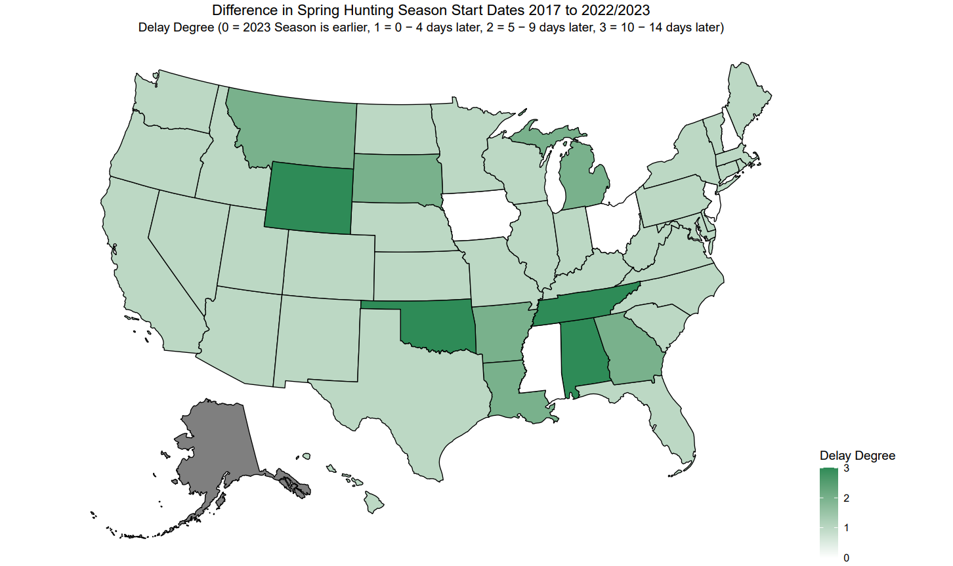

Figure 2.1. Differences in spring wild turkey hunting season start dates from the 2017 season to the 2022/2023 season across all states in the U.S. grouped by earlier, 0-4 (no change), 5-9, 10-14 days later in 2022/2023 with darker green colors representing longer season delays per state. Sources for dates can be found on Table 2.1.
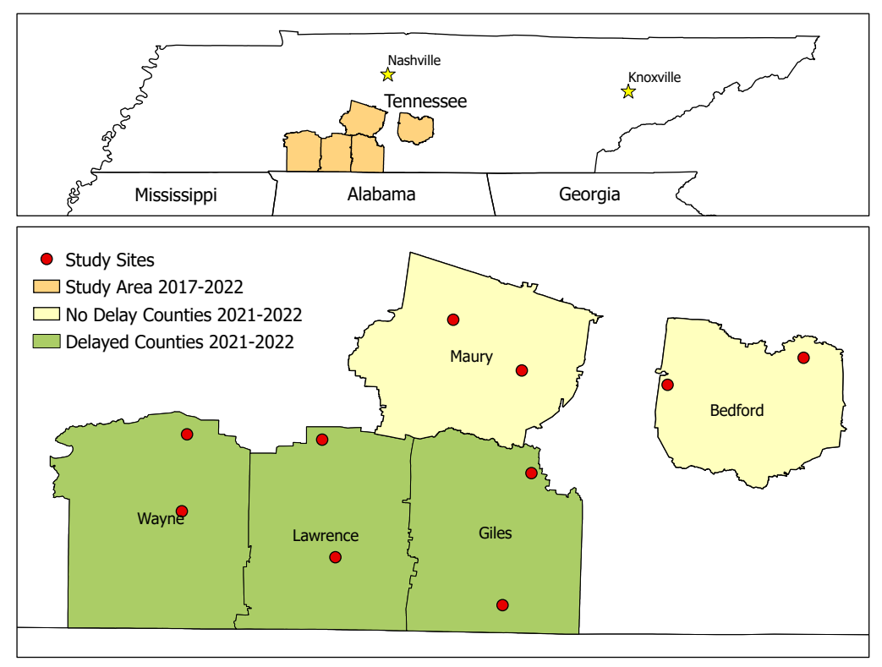
Figure 2.2. Map of 5 study counties with 10 study sites represented by red dots and counties separated by the start date of the spring hunting season in 2021 and 2022.
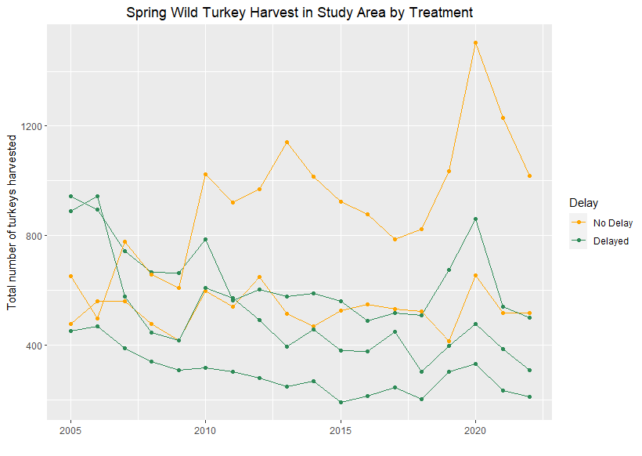
Figure. 2.3. Line graph of annual spring harvest rates of wild turkeys in No Delay counties (Bedford, and Maury) and Delayed counties (Giles, Lawrence, and Wayne) in Region 2 of south-middle Tennessee from 2005-2022.
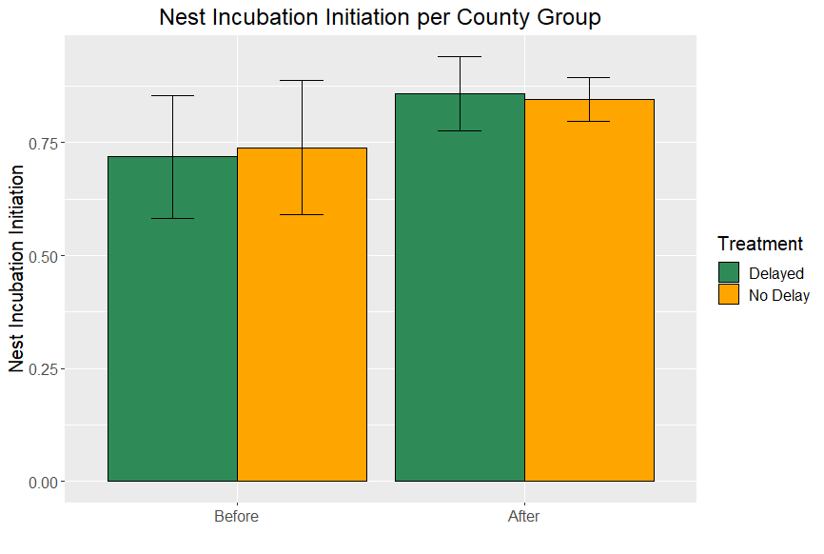
Figure 2.4. Nesting rates with 95% confidence intervals of initial nests in south-middle Tennessee from 2017-2022 grouped by treatment before and after the season delay.

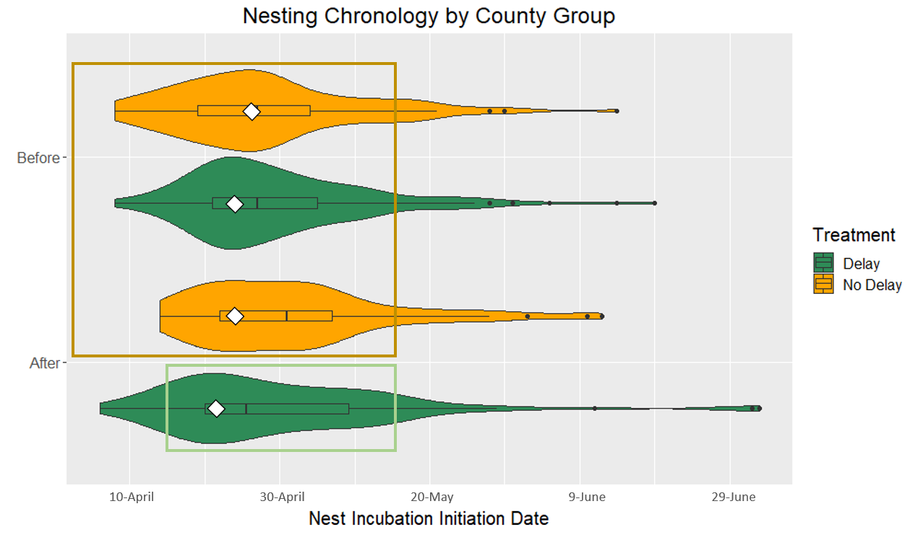
Figure 2.5. Nesting chronology of initial wild turkey nests in south-middle Tennessee represented by a violin plot for each treatment before and after the season delay. White diamonds represent peaks in nesting activity for the given time periods and the dark orange box represents the historic hunting season start and end dates while the light green box represents the delayed hunting season start and end dates for 2021 and 2022.
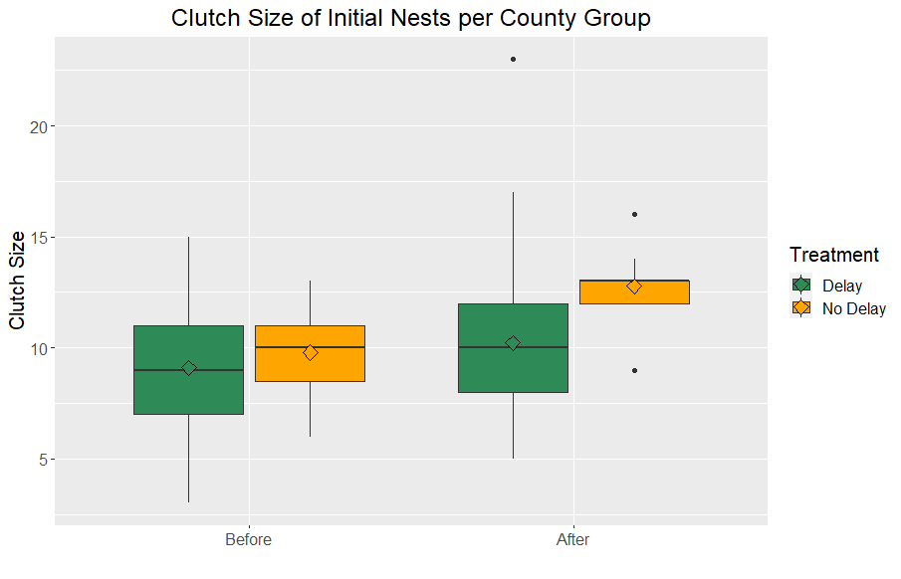
Figure 2.6. Boxplot of initial nest clutch sizes of wild turkey nests in south-middle Tennessee from 2017-2022 organized by county group and before and after the season delay, with the diamonds representing the means for each group.
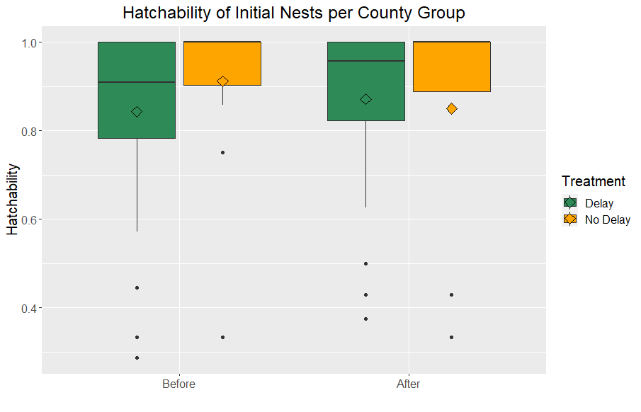
Figure 2.7. Boxplot of hatchability estimates of initial wild turkey nests from 2017-2022 in south-middle Tennessee separated by treatment with the diamonds representing the means for each treatment before and after the season delay.
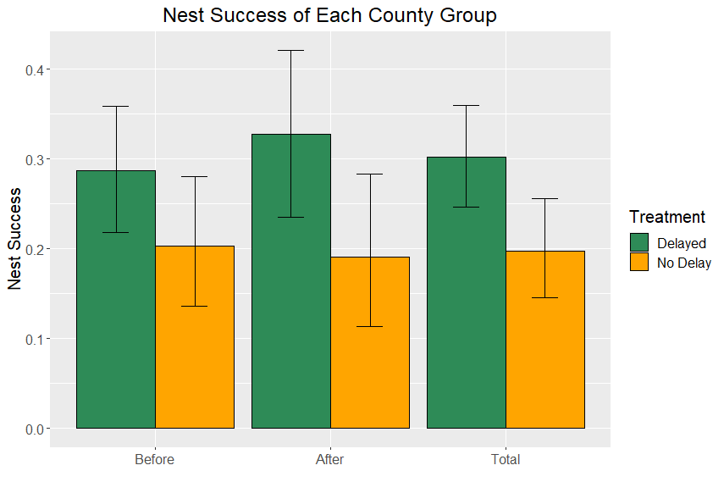
Figure 2.8. Bar graph of nest success with 95% confidence intervals of initial wild turkey nests in south-middle Tennessee grouped before the season delay (2017-2020), after the season delay (2021-2022), and total (2017-2022).

Part III. Changes in hunter behavior, success, and satisfaction in relation to wild turkey season opening dates

ABSTRACT
Many states throughout the range of the wild turkeys (Meleagris gallopavo) have delayed the spring wild turkey hunting season to better allow reproductively active males more time to breed before potentially being harvested. Six states in the southeast have delayed their spring hunting season from seven days to 14 days. However, there are no published data that indicate the current season framework has had a deleterious effect on reproduction. In addition to potentially affecting turkey reproduction, changing the season framework also may impact hunters’ behavior, success and satisfaction. Our objective was to see how hunter behavior, effort, and overall satisfaction changed upon implementing a season delay. We conducted a survey of 2,000 hunters in 2017-2022 to study effort and harvest among hunters. We surveyed the same respondents for all six years and received 2,539 surveys for a response rate of 22.0%. We used a two-level structural model with generalized linear models for panel data to assess changes to hunter effort and experience and then how these change affected satisfaction. We documented hunter effort in the affected counties declined by 40.3% after the delay and the average number of gobbles heard per trip declined by 33.7%. Hunters harvested one bird on average and overall harvest was not affected by the season delay. Harvest success, hunter efficiency and gobbles heard were strong predictors of hunter satisfaction. Our research highlights the need for careful consideration when setting spring hunting season regulations as it may have a negative impact on hunter satisfaction and therefore potentially impact hunter recruitment and retention.
INTRODUCTION
Hunter satisfaction with the hunting season can strongly influence hunter recruitment and retention (Everett and Nelson 2015). Hunter satisfaction is not just correlated with successful harvest. The “Multiple Satisfaction Framework” (Hendee 1974) is impacted by sociocultural factors, such as tradition or comradery, and experiential factors such as harvesting game (Hayslette et al. 2010, Watkins et al. 2018). Understanding factors that influence hunter satisfaction can be useful for state agencies because of its impact on hunter retention and recruitment (Mehmood et al. 2003, Fulton and Manfredo 2004, Burnke and Hunt 2008). Conservation dollars are generated through license sales which can be used to manage wild turkeys as well as many other species. Therefore, it is obviously important for state agencies and other stakeholder groups to understand the factors that drive hunter satisfaction so revenue can be generated for wildlife management.
Wild turkey hunters are no exception to declines in license sales and hunter retention. Chamberlain et al. (2022) reported a 16% decline in wild turkey license sales nationwide. In 2016, the U.S Fish and Wildlife Service’s (USFWS) national survey of fishing, hunting, and wildlife recreation reported that there were 2 million wild turkey hunters that accounted for 115 million hunter days, which is second only to deer hunters with 9.2 million hunters and 133 million hunter days (USFWS 2016). There also was a 25% decline in annual revenue generated from hunting from 2011 to 2016 (USFWS 2016). The decline in hunters and revenue should be alarming to state wildlife agencies. Multiple factors can influence hunter satisfaction, such as harvesting game, opportunity to harvest game, and seeing game (Brunke and Hunt 2008, Ryan and Shaw 2011, Gruntorad et al. 2020), but declining population sizes can negatively affect harvest rates (Roberts and Crimmins 2010) and therefore potentially reduce hunter satisfaction. Watkins et al. (2018) reported 65% of wild turkey hunters in Tennessee were concerned about a decline in the wild turkey population. This perceived decline is supported by Byrne et al. (2016) who reported a general decline in poults per hen ratios throughout the Southeast since 1990.
In addition to the decline in turkey hunter participation, there also is concern that the decline in productivity as indicated by poults per hen ratios is resulting in declining wild turkey numbers and hunter recruitment/retention. One leading hypotheses behind this decline in productivity is that the spring hunting season in many states begins too early and is negatively impacting reproduction by harvesting males before they have had a chance to breed, disrupting the flock’s social hierarchy, and lowering male density too early in the year (Isabelle et al. 2018). Six states within the southeast (Alabama, Arkansas, Georgia, Louisiana, Oklahoma, Tennessee) have delayed their hunting season in response to this hypothesis. However, a later hunting season could negatively impact the hunting experience of turkey hunters as the hunting season may misalign with peak gobbling activity. Gobbling activity is the leading factor associated with turkey hunter satisfaction (Gruntorad et al. 2020), so a later hunting season may negatively impact hunter satisfaction if peak gobbling activity no longer occurs during the hunting season.
Our objective was to investigate how a delayed spring turkey hunting season affected hunter effort, hunter success/efficiency, and hunter satisfaction. We tested three specific hypotheses relative to hunter behavior in response to the season delay:
- Hunter effort would decrease because the season was reduced from 44 to 30 days.
- Hunter success/efficiency would increase because male turkeys would be more responsive to calling more as more hens begin incubating.
- Hunter satisfaction would decrease because of fewer birds heard gobbling and reduced success rate with the season delay.
STUDY AREA
Our study area was five counties in south-middle Tennessee: Bedford, Giles, Lawrence, Maury and Wayne (hereafter referred to as “the five focal counties”). These five counties offer a mix of rural and urban communities with population size ranging from 16,427 – 102,878, and the total population size for these five counties is 244,962. In the five focal counties, 49.1% of the population is male and 50.9% female (Tennessee Department of Labor and Workforce Development, 2022). These communities are predominately white (81.72%) with the largest minorities African American (8.31%), and Hispanic (6.79%; TLWD 2022). In 2021, real gross domestic products in the five focal counties was 8,403,044 and ranged from 309,702 – 4,159,877 (Bureau of Economic Analysis 2022). A demographic overview of our respondents is provided in Table 2.
A survey in 2012 indicated there were 120,700 wild turkey hunters in Tennessee (Schexnayder et. al 2013), and based on license sales from 2022, there were 23,650 license holders in the five focal counties. Approximately 19.6% of wild turkey hunters in Tennessee reside in the five focal counties, and turkey hunters make up 9.7% of the population in these counties. There are 30,000 – 40,000 turkeys killed by hunters each year in Tennessee, and 2550 birds were killed in the five focal counties in 2022, which represented 8.9% of the statewide harvest (Tennessee Hunter Toolbox, unpublished data). From 1990 – 2020, the spring hunting season began on the Saturday closest to April 1st. For the 2021 and 2022 spring seasons, the Tennessee Wildlife and Fisheries Commission voted to delay the hunting season 14 days in three of the five focal counties because of perceived population declines and to determine if delaying the season might have an impact on reproduction and ultimately population size. The experimental delayed season was implemented during the 2021 and 2022 spring wild turkey hunting seasons. We chose to include the five focal counties in our study because Giles, Lawrence, and Wayne were perceived to have the greatest decline in population size based on harvest rates, and Bedford and Maury were perceived to be stable or increasing (Figure 3.1). We assessed responses from hunters in Giles, Lawrence, and Wayne counties (hereafter, referred to as “delayed counties”), and compare them to hunters in Bedford and Maury counties (hereafter, referred to as “no delay counties”) to test our research hypotheses.
METHODS
We conducted a survey every year from 2017-2022. We randomly selected 1,600 people who lived in one of the five focal counties and had a license to hunt wild turkeys in Tennessee. In addition to these original 1,600 people, we randomly sampled 400 additional people who harvested a bird in one of the five focal counties to ensure our sample contained successful hunters, unsuccessful hunters, and non-resident hunters. These same 2,000 individuals were randomly selected in 2016 and were continually surveyed each consecutive year unless they specifically asked to be removed from the survey mailing list.
The survey had 30-38 questions each year and was broken down into four sections. The first section focused on their current season turkey hunting in Tennessee; the second section assessed their opinions surrounding spring turkey hunting regulations; the third documented their perceptions of turkey populations in the five focal counties; and the last section requested demographic information. Our surveys were modeled after Watkins et al (2018), and questions in each section were modified each year to accommodate new regulatory changes, new researcher hypotheses, or to address respondent confusion about specific questions.
The mailing protocol for our survey followed Dillman (2006). Surveys were mailed to respondents within ten days of the close of the spring hunting season. We included a cover letter with the survey which outlined the purpose of the survey with a pre-paid postage envelope to return the completed survey. We mailed a reminder postcard one week after the initial mailing if we had not received a completed survey. We mailed an additional copy of the survey with a reminder letter if we had not received a completed survey two weeks after sending the initial survey and cover letter. All mailings and surveys were conducted with the appropriate and approved Institutional Review Boards (IRB) protocols.
Analytical Methods
We calculated hunter effort, hunter efficiency, and birds seen or heard on a per trip basis where a trip was defined as one individual leaving their house to go hunting and returning. A hunter could have >1 trip per day if they returned home and went hunting again later that day. We derived total hunter effort by taking the number of trips spent hunting in each county and multiplying it by the average time spent per trip. We calculated hunter efficiency by dividing the hunter’s effort by the number of birds harvested which resulted in the units being hours spent to harvest a bird. Hunter success was the number of birds harvested by a hunter in a season. Each respondent reported the number of juveniles (Jakes), and the number of adults (Toms) they saw on a typical trip. They also reported how many gobbles they heard per typical trip as well. Hunters ranked their satisfaction with the spring hunting season on a one (very dissatisfied) through five (very satisfied) scale.
We used generalized linear models for panel data to maintain the longitudinal nature of the study which allowed responses to vary by the start date of the spring hunting season (Bartolucci et al. 2015). We ran these models in RStudio (R Core Team 2020) and used the pglm package (Croissant 2022). The models were run in a structured modeling framework with two levels of analysis (Fulton and Manfredo 2004, Figure 3.2.). The first level was a suite of a priori models where the dependent variable was each of the metrics described above, and the independent variable was the season start date for that county and year. The second level to these models used hunter satisfaction as the dependent variable and the above metrics as the independent variables. The structured model framework allowed us to see direct effects of the season delay (Level 1) and potential indirect effects of the season delay on hunter satisfaction (Level 2).
We evaluated four metrics with our analyses: hunter effort, hunter success, hunter efficiency, and experiential factors. We ran three separate models for hunter effort that included total hunter effort (hours/season regardless of county), delayed county hunter effort, and no delay hunter effort. Harvest success was modeled with a single model of number of birds harvested in a season. We modeled hunter efficiency with two separate models of hunter efficiency (hours spent to harvest a bird), which included one for delayed counties and one for no delay counties. We also ran three models to evaluate three experiential response metrics: the average number of adult males (hereafter referred to as “toms”) seen per typical trip, gobbles heard per trip, and juvenile males (hereafter referred to as “jakes”) seen per typical trip. We used a generalized linear model for panel data with a negative binomial distribution to analyze all hunter effort, harvest success efficiency, and experiential models because all of which are count based data. We analyzed hunter satisfaction with a generalized linear model for panel data with an ordinal probit distribution because hunter satisfaction was based on ordinal scale of 1-5. For the second level of the analysis, all of the above metrics were then related to hunter satisfaction using the same linear models with an ordinal probit distribution.
RESULTS
We received 2,539 surveys from 2017 – 2022, with an average of 423 per year, providing an average response rate of 22.0% from 2017 to 2022, which ranged from 36.2% in 2017 to 17% in 2022. Of these responses, we had 1,763 respondents hunt in one of the five focal counties with an average of 293.8 hunters surveyed in the study area each year. If we adjust the response rates for hunters who hunted in these counties, we had an average response rate of 15.2% across the six years, ranging from 8.4% - 27.0%. We removed some surveys because of incomplete answers. We censored individuals who reported a trip of more than 24 hours, people who reported seeing more than 50 jakes or toms per typical trip, or if the number of gobbles heard exceeded 200. We censored these as they likely reported total number of birds seen and gobbles heard as opposed to number seen or heard per typical trip. Upon censoring surveys, we used 1597 hunter surveys in this analysis.
We had 674 hunter surveys report hunting in one of the two no-delay counties with 547 before the season delay (2017-2020) and 127 after (2021-2022). We had 1070 hunter surveys report hunting in a delayed county with 882 before the delay and 188 after the delay. In no-delay counties, we surveyed 342 individual hunters (Before: 320, After: 95). While in delayed counties, we surveyed 509 individual hunters over the six years (Before: 487, After: 141).
Hunter Effort
Total hunter effort decreased by 22 hours in delayed counties (Before: 56.8, After: 34.8; n = 1585; AIC = 6982.6; P = 0.02), and in no-delay counties, it decreased 8.6 hours (Before: 49.3, After: 40.8). Although effort for both groups declined, the decline was 257% greater by hunters in delayed counties Delayed county hunters spent 48.2 hours hunting in a delayed county with a decline of 20.9 hours (Before: 51.8, After: 31) after the season was delayed (Figure 3.3; n = 1070; AIC = 4605.1; P < 0.00001). Hunters in no delay counties spent 36.5 hours on average and saw a decrease of 7 hours in 2021 and 2022 (Before: 37.0, After: 30.1; n = 674; AIC = 2614.4; P = 0.003).
Hunter Success
We received 797 hunter surveys who reported harvesting at least one turkey. Hunters in delayed counties harvested one bird on average before and after the delay. Harvest in no delay counties remained closely the same with 1.1 birds harvested before the delay and 1.2 after (n = 797; AIC = 1191.8; P = 0.27)
Hunter Efficiency
Spring turkey hunters spent on average 41.3 hours to harvest a turkey. Hunters in delayed counties reported 16.2 fewer hours to harvest a bird after the season delay (Before: 44.0, After: 27.9; n = 488; AIC = 1587.8; P = 0.004). The difference in hunter efficiency in no-delay counties also was statistically significant after the delay as hunters required 2.8 hours (Before: 33.6, After: 30.8; n = 339, AIC = 1095.3, P = 0.04) less to harvest a bird (Figure 3.3).
Experiential Metrics
Hunters in the five focal counties saw 2.9 toms per trip in 2017 – 2022. Delayed county hunters saw 0.1 less toms per typical trip in 2021 and 2022 (Before: 2.6, After: 2.5) and hunters in no-delay counties saw 0.8 more per trip (Before: 3.3, After: 4.1; n = 1585; AIC = 2780.5; P = 0.04). Hunters on average heard 9.6 gobbles per typical trip from 2017-2022. Delayed county hunters heard 3.1 fewer gobbles per trip (Before: 9.2, After: 6.1) and in no-delay counties, hunters heard 2 more gobbles per typical trip (n = 1585; AIC = 4496.5; P = 0.032). Before the season delay in delayed counties, hunters typically saw 2.7 jakes per trip and after the number remained the same. Hunters in no-delay counties saw 4.1 jakes per trip from 2017-2020 and 4.2 jakes in 2021-2022 (n = 1585, AIC = 2851.8, P = 0.70). A summary of all three experiential metrics is provided in Figure 3.4.
Hunter Satisfaction
Hunter satisfaction was not directly impacted by the season delay (n = 1585; AIC = 4791.6; P = 0.47), but satisfaction in delayed counties was historically lower than satisfaction of hunters in no-delay counties (P <0.0001). Hunter satisfaction across all hunters from 2017-2022 was 3.6 which represents “Neither Satisfied or Dissatisfied” or “Somewhat Satisfied”. Hunter satisfaction in delayed counties before the season delay was 2.7 and remained at 2.7 in 2021 and 2022. Hunters in no-delay counties generally were more satisfied with their hunting season with an average hunter satisfaction of 3.2 from 2017-2020, and 3.3 from 2021-2022 (Figure 3.5).
Hunter satisfaction was not impacted by hunter effort but was correlated with hunter success, hunter efficiency and experiential metrics (P _{Effort} >0.06, P _{Success} <0.001, P _{Efficiency} <0.02, P _{Experiential} <0.01). Hunter success had a beta value of 0.18 reflecting a positive relationship between hunter success and hunter satisfaction. The beta estimates for delayed and no-delay hunter efficiency were -0.0066, and -0.004, respectively, indicating that with decreasing hunter efficiency there was a slight decrease in hunter satisfaction. The toms seen model produced a beta-value of 0.065 and 0.0125 for gobbles heard per trip. Number of jakes seen per trip was also correlated with hunter satisfaction and produced a beta value of 0.05.
Regulation Satisfaction
Prior to the season delay in 2021, all hunters reported being “neutral” or “somewhat acceptable” of shortening the hunting season to 36 days with an average acceptability score of 3.3. After the season delay in 2021, hunters reported being between “neither satisfied or dissatisfied” and “somewhat satisfied” with an average score of 3.3. From 2017-2022, 1,624 hunters answered this question with 1047 delayed hunter surveys (Before: 846, After: 201) and 577 from no-delay counties (Before: 475, After: 102). Before the hunting season was delayed, hunters from delayed counties had a higher acceptance (3.4) of a shorter spring season than no-delay hunters (3.1). After the 2021 and 2022 hunting season was shortened and delayed, satisfaction with the regulatory change dropped to 3.2 in delayed and increased to 3.6 in no-delay hunters. These average all remained in the same category of “neutral” to “somewhat acceptable/satisfied” regardless of the county they were from or year.
DISCUSSION
Hunter satisfaction was positively influenced by experiential metrics and hunter efficiency, and both were impacted by the timing of the spring hunting season. These results indicate hunters were more satisfied with their hunting season if they saw more game or if the birds were easier to hunt. Gruntorad et al. (2020) and Schroeder et al. (2019) reported similar results that seeing game had the greatest influence on satisfaction. These studies though did not measure hunter effort or efficiency. Hunter effort was not a strong predictor of hunter satisfaction in our study, which contrasts to a study of waterfowl hunters that reported harvest success was correlated with effort (Haugen et al. 2015). One explanation may be related to bag limits. The turkey bag limit is much smaller than a waterfowl bag limit. Waterfowl hunters, on average, kill more animals than turkey hunters. For a typical turkey hunter, more time spent in the woods often equates to less success. By far, most successful turkey hunters kill only one turkey. The season delay reduced hunter effort in delayed counties. However, it was not a significant predictor of satisfaction.
Harvest success was not impacted by the season delay as hunter in affected counties harvested the same number of birds on average. Harvest was related to hunter satisfaction though which is consistent with other works (Fulton and Manfredo 2004, Schroeder 2014, Gruntorad et al. 2020). The impact harvest has on satisfaction is well documented but may differ with different typologies of hunters, i.e appreciative-oriented, vs. affiliation-oriented vs. achievement-oriented hunters (Watkins et al. 2018). Hunter success may be more influential in satisfaction for achievement-orientated hunters as opposed to affiliation-oriented hunters. Further research should be done to understand how the season delay impacts each type of hunter and what type of hunter is prevalent throughout their hunting community so management can be tailored to maximize satisfaction.
Hunter efficiency was a significant predictor of hunter satisfaction and was impacted by the season delay. The delay shortened the season by two weeks, so hunters had less time to be in the woods in delayed counties. Thus, hours hunted were fewer in delayed counties. By opening the season in mid-April when more hens are incubating, toms may be more susceptible to calling, which likely increased hunter efficiency. Efficiency also increased in no-delay counties, likely indicating more gobblers were available in 2021 – 2022 than previous years. These results support our hypothesis that less time available to hunt combined with greater efficiency did not change overall hunter satisfaction.
Our experiential models showed fewer toms seen and gobbles heard by hunters in delayed counties whereas hunters in no-delay counties saw more birds. The most substantial change was in the number of gobbles heard per typical trip. Hunters reported 33.7% fewer gobbles per trip in delayed counties whereas hunters in no-delay counties reported a 17.7% increase. Previous research has identified factors such as weather (Wightman et al. 2022), changes in population size (Palumbo et al. 2019), and hunter activity (Wightman et al. 2023) as highly influential on gobbling activity. All of which could explain the differences observed after the season delay, but gobbling activity in both county groups were historically consistent with each other with hunters reporting 9.2 gobbles per tip in delayed counties and 11.3 in no delay counites (P = 0.17). Therefore, a reduction in gobbling suggests the delayed hunting season have begun after peak gobbling activity. The decrease in gobbles heard supports our hypothesis that a later hunting season could have decreased gobbling activity and decreased hunter satisfaction, which has been reported in other studies (Diefenbach et al. 2011, Schroeder 2014, Isabelle and Reitz 2015, Gruntorad et al. 2020).
Hunter satisfaction was not directly impacted by the season delay but may have been indirectly impacted through changes in other parameters, such as hunter efficiency, number of toms seen per trip, and gobbles heard. After the season delay in 2021 and 2022, affected hunters were less accepting of the regulatory change. Hunter satisfaction is influenced by many factors and can vary depending on the typology of the hunter (Watkins et al. 2017). Fulton and Manfredo (2004) reported that regulatory changes to the deer hunting season in Colorado had the same level of effect on hunter satisfaction as harvest success (16-17%). We did not find similar results where hunter satisfaction with the hunting season and the regulation change did not change after the season was delayed in 2021 and 2022.
MANAGEMENT IMPLICATIONS
Hunting season frameworks must be set such that they do not have a deleterious effect on the species hunted. Beyond that, consideration for hunter satisfaction is important to maintain hunter involvement, recruitment, and for some species, management of the population. We documented that a 2-week delay and reduction of the opening of the spring wild turkey season in three counties of south-middle Tennessee did not influence hunter satisfaction directly but may indirectly effect satisfaction by reduced gobbling or increased hunter efficiency. However, there was a strong perception among turkey hunters in those affected counties that the turkey population was reduced considerably compared to several years prior, and hunters wanted something done to reverse the decline. A delay and reduction of the season in areas where there is no perception of population decline may be viewed very differently. After two years of the season delay, hunters in delay counties were less accepting of the delay, potentially because they did not perceive benefit. We recommend state agencies use hunter satisfaction data (e.g., peak gobbling period) when determining the timing of the hunting season, but primarily consider how timing may affect reproductive success after analyzing vital rate data in relation to season opening date and length.
ACKNOWLEDGEMENTS
We would like to thank all of the previous technicians who have helped the project enter this data: H. Whited, J. Kosiewska, B. Panos, and D. Radar. We also want to thank Tennessee’s Wildlife Resource Agency for their help in supplying the database in which we drew our respondents from and other logistical support. Thank you to the University of Tennessee Mailing and Printing Services for helping us mail and print the materials in a timely manner. We’d also like to acknowledge our funding sources Tennessee’s Wildlife Resources Agency, University of Tennessee’s School of Natural Resources, and the national chapter of the National Wild Turkey Federation for their continued support of the project.

LITERATURE CITED
Bartolucci, F., F. Belotti, and F. Peracchi. 2015. Testing for time-invariant unobserved heterogeneity in generalized linear models for panel data. Journal of Econometrics. 184(1): 111-123.
Bureau of Economic Analysis, U.S Department of Commerce. 2022. https://www.bea.gov/sites/default/files/2022-12/lagdp1222.pdf . Accessed May 17, 2023
Burnke, K. D., and K. M. Hunt. 2008. Mississippi waterfowl hunter expectations, satisfaction, and intentions to hunt in the future. Human Dimensions of Wildlife. 13(5): 317-328.
Butler, A. B., and G. Wang. 2021. Connecting hunt outcomes to the demographics, behaviors and experiences of wild turkey hunters in Mississippi. Wildlife Society Bulletin. 46:e1268.
Byrne, M. E., M. J. Chamberlain, and B. A. Collier. 2015. Potential density dependence in wild turkey productivity in the southeastern United States. Proceedings 11th National Wild Turkey Symposium. 1: 329-351.
Chamberlain, M. J., M. Hatfield, and B. A. Collier. 2022. Status and distribution of wild turkeys in the United States in 2019. Wildlife Society Bulletin 46:e1287.
Croissant, Y. 2021. Panel generalized linear models. CRAN. https://cran.r-project.org/web/packages/pglm/index.html
Diefenbach, D. R., M. J. Casalena, M. V. Schiavone, M. Reynolds, R. Eriksen, W. C. Vreeland, B. Swift, and R. C. Boyd. 2011. Variation in spring harvest rates of male wild turkeys in New York, Ohio, and Pennsylvania. The Journal of Wildlife Management. 76(3): 514-522.
Dillman, D. A. 2006. Mail and internet surveys: the tailored design method. Hoboken, NJ: John Wiley & Sons. 2: 523.
Everett, M. W., and C. M. Nelson. 2016. ‘Flow’ and satisfaction of Michigan youth waterfowl hunters: implications for hunter retention. Loisir et Societe/Society and Leisure. 39(2): 290-302.
Frey, S., M. Conover, J. Borgo, and T. Messmer. 2011. Factors influencing pheasant hunter harvest and satisfaction. Human Dimensions of Wildlife. 8(4): 277-286.
Fulton, D. C. and M. J. Manfredo. 2004. A panel design to assess the effects of regulatory induced reductions in opportunity on deer hunters’ satisfaction. Human Dimensions of Wildlife. 9: 35-55.
Gruntorad, M. P., J. J. Lusk, M. P. Vrtiska, and C. J. Chizinski. 2020. Identifying factors influencing hunter satisfaction across hunting activities in Nebraska. Human Dimensions of Wildlife. 25(3): 215-231.
Haugen, M. T., L. A. Powell, M. P. Vrtiska, and K. L. Pope. 2015. The effects of harvest regulation on behaviors of duck hunters. Human Dimensions of Wildlife. 20: 15-29.
Hayslette, S. E., J. B. Armstrong, and R. E. Mirarchi. 2010. Mourning dove hunting in Alabama: motivations, satisfactions, and sociocultural influences. Human Dimensions of Wildlife. 6(2): 81-95.
Hendee, J. C. 1974. A multiple satisfaction approach to game management. Wildlife Society Bulletin. 2(3):104-113.
Iijima, H. 2017. The effects of landscape components, wildlife behavior and hunting methods on hunter effort and hunting efficiency of sika deer. Wildlife Biology. doi: 10.2981/wlb.00329
Isabelle, J. L., A. B. Butler, C. Ruth, and D. K. Lowrey. 2018. Journal of the Southeastern Association of Fish and Wildlife Agencies 5: 106-113.
Mehmood, S. R., D. Zhang, and J. B. Armstrong. 2003. Factors associated with declining hunting license sales in Alabama. Human Dimensions of Wildlife. 8: 243-262.
Palumbo, M. D., F. J. Vilella, G. Wang, B. K. Strickland, D. Godwin, P. G. Dixon, B. D. Rubin, and M. A. Lashley. Latitude and daily weather effects on gobbling activity of wild turkeys in Mississippi. International Journal of Biometeorology. 63: 1059-1067.
RStudio Team. 2020. RStudio: Integrated Development for R. RStudio, PBC, Boston, MA URL http://www.rstudio.com/.
Roberts, N. M., and S. M. Crimmins. 2010. Do trends in muskrat harvest indicate widespread population declines? Northeastern Naturalist. 17(2): 229-238.
Ryan, E. L., and B. Shaw. 2011. Improving hunter recruitment and retention. Human Dimensions of Wildlife. 16(5): 311-317.
Schexnayder, S., A. Griffin and J. M. Fly. 2013. Spring 2012 Tennessee hunting survey. Human Dimensions Research Lab, Department of Forestry, Wildlife and Fisheries, University of Tennessee, Knoxville, TN.
Schroeder, S. A. 2014. Minnesota spring wild turkey hunting: a study of hunters’ opinions and activites. Univeristy of Minnestoa, Minnesota Cooperative Fish and Wildlife Research Unit, Department of Fisheries, Wildilfe and Conservation Biology.
Schroeder, S. A., L. Cornicelli, D. C. Fulton, and S. S. Merchant. 2019. The influence of motivation versus experience on recreat satisfaction: how appreciative- versus achievement -oriented recreation experience preferences relate to hunter satisfaction. Journal of Leisure Research. 50(2): 107-131.
Tennessee’s Department of Labor and Workforce Development. 2022. Demographics WDA. < https://www.tn.gov/workforce/tennessee-economic-data-/demographics/demographics-ecd-base-camps.html>. Accessed May 17, 2023.
Tennessee Hunter Toolbox. 2023. https://hunterstoolbox.gooutdoorstennessee.com/ . Accessed February 24, 2023.
Watkins, C., N. C. Poudyal, C. Caplenor, D. Buehler and R. Applegate. 2018. Motivations and support for regulations: a typology of eastern wild turkey hunters. Human Dimensions of Wildlife. 23(5): 433-445.
Wightman, P. H., J. A. Martin, J. C. Kilgo, E. Rushton, B. A. Collier, and M. J. Chamberlain. 2022. Influence of weather on gobbling activity of male wild turkeys. Ecology and Evolution. 12(6): e9018.
Wightman, P. H., J. A. Martin, M. T. Kohl, E. Rushton, B. A. Collier, and M. J. Chamberlain. 2023. Landscape characteristics and predation risk influence spatial variation in auditory courtship of an upland game bird. Landscape Ecology. 38:1221-1236.
U.S Department of Interior, U.S. Fish and Wildlife Services, and U.S. Department of Commerce, U.S. Census Bureau. 2016 National Survey of Fishing, Hunting, and Wildlife-Associated Recreation. Washington, D.C., USA.

Appendix

Table 3.1. Table of hypothesized effect the season delay would have on hunter from south-middle Tennessee from 2017-2022.

Metrics | Hypothesized effect on effected hunters | Justification
Total Hunter Effort | decrease | Total hunter effort would decrease because hunters in delayed counties would have 14 less days to hunt or would have to drive further away to hunt during those first two weeks.
Hunter Effort - Delayed Counties | decrease | Hunter effort in delayed counties will decrease because there are 14 less days and may hunt elsewhere during that time period.
Hunter Effort - No Delay Counties | increase | Hunter effort in no delay counties may increase because hunters from the delayed counties may hunt in these counties during the first two weeks.
Hunter Efficiency - Delayed Counties | increase | Hunter efficiency will increase because males will be more responsive to calls since more hens have begun incubating nests.
Hunter Efficiency - No Delay Counties | remain the same | Hunter efficiency in the unaffected counties should remain the same since nothing is changing regarding the hunting season framework.
Toms Seen/Trip | decrease | We would expect the number of toms seen to decrease in these counties because birds might be gobbling less during this time of year and subsequently may be harder to find.
Jakes Seen/Trip | increase | The basis behind the theory of a later start date would be that there is a reproductive benefit to starting to hunt later in the year. If this is true in subsequent years, we would expect to see more jakes out on the landscape.
Gobbles Heard/Trip | decrease | We would expect gobbling activity to decrease in these effected counties as a later hunting season may exclude the peak in gobbling activity for our focal area.
Hunter Satisfaction | decrease | Hunter satisfaction may decrease in this area as many hunters like hunting earlier in the year as opposed to later in the year and if less gobbling is detected, we may see declines in satisfaction associated with that.

Table 3.2. Summary table of demographic information of the hunters in Bedford, Giles, Lawrence, Maury or Wayne counties that responded to our survey at least once from 2017-2022.

 |  |  | 2017 |  |  | 2018 |  |  |  | 2019 |  |  |  | 2020 |  |  |  | 2021 |  |  |  | 2022 |  |  |  | All Years
 |  |  | n |  | % Resp. |  | n |  | % Resp. |  | n |  | % Resp. |  | n |  | % Resp. |  | n |  | % Resp. |  | n |  | % Resp. | n | % Resp.
Age | ≤ 45 years old |  | 234 |  | 43.494 |  | 138 |  | 38.440 |  | 94 |  | 33.692 |  | 89 |  | 32.246 |  | 55 |  | 33.133 |  | 42 |  | 30.000 | 652 | 37.0876
Age | 46 -60 years old |  | 241 |  | 44.796 |  | 164 |  | 45.682 |  | 129 |  | 46.237 |  | 123 |  | 44.565 |  | 61 |  | 36.747 |  | 53 |  | 37.857 | 771 | 43.8567
Age | 61-70 years old |  | 57 |  | 10.595 |  | 55 |  | 15.320 |  | 50 |  | 17.921 |  | 57 |  | 20.652 |  | 45 |  | 27.108 |  | 38 |  | 27.143 | 302 | 17.1786
Age | 71-80 years old |  | 4 |  | 0.743 |  | 2 |  | 0.557 |  | 6 |  | 2.151 |  | 7 |  | 2.536 |  | 2 |  | 1.205 |  | 7 |  | 5.000 | 28 | 1.5927
Age | >81 years old |  | 0 |  | 0.000 |  | 0 |  | 0.000 |  | 0 |  | 0.000 |  | 0 |  | 0.000 |  | 1 |  | 0.602 |  | 0 |  | 0 | 1 | 0.0569
Age | Declined to answer |  | 2 |  | 0.372 |  | 0 |  | 0.000 |  | 0 |  | 0.000 |  | 0 |  | 0.000 |  | 2 |  | 1.205 |  | 0 |  | 0.000 | 4 | 0.2275
Gender | Male |  | 505 |  | 93.866 |  | 341 |  | 94.986 |  | 262 |  | 93.907 |  | 255 |  | 92.391 |  | 156 |  | 93.976 |  | 128 |  | 91.429 | 1647 | 93.6860
Gender | Female |  | 22 |  | 4.089 |  | 12 |  | 3.343 |  | 11 |  | 3.943 |  | 10 |  | 3.623 |  | 5 |  | 3.012 |  | 8 |  | 5.714 | 68 | 3.8680
Gender | Declined to answer |  | 11 |  | 2.045 |  | 6 |  | 1.671 |  | 6 |  | 2.151 |  | 11 |  | 3.986 |  | 5 |  | 3.012 |  | 4 |  | 2.857 | 43 | 2.4460
Income | < 50,000 |  | 163 |  | 30.297 |  | 83 |  | 23.120 |  | 62 |  | 22.222 |  | 58 |  | 21.014 |  | 27 |  | 16.265 |  | 33 |  | 23.571 | 426 | 24.2321
Income | 50,000 - 99,999 |  | 188 |  | 34.944 |  | 135 |  | 37.604 |  | 108 |  | 38.710 |  | 95 |  | 34.420 |  | 52 |  | 31.325 |  | 31 |  | 22.143 | 609 | 34.6416
Income | 100,000 - 149,999 |  | 92 |  | 17.100 |  | 60 |  | 16.713 |  | 50 |  | 17.921 |  | 41 |  | 14.855 |  | 37 |  | 22.289 |  | 33 |  | 23.571 | 313 | 17.8043
Income | 150,000 - 199,999 |  | 26 |  | 4.833 |  | 18 |  | 5.014 |  | 11 |  | 3.943 |  | 25 |  | 9.058 |  | 9 |  | 5.422 |  | 7 |  | 5.000 | 96 | 5.4608
Income | 200,000 - 249,999 |  | 4 |  | 0.743 |  | 3 |  | 0.836 |  | 6 |  | 2.151 |  | 2 |  | 0.725 |  | 2 |  | 1.205 |  | 2 |  | 1.429 | 19 | 1.0808
Income | ≥ 250,000 |  | 9 |  | 1.673 |  | 7 |  | 1.950 |  | 7 |  | 2.509 |  | 6 |  | 2.174 |  | 6 |  | 3.614 |  | 6 |  | 4.286 | 41 | 2.3322
Income | Declined to answer |  | 56 |  | 10.409 |  | 53 |  | 14.763 |  | 35 |  | 12.545 |  | 49 |  | 17.754 |  | 33 |  | 19.880 |  | 28 |  | 20.000 | 254 | 14.4482
Total Respondents |  | 538 |  | 30.603 |  | 359 |  | 20.421 |  | 279 |  | 15.870 |  | 276 |  | 15.700 |  | 166 |  | 9.443 |  | 140 |  | 7.964 |  | 1758

Table 3.3. Summary table of all models ran on hunter surveys from 2017-2022 in south-central Tennessee, with method used, significance, and effect attributed by the season delay. Red lettering signifies a decrease and green lettering signifies an increase based on averages and model output.

Level | Metric | Statistical Method Used | P-value | Effect of Season Delay
One: Effect of the Season Delay | Total Hunter Effort | Generalized Panel Linear Models | 0.025 | Significant impact ( - )
One: Effect of the Season Delay | Hunter Effort - Delayed | Generalized Panel Linear Models | <0.0001 | Significant impact ( - )
One: Effect of the Season Delay | Hunter Effort - No Delay | Generalized Panel Linear Models | 0.0031 | Significant impact ( - )
One: Effect of the Season Delay | Hunter Efficiency - Delayed | Generalized Panel Linear Models | 0.0046 | Significant impact ( + )
One: Effect of the Season Delay | Hunter Efficiency - No Delay | Generalized Panel Linear Models | 0.042 | Significant impact ( + )
One: Effect of the Season Delay | Toms Seen/Trip | Generalized Panel Linear Models | 0.047 | Significant impact ( - )
One: Effect of the Season Delay | Jakes Seen/Trip | Generalized Panel Linear Models | 0.7 | No Documented Effect
One: Effect of the Season Delay | Gobbles Heard/Trip | Generalized Panel Linear Models | 0.032 | Significant impact ( - )
One: Effect of the Season Delay | Hunter Satisfaction | Generalized Panel Linear Models | 0.47 | No Documented Effect
Two: Effect of metric on Hunter Satisfaction | Total Hunter Effort | Generalized Panel Linear Models | 0.07 | No Documented Effect
Two: Effect of metric on Hunter Satisfaction | Hunter Effort - Delayed | Generalized Panel Linear Models | 0.43 | No Documented Effect
Two: Effect of metric on Hunter Satisfaction | Hunter Effort - No Delay | Generalized Panel Linear Models | 0.063 | No Documented Effect
Two: Effect of metric on Hunter Satisfaction | Hunter Efficiency - Delayed | Generalized Panel Linear Models | <0.0001 | Significant impact ( + )
Two: Effect of metric on Hunter Satisfaction | Hunter Efficiency - No Delay | Generalized Panel Linear Models | 0.0141 | Significant impact ( + )
Two: Effect of metric on Hunter Satisfaction | Toms Seen/Trip | Generalized Panel Linear Models | <0.0001 | Significant impact ( + )
Two: Effect of metric on Hunter Satisfaction | Jakes Seen/Trip | Generalized Panel Linear Models | <0.0001 | Significant impact ( + )
Two: Effect of metric on Hunter Satisfaction | Gobbles Heard/Trip | Generalized Panel Linear Models | <0.0001 | Significant impact ( + )

Figure 3.1. Harvest rates of wild turkeys in five counties in south central TN from 2005-2022 with green lines denoting the three delay study counties (Giles, Lawrence, and Wayne) and orange lines denoting the no delay counties (Bedford and Maury).

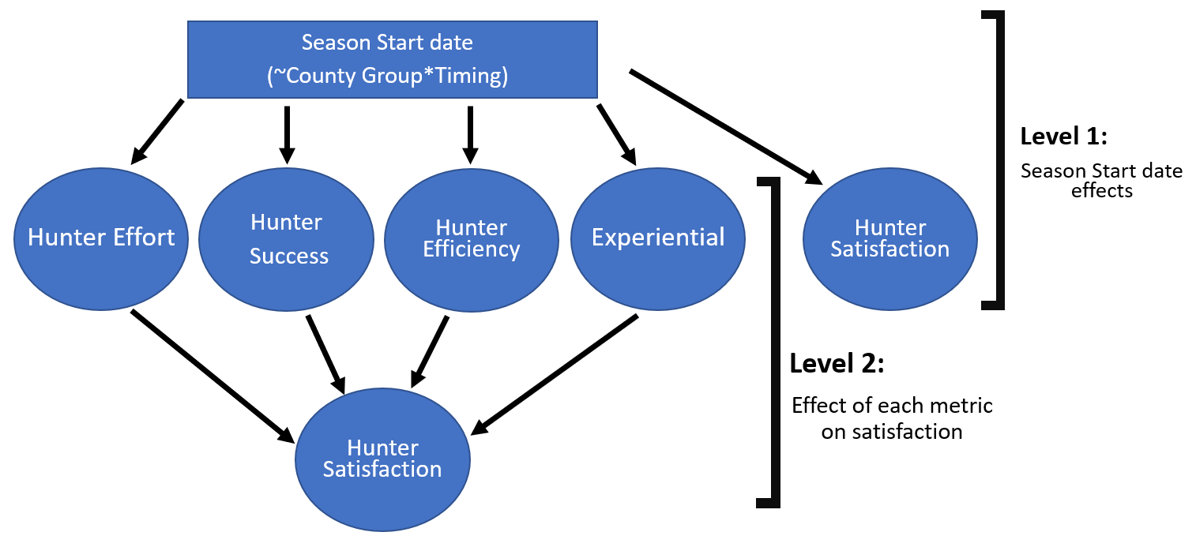
Figure 3.2. Conceptual model of structural design used to determine direct effects of the season delay as well as indirect effects on hunter satisfaction. Each blue circle represents a suite of models, and each black arrow represents a separate generalized panel linear model.

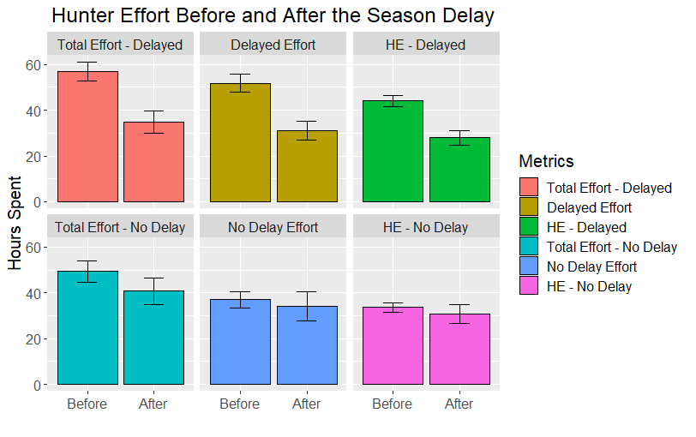
Figure 3.3. Hunter effort and hunter efficiency (HE) of hunters in delayed and no delay counties in south-central Tennessee from 2017-2022 with error bars representing 95% confidence intervals.

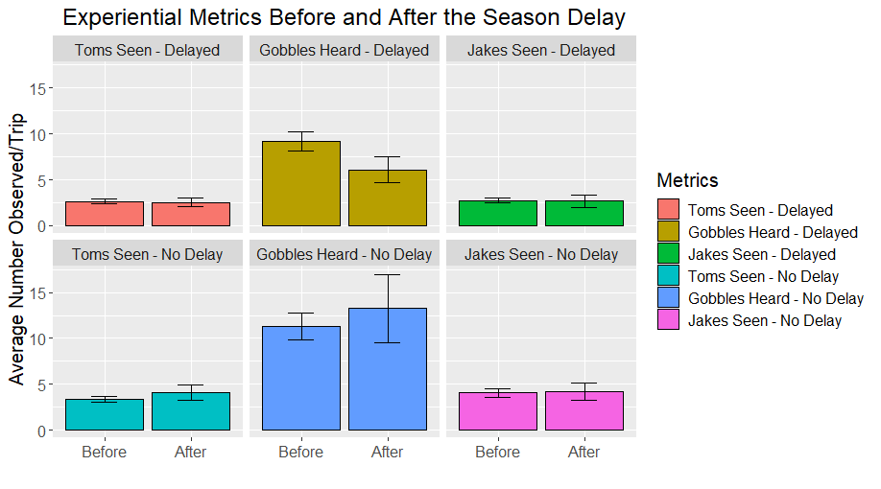
Figure 3.4. Experiential metric such as number of toms seen per trip, gobbles heard per trip and jakes seen by hunters in south central Tennessee from 2017-2022. Black bars represent 95% confidence intervals.

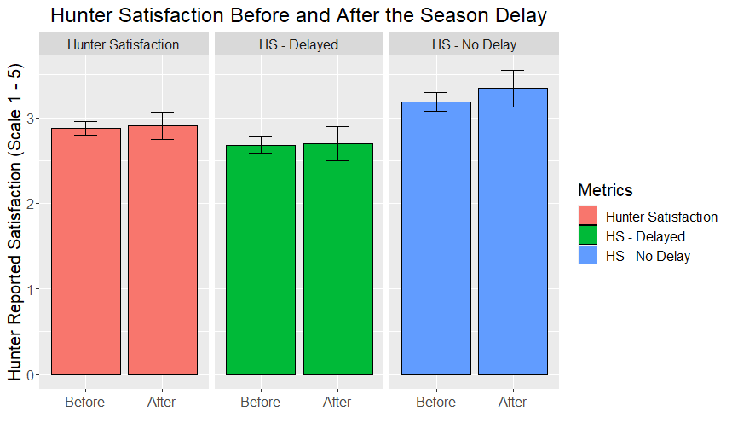
Figure 3.5. Average hunter satisfaction for hunters during the 2017-2022 spring hunting season in each county group in south central Tennessee. Bars represent 95% confidence intervals.
Part IV: Conclusion

VITA
Joseph Quehl is from Mendota Heights, Minnesota and grew up hunting and fishing with his family in northern Minnesota. He obtained a Bachelors of Science in Wildlife Ecology and Management from the University of Wisconsin-Stevens Point, in 2020. He was heavily involved in the student chapter of the Wildlife Society there and has worked on multiple research projects from ruffed grouse in Northwoods of Wisconsin, pheasants in the great plains of Kansas, and waterfowl in the Prairie Pothole Region of Iowa. All of these positions, schooling, and upbringing helped develop a strong passion for game species management through habitat management or regulation changes. He began his Master of Science degree from the University of Tennessee, Knoxville in 2021 where he studied eastern wild turkey reproductive ecology in relation to the start date of the spring hunting season.

