Development and Experimental Analysis of Wireless High Accuracy Ultra-Wideband Localization Systems for Indoor Medical Applications

A Dissertation Presented for
the Doctor of Philosophy
Degree
The University of Tennessee, Knoxville

Michael Joseph Kuhn
May 2012

Copyright © 2012 by Michael Kuhn
All rights reserved.

Dedication
Dedicate it.

Acknowledgements
Acknowledge it.

Abstract
This dissertation addresses several interesting and relevant problems in the field of wireless technologies in medicine and specifically problems related to ultra-wideband high accuracy localization for indoor applications. This includes:
- Current state-of-the-art in wireless technologies for indoor localization with emphasis given to their use in medical applications
- System-level design concerns for high performance indoor ultra-wideband positioning systems and novel techniques for comprehensive system-level simulations for rapid prototype design
- Characterization of the operating room channel in terms of its effects on ultra-wideband localization
- Integrated ultra-wideband RF tags for multi-tag tracking millimeter accuracy UWB localization
- Adaptive ultra-wideband receiver-side detection schemes for high accuracy localization in low signal-to-noise ratio and non-line-of-sight environments
- NLOS detection and mitigation for a millimeter accuracy UWB indoor localization system
- A comprehensive development platform for multi-tag access network operation integrated with high accuracy ultra-wideband localization and associated experimental analysis
These technologies are aimed at use in next-generation medical systems with many applications including surgical navigation, wireless telemetry, medical asset tracking, and in vivo wireless sensors. A good portion of this work has been peer-reviewed in well-known microwave engineering and biomedical engineering conferences and journals.
Table of Contents
1. Introduction 1
1.1 Motivation 1
1.2 Background 1
1.3 Contributions 2
1.4 Organization 4
2. Indoor High Accuracy Wireless Positioning Systems 8
2.1 Current State of Indoor Wireless Localization Systems 9
2.1.1 Commercial Systems 11
2.1.2 Research Systems 13
2.2 Development of the 1st Generation Millimeter Accuracy Real-time Indoor UWB Positioning System 18
2.2.1 System Architecture 18
2.2.2 Low Phase Noise Local Oscillators 20
2.2.3 Sub-Sampling Mixer at the UWB Receiver 22
2.2.4 System Clock Jitter and Scaling Effects 25
2.2.5 Energy Detection 29
2.2.6 Leading-Edge Detection 33
2.2.7 UWB Antenna Phase Center Error 34
2.2.8 Time Difference of Arrival 38
2.3 Real-Time Experiments 41
2.3.1 3-D Dynamic Free Motion 41
2.3.2 3-D Robot Tracking 43
3. A System-Level Simulation Framework for UWB Localization 50
3.1 Simulation Framework 52
3.2 System Architecture 57
3.2.1 Tx and Rx Analog Front-Ends 58
3.2.2 Rx Digital Back-End 64
3.3 Simulations Along an Optical Rail 73
3.3.1 Optical Rail Experimental Setup 73
3.3.2 Ideal Case - Excluding Channel Effects 74
3.3.3 Addition of Indoor LOS and NLOS Channels 79
3.3.4 Comparison with Experimental Results 83
3.4 Simulations for Different Base Station Configurations 85
3.5 ADC Effects and Automatic Gain Control 90
3.6 Extension to Other UWB Systems 91
3.7 Receiver Vivaldi Antenna Effects 94
4. UWB Receiver-Side Digital Signal Processing for High Accuracy Indoor Localization 112
4.1 UWB Pulse Analog-to-Digital Conversion 113
4.2 UWB Peak Detection 116
4.3 UWB Leading-Edge Detection 119
4.4 Noise Estimation 123
4.5 Signal-to-Noise Ratio Calculation 124
4.6 Effects of Low Signal-to-Noise Ratios on Leading-Edge Detection 127
4.7 UWB Control Station Processing 128
4.8 Adaptive Leading-Edge Detection for Low SNR and NLOS Environments 130
4.8.1 Simulation Results 133
5. Non-Line-of-Sight Detection and Mitigation for High Accuracy Indoor UWB Localization……………………………………………………………………………………………..138
5.1 Overview 139
5.2 Experimental Setup 139
5.3 Detection 141
5.4 Mitigation 145
6. UWB Positioning and Orthopedic Surgical Navigation 148
6.1 Current Tracking Technologies 150
6.2 Overview of Orthopedic Surgical Navigation Systems 154
6.3 Commercial Navigation Systems 157
6.3.1 Knee Arthroplasty 161
6.3.2 Hip Arthroplasty 166
6.4 UWB and Future Navigation Systems 175
6.4.1 Intra-Operative Phase 176
6.4.2 Post-Operative Phase 179
6.4.3 UWB Tracking System 181
7. Wireless Technologies in Medicine 185
7.1 Medical Frequency Bands 186
7.2 Microwave Interaction with Biological Tissues 190
7.2.1 Complex Permittivity 191
7.2.2 Coaxial Probe 196
7.2.3 Biological Tissue Coaxial Probe Measurements 198
7.3 Positioning Systems 202
7.4 Communication Systems 205
7.4.1 In Vivo Wireless Telemetry 206
7.4.2 Bluetooth 207
7.4.3 UWB and Ad-hoc Sensor Networks 210
8. Wireless Signal Propagation in Hospital Environments 212
8.1 Narrowband Telemetry Systems 213
8.1.1 Matlab System Simulation of ASK Transmitter and Receiver 219
8.2 UWB Operating Room Channel 226
8.2.1 Experimental Setup 229
8.2.2 Experimental Results 231
8.3 Electromagnetic Interference in the Operating Room 234
8.3.1 OR Indoor Environment 237
8.3.2 Experimental Setup 237
8.3.3 Experimental Results 240
8.4 WLAN Interference at 5 GHz 245
9. Multi-Tag Access for High Accuracy Indoor UWB Localization 250
9.1 1st Generation UWB RF Tag 250
9.1.1 System Architecture 251
9.1.2 Experimental Results 252
9.2 8 GHz On-Off Keying for Multi-Tag Access 258
9.2.1 Digital Communication Scheme 258
9.2.2 Experiments 259
9.2.3 Limitations 259
9.3 2.4 GHz Minimum Shift Keying for Multi-Tag Access 260
9.3.1 Experimental Setup 271
9.3.2 Experimental Results 275
9.4 UWB Multi-Tag Development Platform 276
9.4.1 Integrated UWB Tag 276
9.4.2 UWB Energy Detection Receiver 282
9.4.3 Digital Processing and Real-Time Software Integration 283
9.4.4 Static Tag Integration 289
9.4.5 Cable Length Offsets 290
9.4.6 Tag Scale Factors 292
9.4.7 Dynamic Calibration 297
9.5 MMIC Transmitter and Receiver Integration 310
9.5.1 Transmitter Front-End 310
9.5.2 Receiver Front-End 311
9.5.3 Experimental Results 312
9.5.4 Conclusion 317
10. A Multi-Tag Development Platform for High Accuracy Indoor UWB Localization: Experimental Analysis 318
10.1 Overview 318
10.2 Real-Time Experiments 318
10.2.1 Optical Rail Experiments with Optical Tracking 321
10.2.2 Free Motion Experiments with Optical Tracking 322
10.2.3 Two Tag Dynamic Experiments 324
10.3 Analysis of Observed Errors 326
10.4 Conclusion 328
11. Towards Sub-Millimeter Accuracy in UWB Positioning for Medical Environments 330
11.1 Overview 332
11.2 Background 334
11.3 State-of-the-Art UWB Positioning Systems 335
11.4 Challenges in High Accuracy UWB Positioning Systems 340
11.4.1 Noise and Sensitivity at the UWB Receiver 340
11.4.2 Local Oscillator Phase Noise 341
11.4.3 Antenna Phase Center Variation 341
11.4.4 Time Scaling, Jitter Effects, and System Calibration 343
11.5 Future Work 344
11.5.1 System-Level Design and Simulation Framework 345
11.5.2 Novel UWB Positioning System Architectures 347
11.5.2.1 Dielectric Resonator Oscillator 350
11.5.2.2 Adaptive Leading-Edge Detection 350
11.5.2.3 Automatic Gain Control 351
11.5.2.4 Front-End Bandpass Filter 351
11.5.2.5 Multi-Tag Access 352
11.5.2.6 MMIC Integrated Components 352
11.5.3 Quantitative Testing and Analysis 353
11.6 Conclusion 354
12. Discussion 358
Appendices 359
Appendix A: MCU Code for UWB Tags 360
Appendix B: MCU Code for UWB Access Point 368
References 381
Vita.. 399

List of Tables
Table 2-1: Comparison of commercial UWB localization systems with specifications reported for their compact tags. 11
Table 2-2: Comparison of current research high accuracy positioning systems. 14
Table 2-3: Phase noise performance of different carrier sources. 21
Table 2-4: Jitter performance with different carrier sources. 22
Table 2-5: Comparison of the designed sampler with commercial sampling modules. 25
Table 2-6: Simulated standard deviation error for dynamic scenario. 32
Table 2-7: Error Summary – 3-D unsynchronized localization experiments. 49
Table 3-1: Comparison of commercial wireless indoor positioning systems. 51
Table 3-2: Comparison of wireless system-level simulation methodologies. 53
Table 3-3: Comparison of using I and Q channels. 77
Table 3-4: Comparison of 3-D RMSE for Peak and Leading Edge Detection Algorithms in LOS Indoor Environments. 80
Table 3-5: Comparison of 3-D RMSE for Peak and Leading Edge Detection Algorithms in NLOS Indoor Environments. 81
Table 3-6: Comparison of Simulated and Experimental Results for Optical Rail Experiment. 85
Table 3-7: Results for Multi-Base Station Experiments. 87
Table 4-1: Sub-sampled 300 ps UWB pulse -10 dB bandwidth and FWHM for different expansion factors. 115
Table 6-1: Comparison of the designed sampler with commercial sampling modules. 183
Table 7-1: Summary of licensed medical wireless frequency bands. 187
Table 7-2: Bluetooth specifications. 209
Table 7-3: UWB specification for high data rate digital communication. 211
Table 8-1: Simulated losses for transmitted ASK signals at various frequencies. 215
Table 8-2: Summary of parameters fit to IEEE 802.15.4a channel model with experimental UWB data taken in the operating room. 234
Table 8-3: Hardware used in broadband OR measurements. 240
Table 8-4: SNR of received time extended UWB signals with and without IEEE 802.11a interference. 247
Table 9-1: Comparison of technologies available for indoor RFID applications. 268
Table 9-2: UWB positioning system link and power budget. 269
Table 9-3: Summary of measured tag scale factors for all 10 operational UWB tags. 296
Table 9-4: Simulated phase center offsets introduced to analyze the effect of phase center offsets in observed scaling error in the range difference data for dynamic experiments. 307
Table 9-5: Simulated tag 3-D points and corresponding range differences for the UWB and optical tracking systems. The optical tracking system uses the measured phase center base station positions while the UWB positioning system uses the actual phase center positions. 309
Table 9-6: Results from the simulated analysis which shows that biases in the measured phase center 3-D positions of the base station antennas introduce scaling effects of 1-2% into the range differences of the UWB system compared to the optical system. 309
Table 10-1: Error summary of 3-D dynamic experiments where a tag is moved freely in the view volume and tracked by the optical tracking system. A static tag is used to remove receiver clock jitter and drift. 325
Table 11-1: State-of-the-Art Research in UWB Positioning Systems 337
Table 11-2: Technical Goals for Future Work 356

List of Figures
Figure 2-1: Example of an ultra-wideband signal: (a) time-domain baseband 300 ps wide pulse, (b) frequency domain up-converted UWB pulse compared to typical up-converted narrowband signal. 9
Figure 2-2: Commercial indoor UWB localization systems (a) Multispectral Solutions, Inc., (b) Ubisense. 12
Figure 2-3: Energy detection-based UWB receiver architecture. 15
Figure 2-4: Carrier-based non-coherent UWB receiver architecture. 16
Figure 2-5: Non-coherent UWB receiver architecture using frequency locked loop. 17
Figure 2-6: UWB receiver architecture which combines the carrier-based and energy detection-based UWB receiver schemes. 17
Figure 2-7: System architecture of non-coherent UWB positioning system which includes a carrier-based transmitted signal at the tag and a combination of downconversion and energy detection at the UWB receiver. 19
Figure 2-8: Experimental setup to study the relationship between the carrier phase noise and system jitter. 21
Figure 2-9: Raw data captured using wired PRF clocks and varying levels of LO (8GHz) coherence on each of the 4 base stations [53]. 23
Figure 2-10: Schematic of the sampling mixer highlighting the broadband balun and balanced topology [40]. 24
Figure 2-11: ADS simulation of the reconstructed sub-sampled pulse with and without 3 ps of PRF clock jitter. 28
Figure 2-12: Experimental setup with the unsynchronized PRF clock sources to measure the effect of PRF clock jitter. 29
Figure 2-13: Time variation of the pulse peak position acquired over n sample points. 29
Figure 2-14: The “shoulder effect” in static scenario: the received single channel sub-sampled signal modulated by the equivalent offset carrier frequency. 30
Figure 2-15: “Shoulder” effect when tag is moving one wavelength. 31
Figure 2-16: The “shoulder” effect is minimized by using energy detection after the sub-sampler when tag is moving one wavelength. 32
Figure 2-17: Simulated leading-edge detection 1-D error versus SNR of received UWB pulse for three ADCs with sample rates of 105 MSPS, 400 MSPS, and 3 GSPS in an industrial LOS environment. 35
Figure 2-18: Leading-edge detection on a received multipath UWB signal where the two max windows can be seen, $max_n1[t]$ and $max_n2[t]$. 35
Figure 2-19: Simulation of broadside Vivaldi phase center location versus frequency. 36
Figure 2-20: Experimental setup of Vivaldi antennas in an anechoic chamber used to measure Vivaldi antenna directivity-dependent phase center variation. 37
Figure 2-21: Measured Vivaldi phase center error versus angle for E-cut and H-cut. 38
Figure 2-22: Calculation of tag position based on TDOA approach. 40
Figure 2-23: 3-D unsynchronized localization experiments, 4 base station distribution with locations for each base station. 42
Figure 2-24: 3-D dynamic random mode with energy detection. UWB trace is compared to Optotrak trace. 43
Figure 2-25: 3-D dynamic mode with energy detection. x, y and z axes error compared to Optotrak measurements. 43
Figure 2-26: Experimental setup of robot tracking using the developed non-coherent UWB system. 44
Figure 2-27: Block diagram of experimental setup outlining the role of a computer to control the robot and obtain and process data from the UWB and optical tracking systems. 45
Figure 2-28: Robot arm with UWB monopole and optical tracker attached. 45
Figure 2-29: Experimental setup outlining base station positions. 46
Figure 2-30: 3-D dynamic robot tracking. UWB trace compared to Optotrak trace: (a) 3-D view; (b) XY plane; (c) XZ plane; (d) YZ plane. 48
Figure 2-31: 3-D robot tracking at static positions. UWB points compared to Optotrak points. 49
Figure 3-1: Overview of components which need to be taken into account when performing a system-level comprehensive simulation of our UWB positioning system. 55
Figure 3-2: Block diagram of overall system simulation outlining the different portions of the system simulated in Matlab, Agilent ADS, and Verilog. 57
Figure 3-3: Block diagram of UWB transmitter and receiver architectures including the UWB channel. 59
Figure 3-4: Simulated (a) baseband Gaussian pulse generated from a SRD, (b) modulated UWB pulse after passing through the transmitter chain outlined in Figure 3-3 including the monopole UWB antenna, denoted $x(t)$. 60
Figure 3-5: Simulated (a) complex impulse response using the IEEE 802.15.4a industrial LOS channel model, (b) pulse train with $PRF1=10 MHz$ where the transmitted signal $x(t)$ is convolved with the channel impulse response $h(t)$ and pathloss effects are incorporated for Tx-Rx distance of 2.5 m [64]. 62
Figure 3-6: Time extended UWB pulse obtained at the UWB receiver after passing through the sampling mixer including indoor channel effects and non-linearities from the UWB transmitter: (a) simulated, (b) experimental. 63
Figure 3-7: Block diagram of digital backend at the UWB receiver. 64
Figure 3-8: Frequency content of simulated time extended UWB pulse including receiver and multipath effects. The majority of the pulse power is contained from 0-30 MHz. 64
Figure 3-9: Simulated UWB time extended pulse for ideal case with $LO_offset=3MHz$. Channel effects (e.g. pathloss, multipath interference) are not included to provide an ideal received signal. The system architecture in Figure 3-3 is used to capture the non-ideal performance of various system components. In the ideal case, both the use of peak detection and leading-edge detection algorithms at the FPGA result in accurately detecting the UWB pulse. The ideal case includes use of an ideal channel. $PRF1$ and $PRF2$ are not coherent. 70
Figure 3-10: Simulated UWB time extended pulse with $LO_offset=3MHz$. IEEE 802.15.4a industrial LOS channel (CM7) effects (e.g. pathloss, multipath interference) are included to provide a realistic received signal. The system architecture in Figure 3-3 is used to capture the non-ideal performance of various system components. $PRF1$ and $PRF2$ are not coherent. With a smaller SNR and the addition of multipath interference and significant pathloss, a large variation in the detected peak is observed which results in gross 1-D ranging errors of up to 30 cm. The leading edge still provides accurate 1-D ranging even in this harsh environment. 71
Figure 3-11: Simulated UWB time extended pulse with $LO_offset=3MHz$. A zoomed-in portion of Figure 3-9 is shown to highlight the shoulder effects caused by carrier leakage in the time extended received signal. 72
Figure 3-12: Optical rail experimental setup where four base stations are positioned at distinct 3-D locations and the UWB tag is moved along an optical rail while 1000 3-D points are taken in real-time, utilizing the UWB transmitter and receiver architectures in Figure 3-3. 74
Figure 3-13: Average 3-D RMSE obtained by simulating the experiment outlined in Section IV-A with no channel effects incorporating leading-edge detection, a modulation factor $β=5$, a 21-sample MIQR filter, and 5x averaging of the TDOA results. The effects of time scaling increase proportionally with the expansion factor and cause a trade-off between mitigating jitter/AWGN effects and mitigating time scaling effects. $α=2500$ is considered the optimal expansion factor for minimizing the combined effects of jitter, AWGN, and time scaling. 75
Figure 3-14: 1-D ranging error obtained by simulating the optical rail experiment with no channel effects incorporating leading-edge detection, a variable modulation factor $β$, and $α=2500$, neglecting jitter and time scaling effects. To illustrate the shoulder effect [20], $β$ is varied from 0.1-100. The phase offset of the carrier leakage $∆ωeq$ is varied from 0-360°. The results are presented for two cases: (a) without energy detection, (b) with energy detection. 78
Figure 3-15: 3-D error as tag is moved along the optical rail in the $-z$ direction with the corresponding PDOP shown. No channel effects are included, leading-edge detection is used along with a modulation factor $β=5$, a 21-sample MIQR filter, and 5x averaging of the TDOA results. The 1-D ranging error stays almost constant at 1.22 mm while the PDOP and corresponding 3-D error increase as the tag is moved farther along in the $–z$ direction away from the center of the base station geometric configuration. 79
Figure 3-16: Simulated CM3 signal obtained at the UWB receiver for Tx-Rx distance of 1 m after time extension from the sampling mixer and conversion to digital. The LOS peak is highlighted as well as a strong multipath peak which arrives 4 µs after the LOS peak and causes a 1-D ranging error of 1.2 m using matched filter, iterative peak subtraction, and signal strength peak detection algorithms. 82
Figure 3-17: Examples of received signals. (a) CM8 received signal highlighting the need to detect the first signal above the noise floor instead of trying to resolve the arrival of the peak in the dense multipath region. (b) CM4 received signal highlighting the weaker LOS signal which still provides accurate ranging compared to the strong multipath signal. (c) CM2 received signal where the leading edge is distorted. Since the multipath signals can be resolved, iterative peak subtraction or a matched filter provides the best performance. 84
Figure 3-18: Comparison of final 3-D error from optical rail experiment, CM3 simulation, and CM7 simulation over 1000 points along the optical rail. 86
Figure 3-19: Comparison of final 3-D error from optical rail experiment and CM1 simulation. 86
Figure 3-20: 3-D synchronized localization experiments: (a) 6 base stations. (b) 5 base stations. (c) 4 base stations with low PDOP. (d) 4 base stations with poor coverage in x-direction resulting in high PDOP [19]. 88
Figure 3-21: Comparison of x,y,z error for all points in simulating the multi-base station experiment outlined in Figure 3-20d using leading-edge detection. Substantially larger errors are observed in x; z also has higher error than y. 89
Figure 3-22: Comparison of PDOP in the x,y,z dimensions for simulating the experiment outlined in Figure 3-20d. The PDOP in the x-dimension is much greater than y,z. Also, the PDOP in the z-dimension is consistently greater than y. 89
Figure 3-23: SNR of received UWB pulse vs. distance between transmitter and receiver with and without automatic gain control. 91
Figure 3-24: Simulated leading-edge detection 1-D error vs. SNR of received UWB pulse for three ADCs. 92
Figure 3-25: Quantization SNR of received UWB pulse vs. distance between transmitter and receiver for three ADCs without AGC: 105 MSPS, 400 MSPS, and 3 GSPS. 92
Figure 3-26: Simulated leading-edge detection 1-D error vs. distance between transmitter and receiver in the industrial LOS channel with and without automatic gain control. 93
Figure 3-27: Rao-Wilton-Glisson basis functions which model each pair of triangles as an electric dipole and have proven robust in method-of-moments simulations of arbitrary metal surfaces [101]. 95
Figure 3-28: Newman and Tulyathan method for modeling of dielectric substrates in method-of-moments simulations where the dielectric substrate is modeled as a matrix of dipoles with varying excitation powers to account for the varying current densities [102]. 95
Figure 3-29: Single element Vivaldi with extended ground plane for more accurately modeling the initial excitation. 97
Figure 3-30: Single element Vivaldi antenna without an extended ground plane but with adaptive meshing around the feed point where high electric fields cause greater sensitivity to the overall MOM simulation. 97
Figure 3-31: Feed point for the mesh shown in Figure 3-30 where intense mesh refinement surrounds the thin vertical slice where the voltage excitation is applied. 98
Figure 3-32: Return loss for the mesh shown in Figure 3-30 without dielectric effects where -10 dB is achieved above 9 GHz. 98
Figure 3-33: Resistance and reactance for the mesh shown in Figure 3-30 where the reactance hovers around 0 Ohm and the resistance around 50 Ohm. 99
Figure 3-34: E-cut for the mesh shown in Figure 3-30 where a beamwidth of +/- 45° is achieved. 99
Figure 3-35: Electric field in x,y,z directions where the antenna acts as a bandpass filter and is predominately seen in the y-direction. 100
Figure 3-36: Solid line: incident pulse. Dotted line: pulse after transmission through Vivaldi antenna showing minimal pulse distortion. 101
Figure 3-37: Return loss after adding dielectric effects compared to simulating in Ansoft HFSS. Although the resonance is slightly shifted compared to air, it appears the dielectric model is still inaccurate in taking into account the effects of the substrate material. 101
Figure 3-38: Resistance of single element Vivaldi compared to simulations in Ansoft HFSS. Once again, the MOM results fail to accurately simulate the dielectric effects. 102
Figure 3-39: Reactance of single element Vivaldi compared to simulations in Ansoft HFSS. Once again, the MOM results fail to accurately simulate the dielectric effects. 102
Figure 3-40: E-cut of single element Vivaldi versus air where once again the MOM simulations fail to accurately simulate the dielectric effects. 103
Figure 3-41: H-cut of single element Vivaldi versus air where once again the MOM simulations fail to accurately simulate the dielectric effects. 104
Figure 3-42: Electric field distribution using MOM versus a finite element technique (Ansoft HFSS) where in both cases the majority of the electric field resides along the center line between the signal and ground planes. 104
Figure 3-43: Mesh for simulating a two element planar array of Vivaldi antennas. 105
Figure 3-44: Return loss of two element planar array compared to Ansoft HFSS where instability is noticeable in the MOM simulation from 8-10 GHz compared to HFSS. 105
Figure 3-45: E-cut and H-cut for the two element planar Vivaldi array where the MOM simulation results in smaller sidelobes and a slightly offset beam direction compared to HFSS. 106
Figure 3-46: Resistance of two element planar array compared to HFSS where noticeable differences exist in the MOM simulation compared to HFSS. 107
Figure 3-47: Reactance of two element planar array compared to HFSS where noticeable differences exist in the MOM simulation compared to HFSS. 108
Figure 3-48: E-cut cross polarization of two element planar array for MOM versus Ansoft HFSS. Although some variation exists, overall excellent correlation is achieved. 108
Figure 3-49: H-cut cross polarization of two element planar array for MOM versus Ansoft HFSS. Although some variation exists, overall excellent correlation is achieved. 109
Figure 3-50: Mutual resistance for two element planar Vivaldi array. 109
Figure 3-51: Mutual reactance for two element planar Vivaldi array. 110
Figure 3-52: Process for adaptively refining the meshes used in simulating the single element and double element Vivaldi antennas. 111
Figure 4-1: Raw received UWB pulse using a 2500x expansion factor before analog-to-digital conversion. No ringing is observed in the UWB pulse when compared to Figure 4-2. 114
Figure 4-2: Raw received UWB pulse using a 2500x expansion factor after analog-to-digital conversion. A slight ringing is introduced by the high pass filter on the ADC which can be observed immediately after the initial UWB pulse. The original shape of the UWB pulse before analog-to-digital conversion is shown in Figure 4-1. 114
Figure 4-3: Output sine wave signals for input sine waves of 500 mVpp with frequencies of 10 kHz, 20 kHz, 30 kHz, and 50 kHz. The signals attenuate significantly when comparing 50 kHz to 10 kHz. This is the saturation effect of the RF transformer which effectively limits the input signal to a frequency bandwidth of 50 kHz and above (a high pass filter with a 50 kHz cutoff). 115
Figure 4-4: (a) 3 µs UWB pulse at a 10,000 expansion factor before analog-to-digital conversion, (b) 3 µs UWB pulse at a 10,000 expansion factor after analog-to-digital conversion where a large amount of ringing is evident which is caused by the RF transformer at the differential input of the analog-to-digital converter. 116
Figure 4-5: 30 µs UWB pulse at a 100,000 expansion factor after analog-to-digital conversion where the UWB pulse has been almost completely attenuated by the ADC input RF transformer. 117
Figure 4-6: Absolute value of the received UWB pulse. The peak can easily be located by using a search window which is a substantial size of the UWB pulse period of around 12,500 digital samples. A window size of 5/8 of the period is used which equates to 7812 samples. 117
Figure 4-7: Absolute value of the received UWB pulse. The peak search window is 7812 samples or 5/8th of the overall UWB pulse period of 12,500 samples. 118
Figure 4-8: UWB pulse before the ADC where the high slew rate leading-edge can be seen and provides a much sharper trigger point for resolution of the time-of-arrival (10-20 ps) when compared to the peak of the UWB pulse (30-300 ps for high SNR signals). 120
Figure 4-9: Variation in millimeters for a tag in a static location comparing raw output data from the peak and leading-edge detection algorithms. The leading-edge detection algorithm has a standard deviation of 11.1 mm compared to a standard deviation of 76.5 mm for peak detection. 120
Figure 4-10: Variation in millimeters for a tag in a static location for 10,000 consecutive UWB pulse leading-edge calculations. The raw leading-edge detection data has a standard deviation of 11.1 mm while the application of a 10-sample averaging filter reduces the standard deviation to 0.60 mm. The leading-edge detection data is Gaussian and is easily filtered. 121
Figure 4-11: Leading-edge detection algorithm implemented on the base station FPGA which uses a rectified signal which undergoes a 16-sample averaging filter. This signal is used in triggering the algorithm off of the UWB pulse peak. The peak value is used to set the leading-edge detection threshold. The noise floor is calculated as discussed in Section 4.4. Finally, the peak and noise values are used to calculate the UWB SNR. 122
Figure 4-12: Received UWB pulse peak triggering process where a window is first allocated for peak and leading-edge detection followed by a separate time window allocated for noise sampling and estimation. 123
Figure 4-13: A typical noise signal measured over a time period of 30 s. Values fluctuate from 5-25 as measured by the 10-bit ADC. 124
Figure 4-14: Raw UWB signal after the ADC where various UWB pulse peak heights can be seen to illustrate variations in the SNR of the received UWB signal. 125
Figure 4-15: The SNR received at a UWB receiver over a 30 s period where hand blocking occurs between 20-30 s. This hand blocking reduces the LOS UWB pulse and consequently the SNR drops from 28 dB to between 6-15 dB. 126
Figure 4-16: The SNR for five base stations (A, B, C, D, E) for a static scenario where the tag is kept in a static location. The SNRs of the base stations vary between 25-38 dB but illustrate a strong UWB link between the tag and the five base stations. 126
Figure 4-17: Simulated leading-edge detection 1-D error vs. SNR of received UWB pulse for three ADCs. 127
Figure 4-18: Block diagram of complete digital processing system which includes three 2-channel base station FPGAs which communicate with the control station FPGA when a leading-edge is detected for either channel. The data is transmitted from the control station FPGA through a Perle RS-232 to Ethernet converter to the computer. 129
Figure 4-19: UWB mode selection in the C++ software can be used to switch between 4 base stations and 5 base stations as well as whether or not peak and noise values are transmitted to the computer (NLOS modes include peak and noise values, Multi-Tag and 5 BS do not). 129
Figure 4-20: Simulated baseband UWB Gaussian pulse used as a template signal for the matched filter outlined in Step 1. 132
Figure 4-21: Simulated UWB received signal using the UWB IEEE 802.15.4a residential NLOS channel. The low slew rate of the NLOS leading-edge is highlighted as well as the strong multipath interference which arrives almost 1000 samples after the original weak LOS signal. 133
Figure 4-22: Simulated UWB time-extended signal where the Tx-Rx are 3 m apart in an industrial LOS environment defined by the IEEE 802.15.4a channel model and no automatic gain control is used in the UWB receiver creating a weak signal. Electrical noise, multipath interference, and quantization noise are observed. SNR = -2.61dB. 135
Figure 4-23: Simulated UWB received signal from Figure 4-22 where the basic leading-edge algorithm is run with $α=2, n1=16,n2=300$. Since the SNR = -2.61dB, the leading-edge algorithm incorrectly detects the noise at the beginning of the signal (sample 11) rather than the correct UWB leading-edge (sample 595). 135
Figure 4-24: Simulated UWB received signal from Figure 4-22 where the adaptive leading-edge algorithm is run with $α=2, n1=16,n2=300$, and the template shown in Figure 4-20. Since the new SNR = 4.11dB after applying a matched filter, the adaptive algorithm has no problem locating the correct UWB leading-edge (sample 595). 136
Figure 4-25: SNR versus Tx-Rx distance for standard leading-edge algorithm versus adaptive leading-edge algorithm. The UWB channel environment is the IEEE 802.15.4a industrial LOS channel. On average the addition of a MF increases the SNR by 5.82dB in low SNR conditions (when original signal $y[t]$ has SNR below 6dB). 136
Figure 4-26: Simulated UWB received signal using the UWB IEEE 802.15.4a residential LOS channel with Tx-Rx distance of 2 m. The SNR of $y[t]$ is 17.7dB. After applying a MF, the SNR drops to 14.4dB. 137
Figure 5-1: Experimental setup where partial blockage is introduced in the LOS link path: (a) 30-40% blockage, (b) 95% blockage. 140
Figure 5-2: Software application where 3-D tag position and base station link status (LOS versus NLOS) and base station SNR are displayed and output to a CSV file in real-time. 140
Figure 5-3: Typical received UWB pulse after taking the absolute value of the raw signal and passing it through a 16-sample averaging filter. The amplitude between the peak of the UWB signal and the noise floor is shown to highlight the high SNR’s which can typically be achieved when operating with LOS links. 142
Figure 5-4: Experimental data measuring the peak of the UWB pulses in digital samples. The peak value decreases rapidly as a human hand approaches and almost completely covers the antenna. The quick reduction in link quality is easily measured by measuring the UWB pulse peak values. 143
Figure 5-5: The received UWB pulse signal from Figure 5-4 expressed as SNR in dB. 143
Figure 5-6: Range difference corresponding to the UWB base station where the NLOS blockage occurred. Extremely large ranging errors are observed on the order of two meters. 144
Figure 5-7: Leading-edge algorithm ranging error for one base station versus SNR from the experimental results outlined in Figure 5-5 and Figure 5-6. The leading-edge detection algorithm fails around when the SNR reaches 10-12 dB. At this signal level, the leading-edge (1/4th peak amplitude) will often drop below the noise floor, resulting in large ranging errors (1000 mm or greater). 144
Figure 5-8: Block diagram of NLOS detection and mitigation steps including a return to a LOS link. 145
Figure 5-9: SNR for an experiment where a tag is left in a static location and extreme LOS blockage is introduced. 146
Figure 5-10: Peak detection ranging error for the poor SNR scenario outlined in Figure 5-9. 147
Figure 5-11: Peak detection algorithm ranging error for one base station versus SNR from the experimental results outlined in Figure 5-9 and Figure 5-10. The peak detection algorithm fails when the SNR reaches 4-5 dB. This is a 6-7 dB improvement over the leading-edge detection algorithm as shown in Figure 5-7. 147
Figure 6-1: Polaris Spectra optical tracking system from Northern Digital Inc. (a) optical receiver, (b) passive optical probe with four reflective markers. 150
Figure 6-2: NDI Optotrak Certus view volume with 3.8 m in the z-direction and an in-plane area of 2.6 x 3.5 m² at a z distance of 6 m [112]. 152
Figure 6-3: NDI Polaris Spectra view volume with 2.050 m in the z-direction and an in-plane area of 1.856 x 1.470 m² at a z distance of 3.000 m [111]. 152
Figure 6-4: Flock of Birds electromagnetic tracking system from Ascension Technology Corporation. 153
Figure 6-5: Miniaturized magnetic sensors for use with 3-D Guidance medSAFE electromagnetic tracking system from Ascension Technology Corporation [113]. 154
Figure 6-6: Tactile Guidance SystemTM from MAKO Surgical Corp. [116]. 156
Figure 6-7: CAS system where optical tracking is utilized to assist in a TKR. 157
Figure 6-8: Surgical tools used in a TKR including spacer blocks for ligament balancing. 158
Figure 6-9: Illustration of final goal of intra-operative CAS system where the patient anatomy is tracked (in this case the femur and tibia) as well as the surgical tools. This provides real-time feedback on tool positions relative to surgical axes such as the mechanical axis of the femur. 158
Figure 6-10: Example of a CAS system used in a TKR where optical trackers are attached to the femoral cutting guide and also to the femur itself. Stryker Knee Trac System (imageless). 159
Figure 6-11: Medtronic knee navigation system highlighting AXIEMTM electromagnetic tracking sensors and software interface for selecting where to make the anterior femoral cut [119]. 161
Figure 6-12: (a) Stryker Knee Trac System employing imageless navigation with optical tracking [117]; (b) BrainLAB VectorVision® System utilizing the software interface for rotation of the femoral component [120]. 162
Figure 6-13: 3-D scene showing the pelvis aligned with the Anterior Pelvic Plane (APP) as well as an axis for each acetabulum (a) posterior view highlighting the abduction angle of the acetabulum, (b) superior view highlighting the anteversion angle of the acetabulum. 169
Figure 6-14: (a) Stryker iNstride Hip Navigation software interface for acetabular alignment [144], (b) OrthoPilot® HipSuiteTM software interface for reamer navigation of the acetabulum [145]. 171
Figure 6-15: (a) BrainLAB VectorVision® Navigation System software interface for picking points on the neck and head of the femur [149], (b) Smith and Nephew Birmingham Hip Resurfacing system software interface post-operative validation [150]. 173
Figure 6-16: Intra-operative fluoroscopy image overlayed with surgical pointer to determine location of anterior incision using the Medtronic image guided system [153]. 175
Figure 6-17: Overview of orthopedic surgical navigation system including pre-operative, intra-operative, and post-operative phases. 177
Figure 6-18: User interface for integrated software application which performs virtual resection of a patient-specific bone using a statistical bone atlas and advanced morphometric measurements. It is also used for biplanar X-ray reconstruction and bone morphing. 178
Figure 6-19: Illustration of a smart surgical tool. The spacer block, with embedded pressure sensing-telemetry system, is tracked in 3-D by an UWB localization probe. 179
Figure 6-20: Illustration of the MEMS spacer block integrated with the UWB positioning system for 3-D real-time tracking. UWB probes are rigidly fixed to the femur and tibia to track the bones in real-time. A UWB probe is also rigidly attached to the spacer block to track it in real-time. 180
Figure 6-21: Post-operative analysis, (a) hybrid system combines tracking systems with imaging modalities for tracked visualization and information fusion, (b) positioning system used for post-operative gait lab analysis. 180
Figure 6-22: Drift is noticeable when localizing a static point with 10,000x averaging over 1000 samples. The geometric position dilution of precision (PDOP) causes drift error in the x dimension to be amplified relative to y and z. 183
Figure 6-23: Conceptual drawing of UWB RF surgical navigation probe for painting points in computer assisted orthopedic surgery. 184
Figure 7-1: Comparison of allocated UWB bands between 3-11 GHz in the U.S. versus Europe. 188
Figure 7-2: Comparison of allocated UWB bands between 3-11 GHz in the U.S. versus Japan. 189
Figure 7-3: Electrical properties of human muscle, fat, and skin at 37°C. (a) relative permittivity, (b) conductivity. 193
Figure 7-4: Water and temperature effects on the loss factor [169]. 194
Figure 7-5: Effects of temperature on complex permittivity of water: (a) ε’, (b) ε” [169]. 195
Figure 7-6: Agilent 85070D coaxial probe [175]. 197
Figure 7-7: Accuracy of ε_{r}’ and tanδ for different values of ε_{r}’ [175]. 197
Figure 7-8: Block diagram of coaxial probe measurement system. 198
Figure 7-9: Theoretical and measured complex permittivity of acetone from 3-17 GHz using the four material calibration technique. 200
Figure 7-10: Coaxial probe embedded in snake small intestine. 201
Figure 7-11: Measured complex permittivity of snake skeletal muscle compared to the human data from Gabriel et al. [170] for (a) the normal case, (b) application of a temperature shift to move the reference data from 37°C to 20°C. 201
Figure 7-12: Measured complex permittivity of human skin compared to the human data from Gabriel et al. [170] for (a) the normal case, (b) application of a temperature shift to move the reference data from 37°C to 20°C. 202
Figure 7-13: Accuracy of indoor localization systems in OR [58]. 204
Figure 7-14: PLUS® RTLS from Time Domain Corp. for asset tracking in a hospital [179]. 204
Figure 7-15: Overview of comprehensive telemedicine architecture where wireless technologies enable faster diagnosis and detection inside hospitals, at rural health centers, and from mobile ambulance vehicles [182]. 206
Figure 7-16: Continua Health Alliance personal healthcare ecosystem where various sensors are used to wirelessly and remotely monitor the patient’s health including blood pressure, heart rate, etc. [183]. 207
Figure 7-17: Standard ASK transmitter architecture where a digital signal modulates the RF carrier operating at 315 MHz or 433 MHz. 208
Figure 7-18: Transmitter for in vivo wireless telemetry which uses a MAX1472 ASK transmitter operating at 433 MHz connected to a chip antenna to transmit digital information. 208
Figure 7-19: WPANs for a) wireless fitness monitoring, b) wireless monitoring of vital data [184]. 209
Figure 7-20: Avant® 4000 Oximeter from Nonin Medical, Inc. (Plymouth, MN) for wireless, remote, continuous monitoring of oxygen saturation level in blood utilizing Bluetooth technology [185]. 210
Figure 7-21: Illustration of MB-OFDM allocation utilizing the 3.1-10.6 GHz UWB band open in the United States where up to 14 separate frequency bands can be used in high data rate communication. 211
Figure 7-22: Wireless USB is now a certified technology which utilizes UWB MB-OFDM for high data rate digital communication. Commercial chipsets and products are available, including the CMOS chipset from Wisair which is commercially available in a range of products [186]. 211
Figure 8-1: Overview of simulation setup where the soft tissues of the knee are simulated using a 10 mm layer of muscle, 5 mm layer of fat, and 1 mm layer of skin followed by air. 214
Figure 8-2: Fabricated (a) transmitter, (b) receiver for a microcantilever pressure sensor system operating in the 433.92 MHz ISM band [61]. 217
Figure 8-3: Block diagram of the MAX1473 ASK receiver. 218
Figure 8-4: Normalized binary input data stream. 219
Figure 8-5: ASK signal at transmitter. 220
Figure 8-6: ASK signal at transmitter with the addition of AWGN. 220
Figure 8-7: Power spectral density of ASK signal with noise. 221
Figure 8-8: Frequency response of bandpass filter. 221
Figure 8-9: (a) Frequency spectrum in dB of ASK signal after BPF, (b) Corresponding signal in time domain. 222
Figure 8-10: Low pass filter frequency response. 223
Figure 8-11: Baseband signal after the low pass filter. 223
Figure 8-12: Original data stream and recovered data stream after passing through Tx/Rx. 225
Figure 8-13: Theoretical and simulated BER of the ASK system. 225
Figure 8-14: Comparison of theoretical, semi-analytic, and Monte Carlo methods for computing the BER of the 433 MHz ASK system. 226
Figure 8-15: Theoretical performance of the ASK in fading Rayleigh and Rician channels. 227
Figure 8-16: Various facets of UWB in medicine including wireless sensor networks, high data rate digital communication, and indoor positioning. 227
Figure 8-17: Experimental setup to collect time domain data in the operating room with the UWB localization system. 229
Figure 8-18: Experimental setup to collect frequency domain data in the operating room for characterization of the 3.1-10.6 GHz UWB band. 230
Figure 8-19: Layout of dual operating room during surgery outlining the patient table, glass walls, medical equipment, doors, and walls. The Tx and Rx were positioned 4 m apart across the surgery. 230
Figure 8-20: Layout of dual operating room without surgery taking place where medical equipment, glass walls, and the patient table have been removed. The Tx and Rx were placed in the surgical area and moved from 0.5-4 m apart. 231
Figure 8-21: Experimental setup in the operating room during non-live scenario. 232
Figure 8-22: Experimental setup in the operating room during an orthopedic surgery. 232
Figure 8-23: Comparison of pathloss for IEEE 802.15.4a LOS channels. The pathloss for the OR environment is most similar to residential LOS. 235
Figure 8-24: Pathloss obtained with the Tx and Rx placed 0.49 m apart where effects from the transmitting (monopole) and receiving (Vivaldi) antennas have been removed. The frequency dependence, κ in Table 8-2, can clearly be seen as well as small scale fading effects. 235
Figure 8-25: Experimental received time domain signal with noticeable multipath interference caused by metal tables and walls in the operating room. 236
Figure 8-26: Example received signal in the time domain for a Tx-Rx distance of 1.49 m highlighting the distortion (seen as expansion) in the LOS pulse due to a dense cluster of multipath rays. The overlayed exponential is fit using γ₀ as outlined in Table 8-2 to show the intra-cluster decay of the LOS cluster. 236
Figure 8-27: Layout of dual operating room including operating tables and measurement locations. 238
Figure 8-28: Experimental setup in the OR. 239
Figure 8-29: Antennas used in OR measurements: a) biconical, b) multiband disc, c) broadband TEM horn, d) 4-element Vivaldi array. 241
Figure 8-30: Measured EMI over frequency range of 200 – 800 MHz. 242
Figure 8-31: Measured EMI over frequency range of 800 MHz – 3 GHz. 243
Figure 8-32: Measured EMI over frequency range of 3 – 26 GHz. 243
Figure 8-33: Power spectral density of simulated UWB signal showing -10 dB bandwidth from 5.4-10.6 GHz which bypasses interfering signals observed below 3 GHz. This spectrum contains the IEEE 802.11a WLAN band (5.15-5.875 GHz) as outlined in Section 8.4. 244
Figure 8-34: Power spectral density showing the UWB spectrum where (a) the UWB pulse from the positioning system can be seen as well as interference from an IEEE 802.11a source placed 2 m from the UWB base station, (b) the IEEE 802.11a signal is filtered out by the UWB base station. 248
Figure 8-35: Received time domain signals after passing through the UWB receiver architecture including two stages of amplification, downconversion, LPF, sampling mixer, and ADC conversion. (a) Time extended UWB pulse with no 5GHz interference, (b) time extended UWB pulse with 5 GHz interference where receiver saturation occurs, (c) time extended UWB pulse with 5 GHz interference and a bandpass filter to mitigate the effects of the IEEE 802.11a interferer. 249
Figure 9-1: Block diagram of RF transmitter architecture. 252
Figure 9-2: Layout of UWB RF transmitter architecture. 253
Figure 9-3: Fabricated UWB RF transmitter. 253
Figure 9-4: Omni-directional UWB monopole antenna. 254
Figure 9-5: Electrical circuit required for distributing DC power to op amp, LO, and microcontroller on UWB tag. 254
Figure 9-6: 2nd generation UWB tag where coplanar waveguide lines are used to connect the LO, mixer, and LNA rather than microstrip (as done in the 1st generation). 255
Figure 9-7: Experimental setup for measuring 1st generation output tag signal in frequency domain. 255
Figure 9-8: Experimental setup for measuring 1st generation output tag signal in time domain. 256
Figure 9-9: Output 1st generation tag signal in frequency domain where a strong LO signal and 5.4 GHz -10dB bandwidth can be seen. 256
Figure 9-10: Output 1st generation tag signal in time domain where the strong LO signal is clearly visible in the modulated pulse. 257
Figure 9-11: Output 2nd generation tag signal in frequency domain where a weaker LO signal and 5.0 GHz -10dB bandwidth can be seen. 257
Figure 9-12: Output 2nd generation tag signal in time domain where the weaker LO signal is clearly visible in the modulated pulse compared to the 1st generation design. 258
Figure 9-13: UWB multi-tag access scheme where 8 GHz OOK is used and a TI MSP430 microcontroller allows low power operation where the tag is awakened from a sleep state [19]. 260
Figure 9-14: Controller architecture for multi-tag access scheme where 8 GHz OOK is used and a TI MSP430 microcontroller broadcasts tag IDs to implement a TDMA scheme. 261
Figure 9-15: Diagram outlining protocol followed in waking up tag where controller broadcasts a unique tag ID. The tag with matching ID responds, wakes up, and transmits a train of pulses before falling back asleep. 261
Figure 9-16: Experimental implementation of mixed-signal UWB transmitter architecture where a TI MSP430 microcontroller uses 8 GHz OOK for a sleep-based TDMA approach. 262
Figure 9-17: Experimental implementation of controller architecture where a TI MSP430 microcontroller uses OOK at 8 GHz to implement a TDMA, round-robin scheme for multi-tag access. 262
Figure 9-18: Oscilloscope output showing 1-3 Mbps baseband digital signal both at the transmitter (controller) and receiver (tag) where the controller and tag were connected with a coaxial cable. 263
Figure 9-19: Oscilloscope output showing 1-3 Mbps baseband digital signal both at the transmitter (controller) and receiver (tag) where the controller and tag are attached to Vivaldi four-element array antennas for wireless transmission with results similar to the wired case in Figure 9-18. 263
Figure 9-20: Comparison of theoretical bit-error-rates for UWB modulation schemes (PPM, OOK, BPSK) and narrowband 2.4 GHz minimum shift keying (MSK) in AWGN channel. 267
Figure 9-21: Block diagram of UWB tag where a 2.4 GHz transceiver is used to activate the UWB transmitter via both DC power and an RF switch. Localizing of the 3-D tag position is done using a time division multiple access (TDMA) approach. 267
Figure 9-22: Time division multiple access (TDMA) where the main processing unit broadcasts all tag IDs in a round-robin fashion and the base stations localize its 3-D position. 270
Figure 9-23: Control station architecture where Access Point MCU send tag IDs to the FPGA for synchronous tagging of the TDOA data for TDMA approach. 272
Figure 9-24: Block diagram of experimental setup outlining the role of a computer to collect data from the MCU access point, UWB positioning system, and optical tracking system. The CPU can send configuration signals to the MCU. The MCU-MCU tag-access point communication is also highlighted. 272
Figure 9-25: User interface for UWB multi-tag indoor positioning system. 273
Figure 9-26: Example serial data received during one second at the CPU from the access point microcontroller while communicating with four tags. The data includes the current tag transmitting for TDMA and a general status update for each tag as well as the access point. 274
Figure 9-27: Digital signal output from the MCU to activate and deactivate the UWB tags when two tags are sharing the available time slots allocated during the TDMA process. 274
Figure 9-28: Experimental setup of with two tags and an optical probe. 275
Figure 9-29: Block diagram of integrated UWB tag including the RF board containing the UWB pulse generator, VCO, mixer, and amplifier. A separate DC power board contains the DC-DC converters and load switches used to switch on and off the power to the RF board to implement the TDMA scheme. 277
Figure 9-30: Integrated tag RF board including 10 MHz clock, high slew rate op amp, step recovery diode pulse generator, mixer, VCO, and medium power amplifier. A 6-pin connector is used to connect the MCU board to the RF board. 277
Figure 9-31: DC power board which includes wall power or power via a 9V battery. Connectors are used to directly connect the RF board shown in Figure 9-30. DC-DC converters are used to supply the RF board with +5V, -5V, and +3.3V. Load switches allow the DC power to the tag to be turned on and off and are controlled by the tag MCU. This provides the underlying time division multiple access functionality. 278
Figure 9-32: Integrated tag including DC power board, RF board, MSP430-EZ2500 microcontroller board, VCO connected via external SMA connector, and monopole UWB antenna. 279
Figure 9-33: Integrated tag components including DC power board, RF board, MSP430-EZ2500 microcontroller board, VCO connected via external SMA connector, monopole UWB antenna, 9V battery, and 9V AC/DC power converter. 280
Figure 9-34: Baseband UWB pulses from the 15 tags (in black). A reference pulse from a separate SRD-based pulse generator (green). The pulse amplitude across the 15 tags has some variation, and some of the integrated tags exhibit more ringing than the reference tag. Overall, all of these signals are usable for UWB indoor positioning. 280
Figure 9-35: Upconverted UWB pulse in the frequency domain: integrated tag (black), discrete tag (green). 281
Figure 9-36: Block diagram of the UWB receiver where a single element Vivaldi antenna is connected to a 5-11 GHz band-pass filter, goes through three stages of amplification followed by a squaring mixer, then is low-pass filtered, goes through two stages of baseband amplification, and is sub-sampled to be 2500 times larger in the time domain. The signal is then converted to digital and processed on a field programmable gate array (FPGA) before being fed to a C++ application on a computer via a serial connection. 282
Figure 9-37: UWB energy detection receiver including a front-end band-pass filter, one low noise amplifier, two medium power amplifiers, a squaring mixer, two baseband amplifiers, and the sub-sampling mixer. 283
Figure 9-38: The current tag ID is sent from the control station microcontroller to the control station FPGA. From the control station FPGA, the tag ID is sent to all base station FPGAs to synchronize the current tag ID. 284
Figure 9-39: MCU control signals for tags 1 and 2 over a 50 ms time period broken into 7 ms transmitting intervals for each tag. 284
Figure 9-40: Baseband UWB pulse trains for tags 1 and 2 where a 160 µs latency occurs between turning off and on tags 1 and 2. Obtained by an 8 GHz real-time sampling oscilloscope. 285
Figure 9-41: Time differences received at the computer where two distinct bands can be seen representing the 3-D positions of tags 9 and 13. 286
Figure 9-42: C++ software application for displaying and collecting multi-tag data. This includes information for each tag such as 3-D position, 3-D error (if being tracked by an optical tracker), refresh rate (Hz), signal strength (from 2.4 GHz MCU), temperature (from MCU), and battery voltage. Each tag can be calibrated separately. Each tag can be tracked by an optical probe. A static tag is used to filter out receiver clock jitter and drift. 287
Figure 9-43: Time Division Multiple Access parameters can be configured in the software and distributed to all tags via the 2.4 GHz communication link. This includes time interval (per tag, one time slice) and duty cycle which it is turned on within that time interval as a percentage. 287
Figure 9-44: Tag calibration setup window. Used for setting tag calibration matrices as well as setting tag scale factors, cable length offsets (time differences) and the static tag reference point (in terms of time differences). 288
Figure 9-45: Measured receiver clock jitter and drift over a 23 minute interval caused by the 9.996 MHz signal used by the sub-sampling mixer to sub-sample the incoming UWB pulses. The clock jitter and drift can cause up to 30-40 mm of error in each measured time difference. This can cause 3-D positioning errors of 30 mm or more. 289
Figure 9-46: Received signal over 15000 samples (20-30 seconds) for one time difference for two different tags in static locations. The jitter and drift observed in the two signals correlates well, indicating that the main source of clock jitter and drift is from the UWB receivers and is therefore similar across all tags. 291
Figure 9-47: Measured receiver clock jitter and drift for a 2nd tag using the 1st tag as a static tag to calculate and remove the receiver clock jitter and drift. A nice Gaussian white noise is observed while the jitter and drift effects outlined in Figure 9-45 and Figure 9-46 are removed. 291
Figure 9-48: Illustration of cable length offsets which require a static calibration for removal in the C++ software [53]. 292
Figure 9-49: Period between successive leading-edges of the UWB pulse train from Tag 2 in digital samples spaced 20 ns apart for almost 200,000 successive UWB pulses. 295
Figure 9-50: Period between successive leading-edges of the UWB pulse train from Tag 9 in digital samples spaced 20 ns apart for almost 160,000 successive UWB pulses. 295
Figure 9-51: Raw range difference data for base station B minus base station A (BA), base station C minus base station A (CA), and base station D minus base station A (DA) for both the optical and ultra-wideband positioning systems as the tag is moved around the view volume. The cable length offsets have already been applied, a static tag is used, and the tag scale factor has already been applied. Good correlation is observed when comparing the range differences between the two systems. 300
Figure 9-52: Raw range difference data for base station B minus base station A (BA) for both the optical and ultra-wideband positioning systems as the tag is moved around the view volume. Both uncalibrated and calibrated UWB range difference curves are shown. The calibrated UWB range differences better fit the optical BA range differences. 301
Figure 9-53: A zoomed-in view of the raw range difference data for base station B minus base station A (BA) for both the optical and ultra-wideband positioning systems as the tag is moved around the view volume. The calibrated UWB range differences have a 5.8% scale reduction which provides a noticeably better fit to the optical range difference data, especially at the extremities of the view volume. 302
Figure 9-54: Raw range difference data for base station C minus base station A (CA) for both the optical and ultra-wideband positioning systems as the tag is moved around the view volume. The calibrated UWB range differences better fit the optical CA range differences. 302
Figure 9-55: A zoomed-in view of the raw range difference data for base station C minus base station A (CA) for both the optical and ultra-wideband positioning systems as the tag is moved around the view volume. The calibrated UWB range differences have a 2.8% scale reduction which provides a noticeably better fit to the optical range difference data, especially at the extremities of the view volume. 303
Figure 9-56: Raw range difference data for base station D minus base station A (DA) for both the optical and ultra-wideband positioning systems as the tag is moved around the view volume. The calibrated UWB range differences better fit the optical DA range differences. 303
Figure 9-57: A zoomed-in view of the raw range difference data for base station D minus base station A (DA) for both the optical and ultra-wideband positioning systems as the tag is moved around the view volume. The calibrated UWB range differences have a 6.3% scale reduction which provides a noticeably better fit to the optical range difference data, especially at the extremities of the view volume. 304
Figure 9-58: The 3-D range difference error (defined in (9-8)) for all 50,000 calibration points before and after the dynamic calibration (applying H). The dynamic calibration provides a 26% reduction in RMS 3-D range difference error (reduced from 13.9 mm to 10.3 mm). 305
Figure 9-59: An optical probe is used to estimate the base station Vivaldi antenna phase center. This 3-D position is used in calculating the reference optical range differences for dynamic calibration. This 3-D base station position is also used in the TDOA calculation for the UWB positioning system. 305
Figure 9-60: A roughly 30 mm range of uncertainty is introduced in measuring the UWB base station Vivaldi phase centers. This can translate into 10-60 mm of systematic error in the BA, CA, and DA range differences when comparing optical and UWB range difference data. 306
Figure 9-61: For a worst case analysis, a 30 mm offset is introduced between the measured phase center and the actual phase center of the Vivaldi base station antenna for a simulation of its effect on the UWB positioning system dynamic behavior. 307
Figure 9-62. Block diagram of UWB transmitter front-ends: (a) discrete, (b) integrated into a MMIC chip [206]. 312
Figure 9-63. UWB transmitter front-ends: (a) discrete, (b) integrated into a MMIC chip [206]. 312
Figure 9-64. Block diagram of UWB receiver front-ends: (a) discrete, (b) integrated into a MMIC chip [207]. 313
Figure 9-65. UWB receiver front-ends: (a) discrete, (b) integrated into a MMIC chip [20]. 313
Figure 9-66. Experimental signals: (a) transmitted UWB pulse, (b) received UWB pulse after subsampling. 314
Figure 9-67. Raw time difference static data for two discrete front-end receivers versus two MMIC receivers in millimeters with MMIC data offset to zero for illustration. 315
Figure 9-68. Time difference static data for two discrete front-end receivers versus two MMIC receivers in millimeters after applying a 300 sample averaging window. 315
Figure 9-69. Standard deviation of static time differences comparing two discrete receiver front-ends to two MMIC receiver front-ends with a variable averaging window size. 316
Figure 9-70. Dynamic time differences in millimeters as the tag is moved freely in the view volume comparing two discrete and two MMIC receiver front-ends. An optical tracking system provides 3-D real-time reference data. 316
Figure 9-71. Ranging errors in the dynamic time differences shown in Figure 9-70 when comparing the UWB time difference data to the optical (ground truth) time difference data. 317
Figure 10-1. Two different sized averaging filters are applied to the 3-D UWB dynamic positioning data. The regular tracking mode detects frequencies in the 3-D motion of up to 15 Hz while the high accuracy tracking mode provides better accuracy but at the expense of detecting only 8 Hz of 3-D motion. 319
Figure 10-2. 3-D dynamic experiment where UWB and optical systems are calibrated together. A 3 Hz vibration of the tag as it placed back on the optical rail is detected by both the UWB and optical tracking systems. These results are for Tag 13. 320
Figure 10-3. System and individual tag refresh rate versus the number of tags for up to 10 tags. The overall update rate with a single tag is around 1300 Hz. Only 1000 Hz total update rates can be achieved for multi-tag tracking since around 20% of the data is lost during the tag switching process. 320
Figure 10-4. Experimental setup for optical rail experiments where one tag serves as the static tag while the other tag is moved along the optical rail with an infrared 6 DOF probe rigidly attached to it. 321
Figure 10-5. Typical optical rail experiment where the majority of 3-D motion is along the Z axis. The optical tracking system and UWB positioning system track together with around 6-8 mm of 3-D dynamic error. These results are for Tag 8. 322
Figure 10-6. X-Y cross section showing optical and UWB data for a dynamic freeform experiment for Tag 10. Good agreement can be seen between the UWB and optical tracking systems, although certain 3-D locations have more error than others. 323
Figure 10-7. Y-Z cross section showing optical and UWB data for a dynamic freeform experiment for Tag 10. Good agreement can be seen between the UWB and optical tracking systems. 323
Figure 10-8. X-Z cross section with time also displayed for Tag 10 to show the real-time tracking of the UWB positioning system by the optical tracking system. 324
Figure 10-9. X,Y,Z plot of the 3-D position of tag separate tags as they are moved dynamically while attached to the same rigid body. Accuracy was not measured but is estimated at 6-7 mm 3-D RMSE. 326
Figure 10-10. X position of Tag 10 in a dynamic freeform experiment where increased error and instability caused by a high geometric dilution of precision in the X direction can be seen. 327
Figure 10-11. Y Position of Tag 10 in a dynamic freeform experiment. The large offsets are indicative of phase center error which ultimately causes these types of scaling errors. 327
Figure 10-12. Z position of Tag 10 where the other error sources (geometric dilution of precision and phase center biasing) do not occur to large extent. 328
Figure 10-13. X,Y,Z cross sections with focus on significant bias error locations versus reduced bias error locations. This variation in bias error is most likely caused by inaccurate base station phase center measurements. 329
Figure 11-1: A typical indoor positioning system where four or more base stations triangulate the 3-D position of a mobile tag, and a reference tag in a known location serves as a reference point for the global coordinate frame. 333
Figure 11-2: (Left) UT developed UWB positioning system with four base stations and a mobile tag. (Right) UWB 3-D real-time data overlayed with data from an optical reference source with the two systems calibrated in a dynamic experiment where 3-D motion is controlled by a robot [61],[19],[20]. 333
Figure 11-3: (a) Comparison of peak and leading-edge detection methods utilized at the UWB receiver where the leading-edge of the multipath signal provides the highest accuracy and does not assume a priori pulse shape information, (b) received signal where significant pulse distortion causes noticeable error in locating the correct peak position while the leading-edge of the UWB pulse results in mm 1-D ranging. 335
Figure 11-4: Simulation using six base stations and 81 tag positions to quantify the accuracy dependence of the UWB positioning system on receiver sampling rate (i.e. sampling rate of the sub-sampling mixer). 335
Figure 11-5: (a) Current carrier-based UWB positioning system architecture designed at UT highlighting the RF front-ends and digital back-ends at the UWB transmitter (tag) and UWB receivers (base stations) as well as the master processing unit where the final TDOA calculation takes place (CPU). (b) Simulated leading-edge detection 1-D error vs. SNR of received UWB pulse for three ADCs [64]. 339
Figure 11-6: Measured TDOA raw data error distribution for a static experiment where 1000 samples are taken: (a) high phase noise carriers LO_{A} , (b) low phase noise carriers LO_{B} and LO_{C} [20]. 342
Figure 11-7: (a) Experimentally measured phase center variation of single element Vivaldi antenna in receiving an up-converted UWB pulse (5.4-10.6 GHz bandwidth), (b) single element Vivaldi antenna. 343
Figure 11-8: Comprehensive simulation of 3-D RMSE as the tag moves across 1000 points along an optical rail where the expansion factor (repetition rate) of the sub-sampling mixer is varied when looking at jitter and time scaling (or no time scaling) effects. 344
Figure 11-9: Overview of components which must be taken into account when building a comprehensive simulation framework for accurate and realistic simulations of the complete UWB positioning system. 346
Figure 11-10: Block diagram of complete system-level simulation framework. 346
Figure 11-11: (a) Realistic experimental setup for comprehensive simulation framework where four base stations are positioned at known locations and the tag is moved along an optical rail, (b) simulated 3-D error versus z-position of the tag showing error dependence on position dilution of precision. 348
Figure 11-12: Proposed UWB system architecture which incorporates a Bluetooth-based ad-hoc multi-access scheme, dielectric resonator oscillators for reduced phase noise, automatic gain control for increased operating range, a front-end bandpass filter to mitigate IEEE 802.11a/n interferers, adaptive leading-edge detection for system operation in low SNR and NLOS environments, and dynamic system calibration to mitigate adverse effects including jitter, system clock drift (time scaling), and cable length and phase center variation. 349
Figure 11-13: Current integrated base station where commercially available chips are used. 353
Figure 11-14: (a) Real-time measurement setup (b) proposed setup for positioning in surgical navigation. 354

Scientific Terminology

dB Decibels
dBm Decibels Referenced to One Milliwatt
°C Degrees Celsius
cm Centimeter
fs Femtosecond
GHz Gigahertz
GSPS Giga Samples per Second
Hz Hertz
kHz Kilohertz
MHz Megahertz
MSPS Mega Samples per Second
μs Microsecond
mm Millimeter
ns Nanosecond
ppm Parts-per-Million
ps Picosecond
sub-mm Sub-Millimeter

Acronyms

3-D Three Dimensional
ADC Analog to Digital Converter
ADS Agilent Advanced Design System
AOA Angle-of-Arrival
ASK Amplitude Shift Keying
AWGN Additive White Gaussian Noise
CAS Computer Aided Surgery
CM Channel Model
COTS Commercial-Off-the-Shelf
CT Computed Tomography
DC Direct Current
DDS Direct Digital Synthesizer
DOF Degrees-of-Freedom
DSP Digital Signal Processing
EM Electromagnetic
EMI Electromagnetic Interference
FCC Federal Communications Commission
FIR Finite Impulse Response
FMCW Frequency Modulated Continuous Wave
FPGA Field Programmable Gate Array
GDOP Geometric Dilution of Precision
GPS Global Positioning System
IEEE Institute of Electrical and Electronics Engineers
IIR Infinite Impulse Response
IPS Iterative Peak Subtraction
IQ In-Phase and Quadrature Signals
IR Infrared
IR Impulse Radio
LNA Low Noise Amplifier
LO Local Oscillator
LOS Line-of-Sight
LPF Low pass filter
MDL Minimum Description Length
ML Medio-lateral
MoM Method-of-Moments
MPA Medium Power Amplifier
MRI Magnetic Resonance Imaging
NLOS Non-Line-of-Sight
OOK On-Off Keying
OR Operating Room
PDOP Position Dilution of Precision
PRF Pulse Repetition Frequency
RD Range Difference
RF Radio-frequency
RMSE Root-Mean-Square Error
RTLS Real-Time Location System
RSS Received Signal Strength
Rx Receiver
SNR Signal-to-Noise Ratio
SRD Step Recovery Diode
S-V Saleh-Valenzuela
TD Time Difference
TDMA Time-Division-Multiple-Access
TDOA Time-Difference-of-Arrival
THA Total Hip Arthroplasty
TKA Total Knee Arthroplasty
TOA Time-of-Arrival
Tx Transmitter
UWB Ultra-Wideband
WSN Wireless Sensor Network

Introduction

Motivation
The use of wireless technologies in the medical field has greatly increased both in the deployment of wireless technologies in hospital environments as well as in the research of new wireless systems and sensors designed and optimized to operate in the challenging indoor environments typical of hospitals and other medical facilities.

Background
The fundamental purpose of this research is to open up new areas of application for wireless technologies applied to medicine. This includes pushing the achievable limits in terms of high accuracy indoor 3-D localization using ultra-wideband technology and to utilize this technology in a real-time location system which tracks multiple tags simultaneously with millimeter 3-D accuracy. Additional facets of the system and of wireless technologies in general are examined including comprehensive system simulations of UWB localization systems in indoor environments, receiver-side digital signal processing, non-line-of-sight detection and mitigation, application of UWB localization systems in orthopedic surgical navigation, wireless technologies in medicine, and wireless signal propagation in hospital environments. In this work, the applications are focused mainly in the medical field, although many other potential applications exist in commercial, industrial, military, and even residential settings. UWB has only had a licensed frequency band in the United States since 2002, so much of the work being done at present is laying a foundation on which more widespread and mature technologies will be built to get UWB out into the real, usable world. The use of UWB technology in high performance localization systems requiring millimeter 3-D accuracy has not been well researched, and far fewer systems have been developed, compared to its use in cheaper but more widespread systems with lower accuracy requirements on the order of 10-15 cm 3-D accuracy.

Contributions
Many people have contributed to this work including Drs. Cemin Zhang and Brandon Merkl who graduated in 2008, Dr. Depeng Yang who graduated in 2011, Jonathan Turnmire, Essam Elkhouly, Nathan Rowe, and Gary To. The material presented in this dissertation integrates the ingenuity, dedication, and thoughts of this team as a whole. Within this broader context, my contributions to this greater work are outlined here. My contributions cover a disparate range of topics including system-level simulations, NLOS detection and mitigation, characterizing the UWB OR channel, and multi-tag access with associated experimental analysis. These contributions are outlined as follows:
- Development of a system-level simulation framework using Matlab and ADS to analyze the performance of the UWB indoor positioning system and to characterize various sources of error including clock jitter and drift and multipath interference (Chapter 3). Simulation results are compared with experimental results. The effects of the indoor channel are quantified using the IEEE 802.15.4a channel model for both LOS and NLOS environments.
- Experimental analysis of NLOS detection and mitigation (Chapter 4 and Chapter 5) using the UWB Multi-Tag Development Platform outlined in Chapter 9. This includes FPGA-based SNR calculations and C++ software integration for LOS/NLOS detection and mitigation with discussion of the effects of NLOS and low SNR channels on the TDOA-based UWB Multi-Tag Development Platform.
- Characterizing the operating room channel for UWB signal transmission (Chapter 8). This includes frequency domain and time domain experiments with fitting of the experimental results to the IEEE 802.15.4a channel model. This includes implications of the UWB operating room channel on UWB indoor localization systems. Experimental results and analysis of electromagnetic interference in the operating room is included in the operating room channel characterization.
- Development of the UWB Multi-Tag Development Platform (Chapter 9). This includes an integrated tag design with DC power board, RF board, and 2.4 GHz Texas Instruments digital communication link. Ten integrated tags are functional and have been tested to successfully operate in the UWB positioning system outlined in Chapter 9. The multi-tag functionality is integrated into the base station and control station FPGA digital signal processing and also the C++ real-time software application.
- Experimental analysis of the UWB Multi-Tag Development Platform (Chapter 10). This includes 3-D static and dynamic experiments with one, two, three, four, and ten tags. This also includes an analysis on the static and dynamic 3-D accuracy of four base station TDOA versus five base station TDOA.

Organization
Chapter 2 provides an overview of indoor high accuracy wireless positioning systems. This includes UWB-based systems as well as other technologies such as FMCW. Commercially available systems and systems designed in research settings are discussed. Also, the 1st generation indoor UWB positioning system is outlined which was a starting point for much of the work presented in this dissertation. The architecture of the 1st generation system is presented as well as a few select experimental results.
Chapter 3 discusses a system-level simulation framework for UWB localization. The simulation framework is applied within the context of the indoor UWB localization system outlined in Chapter 2. Simulation results are compared with experimental results for different types of indoor environments. Various ranging algorithms are tested for their performance in indoor environments. Finally, Matlab-based Vivaldi MoM simulations are outlined with associated simulation results and discussion.
Chapter 4 outlines digital signal processing algorithms and discussion related to the UWB receiver and subsequent processing of data on a computer. This includes analog-to-digital conversion of the received UWB pulse as well as FPGA-implemented peak detection, leading-edge detection, noise estimation, and SNR calculation. The RS-232 link to the computer is also discussed including the need for different UWB operating modes on the computer for different system states (four base station, four base station with SNR link information, five base station, five base station with link information). An adaptive algorithm for low SNR and NLOS conditions is also outlined with associated simulation results.
Chapter 5 focuses on NLOS detection and mitigation using the SNR link information discussed in Chapter 4. The focus is on experimental setup and analysis of NLOS link conditions and techniques implemented in software to detect and mitigate the errors associated with having one or more NLOS links when performing TDOA for 3-D positioning data. The next generation multi-tag system outlined in Chapter 9 and Chapter 10 is used in this NLOS detection and mitigation experimental analysis.
Chapter 6 discusses current tracking technologies used in orthopedic surgical navigation including infrared tracking systems and low frequency electromagnetic tracking systems. The potential use of millimeter accuracy indoor UWB localization is then discussed within the context of its application to orthopedic surgical navigation. As discussed in this chapter, if the 3-D accuracy of the indoor UWB localization system can be reduced to 1-2 mm, the indoor UWB localization system can be used both intra-operatively and post-operatively.
Chapter 7 provides a broad overview of wireless technologies applied to medical applications. This includes available frequency bands, microwave interaction with biological tissues, wireless positioning systems for medical applications, and digital communication systems for medical applications including in vivo operation and ad hoc wireless sensor networks.
Chapter 8 discusses wireless signal propagation in hospital environments. The first discussion is on a Matlab simulation of an ASK 315 MHz transmitter and receiver used within the operating room with discussion of multipath effects, pathloss, and operating range. Next, UWB indoor channels are discussed including the indoor channel properties of the operating room measured experimentally in the frequency and time domains. This data is fit to the IEEE 802.15.4a channel model. Experimental measurements of electromagnetic interference in the operating room are also provided. Finally, a simulation is undertaken to examine the effects of IEEE 802.11n 5.8 GHz signals on the indoor UWB positioning system.
Chapter 9 focuses on multi-tag access schemes integrated into the high accuracy indoor UWB localization system. First generation tags and multi-tag access schemes are presented including an 8 GHz OOK scheme integrated with a UWB transmitter and receiver. An integrated tag which uses a 2.4 GHz MSK Zigbee-like approach is outlined and termed the UWB Multi-Tag Development Platform. Ten integrated tags are constructed, and their integration into the high accuracy indoor localization system is discussed. Challenges associated with the UWB Multi-Tag Development Platform are also outlined including system clock jitter, phase center error and dynamic scaling effects, system clock drift and dynamic scaling effects, and cable length offsets. Finally, the future integration of MMIC integrated UWB RF front-ends for both the transmitter and receiver is discussed with preliminary positioning results.
Chapter 10 presents an experimental analysis of the UWB Multi-Tag Development Platform outlined in Chapter 9. This includes static and dynamic experiments with one, two, three, four, and ten tags. Four base station and five base station experiments are provided to analyze the effect of having an extra base station for the TDOA calculation. An analysis of observed errors is provided. Future work is discussed including IMU integration and experiments with a four monopole UWB probe.
Chapter 11 focuses on future work and the endeavor to achieve sub-millimeter 3-D accuracy. The focus is on challenges limiting the currently achievable accuracy which include system clock jitter and drift, phase center uncertainty and variation, local oscillator phase noise, multipath interference and NLOS conditions, and sample rate limitations. A path forward is proposed which includes system-level simulations to analyze error sources combined with system enhancements such as low phase noise dielectric resonator oscillators and high stability crystals. Finally, experimental testing of the system in the operating room is needed to provide quick feedback and testing of new system enhancements.
Chapter 12 provides a high level discussion of topics covered within this dissertation and concludes.

Indoor High Accuracy Wireless Positioning Systems
As the technologies utilized in businesses, hospitals, and manufacturing facilities have become more advanced, a pronounced need within the radio frequency identification (RFID) market (total projected revenue in 2009 of 5.56 billion USD) has developed for high accuracy, indoor, reliable, real-time location information solutions to track people, assets, etc [1]-[2]. Therefore, there is a great demand to develop wireless local positioning technologies as they have many diverse applications and have received considerable attention [3]. Ultra-wideband wireless signals are defined by the Federal Communications Commission (FCC) to be any signal which occupies 500 MHz or more of bandwidth (regardless of carrier frequency, baseband included) or any wireless signal which has a 20% or higher fractional bandwidth (the bandwidth being defined by the -10 dB points on the high and low end of the occupied spectrum while the center frequency is the center of the aforementioned bandwidth) [4]. Figure 2-1 shows an example of an UWB signal where Figure 2-1a shows a baseband UWB pulse in the time domain with a width of 300 ps and Figure 2-1b shows an up-converted UWB signal in the frequency domain with a narrowband up-converted signal included for comparison. It is obvious from Figure 2-1 that an UWB signal occupies a much larger bandwidth than the average narrowband wireless signal while at the same time having a much lower power at any given frequency (the FCC defined the upper limit of power as being -41.3 dBm/MHz [4]). The major strength of UWB signals is their ability to successfully coexist with narrowband signals as well as their short duration in the time domain, which gives UWB robust performance in
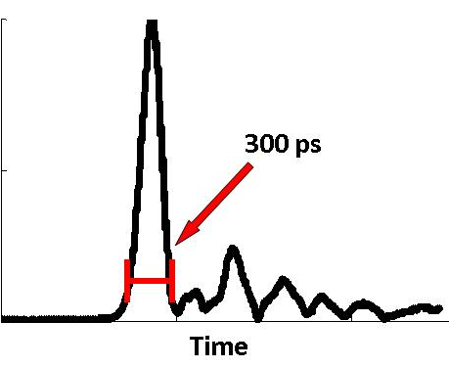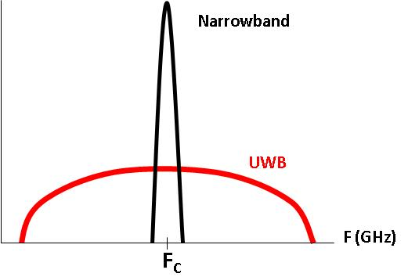
(a) (b)
Figure 2-1: Example of an ultra-wideband signal: (a) time-domain baseband 300 ps wide pulse, (b) frequency domain up-converted UWB pulse compared to typical up-converted narrowband signal.

multipath-ridden indoor environments and also allows for its use in high data-rate digital communication.

Current State of Indoor Wireless Localization Systems
Wireless local positioning has many diverse applications and has been extensively studied [3],[5]. While GPS uses ultra high precision atomic clocks to measure time-of-flight [6], a more standard method for indoor localization systems is time-difference-of-arrival (TDOA), where all of the base stations or receivers are synchronized, and the difference in time is measured between each pair of receivers to triangulate the position of an unsynchronized tag [3]. Two main technologies have emerged as possible solutions for TDOA systems: frequency modulated continuous wave (FMCW) and UWB. FMCW systems can be found both in the literature [7],[8] and as commercial products [10] with various levels of accuracy. For example, Stelzer et al. achieved accuracy of greater than 10 cm for an outdoor application tracking a car around a 500 m² racecar track [7] while Wiebking et al. achieved accuracy around 20 cm for an indoor application covering a 15x25 m² 2-D area [11]. Finally, Roehr et al. achieved accuracy of 1 cm in a line-of-sight (LOS), multipath free environment using a novel chirp technique centered at 5.8 GHz [12]. Meanwhile, interest in UWB for radar applications has increased greatly following the FCC’s decision to open up the bands from 3.1 - 10.6 GHz and 22 – 29 GHz for UWB use in 2002 [4]. UWB technology has inherent advantages for indoor applications in terms of robustness to multipath interference and potential for high ranging accuracy [13].
Commercial systems are already available which utilize UWB sensors for indoor asset tracking. For example, Multispectral Solutions, Inc. has the Sapphire DART system which can operate in indoor environments of greater than 50 m ranges while using TDOA in conjunction with UWB sensors to achieve accuracy of 10 cm [14]. Ubisense has a comparable indoor system which uses UWB in conjunction with TDOA and angle-of-arrival (AOA). It has an operating range of up to 50 – 100 m and can detect sensors with accuracy of 15 cm [15]. Higher accuracy has been reported in the literature for indoor UWB positioning systems. For example, Low et al. achieved centimeter-range accuracy in a 1-D short range indoor LOS environment utilizing UWB pulse signals [16]. Zetik et al. reported sub-mm 1-D accuracy but with only extremely short displacements while accuracy decreased to 1.5 cm for 2-D localization over a 2x2 m² area [17]. Recently, Meier et al. designed a 24 GHz system which uses a Kalman filter combined with correlation and phase information to reduce the uncertainty of a static point to 0.1 mm, although the uncertainty increases to 2 mm when the tag is in motion [18]. These experimental results show that UWB technology has the potential for high precision indoor localization even in harsh environments with significant multipath effects. Commercial UWB systems have localization accuracy of 10 - 15 cm. Certain short-range industrial and medical applications such as dynamic part tracking, structural testing, and 3-D tracking in computer assisted surgery (CAS) require significantly higher accuracy than commercial UWB systems in the mm or sub-mm range.

Commercial Systems
As shown in Table 2-1, current commercial UWB systems can achieve 3-D localization accuracy in the range of 10 – 15 cm. A comparison of the Sapphire DART system from Multispectral Solutions, Inc. and the real-time location system (RTLS) from Ubisense is given in Table 2-1 [14],[15]. As shown in Table 2-1, the two systems share many commonalities including frequency range, operating range, compact tag size, and overall 3-D accuracy. One major difference is the method of digital communication: the Multispectral Solutions, Inc. system uses UWB pulse-based modulation whereas the Ubisense system uses a narrowband 2.4 GHz digital communication scheme (e.g. Bluetooth). Although Bluetooth is a more mature technology than UWB pulse-based modulation, it has a distinct disadvantage in that it is much more susceptible to multipath interference and may experience severe degradation depending on the operating
Table 2-1: Comparison of commercial UWB localization systems with specifications reported for their compact tags.
Company | Frequency Range (GHz) | Operating Range (m) | Tag Size (cm³) | Number of Tags | Refresh Rate (Hz) | Localization Method | Accuracy (cm)
Multispectral Solutions | 5.94 - 7.12 | > 50 | 1.12x 4.01x 2.11 | > 100 | 100 | TDOA | < 10
Ubisense | 5.8 – 7.2 | > 50 | 3.8x 3.9x 1.65 | > 1000 | 20 | TDOA and AOA | < 15
environment of the system. Figure 2-2 shows the two commercial systems. The Multispectral Solutions, Inc. system is shown in Figure 2-2a with the main controller, two base stations, and three different sized tags displayed while Figure 2-2b shows two different sized tags from the Ubisense localization system. It is obvious from Figure 2-2 that these systems are quite comparable and a few distinct trends in commercial indoor localization systems can be inferred:
- Battery operated tags with compact size
  - Low power transmitter architecture and smart power-saving circuitry
- Flexibility in network building schemes
  - Ability to build ad-hoc or self organizing networks
  - Ability to automatically combine sub-networks into an even larger framework
- 3-D accuracy of current systems still limited to cm-range or even tens of centimeters
  - Due to limited sampling rate on receiver side
  - Due also to use of square-law diode detectors at receivers
- Complicated installation with on-site help needed in setting up systems
The limitations of current commercial systems will be revisited when examining state-of-the-art
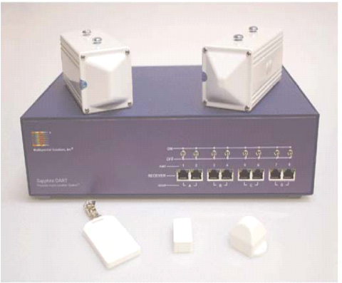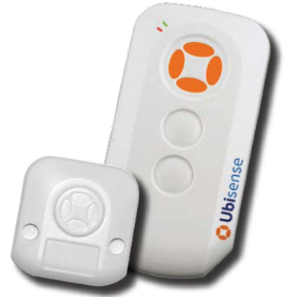
(a) (b)
Figure 2-2: Commercial indoor UWB localization systems (a) Multispectral Solutions, Inc., (b) Ubisense.
in research positioning systems (Section 0) and also the noncoherent UWB positioning system designed for high accuracy indoor applications (Section 2.2).

Research Systems
Competing technologies for high accuracy indoor positioning include frequency modulated continuous wave (FMCW), impulse-based (i.e. carrier-free) ultra-wideband, and carrier-based UWB. Table 2-2 provides a summary of the various research groups utilizing these three approaches for high accuracy indoor positioning. Similar accuracy levels (0.5-20 cm) have been achieved for both carrier-based [18]-[23] and impulse-based [16],[17],[24],[25] UWB positioning systems, although carrier-based systems have shown the potential for mm and sub- mm range accuracy even for 3-D indoor environments (our work [19],[20] and [18],[22],[23]]). FMCW has proven to be a successful competing technology for high accuracy positioning systems [10],[26]-[31]. In the 5.8 GHz band for industrial, medical, and scientific (ISM) applications, documented accuracy of 5-20 cm for 2-D has been achieved [10],[27]-[30]. FMCW systems operating at higher frequencies including 35 GHz and 77 GHz have achieved accuracy levels of 0.1 mm [26],[31], with the system described by Feger et al. working at ranges of up to 10 m [31]. The most recent FMCW trend is a European-wide push to create low power wireless sensor networks built on 5.8 GHz FMCW technology [28]-[30]. It should be noted that in Table 2-2 many of the reported error are standard deviation error, whereas our reported 3-D error are root mean square error (RMSE) referred to an optical system which provides better than 0.3 mm 3-D accuracy. RMSE is a good measure of error resulting from both the accuracy and precision,

Table 2-2: Comparison of current research high accuracy positioning systems.
Research Group/  Company | System Architecture | Frequency (GHz) | Reported  Error | Operating Range
University of Tennessee [19],[20] | Carrier-Based UWB | 5.4-10.6 | 2-5 mm  (3-D) | 5 m/ Indoor
Waldmann et al. [21] | Carrier-Based UWB | 7-8 | 1.7 cm  (1-D) | 10 m/ Indoor
Meier et al. [18],[22] | Carrier-Based UWB | 22.58-25.7 | 0.1-2 mm (1-D) | 8 m/ Indoor
McEwan [23] | Carrier-Based UWB | 5.8 | < 2 mm  (2-D) | 10 cm x 10 cm
Ossberger et al. [24] | Impulse-Based UWB | ~2-7 | 5-10 mm  (1-D) | 5 m/ Indoor
Fujii et al. [25] | Impulse-Based UWB | 3.7-5 | 20 cm  (2-D) | 8 m/ Indoor
Low et al. [16] | Impulse-Based UWB | 3.2-5.2 | 1 cm (1-D) | 8 m/ Indoor
Zetik et al. [17] | Impulse-Based UWB | 0.01-5 | 1.5 cm  (2-D) | 2 m/ Indoor
Stelzer et al. [26] | FMCW and Interferometry | 35 | 0.1 mm  (1-D) | < 1 m/ Indoor
Stelzer et al. [27] | FMCW | 5.8 | 10 cm  (2-D) | 500 m/ Outdoor
Ellinger, Mosshammer et al. [28]-[30] | FMCW | 5.8 | 18 cm  (2-D) | 40 m/ Indoor
Symeo LPR [10] | FMCW | 5.8 | 5 cm (2-D) | 400 m/ Indoor
Feger et al. [31] | FMCW | 77 | 0.1 mm  (1-D) | 1.5 m/ Chamber

i.e., the true unbiased error when data values fluctuate above and below zero.
Ultra-wideband is a promising technology for use in short-range indoor local positioning and wireless data communications. It is well known that very high spatial resolution can be achieved using UWB due to the wide-band nature of the signals. A widely used and low complexity UWB architecture is energy detection (ED), where the UWB signal is transmitted directly through the UWB antenna without up-conversion [25],[32]-[37]. Meanwhile, at the receiver side, the energy detection of the signal is achieved by passing the signal through a square-law device, usually a Schottky or tunnel diode, followed by an integrator and sampler. Figure 2-3 shows the typical UWB receiver architecture using energy detection. However, due to the large bandwidth of the received UWB signal, it is difficult and costly for ED-based receivers to operate at above the Nyquist rate [32]. Typically a fast comparator is used as the sampling device. For example, Buchegger et al. realized an UWB communication link with a data rate of 1.2 Mbps using the tunnel diode detector [33]. Lie et al. realized the leading-edge pulse detection method using a tunnel diode combined with an envelope detector to maintain high accuracy for UWB ranging in a multipath environment [34]. Recently, Fujii et al. achieved a 0.3 ns time resolution using the ED-based impulse detector, corresponding to 0.1 m distance resolution [25].
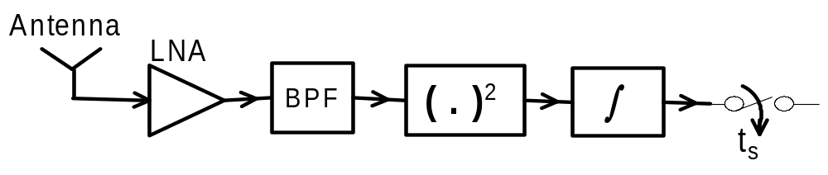
Figure 2-3: Energy detection-based UWB receiver architecture.
Another widely used UWB architecture is carrier-based impulse radio (IR) UWB, where the transmitted UWB signal is up-converted through a microwave carrier, then down-converted at the receiver side [19],[20],[38],[39]. Figure 2-4 shows the carrier-based low complexity UWB receiver architecture. In [38] the demodulator is implemented with a 2-FSK scheme, whereas in [19] the demodulator is realized through a low cost two channel sub-sampling mixer with an equivalent sampling rate of over 100 GSPS [40], followed by a digital signal processing unit implemented through a standard Field Programmable Gate Array (FPGA). However, a problem exists in the amplitude and phase differences between the I and Q channels due to hardware variation between the I and Q receiver chains, which causes distortion of the demodulated signal. Recently, Treyer et al. [41] corrected the amplitude and phase error by using the Hartley phasing-type single sideband modulator, but this method requires relatively complex circuitry and is limited to narrowband applications.
One type of non-coherent UWB receiver architecture was implemented in [23] by McEwan as shown in Figure 2-5. Upon receiving the RF bursts from the transmitter, a timing circuitry called frequency looked loop (FLL) locks the receiver pulse repetition frequency (PRF) clock to the transmitted PRF clock so that both clocks have the same frequency and phase.
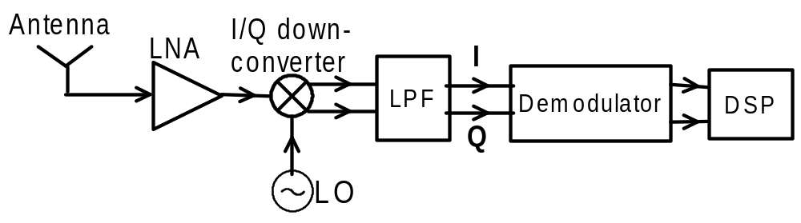
Figure 2-4: Carrier-based non-coherent UWB receiver architecture.
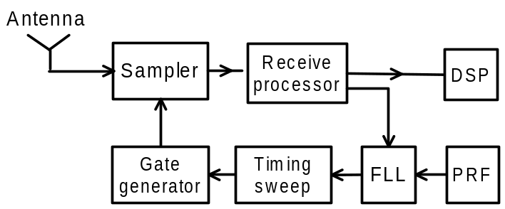
Figure 2-5: Non-coherent UWB receiver architecture using frequency locked loop.
However, the required receiver timing circuitry design is complex and the system is limited to operate at a relatively low carrier frequency to avoid using the expensive samplers needed with high sampling bandwidth.
Another technique is shown in Figure 2-6, where a hybrid UWB receiver architecture combines the carrier-based and ED-based UWB receiver schemes. The down-conversion requires only one channel instead of I and Q channels as compared to Figure 2-4, which lowers system complexity and overall cost.
In Section 2.2, the non-coherent real-time localization system developed at the University of Tennessee using the receiver architecture outlined in Figure 2-6 is discussed in detail. Details on the developed system can also be found in published literature [19],[20],
Oscillator
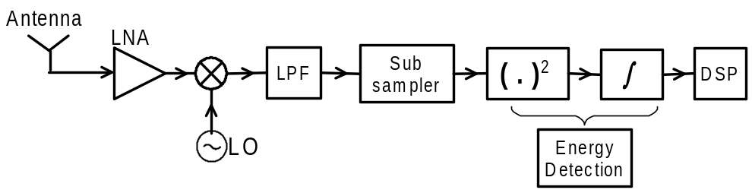
Figure 2-6: UWB receiver architecture which combines the carrier-based and energy detection-based UWB receiver schemes.
[39],[40]. It is based on transmitting and receiving picosecond pulses and then carrying out a complete narrow-pulse, signal detection and processing scheme in the time domain.

Development of the 1st Generation Millimeter Accuracy Real-time Indoor UWB Positioning System
The challenges in developing a millimeter range accuracy real-time non-coherent UWB positioning system include: generating ultra-wideband pulses, pulse dispersion due to antennas, modeling of complex propagation channels with severe multipath effects, need for extremely high sampling rates for digital processing, synchronization between the tag and receivers’ clocks, clock jitter, local oscillator (LO) phase noise, frequency offset between the tag and receivers’ LOs, and antenna phase center variation. For such a high precision system with mm or even sub-mm accuracy, all these effects should be accounted for and minimized. A comprehensive simulation framework has also been utilized in quantifying the accuracy of the system in realistic multipath, indoor environments in terms of the overall sensitivity to the mentioned challenges in achieving high accuracy (see Chapter 3). In this section, the non-coherent UWB positioning system architecture is presented along with methods to mitigate and account for the aforementioned challenges in achieving 3-D real-time millimeter range accuracy.

System Architecture
The complete setup of the non-coherent UWB positioning system is shown in Figure 2-7. The source of the non-coherent UWB positioning system is a step-recovery diode (SRD) based pulse generator with a pulse width of 300 ps and bandwidth of greater than 3 GHz. A detailed discussion of the pulse generator design can be found in [57]. The Gaussian pulse is up-converted with an 8 GHz carrier and then transmitted through an omni-directional monopole UWB antenna. Multiple base stations are located at distinct positions to receive the modulated pulse signal. The received modulated Gaussian pulse at each base station first goes through a directional Vivaldi receiving antenna and then is amplified through a low noise amplifier (LNA) and demodulated to obtain the I signal. Only one channel rather than I/Q is required since energy detection and carrier offsets are also applied at the UWB receiver. After going through a low pass filter (LPF), the I channel is sub-sampled using an UWB sub-sampling mixer, extending the signal to a larger time scale (i.e. μs range) while maintaining the same pulse shape [40]. The PRF clocks are set to be 10 MHz with an offset frequency of 1-2 kHz between the tag and base stations which corresponds to an equivalent sampling rate of 50-100 GS/s. Finally, the extended I channel is processed by a conventional analog to digital
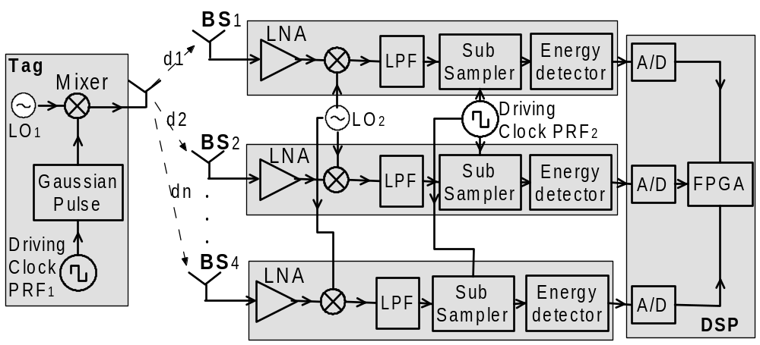
Figure 2-7: System architecture of non-coherent UWB positioning system which includes a carrier-based transmitted signal at the tag and a combination of downconversion and energy detection at the UWB receiver.
converter(ADC) and standard FPGA unit. Leading-edge detection is performed on the FPGA. The time sample indices are sent to a computer where additional filtering and the final time-difference-of-arrival (TDOA) steps are performed to localize the 3-D position of the UWB tag.

Low Phase Noise Local Oscillators
The impact of phase noise from the LOs at the transmitter and receiver has large effects on the resulting performance of the UWB positioning system. Carriers with high and low phase noise performance have been studied at the UWB transmitter and receiver, and the impact of carrier sources with different phase noise performance on the resulting localization system jitter has been analyzed through simulation and measurement. Table 2-3 lists the phase noise performance of three types of LO sources where LO_{A} is a low cost commercial free running MMIC VCO and LO_{B} and LO_{C} are high performance signal generator bench-top instruments. We first consider a static scenario; under this situation the tag is at a fixed position from the base stations. The unsynchronized simulation/experimental setup has been carried out, as shown in Figure 2-8, to study the relationship between the carrier phase noise and system jitter. The jitter was calculated by recording 40 continuous time positions when the comparator is triggered at the rising-edge of a fixed voltage threshold setting at around 50% of the maximum pulse amplitude. The sub-sampled output signal from BS₂ served as the trigger signal for the Tektronix TDS340A oscilloscope. The simple received signal strength (RSS) method with a fixed voltage threshold has been used for pulse detection.
Table 2-4 lists the results of simulated and measured RMS jitter under different
Table 2-3: Phase noise performance of different carrier sources.
Carrier Type | Phase Noise  @1 kHz | Phase Noise  @10 kHz | Phase Noise  @100 kHz
LO_{A} | -46 dBc/Hz | -80 dBc/Hz | -103 dBc/Hz
LO_{B} | -85 dBc/Hz | -90 dBc/Hz | -110 dBc/Hz
LO_{C} | -106 dBc/Hz | -115 dBc/Hz | -115 dBc/Hz

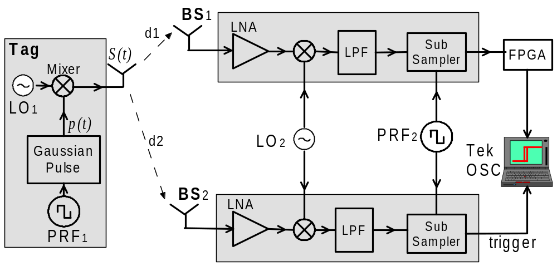
Figure 2-8: Experimental setup to study the relationship between the carrier phase noise and system jitter.
combinations of carrier configurations at the transmitter and receiver. In case II, only replacing the receiver with a low phase noise carrier source has little effect improving the system jitter since the carrier with high phase noise signal is included in the equivalent offset carrier frequency 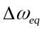. Both the simulated and measured results show a similar trend except for case III. In case III, when low phase noise carriers were used at both the transmitter and receiver, the measured jitter was not reduced as expected according to the simulated results. This is due to the “shoulder” effect, a result of carrier LO phase shift superimposed on the equivalent frequency offset after the down-conversion and sub-sampling process. Maintaining the same setup as in case III, the measured RMS jitter reduced to 7.2 ps when both the modulation factor and the threshold voltage were tailored to minimize the “shoulder” effect. Also, as shown in Figure 2-9, there is an order of magnitude difference in 3-D error when a non-coherent LO base station signal is used compared to having the LO signal coherent at all four base stations when examining the experimental results from the UWB positioning system.

Sub-Sampling Mixer at the UWB Receiver
To detect narrow pulses on the order of a few hundred picoseconds (i.e. 300 ps or 3 GHz bandwidth in our system), analog to digital converters with at least 6 GS/s are needed to satisfy the Nyquist criterion. However, such high performance ADC units are currently either not commercially available or too expensive for most applications. A realistic alternative approach to real-time sampling is to sub-sample the UWB pulses while maintaining the initial pulse

Table 2-4: Jitter performance with different carrier sources.
 | Tx Carrier | Rx Carrier | Measured RMS Jitter | Simulated RMS Jitter
I | LO_{A} | LO_{A} | 56.1 ps | 25.5 ps
II | LO_{A} | LO_{C} | 41.9 ps | 24.0 ps
III | LO_{B} | LO_{C} | 41.1 ps | 1 ps
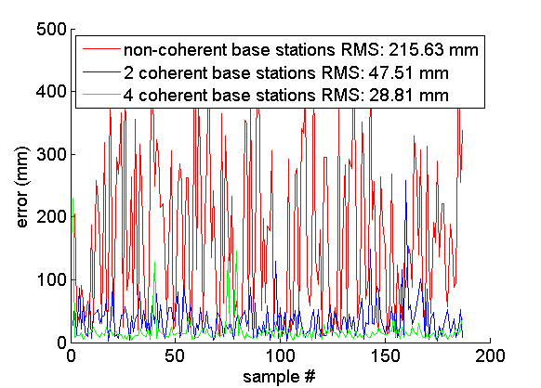
Figure 2-9: Raw data captured using wired PRF clocks and varying levels of LO (8GHz) coherence on each of the 4 base stations [53].
shape through extended time techniques. The extended UWB signals can then be handled by readily available commercial ADCs, reducing overall system cost [42],[43]. We have developed a compact UWB sub-sampling mixer integrated with a fast strobe generator for this purpose [40]. The sampler utilizes a simple broadband balun structure [44] and a balanced topology. Figure 2-10 shows the schematic of the designed sampler.
The designed sampler based on the sub-sampling method uses the same technique as the commercial off-the-shelf (COTS) high speed sampling modules, such as the Tektronix 80E01 [45] and Picosecond 7040 [46]. The comparison between the designed sampler and the commercial sampling modules are listed in Table 2-5. The Picosecond 7040 sampling module, for example, utilized the nonlinear transmission line technique to achieve a fast rise time of 14 ps, and the associated bandwidth of 25 GHz. The 90 ps rise time of our designed sampler is
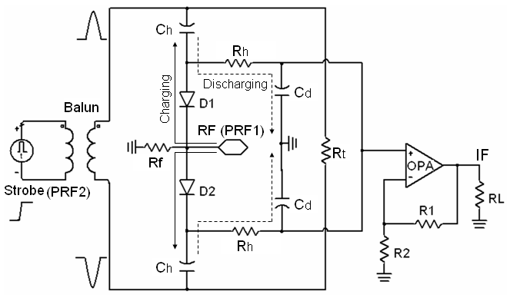
Figure 2-10: Schematic of the sampling mixer highlighting the broadband balun and balanced topology [40].
limited by the SRD transition time and the utilized microwave integrated circuit (MIC) fabrication. However, the designed sampler with 4 GHz bandwidth is adequate to sample a 300 ps pulse signal with a 3 GHz -10dB bandwidth. The compact size of our sampler compared to the commercial samplers in Table 2-5, combined with the low fabrication cost, make it an attractive and necessary alternative to current COTS products. An even wider bandwidth could be potentially achieved by setting a proper gating duration through adjusting the strobe impulse amplitude [40].
For measurement, a direct digital synthesizer (DDS) circuit is used to trigger the strobe-step generator with a pulse repetition frequency (PRF) of PRF₂ =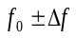. The original transmitted Gaussian pulse has a repetition frequency of PRF₁ ==10 MHz. If the added offset frequency (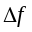) is set to be 100 Hz, the corresponding extending ratio is =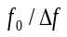=100,000. Noticeable ranging errors can occur during the time extension process due to the stability of PRF₁ and
Table 2-5: Comparison of the designed sampler with commercial sampling modules.
 | Tektronix 80E01 | Picosecond 7040 | Designed sampler
Rise time | 7 ps | 14 ps | 90 ps
Bandwidth | 50 GHz | 25 GHz | 4 GHz
Sampling rate | N/A | Up to 10 MHz | Up to 35 MHz
Fabrication | N/A | MMIC | MIC
Size (cm³) | 13.5x7.9x2.5 | 5.1x3.8x1.3 | 4.3x3.0x2.0
Cost | Very High | High | Very Low

PRF₂. This is due to drifting between the two clocks during the 10 ms interval needed to time extend the signal.

System Clock Jitter and Scaling Effects
The PRF₁ and PRF₂ clock signals (see Figure 2-7) between the tag and receiver in this system are not synchronized. This results in synchronization problems when incorporating the sub-sampling mixer (discussed in Section 2.2.3) since 100,000 pulses are needed to extend the pulse from 300 ps to 30 μs, which corresponds to a 1000 GS/s sampling rate. In our prototyped system, the extended time signal can then be adequately sampled with a 20 MS/s ADC, given the bandwidth of the sub-sampled signal is 0.03 MHz, although in the actual system the 20 MS/s ADC can be replaced by a higher performance ADC (e.g. 24 bit, 250 MS/s). This can potentially increase system performance by reducing quantization error through extending the dynamic range and increasing the sampling rate with little difference in chip and manufacturing costs.
Techniques exist to calculate clock jitter in the time domain given the phase noise of the crystal [47], and crystal manufacturers provide crystal stability specs in terms of parts-per-million (ppm). On the surface, the stability factor would appear to have less of an effect than actual clock jitter. For instance, the stability factor of ±0.5 ppm for the 10.0 MHz Vectron VTC4-A0AA10M000 crystal yields clock jitter of 50 fs [48]. However, the effects of the stability factor are amplified during the sub-sampling process and cause time-scaling to occur.
Any frequency offset occurring between PRF₁ and PRF₂ would cause apparent time-scaling in the sub-sampled signal. The ±0.5 ppm stability of our crystal equates to 5 Hz of variation in the clock signal. This causes the nominal frequency of PRF₁ to be 10.000000 MHz ± 5 Hz and the nominal frequency of PRF₂ to be 9.999900 MHz ± 5 Hz, with the worst case scenario being a difference of 10 Hz between the two signals. If the offset frequency () is set to be 100 Hz, the corresponding extending ratio is α ==100,000. However, with a potential offset of ± 10 Hz, has the potential to be 100 ± 10 Hz, thus α = 100,000 ± 11,111. This time scaling may be time-varying depending on the thermal stability of the clocks, although this is a slow variation with a drift rate of less than 10 Hz, which allows the TDOA algorithm to calibrate such systematic error. Since all the base stations acquire synchronous samples clocked by PRF₂, the time-scaling effect will be unknown, but consistent across receivers. Consequently, the 1-D ranging errors will be roughly ±11%. The TDOA algorithm using time differences will likewise be affected. A simulation was enacted to test the ability to calibrate out the scale factor in a post-processing step. In this simulation, 4-8 base stations in realistic constellations were used to localize a simulated tag trajectory that varied within a volume defined by half of the constellation radius. Using an iterative approach, the TDOA algorithm was allowed to calculate a position using an estimate of the scaling factor, initially set at 100,000. The calculated location was then used to determine a new least squares estimate of the scaling factor, based on the original ranges. Iterating these steps between 3-5 times yielded accuracy consistent with our system’s 1-D accuracy of 1.49 mm of error. This problem has been examined in the field of geolocation [49], and has been likened to multidimensional scaling [50]. In these contexts, this time-scaling problem has been successfully solved even in situations when each receiver undergoes unique scaling, which may indicate that base stations synchronized by PRF₂ are not necessary.
Besides stability, the jitter of these 10 MHz clocks must be examined. When the phase noise is integrated from 1 Hz – 5 MHz using an Agilent E5052A Signal Source Analyzer, RMS jitter for the crystal is found to be between 1 – 1.5 ps [48],[51]. This technique is the most accurate way to measure clock jitter of highly stable crystals. If 1.5 ps of RMS jitter is assumed for both 10 MHz crystals, total system RMS jitter σ_{sys} due to the two unsynchronized clocks of 2.12 ps is obtained
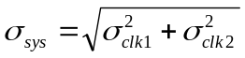 | (2-1)

where σ_{clk1} and σ_{clk2} are assumed to be uncorrelated normal random variables [47],[52] of mean μ = 0 and standard deviation σ = 1.5 ps. The jitter described in (2-1) will cause normally distributed noise of μ = 0, σ = 2.12 ps (corresponds to 0.64 mm error) to be added to each sampled point. A simulation using Agilent ADS2006A has been carried out to study how such jitter affects the sampler performance during the sub-sampling process. Based on the ADS simulation results shown in Figure 2-11, we notice that such jitter would cause tiny signal distortion, and could be significantly reduced after simple digital processing such as a low pass filter. Figure 2-12 outlines the experimental setup used to test the jitter effect caused by the unsynchronized PRF clock signals. A coaxial cable was utilized to connect the pulse generator and the sampler so that no channel noise is included. Figure 2-13 shows the measured time variation of the pulse peak position at consecutive measurement cycles. The peak to peak variation is below 10 ps while the RMS jitter is 3.48 ps. The measured RMS jitter is 1.36 ps larger than the theoretical result of 2.12 ps, which can be interpreted as the added jitter from the sub- sampling mixer, DDS, and ADC circuitry. The measured system clock jitter of 3.48 ps corresponds to 1.05 mm error.
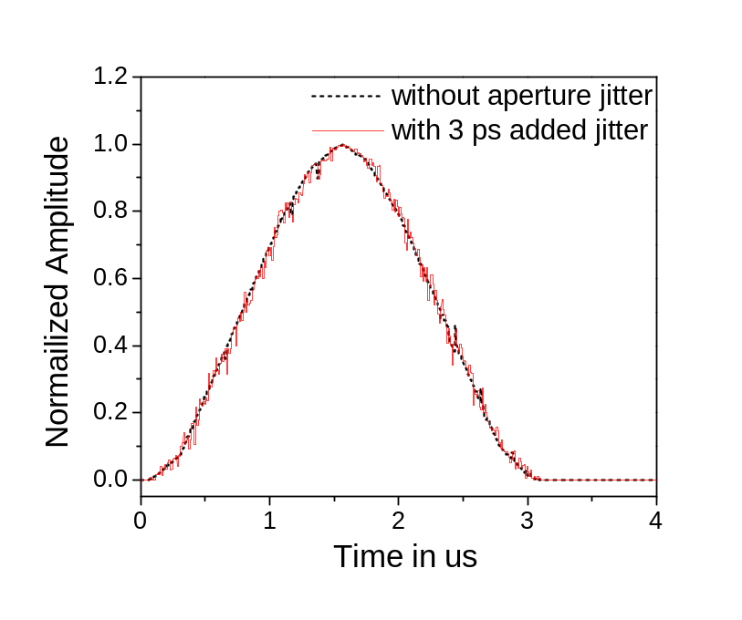
Figure 2-11: ADS simulation of the reconstructed sub-sampled pulse with and without 3 ps of PRF clock jitter.

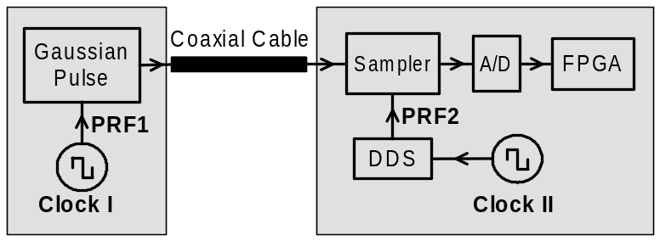
Figure 2-12: Experimental setup with the unsynchronized PRF clock sources to measure the effect of PRF clock jitter.

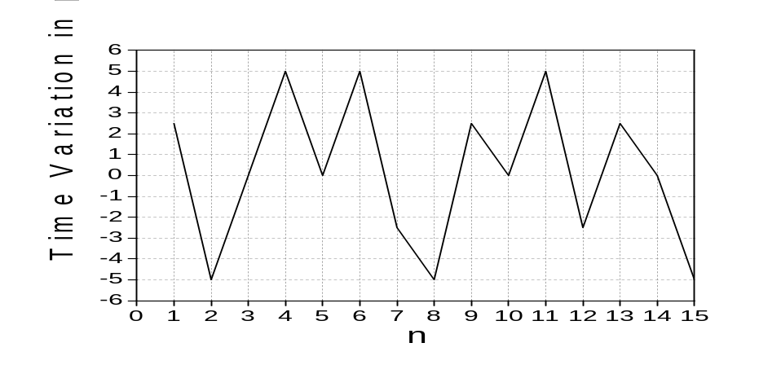
Figure 2-13: Time variation of the pulse peak position acquired over n sample points.

Energy Detection
An important problem of the non-coherent carrier-based UWB system using the single channel approach is the carrier-leakage present in the received signals and its effects on the 1-D ranging of the UWB positioning system. Figure 2-14 shows the single channel output after the sub-sampling process when the tag is put at a static position. The “shoulders” come from the equivalent offset carrier frequency, which modulates the time extended pulse signal 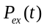. The impact of phase noise from the carrier source has been translated not only as the timing jitter, but also as the “shoulder” amplitude variation of the modulated signal. When the signal
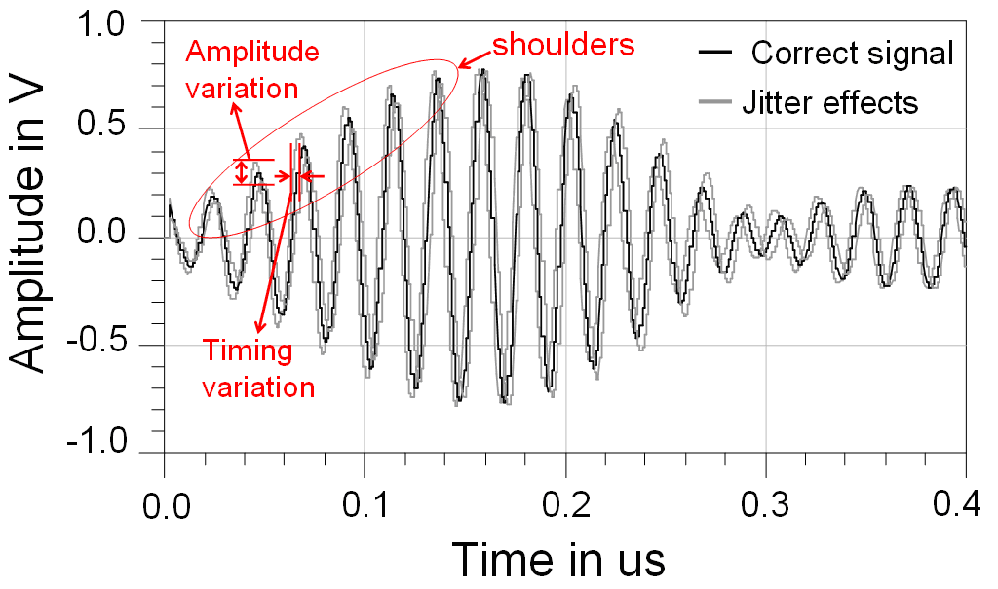
Figure 2-14: The “shoulder effect” in static scenario: the received single channel sub-sampled signal modulated by the equivalent offset carrier frequency.

strength (SS) method with a fixed voltage triggering threshold is used, the random “shoulder” amplitude variation produces another source of error. When the tag is moving, the peak amplitude may vary, causing 1-D ranging errors in accurately detecting the received signal.
To further understand the impact of the “shoulder” effect, the dynamic scenario has been investigated. Under this situation the tag is considered moving continuously away from the base station up to one wavelength at the carrier frequency. In the simulation model, in order to study how the “shoulder” effect responds only to the tag dynamic movement, no phase noise was included in the carriers. Figure 2-15 shows the simulated results where the “shoulder” amplitude experiences a large variation while the tag is moved from 0º to 360º at 60º increments. By setting a fixed threshold, i.e. 0.4 V in both examples, the triggered time delay does not vary linearly with tag movement. As can be seen in Figure 2-15, a large time position error occurs at certain tag positions during the tag movement, which is caused by the “shoulder” amplitude
variation.
In order to reduce system jitter and dynamic error which directly translate into localization error, the “shoulder” effect, for both static and dynamic situations, needs to be minimized. Although the modulated single channel signal, i.e. I_{ex} or Q_{ex}, suffers from “shoulder” amplitude variation, and results in large timing trigger error, the envelope of the modulated signal remains relatively constant and less sensitive to the “shoulder” effect. A simple Schottky diode-based envelope detector is added following the sub-sampler as an energy collector for the time extended single channel signal. The same dynamic simulation setup has been investigated with the tag moving continuously away from the base station up to one wavelength at the carrier frequency. Figure 2-16 shows the simulated results of the same signal as shown in Figure 2-15, but after energy detection. As shown in Figure 2-16, the triggered time position varies linearly with tag movement. The localization error reduced significantly as compared to
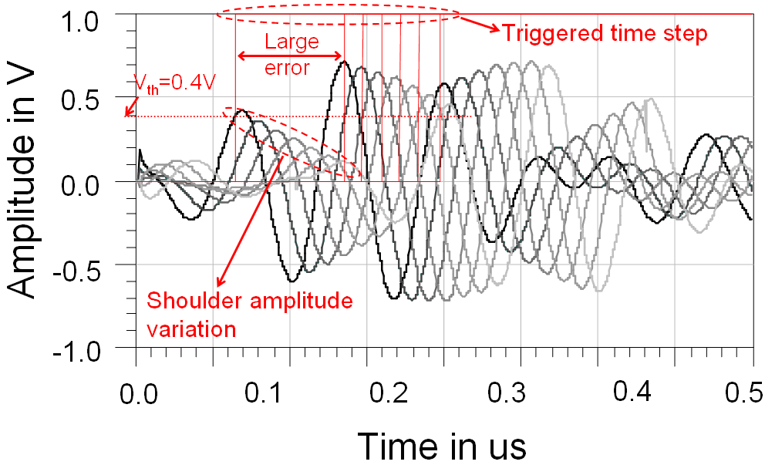
Figure 2-15: “Shoulder” effect when tag is moving one wavelength.
Figure 2-15. The “shoulder” effect has been minimized and the time position output is insensitive to trigger threshold voltage.
Table 2-6 compares and summarizes the two cases from Figure 2-15 and Figure 2-16. The simulated time position errors have been recorded as the tag moves a distance of one wavelength, and the standard deviation errors have been calculated. It shows that the energy detection minimizes the “shoulder” effect and substantially reduces the standard deviation error. No carrier phase noise effects are included in the simulated results.

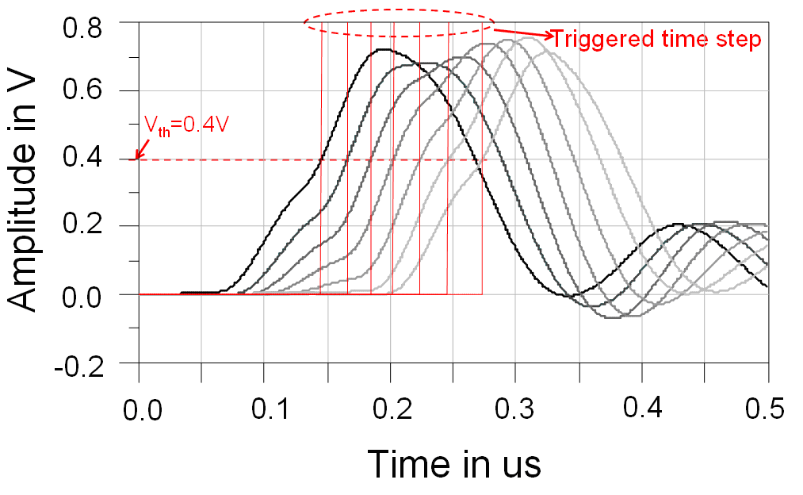
Figure 2-16: The “shoulder” effect is minimized by using energy detection after the sub-sampler when tag is moving one wavelength.

Table 2-6: Simulated standard deviation error for dynamic scenario.
No Energy detection |  | Energy Detection
18.0 ps | 5.40 mm | 2.87 ps | 0.86 mm

Leading-Edge Detection
The leading-edge detection scheme used in the 1st generation UWB system described in Chapter 2 is Merkl’s max-ratio leading-edge detection algorithm [53] outlined in Algorithm 1.
Algorithm 1: Max Ratio Leading-Edge Detection [53]

- Let $h\left(t\right)$ be the received UWB multipath signal as defined by the IEEE 802.15.4a channel model.
(2-2)
$$h\left(t\right)=\sum_{l=0}^{L}{\sum_{k=0}^{K}{a_{k,l}\exp\left(jφ_{k,l}\right)δ(t-T_{l}-τ_{k,l})}}$$
- $h\left(t\right)$ is converted to digital by a 105 MSPS, 10 bit ADC providing 1024 discrete values and denoted $h[t]$.
- $h[t]$ is passed through a 16-element averaging window
(2-3)
$$y[t]=avewindow(abs(h\left[t\right]),16)$$
where $avewindow(x,n)$ denotes the function which averages the signal for a window size n and $abs()$ takes the absolute value of the original signal $h[t]$ [53].
- The averaged signal $y[t]$ then goes through two maximum window filters of sizes $n_{1}$ and $n_{2}$ samples
(2-4)
$$max_n_{1}[t]=maxwindow(y\left[t\right],n_{1})$$
(2-5)
$$max_n_{2}[t]=maxwindow(y\left[t\right],n_{2})$$
where $maxwindow(x,n)$ denotes the function which returns the maximum for a given window size n. For the original algorithm $n_{1}=16$ and $n_{2}=272$.
- A binary ratio is obtained
$$r\left[t\right]=(max_n_{1}[t]*α>max_n_{2}\left[t\right] \&\&$$
(2-6)
$$max_n_{2}\left[t\right] >thresh)$$
where $α$ is a fixed threshold (currently set to two), $thresh$ is an estimate of the noise defined in (2-7), and $r\left[t\right]$ is the final binary value indicating whether or not a leading-edge has been detected [53].
(2-7)
- $thresh⁡=n_{noise}+ t_{switch}⁡$
where $n_{noise}$ is an estimate of the current noise level and $t_{switch}$ is a manually set threshold which can be set to 2^{n} for n=0,1,2,..,8, typically set to n=0.
Simulated results from the basic leading-edge detection algorithm are shown in Figure 2-17 for three different ADCs versus signal-to-noise ratio (SNR) in an industrial LOS environment defined by the IEEE 802.15.4a channel model with $α=2$. As shown in Figure 2-17, the basic leading-edge detection algorithm fails for $SNR<6dB$. Conversely, for $SNR>6dB$, sub-mm accuracy is achieved with the algorithm functioning properly. More information on the comprehensive simulation framework is presented in Chapter 3. Figure 2-18 shows the two max windows used in leading-edge detection on an example received multipath UWB signal.

UWB Antenna Phase Center Error
Accounting for antenna phase center variation at the transmitters and receivers is critical for performance in high accuracy localization systems. Ideally all frequencies contained in the pulse are radiated from the same point of the UWB antenna and thus would have a fixed phase center [54]. In this case, all frequencies travel the same distance within the same time, and the pulse can be received undistorted.
In practice, however, the phase center varies with both frequency and direction. For
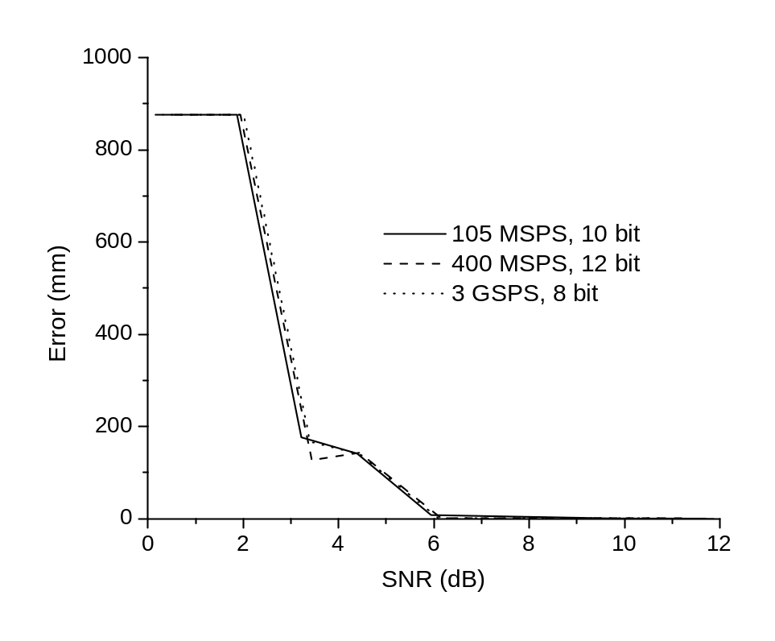
Figure 2-17: Simulated leading-edge detection 1-D error versus SNR of received UWB pulse for three ADCs with sample rates of 105 MSPS, 400 MSPS, and 3 GSPS in an industrial LOS environment.

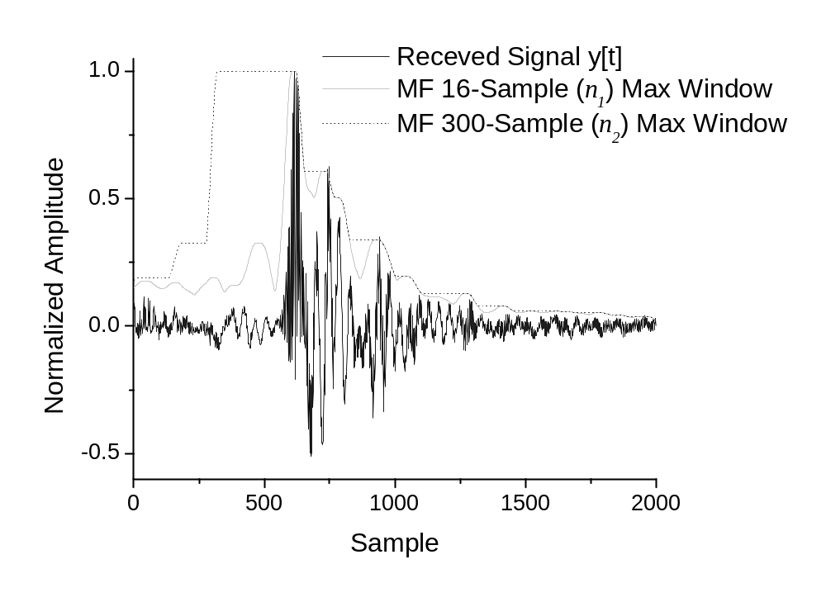
Figure 2-18: Leading-edge detection on a received multipath UWB signal where the two max windows can be seen, $max_n_{1}[t]$ and $max_n_{2}[t]$.
localization systems that require high accuracy, this can result in significant localization errors. For example, to compensate for phase center variation in GPS antennas, automated high precision robots are used in a calibration procedure to move a GPS antenna into 6000 – 8000 distinct orientations [55]. In the case of our transmitting antenna, which is an UWB monopole, phase center variation is less than 1 mm and is considered negligible (both across the frequency band from 6 – 10 GHz and as the azimuth angle is varied). Phase center variation along the broadside direction was simulated to estimate the axial position of the Vivaldi phase center. Figure 2-19 shows the simulated phase center variation over the desired frequency band at broadside using CST software, with the original point set at the input of the Vivaldi antenna, as shown in Figure 2-20. The variation in phase center over frequency can be further reduced by placing a dielectric rod over the end-fire portion of the Vivaldi antenna [56]. The average phase center position across the frequency band of 6 – 10 GHz is obtained at 39.5 mm which is later used as the “apparent phase center” in directivity-dependent phase center measurements.
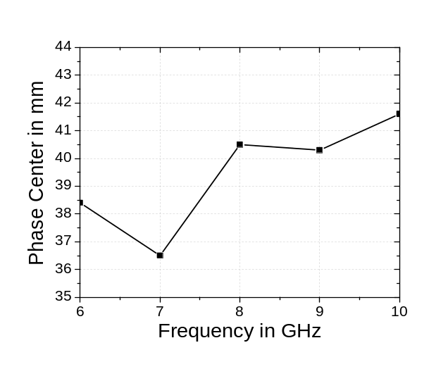
Figure 2-19: Simulation of broadside Vivaldi phase center location versus frequency.
Since the UWB pulse contains broadband frequency information, a more accurate method for defining the phase center variation of the Vivaldi antenna is to employ time domain techniques. As shown in Figure 2-20, an experiment was setup in an anechoic chamber to quantify how the phase center is affected by the directivity based on time domain measurement. Both transmitting and receiving Vivaldi antennas were put face to face and separated by a distance of 1.5 m. The receiving antenna was rotated around the calculated “apparent phase center” (at 39.5 mm, shown in Fig. 17) from 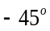 to 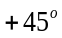 at per step. The apparent phase center was tracked on the receiving Vivaldi antenna as it was rotated from to with an optically tracked probe. These reference points from the optical system were used to calculate the actual center of rotation during the experiment. This allowed changes in the actual phase center as the receiving antenna was rotated to be separated from physical movement of the apparent phase center, shown in Figure 2-20.
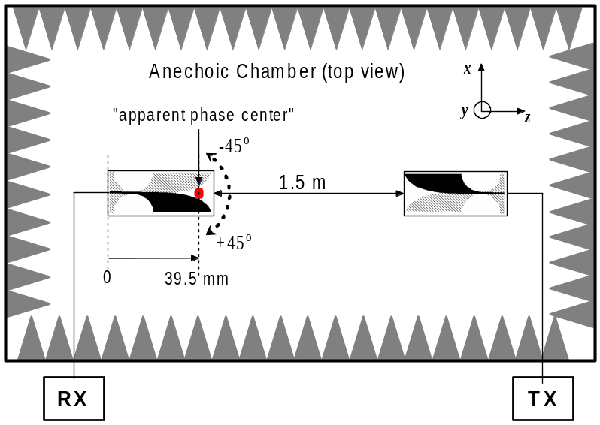
Figure 2-20: Experimental setup of Vivaldi antennas in an anechoic chamber used to measure Vivaldi antenna directivity-dependent phase center variation.
Figure 2-21 shows the measured phase center displacement for both the E and H cuts. As shown in Figure 2-21, the measured phase center variation versus rotating angle indicates a small phase center variation of less than 2 mm within 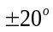 while the variation degrades dramatically with an angle greater than 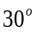. TDOA-related error due to this phase center error can be minimized by varying the number of base stations and their orientation in a standard size room. Additionally, other techniques to calibrate out the phase center error in a practical system by either assuming or measuring orientation for each base station is required to achieve sub-mm accuracy.

Time Difference of Arrival
Algorithm 2: TDOA Algorithm
There are four receivers at known positions R_{x1} or (x₁, y₁, z₁), R_{x2} or (x₂, y₂, z₂), R_{x3} or (x₃, y₃, z₃), and R_{x4} or (x₄, y₄, z₄), and a tag at unknown position (x_{u}, y_{u}, z_{u}) (Figure 2-22). The measured distance between four known receivers to the unknown tag can be represented as ,
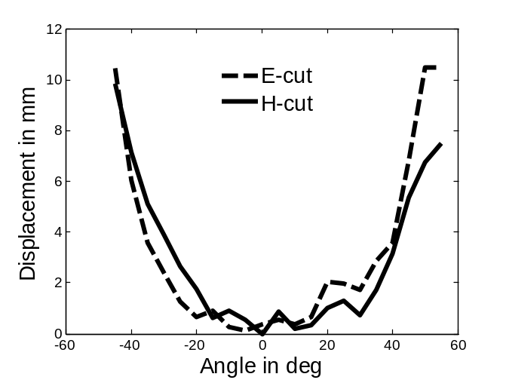
Figure 2-21: Measured Vivaldi phase center error versus angle for E-cut and H-cut.
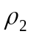, 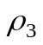, and 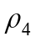, which is given by
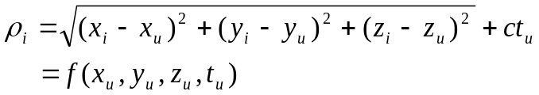 | (2-8)
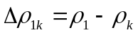  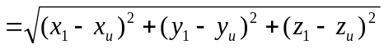  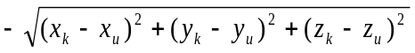 | (2-9)
where i = 1, 2, 3, and 4, c is speed of light, and t_{u} is the unknown time delay in hardware. The differential distances between four receivers and the tag can be written as

where k = 2, 3, and 4, and the time delay t_{u} in hardware has been cancelled. Differentiating this equation will give
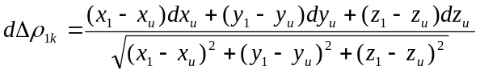  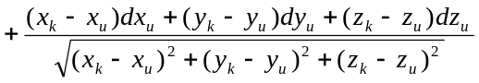  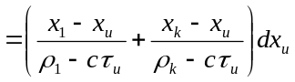  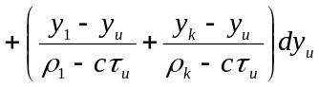  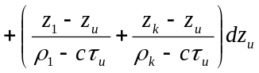 | (2-10)
In (2-12), 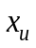, 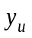, and 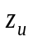 are treated as known values by assuming some initial values
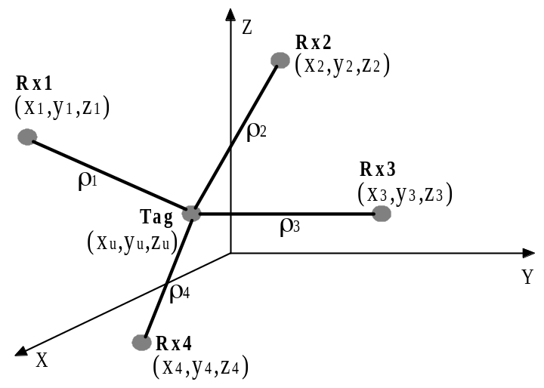
Figure 2-22: Calculation of tag position based on TDOA approach.
for the tag position. 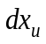, 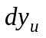, and 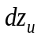 are considered as the only unknowns. From the initial tag position the first set of , , and can be calculated.
These values are used to modify the tag position, , and . The updated tag position, , and can be considered again as known quantities. The iterative process continues until the absolute values of , , and are below a certain predetermined threshold given by
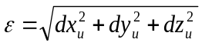 | (2-11)
The final values of , , and are the desired tag position. The matrix form expression of (2-12) is
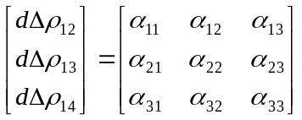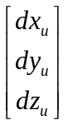 | (2-12)
where
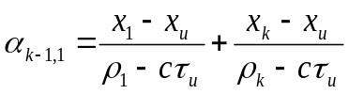  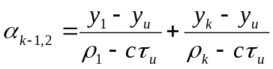  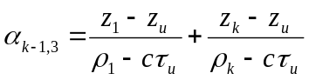 | (2-13)
The solution of (2-13) is given by
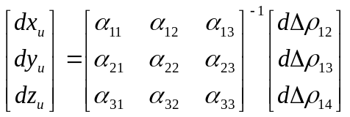 | (2-14)
where [ ]⁻¹ represents the inverse of the  matrix. If there are more than four receivers, the least-squares approach can be applied to find the tag position.

Real-Time Experiments
Two 3-D experiments with unsynchronized LOs and PRF clock sources were carried out, where a minimum of four base stations are needed for the 3-D measurements. The signals from the sub-sampler are then fed to the FPGA which uses the leading-edge detection algorithm to locate the pulse positions (Section 2.2.6).

3-D Dynamic Free Motion
Figure 2-23 shows a four base station setup where the 3-D positions were measured for each base station utilizing the Optotrak 3020 system, which also serves as a reference for comparing the 3-D real-time accuracy of our UWB localization system. The Optotrak 3020 has 3-D real-time accuracy of better than 0.3 mm. It should be noted that the spatial spread of the base stations along the z-axis is the largest (2498 mm), while the x-axis is the smallest (1375 mm). In the dynamic mode, the tag is moving randomly inside the 3-D space indicated in Figure 2-17. The 3-D motion of the tag is then plotted and UWB measurements are compared with Optotrak measurements. RMSE is used to report the error since it is the true unbiased error when data values fluctuate above and below zero. Figure 2-24 plots the UWB trace and Optotrak trace in the 3-D dynamic mode.
Figure 2-25 shows the 3-D dynamic errors in the x, y, and z axes over 1000 measured points. The overall 3-D RMSE is 6.37 mm. The error along the x-axis contributed most to the overall distance error, which can be explained by the limited spatial spread of base stations along the x-axis and can be calculated using the PDOP definitions in [19]. Such error can be easily mitigated through better arrangement of the base stations along the x-axis.
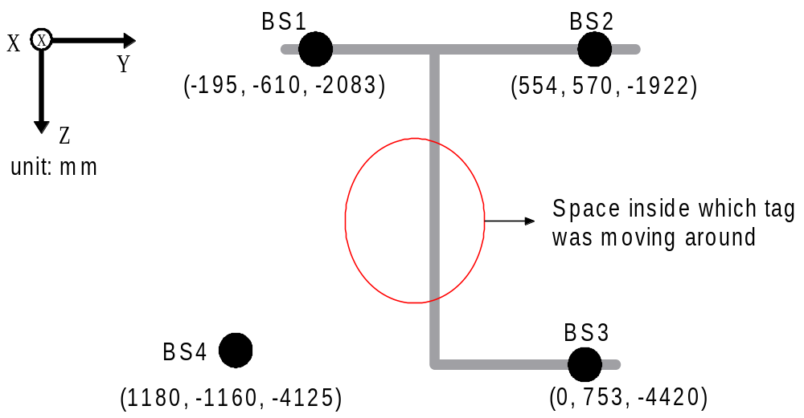
Figure 2-23: 3-D unsynchronized localization experiments, 4 base station distribution with locations for each base station.

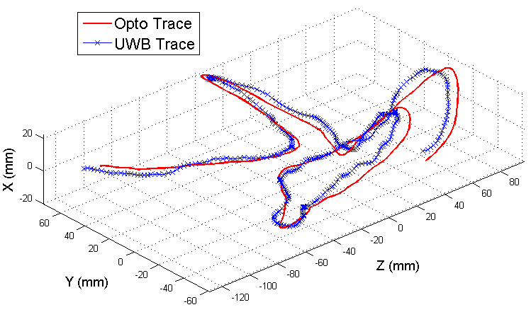
Figure 2-24: 3-D dynamic random mode with energy detection. UWB trace is compared to Optotrak trace.

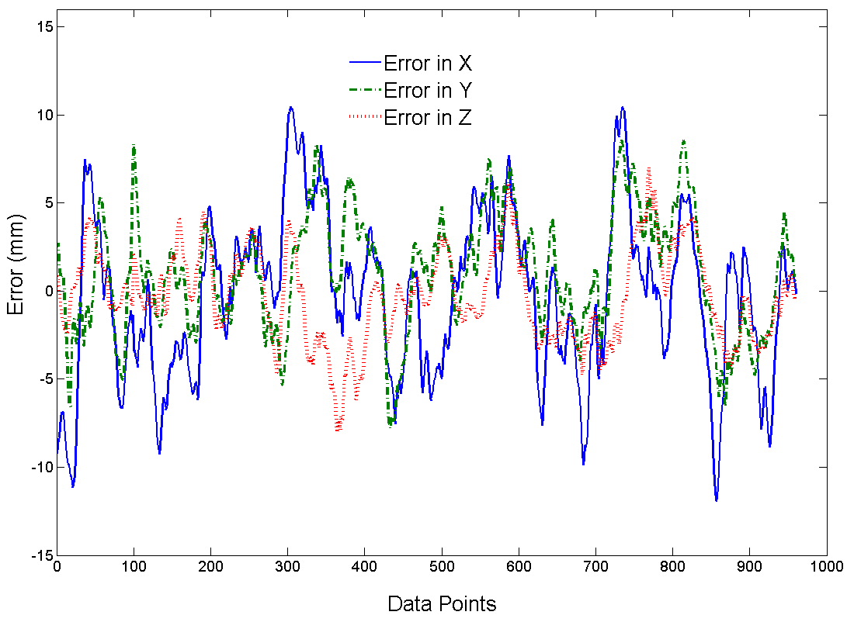
Figure 2-25: 3-D dynamic mode with energy detection. x, y and z axes error compared to Optotrak measurements.

3-D Robot Tracking
The next non-coherent 3-D experiment is to dynamically track the robot position. The experimental setup is shown in Figure 2-26. The monopole antenna and the reference Optotrak probe are tied together and then fixed to the arm of the CRS A465 robot. A block diagram of the experiment is shown in Figure 2-27. A zoomed-in look at the robot arm is shown in Figure 2-28. Finally, the base stations can be seen in Figure 2-29. The robot was pre-programmed to specifically cover 20 distinct static positions in a 3-D volume, stopping for three seconds at each position and then moving to the next position and so on. The measured traces by the UWB system are compared to the Optotrak reference system as shown in Figure 2-30. Figure 2-31 shows the 20 distinct static positions taken by both the UWB and the Optotrak systems. The overall dynamic 3-D robot tracking RMSE is 5.24 mm. In Table 2-7 the real-time non-coherent 3-D experimental results are summarized under various scenarios. The reported RMSE are based on 1000 continuous data points recorded and compared to the Optotrak 3020 system, which served as the real-time reference of our UWB localization system and provides a 3-D accuracy of better than 0.3 mm.

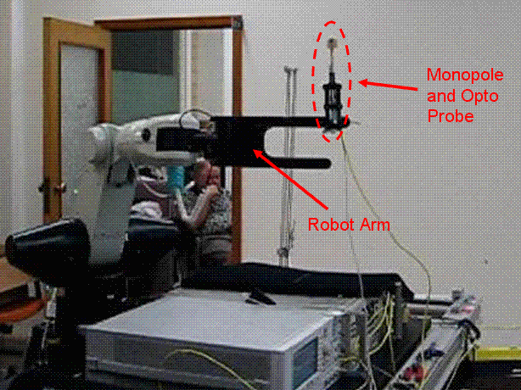
Figure 2-26: Experimental setup of robot tracking using the developed non-coherent UWB system.

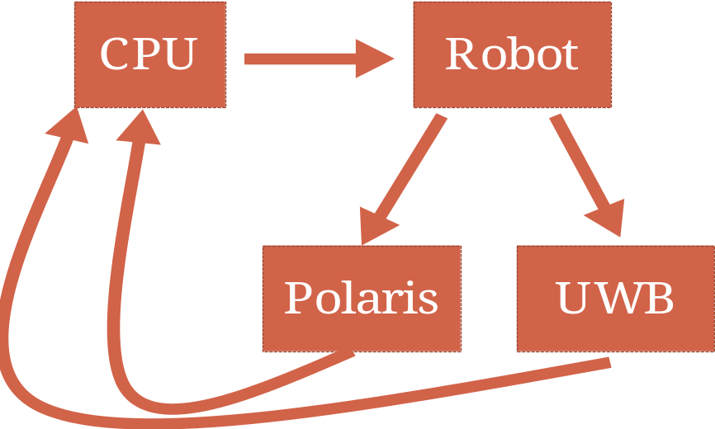
Figure 2-27: Block diagram of experimental setup outlining the role of a computer to control the robot and obtain and process data from the UWB and optical tracking systems.

Figure 2-28: Robot arm with UWB monopole and optical tracker attached.

Figure 2-29: Experimental setup outlining base station positions.

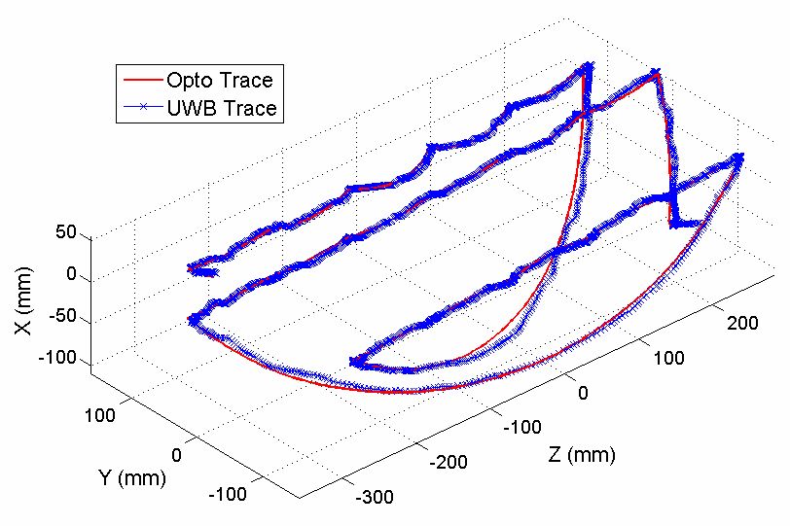
- 3-D view

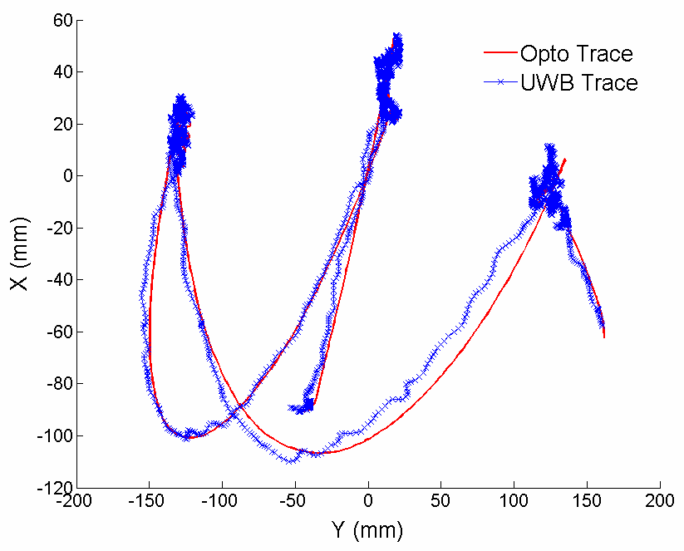
(b) XY plane

Figure 2-30 continued

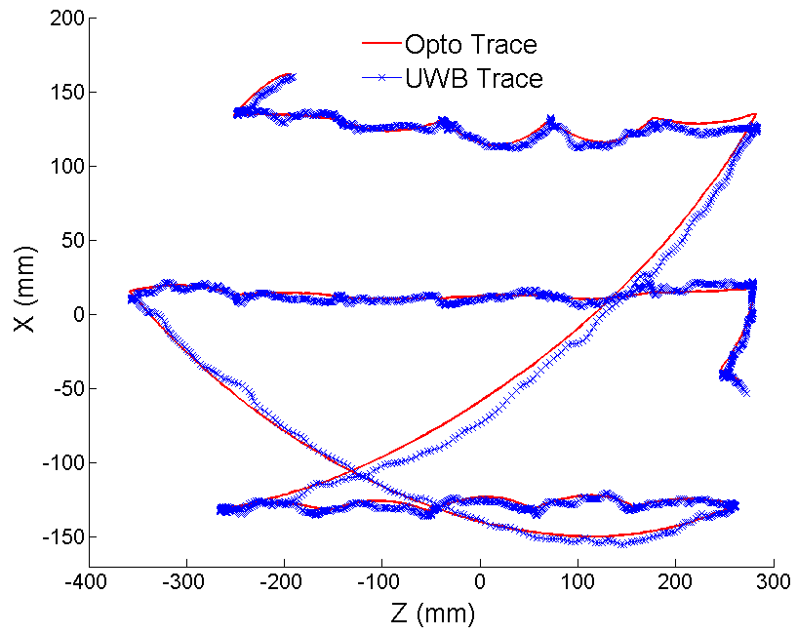
(c) XZ plane

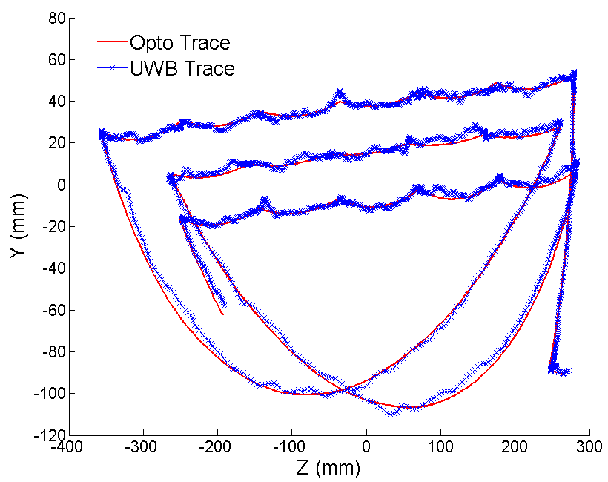
(d) YZ plane
Figure 2-30: 3-D dynamic robot tracking. UWB trace compared to Optotrak trace: (a) 3-D view; (b) XY plane; (c) XZ plane; (d) YZ plane.

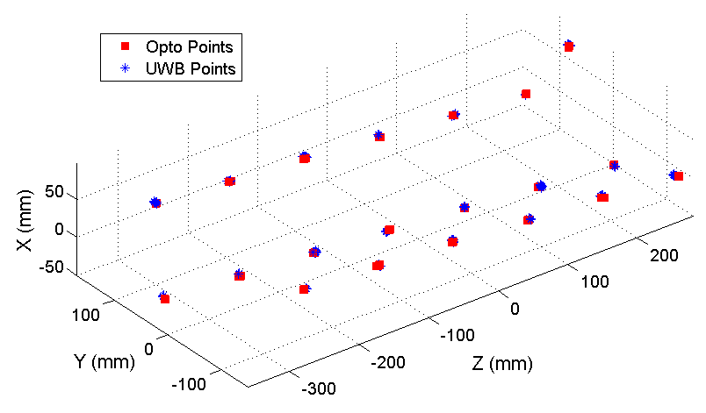
Figure 2-31: 3-D robot tracking at static positions. UWB points compared to Optotrak points.

Table 2-7: Error Summary – 3-D unsynchronized localization experiments.
3-D Experiments | RMSE (mm)
Tag free random motion | 6.37
Robot dynamic tracking | 5.24
Robot static positions (20 distinct locations) | 4.67
Static position w/ 106 times of average | 1.98

A System-Level Simulation Framework for UWB Localization
UWB positioning systems have inherent advantages when applied to indoor environments, most notably their robustness to multipath interference. A need exists within the radio frequency identification (RFID) market (total projected revenue in 2009 of 5.56 billion USD) for high accuracy, indoor, real-time 3-D location information [2]. Clark et al. ran an experiment where five indoor positioning systems (narrowband signal strength, Wi-Fi, ultrasound, RF, and UWB) were tested in multiple locations inside an operating room at a hospital and compared for their performance in 3-D indoor localization [58]. The UWB system (Ubisense [15]) was the only system of the five to consistently achieve 3-D positioning accuracy of less than a meter. The most notable commercial UWB indoor localization systems are the Sapphire DART system from Multispectral Solutions, Inc. (MSSI), the real-time location system (RTLS) from Ubisense, the PLUS system from Time Domain Corp., and the DecaWave RTLS, shown in Table 3-1 [14],[15],[59],[60]. The Symeo LPR-2D is a positioning system based on frequency modulated continuous wave (FMCW) technology with performance comparable to commercial UWB positioning systems [10]. As shown in Table 3-1, many different positioning techniques are used in these systems including time-difference-of-arrival (TDOA), angle-of-arrival (AOA), time-of-arrival (TOA), and return-time-of-flight (RTOF) [3].
Wireless positioning systems have also received a large amount of attention among research groups. This includes systems built using impulse-based (i.e. carrier-free) UWB, carrier-based UWB, and FMCW. An excellent comparison of various systems designed by research groups using these approaches can be found in [20]. We have designed and tested a
Table 3-1: Comparison of commercial wireless indoor positioning systems.
Company | Freq (GHz) | Range (m) | Tags | Localization Method | Accuracy (cm)
Ubisense [15] | 5.8 – 7.2 | 50 | >1000 | TDOA and AOA | < 15
MSSI [14] | 5.9– 7.1 | 50 | >100 | TDOA | < 10
Time Domain [59] | 6.1 – 7.1 | 30-58 | 8000 | TDOA | 30-90
DecaWave [60] | 3.5-7 | 70-500 | 11,000 | TOA and TDOA | < 10
Symeo [10] | 5.7-5.9 | 400 | n/a | RTOF | 5

carrier-based UWB indoor positioning system which outperforms current commercial systems by an order of magnitude (i.e. mm-range 3-D accuracy) [19],[20],[61],[62]. This system uses a unique non-coherent approach where only one channel is downconverted instead of an I/Q downconversion process [20]. This is combined with a novel sub-sampling mixer [40] to time extend the UWB signal and make it easier to sample with a conventional analog-to-digital converter (ADC) (e.g. 105 MSPS, 10 bit). The final step in our implementation is a novel leading-edge (LE) detection algorithm which locates the rising edge of the incoming UWB pulse and is extremely robust to multipath interference [53],[63],[64]. The experimental results from this system show its mm-range accuracy to be intact even in a dynamic experiment where the transmitter is allowed to freely move about in 3-D [20].
A novel simulation framework is utilized to simulate the complete UWB positioning system in realistic indoor channel environments [65]. This includes the analog and digital portions of the UWB transmitter and receiver, the UWB antennas, the UWB indoor channels, and the final index filtering and TDOA calculations done on a computer. This simulation framework utilizes Advanced Design System (ADS) from Agilent [66] which combines RF/transient simulations with Ptolemy for discrete time or digital simulations. Finally, ADS also includes Matlab and Verilog cosimulation tools which are utilized in adding realistic UWB channel effects (from the IEEE 802.15.4a channel model), postprocessing the data, and running realistic digital signal processing (DSP) algorithms (e.g. leading-edge detection) at the UWB receiver. Table 3-2 provides a summary of research groups and different methodologies for system-level simulations of wireless communication and radar systems. The novel aspects of this work compared to the others outlined in Table 3-2 related to radar and positioning systems includes the addition of realistic UWB channel effects from the IEEE 802.15.4a channel model, incorporation of antenna effects including radiation patterns and phase center variation, and simulation of actual experimental setups which allows direct comparison to experimental results. More discussion on the various methodologies shown in Table 3-2 is presented in Section 3.1.

Simulation Framework
Many challenges exist in performing a comprehensive system-level simulation of a UWB positioning system. As shown in Figure 3-1, in order to simulate the entire system, both the analog and digital portions must be taken into account. As mentioned by Eberle [67], varying

Table 3-2: Comparison of wireless system-level simulation methodologies.
Research Group | Type of System | Simulation Framework | Portions of System Simulated
This Work | UWB Indoor Positioning | ADS Ptolemy/  ADS Transient/ Matlab/Verilog | Analog, Digital, UWB Channel
Eberle [67] | Wireless Communication (non-UWB) | FAST/OCAPI/ Matlab | Analog, Digital, Channel
Kürner et al. [68] | THz Communication System | ADS Ptolemy/  ADS Transient/ Matlab | Analog, Digital, Channel
Tüchler et al. [52] | CMOS UWB Positioning System | CMOS Simulator/ Matlab | Digital, UWB Channel
Lecointre et al. [69] | Digital UWB Communication Rx | VHDL Simulator/ Matlab | Digital, UWB Channel
Zhai et al. [70] | UWB Communication/Radar | ADS Ptolemy/  ADS Transient/ FDTD/MOM | Analog, Digital, Channel
Manzi et al. [71] | UWB Communication/WLAN | Simulink | Analog, Digital, Channel
Jue et al. [72] | Chirped Radar/  SatCom Interferer | ADS Ptolemy/  ADS Transient/ Matlab/HDL | Analog, Digital, Channel

levels of complexity exist when accurately simulating a mixed signal system from the ground up. As shown in Figure 3-1, these varying levels of complexity (e.g. transistor/device level, component level, and overall system level) must be considered when designing a system-level simulation framework. Besides the analog and digital portions of the system, other disparate effects must be considered including the UWB antennas. This includes polarization effects, phase center variation, and radiation pattern effects. The UWB channel is exceedingly important in indoor environments because of the dense number of scatterers which causes non-trivial multipath interference and even NLOS conditions. The tag and base station positions must also be considered since geometric position dilution of precision (PDOP) degrades overall 3-D positioning accuracy. The final time-difference-of-arrival (TDOA) or time-of-arrival (TOA) calculation must also be performed in order to simulate actual system performance.
No simulation tools exist which have the capability to simulate all of these disparate components. One approach outlined by Eberle is the use of FAST (an optimized system-level front-end simulation C++ API for digital telecom applications) combined with an extensive OCAPI library which takes high level C++ code, representing the design of a certain digital architecture, and translates it through a multi-step process from floating point to fixed point to VHDL [67].
Incorporating OCAPI in this process maximizes the potential for code re-use, essential in the design of digital systems. The complete framework wraps FAST and OCAPI with a Java middle layer and a Matlab GUI and provides a robust and complete simulation tool that has
Figure 3-1: Overview of components which need to be taken into account when performing a system-level comprehensive simulation of our UWB positioning system.

been successfully used in transceiver simulation and design [67],[73],[74]. Unfortunately, this simulation framework is not commercially available and requires a large team of scientists and computer programmers to implement.
A more feasible solution for a research or design group with a limited number of RF/Microwave engineers is to utilize an existing electronic design automation (EDA) suite such as Advanced Design System from Agilent Technologies [66]. ADS offers an extensive RF/Analog simulation framework for simulating RF front-ends which includes tools for transient, envelope, harmonic balance, frequency, and intermodulation distortion simulations. ADS also has an integrated Ptolemy simulator for discrete time digital simulations with extensive digital signal processing (DSP) libraries. Transient simulations can be embedded within discrete time Ptolemy simulations. Finally, co-simulation of the Ptolemy framework with Matlab and Verilog simulators provides a comprehensive simulation framework where analog, digital, and advanced signal processing with Matlab and Verilog can be integrated together for complete system solutions. Although the co-simulation functionality is relatively new, it has already started to see use both in industry and academia. Examples include modeling of high speed serial links [72], modeling of an X-band satellite uplink signal, and a chirped radar system with interference from a satellite uplink [75]. Kürner et al. utilized a comprehensive simulation framework for THz communication systems constructed in a similar fashion to the framework outlined in this work [68]. Finally, Zhai et al. used ADS for mixed signal simulation of a time-reversal UWB system with potential use in radar and communications applications [70].
Figure 3-2 shows the proposed simulation framework utilized in comprehensively simulating the UWB positioning system. The initial UWB transmitter and receiver positions and orientations are defined in Matlab. ADS is then used for simulating the UWB transmitter outlined in Figure 3-3. After obtaining a pulse train from the UWB transmitter, the signal is sent back to Matlab where effects from the Tx and Rx UWB antennas as well as the indoor UWB channel are added using the IEEE 802.15.4a channel model for channel effects. More information on this process is given in Section 3.2. The pulse train is sent back into ADS where the signal is processed by the UWB receiver. This includes all of the RF/Analog components outlined in Figure 3-3 as well as the sampling mixer, where the train of pulses is sub-sampled to produce a time-extended signal. After passing through the ADC, the signal is sent back into either the Verilog or Matlab co-simulator for field programmable gate array (FPGA) leading-edge or peak detection (the different receiver algorithms are compared in Section 3.2.2). Next, a new pulse train with time-extended pulses is created and system jitter and additive white Gaussian noise (AWGN) are added. A 21-sample median inter-quartile range (MIQR) filter is applied to the pulse train. The final TOA or TDOA calculation is performed in Matlab with 5x averaging using the specified transmitter and receiver positions and orientations to complete the simulation.

System Architecture
The designed system is inherently a mixed signal system. Therefore, the analog portion of the transmitter and receiver is presented first, followed by an overview of the digital
Figure 3-2: Block diagram of overall system simulation outlining the different portions of the system simulated in Matlab, Agilent ADS, and Verilog.
processing carried out on the receiver-side which includes real-time DSP on a FPGA and further post-processing, including the final TDOA calculation done on a computer.

Tx and Rx Analog Front-Ends
The transmitter and receiver architectures for the UWB positioning system are shown in Figure 3-3. A 10 MHz clock signal is generated from a Vectron VTC4 temperature controlled oscillator and triggers a step-recovery diode (SRD) to generate a 300 ps Gaussian pulse [20]. Next, the UWB pulse is upconverted by a low phase noise LO (Agilent E8257D signal generator, LO₁) using a double balanced Hittite HMC553 mixer. After passing through two stages of amplification using a Hittite HMC565 low noise amplifier (LNA) and a Hittite HMC441medium power amplifier (MPA), the signal is transmitted via a broadband, omni-directional monopole antenna [76]. Figure 3-4a shows the baseband Gaussian pulse while Figure 3-4b shows the modulated pulse after going through the transmitter chain including the UWB monopole antenna, with the final transmitted signal denoted $x(t)$.
Next, the signal goes through the UWB channel, which can be described in various ways depending on the application. For instance, an ideal channel where no pulse distortion and only frequency independent pathloss is incurred is used in Section 3.3.2 so that other system-related effects such as the LO frequency offset, phase shifts between I and Q channels, and the performance of various peak detection algorithms can be examined. One standard technique for modeling noise in an UWB channel is the addition of AWGN [77], although Ricean and Rayleigh fading channels are more widely accepted since they can model multipath interference

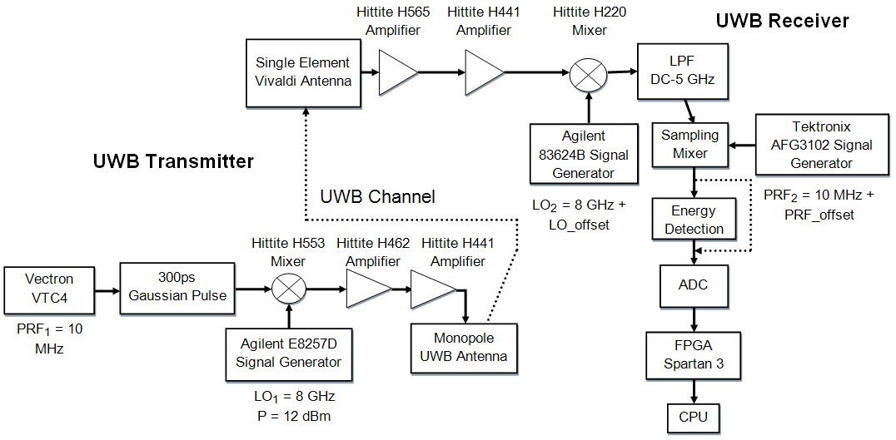
Figure 3-3: Block diagram of UWB transmitter and receiver architectures including the UWB channel.

with and without a LOS signal [78]. The most widely accepted indoor UWB channel model was devised by the IEEE 802.15.4a task force and models multipath interference by groups of clusters which are composed of individual rays [79],[80] for different environments including industrial, residential, etc. In order to add channel multipath effects, the transmitted signal $x(t)$ is convolved with the channel impulse response
$$y\left(t\right)=x\left(t\right)⊗h\left(t\right)$$ | (3-1)
where $y(t)$ is the transmitted signal with the addition of channel-dependent multipath. $h(t)$ is the complex baseband impulse response of a received UWB signal as defined by
$$h\left(t\right)=\sum_{l=0}^{L}{\sum_{k=0}^{K}{a_{k,l}\exp\left(jφ_{k,l}\right)δ\left(t-T_{l}-τ_{k,l}\right)}}$$ | (3-2)
where $a_{k,l}$ represent the cluster and ray peak amplitudes, and the Dirac function marks the times when multipath peaks arrive [79],[80]. Two summations are needed: the first ($k=0 to K$)
(a) (b)
Figure 3-4: Simulated (a) baseband Gaussian pulse generated from a SRD, (b) modulated UWB pulse after passing through the transmitter chain outlined in Figure 3-3 including the monopole UWB antenna, denoted $x(t)$.
represents individual rays in the multipath cluster whereas the second ($l=0 to L$) represents the number of clusters, which are visible on the macro-scale when examining the received signal in the time domain. $τ_{k,l}$ is defined as the intra cluster decay constant and dictates the duration of each cluster. Separate Poisson random variables are used to model the inter-cluster and inter-ray arrival times. The channel model used by the IEEE 802.15.4a task force is an extension of the Saleh-Valenzuela (SV) channel model [81] where the number of occurring clusters is modeled as a random variable with a small mean value rather than an infinite number of clusters of decaying intensity as done in the original SV model. A simpler model which has found widespread use in place of (3-2) is
$$h_{1}\left(t\right)=\sum_{n}{a_{n}\left(t\right)s\left(t-τ_{n}\left(t\right)\right)}$$ | (3-3)
where $a_{n}$ represent the peak amplitudes and $τ_{n}$ represent the arrival times of the received pulses [19],[82],[83]. (3-3) is much simpler than (3-2) and only models the received UWB signal as a summation of pulses with certain amplitudes and delays, neglecting phase variation caused by the channel as well as the cluster and ray phenomena observed experimentally. The channel model used in designing a UWB positioning system (e.g. (3-2) versus (3-3)) has strong implications in overall positioning performance since it dictates the peak or leading-edge detection method used at the base stations. More discussion on the implications of using (3-2) versus (3-3) is given in Section 3.2.2 in discussing the various peak and leading-edge detection algorithms tested in this simulation framework. Finally, pathloss effects are added to $y(t)$
$$PL\left(d\right)={PL}_{0}+10n \log_{10}\left(\frac{d}{d_{0}}\right)$$ | (3-4)
where $PL$ is dependent on the Tx-Rx distance, values for ${PL}_{0}$ and $n$ are obtained from the IEEE 802.15.4a channel model for different environments (e.g. industrial LOS, residential NLOS, etc.), and $d_{0}=1m$ [79],[80]. Figure 3-5a shows an example of a complex impulse response obtained from the IEEE 802.15.4a industrial LOS channel model while Figure 3-5b shows the signal $y(t)$ after convolving the transmitted pulse $x(t)$ with the channel impulse response $h(t)$.
The signal then enters the UWB receiver by passing through a single element Vivaldi antenna followed by two stages of amplification with the Hittite HMC565 LNA and Hittite HMC441 MPA. The signal is then downconverted by LO₂, which is offset in frequency from LO₁. LO_offset is needed to ensure signal detection since only one channel rather than I and Q combined is used for non-coherent positioning [20]. Next, the signal is time extended through
(a) (b)
Figure 3-5: Simulated (a) complex impulse response using the IEEE 802.15.4a industrial LOS channel model, (b) pulse train with ${PRF}_{1}=10 MHz$ where the transmitted signal $x(t)$ is convolved with the channel impulse response $h(t)$ and pathloss effects are incorporated for Tx-Rx distance of 2.5 m [64].
an equivalent time sampling process as outlined in [40] which requires PRF₂ to be offset by PRF_offset from PRF₁. The use of an energy detection circuit to remove carrier leakage from the time extended signal is then investigated which is implemented with a Schottky diode circuit [20]. The signal is then converted to digital with a conventional analog-to-digital converter (ADC) of 105 MSPS, 10 bit followed by leading-edge detection on a FPGA and the final TDOA calculation on a computer. Figure 3-6a shows a simulated UWB signal after time extension by the sampling mixer including effects from the indoor channel and transmitter while Figure 3-6b shows a corresponding signal obtained experimentally for a Tx-Rx distance of 1m. The experimental and simulated signals show good agreement in terms of the characteristics of the time domain signals, which provides the first step in validating the overall simulation framework.
(a) (b)
Figure 3-6: Time extended UWB pulse obtained at the UWB receiver after passing through the sampling mixer including indoor channel effects and non-linearities from the UWB transmitter: (a) simulated, (b) experimental.

Rx Digital Back-End
Figure 3-7 provides an overview of the receiver digital backend where a 105 MSPS, 10 bit ADC converts the signal to digital. This is followed by real-time peak or leading-edge detection on a FPGA, additional filtering of the time indices, and the final TDOA calculation done on a computer. Figure 3-8 shows the fast Fourier transform (FFT) of a simulated UWB time extended pulse before the ADC including multipath effects and receiver non-linearities. A majority of the pulse power is contained from 0-30 MHz, justifying the use of a 105 MSPS, 10 bit ADC.
Figure 3-7: Block diagram of digital backend at the UWB receiver.
Figure 3-8: Frequency content of simulated time extended UWB pulse including receiver and multipath effects. The majority of the pulse power is contained from 0-30 MHz.
After passing through the ADC, the signal is sent through the FPGA where the leading edge or peak f the received signal is detected to give an accurate estimate of the time-of-arrival for the received UWB pulse. Accurate detection of the incoming UWB signal is critical for high accuracy localization. As mentioned in [53], the current method used in our system consists of detecting the leading-edge of the incoming UWB signal versus detection of the first peak of the incoming UWB signal. This builds off of the work of Fontana et al. [13],[84],[85]. As discussed in [85], the leading-edge detection scheme employed by Fontana et al. is currently utilized in UWB communication and localization systems produced by Multispectral Solutions, Inc [14]. The leading-edge detection algorithm utilized in our experimental system is denoted $LE[t]$ and is outlined in [53] where the ratio between two moving average signals, one with 16 samples and the other with 256 samples, is tracked and used to find the pulse leading-edge (currently set at a fixed threshold of ¼ the max pulse amplitude). It should be noted that the moving average signals are obtained from a 16-sample averaged version of the initial received signal.
In order to understand the robustness of leading-edge detection in localization systems where dense multipath interference occurs, it is necessary to compare the leading-edge detection algorithm to other standard peak detection algorithms currently employed in UWB localization both in theory and actual experimental systems. One peak detection method built directly from (3-3) is the peak search and subtract or iterative peak subtraction (IPS) method as described in [19],[82],[83] which uses an estimate of the multipath-free impulse response
$$h_{f}[t]=h_{0}[t]-\sum_{j=0}^{L}{{MP}_{a}^{j}s[t-{MP}_{τ}^{j}]}$$ | (3-5)
where $h_{f}[$t] is the multipath-free impulse response obtained by subtracting out $L$ scaled and time delayed versions of a template of the transmitted baseband signal $s[$t] from the original impulse response $h_{0}[t]$. After obtaining the cleaned impulse response $h_{f}[$t], the main LOS peak can be found with a conventional method such as a matched filter, as done in [19], or a threshold-based method (signal strength). As mentioned in [86],[87], search and subtract techniques can successfully be used to remove narrowband interference from received UWB signals, but, as illustrated in Figure 3-9 and Figure 3-10, this only works for either narrowband interferers or when the multipath UWB peaks have a noticeable spread (e.g. at least half a pulse width [19]) between them. As shown in Figure 3-10, when a dense multipath environment such as the IEEE 802.15.4a industrial LOS channel model is used, search and subtract algorithms produce large errors since the inherent channel model on which they are constructed, (3-3), is no longer a valid approximation of the received signal. Although subtraction techniques have limitations in multipath intensive environments, they have been successfully used in the frequency domain to remove ground surface reflections in ground penetrating UWB radar [88]. The final received signal is
$$r\left[t\right]=ADC\left(y\left(t-j(τ)\right)+n\left(t\right)\right)$$ | (3-6)
where $r[t]$ includes $n(t)$, AWGN from the amplifiers and other active components in the transmitter and receiver chains outlined in Figure 3-3, $j(τ)$, jitter from the PRF clocks, local oscillators, thermal effects, and other active sources measured experimentally and modeled as a Gaussian random variable, and the final ADC conversion by a 105 MSPS, 10 bit ADC.
Other standard peak detection algorithms include a matched filter, signal strength, and first peak detection. The first step in a matched filter is
$\hat{y}\left[t\right]=r\left[t\right]⊗s\left[t\right]$ | (3-7)
where $r\left[t\right]$ is the received signal at the FPGA outlined in (3-6),$s\left[t\right]$ is a baseband template of the original transmitted pulse, and $\hat{y}\left[t\right]$ is the resultant signal. Additional steps such as a low pass filter or envelope detection can be used on the output signal $\hat{y}\left[t\right]$. The final detected peak is then defined as
$MF\left[t\right]=max\left(filt\left(\hat{y}\left[t\right]\right)\right)$ | (3-8)
where the maximum of the filtered output $\hat{y}\left[t\right]$ is considered the peak of the received UWB pulse. Examples of matched filters used in UWB positioning and communication systems are given in [16],[89]. It should be noted that in [16] extra steps are taken to ensure detection of the first peak while in [89] a bank of correlators are used in performing the final peak detection. As discussed in [13], matched filters can successfully filter out narrowband interference, but, similar to the search and subtract technique, exhibit noticeable errors in dense indoor environments similar to the received signal presented in Figure 3-10.
Signal strength (SS) is another standard algorithm used in both narrowband and wideband indoor positioning. In order to properly determine the highest signal strength, the envelope of the received pulse is taken by first removing any DC offset, squaring the received signal $r[t]$, and averaging the signal, First the signal is averaged
$a\left[t\right]=env\left( {\left(r\left[t\right]-DC_offset\right)}^{2}\right)$ | (3-9)
where $a[t]$ is the final signal after taking a 15-sample envelope of the squared received signal with no DC offset. The final SS peak is then located
$SS\left[t\right]=\max\left(a\left[t\right]\right)$ | (3-10)
where $SS[t]$ is the maximum of the envelope signal. As discussed in [90], this is a standard UWB localization approach, similar to TOA or TDOA, although the overall accuracy is typically much less than time-based approaches. For example, even with the use of a Kalman filter, Guvenc et al. were only able to achieve overall 3-D accuracy of 2.48m [91] with the Ekahau Real-Time Location System (RTLS) [92]. It should be noted that a nearest neighbors approach was used in [91] rather than a triangulation technique. Also, the Ekahau RTLS is a narrowband system which operates over WLAN [92].
The final ranging algorithm tested is first peak detection. Similar to [93], the first peak in the time domain is obtained from the envelope of the received signal $a[t]$
$FP\left[t\right]=\max\left(first_peak(a\left[t\right])\right)$ | (3-11)
where $first_peak()$ finds the first contiguous portion of the received signal $a[t]$ when the amplitude is 6dB above the noise floor. The maximum of this portion of the received signal is considered the correct time index for the UWB pulse and is denoted $FP[t]$. Variations of this peak detection method have been proposed which include combining a first peak detection scheme with the total received signal power using a linear unbiased estimator for low-complexity UWB positioning systems [94] while Chehri et al. use the first peak for TOA ranging in a mine after application of a subspace method with LOS accuracy around 1m, making it a cross between first peak detection and the search and subtract methods [95].
Figure 3-9 and Figure 3-10 show two simulated time extended signals obtained after the ADC in the receiver chain shown in Figure 3-3 where $LO_offset=3MHz$ and ${PRF}_{2}=10MHz+10kHz$, resulting in a time expansion factor $α=1000$ [20]. Jitter effects, AWGN, and time scaling effects are not included in the simulations. The difference between Figure 3-9 and Figure 3-10 is that no channel effects or pathloss were added to Figure 3-9 while industrial LOS multipath interference from (3-2) and pathloss from (3-4) were added to the received signal in Figure 3-10. Overlaid on both figures is the ideal received pulse where the LOs and PRF clocks are coherent at the transmitter and receiver and no channel effects were added. This is considered the ideal received signal and provides a reference signal with which to compare non-ideal signals. As shown in Figure 3-9, the peak detection algorithms successfully locate the correct peak of the signal envelope even though carrier leakage, noise from non-coherent LOs and PRF clocks, and distortion effects from the sub-sampling mixer are included in the received signal. As shown in Figure 3-10, when multipath interference and pathloss are introduced, the signal envelope no longer shows a clear peak. This causes gross 1-D ranging errors from the peak detection algorithms of up to 30 cm for SS. Conversely, the leading-edge algorithm correctly finds the leading-edge in both cases with 1-D ranging error of 1-3 mm. Similar trends are found in the simulation results reported in Sections 3.3 and 3.4 when comparing leading-edge detection to these other four ranging algorithms.
As outlined in Figure 3-7, after peak or leading-edge detection on the FPGA, the final time index values from the $N$ base stations are sent to a computer. Before the final TDOA calculation, additional filtering of the time indices is performed. This includes both averaging of multiple index values to remove Gaussian noise caused by LO and PRF jitter as well as a special type of filter, termed the MIQR filter [53]. It is similar to a median filter in that a histogram of data values is obtained from a moving window of $n$ samples. The MIQR filter returns the average value of the 25th and 75th percentiles from the corresponding histogram [53]. The need
Figure 3-9: Simulated UWB time extended pulse for ideal case with $LO_offset=3MHz$. Channel effects (e.g. pathloss, multipath interference) are not included to provide an ideal received signal. The system architecture in Figure 3-3 is used to capture the non-ideal performance of various system components. In the ideal case, both the use of peak detection and leading-edge detection algorithms at the FPGA result in accurately detecting the UWB pulse. The ideal case includes use of an ideal channel. ${PRF}_{1}$ and ${PRF}_{2}$ are not coherent.
Figure 3-10: Simulated UWB time extended pulse with $LO_offset=3MHz$. IEEE 802.15.4a industrial LOS channel (CM7) effects (e.g. pathloss, multipath interference) are included to provide a realistic received signal. The system architecture in Figure 3-3 is used to capture the non-ideal performance of various system components. ${PRF}_{1}$ and ${PRF}_{2}$ are not coherent. With a smaller SNR and the addition of multipath interference and significant pathloss, a large variation in the detected peak is observed which results in gross 1-D ranging errors of up to 30 cm. The leading edge still provides accurate 1-D ranging even in this harsh environment.

for this filter is outlined in Figure 3-11 where a zoomed-in portion of the digital time extended received signal in Figure 3-9 is shown as well as a moving average window of four samples obtained from the squared signal to get the envelope. Ripples or shoulders are noticeable in the envelope signal. The existing shoulders combined with jitter from the PRF clocks and LOs causes a bimodal distribution in the time index values which can be subsequently filtered out by the MIQR filter. It should be noted that this shoulder effect is mitigated by the addition of the energy detection circuit in the receiver chain after the sampling mixer, as shown in Figure 3-3 and outlined in detail in [20]. With the addition of energy detection in the receiver chain, a bimodal distribution is no longer seen but rather a Gaussian distribution. This allows simple averaging of the index values to be used to increase overall 3-D accuracy, although combining the energy detection circuit with the MIQR filter provides the most robust and accurate system architecture for mitigating the shoulder effect. The TDOA algorithm utilized here is outlined in [53] where a guess at the correct 3-D position is made and an iterative approach is used to converge to the true 3-D position. When more than four base stations are used, a least squares approach is taken to find the correct 3-D position. More information on TDOA algorithms can be found in [6].
Figure 3-11: Simulated UWB time extended pulse with $LO_offset=3MHz$. A zoomed-in portion of Figure 3-9 is shown to highlight the shoulder effects caused by carrier leakage in the time extended received signal.

Simulations Along an Optical Rail
All of the simulations performed in Sections 3.3 and 3.4 are based off of actual experimental setups utilizing the UWB positioning system described in [19],[20]. The experimental setup for the optical rail experiment is outlined in Section 3.3.1 while the simulation results for the ideal situation with no multipath interference are presented in Section 3.3.2. Section 3.3.3 examines the optical rail experiment with the addition of LOS and NLOS multipath interference. Finally, Section 3.3.4 compares experimental results with simulation results which include LOS multipath interference.

Optical Rail Experimental Setup
The experimental setup for the optical rail experiment is shown in Figure 3-12. Four UWB base stations are placed at distinct 3-D locations. Similar to the experimental setups in [19],[20], an optical tracking system is used to measure the 3-D location of each Vivaldi antenna phase center for all four base stations. An optical probe is attached to the UWB tag and the data from the optical and UWB positioning systems is synchronously processed on a computer. At the computer, a 21 sample MIQR filter is applied to the time indices returned by the peak or leading-edge detection algorithm, and the final 3-D position returned by the TDOA algorithm is averaged five times. It should be noted that the stability of the Vectron VTC4 temperature compensated crystal oscillators (${PRF}_{1}$and ${PRF}_{2}$) is ±0.5ppm. This produces time scaling effects, as outlined in [19], which are nontrivial and worsen as the expansion factor $α$ is increased. The effects from time scaling are observed experimentally and included in this simulation framework. As outlined in [53], static and dynamic calibration procedures are used to calibrate the UWB positioning system to the optical tracking system and can help compensate for time scaling effects caused by the different time offsets observed at each base station. After calibration of the optical and UWB systems, real-time experiments can be run where mm-range 3-D accuracy of the UWB positioning system has been verified. The simulation results presented in this section are run on this experimental setup. This provides the ability to compare simulation versus experimental results and ensures simulation results can be relevantly used in designing and understanding our experimental system.

Ideal Case - Excluding Channel Effects
In order to understand the system behavior and illustrate the reasoning behind using the final system architecture, it is necessary to first simulate the UWB system without channel effects. All of the non-ideal components shown in Figure 3-3 are included in these simulations
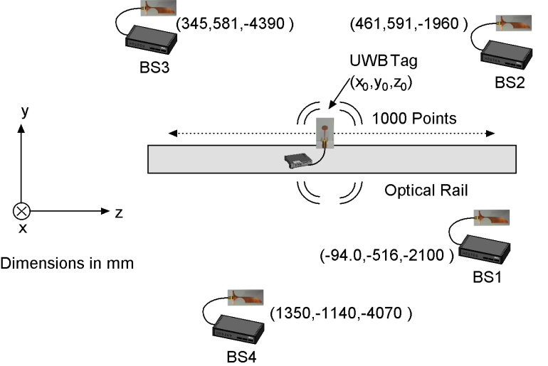
Figure 3-12: Optical rail experimental setup where four base stations are positioned at distinct 3-D locations and the UWB tag is moved along an optical rail while 1000 3-D points are taken in real-time, utilizing the UWB transmitter and receiver architectures in Figure 3-3.

along with jitter from the triggering clocks and local oscillators and also AWGN from active devices. Figure 3-13 shows average overall RMSE for simulating the optical rail experiment where the expansion factor $α$ is varied from 1000-20,000. As $α$ increases, more UWB pulses are averaged to create the time expanded pulse, which lessens the jitter effects since they do not scale with $α$. Conversely, as $α$ increases, the time scaling effects become more pronounced since the reconstructed pulse spans a greater number of clock cycles. The optimal expansion factor found is $α=2500$. It should be noted that in the static case, the time scaling effects can be removed through a calibration procedure, as done in [53], whereas in the dynamic case, it is harder to completely remove them, although an excellent dynamic calibration method is
Figure 3-13: Average 3-D RMSE obtained by simulating the experiment outlined in Section IV-A with no channel effects incorporating leading-edge detection, a modulation factor $β=5$, a 21-sample MIQR filter, and 5x averaging of the TDOA results. The effects of time scaling increase proportionally with the expansion factor and cause a trade-off between mitigating jitter/AWGN effects and mitigating time scaling effects. $α=2500$ is considered the optimal expansion factor for minimizing the combined effects of jitter, AWGN, and time scaling.
outlined in [53]. Therefore, in the static case after calibrating out the time scaling effects, it is possible to get extremely low errors of less than 0.1 mm when averaging large numbers of pulses.
Next, as shown in Table 3-3, a comparison of the error obtained by the five ranging algorithms is given for different cases involving I and Q channels. The optical rail experimental setup was simulated for $α=2500$ and $β=5$ with a 21-sample MIQR filter and 5x averaging of the TDOA results. As mentioned in [20], the final system architecture relies solely on one channel: I or Q. This simulation was setup to analyze the I/Q mismatch seen experimentally and outlined in [20]. As shown in Table 3-3, when no multipath interference is present in the received signal, all five ranging algorithms provide comparable results. Use of either the I or Q channel with the TDOA algorithm produces almost identical results. When the combined $I^{2}+Q^{2}$ signal is used, with the channels correctly aligned, a marginal improvement in overall RMSE of 0.16-0.19 mm is seen. Conversely, when the I and Q channels of the $I^{2}+Q^{2}$ signal are not aligned, the overall RMSE degrades substantially for all five algorithms. Since it would greatly increase the complexity of our system to correctly align the I and Q channels (random phase variations in the time extended signals are introduced by the sampling mixers), only the single I channel is used at each base station.
Given the dependency of our system on the single I channel, another concern, as outlined in [20], are shoulder effects introduced by the carrier leakage ${∆ω}_{eq}$ (shown in Figure 3-11). As discussed in [20], the carrier leakage is necessary for the single channel architecture but is also responsible for introducing added localization error into the received signals. Figure 3-14a shows 1-D ranging error for different phase offsets as $β$ is varied from 0.1-100. It should be noted that the leading-edge algorithm was used with $α=2500$ while jitter and AWGN effects were neglected for this simulation. As shown in Figure 3-14a, as $β$ is decreased, the error after leading-edge detection substantially increases. This increase in error is due to the fact that the ripples of the carrier signal expand as $β$ is decreased, resulting in large errors for certain phase offsets. When jitter and AWGN is added to the signal, a bimodal error distribution is seen [20],[53]. As shown in Figure 3-14b, when the energy detection architecture outlined in [20] is included in the simulation, the shoulder effects are sufficiently mitigated from the received signal to obtain mm-range 1-D ranging accuracy.
As mentioned in [19], the PDOP of the base station geometric configuration plays a crucial role in the resulting 3-D accuracy from the TDOA algorithm. Figure 3-15 shows the 3-D error from simulating the TDOA algorithm after 5x averaging, a 21-sample MIQR filter, LE
Table 3-3: Comparison of using I and Q channels.
Channel | Leading Edge RMSE (mm) | Matched Filter RMSE (mm) | Signal Strength RMSE (mm) | Iterative Peak Subtraction RMSE (mm) | First Peak Detect RMSE (mm)
I | 2.70 | 2.68 | 2.70 | 2.68 | 2.70
Q | 2.70 | 2.68 | 2.70 | 2.71 | 2.70
I²+Q² Aligned | 2.54 | 2.50 | 2.56 | 2.52 | 2.56
I²+Q² Not Aligned | 4.19 | 4.12 | 4.16 | 4.16 | 4.16

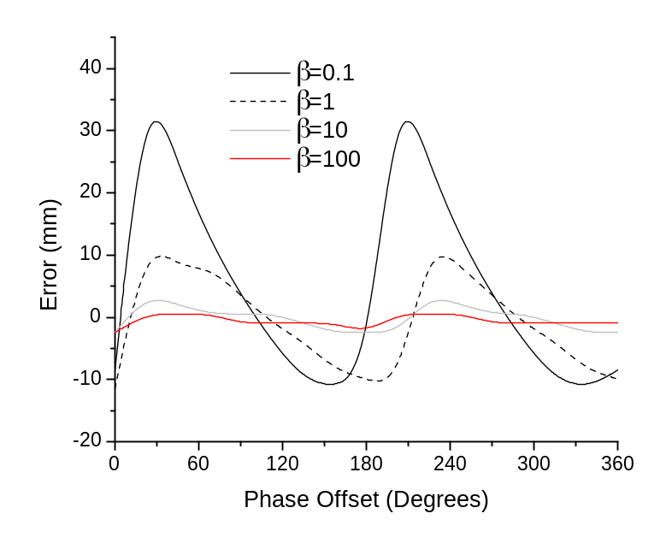
(a)
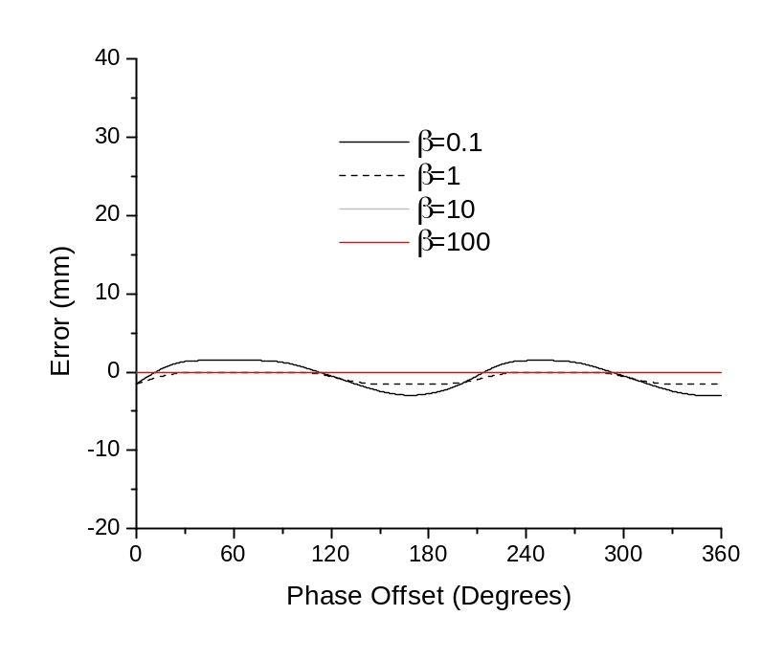
(b)
Figure 3-14: 1-D ranging error obtained by simulating the optical rail experiment with no channel effects incorporating leading-edge detection, a variable modulation factor $β$, and $α=2500$, neglecting jitter and time scaling effects. To illustrate the shoulder effect [20], $β$ is varied from 0.1-100. The phase offset of the carrier leakage ${∆ω}_{eq}$ is varied from 0-360°. The results are presented for two cases: (a) without energy detection, (b) with energy detection.

detection, $β=5$, and $α=2500$. The tag starts closer to the geometric center of the base station configuration outlined in Figure 3-12. As the tag is moved along the optical rail, the PDOP and corresponding 3-D error increase while the 1-D ranging error remains nearly constant at 1.22 mm. To illustrate this effect, the RMSE from $z=-3273$ mm to $z=-3558$ mm is 2.08 mm while the RMSE from $z=-3558$ mm to $z=-3789$ mm is 2.86 mm. More discussion on the effects of PDOP, number of base station used, and base station geometric configurations is given in Section 3.4.

Addition of Indoor LOS and NLOS Channels
As shown in Table 3-3, when no multipath or pathloss effects are included in the
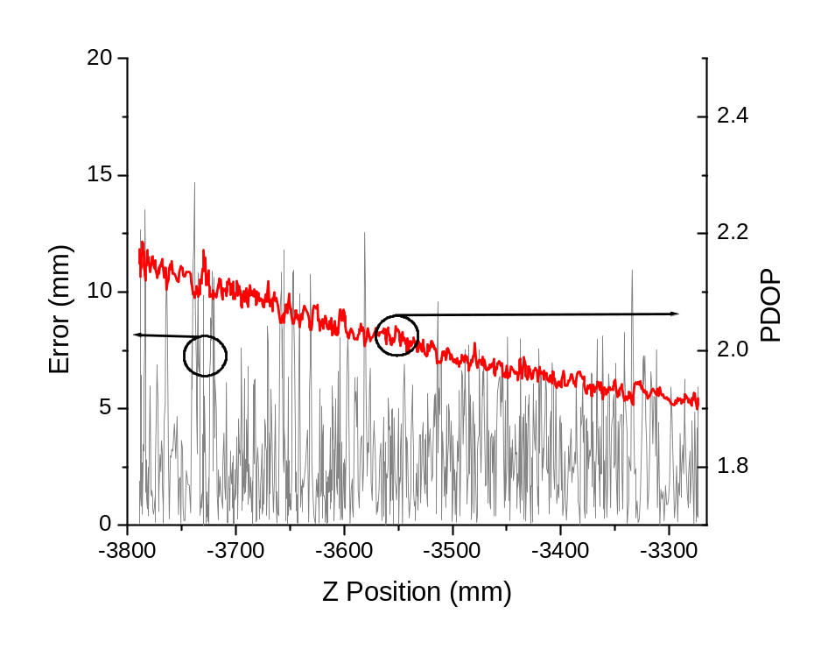
Figure 3-15: 3-D error as tag is moved along the optical rail in the $-z$ direction with the corresponding PDOP shown. No channel effects are included, leading-edge detection is used along with a modulation factor $β=5$, a 21-sample MIQR filter, and 5x averaging of the TDOA results. The 1-D ranging error stays almost constant at 1.22 mm while the PDOP and corresponding 3-D error increase as the tag is moved farther along in the $–z$ direction away from the center of the base station geometric configuration.
simulation, all five ranging algorithms perform comparably. This is consistent with the illustration given in Figure 3-9. Conversely, when indoor channel effects are included in the simulation, a much larger variation in the performance of the ranging algorithms is seen. The optical rail experiment was once again simulated for various LOS and NLOS UWB channel environments utilizing the IEEE 802.15.4a channel model. As shown in Table 3-4, the leading-edge detection algorithm outperforms the other ranging algorithms in the residential,

Table 3-4: Comparison of 3-D RMSE for Peak and Leading Edge Detection Algorithms in LOS Indoor Environments.
UWB Channel | Leading Edge RMSE (mm) | Matched Filter RMSE (mm) | Signal Strength RMSE (mm) | Iterative Peak Subtraction RMSE (mm) | First Peak Detect RMSE (mm)
Industrial LOS (CM7) no ED | 7.58 | 45.1 | 42.4 | 44.7 | 48.8
Industrial LOS (CM7) with ED | 6.85 | 108 | 109 | 108 | 103
Commercial LOS (CM3) no ED | 4.22 | 360 | 361 | 359 | 65.8
Commercial LOS (CM3) with ED | 3.18 | 372 | 372 | 372 | 144
Residential LOS (CM1) no ED | 3.99 | 206 | 209 | 11.4 | 12.3
Residential LOS (CM1) with ED | 3.00 | 205 | 206 | 203 | 206
Table 3-5: Comparison of 3-D RMSE for Peak and Leading Edge Detection Algorithms in NLOS Indoor Environments.
UWB Channel | Leading Edge RMSE (mm) | Matched Filter RMSE (mm) | Signal Strength RMSE (mm) | Iterative Peak Subtraction RMSE (mm) | First Peak Detect RMSE (mm)
Industrial NLOS (CM8) no ED | 241 | 1390 | 1010 | 994 | 28.8
Industrial NLOS (CM8) with ED | 631 | 1120 | 743 | 1090 | 1410
Commercial NLOS (CM4) no ED | 6.69 | 10.6 | 761 | 10.2 | 19.0
Commercial NLOS (CM4) with ED | 5.00 | 126 | 748 | 124 | 8.69
Residential NLOS (CM2) no ED | 365 | 97.2 | 157 | 157 | 192
Residential NLOS (CM2) with ED | 356 | 94.5 | 103 | 101 | 373

commercial, and industrial LOS environments. The addition of energy detection, shown in Figure 3-3, does slightly improve the performance through mitigation of the shoulder effect. For all simulations in this section, the TDOA algorithm was run with 5x averaging, a 21-sample MIQR filter, $β=5$, and $α=2500$. In LOS multipath conditions, the other four ranging algorithms (matched filter, SS, first peak, and iterative peak subtraction) exhibit large errors due to the ambiguity in 1-D ranging caused by multipath interference (e.g. Figure 3-10, Figure 3-16).First peak and iterative peak subtraction performed well in the residential LOS environment since the multipath peaks are spread out enough for peak detection to allow accurate ranging of the first received pulse. In order to account for the random nature of these statistical channels, 1000 channel instantiations were made for each LOS and NLOS channel. For each TDOA calculation along the optical rail (1000 total points), a random channel instance was selected for each tag-base station path from the 1000 instantiations.
For NLOS channels (results in Table 3-5), the leading-edge algorithm provides mm accuracy only when a weaker LOS signal still exists, which is typically the case in the
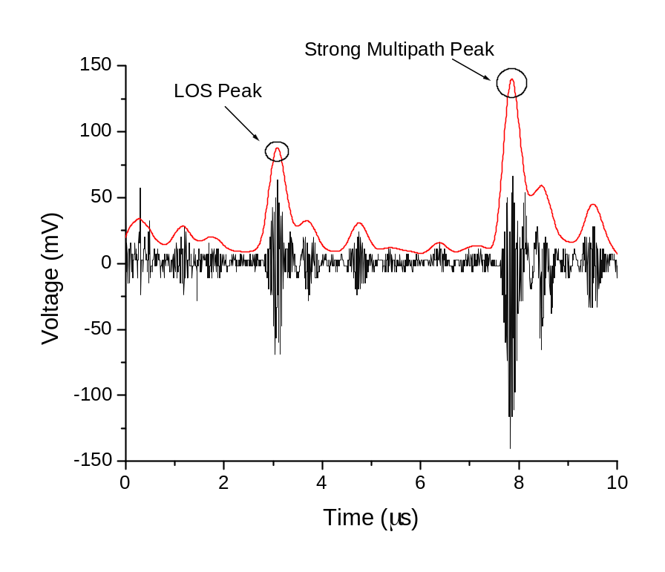
Figure 3-16: Simulated CM3 signal obtained at the UWB receiver for Tx-Rx distance of 1 m after time extension from the sampling mixer and conversion to digital. The LOS peak is highlighted as well as a strong multipath peak which arrives 4 µs after the LOS peak and causes a 1-D ranging error of 1.2 m using matched filter, iterative peak subtraction, and signal strength peak detection algorithms.
commercial NLOS channel (Figure 3-17b). When no LOS signal is present, typical of residential and industrial NLOS channels, leading-edge detection produces large ranging errors and is not an ideal ranging technique. Figure 3-17 provides example residential, commercial, and industrial NLOS received signals. As shown in Table 3-5, a first peak detect algorithm with no energy detection outperforms leading-edge detection in residential and industrial NLOS conditions. It is therefore necessary to detect when LOS versus NLOS conditions exist at the UWB receiver and switch ranging algorithms accordingly. More information on detecting NLOS conditions and ranging algorithms optimized for NLOS can be found in [96],[97].

Comparison with Experimental Results
A direct comparison of simulation results to experimental results is possible since the simulated scenario was first run as an actual experiment. Table 3-6 shows the RMSE for the optical rail experiment for actual experimental results compared to simulations with energy detection using industrial LOS (CM7), commercial LOS (CM3), and residential LOS (CM1). It should be noted that for all simulations the TDOA algorithm was run with 5x averaging, the leading-edge detection algorithm, a 21-sample MIQR filter, $β=5$, $α=2500$. Figure 3-18 compares the simulation results for CM7 and CM3 with experimental results for all 1000 points while Figure 3-19 compares experimental results with simulation results for the residential LOS (CM1) channel. As shown in Figure 3-18, the CM7 channel introduces errors larger than actually observed experimentally. The RMSE for commercial LOS (3.18 mm) and residential LOS (3.00 mm) is much closer to the actual experimental error of 4.39 mm. As shown in Figure 3-19,
(a)
(b)
(c)
Figure 3-17: Examples of received signals. (a) CM8 received signal highlighting the need to detect the first signal above the noise floor instead of trying to resolve the arrival of the peak in the dense multipath region. (b) CM4 received signal highlighting the weaker LOS signal which still provides accurate ranging compared to the strong multipath signal. (c) CM2 received signal where the leading edge is distorted. Since the multipath signals can be resolved, iterative peak subtraction or a matched filter provides the best performance.
experimental results are most similar to a residential LOS environment while errors from
the commercial LOS environment have less correlation.

Simulations for Different Base Station Configurations
The various base station configurations were adapted from experiments undertaken in various configurations of the four to six base stations to test their ability to localize the 3-D position of the tag over 8 distinct points. This setup is shown in Figure 3-20 [19]. The same experimental setup was simulated using the framework outlined in Section 3.1. For all simulations the TDOA algorithm was run with 5x averaging, a 21-sample MIQR filter,$β=5$, $α=2500$. The residential LOS (CM1) UWB channel model was used as well as an ideal scenario [19] where a tag was moved along an optical rail with six base stations present while using with no multipath (MP) interference or pathloss. The results in Table 3-7 use the leading-edge detection and iterative peak subtraction ranging algorithms. LE represents the best ranging
Table 3-6: Comparison of Simulated and Experimental Results for Optical Rail Experiment.
Type | RMSE (mm)
Experiment |  | 4.39
Simulation CM7 with ED |  | 6.85
Simulation CM3 with ED |  | 3.18
Simulation CM1 with ED |  | 3.00
Figure 3-18: Comparison of final 3-D error from optical rail experiment, CM3 simulation, and CM7 simulation over 1000 points along the optical rail.

Figure 3-19: Comparison of final 3-D error from optical rail experiment and CM1 simulation.
solution and IPS was the algorithm used in [19] for the experiments. Similar to the setup in [19], the PRF clocks were synchronized in these simulations.
As shown in Table 3-7, use of LE detection outperforms the experimental results even in CM1 multipath conditions. IPS performs worse than the observed experimental results in CM1 multipath conditions. When no multipath interference or pathloss exists in the UWB channel, simulated results using IPS significantly outperform the experimental results, suggesting multipath interference and pathloss constitute the largest sources of error in this experiment. The geometric PDOP plays a significant role in the final 3-D accuracy obtained from the TDOA calculation. As shown in Figure 3-21, the error in the x-dimension is much larger than y and z while performing TDOA of the tag position using the experimental setup in Figure 3-20d and LE for the ranging algorithm. As shown in Figure 3-22, this is caused by the much larger PDOP in the x-dimension compared to y and z. The flexibility of this simulation framework allows easy adaptation to new experimental setups such as the multi-base station optical rail experiment outlined in this section.

Table 3-7: Results for Multi-Base Station Experiments.
BS  Configuration | Experiment  Mean Error (mm) | Simulation Mean Error LE CM1  (mm) | Simulation Mean Error IPS CM1  (mm) | Simulation Mean Error IPS no MP  (mm) | Mean PDOP
6 BS  5 BS  4 BS - Figure 3-20c  4 BS - Figure 3-20d | 2.45 | 1.59 | 3.06 | 0.48 | 1.88
6 BS  5 BS  4 BS - Figure 3-20c  4 BS - Figure 3-20d | 3.13 | 2.07 | 4.16 | 0.53 | 2.02
6 BS  5 BS  4 BS - Figure 3-20c  4 BS - Figure 3-20d | 3.62 | 2.92 | 6.08 | 0.61 | 2.43
6 BS  5 BS  4 BS - Figure 3-20c  4 BS - Figure 3-20d | 43.3 | 19.1 | 68.1 | 5.11 | 20.6

Figure 3-20: 3-D synchronized localization experiments: (a) 6 base stations. (b) 5 base stations. (c) 4 base stations with low PDOP. (d) 4 base stations with poor coverage in x-direction resulting in high PDOP [19].

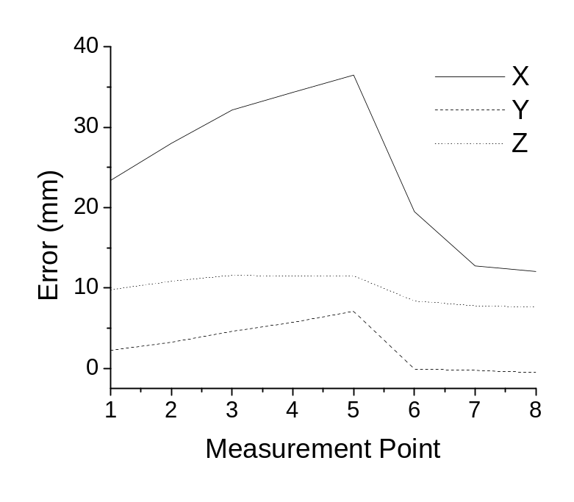
Figure 3-21: Comparison of x,y,z error for all points in simulating the multi-base station experiment outlined in Figure 3-20d using leading-edge detection. Substantially larger errors are observed in x; z also has higher error than y.
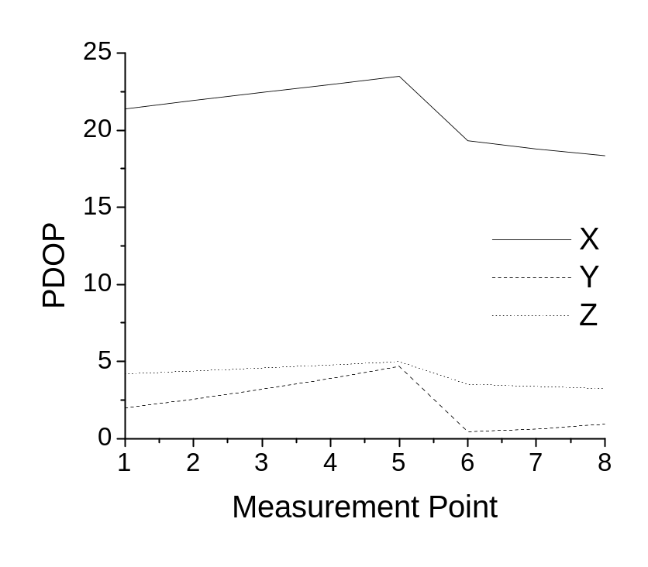
Figure 3-22: Comparison of PDOP in the x,y,z dimensions for simulating the experiment outlined in Figure 3-20d. The PDOP in the x-dimension is much greater than y,z. Also, the PDOP in the z-dimension is consistently greater than y.

ADC Effects and Automatic Gain Control
As mentioned in [98], automatic gain control (AGC) and ADC selection play a critical role in the performance of UWB receivers. The simulation results are shown in Figure 3-23, Figure 3-24, Figure 3-25, and Figure 3-26. All of the simulation results use the industrial LOS channel model to add significant multipath interference and pathloss to the UWB signals at the receivers. Figure 3-23 shows how the AGC increases the SNR of the received pulse and how the SNR is instrumental in ensuring correct operation of the leading-edge detection algorithm. For example, as shown in Figure 3-24, when the SNR drops below 6 dB, the leading-edge detection algorithm fails regardless of the ADC. Figure 3-25 shows the quantization-noise-to-signal-ratio (QNSR) of the received UWB pulses versus distance for three different ADCs: 105 MSPS, 10 bit (currently used in our system), 400 MSPS, 12 bit (commercially available for relatively cheap), and 3 GSPS, 8 bit. The 3 GSPS, 8 bit ADC is currently top of the line technology and represents the upper limit of technology available for the ADC. As shown in Figure 3-25, the QNSR of the 105 MSPS ADC is relatively high for all distances (e.g. -8 dB) whereas the 3 GSPS ADC has a low QNSR for short distances but it drastically increases as the Tx-Rx distance moves towards 4 m. Although there is significant variation among the ADCs in terms of QNSR, as shown in Figure 3-23, the ADCs perform almost identically in terms of the most important parameter: accurate leading-edge detection of the incoming UWB pulse for a given SNR. All three ADCs fail as the SNR of the incoming pulse drops below 6 dB. Finally, in Figure 3-26, the addition of AGC significantly increases the operating range between the transmitter and receiver by increasing the SNR of the received UWB signal (Figure 3-23). This analysis shows how the UWB positioning system would benefit greatly from at least one stage of AGC while it depends little on ADC performance mainly because of the use of the sub-sampling mixer in the UWB receiver, which reduces the bandwidth of the received UWB signal to less than 50 MHz. The leading-edge detection algorithm provides a robustness to ADC limitations such as QNSR, which only adds to its importance in overall system performance.

Extension to Other UWB Systems
A novel simulation framework has been introduced which was used in simulating and understanding the operation of our indoor UWB positioning system. The complete simulation framework allows the system to be tested and characterized by using its most critical parameter as the final result: real-time 3-D positioning accuracy. Unless actual experimental setups are
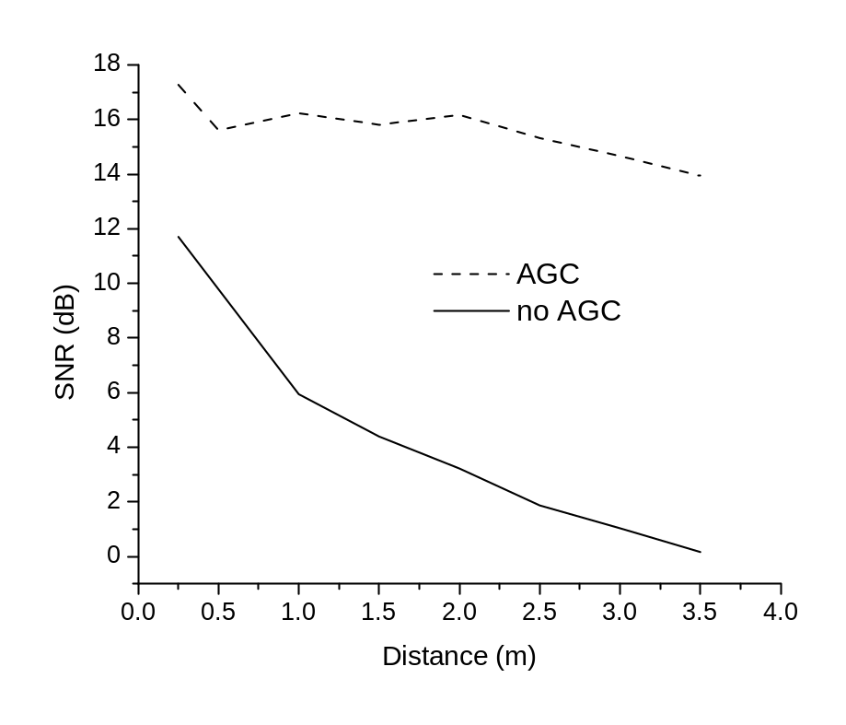
Figure 3-23: SNR of received UWB pulse vs. distance between transmitter and receiver with and without automatic gain control.

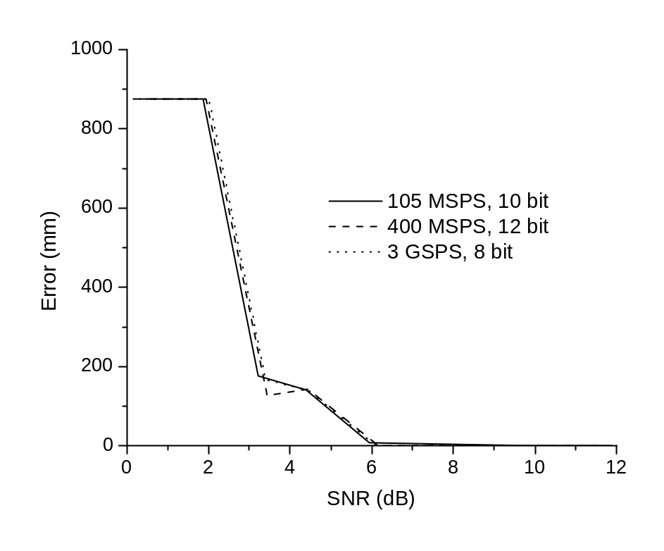
Figure 3-24: Simulated leading-edge detection 1-D error vs. SNR of received UWB pulse for three ADCs.

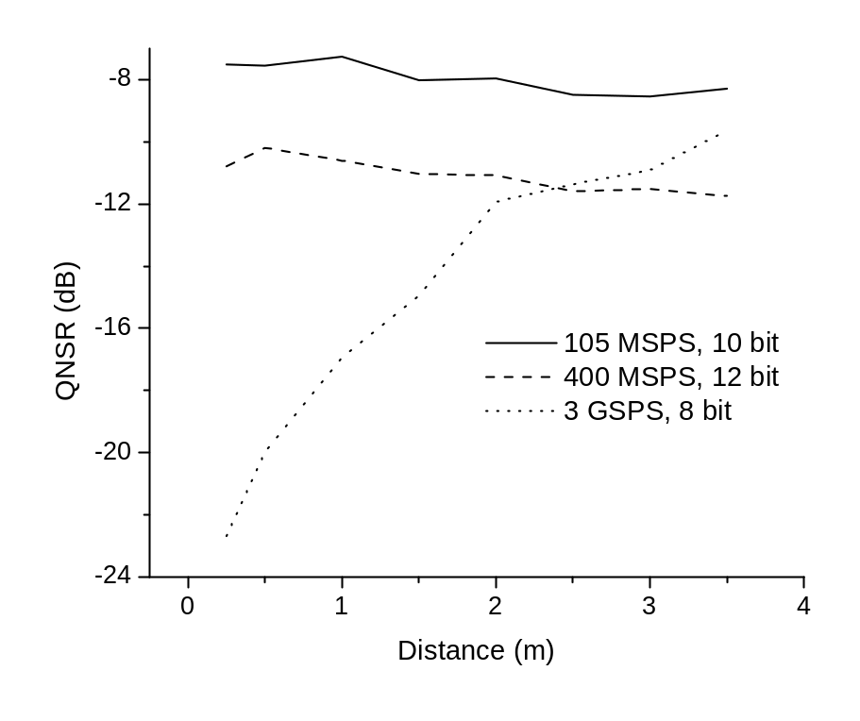
Figure 3-25: Quantization SNR of received UWB pulse vs. distance between transmitter and receiver for three ADCs without AGC: 105 MSPS, 400 MSPS, and 3 GSPS.
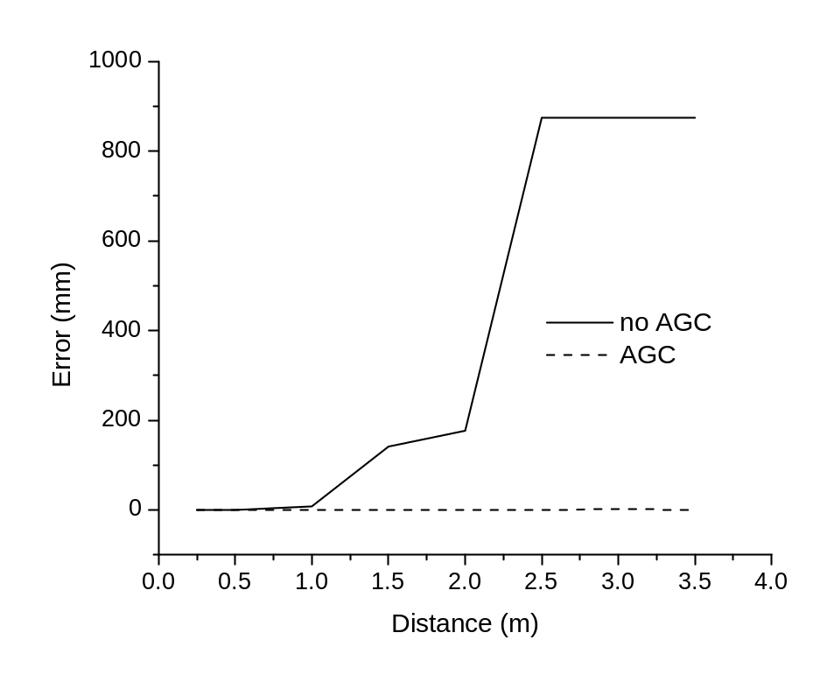
Figure 3-26: Simulated leading-edge detection 1-D error vs. distance between transmitter and receiver in the industrial LOS channel with and without automatic gain control.
simulated, such as the optical rail experiments outlined in this paper, and all relevant aspects of the system taken into account (i.e. analog and digital portions of the transmitter and receiver, antenna effects, final processing of data on a computer, channel effects, geometric or other environmental effects, etc.), it is difficult or impossible to accurately simulate the performance of a complex wireless system such as our UWB indoor positioning system. This methodology for simulating all aspects of a complex wireless system is gaining momentum for both communication and radar systems as simulation tools become more robust. Recently, this same framework has been utilized in simulating the performance of a see-through-wall radar UWB imaging system [99],[100]. This overall framework is general and the underlying simulation tools robust which allows it to be tailored to any given wireless system, both narrowband and wideband. Given the need for rapid prototyping combined with the cost of constructing experimental prototypes, it is critical that comprehensive simulation frameworks receive more attention and be included in the early stages of the design process for new wireless systems.

Receiver Vivaldi Antenna Effects
In order to analyze the effects of the single element Vivaldi antennas (which are present at the UWB receivers), method-of-moments (MOM) simulations of the antennas were carried out both for a single element as well as a planar array of two Vivaldi antennas. Method-of-moments is a more challenging method to use in simulating antennas compared to finite element techniques since it has trouble taking into account the 3-D nature of the antenna (i.e. the substrate). This work represents an investigation of novel techniques which allow the simulation of Vivaldi antennas via MOM techniques. The triangular elements used in simulating the metallic surfaces of both the signal and ground planes are the well known Rao-Wilton-Glisson (RWG) basis functions which simulate a pair of triangles as an electric dipole which can interact with the elements around it through the compilation of an overall mutual coupling between the array of dipole elements. The RWG basis functions are shown in Figure 3-27 [101]. The dielectric model breaks the dielectric into volumetric elements using the same triangular mesh as the surface elements of the ground plane. This approximation only works for thin slab dielectrics and is based off the method in [102] and shown in Figure 3-28 where each triangle represents an electric dipole and the dielectric is replaced with an equivalent volumetric polarization current (Figure 3-28). The interaction between the signal and ground

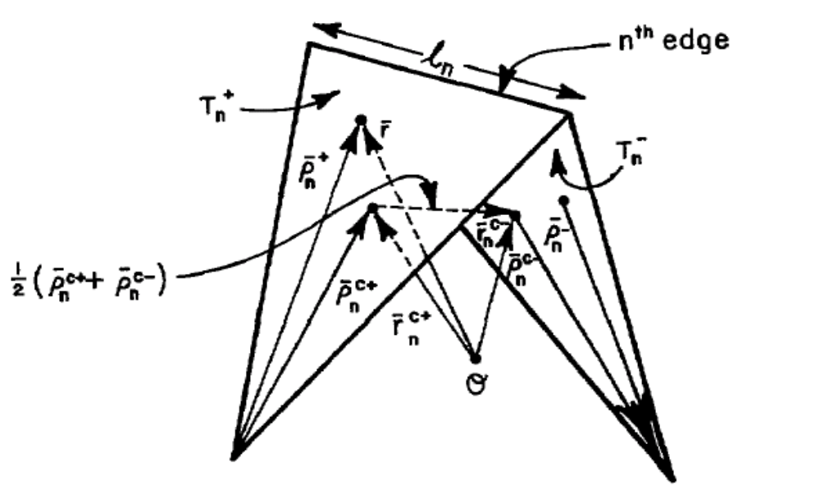
Figure 3-27: Rao-Wilton-Glisson basis functions which model each pair of triangles as an electric dipole and have proven robust in method-of-moments simulations of arbitrary metal surfaces [101].

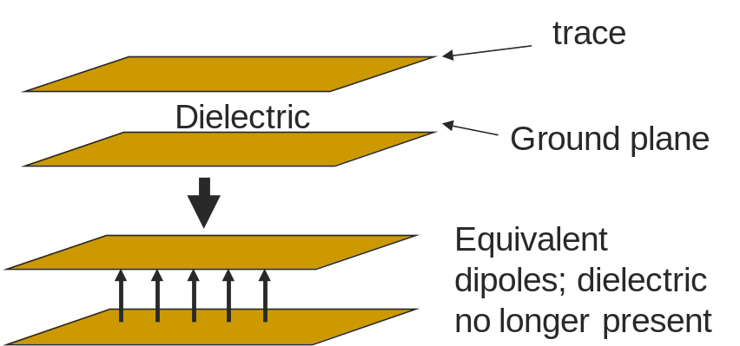
Figure 3-28: Newman and Tulyathan method for modeling of dielectric substrates in method-of-moments simulations where the dielectric substrate is modeled as a matrix of dipoles with varying excitation powers to account for the varying current densities [102].

planes with the dielectric is described by (3-12) where impedance matrices for the surface (Z_{SS}), the dielectric (Z_{DD}), and the surface-dielectric interaction (Z_{SD}) are compiled. The currents in the surface and dielectric are solved for (I_{S} and I_{D}) given the initial excitation voltage (V). More information on this process is outlined in [103].
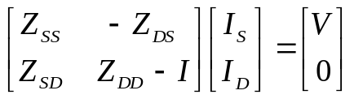 | (3-12)

Two different Vivaldi meshes were created in simulating the performance of the antenna as shown in Figure 3-29 and Figure 3-30, both based on the Vivaldi antenna design described in [104]. The mesh in Figure 3-29 uses an extended ground plane with a refined mesh to accurately simulate the feed point while the mesh in Figure 3-30 was adaptively meshed for refinement around both the feed point as well as areas with high electric field along the center line of the antenna. The mesh in Figure 3-30 provides more accurate results due to not needing an extended ground plane and also due to its refinement along the center portion of the Vivaldi. A zoomed-in view of the feed point for the antenna mesh in Figure 3-30 is shown in Figure 3-31 while the return loss of the antenna is shown in Figure 3-32 where -10 dB is achieved above 9 GHz. The E-cut radiation pattern is shown in Figure 3-34 where a beamwidth of +/- 45° is achieved. The electric field in x,y,z is shown in Figure 3-35 where it is predominately in the vertical or y-direction and acts as a bandpass filter in the frequency domain. The pulse after transmission through the Vivaldi antenna is shown in the time domain in Figure 3-36 where minimal distortion of the UWB pulse is observed. The return loss while incorporating dielectric
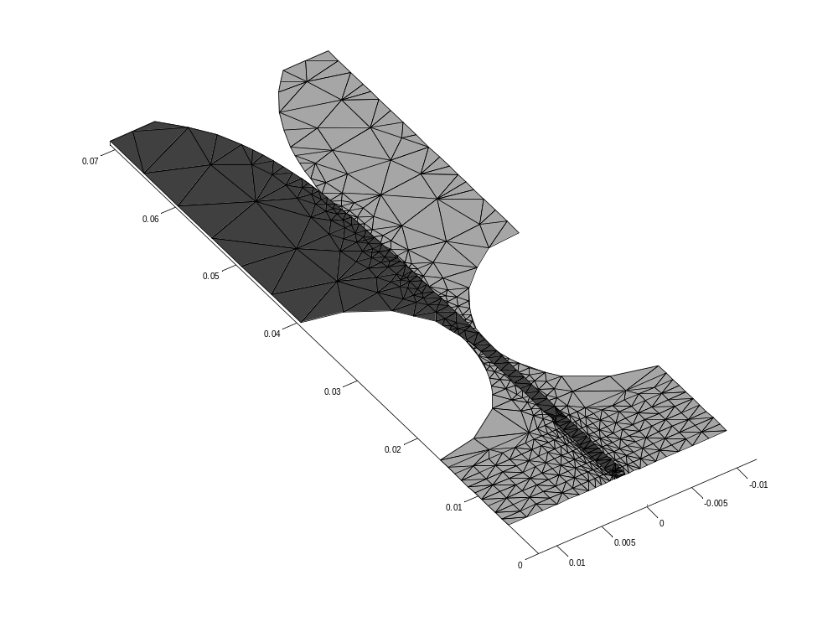
Figure 3-29: Single element Vivaldi with extended ground plane for more accurately modeling the initial excitation.

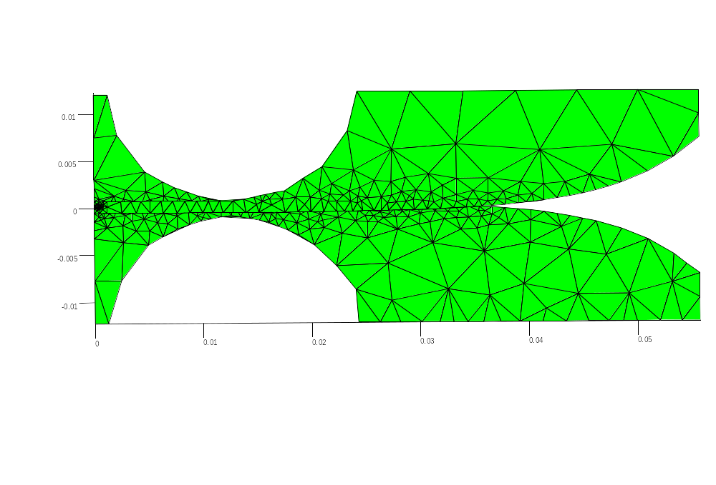
Figure 3-30: Single element Vivaldi antenna without an extended ground plane but with adaptive meshing around the feed point where high electric fields cause greater sensitivity to the overall MOM simulation.

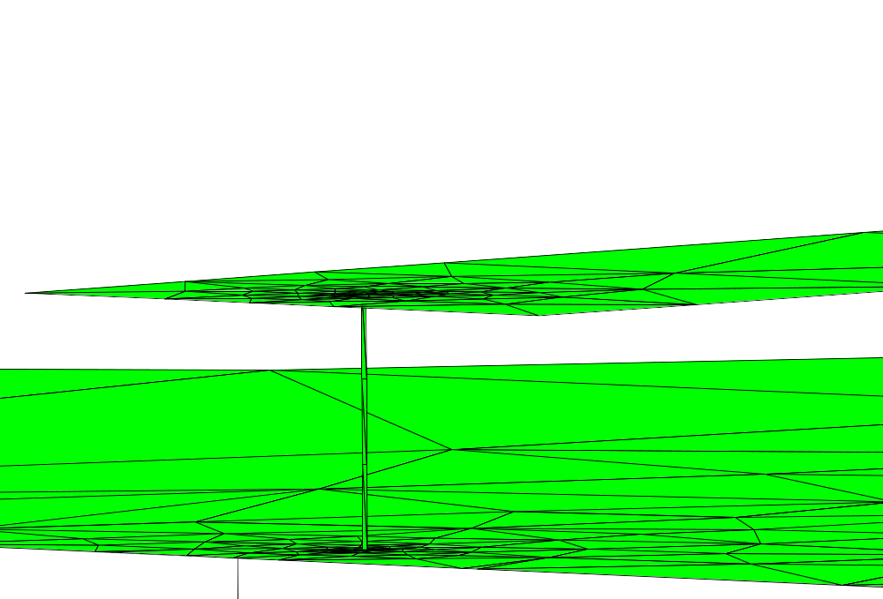
Figure 3-31: Feed point for the mesh shown in Figure 3-30 where intense mesh refinement surrounds the thin vertical slice where the voltage excitation is applied.

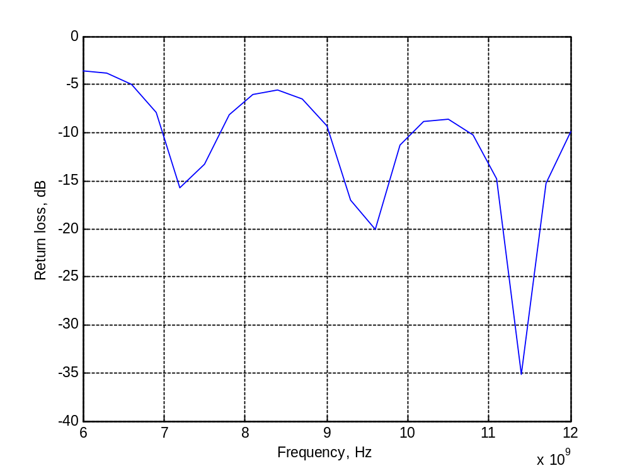
Figure 3-32: Return loss for the mesh shown in Figure 3-30 without dielectric effects where -10 dB is achieved above 9 GHz.

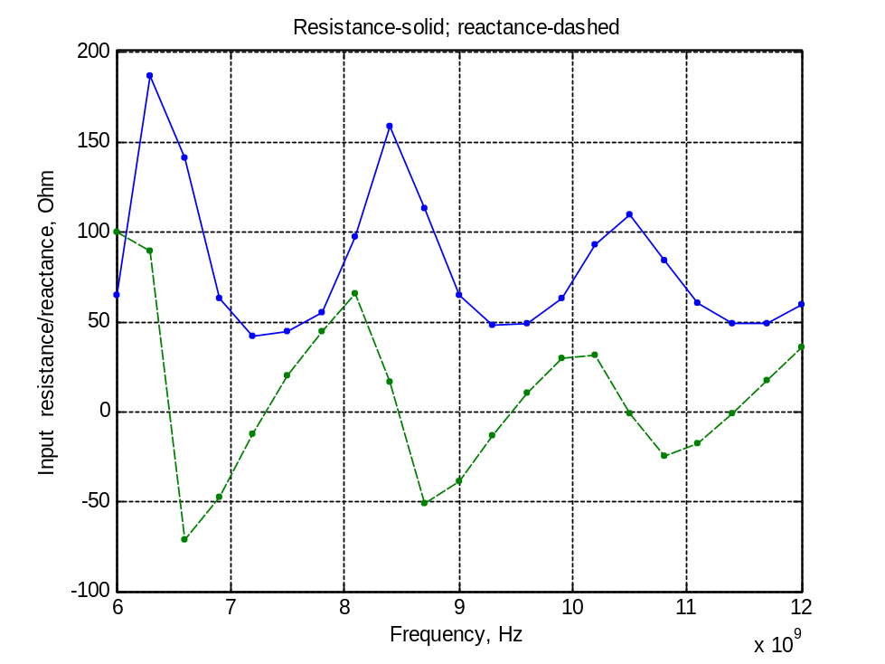
Figure 3-33: Resistance and reactance for the mesh shown in Figure 3-30 where the reactance hovers around 0 Ohm and the resistance around 50 Ohm.

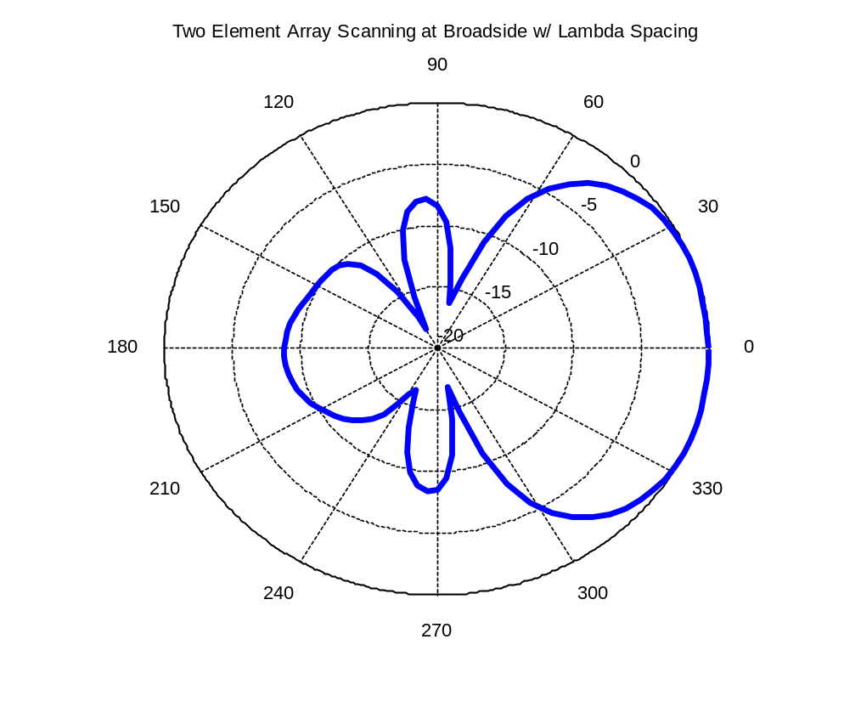
Figure 3-34: E-cut for the mesh shown in Figure 3-30 where a beamwidth of +/- 45° is achieved.
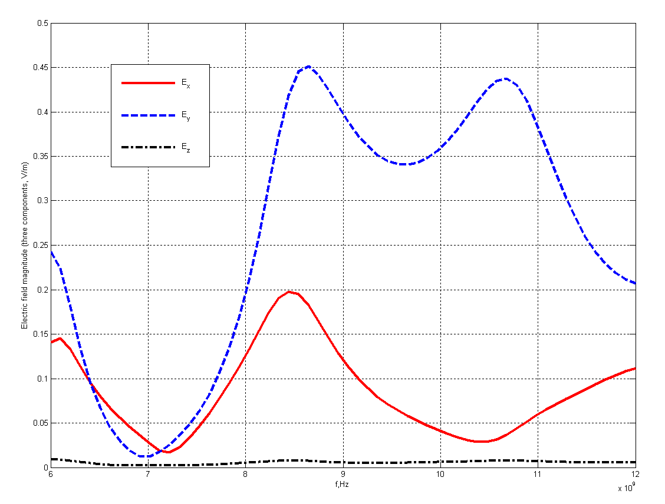
Figure 3-35: Electric field in x,y,z directions where the antenna acts as a bandpass filter and is predominately seen in the y-direction.

effects is shown in Figure 3-37 and compared to simulating the antenna in Ansoft HFSS. The MOM results appear closer to the HFSS simulation which uses air as the dielectric rather than Rogers 4003C susbstrate (εr = 3.38, tanδ = 0.003), suggesting that the dielectric model described in Figure 3-28 is still inaccurate in taking into account the effects of the substrate. The reactance and resistance versus frequency is shown in Figure 3-38 and Figure 3-39 where the MOM simulation once again fails to take into account the effects of the dielectric, although some shifting is seen in the reactance compared to air (Figure 3-39). The E-cut and H-cut for the single element Vivaldi are shown in Figure 3-40 and Figure 3-41 where once again the MOM results fail to accurately simulate the effects of the dielectric. Finally, the electric field distribution for
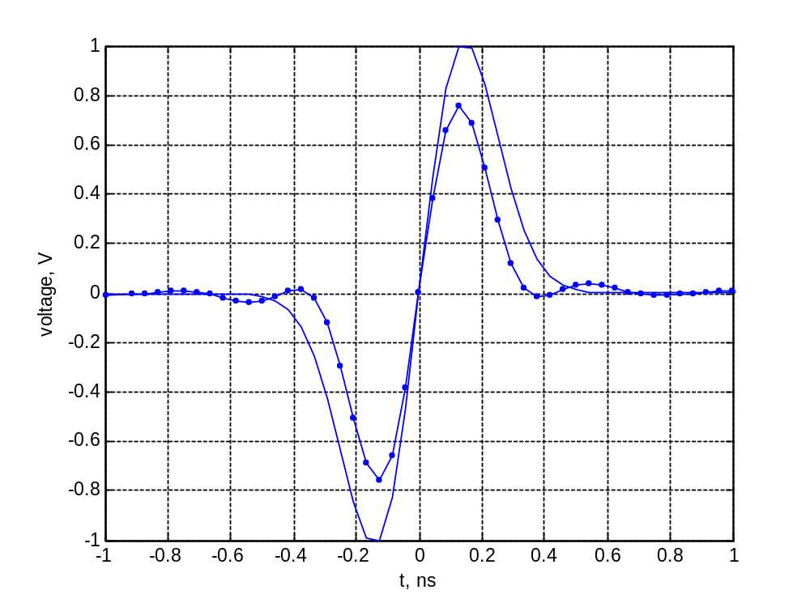
Figure 3-36: Solid line: incident pulse. Dotted line: pulse after transmission through Vivaldi antenna showing minimal pulse distortion.
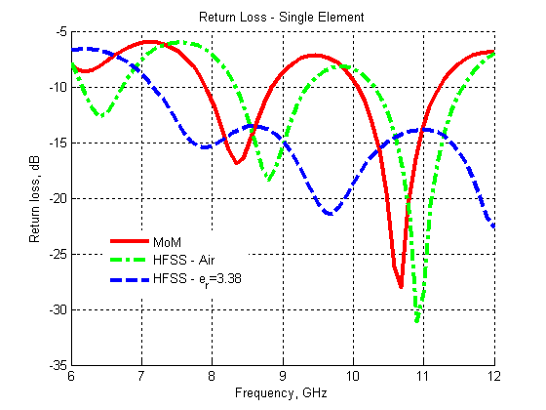
Figure 3-37: Return loss after adding dielectric effects compared to simulating in Ansoft HFSS. Although the resonance is slightly shifted compared to air, it appears the dielectric model is still inaccurate in taking into account the effects of the substrate material.
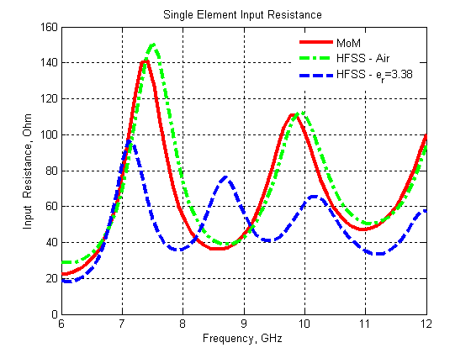
Figure 3-38: Resistance of single element Vivaldi compared to simulations in Ansoft HFSS. Once again, the MOM results fail to accurately simulate the dielectric effects.
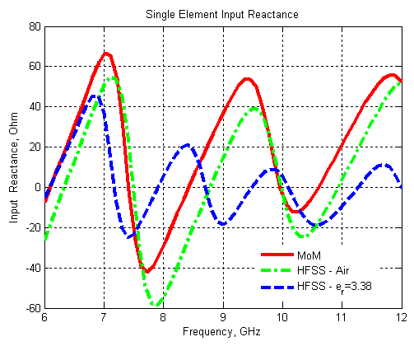
Figure 3-39: Reactance of single element Vivaldi compared to simulations in Ansoft HFSS. Once again, the MOM results fail to accurately simulate the dielectric effects.
the single element Vivaldi is shown in Figure 3-42 and compared to the de facto finite element technique (Ansoft HFSS). Although some differences exist, the electric field distribution in both cases resides along the center line where the signal and ground planes overlap.
The same MOM technique and single element mesh (Figure 3-30) was used in simulating the performance of a two element planar Vivaldi array (shown in Figure 3-43) [105]. The return loss is shown in Figure 3-44 where instability in the MOM simulation is seen from 8-10 GHz, most likely due to its inability to accurately simulate the effects of the Vivaldi antenna. The E-cut and H-cut for the two element planar array are shown in Figure 3-45 where the MOM simulation results in a slightly offset beam direction in the E-cut and narrower beamwidth in the H-cut compared to Ansoft HFSS. Simulated results of the resistance and reactance for the
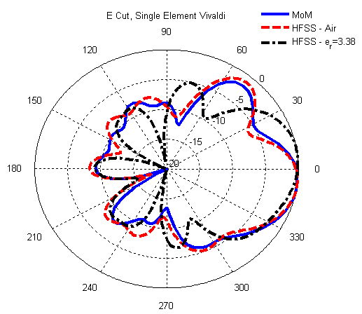
Figure 3-40: E-cut of single element Vivaldi versus air where once again the MOM simulations fail to accurately simulate the dielectric effects.
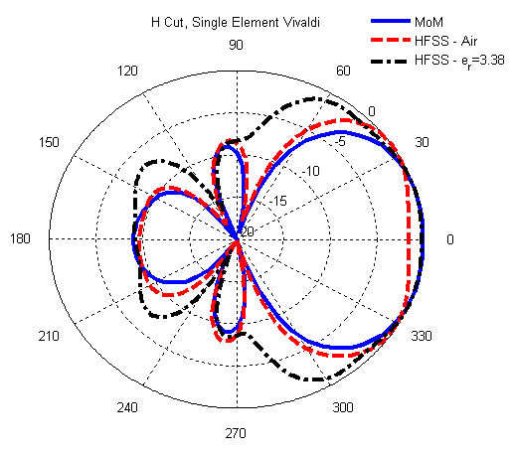
Figure 3-41: H-cut of single element Vivaldi versus air where once again the MOM simulations fail to accurately simulate the dielectric effects.
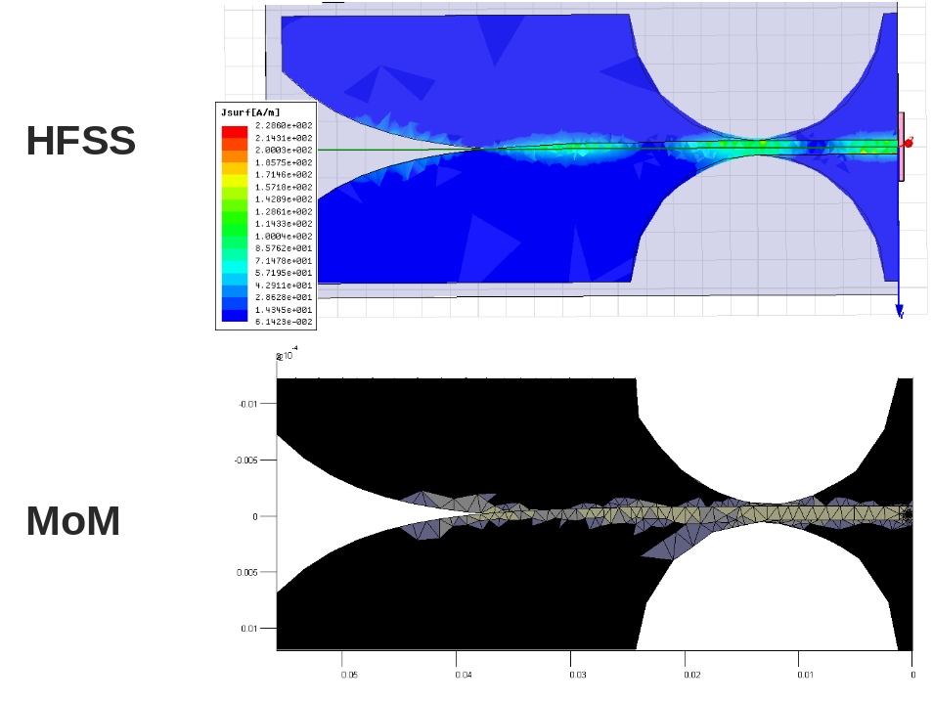
Figure 3-42: Electric field distribution using MOM versus a finite element technique (Ansoft HFSS) where in both cases the majority of the electric field resides along the center line between the signal and ground planes.
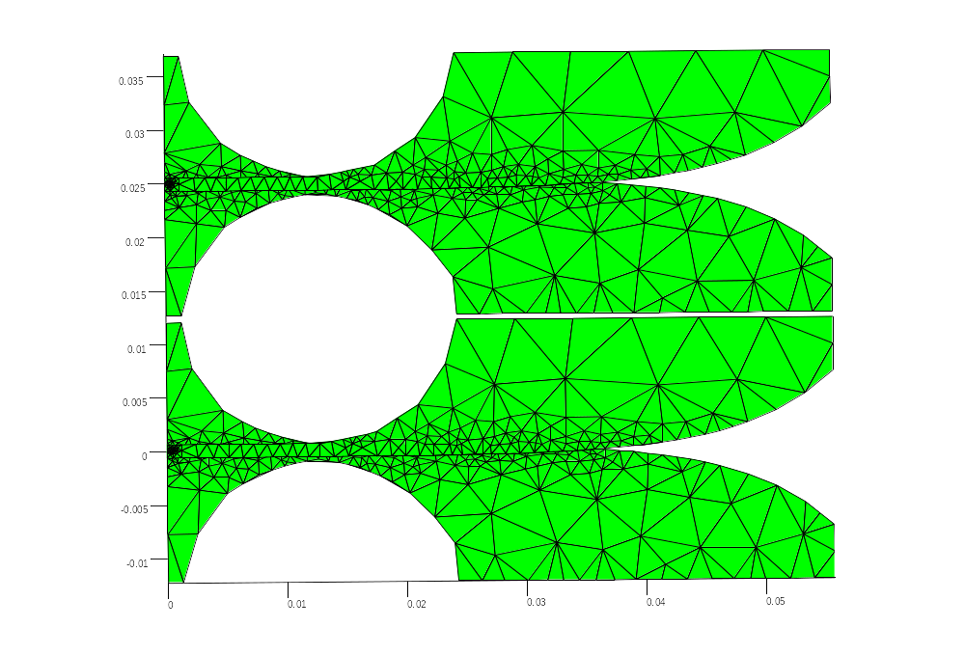
Figure 3-43: Mesh for simulating a two element planar array of Vivaldi antennas.
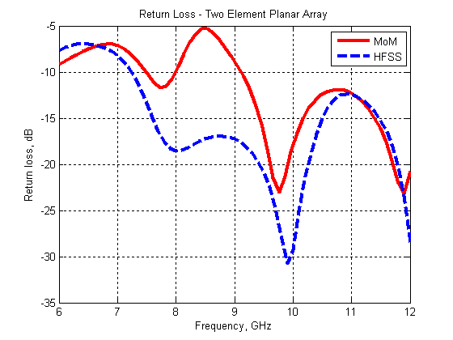
Figure 3-44: Return loss of two element planar array compared to Ansoft HFSS where instability is noticeable in the MOM simulation from 8-10 GHz compared to HFSS.
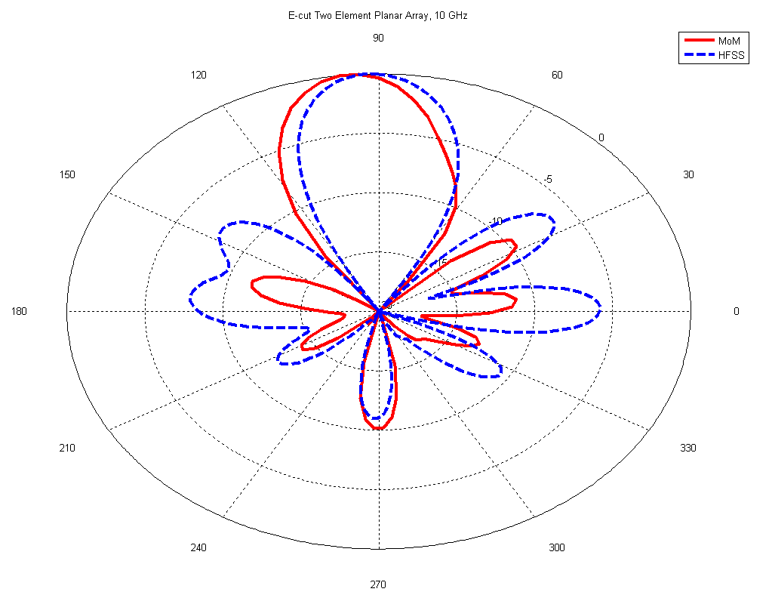
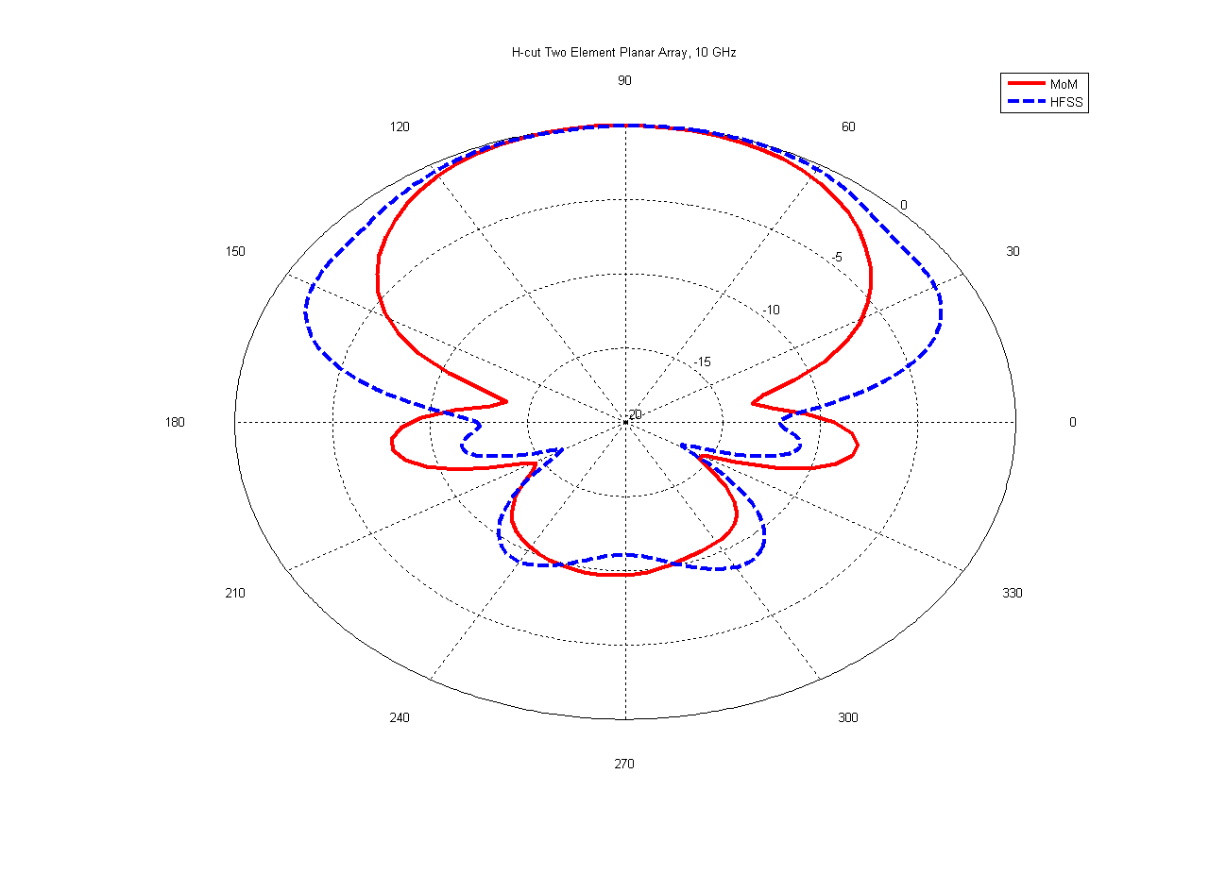
Figure 3-45: E-cut and H-cut for the two element planar Vivaldi array where the MOM simulation results in smaller sidelobes and a slightly offset beam direction compared to HFSS.
two element planar array compared to Ansoft HFSS are shown in Figure 3-46 and Figure 3-47 where noticeable differences exist between the MOM and finite element simulations (once again caused by the inability of the MOM simulation to take into account the dielectric effects). Sensitivity of the MOM simulation to the excitation technique also contributes to the larger variations observed in the resistance and reactance of the antenna array compared to HFSS. Simulations of the E-cut and H-cut co-polarization and cross polarization are shown in Figure 3-48 and Figure 3-49 where excellent correlation is achieved when comparing MOM to Ansoft HFSS. Simulations of the mutual resistance and reactance between the two elements is shown in Figure 3-50 and Figure 3-51. Instability is seen in the MOM simulation of the mutual resistance and reactance which is caused by the instability observed in the overall MOM simulation of the resistance and reactance of the two element planar array (Figure 3-46 and Figure 3-47). Finally,
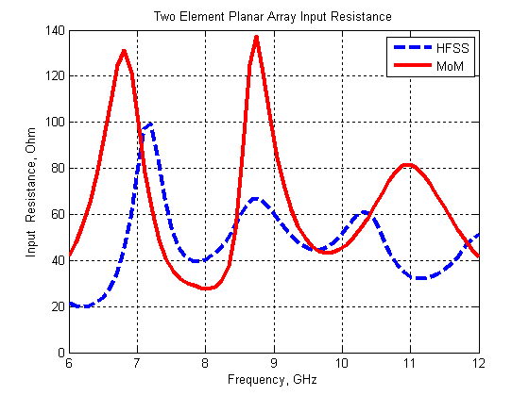
Figure 3-46: Resistance of two element planar array compared to HFSS where noticeable differences exist in the MOM simulation compared to HFSS.
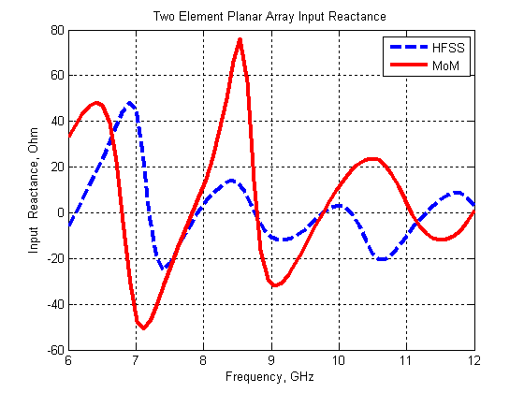
Figure 3-47: Reactance of two element planar array compared to HFSS where noticeable differences exist in the MOM simulation compared to HFSS.
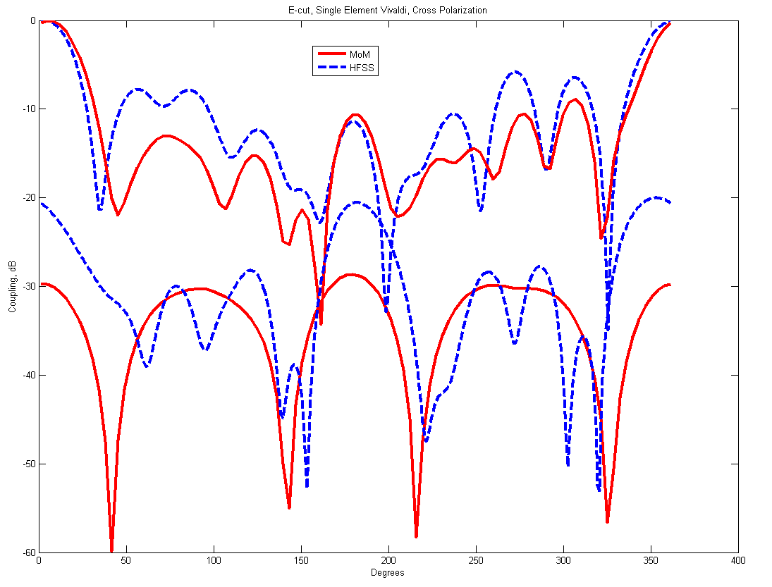
Figure 3-48: E-cut cross polarization of two element planar array for MOM versus Ansoft HFSS. Although some variation exists, overall excellent correlation is achieved.
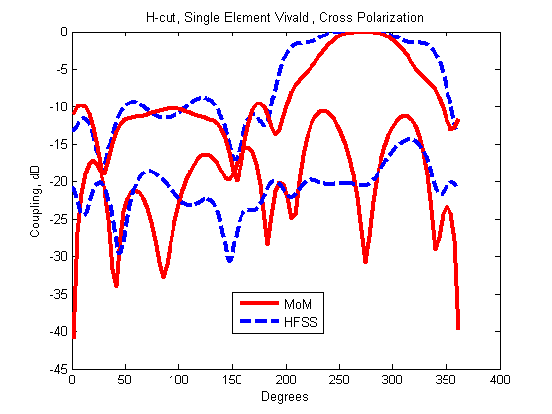
Figure 3-49: H-cut cross polarization of two element planar array for MOM versus Ansoft HFSS. Although some variation exists, overall excellent correlation is achieved.
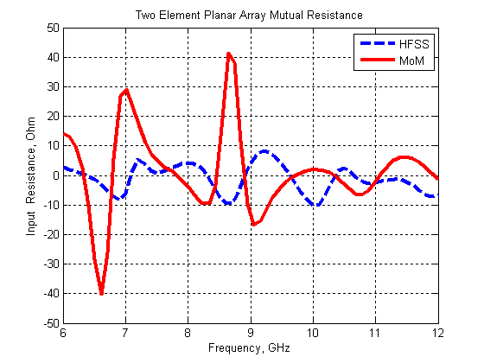
Figure 3-50: Mutual resistance for two element planar Vivaldi array.
Figure 3-52 outlines the process for adaptively refining the meshes used in simulating the single and double element Vivaldi antennas. The use of MOM techniques in antenna simulation is promising, as outlined in the simulation results presented here. The major drawback which needs further investigation is how to accurately simulate the effects of the substrate for a true 3-D simulation since the approximate method outlined here did not provide accurate results in simulating the effects of the dielectric.

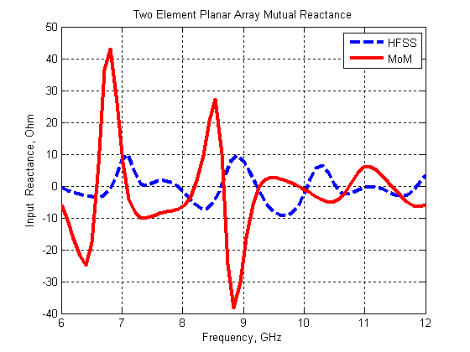
Figure 3-51: Mutual reactance for two element planar Vivaldi array.

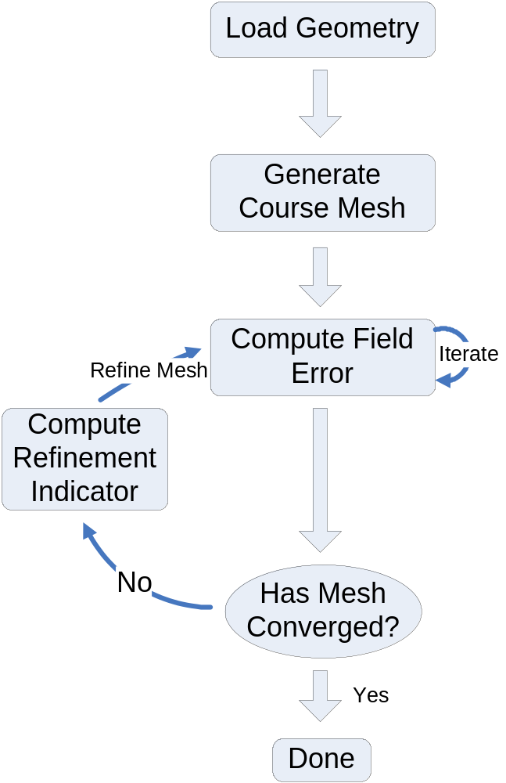
Figure 3-52: Process for adaptively refining the meshes used in simulating the single element and double element Vivaldi antennas.

UWB Receiver-Side Digital Signal Processing for High Accuracy Indoor Localization
A pronounced need exists for adaptive techniques in receiving and processing of UWB signals at base stations and communications receivers. This is due to the wide range of indoor environments which UWB signals travel through from the transmitter to receiver(s). For example, the signal may be either LOS or NLOS, which fundamentally changes its characteristics and therefore how it should be processed at the receiver. Adaptive techniques are needed which are implemented on programmable digital hardware (i.e. FPGAs) to accurately detect the nature of the incoming UWB signals so that appropriate mitigation techniques can be used either on the FPGA or in the software. An overview is provided here of the digital signal processing techniques used in the UWB real-time location system which are implemented on an FPGA. This includes peak and leading-edge detection, noise estimation, and signal-to-noise ratio calculations. Effects of low signal-to-noise ratios on UWB leading-edge detection is discussed in Section 4.5 to provide background and an understanding of the effects low SNR and NLOS signals have at the UWB energy detection receiver. Chapter 5 provides a more formalized discussion of non-line-of-sight detection and mitigation including experimental results using the UWB multi-tag development platform outlined in Section 9.4 and Chapter 10. Section 4.6 discusses an adaptive leading-edge detection algorithm which utilizes SNR and received pulse slew rate to first determine LOS or NLOS and then uses an adaptive technique to apply a matched filter to the incoming UWB signal. The matched filter helps to increase the SNR of the LOS UWB pulse by up to 5-7 dB. Simulation results are included in Section 4.6. The FPGA used at the UWB base stations and UWB control station is the Spartan 3E evaluation board with a Xilinx Spartan-3 XC3S200 FPGA (and in some cases the Xilinx Spartan-3 XC3S1000 FPGA). The transmission of time difference and SNR data to the computer via an RS-232 serial connection is discussed in Section 4.7.

UWB Pulse Analog-to-Digital Conversion
The raw UWB signal after sub-sampling (see Section 2.2.3) is shown in Figure 4-1. The sub-sampling process extends the pulse from 300 ps FWHM to 0.7-1.0 µs FWHM using a 2500 expansion factor. The received UWB pulse after passing through a 50 MSPS 10-bit Analog Devices AD9216 ADC evaluation board is shown in Figure 4-2. The UWB pulse is intact, but a slight ringing is introduced by the RF transformer at the differential input of the ADC. The RF transformer resonates around 100 kHz and saturates for low frequency signals (< 50 kHz), effectively making the input signal high pass filtered at around 100-300 kHz. This effect is shown in Figure 4-3 and effectively limits the usable expansion factor for the UWB system. As shown in Figure 4-3, the 50 kHz sine wave passes the input RF transformer without attenuation while the 30 kHz, 20 kHz, and 10 kHz sine waves become more and more attenuated.
Table 4-1 shows the sub-sampled -10 dB bandwidth and FWHM for different expansion factors. At a 2500 expansion factor, the UWB pulse is transmitted successfully with no amplitude reduction and slight ringing as shown in Figure 4-2. At a 10,000 expansion factor, the UWB pulse is transmitted through the RF transformer but causes extreme amounts of ringing which makes it unusable for localizing in the UWB positioning system. This effect is shown in
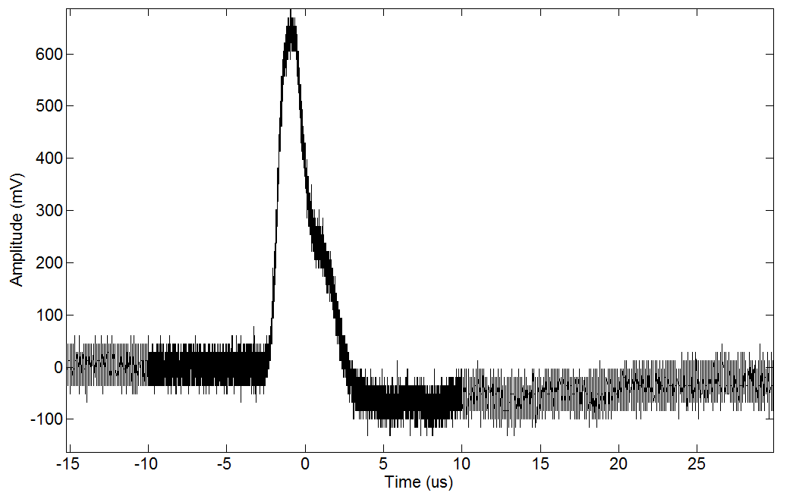
Figure 4-1: Raw received UWB pulse using a 2500x expansion factor before analog-to-digital conversion. No ringing is observed in the UWB pulse when compared to Figure 4-2.
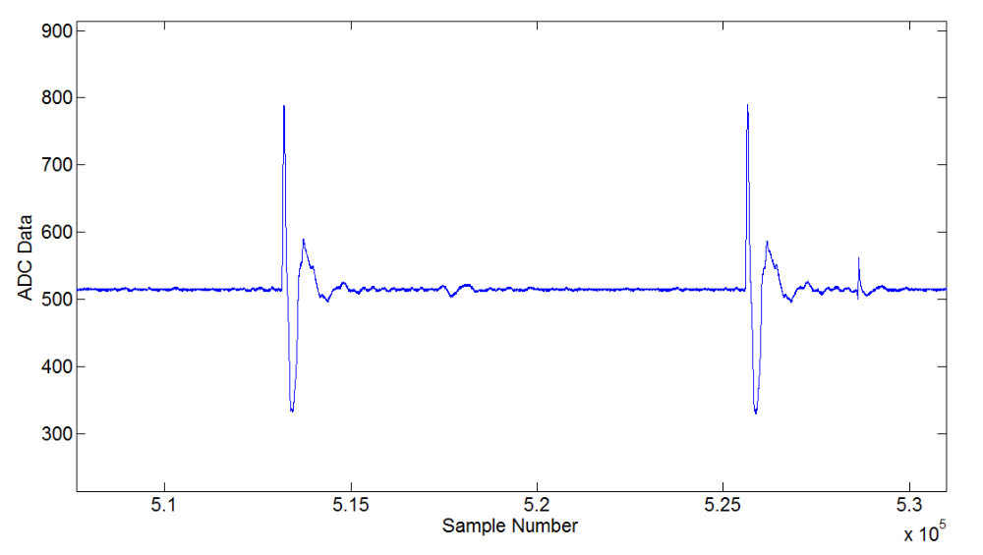
Figure 4-2: Raw received UWB pulse using a 2500x expansion factor after analog-to-digital conversion. A slight ringing is introduced by the high pass filter on the ADC which can be observed immediately after the initial UWB pulse. The original shape of the UWB pulse before analog-to-digital conversion is shown in Figure 4-1.
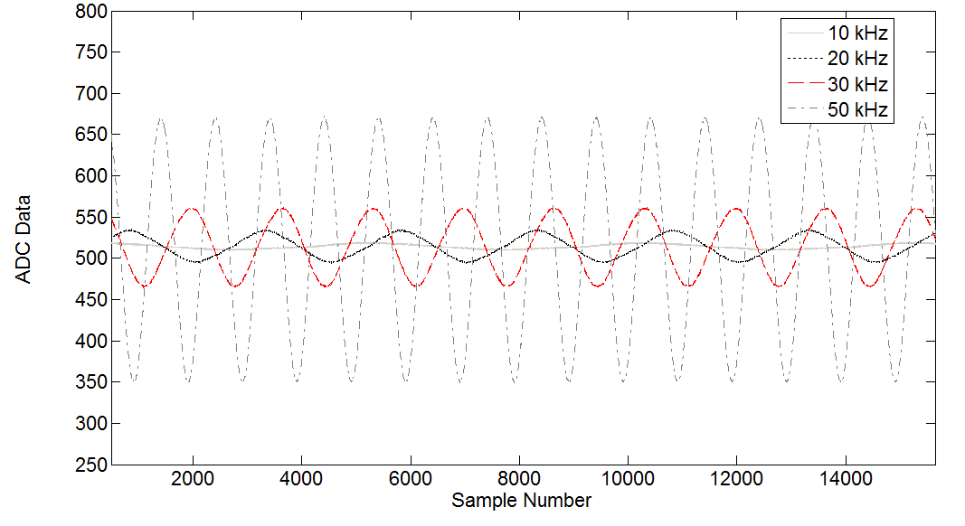
Figure 4-3: Output sine wave signals for input sine waves of 500 mVpp with frequencies of 10 kHz, 20 kHz, 30 kHz, and 50 kHz. The signals attenuate significantly when comparing 50 kHz to 10 kHz. This is the saturation effect of the RF transformer which effectively limits the input signal to a frequency bandwidth of 50 kHz and above (a high pass filter with a 50 kHz cutoff).

Table 4-1: Sub-sampled 300 ps UWB pulse -10 dB bandwidth and FWHM for different expansion factors.
Expansion Factor | UWB Pulse -10 dB Bandwidth | Pulse FWHM
1000 | DC - 3 MHz | 300 ns
2500 | DC – 1.2 MHz | 750 ns
5000 | DC – 600 kHz | 1.5 µs
10,000 | DC – 300 kHz | 3 µs
100,000 | DC – 30 kHz | 30 µs
Figure 4-4 where the UWB pulse with 10,000 expansion is shown before and after analog-to-digital conversion. Before the ADC, the UWB pulse has a typical pulse shape while after the ADC, the pulse has an extreme amount of ringing. At a 10,000 expansion factor, the -10 dB bandwidth is 300 kHz, which is greatly distorted and resonated by the RF transformer at the differential input of the ADC. Finally, Figure 4-5 shows a 30 µs UWB pulse with 100,000 expansion factor. The bandwidth of this signal is 30 kHz, and it is almost completely attenuated by the RF transformer at the differential input of the ADC. Given the input frequency constraints of the ADC differential input RF transformer, an expansion factor of 2500 is used to ensure the received UWB signal has minimal ringing, minimal distortion, and a higher digital sample period (for 2500, each sample is spaced 8 ps apart).

UWB Peak Detection
The first step in localizing the sub-sampled UWB pulses is detection of the UWB pulse peak. The pulse peak is important for multiple reasons which include its use as a trigger to reset
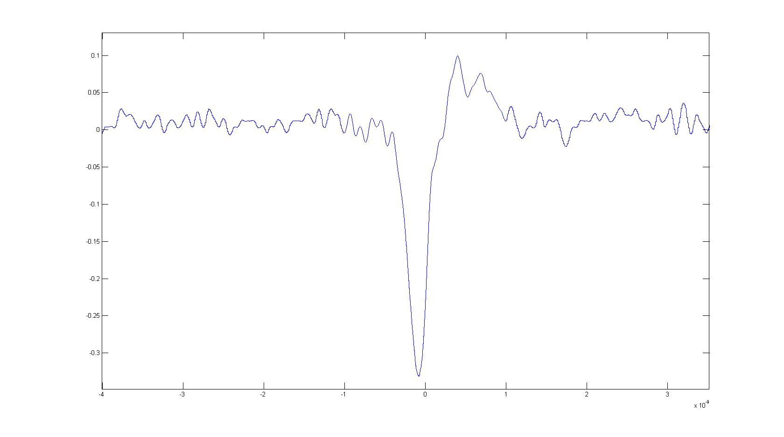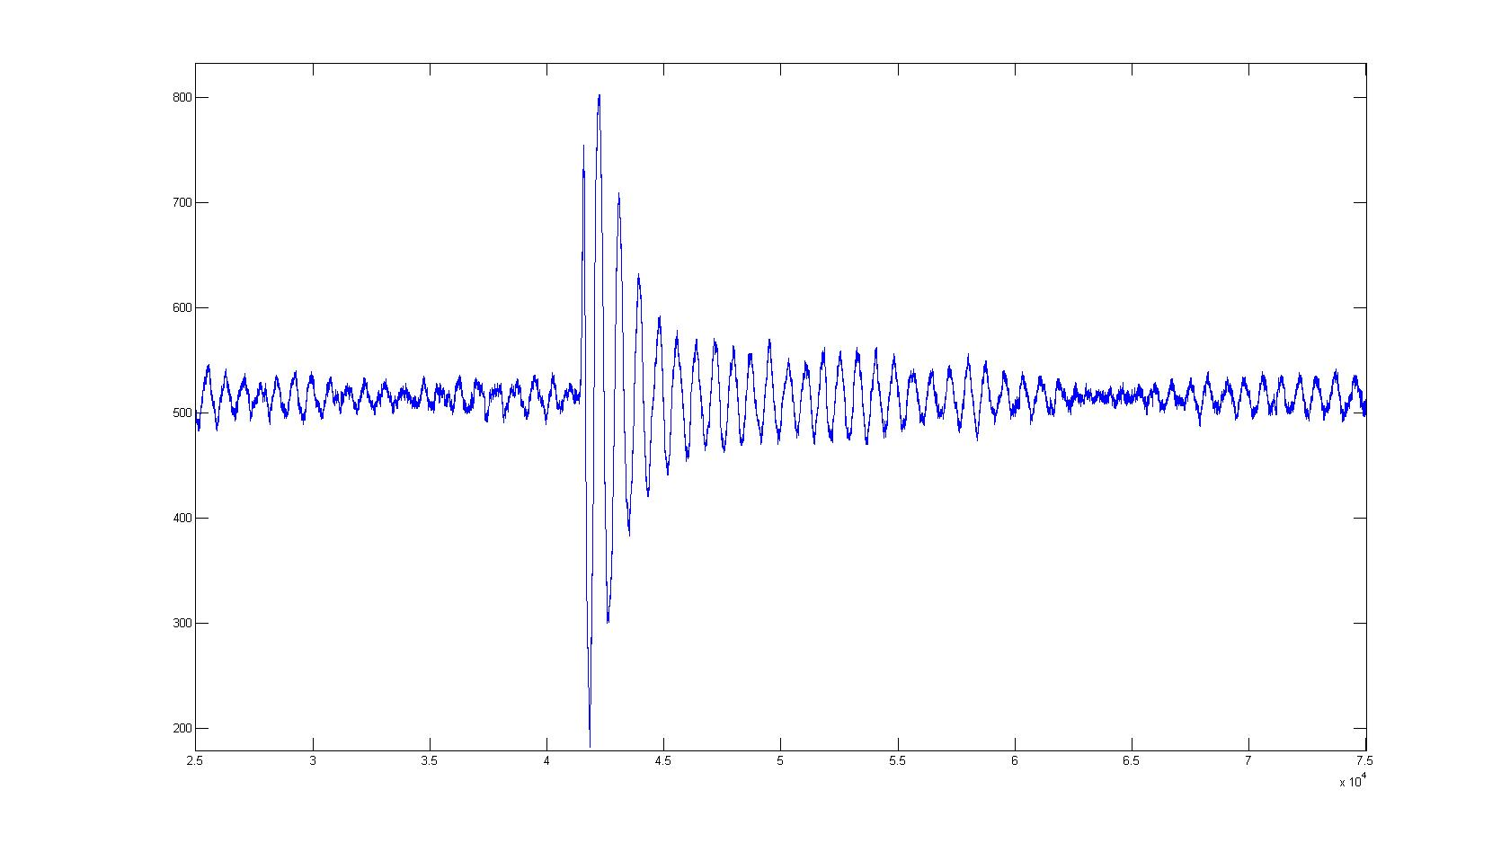
(a) (b)
Figure 4-4: (a) 3 µs UWB pulse at a 10,000 expansion factor before analog-to-digital conversion, (b) 3 µs UWB pulse at a 10,000 expansion factor after analog-to-digital conversion where a large amount of ringing is evident which is caused by the RF transformer at the differential input of the analog-to-digital converter.
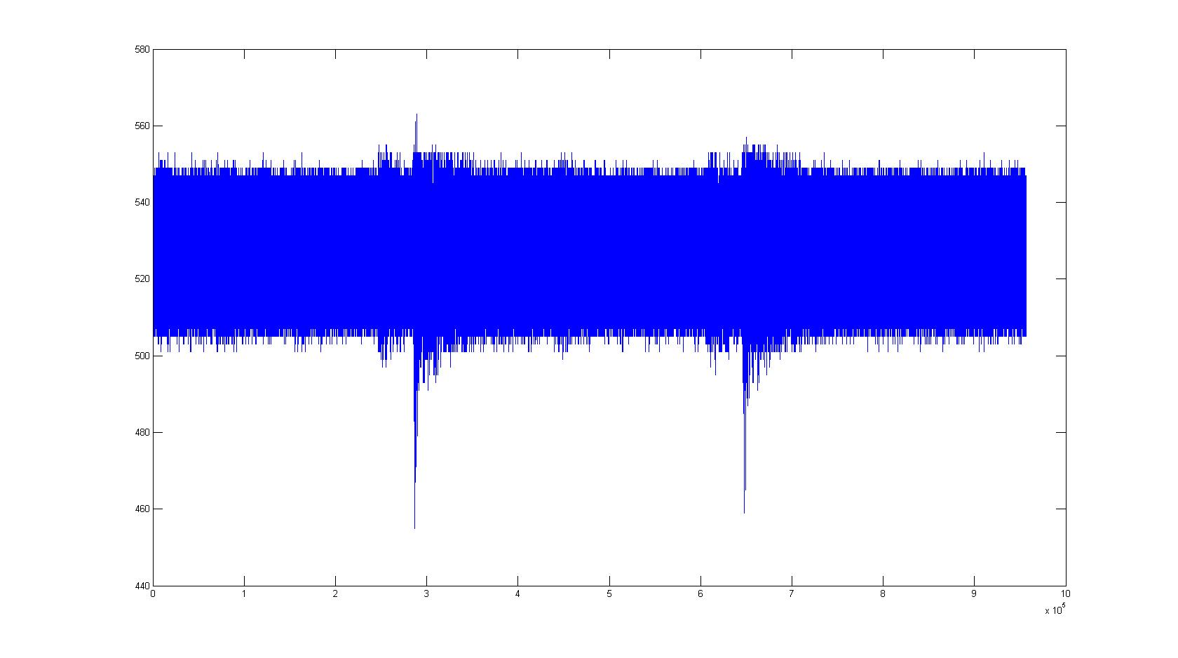
Figure 4-5: 30 µs UWB pulse at a 100,000 expansion factor after analog-to-digital conversion where the UWB pulse has been almost completely attenuated by the ADC input RF transformer.
the UWB base station peak and leading-edge detection algorithms as well as its use in the signal-to-noise ratio calculation which can then be used for NLOS detection and mitigation as discussed in Chapter 5. Figure 4-6 shows the absolute value of the received UWB signal. The
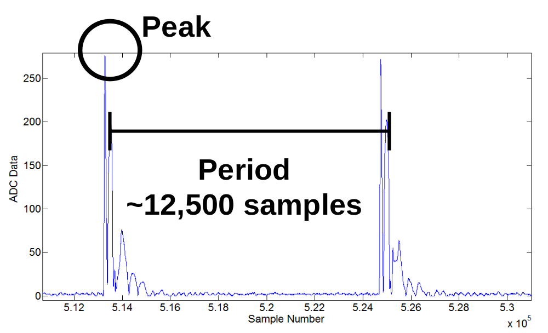
Figure 4-6: Absolute value of the received UWB pulse. The peak can easily be located by using a search window which is a substantial size of the UWB pulse period of around 12,500 digital samples. A window size of 5/8 of the period is used which equates to 7812 samples.
peak is located by using a moving window of 5/8 the size of the UWB pulse period. Each time a new maximum value is found, the counter resets to zero. Since the digital pulse period is 12,500 samples for a 2500 expansion factor (equates to 250 µs), the moving window is 7812 samples. This is sufficiently large to lock onto the UWB pulse peak while reducing the likelihood of false peak triggering to virtually zero. This provides a triggering capability which resets the leading-edge detection algorithm each time a new UWB pulse peak is located. Once the counter for the 7812 sample window reaches becomes greater than the window size of 7812, the peak or leading-edge time position is saved, and the FPGA switches into a hold mode and noise sampling mode. The running peak search window is shown in Figure 4-7.

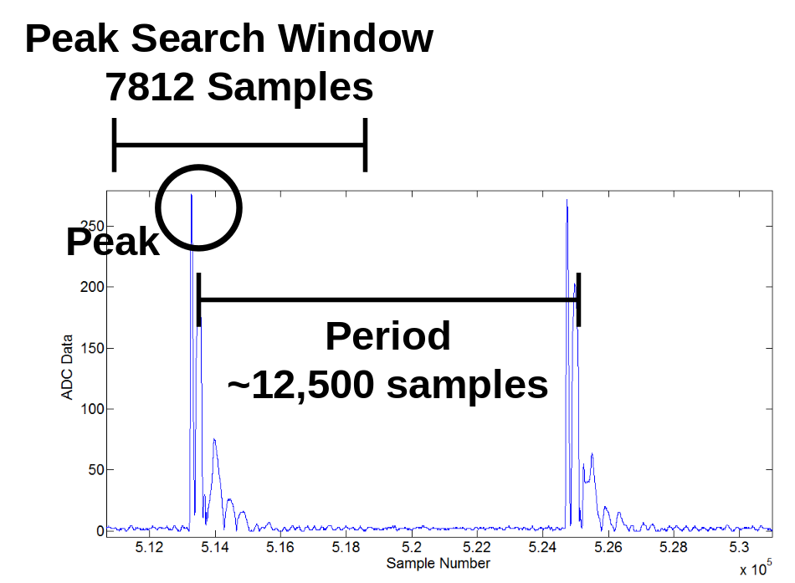
Figure 4-7: Absolute value of the received UWB pulse. The peak search window is 7812 samples or 5/8th of the overall UWB pulse period of 12,500 samples.

UWB Leading-Edge Detection
Leading-edge detection is the most robust ranging algorithm for accurate estimation of the time-of-arrival of a UWB pulse. It is used in commercial UWB indoor positioning systems [14] as well as in research-related UWB positioning systems [20]. The first generation leading-edge detection algorithm designed by Merkl is described in [53] and outlined in Section 2.2.6. It uses two max windows of 16 and 256 samples and the ratio between them to detect the leading-edge of the incoming UWB pulse. The 3-D dynamic results from the 1st generation UWB indoor positioning system outlined in Chapter 2 were obtained with Merkl’s max ratio leading-edge detection algorithm implemented on an FPGA. Chapter 3 provides simulation results which further support the robustness of leading-edge detection for indoor LOS environments. Figure 4-8 shows a received UWB pulse and highlights the leading edge of the pulse. The leading-edge can be detected with a high accuracy of 10-20 ps (3-6 mm) for the raw signal compared to 30-300 ps (9-90 mm) for peak detection of a high SNR UWB pulse signal. This is possible because of the high slew rate of the leading-edge when compared to the peak of the UWB pulse. Figure 4-9 shows the error in millimeters for a tag in a static position for both the leading-edge detection and peak detection algorithms. As shown in Figure 4-9, leading-edge detection has much less variation (11.1 mm) compared to 76.5 mm for peak detection. Error due to clock jitter and drift and AWGN combine with uncertainty in the leading-edge to cause the raw error to be 11.1 mm instead of the theoretical uncertainty given the slew rate of the leading-edge of 3-6 mm.
The leading-edge digital sample position is calculated by first detecting the UWB pulse peak from the previously received UWB pulse. For example, for the signal in Figure 4-7, the
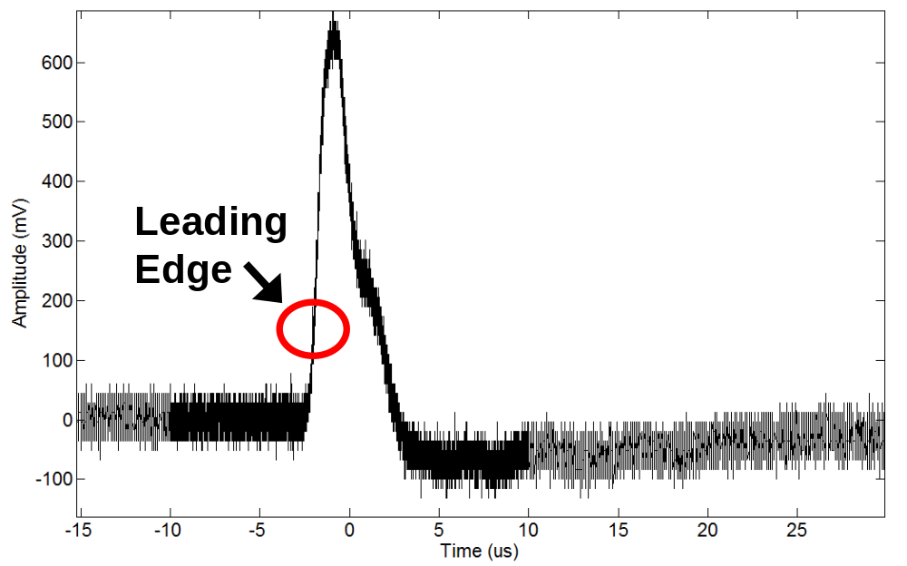
Figure 4-8: UWB pulse before the ADC where the high slew rate leading-edge can be seen and provides a much sharper trigger point for resolution of the time-of-arrival (10-20 ps) when compared to the peak of the UWB pulse (30-300 ps for high SNR signals).
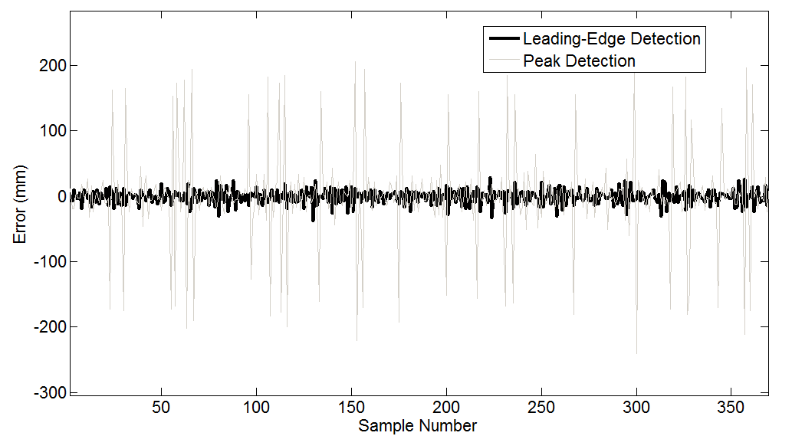
Figure 4-9: Variation in millimeters for a tag in a static location comparing raw output data from the peak and leading-edge detection algorithms. The leading-edge detection algorithm has a standard deviation of 11.1 mm compared to a standard deviation of 76.5 mm for peak detection.
peak value is around 290. The threshold for the leading-edge detection algorithm is set to 1/4th the magnitude of the UWB peak value. In this case, the leading-edge detection threshold is set to 72. A final comparison is done to make sure the current leading-edge threshold is above the noise floor of the incoming signal. The noise floor calculation is discussed in Section 4.4. Results for the leading-edge detection algorithm are outlined in Figure 4-10 where a tag is left in a static location and 10,000 consecutive leading-edge detection measurements are taken. The raw leading-edge data has a standard deviation of 11.1 mm while the standard deviation drops to 0.60 mm with the application of a 10-sample averaging filter. The complete leading-edge detection algorithm is outlined in Figure 4-11. This algorithm is used to provide data for the NLOS detection and mitigation outlined in Chapter 5.
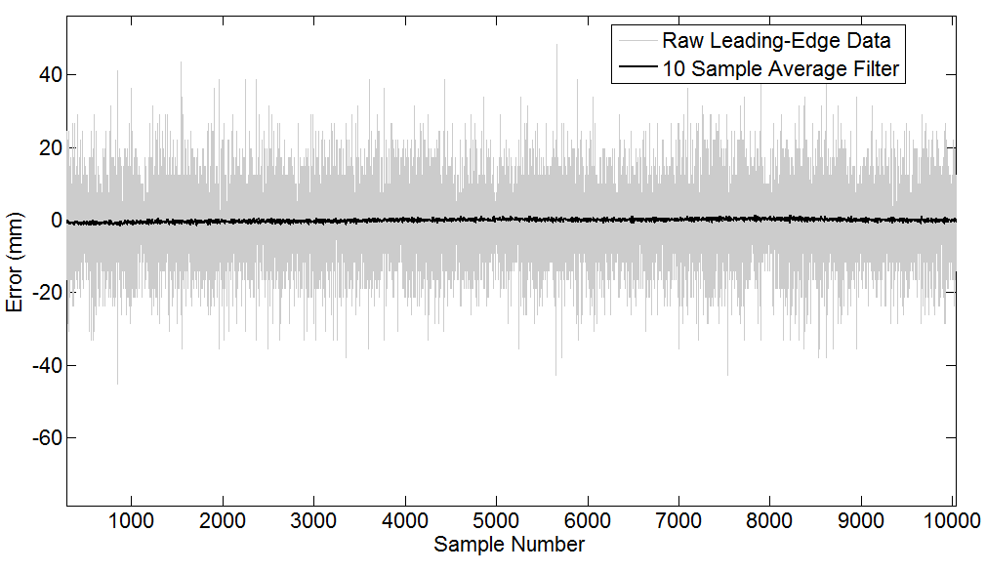
Figure 4-10: Variation in millimeters for a tag in a static location for 10,000 consecutive UWB pulse leading-edge calculations. The raw leading-edge detection data has a standard deviation of 11.1 mm while the application of a 10-sample averaging filter reduces the standard deviation to 0.60 mm. The leading-edge detection data is Gaussian and is easily filtered.

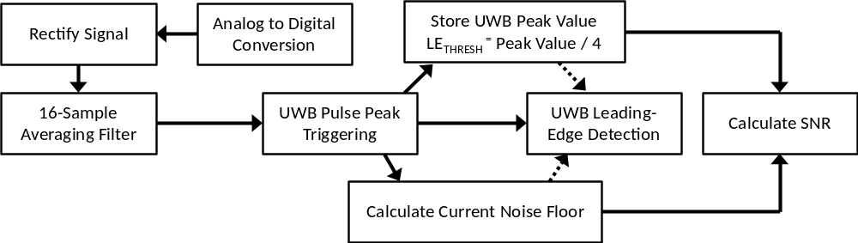
Figure 4-11: Leading-edge detection algorithm implemented on the base station FPGA which uses a rectified signal which undergoes a 16-sample averaging filter. This signal is used in triggering the algorithm off of the UWB pulse peak. The peak value is used to set the leading-edge detection threshold. The noise floor is calculated as discussed in Section 4.4. Finally, the peak and noise values are used to calculate the UWB SNR.

Noise Estimation
The noise in the received UWB pulse signal is estimated by first triggering the leading-edge detection algorithm off of the received UWB pulse peak as discussed in Section 4.2. Once the peak triggering is set, then a window is allocated for the received signal noise estimation. This process is outlined in Figure 4-12 where two separate moving windows are allocated: one for leading-edge and peak detection, the other for noise sampling and estimation. Currently the maximum value found within the noise sampling window is stored and used as the current noise level of the UWB signal. As shown in the leading-edge detection algorithm in Figure 4-11, the noise value is located after the received signal is rectified and sent through a 16-sample averaging filter. A typical noise signal is shown in Figure 4-13. The noise signal was measured
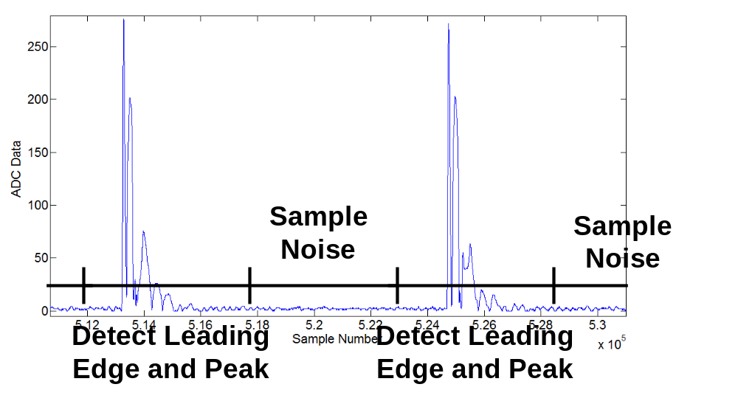
Figure 4-12: Received UWB pulse peak triggering process where a window is first allocated for peak and leading-edge detection followed by a separate time window allocated for noise sampling and estimation.
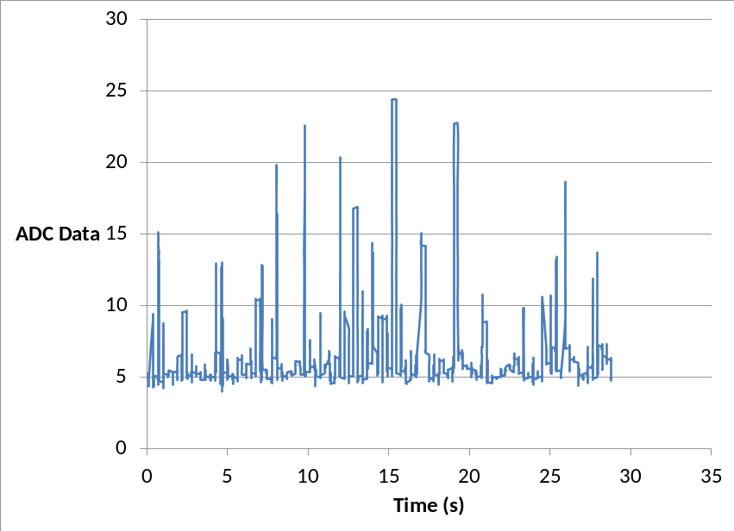
Figure 4-13: A typical noise signal measured over a time period of 30 s. Values fluctuate from 5-25 as measured by the 10-bit ADC.
over a 30 s period from a UWB receiver while the tag was left in a static location. The data values from the 10-bit ADC vary from 5-25 for this example signal.

Signal-to-Noise Ratio Calculation
The UWB peak value and noise value are used to calculate the SNR of the received UWB pulse. Peak detection is discussed in Section 4.2 while noise estimation is outlined in Section 4.4. The SNR is calculated using (4-1)
$SNR=20 \log_{10}\left(\frac{Voltage Peak Val}{Voltage Noise Val}\right)$ | (4-1)
where the peak value is calculated as discussed in Section 4.2 and the noise value is calculated using the method outlined in Section 4.4. The SNR can be solved for exactly when the peak and noise data is sent to the computer, as discussed in Section 4.8. Conversely, the SNR is estimated on the FPGA using (4-2)
$SNR=\frac{420}{64}*Round\left(\log_{2}\left(\frac{Voltage Peak Val}{Voltage Noise Val}\right)\right)$ | (4-2)
where the log₂ (Voltage Peak Val / Voltage Noise Val) is estimated to the nearest power of two. The resultant possible SNR values output directly to the FPGA seven segment display include 0, 6, 13, 19, 25, 32, 39, 45 (or 0, 6, D, 13, 19, 20, 27, 2D in hex). The FPGA calculated SNR values are useful for quick system checking and debugging.
Figure 4-14 shows the raw UWB received signal after the ADC. Variations in the UWB pulse peak amplitude can be captured in variations of the SNR of the received UWB pulses. Figure 4-15 shows the SNR in dB for a UWB receiver where a hand is purposely waived in front of the UWB receiver during the 20-30 s time interval. This effectively blocks the LOS path and causes a reduction in SNR from 28 dB to 6-15 dB. Finally, the SNR for five base stations over a
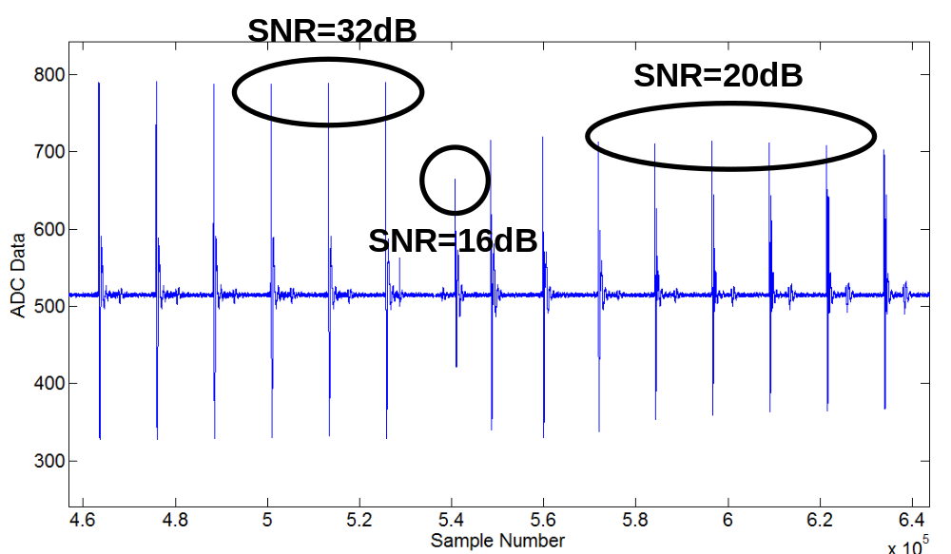
Figure 4-14: Raw UWB signal after the ADC where various UWB pulse peak heights can be seen to illustrate variations in the SNR of the received UWB signal.
140 s time period is shown in Figure 4-16. The tag is kept in a static location over this time period. The SNRs of the five base stations vary between 25-38 dB but illustrate a strong link between the tag and the five base stations. The SNR of the UWB signal is used in NLOS detection and mitigation as discussed in Chapter 5.
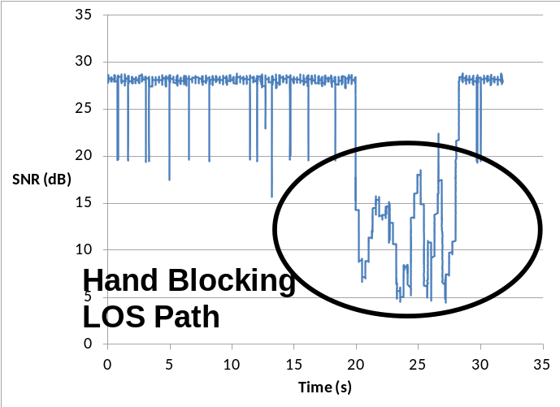
Figure 4-15: The SNR received at a UWB receiver over a 30 s period where hand blocking occurs between 20-30 s. This hand blocking reduces the LOS UWB pulse and consequently the SNR drops from 28 dB to between 6-15 dB.
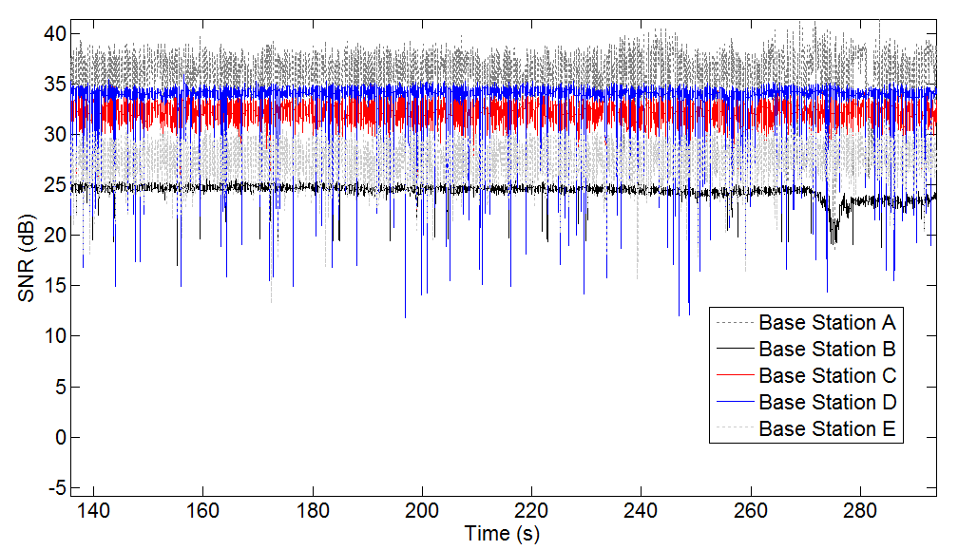
Figure 4-16: The SNR for five base stations (A, B, C, D, E) for a static scenario where the tag is kept in a static location. The SNRs of the base stations vary between 25-38 dB but illustrate a strong UWB link between the tag and the five base stations.

Effects of Low Signal-to-Noise Ratios on Leading-Edge Detection
As discussed in Section 3.3.3, Section 3.5, Section 4.8, and [53], the deterioration of the SNR of the received UWB pulse can have significant effects in the operation of the leading-edge detection algorithm. Since a ratio of 1/4th is used in detecting the UWB pulse leading-edge, when the SNR drops to below 6 dB, the leading-edge detection algorithm begins to detect noise instead of the actual pulse leading-edge. This is clearly illustrated in Figure 4-17 where in a simulated scenario as the SNR of the received UWB signal drops below 6 dB, the leading-edge detection ranging error increases from around 1 mm to almost 1000 mm. Therefore, an SNR below 12 dB indicates potential NLOS conditions where larger errors in leading-edge detection ranging can occur. This LOS/NLOS detection scheme is outlined in more detail in Chapter 5.
Figure 4-17: Simulated leading-edge detection 1-D error vs. SNR of received UWB pulse for three ADCs.

UWB Control Station Processing
The UWB control station FPGA calculates the range differences (in digital samples) between the reference base station A and the other base stations (B, C, and D for four base station experiments and B, C, D, and E for five base station experiments). The range difference calculations are relative to base station A. The results are sent via an RS-232 serial port connection to the computer for further processing. The complete process of digital data passing from the base station FPGAs to the control station FPGA to the computer is outlined in Figure 4-18. The base station FPGAs provide two-channel support. Three base station FPGAs support up to six operational UWB base stations. A confirmed leading-edge detection is sent to the control station FPGA as a digital zero-to-one transition. Peak and noise values for the UWB received signals are also sent to the control station FPGA. The control station FPGA broadcasts the current Tag ID to the base station FPGAs. This allows UWB peak values to be stored individually for each tag currently connected to the UWB positioning system. The time differences, the Tag ID, and the peak and noise values are transmitted via RS-232 to the computer through the Perle RS-232 to Ethernet converter. The Perle RS-232 to Ethernet converter is needed to support data rates higher than 115,200 baud for the control station-computer RS-232 link. The Spartan 3E evaluation board a Maxim MAX3232 RS232 voltage translator chip. This chip supports data rates of up to 460,800 baud. With the Perle RS-232 to Ethernet converter, data rates of up to 460,800 can be realized at the computer. Figure 4-19 shows the main window of the UWB C++ software application. Different modes can be selected depending on whether 4 or 5 base stations are connected and whether or not SNR information is desired. The UWB real-time C++ software is outlined in more detail in Chapter 9.
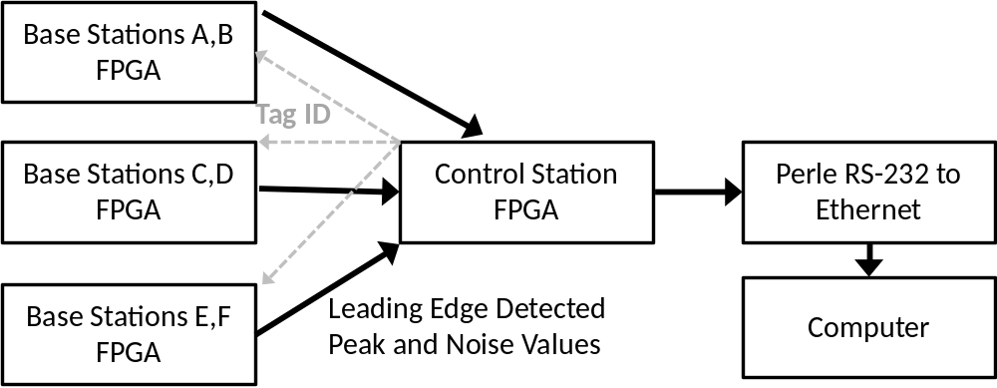
Figure 4-18: Block diagram of complete digital processing system which includes three 2-channel base station FPGAs which communicate with the control station FPGA when a leading-edge is detected for either channel. The data is transmitted from the control station FPGA through a Perle RS-232 to Ethernet converter to the computer.
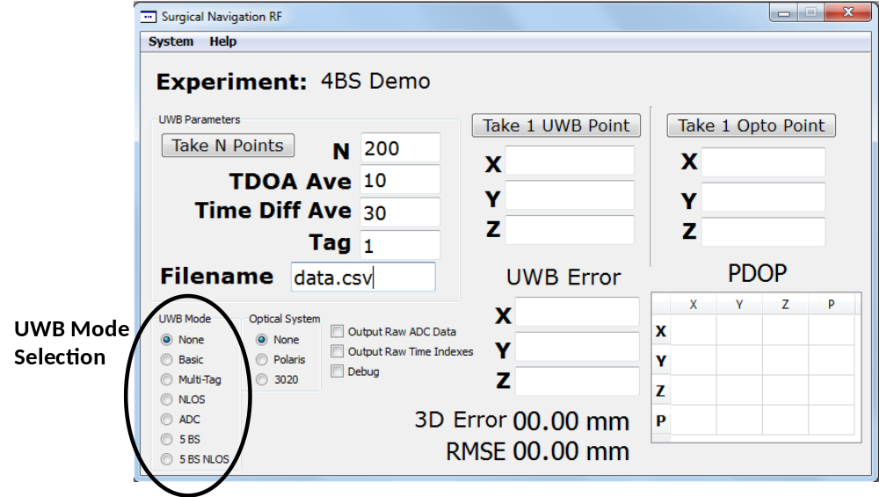
Figure 4-19: UWB mode selection in the C++ software can be used to switch between 4 base stations and 5 base stations as well as whether or not peak and noise values are transmitted to the computer (NLOS modes include peak and noise values, Multi-Tag and 5 BS do not).

Adaptive Leading-Edge Detection for Low SNR and NLOS Environments
The adaptive leading-edge detection algorithm builds off of Merkl’s max-ratio leading-edge detection algorithm, which is outlined in Section 2.2.6. The adaptive portion of this algorithm builds off the basic algorithm defined in Section 2.2.6 (Algorithm 1).
Algorithm 3: Adaptive Leading-Edge Detection

Results from the basic leading-edge detection algorithm are shown in Figure 3-24 for three different ADCs versus signal-to-noise ratio (SNR) in an industrial LOS environment defined by the IEEE 802.15.4a channel model with $α=2$. As shown in Figure 3-24, the basic leading-edge detection algorithm fails for $SNR<6dB$. Conversely, for $SNR>6dB$, sub-mm accuracy is achieved with the algorithm functioning properly.
(4-3)
$r_{SNR}= \frac{σ_{V_pulse}}{σ_{V_noise}}={10}^{\frac{SNR}{20}}⁡$
where $σ_{V_pulse}$ is the standard deviation of the UWB pulse portion of the received signal in Volts and $σ_{V_noise}$ is the standard deviation of the noise in Volts. Instead of solving for (4-3), $r_{SNR}$ can be approximated by
(4-4)
$r_{SNR}\tilde{=} \frac{max_n_{2}_pulse[t]}{n_{noise}}⁡$
where $max_n_{2}_pulse[t]$ is the maximum value of the larger moving window as it traverses over the UWB pulse and $n_{noise}$ is the maximum value obtained when sampling the UWB signal during the 2nd half of the 10 MHz clock cycle [53]. A SNR of 6dB corresponds to $r_{SNR}=2$. Since $α=2$, it can be seen that the algorithm fails when $r_{SNR}≤α$. When the received signal goes below this threshold, the comparator operation performed in (2-6) fails since $max_n_{1}[t]*α$ could return values greater than $max_n_{2}\left[t\right]$ even when detecting noise rather than an UWB pulse even if $max_n_{2}\left[t\right]$ is greater than the noise threshold $thresh$. The additional adaptive steps needed for low SNR and NLOS situations are outlined in Steps 1-3.
- The adaptive portion of the algorithm is added by including an additional check
(4-5)
$if \left( r_{SNR}≤α\right) then \hat{y}\left[t\right]=h[t] ⨂ g[t]$
where $g[t]$ is the template signal shown in Figure 4-20 and $⨂$ denotes the convolution operator. The new match filtered (MF) signal $\hat{y}\left[t\right]$ is then run through the original leading-edge detection algorithm outlined in Section 2.2.6.
- Besides detecting low SNR conditions, NLOS conditions must also be detected since, as shown in Figure 4-21, the received signals have a much lower slew rate, which causes ambiguity in detecting the leading-edge of the incoming signal. The slew rate can be estimated using a window around the leading-edge estimate
(4-6)
$r_{slew}\tilde{=}max_n_{1}[t+30]- max_n_{1}[t-30]$
where the slope over 61 samples of the max window $max_n_{1}[t]$ is used in estimating the slew rate.
- As shown in Figure 4-21, another concern in NLOS conditions is the presence of strong multipath components shifted a significant distance in time from the weaker LOS signal. A 2nd check is needed when determining whether or not the received signal is NLOS, $σ_{LE}$, which represents the standard deviation in the leading-edge time sample value over the previous five received pulses. Combining Step 2 with $σ_{LE}$ gives
(4-7)
$if \left( r_{slew}≤β\right) OR \left(σ_{LE}≥γ\right) First_detect and NLOS=true$
where $β$ and $γ$ are empirically derived thresholds and $First_detect$ is a simplified algorithm where the first detectable sample in $y\left[t\right]$ above $thresh$ is considered the leading-edge. $First_detect$ is only run in NLOS situations. Additionally, the fact that the received signal is NLOS can be sent to the computer and either discarded or used in the final TDOA algorithm similar to [106] where realistic error models for NLOS received signals were used in a global maximum likelihood scheme for the ranging estimates in the final TDOA calculation.
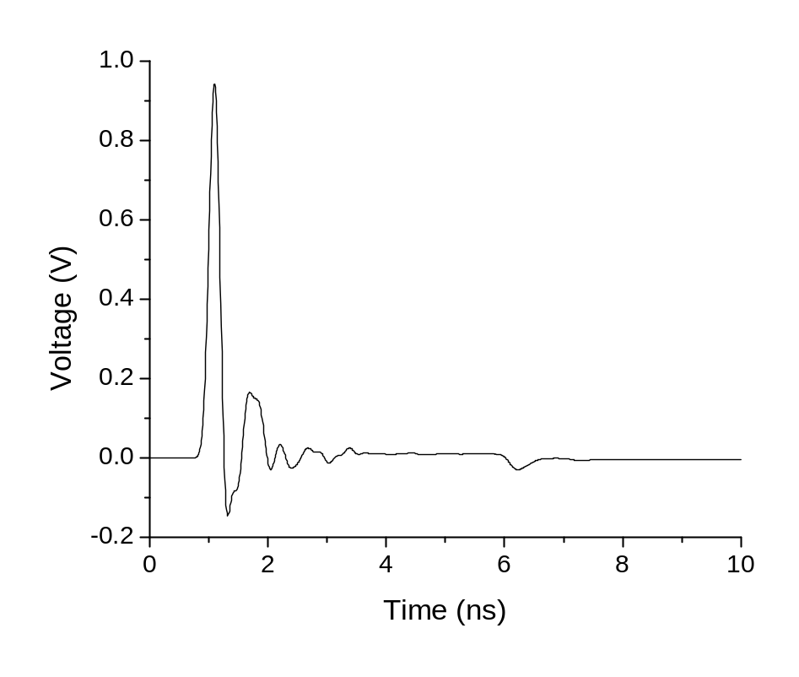
Figure 4-20: Simulated baseband UWB Gaussian pulse used as a template signal for the matched filter outlined in Step 1.
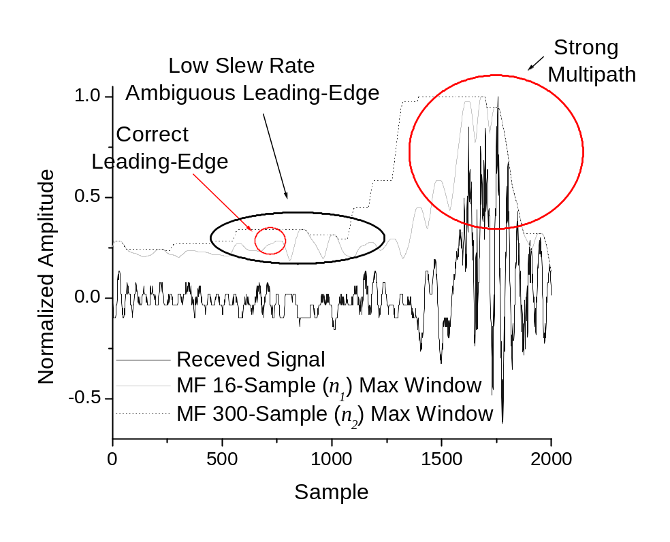
Figure 4-21: Simulated UWB received signal using the UWB IEEE 802.15.4a residential NLOS channel. The low slew rate of the NLOS leading-edge is highlighted as well as the strong multipath interference which arrives almost 1000 samples after the original weak LOS signal.

Simulation Results
The simulation framework outlined in Chapter 3 was used to test the adaptive scheme in comparison to the basic leading-edge detection algorithm. The entire UWB positioning system is simulated including the analog portions of the Tx and Rx in ADS, the UWB channel in Matlab (IEEE 802.15.4a to simulate different environments), and the sub-sampling mixer in Agilent ADS. The signal is first converted to digital by a 10 bit, 105 MSPS ADC. Next, the signal is sent to the FPGA where the leading-edge algorithm is run. The final processing is done on a computer to run the TDOA algorithm. Figure 4-22 shows an example received signal sent through an industrial LOS channel with the Tx-Rx 3 m apart. Significant noise and multipath mask the LOS pulse causing a SNR = -2.61dB. Figure 4-23 shows the same signal after (2-3) with $max_n_{1}[t]$ and $max_n_{2}[t]$ overlayed. Since $r_{SNR}<α$, noise is detected rather than the UWB pulse leading-edge. Figure 4-24 shows the same signal after (2-3) with the application of the MF in (4-5) overlayed by $max_n_{1}[t]$ and $max_n_{2}[t]$. The new SNR = 4.11dB and is detectable by the leading-edge algorithm since the MF significantly reduces the noise in the signal allowing correct detection of the leading-edge. Figure 4-25 shows SNR versus Tx-Rx distance for the industrial LOS environment where the addition of a MF increases the SNR by an average of 5.82dB. Conversely, as shown in Figure 4-26, in high SNR situations, such as the residential LOS environment with the Tx-Rx separated by 2 m, the addition of a MF reduces the SNR by 3.3dB, showing the need for a MF only in low SNR situations. 20 instantiations of the commercial and industrial LOS IEEE 802.15.4a channels were tested with a Tx-Rx distance of 2-8 m. An average SNR increase of 5.42dB and 3.42dB was obtained with application of a MF for the industrial and commercial LOS channels. In NLOS situations, the use of $First_detect$ applied to five instantiations of the residential, commercial, and industrial NLOS channels with Tx-Rx distances of 1-5 m yielded on average 1-D ranging accuracy of 12.5 mm, 19 mm, and 29.5 mm compared to an average of 350 mm, 31 mm, and 225 mm for the normal leading-edge algorithm.
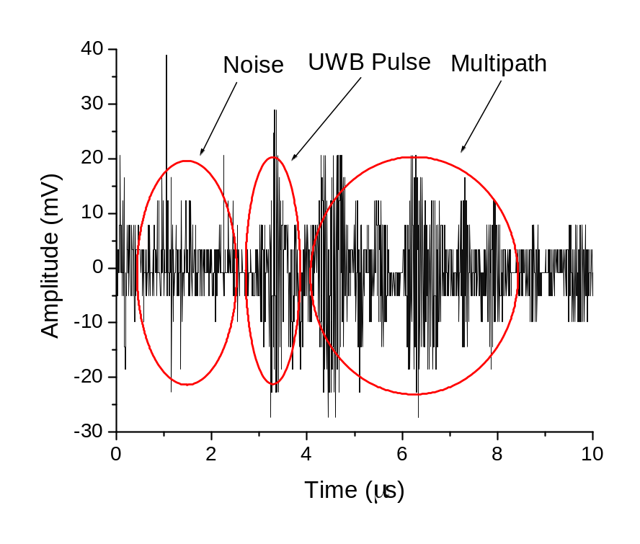
Figure 4-22: Simulated UWB time-extended signal where the Tx-Rx are 3 m apart in an industrial LOS environment defined by the IEEE 802.15.4a channel model and no automatic gain control is used in the UWB receiver creating a weak signal. Electrical noise, multipath interference, and quantization noise are observed. SNR = -2.61dB.

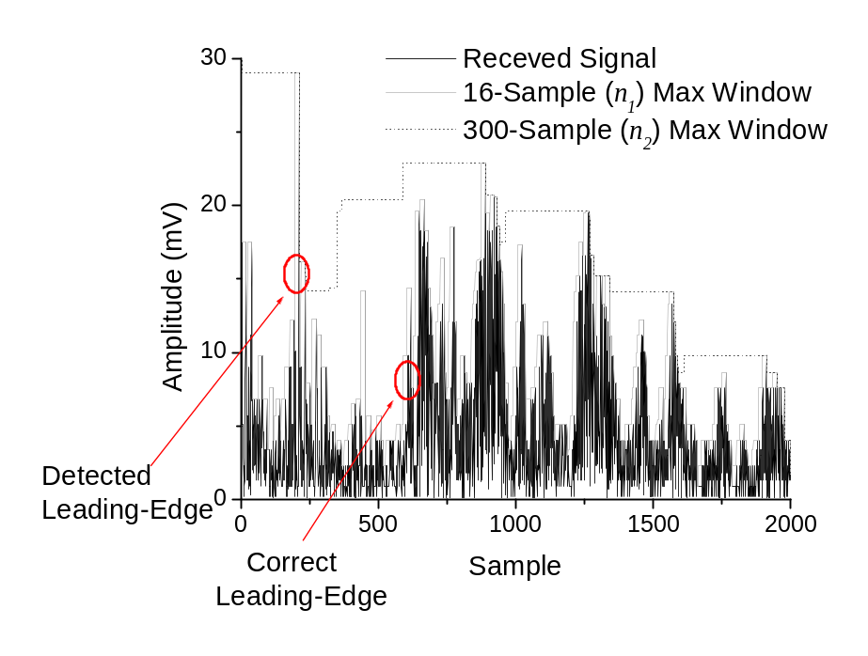
Figure 4-23: Simulated UWB received signal from Figure 4-22 where the basic leading-edge algorithm is run with $α=2, n_{1}=16,n_{2}=300$. Since the SNR = -2.61dB, the leading-edge algorithm incorrectly detects the noise at the beginning of the signal (sample 11) rather than the correct UWB leading-edge (sample 595).
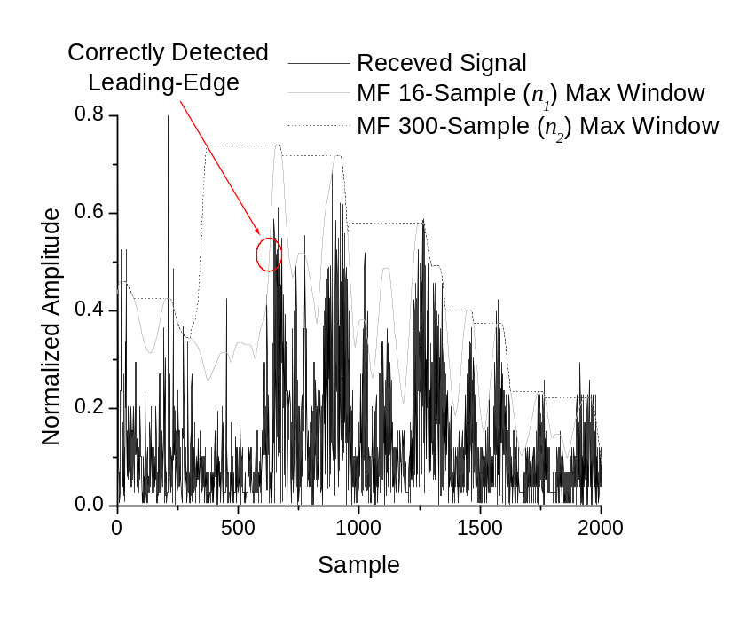
Figure 4-24: Simulated UWB received signal from Figure 4-22 where the adaptive leading-edge algorithm is run with $α=2, n_{1}=16,n_{2}=300$, and the template shown in Figure 4-20. Since the new SNR = 4.11dB after applying a matched filter, the adaptive algorithm has no problem locating the correct UWB leading-edge (sample 595).
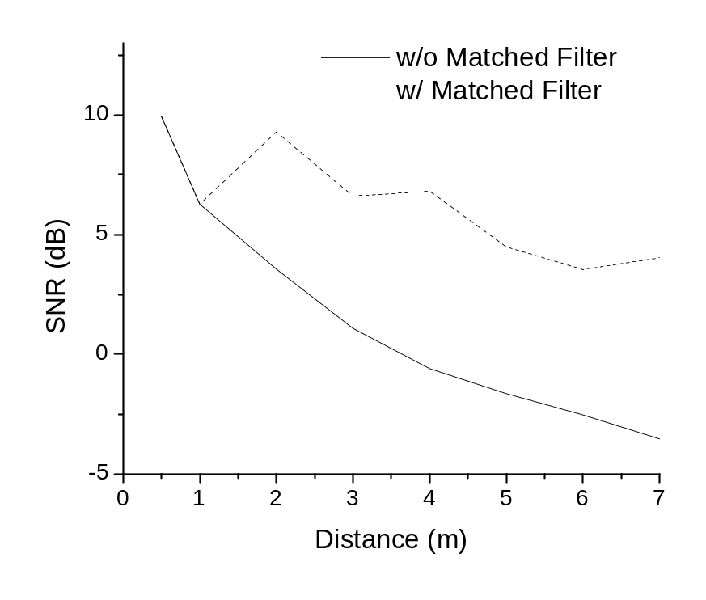
Figure 4-25: SNR versus Tx-Rx distance for standard leading-edge algorithm versus adaptive leading-edge algorithm. The UWB channel environment is the IEEE 802.15.4a industrial LOS channel. On average the addition of a MF increases the SNR by 5.82dB in low SNR conditions (when original signal $y[t]$ has SNR below 6dB).
Figure 4-26: Simulated UWB received signal using the UWB IEEE 802.15.4a residential LOS channel with Tx-Rx distance of 2 m. The SNR of $y[t]$ is 17.7dB. After applying a MF, the SNR drops to 14.4dB.

Non-Line-of-Sight Detection and Mitigation for High Accuracy Indoor UWB Localization
The quality of the wireless link between the tag and the base station plays a key role in the quality of the positioning data. This is true for all wireless positioning systems which use time-of-flight information to estimate ranges and ultimately perform 2-D or 3-D positioning. For example, redundant GPS satellites (more than the minimum number of four) are always visible at any point within the United States and most locations around the world. Ten or more GPS satellites can be visible at any one location on the earth. This provides a high level of redundancy in case one or more of the links are attenuated, partially blocked, or fully blocked. Partially blocked wireless signals can be reflected off of metal structures while attenuated wireless signals transmit directly through a lossy medium en-route to the final destination. In order to achieve ranging accuracy of five millimeters, accurate timing resolution of better than 20 picoseconds is required. This difficult requirement of 20 picoseconds creates a pronounced need for wireless links between the tag and base stations which are of high quality throughout the volume of interest. The real-time detection of poor link quality and NLOS conditions is outlined in this chapter. FPGA digital signal processing combined with real-time detection and mitigation algorithms implemented in software is required to detect and mitigate the effects of poor link quality and, in the worst case scenario, NLOS conditions.

Overview
The detection and mitigation of NLOS conditions for the high accuracy UWB indoor positioning system outlined in Chapter 9 is a difficult problem which requires a system-level approach and real-time operation to provide successful operation in dynamic scenarios. The detection of poor link quality and NLOS conditions is first outlined. This occurs both at the FPGA-level and also within the C++ software application. The mitigation of the effects of poor link quality and NLOS conditions must also be implemented at the system-level – both on digital hardware and in the real-time software application. Experiments are run to analyze the LOS versus NLOS wireless link behavior within the high accuracy UWB indoor positioning system. A mitigation strategy is introduced which relies on both peak detection and leading-edge detection ranging algorithms and utilizing the link SNR.

Experimental Setup
The experimental setup used in analyzing the UWB wireless link for LOS versus NLOS is shown in Figure 5-1. Partial (30-40%) and almost full blockage (95%) is introduced in the UWB wireless link path between the transmitter and base station. This is done by placing persons within the LOS link path for partial blockage and cupping the receive antenna at close range for near full blockage. Near full blockage corresponds to the low SNRs observed in Section 5.3 and 5.4. Figure 5-4 outlined the C++ software application where real-time tag information is displayed and recorded along with link information (LOS/NLOS) and link SNR. This setup is used in the experimental analysis outlined in Sections 5.3 and 5.4.
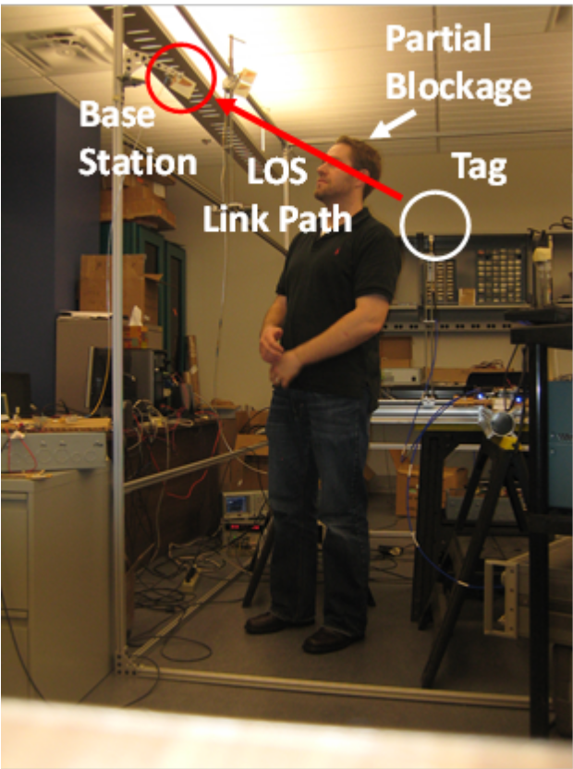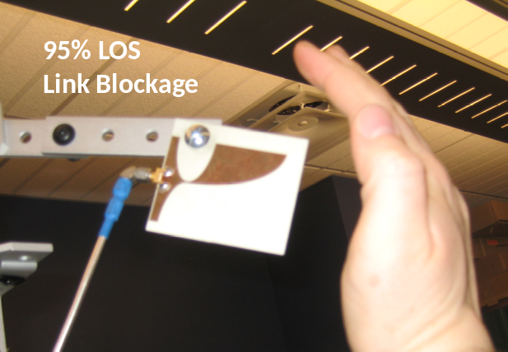
- (b)
Figure 5-1: Experimental setup where partial blockage is introduced in the LOS link path: (a) 30-40% blockage, (b) 95% blockage.
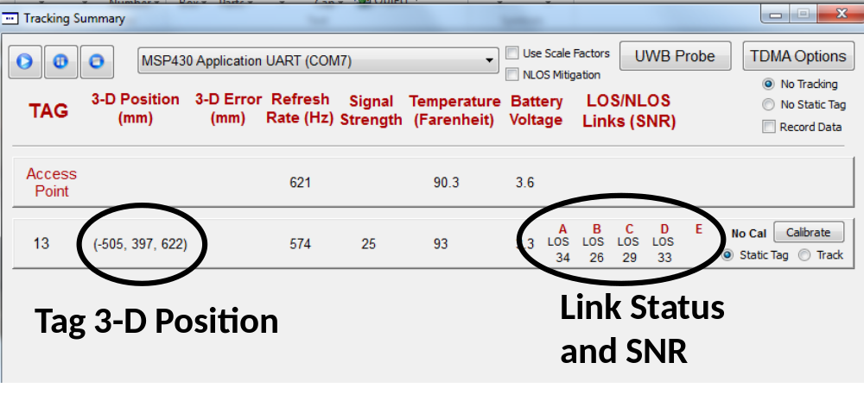
Figure 5-2: Software application where 3-D tag position and base station link status (LOS versus NLOS) and base station SNR are displayed and output to a CSV file in real-time.

Detection
The initial detection of NLOS conditions has to be done in real-time on dedicated digital hardware. The first measurement which provides the bulk of the information on whether or not an NLOS link exists is the signal-to-noise ratio. The FPGA-implemented SNR calculation algorithm is outlined in Section 4.5. The SNR of the received UWB signal as seen by the FPGA is defined as follows
$SNR=20 \log_{10}\left(\frac{Voltage Peak Val}{Voltage Noise Val}\right)$ | (5-1)
where the voltage peak value and the voltage noise value of the received UWB signal is measured in digital samples after passing through the ADC. Figure 5-3 shows the received UWB signal after taking the signal absolute value and passing the signal through a 16-sample averaging filter. This signal is typical of a strong received UWB pulse where the transmitter and receiver. The peak value in digital samples is 285 while the noise floor is 8. This corresponds to a SNR of 40 dB using (5-1). In practical operation, the SNR at each link for a strong UWB pulse typically lies between 20-40 dB. As the SNR degrades below 20 dB and approaches 10 dB and below, the leading-edge detection will fail as it is trying to locate the leading-edge at 1/4th the amplitude of the peak of the received UWB signal which lies below the noise floor of the received signal. Wireless signal propagation conditions which cause the SNR to degrade to 10 dB and below are typically caused by partial or close to complete blockage of the path between the transmitted wireless signal and the base station receiver.
Figure 5-4 shows the raw peak values for a transmitter-base station wireless link. The typical values around 70 digital samples (150 mV) are indicative of a strong link where the
UWB pulse signal is received consistently. The three dips illustrate a human hand moving towards and away from the base station antenna to cause partial blockage up to 95% blockage. Figure 5-5 shows the corresponding SNR for the received UWB pulse signal shown in Figure 5-4. The SNR for a strong LOS link is typically 25-27 dB. When partial to 95% blockage occurs, the SNR is reduced to less than 5 dB. As shown in Figure 5-6, the quick degradation of the SNR causes large ranging errors for the FPGA-implemented leading-edge detection algorithm outlined in Section 4.3 of up to 2 m. Figure 5-7 shows the leading-edge ranging error versus SNR. As the SNR drops below 10-12 dB, the leading-edge algorithm fails to locate the UWB pulse resulting in large errors. Given the relationship between received signal SNR and the
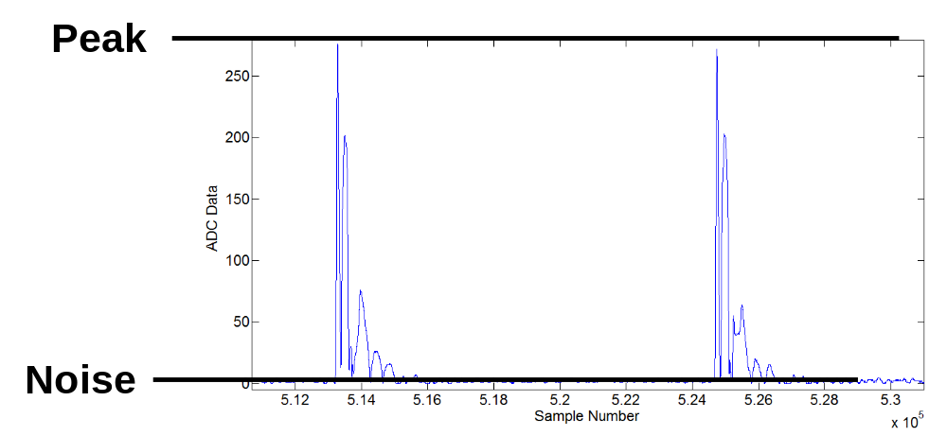
Figure 5-3: Typical received UWB pulse after taking the absolute value of the raw signal and passing it through a 16-sample averaging filter. The amplitude between the peak of the UWB signal and the noise floor is shown to highlight the high SNR’s which can typically be achieved when operating with LOS links.

performance of the leading-edge detection algorithm, an SNR threshold of 12 dB is used to detect LOS versus NLOS link conditions.
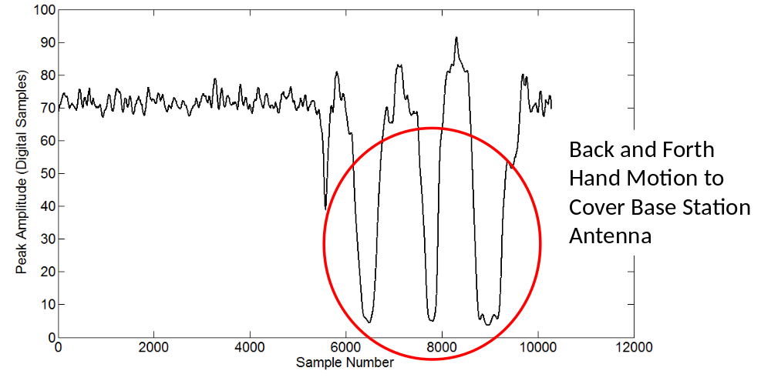
Figure 5-4: Experimental data measuring the peak of the UWB pulses in digital samples. The peak value decreases rapidly as a human hand approaches and almost completely covers the antenna. The quick reduction in link quality is easily measured by measuring the UWB pulse peak values.
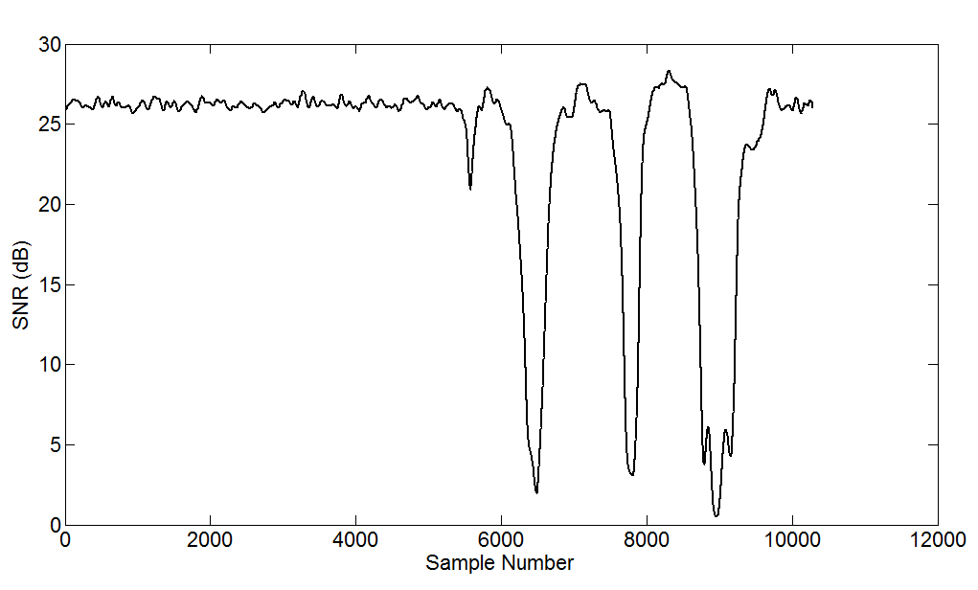
Figure 5-5: The received UWB pulse signal from Figure 5-4 expressed as SNR in dB.
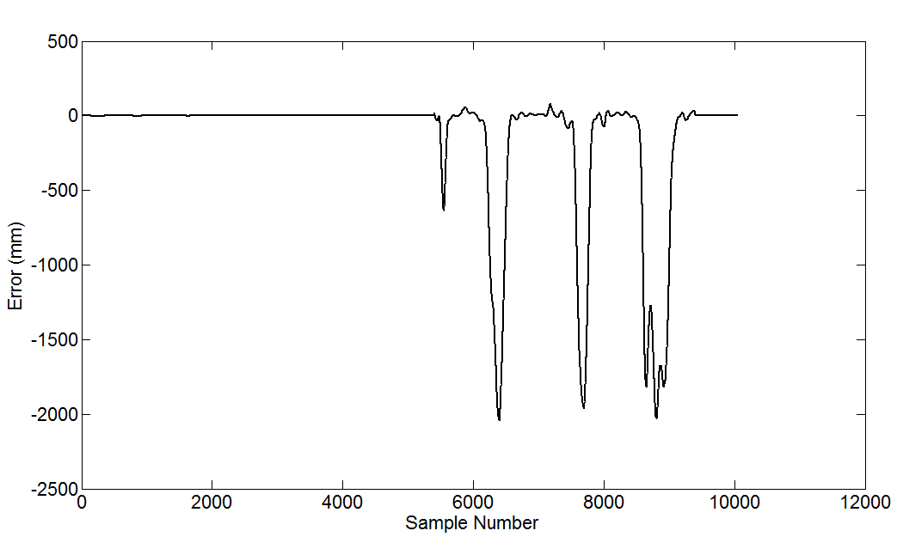
Figure 5-6: Range difference corresponding to the UWB base station where the NLOS blockage occurred. Extremely large ranging errors are observed on the order of two meters.
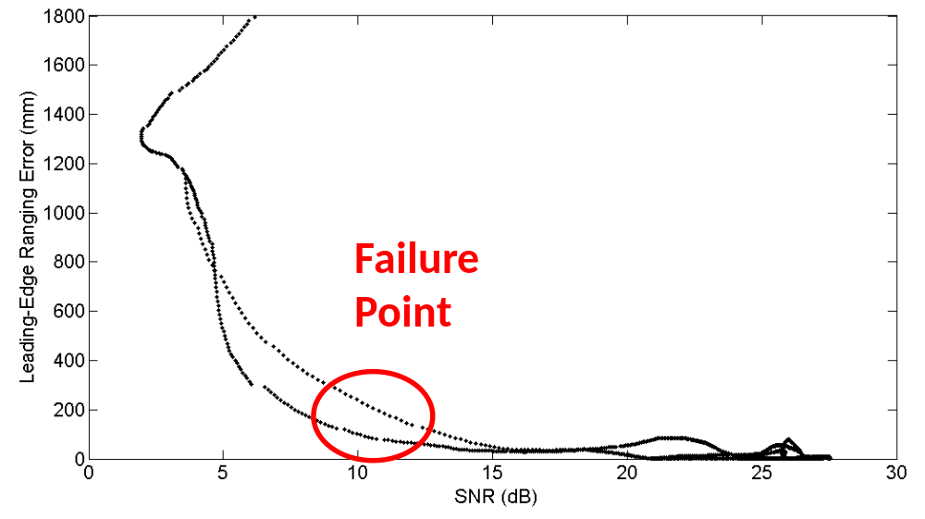
Figure 5-7: Leading-edge algorithm ranging error for one base station versus SNR from the experimental results outlined in Figure 5-5 and Figure 5-6. The leading-edge detection algorithm fails around when the SNR reaches 10-12 dB. At this signal level, the leading-edge (1/4th peak amplitude) will often drop below the noise floor, resulting in large ranging errors (1000 mm or greater).

Mitigation
As discussed in Section 5.2, the leading-edge detection algorithm will routinely fail for SNR values of less than 12 dB. The first step in dealing with NLOS conditions is detecting when they happen. The next step in providing robust indoor UWB positioning in such conditions is to mitigate the ranging errors once NLOS conditions have been detected. Since the leading-edge algorithm fails below 12 dB, FPGA-implemented peak detection, outlined in Section 4.3, provides a better ranging technique since the UWB peak can still be located for a SNR above zero. Figure 5-8 outlines the sequence of states for NLOS detection and mitigation which includes NLOS detection (SNR < 12 dB), switching of the ranging algorithm to peak detection, and, as a last resort, elimination of this base station from the tag TDOA calculation. If the UWB link improves (SNR increases above 12 dB), leading-edge detection is re-enabled. Figure 5-9 shows the SNR for an experiments similar to that done for leading-edge detection in Section 5.2 where a tag is left in a static location and LOS blockage is introduced dynamically between the tag and one of the base stations. This results in drops in SNR to below 5 dB as shown in
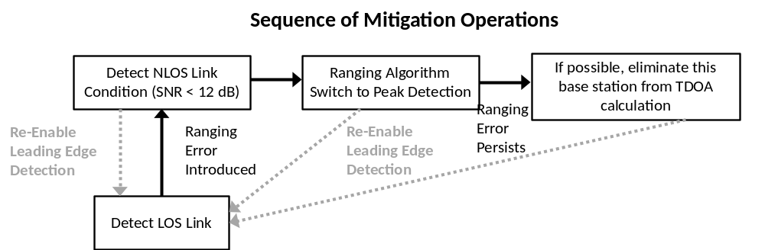
Figure 5-8: Block diagram of NLOS detection and mitigation steps including a return to a LOS link.
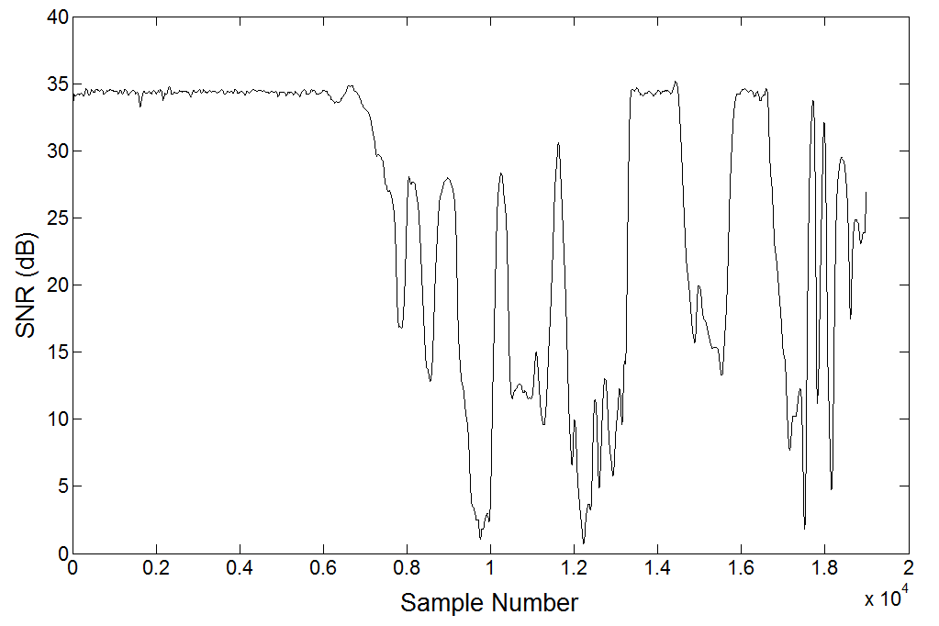
Figure 5-9: SNR for an experiment where a tag is left in a static location and extreme LOS blockage is introduced.

Figure 5-9. The resulting ranging error for peak detection is outlined in Figure 5-10. It can clearly been seen in Figure 5-10 that peak detection is more robust to ranging errors than leading-edge detection as the ranging errors are smaller and less frequent given the low SNR conditions compared to leading-edge detection in Figure 5-6. Figure 5-9 shows the SNR versus peak detection ranging error for the experiment outlined in Figure 5-9 and Figure 5-10. The failure point for peak detection is around 4-5 dB compared to 10-12 dB for leading-edge detection as shown in Figure 5-7. Peak detection only fails when the received UWB pulse peak shrinks to within the noise floor of the received signal.
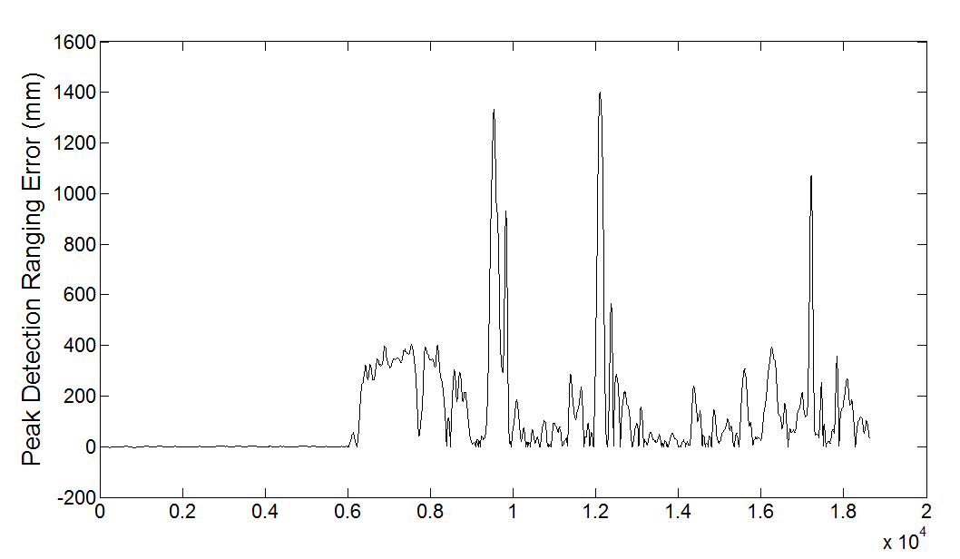
Figure 5-10: Peak detection ranging error for the poor SNR scenario outlined in Figure 5-9.

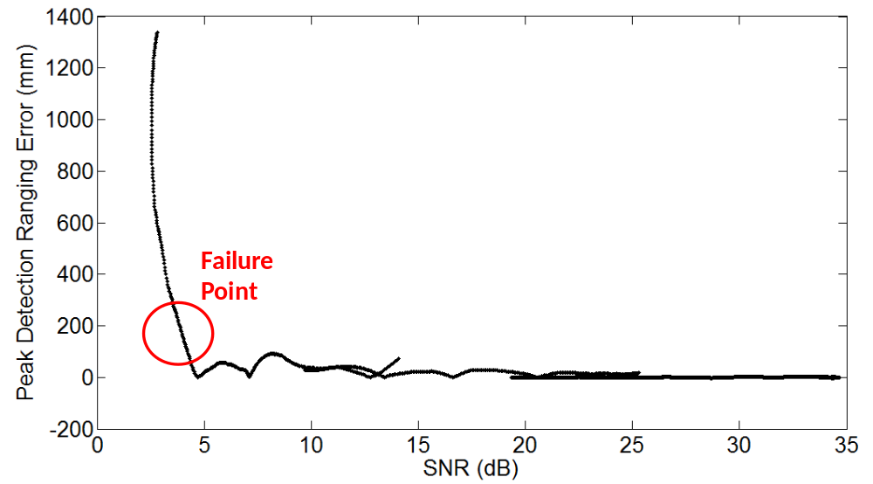
Figure 5-11: Peak detection algorithm ranging error for one base station versus SNR from the experimental results outlined in Figure 5-9 and Figure 5-10. The peak detection algorithm fails when the SNR reaches 4-5 dB. This is a 6-7 dB improvement over the leading-edge detection algorithm as shown in Figure 5-7.

UWB Positioning and Orthopedic Surgical Navigation
In modern day health care, orthopedics is defined as the branch of medicine which deals with diseases and injuries to the musculoskeletal system of the human body. Central to the musculoskeletal system are the joints in the human body including the knee, hip, ankle, spine, elbow, shoulder, jaw, etc. As mentioned in [53], the advent of the orthopedics industry happened late in the 19th century in Warsaw, Indiana when Revra DePuy replaced traditional wooden splints with a new and improved metal counterpart. Shortly after, one of his apprentices, Justin Zimmer, formed his own orthopedics company which has grown to become Zimmer, Inc. In 1977, yet another orthopedics company, Biomet, Inc., was formed in Warsaw, Indiana by another group of entrepreneurs, two of which were former Zimmer employees [107]. The orthopedics industry still revolves around Warsaw, Indiana with these three major companies headquartered there. The use of plastics in the orthopedics industry now rivals its need for metals. With full mechanical replacements available for nearly all human joints, the focus of surgery in orthopedics has come to the forefront of the industry. It is estimated that 500,000 knee replacement surgeries will be performed in the United States in 2008 alone with that number projected to increase to as high as 3.2 million total knee surgeries in 2018 [53].
Since a large portion of the money in orthopedics goes to replacement surgeries, it should come as no surprise that a correspondingly large push has been made to utilize technology in improving the outcomes of orthopedic surgeries. CAS has many direct applications in orthopedics due to a combination of factors including the rigidity of bones, the direct biomechanics aspect of the human musculoskeletal system which must be considered when reconstructing a joint, and the obvious potential to include various medical imaging modalities into the mix of technologies utilized in performing an orthopedic surgery. Expanding on the above advantages for incorporation of CAS in orthopedic surgeries, since bones are inherently rigid, tracking systems can be used to intraoperatively track bones with a much greater ease and accuracy than soft tissues (e.g. neurosurgery or abdominal surgery) [108]. Reconstruction of the proper biomechanics of the musculoskeletal system has implications in that certain biomechanical axes and angles must be considered when implanting artificial components in a human joint such as the knee. For example, in the knee, the mechanical axis, which goes from the femoral head through the center of the ankle, must be properly aligned relative to the artificial knee joint to ensure proper functioning of the implanted joint. With the use of intraoperative medical imaging and intraoperative 3-D tracking of the relevant bones, it is possible for computer assistance to be provided to the surgeon to ensure accurate reconstruction of the relevant biomechanical axes and angles. As far as medical imaging modalities are concerned, X-rays, computed tomography (CT), magnetic resonance imaging (MRI), and fluoroscopy have all been used either preoperatively or intraoperatively in orthopedic surgeries. Fluoroscopy is the most common intraoperative tool while X-rays and CT scans are typically done preoperatively. Next, MRI is much less common in orthopedic surgeries since it is better suited for analyzing soft tissue, although it is commonly used when examining problems related to muscles or cartilage. Finally, ultrasound is not commonly used intraoperatively during orthopedic surgeries due to its inherent noisiness compared to X-rays, CT, and fluoroscopy, but it has certain advantages such as being radiation-free, relatively inexpensive, and able to provide real-time 3-D imaging, which make its application to orthopedic surgery the focus of current research groups [108].

Current Tracking Technologies
The fundamental 3-D tracking technologies currently used in CAS for orthopedic applications are optical and electromagnetic tracking systems. Figure 6-1 shows the Polaris Spectra® 3-D optical tracking system from Northern Digital Inc (NDI). This optical tracking system is an industry standard which has found wide use in CAS for orthopedics applications including the current push in joint replacement surgeries for small incisions, i.e. minimally invasive surgeries (MIS) [109]. This optical tracking system works by infrared light being reflected off of the passive markers on the probe (Figure 6-1b) and then being received by two infrared cameras on the receiver shown in Figure 6-1a (essentially two charge-coupled devices or CCDs which work in the infrared light range instead of the visible light range like a standard digital camera). As discussed by researchers at Northern Digital Inc. in [110], optical tracking systems with passive or wireless probes can obtain comparable 3-D accuracy to active or wired optical probes, although misconceptions are commonly held by users of the 3-D trackers where
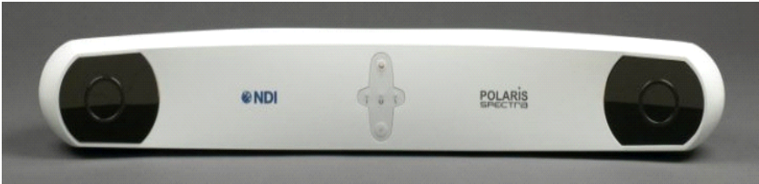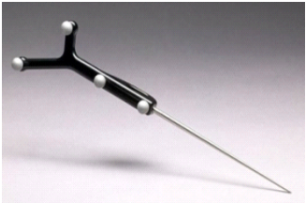
- (b)
Figure 6-1: Polaris Spectra optical tracking system from Northern Digital Inc. (a) optical receiver, (b) passive optical probe with four reflective markers.
it is thought the use of a passive optical probe reduces the 3-D accuracy of the optical tracking system compared to that of an active optical probe. The rated 3-D accuracy of the Polaris Spectra system is 0.25 mm root-mean-squared error (RMSE) for a single marker [110],[111] with 0.233 mm RMSE for 3-D position of a rigid body with active markers and 0.231 mm RMSE for 3-D position of a rigid body with passive markers [110]. The results from [110] prove that with correct usage of the optical tracking system, comparable performance can be achieved with both passive and active markers. The operating range of the Polaris Spectra is 0.950 to 3.000 m out-of-plane distance from the optical probe to the receiver with an in-plane size of 1.856 x 1.470 m² at a z-distance of 3.000 m.
The main limitation of the Polaris Spectra is its limited view volume when compared to other optical tracking systems offered by NDI. For example, Figure 6-2 shows the view volume for the NDI Optotrak Certus while Figure 6-3 shows the view volume for the NDI Polaris Spectra. The Optotrak Certus extends 3.8 m in the z-direction and has a large in-plane volume of 2.6 x 3.5 m² at its maximum while the Polaris Spectra extends 2.050 m in the z-direction and has an in-plane volume of 1.856 x 1.470 m² at its maximum [111],[112]. Consequently, the Optotrak 3020 (precursor to the Optotrak Certus with a comparable view volume) was used in most experimental setups since the UWB receivers needed to be spread out in order to ensure a low PDOP, which is critical in obtaining high 3-D positioning accuracy.
The main advantage electromagnetic tracking systems have over optical tracking systems is their ability to operate in NLOS conditions, whereas optical tracking systems require a LOS signal with the optical receiver. The main disadvantage of electromagnetic tracking systems is their elevated susceptibility to metallic interference. One of the de facto standard systems for electromagnetic tracking in orthopedic-related CAS is the Flock of Birds® system
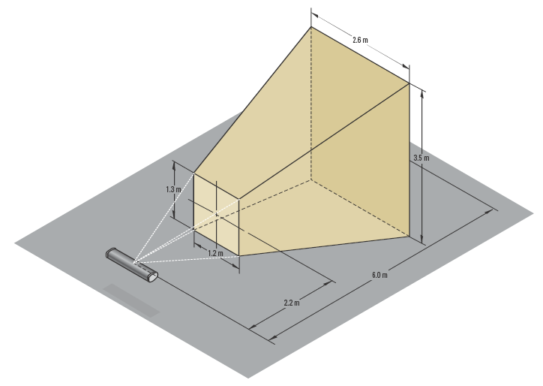
Figure 6-2: NDI Optotrak Certus view volume with 3.8 m in the z-direction and an in-plane area of 2.6 x 3.5 m² at a z distance of 6 m [112].
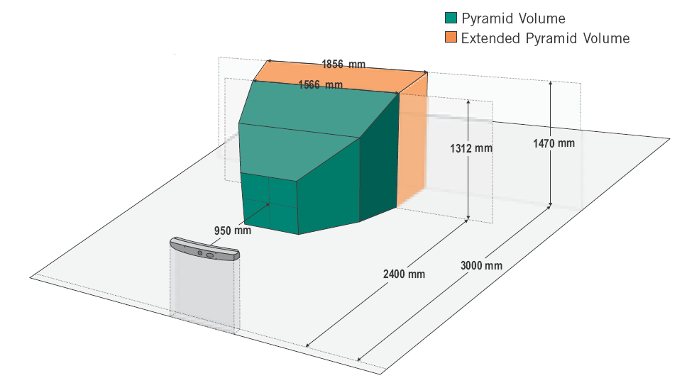
Figure 6-3: NDI Polaris Spectra view volume with 2.050 m in the z-direction and an in-plane area of 1.856 x 1.470 m² at a z distance of 3.000 m [111].
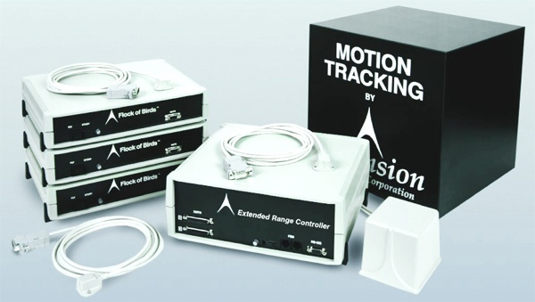
Figure 6-4: Flock of Birds electromagnetic tracking system from Ascension Technology Corporation.
from Ascension Technology Corporation. Figure 6-4 shows the Flock of Birds system with the main controller, transmitting coils, and electromagnetic sensors displayed [113]. The 3-D static position accuracy of the system is reported to be 1.8 mm RMSE using the mid-range transmitter over an operating range of 0.203 to 0.762 m from the transmitting coil to the sensor [113]. The system is able to take data at a rate of 144 Hz. The maximum operating range of the system with 1.8 mm RMSE is 0.75 m from transmitting coil to magnetic sensor, noticeably smaller than the operating range of the Polaris Spectra and Optotrak Certus optical tracking systems. Ascension Technology Corporation has another system known as the 3-D Guidance medSAFE tracking system. As shown in Figure 6-5, it uses miniaturized magnetic sensors, with the newest generation of sensors being 0.90 mm in diameter. This small size allows the sensor to be embedded into the tip of a hollow 19-gauge needle [114]. For example, a sensor similar to the one shown in Figure 6-5 is currently embedded into the working channel of a bronchoscope which highlights how these sensors can be used to track catheters and scopes into organs and vessels internal to the human body. These miniaturized sensors have a static 3-D RMSE of 1.4 mm. The medSAFE electromagnetic system is an approved medical device by the Food and Drug Administration for use in the United States and is specified as Class 1, Type CF, Defib Proof [114]. The 3-D tracking systems currently used in CAS for orthopedic applications have certain limitations (e.g. LOS requirement for optical trackers and susceptibility to metal for electromagnetic trackers) but nonetheless have been successfully integrated into commercial orthopedic surgical navigation systems. The UWB indoor positioning system has neither of the shortcomings experienced by these two systems (i.e. LOS limitations or susceptibility to metallic interference). The main challenge with UWB localization technology is consistently achieving accuracy comparable to optical and electromagnetic trackers.

Overview of Orthopedic Surgical Navigation Systems
With the outgrowth of orthopedic surgery and total joint replacements to so many joints
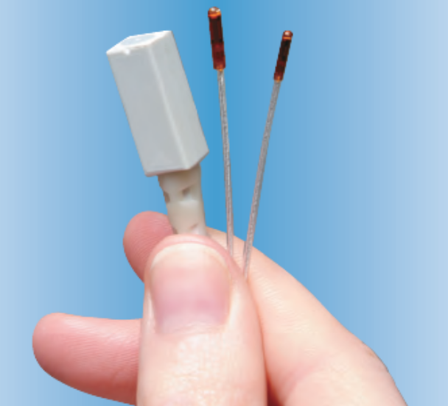
Figure 6-5: Miniaturized magnetic sensors for use with 3-D Guidance medSAFE electromagnetic tracking system from Ascension Technology Corporation [113].
in the human body (e.g. ankle, knee, hip, spine, elbow, wrist, shoulder, jaw, etc.) and with multiple surgical approaches for a single joint, it comes as no surprise that the CAS systems designed to assist in these procedures are themselves a diverse bunch. It is first worth making a few distinctions in how to classify orthopedic surgical navigation systems: passive navigation systems refer to navigation systems which use a 3-D tracking system, e.g. optical or electromagnetic as described in Section 6.1, to track the spatial positions and orientations of bones and surgical tools in real-time during the surgery. A surgeon has complete control of a passive surgical navigation system. An active navigation system has a robot which can make decisions based on sensor (e.g. position or force) feedback and perform autonomous surgical tasks without the assistance of the surgeon. Active systems are not commercially available due to the hesitancy of doctors, hospitals, and engineers alike to adopt navigation systems which remove the surgeon from wielding control over how the orthopedic surgery is performed [115]. A newer development is a class of navigation systems known as semi-active. In this type of system, a robot is still incorporated into the navigation system, but now the robot is still under the control of the surgeon, and the surgeon is able to utilize the robot in making the surgical cuts needed for the orthopedic surgery. An example of this is the Tactile Guidance SystemTM from MAKO Surgical Corp., shown in Figure 6-6. This system uses the robotic arm in Figure 6-6 combined with tactile feedback sensing to provide robotic assisted unicompartmental knee resurfacing [116].
A standard orthopedic surgical navigation system can be seen in Figure 6-7. In this CAS system, optical tracking is employed to track both the bones of the patient (by drilling holes and
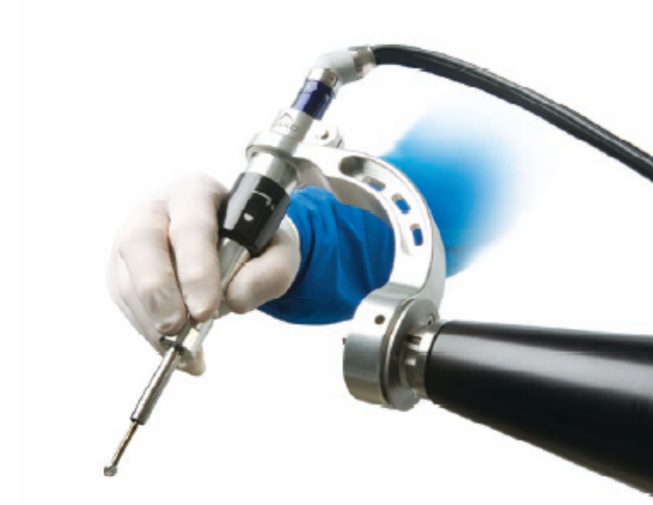
Figure 6-6: Tactile Guidance SystemTM from MAKO Surgical Corp. [116].
rigidly attaching optical markers) as well as the surgical tools. The optical trackers must have LOS visibility with the optical receivers in order to be tracked. The final 3-D scene is displayed on the user interface to provide feedback to the surgeon. Multiple tools are tracked simultaneously in order to provide real-time feedback on the tools’ positions and orientations relative to the anatomy of the patient. The surgery in Figure 6-7 is a Total Knee Replacement (TKR), so the relevant anatomy includes the distal portion of the femur and the proximal portion of the tibia as well as the patella. Figure 6-8 shows a portion of the tools needed in performing a TKR. This includes tibial and femoral cutting guides, spacer blocks for ligament balancing, etc. These tools are used in TKRs whether or not the surgery is done with CAS assistance. Figure 6-9 shows the final goal of orthopedic CAS systems where the patient anatomy, in this case the femur and tibia, are tracked relative to surgical tools such as cutting guides for the femur and tibia. Since the 3-D positions and orientations of all of these rigid bodies are known, it is then possible to automatically calculate relevant surgical axes and angles, such as the mechanical axis of the femur (displayed along with the anatomical axis of the femur and transepicondylar axis). Figure 6-10 shows the Stryker Knee Trac System being used on a cadaver. Optical trackers are rigidly attached to the femoral cutting guide and also to the femur itself. More information on this system can be found in [117].

Commercial Navigation Systems
In Section 6.2, an overview of the components used in an orthopedic surgical navigation system was presented, including the widespread use of optical tracking, how bones are also optically tracked, and a brief introduction to how custom software is then used to calculate relevant surgical axes and angles and provide real-time feedback to the surgeon on implant placement, where to place the cutting guides, ligament balancing, etc. In this section, different
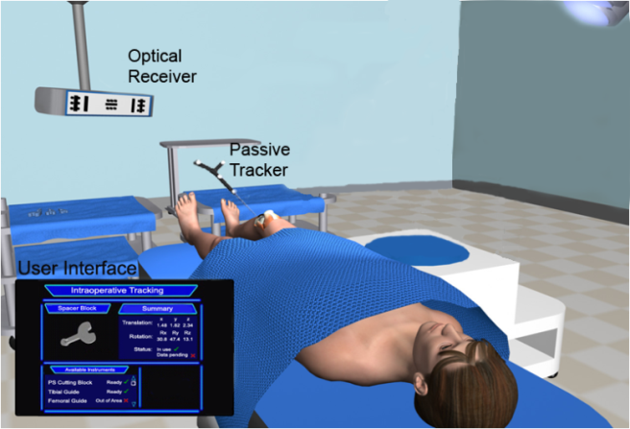
Figure 6-7: CAS system where optical tracking is utilized to assist in a TKR.
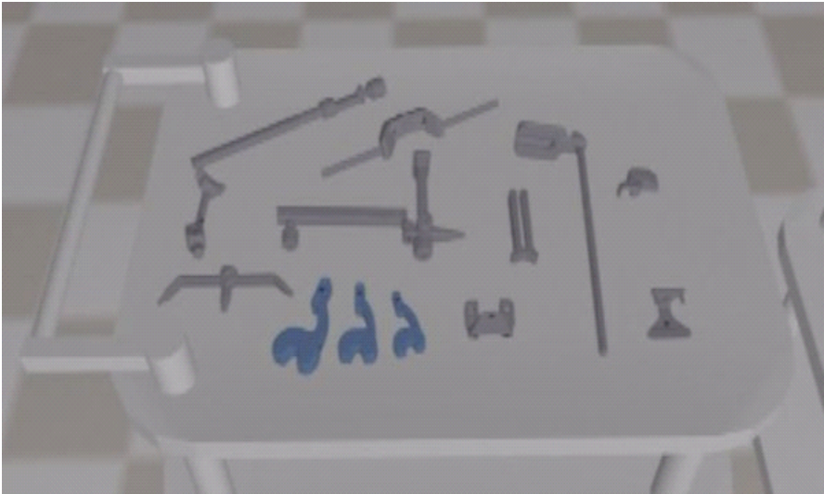
Figure 6-8: Surgical tools used in a TKR including spacer blocks for ligament balancing.

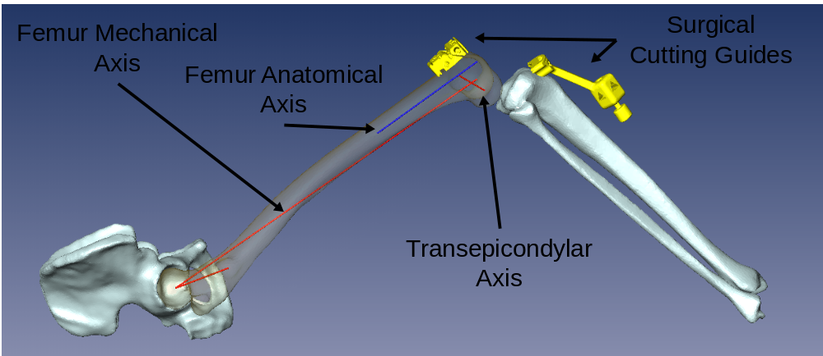
Figure 6-9: Illustration of final goal of intra-operative CAS system where the patient anatomy is tracked (in this case the femur and tibia) as well as the surgical tools. This provides real-time feedback on tool positions relative to surgical axes such as the mechanical axis of the femur.
state-of-the-art orthopedic navigation systems are discussed with the primary goal being to highlight novel technologies, point out inherent strengths and weaknesses in the different systems, and to provide a comprehensive overview of the commercial systems currently deployed in hospitals around the world.
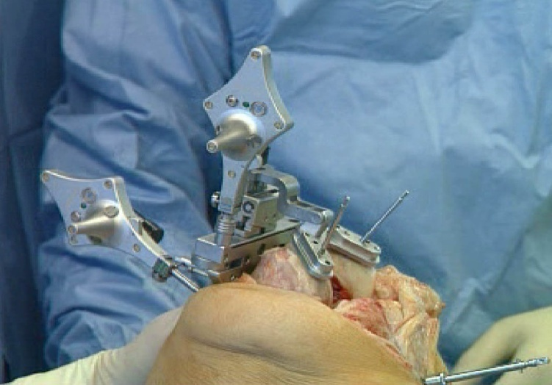
Figure 6-10: Example of a CAS system used in a TKR where optical trackers are attached to the femoral cutting guide and also to the femur itself. Stryker Knee Trac System (imageless).

Although CAS systems in orthopedics have become more widespread over the last few years, there is still controversy over their effectiveness and overall necessity when weighing the costs and benefits of these systems. As discussed in [108], it is still unclear whether the use of CAS in orthopedic surgeries presents clear benefits in terms of overall success of the surgery. For example, a 2003 US NIH Consensus Development Report geared towards TKA concluded that there was some evidence of increased accuracy, but with higher costs and longer surgical times, the overall benefits remained unclear [118]. Also, studies have been done by the Ontario Health Technology Advisory Committee as well as the California Blue Cross. The Ontario committee concluded that navigation and robotic technologies for use in orthopedic surgeries were still in an investigational phase. The California Blue Cross investigated whether or not the increased costs associated with CAS merited reimbursement on the state level. The lack of randomized control trials for the major surgical operations for which CAS systems are targeted, including Total Hip Arthroplasty (THA), TKA, and pelvic fracture repairs, caused the California Blue Cross to reach the same conclusion as the Ontario committee and label the use of navigation systems in orthopedic surgical procedures as investigational and not necessary for completing the medical procedures [108]. Therefore, even though orthopedic navigation systems exist and are in use at hospitals today, inherent limitations such as increased surgical time, cost of the navigation systems, lack of substantial evidence in terms of how they help surgical outcomes, etc. continue to place pressure on their usefulness and current design. These limitations are pushing the development of disruptive technologies to bring out a new generation of orthopedic navigation systems which are less invasive, easier to use, more accurate, and provide the surgeon with a greater suite of high technology tools which can be utilized to enhance orthopedic surgical procedures and improve patient outcomes. When looking at commercial navigation systems, the most intuitive approach is to focus on certain orthopedic surgical procedures and then compare the available navigation systems in terms of underlying technologies and overall usefulness to the surgeon. Therefore, TKA and THA procedures are examined and the available navigation systems compared. It should be noted that surgical navigation systems are available for a variety of other surgeries not touched upon here (both orthopedic and beyond) including spine, trauma, and neurosurgery. TKA and THA are focused on because they are the most common orthopedic surgeries. Also, the integration of UWB would first be applied to TKA followed by THA.

Knee Arthroplasty
The available CAS systems for unicompartmental and total knee arthopasty can be divided into distinct categories including imageless or image-free, CT-based, and more recently intraoperative fluoro-based. The most prevalent type of navigation systems are imageless, where a sequence of steps is needed to identify relevant landmarks across the lower limb including the hip center, ankle center, and medial and lateral epicondyles. Figure 6-11 shows the Medtronic imageless knee navigation system including their patented AXIEMTM electromagnetic sensors for bone tracking and the overall software user interface [119]. The Stryker Knee Trac System, which uses optical tracking and an imageless framework, is shown in Figure 6-12a while the software interface for the BrainLAB VectorVision® System, which can be used both in an imageless framework and also in a CT-based framework, is shown in Figure 6-12b [117,120]. More knee navigation systems exist, including the Navitrak® System from
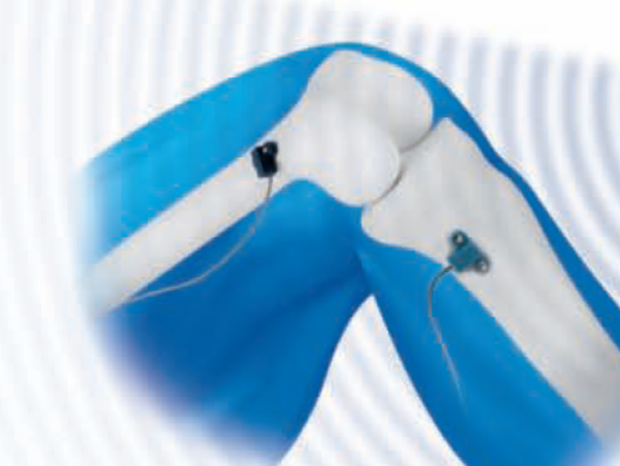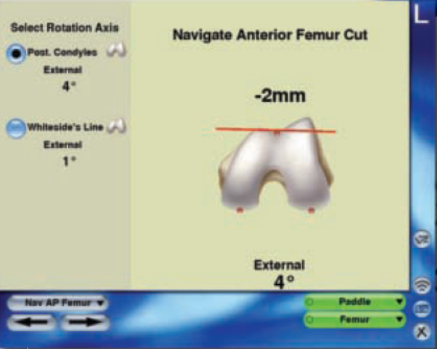
Figure 6-11: Medtronic knee navigation system highlighting AXIEMTM electromagnetic tracking sensors and software interface for selecting where to make the anterior femoral cut [119].
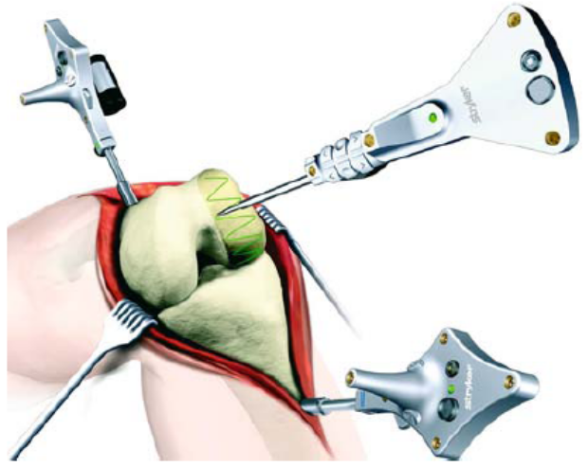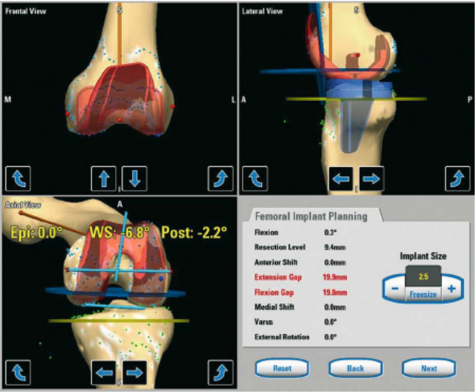
(a) (b)
Figure 6-12: (a) Stryker Knee Trac System employing imageless navigation with optical tracking [117]; (b) BrainLAB VectorVision® System utilizing the software interface for rotation of the femoral component [120].
Orthosoft, Inc., the PI-Galileo System for ligament balancing from Plus Orthopedics Aarau, the Surgitecs Bone-Morphing System from Praxim, and the OrthoPilot® KneeSuiteTM from Aesculap AG [121]-[124].
With the initial design of knee navigation systems, such as the OrthoPilot® system [124], the main concern in correct implant alignment concentrated on the varus/valgus condition of the implanted knee since studies showed its importance in the 10-year survival rate of the implant [125]. After locating the mechanical axis of the lower leg and aligning the implanted knee with this axis, it is possible to greatly minimize varus/valgus conditions in the implanted knee. Jenny et al. performed a multi-center study with the OrthoPilot® system which found statistically significant differences in the mechanical axis alignment when comparing manual techniques to navigation with the OrthoPilot® system [126]. The three-month postoperative radiographs of a total of 570 TKA patients (235 implanted with the OrthoPilot® system and 235 implanted without a navigation system) were examined and it was found that 92% of patients implanted with the navigation system had optimal mechanical axis alignment compared to only 72% of the patients implanted without a navigation system [126]. Next, the internal/external rotation of the normal knee must be determined so that the implanted knee can be rotated likewise. This is currently done by having the surgeons pick landmarks or point clouds on the medial and lateral epicondyles. The transepicondylar axis can then be determined and used in determining the external/internal rotation. Also, Whiteside’s line can be determined and used to find an AP axis, providing information on the external/internal rotation of the femur. Figure 6-12b shows the BrainLAB user interface for calculating external/internal rotation. Note that the Whiteside line, transepicondylar axis, and posterior condylar axis can all be seen. All major commercial imageless systems incorporate this process in their surgical approach, including the Stryker Knee Trac System, the OrthoPilot® system, and the BrainLAB VectorVision® System [117],[120],[124].
Stability of the implanted knee is also of prime importance to ensure a positive surgical outcome. The collateral ligaments and posterior cruciate ligament play key roles in maintaining knee stability throughout flexion. This can be examined by measuring the gaps between the implanted femur and tibia at both flexion and extension and ensuring a rectangular shape at both positions (if the gap on the medial or lateral side is significantly different, e.g. 2-5 mm, the knee may buckle under loading conditions). Also, if the gap spacing is not equal at flexion and extension, this can cause areas of tightening or loosening as the knee goes from extension to flexion [108]. The OrthoPilot® system, along with the BrainLAB VectorVision® System and PI-Galileo System, uses a special gap measuring tool so that medial and lateral gaps can be measured at flexion and extension, displaying feedback information via the software interface for the surgeon [124]. Conversely, the Knee Trac System from Stryker uses the transepicondylar axis as well as the proximal resection of the tibia to determine a curve for both the medial and lateral condyles that can be rotated through the complete range of motion, although this technique is susceptible to the accuracy in measuring the transepicondylar axis [124]. Another point of consideration is instability of the patellofemoral joint after TKA. If the line-of-action of the quadriceps tendon pulls the patella laterally, which is most prone with the leg in extension, subluxation of the patella can result along with general knee pain [127]. Given the susceptibility of the patellofemoral joint to instability, it should come as no surprise that navigation systems are now handled to resurface, replace, or in some way reposition the patella during TKA. For example, the OrthoPilot® system can be used to implant a patellar endoprosthesis as needed. More commonly, the system can be used to help orient the patella after resurfacing. Post-operative, three month radiographs showed reduction in lateralization and tilt of the patella compared to preoperative radiographs [124]. The Surgitecs Bone-Morphing System places even greater emphasis on the patella by placing an intra-operative optical tracking device to it and tracking its 3-D position and orientation during the surgery [123]. The placement of the femoral implant is optimized in terms of its position with both the tibia and patella. Also, the patella is factored into the soft tissue ligament balancing procedure [123]. Many other additions and variants to the technologies and procedures described here exist when performing knee arthroplasties. For example, the Surgitecs system uses deformable shape models to create 3-D patient-specific models from painted points which can then be used to provide more accurate model-specific information to the surgeon [123]. The PI-Galileo navigation system uses a device to measure actual ligament tension during flexion and extension. This information is then used along with external/internal rotation of the femur and the AP joint line to optimize the rectangular gap at flexion and extension [122].
Imageless knee navigation systems are much more widespread than CT-based navigation systems. Lüring et al. examined both the imageless and CT-based navigation systems from BrainLAB in use at the University of Regensburg, Germany from 2002-2006. It was observed that by 2006, 1300/yr knee surgeries were being performed with the imageless system while only 180/yr or so were performed with the CT-based navigation system, with the CT-based navigation system reserved for more difficult surgeries involving significant bone deformities [120]. The CT scan of the knee is taken preoperatively. 3-D models of the bones, including the femur, tibia, and patella, are created and used in a preoperative step to plan the surgical procedure. Next, the 3-D patient-specific models are tracked intra-operatively by having the surgeon register 20 or so points which are used in 3-D fitting of the bone surfaces. This works well in extreme cases where normal knee anatomy cannot be assumed due to gross deformities of the patient’s bones [120].
A new type of knee navigation system is currently available since the development of portable, fluoroscopic systems. Victor describes testing of the Medtronic fluoroscopic navigation system on 100 patients where 50 surgeries were performed with the fluoroscopic navigation system and 50 surgeries were performed without it. A significant difference in correct mechanical axis alignment was achieved for the group using fluoroscopic navigation versus the group without it (100% versus 73.5%) [128]. This preliminary study shows the potential for incorporation of an intra-operative imaging modality such as fluoroscopy for use during a knee surgery. With the current push towards minimally invasive surgeries (MIS) in orthopedics, an imaging modality such as fluoroscopy is well suited for incorporation given the added difficulty in ensuring proper implant alignment with the limited visibility of smaller incisions. Also, the use of magnetic sensors for 3-D tracking, specifically the AXIEMTM sensors from Medtronic described in Figure 6-11, have been incorporated in a pilot study where the quadriceps sparing MIS TKA surgical approach was performed in 75 patients and EM sensors were used to track the femur and tibia. Preliminary post-operative results show that the EM system performed well (a 100% success rate using post-operative radiographs), although two instances occurred where the EM system was abandoned during the surgery because of gross inaccuracies in tracking the 3-D position and orientation of the femur and tibia [129].

Hip Arthroplasty
Total hip arthroplasties comprise the second most common total joint replacement surgery behind knee replacements with 230,000 THAs performed in the United States in 2004 [108]. Outcomes of THAs have shown excellent long term survival rates in some cases exceeding 90% at 15-20 years post-operative [130]. Due to increased life span and younger patients becoming candidates for hip replacements, the ideal target life span for an implanted hip is 30-50 years. Revisions bring added complications, so it would be ideal to have the average life span of a hip replacement extend to 50 years. Premature failure of hip implants occurs mainly because of infection, instability, and wear [108]. Of these causes, instability and wear can be targeted by CAS systems whereas infection is mainly linked to aseptic techniques, laminar airflow in the operating room, and the use of antibiotic bone cement.
There are a number of factors to consider when looking at the stability of the implanted joint. For example, the surgical approach has an effect in the joint’s stability. Masonis et al. examined over 14 clinical studies spanning a 30 year period which included 13,000 primary total hip replacement surgeries [131]. They concluded that lower dislocation rates, around 0.55% to 3.95%, were achievable with the right surgical approach. The posterior approach consistently had the highest dislocation rates (up to 20%), although a more recent study by Kwon et al. found that dislocation rates decreased for the posterior approach when soft tissue repair was performed [132]. One of the main causes of premature joint dislocation is inaccurate orientation of the acetabular cup. Parratte et al. reported that manual techniques for orienting the acetabular component resulted in large ranges of variation including 27° in abduction and 37° in anteversion [133]. This large variation in cup orientation can cause femoroacetabular impingement, reduce the range-of-motion (ROM), and increase the chance for dislocation and wear. However, dislocation rates are still relatively low, so no study currently exists which shows a statistically significant reduction in hip dislocation rates when CAS systems are used to perform the surgery.
Wear in the hip joint has been identified as the main long term complication in implanted hip joints [134]. Wear can cause small particles to be released which then induce osteolysis around the implant, resulting in loosening and failure. Next, it is necessary to look at femoral head resurfacing, which has emerged as an alternative to total hip arthroplasty for younger and more active patients [108]. Early failures of resurfaced hips have been studied and can be linked to varus placement of the implant. Next, Back et al. report that it takes somewhere around 60 hip surgeries for a surgeon to consistently be able to place the acetabular cup implant within 5° of the desired orientation [135]. This indicates a steep learning curve in becoming consistent and proficient in performing optimal hip replacement surgeries. Minimally invasive techniques for hip surgeries have been introduced and short-term benefits such as shorter hospital stays and reduced blood loss have been documented [136]-[137], but substantial long term benefits are still lacking [138]. Reininga et al. are currently performing a study which will determine whether or not computer-navigated MIS in hip arthroplasty will result in a quicker recovery time at three months post-operative and at least an equivalent outcome relative to manual techniques at six months post-operative [139].
Although the long-term benefits of CAS in hip replacement surgeries is still lacking, there are several factors, including more accurate placement of the acetabular component, integration of CAS systems with MIS surgical approaches, reduction or elimination of the learning curve for new surgeons consistently being able to achieve accurate acetabular placement, and the ability to measure and correct leg length discrepancies intra-operatively (leg length discrepancies are a common problem after hip replacement surgeries and can cause premature implant failure [140] and have been the cause for numerous law suits against hospitals and surgeons [141],[142]) that provide ample motivation for the introduction of CAS systems and techniques into hip arthoplasty surgeries. Three main types of CAS systems are available for hip replacement surgeries, similar to knee arthroplasty as outlined in Section 6.3.1, including imageless, CT-based, and fluoroscopy-based.
All commercial hip navigation systems track the tools used in determining correct cup and stem placement intraoperatively. As shown in Figure 6-13, the main goal of hip navigation systems in terms of correct cup placement is to correctly determine the acetabulum orientation relative to the Anterior Pelvic Plane (APP) and provide feedback to the surgeon on the orientation in terms of abduction, anteversion, and flexion angles intraoperatively. The abduction angle is defined as the rotation of the acetabulum relative to the axis normal to the
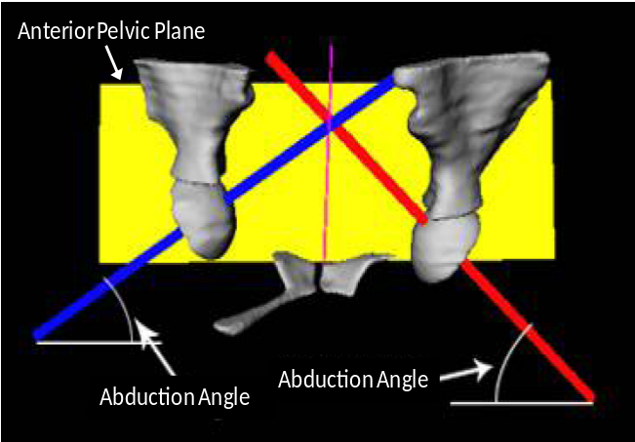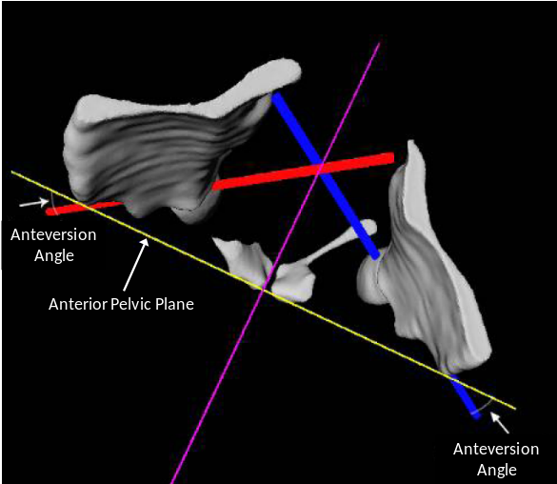
(a) (b)
Figure 6-13: 3-D scene showing the pelvis aligned with the Anterior Pelvic Plane (APP) as well as an axis for each acetabulum (a) posterior view highlighting the abduction angle of the acetabulum, (b) superior view highlighting the anteversion angle of the acetabulum.
APP, visible in the sagittal plane, as shown in Figure 6-13a. The anteversion angle is defined as the rotation of the acetabulum relative to the superior/inferior axis defined by the APP, producing a rotation visible in the coronal plane, shown in Figure 6-13b. Although CT-based and fluoro-based hip navigation systems exist, imageless systems are the de facto standard. For example, Medtronic has an imageless hip procedure which utilizes tracking of the cup to track the acetabular orientation relative to the APP. Leg length and offsets can be calculated as well as pelvic tilt. Similar to other commercial systems, bone morphing is included through the use of deformable shape models for accurate estimation of the patient anatomy [143]. Figure 6-14a shows the software interface for the Stryker iNstride Hip Navigation system [144]. The Stryker system has many similar features to the Medtronic hip navigation system including leg length, offset, the ability to only track the pelvis, etc. Additional features include using either the anatomical or functional pelvic plane, simulated kinematic analysis across the ROM to analyze lift off and impingement, support of multiple surgical approaches including new MIS approaches, and the ability to track the femur intraoperatively. Next, the OrthoPilot® HipSuiteTM is shown in Figure 6-14b. The OrthoPilot® system tracks both the femur and pelvis intraoperatively. Similar to the Medtronic and Stryker systems, it calculates leg length, offset, and performs a kinematic analysis through the ROM to simulate impingement (which causes post-operative joint dislocation) [145]. Finally, the OrthoPilot® system takes into account pelvic tilt (or flexion), which needs to be considered when performing a hip replacement surgery to ensure accurate measurement of inclination and anteversion of the acetabulum. The OrthoPilot® system was tested on 80 patients. Anteversion, inclination, and leg length were
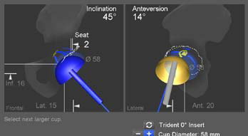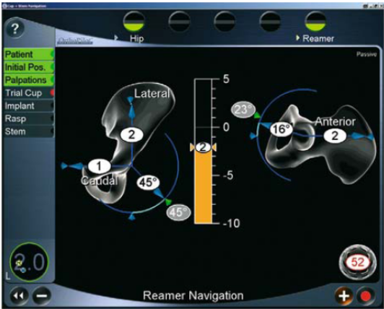
(a) (b)
Figure 6-14: (a) Stryker iNstride Hip Navigation software interface for acetabular alignment [144], (b) OrthoPilot® HipSuiteTM software interface for reamer navigation of the acetabulum [145].
measured post-operatively with full leg radiographs and compared with the data obtained intraoperatively with the OrthoPilot® system. The average error in inclination angle was 3.66°, average error in anteversion angle was 6.86°, and average leg length error was 4.58 mm. All of these values are substantially lower than the variation observed with manual techniques (see [133]). The post-operative X-rays concluded that 96% of the acetabular cups were positioned inside the safe-zone, defined as the Lewinnek safe-zone that spans 40° ± 10° inclination and 15° ± 10° anteversion [146].
Other studies have been done with similar imageless hip navigation systems including the BrainLAB VectorVision® Hip Essential system and the Aesculap Orthosoft® Navitrak® system [147]. Similar to the previous imageless systems, these navigation systems use kinematic techniques to locate landmarks such as the APP, acetabulum, and femoral head. The BrainLAB system uses statistical models whereas the Orthosoft® system displays 3-D models of the implants along with picked points, axes, and other geometrical structures useful for orienting components during the surgery. In order to study the effects of the CAS systems in hip replacement surgeries, two groups were defined each with 37 patients: the first group had either the BrainLAB or Orthosoft® navigation incorporated in their surgery while the second group had a manual technique with no computer assistance [147]. The post-operative results from the group incorporating CAS were significantly better including higher average Harris Hip Score (95 versus 84), lower inclination and anteversion standard deviation (±2° versus ±5° and ±2° versus ±4°), and lower leg length discrepancy (±3 mm versus ±1 cm) [147]. Even more imageless hip navigation systems have been built and tested including an adaptation of the Praxim Total Knee Solution incorporating bone morphing to work for hip navigation [148].
CAS is also used in hip resurfacing procedures. Figure 6-15a shows the BrainLAB VectorVision® Navigation System where a cloud of points have been painted on the proximal femoral head. These points are used in a bone morphing algorithm to get a patient-specific model which allows a more accurate CAS approach than conventional techniques for hip resurfacing [149]. Figure 6-15b shows the software interface for the Smith and Nephew Birmingham Hip Resurfacing system which, similar to the BrainLAB system, digitizes a point cloud on the proximal femur (150 points on the head, 40 points on the neck, and 20 points on the impingement area near the lesser trochanter) to create a patient-specific model [150]. The Birmingham Hip Resurfacing system is an imageless system, although preoperative, intra-operative, and post-operative X-rays can be incorporated for planning and validation of the hip resurfacing procedure. The initial results in hip resurfacing navigation look promising. 28
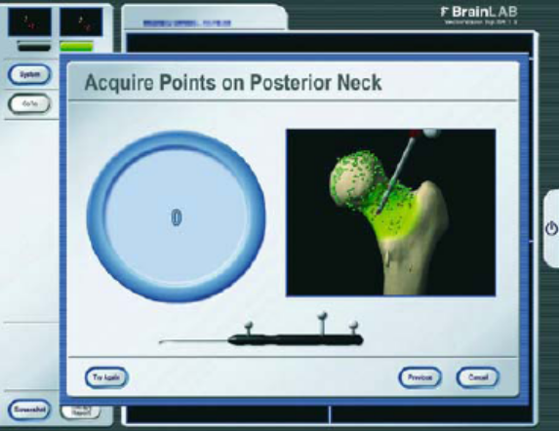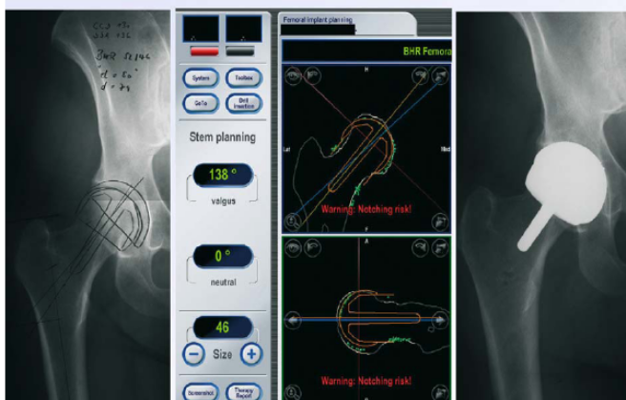
(a) (b)
Figure 6-15: (a) BrainLAB VectorVision® Navigation System software interface for picking points on the neck and head of the femur [149], (b) Smith and Nephew Birmingham Hip Resurfacing system software interface post-operative validation [150].
patients were tested with the BrainLAB system and post-operative radiographs confirmed a slightly valgus mean shaft-neck angle of 137° ± 2.1° in the frontal plane with an average deviation of 2.9° in the axial plane [149]. Hess obtained similar results where 67 patients hadnavigated hip resurfacing procedures. The mean shaft-neck angle was 7.0° valgus from its normal position with a standard deviation of 2.8° [150]. These results are similar to those reported by Bäthis et al. for the BrainLAB system [149]. The preliminary results of these two studies show the potential CAS systems have in hip resurfacing procedures.
The commercial trend in hip navigation has been away from the use of a preoperative CT scan due to cost and in a great majority of CAS-based hip arthroplasty and hip resurfacing surgeries, the imageless systems described previously provide excellent results compared to manual techniques, negating the need to incorporate an imaging modality either preoperatively (CT) or post-operatively (fluoroscopy). The HipNav system designed by Jaramaz et al. was one of the first hip navigation systems built and incorporated 3-D models obtained from a preoperative CT-scan for intraoperative use [151]. No major existing commercial system incorporates a preoperative CT scan in their hip navigation system, whether the system is used for hip arthroplasty, hip resurfacing, or MIS. Fluoroscopy is much more widely adapted in commercial systems mainly because it can provide valuable information to the surgeon during MIS hip surgeries. Haaker et al. tested the Orthosoft® cup and stem navigation system from Aesculap incorporating intraoperative fluoroscopy [152]. Both lateral and ventral surgical approaches were used and, although quantitative results on orientations, etc. are not provided, although after six months post-operative, excellent results were seen with the lateral approach while more work on integrating the navigation system into the ventral approach needs to be done to ensure its success. Next, the Medtronic image guided system (incorporating O-Arm technology) was used in testing the two-incision MIS approach [153]. As shown in Figure 6-16, a navigated surgical pointer is registered to the fluoroscopy images and used to determine the location for the anterior incision. Both the femur and pelvis are tracked intra-operatively with trackers. A similar procedure to that shown in Figure 6-16 is used to accurate determine the location for the femoral incision. Results show that an average of 21 seconds of fluoroscopy is needed in the procedure. The surgery is lengthened by an average of 20 minutes, and the initial qualitative post-operative results show no dislocations and leg-length discrepancies of less 2 mm. The use of image guided navigation systems in MIS hip surgeries provides a promising platform for a more widespread use of CAS in hip arthroplasty.
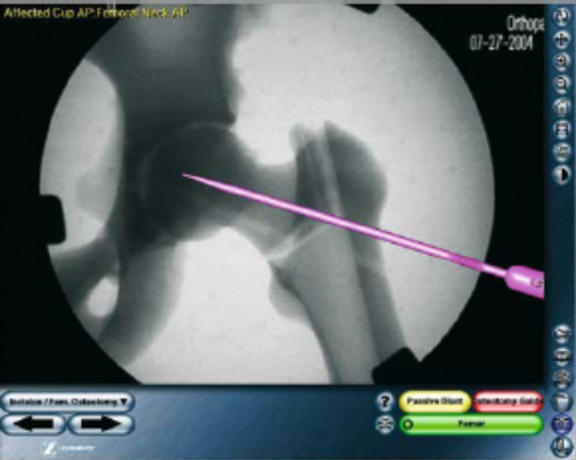
Figure 6-16: Intra-operative fluoroscopy image overlayed with surgical pointer to determine location of anterior incision using the Medtronic image guided system [153].

UWB and Future Navigation Systems
The main purpose of surgical navigation systems is to provide real-time feedback and quantitative assessment to the surgeon regarding the quality of the surgical process. The overall surgical process can be divided into three distinct steps: pre-operative, intra-operative, and post-operative [61]. Figure 6-17 outlines how novel technologies can be used in each of these steps to help provide more information with better accuracy for surgeons, implant designers, and patients. In the pre-operative step, technologies such as automatic 3-D segmentation of computed tomography (CT) datasets and biplanar X-ray reconstruction are used in creating patient-specific 3-D models of the patient’s bones, which are then tracked on a computer in the intra-operative phase [154],[155]. Once an accurate model of the patient’s anatomy is created, advanced analysis of the joint anatomy can be used to provide feedback to the surgeon on implant sizing and other relevant specifications, as shown in Figure 6-18 [156]. In the intra-operative phase, 3-D real-time tracking of the patient’s bones as well as surgical tools will be done through registering a bone tracking system with our UWB positioning system and using the UWB positioning system for tool tracking, tracking of the capacitive sensor ligament balancing system into the surgical scene, and finally incorporation of the UWB technology into smart surgical tools. The ligament balancing system uses microcantilever pressure sensors. The smart provisional, used to determine patient implant size intra-operatively, uses MEMS-based pressure sensors. The final phase is post-operative analysis. A novel 3-D to 2-D registration algorithm is already in use for extracting 6 degree-of-freedom (3-D translation and 3-D rotation) information from fluoroscopic images [157]. This will be combined with a gait analysis lab. Current gait analysis is done by either tracking with one or more video cameras or by using passive or active optical markers which reflect or emit signals to a multiple (e.g. 8) of infrared cameras. Figure 6-17 provides an overview of the complete navigation system. More details are provided on the intra-operative step including smart surgical tools in Section 6.4.1, the post-operative step including gait analysis in Section 6.4.2.

Intra-Operative Phase
As shown in Figure 6-17, the intra-operative phase consists of real-time tracking of smart tools or instruments, bones, and the capacitive ligament balancing system. The UWB tracking system is covered in detail in Section 6.4.3. The smart provisional provides intra-operative feedback to optimize soft tissue interaction with orthopedic joint replacements. The smart provisional system utilizes the 315 MHz and 433.92 MHz frequency bands for data transmission.

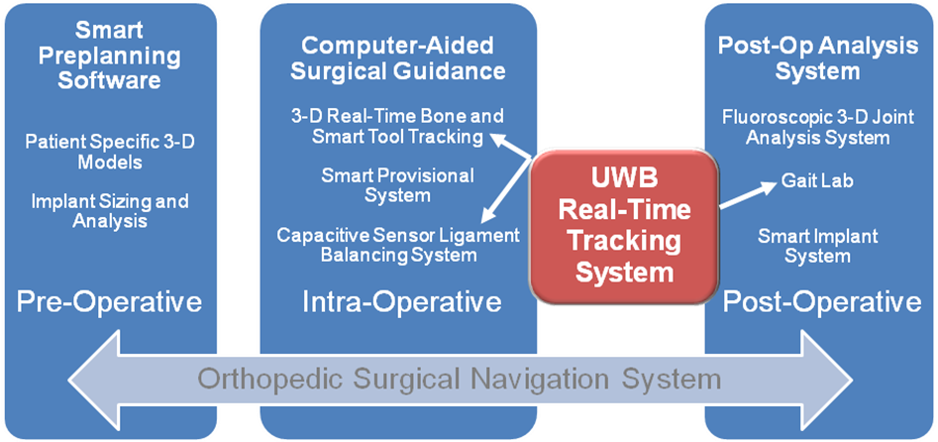
Figure 6-17: Overview of orthopedic surgical navigation system including pre-operative, intra-operative, and post-operative phases.

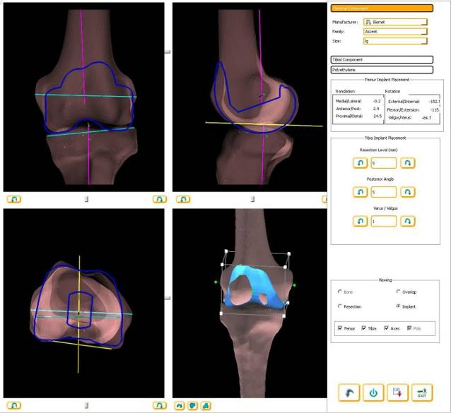
Figure 6-18: User interface for integrated software application which performs virtual resection of a patient-specific bone using a statistical bone atlas and advanced morphometric measurements. It is also used for biplanar X-ray reconstruction and bone morphing.

The incorporation of the intra-operative pressure sensing system inside the spacer block combined with an UWB localization probe that tracks its location in real time, as illustrated in Figure 6-19, is an example of the future technology in surgical navigation: smart surgical tools. Figure 6-20 further illustrates the integration of the UWB tracking system and microcantilever pressure sensing spacer block system. A UWB probe containing a 3-6 element UWB monopole array is used to obtain the 3-D position and 3-D orientation of a rigid body. The femur, tibia, and spacer block have UWB probes rigidly attached to them, as shown in Figure 6-20. As discussed in Section 6.4.3, the UWB positioning system has static 3-D accuracy of 4.67 mm and dynamic 3-D accuracy of 5.24-6.37 mm. This can cause 4-6 mm of translation error and 1-3° of x,y,z rotation error for each rigid body. This is still too high for surgical navigation applications where 1-2 mm of 3-D translation accuracy and <1° of x,y,z rotation is needed to ensure proper implant alignment to the patient anatomy. Conversely, this accuracy is acceptable for ligament balancing applications since the system can still use the pressure mapping of the medial and lateral condyles to monitor the compartmental pressures. The UWB positioning system provides quantitative data on the varus/valgus condition of the knee. It also provides an accurate measure of the quality of the distal and posterior cuts on the femur to the proximal cut on the tibia. This quickly alerts the surgeon to any problems in the surgical resection intra-operatively.

Post-Operative Phase
Figure 6-21a shows a post-operative analysis system where a hybrid system combines tracking data, from either an optical or UWB-based tracking system, with image data [53]. The data is fused to provide highly accurate gait analysis. Figure 6-21b shows a conventional gait positioning system incorporating optical markers [53]. UWB tracking has the potential to
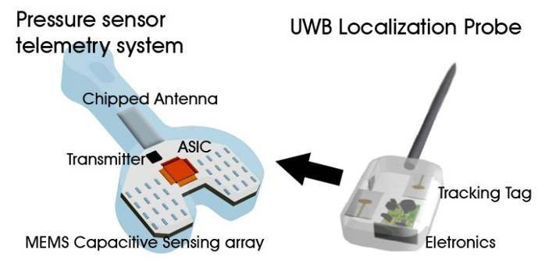
Figure 6-19: Illustration of a smart surgical tool. The spacer block, with embedded pressure sensing-telemetry system, is tracked in 3-D by an UWB localization probe.
integrate with sensor-based systems and even medical imaging modalities to create advanced intra-operative and post-operative guidance systems with the potential to revolutionize the technology used in surgical navigation.
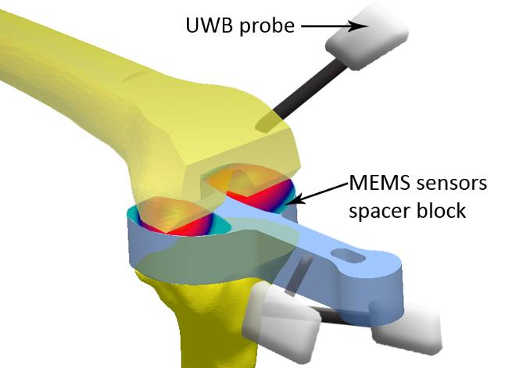
Figure 6-20: Illustration of the MEMS spacer block integrated with the UWB positioning system for 3-D real-time tracking. UWB probes are rigidly fixed to the femur and tibia to track the bones in real-time. A UWB probe is also rigidly attached to the spacer block to track it in real-time.

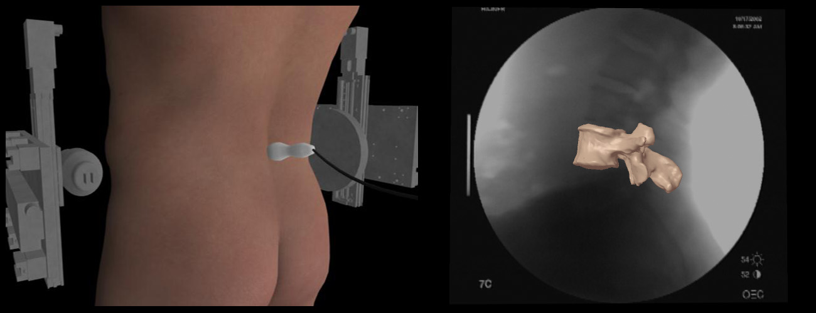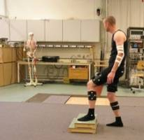

(a) (b)
Figure 6-21: Post-operative analysis, (a) hybrid system combines tracking systems with imaging modalities for tracked visualization and information fusion, (b) positioning system used for post-operative gait lab analysis.

UWB Tracking System
The experimental setup used in testing our system is outlined in Chapter 2. The use of an optical tracking system, which has higher accuracy than the UWB positioning system with 0.3 mm 3-D root-mean-square error (RMSE), is used and provides reference 3-D positioning data to compare the 3-D data of the UWB system. The optical tracking system used is the hybrid Polaris Spectra from Northern Digital Inc. [111]. Data from both the optical tracking system and UWB positioning system are synchronized and sent to a computer. In contrast to previous experiments, since this experiment was being run in real-time, a two-fold calibration procedure is needed to calibrate the UWB system to the optical tracking system. First, the cable length offsets of the UWB system are calibrated by using the optical system as a reference and iterating through offset values used in the time differences of the time-difference-of-arrival (TDOA) calculation. Once the cable length offset calibration has occurred, a full 3-D calibration is done where a 3-D transformation matrix is obtained to calibrate the UWB system with the probe tip of the optical passive probe. This is done by moving the combined apparatus containing the optical and UWB systems around the 3-D view volume and collecting points across the entire view volume for use in the final 3-D calibration [53]. Once an accurate 3-D calibration has been carried out, synchronized real-time 3-D data is collected from both systems. Median inter-quartile-range (MIQR) filtering and averaging of time indices and TDOA values is needed to obtain millimeter accuracy. A summary of the experimental results for the UWB positioning system is shown in Table 6-1. The system has been tested in both static and dynamic scenarios. The dynamic 3-D accuracy for experiments using freeform motion, robot controlled motion, and an optical rail is 5.24-6.37 mm. This is still too high compared to the 1-2 mm which is needed in orthopedic surgical navigation systems to ensure correct 6 DOF tracking of instruments and bones. As shown in Table 6-1, in static experiments the accuracy is 4.67 mm for 20 distinct locations for a non-coherent experiment where the transmitter uses PRF₁ and the receiver PRF₂. In the coherent case where the transmitter and receiver are run off the same clock, static 3-D accuracy of 0.73 mm is achieved. This is below the error threshold for orthopedic surgical navigation intra-operative tracking.
Figure 6-22 shows x,y,z data obtained using 10,000-point averaging for 1000 samples. Noticeable drift can be seen in the UWB data after a prolonged time period (e.g. 30 minutes). This is caused by the instability of the non-coherent PRF clocks. As the expansion factor of the received pulse at the sampling mixer is increased, or more points are averaged on the computer, the effects of time scaling and drift become more noticeable. The initial calibration procedures and also the use of a reference tag in a fixed and known location is needed to help mitigate the effects from time scaling and drift. Using the robot experiments, hysteresis of the system was measured around 3-5% in a 0.60x0.20x0.15m³ view volume [53]. In the future, the full integration of the UWB system with smart instruments and bone morphing will solidify the use of UWB technology in high accuracy indoor applications. Figure 6-23 shows a conceptual drawing of a RF UWB probe used for painting points in orthopedic surgical navigation. The points could then be used for bone morphing, intra-operative tracking, landmark detection, etc.

Table 6-1: Comparison of the designed sampler with commercial sampling modules.
Type | RMSE (mm) | Samples | View Volume
Dynamic - Robot | 5.24 | 2000 | 0.60x0.20x0.15m³
Dynamic - Freeform | 6.37 | 1000 | 0.16x0.04x0.04m³
Dynamic - Optical Rail | 6.13 | 1000 | 0.52x0.06x0.04m³
Static – Non-coherent | 4.67 | 5-10 | 0.60x0.20x0.15m³
Static - Coherent | 0.73 | 200 | n/a

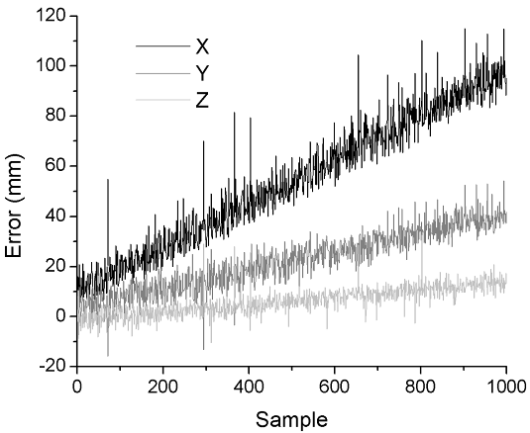
Figure 6-22: Drift is noticeable when localizing a static point with 10,000x averaging over 1000 samples. The geometric position dilution of precision (PDOP) causes drift error in the x dimension to be amplified relative to y and z.

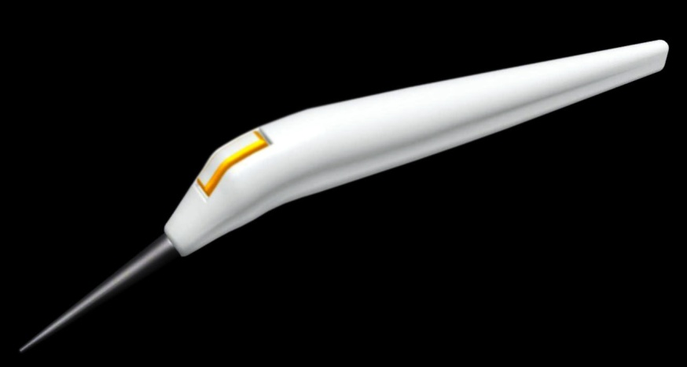
Figure 6-23: Conceptual drawing of UWB RF surgical navigation probe for painting points in computer assisted orthopedic surgery.

Wireless Technologies in Medicine
Wireless technologies have found many applications in the medical field. Varshney describes current and future uses of various wireless technologies for medical applications including intelligent mobile emergency response systems, ad hoc networks combined with WLANs for patient monitoring both inside and outside the hospital, the use of smart phones and other portable devices equipped with 802.11 WLAN technology for telemedicine applications (i.e. everyday hospital use such as downloading daily schedules, patient information, etc.), and indoor tracking of assets, personnel, and patients through Differential GPS or RFID technology [158]. Pattichis et al. gives a comprehensive overview of the wireless technologies used in telemedicine as well as an overview of systems deployed by various research groups to test the effect of telemedicine in various clinical settings for transmission of electrocardiograph (ECG), blood pressure, temperature, medical images, and other relevant signals for applications such as remote monitoring, teleradiology, and emergency care [159]. The continued advancement of modern day telecommunication systems has allowed new methods of surgical instruction, such as international telementoring, where a mature surgeon can guide and teach practicing surgeons new operative techniques through video streaming, medical robots, and high bandwidth digital communication, to be successfully used in specialized international surgical procedures [160]. Finally, the use of implantable in vivo sensors which utilize a telemetry system to transmit data from the body have become more common with advances in science and technology. For example, Bergmann et al. measured in vivo contact forces and temperatures in the proximal femoral implant of a Total Hip Arthroplasty (THA) using an inductive telemetry system which takes high voltage signals (e.g. 50 Vpp) at low frequencies (e.g. 3.5-4.5 kHz) and wirelessly transmits the digital information via induction coils [161],[162]. Evans and To have done extensive simulation, design, and experimental testing of microelectromechanical systems (MEMS) capacitive pressure sensors and microcantilever technology for recording a pressure map of the knee stresses on the spacer block used in a Total Knee Arthroplasty (TKA) incorporating radio frequency (RF) telemetry in the 315 MHz and 433 MHz bands [163],[164]. Reagan is extending this sensor technology for in vivo use by embedding the sensors in a parylene coating for placement inside the polyethylene insert of TKA and optimizing sensor performance for in vivo loading, which will allow pressure mapping of the knee stresses on the femoral condyles [165].

Medical Frequency Bands
Wireless medical devices, for both positioning and communication, have stringent requirements on the frequency bands in which they can operate. Table 7-1 highlights the different bands both in the United States and Europe which can be used for indoor medical applications for both narrowband and UWB applications. UWB has available frequency bands from 3.1 – 10.6 GHz and 22 – 29 GHz in the U.S. Only portions of that 3.1 – 10.6 GHz band are currently available in Europe. A number of telemetry bands exist in the U.S., and both the U.S. and Europe have instrumentation, scientific, and medical (ISM) bands available, mainly in the 300 MHz to 3 GHz range. As shown in Table 7-1, in vivo telemetry applications typically use bands in the RF and lower microwave frequency range for operation (i.e. 315 MHz, 402 – 405 MHz, and up to 1427 – 1432 MHz in the United States while Europe uses 433.05 – 434.79 MHz and 868 – 870 MHz). In order to understand why telemetry bands are not allocated above 1.43 GHz, it is necessary to look at the complex permittivity of human tissues as done in Section 7.2. The UWB positioning system operates from 5.4 – 10.6 GHz in the upper region of the 3.1–10.6

Table 7-1: Summary of licensed medical wireless frequency bands.
Location |  | Frequency Band | Frequency (MHz)
 | U.S. | Medical Implant Communications Service | 402 - 405
 | U.S. | Wireless Medical Telemetry Service | 608 – 614  1395 – 1400  1427 - 1432
 | U.S. | Instrumentation, Scientific, and Medical (ISM) | 315  902 – 928  2400 – 2483.5  5150 - 5875
 | Europe | ISM | 433.05 - 434.79  868 - 870 (short-range)  2400 - 2483.5
 | U.S. | UWB | 3.1 – 10.6 GHz  22 – 29 GHz, center freq > 24.075 GHz
 | Europe | UWB | 4.2 – 4.8 GHz  6 – 8.5 GHz  3.4 - 4.2 GHz Pending

GHz band while most wireless telemetry systems for in vivo use operate at 433.92 MHz in the 433.05 - 434.79 European ISM band and at 315 MHz for the U.S. ISM band. As shown in Figure 7-1, the allocated band in the United States goes from 3-10.6 GHz at a power level of -41.3 dBm/MHz. Compared to Europe, where the power level is required to be at -71.3 dBm/MHz from 4.8-6 GHz, -65 dBm/MHz from 8.5-10.6 GHz, and can only be at -41.3 dBm/MHz from 3.4-4.8 GHz if detect and avoid (DAA) circuitry is implemented to minimize interference with other wireless systems operating in this band. Figure 7-2 compares the UWB bands in Japan versus
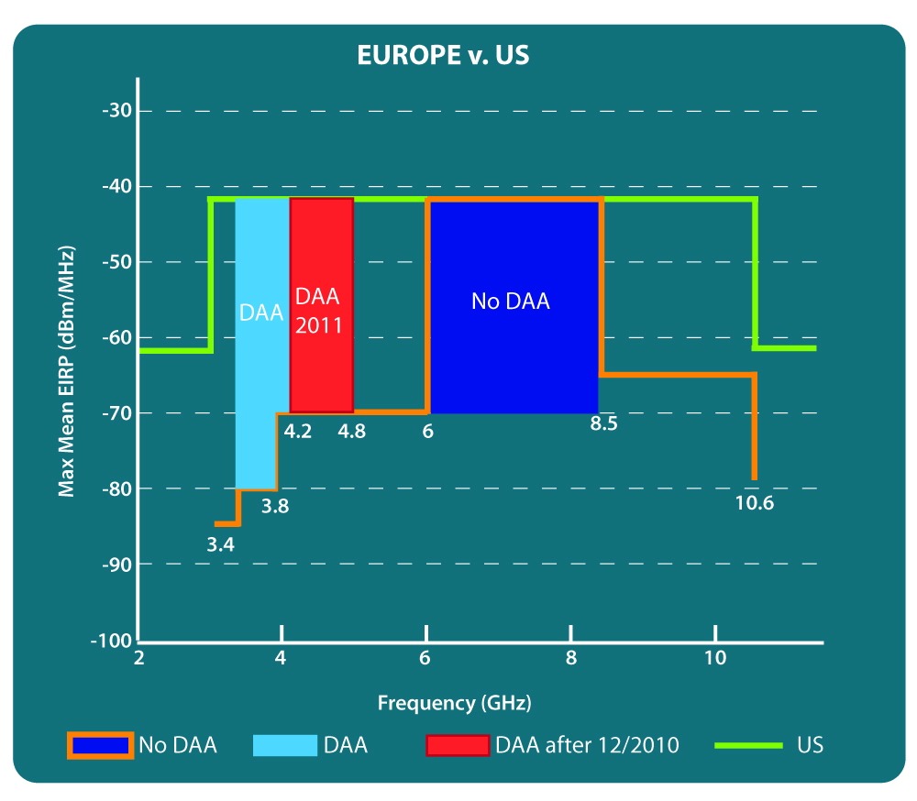
Figure 7-1: Comparison of allocated UWB bands between 3-11 GHz in the U.S. versus Europe.
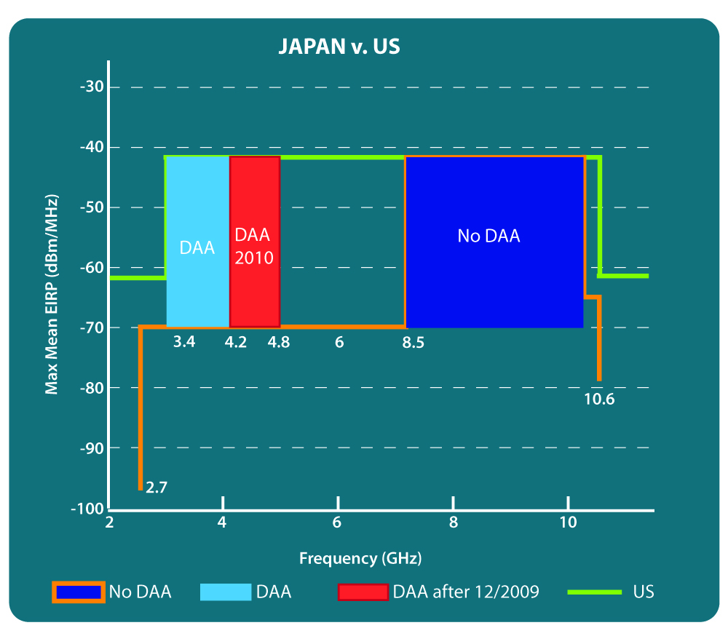
Figure 7-2: Comparison of allocated UWB bands between 3-11 GHz in the U.S. versus Japan.

the United States. Similar to Europe, the Japanese regulations also require DAA in the 3.4-4.8 GHz band. The main difference between the European band and the Japanese band is in the no DAA band: in Europe, this exists from 6-8.5 GHz while in Japan, this band goes from 8.5-10.6 GHz. From looking at Figure 7-1 and Figure 7-2, it is clear that the various restrictions imposed around the world make designing one system for worldwide operation difficult to impossible. Multiple variations of a system may be needed to meet the various worldwide regulations.

Microwave Interaction with Biological Tissues
The electrical characteristics of biological tissues change dramatically from DC through higher frequencies such as X-ray and gamma radiation. At very low frequencies (the kHz range), the primary means through which electrical current travels through the body is conduction via the extracellular matrix. At the visible frequency range and even higher in ultraviolet (UV) and X-ray frequency ranges, most electromagnetic waves are able to pass through biological tissues, with differing amounts of energy being absorbed by different tissues. Between these two extremes lie the RF/Microwave frequency bands. Electrical properties of biological tissues change dramatically over this frequency range. There are specific techniques, such as coaxial probe dielectric measurements, which can be followed to apply a uniform method for electrical characterization of biological tissues (or other lossy media) over this frequency range.
RF/Microwave radiation is considered from 100 kHz – 30 GHz [166]. Although the interaction of radiation with biological tissues changes significantly over this range, there are some similar properties that provide coherence for grouping RF/Microwave frequencies together. First, over this whole frequency range radiation can be considered non-ionizing. Ionizing radiation includes UV and X-ray, and these frequency ranges are characterized by disruption of atomic structures. Second, it is convenient and useful to use RF/Microwave frequencies for the purpose of radiating electromagnetic (EM) energy. At low frequencies (LF) and extremely low frequencies (ELF), the wavelength of the transmitting signal is much larger than the structures used in transporting it. Radiation at LF and ELF is not typically seen. Conversely, the wavelengths in the RF/Microwave range are comparable to their corresponding transmission lines (millimeter-meter in size), which makes them ideal for radiation applications.
The RF/Microwave frequency range has already been well researched and has many current uses in the medical field. Current successful applications include benign prostatic hyperplasia, endometrial ablation, cardiac ablation, microwave assisted balloon angioplasty, and localized hyperthermia [166]. One of the more recent applications is in radiometry (a device used to measure low power EM radiation). The radiometer can be used both to measure the temperature distribution of biological tissues as well as to monitor hyperthermia systems [167]. Central to designing any of these systems is a thorough understanding of the electrical properties of the tissues that will be exposed to the EM energy. An enormous amount of research has been done in this area. This has included use of a wide range of measurement techniques, testing on many different types of animals as well as humans, and testing of biological tissues in different environments (e.g. in vivo, in vitro, over a range of temperatures, etc.).

Complex Permittivity
The complex permittivity is a common method used to characterize the electrical properties of an arbitrary medium. Combined with other electrical parameters, such as conductivity and skin depth, it can be used to provide complete electrical characterization. (7-1) shows the basic definition of complex permittivity
$${ε^{*}=ε}^{'}-jε"$$ | (7-1)
where the first term, ε’, represents the capacitive nature of the tissue (i.e. amount of charge stored in it) while ε” characterizes the lossy nature of the medium. Using these two terms, it is possible to calculate α and β, which can then be used to characterize how an electromagnetic (EM) wave behaves inside the medium [168]. (7-2) and (7-3) show this process.
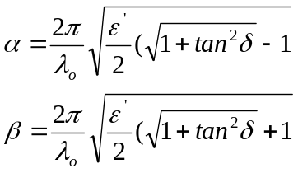 | (7-2)
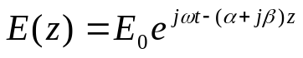 | (7-3)
Finally, once the electrical field is known, the power dissipated through the region can be
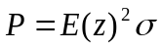 | (7-4)
calculated assuming the conductivity of the medium is known combined with (7-3). This shows the usefulness in knowing the complex permittivity and how it can be used to characterize radiation in an arbitrary medium. The electrical losses can be attributed to both ionic conduction and dipole rotation [169].
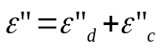 | (7-5)
The standard way to model the complex permittivity for an arbitrary material is through the Cole-Cole equation
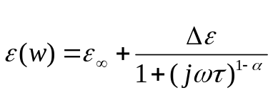 | (7-6)
where there is a dispersion peak in the loss factor whose size and place depends on the relaxation time, τ, and dispersion factor α. Figure 7-3 shows typical curves for the complex permittivity of human tissues as modeled through the Cole-Cole equation (7-6) [170]. A multi-
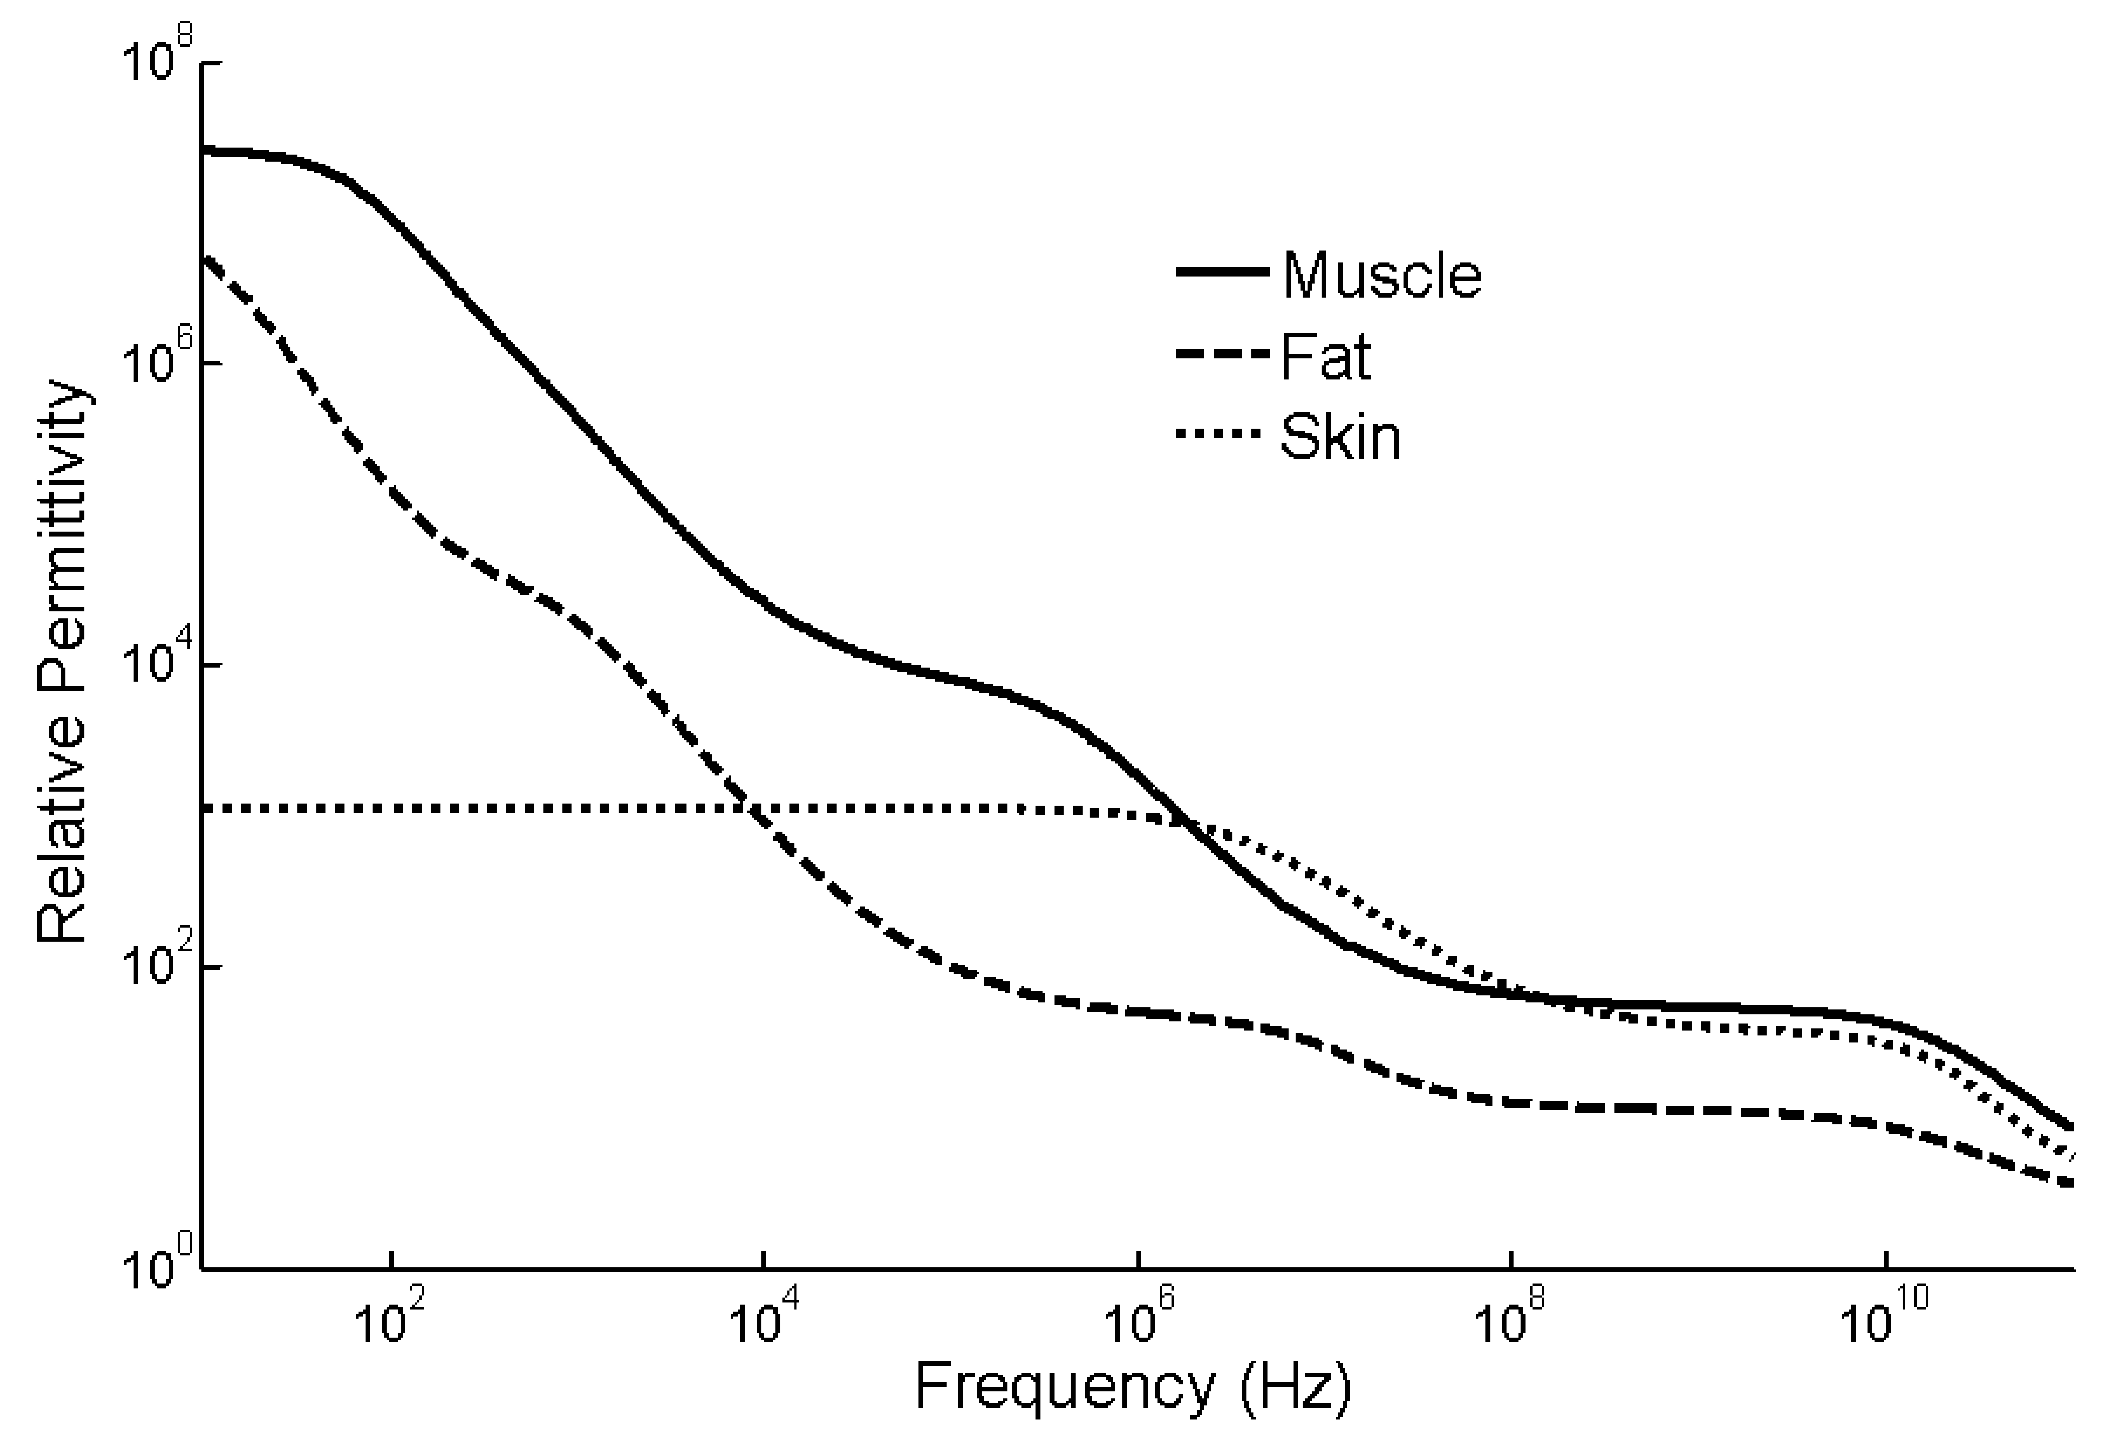
(a)
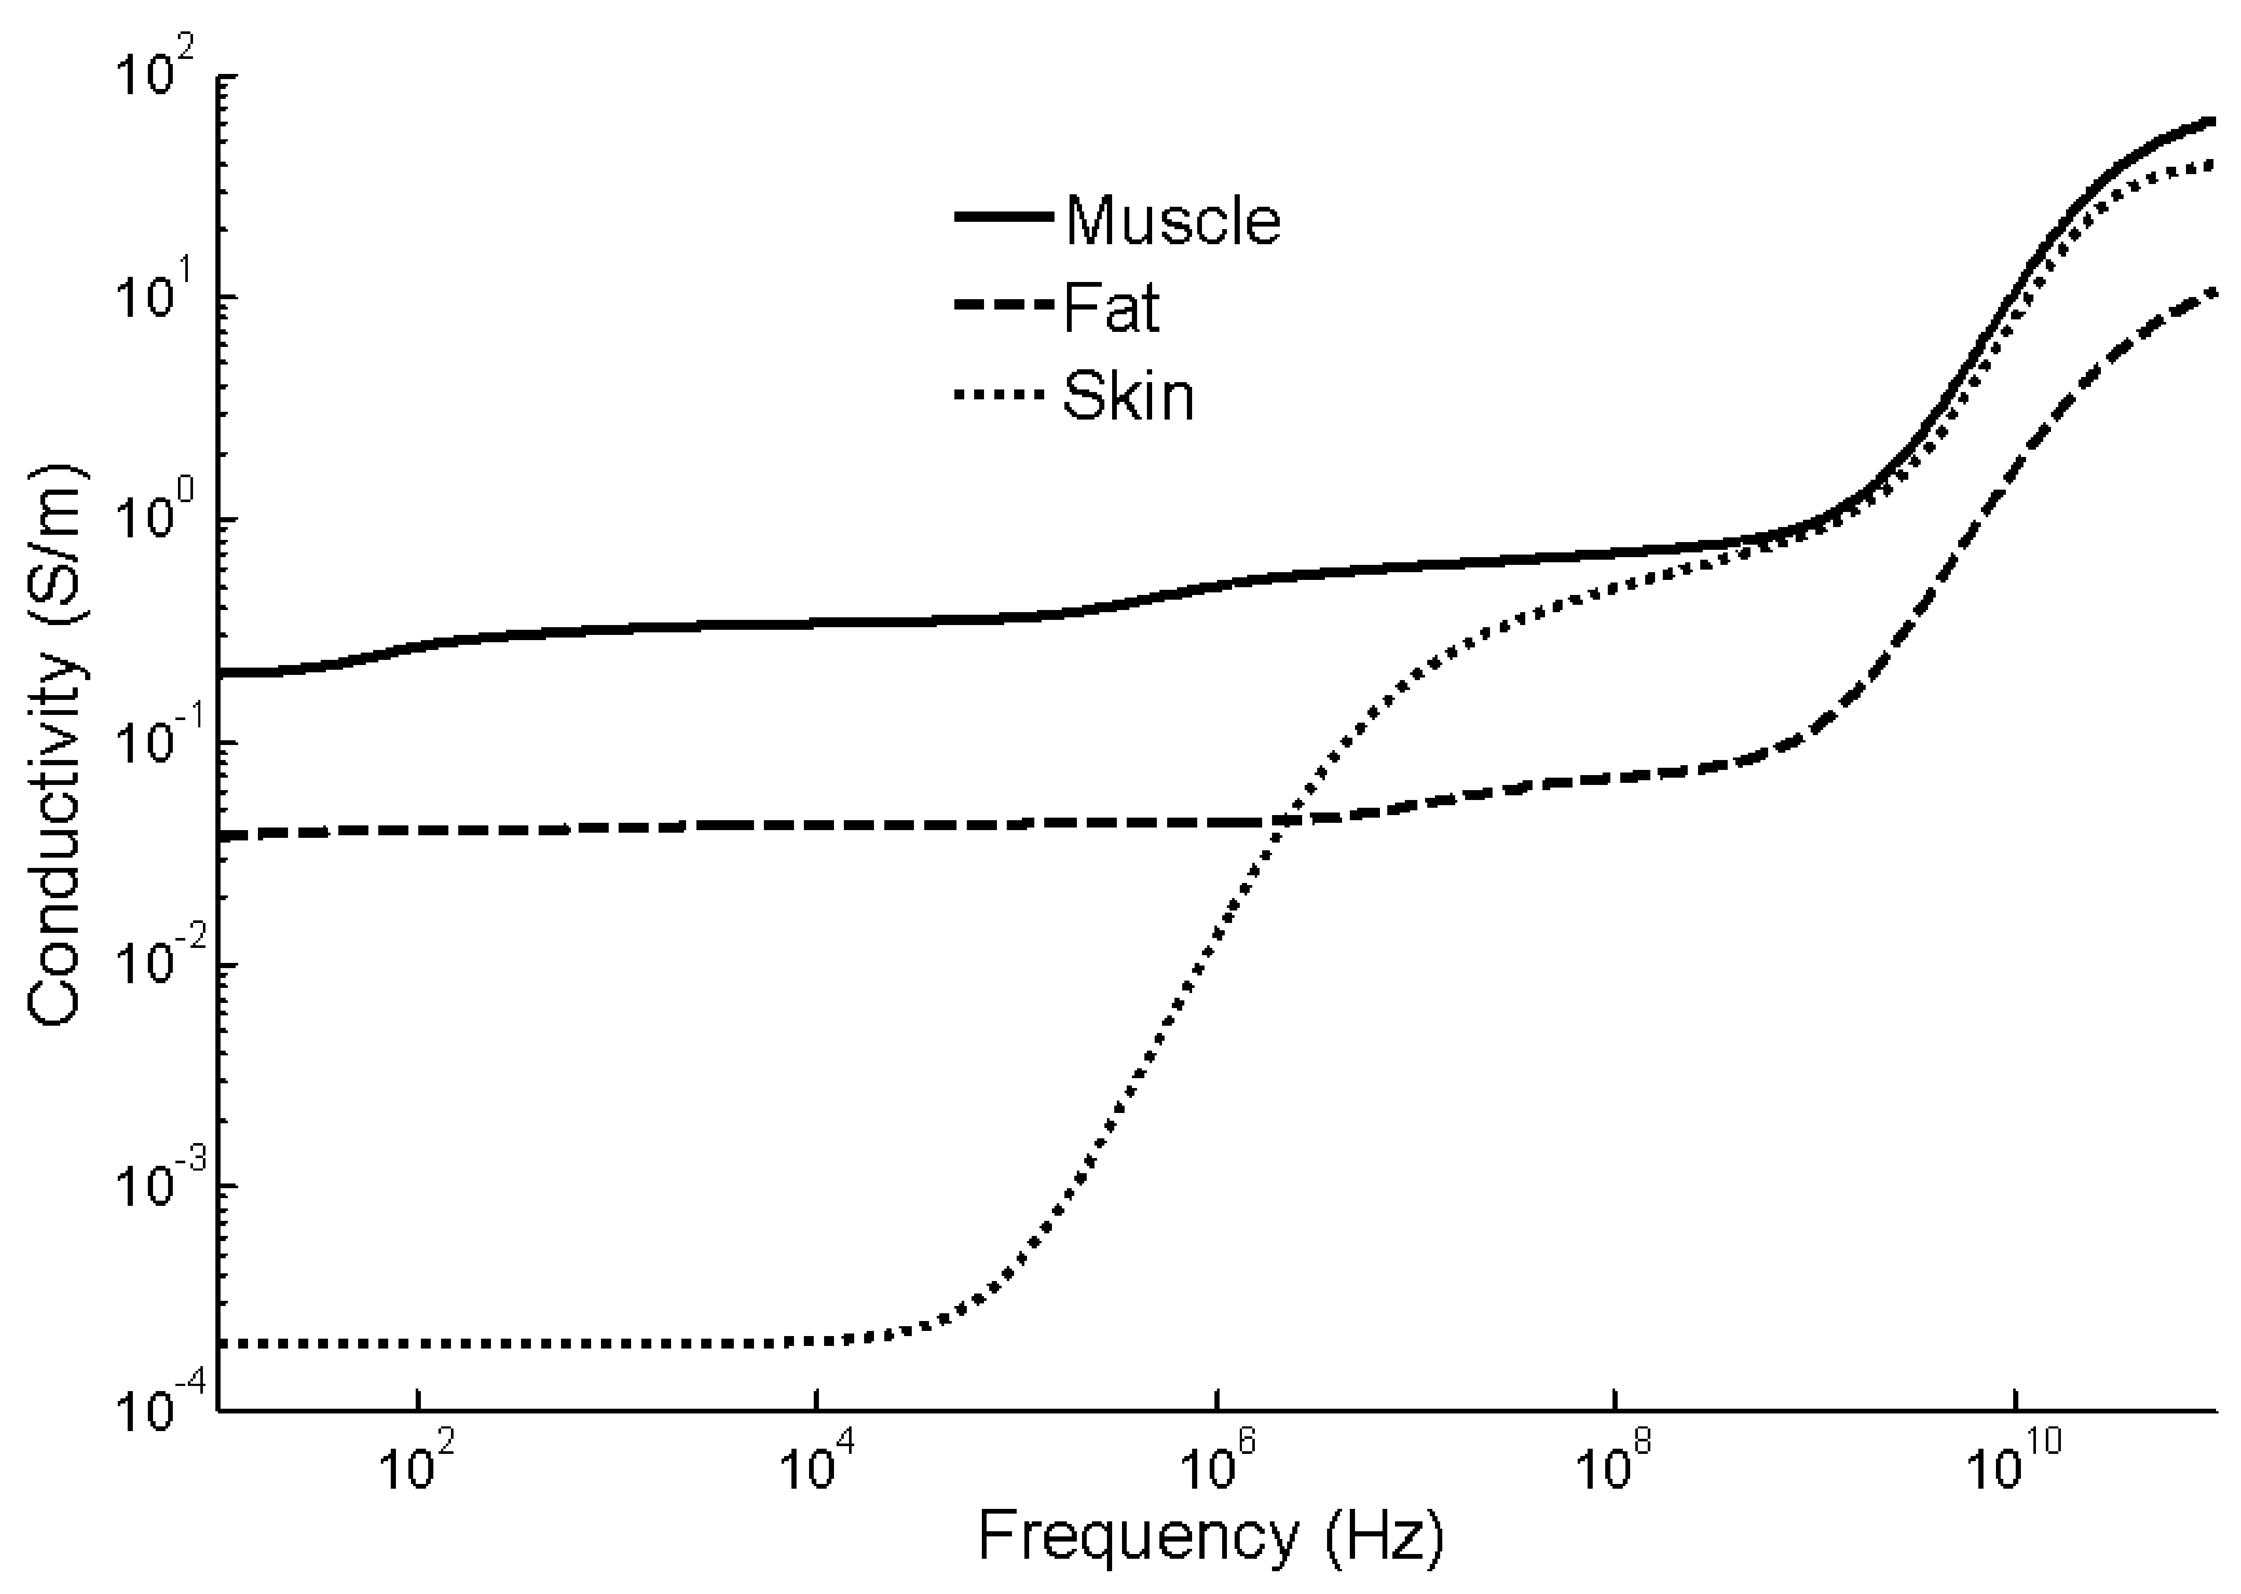
(b)
Figure 7-3: Electrical properties of human muscle, fat, and skin at 37°C. (a) relative permittivity, (b) conductivity.
peak Cole-Cole equation (7-7) is used by Gabriel et al. and allows a parametric model for complex permittivity to be established where multiple dispersion peaks and relaxation times are taken into account [170].
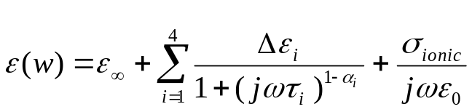 | (7-7)
The loss factor in an arbitrary medium (i.e. ε”) is due to both ionic conductivity and dipole rotation, and dipole rotation is the primary means through which losses occur over the RF and microwave frequency range. The various losses experienced through the microwave frequency range are shown in Figure 7-4. The temperature increases the ionic conductivity, which is the main reason the loss factor tends to increase with increases in temperature over lower microwave frequency range (DC – 1 GHz) [169]. Above 1 GHz, the effects due to ionic
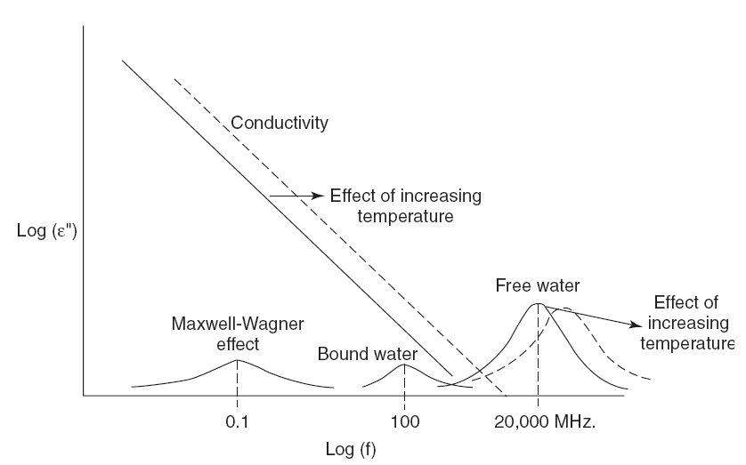
Figure 7-4: Water and temperature effects on the loss factor [169].
conductivity lessen, and the loss factor is primarily due to dipole rotation (or free-water dispersion). This has the effect of decreasing the loss factor of water-based tissues, at least over the range of 3 – 17 GHz, with increase in temperature. Figure 7-5 shows how changes in temperature affect both ε’ and ε” for water over a range of frequencies and temperatures [169]. As Figure 7-5 shows in a qualitative sense, over the microwave frequency range of interest (3-17 GHz), increases in temperature tend to decrease ε’ by an almost consistent amount (decrease of ~8 for an increase in temperature of 25°C) and also tend to decrease ε”. Since most biological
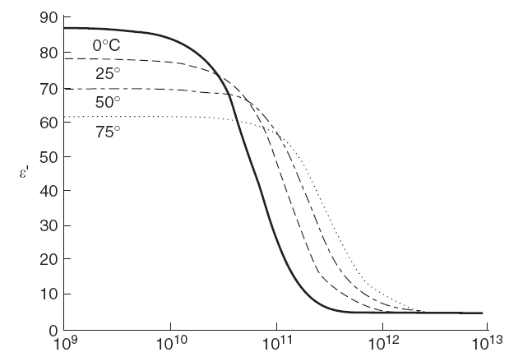
(a)
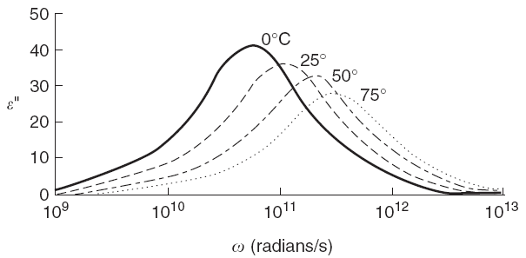
(b)
Figure 7-5: Effects of temperature on complex permittivity of water: (a) ε’, (b) ε” [169].
tissues, especially muscle and liver, are highly water-based, they tend to follow similar trends for variation of complex permittivity over a range of temperatures. The change in complex permittivity of water is mostly due to the change in viscosity that occurs in water for varying temperatures. For example, a 32.4% decrease in viscosity of water is observed when going from 20°C to 37°C. This causes a decrease in the relaxation time of approximately 38.2%.

Coaxial Probe
Although there are a number of methods for measuring the complex permittivity of different materials, only a few of these techniques work for biological tissues. This is due to the relatively high ε’ and ε” seen in most biological tissues. Because the complex permittivity of most tissues is several factors larger than that of air, higher order modes of propagation exist within the tissue when using transmission measurement techniques such as waveguides or free space antennas. The measurement technique best suited for measuring the complex permittivity of high loss materials is the coaxial probe. This is a technique that has been widely researched in literature. Throughout the 1970s many studies were undertaken to measure the complex permittivity of different biological tissues with a coaxial probe. Athey et al. did extensive testing on a live feline [171]. They used a complex capacitance model for the probe and obtained good results for skeletal muscle, smooth muscle, liver, kidney, and spleen. Pethig provided an excellent review of what had been done in literature on various types of tissues for both animals and humans [172]. Finally, Gabriel et al. did an exhaustive review on previous work done in literature over the whole spectrum of biological tissues which included work done on animals
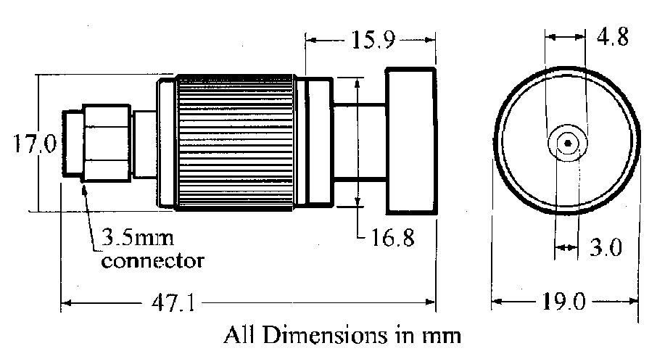
Figure 7-6: Agilent 85070D coaxial probe [175].
and humans [173]. Most of the initial work went from radio frequencies to 10 or 20 GHz, although more recently, with the advent of vector network analyzers with higher frequency ranges, people have been able to extend measurements up to 110GHz [174]. The coaxial probe used in the experiments outlined in Section 7.2.3 comes from the Agilent 85070D dielectric probe kit. The dielectric probe is depicted in Figure 7-6 [175]. It canoperate over a frequency range of 200 kHz–20 GHz and a temperature range of -40 °C to 200 °C. It maintains an error of ε_{r}’ ±5% and tanδ ±0.05 over these ranges, as depicted in Figure 7-7 [175].
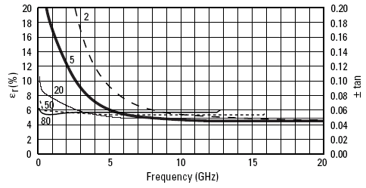
Figure 7-7: Accuracy of ε_{r}’ and tanδ for different values of ε_{r}’ [175].

Biological Tissue Coaxial Probe Measurements
A block diagram of the coaxial probe measurement system is shown in Figure 7-8 [176]. The Agilent 85070D coaxial dielectric probe is connected to either an HP 8510 vector network analyzer or an Agilent E8365B PNA vector network analyzer. The data is then fed into a computer for post-processing with Matlab. The Agilent 85070D coaxial probe is rated at 200 kHz to 20 GHz and for temperatures from -40°C to 200°C with error in ε_{r} of ±5% and error in loss tangent of ±0.05 over that range. A coaxial probe setup is the most accurate detection method for lossy tissues, although Zhang et al. used a parallel plate waveguide probe for S₁₁ measurements up to 7 GHz for breast cancer detection [177].
The four material calibration technique comes from Staebell et al. [178]. The use of four materials in the calibration step helps avoid evaluating complex triple integrals dependent on the geometry of the coaxial probe. Also, the use of two load materials provides more accurate complex permittivity readings over a wider range of values for ε’ and ε”. A summary of the method is given here. A basic three material calibration is setup
$$\frac{Y_{s}-Y_{1}}{Y_{s}-Y_{2}}\frac{Y_{3}-Y_{2}}{Y_{1}-Y_{3}}=\frac{δ_{S1}δ_{32}}{δ_{S2}δ_{13}} δ_{ij}=Γ_{i}-Γ_{j}$$ | (7-8)
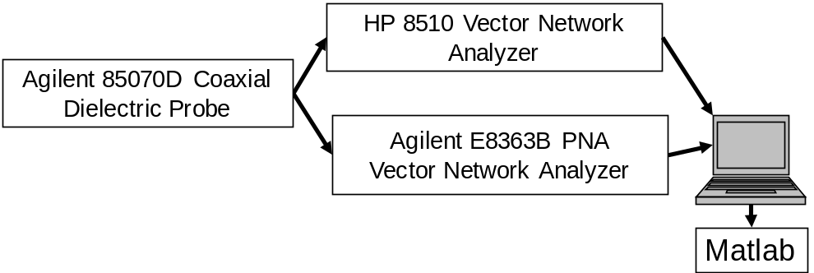
Figure 7-8: Block diagram of coaxial probe measurement system.
where Γ_{i} is the reflection coefficient for the i^{th} material, Y₁,Y₂,Y₃ are the admittances for the reference materials, and Y_{S} is the admittance of the sample in question. In order to solve for the admittances of the reference materials, a complex formula for the aperture admittance is typically needed which incorporates the geometry of the coaxial probe and can be solved by using quasi-static conditions and assuming a coaxial line terminated by a semi-infinite medium on a ground plane [178]. Instead of solving this complex equation, a transformed aperture admittance for a certain load can be approximated with a simple bilinear interpolation
$$y_{S}\tilde{=}ε^{*}+ξ{ε^{*}}^{2}$$ | (7-9)
where y_{s} is the transformed aperture admittance corresponding to Y_{S}, $ε^{*}=ε^{'}-jε"$, $ξ$ is a frequency dependent constant derived from the dimensions of the aperture, and radiation from the coaxial aperture is neglected. Given the approximation in (7-9), it is possible to solve for $ξ$ by
$$ξ=\frac{\left(1+Δ\right)ε_{4}^{*}-ε_{1}^{*}-Δε_{2}^{*}}{ε_{1}^{* 2}+Δε_{2}^{* 2}-(1+Δ)ε_{4}^{* 2}} Δ=\frac{δ_{41}δ_{32}}{δ_{42}δ_{13}}$$ | (7-10)
where $ε_{i}^{*}$ is the complex permittivity of the i^{th} material and the third material is a short circuit [178]. The aperture admittance for the material under test is first calculated
$$y_{S}=\frac{y_{1}+Δ'y_{2}}{1+Δ'} Δ^{'}=\frac{δ_{S1}δ_{32}}{δ_{S2}δ_{13}}$$ | (7-11)
using a standard three material calibration including a short circuit. Once y_{s} is known, it is possible to solve for
$$ε^{*}=\frac{-1±\sqrt{1+4ξy_{S}}}{2ξ}$$ | (7-12)
where $ε^{*}$ is the final complex permittivity. Figure 7-9 shows experimental results for acetone where air, water, short, and methanol are used as the four materials in the calibration. Average errors of 1.2% for $ε^{'}$ and 6.9% for $ε"$ are achieved.
The coaxial probe measurement system was tested on both human and snake tissues. Human tissues were obtained with permission from the Anthropology department at the University of Tennessee, Knoxville while snake tissues were obtained via a dissection of a Boa Constrictor obtained from the Biology department at the University of Tennessee, Knoxville. Figure 7-10 shows the coaxial probe pressed against the small intestine of the snake. Results for both human tissue and snake tissue were compared to the data from Gabriel et al. [170], the de facto standard for complex permittivity values of human biological tissues. Results for snake skeletal muscle and human skin are shown in Figure 7-11a and Figure 7-12a where it is possible to see the discrepancy caused by the reference data from Gabriel et al. [170] being at 37°C while our measured data was taken at 20°C. Average errors of 15% for $ε^{'}$ and 24% for $ε"$ were
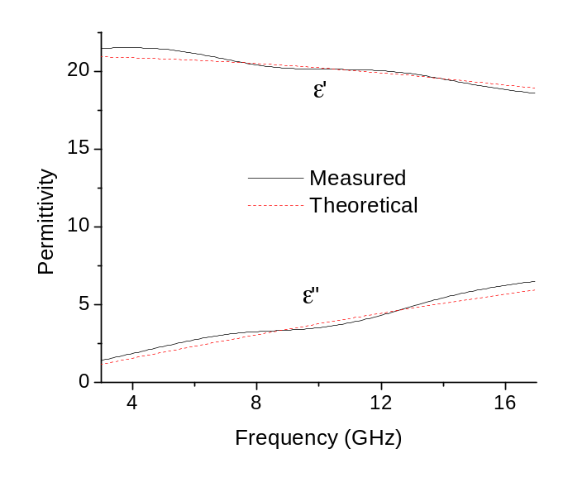
Figure 7-9: Theoretical and measured complex permittivity of acetone from 3-17 GHz using the four material calibration technique.
observed across the frequency range when examining human muscle, skin, and fat as well as snake liver, heart, lung, small intestine, kidney, skeletal muscle, and skin.
As mentioned in Section 7.2.1, in the RF and microwave frequency ranges, the loss factor $ε"$ is primarily due to dipole rotation (or free-water dispersion). Since this effect lessens with increased temperature, both $ε^{'}$ and $ε"$ trend towards smaller values with increased temperature. In Figure 7-11b and Figure 7-12b, this relationship is used to shift the Gabriel et al. data from 37°C to 20°C. After applying the shift, the average errors reduce to 4.1% for $ε^{'}$ and 10% for $ε"$.
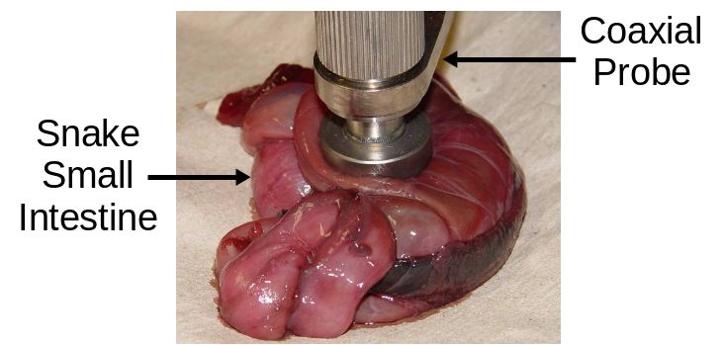
Figure 7-10: Coaxial probe embedded in snake small intestine.
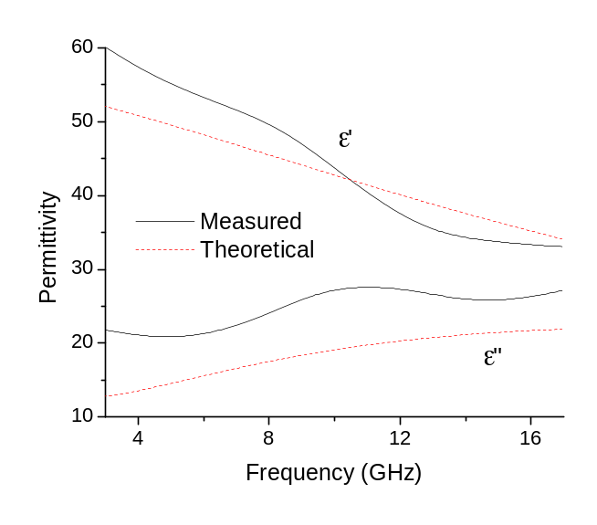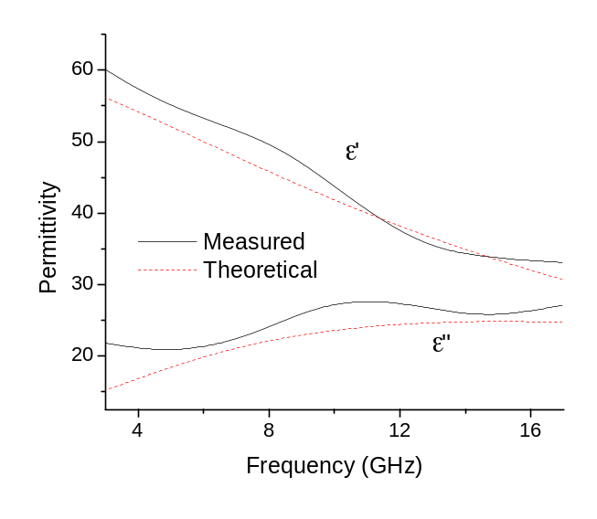
(a) (b)
Figure 7-11: Measured complex permittivity of snake skeletal muscle compared to the human data from Gabriel et al. [170] for (a) the normal case, (b) application of a temperature shift to move the reference data from 37°C to 20°C.
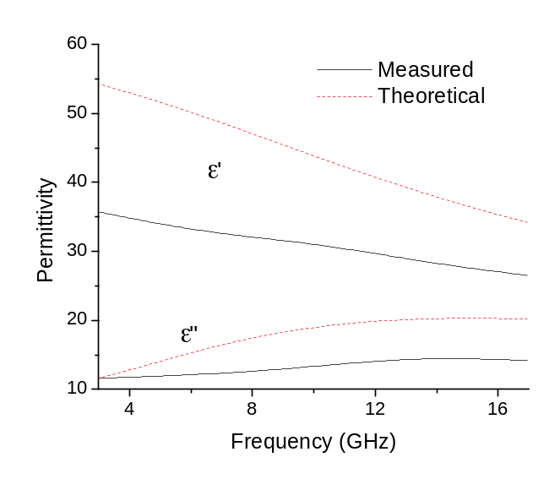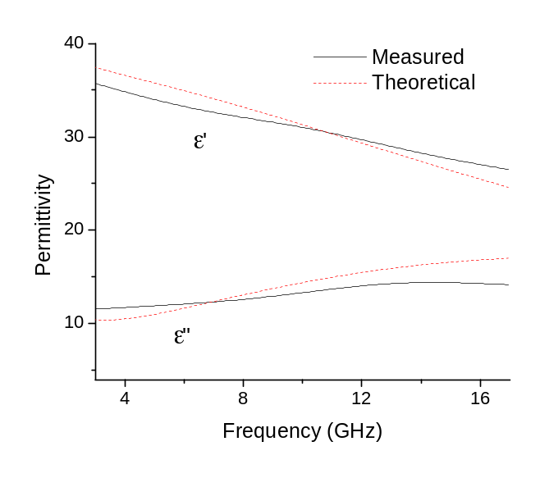
(a) (b)
Figure 7-12: Measured complex permittivity of human skin compared to the human data from Gabriel et al. [170] for (a) the normal case, (b) application of a temperature shift to move the reference data from 37°C to 20°C.

Positioning Systems
In terms of current technologies used for indoor localization in hospital environments, commercial systems are available which use Wi-Fi, received signal strength, RFID, ultrasound, and UWB. Clarke et al. ran an experiment where these five systems were tested in multiple locations inside an operating room and compared for their performance in 3-D indoor localization [58]. As shown in Figure 7-13, UWB performed orders of magnitude better than the other technologies with RF localization being the only other one to consistently localize points with even sub-meter accuracy [58]. Signal strength, Wi-Fi, and RFID systems all suffered from multipath effects given their narrowband nature while the ultrasound system only reported the nearest distance from the transmitting tag to the nearest receiver, so it was not able to report 3-D position values at all. This experiment shows in a quantitative manner how UWB localization systems can obtain better 3-D localization results than other wireless technologies in medical indoor environments using LOS signals. Time Domain Corp. offers the PLUS® RTLS for indoor asset tracking solutions, utilizing UWB operating at a center frequency of 6.6 GHz with around 1 GHz bandwidth and an operating range near 50 m [59]. Figure 7-14 shows the use of the PLUS® RTLS for asset tracking in a hospital environment [179]. This allows tracking of patients, staff, and medical equipment which can be used to optimize workflow processes and provide better management of these different assets.
The development of the IEEE 802.15.4a standard for LDR WSNs has resulted in a substantial amount of research and development on UWB CMOS transceivers [180],[181] which comply to the standard. Startup companies have also begun to appear (DecaWave), integrating an IEEE 802.15.4a transceiver with RTLS, giving LDR communication (110 kbps to 6.8 Mbps), high location accuracy (10 cm), and large operating ranges (up to 500 m indoor LOS and up to 45 m indoor NLOS) [60]. The use of these WSNs for sensing, LDR communication, and positioning make them an excellent candidate for a wide variety of applications including telemetry of bodily vital signs in body area networks (BANs), which can be extended into personal area networks (PANs), process optimization in logistics and manufacturing, emergency services, military, and high security (assuming proper measures are taken on the network layers above the UWB physical layer).
The push taken by DecaWave in utilizing CMOS technology for ultra-low power UWB transceivers which comply to the IEEE 802.15.4a standard, are compact in size (a 4.5 mm x 4.5 mm ball grid array), work in NLOS conditions, and can be used for high accuracy localization, is a good summary of the current momentum in research for UWB positioning integrated with WSNs.
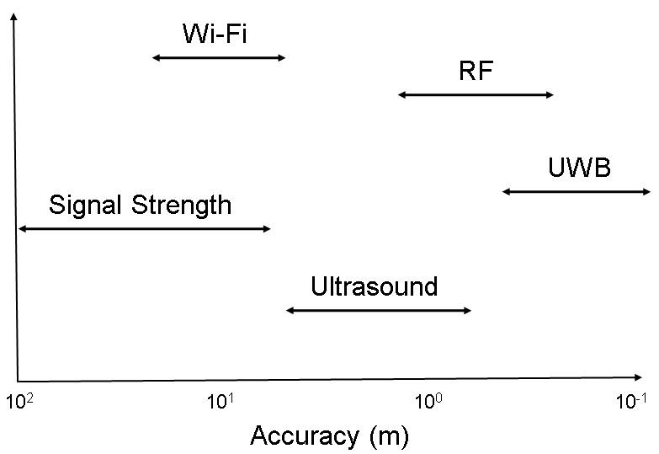
Figure 7-13: Accuracy of indoor localization systems in OR [58].
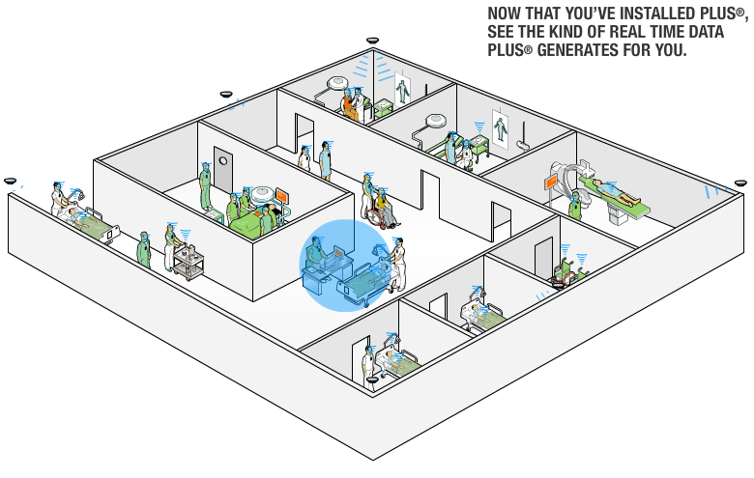
Figure 7-14: PLUS® RTLS from Time Domain Corp. for asset tracking in a hospital [179].

Communication Systems
The prevalence of wireless communications systems in medicine has increased significantly in recent years with the pervasive nature of mobile devices, satellites, and computers. There are many wireless technologies that are currently employed in medical facilities including WLAN, cellular telephone technologies (e.g. CDMA-2000, IS-95, etc.), Bluetooth, Zigbee, WiMAX, and various telemetry digital communication frameworks (e.g. frequency shift keying, amplitude shift keying, etc.). As shown in Figure 7-15, the concept of telemedicine is now a reality where video, audio, and even vital signals can be transmitted wirelessly from remote health centers, ambulances, homes, ships, and even intensive care units to relay up-to-date patient information instantaneously for immediate medical assistance [182]. One major push in the area of telemedicine is the concept of personal telehealth, where the patient can take a proactive and autonomous approach in monitoring their health. As shown in Figure 7-16, the Continua Health Alliance is a non-profit, open industry coalition of over 200 healthcare and technology companies promoting an interoperable personal healthcare ecosystem where multiple sensors integrated with various wireless technologies and a network infrastructure allow remote monitoring of the patient’s home to monitor various activities including medication tracking, blood sugar levels, blood pressure and heart rate [183]. Given the vast number of applications in medicine for telehealth, wireless sensor networks, and wireless telemetry, the various wireless technologies enabling this communication need to be examined to understand their strengths and weakness. Section 7.4.1 introduces in vivo wireless telemetry, Section 7.4.2 looks at the use of Bluetooth in medical sensor and ex vivo wireless telemetry, and Section 7.4.3 introduces UWB digital communication including its integration into ad-hoc wireless sensor networks.

In Vivo Wireless Telemetry
As discussed in Section 7.2, the losses seen when transmitting microwave signals through biological tissues above 1.98 GHz increase dramatically. Therefore, when transmitting wireless signals through tissues, frequencies much less than 1.98 GHz must be used. As shown in Table 7-1, ISM bands are available in the United States and Europe which operate at 315 MHz and 433 MHz. These are the ideal frequency bands for in vivo wireless telemetry. Figure 7-17 shows a standard amplitude shift keying (ASK) transmitter where a baseband digital signal modulates a RF signal operating at either 315 MHz or 433 MHz to transmit digital information. Figure 7-18 shows a MAX1472 (Maxim IC) transmitter connected to a 433 MHz chip antenna
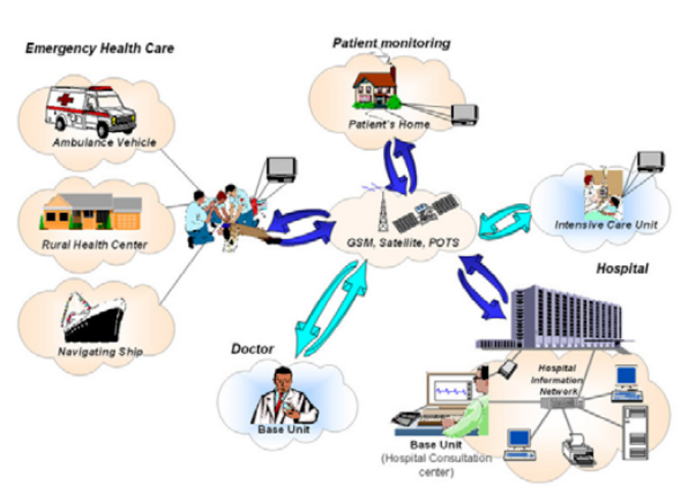
Figure 7-15: Overview of comprehensive telemedicine architecture where wireless technologies enable faster diagnosis and detection inside hospitals, at rural health centers, and from mobile ambulance vehicles [182].
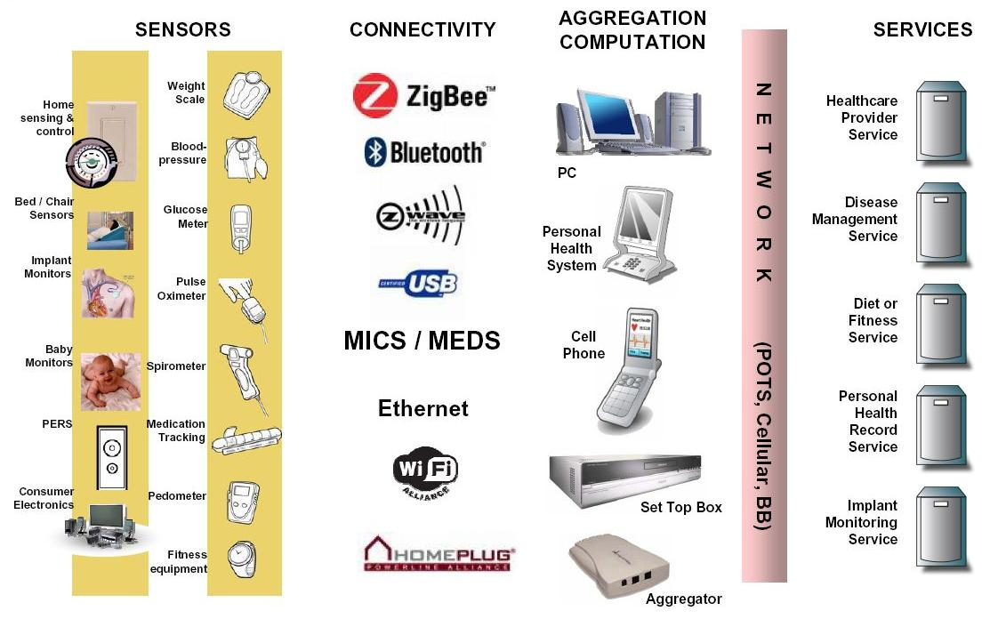
Figure 7-16: Continua Health Alliance personal healthcare ecosystem where various sensors are used to wirelessly and remotely monitor the patient’s health including blood pressure, heart rate, etc. [183].
(Tricome) used to transmit pressure data from an in vivo sensor in the knee joint in the 433 MHz ISM band. Wireless telemetry from in vivo sensors is a promising field which has many applications including embedding sensing systems into orthopedic implants to help monitor for infection as well as overall operation of the joint. Also, 1.4 GHz can be used for short range wireless telemetry applications including knee pressure sensing.

Bluetooth
Bluetooth represents another up and coming technology for ex vivo wireless telemetry of digital information in medical sensors. It is one of the wireless technology standards supported by the Continua Health Alliance [183] and is currently integrated into most computers and
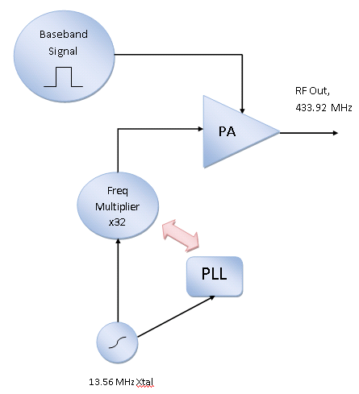
Figure 7-17: Standard ASK transmitter architecture where a digital signal modulates the RF carrier operating at 315 MHz or 433 MHz.
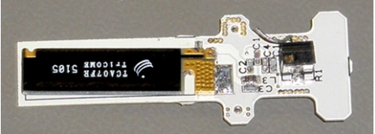
Figure 7-18: Transmitter for in vivo wireless telemetry which uses a MAX1472 ASK transmitter operating at 433 MHz connected to a chip antenna to transmit digital information.
personal digital assistants (PDAs). Bluetooth fits into the IEEE 802.15.1 standard for wireless personal area networks (WPANs). The specifications for Bluetooth operation are shown in Table 7-2 where a targeted operating range is 10-100 m with data rates of up to 1 Mbps. Compared to the IEEE 802.15.4a standard, which is for ultra-low data rate WPANs, Bluetooth costs more, has added complexity, consumes more power, has a farther operating range (100 m versus 10 m), and can transmit at faster data rates (1 Mbps versus 0.25 Mbps). Bluetooth employs frequency shift keying (FSK) or Gaussian frequency shift keying (GFSK). Figure 7-19a shows an example of a WPAN for wireless fitness monitoring while Figure 7-19b shows a WPAN for wireless monitoring of bodily vital signals [184]. Figure 7-20 shows the Avant® 4000 Oximeter from Nonin Medical, Inc. (Plymouth, MN) which is used for wireless monitoring of the oxygen saturation level of a patient’s blood for continuous and remote monitoring [185]. Chapter 9 discusses various multi-tag access schemes for UWB localization including a protocol similar to Bluetooth.
Table 7-2: Bluetooth specifications.
Frequency | Data Rate | Operating Range | Modulation Type
2.4-2.483 GHz | Up to 1 Mbps | 10-100 m | FSK,GFSK,MSK
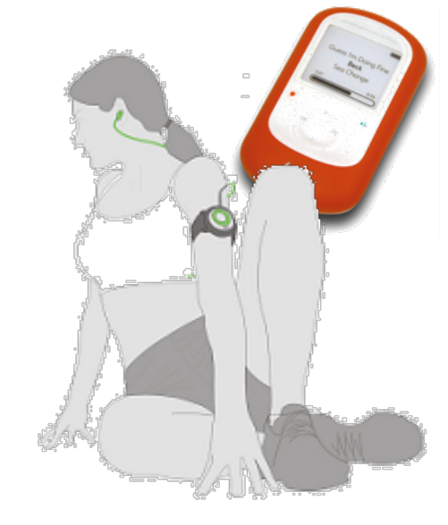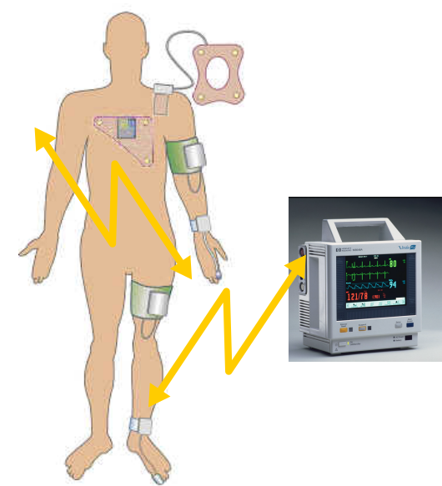
(a) (b)
Figure 7-19: WPANs for a) wireless fitness monitoring, b) wireless monitoring of vital data [184].
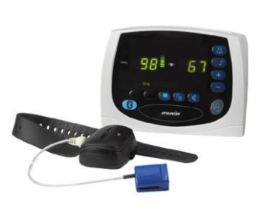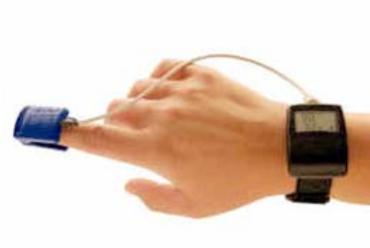
Figure 7-20: Avant® 4000 Oximeter from Nonin Medical, Inc. (Plymouth, MN) for wireless, remote, continuous monitoring of oxygen saturation level in blood utilizing Bluetooth technology [185].

UWB and Ad-hoc Sensor Networks
The use of UWB in digital communications has skyrocketed since the Federal Communications Commission’s decision to open up the 3.1-10.6 GHz band in the United States in 2002 [4]. The IEEE 802.15.3a task force examined the use of both direct sequence spread spectrum (DSSS) and MB-OFDM for high data rate (e.g. 480-1100 Mbps), short range wireless communication. As shown in Figure 7-21, MB-OFDM utilizes frequency division multiplexing by allocating 500 MHz bands through the 3.1-10.6 GHz UWB spectrum. With up to 14 separate bands, the symbols are transmitted by utilizing multiple frequency bands where quadrature phase shift keying (QPSK) is the underlying modulation technique in conjunction with frequency division multiplexing. Table 7-3 shows the specification for high data rate UWB digital communication with an operating range of 10 m and data rates as high 1100 Mbps. Figure 7-22 shows the chipset from Wisair which utilizes MB-OFDM in the 3.1-4.8 GHz band for high data rate UWB digital communication up to 1100 Mbps for applications including transmitting video signals [186]. Low data rate UWB applications also exist mostly in the area of wireless sensor networks which comply to the IEEE 802.15.4a standard. These devices are especially appealing since they can be compact in size, offer data rates of greater than 1 Mbps, and provide a method for high accuracy localization. DecaWave has a new real-time location system (RTLS) which utilizes a UWB complementary metal oxide semiconductor (CMOS) transceiver in an ad-hoc network approach which adheres to the IEEE 802.15.4a standard, giving low data rate communication (110 kbps to 6.8 Mbps), high location accuracy (10 cm), and large operating ranges (up to 500 m indoor LOS and up to 45 m indoor NLOS) [60].
Table 7-3: UWB specification for high data rate digital communication.
Frequency | Data Rate | Operating Range | Modulation Type
3-10.6 GHz | 480-1100 Mbps | 3-10 m | MB-OFDM

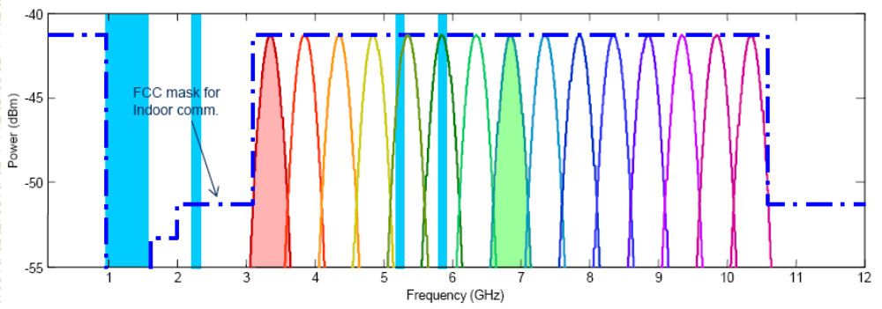
Figure 7-21: Illustration of MB-OFDM allocation utilizing the 3.1-10.6 GHz UWB band open in the United States where up to 14 separate frequency bands can be used in high data rate communication.
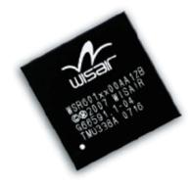
Figure 7-22: Wireless USB is now a certified technology which utilizes UWB MB-OFDM for high data rate digital communication. Commercial chipsets and products are available, including the CMOS chipset from Wisair which is commercially available in a range of products [186].

Wireless Signal Propagation in Hospital Environments
The main concern with using wireless tracking and communication technology in the operating room (OR) and other hospital environments is the high level of scatterers and corresponding multipath interference experienced when transmitting wireless signals. While the experiment from Clarke et al. [58] provides quantitative data on how wireless real-time positioning systems perform in the OR, it is also useful to look into narrowband and UWB channels and their effect on narrowband and UWB signals for communication and positioning applications. There are two typical approaches used when modeling wireless channels: the first is statistical models used to model generic environments (e.g. industrial, residential, commercial, etc.), which incorporate LOS or non-line-of-sight (NLOS) measurements taken in the time and frequency domains, which are then used in setting the parameters of these statistical models. The second method uses ray tracing techniques to model specific geometrical layouts (e.g. buildings, cities) and can provide a more accurate depiction of which obstacles and structures will have the greatest effect on wireless propagation [53]. The drawback with ray tracing is the static nature of the results (i.e. results are only valid for a certain scenario of objects placed in the scene). Even if the wireless systems in the operating room are static, other objects will not be including people, patients, the operating table, and medical equipment.
The effects of hospital environments on both narrowband telemetry systems (e.g. 315 MHz or 433 MHz systems) as well as UWB positioning and communication systems operating in the 3.1-10.6 GHz band are discussed in Sections 8.1 and 8.2. This includes time and frequency domain experiments outlined in Section 8.2 which were used in obtaining parameters for a UWB channel model for the operating room environment fit to the IEEE 802.15.4a channel model. Section 8.3 outlines an experiment to quantify which types of wireless signals are found in the operating room which have the potential to cause electromagnetic interference (EMI) with narrowband and UWB wireless systems. Finally, Section 8.4 discusses the susceptibility of our UWB positioning system to WLAN interference in the 5.8 GHz ISM band and includes specifications for a multi-stage bandpass filter which is needed to ensure the UWB receivers are not jammed by high power WLAN interferers.

Narrowband Telemetry Systems
Attenuation of wireless signals due to soft tissue is one of the major obstacles in designing in vivo wireless systems, including systems which operate in the 315 MHz and 433 MHz ISM bands (Table 7-1). The lossy nature of soft tissue to signals in the RF and microwave frequency range has been extensively researched (Section 7.2). The electrical properties of an arbitrary medium (e.g. muscle, fat) can be completely characterized by the relative permittivity ε’ and conductivity σ
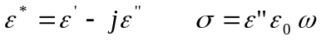 | (8-1)
where ε* is the complex permittivity, ε” is the imaginary portion of the complex permittivity signifying loss, and ω is the radial frequency. As outlined in Section 7.2, human tissues have been characterized in terms of their complex permittivity and conductivity which allows the study of propagation of wireless signals through human tissues. As mentioned in Section 7.2, the losses observed in human tissues rise sharply above 1.43 GHz.
Figure 8-1 outlines a simulation conducted using the tissue properties in Section 7.2. The electric field and tissue interfaces were simulated following the procedure outlined in [166] where a recursive process is used to solve for the equivalent impedances of each tissue and reflection coefficients for each tissue interface (e.g. muscle-fat, fat-skin, and skin-air). The signal first travels through 10 mm of muscle and then through the muscle-fat interface, then through 5 mm of fat and through the fat-skin interface. Part of the signal is reflected at the fat-skin interface, which then travels back to the fat-muscle interface. Solving for the equivalent impedances and reflection coefficients for each tissue and interface in the same order as the emitted signal takes into account this phenomenon where electric field waves can effectively bounce around between two interfaces [166]. For the simulation, a modulated ASK signal is transmitted at 10 dBm power at 315 MHz, 433 MHz, 915 MHz, and 2.4 GHz. As shown in Table 8-1, all signals will experience some loss due to the tissues. The losses incurred at 315 MHz and
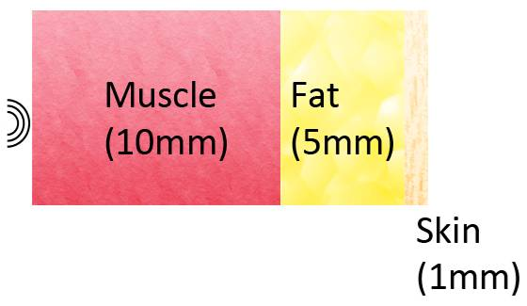
Figure 8-1: Overview of simulation setup where the soft tissues of the knee are simulated using a 10 mm layer of muscle, 5 mm layer of fat, and 1 mm layer of skin followed by air.
433 MHz are 12.5-22.5 dB lower than the losses incurred at 915 MHz and 2.4 GHz. Operating at 315 MHz and 433 MHz successfully meets the operating range of our system while operating at 915 MHz and above results in losses through the medium too high to obtain an operating range of even 5 m.
It is worth noting that RFID systems are commercially available for hospital use which operate in the 433 MHz band [187]. Also, ECG telemetry systems have been designed which operate in the 433 MHz band using frequency shift keying (FSK) at ranges up to 40 m [188]. As mentioned in [189], for the ASK transmitter and receiver employed in the pressure sensing telemetry system shown in Figure 8-2, 30-40 dB more pathloss is noticed indoors versus outdoors. This significantly reduces the operating range of systems using the 315 MHz and 433 MHz bands inside a hospital. For example, given a receiver sensitivity of -115.6 dBm, a transmitter power of -10 dBm after the chip antenna, the tissue losses outlined in Table 8-1, and the indoor pathloss specified by the manufacturer [189], the maximum operating range of the telemetry system is 20 m in the 315 MHz band and 15 m in the 433 MHz band, both satisfying
Table 8-1: Simulated losses for transmitted ASK signals at various frequencies.
Frequency | Loss (dB)
315 MHz | 28.5
433 MHz | 32.5
915 MHz | 45
2.4 GHz | 51

a standard operating range requirement of 5 m for being able to transmit inside a standard room. Each transmitted packet includes a 16 bit header which employs even parity checking and a unique bit sequence for identification. This is followed by 270 bits for 30 channels of microcantilever data which employs odd parity checking to ensure proper transmission. The use of parity checking and a unique header in data transmission helps mitigate effects from interference seen at the 315 MHz and 433 MHz bands. The in vivo telemetry system in Figure 8-2 comes equipped with a chip antenna operating at 433.92 MHz, which allows it to transmit data even when inserted into the knee joint of a patient. The transmitting and receiving boards for a microcantilever pressure sensing system are shown in Figure 8-2 [61]. A chip antenna from Tricome is used for telemetry at 433 MHz (European ISM band). The transmitter and receiver used are the MAX1472 and MAX1473 chips from Maxim-IC, Inc. which use ASK modulation. The data rate is approximately 100 kbps. However, the transmitter power drops to -10 dBm after switching to the chip antenna as compared to +10 dBm as stated in the specification for a normal monopole antenna. The sensitivity of the wireless system operating at 433.92 MHz is -115.6 dBm with approximately 0.2% BER. This provides a 15 m operating range when transmitting through tissue, surpassing the 5 m requirement needed by our surgical navigation system.
The block diagram of the ASK receiver is shown in Figure 8-3. The RF signal is down converted via an image rejection fully differential mixer. The mixer is coherent in that a PLL is used to lock onto the phase of the incoming RF signal. Using a coherent receiver provides a lower BER compared to a non-coherent receiver. As shown in Figure 8-3, the I and Q
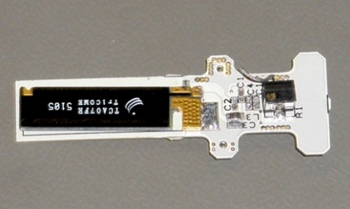
(a)
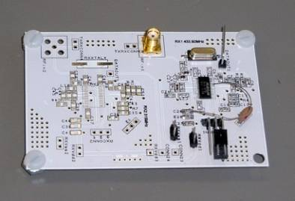
(b)
Figure 8-2: Fabricated (a) transmitter, (b) receiver for a microcantilever pressure sensor system operating in the 433.92 MHz ISM band [61].
channels are extracted from the incoming RF signal and then summed to get the down converted IF signal. The 10.7 MHz IF signal is then sent through a bandpass filter. This is followed by an IF limiting amplifier. The IF limiting amplifier acts as both an amplifier and a low pass filter. After going through the IF limiting amplifier, the signal is sent to the data slicer. The data slicer acts like a comparator (with a couple extra op amp stages) to output the final, recovered, coherent

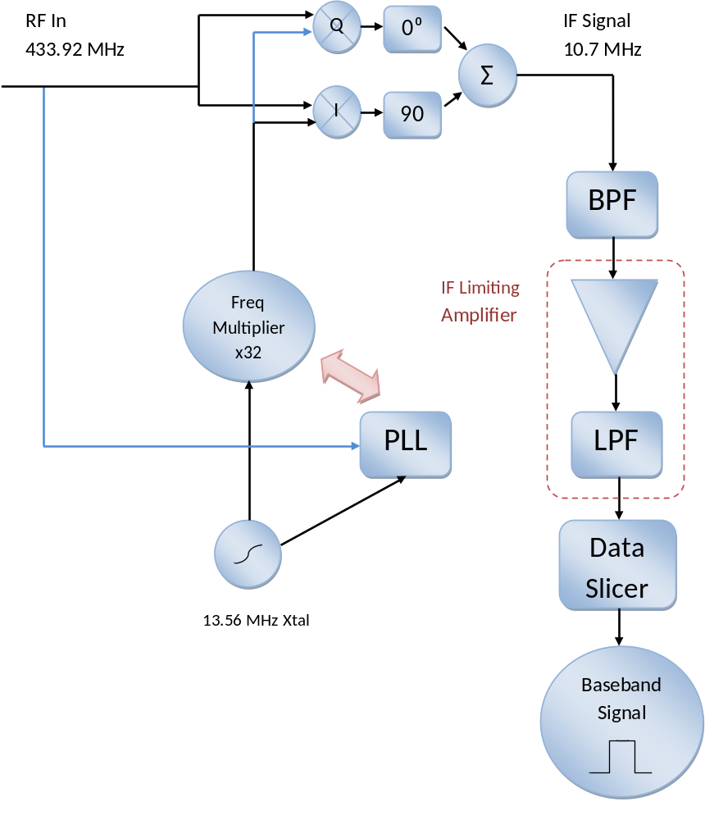
Figure 8-3: Block diagram of the MAX1473 ASK receiver.
baseband signal. Once again this system is fabricated and packaged into a CMOS chip. The sensitivity of the receiver is -114 dBm [190]. It also includes an on-chip automatic gain control (AGC) stage. This increases the dynamic range of the receiver by an extra 37dB.

Matlab System Simulation of ASK Transmitter and Receiver
A simplified version of the ASK transmitter/receiver system was simulated to analyze how the BER changes relative to the Signal-to-Noise ratio (SNR). Figure 8-4 shows the input signal at 100 kb/s where the amplitude has been normalized from zero to one. For this simulation, a sampling frequency of 100 MS/s was used to ensure that that the IF signal (10.7 MHz) was recovered correctly. Next, the input baseband data was used to modulate the 10.7 MHz IF signal. The resulting signal is shown in Figure 8-5. The data must be downconverted at the receiver into the 10.7 MHz IF signal. Figure 8-6 shows the same ASK signal with additive
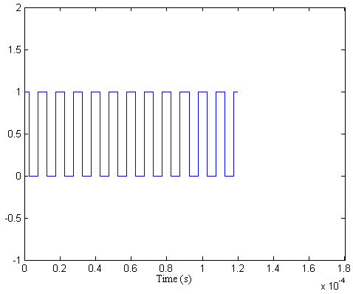
Figure 8-4: Normalized binary input data stream.
white Gaussian noise (AWGN). Specifying the noise amplitude relative to the signal amplitude allows the SNR of the resulting signal to be controlled. Varying the noise amplitude is used to generate the BER versus SNR plots. The spectrum of the ASK including noise is shown in Figure 8-20. This is the power spectral density of the signal leaving the transmitter plotted
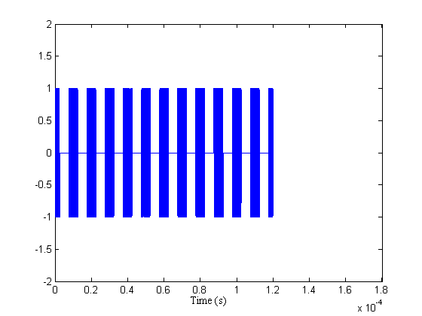
Figure 8-5: ASK signal at transmitter.
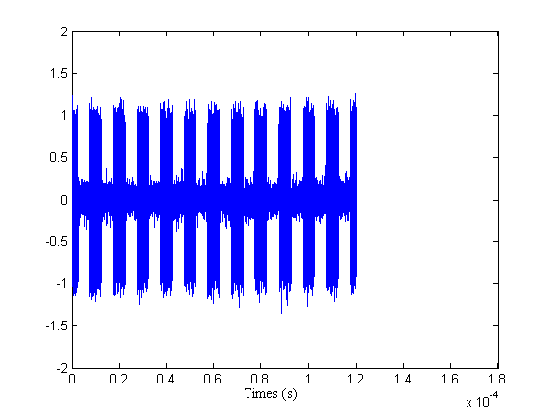
Figure 8-6: ASK signal at transmitter with the addition of AWGN.
linearly rather than in dB. Figure 8-8 shows the frequency response of the bandpass filter. From the specs in the receiver datasheet [190], the bandpass filter was designed to be centered at
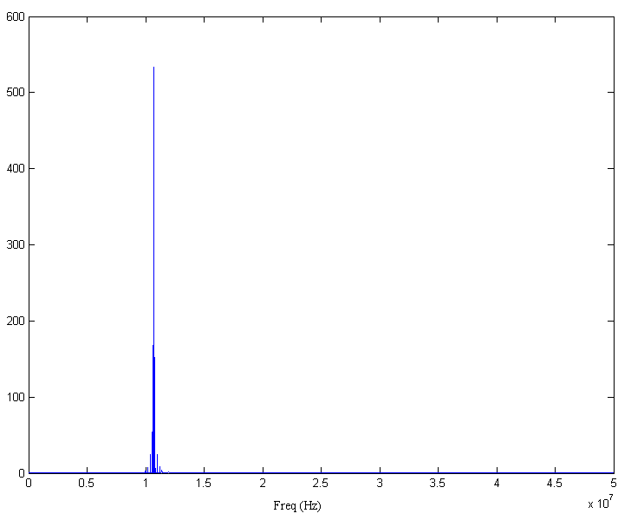
Figure 8-7: Power spectral density of ASK signal with noise.
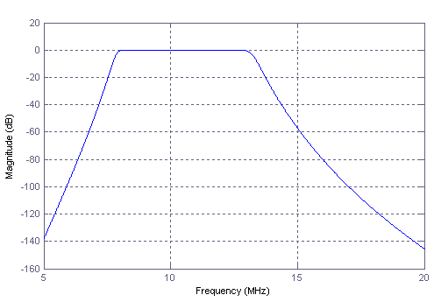
Figure 8-8: Frequency response of bandpass filter.
10.7 MHz, have a passband from 7.5-13 MHz with 3dB ripple or less, and to have a stopband below 5 MHz and above 16 MHz with at least 80dB attenuation. This was realized with a 6 order Butterworth bandpass filter. It is difficult to realize a filter of this order when designing the bandpass filter in CMOS. Figure 8-9 shows the resultant signal in both frequency and time after passing through the bandpass filter. As shown in Figure 8-9a, after passing through the bandpass filter, and with the addition of the noise, the signal contains many harmonics, although they are 60-100 dB below the main signal. The next block in the receiver chain is the IF limiting amplifier. It can be assumed that this amplifier is linear. Figure 8-10 shows the frequency response of the low pass filter while Figure 8-11 shows the IF signal after passing through the low pass filter. The cutoff frequency of the low pass filter is 700 kHz, which will completely eliminate the 10.7 MHz IF signal. From the resulting signal, shown in Figure 8-11, the baseband signal can clearly be seen. The last step is to send the signal through the data
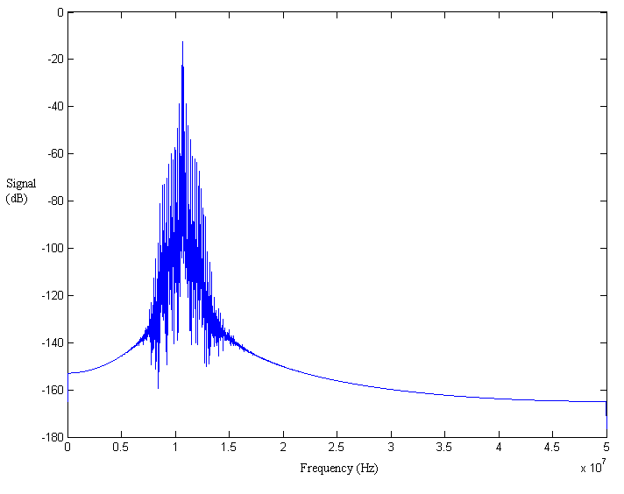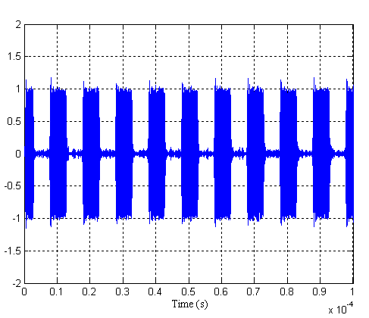
(a) (b)
Figure 8-9: (a) Frequency spectrum in dB of ASK signal after BPF, (b) Corresponding signal in time domain.
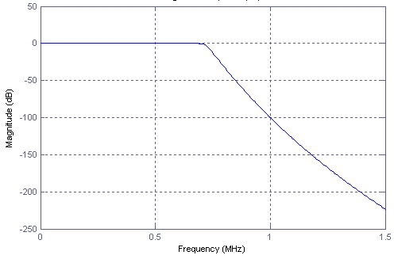
Figure 8-10: Low pass filter frequency response.
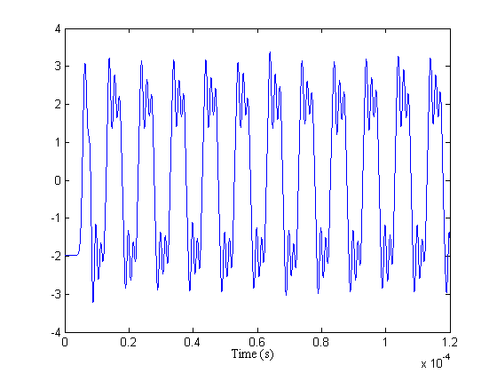
Figure 8-11: Baseband signal after the low pass filter.
slicer. For all practical purposes, this is just a comparator, although in designing a real system,the data slicer is typically more complex. The data slicer in the MAX1473 receiver includes the basic op amp comparator configuration as well as two other op amps for peak detection which are needed to detect bits before the capacitor in the LPF of the circuit has gotten sufficiently saturated. Figure 8-12 shows the received data stream juxtaposed with the transmitted data stream. The receiver is coherent, which means the phase of the signals will be locked, as seen in Figure 8-12. A small discrepancy exists at the beginning of the Rx data stream. This is caused by the slow temporal response of the low pass filter. In the MAX1473 this will not occur since the data slicer is able to compensate for these effects.
Figure 8-13 shows the theoretical and simulated BER versus SNR for the ASK system. As expected, the BER of the actual system is worse than the theoretical limit using ASK. In [190], a BER of 0.2% is given. They do not specify the SNR of the signal. If a standard SNR of 10dB is assumed, then the theoretical limit of ASK is 7E-4 while the simulated system produces a BER of 0.3%, which is closer to the BER given in the specifications of the MAX1473 receiver. Finally, it is worth noting the divergence of the two curves in Figure 8-13, especially for larger SNR values (10 or 12 dB. Simulations of the ASK system were performed in Matlab using the Matlab BERTool. This allows a theoretical BER to be calculated alongside a semi-analytic solution, and finally a solution obtained using a Monte Carlo simulation. As shown in Figure 8-14, the semi-analytic and Monte Carlo simulations are more realistic when compared to the actual performance of an ASK system. The theoretical BER is much lower than actual performance seen because it assumes no noise or interference or fading due to scatterers. It should be noted that the theoretical BER in Figure 8-14 is lower than that in Figure 8-13. This is because convolutional encoding is used in the simulations in Figure 8-14 to reduce the error further (and also is more realistic to actual system). The Monte Carlo simulation gives a BER of
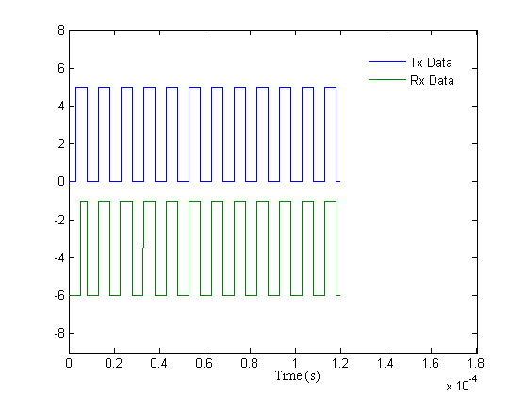
Figure 8-12: Original data stream and recovered data stream after passing through Tx/Rx.
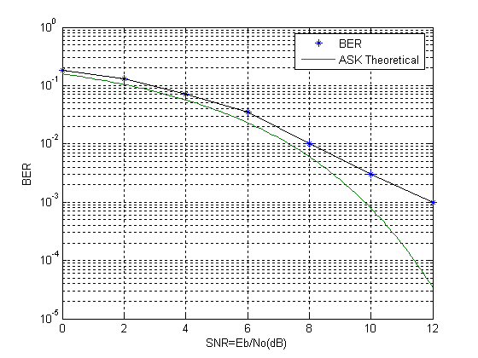
Figure 8-13: Theoretical and simulated BER of the ASK system.
0.1% at SNR=10dB. This almost identical to the manufacturer specification of 0.2% and also to the calculated BER from the Matlab simulation (0.3%). Finally, as shown in Figure 8-15, the performance of ASK is drastically reduced in fading multipath channels, such as Rayleigh and Rician channels. The theoretical lower bounds of the BER of an ASK system is 10⁶ higher at SNR=10dB than that of a system in an AWGN channel. This explains the reason ASK systems are not used in dense, multipath environments.

UWB Operating Room Channel
UWB systems have been designed and targeted for various medical applications given its robustness to dense multipath interference found in hospital environments as shown in Figure 8-16. Given the large amount of metallic interference, an accurate characterization of this environment is needed to design and simulate its effects on system performance. In developing
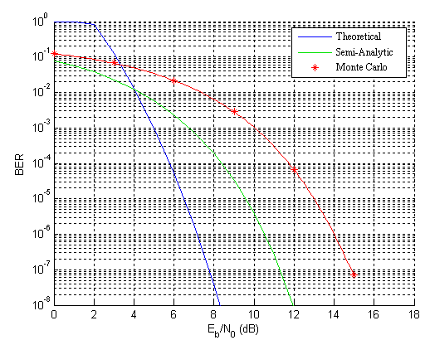
Figure 8-14: Comparison of theoretical, semi-analytic, and Monte Carlo methods for computing the BER of the 433 MHz ASK system.
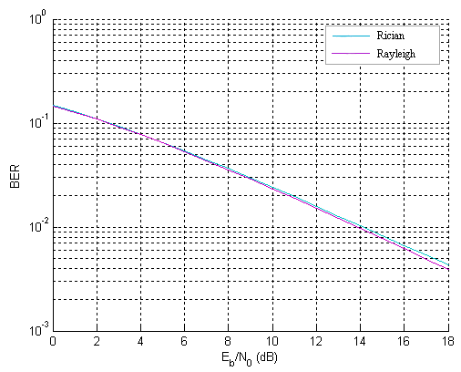
Figure 8-15: Theoretical performance of the ASK in fading Rayleigh and Rician channels.
the UWB positioning system outlined in Chapter 2, the IEEE 802.15.4a channel model has been used in the back-end DSP, which uses a large number of parameters and random variables in modeling a wide variety of environments (e.g. indoor industrial LOS/NLOS, indoor commercial LOS/NLOS, indoor residential LOS/NLOS, outdoor, body-area- networks) [79],[80]. The
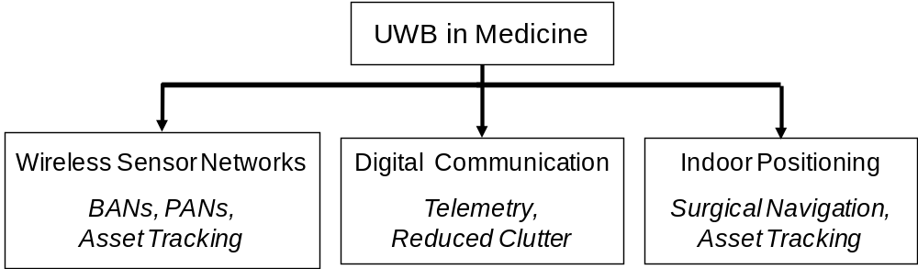
Figure 8-16: Various facets of UWB in medicine including wireless sensor networks, high data rate digital communication, and indoor positioning.

$$h\left(t\right)=\sum_{l=0}^{L}{\sum_{k=0}^{K}{a_{k,l}\exp\left(jφ_{k,l}\right)δ(t-T_{l}-τ_{k,l})}}$$ | (8-2)
$$PL\left(d\right)={PL}_{0}+10n \log_{10}\left(\frac{d}{d_{0}}\right)$$ | (8-3)
impulse response of the UWB channel in the time domain is shown in (8-2) while the pathloss model used in the corresponding UWB channel is shown in (8-3). These models have been used both in simulating the behavior of the UWB positioning system (Chapter 3) and in designing and implementing receiver-side pulse detection algorithms for highly accurate 1-D distance measurements between the transmitter and receiver, integral to the high performance of the system (Chapter 2).
Although the IEEE 802.15.4a UWB channel model has been fit to many environments, the OR is one place where measurement data is lacking and modeling information is still non-conclusive. The most comprehensive analysis was done by Hentila et al. who used time domain and frequency domain measurement techniques in analyzing UWB channels in different hospital environments including the operating room (OR), X-ray examination room, and intensive care unit [191]. The data best fit to a Nakagami-m distribution using a modified Saleh-Valenzuela model, similar to (8-2). Many techniques exist for performing indoor channel measurements of an UWB signal. For example, Irahhauten et al. discusses both frequency domain and time domain techniques [192] which can be used in conjunction with one another for an accurate description of channel fading versus frequency, root-mean-square (RMS) delay spread, path loss, power delay profile, and many other measurements.

Experimental Setup
Extensive time domain and frequency domain measurements in the operating room both during surgery (live) and not during surgery (non-live) for Tx-Rx distances of 0.5 m to 4 m. Figure 8-17 and Figure 8-18 show the time domain and frequency domain setups to collect data in the OR. Figure 8-19 and Figure 8-20 show the live and non-live setups where the layout of the dual OR is shown to highlight the Tx and Rx locations for both the live and non-live experiments. Note that both monopole and single element Vivaldi antennas are used for transmission and reception. The basic strategy in the time domain is to send out a narrow UWB pulse, either baseband or modulated by a carrier signal, in the 3.1-10.6 GHz band approved by the FCC [4]. Indoor measurements can also be measured at bands higher than the standard 3.1- 10.6 GHz (e.g. 22-29 GHz) with the understanding that the effective isotropic radiated power (EIRP) is limited to -51.3 dBm/MHz rather than the -41.3 dBm/MHz available in the lower band [4]. Figure 8-21 shows the experimental setup during the non-live case (Figure 8-20) for obtaining both time and frequency domain data while Figure 8-22 shows the experimental
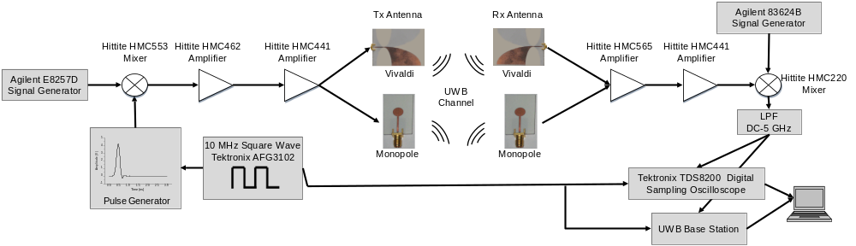
Figure 8-17: Experimental setup to collect time domain data in the operating room with the UWB localization system.
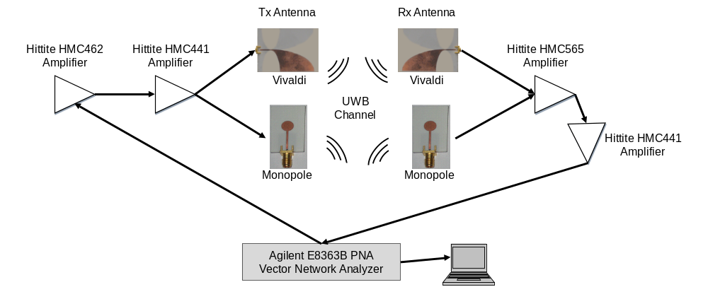
Figure 8-18: Experimental setup to collect frequency domain data in the operating room for characterization of the 3.1-10.6 GHz UWB band.
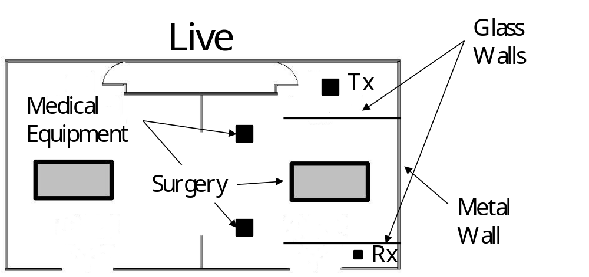
Figure 8-19: Layout of dual operating room during surgery outlining the patient table, glass walls, medical equipment, doors, and walls. The Tx and Rx were positioned 4 m apart across the surgery.

setup during an orthopedic surgery (the live case in Figure 8-19). In Figure 8-17, the 10 MHz triggering signal is synchronized between the transmitter and receiver, and the received signal is processed both by a UWB base station and also with a Tektronix TDS8200 equivalent time oscilloscope. When performing measurements in the frequency domain, the typical approach is
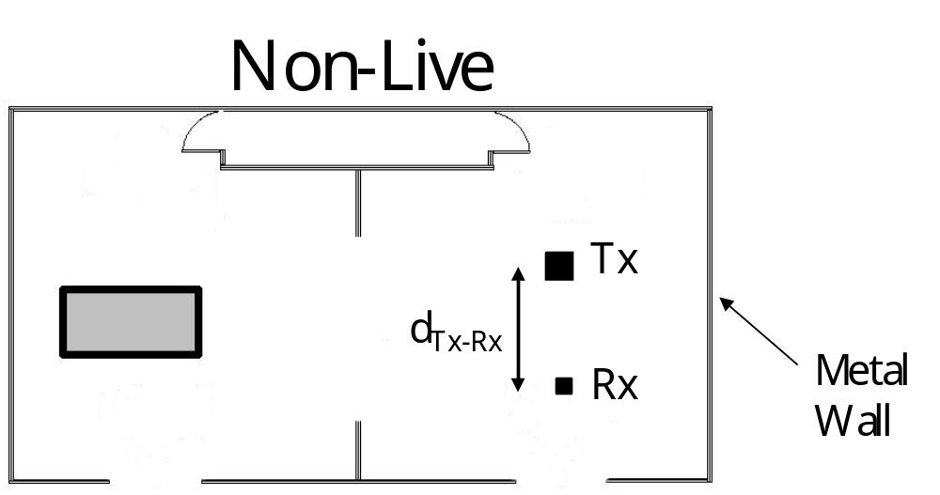
Figure 8-20: Layout of dual operating room without surgery taking place where medical equipment, glass walls, and the patient table have been removed. The Tx and Rx were placed in the surgical area and moved from 0.5-4 m apart.

to use a vector network analyzer to sweep across the UWB frequency range (e.g. 3.1 – 10.6 GHz) and measure the S-parameter response of the channel where a UWB signal is passed between a transmitting and receiving antenna. The inverse Fourier transform can then be used to convert the signal from a frequency response into an impulse response in the time domain. This allows frequency dependent fading and path loss as well as the RMS delay spread and power delay profile measurements to be obtained. In Figure 8-18, an Agilent E8363B vector network analyzer is used to collect data. Also, once again both monopole and single element Vivaldi antennas are used in transmission and reception both for comparison and factoring out antenna effects from the channel measurements.

Experimental Results
Table 8-1 shows a truncated list of parameters for the LOS operating room environment fit to the IEEE 802.15.4a channel model which were obtained with time domain and frequency
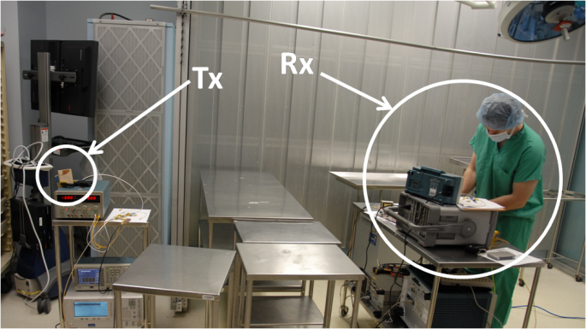
Figure 8-21: Experimental setup in the operating room during non-live scenario.

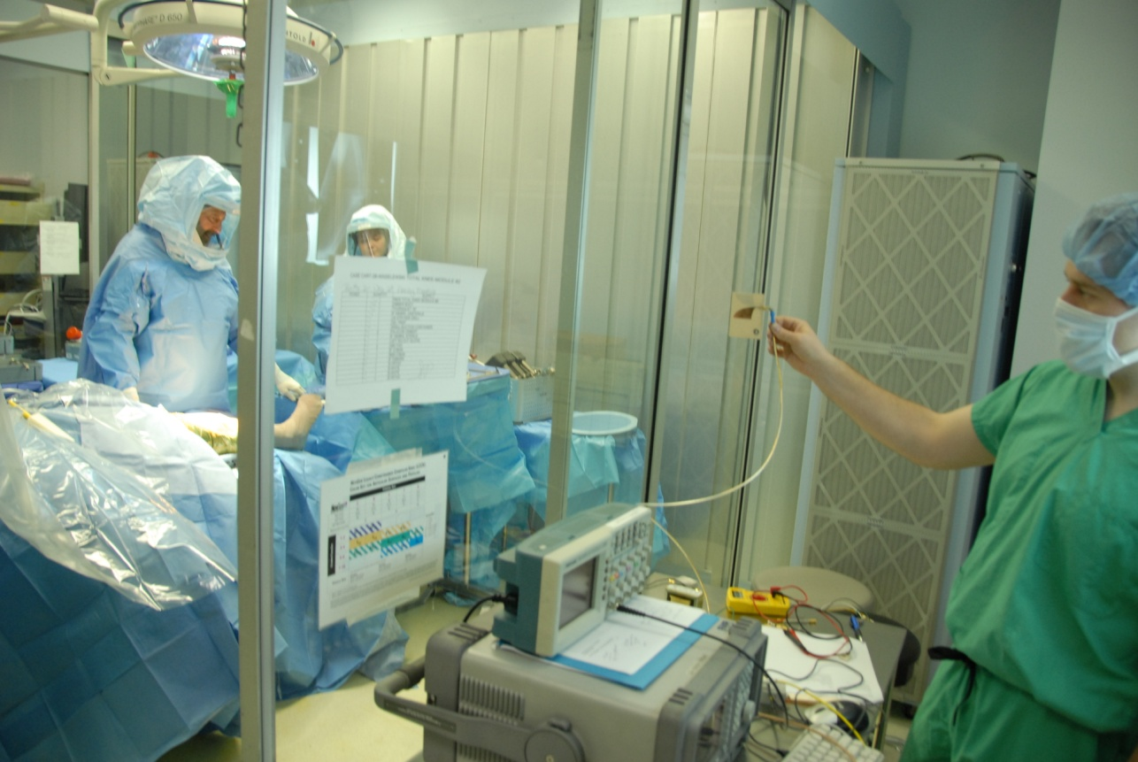
Figure 8-22: Experimental setup in the operating room during an orthopedic surgery.

domain experimental data. Figure 8-23 shows the pathloss for the OR environment obtained by fitting experimental data to (8-3) and compared to residential LOS, commercial LOS, and industrial LOS. The pathloss in the OR is most similar to residential LOS, although this can change depending on which instruments are placed near the transmitter and receiver or the locations of the UWB tags and base stations in the room. Figure 8-24 shows pathloss obtained for a Tx-Rx distance of 0.49 m where the transmitting (monopole) and receiving (Vivaldi) antenna effects have been removed. Small scale fading effects can be seen as well as frequency dependent pathloss, which is captured in the parameter κ in Table 8-2. Figure 8-25 shows an example time domain signal where significant multipath interference is caused by reflections from metal tables and walls. Figure 8-26 shows an example time domain received signal for a Tx-Rx distance of 1.49 m using the monopole antenna for transmitting and single element Vivaldi antenna for receiving. A decaying exponential is overlayed on the received signal to highlight the intra-cluster decay, defined by γ₀ = 1.33 in Table 8-2. The pathloss of the LOS OR channel is most like a residential LOS environment whereas the power delay profile (PDP) is closer to an industrial LOS environment (γ₀ = 0.651) where dense clusters of multipath quickly decay (rather than the residential LOS environment where γ₀ = 12.53). The mean number of clusters ($\overline{L}=4$) is in between the residential and industrial LOS environments ($\overline{L}=3$ and $\overline{L}=4.75$). The inter-cluster decay constant and inter-cluster arrival rate (Λ and Γ) for the operating room channel are more similar to the industrial LOS channel rather than the commercial or residential LOS channels. The operating room LOS channel is similar to the industrial LOS channel in its time domain characteristics (i.e. multipath interference and decay) while it is similar to the residential LOS channel in its frequency domain characteristics.

Electromagnetic Interference in the Operating Room
Electromagnetic interference (EMI) in the OR was measured across a wide frequency range in the context of comparing the interference present in useable frequency bands for narrowband and UWB communication and localization systems (for available bands see Table 7-1).
Table 8-2: Summary of parameters fit to IEEE 802.15.4a channel model with experimental UWB data taken in the operating room.
Operating Room | LOS
PL₀ [dB] | -47.5
n | 1.33
κ | 0.95
$$\overline{L}$$ | 4
Λ [1/ns] | 0.095
λ [1/ns] | n/a
γ₀ [ns] | 1.33
k_{γ} | 0.217
Γ [ns] | 10.8
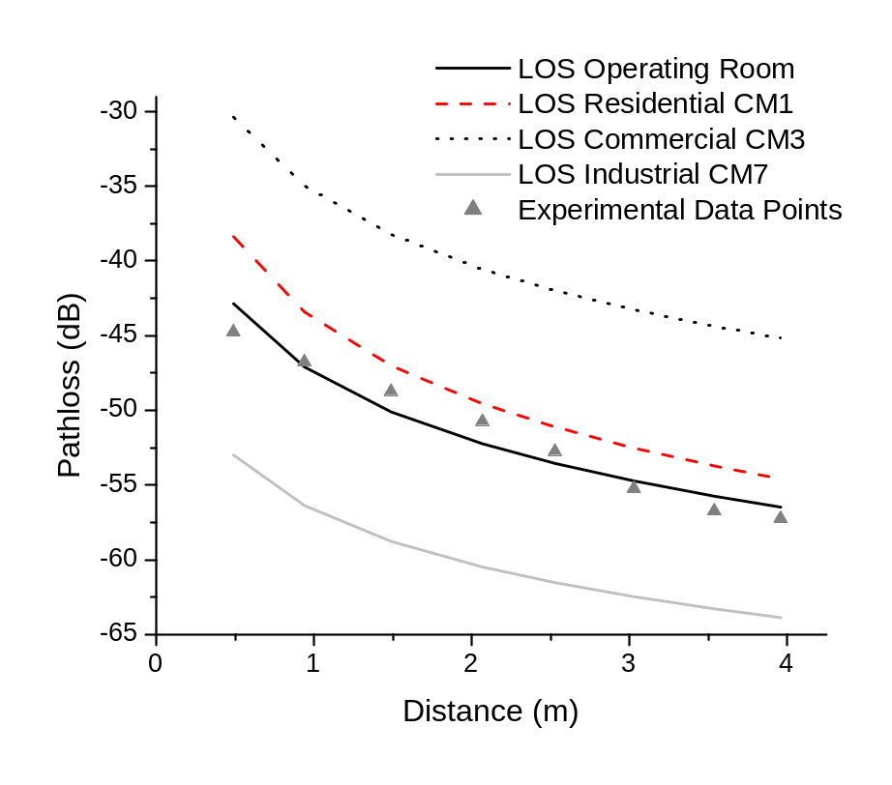
Figure 8-23: Comparison of pathloss for IEEE 802.15.4a LOS channels. The pathloss for the OR environment is most similar to residential LOS.

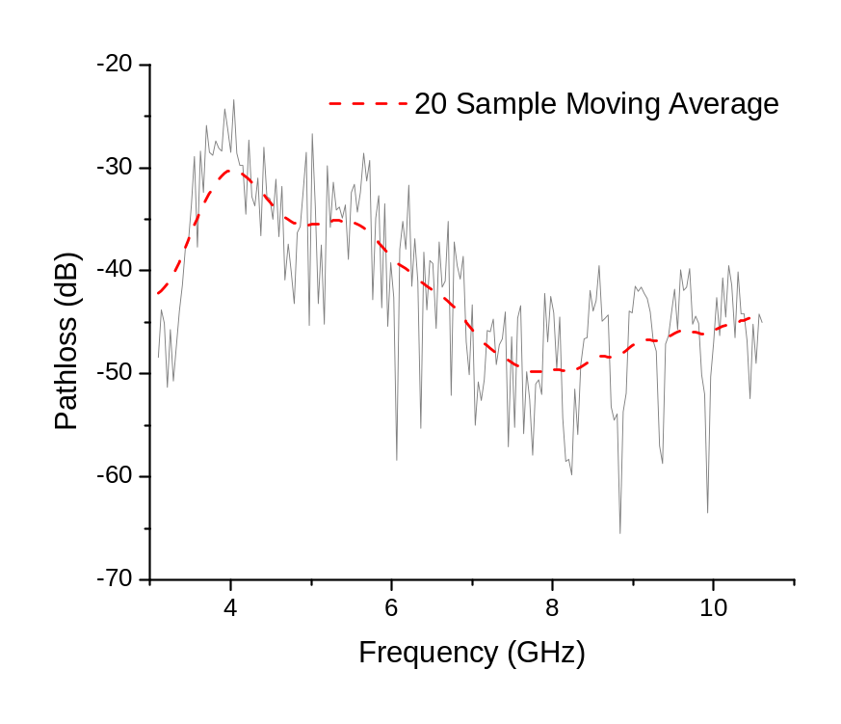
Figure 8-24: Pathloss obtained with the Tx and Rx placed 0.49 m apart where effects from the transmitting (monopole) and receiving (Vivaldi) antennas have been removed. The frequency dependence, κ in Table 8-2, can clearly be seen as well as small scale fading effects.
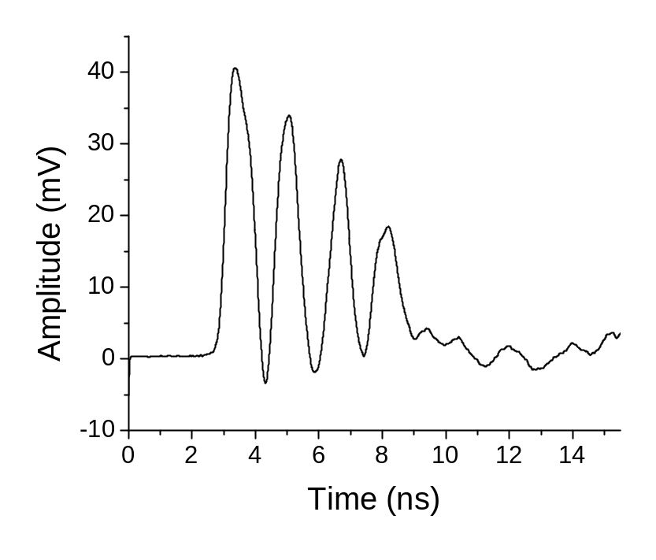
Figure 8-25: Experimental received time domain signal with noticeable multipath interference caused by metal tables and walls in the operating room.

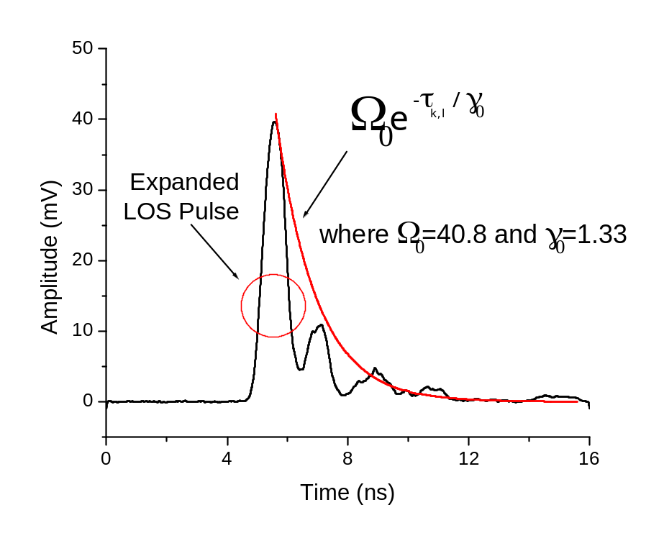
Figure 8-26: Example received signal in the time domain for a Tx-Rx distance of 1.49 m highlighting the distortion (seen as expansion) in the LOS pulse due to a dense cluster of multipath rays. The overlayed exponential is fit using γ₀ as outlined in Table 8-2 to show the intra-cluster decay of the LOS cluster.

OR Indoor Environment
EMI was measured over a large frequency band (200 MHz – 26 GHz) in the OR during four separate orthopedic surgeries. Figure 8-27 shows a layout of the dual OR. Two ORs allow a faster turn-around time in completing the four surgeries. Figure 8-28 shows the experimental setup in the OR. Besides the operating table, numerous other pieces of medical equipment were present during the surgery including an anesthesia machine, ventilator, surgical lamps, various monitoring equipment, visualization screens, carts containing necessary orthopedic surgical tools, drills, etc. Also, numerous people were present including the surgical team, orthopedic company representatives, and spectators observing the surgery. The combination of people and medical equipment closely packed into the OR creates a dense multipath indoor environment that can greatly disrupt standard RFID tracking systems. UWB systems have inherent advantages that make them a strong candidate for use in dense multipath environments such as the OR.

Experimental Setup
Various hardware was needed to get accurate measurements across the wide band of 200 MHz – 26 GHz. Table 8-3 summarizes all of the equipment needed in running this experiment. It should be noted that all reported gain and noise figure values are averages across the frequency range of operation. Figure 8-29 shows the four antennas used to cover the entire frequency range. The standard setup for each of the frequency bands measured included an antenna, two stages of amplification, and a spectrum analyzer for visualization. Commercial off-the-shelf components were used whenever possible.
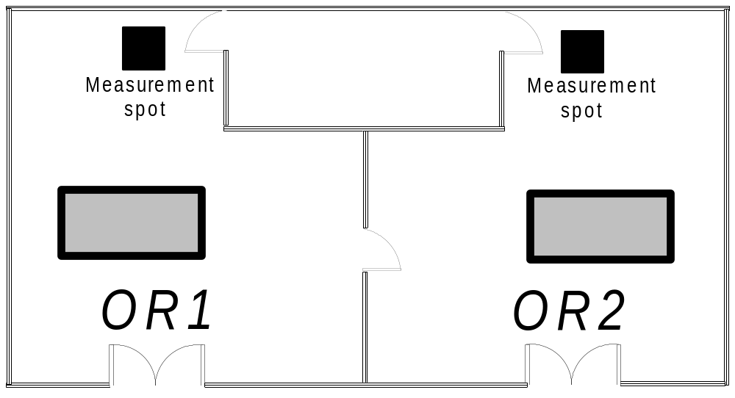
Figure 8-27: Layout of dual operating room including operating tables and measurement locations.
Using the hardware summarized in Table 8-3, four setups were needed to cover the entire frequency range. From 200 MHz – 800 MHz, the biconical antenna (Figure 8-29a) and two Hittite HMC465 LNAs were used. From 800 MHz – 3 GHz, both disc and horn antennas (Figure 8-29b and Figure 8-29c), a Mini-circuits ZX60-3011 LNA, and a Hittite HMC465 LNA were used. From 3 GHz – 18 GHz, the broadband horn (Figure 8-29c) and two Hittite HMC465 LNAs were used. Finally, from 18 GHz – 26 GHz, the Vivaldi 4-element array (Figure 8-29d) and two HMC517 LNAs were used. Before conducting the experiment, it was assumed that most of the EMI detected would be in the range of 200 MHz – 3 GHz. This conclusion was made because WLAN and Bluetooth transceivers (operating at 2.4 – 2.48 GHz) were already present in the OR. Also, this frequency range covers GPS (1.575 GHz), US cellular phone frequencies, and a number of medical bands. Table 7-1 lists the major medical, scientific, and UWB frequency
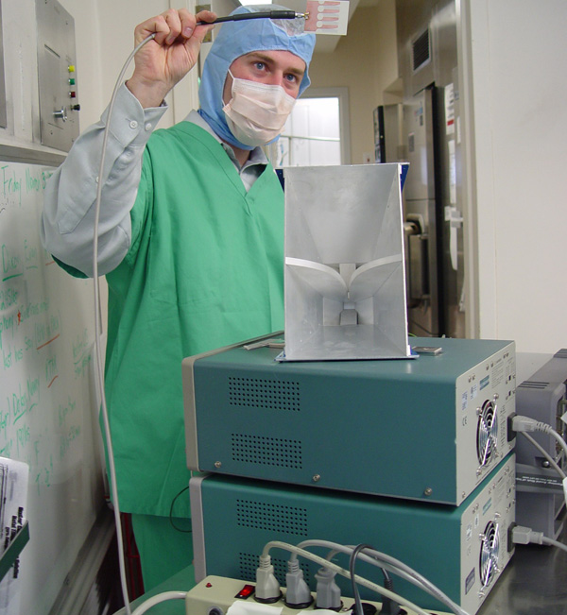
Figure 8-28: Experimental setup in the OR.
bands in the US and Europe [4],[193],[194]. A majority of the scientific and medical bands in both Europe and the US fall between the frequencies of 200 MHz – 3 GHz. Also, most RFID systems operate in the MHz range up to 3 GHz. Even though RFID systems can operate at 5.8 GHz or 24.125 GHz, limitations still exist on how well a system with small bandwidth can handle the dense multipath environment of the OR at these high frequencies. When looking at different wireless bands currently in use, whether WLAN, cellular phones, GPS, or medical, the advantages of operating in the higher frequency bands of 3.1 – 10.6 GHz and 22 – 29 GHz
Table 8-3: Hardware used in broadband OR measurements.
Device | Model # / Type | Frequency (GHz) | Gain (dB) | Noise Fig.  / Pattern
LNA | Mini-circuits ZX60-3011 | 0.4 – 3 | 10 | 1.6 dB
LNA | Hittite HMC465 | DC - 20 | 15 | 3.5 dB
LNA | Hittite HMC517 | 17 – 26 | 19 | 2.7 dB
Antenna - A | TDK MBA-2501 Biconical | 0.25 – 1 | 23 | Omni-directional
Antenna - B | Kathrein Scala 800-10249 Disc | 0.824 – 0.960, 1.425 – 3.6,  5.15 – 6 | 2 | Omni-directional
Antenna – C | Double ridged TEM horn | 1 – 18 | 8 | Directive
Antenna - D | Vivaldi array – 4 element | 18 – 26 | 10 | Directive
Spectrum Analyzer | Agilent E4407B ESA-E | 9 kHz – 26.5 | n/a | n/a

useable for UWB become clear.

Experimental Results
Using the equipment setup described in Section 8.3.2, EMI was measured over the frequency range of 200 MHz – 26 GHz. The results from these measurements can be seen in Figure 8-30, Figure 8-31, Figure 8-32. A number of signals were detected in the lower frequency
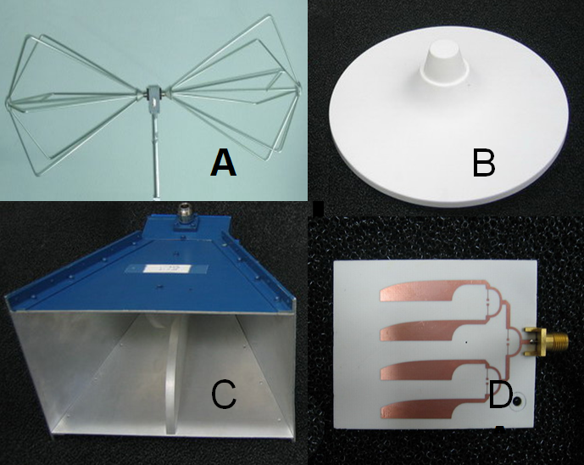
Figure 8-29: Antennas used in OR measurements: a) biconical, b) multiband disc, c) broadband TEM horn, d) 4-element Vivaldi array.

range of 400 MHz – 2.5 GHz. As shown in Figure 8-30, no appreciable signals were picked up between 200 – 800 MHz. Although there is a small spike near 470 MHz, it is only 6dB above the noise floor and is considered noise. Also, there are no licensed frequency bands in the US that could correspond to the 470 MHz peak. Figure 8-31 shows the frequency band from 800 MHz – 3 GHz. A number of different signals were found in this frequency range. The two strongest signals, which were found at 872 MHz and 928 MHz, correspond to CDMA2000 uplinks and downlinks (US cellular bands). The peak at 1.95 GHz also corresponds to a US
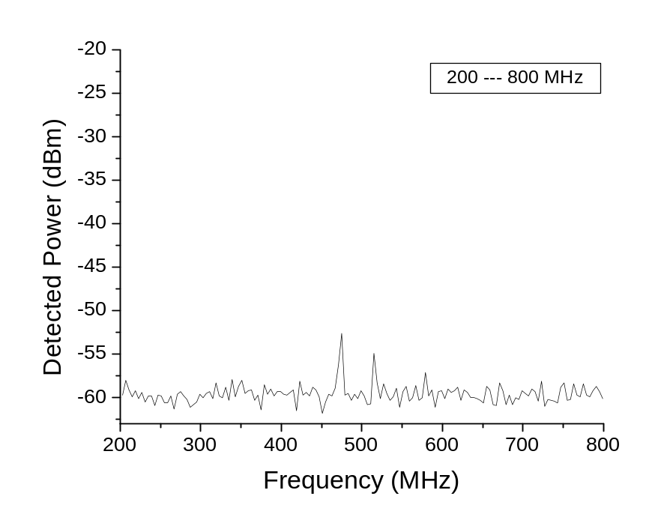
Figure 8-30: Measured EMI over frequency range of 200 – 800 MHz.

cellular band. Finally, the peak at 2.4 GHz is caused by WLAN and Bluetooth components. Figure 8-32 shows the frequency band from 3 – 26 GHz. No noticeable signals were picked up across this entire band. This is somewhat unexpected since there are ISM and WLAN bands between 5 – 6 GHz, which could be the major culprit causing interference that could affect the UWB system. The UWB positioning system operates over a frequency band of 5.4 – 10.6 GHz as shown in Figure 8-33, effectively bypassing all potential EMI except for the U.S. ISM band at 5150 – 5875 MHz, which is where IEEE 802.11a WLAN systems currently operate (802.11n systems also operate in this band). Since interference from this band is a concern for UWB systems operating in the OR, a comprehensive simulation of potential WLAN interference is outlined in Section 8.4.
The frequency bands containing noticeable EMI correspond to widespread technologies
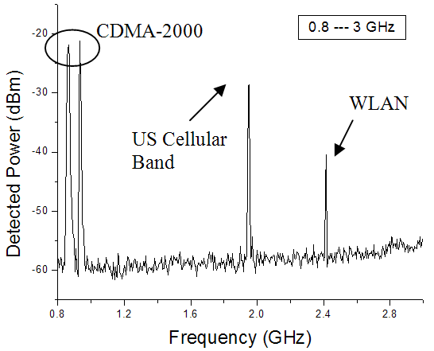
Figure 8-31: Measured EMI over frequency range of 800 MHz – 3 GHz.

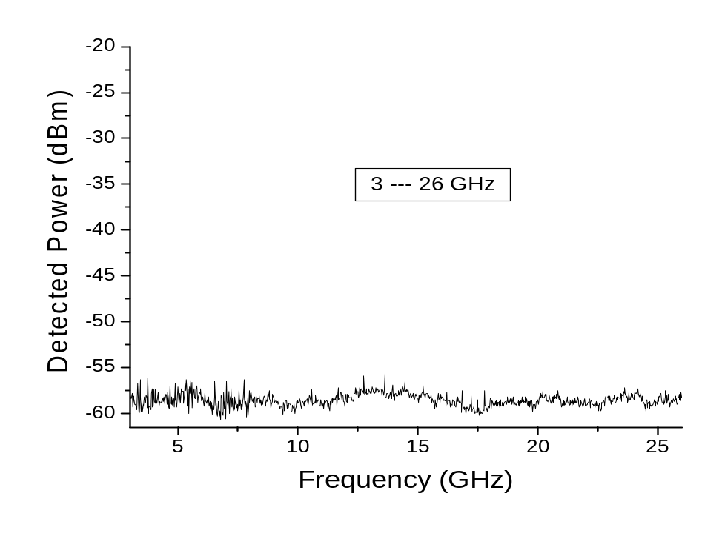
Figure 8-32: Measured EMI over frequency range of 3 – 26 GHz.

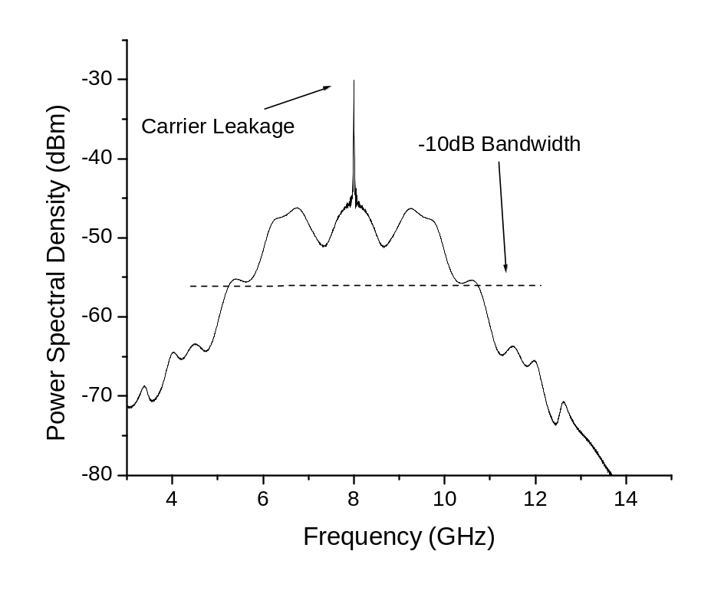
Figure 8-33: Power spectral density of simulated UWB signal showing -10 dB bandwidth from 5.4-10.6 GHz which bypasses interfering signals observed below 3 GHz. This spectrum contains the IEEE 802.11a WLAN band (5.15-5.875 GHz) as outlined in Section 8.4.

that will likely be seen in the average OR. One surprise was the almost complete absence of US scientific and medical bands. Many medical devices do conduct wireless operations at the frequency bands summarized in Table 7-1, but besides the WLAN signal at 2.4 GHz seen in Figure 8-31, no significant EMI corresponding to these frequency bands was detected in the OR.
As outlined in Table 7-1, there is another UWB frequency band from 22 – 29 GHz that can be used for localization systems. As seen from Figure 8-32, there is no EMI in the band from 22 – 26 GHz. One reason for having no EMI is that very few licensed bands exist between 22 – 29 GHz that would affect an OR (most are used for astronomy). Also, signals in this frequency band tend to be attenuated more by the atmosphere and are typically used for short range applications. Using UWB for localization in the OR holds a distinct advantage over other technologies because of both the large bandwidth used as well as the higher frequencies available for operation.

WLAN Interference at 5 GHz
Technologies exist which operate in frequency bands in the lower UWB spectrum (3.1 – 10.6 GHz), including ISM at 5.15 – 5.875 GHz, WiMAX at 3.3 – 3.8 GHz, 5.15 – 5.35 GHz, and 5.75 – 5.825 GHz, and WLAN at 5.47 – 5.825 GHz. These technologies will directly interfere with an RFID or UWB localization or communication system operating at or below 5.8 GHz. Some fixes to block WLAN and WiMAX signals from UWB systems include integrating a notch filter into the UWB antenna design [195]. Although this could provide a viable solution, another notch filter would need to be used to block licensed frequencies in the 3 – 4 GHz range (e.g. WiMAX). Zhang et al. examined incorporating notch filters into UWB antennas for LO leakage cancellation [196]. The feasibility of using notch filters to block all possible frequency bands while still being able to correctly transmit an UWB pulse waveform is low. A more feasible solution for an UWB system is to operate in the higher part of the 3.1 – 10.6 GHz band.
The UWB localization system described in Chapter 2 operates from 5.4-10.6 GHz, as shown in Figure 8-33. Since the ISM band extends from 5.15-5.875 GHz and the UWB monopole and Vivaldi antennas operate over this range, the susceptibility of the UWB localization system to interference from IEEE 802.11a/n systems needs to be addressed. A simulation has been performed of the UWB localization system in the presence of a 5 GHz interferer utilizing the simulation framework described in Chapter 3. Agilent ADS was used to generate an IEEE 802.11a WLAN signal. The approach for adding channel effects to the IEEE 802.11a signal is similar to that followed by Bellorado et al. [197]. The pathloss model for the operating room shown in Figure 8-23 was used for modeling the pathloss of both the UWB and IEEE 802.11a signals. LOS between the IEEE 802.11a source and the UWB base stations was assumed. Multipath fading was modeled by a Rician fading channel with a K-factor of 6 dB for the WLAN system. Interference from the IEEE 802.11a source was examined at distances of 1, 2, 5, and 10 m from the UWB base stations. The distance from the UWB transmitter to each UWB base station was kept between 1-2 m LOS and the time domain indoor channel for the OR described in Section 8.2 was used to model multipath interference for the UWB system.
Figure 8-34a shows the power spectral density for an input signal seen at the UWB receiver where both the UWB pulse and IEEE 802.11a signals are present. The WLAN signal is 2 m LOS from the UWB base station. The time extended signal obtained by the UWB receiver for the received signal in Figure 8-34a is shown in Figure 8-35b. No visible UWB pulse is detected because of the high power WLAN interfering signal. Figure 8-34b shows the received signal after passing through two stages of amplification and a three-stage stub-based bandpass filter where a -35 dB stopping amplitude is seen at 5.5 GHz and the passband begins at 6.8 GHz. Zhu et al. achieved comparable experimental performance with multi-stage bandpass filters using ground plane aperture techniques [198]. The added distortion of the UWB pulse from the bandpass filter does not affect the overall system accuracy since the leading-edge detection algorithm (Section 2.2.6) only looks for the initial leading edge rather than attempting to reconstruct the correct pulse shape. Figure 8-35c shows the time extended received signal for the power spectrum shown in Figure 8-34b. The UWB pulse is once again clearly seen, although, as shown in Table 8-4, with the addition of a bandpass filter to remove the WLAN interference, the SNR of the received pulse drops 6.2 dB for a WLAN interferer placed 2 m from the UWB base station. Similar results for the received SNR are seen for WLAN transmitting distances of 1, 5, and 10 m with the SNR increasing as the WLAN interferer moves farther away (9.74 dB with a 10 m distance). The use of automatic gain control (AGC), as discussed in Section 3.5, is needed in the UWB localization system both to extend the operating range and also to ensure correct operation in the presence of IEEE 802.11a interference to compensate for the loss in SNR due to the addition of a bandpass filter in the receiver chain.

Table 8-4: SNR of received time extended UWB signals with and without IEEE 802.11a interference.
Received Signal | SNR (dB)
No WLAN Interference | 14.4
WLAN Interference | 0.165
WLAN Interference with Front-End Filter | 8.20

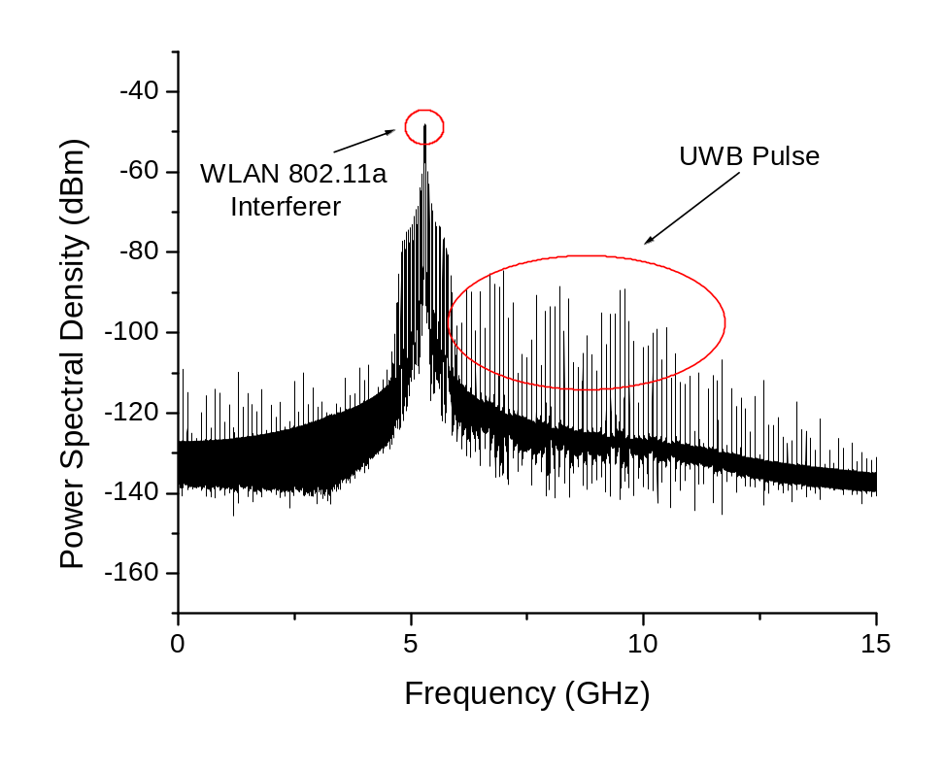
(a)
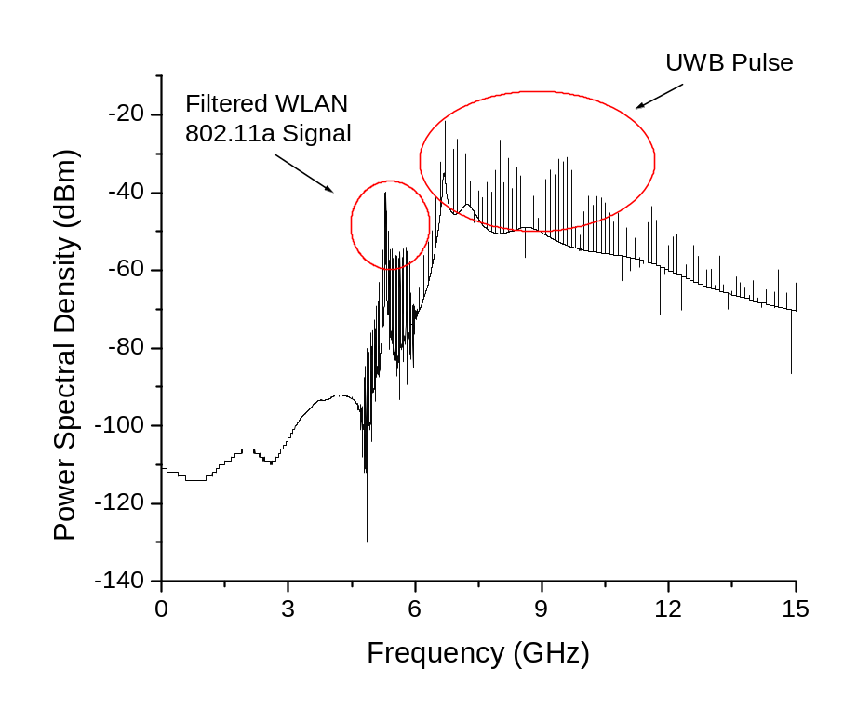
(b)
Figure 8-34: Power spectral density showing the UWB spectrum where (a) the UWB pulse from the positioning system can be seen as well as interference from an IEEE 802.11a source placed 2 m from the UWB base station, (b) the IEEE 802.11a signal is filtered out by the UWB base station.
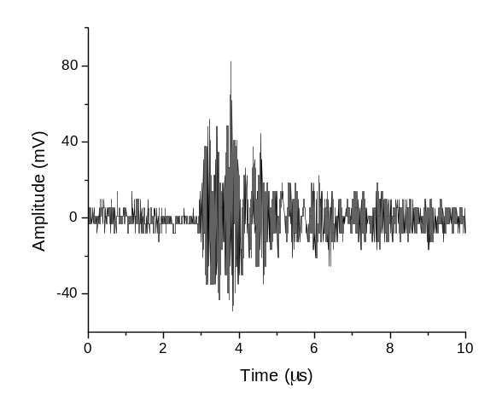
(a)
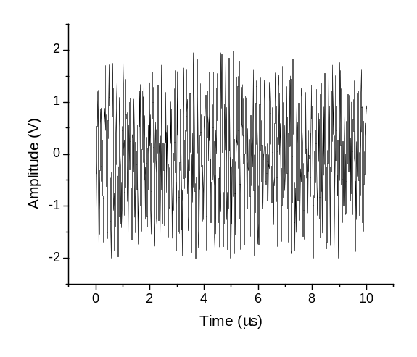
(b)
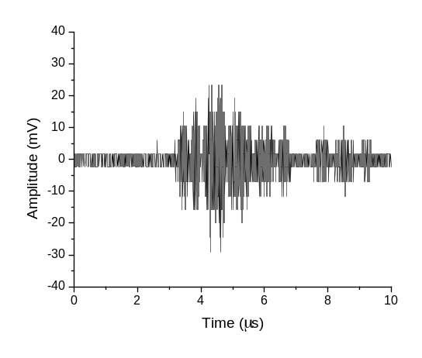
(c)
Figure 8-35: Received time domain signals after passing through the UWB receiver architecture including two stages of amplification, downconversion, LPF, sampling mixer, and ADC conversion. (a) Time extended UWB pulse with no 5GHz interference, (b) time extended UWB pulse with 5 GHz interference where receiver saturation occurs, (c) time extended UWB pulse with 5 GHz interference and a bandpass filter to mitigate the effects of the IEEE 802.11a interferer.

Multi-Tag Access for High Accuracy Indoor UWB Localization
Essential to an operational UWB localization system is a multi-tag access scheme based on wireless digital communication to enable the tracking of multiple assets simultaneously. Multiple architectures are introduced which include experimental results. In Section 9.1, the integrated UWB tag design is presented including experimental results. Section 9.2 discusses an on-off-keying digital communication architecture used in multi-tag access. Section 9.3 discusses a minimum shift keying approach based on Zigbee-like COTS. This opens up the ability for network operation in UWB localization. Section 9.4 discusses the use of UWB for high data rate communication. Finally, Section 9.5 analyzes the performance of these different digital communication architectures in hospital environments.

1st Generation UWB RF Tag
The mobile transceiver is an integral part of the UWB localization system (Chapter 2). Not only does the tag need to be compact in size, it also needs to be a low power device and use a multi-access framework through some type of digital communication to ensure its operability in real-time with other tags. In this section, the RF/Analog framework of the tag is presented. The main design constraints for the UWB transceiver include:
- Compact size
- Low power, battery operated
- Robust to electromagnetic interference in hospital and industrial environments

System Architecture
The first generation of the UWB RF transmitter is shown in Figure 9-1. A 300 ps Gaussian pulse is generated with a SRD. The SRD is triggered by a 10 MHz clipped sine wave which is generated by a Vectron VTC4-A0AA10M000 crystal with low phase noise and high stability (phase noise translates into 1-1.5 ps of RMS jitter and ±0.5 ppm stability) [19]. The UWB pulse is upconverted by an 8 GHz LO signal from a Hittite H506 voltage controlled oscillator (VCO) monolithic microwave integrated circuit (MMIC) where the signals are combined with a Hittite H220 mixer. The layout of the UWB RF transmitter is shown in Figure 9-2 where the coin cell battery, DC-DC converters, op amp, UWB pulse generator, and MMICs for mixing and LO generation are shown with an output signal fed to a SMA connector. The fabricated UWB RF transmitter is shown in Figure 9-3. The omni-directional UWB monopole antenna connected to the tag is shown in Figure 9-4. Experimental results for the 1st generation UWB transmitter are included in Section 9.1.2. It should be noted that the coin cell batteries used in the system (two BR1225 batteries) were not able to deliver the max current needed by the op amp (500 mA). Also, the 5V to -5V voltage inverter (LM2781) was rated at the quiescent current of the op amp (~20mA) rather than the max current (500mA) and failed to deliver the necessary power to drive the op amp and the SRD. Therefore, the battery operation of this UWB transmitter failed. As shown in Figure 9-5, an unreasonably large circuit requiring 2x2 in.² of board space is needed to distribute the large 500 mA max current required by the op amp. Successful results were obtained, however, when connecting the tag to a power source to drive the RF portion of the circuit. It should be noted that 2-3 AAA batteries can be used to drive this circuit (consumes 150mA when transmitting UWB pulses) in conjunction with the circuitry in Figure 9-5.
The 2nd generation tag is shown in Figure 9-6 where coplanar waveguide transmission lines using the evaluation board designs are used for the LO (Hittite H506), mixer (Hittite H553), and LNA (Hittite H565). Experimental results for both the 1st and 2nd generation designs are given in Section 9.1.2. Next generation tags based on MMIC or CMOS technology will help reduce the power requirements and also the size and batteries needed for mobile tag operation.

Experimental Results
The experimental setups in Figure 9-7 and Figure 9-8 were used to obtaining output data in the time and frequency domains. As shown in Figure 9-9, a 5.4 GHz -10dB bandwidth is obtained. The LO signal is rather strong in the 1st generation design (13.1 dBm) considering the compact nature of this tag and was reduced in the 2nd generation design. Figure 9-10 shows the
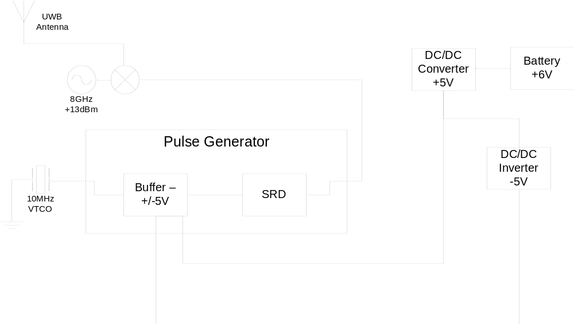
Figure 9-1: Block diagram of RF transmitter architecture.
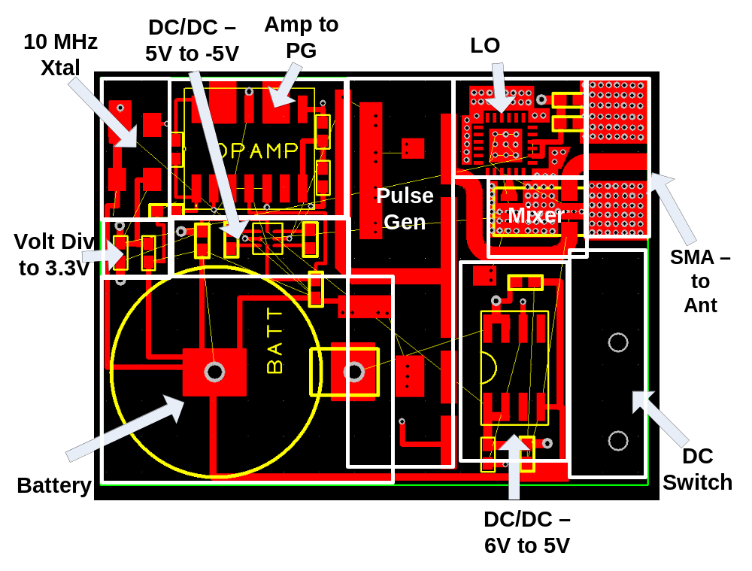
Figure 9-2: Layout of UWB RF transmitter architecture.

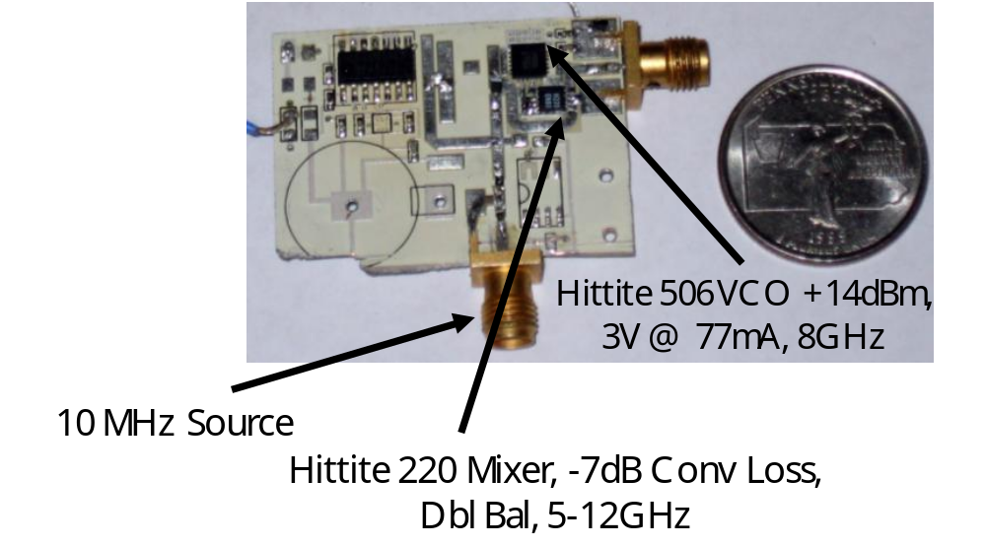
Figure 9-3: Fabricated UWB RF transmitter.
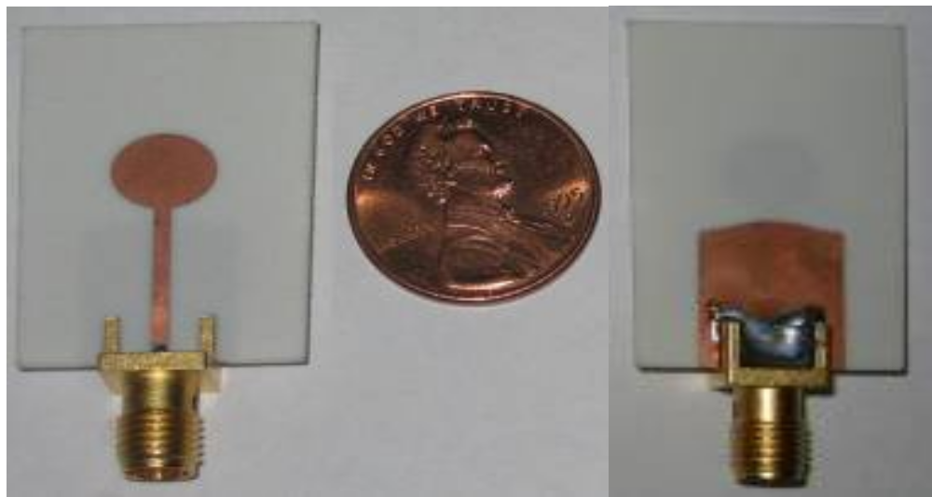
Figure 9-4: Omni-directional UWB monopole antenna.
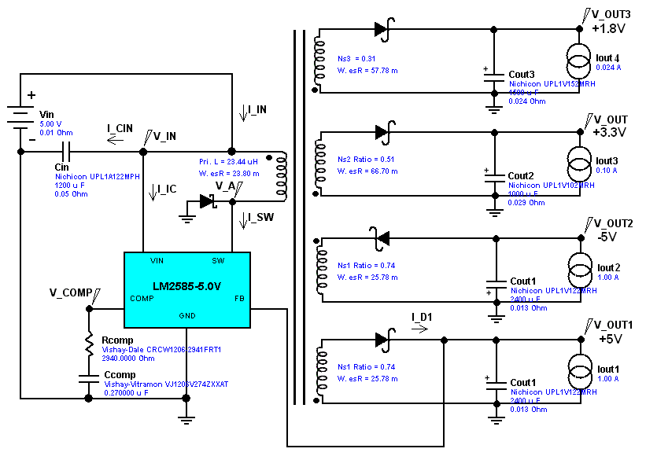
Figure 9-5: Electrical circuit required for distributing DC power to op amp, LO, and microcontroller on UWB tag.

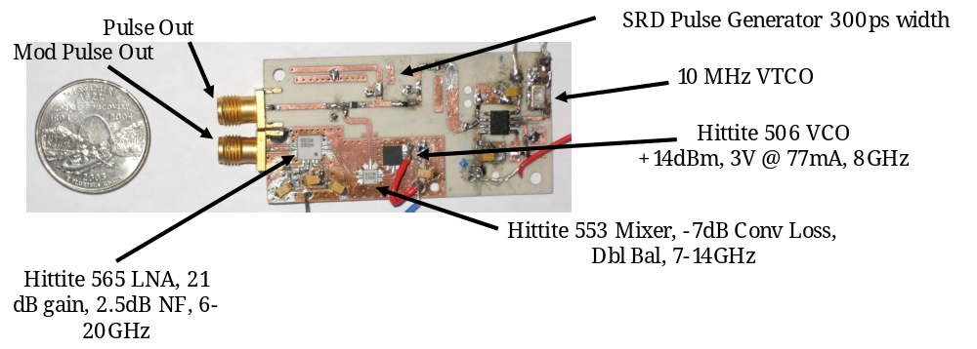
Figure 9-6: 2nd generation UWB tag where coplanar waveguide lines are used to connect the LO, mixer, and LNA rather than microstrip (as done in the 1st generation).
output tag signal in the time domain where the strong LO signal can be clearly seen along with the modulated UWB pulse. As shown in Figure 9-11, the modulated pulse for the 2nd generation tag has a weaker LO signal of -3.3 dBm compared to the 1st generation. This is due to better isolation of the LO from the RF output port. Also, the -10 dB bandwidth of the pulse is 5.0 GHz (0.4 GHz smaller than the 1st generation) since the Hittite H553 mixer (smaller bandwidth) is
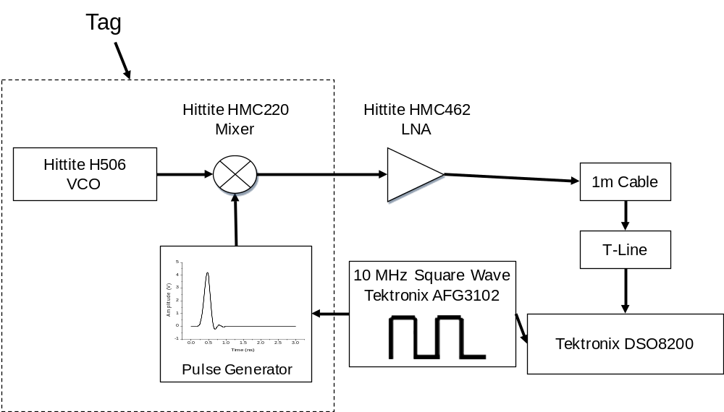
Figure 9-7: Experimental setup for measuring 1st generation output tag signal in frequency domain.
used in the 2nd generation design compared the Hittite H220 mixer used in the 1st generation. Finally, a smaller LO signal is seen in the time domain modulated pulse (Figure 9-12).

Figure 9-8: Experimental setup for measuring 1st generation output tag signal in time domain.
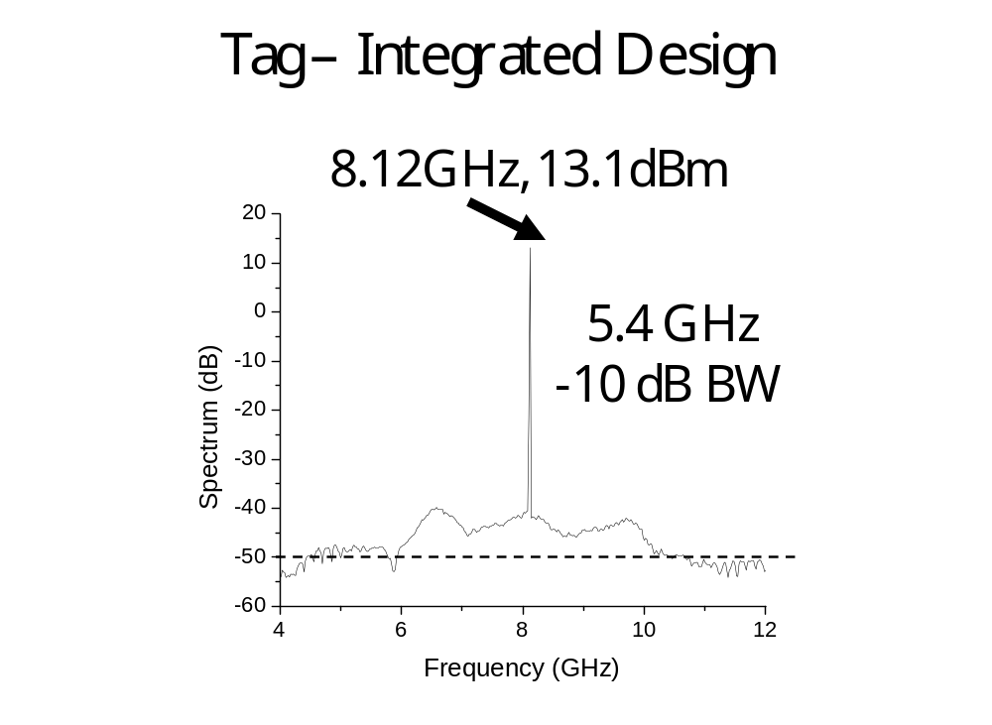
Figure 9-9: Output 1st generation tag signal in frequency domain where a strong LO signal and 5.4 GHz -10dB bandwidth can be seen.
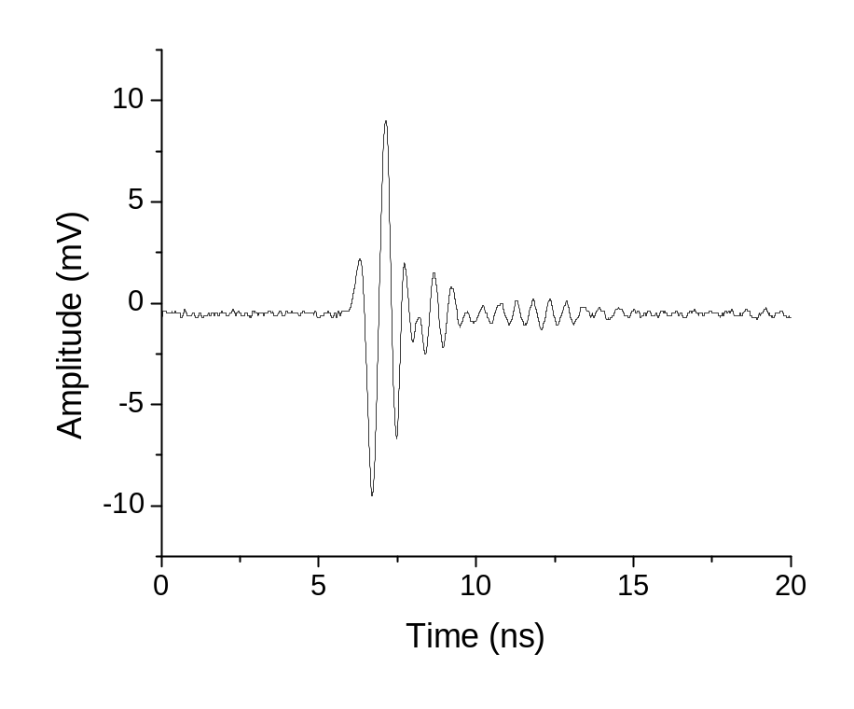
Figure 9-10: Output 1st generation tag signal in time domain where the strong LO signal is clearly visible in the modulated pulse.

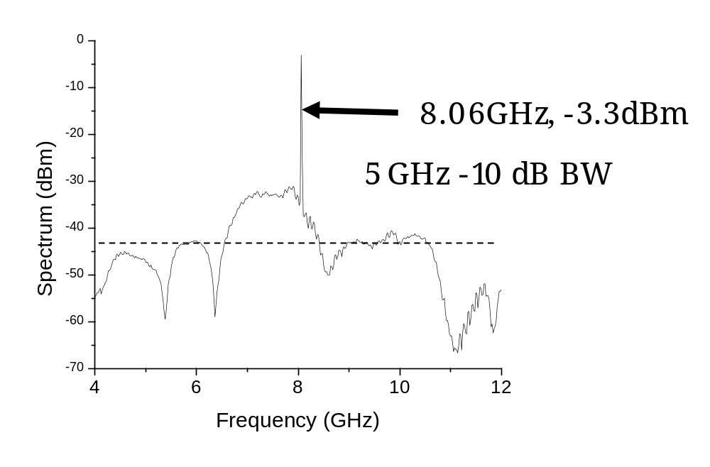
Figure 9-11: Output 2nd generation tag signal in frequency domain where a weaker LO signal and 5.0 GHz -10dB bandwidth can be seen.

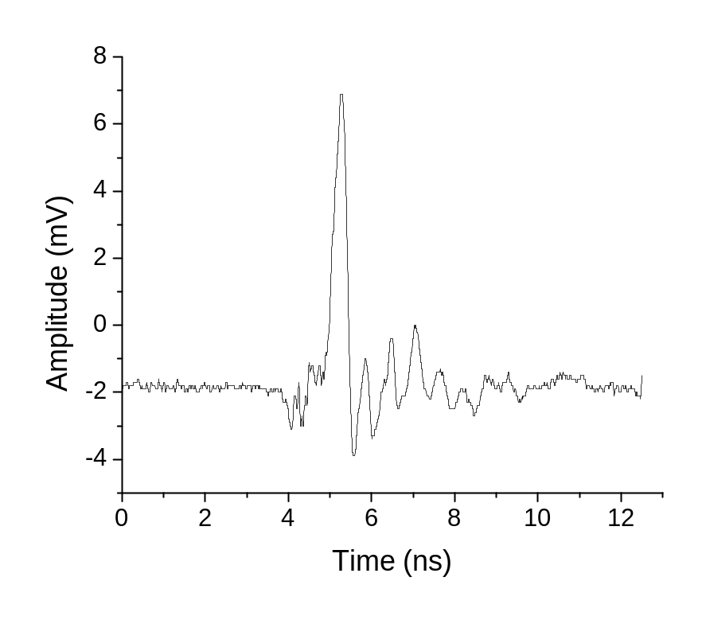
Figure 9-12: Output 2nd generation tag signal in time domain where the weaker LO signal is clearly visible in the modulated pulse compared to the 1st generation design.

8 GHz On-Off Keying for Multi-Tag Access
As discussed in Section 7.4, wireless digital communication is essential in medical applications both for transmitting sensitive medical data and also to allow ad-hoc operation of wireless sensor networks for UWB localization.

Digital Communication Scheme
The 1st generation multi-tag access architecture is shown in Figure 9-13 where a TI MSP430 microcontroller controls a high frequency switch which modulates an 8 GHz signal generated by a Hittite H506 VCO [19]. This implements an on-off keying (OOK) approach for transmitting digital communication. For reception, an 8 GHz detector is used in conjunction with a comparator. The same architecture for digital communication is used at the controller, shown in Figure 9-14 where 8 GHz OOK with a TI MSP430 microcontroller is used to implement the time division multiple access (TDMA) scheme where tag IDs are transmitted in a round-robin fashion. Figure 9-15 shows the network protocol where the tag is awoken from the sleep state, responds to the controller, and then begins UWB pulse transmission after getting confirmation from the controller.

Experiments
An experiment to test this multi-access scheme was undertaken and successful. Figure 9-16 shows the hardware implementation of the mixed-signal tag architecture including microcontroller, 8 GHz detector, and pulse generator. Figure 9-17 shows the hardware implementation of the controller which uses the same microcontroller and 8 GHz detector. Figure 9-18 shows a screenshot from the oscilloscope where the digital baseband signal operating at 1-3 Mbps can be seen both at the transmitter (controller) and receiver after demodulation (tag). The controller and tag in Figure 9-18 were connected with a coaxial cable. Figure 9-19 shows a similar experiment where the controller and tag are connected to four-element Vivaldi array UWB antennas. The same baseband digital signals at the controller and tag can be seen, showing the modulation and demodulation of the 8 GHz carrier so that the TDMA low-power multi-access scheme can be run on top of this digital communication layer.

Limitations
Although the results from this experiment were successful, this OOK scheme has certain limitations including short operating range (3-5 m), susceptibility to multipath interference which increases the bit error rate (BER), and limitations on available data rate (~1 Mbps) which is limited by the high frequency switch and the microcontroller. Given these limitations, a 2nd generation multi-tag access scheme is needed which is discussed in Section 9.3. This scheme provides data rates in excess of 100 kbps and uses only 5 mA at 3.3 V in transmit mode and 2 mA at 3.3 V in receive mode. The operating range between the transmitter and receiver for indoor applications is unacceptably low at 3.14 m due to the available transmittable power at 8 GHz indoors being limited to -41.3 dBm as specified for UWB by the Federal Communications Commission [4].

2.4 GHz Minimum Shift Keying for Multi-Tag Access
The 2nd generation tag-controller architecture utilizes a TI MSP430 microcontroller in conjunction with the TI CC2500 minimum shift keying (MSK) transceiver which are connected
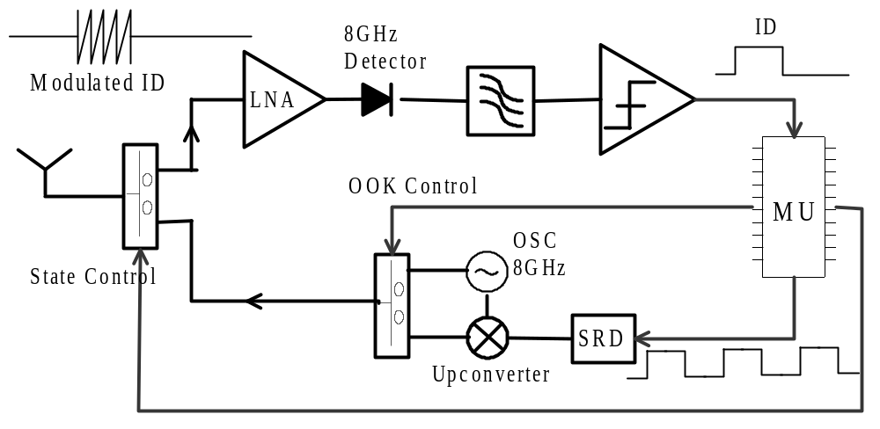
Figure 9-13: UWB multi-tag access scheme where 8 GHz OOK is used and a TI MSP430 microcontroller allows low power operation where the tag is awakened from a sleep state [19].

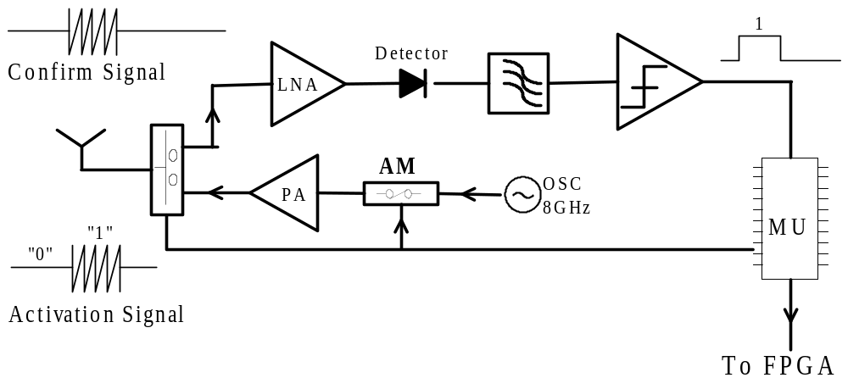
Figure 9-14: Controller architecture for multi-tag access scheme where 8 GHz OOK is used and a TI MSP430 microcontroller broadcasts tag IDs to implement a TDMA scheme.

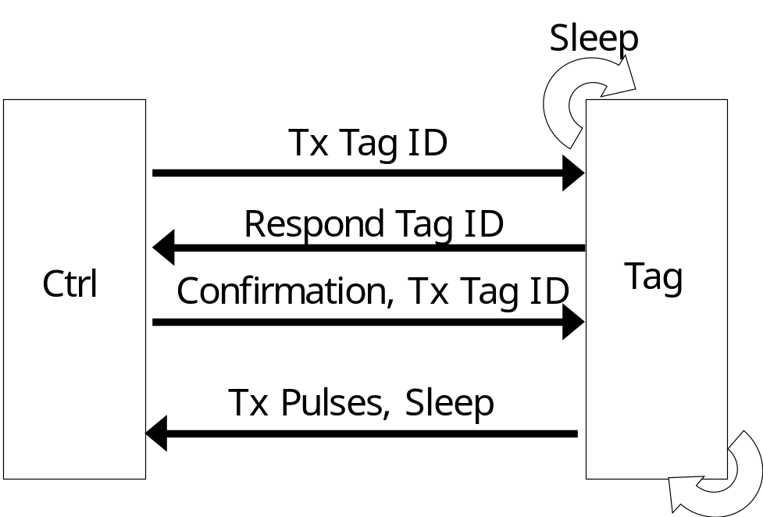
Figure 9-15: Diagram outlining protocol followed in waking up tag where controller broadcasts a unique tag ID. The tag with matching ID responds, wakes up, and transmits a train of pulses before falling back asleep.
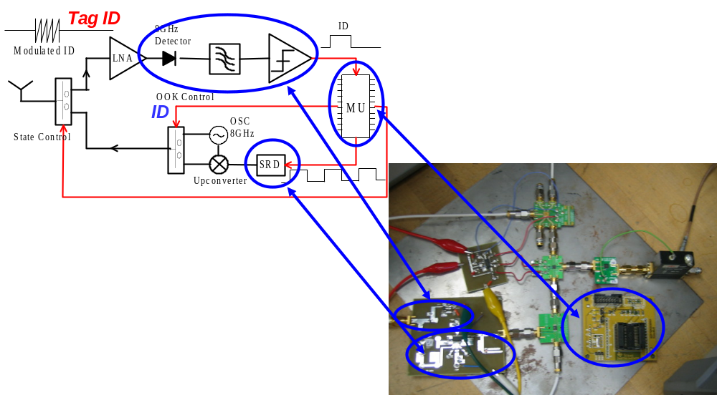
Figure 9-16: Experimental implementation of mixed-signal UWB transmitter architecture where a TI MSP430 microcontroller uses 8 GHz OOK for a sleep-based TDMA approach.

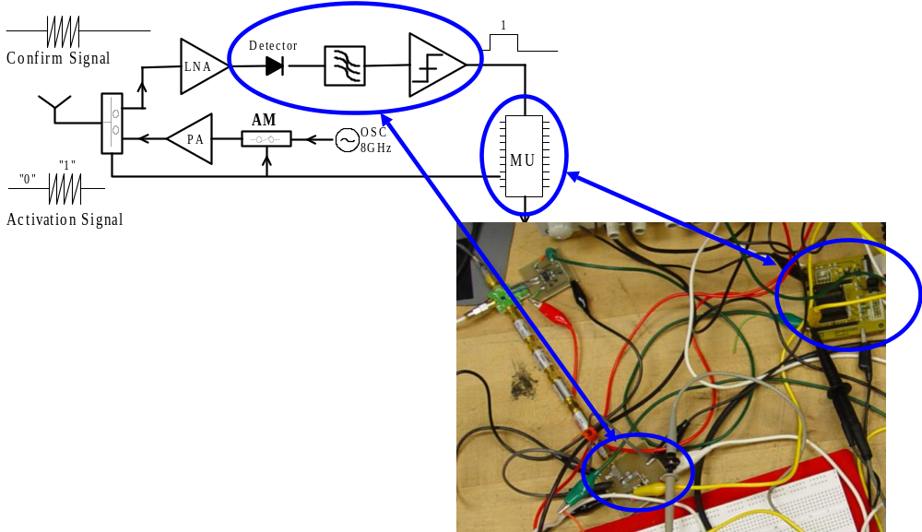
Figure 9-17: Experimental implementation of controller architecture where a TI MSP430 microcontroller uses OOK at 8 GHz to implement a TDMA, round-robin scheme for multi-tag access.
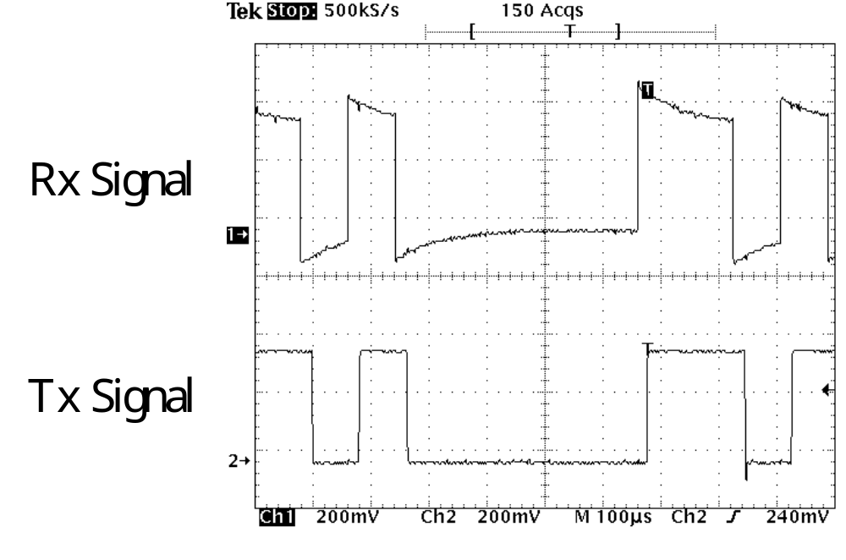
Figure 9-18: Oscilloscope output showing 1-3 Mbps baseband digital signal both at the transmitter (controller) and receiver (tag) where the controller and tag were connected with a coaxial cable.

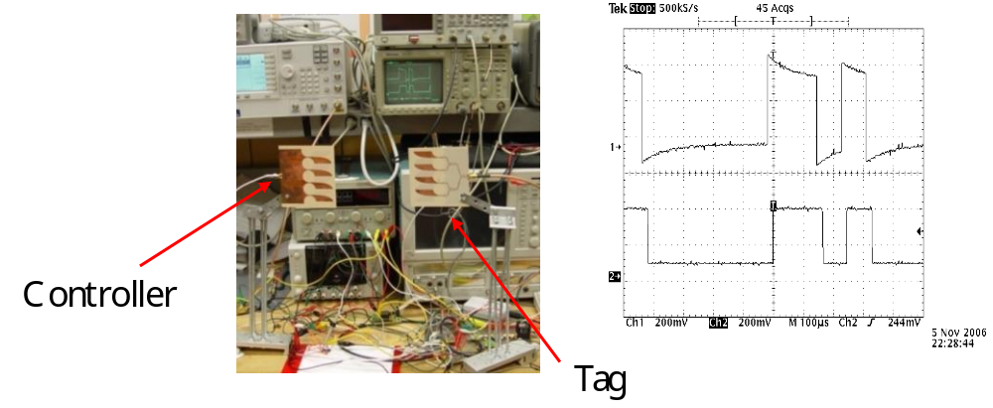
Figure 9-19: Oscilloscope output showing 1-3 Mbps baseband digital signal both at the transmitter (controller) and receiver (tag) where the controller and tag are attached to Vivaldi four-element array antennas for wireless transmission with results similar to the wired case in Figure 9-18.
through a serial peripheral interface (SPI) bus. The integrated solution is the TI EZ430-RF2500 module which contains both of these chips as well as a USB interface for JTAG programming of the device. The SimpliciTI ad-hoc, low power network protocol is used to allow ad-hoc network operation [199]. This is implemented on the TI MSP430F2274 microcontroller to allow a TDMA ad-hoc network scheme.
Extensive work has been done in standardizing multi-tag access for various UWB applications by the IEEE 802.15 task groups. This includes UWB-impulse response (UWB-IR) for low data rate applications (802.15.4a task group) and changes to the physical layer (PHY) and media access control (MAC) layer to be amended to 802.15.4-2006 standard for RFID applications (802.15.4f task group) [200]. The standards constructed by these task groups are instrumental in determining the future direction of research and development both in academia and industry. This multi-tag access scheme falls within the low data rate applications included in the 802.15.4-2006 standard and is extendable to meet the newly created criteria agreed upon by the 802.15.4f task group.
The physical layers considered for use by the IEEE 802.15.4f task group are shown in Table 9-1. Data was obtained from recent presentations made by each company at the September 2009 meeting of the task group [201]. The proposals for the physical layer are divided between solutions based on UWB communication and more conventional 2.4 GHz Zigbee protocols. UWB implemented in complementary metal oxide semiconductor (CMOS) technology yields the best performance in terms of lower power (1-60 mW), longer operating ranges (>250 m for coherent receiver architectures), and higher data rates (1-6 Mbps), although the hardware required to support UWB communication is still in its infant stage. In the UWB systems, a tradeoff exists between data rate and operating range (e.g. the DecaWave proposal has a range of 940 m for 110 kbps while only 238 m for 6800 kbps). Also, non-coherent UWB receivers provide a simpler architecture compared to coherent receivers but typically have only 50-70% the range of a coherent receiver. Although UWB-IR is not tied to any specific modulation technique (many different schemes could be used including pulse position modulation (PPM), OOK, binary phase shift keying (BPSK), and pulse shape modulation), the 802.15.4f task group chose OOK for the final UWB modulation scheme due to its simplified implementation architecture, lower transmit and receive power, and adequate performance for RFID applications [202]. An analysis by Ubisense using P-Aloha modified for UWB OOK showed a maximum throughput of 40,000 tags and 95% packet success rate for 1000 tags transmitting blink signals at 1 s intervals.
The theoretical bit-error-rate (BER) for UWB OOK, PPM, and BPSK as well as 2.4 GHz minimum shift keying (MSK) for an additive white Gaussian noise (AWGN) channel is shown in Figure 9-20. A theoretical analysis on UWB BER performance can be found in [203]. It is apparent from Figure 9-20 that MSK and BPSK achieve better BER performance compared to PPM and OOK. However, both MSK and BPSK rely on accurate phase information, which requires an accurate channel estimation at the receiver. As discussed in [203], even when analyzing the BER in realistic channel environments including the residential line-of-sight (LOS) IEEE 802.15.4a channel model, BPSK only achieves a 3-4 dB improvement compared to simplified approaches such as PPM and OOK. Also, BPSK requires an accurate channel estimation, which is a large assumption for indoor environments with a dense number of scatterers.
As previously mentioned, UWB OOK schemes are the preferred choice for RFID applications for many reasons including long battery life, simplified transmitter and receiver architectures, and not needing an accurate channel estimation to transmit and receive digital information. Unfortunately, low power CMOS UWB transceivers are still a maturing technology. Successful designs can be found both from research groups [180],[181] and in industry [60]. However, these components are not for sale commercially, which prevents our group from moving directly into a UWB physical layer. Instead, we have opted to use the 2.4 GHz physical layer currently being constructed by the 802.15.4f task group which closely follows the MSK scheme outlined by Ubisense in Table 9-1 [202]. With development tools readily available at low cost, this provides a viable alternative for multi-tag access while the technology needed for the UWB physical layer continues to mature.
The integrated UWB tag including a 2.4 GHz transceiver, microcontroller, and chip antenna is shown in Figure 9-21. The EZ430-RF2500 receives signals from the control station broadcasting unique tag IDs. The microcontroller regulates the DC power and an RF switch to control when the UWB tag transmits pulses for the TDMA scheme. The overall specifications for the multi-tag UWB positioning system are shown in Table 9-2 where the RF system has an operating range of 100 m while the UWB system range is limited to 13 m. The power
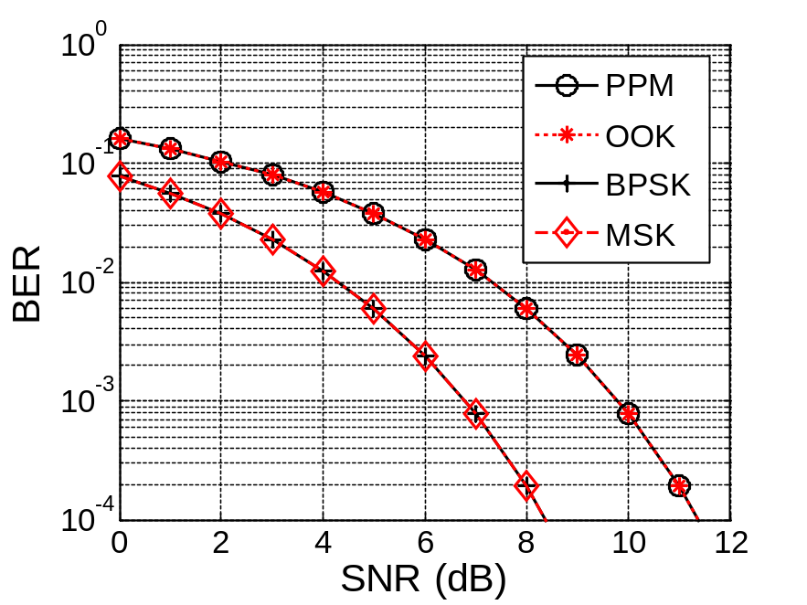
Figure 9-20: Comparison of theoretical bit-error-rates for UWB modulation schemes (PPM, OOK, BPSK) and narrowband 2.4 GHz minimum shift keying (MSK) in AWGN channel.
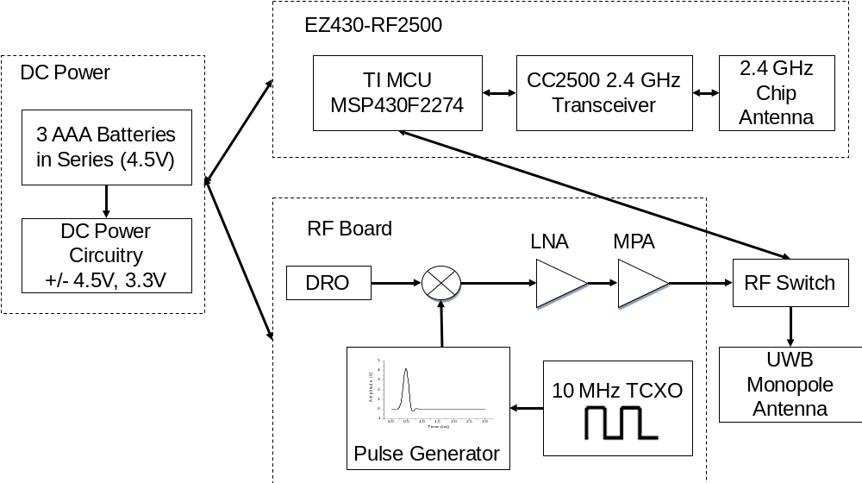
Figure 9-21: Block diagram of UWB tag where a 2.4 GHz transceiver is used to activate the UWB transmitter via both DC power and an RF switch. Localizing of the 3-D tag position is done using a time division multiple access (TDMA) approach.

Technology | Modulation Type | Frequency (GHz) | Refresh Rate (Hz) | Number of Tags | Positioning Accuracy | Range (m) | Data Rate (Mbps) | Battery Life (Days)
Wi-Fi 802.11b | DSSS | 2.40-2.48 | >1000 | 32 | > 3 m | 1-100 | 11 | 0.5-5
Bluetooth | GFSK, DPSK | 2.40-2.48 | >1000 | 7 | 1-2 m | 1-10+ | 0.72-3 | 1-7
802.15.4f UWB | OOK | 5.90-7.10  6.00-8.50  7.20-10.2 | <1 | Unlimited | 5-30 cm | 49-280 | 1-2 | 100-1000+
802.15.4f 2.4 GHz | MSK | 2.40-2.48 | <1 | Unlimited | > 50 cm | 1-100 | 0.25 | 100-1000+
Zigbee | MSK | 2.40-2.48 | <1 | Unlimited | > 50 cm | 1-100+ | 0.25 | 100-1000+
This Work | MSK | 2.40-2.48  5.40-10.6 | <1-20 | 1000 to 50 per piconet | 5-10 mm | 1-100  <13 | 0.25 | 10-27+
Table 9-1: Comparison of technologies available for indoor RFID applications.

Table 9-2: UWB positioning system link and power budget.
RF Operating Range | 100 m
UWB Operating Range | 13 m
3-D UWB Positioning Accuracy | 5-10 mm
Power Consumption  (1 Hz Refresh Rate) | 3.8 mW
Power Consumption  (20 Hz Refresh Rate) | 10.3 mW
Number of Tags  (20 Hz Refresh Rate) | 50
Number of Tags  (1 Hz Refresh Rate) | 1000
Battery Lifetime  (20 Hz Refresh Rate) | 10 days
Battery Lifetime  (1 Hz Refresh Rate) | 27 days
UWB Transmit Power | -7.8 dBm
UWB Bandwidth | 5.4-10.6 GHz
UWB Receiver Sensitivity | -75.3 dBm
RF Transmit Power | -1 dBm
RF Bandwidth | 650 kHz
RF Receiver Sensitivity | -88 dBm
RF Modulation | MSK

consumption is dependent on the refresh rate of the tag (3.8-10.3 mW for refresh rates of 1-20 Hz). Battery lifetime ranges from 10-27 days depending on the refresh rate (20-1 Hz). The 2.4 GHz RF transmit power is -1 dBm while the UWB transmit power is -7.8 dBm integrated across the whole frequency range of the UWB signal (5.4-10.6 GHz). The UWB receiver sensitivity of -75.3 dBm is limited by the wide bandwidth of the UWB signal (5.2 GHz bandwidth) compared to the narrowband 2.4 GHz system with a receiver sensitivity of -88 dBm. The overall multi-tag access scheme is a TDMA approach which allows for ad-hoc networking of the UWB tags. This concept is illustrated in Figure 9-22 where new tags are “discovered” and incorporated into the overall wireless sensor network. It should be noted that the ad-hoc networks are limited by the range of the UWB signals (13 m from Tx-Rx). Additional base stations are needed to expand the overall coverage of the system. The experimental setup for testing this system is described in Section 9.3.1 while experimental results are included in Section 9.3.2.
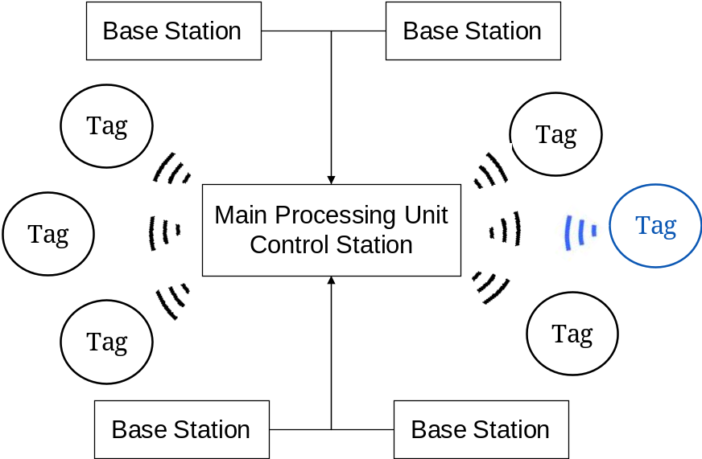
Figure 9-22: Time division multiple access (TDMA) where the main processing unit broadcasts all tag IDs in a round-robin fashion and the base stations localize its 3-D position.

Experimental Setup
One EZ430-RF2500 module (termed the Access Point MCU) is needed at the CPU and is directly connected to the FPGA through two digital lines, comprising the main control station. Figure 9-23 shows the control station architecture where the Access Point MCU asynchronously transmits tag IDs to the FPGA to label incoming TDOA packets with the correct tag ID. Figure 9-27 shows an experimental signal from the Access Point MCU which includes a clock signal and the tag ID for asynchronous communication with the FPGA. Figure 9-25 shows the C++ user interface used to collect tag data and provide visual display of the system. Figure 9-26 shows example serial data output by the Access Point MCU to the computer to collect and process TDMA information by the C++ software application. A static experiment was undertaken using two tags to test the full multi-tag UWB positioning system. Figure 9-24 shows a block diagram of the experiment where the Access Point MCU communicates with the tag MCUs for tags 1 and 2 to implement the TDMA scheme. The experimental setup with two UWB tags and an optical probe is shown in Figure 9-28. The C++ user interface shown in Figure 9-25 was designed for monitoring the tags including their 3-D position, 3-D error, temperature, and battery voltage.

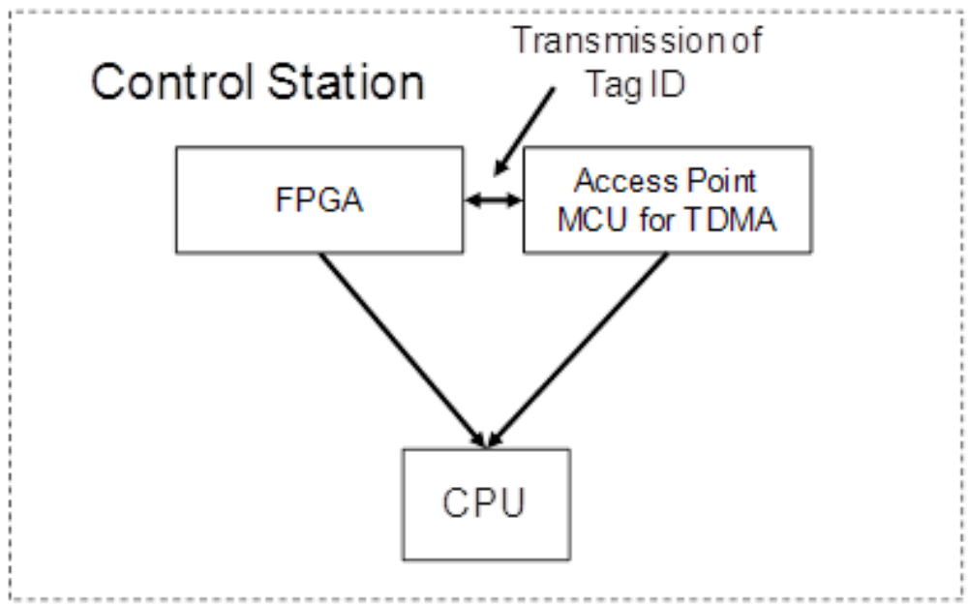
Figure 9-23: Control station architecture where Access Point MCU send tag IDs to the FPGA for synchronous tagging of the TDOA data for TDMA approach.
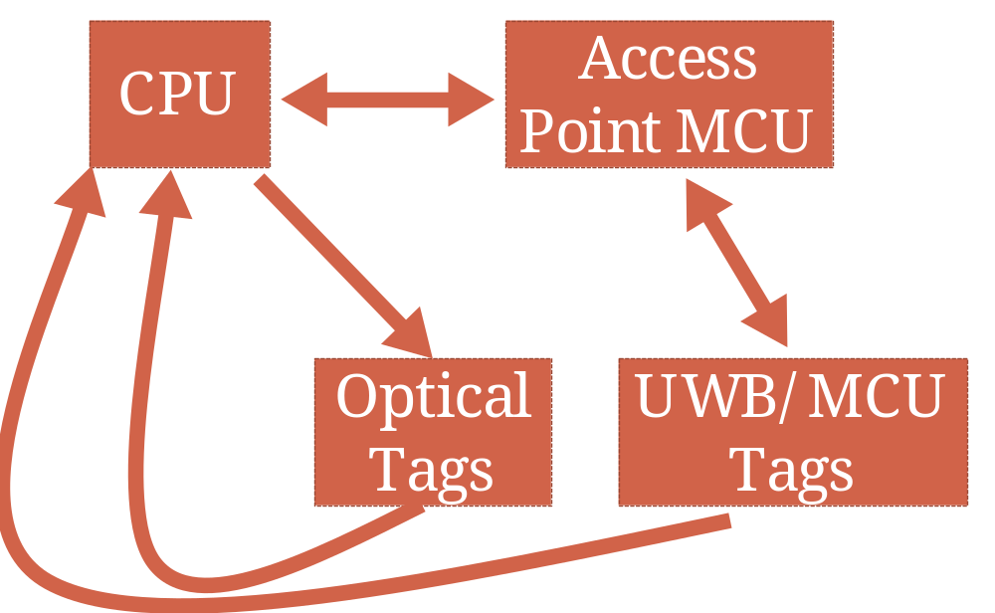
Figure 9-24: Block diagram of experimental setup outlining the role of a computer to collect data from the MCU access point, UWB positioning system, and optical tracking system. The CPU can send configuration signals to the MCU. The MCU-MCU tag-access point communication is also highlighted.

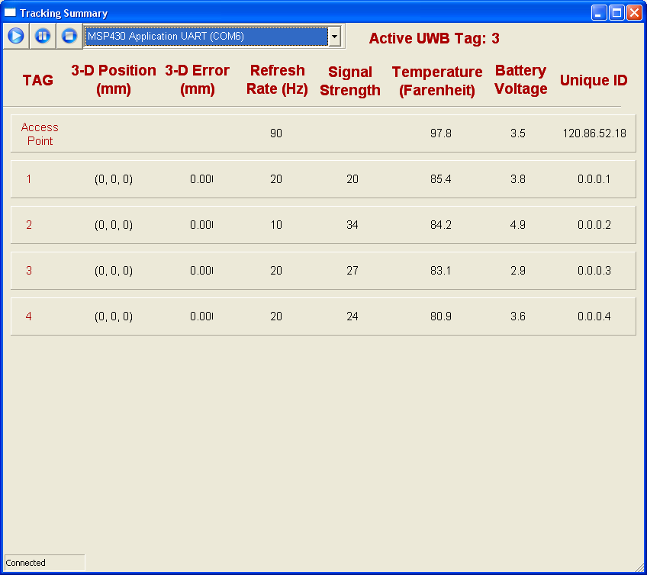
Figure 9-25: User interface for UWB multi-tag indoor positioning system.

$0001, 86.1F,3.8,020,N#,002
T1
$HUB0, 97.1F,3.5,000,N#,009
$0004, 81.3F,4.9,033,N#,001
T2
T3
$0002, 84.7F,3.6,022,N#,002
T4
T1
$0003, 83.1F,2.9,026,N#,002
T2
T3
T4
T1
T2
Figure 9-26: Example serial data received during one second at the CPU from the access point microcontroller while communicating with four tags. The data includes the current tag transmitting for TDMA and a general status update for each tag as well as the access point.
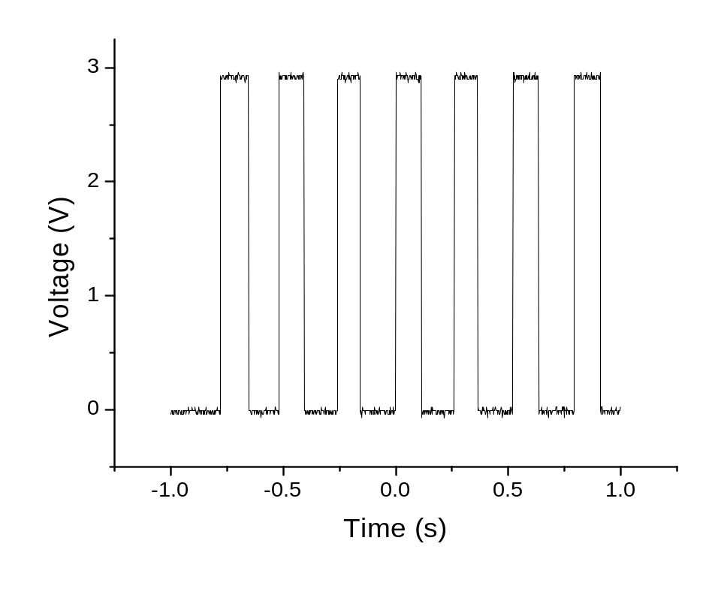
Figure 9-27: Digital signal output from the MCU to activate and deactivate the UWB tags when two tags are sharing the available time slots allocated during the TDMA process.
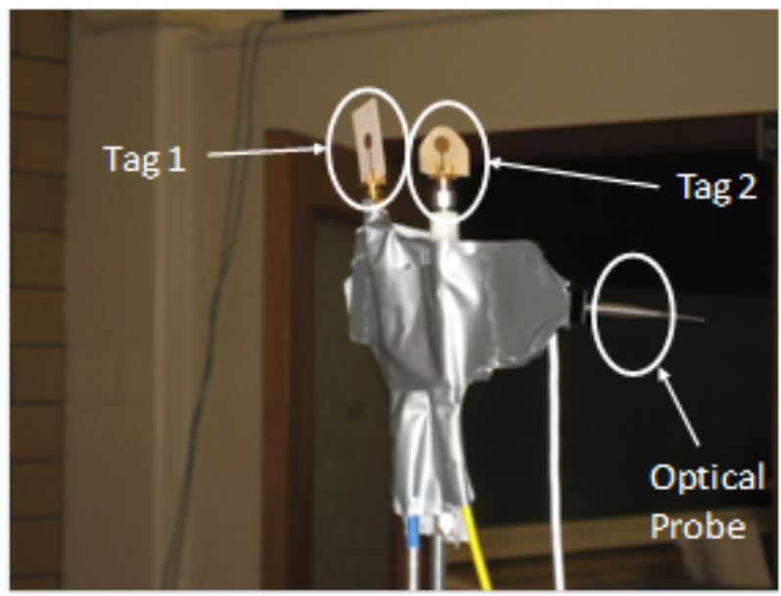
Figure 9-28: Experimental setup of with two tags and an optical probe.

Experimental Results
The overall system update rate was measured at 744 Hz while switching between the two tags 20 times per second, which provides at least a 35-40 Hz update rate for up to 20 tags. The control station synchronization was verified by all 3-D positions being correctly attributed to the corresponding tag. The static 3-D accuracy for the two tags was between 2-3 mm with average update rates for the tags of 378 Hz for tag 1 and 366 Hz for tag 2 while the experiment was run over a duration of 274 seconds. This constitutes 103,853 points for tag 1 and 100,199 points for tag 2. The addition of the TDMA approach adds a 10% latency to the overall system update rate for up to 20 tags. Above 20 tags, the overall system latency may increase. Also, above 20 tags, the tag update rates may slow, approaching 5-15 Hz. This could begin to degrade 3-D dynamic accuracy and will set an upper bound to the total number of tags while maintaining mm-range accuracy to somewhere around 30. Possible ways to increase this number include optimizing the MCU firmware to reduce the latency in tag-Access Point communication and creating multiple cells, each using its own TDMA scheme, which would allow this multiple access scheme to scale to greater numbers of tags.

UWB Multi-Tag Development Platform
The 3rd generation tag-controller architecture builds off of the 2.4 GHz system discussed in Section 9.3 while expanding the system to 10 functional tags fully integrated into the overall UWB positioning system which includes receiver and control station digital processing and a C++ software application for real-time location system functionality. The UWB multi-tag development platform consists of a 10 tag system where each tag is an integrated system using either wall power or a 9 V battery for power with its own transmitter 10 MHz system clock. The tags are integrated into the digital processing done at the UWB receivers and the UWB control station as well as the C++ UWB software application.

Integrated UWB Tag
A block diagram of the UWB integrated tag is shown in Figure 9-29. The tag consists of a direct current (DC) power board fabricated on FR4 substrate. The DC power board includes a 9 V battery holder and a jack for wall power. DC-DC converters are used to supply the RF board with +5 V, -5 V, and 3.3 V. Load switches reside on the DC power board. The DC power board is shown in Figure 9-31. These load switches are controlled by the Texas Instruments (TI) MSP430-RF2500 2.4 GHz microcontroller unit (MCU) module to switch on and off power to the UWB tag to implement the TDMA multi-tag scheme. The RF board is outlined in Figure 9-30 where a 10
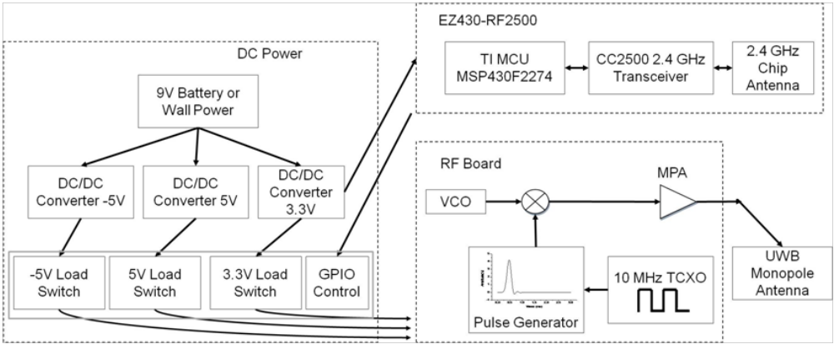
Figure 9-29: Block diagram of integrated UWB tag including the RF board containing the UWB pulse generator, VCO, mixer, and amplifier. A separate DC power board contains the DC-DC converters and load switches used to switch on and off the power to the RF board to implement the TDMA scheme.
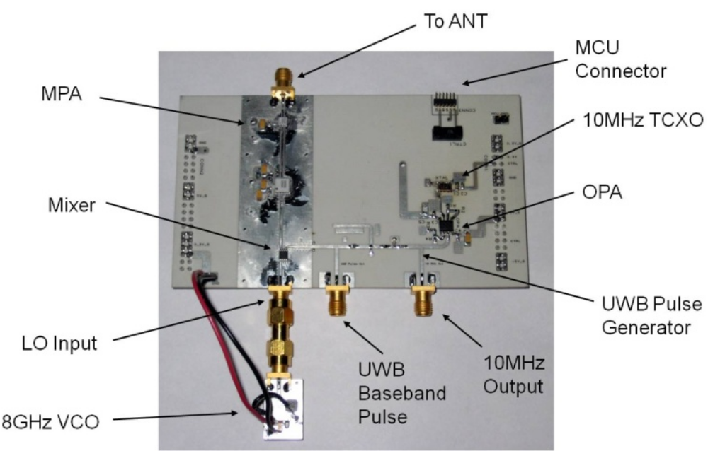
Figure 9-30: Integrated tag RF board including 10 MHz clock, high slew rate op amp, step recovery diode pulse generator, mixer, VCO, and medium power amplifier. A 6-pin connector is used to connect the MCU board to the RF board.
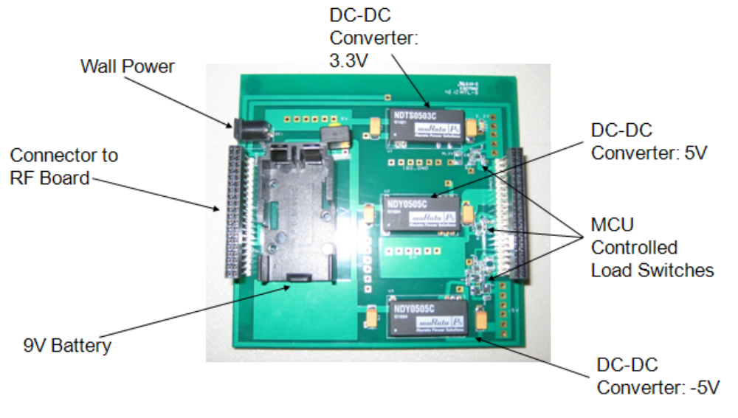
Figure 9-31: DC power board which includes wall power or power via a 9V battery. Connectors are used to directly connect the RF board shown in Figure 9-30. DC-DC converters are used to supply the RF board with +5V, -5V, and +3.3V. Load switches allow the DC power to the tag to be turned on and off and are controlled by the tag MCU. This provides the underlying time division multiple access functionality.
MHz Vectron TCXO drives a TI 2674 op amp which drives a step recovery diode UWB pulse generator. The UWB pulse is upconverted via a Hittite H506 VCO and amplified by a Hittite H441 medium power amplifier. The pulse is transmitted via a UWB monopole antenna. The complete integrated tag is shown in Figure 9-32 and Figure 9-33 where the MCU board connects to the RF board, and the RF and DC power board lock together via two 40 pin Samtec connectors. The tag has a relatively high load power requirement when fully operating of 1008 mW. When DC-DC converter losses are included, the tag consumes around 1.5 W of power when transmitting UWB pulses. In its low power state when UWB transmission is turned off, the tag consumes around 200 mW of power. As discussed in Section 9.6, future work is being done to incorporate MMIC front-ends into the tag and receivers to significantly reduce operating power requirements. Figure 9-34 shows baseband pulses from all 15 tags where the green pulse is from a discrete (ideal) pulse generator and the black pulses are from the integrated tags. The pulse amplitude across the 15 tags has some variation, and some of the integrated tags exhibit more ringing than the reference tag (green). Overall, all of these signals
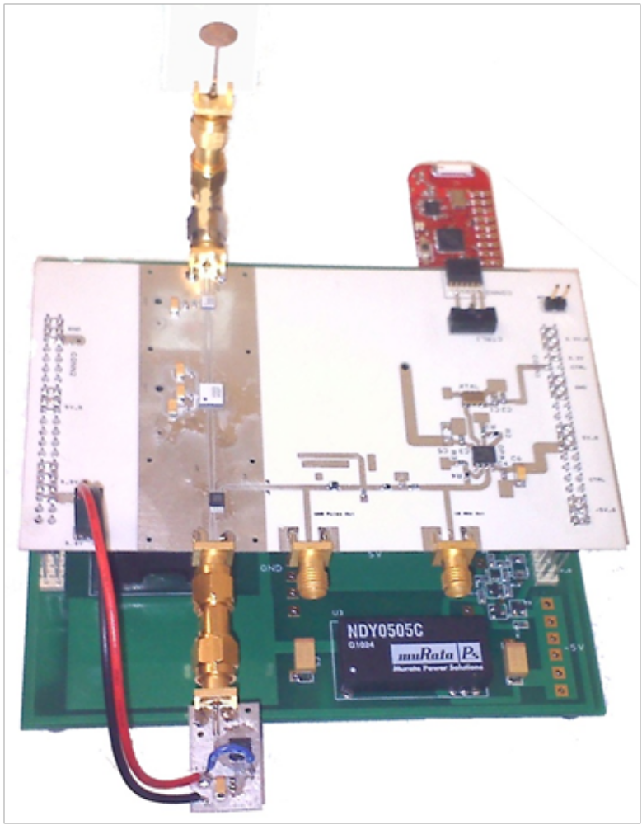
Figure 9-32: Integrated tag including DC power board, RF board, MSP430-EZ2500 microcontroller board, VCO connected via external SMA connector, and monopole UWB antenna.
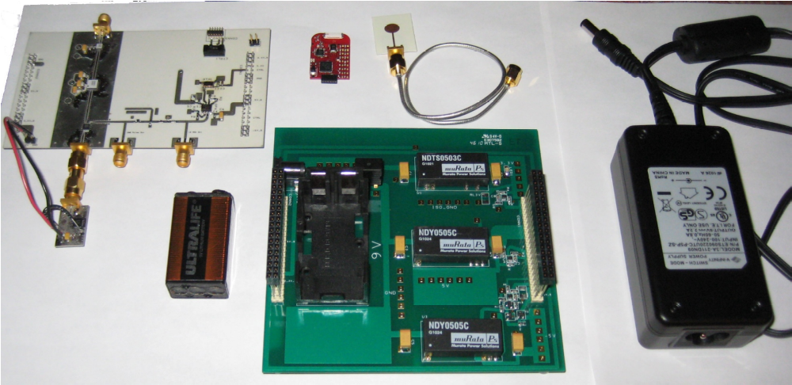
Figure 9-33: Integrated tag components including DC power board, RF board, MSP430-EZ2500 microcontroller board, VCO connected via external SMA connector, monopole UWB antenna, 9V battery, and 9V AC/DC power converter.
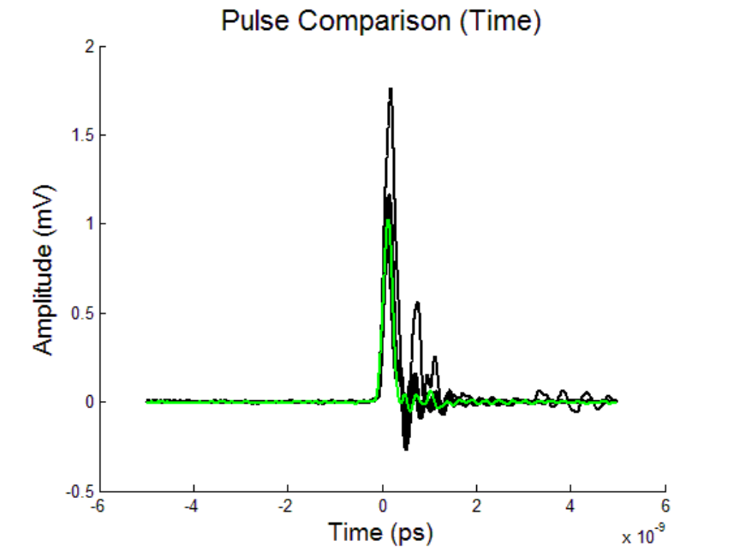
Figure 9-34: Baseband UWB pulses from the 15 tags (in black). A reference pulse from a separate SRD-based pulse generator (green). The pulse amplitude across the 15 tags has some variation, and some of the integrated tags exhibit more ringing than the reference tag. Overall, all of these signals are usable for UWB indoor positioning.
are usable for UWB indoor positioning and can be processed using the leading-edge detection algorithm outlined in Section 4. Figure 9-35 shows the upconverted UWB pulse from an integrated tag (black) as well as the upconverted UWB pulse from the reference transmitter (green) in the frequency domain. The -10 dB bandwidth of the reference transmitter is around 1.5 GHz larger than the integrated tag. The reduction in bandwidth is most likely caused by the integrated RF board shown in Figure 9-30. Variation exists when comparing the frequency spectrum of the upconverted signal across all 15 tags. Ultimately, these variations do not have a significant effect on the positioning accuracy since the UWB receivers are able to sub-sample the downconverted UWB pulses and digitally located the pulse leading edge. Thus, it can be inferred that the integrated tag is a viable solution for achieving millimeter 3-D dynamic accuracy for multiple, independent tags in real-time.
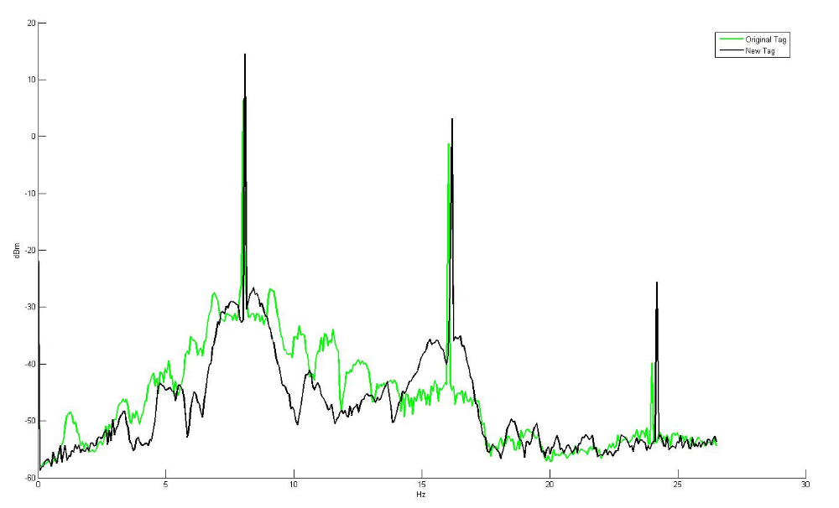
Figure 9-35: Upconverted UWB pulse in the frequency domain: integrated tag (black), discrete tag (green).

UWB Energy Detection Receiver
Figure 9-36 shows the block diagram for the UWB noncoherent receiver. The transmitted UWB pulse is received by a single element Vivaldi directional antenna. It then goes through a 5-11 GHz bandpass filter, three stages of amplification, and is downconverted by a broadband squaring mixer. The signal is then lowpass filtered, goes through two stages of baseband amplification, is subsampled to time extend by a factor of 2500, reducing the bandwidth of the pulse from 3 GHz to around 1.2 MHz. The signal is then passed through a 105 MSPS ADC, the leading-edge is located via the FPGA implemented algorithm discussed in Section 4. The final time difference data for all four UWB receivers is fed to the computer via an RS232 serial connection with baud rates of up to 460,800. Figure 9-37 shows the UWB noncoherent receiver outlined in the block diagram in Figure 9-36.

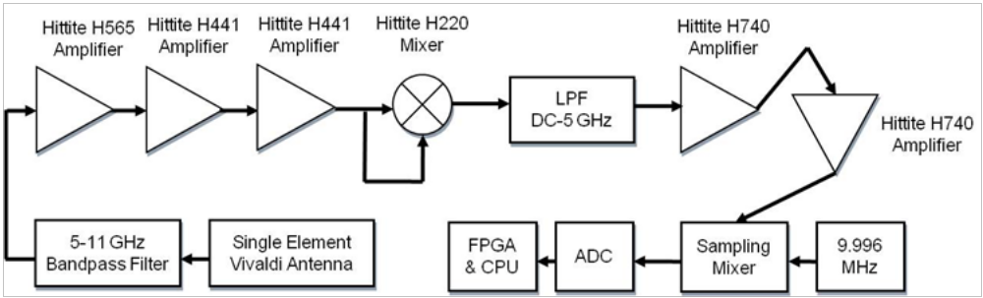
Figure 9-36: Block diagram of the UWB receiver where a single element Vivaldi antenna is connected to a 5-11 GHz band-pass filter, goes through three stages of amplification followed by a squaring mixer, then is low-pass filtered, goes through two stages of baseband amplification, and is sub-sampled to be 2500 times larger in the time domain. The signal is then converted to digital and processed on a field programmable gate array (FPGA) before being fed to a C++ application on a computer via a serial connection.
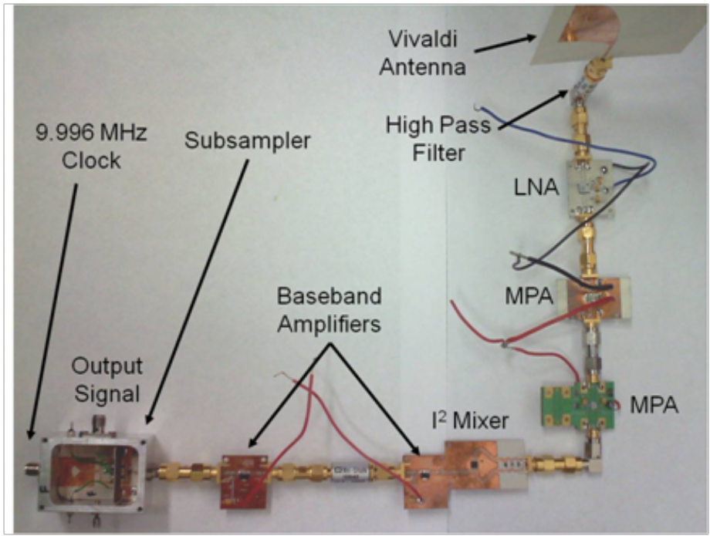
Figure 9-37: UWB energy detection receiver including a front-end band-pass filter, one low noise amplifier, two medium power amplifiers, a squaring mixer, two baseband amplifiers, and the sub-sampling mixer.

Digital Processing and Real-Time Software Integration
The microcontroller at the UWB control station turns tags on and off in a round robin fashion to implement the TDMA scheme. The control station consists of a TI EZ430-RF2500 USB dongle connected to the computer and an FPGA Spartan 3E evaluation board which is connected to the computer via an RS232 serial connection. A Perle RS232 to Ethernet device is inserted between the FPGA control station board and the computer to allow for data rates of up to 460,800 (limit of the RS232 chip on the FPGA evaluation board). Tag IDs are picked by the control station microcontroller as shown in Figure 9-38. The current Tag ID is sent to the control station FPGA which then broadcasts the current Tag ID to all base station FPGAs to synchronize the reception of UWB localization pulses with the correct Tag ID. Figure 9-39 shows the MCU control signals from tags 1 and 2 which are used in turning on and off the load switches which supply DC power to the RF board of each integrated tag. Each tag is allocated 7 ms time bins to transmit UWB pulses before switching to the next tag. The C++ software application currently supports up to 10 tags operating simultaneously. Figure 9-40 shows UWB pulse trains for tags 1 and 2 captured with an 8 GHz real-time oscilloscope. A 160 µs latency in UWB pulse train transmission is observed when switching between tags 1 and 2. This is due to the
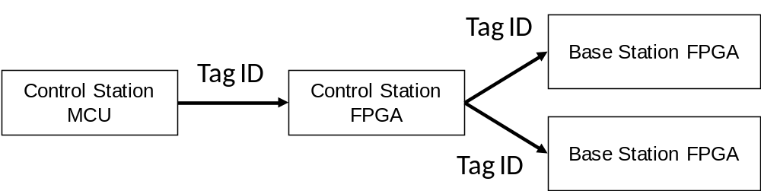
Figure 9-38: The current tag ID is sent from the control station microcontroller to the control station FPGA. From the control station FPGA, the tag ID is sent to all base station FPGAs to synchronize the current tag ID.
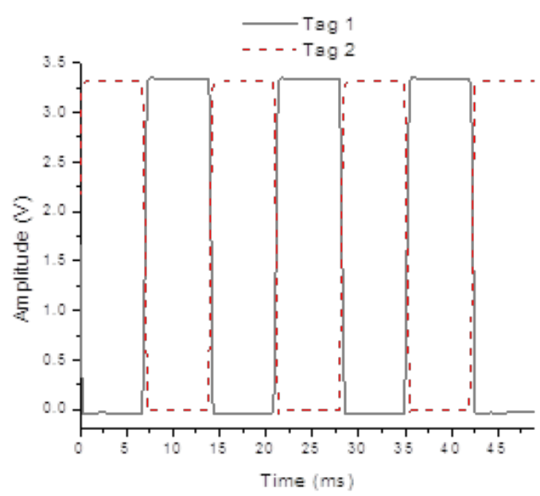
Figure 9-39: MCU control signals for tags 1 and 2 over a 50 ms time period broken into 7 ms transmitting intervals for each tag.
microcontroller processing associated with switching between tags at the control station MCU. This results in a 2.3% reduction in transmission of UWB pulses for a time bin size of 7 ms. Larger time bin sizes will result in lower and lower percentage reductions since the 160 µs latency will occur will less and less frequency. Figure 9-41 shows the time differences received at the computer via the C++ software application for tags 9 and 13 where the tags are left in static positions. The time differences represent the raw data used to calculate the tag 3-D position. As shown in Figure 9-41, the time differences can be seen switching between the current location of tags 9 and 13. A roughly 20% reduction in the overall system update rate is observed when switching between multiple tags with a time bin of 7 ms. This occurs because UWB positioning data packets are corrupted at the UWB receivers for the short time interval surrounding the switch from one tag to the next (illustrated for two tags in Figure 9-40).
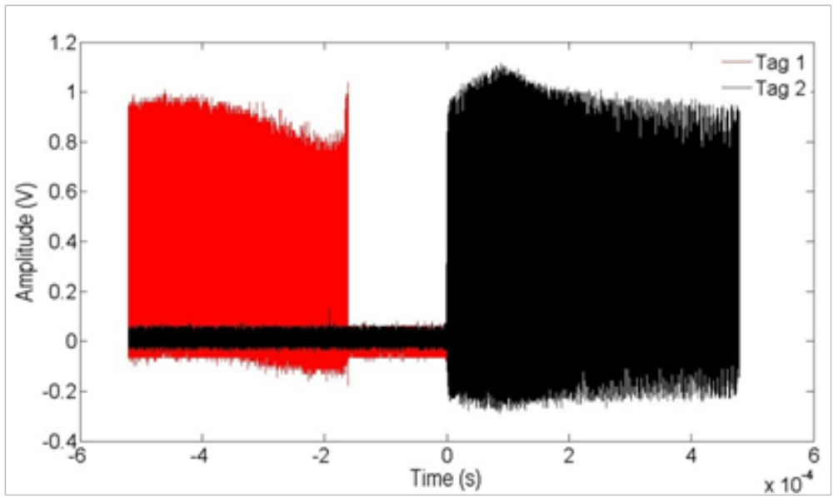
Figure 9-40: Baseband UWB pulse trains for tags 1 and 2 where a 160 µs latency occurs between turning off and on tags 1 and 2. Obtained by an 8 GHz real-time sampling oscilloscope.

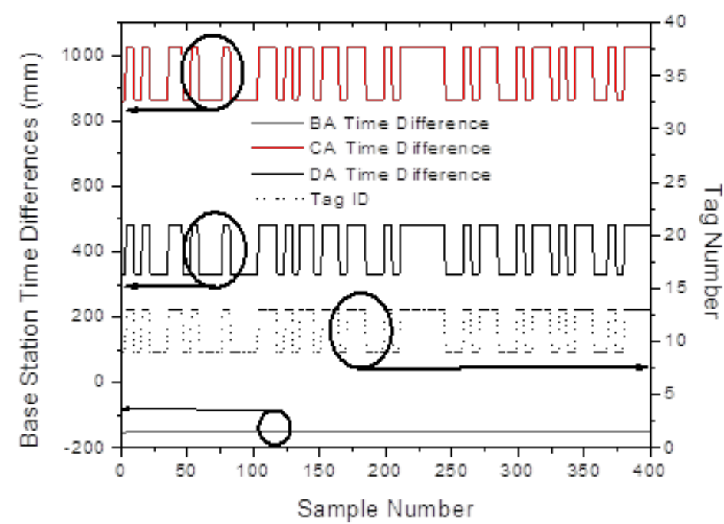
Figure 9-41: Time differences received at the computer where two distinct bands can be seen representing the 3-D positions of tags 9 and 13.
The C++ software application is outlined in Figure 9-42, Figure 9-43, and Figure 9-44. The multi-tag display window shown in Figure 9-42 displays the currently connected tags including their 3-D position, 3-D error (if being tracked by an optical probe), refresh rate (in Hz), signal strength which corresponds to the 2.4 GHz MCU link, temperature as calculated by the MCU, and battery voltage. A tag can be designated as the static tag. More information on the static tag is outlined in Section 9.4.4. The Record Data checkbox allows recording CSV data for each tag. The Calibrate button can be used to perform a 3-D calibration for each tag as outlined in Section 9.4.5. Figure 9-43 shows the time division multiple access or TDMA window. The time interval allocated to each tag can be set here as well as the duty cycle for how much of that time interval the tag is turned on. The default settings are 7 ms time interval and 100% duty cycle (for high accuracy real-time tracking). Low power operation could consist of a 1000 ms time
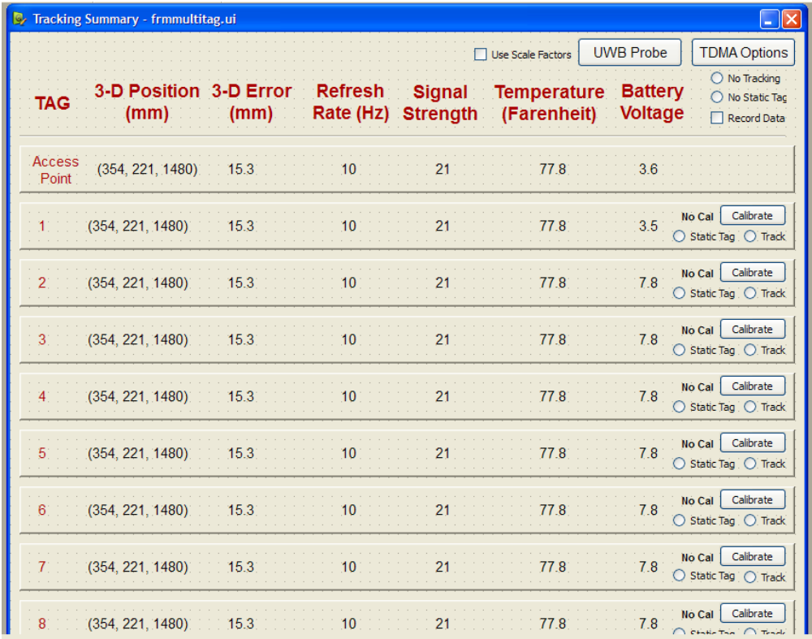
Figure 9-42: C++ software application for displaying and collecting multi-tag data. This includes information for each tag such as 3-D position, 3-D error (if being tracked by an optical tracker), refresh rate (Hz), signal strength (from 2.4 GHz MCU), temperature (from MCU), and battery voltage. Each tag can be calibrated separately. Each tag can be tracked by an optical probe. A static tag is used to filter out receiver clock jitter and drift.
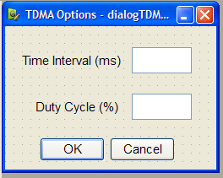
Figure 9-43: Time Division Multiple Access parameters can be configured in the software and distributed to all tags via the 2.4 GHz communication link. This includes time interval (per tag, one time slice) and duty cycle which it is turned on within that time interval as a percentage.
interval with a 1% duty cycle. The tag calibration setup window is shown in Figure 9-44. This window can be used to save and load tag calibration files. These files contain 3-D calibration matrix data for 4 base station and 5 base station experiments, the number of 3-D points used in the calibration process, the tag scale factor (measured experimentally) which is a number to convert from raw time difference information to millimeters, the current static tag (tag number), the static tag reference time differences, the cable length offset (in time differences), and an 3-D XYZ offset to account for the optical probe tip being offset from the phase center of the tag monopole antenna.
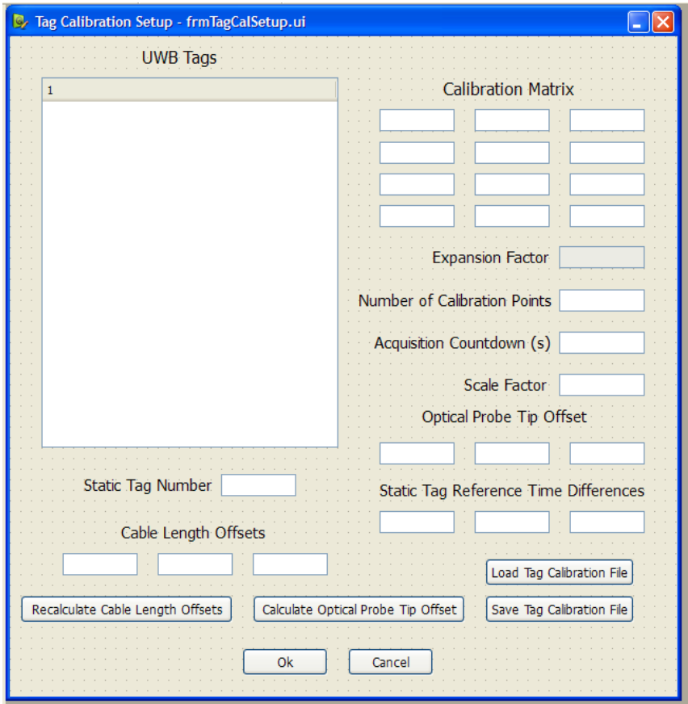
Figure 9-44: Tag calibration setup window. Used for setting tag calibration matrices as well as setting tag scale factors, cable length offsets (time differences) and the static tag reference point (in terms of time differences).

Static Tag Integration
The use of a sub-sampling mixer combined with the fact that precise ranging measurements on the order of 1-40 ps are needed for millimeter 3-D positioning cause this UWB indoor positioning system to have a high sensitivity to clock jitter and drift. Figure 9-45 illustrates the jitter and drift observed in the received time difference signals for a tag in a static location over a period of 23 minutes. Significant effects are observed including errors as high as 30-40 mm for each time difference. This causes 3-D positioning errors of 30 mm or more. These extremely large errors must be mitigated for the system to achieve consistent millimeter 3-D accuracy. Figure 9-46 shows one time difference signal for two tags at static positions over a
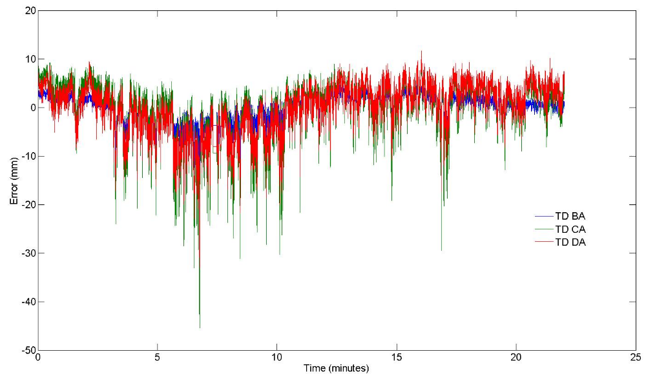
Figure 9-45: Measured receiver clock jitter and drift over a 23 minute interval caused by the 9.996 MHz signal used by the sub-sampling mixer to sub-sample the incoming UWB pulses. The clock jitter and drift can cause up to 30-40 mm of error in each measured time difference. This can cause 3-D positioning errors of 30 mm or more.
time period of 20-30 s. There is a high correlation of the jitter and drifting between the two tags. This supports the hypothesis that the main source of error is receiver clock jitter and drift. The tags have a TCXO Vectron VTC4 crystal which has low drifting and jitter which can be removed by averaging signals on the receiver side. The receiver clock jitter and drift observed in Figure 9-45 and Figure 9-46 is due to the 9.996 MHz signal used by the sub-sampling mixer, which is currently supplied by a Tektronix AFG 3102 function generator. Since this drifting and jitter is consistent across all operating tags, it can be removed by using a static tag. Figure 9-47 shows the time differences for a 2nd tag over a time period of 25 minutes. Both tags are left in static positions. The first tag is designated the static tag and used to directly calculate the clock jitter and drift signal shown in Figure 9-45. The static received signal from the 2nd tag does not contain large drifting and jitter and contains mainly white Gaussian noise which can be removed by further averaging of the received signals. The C++ software application discussed in Section 9.4.3 has complete integration for the use of a static tag to remove the outlined receiver clock jitter and drift.

Cable Length Offsets
As discussed in [53], bias offsets exist in the path lengths from the UWB antennas to the point at the control station FPGA where the time differences are calculated. These static path lengths must be calibrated out of the system to remove the static bias errors they cause in performing the TDOA calculations. Using the same technique outlined in [53], these static path length biases are calculated using a single point where the optical system provides ground truth
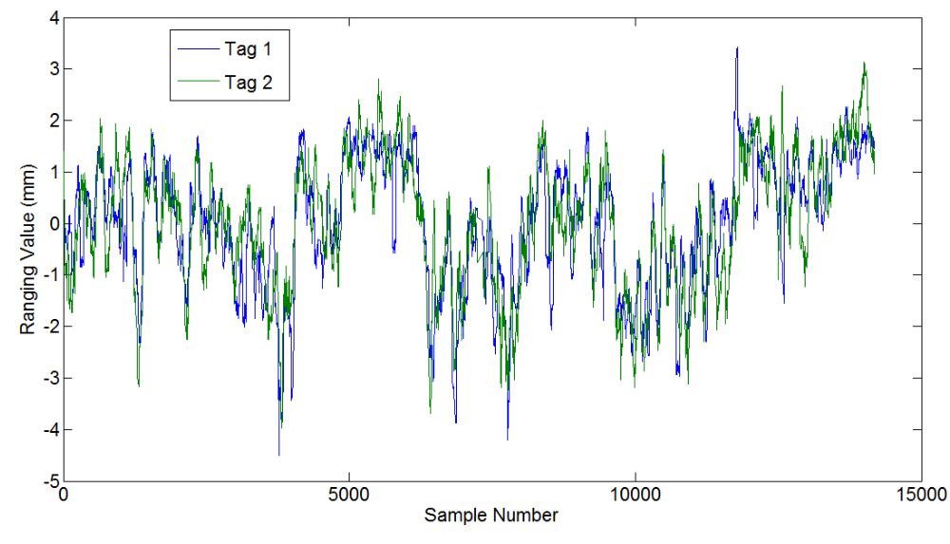
Figure 9-46: Received signal over 15000 samples (20-30 seconds) for one time difference for two different tags in static locations. The jitter and drift observed in the two signals correlates well, indicating that the main source of clock jitter and drift is from the UWB receivers and is therefore similar across all tags.
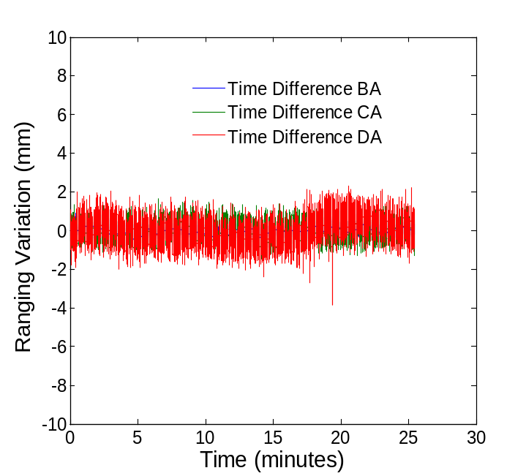
Figure 9-47: Measured receiver clock jitter and drift for a 2nd tag using the 1st tag as a static tag to calculate and remove the receiver clock jitter and drift. A nice Gaussian white noise is observed while the jitter and drift effects outlined in Figure 9-45 and Figure 9-46 are removed.
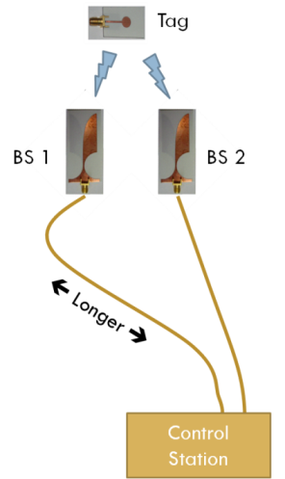
Figure 9-48: Illustration of cable length offsets which require a static calibration for removal in the C++ software [53].
information. Once the cable length offsets have been calculated, they are subtracted from new time difference data for every tag for every subsequent TDOA calculation. The cable length offset calibration is needed in addition to the use of a static tag (discussed in Section 9.4.4).

Tag Scale Factors
Each of the 10 tags contains its own Vectron VTC4 TCXO 10 MHz clipped sine wave
clock which drives the transmission of UWB pulses. The VTC4 crystal has a stability of ±0.5 ppm and jitter of less than <30 ps (measured). The ±0.5 ppm stability can become an issue since 2500 pulses are required for each pulse obtained in the subsampling process. At f=10 MHz, stability of ±0.5 ppm translates into ±5 Hz. This translates into a 0.13% scaling error in the subsampling process when a ∆f=4 kHz frequency offset is used between f_{Tx} and f_{Rx}. For example, if the scale factor is set at 2500, this error would cause it to fluctuate between 2497-2503.
In addition to instability in the transmitter clocks, there is instability in the receiver clocks. This includes the 9.996 MHz signal distributed to the subsamplers in addition to the FPGA clocks at the base stations and control station. The 9.996 MHz clock has the greatest effect since it is used in the subsampling process. The 9.996 MHz square wave signal is currently generated with a Tektronix AFG 3102 function generator. The Tektronix AFG 3012 function generator has a stability of ±1.0 ppm and jitter of <200 ps as defined in its specifications. The jitter and instability of the Tektronix AFG 3012 function generator results in jitter and drifting which is clearly illustrated in static scenarios such as those of Figure 9-45 and Figure 9-46. The jitter and instability over long time periods (1-30 minutes) cause triangulation errors of 10-40 mm and necessitates the addition of a static tag to the UWB real-time location system as discussed in Section 9.4.4. The stability of ±1.0 ppm occurs in addition to the stability of the Vectron VTC4 of ±0.5 ppm. This results in a worst case combined stability for the transmitter and receiver clocks of ±1.5 ppm. This translates into an uncertainty of ±15 Hz in the frequency offset ∆f = f_{Tx} - f_{Rx}. With f_{Tx} = 10 MHz and f_{Rx} = 9.996 MHz, ∆f = 4 kHz ± 15 Hz. The ±15 Hz instability results in a scaling error of 0.38%. For a scale factor of 2500, the instability causes the actual scale factor to lie between 2491-2509.
Finally, the Spartan 3E evaluation board has an Epson SG-8002JF 50 MHz clock source with stability of ±50 ppm. This has only a minimal effect since it will only effect each digital sample after subsampling. For example, instead of each digital sample being spaced 20 ns apart, this introduces an uncertainty that the samples will be 19.999-20.001 ns apart (an uncertainty of around 1 ps per digital sample). Since this 1 ps uncertainty is added after subsampling, it is equivalent to a 0.4 fs uncertainty before subsampling. The Epson SG-8002JF 50 MHz clock source has a measured jitter value of around 200 ps. This is much smaller than the 200 ps of jitter introduced by the 9.996 MHz clock which is included in the subsampled signal as jitter 2500x larger (500 ns). 200-500 ns jitter is observed experimentally in the raw output leading-edge signals from the base station FPGAs.
In order to verify this analysis of the tag scale factors, the scale factor for each of the 10 tags was measured experimentally. This was done by measuring the number of 50 MHz clock cycles (20 ns spaced digital samples) that occurred between each successive UWB pulse leading-edge. This was repeated for 100,000-300,000 consecutive UWB pulse cycles for each of the 10 tags. Examples of the raw data obtained from this analysis are shown in Figure 9-49 and Figure 9-50. As shown in Figure 9-49 and Figure 9-50, there is typically a spread of around 10 digital samples (200 ns) caused by the jitter in the received UWB pulse, but ultimately the period is well defined with a standard deviation of 1-2 digital samples (20-40 ns). A summary of the scale factor analysis for all 10 tags is presented in Table 9-3. As shown in Table 9-3, the measured scale factors vary between 2489.7-2492.2. This translated into a scale factor error of 0.23%-0.41%. These values are consistent with the theoretical analysis which suggested a worst case scale factor of 0.38% when taking into account the transmitter 10 MHz clock and the receiver 9.996 MHz clock. The dynamic calibration procedure described in Section 9.4.7 is used to measure and remove the scale factor error. The dynamic calibration also helps to mitigate phase center error caused by the shifting of the receiver antenna phase centers as the tag moves around the view volume.
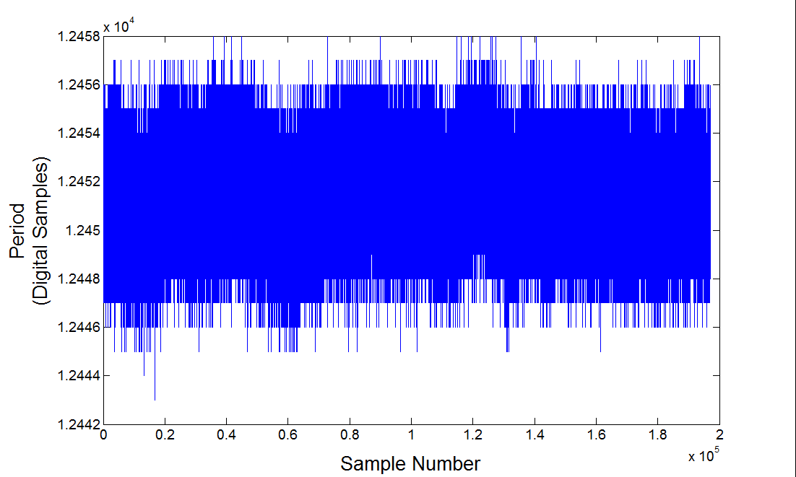
Figure 9-49: Period between successive leading-edges of the UWB pulse train from Tag 2 in digital samples spaced 20 ns apart for almost 200,000 successive UWB pulses.
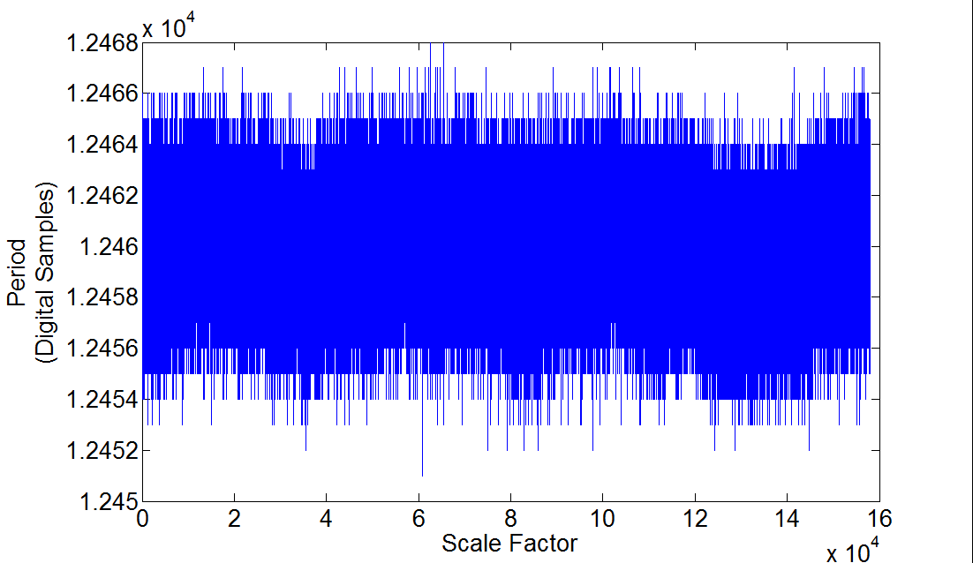
Figure 9-50: Period between successive leading-edges of the UWB pulse train from Tag 9 in digital samples spaced 20 ns apart for almost 160,000 successive UWB pulses.
Table 9-3: Summary of measured tag scale factors for all 10 operational UWB tags.
Tag Number | Period (Digital Samples) | Scale Factor | Scale Factor Error (%)
2 | 12,451 ± 1.7 | 2490.3 | 0.39
4 | 12,462 ± 2.1 | 2492.3 | 0.31
5 | 12,450 ± 2.0 | 2490.0 | 0.40
8 | 12,464 ± 1.8 | 2492.9 | 0.29
9 | 12,460 ± 2.0 | 2492.0 | 0.32
10 | 12,471 ± 1.7 | 2494.2 | 0.23
12 | 12,458 ± 1.7 | 2491.6 | 0.34
13 | 12,450 ± 1.7 | 2490.0 | 0.40
14 | 12,464 ± 1.7 | 2492.8 | 0.29
15 | 12,449 ± 2.1 | 2489.7 | 0.41

Ultimately, the accuracy of the system is limited by the 1-D ranging accuracy of the UWB base stations, receiver antenna phase center variation, and geometric dilution of precision. The scale factor error of 0.23%-0.41% is negligible when compared to receiver antenna phase center variation and geometric dilution of precision as discussed in Section 9.4.7. Dynamic accuracy is limited by tag update rate in addition to 1-D ranging accuracy of the UWB base stations, receiver antenna phase center variation, and geometric dilution of precision. Finally, the measurement of tag accuracy introduces another source of error: synchronization errors when comparing dynamic data from the UWB positioning system and the optical tracking system.

Dynamic Calibration
A dynamic 3-D calibration procedure helps in removing errors observed dynamically across many points within the view volume. These errors include uncertainty in the base station antenna phase center measurement used in the TDOA calculations, base station phase center variation as the tag moves around the view volume and changes its relative angle to each base station Vivaldi antenna, and any additional bias in the time difference data not initially seen at the static point used in calculating the cable length offsets (essentially a more accurate cable length offset estimate obtained using a larger dataset with a more accurate representation of the entire view volume). The dynamic calibration can even help mitigate the synchronization error that can occur in attempting to align the dynamic data from the UWB and optical positioning systems.
It should be noted that 3-D dynamic experiments can be run without performing the dynamic 3-D calibration procedure outlined in this section. This can be seen by looking at the range difference data in Figure 9-51. Figure 9-51 shows dynamic range difference data (BA, CA, DA) for the UWB positioning system and the optical tracking system for Tag 10. A static tag is used to mitigate system clock jitter and drift effects (as outlined in Section 9.4.4). Cable length offsets have been calculated to align the UWB and optical range difference data at a single point in the view volume (Section 9.4.5). Finally, the measured tag scale factor for Tag 10 has been applied to the UWB range difference data (Section 9.4.6). As shown in Figure 9-51, the range difference data for the optical and UWB systems has good correlation. The 3-D RMS error of the UWB range difference data versus the optical range difference data is 13.9 mm. This does not translate directly into 3-D X,Y,Z error but provides a baseline value that is indicative of the final 3-D positioning error after the TDOA calculation. After the dynamic 3-D calibration is performed, the 3-D RMS error is reduced to 10.3 mm. This provides a welcome 26% reduction in error but still shows that more error exists within the UWB positioning data which the dynamic 3-D calibration did not remove. Thus, it can be inferred that the dynamic 3-D calibration procedure does mitigate error within the system but is not a “catch all” calibration and must be used in conjunction with other error mitigation techniques in the quest for sub-millimeter 3-D accuracy.
The dynamic 3-D calibration procedure is outlined in [53] and is termed the System Time-Scale and Offset Calibration in [53]. It is reproduced here using the same equations and nomenclature described in [53]. This algorithm requires a reference positioning system (the optical tracking system) denoted R while the UWB positioning system pseudo ranges are denoted as P. A least squares approach is used to solve for a homogeneous transformation matrix which best aligns the UWB range difference coordinate frame with the optical range difference coordinate frame. As shown in (9-1), $∆r_{1k}^{t}$ represent the range differences computed using the reference positioning system (optical tracking system). $∆ρ_{1k}^{t}$represent the range differences computed by the UWB positioning system as shown in (9-2). t represents the time index or sample index of the acquired ranges. The homogeneous transformation matrix H is solved for in the linear system which equates the UWB range differences $∆P$ to the optical reference positioning system range differences $∆R$. $∆P$ and $∆R$ are defined in (9-4) and (9-5). The resulting linear system is defined in (9-3). The homogeneous transformation matrix H is defined in (9-6). As mentioned in [53], $∆P$ and $∆R$ must be full rank in order to ensure H provides an accurate least squares estimate of the homogeneous transformation matrix. The antenna of a UWB tag must be rigidly attached and statically calibrated to the optical probe in order to obtain range difference data from both positioning systems simultaneously.
An example transformation matrix H is shown in (9-7). This transformation matrix corresponds to the raw data shown in Figure 9-51. As can be seen in (9-7), the transformation
$∆r_{1k}^{t}=r_{1}^{t}-r_{k+1}^{t}$ | (9-1)
$$∆ρ_{1k}^{t}=ρ_{1}^{t}-ρ_{k+1}^{t}$$ | (9-2)
$$∆P=H∆R$$ |  | (9-3)
$$∆P=\left[\begin{matrix}∆ρ_{11}^{1} & ⋯ & ∆ρ_{1k}^{1} \\ ⋮ & ⋱ & ⋮ \\ ∆ρ_{11}^{N} & ⋯ & ∆ρ_{1k}^{N}\end{matrix} \begin{matrix}1 \\ 1 \\ 1\end{matrix}\right]$$ |  | (9-4)
$∆R=\left[\begin{matrix}∆r_{11}^{1} & ⋯ & ∆r_{1k}^{1} \\ ⋮ & ⋱ & ⋮ \\ ∆r_{11}^{N} & ⋯ & ∆r_{1k}^{N}\end{matrix}\right]$ |  | (9-5)
$$H= \left[\begin{matrix}s_{11} & s_{12} & s_{13 } & d_{1} \\ s_{21} & s_{22} & s_{23} & d_{2} \\ s_{31} & s_{32} & s_{33} & d_{3} \\ 0 & 0 & 0 & 1\end{matrix}\right]$$ |  | (9-6)
$$H_{Example}= \left[\begin{matrix}0.942 & 0.047 & -0.038 & -28.5 \\ 0.005 & 0.972 & 0.007 & 7.62 \\ -0.049 & 0.051 & 0.937 & -40.1 \\ 0 & 0 & 0 & 1\end{matrix}\right]$$ |  |  | (9-7)
mainly occurs as a scale factor along the diagonal ($s_{11}$,$s_{22}$,$s_{33}$) combined with translation offsets $d_{1}$,$d_{2}$, and $d_{3}$. There is a small amount of correlation among the off-diagonal scale factors, but this contribution is negligible compared to the main diagonal. The translation offsets $d_{1}$,$d_{2}$, and $d_{3}$ represent a corrected estimate of the cable length offsets with less error than the original estimate since some of the error inherent to the single point cable length offset calibration (Section 9.4.5) has been removed. The scale factors $s_{11}$,$s_{22}$, and$s_{33}$ represent a
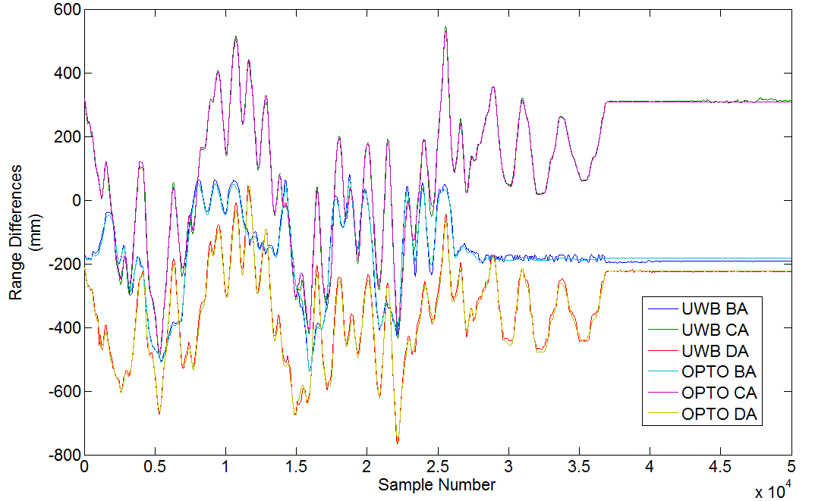
Figure 9-51: Raw range difference data for base station B minus base station A (BA), base station C minus base station A (CA), and base station D minus base station A (DA) for both the optical and ultra-wideband positioning systems as the tag is moved around the view volume. The cable length offsets have already been applied, a static tag is used, and the tag scale factor has already been applied. Good correlation is observed when comparing the range differences between the two systems.
scaling of the range differences applied to the non-calibrated UWB BA, CA, and DA range differences. For the example transformation matrix $H_{Example}$ , $s_{11}=0.942$, $s_{22}=0.972$, and $s_{33}=0.937$. This constitutes a 5.8% scale reduction for BA, a 2.8% scale reduction for CA, and a 6.3% scale reduction for DA. The effects of these scale reductions can be seen in Figure 9-52, Figure 9-53, Figure 9-54, Figure 9-55, Figure 9-56, Figure 9-57, and Figure 9-58. The zoomed-in plots of Figure 9-53, Figure 9-55, and Figure 9-57 illustrate how the dynamic calibration mitigates errors in the UWB range difference data. Figure 9-58 shows the 3-D range difference error before and after the dynamic calibration. 3-D range difference error is defined in (9-8) and incorporates error from UWB BA, CA, and DA range differences. A 26% reduction in error is
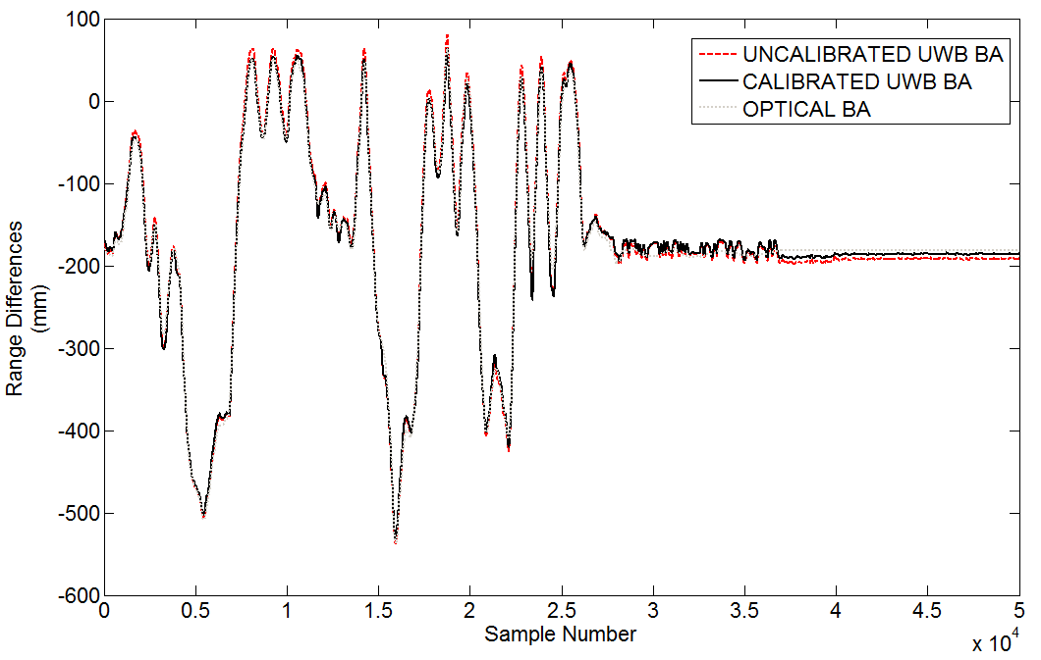
Figure 9-52: Raw range difference data for base station B minus base station A (BA) for both the optical and ultra-wideband positioning systems as the tag is moved around the view volume. Both uncalibrated and calibrated UWB range difference curves are shown. The calibrated UWB range differences better fit the optical BA range differences.
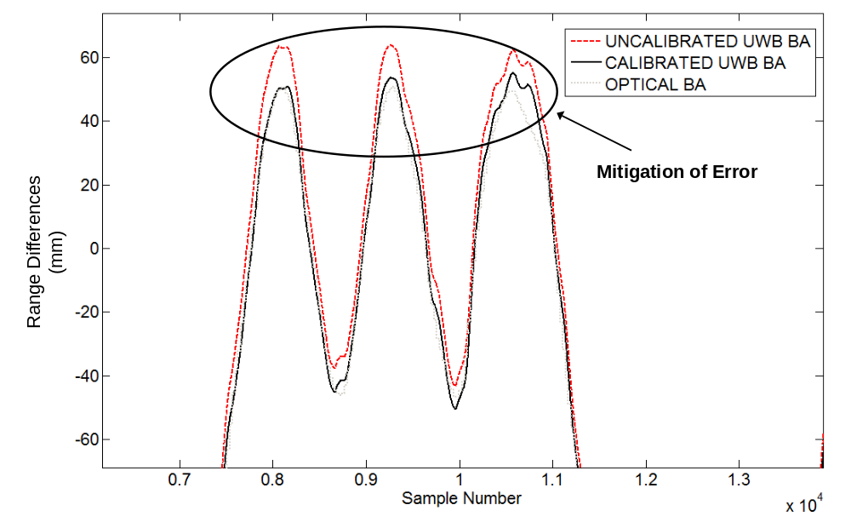
Figure 9-53: A zoomed-in view of the raw range difference data for base station B minus base station A (BA) for both the optical and ultra-wideband positioning systems as the tag is moved around the view volume. The calibrated UWB range differences have a 5.8% scale reduction which provides a noticeably better fit to the optical range difference data, especially at the extremities of the view volume.
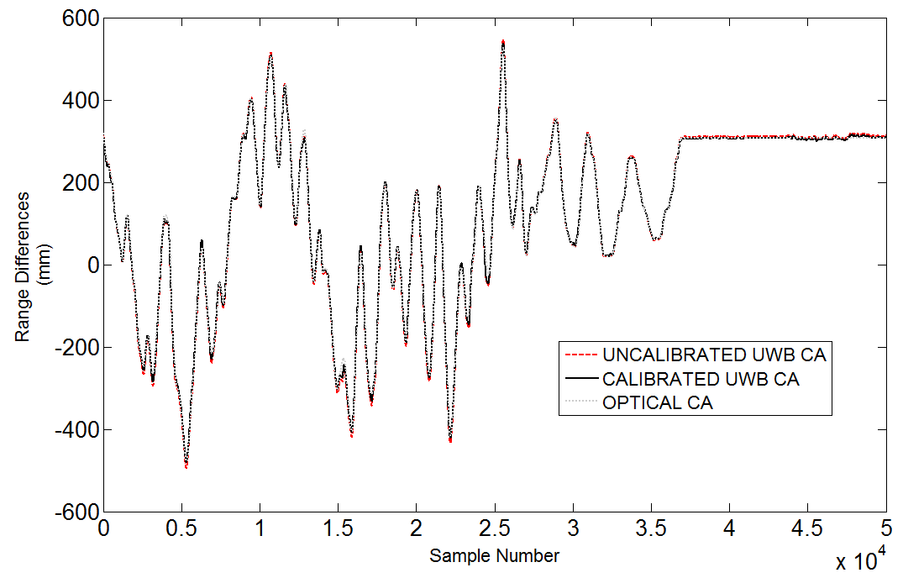
Figure 9-54: Raw range difference data for base station C minus base station A (CA) for both the optical and ultra-wideband positioning systems as the tag is moved around the view volume. The calibrated UWB range differences better fit the optical CA range differences.
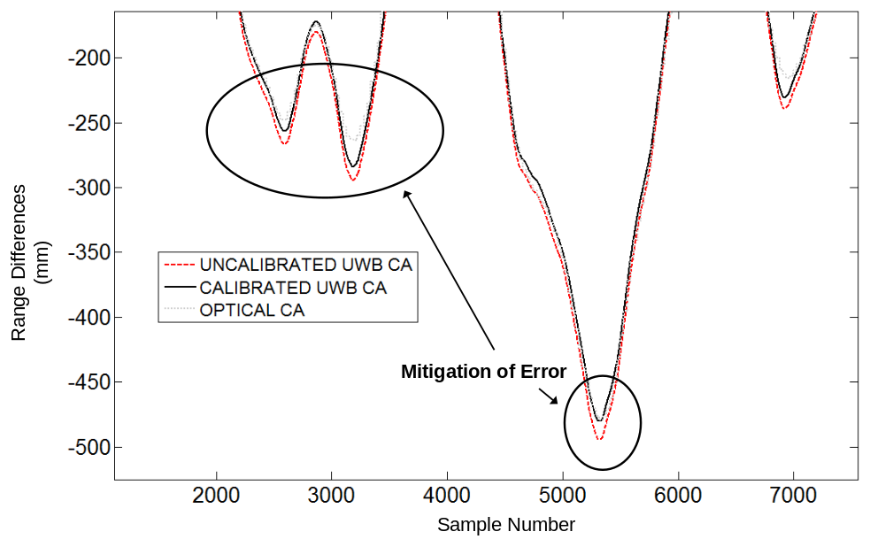
Figure 9-55: A zoomed-in view of the raw range difference data for base station C minus base station A (CA) for both the optical and ultra-wideband positioning systems as the tag is moved around the view volume. The calibrated UWB range differences have a 2.8% scale reduction which provides a noticeably better fit to the optical range difference data, especially at the extremities of the view volume.
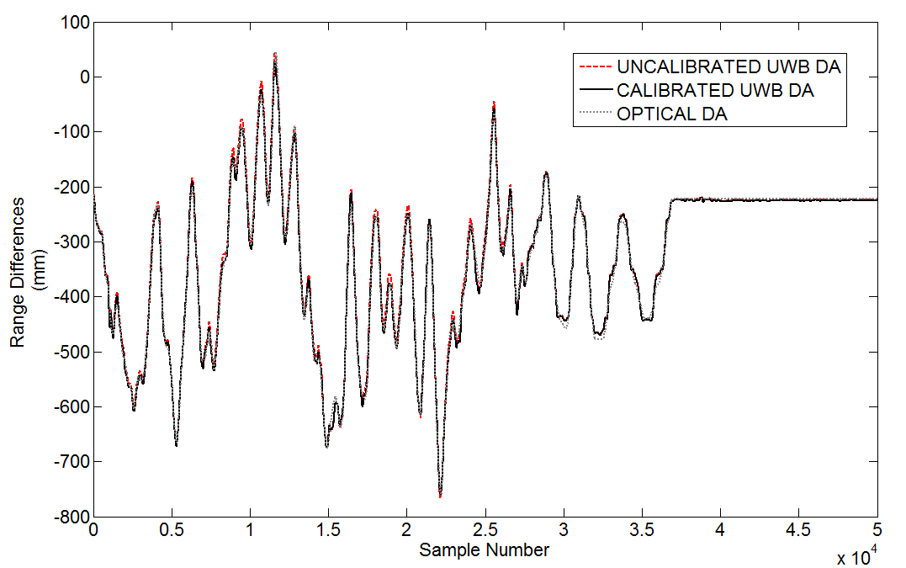
Figure 9-56: Raw range difference data for base station D minus base station A (DA) for both the optical and ultra-wideband positioning systems as the tag is moved around the view volume. The calibrated UWB range differences better fit the optical DA range differences.
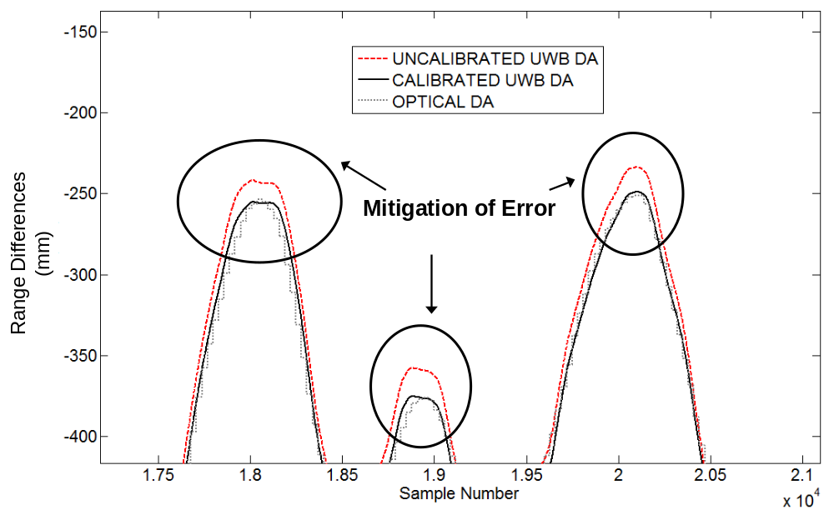
Figure 9-57: A zoomed-in view of the raw range difference data for base station D minus base station A (DA) for both the optical and ultra-wideband positioning systems as the tag is moved around the view volume. The calibrated UWB range differences have a 6.3% scale reduction which provides a noticeably better fit to the optical range difference data, especially at the extremities of the view volume.
error is observed for the calibrated 3-D range difference error versus the non-calibrated 3-D range difference error.
$$3D Range Difference Error=$$  $$\sqrt{{({BA}_{UWB}- {BA}_{OPTICAL})}^{2}+{({CA}_{UWB}- {CA}_{OPTICAL})}^{2}+{({DA}_{UWB}- {DA}_{OPTICAL})}^{2}}$$ | (9-8)
A plausible error source which would necessitate scaling reductions in the BA, CA, and DA range differences, such as the 5.8% reduction for BA, 2.8% reduction for CA, and 6.3% reduction for DA observed here, is an inaccurate initial estimate of the base station phase center 3-D positions. Figure 9-59 shows a typical measurement of the base station Vivaldi phase center while Figure 9-60 shows how there is actually a range of uncertainty in this measurement since
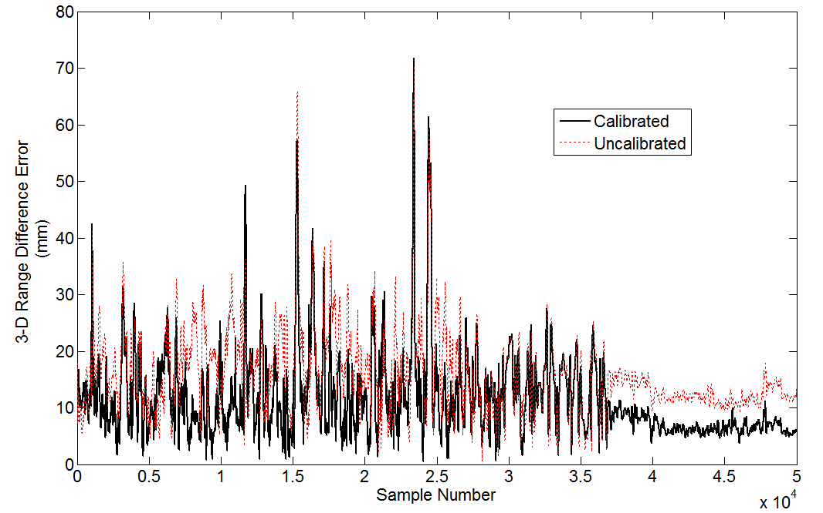
Figure 9-58: The 3-D range difference error (defined in (9-8)) for all 50,000 calibration points before and after the dynamic calibration (applying H). The dynamic calibration provides a 26% reduction in RMS 3-D range difference error (reduced from 13.9 mm to 10.3 mm).
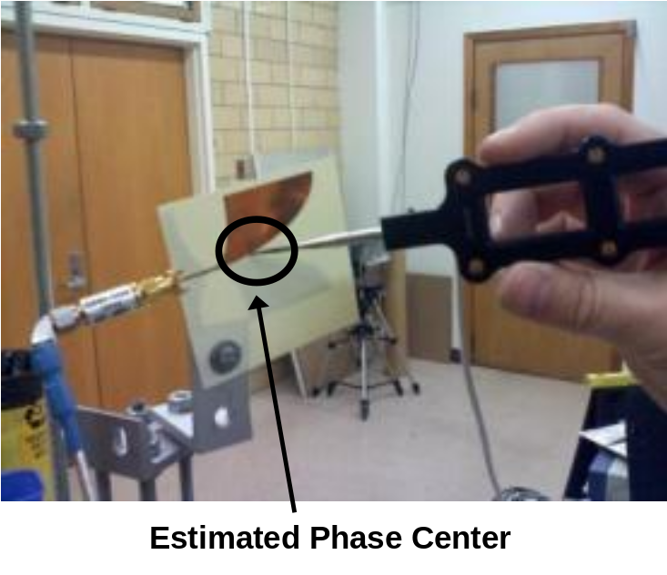
Figure 9-59: An optical probe is used to estimate the base station Vivaldi antenna phase center. This 3-D position is used in calculating the reference optical range differences for dynamic calibration. This 3-D base station position is also used in the TDOA calculation for the UWB positioning system.
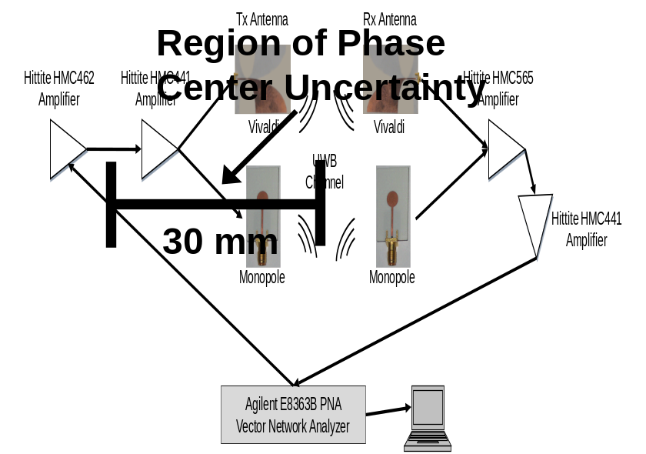
Figure 9-60: A roughly 30 mm range of uncertainty is introduced in measuring the UWB base station Vivaldi phase centers. This can translate into 10-60 mm of systematic error in the BA, CA, and DA range differences when comparing optical and UWB range difference data.
the actual phase center position is unknown. This range of uncertainty is estimated at 30 mm per base station. For a worst case analysis, we will assume that each base station (A,B,C,D) has a 30 mm offset in its actual phase center versus the measured phase center as shown in Figure 9-61. This offset will cause scaling between the UWB and optical range differences as the tag is moved around the view volume because the UWB range differences are inherently using the actual phase center while the measured optical range differences rely on the measured phase center 3-D points to compute the optical range differences.
A simulation of this effect is outlined in Figure 9-61, Table 9-4, Table 9-5, and Table 9-6. The phase center of each base station was measured with the optical tracking system. The 3-D measured positions are provided in Table 9-4. An offset was introduced in the general direction of where the actual phase center may be located (its actual position is not known). The offset
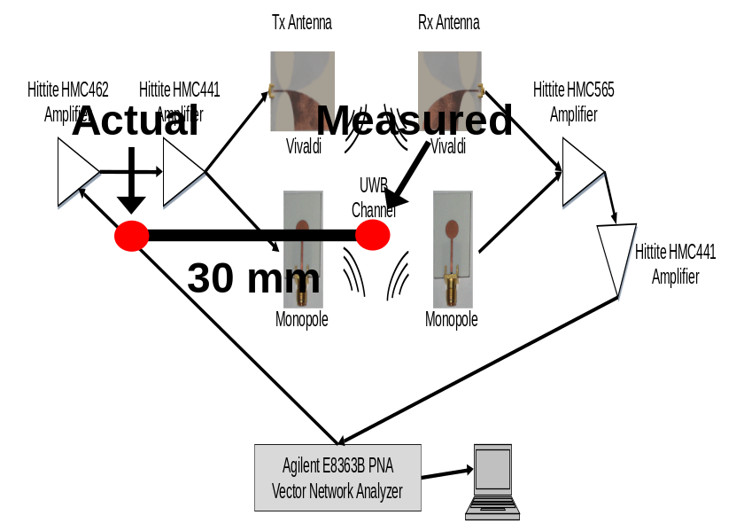
Figure 9-61: For a worst case analysis, a 30 mm offset is introduced between the measured phase center and the actual phase center of the Vivaldi base station antenna for a simulation of its effect on the UWB positioning system dynamic behavior.
Table 9-4: Simulated phase center offsets introduced to analyze the effect of phase center offsets in observed scaling error in the range difference data for dynamic experiments.
Base Station | Measured Phase Center (x,y,z) | Actual Phase Center (x,y,z) | 3-D Difference (mm)
A | (-838.4, -570.9, -3763.0) | (-825, -557, -3759) |  | 19.7
B | (255.5, -274.8, -2680.1) | (257, -272, -2708) |  | 28.1
C | (-44.1, 333.2, -5790.5) | (-54, 326, -5765) |  | 28.3
D | (-703.9, 517.9, -2964.2) | (-693, 526, -2981) |  | 21.6

phase center 3-D positions represent the actual 3-D phase centers of the UWB base station antennas and are outlined in Table 9-4. The 3-D difference between the measured and actual phase center is also shown in Table 9-4 with maximum differences of < 30 mm. Table 9-5 contains the resulting range differences for three tag locations around the view volume for both the optical and UWB tracking systems. The three tag locations provide values across the view volume spanning 1.6 m across. The phase center offsets cause the UWB and optical range differences to vary with the most significant differences observed at the edges of the view volume since the base station antennas are oriented towards the center of the view volume, which provides some mitigation to the effect of the phase center offset on the observed range differences at the center versus the edges. Table 9-6 shows the spread in millimeters of the range differences for BA, CA, and DA across the three simulated tag points as well as the associated scale difference caused by the phase center offset. As shown in Table 9-6, the phase center offset causes a 1.54% scale difference for BA, a 0.86% scale difference for CA, a and 1.12% scale difference for DA. These scale differences are smaller than the observed scale differences from the full dynamic calibration (5.8% for BA, 2.8% for CA, and 6.3% for DA). Still, they are within 25%-55% of the magnitude of the observed scale differences from the dynamic calibration (1.54% versus 2.8%-6.3%). Also, in a real dynamic calibration, the phase center can vary in its position dynamically, which could potentially increase the observed scale differences between the two systems compared to the initial phase center offset. Finally, the dynamic calibration itself is quite sensitive to the input data from the UWB and optical positioning systems which makes it likely that a rather large variation of scale differences can be observed when performing a series of calibrations, which is indeed the case. Experimentally, scale differences from 0.3%-15% were observed when calibrating the system 20-30 times with different input data. More work is needed to understand the effects the phase center has on the system. The
Table 9-5: Simulated tag 3-D points and corresponding range differences for the UWB and optical tracking systems. The optical tracking system uses the measured phase center base station positions while the UWB positioning system uses the actual phase center positions.
Tag 3-D Position (x,y,z) | UWB Range Differences  (BA, CA, DA) | Optical Range Differences  (BA, CA, DA)
(12, 12, -4200) | (434, 494, 395) | (446, 504, 395)
(80, 300, -3500) | (-280, 996, -315) | (-276, 1001, -318)
(-40, -300, -5000) | (821, -502, 786) | (842, -484, 795)

Table 9-6: Results from the simulated analysis which shows that biases in the measured phase center 3-D positions of the base station antennas introduce scaling effects of 1-2% into the range differences of the UWB system compared to the optical system.
 | Range Difference | Optical Spread  (mm) | UWB Spread  (mm) | Scale Difference (%)
BA |  | 1101 | 1118 | 1.54
 | CA | 1498 | 1486 | 0.86
 | DA | 1101 | 1114 | 1.12

uncertainty in the initial phase center 3-D position combined with the uncertainty in the dynamic phase center position as the tag moves around the view volume is clearly a major source of error. The phase center effects combined with geometric dilution of precision and 1-D ranging accuracy pose the greatest hurdles to achieving sub-millimeter 3-D accuracy.

MMIC Transmitter and Receiver Integration

The UWB group at the University of Tennessee is working with Dr. Schumacher and his doctoral student Dayang Lin at the University of Ulm in Germany to integrate MMIC analog RF front-ends at both the UWB tags and receivers used in the University of Tennessee UWB indoor real-time location system. The MMIC energy detection receiver designed by Dr. Schumacher’s group has already been incorporated into the University of Tennessee UWB positioning system. The MMIC UWB transmitter will be incorporated in the future through a new integrated tag design to replace the current tag design described in Section 9.4.1. A discussion of the MMIC integration is outlined here since it will greatly improve the reliability while shrinking the tag and receiver form factors and lowering power consumption for both the tag and receiver.

Transmitter Front-End
The non-coherent UWB positioning system currently being used for indoor positioning at the University of Tennessee is outlined in Section 9.4 and discussed in [205]. As discussed in Section 9.4.1, the power requirement of the transmitter (or tag) is over 1 W, which restricts the use of this system in low power applications. Figure 9-62a outlines the current discrete tag which utilizes a voltage controlled oscillator (VCO) and medium power amplifier (MPA) as well as a step recovery diode-based pulse generator causing the large power requirement of around 1 W. The corresponding picture of the discrete tag is shown in Figure 9-63a. The block diagram of the SiGe MMIC-based UWB transmitter is shown in Figure 9-62b where a cross-coupled oscillator core is transiently turned on by a current spike generated by a Schmitt trigger driving a current mirror. An integrated board design with the MMIC at the feed point of the UWB dipole antenna is shown in Figure 9-63b. More details on the MMIC design can be found in [206]. The MMIC-based transmitter is more compact and only has a load requirement of 6 mW for operation (1.5 V, 4 mA).

Receiver Front-End
A block diagram of the discrete UWB noncoherent receiver is shown in Figure 9-64a including directional Vivaldi antenna, bandpass filter, three stages of amplification, squaring mixer, lowpass filter, baseband amplification, and subsampling mixer. Figure 9-65a shows a picture of this receiver chain. The main restrictions of the discrete receiver include power consumption (2.15 W load requirement) and size. Figure 9-64b shows a block diagram of the MMIC-based receiver where the amplifiers, squaring mixer, and lowpass filter have been replaced by an integrated SiGe MMIC chip. Figure 9-65b shows a picture of the UWB noncoherent receiver using the integrated SiGe MMIC front-end. More information on the design of the MMIC noncoherent receiver front-end can be found in [207]. The MMIC receiver provides a significant reduction in the size of the RF front-end and reduces total power consumption including DC-DC converter losses from more than 3 W to around 190 mW. Figure 9-66a shows experimental signals at the transmitter. The MMIC UWB pulse falls below the Federal Communications Commission limits of -41.3 dBm/MHz and consequently only has a peak-to-peak voltage of around 250 mV whereas the discrete tag is around 1 V peak-to-peak. Figure 9-66b shows experimental signals at the receiver after subsampling. The discrete transmitter was used for the signals received in Figure 9-66b. Both the discrete and MMIC receivers produce a strong subsampled pulse of around 1 µs width and 1 V amplitude.

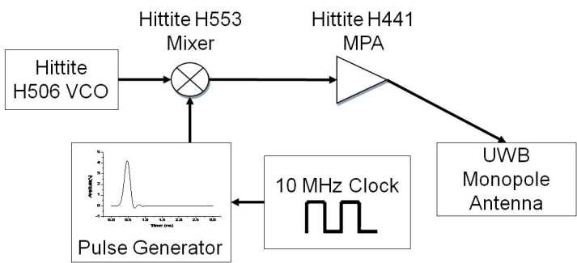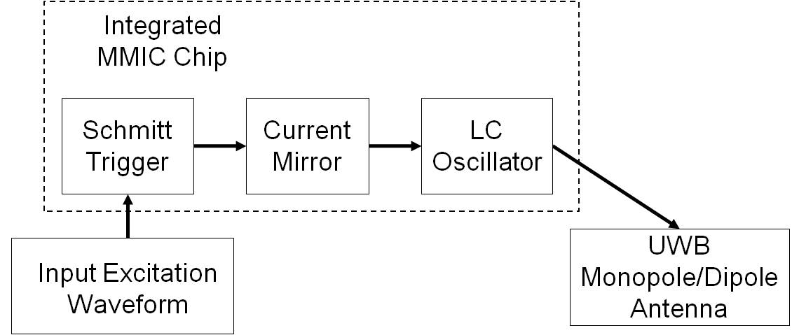
(a) (b)
Figure 9-62. Block diagram of UWB transmitter front-ends: (a) discrete, (b) integrated into a MMIC chip [206].

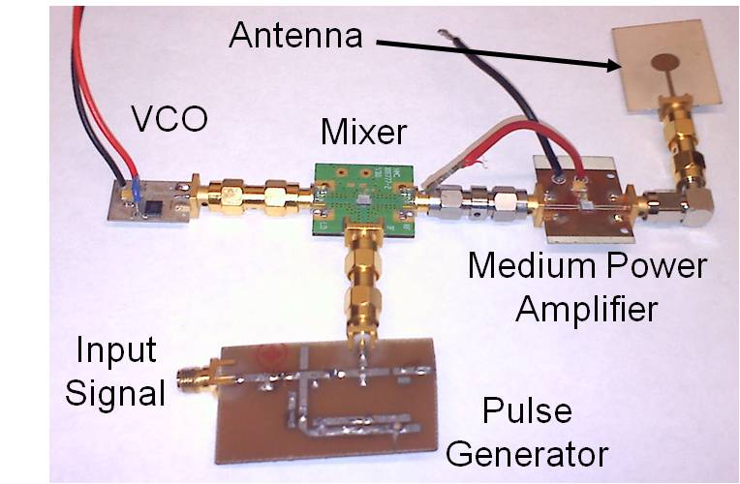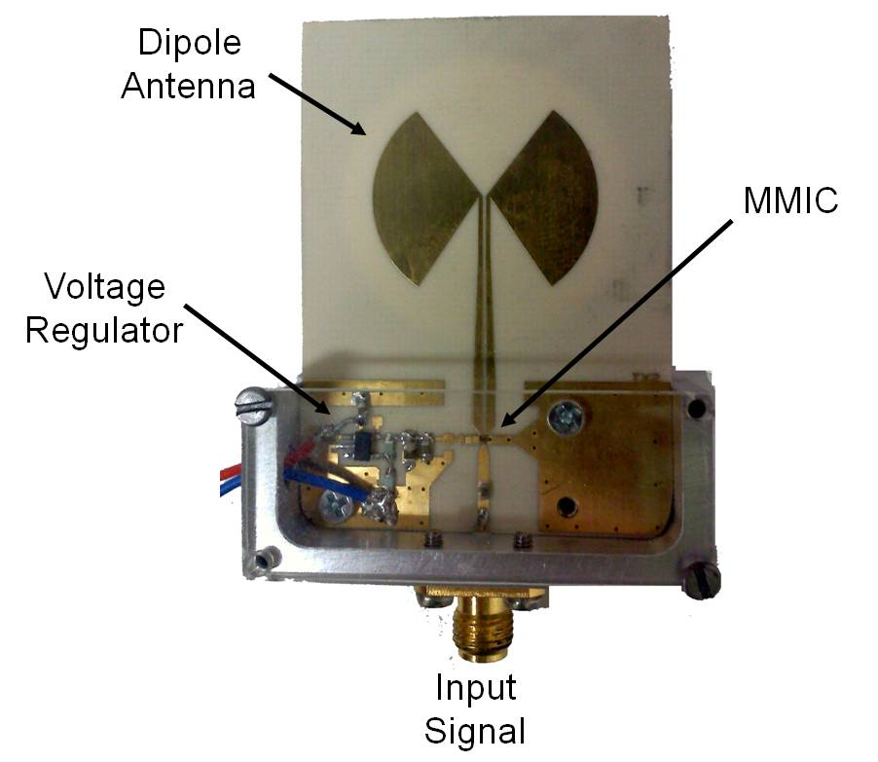
(a) (b)
Figure 9-63. UWB transmitter front-ends: (a) discrete, (b) integrated into a MMIC chip [206].

Experimental Results
Static and dynamic real-time experiments were undertaken to compare the high accuracy localization performance of the discrete and MMIC front-ends. The leading-edge of the UWB pulses was located via a Field Programmable Gate Array (FPGA) algorithm after the subsampled pulse was digitized. The time difference is used in the time difference of arrival algorithm and represents the difference in samples as measured by the FPGA between two channels. This sample difference is then converted to millimeters using the FPGA clock period and subsampling expansion factor. Figure 9-67 shows raw static data comparing the time
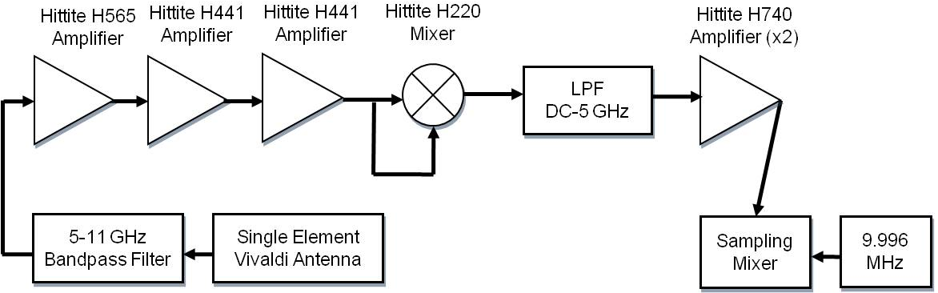
(a)

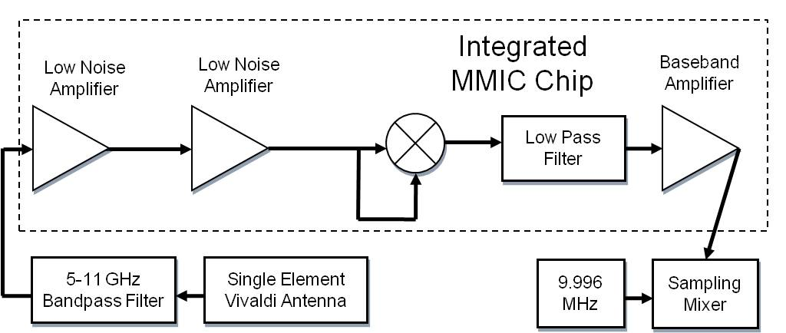
(b)
Figure 9-64. Block diagram of UWB receiver front-ends: (a) discrete, (b) integrated into a MMIC chip [207].

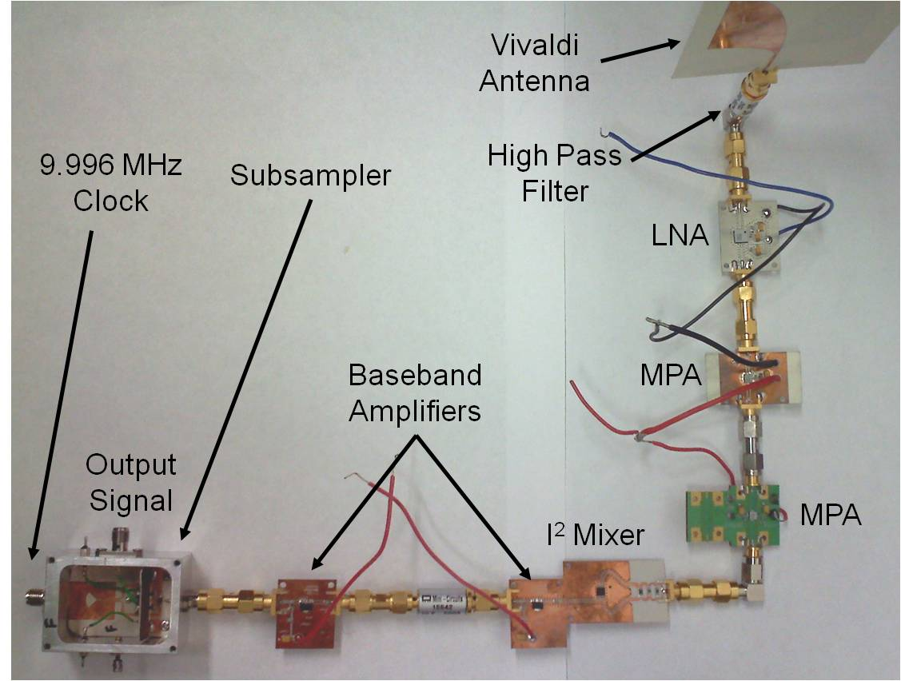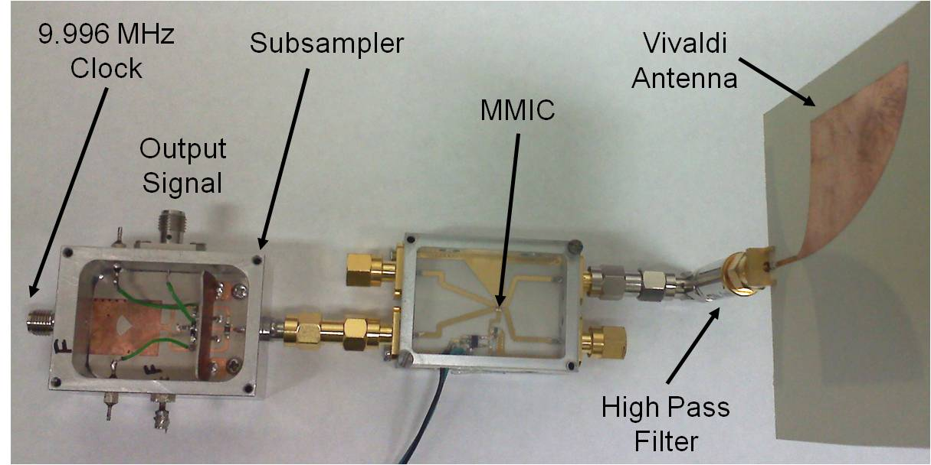
(a) (b)
Figure 9-65. UWB receiver front-ends: (a) discrete, (b) integrated into a MMIC chip [20].

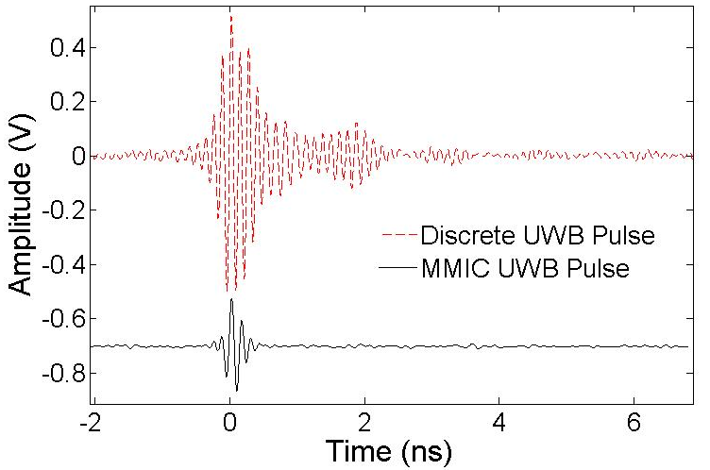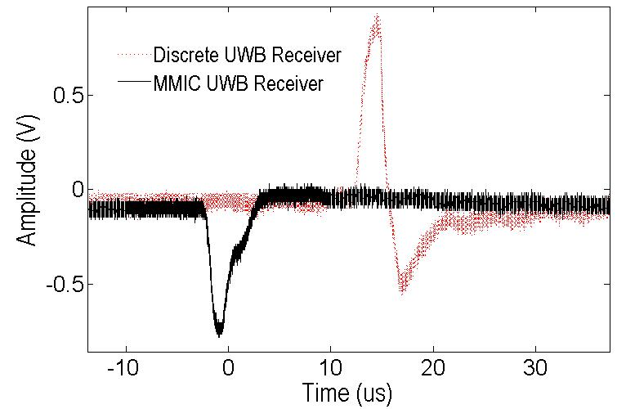
(a) (b)
Figure 9-66. Experimental signals: (a) transmitted UWB pulse, (b) received UWB pulse after subsampling.

difference of two discrete and two MMIC front-end receivers. The raw standard deviations are 11.2 mm and 9.59 mm for the discrete and MMIC receivers. Figure 9-68 shows the same time differences after applying a 300 sample moving window averaging filter. The standard deviations are reduced to 0.58 mm and 0.64 mm for the discrete and MMIC receivers. Figure 9-69 shows how the standard deviation decreases for larger averaging windows with no difference between discrete and MMIC receivers. Figure 9-70 shows a dynamic experiment where a tag moves freely around the view volume causing dynamic changing of the time differences. The optical tracking system is calibrated to the UWB tag and all four UWB receivers to provide 3-D real-time reference data. As shown in Figure 9-70, the UWB and optical systems follow identical trends within a few millimeters. Figure 9-71 shows the absolute difference between the time differences for the UWB positioning system versus the optical positioning system. The MMIC receivers have a root mean square error (RMSE) of 2.56 mm while the discrete receivers have a RMSE of 4.47 mm over all 10,000 samples.
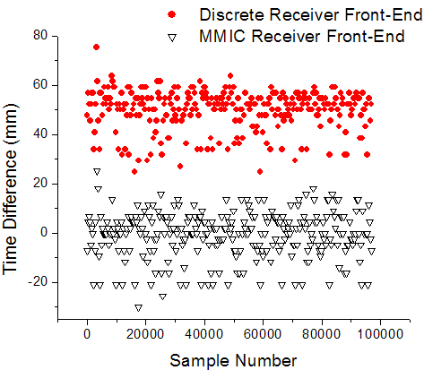
Figure 9-67. Raw time difference static data for two discrete front-end receivers versus two MMIC receivers in millimeters with MMIC data offset to zero for illustration.

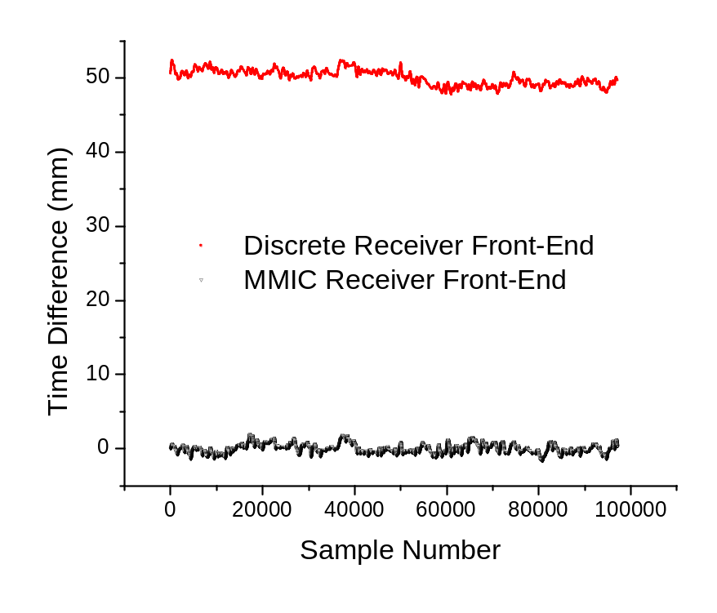
Figure 9-68. Time difference static data for two discrete front-end receivers versus two MMIC receivers in millimeters after applying a 300 sample averaging window.

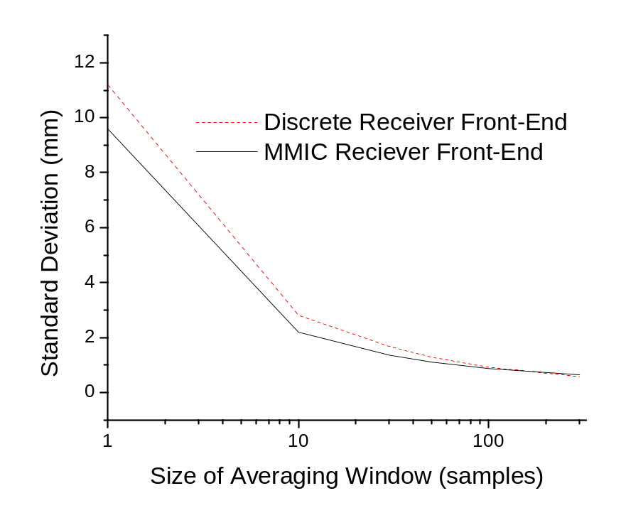
Figure 9-69. Standard deviation of static time differences comparing two discrete receiver front-ends to two MMIC receiver front-ends with a variable averaging window size.

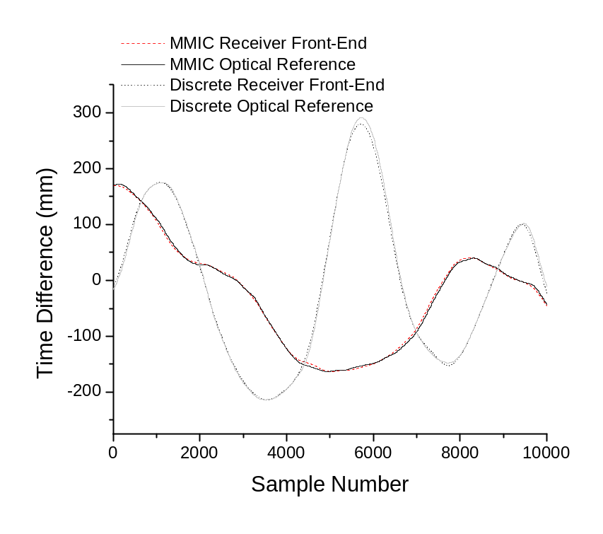
Figure 9-70. Dynamic time differences in millimeters as the tag is moved freely in the view volume comparing two discrete and two MMIC receiver front-ends. An optical tracking system provides 3-D real-time reference data.

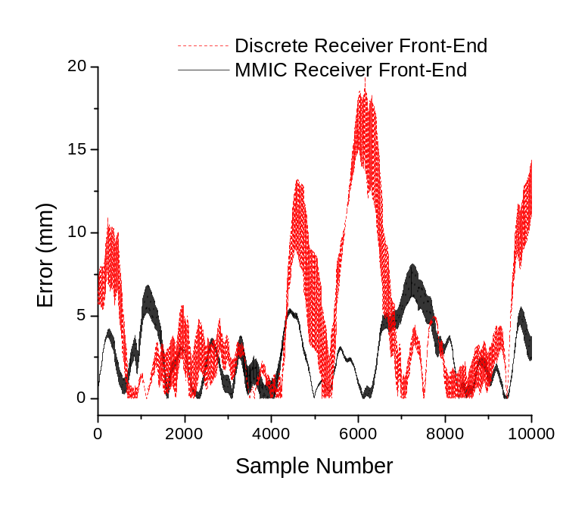
Figure 9-71. Ranging errors in the dynamic time differences shown in Figure 9-70 when comparing the UWB time difference data to the optical (ground truth) time difference data.

Conclusion
We are currently working towards integrating MMIC front-ends into our UWB transmitter and receiver chains to reduce power consumption and size. As discussed in Section 9.5.3, the performance of the discrete and MMIC receiver front-ends was similar in both static and dynamic experiments, showing the potential of MMIC front-ends in future systems targeting high accuracy indoor positioning. Future work includes the design and integration of a tag using the MMIC UWB transmitter into the UWB development platform outlined in Section 9.4.

A Multi-Tag Development Platform for High Accuracy Indoor UWB Localization: Experimental Analysis

Overview
The Multi-Tag Development Platform is outlined in Section 9.4. It contains an integrated tag design with 10 operational tags, an energy detection receiver with squaring mixer, DSP for leading-edge detection and multi-tag support, and real-time dynamic operation via a C++ software application with user interface. Results are presented in this chapter for four base station scenarios using the Multi-Tag Development Platform. This includes 3-D dynamic and static experiments with multiple tags operating simultaneously. Future experiments are discussed including a four monopole UWB probe for resolving 3-D translation and rotation and 3-D point picking as well as integration of the Multi-Tag Development Platform with an inertial measurement unit being researched and developed at the Center for Musculoskeletal Research at The University of Tennessee. An analysis of the errors observed in these experiments is also provided.

Real-Time Experiments
Experiments were undertaken using four base stations to resolve the 3-D positions of one or more tags. The cable length offsets were removed and a 3-D dynamic calibration was performed as discussed in Section 9.4. Also, a static tag was used to mitigate receiver clock jitter and drift effects as discussed in Section 9.4. Figure 10-1 shows the frequency response of the two averaging filters which can be applied independently to the dynamic UWB positioning data.
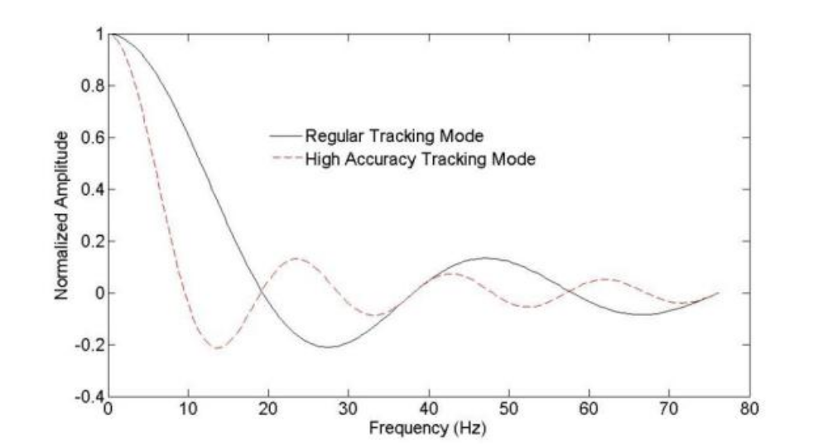
Figure 10-1. Two different sized averaging filters are applied to the 3-D UWB dynamic positioning data. The regular tracking mode detects frequencies in the 3-D motion of up to 15 Hz while the high accuracy tracking mode provides better accuracy but at the expense of detecting only 8 Hz of 3-D motion.

The regular tracking mode averaging filter has a 3 dB passband of 15 Hz which can capture relatively quick 3-D motion compared to the high accuracy track mode. The high accuracy track mode has a 3 dB bandwidth of 8 Hz. The regular track mode can pick-up quick motions such as the tag vibration outlined in Figure 10-2. The high accuracy track mode may still pick-up some at least some of this motion, although with decreased sensitivity. Figure 10-3 outlines the overall system refresh rate and individual tag refresh rate for up to 10 tags. The maximum system update rate is around 1300 Hz due to baud rate limitations with the control station RS-232 link (described in Chapter 4). A 20% reduction in overall system update rate occurs when tracking multiple tags due to lost packets during the tag switches TDMA process. The individual tag update rate decreases as more tags are added since each tag gets fewer and fewer
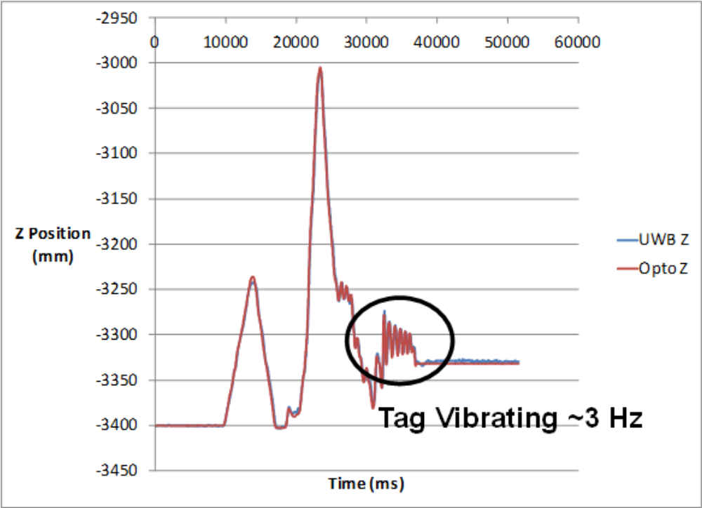
Figure 10-2. 3-D dynamic experiment where UWB and optical systems are calibrated together. A 3 Hz vibration of the tag as it placed back on the optical rail is detected by both the UWB and optical tracking systems. These results are for Tag 13.
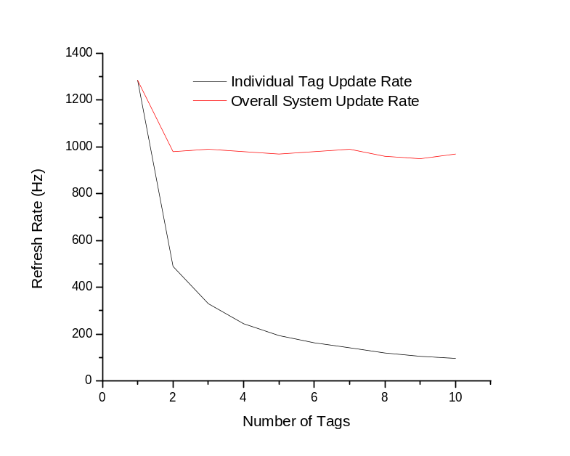
Figure 10-3. System and individual tag refresh rate versus the number of tags for up to 10 tags. The overall update rate with a single tag is around 1300 Hz. Only 1000 Hz total update rates can be achieved for multi-tag tracking since around 20% of the data is lost during the tag switching process.
time slices allocated to it.

Optical Rail Experiments with Optical Tracking
Optical rail experiments were undertaken where one tag was placed in a static location while the other tag was moved along the optical rail with an infrared tracking probe from the Optotrak 3020 rigidly attached and the UWB and optical tracking systems calibrated to one another. This experimental setup is shown in Figure 10-4. Typical experimental results for the optical tracking experiment are shown in Figure 10-5. The majority of movement occurs in the Z dimension, so only the Z dimension is shown. There is good agreement between the optical and UWB tracking systems. Typical 3-D dynamic error across the 10 tags is around 6-8 mm 3-D for the optical rail experiment using the regular tracking mode 15 Hz averaging filter.
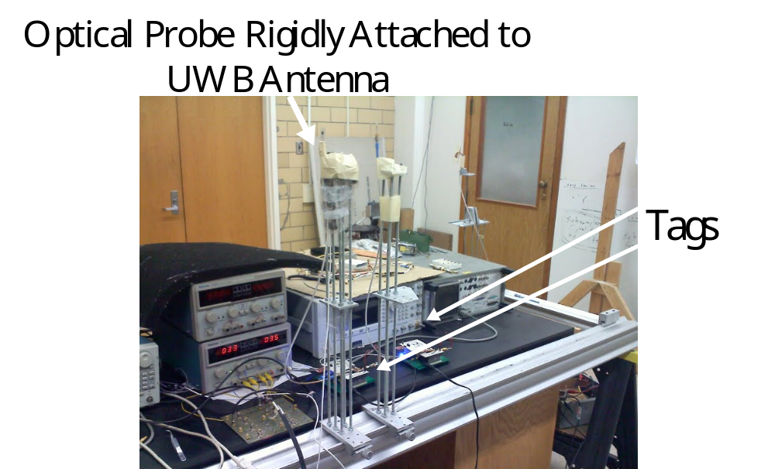
Figure 10-4. Experimental setup for optical rail experiments where one tag serves as the static tag while the other tag is moved along the optical rail with an infrared 6 DOF probe rigidly attached to it.

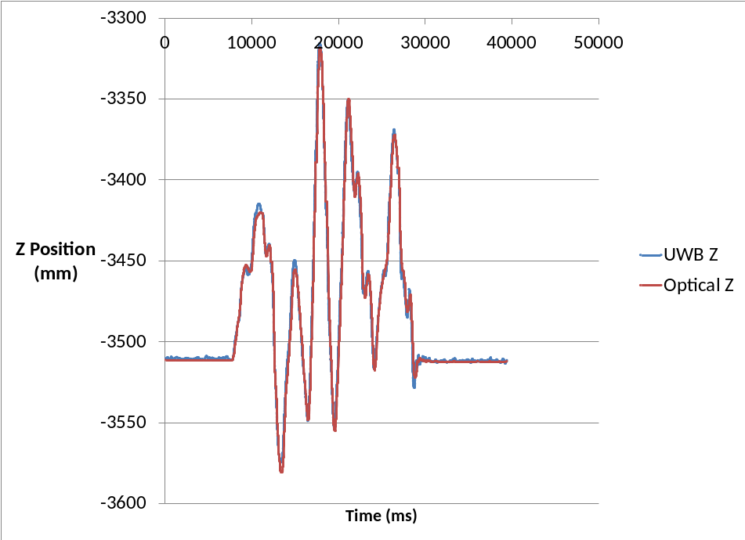
Figure 10-5. Typical optical rail experiment where the majority of 3-D motion is along the Z axis. The optical tracking system and UWB positioning system track together with around 6-8 mm of 3-D dynamic error. These results are for Tag 8.

Free Motion Experiments with Optical Tracking
Freeform motion experiments were undertaken using the same experimental setup shown in Figure 10-4. In the freeform dynamic experiment, the tag is moved around continuously through the view volume in a random fashion with some quick turning and accelerating. Typical 3-D results from the freeform experiments are shown in Figure 10-6, Figure 10-7, and Figure 10-8. Overall the UWB and optical data track together well. There is still 5-7 mm of 3-D dynamic error between the two systems. One reason for this error is the phase center bias outlined in Section 9.4. The freeform experiments showcase the robustness of this system in detecting quick and changing motions around the view volume. A summary of freeform 3-D dynamic experiments is provided in Table 10-1. Overall the tags perform similar to one another
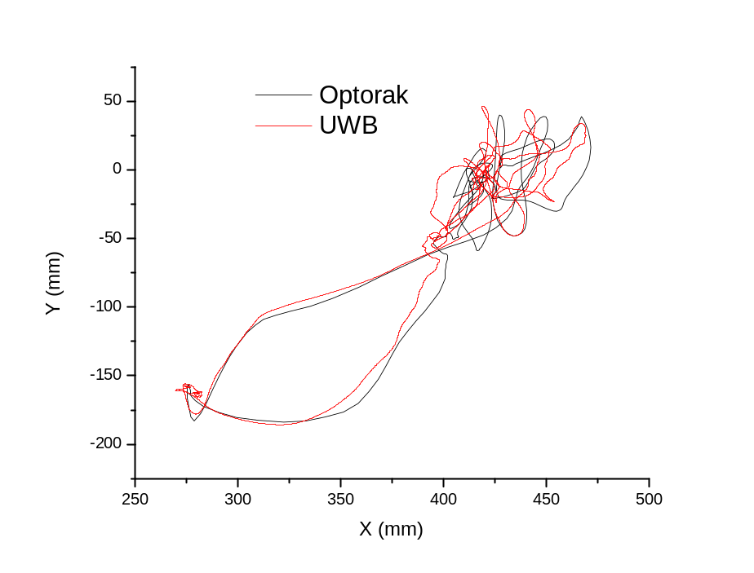
Figure 10-6. X-Y cross section showing optical and UWB data for a dynamic freeform experiment for Tag 10. Good agreement can be seen between the UWB and optical tracking systems, although certain 3-D locations have more error than others.
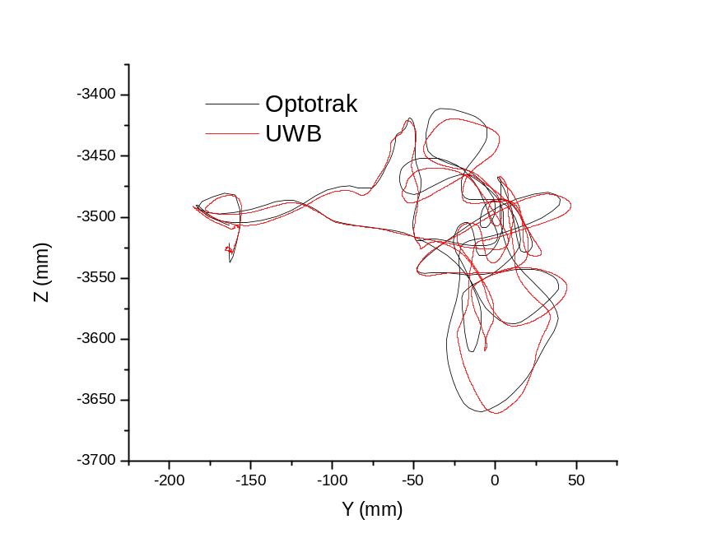
Figure 10-7. Y-Z cross section showing optical and UWB data for a dynamic freeform experiment for Tag 10. Good agreement can be seen between the UWB and optical tracking systems.
Figure 10-8. X-Z cross section with time also displayed for Tag 10 to show the real-time tracking of the UWB positioning system by the optical tracking system.
with 5.56-7.12 mm 3-D RMSE measured for the high accuracy track mode and 7.56-11.6 mm 3-D RMSE for the regular track mode. These experiments were performed three times per tag and averaged to get consistent results. The overall average across all 10 tags was 9.54 mm 3-D RMSE for regular tracking mode and 6.71 mm for high accuracy track mode. These results are promising, especially since the tag is a standalone system and this was a freeform experiment which typically causes more error than other types of less dynamic experiments. Also, the tag is using a VCO rather than a low phase noise local oscillator. The VCO was a serious detriment to the 1st generation system outlined in Chapter 2.

Two Tag Dynamic Experiments
Currently only one optical probe is integrated into the UWB positioning system, so it is
Table 10-1: Error summary of 3-D dynamic experiments where a tag is moved freely in the view volume and tracked by the optical tracking system. A static tag is used to remove receiver clock jitter and drift.
Tag | 80 Sample Average  15 Hz Passband  3-D RMS Error (mm) | 160 Sample Average  8 Hz Passband  3-D RMS Error (mm)
2 | 7.56 | 5.56
4 | 11.6 | 6.67
5 | 10.1 | 6.99
8 | 8.62 | 6.98
9 | 9.79 | 7.01
10 | 9.08 | 7.04
12 | 10.1 | 7.12
13 | 9.23 | 7.00
14 | 9.81 | 6.61
15 | 9.53 | 6.14
Average | 9.54 | 6.71

not possible to get 3-D accuracy for both tags. Nonetheless, experiments can be run to verify visually and within the context of the experiment that multiple tags are tracking dynamically at the same time. Figure 10-9 shows an X,Y,Z plot of the 3-D position of two tags as the rigid body both of them are attached to begins to move. The UWB positioning system can handle tracking up to 10 tags simultaneously, so as expected tracking two simultaneously works well.
Figure 10-9. X,Y,Z plot of the 3-D position of tag separate tags as they are moved dynamically while attached to the same rigid body. Accuracy was not measured but is estimated at 6-7 mm 3-D RMSE.

Analysis of Observed Errors
The results presented in this chapter of 6-9 mm of 3-D RMSE are promising since an integrated tag is being used which has a noisy VCO as its LO source, and many real system design features have been incorporated into the multi-tag UWB development platform. Unfortunately, the goal of this project is sub-millimeter accuracy, so there are still more hurtles to overcome in the pursuit of sub-millimeter 3-D wireless accuracy. Figure 10-10 shows dynamic data for the X dimension where X has a higher PDOP when compared to Y and Z (around 2). This causes reduced range resolution and higher errors in the X dimension. Figure 10-11 shows the Y dimension for the same experiment. The Y dimension in this case does not have significant added PDOP but rather contains phase center bias and error which is easily
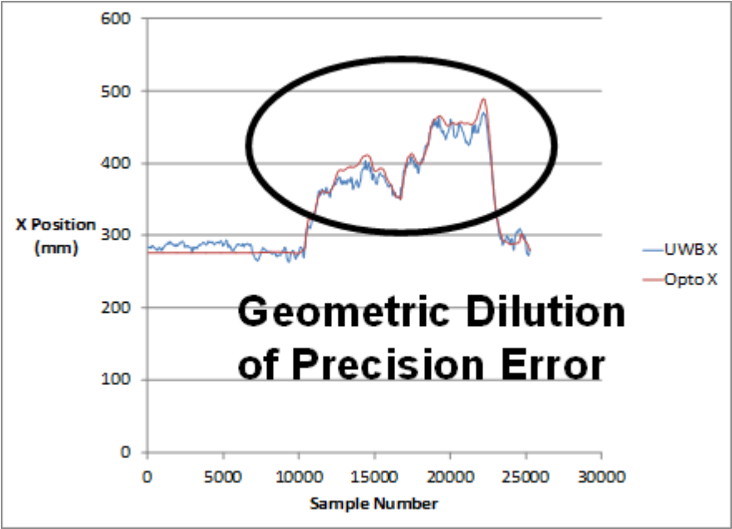
Figure 10-10. X position of Tag 10 in a dynamic freeform experiment where increased error and instability caused by a high geometric dilution of precision in the X direction can be seen.

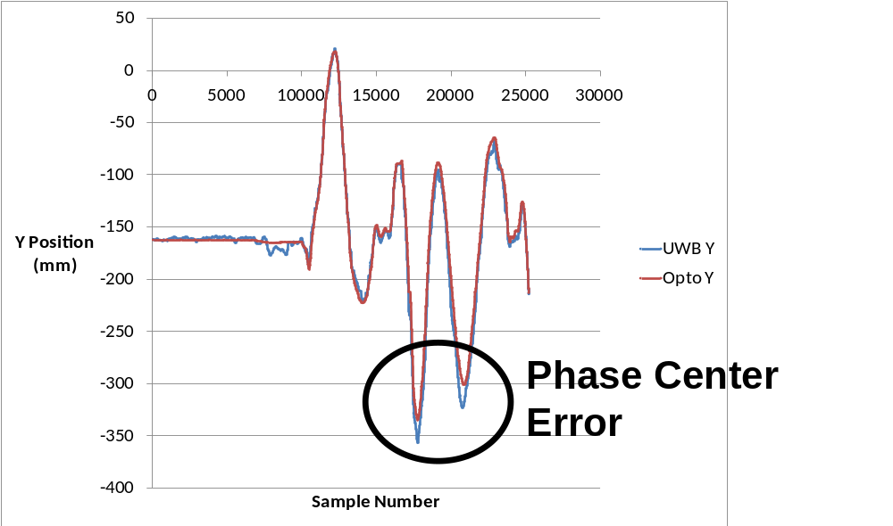
Figure 10-11. Y Position of Tag 10 in a dynamic freeform experiment. The large offsets are indicative of phase center error which ultimately causes these types of scaling errors.

observed in the extreme locations of the view volume such as those locations outlined in Figure 10-11. Figure 10-12 is the Z dimension for the same experiment. No noticeable PDOP effects or phase center biasing effects are observed. Finally, Figure 10-13 illustrates how phase center biasing and dynamic phase center variation can cause areas of significant bias in the range differences. Some locations within the view volume have little to no effects from phase center biasing while other locations see significant bias effects.

Conclusion
Dynamic 3-D data has been presented for the 10 tags which are part of the UWB Multi-
Tag Development Platform. This includes optical rail and freeform dynamic experiments. Additional error sources observed during this experimental analysis have also been highlighted. The UWB Multi-Tag Development Platform consistently achieves 6-9 mm 3-D
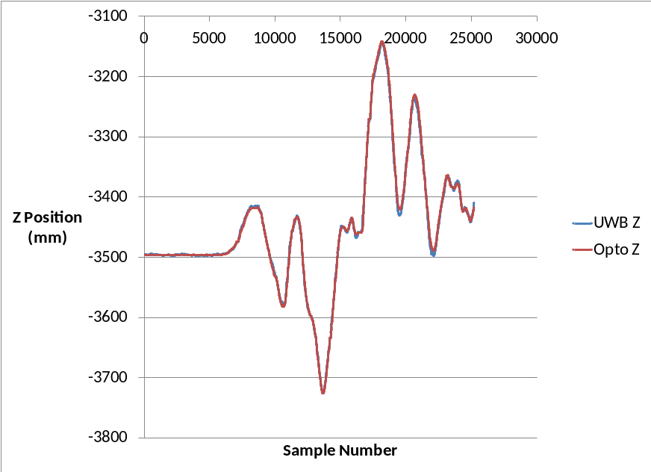
Figure 10-12. Z position of Tag 10 where the other error sources (geometric dilution of precision and phase center biasing) do not occur to large extent.
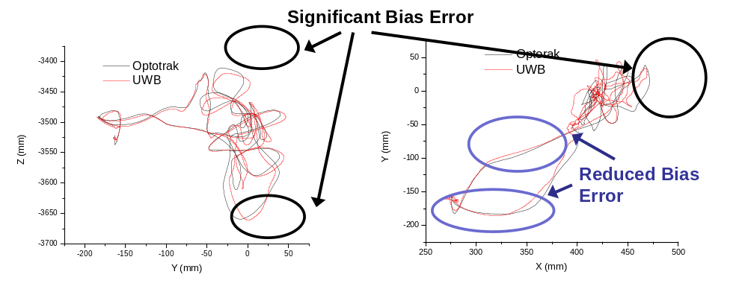
Figure 10-13. X,Y,Z cross sections with focus on significant bias error locations versus reduced bias error locations. This variation in bias error is most likely caused by inaccurate base station phase center measurements.
accuracy in freeform dynamic experiments across a large portion of the view volume (50 cm x 20 cm x 20 cm). More experimental analysis is needed to test the effect of five base stations in standard TDOA operation. This system achieves comparable 3-D dynamic accuracy to the 1st generation system outlined in Chapter 2 even after the addition of integrated tags and base stations and the removal of low phase noise LOs from the transmitter and receiver.

Towards Sub-Millimeter Accuracy in UWB Positioning for Medical Environments
Advances in UWB and other enabling technologies has resulted in higher achievable accuracy for wireless sensor networks, which has opened up new applications including smart medical instruments, surgical navigation, and tracking in wireless body-area-networks. To realize the potential of these approaches as transformative technologies, additional research is needed in three main areas: (1) investigation of system-level design concerns and comprehensively quantifying their effects on overall system accuracy (e.g. UWB receiver leading-edge detection algorithms, Tx/Rx system architectures, local oscillator phase noise sensitivity, etc.); (2) realization of novel UWB system architectures through integrated RF front-ends with microwave integrated circuit (MIC) and monolithic microwave integrated circuit (MMIC) technologies; (3) quantifiable testing of the system performance in realistic hospital environments in terms of dynamic 3-D accuracy using novel, real-time testing platforms.
The potential exists to fundamentally change the achievable accuracy of indoor wireless localization systems to millimeter and sub-millimeter accuracy for an array of new location-aware clinical applications including smart medical instruments, surgical navigation, and wireless body-area-networks. The proposed novel UWB localization techniques have a strong potential to be transformative by overcoming inherent limitations of current RTLS that have been exhaustively investigated and developed into commercial products. Also, comprehensive development and testing platforms for UWB localization systems in clinical settings are needed to optimize these systems for hospital use. The impact of this work will be felt not only by engineers working towards high accuracy UWB localization systems for dense indoor environments in applications such as surgical navigation and location-aware smart sensing medical instruments, but for scientists working in fundamental areas including microwave-based biological sensors and characterization of biological tissues at microwave frequencies. Successful development of high accuracy UWB localization systems would have a direct and significant impact on indoor wireless positioning systems, surgical navigation, wireless bio-sensors, and biological sensing – fields that rely critically on high accuracy localization and accurate detection of changes in dielectric properties at microwave frequencies.
Although these technologies can be scaled and applied to any UWB-available frequency range, it is advantageous to utilize the 3.1-10.6 GHz and 22-29 GHz bands allocated for UWB use by the FCC in 2002. The rationale for using these bands is (1) the 3.1-10.6 GHz band has received enormous interest in designing UWB communication, imaging, and localization systems for a wide array of indoor applications with existing commercial devices and chipsets available and (2) the 22-29 GHz band will have less indoor interference, allow for smaller circuit, chip, and antenna design, provide an attractive testing platform for MMIC technology, and mature MMIC devices are currently available for rapid prototype design. The mature technologies available at these frequency bands ensure a higher likelihood of success in the commercialization and realization of these systems.

Overview
Ultra-wideband technology has been utilized in low probability of detection radar and communications systems for decades since its inception from time domain electromagnetics in the 1960s [13]. Interest in UWB for unique indoor communications and positioning applications has skyrocketed since the FCC released its notice of inquiry in 1998 and then opened up the 3.1-10.6 GHz and 22-29 GHz frequency bands for UWB use in 2002 [4].
A depiction of a typical indoor positioning system is shown in Figure 11-1 where the base stations are connected to a master processing unit, and a reference tag is needed to bring the mobile tag into the 3-D global coordinate frame. The use of time difference of arrival for 3-D triangulation combined with the leading-edge detection at the UWB receiver help mitigate the stringent requirements needed in terms of base station synchronization and ranging sensitivity to dense indoor multipath interference. Although the system architecture shown in Figure 11-1 is well known and has been implemented in other wireless positioning systems including GPS, realizing this architecture for high accuracy indoor 3-D positioning has proven to be deceptively difficult. Figure 11-2 provides an example of a carrier-based UWB positioning system developed at the University of Tennessee with documented 3-D millimeter accuracy in real-time, indoor, repeatable experiments using a robot for controlled 3-D motion where the UWB positioning system is calibrated with an optical tracking reference system [61],[20].
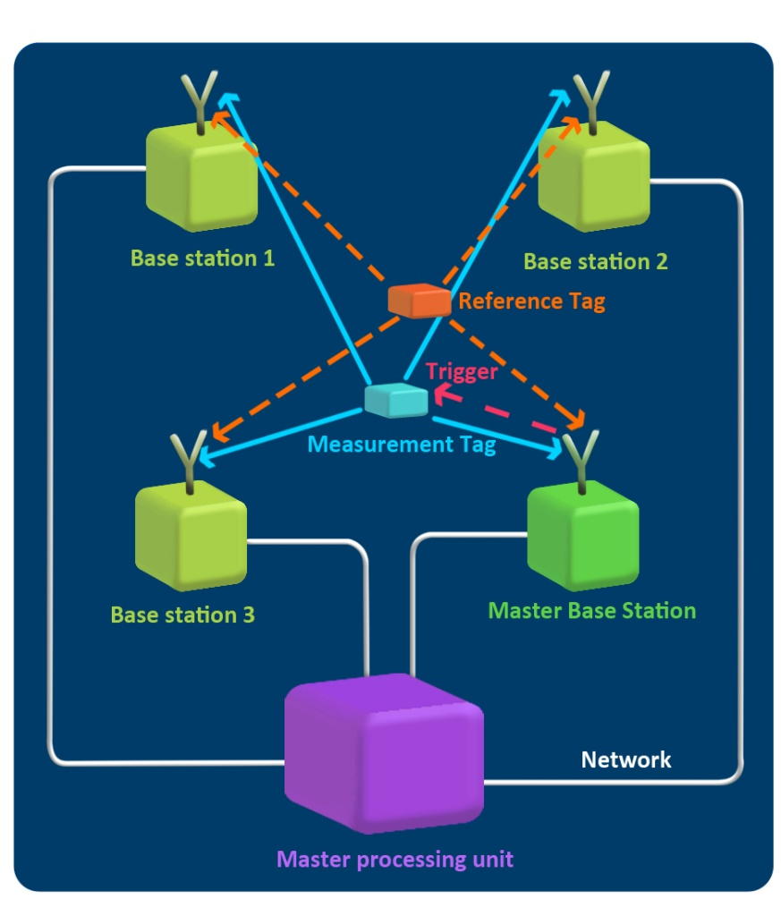
(b)
Figure 11-1: A typical indoor positioning system where four or more base stations triangulate the 3-D position of a mobile tag, and a reference tag in a known location serves as a reference point for the global coordinate frame.
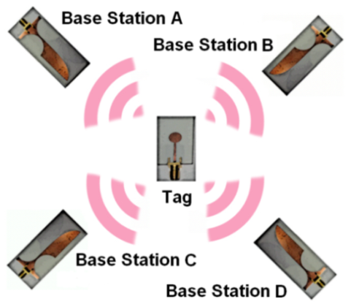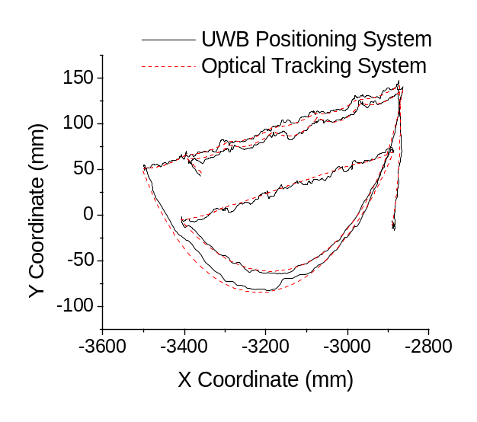
Figure 11-2: (Left) UT developed UWB positioning system with four base stations and a mobile tag. (Right) UWB 3-D real-time data overlayed with data from an optical reference source with the two systems calibrated in a dynamic experiment where 3-D motion is controlled by a robot [61],[19],[20].

Background
Central difficulties in achieving high 3-D real-time accuracy for indoor localization systems include indoor multipath interference, sampling-rate limitations, local oscillator phase noise, phase center effects, system clock jitter and drift, etc. Many techniques have been proposed for ranging in UWB positioning systems which includes (see Figure 11-3a): leading-edge detection [13],[84],[85],[53], matched filter [16],[89], received signal strength [90]-[92], first peak detect [93]-[95], and peak search and subtract [19],[82],[83],[86],[87]. As discussed in [63],[64], the main limitation of peak detection algorithms (e.g. received signal strength, first peak detect, and peak search and subtract) is assuming a priori information concerning the received pulse shape. The matched filter is useful in low SNR environments in conjunction with leading-edge detection. In realistic indoor environments which contain significant multipath interference, this introduces large 1-D ranging errors resulting in poor overall 3-D accuracy (Figure 11-3b). In many current systems, a tunnel (or square law) diode is used at the receiver for energy detection which integrates a nanosecond of the incoming signal, putting an upper bound of roughly 5 cm on the 1-D ranging accuracy even when using leading-edge detection [13]. The ranging limitations due to multipath interference are compounded with sampling rate limitations. Figure 11-4 shows dependence of the overall 3-D accuracy on receiver sampling rate. In order to achieve millimeter range 3-D accuracy, sampling rates >100 GSPS are needed. This can be achieved with a sub-sampling receiver architecture developed at UT [40]. The use of conventional analog-to-digital converters (ADC), even if 5-10 GSPS, places an upper bound on the 1-D ranging accuracy of 5 cm.
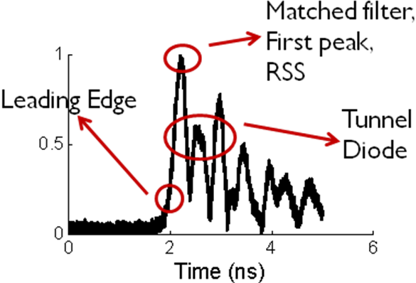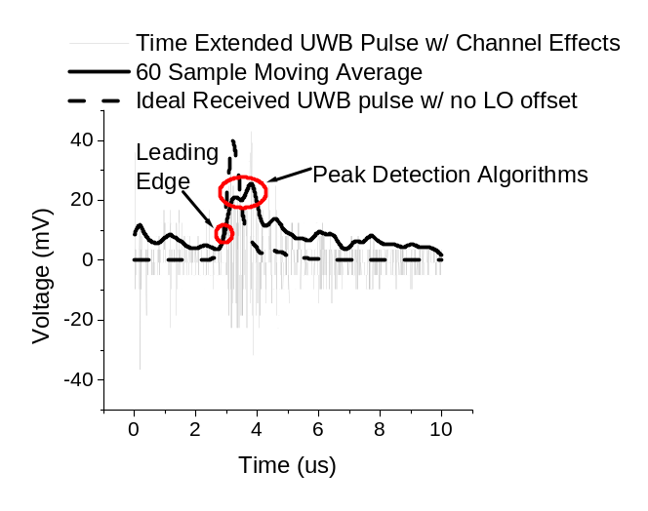
(a) (b)
Figure 11-3: (a) Comparison of peak and leading-edge detection methods utilized at the UWB receiver where the leading-edge of the multipath signal provides the highest accuracy and does not assume a priori pulse shape information, (b) received signal where significant pulse distortion causes noticeable error in locating the correct peak position while the leading-edge of the UWB pulse results in mm 1-D ranging.
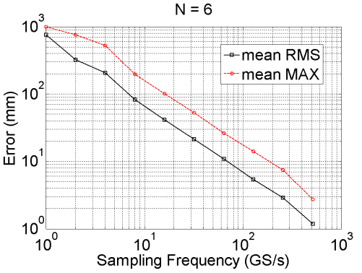
Figure 11-4: Simulation using six base stations and 81 tag positions to quantify the accuracy dependence of the UWB positioning system on receiver sampling rate (i.e. sampling rate of the sub-sampling mixer).

State-of-the-Art UWB Positioning Systems
Although UWB positioning systems are well established in their use for indoor applications requiring 3-D real-time accuracy on the level of 10-15 cm, current approaches (i.e. commercial systems) have not been able to meet the stringent accuracy specifications (e.g. 1-2 mm or sub-mm 3-D) of the next level of applications including smart medical instruments, surgical navigation, and tracking in wireless body-area-networks. As shown in Table 11-1, current research efforts for indoor UWB positioning systems, including research done at the University of Tennessee, show the potential for millimeter and even sub-mm dynamic real-time accuracy if certain limitations can be overcome. Carrier-based UWB positioning systems have the potential for millimeter and even sub-mm 3-D real-time accuracy and offer unique advantages in mitigating multipath interference in dense indoor environments if the challenges and limitations of these systems can be overcome. These advantages have a strong potential to be transformative in high accuracy wireless indoor positioning systems by overcoming limitations inherent to existing system architectures. Currently available commercial system architectures have been extensively researched and developed and rely on technologies rapidly becoming outdated in achieving high accuracy in dense indoor multipath environments.
The principal advantage of UWB positioning systems is a robustness to multipath interference compared to competing wireless technologies due to the large bandwidths of the transmitted signals which allows highly accurate gating of multipath signals in the time domain. The current system architecture of the UWB positioning system developed at the University of Tennessee is shown in Figure 11-5a where a UWB baseband pulse is modulated by LO₁ and transmitted via a UWB monopole antenna to the UWB receivers. A sampling mixer is used to sub-sample the incoming periodic UWB received signal which is followed by a conventional ADC and leading-edge detection on a FPGA. The use of leading-edge detection at the UWB receiver eliminates the need for a priori pulse shape information – a serious limitation of many current UWB positioning systems. Future research to extend accuracy to sub-mm must focus on analyzing, extending, and building upon this and other current system architectures to develop a mature platform for comprehensive development and testing of high accuracy indoor positioning systems.
A second key to future UWB indoor positioning system architectures is that a non-coherent approach should be utilized between the transmitter and receiver. Allowing non-coherency reduces the complexity at both the transmitter and receiver compared to systems which require a coherent signal (i.e. phase detection circuitry), e.g. FMCW. This reduces power consumption and circuit board real estate requirements at both the transmitter and receiver. Also, since coherency is not needed in the final ranging measurement (e.g. leading-edge detection
Table 11-1: State-of-the-Art Research in UWB Positioning Systems
Group | Coherence |  | Triangulation Method | Environment | Typical Accuracy | Range
University of Tennessee [19],[20] |  | Wireless | TDOA | Residential LOS | 5.5 mm  (3-D) | 5 m
Zetik et al. [17] | Wired |  | TDOA | Indoor LOS | 1.5 cm (2-D) | 4 m
Low et al. [16] | Wired |  | TOA | Commercial LOS | 2.0 cm or 10.6 cm  (1-D) | 8 m or  24 m
Meier et al. [18] | Wired |  | TOA | Indoor LOS | 0.1-2.0 mm (1-D) | 8 m
Fujii et al. [25] | Wireless |  | TDOA | Indoor LOS | 20 cm (2-D) | 8 m
algorithm), it is possible to build and test impulse-based UWB system architectures at the transmitter and receiver with minimal change to a carrier-based system architecture (e.g. build an impulse-based UWB transmitter where the output frequency spectrum is centered at LO₁ and use the existing receiver architecture outlined in Figure 11-5a for positioning). The use of a sampling mixer to sub-sample the received periodic UWB waveform also reduces the system complexity by relaxing the requirements of the ADC, as shown in Figure 11-5b. In choosing a repetition rate for the sub-sampling process at the UWB receiver, care is taken to ensure this sub-sampling process does not violate the channel coherence time of the indoor UWB environment. Many advantages are readily apparent in our current system architecture including robustness to multipath interference, simplified transmitter and receiver architectures through a novel non-coherent approach, and mitigation of sampling-rate limitations in achieving high accuracy 1-D ranging.
Although many inherent advantages exist in the current UWB positioning system architecture designed for high accuracy indoor applications when compared to competing technologies, limitations inherent to these current systems have kept this technology from reaching its true potential in high accuracy short range applications and must be addressed. Before outlining how to expand our current architecture in terms of analysis, design, and comprehensive testing platforms, it is essential to examine the limitations and challenges of the current carrier-based UWB positioning system architecture.
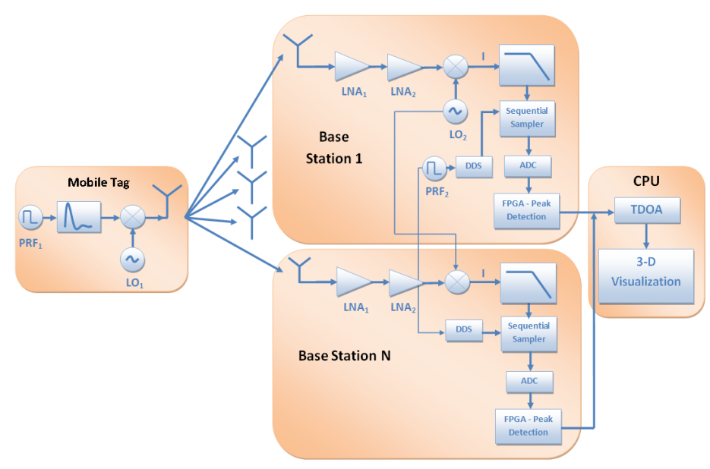
UWB Channel
(a)
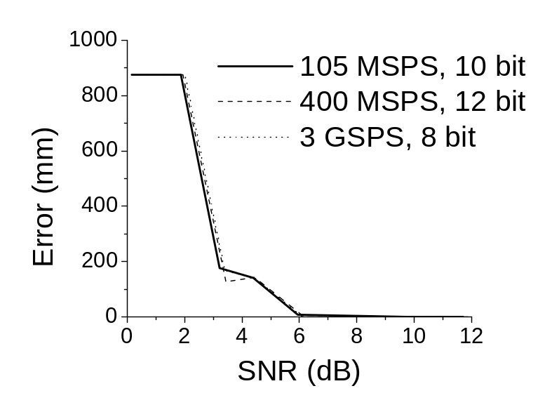
(b)
Figure 11-5: (a) Current carrier-based UWB positioning system architecture designed at UT highlighting the RF front-ends and digital back-ends at the UWB transmitter (tag) and UWB receivers (base stations) as well as the master processing unit where the final TDOA calculation takes place (CPU). (b) Simulated leading-edge detection 1-D error vs. SNR of received UWB pulse for three ADCs [64].

Challenges in High Accuracy UWB Positioning Systems
Many challenges exist when building an indoor UWB positioning system targeting millimeter or sub-millimeter 3-D dynamic accuracy. This includes the noise and sensitivity of the UWB receiver, local oscillator phase noise (in the case of a carrier-based system), antenna phase center variation, time scaling, jitter, and degradation due to overall system calibration. Each of these challenges is discussed with focus on how each affects the UWB positioning system designed at The University of Tennessee.

Noise and Sensitivity at the UWB Receiver
When analyzing the sensitivity of the UWB receiver to AWGN and SNR, the max-ratio leading-edge detection algorithm implemented on the FPGA must be examined in further detail to understand the overall limitations of the current system in terms of ranging accuracy. As discussed in Chapter 4, the max-ratio leading-edge detection algorithm uses two maximum windows applied to a low pass filtered version of the received digital signal. The ratio of the amplitudes of the two max windows is examined and compared to a fixed threshold value $α$, currently set to 2. thresh represents a noise threshold which is estimated by the FPGA during the latter half of the clock period when no signals are received. When $max_n_{1}[t]$ reaches half the amplitude of $max_n_{2}\left[t\right]$ (n₁=16,n₂=256) and the signal is above the noise threshold, r[t]=1, and the leading-edge is detected. Currently this algorithm fails for SNR < 6 dB (corresponds to $α$=2). Although it works well in dense multipath environments, this is dependent on a relatively high SNR of >6 dB and LOS conditions. The general consensus on UWB ranging is that a high SNR is needed for any chance at accurate positioning, placing a restriction on the robustness of the current system. Another limitation of the current system is the dynamic range of the UWB receiver which limits the current operating range of the system to 5 m. Finally, as discussed in Section 8.3.3, our system currently operates from 5.4-10.6 GHz, which makes it susceptible to narrowband, high power IEEE 802.11a/n interferers (see Section 8.4) and needs to be addressed at the design level of our proposed advanced positioning system.

Local Oscillator Phase Noise
The non-coherent architecture of the current UWB positioning system places stringent requirements on phase noise specifications of the local oscillators at the transmitter and receiver. The use of a reference tag partially mitigates the local oscillator phase noise and temperature effects at the UWB receivers. Even with a reference tag, the phase noise presents a formidable challenge to achieving millimeter 3-D real-time accuracy. As shown in Figure 11-6, when high phase noise carriers (e.g. free running voltage controlled oscillators) are used at the transmitter and receiver, 3-D RMS jitter of 18.8 mm is observed while 5.73 mm of 3-D RMS jitter is observed using low phase noise carriers (e.g high-end bench-top instruments). Bench-top instruments are not practical in realistic systems, so novel approaches are crucially important to reduce the phase noise of the LOs at the transmitter and receiver.

Antenna Phase Center Variation
When attempting to achieve millimeter and sub-mm accuracy, phase center variation of the antennas at the Tx/Rx is an important source of error which needs to be taken into account. The transmitter employs a UWB monopole antenna which provides an omni-directional radiation
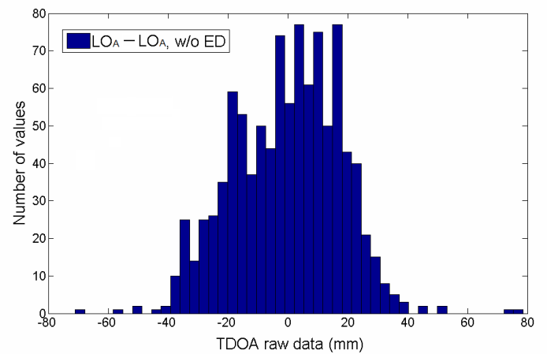
(a)
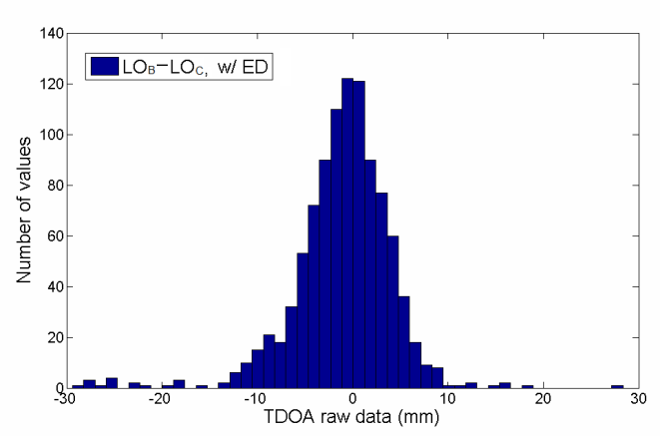
(b)
Figure 11-6: Measured TDOA raw data error distribution for a static experiment where 1000 samples are taken: (a) high phase noise carriers LO_{A} , (b) low phase noise carriers LO_{B} and LO_{C} [20].

pattern with minimal phase center variation while the receiver utilizes a single element Vivaldi antenna for a radiation pattern directed at the view volume of interest. As shown in Figure 11-7, noticeable variation of the phase center is observed in both the E and H cuts especially for angles greater than ±30°. High accuracy positioning systems must employ calibration
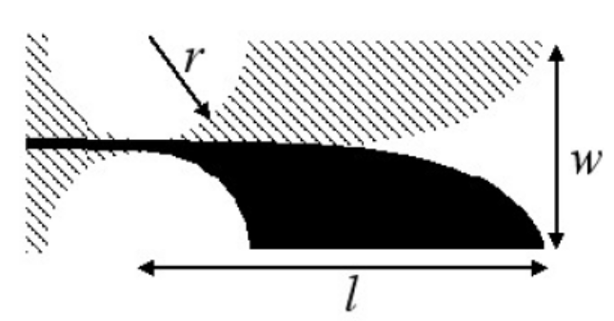
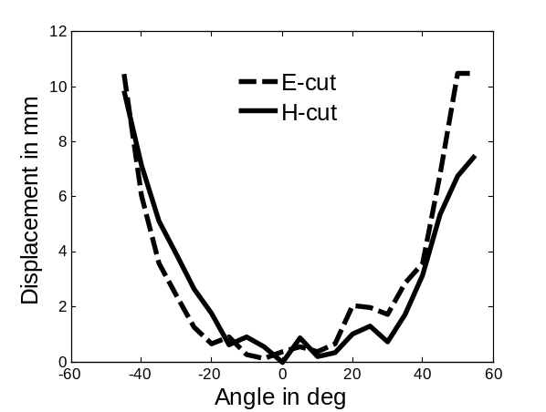
(a) (b)
Figure 11-7: (a) Experimentally measured phase center variation of single element Vivaldi antenna in receiving an up-converted UWB pulse (5.4-10.6 GHz bandwidth), (b) single element Vivaldi antenna.
techniques to remove the phase center effects. For example, antennas used for GPS systems go through an advanced automated calibration process which uses high precision robots to move the antennas to 6000-8000 distinct points in calibrating out phase center effects.

Time Scaling, Jitter Effects, and System Calibration
More challenges appear in achieving high accuracy real-time indoor positioning when moving to the system-level. Cable length effects at the UWB receivers must be accounted for and statically calibrated out of the system. Time scaling effects due to system clock drift must be characterized and calibrated out of the final TDOA calcula$∆ρ_{1k}^{t}=ρ_{1}^{t}-ρ_{k+1}^{t}$tions in a dynamic manner when moving around the view volume. Time scaling effects change across the view volume due to the differences in LOS ranges r_{i} between the tag and each base station. Therefore, multiple points must be collected across the view volume, and a transformation matrix H must be defined to convert from the original TDOA points ΔP which contain time scaling and geometric effects to ΔR, where time scaling and geometric effects are largely mitigated. ΔP and ΔR must be full rank, which means a large number of points must be obtained across the view volume. As shown in Figure 11-8, averaging more pulses at the sub-sampling mixer mitigates jitter effects while amplifying time scaling effects, causing a tradeoff in system performance. All of these effects must be addressed at the system-level and mitigated in a comprehensive manner to ensure optimum performance in achieving millimeter and sub-mm accuracy.

Future Work
To realize the potential of our carrier-based UWB positioning approach as a transformative technology for millimeter/submillimeter accuracy in dense indoor environments, the future research should be focused in three primary areas: (1) investigation of system-level design concerns and comprehensively quantifying their effects on overall system accuracy through development of a novel system-level simulation framework (e.g. UWB receiver
Figure 11-8: Comprehensive simulation of 3-D RMSE as the tag moves across 1000 points along an optical rail where the expansion factor (repetition rate) of the sub-sampling mixer is varied when looking at jitter and time scaling (or no time scaling) effects.
leading-edge detection algorithms, Tx/Rx system architectures, local oscillator phase noise sensitivity, etc.); (2) realization of novel UWB system architectures through integrated RF front-ends with microwave integrated circuit (MIC) and monolithic microwave integrated circuit (MMIC) technologies; (3) quantifiable testing of the system performance in realistic hospital environments in terms of dynamic 3-D accuracy using novel, real-time testing platforms. Specific issues to be investigated and approaches to be taken in these three areas are described in the following subsections.

System-Level Design and Simulation Framework
Many challenges exist in designing a comprehensive system-level simulation framework for our proposed UWB positioning system. As shown in Figure 11-9, in order to simulate the entire system, both the analog and digital portions must be taken into account in varying levels of complexity. No commercially available simulation tools exist which have the capability to simulate all of these disparate components. One approach outlined by Eberle uses proprietary software developed at IMEC in Belgium [67]. A robust method is utilizing an existing electronic design automation (EDA) suite such as Advanced Design System (ADS) from Agilent Technologies. Co-simulation with Matlab and Verilog simulators provides a comprehensive simulation framework where analog, digital, and advanced signal processing can be integrated together for complete system solutions, as shown in Figure 11-10. The current simulation framework outlined in Figure 11-10 should be extended into a complete software application which can communicate with a variety of industry standard simulation tools (e.g. Matlab, ADS, HFSS, Insite,
Figure 11-9: Overview of components which must be taken into account when building a comprehensive simulation framework for accurate and realistic simulations of the complete UWB positioning system.

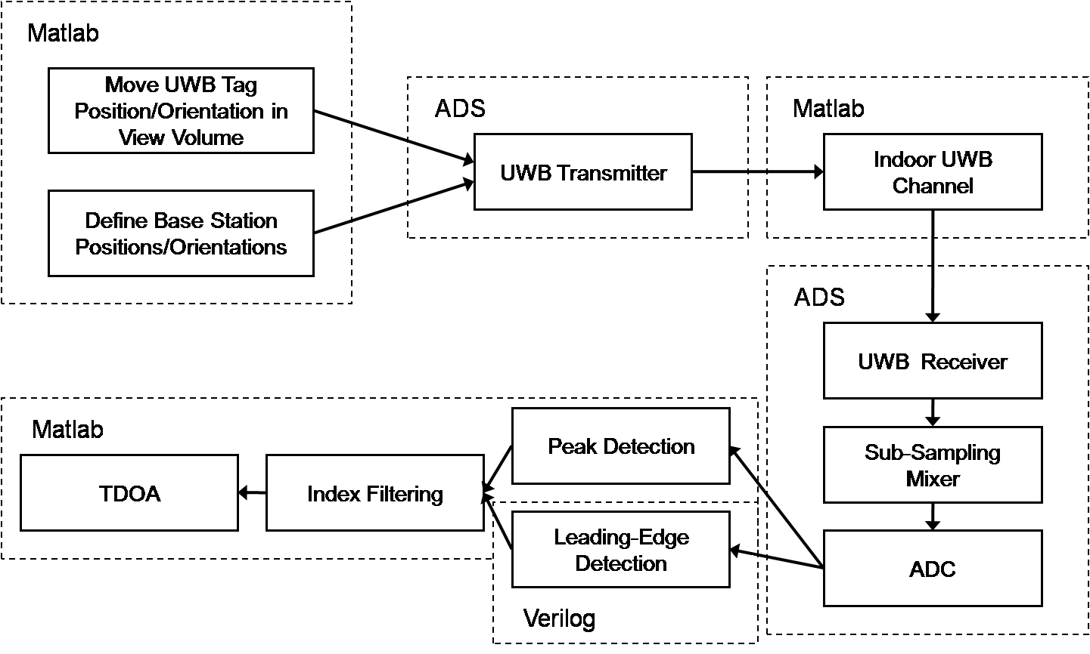
Figure 11-10: Block diagram of complete system-level simulation framework.
etc.) and allow the user to perform comprehensive simulations of various UWB positioning system architectures which includes realistic channel environments adopted from the UWB channel model developed by the IEEE 802.15.4a task force for various indoor environments (e.g. industrial, commercial, residential, LOS, NLOS) [79]-[80]. The final output of the comprehensive simulation framework is 3-D accuracy in triangulating the position of the UWB tag through TDOA. Realistic experimental setups, such as that shown in Figure 11-11a, can be setup to provide quantitative output results such as those shown in Figure 11-4, Figure 11-8, and Figure 11-11b. The current simulation framework needs to be extended into an even more robust solution where a C++ interface ties together the underlying disparate applications and additional simulation tools such as HFSS, Insite, and CST can be used for even more accurate simulations of (1) antennas in realistic operating environments, (2) site specific UWB indoor channels, (3) simulation of phase center effects for orientation-specific cases where various input waveforms can be analyzed, and (4) integration with MMIC simulation tools to quantitatively evaluate designed MMIC components in realistic operating environments.

Novel UWB Positioning System Architectures
Given the many limitations of the current positioning system, numerous novel hardware components developed from the system-level perspective are needed at the UWB mobile tag, the base stations, and the main control unit to attain the targeted 1-2 millimeter or submillimeter positioning accuracy. Figure 11-12 outlines the proposed positioning system which includes many critical additions compared to the original architecture in Figure 11-5a including
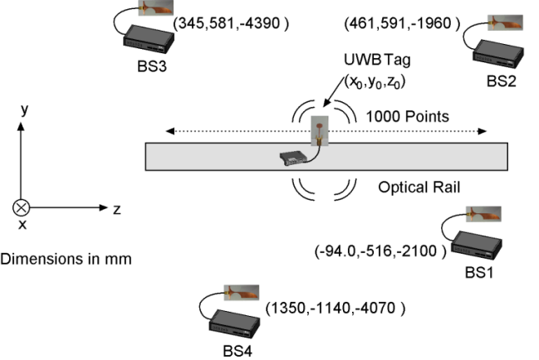
(a) (b)
Figure 11-11: (a) Realistic experimental setup for comprehensive simulation framework where four base stations are positioned at known locations and the tag is moved along an optical rail, (b) simulated 3-D error versus z-position of the tag showing error dependence on position dilution of precision.

(1) dielectric resonator oscillator circuits at the mobile tag and base stations to meet the criteria of low phase noise LOs which is critical in reducing overall system jitter for submillimeter accuracy; (2) adaptive leading-edge detection implemented on a FPGA at the UWB receivers to extend system operation into low SNR and NLOS conditions to ensure system operation even in dense indoor environments with extreme pathloss; (3) automatic gain control at the UWB receiver to extend the system dynamic range and to ensure, combined with adaptive-leading edge detection, operation in low SNR and even NLOS environments; (4) a front-end bandpass filter at the UWB receiver to mitigate the effects from high power IEEE 802.11a/n interferers which potentially exist in hospital environments; (5) narrowband (Bluetooth) and UWB (carrier-based on-off-keying) multi-tag access schemes building a foundational framework to incorporate ad-hoc network schemes into future system architectures for optimum system scalability; (6) MMIC integrated designs building

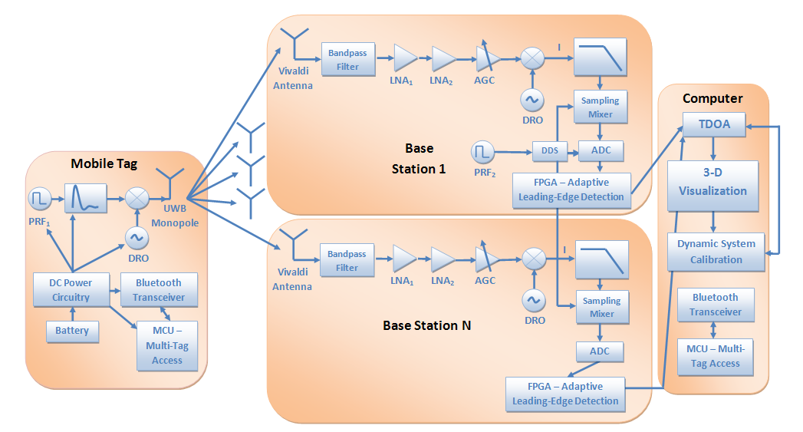
Figure 11-12: Proposed UWB system architecture which incorporates a Bluetooth-based ad-hoc multi-access scheme, dielectric resonator oscillators for reduced phase noise, automatic gain control for increased operating range, a front-end bandpass filter to mitigate IEEE 802.11a/n interferers, adaptive leading-edge detection for system operation in low SNR and NLOS environments, and dynamic system calibration to mitigate adverse effects including jitter, system clock drift (time scaling), and cable length and phase center variation.

on the 1st generation MIC solutions for the RF front-ends at the mobile tag and base stations for minimal size, reduced power consumption, and optimum system performance.

Dielectric Resonator Oscillator
A dielectric resonator oscillator (DRO) provides substantially lower phase noise LO signals compared to a free running VCO, critical to achieving submillimeter accuracy. A series- feedback topology is proposed, which consists of a resonator network, a feedback element, a bias and an output matching network. The proposed architecture includes a high performance 100 MHz OCXO as the reference clock and a phase locked loop consisting of a phase detector, loop filter, voltage controlled DRO, and prescaler. Preliminary simulation results show a 40 dB improvement at a 1 kHz offset is obtained versus a commercially available free-running VCO [204].

Adaptive Leading-Edge Detection
As discussed previously, the current leading-edge detection algorithm has significant limitations in low SNR and NLOS environments when the SNR of the received pulse falls below the predefined threshold value. An adaptive framework is needed to sense low SNR and NLOS conditions and adapt by switching ranging algorithms on the fly. Also, the use of adaptive thresholding algorithms will be explored to further increase the capabilities of the UWB receivers to perform accurate submillimeter ranging even in dense multipath environments. Using the max window of the leading-edge detection algorithm and the noise estimate, the SNR of the received signal can be estimated on the FPGA. An adaptive matched filter scheme is proposed where multiple matched filters are applied, and the one with the largest SNR is selected prior to running the leading-edge detection algorithm. r_{SNR} is a scalar estimate of the SNR used to switch on the adaptive matched filter step. Simulation results in realistic indoor environments showed that the SNR is increased by almost 8 dB after application of a matched filter. For NLOS scenarios, the slew rate r_{slew} of the detected leading edge is significantly reduced. This is combined with substantially more uncertainty σ_{LE} in detecting the received UWB signal. Metrics should be added to test for these conditions in the FPGA architecture and using a first detect approach where the leading-edge of the received signal is considered the first signal detected 3σ above the current noise level. Preliminary results show an order of magnitude improvement in 1-D ranging in NLOS environments (see Chapter 4).

Automatic Gain Control
As shown in Figure 11-12, an automatic gain control block is incorporated into the advanced system to significantly increase the dynamic range of the UWB receiver. We propose implementing this block by combining a variable voltage attenuator, variable gain amplifier, and power detector controlled by the FPGA for 60-70 dB dynamic range improvement.

Front-End Bandpass Filter
Interference from high power sources (e.g. IEEE 802.11a/n WLAN) operating in the 5.725-5.875 GHz ISM band pose a significant concern for our UWB positioning system operating from 5.4-10.6 GHz. As discussed in Chapter 8, a WLAN interferer is placed 2 m away from the UWB base station in a simulated environment. The high power source saturates the UWB receiver. A multi-stage bandpass filter using ground plane aperture techniques is needed in the RF front-end. Simulation results in Chapter 8 show that this addition to the system successfully mitigates high power interference from WLAN sources, although a drop in SNR of 4-6 dB is incurred from the bandpass filter. Also, even though pulse distortion is added by the bandpass filter, the leading-edge detection algorithm does not rely on pulse shape information, so this has no adverse affects on the ranging performance.

Multi-Tag Access
A robust multi-tag access scheme is proposed where the digital communication will be implemented with two competing methodologies: (1) a Bluetooth-based approach which relies on commercially available chips to implement time division multiple access and ad-hoc network communication schemes for easy integration and scalability to tracking of 100+ tags (see Chapter 9); (2) a UWB-based approach which relies on a simplified architecture where the existing RF front-end at the tag is used to transmit data with a simplified on-off keying approach where low duty cycles and system clock phase offsets are used to ensure communication from multiple tags does not overlap in the time domain (building off the scheme employed by [14]).

MMIC Integrated Components
The current hardware needs to be extended, with designs such as the base station RF front-end in Figure 11-13, to integrated MMIC chips. This will minimize the size of the RF front-ends at the tag and base stations, reduce power consumption, and optimize performance. This provides a great learning opportunity for students because it directly coincides with a course on
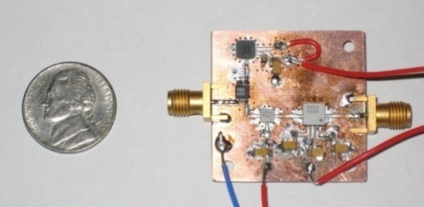
Antenna

LNA

Mixer
VCO

Integrated Base Station Board
MPA
Figure 11-13: Current integrated base station where commercially available chips are used.
MMIC design currently being taught by the Co-PI at the University of Tennessee.

Quantitative Testing and Analysis
A critical aspect of this work is experimental testing and characterization of the harsh operating conditions found in medical environments. As shown in Figure 11-14, a real-time experimental testing platform which utilizes an optical tracking system for ground truth is currently employed for experimental analysis of the system. This needs to be extended to a real-time testing platform to run experiments in hospital environments (e.g. Figure 11-14b). Also, dynamic self calibration techniques are needed in the system to remove time scaling effects, geometric effects, and phase center effects. Building on this experimental testing platform, the analysis can be taken one step further by better quantifying the channels typically found in a hospital environment. For example, in [61] an experiment was run in the operating room during a live orthopaedic surgery where the pathloss of the operating room channel was fit to the IEEE 802.15.4a channel model and showed it is most similar to an industrial or residential LOS scenario. Even more quantitative approaches are needed which includes developing customized comprehensive channel models for various medical environments which builds on these preliminary results and allows quick and accurate characterization of UWB communication and localization systems in these harsh medical environments.

Conclusion
The research described in this dissertation offers fundamentally novel approaches for precise localization in harsh indoor environments. The incentive for pursuing this research is to address the central difficulties in high accuracy localization systems to achieve a 3-D real-time accuracy of 1-2 mm
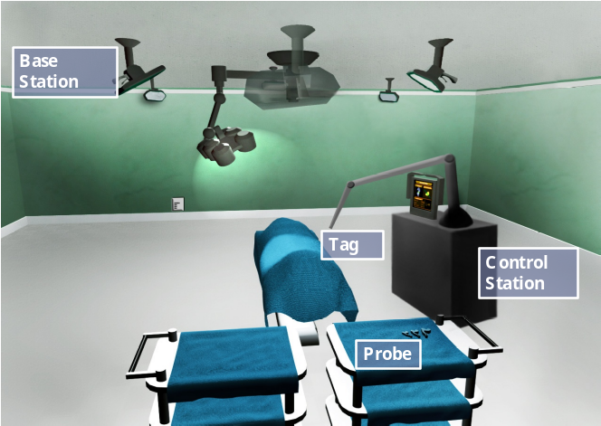
(a) (b)
Figure 11-14: (a) Real-time measurement setup (b) proposed setup for positioning in surgical navigation.

and even sub-mm. The goals for future work to extend this UWB positioning system to 1-2 mm or even sub-millimeter 3-D dynamic accuracy are outlined in Table 11-2. The main tasks include (1) develop a comprehensive simulation platform for realistic prototyping of high accuracy UWB positioning systems, (2) develop various novel hardware components including MMIC integrated solutions needed to transform overall system performance into the submillimeter range, and (3) experimentally test hardware components in the 3.1-10.6 GHz and 22-29 GHz bands in realistic medical environments with real-time testing platforms.
Future trends in UWB precise positioning show its convergence with UWB digital communication in WSNs outlined by the IEEE 802.15.4a standard. MMIC technology, ultra-low-noise oscillators, extremely low jitter-clocks, and wired/wireless synchronization of various base stations are the driving forces for these new systems since they facilitate eliminating various localization errors associated with current technologies. Among the anticipated technical benefits are:
(1) A fundamentally new approach for the integration of the pulser, medium power drivers, LNA, and sub-sampler using MMIC circuits.
(2) To push positioning to mm or even sub-mm accuracy so that it can be used for surgical operations that require such accuracy, replacing optical and electromagnetic methods which suffer from LOS limitations and susceptibility to metallic interference.
(3) Extend the range to 10-20 m and simultaneously track many targets (e.g. 100+).

Table 11-2: Technical Goals for Future Work
Research Topic | Goal
Simulation Framework | Development of a comprehensive C++ application which interacts with ADS, Matlab, HFSS, etc. and is freely downloadable on the web
Dielectric Resonator Oscillator | Integration of DRO and PLL technology into base stations and tags
Adaptive Leading-Edge Detection | FPGA experimental implementation of adaptive leading-edge detection and testing of algorithm in realistic environments
Automatic Gain Control | Development of experimental design and integration with base station RF front-end
IEEE 802.11a/n Interference | Development of novel bandpass filters and experimental testing in the presence of interferers
Multi-Tag Access | Development of multi-tag access experimental testing platform and integration with RF front-end hardware
Integration of RF Front-ends | Simulation and experimental chip testing of MMIC RF front-ends for the UWB tag and base stations
Quantitative Testing and Analysis | Real-time experimental testing in hospital environments. Development of customized channel models for various medical environments.

The direct beneficiaries of this work are researchers who rely directly on UWB technology but can also include biomedical researchers looking for robust wireless solutions for smart surgical tools and wireless sensors. Moreover, the evolution of UWB positioning technology provides new and expanded opportunities to develop and apply fast A/D conversion, advanced signal processing, asset tracking, microwave, wireless communications, and precise localization to unique applications and environments. This work is interdisciplinary/multidisciplinary by nature and provides stimulus to multiple fields needing advanced wireless paradigms where the application is driven by the need for millimeter 3-D accuracy or greater even while operating in challenging indoor environments.

Discussion

Appendices

Appendix A: MCU Code for UWB Tags
#include "bsp.h"
#include "mrfi.h"
#include "nwk_types.h"
#include "nwk_api.h"
#include "bsp_leds.h"
#include "bsp_buttons.h"
#include "vlo_rand.h"
#include "nwk_join.h"

#ifndef APP_AUTO_ACK
#error ERROR: Must define the macro APP_AUTO_ACK for this application.
#endif

void toggleLED(uint8_t);
static void linkTo(void);
static linkID_t sLinkID1 = 0;

#define SPIN_ABOUT_A_SECOND NWK_DELAY(1000)
#define SPIN_ABOUT_A_QUARTER_SECOND NWK_DELAY(250)

/* How many times to try a Tx and miss an acknowledge before doing a scan */
#define MISSES_IN_A_ROW 2

void createRandomAddress(void);

volatile int * tempOffset = (int *)0x10F4; // Temperature offset set at production
char * Flash_Addr = (char *)0x10F0; // Initialize radio address location

__interrupt void ADC10_ISR(void);
__interrupt void Timer_A (void);

/* work loop semaphores */
static volatile uint8_t sSelfMeasureSem = 0;
static volatile uint8_t sControlFrameSem = 0;
static volatile uint8_t sTransmitTagPosUWB = 0;
static volatile uint8_t sTransmitDoneSigUWB = 0;
static volatile uint8_t sCountTimerIter = 0;
static volatile uint8_t sNumUWBTransmissions = 0;
static volatile uint8_t sProceedToNextTagIter = 0;
static volatile uint8_t sRelinkIter = 0;

/* callback handler */
static uint8_t sCB(linkID_t);

void main (void)
{
addr_t lAddr;
uint8_t msg2[2];
smplStatus_t rc;
bspIState_t intState;

BSP_Init();

if(Flash_Addr[0] == 0xFF && Flash_Addr[1] == 0xFF &&
Flash_Addr[2] == 0xFF && Flash_Addr[3] == 0xFF )
{
createRandomAddress(); // set Random device address at initial startup
}
lAddr.addr[0] = Flash_Addr[0];
lAddr.addr[1] = Flash_Addr[1];
lAddr.addr[2] = Flash_Addr[2];
lAddr.addr[3] = Flash_Addr[3];
SMPL_Ioctl(IOCTL_OBJ_ADDR, IOCTL_ACT_SET, &lAddr);
//SMPL_Ioctl( IOCTL_OBJ_RADIO, IOCTL_ACT_RADIO_RXON, 0);

// callback to receive messages from Control Station
//SMPL_Init(sCB);

// set output ports for UWB control
P4DIR |= 0x30;
P4OUT &= 0xcf;

/* Keep trying to join (a side effect of successful initialization) until
* successful. Toggle LEDS to indicate that joining has not occurred.
*/
while (SMPL_SUCCESS != SMPL_Init(sCB))
{
SPIN_ABOUT_A_SECOND;
}

BCSCTL3 |= LFXT1S_2; // LFXT1 = VLO

// TimerA used to transmit tag state (temp, voltage, SS)
TACCTL0 = CCIE; // TACCR0 interrupt enabled
TACCR0 = 300; // ~ 1 sec
TACTL = TASSEL_1 + MC_1; // ACLK, upmode

/* Unconditional link to AP which is listening due to successful join. */
linkTo();

while (1) ;
}

static void linkTo()
{
uint8_t msg[4];
uint8_t misses, done;
smplStatus_t rc;
bspIState_t intState;
uint8_t msg2[2];
uint8_t noAck;

/* Keep trying to link... */
while (SMPL_SUCCESS != SMPL_Link(&sLinkID1))
{
SPIN_ABOUT_A_SECOND;
}

SMPL_Ioctl( IOCTL_OBJ_RADIO, IOCTL_ACT_RADIO_AWAKE, 0);
MRFI_RxOn();

while (1)
{

MRFI_RxOn();

if (sSelfMeasureSem) {
volatile long temp;
int degC, volt, UWBTrans;
int results[2];
uint8_t noAck;
smplStatus_t rc;

/* get radio ready...awakens in idle state */
SMPL_Ioctl( IOCTL_OBJ_RADIO, IOCTL_ACT_RADIO_AWAKE, 0);

ADC10CTL1 = INCH_10 + ADC10DIV_4; // Temp Sensor ADC10CLK/5
ADC10CTL0 = SREF_1 + ADC10SHT_3 + REFON + ADC10ON + ADC10IE + ADC10SR;
for( degC = 240; degC > 0; degC-- ); // delay to allow reference to settle
ADC10CTL0 |= ENC + ADC10SC; // Sampling and conversion start
__bis_SR_register(CPUOFF + GIE); // LPM0 with interrupts enabled

results[0] = ADC10MEM;
ADC10CTL0 &= ~ENC;
ADC10CTL1 = INCH_11; // AVcc/2
ADC10CTL0 = SREF_1 + ADC10SHT_2 + REFON + ADC10ON + ADC10IE + REF2_5V;
for( degC = 240; degC > 0; degC-- ); // delay to allow reference to settle
ADC10CTL0 |= ENC + ADC10SC; // Sampling and conversion start
__bis_SR_register(CPUOFF + GIE); // LPM0 with interrupts enabled
results[1] = ADC10MEM;
ADC10CTL0 &= ~ENC;
ADC10CTL0 &= ~(REFON + ADC10ON); // turn off A/D to save power

// oC = ((A10/1024)*1500mV)-986mV)*1/3.55mV = A10*423/1024 - 278
// the temperature is transmitted as an integer where 32.1 = 321
// hence 4230 instead of 423
temp = results[0];
degC = ((temp - 673) * 4230) / 1024;
if( (*tempOffset) != 0xFFFF )
{
degC += (*tempOffset);
}
/* message format, UB = upper Byte, LB = lower Byte
-------------------------------
|degC LB | degC UB | volt LB |
-------------------------------
0 1 2
*/
UWBTrans = sNumUWBTransmissions;

temp = results[1];
volt = (temp*25)/512;
msg[0] = degC&0xFF;
msg[1] = (degC>>8)&0xFF;
msg[2] = volt;
msg[3] = UWBTrans;

done = 0;
while (!done)
{
noAck = 0;

/* Try sending message MISSES_IN_A_ROW times looking for ack */
for (misses=0; misses < MISSES_IN_A_ROW; ++misses)
{
if (SMPL_SUCCESS == (rc=SMPL_SendOpt(sLinkID1, msg, sizeof(msg),
SMPL_TXOPTION_ACKREQ)))
{
/* Message acked. We're done. */
sRelinkIter = 0;
break;
}
if (SMPL_NO_ACK == rc)
{
/* Count ack failures. Could also fail becuase of CCA and
* we don't want to scan in this case.
*/
noAck++;
}
}
if (MISSES_IN_A_ROW == noAck)
{
sRelinkIter++;
#ifdef FREQUENCY_AGILITY
/* Assume we're on the wrong channel so look for channel by
* using the Ping to initiate a scan when it gets no reply. With
* a successful ping try sending the message again. Otherwise,
* for any error we get we will wait until the next button
* press to try again.
*/
if (SMPL_SUCCESS != SMPL_Ping(sLinkID1))
{
done = 1;
}
#else
done = 1;
#endif /* FREQUENCY_AGILITY */
}
else
{
/* Got the ack or we don't care. We're done. */
done = 1;
}
}
/* radio back to sleep */
sNumUWBTransmissions = 0;
}
sSelfMeasureSem = 0;
MRFI_RxOn();

}
}

void toggleLED(uint8_t which)
{
return;
}

void createRandomAddress()
{
unsigned int rand, rand2;
do
{
rand = TI_getRandomIntegerFromVLO(); // first byte can not be 0x00 of 0xFF
}
while( (rand & 0xFF00)==0xFF00 || (rand & 0xFF00)==0x0000 );
rand2 = TI_getRandomIntegerFromVLO();

BCSCTL1 = CALBC1_1MHZ; // Set DCO to 1MHz
DCOCTL = CALDCO_1MHZ;
FCTL2 = FWKEY + FSSEL0 + FN1; // MCLK/3 for Flash Timing Generator
FCTL3 = FWKEY + LOCKA; // Clear LOCK & LOCKA bits
FCTL1 = FWKEY + WRT; // Set WRT bit for write operation

Flash_Addr[0]=(rand>>8) & 0xFF;
Flash_Addr[1]=rand & 0xFF;
Flash_Addr[2]=(rand2>>8) & 0xFF;
Flash_Addr[3]=rand2 & 0xFF;

FCTL1 = FWKEY; // Clear WRT bit
FCTL3 = FWKEY + LOCKA + LOCK; // Set LOCK & LOCKA bit
}

/* Runs in ISR context. Reading the frame should be done in the */
/* application thread not in the ISR thread. */
static uint8_t sCB(linkID_t lid)
{
// if this message is from the Control Station, process
// the message. Otherwise, ignore it.
if (lid == sLinkID1)
{
uint8_t msg3[MAX_APP_PAYLOAD], len, i;

if (SMPL_SUCCESS == SMPL_Receive(sLinkID1, msg3, &len))
{

sTransmitTagPosUWB = 1;
sRelinkIter = 0;
P4OUT &= 0xcf;
sNumUWBTransmissions++;
sControlFrameSem--;
sProceedToNextTagIter = 0;
}
}

// leave frame to be read by application.
return 0;
}

/*------------------------------------------------------------------------------
* ADC10 interrupt service routine
------------------------------------------------------------------------------*/
#pragma vector=ADC10_VECTOR
__interrupt void ADC10_ISR(void)
{
__bic_SR_register_on_exit(CPUOFF); // Clear CPUOFF bit from 0(SR)
}

/*------------------------------------------------------------------------------
* Timer A0 interrupt service routine
------------------------------------------------------------------------------*/
#pragma vector=TIMERA0_VECTOR
__interrupt void Timer_A (void)
{

if (sCountTimerIter == 0)
sSelfMeasureSem = 1;

if (sCountTimerIter < 40)
sCountTimerIter++;
else
sCountTimerIter = 0;

if (sTransmitTagPosUWB == 1 && sProceedToNextTagIter == 4)
{
P4OUT |= 0x30;
sTransmitTagPosUWB = 0;
}

if (sProceedToNextTagIter < 4)
sProceedToNextTagIter++;
else
sProceedToNextTagIter = 0;

__bic_SR_register_on_exit(LPM3_bits); // Clear LPM3 bit from 0(SR)
}
Appendix B: MCU Code for UWB Access Point
#include <string.h>
#include "bsp.h"
#include "mrfi.h"
#include "bsp_leds.h"
#include "bsp_buttons.h"
#include "nwk_types.h"
#include "nwk_api.h"
#include "nwk_frame.h"
#include "nwk.h"
#include "virtual_com_cmds.h"

#ifndef APP_AUTO_ACK
#error ERROR: Must define the macro APP_AUTO_ACK for this application.
#endif

void toggleLED(uint8_t);

/* reserve space for the maximum possible peer Link IDs */
static linkID_t sLID[NUM_CONNECTIONS] = {0};
static linkID_t sSleepingLID[NUM_CONNECTIONS] = {0}; // allow tags to come in and out of range
static uint8_t sNumCurrentPeers = 0;
static uint8_t sNumSleepingPeers = 0;
static uint16_t tagTimedOutIter[NUM_CONNECTIONS];

/* callback handler */
static uint8_t sCB(linkID_t);

// TDMA state variables for UWB transmission
static uint8_t is_TDMA_Response;
static uint8_t is_UWB_Transmission_OK;
static uint8_t sProceedToNextTag;
static uint8_t current_TDMA_Index;

/* received message handler */
static void processMessage(linkID_t, uint8_t *, uint8_t);

/* Frequency Agility helper functions */
static void checkChangeChannel(void);
static void changeChannel(void);

/* work loop semaphores */
static volatile uint8_t sPeerFrameSem = 0;
static volatile uint8_t sJoinSem = 0;
static volatile uint8_t sSelfMeasureSem = 0;
static volatile uint8_t sCountTimerIter = 0;
static volatile uint8_t sProceedToNextTagIter = 0;
static volatile uint8_t sNumUWBTransmissions = 0;

/* How many times to try a Tx and miss an acknowledge before doing a scan */
#define MISSES_IN_A_ROW 2

#ifdef FREQUENCY_AGILITY
/* ************** BEGIN interference detection support */

#define INTERFERNCE_THRESHOLD_DBM (-70)
#define SSIZE 25
#define IN_A_ROW 3
static int8_t sSample[SSIZE];
static uint8_t sChannel = 0;
#endif /* FREQUENCY_AGILITY */

/* blink LEDs when channel changes... */
static volatile uint8_t sBlinky = 0;

//data for terminal output
const char splash[] = {"\r\n--------------------------------------------------\r\n ****\r\n **** eZ430-RF2500\r\n ******o**** UWB Positioning System\r\n********_///_***\r\n--------------------------------------------------\r\n"};
volatile int * tempOffset = (int *)0x10F4;

__interrupt void ADC10_ISR(void);
__interrupt void Timer_A (void);

/* ************** END interference detection support */

#define SPIN_ABOUT_A_QUARTER_SECOND NWK_DELAY(250)

void main (void)
{
bspIState_t intState;
uint8_t msg_TDMA[2], msg_WhichTag[4];
uint8_t noAck;
uint8_t misses, done;
int i;

msg_TDMA[0] = 'O';
msg_TDMA[1] = 'N';

msg_WhichTag[2] = 'T';
msg_WhichTag[3] = 'X';
msg_WhichTag[0] = '\r';
msg_WhichTag[1] = '\n';

memset(sSample, 0x0, sizeof(sSample));
sProceedToNextTag = 1;

BSP_Init();

BCSCTL3 |= LFXT1S_2; // LFXT1 = VLO
TACCTL0 = CCIE; // TACCR0 interrupt enabled
TACCR0 = 120; // ~1 second
TACTL = TASSEL_1 + MC_1; // ACLK, upmode

COM_Init();
TXString( (char*)splash, sizeof splash);
TXString( "\r\nInitializing Network....", 26 );

SMPL_Init(sCB);

// network initialized
TXString( "Done\r\n", 6);
SMPL_Ioctl( IOCTL_OBJ_RADIO, IOCTL_ACT_RADIO_RXON, 0);

/* main work loop */
current_TDMA_Index = 0;
while (1)
{
/* Wait for the Join semaphore to be set by the receipt of a Join frame from a
* device that supports an End Device.
*
* An external method could be used as well. A button press could be connected
* to an ISR and the ISR could set a semaphore that is checked by a function
* call here, or a command shell running in support of a serial connection
* could set a semaphore that is checked by a function call.
*/
if (sJoinSem && (sNumCurrentPeers < NUM_CONNECTIONS))
{
/* listen for a new connection */
while (1)
{
if (SMPL_SUCCESS == SMPL_LinkListen(&sLID[sNumCurrentPeers]))
{
tagTimedOutIter[sNumCurrentPeers] = 0;
break;
}
/* Implement fail-to-link policy here. otherwise, listen again. */
}

BSP_ENTER_CRITICAL_SECTION(intState);
sJoinSem--;
sNumCurrentPeers++;
BSP_EXIT_CRITICAL_SECTION(intState);
}

// if it is time to measure our own temperature...
if(sSelfMeasureSem)
{
char msg [6];
char addr[] = {"HUB0"};
char rssi[] = {"000"};
int degC, volt;
volatile long temp;
int results[2];

ADC10CTL1 = INCH_10 + ADC10DIV_4; // Temp Sensor ADC10CLK/5
ADC10CTL0 = SREF_1 + ADC10SHT_3 + REFON + ADC10ON + ADC10IE + ADC10SR;
for( degC = 240; degC > 0; degC-- ); // delay to allow reference to settle
ADC10CTL0 |= ENC + ADC10SC; // Sampling and conversion start
__bis_SR_register(CPUOFF + GIE); // LPM0 with interrupts enabled
results[0] = ADC10MEM;

ADC10CTL0 &= ~ENC;

ADC10CTL1 = INCH_11; // AVcc/2
ADC10CTL0 = SREF_1 + ADC10SHT_2 + REFON + ADC10ON + ADC10IE + REF2_5V;
for( degC = 240; degC > 0; degC-- ); // delay to allow reference to settle
ADC10CTL0 |= ENC + ADC10SC; // Sampling and conversion start
__bis_SR_register(CPUOFF + GIE); // LPM0 with interrupts enabled
results[1] = ADC10MEM;
ADC10CTL0 &= ~ENC;
ADC10CTL0 &= ~(REFON + ADC10ON); // turn off A/D to save power

// oC = ((A10/1024)*1500mV)-986mV)*1/3.55mV = A10*423/1024 - 278
// the temperature is transmitted as an integer where 32.1 = 321
// hence 4230 instead of 423
temp = results[0];
degC = (((temp - 673) * 4230) / 1024);
if( (*tempOffset) != 0xFFFF )
{
degC += (*tempOffset);
}

temp = results[1];
volt = (temp*25)/512;

msg[0] = degC&0xFF;
msg[1] = (degC>>8)&0xFF;
msg[2] = volt;
msg[3] = sNumUWBTransmissions;
transmitDataString(1, addr, rssi, msg );
//BSP_TOGGLE_LED1();
sNumUWBTransmissions = 0;
sSelfMeasureSem = 0;

/* process all frames waiting */
for (i=0; i<sNumCurrentPeers; ++i)
{
// check for any tags which may have timed out
// currently they have a 5 second time out
if (tagTimedOutIter[i] > 499)
{
// need to remove node i from current peers
linkID_t tempLinkID;
int j;
tagTimedOutIter[i] = 0;
sSleepingLID[sNumSleepingPeers] = sLID[i];
sNumSleepingPeers++;

if (sNumCurrentPeers>1)
{
for (j=i+1; j<sNumCurrentPeers; ++j)
{
sLID[j-1] = sLID[j];
}
}
else
sLID[i] = 0;

sNumCurrentPeers--;
}
}
}

/* Have we received a frame on one of the ED connections?
* No critical section -- it doesn't really matter much if we miss a poll
*/
if (sPeerFrameSem)
{
uint8_t msg[MAX_APP_PAYLOAD], len, i;

/* process all frames waiting */
for (i=0; i<sNumCurrentPeers; ++i)
{
if (SMPL_SUCCESS == SMPL_Receive(sLID[i], msg, &len))
{
ioctlRadioSiginfo_t sigInfo;
tagTimedOutIter[i] = 0;
sigInfo.lid = sLID[i];
SMPL_Ioctl(IOCTL_OBJ_RADIO, IOCTL_ACT_RADIO_SIGINFO, (void *)&sigInfo);
transmitData( i, sigInfo.sigInfo.rssi, (char*)msg );

BSP_ENTER_CRITICAL_SECTION(intState);
sPeerFrameSem--;
BSP_EXIT_CRITICAL_SECTION(intState);
}
}
}
if (BSP_BUTTON1())
{
SPIN_ABOUT_A_QUARTER_SECOND; /* debounce */
changeChannel();
}
else
{
checkChangeChannel();
}
BSP_ENTER_CRITICAL_SECTION(intState);
if (sBlinky)
{
if (++sBlinky >= 0xF)
{
sBlinky = 1;
}
}
BSP_EXIT_CRITICAL_SECTION(intState);

// this section is added to implement the TDMA scheme
// for transmission of tag 3-D position via UWB system
// iterate through all tags currently present

if (sProceedToNextTag && sNumCurrentPeers > 0)
{
BSP_ENTER_CRITICAL_SECTION(intState);
sProceedToNextTag = 0;
BSP_EXIT_CRITICAL_SECTION(intState);
// need to get acknowledgement from tag
done = 0;
while (!done)
{
noAck = 0;
smplStatus_t rc;
uint8_t tempInt;

// Try sending message MISSES_IN_A_ROW times looking for ack
sNumUWBTransmissions++;
for (misses=0; misses < MISSES_IN_A_ROW; ++misses)
{
if (SMPL_SUCCESS == (rc=SMPL_Send(sLID[current_TDMA_Index], msg_TDMA,
sizeof(msg_TDMA))))
{
tempInt = current_TDMA_Index;
msg_WhichTag[3] = '0'+((tempInt+1)%10);
TXString(msg_WhichTag,4);
break;
}
if (SMPL_NO_ACK == rc)
{
// Count ack failures. Could also fail becuase of CCA and
// we don't want to scan in this case.
//
noAck++;
}
}
if (MISSES_IN_A_ROW == noAck)
{
// Message not acked. Toggle LED 2.
#ifdef FREQUENCY_AGILITY
// Assume we're on the wrong channel so look for channel by
// using the Ping to initiate a scan when it gets no reply. With
// a successful ping try sending the message again. Otherwise,
// for any error we get we will wait until the next button
// press to try again.
//
if (SMPL_SUCCESS != SMPL_Ping(sLID[current_TDMA_Index]))
{
done = 1;
}
#else
// transmission to awake current tag failed
BSP_ENTER_CRITICAL_SECTION(intState);
if (current_TDMA_Index + 1 < sNumCurrentPeers)
current_TDMA_Index++;
else
current_TDMA_Index = 0;

//sProceedToNextTag = 1;
BSP_EXIT_CRITICAL_SECTION(intState);

done = 1;
#endif // FREQUENCY_AGILITY
}
else
{
// Got the ack or we don't care. We're done.
// acknowledgement received...have to wait for final response
// from tag stating 'OK' or 'ER' for UWB transmission
BSP_ENTER_CRITICAL_SECTION(intState);
if (current_TDMA_Index + 1 < sNumCurrentPeers)
current_TDMA_Index++;
else
current_TDMA_Index = 0;

//sProceedToNextTag = 1;
BSP_EXIT_CRITICAL_SECTION(intState);

done = 1;
//transmitDataTDMA(current_TDMA_Index,1);
} //else
} // while (!done)
} // if (sProceedToNextTag)
} // while (1)
}

void toggleLED(uint8_t which)
{
return;
}

/* Runs in ISR context. Reading the frame should be done in the */
/* application thread not in the ISR thread. */
static uint8_t sCB(linkID_t lid)
{
uint8_t tagInList = 0, tagAsleep = 0;
int i,j;
// see if this tag is in the sleeping category
// bring back into active, if so
for (i=0; i<sNumSleepingPeers; ++i)
{
if (lid == sSleepingLID[i])
{
// add tag back to active list
tagAsleep = 1;
sLID[sNumCurrentPeers] = sSleepingLID[i];
sNumCurrentPeers++;

if (sNumSleepingPeers>1)
{
for (j=i+1; j<sNumSleepingPeers; ++j)
{
sSleepingLID[j-1] = sSleepingLID[j];
}
}
else
sSleepingLID[i] = 0;

sNumSleepingPeers--;
return 0;
}
}

if (lid)
{
sPeerFrameSem++;
sBlinky = 0;
}
else
{
sJoinSem++;
}

/* leave frame to be read by application. */
return 0;
}

static void processMessage(linkID_t lid, uint8_t *msg, uint8_t len)
{
// deprecated
return;
}

static void changeChannel(void)
{
#ifdef FREQUENCY_AGILITY
freqEntry_t freq;

if (++sChannel >= NWK_FREQ_TBL_SIZE)
{
sChannel = 0;
}
freq.logicalChan = sChannel;
SMPL_Ioctl(IOCTL_OBJ_FREQ, IOCTL_ACT_SET, &freq);
BSP_TURN_OFF_LED1();
BSP_TURN_OFF_LED2();
sBlinky = 1;
#endif
return;
}

/* implement auto-channel-change policy here... */
static void checkChangeChannel(void)
{
#ifdef FREQUENCY_AGILITY
int8_t dbm, inARow = 0;

uint8_t i;

memset(sSample, 0x0, SSIZE);
for (i=0; i<SSIZE; ++i)
{
/* quit if we need to service an app frame */
if (sPeerFrameSem || sJoinSem)
{
return;
}
NWK_DELAY(1);
SMPL_Ioctl(IOCTL_OBJ_RADIO, IOCTL_ACT_RADIO_RSSI, (void *)&dbm);
sSample[i] = dbm;

if (dbm > INTERFERNCE_THRESHOLD_DBM)
{
if (++inARow == IN_A_ROW)
{
changeChannel();
break;
}
}
else
{
inARow = 0;
}
}
#endif
return;
}

/*------------------------------------------------------------------------------
* ADC10 interrupt service routine
------------------------------------------------------------------------------*/
#pragma vector=ADC10_VECTOR
__interrupt void ADC10_ISR(void)
{
__bic_SR_register_on_exit(CPUOFF); // Clear CPUOFF bit from 0(SR)
}

/*------------------------------------------------------------------------------
* Timer A0 interrupt service routine
------------------------------------------------------------------------------*/
#pragma vector=TIMERA0_VECTOR
__interrupt void Timer_A (void)
{
int i;
if (sCountTimerIter == 0)
{
sSelfMeasureSem = 1;
}

if (sProceedToNextTagIter == 0)
{
sProceedToNextTag = 1;
}

if (sProceedToNextTagIter < 10)
sProceedToNextTagIter++;
else
sProceedToNextTagIter = 0;

if (sCountTimerIter < 99)
sCountTimerIter++;
else
sCountTimerIter = 0;

// used to watch for tags timing out
for (i=0; i<sNumCurrentPeers; ++i)
tagTimedOutIter[i]++;
}

References

            - “RTLS and Wireless Technologies,” Venture Development Corp., RFID Business Planning Service 2005-2006, http://www.pencomputing.com/news/news_rtls.html.
            - “RFID Forecasts, Players and Opportunities 2009-2019,” Summary, IDTechEx, Cambridge, MA, 2009, http://www.idtechex.com/research/reports/rfid_forecasts_players_and_opportunities_2009_2019_000226.asp.
            - M. Vossiek, L. Wiebking, P. Gulden, J. Wieghardt, C. Hoffman, P. Heide, “Wireless local positioning,” IEEE Microwave Magazine, vol. 4, 2003, pp. 77 – 86.
            - Federal Communications Commission, “The first report and order regarding ultra-wideband transmission systems,” FCC 02-48, ET Docket No. 98-153, 2002.
            - N. Patwari, J. Ash, S. Kyperountas, A. Hero III, et al., “Locating the nodes: cooperative localization in wireless sensor networks,” IEEE Signal Processing Magazine, vol. 22, 2005, pp. 54 – 69.
            - E. Kaplan, Understanding GPS: Principles and Applications, Boston, MA: Artech House, 1996.
            - A. Stelzer, K. Pourvoyeur, A. Fischer, “Concept and application of LPM-A novel 3-D local position measurement system,” IEEE Trans. Microwave Theory and Tech., vol. 52, 2004, pp. 2664 – 2669.
            - M. Pichler, A. Stelzer, P. Gulden, C. Seisenberger, M. Vossiek, “Phase-error measurement and compensation in PLL frequency synthesizers for FMCW sensors—I: context and application,” IEEE Trans. Cir. and Sys. I, vol. 54, 2007, pp. 1006 – 1017.
            - L. Reindl, C. Ruppel, S. Berek, U. Knauer, et al., “Design, fabrication, and application of precise SAW delay lines used in an FMCW radar system,” IEEE Trans. Microwave Theory and Tech., vol. 49, 2001, pp. 787–794.
            - LPR-2D, Symeo, 2009, http://www.symeo.com/cms/upload/PDF/Datasheet_LPR-2D.pdf.
            - L. Wiebking, M. Glanzer, D. Mastela, M. Christmann, M. Vossiek, “Remote local positioning radar,” in IEEE Radio and Wireless Symp., 2004, pp. 191 – 194.
            - S. Roehr, M. Vossiek, P. Gulden, “Method for high precision radar distance measurement and synchronization of wireless units,” in IEEE International Microwave Symp., 2007, pp. 1315-1318.
            - R. Fontana, “Recent system applications of short-pulse ultra-wideband (UWB) technology,” IEEE Trans. Microwave Theory and Tech., 52(9), 2004, pp. 2087 – 2104.
            - “Sapphire DART (RTLS) product data sheet,” Multispectral Solutions Inc., Germantown, MD, 2008, http://www.multispectral.com/pdf/Sapphire_DART.pdf.
            - “Hardware datasheet,” Ubisense, Cambridge, UK, 2007, http://www.ubisense.net/media/pdf/Ubisense%20System%20Overview%20V1.1.pdf.
            - Z. Low, J. Cheong, C. Law, W. Ng, Y. Lee, “Pulse detection algorithm for line-of-sight (LOS) UWB ranging applications,” IEEE Ant. and Wireless Prop. Letters, vol. 4, 2005, pp. 63 – 67.
            - R. Zetik, J. Sachs, R. Thomä, “UWB localization - active and passive approach, in Proceedings of the 21st IEEE IMTC, vol. 2, 2004, pp. 1005-1009.
            - C. Meier, A. Terzis, S. Lindenmeier, “A robust 3D high precision radio location system, in IEEE International Microwave Symp., 2007, pp. 397 – 400.
            - M. Mahfouz, C. Zhang, B. Merkl, M. Kuhn, A. Fathy, “Investigation of high accuracy indoor 3-D positioning using UWB technology,” IEEE Transactions on Microwave Theory and Techniques, 56(6), 2008, pp. 1316-1330.
            - C. Zhang, M. Kuhn, B. Merkl, A. Fathy, M. Mahfouz, “Real-time non-coherent UWB positioning radar with millimeter range accuracy: theory and experiment,” IEEE Transactions on Microwave Theory and Techniques, 58(1), 2010, pp. 9-20.
            - B. Waldmann, R. Weigel, P. Gulden, “Method for high precision local positioning radar using an ultra wideband technique,” in IEEE International Microwave Symp., Atlanta, USA, 2008, pp. 117-120.
            - C. Meier, A. Terzis, S. Lindenmeier, “Investigation and suppression of multipath influence on indoor radio location in the millimeter wave range,” in Conf. Wave Prop. Comm., Microwave Sys. Nav., Chemnitz, Germany, 2007, pp. 21-24.
            - Thomas E. McEwan, “Radiolocation system having writing pen application,” U.S. Patent 6,747,599, June, 2004.
            - G. Ossberger, T. Buchegger, E. Schimback, A. Stelzer, R. Weigel, “Non-invasive respiratory movement detection and monitoring of hidden humans using ultra wideband pulse radar,” in IEEE International Conf UWB Sys. Tech., Kyoto, Japan, 2004, pp. 395-399.
            - A. Fujii, H. Sekiguchi, M. Asai, S. Kurashima, H. Ochiai, and R. Kohno, “Impulse radio UWB positioning system,” in IEEE Radio and Wireless Symposium, pp. 55-58, 2007.
            - A. Stelzer, C.G. Diskus, H.W. Thim, “A microwave position sensor with sub-millimeter accuracy,” IEEE Trans. Microwave Theory and Tech., 47(12), 1999, pp. 2621–2624.
            - A. Stelzer, K. Pourvoyeur, A. Fischer, “Concept and application of LPM-a novel 3-D local position measurement system,” IEEE Trans. Microwave Theory and Tech., 52(12), 2004, pp. 2664 – 2669.
            - F. Ellinger, R. Eickhoff, R. Gierlich, J. Hüttner et al., “Local positioning for wireless sensor networks,” in IEEE Globecom Workshops, Washington DC, USA, 2007, pp. 1-6.
            - R. Mosshammer, M. Huemer, R. Szumny, K. Kurekt, J. Hittner, R. Gierlichli, “A 5.8 GHz local positioning and communication system,” in IEEE MTT-S International Microwave Symposium, Honolulu, USA, 2007, pp. 1237-1240.
            - P. Tragas, A. Kalis, C. Papadias, F. Ellinger, R. Eickhoff , et al., “RESOLUTION: reconfigurable systems for mobile local communication and positioning,” in Mob. and Wireless Comm. Summit, Budapest, Hungary, 2007, pp. 1-5.
            - R. Feger, C. Wagner, S. Schuster, H. Jäger, A. Stelzer, “A 77-GHz FMCW MIMO radar based on an SiGe single-chip transceiver,” IEEE Trans. Microwave Theory and Tech., 57(5), 2009, pp. 1020 - 1035.
            - I. Guvenc, Z. Sahinoglu, P. Orlik, “TOA estimation for IR-UWB systems with different transceiver types,” IEEE Transactions on Microwave Theory and Techniques, 54(4), Part 2, 2006, pp. 1876 – 1886.
            - T. Buchegger, G. Obberger, A. Reisenzahn, E. Hochmair, A. Stelzer, A. Springer, ‘‘Ultrawideband transceivers for cochlear implants,’’ EURASIP J. Appl. Signal Process, vol. 2005, no. 18, 2005, pp. 3069–3075.
            - J. P. Lie, C. M. See, B. P. Ng, “UWB ranging with high robustness against dominant jammer and multipath,” IEEE Microwave and Wireless Components Letters, 15(12), 2005, pp. 907-909.
            - A. Rabbachin, I. Oppermann, “Synchronization analysis for UWB systems with a low-complexity energy collection receiver,” in Proc. IEEE Ultrawideband Syst. Technol. Conf., Kyoto, Japan, 2004, pp. 288–292.
            - R.J. Fontana, F.J. Larrick, “Ultra wideband receiver with high speed noise and interference tracking threshold,” U.S. Patent 5,901,172, May, 1999.
            - C.-C. Chong, S. K. Yong, S.-S. Lee, “UWB direct chaotic communication technology,” IEEE Antennas Wireless Propagat. Lett., vol. 4, 2005, pp. 316–319.
            - D. Barras, F. Ellinger, H. Jäckel, W. Hirt, "A robust front-end architecture for low-power UWB radio transceivers", IEEE Trans. Microwave Theory Tech., 54(4), Part 2, 2006, pp. 1713 – 1723.
            - C. Zhang, M. Kuhn, B. Merkl, M. Mahfouz, and A. E. Fathy, “Development of an UWB indoor 3-D positioning radar with millimeter accuracy,” in IEEE International Microwave Symp., 2006, pp. 106-109.
            - C. Zhang, A. Fathy, M. Mahfouz, “Performance enhancement of a sub-sampling circuit for ultra-wideband signal processing”, IEEE Micro. and Wireless Comp. Lett., 17(12), 2007, pp. 873-875.
            - D. M Treyer, W. Bächtold, “Investigation of a self-calibrating SSB modulator,” IEEE Trans. Microwave Theory and Tech., 53(12), 2005, pp. 3806-3816.
            - M. Gerding, T. Musch, B. Schiek , “A novel approach for a high-precision multitarget-level measurement system based on time-domain reflectometry,” IEEE Trans. on Microwave Theory and Tech., 54(6), 2006, pp. 2768 – 2773.
            - J. Han, C. Nguyen, “Coupled-slotline-hybrid sampling mixer integrated with step-recovery-diode pulse generator for UWB applications,” IEEE Trans. on Microwave Theory and Tech., 53(6), 2005, pp. 1875 – 1882.
            - M. M. Zinieris, R. Sloan, L. E. Davis, “A broadband microstrip-to-slot-line transition,” Microwave and Optical Technology Letters, pp. 339-342, 1998.
            - Tektronix Electrical Sampling Modules Datasheet, http://www.tek.com/.
            - Picosecond Pulse Labs 7040 Sampler Module Datasheet, http://www.picosecond.com/.
            - M. Shinagawa, Y. Akazawa, T. Wakimoto, “Jitter analysis of high speed sampling system,” in IEEE VLSI Circuits Symposium, Kyoto, Japan, May, 1989, pp. 95 - 96.
            - VTC4 series voltage controlled temperature compensated crystal oscillator, Vectron Int’l, Hudson, NH, 2007, p. 7.
            - Y.T. Chan, K.C. Ho, "Joint time-scale and TDOA estimation: analysis and fast approximation," IEEE Trans. on Signal Processing, 53(8), 2005, pp. 2625-2634.
            - J.A. Costa, N. Patwari, A.O. Hero, “Distributed weighted multidimensional scaling for node localization in sensor networks. ACM Trans. Sen. Netw. 2(1), 2006, pp. 39-64.
            - Application note VTC4, clippsed sine wave TCXO typical phase noise measurements, Vectron Int’l, Hudson, NH, 2007.
            - M. Tüchler, V. Schwarz, A. Huber, “Location accuracy of an UWB localization system in a multi-path environment,” in IEEE International Conf UWB, Zurich, Switzerland, 2005, pp. 414-419.
            - B. Merkl, “The future of the operating room: surgical preplanning and navigation using high accuracy ultra-wideband positioning and advanced bone measurement, Ph.D. Dissertation, The University of Tennessee, 2008.
            - H.G. Schantz, “Introduction to ultra-wideband antennas,” in IEEE Conference on Ultra Wideband Systems and Technologies, Nov. 2003, pp. 1 – 9.
            - G. M. Wubbena, M. Schmitz, F. Menge, V. Boder, and G. Seeber, “Automated absolute field calibration of GPS antennas in real-time,” in Proc. ION GPS 2000, 2000, pp. 2512–2522.
            - A. Elsherbini, C. Zhang, S. Lin, M. Kuhn, A. Kamel, A. E. Fathy, H. Elhennawy, “Enhancing the performance of antipodal Vivaldi antennas using a dielectric rod for high precision localization applications,” in IEEE AP-S Int. Symp. 2007, pp. 1973 - 1976.
            - C. Zhang and A. E. Fathy, “Reconfigurable pico-pulse generator for UWB applications,” in IEEE International Microwave Symp., 2006, pp. 407 - 410.
            - D. Clarke, A. Park, “Active-RFID system accuracy and its implications for clinical applications,” IEEE Symp. on Computer-Based Med. Sys., Salt Lake City, USA, 2006, pp. 21-26.
            - PLUS® RTLS Data Sheet, Time Domain Corp., Huntsville, AL, 2009, http://www.timedomain.com/datasheets/plus-system.pdf.
            - DecaWave RTLS Product Description and Applications, DecaWave, Dublin, Ireland, 2009, http://www.decawave.com/rtls.html.
            - M. Mahfouz, M. Kuhn, G. To, A. Fathy, “Integration of UWB and wireless pressure mapping in surgical navigation,” in IEEE Trans. Microwave Theory Tech., 57(10), Part 2, 2009, pp. 2550-2564.
            - M. Kuhn, M. Mahfouz, A. Fathy, “A UWB real-time millimeter 3-D wireless positioning system,” Advances in UWB Localization and Sensing Workshop, European Microwave Conference, Rome, Italy, Oct, 2009.
            - M. Kuhn, C. Zhang, B. Merkl, et al., “High accuracy UWB localization in dense indoor environments,” in IEEE International Conf UWB, Hannover, Germany, 2008, vol. 2, pp. 129-132.
            - M. Kuhn, C. Zhang, S. Lin, M. Mahfouz, A. Fathy, “A system-level design approach to UWB localization,” in IEEE MTT-S International Microwave Symposium, Boston, MA, 2009, pp. 409-412.
            - M. Kuhn, M. Mahfouz, C. Zhang, B. Merkl, A. Fathy, “A system-level simulation framework for UWB localization,” submitted to IEEE Trans. Microwave Theory Tech., Jan. 2010.
            - Advanced Design System (ADS), Agilent Technologies, 2009, http://www.home.agilent.com/agilent/product.jspx?nid=-34346.0.00&cc=US&lc=eng.
            - W. Eberle, Wireless Transceiver Systems Design, New York, NY, Springer Inc., 2008.
            - T. Kürner, M. Jacob, R. Piesiewicz, J. Schoebel, “An integrated simulation environment for the investigation of future THz communication systems: extended version,” in SIMULATION, 84(2/3), 2008, pp. 123-130.
            - A. Lecointre, D. Dragomirescu, R. Plana, “System architecture modeling of an UWB receiver for wireless sensor network,” Embedded Computer Systems: Architectures, Modeling, and Simulation, Lecture Notes in Computer Science 4599, Berlin, Germany, Springer Inc., 2007, pp. 408-420.
            - H. Zhai, S. Sha, V. Shenoy, S. Jung, M. Lu, K. Min, S. Lee, D. Ha, “An electronic circuit system for time-reversal of ultra-wideband short impulses based on frequency domain approach,” in IEEE Trans. Microwave Theory Tech., 58(1), 2010, pp. 74-86.
            - G. Manzi, M. Feliziani, P. Beeckman, N. van Dijk “Coexistence between ultra-wideband radio and narrow-band wireless LAN communication systems—part II: EMI evaluation,” in IEEE Trans. Electro. Compatibility, 51(2), 2009, pp. 382-390.
            - G. Jue, D. Leiss, “System-level design for aerospace, defense, and SatCom applications using ADS,” Agilent AD Symposium, Oct. 2004.
            - G. Vandersteen, P. Wambacq, Y. Rolain, P. Dobrovolný, et al., “A methodology for efficient high-level dataflow simulation of mixed-signal front-ends of digital telecom transceivers,” in Proc. ACM IEEE Design Auto.Conf., Los Angeles, CA, 2000, pp. 440-445.
            - G.G.E. Gielen, “Modeling and analysis techniques for system-level architectural design of telecom front-ends,” in IEEE Trans. Microwave Theory Tech., 50(1), 2002, pp. 360-368.
            - H. Chunxing, S. Gupta, “Statistical eye simulation and modeling high-speed serial links,” Planet Analog, May 1, 2009, http://www.planetanalog.com/features/signal/showArticle.jhtml?articleID=197008439.
            - C. Zhang, A. E. Fathy, “Development of an ultra-wideband elliptical disc planar monopole antenna with improved omni-directional performance using a modified ground,” in Proc. IEEE AP-S Int. Symp., Albuquerque, NM, 2006, pp. 1689 – 1692.
            - J. Choi, W. Stark, “Performance of ultra-wideband communications with suboptimal receivers in multipath channels,” IEEE J. Selected Areas Comm., 20(9), Dec. 2002, pp. 1754-1766.
            - J. Proakis, M. Salehi, Communication Systems Engineering, 2nd Edition, Upper Saddle River, NJ: Pearson Education, Inc., 2002.
            - A. Molisch, K. Balakrishnan, et al., “IEEE 802.15.4a channel model - final report,” Tech. Rep., Document IEEE 802.1504-0062-02-004a, 2005.
            - A.F. Molisch, D. Cassioli, C. Chong, S. Emami, A. Fort, B.. Kannan, J. Karedal, J. Kunisch, H.G. Schantz, K. Siwiak, M.Z. Win, “A comprehensive standardized model for ultrawideband propagation channels,” IEEE Trans. Antennas and Propag., vol. 54, Nov. 2006, pp. 3151-3166.
            - A. Saleh, R. Valenzuela., "A statistical model for indoor multipath propagation," IEEE J. Sel. Areas Comm., Vol. 5, Feb. 1987, pp. 128–137.
            - R. Vaughan and N. Scott, “Super-resolution of pulsed multipath channels for delay spread characterization,” IEEE Trans. Comm., vol. 47, Mar. 1999, pp. 343-347.
            - C. Falsi, D. Dardari, L. Mucchi, and M. Z. Win, “Time of arrival estimation for uwb localizers in realistic environments,” EURASIP Journal on Applied Signal Processing, vol. 2006, Article ID 32082, 13 pages, 2006.
            - R. J. Fontana, "Experimental results from an ultra-wideband precision geolocation system,” Ultra-Wideband, Short-Pulse Electromagnetics 5, Part 2, Springer U.S., 2002, p. 215-224.
            - R. J. Fontana et al., “UWB dual tunnel diode detector for object detection, measurement, or avoidance,” U.S. Patent 6239741, May 29, 2001.
            - L. Zhao, A. Haimovich, “Performance of ultra-wideband communications in the presence of interference,” IEEE J. Selected Areas Comm., 20(9), Dec. 2002, pp. 1684-1691.
            - T. Miller, L. Potter, J. McCorkle, “RFI suppression for ultra wideband radar,” IEEE Trans. Aero. Elec. Sys., 33(4), Oct. 1997, pp. 1142-1156.
            - V. Mikhnev, P. Vainikainen, “A clutter reduction technique for microwave reconstruction of shallow underground targets,” Euro. Conf. Ant. Prop., Nov. 2007.
            - I. O’Donnell, M. Chen, S. Wang, R. Brodersen, “An integrated, low power ultra-wideband transceiver for low-rate, indoor wireless systems,” IEEE CAS Workshop on Wireless Comm. Networking, Pasadena, USA, Sep. 2002.
            - S. Gezici, Z. Tian, G. Giannakis, H. Kobayashi, A. Molisch, H. Poor, Z. Sahinoglu, “Localization via ultra-wideband radios: a look at positioning aspects of future sensor networks,” IEEE Signal Processing Magazine, 22(4), Jul. 2005, pp. 70 – 84.
            - I. Guvenc, C. Abdallah, R. Jordan, O. Dedeoglu, “Enhancements to rss based indoor tracking systems using kalman filters,” Int. Sig. Proc. Conf. & GSP Expo, Dallas, USA, Apr. 2003.
            - Ekahau Real-Time Location System Brochure, Ekahau, Inc., 2008, http://www.ekahau.com/images/stories/documents/ekahau_rtls_brochure_en_122007_lo.pdf
            - B. Alavi, K. Pahlavan, “Modeling of the TOA-based distance measurement error using UWB indoor radio measurements,” IEEE Comm. Let., 10(4), Apr. 2006, pp. 275-277.
            - G. Bellusci, G. Janssen, J. Yan, C. Tiberius, “Low complexity ultra-wideband ranging in indoor multipath environments,” IEEE/ION Pos., Loc. and Nav. Symp., Monterey, USA, May 2008, pp. 394-401.
            - A. Chehri, P. Fortier, P. Tardif, “On the TOA estimation for UWB ranging in complex confined area,” URSI Int. Symp. Signals. Sys. Elec., Montreal, Canada, Jul. 2007, pp. 533-536.
            - M. Kuhn, J. Turnmire, M. Mahfouz, A. Fathy, “Adaptive leading-edge detection in UWB indoor localization,” in IEEE Radio Wireless Symp., New Orleans, LA, 2010, pp. 268-271.
            - K. Yu, I. Sharp, Y. J. Guo, Ground-Based Wireless Positioning, West Sussex, United Kingdom: John Wiley & Sons Ltd., 2009.
            - Y. Vanderperren, G. Leus, W. Dehaene, “An Approach for specifying the ADC and AGC requirements for UWB digital receivers,” Inst. Engr. Tech. Seminar, UWB Technologies and Applications, 2006, pp. 196-200.
            - Y. Wang, M. Kuhn, A. Fathy, “Advanced system level simulation of UWB three-dimensional through-wall imaging radar for performance limitation prediction,” accepted in IEEE MTT-S International Microwave Symposium, Anaheim, CA, 2010.
            - Y. Wang, M. Kuhn, M. Mahfouz, A. Fathy, “A comprehensive system-level simulation paradigm for UWB systems,” submitted to IEEE AP-S Int. Symp., Toronto, Canada, 2010.
            - S. M. Rao, D. R. Wilton, and A. W. Glisson, “Electromagnetic scattering by surfaces of arbitrary shape,” IEEE Trans. Antennas and Propagation, 30(3), 1982, pp. 409-418.
            - E. Newman, P. Tulyathan, “Analysis of microstrip antennas using moment method,” IEEE Trans. Antennas and Propagation, 29(1), 1981, pp. 47-53.
            - S. N. Makarov, Antennas and EM modeling with MATLAB, John Wiley & Sons Inc., New York, 2002.
            - Y. Yang, C. Zhang, S. Lin, and A. Fathy, “Development of an ultra wideband Vivaldi antenna array,” in IEEE AP-S International Symposium on Antennas and Propagation, Vol. 1A, 2005, pp. 606–609.
            - M. Kuhn, C. Zhang, M. Mahfouz, A. Fathy, “Cross polarization effects and UWB performance of antipodal Vivaldi antennas using method of moments,” URSI National Radio Science Meeting, URSI691, Ottawa, Canada, 2007.
            - B. Denis, N. Daniele, “NLOS ranging error mitigation in a distributed positioning algorithm for indoor UWB ad-hoc networks,” Int. Workshop on Wireless Ad-Hoc Networks, Oulu, Finland, 2004, pp. 356-360.
            - E. Elfenbein, “The miracle of Warsaw, Indiana,” March 21st, 2006, http://www.crossingwallstreet.com/archives/2006/03/the_miracle_of.html.
            - A. Hodgson, “Computer-assisted orthopedic surgery,” Chapter 12 in Image-Guided Interventions, Technology and Applications, Springer US, New York, USA, 2008.
            - B. Jaramaz, A. DiGioia III, “CT-based navigation systems,” Chapter 2 in Navigation and MIS in Orthopedic Surgery, Springer Berlin Heidelberg, Berlin, Germany, 2007.
            - A. Wiles, D. Thompson, D. Frantz, “Accuracy assessment and interpretation for optical tracking systems,” Proc. of SPIE, vol. 5367, 2004, pp. 421 – 432.
            - “Polaris Spectra & Polaris Vicra technical specifications,” Northern Digital Inc., 2008, http://www.ndigital.com/medical/polarisfamily-techspecs.php.
            - “Optotrak Certus technical specifications,” Northern Digital Inc., 2003, http://www.gaitech.net/certustechspec.pdf.
            - “Flock of Birds, real-time motion tracking,” Ascension Technologies Corporation, 2008, http://www.ascension-tech.com/docs/Flock_of_Birds.pdf.
            - “3D Guidance medSAFE,” Ascension Technologies Corporation, 2008, http://www.ascension-tech.com/docs/3DGuide%20medSAFE.pdf.
            - J. Kowal, F. Langlotz, L. Nolte, “Basics of computer-assisted orthopaedic surgery,” Chapter 1 in Navigation and MIS in Orthopedic Surgery, Springer Berlin Heidelberg, Berlin, Germany, 2007.
            - “MAKOplasty® brochure,” MAKO Surgical Corp., 2008, http://www.makosurgical.com/pdfs/201812_MAKOplasty_Restoris.pdf.
            - K. Krackow, “Total knee arthroplasty using the Stryker Knee Trac system,” Chapter 13 in Navigation and MIS in Orthopedic Surgery, Springer Berlin Heidelberg, Berlin, Germany, 2007, pp. 100-105.
            - National Institutes of Health, “Consensus statement on total knee replacement,” NIH Consensus and State-of-the-Science Statements, 20(1), 2003, pp. 1–34.
            - Medtronic Navigation, Total Knee Arthroplasty Procedure, 2007, http://www.medtronicnavigation.com/procedures/orthopaedic/knee.jsp.
            - C. Lüring, H. Bäthis, M. Tingart, J. Grifka, L. Perlick, “Experience with navigated total knee replacements with CT-free and CT-based VectorVision® BrainLAB navigation system,” Chapter 19 in Navigation and MIS in Orthopedic Surgery, Springer Berlin Heidelberg, Berlin, Germany, 2007.
            - T. Mattes, R. Decking, H. Reichel, “Navigated total knee arthroplasty with the Navitrack® system,” Chapter 18 in Navigation and MIS in Orthopedic Surgery, Springer Berlin Heidelberg, Berlin, Germany, 2007.
            - P. Ritschl, F. Machacek, R. Fuiko, “Modern navigated ligament balancing in total knee arthroplasty with the PiGalileo system,” Chapter 17 in Navigation and MIS in Orthopedic Surgery, Springer Berlin Heidelberg, Berlin, Germany, 2007.
            - E. Stindel, J. Briard, C. Plaskos, J. Troccaz, “Navigated total knee arthroplasty and the Surgetics bone-morphing system, Chapter 16 in Navigation and MIS in Orthopedic Surgery, Springer Berlin Heidelberg, Berlin, Germany, 2007.
            - R. Haaker, M. Senkal, A. Ottersbach, R. Willburger, “Navigated total knee arthroplasty and the OrthoPilot system,” Chapter 14 in Navigation and MIS in Orthopedic Surgery, Springer Berlin Heidelberg, Berlin, Germany, 2007.
            - R. Jeffery, R. Morris, R. Denham, “Coronal alignment after total knee replacement,” J. Bone Joint Surg. Br., 73(5), 1991, pp. 709-714.
            - J. Jenny, U. Clemens, S. Kohler, H. Kiefer, W. Konermann, R. Miehlke, “Consistency of implantation of a total knee arthroplasty with a non-image-based navigation system,” J. Arthroplasty, 20(7), 2005, pp. 832-839.
            - M. Kelly, “Patellofemoral complications following total knee arthroplasty,” Instructor Course Lectures, 2001, 50, pp. 403-407.
            - J. Victor, “Navigated total knee arthroplasty with the fluoroscopic Medtronic system,” Chapter 22 in Navigation and MIS in Orthopedic Surgery, Springer Berlin Heidelberg, Berlin, Germany, 2007.
            - R. Alen, A. Tria, “Quadriceps sparing total knee arthroplasty in association with electromagnetic navigation,” Chapter 28 in Navigation and MIS in Orthopedic Surgery, Springer Berlin Heidelberg, Berlin, Germany, 2007.
            - M. Skutek, R. Bourne, C. Rorabeck, A. Burns, S. Kearns, G. Krishna, “The twenty to twenty-five year outcomes of Harris Design-2 matte-finished cemented total hip replacement. A concise follow-up of a previous report,” J. Bone Joint Surg. Am., 89(4), 2007, pp. 814-818.
            - J. Masonis, B. Bourne, “Surgical approach, abductor function, and total hip arthroplasty dislocation,” Clin. Ortho. Related Research., 405, 2002, pp. 46-53.
            - M. Kwon, M. Kuskowski, K. Mulhall, W. Macaulay, T. Brown, K. Saleh, “Does surgical approach affect total hip arthroplasty dislocation rates?,” Clin. Ortho. Related Research., 447, 2006, pp. 34-38.
            - S. Parratte, J. Argenson, “Validation and usefulness of a computer-assisted cup-positioning system in total hip arthroplasty. A prospective, randomized, controlled study,” J. Bone Joint Surg. Am., 89(3), 2007, pp. 494-499.
            - W. Harris, “Wear and periprosthetic osteolysis: the problem,” Clin. Ortho. Related Research., 393, 2001, pp. 66-70.
            - D. Back, J. Smith, R. Dalziel, D. Young, J. Skinner, A. Shimmin, “Establishing a learning curve for hip resurfacing,” annual meeting of American Academy of Orthopedic Surgeons, 2007, San Diego, USA.
            - P.Vavken, R. Kotz, R. Dorotka, “Minimally invasive hip replacement – a meta-analysis,” Z. Orthop. Unfall., 145(2), 2007, pp. 152-156.
            - F. Orozco, A. Ong, R. Rothman, “The role of minimally invasive hip surgery in reducing pain,” Instructor Course Lectures, 2007, 56, pp. 121-124.
            - S. Woolson, “In the absence of evidence – why bother? A literature review of minimally invasive total hip arthroplasty,” Instructor Course Lectures, 2006, 55, pp. 189-193.
            - I. Reininga, R. Wagenmakers, I. van den Akker-Scheek, A. Stant, J. Groothoff, S. Bulstra, W. Zijlstra, M. Stevens, “Effectiveness of computer-navigated minimally invasive total hip surgery compared to conventional total hip arthroplasty: deisgn of a randomized controlled trial,” BMC Musculoskeletal Disorders, 8(1):4, 2007.
            - D. Attarian, T. Vail, “Medicolegal aspects of hip and knee arthroplasty,” Clin. Ortho. Related Research, 433, 2005, pp. 72-76.
            - J. Edeen, P. Sharkey, A. Alexander, “Clinical significance of leg-length inequality after total hip arthroplasty,” Am. J. Orthopedics, 24(4), 1995, pp. 347-351.
            - T. Visuri, T. Lindholm, I. Antti-Poika, M. Koskenvuo, “The role of overlength of the leg in aseptic loosening after total hip arthroplasty,” Italian J. Orthopedics Traumatology, 19(1), 1993, pp. 107-111.
            - Medtronic Total Hip Replacement Procedure, 2006-2007, http://www.medtronicnavigation.com/procedures/orthopaedic/hip.jsp.
            - Stryker iNstride Hip Navigation Software, 2008, http://www.stryker.com/en-us/products/Orthopaedics/ComputerAssistedSurgery/HipNavigationSurgery/iNstride/index.htm.
            - H. Kiefer, A. Othman, “Cup and stem navigation with the Orthopilot system,” Chapter 43 in Navigation and MIS in Orthopedic Surgery, Springer Berlin Heidelberg, Berlin, Germany, 2007.
            - G. Lewinnek, J. Lewis, R. Tarr, C. Compere, J. Zimmermann, “Clinical dislocations after total hip-replacement arthroplasties,” J. Bone Joint Surg. Am., 60A, 1978, pp. 217-220.
            - J. Babisch, F. Layher, K. Sander, “Imageless cup and stem navigation in dysplastic hips with the Navitrack and Vector Vision systems,” Chapter 44 in Navigation and MIS in Orthopedic Surgery, Springer Berlin Heidelberg, Berlin, Germany, 2007.
            - J. Argenson, S. Parratte, X. Flecher, J. Aubaniac, “Navigation of computer-assisted designed hip arthroplasty,” Chapter 45 in Navigation and MIS in Orthopedic Surgery, Springer Berlin Heidelberg, Berlin, Germany, 2007.
            - H. Bäthis, L. Perlick, M. Tingart, T. Kalteis, J. Grifka, “Computer-assisted hip resurfacing,” Chapter 46 in Navigation and MIS in Orthopedic Surgery, Springer Berlin Heidelberg, Berlin, Germany, 2007.
            - T. Hess, “Navigation for hip resurfacing,” Chapter 47 in Navigation and MIS in Orthopedic Surgery, Springer Berlin Heidelberg, Berlin, Germany, 2007.
            - B. Jaramaz, A. DiGioia, M. Blackwell, C. Nikou, “Computer assisted measurement of cup placement in total hip replacement,” Clin. Ortho. Related Research., 354, 1998, pp. 70-81.
            - R. Haaker, G. Trottenberg, A. Gleichmann, “Cup and offset navigation with OrthoPilot system,” Chapter 55 in Navigation and MIS in Orthopedic Surgery, Springer Berlin Heidelberg, Berlin, Germany, 2007.
            - M. Hartzband, G. Klein, “Navigating the two-incision total hip arthroplasty,” Chapter 60 in Navigation and MIS in Orthopedic Surgery, Springer Berlin Heidelberg, Berlin, Germany, 2007.
            - B. Merkl, M. Mahfouz, “Unsupervised three-dimensional segmentation of medical images using an anatomical bone atlas,” 12th International Conference on Biomedical Engineering, Singapore, Dec. 2005.
            - M. Mahfouz, E. Abdel Fatah, H. E. Dakhakhni, R. Tadross, R. Komistek, “Three-dimensional bone creation and landmarking using two still X-rays,” in Annual Meeting of American Academy of Orthopaedic Surgeons, San Francisco, CA, Mar. 2008.
            - M. Mahfouz, B. Merkl, E. Abdel Fatah, R. Booth, J. Argenson, “Automatic methods for characterizing of sexual dimorphism of adult femora: distal femur,” Comp. Methods in Biomechanics and Biomedical Engr., 10(6), 2007, pp. 447-456.
            - M. Mahfouz, W. Hoff, R. Komistek, D. Dennis, “A robust method for registration of three-dimensional knee implant models to two-dimensional fluoroscopy images,” IEEE Trans. Med. Imag., 22(12), 2003, pp. 1561-1574.
            - U. Varshney, “Using wireless technologies in healthcare,” Int. J. of Mobile Communications, Vol. 4, 2006, pp. 354-368.
            - C. Pattichis, E. Kyriacou, S. Voskarides, M. Pattichis, et al., “Wireless telemedicine systems: an overview,” IEEE Antenna and Propagation Magazine, 44(2), 2002, pp. 143-153.
            - B. Lee, J. Bishoff, G. Janetschek, P. Bunyaratevej, et al., “A novel method of surgical instruction: international telementoring,” World J. Urology, Vol. 16, 1998, pp. 367-370.
            - F. Graichen, G. Bergmann, A. Rohlmann, “Hip endoprosthesis for in vivo measurement of joint force and temperature,” J. Biomechanics, Vol. 32, 1999, pp. 1113-1117.
            - G. Bergmann, F. Graichen, A. Rohlmann, N. Verdonschot, G. van Lenthe, “Frictional heating of total hip implants, Part 1. measurements in patients,” J. Biomechanics, Vol. 34, 2001, pp. 421-428.
            - B. Evans, MEMS Capacitive Strain Sensing Elements for Integrated Total Knee Arthroplasty Prosthesis Monitoring, Ph.D. Dissertation, University of Tennessee, 2007.
            - G. To, Development of the Telemetrical Intraoperative Soft Tissue Tension Monitoring System in Total Knee Replacement with MEMS and ASIC Technologies, M.Sc. Thesis, University of Tennessee, 2007.
            - E. Pritchard, M. Mahfouz, B. Evans, S. Eliza, M. Haider, “Flexible capacitive sensors for high resolution pressure measurement,” in IEEE Sensors, Lecce, Italy, Oct. 2008, pp. 1484-1487.
            - A.V. Vorst, A. Rosen, Y. Kotsuka, RF/Microwave Interaction with Biological Tissues, John Wiley & Sons Inc., Hoboken,NJ, 2006.
            - L. Dubois, J.P. Sozanski, V. Tessier, J. Camart, J.J. Favre, J. Pribetich, M. Chiv´e, “Temperature control and thermal dosimetry by microwave radiometry in hyperthermia,” IEEE Trans. Microwave Theory Tech., 44(10), Part 2, 1996, pp. 1755–61.
            - S.O. Nelson. “Dielectric properties of agricultural products - measurements and applications,” IEEE Trans. Elec. Insul., 26(5), 1991, pp. 845-869.
            - V. Komarov, S. Wang, J. Tang. “Permittivity and measurements,” Ed. K. Chang, Wiley Encyclopedia RF Microwave Engineering, John Wiley & Sons, New York, 2005, pp. 3693-3711.
            - S. Gabriel, R.W. Lau, C. Gabriel. “The dielectric properties of biological tissues: III parametric models for the dielectric spectrum of tissue,” Phys. Med. Biol., 41, 1996, pp. 2271-2293.
            - T.W. Athey, M.A. Stuchly, S.S. Stuchly. “Measurement of radio frequency permittivity of biological tissues with an open-ended coaxial line, part 1,” IEEE Trans. Microwave Theory Tech., 30(1), 1982, pp. 82-92.
            - R. Pethig. “Dielectric properties of body tissues,” Clin. Phys. Physiol. Meas., 8, 1987, pp. 5-12.
            - C. Gabriel, S. Gabriel, E. Corthout, “The dielectric properties of biological tissues: I. Literature survey,” Phys. Med. Biol., 41, 1996, pp. 2231-2249.
            - F. Duhamel, I. Huynen, A.V. Vorst, “Measurements of complex permittivity of biological and organic liquids up to 110 GHz,” IEEE MTT-S International Microwave Symp., Denver, CO, Vol. 1, 1997, pp. 107-110.
            - Technical Overview. Agilent 85070D Dielectric Probe Kit 200 MHz to 20 GHz, Agilent literature number 5968-5330E, 2002.
            - M. Kuhn, M. Awida, M. Mahfouz, A. Fathy, “Open-ended coaxial probe measurements for breast cancer detection,” IEEE Radio Wireless Symp., New Orleans, LA, 2010, pp. 512-515.
            - H. Zhang, S. Y. Tan, H. S. Tan, “A novel method for microwave breast cancer detection,” Progress in Electromagnetics Research, 83, 2008, pp. 413-434.
            - K.F. Staebell, D. Misra. “An experimental technique for in vivo permittivity measurements of materials at microwave frequencies,” IEEE Trans. Microwave Theory Tech., 38(3), 1990, pp. 337-339.
            - Time Domain Corp. PLUS® RTLS for Healthcare Applications, http://www.timedomain.com/healthcare.php.
            - Y. Zheng, M. Arusa, K. Wong, et al., “A 0.18μm CMOS 802.15.4a UWB transceiver for communication and localization,” IEEE Int. Solid State Cir. Conf., San Francisco, CA, 2008, pp. 118-119, 600.
            - J. Ryckaert, G. Van der Plas, V. De Heyn, et al., “A 0.65-to-1.4nJ/burst 3-to-10GHz UWB all-digital Tx in 90nm CMOS for IEEE 802.15.4a,” IEEE J. Solid State Cir., 42(12), 2007, pp. 2860-2869.
            - E. Kyriacou, S. Pavlopoulos, A. Berler, M. Neophytou, et al., “Multi-purpose healthcare telemedicine systems with mobile communication link support,” BioMedical Engineering OnLine, 2, 2003, pp. 1-12.
            - R. Carroll, R. Cnossen, M. Schnell, D. Simons, “Continua: an interoperable personal healthcare ecosystem,” IEEE Pervasive Computing, 6(4), 2007, pp. 90-94.
            - S. Drude, “Tutorial on body area networks,” IEEE 15-06-0331, July 2006, submitted to IEEE P802.15 Working Group for WPANs.
            - “Avant® 4000 wireless tabletop pulse oximeter,” Nonin Medical, Inc., Plymouth, MN, 2009, http://www.nonin.com/products/4000-avant-bluetooth-wireless-tabletop-oximetry/
            - “WSR601 - wireless UWB single chip,” Wisair, 2009, http://www.wisair.com/wp-content/WSR601.pdf.
            - J. Collins, “RFID remedy for medical errors,” RFID Journal, May 28, 2004, http://www.rfidjournal.com/article/view/961/1/1.
            - N.F. Güler and U. Fidan, “Wireless transmission of ECG signal,” J. Medical Sys., Springer Netherlands, 30(3), 2006, pp. 231-235.
            - Application Note 3945, “Path loss in remote keyless entry systems,” Maxim-IC, Inc., Dec. 15, 2006, http://www.maxim-ic.com/appnotes.cfm/an_pk/3945.
            - “Maxim 1473 315 MHz and 433 MHz superheterodyne receiver with extended dynamic range,” Datasheet, Maxim Integrated Products, 19-2748, Rev 3, 2003.
            - L. Hentila, A. Taparungssanagorn, H. Viittala and M. Hämäläinen, “Measurement and modelling of an UWB channel at hospital,” IEEE International Conference on Ultra-Wideband, Zurich, Switzerland, Sept. 2005, pp. 113-117.
            - Z. Irahhauten, H. Nikookar, G.J.M. Janssen, “An overview of ultra wide band indoor channel measurements and modeling,” IEEE Microwave and Wireless Components Letters, 14(8), 2004, pp. 386-388.
            - FCC Regulations, 47 CFR, 18.301, 95, Washington, D.C.
            - ERC Report 25, “Frequency range 29.7 MHz to 105 GHz and associated European table of frequency allocations and utilisations,” 1994, revised in Brugge, February 1998. European Radiocommunications Committee (ERC) within the CEPT.
            - Y. Kim, D.H. Kwon, “CPW-fed planar ultra-wideband antenna having a frequency band notch function,” IEEE Elect. Letters, vol. 40, 2004, pp. 403–405.
            - C. Zhang, A. Elsherbini, A.E. Fathy, M. Mahfouz, “Investigation of pulse dispersion in a carrier-based UWB system with LO leakage cancellation,” Int. J. RF Microwave Computer-Aided Engineering, 19(6), 2009, pp. 669-675.
            - J. Bellorado, S.S. Ghassemzadeh, L.J. Greenstein, T. Sveinsson, V. Tarokh, “Coexistence of ultra-wideband systems with IEEE-802.11a wireless LANs,” IEEE Global Telecom. Conf., San Francisco, CA, Dec. 2003, pp. 410-414.
            - L. Zhu, H. Bu, K. Wu, “Broadband and compact multi-pole microstrip bandpass filters using ground plane aperture technique,” IEE Proc. Microwaves, Ant. and Prop., 149(1), 2002, pp. 71-77.
            - “Introduction to SimpliciTI,” Technical Document SimpliciTI Overview (Rev. B), Texas Instruments Inc., Dec. 2008, http://focus.ti.com/lit/ml/swru130b/swru130b.pdf.
            - IEEE 802.15 Working Group for WPAN, http://ieee802.org/15/index.html.
            - IEEE 802.15 WPAN™ Task Group 4f (TG4f) Active RFID System, http://www.ieee802.org/15/pub/TG4f.html.
            - TG4f Merged Proposal: Decawave, Guard RFID, Time Domain, Ubisense, ZES, November 19, 2009, https://mentor.ieee.org/802.15/dcn/09/15-09-0804-01-004f-tg4f-merged-proposal-decawave-guard-rfid-time-domain-ubisense-zes.pptx.
            - H. Arslan, Z. N. Chen, M. G. Di Benedetto, Ultra Wideband Wireless Communication, John Wiley & Sons Inc., New Jersey, USA, 2006.
            - Hittite HMC506LP4 Datasheet, Hittite Microwave Corp., Boston, MA, 2009, http://hittite.com/content/documents/data_sheet/hmc506lp4.pdf.
            - M. Kuhn, M. Mahfouz, N. Rowe, E. Elkhouly, et al., “Ultra wideband 3-D tracking of multiple tags for indoor positioning in medical applications requiring millimeter accuracy,” accepted in IEEE Topical Conference on Biomedical Wireless Technologies, Networks, and Sensing Systems (BioWireleSS), Santa Clara, CA, 2012.
            - D. Lin, A. Trasser, H. Schumacher, “Si/SiGe HBT differential impulse generator for high-speed UWB applications,” Electronics Letters, 46(24), 2010, pp. 1634 – 1635.
            - D. Lin, A, Trasser, H. Schumacher, “A fully differential IR-UWB front-end for noncoherent communication and localization,” accepted IEEE ICUWB, Bologna, Italy, 2011.

Vita

Michael Joseph Kuhn was born in Wheat Ridge, Colorado, USA, in 1982. He received the B.S. degree in electrical engineering and the B.S. degree in computer science from the Colorado School of Mines, Golden, CO, in 2004, and the M.S. degree in engineering science from the University of Tennessee, Knoxville, TN, in 2008. He received the Ph.D. degree in biomedical engineering from the University of Tennessee, Knoxville, TN, in 2011. He is currently a Research and Development Engineer in the Global Nuclear Safeguards Security and Technologies Division at Oak Ridge National Laboratory, Oak Ridge, TN. He has published and presented at numerous international conferences in the fields of biomedical engineering and also microwave and antenna engineering. His current research interests include wireless technologies and sensors with emphasis on UWB, medical applications of UWB, numerical techniques in microwave engineering, and orthopedic surgical navigation. Michael received the Ph.D. Fellowship in 2005 from the College of Engineering at the University of Tennessee.

