Chapter 1

Elongated PEO-based nanoparticles bind the high-density lipoprotein (HDL) receptor and SARS-CoV-2 cell-entry factor, SR-BI

Mitch Raith¹, Sarah J. Kauffman², Monireh Asoudeh¹, Jennifer A. Buczek³, Nam-Goo Kang⁴, Jimmy W. Mays⁴, and Paul Dalhaimer^{1,5,*}

1. Department of Chemical and Biomolecular Engineering

2. Department of Microbiology

3. College of Veterinary Medicine

4. Department of Chemistry
5. Department of Biochemistry, Cellular, and Molecular Biology
University of Tennessee
Knoxville, TN 37996

Correspondence: Paul Dalhaimer
Email: pdalhaim@utk.edu

Abstract
Targeting cell-surface receptors with nanoparticles (NPs) is a crucial aspect of nanomedicine. Here, we show that soft, flexible, elongated NPs with poly-ethylene-oxide (PEO) exteriors and poly-butadiene (PBD) interiors – PEO-PBD filomicelles - interact directly with the major high-density lipoprotein (HDL) receptor and SARS-CoV-2 uptake factor, SR-BI. Filomicelles have a ~6-fold stronger interaction with reconstituted SR-BI than PEO-PBD spheres. HDL, and the lipid transport inhibitor, BLT-1, both block the uptake of filomicelles by macrophages and Idla7 cells that are constitutively expressing SR-BI (Idla7-SR-BI). Co-injections of HDL and filomicelles into wild-type mice reduced filomicelle signal in the liver and increased filomicelle plasma levels. The same was true with SCARB1^{-/-} mice. SR-BI combines action with phagocytosis for filomicelle macrophage entry, but only SR-BI is needed for entry into Idla7-SR-BI cells. PEO-PBD spheres did not interact strongly with SR-BI in the above experiments. The results show elongated PEO-based NPs can bind cells via cooperativity among SR-BI receptors on cell surfaces. (157 words)

Introduction
Given the prevalence of metabolic disorders such as obesity [1], there is great need to target surface receptors on cells that are involved in mammalian-wide lipid and cholesterol homeostasis using nanoparticles (NPs). Lipoproteins play a major role in controlling the distribution of neutral lipids and cholesterol. A subset of lipoproteins – mostly high-density lipoprotein (HDL) - bind scavenger receptor class B I (SR-BI) [2]. HDL transports cholesterol from tissues and delivers it to SR-BI on the liver [3,4,5,6]. SR-BI is also an entry point for certain pathogens [7]. Hepatitis C virus uses SR-BI to enter cells [8,9], as does SARS-CoV-2 [10]. These viruses bind HDL, which most likely guides their cellular entry [10,11]. Thus, SR-BI is an attractive NP target for modulating metabolic imbalances and for combating certain pathogen infections. The issue is how to target SR-BI. In theory this can be done by attaching an SR-BI-targeting ligand to the exterior of the NP. However, the molecular interaction between HDL and SR-BI is unknown, thus negating the identification of a potential ligand that can be conjugated to a NP. Alternatively, lipoprotein can be modified and used to deliver drugs. However, this can be expensive and time consuming [44]. A cost-effective and biocompatible approach to targeting this crucial receptor is needed.
Here, we show that soft poly-ethylene-oxide (PEO)ylated NPs (synonymous with poly-ethylene-glycol (PEG)ylated NPs) with poly-butadiene (PBD) cores that are elongated in one dimension – PEO-PBD filomicelles – achieve the above goals with respect to binding SR-BI and being internalized by cells expressing SR-BI. Filomicelles bind reconstituted human SR-BI (rSR-BI) in pull down experiments. Filomicelle uptake by M1 and M2 murine macrophages is blocked by human HDL (hHDL) and by the small blocks lipid transport molecule, BLT-1, in co-incubation experiments. These results also hold for Idla7 cells constitutively expressing SR-BI (Idla7-SR-BI) cells. In vivo, co-injections of filomicelles and hHDL into wild-type mice resulted in a ~2-fold decrease in filomicelle localization to the liver. This was also true when filomicelles were injected solitarily into SR-BI-deficient mice (SCARB1^{-/-}). Filomicelle levels in the plasma were increased over controls in both experiments. By using a panel of inhibitors for classic NP entry points into cells, we show that polyinosinic (PI) acid, an SR-BI blocker, negates the uptake of filomicelles by Idla7-SR-BI cells. Filomicelles enter M1 and M2 murine macrophages by a combination of SR-BI binding and subsequent phagocytosis. In the above experiments, spherical PEO analogs did not have appreciable interactions with SR-BI. In sum, our results point to a new paradigm for binding and entering cells that express SR-BI, a major player in metabolic homeostasis and pathogenesis.

Results
We used two types of uncharged PEO-PBD NPs in this study: cylindrical/filomicelle and spherical. NP structural details are presented in Fig. S1A-C. Both have similar diameters: ~50 nm (Fig. S1D,E). The filomicelles have micron lengths (Fig. S1D) [31]. Both NPs are stable in the cell culture medias used in this study (Fig. SF-I). We used spherical NPs as controls to determine the effects of NP geometry on NP – SR-BI interactions. We first wished to determine if human HDL (hHDL) bound filomicelles. We used 50 nm polystyrene (PS)-COOH NPs as a positive control because they have micro-molar affinities for hHDL [12]. We incubated PEO-PBD NPs and PS-COOH NPs separately with hHDL and determined the amount bound of Apo-AI - the main structural protein of HDL - using gel electrophoresis. Apo-AI bound PS-COOH NPs but did not bind PEO-PBD filomicelles at measurable levels (Fig. 1A). Next, we wished to determine if PEO-PBD NPs interacted directly with SR-BI. We determined that PEO-PBD filomicelles pull down a ~3-fold greater amount of rSR-BI than PEO-PBD spheres (Fig. 1B,C). The surface area of one 1 micron x 50 nm cylinder is A = 2πrh + 2πr² ~ 300,000 nm². The surface area of one 50 nm sphere is A = 4πr² ~ 3,000 nm². For 20 spheres that compare in length to a 1 micron cylinder, the total surface area A = 600,000 nm², which is twice the exposed surface area of one cylinder. Thus, the difference in the amount of rSR-BI bound can be further increased 2-fold when the available surface areas of the spheres versus the cylinders are taken into account. The lengths of the PEO block of the copolymers are different for the filomicelles (n = 56; ~2500 Da) and the spheres (n = 132; ~5800 Da). To ensure that this PEO length difference was not the reason for different affinities of filomicelles vs. spheres for rSR-BI, we performed the above pull-down experiments with single PEO molecules (not in a NP) of MW 1500, 3350, 5000, and 6000 Da. PEO affinity for rSR-BI increased as a function of PEO length (Fig. 1D). Since the PEO block of the PEO-PBD spheres is longer than the PEO block of the PEO-PBD filomicelles, our NP-rSR-BI binding results are not an artifact of PEO length. Although it must be kept in mind that the conformation of free PEO (coiled) will be different from the conformation of PEO on a NP (brush-like). We then transfected Chinese Hamster Ovary (CHO) cells that do not express SR-BI (Idla7 cells) with SR-BI-GFP [2,15]. We lysed the cells and added PEO-PBD filomicelles carrying near infrared dye (NIR) and added the mixture to a microscope slide. The NIR and GFP signals overlapped (Fig. 1E). Note that the filomicelle has a short length in the micrograph most likely due to structural disruption caused by cellular factors in the lysate.

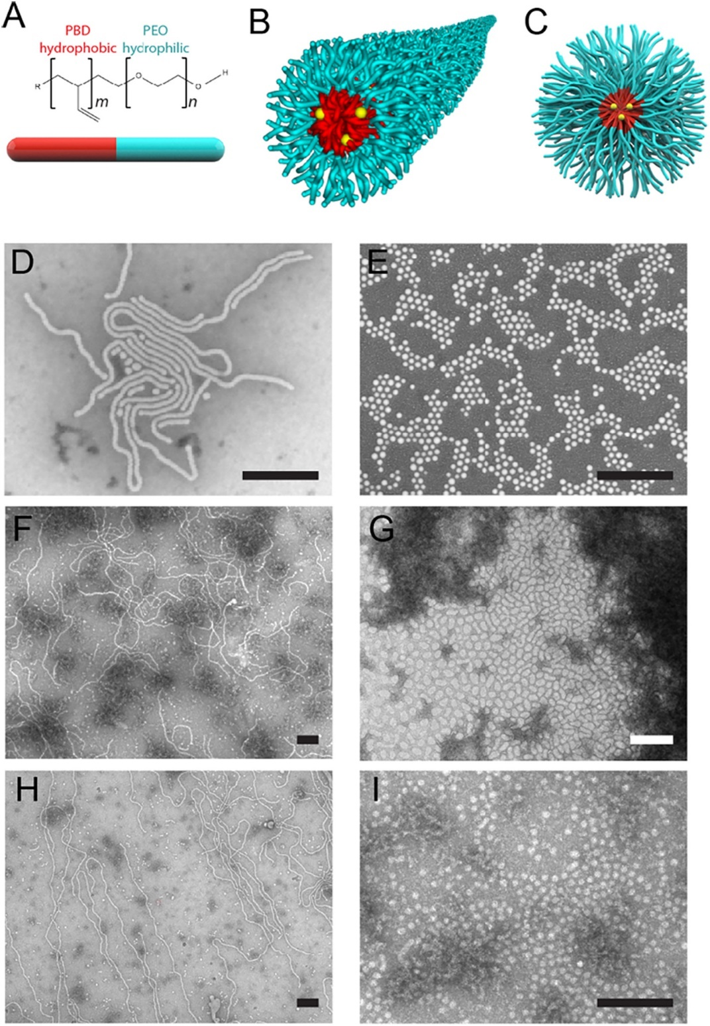
If PEO-PBD filomicelles bind SR-BI, then HDL could compete for the binding site on the cell surface of an SR-BI-expressing cell. To test this, we set up a series of titrations keeping the amount of filomicelles carrying PKH67 dye (green) constant and increased the amount of unlabeled hHDL in culture with RAW 264.7 M1 and M2 murine macrophages as a model in vitro system because they have high surface expression levels of SR-BI [13]. Also, macrophages are desirable targets in nanomedicine for a wide range of applications. The uptake of filomicelles carrying PKH67 (filomicelles-PKH67) decreased as the concentration of hHDL increased in fluorescence micrographs (Fig. 2A). Fluorescence quantification of the cells by flow cytometry showed a ~100-fold drop in signal as the hHDL concentration increased (Fig. 2B; Fig. S2-3). There was no difference in the uptake of spheres carrying PKH67 in the same experiments, except at the highest concentration of hHDL (Fig. 2A,B; Fig. S4-5). We wished to determine if the small molecule BLT-1, which blocks lipid transport at SR-BI [14], also decreased filomicelle uptake by macrophages. BLT-1 greatly lowered the uptake of filomicelles carrying PKH67 in both M1 and M2 murine macrophages but had no effect on the uptake of spheres carrying PKH67 (Fig. 2C,D; Fig. S6). We used immunofluorescence with SR-BI as the epitope tag to determine the expression levels of SR-BI in M1 and M2 murine macrophages that were incubated with either PBS, hHDL, filomicelles, or spheres for 2 hours. SR-BI levels matched for hHDL and filomicelles, and were slightly lower for spheres (Fig. 2E).
Figure 1. Binding of PEO-PBD NPs to hHDL and rSR-BI. (A) SDS-Page gel showing the results of a binding experiment where NPs were mixed with hHDL. The major structural protein of HDL, Apo-AI, does not bind PEO-PBD filomicelles (black rectangle). As a positive control we used 50 nm PS-COOH beads as a known binder of Apo-AI (green rectangle). S = supernatant, W = wash, E = elution, L = ladder. (B) SDS-Page gel showing the results of a binding experiment where PEO-PBD spheres (red rectangle) and PEO-PBD filomicelles (blue rectangle) were mixed with recombinant SR-BI (rSR-BI). (C) Plot of the binding of rSB-BI to PEO-PBD filomicelles and PEO-PBD spheres from the experiments described in (B). (D) Plot of the binding of free PEO molecules of varying MW with rSR-BI. (E) Fluorescence micrographs of PEO-PBD filomicelles-NIR that were incubated with lysed Idla7 cells expressing SR-BI-GFP. Scale bars are 5 microns.
We wished to use a model system that had controllable expression of SR-BI and circumvented SR-BI-dependent macrophage activation. To this end, we used SR-BI (Idla7 cells), which do not express SR-BI as a control versus those that constitutively express SR-BI (Idla7-SR-BI cells) [2,15]. We performed similar experiments as the ones described above. Again, hHDL titrations greatly reduced the uptake of filomicelles carrying PKH67 by Idla7-SR-BI cells (Fig. 3A,B; Fig. S7,S8; Movie S1). There was little difference in the uptake of spheres carrying PKH67 in the same experiments (Fig. 3A,B). No significant difference in either filomicelles or spheres carrying PKH67 was seen in hHDL titration experiments with Idla7 cells (Fig. 3C,D; Fig. S9,S10). BLT-1 lowered the uptake of filomicelles carrying PKH26 by Idla7-SR-BI cells versus DMSO controls, but had no difference on filomicelle uptake by Idla7 cells (Fig. 3E,F; Fig S11). BLT-1 had no effect on the uptake of spheres carrying PKH26 by Idla7-SR-BI or Idla7 cells (Fig. 3E,F; Fig S11). We transiently expressed SR-BI-GFP in Idla7 cells and determined the uptake of PEO-PBD filomicelles and spheres. Idla7 cells expressing SR-BI-GFP had a ~10-fold higher uptake of filomicelles carrying PKH26 (red) than Idla7 cells that were not expressing SR-BI-GFP (Fig. 3G,H; Fig. S12). Again, no difference was seen in uptake of spheres carrying PKH26 in these experiments (Fig. 3G,H; Fig. S12).
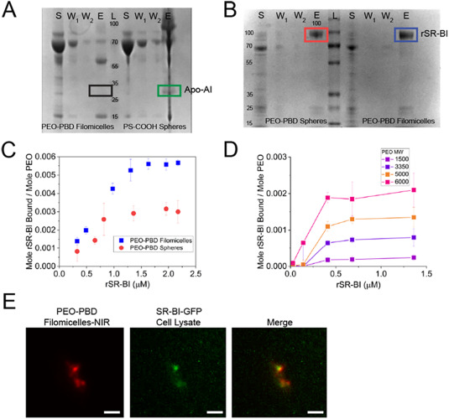
Figure 2. hHDL and BLT-1 block the uptake of PEO-PBD filomicelles by murine M1 and M2 macrophages. (A) Fluorescence micrographs of M1 and M2 murine macrophages that were incubated with either PEO-PBD filomicelles carrying PKH67 dye or PEO-PBD spheres carrying PKH67 dye and increasing amounts of unlabeled hHDL as indicated. (B) Plots of filomicelle and sphere fluorescence as a function of the concentration of hHDL as measured by flow cytometry. (C) Fluorescence micrographs of M1 and M2 murine macrophages incubated with PEO-PBD filomicelles carrying PKH67 dye in the absence and presence of BLT-1 and accompanying plot of the fluorescence of PEO-PBD filomicelles-PKH67 as measured by flow cytometry. (D) Fluorescence micrographs of M1 and M2 murine macrophages incubated with PEO-PBD spheres carrying PKH67 dye in the absence and presence of BLT-1 and accompanying plot of the fluorescence of PEO-PBD spheres-PKH67 as measured by flow cytometry. N = 10k cells per curve for all plots. All scale bars are 10 microns. (E) Plot of the expression of SR-BI in M1 and M2 murine macrophages as measured by immunofluorescence against SR-BI. Experiments were performed in triplicate. * P<0.1, ** P<0.05, *** P<0.01.

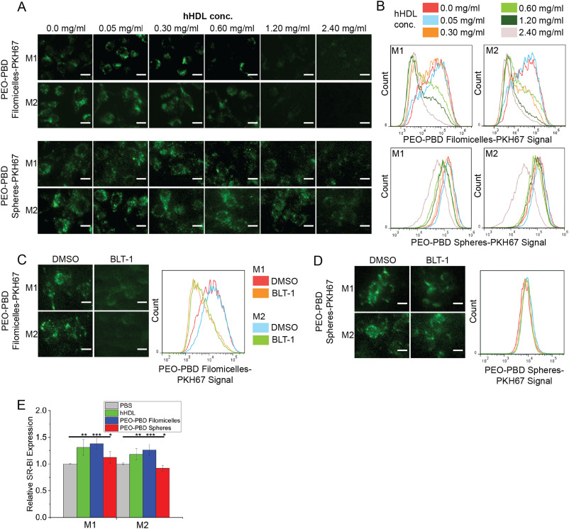
To determine the relationship between PEO-PBD filomicelles and spheres and SR-BI in vivo, we co-injected (tail-vein) filomicelles and spheres carrying near infrared (NIR) dye with unlabeled hHDL. We harvested the major organs and blood 3 hours post-injection. We measured the NIR fluorescence of the major organs scaled by organ weight. We observed a ~2-fold drop in filomicelle localization to the livers of wild-type C57 mice and a ~2-fold increase in filomicelle presence in the plasma and the gastrointestinal (GI) tract (Fig. 4A,B). Controls were solitary injections of filomicelles into wild-type C57 mice. With spheres, we observed a slight drop in liver signal between the solitary and co-hHDL injections (Fig. 4A,B). We used SCARB1^{-/-} mice as a model system for mice lacking SR-BI. We repeated the above experiments injecting either filomicelles or spheres into the mice. The signal fraction of filomicelles in the liver dropped ~2-fold from wild-type to SCARB1^{-/-} mice (Fig. 4A,B). There was a corresponding ~2-fold increase in the signal fraction of filomicelles in the plasma. The signal fraction of spheres in the liver dropped slightly in SCARB1^{-/-} mice versus wild-type and increased slightly in the plasma. The signal was statistically equivalent across the other major organs between wild-type and SCARB1^{-/-} mice for the spheres (Fig. 4A,B).
Figure 3. hHDL and BLT-1 block the uptake of PEO-PBD filomicelles by Idla7-SR-BI cells. (A) Fluorescence micrographs of Idla7-SR-BI cells incubated with PEO-PBD filomicelles carrying PKH67 or PEO-PBD spheres carrying PKH67 with increasing amounts of unlabeled hHDL as indicated. (B) Plots of the fluorescence of the cells shown in (A) measured by flow cytometry. (C) Fluorescence micrographs of Idla7 cells that were incubated with PEO-PBD filomicelles carrying PKH67 or PEO-PBD spheres carrying PKH67 with increasing amounts of unlabeled hHDL as indicated. (D) Plots of the fluorescence of the cells shown in (C) measured by flow cytometry. (E) Fluorescence micrographs of Idla7-SR-BI and Idla7 cells incubated with either PEO-PBD filomicelles carrying PKH26 or PEO-PBD spheres carrying PKH26 and DMSO or BLT-1. (F) Plots of the fluorescence of the cells shown in (E) measured by flow cytometry. (G) Fluorescence micrographs of Idla7 cells that were transfected with SR-BI-GFP and incubated with either PEO-PBD filomicelles carrying PKH26 or PEO-PBD spheres carrying PKH26. (H) Plots of the fluorescence of the cells shown in (G) measured by flow cytometry. N = 10k cells per curve for all plots. All scale bars are 10 microns.

We wished to determine if filomicelles were entering macrophages and Idla7-SR-BI cells exclusively through SR-BI or if other factors were involved. We shut down a subset of typical NP entrance pathways using the following inhibitors: colchicine (pinocytosis) [16], cytochalasin B (phagocytosis) [17], rottlerin (macropinocytosis) [18], polyinosinic (PI) acid (lipoprotein endocytosis) [19], and monosdansyl cadaverine (clathrin-mediated endocytosis) [20]. hHDL uptake was substantially decreased by PI in Idla7-SR-BI cells, but PI had no effect M1 and M2 macrophages. In macrophages, the uptake of hHDL was only slightly decreased by cytochalasin B and rottlerin in M1 macrophages, but only rottlerin had a mild effect on M2 macrophages (Fig. 5A,B; Fig. S13). Cytochalasin B decreased the uptake of filomicelles by M1 and M2 macrophages, whereas PI acid had the strongest effect on decreasing filomicelle uptake by Idla7-SR-BI cells (Fig. 5C,D; Fig. S14). Fluorescence uptake profiles of spheres by M1 and M2 macrophages showed micropinocytosis being the strongest factor followed by phagocytosis; none of the inhibitors had an effect on sphere uptake by Idla7-SR-BI cells (Fig. 5E,F; Fig. S15). PI acid mainly inhibits SR-A [21]. Macrophages express both SR-BI and SR-A [22]. Thus, PI acid is likely binding SR-A on macrophages and SR-BI is still available for binding filomicelles and spheres. Hence, the observed high uptake of filomicelles by macrophages in the presence of PI acid (Fig. 5A,B). Therefore, we wished to determine if PI acid inhibits SR-BI in cells with controllable SR-A expression. We transiently transfected Idla7-SR-BI cells, which do not express SR-A (Fig. S17), with mSR-A-GFP. GFP was used to monitor transfection efficiency, not to determine potential co-localization with filomicelles or spheres. Cells expressing mSR-A-GFP took up filomicelles in the presence of PI acid, which should now block mSR-A-GFP instead of SR-BI (Fig. 6A,B; Fig. S16). PI acid has no effect on sphere uptake in these cells (Fig. 6C,D; Fig. S16). This indicates that PI acid can inhibit SR-BI binding to PEO-filomicelles only in the absence of SR-A, its preferred binding partner. Thus, we postulate that filomicelles bind SR-BI on the surfaces of M1 and M2 murine macrophages.
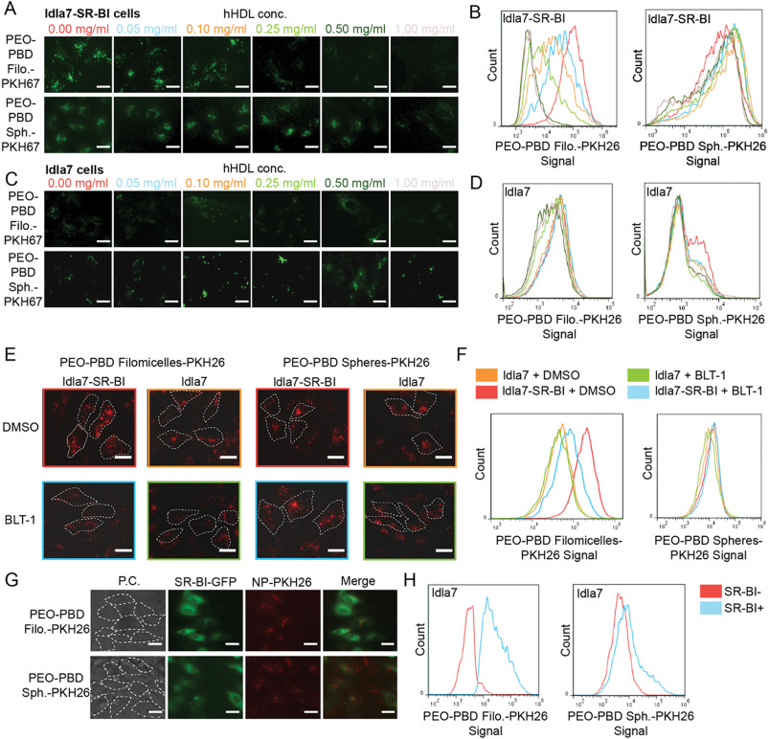
Figure 4. PEO-PBD filomicelle localization to the liver drops when co-injected with hHDL in wild-type mice and also in SCARB1-deficient mice when injected solitarily. (A) Fluorescence micrographs of the major organs of wild-type mice that were harvested 3 hours post tail-vein injection of either PEO-PBD filomicelles, PEO-PBD filomicelles + hHDL, PEO-PBD spheres, or PEO-PBD spheres + hHDL. The filomicelles and spheres were carrying NIR dye. PEO-PBD filomicelles and PEO-PBD spheres were also administered to SCARB1^{-/-} mice as indicated. Scale bars are 10 mm. (B) Plot of the NIR signal fraction of the organs shown in (A). N = 5 mice per bar. * P<0.1, ** P<0.05.

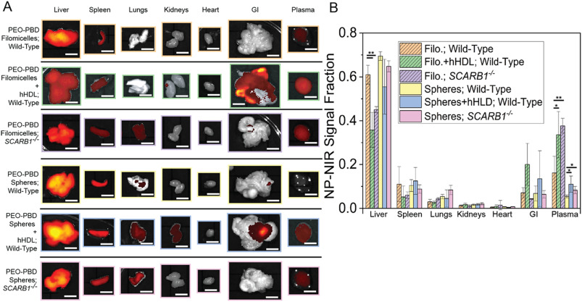
Fig. 5. PEO-PBD filomicelle localization to the liver drops when co-injected with hHDL in wild-type mice and in SCARB1-deficient mice when injected solitarily. (A) Fluorescence micrographs of the major organs of wild-type mice that were harvested 3 h post tail-vein injection of either PEO-PBD filomicelles, PEO-PBD filomicelles + hHDL, PEO-PBD spheres, or PEO-PBD spheres + hHDL. The filomicelles and spheres were carrying NIR dye. PEO-PBD filomicelles and PEO-PBD spheres were also administered to SCARB1^{−/−} mice as indicated. Scale bars are 10 mm. (B) Plot of the NIR signal fraction of the organs shown in (A). N = 5 mice per bar. * P < 0.1, ** P < 0.05.

Discussion
PEG/PEO is used in nanomedical applications because it is biocompatible and it has a low affinity for most proteins [23]. Thus, our discovery that PEO-PBD filomicelles have a strong affinity for SR-BI is surprising. However, there are several findings in the literature that foreshadowed our results. PEG-1500 in the crystallization buffer showed electron density in the crystal structure of LIMP-2, a member of the CD36 super family of scavenger receptor proteins, which also includes SR-BI [24]. The Pro270, Thr365, and Lys381 residues near PEG-1500 in the LIMP-2 structure were in the homologous SR-BI cavity/tunnel that is responsible for cholesterol transport [24]. This shows that single PEG/PEO molecules can interact with proteins in the scavenger receptor superfamily. Recently, a Cryo-TEM study showed that PEG interacts with anti-PEG Fab at Trp96 of the heavy chain complementarity-determining region 3 [25]. Trp53, Trp178, and Trp231 are in relatively close proximity to the PEG density in the LIMP-2 structure. They are conserved between LIMP-2 and SR-BI [24]. Given our findings that the affinity of PEG polymers - without PBD - for rSR-BI increases as a function of PEG length (Fig. 1D), we postulate that PEG may be interacting with these tryptophans in addition to its interaction with the Lys, Pro, and Thr residues listed above. Otherwise, the affinity of PEG for rSR-BI would not be a function of PEG length; each PEG molecule would bind two rSR-BI proteins. This is not what we observe. Additional structural biology and point mutation studies may shed light on the interactions between PEG and protein.
Although our spheres bound rSR-BI, they had weak affinity for cells expressing SR-BI. Spheres bind rSR-BI in pulldowns, but the binding assay showed that spheres have significantly less affinity for rSR-BI than filomicelles. This is further seen by the weak affinity they have for cells expressing SR-BI. Filomicelles had consistently stronger interactions with the same cells. We postulate that this is due to
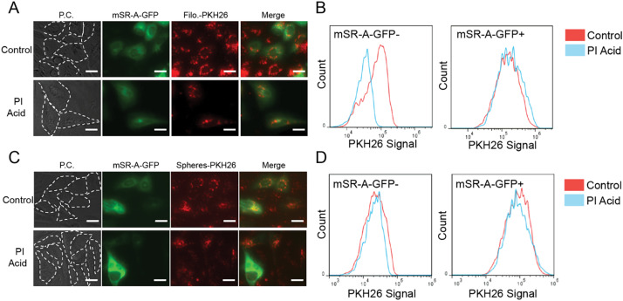
cooperativity among a filomicelle and a group of SR-BI receptors on the surface of a cell. HDL could also display cooperativity effects with SR-BI. Nascent HDL particles are disk-shaped molecular aggregates; only after they have taken up cholesterol esters do HDL particles mature into spheres [5]. Thus, HDL have the potential to form elongated Rouleau structures [26]. It is possible that Rouleau HDL particles and filomicelles have binding synergies across multiple SR-BI molecules.
Figure 6. SR-A does not play a role in PEO-PBD filomicelles uptake by Idla7-SR-BI cells.
(A) Fluorescence micrographs of Idla7-SR-BI cells that were transfected with mSR-A-GFP and incubated with PEO-PBD filomicelles-PKH26 with and without PI acid. (B) Plots of the PKH67 fluorescence of the cells shown in (A) measured by flow cytometry. (C) Fluorescence micrographs of Idla7-SR-BI cells that were transfected with mSR-A-GFP and incubated with PEO-PBD spheres-PKH26 with and without PI acid. (D) Plots of the PKH67 fluorescence of the cells shown in (C) measured by flow cytometry. N = 10k cells per curve. All scale bars are 10 microns.

Our results suggest that SR-BI is directly involved in the binding of filomicelles to professional phagocytes and epithelial cells using macrophages and Idla7 as model systems. However, filomicelle entry into the two cells diverges. PI acid inhibition of SR-BI eliminates uptake of filomicelles by Idal7-SR-BI cells. However, PI acid does not inhibit uptake of filomicelles by M1 or M2 macrophages. These macrophages are expressing both SR-BI and SR-A, whereas the Idla7-SR-BI system is not expressing SR-A [45]. PI acid mainly inhibits SR-A [41]. Thus, the addition of PI acid should inhibit SR-A instead of SR-BI in both M1 and M2 macrophages. Therefore, PI acid should have no effect on filomicelle binding and uptake by macrophages because SR-BI should be able to interact with filomicelles even in the presence of PI acid. By showing that PI acid does not reduce filomicelle uptake by Idla7 cells co-expressing SR-BI and SR-A-GFP, we confirmed that the SR-BI is still available for filomicelle binding when SR-A is inhibited.
It is not surprising that phagocytosis is the predominant filomicelle entry (but not binding) mechanism in macrophages. Indeed, particle uptake by professional phagocytes involves multiple membrane receptors, cytoskeleton action, bulk membrane flow and remodeling. We postulate SR-BI molecules expressed on macrophages bind filomicelles and bring them in proximity to other receptors that trigger phagocytosis, the main internalization pathway of foreign objects by macrophages. The identity of these receptors is currently unknown. They could include the Ig receptors FcR and CD14, and/or complement receptor CR3, which binds C3, the only complement factor found on PEGylated liposomes after administration to mice [42]. Still, hHDL titration and BLT-1 co-incubation experiments with filomicelles confirm that SR-BI is the major factor in the binding of filomicelles to macrophages.
In the context of NPs, SR-BI is responsible for the importation of HDL-coated silver NPs (AgNPs), and to a lesser extent uncoated AgNPs in RAW 264.7 mouse macrophages [27]. However, it is not clear if this is a direct interaction between AgNPs and SR-BI or if SR-BI controlled AgNP uptake indirectly through macrophage activation. By using an epithelial cell line stably expressing SR-BI (Idal7-SR-BI), we were able to study an isolated PEG-SR-BI interaction and avoid effects of macrophage activity. Here we show that this is a direct interaction in the case of filomicelles. Our results point to a strategy to not only target cells expressing SR-BI, but to block the ability of SR-BI expressing phagocytes from clearing elongated PEGylated NPs by co-injection with HDL. Currently, one popular strategy to limit the clearing of NPs is to kill a large fraction of liver resident macrophages – Kupffer cells - using a pre-injection of clodronate liposomes [30]. Naturally, this will compromise the immunity of a potential patient. A strategy of using HDL in place of clodronate liposomes should not put the patient at potential risk because of a weakened immune system. This could be a new approach for extending the circulation and targeting of PEGylated NPs.

Materials and Methods
Nanoparticles
PEO₅₆-PBD₄₆ diblock copolymers (filomicelles) were synthesized according to the methods of Ref. 31. PEO₁₃₂-PBD₆₉ diblock copolymers (spheres) were a gift from Dr. Frank S. Bates (Univ. of Minnesota). NPs were formed at 10 mg/ml copolymer using film rehydration with phosphate buffered saline (PBS) as the aqueous buffer as described previously [32]. Nanoparticles were stained with hydrophobic PKH-26/67 or near-infrared (NIR) dyes and dialyzed overnight into PBS [33]. The PBS was changed three times.
SEM Imaging
200 mesh copper grids with a thin carbon film were made to be hydrophilic by placing the grid with film in weak plasma for 30 seconds. The grid with carbon film was then floated on a small drop of sample for 1 minute, excess sample was quickly removed by touching the edge of the grid to a piece of filter paper. The grid with sample was washed with water then stained with 1% uranyl acetate, after 1 minute excess stain was removed by touching the edge of the grid to a piece of filter paper. The images were taken by ZEISS LIBRA 200 HT FE and analyzed by ImageJ (Fiji).
Binding Assays
hHDL was purchased from Lee BioSolutions (#361-10). The solution contained 3,320 mg/dL total cholesterol, 1,350 mg/dL triglyceride, and 3,070 hHDL cholesterol. Electrophoresis (Helena QuickGel) preformed at Lee BioSolutions showed one major band corresponding to ApoA-I. PS-COOH NPs (Bangs Labs; #PC2002) were pelleted by centrifugation. Filomicelles were pelleted using immune precipitation. Briefly, filomicelles and hHDL or rSR-BI (R and D systems; #8114-SRB) were mixed for 3 hours at 4ºC. An antibody for PEG (Abcam; #ab133471) was then added and the mixed was mixed at 4ºC for an additional hour. Agarose Protein L beads (Santa Cruz Bio; #sc-500779) were then added for an additional hour. At this point filomicelles with bound Apo-AI were pelleted. The amount of unbound Apo-AI in the supernatant was quantified by spectroscopy (Nanodrop).
Mammalian Cell Culture
M0 RAW 264.7 macrophages (ATCC; #TIB-71) were polarized into M1-like macrophages by adding 20 ng/ml of IFN-γ (PeproTech; #315-05) or into M2-like macrophages by adding 10 ng/mL each of IL-4 (PeproTech; #214-14) and IL-13 (PeproTech; #210-13) for 48 hours [34,39]. Increased expression of IL-12 (M1) and IL-10 was confirmed using standard RT-PCR techniques (Fig. S18). Macrophages were maintained at 5% CO₂ and 37ºC in DMEM supplemented with 10% FBS and 1% penicillin-streptomycin. Idal7 and Idal7-SR-BI cells were provided by Dr. Monty Krieger (MIT). Idal7 cells were maintained at 5% CO₂ and 37ºC in F-12K supplemented with 10% FBS and 1% penicillin/streptomycin. Idal7-SR-BI also had 200 ng/ml G418 in the media.
In vitro experiments
18 hours prior to experiments, cells were seeded in a 24 well plate. 70-90% confluence was targeted at the start of the experiment. NPs were added to a final concentration of 400 μg/ml. Plates were swirled to mix. After 2 hours, the media was removed, the cells were washed 3x times with PBS and imaged to visualize NP content with an EVOS FL Cell Imaging System (Thermo). Cells were then trypsinized and two volumes of FACSmax (ASMBIO) buffer was added before the cells were aspirated. Cells were then quantitatively analyzed with an Accuri C6 flow cytometer (BD). hHDL was added simultaneously with the NPs to the final concentrations stated. Plates were swirled to mix and incubated for 2 hours. Analysis was done as described above. The SR-BI-GFP plasma was a gift from Dr. Sergio Grinstein (Univ. of Toronto). SR-A-GFP was in a pcDNA3.1(+)-C-eGFP backbone (Genescript). Inhibitor treatments are described in Table S1.

SR-BI Gene Expression Assays
M1 and M2 RAW 264.7 Macrophages were seeded in a 96 well plate. 70-90% confluence was targeted at the start of the experiment. The described NP or hHDL was added to the culture media for 2 hours. NPs were added to a final concentration of 400 μg/ml and hHDL to 2.4mg/ml. After incubation, the cell were fixed by adding 1 volume of 10% buffered formalin (Fisher) to each well and incubated for 30 minutes at 37ºC. The cells were then washed 3x with PBS. Blocking and perforation was performed in one step with 10% Goat serum, .5%BSA, .1%Tween 20 PBS at 37ºC for 1 hr. Cell were washed 3x in PBS. .5% BSA PBS with .5µg/ml SR-BI antibody (Novus;NB400-104) was added and the cells were incubated for 1 hour at 37ºC. Cells were washed 3x with PBS before .5%BSA PBS containing 1µg/ml Texas Red conjugated secondary antibody (Abcam; ab6719) was added. Cells were incubated for 1hr at 37ºC. Cells were washed 3x with PBS and switched to PBS containing 100nM DAPI to counter stain the nucleus for 5minuets at RT and washed 3x again with PBS. The plate was that analyzed with a VarioSkan LUX (ThermoFisher). Fluorescence was measured both for Texas Red and DAPI. Singly stained wells confirmed there was not significant crosstalk between the channels. The fluorescence of Texas Red was standardized for the number of cells in each well by dividing by the DAPI signal. A gene expression score is assigned by normalizing to the standardized expression of the untreated cells.

Mouse Experiments
All experiments were performed under the guidelines of the University of Tennessee’s IACUC protocol #2231. BL6;129S-Scarb1^{tm1Kri}/J mice were purchased from Jackson Laboratories and bred in house. Mice were genotyped with tail snip PCR analysis. Litter mates were used as experimental controls. Prior to injection, aggregates that did not form NPs were pelleted at 23°C for 15 minutes at 15,000 x g in a Fisher Scientific AccuSpin Micro 17 centrifuge. The upper phase containing the dispersed NPs was reserved for injection although no pellet was visible. NPs were loaded with 5 μl of a 2.5 mg/ml stock of NIR dye in ethanol for imaging (Life Technologies; #D-12731). The dye partitions into the hydrophobic interiors of the nanoparticles and does not leak in vivo [33,36]. 100 μl of 5 mg/ml NP solution in PBS was tail-vein injected into the mice. Mice were euthanized 3 hours after injection by isoflurane and cervical dislocation. The plasma concentration of C57BL/6J mice is reported to be ~0.6 mg/ml [36], correlating to a blood concentration of 0.35 mg/ml. The weight of the mouse was used to calculate the blood volume [37] and the resulting amount of hHDL co-injected with filomicelles. hHDL was injected to reach a level of at least 0.50 mg/mL in the bloodstream to mimic the end point of the in vitro titration.

Acknowledgments
The authors thank Dr. Eric Boder for the use of his flow cytometer, Dr. John R. Dunlap for electron microscopy, Deanna Riley for mouse genotyping, and the Center for Environmental Biotechnology for use of their IVIS imaging system. We also thank Dr. Monty Krieger of MIT for providing Idla7 and Idla7-SR-BI cell lines.This work was supported in part by R15GM116037.

Author Contributions
M.R., S.J.K., M.A., J.A.B., N.G.K, J.W.M. performed the experiments. M.R and P.D. wrote the manuscript.

References
- Hales, C. M., Carroll, M. D., Fryer, C. D., and Ogden, C. L. Prevalence of obesity and severe obesity among adults: United States, 2017-2018. NCHS Data Brief 360 (2020).
- S. Acton et al., Identification of scavenger receptor SR-BI as a high density lipoprotein receptor. Science 271, 518-520 (1996).
- V. N. Sukhorukov et al., Lipid metabolism: focus on athersclerosis. Biomedicines 8, 262 (2020).
- Y. Ji et al., Scavenger receptor BI promotes high density lipoprotein-mediated cellular cholesterol efflux. J. Biol. Chem. 34, 20982-30985 (1997).
- K. Frayn, R. Evans, Human Metabolism (Wiley Blackwell) 4th edition, pp. 304-312.
- C. Rohrl, H. Stangl, HDL endocytossi and resecretion. Biochem. Biophys. Acta 1831, 1626-1633 (2013).
- J. Canton, D. Neculai, S. Grinstein, Scavenger receptors in homeostasis and immunity. Nat. Rev. Immunol. 13, 621-623 (2013).
- M. T. Catanese et al. Role of scavenger receptor class B type I in hepatitis C virus entry: kinetics and molecular determinants. J. Virol. 84, 34-43 (2010).
- C. C. Colpitts, P. L. Tsai, M. B. Zeisel, Hepatitis C virus entry: an intriguingly complex and highly regulated process. Int. J. Sci. 21, 2091 (2020).
- C. Wei et al., SARS-CoV-2 manipulates the SR-BI-mediated HDL uptake pathway for its entry. Nat. Metab. 2, 1391-1400 (2020).
- P. Andre, G. Perlemuter, A. Budkowska, C. Brechot, V. Lotteau, Hepatitis C virus particles and lipoprotein metabolism. Semin. Liver Dis. 25, 93-104 (2005).
- U. C. Anozie, K. J. Quigley, A. Prescott, S. M. Abel, P. Dalhaimer, Equilibrium binding of isolated and in-plasma high-density lipoprotein (HDL) to polystyrene nanoparticles. J. Nanoparticle Res. 22, 223 (2020).
- A. Ji et al., Scavenger receptor SR-BI in macrophage lipid metabolism. Atherosclerosis 217, 106-112 (2011).
- T. J. Nieland et al., Discovery of chemical inhibitors of the selective transfer of lipids mediated by the HDL receptor SR-BI. Proc. Natl. Acad. Sci. U.S.A. 99, 15422-15427 (2002).
- K. F. Kozarsky, H. A. Brush, M. Krieger, Unusual forms of low density lipoprotein receptors in hamster cell mutants with defects in the receptor structural gene. J. Cell Biol. 102, 1567-1575 (1986).
- C. Neubauer, A. M. Phelan, H. Kues, D. G. Lange, Microwave irradiation of rats at 2.35 GHZ activates pinocytotic-like uptake of tracer by capillary endothelial cells of cerebral cortex. Bioelectronics 11, 261-268 (1990).
- A. T. Davis, R. Estensen, P. G. Quie, Cytochalasin-B.3. inhibition of human polymorphonuclear leukocyte phagocytosis. Proc. Soc. Exp. Biol. Med. 137, 161 (1971).
- K. Sarkar, M. J. Kruhlak, S. L. Erlandsen, S. Shaw, Selective inhibition by rottlerin of macropinocytosis in monocyte-derived dendritic cells. Immunology 116, 513-524 (2005).
- L. Kobzik, Lung macrophage uptake of unopsonized environmental particles – role of scavenger-type receptors. J. Immunology 155, 367-376 (1995).
- P. K. Nandi, P. P. van Jaarsveld, R. E. Lippoldt, H. Edelhoch, Effect of basic compounds on the polymerization of clathrin. Biochemistry 20, 6706-6710 (1981).
- R. van Dijk et al., Polyinosinic acid blocks adeno-associated virus macrophage endocytosis in vitro and enhances adeno-associated virus liver-directed gene therapy. Hum. Gene Ther. 24, 807-813 (2013).T. Kodama et al., Type I macrophage scavenger receptor contains alpha-helical and collagen-like coiled coils. Nature 343, 531-535 (1990).
- K. Kristenson, T. B. Engle, A. Stensballe, J. B. Simonsen, T. L. Andreson, The hard protein corona of stealth liposomes is sparse. J. Cont. Rel. 307, 1-15 (2019).
- D. Neculai et al., Structure of LIMP-2 provides functional insights with implications for SR-BI and CD36. Nature 504, 172-176 (2013).
- J. T. Huckaby et al., Structure of an anti-PEG antibody reveals an open ring that captures highly flexible PEG polymers. Comm. Chem. 3, 124 (2020).
- L. Zhang et al., Morphology and structure of lipoproteins revealed by an optimized negative-staining protocol of electron microscopy. J. Lipid Res. 52, 175-194 (2011).
- A. A. Aldossari, J. H. Shannahan, R. Podila, J. M. Brown, Scavenger receptor B1 facilitates macrophage uptake of silver nanoparticles and cellular activation. J. of Nanoparticle Res. 17, 313 (2015).
- M. Tsugita, N. Morimoto, M. Tashiro, K. Kinoshita, M. Nakayama, SR-B1 is a silica receptor that mediates canonical inflammasome activation. Cell Rep. 18, 1298-1311 (2017).
- Y. Qiu et al., Scavenger receptor A modulates immune response to pulmonary cryptococcus neoformans infection. J. Immunol. 191, 238-248 (2013).
- A. J. Tavares et al., Effect of removing Kupffer cells on nanoparticle tumor delivery. Proc. Natl. Acad. Sci. U.S.A. 114, E10871-E10880 (2017).
- Y.-Y. Won, H. T. Davis, F. S. Bates, Giant wormlike rubber micelles. Science 283, 960-963 (1999).
- Y. Geng et al. Shape effects of filaments versus spherical particles in flow and drug delivery. Nat. Nanotech. 2, 249-255 (2007).
- P. Dalhaimer, F. S. Bates, D. E. Discher, Single molecule visualization of stiffness-tunable, flow-conforming worm micelles. Macromolecules 36, 68-73-6877 (2003).
- Zandi, S. et al. ROCK-isoform-specific polarization of macrophages associated with age-related macular degeneration. Cell Reports 10, 1173-1186 (2015).
- D. A. Christian et al., Flexible filaments for in vivo imaging and delivery: persistent circulation of filomicelles opens the dosage window for sustained tumor shrinkage. Mol. Pharm. 6, 1343-1352, 2009.
- J. C. Link et al., Increased high-density lipoprotein cholesterol levels in mice with XX versus XY sex chromosomes. Arterioscler. Thromb. Vasc. Biol. 35, 1778-86 (2015).
- A. C. Riches et al., Blood volume determination in the mouse. J. Physiol., 228, 279-284 (1973).
- J. J. Anzinger et al., Native low-density lipoprotein uptake by macrophage colony-stimulating factor-differentiated human macrophages is mediated by macropinocytosis and micropinocytosis. Arterioscler. Thromb. Vasc. Biol. 30, 2022-2031 (2010).
- 77. Bai, L. et al. M2-like macrophages in the fibrotic liver protect mice against lethal insults through conferring apoptosis resistance to hepatocytes. Scientific Reports 7, 10518 (2017).
- Henrich, S. E., Thaxton, C. S. An update on synthetic high-density lipoprotein-like nanoparticles for cancer therapy. Expert Review of Anticancer Therapy 19, 515-528 (2019).
- Erdman, L. K. et al. CD36 and TLR interactions in inflammation and phagocytosis: implications for malaria. Journal of Immunology 183, 6452-6459 (2009).
- Yla-Hertuala, S. et al. Evidence for the presence of oxidatively modified low density lipoprotein in atherosclerotic lesions of rabbit and man. Journal of Clinicanl Investigation 84, 1086-1095 (1989).
- Hadjidemetriou, M., Al-Ahmady, Z., and Kostarelos, K. Time-evolution of in vivo protein corona onto blood-circulating PEGylated liposomal doxorubicin (DOXIL) nanoparticles. Nanoscale 8, 6948-6957 (2016).
- Wegmann, U., Carvalho, A. L., Stocks, M., and Carding, S. R. Use of genetically modified bacteria for drug delivery in humans: revisiting the safety aspect. Scientific Reports 7, 2294 (2017).
- Busatto, S. et al. Lipoprotein-based drug delivery. Advanced Drug Delivery Reviews 159, 377-390 (2020).

Supplemarty Information

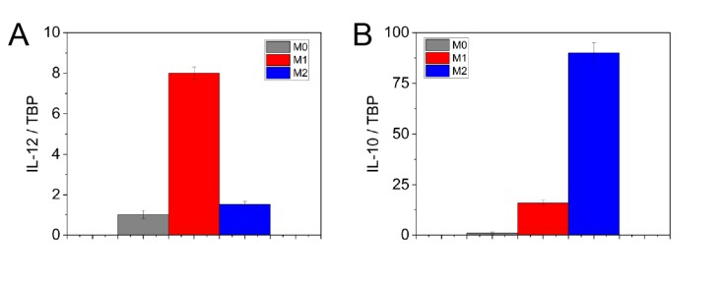
Figure S1. Confirmation of macrophage polarization by RT-PCR. (A-B) Plots of the relative expression of IL-12 (M1 phenotype) (A) and IL-10 (M2 phenotype) (B) for the polarized macrophages used in the experiments.

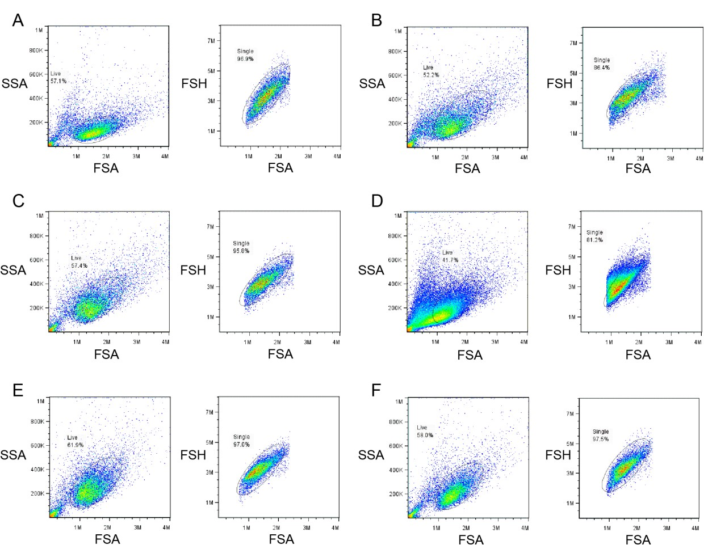

Figure S2. Scatter plots for the PEO-PBD filomicelles-PKH67 histograms shown in
Figure 3B for M1 murine macrophages. (A) 0.0 mg/ml hHDL. (B) 0.05 mg/ml hHDL. (C)
0.30 mg/ml hHDL. (D) 0.60 mg/ml hHDL. (E) 1.20 mg/ml hHDL. (F) 2.40 mg/ml hHDL. SSA
= side scatter angle. FSA = forward scatter angle. FSH = forward scatter height.

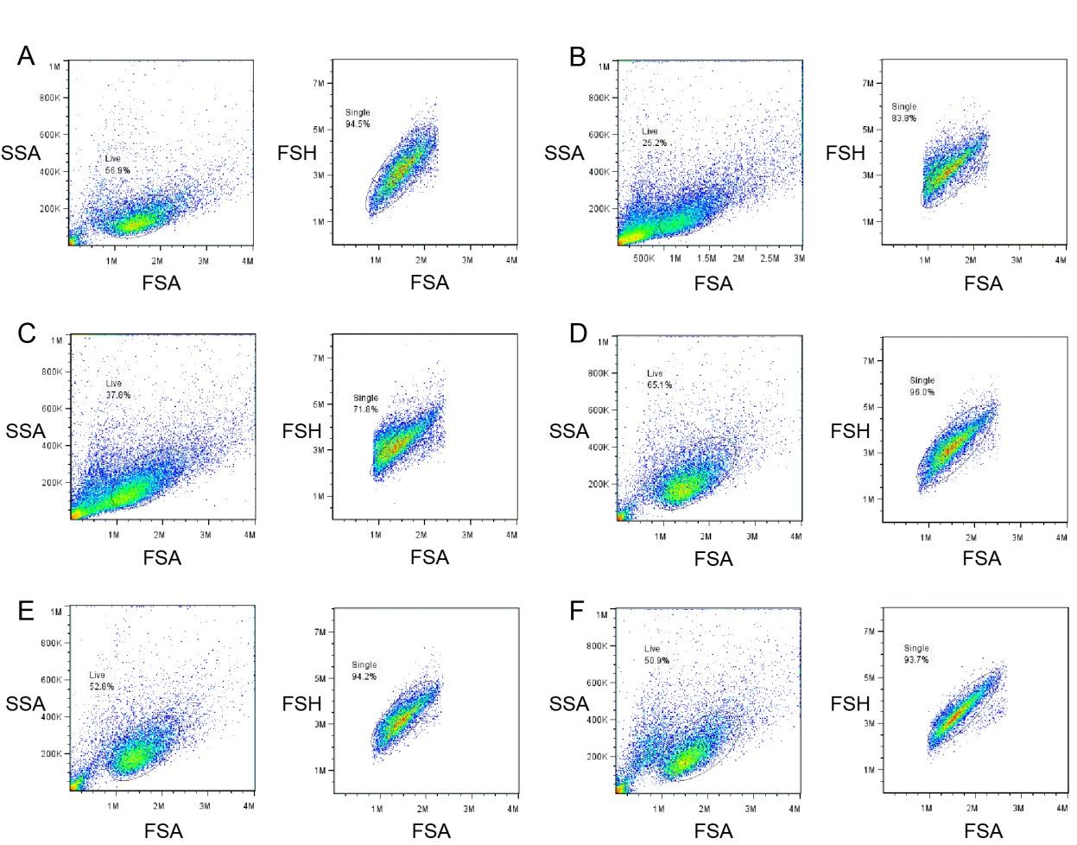

Figure S3. Scatter plots for the PEO-PBD filomicelles-PKH67 histograms shown in
Figure 3B for M2 murine macrophages. (A) 0.0 mg/ml hHDL. (B) 0.05 mg/ml hHDL. (C)
0.30 mg/ml hHDL. (D) 0.60 mg/ml hHDL. (E) 1.20 mg/ml hHDL. (F) 2.40 mg/ml hHDL. SSA
= side scatter angle. FSA = forward scatter angle. FSH = forward scatter height.

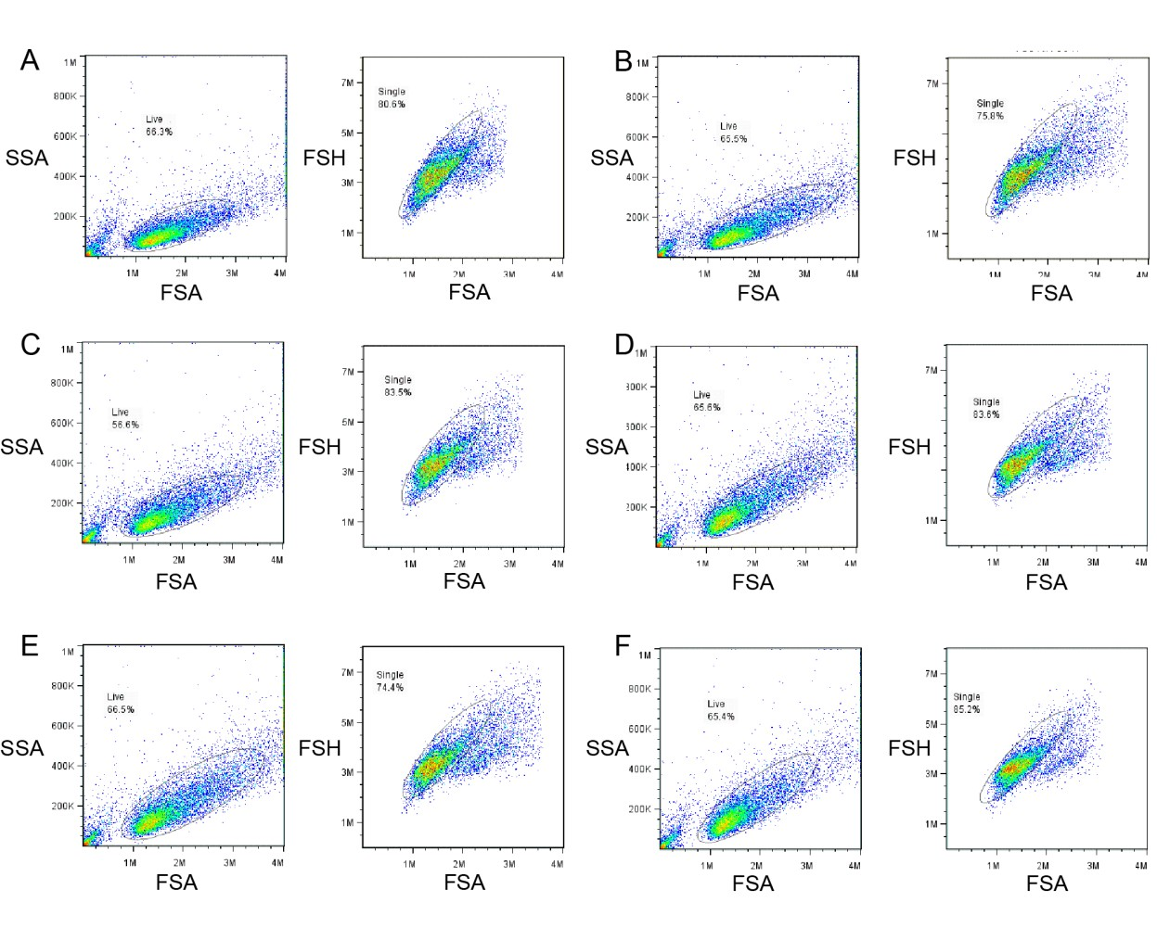

Figure S4. Scatter plots for the PEO-PBD spheres-PKH67 histograms shown in Figure
3B for M1 murine macrophages. (A) 0.0 mg/ml hHDL. (B) 0.05 mg/ml hHDL. (C) 0.30 mg/ml hHDL. (D) 0.60 mg/ml hHDL. (E) 1.20 mg/ml hHDL. (F) 2.40 mg/ml hHDL. SSA = side scatter angle. FSA = forward scatter angle. FSH = forward scatter height.

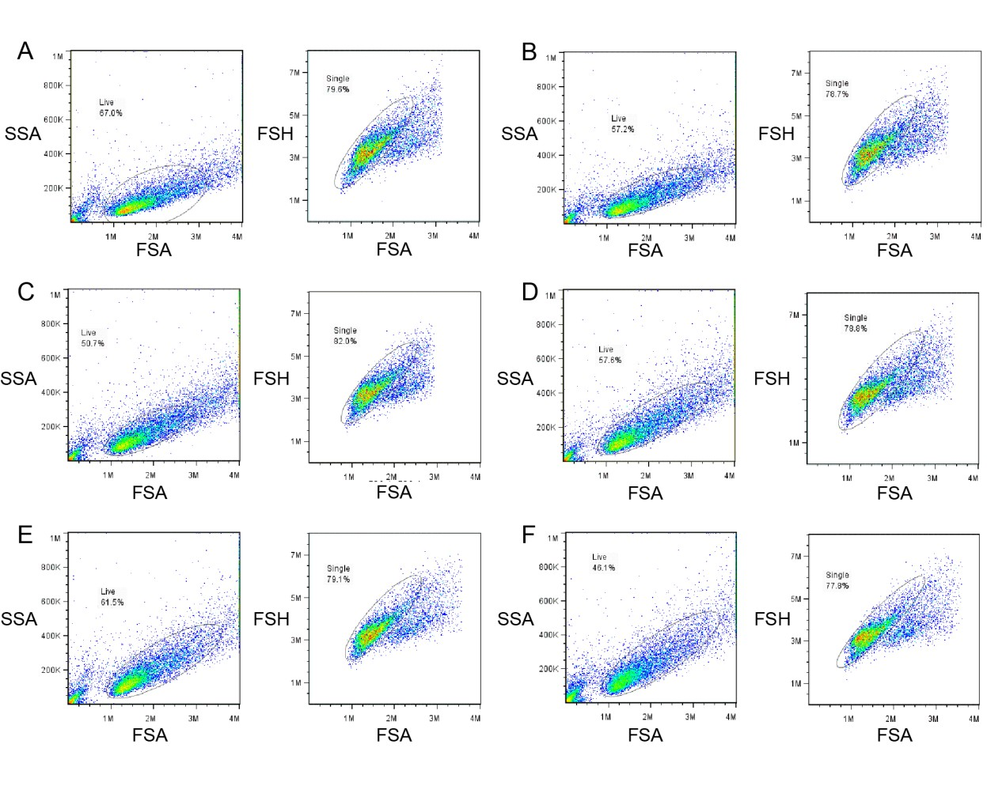
Figure S5. Scatter plots for the PEO-PBD spheres-PKH67 histograms shown in Figure
3B for M2 murine macrophages. (A) 0.0 mg/ml hHDL. (B) 0.05 mg/ml hHDL. (C) 0.30 mg/ml hHDL. (D) 0.60 mg/ml hHDL. (E) 1.20 mg/ml hHDL. (F) 2.40 mg/ml hHDL. SSA = side scatter angle. FSA = forward scatter angle. FSH = forward scatter height.

Figure S6
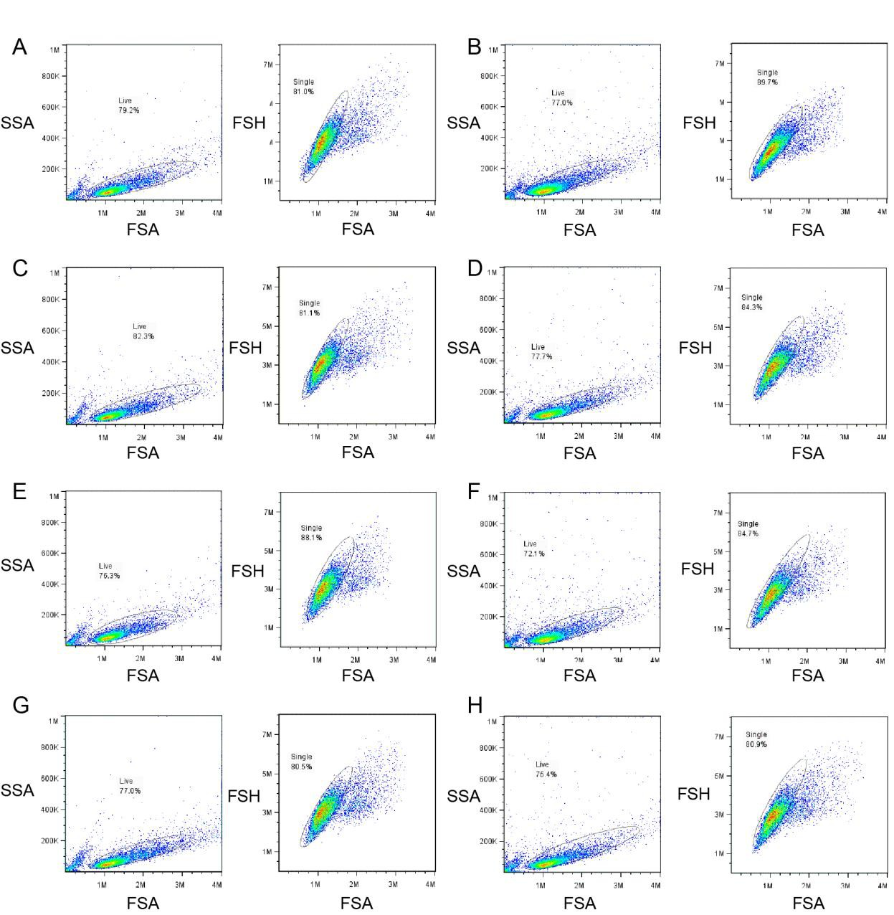

Figure S6. Scatter plots for the PEO-PBD filomicelles-PKH67 and PEO-PBD spheres- PKH67 histograms shown in Figure 3C,D for M1 and M2 murine macrophages. (A-B) M1 macrophages incubated with PEO-PBD filomicelles-PKH67 with DMSO (A) or BLT-1 (B). (C-D) M2 macrophages incubated with PEO-PBD filomicelles-PKH67 with DMSO (C) or BLT-
1 (D). (E-F) M1 macrophages incubated with PEO-PBD spheres-PKH67 with DMSO (E) or BLT-1 (F). (G-H) M2 macrophages incubated with PEO-PBD spheres-PKH67 with DMSO (G) or BLT-1 (H). SSA = side scatter angle. FSA = forward scatter angle. FSH = forward scatter height.

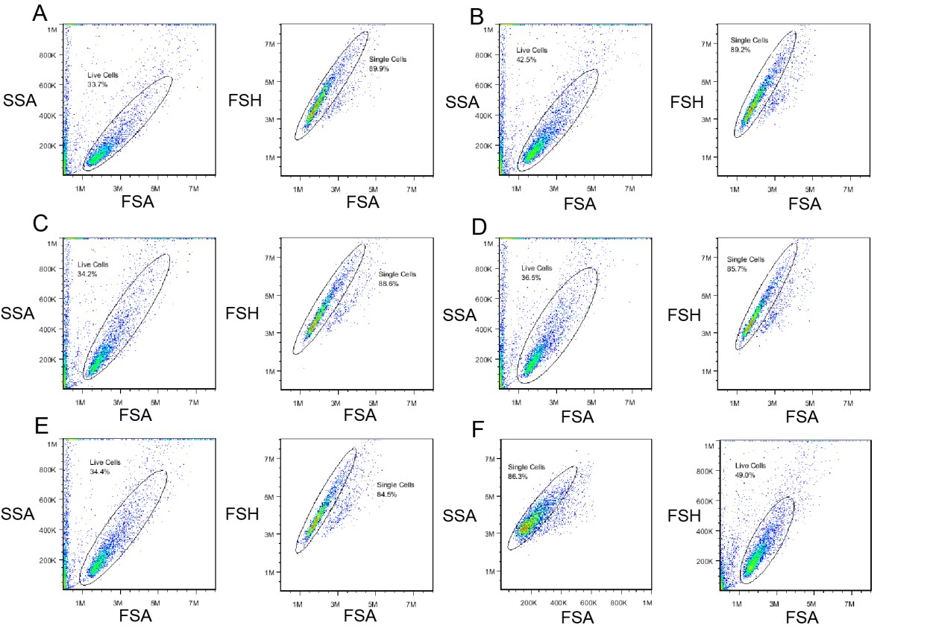

Figure S7. Scatter plots for PEO-PBD filomicelles-PKH67 histograms shown in Figure
4B for Idla7-SR-BI cells. (A) 0.0 mg/ml hHDL. (B) 0.05 mg/ml hHDL. (C) 0.10 mg/ml hHDL. (D) 0.25 mg/ml hHDL. (E) 0.50 mg/ml hHDL. (F) 1.00 mg/ml hHDL. SSA = side scatter angle. FSA = forward scatter angle. FSH = forward scatter height.

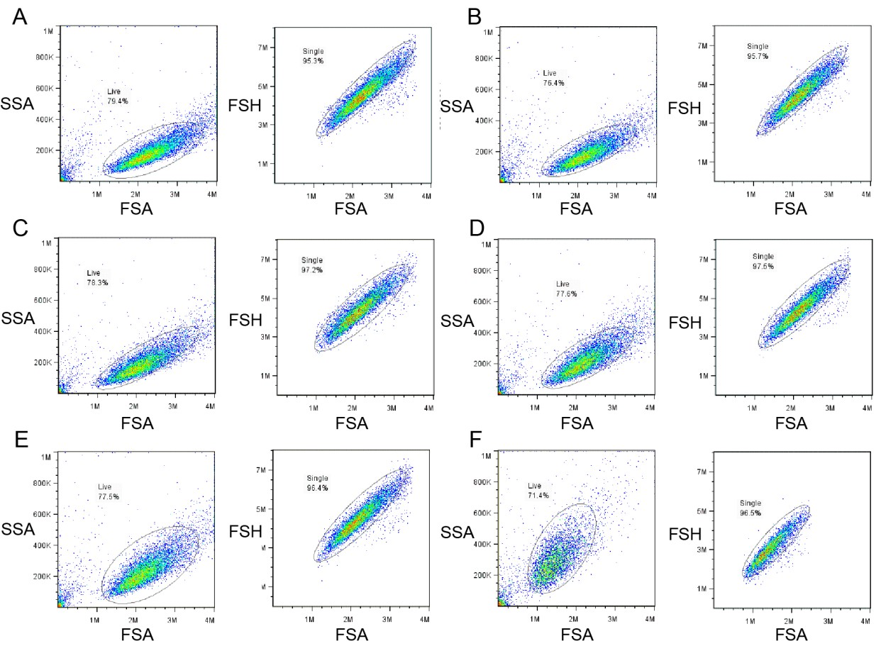

Figure S8. Scatter plots for PEO-PBD spheres-PKH67 histograms shown in Figure 4B
for Idla7-SR-BI cells. (A) 0.0 mg/ml hHDL. (B) 0.05 mg/ml hHDL. (C) 0.10 mg/ml hHDL. (D)
0.25 mg/ml hHDL. (E) 0.50 mg/ml hHDL. (F) 1.00 mg/ml hHDL. SSA = side scatter angle. FSA = forward scatter angle. FSH = forward scatter height.

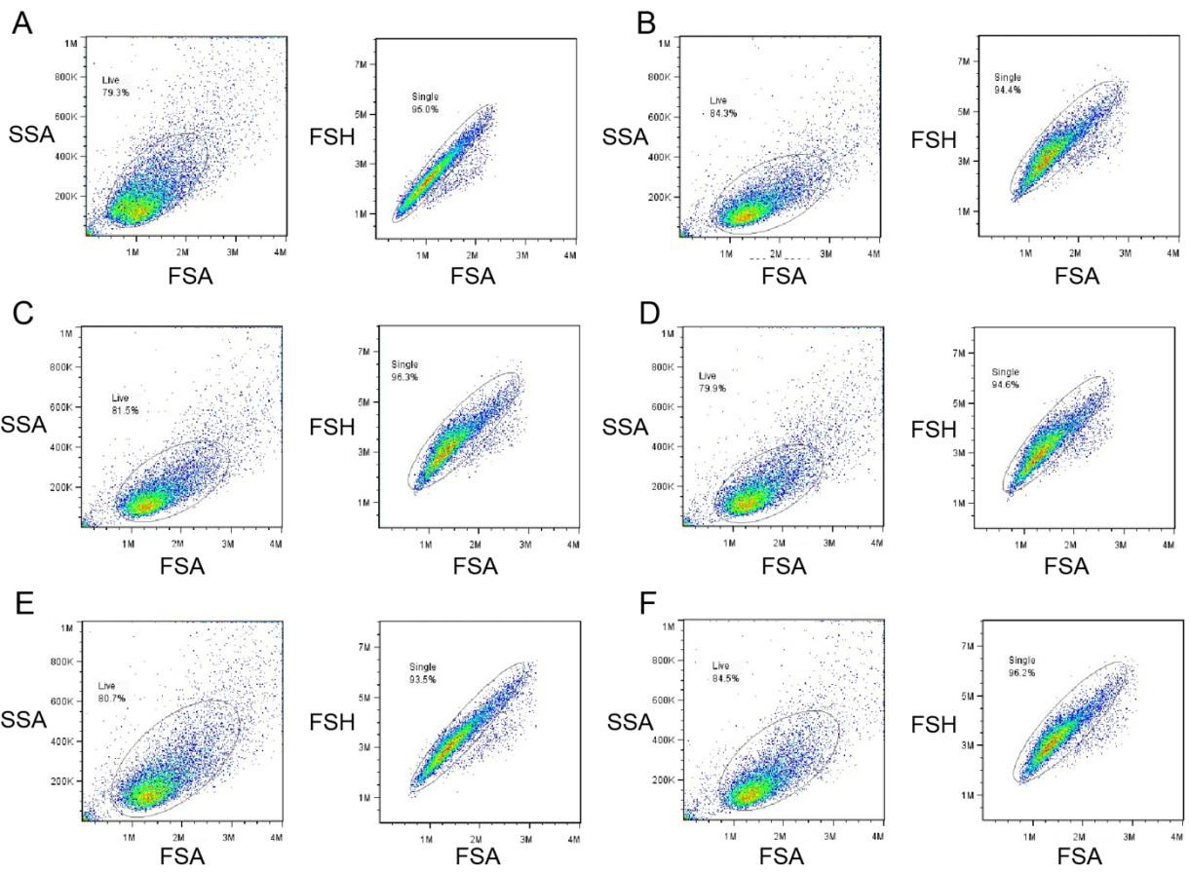

Figure S9. Scatter plots for PEO-PBD filomicelles-PKH67 histograms shown in Figure
4D for Idla7 cells. (A) 0.0 mg/ml hHDL. (B) 0.05 mg/ml hHDL. (C) 0.10 mg/ml hHDL. (D)
0.25 mg/ml hHDL. (E) 0.50 mg/ml hHDL. (F) 1.00 mg/ml hHDL. SSA = side scatter angle. FSA = forward scatter angle. FSH = forward scatter height.

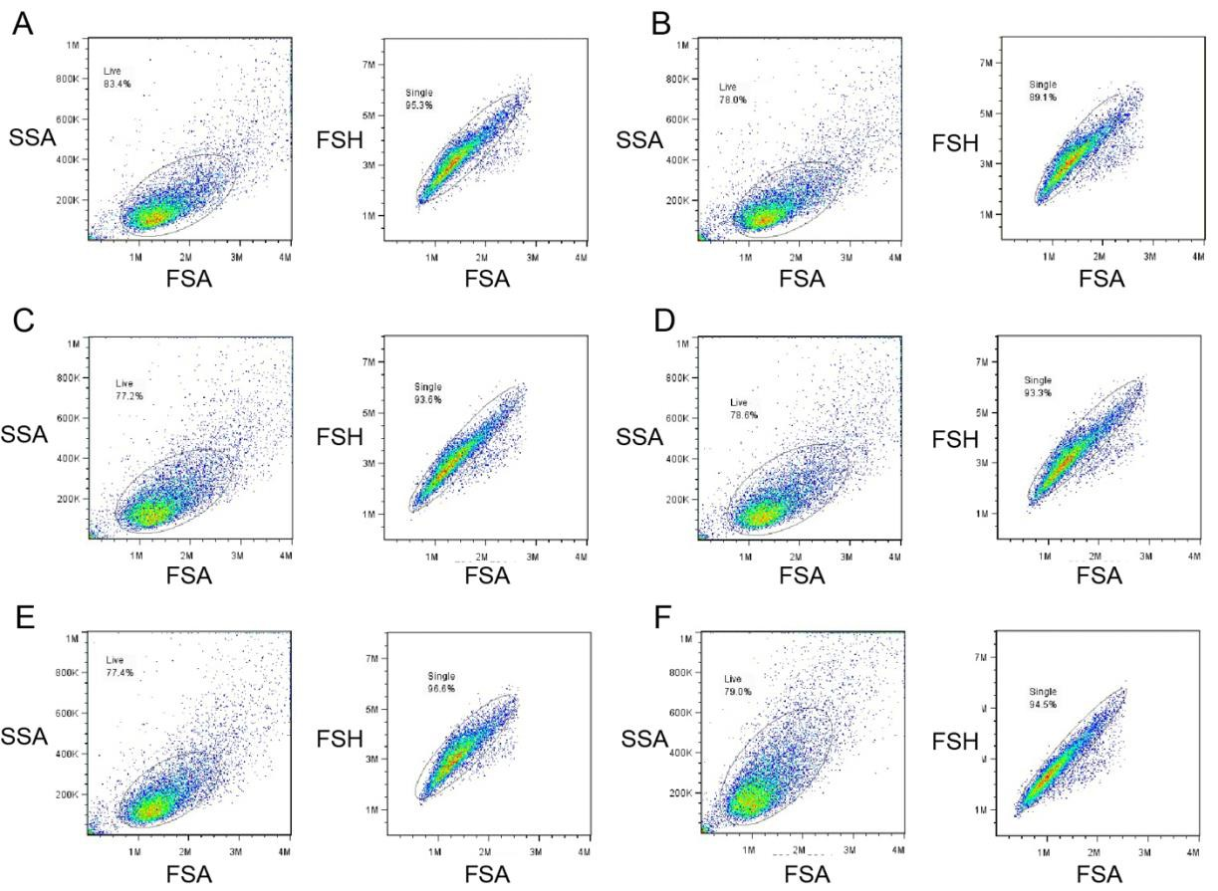

Figure S10. Scatter plots for PEO-PBD spheres-PKH67 histograms shown in Figure 4D for Idla7 cells. (A) 0.0 mg/ml hHDL. (B) 0.05 mg/ml hHDL. (C) 0.10 mg/ml hHDL. (D) 0.25 mg/ml hHDL. (E) 0.50 mg/ml hHDL. (F) 1.00 mg/ml hHDL. SSA = side scatter angle. FSA = forward scatter angle. FSH = forward scatter height.

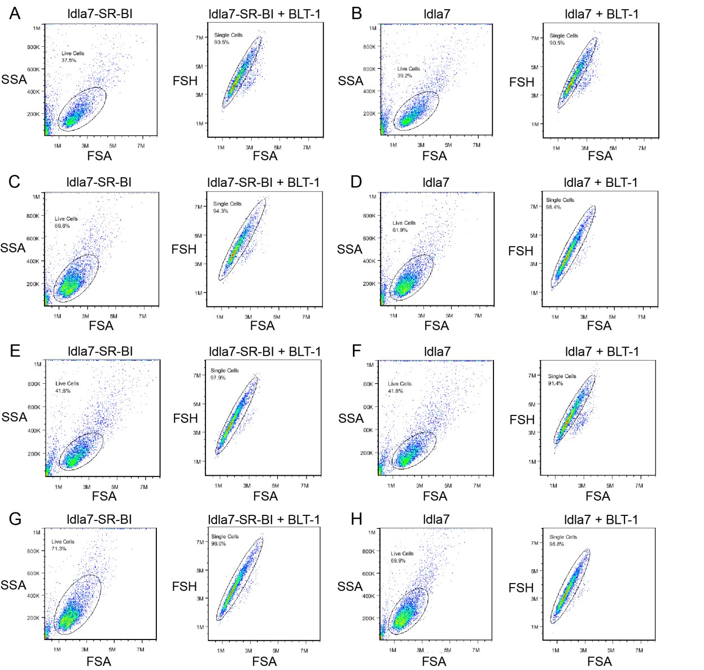

Figure S11. Scatter plots for PEO-PBD filomicelles-PKH26 and PEO-PBD spheres- PKH26 histograms shown in Figure 4F for Idla7 and Idla7-SR-BI cells. (A-D) Plots for PEO-PBD filomicelles-PKH26. (E-H) Plots for PEO-PBD spheres-PKH26. SSA = side scatter angle. FSA = forward scatter angle. FSH = forward scatter height.

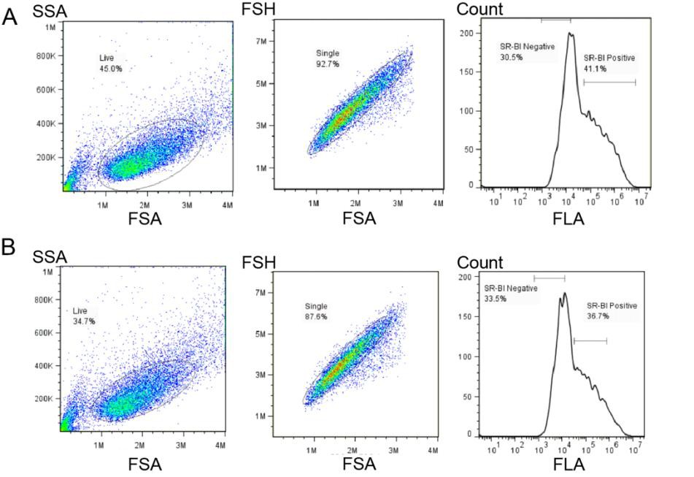

Figure S12. Scatter plots for PEO-PBD filomicelles-PKH26 and PEO-PBD spheres- PKH26 histograms shown in Figure 4H. (A) Plots for PEO-PBD filomicelles-PKH26. (B) Plots for PEO-PBD spheres-PKH26. SSC-A = side scatter angle. FSC-A = forward scatter angle. FSC-H = forward scatter height. FLA-1 = PKH26 fluorescence.

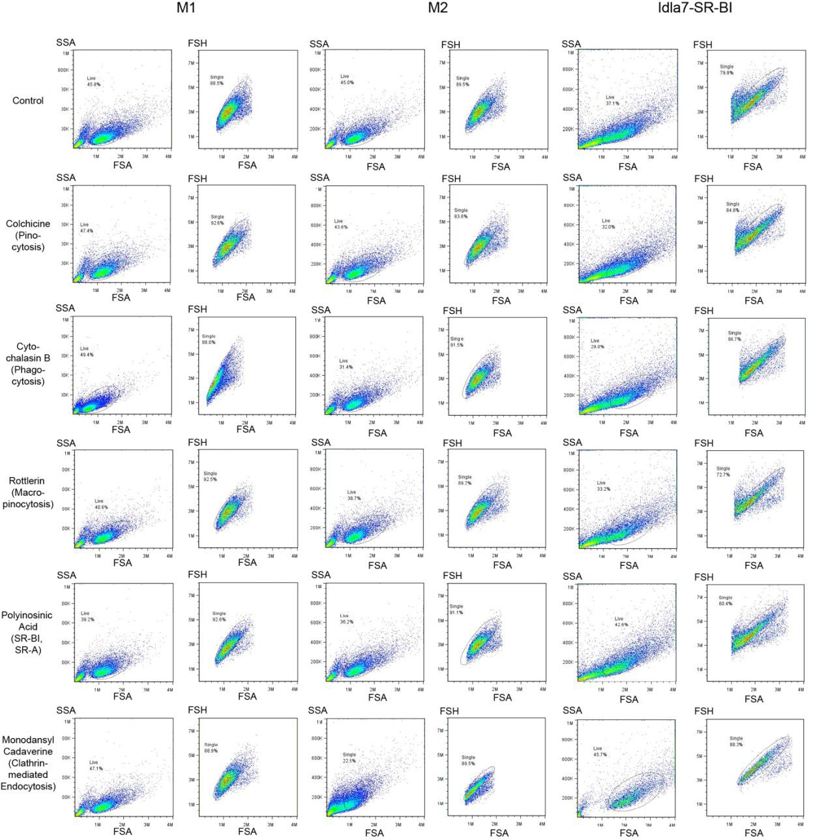

Figure S13. Scatter plots for hHDL shown in Figure 6D. SSA = side scatter angle. FSA =
forward scatter angle. FSH = forward scatter height.

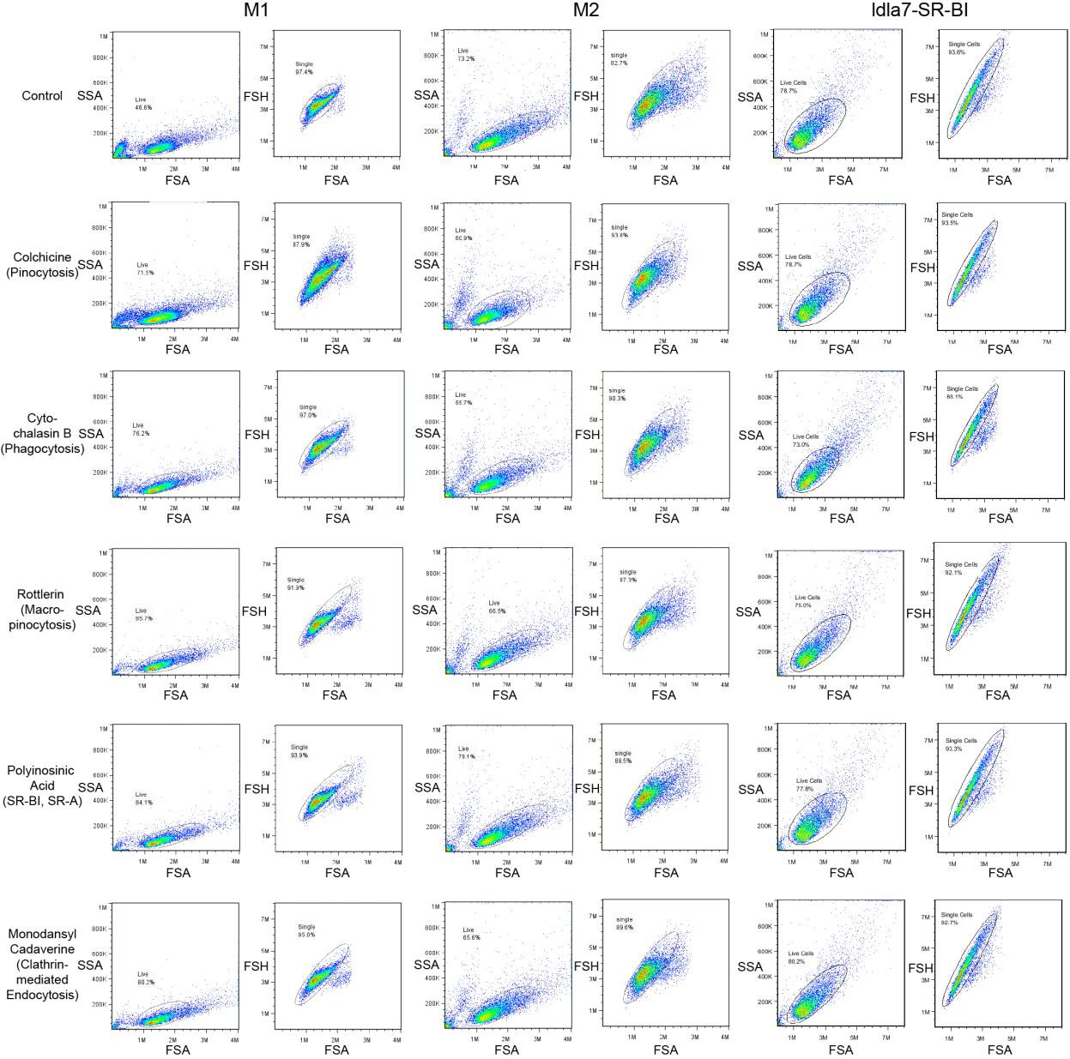

Figure S14. Scatter plots for PEO-PBD filomicelles-PKH67 shown in Figure 6D. SSA =
side scatter angle. FSA = forward scatter angle. FSH = forward scatter height.

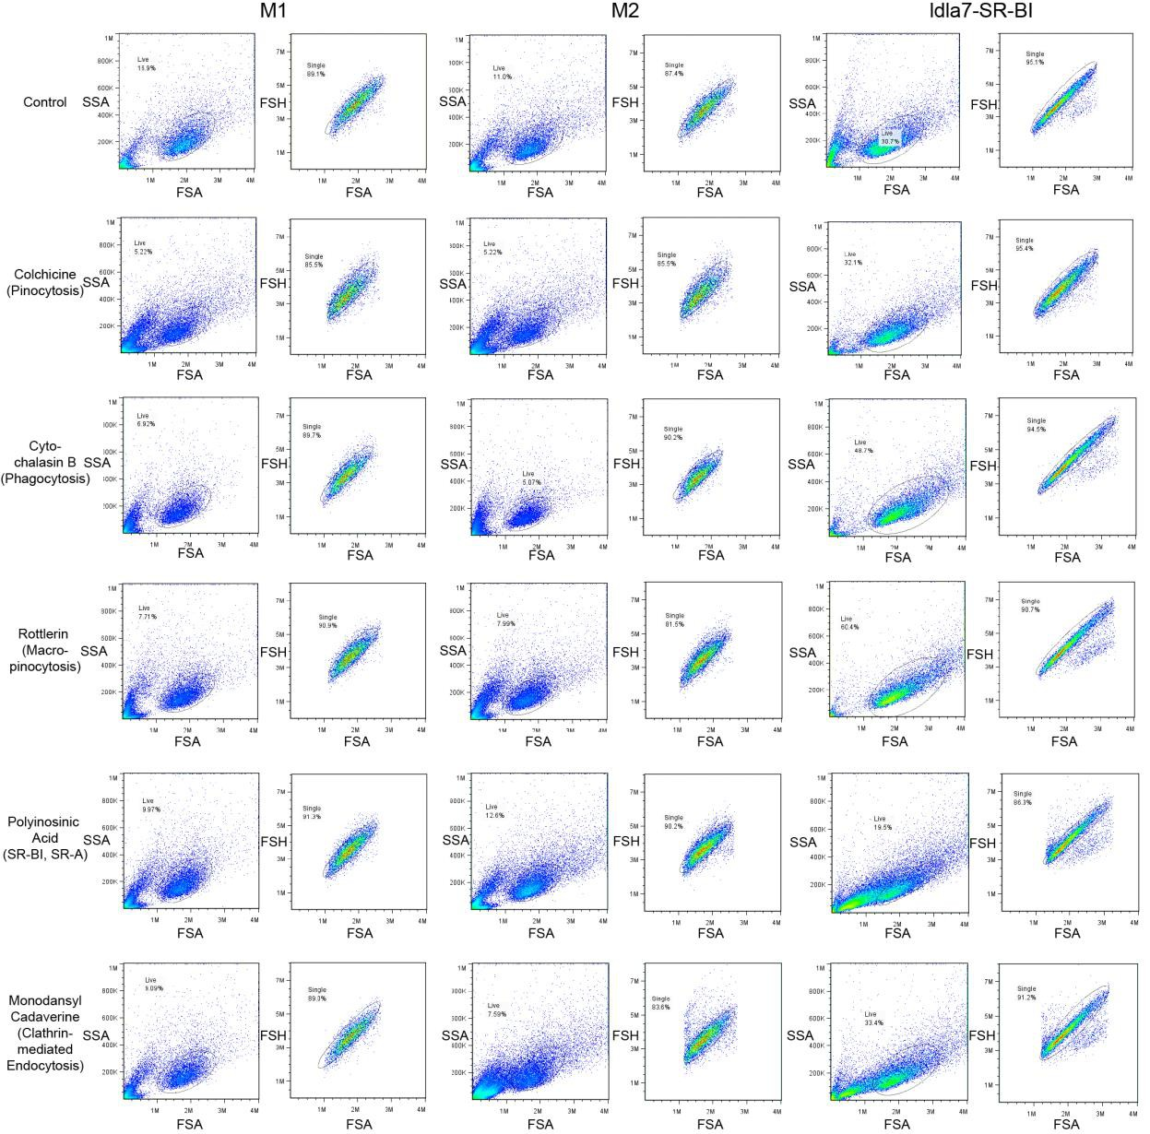
Figure S15. Scatter plots for PEO-PBD spheres-PKH67 shown in Figure 6F. SSA = side scatter angle. FSA = forward scatter angle. FSH = forward scatter height.

Figure S16
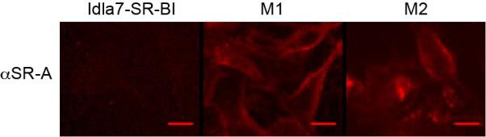

Figure S16. Idla7-SR-BI cells do not express SR-A. Fluorescence micrographs of Idla7- SR-BI cells, M1, and M2 murine macrophages that have been stained with an antibody for SR-A with a fluorescent secondary antibody. Scale bars are 10 microns.
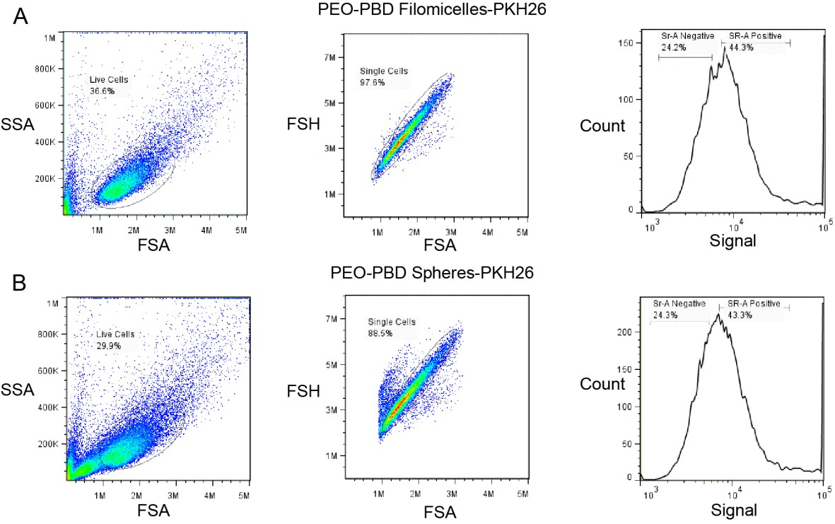
Figure S17

Figure S17. Scatter plots for PEO-PBD filomicelles-PKH26 and PEO-PBD spheres- PKH26 histograms shown in Figure 6F,H. (A) Plots for PEO-PBD filomicelles-PKH26. (B) Plots for PEO-PBD spheres-PKH26. SSA = side scatter angle. FSA = forward scatter angle. FSH = forward scatter height.
Table S1
Inhibitor Concentration Duration Source
BLT-1 50 µM 30 minutes Sigma #373210
Colchicine 100 µg/ml 2 hours Alfa Alesar#A1324003
Cytochalasin B 10 µg/ml 2 hours Fisher #54-741-0
Rottlerin 2 µM 30 minutes Acros #328490100
Polyinosinic Acid 10 µg/ml 30 minutes Sigma #P4154
Monodansyl
Cadaverine
200 µM 10 minutes Sigma #
Chapter 2

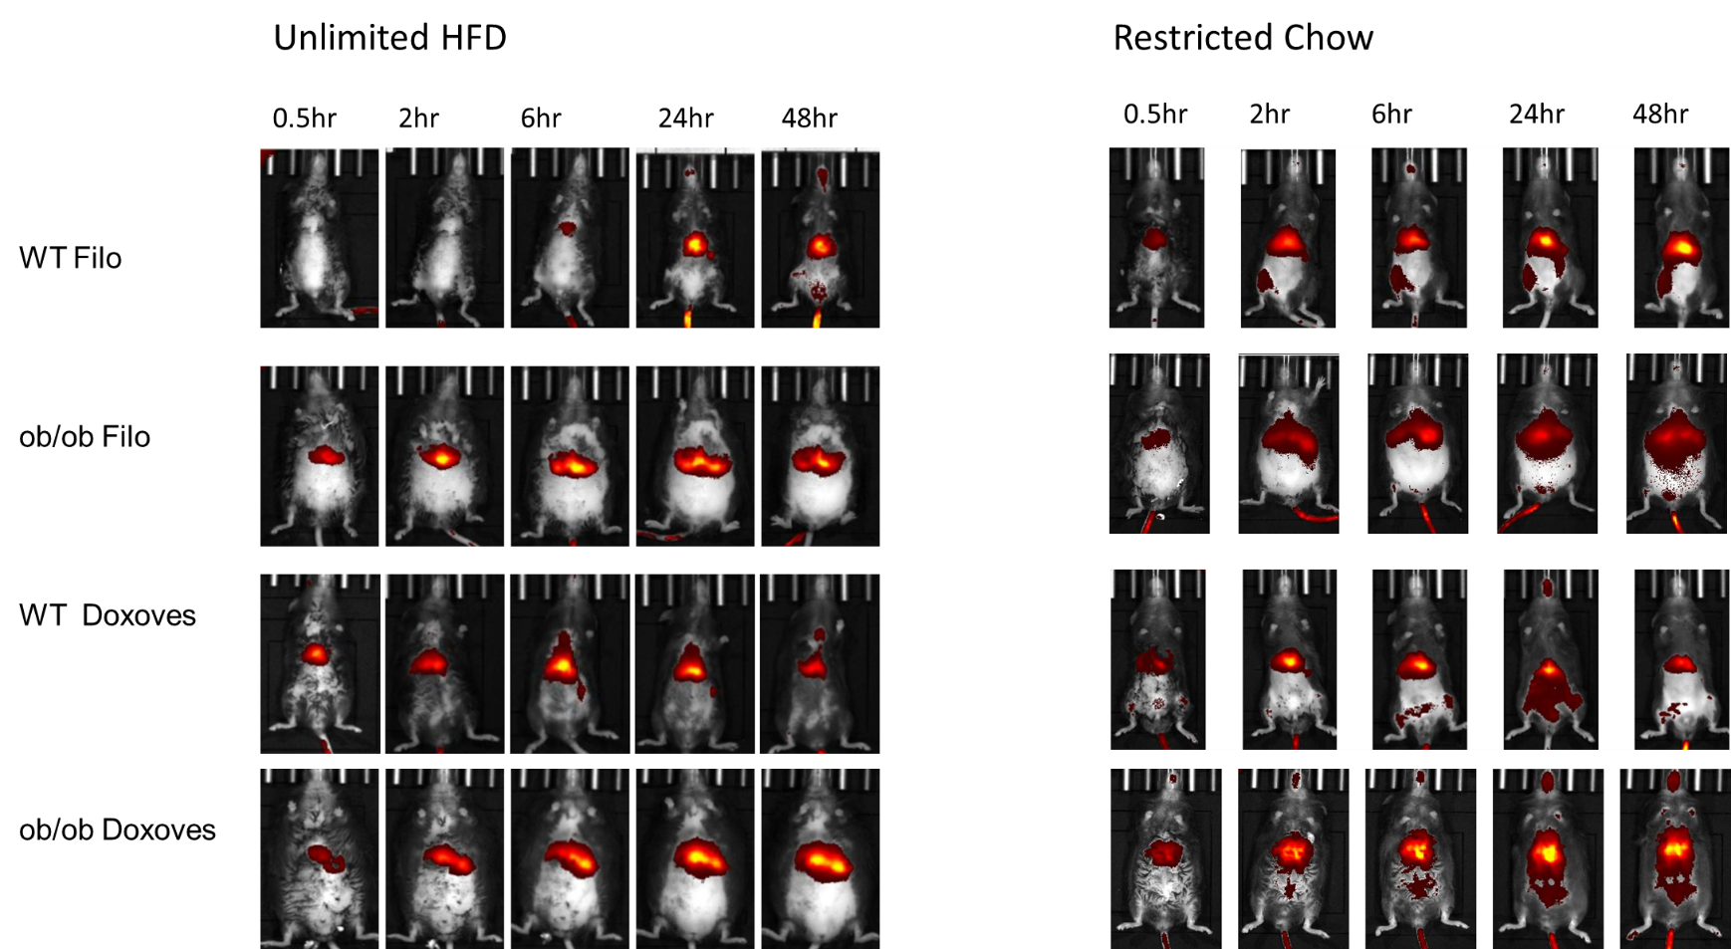
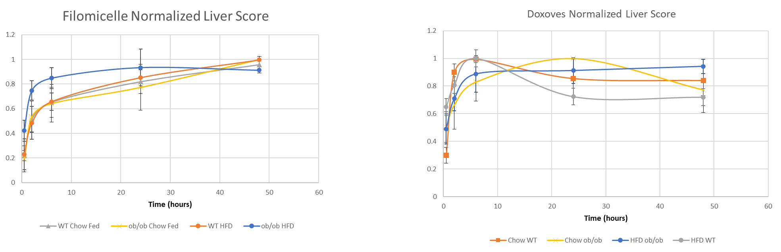

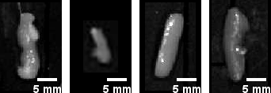
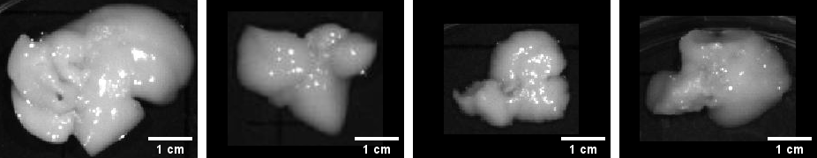
Chapter 3
Enhanced lipid droplet degradation by split-intein-mediated lipid droplet targeting to lysosomes in mammalian cells

Mitch Raith¹
Paul Dalhaimer ^{1,2}

¹Chemical and Biomolecular Engineering, University of Tennessee- Knoxville, Knoxville, Tennessee, United States
²Biochemistry, Cellular and Molecular Biology, University of Tennessee- Knoxville, Knoxville, Tennessee, United States

Correspondence: Paul Dalhaimer, Chemical and Biomolecular Engineering, Street, 37996, Knoxville, Tennessee, United States
E-mail: pdalhaim@utk.edu

Keywords: Autophagy, Chaperone Mediated Autophagy, Lipid Droplet, Lysosome, Split Intein

Abbreviations: [CMA, Chaperone Mediated Autophagy; LD, Lipid Droplet; PLIN2, Perilipin 2; LAMP2A, Lysosome Associated Membrane Protein variant 2A; ]

Abstract
Lipid droplets (LDs) are endoplasmic-reticulum-derived neutral lipid storage organelles. An overabundance of LDs in mammalian cells is characteristic of the progression of the metabolic syndrome. Thus, the development of technologies to increase controlled LD breakdown could provide therapy to treat metabolic-associated disorders. Chaperone-mediated autophagy (CMA) plays a key role in LD breakdown. In CMA, LDs are guided to lysosomes where perilipins (PLINs) are degraded so that adipose tissue triglyceride lipase (ATGL) can convert the neutral lipids into free fatty acids for energy or materials for phospholipids. Here, we used a naturally spit intein to target LDs to lysosomes to enhance CMA. DNA constructs were introduced into NIH/3T3 fibroblasts where the C-terminal segment (NpuC) of the split was linked to PLIN2 and the N-terminal segment of the split intein (NpuN) was linked to the lysosomal surface protein LAMP2A. We showed that NpuC-mCherry-PLIN2/LDs colocalized with LAMP2A-NpuN-GFP/lysosomes in NIH/3T3 fibroblasts. These fibroblasts had a ~4-fold decrease in the number of LDs versus non-transfected control cells and cells expressing a non-cleaving version of the intein system: NpuC(N136A)-mCherry-PLIN2. These results point to the possibility of using technologies to guide entire organelles or protein complexes to lysosomes to control cellular autophagy and upkeep.

1. Introduction
Obesity, non-alcoholic fatty liver disease, cardiovascular disease, and type 2 diabetes are in part a consequence of an excessive cellular fraction of neutral lipids, which are sequestered in organelles called lipid droplets (LDs) [1, 2]. Neutral lipids are mostly triacylglyceride (“fat”) or cholesterol ester. LDs form from the endoplasmic reticulum but exact mechanisms are lacking [3]. Efforts to treat these metabolic diseases on the cellular scale by inhibiting the acyl-CoA:diacylglycerol acylteransferase (DGAT) enzymes [2], which control the final step of triacylglyceride synthesis, for the purpose of inhibiting LD formation, are tenuous because mutations in these genes can cause acute diarrhea and death in infant humans [4]. Thus, attention to reducing LD presence in cells has shifted towards increasing LD breakdown (lipolysis) [5]. Lipolysis is a natural process that occurs when cells need energy or materials to synthesize phospholipids. Lipolysis occurs through multiple pathways. Here we focus on lipolysis that occurs via Chaperone Mediated Autophagy (CMA) [6]. During CMA, the heat shock cognate protein of 70 kDa (Hsc70) binds proteins with a pentapeptide sequence/motif on a target protein [7]. In CMA breakdown of LDs, the target protein is Perilipin 2 (PLIN2). PLIN2 is ubiquitously expressed on the surfaces of LDs and is responsible for the maintenance and stability of LDs [8]. Hsc70 guides LD-associated PLIN2 to the lysosome surface where they bind Lysosomal Associated Membrane Protein 2 variant A (LAMP2A), forming a complex [6]. PLIN2 then unfolds, dissociates from the LD, and is transported across the lysosome membrane [8]. Hsc70 mediated transport of LDs to the lysosome is the rate limiting step in CMA [6]. As PLIN2 breaks down, the neutral lipids in the LD are now accessible to lipases such as cytosolic adipose triglyceride lipase (ATGL), which converts the neutral lipids into free fatty acids and glycerol, although the mechanism is unknown. CMA breakdown of LDs is a stress response because it relies on adenosine monophosphate (AMP) [9]. AMP is a signaler for low energy state in the cell (i.e. starving or nutrient deficiency) and activates AMPK [10]. Once AMPK is activated, it can phosphorylate PLIN2 and which allows Hsc70 binding [9].
We hypothesize that targeting LDs to lysosome will increase LD degradation upon the onset of cellular stress (i.e. starving) and will up regulate CMA. This scheme is depicted in Figure 1A,B. Our goal is to increase the concentration of PLIN2 – which is bound to the LD - at lysosomes whereby locally high concentrations of PLIN2 may increase the activity of Hsc70 and prevent cellular Hsc70 scavenging to detect substrate, resulting in increased LD degradation through CMA.

2 Materials and methods
2.1 Bacterial Strains, Plasmids and Growth Media
E. coli strain XL1-Blue (recA1 endA1 gyrA96 thi-1 hsdR17 supE44 relA1 lac [F´ proAB lacIq Z∆M15 Tn10 (Tetr)]) was used for plasmid construction. Chemically component cells for cloning were prepared by the Inoue method [11] . SOC medium was used for recovery of Inoue cells and Luria-Bertani lysogeny broth (LB) medium was used for growth, transformations, and recovery of frozen storage cultures using standard methods [11] . NaCl, tryptone and yeast extract (DIFCO) were purchased from Fisher Scientific. For plasmid maintenance, ampicillin (ACROS Organics) was added as appropriate to the media at 200 µg/mL. Cells were grown at 37°C for cloning.
cDNA for mPLIN2 and mLAMP2A was purchased from Sino Biological. All protein fusions were constructed using standard overlap extension with Phusion polymerase (Thermo Scientific; #F530S). All constructs containing NpuC were cloned into pcDNA3.1(+) (Invitrogen; #V79020) between NheI and NotI restriction sites. mLAMP2A-NpuN-eGFP was cloned into pIRES (Clontech; #631605) between XhoI and NotI. This replaced the IRES sequence with the target gene and removed the bicistronic functionality of the vector
pET vectors containing both intein segments were gifted by Dr. David Wood at Ohio State University. All oligonucleotides used in this study were obtained from Sigma-Aldrich and are listed in Table 1.
2.2 Cell Culture and Treatment
NIH/3T3 fibroblasts (Gift from Dr. Eric Boder at University of Tennessee, Knoxville) were cultured in DMEM media (Corning; #10013CV) supplemented with 10% FBS (Corning; #35010CV) and maintained at 37ºC-5%CO₂. All media was filtered through 0.22 mm syringe filters to prevent contamination. Oleic acid (OA) (Fisher; #A195-500) was conjugated to bovine albumin by dissolving 1g of BSA (Sigma; #A8806) in 7mL Tris-HCl pH 9 and adding 26uL of oleic acid. The mixture is then mixed at RT for one hour on an orbital shaker. When a high fat diet was simulated to induce LD production, OA was added to a final concentration of 50 mM. The treatment lasted for 24hr. The cells were then washed (3x) with PBS pH7.4 and serum free DMEM was added to simulate a starved condition for an additional 24hr. Before imaging, the cells were washed once more with PBS and the media was replaced with phenol red free Opti-MEM (Gibco; #11-058-021). For Metformin-HCL treatments, cells were exposed to OA as described above. The media was then switched to complete media containing 20 mM Metformin-HCL (MP Biomedicals; #0215169101) for 24hrs.
2.3 Cell Imaging
All imaging done was live cell on an EVOSfl Digital Inverted Fluorescent Microscope. LD staining was done as previously described with monodansylpentane [12]. Images were captured as JPEGS and edited in ImageJ. Colocation analysis was done with JACoP in ImageJ
3 Results and Discussion
3.1 A split intein can be used to localize LDs at the lysosome surface
To facilitate targeting of LDs to lysosomes, we used a naturally split intein from Nostoc Purfuctium DNAe . This intein was selected based on its high intersegmental affinity (K_{d} ~1.2 nM) and fast cleaving rate [13]. The two intein segments are referred to here as NpuN and NpuC. Mutations have been made to the intein as previously described to promote C-terminal cleavage as opposed to native splicing activity [14]. NpuN was fused to the C-terminus of LAMP2A and NpuC was fused to the N-terminus of PLIN2 using polymerase chain reaction. Both proteins have been previously reported to be unaffected by tags fused to the stated termini [15]. To determine if the system could be used to target LDs to the lysosome, we first verified both constructs localized to their respective organelles. LAMP2A-NpuN-GFP and the CytoPainter tracker for lysosomes closely overlapped each other (Figure 2A). It should also be noted that expressing LAMP2A-NpuN-GFP singly did not cause a colocalization of LDs and lysosomes (Figure 2B). When the non-cleaving version of NpuC-mCherry-PLIN2 (NpuC(N136A)-mCherry-PLIN2) was expressed singly, it was seen that while NpuC-mCherry-PLIN2 puncta existed at LDs, a significant portion of the protein was also present in the cytoplasm (Figure 2C). This is consistent with previously discussed effects of placing an N-terminal tag on PLIN2 [15]. NpuC(N136A)-mCherry-PLIN2 did not localize to lysosomes (Figure 2D). We then validated that split inteins could be used to target non-cleaving NpuC(N136A)-mCherry-PLIN2 to the lysosomal surface by co-expressing LAMP2A-NpuN-eGFP and NpuC(N136A)-mCherry-PLIN2. This insured mCherry would remain near the lysosome if targeting was successful. The signals from the two proteins overlapped (Figure 2E), signifying NpuC(N136A)-mCherry-PLIN2 was bound to LAMP2A-rich lysosomes. By expressing the two constructs together, we were able to increase the fraction of lysosomes overlapping NpuC(N136A)-mCherry-PLIN2 to be comparable to the fraction overlapping LAMP2A-NpuN-GFP when singly expressed (Figure 2F). We then moved to see if LDs and lysosomes, could be targeted to each other with our split intein system. To do this, we expressed NpuC-mCherry-PLIN2 and LAMP2A-NpuN-GFP with oleic acid supplemented media to simulate a high fat diet, which will force the synthesis of triacylglyceride and promote the formation of LDs. Again, the NpuC intein was non-cleaving. We saw close overlap between the two fluorescent proteins and a LD dye (Figure 2G). Nearly all LDs appeared near the lysosome whereas cells expressing only LAMP2A-NpuN-GFP appear to have evenly distributed LDs. This is illustrated in the fractional signal overlap increase between LDs and LAMP2A-NpuN-GFP in cells expressing just LAMP2A-NpuN-GFP versus LAMP2A-NpuN-GFP and NpuC-mCherry-PLIN2 (Figure 2H). Our technology’s ability to target organelles and protein complexes and guide them to lysosomes for degradation, may have many applications reaching beyond this work.

3.2 Lipid Droplets localized to the lysosome via the Npu split intein are degraded at a faster rate
To test the inteins’ ability to increase LD degradation we used the cleaving variant – NpuC - over the noncleaving - NpuC(N136A). In CMA, LAMP2A must bring the target protein across the lysosomal surface for degradation. We hypothesize that the force generated by LAMP2A during the transmembrane step of CMA is not strong enough to overcome a strong association between PLIN2 on the LD, and LAMP2A in the lysosome membrane. Our hypothesis details that a bond between LAMP2A and PLIN2 will prevent transport across the lysosomal surface, thus preventing the occurrence of CMA. This led us to use the cleaving intein. A cleaving intein yields two protein elements that are close in spatial proximity but not physically or chemically linked. A split cleaving intein will cause the LD to be localized and then freed near the lysosomal surface to circumvent this.
NIH/3T3 fibroblasts expressing neither LAMP2A-NpuN-GFP nor NpuC-mCherry-PLIN2 and cells expressing LAMP2A-NpuN-GFP and the non-cleaving version of NpuC – NpuC(N136A)-mCherry-PLIN2– had ~4-fold more LDs than cells expressing the cleaving intein system - LAMP2A-NpuN-GFP and NpuC-mCherry-PLIN2 (Figure 3A-D). This may suggest that the translocation that the LAMP2A trimer preforms during CMA isn’t strong enough to overcome the interaction between the intein segments. Though this hasn’t been confirmed, it shows that intein technology may be ideal versus other methods, such as protein-peptide affinity pairs, for targeting molecular bodies to the lysosome to promote increased degradation through the CMA pathway; it is imperative that the tool used to attract the LD to the lysosome also has an “off” step. A technology that brings these organelles together in a permanent state will not yield an increase in LD degradation.
3.3 A Truncated Split Intein Can be used to control the degradation rate of Lipid Droplets
Lipotoxicity from the free fatty acids of triacylglyceride is a concern when LDs are broken down. In an effort to prove that our system can break down some but not all the LDs in fibroblasts, we truncated the first 6 amino acids of NpuC (IKIATR) using PCR. This has previously been shown to decrease the affinity of the intein segments while maintaining activity [16]. We found that while this led to a higher number of LDs than the full length intein (15 versus 8), it was still effective in decreasing LD number (Figure 4A,B). This shows that applications where very high levels of lipolysis is not desired, the system can be turned to generate the amount of LD degradation desired.
3.4 Lipid Droplet degradation can be triggered with chemical activation
We also investigated the ability to trigger LD breakdown on command, without the need for a stress-induced reaction (i.e. starvation to induce AMPK activity). We used a known AMPK activator, Metformin-HCl [17]. AMPK phosphorylates PLIN2 before it binds Hsc70. Metformin was selected because it is approved for therapeutic use in humans.
An LD synthesis period in oleic acid-based media and sequential treatment with Metformin-HCl resulted in similar results as starvation (Figure 4D-F). This suggests our system of LD degradation is possible to trigger on demand and may be useful in selectively degrading other CMA substrates.
4 Conclusion
In conclusion, a split intein was used to localize LDs near the lysosome. After the onset of stress, this caused a rapid degradation of LDs. Through both manpulation of the intein and chemical measures, we have proved this system allows controllable degradation of LDs. Importantly, this technology modulated an existing pathway, CMA. CMA is implicated in aging and its related disorders such as cancer and Alzheimer’s Disease. Our technology may prove useful in treating these diseases.

Figures

Figure 1
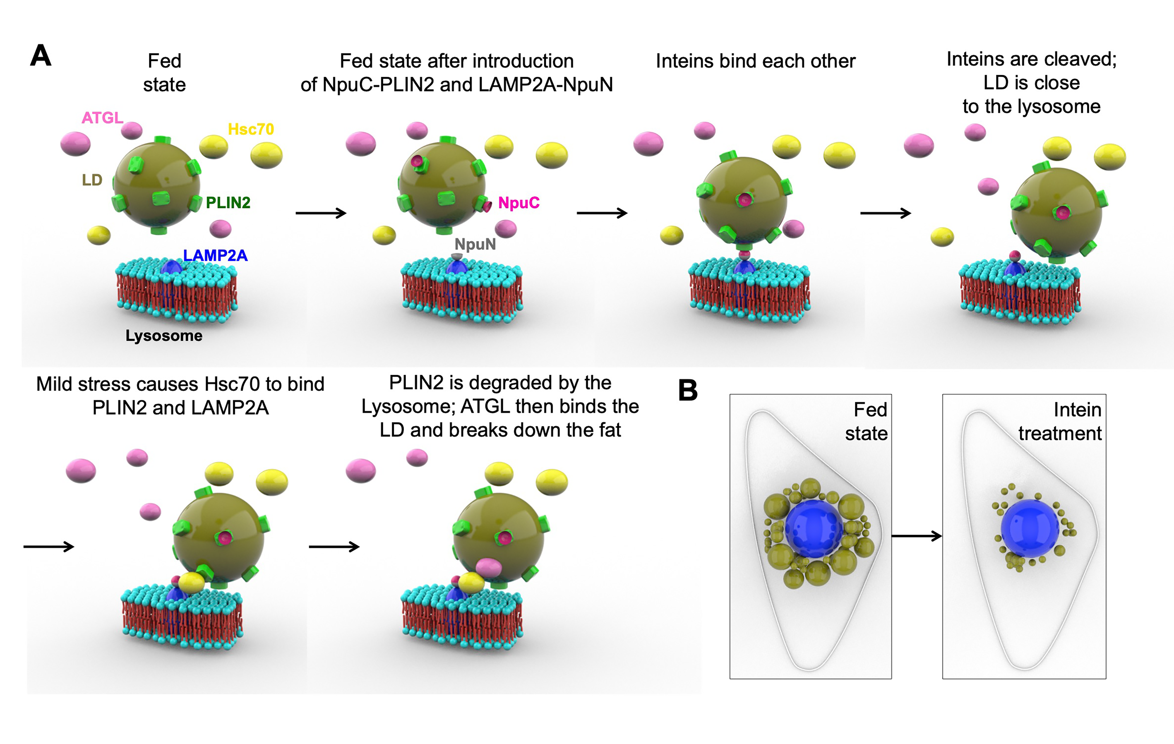
Figure 1. A Schematic illustrating the guidance of LDs to a lysosome with a split intein. (A) NpuC will be fused to the N-terminus of PLIN2 and NpuN will be linked to the C terminus of LAMP2A. This will cause the LD to be guided and subsequently freed near the LD surface. (B) We hypothesis this will result in a decreased number of LDs.

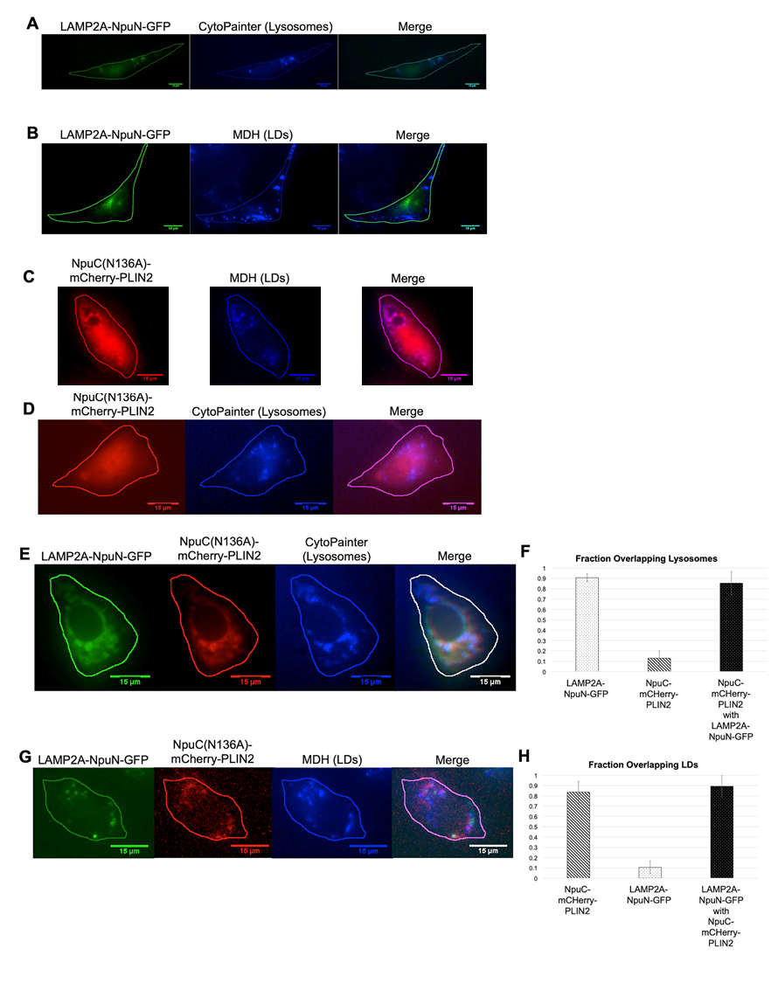
Figure 2. The Npu split intein causes LDs to be localized to lysosomes in NIH/3T3 fibroblasts. (A) NIH/3T3 cells expressing LAMP2A-NpuN-GFP show close overlap with lysosomes dyed with CytoPainter. (B) These cells do not show LDs localized to the lysosomes. (C) NIH/3T3 cells expressing NpuC-mCherry-PLIN2 showed mCherry puncta at LDs while also showing cytoplasmic signals. (D) These cells did not show an overlap between mCherry and lysosomes dyed with CytoPainter. (E) When LAMP2a-NpuN-GFP and NpuC-mCherry-PLIN2 are expressed, GFP and mCherry signals are localized at the lysosome. (F) The same cells also show that LDs are co-localized with LAMP2a-NpuN-GFP and NpuC-mCherry-PLIN2. Expressing the two modules together causes (G) NpuC-mCherry-PLIN2 to localized to lysosomes at the same fraction as LAMP2a-NpuN-GFP and (F) LDs to be overlapping LAMP2a-NpuN-GFP at the same fraction as NpuC-mCherry-PLIN2.

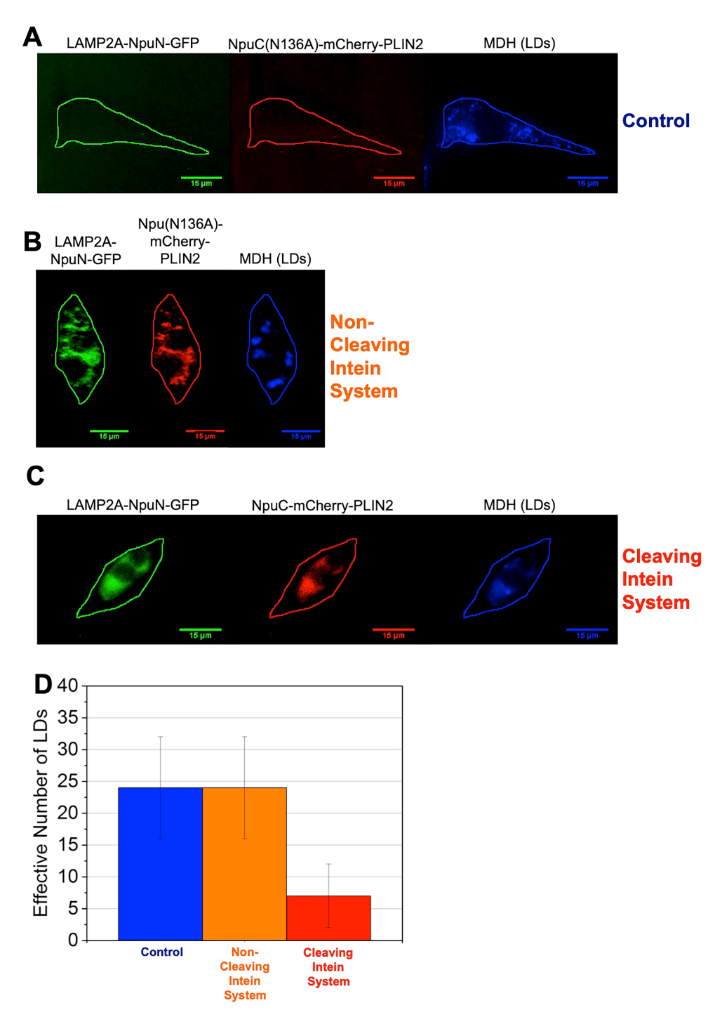
Figure 3. LD numbers are reduced with the cleaving intein system, but not the non-cleaving intein system in NIH/3T3 fibroblasts. (A) Fluorescence micrographs of fibroblasts that are not expressing LAMP2A-NpuN-GFP or NpuC(N136A)-mCHerry-PLIN2. (B) Fluorescence micrographs of fibroblasts that are expressing LAMP2A-NpuN-GFP and NpuC(N136A)-mCHerry-PLIN2. (C) Fluorescence micrographs of fibroblasts that are expressing LAMP2A-NpuN-GFP and cleaving NpuC-mCHerry-PLIN2. (D) Plot of the number of effective lipid droplets in the cells in A-C. N = 20 cells for each column.

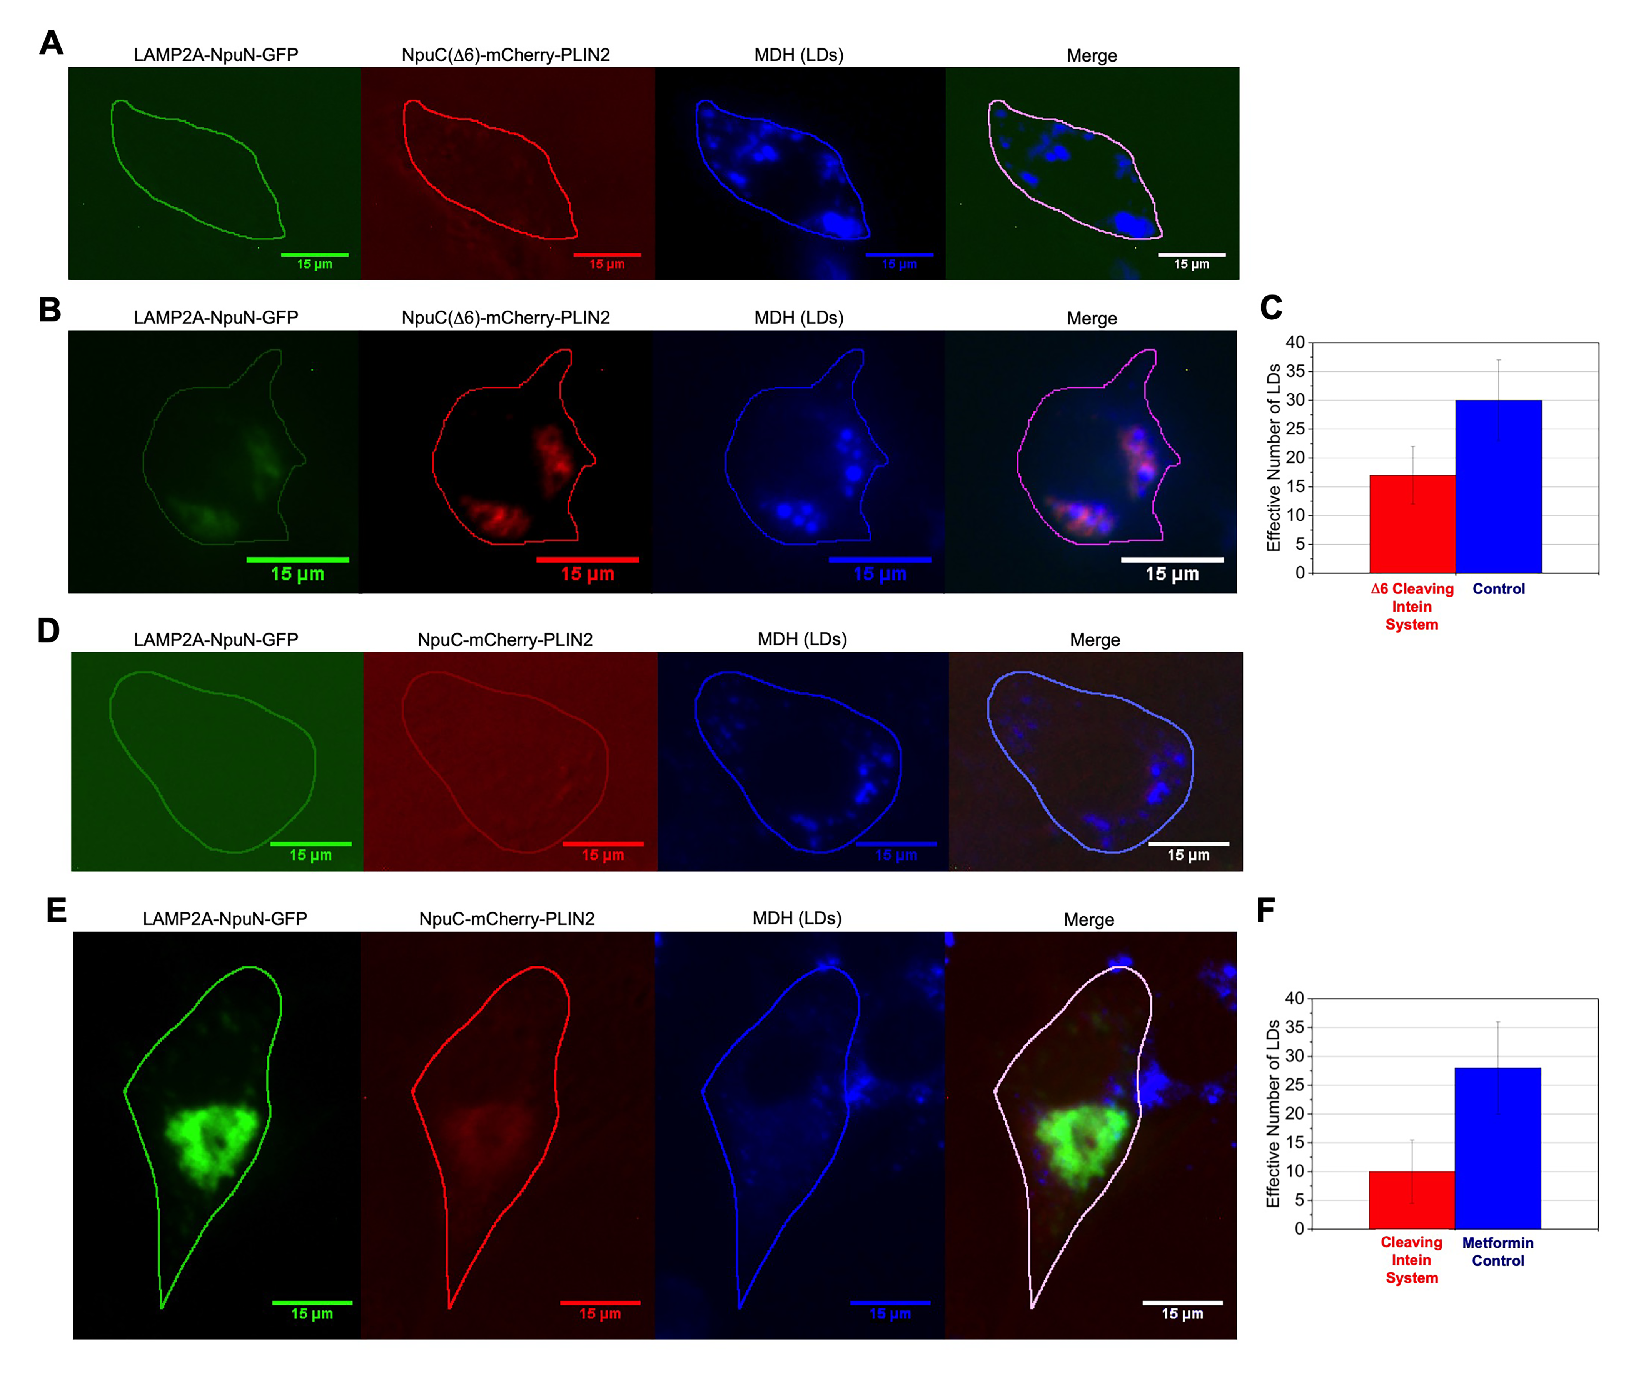
Figure 4. Enhanced split intein mediated LD degradation is controllable with both system modification and chemical activation in NIH/3T3 fibroblasts. (A) Fluorescence micrographs of fibroblasts that are not expressing LAMP2A-NpuN-GFP or NpuC(D6)-mCHerry-PLIN2. (B) Fluorescence micrographs of fibroblasts that are expressing LAMP2A-NpuN-GFP and NpuC(D6)-mCHerry-PLIN2. (C) Plot of the effective number of LDs in cells in (B) versus (C). N = 20 cells for each column. (D) Fluorescence micrographs of fibroblasts that have been exposed to 20 mM Metfromin-HCl for 24hrs. (E) Fluorescence micrographs of fibroblasts that are expressing LAMP2A-NpuN-GFP and NpuC-mCHerry-PLIN2 cells that have been exposed to 20 mM Metfromin-HCl for 24hrs. (F) Plot of the number of effective LDs in the cells represented in (D) versus (F). N = 20 cells for each column.

