MVS AP Physics 2
Unit 2 Project – Diffusion of Smell - Part 1

Overall Purpose
The purpose of this project is to develop a physical understanding of how particles propagate through the air and how data collected about phenomena such as the propagation of smell can help us better understand what’s happening through “modeling” what’s going on.

Part 1 Purpose
The purpose of Part 1 is to interact with a simple model of smell to develop an idea for what’s happening. At the end of Part 1, you will explain what affects the time it takes for a smell to propagate across a room.

Introduction
Chances are that you’ve experiences something like this before, perhaps even in the classroom you are sitting in right now. A pleasant (or perhaps unpleasant) smell is introduced in a far corner of the room. Think about when a classmate of yours peels an orange, or, in science class, when a yucky smell is introduced or encountered in an investigation. Classmates who are close to the source of this smell initially report its presence. Gradually, the smell makes its ways throughout the room and everyone has sensed it.

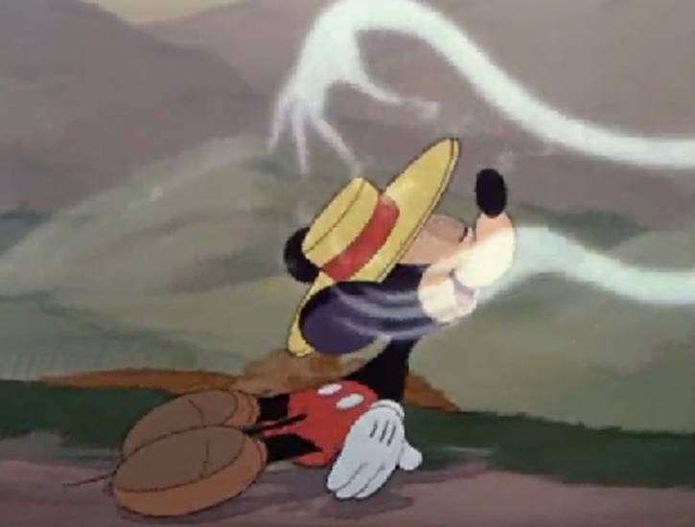
Image retrieved from http://www.disneyfilmproject.com/2010/06/little-whirlwind.html

What’s going on? How exactly does smell move through the room? Can we describe this phenomena based on our prior experiences - or do we need to conduct an experiment? Can the way that smell moves through the room be represented in a graphical depiction, or even a formula? Is there some “speed of smell?”

Finally, perhaps you have seen machines that serve to freshen the air by misting molecules after some period of time. If you could measure all the properties of a the air in a room (pressure, temperature, volume, etc.), how would you precisely predict the time it would take for the smell to reach the other side? Is there any variable you can change to increase or decrease the speed with which smell propagates through a room? While we’re talking about smell, think about other odor detectors. Perhaps you have seen a detector in your home or friend’s home for carbon dioxide. How does it detect this molecule - and how much is “too much”?

These are the questions we will explore in this project.

Grading
This project will be completed in three parts, each worth 10 points. This part will be graded with the following criteria:

- Criterion 1: Participate in activities (4 points)
- Criterion 2: Answer all six questions to the best of ability (6 points)

A Simple Model of Smell
While smell is rarely discussed in science classes, what is going on at a microscopic level closely aligns to some key ideas about the physics of thermodynamics, the focus of our unit. Let’s consider a situation in which someone opens a jar of perfume on the other side of the classroom. We will use a simple physical model to represent this situation.
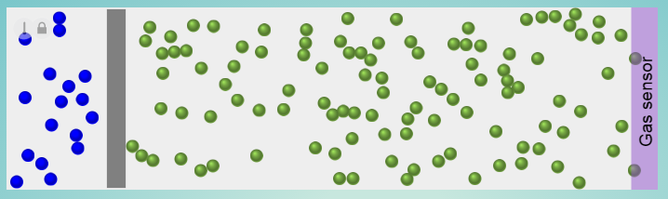

In our model, you are free to think of all molecules as solid billiard balls that can collide with each other as they move randomly in straight lines through the room. The collisions between the billiard balls are “elastic,” so the total velocity (and mass) of all of the molecules is specified to be the same throughout the simulation remains the same, as well as the total kinetic energy of all the molecules. The green billiard balls on the right represent the air molecules throughout the room, the gray wall represents the closed perfume jar, and the blue billiard balls on the left represent tiny molecules of perfume floating in the air which (when the jar is opened and the wall is removed) will eventually make their way toward the “gas sensor” also known as your nose. All of the molecules have the same mass.

Knowing you, you might be a bit suspicious of what we just said. Is this how a gas really behaves?

You’re right. No. This is an “ideal gas,” one about is a good “model” of many gases, but which itself depicts aspects of the behavior of a gas which might be not be realistic.

Question 1
What are some of the benefits of this model of a gas? And what are some of its weaknesses?

This brings up the question of what a model is. A researcher who worked in statistics, George Box, said, “All models are wrong but some are useful.” Box continued, “For [models] there is no need to ask the question "Is the model true?". If "truth" is to be the "whole truth" the answer must be "No". The only question of interest is "Is the model illuminating and useful?".

Many different variables could impact the motion of the particles. One variable, in particular, is the temperature inside the room. In our model (just as in real life), the temperature of the room seems to directly impacts the speed with which the particles are moving.

Question 2
When the temperature of the room is increased, the perfume particles reach the gas sensor more quickly. Explain why you think this happens.

Question 3
What information or data from the simulation would you need in order to predict the exact time it would take for the first perfume particle to reach the gas sensor?

Bringing The Model to Life
Now it’s your turn; next, we will go a bit deeper by interacting with a simulation of the model in action. Visit the Diffusion of Smell Simulation, and click the play button at the bottom of the screen to set the particles in motion. When you are ready to open the jar of perfume, click the “Remove barrier” button and watch the blue particles gradually make their way toward the detector.. Notice that you can change the number of molecules it takes for the simulation to stop. Notice that the simulation will automatically stop after the number of r three perfume particles have reached the gas sensor. The “Experiment time” window then shows us how long this took. Does requiring a greater or lesser number change the consistency of your results? Also notice that a lot of other information is available to you - kinetic energy, pressure, and volume.

Decrease the temperature in the simulation to “Low” and run the simulation. Now increase the temperature to “High” and run it once more.

Question 4
What differences do you observe between the lower temperature and higher temperature runs?

Question 5
Based on your observations of the simulation, explain why the perfume particles reach the gas sensor more quickly when the temperature of the room is increased.

Question 6
What are some questions you could ask about phenomena in the real world with this simulation? What are some of its limitations? For example, you could use this simulation to work to answer the question, “How does temperature affect the time it takes for the perfume particles to travel across a room”?

Finally, you may submit this portion of the project by uploading it through the course website.

