Pore Selectivity and Gating of Arabidopsis Nodulin 26 Intrinsic Proteins and Roles in Boric acid Transport in Reproductive Growth

A Dissertation Presented for the
Doctor of Philosophy
Degree
The University of Tennessee, Knoxville

Tian Li
August 2014
ACKNOWLEDGEMENTS
The printed pages of this dissertation hold far more than the culmination of years of study. These pages also reflect the relationships with many generous and inspiring people I have met since beginning my graduate work.
First of all, I would like to thank my advisors, Dr. Daniel M. Roberts, for teaching me, guiding me, and helping me throughout the past six years. I got to know him since I took his awesome biochemistry BCMB 401 class. I decided to join his lab due to the influence of Dr. Ian Wallace (although Ian tried to convince me not join the lab once), I have never regretted my decision because it allowed me to truly realize what I am passionate about. Dr. Roberts is a very precise, careful and critical scientist, and he always makes time to help me out whenever I need him. His advice has always been enlightening and shall be cherished for a lifetime. I would never have been able to finish my dissertation without the guidance of him.
I would also like to thank the other three members of my committee, Brad Binder, Jerome Baudry and Tim Sparer for all their support and criticism. I would like to thank Dr. Binder posting a sign on the window poking us to “GO BACK TO WORK”; I would like to thank Jerome for leading me through the computer simulation world with the “magic” software MOE.
I deeply thank Ian Wallace for getting me into this business by convincing me stay in the lab the whole night staring at oocytes and got my first exciting results next day. Ian constantly quizzed me and let me figure out the answers on my own. It was his influence that taught me how to become an independent scientist and was a constant role model for me. A special thanks to the people who I share my 6 years with. They are not merely labmates but also invaluable friends to me. Thanks to Won-Gyu Choi and Jinha Hwang who treated me as their younger Korean sister and taught me everything from correct use of the autoclave to how to purify a membrane protein. Thanks to Pintu Masalkar to answer me all the weired questions coming from a bubble, and for his admirable patience with me. I enjoyed every minute of our chatting time in the early morning. Thanks to Ansul Lokdarshi being the best 401 TA. His amazing knowledge made me think that he is Wikipedia and his persistence to never give up had a great influence on me and I am sure he will be a great success in the future. Thanks to Craig Conner to show me what is dedication and organize every lab activity for us. Thanks to Pratyush Routray giving me very insightful suggestions on both my research and my life. Thanks to Zack Beamer to take over the NIPs project. He is a smart and passionate student with promising scientific future (I hope he will make my dream come true since he promised me a “crystal” for Christmas gift). Finally, I want to thank all the undergraduate students and rotation students (Trevor Taylor, Stephanie Weir, Randy Lacey, Vanessa Nguyen and Casey Martin and others) to help me from time to time.
I would like to thank my parents for their unconditional support, and for always asking me whether I have enough money, but never when I'm graduating. I would like to thank Xiaomin Jing, my best friend forever, who always cheer me up when I was down and share me with her life and science. I would like to thank good company of Sherin Ravar, Prashasti, Wilfedo Evangelista, Haden Scott, Ramya Enganti, Meng Li, Stephanie Madison, Keerthana Wuppalapati, Joel Bucci. I truly could not have done this without you and I thank you from the bottom of my heart.

ABSTRACT
Plant nodulin-26 intrinsic proteins (NIPs) are members of the aquaporin superfamily that serve as multifunctional channels of uncharged metabolites and water. They share the same canonical hourglass fold as the aquaporin family. The aromatic arginine (ar/R) selectivity filter controls transport selectivity based on size, hydrophobicity, and hydrogen bonding with substrates. In Arabidopsis thaliana, NIP II subclass proteins contain a conserved ar/R “pore signature” that is composed of Alanine at the helix 2 position (H2), Valine/Isoleucine at the helix 5 position (H5), and an Alanine (LE1) and an invariant Arginine (LE2) at the two loop E positions. In this study, we focused on the structure and function of a Arabidopsis thaliana NIP II protein, NIP7;1. Instead of being constitutive boric acid channel, NIP7;1 is a gated boric acid channel in Arabidopsis. We identified a conserved tyrosine residue (Tyr81) of NIP7;1 stabilizes a closed pore conformation through interaction with the canonical Arg220. Cysteine substitution results in opening of the pore that acquires a robust, transport activity for boric acid. Phenylalanine substitution also opens the channel, supporting the prediction from MD simulations that hydrogen bond interaction between the Tyr81 phenol group and the Arg220 may contribute to the stabilization of a closed pore state. Biological function studies indicate that NIP7;1 is an anther specific boric acid channel that plays a crucial role in the transport of boric acid in developing microspores. Both NIP7;1 promoter-GUS and NIP7;1-YFP fusion protein expression pattern suggested that NIP7;1 is predominantly expressed in stage 9 to 11 anthers, developing pollen and surrounding tapetum cells. T-DNA insertion lines of NIP7;1 showed moderate male sterility and abnormal pollen development under limited boron condition, especially the defect of pollen cell wall structure. Selectivity filter studies indicate that H2 position residue is the signature to differentiate the NIP I and NIP II subgroup proteins. Site-direct mutagenesis studies suggested that changing the H2 residue of NIP I (Tryptophan) to NIP II (Alanine) increases the boric acid while decreases water permeability. Molecular dynamics simulations and umbrella sampling identified a potential water selective residue: Arg220 whose dynamics could be fined tuned by the H2 position residue.
TABLE OF CONTENTS
CHAPTER I 1
INTRODUCTION 1
1.1 Aquaporins 1
1.2 Structures of aquaporins and basis for substrate selectivity 6
1.3 The regulation of AQP family 15
1.4 The plant aquaporin family 17
1.1.1 The plasma membrane intrinsic protein (PIPs) 18
1.1.2 The Tonoplast Intrinsic Protein (TIPs) 19
1.1.3 The Small Intrinsic Protein 20
1.4.4 The Nodulin 26-like Intrinsic Proteins (NIPs) 21
1.5 Nodulin-26 like intrinsic proteins (NIPs) 23
1.6 Metalloid nutrient uptake by NIP II and NIP III channels 27
1.7 Goal of the present research 34
CHAPTER II 36
MATERIALS AND METHODS 36
2.1 Plant materials and general growth conditions 36
2.2 Hydroponic growth condition 36
2.3 Generation of recombineering lines in Arabidopsis 37
2.4 Plant transformation 41
2.5 Characterization of T-DNA insertion mutants of NIP7;1 44
2.6 Total RNA isolation and quantitative real time PCR 45
2.7 Histological Techniques 47
2.8 Expression and transport analyses in Xenopus oocytes 52
2.9 Expression and purification of His₆-NIP7;1 and NIP7;1 Y81C from Pichia pastoris 57
2.10 Proteoliposome reconstitution and boric acid permeability measurements 62
2.11 NIP7;1 Modeling and Molecular Dynamics simulation 65
2.11.1 NIP7;1 monomer modeling and MD simulation 65
2.11.2 NIP7;1 Tetramer modeling and MD simulation 67
2.12 Steered Molecular Dynamics simulation 69
2.13 Expression and transport analyses in Xenopus oocytes for Nodulin 26 mutants and NIP4;1 mutants 70
2.14 General analytical techniques 71
CHAPTER III 75
RESULTS 75
3.1 Structural modeling of the NIP7;1 pore reveals an unusual gating residue that regulates boric acid permeability 75
3.1.1 Sequence Alignment and Homology Modeling of NIP7;1 with an Aquaporin template 75
3.1.2 NIP7;1 is a boric acid transporter regulated by single unusual tyrosine residue, Y81 within the channel pore 79
3.1.3 Molecular Dynamics Simulation of the Tyr81–Arg220 Interaction 87
3.1.4 Quantification of boric acid permeability of wild type and Y81C in proteoliposomes 90
3.2 NIP7;1 role in male gametophyte development and pollen cell wall formation 97
3.2.1 NIP7;1 is expressed in the anther cells during pollen development 97
3.2.2 Arabidopsis plants with NIP7;1 T-DNA insertion mutations show boron-dependent defects in silique and pollen development 102
3.3 Investigation of the contribution of the NIP II Ar/R selectivity filter to substrate selectivity and aquaporin activity 106
3.3.1 Metalloids selectivity properties of NIP proteins 106
3.3.2 Structural basis for the loss of aquaporin activity in NIP II proteins 115
CHAPTER IV 126
DISCUSSION 126
4.1 Boric acid permeability in NIP7;1 126
4.2 Flowering response to boron deficiency 128
4.3 Pollen development in boron deficient plants 131
4.4 Expression of NIP7;1 is tightly and developmentally regulated during pollen microsporogenesis 132
4.5 Proposed function of NIP7;1 as a boric acid channel during pollen development 134
4.6 NIP7;1 as a NIP II boric acid channel with unusual properties 139
4.7 Substrate selectivity of NIP II proteins 145
LIST OF REFERENCES 156
VITA 167

LIST OF TABLES

Table 2.1 Oligonucleotide primers used for recombineering-aided tagging 41
Table 2.2 Oligonucleotide primers used for genotyping of NIP7;1 T-DNA insertion lines 47
Table 2.3 Oligonucleotide primers used for RT-PCR and Q-PCR 47
Table 2.4 Oligonucleotide primers used for site-directed mutagenesis 55
Table 2.5 Oligonucleotide primers used for Pichia protein expression cloning 61
Table 2.6 Oligonucleotide primers used for NIP4;1 cloning 71

LIST OF FIGURES
Figure 1.1 Major Intrinsic Proteins/Aquaporin topology 7
Figure 1.2 Structure of AQP1 9
Figure 1.3 Selectivity filter of AQP1 and GlpF 14
Figure 1.4 Phylogenetic tree of plant NIPs. 28
Figure 2.1 Arabidopsis hydroponic growth set up. 38
Figure 2.2. Physical map of pYLTAC7 vector for JAtY clones 39
Figure 2.3 Procedure for recombineering-aided tagging 43
Figure 2.4. Construction of Xenopus expression system for NIP7;1 and its mutants 55
Figure 2.5 Construction of Pichia expression system for NIP7;1 and NIP7;1 Y81C expression 59
Figure 3.1. Sequence alignment of NIP7;1 and aquaporin templates. 76
Figure 3.2 Homology model of NIP7;1 78
Figure 3.3 HOLE profiles of the NIP7;1 models 80
Figure 3.4 Homology models comparison of NIP5;1, NIP6;1 and NIP7;1. 81
Figure 3.5 Boric acid transport activity of NIP7; 1 in Xenopus Oocytes. 82
Figure 3.6 Boric acid transport activity of NIP7;1 Y81C in Xenopus oocytes 84
Figure 3.7 Osmotic water permeabilities of NIP7;1- and NIP7;1 mutant-expressing oocytes 85
Figure 3.8 Urea and glycerol permeabilities of NIP7;1- and and NIP7;1 mutant-expressing oocytes 86
Figure 3.9 Predicted interaction of Tyr81 and Arg220 by molecular dynamics simulation 88
Figure 3.10 Effect of removal of the tyrosine 81 hydroxyl group on the boric acid transport of NIP7;1 89
Figure 3.11 Rationale of boric acid transport analysis of proteoliposomes by stopped flow fluorimetry 91
Figure 3.12 Recombinant NIP7;1 proteins purified from Pichia pastoris. 93
Figure 3.13. Reconstitution of NIP7;1 and NIP7;1 Y81C into liposomes. 94
Figure 3.14. Boric acid permeability measurements in membrane vesicles 96
Figure 3.15. Selective expression of NIP7;1 in A. thaliana in flowers 98
Figure 3.16. Expression of NIP7;1 in developing Arabidopsis flowers. 99
Figure 3.17. Detection of NIP7;1 protein in Arabidopsis anther 101
Figure 3.18. Isolation of T-DNA insertion mutants of NIP7;1. 103
Figure 3.19. Siliques of wild-type, nip7;1-1 and nip7;1-2 plants under low and high boric acid growth conditions 104
Figure 3.20. Cross-sections of anthers of wild-type, nip7;1-1 and nip7;1-2 plants under high (100 μM) and low boric acid conditions (0.3 μM) 107
Figure 3.21. Ultrastructure of the pollen cell wall from wild-type, nip7;1-1 and nip7;1-2 plants under high and low boric acid conditions 108
Figure 3.22. Ultrastructure of the pollen cell wall from wild-type, nip7;1-1 and nip7;1-2 plants under low boric acid conditions 109
Figure 3.23. Substrate transport activity of NIP4;1 111
Figure 3.24. Boric acid transport activity of Nod26 W77A, NIP4;1 W82A 112
Figure 3.25. Germanic acid transport activity of Nod26 and Nod26W77GV197S 114
Figure 3.26. NIP7;1 tetramer embedded in a hydrated POPC membrane 116
Figure 3.27. Representation snapshots of cv-SMD simulation of NIP7;1 117
Figure 3.28. Representation snapshots of cv-SMD simulation of AQP5 118
Figure 3.29. Two states of the side chain of arginine 120
Figure 3.31. Water permeability comparison in NIP I and NIP II proteins 123
Figure 3.32. Two states of the side chain of arginine 124
Figure 4.1. NIP7;1 expression in response to different boric acid concentrations treatment by Q-PCR analysis 135
Figure 4.2. Model of NIP7;1 function in pollen-wall development 138
Figure 4.3. Comparison of the Helix 2 region of NIP II proteins 146
Figure 4.4. Comparison of the pore diameter between wild-type protein and W/A substitution variant 150
Figure 4.5. Model of water permeation regulation of NIPs 154

CHAPTER I

INTRODUCTION

1.1 Aquaporins

Water is fundamental to life and is the major component of all cells and tissues across biological kingdoms. The plasma membrane is the major barrier to the movement of water between cells and their environment. For many years scientists hypothesized that biological membranes are freely water permeable. However, biophysical studies in red blood cells and kidney tubules revealed that some membranes are more water permeable than others with enhanced osmotic pressure compared with diffusional water permeability, suggesting that water movement could be facilitated through a pore-like pathway. For example, A.K. Solomon and his colleagues observed water transport in red blood cells with low Arrhenius activation energy characteristic of water diffusion in free solution (Paganelli and Solomon 1957), suggesting that the movement of water was due to a pore in the membrane. Further studies by Robert Macey and colleagues revealed that the water permeability of red blood cells could be inhibited by HgCl₂ and that the inhibition could be reversed with chemical reducing agents(Macey and Farmer 1970). Since HgCl₂ does not affect diffusive water movement through bilayers, this result suggested a proteinaceous component that facilitates water flow.
The first water channel, AQP1, was identified during a searchfor the identity of the Rh polypeptide in human erythrocyte membrane(Denker, Smith et al. 1988). A 28kDa protein was co-purified with the Rh polypeptide and rabbits immunized with the co-purified material developed an immune response to 28kDa but not to the Rh polypeptide. The 28kDa protein was found to be entirely associated with Triton X-100 extracted erythrocyte membrane. In addition, the 28kDa protein was glycosylyated and found to form larger oligomers(Denker, Smith et al. 1988). In 1991, the cDNA was isolated for this 28kDa integral membrane protein from human fetal liver and was named “channel forming integral protein 28” (CHIP28) (Preston and Agre 1991). The deduced amino acid sequence of the CHIP28 cDNA showed similarity to other deduced amino acid sequences from microbial and plant origins (Preston and Agre 1991). CHIP28’s role in water transport was first demonstrated by functional analysis of the protein was upon expression in Xenopus oocytes. Oocytes expressing CHIP28 were placed into hypoosmotic diluted Barth’s solution, and rapid swelling of the cell was observed (Preston, Carroll et al. 1992). The osmotic water permeability (P_{f}) of CHIP28-expressing oocytes calculated from these assays was 20-fold higher than that of the control oocytes(Preston, Carroll et al. 1992). Additionally, the Arrhenius activation energy of the CHIP28-expressing oocytes was lower than that of control oocytes, consistent with channel-based transport. The water permeability of the CHIP28 oocytes was also inhibited by HgCl₂ and reversed by reducing agent such as β- mercaptoethanol (Preston, Carroll et al. 1992). These observations with oocytes were confirmed by analysis of purified CHIP28 in reconstituted proteoliposomes. CHIP28 proteoliposomes exhibited a 50-fold increases in the P_{f} compared to control liposomes (Zeidel, Ambudkar et al. 1992) The single channel rate of CHIP28-mediated water flux was calculated as 11.7x10⁻¹⁴ cm³/s per CHIP28 monomer(Zeidel, Ambudkar et al. 1992). Based on these findings, Agre and co-workers suggested the name “Aquaporin” for these water transporting channels(Agre 2004). As a result, CHIP28 was renamed as AQP1 (Agre, Preston et al. 1993).
After the discovery of AQP1 as the first water channel, additional AQP family members were identified in animal, yeast, bacteria, and plants (Maurel, Reizer et al. 1993, Ecelbarger, Terris et al. 1995, Carbrey, Cormack et al. 2001). Thirteen different aquaporins were found with different biological and functional properties in humans. For example, AQP2 was identified in the collecting duct in kidney on intracellular vesicles as well as on the apical plasma membrane. AQP2 shuttles to and from the apical membrane of the principle cells of collecting duct under the modulation of arginine vasopressin (AVP) in order to control the urinary solute concentrations (Nielsen, Kwon et al. 1999). The process is controlled by the protein kinase A-catalyzed phosphorylation of a C-terminal residue within the AQP2 sequence (Katsura, Gustafson et al. 1997). AQP3 was found to be constitutively expressed and located on the basolateral border of the collecting duct membrane providing channels where it facilitates the final exit of water. In addition, AQP3 facilitates glycerol transport across the plasma membrane in the basal layer of keratinocytes in the skin (Ecelbarger, Terris et al. 1995). AQP4 was found concentrated at the perivascular membrane of astroglial cells where it is believed to regulate movement of water between brain parenchyma and the vascular space (Nielsen, Nagelhus et al. 1997). AQP5, which was found expressed in rat salivary glands and lacrimal glands, corneal epithelium, and lungs is proposed to be under neurohormonal control (Lee, Bhakta et al. 1996). AQP6 differs from other AQPs since it exhibited low basal water permeability and instead shows ion conductance characteristics (Ikeda, Beitz et al. 2002). It is co-localized with H⁺-ATPase in intracellular vesicles of acid-secreting α-intercalated cells in renal collecting duct and is proposed to function as a chloride channel (Yasui, Hazama et al. 1999).
AQP3, AQP7, AQP9 and APQ10 are permeated both by water and glycerol. Due to their dual transport role, these proteins have been named as aquaglyceroporins. These proteins differ from water-selective AQPs such as AQP1, AQP2 and AQP4. AQP7 is expressed in adipocytes where the protein releases glycerol generated by triglyceride degradation (Kishida, Kuriyama et al. 2000). Besides glycerol, AQP9 has been reported to transport other small polar solutes, such as amino acids, sugars (Tsukaguchi, Shayakul et al. 1998, Wu and Beitz 2007)[19]. AQP0, similar to AQP6, is a slow water channel (Chepelinsky 2009). It was found to be involved in cell-cell adhesion in lens fiber cells (Chepelinsky 2009). AQP10 is an aquaglyceroporin of the gastrointestinal tract (Hatakeyama, Yoshida et al. 2001, Ishibashi, Morinaga et al. 2002). In some animals, AQP10 is even a pseudogene. AQP11 and AQP12 have been referred to as “superaquaporins” (the aquaporin superfamily with very low homology with conventional AQPs), and are critical for kidney and pancrease development(Morishita, Sakube et al. 2004).
Bacterial AQPs are less diverse than their mammalian counterparts, but also can be separated into water-specific and aquaglyceroporin groups(Heller, Lin et al. 1980). Bacterial GlpF is a highly selective transmembrane channel that conducts glycerol, water and small uncharged organic molecules (Heller, Lin et al. 1980). AQPZ is a water-specific channel in bacterial similar to AQP1 (Calamita, Bishai et al. 1995).
Compared to their animal and microbial counterparts, the aquaporin superfamiliy in higher plants have a much greater genetic and transport diversity. This will be covered in greater detail in Section 1.4 below.

1.2 Structures of aquaporins and basis for substrate selectivity

Analysis of the amino acid sequence of CHIP28 protein predicts that the protein contains 6 bilayer-spanning α-helical domains with 2 potential N-glycosylation sites, and hydrophilic N and C termini (Preston and Agre 1991). Hydropathy plot analysis also indicated that two highly conserved asparagine-proline-alanine (NPA) motifs in loops B and E were part of a secondary structural element that had a high hydrophobicity index (Jung, Preston et al. 1994). The N and C terminal halves of the sequence were found to be very similar and were proposed to have originated by a gene duplication event (Reizer, Reizer et al. 1993) that could potentially lead to the observed two-fold structural symmetry (Figure 1.1). This topology is conserved by all members of the AQP superfamily. The AQP family has become one of the structurally best characterized membrane proteins, since they have proven to be amenable to structural

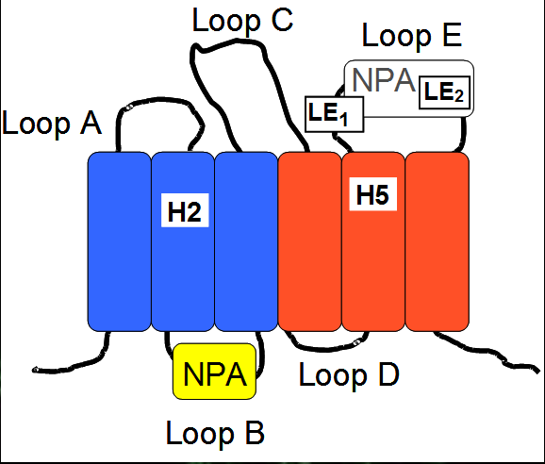

Figure 1.1 Major Intrinsic Proteins/Aquaporin topology The topology map of Major Intrinsic Proteins is shown. The first three transmembrane domains are colored in blue, and the last three are colored in red. Loops B and E containing the highly conserved NPA motifs are indicated in yellow and white, respectively with the α-helical regions in boxes. The relative position of the key ar/R selectivity filter residues at H2, H5, LE1, and LE2 are also indicated.

studies by both electron crystallography of 2D crystals and X-ray crystallography of 3D crystals. Studies on the AQP structure began with electron crystallographic analyses of 2D crystals of AQP1 purified from red blood cells (Mitra, Yeager et al. 1994, Walz, Smith et al. 1994). Later on, 3D density maps showed the organization of the six transmembrane α-helices enclosing a vestibule that would contain the water selective pore and the NPA-carrying loops B and E (Cheng, van Hoek et al. 1997, Walz, Hirai et al. 1997). These low resolution techniques indicated that MIPs formed a tilted helical bundle containing six transmembrane domains. In 2000, the first atomic model of AQP1 was built from X-ray crystallography and revealed the architecture of AQP water pore (Figure 1.2)(Murata, Mitsuoka et al. 2000). The atomic model confirmed the pseudo-2-fold symmetry of the AQP1. The first repeat starting from N-terminus, followed by TM helices 1 and 2 connected by extracellular loop A; loop B connecting TM helices 2 and 3 folds back into the membrane and reverses the direction and forms a short helix with the first NPA motif midway through the membrane. Loop C spans the entire extracellular surface connecting TM helices 3 and 4. TM helix 4 is the start of the second repeat which orients 180° to the first repeat. TM helices 4 and 5 are connected by cytoplasmic
A.
B.
C.
D.

Figure 1.2 Structure of AQP1. A and C. End-on view from the extracellular surface; B and D. side view; Dotted lines in black show the pseudo two-fold axis of the AQP1 monomer. C, Cylinder model of the AQP1 tetramer; end-on view from the extracellular surface; D, side view. Grey bands indicate the surface of the lipid bilayer(Murata, Mitsuoka et al. 2000).

loop D. Like Loop B, Loop E connects helices 5 and 6 folds back into membrane, placing the NPA motif opposite to the first NPA in the middle of the bilayer. Immediately following the second NPA, loop E forms another short helix. The two NPA motifs fold back into the center of the membrane and interact through van der Waals interactions between two proline residues in the NPA boxes. The novel fold was later confirmed by a 2.2 Å resolution X-ray crystal structure of AQP1, which also revealed a short α-helix at the C-terminus(Sui, Han et al. 2001). This fold was found to be conserved in all members of the AQP superfamily and has been named the “Hourglass” fold (Jung, Preston et al. 1994).
The electron microscopy structure revealed that the physical limitation on the size of substrates allowed to permeate to the AQP1 pore is imposed by a narrowing of the pore to a diameter of 3 Å(Murata, Mitsuoka et al. 2000), which is only slightly larger than the 2.8 Å diameter of a water molecule. The pore constriction prevents permeation of all molecules bigger than water including hydrated ions. The narrow pore region of AQP1 was named the Ar/R constriction site, because it contains highly conserved aromatic and arginine residues(Sui, Han et al. 2001). The Ar/R constriction site in AQP1 is formed by Arg197, His182, Phe58 and Cys189 from TM helix 2(H2), helix 5(H5) and loop E(LE1 and LE2) respectively(Sui, Han et al. 2001)(Figure 1.3). Of the residues in the Ar/R site, it is Cys189 that interacts with HgCl₂ thus resulting in channel blockage. In addition to the AQP1 structure, the 2.2 Å crystal structure of GlpF with 3 glycerol molecules bound in the pore was published (Fu, Libson et al. 2000), as well as a 2.1 Å crystal structure for GlpF without glycerol molecules (Tajkhorshid, Nollert et al. 2002). These two structures indicate that aquaglyceroporins adopt the same hourglass fold as AQP1 with 6 transmembrane helices and two NPA half helices that converge to form the transport pore. Differences between the structures of AQP1 and GlpF are found in the extracellular loop regions. For example, loop C forms a helix-turn-helix motif in GlpF instead of lying flat on the extracellular surface as AQP1. The helix-turn-helix structure was believed to function as a funnel for the glycerol molecules (Fu, Libson et al. 2000). More importantly, comparison of these structures revealed that the narrowest constriction of the hourglass, the Ar/R filter, shows a distinct and conserved difference between water-selective aquaporins and aquaglyceroporins. Pore profiles calculated for GlpF indicate that GlpF has a wider Ar/R pore region compared to AQP, allowing molecules that are larger than a water molecule to pass through the channel(Wang, Schulten et al. 2005) (Figure 1.3). This difference is due to a number of substitutions in residues forming the Ar/R constriction site. For example, His182 at H5 of AQP1 is replaced by a much smaller Gly191 in GlpF; Cys191 at LE1 of AQP1 is replaced by an aromatic Phe220 in GlpF, and Phe58 at H2 of AQP1 by a larger aromatic Trp48. The resulting GlpF constriction has a larger diameter of 3.8 Å to accommodate a glycerol molecule.
In addition, the substitutions in the constriction site residues result in an increased amphiphatic character of the GlpF Ar/R tetrad compared to AQP1. The planar aromatics Trp48 and Phe200 form a hydrophobic wedge which pack tightly with the hydrocarbon of glycerol backbone and is stabilized by van der Waals interactions (Fu, Libson et al. 2000). Opposite the hydrophobic wedge, the guanidinium side chain of Arg206 conserved in both AQP1 and GlpF serves as a hydrogen bond donor in contact with two of the hydroxyl groups of glycerol. The two backbone carbonyl oxygen from Gly199 and Phe220 also serve as hydrogen bond acceptors to the OH groups from glycerol molecules. The hydrophobic wall created by Trp48 and Phe200 are also proposed to reduce the permeation of water (Fu, Libson et al. 2000). Mutations of these two aromatic residues result in a higher water conductivity through GlpF (Borgnia and Agre 2001), indicating the importance of the Trp48 and Phe220 for substrate selectivity. In terms of the differences between the glycerol bound and glycerol free GlpF structures, only as light difference in the orientation of three of four Ar/R constriction site residues, Trp48, Phe200, and Arg206 was found. In the glycerol-absent GlpF, these residues position their side chains closer to each other, forming a narrower pore (Tajkhorshid, Nollert et al. 2002).
Despite their ability to flux water, AQPs prevent the conduction of protons. This is an essential feature of these water channels since proton permeability would be undesirable since it would collapse the membrane potential. The first mechanism of proton exclusion was proposed by Murata et al based on the EM structure of AQP1(Murata, Mitsuoka et al. 2000). This structure showed that the two pore NPA helices from loop B and loop E are oriented in opposite directions, and interact through proline-proline interactions of the NPA motifs. The two Asn residues side chains from each NPA group extend into the pore, so that the positive partial dipole moments of the two pore helices form hydrogen bonds with amido NH2 of the Asn residues in the center of the pore. Based on this observation, Murata et al. proposed a “hydrogen bond isolation mechanism” which states that when a water molecule comes into the center of the pore, it must orient itself so that its oxygen atom would form hydrogen bond interactions with the side chains of the two Asn residues rather than with adjacent water molecules. Therefore, the two Asn residues reorient the dipole of the water molecule perpendicular to the pore axis so that the line of continuous

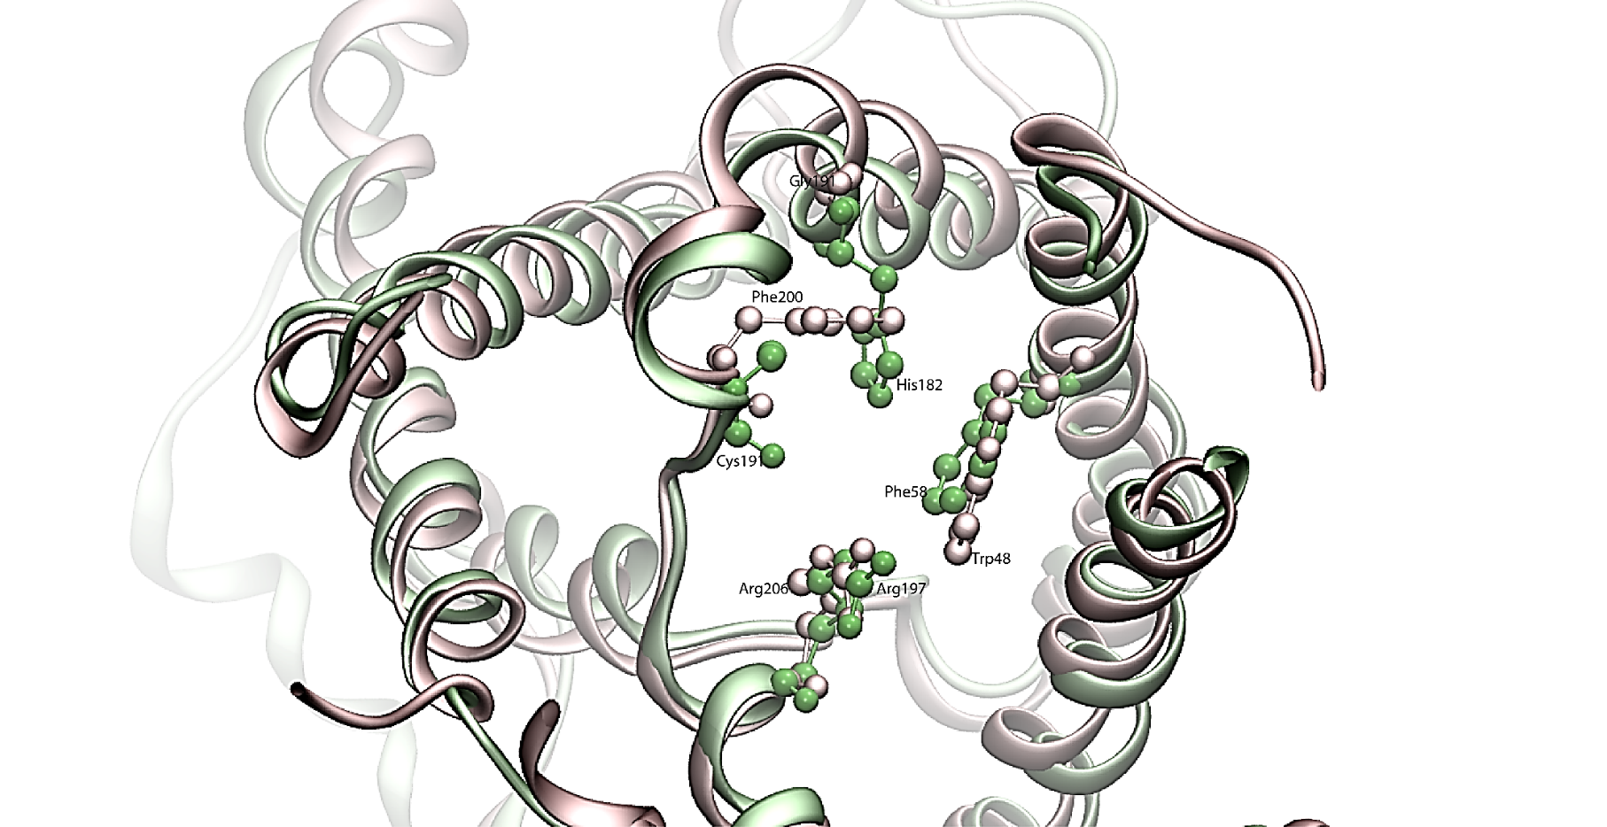
A.
B.
Ar/R
NPA

Figure 1.3 Selectivity filter of AQP1 and GlpF. A. Residues involved in the formation of the AQP1 constriction region (Ar/R tetrad) (H182, R197, F58 and C191) are depicted in green colors while the white side chains are those of the equivalent residues found in the structure of GlpF (G191, R206, W48 and F200). B. The effective pore diameter of the AQP1 and GlpF channels. Green and dark blue arrows indicate the locations of the constriction region. Pore diameters were determined with AMBER-based van der Waals radii and analyzed using the program HOLE(Sui, Han et al. 2001). (Figures are regenerated from Fu et al. 2000)

hydrogen bond network is broken, preventing the Grotthuss mechanism which would enable protons to cross the membrane bilayer through the hydrogen bonded water chain in the AQP pore (Murata, Mitsuoka et al. 2000). With the aid of computer simulation methods, the mechanism of proton exclusion confirmed that Asn residues orient the water molecule in the center of the pore perpendicular to the pore axis (Tajkhorshid, Nollert et al. 2002). According to the simulations, the center water can only form hydrogen bond with the neighboring water molecules either from the extracellular side or cytoplasmic side. Thus the line of water molecules in the two pore halves have an opposite hydrogen bond polarity, thereby preventing protons from traversing the membrane (de Groot and Grubmuller 2005).

1.3 The regulation of AQP family

While members of AQP family share a common structural fold, they show differences in their susceptibility to regulation of their functions by a number of factors including pH, divalent cations, and phosphorylation. Phosphorylation of conserved serine or threonine residues is suggested to play a role in both gating and trafficking of eukaryotic aquaporins (Fushimi, Sasaki et al. 1997, Hoffert, Fenton et al. 2008, Prak, Hem et al. 2008). Changes in pH, changes in divalent cation concentrations and changes in osmolality can also directly influence the water permeability of the plasma membrane in various cells (Johansson and Eriksson 1996, Nemeth-Cahalan and Hall 2000, Tournaire-Roux, Sutka et al. 2003, Zelenina, Tritto et al. 2004). Compelling biochemical evidences suggest that there is gating of the plant plasma membrane aquaporin by pH, divalent cations, and phosphorylation (Tournaire-Roux, Sutka et al. 2003, Alleva, Niemietz et al. 2006, Verdoucq, Grondin et al. 2008). For example, water conductance of plant SoPIP2;1 is regulated by the phosphorylation of two conserved serine residues, Ser247 and Ser115 (Johansson and Eriksson 1996, Johansson, Karlsson et al. 1998) and the protonation of a conserved His residue (Tournaire-Roux, Sutka et al. 2003). In addition, evidence for the gating of yeast aquaporins first emerged for the glycerol facilitator Fps1 of Saccharomyces cerevisiae(Tamas, Luyten et al. 1999). Glycerol transport rates were regulated by both the N-terminus (Tamas, Karlgren et al. 2003) and C-terminus (Hedfalk, Bill et al. 2004). The water facilitator Aqy1 of Pichia pastoris is regulated by an N-terminal tyrosine residue and a serine residue in loop B (Fischer, Kosinska-Eriksson et al. 2009). AQP0 water permeability is maximal at the slightly acidic pH of 6.5(Nemeth-Cahalan and Hall 2000). His40 was identified as possible a pH sensor. It is located at the extracellular entrance of the pore and its side-chain extends into the water pathway. Hence, the protonation state of His40 would be the mechanism by which pH influences AQP0 water conductivity. The second His residue, His66, is located in the second constriction site, also could be involved in pH regulation(Nemeth-Cahalan and Hall 2000).

1.4 The plant aquaporin family

Due to their sessile nature, plants establish a continuum between the soil and the atmosphere and plants are much more susceptible to environmental conditions including osmotic stresses. In addition, plant growth and cell and tissue movements differ from their animal counterparts and are often driven by turgor and hydrostatic forces. As a result, during the evolution of land plants, the aquaporin family of water and solute channels underwent a diversification in the numbers of genes, and their structural and functional properties. The first aquaporin discovered in plants was identified from Arabidopsis (Maurel, Reizer et al. 1993). Subsequent sequencing of several plant genomes revealed that the plant aquaporin family is highly diverse, with 35, 36, 33 and 55 homologs in Arabidopsis, maize, rice and poplar, respectively (Chaumont, Barrieu et al. 2001, Johanson, Karlsson et al. 2001, Sakurai, Ishikawa et al. 2005, Gupta and Sankararamakrishnan 2009). On the basis of sequence homology, the Arabidopsis aquaporins were divided into four phylogenetic subgroups (Weig and Jakob 2000, Johanson, Karlsson et al. 2001, Quigley, Rosenberg et al. 2002). This include the plasma membrane intrinsic proteins (PIP), which localize mostly to the plasma membrane (Johanson, Karlsson et al. 2001). The tonoplast intrinsic proteins (TIP) are another clade which are found largely in the vacuolar membrane (tonoplast)(Quigley, Rosenberg et al. 2002). Nodulin 26-like intrinsic proteins (NIPs) are distinguished by their sequence similarity to Nodulin-26. The fourth, and least characterized, clade are the small basic intrinsic proteins (SIPs).

The plasma membrane intrinsic protein (PIPs)

PIPs constitute a subfamily of plant aquaporins that are mostly localized in the plasma membrane, where they facilitate the passive diffusion of water. The first PIP subfamily member was discovered in Arabidopsis (Daniels, Mirkov et al. 1994) and its function was identified as a water-selective channel. The PIP subfamily consists of 13 members in Arabidopsis that can be subdivided into two groups: PIP1 and PIP2 (Quigley, Rosenberg et al. 2002). While both PIP1 and PIP2 subgroups show high overall sequence identity, they have distinct functional properties (Chaumont, Barrieu et al. 2000). The PIP2 subgroup has been reported to have low water permeability compared to the high water permeability of the PIP2 subgroup (Chaumont, Barrieu et al. 2000). Also, it is reported that PIP1 proteins must form hetertetramers with PIP2 monomers to be able to facilitate water permeation (Fetter, Van Wilder et al. 2004, Zelazny, Borst et al. 2007). A further subgroup of PIP3 sequence is found in the Physcomitrella patens genome (Danielson and Johanson 2008). However, the functions of PIP3 proteins need to be established. PIPs are identified involving several plant processes that necessitate the rapid transport of water, including adaptation to drought, salinity, and flooding stress.

The Tonoplast Intrinsic Protein (TIPs)

The TIP family is the second largest MIP subfamily in Arabidopsis, consisting of 10 genes(Quigley, Rosenberg et al. 2002). The first TIP discovered was also the first water channel to be characterized in plants. It was identified from Phaseolus vulgaris seeds tonoplasts(Johnson, Herman et al. 1989). The cDNA was found to encode a 27kDa intrinsic membrane protein. The hydropathy plots and secondary structure analysis of the polypeptide predicts six membrane-spanning domains and sequence homology to GlpF(Johnson, Hofte et al. 1990). The TIP subfamily was found to have 11 members in Arabidopsis(Quigley, Rosenberg et al. 2002), which are all located on vacuole membranes. Functional analysis of TIP subfamily proteins in Xenopus oocytes suggested that they perform as water-specific channels (Maurel, Reizer et al. 1993), In 1999, Gerbeau et al. showed that TIP proteins can also transport larger molecules such as urea and glycerol (Gerbeau, Guclu et al. 1999, Klebl, Wolf et al. 2003). Thus, in addition to their role as water channels, some TIPs may play a role in equilibrating urea concentrations between the vacuole and the cytoplasm. In addition, TIPs of Arabidopsis were identified in yeast complementation assays that conferred permeability to ammonium, methylammonium or formamide. Expression of TIPs in Xenopus oocytes resulted in an increased permeability for NH₄⁺/NH₃ at rising pH (Jahn, Moller et al. 2004, Holm, Jahn et al. 2005, Loque, Ludewig et al. 2005). Taken together, TIP subfamily proteins are involved in not only osmoregulation but are also important for metabolic pathways such as urea cycle or amino acid synthesis.

The Small Intrinsic Protein

The small basic intrinsic protein subfamily is the smallest in the MIP cluster in plants. It was identified by database mining and phylogenic analysis(Johanson and Gustavsson 2002). The main reason for their small size is a very short cytosolic N-terminal region compared to the other plant MIPs. In recent studies, fusion proteins of Arabidopsis SIPs with green fluorescent protein (GFP) were detected in the ER and not abundant in plasma or vacuolar membranes(Ishikawa, Suga et al. 2005). It is interesting to note that phylogenetic analysis of corn, rice, and Arabidopsis (Chaumont, Barrieu et al. 2000, Johanson, Karlsson et al. 2001, Quigley, Rosenberg et al. 2002) indicate that the SIP subfamily is consistently divided into two groups (SIPI and SIP2) suggesting that each of these subgroups has a conserved physiological function. By heterologous expression in yeast and vesicle permeability studies, SIP1;1 and SIP1;2 were characterized as aquaporins, while SIP2;1 showed only a slow water influx into membrane vesicles (Ishikawa, Suga et al. 2005).

1.4.4 The Nodulin 26-like Intrinsic Proteins (NIPs)

The Noduin-26 is a major component of the symbiosome membrane of nitrogen fixing root nodules, and is among the first members of the aquaporin superfamily that were discovered in plants (Sandal and Marcker 1988). Because this subfamily was the major focus that led to this study, the characteristics of this subfamily are discussed in greater detail in the subsequent section.
While these four phylogenetic subfamilies are found in all plant species, additional aquaporin subclasses have been found in other genomes, such as poplar(Gupta and Sankararamakrishnan 2009), indicting an even greater diversity and complexity of this channel family in plants. For example, another three subfamilies have been reported including the uncategorized X intrinsic proteins (XIPs) (Bienert, Bienert et al. 2011, Lopez, Bronner et al. 2012); GlpF-like intrinsic proteins (GIPs) (Anderberg, Danielson et al. 2011) and the hydrid intrinsic protein (HIPs). HIPs have similarities to both TIPs and PIPs (Anderberg, Kjellbom et al. 2012), and are only present in moss, not vascular plants.
In addition to this phylogenetic diversity, structural modeling of the plant aquaporin family showed that the pore selectivity filter (Ar/R) also became diversified during plant evolution. This was first illustrated by the work of Wallace and Roberts (Wallace and Roberts 2004). Homology modeling was used to construct structural models of the putative pore regions of various plant MIPs based on the atomic resolution crystal structures of mammalian aquaporin 1 and the bacterial aquaglyceroporin GlpF. Based on comparisons of the selectivity filter (Ar/R), the members of the four phylogenetic subfamilies of Arabidopsis MIPs can be classified into eight groups. PIPs have a uniform ar/R signature characteristic of high water permeability aquaporins similar to AQP1, with the conservation of Phe(H2) and His(H5) residues as well as the Arg residue at LE2. TIPs are highly diverse with three separate conserved Ar/R regions: TIP Group I(TIP1;1-3), TIP Groups IIa (TIP2;1-3) and IIb(TIP3;1, TIP3;2, and TIP4;1) and TIP Group III(TIP5;1). TIP Group I and II show that Ar/R regions have a conserved His residue at the H2 position and a conserved Ile residue at the H5 position. TIP Group III possesses a Val at the H5 position, but an Asn at the H2 position. Group II TIPs contain the highly conserved Arg residue at LE2 and either an Ala or Gly at the LE1 position. However, Group I and III TIPs have an unusual Val substitution for the Arg at LE2 position. In addition, TIP Group III has a novel Ar/R tetrad with the conserved Arg at LE2 replaced by a smaller uncharged Cys residue and small flexible Gly residue at LE1. Structural alignment of the nine Arabidopsis NIPs reveals that there are two different Ar/R signatures that differ principally at the H2 position. Six NIPs possess a conserved Ar/R characteristic of the nodulin 26 Ar/R tetrad, whereas three (NIP5;1, NIP6;1, and NIP7;1) have a divergent Ar/R tetrad with the substitution of an Ala for Trp at position H2. The SIP subfamily also has two Ar/R groups, characteristic of either SIP1 or SIP2, and both the SIP Ar/R are divergent from all the other MIPs in plants. The presence of this wide range of Ar/R pore signatures suggest the diversity of structures is also accompanied by a diversity of transport functions. Numerous functional analyses by expression in Xenopus oocytes and yeast supports this hypothesis (Ludewig and Dynowski 2009).

1.5 Nodulin-26 like intrinsic proteins (NIPs)

Nodulin 26 was the first member of the aquaporin family to be discovered in plants(Sandal and Marcker 1988). It was first discovered by Verma and coworkers in 1987(Fortin, Morrison et al. 1987) as a major component of the symbiosome membrane within nitrogen fixing root nodules. Symbiosomes are a specialized symbiotic organelle that is formed by legumes in association with endosymbiotic nitrogen fixing Rhizobia bacteria(Oldroyd and Downie 2008). The membrane, of plant origin, controls the exchange of metabolites between the endosymbiant and the plant host, and contains a number of specialized channel and transport proteins that support the symbiosis(Udvardi and Poole 2013). The work by Fortin et al(Fortin, Morrison et al. 1987) and subsequent work by Weaver et al (Weaver, Crombie et al. 1991) identified nodulin 26 as the major integral membrane component of the symbiosome membrane. Analysis of isolated symbiosome membrane vesicles (Rivers, Dean et al. 1997), proteoliposomes (Dean, Rivers et al. 1999, Hwang, Ellingson et al. 2010) and Xenopus oocytes(Rivers, Dean et al. 1997, Dean, Rivers et al. 1999, Guenther, Chanmanivone et al. 2003) show that nodulin 26 is an aquaglyceroporin with modest intrinsic aquaporin activity as it also it is permeated by NH₃, which is the major export product of the nitrogen from symbiosome.
Since the discovery of soybean nodulin 26, a large number of Nodulin-26 like intrinsic proteins are found in a variety of plants, such as Arabidopsis, rice, maize, and the moss(Chaumont, Barrieu et al. 2001, Quigley, Rosenberg et al. 2002, Sakurai, Ishikawa et al. 2005, Danielson and Johanson 2008). In Arabidopsis there are 9 genes encoding NIPs (Johanson, Karlsson et al. 2001). Based on the homology modeling of the ar/R selectivity filter, it was proposed that the Arabidopsis NIPs can be divided into two pore subgroups (Wallace and Roberts 2004). NIP subgroup I (NIP I) is composed of six genes encoding NIP1;1, NIP1;2, NIP2;1, NIP3;1, NIP4;1 and NIP4;2 which show an identical ar/R selectivity filter as Nodulin-26. A Trp at H2 position, an Ile or Val at H5, an Ala and Arg at LE1 and LE2 respectively. Arabidopsis NIP subgroup II (NIPII) contains three genes: NIP5;1, NIP6;1 and NIP7;1. NIP II proteins contain an Ala residue which replaces the MIP-like Trp at H2 position. This results in a wider pore aperture (Wallace and Roberts 2005), suggesting that NIP II may have different function than NIP I (Wallace and Roberts 2004). A third pore subtype of NIP was discovered from work with the NIP family in rice. There are 10 members of NIPs that have been identified in rice (Bansal and Sankararamakrishnan 2007). Rice possesses an unique subclass of NIP that has distinct Ar/R configuration that has been categorized as NIP subgroup III (NIP III). The ar/R selectivity filter of NIP III proteins is composed of Gly(H2), Ser(H5), Gly(LE1) and Arg(LE2) which provides an even wider pore aperture than NIP II (Mitani, Yamaji et al. 2008).
The distinct pore selectivity signatures results in different substrate selectivties for each 3 NIP subgroups (Figure 1.4). Functional analysis of AtNIP1;1 and 1;2 in Xenopus oocyte and yeast were shown to be aquaglyceroporins similar to nodulin 26(Weig and Jakob 2000). Besides transport of these substrates, some NIP I proteins, such as Arabidopsis NIP 2;1, was found to be permeated by other substrates such as lactic acid. NIP2;1 is a root specific protein which is induced over 1000-fold by flooding and hypoxia and is proposed to mediate the flux of lactic acid produced by fermentation(Choi and Roberts 2007).
Pore predictions of NIP II proteins indicates a wider pore aperture and general loss of the Ar/R constriction (Wallace and Roberts 2005). Consistent with these observations, a comparison of a NIP I protein (Nodulin 26) with a NIP II protein (NIP6;1) showed that NIP II proteins are permeated by a balkier solute, urea (van der Waal volume 32.8 cm³/mol) that is excluded from NIP I proteins. Perhaps more surprising, NIP II proteins are “water tight”, showing little to no aquaporin activity while retaining the ability to flux glycerol and urea(Wallace and Roberts 2005). With respect to biological substrates, it is clear that NIP II channels are permeable to metalloids including boric acid (a nutrient) (Takano, Wada et al. 2006, Tanaka, Wallace et al. 2008) and arsenious acid (a toxin) (Bienert, Thorsen et al. 2008).
Pore predictions of NIP III proteins indicate an even wider and more hydrophilic pore compared to NIP I (Ma, Tamai et al. 2006), and these proteins have been shown to be permeated by larger metalloid solutes, such as germanic acid (GeOH₄) and silicic acid (SiOH₄)(Ma, Tamai et al. 2006). Recent site-directed mutagenesis studies of ar/R region in OsNIP2;1 (NIP III) and AtNIP5;1 (NIP II) shed light on understanding the mechanism of controlling substrate selectivity. The results reveal that the residue at the H5 position of the ar/R filter of both OsNIP2;1 and AtNIP5;1 plays a key role in the permeability of silicon and boron (Mitani-Ueno, Yamaji et al. 2011).In the following sections, the biological functions of NIP II and NIP III channels in plant nutrition are summarized.

1.6 Metalloid nutrient uptake by NIP II and NIP III channels

Boron (B) is an essential microelement for higher plants, and B deficiency is an agricultural problem in many parts of the world(Shorrocks 1997). In nature B mainly exists as boric acid [B(OH)₃]. Boric acid is a weak Lewis acid with a pKa of 9.24 and thus exists in an uncharged state in solutions at physiological pH and in the absence of interaction with biomolecules. Thus, it is accepted that plants take up B from soil in the form of uncharged boric acid. Based on the availability of B, uptake by roots can be carried out by three different molecular mechanisms: passive diffusion through lipid bilayers; protein-facilitated flux mediated by MIPs; or an energy-dependent high-affinity transporters (BOR transporters) (Tanaka and Fujiwara 2008).

Figure 1.4 Phylogenetic tree of plant NIPs. Phylogenetic analysis of rice (Os), arabidopsis (At), maize (Zm), soybean nodulin-26 (GmNod26), and zucchini CpNIP1 is performed. Plant NIPs were classified into three subgroups based on the two NPA motifs and the ar/R selectivity filter formed by four amino acid residues (helix2 H2, helix5 H5, loop E1 LE1, and loop E2 LE2). The NPA motifs and the ar/R residues of each subgroup are indicated in the figure.

Under excessive B conditions, boric acid uptake by roots is mediated via passive diffusion across the biological membrane bilayer. On the basis of ether–water partitioning coefficients, the molecular weight, and the number of H bonds of B, Raven calculated the theoretical lipid permeability coefficient of boric acid to be 8 × 10⁻⁶ cm s⁻¹ (Raven 1980). This relatively high value had been the basis of the widely believed hypothesis that passive diffusion of boric acid across the lipid bilayer represents the major and possibly the only mechanism of membrane transport of B. Dordas and Brown determined the permeability coefficient of boric acid using artificial liposomes consisting of phosphatidylcholine. The estimated value was 4.9 × 10⁻⁶ cm s⁻¹, which was similar to the theoretical values obtained by Raven (1980)(Dordas and Brown 2000). The first experimental evidence suggesting the involvement of channel proteins in B transport were provided by Dordas et al(Dordas, Chrispeels et al. 2000). Using membranes isolated from squash (Cucurbita pepo) roots, he determined the permeability coefficients of boric acid to be 3.9 × 10⁻⁷ and 2.4 × 10⁻⁸ cm s⁻¹ in plasma membrane and plasma membrane–depleted vesicles, respectively. Additionally, B permeability was partially inhibited by channel blocker HgCl₂ (Dordas, Chrispeels et al. 2000). In agreement with these findings, Stangoulis et al. determined the permeability coefficients of boric acid in the plasma membrane of the giant internodal cells of the charophyte alga Chara corallina to be 4.4 × 10⁻⁷ cm s⁻¹ (Stangoulis, Reid et al. 2001). The one order of magnitude higher permeability implied the existence of membrane proteins to facilitate boric acid uptake. The active absorption of B is supported by the fact that B uptake was inhibited by both metabolic inhibitors and cold treatment in roots (H. Pfeffer 1999). To date, two B transporters has been identified to be involved in the efficient B uptake (Noguchi, Yasumori et al. 1997, Miwa, Wakuta et al. 2013).
It is widely known that B deficiency results in the formation of abnormal cell wall structures (Fleischer, O'Neill et al. 1999, Ryden, Sugimoto-Shirasu et al. 2003). In the last decade, B has been established as essential for cell wall structure and function. Up to 90% of the cellular B has been localized in the cell wall fraction (Loomis and Durst 1992). It was proposed that in cell walls, B can cross-link pectic polysaccharides through borate–diol bonding of two rhamnogalacturonan II (RG-II) molecules (Loomis and Durst 1992). The first evidence for borate cross-link two RG-II monomers was provided by Kobayashi et al. The first boron-containing pectic polysaccharide complex was purified from radish root cell walls (Kobayashi, Matoh et al. 1996). Subsequently, Matoh et al found the RG-II-B complex in cell walls of 22 other plant species (Mathoh T 1996). More recently, the borate cross-linked RG-II was shown to be essential for normal plant growth using the Arabidopsis thaliana mur1 mutant and the haploid Nicotiana plumbaginifolia callus mutant nolac-H18, in which the amount of borate cross-linked RG-II is reduced (O'Neill, Eberhard et al. 2001). Besides RG-II, there are other candidates for borate crosslinking in cell walls, such as hydroxyproline-rich glycoproteins and proline-rich proteins. It has been observed that boron-deficient soybean root nodules and petunia pollen tubes contain very low levels of hydroxyprotein-rich protein which is normally secreted and assembled into cell walls.
Beyond the function in plant cell walls, boron was found to be essential for nitrogen fixation (Mateo, Bonilla et al. 1986). Loss of nitrogenase activity under boron-deficient conditions was explained by increased activities of superoxide dismutase, catalase, and peroxidase. Bolanos et al found that in boron-deficient pea nodules, the number of infected host cells was much lower than in sufficient controls. Host cells in boron deficient plants developed enlarged and abnormal infection treads, which burst (Bolanos, Brewin et al. 1996). Developing soybean root nodules are more sensitive to low boron nutrition than fully developed nodules. Both development and nitrogen fixation of young nodules are retarded after boron removal (Yamagishi M 1994). In addition, the cell walls of boron deficient nodules have low levels of proline-rich protein such as ENOD2, which leads to a lower oxygen barrier and inactivation of nitrogenase (Bonilla, Mergold-Villasenor et al. 1997).
Boron’s role in plant metabolism has also been studied. Boron deficiency have been shown to have an effect on the ascorbate/glutathione cycle. In roots and leaves, the ascrobate and glutathione concentrations have been shown decrease under boron deficiency condition(Lukaszewski and Blevins 1996).
In addition to boron deficiency, boron toxicity is also a worldwide problem. Reduced growth of shoots and roots is typical of plants under toxic boron levels (1-5mM) (Nable RO 1990). Boron toxicity affects several processes in plants such as a reduced rate of cell division, lower photosynthetic rates, and a decrease lignin levels. Although the molecular mechanism for boron toxicity is not known, there are three main causes that have been proposed: 1. Disruption of cell walls structure; 2. Binding to ribose moieties of molecules such as ATP, NADH or NADHP causes metabolic disruption; 3. Binding to ribose such DNA and RNA causes cell division and development disruption (Reid RJ 2004).
Dordas et al first proposed that aquaporin plays a role in boric acid assimilation. The plasma membrane purified from squash roots showed 6-fold higher boric acid permeability than that from microsomal vesicles, and mercury inhibited the permeability (Dordas and Brown 2000). Transcriptom analysis of Arabidopsis roots revealed that NIP5;1 was highly upregulated under B-deficient growth conditions compare with adequate B supply. NIP5;1 mRNA levels increased within several hours after low B treatment and peaked after 24hrs with a 15-fold induction. NIP5;1 transports boric acid in Xenopus oocytes. NIP5;1-expressing oocyte accumulated 5 to 6 fold more B than uninjected oocytes when incubated at 5 mM boric acid. The physiological significance of NIP5;1 was demonstrated under B limitation by a T-DNA insertion mutation of NIP5;1 which lead to a striking growth retardation of shoot and roots and an inhibition of flower and silique formation(Takano, Wada et al. 2006). NIP6;1, the second boric acid transporting MIP was identified by expressing in Xenopus oocytes and verified by inductively coupled plasma-mass spectrometry. Compared to uninjected control oocytes, NIP6;1-injected oocytes showed over 50 fold higher rate than the mock-injected oocytes. Quantitative RT-PCR was conducted at both sufficient and deficient B conditions, and NIP6;1 transcript levels in stems was increased 1.4 fold under B limitation condition. Small, young rosette leaves of T-DNA insertion lines of NIP6;1 showed inhibited expansion with dark green in color and irregular in shape. Additionally, the mutant plants lost the apical dominance under B deficiency conditions at the reproductive stage (Tanaka, Wallace et al. 2008).
Molecular characterization of low silicon rice1 (lsi1), a mutant of rice defective in silicon uptake into roots, led to the finding that Lsi1 encodes a NIP homolog. Lsi1 (OsNIP2;1) transports silicon after expression in oocytes. Oocytes expressing Lsi1 have a silicon uptake rate 2.4 times greater than the control oocytes. Kinetic analysis showed that silicon transport activity increased with increasing silicon concentrations in external solution. OsNIP2;1 is the first silicon transport protein of plants(Ma, Tamai et al. 2006). The second silicon efflux transportor in rice (OsNIP2;2) was also identified to play a role in xylem unloading(Yamaji and Ma 2009). Both Lsi1 and Lsi2 are located at the plasma membrane of both exodermal and endodermal cells of the roots. More recently, Lsi6, the homolog of Lsi1 has been identified in rice which is responsible for unloading silicon from the xylem (Yamaji, Mitatni et al. 2008). Another two rice plasma membrane intrinsic proteins, OsPIP2;4 and OsPIP2;7, were reported to be involved in transport as well as providing tolerance to boron toxicity(Kumar, Mosa et al. 2013). In addition, silicon transporters from maize (ZmNIP2;1, ZmLsi2, ZmLsi6) (Mitani, Chiba et al. 2009), barley (HvLsi2(Mitani, Chiba et al. 2009)) have been reported.

1.7 Goal of the present research
MIPs are highly conserved from prokaryotes to the most evolved eukaryotes, suggesting that these proteins are essential transport components of biological membranes. However, as summarized above, besides transporting water, some MIPs are capable of transporting solutes other than water. Plants contain a greater number of functionally and structurally diverse MIP superfamily members than their animal and microbial counterparts. Selectivity filter analysis indicates that plants contain a more diverse combination of Ar/R amino acids at this region. NIPs are plant specific aquaporin subfamilies. In Arabidopsis, the NIPs proteins are classified into NIP I and NIP II groups which have distinct Ar/R tetrad amino acids which results in different substrate selectivities. NIP5;1 and NIP6;1 were identified as boric acid channels specifically expressed in roots and stem node in Arabidopsis respectively (Takano, Wada et al. 2006, Tanaka, Wallace et al. 2008). In the present work, we used homology modeling, molecular dynamics simulation, coupled with site-directed mutagenesis, and functional analysis to investigate the structural determinants as well as substrate selectivity of the third member of NIP II, NIP7;1. In addition, we investigated the biological function, tissue and cellular localization of NIP7;1 in Arabidopsis. Finally, we used computational and functional approaches to investigate the substrate selectivities in both NIP I and NIP II proteins.

CHAPTER II

MATERIALS AND METHODS

2.1 Plant materials and general growth conditions

Arabidopsis thaliana ecotype Columbia-0 seeds were surface sterilized with 50% (v/v) sodium hypochlorite (bleach) containing 0.1% (v/v) Triton X-100 for 15 minutes. The seeds were rinsed five times with sterile distilled water and were planted on 1x Murashige and Skoog (MS) agar medium (Cat # M5524; Sigma-Aldrich, St. Louis, MO). The seeds were stratified at 4°C for 2 days, and were then grown under white fluorescent light (76-100 µmol m⁻²s⁻¹) with a long day (LD) cycle of 16 hr light/8 hr dark at 22°C. Twelve day old seedlings were transplanted to Fafard super fine germinating mix (Sun Gro Horticulture, Agawam, MA), and were grown under white fluorescent light(76-100 µmol m⁻²s⁻¹) at 22°C under the LD cycle. Arabidopsis plants for seed harvest were grown in a growth chamber under LD conditions until they set seeds and were allowed to completely dry without watering for a week. Seeds were harvested from dried siliques using a 200 mesh stainless steel screen.

2.2 Hydroponic growth condition

Plant hydroponic growth media (MGRL media) (1.75mM sodium phosphate buffer pH 5.8, 1.5 mM MgSO₄, 2.0 mM Ca(NO₃)₂, 3.0 mM KNO₃, 67 µM Na₂EDTA, 8.6 µM FeSO₄, 10.3 µM MnSO₄, 1.0 µM ZnSO₄, 24 nM (NH₄)₆Mo₇O₂₄, 130 nM CoCl₂, 1 µM CuSO₄, 60 µM H₃BO₃) were used for seed germination. For hydroponic growth, the set up used is shown in Figure 2.1. Briefly, three to four Arabidopsis seeds were spotted on each rockwool plug which was placed on a homemade floatation device with the bottom touching the surface of MGRL media, and plants were grown under white fluorescent light (76-100 µmol m⁻²s⁻¹) under LD condition. After one week, seedlings were thinned to one seedling on each rockwool plug. Seedlings were continuously grown under the same conditions until the 10th rosette leaf was greater than 1 mm. Then plants were transferred to the final hydroponic medium without boric acid supplemented with either 100 µM or 0.3 µM of boric acid and growth was continued under LD conditions. The media was changed every 4 days and the growth media was aerated with an air pump (Top Fin Air Pump AIR 8000).

2.3 Generation of recombineering lines in Arabidopsis

The JAtY clone information and primers for NIP7;1 (JAtY68K23) were obtained from Arabidopsis Tagging (http://arabidopsislocalizome.org/)(Zhou, Benavente et al. 2011). The JAtY68K23 was purchased from the Genome Analysis Center (Norwich, UK)(Figure 2.2). The E.coli recombineering strain

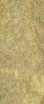
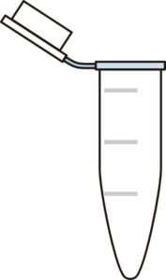
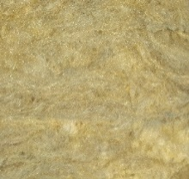
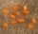
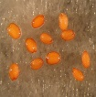
B.
A.

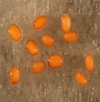
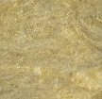
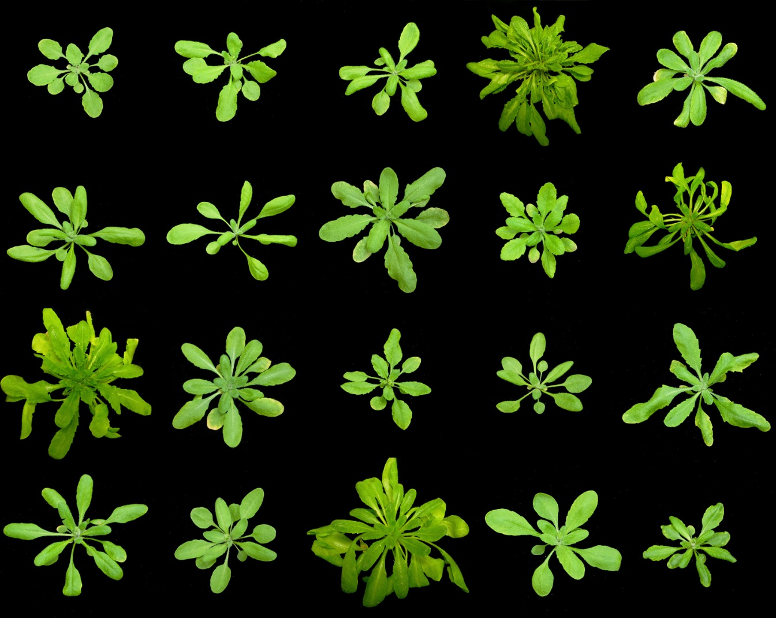
Rockwool cube
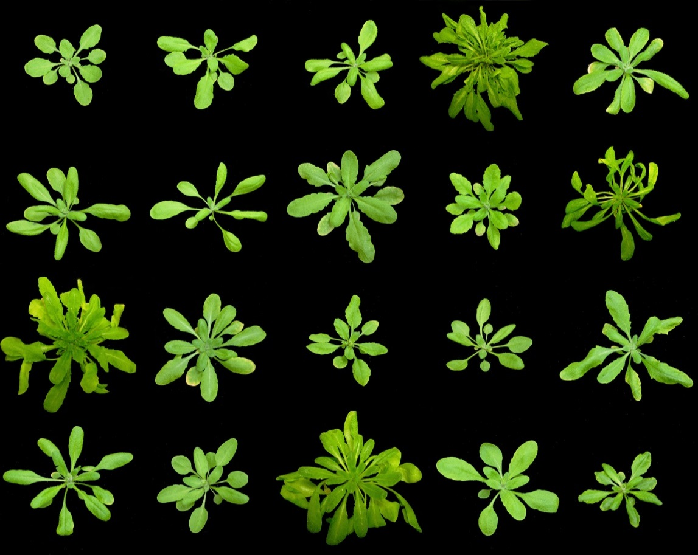
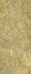
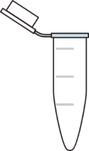
D.
C.
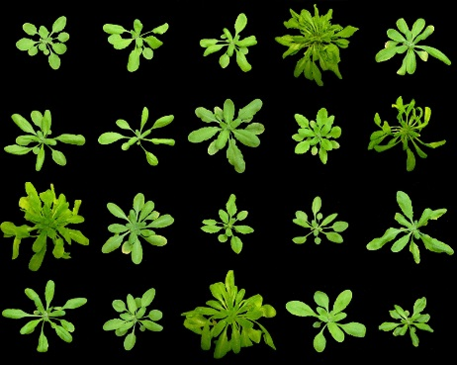
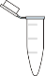
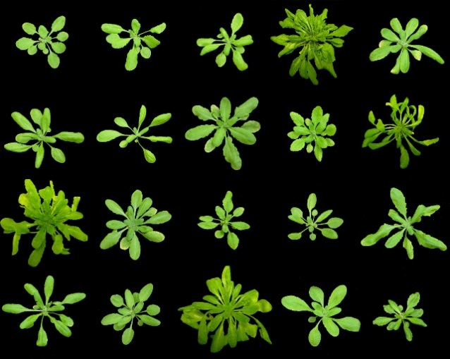


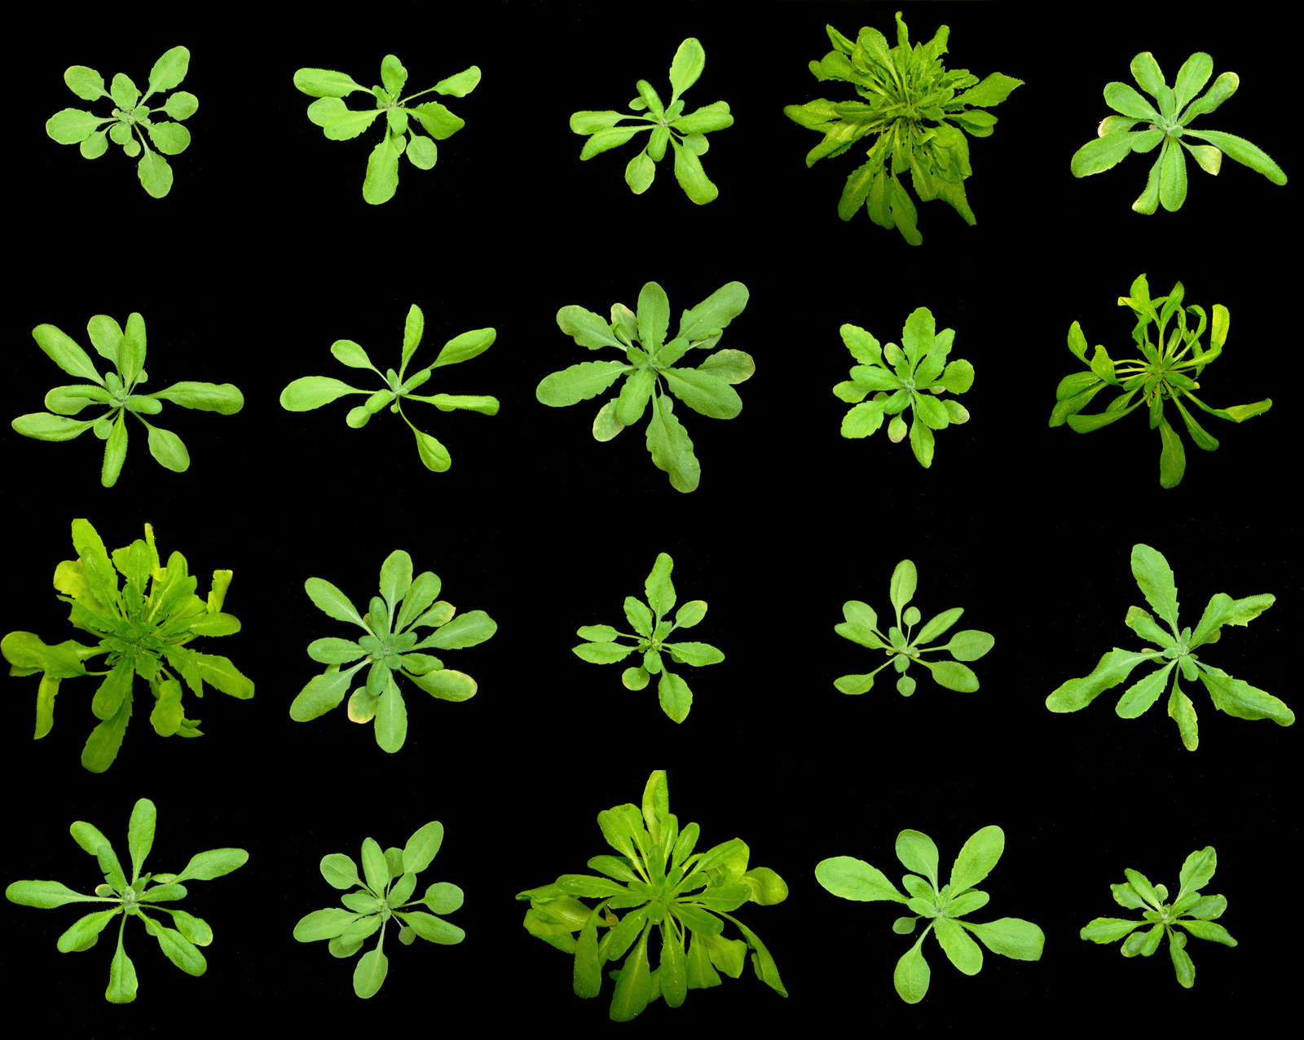

Figure 2.1 Arabidopsis hydroponic growth set up. A. The bottoms of a 1.5 mL Eppendorf tubes are cut, and a small piece of rockwool is inserted inside of the tube. B. Tubes are inserted into a homemade floatation device and several seeds are spotted on the top of the rockwool. C. 50 mL falcon tubes are used as adaptors for transferring small tubes to the bigger flotation device. D. The final hydroponic set up.

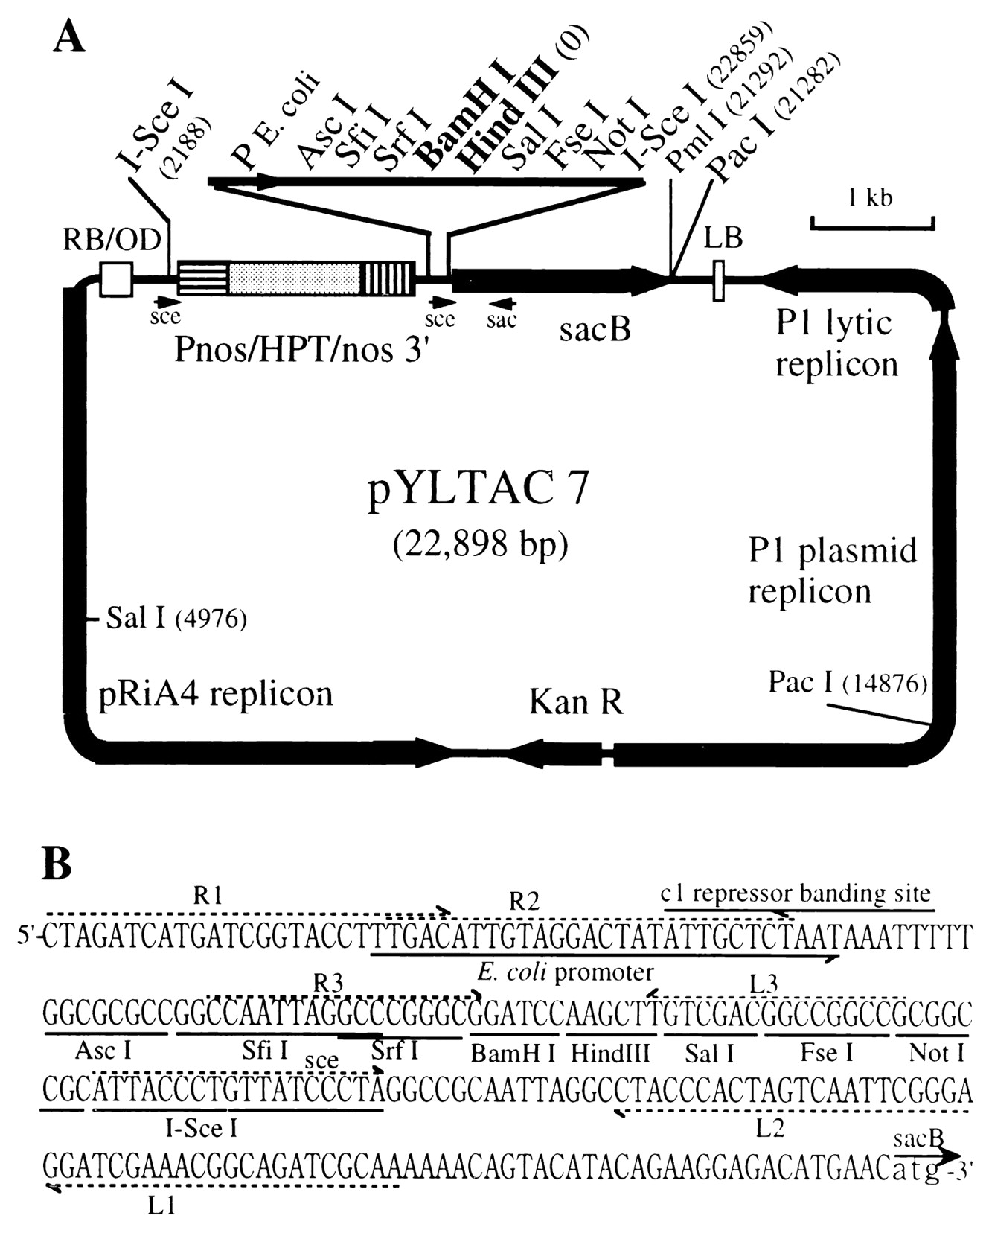

Figure 2.2. Physical map of pYLTAC7 vector for JAtY clones. LB and RB, left and right borders, respectively; OD, overdrive sequence; Pnos, promoter of the nopaline synthase gene; HPT, coding region of the hygromycin phosphotransferase gene; nos 3′, polyadenylation signals of the nopaline synthase gene; KanR, kanamycin-resistance gene (NPT1). BamH I and Hind III are cloning sites for genomic DNA insertion.

SW105 was purchased from Frederick National Laboratory for Cancer Research (Frederick, MD, USA) and the recombineering cassette with 3xYpet was generously provided by Dr. Jose Alonso (University of North Carolina, Raleigh). The cassette was introduced to the C terminus of NIP7;1 by PCR with the Rec_F and Rec_R primers (Table 2.1). The PCR cycling conditions used were: 96°C 10 min, 96°C 30 s, 64°C 30 s (-1°C per cycle for 10 cycles), and 72°C 1.5 min. After the first 10 initial cycles of touchdown, 20 additional cycles using 54°C annealing were used(Zhou, Benavente et al. 2011). The transformed SW105 strains were grown on Luria Broth agar plates supplemented with 25 µg/ml kanamycin and 50µg/ml ampicillin and confirmed by PCR with NIP7;1 specific primers(Table 2.1). The PCR cycling conditions used were: initial denaturation at 94°C for 10 minutes, 30 cycles of 94°C for 30 seconds, 55°C for 30 seconds, and 72°C for 1 minutes, followed by a final extension of 72°C for 10 minutes. The ampicillin selection marker was removed from the cassette by flipase induced with 10% arabinose (Figure 2.3). Automated DNA sequencing was followed to confirm that no mutations had been introduced in the 3xYpet gene. DNA sequencing was performed at molecular biology resource facility at University of Tennessee, Knoxville. The 3xYpet tagged JAtY68K23 clone was transformed to Agrobacterium Gv3101 strains with electroporation. Electroporation was done using the following conditions: 1800 kV/cm, 600 ohms and 10 µ Farads(Zhou, Benavente et al. 2011). The JAtY-containing strains were used for plant transformation by floral dip(Clough and Bent 1998). Transformed plants were kept in a controlled climate growth chamber at 22 °C under LD conditions. Transformants were selected on MS plates supplemented with 20 µg/ml glufosinate ammonium (Basta) and 300 µg/ml timentin and confirmed by PCR with NIP7;1 specific forward primer and 3xYpet specific reverse primer (Table 2.1). The PCR cycling conditions used were: initial denaturation at 94°C for 10 minutes, 30 cycles of 94°C for 30 seconds, 50°C for 30 seconds, and 72°C for 2 minutes, followed by a final extension of 72°C for 10 minutes.

2.4 Plant transformation

Agrobacterium tumefaciens strain GV3101 (Koncz and Schell, 1986) was transformed with plant expression binary vectors by electroporation. Electrocompetent cells were prepared(Zhou, Benavente et al. 2011) and resuspended in ice cold sterile water and were washed three times with sterile 10%(v/v) glycerol. The final cell pellet was resuspended in sterile 10%(v/v) glycerol. Electroporation was performed with a BioRad Gene Pulser (BioRad) with 100 ng of purified JAty TAC clone binary vectors. Transformants were identified by selection on LB agar containing
Name | Direction |  | Sequence(5’-3’) | Comment
Rec_F | Forward | CCAGGCCTTGCCCTTCTCCAGTTTCCCCTTCCGTTTCTTCACTTTTACGTGGAGGTGGAGGTGGAGCT |  | Recombineering primer
Rec R | Reverse | AAATCAAAAGTGTTTATTTGTATAATAGATATTAGGTTTTGAAGTGATTAGGCCCCAGCGGCCGCAGCAGCACC |  | Recombineering primer
71F | Forward | GGTTAGACCGATTTCAGGAGG |  | NIP7;1 specific primer
71R | Reverse | TAAAAAGAACAAAATGCCCCC |  | NIP7;1 specific primer
3xYpet | Reverse | CACCCTCGCCTTCTCCACTCACAG |  | 3xYpet specific primer

Table 2.1 Oligonucleotide primers used for recombineering-aided tagging

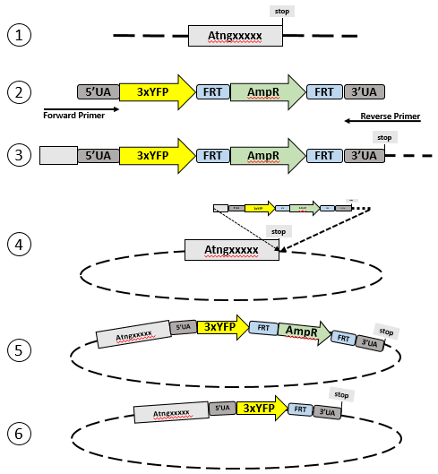
Recombination cassette

Recombination cassette
PCR amplification

PCR amplification
JAtY TAC clone

JAtY TAC clone
JAtY TAC clone

JAtY TAC clone
JAtY TAC clone

Figure 2.3 Procedure for recombineering-aided taggingJAtY TAC clone

  - Figure 2.3 Procedure for recombineering-aided tagging
- Select gene of interest(GOI)
- Add gene specific sequence (50nt) to each end of the recombination cassette
- PCR product
- Transform PCR product into recombineering competent cell containing the GOI
- Select Amp^{R} clone which contains the recombineering cassette has been inserted in the GOI
- Eliminate selectable marker by Flipase-mediated recombination

Figure 2.4. Construction of Xenopus expression system for NIP7;1 and its mutants.Figure 2.3 Procedure for recombineering-aided tagging
- Select gene of interest(GOI)
- Add gene specific sequence (50nt) to each end of the recombination cassette
- PCR product
- Transform PCR product into recombineering competent cell containing the GOI
- Select Amp^{R} clone which contains the recombineering cassette has been inserted in the GOI
- Eliminate selectable marker by Flipase-mediated recombination
50 μg/mL kanamycin. Transgenic Arabidopsis plants were generated by using the floral dip method(Clough and Bent 1998). Briefly, inflorescences of 4-wk old Arabidopsis were submerged into mid-logarithmic cultures (A₆₀₀ = 0.8) of Agrobacterium tumefaciens in 5% (w/v) sucrose and 0.05% (v/v) Silwet-L77 (Lehle Seeds, Round Rock, TX) for 1 minute. The plants were then washed 3-5 times with distilled water to remove residual sucrose from the leaves. The plants were covered with clear plastic to prevent desiccation of the inflorescences and were kept overnight in a growth chamber set to LD conditions.

2.5 Characterization of T-DNA insertion mutants of NIP7;1

Seeds for T-DNA insertion mutant lines nip7;1-1 (Salk_042590) and nip7;1-2 (Salk_057023)(Salk Institute Genomic Analysis Laboratory http://signal.salk.edu/cgi-bin/tdnaexpress/), were purchased from the Arabidopsis Biological Resource Center (ABRC). nip7;1-1 and nip7;1-2 contain T-DNA insertions in the 4th exon and 2nd intron, respectively.
For characterization of nip7;1-1 and nip7;1-2, seeds were surface sterilized and grown on a selection plate containing 1x MS agar medium with 200 µM glufosinate-ammonium(Basta). Twelve day old antibiotic-resistant seedlings were transplanted onto Fafard soil(Knoxville Seed and Greenhouse) followed by growth under LD conditions. Plants were allowed to set seed, and seeds were harvested from individual antibiotic resistant plants.
For PCR genotyping, genomic DNA was extracted from small rosette leaves using the cetyltrimethylammonium bromide (CTAB) and phenol-chloroform methods(Zhou, Benavente et al. 2011). The T-DNA insertion site and the genotype of the T4 generation of the mutant were analyzed by using PCR-based genotyping with the following PCR parameters: 94°C for 5 minutes; followed by 30 cycles of: 94°C for 30 seconds, 58°C for 30 seconds, 72°C for 90 seconds; with a final elongation cycle of 72°C for 10 minutes. The primers used for genotyping of nip7;1-1 are: 71-1LP, 71-1RP and LBb1. The primers used for genotyping of nip7;1-2 are 71-2LP, 71-2RP, LBb1.3 for (Table 2.2). Two paired PCR reactions were performed with LP+RP and LB+RP for both nip7;1-1 and nip7;1-2.
RT-PCR analysis was performed to confirm that NIP7;1 mRNA was not present in the knockout mutants. UBQ-10 was used as the internal reference gene (Table 2.3).

2.6 Total RNA isolation and quantitative real time PCR

In order to test the expression level of NIP7;1 in Arabidopsis flower at different boric acid condition, quantitative real time PCR was performed. Total RNA was isolated from Arabidopsis inflorescence by using TRIzol® RNA isolation reagents (Life Technologies) followed by RNAse-free DNase I treatment. Four micrograms of total RNA was reverse transcribed into cDNA with the SuperScript™ III reverse transcriptase (Life Technologies). Q-PCR was performed with 10 ng cDNA sample on an iQ5 Real-Time PCR detection system and data was collected by using iQ5 Optical system software (Bio-Rad). Ubiquitin conjugating enzyme 9 (UBC-9), ubiquitin 10 (UBQ-10), pentatricopeptide repeat (PPR) and actin (ACT2)(Czechowski, Stitt et al. 2005) were analyzed for best internal reference gene at different boric acid conditions by using the primer sets in table 2.3. Since UBC-9 expression was revealed as the most stable at different boric acid conditions, it was selected as internal reference for standardization. Q-PCR was performed in a 96-well optical PCR plate (ABgene) by SYBR® Green PCR master mix (Life technologies) using the following cycles: 1 cycle of 10 min at 95°C, and 40 cycles of 30 seconds at 95°C, 45 sec at 48 °C and 45 seconds at 72 °C. The specificity of amplification was confirmed by melting curve analysis as describe by (Choi and Roberts 2007). The relative expression level of each gene was calculated by using the comparative threshold temperature (Ct). ∆Ct was calculated using the following equation.
$∆Ct={Ct}_{sample}-{Ct}_{reference}$ (Eq 1)
Where Ct_{sample} is the Ct value of gene of interest, and Ct_{reference} is the Ct of the Arabidopsis UBC-9. ∆∆Ct was calculated using following equation
$∆∆Ct=∆{Ct}_{sample}-∆{Ct}_{calibrator}$ (Eq 2)
Where ∆Ct_{sample} is the expression value of the gene of interest calculated, and ∆Ct_{calibrator} is the Ct value for the calibrator also normalized to the UBC-9 gene. The relative expression value was obtained from the following equation
$Relative expression=2^{-∆∆Ct}$ (Eq 3)

2.7 Histological Techniques

GUS staining and visualization were conducted on Arabidopsis inflorescences of 6-week-old transgenic NIP7;1pro::GUS reporter plants as described by (Li, Choi et al. 2011). Harvested tissue was placed in cold 90% (v/v) acetone on ice. Vacuum was applied for 10 minutes at room temperature, and the tissue was incubated further at room temperature for 20 to 30 minutes. After fixation, the tissue was incubated with wash buffer (50 mM sodium phosphate buffer pH7.2, 0.2(v/v)% Triton X-100, 2 mM pPotassium ferrocyanide, 2 mM potassium ferricyanide) under vacuum for 10 minutes at room temperature. The sample were then transferred to wash buffer with 2 mM X-gluc (5-bromo-4-chloro-3-indolyl β-D-glucuronide) and were infiltrated under

Name |  | Direction | Sequence(5’-3’) | Comment
71-1LP |  | Forward | ATATTGTTTTTGGTCCGATCG | Primer for SALK_042590 genotyping
71-1RP |  | Reverse | TGTGTTGTTGGTCAATTAAATTTTG | Primer for SALK_042590 genotyping
71-2LP |  | Forward | TGTCAAAACTCCGATTATGGC | Primer for SALK_057023 genotyping
71-2RP |  | Reverse | AGTGTGTGTGGGGTCATAAGC | Primer for SALK_057023 genotyping
LBb1 |  | Forward | GCGTGGACCGCTTGCTGC | T-DNA left border specific primer for SALK_042590 genotyping
LBb1.3 |  | Forward | ATTTTGCCGATTTCGGAA | T-DNA left border specific primer for SALK_057023  genotyping

Table 2.2 Oligonucleotide primers used for genotyping of NIP7;1 T-DNA insertion lines

Table 2.3 Oligonucleotide primers used for RT-PCR and Q-PCR
Name | Direction | Sequence(5’-3’) | Comment
RTNIP71F | Forward | CATCTCTGGCGCCCATCT | NIP7;1 primer for Q-PCRª
RTNIP71R | Reverse | CCGCCAAAGACAGCGAAA | NIP7;1 primer for Q-PCRª
UBC-9F | Forward | TCACAATTTCCAAGGTGCTGC | UBC9 primer for Q-PCRª
UBC-9R | Reverse | TCATCTGGGTTTGGATCCGT | UBC9 primer for Q-PCRª
ACT2F | Forward | CTTGCACCAAGCAGCATGAA | ACT2 primer for Q-PCRª
ACT2R | Reverse | CCGATCCAGACACTGTACTTCCTT | ACT2 primer for Q-PCRª
UBQ10F | Forward | GGCCTTGTATAATCCCTGATGAATAAG | UBQ10 primer for Q-PCRª
UBQ10R | Reverse | AAAGAGATAACAGGAACGGAAACATAGT | UBQ10 primer for Q-PCRª
PPR-F | Forward | AAGACAGTGAAGGTGCAACCTTACT | PPR primer for Q-PCRª
PPR-R | Reverse | AGTTTTTGAGTTGTATTTGTCAGAGAAAG | PPR primer for Q-PCRª
RTubq10F | Forward | CACACTCCACTTGGTCTTGCGT | UBQ10 primer for RT-PCR^{b}
RTubq10R | Reverse | TGGTCTTTCCGGTGAGAGTCTTCA | UBQ10 primer for RT-PCR^{b}
RTNIP71F | Forward | CATCTCTGGCGCCCATCT | NIP7;1 primer for RT-PCR^{b}
RTNIP71R | Reverse | CCGCCAAAGACAGCGAAA | NIP7;1 primer for RT-PCR^{b}

a, Primers for Q-PCR analysis of NIP7;1 expression in Arabidopsis flower; b, Primers for RT-PCR to confirm the NIP7;1 T-DNA insertion knockout

vacuum for 15 to 20 minutes on ice. Samples were then incubated at 37 °C for 8 to 16 hrs. Inflorescences were incubated successively in 20%, 35% and 50% (v/v) ethanol at room temperature for 30 minutes each, and were then incubated in 50% (v/v) ethanol, 2.7% (v/v) formaldehyde, 5% (v/v) acetic acid for
30 minutes at room temperature for fixation. After sample fixation, samples were stored in 70% (v/v) ethanol until microscopic examination. GUS stained tissues were observed and imaged using a Nikon ECLIPSE E600 microscope and QCapture 2.60 software (QImaging Corporation, Burnaby, BC, Canada). For cellular localization determination, the tissue was dehydrated and embedded in Spurr’s epoxy (Electron Microscopy Sciences)(Choi, Jin et al. 2011). GUS-stained tissues were dehydrated using 100% ethanol for 30 minutes, followed by two pure propylene oxide treatments for 25 minutes each at room temperature. The tissue was then infiltrated with Spurr’s epoxy/propylene oxide (1:4, 1:2, 1:1, 2:1, 4:1) volume ratio for at least 8 hours each followed by 100% Spurr’s. Samples were embedded in Spurr’s resin and polymerized at 60 °C for overnight. Sample blocks were trimmed and sectioned by using a Leica (Reichert) OMU3 ultramicrotome, and were observed using a Nikon Eclipse E600 microscope equipped with the QCapture 2.6 software (QImaging corporation, Burnaby, BC, Canada).
For examination of tissues of NIP7;1 T-DNA insertion lines, flower buds from wild-type and nip7;1 plants were fixed and embedded in Spurr’s resin by the general method of (Choi, Jin et al. 2011). Briefly, the sample were fixed in 50 mM sodium-phosphate buffer pH 7.2 containing 3%(w/v) glutaraldehyde and 2%(w/v) paraformaldehyde overnight at 4 °C. The sample were washed with 100 mM sodium-phosphate buffer pH 7.2 containing 0.14 M sucrose overnight at 4 °C. Sample were then incubated in 1% (w/v) osmium tetroxide in 0.21 M sucrose/50 mM sodium-phosphate pH 7.2 for 2 hrs at 4 °C. The samples were dehydrated in a graded ethanol series (20%, 35%, 40%, 50%, 60% 70%, 80%, 90%, 100%) (v/v) for 30 minutes each, and were treated twice with propylene oxide for 25 minutes each. Serial infiltration was performed with a mixture of Spurr’s resin and propylene oxide (1:4, 1:2, 1:1, 2:1, 4:1) volume ratio followed by 100% Spurr’s for at least 8 hours each was performed. Finally, samples were embedded in 100% Spurr’s resin overnight at 60 °C. Semi-thin sections (1 µm) were prepared by using a Leica (Reichert) OMU3 ultramicrotome, and sections were mounted on glass slides and stained with 1% (w/v) toluidine blue in 1% (w/v) sodium borate pH 11, for 5 minutes. Microscopic analysis was done using a Nikon Eclipse E600 microscope.
Flower buds for transmission electron microscopy were prepared and embedded in Spurr’s resin as described above. Thin sections (100 nM) were obtained using a Leica EMFC7 ultramicrotome, mounted on copper grids, and then stained with 2% (w/v) aqueous uranyl acetate for 20 min, followed by Reynolds’ lead citrate (Reynolds 1963) for 5 min. The samples were observed using a Zeiss Auriga scanning electron microscope under the scanning transmission electron microscope (STEM) modes at 30 kV at the Advanced Microscopy and Imaging Center at the University of Tennessee, Knoxville.
For Scanning Electron Microscopy examination, fresh pollen grains from both wild type and mutants were attached to an adhesive carbon tape on the top surface of SEM sample holder. The specimens were coated with gold by an SPI sputter coater (SPI Supplier), and were then observed by Zeiss Auriga SEM at 5 kV at Advanced Microscopy and Imaging Center at the University of Tennessee, Knoxville.

2.8 Expression and transport analyses in Xenopus oocytes

Xenopus laevis expression constructs containing the NIP7;1 coding sequence (CDS) were prepared in the pXβG-ev-1 vector with an in-frame N-terminal FLAG epitope tag(Wallace and Roberts 2005) as described in Figure 2.2. For site-directed mutagenesis, the pXβG-NIP7;1 construct was used as a template for PCR mutagenesis by using the QuickChange site-directed mutagenesis kit (Stratagene) and the mutagenesis primers listed in Table 2.4. The mutagenesis PCR conditions used were: initial denaturation at 94°C for 10 minutes, 30 cycles of 94°C (30s), 60°C (30s), 72°C (8 min), with a final extension at 72°C for 10 minutes. The PCR products were digested with DpnI, and the mixture was used to transform competent Escherichia coli DH5α. pXβG-ev-1 constructs containing NIP5;1, NIP6;1 and ApAQP1 aquaporin were generated by the same methods(Wallace and Roberts 2005, Tanaka, Wallace et al. 2008, Wallace, Shakesby et al. 2012). cRNA was generated from XbaI-linearized plasmids by in vitro transcription using the AmpliCap-Max T3 High Yield Message Maker Kit (Epicenter).
Stage V and VI Xenopus oocytes were prepared as previously described(Dean, Rivers et al. 1999) and were microinjected with 46 nL of 1 µg/µL of cRNA solutions or with DEPC-treated water as negative control by using a Drummond “nanoject” automatic injector (Drummond Scientific Company, Broomall). The oocytes were cultured for 72 hr in 96 well plates at 16°C in Ringer’s solution (96 mM NaCl, 2 mM KCl, 5 mM MgCl₂, 5 mM HEPES-NaOH pH 7.6, 0.6 mM CaCl₂, 200 mosmol/kg) supplemented with 100 µg/mL penicillin-streptomycin. The oocyte media was replaced at 24 hr intervals until the oocytes were assayed. The osmotic water permeability (P_{f}) of the oocytes was measured by the standard oocyte swelling assay at 18°C as previously described (Rivers, Dean et al. 1997, Guenther, Chanmanivone et al. 2003). Swelling was induced by hypoosmotic challenge with 30% (60-70 mosmol/kg) Ringer’s solution, and was measured by video microscopy on a Nikon Alphaphot YS microscope equipped with a Pro-Series High Performance CCD camera. Images were captured using the NIH Image software as described in(Wallace and Roberts 2005). From the initial oocyte swelling rate [(dV/V₀)/dt] osmoticwater permeability coefficient (P_{f}) was determined by using the following equation:
${ P}_{f}$=$\frac{{(V}_{0}/S_{0})(dV/V_{0})dt}{(S_{real}/S_{sphere})V_{w}({osm}_{in}-{osm}_{out})}$ (Eq 4)
where V0 is the initial oocyte volume, osmin is the osmolarity in the oocyte, osmout is the osmolarity of the bath media used for swelling assay, Vw is the partial molar volume of water (18 cm3/mol), Sreal is the actual surface area of the oocyte, and Ssphere is the area calculated by assuming a sphere. Sreal/Ssphere is taken as 9 for the water permeability measurements (Zampighi et al., 1995; Rivers et al., 1997). Glycerol permeability measurements of Xenopus oocytes were performed by radioisotopic uptake assay as described by (Wallace and Roberts, 2005). Assays were performed at 22°C for 10 minutes and oocytes were washed twice in 10 mL of ice cold Ringer’s solution containing 20 mM glycerol without radioisotope.

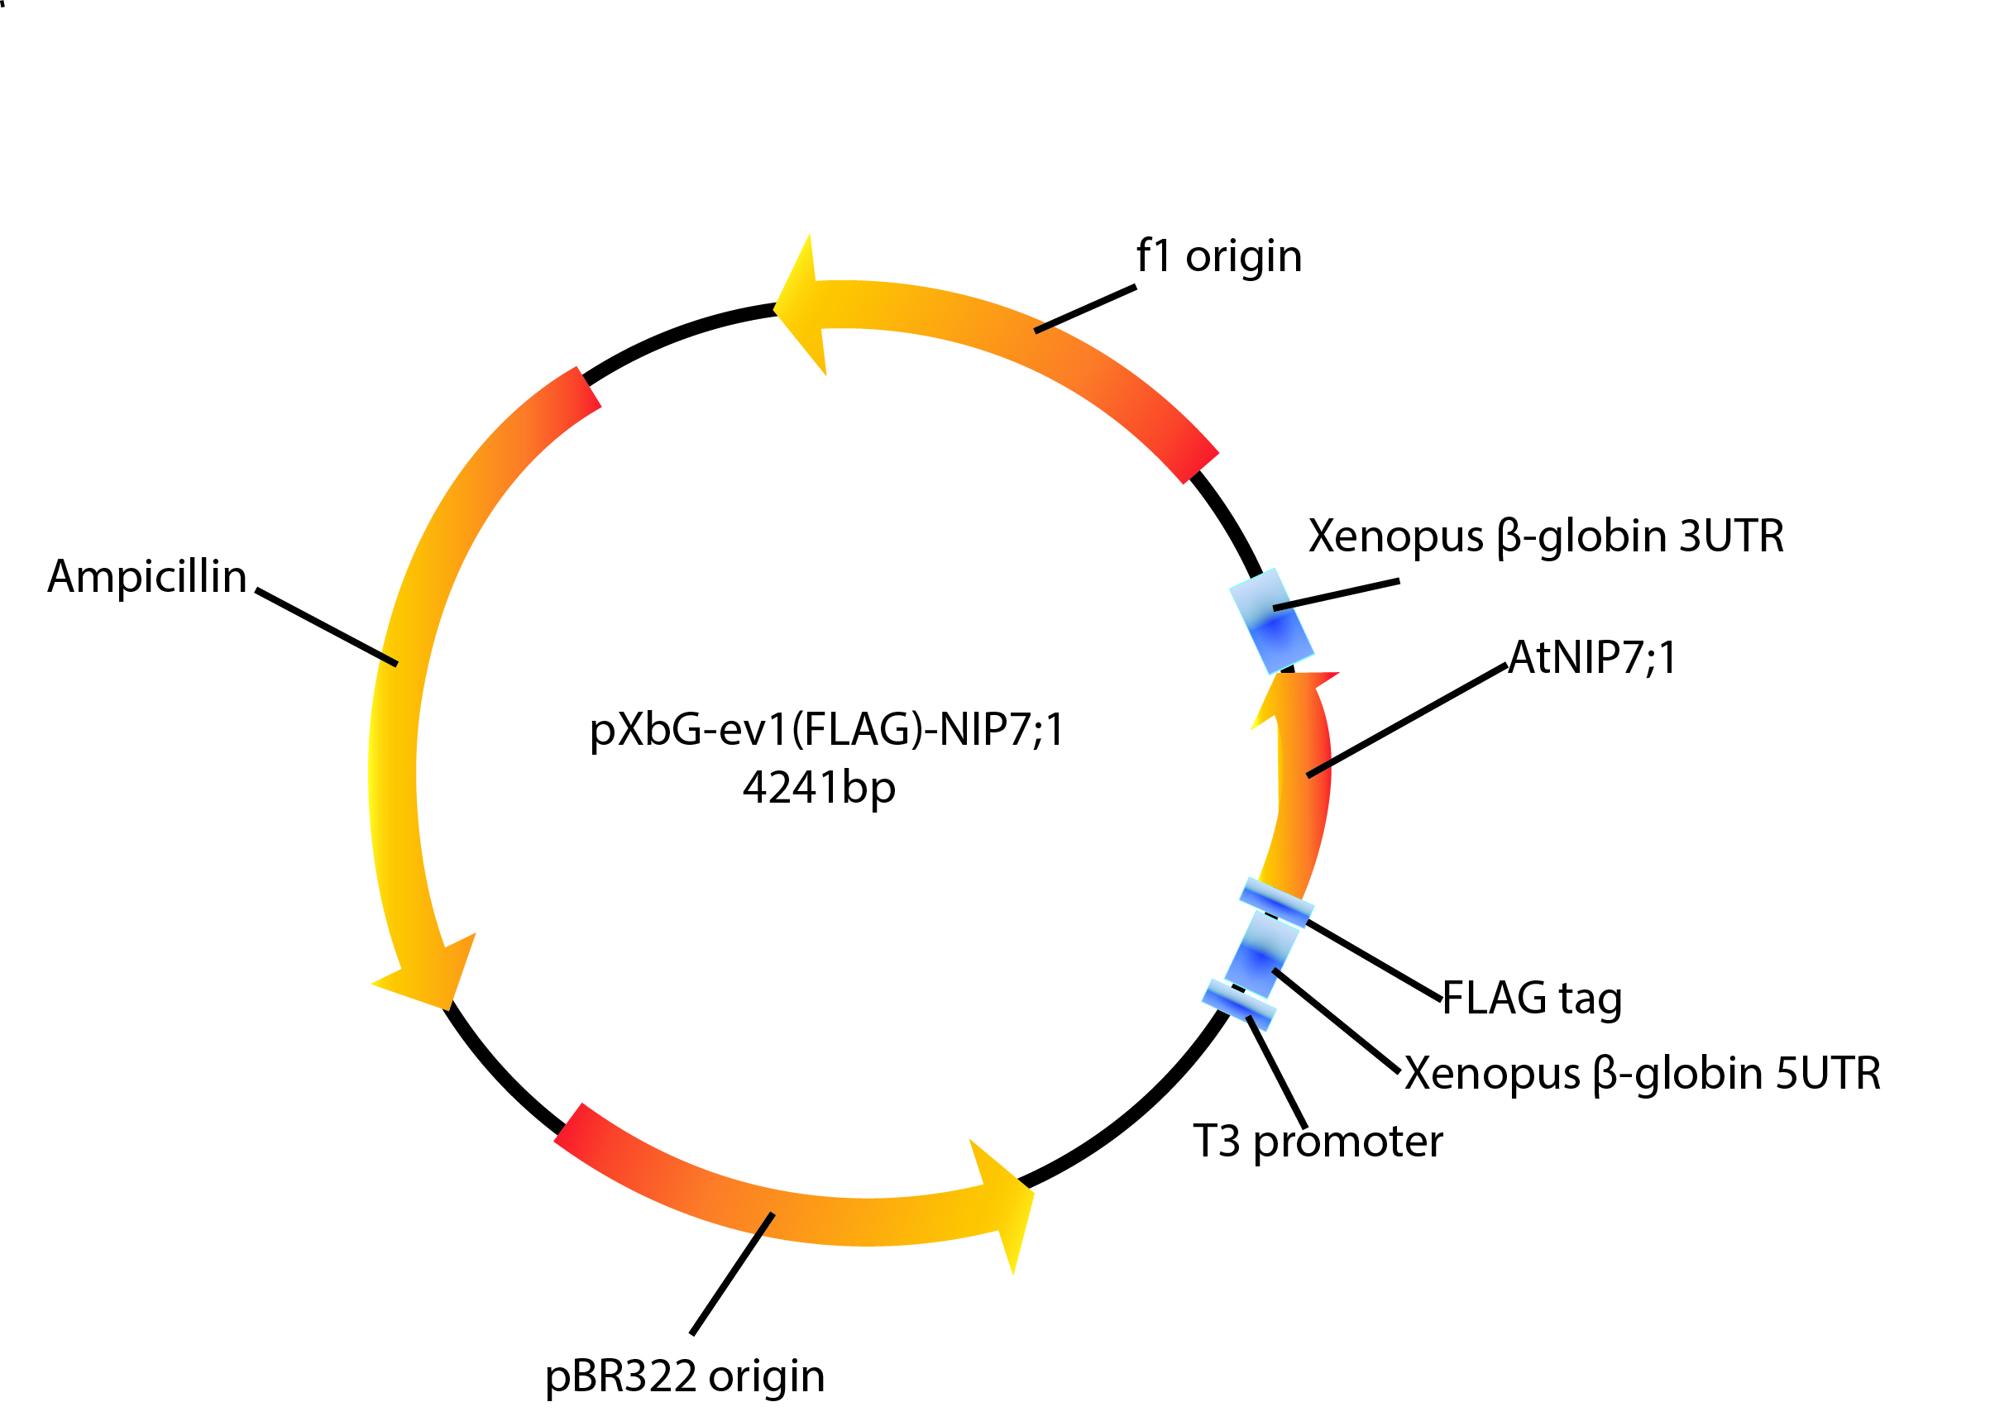

Figure 2.4. Construction of Xenopus expression system for NIP7;1 and its mutants. Schematic representation of Xenopus expression vector inserted with NIP7;1 or NIP7;1 mutant coding sequence. The sequence of PCR primer set used for cDNA amplification is indicated in the table 2.1. The T3 promoter used for high efficiency in vitro transcription by T3 RNA polymerase is indicated.

Name | Direction | Sequence(5’-3’) | Comment
NIP7;1Y81C | Forward | GGATTGCTAGAGTGCGCCGTCACCGCT | Mutagenesis primer for NIP7;1 Y81C
NIP7;1Y81C | Reverse | AGCGGTGACGGCGCACTCTAGCAATCC | Mutagenesis primer for NIP7;1 Y81C
NIP7;1Y81F | Forward | GGATTGCTAGAGTTCGCCGTCACCGCT | Mutagenesis primer for NIP7;1 Y81F
NIP7;1Y81F | Reverse | AGCGGTGACGGCGAACTCTAGCAATCC | Mutagenesis primer for NIP7;1 Y81F
NIP7;1Y81N | Forward | GGATTGCTAGAGAACGCCGTCACCGCT | Mutagenesis primer for NIP7;1 Y81N
NIP7;1Y81N | Reverse | AGCGGTGACGGCGTTCTCTAGCAATCC | Mutagenesis primer for NIP7;1 Y81N
NIP4;1W82A | Forward | ATCTGTGTTACTGCGGGTCTCATTGTT | Mutagenesis primer for NIP4;1 W82A
NIP4;1W82A | Reverse | AACAATGAGACCCGCAGTAACACAGAT | Mutagenesis primer for NIP4;1 W82A
Nod26W77A | Forward | GGGATAGCAATTGTTGCGGGTCTGGTTCTGACG | Mutagenesis primer for Nod26 W77A
Nod26W77A | Reverse | CGTCAGAACCAGACCCGCAACAATTGCTATCCC | Mutagenesis primer for Nod26 W77A
Nod26W77G | Forward | GGGATAGCAATTGTTGGGGGTCTGGTTCTGACG | Mutagenesis primer for Nod26 W77G
Nod26W77G | Reverse | CGTCAGAACCAGACCCCCAACAATTGCTATCCC | Mutagenesis primer for Nod26 W77G
Nod26V197S | Forward | ACATTACTGCTGAATTCGATTATTGGAGGGCCA | Mutagenesis primer for Nod26 V197S
Nod26V197S | Reverse | TGGCCCTCCAATAATCGAATTCAGCAGTAATGT | Mutagenesis primer for Nod26 V197S
Table 2.4 Oligonucleotide primers used for site-directed mutagenesis

Sensitivity to mercury was determined by preincubating oocytes in Ringer’s solution containing 1 mM HgCl₂ for 10 min prior to assay as previously described (Rivers et al., 1997). After isotopic uptake assays, oocytes were lysed with 300 µL of 10% (w/v) SDS and scintillation counting was done in 10 mL of Scintsafe (Fisher Scientific, Pittsburgh) by using a Beckman LS6500 Multi-Purpose Scintillation Counter (Beckman Coulter, Fullerton).
Boric acid uptake assays were performed by equilibrating oocytes in standard oocyte medium and measuring the swelling rate at 15 °C by video microscopy upon placement in a modified, isoosmotic Ringer’s solution (190 mOsmol/kg) in which NaCl was replaced with boric acid. Under these assay conditions, the transport of boric acid into oocytes creates an inwardly directed osmotic gradient resulting in water uptake and oocyte swelling. The rate of solute uptake is reported as an oocyte swelling rate [d(V/V₀)/min] determined by video microscopy as described above.

2.9 Expression and purification of His₆-NIP7;1 and NIP7;1 Y81C from Pichia pastoris

NIP7;1 and NIP7;1 Y81C coding sequences were codon optimized for Pichia pastoris by OptimumGene™ codon optimization analysis system (GenScript,NJ). The codon adaptation index (CAI) was raised up to 0.82 from 0.63. In general, a CAI >0.8 is regarded as good, in terms of high gene expression level. Optimized coding sequences were subcloned as N-terminal histidine tagged fusions into the BamH1 and NotI restriction sites of the pPIC3.5K expression vector (Figure 2.5) with primers in Table 2.5. Expression constructs were transformed into Pichia pastoris as described in the Easyselect™ Pichia handbook (Life Technologies). Clones with multiple inserts were identified by selection on media with 1.75 mg/ml geneticin sulfate (G418) (MP Biomedicals) and were cultured for protein expression in IsoYeast media (Sigma). A single colony was inoculated into a 20 mL IsoYeast growth media and was cultured at 30°C with shaking at 250 rpm overnight. The seed culture was inoculated into 1L IsoYeast growth media and was grown at the same conditions until the OD600 exceeded 2.0(approximately 12 hrs). The cells from the 1 L culture were collected by centrifugation at 3000×g at 4 °C in a Sorvall GS-3 rotor and the pellet was transferred to 250mL IsoYeast expression media with 0.5% (v/v) methanol added. The culture was continuously grown at 28 °C for 4 days and was supplemented with 0.5%(v/v) methanol every 24 hrs. Cell pellets collected were resuspended in 20-30 ml of 20 mM Tris–HCl, pH 8.0, 100 mM NaCl, 1 μg/ml leupeptin, 1 μg/ml pepstatin A, 0.5 mM phenylmethanesulfonylfluoride (PMSF) and were lysed in a French-Press Cell Disrupter (Thermo

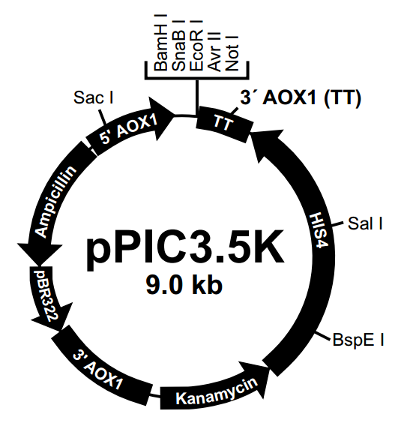
MHHHHHH-NIP7;1/NIP7;1Y81C-stop/stop

Figure 2.5 Construction of Pichia expression system for NIP7;1 and NIP7;1 Y81C expression. Schematic representation of Pichia expression vector consistent of the NIP7;1 or NIP7;1 Y81C coding sequence with an in-frame 6 histidine leader sequence at the amino terminus and two stop codons. The sequence of PCR primer set used for cDNA amplification is shown in the table 2.5 5’AOX1, a 937 bp sequence containing the alcohol oxidase promoter, allowing methanol-inducible high level expression; TT, native transcription termination and polyadenylation signal from the AOX1 gene; HIS4, Pichia wild-type gene coding for histidinol dehydrogenase and used to complement Pichia his4 strains.

Scientific). The lysate was centrifuged at 7000×g for 45 min at 4 °C, and the resulting supernatant fraction was then centrifuged at 200 000×g for 2 h at 4°C. The membrane fraction was resuspended in 30 to 50 mL resuspension buffer containing 20 mM Tris–HCl, pH 8.0, 100 mM NaCl, 10% (v/v) glycerol, 20 mM imidazole, 2% (w/v) n-Dodecyl-β-D-Maltopyranoside (DDM)(Anatrace) and solubilization of the membrane pellet was done by gentle agitation overnight at 4 °C. The mixture was centrifuged at 12 000×g for 20 min, and the supernatant fraction was added to the Ni²⁺-NTA resin (1 ml packed volume) (Qiagen) pre-equilibrated in the 10 mL of Ni²⁺-NTA wash buffer (20 mM Tris–HCl, pH 8.0, 300 mM NaCl, 35 mM imidazole, 0.03% (w/v) DDM) for 3 hours at 4 °C. The resin was washed with 100 column volumes of wash buffer and the histidine-tagged protein was eluted with 20 mM Tris–HCl, pH 8.0, 100 mM NaCl, 500 mM imidazole, 0.02% (w/v) DDM. The elution fraction was concentrated on a Vivaspin sample concentrator with 50 kDa MW cutoff (GE Healthcare) and chromatographed on Superdex 200 10/300 GL (GE Healthcare). Two column volume (48 mL) of 20 mM Tris–HCl, pH 8.0, 100 mM NaCl 0.02% (w/v) DDM was used to pre-equilibrate the column. The chromatography was performed in the same buffer. The column was monitored by AKTAFPLC system using UNICORN software (GE Healthcare). Fractions containing pure protein were eluted and

Table 2.5 Oligonucleotide primers used for Pichia protein expression cloning
Name | Direction | Sequence(5’-3’) | Comment
SynNIP7;1Y81C | Forward | GGATTGCTTGAGTGCGCTGTTACTGCC | Mutagenesis primer for synthetic NIP7;1 Y81C
SynNIP7;1Y81C | Reverse | GGCAGTAACAGCGCACTCAAGCAATCC | Mutagenesis primer for synthetic NIP7;1 Y81C
71_synthetic | Forward | TGAACGGAGAGGCAAGAAGT | a
71_synthetic | Reverse | CAGCGTACTCAAGCAATCCA | a
Nod26_synthetic | Forward | GGTTGTGCCTCTTTGGTTGT | b
Nod26_synthetic | Reverse | GGTTGTGCCTCTTTGGTTGT | b
AOX 5’ | Forward | GACTGGTTCCAATTGACAAGC | Primer for AOX promoter in pPIC3.5K
AOX 3’ | Reverse | GACTGGTTCCAATTGACAAGC | Primer for AOX promoter in pPIC3.5K

a Primers for synthetic NIP7;1 colony PCR; b Primers for synthetic Nod26 colony PCR

collected by Fraction collector Frac-950(GE Healthcare)in 20 mM Tris–HCl, pH 8.0, 100 mM NaCl 0.02% (w/v) DDM. The fractions containing protein were combined and were concentrated to 1.0 mg/ml using a Vivaspin sample concentrator with a 50 kDa MW cutoff (GE healthcare). SDS-PAGE and western blotting using HRP-conjugated anti-His₆ antibody (Sigma) (the detail of western blot is described in section 2.13) were used to test the purity of the protein and the final product was stored at -80°C.

2.10 Proteoliposome reconstitution and boric acid permeability measurements

For the generation of proteoliposomes, 5 mg of E. coli total lipid extract provided as a solution dissolved in chloroform (Avanti Polar Lipids) were dried under N₂ gas, and were suspended by bath sonication in 1 mL of 50 mM HEPES-NaOH (pH 7.4), 50mM NaCl, 10mM carboxyfluorescein (CF), 200 mM boric acid until the solution was homogenous and opalescent. The mixture were extruded 40 times through a mini extruder (Avanti Polar lipids) to produce small unilamellar vasicles. Reconstitution of NIP7;1 into liposomes was done by the general method of (Knol, Sjollema et al. 1998). Briefly, 3.25 mg of DDM (detergent-to-lipid ratio of 0.65 [w/w]) was added to the liposome suspension, and the mixture was incubated for 1 hour at 4 °C. Purified protein (lipid-to-protein ratio 80:1 [w/w]) was added and the incubation was continued for 1 hour at 4 °C by gentle mixing. The detergent was removed from the mixture by using detergent-absorbing polystyrene beads (Bio-Beads SM2 Adsorbent; Bio-Rad Laboratories)as described in (Rigaud and Levy 2003). Briefly, 2g of Bio-Beads were washed with 14 mL of methanol and were rinsed with deionized water. The washed Bio-Beads were suspended in 50 mM HEPES-NaOH (pH 7.4), 50 mM NaCl and were stored at 4 °C until use. Bio-Beads was added to the protein-lipid-detergent mixture at beads-to-detergent mass ratio of 10 and the mixture was incubated for 1 hour at room temperature. The procedure was repeated with a fresh aliquot of Bio-Beads added to the protein-lipid-detergent mixture without removing the first aliquot of Bio-Beads, and the mixture was incubated for 2 hours. Finally an additional Bio-Beads(beads-to-detergent mass ratio of 20) was added and the mixture was incubated overnight. Control liposomes were formed in the same way except without adding protein. The external extra vesicular CF dye was removed by chromatography on a PD-10 desalting column (GE healthcare) in 10 mM HEPES-NaOH, pH 7.4, 50 mM NaCl, 200 mM boric acid. The diameters of proteoliposomes and liposomes were determined by dynamic light scattering as described by(Drin, Morello et al. 2008) using a Dynapro NanoStar instrument (Wyatt Technology). The incorporation of protein into the final proteoliposomes was verified by SDS-PAGE and western blotting.
Boric acid permeability measurements of CF-loaded proteoliposomes were performed by stopped-flow fluorimetry as described in (Mathai and Zeidel 2007). The liposomes were loaded with 10 mM CF, a volume sensitive dye, and 200 mM of boric acid. Liposomes were abruptly mixed in an equal volume of iso-osmotic media with nonpermeant solutes (10 mM HEPES-NaOH pH 7.6, 150mM NaCl, 350 mOsm/kg). As boric acid fluxes from the interior of the liposomes, water osmotically follows and the rate of liposome vesicle shrinkage (reported as a decrease in fluorescence due to CF quenching) is dependent on the rate of boric acid efflux. Fluorescence measurements were performed using an Applied Photophysics model SX stopped-flow spectrofluorimeter(excitation at 492nm, emission filtered with 515 cutoff filter) (Applied Photophysics). Fluorescence data was collected (1000 points) at time intervals of 10s or 20s. Multiple, eight to ten, measurements were collected and were averaged using the Pro-Data software (Applied Photophysics). A single exponential function was fitted to the averaged time trace by Prism software (Version 6, GraphPad) resulting in a rate constant which was used to calculate the permeability coefficient (Equation 1).
$Y=Y_{0}+(A-Y_{0})(1-\exp^{-kt})$ (Eq 5)
Where Y is the relative fluorescence, Y₀ is the initial fluorescence, A is the plateau fluorescence, k is the rate constant, and t is the time. To determine P_{b} the differential equation described by Mathai and Zeidel was modified according to the experimental condition in this study (Equation 2).
$$\frac{dV_{rel}}{dt}=\left(P_{b}\right)\left(\frac{SAV}{V_{0}}\right)(1/350)(\frac{500}{V_{rel}}-600)$$

Figure 3.1. Sequence alignment of NIP7;1 and aquaporin templates The NIP7;1 protein sequence (TAIR: At3g06100) was aligned with six structures (AQP1, pdb1J4N; AQP0,pdb1YMG; AQP4, pdb3GD8; AQP5, pdb3D9S; AQPz; pdb1RC2; GlpF, pdb1LDI) using the MOE software(Molecular Operating Environment, Montreal, Canada, version 2008.10). 1. NIP7;1, 2. AQP0, 3. AQP1, 4. AQP4, 5. AQP 5, 6. AQP Z, 7. GlpF. The position of transmembrane α-helices and NPA loops, based on the conserved aquaporin hourglass fold, are indicated. The magenta residues indicate conserved signature residues of the aquaporin fold in each structural element that were used to validate alignment. The black dotted boxes indicate the positions of the residues of the ar/R selectivity filter. The % amino acid sequence identity within transmembrane and NPA loop αhelices of each structural template to the aligned NIP7;1 sequence is shown in the upper left corner.

Figure 3.1. Sequence alignment of NIP7;1 and aquaporin templates$\frac{dV_{rel}}{dt}=\left(P_{b}\right)\left(\frac{SAV}{V_{0}}\right)(1/350)(\frac{500}{V_{rel}}-600)$
(Eq 6)
Where SAV: the surface area to volume ratio, $V_{0}$ is initial volume, V_{rel} is relative volume. dV_{rel}/dt defines the relationship between relative volume and permeability coefficient. The system of differential equation was solved numerically using Mathematica 9 (Wolfram). The osmolality was measured by using vapor pressure osmometer (Vapro Osmometer 5520, Wescor, Inc, UT) and adjusted in order to reach the same osmolality as the liposome resuspension buffer.

2.11 NIP7;1 Modeling and Molecular Dynamics simulation

2.11.1 NIP7;1 monomer modeling and MD simulation

Alignments of the NIP7;1 protein sequence (TAIR: At3g06100) with aquaporin/glyceroporin template structures (AQP1, PDB entry 1J4N; AQP0, PDB entry 1YMG; AQP4, PDB entry 3GD8; AQP5, PDB entry 3D9S; GlpF, PDB entry 1LDI; AQPz, PDB entry 1RC2) were created by using MOE version 2008.10 (Molecular Operating Environment, Montreal, QC) with structural alignment enabled and the blosum62 substitution matrix. The alignment results were adjusted manually on the basis of the multiple-sequence alignment of Gorelick et al.(Gorelick, Praetorius et al. 2006) and the conserved motifs of the aquaporin fold(Heymann and Engel 2000) A structural homology model of NIP7;1 was obtained using the homology modeling program in MOE and the CHARMM27 force field(Foloppe and MacKerell 2000) with AQP0 as structural template which has 35% of sequence identity at the pore region with NIP7;1. An ensemble of 10 possible structures for NIP7;1 was generated, with no intermediate energy minimization (to avoid artifactual “swelling” of the transmembrane region). The 10 models were subsequently ranked using MOE’s packing algorithm.
The NIP7;1 model with the most favorable packing score (2.1313) was used for molecular dynamics simulations. The homology model was energy-minimized using the CHARMM27 force field and distance-dependent dielectric down to an energy gradient of 10–5 kcal mol–1 Å–2. All α-carbons were fixed during the energy minimization, again to prevent swelling of the transmembrane region of the protein. Molecular dynamics were run at a temperature of 310 K for 5 ns, using a 1 ps integration time step in the isothermal-isobaric (NPT) thermodynamic ensemble. Pore diameters were calculated using HOLE)(Smart, Breed et al. 1997) from selected structural snapshots from the molecular dynamics trajectory.

2.11.2 NIP7;1 Tetramer modeling and MD simulation

Since the MIPs superfamily proteins are tetrameric, the homology modeling was performed in order to generate a tetrameric NIP7;1. The AQP4 (PDB entry 3GD8) was analyzed using the Molecular Operating Environment (MOE 2009.10)(Montreal, QC) software and the biological assemble (BIOMT) transformation was performed in order to generate the homotetramer structure. Furthermore, NIP7;1 sequence was aligned with 4 chains of AQP4 and homology modeling was performed to generate a NIP7;1 tetramer homology model using MOE(Montreal, QC). The Visual Molecular Dynamics (VMD)(Humphrey, Dalke et al. 1996) (http://www.ks.uiuc.edu/Research/vmd/) membrane builder plugin was used to generate a 1-palmitoyl-2-oleoyl-sn-glycero-3-phosphocholine(POPC) membrane patch (100 by 100 A²), with the membrane normal aligned along the z-axis. The NIP7;1 tetramer was oriented by using to OPM (Orientations of proteins in membranes http://opm.phar.umich.edu/)(Lomize, Lomize et al. 2006) before superimposing onto the membrane patch. According to the tutorial (http://www.ks.uiuc.edu/Training/Tutorials/index-all.html), surface tyrosine residues at the periphery of the tetramer were used to adjust the position of the tetramer along the membrane normal. All lipid and water molecules with heavy atoms closer than 0.6 Å to any atom of the protein were removed. The system was solvated by two 34 Å layers of water using the SOLVATE plugin of VMD and ionized with 150 mM KCl by using the AUTOIONIZE plugin in VMD. The final system contains 71926 atoms: 12964 NIP7;1 atoms, 24656 lipid atoms, 34230 water atoms, 44 potassium ions, and 32 chloride ions. The whole system is minimized for 20000 steps using software Nanoscale Molecular Dynamics program (NAMD 2.9)(Phillips, Braun et al. 2005) (http://www.ks.uiuc.edu/Research/namd/). Lipid tails are melted by simulating 0.5 ns using canonical ensemble (NVT) with moles, volume and temperature conserved. Another 0.5 ns simulations were performed where the protein heavy atoms and C_{α} were harmonically constrained using NAMD before the 10 ns whole system equilibration under constant 1 atm pressure, 300 K temperature (NPT) and constant area. The structure of NIP7;1 after equilibration exhibits an RMSD of 3.0 Å compared to the first frame for protein backbone atoms. All simulations were performed using NAMD 2.9 with CHARMM36 parameters for protein(Mackerell, Feig et al. 2004) and CHARMM36 for lipids(Klauda, Venable et al. 2010). Water is modeled as TIP3P(MacKerell, Bashford et al. 1998). Assuming periodic boundary conditions, the Particle Mesh Ewald method with a grid density of at least 1/Å³ was employed for computation of electrostatic forces without cutoff by NAMD. All simulations were performed with a time step of 2 fs. Langevin dynamics was used to keep the temperature constant. A Langevin piston was employed to maintain the pressure at 1 atm in all simulations.

2.12 Steered Molecular Dynamics simulation

In order to track water movement through the NIP7;1 pore, Constant velocity (cv) SMD simulations were performed(Wang, Schulten et al. 2005, Sotomayor and Schulten 2007). Simulations were carried out by attaching an oxygen atom of a selected water molecule to a harmonic constraint moving with a constant velocity. The pulling began at the periplasmic side of NIP7;1 and proceeded along the -z direction. The pulling velocity was set to 0.001Å/ps for the whole simulation. Spring constant k (k=347 pN/Å) (Wang, Schulten et al. 2005)was used to ensure that the pulled atom followed the constraint closely. The C_{α} atoms of 7 residues distant from the pore, namely Asp233, Gly146, Val227, Ile66, Gly77, Pro210 and Ala156 were constrained with a spring constant of 347 pN/Å (Wang, Schulten et al. 2005) during the SMD simulations to counterbalance the external force applied to the water molecules and to prevent the protein from drifting under the applied force. To limit the possibility that the molecule would move laterally outside of the channel before continuing translocation, a xy plane restraint was applied by using collective variables (colvars) module.
Umbrella sampling was used to calculate the potential of mean force (PMF) of water permeation through the NIP7;1 pore. To perform umbrella sampling, the equilibrated structure of NIP7;1 generated in SMD was used, and the transport pore axis was divided along the z-axis into 1 Å wide window. Umbrella sampling is performed by restraining the water molecule at the center of each window with a force constant of 7.5 kcal/mol/Å² to ensure adequate sampling over the whole reaction coordinate. Note that the restraint is performed on the center-of-mass of the oxygen atom of the water molecule and is only applied along the channel axis. A 4 ns simulation was performed for each window using NAMD 2.9 and the PMF was constructed using the weighted histogram method (WHAM). As the sampling of the bulk water region (the water outside the membrane boundary) is almost impossible to be sufficient within the current simulation timescale, the sampling of the bulk water was restricted to a cylinder centered at the geometric center of the NIP7;1 monomer with a radius R=8Å(Wang, Schulten et al. 2005).

2.13 Expression and transport analyses in Xenopus oocytes for Nodulin 26 mutants and NIP4;1 mutants

In order to study the function of Ar/R residues in substrate selectivities for boron, silicon and water, site-directed mutagenesis analysis of the Ar/R selectivity filter in two NIP I proteins Nod26 and NIP4;1 was performed and transport activities for water, boric acid and germanic acid were tested.
NIP4;1 CDS was cloned from the Arabidopsis flower cDNA into the pXβG-ev-1 vector with primers listed in Table 2.6 with Bgl II restriction sites. The pXβG-NIP4;1 construct was used as template for site-directed mutagenesis described in section 2.7 to generate pXβG-NIP4;1W82A with primers listed Table 2.4. Similarly, pXβG-Nod26(Rivers, Dean et al. 1997) was used as template for generating pXβG-Nod26W77A, pXβG-Nod26V197S, pXβG-Nod26W77GV197S constructs with primers listed in Table 2.4. Oocyte water permeability assay and oocyte solute permeability assay were performed on all the NIP mutants as described in section 2.7.

2.14 General analytical techniques

Protein visualization on SDS-PAGE gels using the buffer system of laemmli was done by staining with 0.1% (w/v) Coomassie Blue R-250 (Bio-Rad) in 50% (v/v) methanol and 10% (v/v) glacial acetic acid. Protein quantitation was performed by using the BCA assay (Thermo Scientific), Bradford assay (Thermo Scientific), or Detergent Compatible (DC) assay (Bio Rad). Bovine serum albumin was used as the assay standard.

Name | Direction | Sequence(5’-3’) | Comment
NIP4;1 | Forward | GGAAGATCTATGTCTTCGCATAGTGATGAAA | a
NIP4;1 | Reverse | GGAAGATCTTTAAGTCTTAGAACTAGAACCC | a
NIP4;1T | Forward | CAATTTGCGGGATCGTTACT | b
NIP4;1T | Reverse | ACGATTATCGGTGGCAACTC | b

Table 2.6 Oligonucleotide primers used for NIP4;1 cloning

a, NIP4;1 primers for cloning NIP4;1 coding sequence in pXβG-ev-1 vector; b, primers for colony PCR.

For expression analysis of various MIP constructs in Xenopus, western blotting were performed. Lysate proteins were separated by electrophoresis on a 12.5 % (w/v) polyacrylamide gel (SDS-PAGE) and were electrophoretically transferred onto polyvinylidene fluoride membranes (Immobilion) for 1 hr at 4°C in transfer buffer (0.2 M glycine, 25 mM Tris-HCl, and 20 % [v/v] methanol) using Mini Trans-Blot™ Cell (Bio-Rad). Membranes were incubated in blocking solution (10 % [w/v] non-fat dry milk, 137 mM NaCl, 2.7 mM KCl, 10 mM NaH₂PO₄, and 2 mM K₂HPO₄ [PBS] at pH 7.2) for 2 hrs at 37°C or overnight at 4°C with gentle shaking. The membranes were washed three times for 10 minutes in PBST (PBS at pH 7.2 and 0.02 % [v/v] Tween-20). The membrane was then incubated with primary antibody solution (1:1000 mouse anti-FLAG antibody [Stratagene] in 1 % [w/v] non-fat dry milk and PBS pH 7.2) for 1 hr at 37°C. The membranes were washed in PBST as described above, and were incubated in secondary antibody solution (1:2000 coupled horse anti-mouse IgG [Vector Biotechnologies], 1 % [w/v] non-fat dry milk, and PBS pH 7.2). The membrane was washed again with PBST as described above.
For expression analysis of recombinant protein from yeast, western blotting were performed as described above except a monoclonal antibody conjugated with horseradish peroxidase (1:1000) against the 6xHis epitope tag (Sigma) was used.
The membrane was developed with ECL Western Blotting substrate (Pierce) and the chemiluminescent signal was detected by CCD camera of ChemiDoc™XRS system (BioRad).

CHAPTER III

RESULTS

3.1 Structural modeling of the NIP7;1 pore reveals an unusual gating residue that regulates boric acid permeability

(Note: Portions of this section were published as a first author paper, Li et al, 2011, Biochemistry 50 (31), pp 6633–6641)

3.1.1 Sequence Alignment and Homology Modeling of NIP7;1 with an Aquaporin template

Homology modeling of NIP7;1 was performed by using established approaches with the MOE software (Molecular Operating Environment, Montreal, Canada, version 2010). The NIP7;1 protein sequence (TAIR: At3g06100) was aligned with six aquaporin structures (AQP1, pdb1J4N; AQP0, pdb1YMG; AQP4, pdb3GD8; AQP5, pdb3D9S; GlpF, pdb1LDI; AQPz; pdb1RC2) using MOE with structural alignment enabled and the blosum62 substitution matrix (Figure 3.1). The highest sequence identity (36% within the transmembrane and NPA helical areas) was observed with AQP0, and this structure (pdb1YMG) was used as a template for modeling of NIP7;1. A three-dimensional structural homology model of NIP7;1 was obtained using the homology modeling facility in MOE and the CHARMM27 force field as implemented in MOE (Figure 3.2). An ensemble of ten possible structures for NIP7;1 was generated, with no intermediate energy
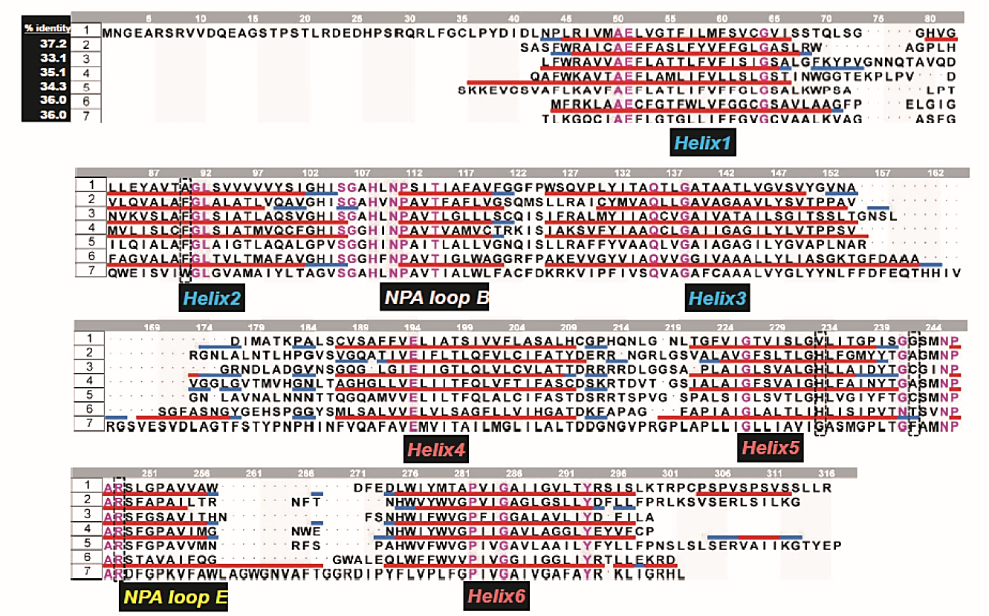
Figure 3.1. Sequence alignment of NIP7;1 and aquaporin templates. The NIP7;1 protein sequence (TAIR: At3g06100) was aligned with six structures (AQP1, pdb1J4N; AQP0,pdb1YMG; AQP4, pdb3GD8; AQP5, pdb3D9S; AQPz; pdb1RC2; GlpF, pdb1LDI) using the MOE software(Molecular Operating Environment, Montreal, Canada, version 2008.10). 1. NIP7;1, 2. AQP0, 3. AQP1, 4. AQP4, 5. AQP 5, 6. AQP Z, 7. GlpF. The position of transmembrane α-helices and NPA loops, based on the conserved aquaporin hourglass fold, are indicated. The magenta residues indicate conserved signature residues of the aquaporin fold in each structural element that were used to validate alignment. The black dotted boxes indicate the positions of the residues of the ar/R selectivity filter. The % amino acid sequence identity within transmembrane and NPA loop αhelices of each structural template to the aligned NIP7;1 sequence is shown in the upper left corner.

minimization (to avoid artificial “swelling” of the transmembrane region).The ten models were subsequently ranked using MOE’s packing algorithm.
Analysis of the model showed that the residues forming the ar/R tetrad in NIP7;1 are Ala85 (Helix2), Val205 (Helix5), Gly214 (LoopE1) and Arg220 (LoopE2). This is identical to the ar/R composition of the NIP II boric acid transporters AtNIP5;1 and AtNIP6;1 with the exception of a conservative Val substitution for Ile at H5. The residue at the LE1 position is typically Ala or Gly, with the backbone carbonyl typically providing a hydrogen bond to transported substrates (Figure 3.2).
Analysis of ten separate homology models generated by MOE showed excellent superimposition with the structural template (rmsd ranging from 0.5 to 0.9 Å). However, analysis of the models revealed the presence of an unusual tyrosine (Tyr81) in transmembrane helix 2 which is located on the extracellular side of the H2 ar/R residue facing the pore and lying close to the Ar/R region in the three dimensional structure. Superimposition of the homology models showed that the Tyr81 side chain can adopt two rotomer states that can be described by an “up” or “down” configuration with respect to the normal to the membrane plane (Figure 3.3). In the down configuration, the tyrosine appears to

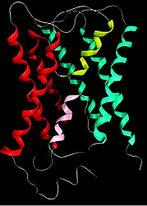
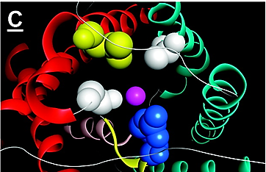
A.

A.

A.

A.
B.

Figure 3.2 Homology model of NIP7;1.B.

Figure 3.2 Homology model of NIP7;1. A. Ribbon diagram of the NIP7;1 homology model constructed in MOE using the AQP0 (PDB entry1YMG) structural template. The helix colors correspond to the positions of the transmembrane and NPA helices shown in Figure 1.1. The structure is viewed perpendicular to the axis of the transport pore with the extracellular side of the membrane at the top. B. NIP7;1 model viewed down the transport pore axis from the extracellular face of the membrane with the side chains of the ar/R selectivity filter highlighted in space filling representation. The residues correspond to (in clockwise fashion starting from the top right) Ala85 (white) in the H2 position, Arg220 (blue) in the LE2 position, Gly214 (white) in the LE1 position, and Val205 (yellow) in the H5 position. The position of the transport substrate (in this case water) in the ar/R constriction based on the crystal structure(Gonen, Cheng et al. 2005) of the AQP0 template is denoted with a magenta sphere.

Figure 3.2 Homology model of NIP7;1.B.

Figure 3.2 Homology model of NIP7;1.B.

Figure 3.2 Homology model of NIP7;1. A. Ribbon diagram of the NIP7;1 homology model constructed in MOE using the AQP0 (PDB entry1YMG) structural template. The helix colors correspond to the positions of the transmembrane and NPA helices shown in Figure 1.1. The structure is viewed perpendicular to the axis of the transport pore with the extracellular side of the membrane at the top. B. NIP7;1 model viewed down the transport pore axis from the extracellular face of the membrane with the side chains of the ar/R selectivity filter highlighted in space filling representation. The residues correspond to (in clockwise fashion starting from the top right) Ala85 (white) in the H2 position, Arg220 (blue) in the LE2 position, Gly214 (white) in the LE1 position, and Val205 (yellow) in the H5 position. The position of the transport substrate (in this case water) in the ar/R constriction based on the crystal structure(Gonen, Cheng et al. 2005) of the AQP0 template is denoted with a magenta sphere.

lie across the pore axis, suggesting that it may occlude the pore. In the up configuration, the side chain is parallel to the z-axis of the pore, pointed to the extracellular vestibule, suggesting an open pore in this configuration. This was tested by analysis of the two “up and down” NIP7;1 models by using the HOLE program(Smart, Breed et al. 1997). The up state shows an open pore characteristic of other NIP II proteins (Wallace and Roberts 2004, Wallace and Roberts 2005), but the down state shows a pinched pore with a diameter of <2 Å (Figure 3.3). This suggests that NIP7;1 could potentially exist in either an open or closed state, raising the possibility that transport through this channel may be determined by the position of the Tyr81 side chain. In comparison, modeling of the NIP5;1 and NIP6;1 boric acid transport channels shows the presence of an Asn or a Cys residue at the corresponding position of Tyr81 in NIP 7;1 (Figure 3.4). As a result, the predicted pore apertures of NIP5;1 and NIP6;1 are open compared to that of NIP7;1 (Figure 3.4).

3.1.2 NIP7;1 is a boric acid transporter regulated by single unusual tyrosine residue, Y81 within the channel pore
Down

Down

Down

Down

To test whether NIP7;1 is functionally similar to other NIP II proteins and whether the tyrosine residue affects channel permeability, the boric acid permeability of Xenopus oocytes
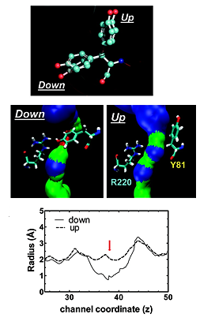
A.

A.

A.

A.
B.

B.

B.

B.
C.

Figure 3.3 HOLE profiles of the NIP7;1 modelsC.

Figure 3.3 HOLE profiles of the NIP7;1 models. A. Superimposition of homology models obtained for NIP7;1 viewed perpendicular to the transport pore axis with the Tyr81 side chain shown as a ball and stick representation. The two orientations of the Tyr81 phenolic side chain in either an up or down orientation relative to the pore axis are indicated. B. Pore width of NIP7;1 in the up or down state analyzed by using HOLE. Surface representations are colored according to the pore width (blue for diameters of >5 Å, light green for >2 Å, and red for <2 Å). The side chains of Tyr81 in the up or down states relative to Arg220 are shown. C. Pore radii of the Tyr81 in the up state (---) and down state (—), plotted along the z axis calculated with HOLE. The arrow shows the pore position of Tyr81.

Figure 3.4 Homology models comparison of NIP5;1, NIP6;1 and NIP7;1Figure 3.3 HOLE profiles of the NIP7;1 modelsC.

Figure 3.3 HOLE profiles of the NIP7;1 modelsC.

Figure 3.3 HOLE profiles of the NIP7;1 models. A. Superimposition of homology models obtained for NIP7;1 viewed perpendicular to the transport pore axis with the Tyr81 side chain shown as a ball and stick representation. The two orientations of the Tyr81 phenolic side chain in either an up or down orientation relative to the pore axis are indicated. B. Pore width of NIP7;1 in the up or down state analyzed by using HOLE. Surface representations are colored according to the pore width (blue for diameters of >5 Å, light green for >2 Å, and red for <2 Å). The side chains of Tyr81 in the up or down states relative to Arg220 are shown. C. Pore radii of the Tyr81 in the up state (---) and down state (—), plotted along the z axis calculated with HOLE. The arrow shows the pore position of Tyr81.

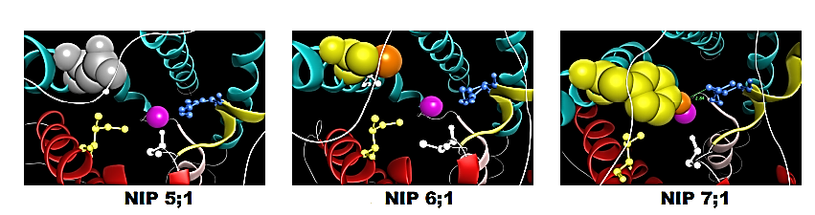
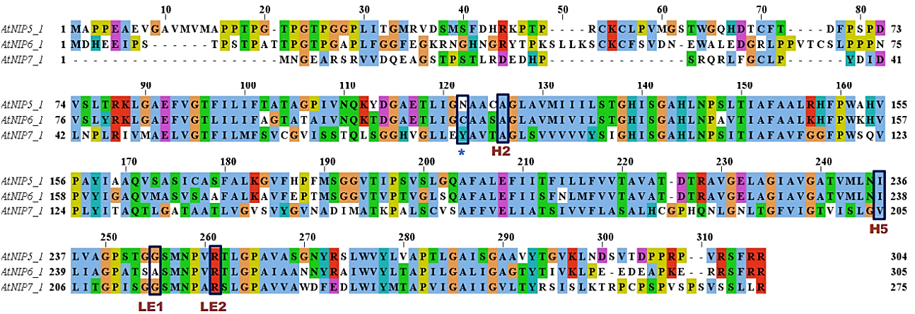
B.

B.

B.

B.
A.

A.

A.

A.

Figure 3.4 Homology models comparison of NIP5;1, NIP6;1 and NIP7;1. A. Sequence alignment of NIP5;1, NIP6;1 and NIP7;1 protein sequences. The Ar/R residues are highlighted with the position nomenclature (H2, H5, LE1 and LE2) of Wallace and Roberts(Wallace and Roberts 2005). The position of Tyr81 of NIP7;1 and the corresponding Asn and Cys in NIP5;1 and NIP6;1 respectively are indicated by an asterisk. B. Homology models of NIP5;1, NIP6;1 and NIP7;1 viewed down the pore axis from the extracellular vestibule. The ar/R residues are indicated by a ball and stick representation with the blue residue indicating the conserved Arg at position LE2. The position of the Asn (gray), Cys (yellow) and Tyr (yellow) from the asterisked position in the sequence in panel A is shown in space filling representation. The orange atoms in NIP 6;1 and NIP7;1 show the position of sulfhydryl S and phenolic O atoms respectively. The distance (2.84 Å) between the Tyr 81 hydroxyl and the closest guanidinium nitrogen atom of Arg220 is indicated in the NIP7;1 structure by a green dotted line.

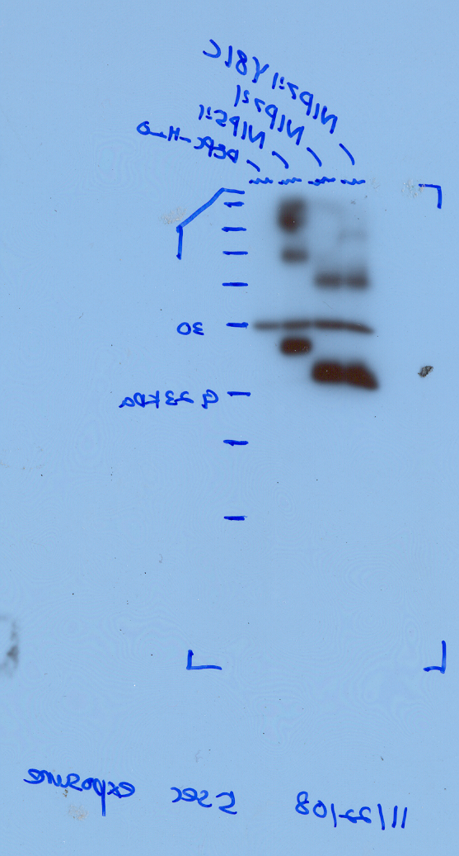
B.

B.

B.

B.
kDa

kDa

kDa

kDa
17

17

17

17
1

1

1

1
2

2

2

2
3

3

3

3
23

23

23

23
30

30

30

30
A.

A.

A.

A.
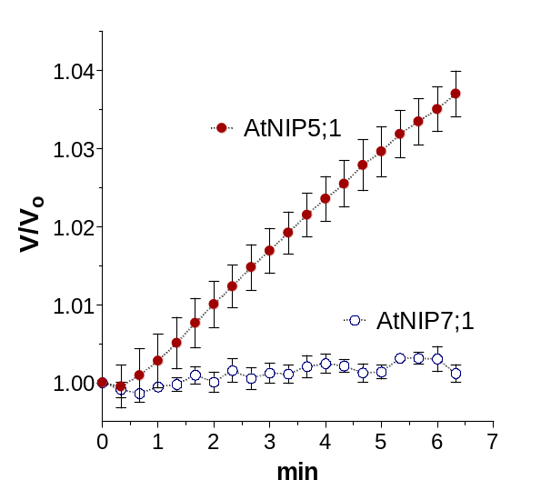

C.

Figure 3.5 Boric acid transport activity of NIP7; 1 in Xenopus OocytesC.

Figure 3.5 Boric acid transport activity of NIP7; 1 in Xenopus Oocytes A. Time course of boric acid-driven oocyte swelling of NIP5;1 and NIP7;1 cRNA-injected oocytes upon immersion in an isoosmotic Ringer’s solution containing boric acid. The swelling rates due to the uptake of boric acid followed by the osmotically driven uptake of water were measured by video microscopy. V/V₀ represents the increase in oocyte volume divided by the volume at time zero. B. Western blot of oocyte lysates (5 μg of protein/lane) with the anti-FLAG tag monoclonal antibody: lane 1, oocytes mock injected with sterile water; lane 2, NIP5;1-injected oocytes; lane 3, NIP7;1-injected oocytes. As expected, NIP5;1 (31.5 kDa) migrates at a higher-molecular mass position than NIP7;1 (28.8 kDa). C. The rate of boric acid-driven oocyte swelling corrected for basal transport through negative control (sterile water-injected) oocytes, with error bars showing the SEM (n = 5 oocytes).

Figure 3.5 Boric acid transport activity of NIP7; 1 in Xenopus OocytesC.

Figure 3.5 Boric acid transport activity of NIP7; 1 in Xenopus OocytesC.
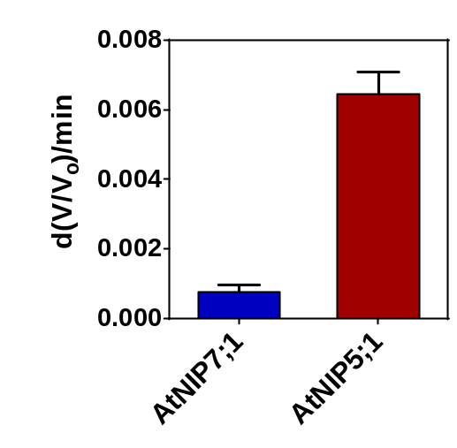

Figure 3.5 Boric acid transport activity of NIP7; 1 in Xenopus Oocytes. A. Time course of boric acid-driven oocyte swelling of NIP5;1 and NIP7;1 cRNA-injected oocytes upon immersion in an isoosmotic Ringer’s solution containing boric acid. The swelling rates due to the uptake of boric acid followed by the osmotically driven uptake of water were measured by video microscopy. V/V₀ represents the increase in oocyte volume divided by the volume at time zero. B. Western blot of oocyte lysates (5 μg of protein/lane) with the anti-FLAG tag monoclonal antibody: lane 1, oocytes mock injected with sterile water; lane 2, NIP5;1-injected oocytes; lane 3, NIP7;1-injected oocytes. As expected, NIP5;1 (31.5 kDa) migrates at a higher-molecular mass position than NIP7;1 (28.8 kDa). C. The rate of boric acid-driven oocyte swelling corrected for basal transport through negative control (sterile water-injected) oocytes, with error bars showing the SEM (n = 5 oocytes).

expressing NIP7;1 was investigated. Comparison of NIP7;1- and NIP5;1-expressing oocytes shows that while both are expressed at equivalent levels, NIP7;1 shows a level of boric acid uptake reduced more than 10-fold compared to that of NIP5;1(Figure 3.5). To test the hypothesis that Tyr81 may regulate NIP7;1 transport, site-directed mutagenesis was used to convert Tyr81 to the smaller Cys residue (NIP7;1 Y81C), characteristic of NIP6;1. Boric acid uptake assays were performed. Substitution of Y81 with cysteine resulted in a robust level of boric acid transport that was 20-fold higher than that of wild-type NIP7;1 and 4-fold higher than that of the positive control NIP5;1(Figure 3.6). In addition, pretreatment of NIP7;1 Y81C-injected oocytes with the channel blocker HgCl₂ resulted in a 70% reduction of the boric acid transport activity (Figure 3.6). This suggests that the substituted cysteine residue is in close proximity to the transport pore as predicted by molecular modeling. While an increase in the boric acid uptake rate was observed for the NIP7;1 Y81C mutant, the osmotic water permeability (P_{f}) of both NIP7;1- and NIP7;1 Y81C-injected oocytes were indistinguishable from those of the negative control oocytes (Figure 3.7). In addition to transport of the physiologically relevant solute boric acid, the NIP II subtype of proteins also exhibit the ability to transport the test substrates glycerol and urea, which are useful for the direct analysis of transport using
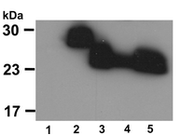
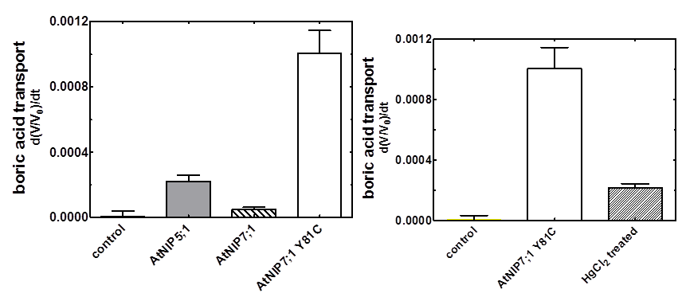
A.

A.

A.

A.
B.

B.

B.

B.
C.

Figure 3.6 Boric acid transport activity of NIP7;1 Y81C in Xenopus oocytesC.

Figure 3.6 Boric acid transport activity of NIP7;1 Y81C in Xenopus oocytes. A. Boric acid transport rates of NIP5;1, NIP7;1, and NIP7;1 Y81C -injected oocytes, as well as negative control oocytes, determined by same approach shown in Figure 3.5. The error bars show the SEM (n = 8 oocytes). B. Sensitivity of the boric acid permeability of NIP7;1 Y81C-injected oocytes to HgCl₂ (1 mM). The error bars show the SEM (n= 9 oocytes for control and NIP7;1 Y81C; n = 7 oocytes for NIP7;1 Y81C treated with HgCl₂). C. Western blot of oocyte lysates (5 μg of protein/lane) with the anti-FLAG tag monoclonal antibody: lane 1, negative control oocytes; lane 2, AtNIP5;1-injected oocytes; lane 3, NIP7;1-injected oocytes; lane 4, NIP7;1 Y81C-injected oocytes; lane 5, NIP7;1 Y81C-injected oocytes incubated with 1 mM HgCl₂.

Figure 3.7 Osmotic water permeabilities of NIP7;1- and NIP7;1 mutant-expressing oocytes.Figure 3.6 Boric acid transport activity of NIP7;1 Y81C in Xenopus oocytesC.

Figure 3.6 Boric acid transport activity of NIP7;1 Y81C in Xenopus oocytesC.

Figure 3.6 Boric acid transport activity of NIP7;1 Y81C in Xenopus oocytes. A. Boric acid transport rates of NIP5;1, NIP7;1, and NIP7;1 Y81C -injected oocytes, as well as negative control oocytes, determined by same approach shown in Figure 3.5. The error bars show the SEM (n = 8 oocytes). B. Sensitivity of the boric acid permeability of NIP7;1 Y81C-injected oocytes to HgCl₂ (1 mM). The error bars show the SEM (n= 9 oocytes for control and NIP7;1 Y81C; n = 7 oocytes for NIP7;1 Y81C treated with HgCl₂). C. Western blot of oocyte lysates (5 μg of protein/lane) with the anti-FLAG tag monoclonal antibody: lane 1, negative control oocytes; lane 2, AtNIP5;1-injected oocytes; lane 3, NIP7;1-injected oocytes; lane 4, NIP7;1 Y81C-injected oocytes; lane 5, NIP7;1 Y81C-injected oocytes incubated with 1 mM HgCl₂.

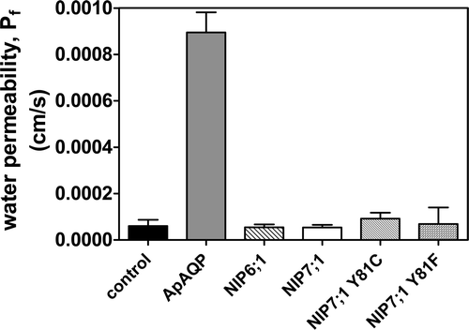

Figure 3.7 Osmotic water permeabilities of NIP7;1- and NIP7;1 mutant-expressing oocytes. Oocytes were injected with the indicated cRNAs or with sterile water (negative control). The osmotic water permeability (P_{f}) was determined from the rate of oocyte swelling upon incubation in a hypoosmotic Ringer's solution. The error bars show the SEM (n = 8 oocytes). ApAQP(Wallace, Shakesby et al. 2012) was used as a positive control aquaporin cRNA.

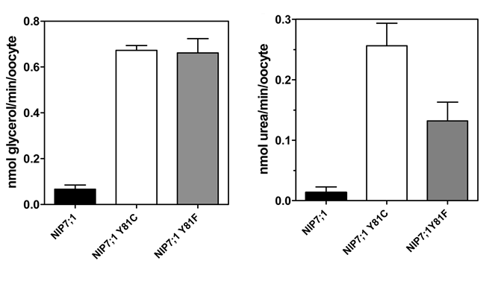
A.

A.

A.

A.
B.

Figure 3.8 Urea and glycerol permeabilities of NIP7;1- and and NIP7;1 mutant-expressing oocytes.B.

Figure 3.8 Urea and glycerol permeabilities of NIP7;1- and and NIP7;1 mutant-expressing oocytes. Oocytes were injected with the indicated cRNAs or with sterile water (negative control). A The [³H]glycerol permeability or B [¹⁴C]urea permeability of the indicated oocytes were determined as described in(Wallace and Roberts 2005). The error bars show the SEM (n = 4).

Figure 3.8 Urea and glycerol permeabilities of NIP7;1- and and NIP7;1 mutant-expressing oocytes.B.

Figure 3.8 Urea and glycerol permeabilities of NIP7;1- and and NIP7;1 mutant-expressing oocytes.B.

Figure 3.8 Urea and glycerol permeabilities of NIP7;1- and and NIP7;1 mutant-expressing oocytes. Oocytes were injected with the indicated cRNAs or with sterile water (negative control). A The [³H]glycerol permeability or B [¹⁴C]urea permeability of the indicated oocytes were determined as described in(Wallace and Roberts 2005). The error bars show the SEM (n = 4).

radiolabeled solute uptake assays. Analysis of the NIP7;1 Y81C mutant shows that substitution of an NIP6;1-like cysteine results in the opening of the pore to transport of glycerol as well as urea, consistent with previous analyses of NIP6;1(Figure 3.8). Thus, similar to other NIP II channels, opening of the NIP7;1 pore results in boric acid transport, as well as permeation by urea and glycerol test solutes while remaining impermeable to water without detectable aquaporin activity.

3.1.3 Molecular Dynamics Simulation of the Tyr81–Arg220 Interaction

To gain insight into how the down configuration of Tyr81 might be stabilized, a 5 ns molecular dynamics simulation was performed on the NIP7;1 model. During the molecular dynamics simulation, rotation of the Arg220 side chain in the ar/R region was observed with the guanidinium moiety moving within hydrogen bonding distance of the Tyr81 hydroxyl present in the down configuration. HOLE modeling shows that the formation of this hydrogen bond would effectively close the NIP7;1 channel(Figure 3.9). This observation suggests that a hydrogen bond interaction of the Tyr81 hydroxyl group with the Arg220 side chain could stabilize the down state of the Tyr81, resulting in a low-energy closed state.
To test this hypothesis, site-directed mutagenesis of NIP7;1 was performed to generate a Phe81 substitution (NIP7;1

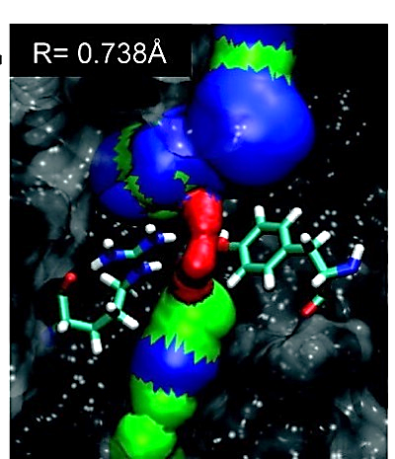
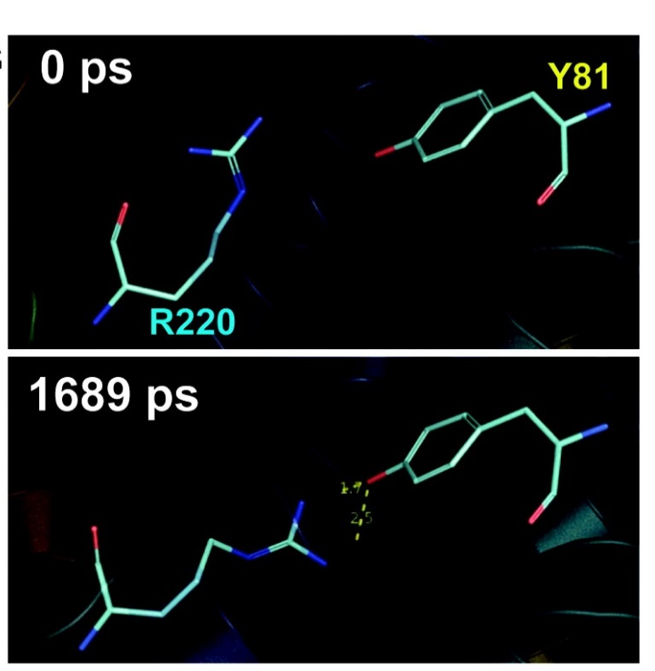
B.

B.

B.

B.
A.

Figure 3.9 Predicted interaction of Tyr81 and Arg220 by molecular dynamics simulationA.

Figure 3.9 Predicted interaction of Tyr81 and Arg220 by molecular dynamics simulation. A.MD simulation of an NIP7;1 model with the Tyr81 side chain in the down position. The top panel shows a side view of the NIP7;1 pore at the beginning of the simulation, showing the positions of the Arg220 and Tyr81 side chains. The bottom panel shows the same view at 1689 ps showing the reorientation of the Arg220 side chain in a configuration perpendicular to the pore axis, stabilized by hydrogen bonds (yellow dotted line) formed between the guanidinium group of Arg220 and the phenolic OH group of Tyr81. B. HOLE depiction of the ar/R pore region at the beginning of the simulation (top pannel) and at the end of the simulation (lower panel) with the radius of the ar/R aperture indicated numerically on each panel. Residues are shown in surface representation except for the Arg220 and Tyr81 side chains, which are shown as sticks.

Figure 3.9 Predicted interaction of Tyr81 and Arg220 by molecular dynamics simulationA.

Figure 3.9 Predicted interaction of Tyr81 and Arg220 by molecular dynamics simulationA.

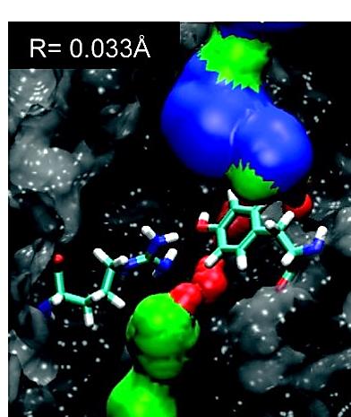

Figure 3.9 Predicted interaction of Tyr81 and Arg220 by molecular dynamics simulation. A.MD simulation of an NIP7;1 model with the Tyr81 side chain in the down position. The top panel shows a side view of the NIP7;1 pore at the beginning of the simulation, showing the positions of the Arg220 and Tyr81 side chains. The bottom panel shows the same view at 1689 ps showing the reorientation of the Arg220 side chain in a configuration perpendicular to the pore axis, stabilized by hydrogen bonds (yellow dotted line) formed between the guanidinium group of Arg220 and the phenolic OH group of Tyr81. B. HOLE depiction of the ar/R pore region at the beginning of the simulation (top pannel) and at the end of the simulation (lower panel) with the radius of the ar/R aperture indicated numerically on each panel. Residues are shown in surface representation except for the Arg220 and Tyr81 side chains, which are shown as sticks.

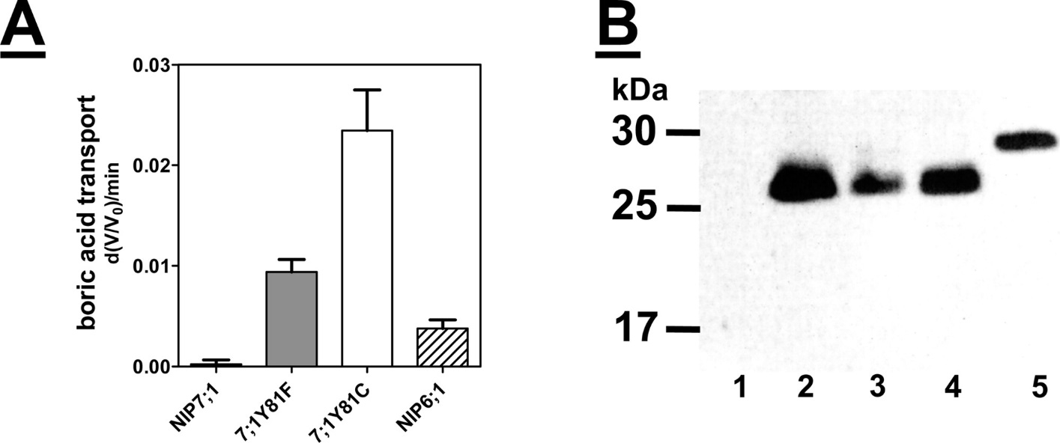
A.

A.

A.

A.
B.

Figure 3.10 Effect of removal of the tyrosine 81 hydroxyl group on the boric acid transport of NIP7;1.B.

Figure 3.10 Effect of removal of the tyrosine 81 hydroxyl group on the boric acid transport of NIP7;1. A. Comparison of the boric acid transport rates of oocytes injected with the indicated cRNAs corresponding to wild-type NIP7;1 or its site-directed mutants. NIP6;1 represents a positive control boric acid transporter. The error bars represent the SEM (n = 7 or 8 oocytes per cRNA). B. Western blot of oocyte lysates (5 μg of protein/lane) with the anti-FLAG tag monoclonal antibody: lane 1, uninjected oocytes; lane 2, NIP7;1-injected oocytes; lane 3, NIP7;1 Y81C-injected oocytes; lane 4, NIP7;1 Y81F-injected oocytes; lane 5, NIP6;1-injected oocytes.

Figure 3.10 Effect of removal of the tyrosine 81 hydroxyl group on the boric acid transport of NIP7;1.B.

Figure 3.10 Effect of removal of the tyrosine 81 hydroxyl group on the boric acid transport of NIP7;1.B.

Figure 3.10 Effect of removal of the tyrosine 81 hydroxyl group on the boric acid transport of NIP7;1. A. Comparison of the boric acid transport rates of oocytes injected with the indicated cRNAs corresponding to wild-type NIP7;1 or its site-directed mutants. NIP6;1 represents a positive control boric acid transporter. The error bars represent the SEM (n = 7 or 8 oocytes per cRNA). B. Western blot of oocyte lysates (5 μg of protein/lane) with the anti-FLAG tag monoclonal antibody: lane 1, uninjected oocytes; lane 2, NIP7;1-injected oocytes; lane 3, NIP7;1 Y81C-injected oocytes; lane 4, NIP7;1 Y81F-injected oocytes; lane 5, NIP6;1-injected oocytes.

Y81F), which effectively removes the predicted hydrogen bonding hydroxyl group
on the aromatic ring of Tyr81. Expression of NIP7;1 Y81F in Xenopus oocytes resulted in an increase in the boric acid transport rate compared to that of NIP7;1 (Figure 3.10). The transport of boric acid through NIP7;1 Y81F was still approximately 3-fold slower than that observed with NIP7;1 Y81C. This suggests that while the Phe substitution results in channel opening, it is still restricting boric acid permeability relative to a substitution with a smaller Cys residue. Nevertheless, the rate of transport of boric acid through NIP7;1 Y81F was significantly higher than that of NIP6;1, which is an established boric acid transporter of A. thaliana.

3.1.4 Quantification of boric acid permeability of wild type and Y81C in proteoliposomes

To investigate in a quantitative fashion, boric acid transport analysis of NIP7;1-proteoliposome by stopped flow fluorimetric approaches was adopted. This method was established for the transport of nonelectrolytes through aquaporin and aquaporin-like protein channels (Rivers, Dean et al. 1997).
The rationale for this assay is shown in Figure 3.11. Liposomes are prepared, equilibrated, and loaded with a volume sensitive dye (carboxylfluorescein CF) and a buffered solution of 200 mM of the test solute (e.g. boric acid). These liposomes

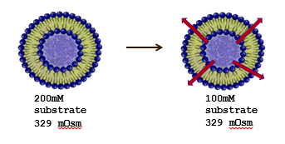
CF

CF

CF

CF
CF

CF

CF

CF
Vesicles loaded with volume-sensitive dye, carboxyfluorescein (CF)
200 mM boric acid

200 mM boric acid

200 mM boric acid

200 mM boric acid
Injection into isosmotic buffer containing impermeable solute

Injection into isosmotic buffer containing impermeable solute

Injection into isosmotic buffer containing impermeable solute

Injection into isosmotic buffer containing impermeable solute

Effluxes creating an osmotic gradient which cause water efflux and vesicle shrinkage

100 mM boric acid

Figure 3.11 Rationale of boric acid transport analysis of proteoliposomes by stopped flow fluorimetry.100 mM boric acid

Figure 3.11 Rationale of boric acid transport analysis of proteoliposomes by stopped flow fluorimetry. Vesicles loaded with 20 mM CF dye were equilibrated with 200 mM boric acid. The efflux assay was initiated by injection into an equal volume of isosmotic buffer containing an impermeable solute. A Boric acid concentration gradient results in fast efflux of boric acid from the vesicle and the efflux creates an osmotic gradient which cause water efflux and vesicle shrinkage which reported as a decrease in vesicular CF fluorescence.

Figure 3.11 Rationale of boric acid transport analysis of proteoliposomes by stopped flow fluorimetry.100 mM boric acid

Figure 3.11 Rationale of boric acid transport analysis of proteoliposomes by stopped flow fluorimetry.100 mM boric acid

Figure 3.11 Rationale of boric acid transport analysis of proteoliposomes by stopped flow fluorimetry. Vesicles loaded with 20 mM CF dye were equilibrated with 200 mM boric acid. The efflux assay was initiated by injection into an equal volume of isosmotic buffer containing an impermeable solute. A Boric acid concentration gradient results in fast efflux of boric acid from the vesicle and the efflux creates an osmotic gradient which cause water efflux and vesicle shrinkage which reported as a decrease in vesicular CF fluorescence.

are injected into an equal volume of an isoosmoticc solution of an impermeable solute. This results in a gradient of the test solute (e.g. 100mM boric acid on the extravesicular side). Efflux of the test solute creates an osmotic gradient which results in water efflux and shrinkage of the intravesicular volume of the liposome. Vesicle shrinkage results in a decrease in the internal volume and self quenching of the CF dye (measured as a decrease in fluorescence).
In order to measure NIP7;1 permeability by this approach, it was first necessary to express and purify the protein for liposome reconstitution. For this purpose, heterologous expression in the methanotrophic yeast Pichia pastoris was employed. Expression of NIP7;1 as an amino terminal a His₆-tag fusion in Pichia resulted in the expected protein band which was purified by Ni²⁺-chelate chromatography and size exclusion chromatography (Figure 3.12). Size exclusion chromatography showed a single homogenous peak which was taken as an indication of a uniform, non-aggregated protein sample (Figure 3.12).
Small unilammelar vesicles (SUVs) were prepared, and purified NIP7;1 and NIP7;1 Y81C were reconstituted into to generate proteoliposomes loaded with 20 mM CF. The size of liposome and proteoliposome preparations were determined by light scattering (Figure 3.13). Both control and NIP7;1 proteoliposomes were present as a uniform population of

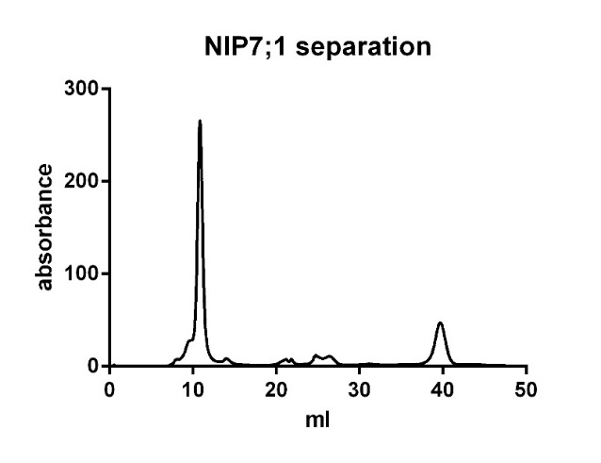
A.

A.

A.

A.
B.

B.

B.

B.
MW kDa

MW kDa

MW kDa

MW kDa
0.4

0.4

0.4

0.4
0.8

0.8

0.8

0.8
1.2

1.2

1.2

1.2
1.6

1.6

1.6

1.6
CV

Figure 3.12 Recombinant NIP7;1 proteins purified from Pichia pastoris.CV

Figure 3.12 Recombinant NIP7;1 proteins purified from Pichia pastoris. A. Proteins were resolved by SDS-PAGE on a 12% (w/v) polyacrylamide gel and were stained with Coomassie Blue. Lane 1, NIP7;1; Lane 2, NIP7:1Y81C. The band corresponding to the monomer molecular weight is indicated with an arrow. A second band characteristic of a dimeric form of the protein, often observed with purified aquaporin-like proteins, is apparent at 50 kDa. B. The last purification step, size exclusion chromatography, showing a symmetrical peak at approximate 0.5 column volume, which indicates a homogenous, non-aggregated sample. The x-axis shows the column volume and the y-axis shows the absorption at 280 nm. The void volume is 0.3 CV.

Figure 3.12 Recombinant NIP7;1 proteins purified from Pichia pastoris.CV

Figure 3.12 Recombinant NIP7;1 proteins purified from Pichia pastoris.CV

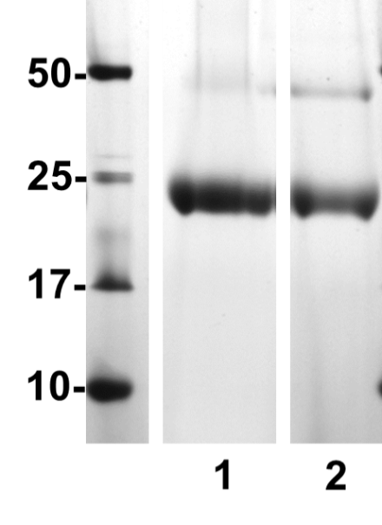
Figure 3.12 Recombinant NIP7;1 proteins purified from Pichia pastoris. A. Proteins were resolved by SDS-PAGE on a 12% (w/v) polyacrylamide gel and were stained with Coomassie Blue. Lane 1, NIP7;1; Lane 2, NIP7:1Y81C. The band corresponding to the monomer molecular weight is indicated with an arrow. A second band characteristic of a dimeric form of the protein, often observed with purified aquaporin-like proteins, is apparent at 50 kDa. B. The last purification step, size exclusion chromatography, showing a symmetrical peak at approximate 0.5 column volume, which indicates a homogenous, non-aggregated sample. The x-axis shows the column volume and the y-axis shows the absorption at 280 nm. The void volume is 0.3 CV.

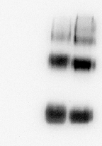
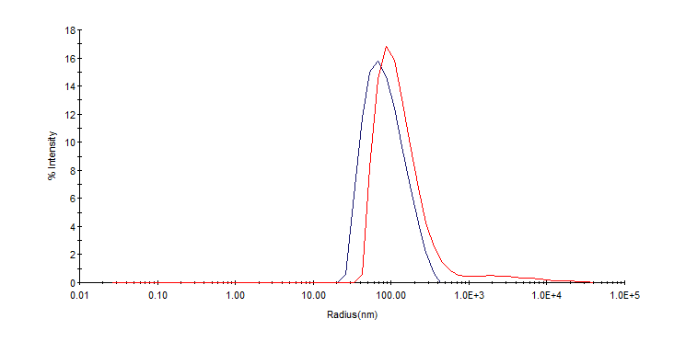
B.

B.

B.

B.
A.

A.

A.

A.
MW
(kDa)

MW
(kDa)

MW
(kDa)

MW
(kDa)
1

1

1

1
2

2

2

2
3

3

3

3
70-

70-

70-

70-

25-

Figure 3.13. Reconstitution of NIP7;1 and NIP7;1 Y81C into liposomes25-

Figure 3.13. Reconstitution of NIP7;1 and NIP7;1 Y81C into liposomes A. Proteoliposome size is determined by light scattering. Intensity is plotted against vesicle radius distribution. Red, vesicles size distribution before extrusion; Blue, vesicle size distribution after extrusion. B. Anti-His Western blotting of purified protein after liposome reconstitution. Lane 1, control liposome; lane 2, NIP7;1 proteoliposome; lane 3, NIP7;1 Y81C proteoliposome

Figure 3.13. Reconstitution of NIP7;1 and NIP7;1 Y81C into liposomes25-

Figure 3.13. Reconstitution of NIP7;1 and NIP7;1 Y81C into liposomes25-

Figure 3.13. Reconstitution of NIP7;1 and NIP7;1 Y81C into liposomes. A. Proteoliposome size is determined by light scattering. Intensity is plotted against vesicle radius distribution. Red, vesicles size distribution before extrusion; Blue, vesicle size distribution after extrusion. B. Anti-His Western blotting of purified protein after liposome reconstitution. Lane 1, control liposome; lane 2, NIP7;1 proteoliposome; lane 3, NIP7;1 Y81C proteoliposome

approximately the same average radius (100 nm). Western blot was used to verify the presence of NIP7;1 and NIP7;1 Y81C (Figure 3.13) in the final proteoliposome preparations.
Reconstitution of NIP7;1 into proteoliposomes resulted in the acquisition of high boric acid flux activity that was not observed in control liposomes. After correction for the nonselective rate of diffusion through the lipid bilayer, the permeability co-efficient (P_{B}) for boric acid flux through the NIP7;1 channel was estimated to P_{B}=2.82 x10⁻⁶ ±0.078 cm/s, a rate that is almost 2-fold greater than that exhibited by negative control liposomes and it is ten-fold higher than the reported lipid permeability for boric acid in plant plasma membranes (Dordas, Chrispeels et al. 2000), which supports a transport function of boric acid for this protein. Boric acid efflux from NIP7;1 Y81C was even more rapid(P_{B}=3.721 x10⁻⁶ ±0.83 cm/s)(Figure 3.14). The results indicate that wild type NIP7;1 is indeed permeated by boric acid. In addition, comparison of wild type NIP7;1 with NIP7;1 Y81C shows that the later possesses a higher P_{B}, consistent with previous observations from Xenopus oocyte expression system suggesting tyrosine gating of the pore.

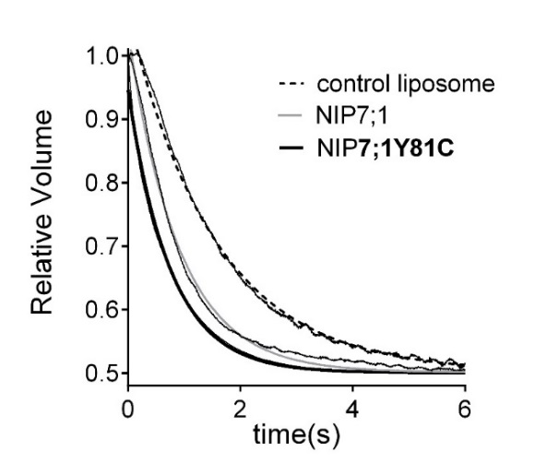
B.

B.

B.

B.
A.

A.

A.

A.
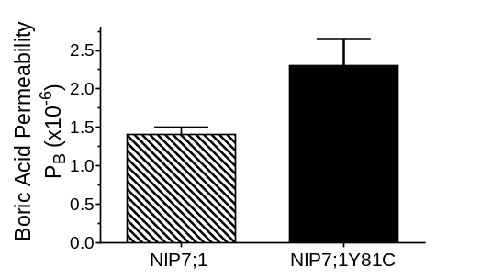
*

*

*

*
**

Figure 3.14. Boric acid permeability measurements in membrane vesicles.**

Figure 3.14. Boric acid permeability measurements in membrane vesicles. A. Relative fluorescence traces were plotted versus time. A nonlinear single exponential decay model was used to fit the experimental data. B. Boric acid permeability coefficients of NIP7;1 proteoliposomes, NIP7;1 Y81C proteoliposome and negative control liposomes determined by the modified differential equations described by Mathai and Zeidel(Zeidel, Ambudkar et al. 1992). The error bars show SEM (n=3) (** indicates P < 0.001; * indicates P < 0.01).

Figure 3.14. Boric acid permeability measurements in membrane vesicles.**

Figure 3.14. Boric acid permeability measurements in membrane vesicles.**

Figure 3.14. Boric acid permeability measurements in membrane vesicles. A. Relative fluorescence traces were plotted versus time. A nonlinear single exponential decay model was used to fit the experimental data. B. Boric acid permeability coefficients of NIP7;1 proteoliposomes, NIP7;1 Y81C proteoliposome and negative control liposomes determined by the modified differential equations described by Mathai and Zeidel(Zeidel, Ambudkar et al. 1992). The error bars show SEM (n=3) (** indicates P < 0.001; * indicates P < 0.01).

3.2 NIP7;1 role in male gametophyte development and pollen cell wall formation

3.2.1 NIP7;1 is expressed in the anther cells during pollen development

The expression of NIP7;1 in various Arabidopsis tissues was investigated by Q-PCR analysis. The results showed that NIP7;1 is expressed predominantly in reproductive tissue(flower and siliques) with the highest expression levels (> 50-fold over basal expression in leaves)observed in flowers (Figure 3.15). To investigate the tissue-specific expression during flower development, transgenic plants expressing a NIP7;1 promoter-driven β-glucuronidase reporter gene (NIP7;1pro::GUS) were analyzed. Inflorescences from GUS reporter plants showed GUS expression principally in young unopened floral buds. The GUS signal was limited to anthers, with the highest expression levels observed in floral stages 9 and 10 and declining in older stages and disappearing by stage 12 (Figure 3.16 A). This finding is consistent with transcriptomic data (Figure 3.15 B) which also shows highest expression in stage 9-11 flowers.
To determine the tissue and cell type specific expression of NIP7;1 in anther tissue, cross-sections of stage 9 and stage 10 flowers were investigated (Figure 3.16 B-D). Floral stage 9 anthers show that the GUS signal was most intense within the developing

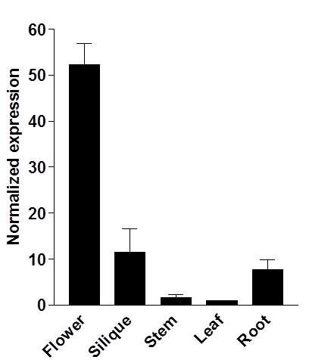
B.

B.

B.

B.
A.

Figure 3.15. Selective expression of NIP7;1 in A. thaliana in flowersA.

Figure 3.15. Selective expression of NIP7;1 in A. thaliana in flowers. A. Q-PCR analysis for NIP7;1 expression in dissected organs of 45-day-old A. thaliana plants. Data were normalized to NIP7;1 expression in leaf tissues. Error bars show the SEM of three (siliques), five (stems), or six (flowers, leaves, and roots) biological replicates. B. Comparative floral stage-specific expression of NIP7;1 based on microarray data obtained from the Genevestigator website (www.genevestigator.com). Error bars show standard error of mean (n=3).

Figure 3.15. Selective expression of NIP7;1 in A. thaliana in flowersA.

Figure 3.15. Selective expression of NIP7;1 in A. thaliana in flowersA.
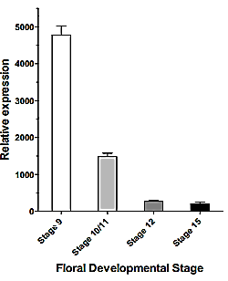

Figure 3.15. Selective expression of NIP7;1 in A. thaliana in flowers. A. Q-PCR analysis for NIP7;1 expression in dissected organs of 45-day-old A. thaliana plants. Data were normalized to NIP7;1 expression in leaf tissues. Error bars show the SEM of three (siliques), five (stems), or six (flowers, leaves, and roots) biological replicates. B. Comparative floral stage-specific expression of NIP7;1 based on microarray data obtained from the Genevestigator website (www.genevestigator.com). Error bars show standard error of mean (n=3).

B.

B.

B.

B.
A.

A.

A.

A.
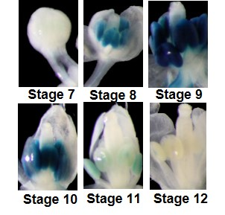
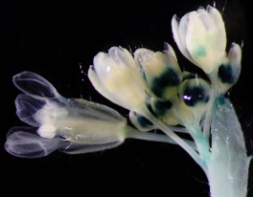
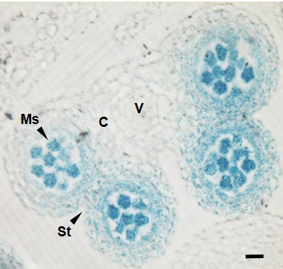

C.

C.

C.

C.
D.

Figure 3.16. Expression of NIP7;1 in developing Arabidopsis flowersD.

Figure 3.16. Expression of NIP7;1 in developing Arabidopsis flowers. A. Analysis of GUS expression in inflorescences of 6-week-old transgenic plant expressing the NIP7;1pro:GUS construct. The right panel shows dissection of flowers from the inflorescence above with floral stages based on the nomenclature of (Smyth, Bowman et al. 1990)indicated. B. Anther cross-section from a late floral stage 9 showing the four microsporangia sacs with developing microspores. The scale bar represents 20 µm. V, vascular region; St, stomium; C, connective; Ms, microspore. C and D. Comparison of GUS staining pattern in microsporangia from late floral stage 9 and floral stage 10. The scale bar represents 10 µm. T, tapetum; E, epidermis; En, endothecium; Ms, microspore; ML, middle layer.

Figure 3.16. Expression of NIP7;1 in developing Arabidopsis flowersD.

Figure 3.16. Expression of NIP7;1 in developing Arabidopsis flowersD.
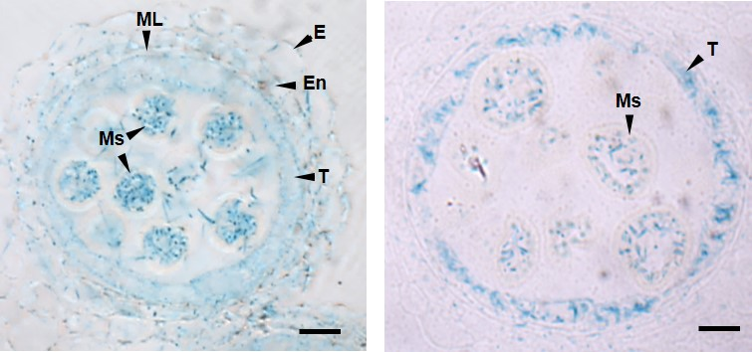

Figure 3.16. Expression of NIP7;1 in developing Arabidopsis flowers. A. Analysis of GUS expression in inflorescences of 6-week-old transgenic plant expressing the NIP7;1pro:GUS construct. The right panel shows dissection of flowers from the inflorescence above with floral stages based on the nomenclature of (Smyth, Bowman et al. 1990)indicated. B. Anther cross-section from a late floral stage 9 showing the four microsporangia sacs with developing microspores. The scale bar represents 20 µm. V, vascular region; St, stomium; C, connective; Ms, microspore. C and D. Comparison of GUS staining pattern in microsporangia from late floral stage 9 and floral stage 10. The scale bar represents 10 µm. T, tapetum; E, epidermis; En, endothecium; Ms, microspore; ML, middle layer.

microspore and the surrounding tapetum cells with lower levels observed within the cells of the endothecium and middle layer (Figure 3.16 B-D). In stage 10 flowers GUS staining declines but still persists within released microspores and the surrounding tapetum (Figure 3.16 D). To investigate the expression and cellular localization of NIP7;1 protein, the recombineering technology described by Zhou et al.(Zhou, Benavente et al. 2011) was used to generate transgenic Arabidopsis plant lines with an in frame translational fusion of NIP7;1 with a C-terminal yellow fluorescence protein (YFP) marker under the regulation of the endogenous NIP7;1 promoter. Western blot of dissected flowers from the NIP7;1 recombineering plants at various developmental stages showed the presence of the NIP7;1-YFP fusion protein in early stages (9-11) but not at later stages of development (Figure 3.17 A). Fluorescence microscopy supports the results of GUS expression experiments and shows expression NIP7;1-YFP in tapetal cells as well as developing microspores (Figure 3.17 B).
The results suggest that the expression of NIP7;1 peaks in the early pollen developmental window (Sanders, Bui et al. 1999) that spans microsporogenesis and the beginning of the pollen mitotic divisions (floral stages 9-11), and is no longer detectable when tricellular pollen maturation is complete and anther dehiscence occurs (floral stages 12-14).

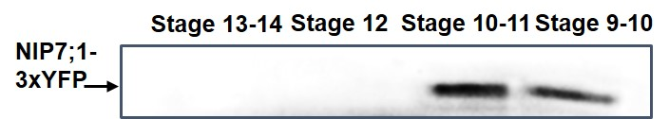
A.

A.

A.

A.
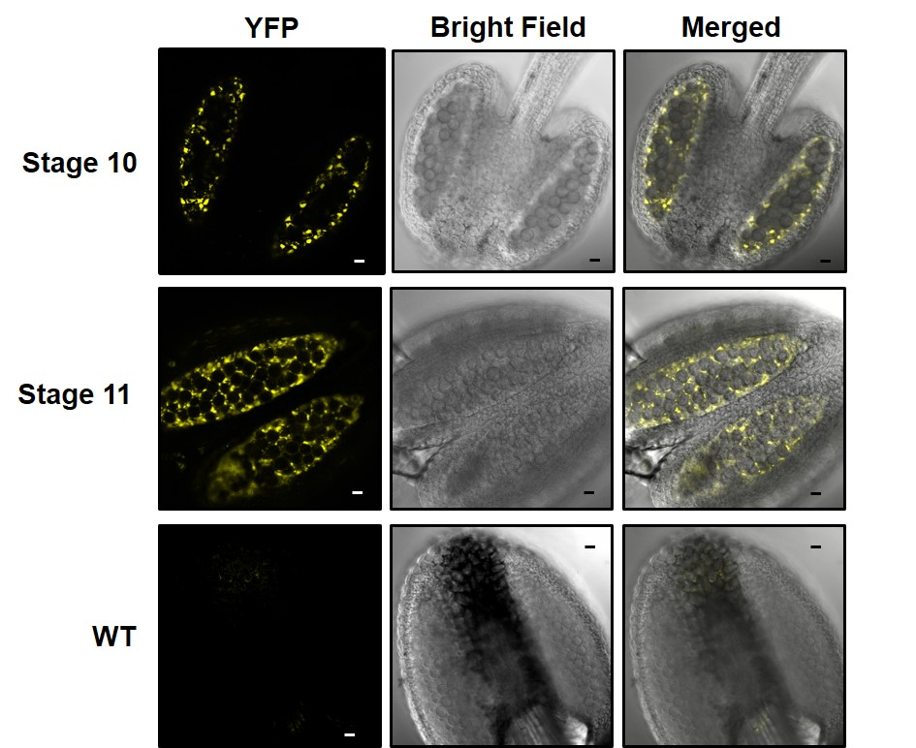
B.

Figure 3.17. Detection of NIP7;1 protein in Arabidopsis antherB.

Figure 3.17. Detection of NIP7;1 protein in Arabidopsis anther. A. Western blot analysis of NIP7;1 in Arabidopsis flower buds at different developmental stages. The arrow indicates the expected molecular weight (100kDa) of NIP7;1 fusion protein. B. Fluorescence and bright field images of anthers of NIP7;1-3xYFP at different developmental stages. Intense YFP fluorescence was shown in tapetum cells at floral stage 10 and both tapetum and microspores at stage 11. Bar=10µm

Figure 3.17. Detection of NIP7;1 protein in Arabidopsis antherB.

Figure 3.17. Detection of NIP7;1 protein in Arabidopsis antherB.

Figure 3.17. Detection of NIP7;1 protein in Arabidopsis anther. A. Western blot analysis of NIP7;1 in Arabidopsis flower buds at different developmental stages. The arrow indicates the expected molecular weight (100kDa) of NIP7;1 fusion protein. B. Fluorescence and bright field images of anthers of NIP7;1-3xYFP at different developmental stages. Intense YFP fluorescence was shown in tapetum cells at floral stage 10 and both tapetum and microspores at stage 11. Bar=10µm

3.2.2 Arabidopsis plants with NIP7;1 T-DNA insertion mutations show boron-dependent defects in silique and pollen development

Mutant lines with T-DNA insertions within the 4th exon (nip7;1-1) and the 2nd intron (nip7;1-2) of NIP7;1 were obtained from the Salk Institute (Figure 3.18 A). PCR genotyping verified that both lines were homozygous for the T-DNA insert, and the loss of NIP7;1 transcripts in 6-week old Arabidopsis flowers was confirmed by RT-PCR (Figure 3.18 B). Since previous work showed that the Arabidopsis NIP5;1 and NIP6;1 T-DNA insertion mutants show boron-dependent phenotypes(Takano, Wada et al. 2006, Tanaka, Wallace et al. 2008), a similar strategy was adopted to investigate the developmental phenotype of the nip7;1 plants. Plants were grown hydroponically in a standard growth media for 12 days, and were then transferred to either sufficient (100 μM) or low (0.3 μM) boron media and were grown for an additional four weeks. No obvious differences were observed in vegetative development and flowering times between wild type and mutant plants under the two boric acid conditions. Under growth conditions with sufficient boron, flower and silique development of wild-type, nip7;1-1 and nip7;1-2 plants were indistinguishable with each showing fully elongated normal siliques and normal seed fill (Figure 3.19). In contrast, significant differences were observed between siliques of wild

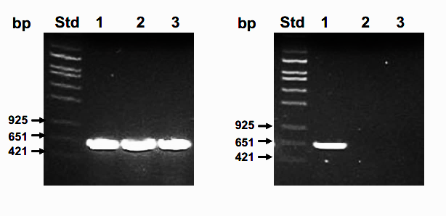
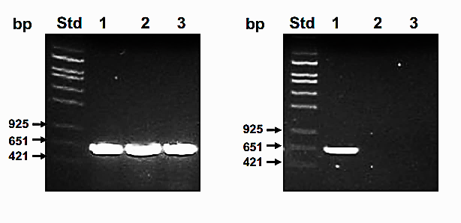
TAA

TAA

TAA

TAA
ATG

ATG

ATG

ATG
nip7;1-1

nip7;1-1

nip7;1-1

nip7;1-1
nip7;1-2

nip7;1-2

nip7;1-2

nip7;1-2
A.
B

nip7;1-1

nip7;1-2

NIP7;1
UBQ10

Figure 3.18. Isolation of T-DNA insertion mutants of NIP7;1. A. Gene structure of NIP7;1 showing the T-DNA insertion sites for nip7;1-1 and nip7;1-2 . Exons and introns are shown as black boxes and lines, respectively. B. Endpoint RT-PCR analysis of NIP7;1 expression. Total RNA was extracted from wild type, nip7;1-1, and nip7;1-2 inflorescences. The gene specific primers were used to detect NIP7;1 transcripts in nip7;1-1 and nip7;1-2 respectively, UBQ10 was used as an internal control.

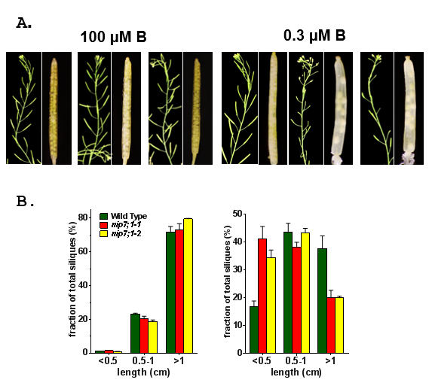
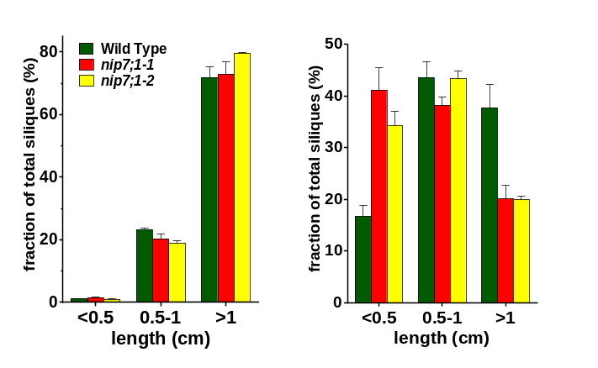
B.

*

*
*

*
*

*
*

*

Figure 3.19. Siliques of wild-type, nip7;1-1 and nip7;1-2 plants under low and high boric acid growth conditions. A. Siliques from six-week-old plants grown hydroponically in medium containing 100 μM and 0.3 μM boric acid. Short siliques with aborted seeds were identified only in nip7;1-1 and nip7;1-2 under reduced boric acid conditions. Bar = 1mm. The nip7;1-1 and nip7;1-2 siliques under low B conditions are magnified to illustrate the presence of aborted seeds (red arrowhead). B. Silique lengths were measured and the percentages of length ranging from less than 0.6 cm, between 0.6 to 1cm and longer than 1 cm were plotted side by side for 0.3 µM (Right panel) and 100 µM boric acid (Left panel) conditions. Silique length distributions from Wild-type (green bars), nip7;1-1 (red bars) and nip7;1-2 (yellow bars) plants under 100 μM (left panel) or 0.3 μM boric acid (right panel). The error bars show standard error of mean for three biological replicates with each replicate representing 200-500 siliques. Asterisks denote Student’s t-test significance compared with WT plants: *, p<0.01.

type and mutants plants under conditions of boron deficiency. While limiting B reduced the average length of wild type as well as mutant siliques (6 wk old) (Figure 3.18 B), nip7;1-1 and nip7;1-2 plants showed a much greater sensitivity to low B conditions with 40% of siliques showing stunted growth (less than 0.5 cm in length). In addition, nip7;1 siliques show evidence of seed abortion and reduced seed set (Figure 3.19 A), which was not observed in wild type siliques. Shortened siliques and abortion of seed development (Vivian-Smith, Luo et al. 2001) is a phenotype that is commonly observed in Arabidopsis male gametophyte mutations resulting in defective pollen and reduced fertility. Since GUS expression indicates NIP7;1 expression during early pollen development, the effects of low B on pollen morphology in wild type and mutant plants were investigated. Comparison of mature pollen in stage 12 flowers from mutant and wild type plants grown under sufficient boron conditions showed minor morphological differences (Figure 3.20 A). However under limiting conditions, mutant plants differed from wild type showing enlarged and misshapen pollen grains, as well as some collapsed pollen (Figure 3.20). Examination of the wall morphology of mature pollen isolated from wild type and mutant plants grown under the two B conditions was done by SEM (Figure 3.21). Under sufficient B conditions, there were no detectable difference between the wall pattern of wild type and nip7;1 mature pollen grains, with both showing the characteristic reticulate pattern (Scott, Spielman et al. 2004) of the external exine cell wall with well-defined lacuna apertures (Figure 3.21A). Under conditions of low B, wild type pollen showed normal morphology, but defects in the exine cell wall were detected in nip7;1 pollen grains (Figure 3.21B, 3.22). While elements of the reticulate pattern were observed on the pollen surface, mutant pollen showed evidence of a collapse and breaks in the exine structure (Figure 3.20B), as well as occlusions of the lacuna apertures on the reticulate surface (Figure 3.22). Aberrations in the developing exine wall were also apparent in TEM images of nip7;1 pollen microspores from stage 10 flowers, with poorly developed features of the outer exine (bacula and tecta) compared to wild type microspores (Figure 3.22). Taken together, these observations indicate that nip7;1 pollen form defective cell wall structures under limiting boron conditions, and support a role for this protein in boric acid transport during and cell wall development this developmental stage.

3.3 Investigation of the contribution of the NIP II Ar/R selectivity filter to substrate selectivity and aquaporin activity

3.3.1 Metalloids selectivity properties of NIP proteins

As discussed in the Introduction, Nodulin-26 like intrinsic proteins can be categorized into three subgroups based on their
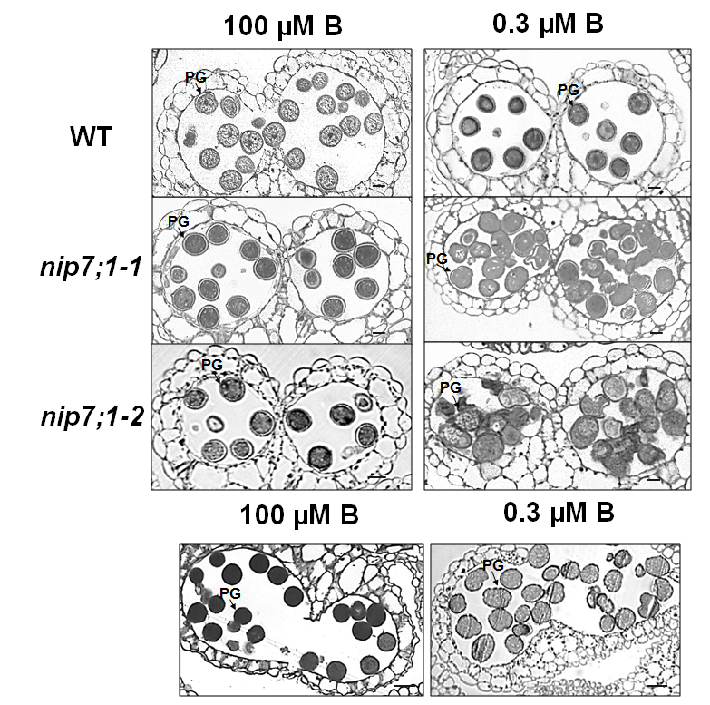
B.
A.
Figure 3.20. Cross-sections of anthers of wild-type, nip7;1-1 and nip7;1-2 plants under high (100 μM) and low boric acid conditions (0.3 μM). A. Representative microsporangia of anthers at floral stage 12 with mature pollen Bar =10µM. B. and C. Representative microsporangia of mutant anthers treated with different boric acid conditions at anther dehiscence. Bar= 20 µM. PG, pollen grains

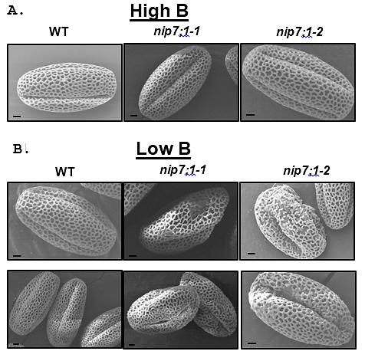
Figure 3.21. Ultrastructure of the pollen cell wall from wild-type, nip7;1-1 and nip7;1-2 plants under high and low boric acid conditions. Scanning electron microscope images of wild-type and nip7;1-1, nip7;1-2 pollen grains isolated from plants grown under A. high (100 μM) or B. low (0.3 μM) boric acid conditions. Bar= 2 µm.

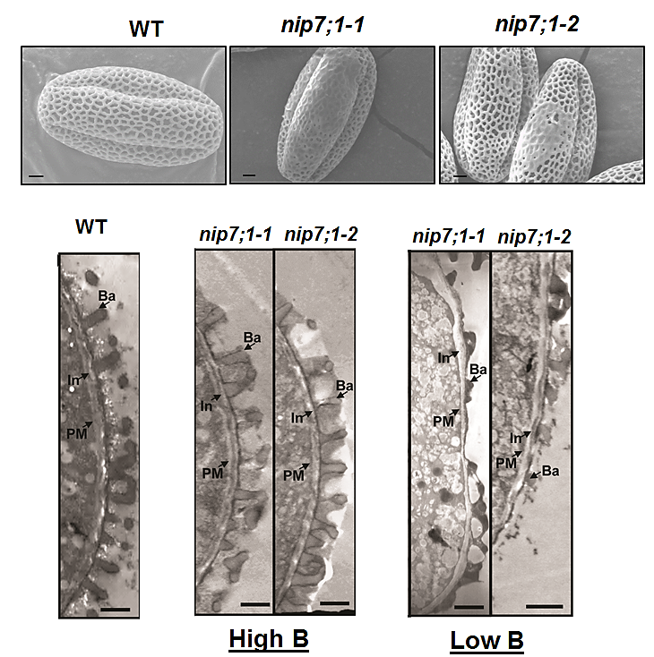
A.

B.

Figure 3.22. Ultrastructure of the pollen cell wall from wild-type, nip7;1-1 and nip7;1-2 plants under low boric acid conditions. A. Scanning electron microscope images of wild-type and nip7;1-1, nip7;1-2 pollen grains under low B. In addition to disruptions in the reticulate exine pattern, nip7;1 pollen grains show occlusions of the lacuna apertures in the reticulate exine. B. Transmission electron microscope images of nip7;1-1 and nip7;1-2 developing pollen microspores in late stage 10 flowers under high or low B conditions. For comparison, the ultrastructure of wild type pollen under low B conditions showing the elements of the exine cell wall is shown. Bar = 2 µm. Ba, bacula; PM, plasma membrane; In, intine.

to understand the interactions that allow for such substrate specificity. A major difference between NIP I and NIP II proteins is the presence of an alanine/glycine at the H2 (NIP II) selectivity filter (Ar/R tetrad). In order to investigate the substrate specificity among NIP proteins, various mutations of the amino acids at Helix 2 and Helix 5 of ar/R region were generated position compared to a tryptophan (NIP I). To determine the significance of this substitution, representative NIP I and NIP II proteins with or without site directed mutations in the Ar/R region were investigated.
Soybean Nodulin26 (the NIP I archetype) and Arabidopsis NIP4;1 were selected to represent NIP I subgroup, and NIP6;1 and NIP5;1 were used as NIP II representatives. Both Nodulin 26 and NIP4;1 were expressed as flag-tagged proteins in Xenopus oocytes, and permeability for water, boric acid and glycerol were determined. Similar to Nodulin 26, NIP4;1 is an aquaglyceroporin which possesses aquaporin activity as well as glycerol permeability (Figure 3.23). In contrast, both NIP proteins have low permeability for boric acid compared to the NIP II protein NIP5;1 or NIP6;1(Figure 3.24). In order to study the role of the H2 tryptophan in the Ar/R of NIP I proteins, site-directed mutagenesis was performed to mutate the corresponding tryptophan residues in Nodulin 26 and NIP4;1 to an alanine. Boric acid permeability assay of Nod26 W77A and NIP4;1 W82A showed that
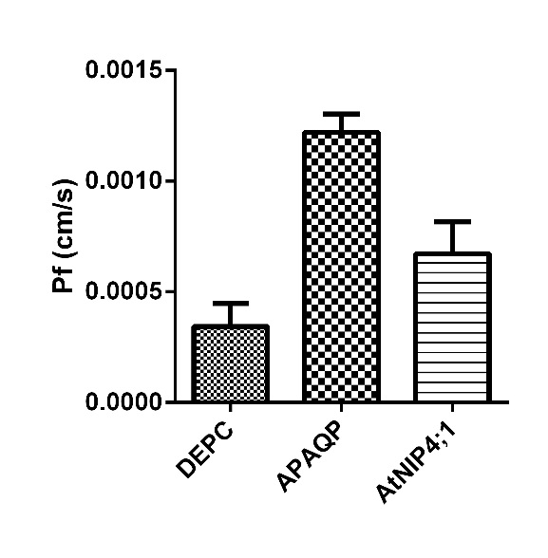
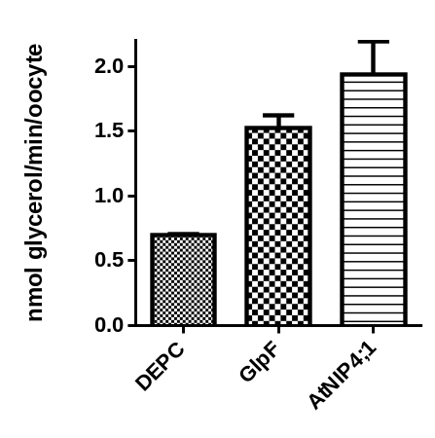
B.

B.

B.

B.
A.

Figure 3.23. Substrate transport activity of NIP4;1A.

Figure 3.23. Substrate transport activity of NIP4;1. Oocytes were injected with the indicated cRNAs or with sterile water (negative control). A. The osmotic water permeability assay of NIP4;1. The osmotic water permeability (P_{f}) was determined from the rate of oocyte swelling upon incubation in a hypoosmotic Ringer's solution. The error bars show the SEM (n = 8 oocytes). ApAQP was used as a positive control aquaporin cRNA B. The [³H]glycerol permeability of the indicated oocytes were determined. The error bars show the SEM (n = 4). C. Boric acid permeability of the indicated oocytes were determined. The error bars show the SEM (n = 8). D. Western blotting indicating equal expression of all proteins. Lane1, mock-injected; lane2, ApAQP; lane3, GlpF; lane4, NIP5;1; lane6, NIP4;1. The GlpF construct did not possess an N-terminal FLAG tag.

Figure 3.23. Substrate transport activity of NIP4;1A.

Figure 3.23. Substrate transport activity of NIP4;1A.

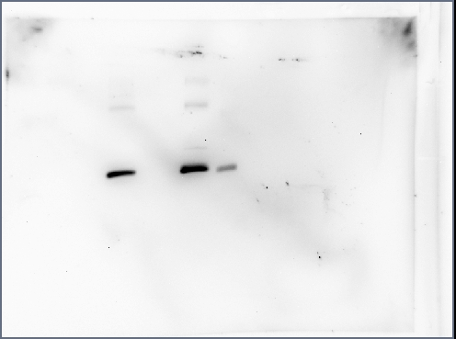
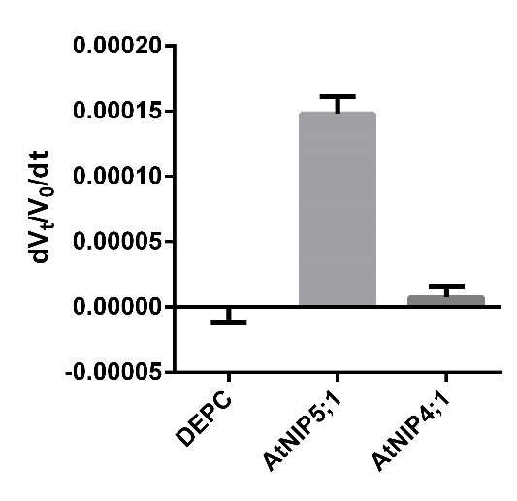
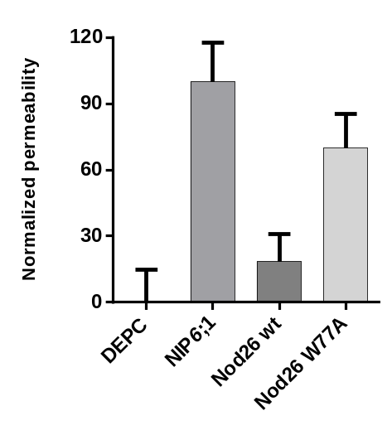
Figure 3.23. Substrate transport activity of NIP4;1. Oocytes were injected with the indicated cRNAs or with sterile water (negative control). A. The osmotic water permeability assay of NIP4;1. The osmotic water permeability (P_{f}) was determined from the rate of oocyte swelling upon incubation in a hypoosmotic Ringer's solution. The error bars show the SEM (n = 8 oocytes). ApAQP (Wallace, Shakesby et al. 2012)was used as a positive control aquaporin cRNA B. The [³H]glycerol permeability of the indicated oocytes were determined. The error bars show the SEM (n = 4). C. Boric acid permeability of the indicated oocytes were determined. The error bars show the SEM (n = 8). D. Western blotting of lysates (10 μg of protein/lane) with the anti-FLAG tag monoclonal antibody: lane1, mock-injected; lane2, ApAQP; lane3, GlpF; lane4, NIP5;1; lane5, NIP4;1. The GlpF construct did not possess an N-terminal FLAG tag.

D.

D.

D.

D.
C.

C.

C.

C.
MW
kD

MW
kD

MW
kD

MW
kD
1

1

1

1
2

2

2

2
3

3

3

3
4

4

4

4
5

5

5

5
25

25

25

25
70

70

70

70
B.

B.

B.

B.
A.

Figure 3.24. Boric acid transport activity of Nod26 W77A, NIP4;1 W82A.A.

Figure 3.24. Boric acid transport activity of Nod26 W77A, NIP4;1 W82A. A. Boric acid transport activity of NIP4;1 W82A. Oocytes were injected with the indicated cRNAs or with sterile water (negative control). NIP5;1 was used as a positive control The error bars show the SEM (n = 8). NIP4;1 W82A was used to define 100% for normalization. B. Boric acid transport activity of Nod26 W77A. NIP6;1 was used as a positive control. The error bars show the SEM (n = 8).NIP6;1 was used to define 100% for normalization.

Figure 3.24. Boric acid transport activity of Nod26 W77A, NIP4;1 W82A.A.

Figure 3.24. Boric acid transport activity of Nod26 W77A, NIP4;1 W82A.A.
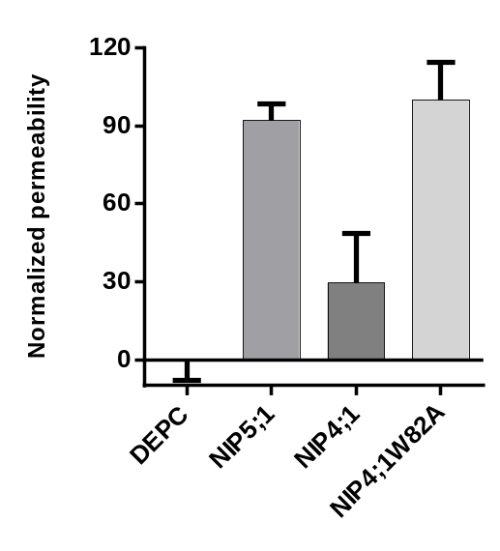

Figure 3.24. Boric acid transport activity of Nod26 W77A, NIP4;1 W82A. A. Boric acid transport activity of NIP4;1 W82A. Oocytes were injected with the indicated cRNAs or with sterile water (negative control). NIP5;1 was used as a positive control The error bars show the SEM (n = 8). NIP4;1 W82A was used to define 100% for normalization. B. Boric acid transport activity of Nod26 W77A. NIP6;1 was used as a positive control. The error bars show the SEM (n = 8).NIP6;1 was used to define 100% for normalization.

Figure 3.24. Boric acid transport activity of Nod26 W77A, NIP4;1 W82A. A. Boric acid transport activity of NIP4;1 W82A. Oocytes were injected with the indicated cRNAs or with sterile water (negative control). NIP5;1 was used as a positive control The error bars show the SEM (n = 8). NIP4;1 W82A was used to define 100% for normalization. B. Boric acid transport activity of Nod26 W77A. NIP6;1 was used as a positive control. The error bars show the SEM (n = 8).NIP6;1 was used to define 100% for normalization.

Figure 3.24. Boric acid transport activity of Nod26 W77A, NIP4;1 W82A. A. Boric acid transport activity of NIP4;1 W82A. Oocytes were injected with the indicated cRNAs or with sterile water (negative control). NIP5;1 was used as a positive control The error bars show the SEM (n = 8). NIP4;1 W82A was used to define 100% for normalization. B. Boric acid transport activity of Nod26 W77A. NIP6;1 was used as a positive control. The error bars show the SEM (n = 8).NIP6;1 was used to define 100% for normalization.

Figure 3.24. Boric acid transport activity of Nod26 W77A, NIP4;1 W82A. A. Boric acid transport activity of NIP4;1 W82A. Oocytes were injected with the indicated cRNAs or with sterile water (negative control). NIP5;1 was used as a positive control The error bars show the SEM (n = 8). NIP4;1 W82A was used to define 100% for normalization. B. Boric acid transport activity of Nod26 W77A. NIP6;1 was used as a positive control. The error bars show the SEM (n = 8).NIP6;1 was used to define 100% for normalization.

both mutants have more than 5 fold higher boric acid permeability than the corresponding wild type proteins. Based on these results, it was concluded that
the Ar/R residue at the H2 position plays an important role in boric acid selectivity.
Compared to NIP II and NIP I proteins, NIP III possesses an additional substitution at the helix 5 position of the Ar/R, presumably to accommodate the bulkier and more hydroxylated Si(OH)₄ substrate(Mitani-Ueno, Yamaji et al. 2011). In order to test this hypothesis, a double mutant of Nod26 was generated with Trp77 mutated to an Ala at helix 2 and Val197 mutated to a Ser at helix 5 and the permeability to germanic acid(Ge[OH]₄), a structural analog of silicic acid, was determined. Compared to wild type Nod26, Nod26W77GV197S showed robust germanic acid transport activity (Figure 3.25). Interestingly, single mutation either at Trp77 or Val197 did not result in acquisition of permeability to germanic acid. From these results it is clear that not only the H5 amino acid but also the H2 amino acid of NIP ar/R selectivity filter contribute to silicic acid selectivity and provides a structural basis for the disparate permeability of the NIP Ar/R subclasses.

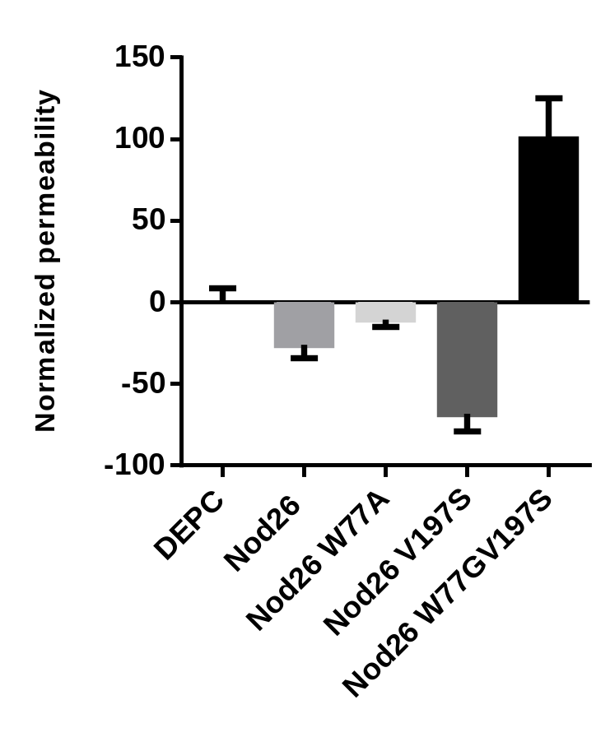

Figure 3.25. Germanic acid transport activity of Nod26 and Nod26W77GV197S. Oocytes were injected with the indicated cRNAs or with sterile water (negative control). DEPC-treated water injected oocytes were used as a negative control. The error bars show the SEM (n = 8).

Figure 3.25. Germanic acid transport activity of Nod26 and Nod26W77GV197S. Oocytes were injected with the indicated cRNAs or with sterile water (negative control). DEPC-treated water injected oocytes were used as a negative control. The error bars show the SEM (n = 8).

Figure 3.25. Germanic acid transport activity of Nod26 and Nod26W77GV197S. Oocytes were injected with the indicated cRNAs or with sterile water (negative control). DEPC-treated water injected oocytes were used as a negative control. The error bars show the SEM (n = 8).

Figure 3.25. Germanic acid transport activity of Nod26 and Nod26W77GV197S. Oocytes were injected with the indicated cRNAs or with sterile water (negative control). DEPC-treated water injected oocytes were used as a negative control. The error bars show the SEM (n = 8).

3.3.2 Structural basis for the loss of aquaporin activity in NIP II proteins

As shown earlier, NIP7;1 shows poor to no detectable water permeability with NIP7;1 ooctyes showing permeability coefficients comparable to the simple diffusion of water through the membrane bilayers(Figure 3.7). This “water tight” characteristic is shared by other NIP II subgroup proteins, NIP5;1 and NIP6;1(Takano, Wada et al. 2006, Tanaka, Wallace et al. 2008). The observation is counter intuitive, since the pore diameter of these proteins is more than adequate to accommodate the movement of a column water (Wallace and Roberts 2005). What is the reason for the water-tight character of NIP II pores which still retain the ability to flux glycerol and metalloids? To address this question, computational approaches were used. A tetrameric homology model of NIP7;1 was generated and inserted into a POPC membrane bilayer. The equilibrated system (Figure 3.26) was then subjected to steered molecular dynamic simulations and umbrella sampling to investigate the dynamics of water movement through the pore. The AQP5 protein system was generously provided by Dr. Emad Tajkhorshid (University of Illinois at Urbana-Champaign) as a simulation control.
Constant velocity SMD (cv-SMD) simulations were performed to compare water permeation events through AQP5 and NIP7;1. The
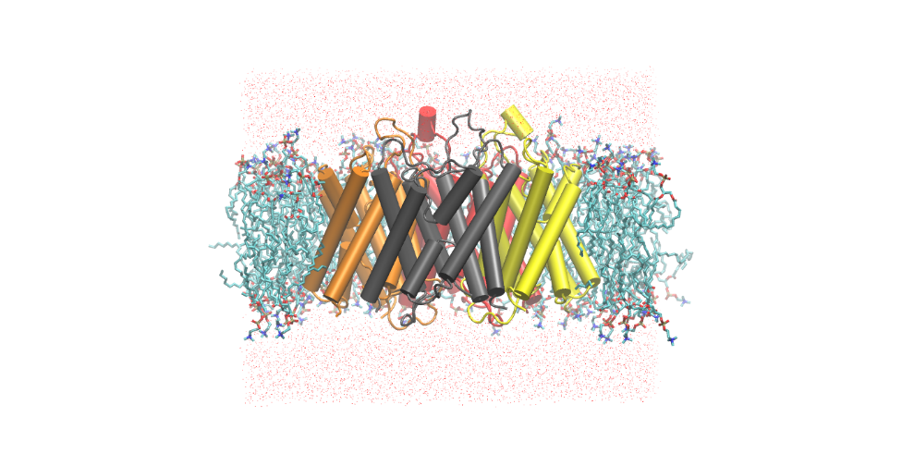
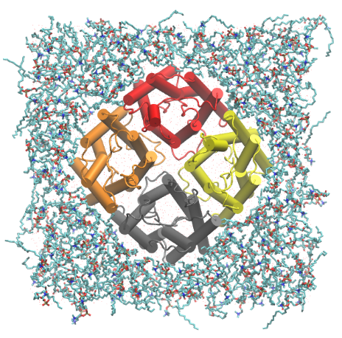
periplasm

periplasm

periplasm

periplasm
cytoplasm

cytoplasm

cytoplasm

cytoplasm
B.

B.

B.

B.
A.

A.

A.

A.

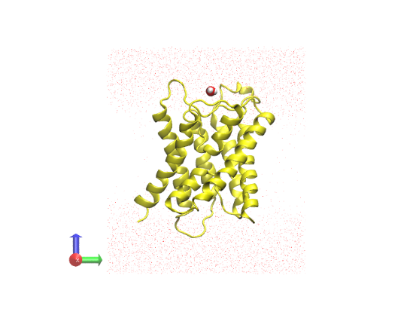
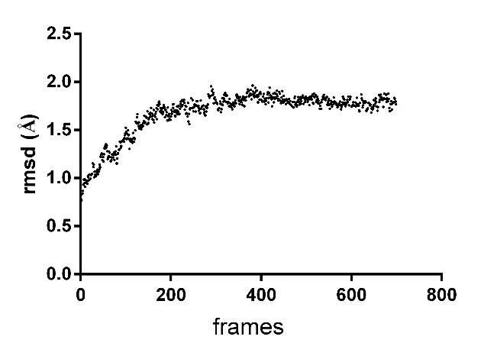
(z)

(z)

(z)

(z)
D.

D.

D.

D.
C.

Figure 3.26. NIP7;1 tetramer embedded in a hydrated POPC membrane.C.

Figure 3.26. NIP7;1 tetramer embedded in a hydrated POPC membrane. A. Side view and B. top view from the periplasmic side. NIP7;1 monomers are shown in individually colored cartoon representations. The lipid head groups are shown in red and blue, and the fatty acid tails are shown in cyan. Some of the lipid molecules are omitted in A to provide a better view of the protein. Water molecules appear as red points. C. RMSD of protein backbone atoms versus simulation time (in frames) of the equilibrated system. D. One water molecule (vdW representation) is positioned above the periplasmic side vestibule above one monomer and is pulled along the z-axis (from periplasm to cytoplasm) during the SMD simulations.

Figure 3.27. Representation snapshots of cv-SMD simulation of NIP7;1,Figure 3.26. NIP7;1 tetramer embedded in a hydrated POPC membrane.C.

Figure 3.26. NIP7;1 tetramer embedded in a hydrated POPC membrane.C.

Figure 3.26. NIP7;1 tetramer embedded in a hydrated POPC membrane. A. Side view and B. top view of NIP7;1 tetrameric homology model in a POPC bilayer. NIP7;1 monomers are shown in individually colored cartoon representations. The lipid head groups are shown in red and blue, and the fatty acid tails are shown in cyan. Some of the lipid molecules are omitted in A to provide a better view of the protein. Water molecules appear as red points. C. RMSD of protein backbone atoms versus simulation time (in frames) of the equilibrated system. D. One water molecule (vdW representation) is positioned above the periplasmic side vestibule above one monomer and is pulled along the z-axis (from periplasm to cytoplasm) during the SMD simulations.

Figure 3.27. Representation snapshots of cv-SMD simulation of NIP7;1,Figure 3.26. NIP7;1 tetramer embedded in a hydrated POPC membrane. A. Side view and B. top view from the periplasmic side. NIP7;1 monomers are shown in individually colored cartoon representations. The lipid head groups are shown in red and blue, and the fatty acid tails are shown in cyan. Some of the lipid molecules are omitted in A to provide a better view of the protein. Water molecules appear as red points. C. RMSD of protein backbone atoms versus simulation time (in frames) of the equilibrated system. D. One water molecule (vdW representation) is positioned above the periplasmic side vestibule above one monomer and is pulled along the z-axis (from periplasm to cytoplasm) during the SMD simulations.

Figure 3.27. Representation snapshots of cv-SMD simulation of NIP7;1, showing a monomer with water permeating from the periplasmic vestibule to the cytoplasmic vestibule. The protein is shown as NewCartoon in transparent yellow, the water molecule is shown as vdw sphere and the selectivity filter Arg220 is shown as a ball and stick in the “DOWN” state. The dotted arrow shows the pathway of water permeation through the channel.

Figure 3.28. Representation snapshots of cv-SMD simulation of AQP5Figure 3.27. Representation snapshots of cv-SMD simulation of NIP7;1,Figure 3.26. NIP7;1 tetramer embedded in a hydrated POPC membrane. A. Side view and B. top view from the periplasmic side. NIP7;1 monomers are shown in individually colored cartoon representations. The lipid head groups are shown in red and blue, and the fatty acid tails are shown in cyan. Some of the lipid molecules are omitted in A to provide a better view of the protein. Water molecules appear as red points. C. RMSD of protein backbone atoms versus simulation time (in frames) of the equilibrated system. D. One water molecule (vdW representation) is positioned above the periplasmic side vestibule above one monomer and is pulled along the z-axis (from periplasm to cytoplasm) during the SMD simulations.

Figure 3.27. Representation snapshots of cv-SMD simulation of NIP7;1,Figure 3.26. NIP7;1 tetramer embedded in a hydrated POPC membrane. A. Side view and B. top view from the periplasmic side. NIP7;1 monomers are shown in individually colored cartoon representations. The lipid head groups are shown in red and blue, and the fatty acid tails are shown in cyan. Some of the lipid molecules are omitted in A to provide a better view of the protein. Water molecules appear as red points. C. RMSD of protein backbone atoms versus simulation time (in frames) of the equilibrated system. D. One water molecule (vdW representation) is positioned above the periplasmic side vestibule above one monomer and is pulled along the z-axis (from periplasm to cytoplasm) during the SMD simulations.

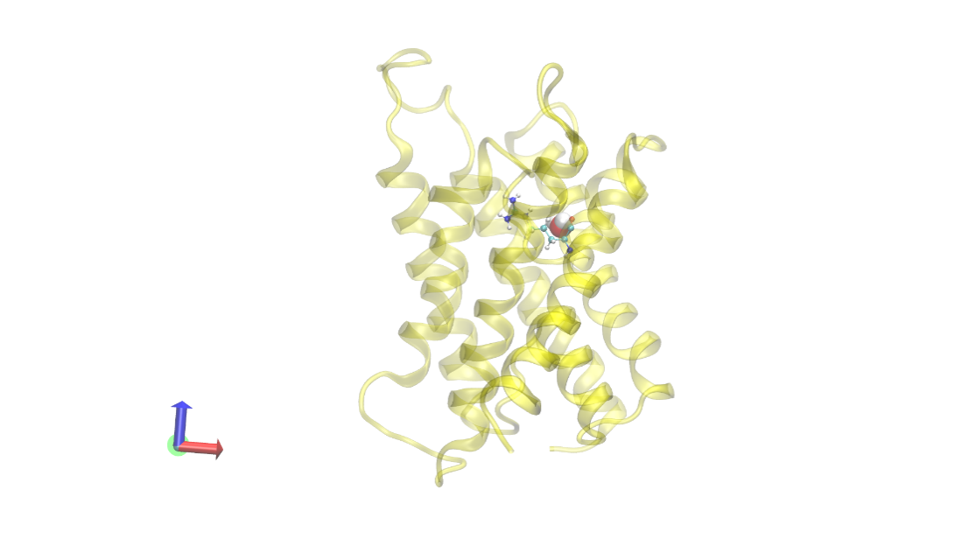
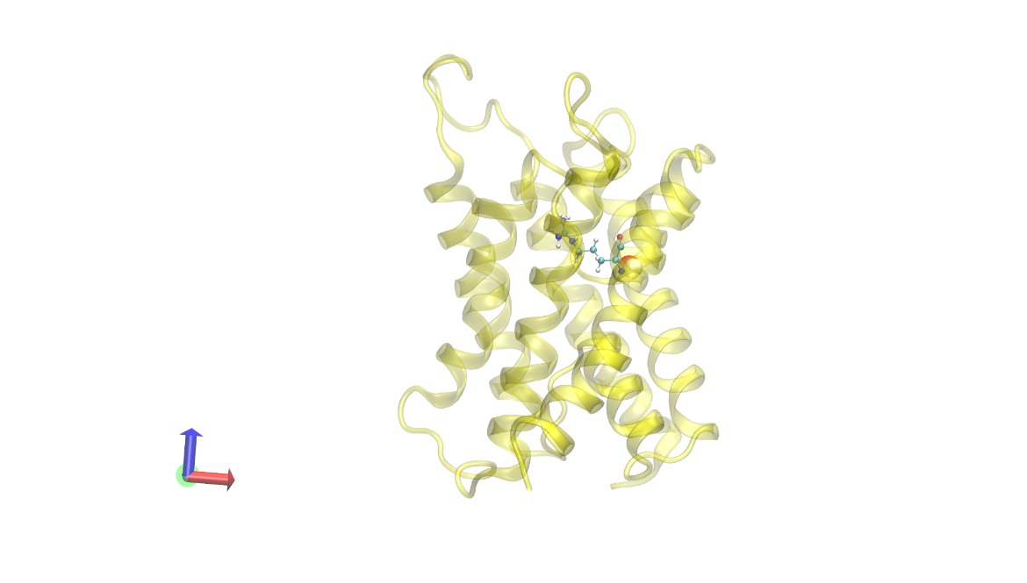
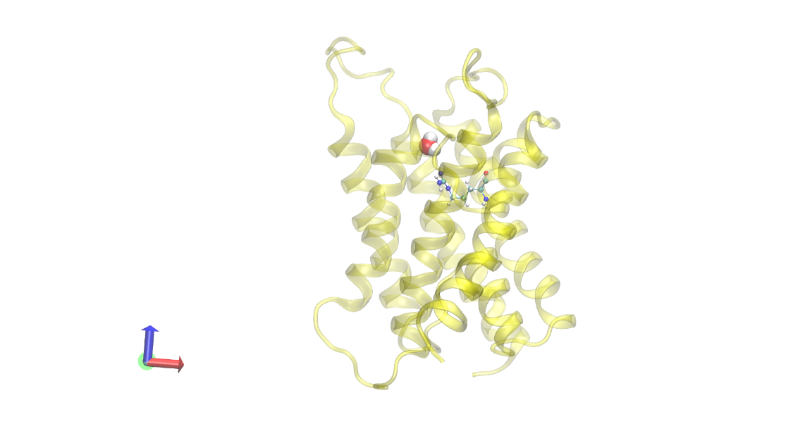
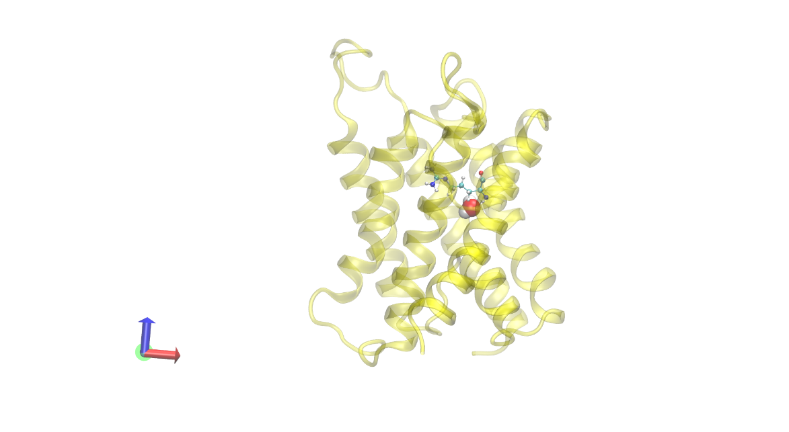
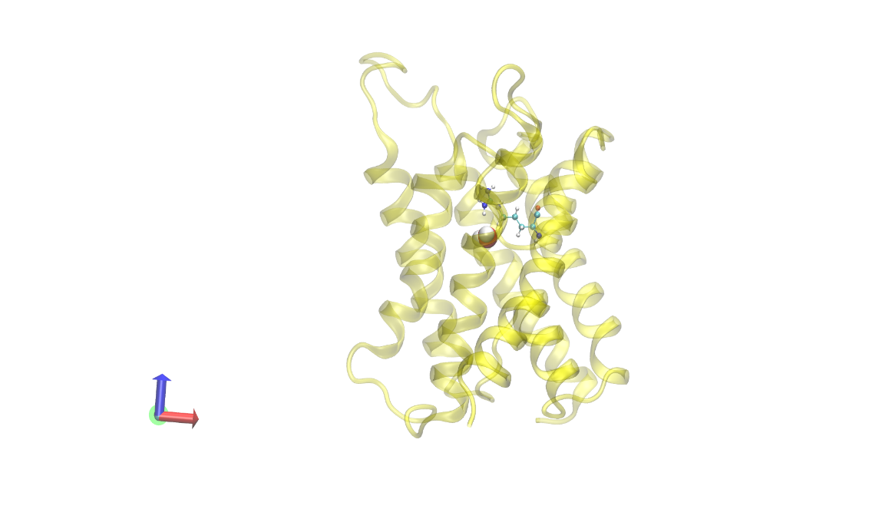
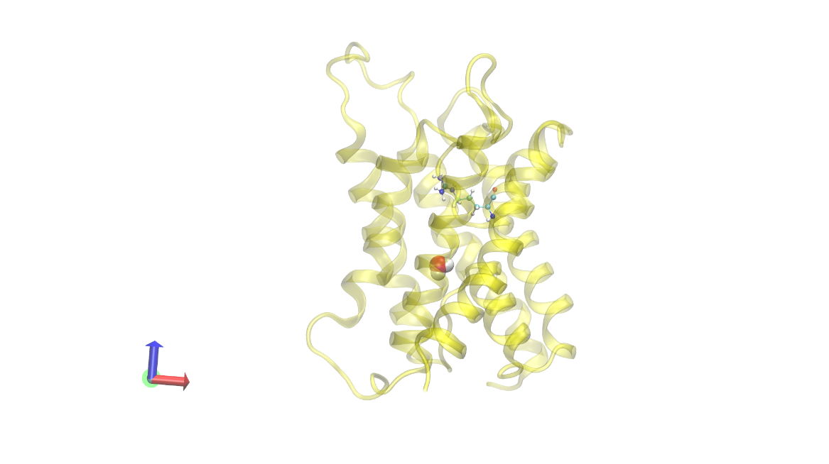

Figure 3.27. Representation snapshots of cv-SMD simulation of NIP7;1. Snapshots show a monomer with water permeating from the periplasmic vestibule to the cytoplasmic vestibule. The protein is shown in ribbon representation in transparent yellow, the water molecule is shown as van der Waals sphere and the selectivity filter Arg220 is shown as a ball and stick in the “down” state. The dotted arrow shows the pathway of water permeation through the channel.

Figure 3.28. Representation snapshots of cv-SMD simulation of AQP5Figure 3.27. Representation snapshots of cv-SMD simulation of NIP7;1, showing a monomer with water permeating from the periplasmic vestibule to the cytoplasmic vestibule. The protein is shown as NewCartoon in transparent yellow, the water molecule is shown as vdw sphere and the selectivity filter Arg220 is shown as a ball and stick in the “DOWN” state. The dotted arrow shows the pathway of water permeation through the channel.

Figure 3.28. Representation snapshots of cv-SMD simulation of AQP5, showing a monomer with water permeating from the periplasmic vestibule to the cytoplasmic vestibule. The protein is shown as NewCartoon in transparent blue, the water molecule is shown as vdw sphere and the selectivity filter Arg188 is shown as stick in the “UP” state. The dotted arrow shows the pathway of water permeation through the channel.

Figure 3.28. Representation snapshots of cv-SMD simulation of AQP5Figure 3.27. Representation snapshots of cv-SMD simulation of NIP7;1, showing a monomer with water permeating from the periplasmic vestibule to the cytoplasmic vestibule. The protein is shown as NewCartoon in transparent yellow, the water molecule is shown as vdw sphere and the selectivity filter Arg220 is shown as a ball and stick in the “DOWN” state. The dotted arrow shows the pathway of water permeation through the channel.

Figure 3.28. Representation snapshots of cv-SMD simulation of AQP5Figure 3.27. Representation snapshots of cv-SMD simulation of NIP7;1, showing a monomer with water permeating from the periplasmic vestibule to the cytoplasmic vestibule. The protein is shown as NewCartoon in transparent yellow, the water molecule is shown as vdw sphere and the selectivity filter Arg220 is shown as a ball and stick in the “DOWN” state. The dotted arrow shows the pathway of water permeation through the channel.

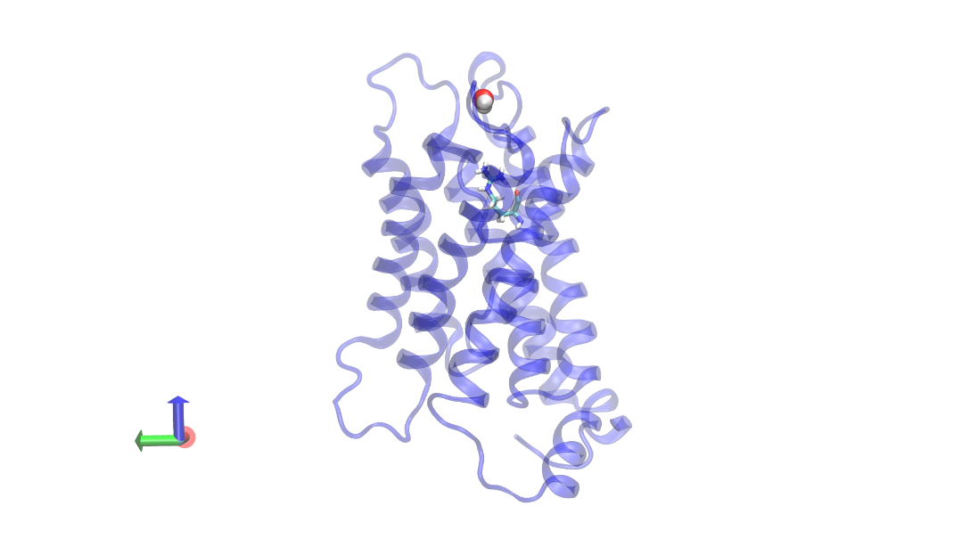
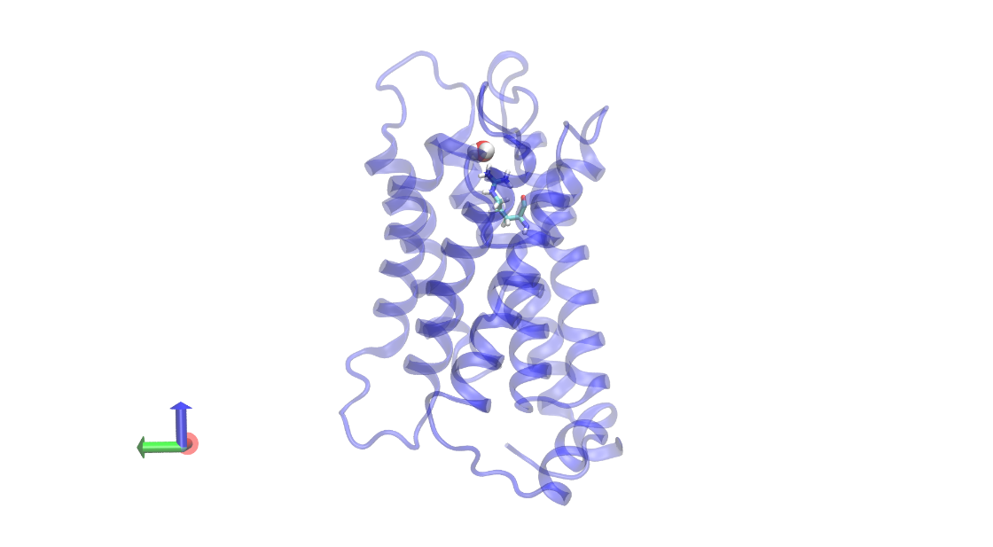
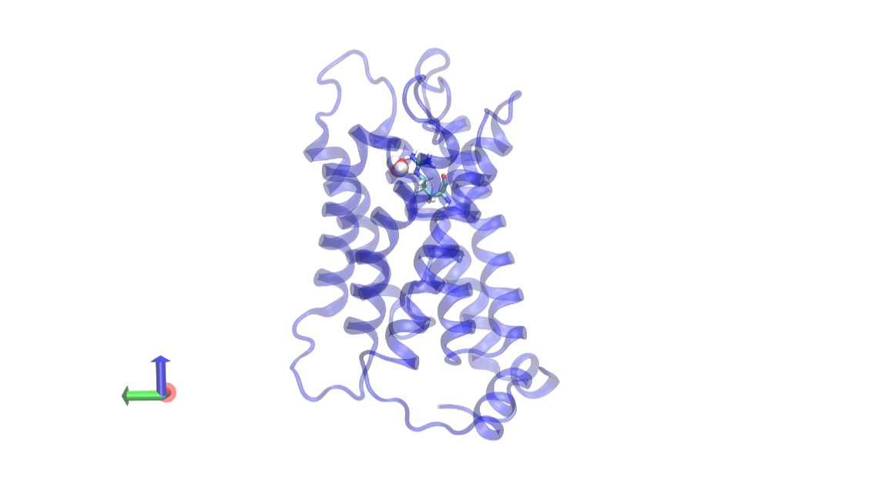
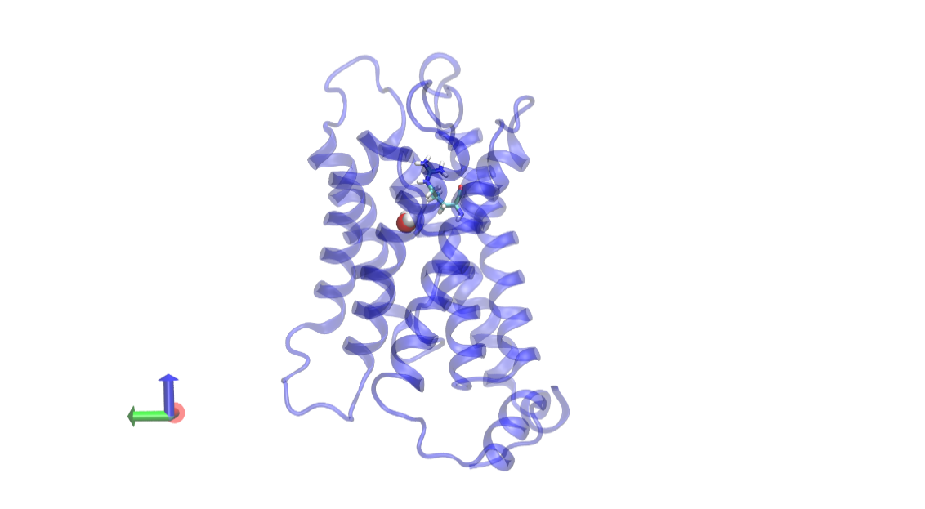
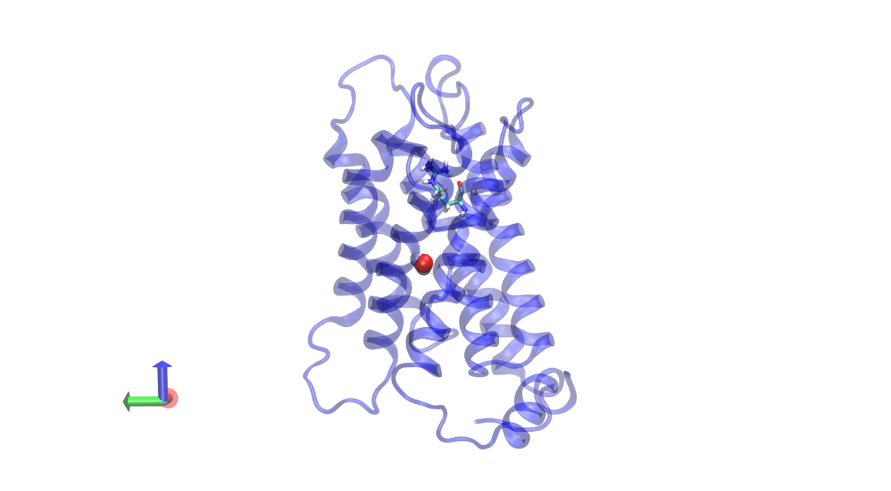
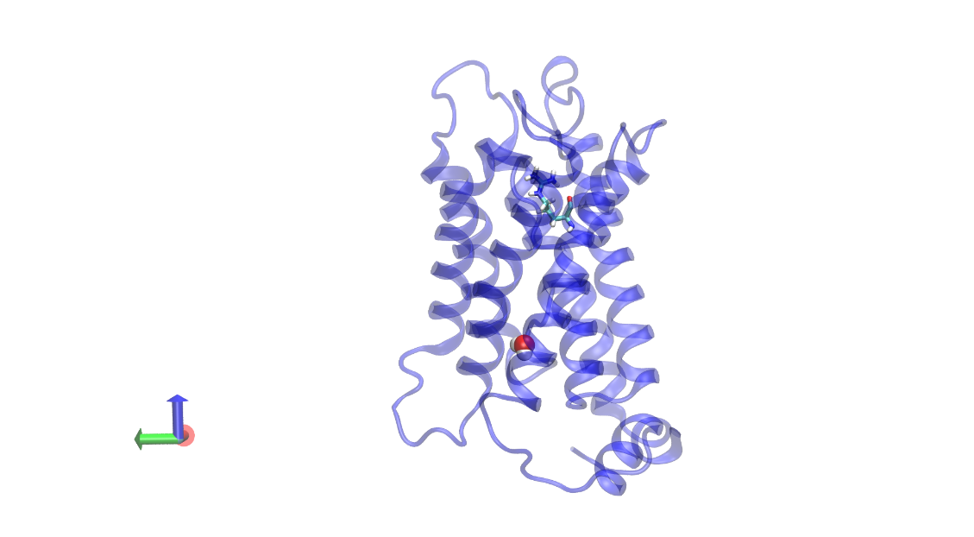

Figure 3.28. Representation snapshots of cv-SMD simulation of AQP5. Snapshots show a monomer with water permeating from the periplasmic vestibule to the cytoplasmic vestibule. The protein is shown in ribbon representation in transparent blue, the water molecule is shown as van der Waals sphere and the selectivity filter Arg188 is shown as stick in the “up” state. The dotted arrow shows the pathway of water permeation through the channel.

Figure 3.28. Representation snapshots of cv-SMD simulation of AQP5, showing a monomer with water permeating from the periplasmic vestibule to the cytoplasmic vestibule. The protein is shown as NewCartoon in transparent blue, the water molecule is shown as vdw sphere and the selectivity filter Arg188 is shown as stick in the “UP” state. The dotted arrow shows the pathway of water permeation through the channel.

Figure 3.28. Representation snapshots of cv-SMD simulation of AQP5, showing a monomer with water permeating from the periplasmic vestibule to the cytoplasmic vestibule. The protein is shown as NewCartoon in transparent blue, the water molecule is shown as vdw sphere and the selectivity filter Arg188 is shown as stick in the “UP” state. The dotted arrow shows the pathway of water permeation through the channel.

Figure 3.28. Representation snapshots of cv-SMD simulation of AQP5, showing a monomer with water permeating from the periplasmic vestibule to the cytoplasmic vestibule. The protein is shown as NewCartoon in transparent blue, the water molecule is shown as vdw sphere and the selectivity filter Arg188 is shown as stick in the “UP” state. The dotted arrow shows the pathway of water permeation through the channel.

typical transport event of water in cv-SMD simulations is illustrated through snapshots shown in figure 3.27 and figure 3.28. Interestingly a single file composed of water molecules was maintained throughout the permeation event during AQP5 SMD simulation but not in NIP7;1. Further structural examinations on the selectivity filter residues revealed distinct structural differences between the Ar/R arginine side chain in NIP7;1 and control AQP5. During the simulation, the side chain of the ar/R tetrad arginine (Arg220 in NIP7;1) was maintained in a “down” state compared to Arg188 in AQP5 which existed in an “up” state. The average value of the dihedral C_{β}-C_{ϒ}-C_{δ}-N_{ε} in the “up” state was -94.4° during AQP5 simulation. In contrast, the “down” state was characterized by an average dihedral value of -151° for NIP7;1 (Figure 3.29). A continuous single file of water molecules freely permeated through the AQP channel. In contrast, the Arg220 in the “down” state in NIP7;1 resulted in a channel that is occluded by its side chain. Thus, instead of freely permeating through the Ar/R selectivity filter, water molecules came into contact with the Arg220 backbone oxygen atom and are blocked. The blocking leads to further dehydration of the constriction region and random distribution of water molecules.
The potential of the Mean Force (PMF) of water permeation through the monomeric pore were calculated from umbrella sampling.

A.

A.

A.

A.
B.

B.

B.

B.

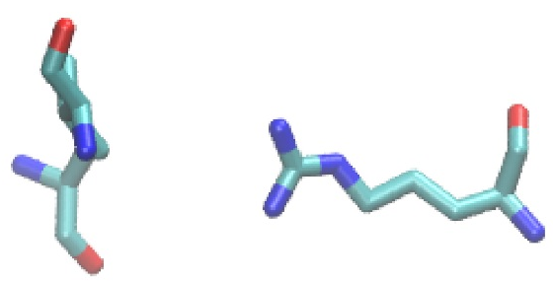
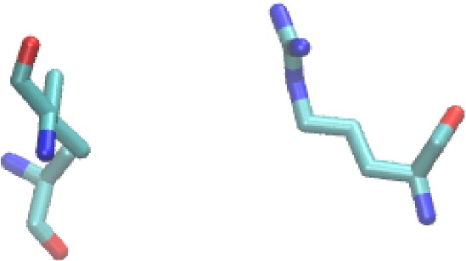

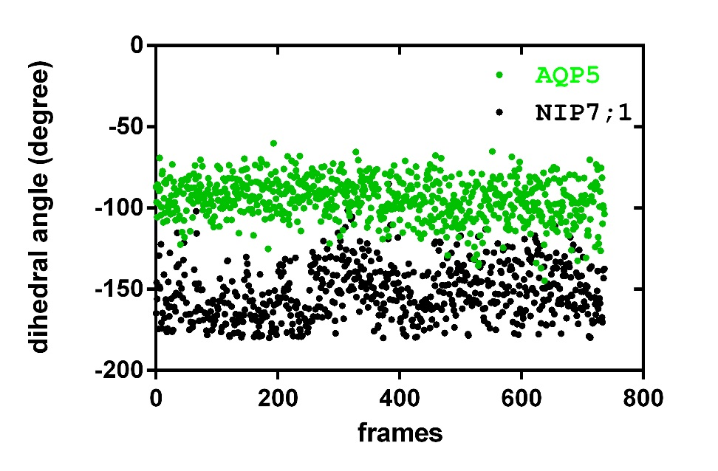
5

5

5

5
10

10

10

10
15

15

15

15
20

20

20

20
C.

Figure 3.29. Two states of the side chain of ArginineC.

Figure 3.29. Two states of the side chain of Arginine. A. Arg220 in the “DOWN” state of NIP7;1. B Arg188 in the “UP” state of AQP5. Selectivity filter residues Ala85 and Val205 are shown in A and B. C. Dihedral angle C_{β} — C_{ϒ} — C_{δ} — N_{ε} of Arginine in the 20ns SMD simulation. The average dihedral angle is -151° in A, and -94.4° in B.

Figure 3.30. PMF calculationFigure 3.29. Two states of the side chain of ArginineC.

Figure 3.29. Two states of the side chain of ArginineC.

Figure 3.29. Two states of the side chain of arginine. A. Arg220 in the “down” state of NIP7;1. B Arg188 in the “up” state of AQP5. Selectivity filter residues Ala85 and Val205 are shown in A and B. C. Dihedral angle C_{β} — C_{ϒ} — C_{δ} — N_{ε} plot of arginine in the 20ns SMD simulation. The average dihedral angle is -151° in A, and -94.4° in B.

Figure 3.30. PMF calculationFigure 3.29. Two states of the side chain of Arginine. A. Arg220 in the “DOWN” state of NIP7;1. B Arg188 in the “UP” state of AQP5. Selectivity filter residues Ala85 and Val205 are shown in A and B. C. Dihedral angle C_{β} — C_{ϒ} — C_{δ} — N_{ε} of Arginine in the 20ns SMD simulation. The average dihedral angle is -151° in A, and -94.4° in B.

Figure 3.30. PMF calculation. Free energy profile (Potential of mean force PMF) of water permeation through NIP7;1(green) and AQP5(red) calculated using umbrella sampling. In all PMFs, z=0 is set to the center-of-mass of the monomer applied sampling.

Figure 3.30. PMF calculationFigure 3.29. Two states of the side chain of Arginine. A. Arg220 in the “DOWN” state of NIP7;1. B Arg188 in the “UP” state of AQP5. Selectivity filter residues Ala85 and Val205 are shown in A and B. C. Dihedral angle C_{β} — C_{ϒ} — C_{δ} — N_{ε} of Arginine in the 20ns SMD simulation. The average dihedral angle is -151° in A, and -94.4° in B.

Figure 3.30. PMF calculationFigure 3.29. Two states of the side chain of Arginine. A. Arg220 in the “DOWN” state of NIP7;1. B Arg188 in the “UP” state of AQP5. Selectivity filter residues Ala85 and Val205 are shown in A and B. C. Dihedral angle C_{β} — C_{ϒ} — C_{δ} — N_{ε} of Arginine in the 20ns SMD simulation. The average dihedral angle is -151° in A, and -94.4° in B.

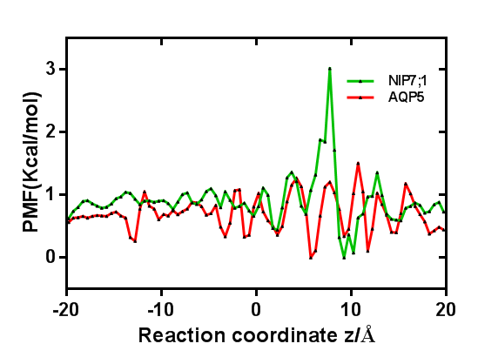
Figure 3.30. PMF calculation of water permeation through channel. Free energy profile (Potential of mean force PMF) of water permeation through NIP7;1(green) and AQP5(red) calculated using umbrella sampling. In all PMFs, z=0 is set to the center of the protein monomer channel.

Figure 3.30. PMF calculation. Free energy profile (Potential of mean force PMF) of water permeation through NIP7;1(green) and AQP5(red) calculated using umbrella sampling. In all PMFs, z=0 is set to the center-of-mass of the monomer applied sampling.

Figure 3.30. PMF calculation. Free energy profile (Potential of mean force PMF) of water permeation through NIP7;1(green) and AQP5(red) calculated using umbrella sampling. In all PMFs, z=0 is set to the center-of-mass of the monomer applied sampling.

Figure 3.30. PMF calculation. Free energy profile (Potential of mean force PMF) of water permeation through NIP7;1(green) and AQP5(red) calculated using umbrella sampling. In all PMFs, z=0 is set to the center-of-mass of the monomer applied sampling.

The calculation revealed the existence of a 3.0 kcal/mol energy barrier for NIP7;1 at about 7-10 Å along reaction coordinate, whereas, a much lower energy barrier (up to 1 kcal/mol) was calculated for AQP5 (Figure 3.30). These results suggest that the energy barrier for water permeation through the NIP7;1 monomeric pore is higher than that observed for an aquaporin water pore.
As discussed above, NIP I proteins possess a tryptophan instead of a smaller alanine at the helix 2 position that is present in NIP II. NIP I proteins have a higher water permeability compared to NIP II proteins. In order to investigate the role of H2 residues in water permeability, site-directly mutagenesis was performed to mutate the Ar/R selectivity filter residues from Nod26 (NIP I) and NIP6;1(NIP II). Trp77 from Nod26 was mutated into Ala which mimics a NIP II subgroup residue, while Ala119 from NIP6;1 was substituted by a Trp as in NIP I subgroup protein. Water permeability assays were carried out and the results indicates that Trp to Ala mutation in NIP I reduced water permeability about 6 fold whereas the Ala to Trp mutation in NIP II results in the conversion of NIP 6;1 to an aquaporin similar to nodulin 26.(Figure 3.31). This indicates that the H2 position in pivotal in controlling water permeability.

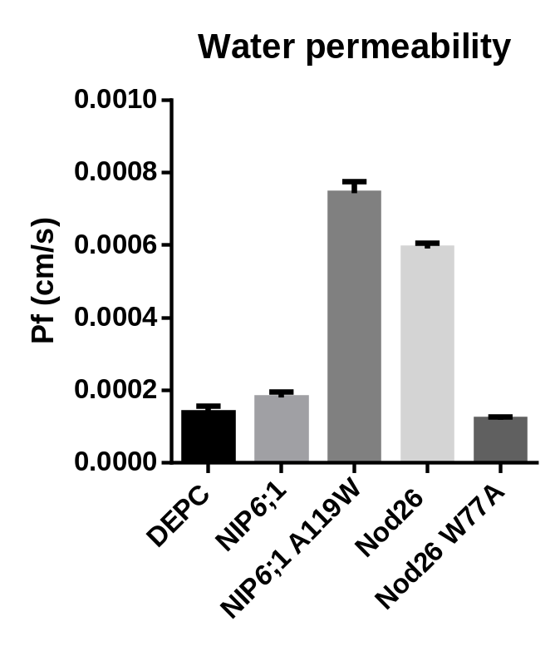

Figure 3.31. Water permeability comparison in NIP I and NIP II proteins. Relative water transport rate of NIP6;1 (NIP II) and NIP6;1A119W, Nod26 and Nod26 W77A. Sterile water-injected ooctye was used as negative control. The error bars show the SEM (n = 8)

Figure 3.31. Water permeability comparison in NIP I and NIP II proteins. Relative water transport rate of NIP6;1 (NIP II) and NIP6;1A119W, Nod26 and Nod26 W77A. DEPC was used as positive control. The error bars show the SEM (n = 8)

Figure 3.31. Water permeability comparison in NIP I and NIP II proteins. Relative water transport rate of NIP6;1 (NIP II) and NIP6;1A119W, Nod26 and Nod26 W77A. DEPC was used as positive control. The error bars show the SEM (n = 8)

Figure 3.31. Water permeability comparison in NIP I and NIP II proteins. Relative water transport rate of NIP6;1 (NIP II) and NIP6;1A119W, Nod26 and Nod26 W77A. DEPC was used as positive control. The error bars show the SEM (n = 8)

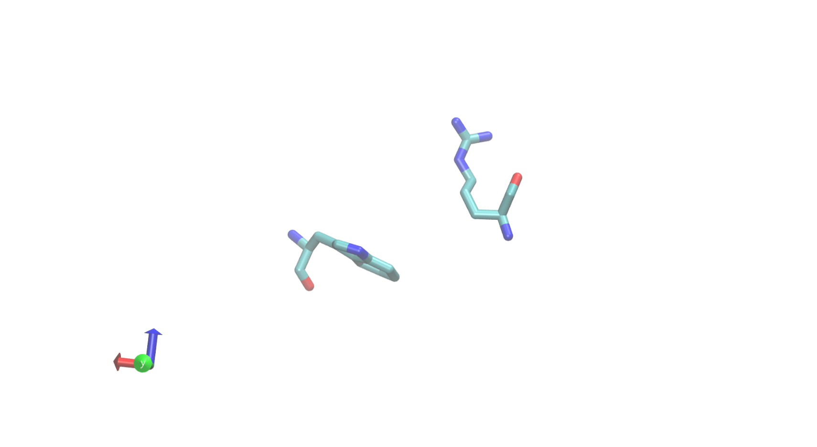
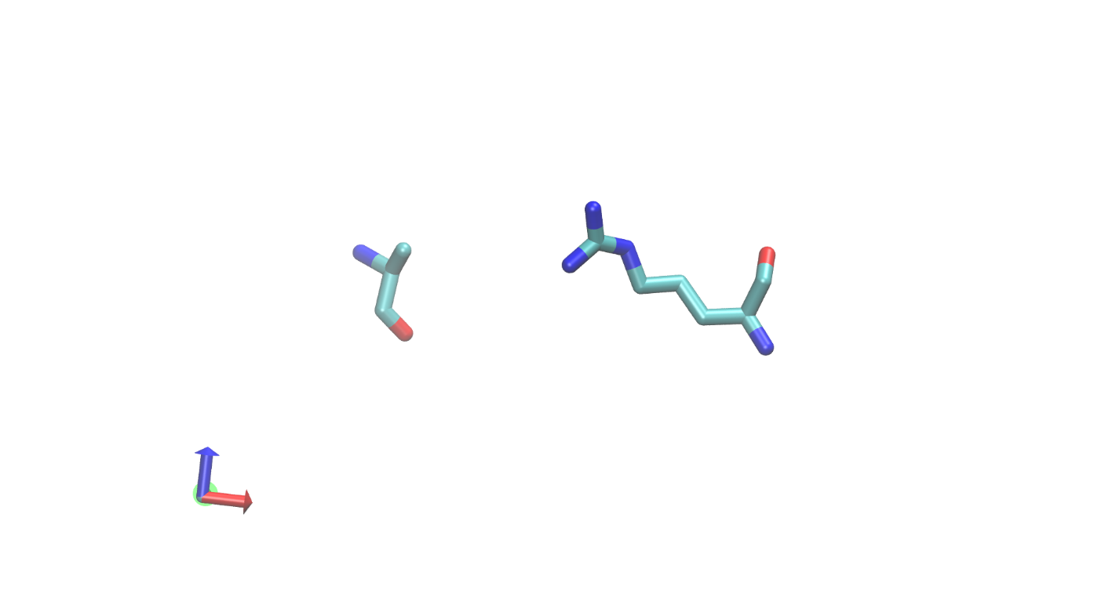
Arg220
Ala85

Trp85
Arg220

A.

A.

A.

A.

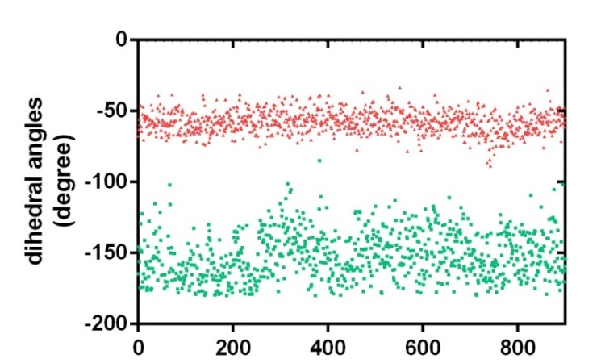
B.

B.

B.

B.
C.

Figure 3.32. Two states of the side chain of ArginineC.

Figure 3.32. Two states of the side chain of Arginine. A. Free energy profile (Potential of mean force PMF) of water permeation through NIP7;1(red), NIP7;1A85W(green) calculated using WHAM. B. Arg220 in the “UP” state of NIP7;1 A85W. Arg220 in the “DOWN” state of NIP7;1. Trp85 and Ala85 are indicated. C. Dihedral angle C_{β} — C_{ϒ} — C_{δ} — N_{ε} of Arginine in the 20ns SMD simulation. The average dihedral angle is -57.6° in NIP7;1A85W (red) and -151° in NIP7;1(green). D. Dihedral angles C_{α} - C_{β} - C_{γ} - C_{δ} of Arginine in the 20ns SMD simulation. The average dihedral angle is 171° in NIP 7;1(green) and 61° in NIP7;1 A85W (red).

Figure 4.1. NIP7;1 expression in response to different boric acid concentrations treatment by Q-PCR analysis.Figure 3.32. Two states of the side chain of ArginineC.

Figure 3.32. Two states of the side chain of ArginineC.
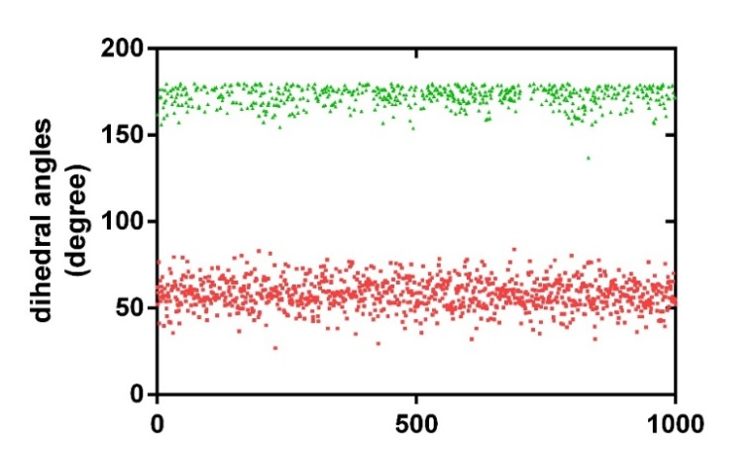

Figure 3.32. Two states of the side chain of arginine. A. Arg220 in the “up” state of NIP7;1 A85W. Arg220 in the “down” state of NIP7;1. Trp85 and Ala85 are indicated. B. Dihedral angle C_{β} — C_{ϒ} — C_{δ} — N_{ε} of Arginine in the 20ns SMD simulation. The average dihedral angle is -57.6° in NIP7;1A85W (red) and -151° in NIP7;1(green). C. Dihedral angles C_{α} - C_{β} - C_{γ} - C_{δ} of Arginine in the 20ns SMD simulation. The average dihedral angle is 171° in NIP 7;1(green) and 61° in NIP7;1 A85W (red).

In silico site directed mutagenesis was performed to mutate Ala85 to Trp residue, and SMD was performed as described above. Trp85 decreases the energy almost to 0 kcal/mol at the ar/R position. Dihedral angles C_{α} - C_{β} - C_{γ} - C_{δ} and C_{β} — C_{ϒ} — C_{δ} — N_{ε} of arginine along the SMD trajectory of both NIP7;1 and NIP7;1A85W were compared and showed that the Trp mutant restricts the dynamics of the arginine residue by keeping the arginine residue at the “UP” state (Figure 32). These findings provide a model for the loss of aquaporin activity in NIP II proteins based on the rotomeric state of the conserved arginine in the Ar/R selectivity filter.

CHAPTER IV

DISCUSSION

The present research provides new insight into the structural and functional properties of Nodulin26-like intrinsic protein NIP7;1 as well as its role in Arabidopsis pollen development.

4.1 Boric acid permeability in NIP7;1

A. thaliana flower development is divided into 20 stages that represent a series of landmark events beginning with flower initiation and ending with seed fall (Smyth, Bowman et al. 1990, Sanders 1999). Analysis of NIP7;1 on floral developmental microarrays shows high levels of the transcript at stage 9 and then a gradual decline over flower stages 10–12 with little expression observed at stage 15, which occurs after flower opening and dehiscence (Figure 3.15).
Boron has long been acknowledged as a critical micronutrient essential for normal vegetative and reproductive growth (Dell and Huang 1997, Blevins and Lukaszewski 1998, Herrera-Rodriguez, Gonzalez-Fontes et al. 2010), and in particular for the structural integrity of the pectin cell wall through its role in crosslinking apiose residues in the RG II component (O'Neill, Eberhard et al. 2001, O'Neill, Ishii et al. 2004). Boron in nature is found principally as boric acid, a weak Lewis acid which is found in an uncharged state [B(OH)₃] under conditions of soil and physiological pH and is often found in limiting conditions in soils (Kot 2009). While boric acid permeates lipid bilayers, its mobility within the symplast of many plant species (Shelp, Marentes et al. 1995, Herrera-Rodriguez, Gonzalez-Fontes et al. 2010), including Arabidopsis (Takano, Yamagmi et al. 2001) is limited. As a result, a collection of boric acid transporters and channels have evolved to facilitate the uptake and directional transport of boric acid to sink tissues of need (Takano, Miwa et al. 2008, Miwa, Wakuta et al. 2013). These include members of the BOR family of secondary transporters which are proposed to mediate the efflux of borate or boric acid against a concentration gradient (Takano, Noguchi et al. 2002, Miwa, Wakuta et al. 2013). This includes nodulin intrinisic protein channels of the NIP II subclass which facilitate the passive transmembrane flux of uncharged boric acid (Takano, Wada et al. 2006, Tanaka, Wallace et al. 2008).
BOR1 is involved in xylem loading of boron in roots and is responsible for the distribution of boron to young rosette leaves. bor1-1 mutant plants showed growth reduction in young rosette leaves under limited boron conditions(Noguchi, Yasumori et al. 1997). BOR2, another root specific expression boric acid transporter, could be involved in boric acid transport from symplast to apoplast in order to crosslink the RG-II cell wall effectively and promote root cell elongation(Miwa, Wakuta et al. 2013). Arabidopsis possesses three genes that encode NIP II channels: NIP5;1, NIP6;1 and NIP7;1. Roles for NIP5;1 and NIP6;1 in boric acid transport and mobility in vegetative tissues are established (Takano, Wada et al. 2006, Tanaka, Wallace et al. 2008). NIP5;1 has a significant role in acquisition of boron, thus nip5;1 mutant plants display lower boric acid uptake into roots, lower biomass production and increased sensitivity of root and shoot development as a result of boron deficiency(Takano, Wada et al. 2006). NIP6;1 is preferentially expressed in stem node. The major function of NIP6;1 is to transport boron to sink tissues in shoots via xylem-phloem transfer(Tanaka, Wallace et al. 2008). In the present work, another Arabidopsis NIP II boric acid channel NIP7;1, which is specific to developing anther tissues, was characterized.

4.2 Flowering response to boron deficiency

It has often been observed that reproductive growth, especially flowering, fruit and seed set and seed yield, are more sensitive to boron deficiency than vegetative growth. Factors affecting the impact of a low external boron supply on sexual reproduction in flowering plants are likely to include: the capacity of roots to acquire boron from soil; the mobility of boron in the phloem; the capacity to redistribute B from vegetative tissues to reproductive organs; the rate of transpiration by floral organs; the functional requirement for boron in reproductive tissues; and the distribution and abundance of boron-binding compounds in the apoplast pathway between the vein endings and the most distal floral tissue. Further, responses can be expected to differ between species or cultivars (Dell and Huang 1997). Low B can result in plants being functionally male sterile e.g. wheat; rice; barley, although cases of female sterility have been reported. Compared to ovule growth, male gametogenesis is particularly sensitive to low B supply.
Microsporogenesis has been described in detail in some crop plants, such as maize (Chang M T 1989), and Arabidopsis thaliana (Owen 1995). Generally, before the anther has reached 25% of its final length, a large number of centrally located cells (microsporemother cells or microsporocytes) undergo synchronous meiotic division to form tetrads. At the end of this stage, the haploid cells are encased as tetrads by a massive common wall rich in ß-1, 3-glucan (callose). Exine (future outer pollen wall) patterns are initiated and appear within the callose (Takahasi 1993). The tetrads lie within a central locule surrounded by the nutritive tapetum, a cytoplasmically rich tissue lining the locule. The cellulosic intine wall layer, which is similar to the primary walls of somatic cells, is laid down after the exine forms. Once the uninucleate microspores have been released from the tetrads they rapidly grow, take up water, expand and become vacuolated (Bedinger 1992). The nucleus in the vacuolated microspore divides by mitosis giving rise to a binucleate microspore. Cytokinesis partitions the young pollen grain asymmetrically into a large transcriptionally active vegetative cell and a small quiescent generative cell. During maturation of the pollen in the anther, the large vacuole disappears and the cytoplasm becomes rich in organelles and membranes. Substances (lipid, carbohydrate, protein) accumulate and the deposition of tapetum-derived surface wall deposits in the exine is completed. During these latter stages, the anther enlarges, the filament extends, the tapetum degenerates and the endothecium becomes fully differentiated.
Studies on anther development and floret fertility in wheat indicate that there are two phases of pollen development that are sensitive to boron deficiency. The phase from premeiotic interphase through meiosis to late tetrad is the most sensitive stage of microsporogenesis while the period from mitosis-I to II in the pollen grain is less sensitive (Huang, Pant et al. 2000). The tapetum is critical to pollen formation and maturation for several reasons. It provides enzymes to degrade the callose-rich walls of the pollen tetrads and the thecal fluid which bathes the pollen as they undergo cell division. It also secrets or releases by autolysis of the sporopollenin, providing lipids and possibly protein constituents of the exine wall of the pollen grain. Besides, it provides water and nutrients (inorganic and organic) pass it to reach the pollen; it accumulates and mobilizes the carbohydrate reserves needed for starch and lipid deposition in the maturing pollen grain, and it is the source of flavonols and other compounds which accumulate in the exine just prior to pollen release. It is worth noting that the main cause of physiological and genetic male sterility has been attributed to persistence or premature breakdown of the tapetum (Kaul 1998).

4.3 Pollen development in boron deficient plants

Male sterility is induced by B deficiency in many species of monocots and dicots. The pollen grains in well-formed anthers appear empty, misshapen, shrivelled, or may be normal in shape but lack reserves of storage materials such as starch. In severely deficient wheat, some anthers have their development arrested early, resulting in small arrow-shaped structures largely devoid of cells in the anther locules. Small stamens have also been observed in B-deficient oilseed rape (Zhang 1994). There is a tendency for pollen from plants with a deficient B supply to aggregate, possibly because the cells have leaked part of their contents. The degree of male sterility can vary considerably with position in the inflorescence and between inflorescences. This is particularly evident in wheat where male infertility is often higher in the more distal spikelets and fertility in late tillers can be different from that in the ear of the main shoot. Differences may also occur with floret position within a spikelet. In short-term transfer experiments with wheat, transferring plants into nutrient solution without B for a few days induced abnormal pollen to develop when the treatment was imposed just prior to meiosis. However, visible impairment in pollen development did not appear until after the microspores were released from the tetrads. This means that meiosis proceeded satisfactorily but it does not rule out a direct early effect of B deficiency that is expressed structurally later in pollen development. In follow up experiments, Zhang et al. reported abnormal development in the tapetum of oilseed rape (Zhang 1994). Smith et al. noted that the exine was less extensively developed in pollen from B-deficient avocado under electron microscope(Vivian-Smith, Luo et al. 2001).

4.4 Expression of NIP7;1 is tightly and developmentally regulated during pollen microsporogenesis

Unlike NIP5;1 (root-specific) and NIP6;1 (leaf nodes), NIP7;1 is a flower-specific transcript that is expressed in a narrow window of time during Arabidopsis flower development. By GUS promoter analysis and the analysis of NIP7;1-YFP recombineering plants, NIP7;1 expression and protein accumulation is induced solely within anther tissues during flower stage 9 and persists through flower stages 10 and 11 before decreasing acutely at stage 12. During stage 9, which is the longest floral developmental stage (Smyth, Bowman et al. 1990), the anther tissues lengthen rapidly and pollen microsporocytes enter and complete meiosis (Sanders, Bui et al. 1999). In stage 10 flowers, individual pollen microspores are released and the generation of the exine cell wall is initiated. The tapetum plays a critical role during this developmental phase by providing metabolites, nutrients and other components for the formation of the complex pollen cell wall (Liu and Fan 2013). In Arabidopsis, the tapetal cells undergo programmed cell death in floral stages 11 and 12 during the final stages of pollen maturation (Sanders, Bui et al. 1999). Unlike NIP5;1 in roots involved in B uptake from the soil, and induced by low environmental B (Takano, Wada et al. 2006), expression analysis of NIP7;1 in flowers show only a minor fluctuation (40% increase) upon reduction of media B from 100 μM to 1 μM and a reduction of media B at 0.1 μM (Figure 4.1). Thus, NIP7;1 expression is likely to be principally regulated in as part of the flower development program rather than in response to environmental B.

4.5 Proposed function of NIP7;1 as a boric acid channel during pollen development

T-DNA knockout mutants nip7;1-1 and nip7;1-2 showed abnormal pollen development and cell wall structure which were manifested in a boron-dependent manner. Under conditions of low boric acid, pollen grains formed by nip7;1 plants were misshapen with defects in the formation of the outer exine cell wall. Consistent with these observations, nip7;1 plants showed shortened siliques and evidence of aborted seeds, traits that are associated with reduced fertility. The dependence of the nip7;1 phenotype on external boron concentrations, along with the demonstration that NIP7;1 is a boric acid channel, suggests a function for the protein in the transport and homeostasis of boric acid during pollen development and cell wall formation. In support of this, the defects observed in pollen formation in the nip7;1 plants are consistent with the boron nutritional defects on reproductive growth observed with several plant species. For example, anther development and pollen microsporogenesis have been shown to be particularly sensitive to boron limitation, and male sterility is a common outcome of limiting level of B (Rawson 1996, Dell and Huang 1997, Huang, Pant et al. 2000, Huang, Zeller et al. 2000).
Investigation of boron and pollen development in wheat showed that the most sensitive stage of microsporogenesis to

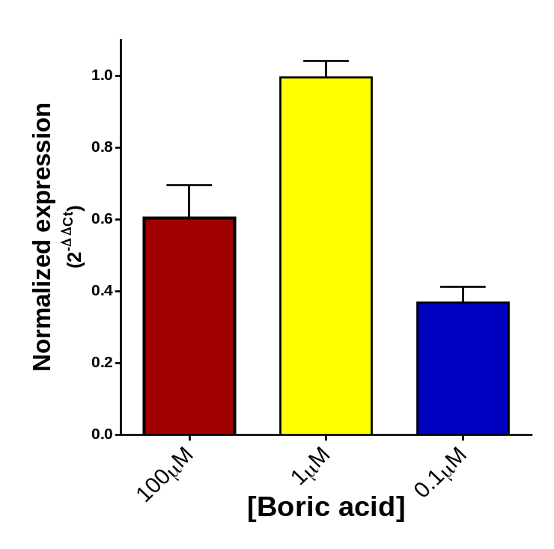

Figure 4.1. NIP7;1 expression in response to different boric acid concentrations treatment by Q-PCR analysis. Hydroponically grown Arabidopsis were treated by three different boric acid concentrations. Total RNA from inflorescence were analyzed for NIP7;1, UBC9 expression by Q-PCR. The ΔCt obtained from the UBC9 was used as the calibrator for ΔΔCt calculations. Histogram compares NIP7;1 grown under three boric acid conditions. red: 100µM; yellow: 1µM; blue: 0.1µM Error bars indicate standard error of three biological replicates (NIP7;1 and UBC9).

boron deficiency was the phase between the premeiotic interphase through meiosis to the late tetrad stage (Rawson 1996, Huang, Pant et al. 2000). This phase would correspond to flower developmental stages 9-10 in Arabidopsis, the flower stages with maximal NIP7;1 expression. Under boron deficient conditions, defects in pollen morphology including empty or misshapen pollen grains (Dell and Huang 1997) and poorly developed exine cell walls (Smith, Asher et al. 1997) have been observed.
How could the disruption of the NIP7;1 channel and associated boric acid transport lead to defective pollen cell wall formation? Pollen cell wall formation is a spatially and temporally regulated process that involves the synthesis, secretion and assembly of various components including callose, a microfibrilar primexine template, the elaborate reticulate outer exine wall, and the inner pectocellulosic intine (Blackmore, Wortley et al. 2007). The tapetum is involved the synthesis and release of various cell wall precursor components during pollen development (Liu and Fan 2013). For example, during meiosis and post-meiotic microspore development, the tapetum is involved in the formation and secretion of pectin cell wall materials for assembly into the developing pollen cell wall (Aouali, Laporte et al. 2001). During the tetrad stage of pollen microsporogenesis (stage 9 flowers), synthesis and deposition of the primexine cell wall commences which serves as the template for the accumulation of sporopollenin, a polymer of long fatty acids and phenylpropanoids, which forms the exine cell wall in mature pollen (Hess and Frosch 1994, Blackmore, Wortley et al. 2007). Arabidopsis mutants that disrupt primexine formation lead to defects in anchoring of sporopollenin and exine patterning (Wilson and Zhang 2009).
Since NIP7;1 is expressed during this stage of pollen wall development, it is proposed that it plays a role in boric acid uptake in tapetal and pollen microspores to facilitate the synthesis of boron cross-linked RGII in the pectic cell wall (Figure 4.2). The importance of boron and pectic RG-II in pollen development and tapetum function is underscored by the findings of Iwai et al. (Iwai, Hokura et al. 2006). By using tobacco, they showed that pectin glucuronsyl transferase gene NpGUT1, which is essential for the formation of boron crosslinked RG-II, is highly expressed in tapetum and pollen, and that RNAi knockdown of NpGLUT1 expression leads to defective pollen development.
Additional evidence for boric acid transporters in mediating the uptake and distribution of B in a manner that is essential for male fertility has also been provided for the rice OsBOR4 efflux transporter (Tanaka, Uraguchi et al. 2013). Based on the hypothesis of (Takano, Miwa et al. 2008) for boron homeostasis, it is likely that NIP7;1 “collaborates” with other

Stage 10
Tapetum
exine
Plasma membrane
cytosol
Nuclei
vacuole
Microspores
Tetrad
primexine
Plasma membrane
Nuclei
Stage 9
Exine wall formed
Released Microspore
NIP7;1

Figure 4.2. Model of NIP7;1 function in pollen-wall development. After microspores are released from callas wall, exine precursors, the first layer of pollen wall, primexine is formed. It is possible that NIP7;1 transports boric acid into microspore in order to facilitate development of primexine, or additionally NIP7;1 facilitates boric acid uptake into tapetum cells so that tapetum cells will maintain the functional cell wall or they are able to transport exine precursors onto the microspore surface.

channels and transporters to facilitate directional boric acid movement to critical cells of need during pollen gametogenesis.

4.6 NIP7;1 as a NIP II boric acid channel with unusual properties

During the diversification of the NIP gene family during higher plant evolution, three structural “pore families” with distinct structures and transport selectivities emerged: NIP I, NIP II, and NIP III (Wallace and Roberts 2004, Wallace, Choi et al. 2006, Liu and Zhu 2010). NIP II and NIP III channels have wider pore selectivity regions and are involved in the transport of uncharged metalloid nutrients: boric acid [B(OH)₃] (NIP II proteins) and silicic acid [Si(OH)₄] (NIP III proteins) (Ma, Tamai et al. 2006, Takano, Wada et al. 2006, Tanaka, Wallace et al. 2008).
Unlike the NIP5;1 and NIP6;1 channels, which show constitutive boric acid transport activity, the NIP7;1 channel shows unusual transport properties that are the result of a tyrosine residue (Tyr81) located on helix 2, approximately one α-helical turn on the extracellular side of the ar/R selectivity filter. Two potential rotomeric states of Tyr81 are observed in NIP7;1 pore models, with MD suggesting stabilization of the Tyr81 side chain in the down configuration by Arg220, resulting in closure of the channel (predicted pore aperture of <1 Å). Support for a closed state of the channel comes from observations that expression of NIP7;1 in Xenopus oocytes results in normal expression of the protein but little measurable transport activity over the negative control oocytes. Intrinsically low boric acid transport activity observed for wild-type NIP7;1 is supported by previous observations of metalloid sensitivity in yeast(Bienert, Thorsen et al. 2008, Isayenkov and Maathuis 2008).
The two boric acid transporters from A. thaliana, NIP5;1 and NIP6;1, possess an Asn and a Cys, respectively, which are predicted to remove the potential pore blocking properties associated with the bulkier Tyr. Substitution of a Cys residue for Tyr81 completely opens the channel to boric acid transport, at a rate higher than that of the established NIP boric acid channels. Inhibition of this transport by Hg²⁺ suggests that this cysteine side chain lies close to the pore as predicted in structural models. Interestingly, NIP7;1 Y81C shows no apparent transport of water. This suggests that, similar to NIP6;1, NIP7;1 in an open configuration forms a water-tight boric acid channel.
The observation of two rotomeric states of Tyr81 in NIP7;1 is consistent with the “pore pinching” gating properties observed for certain aquaporins based on structural analyses (Gonen, Sliz et al. 2004, Harries, Akhavan et al. 2004, Hedfalk, Tornroth-Horsefield et al. 2006, Jiang, Daniels et al. 2006, Tornroth-Horsefield, Wang et al. 2006, Tornroth-Horsefield, Hedfalk et al. 2010).
The E.coli water channel AQPZ was the third AQP protein for which an atomic structure was solved. The 2.5 Å crystal structure indicated that AQPZ adopted the canonical AQP hourglass fold. The Ar/R constriction site is formed by Arg189, Phe43, His174, and Thr183, bringing the pore diameter to 2 Å (Savage, Egea et al. 2003). The AQPZ tetramer shows two protomers with different Ar/R pore structures. The main differences in the pore lining residues between protomer A and protomer B is the position of the conserved Ar/R residue Arg189(Savage, Egea et al. 2003). In protomer A, Arg189 is in an “UP” position, which is the conformation seen in AQP1(Walz, Hirai et al. 1997). In protomer B, Arg189 is in the “Down” state, which also seen in AQP0 (Harries, Akhavan et al. 2004). In a recent crystal structure of AQPZ, Arg189 adopt two different conformations in different subunits of the same tetramer(Jiang, Daniels et al. 2006).
The yeast aquaporin structure AQY1 was determined at 1.15 Å resolution revealing a striking feature of the water pore. Although AQY1 shares the same hourglass fold and constriction site as other AQPs, the water channel is closed on the cytoplasmic side by conserved N-terminal residues. The N terminus folds such that each AQY1 subunits is intertwined with its neighbor within the tetramer via a helical bundle that is stabilized by multiple hydrogen bond interactions. A Hydrogen bond from Tyr27 anchors the helical bundle of AQY1 to the neighboring subunit and Pro29 introduces a kink allowing Tyr31 to insert into the water channel. The hydroxyl group of Tyr31 is involved in the formation of a well ordered hydrogen bond network. The pore profile indicates that the Tyr31 narrows the channel diameter to 0.8 Å, which is too small to allow the water passage (Fischer, Kosinska-Eriksson et al. 2009).
Structures of both open and closed SoPIP2;1 revealed that the gating of the pore is mediated by the loop D (Tornroth-Horsefield, Wang et al. 2006). Phosphorylation and dephosphorylation of Ser247 and Ser115 affects pore opening and closing respectively. When Ser247 is phosphorylated, the interaction with Pro199 and Leu200 is lost, so that loop D is displaced. In the closed state, loop D is anchored to the N terminus by a network of hydrogen bonding interactions involving dephosphorylated Ser115. Phosphorylation of Ser115 disrupts these interactions, releasing loop D and opening the pore(Tornroth-Horsefield, Wang et al. 2006). The protonation of His193 forms a salt bridge with Asp28, which re-anchors loop D on the N terminus, thus closing the pore(Tornroth-Horsefield, Wang et al. 2006).
In the present study, it is proposed that NIP7;1 adopts a similar pore regulatory mechanism on the basis of MD simulations that show movement of the ar/R Arg220 guanidinium group into a down configuration similar to that observed in AQPZ. On the basis of the orientation of the Tyr81 and Arg220 side chains, it is proposed that hydrogen bond interactions between the Tyr phenolic hydroxyl group and the Arg guanidinium group could contribute to stabilization of the closed orientation. In support of this hypothesis, removal of the Tyr81 hydroxyl group by mutagenesis to Phe results in channel opening.
To quantify the intrinsic boric acid transport of NIP7;1 more precisely, we have purified reconstituted NIP7;1 wild type as well as a mutant derivative (NIP7;1 Y81C) which removes the tyrosine gate and replaces it with a cysteine residue (characteristic of constitutive NIP6;1), and have used stopped flow fluorimetric techniques in proteoliposomes to quantify the permeability coefficient of each protein. The results indicate that wild type NIP7;1 is indeed permeated by boric acid, with a P_{B} that is tenfold higher than the diffusive permeability through plant lipid bilayers. In addition, comparison of wild type NIP7;1 with NIP7;1 Y81C shows that the later possesses a higher P_{B} , consistent with the observations suggesting tyrosine gating of the pore. Comparison of a number of NIP II proteins across several plant species suggests that the helix 2 position occupied by Tyr81 in NIP7;1 is either a Tyr, Asn, or Cys(Figure 4.3). The finding of NIP II homologues in other plant species with a Tyr residue at this position suggests that the presence of this potential gating residue may be conserved in other metalloid transporters in plants. Why would NIP7;1 transporters require this type of regulation? A potential clue comes from the dual effects of boric acid on plant tissues (Camacho-Cristobal, Rexach et al. 2008, Takano, Miwa et al. 2008, Miwa, Kamiya et al. 2009). Boron is an essential plant nutrient that is necessary for the formation of borate–diol ester cross-links in dimers of the plant pectic polysaccharide rhamnogalacturonan II(O'Neill, Ishii et al. 2004). This cross-link is necessary for the mechanical stability of the primary cell wall essential for normal plant growth and development. However, at high concentrations, boron is toxic to plant growth. In addition, unlike NIP5;1 and NIP6;1, NIP7;1 expression is not boric acid concentration dependent. In order to regulate boric acid assimilation, NIP7;1 may utilize post-translational mechanisms and the presence of an intrinsic gate within the pore to provide a more rapid regulatory mechanism. This potential gating mechanism is unique among NIP proteins and may serve to add another level of regulation of B homeostasis and preventing over accumulation and toxicity.
Less clear at present is the nature of the signals or environmental cues that would regulate this potential gating mechanism. On the basis of analogy to other aquaporins, potential regulators of transport gating could be pH, protein phosphorylation, and protein–protein interactions. In terms of pH regulation, purified protein was reconstituted into proteoliposome and boric acid uptake assay was performed by stopped-flow spectroscopy. It was determined that the boric acid permeability coefficient is not influenced by the internal or external pH changes. With respect to protein phosphorylation, it is interesting to note that NIP II proteins, including NIP7;1, have conserved MAP kinase phosphorylation motifs within their N- and C-terminal domains(Wallace, Choi et al. 2006, Bienert, Thorsen et al. 2008) and phosphorylation of these regions by recombinant MAP kinases has been observed in vitro.

4.7 Substrate selectivity of NIP II proteins

The diversification of members of the aquaporin superfamily during land plant evolution has led to the generation of a specialized subclass of channels, the nodulin 26-like intrinsic proteins, which have acquired additional transport selectivities (Ma and Yamaji 2006, Wallace, Choi et al. 2006, Takano, Miwa et al. 2008, Ludewig and Dynowski 2009).

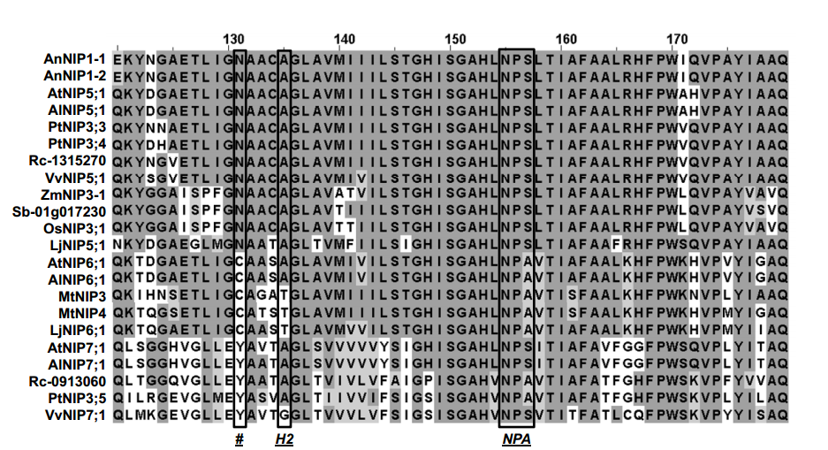
Figure 4.3. Comparison of the Helix 2 region of NIP II proteins.
Multiple sequence alignment of transmembrane helix 2 and the first NPA box of NIP subgroup II proteins from the following: Arabidopsis thaliana (AtNIP5;,AtNIP6;1,NIP7;1), Arabidopsis lyrata (AlNIP5;1, AlNIP6;1), Atriplex nummularia (AnNIP1-1, AnNIP1-2), Populus trichocarpa (PtNIP3;3, PtNIP3;4,PtNIP3;5), Ricinus communis(Rc-1315270 Rc-0913060), Vitis vinifera(VvNIP5;1 VvNIP5;1,VvNIP7;1), Zea mays(ZmNIP3-1), Sorghum bicolor(Sb-01g017230 01g017230) Oryza sativa Japonica (OsNIP3;1), Lotus japonicus(LjNIP5;1, LjNIP6;1), Medicago truncatula (MtNIP3, MtNIP4). The NPA from loop B, the H2 residue of the ar/R selectivity filter are indicated. #indicates the residue position homologous to Tyr 81 in NIP7;1.

Analysis of NIPs across several plant genomes has led to classification into “pore subclasses” based on the proposed structure of the ar/R pore selectivity filter. “NIP I” proteins are similar to the family archetype, soybean nodulin 26, and possess a canonical ar/R sequence (H2, Trp; H5, Val; LE1, Ala or Gly; LE2, Arg)(Wallace and Roberts 2004). NIP I proteins form aquaglyceroporin channels(Wallace, Choi et al. 2006). “NIP II” proteins adopt distinct ar/R pore selectivity structures (H2, Ala, Gly, or Thr; H5, Ile or Val; LE1, Gly or Ala; LE2, Arg) and show permeabilty to solutes larger than those allowed by NIP I proteins (Wallace and Roberts 2005). NIP7;1 belongs to the second subgroup of Nodulin 26-like intrinsic protein and has almost identical amino acids composition at it selectivity filter to NIP5;1 and NIP6;1.
The biological substrate for NIP II proteins is boric acid(Takano, Miwa et al. 2008), although analysis in oocytes shows that they are also permeated by urea and glycerol test solutes. In contrast, most NIP I subgroup proteins transport glycerol, urea and formamide (Wallace and Roberts 2005). More recently, a third group, the “NIP III” proteins that are specific to Si-accumulating plants, such as rice, have been identified.(Mitani, Yamaji et al. 2008, Rouge and Barre 2008, Liu, Wang et al. 2009) These proteins form metalloid transport channels that facilitate the uptake and transport of silicic acid(Ma and Yamaji 2006) through a specialized ar/R filter (H2, Gly; H5, Ser; LE1, Gly; LE2, Arg). A. thaliana, which does not accumulate Si, does not contain genes encoding NIP III proteins. Due to the fact that the molecules transported by the different subclasses of NIP proteins, the molecules transported differ in size and chemical properties, therefore, there must be mechanisms regulating the permeability of these substrates. The selectivity filter (ar/R) region of NIP III consists of four small-sized residues, GSGR, forming a larger constriction pore compared to other NIP subgroups. This allows the relatively large molecules of silicic acid to permeate(Wu and Beitz 2007). The difference in the selectivity filter between NIP II and NIP III resides in the H2 and H5 helices. Substitution of glycine in H2 of NIP III by alanine did not affect the transport activity, suggesting that the G/A substitution at H2 position is not important for transport substrate selectivity. In contrast, the point mutation from serine to isoleucine at H5 position of NIP III was found to affect strongly the transport activity of silicic acid (Mitani-Ueno, Yamaji et al. 2011). The difference in the selectivity filter between NIP I and NIP II resides in H2 position. The NIP II subgroup is believed to transport larger solutes (boric acid) than the prototype NIP I protein, such as Nod26 (Wallace and Roberts 2005), due to the substitution of a bulky residue “Trp” with “Ala” at the H2 position. The present study focused on the role of ar/R regions, particularly the role of the H2 position residue in controlling the transport substrate selectivity. NIP4;1 and Nod26 were selected for mutagenesis analysis. Substitution of tryptophan in H2 by Alanine for both NIP4;1 and Nod26 greatly increased the permeability of boric acid, suggesting that W/A substitution at H2 position is very important for transport substrate selectivity. Compared to tryptophan, alanine is considerably smaller and may increase the pore size at the ar/R region in the mutants. Subsequently, the size of the channel was calculated by CAVER software and compared between the wild-type protein and the mutant. The radius of the ar/R constriction in the W/A mutant was calculated to be 2.2 Å, which is significantly larger than the 1.4 Å of wild type protein (Figure 4.4). Similarly, point mutations were performed to engineer NIP I protein to NIP III protein. Germanic acid was used to mimic silicic acid. Uptake assays in Xenopus oocyte indicated that mutations at both residues at the H2 and H5 positions are required to open the channel for transport of germanic acid. This compliments the results from Mitani-Ueno et al. suggesting that both H2 and H5 residues play an important role in substrate selectivity.
NIP6;1, a boric acid transporter, is predicted to have pore size of 5 Å in diameter, large enough to accommodate approximately two water molecules. However, this protein showed

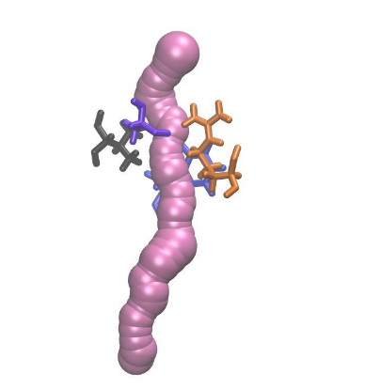
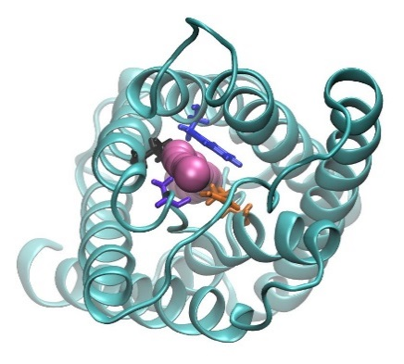
B.

B.

B.

B.
A.

A.

A.

A.
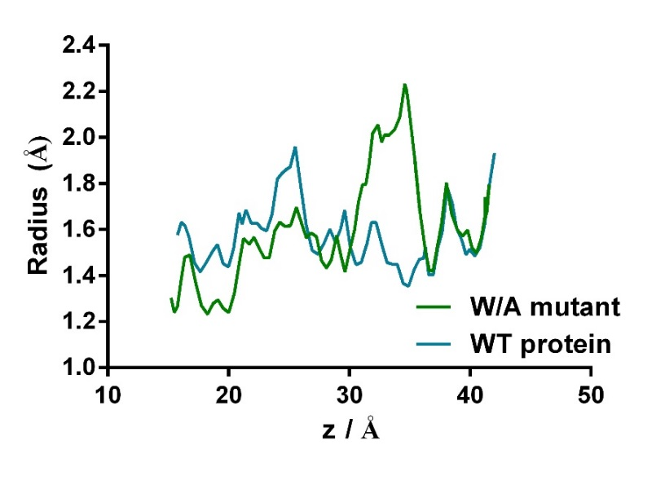

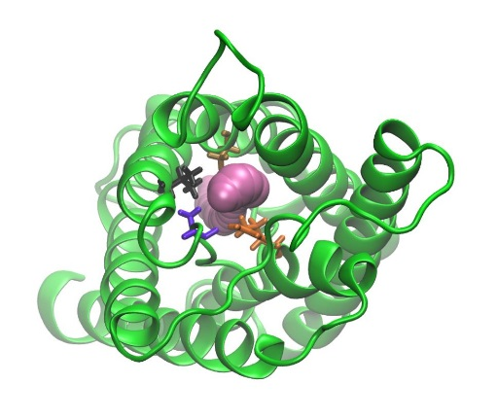
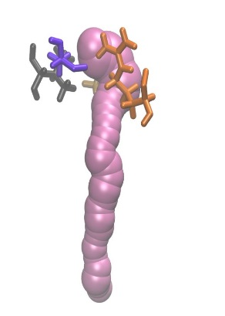

Ar/R

Figure 4.4. Comparison of the pore diameter between wild-type protein and W/A substitution variantAr/R

Figure 4.4. Comparison of the pore diameter between wild-type protein and W/A substitution variant. A. Channel radius calculated by CAVER (CaverSoft s.r.o. cz) was plotted versus the channel z axis. Wild-type protein (blue), W to A mutant (green). B. Homology models of both WT and mutant proteins. Top view from extracellular side with channel surface representation is shown. Top panel: wild-type protein; lower panel: W/A mutant. The ar/R residues are shown in stick representation. Protein backbone is shown in Newcartoon representation.

Figure 4.5. Model of water permeation regulation of NIPsFigure 4.4. Comparison of the pore diameter between wild-type protein and W/A substitution variantAr/R

Figure 4.4. Comparison of the pore diameter between wild-type protein and W/A substitution variantAr/R

Figure 4.4. Comparison of the pore diameter between wild-type protein and W/A substitution variant. A. Channel radius calculated by CAVER (CaverSoft s.r.o. cz) was plotted versus the channel z axis. Wild-type protein (blue), W to A mutant (green). B. Homology models of both WT and mutant proteins. Top view from extracellular side with channel surface representation is shown. Top panel: wild-type protein; lower panel: W/A mutant. The ar/R residues are shown in stick representation. Protein backbone is shown in Newcartoon representation.

extremely low water permeability (Wallace and Roberts 2005, Tanaka, Wallace et al. 2008). Additionally, NIP7;1 is not a robust water channel even with a pore widened by a Tyr to Cys mutation. Substitution of the alanine residue by tryptophan at the H2 position resulted in enhanced water transport activity in NIP6;1. Computer simulations indicated that the ar/R Arginine residue could be blocking the pore, resulting slower assimilation of water. It is noteworthy that the motion of the arginine might be important in NIP substrate selectivity because the blocking of functionality of the selectivity filter arginine has been reported for several aquaporins (Savage, Egea et al. 2003, Gonen, Sliz et al. 2004, Fischer, Kosinska-Eriksson et al. 2009). The length and permanent charge of this side chain along with the observed fluctuation between a closed and an open channel make it a very good candidate for a possible gating mechanism in aquaporin proteins. In this study, we observed the similar two states of selectivity filter arginine but not as frequent dynamic motion as seen in aquaporin proteins. Arginine side chains are very well known to function as voltage sensors in voltage-gated channels (Roux and MacKinnon 1999, Berneche and Roux 2000, Berneche and Roux 2001). A voltage sensing mechanism seems likely in NIPs, although the displacement of guanidinium between the two states only amounts to about 3 Å along the membrane normal under simulation conditions. However, in the physiological plant membrane potential, the displacement could produce a preference for one state over the other one. The other observation is that the different NIP proteins show a preference for UP or DOWN states. In NIP I proteins, arginine prefers the “UP” state whereas in NIP II proteins, arginine stays in the “DOWN” configuration. In silico site-directed mutagenesis and MD simulations indicate that the states of arginine correlates with the identity of the residue at H2 position. One possible explanation could be that the smaller residue, such as alanine in NIP II, occupies less space compared to the bulkier tryptophan residue in NIP I. Therefore, arginine has more room in NIP II and prefers to stay in the “DOWN” state, restricting the passage of water molecules through the selectivity filter. In contrast, the NIP I subgroup utilizes the bulkier side chain from tryptophan to maintain the arginine in the “UP” state, and restricting the blockage of the pore by moving on the arginine side chain into the DOWN state. Taking advantage of the conformation and dynamics restriction, water molecules experience less energy barrier and flow through the canonical channel (Figure 4.5).
Why is a water tight feature desirable in NIP II proteins? The investigation of the localization of NIP5;1 and NIP6;1 indicate that they are localized to the plasma membrane(Takano, Wada et al. 2006, Tanaka, Wallace et al. 2008), where they facilitate the flow of boric acid into the cytosol of cells. In order to maintain the turgor of plant cells, and careful osmotic balance is required. As a result, the plasma membrane of plant cells have a much lower (3 orders of magnitude) P_{f} compared to the tonoplast and internal membrane(Maurel, Verdoucq et al. 2008). Indeed, unlike animal aquaporins, plant PIP aquaporin are susceptible to tight regulation by pH and phosphorylation through channel gating (Horie, Kaneko et al. 2011). In the case of NIP II proteins, it is proposed that the H2 residue plays a dual function allowing a wider pore that facilities metalloid transport while preventing undesirable water flux.

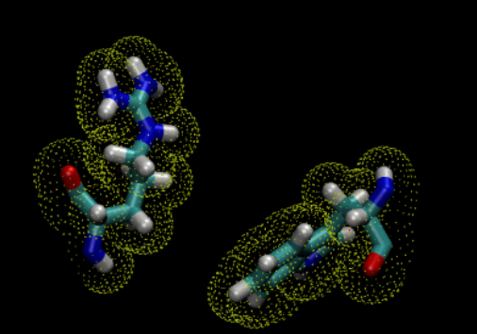
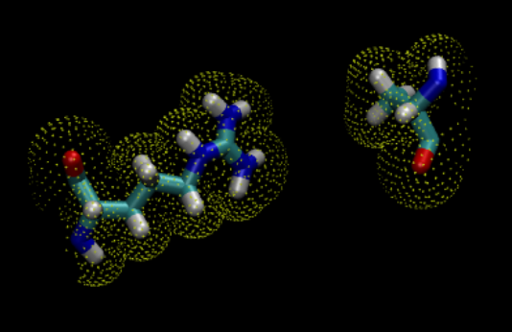
Figure 4.5. Model of water permeation regulation of NIPs. Protein channels are shown in blue curves. Arg, Ala and Trp residues are highlighted. Water molecules are indicated as small red sphere; predicated water permeation pathway is shown as yellow tube. Water molecules are indicated as red sphere.

Figure 4.5. Model of water permeation regulation of NIPs. Protein channels are shown in blue curves. Arg, Ala and Trp residues are highlighted. Water molecules are indicated as small red sphere; predicated water permeation pathway is shown as yellow tube. Water molecules are indicated as red sphere.

NIP I

NIP I
NIP II

NIP II

LIST OF REFERENCES

Agre, P. (2004). "Nobel Lecture. Aquaporin water channels." Biosci Rep 24(3): 127-163.
Agre, P., G. M. Preston, B. L. Smith, J. S. Jung, S. Raina, C. Moon, W. B. Guggino and S. Nielsen (1993). "Aquaporin CHIP: the archetypal molecular water channel." Am J Physiol 265(4 Pt 2): F463-476.
Alleva, K., C. M. Niemietz, M. Sutka, C. Maurel, M. Parisi, S. D. Tyerman and G. Amodeo (2006). "Plasma membrane of Beta vulgaris storage root shows high water channel activity regulated by cytoplasmic pH and a dual range of calcium concentrations." J Exp Bot 57(3): 609-621.
Anderberg, H. I., J. A. Danielson and U. Johanson (2011). "Algal MIPs, high diversity and conserved motifs." BMC Evol Biol 11: 110.
Anderberg, H. I., P. Kjellbom and U. Johanson (2012). "Annotation of Selaginella moellendorffii Major Intrinsic Proteins and the Evolution of the Protein Family in Terrestrial Plants." Front Plant Sci 3: 33.
Aouali, N., P. Laporte and C. Clement (2001). "Pectin secretion and distribution in the anther during pollen development in Lilium." Planta 213(1): 71-79.
Bansal, A. and R. Sankararamakrishnan (2007). "Homology modeling of major intrinsic proteins in rice, maize and Arabidopsis: comparative analysis of transmembrane helix association and aromatic/arginine selectivity filters." BMC Struct Biol 7: 27.
Bedinger, P. (1992). "The remarkable biology of pollen." Plant Cell 4(8): 879-887.
Berneche, S. and B. Roux (2000). "Molecular dynamics of the KcsA K(+) channel in a bilayer membrane." Biophys J 78(6): 2900-2917.
Berneche, S. and B. Roux (2001). "Energetics of ion conduction through the K+ channel." Nature 414(6859): 73-77.
Bienert, G. P., M. D. Bienert, T. P. Jahn, M. Boutry and F. Chaumont (2011). "Solanaceae XIPs are plasma membrane aquaporins that facilitate the transport of many uncharged substrates." Plant J 66(2): 306-317.
Bienert, G. P., M. Thorsen, M. D. Schussler, H. R. Nilsson, A. Wagner, M. J. Tamas and T. P. Jahn (2008). "A subgroup of plant aquaporins facilitate the bi-directional diffusion of As(OH)3 and Sb(OH)3 across membranes." BMC Biol 6: 26.
Blackmore, S., A. H. Wortley, J. J. Skvarla and J. R. Rowley (2007). "Pollen wall development in flowering plants." New Phytol 174(3): 483-498.
Blevins, D. G. and K. M. Lukaszewski (1998). "Boron in Plant Structure and Function." Annu Rev Plant Physiol Plant Mol Biol 49: 481-500.
Bolanos, L., N. J. Brewin and I. Bonilla (1996). "Effects of Boron on Rhizobium-Legume Cell-Surface Interactions and Nodule Development." Plant Physiol 110(4): 1249-1256.
Bonilla, I., C. Mergold-Villasenor, M. E. Campos, N. Sanchez, H. Perez, L. Lopez, L. Castrejon, F. Sanchez and G. I. Cassab (1997). "The aberrant cell walls of boron-deficient bean root nodules have no covalently bound hydroxyproline-/proline-rich proteins." Plant Physiol 115(4): 1329-1340.
Borgnia, M. J. and P. Agre (2001). "Reconstitution and functional comparison of purified GlpF and AqpZ, the glycerol and water channels from Escherichia coli." Proc Natl Acad Sci U S A 98(5): 2888-2893.
Calamita, G., W. R. Bishai, G. M. Preston, W. B. Guggino and P. Agre (1995). "Molecular cloning and characterization of AqpZ, a water channel from Escherichia coli." J Biol Chem 270(49): 29063-29066.
Camacho-Cristobal, J. J., J. Rexach and A. Gonzalez-Fontes (2008). "Boron in plants: deficiency and toxicity." J Integr Plant Biol 50(10): 1247-1255.
Carbrey, J. M., B. P. Cormack and P. Agre (2001). "Aquaporin in Candida: characterization of a functional water channel protein." Yeast 18(15): 1391-1396.
Chang M T, N. M. G. (1989). "Maize microsporogenesis." Genome 32: 12.
Chaumont, F., F. Barrieu, R. Jung and M. J. Chrispeels (2000). "Plasma membrane intrinsic proteins from maize cluster in two sequence subgroups with differential aquaporin activity." Plant Physiol 122(4): 1025-1034.
Chaumont, F., F. Barrieu, E. Wojcik, M. J. Chrispeels and R. Jung (2001). "Aquaporins constitute a large and highly divergent protein family in maize." Plant Physiol 125(3): 1206-1215.
Cheng, A., A. N. van Hoek, M. Yeager, A. S. Verkman and A. K. Mitra (1997). "Three-dimensional organization of a human water channel." Nature 387(6633): 627-630.
Chepelinsky, A. B. (2009). "Structural function of MIP/aquaporin 0 in the eye lens; genetic defects lead to congenital inherited cataracts." Handb Exp Pharmacol(190): 265-297.
Choi, H., J. Y. Jin, S. Choi, J. U. Hwang, Y. Y. Kim, M. C. Suh and Y. Lee (2011). "An ABCG/WBC-type ABC transporter is essential for transport of sporopollenin precursors for exine formation in developing pollen." Plant J 65(2): 181-193.
Choi, W. G. and D. M. Roberts (2007). "Arabidopsis NIP2;1, a major intrinsic protein transporter of lactic acid induced by anoxic stress." Journal of Biological Chemistry 282(33): 24209-24218.
Choi, W. G. and D. M. Roberts (2007). "Arabidopsis NIP2;1, a major intrinsic protein transporter of lactic acid induced by anoxic stress." J Biol Chem 282(33): 24209-24218.
Clough, S. J. and A. F. Bent (1998). "Floral dip: a simplified method for Agrobacterium-mediated transformation of Arabidopsis thaliana." Plant J 16(6): 735-743.
Czechowski, T., M. Stitt, T. Altmann, M. K. Udvardi and W. R. Scheible (2005). "Genome-wide identification and testing of superior reference genes for transcript normalization in Arabidopsis." Plant Physiol 139(1): 5-17.
Daniels, M. J., T. E. Mirkov and M. J. Chrispeels (1994). "The plasma membrane of Arabidopsis thaliana contains a mercury-insensitive aquaporin that is a homolog of the tonoplast water channel protein TIP." Plant Physiol 106(4): 1325-1333.
Danielson, J. A. and U. Johanson (2008). "Unexpected complexity of the aquaporin gene family in the moss Physcomitrella patens." BMC Plant Biol 8: 45.
de Groot, B. L. and H. Grubmuller (2005). "The dynamics and energetics of water permeation and proton exclusion in aquaporins." Curr Opin Struct Biol 15(2): 176-183.
Dean, R. M., R. L. Rivers, M. L. Zeidel and D. M. Roberts (1999). "Purification and functional reconstitution of soybean nodulin 26. An aquaporin with water and glycerol transport properties." Biochemistry 38(1): 347-353.
Dell, B. and L. B. Huang (1997). Physiological response of plants to low boron. Plant and soil. Netherlands, Kluwer Academic: 103-120.
Denker, B. M., B. L. Smith, F. P. Kuhajda and P. Agre (1988). "Identification, purification, and partial characterization of a novel Mr 28,000 integral membrane protein from erythrocytes and renal tubules." J Biol Chem 263(30): 15634-15642.
Dordas, C. and P. H. Brown (2000). "Permeability of boric acid across lipid bilayers and factors affecting it." J Membr Biol 175(2): 95-105.
Dordas, C., M. J. Chrispeels and P. H. Brown (2000). "Permeability and channel-mediated transport of boric acid across membrane vesicles isolated from squash roots." Plant Physiol 124(3): 1349-1362.
Drin, G., V. Morello, J. F. Casella, P. Gounon and B. Antonny (2008). "Asymmetric tethering of flat and curved lipid membranes by a golgin." Science 320(5876): 670-673.
Ecelbarger, C. A., J. Terris, G. Frindt, M. Echevarria, D. Marples, S. Nielsen and M. A. Knepper (1995). "Aquaporin-3 water channel localization and regulation in rat kidney." Am J Physiol 269(5 Pt 2): F663-672.
Fetter, K., V. Van Wilder, M. Moshelion and F. Chaumont (2004). "Interactions between plasma membrane aquaporins modulate their water channel activity." Plant Cell 16(1): 215-228.
Fischer, G., U. Kosinska-Eriksson, C. Aponte-Santamaria, M. Palmgren, C. Geijer, K. Hedfalk, S. Hohmann, B. L. de Groot, R. Neutze and K. Lindkvist-Petersson (2009). "Crystal structure of a yeast aquaporin at 1.15 angstrom reveals a novel gating mechanism." PLoS Biol 7(6): e1000130.
Fleischer, A., M. A. O'Neill and R. Ehwald (1999). "The Pore Size of Non-Graminaceous Plant Cell Walls Is Rapidly Decreased by Borate Ester Cross-Linking of the Pectic Polysaccharide Rhamnogalacturonan II." Plant Physiol 121(3): 829-838.
Foloppe, N. and A. D. MacKerell (2000). "All-atom empirical force field for nucleic acids: I. Parameter optimization based on small molecule and condensed phase macromolecular target data." Journal of Computational Chemistry 21(2): 86-104.
Fortin, M. G., N. A. Morrison and D. P. Verma (1987). "Nodulin-26, a peribacteroid membrane nodulin is expressed independently of the development of the peribacteroid compartment." Nucleic Acids Res 15(2): 813-824.
Fu, D., A. Libson, L. J. Miercke, C. Weitzman, P. Nollert, J. Krucinski and R. M. Stroud (2000). "Structure of a glycerol-conducting channel and the basis for its selectivity." Science 290(5491): 481-486.
Fushimi, K., S. Sasaki and F. Marumo (1997). "Phosphorylation of serine 256 is required for cAMP-dependent regulatory exocytosis of the aquaporin-2 water channel." J Biol Chem 272(23): 14800-14804.
Gerbeau, P., J. Guclu, P. Ripoche and C. Maurel (1999). "Aquaporin Nt-TIPa can account for the high permeability of tobacco cell vacuolar membrane to small neutral solutes." Plant Journal 18(6): 577-587.
Gonen, T., Y. Cheng, P. Sliz, Y. Hiroaki, Y. Fujiyoshi, S. C. Harrison and T. Walz (2005). "Lipid-protein interactions in double-layered two-dimensional AQP0 crystals." Nature 438(7068): 633-638.
Gonen, T., P. Sliz, J. Kistler, Y. Cheng and T. Walz (2004). "Aquaporin-0 membrane junctions reveal the structure of a closed water pore." Nature 429(6988): 193-197.
Gorelick, D. A., J. Praetorius, T. Tsunenari, S. Nielsen and P. Agre (2006). "Aquaporin-11: a channel protein lacking apparent transport function expressed in brain." BMC Biochem 7: 14.
Guenther, J. F., N. Chanmanivone, M. P. Galetovic, I. S. Wallace, J. A. Cobb and D. M. Roberts (2003). "Phosphorylation of soybean nodulin 26 on serine 262 enhances water permeability and is regulated developmentally and by osmotic signals." Plant Cell 15(4): 981-991.
Gupta, A. B. and R. Sankararamakrishnan (2009). "Genome-wide analysis of major intrinsic proteins in the tree plant Populus trichocarpa: characterization of XIP subfamily of aquaporins from evolutionary perspective." BMC Plant Biol 9: 134.
H. Pfeffer, F. D., V. Romheld (1999). "Are there two mechanisms for boron uptake in sunflower? ." Journal of Plant physiology 155(1): 6.
Harries, W. E., D. Akhavan, L. J. Miercke, S. Khademi and R. M. Stroud (2004). "The channel architecture of aquaporin 0 at a 2.2-A resolution." Proc Natl Acad Sci U S A 101(39): 14045-14050.
Hatakeyama, S., Y. Yoshida, T. Tani, Y. Koyama, K. Nihei, K. Ohshiro, J. I. Kamiie, E. Yaoita, T. Suda, K. Hatakeyama and T. Yamamoto (2001). "Cloning of a new aquaporin (AQP10) abundantly expressed in duodenum and jejunum." Biochem Biophys Res Commun 287(4): 814-819.
Hedfalk, K., R. M. Bill, J. G. Mullins, S. Karlgren, C. Filipsson, J. Bergstrom, M. J. Tamas, J. Rydstrom and S. Hohmann (2004). "A regulatory domain in the C-terminal extension of the yeast glycerol channel Fps1p." J Biol Chem 279(15): 14954-14960.
Hedfalk, K., S. Tornroth-Horsefield, M. Nyblom, U. Johanson, P. Kjellbom and R. Neutze (2006). "Aquaporin gating." Curr Opin Struct Biol 16(4): 447-456.
Heller, K. B., E. C. Lin and T. H. Wilson (1980). "Substrate specificity and transport properties of the glycerol facilitator of Escherichia coli." J Bacteriol 144(1): 274-278.
Herrera-Rodriguez, M., A. Gonzalez-Fontes, J. Rexach, J. J. Camacho-Cristobal, J. Maldonado and M. Navarro-Gochicoa (2010). Role of boron in vascular plants and response mechanisms to boron stresses. Plant Stress: 115-122.
Hess, M. W. and A. Frosch (1994). "Subunits of forming pollen exine and Ubisch bodies as seen freeze substituted Ledebouria socialis Roth (Hyacinthaceae) " Protoplasma 182: 10-14.
Heymann, J. B. and A. Engel (2000). "Structural clues in the sequences of the aquaporins." Journal of Molecular Biology 295(4): 1039-1053.
Hoffert, J. D., R. A. Fenton, H. B. Moeller, B. Simons, D. Tchapyjnikov, B. W. McDill, M. J. Yu, T. Pisitkun, F. Chen and M. A. Knepper (2008). "Vasopressin-stimulated increase in phosphorylation at Ser269 potentiates plasma membrane retention of aquaporin-2." J Biol Chem 283(36): 24617-24627.
Holm, L. M., T. P. Jahn, A. L. Moller, J. K. Schjoerring, D. Ferri, D. A. Klaerke and T. Zeuthen (2005). "NH3 and NH4+ permeability in aquaporin-expressing Xenopus oocytes." Pflugers Arch 450(6): 415-428.
Horie, T., T. Kaneko, G. Sugimoto, S. Sasano, S. K. Panda, M. Shibasaka and M. Katsuhara (2011). "Mechanisms of water transport mediated by PIP aquaporins and their regulation via phosphorylation events under salinity stress in barley roots." Plant Cell Physiol 52(4): 663-675.
Huang, L. B., J. Pant, B. Dell and R. W. Bell (2000). "Effects of boron deficiency on anther development and floret fertility in wheat." Annal of Botany 85: 7.
Huang, X., F. J. Zeller, S. L. Hsam, G. Wenzel and V. Mohler (2000). "Chromosomal location of AFLP markers in common wheat utilizing nulli-tetrasomic stocks." Genome 43(2): 298-305.
Humphrey, W., A. Dalke and K. Schulten (1996). "VMD: visual molecular dynamics." J Mol Graph 14(1): 33-38, 27-38.
Hwang, J. H., S. R. Ellingson and D. M. Roberts (2010). "Ammonia permeability of the soybean nodulin 26 channel." Febs Letters 584(20): 4339-4343.
Ikeda, M., E. Beitz, D. Kozono, W. B. Guggino, P. Agre and M. Yasui (2002). "Characterization of aquaporin-6 as a nitrate channel in mammalian cells. Requirement of pore-lining residue threonine 63." J Biol Chem 277(42): 39873-39879.
Isayenkov, S. V. and F. J. Maathuis (2008). "The Arabidopsis thaliana aquaglyceroporin AtNIP7;1 is a pathway for arsenite uptake." FEBS Lett 582(11): 1625-1628.
Ishibashi, K., T. Morinaga, M. Kuwahara, S. Sasaki and M. Imai (2002). "Cloning and identification of a new member of water channel (AQP10) as an aquaglyceroporin." Biochimica Et Biophysica Acta-Gene Structure and Expression 1576(3): 335-340.
Ishikawa, F., S. Suga, T. Uemura, M. H. Sato and M. Maeshima (2005). "Novel type aquaporin SIPs are mainly localized to the ER membrane and show cell-specific expression in Arabidopsis thaliana." FEBS Lett 579(25): 5814-5820.
Iwai, H., A. Hokura, M. Oishi, H. Chida, T. Ishii, S. Sakai and S. Satoh (2006). "The gene responsible for borate cross-linking of pectin Rhamnogalacturonan-II is required for plant reproductive tissue development and fertilization." Proc Natl Acad Sci U S A 103(44): 16592-16597.
Jahn, T. P., A. L. Moller, T. Zeuthen, L. M. Holm, D. A. Klaerke, B. Mohsin, W. Kuhlbrandt and J. K. Schjoerring (2004). "Aquaporin homologues in plants and mammals transport ammonia." FEBS Lett 574(1-3): 31-36.
Jiang, J., B. V. Daniels and D. Fu (2006). "Crystal structure of AqpZ tetramer reveals two distinct Arg-189 conformations associated with water permeation through the narrowest constriction of the water-conducting channel." J Biol Chem 281(1): 454-460.
Johanson, U. and S. Gustavsson (2002). "A new subfamily of major intrinsic proteins in plants." Mol Biol Evol 19(4): 456-461.
Johanson, U., M. Karlsson, I. Johansson, S. Gustavsson, S. Sjovall, L. Fraysse, A. R. Weig and P. Kjellbom (2001). "The complete set of genes encoding major intrinsic proteins in Arabidopsis provides a framework for a new nomenclature for major intrinsic proteins in plants." Plant Physiol 126(4): 1358-1369.
Johansson, I., M. Karlsson, V. K. Shukla, M. J. Chrispeels, C. Larsson and P. Kjellbom (1998). "Water transport activity of the plasma membrane aquaporin PM28A is regulated by phosphorylation." Plant Cell 10(3): 451-459.
Johansson, N. G. and S. Eriksson (1996). "Structure-activity relationships for phosphorylation of nucleoside analogs to monophosphates by nucleoside kinases." Acta Biochim Pol 43(1): 143-160.
Johnson, K. D., E. M. Herman and M. J. Chrispeels (1989). "An abundant, highly conserved tonoplast protein in seeds." Plant Physiol 91(3): 1006-1013.
Johnson, K. D., H. Hofte and M. J. Chrispeels (1990). "An intrinsic tonoplast protein of protein storage vacuoles in seeds is structurally related to a bacterial solute transporter (GIpF)." Plant Cell 2(6): 525-532.
Jung, J. S., G. M. Preston, B. L. Smith, W. B. Guggino and P. Agre (1994). "Molecular structure of the water channel through aquaporin CHIP. The hourglass model." J Biol Chem 269(20): 14648-14654.
Katsura, T., C. E. Gustafson, D. A. Ausiello and D. Brown (1997). "Protein kinase A phosphorylation is involved in regulated exocytosis of aquaporin-2 in transfected LLC-PK1 cells." Am J Physiol 272(6 Pt 2): F817-822.
Kaul (1998). Male Sterility in Higher Plants. Berlin, Springer-Verlag.
Kishida, K., H. Kuriyama, T. Funahashi, I. Shimomura, S. Kihara, N. Ouchi, M. Nishida, H. Nishizawa, M. Matsuda, M. Takahashi, K. Hotta, T. Nakamura, S. Yamashita, Y. Tochino and Y. Matsuzawa (2000). "Aquaporin adipose, a putative glycerol channel in adipocytes." J Biol Chem 275(27): 20896-20902.
Klauda, J. B., R. M. Venable, J. A. Freites, J. W. O'Connor, D. J. Tobias, C. Mondragon-Ramirez, I. Vorobyov, A. D. MacKerell, Jr. and R. W. Pastor (2010). "Update of the CHARMM all-atom additive force field for lipids: validation on six lipid types." J Phys Chem B 114(23): 7830-7843.
Klebl, F., M. Wolf and N. Sauer (2003). "A defect in the yeast plasma membrane urea transporter Dur3p is complemented by CpNIP1, a Nod26-like protein from zucchini (Cucurbita pepo L.), and by Arabidopsis thaliana delta-TIP or gamma-TIP." Febs Letters 547(1-3): 69-74.
Knol, J., K. Sjollema and B. Poolman (1998). "Detergent-mediated reconstitution of membrane proteins." Biochemistry 37(46): 16410-16415.
Kobayashi, M., T. Matoh and J. Azuma (1996). "Two Chains of Rhamnogalacturonan II Are Cross-Linked by Borate-Diol Ester Bonds in Higher Plant Cell Walls." Plant Physiol 110(3): 1017-1020.
Kot, F. (2009). "Boron sources, speciation and its potential impact on health." Rev Environ Sci Biotechnol(8): 3-28.
Kumar, K., K. A. Mosa, S. Chhikara, C. Musante, J. C. White and O. P. Dhankher (2013). "Two rice plasma membrane intrinsic proteins, OsPIP2;4 and OsPIP2;7, are involved in transport and providing tolerance to boron toxicity." Planta.
Lee, M. D., K. Y. Bhakta, S. Raina, R. Yonescu, C. A. Griffin, N. G. Copeland, D. J. Gilbert, N. A. Jenkins, G. M. Preston and P. Agre (1996). "The human Aquaporin-5 gene. Molecular characterization and chromosomal localization." J Biol Chem 271(15): 8599-8604.
Li, T., W. G. Choi, I. S. Wallace, J. Baudry and D. M. Roberts (2011). "Arabidopsis thaliana NIP7;1: an anther-specific boric acid transporter of the aquaporin superfamily regulated by an unusual tyrosine in helix 2 of the transport pore." Biochemistry 50(31): 6633-6641.
Liu, L. and X. D. Fan (2013). "Tapetum: regulation and role in sporopollenin biosynthesis in Arabidopsis." Plant Mol Biol(83): 165-175.
Liu, Q., H. Wang, Z. Zhang, J. Wu, Y. Feng and Z. Zhu (2009). "Divergence in function and expression of the NOD26-like intrinsic proteins in plants." BMC Genomics 10: 313.
Liu, Q. and Z. Zhu (2010). "Functional divergence of the NIP III subgroup proteins involved altered selective constraints and positive selection." BMC Plant Biol 10: 256.
Lomize, M. A., A. L. Lomize, I. D. Pogozheva and H. I. Mosberg (2006). "OPM: orientations of proteins in membranes database." Bioinformatics 22(5): 623-625.
Loomis, W. D. and R. W. Durst (1992). "Chemistry and biology of boron." Biofactors 3(4): 229-239.
Lopez, D., G. Bronner, N. Brunel, D. Auguin, S. Bourgerie, F. Brignolas, S. Carpin, C. Tournaire-Roux, C. Maurel, B. Fumanal, F. Martin, S. Sakr, P. Label, J. L. Julien, A. Gousset-Dupont and J. S. Venisse (2012). "Insights into Populus XIP aquaporins: evolutionary expansion, protein functionality, and environmental regulation." J Exp Bot 63(5): 2217-2230.
Loque, D., U. Ludewig, L. Yuan and N. von Wiren (2005). "Tonoplast intrinsic proteins AtTIP2;1 and AtTIP2;3 facilitate NH3 transport into the vacuole." Plant Physiol 137(2): 671-680.
Ludewig, U. and M. Dynowski (2009). "Plant aquaporin selectivity: where transport assays, computer simulations and physiology meet." Cell Mol Life Sci 66(19): 3161-3175.
Lukaszewski, K. M. and D. G. Blevins (1996). "Root Growth Inhibition in Boron-Deficient or Aluminum-Stressed Squash May Be a Result of Impaired Ascorbate Metabolism." Plant Physiol 112(3): 1135-1140.
Ma, J. F., K. Tamai, N. Yamaji, N. Mitani, S. Konishi, M. Katsuhara, M. Ishiguro, Y. Murata and M. Yano (2006). "A silicon transporter in rice." Nature 440(7084): 688-691.
Ma, J. F. and N. Yamaji (2006). "Silicon uptake and accumulation in higher plants." Trends Plant Sci 11(8): 392-397.
Macey, R. I. and R. E. Farmer (1970). "Inhibition of water and solute permeability in human red cells." Biochim Biophys Acta 211(1): 104-106.
MacKerell, A. D., D. Bashford, M. Bellott, R. L. Dunbrack, J. D. Evanseck, M. J. Field, S. Fischer, J. Gao, H. Guo, S. Ha, D. Joseph-McCarthy, L. Kuchnir, K. Kuczera, F. T. Lau, C. Mattos, S. Michnick, T. Ngo, D. T. Nguyen, B. Prodhom, W. E. Reiher, B. Roux, M. Schlenkrich, J. C. Smith, R. Stote, J. Straub, M. Watanabe, J. Wiorkiewicz-Kuczera, D. Yin and M. Karplus (1998). "All-atom empirical potential for molecular modeling and dynamics studies of proteins." J Phys Chem B 102(18): 3586-3616.
Mackerell, A. D., Jr., M. Feig and C. L. Brooks, 3rd (2004). "Extending the treatment of backbone energetics in protein force fields: limitations of gas-phase quantum mechanics in reproducing protein conformational distributions in molecular dynamics simulations." J Comput Chem 25(11): 1400-1415.
Mateo, P., I. Bonilla, E. Fernandez-Valiente and E. Sanchez-Maeso (1986). "Essentiality of Boron for Dinitrogen Fixation in Anabaena sp. PCC 7119." Plant Physiol 81(2): 430-433.
Mathai, J. C. and M. L. Zeidel (2007). "Measurement of water and solute permeability by stopped-flow fluorimetry." Methods Mol Biol 400: 323-332.
Mathoh T, K. S., Kobayashi M. (1996). "Ubiquity of a borate-rhamnogalacturonan II complex in the cell walls of higher plants." Plant Cell Physiol. 37: 4.
Maurel, C., J. Reizer, J. I. Schroeder and M. J. Chrispeels (1993). "The vacuolar membrane protein gamma-TIP creates water specific channels in Xenopus oocytes." EMBO J 12(6): 2241-2247.
Maurel, C., L. Verdoucq, D. T. Luu and V. Santoni (2008). "Plant aquaporins: membrane channels with multiple integrated functions." Annu Rev Plant Biol 59: 595-624.
Mitani-Ueno, N., N. Yamaji, F. J. Zhao and J. F. Ma (2011). "The aromatic/arginine selectivity filter of NIP aquaporins plays a critical role in substrate selectivity for silicon, boron, and arsenic." Journal of Experimental Botany 62(12): 4391-4398.
Mitani, N., Y. Chiba, N. Yamaji and J. F. Ma (2009). "Identification and characterization of maize and barley Lsi2-like silicon efflux transporters reveals a distinct silicon uptake system from that in rice." Plant Cell 21(7): 2133-2142.
Mitani, N., N. Yamaji and J. F. Ma (2008). "Characterization of substrate specificity of a rice silicon transporter, Lsi1." Pflugers Arch 456(4): 679-686.
Mitra, A. K., M. Yeager, A. N. van Hoek, M. C. Wiener and A. S. Verkman (1994). "Projection structure of the CHIP28 water channel in lipid bilayer membranes at 12-A resolution." Biochemistry 33(43): 12735-12740.
Miwa, K., T. Kamiya and T. Fujiwara (2009). "Homeostasis of the structurally important micronutrients, B and Si." Curr Opin Plant Biol 12(3): 307-311.
Miwa, K., S. Wakuta, S. Takada, K. Ide, J. Takano, S. Naito, H. Omori, T. Matsunaga and T. Fujiwara (2013). "Roles of BOR2, a Boron Exporter, in Cross Linking of Rhamnogalacturonan II and Root Elongation under Boron Limitation in Arabidopsis." Plant Physiol 163(4): 1699-1709.
Morishita, Y., Y. Sakube, S. Sasaki and K. Ishibashi (2004). "Molecular mechanisms and drug development in aquaporin water channel diseases: aquaporin superfamily (superaquaporins): expansion of aquaporins restricted to multicellular organisms." J Pharmacol Sci 96(3): 276-279.
Murata, K., K. Mitsuoka, T. Hirai, T. Walz, P. Agre, J. B. Heymann, A. Engel and Y. Fujiyoshi (2000). "Structural determinants of water permeation through aquaporin-1." Nature 407(6804): 599-605.
Nable RO, C. B., Lance RC (1990). Genotypic differences in boron accumulation in barley: relative susceptibilities to boron deficiency and toxicity. . The Netherlands, Kluwer Academic Publishers.
Nemeth-Cahalan, K. L. and J. E. Hall (2000). "pH and calcium regulate the water permeability of aquaporin 0." J Biol Chem 275(10): 6777-6782.
Nielsen, S., T. H. Kwon, B. M. Christensen, D. Promeneur, J. Frokiaer and D. Marples (1999). "Physiology and pathophysiology of renal aquaporins." J Am Soc Nephrol 10(3): 647-663.
Nielsen, S., E. A. Nagelhus, M. Amiry-Moghaddam, C. Bourque, P. Agre and O. P. Ottersen (1997). "Specialized membrane domains for water transport in glial cells: high-resolution immunogold cytochemistry of aquaporin-4 in rat brain." J Neurosci 17(1): 171-180.
Noguchi, K., M. Yasumori, T. Imai, S. Naito, T. Matsunaga, H. Oda, H. Hayashi, M. Chino and T. Fujiwara (1997). "bor1-1, an Arabidopsis thaliana mutant that requires a high level of boron." Plant Physiol 115(3): 901-906.
O'Neill, M. A., S. Eberhard, P. Albersheim and A. G. Darvill (2001). "Requirement of borate cross-linking of cell wall rhamnogalacturonan II for Arabidopsis growth." Science 294(5543): 846-849.
O'Neill, M. A., T. Ishii, P. Albersheim and A. G. Darvill (2004). "Rhamnogalacturonan II: structure and function of a borate cross-linked cell wall pectic polysaccharide." Annu Rev Plant Biol 55: 109-139.
Oldroyd, G. E. and J. A. Downie (2008). "Coordinating nodule morphogenesis with rhizobial infection in legumes." Annu Rev Plant Biol 59: 519-546.
Owen, M. C. A. (1995). "Ultrastructure of microsporogenesis and microgametogenesis in Arabidopsis thaliana(L.) Heynh. ecotype Wassilewskija (Brassicaceae) " Protoplasma 185: 14.
Paganelli, C. V. and A. K. Solomon (1957). "The rate of exchange of tritiated water across the human red cell membrane." J Gen Physiol 41(2): 259-277.
Phillips, J. C., R. Braun, W. Wang, J. Gumbart, E. Tajkhorshid, E. Villa, C. Chipot, R. D. Skeel, L. Kale and K. Schulten (2005). "Scalable molecular dynamics with NAMD." J Comput Chem 26(16): 1781-1802.
Prak, S., S. Hem, J. Boudet, G. Viennois, N. Sommerer, M. Rossignol, C. Maurel and V. Santoni (2008). "Multiple phosphorylations in the C-terminal tail of plant plasma membrane aquaporins: role in subcellular trafficking of AtPIP2;1 in response to salt stress." Mol Cell Proteomics 7(6): 1019-1030.
Preston, G. M. and P. Agre (1991). "Isolation of the cDNA for erythrocyte integral membrane protein of 28 kilodaltons: member of an ancient channel family." Proc Natl Acad Sci U S A 88(24): 11110-11114.
Preston, G. M., T. P. Carroll, W. B. Guggino and P. Agre (1992). "Appearance of water channels in Xenopus oocytes expressing red cell CHIP28 protein." Science 256(5055): 385-387.
Quigley, F., J. M. Rosenberg, Y. Shachar-Hill and H. J. Bohnert (2002). "From genome to function: the Arabidopsis aquaporins." Genome Biol 3(1): RESEARCH0001.
Raven (1980). "Short- and long-distance transport of boric acid in plants." New Phytol 84: 28.
Rawson, h. m. (1996). "The developmental stage during which boron limitation causes sterility in wheat genotypes and the recovery of fertility." Australian journal of plant physiology 23: 709-717.
Reid RJ, H. J., Post A, Stangoulis JCR, Graham RD (2004). "A critical analysis of the causes of boron toxicity in plants." Plant Cell Environ 25: 9.
Reizer, J., A. Reizer and M. H. Saier, Jr. (1993). "The MIP family of integral membrane channel proteins: sequence comparisons, evolutionary relationships, reconstructed pathway of evolution, and proposed functional differentiation of the two repeated halves of the proteins." Crit Rev Biochem Mol Biol 28(3): 235-257.
Reynolds, E. S. (1963). "The use of lead citrate at high pH as an electron-opaque stain in electron microscopy." J Cell Biol 17: 208-212.
Rigaud, J. L. and D. Levy (2003). "Reconstitution of membrane proteins into liposomes." Methods Enzymol 372: 65-86.
Rivers, R. L., R. M. Dean, G. Chandy, J. E. Hall, D. M. Roberts and M. L. Zeidel (1997). "Functional analysis of nodulin 26, an aquaporin in soybean root nodule symbiosomes." J Biol Chem 272(26): 16256-16261.
Rouge, P. and A. Barre (2008). "A molecular modeling approach defines a new group of Nodulin 26-like aquaporins in plants." Biochemical and Biophysical Research Communications 367(1): 60-66.
Roux, B. and R. MacKinnon (1999). "The cavity and pore helices in the KcsA K+ channel: electrostatic stabilization of monovalent cations." Science 285(5424): 100-102.
Ryden, P., K. Sugimoto-Shirasu, A. C. Smith, K. Findlay, W. D. Reiter and M. C. McCann (2003). "Tensile properties of Arabidopsis cell walls depend on both a xyloglucan cross-linked microfibrillar network and rhamnogalacturonan II-borate complexes." Plant Physiol 132(2): 1033-1040.
Sakurai, J., F. Ishikawa, T. Yamaguchi, M. Uemura and M. Maeshima (2005). "Identification of 33 rice aquaporin genes and analysis of their expression and function." Plant Cell Physiol 46(9): 1568-1577.
Sandal, N. N. and K. A. Marcker (1988). "Soybean nodulin 26 is homologous to the major intrinsic protein of the bovine lens fiber membrane." Nucleic Acids Res 16(19): 9347.
Sanders, P. M. (1999). "Anther developmental defects in Arabidopsis thaliana male-sterile mutants." Sex Plant Reprod 11: 25.
Sanders, P. M., A. Q. Bui, K. Weterings, K. N. McIntire, Y. C. Hsu, P. Y. Lee, M. T. Truong, T. P. Beals and R. B. Goldberg (1999). "Anther developmental defects in Arabidopsis thaliana male-sterile mutants." Sexual Plant Reproduction 11(6): 297-322.
Savage, D. F., P. F. Egea, Y. Robles-Colmenares, J. D. O'Connell, 3rd and R. M. Stroud (2003). "Architecture and selectivity in aquaporins: 2.5 a X-ray structure of aquaporin Z." PLoS Biol 1(3): E72.
Scott, R. J., M. Spielman and H. G. Dickinson (2004). "Stamen structure and function." Plant Cell 16 Suppl: S46-60.
Shelp, B. J., E. Marentes, A. Kitheka and P. Vivekanandan (1995). "Boron mobility in plants." Physiologia Plantarum(94): 356-361.
Shorrocks, V. M. (1997). "The occurrence and correction of boron deficiency." Plant and Soil 193(1-2): 121-148.
Smart, O. S., J. Breed, G. R. Smith and M. S. Sansom (1997). "A novel method for structure-based prediction of ion channel conductance properties." Biophys J 72(3): 1109-1126.
Smith, T. E., C. J. Asher, R. A. Stephenson and S. E. Hetherington (1997). "Boron deficiency of avocado." Developments in Plant and Soil Sciences 76: 135-137.
Smyth, D. R., J. L. Bowman and E. M. Meyerowitz (1990). "Early flower development in Arabidopsis." Plant Cell 2(8): 755-767.
Sotomayor, M. and K. Schulten (2007). "Single-molecule experiments in vitro and in silico." Science 316(5828): 1144-1148.
Stangoulis, J. C., R. J. Reid, P. H. Brown and R. D. Graham (2001). "Kinetic analysis of boron transport in Chara." Planta 213(1): 142-146.
Sui, H., B. G. Han, J. K. Lee, P. Walian and B. K. Jap (2001). "Structural basis of water-specific transport through the AQP1 water channel." Nature 414(6866): 872-878.
Tajkhorshid, E., P. Nollert, M. O. Jensen, L. J. Miercke, J. O'Connell, R. M. Stroud and K. Schulten (2002). "Control of the selectivity of the aquaporin water channel family by global orientational tuning." Science 296(5567): 525-530.
Takahasi (1993). "Exine initiation and substrcutre in pollen of Caesalpinia japonica (Leguminosae: Caesalpinoideae)." Amer. J. Bot. 80: 5.
Takano, J., K. Miwa and T. Fujiwara (2008). "Boron transport mechanisms: collaboration of channels and transporters." Trends Plant Sci 13(8): 451-457.
Takano, J., K. Noguchi, M. Yasumori, M. Kobayashi, Z. Gajdos, K. Miwa, H. Hayashi, T. Yoneyama and T. Fujiwara (2002). "Arabidopsis boron transporter for xylem loading." Nature(420): 337-340.
Takano, J., M. Wada, U. Ludewig, G. Schaaf, N. von Wiren and T. Fujiwara (2006). "The Arabidopsis major intrinsic protein NIP5;1 is essential for efficient boron uptake and plant development under boron limitation." Plant Cell 18(6): 1498-1509.
Takano, J., M. Yamagmi, K. Noguchi, H. Hayashi and T. Fujiwara (2001). "Preferential translocation of boron to young leaves in Arabidopsis thaliana regulated by the BOR1 gene. ." Soil Sci. Plant Nutr.(47): 345-357.
Tamas, M. J., S. Karlgren, R. M. Bill, K. Hedfalk, L. Allegri, M. Ferreira, J. M. Thevelein, J. Rydstrom, J. G. Mullins and S. Hohmann (2003). "A short regulatory domain restricts glycerol transport through yeast Fps1p." J Biol Chem 278(8): 6337-6345.
Tamas, M. J., K. Luyten, F. C. Sutherland, A. Hernandez, J. Albertyn, H. Valadi, H. Li, B. A. Prior, S. G. Kilian, J. Ramos, L. Gustafsson, J. M. Thevelein and S. Hohmann (1999). "Fps1p controls the accumulation and release of the compatible solute glycerol in yeast osmoregulation." Mol Microbiol 31(4): 1087-1104.
Tanaka, M. and T. Fujiwara (2008). "Physiological roles and transport mechanisms of boron: perspectives from plants." Pflugers Arch 456(4): 671-677.
Tanaka, M., I. S. Wallace, J. Takano, D. M. Roberts and T. Fujiwara (2008). "NIP6;1 is a boric acid channel for preferential transport of boron to growing shoot tissues in Arabidopsis." Plant Cell 20(10): 2860-2875.
Tanaka, N., S. Uraguchi, A. Saito, M. Kajikawa, K. Kasai, Y. Sato, Y. Nagamura and T. Fujiwara (2013). "Roles of pollen-specific boron efflux transporter, OsBOR4, in the rice fertilization process." Plant Cell Physiol 54(12): 2011-2019.
Tornroth-Horsefield, S., K. Hedfalk, G. Fischer, K. Lindkvist-Petersson and R. Neutze (2010). "Structural insights into eukaryotic aquaporin regulation." FEBS Lett 584(12): 2580-2588.
Tornroth-Horsefield, S., Y. Wang, K. Hedfalk, U. Johanson, M. Karlsson, E. Tajkhorshid, R. Neutze and P. Kjellbom (2006). "Structural mechanism of plant aquaporin gating." Nature 439(7077): 688-694.
Tournaire-Roux, C., M. Sutka, H. Javot, E. Gout, P. Gerbeau, D. T. Luu, R. Bligny and C. Maurel (2003). "Cytosolic pH regulates root water transport during anoxic stress through gating of aquaporins." Nature 425(6956): 393-397.
Tsukaguchi, H., C. Shayakul, U. V. Berger, B. Mackenzie, S. Devidas, W. B. Guggino, A. N. van Hoek and M. A. Hediger (1998). "Molecular characterization of a broad selectivity neutral solute channel." J Biol Chem 273(38): 24737-24743.
Udvardi, M. and P. S. Poole (2013). "Transport and metabolism in legume-rhizobia symbioses." Annu Rev Plant Biol 64: 781-805.
Verdoucq, L., A. Grondin and C. Maurel (2008). "Structure-function analysis of plant aquaporin AtPIP2;1 gating by divalent cations and protons." Biochem J 415(3): 409-416.
Vivian-Smith, A., M. Luo, A. Chaudhury and A. Koltunow (2001). "Fruit development is actively restricted in the absence of fertilization in Arabidopsis." Development 128(12): 2321-2331.
Wallace, I. S., W. G. Choi and D. M. Roberts (2006). "The structure, function and regulation of the nodulin 26-like intrinsic protein family of plant aquaglyceroporins." Biochim Biophys Acta 1758(8): 1165-1175.
Wallace, I. S. and D. M. Roberts (2004). "Homology modeling of representative subfamilies of Arabidopsis major intrinsic proteins. Classification based on the aromatic/arginine selectivity filter." Plant Physiol 135(2): 1059-1068.
Wallace, I. S. and D. M. Roberts (2005). "Distinct transport selectivity of two structural subclasses of the nodulin-like intrinsic protein family of plant aquaglyceroporin channels." Biochemistry 44(51): 16826-16834.
Wallace, I. S., A. J. Shakesby, J. H. Hwang, W. G. Choi, N. Martinkova, A. E. Douglas and D. M. Roberts (2012). "Acyrthosiphon pisum AQP2: a multifunctional insect aquaglyceroporin." Biochim Biophys Acta 1818(3): 627-635.
Walz, T., T. Hirai, K. Murata, J. B. Heymann, K. Mitsuoka, Y. Fujiyoshi, B. L. Smith, P. Agre and A. Engel (1997). "The three-dimensional structure of aquaporin-1." Nature 387(6633): 624-627.
Walz, T., B. L. Smith, P. Agre and A. Engel (1994). "The three-dimensional structure of human erythrocyte aquaporin CHIP." EMBO J 13(13): 2985-2993.
Wang, Y., K. Schulten and E. Tajkhorshid (2005). "What makes an aquaporin a glycerol channel? A comparative study of AqpZ and GlpF." Structure 13(8): 1107-1118.
Weaver, C. D., B. Crombie, G. Stacey and D. M. Roberts (1991). "Calcium-dependent phosphorylation of symbiosome membrane proteins from nitrogen-fixing soybean nodules : evidence for phosphorylation of nodulin-26." Plant Physiol 95(1): 222-227.
Weig, A. R. and C. Jakob (2000). "Functional identification of the glycerol permease activity of Arabidopsis thaliana NLM1 and NLM2 proteins by heterologous expression in Saccharomyces cerevisiae." FEBS Lett 481(3): 293-298.
Wilson, Z. A. and D. B. Zhang (2009). "From Arabidopsis to rice: pathways in pollen development." J Exp Bot 60(5): 1479-1492.
Wu, B. and E. Beitz (2007). "Aquaporins with selectivity for unconventional permeants." Cell Mol Life Sci 64(18): 2413-2421.
Yamagishi M, Y. Y. (1994). "Effects of boron on nodule developemtn and symbiotic nitrogen fixation in soybean plants." Soil Sci. Plant Nutr. 40: 9.
Yamaji, N. and J. F. Ma (2009). "A transporter at the node responsible for intervascular transfer of silicon in rice." Plant Cell 21(9): 2878-2883.
Yamaji, N., N. Mitatni and J. F. Ma (2008). "A transporter regulating silicon distribution in rice shoots." Plant Cell 20(5): 1381-1389.
Yasui, M., A. Hazama, T. H. Kwon, S. Nielsen, W. B. Guggino and P. Agre (1999). "Rapid gating and anion permeability of an intracellular aquaporin." Nature 402(6758): 184-187.
Zeidel, M. L., S. V. Ambudkar, B. L. Smith and P. Agre (1992). "Reconstitution of functional water channels in liposomes containing purified red cell CHIP28 protein." Biochemistry 31(33): 7436-7440.
Zelazny, E., J. W. Borst, M. Muylaert, H. Batoko, M. A. Hemminga and F. Chaumont (2007). "FRET imaging in living maize cells reveals that plasma membrane aquaporins interact to regulate their subcellular localization." Proceedings of the National Academy of Sciences of the United States of America 104(30): 12359-12364.
Zelenina, M., S. Tritto, A. A. Bondar, S. Zelenin and A. Aperia (2004). "Copper inhibits the water and glycerol permeability of aquaporin-3." J Biol Chem 279(50): 51939-51943.
Zhang (1994). "On the relationship between boron nutrition and development of anther (pollen) in rapeseed plant." Scientia Agric. Sinica 27: 5.
Zhou, R., L. M. Benavente, A. N. Stepanova and J. M. Alonso (2011). "A recombineering-based gene tagging system for Arabidopsis." Plant J 66(4): 712-723.

VITA
Tian Li was born in Nanjing, Jiangsu, People of Republic of China on Dec 29, 1984. She entered the Nanjing Forestry University in September of 2002 and graduated with a Bachelor of Science degree in Biotechnology in June of 2006. After graduation with a BS degree, she continued study in graduate school at the Nanjing Forestry University for 2 years. She moved to the United States of America and entered the University of Tennessee, Knoxville in the graduate school of Genome Science and Technology program in August of 2008. During her time at the University of Tennessee, she was employed as a graduate teaching assistant (GTA) from August 2008 to August 2013.
She joined and began her Ph.D training in Dr. Daniel Roberts’ laboratory at the University of Tennessee in August 2009. During her graduate work, she worked on the Arabidopsis nodulin 26-like intrinsic proteins (NIPs), NIP7;1, and contributed new discoveries on the structural and functional properties of the protein and its roles in pollen development. As a result of her graduate studies in both China and USA, she published and presented her research (see below for details).

PUBLICATIONS

- Li T, Roberts DM. Nodulin Intrinsic Protein NIP7;1, a boric acid channel in pollen development in Arabidopsis thaliana. In preparation

- Li T, Choi WG, Wallace IS, Baudry J, Roberts DM. Arabidopsis thaliana NIP7;1: An Anther-Specific Boric Acid Transporter of the Aquaporin Superfamily Regulated by an Unusual Tyrosine in Helix 2 of the Transport Pore. Biochemistry, 2011, 50 (31), pp 6633–6641

- He QL, Chen Y, Li T, Zhang L, Zhou J, Huang MR, Wang MX. Construction and Characterization of cDNA Library from Petals of Lycoris longituba China Biotechnology. 2006, 26(0) 65-68

PRESENTATIONS

- As a poster presenter at Frontiers in Membrane Protein Structural Dynamics, May 7-9 Chicago, 2014. Title: An unusual aquaporin-like metalloid boric acid channel in Arabidopsis

- As a poster presenter at Cold Spring Harbor Asia meeting, May 13-17 Suzhou, China, 2013 Title: An unusual aquaporin-like boric acid channel of developing Arabidopsis pollen

- As a poster presenter at Biophysical Society meeting, Philadelphia, PA, Feb 2-6, 2013 Title: An unusual aquaporin-like boric acid channel of developing Arabidopsis pollen

- As a poster presenter at Pan American Plant Membrane Biology Workshop, Asilomar, California May 16-20, 2012 Title: Arabidopsis NIP7;1, An Unusual Boric Acid Facilitator of the Nodulin-26 Intrinsic Protein Family in Developing Pollen Grains

- As student at Computational Modeling Core Membrane Protein Workshop at University of Chicago, May 1-2, 2012

- As a poster presenter at International conference on Arabidopsis research at University of Wisconsin-Madson, June 22-25, 2011 Title: Molecular mechanisms of boric acid transport by NIP7;1, an anther-specific Nodulin Intrinsic Protein

- As oral presenter at SS-ASPB meeting Knoxville, April 10-12, 2010 Title: A Novel Potential Gating Mechanism of Arabidopsis NIP7;1 Boric Acid transporter

- As an invited student and a poster presenter at summer school at ORNL: Computational and Experimental Challenge, August 1-3, 2009 Title: A Novel Potential Gating Mechanism of Arabidopsis NIP7;1 Boric Acid transporter

