LiDAR evaluation of the structural complexity of multi-cropped white oak (Quercus alba) and pine (Pinus spp.) plantings in East Tennessee, USA

A Thesis Presented for the
Master of Science
Degree
The University of Tennessee, Knoxville

Bret Alan Elgersma
August 2021

Copyright © 2021 by Bret Alan Elgersma.
All rights reserved.

ACKNOWLEDGEMENTS
I would like to thank my committee members Dr. David Buckley, Dr. Lisa Muller, and Dr. Mona Papeş for assisting me during the Covid-19 pandemic to complete this thesis. It has been a long, difficult road, but I appreciate all the time and guidance you have provided. Dr. Buckley, thank you for being a great advisor even under the pandemic times and throughout my time here at UT. I appreciate all the conversations we have had about oak regeneration problems, successional changes, and the numerous challenges facing forestry in the future. I know these conversations have helped shape my thoughts on forest management strategies. Dr. Papeş and Dr. Árpi Nyári, thank you for coming along and surviving all the hot days, thorny vegetation, and annoying insects to help complete all the LiDAR scans. Dr. Papeş, thank you for teaching me so much about LiDAR and providing the opportunity to use it for this unique study. Dr. Muller, thank you for passing on all your experience with mammals. I appreciate you sharing the knowledge and process of designing small mammal trapping. I am sorry we never got to implement the plan, but I know this knowledge will help me in my future career.
Thanks to Dr. Kevin Hoyt for providing access to the arboretum and checking in on me when in the field. Dr. David Buehler, thanks for fostering a passion for birding. I have developed a life-long hobby because of your classes. Dr. Scott Schlarbaum, thank you for the extra financial support and teaching me about tree genetics. I have enjoyed our conversations. Dr. Sheng-I Yang, thank you for all statistical advice. Thank you for allowing me to have fun being the teaching assistant for measurements and sampling. To all the professors in the department and the university, thank you for all the knowledge that you have passed on throughout my time here in courses and conversations. I would also like to thank the department for the opportunity to complete this Master’s in Forestry. Without the research and teaching assistantship, I would have never been able to complete this work.
To my family and friends, thank you for all the support during the change in career. The decision to leave accounting and banking to try a new career was difficult, and without your support I would not have been able to complete the change in career to forestry. Mom and Dad, thank you for always supporting me every day in everything I do. I could not do it without your love and support.
Finally, to my loving and supporting wife Paula Perilla Castillo. Paulacita thank you so much for the love and support as I completed this thesis. You have been my rock. I am so happy for all the prayer, conversation, and support from your family that you have given. I appreciate all the walks you gave Buttercup. I appreciate the way you have integrated into my family and integrated me into yours. I love you always and forever Paulacita.
ABSTRACT
Structural complexity has an important influence on wildlife habitat and several other ecosystem services. Establishment of white oak (Quercus alba) intercropped with loblolly pine (Pinus taeda), shortleaf pine (Pinus echinata), or eastern white pine (Pinus strobus), in 2014 provided the opportunity to investigate effects of planting species mixtures in different spatial arrangements on structural complexity. Terrestrial LiDAR was used to evaluate the structure of each intercropped treatment and monoculture control. The measures of complexity included: 1) rumple 2) top rugosity 3) standard deviation of individual tree crown area, 4) standard deviation of maximum tree heights, 5) standard deviation of total number returns associated with trees, 6) standard deviation of LiDAR returns associated with trees across 0.5m vertical layers, and 7) standard deviation of 0.5 x 0.5 x 0.5m voxel by the number of returns at 0.5m vertical intervals. In addition, mean maximum tree height, individual tree crown area, mean of 95th percentile of returns, and the mean number of returns by tree height were analyzed. The following three hypotheses were tested: 1) oak and pine mixtures would have greater structural complexity than monocultures, 2) white oak and loblolly pine would have greater structural complexity than other mixtures, and 3) complexity would be greater in treatments with a 0.31m spacing than in those with a 1.74m spacing. Significantly greater complexity in the mixtures than in oak monocultures partially supported the hypothesis that oak and pine mixtures would have greater structural complexity. The lack of significant differences between the complexity of mixtures and pine monocultures, however, suggests that the pines were more important in contributing to complexity than white oak. According to most measures of variability, mixtures with loblolly pine and loblolly pine monocultures had the greatest structural complexity; supporting the hypothesis that white oak and loblolly pine would have greater structural complexity. The hypothesis that complexity would be greater in treatments with a 0.31m spacing was not supported. The importance of loblolly pine in this study suggests that fast-growing species can influence structural complexity as much or more than the number of species planted.

Table of Contents
Chapter One 1
Introduction 1
Benefits of Mixed Plantations 1
Worldwide Examples of Mixed Plantations 2
Niche Complementarity 3
Examples of Mixed Plantations in the United States 5
Importance of Oaks and Pines 5
Oak Regeneration Problem 11
Mixed Oak-Pine Plantings in the United States 12
Importance of Structural Complexity 13
Traditional Measurements of Structural Complexity 15
LiDAR as a Tool for Measuring Structural Complexity 16
Research Objectives and Hypotheses 22
Chapter Two 23
Materials and Methods 23
Site Information 23
Experimental Design 24
Species Ecology & Silvics 24
White Oak Ecology & Silvics 27
LiDAR Methodology 28
Chapter Three 32
Results 32
Chapter Four 34
Discussion and Conclusion 34
References 39
Appendices 49
Vita 92

LIST OF TABLES

Table 1.1. Wildlife species that diet consists of oaks acorn, twig, foliage, or bark (Martin, 1961). 50
Table 1.2 Wildlife species and use of pine seeds, needles, foliage, or bark (Martin, 1961). 51
Table 2.3. Dates of Faro Focus LiDar scan with the bocks and plots at the UT arboretum. 52
Table 2.4. Faro Focus technical specifications provided by Faro (Scene). 52
Table 2.5. Point cloud average number of returns before clipping, after clipping, and after decimation for computer processing. 53

LIST OF FIGURES

Figure 1: Map of the general area and the field sites located at the University of Tennessee Forest Resource Ag Research and Education Center (UT Arboretum). 54
Figure 2: Map of the UT Arboretum zoomed in on block locations on site. 55
Figure 3: Block diagram of the treatments and spacing for each treatment for the experiment located at the Ut Arboretum. 56
Figure 4: Range map of loblolly pine provided by on 1:8m scale with modeled range, mapped Atlas, and coincidence areas. 57
Figure 5: Range map of shortleaf pine provided by (Ellenwood et al., 2015) on a 1:8M scale. 58
Figure 6: Range map of eastern white pine provided by (Ellenwood et al., 2015) on a 1:4M scale. 59
Figure 7: Range map of White Oak provided by (Ellenwood et al., 2015) on a 1:10M scale. 60
Figure 8: LiDAR derived average number of returns by height (every 0.5m) of white oak intercropped with loblolly pine planted at a 1.74m spacing. 62
Figure 9: LiDAR derived average number of returns by height (every 0.5m) of white oak intercropped with shortleaf pine planted at a 1.74m spacing. 63
Figure 10: LiDAR derived average number of returns by height (every 0.5m) of white oak intercropped with eastern white pine planted at a 1.74m spacing. 64
Figure 11: LiDAR derived average number of returns by height (every 0.5m) of white oak intercropped with loblolly pine planted at a 0.31m spacing. 65
Figure 12: LiDAR derived average number of returns by height (every 0.5m) of white oak intercropped with shortleaf pine planted at a 0.31m spacing. 66
Figure 13: LiDAR derived average number of returns by height (every 0.5m) of white oak intercropped with eastern white pine planted at a 0.31m spacing. 67
Figure 14: LiDAR derived average number of returns by height (0.5m) of the loblolly pine control monoculture treatment. 68
Figure 15: LiDAR derived average number of returns by height (0.5m) of the shortleaf pine monocultures treatment. 69
Figure 16: LiDAR derived average number of returns by height (0.5m) of the eastern white pine control treatments. 70
Figure 17: LiDAR derived average number returns by height (0.5m) of the treatments of white oak monoculture control 71
Figure 18: LiDAR derived average number of Voxel returns by height (every 0.5m) of white oak intercropped with loblolly pine planted at a 1.74m spacing. 72
Figure 19: LiDAR derived average number of Voxel returns by height (every 0.5m) of white oak intercropped with shortleaf pine planted at a 1.74m spacing. 73
Figure 20: LiDAR derived average number of Voxel returns by height (every 0.5m) of white oak intercropped with eastern white pine planted at a 1.74m spacing. 74
Figure 21: LiDAR derived average number of voxels returns by height (every 0.5m) of white oak intercropped with loblolly pine planted at a 0.31m spacing. 75
Figure 22: LiDAR derived average number of voxels returns by height (every 0.5m) of white oak intercropped with shortleaf pine planted at a 0.31m spacing. 76
Figure 23: LiDAR derived average number of voxels returns by height (every 0.5m) of white oak intercropped with eastern white pine planted at a 0.31m spacing. 77
Figure 24: LiDAR derived average number of Voxel returns by height (0.5m) of the loblolly pine control treatments. 78
Figure 25: LiDAR derived average number of Voxel returns by height (0.5m) of the shortleaf pine control treatments. 79
Figure 26: LiDAR derived average number of Voxel returns by height (0.5m) of the eastern white pine control treatments. 80
Figure 27: LiDAR derived voxels returns by height (0.5m) of white oak control. 81
Figure 28: LiDAR derived image of white oak intercropped with loblolly pine at a 1.74m spacing (Cloudcompare Version 2.11.3, 2021). 82
Figure 29: LiDAR derived image of white oak intercropped with shortleaf pine at a 1.74m spacing (Cloudcompare Version 2.11.3, 2021). 83
Figure 30: LiDAR derived image of white oak intercropped with eastern white pine at a 1.74m spacing (Cloudcompare Version 2.11.3, 2021). 84
Figure 31: LiDAR derived image of white oak intercropped with loblolly pine at a 0.31m spacing (Cloudcompare Version 2.11.3, 2021). 85
Figure 32: LiDAR derived image of white oak intercropped with shortleaf pine at a 0.31m spacing (Cloudcompare Version 2.11.3, 2021). 86
Figure 33: LiDAR derived image of white oak intercropped with eastern white pine at at 0.31 spacing (Cloudcompare Version 2.11.3, 2021). 87
Figure 34: LiDAR derived image of a loblolly pine monoculture (Cloudcompare Version 2.11.3, 2021). 88
Figure 35: LiDAR derived image of a shortleaf pine monoculture compare (Cloudcompare Version 2.11.3, 2021). 89
Figure 36: LiDAR derived image of an eastern white pine monoculture (Cloudcompare Version 2.11.3, 2021). 90
Figure 37: LiDAR derived image of a white oak monoculture (Cloudcompare Version 2.11.3, 2021). 91

Chapter One

Introduction

Benefits of Mixed Plantations
Increasing recognition of the benefits of mixed plantations over monocultures has resulted in implementation and testing of mixed species plantings around the world. Well planned, mixed plantations can emulate natural stand development by intercropping fast-growing trees to nurse slower-growing species in alternate rows (Messier & Paquette, 2013). Mixed stands are more resistant to damage and more diverse in fauna and flora (Messier & Paquette, 2013). Mixed plantations can emulate important ecosystem characteristics of natural forests such as self-regulation of growth of species, adaptive capacity (ability to adapt to changing conditions), and resistance capacity (ability for the community to remain unchanged when challenged by disturbances), all of which are magnified with increased numbers of species (Messier, 2013). Mixtures can facilitate the complementary use of resources such as light by developing a stratified canopy that is structurally diverse in arrangement (Messier, 2013). Complementary use of resources can result in increased productivity (Kelty, 2006). In some cases, mixed plantations have increased nitrogen availability when the mixtures contain nitrogen fixing species (Kelty, 2006). Increased nitrogen availability can result in greater growth and yield for all species (Kelty, 2006). In terms of resistance and resilience, the mixing of planted species can reduce damage from insects and diseases (Kelty, 2006) and extreme weather events by creating a diversity of vertical structures, horizontal surfaces, and variable growth rates in the plantation (Dhôte, 2005). Mixed plantations that have species differing in fire tolerance can survive a high diversity of fire regimes from superficial to devastating crown fires in more frequent intervals (Wirth, 2005). The financial benefits of mixed species plantations include a mixture of products that allow for diversified harvesting at different times on different rotation cycles that can provide multiple income streams (Kelty, 2006).

Worldwide Examples of Mixed Plantations
In Sweden, stands of Norway spruce (Picea abies) mixed with silver birch (Betula pendula) or downy birch (Betula pubescens) have resulted in competitive levels of timber production and economic value and greater recreational opportunities for the surrounding community (Ekö et al., 2008). Norway spruce – birch stands have also been shown to provide reduced risk of wind damage and pest damage (Felton et al., 2010).
In Japan, conifer plantations of hinoki (Chamaecyparis obtusa) and sugi (Cryptomeria japonica) accounted for 40% of forested land in 2010 and were thought to have resulted in a loss of biodiversity on a regional level (Yamagawa, et al., 2010). These plantations are being abandoned after clearcutting due to declines in the Japanese forest industry, frequent damage caused by typhoons, and damage from sika deer (Cervus nippon) browsing that makes the plantations economically non-viable (Sakai, 2003). As a result, development of silvicultural practices for establishing mixed plantations that mimic naturally occurring mixed conifer-broadleaf old growth forests in the area is an important priority of the government of Japan (Noguchi et. al., 2016). Species targeted for restoration in the establishment of conifer-broadleaf forests are native Mongolian oak (Quercus mongolica) in the understory or midstory with native Sakhalin fir (Abies sachalinensis) in the overstory (Shoyama, 2008). The goal is semi-restored or restored forests with native species that can help restore natural succession cycles, prevent erosion, improve species composition, provide different ecosystem services, and positively impact degraded biodiversity of mammals and birds in the region (Yamagawa et al., 2010).
In Australia, many mixed plantations of Tasmanian blue gum (Eucalyptus globulus) and black wattle (Acadia mearnssii) have been established (Forrester et al., 2006). The mixtures provide benefits of product diversification and improved management of pest and disease risks (Forrester et al., 2004). These mixtures were found to have higher survival rates than planted monocultures of either species (Forrester et al., 2004). Height and diameter growth were also significantly greater in mixed plantations than monoculture stands (Forrester et al., 2004). Black wattle facilitates increased nitrogen availability through increased nitrogen cycling, providing better height and diameter growth for blue gum (Forrester et al., 2004).

Niche Complementarity
The niche complementarity hypothesis implies that plant species or functional groups occupy functionally distinct niches in an ecosystem and use resources in a complementary way (Kahmen et al., 2006). The facilitative production principle involves one species benefiting from the growth of another (Vandermeer, 1989). Mixed species plantations can be designed to facilitate interactions resulting in complementarity of resources such as combining nitrogen-fixing tree species with a non-nitrogen-fixing valuable timber species (Forrester et al., 2006). A highly productive mixed plantation could combine species characteristics such as shade tolerance, height growth rate, crown structure (leaf area density), foliar phenology (evergreen vs. deciduous), root depth, and root phenology allowing for more efficient and effective capture of site sources (Kelty et al., 1992). The resulting mixture can result in greater biomass production, increase stand level productivity by utilizing facilitation between desirable species, increase individual tree growth rates and stem qualities, provide multiple products in varying rotation cycles, reduce risk of pest damage, and restore degraded soils or lands after mining (Kelty, 2006).
Several cases of positive relationships between pines and oaks have been observed in previous research. In Europe, species mixtures of evergreen oak (Quercus Ilex) with Aleppo pine (Pinus halepensis) and mixtures of Downy oak (Quercus pubescens) with Aleppo pine improved soil properties by increasing microbial biomass and catabolic diversity (Brunel et al., 2017). Mixed stands with oak helped increase soil microbial functioning and organic material vital to regulating nutrient availability for plants and microbes in the study (Brunel et al., 2017). Additional studies in Europe of Scots Pine (Pinus Sylvestri) and oak (Quercus robur & Quercus petraea) revealed improved water availability when the two species were mixed and greater resiliency to drought (Steckel et al., 2020).

Examples of Mixed Plantations in the United States
Despite the multiple advantages of mixed plantations discussed above, testing and implementation of mixed species plantations have been very limited in the United States due to a longstanding focus on managing planted monocultures. Another factor limiting the implementation of mixed species plantations is the fact that many hardwoods, including oak, remain largely undomesticated. Hardwood tree improvement and artificial regeneration have been limited to northern red oak (Quercus rubra) and white oak (Quercus alba), which have high economic and ecological values (Clark & Schlarbaum, 2016). Examples of studies of mixed-species plantations in the United States include an investigation in Mississippi involving nuttall oak (Quercus nuttallii), water oak (Quercus nigra) and green ash (Fraxinus pennsylvanica), which had limited success (Goelz, 2001) and a mixed planting of cherrybark oak (Quercus pagoda) and sweetgum (Liquidambar styraciflua) in the Mississippi Alluvial valley in which the shapes of sweetgum and cherrybark oak crowns were highly complementary (Lockhart et al., 2008).

Importance of Oaks and Pines
Oak and pine species are a particular focus in forest management in the Eastern United States due to their high value for wildlife and forest products. In Eastern United States forests, oaks (Quercus spp.) contribute to the rich diversity of species and have increased in abundance and importance since the loss of American chestnut (Castanea dentata) from forest ecosystems (McShea & Healy, 2002). Oak-hickory forests are highly complex ecosystems with many species and processes interdependent on the existence of oak (McShea & Healy, 2002). Ecologically, oaks are of tremendous value for wildlife populations (McShea & Healy, 2002). Oak trees provide the structure of the forest and forage for vertebrate and invertebrate herbivores (McShea & Healy, 2002). White oak seedlings are an important source of browse for white-tailed deer (Odocoileus virginianus) and rabbits (Sylvilagus spp.) since white oak leaves are highly palatable (Tirmenstein, 1991). Beaver (Castor canadensis) and porcupine (Erethizon doratum) have been documented consuming bark (Tirmenstein, 1991). Mice (Peromyscus spp.) and voles (Microtus spp.) girdle seedlings, which causes seedling mortality (Houston, 1971).
White oak structure, palatability, and acorn production make it an ecologically integral part of the forest (Fralish, 2004). Oak acorns are a low protein, high energy, and easily digestible food utilized by many species (McShea & Healy, 2002). White oak acorns are a valuable source of hard mast for wildlife due to relatively small size, high carbohydrate, low protein, crude fiber, and potassium (Tirmenstein, 1991). Oak acorns are consumed by 96 vertebrate species (Appendix Table 1.1; Martin, 1961). Interactions between white-footed mice (Peromyscus leucopus), white-tailed deer, and mammalian predators have not been clearly established, but white oak is an important part of the food web system for these species (McShea & Healy, 2002).
White oak provides important cover for many species of wildlife (Tirmenstein, 1991). White oak leaves are frequently used as nesting material for many songbird and mammal species (Tirmenstein, 1991). Species such as wood thrush (Hylocichla mustelina), dark-eyed junco (Junco hyemalis), and worm-eating warblers (Helmitheros vermivorum) all utilize oak forests for nesting at or near the ground (McShea & Healy, 2002). The developed crowns provide shelter and hiding spaces for small mammals like mice (Peromyscus spp.), pine squirrels (Tamiasciurus spp.), and ground squirrels (Glaucomys spp.; McShea & Healy, 2002). Large white oaks provide structure for denning sites used by black bears (Ursus americanus; Tirmenstein, 1991). White oak of various ages provides perching and nesting sites for many songbirds (Tirmenstein, 1991).
Pines provide food, forage, cover, and other habitat needs for North American wildlife (Martin, 1961). A total of 79 species consume pine seed, bark, or foliage (Martin, 1961). Pine seed crops are highly variable and can change year to year in the volume of seeds produced (Martin, 1961). According to Martin (1961), pine seeds are consumed by upland game birds, songbirds, and a variety of mammals (Appendix Table 1.2). Pine needles are consumed by several mammals for food or used as nesting material for various songbirds (Martin, 1961). Pine trees provide roosting places and tree cavities in pines are important for cavity excavators (Martin, 1961). The cavities provide roosting or breeding spaces, escape routes, and thermal cover (Vierling et al., 2018).
The benefits of loblolly pine (Pinus taeda) vary based on stand age, forest composition, and location (Carey, 1992b). Lobolly pine seeds are an important food source for birds and small mammals (Carey, 1992b). According to Martin (1961), the seeds make up over 66% of the diet of red crossbills (Loxia curvirostra). Lobolly pine stands provide cover and habitat for white-tailed deer, northern bobwhites (Colinus virginianus), wild turkeys (Meleagris gallopavo), grey squirrels (Sciurus carolinensis), and fox squirrels (Sciurus niger). Old growth loblolly provides nesting habitat for the endangered red-cockaded woodpecker (Leuconotopicus borealis) in trees older than 75 years with heart rot (Carey, 1992b). Young Lobolly pine are associated with early successional, shrubland, and pine-grassland bird species (Carey, 1992b). Industrial practices such as prescribed fire and thinning in mid-rotation stands help promote habitat for open forest birds like prairie warblers (Setophaga discolor), indigo buntings (Passerina cyanea), and northern bobwhite during the life cycle of the plantation (Greene et al., 2019).
Shortleaf pine (Pinus echinata) is an important food source for birds and small mammals. White-tailed deer browse seedlings (Carey, 1992a). Stands of seedlings and saplings provide cover for northern bobwhite quail and wild turkey (Carey, 1992a). Old growth provides cavity nesting space for red-cockaded woodpecker and other cavity nesting birds requiring decaying heartwood (Carey, 1992a). The structure provides resting places, thermal cover, and escape cover for a variety of species (Carey, 1992a).
Eastern white pine (Pinus strobus) provides habitat for numerous wildlife and bird species. The seeds are consumed by some bird species, while other birds consume insects associated with the community (Carey, 1993). Red squirrel (Tamiasciurus hudsonicus) commonly damage shoots in the process of removing cones (Carey, 1993). Mice, voles, shrews (Sorex spp.), and eastern chipmunks (Tamias striatus) all are known consumers of eastern white pine seeds (Mullin, 2002). Porcupines utilize eastern white pine forests for shelter and consume young bark (Mullin, 2002). Snowshoe hares (Lepus americanus) and eastern cottontails (Sylvilagus floridanus) commonly browse young bark and buds during the winter months (Mullin, 2002). Pocket gophers (Geomys spp.) graze the roots of seedlings and young trees (Carey, 1993). White-tailed deer have an intermediate preference for eastern white pine as browse (Carey, 1993). Bald eagles (Haliaeetus leucocephalus) utilize the tops of eastern white pine for nesting locations usually on a main branch below the terminal leader (Carey, 1993). Cavity nesting birds utilize broken tops as nesting spaces (Carey, 1993). Young black bears utilize larger trees for climbing escape routes (Carey, 1993).
Oaks are of major economic importance and are an important component of forest aesthetics and recreation opportunities (Smith, 1992). Oak was the most dominant genus before European settlement in the Eastern United States (Abrams, 2003). White oak was the most significant tree species in Eastern United States Forests (Abrams, 2003). White oak by volume and quality is the most valuable sawtimber species in the eastern United States and is used for construction, flooring, cabinetry, and the barrel stave industry (Abrams, 2003). Demand for white oak has been increasing due to multiple users of logs of all grades (Cox, 2019). Competition for high quality white oak logs continues to increase demand for white oak used to make barrels for the distilling industry (Cox, 2019). Demand for high quality stave logs across all markets created an average price of $1.40 a board foot in 2019 in Kentucky and is expected to increase in the future (Cox, 2019).
The pine (Pinaceae) family is the largest and most important timber producing family with 10 genera and 200 species (Hardin, 2001). Humans have interacted with pines for over 1 million years (Richardson, 1998). Pines are important economically and provide fuelwood for heating, construction materials, pulp for paper products, pine nuts, turpentines, resins for cough remedies, embalming fluids, cancer-fighting compounds, and many other forest products (Richardson, 1998). The production of naval stores such as turpentines, pitch, pinewood oils, wood tars and rosin were very important in the past (Hardin, 2001). Rosins are obtained from slash pine (Pinus elliottii) or longleaf pine (Pinus palustris) in North America and longleaf Indian pine (Pinus roxburghii) in India (Hardin, 2001).
Loblolly pine is one of the most important timber trees in the United States (Peterson, 2002). The wood is utilized for construction materials, poles, pilings, plywood materials, toys, laminated wood products and many other industrial uses (Peterson, 2002). Loblolly pine wood has long fibers that make it very well suited for making paper (Peterson, 2002). Shortleaf pine is also a very important species in the United States. Fifteen million shortleaf pines are planted annually in the southeastern United States and account for 25% of all the southern pine (Nyoka, 2002). Shortleaf pine wood is harvested for the pulp and Kraft paper industry (Nyoka, 2002). Shortleaf pine lumber is utilized for construction timbers such as beams, light construction, furniture, flooring, laminated veneer, and wall paneling (Nyoka, 2002). Eastern white pine has been described as the most valuable species in North America and comprised an estimated 3.4 billion m³ (600 billion mbf) of lumber in the virgin forests before European settlement (Wendel & Smith, 1990). Eastern white pine played a major role in the economies and settlement of New England as the tallest trees were utilized by the British Crown for ship masts (Mullin, 2002). Eastern white pine timber today is used for doors, window frames, paneling, moulding, and cabinetry. Eastern white pine is also grown for Christmas trees in plantations and planted in reforestation projects and urban forests (Mullin, 2002).

Oak Regeneration Problem
Due to the high economic and ecological values of oak species, growing evidence for reduced oak regeneration success has led to numerous studies designed to identify causes and solutions. Oak reproduction was identified as numerous and sufficient in the 1920s to 1950s (Clark, 1992). Carvell & Tryon (1961) noted the lack of oak regeneration under mature oak forest and Weitzman & Trimble (1957) noted the difficulties regenerating oaks in moist sites in the early 1960s (Clark, 1992). The forestry community organized the first oak symposium in 1971 to respond to concerns over oak regeneration problems (Clark, 1992). Research since that time has implicated increased dominance of hardwood species such as red maple (Acer rubrum), sugar maple (Acer saccharum), American beech (Fagus grandifolia), and yellow-poplar (Liriodendron tulipifera) in oak regeneration failures. These species are less well adapted to fire than oak and are thought to have increased in abundance over the 20th Century due to fire suppression (Abrams, 1992; Lorimer, 1993). Rodent foraging of acorns and white-tailed deer consumption of both acorns and oak stems have also influenced oak success in certain cases (McShea & Healy, 2002). Commonly recommended solutions to the problem of increased competition between oak and other hardwoods include reduction of competitors in the canopy through the creation of shelterwoods, spraying or prescribed burning competitors in the middlestory and understory, and planting high-quality oak seedlings, especially in cases where sources of native oak species are no longer present (Alexander et al., 2008; Brose et al., 1999; Loftis, 1990; Parrott et al., 2012; Clark & Schlarbaum, 2016; Keyser et al., 2017).

Mixed Oak-Pine Plantings in the United States
In Michigan, red pine (Pinus resinosa) plantations underplanted with northern red oak had better long-term northern red oak growth and survival than natural oak stands underplanted with northern red oak, provided that seedlings were protected from deer browsing (Granger et al., 2018). In another Michigan northern red oak planting in which red pine seedlings were inadvertently planted in the same rows as the oaks, the oaks had good growth and form in the rows containing intercropped pines but were either missing or short in stature with multiple sprouts when planted in rows without the red pines (Buckley, unpublished data). These results suggested that the pines in the interplanted rows may have protected the oaks from deer browsing or late spring frost.
As a follow up to observations of the positive interactions between oaks and pines in Michigan, mixed plantings with white oak intercropped with loblolly pine, shortleaf pine, and eastern white pine and controls with each species planted alone were established in East Tennessee in 2014. These experimental plantings were designed to document any negative competitive interactions or positive interactions between species leading to better growth and survival of individual trees (Granger & Buckley, 2021). Six-year results for this study revealed no significant negative or positive interactions between the intercropped oaks and pines, suggesting reasonable compatibility between white oak and each of the pine species when interplanted (Granger & Buckley, 2021). In addition to treatment effects on oak and pine seedling performance, the 2014 study layout provided the opportunity to investigate the effects of species mixtures and spacings on structural complexity, which is important for forest productivity, carbon storage, and wildlife habitat (Messier et al., 2013)

Importance of Structural Complexity
Understanding the link between structural complexity and wildlife use has been an important goal of ecologists. In the 1960s, observational studies were conducted utilizing songbird observation and documentation of the associated vegetation (MacArthur & MacArthur, 1961). The authors created a bird species diversity index that was based on layers of vegetation observed at three height intervals: 0-0.6m, 0.6- 7.62m, and greater than 7.62m above the ground. The authors described this technique as the foliage height density (FHD) measurement (MacArthur & MacArthur, 1961). The formula utilizes vertical structure to describe bird habitat selection to create a bird species diversity index for the location (MacArthur & MacArthur, 1961). The horizontal layers and the abundance of species is determined by the number of patches of vegetation in the bird selection. Greater internal variation in vegetation profile will support a greater diversity of birds (MacArthur, MacArthur, & Preer, 1962).
A further refinement of the technique was the creation of the Shannon diversity index (Shannon & Weaver, 1949) which was an adaption of information theory of predictive text developed for use in species genetics and species diversity studies (Konopiński, 2020). The Shannon index considers the proportion of each species in an ecosystem studied based on a sample of the population obtained as a proxy for whole population parameters (Konopiński, 2020). The index has been used in bird and vegetation studies to calculate bird species richness, abundance, and diversity based on detections by observers in areas with different silvicultural practices (Duguid et al., 2016). The observations of sampled bird behavior were used as a proxy for the entire population to evaluate the impact of the silvicultural practices (Duguid et al., 2016).
In 1974, United States Fish and Wildlife Service (USFWS) created habitat evaluation procedures (HEP) as standard assessments for wildlife habitat comparisons of the same area over time (USFWS HEP, 1980). The HEP assumes that habitat for wildlife species can be quantified into a Habitat Suitability Index (HSI) on a scale of 0-1 (USFWS HEP, 1980). The HSI value is multiplied by the area of available habitat called a habitat unit (HU; USFWS HEP, 1980). The HEP has three steps which include defining the study area, delineating cover types, and selecting evaluation species (USFWS HEP, 1980). The cover type is determined by vegetation structure, which forms the basis of terrestrial cover types by color infrared photography (USFWS HEP, 1980). The species selection is based on both terrestrial and aquatic species that have high public interest or economic value or provide a broad ecological perspective for an area (USFWS HEP, 1980). A matrix is created by evaluating the number of species and guilds present in an area to create a quantitative score for the habitat evaluation (USFWS HEP, 1980).
Traditional Measurements of Structural Complexity
Historically a densiometer, which is a handheld concave mirror with 96 grid squares, was used to measure canopy closure in forest and ecological studies (Strickler, 1959). The observer counts the numbers of squares covered on the mirror by vegetation structure in four cardinal directions and the counts are averaged to create a sample canopy density (Strickler, 1959). Overstory canopy cover is a key to numerous forest ecological processes (Cook, et al., 1995). Densiometer measurements have been used to understand snow dynamics, radiance energy fluctuations, understory vegetation productivity, wildlife habitat selection, identify old growth forests, and facilitate forest management decisions (Cook et al., 1995).
During the 1970s, Thomas Nudds developed a method to quantify vegetative structure for wildlife cover (Nudds, 1977). A board painted black and white at 0.5m intervals is used to measure the density of vegetation. An observer looks at the board from a set distance to determine the amount of the board that is covered by vegetation at each level. The observer can record the species covering the board if species composition information is desired (Nudds, 1977). Nudds boards have been used to measure habitat selection for cottontail rabbits in Mississippi (Bond et al., 2002), white-tailed deer hiding cover (Griffith & Youtie, 1988), and microhabitats for birds like pied-billed grebes (Podilymbus podiceps) in North Dakota (Nudds, 1982).
Leaf Area Index (LAI) was defined by (Watson, 1947) as the total one-sided area of leaf tissue per unit area on the ground. Leaf area is a dimensionless unit used to quantify and characterize the canopy of an ecosystem and is measured both directly and indirectly (Bréda, 2003). Direct measurements include collecting dry mass of sample leaf area, harvesting all vegetation in a delimited area, measuring crown base and diameter at breast height (DBH), collecting fallen leaves in traps, and measuring dry mass, and collecting leaf litter debris from soils (Bréda, 2003). Indirect methods of measurement based on a statistical and probabilistic approach to foliar element or its complement using a gap fraction distribution and arrangement in the canopy (Jones, 1992) and the LAI is calculated by inversion of the exponential expression of the gap fraction (Bréda, 2003). Commercial devices that measure sun fleck irradiance such as SunSCAN Canopy Analysis System (Delta‐T Devices Ltd, Cambridge, UK) and AccuPAR LP-80 (Decagon Devices, Pullman, USA) calculate LAI based on readings obtained in different locations (Bréda, 2003). Leaf area index (LAI) is a measurement of the canopy foliage content in vegetation and ecosystems (Gregory et al., 2003). LAI can be used as an index of growth and canopy light competition (Gregory et al., 2003).

LiDAR as a Tool for Measuring Structural Complexity
The emerging technology of light detection and ranging (LiDAR) has helped characterize the structural component of habitat (Vierling et al., 2018). LiDAR functions by using high frequency pulses from a light laser to measure the distance from the sensor to a target (St-Onge et al., 2003). The time and strength of the arrival of the return signal provide a three-dimensional image of the target from various return pulses (St-Onge et al., 2003). LiDAR has the potential to provide an advanced understanding of animal-habitat associations for habitat modeling (Vierling et al., 2018). LiDAR can be utilized as a predictive tool to determine new habitat locations based on known species habitat requirements (Vierling et al., 2018). LiDAR data could help establish the relationships between vertical and horizontal structure and animal diversity (Vierling et al., 2018). Terrestrial LiDAR coupled with field observations could provide a new method for characterizing habitat assessment (Vierling et al., 2018).
Airborne LiDAR first came into use in the early 1960s for topography studies (St-Onge et al., 2003). In the early 1980s, interest in developing stand height and volume using lidar was first explored (St-Onge et al., 2003). Improvements in Global Positioning Systems (GPS) allowed airborne LiDAR to be further utilized by forest industries (St-Onge et al., 2003). Since 2001, Airborne LiDAR has been used to collect data on forests over vast areas (St-Onge et al., 2003). The airborne LiDAR scanning platform has facilitated the sampling of vast areas to determine individual tree heights, tree crown architecture, stand height and volume, biomass, and vertical structure (St-Onge et al., 2003). Additional information like gas exchange, transpiration, and canopy carbon content has also been derived from airborne scans (St-Onge et al., 2003). The primary focus of airborne LiDAR has been on forest inventory measures like tree locations, tree heights, crown dimensions, and volume estimates (Dassot, et al., 2011). The airborne LiDAR provides limited information on tree scale and understory due to limited canopy penetration of the laser to reach lower levels of the canopy (Dassot et al., 2011).
Terrestrial laser scanning (TLS) functions differently than airborne LiDAR. An emitted laser beam is deflected off a mirror to scan a scene based on the first object encountered (Dassot et al., 2011). The angle and distance of the reflection is measured and allows for the creation of a 3D point (Dassot et al., 2011). The characteristics are derived from fraction of the emitted light reflected by the target and the coordinates for the target (Dassot et al., 2011). The created point cloud results in millions of points obtained by the scanner in the scan field (Dassot et al., 2011). A mounted digital single lens reflex camera is attached to the laser scanner to help map the point clouds and assign colors to the points based on the frequency of return hits (Dassot et al., 2011). The use of single scan and multi-scan (3 to 4) scans has become common based on user’s needs (Dassot et al., 2011). Multi-scans are transformed into a single image with the aid of reference targets that are common to both scans (Cifuentes, et al., 2014).
TLS technology has been traditionally used in engineering applications such as construction and mapping of archaeological sites (Dassot et al., 2011). The demand has created increased commercial production of TLS systems, which has helped reduce overall costs (Dassot et al., 2011). The increased commercial availability has attracted the attention of forest managers as a tool for making management decisions and understanding underlying forest ecology processes (Dassot et al., 2011). Determining efficient and effective techniques for ecologically and commercially relevant data points has been a challenge (Dassot et al., 2011).
TLS provides a better understanding of tree structure than traditional measurement tools (Dassot et al., 2011). TLS has been utilized to provide tree dendrometric parameters like stem diameters, tree height, stem density, basal area, and commercial wood volumes (Dassot et al., 2011). Stem analyses to detect defects like scars and knots have been accomplished to measure wood quality from TLS scans (Dassot et al., 2011). Canopy cover and gap fraction have been used to measure the tree crown coverage in forests (Dassot et al., 2011). Leaf area index (LAI), the total one-sided leaf area per unit of forest ground cover, has also been described using 3D point clouds (Dassot et al., 2011). Advanced modeling of branch volume and geometry allows for a better understanding of forest structure and composition (Dassot et al., 2011). Tree identification with TLS based on bark structure derived from the 3D point clouds would also be useful, but has had limited success (Dassot et al., 2011).
TLS scans of forest stands provide millions of data points in a point cloud (Atkins et al., 2018). To aid in the processing of the millions of points created in scanning, computer programming has been used to help unify and simplify structural complexity measures (Atkins et al., 2018). TLS provides a new view of the canopy with tremendous potential to unlock and understand ecological processes (Atkins et al., 2018). TLS can allow ecologists to view, characterize, and quantify forest canopy structure by providing two- or three-dimensional views of the ecosystem vegetation (Eitel et al., 2016).
TLS has the ability to quantity and arrange the canopy elements in space and describe the structural elements in the canopy structural complex (CSC). Multiple software programs have been used to generate a variety of metrics such as rumple (measure of surface roughness), top rugosity (measure of the canopy height), area of the crown structure (volume of the tree crown), and a variety of height measurements (Atkins et al., 2018).
Rumple is a calculation of the ratio between the canopy height model and the digital elevation model (DTM; Jenness, 2004). Specifically, the function calculates the area of the canopy height model from LiDAR that represents the tree canopy to the projected area of the ground detected from LiDAR returns to create a ratio that represents the vertical and horizontal differences in the canopy and the trees (Roussel et al., 2020). Rumple reflects the roughness or changes in the elevation of landscapes, which have been shown to have implications for wildlife species preferences (Jenness, 2004). In Texas, white-tailed deer and desert mule deer (Odocoileus hermionus) segregate over a shared range based on geographic roughness. The mule deer preferred more geographic roughness (Wiggers & Beasom, 1986). River Otter (Lontra canadensis) in the Upper Mississippi River have shown a preference for steep slope gradients of 35-60 degrees for denning site location (Pikora, 2016). Cougars (Puma concolor) in California tend to choose travel corridors that have less geographical roughness than the surrounding landscape (Dickson, et al., 2005). In bird studies, topographic roughness and altitude have been highly intercorrelated with species richness (Luoto, et al., 2004) and topographic roughness facilitates local climate gradients that are a strong predictor of species richness patterns (Ruggiero & Hawkins, 2008).
Canopy rugosity measures heterogeneity of vegetation position in the canopy space (Atkins et al., 2018). Canopy rugosity is measured by describing the horizontal and vertical variance of the vegetation area index (VAI) in the canopy position (Atkins et al., 2018). Top rugosity is a method to measure and describe the variability of the maximum canopy height model derived from LiDAR data (Gough et al., 2019). Rugosity has been used to describe primary production (Hardiman, Bohrer, Gough, Vogel, & Curtis, 2011), light and nitrogen use efficiency (Hardiman et al., 2013), and carbon storage (Hickey et al., 2019). Structural habitat relationships have been documented in birds, amphibians, primates, reptiles, and arthropods, in which vegetation structure has a strong influence on local biodiversity (Bergen et al., 2009).
LiDAR can provide structural metrics on individual trees like crown area (m^{2;} Roberts et al., 2005). Canopy cover and basal area are two common forest wildlife habitat variables used in selection studies (Cade, 1997). The crown area (m²) has been used with species with large habitat requirements (Cade, 1997). In tropical forests, tree crowns can influence microclimate parameters like temperature and evaporation rates (Stuntz, et al., 2002). Tree crowns have been an important indicator of tree health and have been used to predict tree mortality, insect infestations, and insect movements (Morin, et al., 2015). The standard deviation of the crown area (m²) represents the variability in the surface area of the crown.
Height metrics calculate the uppermost canopy layer and can provide the maximum height, mean canopy height, and other height related measurements (Atkins et al., 2018). Height has been associated with wood volume production (Jenkins et al., 2001), light interception (King, 1990) canopy hydraulic conductance (McDowell et al., 2002), and biodiversity (Goetz, et al., 2007). Canopy height metrics have been utilized as a surrogate for successional stage and age (Bergen et al., 2009).

Research Objectives and Hypotheses
Due to inherent differences in tree architecture, the intercropping of two genera (Quercus and Pinus) should create a more structurally complex canopy than planting of a single genus. Similarly, innate differences in the architecture and growth rates between species within a genus should lead to different levels of structural complexity during stem development. Spatial arrangements between individuals within plantings will influence growth rates and crown structure will vary due to phenotypic plasticity. Therefore, the specific objectives of this research were to:
- Test the hypothesis that oak and pine mixtures will have greater structural complexity than oak or pine monocultures.
- Test the hypothesis that plots with white oak and loblolly pine will have the greatest structural complexity.
- Test the hypothesis that plots with white oak and pines at a 0.31m spacing will have greater structural complexity than plantings with a 1.74m spacing or monocultures.
- Identify which components of structural complexity differed significantly across the treatments.

Chapter Two

Materials and Methods

Site Information
All study sites are located at the University of Tennessee (UT) Forest Resources AgResearch and Education Center, commonly referred to as the UT Arboretum (Appendix Figure 1). Located in Anderson County, TN the UT arboretum is an 891-hectare research forest that was established in 1964. Prior to the 1940s, the area was heavily farmed. The old fields transformed over time into an oak-hickory forest (Begun, 1981).
The first site is located at (36° 0'5.45"N & 84°12'27.21"W), hereafter referred to as Block 1. The site has an elevation of 363m to 347m. Site two is located at (35°59'56.82"N and 84°12'29.14"W) and is referenced as Block 2. The site has an elevation of 348m to 341m. The third location is located at (84°12'29.14"W 84°12'46.47"W) and is referred to as Block 3. Block 3 has an elevation of 330m to 316m (Appendix Figure 2). Soils in all blocks and plots are gravelly silt loams in the Fullerton-Pailo complex. Slopes on the study sites average 20% and site index at age 50 for white oak is 21.33 m ("Soil Survey Staff," 2020). The predominant aspects for Blocks 1, 2, and 3 are NE, SE, and S, respectively ("Soil Survey Staff," 2020).
In general, the climate in southeast Tennessee is temperate with temperatures varying seasonally. The highest temperatures occur in the months of June to August with an average monthly temperature of 27.7 °C (NWS). The lowest temperatures occur between the months of December and February with an average monthly temperature of 10 °C. The wettest months occur between December and February, with an average monthly rainfall of 351mm (NWS).

Experimental Design
Each block is 146.3m by 21.95m and contains 10 plots that measure 14.63m by 21.95m. The plots within each block were assigned treatments at random to create a randomized complete block design (Appendix Figure 3; Granger & Buckley, 2021). Treatments included white oak intercropped with a single pine species, either loblolly pine, shortleaf pine or eastern white pine. There were two spacings for each mixture planted, 1.74m and 0.31m (Appendix Figure 3; Granger & Buckley, 2021). Controls included monocultures of single species consisting of white oak, loblolly pine, shortleaf pine, or eastern white pine on a 2.44m by 2.44m spacing. The field site locations were clearcut in summer 2013 and logging slash was cleared with a bulldozer. The site was laid out and planted in mid-February through early-March 2014 (Granger & Buckley, 2021).

Species Ecology & Silvics
The focal species planted for this study were selected based on their high economic and ecological values and abundance in the region. Loblolly pine is a medium to large tree that self-prunes and develops a straight trunk with an oval and somewhat dense crown (Peterson, 2002). Mature Lobolly pines reach heights from 27m to 33.5m with a DBH from 34cm to 75cm (Hardin, 2001). The tree matures in 150 to 300 years (Hardin, 2001). Loblolly pine’s natural range extends from New Jersey to central Florida to eastern Texas (Appendix Figure 4; Peterson, 2002). Lobolly pine is associated with numerous forest cover types and is a shade intolerant, aggressive pioneer species associated with ultisols and alfisols (Peterson, 2002). The species can grow on a wide variety of soil types, textures, moisture levels, and acidity levels (Peterson, 2002). It occurs at altitudes ranging from 0 to 900 m, in areas with mean annual rainfall of 900-2000mm, 14-24 °C mean annual temperatures, and an absolute minimum tolerable temperature of -23 °C (Peterson, 2002). Natural seed distribution occurs in October and November. Seeds remain viable for several years (Peterson, 2002). Loblolly pine growth and yield is inherently good, but variable based on soils, light, and precipitation. The species is often characterized by rapid growth (Baker & Langdon, 1990).
Shortleaf pine stems and limbs form a short, pyramidal, rounded crown that is self-pruning (Nyoka, 2002). Mature shortleaf pines have a height of 24.3m to 30.4m with a DBH ranging from 60 cm to 91 cm (Lawson, 1990). Trees reach maturity in 170 to 400 years (Hardin, 2001). The native range includes portions of the Coastal plain in southeastern New York to northern Florida across to southern Missouri, eastern Oklahoma, and Texas, covering more than 11,139,600 km² (Appendix Figure 5; Wendel & Smith, 1990). Shortleaf pine occurs on a wide variety of soils, with the best growth on well drained, fine sandy loam or silty loam, but sandy soils can cause excessive internal damage (Nyoka, 2002). Shortleaf pine was not highly favored by the timber industry due to slower growth rates and poorer stem forms compared to loblolly pine (Lawson, 1990). The species will not grow in soils with high calcium content or pH (Lawson, 1990). The species occurs at altitudes of 0 to 1700 m, on sites with mean annual rainfall of 1015-1525mm (Lawson, 1990). Shortleaf occurs in regions with 9-21 °C mean annual temperatures with a minimum tolerable temperature of -30 °C (Lawson, 1990). Natural seed distribution occurs from March to June, depending on the location, with mast years occurring every 3-10 years, depending on latitude (Nyoka, 2002). Shortleaf pine seedlings grow slowly in height as resources are diverted to root system development during the first year or two after establishment (Lawson, 1990).
Eastern white pine is considered a medium size tree with a conical crown shape with heights up to 30m tall with occasional specimens reaching 67m tall with 100 cm DBH and occasionally 180 cm DBH in trees over 200 years old (Hardin, 2001). The tree is long lived, reaching 200 to 450 years (Wendel & Smith, 1990). Eastern white pine has a native range from Newfoundland to Quebec in the north, west to central Ontario and Southeastern Manitoba, south to Minnesota, and east through New Jersey (Hardin, 2001). A portion of the range dips into the Appalachian Mountains in North Georgia to Tennessee and western North Carolina (Appendix Figure 6; Hardin, 2001). Eastern white pine can tolerate a wide variety of soils, from dry sands to rocky soils on ridges to sphagnum bogs (Hardin, 2001). The preferred soils are moist sandy or loamy soils (Hardin, 2001). The tree can be found at altitudes ranging from 0 to 220m, with mean annual rainfall of 510-2230mm (Hardin, 2001). The species occurs in regions with mean annual temperatures of 5-12 °C with a minimum tolerable temperature of -40 °C. Natural seed distribution occurs in May and June, with mast years occurring every 3 to 5 years (Mullin, 2002). The growth rate is slow during the first 2-3 years, but rapidly accelerates at a rate of 1m per year between 10 and 15 years old on sites with a site index of 80 at age 50 (Wendel & Smith, 1990).

White Oak Ecology & Silvics
White oak is a medium to large deciduous tree which commonly reaches 18-24m, and on favorable sites can grow up to 30m tall (Tirmenstein, 1991). White oak is slow growing and long lived over 600 years with diameters that can often exceed 1.5m (Tirmenstein, 1991). White oak can be regenerated from both seed (acorn) and sprouts (Tirmenstein, 1991). White oak produces good acorn crops at erratic intervals from 4 to 10 years (Tirmenstein, 1991). White oak acorns do not require a dormancy period, and rapidly start germinating after they fall on areas with little ground cover (Tirmenstein, 1991).
The native range is from North Florida to eastern Texas, to northern Minnesota to New York (Appendix Figure 7; Tirmenstein, 1991). White oak grows across a wide variety of elevations, soils, and climates. White oaks occur at elevations from 0 m to 1798 m (Tirmenstein, 1991). The species grows in silty loam, clay loam, silty clay loam, fine sand, and loamy clay (Tirmenstein, 1991). The species occurs on sites with 7 to 21 °C mean annual temperatures and 5 to 9 month growing seasons, depending on latitude (Tirmenstein, 1991). White oak is present in a variety of habitats, including rich uplands, moist bottomlands, and stream hammocks (Tirmenstein, 1991). White oak is associated with mesic woodland communities, pine-oak-hickory forests, beech-maple forests, and mixed hardwood forests, but rarely occurs in pure stands (Tirmenstein, 1991). White oak also is associated with oak savannah communities, which provide habitat for a wide variety of herbaceous plants (Tirmenstein, 1991).

LiDAR Methodology
Leaf-on terrestrial LiDAR (TLS) data were obtained from 30 June 2020 to 6 August 2020 utilizing the Faro FocusS 350 (Faro Technologies Inc., Lake Mary, Florida) portable LiDAR system on specific scan dates (Appendix Table 2.1). Faro FocusS 350 is a phase-based scanning unit than can collect 976,000 points per second (Appendix table 2.2). The Faro FocusS 350 system was placed on a tripod. The laser was leveled prior to the start of any scan with a horizontal and vertical level in the scanner. A total of four scans were collected per plot in a clockwise direction based on the entry position into the plot. The multiple scans of each plot were transformed into a single image with the aid of reference targets that were common to both scans on a given side of the plot (Cifuentes et al., 2014). Reference targets were three 0.15m diameter round spheres placed on tripods halfway down the side of each plot at random heights and arrangements (Cifuentes et al., 2014). The different angles of scans provide a more accurate assessment of the vegetation in the plot. Scan distance from the trees varied based on the distance from the scan position to the tree within the plots with techniques developed by Cifuentes et al. (2014).
Scene (Faro proprietary software) was utilized to pre-process the scans (Scene). Pre-processing consists of converting scan data from the laser to x, y, z, intensity, R, G, B values, and a coordinate system for the scan transferring the structure of the scan into a three-dimensional color image of the scan location. Faro Scene allowed for the consolidation of the four scans into one point cloud with the use of spherical registration points, which were used to register the four scans (Cifuentes et al., 2014). The research blocks are 14.63 x 21.9m with the scans identifying objects, including surrounding vegetation in the area, up to 100m away from the scan location. The point clouds were reduced by clipping to capture a 10.97 x 16.46m area centered within the plot to ensure only areas of interest within the research plots were included and not surrounding natural regenerated vegetation (Appendix Table 2.3). The file was converted from Scene as a las file.
R studio 1.3.1 (R. Team, 2020) was utilized to run code for R version 4.0.2 (R. C. Team, 2020 ). The package lidR was used primarily to process the las file to perform classification of the ground, create a digital terrain model, normalize the heights, create a canopy height model, and identify and classify trees (Roussel et al., 2020). Cran library RLAS was used to read and write las files (Roussel et al., 2020). The lidR package was used to decimate or randomly reduce the point cloud by 1,500 points to a size more easily generated for desktop computing (Appendix Table 2.3) and was used to classify the ground with cloth simulation filter methodology (Zhang et al., 2016). The height was normalized in lidR using the k-nearest neighbour approach with an inverse-distance weighting method (KNNIDW). Digital terrain models (DTM) were created with invert distance weighting (IDW). Unsampled points were assigned a weighted average within a cutoff distance from a given number of closest neighbours with the weights inversely proportional to the power and distance estimated by the closest neighbour. The digital surface model (ground surface) and canopy height model (vegetative surface) were created by the point to raster method. An algorithm based on the highest point in each pixel of the raster was used to generate the ground or vegetation point. Individual tree detection and segmentation was performed with a local maximum filter with fixed window size having a radius of 1.5m to identify the highest point in the canopy height model to identify treetops. The algorithm results were visually examined for additional treetops not identified by the algorithm, based on the point cloud and planting arrangement. Any missing treetops were manually selected.
In this study, we evaluated eleven LiDAR-derived metrics to assess structural complexity in two broad categories: canopy metrics and vertical metrics. The canopy metrics measured were evaluated by determining 1) rumple (related to canopy surface area roughness), 2) top rugosity (variability in the top surface of the canopy), 3) means of the crown area (m²) of trees, and the 4) standard deviation of crown area (m²) of the trees. The vertical metrics were evaluated by determining the following: 5) mean of 95th percentile of pulse of LiDAR returns based on height (m), 6) mean maximum tree height (m) determined from returns, 7) standard deviation of maximum tree heights (m), 8) means of returns by trees height (m), 9) standard deviation of total number returns associated with trees, 10) standard deviation of LiDAR returns associated with trees across 0.5m vertical layers, and 11) standard deviation of 0.5 x 0.5 x 0.5m voxels of returns by 0.5m vertical intervals.
Rumple was calculated based on the Delaunay triangulation method and is a ratio of canopy surface area to surface area on the ground (Jenness, 2004). The package lidR created tree metrics based on point cloud data and allowed calculation of the following: 1) mean area (m²) of the trees detected, 2) standard deviation of areas (m²) trees detected, 3) mean of the 95th percentile of returns of the maximum height (m), 4) mean of the maximum tree heights (m) of all trees detected, 5) standard deviation of the mean maximum height (m) of trees detected, 6) the mean number of returns of trees detected, and 7) the standard deviation of the returns detected (Roussel et al., 2020).
In the final processing step of point clouds, lidR converted the point cloud in a voxel metric in a 0.5 x 0.5 x 0.5m cubic voxel and a 1 x 1 x 1m cubic voxel (Roussel et al., 2020). The 0.5 x 0.5 x 0.5m voxel measures all vegetation in a plot by 0.5m increments. The standard deviation of the number of returns detected in each voxel was used to calculate the standard deviation of 0.5 x 0.5 x 0.5m voxel returns by 0.5m vertical intervals. Top rugosity was determined by calculating the standard deviation of the height of the uppermost voxel in each 1 x 1m area on the ground within the plot (Atkins et al., 2018).
Differences in each measure of variability across treatments were analyzed with Analysis of variance (ANOVA). ANOVA was performed with DANDA macro code MMAOV (Mixed Model analysis of variance) with an alpha = 0.05 adjustment (Saxton, 1998) in SAS version 9.4 (SAS Institute Inc, Cary, North Carolina, USA). The model used was appropriate for a randomized complete block design and differences were considered significant at the alpha = 0.05 level.

Chapter Three

Results
Overall, comparison of point clouds and corresponding photo images suggested TLS captured the actual vertical and horizontal vegetation structure in each plot (Appendix Figure 8-37). Li et al (2014) were able to capture detailed information for young trees in plantations such as total tree height, stem diameter, and the length and height of the longest branch with TLS. Fewer points in the center of registered scans (e.g., Appendix Figure 37) indicated an additional scan in the center of each plot may have helped capture interior vegetation structure that was obstructed by vegetation along plot perimeters. In addition, more targets placed within the plots would aid the scan registration process. Nine of the eleven measures of structural complexity studied differed significantly across the treatments. These were rumple (p<0.0001), top rugosity (p<0.0001), means of the crown area (m²) of trees (p<0.0002), standard deviation of crown area (m²) of the trees (p<0.001), mean of 95th percentile of pulse of LiDAR returns based on height (m) (p<0.0001), mean maximum tree height (m) determined from returns (p<0.0001), standard deviation of maximum tree heights (m) (p<0.0015), standard deviation of total number returns associated with trees (p<0.0025), and standard deviation of LiDAR returns associated with trees across 0.5m vertical layers (p<0.0012). Standard deviation of 0.5 x 0.5 x 0.5m voxel returns by 0.5m vertical intervals and standard deviation of total number returns associated with trees did not differ significantly across treatments (p<0.1022 and p< 0.0958, respectively).
White oak monocultures had significantly less structural complexity than mixtures of white oak and loblolly pine, shortleaf pine, or eastern white pine, as indicated by several measures of complexity (Appendix Table 3.1). In contrast, none of the pine monocultures were significantly lower in structural complexity than the mixtures (Appendix Table 3.1). Loblolly pine added considerable structure, complexity, and height in treatments containing this species (Appendix Table 3.1). Within a given white oak and pine mixture, the 1.74m spacing treatment had greater nominal structural complexity values than treatments with 0.31m spacing, but these differences were not significant (Appendix Table 3.1).
All canopy related metrics (rumple, top rugosity, means of the crown area (m²) of trees, and the standard deviation of crown area (m²) differed significantly across treatments. In contrast, two out of seven vertical metrics did not differ across treatments. The standard deviation of total number of returns associated with trees and standard deviation of 0.5 x 0.5 x 0.5m voxel of returns by 0.5m vertical intervals did not differ across treatments (p<0.1022 and p<0.0958, respectively).
Values for multiple measures of complexity for loblolly pine were often double those for other tree species (Appendix Table 3.1). Shortleaf pine had the next greatest value for several complexity measures. Eastern white pine tended to have the lowest levels of structural complexity of the three pine species. White oak exhibited levels of complexity similar to eastern white pine (Appendix Table 3.1). Mean maximum tree heights (m) were greatest in loblolly pine, followed by shortleaf pine, eastern white pine, and white oak, respectively (Appendix Table 3.1).

Chapter Four

Discussion and Conclusion
The significantly greater values for most measures of structural complexity in oak and pine mixtures than in oak monocultures partially supports the hypothesis that oak and pine mixtures will have greater structural complexity than oak or pine monocultures. The lack of significantly greater complexity in mixtures than in pine monocultures, however, suggests that adding pine to oak monocultures was more important in impacting complexity than adding oak to pine monocultures. Although effects on structural complexity were not statistically significant, planting white oak likely had an actual impact on structure, but the effect was either too inconsistent, or too small to be detected in the analysis of the LiDAR scans.
The significantly greater rumple, top rugosity, and standard deviation of crown area (m²) of the trees in the white oak loblolly mixtures supports the hypothesis that plots with white oak and loblolly pine would have the greatest structural complexity. Mean maximum heights (m) captured with LiDAR were significantly greater for loblolly pine than white oak and it is likely that the faster growth rates of loblolly pine contributed to significantly greater levels of structural complexity. Standard deviation of maximum tree heights (m²) was significantly greater in loblolly pine multi-cropped with white oak at the 1.74m spacing than white oak intercropped with short-leaf pine and eastern white pine at the same spacing. The presence of tall and wide loblolly pine likely contributed more to greater variability in maximum tree heights (m) than the presence of the other two pine species.
The lack of significant differences between the 1.74m and 0.31m spacings for any measures of complexity does not support the hypothesis that white oak and pines at the 0.31m spacing would have greater structural complexity than the mixtures with the 1.74m spacing. Although instances of training effects within the 0.31m spacing were noted among white oak and pine mixtures, LiDAR may not have distinguished between the separate crowns of the paired white oaks and pines. Again, it appears that the larger pines may have had a more significant role in impacting overall structural complexity than white oak in the 0.31m treatment.
Structural complexity has been shown to influence the choices wildlife make in habitat selection and usage. Structural complexity provides several important habitat components including escape, thermal, and brooding cover, nesting and den sites, territorial defense, roosting and brooding space, ambush cover, and travel corridors (McComb, 2008). Structural complexity can be broken down into horizontal and vertical components. Vertical structure has been shown to be very important for birds, reptiles, and mammals. Vertical stratification of vegetation has been shown as a strong influence for neotropical forest birds (Walther, 2002). Predator-prey relationships between snakes and birds affecting nest success in grassland systems have also been shown to be related to vertical vegetation structure (Klug et al., 2010). Townsend’s chipmunks (Tamias townsenddii) travel corridor routes were also influenced by the availability of vertical structure (Harestad, 1991). Wood mice (Apodemus sylvaticus) have been shown to choose habitat with more complex vertical structure and openness (Jaime-González et al., 2017). Horizontal components of structural complexity such as treefall gaps, other openings, and undulating tree canopies can affect the foraging behavior of bats (Ford et al., 2006), birds (Carrasco et al., 2019), and small mammals (Larsen et al., 2018).
Based on previous work, the taller loblolly pine stems greater than 2m tall should provide greater overstory cover (Appendix Figures 8, 11, 14, 18, 21, 24, 28, 31, and 34) which has been shown to be a selective factor for fledgling golden-winged warblers (Vermivora chrysoptera; Fiss et al 2021). In a study of microhabitat use in young loblolly pine stands, Mengak & Guynn (2001) found that shrews were more abundant in areas with taller vegetation, whereas cotton rats (Sigmodon hispidus) were associated with less well-developed woody stems with greater cover of grass and other herbaceous vegetation. As a result, shrews may benefit from mixtures containing loblolly pine (Appendix Figures 8, 11, 14, 18, 21, 24, 28, 31, and 34) and cotton rats may benefit from the less well-developed tree seedlings in the oak and eastern white pine mixtures and monocultures (Appendix Figures 10, 13, 16, 20, 23, 26, 30, 33, and 36). White-tailed deer may also benefit more from the mixtures and monocultures with less well-developed tree seedlings due to the quality and digestibility of forbs, which tend to be more abundant in these areas (Blair et al., 1977). On the other hand, mixtures containing well developed white oak are also likely to be beneficial as a source of browse for white-tailed deer (Marques et al., 1976). Red bats (Lasiurus borealis) are known to forage in open areas with little clutter in conifer dominated systems such as pine plantations (Elmore et al., 2005). As a result, mixtures and monocultures with white oak, shortleaf pine, and eastern white pine with less clutter (Appendix Figures: 9, 10, 12, 13, 15, 17, 19, 20, 22, 23, 25, 26, 27, 29, 30, 32, 33, 36, and 37) are likely to be more favorable for red bat foraging. These mixtures are also likely to remain open longer than mixtures with loblolly pine. These examples highlight the variety of structural components required by different wildlife species and the potential importance of planting different species mixtures in different spatial arrangements in forested landscapes to meet a number of different habitat requirements.
Timber production and wildlife habitat objectives contribute heavily to strategies applied by public and private managers. The focus on planting monocultures of loblolly pine has been driven by timber objectives (Allen et al., 2005) and has resulted in reduced plant diversity and simplification of vertical and horizontal forest structure (Jones et al., 2009). Given the reduced complexity of older loblolly pine plantations, the fact that loblolly pine contributed the most to adding structural complexity at year seven suggests that the role of different species in the development of complexity may vary at different stages of stand development. In older plantations, the vigorous growth and crown closure of loblolly pine reduces structural complexity by hindering the development of understory and middlestory vegetation. In younger plantations, such as those measured, the same rapid growth of loblolly pine contributed heavily to the development of structural complexity. At year seven, planted white oak had lower heights and diameters than the pine species (Granger & Buckley, 2021). With continued stand growth and development, the white oaks should eventually become more dominant components of structural complexity. The presence of reproductively mature white oak in mixed oak and pine stands would also substantially enhance wildlife habitat through the production of hard mast (acorns).
Growth rates and crown form of the pine species appear to have had a significant impact on the observed results. In general, the fastest growing loblolly pine produced the greatest structural complexity, followed by shortleaf pine and eastern white pine, respectively. Loblolly’s oval and somewhat dense crown (Appendix Figures 14, 24 and 34) may have contributed more to measures of rumple and top rugosity compared to the pyramidal, rounded crown of shortleaf pine (Appendix Figure 15, 25, and 35) or the conical shape of eastern white pine (Appendix Figure 16, 26, and 36). White oak crowns had a pattern of returns similar to loblolly pine and shortleaf pine (Appendix Figures 14, 15, and 17), but white oak crowns were smaller and likely had less influence on the results than any of the pine species.
The results for this study suggest that the contribution of certain fast-growing species such as loblolly pine to complexity can be very important. Similar to the findings that ecosystem productivity can depend on the particular species composition in addition to diversity (Tilman et al., 1997), structural complexity of mixed species plantations may also be heavily influenced by the particular species planted in addition to the number of species planted. Based on the importance of species-specific, canopy related variables, species choices can be very important in influencing the structure and development of mixed plantations.

                - References

Abrams, M. D. (Pennsylvania S. U. (1992). Fire and the development of oak forests. Bioscience, 42(5), 346–353. https://doi.org/10.2307/1311781
Abrams, M. D. (2003). Where Has All the White Oak Gone? Bioscience, 53(10), 927–939. https://doi.org/10.1641/0006-3568(2003)053[0927:WHATWO]2.0.CO;2
Alexander, H. D., Arthur, M. A., Loftis, D. L., & Green, S. R. (2008). Survival and growth of upland oak and co-occurring competitor seedlings following single and repeated prescribed fires. Forest Ecology and Management, 256(5), 1021–1030. https://doi.org/10.1016/j.foreco.2008.06.004
Allen, L. H., Fox, T. R., & Campbell, R. G. (2005). What is Ahead for Intensive Pine Plantation Silviculture in the South? Southern Journal of Applied Forestry, 29(2), 62-69. doi:10.1093/sjaf/29.2.62
Atkins, J. W., Bohrer, G., Fahey, R. T., Hardiman, B. S., Morin, T. H., Stovall, A. E. L., . . . Goslee, S. (2018). Quantifying vegetation and canopy structural complexity from terrestrial LiDAR data using the forestr r package. Methods in Ecology and Evolution, 9(10), 2057-2066. doi:10.1111/2041-210X.13061
Baker, J., & Langdon, G. (1990). Silvics of North America- Loblolly Pine (Pinus tadea). Washington, D.C: U.S. Dept. of Agriculture, Forest Service
Begun, E. (1981). History of the University of Tennessee Arboretum Society.
Bergen, K. M., Goetz, S. J., Dubayah, R. O., Henebry, G. M., Hunsaker, C. T., Imhoff, M. L., . . . Radeloff, V. C. (2009). Remote sensing of vegetation 3-D structure for biodiversity and habitat: Review and implications for LiDAR and radar spaceborne missions. Journal of Geophysical Research: Biogeosciences, 114(G2), n/a. doi:10.1029/2008JG000883
Blair, Robert M, Henry L Short, and E. A Epps. “Seasonal Nutrient Yield and Digestibility of Deer Forage from a Young Pine Plantation.” The Journal of wildlife management 41.4 (1977): 667–676. Web.
Bond, B. T., Burger, W. L., Leopold, B., D., Jones, J. C., & Godwin, D. K. (2002). Habitat Use by Cottontail Rabbits across Multiple Spatial Scales in Mississippi. The Journal of wildlife management, 66(4), 1171-1178. doi:10.2307/3802950
Bréda, N., J. J. (2003). Ground-based measurements of leaf area index: a review of methods, instruments and current controversies. Journal of experimental botany, 54(392), 2403-2417. doi:10.1093/jxb/erg263
Brose, P. H., Van Lear, D. H., & Keyser, P. D. (1999). A Shelterwood—Burn Technique for Regenerating Productive Upland Oak Sites in the Piedmont Region. Southern Journal of Applied Forestry, 23(3), 158-163. doi:10.1093/sjaf/23.3.158 %J Southern Journal of Applied Forestry
Brunel, C., Gros, R., Ziarelli, F., & Farnet Da Silva, A. M. (2017). Additive or non-additive effect of mixing oak in pine stands on soil properties depends on the tree species in Mediterranean forests. The Science of the total environment, 590-591, 676-685. doi:10.1016/j.scitotenv.2017.03.023
Buckley, D. S. (unpublished data).
Cade, B. S. (1997). Comparison of Tree Basal Area and Canopy Cover in Habitat Models: Subalpine Forest. The Journal of wildlife management, 61(2), 326-335. doi:10.2307/3802588
Carey, J. H. (1992a). Pinus Echinata in Fire Effects Information System. Fire Science Laboratory Retrieved from https://www.fs.fed.us/database/feis/plants/tree/pinech/all.html [2020, November 16]
Carey, J. H. (1992b). Pinus Taeda Fire Effects Information System. Fire Effects Information Systems (FEIS) Retrieved from https://www.fs.fed.us/database/feis/plants/tree/pintae/all.html [2020, November 16]
Carey, J. H. (1993). Pinus Strobus- In Fire Effects Information Systems. Retrieved from https://www.fs.fed.us/database/feis/plants/tree/pinstr/all.html [2020, November 17].
Carrasco, L., Giam, X., Papeş, M., & Sheldon, K. (2019). Metrics of LiDAR-Derived 3D Vegetation Structure Reveal Contrasting Effects of Horizontal and Vertical Forest Heterogeneity on Bird Species Richness. Remote sensing (Basel, Switzerland), 11(7), 743. doi:10.3390/rs11070743
Carrvell, K.L.; Tyron E.H. 1961. The effect of environmental Factors on the abudance of oak regneration beneath mature oak stands. Forest Sciecne 7:98-105.
Cifuentes, R., Van der Zande, D., Salas, C., Farifteh, J., & Coppin, P. (2014). Correction of Erroneous LiDAR Measurements in Artificial Forest Canopy Experimental Setups. Forests, 5(7), 1565-1583. doi:10.3390/f5071565
Clark, B. F. (1992). An Historical Perspective of Oak Regeneration. Paper presented at the Oak Regeneration: Serious Problems, Practical Recommendations:, Knoxville, Tn.
Clark, S. L., & Schlarbaum, S. E. (2016). Artificial Regeneration In The Southern Appalachians. Paper presented at the Oak Symposium: Sustaining Oak Forests In the 21st Century through Science-based Mangement, Knoxville, TN.
Cloudcompare Version 2.11.3. (2021). Cloudcompare 64-bit open source software. Retrieved from Retrieved from http://www.cloudcompare.org/
Cook, J., G., Stutzman, T. W., Bowers, C., W. , Brenner, K., A., & Irwin, L., L. . (1995). Spherical Densiometers Produce Biased Estimates of Forest Canopy Cover. Wildlife Society bulletin, 23(4), 711-717.
Cox, N. (2019). Delivered Timber Prices 2019. Kentucky Forest Sector Economic Contribution. Retrieved from http://forestry.ca.uky.edu/delivered-timber-prices
Dassot, M., Constant, T., & Fournier, M. (2011). The use of terrestrial LiDAR technology in forest science: application fields, benefits and challenges. Annals of forest science., 68(5), 959-974. doi:10.1007/s13595-011-0102-2
Dhôte, J. F. (2005). Implication of Forest Diversity in Resistance to Strong Winds. In (pp. 291-307). Berlin, Heidelberg: Springer Berlin Heidelberg.
Dickson, B. G., Jenness, J. S., & Beier, P. (2005). INFLUENCE OF VEGETATION, TOPOGRAPHY, AND ROADS ON COUGAR MOVEMENT IN SOUTHERN CALIFORNIA. The Journal of wildlife management, 69(1), 264-276. doi:10.2193/0022-541X(2005)069<0264:IOVTAR>2.0.CO;2
Duguid, M. C., Morrell, E. H., Goodale, E., & Ashton, M. S. (2016). Changes in breeding bird abundance and species composition over a 20 year chronosequence following shelterwood harvests in oak-hardwood forests. Forest Ecology and Management, 376, 221-230. doi:10.1016/j.foreco.2016.06.010
Eitel, J. U. H., Höfle, B., Vierling, L. A., Abellán, A., Asner, G. P., Deems, J. S., . . . Vierling, K. T. (2016). Beyond 3-D: The new spectrum of LDIAR applications for earth and ecological sciences. Remote sensing of environment, 186, 372-392. doi:10.1016/j.rse.2016.08.018
Ekö, P.-M., Johansson, U., Petersson, N., Bergqvist, J., Elfving, B., & Frisk, J. (2008). Current growth differences of Norway spruce (Picea abies), Scots pine (Pinus sylvestris) and birch (Betula pendula and Betula pubescens) in different regions in Sweden. Scandinavian journal of forest research, 23(4), 307-318. doi:10.1080/02827580802249126
Ellenwood, J. R., Krist, F. J., & Romero, S. A. (2015). National individual tree species atlas. FHTET-15-1. Fort Collins, CO: U.S. Department of Agriculture Forest Service, Forest Health Technology Enteprise Team.
Elmore, Leslie W, Darren A Miller, And Francisco J Vilella. “Foraging Area Size and Habitat Use by Red Bats (Lasiurus Borealis) in an Intensively Managed Pine Landscape in Mississippi.” The American Midland Naturalist 153.2 (2005): 405–417. Web.
Felton, A., Lindbladh, M., Brunet, J., & Fritz, Ö. (2010). Replacing coniferous monocultures with mixed-species production stands: An assessment of the potential benefits for forest biodiversity in northern Europe. Forest Ecology and Management, 260(6), 939-947. doi:10.1016/j.foreco.2010.06.011
Ford, W. M., Menzel, J. M., Menzel, M. A., Edwards, J. W., & Kilgo, J. C. (2006). Presence and Absence of Bats Across Habitat Scales in the Upper Coastal Plain of South Carolina. The Journal of wildlife management, 70(5), 1200-1209. doi:10.2193/0022-541X(2006)70[1200:PAAOBA]2.0.CO;2
Forrester, D. I., Bauhus, J., Cowie, A. L., & Vanclay, J. K. (2006). Mixed-species plantations of Eucalyptus with nitrogen-fixing trees: A review. Forest Ecology and Management, 233(2), 211-230. doi:10.1016/j.foreco.2006.05.012
Forrester, D. I., Bauhus, J., & Khanna, P. K. (2004). Growth dynamics in a mixed-species plantation of Eucalyptus globulus and Acacia mearnsii. Forest Ecology and Management, 193(1), 81-95. doi:10.1016/j.foreco.2004.01.024
Fiss, Cameron J ; McNeil, Darin J ; Rodewald, Amanda D ; Heggenstaller, Daniel ; Larkin, Jeffery L (2021). Cross-scale habitat selection reveals within-stand structural requirements for fledgling Golden-winged Warblers. Avian conservation and ecology, 2021, Vol.16 (1)
Fralish, J. S. (2004). The Keystone Role of Oak and Hickory in the Central Hardwood Forest. Asheville, NC Retrieved from https://www.fs.usda.gov/treesearch/pubs/6500
Goelz, J. C. G. (2001). Survival and Growth of Individual Trees in Mixed-species Plantations of Bottomland Hardwoods on 2 Mississippi Delta Soil Types. Native plants journal, 2(2), 98-104. doi:10.3368/npj.2.2.98
Goetz, S., Steinberg, D., Dubayah, R., & Blair, B. (2007). Laser remote sensing of canopy habitat heterogeneity as a predictor of bird species richness in an eastern temperate forest, USA. Remote Sensing of Environmental monitoring and assessment, 108, 254-263. doi:https://doi.org/10.1016/j.rse.2006.11.016
Gough, C. M., Atkins, J. W., Fahey, R. T., & Hardiman, B. S. (2019). High rates of primary production in structurally complex forests. Ecology (Durham), 100(10), e02864-n/a. doi:10.1002/ecy.2864
Granger, J. J., & Buckley, D. S. (2021). Performance of white oak (Quercus alba) and three pine species in novel multi-cropped plantations in eastern Tennessee, USA. Forest Ecology and Management, 489, 119060. doi:10.1016/j.foreco.2021.119060
Granger, J. J., Buckley, D. S., Sharik, T. L., Zobel, J. M., DeBord, W. W., Hartman, J. P., . . . Marshall, J. M. (2018). Northern red oak regeneration: 25-year results of cutting and prescribed fire in Michigan oak and pine stands. Forest Ecology and Management, 429, 467-479. doi:10.1016/j.foreco.2018.06.003
Greene, R. E., Iglay, R. B., & Evans, K. O. (2019). Providing open forest structural characteristics for high conservation priority wildlife species in southeastern U.S. pine plantations. Forest Ecology and Management, 453, 117594. doi:10.1016/j.foreco.2019.117594
Gregory, P. A., Jonathan, M. O. S., & Jeffrey, A. H. (2003). Global Synthesis of Leaf Area Index Observations: Implications for Ecological and Remote Sensing Studies. Global ecology and biogeography, 12(3), 191-205. doi:10.1046/j.1466-822X.2003.00026.x
Griffith, B., & Youtie, B. A. (1988). Two Devices for Estimating Foliage Density and Deer Hiding Cover. Wildlife Society bulletin, 16(2), 206-210.
Hardiman, B. S., Bohrer, G., Gough, C. M., Vogel, C. S., & Curtis, P. S. (2011). The role of canopy structural complexity in wood net primary production of a maturing northern deciduous forest. Ecology (Durham), 92(9), 1818-1827. doi:10.1890/10-2192.1
Hardiman, B. S., Gough, C. M., Halperin, A., Hofmeister, K. L., Nave, L. E., Bohrer, G., & Curtis, P. S. (2013). Maintaining high rates of carbon storage in old forests: A mechanism linking canopy structure to forest function. Forest Ecology and Management, 298, 111-119. doi:10.1016/j.foreco.2013.02.031
Hardin, J. W. (2001). Harlow & Harrar's textbook of dendrology. Harlow and Harrar's textbook of dendrology.
Harestad, A. S. (1991). Spatial behaviour of Townsend's chipmunks and habitat structure. Acta Theriol, 36, 247-254.
Hickey, L. J., Atkins, J., Fahey, R. T., Kreider, M. T., Wales, S. B., & Gough, C. M. (2019). Contrasting Development of Canopy Structure and Primary Production in Planted and Naturally Regenerated Red Pine Forests. Forests, 10(7), 566. doi:10.3390/f10070566
Houston, D. R. (1971). Noninfectious diseases of oaks. In: Oak Symposium Proceedings. 1971 August 16-20. Upper Darby PA Retrieved from https://www.nrs.fs.fed.us/pubs/4529
Jaime-González, C., Acebes, P., Mateos, A., & Mezquida, E. T. (2017). Bridging gaps: On the performance of airborne LiDAR to model wood mouse-habitat structure relationships in pine forests. PloS one, 12(8), e0182451-e0182451. doi:10.1371/journal.pone.0182451
Jenkins, J., C., Birdsey, R., A., & Pan, Y. (2001). Biomass and NPP Estimation for the Mid-Atlantic Region (USA) Using Plot-Level Forest Inventory Data. Ecological applications, 11(4), 1174-1193. doi:10.1890/1051-0761(2001)011[1174:BANEFT]2.0.CO;2
Jenness, J. S. (2004). Calculating landscape surface area from digital elevation models. Wildlife Society bulletin, 32(3), 829-839. doi:10.2193/0091-7648(2004)032[0829:CLSAFD]2.0.CO;2
Jones, H. (1992). Plant and microclimate 2nd Edn. Cambridge, UK: Cambridge University Press.
Jones, P. D., Edwards, S. L., Demarais, S., & Ezell, A. W. (2009). Vegetation community responses to different establishment regimes in loblolly pine ( Pinus taeda) plantations in southern MS, USA. Forest Ecology and Management, 257(2), 553-560. doi:10.1016/j.foreco.2008.09.033
Kahmen, A., Renker, C., Unsicker, S., B, & Buchmann, N. (2006). Niche Complementarity for Nitrogen: An Explanation for the Biodiversity and Ecosystem Functioning Relationship? Ecology (Durham), 87(5), 1244-1255. doi:10.1890/0012-9658(2006)87[1244:NCFNAE]2.0.CO;2
Kelty, M. J. (2006). The role of species mixtures in plantation forestry. Forest Ecology and Management, 233(2), 195-204. doi:10.1016/j.foreco.2006.05.011
Kelty, M. J., Larson, B. C., & Oliver, C. D. (1992). The Ecology and Silviculture of Mixed-Species Forests A Festschrift for David M. Smith. Dordrecht: Springer Netherlands.
Keyser, T. L., Arthur, M., & Loftis, D. L. (2017). Repeated burning alters the structure and composition of hardwood regeneration in oak-dominated forests of eastern Kentucky, USA. Forest Ecology and Management, 393, 1-11. doi:10.1016/j.foreco.2017.03.015
King, D. A. (1990). Allometry of saplings and understorey trees of a panamanian forest. Functional Ecology, 4, 27-32. doi:https://doi.org/10.2307/2389648
Klug, P. E., Jackrel, S. L., & With, K. A. (2010). Linking Snake Habitat Use to Nest Predation Risk in Grassland Birds: The Dangers of Shrub Cover. Oecologia, 162(3), 803-813. doi:10.1007/s00442-009-1549-9
Konopiński, M. K. (2020). Shannon diversity index: a call to replace the original Shannon’s formula with unbiased estimator in the population genetics studies. PeerJ (San Francisco, CA), 8, e9391-e9391. doi:10.7717/peerj.9391
Larsen, A. L., Homyack, J. A., Wigley, T. B., Miller, D. A., & Kalcounis-Rueppell, M. C. (2018). Altered understory characteristics affect rodent spatial and foraging behaviors and reproduction patterns. Forest Ecology and Management, 409, 119-128. doi:10.1016/j.foreco.2017.10.061
Lawson, E. (1990). Silvics of North America-Shortleaf Pine (Pinus echinata).
Li, Y., Hess, C., von Wehrden, H., Härdtle, W., & von Oheimb, G. (2014). Assessing tree dendrometrics in young regenerating plantations using terrestrial laser scanning. Annals of Forest Science., 71(4), 453–462. https://doi.org/10.1007/s13595-014-0358-4
Lockhart, B., Gardiner, E., & Leininger, T. (2008). A conceptual model for developing mixed-species plantations in the lower Mississippi Alluvial Valley. Paper presented at the Proceedings, Seedling Physiology and Growth Problems in Oak Plantings, Jackson, MS.
Loftis, D. L. (1990). A Shelterwood Method for Regenerating Red Oakin the Southern Appalachians. Forest science, 36(4), 917-929.
Lorimer, C. G. (1993). Causes of the Oak Regeneration Problem. Asheville, N.C: U.S. Dept. of Agriculture, Forest Service, Southeastern Forest Experiment Station
Luoto, M., Virkkala, R., Heikkinen, R. K., & Rainio, K. (2004). Predicting Bird Species Richness Using Remote Sensing in Boreal Agricultural-Forest Mosaics. Ecological applications, 14(6), 1946-1962. doi:10.1890/02-5176
MacArthur, R. H., & MacArthur, J. W. (1961). On Bird Species Diversity. Ecology (Durham), 42(3), 594-598. doi:10.2307/1932254
MacArthur, R. H., MacArthur, J. W., & Preer, J. (1962). On Bird Species Diversity. II. Prediction of Bird Census from Habitat Measurements. The American naturalist, 96(888), 167-174. doi:10.1086/282219
Marquis, D.A., Eckert, P.L., Roach, B.A., 1976. Acorn weevils, rodents, and deer allcontribute to oak-regeneration difficulties in Pennsylvania. Res. Pap. NE-356. USDAForest Service, Northeastern Forest Experiment Station, Upper Darby, PA. p. 5
Martin, A. C. (1961). American wildlife and plants, a guide to wildlife food habits; the use of trees, shrubs, weeds, and herbs by birds and mammals of the United States.
McComb, B. C. (2008). Wildlife habitat management : concepts and applications in forestry. Boca Raton: CRC Press/Taylor & Francis Group.
McDowell, N., Barnard, H., Bond, B., Hinckley, T., Hubbard, R., Ishii, H., & Whitehead, D. (2002). The relationship between tree height and leaf area: Sapwood area ratio. Oecologia,, 132, 12-20. doi:https://doi.org/10.1007/s00442-002-0904-x
McShea, W. J., & Healy, W. M. (2002). Oak forest ecosystems ecology and management for wildlife.
Mengak, Michael T, and David C Guynn. “Small Mammal Microhabitat Use on Young Loblolly Pine Regeneration Areas.” Forest ecology and management 173.1 (2003): 309–317. Web.
Messier, C. (2013). Managing Forests As Complex Adaptive Systems : Building Resilience to the Challenge of Global Change.
Messier, C., & Paquette, A. (2013). Managing Tree Plantations as Complex Adaptive Systems.
Messier, C., Puettmann, K. J., & Coates, K. D. (2013). Managing Forests As Complex Adaptive Systems: Introductory Concepts and Applications.
Morin, R. S., Randolph, K. C., & Steinman, J. (2015). Mortality rates associated with crown health for eastern forest tree species. Environmental monitoring and assessment, 187(3), 1-11. doi:10.1007/s10661-015-4332-x
Mullin, L. (2002). Pinus Strobus. In Pines of silvicultural importance. Oxon, UK ;: CABI Pub.
Noguchi, M., Miyamoto, K., Okuda, S., Itou, T., & Sakai, A. (2016). Heavy thinning in hinoki plantations in Shikoku (southwestern Japan) has limited effects on recruitment of seedlings of other tree species. Journal of forest research, 21(3), 131-142. doi:10.1007/s10310-016-0522-9
Nudds, T. D. (1977). Quantifying the Vegetative Structure of Wildlife Cover. Wildlife Society bulletin, 5(3), 113-117.
Nudds, T. D. (1982). Ecological Separation of Grebes and Coots: Interference Competition or Microhabitat Selection? The Wilson bulletin (Wilson Ornithological Society), 94(4), 505-514.
NWS. Oak Ridge Climate Page. Retrieved from https://www.weather.gov/mrx/oqtclimate
Nyoka, B. I. (2002). Pinus Echinata. In Pines of silvicultural importance. Oxon, UK ;: CABI Pub.
Parrott, D. L., Lhotka, J. M., Stringer, J. W., & Dillaway, D. N. (2012). Seven-Year Effects of Midstory Removal on Natural and Underplanted Oak Reproduction. Northern journal of applied forestry, 29(4), 182-190. doi:10.5849/njaf.12-001
Peterson, J. (2002). Pinus Taeda. In Pines of silvicultural importance. Oxon, UK CABI Pub.
Pikora, S. (2016). Topography and water stability preferences for den selection by the North American River Otter (Lontra canadensis). In: ProQuest Dissertations Publishing.
Richardson, D. M. (1998). Ecology and biogeography of Pinus. Cambridge ;: Cambridge University Press.
Roberts, S. D., Dean, T. J., Evans, D. L., McCombs, J. W., Harrington, R. L., & Glass, P. A. (2005). Estimating individual tree leaf area in loblolly pine plantations using LiDAR-derived measurements of height and crown dimensions. Forest Ecology and Management, 213(1), 54-70. doi:10.1016/j.foreco.2005.03.025
Roussel, J.-R., Auty, D., Coops, N. C., Tompalski, P., Goodbody, T. R. H., Meador, A. S., . . . Achim, A. (2020). lidR: An R package for analysis of Airborne Laser Scanning (ALS) data. Remote sensing of environment, 251, 112061. doi:10.1016/j.rse.2020.112061
Ruggiero, A., & Hawkins, B. A. (2008). Why do mountains support so many species of birds? Ecography (Copenhagen), 31(3), 306-315. doi:10.1111/j.0906-7590.2008.05333.x
Sakai, M. (Ed.) (2003). Socialization of forest resources management in Japanese. Fukuoka: Kyushu University Press.
Saxton, A. M. (1998). A macro for converting mean separation output to letter groupings in Proc Mixed. Paper presented at the Proceedings of the 23rd SAS Users Group International, Cary, NC
Scene, F. Faro Technolgies https://www.faro.com/products/construction-bim/faro-scene/
Shannon, C. E., & Weaver, W. (1949). The mathematical theory of communication. Urbana, IL The University of Illinois Press
Shoyama, K. (2008). Reforestation of abandoned pasture on Hokkaido, northern Japan: effect of plantations on the recovery of conifer-broadleaved mixed forest. Landscape and ecological engineering, 4(1), 11-23. doi:10.1007/s11355-008-0034-7
Smith, D. (1992). Oak Regeneration: The Scope of the Problem. Paper presented at the Oak Regeneration: Serious Problems, Practical Recommendations:, Knoxville, Tn
Soil Survey Staff. (2020). WSS. Retrieved from http://websoilsurvey.sc.egov.usda.gov/.
St-Onge, B., Treitz, P., & Wulder, M. A. (2003). Remote sensing of forest environments : concepts and case studies. Boston: Kluwer Academic Publishers.
Steckel, M., del Río, M., Heym, M., Aldea, J., Bielak, K., Brazaitis, G., . . . Pretzsch, H. (2020). Species mixing reduces drought susceptibility of Scots pine (Pinus sylvestris L.) and oak (Quercus robur L., Quercus petraea (Matt.) Liebl.) – Site water supply and fertility modify the mixing effect. Forest Ecology and Management, 461(461), 117908. doi:10.1016/j.foreco.2020.117908
Strickler, G. S. (1959). Use of the densiometer to estimate density of forest canopy on permanent sample plots.
Stuntz, S., Simon, U., & Zotz, G. (2002). Rainforest air-conditioning: the moderating influence of epiphytes on the microclimate in tropical tree crowns. International Journal of Biometeorology, 46(2), 53-59. doi:10.1007/s00484-001-0117-8
Team, R. (2020). RStudio: Integrated Development for R. Boston, MA: PBC. Retrieved from http://www.rstudio.com/
Team, R. C. (2020 ). R: A language and environment for statistical computing. Vienna, Austria: R Foundation for Statistical Computing. Retrieved from https://www.R-project.org/.
Tilman, D., Lehman, C. L., & Thomson, K. T. (1997). Plant Diversity and Ecosystem Productivity: Theoretical Considerations. Proceedings of the National Academy of Sciences - PNAS, 94(5), 1857-1861. doi:10.1073/pnas.94.5.1857
Tirmenstein, D. A. (1991). Quercus alba. . Retrieved from https://www.fs.fed.us/database/feis/plants/tree/quealb/all.html
USFWS HEP. (1980). USFWS Ecological Services Habitat Evaluation Procedures (102 ESM). Washington, D.C.
Vandermeer, J. H. (1989). The Ecology of Intercropping. In The ecology of Intercripping (pp. 138-139): Cambridge University Press
Vierling, K. T., Lorenz, T. J., Cunningham, P., & Potterf, K. (2018). Thermal conditions within tree cavities in ponderosa pine (Pinus ponderosa) forests: potential implications for cavity users. International Journal of Biometeorology, 62(4), 553-564. doi:10.1007/s00484-017-1464-4
Walther, B. A. (2002). Vertical stratification and use of vegetation and light habitats by Neotropical forest birds. Journal für Ornithologie, 143(143), 64-81.
Watson, D. (1947). Comparative physiological studies in the growth of field crops. I. Variation in net assimilation rate and leaf area between species and varieties, and within and between years. Annals of Botany, 11, 41-47.
Wendel, G. W., & Smith, C. H. (1990). Silvics of North America- Eastern White Pine (Pinus strobus). Washington, D.C: U.S. Dept. of Agriculture, Forest Service
Wiggers, E. P., & Beasom, S. L. (1986). Characterization of Sympatric or Adjacent Habitats of 2 Deer Species in West Texas. The Journal of wildlife management, 50(1), 129-134. doi:10.2307/3801502
Weitzman S,; Trimble G.R. Jr. 1957. Some natural factors that govern the management of oaks Pa. No. 88. Upper Darby, Pa; U.S. Department of Agriculture, Forest Service, Northeastern Experiment Sation. 40pp.
Wirth, C. (2005). Fire Regime and Tree Diversity in Boreal Forests: Implications for the Carbon Cycle. In (pp. 309-344). Berlin, Heidelberg: Springer Berlin Heidelberg.
Yamagawa, H., Ito, S., & Nakao, T. (2010). Restoration of semi-natural forest after clearcutting of conifer plantations in Japan. Landscape and ecological engineering, 6(1), 109-117. doi:10.1007/s11355-009-0088-1
Zhang, W., Qi, J., Wan, P., Wang, H., Xie, D., Wang, X., & Yan, G. (2016). An Easy-to-Use Airborne LiDAR Data Filtering Method Based on Cloth Simulation. Remote sensing (Basel, Switzerland), 8(6), 501. doi:10.3390/rs8060501

                - Appendices

Table 1.1. Wildlife species that diet consists of oaks acorn, twig, foliage, or bark (Martin, 1961).
Acorns Diet Percentage | Species | Acorns Diet Percentage | Species | Acorns bark, Wood Diet  Percentage | Species
2% - 5% | Mallard | ½% - 2% | Carolina Wren | ½% - 2% | Black bear
½% - 2% | Pintail | 5% - 10% | Eastern Chipmunk | ½% - 2% | Beaver
62% | Wood duck | Unknown | Gila Chipmunk | ½% - 2% | Ring-tailed cat
½% - 2% | Clapper Rail | Unknown | Lyster chipmunk | ½% - 2% | Gray fox
½% - 2% | Rusty blackbird | 2% to 5% | Western chipmunk | ½% - 2% | Red fox
½% - 2% | Mountain chickadee | 5% - 10% | Pocket gopher | ½% - 2% | Hare sp
½% - 2% | Common crow | 5% - 10% | Columbian ground squirrel | ½% - 2% | Muskrat
5% - 10% | Northern Flicker | 10% - 25% | Beechy ground squirrel | 2% - 5% | Opossum
½% - 2% | Goldfinch | ½% - 2% | Douglas ground squirrel | 2% to 5% | Eastern Cottontail
10%-25% | Grackle | 2% to 5% | Mantled ground squirrel | ½% - 2% | Mearns cottontail
½% - 2% | Rose-breasted grosbeak | ½% - 2% | Meadow mouse | 2% - 5% | New England cotton tail
25% - 50% | Blue jay | 5% - 10% | Whited-footed mouse | 25% - 50% | Racoon
25% - 50% | Florida blue jay | 5% - 10% | Kangaroo rats | 5% - 10% | Flying squirrel
25% - 50% | California jay | 5% - 10% | Wood rat | 10% - 25% | Eastern Fox squirrel
25% - 50% | Florida jay | Unknown | Allegheny wood rat | 25% - 50% | Western Fox Squirrel
25% - 50% | Steller jay | Unknown | Atwater woodrat | 25% - 50% | Gray squirrel
10% - 25% | Woodhouse jay | Unknown | Dusky-footed woodrat | 25% - 50% | Red squirrel
25% - 50% | California horned lark | Unknown | Large-eared wood rat | 10% - 25% | Redheaded woodpecker
½% - 2% | Meadowlark | Unknown | Portola wood rat
½% - 2% | Clark nutcracker | 10% - 25% | Rock squirrel
10% - 25% | White-breasted nuthatch | Acorns & Buds Diet Percent | Species | Twigs Foliage, Acorn Diet Percentage | Species
½% - 2% | Yellow-bellied sapsucker | 2% to 5% | White-winged dove | 25% - 50% | Black-tailed deer
½% - 2%10% - 25% | Starling | 10% - 25% | Ruffed Grouse | 10% - 25% | Mule deer
10% - 25% | Brown thrasher | ½% - 2% | Sharp-tailed grouse | 52% | White-tailed deer
2% to 5% | California thrasher | 2% to 5% | Ring-necked pheasant | ½% - 2% | Elk
5% - 10% | Plain titmouse | 25% - 50% | Banded-tailed pigeon | 25% - 50% | Peccary
5% - 10% | Tufted titmouse | 2% to 5% | Greater Prairie chicken | ½% - 2% | Mountain sheep
10% - 25% | Varied thrush | 52% | Lesser Prairie chicken
5% - 10% | Red-eye towhee | 5% - 10% | Bobwhite quail
5% - 10% | Spotted towhee | 2% to 5% | California quail
25% - 50% | Ant-eating woodpecker | 10% - 25% | Mearns quail
½% - 2% | Downy woodpecker | 5% - 10% | Mountain quail
10% - 25% | Lewis woodpecker | 5% - 10% | Valley quail
10% - 25% | Red-bellied woodpecker | 5% - 10% | Merriam turkey
½% - 2% | Red-cockaded woodpecker | 25% - 50% | Wild turkey

Table 1.2 Wildlife species and use of pine seeds, needles, foliage, or bark (Martin, 1961).
Seed Diet Percentage | Species | Seed Diet Percentage | Species
5% - 10% | Black-capped chickadee | ½% - 2% | Carolina wren
5% - 10% | Carolina chickadee | 2% - 5% | Lake Superior Chipmunk
5% - 10% | Chestnut-backed chickadee | 25% - 50% | Various mountain desert & Pac chipmunk
2% - 5% | Hudsonian chickadee | 10 - 25% | Norwest Pac chipmunk
2% - 5% | Mountain chickadee | 5% - 10% | Antelope ground squirrel
2% - 5% | Brown creeper | 2% - 5% | Mantled ground squirrel
66% | Red crossbill | 5% - 10% | White-footed mouse
10-25% | White-winged crossbill | ½% - 2% | Kangaroo rat
½% - 2% | House finch
5%-10% | Rosy Finch | Seeds/ Needles Diet Percentage | Species
½% - 2% | Flicker | 5%-10% | Ground Dove
½% - 2% | Goldfinch | 2% - 5% | Mourning Dove
10%-25% | Evening grosbeak | 5%-10% | Blue Grouse
25% - 50% | Pine grosbeak | 5%-10% | Franklin Grouse
5% - 10% | California jay | 2% - 5% | Sharp-tailed grouse
5% - 10% | Florida jay | 25% - 50% | Spruce Grouse
25% - 50% | Pinon jay | 10%-25% | Band-tailed pigeon
½% - 2% | Steller jay | ½% - 2% | Greater Prairie Chicken
½% - 2% | Oregon junco | 10%-25% | Bobwhite quail
½% - 2% | Slate-colored junco | 10%-25% | Turkey
½% - 2% | American magpie
2% - 5% | Meadowlark | Seeds/Bark/ Foliage Diet Percentage | Species
74% | Clark nuthatch | 5%-10% | Black bear
25% - 50% | Brown-headed nuthatch | 5%-10% | Beaver
25% - 50% | Pygmy nuthatch | 10 - 25% | Douglas Chickaree
25% - 50% | Red-breasted nuthatch | 25% - 50% | Various Hares
5% - 10% | White-breasted nuthatch
½% - 2% | Yellow-bellied sapsucker | Foliage/ Twig Diet Percentage | Species
5% - 10% | Pine Siskin | 10%-25% | Mule Deer
½% - 2% | English sparrow | 10%-25% | White-tailed deer
½% - 2% | Pine-woods sparrow | 5% - 10% | Elk
2% - 5% | Brown thrasher | ½% - 2% | Moose
½% - 2% | Plain titmouse | 5% - 10% | Mountain Sheep
½% - 2% | Tufted titmouse
2% - 5% | Towhee
10%-25% | Hermit thrush
½% - 2% | Myrtle warbler
5% - 10% | Pine warbler
5% - 10% | Lewis woodpecker
2% - 5% | Red-bellied woodpecker
10% -25% | Red-cockaded woodpecker
71% | White-headed woodpecker

Table 2.3. Dates of Faro Focus LiDar scan with the bocks and plots at the UT arboretum.
Block | Plot | Scan Date | Block | Plot | Scan Date | Block | Plot | Scan Date
1 | 1 | 07/13/2020 | 2 | 1 | 07/20/2020 | 3 | 1 | 07/29/2020
1 | 2 | 07/03/2020 | 2 | 2 | 07/20/2020 | 3 | 2 | 07/29/2020
1 | 3 | 07/03/2020 | 2 | 3 | 07/20/2020 | 3 | 3 | 07/29/2020
1 | 4 | 07/02/2020 | 2 | 4 | 07/22/2020 | 3 | 4 | 07/30/2020
1 | 5 | 07/02/2020 | 2 | 5 | 07/22/2020 | 3 | 5 | 08/04/2020
1 | 6 | 06/30/2020 | 2 | 6 | 07/22/2020 | 3 | 6 | 08/05/2020
1 | 7 | 07/08/2020 | 2 | 7 | 07/22/2020 | 3 | 7 | 08/05/2020
1 | 8 | 07/08/2020 | 2 | 8 | 07/26/2020 | 3 | 8 | 08/05/2020
1 | 9 | 07/13/2020 | 2 | 9 | 07/26/2020 | 3 | 9 | 08/06/2020
1 | 10 | 07/13/2020 | 2 | 10 | 07/26/2020 | 3 | 10 | 08/06/2020

Table 2.4. Faro Focus technical specifications provided by Faro (Scene).
Faro Focus 350
Laser Class | Laser Class 1
Wavelength | 1550nm
Beam Divergence | 0.3 mrad (1/e)
Beam Diameter at Exit | 2.12 mm (1/e)
Field of View | 300°vertical⁶ / 360° horizontal
White 90% Reflectivity | 0.6m-350m
Scan rate | 976,000 points/ second

Table 2.5. Point cloud average number of returns before clipping, after clipping, and after decimation for computer processing.
Treatment | Original Scan Average # Points | Clipped Scans Average # Points | Decimated Scene Average # points
Loblolly pine multi-cropped with white oak at 1.74m spacing | 46,488,343 | 893,191 | 272,759
Shortleaf pine multi-cropped with white oak at a 1.74m spacing | 40,499,916 | 899,914 | 272,395
Eastern white pine multi-cropped with white oak at a 1.74m spacing | 39,607,837 | 751,917 | 243,901
Loblolly pine multi-cropped with white oak at a 0.31m spacing | 44,783,165 | 1,013,783 | 275,342
Shortleaf pine multi-cropped with white oak at a 0.31m spacing | 46,173,312 | 2,629,061 | 274,393
Eastern white pine multi-cropped with white oak at a 0.31m spacing | 45,476,244 | 1,376,318 | 271,211
Loblolly pine monoculture | 42,444,834 | 999,623 | 272,974
Shortleaf monoculture | 46,320,962 | 1,256,347 | 252,420
Eastern white pine monoculture | 42,654,347 | 778,393 | 217,998
White oak monoculture | 44,414,189 | 2,190,127 | 274,258

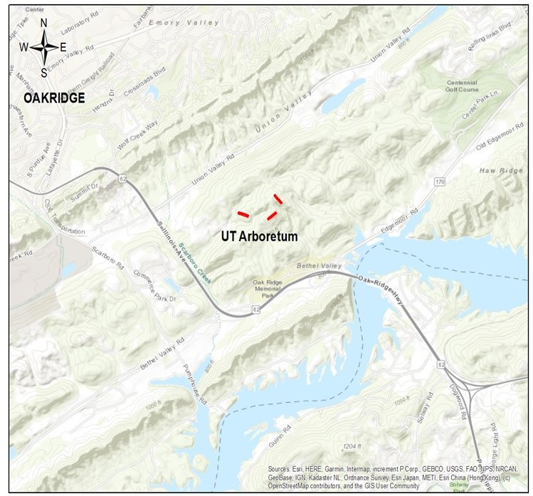
Figure 1: Map of the general area and the field sites located at the University of Tennessee Forest Resource Ag Research and Education Center (UT Arboretum).
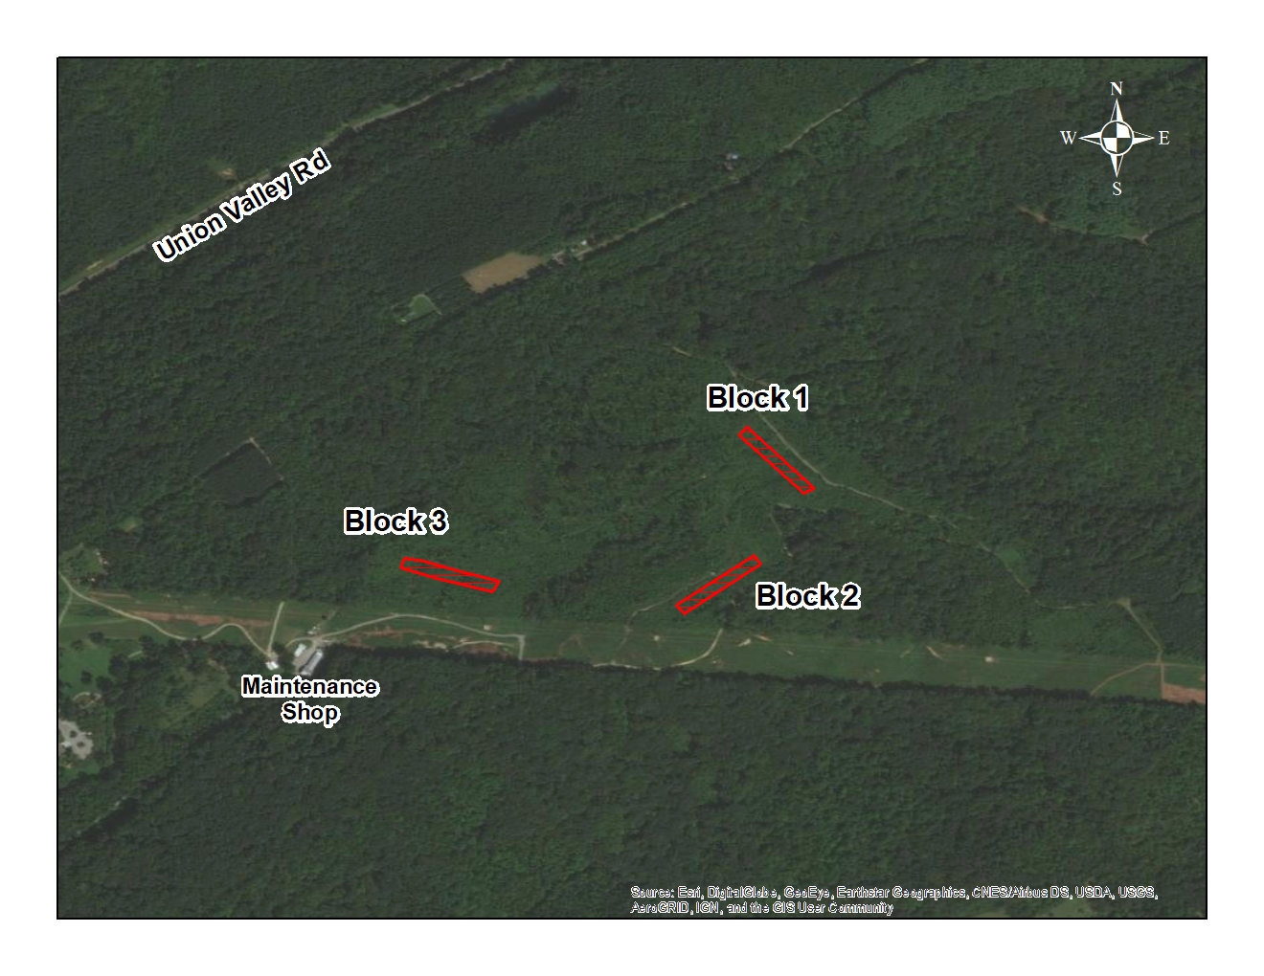
Figure 2: Map of the UT Arboretum zoomed in on block locations on site.

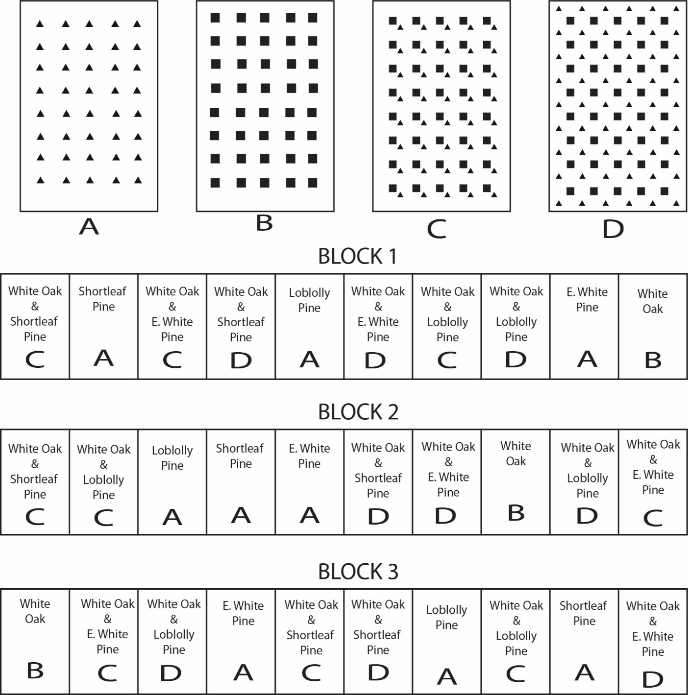
Figure 3: Block diagram of the treatments and spacing for each treatment for the experiment located at the Ut Arboretum.

A are monoculture pine plots, B monoculture oak plots, C pine (spp.) multi-cropped with white oak on a .31m spacing with species as indiciated, and D are pine (spp.) multi-cropped with white oak on a 1.74m spacing with species as indicated.

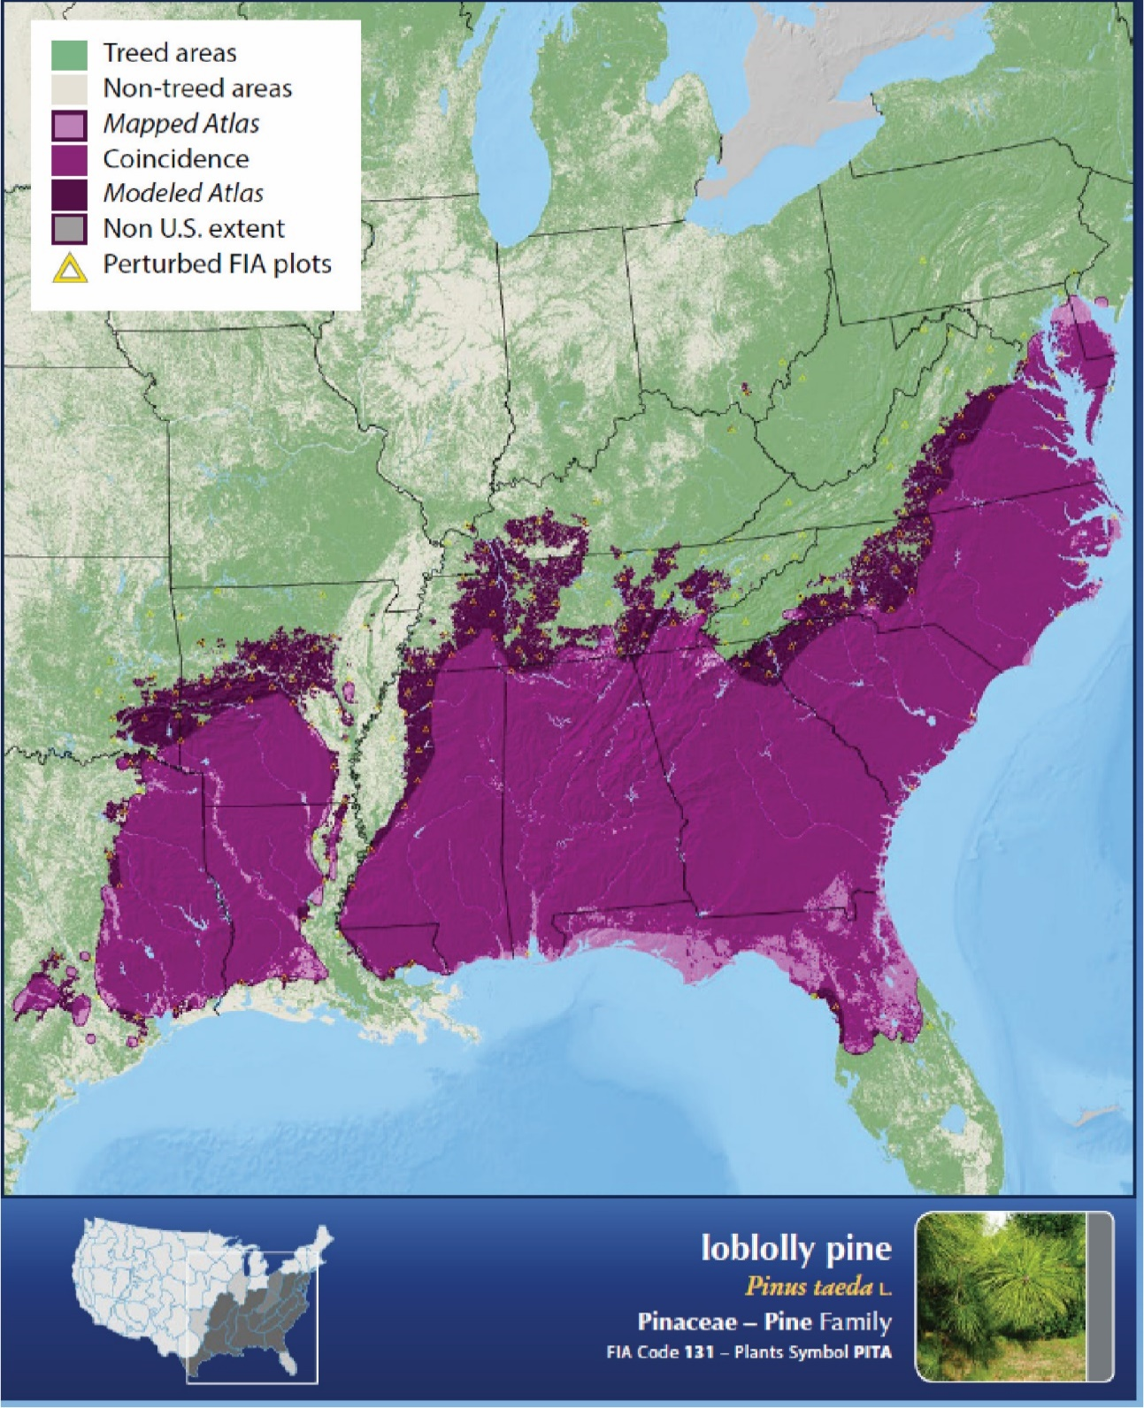
Figure 4: Range map of loblolly pine provided by on 1:8m scale with modeled range, mapped Atlas, and coincidence areas.
Mapped Atlas depicts actual mapped range, modeled atlas depicts estimates of tree species occurrence, and coincidence areas are where the mapped and modeled ranges overlap (Ellenwood, Krist, & Romero, 2015).
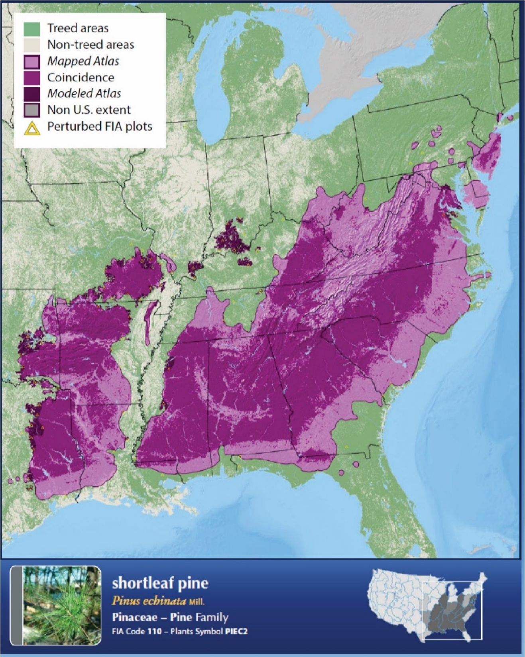
Figure 5: Range map of shortleaf pine provided by (Ellenwood et al., 2015) on a 1:8M scale.
Mapped Atlas depicts actual mapped range, modeled atlas depicts estimates of tree species occurrence, and coincidence areas are where the mapped and modeled ranges overlap (Ellenwood, Krist, & Romero, 2015).
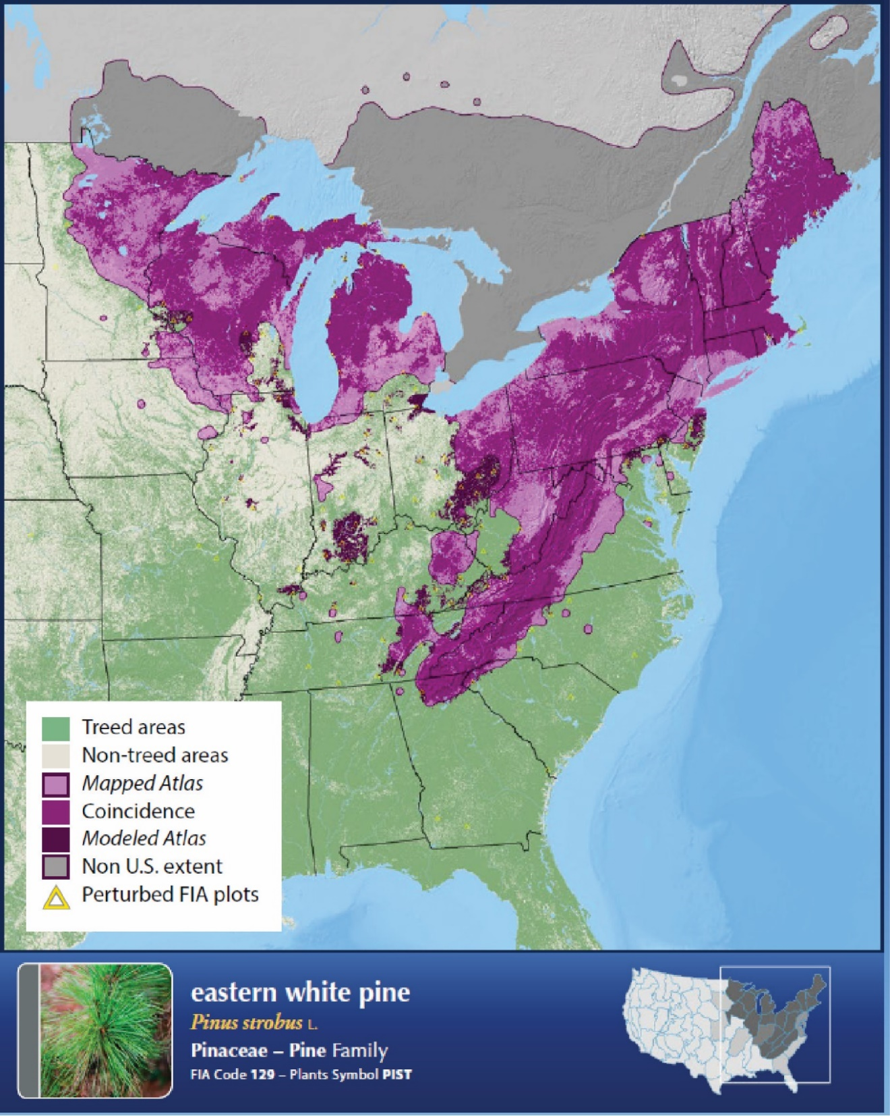
Figure 6: Range map of eastern white pine provided by (Ellenwood et al., 2015) on a 1:4M scale.
Mapped Atlas depicts actual mapped range, modeled atlas depicts estimates of tree species occurrence, and coincidence areas are where the mapped and modeled ranges overlap (Ellenwood, Krist, & Romero, 2015).
.

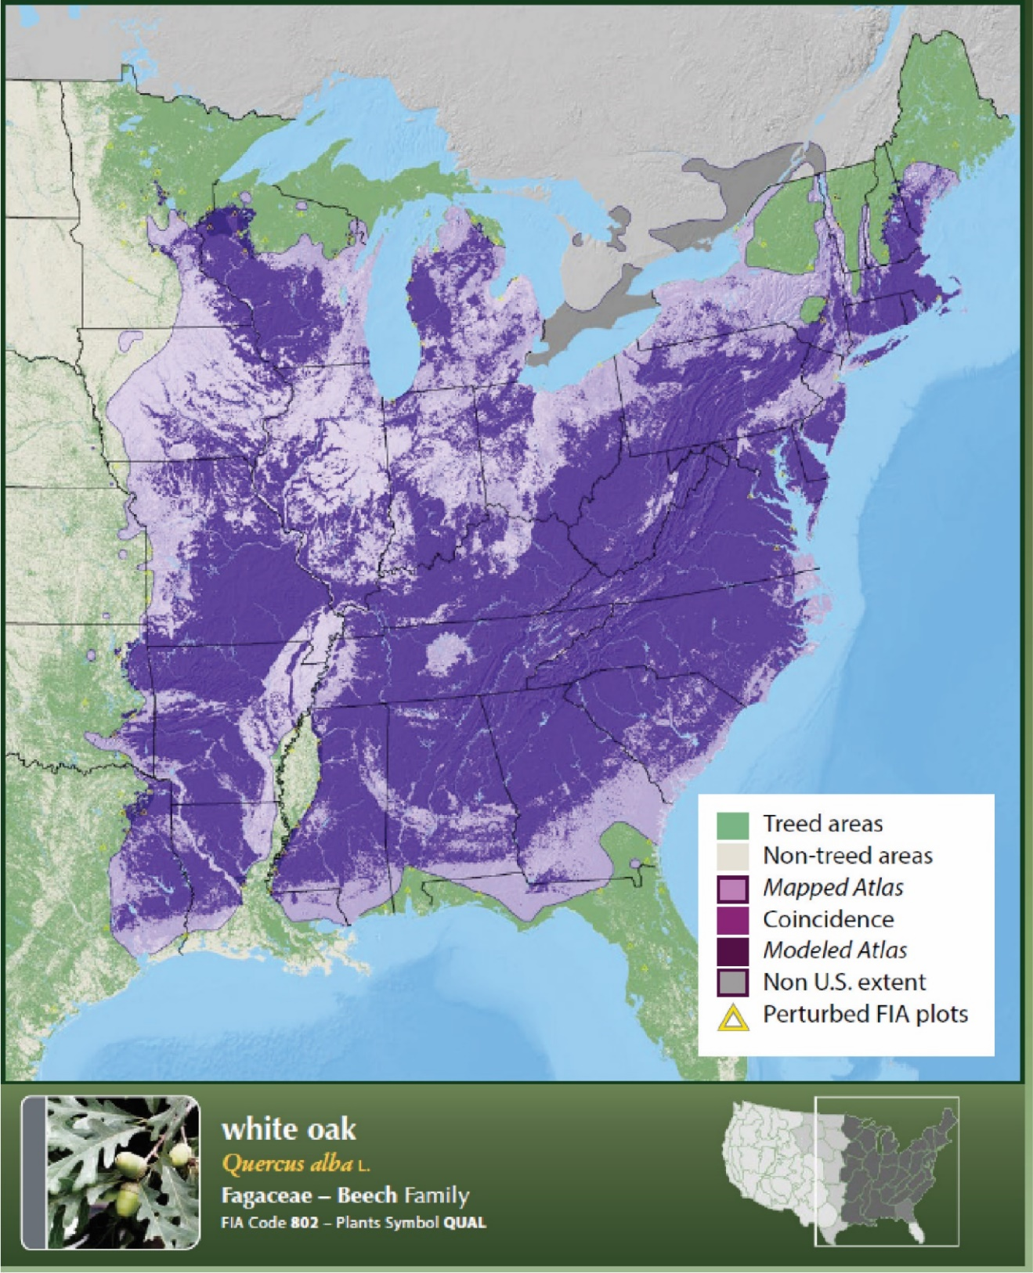
Figure 7: Range map of White Oak provided by (Ellenwood et al., 2015) on a 1:10M scale.
Mapped Atlas depicts actual mapped range, modeled atlas depicts estimates of tree species occurrence, and coincidence areas are where the mapped and modeled ranges overlap (Ellenwood, Krist, & Romero, 2015).

Table 3.1. Summary of the analysis of variance of variables to measure structural complexity generated by SAS 9.4
Variable | LP1 | SP1 | EWP1 | LP2 | SP2 | EWP2 | LC | SC | EWPC | WOC
Rumple* | 4.6 (0.3)ª | 2.6 (0.3)^{cd} | 2.4 (0.3)^{d} | 4.0 (0.3)^{abc} | 3.4 (0.3)^{abcd} | 2.5 (0.3)^{cd} | 4.3 (0.3)^{ab} | 3.0 (0.3)^{bcd} | 2.3 (0.3)^{d} | 2.3 (0.3)^{d}
Top Rugosity* | 2.0 (0.1) ^{ab} | 1.2 (0.1) ^{cd} | 1.0 (0.1) ^{d} | 1.8 (0.1) ^{abc} | 1.4 (0.1) ^{bcd} | 1.1 (0.1) ^{cd} | 2.3 (0.1) ª | 1.4 (0.1) ^{bcd} | 1.2 (0.1) ^{cd} | 1.0 (0.1) ^{d}
Mean Area (m²) of trees* | 5.1 (0.4)^{ab} | 2.5 (0.4)^{cd} | 2.2 (0.4)^{d} | 4.1 (0.4)^{abc} | 3.2 (0.4)^{cd} | 2.5 (0.4)^{cd} | 5.5 (0.4)ª | 3.3 (0.4)^{bcd} | 2.5 (0.4)^{cd} | 2.1 (0.4)^{d}
SD area (m²) of trees* | 4.0 (0.4)ª | 1.6 (0.4)^{bcd} | 1.8 (0.4)^{bcd} | 3.5 (0.4)^{ab} | 2.4 (0.4)^{abcd} | 1.8 (0.4)^{bcd} | 4.1 (0.4)ª | 3.0 (0.4)^{abc} | 0.9 (0.4)^{d} | 1.4 (0.4)^{cd}
95th % of returns (m)* | 4.6 (0.3)^{ab} | 2.2 (0.3)^{cd} | 2.0 (0.3)^{d} | 3.7 (0.3)^{abc} | 2.9 (0.3)^{bcd} | 2.2 (0.3)^{cd} | 4.9 (0.3)ª | 2.9 (0.3)^{cd} | 2.4 (0.3)^{cd} | 1.8 (0.3)^{d}
Mean Max tree Height (m) * | 5.1 (0.4)^{ab} | 2.5 (0.4)^{cd} | 2.2 (0.4)^{d} | 4.1 (0.4)^{abc} | 3.2 (0.4)^{cd} | 2.5 (0.4)^{cd} | 5.5 (0.4)ª | 3.3 (0.4)^{bcd} | 2.5 (0.4)^{cd} | 2.1 (0.4)^{d}
SD of max tree (m) ++ | 1.5 (0.1)ª | 0.9 (0.1)^{bc} | 0.6 (0.1)^{c} | 1.3 (0.1)^{ab} | 0.9 (0.1)^{abc} | 0.8 (0.1)^{bc} | 1.1 (0.1)^{abc} | 0.9 (0.1)^{bc} | 0.8 (0.1)^{bc} | 0.9 (0.1)^{bc}
Mean # returns by height trees* | 6,392 (1,917)^{ab} | 5,207 (1,917)^{ab} | 7,766 (1,917)^{ab} | 14,715 (1,917)ª | 13,265 (1,917)ª | 9,752 (1,917)^{ab} | 7,547 (1,917)^{ab} | 8,751 (1,917)^{ab} | 1,496 (1,917)^{b} | 2,725 (1,917)^{b}
SD .5m Voxel by Height 0.5m++ | 19,663 (4,695)ª | 28,693 (4,695)ª | 25,899 (4,695)ª | 21,661 (4,695)ª | 30,916 (4,695)ª | 35,175 (4,695)ª | 19,111 (4,695)ª | 27,887 (4,695)ª | 26,398 (4,695)ª | 39,874 (4,695)ª
Mean # Returns by trees* | 5,131 (911)^{abc} | 3,290 (911)^{bc} | 3,240 (911)^{bc} | 5,795 (911)^{ab} | 3,714 (911)^{abc} | 4,238 (911)^{abc} | 7,879 (911)ª | 5,596 (911)^{abc} | 1,147 (911)^{c} | 1,259 (911)^{c}
SD of returns per tree++ | 12,535 (2,622)ª | 6,137 (2,622)ª | 8,654 (2,622)ª | 11,173 (2,622)ª | 8,735 (2,622)ª | 11,566 (2,622)ª | 11,905 (2,622)ª | 9,401 (2,622)ª | 1,807 (2,622)ª | 3,018 (2,622)ª
LP1= loblolly pine multi-cropped with white oak at a 1.74m spacing, SP1= Shortleaf pine multi-cropped with white oak at 1.74m spacing, EWP1= eastern white pine multi-cropped with white oak at 1.74m spacing, LP2= loblolly pine multi-cropped with white oak at a 0.31m spacing, SP2= shortleaf pine multi-cropped with white oak at a 0.31m spacing, EWP2= eastern white pine multi-cropped with white oak at a 0.31m spacing, LPC= Loblolly pine monoculture, SPC= shortleaf pine mono culture, EWPC= eastern white pine monoculture, and WOC is white oak monoculture. Variables with * had stastitically significant differences among treatments. Variables with ++ did not have stastically significant differences. Across treatments, means with the same letters are not significantly different at the alpha =0.05 level.

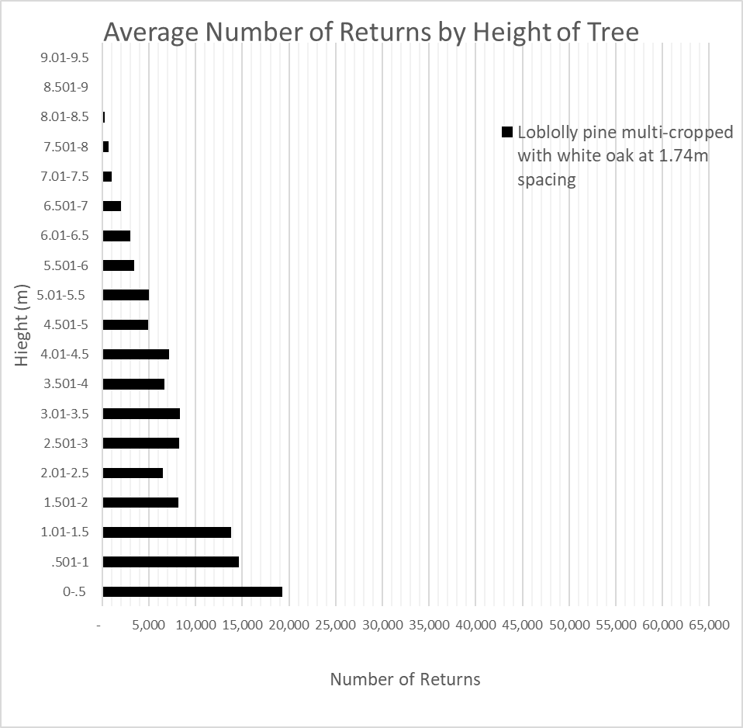
Figure 8: LiDAR derived average number of returns by height (every 0.5m) of white oak intercropped with loblolly pine planted at a 1.74m spacing.
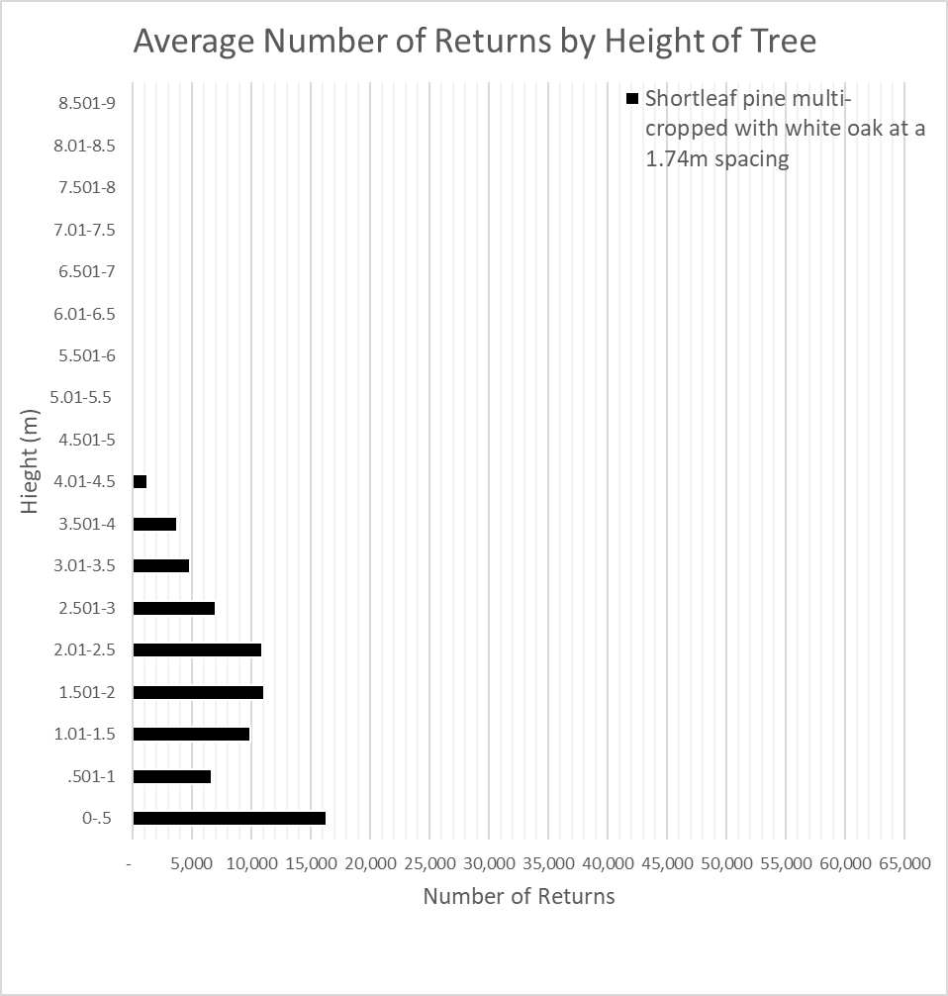
Figure 9: LiDAR derived average number of returns by height (every 0.5m) of white oak intercropped with shortleaf pine planted at a 1.74m spacing.


Figure 10: LiDAR derived average number of returns by height (every 0.5m) of white oak intercropped with eastern white pine planted at a 1.74m spacing.
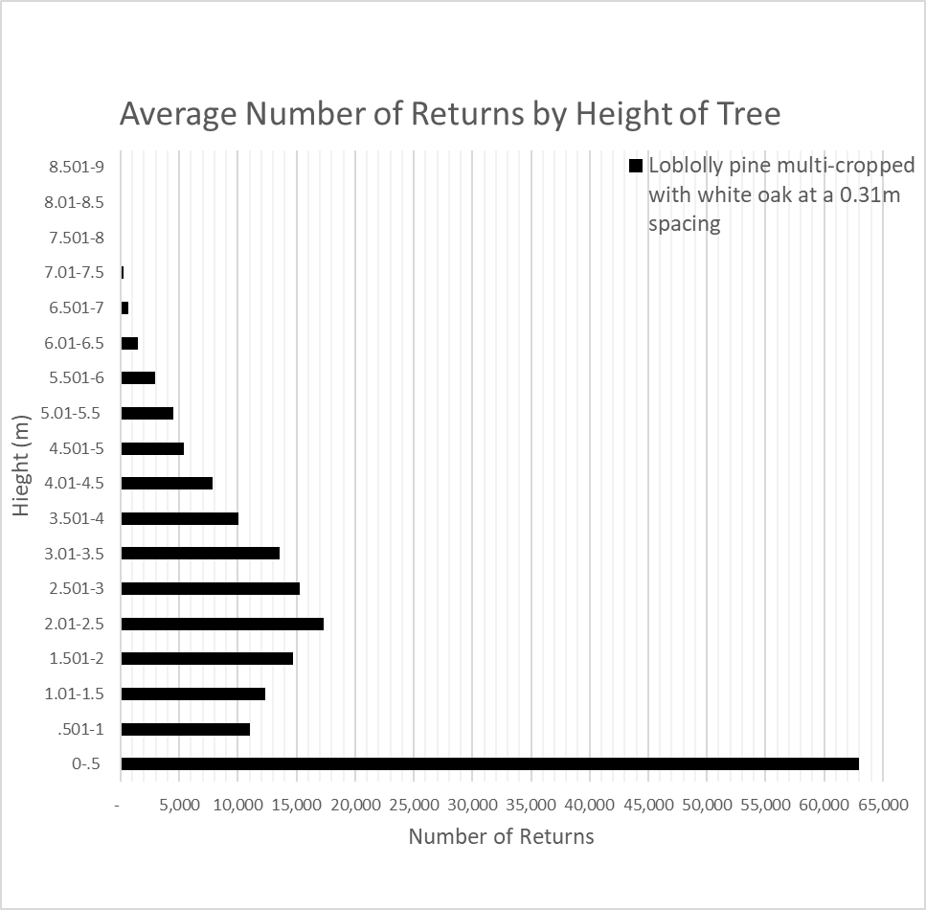
Figure 11: LiDAR derived average number of returns by height (every 0.5m) of white oak intercropped with loblolly pine planted at a 0.31m spacing.

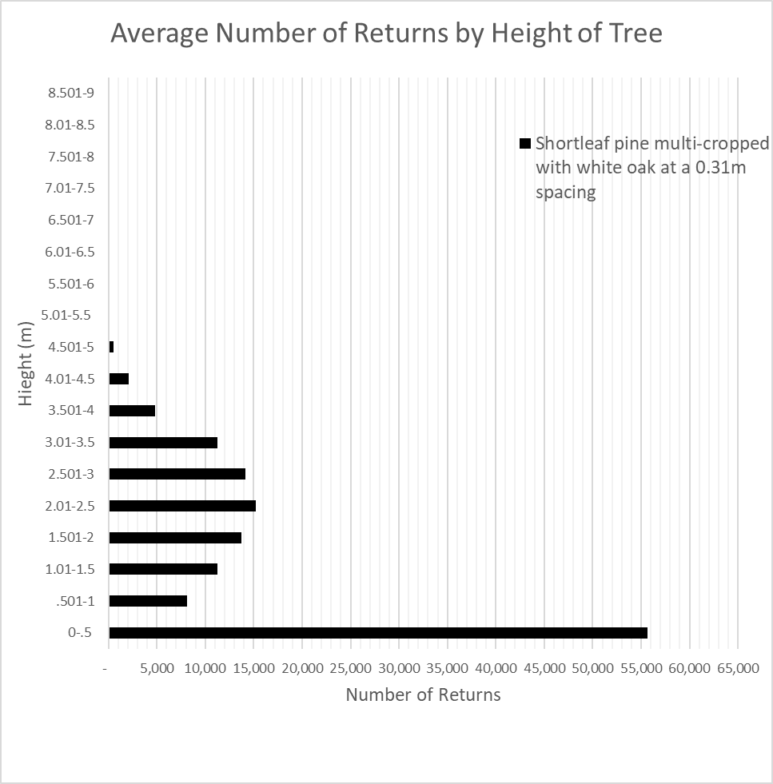
Figure 12: LiDAR derived average number of returns by height (every 0.5m) of white oak intercropped with shortleaf pine planted at a 0.31m spacing.

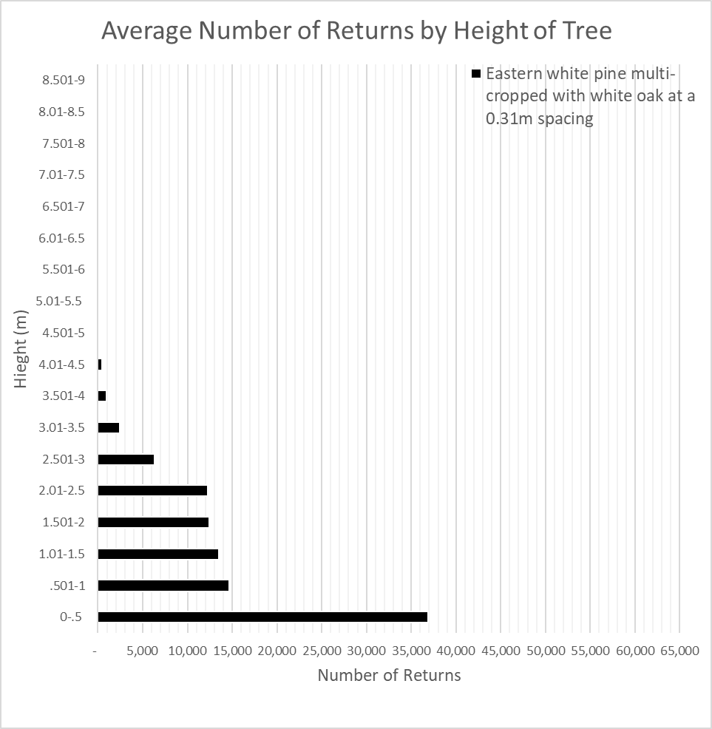
Figure 13: LiDAR derived average number of returns by height (every 0.5m) of white oak intercropped with eastern white pine planted at a 0.31m spacing.

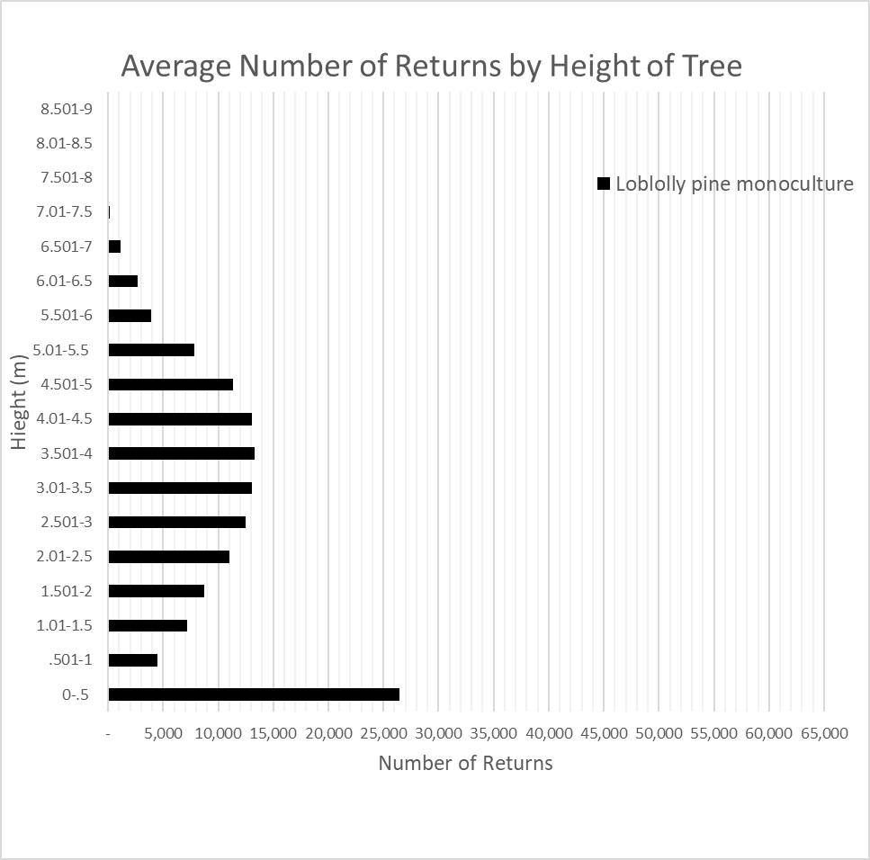
Figure 14: LiDAR derived average number of returns by height (0.5m) of the loblolly pine control monoculture treatment.

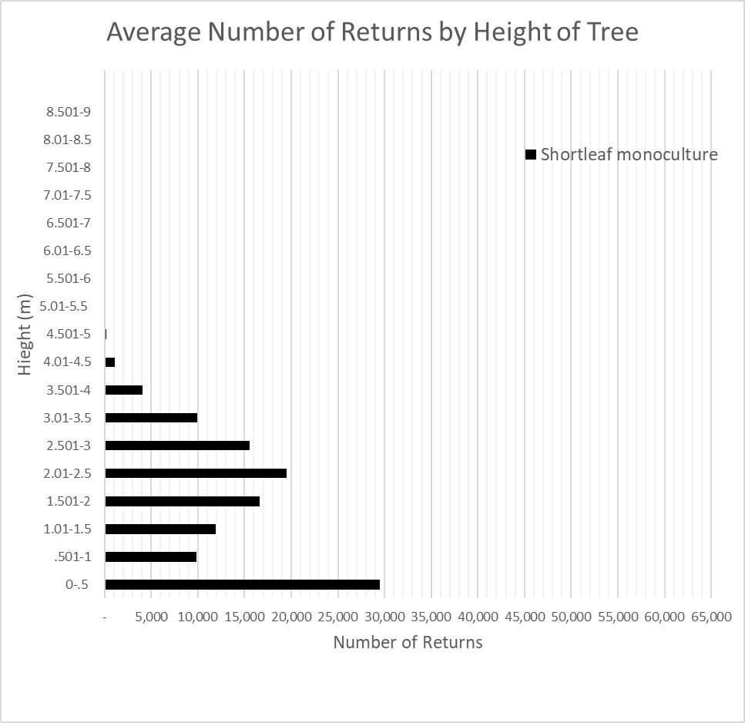
Figure 15: LiDAR derived average number of returns by height (0.5m) of the shortleaf pine monocultures treatment.

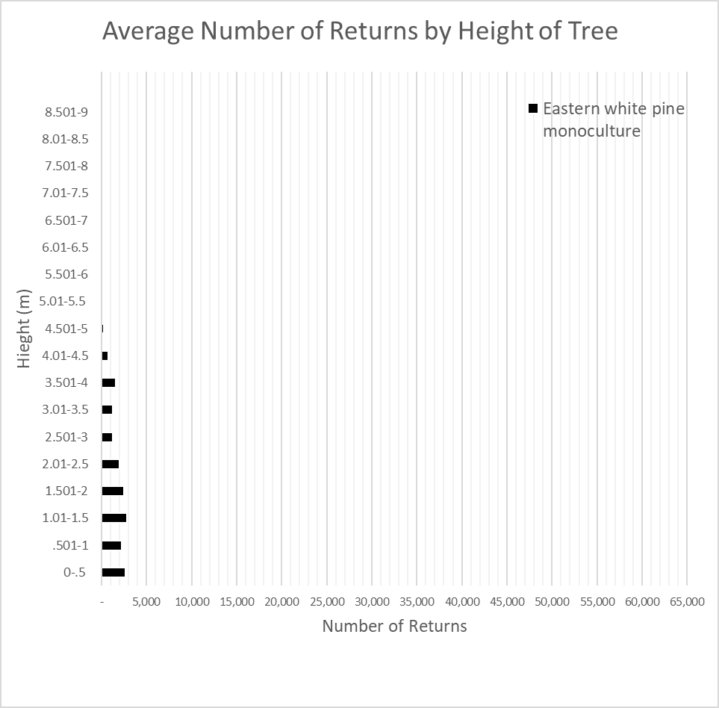
Figure 16: LiDAR derived average number of returns by height (0.5m) of the eastern white pine control treatments.

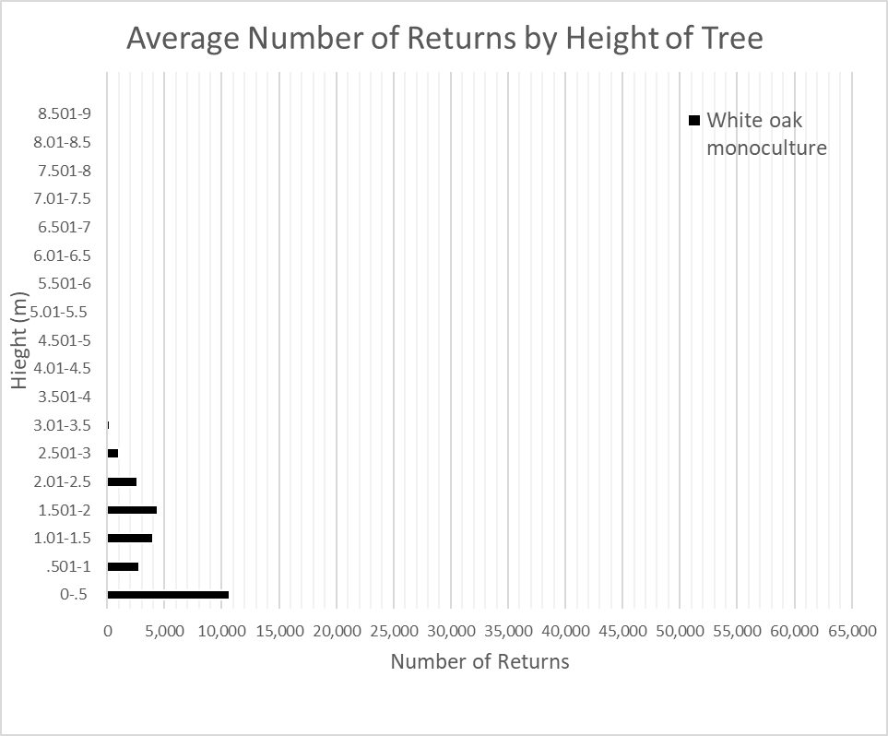
Figure 17: LiDAR derived average number returns by height (0.5m) of the treatments of white oak monoculture control
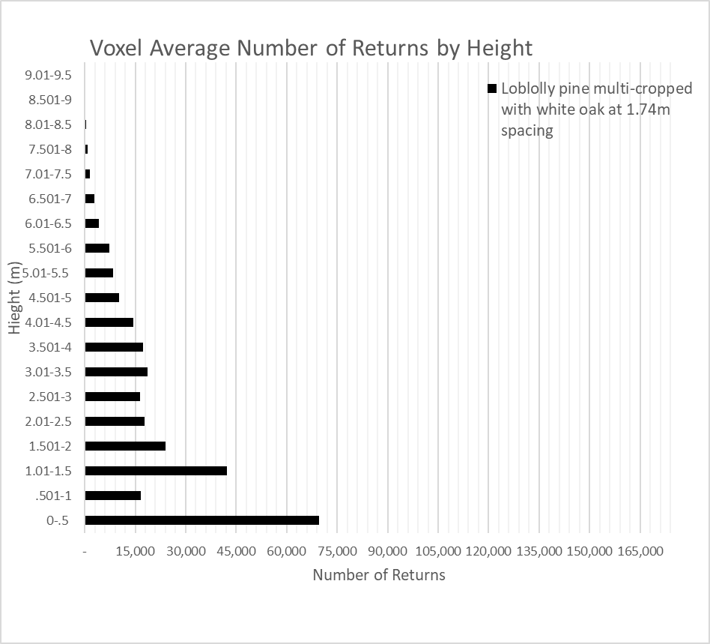
Figure 18: LiDAR derived average number of Voxel returns by height (every 0.5m) of white oak intercropped with loblolly pine planted at a 1.74m spacing.
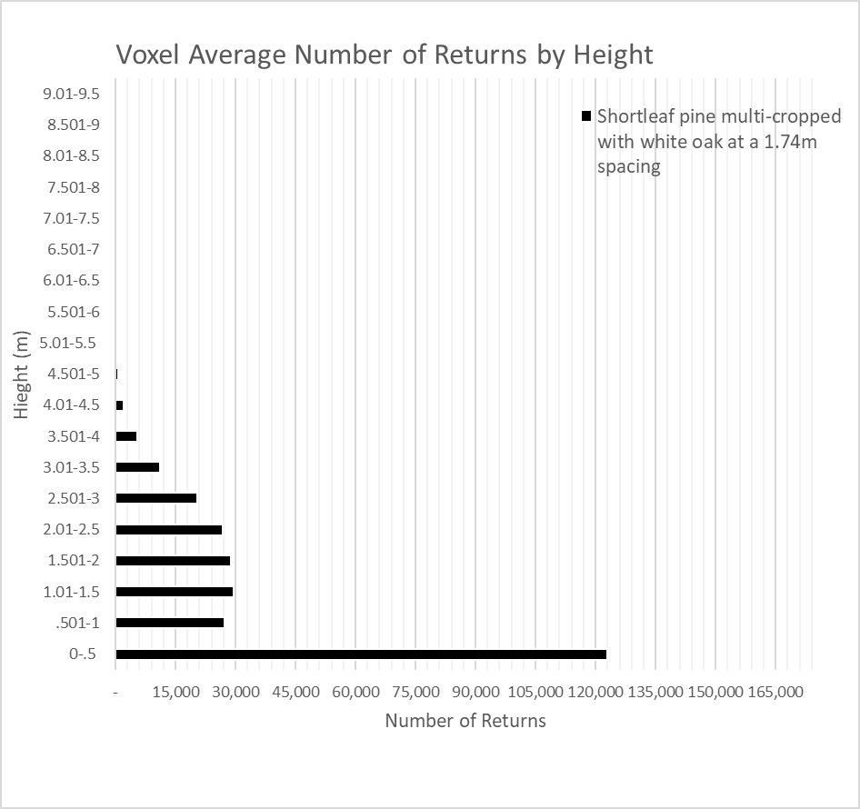
Figure 19: LiDAR derived average number of Voxel returns by height (every 0.5m) of white oak intercropped with shortleaf pine planted at a 1.74m spacing.
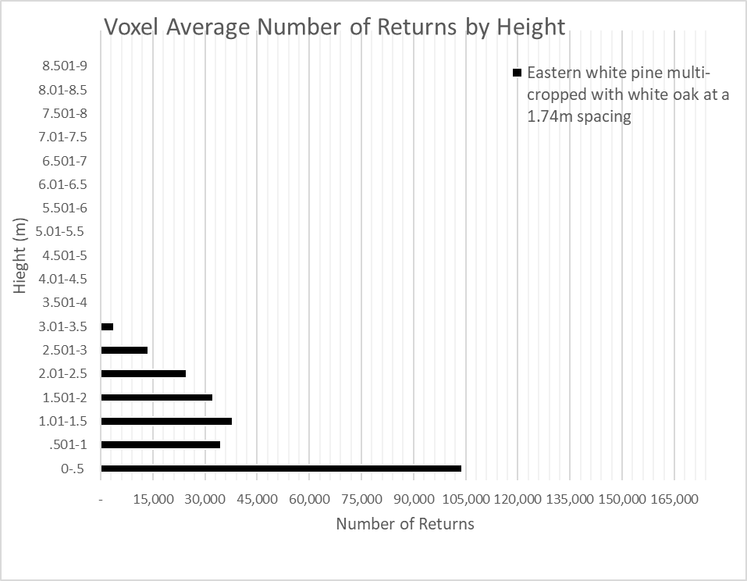
Figure 20: LiDAR derived average number of Voxel returns by height (every 0.5m) of white oak intercropped with eastern white pine planted at a 1.74m spacing.

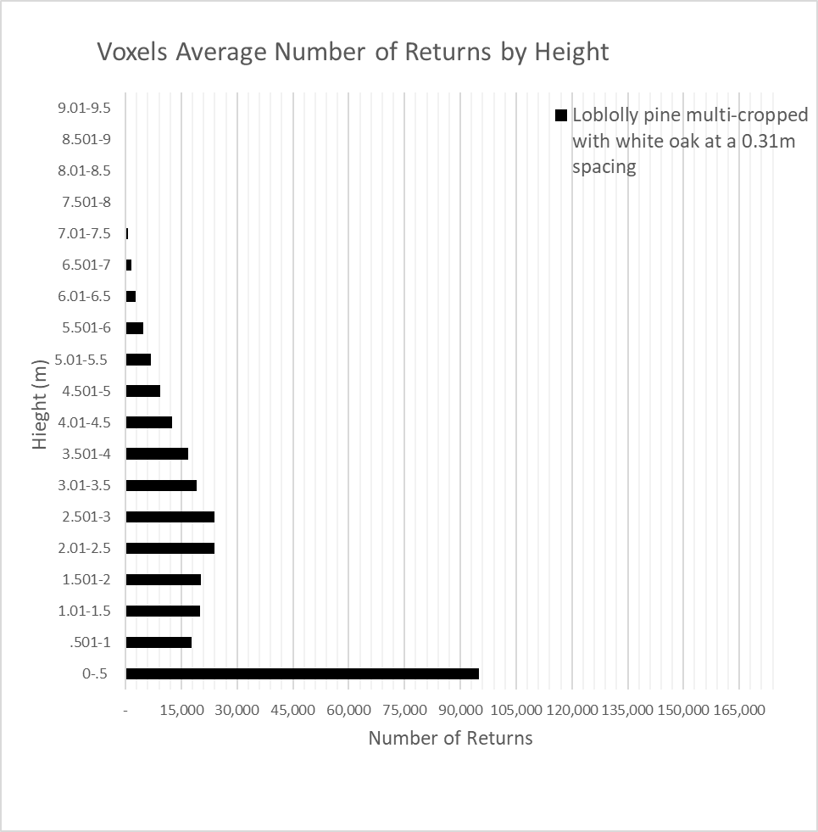
Figure 21: LiDAR derived average number of voxels returns by height (every 0.5m) of white oak intercropped with loblolly pine planted at a 0.31m spacing.

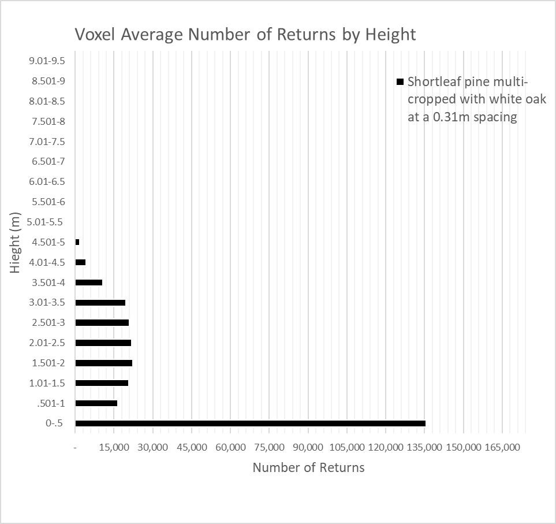
Figure 22: LiDAR derived average number of voxels returns by height (every 0.5m) of white oak intercropped with shortleaf pine planted at a 0.31m spacing.

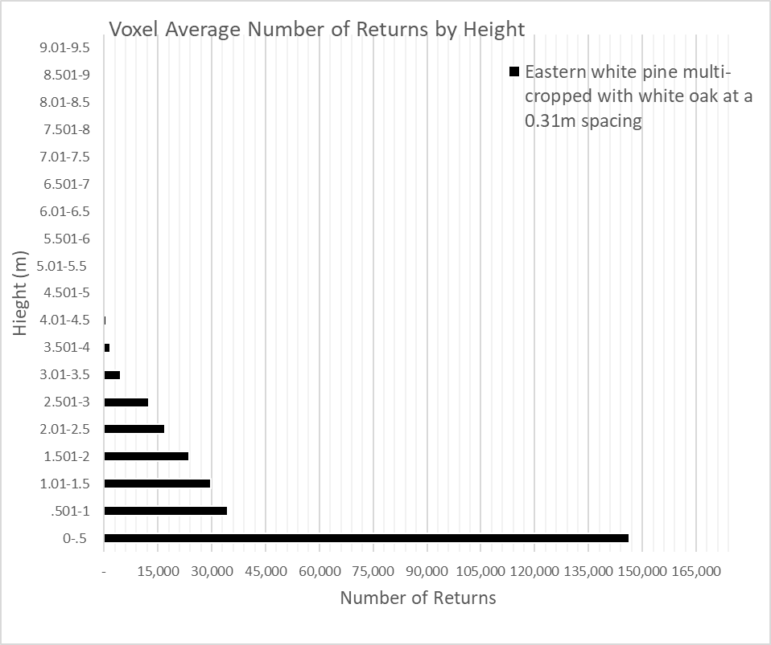
Figure 23: LiDAR derived average number of voxels returns by height (every 0.5m) of white oak intercropped with eastern white pine planted at a 0.31m spacing.

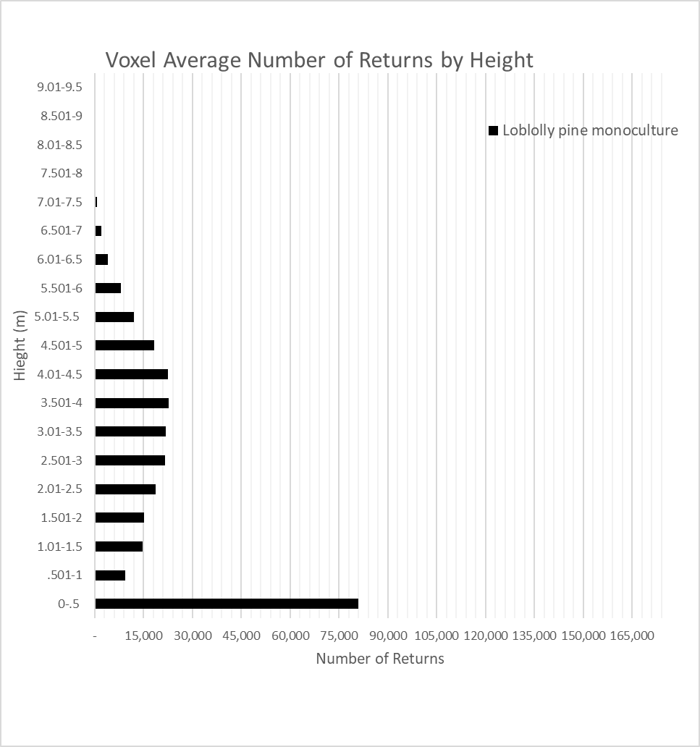
Figure 24: LiDAR derived average number of Voxel returns by height (0.5m) of the loblolly pine control treatments.

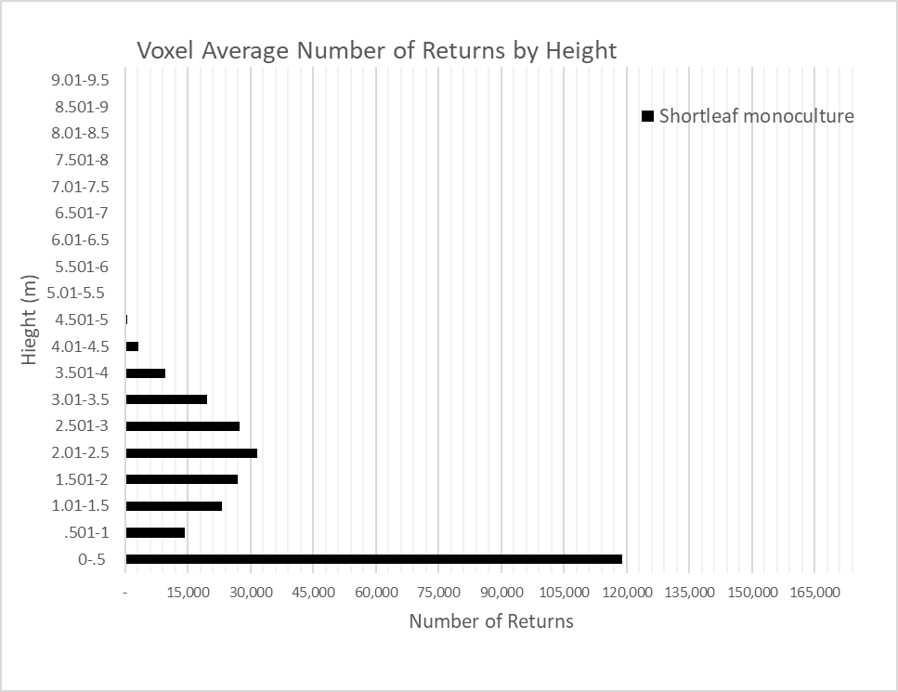
Figure 25: LiDAR derived average number of Voxel returns by height (0.5m) of the shortleaf pine control treatments.

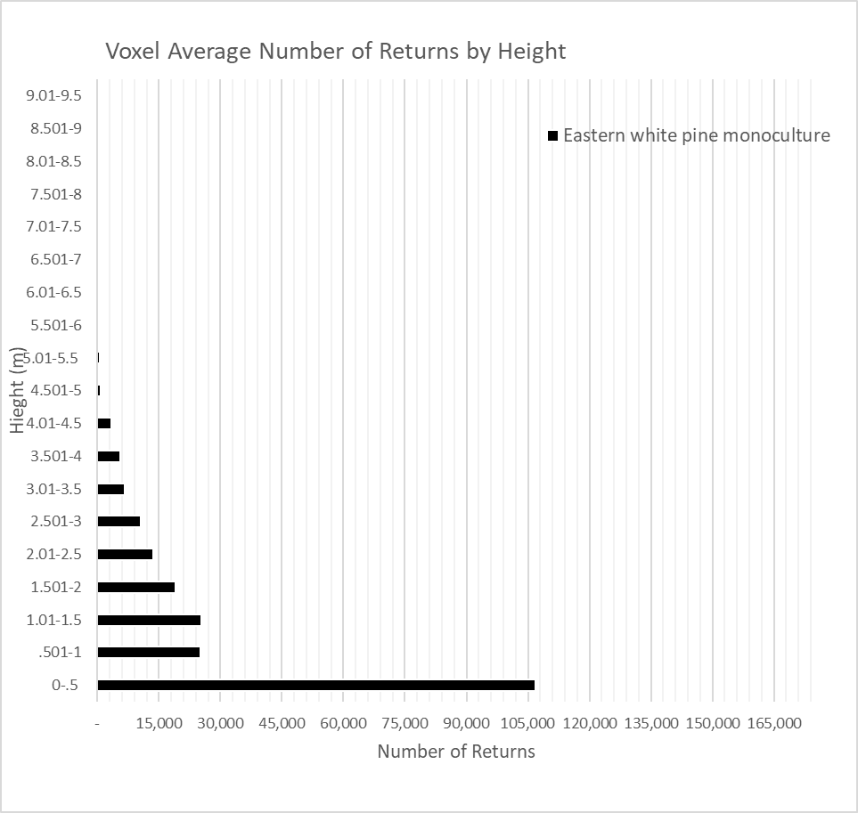
Figure 26: LiDAR derived average number of Voxel returns by height (0.5m) of the eastern white pine control treatments.
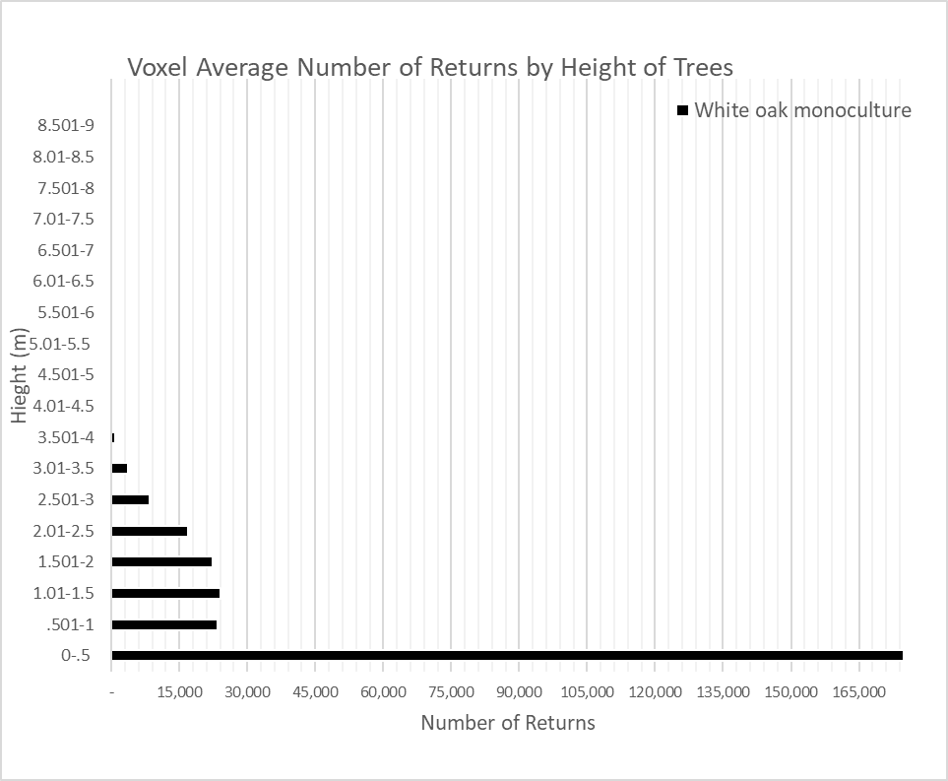
Figure 27: LiDAR derived voxels returns by height (0.5m) of white oak control.
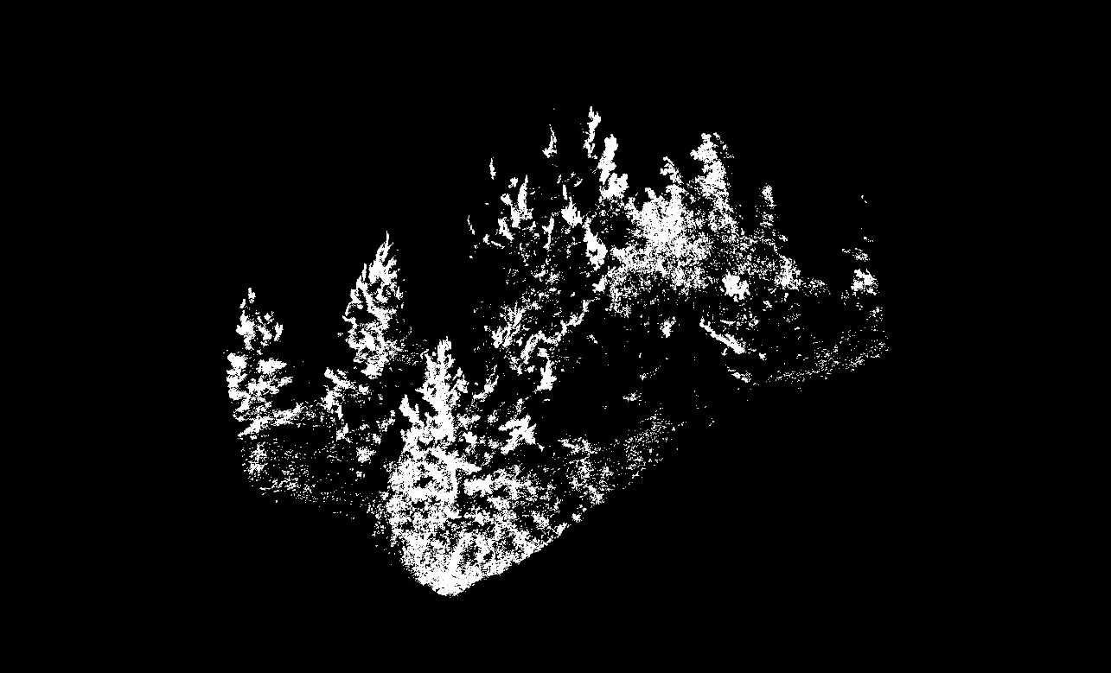
Figure 28: LiDAR derived image of white oak intercropped with loblolly pine at a 1.74m spacing (Cloudcompare Version 2.11.3, 2021).

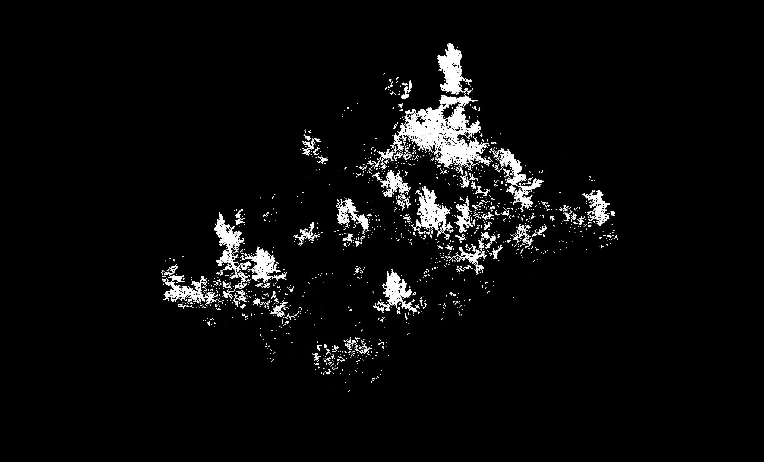
Figure 29: LiDAR derived image of white oak intercropped with shortleaf pine at a 1.74m spacing (Cloudcompare Version 2.11.3, 2021).

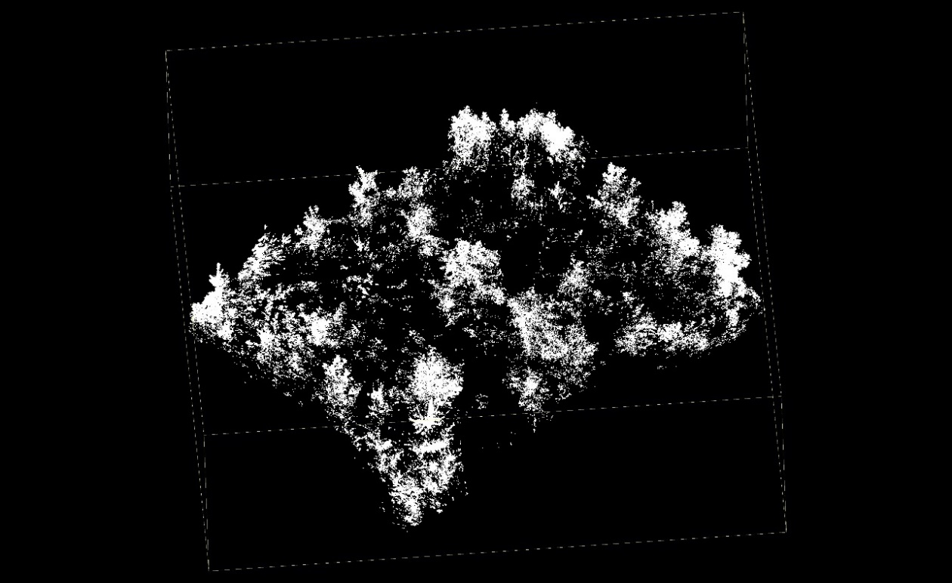
Figure 30: LiDAR derived image of white oak intercropped with eastern white pine at a 1.74m spacing (Cloudcompare Version 2.11.3, 2021).

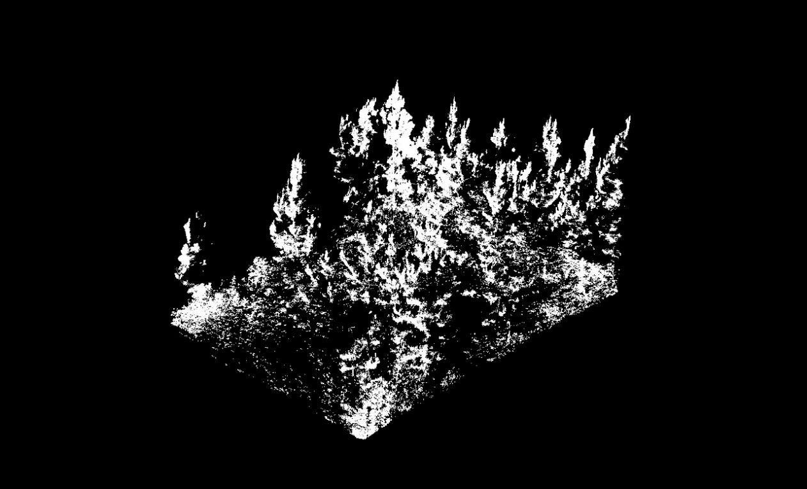
Figure 31: LiDAR derived image of white oak intercropped with loblolly pine at a 0.31m spacing (Cloudcompare Version 2.11.3, 2021).

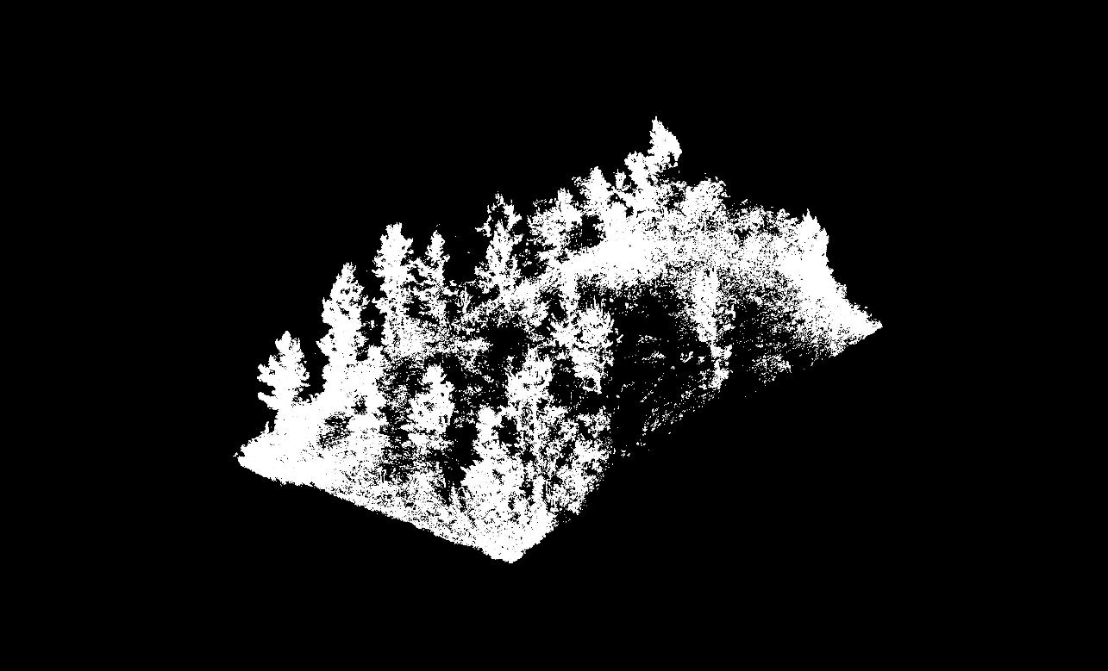
Figure 32: LiDAR derived image of white oak intercropped with shortleaf pine at a 0.31m spacing (Cloudcompare Version 2.11.3, 2021).

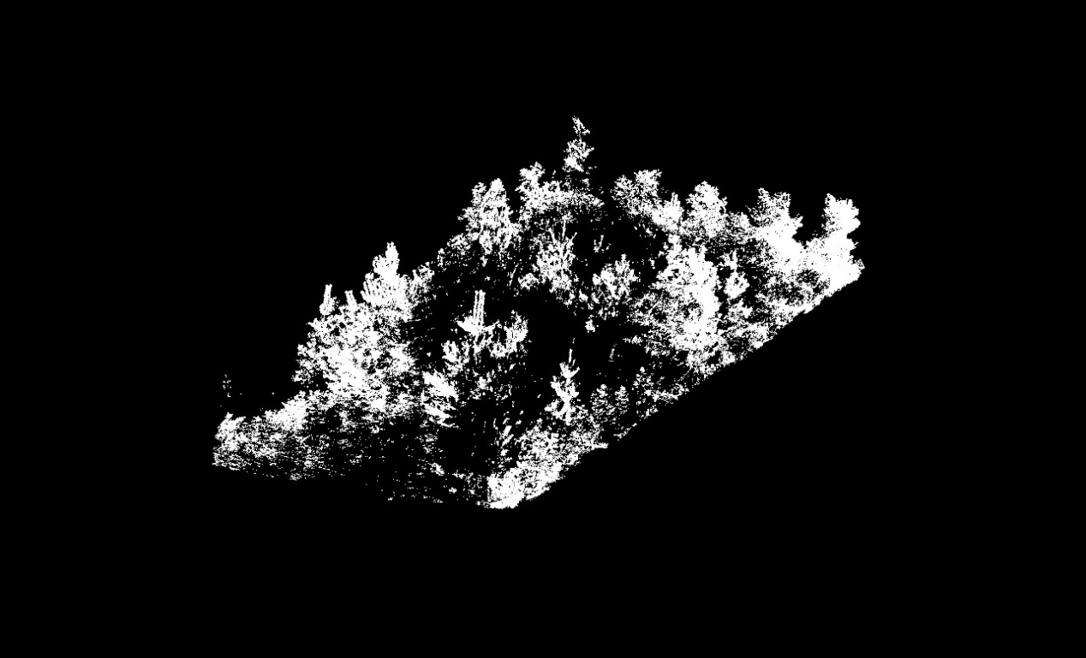
Figure 33: LiDAR derived image of white oak intercropped with eastern white pine at at 0.31 spacing (Cloudcompare Version 2.11.3, 2021).

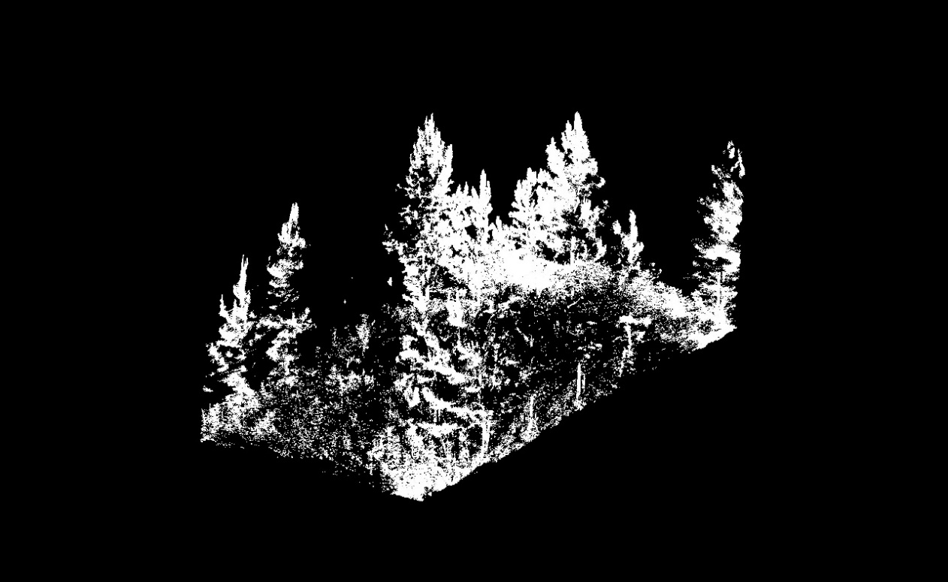
Figure 34: LiDAR derived image of a loblolly pine monoculture (Cloudcompare Version 2.11.3, 2021).

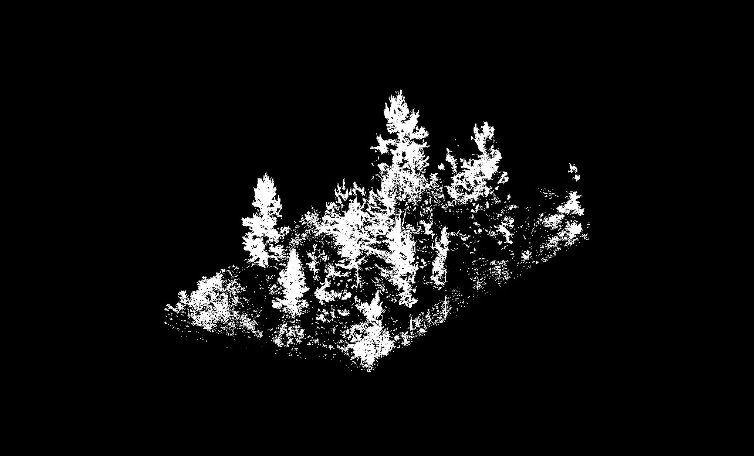
Figure 35: LiDAR derived image of a shortleaf pine monoculture compare (Cloudcompare Version 2.11.3, 2021).

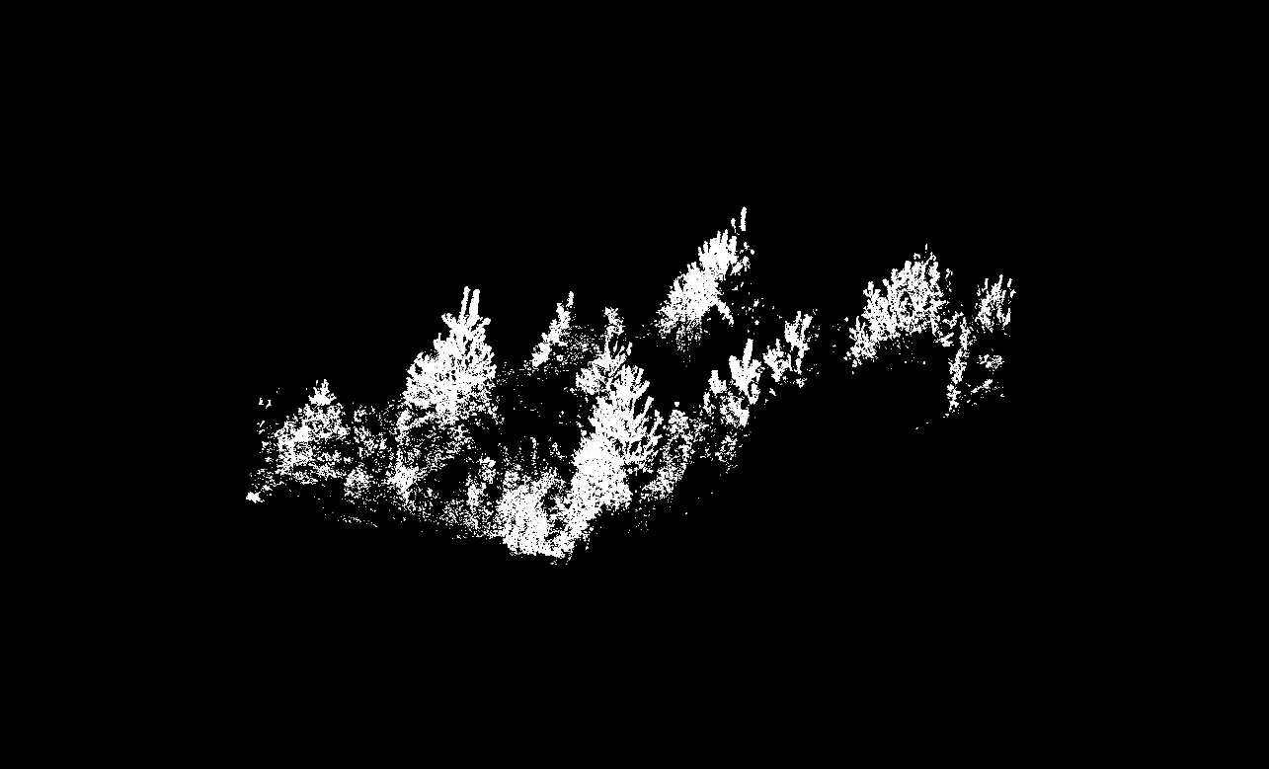
Figure 36: LiDAR derived image of an eastern white pine monoculture (Cloudcompare Version 2.11.3, 2021).

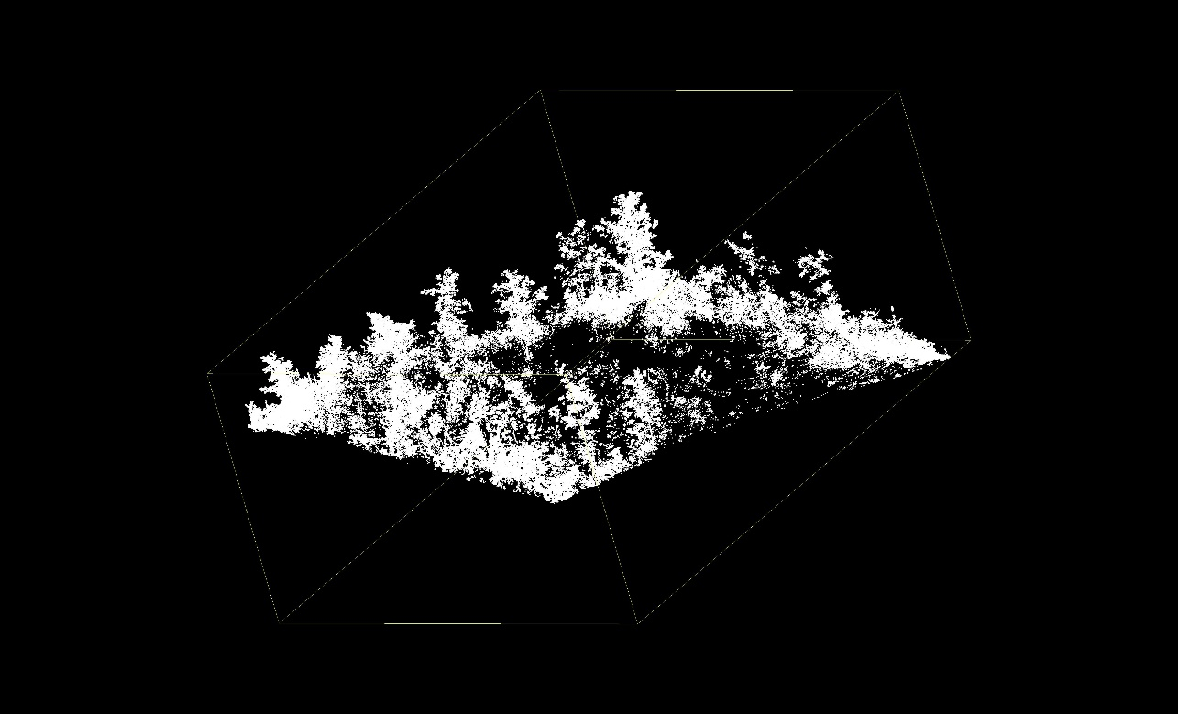
Figure 37: LiDAR derived image of a white oak monoculture (Cloudcompare Version 2.11.3, 2021).

Vita
Bret Alan Elgersma was born in Hollywood, Florida. He graduated from Nova Southeastern University with a Bachelor of Science in accounting in May 2005. He went on to obtain a Master of Accounting degree in August 2011, from Florida Atlantic University. After spending six years in industry, he decided to pursue a career that was aligned with his love for the outdoors. Bret attended the University of Tennessee, Knoxville, where he earned a bachelor’s degree in Wildlife and Fisheries Science with a minor in forestry and watershed management in June 2019. Upon graduation, Bret began a Master of Science in Forestry at the University of Tennessee Knoxville. He will be graduating with his Master’s degree in August 2021.

