Population dynamics and genetic structure of Louisiana black bears in the Lower Mississippi Alluvial Valley of Louisiana

A Dissertation Presented for the
Doctor of Philosophy
Degree
The University of Tennessee, Knoxville

Jared Scott Laufenberg
August 2014

DEDICATION

This dissertation is dedicated to
all who dared to go further than their soul
or headlamp could see

“It is a commendable maxim still for population ecologists
to seek simplicity and distrust it”
L.C. Birch 1957

“A fancy title is about as useful as the curl in a pig’s tail.”
Unknown source

ACKNOWLEDGMENTS
This dissertation is the result of the cooperation, guidance, and support I have received from so many people during the course of my research in Louisiana and education at the University of Tennessee. Indeed, remembering everyone on such a long list is a remarkable challenge for my memory. The following is my best attempt to express my sincere gratitude to all those who invested their time and effort over the years to make this study the success that is has become.
First and foremost, I want to thank my advisor Dr. Joseph Clark. Not only did he offer me opportunity to be part of such an incredible research project, but he gave me the freedom to pursue new research ideas, always supported my endeavors to further develop my quantitative skills, and showed exceptional patience and flexibility at all times. I have been fortunate to have had him as my mentor and look forward to collaborating with him in the future.
Next I would like to acknowledge my official committee members Dr. Benjamin Fitzpatrick, Dr. Lisa Muller, and Dr. Russell Zaretzki. Their contributions to my research and education certainly have improved and expanded my thinking as a research scientist. I also want to extend my appreciation to Dr. Michael Chamberlain who served as an ex officio committee member and provided a substantial amount of data collected by his former students at Louisiana State University. His understanding of the history and ecology of Louisiana black bears certainly benefited my research.
I also want to thank and acknowledge all the other graduate students who have worked on this project. Mike Hooker, University of Tennessee, initiated DNA sampling in the Tensas River Basin to estimate population parameters and assisted with summer live capture, winter den work, and reintroduction of bears into the Three Rivers Complex. Carrie Lowe, University of Tennessee, initiated DNA sampling in the Upper Atchafalaya River Basin to estimate population parameters and assisted with summer live capture, winter den work, and reintroduction of bears into the Three Rivers Complex. Jesse Troxler, University of Tennessee, initiated DNA sampling in the Lower Atchafalaya River Basin to estimate population parameters and assess genetic structure. Kaitlin O’Connell-Goode, University of Tennessee, continued DNA sampling in the Upper Atchafalaya River Basin to estimate population parameters and assess flooding effects within the Morganza Spillway. Annelie Crook, Louisiana State University, collected survival and reproduction data and assisted with reintroduction of bears into the Three Rivers Complex while studying den ecology in the Tensas River Basin and Three River Complex. John Benson, Louisiana State University, collected survival and reproduction data and assisted with reintroduction of bears into the Three Rivers Complex while studying space use, survival, and reproduction of bears in the Tensas River Basin and Three River Complex.
This project would never have been as successful without the unrelenting persistence of Maria Davidson of the Louisiana Department of Wildlife and Fisheries. Her level of commitment to and personal investment in the successful recovery of the Louisiana black bear is unmatched by anyone else I know. I also want to personally thank Kelly Purkey, Project Leader at Tensas River National Wildlife Refuge (TRNWR) for providing logistical support, equipment, and housing for me and my research technicians. Her commitment to wildlife research and her effectiveness as a leader were instrumental in developing such a rewarding and successful collaboration between UT and TRNWR. I thank John Dickson, Biologist at TRNWR, for his assistance with field work and logistics, Leslie Watson, Shop Manager at TRNWR, for sharing his extensive knowledge of automotive repair and the hydrology and history of the TRNWR, and the rest of the TRNWR staff who graciously offered their time and assistance.
Many other people and agencies contributed to this project in various ways over the years. Funding was provided by the Louisiana Department of Wildlife and Fisheries, U.S. Fish and Wildlife Service, U.S. Army Corps of Engineers, Roy O. Martin Timber Company, Black Bear Conservation Coalition, University of Tennessee, and U.S. Geological Survey. Debbie Fuller, USFWS, provided logistical and contractual assistance. Chris Clayton of the Roy O. Martin Timber Company and Paul Davidson and David Telesco of the Black Bear Conservation Coalition acquired funding and purchased equipment. Jimmy Goad conducted telemetry flights for monitoring radio-collared bears. I want thank the numerous private landowners throughout Louisiana who granted access to their property or provided housing to research personnel. I thank the staff of Red River, Three Rivers, and Spring Bayou Wildlife Management Areas and Bayou Tech, Lake Ophelia, and Bayou Cocodrie National Wildlife Refuges for their help with field work and logistics. I thank Dr. Richard Chandler, University of Georgia, who assisted me with the CMR modeling. I also thank David Paetkau and his staff at Wildlife Genetics International, Inc. for their diligent DNA analysis work and guidance with population genetics analyses. I am grateful to Dr. Jerry Belant, Mississippi State University, and David Garshelis, Minnesota Department of Natural Resources for providing samples for DNA analysis.
I also want to recognize a very special person who consistently went to great lengths to make me feel welcome and part of the local community in northern Louisiana. Tom Bartholomew’s help and advice was available 24/7. Whether it was helping me figure out property ownerships, coming to the aid of a stuck truck, or smoothing over the ruffled feathers of a landowner after I unknowingly trespassed, I always knew I could depend on him. I will always treasure our friendship.
I cannot express enough gratitude to the numerous technicians who worked on this project. The sheer quantity and diversity of wildlife in Louisiana makes it a dream location for any aspiring wildlife student. However, the forests are hot, humid, dense, remote, muddy, and full of snakes, mosquitoes, ticks, chiggers, alligators, and poison ivy. They all braved the worst, embraced the best, and hopefully came out the other side with great memories, few nightmares, and a small place in their hearts for such an amazing place.
My journey on the PhD roller coaster has been incredibly challenging and rewarding. My success and moderate preservation of my sanity has, in no small part, been due to the encouragement and support of my friends and colleagues in Knoxville, Tennessee. First, I want to thank Terry White. She played an essential role providing administrative support throughout this project. However, I value her much more for her friendship. I thank her for being the ear to which I could vent my frustrations and share my triumphs. I certainly will miss our Monday morning conversations. To all the FWF faculty members and graduate students, I thank you for all the intellectually stimulating conversations. As always, I must extend my never-ending gratitude to my close personal friend, Jennifer Murrow. Even from 500 miles away and in the midst of teaching, conducting research, and raising a family, she has somehow managed to be there for me time and again. Thank you!
Finally, I would like to thank my family. It has been 15 years since I left my home in Wisconsin. During that time, they all have supported and shared in my wildlife endeavors from afar. Above all, I want thank my father, Daniel Laufenberg for instilling in me a sound work ethic and a passion for wildlife. In the acknowledgements of my M.S. thesis I credited my unrelenting stubbornness to him. He disagreed. I maintain my position. I still am a proud son.

ABSTRACT
In 1992, the U.S. Fish and Wildlife Service granted the Louisiana black bear threatened status under the U.S. Endangered Species Act, listing loss and fragmentation of habitat as the primary threats. The 1995 Recovery Plan outlines recovery goals designed to meet the objective of reducing threats to the Louisiana black bear metapopulation and supporting habitat. To meet that objective, the Recovery Plan requires 1) at least 2 viable subpopulations, 1 each in the Tensas and Atchafalaya River Basins, 2) movement corridors between the 2 viable subpopulations, and 3) long-term protection of the habitat supporting each viable subpopulation and interconnecting corridors for delisting to occur. To address criteria 1 and 2, my objectives were 1) to estimate demographic rates of Louisiana black bear subpopulations, 2) to evaluate genetic structure and interchange of Louisiana black bear subpopulations, 3) to develop data-driven projection models to assess long-term persistence of individual subpopulations and the metapopulation in Louisiana, and 4) to determine how different model assumptions and parameter values affect estimates of long-term persistence. I used telemetry, den check data, and DNA-based capture-mark-recapture to demographic rates. Bayesian hierarchical modeling methods were used to estimate temporal process variance and parameter uncertainty. I developed stochastic population projection models based on estimates of demographic rates, process variances, and parameter uncertainty to estimate probabilities of persistence. I used 2 genetic clustering analyses to evaluate genetic structure among subpopulations in Louisiana and used 2 genetic assignment tests to measure interchange among subpopulations. Based on most projection models, estimates of persistence probabilities indicate that a viable subpopulation exists within the Tensas River Basin and within the Upper Atchafalaya River Basin. However, simulations under the most pessimistic set of assumptions suggested that the probability of extinction was slightly less than 95% for the Upper Atchafalaya (93%). Genetic analyses revealed that Louisiana black bear subpopulations were genetically distinct from each other and that contemporary gene flow is occurring between the Tensas River Basin and Upper Atchafalaya River Basin via a recently reintroduced population located between the two at the Three Rivers Complex. Those results suggest movement pathways currently exist between viable subpopulations.
TABLE OF CONTENTS

1 INTRODUCTION 1
2 STUDY AREA 7
3 METHODS 8
3.1 Data sources 8
3.1.1 General approach 8
3.1.2 Live-capture 8
3.1.3 Winter den visits 9
3.1.4 Radio monitoring 10
3.1.5 Non-invasive DNA sampling 10
3.1.6 Non-invasive hair sample selection 11
3.1.7 DNA extraction and microsatellite genotyping 13
3.1.8 Marker selection for individual identification 13
3.1.9 Analysis of samples from alternative sources 15
3.2 Demographic rate analysis 16
3.2.1 Model fitting, estimation, and inference 16
3.2.2 Survival rates of radio-collared adult female bears 17
3.2.3 Reproductive rates of radio-collared adult female bears 20
3.2.4 Demographic rates from capture-mark-recapture 22
3.3 Population viability analysis 30
3.4 Population structure and migrant analysis 37
3.4.1 General approach 37
3.4.2 Population structure analysis 39
3.4.3 Migrant analysis 41
4 RESULTS 43
4.1 Data sources 43
4.1.1 Non-invasive hair sampling 43
4.1.2 Marker selection for individual identification 44
4.1.3 Microsatellite genotyping for individual identification 45
4.2 Demographic rate analysis 45
4.2.1 Survival rates of radio-collared adult female bears 45
4.2.2 Reproductive rates of radio-collared adult female bears 46
4.2.3 Demographic rates from capture-mark-recapture data 48
4.3 Population viability analysis 50
4.4 Population structure and migrant analysis 52
4.4.1 Population structure analysis 52
4.4.2 Migrant analysis 55
5 DISCUSSION 57
5.1 Demographic rate analysis 57
5.1.1 Survival rates of radio-collared adult female bears 57
5.1.2 Reproductive rates of radio-collared adult female bears 58
5.1.3 Demographic rates from capture-mark-recapture data 59
5.1.4 Asymptotic population growth rates 63
5.2 Population viability analysis 64
5.3 Population structure and migrant analysis 68
6 CONCLUSIONS 75
LIST OF REFERENCES 77
APPENDICES 87
Appendix A: Tables 88
Appendix B: Figures 112
Appendix C. Non-invasive hair sample selection 150
Appendix D. Programming code 155
VITA 206

LIST OF TABLES

Table 1. Distribution of hair collection sites for study areas in the Tensas River Basin, Upper Atchafalaya River Basin, and Lower Atchafalaya River Basin, Louisiana. 89
Table 2. Observed (first value) and expected (second value) heterozygosities of microsatellite loci sampled from American black bear populations in Itasca County, Minnesota (MINN), White River Basin of Arkansas (WRB), Tensas River Basin of Louisiana (TRB), Three Rivers Complex of Louisiana (TRC), Upper Atchafalaya River Basin of Louisiana (UARB), Lower Atchafalaya River Basin of Louisiana (LARB), and western and southern Mississippi (MISS). 90
Table 3. Microsatellite markers used for individual identification and population genetics analyses for Louisiana black bears in Louisiana, USA from 2006−2012. 92
Table 4. Causes of death for adult female black bears radio monitored between 2002 and 2012 in the Tensas River Basin and Three Rivers Complex of Louisiana, USA. 94
Table 5. Estimated transition rates between reproductive states for adult female Louisiana black bears in the Tensas River Basin and Three Rivers Complex, Louisiana, USA. 95
Table 6. Summary of 10,000 simulated population trajectories over a 100-year period for female Louisiana black bears in the Tensas River Basin (TRB) and Upper Atchafalaya River Basin (UARB), Louisiana, USA. Simulations were based on demographic rates estimated from capture-mark-recapture analyses that modeled capture heterogeneity as individual random effects (i.e., Model 1) or finite mixture distributions (i.e., Model 2) and incorporated only process variation (i.e., Process-only) or process variation and parameter uncertainty (i.e., All uncertainty). 96
Table 7. Summary of 10,000 simulated population trajectories over a 100-year period for female Louisiana black bears in the Three Rivers Complex, Louisiana, USA. Simulations were based on adult survival rates estimated from radio-telemetry data and reproductive rates estimated from den visit data, incorporated only process variation (i.e., Process-only) or process variation and parameter uncertainty (i.e., All-uncertainty), and included different strengths of density dependence (i.e., 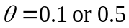) using the Michaelis-Menten function for enzyme kinetics. Simulations were conducted separately for estimates of adult survival rates that treated unresolved radio losses as censored (i.e., Assumed censored) and estimates that treated those losses as mortalities (i.e., Assumed dead). Carrying capacity (CC) based on density estimates derived from capture-mark-recapture analyses modeling capture heterogeneity with random effects (i.e., Model 1). 97
Table 8. Summary of 10,000 simulated population trajectories over a 100-year period for female Louisiana black bears in the Three Rivers Complex, Louisiana, USA. Simulations were based on adult survival rates estimated from radio-telemetry data and reproductive rates estimated from den visit data, incorporated only process variation (i.e., Process-only) or process variation and parameter uncertainty (i.e., All-uncertainty), and included different strengths of density dependence (i.e., ) using the Michaelis-Menten function for enzyme kinetics. Simulations were conducted separately for estimates of adult survival rates that treated unresolved radio losses as censored (i.e., Assumed censored) and estimates that treated those losses as mortalities (i.e., Assumed dead). Carrying capacity (CC) based on density estimates derived from capture-mark-recapture analyses modeling capture heterogeneity with 2-point finite mixture distribution (i.e., Model 2). 99
Table 9. Estimates of annual survival for adult female black bears from unhunted populations within the southeastern US. 101
Table 10. Summary of population parameter estimates for female Louisiana black bears in the Tensas River Basin, Three Rivers Complex, Upper Atchafalaya River Basin, and Lower Atchafalaya River Basin of Louisiana, USA. 102
Table 11. Observed allele frequencies for American black bears from Itasca County, Minnesota (MINN), the White River Basin of Arkansas (WRB), the Tensas River Basin of Louisiana (TRB), the Three Rivers Complex of Louisiana (TRC), the Upper Atchafalaya River Basin of Louisiana (UARB), the Lower Atchafalaya River Basin of Louisiana (LARB), and western and southern Mississippi (MISS). 103

LIST OF FIGURES

Figure 1. Map of the study area showing each of the 4 subpopulations of Louisiana black bear (black polygons) within the Lower Mississippi Alluvial Valley in Louisiana, USA. Natural land cover is in green and non-natural is in gray. 113
Figure 2. Number of sites producing ≥1 collected sample each week in the Tensas River Basin of Louisiana, USA, 2006–2012. 114
Figure 3. Number of samples collected each week in the Tensas River Basin of Louisiana, USA, 2006–2012. 115
Figure 4. Number of individual hair-collection sites that produced ≥1 collected sample across all weeks within each year for the Tensas River Basin (solid line with squares), the Upper Atchafalaya River Basin (dashed line with triangles), and the Lower Atchafalaya River Basin (dotted line with circles) of Louisiana, USA, 2006–2012. 116
Figure 5. Number of sites producing ≥1 collected sample each week in the Upper Atchafalaya River Basin of Louisiana, USA, 2007–2012. 117
Figure 6. Number of samples collected each week in the Upper Atchafalaya River Basin of Louisiana, USA, 2007–2012. 118
Figure 7. Number of sites producing ≥1 collected sample each week in the Lower Atchafalaya River Basin of Louisiana, USA, 2010–2012. 119
Figure 8. Number of samples collected each week in the Upper Atchafalaya River Basin of Louisiana, USA, 2007–2012. 120
Figure 9. Distribution of mismatched pairs of multilocus genotypes from the Tensas River Basin of Louisiana, USA, 2006–2012. 121
Figure 10. Distribution of mismatched pairs of multilocus genotypes from the Upper Atchafalaya River Basin of Louisiana, USA, 2007–2012. 122
Figure 11. Distribution of mismatched pairs of multilocus genotypes from the Lower Atchafalaya River Basin of Louisiana, USA, 2010–2012. 123
Figure 12. Annual estimates (diamonds) and 95% credible intervals (bars) of adult female survival for Louisiana black bears within the Tensas River Basin (top) and Three Rivers Complex (bottom) in Louisiana, USA. Estimates assume bears with unresolved fates were alive at time of last contact. Thick dashed lines are mean annual survival estimates and thin dashed lines are 95% credible intervals. 124
Figure 13. Annual estimates (diamonds) and 95% credible intervals (error bars) of adult female survival for Louisiana black bears within the Tensas River Basin (top) and Three Rivers Complex (bottom) in Louisiana, USA. Estimates assume bears with unresolved fates were dead at time of last contact. Thick dashed lines are mean annual survival estimates and thin dashed lines are 95% credible intervals. 125
Figure 14. Posterior distributions for proportions of adult female Louisiana black bears with no litters (top), cubs (center), and yearlings (bottom) within the Tensas River Basin (light gray) and Three Rivers Complex (dark gray) in Louisiana, USA. Dashed lines are posterior distribution modes. 126
Figure 15. Estimated litter size probabilities (diamonds and circles) of cub (top) and yearling (bottom) litters and 95% credible intervals (error bars) for adult female Louisiana black bears within the Tensas River Basin (diamonds) and Three Rivers Complex (circles) in Louisiana, USA. 127
Figure 16. Annual number of DNA-based initial captures (dark gray) and recaptures (light gray) of Louisiana black bears from hair-snare sampling within the Tensas River Basin, Upper Atchafalaya River Basin, and Lower Atchafalaya River Basin in Louisiana, USA. 128
Figure 17. Population parameter estimates (diamonds) and 95% credible intervals (error bars) from Model 1 (individual capture heterogeneity modeled with logistic-normal distribution) for female Louisiana black bears within the Tensas River Basin in Louisiana, USA. 129
Figure 18. Population parameter estimates (diamonds) and 95% credible intervals (error bars) from Model 2 (individual capture heterogeneity modeled with 2-point finite mixture distribution) for female Louisiana black bears within the Tensas River Basin in Louisiana, USA. 130
Figure 19. Population parameter estimates (diamonds) and 95% credible intervals (error bars) from Model 1 (individual capture heterogeneity modeled with logistic-normal distribution) for female Louisiana black bears within the Upper Atchafalaya River Basin in Louisiana, USA. 131
Figure 20. Population parameter estimates (diamonds) and 95% credible intervals (error bars) from Model 2 (individual capture heterogeneity modeled with 2-point finite mixture distribution) for female Louisiana black bears within the Upper Atchafalaya River Basin in Louisiana, USA. 132
Figure 21. Population parameter estimates (diamonds) and 95% credible intervals (error bars) from Model 1 (individual capture heterogeneity modeled with logistic-normal distribution) for female Louisiana black bears within the Lower Atchafalaya River Basin in Louisiana, USA. 133
Figure 22. Population parameter estimates (diamonds) and 95% credible intervals (error bars) from Model 2 (individual capture heterogeneity modeled with 2-point finite mixture distribution) for female Louisiana black bears within the Lower Atchafalaya River Basin in Louisiana, USA. 134
Figure 23. Factorial correspondence analysis results for black bears in Minnesota (blue), Mississippi (pink), the White River Basin (orange) in Arkansas, and the Tensas River Basin north of Interstate 20 (green), Tensas River Basin south of Interstate 20 (gray), Three Rivers Complex (brown), Upper Atchafalaya River Basin (light blue), and Lower Atchafalaya River Basin (red) in Louisiana, USA. 135
Figure 24. Factorial correspondence analysis results for black bears in Minnesota (dark blue) and the Tensas River Basin north of Interstate 20 (green), Tensas River Basin south of Interstate 20 (gray), Upper Atchafalaya River Basin (light blue), and Lower Atchafalaya River Basin (red) in Louisiana, USA. 136
Figure 25. Factorial correspondence analysis results for black bears within the Tensas River Basin north of Interstate 20 (green), Tensas River Basin south of Interstate 20 (gray), Three Rivers Complex (brown), and Upper Atchafalaya River Basin (light blue). 137
Figure 26. Factorial correspondence analysis results for black bears within the White River Basin (orange) in Arkansas and the Tensas River Basin north of Interstate 20 (green) and Tensas River Basin south of Interstate 20 (gray) in Louisiana, USA. 138
Figure 27. Factorial correspondence analysis results for black bears within the Tensas River Basin north of Interstate-20 (green) and south of Interstate-20 (gray) in Louisiana, USA. 139
Figure 28. Factorial correspondence analysis results for black bear cubs born within the Three Rivers Complex in Louisiana, USA. 140
Figure 29. Factorial correspondence analysis results for black bears within the Upper Atchafalaya River Basin in Louisiana, USA. 141
Figure 30. Factorial correspondence analysis results for bears within the Lower Atchafalaya River Basin in Louisiana, USA. 142
Figure 31. Mean capture locations from DNA-based captures for black bears in St. Mary and Iberia parishes, Louisiana, USA, 2010–2012, color categorized by genetic assignment. Blue: >0.75 assignment to population 1, Gold: >0.75 assignment to population 2. White: 0.25–0.75 assignment to either population. Reproduced from Troxler 2013. 143
Figure 32. Proportional population ancestries for 556 black bears from Minnesota (MINN), Mississippi (MISS), the White River Basin in Arkansas (WRB), and the Tensas River Basin (TRB), Three Rivers Complex (TRC), Upper Atchafalaya River Basin (UARB), Lower Atchafalaya River Basin (LARB) in Louisiana, USA. Ancestries were estimated using models in Program STRUCTURE based on assumed values of K that ranged from 2 to 11. 144
Figure 33. Program STRUCTURE log[K] values across 10 chains for each value of K from 2 to 11. 145
Figure 34. Estimated Δlog[K] values from STRUCTURE population clustering analyses for values of K from 3 to 10. 146
Figure 35. Proportional population ancestries for black bears within the Tensas River Basin in Louisiana, USA. Ancestries were estimated in Program STRUCTURE based on an assumed value of K = 5. 147
Figure 36. Proportional population ancestries for black bears within the southern portion of the White River Basin in Arkansas, the northern portion of the Tensas River Basin in Louisiana, , and northeastern Mississippi, USA. Ancestries were estimated in Program STRUCTURE based on an assumed value of K = 5. 148
Figure 37. Proportional population ancestries for black bears within the Three Rivers Complex in Louisiana, USA. Ancestries were estimated in Program STRUCTURE based on an assumed value of K = 5. 149

1 INTRODUCTION
Habitat fragmentation is a fundamental cause of population decline and increased risk of extinction for many wildlife and plant species worldwide. The subdivision of contiguous populations into small isolated subpopulations can have serious demographic and genetic consequences that increase the likelihood of local extirpations and the eventual collapse of entire systems. For example, small populations are subject to increased probabilities of extinction compared with larger ones simply due to stochastic demographic processes ((MacArthur and Wilson 1967, Shaffer 1987, Lande 1993). Also, small populations are more prone to chance fixation of deleterious alleles caused by stochastic processes such as genetic drift, founder effects, and inbreeding depression (Mills 2007). Furthermore, populations composed of spatially discrete subpopulations often depend on dispersal to facilitate demographic rescue or re-colonization and maintain genetic variability essential to long-term persistence (Hanski 1996, McCullough 1996, Anderson and Danielson 1997, Duke et al. 2001). Finally, close spatial proximity may result in non-independent fates of individual subpopulations, resulting in an increased extinction risk for the entire system. Therefore, understanding how fragmented systems function is critical to the management of species of conservation concern.
The American black bear (Ursus americanus) is the most common of the North American ursids and once occurred throughout the continent from northern Canada into Mexico (Pelton 2003). Since European settlement, the historic range of the black bear has been reduced by nearly 25–35% with most of that reduction occurring in the contiguous US (Scheick and McCown 2014). Large contiguous populations continue to persist in mountainous regions such as the Rocky and Appalachian mountains, largely because these rugged topographies were less prone to human development and exploitation. In contrast, human development in the Southeastern Coastal Plain has reduced bear populations, which now exist in small vestigial patches of forests consisting of mixtures of bottomland hardwood swamps, pocosins, and pine (Pinus spp.) plantations (Wooding et al. 1994).
Conservation and management priorities for southeastern bear populations are to alleviate the negative demographic and genetic consequences associated with habitat loss and fragmentation (Hellgren and Vaughan 1994). Because population growth in bear populations is most sensitive to changes in adult female survival, factors affecting this vital rate have significant consequences for the future viability of bear populations in this region (Beston 2011). Therefore, recovery efforts for populations at risk, such as those of the Louisiana black bear (Ursus americanus luteolus), have recognized the importance of management strategies that increase the quality and quantity of habitat and reduce human-caused mortality (USFWS 1995).
The Louisiana black bear once ranged throughout Louisiana, southern Mississippi, and eastern Texas and occurred in greatest numbers in the bottomland hardwoods of the Lower Mississippi Alluvial Valley (LMAV; St. Amant 1959). By the 1950s, much of the bottomland hardwoods had been converted to agriculture and the statewide bear population was estimated to be 80–120 bears equally distributed between the Tensas River Basin and the coastal portion of the Atchafalaya River Basin (St. Amant 1959). In response to low population numbers, the Louisiana Wild Life and Fisheries Commission (now Louisiana Department of Wildlife and Fisheries [LDWF]) initiated a reintroduction program from 1964 to 1967 during which 161 bears were captured in Cook County, Minnesota and released in Louisiana, 31 in the Tensas River Basin and 130 in the Upper Atchafalaya River Basin (Taylor 1971).
Bottomland hardwood forests in the LMAV remain highly fragmented with >80% being primarily lost to land clearing for agriculture by 1980 (USFWS 1995). As a consequence, the remaining bears in the region exist in isolated fragments of wooded habitat in the Tensas and Atchafalaya river basins. In 1992, the USFWS granted the Louisiana black bear threatened status under the U.S. Endangered Species Act (ESA), listing loss and fragmentation of habitat as the primary threats (USFWS 1992). The 1995 Recovery Plan outlines recovery goals designed to meet the objective of reducing threats to the Louisiana black bear metapopulation and the supporting habitat (USFWS 1995). To meet that objective, the Recovery Plan lists the following criteria for delisting:
1) At least 2 viable subpopulations, 1 each in the Tensas and Atchafalaya River Basins;
2) Establishment of immigration and emigration corridors between the 2 viable subpopulations; and
3) Long-term protection of the habitat and interconnecting corridors that support each of the 2 viable subpopulations used as justification for delisting.
The Recovery Plan defines a viable subpopulation as one which has a 95% or better chance of persistence over 100 years, despite random effects of demography, environment, genetics, and natural catastrophes. Long-term protection is defined as having sufficient voluntary conservation agreements with private landowners and public land managers so that habitat degradation is unlikely to occur over 100 years. Although the Recovery Plan was not explicit in defining how to determine existence of corridors, the document does describe the functional attributes of corridors as “Corridors providing cover may facilitate the movement of bears between highly fragmented forest habitats (Pelton 1982, Noss 1987). If adequate immigration and emigration exists between habitat patches, small numbers of bears can function as a viable population (Lande 1987)”. Thus, the Recovery Plan implies that the identification and conservation of crucial habitat blocks and corridors may be required to facilitate the movement of bears between fragmented forest habitats. It should be noted that the 1995 Recovery Plan classifies bears along the Louisiana coast in the Lower Atchafalaya River Basin (LARB; Iberia and St. Mary parishes) and bears in the Upper Atchafalaya River Basin (UARB; Point Coupee Parish) as sub-subpopulations and the 2 together constituting the Atchafalaya River Basin subpopulation (Figure 1).
A number of studies on Louisiana black bears had been conducted since the Recovery Plan was published and prior to the initiation of my work. Research focused on movement patterns (Marchinton 1995, Nyland 1995, Anderson 1997, Beausoliel 1999, Wagner et al. 2001, Hightower 2003, Benson and Chamberlain 2007), habitat needs (Weaver 1990, Stinson 1996, Bowman 1999), taxonomy (Warrillow et al. 2001, Kennedy et al. 2002, Csiki et al. 2003, Triant et al. 2004), denning ecology (Weaver and Pelton 1994, Hightower et al. 2002, Crook and Chamberlain 2010), public attitudes (Bowman et al. 2001, Van Why and Chamberlain 2003b), mortality (Pace et al. 2000, Van Why and Chamberlain 2003a), and population abundance (Beausoliel 1999, Boersen et al. 2003, Triant et al. 2004). Most recently, Hooker (2010), Lowe (2011), and Troxler (2013) estimated bear population sizes at the TRB, UARB, and LARB, respectively, and O’Connell (2013) updated population estimates and evaluated the effects of the opening of the Morganza Spillway on bear demographics at UARB.
Along with research, a number of management activities have improved recovery prospects for the Louisiana black bear. In 2009, the USFWS designated approximately 484,000 ha of federal, state, and privately owned lands as Critical Habitat for the Louisiana black bear under the ESA (USFWS 2009). Since listing in 1992, 22,263 ha of potential bear habitat was created under the Federal Wetland Reserve Program and 3,654 ha were protected through the establishment of Bayou Teche National Wildlife Refuge, adding to the existing 115,500 ha of federal and state lands within the boundaries of the Critical Habitat designation (USFWS 2009). Additionally, a reintroduction program was conducted from 2001 to 2009 to reestablish a subpopulation in the Three Rivers Complex (TRC) located in east-central Louisiana between the TRB and UARB (Figure 1). The primary objective of this program was to translocate breeding-age females from the TRB to suitable but vacant habitat, thereby establishing another breeding subpopulation to strengthen the network of bear subpopulations in the region. Since inception of the reintroduction program, 48 adult females with 104 cubs have been translocated to the TRC. Although the TRC subpopulation was not identified in the 1995 Recovery Plan, the intent of the reintroduction was for the TRC subpopulation to function as a stepping stone, thus increasing connectivity between the UARB and TRB and to act as a numeric buffer, thus increasing the probability of persistence for the metapopulation.
Although there have been many positive developments, whether Louisiana black bears can persist for the long-term has not been established. The Recovery Plan generally referred to 2 subpopulations consisting of bears in the Tensas River Basin and those in the Atchafalaya River Basin. Today, researchers and managers generally consider there to be 4 distinct, breeding Louisiana black bear subpopulations consisting of TRB, UARB, LARB, and the reintroduced TRC population (Figure 1). Therefore, to determine persistence of the Louisiana black bear, a unified evaluation of Louisiana black bear recovery throughout the entire LMAV of Louisiana is needed. This will first require an evaluation of the long-term viability of each of the subpopulations by forecasting individual subpopulation trajectories. Once the viability of each subpopulation is assessed, a comprehensive viability analysis for all subpopulations can be achieved. Furthermore, genetic and demographic interchange within the network of populations within the Lower Mississippi Alluvial Valley (LMAV) of Louisiana is essential to long-term viability and a better understanding is needed. This information will then be combined to provide a holistic evaluation of Louisiana black bear recovery throughout the entire LMAV of Louisiana.
My objectives were to:
- Estimate demographic rates of Louisiana black bear populations,
- Evaluate genetic structure and movement parameters of Louisiana black bear populations,
- Develop data-driven stochastic population projection models to assess long-term persistence of individual populations and the black bear metapopulation in Louisiana, and
- Determine how different assumptions about projection model structure and parameter values affect population trajectories and long-term persistence.
Whether the recovery criteria established in the 1995 Recovery Plan have been achieved will largely depend on the assumptions of the projections deemed most reasonable, definitions of connectivity and interchange, and the level of uncertainty that authorities determine are acceptable. These are largely administrative decisions rather than scientific ones, so my goal was simply to provide the best information possible to state and federal authorities so that they may make informed choices based on the data regarding whether the individual populations are viable (Criterion 1) and whether connectivity is established (Criterion 2).

2 STUDY AREA
My analysis area included the entire LMAV of Louisiana and western Mississippi but field data collection was restricted to the 3 original subpopulations plus the reintroduced subpopulation at TRC (Figure 1). Most of Louisiana is Outer Coastal Plain Mixed Forest (i.e., uplands) and Lower Mississippi Riverine Forest (i.e., alluvial; U.S. Forest Service 2004). The uplands consisted of prairie and woodlands whereas the alluvial region included swamps, coastal marshes, beaches, and barrier islands. Elevations ranged from sea level at the coast to 163 m at Driskill Mountain in the uplands. The riverine system was extensive, consisting of >6,400 km of navigable waterways.
The study area had a humid subtropical climate, with long, hot, humid summers and short, mild winters. Average annual temperatures ranged from 16 to 21ºC. Rainfall was abundant and well distributed throughout the year; annual precipitation ranged from 102 to 153 cm. Historically, much of Louisiana was covered by bottomland deciduous forest with an abundance of ash (Fraxinus spp.), elm (Ulmus spp.), cottonwood (Populus deltoides), sugarberry (Celtis laevigata), sweetgum (Liquidambar styraciflua), water tupelo (Nyssa aquatica), oak (Quercus spp.), and baldcypress (Taxodium distichum). Upland areas consisted of loblolly (Pinus taeda) and shortleaf pine (Pinus echinata). Much of the alluvial area has since been converted to agriculture, primarily consisting of corn, soybeans, and wheat (Neal 1990).

3 METHODS

3.1 Data sources

3.1.1 General approach
I used data collected from 4 primary research activities: 1) live capture, 2) winter den visits, 3) radio monitoring of individuals fitted with VHF transmitters, and 4) non-invasive DNA sampling. Additional data were opportunistically collected from sightings, road mortalities, and human-bear conflict management activities throughout the LMAV of Louisiana. Data collection was conducted by the University of Tennessee, Louisiana State University, and Louisiana Department of Wildlife and Fisheries (LDWF) and took place from 2002 to 2012 in the 4 areas supporting breeding populations. Additionally, I used genetic and capture data from samples collected during research and management activities in Arkansas, Mississippi, and Minnesota.

3.1.2 Live-capture
Black bears were captured each year from 2002 to 2011 as part of several projects with various research and management objectives including investigations of habitat use, denning ecology, reproduction, survival, movement patterns, and translocation. Bears were captured using modified Aldrich spring-activated foot snares (Aldrich Animal Trap Company, Clallam Bay, Washington) or culvert traps. Traps were checked once daily except during extremely hot weather (i.e., >35°C) when traps were checked twice daily or disabled during diurnal hours. Bears were immobilized using 4.4 mg of ketamine hydrochloride and 2.2 mg of xylazine hydrochloride per kg or using 4−5 mg of Telazol® (Fort Dodge Animal Health, Fort Dodge, Iowa, USA) per kg of estimated body mass. After latency, bears were placed in lateral or sternal recumbency, sterile ophthalmic lubricant was applied to prevent corneal desiccation, and blindfolds were secured to reduce visual stimulation and prevent retinal damage. Body temperature, respiration, and pulse were monitored throughout each immobilization. Yohimbine hydrochloride was intravenously administered at a dosage of 0.2 mg per kg of estimated body mass as an antagonist for xylazine.
Females ≥36 kg captured from 2002 to 2005 and females ≥45 kg captured from 2006 to 2011 were fitted with mortality-sensitive VHF radio collars (Advanced Telemetry Systems, Isanti, Minnesota, USA; Telonics, Mesa, Arizona, USA). All collars incorporated a leather spacer soaked in oil to serve as a release mechanism. Unmarked individuals received unique lip tattoos, plastic ear tags, and passive integrated transponder (PIT) tags. Existing marks, morphometric measurements, estimated age class, general condition, and reproductive status were recorded for all bears. First upper premolars were extracted for age determination by cementum annuli analysis (Willey 1974). Animals were handled according to University of Tennessee Institutional Animal Care and Use Committee (IACUC) protocol number 1716 and Louisiana State University IACUC protocol number A-03-04.

3.1.3 Winter den visits
From 2003 to 2013, radio collared females in the TRC and TRB were located by VHF signal during January–March to determine reproductive status and litter size. When feasible, females wearing failing VHF collars were immobilized using the same immobilization drugs and procedures as live-captured bears to replace collars approaching the end of battery life. Cubs were weighed, sexed, and implanted with PIT tags. Hair samples were collected for DNA analysis. Additionally, select females (i.e., accessible and with cubs of the year) were immobilized for translocation to the TRC from 2001 to 2009 as part of the reintroduction program

3.1.4 Radio monitoring
Radio monitoring was conducted in the TRB and TRC at various intensities and durations according to a variety of research objectives during the time span of this study. From 2003 to 2005, adult females were located by ground telemetry ≥3 times per week during the active months (April−November) to determine space use of resident bears in the TRB and of bears recently released into the TRC (Benson 2005). Radio monitoring resumed in the TRC in 2006 and the TRB in 2007 and continued through 2012 with bi-monthly or monthly telemetry flights during non-denning months to monitor survival for adult females in the TRB and all bears reintroduced to the TRC. From 2002 to 2012, collared females were opportunistically radio located by ground telemetry throughout the non-denning period to conduct post-den emergence observations of family groups in the TRB and TRC to verify reproductive status. Females were then approached on foot to determine reproductive state (barren [B], with cubs [C], or with yearlings [Y]) and to record observed litter size.

3.1.5 Non-invasive DNA sampling
Non-invasive DNA sampling was based on the use of molecular markers to obtain unique, multilocus genotypes of individual animals. I used DNA extracted from hair collected at baited, barbed-wire enclosures to determine individual identities, record capture histories for capture-mark-recapture (CMR) analysis, ascertain population of origin, infer population structure, and study family relationships (Woods et al. 1999). Hair sampling occurred at 3 subpopulations: TRB, UARB, and LARB. To ensure that all bears would have opportunities to be sampled, hair collection sites were spaced so that ≥4 sites would be available per adult female home range (Otis et al. 1978). Site density, number of sites, and sampling area varied among study areas depending on home range size, area of forested habitat, and accessibility (Table 1).
From 2006 to 2009, hair-collection sites were established which consisted of a single strand of 4-point, 15.5-gauge barbed wire stretched around 3–5 trees at 40–50 cm above ground and enclosing an area approximately 5 × 5 m. Beginning in 2010, sites were constructed using 2 strands of barbed wire, 1 located at 35−40 cm and 1 at 65−70 cm above ground, to increase the likelihood of collecting hair from bears that avoided detection by crawling under or stepping over the single wire. Each site was baited with a small amount of bakery products (e.g., sweet rolls, donuts) and a scent attractant (raspberry or honey extract; Mother Murphy’s Laboratories, Greensboro, NC, USA). All sites were checked for hair samples and rebaited every 7 days for 8 weeks each year. Hair was collected using this protocol for 6 years in the TRB (2006–2011), 6 years in the UARB (2007–2012), and 3 years in the LARB (2010–2012). In 2012 in the TRB, sites were sampled for only 3 weeks because research objectives changed to less intensive long-term monitoring of population trends (M. Davidson, LDWF, personal communication). Samples collected from individual barbs were each placed in individually labeled coin envelopes and stored in a dry location at room temperature until DNA extraction was performed. To ensure sufficient DNA for sequence analysis, only samples with ≥5 hairs were collected. To prevent contamination with future hair samples, a cigarette lighter or propane torch was used to burn any remaining hair from the barbs after sample collection.
In addition to hair samples, bear tissue samples were opportunistically collected from road mortalities. Small sections of foot pad tissue, approximately 0.25 cm² in size, were placed in individually labeled coin envelopes and stored in a dry location at room temperature until DNA extraction was performed.

3.1.6 Non-invasive hair sample selection
Small home ranges and high population densities often require greater densities of hair collection sites to ensure all bears have a non-zero probability of being captured. Such site densities can produce a large number of hair samples (Settlage et al. 2008). Because genotyping all samples was cost prohibitive, only a proportion of the total number of samples collected (i.e., subsample) was selected for DNA analysis. My objective was to genotype a subset of collected samples that represented a random sample and ensured spatial coverage and adequate capture probabilities for capture-mark-recapture analyses. Because population densities, size of surveyed areas, and survey methods differed among years and study areas, numbers of subsamples and the method of selection varied by year and study area. Moreover, the number of samples selected increased over time, as determined by analyses of previous graduate students, to increase capture probabilities for capture-mark-recapture analyses. Below, I provide a general description of the subsampling procedures used for each study area. A more comprehensive and detailed description of selection methods is provided in Appendix C.
In the TRB, our subsampling objective was to submit 75 viable samples, defined as samples containing adequate material (i.e., ≥ 5 guard hairs or combination of guard hairs and underfur hairs) for DNA extraction, per week for DNA analysis. We accomplished this by selecting 1 viable sample from 75 randomly selected sites each week from those that produced ≥1 collected sample. Within each selected site, we examined those samples in random order to select the first viable sample. If no viable samples were available for a given site, we then passed over that site. If the number of unique sites that produced ≥1 viable sample in a given week was <75, we randomly reselected sites in search of additional viable samples to reach the target of 75 samples. In the UARB, our subsampling objective was 38 samples per week and samples were selected using the same subsampling approach as at the TRB. In contrast, subsampling in the LARB was conducted by searching all site/week combinations for a viable sample in random order until 533 samples were selected each year. Similar to the TRB and UARB, if the number of unique site/week combinations that produced ≥1 viable sample was <533, we randomly reselected site/week combinations to find additional samples to reach our target.

3.1.7 DNA extraction and microsatellite genotyping
DNA extraction and microsatellite genotyping took place at Wildlife Genetics International, Inc. (Nelson, BC, Canada) following standard protocols (Woods et al. 1999, Paetkau 2003, Roon et al. 2005). DNA was extracted from selected hair samples using QIAGEN’s DNeasy Tissue kits. Guard hair roots were clipped and used for extraction whereas, in the case of underfur, entire clumps were used for extraction. The quantity of guard hairs and underfur used for extraction was recorded for each sample.
Extracted DNA was amplified at all loci using polymerase chain reaction. Reactions contained 50 nM KCL, 0.1% Trton X-100, and 160 µM deoxyribonucleotide triphosphates in a volume of 15 µL with concentrations of MgCl₂, Taq polymerase, and primers optimized to permit co-amplification. Thermal cycling was performed using a Perkin Elmer 9600 (Perkin Elmer, Waltham, MA). Amplified DNA samples were sequenced on a 373A automated sequencer (Applied Biosystems [ABI], Foster City, CA) using ABI’s four-color detection system. DNA fragments were analyzed and genotype data were generated using Genescan software (ABI) and genotypes were determined using Genotyper software (ABI). Genotyping followed a 3-phase approach to assign individual identities to samples submitted each year and minimize genotyping errors causing misidentification of individuals (Paetkau 2003).

3.1.8 Marker selection for individual identification
The power of multilocus genotypes to differentiate individuals depends on the number and variability of markers used for individual identification and the number of individuals sampled (Paetkau 2003). Marker variability was expected to be low and different among study areas because the bear population in Louisiana was substantially fragmented and reduced in size between 1890 and 1950 (St. Amant 1959). Additionally, LDWF released 130 and 31 bears from Minnesota into the TRB and UARB, respectively, from 1964 to 1967 (Taylor 1971), which may have affected genetic variation in those areas. For those reasons, genetic marker systems for individual identification were independently developed for each study area to ensure adequate power. Marker selection began by genotyping about 30 individuals from each population at 22 microsatellite markers to provide information on H_{E} that could be used to identify a smaller, optimal set of markers for each population. (Paetkau 2003) suggested that projects involving small numbers of individuals (n < 100) require H_{E} ≥ 0.69 for 6-marker systems to reliably distinguish between individuals, whereas H_{E} ≥ 0.75 is needed for larger projects (200 < n < 400) using the same number of markers. In all study areas, the initial 22-marker analysis revealed low variability and the need for >6 markers for individual identification. Based on individual H_{E} of the markers available for black bears and efficiency of various markers to be simultaneously analyzed (i.e., multi-plexing), subsets of 8–9 markers with the greatest power to differentiate individuals were identified and selected for individual identification in each study area. Additionally, a region of the amelogenin gene was sequenced for all submitted samples to determine sex (Ennis and Gallagher 1994) and used as a supplemented microsatellite marker in resolving individual identities.
To assess the power of the marker systems used to differentiate individuals, I estimated the probability that 2 full siblings randomly drawn from a population will have the same multilocus genotype (PI_{sibs}, Taberlet and Luikart 1999). The PI_{sibs} estimator represents a conservative upper limit of the probability of observing identical genotypes among individuals within a population (Taberlet and Luikart 1999, Waits et al. 2001). Assuming random sampling of individuals, independence of alleles within loci, and no shared ancestry among individuals, PI_{sibs} at each locus is calculated as
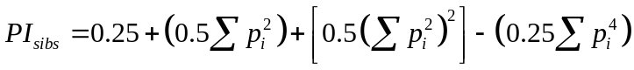,
where p_{i} is the frequency of the ith allele. Assuming independence of alleles among loci, an estimate of the multilocus PI_{sibs} is obtained by taking the product of all loci-specific PI_{sibs}. To determine whether independence of loci and random sampling assumptions were met, I tested for linkage disequilibrium (lack of allele independence between loci) and conformity to Hardy-Weinberg equilibrium (independence of alleles within loci) in Program GENEPOP version 3.4 (Raymond and Rousset 1995). I used the Dunn-Sidak method (Sokal and Rohlf 1995) to ensure an experimentwise error rate of α = 0.05 by restricting critical values for individual comparisons to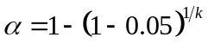, where k is the number of individual comparisons.
For each marker set, I also estimated the frequency at which 2 individuals would match at all genotyped markers including the sex marker (i.e., zero-mismatch pairs or 0MM-pairs) for the TRB, UARB, and LARB. To do so, I used genotype data from all individuals in each population to tally the number of pairs of individuals that mismatched at 1 to k loci where k is the number of loci used in a marker set. I then plotted the distribution of those numbers on the log₁₀ scale against the number of mismatches, extrapolated the slope of that distribution to 0MM-pairs, and visually derived an empirical estimate of the number of expected 0MM-pairs (Paetkau 2003).

3.1.9 Analysis of samples from alternative sources
Samples collected from individuals handled from live-captures, den checks, and road mortalities in all 4 primary study areas were submitted for DNA analysis to supplement the non-invasive data set. Hair samples were collected from live-handled bears and foot pad tissue samples were collected from road mortalities. DNA extraction, microsatellite amplification, sequencing, and genotyping followed the same procedures as those used for non-invasive samples. Initial genotypes were obtained using the identification marker system specific to each individual’s source population so genotypes from all sources could be compared and matches identified. Genotyping of individuals handled in the TRC used the TRB marker subset because those individuals were translocated or were descendants of bears from the TRB. Additionally, I submitted and genotyped samples collected from bears during research studies and management activities in Arkansas, Mississippi, and Minnesota to evaluate interchange.

3.2 Demographic rate analysis

3.2.1 Model fitting, estimation, and inference
For all demographic rate analyses, I used Markov chain Monte Carlo (MCMC) sampling methods within a Bayesian inference framework implemented in JAGS (https://sourceforge.net/projects/mcmc-jags) accessed through Program R (Version 3.0.2, http://cran.us.r-project.org/, accessed 30 January 2014) via the package rjags for model fitting and parameter estimation. Three independent MCMC sampling chains of 100,000 steps were collected after burn-in samples were discarded. Individual chains were inspected for serial correlation using autocorrelation function plots and were thinned to reduce within-chain serial correlation. I assessed convergence by visually inspecting trace plots of the thinned chains and calculating the Gelman-Rubin diagnostic statistic using the gelman.diag function in the coda package for R (Plummer 2006). I report posterior modes for all parameter point estimates unless specified otherwise. All analyses were conducted using vague, non-informative prior distributions.

3.2.2 Survival rates of radio-collared adult female bears
Survival rate of adult females is a critical demographic component of black bear population dynamics (Beston 2011). Determining how individual and environmental covariates affect survival rates and, hence, population growth is important to assessing population trends.
I constructed monthly encounter histories from radio monitoring data for my adult female survival analysis. I used April 1 of each year as the start date of the annual survival period to coincide with the period when females generally become active following den emergence. Each bear was considered initially available during the month it was radio collared and continued to be considered available until it died or was censored. Confirmed mortalities were assigned to month of known death or month of last known active signal. I assumed bears that shed their collars (i.e., leather spacer broke and released collar or collar slipped off bear) were alive at the time of last active signal and right censored encounter histories of those bears to the month of the last active signal. Bears that were not encountered in >2 consecutive months but subsequently re-encountered (i.e., temporary loss of signal) were right-censored to the month of the last active signal (i.e., removed from the data set for all subsequent months) and re-entered the data set as a new individual during the month it was re-encountered. Because non-parturient females can be active during the winter den season in Louisiana, I did not assume survival was 1.0 during that period and applied the same censoring rule throughout the entire year.
Process variation of demographic rates refers to the manner in which those rates vary over time, space, and individuals. Estimates of survival rate process variance over time are important for incorporating temporal variation into population projection models that is not explained by ancillary covariates (White 2000). Variance estimates obtained from time series of demographic rate estimates are not appropriate estimates of temporal process variation because of the added effects of sampling variation on variation in the time series. Therefore, separating temporal process and sampling variation is necessary to obtain reliable estimates of true process variation.
Ideally, the most important factors influencing such variation are known, are measureable, and can be used to characterize or forecast variation in demographic rates and population dynamics. More often, such factors are unknown or operate in such complex ways that they cannot be identified or measured because sufficient data to do so are not available. Fortunately, the cumulative effects of such complex factors often can be characterized by general stochastic processes based on known families of probability distributions for which governing parameters can be estimated from available data and then used in population forecasts. When time series of demographic data were sufficient in length (i.e., ≥6 years), I estimated temporal process variation for survival and other demographic rates.
Numerous methods exist that can be used to separate those sources of variation. In general, I used a hierarchical modeling approach within a Bayesian estimation framework to separately estimate temporal process variation and sampling variation. To do so, I imposed a hyperdistribution structure on annual demographic rates whereby annual rates were modeled as coming from a normal distribution governed by a mean that represented the expected value over time and a variance term that represented the magnitude of temporal process variation. The Bayesian estimation procedure produced a set of values that represented a sample from the posterior distribution and provided an estimate of parameter uncertainty caused by sampling variation. I did not estimate spatial or individual process variation because sufficient data to do so were not available.
From 2001 to 2009, radio-collared adult female bears with cubs were translocated from the TRB to the TRC during the winter den season in an effort to reestablish a breeding population. From the perspective of the TRB population, those females essentially were losses. However, treating those animals as losses can negatively bias estimates because only radio collared individuals were exposed to translocation (Clark and Eastridge 2006). Therefore, I right-censored translocated TRB females to the month of translocation and re-entered them into the data set as new TRC females the same month.
Loss of radio signal caused by battery depletion, malfunction, or inaccessibility occasionally prevented collar recovery and fate determination. When fates of individuals are unknown, a maximum survival estimate treating missing animals as alive and a minimum survival estimate treating missing animals as dead can be obtained that provide an upper and lower bound for survival (Heisey and Fuller 1985, Pollock et al. 1989). To bound survival estimates, I constructed 2 data sets by either assuming radio-collared bears with unknown fates were alive and right censoring those to the month of last active signal (i.e., assumed alive, AC) or by assuming they died with mortality assigned to the month of last active signal (i.e., assumed dead, AD). The latter scenario is relevant because poachers sometimes destroy radio collars after killing the animal and, if this occurs to any extent, assuming that signal loss is not related to mortality can produce positively biased estimates of survival. I used both estimates in the population projections to provide pessimistic and optimistic estimates of growth.
I used a parametric exponential model of survival time with a constant discrete hazard rate function and a hierarchical modeling approach to estimate population-specific annual survival rates, mean annual survival rate, and temporal process variance for female black bears in the TRB and TRC. Annual survival (S) was defined as
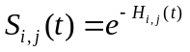,
where 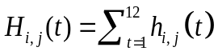was the cumulative discrete hazard and 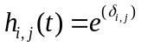was the unit (monthly) hazard rate. Subscripts i and j indexed years and populations, respectively, and was defined as the baseline log hazard rate. To estimate mean annual survival rates, process variances, and process correlation, I treated annual survival rates for each population as random effects by imposing a hierarchical model structure whereby annual log hazard rates were modeled as random realizations from a common bivariate normal hyperdistribution. I used the inverse Wishart distribution with 2 parameters, a scale matrix (R) and degrees of freedom (df), as the prior for the variance-covariance matrix of the bivariate normal hyperdistribution. R was specified as
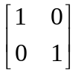 with df = 3.
Uniform priors of Unif (−15, 0) were specified for the means of the bivariate hyperdistribution.

3.2.3 Reproductive rates of radio-collared adult female bears
To estimate reproductive rates for the TRB and TRC, I used reproductive state data from radio-collared adult females collected during winter den visits. First, I used a multi-state transition modeling approach to estimate the probability that a female was in reproductive state B, state C, or state Y during winter given her reproductive state during the previous winter (Schwartz and White 2008). This approach assumes transitions between states are first-order Markovian processes and differs from the classical multi-state CMR modeling approach (Arnason 1972) in that apparent survival and detection probabilities are assumed to be 1. I made that assumption because I only analyzed data from females that survived and for which reproductive status was observed in consecutive years. I separately estimated transition probabilities for the TRB and TRC to compare rates between the 2 populations. Because transitions from B to Y and from Y to Y were not biologically possible, I fixed those transition probabilities at 0. To ensure transition probabilities were restricted to the interval [0, 1] and met the unit sum constraint requirement for transitions from 1 state to all other states, I indirectly imposed a Dirichlet prior for transition probabilities by specifying hyperpriors 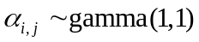 and the relationship
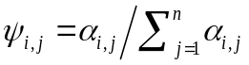,
where 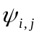 is the probability of transitioning from state i to state j (Royle and Dorazio 2008, Kery and Schaub 2012).
Assuming transition probabilities were constant across time and age classes, I next estimated the posterior distributions of stable state probabilities (i.e., proportion of females in each reproductive state) by multiplying a state vector representing all possible reproductive states (e.g., [1, 0, 0]) by the transition matrix from each MCMC sample and repeating the procedure 50 times using the resulting vector from the previous iteration. I compared the distributions of stable state probabilities for females in different reproductive states from the TRB to those of the TRC to identify potential differences in reproduction and litter survival processes. From the estimated stable reproductive state probabilities, the proportion of females with cubs or with yearlings can be multiplied by the mean litter size of those age classes to obtain an estimate of recruitment rate of breeding females which can be used to project the number of new recruits into the cub age class or yearling age class in population projections. However, recruitment measures based on mean litter size pose problems for population projections because recruitment is a discrete process whereas mean litter size is on the continuous scale. Therefore, I chose to independently model litter size probabilities for cub and yearling litters as a multinomial process where each possible litter size was treated as a categorical response variable on the nominal scale.
I used observed litter size data for females with cubs collected during winter den visits in the TRB and TRC and multinomial logistic regression to estimate the probability of a female producing a 1-, 2-, 3-, or 4-cub litter conditional on the female being in the C reproductive state. Similarly, I used observed litter size data for females with yearlings to estimate litter size probabilities for that age class. I separately estimated litter size probabilities for the TRB and TRC . I used a Dirichlet prior via gamma hyperpriors to ensure probabilities were restricted to the interval [0, 1] and met the unit sum constraint requirement.
I derived an estimate for mean litter size by first calculating the posterior distribution for mean litter size as
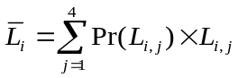,
where Pr(L_{i,j}) is the probability of litter size j and L_{i,j} is litter size j for the i^{th} sample and then calculating the mode of that distribution. To derive an estimate of recruitment of cubs (r_{C}) and yearlings (r_{Y}) per breeding age female for each study area, I then calculated the posterior distribution for recruitment as the product of 1,000,000 random values drawn from the posterior distribution of mean cub or yearling litter size, 1,000,000 random values drawn from the posterior distribution of the corresponding C or Y stable state probability, and 0.5 based on an assumed 1:1 sex ratio for cubs and yearlings. Finally, I estimated r_{C} and r_{Y} by calculating the modes of those posterior distributions.

3.2.4 Demographic rates from capture-mark-recapture
The complete CMR data set consisted of DNA-based binary detection records (i.e., 1 if detected and 0 if not) of individual bears obtained from hair collection surveys conducted across arrays of hair collection sites in the TRB, UARB, and LARB populations. Surveys were conducted in a robust-design format consisting of primary sampling occasions (i.e., years) between which the population was considered open to gains and losses and secondary occasions (i.e., weeks) within primary occasions during which the population was considered geographically and demographically closed (Pollock 1982). Selection of >1 sample for DNA analysis from individual site/week combinations occasionally caused the same bear to be detected more than once at a site during the same week. Additionally, individuals were often detected at ≥1 site within a given week. I consolidated those multiple within-week detections into single binary detection records. The final CMR data set used for analysis consisted of binary records 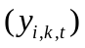 indicating whether individual i 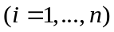 was detected during week k 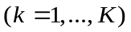 of year t 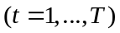 where n is the total number of individuals ever detected, K is the number of detection occasions within each year, and T is the number of years.
My general approach to data analysis was to use a hierarchical CMR modeling framework based on a state-space parameterization of the Jolly-Seber model (Royle and Dorazio 2008, Link and Barker 2010) to estimate abundance (N), annual apparent survival (ϕ), annual per-capita recruitment (γ), annual realized population rate-of-change (λ), and weekly detection probabilities (p) for females in the TRB, UARB, and LARB. Note that per-capita recruitment is the ratio of the number of new recruits (i.e., in situ reproduction or immigrants) to the total number of current residents (i.e., breeding or non-breeding age) in the population and is different than recruitment per breeding female (i.e., r_{C} and r_{Y}) from the telemetry data. I restricted my analysis to only females because vital rates of females are more important determinants of population growth than those of males (Beston 2011) and because female reproductive rates are simpler to estimate. I considered ϕ and γ for the TRB and UARB as random quantities using a hierarchical modeling approach to directly estimate temporal process variation 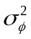and 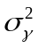, respectively, while accounting for imperfect detection and sampling variation (Link and Barker 2005). I did not attempt to estimate temporal variance in vital rates for the LARB because the number of years of data collection was insufficient for reliable estimation. Additionally, I modeled the relationship between γ and N to test for density dependence in that vital rate. I used a parameter-expanded data augmentation methodology to avoid technical problems caused by changes in the parameter space with each draw of the MCMC estimation procedure (Royle et al. 2007, Royle and Dorazio 2012). This approach artificially inflates the number of individuals in the observed data set with a fixed, known number of all-zero detection histories and includes an estimable zero-inflation parameter that represented the probability of inclusion in the population at the beginning of the study (Royle et al. 2007).
The basic structure of the state-space model formulation included 2 components for the ecological state processes of interest (i.e., abundance, survival, and recruitment) and 1 component for the observation state process (i.e., detection) as follows: 1) a model for initial abundance during the first study year in each population, 2) a model for the change in abundance over time as a function of survival and recruitment, and 3) a model for the observation (i.e., CMR) data. I first defined a latent state variable matrix of dimension 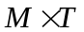where element 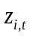 indicates whether individual i is alive and has not permanently emigrated from the study area 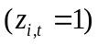 or is dead or has permanently emigrated 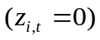at time t, M is the sum of the total number of detected individuals across all study years (n) and the number of all-zero detection histories used to augment the data set, and T is the number of study years. I selected a number of individuals with which to augment the observation data for each population that would result in 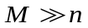 and avoid upper truncation of the posterior distribution for N.
I modeled the initial state of each individual in the augmented data set as
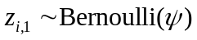
where 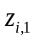 indicates if individual i is alive and a member of the sampled population at the beginning of the study and 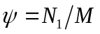is the inclusion probability (Royle and Dorazio 2008). As a result, initial abundance (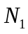) was defined as
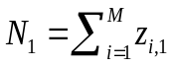.
The second component of the ecological state process modeled abundance in years 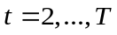 as
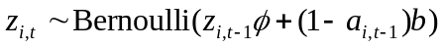,
where 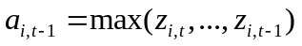 indicates if individual i has already been recruited to the population and b is recruitment probability. The state process equation defines the probability that an individual is alive and a member of the sampled population at time t as given it was alive and on the study area at time t - 1 and as b if the individual had not previously been a member of the sampled population. Note that ϕ = SF where S is the true annual probability of survival and F is annual probability of fidelity to the study area; S is referred to apparent survival because deaths and permanent emigration cannot be distinguished without ancillary information. The parameter b is considered the probability of being recruited into the population. However, that probability is influenced by M and has no direct biological interpretation. Per-capita recruitment (γ) is related to b and is a more intuitive vital rate which I defined as
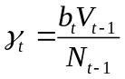 , ,
where 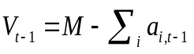is the number of available recruits. I described the model component for the detection data as
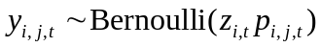,
where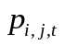is the detection probability for individual i during week j of year t.
To separate sampling variance from process variance for and , I treated annual values for each of those vital rates as random variables coming from a common hyperdistribution using an appropriate link function. I described the hyperdistribution for ϕ as
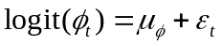
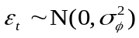
where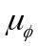is the overall mean annual apparent survival on the logit scale, is the annual deviation from the mean, and 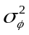 is the temporal process variance. Similarly, I modeled temporal process variation of γ as
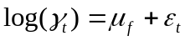
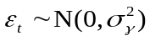,
where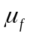is the overall mean annual recruitment on the log scale, is the annual deviation from the mean, and 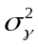 is the temporal process variance.
Individual heterogeneity in p is a well-known and prevalent issue when estimating vital rates for black bears from DNA-based CMR data (Tredick et al. 2007, Clark et al. 2010, Laufenberg et al. 2013). However, the most appropriate family of distributions (e.g., beta, log-normal, or finite mixture) used to model individual heterogeneity is not identifiable using data-based selection criteria because different families can produce nearly identical data distributions but are parameterized by different values of N (Link 2003). An alternative approach to selecting a single distribution family is to consider multiple families and base inference on the entire set of models. Therefore, I considered 2 common families of distributions, the logistic-normal (Coull and Agresti 1999, Dorazio and Royle 2003) and the finite-mixture distribution (Pledger 2000). For the logistic-normal distribution (Model 1), I defined p for individual i during week k in year t as
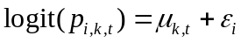
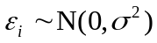,
where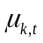is the mean weekly detection probability in year t on the logit scale, is the individual deviation from the mean, and 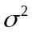 is the variance among individuals. For the finite-mixture distribution (Model 2), I defined p for individual i during week k in year t as
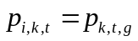
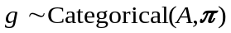,
where 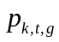is the detection probability for mixture g during week j of year t, A is the number of mixtures, and is a vector defining the probability of an individual belonging to mixture g. For my analysis, I restricted A to 2 mixtures. Detection probabilities likely differed across years in response to annual variation in abundance, distribution of food resources, weather, or other unknown factors. Therefore, I modeled 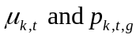for the logit-normal and finite-mixture distributions with fixed-effect differences among years. In 2010, the hair-site configuration was modified from a 1-wire system to a 2-wire system that likely influenced the distribution of individual differences in p. To account for this change in sampling methodology, I modeled with fixed-effects differences in 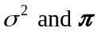for the logit-normal and finite-mixture distributions as 2 levels: pre- and post-modification. I assumed no temporal variation or behavioral effects in detection probabilities across weeks within years.
To model density dependence in per-capita recruitment (Lebreton and Gimenez 2013), I defined a log-linear model for the relationship between γ and N as
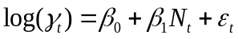
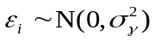,
where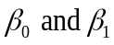are the intercept and slope parameters, respectively, is the annual deviation from the mean, and is the temporal process variance .
The state-space formulation of the Jolly-Seber model often has extensive computational requirements because the latent state variable z for each individual in each year must be updated at each step of the MCMC sampling process. For example, missing observations from the detection data between successive observations (e.g., 1 0 0 1 annual detection history) must be estimated because they are only related to z through the observation process. This can result in extremely long periods of time required to achieve convergence and adequate mixing of multiple chains. One method to improve efficiency and reduce computation time is to directly impute information about z for all years between the first and last year of observation and directly enter that information into the analysis (Kery and Schaub 2012). I accomplished this by creating a data matrix of known latent states where I recorded a 1 for all years I knew an individual to be alive (e.g., 1 0 0 1 now becomes 1 1 1 1) and NAs for years for which I had no information (e.g., 1 1 0 0 becomes 1 1 NA NA).
A rapidly developing approach for analyzing different types of population data in a single unified framework is integrated population modeling (Besbeas et al. 2002, Brooks et al. 2004, Schaub et al. 2007). This approach combines information collected from different sampling methods into a single population model facilitating simultaneous estimation of multiple vital rates and population processes that could not have been achieved if data sets were separately analyzed. Furthermore, use of integrated population models increases accuracy and precision when different types of data collected on the same vital rate (e.g., CMR and known-fate data) are concurrently analyzed. Because genotyped hair samples were collected from most of the females in the TRB known-fate data set, I could match those genotypes to genotypes in the CMR data set. This allowed me to directly incorporate known-alive status information from the known-fate data set into the known latent state matrix for the TRB analysis. Moreover, I incorporated information for bears in the CMR data from the TRB, UARB, and LARB that matched genotyped samples collected from bears handled during live-capture efforts for radio collaring, den-season captures for reproduction assessment, and conflict management activities.
In addition to including ancillary information about known-alive status, the known latent state matrix can also incorporate information from known mortalities. Therefore, I used known mortality data collected from radio monitoring and road mortality recoveries to incorporate known times of death into the analysis. During the first 4 years of CMR data collection in the TRB, females were being removed and translocated as part of the reintroduction efforts in the TRC. To account for removal of those females, I entered zeros into the known latent state matrix. I used the following vague priors in all CMR models: 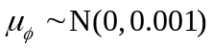, 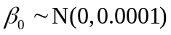, 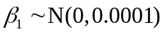, 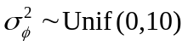, 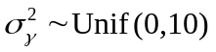, and 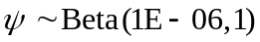. I used the median of the posterior distributions as point estimators for and because it is generally more robust when the level of variation is moderate and estimation is based on a time series of <7 years (see table 3 of White et al. 2009).
Determining the demographic segment of the population that is being sampled is important in CMR-based studies of population dynamics because demographic rate estimates and inferences of population dynamics drawn from those estimates pertain only to the sampled population and may not reflect population segments that are not sampled. For DNA-based hair snare studies, young bears may never be detected because they are too small to encounter the barbed wire. To determine whether young bears were part of the sampled population, I performed a search of live-capture records for bears that were present on the TRB study area as cubs or yearlings during years of hair sampling and that had DNA samples collected during capture that were successfully genotyped. I then searched our DNA-based CMR data set for genotype matches and determined the age at which each bear was first detected at a hair snare. I tallied the numbers of bears detected at hair collection sites as cubs, as yearlings, and as 2-year olds as measures of whether those age classes were part of the sampled population.

3.3 Population viability analysis
To assess probability of persistence for the Louisiana black bear in the LMAV of Louisiana, I constructed stochastic population projection models for females in the TRB and UARB based on results from the CMR analysis. I did not project growth for the LARB population because I had estimates of only 2 interannual periods for each demographic rate (i.e., γ, ϕ, and λ).
Population projections are not to be confused with population predictions. A projection simply is 1 of many possible population trajectories, some of which are more likely to occur than others, based on a stochastic model with a number of simplifying assumptions that govern population dynamics. By projecting a large number of trajectories, probability of persistence can be inferred from those trajectory outcomes most likely to occur (i.e., extinction vs. persistence) while accounting for uncertainty caused by stochastic population processes. However, the correct model parameters and assumptions are never known with perfect certainty and plausible projections under varying parameter values and model assumptions can range from pessimistic to optimistic. My goal was to develop a set of models based on a range of biologically reasonable model parameters and assumptions by which to project population trajectories and characterize persistence probabilities.
I used 4 population projections based on combinations of 2 different projection model structures and CMR-based parameter estimates from 2 different capture heterogeneity models (i.e., Model 1 and Model 2) to evaluate how different stochastic processes and parameter uncertainty affected my ability to infer population viability. For the first projection model structure (hereafter referred to as temporal process model), I incorporated environmental (temporal) process variation for ϕ and γ and included density dependence for γ using hyperdistribution parameter estimates obtained from my CMR analysis. I incorporated demographic variation by using appropriate probability distributions (e.g., multinomial and Poisson) to simulate demographic processes. I used Monte Carlo methods to simulate10,000 trajectories over a 100-year period using a 2-level hierarchical approach:
- For each year within a simulated trajectory, I drew a random value for each demographic rate (i.e., ϕ and γ) from a probability distribution defined by hyperdistribution parameter estimates. Those values were then used to define probability distributions used in the next level. This was done to incorporate temporal process variation in population projections.
- Within each year, I simulated the number of recruits by drawing a random value from a Poisson distribution with a rate parameter defined as the product of the random value drawn for and the number of bears alive at the previous time step (N_{t−1}). I simulated the number of survivors by sampling from a binomial probability distribution defined by the random value drawn for ϕ and the sum of N_{t−1} and the previous number of recruits. Those 2 processes incorporated demographic variation in survival and recruitment into population projections.
The second projection model structure (hereafter referred to as all uncertainty model) incorporated the same sources of variation as the temporal process model but also included parameter uncertainty for mean ϕ, mean γ, and density dependence by drawing a random value for each of those vital rates from the corresponding set of posterior samples for each population trajectory. Again, I used Monte Carlo methods to simulate 10,000 population trajectories over a 100-year period. Incorporating parameter uncertainty required an additional hierarchical level. For each simulated trajectory (i.e., level 1 of the simulation process), I first drew a random value from posterior distributions for the hyperdistribution means of ϕ and γ and a random value for the intercept and slope parameters that defined the density dependence relationship. I then used those values of hyperdistribution means and corresponding point estimates of temporal process variance to define the distribution governing temporal variation in vital rates that I used in the next simulation level (i.e., level 2). This process incorporated parameter estimation uncertainty into the population projections. To avoid drawing extreme and biologically unreasonable values from the tails of the posterior distributions, I restricted draws to values between the 2.5% and 97.5% percentiles. I incorporated demographic variation in recruitment and survival into all uncertainty model simulations (i.e., level 3) as I did for the temporal process model. For all 4 projections, I placed an upper bound on simulated values of γ equal to the largest annual estimate from each population for each capture heterogeneity model to avoid overly optimistic effects of extremely large values that could be generated by the density-dependence relationship if sudden declines in abundance occurred during the simulations.
I derived an estimate of the probability of persistence for each population under each simulation model by dividing the number of trajectories that went extinct (i.e., N < 1) by 10,000 and subtracting that value from 1. I report probability of persistence estimates of >0.999 for simulations where all trajectories remained extant because such results are based on a finite sample of the distribution of possible trajectories and does not imply absolute certainty of persistence. I also summarized the ending N after 100 years (N₁₀₀) by calculating the mean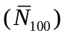, 2.5% percentile, and 97.5% percentile for the empirical distribution of N₁₀₀ based on all 10,000 simulations. I assumed population projections and subsequent evaluations of long-term persistence applied only to female age classes ≥1.
To include the TRC subpopulation in assessing Louisiana black bear viability, which was not sampled using the CMR methods, I constructed a stochastic age-structured matrix population model (Caswell 2001) using demographic rates and temporal process variance estimated from the telemetry-based survival and reproduction data. I restricted the population model to age classes ≥1 because data for individual cub survival was insufficient and I wanted to project population dynamics for the same age classes for the TRC as I did for the 2 other subpopulations. Similar to the CMR population simulations, I simulated 10,000 population trajectories over a 100-year period using Monte Carlo methods. In contrast, the simulation procedure used estimates of adult female survival and temporal process variance from my known-fate survival analysis, stable state probability for reproductive state Y and reproductive state transition probabilities from my multi-state transition analysis, and litter size probability estimates from my multinomial regression analysis of litter counts. I assumed the sex ratio for yearling litters was 1:1, the age of primiparity for rearing yearling litters was 4, and the maximum age was 24. I used estimates of adult female survival rates and process variances from my known-fate survival analysis for all females ≥2 years of age. For yearling survival, I obtained estimates from the published literature on southeastern bears (Hellgren 1988 [0.78], Lombardo 1993 [0.53], Maddrey 1995 [0.78], Beausoleil 1999 [0.57]). I then calculated the mean and sample standard deviation of those estimates to be used in the simulations.
To forecast population trajectories using age-structured population models, information about the standing age distribution must be available to specify the starting conditions for simulations. For bears, this distribution is typically derived from the age distribution of live-captured individuals. However, because live-capture data were not available for the TRC subpopulation, I could not estimate the standing age distribution in 2013 (i.e., the starting point of the simulations) using traditional methods. To obtain an initial age distribution, I constructed a separate individual-based population model by simulating annual survival events of censored adult females. I also simulated survival events up to 2013 for female yearlings known to have been produced by radio-collared females in the TRC prior to 2013. I incorporated unobserved yearling recruitment prior to 2013 by simulating the number of yearlings potentially produced by censored females, by females known to be alive through 2013 but lacking known reproductive histories, and by female recruits (known and simulated) that reached reproductive maturity prior to 2013. Simulated and known recruits still alive in 2013 were then combined with simulated and known-alive adult females to define potential standing age distributions in the TRC which I then used as starting points in the second phase of the population projections.
The second phase of the population projections simulated life history events (i.e., survival and reproduction) in the TRC for 100 years. Similar to the CMR-based simulations, I used multiple approaches to assess how different sources of uncertainty in vital rates affected project population trajectories and inference for population persistence. More specifically, the approaches I used addressed uncertainty caused by temporal process variation versus sampling variation, uncertainty in adult survival rates caused by the 2 ways I handled unknown fates (i.e., AC and AD), and uncertainty in the form and strength of density-dependence in reproductive rates. Again, I used 2-level and 3-level approaches to incorporate uncertainty caused by process-only variation versus uncertainty from process and sampling variation. Because I did not have data-based estimates of process variance for reproductive rates in the TRC, I used coefficients of variation calculated from the estimated means and process variances of γ based on CMR data from the TRB and UARB to derive approximate values of temporal process variation for R 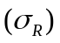 that reflected observed reproductive variation within the LMAV. Moreover, because I did not have empirical estimates of density-dependent relationships between N and reproduction in the TRC, I incorporated density dependence by assuming a relationship between N and R based on the Michaelis-Menten function for enzyme kinetics used in Program RISKMAN (Taylor et al. 2006) and defined as
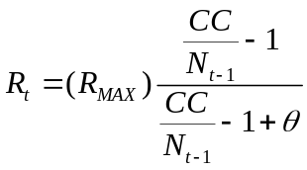,
where R_{MAX} is the value for R estimated from my reproductive state transition analysis, CC is the carrying capacity for the TRC, and θ is a shape parameter governing the strength of non-linearity of the density-dependence relationship. Because no data were available that could be used to directly determine CC for the TRC, I derived possible values for CC using an estimate of current bear habitat in the TRC and density estimates from the TRB and UARB. To accomplish this, I first quantified the amount of current suitable habitat on state or federally owned land or on private land within designated Critical Habitat (848.4 km^{2,} USFWS 2009) based on habitat classification categories reported by Murrow et al. (2013). I then multiplied that value by density estimates for the TRB and UARB derived from abundance estimates based on heterogeneity Model 1 or Model 2 and effective sampling areas calculated by placing a 1,600 km² buffer (approximate radius of annual female home range) around respective trapping arrays. By deriving 4 estimates of CC and simulating separate projections for each, I was able to include uncertainty in population densities that the TRC could support and uncertainty in the most appropriate heterogeneity model used to estimate density. To account for uncertainty in the strength of non-linearity of the density-dependence relationship, I considered 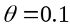 and 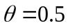. Finally, to account for differences in survival rate estimates caused by assuming unknown fates as right censored (AC) or mortalities (AD), I ran simulations using both estimates. I restricted combinations of the values of CC and 2 values of 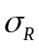to come from the same population from which those values were derived (i.e., CC and both from the TRB vs. CC and from the UARB). In total, I used 32 combinations of sources of uncertainty in the simulations. I summarized the outcomes of the 10,000 trajectories for each of those simulations as for the other 2 subpopulations.
As a secondary measure of population trend in the TRB and as a direct comparison with the TRC, I used population matrix models (Caswell 2001) to estimate the asymptotic rate of population growth (λ_{Asym}) for the TRB and TRC. I used my estimates of yearling recruitment and adult female survival from each study area and estimates of yearling survival obtained from the published literature on southeastern bears to parameterize the models. I used the finite rate of increase module in PopTools (G. M. Hood 2010; PopTools version 3.2.5 http://www.poptools.org/) to calculate deterministic estimates of λ_{Asym}.
Assuming dynamics of individual populations in Louisiana as independent, I calculated the probability of persistence for the entire system of Louisiana black bear populations as:
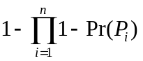,
where Pr(P_{i}) is the probability of persistence for population i and n is the number of populations.

3.4 Population structure and migrant analysis

3.4.1 General approach
Genetic structuring of wildlife populations can be caused by natural or anthropogenic restrictions of gene flow between adjacent areas of occupied habitat. Identifying where such discontinuities exist on the landscape and what factors cause them is important for conservation planning. Genetic distance measures are commonly calculated between groups of individuals where group membership is based on subjective criteria and used to identify landscape features associated with reduced gene flow. Because factors causing zones of restricted movements may be cryptic or associated with unforeseen landscape characteristics, subjective criteria for assigning group membership may result in biased inference when identifying locations and causes of restricted gene flow. A more robust approach for delineating groups is to assume no a priori structure and allow the genetic data to objectively identify clusters.
Multivariate clustering methods are now available that use individual genotype data to objectively identify clusters of similar genotypes while assuming no a priori group membership. I used such searches of microsatellite data collected from all study populations to identify groups of similar genotypes at the landscape scale. Potential causes for genetic discontinuities can then be identified by comparing clusters of individuals with spatial locations of those clusters and identifying intervening landscape characteristics. Because inter-population signals of genetic discontinuities between subpopulations can mask signals of intra-population structure, I also conducted individual analyses for each subpopulation to search for fine-scale structural patterns at the local population level.
Numerous genetic methods exist for evaluating connectivity and rates of interchange between animal subpopulations (Spear et al. 2010). The F_{ST} statistic, which quantifies differences in allele frequencies between populations, can be used to measure population differentiation and the rate at which migrants enter and breed within a subpopulation (Mills 2007). F_{ST} is based on several important assumptions, such as equilibrium between gene flow and genetic drift, equal population sizes, and constant, symmetrical dispersal rates between populations, which may not be applicable for measuring gene flow among contemporary populations. Genetic assignment tests identify putative migrants as individuals with genotypes that do not fit within an expected genotype distribution which provide estimates of interchange more reflective of current gene flow because they include non-effective dispersal and require fewer assumptions (e.g., Hardy-Weinberg equilibrium). As such, assignment tests are more equivalent to quantifying dispersal based on demographic methods (e.g., radio telemetry; Manel et al. 2005) because first-generation dispersers can be distinguished from offspring and relatives. Therefore, I used genetic assignment tests to identify potential migrants and measure interchange among population units identified by my genetic clustering analysis.
My approach was to use genetic data to determine population structure and rates of contemporary exchange between the 4 subpopulations of Louisiana black bears. The development of highly variable genetic markers, such as microsatellites, enables the direct estimation of movement rates and connectivity among populations from genetic data by differentiating immigrants from residents using individual-level genetic methods. Moreover, such markers permit detection of genetic structure within populations that may reveal existence of natural- or anthropogenic-caused genetic discontinuities operating at smaller spatial scales that could influence local population dynamics. However, adequate power to identify immigrants requires genotyping a sufficient number of individuals from each population or population segment (e.g., each side of a potential discontinuity) and using a sufficient number of markers (Paetkau 2004). To ensure adequate power to detect migrants and genetic discontinuities, genotypes from ≥50 individuals per potential population segment were extended beyond the number of markers we used for CMR to 23 markers. I investigated potential population segments in the TRB located north and south of Interstate 20 in Madison Parish, which required genotyping additional markers for ≥50 individuals from either side of the interstate. Likewise, genotypes for ≥100 individuals in the LARB were extended to the same 23 markers to investigate potential genetic structure within that population associated with State Highway 317 which bisected that study area. Finally, genotypes for ≥50 individuals in the UARB were extended to 23 markers to investigate regional genetic structure among the TRB, UARB, and LARB.
I also used microsatellite genotype data collected from bear populations in central Itasca County, Minnesota (MINN), the White River Basin of Arkansas (WRB), the TRC, and western and southern Mississippi. Bears from Minnesota were reintroduced to the TRB and UARB so I wanted to determine the amount of influence those bears may still have on my study populations in Louisiana. Also, bears from WRB were reintroduced to Felsenthal National Wildlife Refuge (FNWR) in south central Arkansas (Wear et al. 2005), approximately 200 km northwest of TRB, and I wanted to evaluate possible gene exchange between WRB and bears in Louisiana. Finally, a growing bear population exists in western Mississippi and I was interested in examining the source for those bears to provide further insight on movement and dispersal potential.

3.4.2 Population structure analysis
I used 2 multivariate clustering methods, spatial distribution of bears in the LMAV, and knowledge of reintroduction history in Louisiana to determine population structure and identify genetically distinct populations that would be used in subsequent migrant identification analyses. The first clustering method was factorial correspondence analysis (FCA; She et al. 1987) in Program GENETIX (Belkhir 2004). FCA is a special case of principal components analysis that uses multivariate categorical data to identify structural relationships among variables without any a priori information or expectations such as true number of clusters. For my analysis, I used FCA to reduce landscape-level multi-locus genotype data from all or specific subsets of populations down to principal dimensions from which groups of individuals with similar genotypes could be identified using graphical displays. I then visually compared the distribution of individuals among inferred populations to the true spatial distribution of those individuals across the landscape to infer the appropriate number and juxtaposition of distinct populations to be used in my migrant analyses. Furthermore, because inter-population signals of genetic discontinuities between subpopulations can mask signals of intra-population structure, I conducted separate FCA analyses for each of the 4 subpopulations in LA to search for fine-scale structural patterns at the population level and identify potential movement barriers within populations.
The second clustering method I used was a model-based clustering algorithm that infers population structure by assuming a user-specified number of populations (K), employed by Program STRUCTURE (Pritchard et al. 2000). Each putative population is assumed to be characterized by a unique set of allele frequencies and loci in Hardy-Weinberg and linkage equilibria within populations. Because this method is conditional on K, multiple values of K must be evaluated. To choose the most likely number of populations occurring within my genetic data set, I fit models that assumed different values of K ranging from 2 to 11 and selected the model that best described the data based on the log of the posterior probability of the data for a given K (log[K], Pritchard et al. 2000), the second-order rate of change of log[K] (Δlog[K], Evanno et al. 2005), and prior knowledge of the historic and current distribution of bear populations within the LMAV. I also included individual admixture in the model to estimate the probability of an individual coming from each of the putative clusters and I assumed allele frequencies were correlated because extant bear populations along the LMAV historically were a more continuous single population. Program STRUCTURE employs Bayesian methods and MCMC sampling to generate samples from the posterior distribution from which parameter estimates can be obtained and the most appropriate value of K can be inferred. I ran 10 independent chains for each value of K to account for among-chain variation in convergence. Each chain was run for 500,000 steps whereby the first 50,000 samples were discarded as burn-in and the subsequent 450,000 samples were retained for inference. Based on those results, I selected the most likely value of K and ran 10 additional chains with 500,000 burn-in samples and 500,000 retained samples to ensure consistent and reliable convergence across chains.

3.4.3 Migrant analysis
I used 2 independent assignment methods to identify putative first-generation migrants between all pairs of population units identified by my FCA and STRUCTURE analyses. I limited my analysis to bears from the WRB, TRB, UARB, and LARB because natural movement between MINN and any of the other areas I sampled was not possible. First, I assigned individuals to populations of origin with the highest probability based on population-specific allele frequencies using simulation methods for distinguishing true migrants (Paetkau et al. 2004) and available in the software package GENECLASS 2.0 (Piry et al. 2004). Migrants were identified as those bears with assigned population differing from the population from which they were sampled. I used the ratio of the likelihood of an individual’s genotype coming from its sample population to the highest likelihood of that genotype coming from any of the sampled populations as the test statistic for determining significance. To obtain critical values for determining migrant status of each individual, I used the empirical distribution of test statistic values calculated from 10,000 simulated genotypes generated using observed allele frequencies of an individual’s sample population. I assigned migrant status to bears if their test statistics fell beyond the 2.5% and 97.5% percentiles (i.e., Type I error rate of the test statistic distribution). To account for missing alleles, I set allele frequencies to 0.01 in populations where specific alleles were not observed.
Next, I independently tested for putative migrants using the model-based approach available in Program STRUCTURE (Pritchard et al. 2000). The assignment method in STRUCTURE is similar to the approach used to identify population clusters except that prior population information is directly incorporated into the analysis. This is accomplished by coding each population with an integer value between 1 and K, where K is the number of populations identified in the previous analysis, and assigning each individual with the value of K pertaining to population from which it was sampled. Using this model, the probability can be estimated that an individual is an immigrant to its sampled population or is an n^{th} generation offspring of a migrant ancestor (Pritchard et al. 2000). I assumed allele frequencies were correlated among populations and set the value for the assumed migration rate (required user-specified input) to 0.01 because I believed rates of interchange to be low among such highly fragmented populations. I ran a single chain of 200,000 steps discarding the first 100,000 samples as burn-in and retaining the remaining 100,000 for inference. To obtain conservative estimates of interchange, I defined migrants as individuals that were classified as putative migrants by both assignment methods.
I could not directly test for putative migrants to the TRC because I lacked samples from bears other than translocated females and their offspring. Alternatively, I indirectly assessed interchange between the TRC and UARB by testing cubs born in the TRC to females with known TRB ancestry (i.e., translocated to TRC from TRB) for evidence of being sired by males immigrating from the UARB (i.e., second generation migrants). I classified bears sampled in the TRB and TRC cubs as a single population cluster and compared that cluster to the UARB cluster using Program STRUCTURE. Program STRUCTURE identifies individuals with recent immigrant ancestry by estimating probabilities that an individual has a direct immigrant ancestor in the past G generations (i.e., immigrant parent or grandparent). For TRC cubs, I estimated the probability that each individual had 1 immigrant parent (i.e., father) from the UARB to identify those cubs showing evidence of having been sired by males with UARB ancestry.
To supplement my search for migrants based on genetic assignment tests, I also searched DNA-based CMR histories and live-capture records for individuals that occurred in >1 population within the LMAV. Those individuals were then combined with migrants from assignment tests to determine the total number of migrants.

4 RESULTS

4.1 Data sources

4.1.1 Non-invasive hair sampling
From 2006 to 2012, 23,312 hair samples were collected in the TRB. The weekly number of sites that produced ≥1 collected hair sample ranged from 35 to 174 (Figure 2) and the weekly number of samples collected ranged from 98 to 1,382 (Figure 3). Of the 209 sites surveyed each year in the TRB, the annual number of sites that produced ≥1 collected hair sample across all weeks ranged from 138 to 206 (Figure 4).
The number of sites each week from which samples were collected in the UARB ranged from 7 to 101 (Figure 5). Each week in the UARB, between 15 and 607 samples were collected (Figure 6) and 11,643 samples were collected across all years from 2007 to 2012. Of the 115 sites surveyed each year in the UARB, the annual number of sites that produced ≥1 collected hair sample ranged from 65 to 115 (Figure 4).
From 2010 to 2012, the number of sites producing samples each week in the LARB varied from 26 to 78 (Figure 7). The number of samples collected each week ranged from 53 to 281 (Figure 8) totaling 3,698 samples collected during the entire study period. Of the 118 sites surveyed each year in the LARB, the annual number of sites that produced ≥1 collected hair sample ranged from 90 to 104 (Figure 4).

4.1.2 Marker selection for individual identification
For the TRB, UARB, and LARB, H_{E} for individual microsatellite loci ranged from 0.16 to 0.78, 0.30 to 0.77, and 0.31 to 0.73 (Table 2), respectively, across all 23 available loci. Based on those values, marker sets consisting of 9, 7, and 8 loci (Table 3) were selected for identification of individual bears in the TRB, UARB, and LARB, respectively.
The overall PI_{sibs} for the TRB was 1.5 x 10⁻³, corresponding to a 1 in 673 chance that a bear shared its multilocus genotype with another bear. Using the Dunn-Sidak method to control the experimentwise error rate, 3 of 9 microsatellite loci violated Hardy-Weinberg expectations (α = 0.006) and 15 of the associations among 36 pairs of loci exhibited linkage disequilibrium (α = 0.001). For the UARB, the overall PI_{sibs} was 3.6 x 10⁻³, corresponding to a 1 in 274 chance that 2 bears shared the same multilocus genotype. None of the 7 microsatellite loci violated Hardy-Weinberg expectations (α = 0.007) and 2 of 21 loci pairs exhibited linkage disequilibrium (α = 0.002). The overall PI_{sibs} for the LARB was 3.0 x 10⁻³, or a 1 in 337 chance that 2 bears shared the same multilocus genotype. One of 8 loci violated Hardy-Weinberg expectations (α = 0.006) and 2 of 28 locus pairs exhibited linkage disequilibrium (α = 0.002). Extrapolation of mismatch distribution plots indicated that the expected numbers of 0MM-pairs were ≤1 for the TRB (Figure 9), UARB (Figure 10), and LARB (Figure 11).

4.1.3 Microsatellite genotyping for individual identification
From 2006 to 2012, DNA extraction and microsatellite genotyping was attempted for 3,821 hair samples from hair-collection sites surveyed in the TRB. The average annual genotyping success rate was 84% (range = 80–89%) and the average annual percentage of samples being composed of a mixture of hairs from >1 bear was <1%. During that same period, 229 hair samples and 18 tissue samples from live-captured bears and mortality recoveries were extracted with success rates of 98% and 90%, respectively. For the UARB, 1,755 hair samples were submitted for DNA extraction from 2007 to 2012 with an annual average success rate of 79% (range = 60–87%). Mixed samples were encountered only in 2009 and comprised 3% of those submitted. Twenty-three hair samples and 1 tissue sample from live-captured bears and mortality recoveries were extracted with 100% success rates. From 2010 to 2012, 1,599 hair samples from hair- collection sites in the LARB were submitted for DNA extraction. An average of 87% (range = 81–91%) of those samples were successfully genotyped each year and an average of ≤1% were identified as mixtures of hairs from >1 bear. All 25 hair samples collected from live-captured bears and mortality recoveries were successfully genotyped whereas 6 of 7 (86%) tissue samples were successful.

4.2 Demographic rate analysis

4.2.1 Survival rates of radio-collared adult female bears
From 2002 to 2012, 86 adult females >2 years old were radio monitored within the TRB for 305 bear-years and 43 adult females were monitored within the TRC for 208 bear-years. Four and 9 known mortalities were recorded in the TRB and TRC, respectively. The causes of 3 known mortalities in the TRB were human-related (i.e., vehicle collision or research-related) and the cause of 1 mortality was unknown (Table 4). In the TRC, 8 mortalities were human-related (i.e., vehicle collision, illegal kill, or capture-related) and 1 mortality was due to natural causes (Table 4). Assuming unknown fates were mortalities (AD), 10 and 16 mortalities would have occurred in the TRB and TRC, respectively.
In general, annual survival rate estimates were higher and less variable for the TRB compared with the TRC regardless of censoring method (Figures 12 and 13). When unknown fates were right censored (AC), the mean annual survival rate estimate was 0.99 (95% CI = 0.96–1.00) for TRB and 0.97 (95% CI = 0.91–0.99) for the TRC (Figure 12). Temporal process variance for the baseline log hazard rate () was 0.28 (95% CI = 0.13–1.15) for the TRB and 0.45 (95% CI = 0.16–1.44) for the TRC. Assuming unknown fates were mortalities (AD), mean annual survival rates were 0.97 (95% CI = 0.93– 0.99) in the TRB and 0.93 (95% CI = 0.85–0.97) in the TRC (Figure 13). Temporal process variance for was 0.29 (95% CI = 0.12–0.80) for the TRB and 0.32 (95% CI = 0.13–0.97) for the TRC.

4.2.2 Reproductive rates of radio-collared adult female bears
From 2003 to 2013, 142 transitions among reproductive states were observed for 58 females in the TRB and 74 transitions for 29 females in the TRC. Females in the TRB were more likely to transition to state C from any previous state (i.e., 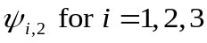) compared with females in the TRC (Table 5). Conversely, females in the TRC were more likely to transition from the C to the Y state (i.e., 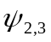) than females in the TRB. Furthermore, females in TRC were nearly twice as likely to remain in state B as were females in the TRB (Table 5). The estimated stable state probability of females being in the B state was greater in the TRC (Pr(B) = 0.47, 95% credible interval = 0.31–0.64) than in the TRB (Pr(B) = 0.27, 95% credible interval = 0.19–0.36; Figure 14) whereas the estimated probability of females being in the C state was greater in the TRB (Pr(C) = 0.51, 95% credible interval = 0.45–0.57) compared with the TRC (Pr(C) = 0.34, 95% credible interval = 0.23–0.43). The proportion of females in the Y state was nearly identical for the TRB (Pr(Y) = 0.22, 95% credible interval = 0.16–0.28) and the TRC (Pr(Y) = 0.19, 95% credible interval = 0.12–0.27).
From 2003 to 2013, 130 litters consisting of cubs for 74 females were observed in the TRB and 74 litters for 45 females were observed in the TRC. During the same period, 43 litters consisting of yearlings for 33 females were observed in the TRB and 21 yearling litters were observed for 19 females in the TRC. Although estimated probabilities of females having litters of 1 or 2 cubs were greater in the TRB than in the TRC and probability estimates for 3- or 4-cub litters were greater in the TRC, strong evidence of a true difference existed only for the 3-cub litter category (i.e., minimal overlap of 95% credible intervals, Figure 15). Similarly, females in the TRB were more likely to have single-yearling litters and females in TRC were more likely to have 2- and 4-yearling litters, although there was substantial overlap among 95% credible intervals. Mean cub and yearling litter sizes were 1.85 (95% credible interval = 1.72–1.99) and 1.40 (95% credible interval = 1.26–1.64) in the TRB whereas estimates for the TRC were 2.15 (95% credible interval = 1.94–2.37) and 1.84 (95% credible interval = 1.55–2.28). Estimates of r_{C} and r_{Y} for the TRB were 0.47 (95% credible interval = 0.41–0.54) and 0.15 (95% credible interval = 0.11–0.20), respectively, whereas estimates for the TRC were 0.37 (95% credible interval = 0.25–0.47) and 0.18 (95% credible interval = 0.11–0.27). Estimated asymptotic growth rates for the TRC when unresolved fates were AC and AD were 1.02 and 0.99, respectively.

4.2.3 Demographic rates from capture-mark-recapture data
After collapsing multiple weekly detections into single detection records, my CMR data set for the TRB contained 730 detections of 201 females and 490 detections of 191 males during the entire study period. In the UARB, 62 females were detected 196 times and 47 males 118 times. The LARB data set contained 175 detections of 91 females and 148 detections of 83 males. In general, the numbers of previously uncaptured bears entering each data set each year decreased during the study period (Figure 16). None of the 13 bears that were present on the TRB as cubs were detected at hair collection sites, 3 of 19 (16%) bears present as yearlings were detected, and 17 of 30 (57%) were first detected at age 2.
When detection heterogeneity was assumed to follow a logistic-normal distribution (Model 1), female abundance estimates for the TRB study area ranged from 140 to 163 between 2006 and 2012 (Model 1, Figure 17). Estimates of annual per-capita recruitment (γ) using Model 1 ranged from 0.00 to 0.22 and annual apparent survival rate (ϕ) ranged from 0.87 to 0.93 during that period. Density dependence between N and γ was negative 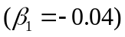 with 96% of the posterior distribution for 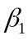 being < 0 (i.e., the probability of the relationship being negative was 96%). The geometric mean of realized annual population growth rate estimates 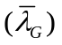was 1.02 (range = 0.98–1.09; Figure 17). Temporal process variance for ϕ on the logit scale was 0.52 (95% CI = 0.03–2.67) and for γ on the log scale was 0.64 (95% CI = 0.03–6.64). Assuming a 2-point finite mixture distribution for detection heterogeneity (Model 2), annual point estimates of female abundances for the TRB ranged from 133 to 158 (Figure 18). Annual estimates of γ based on Model 2 ranged from 0.00 to 0.16 and annual estimates of ϕ ranged from 0.87 to 0.89. Density dependence between N andwas also negative 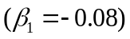 based on Model 2 with 84% of the posterior distribution for being < 0; 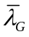 was 0.97 (range = 0.88–1.06, Figure 18). Temporal process variance for ϕ on the logit scale was 0.33 (95% CI = 0.02–1.50) and for γ on the log scale was 0.73 (95% CI = 0.04–8.30).
In the UARB, annual point estimates of N for from Model 1 ranged from 25 to 44 during the study period (Figure 19). Model 1 estimates of γ ranged from 0.00 to 0.41 and ϕ ranged from 0.88 to 0.90. Similar to the TRB, I estimated a negative relationship between N and γ 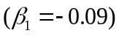 with 88% of the posterior distribution for being < 0; was 1.08 (range = 0.93–1.29, Figure 19). Temporal process variance for ϕ on the logit scale was 0.36 (95% CI = 0.01–2.1) and for γ on the log scale was 1.08 (95% CI = 0.07–8.00). When detection heterogeneity was estimated with Model 2, annual point estimates of N for the UARB study area ranged from 23 to 41 (Figure 20). Model 2 estimates of γ ranged from 0.00 to 0.43 and estimates of ranged from 0.85 and 0.89. A negative relationship between N and γ 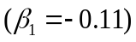 was again evident with 82% of the posterior distribution for located below 0. Based on Model 2, was 1.09 (range = 0.90–1.35, Figure 20). Temporal process variance for ϕ on the logit scale was 0.69 (95% CI = 0.03–5.94) and for γ on the log scale was 1.41 (95% CI = 0.12–9.02).
Point estimates of female N for the LARB ranged from 78 to 97 from 2010 to 2012 based on Model 1 (Figure 21). Estimates of γ were 0.00 (95% CI = 0–0.03) for 2010–2011 and 0.24 (95% CI = 0.10–0.50) for 2011–2012. For those periods ϕ was 0.81 (95% CI = 0.68–0.90) and 0.85 (95% CI = 0.70–0.94), respectively. My estimate of was 0.81 (95% CI = 0.68–0.91) for 2010–2011 and 1.08 for 2011–2012 (95% CI = 0.89–1.37, Figure 21). Based on Model 2, estimates of female abundance for the LARB ranged from 68 to 84 from 2010 to 2012 (Figure 22). Model 2 estimates of γ were 0.00 (95% CI = 0–0.03) for 2010–2011 and 0.31 (95% CI = 0.16–0.51) for 2011–2012. Based on Model 2, ϕ was 0.81 (95% CI = 0.68–0.90) and 0.84 (95% CI = 0.69–0.97) for 2010–2011 and 2011–2012, respectively. For 2010–2011, based on Model 2 was 0.81 (95% CI = 0.68–0.91) and for 2011–2012 was 1.16 (95% CI = 0.93–1.41, Figure 22). Estimated asymptotic growth rates for the TRB when unresolved fates were AC and AD were 1.04 and 1.02, respectively.

4.3 Population viability analysis
Based on vital rate estimates from Model 1 of the CMR analysis, probability of persistence over 100 years for the TRB population was >0.999 and 0.975 for process-only and all-uncertainty projections, respectively (Table 6). Similarly, the probability of persistence was >0.999 and 0.982 based on Model 2 for process-only and all-uncertainty projections, respectively. In general, the probability that the TRB population would decline over the next 100 years (i.e., projected N at year 100 less than initial N) was >0.70 for all simulations (Table 6). The mean percent change in projected abundance for the TRB over 100 years was negative for all simulations (Table 6). Because no cubs-of-the-year handled during winter den captures were ever detected at hair collection sites and were not part of the sampled population for CMR-based demographic rate analyses, my projections for the TRB and UARB pertain to bears ≥1 year of age.
For the UARB, probabilities of persistence based on Model 1 were >0.999 and 0.971 for process-only and all-uncertainty projections, respectively and 0.993 and 0.926 for Model 2. Similar to the TRB, the mean percent change in projected abundance over 100 years was negative for all simulation scenarios except for the scenario based on Model 1 vital rate estimates and incorporating all uncertainty, which was positive (Table 6). However, further inspection of abundances after 100 years for those simulations revealed several large outlier values (i.e., N₁₀₀ > 1000) that caused right skewness and an inflated arithmetic mean. The probability that N would decline ranged from 0.578 to 0.819 depending on projection model (Table 6). Projected N at year 100 for the TRB and UARB was consistently higher for simulations based on vital rates from CMR Model 1 compared with simulations based on Model 2 estimates (Table 6).
Using the telemetry and reproductive data from the TRC, probabilities of persistence were approximately 3 times greater for AC compared with AD projections when only temporal process variance of vital rates was incorporated, regardless of assumed strength of density dependence or CMR model used to derive carrying capacity (Tables 7 and 8). When all uncertainty in vital rate estimates was incorporated, probabilities of persistence were about 1.6–1.7 times greater for AC compared with AD censoring (Tables 7 and 8). Persistence probabilities were ≥0.95 only for projections based on AC assumptions and incorporating process-only variation. Moreover, values of 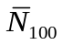from AC projections were more variable, which reflected uncertainty in vital rate values used in those projections. Probabilities of persistence for population projections based on equilibrium abundance estimates derived from the UARB were, in most cases, nearly identical to those based on estimates derived from the TRB. However, values of were consistently lower for all UARB-based scenarios because of the lower equilibrium abundance used. Differences in the assumed strength of the density-dependence relationship used in projections had only a minor influence on all persistence probabilities (Tables 7 and 8).
Assuming dynamics of the TRB, TRC, and UARB populations were independent and using the most pessimistic population-specific persistence probabilities (i.e., 0.975, 0.295, and 0.929, respectively), the overall probability of persistence for bears in that population system was 0.998.

4.4 Population structure and migrant analysis

4.4.1 Population structure analysis
Clustering results from my factorial correspondence analysis indicated varying levels of genetic structure among different pairs of study populations. When all populations were included in the analysis, 4 distinct clusters were identifiable corresponding to the MINN, UARB, and LARB populations along with a composite population (COMP) composed of all bears from the WRB and TRB, most MISS bears, and about half of the TRC bears (Figure 23). Genetic structure appeared greatest between COMP vs. LARB, COMP vs. UARB, and UARB vs. LARB pairs; and appeared lowest between MINN and UARB. Additionally, 7 bears from MISS were located between the LARB and MINN clusters and 50% of the TRC bears and 3 MISS bears were located between the TRB and UARB indicating mixed ancestry or potentially genetically distinct groups. FCA results from analyses restricted to bears from the MINN, TRB, UARB, and LARB populations revealed 4 distinct clusters corresponding to the true population of origin for those individuals (Figure 24). However, the MINN and UARB clusters slightly overlapped along axis 1 indicating considerably less genetic structure between those populations compared with other population pairs. When only bears from the TRB, TRC, and UARB were considered, the TRB and UARB populations appeared as substantially distinct genetic groups whereas bears in the TRC were divided between individuals clustering with the TRB and those whose genotypes were clustered mid-way between the TRB and UARB (Figure 25). Results from analysis based only on bears from the WRB and TRB revealed greater structure between those populations compared with pairings between the MINN and WRB, TRB, TRC, LARB, or MISS but less structure compared with the MINN-UARB pair. However, sufficient genetic structure appeared to exist between the WRB and TRB such that recent migrants could be identified (e.g., bears sampled in the TRB clustering with WRB; Figure 26). Taken together, results from the all-population and the WRB-TRB clustering analyses indicate at least 5 genetically distinct populations were represented in my genetic data.
Similar to between-population genetic structure patterns, my FCA revealed differing levels of within-population genetic structure among the 4 Louisiana populations. Within the TRB, a low level of structure was evident between bears sampled north of Interstate 20 and bears sampled south of Interstate 20 (Figure 27). Additionally, 2 bears did not cluster with the overall group (axis 2 vs. axis 3, Figure 27) and were identified as outliers potentially having ancestry from another population. Bears in the TRC were strongly segregated into 2 genetic groups that did not correspond with any particular spatial pattern or landscape feature (Figure 28). Bears in the UARB did not show any evidence of genetic structure except for 1 bear that was an extreme outlier (Figure 29). FCA revealed evidence of genetic structure in the LARB that corresponded to an eastern cluster and a western cluster with State Highway 317 operating as a potential movement barrier, as also found by Troxler (2013, Figures 30 and 31).
Clustering results from Program STRUCTURE consistently partitioned individuals into groups corresponding to known extant populations across independent MCMC chains as K increased from 2 to 4 (Figure 32). At K = 2, bears were partitioned into a group mostly consisting of individuals from WRB, TRB, and MISS and a group of individuals from MINN, UARB, and LARB. When K was increased to 3, bears in the LARB split away into a single cluster. When K = 4, bears from WRB and a majority of MISS bears were clustered into a single group. At K = 5, results across chains were less consistent. Six of 10 chains converged on population clusters corresponding to known populations in MINN, WRB, TRB, UARB, and LARB, 3 chains pooled MINN and UARB together and split TRB into 2 groups, and 1 chain pooled MINN and UARB and split LARB into 2 groups. Results were inconclusive when K > 5 because of substantial variation of convergence among MCMC chains for each value of K.
In general, log[K] values increased as I increased K from 2 to 7, after which values from different chains for greater values of K began to overlap indicating models with K > 7 over fit my data (Figure 33). Based on Δlog[K], the most likely number of populations present in my data was K = 4 (Figure 34) which was also the value of K that had the greatest and most stable values of log[K] across chains. However, the majority of chains (n = 6) for K = 5 converged on clusters corresponding to distinct populations known to be spatially segregated by large distances, indicating reasonable support from the data. In total, measures of model fit and spatial distribution of fragmented populations indicated the most likely number of genetically distinct groups was 5.
Based on results from the FCA and preceding STRUCTURE analysis, I ran an additional 10 chains in STRUCTURE for the K = 5 model. For each bear, I then plotted the estimated probability that it had originated from each of the 5 putative clusters in search of evidence of genetic interchange between populations within the LMAV. In the TRB, nearly 30 bears had a ≥0.10 probability of originating from WRB, 1 had a 0.99 probability of originating from the LARB, and 1 had a 0.48 probability of coming from the UARB (Figure 35). Thirty-two bears sampled in northwestern MISS had probabilities of WRB origin ≥0.90 whereas 10 bears from that area had a ≥0.90 probability of originating from the TRB (Figure 36). Six bears from the northwestern portion of MISS had mixed ancestry between WRB and TRB and were sampled east of the TRB and across the Mississippi River (Figure 36). Moreover, 3 cubs sampled in the west central portion of MISS east of the TRC showed evidence of mixed ancestry between TRB and UARB. Of the sampled cubs born in the TRC, about half had mixed ancestry between TRB and UARB and the other half had nearly complete TRB ancestries. Furthermore, an adult female reintroduced to the TRC that subsequently dispersed to the Boeuf Wildlife Management Area (northwest of the TRC and southwest of the TRB) and a cub of that female subsequently born at that location both showed evidence of partial ancestry originating from WRB (upper portion of Figure 37). Thus, evidence exists that WRB genes existed beyond TRB but not quite to TRC.

4.4.2 Migrant analysis
My search for migrants using GeneClass identified 5 bears in the TRB as migrants from the WRB (4M:1F) and 1 female in the TRB as a migrant from the LARB. No migrants were detected in the WRB, UARB, or LARB. My STRUCTURE-based migrant search using a model with K = 5 identified the same female in the TRB as a migrant from LARB with a probability >0.99. Two males in the TRB were classified as migrants from the WRB with probabilities >0.99, 1 male was classified as a true WRB migrant with a 0.60 probability. Taken together, results from both analyses commonly identified 3 male migrants in TRB originating from WRB and 1 female migrant in TRB originating from the LARB. Twenty of 35 TRC cubs showed evidence of having been sired by an immigrant male from UARB. Those cubs were distributed across 8 litters produced by 6 different females. Searches of DNA-based CMR histories and live-capture records identified 3 males in the TRB that dispersed from the TRC. One male was a cub born to and moved with a female in 2006 that was translocated from the TRB to the TRC as part of the reintroduction. That male was subsequently live captured in the TRB in 2010. The other 2 males were born on the TRC to translocated females, handled as cubs in their natal dens, and subsequently detected at hair collection sites in the TRB by age 2. A fourth male was detected at hair collection sites in the TRB and was classified as a second generation migrant from the UARB (i.e., 1 parent from the UARB). Three females were detected at hair collection sites in the WRB from 2004 to 2006 were subsequently live captured 80–150 km south of the WRB in Sharkey and Sunflower counties in Mississippi between 2008 and 2010. One male was detected at hair collection sites in the TRB in 2007 and was later live captured approximately 14 km directly east of the TRB in Warren County, Mississippi.

5 DISCUSSION

5.1 Demographic rate analysis

5.1.1 Survival rates of radio-collared adult female bears
Estimates of mean annual adult female survival based on radio telemetry data were slightly lower in the TRC compared with the TRB when unknown fates were right censored and that difference doubled in magnitude when unknown fates were treated as mortalities. Indeed, over twice as many known mortalities were recorded in the TRC over only two-thirds the number of bear-years monitored compared with the TRB suggesting mortality risks were greater in the TRC. Although 95% credible intervals for the 2 areas overlapped, lower point estimates for the TRC may reflect the effects of additional mortality caused by illegal kills. Nearly half (4 of 9) of the documented mortalities at the TRC were attributed to poaching compared with no poaching-related mortalities documented in the TRB. Annual survival rate estimates for adult females in the TRB and TRC were similar to or slightly higher than survival estimates from other non-hunted black bear populations in the southeastern US (Table 9). Consistent with other studies of adult female survival, the leading cause of mortalities in both study areas were human-related (3 of 4 in the TRB and 8 of 9 in the TRC).
The prevalence of mortalities of radio-collared adult females caused by poaching in the TRC in my study is in contrast to results reported by Benson and Chamberlain (2007). Those authors recorded zero illegal kills of 21 reintroduced adult females during the first 5 years of the reintroduction effort in the TRC and concluded that poaching prevalence was lower than other bear reintroductions in the southeastern US. The discrepancy between my findings and those of Benson and Chamberlain (2007) may have been caused by the shorter time period (i.e., 2001–2005) over which they monitored reintroduced females compared with the longer time period of my study (i.e., 2002–2012). Indeed, all 4 illegal kills occurred after mid-2006. However, the cause of the higher rate of poaching in later years is not clear. A potential explanation is that competition for space and resources increased on protected state and federal lands as population numbers increased causing some bears to spend more time on less protected private properties where poaching threats may have been higher. However, such range expansion would only account for half of the illegal kills of radio-collared females because 2 of 4 occurred on state-owned Wildlife Management Areas.

5.1.2 Reproductive rates of radio-collared adult female bears
The higher likelihood of females in the TRC to transition between states C and Y suggests that cub survival was lower in the TRB. Lower cub survival in the TRB may be caused by greater competition for resources and greater potential for intraspecific killing because that population may be closer to carrying capacity. Such density-dependent regulation of dependent offspring survival is a well-documented aspect of bear population dynamics (Bunnell and Tait 1981, Clark and Smith 1994, Czetwertynski et al. 2007). In contrast, females in the TRC were less likely to transition from any of the 3 reproductive states to state C indicating breeding success was lower in the TRC. Lower breeding success in the TRC may be related to possible Allee effects caused by few resident breeding males in the area at the onset of the reintroduction project (Courchamp et al. 2008). Despite these differences, stable state probabilities for state Y for the TRB and TRC were similar, suggesting that the positive effect of higher cub survival was largely offset by potential Allee effects resulting in a higher proportion of unbred females in the TRC (Courchamp et al. 2008).
In general, females in the TRC produced more cubs and more yearlings per litter than females in the TRB. Conversely, r_{C} was greater in the TRB which was primarily caused by the greater proportion of females producing litters of cubs. However, r_{Y} in the TRC was slightly greater despite that population having a lower proportion of females encumbered by yearlings. The factor driving that difference was that females in the TRC had larger yearling litters which, similar to the reproductive transition analysis, reflects greater cub survival in the TRC.

5.1.3 Demographic rates from capture-mark-recapture data
Annual abundance estimates for the TRB and LARB differed depending on how I modeled detection heterogeneity (Table 10). In contrast, abundance estimates for the UARB were similar for both models (Table 10) because nearly all females were detected in >1 secondary sampling period (i.e., weeks) of primary sampling periods (i.e., years) during which they were alive and present on the study area. Moreover, estimates of γ were also affected by model choice because those estimates are linked with estimates of abundance. Detection heterogeneity is a common challenge to overcome when estimating population abundance for bears from CMR data because estimates can be greatly influenced by how heterogeneity is modeled. Conversely, estimates of ϕ were similar for all populations regardless of heterogeneity model choice (Table 10) because ϕ is robust to heterogeneity biases (Abadi et al. 2013). Therefore, my estimates of likely were robust to choice of heterogeneity model because growth and sustainability of bear populations are primarily driven by adult female survival.
Another potential difficulty for DNA-based CMR studies is determining whether all age cohorts within a population are being sampled because age data generally cannot be obtained from DNA. I found that genotypes of cubs known to be alive and present on the study area did not match genotypes of bears detected at hair sites. This is in contrast to Kendall et al. (2009) who concluded their abundance estimates for grizzly bears included all age cohorts and was likely due to the physiological differences between grizzly and black bear cubs and different wire configurations. Because field collection methods were standardized across all study areas, abundance estimates and demographic rate estimates from CMR analyses for the TRB, UARB, and LARB should be interpreted as pertaining to age cohorts 1-year old and older.
Although the specific patterns of variation in abundance and recruitment differed between models, overall population dynamics as measured bywere stable to slightly decreasing for the TRB compared with the UARB. Greater variability of growth rates in the UARB may reflect greater environmental variation in recruitment or higher demographic variability caused by the smaller population size (Shaffer 1987, White 2000, Mills 2007). Apparent survival based on the CMR analysis (0.87–0.93) was much lower than the estimate from the telemetry data (0.97–0.99) at the TRB (Table 10). That difference is expected because ϕ from CMR includes emigration whereas survival based on known-fate analysis does not. Apparent survival was slightly lower for the UARB compared with the TRB; whether the lower ϕ was primarily the result of mortality or permanent emigration is unknown.
Eberhardt (1977) described an ordered sequence of mechanisms by which large mammal populations are regulated as density approaches carrying capacity. Initially, increased intra-specific competition for resources and direct conspecific-caused mortality would be expected at higher densities and cause reductions in survival of dependent offspring and independent juveniles. As density continues to increase, increases in age of primiparity and decreases in reproductive output would occur. Lastly, survival of adults would be expected to decrease under extreme conditions caused when population growth drastically overshoots carrying capacity. For bears, several studies have reported evidence supporting such population regulation through an inverse relationship between cub survival and population density (Lindzey et al. 1983, Miller et al. 2003, Schwartz et al. 2006, Czetwertynski et al. 2007, Garrison et al. 2007). However, other researchers have reported no or inconclusive evidence that population density affects demographic rates in bears (Elowe and Dodge 1989, Miller 1994, Sargeant and Ruff 2001, Obbard and Howe 2008). Furthermore, whether population regulation in bears can be rigorously detected and measured has also been questioned (Derocher and Taylor 1994, Garshelis 1994, McLellan 1994).
My analysis of CMR data for the TRB and UARB showed evidence for a negative relationship between per-capita recruitment and abundance which suggests that density-dependent regulatory factors influence dynamics of those populations, although, the mechanism by which that regulation is occurring is unclear. I estimated per-capita recruitment which is defined as the number of bears new to the population (i.e., recruits) divided by the number of resident bears. This definition does not distinguish between in situ recruits that are born in the study area and immigrant recruits that disperse to the study area from adjacent, but unsampled areas. However, I limited my analysis to females which typically are poor dispersers and display strong natal site fidelity. Therefore, per-capita recruitment most likely reflected true in situ recruitment. Moreover, because the sampled population in my CMR data set was restricted to bears >1 year old, recruitment estimates for my study should be interpreted as in situ recruitment of yearling bears. That interpretation prohibits a clear understanding of which vital rates were being influenced by population density because my data do not allow separating yearling recruitment into its demographic components (i.e., female reproductive rate and cub survival). However, multiple mechanisms likely operate simultaneously to regulate populations that are near carrying capacity (Eberhardt 1977). Such synergistic effects may explain why I detected a density-dependent relationship in my study because per-capita yearling recruitment represents the cumulative effects of multiple demographic processes that may be regulated by density. Also, the longer time period of my study likely contributed to my greater ability to detect density dependence.
Estimating process variation of demographic rates over time is critical for incorporating temporal stochasticity into population projection models used for population viability assessments (White 2000). Reliability of variance estimates in terms of bias and precision for CMR analyses is linked to the number of animals sampled within each year and to the number of years of sampling (Burnham and White 2002, White et al. 2009). Using simulated data sets and Bayesian estimation methods, White et al. (2009) found that estimates of temporal variance for apparent survival generally were positively biased when the number of occasions was 7 and estimates were based on the mean of the posterior distribution. Although White et al. (2009) did not explicitly discuss reliability of estimates based on other measures of central tendency (e.g., median or mode), their simulation results based on 7 occasions and the posterior mode as the estimator (see Table 3 of White et al. 2009) indicated substantial negative bias. I chose to base my estimates of temporal process variances on posterior medians, which typically fall in between the mean and mode of skewed distributions, thereby minimizing potential bias. Moreover, CMR data collection has continued on the TRB and UARB which will extend the time series and should facilitate more robust estimation of temporal process variation in the future.
I estimated γ and λ for only 2 intervals at the LARB, and both substantially differed by interval (Table 10). Whether the large difference across intervals is because population dynamics at LARB truly are more variable or because my study occurred over an unusual sequence of extreme dynamics cannot be determined without a longer time series of data. Moreover, ϕ was considerably lower than at the TRB or UARB (Table 10) which was likely because of greater exposure to anthropogenic causes of mortality compared with other Louisiana black bear populations (Pace et al. 2000). Because data for only 2 annual intervals were collected in the LARB, I was unable to explicitly model and reliably estimate global means and annual variation for vital rates.

5.1.4 Asymptotic population growth rates
Estimates of λ_{Asym} for the TRB were positive regardless of the adult female survival rate (i.e., AC versus AD) compared with stable to slightly decreasing CMR-based estimates of the geometric mean of . The discrepancy between and λ_{Asym} are to be expected because inherently includes temporal stochasticity in vital rates that cause lower overall future growth rates whereas λ_{Asym} assumes stationary, ergodic conditions and a stable age distribution resulting in higher growth rates (Morris and Doak 2002, Mills 2007). Therefore, if the true population in the TRB was decreasing at substantially high rate, estimates of λ_{Asym} would likely have been <1 which was not the case in my study. For the TRC, only the most optimistic estimate of adult female survival resulted in positive population growth indicating that population may not yet be self-sustaining. Although adult female survival rates (0.93–0.97) at TRC were high and comparable to other bear populations in the Southeast, recruitment for breeding females was relatively low which contributed to lower λ_{Asym}. Whether these low reproductive rates will persist is unknown, but the high stable state probability of barren females (B) at TRC suggests an Allee effect caused by the initially low numbers of adult males there. This situation could change as cubs born at TRC grow older and reach maturity and as more males immigrate from UARB. Other researchers have documented low initial growth rates of reintroduced bear populations which dramatically increased in subsequent years (S. Murphy, University of Kentucky and J. Clark, US Geological Survey, unpublished data).

5.2 Population viability analysis
Regardless of whether only temporal process variation or all sources of uncertainty were incorporated for the TRB, the probabilities of persistence were >95% and viable based on the definition stated in the Recovery Plan. For the UARB, only projections including process-only variation resulted in a >0.95% chance of persistence, however incorporating all uncertainty resulted in estimates of persistence being only slightly below the viability threshold (93%). The probability of persistence for the system of populations including the TRB, TRC, and UARB also met the viability threshold. My estimates of λ at TRB were similar whether projections were based on CMR or telemetry data, which lends some validity for the matrix methods I used for the TRC projections.
I did not estimate or account for temporal correlation of vital rates among individual component populations in my projection models. Such correlations are potentially important to metapopulation dynamics because they cause temporal synchrony of individual population dynamics and influence global extinction of the entire population system (Harrison and Quinn 1989, Heino et al. 1997, Palmqvist and Lundberg 1998). For example, if populations are located within sufficient proximity such that they are affected by the same environmental variation influencing vital rates, probabilities of persistence will be lower for the entire system than if they are assumed to be independent. That is because a potential decline due to a stochastic environmental event would be likely to similarly affect all subpopulations, with less chance that one population could compensate for the other. Although presence of temporal correlations among Louisiana black bear populations would reduce long-term viability of the entire system, the high persistence probabilities that I estimated in TRB and UARB would negate any co-variation in parameters because the probability that at least 1 population persists would be at least as great as the population with the higher probability of persistence, which was >95%. Moreover, my viability analysis did not include persistence probabilities for Louisiana black bears in the LARB or in Mississippi. Inclusion of those populations would further increase the likelihood of long-term viability of bears in general for the entire system.
I did not include temporal correlations among population-specific vital rates in my projections because the length of my time series of CMR data was insufficient to reliably estimate among-parameter covariances. Such correlations can decrease persistence probabilities for the same general reasons as those for among population correlations (Morris and Doak 2002). However, high means and low variances of adult female survival rates and relatively higher variation in per-capita recruitment indicate population dynamics are primarily driven by recruitment processes rather than survival processes which would dampen potential covariance effects. Nonetheless, CMR-based monitoring efforts in the TRB and UARB are expected to continue (Maria Davidson, LDWF, personal communication) which should allow estimation of among-parameter covariances and their effects on population dynamics in the future.
Incorporating density-dependence into projection models inherently causes compensatory mechanisms to return populations to equilibrium levels and reduces the overall risk of extinction (Ginzburg et al. 1990). Furthermore, inference about long-term population persistence is sensitive to the specific form of the density-dependent relationship included in a projection model used for population viability analysis (Mills et al. 1996). Therefore, density-dependent relationships should be based on empirical data collected from the population of interest rather than be assumed from population theory or extrapolated from other populations or species. When such data are not available, testing multiple forms of density dependence allows evaluation of uncertainty about the effects of different structures of population regulation on viability assessment.
I estimated the functional relationship between per-capita recruitment and abundance directly from my CMR data set for the TRB and UARB. This allowed me to incorporate regulatory mechanisms known to be operating in those populations into population projections. However, parameter estimation uncertainty prevented conclusive determination of the form of density-dependence which could result in misleading conclusions about population persistence if that uncertainty was ignored. To account for that uncertainty, my all-uncertainty projections for the TRB and UARB explicitly incorporated parameter uncertainty, including the density dependence parameter, into my simulations and I conclude that incorporating density-dependence into my projection models was justified and that inferences about the long-term persistence of those populations were reliable. Furthermore, results from my projections incorporating all sources of uncertainty represent the most conservative estimates of probabilities of persistence for the TRB and UARB.
For the TRC, I tested 2 different strengths of density-dependence based on the Michaelis-Menten function for enzyme kinetics because data required for determining the specific relationship was not available. Regulatory mechanisms in large mammals are expected to operate only when populations are near carrying capacity (Eberhardt 1977, Fowler 1981) and may not be realistic for a recently re-established population such as the TRC. However, population projection models that do not include regulatory mechanisms would result in exponential growth given sufficient vital rates which would also be unrealistic. Conversely, not incorporating a density-dependence relationship in demographic rates could eliminate any compensatory response for a small declining population that could mistakenly increase probabilities of extinction. Therefore, I chose to include density-dependence to avoid overly optimistic probabilities of persistence and overly pessimistic probabilities. Because simulation results showed that long-term persistence was least sensitive to the form of population regulation compared with the method used to estimate adult female survival and whether only temporal process or all uncertainty in vital rates was included, I conclude that the forms of density-dependence I used did not result in misleading inferences about the viability of the TRC.
To my knowledge, my study is the first to perform a risk assessment for determining recovery status for a threatened terrestrial mammal species using Bayesian population viability analysis. Explicitly incorporating parameter uncertainty through the use of Bayesian posterior distributions is preferred because it results in a wider distribution of extinction times that is more likely to contain the true distribution (Wade 2002). Moreover, Bayesian PVAs have the added benefit of expressing extinction risk in terms of a frequency-based framework that is more readily incorporated into delisting decisions and adaptive management components of recovery plans (Goodman 2002). For example, Bayesian PVAs that incorporate multiple sources of variation including parameter uncertainty and process variation (i.e., temporal and demographic variance) typically result in more conservative estimates of probabilities of persistence which lowers the chances of committing a Type II error when deciding to delist imperiled species.
Population viability analysis has often come under scrutiny for whether it can produce reliable risk assessments for the conservation and management of imperiled species. Some common criticisms include misuse of generic software packages to conduct such analyses, lack of sufficient time series of data to account for environmental variation, and exclusion or inappropriate estimation of parameter uncertainty (Taylor 1995, Beissinger and Westphal 1998). However, Brook et al. (2000) evaluated the performance of PVAs by conducting separate PVAs for 21 species for which sufficient data was available to use the first half of the data for parameter estimation and population forecasting and the second half for model validation. Those authors found that estimates of extinction risk were reliable regardless of software package used which lends further credibility to the reliability of my PVA because my projection models were based on life history processes of black bears and explicitly included parameter uncertainty.

5.3 Population structure and migrant analysis
Genetic clustering results from Program STRUCTURE analyses assuming K = 2 and using genotype data from all populations in the LMAV and the MINN population partitioned bears by geographic regions roughly associated with the northern and southern portions of the LMAV with MINN being grouped with the southern clade. The inclusion of MINN and UARB bears into the same cluster likely reflects the differential impacts of the previous restocking effort. Of the 161 bears released from 1964 to 1967, 131 were released in Pointe Coupee Parish within the UARB and 31 were released in Tensas and Madison Parishes within the TRB (Taylor 1971). The greater number of bears released in the UARB likely resulted in more bears establishing home ranges in that area, reproducing, and eventually having a greater influence on the future genetic composition in the UARB compared with the TRB. That influence would explain the greater affinity between the UARB and MINN supported by my results.
The inclusion of bears from the LARB into the southern clade is more difficult to explain because no bears were released in the Lower Atchafalaya Basin. However, the LARB is located approximately 100 km from the release site in the UARB which is within the dispersal capabilities of black bears. Given that bears were released during the summer without an acclimation period (i.e., hard released) and the propensity for hard-released bears to disperse longer distances from release sites (Rogers 1973, Eastridge and Clark 2001, Clark et al. 2002), a sufficient number of bears released in the UARB may have dispersed to the LARB. From 1965 to 1969, released bears were reported to have dispersed to Texas, Mississippi, and Arkansas and presence of bears was recorded in 37 of 64 Louisiana parishes (Taylor 1971) which further suggests the likelihood of bears dispersing to the LARB and affecting the future genetic composition of that population. Moreover, other genetic studies by Warrilow et al. (2001), Csiski et al. (2003), and Triant et al (2004) found greater genetic similarity between bears in the UARB and LARB than between either of those areas and the TRB or WRB.
Clustering of bears from the WRB, TRB, and MISS into a single group suggests those areas were relatively unaffected by the restocking program in Louisiana and retained a greater proportion of their historic genetic composition. Of those 3 areas, the TRB and WRB are the only 2 areas that support extant populations that have never been extirpated, though the TRB population was augmented with bears from MINN. Contiguous bottomland hardwood forests once existed throughout the LMAV that likely supported a continuous bear population between the WRB and TRB. Prior to extensive loss and fragmentation of habitat that lead to isolation bear populations in the LMAV, a continuous distribution of bears may have facilitated sufficient historic gene flow throughout the region to cause allele frequencies in the WRB to have been correlated with those in the TRB. If so, persistence of that correlation may explain the genetic similarities I detected between current populations in the WRB and TRB. Although black bears were nearly extirpated (≤12 individuals) from Mississippi by the late 1930s, bears from Louisiana, Arkansas, and Alabama have recently recolonized formerly occupied habitat in western and southeastern portions of that state (Simek et al. 2012). Because of the relatively close proximity of the WRB and TRB to Mississippi, those populations are the most likely sources of migrants into western Mississippi which would explain clustering of MISS bears with TRB and WRB bears.
When I increased the number of potential genetic clusters in my STRUCUTRE analysis from 2 to 3, the LARB was the first population to separate from the other clusters. Genetic differentiation of the LARB from other populations in Louisiana was likely caused by a combination of factors. By the late 1950s, the number of black bears in Louisiana was greatly reduced to only 80–120 individuals in isolated patches of habitat in the Lower Atchafalaya River Basin and Tensas River Basin (St. Amant 1959). Those areas were separated by >275 km which is beyond the typical dispersal distance capabilities of bears and likely resulted in limited historic gene flow between those populations caused by isolation-by-distance effects (Wright 1943). Moreover, such low numbers may have resulted in rapid genetic drift (Fisher 1930, Wright 1931) which may have further contributed to genetic divergence between those populations.
My STRUCTURE analysis that assumed 4 population clusters produced the first instance of the TRB and WRB splitting into 2 separate clusters indicating bears in the TRB had a closer genetic affinity to bears in the WRB compared with bears from any of the other extant populations in the LMAV. Additionally, I identified 3 males in the TRB as migrants from the WRB which suggests that the greater affinity may in part be the result of contemporary gene flow indicating a movement pathway exists between those populations. Indeed, bears could disperse directly from the WRB to the TRB as evidenced by a male bear with Arkansas ear tags captured in 2005 at Lake Ophelia National Wildlife Refuge in Avoyelles Parish, Louisiana (Maria Davidson, LDWF unpublished data) which is located 100 km south of the TRB and almost 300 km south of the WRB. That bear was identified as a nuisance bear that was captured and released near White River National Wildlife Refuge in the WRB. Although that bear had bypassed the TRB and likely did not contribute to gene flow in that population, it suggests movement directly from the WRB to the TRB is possible.
Alternatively, the migrants I detected may be the result of the reintroduction of bears from the WRB to FNWR. From 2000 to 2002, 23 adult female bears and 56 cubs were translocated from the WRB to FNWR (Wear et al. 2005) which is located approximately 100 km northwest of the TRB. Of those bears moved to FNWR, 1 radio-collared adult female was known to have subsequently dispersed as far south as the Tensas River National Wildlife Refuge in the TRB (Maria Davidson, LDWF unpublished data) demonstrating that dispersal from FNWR to the TRB has occurred. A third potential route by which migration from the WRB to the TRB could have occurred is through Mississippi. Several lines of evidence support this hypothesis. First, I found direct evidence that WRB bears have dispersed across the Mississippi River and recolonized forested habitats in western Mississippi. Second, I documented movement from the TRB to Mississippi based on DNA-based CMR and live capture which suggests movement in the reverse direction is possible. Third, movement of several radio-collared bears from the TRB into Mississippi has been documented over the past 15 years (Maria Davidson, LDWF unpublished data). Lastly, reproduction has recently been documented in Issaquena, Sharkey, and Warren counties of Mississippi (Simek et al. 2012) which are located east and northeast of the TRB. Genetic evidence of bears with full and partial WRB ancestry occurring in those counties combined with the documented ability of bears to cross the Mississippi River suggests dispersal of bears with WRB ancestry into the TRB via Mississippi is likely.
At K = 5, bears in the UARB were first distinguished from MINN bears which indicates the lasting genetic effects of the reintroduction in the 1960s. Differentiation between those populations also improved inference about admixed cubs in the TRC by identifying the UARB as the source of immigrant sires. Moreover, I found evidence of indirect interchange between the TRB and UARB via the TRC which indicates the presence of pathways necessary for such interchange. However, interchange between the TRC and UARB does not appear to be symmetrical because no instances of bears with partial TRB ancestry were found in the UARB that would suggest movement in that direction. Such asymmetrical movement demonstrates that existence of pathways is not a sufficient condition for interchange to occur. Although I detected movements of bears only from the TRC to the TRB, I was unable to determine symmetry of movements because I lacked data for potential migrants into the TRC (i.e., samples from bears other than translocated females and their offspring). However, a DNA-based CMR population study began in the TRC in 2014 which should provide the necessary data for identifying potential migrants from the TRB and evaluating the ability of the corridor between the TRB and TRC to facilitate movement to the TRC.
The only evidence of direct movement (i.e., a known individual) among any of the 3 extant Louisiana black bear populations identified in the Recovery Plan was a single female migrant in the TRB that was identified as coming from the LARB. Given that the TRB is well beyond the typical natural dispersal distance of female black bears from the LARB and that nuisance bears in the LARB are occasionally moved to the northern portion of the TRC (Maria Davidson, personal communication), that female most likely was a nuisance bear that dispersed to the TRB from the TRC.
One male detected at hair collection sites in the TRB was classified as being a second generation migrant from the UARB. Whether this bear is a resident offspring of a first generation UARB migrant to the TRB or is mixed ancestry offspring born in the TRC that subsequently dispersed to the TRB could not be determined. However, given the high proportion of cubs born in the TRC with mixed ancestry and documented dispersal of young males from the TRC to the TRB, that bear most likely was a cub produced in the TRC by a female with TRB ancestry and male with UARB ancestry that dispersed. Again, that bear indicates gene flow from the UARB to the TRB that was likely facilitated by the presence of the reintroduced population in the TRC.
Although analyses that assumed numbers of clusters >5 were not well supported by the data, an interesting pattern within the TRB was apparent. At K = 6, bears in the TRB separated into 2 primary groups. When individuals in those 2 groups were plotted, I found the observed differentiation coarsely aligned with Interstate 20 (I-20) and U.S. Route 80 (Hwy 80) transportation corridor which suggests a restriction of gene flow may have occurred at some point in the past between bears north of those roadways and bears to the south. Whether or not this pattern was caused by historic fragmentation, a contemporary restriction in gene flow, or random chance could not be determined. Given the relatively long generation time of black bears, the time since construction of I-20 in the 1950s may not have been sufficient to have produced conclusive evidence of restricted gene flow. Regardless, relatively high rates of mortality associated with vehicle collisions along a 30-km section of the I-20/Hwy 80 corridor (14 mortalities from 2010–2013; Maria Davidson, LDWF unpublished data) indicate those highways negatively affect successful movement.
Collective results from my clustering analyses indicate that the 3 subpopulations of Louisiana black bears identified in the Recovery Plan (1995) are genetically distinct from each other. Moreover, bears in those populations show significant genetic dissimilarities when compared with bears from the WRB and MINN. Identifying the factors causing the genetic structuring of those populations is a difficult and complex problem because individual populations were influenced by varying levels of many different factors. However, differentiation among populations within the LMAV can be reduced to 3 main factors: 1) restricted gene flow between populations caused by extensive loss and fragmentation of habitat, 2) accelerated genetic drift related to past reductions in local population abundances, and 3) differing levels of genetic introgression that resulted from the historic reintroduction of bears from Minnesota into Louisiana. Fortunately, my results also revealed evidence that gene flow has resumed among some populations facilitated by the reintroduction efforts at the TRC, and perhaps the FNWR.
Although bears in Louisiana may have affinities to MINN bears and WRB bears may have immigrated to TRB, the level of genetic affinity or differentiation between populations is not sufficient evidence for determining taxonomic status (Allendorf et al. 2013) and thus should not be the only measure used to determine protected status. Moreover, the issue of true taxonomic status may be irrelevant from a legal standpoint because American black bears are indistinguishable from Louisiana black bears based on physical characteristics and are afforded protection within the historic range of the Louisiana black bear under the similarity of appearance section of the ESA (USFWS 1992). My data suggest genetic interchange by bears from outside the range of U. a. luteolus (i.e., Arkansas) with bears in Louisiana and Mississippi. Given the historic proximity and genetic purity of WRB bears, that ingress probably should be considered a positive genetic and demographic contribution the Louisiana black bear, regardless of taxonomic delineation

6 CONCLUSIONS
My goal was to address the recovery criteria 1 and 2 in the 1995 Recovery Plan and to go beyond that to use the best available science to assess long-term viability of the assemblage of bear subpopulations within the historic range of U. a. luteolus. Most of my population projections indicate that bear subpopulations in the TRB and the UARB are viable, with only the most pessimistic projection narrowly missing the 95% target. Those projections are based on the assumption that the environmental and demographic mechanisms regulating population dynamics during my study remain the same for the next 100 years and on assumptions built into the population projection models themselves. The inclusion of covariances among vital rates and populations, the exclusion of density effects, and any number of other modeling choices could change that. However, I attempted to take a conservative (pessimistic) approach and I think my projections were reasonable and defendable.
The 1995 Louisiana black bear recovery plan requires the establishment of immigration and emigration corridors between the 2 viable subpopulations in the Tensas and Atchafalaya river basins that are considered sustainable (USFWS 1995). Corridors are often touted as effective tools for connecting fragmented landscapes and enabling demographic and genetic interchange between isolated populations (Nelson et al. 2003, Noss 2003, Dixon et al. 2006). That undoubtedly was the intent when recovery criterion 2 was developed. My genetic analysis and CMR data indicate that bears from the UARB dispersed to the TRC and bred with reintroduced bears there and my hair-trapping data indicate that some subadult males have dispersed from the TRC to the TRB. Therefore, habitat exists through which contemporary interchange between bears in the Tensas and Atchafalaya river basins has occurred. Mills and Allendorf (1996) recommended 1–10 migrants per generation to avoid the loss of polymorphism and heterozygosity in subpopulations. Current migration rates of males, possibly facilitated by management trapping and relocation of nuisance bears, may be sufficient to avoid inbreeding. For females, dispersal potential appears to be low to non-existent between all subpopulations due to absence of female migrants identified in my analyses. For female interchange and demographic rescue to be effective, linkages between subpopulations would probably have to be permanently occupied. Thus, the establishment of stepping-stone populations of bears between the subpopulations may be a more effective measure than the establishment of long corridors without a population presence in between.
Finally, Criterion 3 of the recovery plan requires long-term protection of the habitat and interconnecting corridors that support each of the 2 viable subpopulations used as justification for delisting. The bear population at TRB exists almost entirely on a National Wildlife Refuge and state lands. Thus, habitat for that subpopulation is presumably protected. At UARB, most of the bears live within the Morganza Spillway which is under permanent easement by the U.S. Army Corps of Engineers. The other subpopulations in Louisiana exist on a combination of state, federal, and private land. The USFWS has designated 483,932 ha as critical habitat for black bears under section 4 of the Endangered Species Act of 1973. Of the total area, 50,122 and 78,588 ha of critical habitat is in federal and state ownership, respectively (USFWS 2009), with the bulk being in local or private ownership (355,221 ha). However, the critical habitat designation is rescinded once delisting occurs. The long-term viability of the TRB subpopulation is probably assured given that it is located almost entirely on a National Wildlife Refuge. Whether any of the other subpopulations can exist wholly on the available state or federal land is not known. Private land managers may play a critical role in maintaining adequate bear habitat into the future.

LIST OF REFERENCES

Abadi, F., A. Botha, and R. Altwegg. 2013. Revisiting the effect of capture heterogeneity on survival estimates in capture-mark-recapture studies: does it matter? Plos One 8.
Allendorf, F. W., G. H. Luikart, and S. N. Aitken. 2013. Conservation and the genetics of populations. John Wiley & Sons, West Sussex, Unitied Kingdom.
Anderson, D. R. 1997. Corridor use, feeding ecology, and habitat relationships of black bears in a fragmented landscape in Louisiana. Thesis, University of Tennessee, Knoxville, Tennessee, USA.
Anderson, G. S., and B. J. Danielson. 1997. The effects of landscape composition and physiognomy on metapopulation size: the role of corridors. Landscape Ecology 12:261–271.
Arnason, A. N. 1972. Parameter estimates from mark-recapture experiments on two populations subject to migration and death. Researches on Population Ecology (Tokyo) 13:97–113.
Beausoliel, R. A. 1999. Population and spatial ecology of the Louisiana black bear in a fragmented bottomland hardwood forest. Thesis, University of Tennessee, Knoxville, Tennessee, USA.
Beissinger, S. R., and M. I. Westphal. 1998. On the use of demographic models of population viability in endagnered species management. Journal of Wildlife Management 62:821–841.
Belkhir, K. 2004. GENETIX version v.4.05.2. Laboratoire Génome, Populations, Interactions, Adaptation. CNRS UPR, Université Montpelier, France.
Benson, J. F. 2005. Ecology and conservation of Louisiana black bears in the Tensas River Basin and reintroduced populations. Thesis, Louisiana State University, Baton Rouge, Louisiana, USA.
Benson, J. F., and M. J. Chamberlain. 2007. Space use and habitat selection by female Louisiana black bears in the Tensas River Basin of Louisiana. Journal of Wildlife Management 71:117–126.
Besbeas, P., S. N. Freeman, B. J. T. Morgan, and E. A. Catchpole. 2002. Integrating mark-recapture-recovery and census data to estimate animal abundance and demographic parameters. Biometrics 58:540–547.
Beston, J. A. 2011. Variation in Life History and Demography of the American Black Bear. Journal of Wildlife Management 75:1588–1596.
Boersen, M. R., J. D. Clark, and T. L. King. 2003. Estimating black bear population density and genetic diversity at Tensas River, Louisiana using microsatellite DNA markers. Wildlife Society Bulletin 31:197–207.
Bowman, J. L. 1999. An assessment of habitat suitability and human attitudes for black bear restoration in Mississippi. Dissertation, Mississippi State University, Starkville, Mississippi, USA.
Bowman, J. L., B. D. Leopold, F. J. Vilella, and D. A. Gill. 2001. Attitudes of landowners toward American black bears compared between areas of high and low bear populations. Volume 12.
Breen, M., S. Jouquand, C. Renier, C. S. Mellersh, C. Hitte, N. G. Holmes, A. Cheron, N. Suter, F. Vignaux, A. E. Bristow, C. Priat, E. McCann, C. Andre, S. Boundy, P. Gitsham, R. Thomas, W. L. Bridge, H. F. Spriggs, E. J. Ryder, A. Curson, J. Sampson, E. A. Ostrander, M. M. Binns, and F. Galibert. 2001. Chromosome-specific single-locus FISH probes allow anchorage of an 1800-marker integrated radiation-hybrid/linkage map of the domestic dog genome to all chromosomes. Genome Research 11:1784–1795.
Brooks, S. P., R. King, and B. J. T. Morgan. 2004. A Bayesian approach to combining animal abundance and demographic data. Animal Biodiversity and Conservation 27:515–529.
Bunnell, F. L., and D. E. Tait. 1981. Population dynamics of bears - implications. Pages 75–98 in C. W. Fowler, andT. D. Smith, editors. Dynamics of large mammal populations. John Wiley and Sons, New York, New York, USA.
Burnham, K. P., and G. C. White. 2002. Evaluation of some random effects methodology applicable to bird ringing data. Journal of Applied Statistics 29:245–264.
Caswell, H. 2001. Matrix population models: construction, analysis, and interpretation. Second edition. Sinauer Association, Sunderland, Masachusettes, USA.
Clark, J. D., and R. Eastridge. 2006. Growth and sustainability of black bears at White River National Wildlife Refuge, Arkansas. Journal of Wildlife Management 70:1094–1101.
Clark, J. D., R. Eastridge, and M. J. Hooker. 2010. Effects of exploitation on black bear populations at White River National Wildlife Refuge. Journal of Wildlife Management 74:1448–1456.
Clark, J. D., D. Huber, and C. Servheen. 2002. Bear reintroductions: Lessons and challenges. Ursus 13:335–345.
Clark, J. D., and K. G. Smith. 1994. A demographic comparison of 2 black bear populations in the Interior Highlands of Arkansas. Wildlife Society Bulletin 22:593–603.
Coull, B. A., and A. Agresti. 1999. The use of mixed logit models to reflect heterogeneity in capture-recapture studies. Biometrics 55:294–301.
Courchamp, F., J. Berec, and J. Gascoigne. 2008. Allee effects in ecology and conservation. Oxford University Press, Oxford, United Kingdom.
Crook, A. C., and M. J. Chamberlain. 2010. A multiscale assessment of den selection by black bears in Louisiana. Journal of Wildlife Management 74:1639–1647.
Csiki, I., C. Lam, A. Key, E. Coulter, J. D. Clark, R. M. Pace, K. G. Smith, and D. D. Rhoads. 2003. Genetic variation in black bears in Arkansas and Louisiana using microsatellite DNA markers. Journal of Mammalogy 84:691–701.
Czetwertynski, S. M., M. S. Boyce, and F. K. Schmiegelow. 2007. Effects of hunting on demographic parameters of American black bears. Ursus 18:1–18.
Derocher, A. E., and M. Taylor. 1994. Density-dependent population regulation of polar bears.
Dorazio, R. M., and J. A. Royle. 2003. Mixture models for estimating the size of a closed population when capture rates vary among individuals. Biometrics 59:351–364.
Dreher, B. P., S. R. Winterstein, K. T. Scribner, P. M. Lukacs, D. R. Etter, G. J. M. Rosa, V. A. Lopez, S. Libants, and K. B. Filcek. 2007. Noninvasive estimation of black bear abundance incorporating genotyping errors and harvested bear. Journal of Wildlife Management 71:2684–2693.
Duke, D. L., M. Hebblewhite, P. C. Paquet, C. Callaghan, and M. Percy. 2001. Restoring a large-carnivore corridor in Banff National Park. Pages 261–275 in D. S. Maehr, R. Noss, andJ. L. Larkin, editors. Large mammal restoration: ecological and sociological challenges in the 21st century. Island Press, Washington, D.C., USA.
Eastridge, R., and J. D. Clark. 2001. Evaluation of 2 soft-release techniques to reintroduce black bears. Wildlife Society Bulletin 29:1163–1174.
Eberhardt, L. L. 1977. Optimal policies for conservation of large mammals, with special reference to marine ecosystems. Environmental Conserv 4:205–212,illust.
Elowe, K. D., and W. E. Dodge. 1989. Factors affecting black bear reproductive success and cub survival. Journal of Wildlife Management 53:962–968.
Ennis, S., and T. F. Gallagher. 1994. A PCR-based sex-determination assay in cattle based on the bovine amelogenin locus. Animal Genetics 25:425–427.
Evanno, G., S. Regnaut, and J. Goudet. 2005. Detecting the number of clusters of individuals using the software STRUCTURE: a simulation study. Molecular Ecology 14:2611–2620.
Fisher, R. A. 1930. The genetical theory of natural selection. Clarendon Press, Oxford, United Kingdom.
Fowler, C. W. 1981. Density dependence as related to life history strategy. Ecology 62:602–610.
Fredholm, M., and A. K. Wintero. 1995. Variation of short tandem repeats within and between species belonging to the Canidae family. Mammalian Genome 6:11–18.
Garrison, E. P., J. W. McCown, and M. K. Oli. 2007. Reproductive ecology and cub survival of Florida black bears. Journal of Wildlife Management 71:720–727.
Garshelis, D. L. 1994. Density-dependent population regulation of black bears. Pages 3–14 in M. Taylor, editor. Density-Dependent Population Regulation of Black, Brown, and Polar Bears.
Ginzburg, L. R., S. Ferson, and H. R. Akcakaya. 1990. Reconstructibility of density dependence and the conservative assessment of extinction risk. Conservation Biology 4:63–70.
Goodman, D. 2002. Predictive Bayesian population viability analysis: a logic for listing criteria, delisting criteria, and recovery plans. Pages 447–469 in S. R. Beissinger, andD. R. McCullough, editors. Population viability analysis. The University of Chicago Press, Chicago, Illinois, USA.
Hanski, I. 1996. Metapopulation ecology. in J. O. E. Rhodes, R. K. Chesser, andM. H. Smith, editors. Population dynamics in ecological space and time. University of Chicago Press, Chicago, Illinois, USA.
Harrison, S., and J. F. Quinn. 1989. Correlated environments and the persistence of metapopulations. Oikos 56:293–298.
Heino, M., V. Kaitala, E. Ranta, and J. Lindstrom. 1997. Synchronous dynamics and rates of extinction in spatially structured populations. Proceedings of the Royal Society B-Biological Sciences 264:481–486.
Heisey, D. M., and T. K. Fuller. 1985. Evaluation of survival and cause-specific mortality rates using telemetry data. Journal of Wildlife Management 49:668–674.
Hellgren, E. C. 1988. Ecology and physiology of a black bear (Ursus americanus) population in Great Dismal Swamp and reproductive physiology in the captive female black bear. Dissertation, Virginia Polytech Institute and State University, Blacksburg, Virginia, USA.
Hellgren, E. C., and M. R. Vaughan. 1994. Conservation and management of isolated black bear populations in the southeastern coastal plain of the United States. Proceedings of the Annual Conference Southeastern Association of Fish and Wildlife Agencies 48:276–285.
Hightower, D. A. 2003. Fine-scaled movements and habitat use of black bears in south central Louisiana. Thesis, Louisiana State University, Baton Rouge, Louisiana, USA.
Hightower, D. A., R. O. Wagner, and R. M. Pace. 2002. Denning ecology of female American black bears in south central Louisiana. Ursus 13:11–17.
Hood GM. 2010. PopTools version 3.2.5. http://www.poptools.org.
Hooker, M. J. 2010. Estimating population parameters of the Louisiana black bear in the Tensas River Basin, Louisiana, using robust design capture-mark-recapture. Thesis, University of Tennennessee, Knoxville, Tennessee, USA.
Kendall, K. C., J. B. Stetz, J. Boulanger, A. C. Macleod, D. Paetkau, and G. C. White. 2009. Demography and genetic structure of a recovering grizzly bear population. Journal of Wildlife Management 73:3–17.
Kennedy, M. L., P. K. Kennedy, M. A. Bogan, and J. L. Waits. 2002. Geographic variation in the black bear (Ursus americanus) in the eastern United States and Canada. Southwestern Naturalist 47:257–266.
Kery, M., and M. Schaub. 2012. Bayesian population analysis using WinBUGS: A hierarchical perspective. Academic Press, Amsterdam, Netherlans.
Kitahara, E., Y. Isagi, Y. Ishibashi, and T. Saitoh. 2000. Polymorphic microsatellite DNA markers in the Asiatic black bear Ursus thibetanus. Molecular Ecology 9:1661–1662.
Lande, R. 1987. Extinction thresholds in demographic models of territorial populations. American Naturalist 130:624–635.
Lande, R. 1993. Risks of population extinction from demographic and environmental stochasticity and random catastrophes. The American Naturalist 142:911–927.
Laufenberg, J. S., F. T. Van Manen, and J. D. Clark. 2013. Effects of sampling conditions on DNA-based estimates of american black bear abundance. Journal of Wildlife Management 77:1010–1020.
Lebreton, J.-D., and O. Gimenez. 2013. Detecting and estimating density dependence in wildlife populations. Journal of Wildlife Management 77:12–23.
Lindzey, J. S., G. L. Alt, C. R. McLaughlin, and W. S. Kordek. 1983. Population response of Pennsylvania black bears to hunting. Bears: Their Biology and Management:34–39.
Link, W. A. 2003. Nonidentifiability of population size from capture-recapture data with heterogeneous detection probabilities. Biometrics 59:1123–1130.
Link, W. A., and R. J. Barker. 2005. Modeling association among demographic parameters in analysis of open population capture-recapture data. Biometrics 61:46–54.
Link, W. A., and R. J. Barker. 2010. Bayesian inference with ecological applications. Academic Press, Burlington, Massachusettes, USA.
Lombardo, C. A. 1993. The population ecology of black bears on Camp LeJeune, North Carolina. Thesis, University of Tennessee, Knoxville, Tennessee, USA.
Lowe, C. L. 2011. Estimating population parameters of the Louisiana black bear in the Upper Atchafalaya River Basin. Thesis, University of Tennessee, Knoxville, Tennessee, USA.
MacArthur, R. H., and E. O. Wilson. 1967. The theory of island biogeography. Princeton University Press, Princeton, Jew Jersey, USA.
Maddrey, R. C. 1995. Morphology, reproduction, food habits, crop depredation, and mortality of black bears on the Neuse-Pamlico Peninsula, North Carolina. Thesis, University of Tennessee, Knoxville, Tennessee, USA.
Manel, S., O. E. Gaggiotti, and R. S. Waples. 2005. Assignment methods: matching biological questions techniques with appropriate. Trends in Ecology & Evolution 20:136–142.
Marchinton, F. B. 1995. Movement ecology of black bears in a fragmented bottomland hardwood habitat in Louisiana. Thesis, University of Tennessee, Knoxville, Tennessee, USA.
McCullough, D. R. 1996. Metapopulation management: what patch are we in and what corridor should we take? Pages 405–410 in D. R. McCullough, editor. Metapopulations and wildlife conservation. Island Press, Washington, D.C., USA.
McLellan, B. 1994. Density-dependent population regulation of brown bears. Pages 15–24 in M. Taylor, editor. Density-Dependent Population Regulation of Black, Brown, and Polar Bears.
Meredith, E. P., J. A. Rodzen, J. D. Banks, and K. C. Jones. 2009. Characterization of 29 tetranucleotide microsatellite loci in black bear (Ursus americanus) for use in forensic and population applications. Conservation Genetics 10:693–696.
Miller, S. D. 1994. Black bear reproduction and cub survivorship in south-central Alaska. Bears - Their Biology and Management:263–273.
Miller, S. D., R. A. Sellers, and J. A. Keay. 2003. Effects of hunting on brown bear cub survival and litter size in Alaska. Ursus (Knoxville) 14:130–152.
Mills, L. S. 2007. Conservation of wildlife populations. Blackwell Publishing, Malden, Massachusettes, USA.
Mills, L. S., S. G. Hayes, C. Baldwin, M. J. Wisdom, J. Citta, D. J. Mattson, and K. Murphy. 1996. Factors leading to different viability predictions for a grizzly bear data set. Conservation Biology 10:863–873.
Morris, W. F., and D. F. Doak. 2002. Quantitative conservation biology: theory and preactice of population viability analysis. Sinauer Associates, Inc., Sunderland, Massachusetts, USA.
Murrow, J. L., J. D. Clark, S. Flanagan, and C. Thatcher. 2013. A tool for estimating effects of land-use changes on Louisiana black bear habitat. Final report to the Fish and Wildlife Service, Ecological Services Field Office, Lafayette, Louisiana, USA.
Neal, W. A. 1990. Proposed threatened status for the Louisiana black Bear. Federal Register 55:25341–25345.
Nelson, J. G., J. C. Day, and L. M. Sportza, eds. 2003. Protected areas and the regional planning imperative in North America: integrating nature conservation and sustainable development. University of Calgary Press, Calgary, Alberta.
Noss, R. F. 1987. Protecting natural areas in fragmented landscapes. Natural Areas Journal 7:2–13.
Nyland, P. D. 1995. Black bear habitat relationships in coastal Louisiana. Thesis, Louisiana State University, Baton Rouge, Louisiana, USA.
O'Connell, K. C. 2013. Population dynamics of the Louisiana black bear in the Upper Atchafalaya River Basin. Thesis, University of Tennessee, Knoxville, Tennessee, USA.
Obbard, M. E., and E. J. Howe. 2008. Demography of black bears in hunted and unhunted areas of the boreal forest of Ontario. Journal of Wildlife Management 72:869–880.
Otis, D. L., K. P. Burnham, G. C. White, and D. R. Anderson. 1978. Statistical inference from capture data on closed animal populations. Wildlife Monographs:7–135.
Pace, R. M., III, D. R. Anderson, and S. Shively. 2000. Sources and patterns of black bear mortality in Louisiana. Proceedings of the Annual Conference Southeastern Association of Fish and Wildlife Agencies 54:365–373.
Paetkau, D. 2003. An empirical exploration of data quality in DNA-based population inventories. Molecular Ecology 12:1375–1387.
Paetkau, D. 2004. The optimal number of markers in genetic capture-mark-recapture studies. Journal of Wildlife Management 68:449–452.
Paetkau, D., W. Calvert, I. Stirling, and C. Strobeck. 1995. Microsatellite analysis of population structure in Canadian polar bears. Molecular Ecology 4:347–354.
Paetkau, D., R. Slade, M. Burden, and A. Estoup. 2004. Genetic assignment methods for the direct, real-time estimation of migration rate: a simulation-based exploration of accuracy and power. Molecular Ecology 13:55–65.
Paetkau, D., and C. Strobeck. 1994. Microsatellite analysis of genetic variation in black bear populations. Molecular Ecology 3:489–495.
Palmqvist, E., and P. Lundberg. 1998. Population extinctions in correlated environments. Oikos 83:359–367.
Pelton, M. R. 1982. Black bear. Pages 504–514 in J. A. Chapman, andG. A. Feldhammer, editors. Wild mammals of North American: biology, management and economics. The John Hopkins University Press, Baltimore, Maryland, USA.
Pelton, M. R. 2003. Black bear. Pages 547–555 in G. A. Feldhamer, B. C. Thompson, andJ. A. Chapman, editors. Wild mammals of North America. Johns Hopkins University Press, Baltimore, Maryland, USA.
Pelton, M. R., and F. T. v. Manen. 1994. Distribution of black bears in North America. Proceedings of the Eastern Workshop on Black Bear Research and Management 12:133−138.
Piry, S., A. Alapetite, J. M. Cornuet, D. Paetkau, L. Baudouin, and A. Estoup. 2004. GENECLASS2: A software for genetic assignment and first-generation migrant detection. Journal of Heredity 95:536–539.
Pledger, S. 2000. Unified maximum likelihood estimates for closed capture-recapture models using mixtures. Biometrics 56:434–442.
Plummer, M. N. B., K. Cowles, and K. Vines. 2006. CODA: convergence diagnosis and output analysis for MCMC. R News 6:7–11.
Pollock, K. H. 1982. A capture-recapture design robust to unequal probability of capture. Journal of Wildlife Management 46:752–757.
Pollock, K. H., S. R. Winterstein, C. M. Bunck, and P. D. Curtis. 1989. Survival analysis in telemetry studies: the staggered entry design. Journal of Wildlife Management 53:7–15.
Pritchard, J. K., M. Stephens, and P. Donnelly. 2000. Inference of population structure using multilocus genotype data. Genetics 155:945–959.
Proctor, M. F., B. N. McLellan, and C. Strobeck. 2002. Population fragmentation of grizzly bears in southeastern British Columbia, Canada. Ursus 13:153–160.
Raymond, M., and F. Rousset. 1995. GENEPOP (Version 1.2) - Population genetics software for exact tests and ecumenicism. Journal of Heredity 86:248–249.
Rogers, M. J. 1973. Movements and reproductive success of black bears introduced into Arkansas. Proceedings of the Southeastern Association of Fish and Wildlife Agencies 27:307–308.
Roon, D. A., L. P. Waits, and K. C. Kendall. 2005. A simulation test of the effectiveness of several methods for error-checking non-invasive genetic data. Animal Conservation 8:203–215.
Royle, J. A., and R. M. Dorazio. 2008. Hierarchical modeling and inference in ecology: the analysis of data from populations, metapopulations and communities. Academic Press, New York, New York, USA.
Royle, J. A., and R. M. Dorazio. 2012. Parameter-expanded data augmentation for Bayesian analysis of capture-recapture models. Journal of Ornithology 152:S521–S537.
Royle, J. A., R. M. Dorazio, and W. A. Link. 2007. Analysis of multinomial models with unknown index using data augmentation. Journal of Computational and Graphical Statistics 16:67–85.
Sargeant, G. A., and R. L. Ruff. 2001. Demographic response of black bears at Cold Lake, Alberta, to the removal of adult males. Volume 12.
Schaub, M., O. Gimenez, A. Sierro, and R. Arlettaz. 2007. Use of integrated modeling to enhance estimates of population dynamics obtained from limited data. Conservation Biology 21:945–955.
Scheick, B. K., and W. McCown. 2014. Geographic distribution of American black bears in North America. Ursus 25:24–33.
Schwartz, C. C., M. A. Haroldson, and G. C. White. 2006. Survival of cub and yearling grizzly bears in the Greater Yellostone Ecosystem, 1983–2001. Pages 18–23 in C. C. Schwartz, M. A. Haroldson, G. C. White, R. B. Harris, S. Cherry, K. A. Keating, D. S. Moody, andC. Servheen, editors. Temporal, spatial, and environmental influences on the demographics of grizzly bears in the Greater Yellowstone Ecosystem. Wildlife Monographs 161.
Schwartz, C. C., and G. C. White. 2008. Estimating reproductive rates for female bears: Proportions versus transition probabilities. Ursus 19:1–12.
Settlage, K. E., F. T. van Manen, J. D. Clark, and T. L. King. 2008. Challenges of DNA-based mark-recapture studies of American black bears. Journal of Wildlife Management 72:1035–1042.
Shaffer, M. 1987. Minimum viable populations: coping with uncertainty. Pages 69–86 in M. E. Soule, editor. Viable populations for conservation. Cambridge University Press, Cambridge, UK.
She, J. X., M. Autem, G. Kotulas, N. Pasteur, and F. Bonhomme. 1987. Multivariate analysis of genetic exchanges between Solea aegyptiaca and Solea senegalensis (Teleosts, Soleidae). Biological Journal of the Linnean Society 32:357–371.
Simek, S. L., J. L. Belant, B. W. Young, C. Shropshire, and B. D. Leopold. 2012. History and status of the American black bear in Mississippi. Ursus 23:159–167.
Sokal, R. R., and F. J. Rohlf. 1995. Biometry. Third edition. W. H. Freeman and Company, San Francisco, California, USA.
Spear, S. F., N. Balkenhol, M.-J. Fortin, B. H. McRae, and K. Scribner. 2010. Use of resistance surfaces for landscape genetic studies: considerations for parameterization and analysis. Molecular Ecology 19:3576–3591.
St. Amant, L. S. 1959. Louisiana wildlife inventory and management plan. Louisiana Wildlife and Fisheries Commision, Baton Rouge, Louisiana, USA.
Stinson, P. H. 1996. Black bears in the Tunica Hills: present status and habitat suitability. Thesis, Louisiana State University, Baton Rouge, Louisiana, USA.
Taberlet, P., J. J. Camarra, S. Griffin, E. Uhres, O. Hanotte, L. P. Waits, C. DuboisPaganon, T. Burke, and J. Bouvet. 1997. Noninvasive genetic tracking of the endangered Pyrenean brown bear population. Molecular Ecology 6:869–876.
Taberlet, P., and G. Luikart. 1999. Non-invasive genetic sampling and individual identification. Biological Journal of the Linnean Society 68:41–55.
Taylor, E. F. 1971. A radio-telemetry study of the black bear (Euarctos americanus) with notes on its history and present status in Louisiana. Thesis, Louisiana State University, Baton Rouge, Louisiana, USA.
Taylor, B. L. The reliability of using population viability analysis for risk classification of species. Conservation Biology 9:551–558.
Taylor, M., K. Miroslaw, M. Obbard, H. D. Cluff, and B. Pond. 2006. RISKMAN: Stochastic and deterministic population modeling RISK MANagement decision tool for harvested and unharvested populations. Government of Nunavut, Iqaluit, Nunavit Territory, Canada.
Tredick, C. A., M. R. Vaughan, D. F. Stauffer, S. L. Simek, and T. Eason. 2007. Sub-sampling genetic data to estimate black bear population size: a case study. Ursus 18:179–188.
Triant, D. A., R. M. Pace, and M. Stine. 2004. Abundance, genetic diversity and conservation of Louisiana black bears (Ursus americanus luteolus) as detected through noninvasive sampling. Conservation Genetics 5:647–659.
Troxler, J. C. 2013. Population demographics and genetic structure of black bears in coastal Louisiana. Thesis, University of Tennessee, Knoxville, Tennessee, USA.
U.S. Fish and Wildlife Service. 1992. Endangered and threatened wildlife and plants; determination for threatened status for U. a. luteolus (Louisiana black bear). Federal Register 57:588–595.
U.S. Fish and Wildlife Service. 1995. Louisiana black bear recovery plan. U.S. Fish and Wildlife Service, Jackson, Mississippi, USA.
U.S. Fish and Wildlife Service. 2009. Endangered and threatened wildlife and plants; designation of critical habitat for the Louisiana black bear (Ursus americanus luteolus). Federal Register 74:10350–10409.
U.S. Forest Service. 2004. Bailey's ecoregions and subregions of the United States, Puerto Rico, and the U.S. Virgin Islands: national atlas of the United States. Reston, Virginia, USA.
Van Why, K. R., and M. J. Chamberlain. 2003a. Mortality of Louisiana black bears associated with elevated train trestles. Canadian Field-Naturalist 117:113−115.
Van Why, K. R., and M. J. Chamberlain. 2003b. Sportsmen knowledge and opinions on restoring the Louisiana black bear. Proceedings of the Southeastern Association of Fish and Wildlife Agencies 57:299−307.
Wade, P. R. 2002. Bayesian population viability analysis. Pages 213–238 in S. R. Beissinger, andD. R. McCullough, editors. Population viability analysis. The Chicago University Press, Chicago, Illinois, USA.
Wagner, R. O., D. A. Hightower, and R. M. Pace. 2001. Measuring levels and patterns of activity in black bears. Volume 12.
Waits, L. P., G. Luikart, and P. Taberlet. 2001. Estimating the probability of identity among genotypes in natural populations: cautions and guidelines. Molecular Ecology 10:249–256.
Warrillow, J., M. Culver, E. Hallerman, and M. Vaughan. 2001. Subspecific affinity of black bears in the White River National Wildlife Refuge. Journal of Heredity 92:226–233.
Wear, B. J., R. Eastridge, and J. D. Clark. 2005. Factors affecting settling, survival, and viability of black bears reintroduced to Felsenthal National Wildlife Refuge, Arkansas. Wildlife Society Bulletin 33:1363–1374.
Weaver, K. M. 1990. The ecology and management of black bears in the Tensas River Basin of Louisiana. Dissertation, University of Tennessee, Knoxville, Tennessee, USA.
Weaver, K. M., and M. R. Pelton. 1994. Denning ecology of black bears in the Tensas River Basin of Louisiana.
White, G. C. 2000. Population viability analysis: data requirements and essential analyses. in L. Boitani, andT. K. Fuller, editors. Research techniques in Animal Ecology. Columbia University Press, New York, New York, USA.
White, G. C., K. P. Burnham, and R. J. Barker. 2009. Evaluation of a Bayesian MCMC Random Effects Inference Methodology for Capture-Mark-Recapture Data. Pages 1119–1127 in D. L. Thomson, E. G. Cooch, andM. J. Conroy, editors. Modeling Demographic Processes in Marked Populations. Springer, New York, New Yor, USA.
Willey, C. H. 1974. Aging black bears from first premolar tooth sections. Journal of Wildlife Management 38:97–100.
Wooding, J. B., J. A. Cox, and M. R. Pelton. 1994. Distribution of black bears in the southeastern coastal plain. Proceedings of the Annual Conference Southeastern Association of Fish and Wildlife Agencies 48:270–275.
Woods, J. G., D. Paetkau, D. Lewis, B. N. McLellan, M. Proctor, and C. Strobeck. 1999. Genetic tagging of free-ranging black and brown bears. Wildlife Society Bulletin 27:616–627.
Wright, S. 1931. Evolution in Mendelian populations. Genetics 16:0097–0159.
Wright, S. 1943. Isolation by distance. Genetics 28:114–138.

APPENDICES

Appendix A: Tables
Table 1. Distribution of hair collection sites for study areas in the Tensas River Basin, Upper Atchafalaya River Basin, and Lower Atchafalaya River Basin, Louisiana.
Study area | Home range sizeª | Site density^{b} | Sites per home range^{c} | No. of sites | Sampling area size^{d}
TRB | 10.0 km² | 1/3.8 km² | 2.63 | 209 | 795 km²
UARB | 15.7 km² | 1/5.0 km² | 3.14 | 115 | 575 km²
LARB | 11.8 km² | 1/5.2 km² | 2.27 | 118 | 613 km²
ªAdult female home range size estimates for TRB, UARB, and LARB obtained from Smith and Pelton (1990), Wagner (1995), and Murrow and Clark (In press), respectively.
^{b}Site density = No. of sites / area size
^{c}Sites per home range = Home range × site density
^{d}Sampling area was estimated by circumscribing each site by a circle with a radius equal to that of an adult female home range, merging those circles into a single polygon, and calculating the area contained within that polygon. Note: non-forested habitat was not excluded from these estimates.
Table 2. Observed (first value) and expected (second value) heterozygosities of microsatellite loci sampled from American black bear populations in Itasca County, Minnesota (MINN), White River Basin of Arkansas (WRB), Tensas River Basin of Louisiana (TRB), Three Rivers Complex of Louisiana (TRC), Upper Atchafalaya River Basin of Louisiana (UARB), Lower Atchafalaya River Basin of Louisiana (LARB), and western and southern Mississippi (MISS).
 | Populations
 | Minnesota | Arkansas | Louisiana |  |  |  | Mississippi
Locus¹ | MINN | WRB | TRB | TRC | UARB | LARB | MISS
CPH9 | 0.76 / 0.78 | 0.5 0/ 0.50 | 0.36 / 0.35 | 0.36 / 0.30 | 0.46 / 0.46 | 0.61 / 0.62 | 0.44 / 0.61
CXX110 | 0.78 / 0.87 | 0.50 / 0.51 | 0.33 / 0.32 | 0.77 / 0.65 | 0.67 / 0.67 | 0.66 / 0.65 | 0.36 / 0.61
CXX20 | 0.85 / 0.85 | 0.20 / 0.21 | 0.64 / 0.60 | 0.79 / 0.68 | 0.62 / 0.61 | 0.46 / 0.50 | 0.32 / 0.44
D123 | 0.89 / 0.81 | 0.31 / 0.29 | 0.6 0/ 0.62 | 0.85 / 0.72 | 0.79 / 0.70 | 0.65 / 0.62 | 0.61 / 0.58
D1A | 0.80 / 0.85 | 0.47 / 0.46 | 0.61 / 0.63 | 0.8 0/ 0.84 | 0.75 / 0.74 | 0.67 / 0.65 | 0.59 / 0.60
G10B | 0.80 / 0.75 | 0.37 / 0.37 | 0.62 / 0.58 | 0.74 / 0.66 | 0.50 / 0.49 | 0.45 / 0.47 | 0.47 / 0.55
G10C | 0.74 / 0.81 | 0.22 / 0.23 | 0.37 / 0.33 | 0.64 / 0.57 | 0.74 / 0.72 | 0.61 / 0.60 | 0.24 / 0.39
G10H | 0.80 / 0.82 | 0.46 / 0.41 | 0.46 / 0.49 | 0.62 / 0.64 | 0.54 / 0.57 | 0.41 / 0.40 | 0.54 / 0.50
G10J | 0.74 / 0.75 | 0 .00/ 0.00² | 0.15 / 0.16 | 0.62 / 0.57 | 0.68 / 0.64 | 0.65 / 0.63 | 0.2 0/ 0.19
G10L | 0.76 / 0.79 | 0.48 / 0.48 | 0.39 / 0.38 | 0.67 / 0.61 | 0.67 / 0.66 | 0.57 / 0.56 | 0.27 / 0.44
G10M | 0.87 / 0.85 | 0.51 / 0.47 | 0.63 / 0.61 | 0.54 / 0.64 | 0.8 0/ 0.73 | 0.42 / 0.42 | 0.59 / 0.65
G10P | 0.80 / 0.84 | 0.12 / 0.14 | 0.74 / 0.69 | 0.74 / 0.78 | 0.72 / 0.67 | 0.74 / 0.73 | 0.27 / 0.48
G10U | 0.96 / 0.79 | 0.02 / 0.02 | 0.26 / 0.26 | 0.54 / 0.46 | 0.82 / 0.75 | 0.64 / 0.66 | 0.19 / 0.21
G10X | 0.85 / 0.87 | 0.36 / 0.36 | 0.52 / 0.54 | 0.9 0/ 0.73 | 0.66 / 0.66 | 0.34 / 0.38 | 0.44 / 0.56
G1A | 0.76 / 0.72 | 0.49 / 0.46 | 0.41 / 0.37 | 0.38 / 0.37 | 0.59 / 0.56 | 0.33 / 0.31 | 0.41 / 0.47
G1D | 0.83 / 0.87 | 0.35 / 0.39 | 0.62 / 0.61 | 0.69 / 0.63 | 0.68 / 0.66 | 0.44 / 0.42 | 0.44 / 0.49
MSUT2 | 0.87 / 0.85 | 0.70 / 0.64 | 0.64 / 0.66 | 0.77 / 0.70 | 0.73 / 0.72 | 0.40 / 0.44 | 0.59 / 0.73
MU23 | 0.89 / 0.87 | 0.37 / 0.46 | 0.57 / 0.65 | 0.85 / 0.78 | 0.78 / 0.77 | 0.69 / 0.69 | 0.39 / 0.58
MU26 | 0.57 / 0.74 | 0.40 / 0.34 | 0.78 / 0.78 | 0.74 / 0.79 | 0.71 / 0.70 | 0.53 / 0.53 | 0.47 / 0.65
Table 2. Continued.
 | Populations
 | Minnesota | Arkansas | Louisiana |  |  |  | Mississippi
Locus¹ | MINN | WRB | TRB | TRC | UARB | LARB | MISS
MU50 | 0.87 / 0.90 | 0.56 / 0.60 | 0.65 / 0.64 | 0.87 / 0.72 | 0.41 / 0.44 | 0.58 / 0.58 | 0.68 / 0.84
MU59 | 0.78 / 0.89 | 0 .00/ 0.00² | 0.17 / 0.18 | 0.46 / 0.38 | 0.67 / 0.65 | 0.65 / 0.69 | 0.19 / 0.32
REN144A06 | 0.57 / 0.81 | 0.45 / 0.48 | 0.58 / 0.58 | 0.69 / 0.63 | 0.34 / 0.30 | 0.56 / 0.73 | 0.49 / 0.57
REN145P07 | 0.72 / 0.77 | 0.57 / 0.54 | 0.48 / 0.48 | 0.77 / 0.64 | 0.48 / 0.56 | 0.61 / 0.62 | 0.51 / 0.64
¹ Sample sizes for calculating heterozygosities varied by locus and population (Table 11).
² Locus fixed to a single allele.

Table 3. Microsatellite markers used for individual identification and population genetics analyses for Louisiana black bears in Louisiana, USA from 2006−2012.
Name | GENBANK accession code | TRB | UARB | LARB | Population genetics
CPH9ª | GU179031.1 |  |  |  | X
CXX110^{b} | N/A |  |  | X | X
CXX20^{b} | N/A |  |  |  | X
G10B^{c} | U22084.1 | X |  |  | X
G10C^{d} | U22085.1 |  | X |  | X
G10H^{c} | U22086.1 |  |  |  | X
G10J^{c} | U22087.1 |  |  | X | X
G10L^{c} | U22088.1 |  | X |  | X
G10M^{d} | U22089.1 | X | X |  | X
G10P^{d} | U22091.1 | X | X | X | X
G10U^{c} | U22092.1 |  |  | X | X
G10X^{d} | U22093.1 |  |  |  | X
G1A^{c} | U22095.1 |  |  |  | X
G1D^{c} | U22094.1 | X |  |  | X
MSUT-2e | AB040107.1 | X |  |  | X
REN144A06^{f} | AJ411278 |  |  |  | X
REN145P07^{f} | AJ411284 |  |  |  | X
UamD123^{g} | EU414329 | X |  | X | X
UamD1a^{g} | EU414318 |  |  |  | X
UarMU23^{h} | Y09645.1 | X | X | X | X
UarMU26^{h} | Y09646.1 | X | X |  | X
Table 3. Continued.
Name | GENBANK accession code | TRB | UARB | LARB | Population genetics
UarMU50^{h} | Y09647.1 | X |  | X | X
UarMU59^{h} | Y09649.1 |  | X | X | X
ªFredholm and Winterø 1995
^{b}Proctor et al. 2002
^{c}Paetkau and Strobeck 1994
^{d}Paetkau et al. 1995
^{e}Kitahara et al. 2000
^{f}Breen et al. 2001
^{g}Meredith et al. 2009
^{h}Taberlet et al. 1997

Table 4. Causes of death for adult female black bears radio monitored between 2002 and 2012 in the Tensas River Basin and Three Rivers Complex of Louisiana, USA.
Bear ID | Date | Cause of death
Tensas River Basin
D2 | May 2008 | Vehicle collision
D7 | September 2005 | Vehicle collision
D16 | May 2008 | Unknown
T23 | March 2009 | Research related
Three Rivers Complex
D32 | June 2009 | Vehicle collision
T20 | April 2009 | Illegal kill
T22 | December 2009 | Illegal kill
T26 | March 2009 | Research related
T34 | October 2011 | Vehicle collision
T4 | August 2006 | Illegal kill
T47 | May 2008 | Natural (lightning strike)
T51 | January 2010 | Illegal kill
T65 | April 2009 | Vehicle collision

Table 5. Estimated transition rates between reproductive states for adult female Louisiana black bears in the Tensas River Basin and Three Rivers Complex, Louisiana, USA.
 | Transition to reproductive state
Current reproductive state | B | C | Y
TRB
B | 0.34 (0.23–0.46)ª | 0.66 (0.54–0.77) | 0
C | 0.25 (0.16–0.38) | 0.31 (0.20–0.43) | 0.43 (0.31–0.56)
Y | 0.20 (0.09–0.39) | 0.80 (0.61–0.91) | 0
TRC
B | 0.67 (0.46–0.82) | 0.33 (0.18–0.54) | 0
C | 0.26 (0.14–0.41) | 0.14 (0.06–0.29) | 0.58 (0.42–0.73)
Y | 0.33 (0.15–0.59) | 0.67 (0.41–0.85) | 0
ª 95% credible intervals in parentheses.
Table 6. Summary of 10,000 simulated population trajectories over a 100-year period for female Louisiana black bears in the Tensas River Basin (TRB) and Upper Atchafalaya River Basin (UARB), Louisiana, USA. Simulations were based on demographic rates estimated from capture-mark-recapture analyses that modeled capture heterogeneity as individual random effects (i.e., Model 1) or finite mixture distributions (i.e., Model 2) and incorporated only process variation (i.e., Process-only) or process variation and parameter uncertainty (i.e., All uncertainty).
 | Meanª | LCL^{b} | UCL^{c} | P(N₁₀₀ > 0)^{d} | P(N₁₀₀ < N₀)^{e} | Mean percent change^{f}
TRB
Model 1
Process-only | 142.1 | 90.0 | 178.0 | >0.999 | 0.764 | −10.6
All uncertainty | 133.6 | 0.0 | 200.0 | 0.975 | 0.725 | −15.7
Model 2
Process-only | 124.6 | 92.0 | 149.0 | >0.999 | 0.798 | −9.0
All uncertainty | 115.2 | 15.0 | 153.0 | 0.982 | 0.782 | −15.8
UARB
Model 1
Process-only | 42.2 | 28.0 | 58.0 | >0.999 | 0.578 | −4.2
All uncertainty | 46.3 | 0.0 | 93.0 | 0.971 | 0.636 | 3.4
Model 2
Process-only | 31.4 | 10.0 | 51.0 | 0.993 | 0.819 | −23.4
All uncertainty | 35.2 | 0.0 | 73.0 | 0.929 | 0.760 | −16.0
ªMean female abundance after 100 years
^{b}2.5% percentile of distribution of abundances after 100 years
^{c}97.5% percentile of distribution of abundances after 100 years
^{d}Probability of persistence after 100 years
^{e}Probability of female abundance after 100 years less than starting female abundance
^{f}Percent change in female abundance over 100 years averaged over 10,000 simulations
Table 7. Summary of 10,000 simulated population trajectories over a 100-year period for female Louisiana black bears in the Three Rivers Complex, Louisiana, USA. Simulations were based on adult survival rates estimated from radio-telemetry data and reproductive rates estimated from den visit data, incorporated only process variation (i.e., Process-only) or process variation and parameter uncertainty (i.e., All-uncertainty), and included different strengths of density dependence (i.e., ) using the Michaelis-Menten function for enzyme kinetics. Simulations were conducted separately for estimates of adult survival rates that treated unresolved radio losses as censored (i.e., Assumed censored) and estimates that treated those losses as mortalities (i.e., Assumed dead). Carrying capacity (CC) based on density estimates derived from capture-mark-recapture analyses modeling capture heterogeneity with random effects (i.e., Model 1).
 | Mean^{b} | LCL^{c} | UCL^{d} | P(N₁₀₀ > 0)^{e} | P(N₁₀₀ < N₀)^{f} | Mean percent change^{g}
TRB CC and 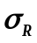ª
Assumed censored
Process-only, | 129.7 | 21.0 | 253.0 | 0.999 | 0.054 | 256.1
Process-only, | 72.1 | 13.0 | 135.0 | 0.997 | 0.130 | 98.7
All-uncertainty, | 176.7 | 0.0 | 320.0 | 0.899 | 0.257 | 354.6
All-uncertainty, | 114.1 | 0.0 | 259.0 | 0.892 | 0.302 | 192.4
Assumed dead
Process-only, | 2.3 | 0.0 | 16.0 | 0.358 | 0.997 | −92.6
Process-only, | 2.0 | 0.0 | 14.0 | 0.340 | 0.999 | −93.7
All-uncertainty, | 57.4 | 0.0 | 307.0 | 0.540 | 0.696 | 58.3
All-uncertainty, | 34.4 | 0.0 | 211.0 | 0.523 | 0.730 | −4.3

Table 7. Continued.
 | Mean^{b} | LCL^{c} | UCL^{d} | P(N₁₀₀ > 0)^{e} | P(N₁₀₀ < N₀)^{f} | Mean percent change^{g}
UARB CC and ª
Assumed censored
Process-only, | 81.5 | 13.0 | 142.0 | 0.995 | 0.108 | 124.8
Process-only, | 40.5 | 4.0 | 82.0 | 0.989 | 0.437 | 12.2
All-uncertainty, | 90.8 | 0.0 | 154.0 | 0.899 | 0.272 | 135.1
All-uncertainty, | 55.3 | 0.0 | 125.0 | 0.873 | 0.390 | 42.2
Assumed dead
Process-only, | 2.3 | 0.0 | 16.0 | 0.354 | 0.997 | −92.7
Process-only, | 1.6 | 0.0 | 13.0 | 0.295 | 0.999 | −94.8
All-uncertainty, | 33.0 | 0.0 | 147.0 | 0.531 | 0.702 | −7.0
All-uncertainty, | 18.2 | 0.0 | 101.0 | 0.498 | 0.792 | −49.4
ª Carrying capacity (CC) and process variance for reproduction () based on Tensas River Basin (TRB) or Upper Atchafalaya River Basin (UARB) of Louisiana, USA.
^{b}Mean female abundance after 100 years
^{c}2.5% percentile of distribution of abundances after 100 years
^{d}97.5% percentile of distribution of abundances after 100 years
^{e}Probability of persistence after 100 years
^{f}Probability of female abundance after 100 years less than starting female abundance
^{g}Percent change in abundance over 100 years 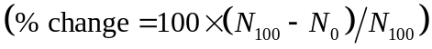 averaged over 10,000 simulations
Table 8. Summary of 10,000 simulated population trajectories over a 100-year period for female Louisiana black bears in the Three Rivers Complex, Louisiana, USA. Simulations were based on adult survival rates estimated from radio-telemetry data and reproductive rates estimated from den visit data, incorporated only process variation (i.e., Process-only) or process variation and parameter uncertainty (i.e., All-uncertainty), and included different strengths of density dependence (i.e., ) using the Michaelis-Menten function for enzyme kinetics. Simulations were conducted separately for estimates of adult survival rates that treated unresolved radio losses as censored (i.e., Assumed censored) and estimates that treated those losses as mortalities (i.e., Assumed dead). Carrying capacity (CC) based on density estimates derived from capture-mark-recapture analyses modeling capture heterogeneity with 2-point finite mixture distribution (i.e., Model 2).
 | Mean^{b} | LCL^{c} | UCL^{d} | P(N₁₀₀ > 0)^{e} | P(N₁₀₀ < N₀)^{f} | Mean percent change^{g}
TRB CC and ª
Assumed censored
Process-only, | 123.8 | 23.0 | 234.0 | 0.998 | 0.054 | 240.0
Process-only, | 67.5 | 13.0 | 126.0 | 0.996 | 0.150 | 86.3
All-uncertainty, | 161.3 | 0.0 | 292.0 | 0.904 | 0.262 | 316.0
All-uncertainty, | 104.4 | 0.0 | 236.0 | 0.892 | 0.309 | 167.7
Assumed dead
Process-only, | 2.4 | 0.0 | 17.0 | 0.375 | 0.997 | −92.2
Process-only, | 1.9 | 0.0 | 14.0 | 0.332 | 0.999 | −93.8
All-uncertainty, | 54.3 | 0.0 | 281.0 | 0.539 | 0.695 | 51.1
All-uncertainty, | 32.7 | 0.0 | 193.0 | 0.525 | 0.731 | −9.5

Table 8. Continued.
 | Mean^{b} | LCL^{c} | UCL^{d} | P(N₁₀₀ > 0)^{e} | P(N₁₀₀ < N₀)^{f} | Mean percent change^{g}
UARB CC and ª
Assumed censored
Process-only, | 76.8 | 13.0 | 133.0 | 0.996 | 0.121 | 112.3
Process-only, | 37.8 | 4.0 | 78.0 | 0.988 | 0.484 | 4.4
All-uncertainty, | 83.3 | 0.0 | 143.0 | 0.894 | 0.286 | 116.2
All-uncertainty, | 52.7 | 0.0 | 117.0 | 0.877 | 0.392 | 35.9
Assumed dead
Process-only, | 2.3 | 0.0 | 16.0 | 0.354 | 0.997 | −92.7
Process-only, | 1.6 | 0.0 | 12.0 | 0.298 | 1.000 | −94.8
All-uncertainty, | 30.5 | 0.0 | 137.0 | 0.531 | 0.713 | −14.2
All-uncertainty, | 17.5 | 0.0 | 96.0 | 0.500 | 0.794 | −51.0
ª Carrying capacity (CC) and process variance for reproduction () based on Tensas River Basin (TRB) or Upper Atchafalaya River Basin (UARB) of Louisiana, USA.
^{b}Mean female abundance after 100 years
^{c}2.5% percentile of distribution of abundances after 100 years
^{d}97.5% percentile of distribution of abundances after 100 years
^{e}Probability of persistence after 100 years
^{f}Probability of female abundance after 100 years less than starting female abundance
^{g}Percent change in abundance over 100 years averaged over 10,000 simulation

Table 9. Estimates of annual survival for adult female black bears from unhunted populations within the southeastern US.
Source | Location | Annual survival rate
Wear et al. 2005 | Felsenthal National Wildlife Refuge | 0.91¹
Bales et al. 2005 | Southeastern Oklahoma | 0.90
Dobey et al. 2005 | Osceola National Forest, Florida | 0.97
Clark and Smith 1994 | Interior Highlands, Arkansas | 0.98
Clark and Eastridge 2006 | White River National Wildlife Refuge, Arkansas | 0.98 (0.94)²
¹Survival rate of reintroduced adult females during second year post release.
²Survival rates treating lost signals as censored (first value) or mortalities (inside parentheses
Table 10. Summary of population parameter estimates for female Louisiana black bears in the Tensas River Basin, Three Rivers Complex, Upper Atchafalaya River Basin, and Lower Atchafalaya River Basin of Louisiana, USA.
Subpopulation | CMR Model | Nª | S_{AC}^{b} | S_{AD}^{b} | r_{C}^{c} | r_{Y}^{c} | ϕ^{d} | γ^{e} | λ^{f} | Prob^{g}
Demographic monitoring data^{h}
TRB |  |  | 0.99 | 0.97 | 0.47 | 0.15 |  |  | 1.02–1.04
TRC |  |  | 0.97 | 0.93 | 0.37 | 0.17 |  |  | 0.99–1.02 | 0.295–1.000
Capture–mark–recapture data^{i}
TRB | Model 1 | 140–163 |  |  |  |  | 0.87–0.93 | 0.00–0.22 | 0.98–1.09 | 0.975–1.000
 | Model 2 | 133–158 |  |  |  |  | 0.87–0.89 | 0.00–0.16 | 0.88–1.06 | 0.982–0.999
UARB | Model 1 | 25–44 |  |  |  |  | 0.88–0.90 | 0.00–0.41 | 0.93–1.29 | 0.971–1.000
 | Model 2 | 23–41 |  |  |  |  | 0.85–0.89 | 0.00–0.43 | 0.90–1.35 | 0.929–1.000
LARB | Model 1 | 78–97 |  |  |  |  | 0.81–0.85 | 0–0.24 | 0.81–1.08
 | Model 2 | 68–84 |  |  |  |  | 0.81–0.84 | 0–0.31 | 0.81–1.16
ªFemale abundance
^{b}Adult female survival assuming unresolved fates were alive and censored (AC) or mortalities (AD)
^{c}Recruitment for cubs (C) and yearlings (Y) per breeding female
^{d}Apparent female survival
^{e} Female recruitment per female (breeding or non-breeding)
^{f}Population growth rate
^{g}Probability of persistence after 100 years
^{h}Range values represent ranges of parameter estimates across different population projection models
^{i}Range values represent ranges of parameter estimates across years during the study period
Table 11. Observed allele frequencies for American black bears from Itasca County, Minnesota (MINN), the White River Basin of Arkansas (WRB), the Tensas River Basin of Louisiana (TRB), the Three Rivers Complex of Louisiana (TRC), the Upper Atchafalaya River Basin of Louisiana (UARB), the Lower Atchafalaya River Basin of Louisiana (LARB), and western and southern Mississippi (MISS).
Locus | MINN | WRB | TRB | TRC | UARB | LARB | MISS
CPH9
(n)¹ | 46 | 105 | 180 | 39 | 56 | 137 | 59
127 | 4.35
139 |  |  | 0.28 |  |  | 14.23
141 | 1.09 | 50.00 | 22.22 | 17.95 | 13.39 |  | 40.68
143 | 33.70 | 50.00 | 77.50 | 82.05 | 70.54 | 45.99 | 47.46
145 | 14.13 |  |  |  | 16.07 | 0.36
147 | 17.39 |  |  |  |  | 39.42 | 8.47
149 | 23.91 |  |  |  |  |  | 3.39
151 | 5.43
CXX110
(n) | 46 | 105 | 180 | 39 | 60 | 178 | 59
137 | 15.22
141 | 1.09 |  |  | 5.13 | 31.67 |  | 1.69
143 | 1.09
147 |  |  | 0.28 | 24.36 | 44.17
149 | 10.87 |  |  |  | 18.33
151 | 15.22 | 12.38 | 5.00 | 1.28 |  | 45.22 | 11.86
153 | 11.96 | 21.90 | 81.39 | 51.28 | 5.83 | 27.81 | 35.59
155 | 14.13 | 65.71 | 13.33 | 17.95 |  | 26.97 | 50.85
157 | 15.22
159 | 15.22
CXX20
(n) | 46 | 55 | 211 | 39 | 61 | 123 | 59
123 | 26.09 | 11.82 | 26.07 | 24.36 |  | 9.35 | 16.10
129 | 1.09
133 | 3.26
135 | 16.30 |  |  |  | 18.85
137 | 11.96 |  |  |  |  | 21.14
139 | 18.48 | 88.18 | 55.21 | 30.77 | 23.77 | 2.85 | 72.88
141 | 9.78 |  | 16.82 | 41.03 | 54.92 | 66.67 | 9.32
143 | 7.61 |  | 1.90 | 3.85 |  |  | 1.69
145 | 3.26 |  |  |  | 2.46
147 | 2.17
Table 11. Continued.
Locus | MINN | WRB | TRB | TRC | UARB | LARB | MISS
D123
(n) | 46 | 51 | 378 | 39 | 56 | 178 | 59
141 | 31.52 |  | 49.21 | 43.59 | 45.54 |  | 18.64
143 | 9.78 |  | 0.13 | 8.97 | 16.07 | 36.24
145 | 18.48
147 | 11.96
149 | 1.09 |  | 2.51 | 7.69 | 23.21
151 | 4.35
153 | 4.35 | 17.65 | 14.29 | 16.67 |  | 17.13 | 23.73
155 | 18.48 | 82.35 | 33.86 | 23.08 | 15.18 | 46.63 | 57.63
D1A
(n) | 46 | 51 | 180 | 5 | 56 | 123 | 59
157 | 14.13 |  | 0.28 |  | 9.82
159 | 1.09 |  |  |  | 0.89
163 | 21.74 |  | 0.28 |  | 9.82 | 32.11
165 | 21.74 | 35.29 | 17.78 | 10.00 |  | 44.72 | 43.22
167 | 8.70 |  |  | 30.00 | 41.07 |  | 2.54
169 | 5.43
175 | 16.30 |  | 48.06 | 30.00 |  |  | 8.47
177 | 2.17 | 64.71 | 33.33 | 20.00 |  | 23.17 | 45.76
179 | 8.70 |  | 0.28 |  | 14.29
183 |  |  |  | 10.00 | 24.11
G10B
(n) | 46 | 105 | 481 | 39 | 56 | 123 | 59
152 |  |  |  | 3.85 | 20.54
154 | 3.26
156 | 31.52 | 24.29 | 56.13 | 44.87 | 67.86 | 70.73 | 52.54
158 | 31.52 |  |  |  | 10.71 | 4.47
160 | 22.83 |  |  |  |  | 2.44
162 | 2.17 |  | 16.11 | 17.95 |  | 0.41 | 3.39
164 | 8.70 | 75.71 | 27.55 | 33.33 |  | 17.07 | 41.53
166 |  |  | 0.21 |  | 0.89 | 4.88 | 2.54
Table 11. Continued
Locus | MINN | WRB | TRB | TRC | UARB | LARB | MISS
G10C
(n) | 46 | 54 | 180 | 39 | 109 | 137 | 59
201 | 2.17
205 | 19.57 |  |  |  | 11.01
207 | 3.26
209 | 4.35 |  |  |  |  |  | 9.32
211 | 19.57 |  |  |  |  |  | 2.54
213 | 31.52 | 87.04 | 79.44 | 58.97 | 21.10 | 55.11 | 77.12
215 | 15.22 |  | 19.44 | 23.08 | 33.49 | 25.18 | 5.08
217 | 1.09 | 12.96 | 1.11 | 17.95 | 34.40 | 17.52 | 5.93
219 | 3.26 |  |  |  |  | 2.19
G10H
(n) | 46 | 105 | 198 | 39 | 56 | 123 | 59
221 |  | 0.48
233 | 5.43
235 | 2.17
237 | 6.52
239 | 18.48 | 28.10 | 58.08 | 47.44 | 47.32 | 17.07 | 41.53
241 | 34.78 | 71.43 | 41.41 | 33.33 | 7.14 | 75.20 | 57.63
243 | 1.09 |  | 0.51 | 19.23 | 45.54 | 6.10 | 0.85
245 | 4.35
247 | 1.09 |  |  |  |  | 1.63
249 | 1.09
251 | 2.17
253 | 15.22
254 | 1.09
257 | 1.09
259 | 1.09
261 | 1.09
263 | 1.09
271 | 2.17
Table 11. Continued
Locus | MINN | WRB | TRB | TRC | UARB | LARB | MISS
G10J
(n) | 46 | 55 | 180 | 39 | 63 | 178 | 59
185 | 1.09
187 | 45.65 | 100.00 | 91.39 | 62.82 | 19.05 | 40.17 | 89.83
189 | 2.17 |  | 0.28 |  |  | 44.66
191 | 9.78 |  | 0.28 | 12.82 | 37.30 | 1.69 | 0.85
199 | 8.70
201 | 2.17 |  |  | 14.10 | 43.65 |  | 1.69
203 | 11.96 |  | 8.06 | 10.26 |  | 2.25 | 7.63
205 | 14.13
207 | 1.09 |  |  |  |  | 11.24
211 | 3.26
G10L
(n) | 46 | 105 | 180 | 39 | 109 | 123 | 59
135 | 16.30 | 60.95 | 76.94 | 58.97 | 1.38 | 62.60 | 72.88
137 | 40.22 |  | 0.56 |  | 38.07 |  | 0.85
139 | 4.35
141 | 3.26
143 | 1.09
149 | 11.96
151 | 1.09 |  |  |  |  | 11.79 | 11.86
153 | 8.70 |  | 15.28 | 12.82 |  |  | 0.85
155 | 7.61 |  |  | 10.26 | 22.48 | 8.94
157 |  | 39.05 | 6.94 | 2.56 |  | 16.67 | 11.86
159 | 5.43 |  | 0.28 | 15.38 | 38.07 |  | 1.69
G10M
(n) | 46 | 55 | 481 | 39 | 109 | 123 | 59
206 | 18.48 |  |  |  | 5.05 |  | 4.24
208 | 11.96 |  |  | 15.38 | 29.36 |  | 0.85
210 | 7.61 |  | 14.14 | 6.41 |  | 15.45 | 12.71
212 | 9.78 | 63.64 | 44.59 | 52.56 | 35.32 | 7.72 | 50.00
214 | 20.65 | 35.45 | 41.16 | 25.64 | 22.02 | 2.44 | 29.66
216 | 19.57 | 0.91 | 0.10 |  | 8.26 | 74.39 | 2.54
218 | 11.96
Table 11. Continued.
Locus | MINN | WRB | TRB | TRC | UARB | LARB | MISS
G10P
(n) | 46 | 67 | 481 | 39 | 109 | 178 | 59
147 | 1.09 |  | 22.14 | 19.23 | 48.62 | 19.94 | 24.58
149 |  |  |  |  |  | 1.97
151 | 1.09 | 92.54 | 47.19 | 32.05 | 20.18 | 12.36 | 67.80
153 | 13.04 |  |  |  | 8.26
155 | 19.57 |  | 13.20 | 8.97 |  |  | 1.69
157 | 26.09 | 7.46 | 3.01 |  |  | 32.30 | 1.69
159 | 7.61 |  | 0.10 | 16.67 | 22.94 | 33.43
161 | 15.22
163 | 13.04 |  | 14.35 | 23.08 |  |  | 4.24
165 | 1.09
167 | 2.17
G10U
(n) | 46 | 53 | 199 | 39 | 61 | 178 | 59
167 | 4.35
173 | 16.30 |  | 14.82 | 21.79 | 18.85 | 28.93 | 5.08
175 | 20.65 |  | 0.25 | 2.56 | 27.05 | 23.03 | 4.24
177 | 32.61 | 99.06 | 84.92 | 70.51 | 22.95 | 45.51 | 88.98
179 | 19.57 | 0.94 |  | 5.13 | 31.15 | 2.53 | 1.69
181 | 5.43
183 | 1.09
G10X
(n) | 46 | 55 | 292 | 39 | 56 | 123 | 59
129 | 6.52
133 | 1.09
135 | 3.26
141 | 28.26 | 23.64 | 32.71 | 30.77 | 32.14 | 76.83 | 25.42
143 | 1.09 |  |  | 7.69 | 46.43 |  | 10.17
145 | 4.35
147 | 5.43 | 76.36 | 58.90 | 38.46 |  |  | 61.02
149 | 10.87
151 | 9.78 |  | 0.17 | 14.10 | 9.82 | 15.04
153 | 11.96 |  | 8.05 | 8.97 |  | 1.22 | 1.69
155 | 4.35 |  | 0.17 |  |  | 6.91
157 | 4.35 |  |  |  | 11.61 |  | 1.69
159 | 8.70
Table 11. Continued.
Locus | MINN | WRB | TRB | TRC | UARB | LARB | MISS
G1A
(n) | 46 | 105 | 179 | 39 | 63 | 123 | 59
184 | 6.52 |  |  | 11.54 | 6.35
188 |  |  |  | 6.41 | 11.11
190 |  |  | 10.89 | 2.56
194 | 43.48 | 64.29 | 77.65 | 78.21 | 62.70 |  | 64.41
196 | 15.22 | 35.71 | 11.45 | 1.28 |  | 13.41 | 34.75
198 | 26.09 |  |  |  |  | 82.11
200 | 8.70 |  |  |  | 2.38 | 4.47
204 |  |  |  |  | 17.46 |  | 0.85
G1D
(n) | 46 | 55 | 481 | 39 | 63 | 123 | 59
172 | 15.22 |  | 0.10 | 11.54 | 28.57
174 | 9.78
176 | 16.30 | 73.64 | 54.78 | 57.69 | 48.41 | 70.73 | 68.64
178 | 6.52
180 | 17.39 |  |  |  | 8.73 | 0.41
182 | 5.43 |  |  | 6.41 | 13.49
184 | 11.96 | 26.36 | 2.08 |  |  |  | 11.86
186 | 17.39 |  | 23.70 | 14.10 | 0.79 | 28.86 | 16.95
190 |  |  | 19.33 | 10.26 |  |  | 2.54
MSUT2
(n) | 46 | 105 | 481 | 39 | 56 | 123 | 59
181 | 5.43
191 | 2.17
195 | 15.22 | 25.24 | 45.11 | 42.31 | 15.18 | 71.95 | 21.19
197 | 26.09 |  |  | 2.56 | 16.96 |  | 0.85
199 | 2.17 |  |  |  |  |  | 10.17
201 | 7.61 | 46.19 | 25.26 | 14.10 | 10.71 |  | 42.37
203 | 3.26 |  | 26.30 | 32.05 | 9.82 | 13.01 | 5.93
205 | 18.48 | 28.57 | 3.33 | 8.97 | 46.43 |  | 19.49
207 | 8.70 |  |  |  |  | 15.04
209 | 10.87 |  |  |  | 0.89
Table 11. Continued.
Locus | MINN | WRB | TRB | TRC | UARB | LARB | MISS
MU23
(n) | 46 | 105 | 481 | 39 | 109 | 178 | 59
187 | 16.30 | 35.71 | 46.26 | 21.79 | 19.72 | 39.33 | 45.76
189 | 3.26
191 | 2.17 | 64.29 | 33.58 | 33.33 |  | 32.87 | 45.76
193 | 2.17
195 | 2.17 |  | 0.10 | 17.95 | 11.93
197 | 3.26
199 | 10.87
201 | 11.96 |  | 6.13 |  |  | 4.78 | 0.85
203 | 25.00 |  |  | 5.13 | 20.64 |  | 2.54
205 | 6.52 |  | 12.58 | 17.95 | 11.93 | 1.12 | 4.24
207 | 14.13 |  | 1.35 | 3.85 | 35.78 |  | 0.85
209 | 2.17 |  |  |  |  | 21.91
MU26
(n) | 46 | 105 | 481 | 39 | 109 | 137 | 59
183 | 32.61 | 21.90 | 11.54 | 19.23 | 41.74 | 63.87 | 11.02
184 | 2.17 | 78.10 | 24.22 | 11.54 |  | 18.98 | 56.78
185 | 35.87 |  | 22.97 | 21.79 | 19.72 | 15.33 | 8.47
186 | 3.26 |  |  |  | 29.36
191 | 14.13 |  | 12.79 | 17.95 |  | 1.46 | 10.17
195 | 10.87 |  | 1.04 |  | 9.17 |  | 7.63
197 |  |  |  |  |  |  | 4.24
199 | 1.09 |  | 27.44 | 29.49 |  |  | 1.69
203 |  |  |  |  |  | 0.36
Table 11. Continued.
Locus | MINN | WRB | TRB | TRC | UARB | LARB | MISS
MU50
(n) | 46 | 105 | 481 | 39 | 56 | 178 | 59
114 | 3.26
120 | 16.30
122 | 6.52 |  | 0.10 | 23.08 | 68.75 |  | 4.24
124 | 6.52 | 17.62 | 41.16 | 37.18 |  |  | 22.88
126 | 2.17 |  | 7.17 | 1.28 |  | 23.31 | 10.17
128 | 4.35
130 | 4.35
132 | 14.13 | 53.33 | 0.31 |  |  |  | 21.19
134 | 18.48 |  |  | 6.41 | 29.46 |  | 0.85
136 | 10.87 |  | 0.10 |  | 1.79 | 12.64
138 | 3.26
140 | 6.52 |  | 0.52 |  |  | 4.78 | 5.93
142 | 3.26 |  | 41.68 | 30.77 |  |  | 9.32
144 |  |  | 0.10 |  |  | 59.27 | 3.39
148 |  | 29.05 | 8.84 | 1.28 |  |  | 22.03
MU59
(n) | 46 | 53 | 203 | 39 | 109 | 178 | 59
229 | 3.26
231 | 6.52
233 | 9.78
235 | 5.43 |  |  |  | 24.77 | 27.81 | 6.78
237 | 17.39 |  | 0.25 |  |  | 31.46
239 | 15.22 | 100.00 | 89.90 | 76.92 | 13.30 | 37.08 | 82.20
241 | 14.13 |  | 9.61 | 7.69 |  | 3.65 | 3.39
243 | 11.96 |  |  |  | 10.55 |  | 6.78
245 | 10.87 |  | 0.25 | 15.38 | 51.38 |  | 0.85
247 | 5.43
Table 11. Continued.
Locus | MINN | WRB | TRB | TRC | UARB | LARB | MISS
REN144A06
(n) | 46 | 105 | 281 | 39 | 56 | 136 | 59
117 | 11.96 |  |  |  |  | 1.47
119 | 32.61 |  | 0.18 | 5.13 | 15.18 | 22.79
121 | 11.96 |  |  |  | 2.68
123 |  |  | 5.69 | 1.28 |  | 12.13 | 14.41
125 | 5.43 |  | 0.18
127 | 2.17
129 | 20.65 | 38.57 | 17.08 | 24.36 | 82.14 | 24.63 | 22.03
131 | 4.35 | 61.43 | 59.61 | 53.85 |  |  | 60.17
133 | 10.87 |  | 17.26 | 15.38 |  | 38.24 | 3.39
137 |  |  |  |  |  | 0.74
REN145P07
(n) | 46 | 105 | 180 | 39 | 56 | 137 | 59
157 | 39.13 |  | 0.28 | 2.56 | 38.39 | 23.72 | 1.69
159 | 16.30
161 | 3.26
163 | 3.26
167 | 21.74 |  | 0.28 | 25.64 | 54.46 | 51.82 | 2.54
169 | 1.09
170 | 4.35
172 | 4.35 |  |  |  | 7.14
174 | 3.26 | 44.76 | 60.56 | 51.28 |  | 24.45 | 48.31
176 | 3.26 |  |  |  |  |  | 7.63
177 |  | 50.95 | 38.89 | 20.51 |  |  | 35.59
181 |  | 4.29 |  |  |  |  | 4.24
¹ Sample size

Appendix B: Figures

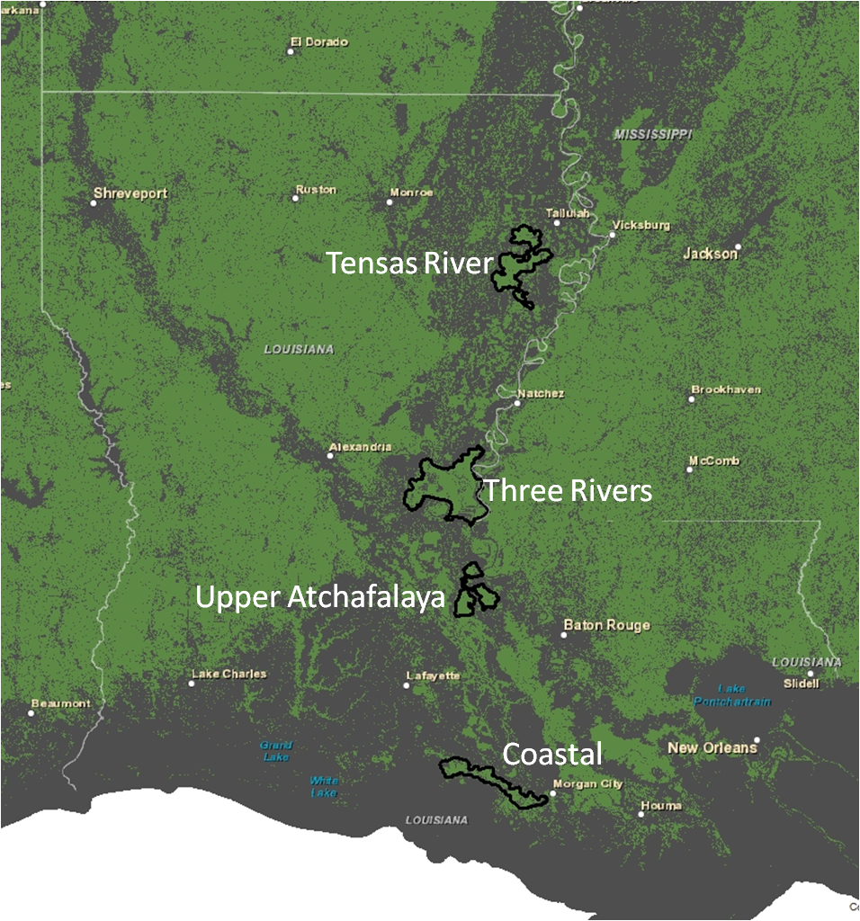
Figure 1. Map of the study area showing each of the 4 subpopulations of Louisiana black bear (black polygons) within the Lower Mississippi Alluvial Valley in Louisiana, USA. Natural land cover is in green and non-natural is in gray.
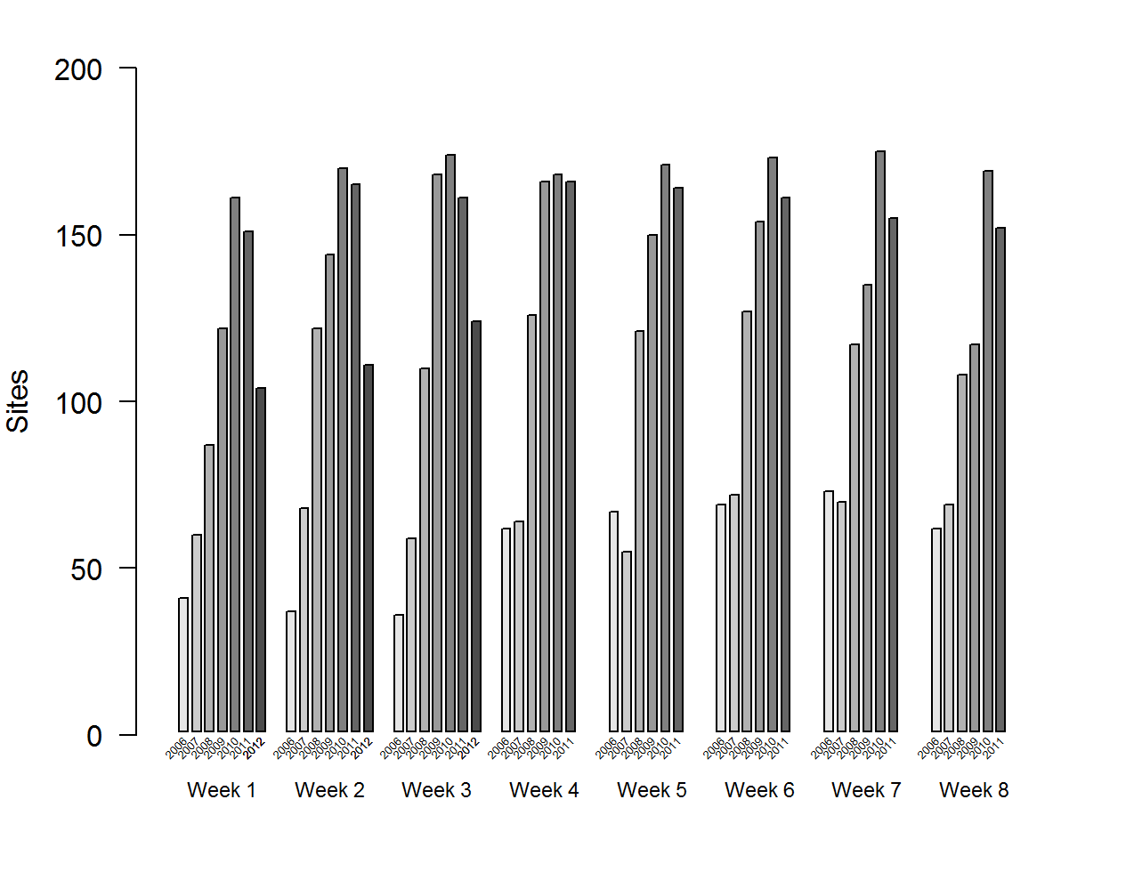
Figure 2. Number of sites producing ≥1 collected sample each week in the Tensas River Basin of Louisiana, USA, 2006–2012.
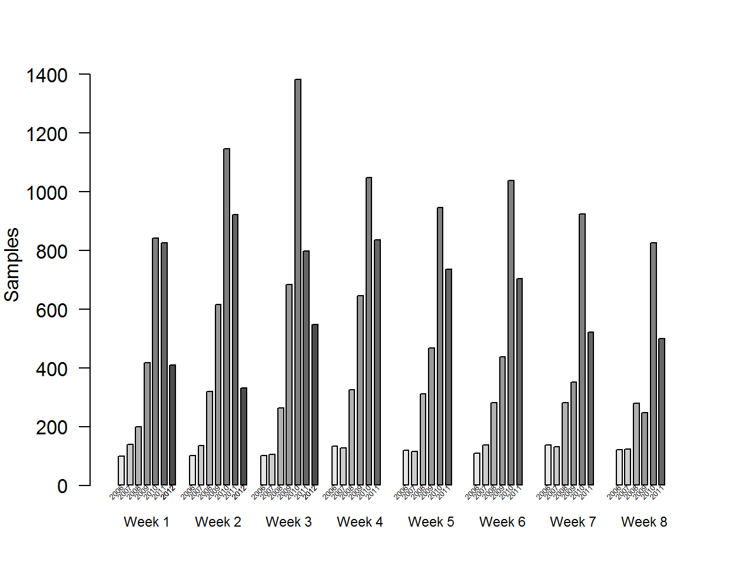
Figure 3. Number of samples collected each week in the Tensas River Basin of Louisiana, USA, 2006–2012.
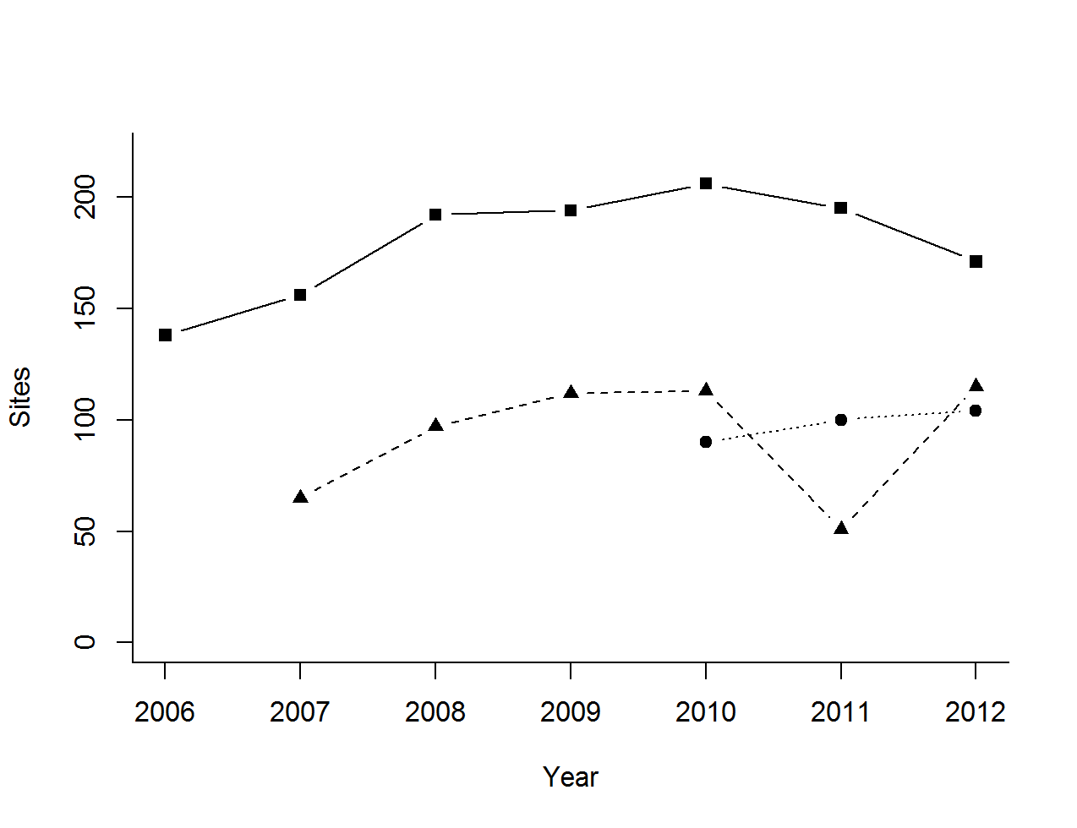
Figure 4. Number of individual hair-collection sites that produced ≥1 collected sample across all weeks within each year for the Tensas River Basin (solid line with squares), the Upper Atchafalaya River Basin (dashed line with triangles), and the Lower Atchafalaya River Basin (dotted line with circles) of Louisiana, USA, 2006–2012.
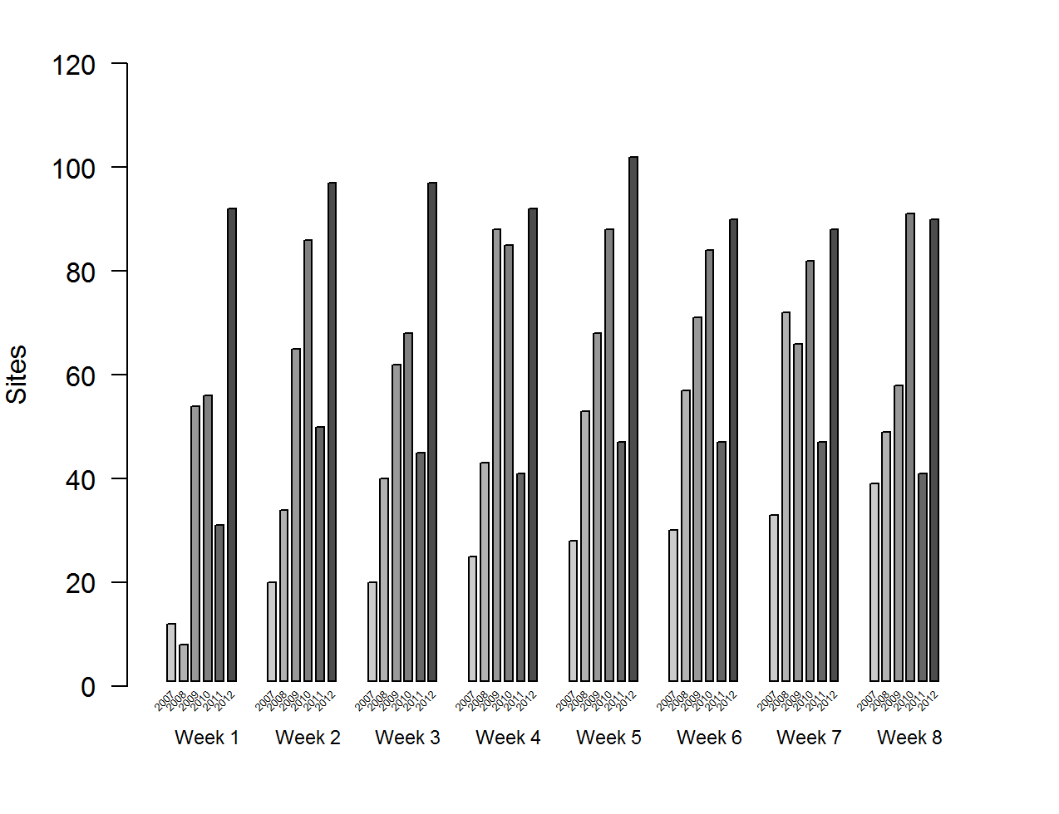
Figure 5. Number of sites producing ≥1 collected sample each week in the Upper Atchafalaya River Basin of Louisiana, USA, 2007–2012.
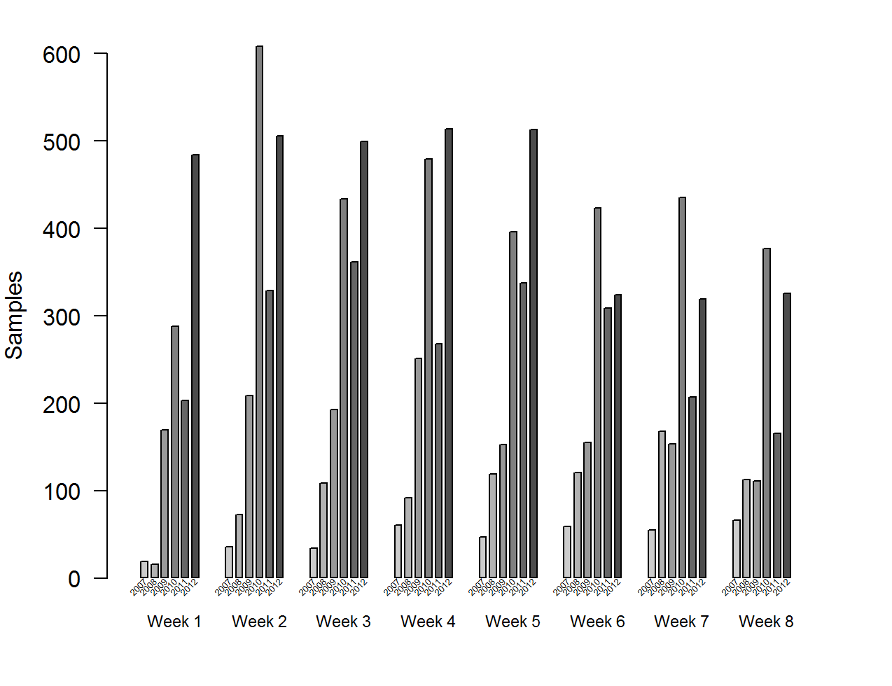
Figure 6. Number of samples collected each week in the Upper Atchafalaya River Basin of Louisiana, USA, 2007–2012.
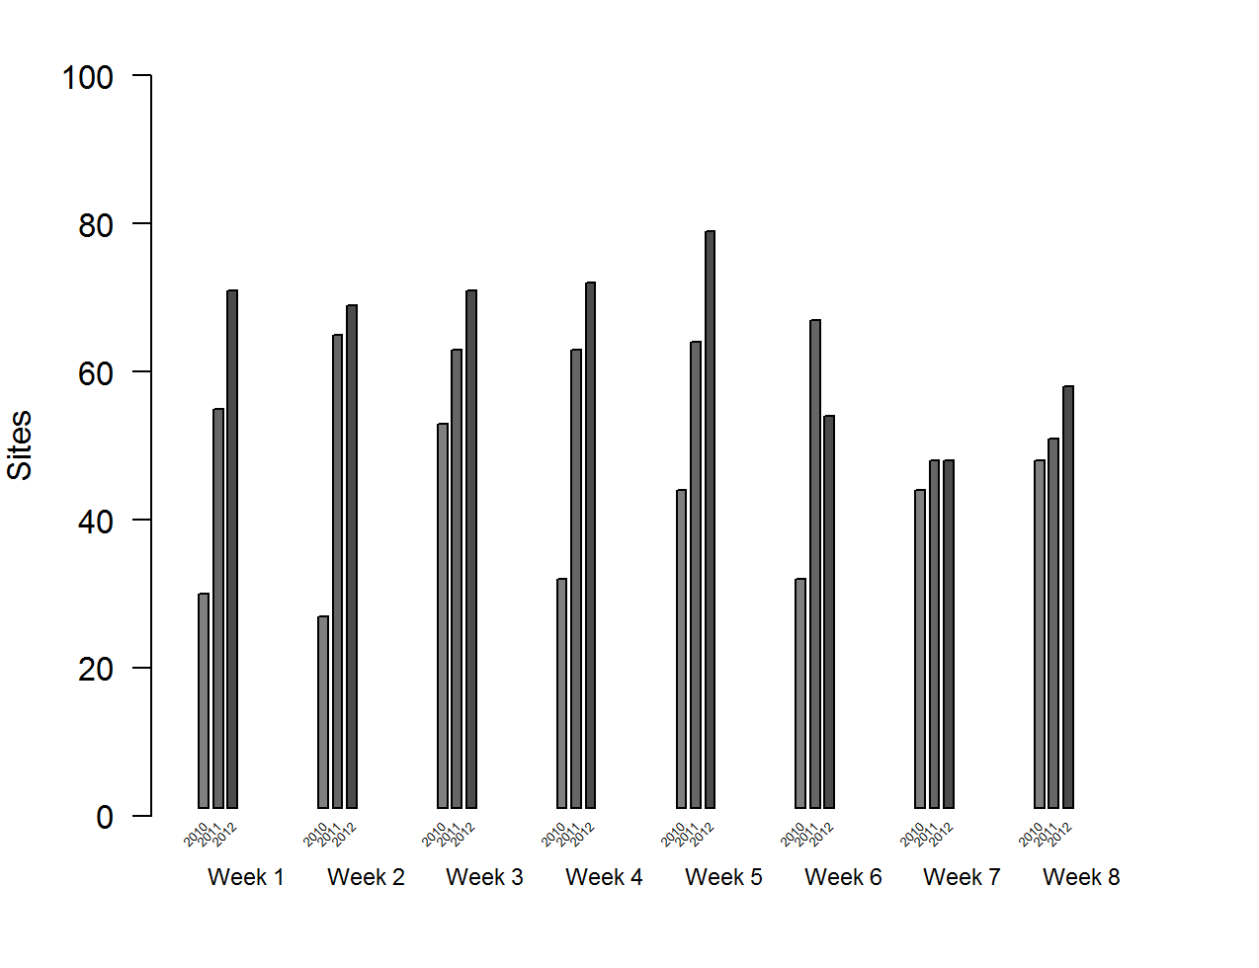
Figure 7. Number of sites producing ≥1 collected sample each week in the Lower Atchafalaya River Basin of Louisiana, USA, 2010–2012.
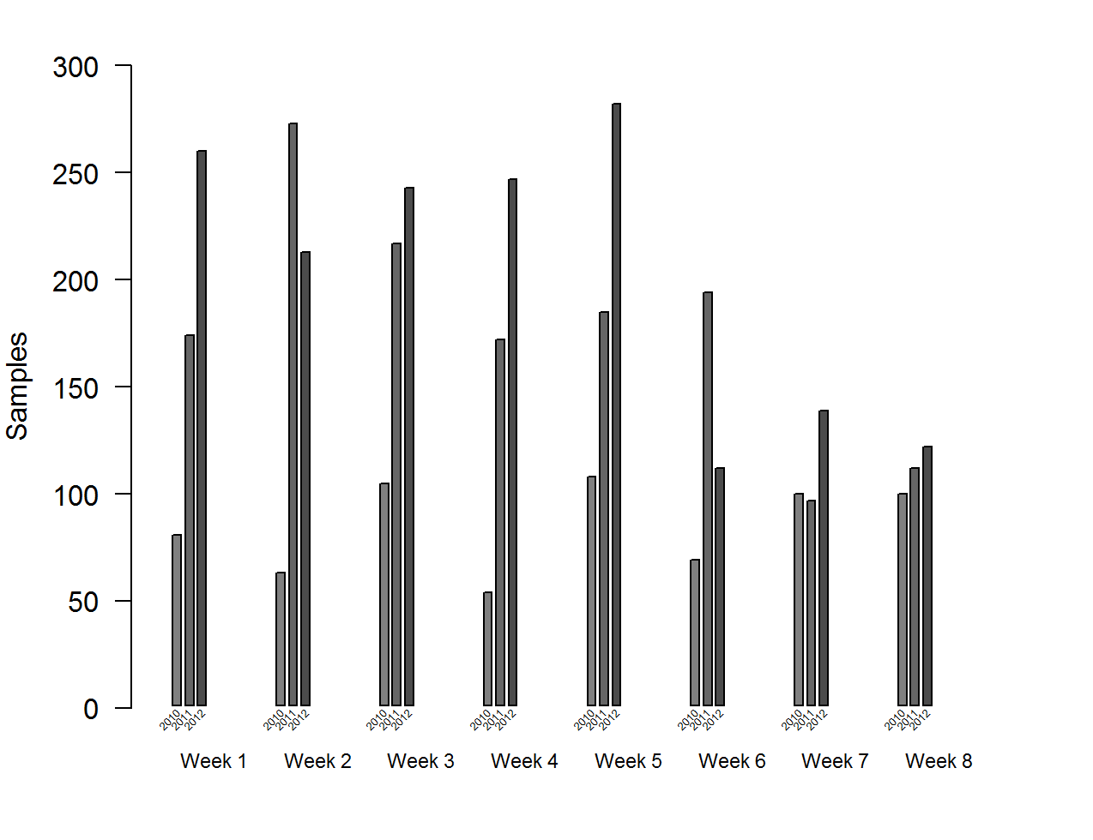
Figure 8. Number of samples collected each week in the Upper Atchafalaya River Basin of Louisiana, USA, 2007–2012.
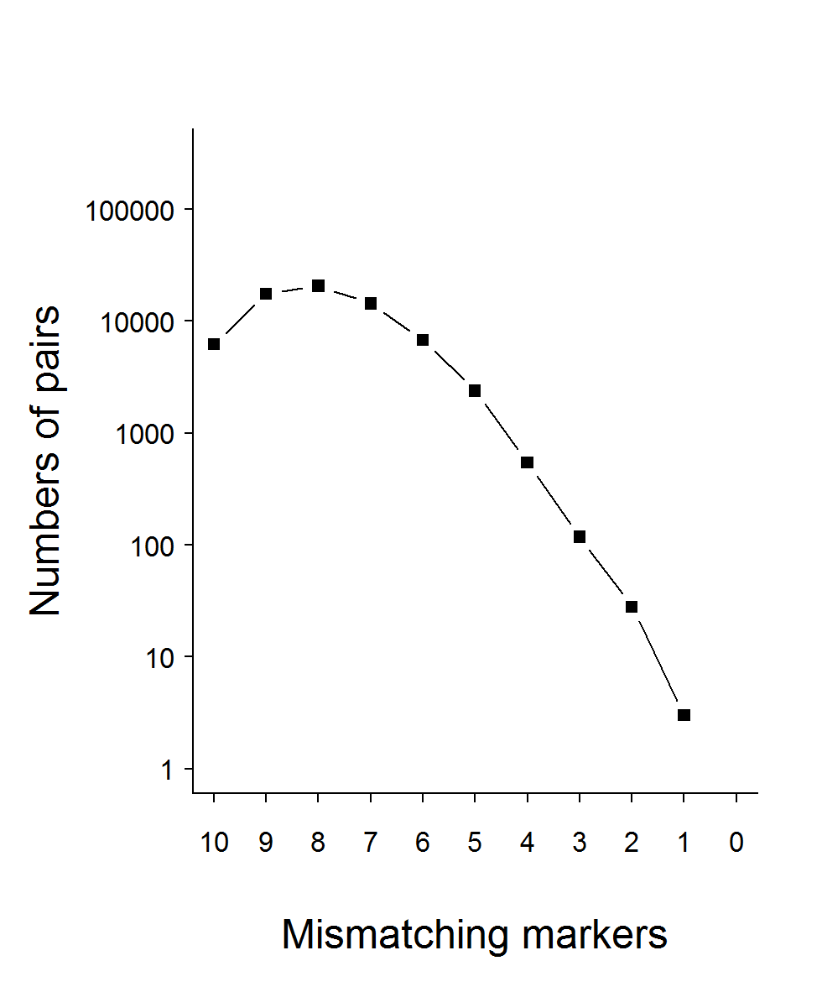
Figure 9. Distribution of mismatched pairs of multilocus genotypes from the Tensas River Basin of Louisiana, USA, 2006–2012.
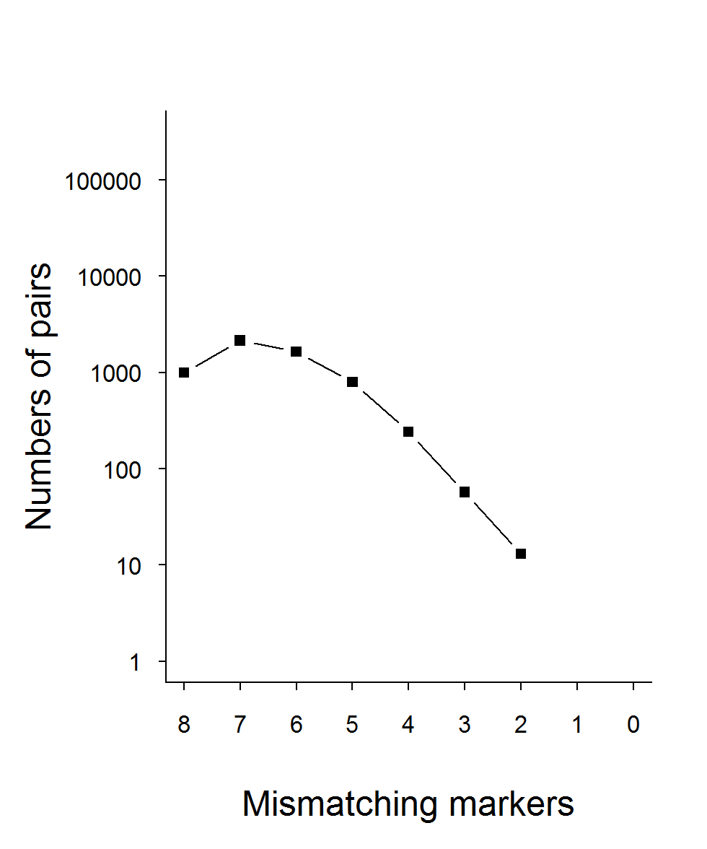
Figure 10. Distribution of mismatched pairs of multilocus genotypes from the Upper Atchafalaya River Basin of Louisiana, USA, 2007–2012.
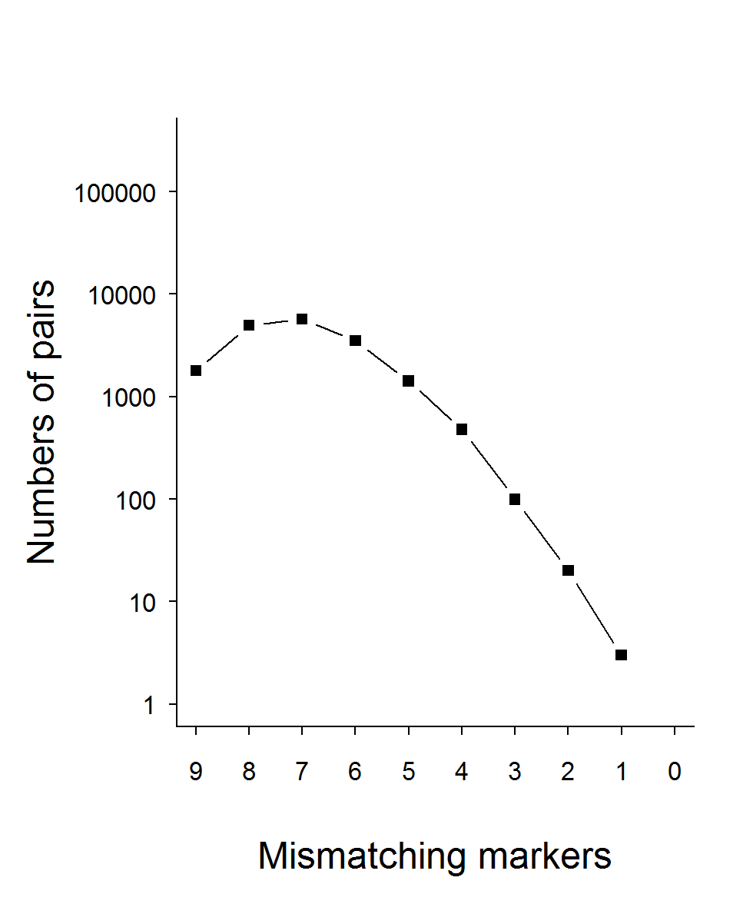
Figure 11. Distribution of mismatched pairs of multilocus genotypes from the Lower Atchafalaya River Basin of Louisiana, USA, 2010–2012.
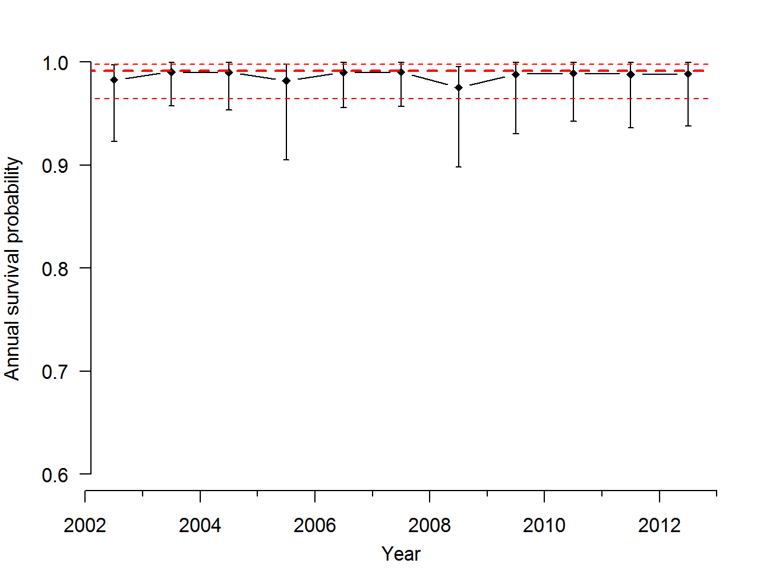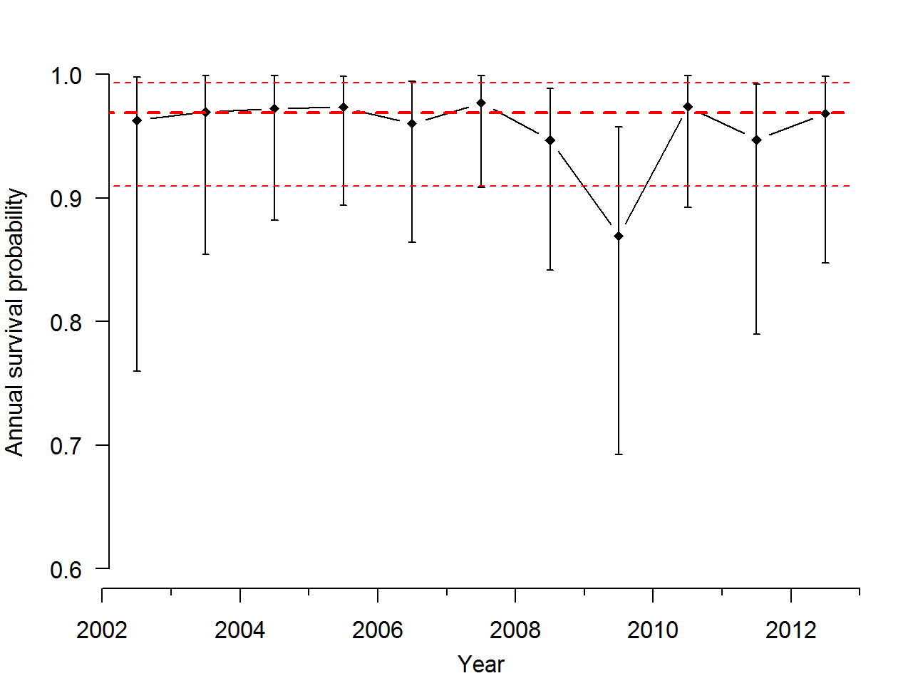
Figure 12. Annual estimates (diamonds) and 95% credible intervals (bars) of adult female survival for Louisiana black bears within the Tensas River Basin (top) and Three Rivers Complex (bottom) in Louisiana, USA. Estimates assume bears with unresolved fates were alive at time of last contact. Thick dashed lines are mean annual survival estimates and thin dashed lines are 95% credible intervals.
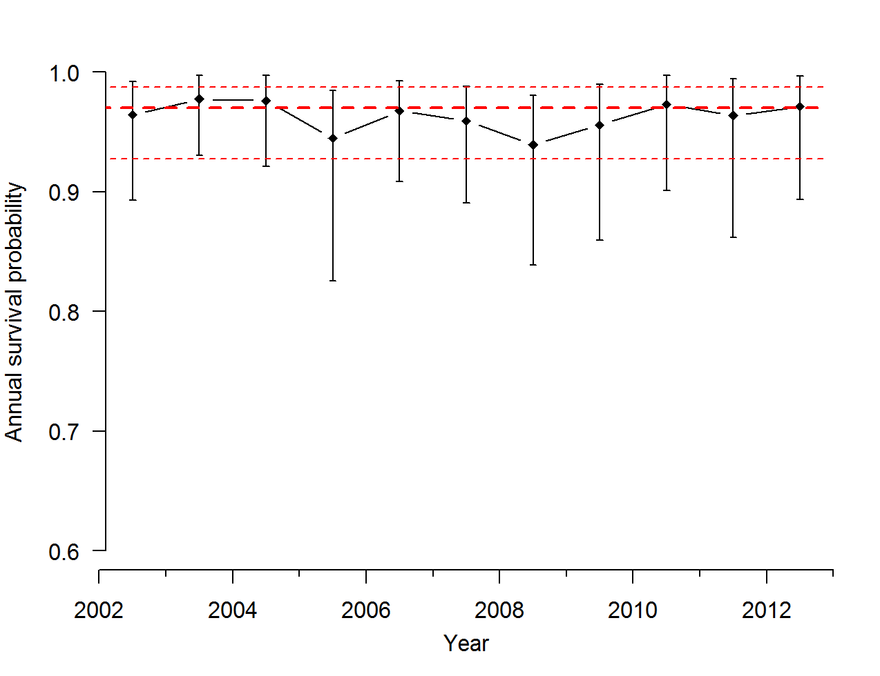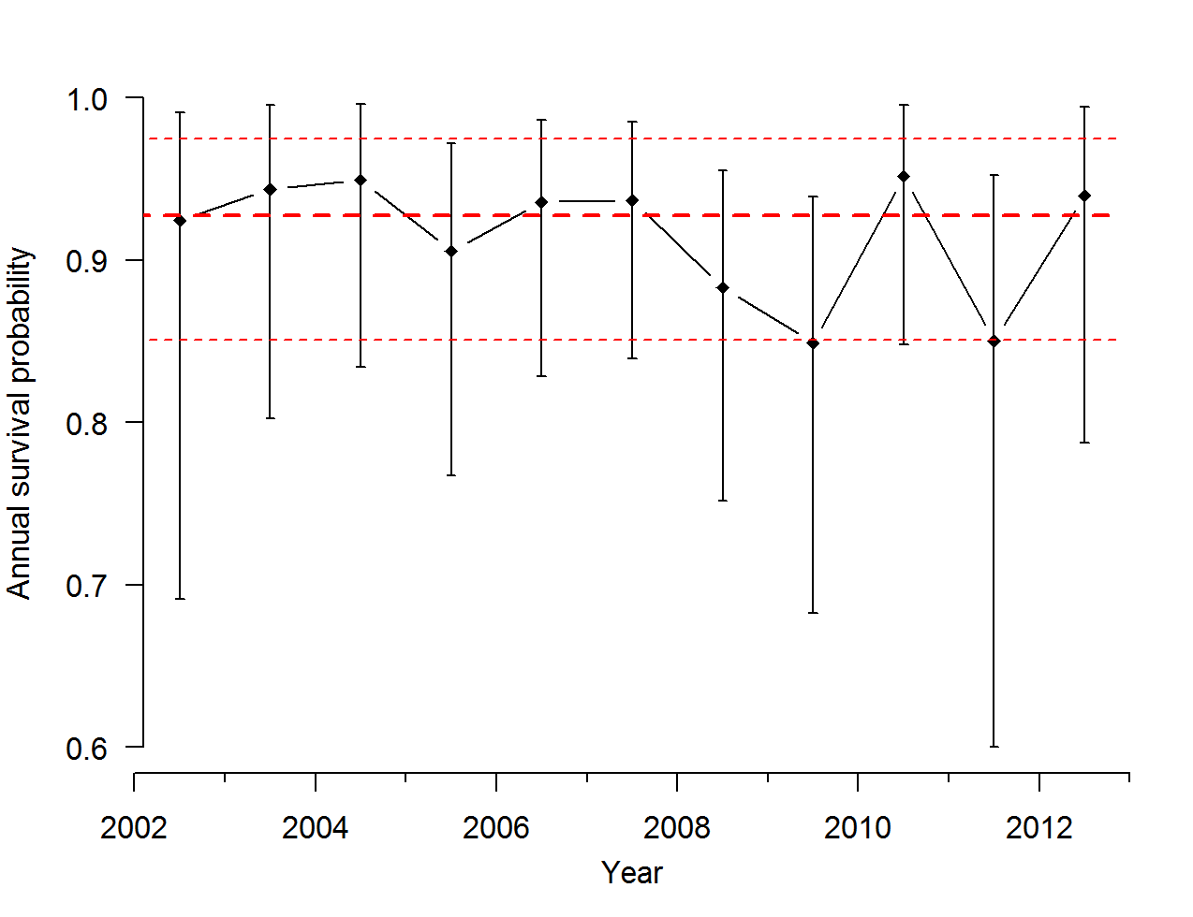
Figure 13. Annual estimates (diamonds) and 95% credible intervals (error bars) of adult female survival for Louisiana black bears within the Tensas River Basin (top) and Three Rivers Complex (bottom) in Louisiana, USA. Estimates assume bears with unresolved fates were dead at time of last contact. Thick dashed lines are mean annual survival estimates and thin dashed lines are 95% credible intervals.
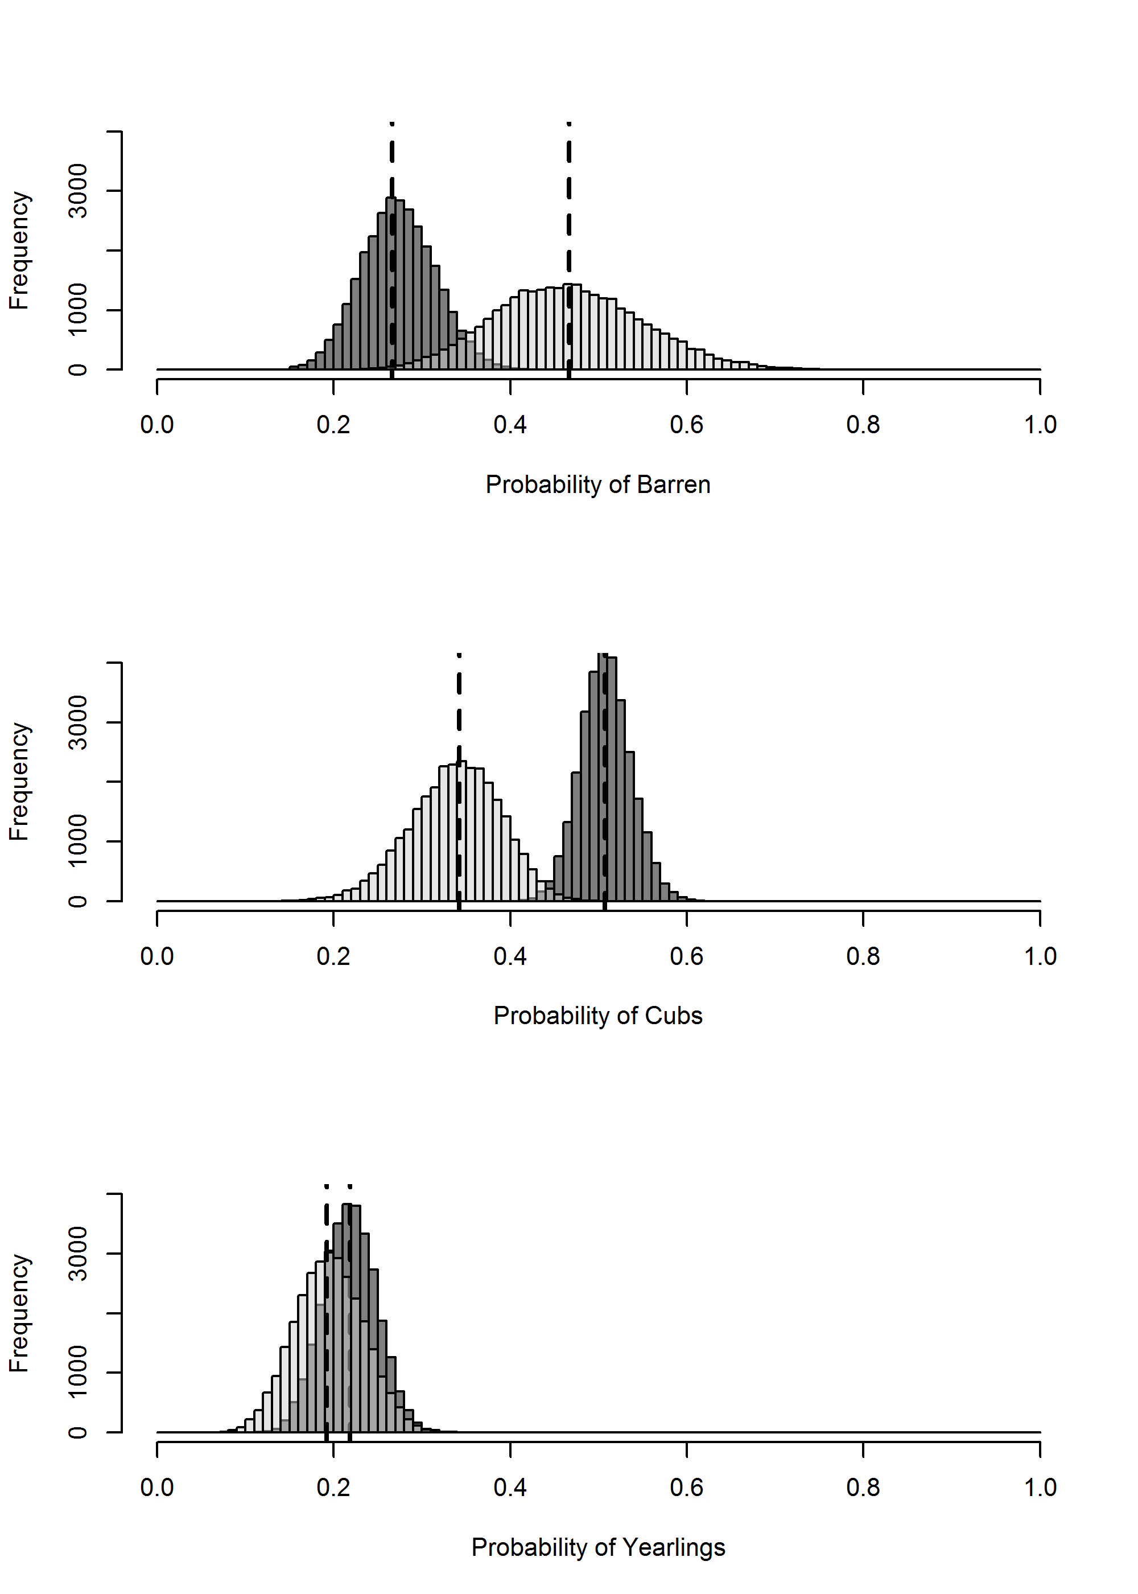
Figure 14. Posterior distributions for proportions of adult female Louisiana black bears with no litters (top), cubs (center), and yearlings (bottom) within the Tensas River Basin (light gray) and Three Rivers Complex (dark gray) in Louisiana, USA. Dashed lines are posterior distribution modes.
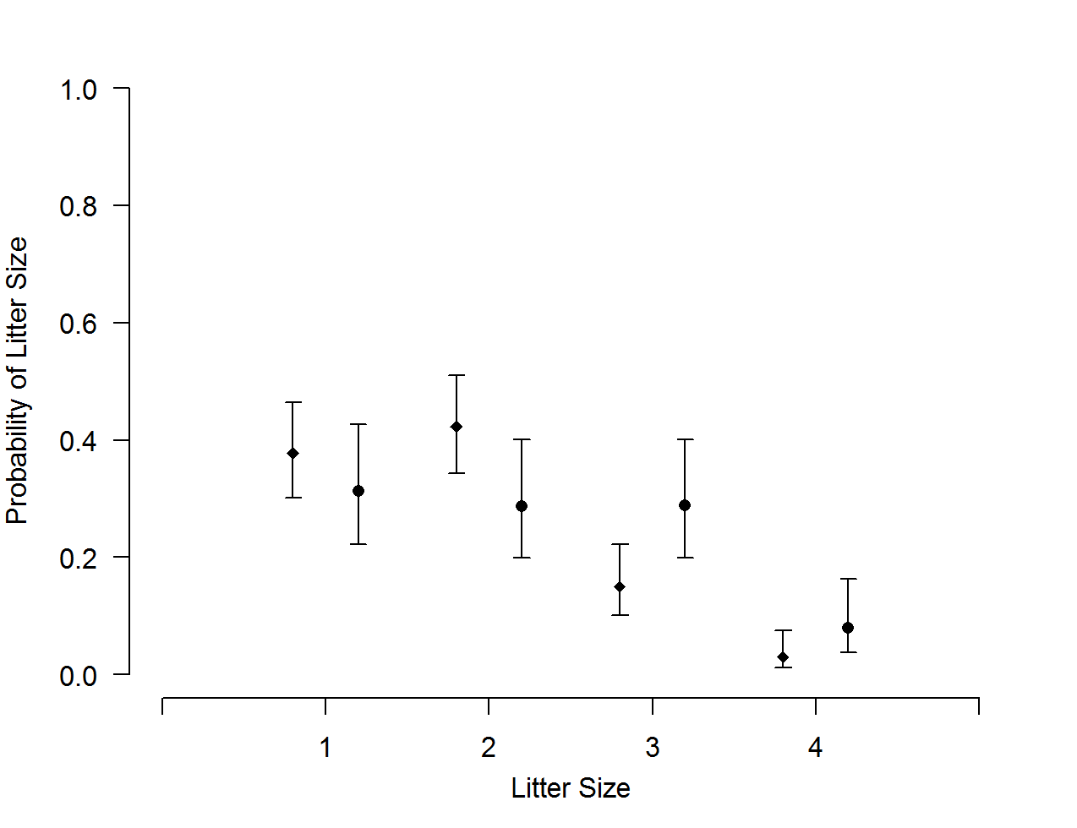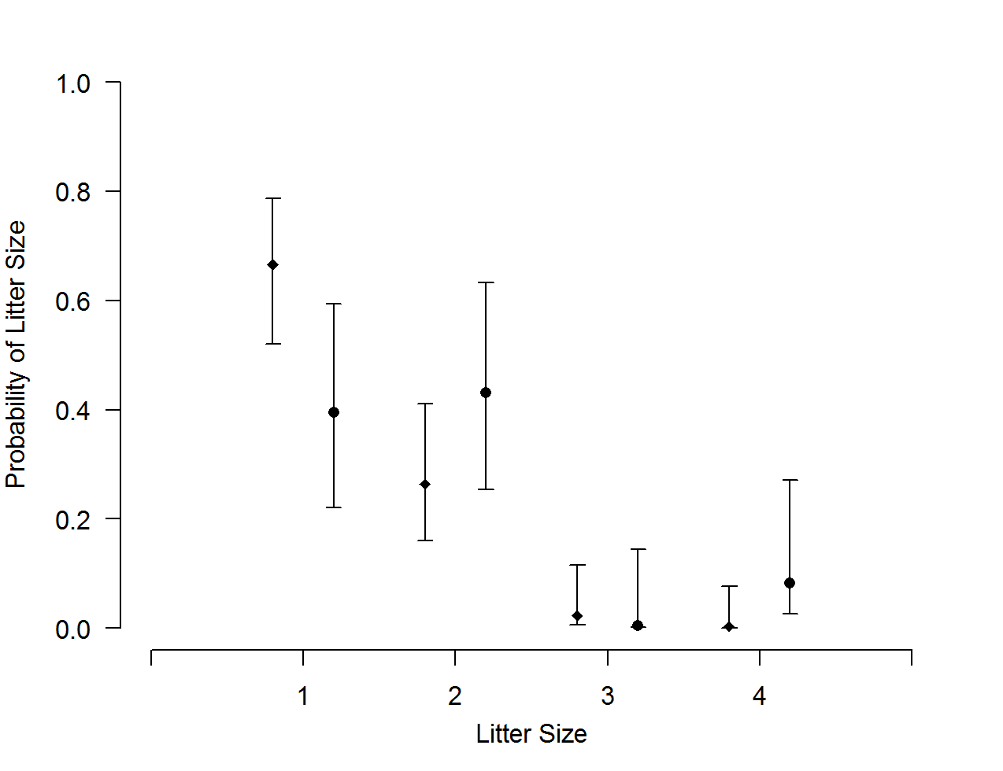
Figure 15. Estimated litter size probabilities (diamonds and circles) of cub (top) and yearling (bottom) litters and 95% credible intervals (error bars) for adult female Louisiana black bears within the Tensas River Basin (diamonds) and Three Rivers Complex (circles) in Louisiana, USA.
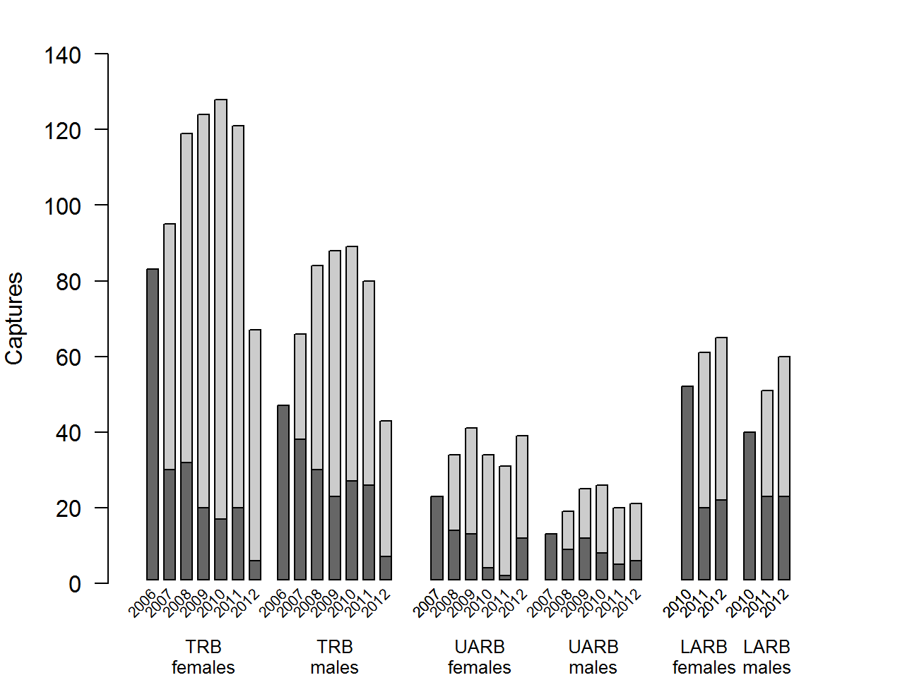
Figure 16. Annual number of DNA-based initial captures (dark gray) and recaptures (light gray) of Louisiana black bears from hair-snare sampling within the Tensas River Basin, Upper Atchafalaya River Basin, and Lower Atchafalaya River Basin in Louisiana, USA.
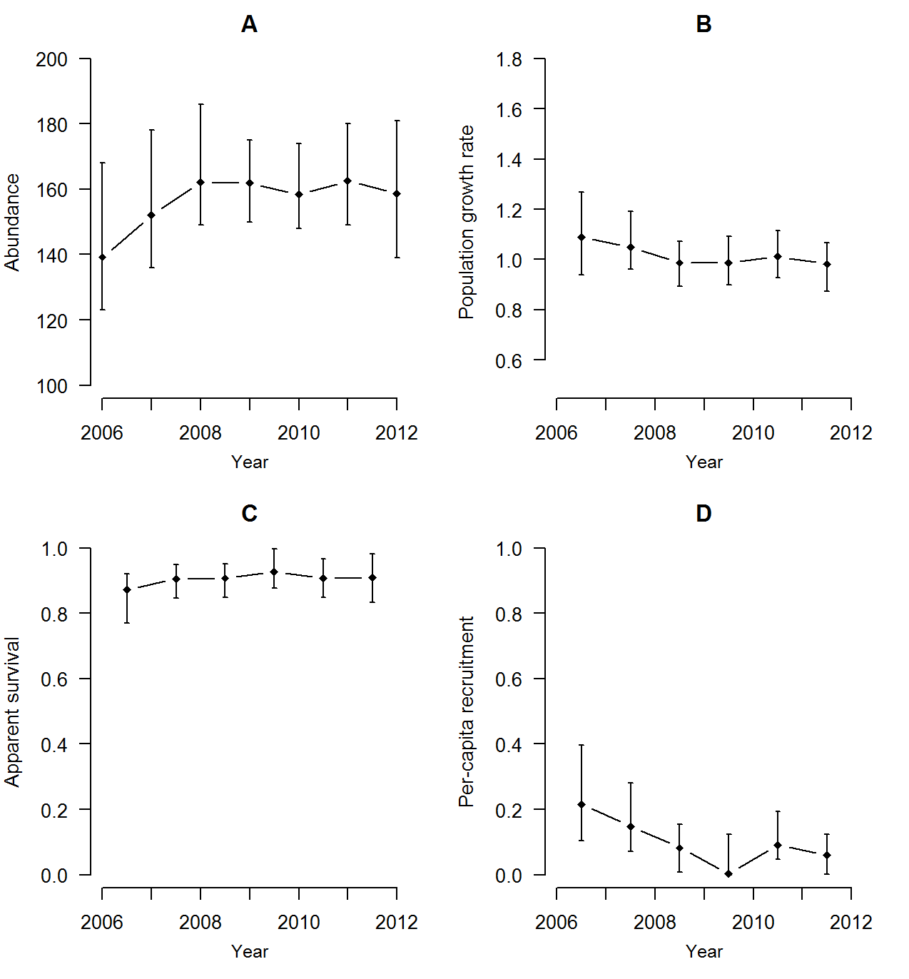
Figure 17. Population parameter estimates (diamonds) and 95% credible intervals (error bars) from Model 1 (individual capture heterogeneity modeled with logistic-normal distribution) for female Louisiana black bears within the Tensas River Basin in Louisiana, USA.
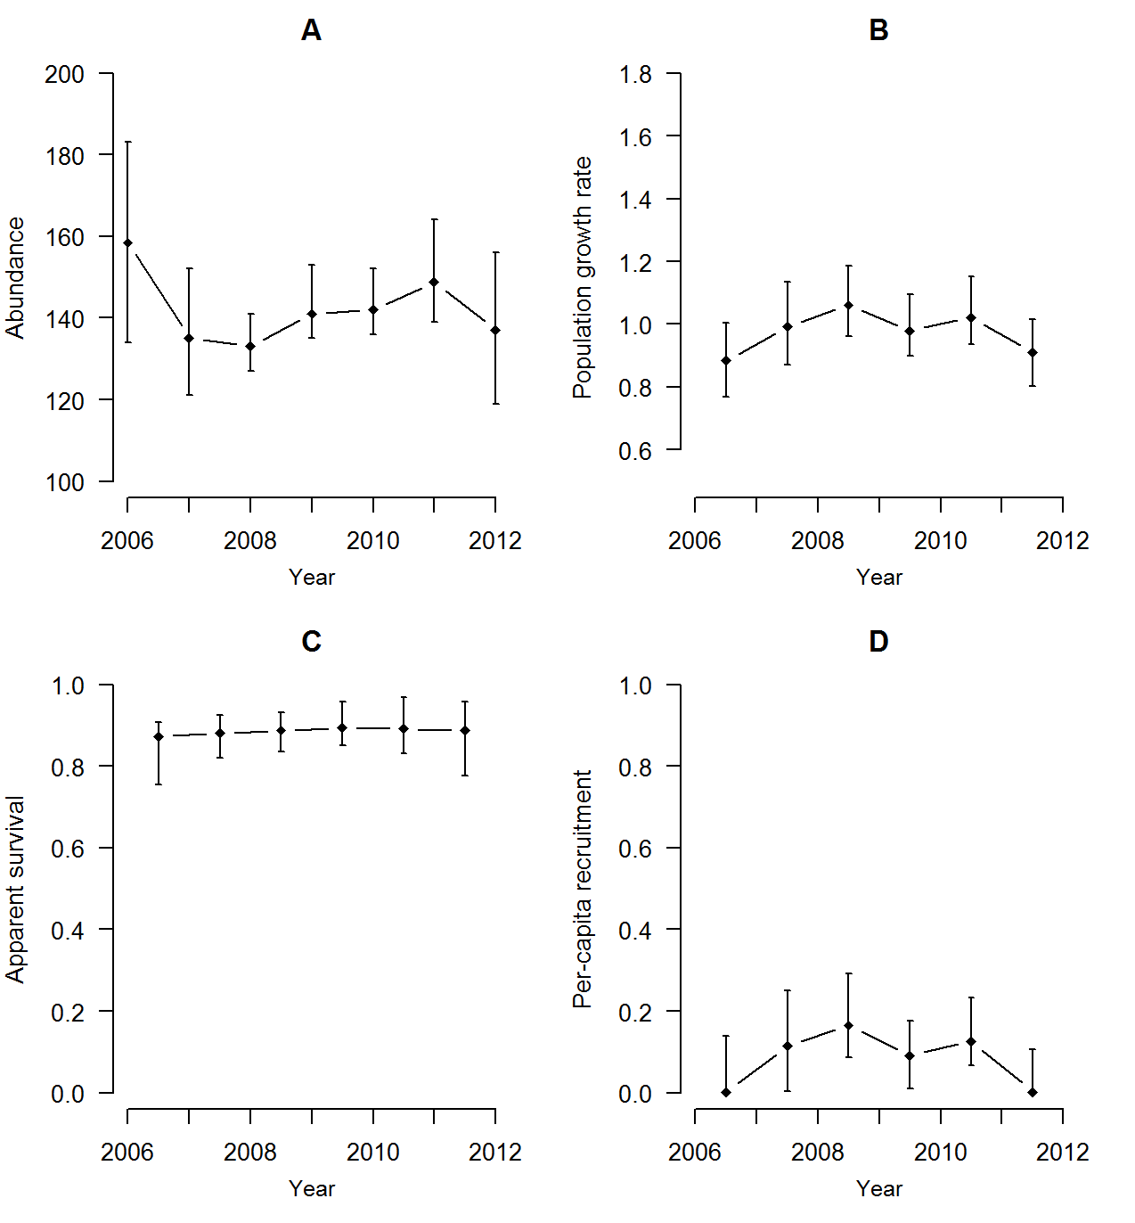
Figure 18. Population parameter estimates (diamonds) and 95% credible intervals (error bars) from Model 2 (individual capture heterogeneity modeled with 2-point finite mixture distribution) for female Louisiana black bears within the Tensas River Basin in Louisiana, USA.
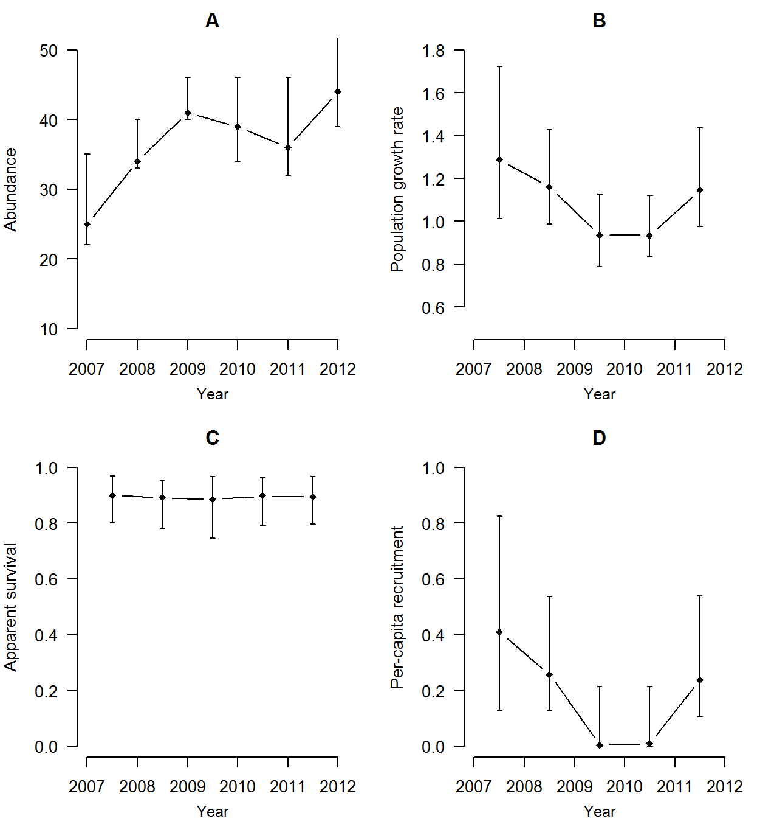
Figure 19. Population parameter estimates (diamonds) and 95% credible intervals (error bars) from Model 1 (individual capture heterogeneity modeled with logistic-normal distribution) for female Louisiana black bears within the Upper Atchafalaya River Basin in Louisiana, USA.
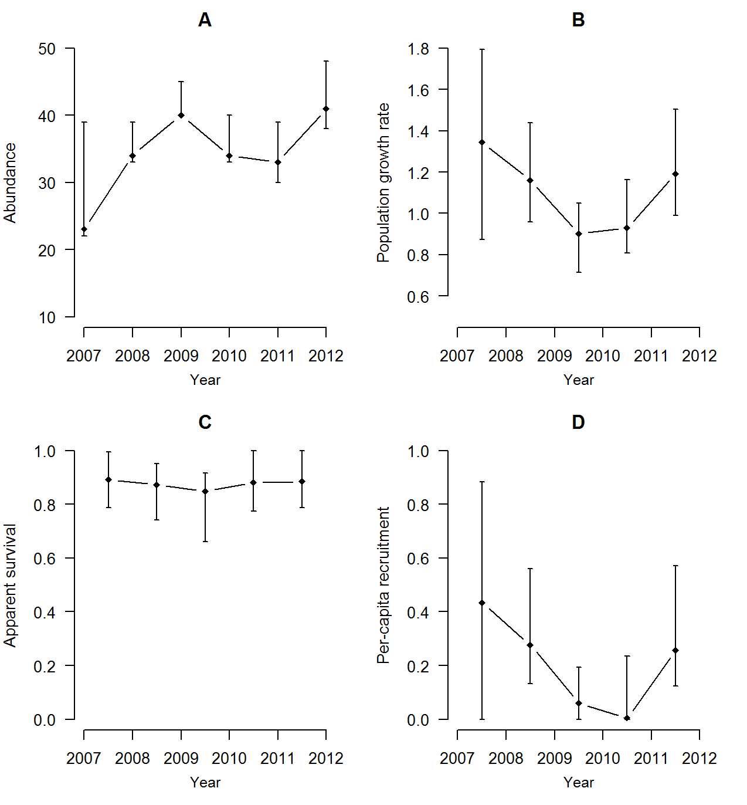
Figure 20. Population parameter estimates (diamonds) and 95% credible intervals (error bars) from Model 2 (individual capture heterogeneity modeled with 2-point finite mixture distribution) for female Louisiana black bears within the Upper Atchafalaya River Basin in Louisiana, USA.
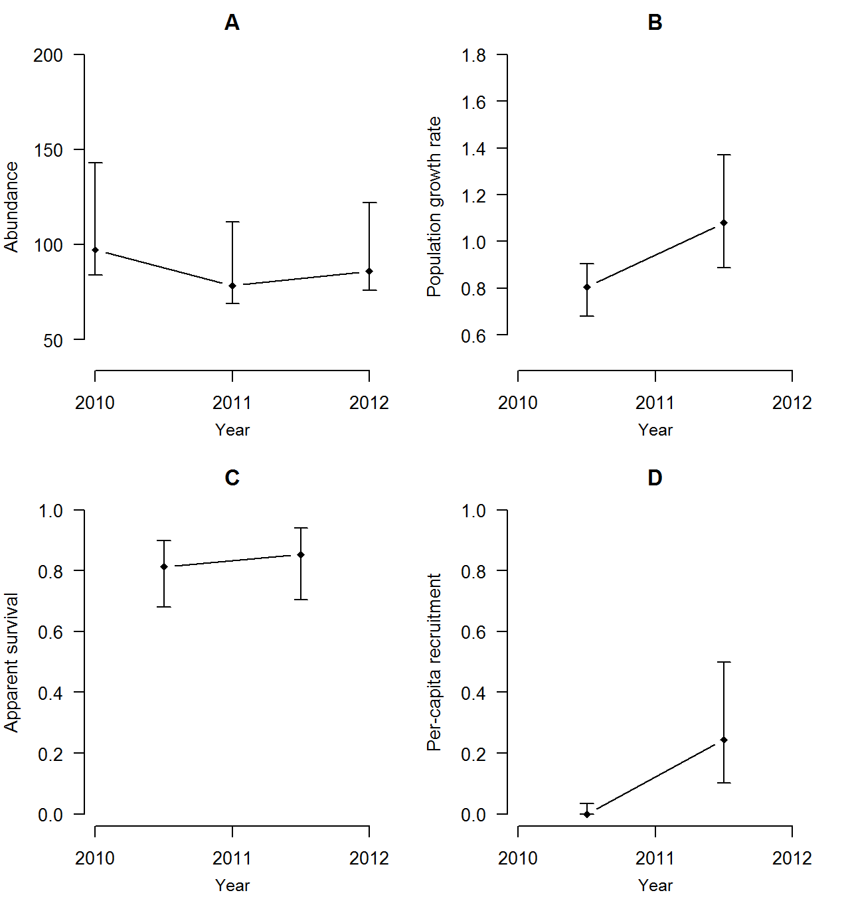
Figure 21. Population parameter estimates (diamonds) and 95% credible intervals (error bars) from Model 1 (individual capture heterogeneity modeled with logistic-normal distribution) for female Louisiana black bears within the Lower Atchafalaya River Basin in Louisiana, USA.
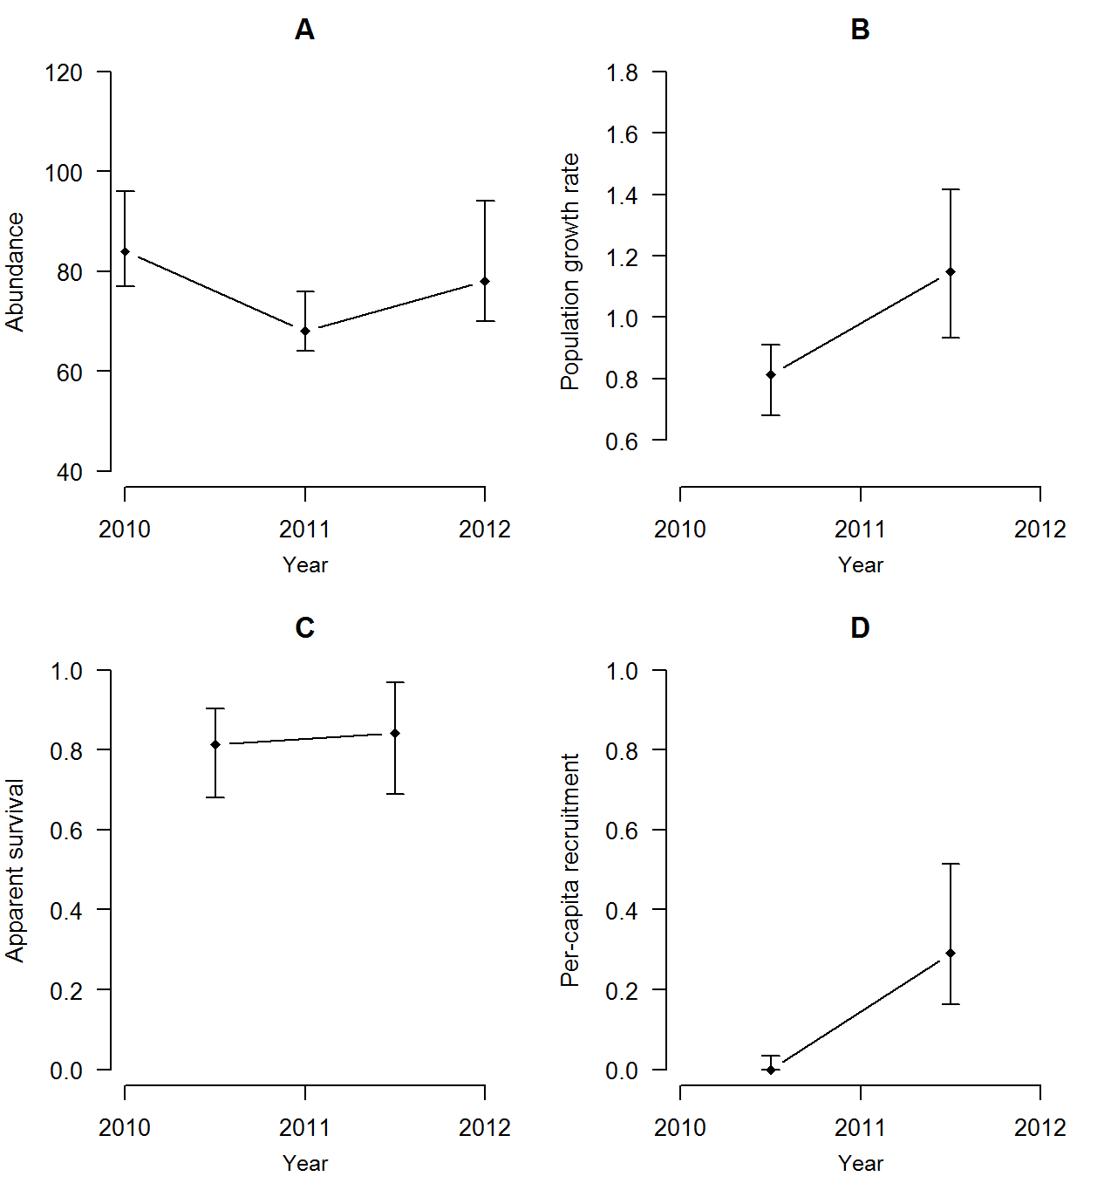
Figure 22. Population parameter estimates (diamonds) and 95% credible intervals (error bars) from Model 2 (individual capture heterogeneity modeled with 2-point finite mixture distribution) for female Louisiana black bears within the Lower Atchafalaya River Basin in Louisiana, USA.
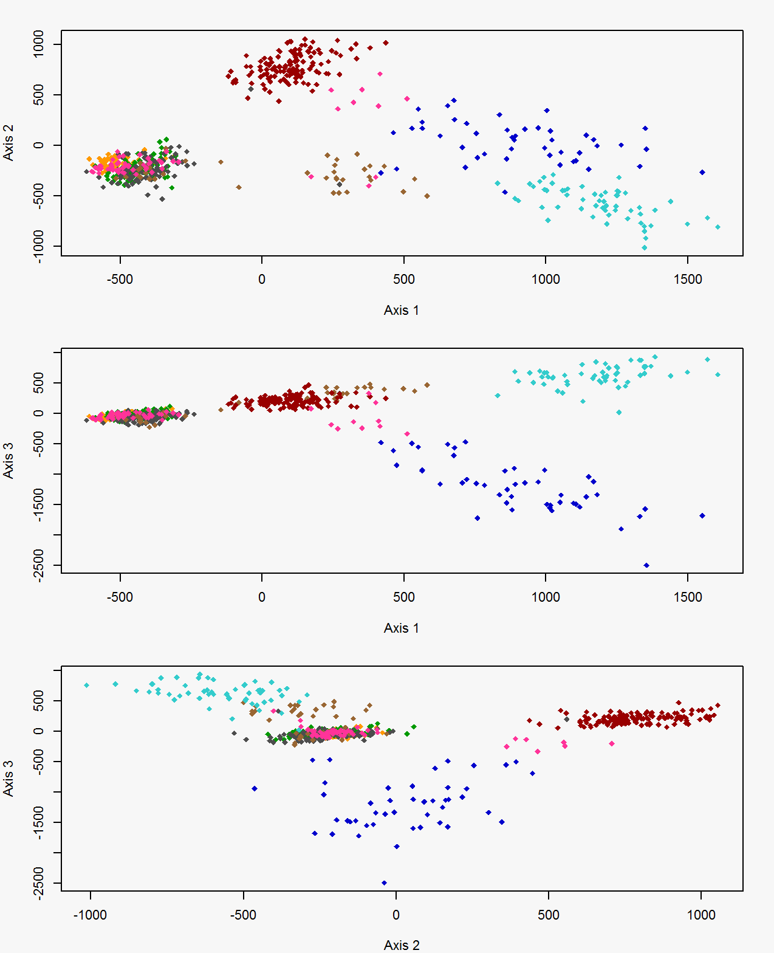
Figure 23. Factorial correspondence analysis results for black bears in Minnesota (blue), Mississippi (pink), the White River Basin (orange) in Arkansas, and the Tensas River Basin north of Interstate 20 (green), Tensas River Basin south of Interstate 20 (gray), Three Rivers Complex (brown), Upper Atchafalaya River Basin (light blue), and Lower Atchafalaya River Basin (red) in Louisiana, USA.
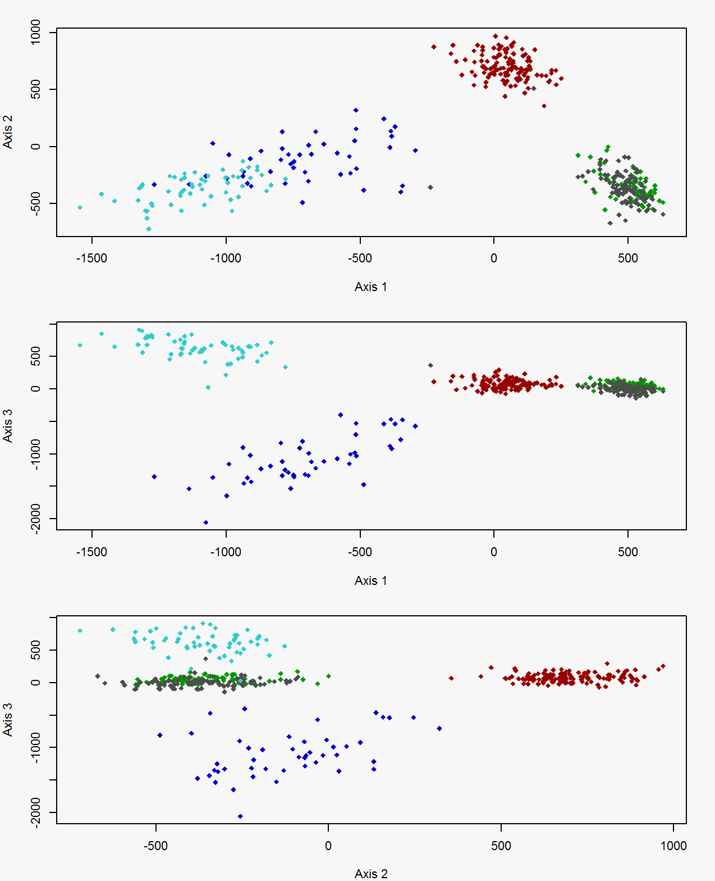
Figure 24. Factorial correspondence analysis results for black bears in Minnesota (dark blue) and the Tensas River Basin north of Interstate 20 (green), Tensas River Basin south of Interstate 20 (gray), Upper Atchafalaya River Basin (light blue), and Lower Atchafalaya River Basin (red) in Louisiana, USA.
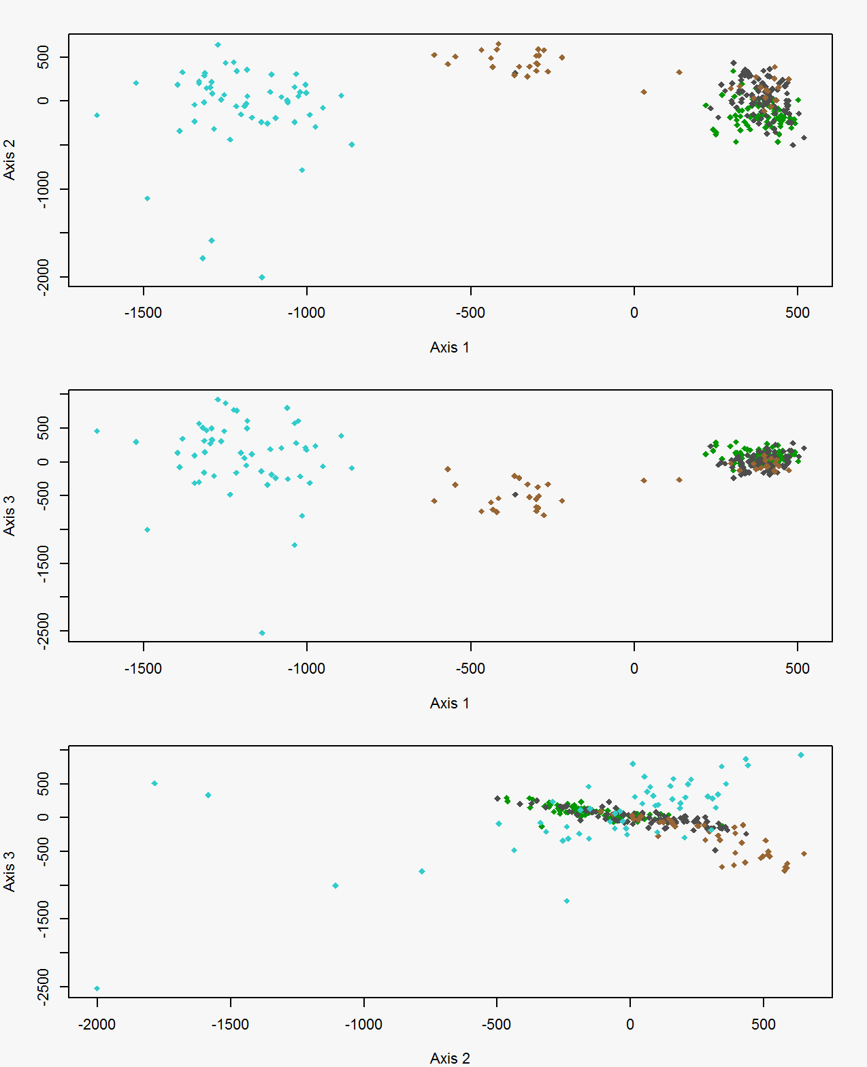
Figure 25. Factorial correspondence analysis results for black bears within the Tensas River Basin north of Interstate 20 (green), Tensas River Basin south of Interstate 20 (gray), Three Rivers Complex (brown), and Upper Atchafalaya River Basin (light blue).
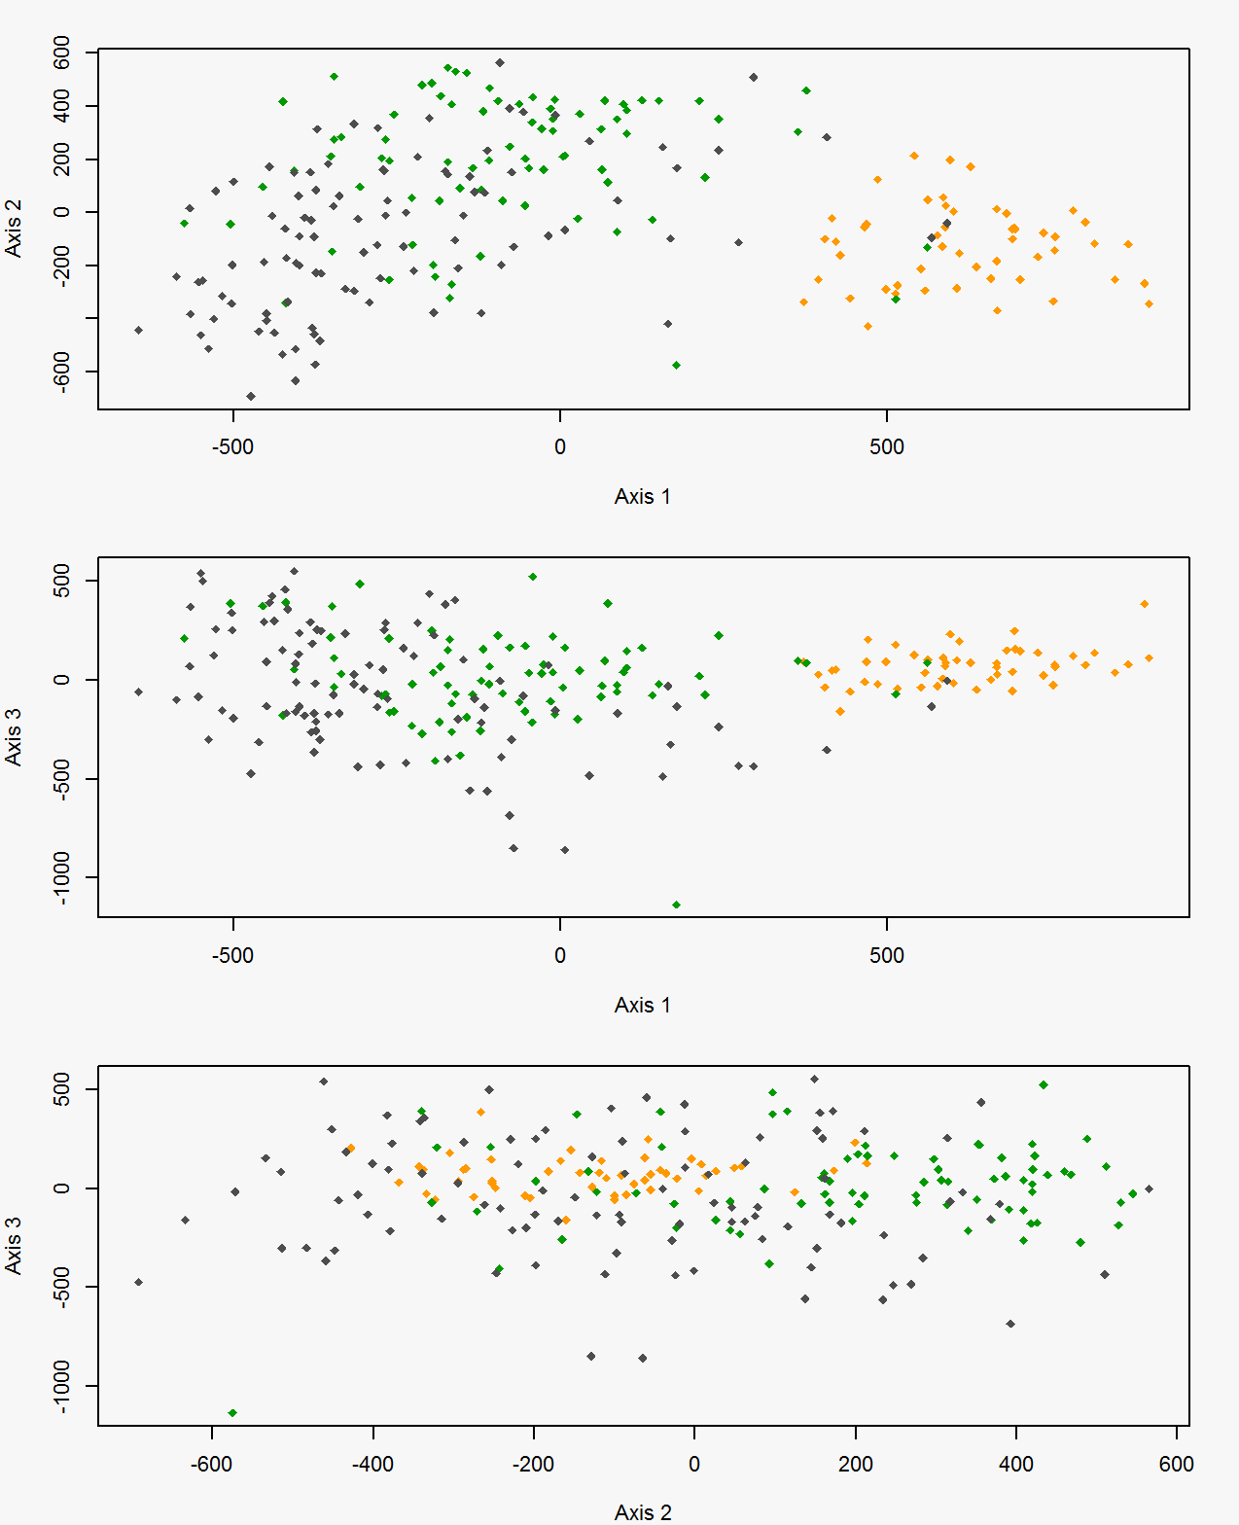
Figure 26. Factorial correspondence analysis results for black bears within the White River Basin (orange) in Arkansas and the Tensas River Basin north of Interstate 20 (green) and Tensas River Basin south of Interstate 20 (gray) in Louisiana, USA.
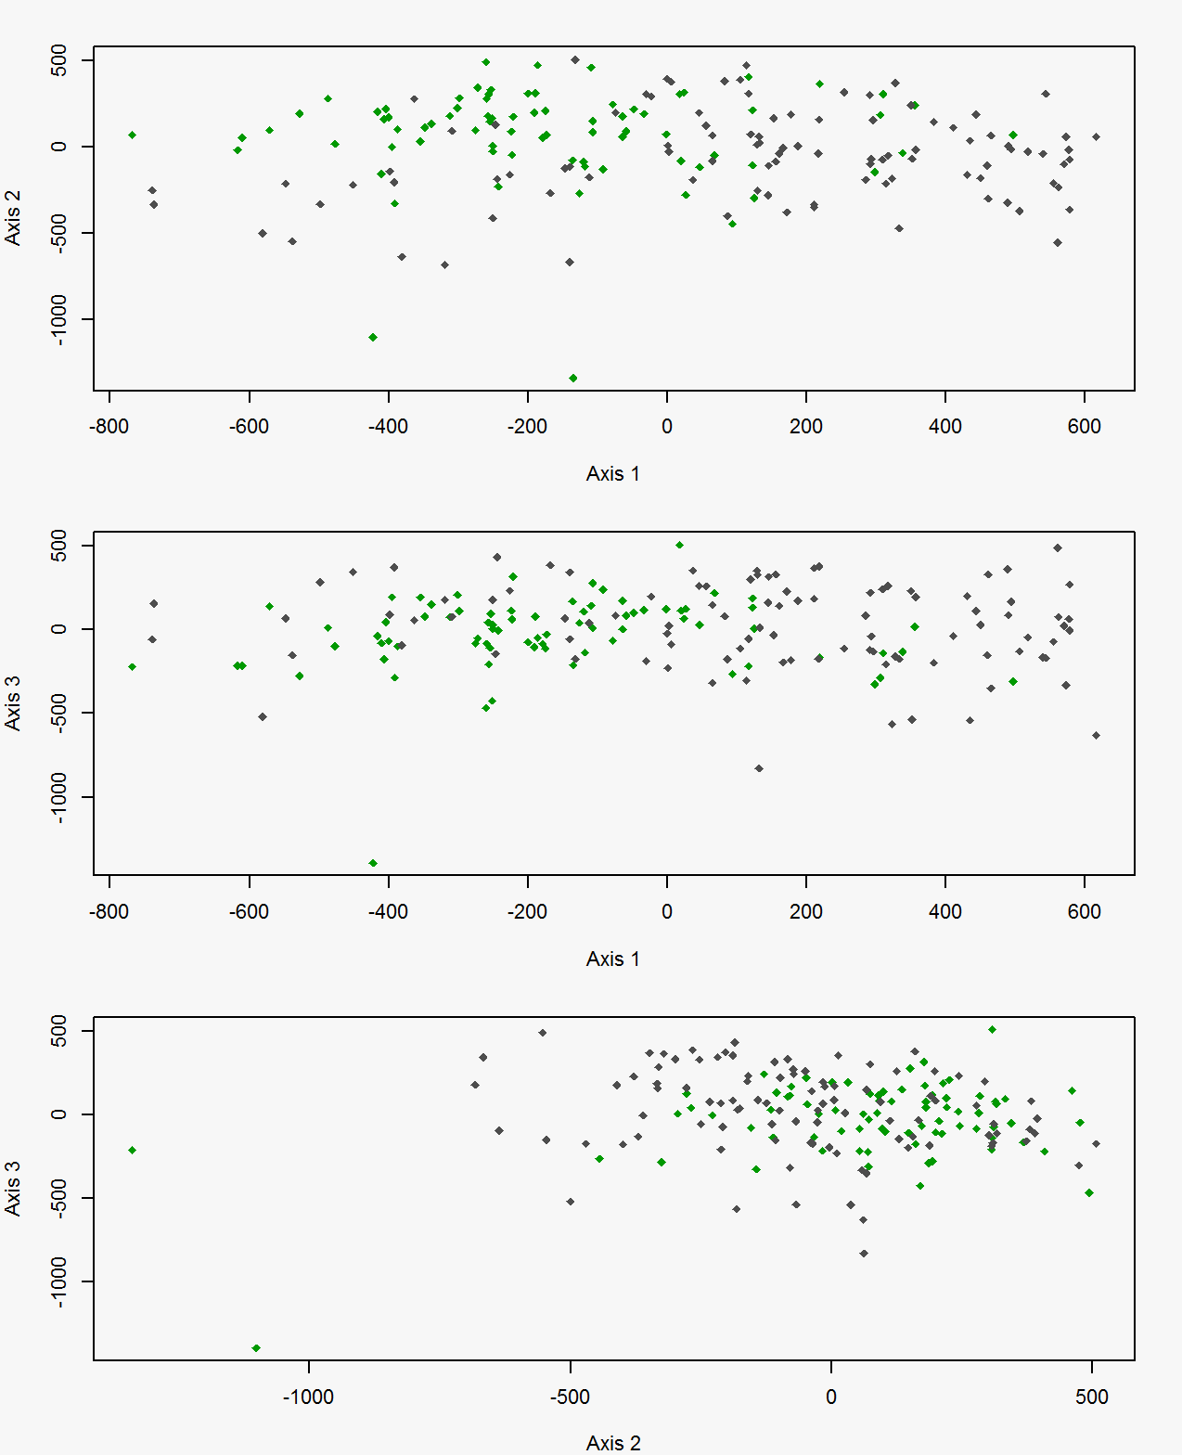
Figure 27. Factorial correspondence analysis results for black bears within the Tensas River Basin north of Interstate-20 (green) and south of Interstate-20 (gray) in Louisiana, USA.
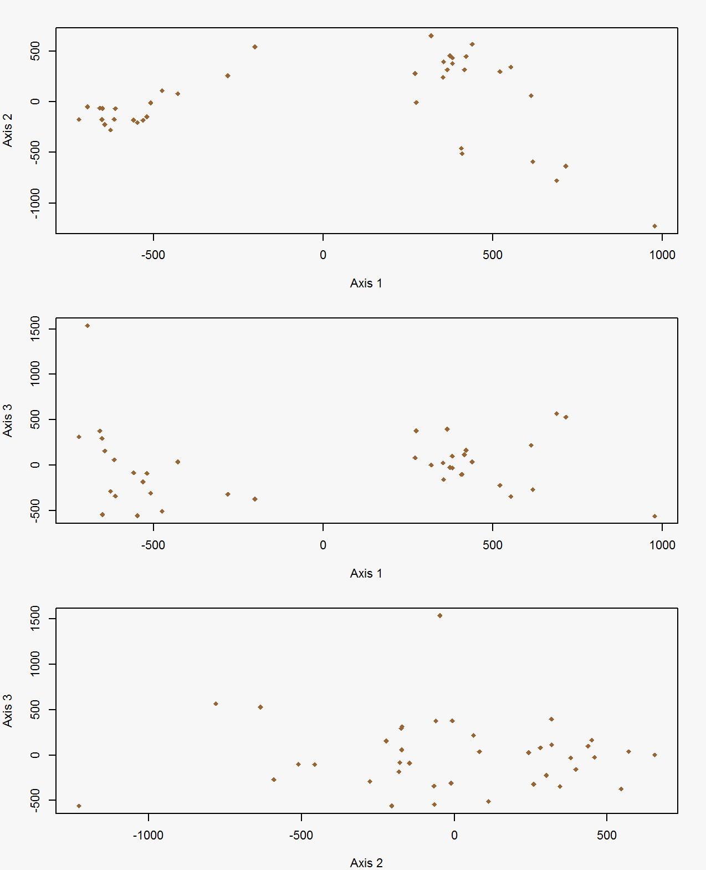
Figure 28. Factorial correspondence analysis results for black bear cubs born within the Three Rivers Complex in Louisiana, USA.
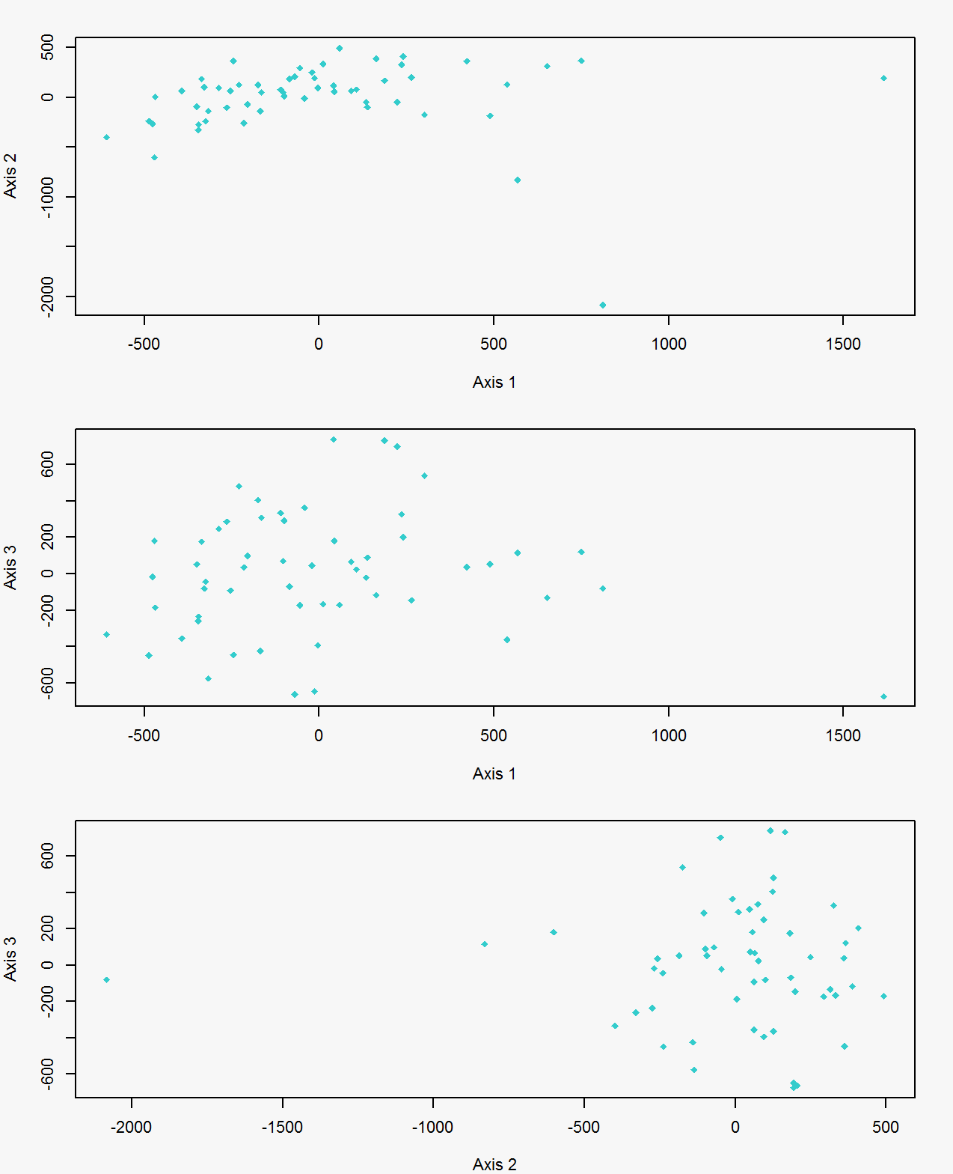
Figure 29. Factorial correspondence analysis results for black bears within the Upper Atchafalaya River Basin in Louisiana, USA.
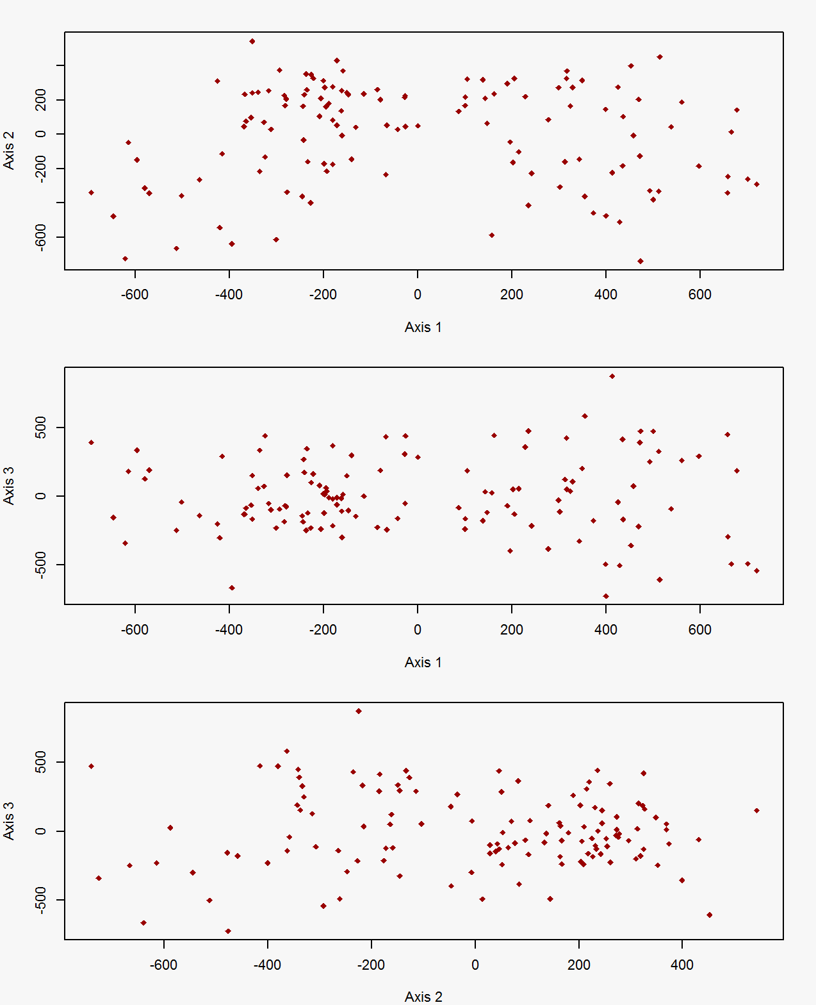
Figure 30. Factorial correspondence analysis results for bears within the Lower Atchafalaya River Basin in Louisiana, USA.
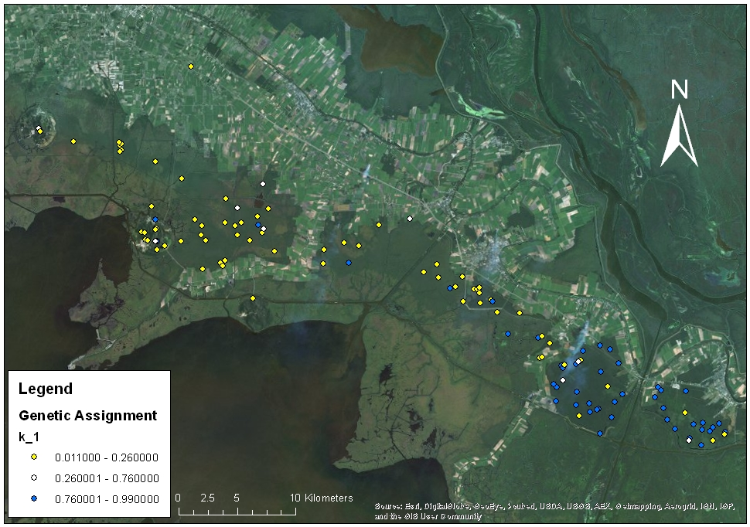
Figure 31. Mean capture locations from DNA-based captures for black bears in St. Mary and Iberia parishes, Louisiana, USA, 2010–2012, color categorized by genetic assignment. Blue: >0.75 assignment to population 1, Gold: >0.75 assignment to population 2. White: 0.25–0.75 assignment to either population. Reproduced from Troxler 2013.
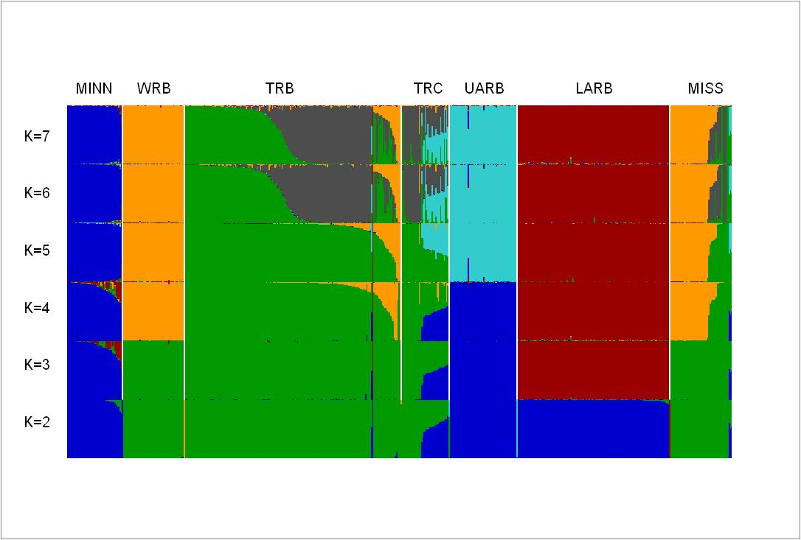
Figure 32. Proportional population ancestries for 556 black bears from Minnesota (MINN), Mississippi (MISS), the White River Basin in Arkansas (WRB), and the Tensas River Basin (TRB), Three Rivers Complex (TRC), Upper Atchafalaya River Basin (UARB), Lower Atchafalaya River Basin (LARB) in Louisiana, USA. Ancestries were estimated using models in Program STRUCTURE based on assumed values of K that ranged from 2 to 11.
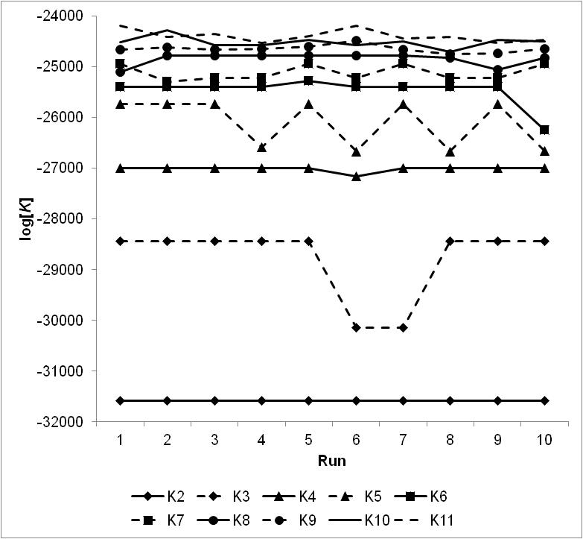
Figure 33. Program STRUCTURE log[K] values across 10 chains for each value of K from 2 to 11.
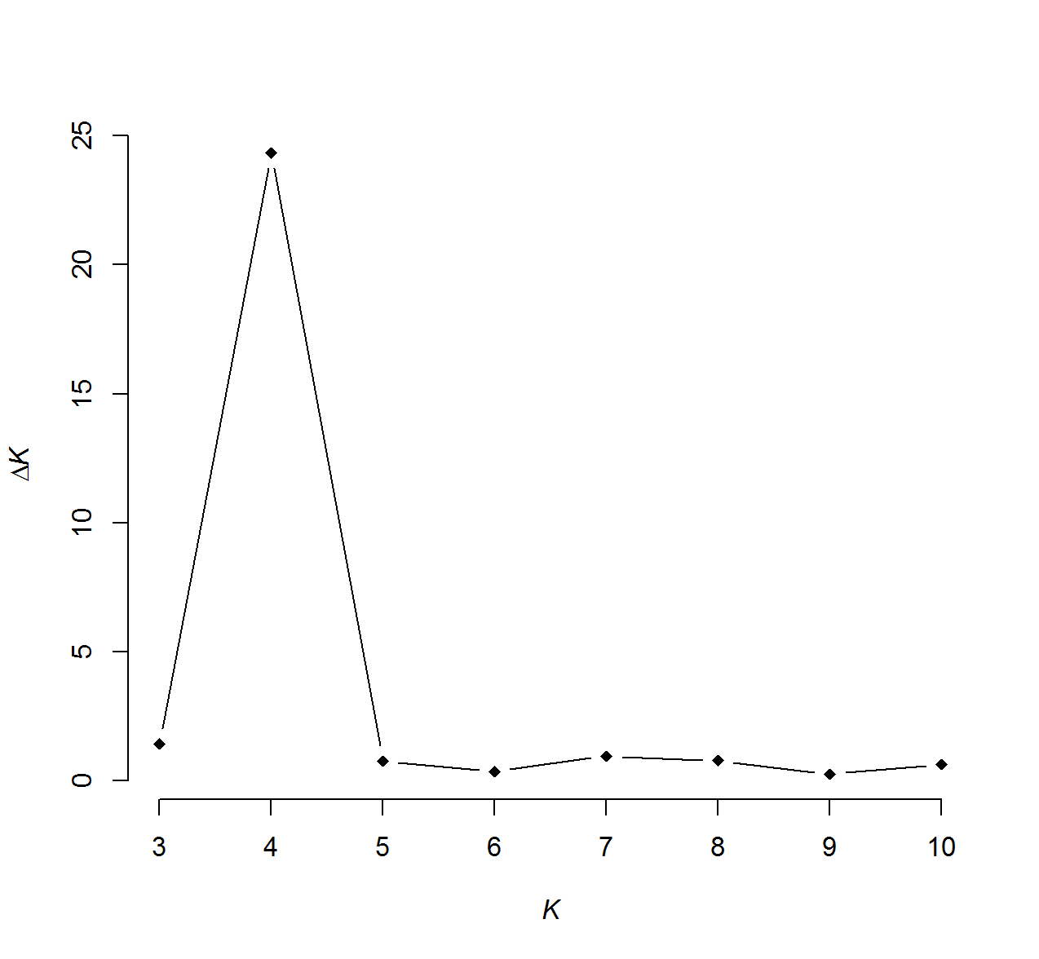
Figure 34. Estimated Δlog[K] values from STRUCTURE population clustering analyses for values of K from 3 to 10.
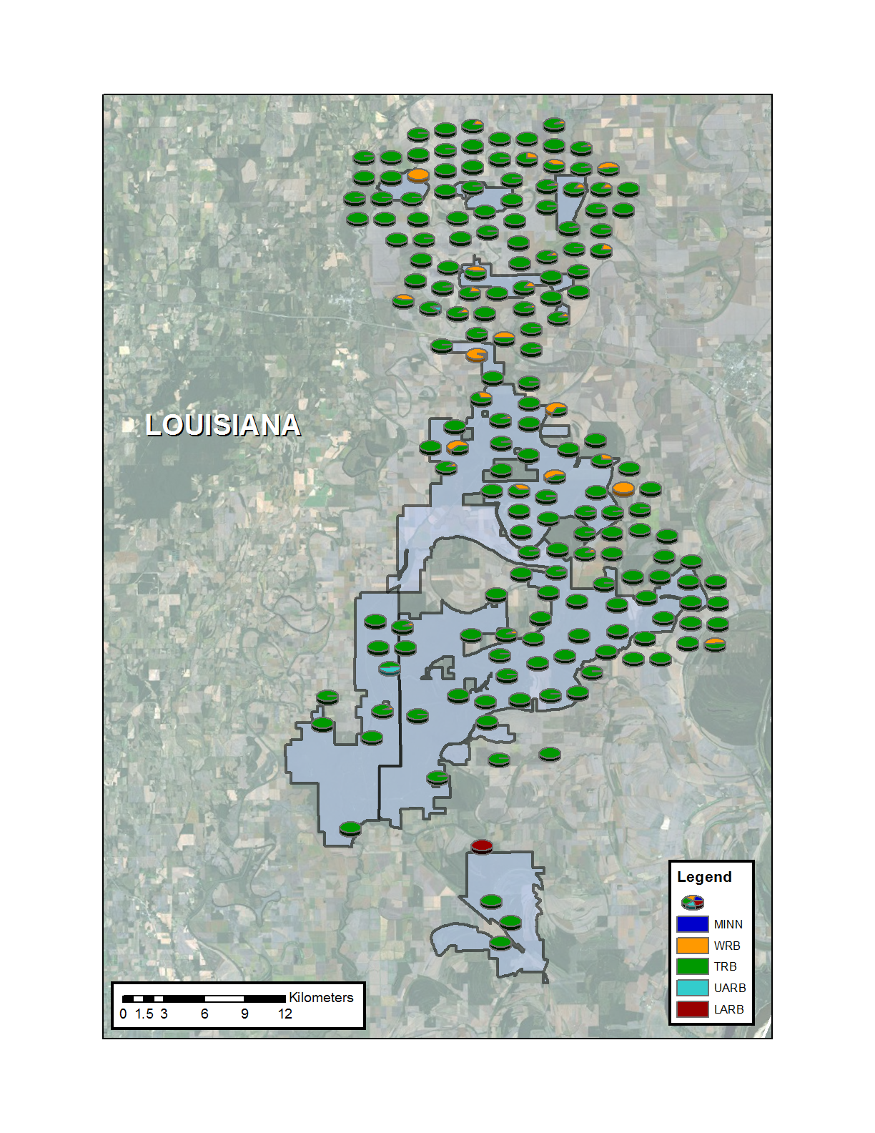
Figure 35. Proportional population ancestries for black bears within the Tensas River Basin in Louisiana, USA. Ancestries were estimated in Program STRUCTURE based on an assumed value of K = 5.
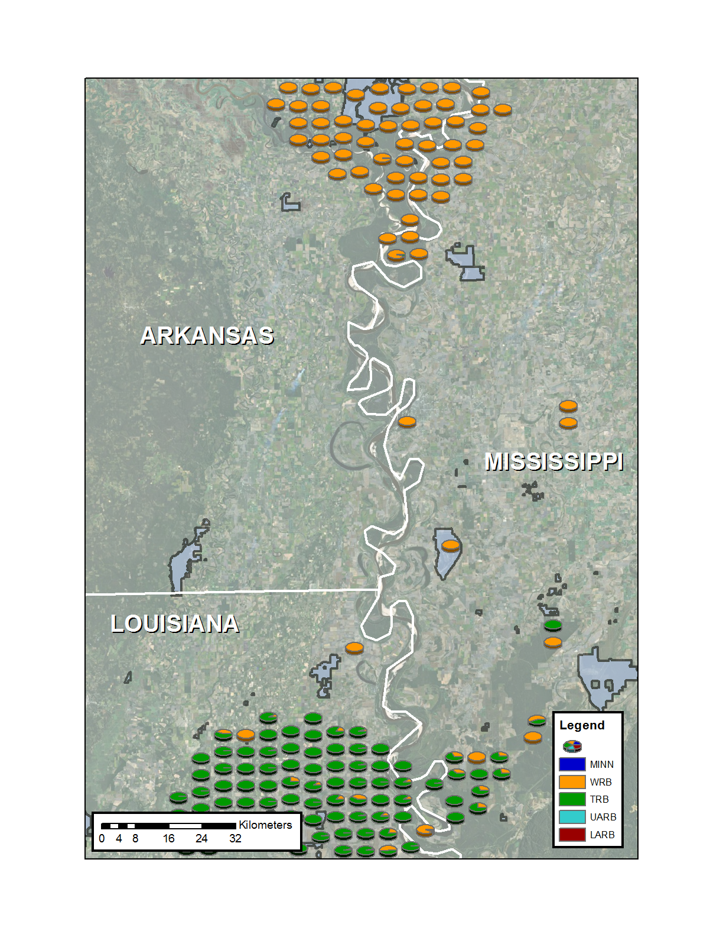
Figure 36. Proportional population ancestries for black bears within the southern portion of the White River Basin in Arkansas, the northern portion of the Tensas River Basin in Louisiana, , and northeastern Mississippi, USA. Ancestries were estimated in Program STRUCTURE based on an assumed value of K = 5.
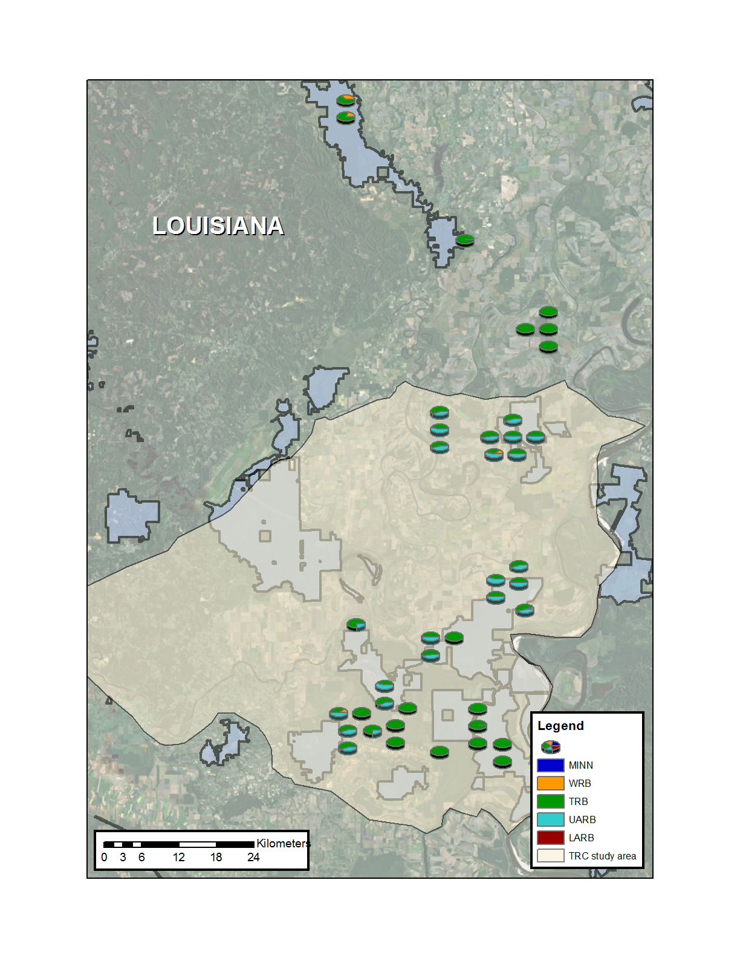
Figure 37. Proportional population ancestries for black bears within the Three Rivers Complex in Louisiana, USA. Ancestries were estimated in Program STRUCTURE based on an assumed value of K = 5.

Appendix C. Non-invasive hair sample selection
In the TRB in 2006, the subsampling objective was to submit 1 viable sample from each site/week combination (n = 439) that produced ≥1 collected sample for DNA analysis. Viable was defined as containing adequate material for DNA extraction based on a threshold of ≥1 guard hair or ≥5 underfur. Subsampling was accomplished by examining samples in random order within each site/week combination and selecting the first viable sample for analysis. If no viable samples were available for a given site, then that site was passed over with no sample from that site being selected for analysis. Samples within sites were not randomly ordered prior to screening because the subsampling objective did not require selecting >1 sample from a site.
From 2007 to 2009, the subsampling objective in the TRB was to submit 50 viable samples per week for DNA analysis. In contrast to 2006, sites with collected samples for a given week were placed in random order and individually screened in that order for 1 viable sample until 50 sites produced a viable sample. Screening within sites consisted of examining collected samples in random order and selectingt the first viable sample with ≥1 guard hair or ≥5 underfur. If no viable samples were available for a given site, then that site was passed over. If the number of unique sites that produced ≥1 viable sample in a given week was <50, sites were randomly reordered and screened in search of additional viable samples to reach the target of 50 samples. Similar to 2006, samples within sites were not placed in random order prior to screening.
From 2010 to 2011, TRB sites were again put in random order within weeks and screened until 50 viable samples were selected. For the first pass through In search of a viable sample from a given site, collected samples for that site were first screened using more stringent denfinition of viable based on a threshold of ≥5 guard hairs or ≥20 underfur (henceforth upper threshold). If no samples met that threshold, samples were then re-screened using the threshold of ≥1 guard hair or ≥5 underfur (henceforth lower threshold) before moving onto the next site. Also beginning in 2010, collection sites were constructed using a 2-wire system and technicians were instructed to collect all samples from the top wire prior to the bottom wire. Such nonrandom sample collection can result in a biased subsample if samples are screened in order of collection. For example, starting the screening process with the first collected sample would tend to select samples from bears more likely to leave samples on the top wire (e.g., larger bears). Therefore, samples within each site were placed in random order prior to screening.
In 2012, TRB sites were again screened in random order for viable samples using the upper quality threshold. However, instead of immediately re-screening within a site at the lower threshold if a sample meeting the upper threshold was not found, the site was passed over. If all sites were screened and the quota of samples was not achieved, then sites that did not initially produce a viable sample were re-screened using the lower threshold. Additionally in 2012, the subsampling objective was increased for all years to 75 samples per week. This required selecting additional samples from previous years for DNA analysis. For 2006, sites were re-screened in random order using the upper threshold until the objective was met. For 2007–2011, screening of sites resumed from where selections in previous years ended and screening of samples used the upper threshold until all available sites were exhausted after which sites were rescreened with the lower threshold as before. Increasing the number of samples to 75 per week required selecting additional samples from sites from which samples had previously been selected. Because samples were not randomly sorted within sites for 2006−2009 and sample envelope labels did not identify adjacent samples, the likelihood of a second sample collected from an adjacent barb coming from the same bear as the previously selected sample was non-trivial. Therefore, if a site was screened for an additional sample, then the remaining samples eligible for selection were first put in random order to reduce the likelihood of selecting redundant samples from the same bear.
In the UARB from 2007 to 2011, the subsampling objective was to submit 25 viable samples per week for DNA analysis. Sample selection procedures were similar to the TRB. From 2007 to 2009, sites were randomly sorted, samples were not randomly sorted, and a 1 guard hair/5 underfur quality threshold was used. Rescreening sites during those years was not required to meet the subsampling objective. From 2010 to 2011, the quality threshold was increased to ≥5 guard hairs or ≥20 and samples within sites were randomly sorted to avoid potential sample collection bias associated with 2-wire system. In 2010, sites without samples meeting the upper threshold were re-screened for viable samples using the lower threshold prior to moving on to the next site, whereas those sites in 2011 were not re-screened until all sites had initially been screened using the upper threshold.
In 2012, the subsampling objective was increased to 38 samples per week for all years which required selection of additional samples from previous years. For the same reason as the 2006−2009 TRB samples, 2007−2009 samples were randomly sorted for sites from which additional samples were to be selected. The lower threshold was only used if a second pass was necessary to achieve the subsampling objective. Additional samples for 2010–2011 were selected by continuing to screen sites in random order for viable samples using the upper threshold. As before, the lower threshold was only used when returning to sites previously screened for a second sample was necessary.
For the LARB, the subsampling objective in 2010 was to select 1 viable sample from each site/week combination that produced ≥1 collected sample (n = 302). Samples within each site/week combination were screened in random order using the upper quality threshold. If a viable sample based on that threshold was not found, the site was immediately re-screened using the lower threshold. In 2011, the objective was increased to 355 viable samples over the 8-week sampling period. Because ≥355 site/week combinations produced ≥1 sample, all site/week combinations were randomized and collected samples within each site/week were randomly screened for viable samples using the upper threshold. Because the first pass through those sites met the sample size objective, a second pass based on the lower threshold was not required. In 2012, the subsampling objective was increased to 533 samples per year for all years, which required selection of additional samples from previous years. For 2010, site/week combinations were placed in random order and screened for the first sample to meet the upper threshold. If no samples met that threshold, then the site was immediately rescreened using the lower threshold. This process was repeated until the objective was met. For 2011, the initial screening of sites from the previous year was completed using the upper threshold. A second screening of sites using the lower threshold was conducted which targeted site/week combinations from which no sample had been selected during the first screening. Finally, a third screening was performed using the upper threshold. The subsampling procedure for 2012 samples used an initial screening of all site/week combinations using the upper threshold, a second screening of sites from which no samples were selected during the initial screening using the lower threshold, and a third screening of sites using the upper threshold

Appendix D. Programming code
JAGS model statement for adult female survival analysis

## priors and constraints

# annual survival as random effects from multivariate normal distribution with mean
# vector = mu.s and covariance matrix Omega

for(t in 1:Nyear){
S[t,1:Narea] ~ dmnorm(mu.s[],Omega[,])
} #t

# uniform priors for area specific means

for(g in 1:Narea){
mu.s[g] ~ dunif(-15,0)
} #g

# priors for var-cov matrix

Omega[1:Narea, 1:Narea] ~ dwish(R[,], df)
Sigma[1:Narea, 1:Narea] <- inverse(Omega[,])

## likelihood
for(i in 1:Nrec){
for(j in left[i]:(right[i])){
UH[i,j] <- exp(S[year[i],area[i]]) # exponential model for monthly hazard
# (monthly probability of dying)
}
SLR[i] <- exp(-sum(UH[i,left[i]:(right[i])])) # probability of death on or before
#month j
censored[i] ~ dbern(SLR[i])
}
# derived parameters
for(g in 1:Narea){
annual.s[g] <- exp(-(exp(mu.s[g])*end))
}

for(t in 1:Nyear){
for(g in 1:Narea){
UH0[t,g] <- exp(S[t,g])
CH0[t,g] <- UH0[t,g]*12
S0[t,g] <- exp(-CH0[t,g])
}
}
JAGS model statement for reproductive state transition analysis
# -------------------------------------------------
# Parameters:
# psiN[,1]: transition probability from barren to barren
# psiN[,2]: transition probability from barren to cubs
# psiN[,3]: transition probability from barren to yearlings (impossible)
# psiC[,1]: transition probability from cubs to barren
# psiC[,2]: transition probability from cubs to cubs
# psiC[,3]: transition probability from cubs to yearlings
# psiY[,1]: transition probability from yearlings to barren
# psiY[,2]: transition probability from yearlings to cubs
# psiY[,3]: transition probability from yearlings to yearlings (impossible)
# -------------------------------------------------
# States (S):
# 1 barren
# 2 cubs
# 3 yearlings
# -------------------------------------------------

# Priors and constraints

# Transitions from barren to barren or barren to cubs
for(g in 1:n.area){
for(s in 1:2){ # s indexes arrival state
N[g,s] ~ dgamma(1, 1)
psiN[g,s] <- N[g,s]/sum(N[g,]) # unit sum constraint
} #s
} #g

# Transitions from cubs to barren, cubs to cubs, or cubs to yearlings
for(g in 1:n.area){
for(s in 1:3){ # s indexes arrival state
C[g,s] ~ dgamma(1, 1)
psiC[g,s] <- C[g,s]/sum(C[g,]) # unit sum constraint
} #s
} #g

# Transitions from yearling to barren or yearling to cubs
for(g in 1:n.area){
for(s in 1:2){ # s indexes arrival state
Y[g,s] ~ dgamma(1, 1)
psiY[g,s] <- Y[g,s]/sum(Y[g,]) # unit sum constraint
} #s
} #g

# Define state-transition matrix
for(i in 1:nind){
for(g in 1:n.area){
# Define probabilities of state S(t+1) given S(t)

ps[1,i,g,1] <- psiN[g,1] # probability of barren to barren
ps[1,i,g,2] <- psiN[g,2] # probability of barren to cubs
ps[1,i,g,3] <- 0 # probability of barren to yearlings
ps[2,i,g,1] <- psiC[g,1] # probability of cubs to barren
ps[2,i,g,2] <- psiC[g,2] # probability of cubs to cubs
ps[2,i,g,3] <- psiC[g,3] # probability of cubs to yearlings
ps[3,i,g,1] <- psiY[g,1] # probability of yearlings to barren
ps[3,i,g,2] <- psiY[g,2] # probability of yearlings to cubs
ps[3,i,g,3] <- 0 # probability of yearlings to yearlings
} #g
} #i

# Likelihood
for (i in 1:nind){
z[i,2] ~ dcat(ps[z[i,1], i, area[i],])
} #i
JAGS model statement for litter size analysis
## Priors and constraints
for(i in 1:4){

a[i] ~ dgamma(1,1) # priors for TRB litters
psiT[i] <- a[i]/sum(a[]) # unit sum constraint
b[i] ~ dgamma(1,1) # priors for TRC litters
psiR[i] <- b[i]/sum(b[])# unit sum constraint
} #i

p[1,1] <- psiT[1] # probability of litter size 1 for TRB
p[1,2] <- psiT[2] # probability of litter size 2 for TRB
p[1,3] <- psiT[3] # probability of litter size 3 for TRB
p[1,4] <- psiT[4] # probability of litter size 4 for TRB
p[2,1] <- psiR[1] # probability of litter size 1 for TRC
p[2,2] <- psiR[2] # probability of litter size 2 for TRC
p[2,3] <- psiR[3] # probability of litter size 3 for TRC
p[2,4] <- psiR[4] # probability of litter size 4 for TRC

## Likelihood

for(i in 1:nind){
z[i] ~ dcat(p[pop[i],])
} #i
JAGS model statement for CMR Model 1 for TRB and UARB

## Priors and constraints

psi ~ dbeta(1.0E-6,1) # M*psi = E[N(1)]

for(t in 1:(T-1)) {
logit.phi[t]~ dnorm(mu.phi,tau.phi)
logit(phi[t]) <- logit.phi[t
log.gamma[t]<- beta0 + beta1*N[t] + eps.g[t]
# density dependence function
gamma[t]<- exp(log.gamma[t])
eps.g[t]~ dnorm(0,tau.eps.g)T(-10,10) # recruitment random
# effect
EB[t] <- N[t]*gamma[t] # Expected recruits
b[t] <- min(EB[t] / V[t], 0.999) # Probability of being
# recruited
} #t

mu.phi~ dnorm(0,0.001)
sd.phi~ dunif(0,10)
tau.phi<- pow(sd.phi,-2)
beta0~ dnorm(0,0.0001)T(-5,5)
beta1~ dnorm(0,0.0001)
sd.g~ dunif(0,10)
tau.eps.g<- pow(sd.g,-2)

for(t in 1:T) {
mean.lp[t]<- log(mean.p[t]/(1-mean.p[t]) )
mean.p[t]~ dunif(0,1)

N[t] <- sum(z[,t]) # Number of females
V[t] <- max(M - sum(a[,t]), 0.01) # Bears available to be
# recruited
} #t

sd.p1~ dunif(0,5)
tau.p1<- pow(sd.p1,-2)
sd.p2~ dunif(0,5)
tau.p2<- pow(sd.p2,-2)

## Likelihood

for(i in 1:M) {
z[i,1] ~ dbern(psi)
a[i,1] <- z[i,1] # recruited yet?

for(t in 2:T) {
mu[i,t-1] <- z[i,t-1]*phi[t-1] + (1 - a[i,t-1])*b[t-1]
z[i,t] ~ dbern(mu[i,t-1])
a[i,t] <- max(z[i,1:t]) # recruited yet? Once z(i,t)=1, then a(i,t:T)=1
} #t

eps1[i]~ dnorm(0, tau.p1)T(-16, 16)
eps2[i]~ dnorm(0, tau.p2)T(-16, 16)

for(t in 1:(T−)) {

lp[i,t]<- mean.lp[t] + eps1[i]
p[i,t]<- 1 / (1 + exp(-lp[i,t]) )
p.eff[i,t]<- p[i,t]*z[i,t]
y[i,t] ~ dbin(p.eff[i,t],K)
} #t

for(t in (T-2):T) {

lp[i,t]<- mean.lp[t] + eps2[i]
p[i,t]<- 1 / (1 + exp(-lp[i,t]) )
p.eff[i,t]<- p[i,t]*z[i,t]
y[i,t] ~ dbin(p.eff[i,t],K)
} #t

zi[i] <- (sum(z[i,]) > 0) # Was this bear ever alive?
} #i

## Derived parameters
for(t in 1:(T-1)){
lambda[t]<- phi[t] + gamma[t]
} #t
Never <- sum(zi[]) # Bears ever alive

JAGS model statement for CMR Model 2 for TRB and UARB

## Priors and constraints

psi ~ dbeta(1.0E-6,1) # M*psi = E[N(1)]

for(t in 1:(T-1)) {
logit.phi[t] ~ dnorm(mu.phi,tau.phi)
logit(phi[t]) <- logit.phi[t]
log.gamma[t] <- beta0 + beta1*N[t] + eps.g[t]
# density dependence function
gamma[t] <- exp(log.gamma[t])
eps.g[t] ~ dnorm(0,tau.eps.g)T(-10,10) # recruitment random
# effect
EB[t] <- N[t]*gamma[t] # Expected recruits
b[t] <- min(EB[t] / V[t], 0.999) # Probability of being
# recruited
} #t

mu.phi ~ dnorm(0,0.001)
sd.phi ~ dunif(0,10)
tau.phi <- pow(sd.phi,-2)
beta0 ~ dnorm(0,0.0001)
beta1 ~ dnorm(0,0.0001)T(-5,5)
sd.g ~ dunif(0,10)
tau.eps.g <- pow(sd.g,-2)

for(t in 1:T) {
p.mix2[t] <- p.mix1[t] + theta[t]
p.mix1[t] ~ dunif(0,1)
theta[t] ~ dunif(0,1)
N[t] <- sum(z[,t]) # Number of females
V[t] <- max(M - sum(a[,t]), 0.01) # Bears available to be
# recruited
} #t

pi.pre ~ dunif(0,1)
pi.post ~ dunif(0,1)

## Likelihood

for(i in 1:M) {
z[i,1] ~ dbern(psi)
a[i,1] <- z[i,1] # recruited yet?

for(t in 2:T) {
mu[i,t-1] <- z[i,t-1]*phi[t-1] + (1 - a[i,t-1])*b[t-1]
z[i,t] ~ dbern(mu[i,t-1])
a[i,t] <- max(z[i,1:t]) # recruited yet?
# once z(i,t)=1, then a(i,t:T)=1
} #t

for(t in 1:(T-3)) {
group[i,t] ~ dbern(pi.pre)
p[i,t] <- p.mix1[t] * group[i,t] +
p.mix2[t] * (1-group[i,t])
p.eff[i,t] <- p[i,t]*z[i,t]
y[i,t] ~ dbin(p.eff[i,t],K)
} #t

for(t in (T-2):T) {
group[i,t] ~ dbern(pi.post)
p[i,t] <- p.mix1[t] * group[i,t] +
p.mix2[t] * (1-group[i,t])
p.eff[i,t] <- p[i,t]*z[i,t]
y[i,t] ~ dbin(p.eff[i,t],K)
} #t

zi[i] <- (sum(z[i,]) > 0) # Was this bear ever alive?
} #i

## Derived parameters

for(t in 1:(T-1)){
lambda[t]<- phi[t] + gamma[t]
} #t
Never <- sum(zi[]) # Bears ever alive

JAGS model statement for CMR Model 1 for LARB

## Priors and constraints

psi ~ dbeta(1.0E-6,1) # M*psi = E[N(1)]

for(t in 1:(T-1)) {
log.gamma[t] ~ dnorm(0,.001)
gamma[t] <- exp(log.gamma[t])
phi[t] ~ dbeta(1,1)
EB[t] <- N[t]*gamma[t] # Expected recruits
b[t] <- min(EB[t] / V[t], 0.999) # Probability of
# being recruited
} #t

for(t in 1:T) {
mean.lp[t] <- log(mean.p[t]/(1-mean.p[t]) )
mean.p[t] ~ dunif(0,1)
sd.p[t] ~ dunif(0,5)
tau.p[t] <- pow(sd.p[t],-2)
N[t] <- sum(z[,t]) # Number of females
V[t] <- max(M - sum(a[,t]), 0.01) # Bears available to be
# recruited
} #t

## Likelihood

for(i in 1:M) {
z[i,1] ~ dbern(psi)
a[i,1] <- z[i,1] # recruited yet?

for(t in 2:T) {
mu[i,t-1] <- z[i,t-1]*phi[t-1] + (1 - a[i,t-1])*b[t-1]
z[i,t] ~ dbern(mu[i,t-1])
a[i,t] <- max(z[i,1:t]) # recruited yet?
# once z(i,t)=1, then a(i,t:T)=1
} #t

for(t in 1:T) {
eps[i,t] ~ dnorm(0, tau.p[t])T(-16, 16)
lp[i,t] <- mean.lp[t] + eps[i,t]
p[i,t] <- 1 / (1 + exp(-lp[i,t]) )
p.eff[i,t] <- p[i,t]*z[i,t]
y[i,t] ~ dbin(p.eff[i,t],K)
} #t

zi[i] <- (sum(z[i,]) > 0) # Was this bear ever alive?
} #i

## Derived parameters

for(t in 1:(T-1)){
lambda[t] <- phi[t] + gamma[t]
} #t
Never <- sum(zi[]) # Bears ever alive

JAGS model statement for CMR Model 2 for LARB

## Priors and constraints

psi ~ dbeta(1.0E-6,1) # M*psi = E[N(1)]

for(t in 1:(T-1)) {
log.gamma[t] ~ dnorm(0,.001)
gamma[t] <- exp(log.gamma[t])
phi[t] ~ dbeta(1,1)
EB[t] <- N[t]*gamma[t] # Expected recruits
b[t] <- min(EB[t] / V[t], 0.999) # Probability of being
# recruited
} #t

for(t in 1:T) {
p.mix2[t] <- p.mix1[t] + theta[t]
p.mix1[t] ~ dunif(0,1)
theta[t] ~ dunif(0,1)
pi[t] ~ dunif(0,1)
N[t] <- sum(z[,t]) # Number of females
V[t] <- max(M - sum(a[,t]), 0.01) # Bears available to be
# recruited
} #t

## Likelihood

for(i in 1:M) {
z[i,1] ~ dbern(psi)
a[i,1] <- z[i,1] # recruited yet?

for(t in 2:T) {
mu[i,t-1] <- z[i,t-1]*phi[t-1] + (1 - a[i,t-1])*b[t-1]
z[i,t] ~ dbern(mu[i,t-1])
a[i,t] <- max(z[i,1:t]) # recruited yet?
# once z(i,t)=1, then a(i,t:T)=1
} #t

for(t in 1:T){
group[i,t] ~ dbern(pi[t])
p[i,t] <- p.mix1[t] * group[i,t] +
p.mix2[t] * (1-group[i,t])
p.eff[i,t] <- p[i,t]*z[i,t]
y[i,t] ~ dbin(p.eff[i,t],K)
} #t

zi[i] <- (sum(z[i,]) > 0) # Was this bear ever alive?
} #i

## Derived parameters

for(t in 1:(T-1)){
lambda[t]<- phi[t] + gamma[t]
} #t
Never <- sum(zi[]) # Bears ever alive
R code for TRB and UARB population projections
########## Note: Simulations enforce an upper limit for recruitment equal to
########## the maximum observed annual estimate after discarding the first year's
########## estimate because of potential bias associated with that initial estimate.

################ Auxiliary functions ###################################################

### function for calculating mode from posterior sample

Mode <- function(x) {
d <- density(x)
d$x[which.max(d$y)]
} #fn

### function for calculating summary statistics for lambdas from simulated population
### trajectories

geom.lamda <- function(x,yr,iter){
l <- matrix(0L,iter,(yr-1))
for(i in 1:(yr-1)){
for(j in 1:iter){
if(x[j,i]==0){next
}
else{l[j,i] <- x[j,i+1]/x[j,i]
}
} #j
} #i
gm.l <- apply(l, 1, function(x)exp(mean(log(x))))
y <- array(0L,c(1,10))
y[] <- c(mean(gm.l), sd(gm.l), Mode(gm.l), quantile(gm.l, probs = c(0,0.025,0.25,0.50,0.75,0.975,1)))
dimnames(y)[[2]] <- c("Mean","SD","Mode","0%","2.5%","25%","50%","75%","97.5%","100%")
return(list(gm.l,y))
} #fn

### generic function for calculating summary statistics from sample of values

summary.fn <- function(x){
y <- array(0L,c(1,10))
y[] <- c(mean(x), sd(x), Mode(x), quantile(x, probs = c(0,0.025,0.25,0.50,0.75,0.975,1)) )
dimnames(y)[[2]] <- c("Mean","SD","Mode","0%","2.5%","25%","50%","75%","97.5%","100%")
return(y)
}# fn

#########################################################################################

############# Function for simulating population trajectories #############
############# incorporating density dependence and temporal-only #############
############# variation in vital rates. #############

popfunc.mode.dd.cap <- function(name,N1,npops,nyears,beta0,beta1,
sd.g,g.max,mu.phi,sd.phi, hist.int,fig.max){
simpop <- matrix(0L, npops, (nyears+1)) # creates null matrix to which abundance from # simulations are written
simpop[,1] <- N1 # sets initial abundance values to first column of matrix
for(i in 1:npops){
for(t in 2:(nyears+1)){
if(simpop[i,(t-1)]==0){simpop[i,t]<-0} # automatically writes zero for # abundance if abundance at prior time
# step was zero
else{
gam <- exp(rnorm(1,(beta0 + beta1*simpop[i,(t-1)]), sd.g))
# specifies recruitment rate

if(gam > g.max){simpop[i,t] <- rbinom(1,(rpois(1,(round((simpop[i,(t-1)]) *
g.max))) + simpop[i,(t-1)]), (1/(1+exp(-
norm(1,mu.phi,sd.phi)))))}
# if statement forcing max limit on recruitment
else{
simpop[i,t] <- rbinom(1,(rpois(1,(round((simpop[i,(t-1)]) * gam))) +
simpop[i,(t-1)]), (1/(1+exp(-rnorm(1,mu.phi,sd.phi)))))
} #ifelse
} #ifelse
} #t
} #i
roundUp <- function(x,hist.int){ # generic rounding function
hist.int*(x%/%hist.int + as.logical(x%%hist.int))
} #fn
png(paste("./", name, ".png", sep=""), width=6.5, height=4, units="in", res=196)
# creates .png image of matplot for population projections
par(mfrow = c(1,2), las = 1)
matplot(t(simpop), type="l", ylab = "Abundance")
hist(simpop[,(nyears+1)], breaks = seq(0, roundUp(max(simpop[,(nyears+1)]),hist.int)
,hist.int), xlim = c(0,fig.max), xlab = "Abundance", main = "")
dev.off()
N.sum.stats <- summary.fn(simpop[,(nyears+1)]) # summarizes end abundance of all
# projections
probpers <- length(which(simpop[,(nyears+1)]!=0))/npops # calculates probability of
# persistence
lambdas <- geom.lamda(simpop,(nyears+1),npops) # calculates geom mean of lambdas for
# all projections
lambda.sum.stats <- lambdas[[2]] # returns summary of geometric means of lambdas over
# all projections
lower.N <- length(which(simpop[,1]>simpop[,100])) # calculates number of projections
# with end abundance lower than
# initial abundance
dec.popG <- length(which(lambdas[[1]]<1)) # calculates number of projections with # geometric mean of lambda <1
return(list(simpop,N.sum.stats,lambda.sum.stats,probpers,lower.N,dec.popG,lambdas[[1]]))
} #fn

#### Definitions of function arguments for simulations incorporating only process variance

# name = name for matplot figures
# N1 = estimated initial abundance (posterior mode)
# npops = number of simulated tracjectories
# nyears = number of years to project population
# beta0 = estimated intercept for log-linear density-dependence function for
# recruitment (posterior mode)
# beta1 = estimated slope for log-linear density-dependence function for recruitment
# (posterior mode)
# sd.g = estimated temporal process variance term for recruitment (posterior mode)
# g.max = upper limit place on recruitment i.e., maximum estimated value from CMR data
# (posterior modes)
# mu.phi = estimated global mean annual apparent survival rate (posterior mode)
# sd.phi = estimated temporal process variance term for apparent survival
# (posterior mode)
# hist.int = controlling parameter for matplot
# fig.max = controlling parameter for matplot

#########################################################################################

############# Function for simulating population trajectories #############
############# incorporating density dependence and all sources #############
############# of variation in vital rates including estimation #############
############# uncertainty. #############

popfunc.samp.unc.dd.cap <- function(name,N1,npops,nyears,beta0,beta1,
sd.g,g.max,mu.phi,sd.phi, hist.int, fig.max){
simpop <- matrix(0L, npops, (nyears+1)) # creates null matrix to which abundance
# from simulations are written
sub.beta1 <- which(beta1 > quantile(beta1, probs[1]) & beta1 < 0)
# limits strength of density dependence to
# avoid overly-extreme negative feedbacks
# and potential positive feedbacks.
sub.phi <- which(mu.phi > quantile(mu.phi, probs[1]) &
beta1 < quantile(mu.phi, probs[2]))
# limits values of global mean apparent # survival to avoid extreme and unrealistic
# values
for(i in 1:npops){
rn.beta1 <- sample(sub.beta1,1) # randomly select value of density-dependent slope
# parameter for a single projection
rn.phi <- sample(sub.phi,1) # randomly select value of mean apparent survival for a
# single projection
for(t in 2:(nyears+1)){
simpop[i,1] <- sample(N1,1) # randomly draws initial abundance values from
# posterior sample for each projection
if(simpop[i,(t-1)]<1){simpop[i,t]<-0} # automatically writes zero for abundance
# if abundance at prior time step was zero
else{
gam <- exp(rnorm(1,(beta0[rn.beta1] + beta1[rn.beta1]*simpop[i,(t-1)]), sd.g))
# specifies recruitment rate

if(gam > g.max){simpop[i,t] <- rbinom(1,(rpois(1,(round((simpop[i,(t-1)]) * g.max))) + simpop[i,(t-1)]), (1/(1+exp(- rnorm(1,mu.phi[rn.phi],sd.phi)))))}
# if statement forcing max limit on recruitment
else{
simpop[i,t] <- rbinom(1,(rpois(1,(round((simpop[i,(t-1)]) * gam))) +
simpop[i,(t-1)]), (1/(1+exp(-rnorm(1,mu.phi[rn.phi],sd.phi)))))
} #ifelse
} #ifelse
} #t
} #i
roundUp <- function(x,hist.int){ # generic rounding function
hist.int*(x%/%hist.int + as.logical(x%%hist.int))
} #fn
png(paste("./", name, ".png", sep=""), width=6.5, height=4, units="in", res=196)
# creates .png image of matplot for population projections
par(mfrow = c(1,2), las = 1)
matplot(t(simpop), type="l", ylim = c(0,fig.max), ylab = "Abundance")
sub.simpop <- subset(simpop[,(nyears+1)],
simpop[,(nyears+1)]<quantile(simpop[,(nyears+1)], prob = .975))
hist(sub.simpop, breaks = seq(0, roundUp(max(sub.simpop),hist.int) ,hist.int),
xlim = c(0,fig.max), xlab = "Abundance", main = "")
dev.off()
N.sum.stats <- summary.fn(simpop[,(nyears+1)]) # summarizes end abundance of all
# projections
probpers <- length(which(simpop[,(nyears+1)]!=0))/npops # calculates probability of
# persistence
lambdas <- geom.lamda(simpop,(nyears+1),npops) # calculates geometric mean of
# lambda for all projections
lambda.sum.stats <- lambdas[[2]] # returns summary of geometric means of lambdas over
# all projections
lower.N <- length(which(simpop[,1]>simpop[,100])) # calculates number of projections
# with end abundance lower than
# initial abundance
dec.popG <- length(which(lambdas[[1]]<1)) # calculates number of projections
# with geometric mean of lambda <1
return(list(simpop,N.sum.stats,lambda.sum.stats,probpers,lower.N,dec.popG,lambdas[[1]]))
} #fn

#### Definitions of function arguments for simulations incorporating only process
#### variance and parameter estimation uncertainty

# name = name for matplot figures
# N1 = posterior sample of initial abundance
# npops = number of simulated tracjectories
# nyears = number of years to project population
# beta0 = posterior sample of intercept for log-linear density-dependence function for
# recruitment
# beta1 = posterior sample of slope for log-linear density-dependence function for
# recruitment
# sd.g = estimated temporal process variance term for recruitment (posterior mode))
# g.max = upper limit place on recruitment i.e., maximum estimated value from CMR data
# (posterior modes)
# mu.phi = posterior sample of global mean annual apparent survival rate
# sd.phi = posterior sample of temporal process variance term for apparent survival
# probs = specifies quantiles used to restrict range of posterior sample values
# hist.int = controlling parameter for matplot
# fig.max = controlling parameter for matplot
R code for TRC population projections

################ Auxiliary functions ###################################################

### function for calculating mode from posterior sample

Mode <- function(x) {
d <- density(x)
d$x[which.max(d$y)]
} #fn

### function for calculating summary statistics for lambdas from simulated population
### trajectories

geom.lamda <- function(x,yr,iter){
l <- matrix(0L,iter,(yr-1))
for(i in 1:(yr-1)){
for(j in 1:iter){
if(x[j,i]==0){next
}
else{l[j,i] <- x[j,i+1]/x[j,i]
}
} #j
} #i
gm.l <- apply(l, 1, function(x)exp(mean(log(x))))
y <- array(0L,c(1,10))
y[] <- c(mean(gm.l), sd(gm.l), Mode(gm.l), quantile(gm.l, probs = c(0,0.025,0.25,0.50,0.75,0.975,1)) )
dimnames(y)[[2]] <- c("Mean","SD","Mode","0%","2.5%","25%","50%","75%","97.5%","100%")
return(list(gm.l,y))
} #fn

### generic function for calculating summary statistics from sample of values

summary.fn <- function(x){
y <- array(0L,c(1,10))
y[] <- c(mean(x), sd(x), Mode(x), quantile(x, probs = c(0,0.025,0.25,0.50,0.75,0.975,1)) )
dimnames(y)[[2]] <- c("Mean","SD","Mode","0%","2.5%","25%","50%","75%","97.5%","100%")
return(y)
}# fn

##########################################################################################
# Repro transition rate matrix (1 = barren, 2 = cubs, 3 = yearlings)
#
# conditional
# 1 2 3
# _____________
# i 1 | + | + | - |
# n |___|___|___|
# i 2 | + | + | + |
# t |___|___|___|
# i 3 | + | + | - |
# a |___|___|___|
# l

######## Read in TRC bear data and load workspaces containing parameter posteriors ########

start <- as.matrix(read.table(file="KnownInitRepatStates.csv", sep = ",", header=FALSE))
age <- as.matrix(read.table(file="StartAgeMatrix.csv", sep = ",", header=FALSE))
repro <- as.matrix(read.table(file="StartReproMatrix.csv", sep = ",", header=FALSE))
load("./Repro.Posteriors.RData")
load("./AC.TRC.HyperDist.Posteriors.RData")
load("./AD.TRC.HyperDist.Posteriors.RData")
load("./Yrlg.Lit.Size.Probs.Posteriors.RData")

#######################################################################################
#######################################################################################

##### Define function for projecting population from start of reintroduction (2001)
##### through 2012 incorporating temporal process variation only

init <- function(start, age, repro, yrl.S, adult.S, max.age.S, sr, age.primC, age.primY, LitSize, TransProbs){

##---- Simulate sex of known offspring -----##
# randomly assigns sex status to yearlings known to be alive in the REPAT but with
# unknown sex.
# if sex ratio of litter as cubs was known, probabilities of assignment are based on that # ratio.
# if no information on litter sex ratio is known, assignment is based on common
# probability specified by population-wide average sex-ratio (e.g., 0.5, a.k.a 1:1)

start[35,3] <- rbinom(1,1,(1/3))
start[36,7] <- rbinom(1,1,sr)
start[37,7] <- rbinom(1,1,sr)
start[38,7] <- rbinom(1,1,sr)
start[39,7] <- rbinom(1,1,sr)
start[40,9] <- rbinom(1,1,(2/3))
start[41,9] <- ifelse(start[40,9]==1,rbinom(1,1,sr),1)
start[42,7] <- rbinom(1,1,(1/3))
start[43,7] <- ifelse(start[42,9]==1,0,rbinom(1,1,sr))
start[44,6] <- rbinom(1,1,(2/3))
start[45,6] <- ifelse(start[44,9]==1,rbinom(1,1,sr),1)
start[46,6] <- rbinom(1,1,(2/3))
start[47,6] <- ifelse(start[46,9]==1,rbinom(1,1,sr),1)
start[48,10] <- rbinom(1,1,sr)
start[49,10] <- rbinom(1,1,sr)
start[50,6] <- rbinom(1,1,(2/3))

##--- Simulate survival histories for all female bears known ---##
##--- to have been alive in the REPAT without known fates ---##

end <- matrix(0L,dim(start)[1],1) # NULL matrix for last year known to be alive
for(i in 1:dim(start)[1]) {
if(sum(start[i,])==0){next
}
else{
end[i] <- max(which(start[i,]==1)) # specifies last year known to be alive
} #ifelse
} #i
for(i in 1:dim(start)[1]) {
if( end[i]==dim(start)[2] | sum(start[i,])==0 ){next
}
# if individual i is known to be alive at end
# of 2012 or was never alive (i.e., yearling
# with unknown sex randomly assigned male
# status), skip to next individual
else{
for(t in (end[i]+1):dim(start)[2]) {
if (age[i,t]==1){start[i,t] <- start[i,t-1] * rbinom(1,1,yrl.S)}
# if individual i is yearling,
# yearling survival is used
else {
if(age[i,t]>max.age.S) {start[i,t] <- 0} # if age of individual i is greater
# than maximum age, survival rate
# is 0
else {start[i,t] <- start[i,t-1] * rbinom(1,1,adult.S[t-1])
# otherwise, adult surv is used
} #ifelse
} #ifelse
} #t
} #ifelse
} #i
##--- Simulate timing of first reproduction for female recruits during study ---##
for(i in 1:dim(start)[1]) {
if(sum(repro[i,])!=0){next
}
else{
repro[i,which(age[i,]==age.primC-1)] <- 1 # assigns barren state (i.e., 1) to
# year immediately prior to age of
# primiparity to initial breeding
# history
} #ifelse
} #i
##--- Simulate reproductive histories for all bears including moved females, known
##--- yearling recruits from 2001-2012, and subsequent simulated recruits. All
##--- recruitment occurs at the yearling age class
for(t in 1:(dim(start)[2]-1)) {
for(i in 1:dim(start)[1]) {
if(repro[i,t]==0) {next
}
else{
repro[i,t+1] <- start[i,t] * sample( (1:3), 1, prob = TransProbs[repro[i,t],])
# assigns reproductive status conditional on
# status at previous time step and transition
# probability
} #ifelse
} #i
state3 <- length(which(repro[,t+1]==3)) # determines number of adult females with
# yearling repro status
if(state3==0){next
}
else{
lit.dist <- rmultinom(1,state3,LitSize) # randomly assigns yearlings litter sizes
# to females w/ yearlings
# across litter size classes
recruits <- lit.dist[1] + (2 * lit.dist[2]) +
(3 * lit.dist[3]) + (4 * lit.dist[4])
# tallies total number of yearling recruits
f.recruits <- sum(rbinom(recruits,1,sr)) # randomly assigns sex based on sex
# ratio and tallies total number of
# female yearling recruits
if(f.recruits==0){next
}
else{
new.f.age <- matrix(0L,f.recruits,12) # create age matrix for new recruits
# based on recruitment year
for(j in 1:f.recruits){
new.f.age[j,(t+1):dim(start)[2]] <- c(1:(dim(start)[2]-t))
} #j
new.f.S <- matrix(0L,f.recruits,12) # create survival matrix for new recruits
new.f.S[,t] <- 1
new.f.S[,t+1] <- rbinom(f.recruits,1,yrl.S)
if(t>10){next
}
else{
for(ts in (t+2):dim(start)[2]) {
for(j in 1:f.recruits){
if(new.f.age[j,ts]==max.age.S) {next # if past max age, survival is zero
}
else {new.f.S[j,ts] <- new.f.S[j,ts-1] * rbinom(1,1,adult.S[t-1])
# otherwise, adult survival is used
} #ifelse
} #j
} #ts
### create first repro opportunity for new recruits based on specified age of primiparity
new.f.repro <- matrix(0L,f.recruits,12)
new.f.repro[,(t+(age.primC-1))] <- 1 # assigns barren state (i.e., 1) to # year immediately prior to age of
# primiparity to initial breeding
# history

### appends matrices for new recruits during current time step to
### existing matrices for use in next time step
start <- rbind(start,new.f.S)
repro <- rbind(repro,new.f.repro)
age <- rbind(age,new.f.age)
} #ifelse
} #ifelse
} #ifelse
} #t
last <- cbind(start[,12],age[,12],repro[,12])
return(list=list(start, age, repro, last))
} #fn

#### Definitions of function arguments for projecting population from 2001–2012
#### incorporating temporal process variation only

# start = known alive/dead status for all females moved to or born in the TRC each year
# from 2001–2012
# age = age for all females moved to or born in the TRC each year from 2001–2012
# repro = reproductive status for all females moved to or born in the TRC each year from
# 2001–2012
# yrl.S = mean of yearling survival estimates on logit scale and back transform to real
# scale
# adult.S = vector of annual adult survival rates for projecting TRC from 2001–2012
# max.age.S = maximum life span
# sr = litter sex ratio
# age.primC = age of primiparity for cub litters
# age.primY = age of primiparity for yearling litters (i.e., age.primC + 1)
# LitSize = estimates of litter size probabilities (posterior modes)
# TransProbs = estimates of reproductive transition probabilities (posterior modes)

##### Define function for projecting population for 100 years starting in 2012 #####
##### including temporal process variation only #####

TRC.100yrProject <- function(n.iter, n.YR, AS.parms, LitSize, TransProbs, ssp3,
logit.ssp3.sd, sa, start, age, repro, yrl.S, max.age.S, sr,
age.primC, age.primY, K, theta){

Z.start <- vector("list",n.iter) # creates null list to which results from projections
# for TRC from 2001 to 2012 are written
N <- matrix(0L,n.iter,n.YR+1,dimnames = list(NULL,c("Start",2:101)))
# creates null matrix to which simulated abundances are written
for(n in 1:n.iter){
adult.S <- c(1:11) # creates vector to which annual adult survival rates
# for projecting TRC from 2001 to 2012 are written
for(t in 1:11){
adult.S[t] <- exp(-(exp(rnorm(1,AS.parms[1],(AS.parms[2]^.5)))*12))
# generates random annual adult
# female survival rates for
# projecting TRC from 2001–2012
} #t

Z.tmp <- init(start = start, age = age, repro = repro, yrl.S = yrl.S, adult.S = adult.S,
max.age.S = max.age.S, sr = sr, age.primC = age.primC, age.primY = age.primY,
LitSize = LitSize, TransProbs = TransProbs)[[4]][,1:2]
# calls function for projecting TRC from 2001
# 2012 and saves live/dead status and age as
# initial conditions for 100 year projections
Z.start[[n]] <- subset(Z.tmp, Z.tmp[,1]==1) # writes initial population conditions for
#100 year projection
pop <- Z.start[[n]] # renames initial conditions
N[n,1] <- sum(pop[,1]) # calculates initial abundance

for(t in 2:(n.YR+1)) {
A.S <- exp(-(exp(rnorm(1,AS.parms[1],(AS.parms[2]^.5)))*12)) # generates random
# annual adult female
# survival rate
# (temporal variation)
yrl.tmp <- subset(pop, pop[,2]==1) # selects 1 year old individuals
yrl.tmp[,1] <- rbinom(dim(yrl.tmp)[1],1,yrl.S) # randomly determines number of
# yearling survivors (demographic
# variation)
ad.tmp <- subset(pop, pop[,2]>1 & pop[,2]<(max.age.S+1))
# selects individuals >1 and <max age
ad.tmp[,1] <- rbinom(dim(ad.tmp)[1],1,A.S) # randomly determines number of adult
# survivors (demographic variation)
senes.tmp <- subset(pop, pop[,2]>max.age.S) # selects individuals >max age
senes.tmp[,1] <- 0 # sets all individuals >max age to dead status
pop <- rbind(yrl.tmp,ad.tmp,senes.tmp) # combines yearling, adult, and
#senescent matrices
pop <- subset(pop, pop[,1]==1) # selects individuals with alive status
pop[,2] <- pop[,2] + 1 # ages all survivors 1 year
R <- ssp3*(((K/sum(pop[,1]))-1)/((K/sum(pop[,1]))-1+theta)) +
(1/(1+exp(-rnorm(1,0,logit.ssp3.sd[sa])))) - 0.5
# calculates density-dependent stable state repro
# probabilities for yearlings including random
# deviation (temporal variation)
if(R < 0 | is.na(R) | length(which(pop[,2]>age.primY))==0){ nstate3 <- 0 }
else{
if(R > 1){R <- 1} # ensures stable state probabilities do not exceed 1
else{
nstate3 <- rbinom(length(which(pop[,2]>age.primY)),1,R) # randomly determines which
# individuals of breeding
# age have yearling litters
# (demographic variation)
} #ifelse
} #ifelse
lit.dist <- rmultinom(1,sum(nstate3),LitSize) # randomly distributes females w/
# yearlings across litter size
# classes
Recruits <- lit.dist[1] + (2 * lit.dist[2]) + (3 * lit.dist[3]) + (4 * lit.dist[4])
# tallies total number of yearling
# recruits
f.recruits <- sum(rbinom(recruits,1,sr)) # randomly assigns sex based on sex ratio
# and tallies total number of female
yearling
new.f.matrix <- matrix(1,f.recruits,2) # creates matrix for new female recruits
pop <- rbind(pop,new.f.matrix) # creates population matrix for next time step
N[n,t] <- sum(pop[,1]) # calculates end abundance
if(sum(pop[,1])==0){break} # terminates projection if population goes extinct
} #t
} #n
N.sum.stats <- summary.fn(N[,(n.YR+1)])
probpers <- length(which(N[,(n.YR+1)]!=0))/n.iter
lambdas <- geom.lamda(N,(n.YR+1),n.iter)
lambda.sum.stats <- lambdas[[2]]
lower.N <- length(which(N[,1]>N[,(n.YR+1)]))
dec.popG <- length(which(lambdas[[1]]<1))
return(list=list(N,N.sum.stats,lambda.sum.stats,probpers,lower.N,dec.popG,lambdas[[1]]))
} #fn

#### Definitions of function arguments for projecting population for 100 years starting
#### in 2013 incorporating temporal process variation only

# n.iter = number of simulated tracjectories
# n.YR = number of years to project population
# AS.parms = posterior modes for mean and process variation (SD) of annual adult female
# survival and assuming unknown fates were censored or mortalities
# LitSize = estimates of litter size probabilities (posterior modes)
# TransProbs = estimates of reproductive transition probabilities (posterior modes)
# ssp3 = estimate of stable state probability of a female having yearlings (posterior
# mode)
# logit.ssp3.sd = vector of plausible standard deviations for stable state probability
# used to incorporate temporal variation. Based on mean estimate (ssp3) and
# coefficient of variation derived from mean and variance estimates ofrecruitment from
# CMR analysis for TRB (i.e., logit.ssp3.sd [1]) and UARB (i.e., logit.ssp3.sd [2])
# sa = specifies which standard deviation to be used for incorporating temporal variation
# in stable state probabilities
# start = known alive/dead status for all females moved to or born in the TRC each year
# from 2001–2012
# age = age for all females moved to or born in the TRC each year from 2001–2012
# repro = reproductive status for all females moved to or born in the TRC each year from
# 2001–2012
# yrl.S = mean of yearling survival estimates on logit scale and back transform to real
# scale
# max.age.S = maximum life span
# sr = litter sex ratio
# age.primC = age of primiparity for cub litters
# age.primY = age of primiparity for yearling litters (i.e., age.primC + 1)
# K = carrying capacity derived from density estimates for TRB or UARB multiplied by
# total area of habitat in TRC
# theta = shape parameter governing the strength of non-linearity of the density
# dependence relationship based on Michaelis-Menten function for enzyme kinetics in
# Program RISKMAN (Taylor et al. 2006)

#########################################################################################
#########################################################################################

##### Define function for projecting population from start of reintroduction (2001)
##### through 2012 incorporating temporal process variation and parameter estimate
##### uncertainty

init <- function(start, age, repro, yrl.S, adult.S, max.age.S, sr, age.primC,
age.primY, lit.size.probs.Init, repro.trans){

##---- Simulate sex of known offspring -----##
# randomly assigns sex status to yearlings known to be alive in the REPAT but with
# unknown sex.
# if sex ratio of litter as cubs was known, probabilities of assignment are based on that
# ratio.
# if no information on litter sex ratio is known, assignment is based on common
# probability specified by population-wide average sex-ratio (e.g., 0.5, a.k.a 1:1)

start[35,3] <- rbinom(1,1,(1/3))
start[36,7] <- rbinom(1,1,sr)
start[37,7] <- rbinom(1,1,sr)
start[38,7] <- rbinom(1,1,sr)
start[39,7] <- rbinom(1,1,sr)
start[40,9] <- rbinom(1,1,(2/3))
start[41,9] <- ifelse(start[40,9]==1,rbinom(1,1,sr),1)
start[42,7] <- rbinom(1,1,(1/3))
start[43,7] <- ifelse(start[42,9]==1,0,rbinom(1,1,sr))
start[44,6] <- rbinom(1,1,(2/3))
start[45,6] <- ifelse(start[44,9]==1,rbinom(1,1,sr),1)
start[46,6] <- rbinom(1,1,(2/3))
start[47,6] <- ifelse(start[46,9]==1,rbinom(1,1,sr),1)
start[48,10] <- rbinom(1,1,sr)
start[49,10] <- rbinom(1,1,sr)
start[50,6] <- rbinom(1,1,(2/3))

##--- Simulate survival histories for all female bears known ---##
##--- to have been alive in the REPAT without known fates ---##

end <- matrix(0L,dim(start)[1],1) # NULL matrix for last year known to be alive
for(i in 1:dim(start)[1]) {
if(sum(start[i,])==0){next
}
else{
end[i] <- max(which(start[i,]==1)) # specifies last year known to be alive
} #ifelse
} #i

for(i in 1:dim(start)[1]) {
if( end[i]==dim(start)[2] | sum(start[i,])==0 ){next
}
# if individual i is known to be alive at end of
# 2012 or was never alive (i.e., yearling with
# unknown sex randomly assigned male status),
# skip to next individual
else{
for(t in (end[i]+1):dim(start)[2]) {
if (age[i,t]==1){start[i,t] <- start[i,t-1] * rbinom(1,1,yrl.S)}
# if individual i is a yearling, yearling
# survival is used
else {
if(age[i,t]>max.age.S) {start[i,t] <- 0} # if age of individual i is greater # than maximum age, survival rate
# is 0
else {start[i,t] <- start[i,t-1] * rbinom(1,1,adult.S[t-1])
# otherwise, adult survival is used
} #ifelse
} #ifelse
} #t
} #ifelse
} #i
##--- Simulate timing of first reproduction for female recruits during study ---##
for(i in 1:dim(start)[1]) {
if(sum(repro[i,])!=0){next
}
else{
repro[i,which(age[i,]==age.primC-1)] <- 1 # assigns barren state (i.e., 1) to # year immediately prior to age of
# primiparity to initial breeding
# history
} #ifelse
} #i
##--- Simulate reproductive histories for all bears including moved females, known
##--- yearling recruits from 2001-2012, and subsequent simulated recruits. All
##--- recruitment occurs at the yearling age class for(t in 1:(dim(start)[2]-1)) {
for(i in 1:dim(start)[1]) {
if(repro[i,t]==0) {next
}
else{
repro[i,t+1] <- start[i,t] * sample( (1:3), 1, prob = repro.trans[repro[i,t],])
# assigns reproductive status conditional on
# status at previous time step and transition
# probability
} #ifelse
} #i
state3 <- length(which(repro[,t+1]==3)) # determines number of adult females with
# in yearling repro status
if(state3==0){next
}
else{
lit.dist <- rmultinom(1,state3,lit.size.probs.trc) # randomly distributes
# females w/ yearlings across
# litter size classes
Recruits <- lit.dist[1] + (2 * lit.dist[2]) +
(3 * lit.dist[3]) + (4 * lit.dist[4] # tallies total number of
# yearling recruits
f.recruits <- sum(rbinom(recruits,1,sr)) # randomly assigns sex based on sex
# ratio and tallies total number of
# female yearling recruits
if(f.recruits==0){next
}
else{
new.f.age <- matrix(0L,f.recruits,12) # create age matrix for new recruits
# based on recruitment year
for(j in 1:f.recruits){
new.f.age[j,(t+1):dim(start)[2]] <- c(1:(dim(start)[2]-t))
} #j
new.f.S <- matrix(0L,f.recruits,12) # create survival matrix for new recruits

new.f.S[,t] <- 1
new.f.S[,t+1] <- rbinom(f.recruits,1,yrl.S)
if(t>10){next
}
else{
for(ts in (t+2):dim(start)[2]) {
for(j in 1:f.recruits){
if(new.f.age[j,ts]==max.age.S) {next # if past max age, survival is zero
}
else {new.f.S[j,ts] <- new.f.S[j,ts-1] * rbinom(1,1,adult.S[t-1])
# otherwise, adult survival is used
} #ifelse
} #j
} #ts
new.f.repro <- matrix(0L,f.recruits,12) # create first repro
# opportunity for new
# recruits based on specified
# age of primiparity

new.f.repro[,(t+(age.primC-1))] <- 1 # assigns barren state (i.e., 1) to
# year immediately prior to age of
# primiparity to initial breeding
# history
### appends matrices for new recruits during current time step to existing matrices for
### use in next time step
start <- rbind(start,new.f.S)
repro <- rbind(repro,new.f.repro)
age <- rbind(age,new.f.age)
} #ifelse
} #ifelse
} #ifelse
} #t
last <- cbind(start[,12],age[,12],repro[,12])
return(list=list(start, age, repro, last))
} #f

#### Definitions of function arguments for projecting population from 2001–2012
#### incorporating temporal process variation and parameter estimate uncertainty

# start = known alive/dead status for all females moved to or born in the TRC each year
# from 2001–2012
# age = age for all females moved to or born in the TRC each year from 2001–2012
# repro = reproductive status for all females moved to or born in the TRC each year from
# 2001–2012
# yrl.S = mean of yearling survival estimates on logit scale and back transform to real
# scale
# adult.S = vector of annual adult survival rates for projecting TRC from 2001–2012
# max.age.S = maximum life span
# sr = litter sex ratio
# age.primC = age of primiparity for cub litters
# age.primY = age of primiparity for yearling litters (i.e., age.primC + 1)
# lit.size.probs.trc = random vector of litter size probabilities from posterior sample
# (estimate uncertainty)
# repro.trans = random reproductive state transition matrix from posterior sample
# (estimate uncertainty)

##### Define function for projecting population for 100 years starting in 2012 including
##### temporal process variation and estimate uncertainty

TRC.100yrProject <- function(n.iter,n.YR, lcl, ucl, Surviv, Surviv.var, LitSize,
TransProbs, SS.Probs, logit.ssp3.sd, sa, start, age, repro,
logitSy.mu, logitSy.sd, max.age.S, sr, age.primC, age.primY, K,
theta){

Z.start <- vector("list",n.iter) # creates null list to which results from projections
# for TRC from 2001 to 2012 are written
N <- matrix(0L,n.iter,n.YR+1,dimnames = list(NULL,c("Start",2:101)))
# creates null matrix to which simulated
# abundances are written
SyDist <- rnorm(1000000,logitSy.mu,logitSy.sd) # generates set of random values for
# yearling survival based on mean and sd
# estimates obtained from publishes
# literature
sub.Sy <- which(SyDist > quantile(SyDist, probs = lcl) &
SyDist < quantile(SyDist, probs = ucl))
# limits values of adult female
# survival rates to avoid extreme and
# unrealistic values
for(n in 1:n.iter){
sub.AC <- which(Surviv > quantile(Surviv, probs = lcl) &
Surviv < quantile(Surviv, probs = ucl))
# limits values of adult female
# survival ratesto avoid extreme and
# unrealistic values
AS.parm <- Surviv[sample(sub.AC,1)] # randomly selects value of mean annual female
# survival rate (estimate uncertainty)
yrl.S <- 1/(1+exp(-(SyDist[sample(sub.Sy,1)]))) # randomly selects yearling survival
# rate (estimate uncertainty)
adult.S <- c(1:11) # creates vector to which annual adult survival rates for
# projecting TRC from 2001 to 2012 are written
for(t in 1:11){
adult.S[t] <- exp(-(exp(rnorm(1,AS.parm,(Surviv.var^.5)))*12))
# generates random annual adult female survival
# rates for projecting TRC from 2001 to 2012
# (temporal variation)
} #t
sn.L <- sample(c(1:dim(LitSize)[1]),1) # generates random number for creating litter
# size probability vector
lit.size.probs.trc <- LitSize[sn.L,5:8] # creates random vector of litter size
# probabilities from posterior sample for
# projecting TRC from 2001 to 2012 (estimate
# uncertainty)
sn.R <- sample(c(1:dim(TransProbs[[2]])[1]),1) # generates random number for creating # repro state transition matrix
# (estimate uncertainty)
repro.trans.trc <- matrix(c(TransProbs[[2]][sn.R,1], TransProbs[[2]][sn.R,2], 0,
TransProbs[[2]][sn.R,3],TransProbs[[2]][sn.R,4], TransProbs[[2]][sn.R,5],
TransProbs[[2]][sn.R,6], TransProbs[[2]][sn.R,7], 0),3,3, byrow=TRUE)
# creates random reproductive state transition
# matrix from posterior sample for projecting
# TRC from 2001 to 2012
Z.tmp <- init(start = start, age = age, repro = repro, yrl.S = yrl.S, adult.S = adult.S,
max.age.S = max.age.S, sr = sr, age.primC = age.primC,
age.primY = age.primY, lit.size.probs.trc = lit.size.probs.trc,
repro.trans = repro.trans.trc)[[4]][,1:2]
# calls function for projecting TRC from 2001 to
# 2012 and saves live/dead status and age as
# initial conditions for 100 year projections

Z.start[[n]] <- subset(Z.tmp, Z.tmp[,1]==1) # writes initial population conditions for
# 100 year projection
pop <- Z.start[[n]] # renames initial conditions
N[n,1] <- sum(pop[,1]) # calculates initial abundance
sub.ssp3 <- which(SS.Probs[,3,2] > quantile(SS.Probs[,3,2], probs = lcl) &
SS.Probs[,3,2] < quantile(SS.Probs[,3,2], probs = ucl))
# limits values of stable state reproductive
# rate for yearlings state to avoid extreme and
# unrealistic values

ssp3 <- SS.Probs[sample(sub.ssp3,1),3,2] # selects value of stable state # reproductive rate for yearlings state
# (estimate uncertainty)

for(t in 2:(n.YR+1)) {
A.S <- exp(-(exp(rnorm(1,AS.parm,(Surviv.var^.5)))*12) # generates random annual
# adult female survival rate
# (temporal variation)
yrl.tmp <- subset(pop, pop[,2]==1) # selects 1 year old individuals
yrl.tmp[,1] <- rbinom(dim(yrl.tmp)[1],1,yrl.S) # randomly determines number of # yearling survivors (demographic
# variation)
ad.tmp <- subset(pop, pop[,2]>1 & pop[,2]<(max.age.S+1))
# selects individuals >1 and <max age
ad.tmp[,1] <- rbinom(dim(ad.tmp)[1],1,A.S) # randomly determines number of adult # survivors (demographic variation)
senes.tmp <- subset(pop, pop[,2]>max.age.S) # selects individuals >max age
senes.tmp[,1] <- 0 # sets all individuals >max age to dead status
pop <- rbind(yrl.tmp,ad.tmp,senes.tmp) # combines yearling, adult, and senescent
# matrices
pop <- subset(pop, pop[,1]==1) # selects individuals with alive status
pop[,2] <- pop[,2] + 1 # ages all survivors 1 year
R <- ssp3*(((K/sum(pop[,1]))-1)/((K/sum(pop[,1]))-1+theta)) +
(1/(1+exp(rnorm(1,0,logit.ssp3.sd[sa])))) - 0.5
# calculates density-dependent stable state
# repro probabilities for yearlings including
# random deviation (temporal variation)
if(R < 0 | is.na(R) | length(which(pop[,2]>age.primY))==0){nstate3 <- 0}
else{
if(R > 1){R <- 1} # ensures stable state probabilities do not exceed 1
else{
nstate3 <- rbinom(length(which(pop[,2]>age.primY)),1,R)
# randomly determines which individuals
# of breeding age have yearling litters
# (demographic variation)
} #ifelse
} #ifelse
lit.dist <- rmultinom(1,sum(nstate3),lit.size.probs.trc)
# randomly distributes females w/
# yearlings across litter size
# classes (demographic variation)
recruits <- lit.dist[1] + (2 * lit.dist[2]) + (3 * lit.dist[3]) + (4 * lit.dist[4]) # tallies total number of yearling recruits
f.recruits <- sum(rbinom(recruits,1,sr)) # randomly assigns sex based on sex ratio # and tallies total number of female
# yearling
new.f.matrix <- matrix(1,f.recruits,2) # creates matrix for new female recruits
pop <- rbind(pop,new.f.matrix) # creates population matrix for next time step
N[n,t] <- sum(pop[,1]) # calculates end abundance
if(sum(pop[,1])==0){break} # terminates projection if population goes extinct
} #t
} #n
N.sum.stats <- summary.fn(N[,(n.YR+1)])
probpers <- length(which(N[,(n.YR+1)]!=0))/n.iter
lambdas <- geom.lamda(N,(n.YR+1),n.iter)
lambda.sum.stats <- lambdas[[2]]
lower.N <- length(which(N[,1]>N[,(n.YR+1)]))
dec.popG <- length(which(lambdas[[1]]<1))
return(list=list(N,N.sum.stats,lambda.sum.stats,probpers,lower.N,dec.popG,lambdas[[1]]))
} #fn

#### Definitions of function arguments for projecting population for 100 years starting
#### in 2013 incorporating temporal process variation and parameter estimate uncertainty

# n.iter = number of simulated tracjectories
# n.YR = number of years to project population
# lcl = lower limit (percentile) for posterior sample values of vital rates to avoid
# extreme and unrealistic values
# ucl = upper limit (percentile) for posterior sample values of vital rates to avoid
# extreme and unrealistic values
# Surviv = posterior sample values for adult female survival rate
# Surviv.var = estimate of temporal process variance for adult female survival rate
# (posterior mode)
# LitSize = posterior sample values of litter size probabilities
# TransProbs = posterior sample values of reproductive transition probabilities
# SS.Probs = posterior sample values of stable state probabilities for reproductive
# status
# logit.ssp3.sd = vector of plausible standard deviations for stable state probability
# used to incorporate temporal variation. Based on mean estimate (ssp3) and
# coefficient of variation derived from mean and variance estimates of recruitment from
# CMR analysis for TRB (i.e., logit.ssp3.sd [1]) and UARB (i.e., logit.ssp3.sd [2])
# sa = specifies which standard deviation to be used for incorporating temporal variation
# in stable state probabilities
# start = known alive/dead status for all females moved to or born in the TRC each year
# from 2001–2012
# age = age for all females moved to or born in the TRC each year from 2001–2012
# repro = reproductive status for all females moved to or born in the TRC each year from
# 2001–2012
# logitSy.mu = mean of yearling survival estimates on logit scale
# logitSy.sd = standard deviation of yearling survival estimates on logit scale
# max.age.S = maximum life span
# sr = litter sex ratio
# age.primC = age of primiparity for cub litters
# age.primY = age of primiparity for yearling litters (i.e., age.primC + 1)
# K = carrying capacity derived from density estimates for TRB or UARB multiplied by
# total area of habitat in TRC

VITA

Jared Scott Laufenberg was born on September 24, 1977 in Cross Plains, Wisconsin. He attended Oklahoma State University where he received a Bachelor of Science degree in Wildlife and Fisheries Ecology in December 2003. Jared has worked as a Student Conservation Association intern and as an elk and black bear research technician in Great Smoky Mountains National Park, as a crew leader for the U.S. Forest Service on the Northern Continental Divide Ecosystem Grizzly Bear DNA project in Montana, and as a feral pig hunter for the Institute for Wildlife Studies on Santa Catalina Island, California. In January 2005, he began M.S. degree in the Department of Forestry, Wildlife and Fisheries at the University of Tennessee, Knoxville studying black bears in the Great Smoky Mountains National Park. In January of 2008, Jared accepted an offer to pursue a PhD degree in Natural Resources within the same department studying federally threatened Louisiana black bears in the Lower Mississippi Alluvial Valley of Louisiana. For 2 years, Jared concurrently worked on both his M.S. and PhD research. He received his Master of Science degree in Wildlife and Fisheries Science in May 2010 and his Doctor of Philosophy degree in Natural Resources in August 2014

