Comparison of Three Rapid Commercial Canine Parvovirus Antigen Detection Tests with Quantitative Polymerase Chain Reaction (qPCR)

A Thesis Presented for the
Master of Science
Degree
The University of Tennessee, Knoxville

Niloofar Khajeh-Kazerooni
Fall 2020

Copyright © 2020 by Niloofar Khajeh-Kazerooni
All rights reserved.

ACKNOWLEDGEMENTS
I express my sincere appreciation to the thesis committee members of my MS dissertation: Dr. Melissa Kennedy, Dr. Stephen Kania, and Dr. Deb Miller for all of their guidance through this process; your discussions, ideas, and feedback have been absolutely invaluable. You have set examples of excellence as researchers, mentors, instructors, and role models. Dr. Xiaocun Sun for performing statistical analysis of the data. Dr. Baumann for his scientific advice and knowledge and many insightful discussions and suggestions.
I would like to express my special thanks of gratitude to Dr. DeBolt for her valuable inputs before and during this research.
This journey would not have been possible without the support of my family, specially my beloved husband Reza and my two wonderful, lovely daughters Sabha and Diba who believed in me and encouraged me to follow my dreams.
I would also like to acknowledge Dr. Lisa Chassy, Ms. Stephanie Boyd, Ms. Jaime Norris, and Mrs. Leslie Wereszczak for taking the time to help me contact all of the shelters and private practices for collecting samples.
I gratefully acknowledge the funding received from Dr. Michael McEntee and Dr. Sherry Cox for endorsements towards my Master’s degree from the FEAR Foundation.

ABSTRACT
Objective and hypothesis: To evaluate the effectiveness of three commercial ELISA rapid tests in comparison with qPCR for the diagnosis of canine parvovirus infection using fecal sample. It was hypothesized that the ELISA rapid tests evaluated in this study are as effective as qPCR method in diagnosis of canine parvovirus infection in fecal samples.
Background: Canine parvovirus-2 (CPV-2) infection is an acute, life-threatening, and highly contagious viral disease. The infected dogs shed virus in their stool and a variety of diagnostic methods have been developed for the diagnosis of the infection using fecal samples. Rapid ELISA tests are commonly used in veterinary practices. However, the accuracy of the results of rapid tests has been questioned in many reports and a low sensitivity has been reported for these tests.
Methods: The effectiveness of three parvovirus commercial ELISA rapid tests (Zoetis, Abaxis, and IDEXX) was compared with the laboratory method, qPCR, as a quantitative assay with high sensitivity and specificity. Using qPCR allows quantitation of the amount of viral target gene in a sample. Fecal samples from 80 dogs suspected of having CPV-2 infection, based on the clinical signs, were tested by the three ELISA rapid tests and qPCR method for the presence of canine parvovirus viral DNA, Specificity, sensitivity, positive, and negative predictive values (PPV and NPV) for all tests were calculated and compared.
Results: A total of 42 samples qualified for testing based on the inclusion criteria. The results of qPCR indicated 22 positive samples; however, only 10 of those samples were diagnosed as positive when ELISA kits were used. There was no difference between the results of the three ELISA tests from different manufacturers included in the study. The ct-values for the qPCR tests ranged from 12.03 to 34.21. The ct- values for the samples that were found as false negatives when ELISA tests were used ranged from 21.12 to 34.21. The sensitivity and specificity of the ELISA tests were 45.4% and 100% respectively versus 100% sensitivity and specificity for the gold standard qPCR method. The PPV and NPV values for ELISA tests were 100% and 62.5%, respectively. Conclusion: ELISA rapid tests are associated with a low sensitivity and therefore, the negative results should be confirmed using PCR technology to confirm the diagnosis.

TABLE OF CONTENTS
Chapter One Introduction and General Information 1
Introduction to Canine Parvovirus 1
History 1
Canine Parvovirus Taxonomy 1
Canine Parvovirus Structure 1
Virus Variants 2
Chapter Two Literature Review 4
Canine Parvovirus Infection 4
Pathophysiology 4
Clinical Signs 4
Transmission 5
Diagnosis of Parvoviral Infection 5
Treatment of Canine Parvoviral Infection 7
Vaccination Against Canine Parvoviral Infection 7
Chapter Three Materials and Methods 9
Sample Collection 9
Sample Analysis 9
Sample Screening using q-PCR 9
Primers and Probe Design 9
DNA Isolation 9
ELISA Screening 10
DNA/Ct-Value Standard Curve Preparation 10
Cell Culture 10
Virus Propagation and Isolation 10
Construction of Positive Control Plasmid 11
Standard Curve Generation 11
Data Analysis 11
Chapter Four Results and Discussion 13
Chapter Five Conclusions 15
Bibliography 16
Appendix 21
Vita 35

LIST OF TABLES
Table 1. 22
Table 2. 23
Table 3. 24
Table 4. 25
Table 5. 26
Table 6. . 27
Table 7. 29

LIST OF FIGURES
Figure 1. 30
Figure 2. 31
Figure 3. 32
Figure 4. 33
Figure 5. 34

CHAPTER ONE

INTRODUCTION AND GENERAL INFORMATION

Introduction to canine parvovirus
Canine parvovirus (CPV) is the main etiological agent of viral enteritis and the cause of a life-threatening infection and highly contagious viral disease with mortality of 91% that mainly affects dogs. This disease is known as one of the most common causes of severe hemorrhagic diarrhea in puppies and young dogs. It occasionally causes myocarditis in puppies between 6-16 weeks old, however, older animals are sometimes also affected (Kaur G et al., 2014; Nandi S et al., 2010; Prittie J et al., 2004). Therefore, a quick and safe diagnostic test is crucial to provide immediate treatment and to prevent viral spread, particularly in high population facilities such as animal shelters (Nandi S et al, 2010). A variety of ELISA rapid tests are currently in use for diagnosis of CPV infection in puppies. The ease of the procedure and the low cost of the operation compared to laboratory methods such as PCR, has made these rapid tests very popular among veterinarians and animal owners (Esfandiari J et al., 2000). However, low sensitivity and a high number of false negative ELISA results can lead to underdiagnoses of CPV infection, and therefore, higher risk for the spread of the disease (Desario C et al., 2005; Schmitz S et al., 2009; Proksch AL et al., 2015). On the other hand, advantages of PCR techniques, include the possibility for testing of several samples at the same time with higher sensitivity and specificity. However, testing animals within 3 to 10 days after vaccination with modified-live vaccine, may yield false-positive results, even if a PCR technology is used (Faz M et al., 2017). Therefore, in this study, samples from animals with a history of vaccination within two weeks from sampling were excluded.

History

Parvovirus CPV2 causes a disease that first emerged among dogs almost three decades ago, in Europe in the late 1960s. It spread worldwide and caused an epidemic of myocarditis and gastroenteritis in 1978 killing thousands of dogs and possibly infecting millions more. Canine parvovirus is closely related to a virus that has been known since the 1920s called feline panleukopenia virus (FPV) which infect cats and mink and other animals (Parvoviridae,
In Fenner's Veterinary Virology, Fifth Edition, 2017).
CPV most likely arose as the result of 2 or 3 genetic mutations in FPV that allowed it to increase its host range to infect dogs (Carmichael LE., 2005).

Canine Parvovirus Taxonomy
Canine Parvovirus is a member of the family of Parvoviridae, divided into two subfamilies: the Parvovirinae which infect vertebrate hosts, and the Densovirinae, that infect arthropod hosts. The subfamily Parvovirinae contains five genera Parvovirus, Erythrovirus, Dependovirus, Amdovirus, and Bocavirus (Cotmore S et al., 2014; Decaro N et al., 2012).

Canine Parvovirus Structure
CPV is a non-enveloped, 26 nm diameter, icosahedral virus, linear, single-stranded negative sense DNA, and approximately 5 kb in length. This virus contains two major open reading frames (ORF1 and ORF2) with hairpin structures at both the 5’ and 3’ ends (Parker J, et al., 2017; Kaur G et al., 2014). The ORF1 encodes nonstructural proteins (NS), and ORF2 encodes two viral proteins (VP1, VP2) that form the capsid. VP2 plays an important role in determination of antigenicity of CPV, as a result, mutations of VP2 are responsible for different antigenic variations (Kaur G et al 2014; Cho Ho-Seong et al., 2006; Phromnoi S et al., 2010). VP1 and VP2 proteins are translated from substitute splicing of the same mRNA (Reed A et al., 1988).

Virus Variants:
There are two different parvoviruses known to infect dogs. Canine parvovirus type 1 (CPV-1) or the canine minute virus (MVC), isolated and identified in 1967, which may cause pneumonia, myocarditis, enteritis, lymphadenitis in puppies aged between 5 and 21 days and neonatal death (Carmichael LE et al.,1994).
The second variant is the pathogenic canine parvovirus type 2 (CPV-2), an etiologic agent of canine virus enteritis, was first recognized in 1978. It is one of the important pathogens of domestic and wild canids causing severe gastroenteritis in young dogs, especially unvaccinated puppies. CPV-2 attacks the rapidly dividing intestinal crypt epithelium destroys the intestinal barrier causing hemorrhagic enteritis with severely low white blood cell levels, due to virus replication in the bone marrow and often results in sepsis (Isola J et al., 2013; Nandi S et al., 2010). CPV2 is antigenically related to other parvovirus of carnivores similar to feline panleukopenia virus (FPLV), 98% identical to VP2, differing only in two amino acid in the viral capsid protein. It is also highly similar to raccoon parvovirus (RPV), mink enteritis virus (MEV) and blue fox parvovirus (BFPV) (Steinel A et al, 2001).
The molecular classification of CPV-2 includes three variants, CPV-2a, CPV-2b and CPV-2c, all of which can infect young dogs of all different breeds (Parrish CR et al., 1985; Zhao Y et al., 2013; De la Torre D et al., 2018). CPV-2b and CPV-2c have similar health prospects for dogs, therefore, it is not necessary to perform sequencing in order to distinguish them from each other (Malkovich J et al, 2012). However, results of some studies indicate that if CPV-2c infects vaccinated dogs, it causes more severe disease but this difference may not be detected by diagnostic tests (Calderon MG et al., 2009).

CHAPTER TWO
LITERATURE REVIEW
Canine Parvovirus Infection
Canine parvovirus viral infection is highly contagious disease with high mortality and mortality of 10% (adult dogs) to 91% (unvaccinated puppies) (Nandi S et al., 2010; Appel MJ et al., 1979). Gastroenteritis is the main clinical sign of the disease combined with lymphopenia and neutropenia due to damage to the hematopoietic progenitor cells in the bone marrow and lymphopoietic tissues (Mylonakis M et al,. 2016).
Pathophysiology
Canine parvovirus most likely resulted from genetic mutations in the capsid gene of feline panleukopenia virus (FPV) and consequently expanded its host range to infect dogs (Ohshima T et al., 2009). This virus particularly infects and extinguishes rapidly dividing cells such as lymphopoietic tissue, bone marrow, and the villus epithelium of small-intestinal crypts. Because high levels of the virus is shed in feces 4-7 days post infection, exposure to infective feces is the main source of disease transmission. (Kaur G et al., 2014; Nandi S et al., 2010). Dogs more than 6 months of age and intact males develop CPV enteritis more often than intact female dogs (Houston DM et al., 1996). However, older dogs are occasionally affected. Susceptibility rises with a decrease in maternal antibody, intestinal parasitism, or enteric diseases such as Campylobacter, Salmonella, Giardia, and coronavirus infections. Factors such as a stressful environment will also increase the risk of severe infection (Mylonakis ME et al., 2016).
Different breeds have different susceptibility to parvovirus infection; nevertheless, with an unknown pathophysiology, mixed breeds are known to be less susceptible than pure breeds (Goddard A et al., 2010). Breeds that have been defined to be at great risk of the disease include Rottweilers, American Pit Bull, Doberman Pinschers, Terriers, English Springer Spaniels, and German Shepherds (De Cramer K et al., 2011).
Clinical Signs
The major clinical symptoms of canine parvovirus are generally associated with the intestinal form of the canine parvovirus with severe bloody diarrhea, lethargy, weakness, loss of appetite, malaise, vomiting, high fever (or hypothermia), and dehydration. It is worth noting that the absence of bloody diarrhea does not necessarily rule out CPV infection (Folitse R et al., 2018; Kelly D. Mitchel Merck manual, canine parvovirus). The disease is categorized by two noticeable clinical forms (i) enteritis in adult dogs and (ii) myocarditis in puppies. The virus can distress myocardial cells, which leads to acute heart failure and unexpected death in young puppies (Nandi S et al., 2010; Kilian E et al., 2018). Diarrhea may be seen in dogs of any age but appears frequently in puppies of less than 3 months of age (Nandi S et al., 2010). In severe cases, stool may be watery, or yellowish with blood. Dogs with enteritis show extreme pain and their appetite may be affected, resulting in rapid weight loss (Mylonakis M E et al., 2016). Damage of the intestinal crypt epithelium results in epithelial necrosis, impaired absorptive capacity, villous atrophy, and interruption in gut barrier function which can result in bacterial translocation and bacteremia (Nandi S et al., 2010). In the early stage of the disease, a minor increase in temperature is observed but it will slowly turn to subnormal temperatures. (Nandi S et al., 2010).
Transmission
Canine parvovirus can spread in three ways: Fecal– oral route, Oro-nasal contact, and contaminated fomites of canine, cats, raccoons, mink, coyotes, wolves, and other wild animals. Moreover, a frequent cross-species transmission has been reported (Allison AB et al., 2013). Infected dogs shed the virus in their stool in large amounts after exposure (Kaur G et al., 2014; Nandi S et al., 2010; Miranda C et al., 2016), and since CPV is very stable in the environment, it can survive more than a year in feces and soil over extremes of heat, cold, or humidity. Therefore, contaminated environments can remain a source of infection for months. As a non-enveloped virus, CPV is also very resistant to disinfectants (Nandi S et al., 2010).
Diagnosis of Parvoviral infection
Since this disease is extremely contagious, a fast and reliable diagnostic test is necessary to detect virus-shedding animals and to provide the necessary intensive care for diseased animals (Proksch AL et al., 2015). Another challenge in diagnosis of CPV infection is that several other pathogens such as rotavirus or campylobacter infections may result in the same clinical symptoms of parvovirus, therefore, diagnosis based on the clinical signs may be misleading (Ortega AF et al., 2017).
Several methods have been developed to confirm CPV infection. Currently, six different laboratory tests for diagnosis of canine parvovirus type 2 (CPV-2) are available including immunochromatography, virus isolation, haemagglutination, enzyme-linked immunosorbent assay (ELISA), and polymerase chain reaction (PCR) (Desario C at al., 2005).
Among these techniques, ELISA testing of the fecal samples to detect the CPV-2 antigen is considered a simple, quick, and reliable method by some reports (Kumar M et al, 2010). However, other conflicting reports indicate that ELISA testing is associated with a high percentage of false-negative results due to low viral shedding in earlier or later stages of the infection. In addition, this technique has reported to be associated with poor sensitivity compared to PCR (Proksch AL et al., 2015). False positive ELISA results may be due to several reasons particularly recent vaccination with modified live vaccines. Therefore, it is recommended that every positive ELISA test should be verified by PCR, or additional supportive diagnostics (Mylonakis ME et al., 2016).
PCR technology is known as a reliable method for diagnosis of this disease. Conventional or traditional PCR (cPCR) and quantitative PCR (qPCR) are the two main methods used for diagnostic purposes. c-PCR compares the intensity of the amplification of a specific DNA sequence on a gel to a size standard, called a ladder, to identify the approximate size of the DNA. cPCR is the most basic type of PCR reaction. It is a semi-quantitative method that provides qualitative results and a post-PCR step involved for detection or visualization of the DNA.
In this method, the results are not expressed as numbers and interpretation of the results is often limited to either positive or negative. In addition, cPCR is a time consuming method (3-6 hours versus 30 min to an hour for qPCR). The resolution in cPCR is poor and therefore the sensitivity of the test is low. In contrast, in qPCR, as a quantitative method, the amplified DNA is commonly detected with probes that contain fluorescent dyes and the amount of the fluorescence released during amplification has direct association with the amount of the amplified DNA. qPCR collects the data in the exponential growth phase with high resolutions and results are expressed numerically ( Staggemeier R et al., 2015; Geng Y et al., 2017; Espy M J et al., 2006). Therefore, the qPCR method is mostly used for quantitation of gene expression and viral quantitation, while the cPCR method is useful for sequencing, genotyping and cloning (Nandi S et al., 2010; Desario C et al., 2005; Decaro N et al., 2005). In addition, with the ability to determine the cut-off points, q-PCR allows for differentiation between carrier animals versus those with active disease. Therefore, the qPCR technique is known as the sensitive, and optimal detection method for parvoviral infection and is considered a standard tool for both diagnostics and research purposes (Mackay et al, 2002).
Treatment of Canine Parvoviral Infection
Treatment of canine parvovirus has to be aggressive. It involves the use of broad-spectrum antibiotics, injectable anti-emetics and intravenous fluid therapy. Death may be the result of dehydration or secondary infection rather than the virus itself. Furthermore, myocarditis may increase the severity of the disease as it spreads quickly in the domestic dogs compared with the wild populations (Nandi S et al., 2010). Systemic antibiotics such as ampicillin and cefoxitin are used as single treatments or in combination with enrofloxacin to prevent septicemia (Mylonakis M E et al., 2016). Intravenous fluid therapy is used to prevent dehydration from fluid loss through vomiting and diarrhea. A study has demonstrated the benefits of probiotic treatment in hemorrhagic diarrhea. (Arslan H et al., 2012; Ziese AL et al., 2018; Jensen AP et al., 2019)
Vaccination against Canine Parvoviral Infection:
The morbidity and mortality rate in unvaccinated puppies can reach up to 91% (Nandi S et al., 2010; Parker J et al., 2017). However, currently, inactivated and modified live vaccines used to protect against canine parvovirus have significantly reduced the prevalence of the disease. Nevertheless, outbreaks still occur frequently which presumably arise in unvaccinated or under-vaccinated puppies (Nova BW et al., 2018). Studies indicate that the majority of the animals at the age of 12 weeks respond to vaccines; however, colostrum may affect the response of the animal to vaccination. Other reasons for vaccine failure may include introduction of new antigenic variants and existence of maternal antibodies (Nandi S et al., 2010; Meeusen E et al., 2007).
Considering that canine parvovirus infection is a very contagious disease, a quick and safe diagnostic test is crucial to provide immediate treatment and to prevent viral spread. Therefore it is important to evaluate the effectiveness of the diagnostic methods for this disease, particularly those that are commonly used in clinical practice, the rapid ELISA snap tests.

CHAPTER THREE
MATERIALS AND METHODS
Sample Collection
A total of 80 stool samples were collected from various breeds of dogs exhibiting clinical signs of canine parvovirus infection (fever, anorexia, bloody stool, diarrhea, vomiting, and/or depression) over the course of two years (2018-2020). Dogs included in this study originated as referral patients to University of Tennessee Veterinary teaching hospital or from several veterinary clinics and animal shelters in East Tennessee. The inclusion and exclusion criteria for evaluating the samples are listed in Table 1. Based on these criteria, 38 samples were excluded due to canine parvovirus (CPV) vaccination within 2 weeks of sample collection. Forty-two dogs with symptoms of CPV infection that were also at least two weeks post-vaccination from the date of sample collection, were included in the study. All stool samples were stored at -20°C until analysis.
Sample Analysis
Analysis of the stool samples required several preparatory steps as described below:

A) Sample screening using q-PCR
To perform a diagnostic q-PCR, the following steps were followed:
1) Primers and Probe Design. One pair of primers, forward and reverse, were designed using the Primer3 software package (Integrated DNA Technologies, Inc. San Diego, CA USA). These primer sequences, obtained using BLAST searches against CPV, target a 144 bp region of the non-structural (NS) gene that encodes a nuclear protein that is crucial for viral replication (Table 2).
2) DNA Isolation. DNA was extracted from the 42 fecal samples included in this study according to the manufacturer’s instructions (QIAGEN, QIAamp DNA Micro Kit, Thermofisher Scientific Waltham, MA USA). DNA extracts from the feces of a healthy dog were used as a negative control. The PCR reactions included 20 µL master-mix (Ex-Taq HS master mix; Takara Bio Inc.), 1.5 µL of each primer, 1uL probe labeled with FAM dye with Black Hole Quencher, and 5 µL of extracted DNA. The reactions were carried out using Cepheid Smart Cyclers (Cepheid Smart Cycler ®, Sunnyvale CA, USA) under the following reaction parameters: Initial denaturation at 95°C for 120 seconds followed by 45 cycles of 95°C for 15 seconds, annealing at 60°C for 30 seconds, and extension at 72°C for 30 seconds.
B) ELISA Screening

All 42 samples were additionally evaluated using each of three commonly-used commercial ELISA kits for detecting canine parvovirus, including SNAP Parvo Test from IDEXX (IDEXX Laboratories, Inc. Westbrook, Maine USA),VetScan Canine Parvovirus Rapid Test form Abaxis (Abaxis, Inc. Company Union City CA USA) and WITNESS® Parvo Rapid Test from Zoetis (Zoetis Company Kalamazoo MI USA) following the manufactures instructions.
C) DNA/Ct-Value Standard Curve Preparation
In order to calculate the sensitivity and specificity of the ELISA tests compared to real time PCR, virus was cultured on CRFK (Crandall Reese Feline Kidney) cells and titered to generate a standard curve of DNA concentration versus Cycle threshold (Ct-value, the value at which fluorescence detection surpassing a threshold fluorescence value of 30 fluorescence units indicates template amplification).
1) Cell Culture. In order to prepare a cell culture to be infected with parvovirus, CRFK cells were cultured on Dulbecco's Modified Eagle Medium (DMEM) (Thermofisher scientific-Gibco Pittsburgh PA USA) with 10 mL of pen/strep (100 Mg/ml Penicillin and 100 U/ml Streptomycin) and 50 mL of fetal bovine serum (FBS) (Thermofisher scientific-Gibco Pittsburgh, USA) in sterile 25 cm² culture flasks at 37°C under 5% CO₂. Cell cultures were frequently examined for confluency. Once 100% confluency was achieved (5-7 days from incubation), cells were re-suspended using 0.25% trypsin containing 2.21 mM EDTA (CorningTM, Rochester, NY USA). Finally, cells were suspended in freezing medium (10% DMSO in DMEM/F12) (Spectrum chemical & laboratory products, Gardena, CA USA) and subjected to sequential cooling at 4°C, -20°C, and -80°C.
2) Virus Propagation and Isolation. For virus propagation, the preserved CRFK cells from the previous stage were thawed and transferred to 5 sterile cell culture flasks and incubated at 37°C. At 50% confluency, cells were inoculated with 200 μl of CPV dispensed through a 0.2 μm sterile membrane filter (Whatman Puradisc syringe filtersTM GE Healthcare & Cytiva ,Cleves, OH USA). Cultures were observed daily for five days to monitor the cytopathic effect (CPE), indicated by cell rounding and/or total lysis of the monolayer (Figure 1). Infected Cultures were then trypsinized and the virus was harvested on day 5 post-inoculation. Briefly, the cells were lysed using three sequential freeze-thaw cycles to release the intracellular virus. The suspension was then centrifuged at 6000 rpm for 15 minutes at 4°C, and qPCR was performed on extracts of the supernatant to confirm the presence of the virus. Following confirmation of virus (via low Ct on qPCR), one mL aliquots of supernatant were collected and stored at -80°C as virus stocks.
3) Construction of Positive Control Plasmid. DNA was extracted from aliquots of virus stock following the manufacturer’s protocol (QIAGEN, DNA Mini Kit), and the gene encoding the major non-structural protein of the virus, NS1, was amplified by PCR as described above. The qPCR products(ranges from base 492 to base 636 of the CPV genome) were sub-cloned into the TOPO-TA vector (TOPO® cloning Kit, Invitrogen USA, Inc.), a vector with covalently-linked topoisomerase that relies on A-T complementarity for integration. This construct was then used to transform One Shot® Chemically Competent Escherichia coli following the manufacturer’s protocol. Putative transformants were plated on Luria-Bertani (LB) plates containing ampicillin and enzyme substrate for Lac-Z blue/white screening (imMedia TM Amp Blue for lacZ+ Amp, Invitrogen USA) and incubated overnight at 37°C. After 24 hours, colonies were screened and transferred to LB Broth and shaken overnight at 37°C. Plasmids were isolated using the Gene JET plasmid mini-prep kit (Thermofisher Scientific Company Baltics, UAB,Vilnius Ethuania) following the manufacturer’s protocol. The isolated plasmids were sequenced using M13 and T7 vector sequences flanking the putative NS1 sequence insert.
4) Standard Curve Generation. Following sequence confirmation, a 10-fold serial dilution of the isolated plasmid was prepared to a 10⁻⁸ final dilution. Three replicates of each dilution were analyzed using qPCR as described above. The Ct-value from each triplicate was averaged and reported as the final Ct-Value for that dilution. The qPCR efficiency was calculated using efficiency, percent efficiency, and PCR efficiency equations
Standard curve line equation
y = mx + b
Where:
y = Ct value
m = slope
x = log (quantity)
b = intercept
Efficiency (%) = 10^ (-1/Slope) x 100
Data Analysis:
The association between binary outcomes of qRCR and ELISA tests was evaluated using a Chi-square test. Sensitivity, specificity, positive predictive values, and negative predictive values were calculated using the frequency tables. A receiver operating characteristic curve (ROC) was generated to illustrate the diagnostic ability of methods other than qPCR. A post hoc power analysis was conducted to confirm that the current sample size was large enough to detect the difference between the two methods with a power of at least 80%. Statistical significance was identified with a baseline p-value of 0.05. Analyses were conducted in SAS 9.4 TS1M6 for Windows 64x (SAS institute Inc., Cary, NC, USA).

CHAPTER FOUR
RESULTS AND DISCUSSION
In this study, a total of 80 fecal samples were collected. Of those, 42 samples (~52%) with a known history of vaccination at least two weeks before sample collection were analyzed. Based on the post hoc power analysis, a minimum of 13 samples would be needed to detect the difference between qPCR and ELISA methods with a power of at least 80%, therefore, the 42 samples analyzed in this study were well above the minimum number necessary. Animal demographics and predominant clinical symptoms for the included animals are provided in Table 4 and Figure 2.
The results of qPCR and ELISA testing are presented in tables 5 and 6. Based on these results, there was significant difference between the results obtained by qPCR and all ELISA kits (p=0.0006). However, ELISA methods from the three manufacturers performed similarly and their results were identical. The generated ROC curves for ELISA tests resulted in an area under the curve (AUC) of ~ 73% (>50%), indicating that these methods have high specificity (i.e., the capability of identifying negative cases) but lower sensitivity (i.e., the capability of identifying positive cases) (Figure 4).
A total of 22 positive samples were detected using qPCR, but ELISA testing failed to detect 12 positive samples (54%), out of the 22 detected by qPCR. The PCR products of 12 samples with high ct-values were sequenced and the nucleotide sequence of the CPV gene was determined in all samples. Sensitivity, specificity, positive predictive value (PPV) and negative predictive values for each technique are listed in Table 7.
Based on these results, ELISA rapid testing is associated with a high specificity but lacks an ideal sensitivity. Poor sensitivity of ELISA rapid testing is also reported in other studies when compared to the PCR assay (Desario C et al., 2005; Faz M et al., 2017).
The range of Ct-Value for the 22 positive samples using qPCR, was 12.03 to 34.21. In Figure 3, the positive samples detected by qPCR are shown in association with the prepared Ct-Value /DNA standard curve.
The Ct-Values for the positive samples that were reported as false negatives in ELISA tests ranged from 21.12 to 34.21 indicate the established real-time has reliably in detecting the low amounts of CPV-2 in clinical samples. The higher Ct-Value indicate the lower concentration of the viral antigen, therefore the results of this study clearly indicate that ELISA rapid tests fail in detecting the lower load of the viral antigen and result in false negative results. Based on the results of this study, the Ct-Value of 21.12 is, considered the cutoff point for the ELISA rapid tests to be accurate (Figure 5). In terms of the clinical interpretation of these results, if a positive ELISA test result is obtained, the diagnosis of CPV enteritis is projected to be correct. However, a negative ELISA test may indicate a false negative result due to a lower fecal load of CPV antigen resulting from milder disease, or watery diarrhea. Other causes of false negative results may include mutation of the CPV strain, technical issues in performing the test or sampling errors (Faz M et al., 2017; Proksch AL., 2015).
In relation to the PCR technologies, though the sensitivity and specificity is ideal, if a mutated CPV strain is causing the disease, even the PCR method may fail in detecting true positive samples (Proksch AL., 2015). The use of nucleic acid–based testing is recommended to ensure that mutations have not occurred (Hong C et al., 2007).
Therefore, if the PCR results of CPV testing is negative but clinical signs and hematological and biochemical parameters are strongly suggesting a parvoviral infection, it is imperative to consider other testing methods such as nucleic acid-base testing to determine a potentially mutant strain or isolate the virus to be able to derive a definite diagnosis of parvoviral disease.

CHAPTER FIVE
CONCLUSIONS
Conclusion
ELISA rapid (snap) testing is a suitable testing method only for screening, as particularly in lower load of the viral antigen, the sensitivity of these tests is very low which may lead to misdiagnosis and further increase in mortality and spread of the infection. In contrast, PCR technology has a high sensitivity and specificity, and therefore, the negative ELISA test results should be confirmed by PCR to improve the accuracy of the diagnosis.

BIBLIOGRAPHY
Allison AB, Kohler DJ. (2013).” Frequent Cross-Species Transmission of Parvoviruses among Diverse Carnivore Hosts”. Journal of Virology, 87(4):2342-2347.
Appel MJ, Scott FW. (1979).” Isolation and immunization studies of a canine parco-like virus from dogs with hemorrhagic enteritis.” The Veterinary Record, 105(8):156-9.
Arslan H, Saripinar aksu D. (2012).” Therapeutic effects of probiotic bacteria in parvoviral enteritis in dogs.” Revue Méd. Vét, 163(2): 55-59.

Calderon MG, Mattion N. (2009).”Molecular characterization of canine parvovirus strains in

Argentina: Detection of the pathogenic variant CPV2c in vaccinated dogs.” Jornal of

Virological Methods. 159(2):141-145.
Carmichael LE, Schlafer DH. (1994).” Minute virus of canines (MVC, canine parvovirus type-1): pathogenicity for pups and Seroprevalence estimate.” J Vet Diagn Invest, 6(2):165-74.
Carmichael LE. (2005).” An Annotated Historical Account of Canine Parvovirus.” J. Vet. Med. B Infect Dis Vet Public Health, 52(7-8):303-11.
Cho Ho-Seong, Kang J. (2006). “Detection of canine parvovirus in fecal samples using loop-mediated isothermal amplification.” J Vet Diagn Invest 18:81–84.
Cotmore F, Agbandje-McKenna M. (2014).” The family Parvoviridae.” Arch Virol, 159:1239–1247.
De Cramer K.G.M, Stylianides E. (2011). “Efficacy of vaccination at 4 and 6 weeks in the control of canine parvovirus.” Veterinary Microbiology, 149(1-2):126-32.
De la Torre D, Mafla E. (2018). “Molecular characterization of canine parvovirus variants (CPV-2a, CPV-2b, and CPV-2c) based on the VP2 gene in affected domestic dogs in Ecuador.” Veterinary World, 1(4):480-487
Decaro N, Elia G et al. (2005). “A real-time PCR assay for rapid detection and quantitation of canine parvovirus type 2 in the feces of dogs.” Vet Microbiol. 105(1):19-28.
Decaro N, Buonavoglia C. (2012).” Canine parvovirus--a review of epidemiological and diagnostic aspects, with emphasis on type 2c.” Vet Microbial. 155(1):1-12.
Desario C, Decaro N. (2005). “Canine parvovirus infection: Which diagnostic test.” J Virol Methods, 126(1-2):179-85.
Esfandiari J, klingeborn B. (2000).”Comparative Study of a New Rapid and One-Step Test for the Detection of Parvovirus in Faeces from Dogs, Cats and Mink.”J. Vet. Med. B 47(2):145-53.
Espy M J, Uhl J R. (2006).” Real-Time PCR in Clinical Microbiology: Applications for Routine Laboratory Testing.” Clinical microbiology reviews, 19(1): 165–256.
Faz M, Martínez JS. (2017).” Reliability of clinical diagnosis and laboratory testing techniques currently used for identification of canine parvovirus enteritis in clinical settings,” J. Vet. Med. Sci, 79(1): 213–217.
Fenner's Veterinary Virology, Fifth Edition, 2017.
Folitse R, Kodie D. (2018).” Detection of canine parvovirus antigen in dogs in Kumasi, Ghana.” Afr J Infect Dis, 12(1): 28–32.
Geng Y, Wang J. (2017).” Development of real-time recombinase polymerase amplification assay for rapid and sensitive detection of canine parvovirus 2.” BMC Veterinary Research, 13:311
Goddard A, Leisewitz AL. (2010).” Canine Parvovirus.” Vet Clin Small Anim, 40(6):1041-53.
Hong C, Decaro N. (2007).” Occurrence of canine parvovirus type 2c in the United States.” J Vet Diagn Invest, 19(5):535-9.
Houston DM, Ribble CS. (1996).”Risk factors associated with parvovirus enteritis in dogs: 283 cases (1982-1991).”J Am Vet Med Assoc. 208(4):542-6.
Isola J, Santana AE. (2013).” Severe sepsis and septic shock survival in a clinical canine model”. Crit Care, 17(Suppl 4): P110.
Jensen AP, Bjørnvad CR. (2019). “Clinical effect of probiotics in prevention or treatment of gastrointestinal disease in dogs: A systematic review”. J Vet Intern Med. 33(5): 1849–1864.
Kaur G, Chandra M. (2014).” Antigenic typing of canine parvovirus using differential PCR.” Virus Disease, 25(4): 481–487.
Kelly D. Mitchel Merck manual canine parvovirus.
Kilian E, Suchodolski J et al. (2018). “Long-term effects of canine parvovirus infection in dogs.” PLoS ONE, 13(3): e0192198.
Kumar M, Nandi S (2010). “Development of a polyclonal antibody-based AC-ELISA and its comparison with PCR for diagnosis of canine parvovirus infection.” Virologica Sinica, 25(5):352-60.
Mackay I M, Arden K E. (2002).”Real Time PCR in Virology. “Nucleic acid research, 30(6):1292-305.
Malkovich J, Stucker K. (2012).” Effects of canine parvovirus strain variations on diagnostic test results and clinical management of enteritis in dogs.” Journal of the American Veterinary Medical Association, 241(1):66-72.
Meeusen E, Walker J. (2007) “Current Status of Veterinary Vaccines.” Clinical microbiology reviews, 20(3):489-510.
Miranda C Thompson G. (2016). “Canine parvovirus: the worldwide occurrence of antigenic variants.” Journal of General Virology, 97(9):2043-2057.
Mylonakis M E, Kalli I. (2016). “Canine parvoviral enteritis: an update on the clinical diagnosis, treatment, and prevention. “Veterinary Medicine: Research and Reports, 7: 91–100
Nandi S, Kumar M. (2010). “Canine Parvovirus: Current Perspective.” Indian J. Virol, 21(1):31–44
Nova BV, Cunha E. (2018).” Evaluation of the humoral immune response induced by vaccination for canine distemper and parvovirus: a pilot study.” BMC Veterinary Research, 14(1):348.
Ohshima T, Mochizuki M. (2009). “Evidence for recombination between feline panleukopenia virus and canine parvovirus type 2”. J Vet Med Sci, 71(4):403-8.

Ortega AF, Simón Martínez-Castañeda J. (2017).” Identification of co-infection by rotavirus and parvovirus in dogs with gastroenteritis in Mexico.” Brazilian Journal of Microbiology, 48(4): 769–773.
Parker J, Murphy M. (2017) “Investigation of a Canine Parvovirus Outbreak using Next Generation Sequencing.” Sci Rep, 7(1):9633.
Parrish C, O'Connell P. (1985). ” Natural variation of canine parvovirus.”Science 230(4729):1046-8.
Perez R, Francia L. (2007)” First detection of canine parvovirus type 2c in South America.” Vet Microbiol, 124(1-2):147-52.
Phromnoi S, Sinsiri R. (2010).” Expression of recombinant VP2 protein of canine parvovirus in Escherichia coli.” Kasetsart J, 44: 870 - 878
Prittie J. (2004).” Canine parvoviral enteritis: a review of diagnosis, management, and prevention.” Journal of Veterinary Emergency and Critical Care, 14 (3):167-176
Proksch AL, Unterer. (2015). Influence of clinical and Laboratory variables on faecal antigen ELISA results in dogs with canine parvovirus infection.” Vet J, 204(3):304-8.
Reed A, Jones E. (1988). “Nucleotide Sequence and Genome Organization of Canine Parvovirus.” Journal of virology, 62(1): 266–276.
Schmitz S, Coenen C. (2009). “Comparison of three rapid commercial Canine.” J Vet Diagn Invest, 21(3):344-5.
Staggemeier R, Bortoluzzi M. (2015).” Quantitative vs. Conventional PCR for detection of human adenoviruses in water and sediment samples.” Rev. Inst. Med. Trop. Sao Paulo 57(4):299-303.
Steinel A, Parrish CR. (2001).” Parvovirus Infections in Wild Carnivores.” Journal of Wildlife Diseases, 37(3): 594–607
Zhao Y, Lin Y. (2013). “Genotyping and pathobiologic characterization of canine parvovirus circulating in Nanjing, China.” Virology Journal, 10:272.
Ziese AL, Suchodolski JS. (2018).” Effect of probiotic treatment on the clinical course, intestinal microbiome, and toxigenic Clostridium perfringens in dogs with acute hemorrhagic diarrhea.”. PLoS ONE 13(9).

APPENDIX
Table 1: Inclusion and Exclusion Criteria for Samples
Criteria Patient’s history
Exclusion Criteria  Inclusion Criteria | - Vaccination for CPV within 2 weeks before sampling  - Diarrhea  - Lethargy  - Loss of appetite  - Bloody diarrhea  - Depression  - Anorexia  - High body temperature (over 103 degrees)  - Vomiting  - Dogs with known history of at least 2 weeks post-vaccination from sample collection date

Table 2: Primers and Probes
Primer/ Probe Sequence (5’-3’)
CPV-Forward  CPV-Reverse  Probe | 5’-GAC TGG GAA TCG GAA GTT GA 3’  5’-GAA TGC CAG CCT TGA TCT TT 3’  5’-56-FAM/TCG CCA AAA/ ZEN/AGC AAG TAC AA/31ABKFQ/-3’

Table 3: DNA Concentration and Associated Ct values for DNA Dilutions Used to Prepare the Standard Curve.
Dilutions | DNA copies/mL | Log DNA copies/mL | Ct- values
10⁻⁸ | 10 | 1 | 31.78
10⁻⁷ | 100 | 2 | 29.93
10⁻⁶ | 1000 | 3 | 27.04
10⁻⁵ | 10000 | 4 | 24.07
10⁻⁴ | 100000 | 5 | 21.21
10⁻³ | 1000000 | 6 | 16.83
10⁻² | 10000000 | 7 | 15.15
10⁻¹ | 100000000 | 8 | 12.22

Table 4: Demographics of 42 Animals that were Included in the Study:
Sex Number Age
Female  Male | 19(45%) 7 Weeks- Adult  23(55%) 6 Weeks-Adult

Table 5: Parvovirus Testing Results of 42 Canine Fecal Samples Using qPCR and ELISA.
q-PCR |  | ELISAs
 |  | IDEXX | Abaxis | Zoetis
Positive | 22 | 10 | 10 | 10
Negative | 20 | 32 | 32 | 32
Total | 42 | 42 | 42 | 42

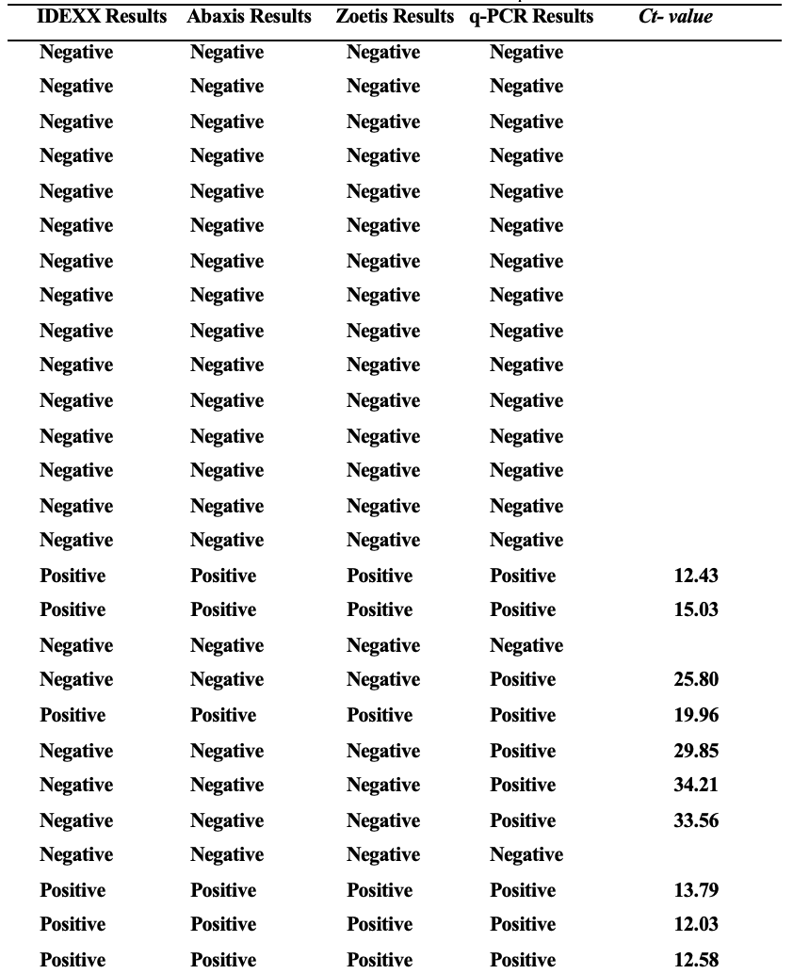
Table 6: Results of Three Different Brands of ELISA tests and q-PCR with Ct Values

Table 6: Results of Three Different Brands of ELISA tests and q-PCR with Ct Values, Continued
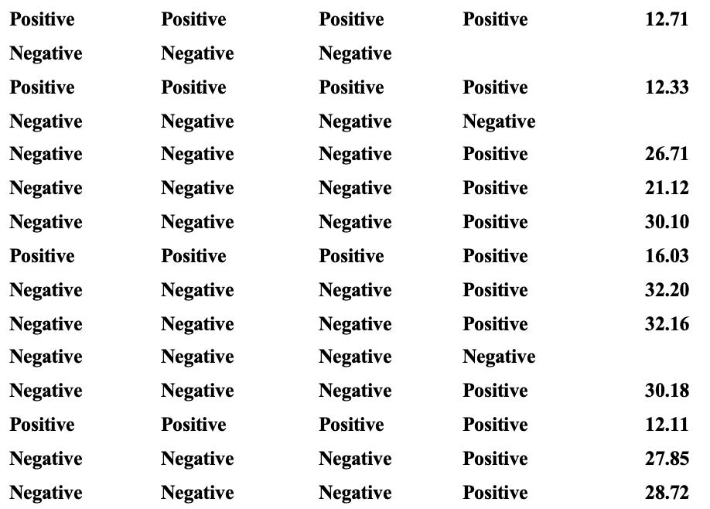

Table 7: Comparing Sensitivity, Specificity, PPV, and NPV for PCR and ELISA tests performed on 42 fecal samples suspected of parvoviral infection.
Testing Method | Sensitivity | Specificity | PPV | NPV
q-PCR | 100 | 100 | 100 | 100
ELISA | 45.4 | 100 | 100 | 62.5

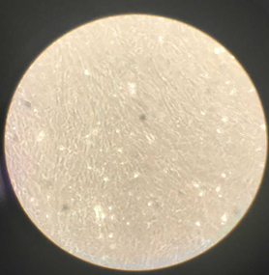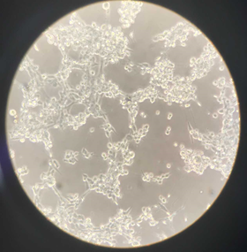
A B
Figure 1. Uninfected (A) and infected (B) CRFK cells under an Inverted Microscope.

Figure 2: Predominant clinical signs in the 42 animals included in the study.

Figure 3: DNA concentration/Ct values standard curve. The qPCR had a linear dynamic range between 10 ⁸ and 10¹copies, with a slope of −2.908, a y-intercept of 35.36, and a mean coefficient linearity (R²) of 0.9937.

Figure 4: ROC curve to illustrate the diagnostic ability of the ELISA rapid
tests used in this study.

Figure 5: q-PCR positive samples plotted on the Ct/DNA concentration standard curve.

                - Vita
Niloofar Khajeh-Kazerooni was born on December 8, 1969 and grew up in one of the oldest and most populous cities of Iran: Shiraz. Shiraz is known as the ancient city of poets, literature, wine, and flowers. She attended high school in the same city and graduated in 1987. She was then accepted to Azad University where she majored in Microbiology with a minor in Biological Science in 1989, receiving her Bachelor of Science in May of 1993.
During her undergraduate studies, she participated in numerous trainings and workshops at Shiraz University Hospital. After receiving her bachelor’s degree, she worked in a diagnostic lab as a technician. In 2003, she immigrated to the United States from Iran, but, due to the regulations of her visa, she was not able to continue her studies. Instead, she volunteered in various locations including libraries and diagnostic labs. Finally, after 10 years, in 2013, she received her Green Card and was able to work in the United States. She was hired at the University of Tennessee College school of Veterinary Medicine (UTCVM), where she previously held a position as a laboratory technician and research aide. She began her work under the title of Laboratory Technologist II and advanced to Research Technician I and finally to her current title of Senior Laboratory Technologist II.
Four years into her career at UTCVM, she was accepted into the Comparative and Experimental Medicine program at the college and began her studies as a master’s student. Niloofar’s research has focused on the diagnostics of canine parvovirus and the evaluation of the ELISA snap test. The work in her thesis further investigates the specificity and sensitivity of the ELISA test, which is used routinely in diagnostic labs, veterinary clinics and animal shelters.

