Spectroscopic Insights into Metal Complexes: Toroidal Properties, Magnetism, and Solvatochromism

A Dissertation Presented for the
Doctor of Philosophy
Degree
The University of Tennessee, Knoxville

Michael Joseph Jenkins
December 2025

Copyright © 2025 by Michael J. Jenkins
All rights reserved.

DEDICATION
To Brooke, for your patience, love, and devotion.

ACKNOWLEDGEMENTS
I would like to acknowledge my advisor, Dr. Zi-Ling (Ben) Xue for his mentorship and guidance through my graduate studies. I would also like to thank my doctoral committee – Drs. Victor Nemykin, Johnathan Brantley, Emily Paskewitz, and David Keffer for their time, support, advice, and assistance.
I would like to thank Drs. Mykhaylo Ozerov, Dimitry Smirnov, Jurek Krzystek, Hans vanTol, and other scientists working with me at the National High Magnetic Field Laboratory for their time and assistance with my research.
I would like to thank my collaborators at Oak Ridge National Laboratory for their time and assistance, including Drs. Yongqiang Cheng, Luke Daemen, Xiaoping Wang, Cheng Li, Thomas Proffen, Christina Hoffman, Huibo Cao, and Madalynn Marshall who is now on faculty at Kennesaw State University in Georgia.
I had the opportunity to work with Dr. Jie Xing and Professor Rongying Jin in the Department of Physics and Astronomy, University of South Carolina at Columbia. I appreciate the opportunity to collaborate with them and use their magnetometers.
I would like to acknowledge and thank the facilities of the National High Magnetic Field Laboratory and Oak Ridge National Laboratory for allowing me to use their unique instruments.
I would also like to thank the members of the Xue research group who have helped me through my graduate studies, including Alex Bone, Pagnareach Tin, Adam Hand, Adiat Fakolujo, and Brandon Sanders.
Lastly, I would like to acknowledge and thank my friends and family who have supported me throughout my time as a student and researcher. Especially my wife, Brooke, and my parents.

ABSTRACT
Compounds exhibiting quantum magnetic properties are of current interest for their potential use in quantum computing or spintronics. These magnetic properties, and the relaxation of magnetic excitations, are not fully understood and need further exploration for more widespread use in quantum information science applications. To further understand the magnetic relaxation and magnetic structure of these materials, they have been studied using advanced techniques such as magneto-couple spectroscopy and neutron scattering. The primary focus of this dissertation is the study of the magnetic structure, relaxation, and synthesis of molecular magnetic compounds such as single-molecule magnets (SMMs), a single-molecule toroic (SMT), and spin-1 Haldane topological chains. These are studied using a combination of routine and advanced techniques, such as inelastic neutron scattering, far-IR magneto spectroscopy, high-field and -frequency electron spin resonance, or polarized neutron diffraction to directly observe magnetic transitions or the magnetic structure. From these studies one can directly observe zero-field splitting parameters for the Co(II) complex Co-MST-H₂O ([Co(MST)(H₂O)][NEt₄]; MST³⁻ = N,N′,N″-[2,2′,2″-nitrilotris(ethane-2,1-diyl)]tris(2,4,6-trimethylbenzenesulfonamido), H₂O = water, NEt₄⁺ = tetraethylammonium) and phonon features of both Co-MST-H₂O and its Ni(II) analog Ni-MST-H₂O in Chapter 2. Using a combination of neutron diffraction techniques and magnetometry we have observed the atomic-scale spin configuration of Dy(III) ions in an SMT candidate in Chapter 3, which is a first for SMT compounds. Chapter 4 shows that through the use of multiple advanced techniques, we characterized two Ni(II)-based MOFs as spin-1 Haldane topological materials.
Chapter 5 is dedicated to synthesis and solvatochromism in Cu(II) compounds and the conversion of Cu(II) salts into CuO. This study was completed to teach the future generations of chemists of multiple chemical theories and features, including the use of mechanochemistry, green chemistry, solvatochromic effects, solvent effects on synthesis, sol-gel reactions, and characterization of solid-state materials.
TABLE OF CONTENTS
Chapter 1: Introduction 1
1.1. Molecular magnetic systems 1
1.1.1 Single-molecule magnets 1
1.1.2. Single-molecule toroics 7
1.1.3. Haldane topological materials 8
1.2. Experimental methods 11
1.2.1. DC magnetometry 11
1.2.2. Inelastic neutron scattering 12
1.2.3. Far-IR magneto-spectroscopy 14
1.2.4. High-field and -frequency electron paramagnetic resonance 15
1.2.7. Polarized neutron diffraction 16
1.2.8. Powder neutron diffraction 17
1.3. Current dissertation 18
1.3.1. Chapter 2 18
1.3.2. Chapter 3 19
1.3.3. Chapter 4 19
1.3.4. Chapter 5 20
Chapter 2: Probing magnetic and vibrational properties of trigonal-bipyramidal Co(II) and Ni(II) complexes using advanced spectroscopies 21
2.1. Abstract 22
2.2. Introduction 23
2.3. Results and discussion of [NMe₄][Co(MST)(OH₂)] (Co-MST-H₂O) 30
2.3.1. FIRMS 30
2.3.2. HFEPR 31
2.3.3. INS 35
2.3.4. DFT phonon and spin density calculations 37
2.3.5. Hirshfeld surface analysis 41
2.4. Results and discussion of [NMe₄][Ni(MST)(OH₂)] (Ni-MST-H₂O) 42
2.5. Conclusions 46
2.6. Experimental section 48
2.6.1. Synthesis 48
2.6.2. FIRMS 48
2.6.3. HFEPR 49
2.6.4. INS 49
2.6.5. Phonon and INS calculations 49
2.6.6. Hirshfeld surface analysis 50
Chapter 3: Atomic-scale visualization of the toroidal order in a trimeric Dy(III) compound 51
3.1. Abstract 52
3.2. Introduction 53
3.3. Results and discussion 59
3.3.1. Selection of the compound and its synthesis 59
3.3.2. Magnetic properties 60
3.3.3. Polarized neutron diffraction 64
3.3.4. Variable-magnetic-field single-crystal neutron diffraction 69
3.4. Conclusions 69
3.5. Experimental section 70
3.5.1 Magnetic susceptibility measurements 70
3.5.2. Polarized neutron diffraction (PND) 70
3.5.3. Neutron diffraction under variable-magnetic fields 71
Chapter 4: Ni(II)-based Haldane topological spin-1 chains within 2-dimensional metal-organic frameworks 72
4.1. Abstract 73
4.2. Introduction 74
4.3. Results and discussion 78
4.3.1 Synthesis 78
4.3.2. Variable-temperature powder neutron diffraction 79
4.3.3. DC magnetic susceptibility 81
4.3.4. High-field electron spin resonance 86
4.3.5. Inelastic neutron scattering 88
4.3.6. Phonon characteristics from INS and far-IR magneto-spectroscopy (FIRMS) 88
4.4. Conclusions 91
4.5. Experimental section 91
4.5.1. Synthesis 91
4.5.2. Magnetometry 92
4.5.3. Inelastic neutron scattering 93
4.5.4. Powder neutron diffraction 93
4.5.6. High-frequency electron spin resonance 93
Chapter 5: Solvatochromism of cupric chloride and its conversion to copper oxide 94
5.1. Abstract 95
5.3. Experimental section 95
5.3.1. UV-visible spectroscopic characterization of CuCl₂·2H₂O in acetone, isopropanol, and water 96
5.3.2. Formation of CuO in acetone, isopropanol, and water and from the solid-state reaction 96
5.4. Results and discussion 97
5.4.1. Visible spectra of CuCl₂·2H₂O in different solvents 97
5.4.2. Formation and characterization of CuO from solution and solid-state reactions 103
5.5. Assessment outcome 109
5.6. Conclusion 110
Chapter 6: Concluding remarks and recommendations 112
References 118
Appendix 171
Addenda for Chapter 2 171
A2.1. Additional results for Co-MST-H₂O 171
A2.1.1. PXRD of Co-MST-H₂O 171
A2.1.2. Additional FIRMS results 171
A2.1.3. Additional HFEPR results 171
A2.1.4. Additional INS results 171
A2.2. DFT calculations for Co-MST-H₂O 171
A2.2.1. Calculated phonons with symmetry 171
A2.2.2 Spin density calculations 200
A2.2.3. Additional Hirshfeld surface results 200
A2.3. Additional results for Ni-MST-H₂O 200
A2.3.1. PXRD of Ni-MST-H₂O 200
A2.3.2. Additional FIRMS results 200
A2.3.3. Additional INS results 200
A2.3.4. Additional Hirshfeld surface results 200
A2.4. Spin densities in [Co(12-crown-4)₂](I₃)₂ and Co(AsPh₃)₂I₂ 212
A2.4.1 Spin densities in [Co(12-crown-4)₂](I₃)₂ 212
A2.4.2. Spin densities in Co(AsPh₃)₂I₂ 217
Addenda for Chapter 3 221
A3.1. Experimental section 221
A3.1.1. Synthesis of n-(2′-pyridinyl)acetoacetamide (paaH) (2) 221
A3.1.2. 221
A3.2. Physical measurements 225
A3.2.1. X-ray crystallography 225
A3.2.3. Magnetic susceptibility measurements 231
A3.2.4. Polarized neutron diffraction (PND) 233
A3.2.5. Neutron diffraction under variable-magnetic fields 233
Addenda for Chapter 4 234
A.4.1. Synthesis 234
A4.1.1. Crystal growth trials 234
A4.1.2. Deuteration reactions 234
A4.2. Physical measurements 239
A4.2.1. Variable temperature powder neutron diffraction 239
A.4.2.2. DC magnetic susceptibility 241
A.4.2.2. Specific heat measurements 241
Addenda for Chapter 5 243
Vita 253

LIST OF TABLES
Table 2.1. List of calculated phonons near the magnetic transition in Co-MST-H₂O and their symmetries from VASP calculations. 38
Table 2.2. Correlation between calculated spin densities on the Co²⁺ ions and ZFS parameters of the complexes/coordination polymer (CP). 40
Table 2.3. Hirshfeld surface coverage based on interactions of atoms on the M-MST⁻ anion with all nearby atoms of neighboring molecules and Me₄N⁺ cation. Most of the interactions are from H atoms of the M-MST⁻ anion with surrounding atoms. 44
Table A2.1. Calculated phonons from VASP calculations for Co-MST-H₂O with symmetry 182
Table A2.2. Spin densities of atoms from VASP calculations for Co-MST-H₂O. There is a second identical molecule in the lattice, and its spin density is not listed. 202
Table A2.3. Spin densities of atoms from VASP calculations for [Co(12-crown-4)₂](I₃)₂. There is a second identical molecule in the lattice, and its spin density is not listed. 214
Table A2.4. Summary of spin densities for [Co(12-crown-4)₂](I₃)₂ 216
Table A2.5. Spin densities of atoms from VASP calculations for Co(AsPh₃)₂I₂. There are three other identical molecules in the lattice and their spin densities are not listed. 218
Table A2.6. Summary of spin densities for Co(AsPh₃)₂I₂ 220
Table A3.1. Crystallographic details for Dy₃-1 (previously reported by Langley et al.^{261, 276}) and Dy₃-2 226
Table A3.2. Continuous shape measurements (CShM) for Dy₃-2 and Dy₃-1. Values closer to zero show a better fit to the symmetry described. 228
Table A5.1. Images of the reactions at different stages in the formation of CuO in three solutions 243
Table A5.2. List of solutions, their relative polarities,^{a, 339, 385} and the near-IR absorptions 249

LIST OF FIGURES
Figure 1.1. Double-well diagram showing the magnetic barrier (U) for a transition metal-based SMM with S = 3/2 and D < 0. If D > 0 the M_{s} = ±1/2 states are minimized. U is the barrier to magnetic reversal, with U_{eff} being the empirical equivalent of U when all relaxation mechanisms are considered. Dashed arrows indicate a simplified ideal pathway for magnetic relaxation. 2
Figure 1.2. A schematic representation of the possible magnetic relaxation mechanisms in SMMs. Black lines indicate spin states. Color code of pathways: black = direct pathway, red = thermally assisted quantum tunnelling of magnetization (QTM), green = ground state QTM, orange = Raman relaxation, blue = Orbach relaxation. 3
Figure 1.3. (a) Depiction of the ligand field splitting for a 5-coordinate, high-spin Co²⁺ complex with local C_{3v} symmetry. (b) Ground-state spin levels of a high-spin d⁷ complex with C₃ or higher local symmetry of the metal site. When the symmetry is lower than C₃, E ≠ 0 and there is a mixing of spin states, giving φ₁, φ_{2,} φ_{3,} and φ₄. The mixing coefficients a = cosβ and b = sinβ are described by the mixing angle β obtained from the spin-Hamiltonian (S = 3/2). Mixing depends on the rhombicity as tan2β = √3(E/D). 5
Figure. 1.4. (a) Schematic showing the Zeeman effect on magnetic excitations and the energy change (E) of the spin-phonon coupling with the external magnetic field B (B = magnitude of B). (b) Schematic view of spin–phonon coupling. φ_{magnetic} and φ_{phonon} represent eigenfunctions of the magnetic state and phonon, respectively. Ψ₊ and Ψ₋ are eigenfunctions of the two spin-phonon coupled states. 7
Figure 1.5. Planar spin alignment of coupled Dy³⁺ ions within an SMT. 9
Figure 1.6. Energy diagram of a Haldane spin-1 chain system with the Zeeman effect on the magnetic states. Adapted from P. Tin, M. J. Jenkins et al.⁵⁶ 10
Figure 1.7. Scheme showing the differences between a Haldane topological chain and an antiferromagnetic material. Adapted from P. Tin, M. J. Jenkins et al.⁵⁶ 10
Figure 1.8. Schematic of the INS experiment. k_{i} = incident neutron momentum; k_{f} outgoing (final) neutron momentum; Q = k_{i} – k_{f} = vector of momentum transfer; Q = length of Q. 13
Figure 2.1. (a) Ligand field splitting diagram for a 5-coordinate, high-spin Co²⁺ complex in crystallographic C_{3v} or D_{3h} symmetry through the metal ion. (b) Ground-state quartet spin levels in high-spin, d⁷ complexes with at least C₃ crystallographic point group symmetry of the metal site (D > 0; E = 0) and lower symmetry (D > 0; E ≠ 0). When the symmetry is lower then C₃, E ≠ 0 and there is a mixing of states to give φ_{1,} φ_{2,} φ_{3,} and φ₄. The mixing coefficients a = cos β and b = sin β are described by the mixing angle β obtained from the spin-Hamiltonian (S = 3/2).^{33, 118} Mixing depends on the rhombicity as tan 2β = √3 (E/D). (c) Ligand field splitting diagram for a high-spin Ni²⁺ complex in C_{3v} geometry with the Jahn-Teller distortion.^{81, 119} (d) Ground-state quartet spin levels in high-spin, d⁸ complexes with at least C₃ crystallographic point group symmetry of the metal site (D < 0; E = 0 before the Jahn-Teller distortion) and lower symmetry (D < 0; E ≠ 0) after the Jahn-Teller distortion. 26
Figure 2.2. Structures of the anions in Co-MST-H₂O and Ni-MST-H₂O. Both show local C_{3v} symmetry. The crystallographic point groups of Co-MST-H₂O and Ni-MST-H₂O are C_{i} (for triclinic space group P1̅, No. 2) and C_{2h} (for monoclinic space group C2/c, No. 15), respectively. 28
Figure 2.3. FIRMS of a powder sample of Co-MST-H₂O. (a) Spectra at 5 K and 0 and 17 T. (b) Contour plot of the normalized (by average) transmission, showing blue shifting of the magnetic peak at 50.6(6) cm⁻¹. The red arrows point to the magnetic transitions. The black arrow points to a shot noise in the spectra. There is no clear spin-phonon coupling or avoided crossings. (c) Turning points for the magnetic peak at 50.6(6) cm⁻¹ as solid lines simulated by EasySpin in the powder spectra using g-values from HFEPR. (d) Turning points for the weak magnetic peak of Co-MST at 65(1) cm⁻¹ as solid lines simulated by EasySpin in the powder spectra using g-values from HFEPR. Additional FIRMS results of Co-MST-H₂O are given in Figure A2.2. 32
Figure 2.4. (a) HFEPR spectrum of Co-MST-H₂O embedded in an n-eicosane pellet at 10 K and 203 GHz (black trace) accompanied by a powder simulation (red trace) using spin-Hamiltonian parameters: D = 25.3 cm^{–1}, E = 0, g⊥ = 2.230, g|| = 2.045. (b) HFEPR spectrum of the same sample at 40 K (black trace) accompanied by simulations. For species A (red trace), the simulation parameters are the same as at 10 K; for species B (blue trace), the parameters are: D = 32.5 cm^{–1}, E = 0, g⊥ = 2.23, g|| = 2.33. dΧ″ / dH is the first derivative of the absorption Χ″ vs the external magnetic field H. 34
Figure 2.5. (a) Bose-corrected INS spectra of Co-MST-H₂O at 20-80 cm⁻¹. Forward-scattering spectra are given in Figure A2.6. (b) INS spectrum at 5 K in comparison to the calculated INS spectrum in the 5-1500 cm⁻¹ range. 36
Figure 2.6. (a) Hirshfeld surfaces of the Co-MST-H₂O⁻ ion showing surface interactions as heat maps. Red zones indicate strong interactions with closer distances between d_{e} and d_{i} atoms, while blue zones are indicative of larger distances and less strong interactions. (b) Representations of the closest and more intense interactions of the Co-MST-H₂O⁻ Hirschfeld surface, showing that lattice H₂O forms hydrogen bonds with the O atoms in the MST³⁻ ligand. The H atoms of lattice CH₂Cl₂ also interact strongly with O atoms of ligand. The CH₂Cl₂ molecule is disordered. 43
Figure 2.7. (a) Bose-corrected INS spectra of Ni-MST-H₂O at 100-500 cm⁻¹. There are no strong magnetic features in this region. (b) INS spectra showing calculated and experimental phonons at 5–1500 cm⁻¹ of Ni-MST-H₂O. Additional regions of the experimental and calculated INS are given in Figures A2.16-A2.18. 45
Figure 2.8. (a) Hirshfeld surfaces of the Ni-MST-H₂O⁻ anion showing surface interactions as heat maps. Red zones indicate strong interactions with closer distances between d_{e} and d_{i} atoms, while blue zones are indicative of larger distances and less strong interactions. (b) Representations of the closest and more intense interactions of the Ni-MST-H₂O⁻ Hirschfeld surface, showing that H₂O solvent molecule and the Me₄N⁺ cation form hydrogen bonds with the O atoms in the MST³⁻ ligand. The ethyl ether (Et₂O) solvent molecule, in contrast, does not show strong interactions with the Ni-MST-H₂O⁻ anion. The Me₄N⁺ cation is disordered. 47
Figure 3.1. Planar spin alignment of coupled Dy³⁺ ions within an SMT. 56
Figure 3.2. Crystallographic unit cell of Dy₃-2 containing four molecules. Solvent molecules and H atoms are omitted for clarity. Dy³⁺ trimers show opposing stacking within the unit cell. 61
Figure 3.3. Depiction of single-crystal orientation vs external field H for magnetic measurements. 63
Figure 3.4: Magnetic susceptibility data for Dy₃-2 showing the powder and single-crystal sample. (a) χT vs T; (b) Variable-temperature M vs H of Dy₃-2⊥ (M and H are lengths of magnetization M and external field H); (c) 1/χ vs T; (d) χ vs T. 63
Figure 3.5. Magnetization vs field collected at 1.9 K: (a) Dy₃-2_{poly}; (b) Dy₃-2||; (c) Dy₃-2⊥. 65
Figure 3.6. (a) Flipping ratios for Dy₃-2. (b) The refined susceptibility tensor for Dy₃-2 in the crystallographic unit cell. The head-to-tail spin arrangement is observed in the ab plane, while the toroidal moment would be pointed along the c axis. 67
Figure 3.7. Simulation of magnetization based on one Dy³⁺ ion within the Dy₃-2 compound based on PND refinement of the susceptibility tensor. 68
Figure 3.8. (a) Field-dependent order parameter with data collected at 5.0 K with 0.1 T/step. (b) Temperature-dependent order parameters for the magnetic form factor of Dy₃-2 at 4.0 T. Field induced magnetic order emerges at 0.2 T. Magnetic order appears at ~10 K with an applied magnetic field of 4.0 T. 68
Figure 4.1. Energy diagram of the Haldane phase, showing perturbations of anisotropy leading to ZFS and the effects of magnetic field on Zeeman splitting. Adapted from P. Tin, M. J. Jenkins et. al.⁵⁶ 75
Figure 4.2. a) Scheme of the AKLT model representation of the spin-1 Haldane chain showing the coupling between two electrons of two neighboring Ni(II) ions within the chain, leaving one unpaired electron at each end of the chain. Green circles show individual Ni²⁺ ions, coupling is shown in the gray oval, quantum coupled electrons are shown as red and blue arrows, and unpaired electrons are shown in orange arrows at the end of the chain. b) Scheme showing typical antiferromagnetic structure in NiO below the Neel temperature. O²⁻ ions are shown as gray circles. Antiferromagnetic coupling gives a magnetic structure at twice the d-spacing of the crystal unit cell. Adapted from P. Tin, M. J. Jenkins et al.⁵⁶ 75
Figure 4.3. a) Simplified structure of NiBaO and b) NiBeO, showing a small portion of the polymeric 2-D MOF structure. 77
Figure 4.4. Patterns of powder neutron diffraction for NiBaO at 1.8 and 200 K. 80
Figure 4.5. Patterns of powder neutron diffraction for NiBeO at 10 and 200 K. 80
Figure 4.6. DC magnetic susceptibility of NiBaO showing χ vs T (red) and χT vs T (blue) plots at 1.8-300 K. The inserted figure is a focus on the low temperature region (1.8–25 K) of the χ vs T plot. 82
Figure 4.7. DC magnetic susceptibility of NiBeO showing χ vs T (red) and χT vs T (blue) plots at 0.8-300 K. The inserted figure is a focus on the low temperature region (1.8–25 K) of the χ vs T plot. 82
Figure 4.8. a) Plot of ln[χ(T) - χ(0)] vs 1/T for data between 20 K and 4 K for NiBaO and b) NiBeO. The red line shows the fit used for extracting the spin gap. 83
Figure 4.9. Magnetic isotherm of NiBaO. 85
Figure 4.10. Magnetic isotherm of NiBeO. 85
Figure 4.11. HFESR spectrum of NiBaO and NiBeO at 4.5 K and 498 GHz. Letters A and B indicate resonances originating from the sample. The narrow signals at 8.6 and 15.9 T come from molecular dioxygen. 87
Figure 4.12. A field vs. frequency dependence of HFESR resonances of NiBeO at 4.5 K. Letters A and B indicate resonances originating from the sample shown in Figure 4.11. 87
Figure 4.13. INS data for NiBaO collected at 5, 10, 15, 20, 25, 30, and 35 K. There is a minor peak that may be related to magnetic transitions at 9 cm⁻¹. 89
Figure 4.14. INS Data for NiBeO collected at 5, 7.5, 10, 15, 25, 50, and 100 K. There are no peaks strong enough to claim they are related to magnetic transitions. 89
Figure 4.15. Bose-corrected INS spectra for a) NiBaO and b) NiBeO. Average of the forward- and back-scattering data are used here. The main phonon features are observed below 1700 cm⁻¹, except for a strong peak at ~3200 cm⁻¹. 90
Figure 5.1. Solutions of CuCl₂·2H₂O in three different solvents: (a) Water; (b) Isopropanol; (c) Acetone. 99
Figure 5.2. (a) Visible spectra of CuCl₂·2H₂O in acetone, isopropanol, and water at 380-750 nm; (b) Spectra at 650-1000 nm focusing on the low energy visible and near-IR range. Pure solvents were used as references for the spectra. Full spectra at 300-1100 nm are given in Figure A5.3. 99
Figure 5.3. Plot of near-IR peaks in water, isopropanol, and acetone vs. relative solvent polarities. The relative polarities are normalized from measurements of the transition energy at 25 °C of the long-wavelength visible absorption of a standard pyridinium N-phenolate betaine dye in Ref. 344. 100
Figure 5.4. Representation of solvent effects of polar solutes in polar solvents.^{329, 345} (a) Positive solvatochromism (bathochromic or red shift): Absorption energy decreases, or moves to longer wavelengths, as the solvent polarity increases. (b) Negative solvatochromism (hypsochromic or blue shift): Absorption energy increases, or moves to shorter wavelengths, as the solvent polarity increases. This figure is adapted with permission from Refs. 329, 345. Copyright 1988 John Wiley and Sons. 100
Figure 5.5. Splitting of the five d orbitals in a d⁹ octahedral complex into t_{2g} and e_{g} levels and Jahn-Teller distortion in Cu(H₂O)₆²⁺, giving a tetragonal-elongated structure. 102
Figure 5.6. Schematic depiction of the sol-gel process in the formation of CuO in water. 105
Figure 5.7. IR spectra of CuO products after drying. Individual spectrum is given in the addendum. 106
Figure 5.8. PXRD of CuO products from different processes. Products were dried in a furnace at 200 °C for 1 hour. 108
Figure 6.1. Structure of 1-methylpyrazin-1-ium. 114
Figure A2.1. PXRD patterns at 296 K of Co-MST-H₂O samples for INS and FIRMS/HFEPR compared to the calculated pattern from the reported single-crystal structure at 100 K.¹⁰⁶ 172
Figure A2.2. (a) FIRMS transmission spectra for a Co-MST-H₂O sample placed in the Voigt configuration.³⁷⁸ (b) 2D plot of the normalized (by average) transmission. Figure 2.3 shows the FIRMS transmission spectra for a sample in the Faraday configuration.³⁷⁸ There is a greater field dependence of data collected by Voigt transmission. 173
Figure A2.3. Averaged data of Co-MST-H₂O with all T-value scans, showing phonon features at 10-500 cm⁻¹. 174
Figure A2.4. HFEPR spectrum of an unconstrained (loose) sample of Co-MST-H₂O at 10 K and 203 GHz. The two resonances with different intensities correspond to different spin species A and B, with the lower intensity being that of B. Species A can be identified as compound Co-MST-H₂O, and species B as the dehydrated compound Co-MST. 175
Figure A2.5. Frequency dependence of the EPR resonances observed in the unconstrained (loose) sample of Co-MST-H₂O at 10 K and 203 GHz. The lines correspond to g-values of 2.20 and 2.30 for the high-intensity (A) and low-intensity (B) resonances respectively. 176
Figure A2.6. Forward scattering spectra of Co-MST-H₂O at 20-80 cm⁻¹. There are two temperature-dependent peaks at 28.5 and 40.2 cm⁻¹ that are not in the backward scattering spectra in Figure 2.5. These peaks show both temperature and Q dependence. (Q = k_{i} – k_{f} is the momentum transfer and Q is the magnitude of Q, where k_{i} refers to the momentum of the incoming neutron and k_{f} of the outgoing neutron.)¹⁵² The observations suggest the peaks are magnetic. The sources giving these peaks are not clear. Impurities from degradation of Co-MST-H₂O or starting materials may contribute to these peaks, though they were not observed in PXRD (Figure A2.1). 177
Figure A2.7. INS spectra of Co-MST-H₂O at 5 K in comparison with the calculated phonon spectrum in the low energy (15-80 cm⁻¹) region with both forward- and back-scattering spectra. 178
Figure A2.8. INS spectra of Co-MST-H₂O at 10-5000 cm⁻¹. 179
Figure A2.9. Calculated vs experimental spectra of Co-MST-H₂O at 5-4000 cm⁻¹. Differences between the calculated and 5 K spectra are not sufficient to determine magnetic excitations clearly. 180
Figure A2.10. Waterfall powder neutron diffraction from VISION for Co-MST-H₂O. Lack of changes to peak shape and location indicates a lack of phase change from high to low temperature. 181
Figure A2.11. Structure of Co-MST-H₂O with labels associated with spin density calculations. 201
Figure A2.12. Fingerprint plots for the Co-MST-H₂O⁻ anion showing the interactions of the listed element inside the Hirshfeld surface to all outer atoms. 204
Figure A2.13. PXRD pattern of the Ni-MST-H₂O sample for INS compared to the calculated pattern from reported structure.¹⁰⁶ 205
Figure A2.14. FIRMS and contour plot of spectra of Ni-MST-H₂O with no distinct magnetic peak. 206
Figure A2.15. Averaged spectral data for Ni-MST-H₂O with all T-values showing vibrational features near the expected magnetic transition. There are several strong phonons in this region, which may be coupled to magnetic transitions. 207
Figure A2.16. INS spectra of Ni-MST-H₂O at 10-5000 cm⁻¹. 208
Figure A2.17. Calculated vs experimental spectra of Ni-MST-H₂O at 10-5000 cm⁻¹. 209
Figure A2.18. INS spectra of Ni-MST-H₂O showing calculated and experimental phonons in the 180-240 cm⁻¹ region. A comparison of the calculated INS spectrum with observed INS spectrum in the 180-240 cm⁻¹ region in the figure below does not clearly show the magnetic peak. 210
Figure A2.19. Fingerprint plots for Ni-MST-H₂O⁻ showing the interactions of the listed element inside the Hirshfeld surface to all outer atoms. 211
Figure A2.20. Model for the spin densities of [Co(12-crown-4)₂](I₃)₂. 213
Figure A2.21. Model for the spin densities for Co(AsPh₃)₂I₂. 217
Figure A3.1. Depiction of diethyl ether vapor diffusion setup used for growth of Dy₃-2 crystals. The system is sealed, and the ether vapor slowly mixes with the mother liquor of PhCN/MeOH to precipitate out crystals. Crystals are then removed from the walls of the inner vial for collection. 222
Figure A3.2. Images of the crystal used of PND experiment. a) is the sample before applying grease and measuring; b) the sample weeks after the experiment; c) and d) show the size of the crystal when mounted in the instrument. 223
Figure A3.3. IR spectrum of a crystal of Dy₃-2 at 23 °C. 224
Figure A3.4. Rotational symmetry elements for Dy₃-2. Green lines show 2-fold rotation, while yellow lines show 3-fold rotation. There is a 3-fold rotation through the center of the Dy₃-2 molecule. 227
Figure A3.5. The Dy₃-2 model used for CShM. 230
Figure A3.6. The Dy₃-1 model used for CShM. 230
Figure A3.7. M vs H plots for Dy₃-2_{poly}, Dy₃-2‖, and Dy₃-2⊥. This is data from Figure 3.5 compiled together to show magnetic anisotropy of the single crystal sample orientation. 232
Figure A4.1. Schematic showing locations of H atoms for H/D exchange for a) bpa and b) bpe. 236
Figure A4.2. Mass spectrometry data representative of bpa deuteration. Without any deuterium, bpa should have a main mass peak of 184. Each main mass peak of 1 m/z higher should be correlated to an H-D exchange. The two strongest peaks at 189 and 190 m/z are related to bpa-d₅ and bpa-d₆, respectively. 236
Figure A4.3. Mass spectrometry data representative of bpe deuteration. Without any deuterium, bpe should have a main mass peak of 182. The two strongest peaks at 188 and 189 m/z are related to bpe-d₆ and bpe-d₇, respectively. 236
Figure A4.4. ¹H NMR of bpa standard before deuteration. 237
Figure A4.5. ¹H NMR of bpa after deuteration. 237
Figure A4.6. ¹³C NMR of bpa standard before deuteration 238
Figure A4.7. ¹³C NMR of bpa after deuteration 238
Figure A4.8. Emphasis on low d-spacing for NiBaO. 240
Figure A4.9. Emphasis on low d-spacing for NiBeO. 240
Figure A4.10. Fitting data for the high-temperature region of DC magnetometry. 241
Figure A4.11. Heat capacity results of NiBaO from 1.8 K to 16 K at 0 and 14 T. There is no sharp uptick correlated to a phase change. 241
Figure A4.13. FIRMS spectra for (left) NiBaO and (right) NiBeO. There is no indication of magnetic transition within these spectra. 242
Figure A5.1. Full range of electronic absorption spectra at 300-1100 nm. 248
Figure A5.2. PXRD patterns of the products without washing from reactions conducted in isopropanol, acetone, water, and solid-state. The patterns of CuO and NaCl standards are given for comparison. The solids were heated in a 200 °C furnace for 20 min. 250
Figure A5.3. PXRD of CuO products dried with a heat gun. For the product from water, the solid was dried first, followed by washing. Trace NaCl diffraction peaks are visible in this PXRD pattern. 251
Figure A5.4. IR spectra of the products separated for clarity. 252

LIST OF ABBREVIATIONS
1-D One-dimensional
2-D Two-dimensional
3-D Three-dimensional
AC Alternate current
AF Antiferromagnetic
AKLT Affleck, Kennedy, Lieb, and Tasaki
AO Atomic orbital
CP Coordination polymer
CASSCF Complete-active-space self-consistent field
CIF Crystallographic information file
CShM Continuous shape measure calculations
DC Direct current
DFT Density functional theory
EPR Electron paramagnetic resonance
FIRMS Far-IR magneto-spectroscopy
FT Fourier transform
HFEPR High-frequency and -field EPR
INS Inelastic neutron scattering
IR Infrared
KD Kramers doublet
LFT Ligand-field theory
LMCT Ligand-to-metal charge transfer
Ln Lanthanide
MOF Metal-organic-framework
NMR Nuclear magnetic resonance
NIR Near-IR
PND Polarized neutron diffraction
PXRD Powder X-ray diffraction
QTM Quantum tunnelling of magnetization
Qubit Quantum bit
SCXRD Single-crystal X-ray diffraction
SH Spin-Hamiltonian
SMM Single-molecule magnet
SMT Single-molecule toroics
SOC Spin-orbit coupling
TM Transition metal
TOF time-of-flight
UV Ultraviolet
VASP Vienna ab initio simulation package
VH Variable-field
VISION Vibrational Spectrometer
VT Variable-temperature
ZFS Zero-field split(ting)

LIST OF SYMBOLS
Λ Spin-phonon coupling constant
χ Magnetic susceptibility
B Magnetic field
D Single-ion axial anisotropy parameter
E Transverse or rhombic anisotropy parameter
g g-factor or g-tensor
J Total angular momentum
KD Kramers doublet
k_{f} Momenta of outgoing neutrons
k_{i} Momenta of incoming neutrons
M_{J} Total angular momentum quantum number
m_{l} Magnetic quantum number
M_{s} or m_{s} Electron spin quantum number
Q Momentum transfer
S Spin
U_{eff} Effective energy barrier separating bistable magnetic states
μ_{eff} Effective magnetic moment (in the unit of μ_{B} or Bohr magneton)
LIST OF COMPOUNDS
Co-MST [M(MST)][NEt₄] (MST³⁻ = N,N′,N″-[2,2′,2″-nitrilotris(ethane-2,1- diyl)]tris(2,4,6-trimethylbenzenesulfonamido), NEt₄⁺ = tetraethylammonium)
Co-MST-H₂O [Co(MST)(OH₂)][NEt₄]
Ni-MST-H₂O [Ni(MST)(OH₂)][NEt₄]
Dy₃-1 [Dy₃(OH)(teaH₂)₃(paa)₃]Cl₂·MeCN·4H₂O [teaH₃ = triethanolamine, paaH = N-(2-pyridyl)-acetoacetamide]
Dy₃-2 [Dy₃(O)(teaH₂)₃(paa)₃]Cl·PhCN·4MeOH
NiBaO [Ni(μ−bpa)(μ−ox)] (bpa = 1,2-di(pyridin-4-yl)ethane); ox²⁻ = oxalate]
NiBeO [Ni(μ−bpe)(μ−ox)] (bpe = 1,2-di(pyridin-4-yl)ethene)
NiBO [Ni(μ-4,4′-bpy)(μ-ox)] (bpy = bipyridine)
NENP [Ni(en)₂(μ-NO₂)](ClO₄) (en = ethylenediamine)
NENB [Ni(en)₂(μ-NO₂)](BF₄) (en = ethylenediamine)
NDMAZ Ni(dmpn)₂(μ-N₃)](ClO₄) (dmpn = 1,3-diamino-2,2-dimethylpropane)
NINO [Ni(1,3-propanediamine)₂(μ-NO₂)](ClO₄)

Chapter 1: Introduction

1.1. Molecular magnetic systems
Molecular quantum materials have gained significant research interest due to their promising use in spintronics, high-density data storage, and in quantum computing.¹⁻¹² These materials exhibit unique electronic structures and quantum entanglement of spins that could be used as qubits in quantum information science. Of these materials, this dissertation will discuss single-molecule magnets (SMMs), single-molecule toroics (SMTs), and Haldane topological spin-1 chains.

1.1.1 Single-molecule magnets
Single-molecule magnets (SMMs) are compounds with bi-stable magnetic states (±M_{s}) below a blocking temperature, as shown in Figure 1.1. These materials show a barrier to magnetization reversal (+M_{s} to -M_{s}), commonly denoted as U_{eff}, leading to long magnetic relaxations in the absence of a magnetic field.¹³⁻¹⁶ For this relaxation to take place, there must be a mechanism that allows for either crossing over this barrier or tunneling through the barrier. These relaxation mechanisms are given in Figure 1.2., showing that there are multiple mechanisms or a combination of mechanisms that might lead to this relaxation.
To examine these mechanisms as well as what leads to the size of the barrier, we can look at Eqs. 1.1 and 1.2 that determine U_{eff},
$U_{eff}=(S^{2}-\frac{1}{4})\left|D\right|$ (Eq 1.1.)
for complexes with integer spins, or
$U_{eff}=S^{2}\left|D\right|$ (Eq 1.2.)

U
M_{s} = +3/2
M_{s} = -3/2
M_{s} = -1/2
M_{s} = +1/2
Figure 1.1. Double-well diagram showing the magnetic barrier (U) for a transition metal-based SMM with S = 3/2 and D < 0. If D > 0 the M_{s} = ±1/2 states are minimized. U is the barrier to magnetic reversal, with U_{eff} being the empirical equivalent of U when all relaxation mechanisms are considered. Dashed arrows indicate a simplified ideal pathway for magnetic relaxation.

Figure 1.2. A schematic representation of the possible magnetic relaxation mechanisms in SMMs. Black lines indicate spin states. Color code of pathways: black = direct pathway, red = thermally assisted quantum tunnelling of magnetization (QTM), green = ground state QTM, orange = Raman relaxation, blue = Orbach relaxation.

for complexes with half-integer spins, where S is the spin of the ions within the complex and D is the axial anisotropy of the ion.¹⁷⁻¹⁹
We either increase the anisotropy of the metal ion or S to enlarge U_{eff} for a complex. This can be demonstrated comparing the first reported SMM [Mn₁₂O₁₂(AcO)₁₆(H₂O)₄]·2AcOH (AcO⁻ = CH₃COO⁻), which is now commonly referred to as Mn₁₂,¹⁵ with [TBA][Pc₂Ln] (Pc²⁻ = phthalocyanine dianion; Ln³⁺ = Tb³⁺, Dy³⁺; TBA⁺ = tetrabutylammonium), a lanthanide-based single-ion SMM. [TBA][Pc₂Ln] shows a much larger barrier based on the high spin of a single Ln³⁺ ion combined with a high level of anisotropy.²⁰ Mn₁₂ has U_{eff} of approximately 45 cm⁻¹ with S = 10, while the U_{eff} of [TBA][Pc₂Tb] is 230 cm⁻¹ with much smaller S = 3.^{15, 20}
When examining the magnetic anisotropy of a metal ion, there are multiple effects to consider. These include the difference in spin states due to crystal field interactions, spin-orbit coupling (SOC) interactions, and the effects leading to zero-field splitting (ZFS).^{21, 22} There are two types of SOC: (1) Angular momentum of the ground state is unquenched, leading to first-order SOC. Here, the electron’s magnetic dipole interacts with the electrostatic field of the nucleus, thus shifting its orbital motion. (2) Angular momentum is quenched. That is, the orbital motions of the unpaired electrons are quenched, and the ground state of the electronic structure mixes with low-energy excited electronic states, giving SOC properties to the ground state.²³⁻³⁰ As a result, the ground state splits inside non-cubic ligand fields, leading to ZFS. Crystal-field split states are shown as ^{2S+1}L from Russell-Sauders coupling, as seen in Figure 1.3(b). These degenerate ^{2S+1}L spin states, in compounds with S > 1/2 and quenched orbital angular momenta, are split by second-order SOC. This splitting is defined as ZFS, which defines magnetic levels according to the spin-Hamiltonian in Eq. 1.3:
${\hat{H}}_{S}=D\left[{{\hat{S}}_{z}}^{2}-\frac{1}{3}S(S+1)\right]+E\left[{{\hat{S}}_{x}}^{2}-{{\hat{S}}_{y}}^{2}\right]+ m_{B}{(g_{x}B}_{x}{\hat{S}}_{x}+{g_{y}B}_{y}{\hat{S}}_{y}+{g_{z}B}_{z}{\hat{S}}_{z})$ (Eq. 1.3)

Figure 1.3. (a) Depiction of the ligand field splitting for a 5-coordinate, high-spin Co²⁺ complex with local C_{3v} symmetry. (b) Ground-state spin levels of a high-spin d⁷ complex with C₃ or higher local symmetry of the metal site. When the symmetry is lower than C₃, E ≠ 0 and there is a mixing of spin states, giving φ₁, φ_{2,} φ_{3,} and φ₄. The mixing coefficients a = cosβ and b = sinβ are described by the mixing angle β obtained from the spin-Hamiltonian (S = 3/2). Mixing depends on the rhombicity as tan2β = √3(E/D).

where ${\hat{S}}_{i}$ = components of the spin operator $\hat{S}$ in the x, y and z directions; D and E = axial and rhombic ZFS parameters, respectively; μ_{B} = electron Bohr magneton; $g_{i}$ = components of the g-factor in the x, y and z directions; B = external magnetic field.³¹⁻³³ Inclusion of a C₃ axis, making x,y axes degenerate, lowers, or even eliminates rhombic anisotropy E. Reducing rhombic anisotropy is key for increasing quantum coherence times as it limits unwanted relaxation pathways such as quantum tunneling.
One can then see that there is an inherent correlation between the structure of an SMM compound, the anisotropy dictated by structure, and the U_{eff} of this compound. Due to the correlation, we have sought to study the impact of structure on magnetic relaxation using a combination of routine and advanced techniques. One of the most important forms of relaxation to study is the direct path or vibrationally coupled relaxation through phonons. In molecular solids, phonons refer to both internal and external vibrations, also described as intramolecular and intermolecular vibrations. Internal vibrations show large distortion of the molecule, while external vibrations have little molecular distortions but larger lattice vibrations and interactions. Lattice vibrations are typically much lower in energy than molecular distortions and are a primary driver of spin-reversal relaxations. In the current work, the term phonons will be used for both intramolecular and intermolecular vibrations. During molecular magnetic relaxation,
there is the possibility that these vibrations mix with the magnetic relaxation of the molecule, leading to spin-phonon couplings. Spin-phonon coupling may be observed in far-IR magneto-spectroscopy (FIRMS) in the form of an avoided crossing, as shown in Figure 1.4. Spin–phonon coupling occurs when the magnetic excited state φ_{magnetic} and phonon excited state φ_{phonon} have the same symmetry. When close enough in energy, these states interact to form two new, spin-phonon coupled states, one (Ψ₊) with higher energy and one (Ψ₋) with lower energy than the

Figure. 1.4. (a) Schematic showing the Zeeman effect on magnetic excitations and the energy change (E) of the spin-phonon coupling with the external magnetic field B (B = magnitude of B). (b) Schematic view of spin–phonon coupling. φ_{magnetic} and φ_{phonon} represent eigenfunctions of the magnetic state and phonon, respectively. Ψ₊ and Ψ₋ are eigenfunctions of the two spin-phonon coupled states.
energies of φ_{magnetic} and φ_{phonon} states. These new states carry both magnetic and phonon features and are shifted by the Zeeman effect. This is shown through blue shifting of magnetic peaks that have repeated avoided crossings within the transition. A simple scheme is given in Figure 1.4. To determine the extent of spin-phonon couplings leading to magnetic relaxation, several spectroscopic methods may be used, including far-IR, Raman, and inelastic neutron scattering (INS). The current studies seek to probe spin-phonon couplings in SMMs.

1.1.2. Single-molecule toroics
A recent development in molecular quantum materials science has been SMT compounds. These compounds are bi-stable molecules with toroidal magnetic state, defined by a vortex arrangement of magnetic moments in a ferrotoroidic material. These vortex spin arrangements are formed by atomic magnetic moments coupling together within a metal cluster, showing geometric spin frustration that, at low temperatures, form a ferrotoroidic or vortex arrangement of spins as shown in Figure 1.5.^{34, 35} These materials show promises of slow magnetic relaxation and relatively large magnetic dipoles in comparison to other qubit candidates.^{4, 10, 36} While the family of these materials continue to grow, there has been strong interest to understand their physical and chemical properties or the driving force for the toroidal molecular moment alignment. The first SMT was reported in 2006 by Tang et al. and theoretically proven to be an SMT in 2008 by the work of Chibotaru et al.^{34, 35} Since this development, there have been many SMTs synthesized and characterized, but there have been few if any studies to directly show the toroidal moment in SMTs.³⁷⁻⁴⁶ This dissertation will address the lack of direct observation of the toroidal spin arrangement.

1.1.3. Haldane topological materials
In 1983, Haldane suggested that antiferromagnetic (AF) Heisenberg chains with integer spin exhibit a disordered ground state along with a finite energy gap, whereas chains with half-integer spins are gapless.⁴⁷⁻⁵¹ This conclusion was based on effective-field theory and topological principles. Figure 1.6 illustrates the energy structure of a Haldane spin-1 chain system, incorporating the effects of anisotropy (zero-field splitting or ZFS) and the Zeeman effect. The topological Haldane phase in the AF spin-1 chain is considered a key example of symmetry-protected topological states. Building on Haldane's work, Affleck, Kennedy, Lieb, and Tasaki (AKLT) developed an extended spin-1 Hamiltonian that describes the ground state of the Haldane phase, which includes one unpaired electron (S = 1/2) at each end of the chain, as depicted in Figure 1.7. The two electrons at the chain's ends can form singlet or triplet states, which are the edge states of the system.^{49, 50, 52-55} The topological Haldane phase is distinguished

Figure 1.5. Planar spin alignment of coupled Dy³⁺ ions within an SMT.

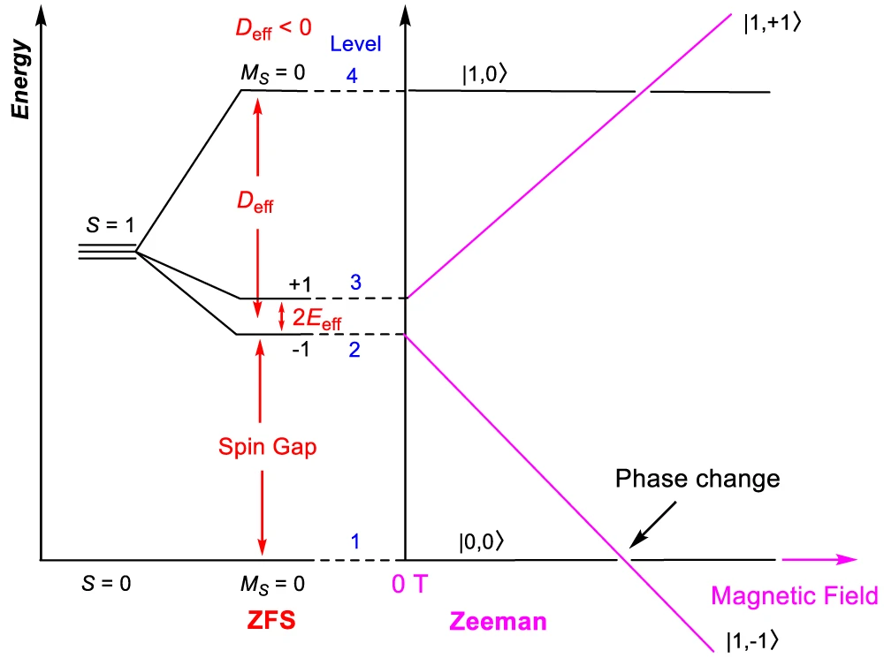
Figure 1.6. Energy diagram of a Haldane spin-1 chain system with the Zeeman effect on the magnetic states. Adapted from P. Tin, M. J. Jenkins et al.⁵⁶

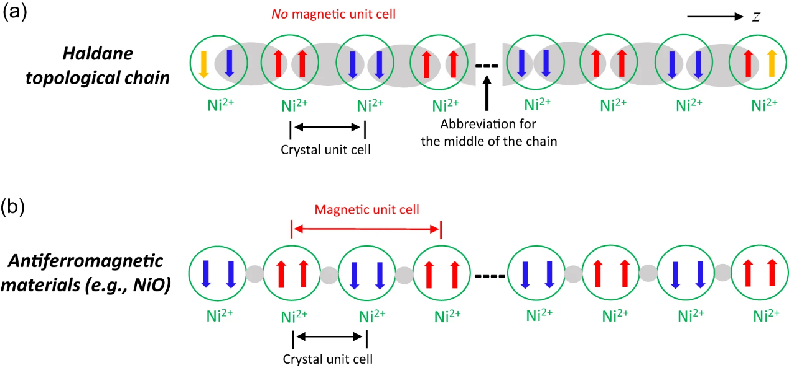
Figure 1.7. Scheme showing the differences between a Haldane topological chain and an antiferromagnetic material. Adapted from P. Tin, M. J. Jenkins et al.⁵⁶

by its finite energy gap, which is protected by symmetry. As long as the symmetries are maintained, the Haldane phase remains stable and resilient to external disturbances. In contrast to typical antiferromagnetic materials, such as NiO, which exhibit long-range magnetic ordering, Haldane materials do not show such a behavior as the comparison in Figure 1.7 shows. In NiO, a
magnetic unit cell forms in addition to the crystal unit cell, leading to Bragg reflections from both the magnetic and nuclear diffraction of the crystal's unit cell.⁵⁷

1.2. Experimental methods
Overviews of the experimental methods used in this dissertation are provided below with references for in-depth discussion.

1.2.1. DC magnetometry
One of the most widely used techniques to study magnetic materials is magnetometry, often implemented through a device known as the Superconducting QUantum Interference Device (SQUID). SQUID functions by exploiting the principles of flux quantization and Josephson tunneling. They consist of a superconducting loop interrupted by a Josephson junction, which permits the tunneling of Cooper pairs. This setup makes SQUIDs extremely sensitive to magnetic flux, effectively serving as flux-to-voltage transducers.
Direct current (DC) magnetization measurements are commonly carried out across a range of temperatures. As temperature decreases, higher-energy spin states become depopulated, providing insight into the energy separations between spin levels. A standard approach in such studies is to report the temperature-dependent magnetic susceptibility (χ) or the product χT. Plotting χT versus temperature (T) reveals deviations from ideal paramagnetic behavior, especially in systems of non-interacting spins. According to Curie’s law, this relationship is described by:
$χT=\frac{Ng^{2}μ_{B}^{2}}{3k_{B}}S(S+1)$ (Eq. 1.4)
where N is Avogadro’s number, g is the g-factor (or g-tensor), μB is the Bohr magneton, and kB is the Boltzmann constant.⁵⁸

1.2.2. Inelastic neutron scattering
In inelastic neutron scattering (INS), incident neutrons interact with a sample in such a way that energy is exchanged between the neutrons and excitations within the material. This interaction results in a change in both the energy and direction of the scattered neutrons, as shown in Figure 1.8. Energy transfer provides direct insight into the dynamic properties of the system, such as phonon modes or magnetic excitations. INS is a powerful technique for probing magnetic excitations in a material, owing to the interaction between the magnetic moment of the incident neutrons and the unpaired electron spins in the sample. This spin–spin interaction can induce transitions between discrete magnetic energy levels, resulting in a loss of energy by the scattered neutrons corresponding to the energy gap between these levels. In addition to magnetic excitations, INS can also couple to lattice vibrations through interactions with atomic nuclei, thereby providing access to the phonon spectrum. Neutrons exhibit high penetration depth, due to their lack of electric charge. One benefit of using INS is the lack of symmetry-based selection rules for vibrations, which govern Raman and IR spectroscopies. Thus, INS makes all phonon transitions observable. In addition, high-level density functional theory (DFT) phonon calculations can give calculated INS spectra and phonon modes to compare with the experimental spectra. “Subtracting” the calculated INS from the observed INS would leave just the magnetic transitions in the INS spectra.

Figure 1.8. Schematic of the INS experiment. k_{i} = incident neutron momentum; k_{f} outgoing (final) neutron momentum; Q = k_{i} – k_{f} = vector of momentum transfer; Q = length of Q.

1.2.3. Far-IR magneto-spectroscopy
Far-infrared magneto-spectroscopy (FIRMS) is a powerful technique for probing magnetic transitions and spin–phonon coupling in molecular materials, particularly SMMs. FIRMS involves far-IR spectroscopy typically performed in the 12–720 cm⁻¹ range under variable magnetic fields, a range well-matched to the energies of many magnetic excitations in metal complexes. Because numerous infrared-active phonons appear in this region and are largely field-independent, applying variable magnetic fields enables clear identification of magnetic transitions as features that shift in response to the magnetic field, distinguishing them from phonon modes. The experimental setup is similar to conventional IR spectroscopy, with the key difference being that the sample is placed within a magnet. Spectra are first collected at zero field, followed by measurements at increasing fields to track the evolution of spectral features. Magnetic transitions in FIRMS arise from magnetic dipole–allowed processes, governed by transition moment operators with the symmetry of rotational operations (R_{x}, R_{y}, R_{z}) as defined in molecular point group character tables. FIRMS serves two primary roles: (1) direct observation and quantification of magnetic transitions, commonly used to extract ZFS parameters such as 2D′ = 2(D² + 3E²)^{1/2} for S = 3/2 complexes; (2) identification and analysis of spin–phonon coupling. Notably, FIRMS can resolve ZFS transitions beyond the frequency limits of traditional electron paramagnetic resonance (EPR), making it a valuable tool for characterizing relaxation dynamics and magnetic anisotropy in systems where EPR is insufficient. The technique has become increasingly important in the study of SMMs, enabling precise determination of magnetic energy levels and offering insight into potential relaxation pathways driven by spin–lattice interactions.

1.2.4. High-field and -frequency electron paramagnetic resonance
EPR is a technique well established for probing the electronic structure of metal complexes and investigating magnetic properties, particularly transitions between M_{S} = -1/2 to +1/2 states. These transitions arise from the Zeeman splitting of spin states in an external magnetic field and occur when the energy difference between states matches the energy of the applied microwave frequency, described by Eq. 1.5:
$∆E=hν=gμ_{B}B$ (Eq. 1.5)
where 𝜈 is the applied frequency, g is the g-tensor, 𝜇_{𝐵} is the Bohr magneton, and B = |B| is the applied magnetic field. The g-tensor components (gₓ, gᵧ, g_{z}), which reflect the magnetic anisotropy of the system, can be determined from single-crystal measurements or, more broadly, from powder or frozen solution samples with isotropic orientation distribution. EPR additionally provides information on the local chemical environment and SOC at the paramagnetic centers.
However, conventional EPR methods, typically operating at X- or Q-band frequencies (~0.3 or ~1.2 cm⁻¹), are limited in their ability to detect large magnetic transitions or measure zero-field splitting (ZFS) parameters D and E when hν < D. To overcome these limitations, high-field and -frequency EPR (HFEPR) has been developed, operating at frequencies up to ~1 THz (33 cm⁻¹) and magnetic fields as high as 35 T. HFEPR extends the applicability of EPR to systems with large ZFS or those that are EPR-silent at lower fields and frequencies. Importantly, HFEPR also enables determination of the sign of D and the E/D ratio in the spin-Hamiltonian, providing deeper insight into magnetic anisotropy and the spin dynamics of high-spin or strongly anisotropic systems.

1.2.7. Polarized neutron diffraction
Direct determination of spin configuration within SMTs is challenging due to the weak interactions of the inter-molecule magnetic spins. While other techniques might determine spin numbers or the magnetic moments of a compound, the only technique to determine spin configurations is polarized neutron diffraction (PND). PND provides an atomic magnetic susceptibility tensor showing the spatial aspects of the wavefunction and bonding within a compound. Examining the spin of a single ion is completed by defining the local susceptibility tensor for each magnetic atom within the unit cell. To experimentally determine the susceptibility tensor, the flipping ratios are measured and compared to determine the orientation as well as the magnitude of the magnetic moment of the atoms within the unit cell. The flipping ratios, defined in Eq. 1.6, are the diffracted intensities for the up-or-down spin of the polarized incident neutron beam in the Bragg reflections.
$R\left(k\right)=R\left(hkl\right)=\frac{I^{+}}{I^{-}}=\frac{{F_{N}}^{2}+2pq^{2}F_{N}F_{M}+q^{2}F_{M}^{2}}{{F_{N}}^{2}-2epq^{2}F_{N}F_{M}+q^{2}F_{M}^{2}}$ (Eq. 1.6)
where I⁺ and I⁻ are the diffracted intensities at a fixed point for the two different polarization states, q is the sine of the angle between the scattering vector and the magnetic field direction, p is the polarization of the incident beam, and e is the flipping intensity.
The molecular structures from single-crystal crystallographic data can be used to subtract the nuclear structure factors and allow for the determination of the magnetic structure. This crystallographic magnetic structure can be broken down into individual atomic spin densities and local susceptibility tensors for each atom.
To determine the independent tensor components, the simultaneous refinements of spin flip ratios from orthogonal directions must be used (this can be changed based on symmetry). The atomic magnetic moment (m_{i}) of an atom i within an applied magnetic field B can be expressed in Eq. 1.7:
$m_{i}={\overset{⃡}{χ}}_{i}B$ (Eq. 1.7)
where χ_{i} is the magnetic susceptibility tensor of the atom i, which has six independent components as shown in Eq. 1.8.
$\overset{⃡}{χ_{i}}=\left(\begin{matrix}χ_{11} & χ_{12} & χ_{13} \\ χ_{12} & χ_{22} & χ_{23} \\ χ_{13} & χ_{23} & χ_{33}\end{matrix}\right)$ (Eq. 1.8)
PND has been used to determine spin density of complexes such as [Fe₈O₂(OH)₁₂(tacn)₆]⁻ (tacn = 1,4,7-triazacyclononane) where it was found that spins of six Fe³⁺ ions were up spin, while the remaining two had down spin. PND has also been used to examine magnetic anisotropy within a compound showing alignment and susceptibility for individual atoms. ⁵⁹⁻⁶⁹

1.2.8. Powder neutron diffraction
Powder neutron diffraction can show both structural and magnetic features of materials. The common basis of powder neutron diffraction is that as a monochromatic neutron beam diffracts through a material, diffraction occurs to give Bragg peaks. These are described through Bragg’s law:
$$nλ=2dsinθ$$
where n is an integer representing the diffraction order, λ is the incident neutron central wavelength, d is the space between the lattice plane of the sample, and θ is the Bragg angle or angle between the neutron beam and the lattice plane.⁷⁰ If instead of a monochromatic neutron beam, a white neutron beam is used, this law must be adapted to account for time-of-flight (TOF) neutron diffraction. This then changes Bragg’s law to be:
$$\frac{n(ht)}{m_{n}L}=2dsinθ$$
where h is Planck’s constant, m_{n} is a neutrons mass, t is TOF, and L is the path length. These changes allow to determine the d-spacing of the crystal lattice by measuring the TOF of the diffracted neutrons at know angles.^{71, 72} Using variable temperature powder neutron diffraction one can then examine the dependence of Bragg peaks on temperature. If a compound is a traditional antiferromagnetic material, then at a temperature below the Neel point there should arise new Bragg peaks within the powder neutron diffraction spectra.⁵⁷ These new peaks are related to the magnetic structure of the material, with magnetic peaks showing at twice the d-spacing of Bragg peaks associated with the metal ions within the sample. These magnetic peaks can then be modeled to show the magnetic structure of the material. A lack of magnetic Bragg peaks within an antiferromagnetic sample, with data collected below the Neel point, is indicative of short-range coupling contained within the crystal lattice. This is an important note when examining Haldane spin-1 chains, as the short-range coupling should not show long range antiferromagnetic coupling that would be indicated by new Bragg peaks in variable temperature powder neutron diffraction.⁵⁷

1.3. Current dissertation

1.3.1. Chapter 2
The use of advanced spectroscopies are applied to two single-molecule magnet candidates, [M(MST)(OH₂)][NEt₄] (where M²⁺ = Co²⁺ or Ni²⁺; MST³⁻ = N,N′,N″-[2,2′,2″-nitrilotris(ethane-2,1-diyl)]tris(2,4,6-trimethylbenzenesulfonamido)), to examine the magnetic excitations and vibrational spectra. The use of INS, coupled with VASP and Phonopy calculations, gives phonon spectra and visual representations of the phonons. Magnetic transitions between ZFS levels are probed by FIRMS, INS, and HFEPR to give ZFS parameters of D, E, and g-values as well as give magnetic excitation spectra. DFT was used to calculate spin densities, showing that more localized spin density on the metal center corresponds with larger ZFS splitting. Hirshfeld surface analysis was used to examine the intermolecular interactions and their intensities to further understand the potential for phonon coupled relaxations of magnetic excitations.

1.3.2. Chapter 3
The combined use of DC magnetometry and polarized neutron diffraction unambiguously determines the atomic magnetic tensor of Dy³⁺ ions within an SMT molecule. Within this chapter is the design, synthesis, and comprehensive characterization, including by polarized neutron diffraction (PND), of a trinuclear dysprosium cluster, [Dy₃(O)(teaH₂)₃(paa)₃]Cl·PhCN·4MeOH [teaH₃ = triethanolamine, paaH = N-(2-pyridyl)-acetoacetamide]. DC magnetometry confirms anisotropic antiferromagnetic coupling normal to the molecular plane and mixed ferromagnetic/antiferromagnetic in-plane coupling, which is consistent with a toroidal ground state. The use of PND at 5 K gives an atomically resolved mapping of the local magnetic susceptibility tensor for each Dy³⁺ ion, showing the head-to-tail spin arrangement that defines a toroidal moment.

1.3.3. Chapter 4
The use of DC magnetometry and neutron scattering is applied to two metal-organic frameworks (MOFs) with Ni-oxalate spin-1 chains showing Haldane topological properties. Magnetometry is used to probe the gapped state and understand the stability to external perturbation. Powder neutron diffraction examines the magnetic unit cell, showing that there is no magnetic unit cell within the temperature range of the Haldane phase. HFESR is used to examine the magnetic excitations within the gapped states.

1.3.4. Chapter 5
Solvatochromism, green chemistry, and CuO nanoparticle synthesis are discussed. The use of multiple types of nanoparticle synthesis is explored to help understand synthetic pathways to CuO and green chemistry.

Chapter 2: Probing magnetic and vibrational properties of trigonal-bipyramidal Co(II) and Ni(II) complexes using advanced spectroscopies

This chapter is based on the following paper:
Michael J. Jenkins, Mykhaylo Ozerov, J. Krzystek, Luke L. Daemen, Yongqiang Cheng, Zi-Ling Xue, Probing magnetic and vibrational properties of trigonal-bipyramidal Co(II) and Ni(II) complexes using advanced spectroscopies. New J. Chem., 2025, 49, 5740-5756. https://doi.org/10.1039/D5NJ00184F
Author Contributions:
M. J. Jenkins and M. Ozerov performed the FIRMS experiments. Jenkins interpreted FIRMS results and conducted simulation of transitions using EasySpin package. J. Krzystek performed HFEPR experiments as well as analyzed and interpreted the results. L. L. Daemen and Y. Cheng collected VT-INS data, and Y. Cheng conducted VASP calculations of the INS spectra and spin density. Jenkins analyzed the INS data and interpreted results. Z.-L. Xue initiated the project and supervised the research. Jenkins, Xue, and Krzystek wrote the manuscript with input from all authors.

2.1. Abstract
Transition metal-based single-molecule magnets (SMMs) with local C₃ or higher symmetries on the metal centers have garnered significant interest due to their unique magnetic properties. With rhombic anisotropy parameters E = (or ≈) 0 for such highly symmetric complexes, quantum tunneling in magnetic relaxation is eliminated or reduced, enhancing the performance of the SMMs. Zero-field splitting (ZFS) in metal complexes has been probed by various advanced methods, including spectroscopies such as far-infrared magneto-spectroscopy (FIRMS), high-frequency and -field electron paramagnetic resonance (HFEPR), and inelastic neutron scattering (INS). Studies of the trigonal bipyramidal SMM complex with local C_{3v} symmetry, (Me₄N)[Co(MST)(OH₂)] (Co-MST-H₂O, MST³⁻ = N,N′,N″-[2,2′,2″-nitrilotris(ethane-2,1-diyl)]tris(2,4,6-trimethylbenzenesulfonamido)), give the following spin-Hamiltonian parameters: axial (D = 25.3 cm⁻¹) and rhombic (E = 0) ZFS values, g⊥ = 2.230, and g|| = 2.045. Phonon properties of Co-MST-H₂O have been studied by INS and DFT phonon calculations, yielding phonon symmetries, energies, and movies. Phonons here refer to either molecular vibrations (internal modes) or lattice vibrations (external modes or intermolecular vibrations) in the crystalline solid. Intermolecular interactions in Co-MST-H₂O have been probed by Hirshfeld surface analysis, revealing strong interactions between the [Co(MST)(OH₂)]⁻ anion and solvents (H₂O and CH₂Cl₂) in the crystal lattice. The DFT phonon calculations of Co-MST-H₂O have also generated the spin density on the Co²⁺ ion and other atoms in the molecule. For (Me₄N)[Ni(MST)(OH₂)] (Ni-MST-H₂O), FIRMS and INS studies did not show the magnetic transitions among the spin sublevels. Spin-Hamiltonian parameters (D, E, and g value) of Ni-MST-H₂O, determined by magnetometry, were reported earlier (K.A. Schulte, K.R. Vignesh, K.R. Dunbar, Chem. Sci., 2018, 9, 9018). In the absence of magnetic resonance or INS results for the magnetic transitions in Ni-MST-H₂O, magnetometry is the only viable technique to determine spin-Hamiltonian parameters for the compound. Hirshfeld surface analysis of Ni-MST-H₂O shows strong interactions of the [Ni(MST)(OH₂)]⁻ anion with lattice solvent H₂O and the cation Me₄N⁺.

2.2. Introduction
Magnetic properties of transition metal complexes have been of intense recent interest for their potential uses as quantum materials with applications in spintronics, data storage, and quantum computing.2, 4, 7, 10, 12-14, 16, 21, 22, 36, 73-81 d-Block complexes with at least two unpaired electrons (S ≥ 1) and quenched first-order spin-orbit coupling (SOC), showing a barrier (U) to spin reversal (or magnetic relaxation) are considered single-molecule magnets (SMMs).^{15, 16} One research area is to find SMMs with large and tunable U. Magnetic anisotropy of transition metal complexes is far more tunable than lanthanide complexes, as the ligand field effects are more easily tuned in the former than the spin-orbit coupling (SOC) in the latter.^{13, 74, 79, 80, 82-84} Transition metal complexes with many unpaired electrons (and thus large spins) are favored, as the increase in the spin (S) leads to the increase in the energy barrier (U) for spin reversal. Because of ligand field or Jahn-Teller distortion, many transition metal complexes have quenched angular orbital momentum of the unpaired electrons. The magnetic properties of such complexes are governed by the second-order SOC, as represented by zero-field splitting (ZFS).^{23-30, 85-88} The magnitude of the ZFS for a transition metal complex is given by axial (D) and rhombic (E) anisotropy parameters, as defined by spin Hamiltonian in Eq. 1:
${\hat{H}}_{S}=D[{\hat{S}}_{z}^{2}-\frac{S\left(S+1\right)}{3}]+E \left({\hat{S}}_{x}^{2}-{\hat{S}}_{y}^{2}\right)+μ_{B}g_{x}B_{x}{\hat{S}}_{x}+μ_{B}g_{y}B_{y}{\hat{S}}_{y}+μ_{B}g_{z}B_{z}{\hat{S}}_{z}$ (2.1)
where Ŝ is the spin operator, μ_{B} is the electron Bohr magneton, g_{x,y,z} are the g-factor components, and B = (B_{x}, B_{y}, B_{z}) is the applied magnetic field vector.³¹⁻³³ In Eq. 1, the last three terms show the Zeeman effect on the zero-field split states.
For complexes with at least C₃ crystallographic point group symmetry at the metal site (or the paramagnetic center), spin Hamiltonian is given in Eq. 2:
${\hat{H}}_{S}=D[{\hat{S}}_{z}^{2}-\frac{S\left(S+1\right)}{3}]+μ_{B}g_{||}B_{z}{\hat{S}}_{z}+μ_{B}g_{}{(B}_{x}{\hat{S}}_{x}+B_{y}{\hat{S}}_{y})$ (2.2)
where g|| and g⊥ are the g-tensor components parallel and perpendicular, respectively, to the unique z axis.
Using the ZFS parameters, the energy barrier (U) for a compound is given by Eqs. 3-4:
$U= \left|D\right|(S^{2}-\frac{1}{4}$) for non-integer spins (2.3)
$U= \left|D\right|S^{2}$ for integer spins (2.4)
Penta-coordinate Co²⁺ complexes have been actively studied to use their magnetic anisotropies in the search of SMMs.^{30, 31, 82, 84, 85, 89-105} For complexes with at least C₃ crystallographic point group symmetry of the metal site (or the paramagnetic center), the rhombic ZFS parameter E = 0.^{31, 84, 104, 105} Five-coordinate Co²⁺-based SMMs with such crystallographic symmetries are typically trigonal bipyramidal in the C_{3v}^{98, 102, 103} or D_{3h}²⁹ point group. These symmetries give d orbital configuration in Figure 2.1a with quenched first-order SOC. Thus, mixing of the M_{S} = ±1/2 and M_{S} = ±3/2 states (to give φ_{1,} φ_{2,} φ_{3,} and φ₄, as shown in Figure 2.1b which leads to quantum tunneling) does not occur. Five-coordinate Co²⁺-based SMMs with crystallographic C_{3v} or D_{3h} symmetry through the metal ion are therefore highly desirable. However, there are few five-coordinate Co²⁺ SMMs with such high symmetries.^{29, 98, 102, 103} Instead, some five-coordinate Co²⁺ SMMs have approximate (or local) C₃^{82, 87, 94, 102, 106-108} or C₄^{85, 109} symmetries of the metal sites. Either crystallographic space groups^{85, 87, 94, 102, 106-108} in, e.g., monoclinic unit cells (with C₂ or C_{2h} symmetry), or the ligands^{82, 109} such as N₃⁻ or NCS⁻ with bent structures, lower the symmetries of the complexes. In addition, five-coordinate Co²⁺ SMMs with planar, tri-dentate ligands such as Co(terpy)X₂ (terpy = terpyridine)^{110, 111} or analogs^{101, 112-117} have approximately C_{2v} symmetry around the metal ions. For such complexes in which the crystallographic point group symmetry of the metal site is lower than C₃, E ≠ 0 and 2D′ = 2(D² + 3E²)^{½}, giving the ground-state quartet level in Figure 2.1b, in which mixing of the M_{S} = ±1/2 and M_{S} = ±3/2 states (to give φ_{1,} φ_{2,} φ_{3,} and φ₄) occurs, potentially leading to quantum tunneling and fast magnetic relaxation. These are undesirable properties for SMMs.
Penta-coordinate d⁸ Ni²⁺ complex with crystallographic C_{3v} symmetry through the metal ion has been reported.^{81, 119} However, Jahn-Teller distortion leads to the splitting of degenerate d orbitals (Figure 2.1c). There are also penta-coordinate Ni²⁺ complexes with approximate (or local)
Figure 2.1. (a) Ligand field splitting diagram for a 5-coordinate, high-spin Co²⁺ complex in crystallographic C_{3v} or D_{3h} symmetry through the metal ion. (b) Ground-state quartet spin levels in high-spin, d⁷ complexes with at least C₃ crystallographic point group symmetry of the metal site (D > 0; E = 0) and lower symmetry (D > 0; E ≠ 0). When the symmetry is lower then C₃, E ≠ 0 and there is a mixing of states to give φ_{1,} φ_{2,} φ_{3,} and φ₄. The mixing coefficients a = cos β and b = sin β are described by the mixing angle β obtained from the spin-Hamiltonian (S = 3/2).^{33, 118} Mixing depends on the rhombicity as tan 2β = √3 (E/D). (c) Ligand field splitting diagram for a high-spin Ni²⁺ complex in C_{3v} geometry with the Jahn-Teller distortion.^{81, 119} (d) Ground-state quartet spin levels in high-spin, d⁸ complexes with at least C₃ crystallographic point group symmetry of the metal site (D < 0; E = 0 before the Jahn-Teller distortion) and lower symmetry (D < 0; E ≠ 0) after the Jahn-Teller distortion.

C_{3v}^{30, 106, 120-124} or C_{4v}^{125, 126} symmetries. Their crystal structures or ligands lower the symmetries of the complexes.
A series of transition metal complexes containing the tripodal ligand N,N′,N″-[2,2′,2″-nitrilotris(ethane-2,1-diyl)]tris(2,4,6-trimethylbenzenesulfonamido) (MST³⁻, Figure 2.2) were reported by Lacy, Lau, Borovik and coworkers, revealing catalytic activities.^{123, 127, 128}
Later, magnetic properties of [NMe₄][Co(MST)(OH₂)] (Co-MST-H₂O) and [NMe₄][Ni(MST)(OH₂)] (Ni-MST-H₂O) were reported by Schulte, Vignesh, and Dunbar, showing slow magnetic relaxation and SMM properties.¹⁰⁶ Although the local symmetry for both [NMe₄][Co(MST)(OH₂)] (Co-MST-H₂O) and [NMe₄][Ni(MST)(OH₂)] (Ni-MST-H₂O) is C_{3v}, the crystallographic symmetry of the two complexes at 100 K is triclinic P1̅ (No. 2; point group C_{i}).¹⁰⁶ ZFS parameters were determined from reduced magnetization data, giving spin-Hamiltonian parameters for Co-MST-H₂O (D = 24 cm⁻¹, ⎜E ⎜= 0.001 cm⁻¹, g = 2.40) and Ni-MST-H₂O (D = −209 cm⁻¹, ⎜E ⎜= 1.8 cm⁻¹, g = 2.81).
Magnetometry is an indirect, non-resonant method for determining ZFS parameters. There are several reported spectroscopic techniques for directly determining ZFS,^{129, 130} including high-frequency and -field electron paramagnetic resonance (HFEPR),25, 27, 85, 88, 95, 103, 114, 116, 131-136 far-IR magneto-spectroscopy (FIRMS),^{25, 96, 119, 137-149} and inelastic neutron scattering (INS).¹⁵⁰⁻¹⁶⁶ HFEPR is a powerful tool to measure ZFS up to approximately 32 cm⁻¹ for non-Kramers ions, and 15 cm^{–1} for Kramers spin species using, e.g., the facilities at the US National High Magnetic Field Laboratory (NHMFL).^{129, 131, 140, 167} For ZFS >32 cm⁻¹, a combined use of HFEPR and FIRMS¹³⁰ has been adopted to determine large spin-Hamiltonian parameters.25, 95, 114, 116, 133, 141, 142, 144-147 FIRMS is far-IR spectroscopy conducted with variable magnetic fields, helping reveal magnetic transitions in the spectra.¹³⁰ Phonon properties of metal complexes and intermolecular
Figure 2.2. Structures of the anions in Co-MST-H₂O and Ni-MST-H₂O. Both show local C_{3v} symmetry. The crystallographic point groups of Co-MST-H₂O and Ni-MST-H₂O are C_{i} (for triclinic space group P1̅, No. 2) and C_{2h} (for monoclinic space group C2/c, No. 15), respectively.

interactions are important to the understanding of spin-phonon coupling and magnetic relaxation. Indirect-geometry time-of-flight (TOF) INS spectroscopy has been widely used to probe both magnetic and vibrational transitions.¹⁵² Incident neutrons (with spin ½) interact with both unpaired electrons and nuclei of atoms in the sample, leading to magnetic and vibrational transitions, respectively.¹⁵² Unlike HFEPR and FIRMS that use external magnetic fields to probe magnetic transitions, indirect-geometry INS spectroscopy can distinguish magnetic transitions in spectra from vibrational transitions (also known as phonons) without the use of external magnetic fields. Phonons here refer to either molecular vibrations (internal modes) or lattice vibrations (external modes or intermolecular vibrations) in crystalline solids of compounds. Phonons are bosons following Bose-Einstein statistics, while electrons, giving magnetic transitions, are fermions following Boltzmann statistics. Thus, in variable-temperature (VT) INS spectra, magnetic and phonon peaks show different temperature profiles, leading to their identifications. Another unique feature of INS is that it does not have symmetry-based selection rules for phonons/vibrations, unlike optical IR and Raman spectroscopies each with its own selection rules.¹⁵² Thus, all phonons are observed in INS spectra. In addition, powerful DFT phonon calculations give calculated phonon symmetries, energies, and INS phonon spectra. Thus, INS and the calculations together are very useful to probe magnetic and phonon properties of metal complexes.¹⁵² Direct determination of ZFS and spin-Hamiltonian parameters by the advanced spectroscopies has led to their increased use.23, 131, 133, 139, 150, 153, 168-172 The DFT phonon calculations also give spin densities on atoms in the molecules.
Hirschfeld surface analysis is a unique technique to probe intermolecular interactions in the context of crystal packing.^{170, 173} It has been extensively used to probe such interactions in metal complexes, including SMMs and other magnetic compounds.^{117, 174-196} Thus, Hirschfeld surface analysis and phonon studies, which include lattice vibrations (external modes), provide an understanding of intermolecular interactions from two perspectives.
We have studied Co-MST-H₂O and Ni-MST-H₂O to answer the following: (1) Could the ZFS and other spin-Hamiltonian parameters be determined using advanced spectroscopies? How are the results compared with those from DC magnetic susceptibility and reduced magnetization? (2) What are the phonon properties of the two complexes, including their symmetries, as revealed by inelastic neutron scattering (INS) spectroscopy and DFT phonon calculations? (3) How do molecules of the two complexes interact in their crystalline solids? Our studies are reported here.

2.3. Results and discussion of [NMe₄][Co(MST)(OH₂)] (Co-MST-H₂O)
Co-MST-H₂O has been probed by far-IR magneto-spectroscopy (FIRMS), HFEPR, INS, DFT-phonon calculations, and Hirschfeld surface analysis.

2.3.1. FIRMS
The FIRMS we have used has a typical energy range of 12–720 cm⁻¹. Since the energy gaps between the spin sublevels in SMMs are often in that energy range, far-IR (i.e., FIRMS) is selected to probe them. A transition from ground M_{S} = ±1/2 sublevel to the excited M_{S} = ±3/2 sublevel is magnetic dipole-allowed.^{130, 197, 198} IR-active phonons are also observed in far-IR. To identify the magnetic peaks from phonon peaks in far-IR spectra, variable magnetic fields are used. The former shift with the fields because of Zeeman effect (Figure 2.1), while the latter do not. The experimental set up in FIRMS is analogous to that of a typical IR experiment, except that the sample is placed inside a magnet and, in our studies, at 5 K. Powders of the samples were made into a mull in n-eicosane, a waxy substance transparent in the far-IR range.
Changes by the external magnetic fields in FIRMS spectra of Co-MST-H₂O at 0 and 17 T are observable in Figure 2.3a. To distinguish the magnetic transitions from the phonon peaks, all spectra were normalized to the reference spectrum, which is the average spectrum for all magnetic fields at 0-17 T. Figure 3b shows the normalized 2D plot (known as a heatmap or contour map). In the 2D plot, a magnetic peak is clearly observed at 50.6(6) cm⁻¹, which blue-shifts as a result of transitions from the Zeeman-split sublevels. The magnetic peak at zero field is the M_{S} = ±1/2 → M_{S} = ±3/2 transition (Figure 2.1b). That is, ZFS for Co-MST-H₂O: 2D′ = 2(D² + 3E²)^{½} = 50.6(6) cm⁻¹. However, determining the D and E values requires additional results from HFEPR discussed below. Also, there is no obvious spin-phonon coupling, as no avoided crossing is clear in Figure 2.3b. In addition to the dominant zero-field transition at 50.6(6) cm⁻¹, another broad transition was observed at 65(1) cm⁻¹ (Figure 2.3c-d).
It has a very low signal/noise (S/N) ratio and we would be reluctant to claim it is a real resonance, but it coincides very well with the magnetometric result for D of the de-hydrated complex [NMe₄][Co(MST)] (Co-MST) (2D′ = 66 cm⁻¹)¹⁰⁶ and is corroborated by HFEPR (see below). We thus tentatively identify it as originating from the dehydrated derivative Co-MST. Given the propensity of Co-MST-H₂O to lose the coordinated water molecule, it is conceivable that the sample of Co-MST-H₂O partially lost water during the sample cooling process which involves pumping on it, to give a small amount of Co-MST.

2.3.2. HFEPR
HFEPR is a field-domain version of magnetic resonance, and can deliver information complementary to FIRMS. When applied to compound Co-MST-H₂O in a loose polycrystalline form, at low temperatures, it delivers spectra such as shown in Figure A2.4 in the addenda. The shape of the spectra strongly suggests that the compound torques (aligns) with magnetic field, a phenomenon well known to HFEPR spectroscopists.¹³² The spectra are thus similar to those of a
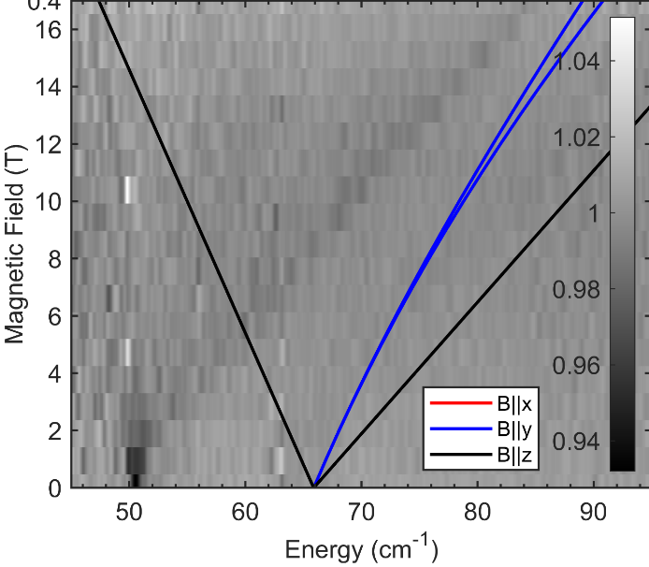
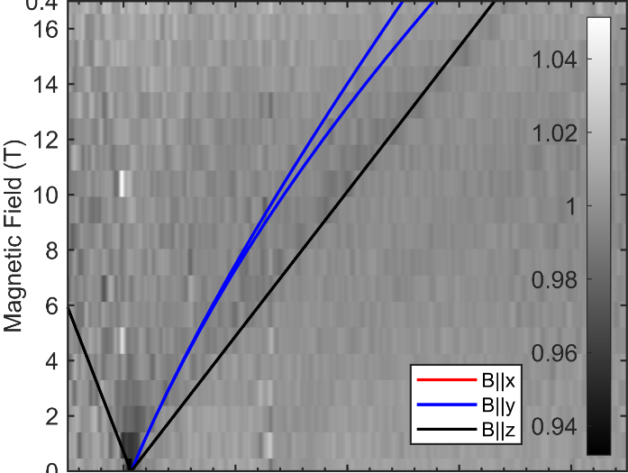
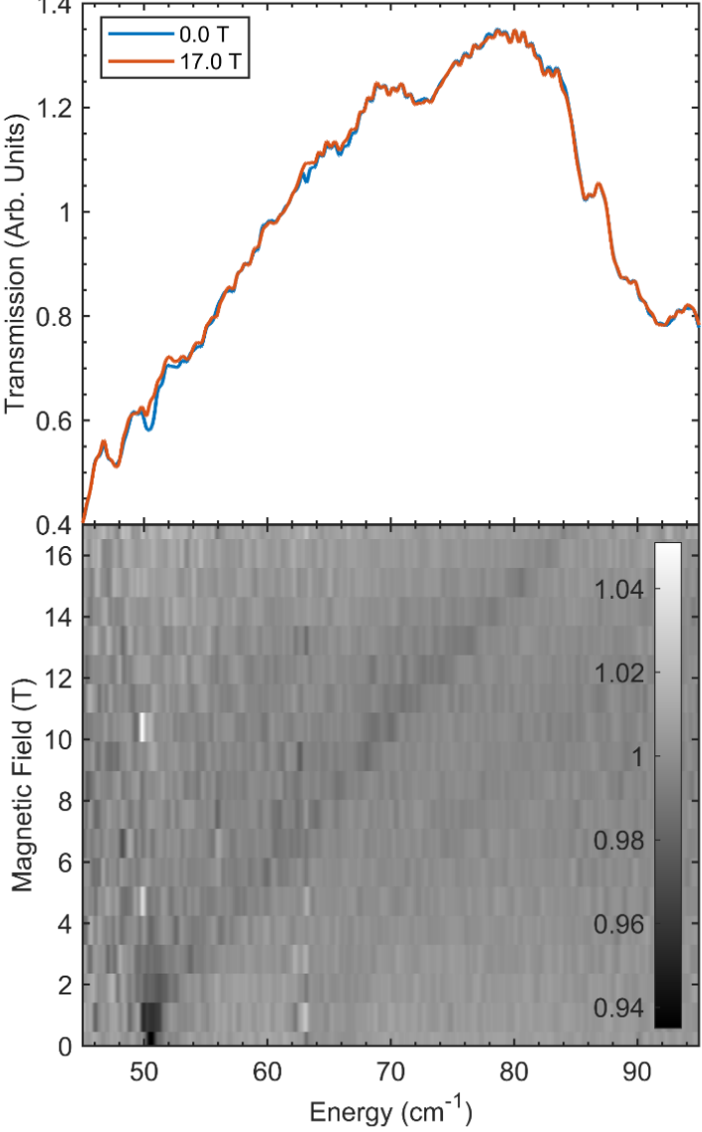
(d)
(b)
(c)
(a)
Figure 2.3. FIRMS of a powder sample of Co-MST-H₂O. (a) Spectra at 5 K and 0 and 17 T. (b) Contour plot of the normalized (by average) transmission, showing blue shifting of the magnetic peak at 50.6(6) cm⁻¹. The red arrows point to the magnetic transitions. The black arrow points to a shot noise in the spectra. There is no clear spin-phonon coupling or avoided crossings. (c) Turning points for the magnetic peak at 50.6(6) cm⁻¹ as solid lines simulated by EasySpin in the powder spectra using g-values from HFEPR. (d) Turning points for the weak magnetic peak of Co-MST at 65(1) cm⁻¹ as solid lines simulated by EasySpin in the powder spectra using g-values from HFEPR. Additional FIRMS results of Co-MST-H₂O are given in Figure A2.2.

single crystal. However, in such a case one would expect a single resonance corresponding to the intra-Kramers transition between the M_{S} = ±1/2 sublevels while two resonances of unequal intensities are actually observed. This observation suggests the presence of two different spin species. The frequency dependence of the two resonances (Figure A2.5) shows that the two species differ by their g-values. We can thus tentatively attribute the resonances to complexes Co-MST-H₂O and its anhydrous derivative (Me₄N)[Co(MST)] (Co-MST) produced by the loss of the axial water ligand. We tentatively attribute the lower-intensity resonance with higher g⊥ value to the anhydrous species.
Given that the field-aligned spectra were uninformative with regard to spin-Hamiltonian parameters, we proceeded to prevent the torquing by pressing Co-MST-H₂O in a pellet with n-eicosane. The resulting spectra at 203 GHz are shown in Figure 2.4 and can be recognized as originating from a powder rather than a single crystal. At low temperatures (10 K in Figure 2.4a), the powder pattern corresponds to a single species, which is assigned to [NMe₄][Co(MST)(OH₂)] (Co-MST-H₂O), as proved by the simulation that uses the 2D′-value obtained from FIRMS, 50.6 cm^{–1}. The other spin-Hamiltonian parameters used in the simulation are: E = 0, g⊥ = 2.230, g|| = 2.045. The ZFS and g-tensors are thus strictly axial and the D′ value obtained from FIRMS is equal to D.
Raising the temperature (40 K in Figure 2.4b) causes an emergence of a second parallel turning point in the spectrum at ca. 6.2 T, of lower intensity. The perpendicular turning point remains unsplit at the same position (3.3 T). This corresponds to a second spin species whose spin-Hamiltonian parameters were obtained through simulation: E = 0, g⊥= 2.23, g|| = 2.33. Apparently, embedding the sample in an n-eicosane pellet did not fully prevent it from losing water under vacuum. Alternatively, the pressure exerted on the sample while making the pellet
Figure 2.4. (a) HFEPR spectrum of Co-MST-H₂O embedded in an n-eicosane pellet at 10 K and 203 GHz (black trace) accompanied by a powder simulation (red trace) using spin-Hamiltonian parameters: D = 25.3 cm^{–1}, E = 0, g⊥ = 2.230, g|| = 2.045. (b) HFEPR spectrum of the same sample at 40 K (black trace) accompanied by simulations. For species A (red trace), the simulation parameters are the same as at 10 K; for species B (blue trace), the parameters are: D = 32.5 cm^{–1}, E = 0, g⊥ = 2.23, g|| = 2.33. dΧ″ / dH is the first derivative of the absorption Χ″ vs the external magnetic field H.

may have caused a release of coordinated water, creating the de-hydrated species Co-MST. The simulation of that extra species used the tentative D-value of the second spin species, i.e., 32.5 cm⁻¹ observed by FIRMS. This species thus has a much larger g|| value than the first one but the same g⊥ value. For both species, the rhombicity factor E/D remains zero within the linewidth of the perpendicular turning point. Results here show that, although the crystallographic point group of C_{i} for Co-MST-H₂O is low, the local molecular symmetry of C_{3v} likely plays a critical role, leading to E = 0 (or it is too small to be detected) by HFEPR, a desired property in SMMs.

2.3.3. INS
As discussed earlier, variable-temperature (VT) INS (without using external magentic fields) is required to differentiate between the local molecular vibrational/phonon and magnetic excitations. As phonons and electrons respond differently to temperature changes, the use of Bose-corrected VT-INS may determine which excitations are magnetic or phonon/vibrational.¹⁵²
INS of Co-MST-H₂O was conducted using Vibrational Spectrometer (VISION) at Oak Ridge National Laboratory (ORNL). There are forward- and back-scatterintg detectors at VISION, which are 45° and 135° from the incident neutrons, respectively.¹⁵² The sample was sealed inside a can under a helium atmosphere in a glovebox and spectra were collected at 5, 25, 50, 75, 100, and 125 K. Bose-corrected VT INS are given in Figure 2.5, where Bose correction is a numerical normalization that highlights non-phonons by applying normalization to phonons that follow Bose-Einstein statistics. The peak at 48.5 cm⁻¹ is assigned to the magnetic transition in Co-MST-H₂O, which is slightly shifted from 50.6 cm⁻¹ observed in FIRMS likely due to instrument errors. Spin-Hamiltonian parameters determined by the advanced techniques: D = 25.3 cm⁻¹, E = 0, g⊥ = 2.230, and g|| = 2.045, are very close to D = 24 cm⁻¹, ⎜E ⎜= 0.001 cm⁻¹, g = 2.40 determined using magnetometry by Schulte, Vignesh, and Dunbar.¹⁰⁶
Figure 2.5. (a) Bose-corrected INS spectra of Co-MST-H₂O at 20-80 cm⁻¹. Forward-scattering spectra are given in Figure A2.6. (b) INS spectrum at 5 K in comparison to the calculated INS spectrum in the 5-1500 cm⁻¹ range.

2.3.4. DFT phonon and spin density calculations
The phonon INS spectrum for Co-MST-H₂O was calculated using the periodic DFT VASP (Vienna Ab Initio Simulation) program. The calculated INS spectrum is compared with the experimental INS spectrum at 5 K. Ab initio (also known as first-principle) DFT calculations allow for predictions of interatomic force constants. For Co-MST-H₂O, the calculated spectrum overall matches experimental spectrum well.
Calculated symmetries and energies of phonons are given in Table A2.1 in the addenda for Chapter 2. There are four phonons (47.65, 50.62, 53.95, and 54.59 cm⁻¹) near the magnetic excitation at 48.5 cm⁻¹, as predicted by VASP calculations. Among the four phonons (listed in Table 2.1), only the 54.59 cm⁻¹ phonon has the u symmetry which is far-IR active. However, there is no observable spin-phonon coupling with this phonon in FIRMS (Figure 2.3) as avoided crossing.
The DFT calculation of phonons produced phonon movies for the four phonons in Table 2.1, which are attached to this dissertation. These phonon movies of the anion (Co-MST-H₂O⁻) in Co-MST-H₂O show small changes in the location of the Co²⁺ ion of the molecule. Larger changes in the mesityl positions in the MST³⁻ ligand and shifting of the water molecule are more noticeable in the phonon movies.
The DFT phonon calculations also determined the spin density, ρ_{s}, on the Co²⁺ ion in Co-MST-H₂O, providing a quantitative scale, revealing how the spin is dispersed onto Co²⁺ ion and atoms in the ligand.¹⁹⁹ VASP partitions electrons according to the Wigner-Seitz radius a_{e} in Eq. 5:²⁰⁰
a_{e} = (3/4πn_{e})^{1/3} (2.5)

Table 2.1. List of calculated phonons near the magnetic transition in Co-MST-H₂O and their symmetries from VASP calculations.
Frequency (cm⁻¹) | Symmetry
47.65 | A_{g}
50.62 | A_{g}
53.95 | A_{g}
54.59 | A_{u}

where n_{e} is the particle density of electrons; a_{e} is the radius “occupied” by one atom in a sample, and each atom is considered as a sphere.
The calculations do not include the spin densities residing in the bonds, but rather just the densities in individual atoms. The range of spin densities for each atom type is presented in Table 2.2. Detailed spin densities are given in Table A2.2. The total spin density (sum of those on all atoms) on the Co-MST-H₂O molecule is 2.863 which is lower than 3 (= 3 unpaired electrons). The total spin density here is similar to those in, e.g., in Co(PPh₃)₂Cl₂ (2.797),¹³³ Co(PPh₃)₂Br₂ (2.783),¹³³ and Co(PPh₃)₂I₂ (2.747).¹³³ The remaining spin densities are dispersed in the bonds in the Co-MST-H₂O molecule. No spin densities are present in the atoms of the cation NMe₄⁺ or lattice solvents (H₂O and CH₂Cl₂). In other words, the unpaired electron spins appear to be entirely on the Co²⁺-containing anion [Co(MST)(OH₂)]⁻. We have used the current DFT calculation method to obtain spin densities in several Co²⁺ SMMs (Table 2.2).^{95, 133} It is the first time that spin densities entirely on the metal-containing anion have been observed.
Most of the spin densities, 2.627 (87.6% of the 3 unpaired electrons) of the total 2.863, is concentrated on the Co²⁺ ion. This is understandable as the unpaired electrons are in the Co²⁺ ion. Then, the axial N atom (N3 in Table A2.2) bound to the Co²⁺ ion has the next highest spin density of 0.045, followed by the 3 equatorial N atoms (N1, N5, N7; spin densities: 0.036-0.037) and the O atom of the water ligand (O3; 0.030) that all bind directly to the Co²⁺ ion. After these α atoms (bound to Co²⁺), β atoms have much smaller or no spin densities, including 0.004-0.005 for S atoms, −0.001 for the C atoms (C13, C23, C33) bound to the 3 equatorial N atoms, −0.001 to 0 for the C atoms (C5, C21, C31) bound to the axial N atom, and 0 for the 2 H atoms of the water ligand. The negative spin densities here indicate that these (small) spins are in the opposite

Table 2.2. Correlation between calculated spin densities on the Co²⁺ ions and ZFS parameters of the complexes/coordination polymer (CP).
Complexes | Spin densities on the Co²⁺ ions (and percentage of 3 unpaired electrons) | D′ values (cm⁻¹) | Refs
Co(PPh₃)₂I₂ | 2.553 (85.1%) | 13.63(10) | 133
Co(AsPh₃)₂I₂ | 2.558 (85.3%) | 27 | ª
Co(PPh₃)₂Br₂ | 2.570 (85.7%) | 13.83(2) | 133
Co(PPh₃)₂Cl₂ | 2.585 (86.2%) | 14.89(2) | 133
Co-MST-H₂O | 2.627 (87.6%) | 25.3 | Current work
Co-TODA (CP) | 2.68-2.69 (89.3%-89.7%) | 40.2 | 95
Co(acac)₂(H₂O)₂ | 2.81 (93.7%) | 57.0 | 199
[Co(12-crown-4)₂](I₃)₂ | 2.82 (94.0%) | 24.7 | ª
ª SMM behaviors of [Co(12-crown-4)₂](I₃)₂ and Co(AsPh₃)₂I₂ were probed by Saber and Dunbar in ref. 201 and by Chen et al. in ref. 202, respectively. Their D′ values determined by advanced spectroscopies were reported in refs. 96 and 139, respectively. Spin densities of [Co(12-crown-4)₂](I₃)₂ and Co(AsPh₃)₂I₂ have been calculated and are reported here for comparison. Tables listing the spin densities for these complexes are given in Tables A2.3-A2.6.

direction as the 3 unpaired electrons on the molecule. Some of the other atoms of the ligand, including a few H atoms, carry small spin densities (Table A2.2). A comparison of calculated spin densities on Co²⁺ ions in a few complexes and their ZFS D′ values are given in Table 2.2.

2.3.5. Hirshfeld surface analysis
Hirschfeld surface analysis^{170, 173} is especially effective to examine which parts of a molecule interact most strongly with neighboring molecules in the crystal solid.^{117, 174-196} A Hirshfeld surface is an isosurface calculated from the weight function w(r) of the sum of spherical atom electron densities (Eq. 6):
$$w\left(r\right)=\frac{ρ_{promolecule}\left(r\right)}{ρ_{procrystal}\left(r\right)}=\sum_{A∈molecule}{ρ_{A}(r)/\sum_{A∈crystal}{ρ_{A}(r)}} (2.6)$$
where ρ_{promolecule}(r) is the sum of the molecular electron density over the atoms in the molecule or ions under consideration (the promolecule) and ρ_{procrystal}(r) is the similar sum over the crystal (the procrystal).^{170, 173}
The isosurface here separates a molecule (promolecule) or ion from its nearest neighbors (procrystal) at a given density level. Distances to the nearest atoms outside (external), d_{e}, and inside (internal), d_{i}, are defined from the Hirshfeld surface, giving a 3-D representation of the intermolecular, close contacts in the crystal using the CrystalExplorer software by Spackman and coworkers.^{170, 173} Also, the Hirshfeld surface could be made into a 2-D histogram with a unique fingerprint plot for intermolecular interactions.
Surfaces (Figure 2.6) and fingerprint plots (Figure A2.12) for the [Co(MST)(OH₂)]⁻ anion (named Co-MST-H₂O⁻) show interactions with neighboring molecules, cation Me₄N⁺, and lattice solvents (CH₂Cl₂ and H₂O), while the average surface reveals low to moderate intensity. The strongest interactions are from those of the O atoms of the sulfonyl groups interacting with solvents in the lattice (CH₂Cl₂ and H₂O through hydrogen bonds), as shown by the red spots in Figure 2.6b. The interactions of the anion with the cation NMe₄⁺ are present but not strong, as there are no nearby red spots near NMe₄⁺ in Figure 2.6b. Interactions of H atoms with other Co-MST-H₂O molecules, the solvents, and the cation NMe₄⁺ take the largest share (83.9%) of close interactions with neighboring molecules, as shown in Table 2.3.

2.4. Results and discussion of [NMe₄][Ni(MST)(OH₂)] (Ni-MST-H₂O)
Phonon properties of Ni-MST-H₂O have been studied by INS, DFT-phonon calculations, and Hirschfeld surface analysis. HFEPR was not used for Ni-MST-H₂O as the effective range for HFEPR using current instrumentation is up to ~30 cm⁻¹, while the expected transition from previously reported magnetometry is near 209 cm⁻¹.¹⁰⁶ Repeated attempts to probe powder samples of Ni-MST-H₂O by FIRMS (Figure A2.13) did not show any magnetic peaks. VT INS spectra of powder samples in Figure 2.7 also did not clearly reveal magnetic peaks in the spectra. VT profile of the shoulder peak at ∼208 cm⁻¹ indicates that it is mostly phonon in nature with possible magnetic contributions to the intensity. Both FIRMS and INS spectra show strong, broad phonon peaks at ∼210 cm⁻¹. We speculate that the following may lead to the results in the current studies: (1) The magnetic transitions among the ZFS states in Figure 2.1d are possibly too weak to be observed by both FIRMS and INS; (2) The magnetic transitions undergo spin-phonon couplings with the nearby strong phonons, dividing the magnetic features over several phonons, making the direct observation of the magnetic transition difficult. For future spectroscopic studies, the use of single crystals in FIRMS and deuterated Ni-MST-H₂O samples in VT INS is expected to help reveal magnetic transitions in Ni-MST-H₂O.

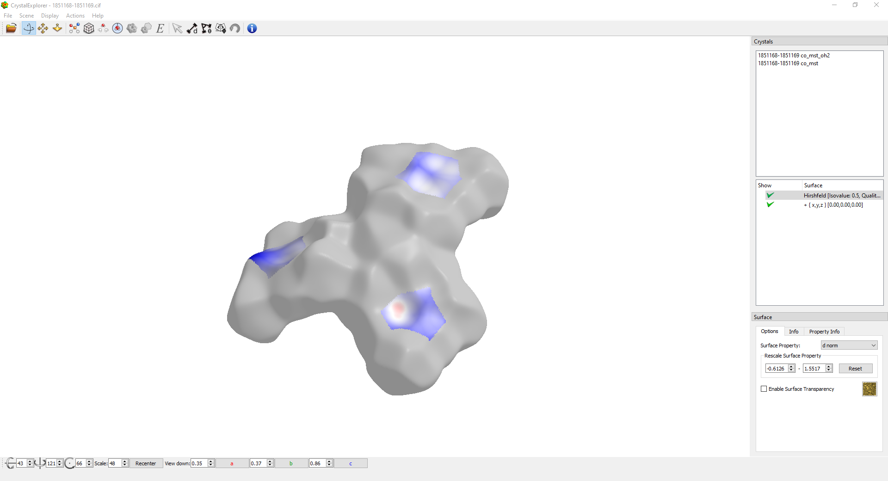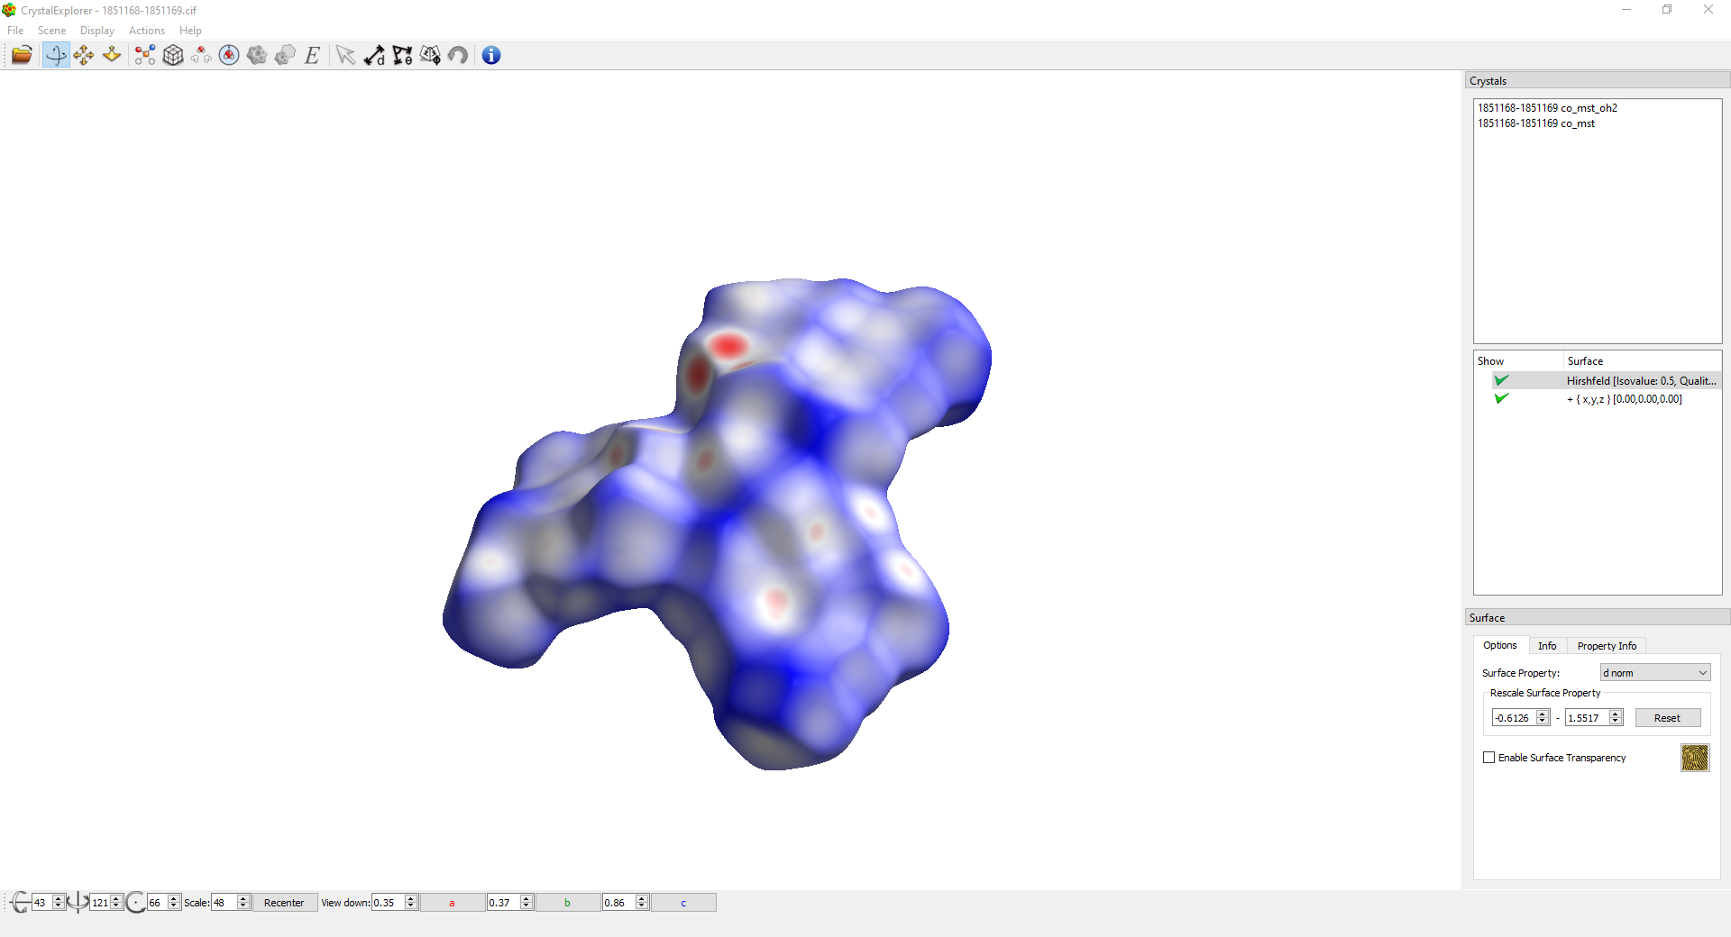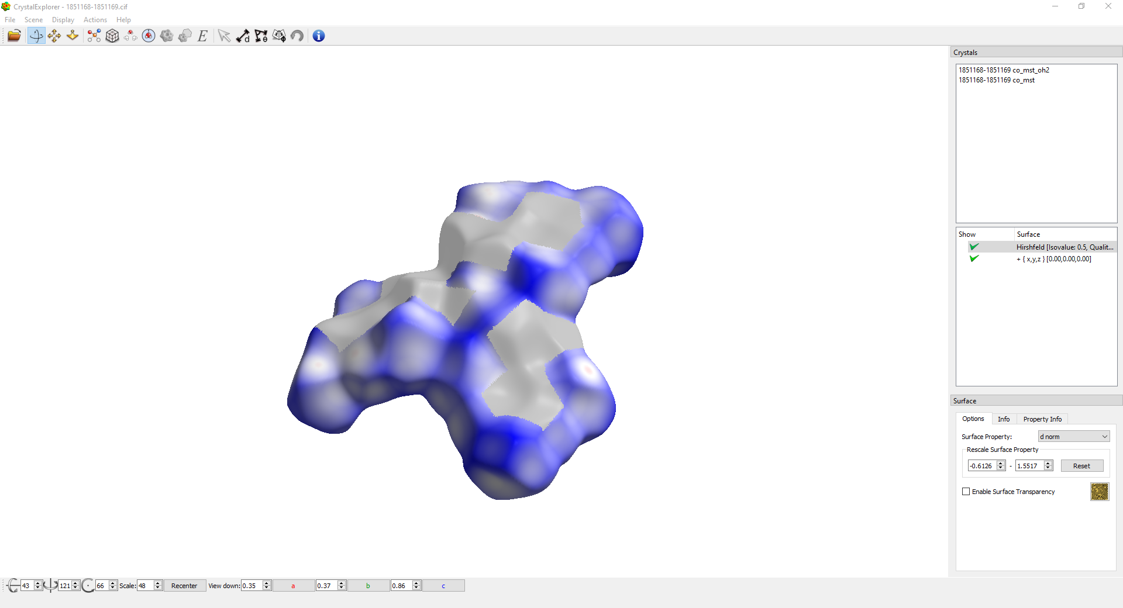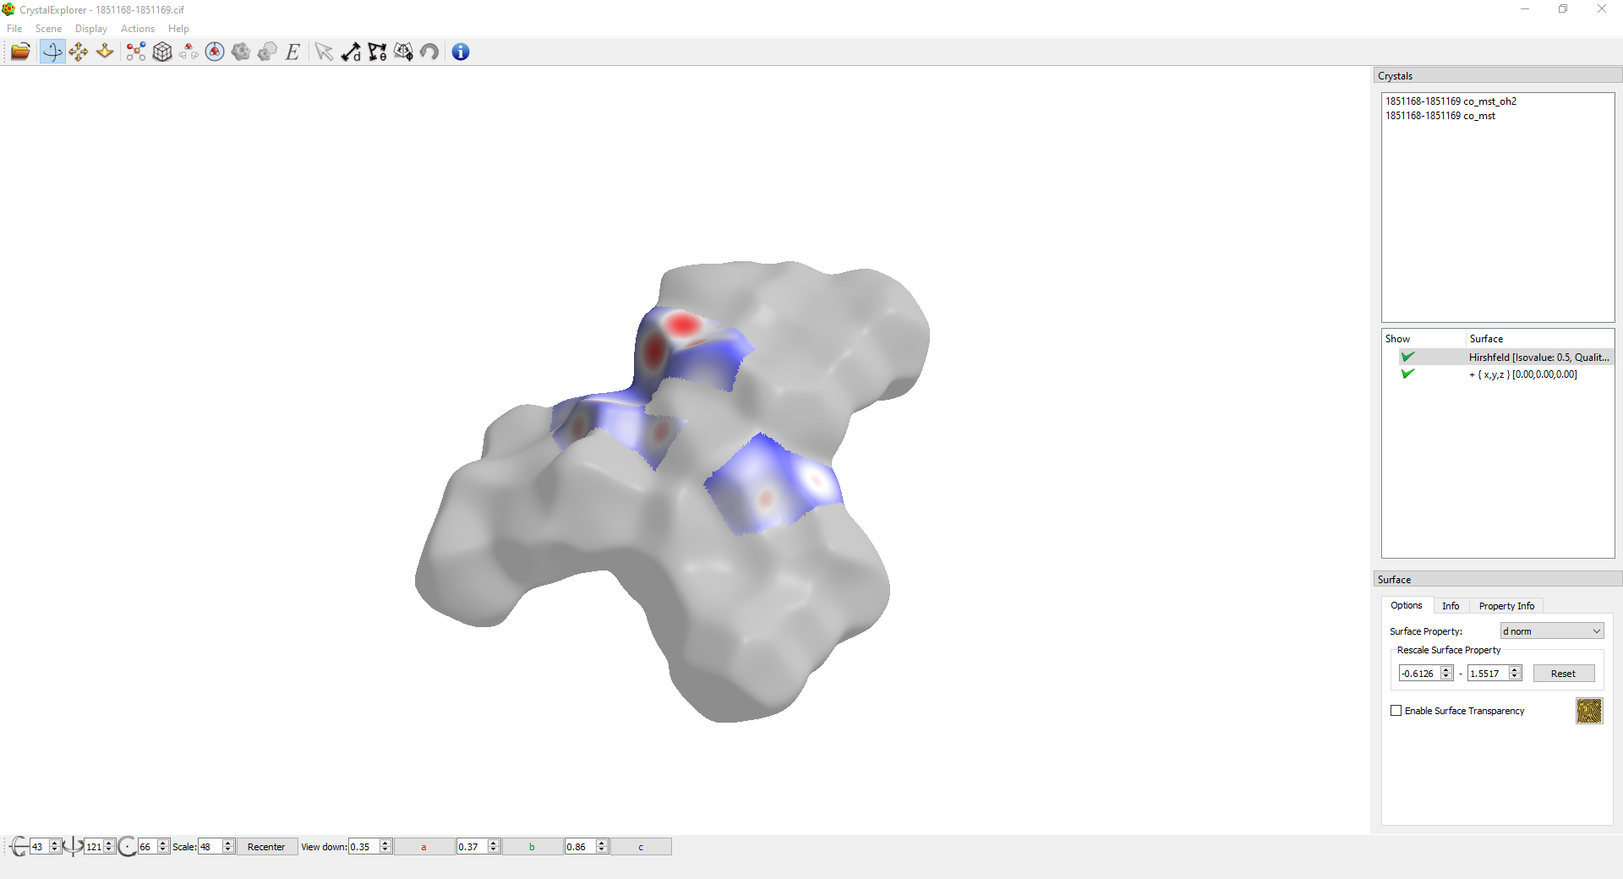
(a)
H close contacts
C close contacts
O close contacts
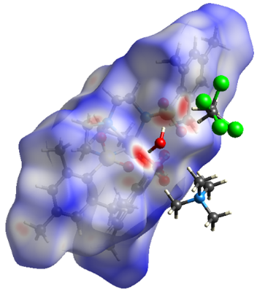
(b)
Figure 2.6. (a) Hirshfeld surfaces of the Co-MST-H₂O⁻ ion showing surface interactions as heat maps. Red zones indicate strong interactions with closer distances between d_{e} and d_{i} atoms, while blue zones are indicative of larger distances and less strong interactions. (b) Representations of the closest and more intense interactions of the Co-MST-H₂O⁻ Hirschfeld surface, showing that lattice H₂O forms hydrogen bonds with the O atoms in the MST³⁻ ligand. The H atoms of lattice CH₂Cl₂ also interact strongly with O atoms of ligand. The CH₂Cl₂ molecule is disordered.

Table 2.3. Hirshfeld surface coverage based on interactions of atoms on the M-MST⁻ anion with all nearby atoms of neighboring molecules and Me₄N⁺ cation. Most of the interactions are from H atoms of the M-MST⁻ anion with surrounding atoms.
 | Co-MST-H₂O | Ni-MST-H₂O
H close contacts | 83.9% | 79.7%
C close contacts | 8.6% | 9.8%
O close contacts | 7.5% | 10.5%
N close contacts | >0.1% | >0.1%
S close contacts | >0.1% | >0.1%
M close contacts | >0.1% | >0.1%

Figure 2.7. (a) Bose-corrected INS spectra of Ni-MST-H₂O at 100-500 cm⁻¹. There are no strong magnetic features in this region. (b) INS spectra showing calculated and experimental phonons at 5–1500 cm⁻¹ of Ni-MST-H₂O. Additional regions of the experimental and calculated INS are given in Figures A2.16-A2.18.

Earlier, Schulte, Vignesh, and Dunbar determined spin-Hamiltonian parameters of Ni-MST-H₂O using DC magnetic susceptibility and reduced magnetization.¹⁰⁶ The current results suggest that the magnetometry remains the only viable technique to determine spin-Hamiltonian parameters for Ni-MST-H₂O. We have thus focused on the phonon properties of Ni-MST-H₂O revealed by INS, DFT phonon calculations, and Hirshfeld surface analysis. INS spectra of Ni-MST-H₂O are given in Figure 2.7. DFT calculated INS spectrum is given in Figure 2.7b in comparison with the experimental INS spectrum, showing a good fit between the two spectra.
Surfaces (Figure 2.8) and fingerprint plots (Figure A2.19) for the [Ni(MST)(OH₂)]⁻ anion (named Ni-MST-H₂O⁻) show intense interactions between the anion and the lattice solvent H₂O (through hydrogen bonds) and the cation Me₄N⁺ through the O atoms of the sulfonyl groups, as shown by the red spots in Figure 2.8b. In comparison, the interactions between Co-MST-H₂O⁻ and its cation NMe₄⁺ are not as strong, as discussed earlier and shown in Figure 2.6b. The interactions of the anion with the other solvent, ethyl ether (Et₂O), are present but not strong, as there are no nearby red spots around Et₂O in Figure 2.8b. Interactions of H atoms with other Ni-MST-H₂O molecules, the solvents, and the cation NMe₄⁺ take the largest share (79.7%) of close interactions with neighboring molecules, as shown in Table 2.3.

2.5. Conclusions
In this work, the use of advanced spectroscopies to probe magnetic transitions in Co-MST-H₂O has delivered spin-Hamiltonian parameters for the compound. INS studies also give phonon properties of the complex. DFT phonon calculations give calculated INS spectrum that fits well with the experimental INS spectrum. The calculations also determined phonon symmetries, their energies, and phonon movies. In addition, the DFT phonon calculations yield spin density on the Co²⁺ ion and other atoms in Co-MST-H₂O. Hirshfeld surface analysis
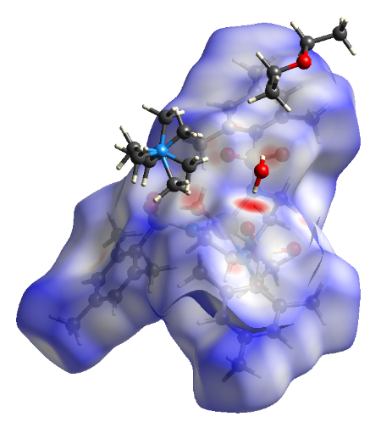
(b)
(a)
H close contacts
C close contacts
O close contacts
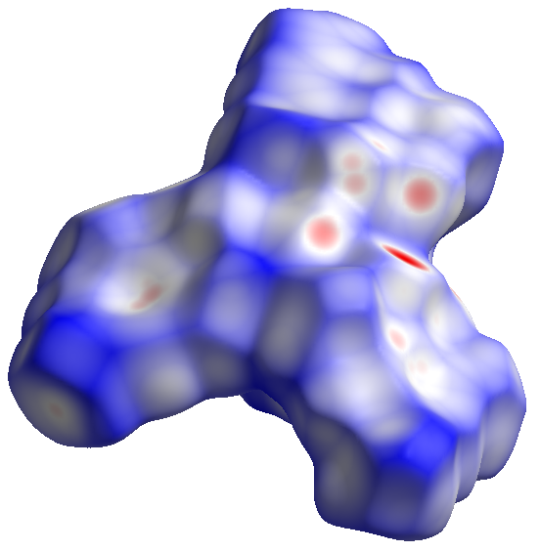
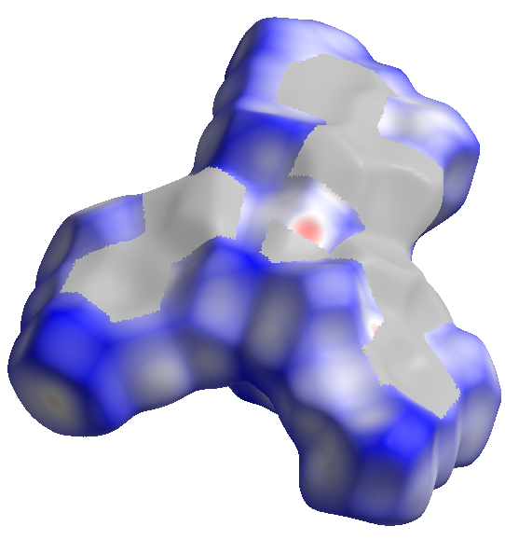
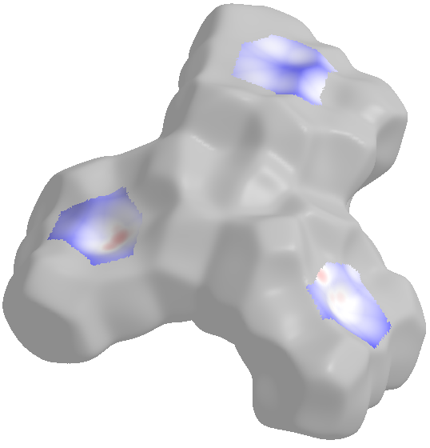
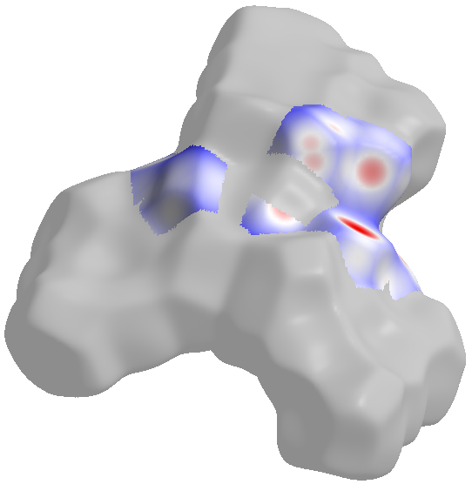
Figure 2.8. (a) Hirshfeld surfaces of the Ni-MST-H₂O⁻ anion showing surface interactions as heat maps. Red zones indicate strong interactions with closer distances between d_{e} and d_{i} atoms, while blue zones are indicative of larger distances and less strong interactions. (b) Representations of the closest and more intense interactions of the Ni-MST-H₂O⁻ Hirschfeld surface, showing that H₂O solvent molecule and the Me₄N⁺ cation form hydrogen bonds with the O atoms in the MST³⁻ ligand. The ethyl ether (Et₂O) solvent molecule, in contrast, does not show strong interactions with the Ni-MST-H₂O⁻ anion. The Me₄N⁺ cation is disordered.

reveals how the Co-MST-H₂O⁻ anion interacts with its cation, solvent molecules, and neighboring Co-MST-H₂O molecules. For Ni-MST-H₂O, phonon properties and intermolecular interactions have been studied by INS, DFT phonon calculations, and Hirshfeld surface analysis. FIRMS and INS studies of Ni-MST-H₂O did not show its magnetic transitions. Thus, the current work on Co-MST-H₂O offers a very good comparison (between results from magnetometry and spectroscopic techniques). For Ni-MST-H₂O, magnetometry is the only viable technique to determine spin-Hamiltonian parameters for the compound in the absence of magnetic resonance or INS results.

2.6. Experimental section

2.6.1. Synthesis
Synthesis of the H₃MST ligand was completed using commercial materials with no further purification following a reported procedure.²⁰³ Co-MST-H₂O and Ni-MST-H₂O were prepared following reported procedures.^{106, 127}

2.6.2. FIRMS
Far-IR magneto-spectroscopy was completed at the National High Magnetic Field Laboratory in Tallahassee, Florida using a Bruker Vertex 80v Fourier-transform infrared (FT-IR) spectrometer coupled with a 17.5 T, vertical-bore superconducting magnet. The experimental setup is equipped with a mercury lamp and a composite silicon bolometer (Infrared Laboratories), as an incoherent (sub)-THz radiation source and detector, respectively. The THz radiation propagates in free space inside the optical beamline, connecting the output of the spectrometer and top of the sample probe. The radiation then passes through the brass light-pipe through a 2.5 m distance to the field center. The probe and beamline are evacuated to eliminate strong parasitic absorptions of the air. Samples were prepared by mixing with n-eicosane under a heat lamp to make a slurry, making a solid layer of polycrystalline sample. Measurements were conducted at 5 K with the sample and bolometer being cooled by low pressure He gas. Spectrum transmitted through the samples was collected between 10 and 720 cm⁻¹ with a resolution of 0.3 cm⁻¹.

2.6.3. HFEPR
HFEPR spectra were collected at the National High Magnetic Field Laboratory in the EMR facility using a spectrometer previously described,²⁰⁴ modified with the use of VDI sources. The spectrometer is associated with a 15/17 T warm-bore superconducting magnet. Co-MST-H₂O was measured both “as is” and as a pellet pressed with n-eicosane to prevent torquing effects of the sample in the magnetic field.

2.6.4. INS
Variable-temperature INS spectra was collected at Oak Ridge National Laboratory using VISION, an indirect-geometry vibrational spectrometer.¹⁵² About 500 mg of sample was used for data collection, sealed in a vanadium can within a helium environment. VISION has two detector banks; magnetic transitions are more intense in the forward scattering detectors for their low scattering angle dependence.

2.6.5. Phonon and INS calculations
DFT calculations were performed using the Vienna Ab Initio Simulation Package (VASP).²⁰⁵ Lattice parameters and atomic coordinates from published structures were used for the structure. Atomic force constants were calculated by VASP using finite displacement method, and vibrational eigen-frequencies and modes were calculated using Phonopy and OCLIMAX software was used to convert DFT calculated phonon results to the simulated INS spectra.²⁰⁶⁻²¹¹

2.6.6. Hirshfeld surface analysis
Surfaces were generated using Crystal Explorer.^{170, 173} Surfaces for this analysis were generated from reported structures.¹⁰⁶ Only atoms within the SMM complex were selected to allow for determination of interactions with counter ions and nearby SMM complexes within the crystal structure. Charges for the metal-containing anions in Co-MST-H₂O and Ni-MST-H₂O were set to -1 while the NMe₄⁺ counter ion was set to +1.

Chapter 3: Atomic-scale visualization of the toroidal order in a trimeric Dy(III) compound

This chapter is based on the following manuscript to be submitted for publication:
Michael J. Jenkins, Madalynn G. Marshall, Jie Xing, Xiaoping Wang, Christina M. Hoffman, Huibo Cao, Rongying Jin, Zi-Ling Xue. Atomic-scale visualization of the toroidal order in a trimeric dysprosium compound
Author contributions
Michael J. Jenkins synthesized and performed preliminary characterization of Dy₃-1 and Dy₃-2. He studied crystal stabilities and developed the method to grow large crystals of Dy₃-2. Jenkins and Zi-Ling Xue investigated the selection of Dy₃-1 for the initial studies. Jenkins, Xiaoping Wang, and Christina Hoffmann solved the structure of Dy₃-2 using single-crystal X-ray diffraction. Wang and Hoffmann also conducted the single-crystal neutron diffraction of Dy₃-1 on TOPAZ at Oak Ridge National Laboratory (ORNL). Jie Xing completed magnetic susceptibility measurements and analysis. Jenkins, Madalynn Marshall, Huibo Cao, and Xue participated in the two neutron diffraction experiments. Marshall completed neutron diffraction data analyses from the two experiments. Xue, Cao, and Rongying Jin initiated and supervised the project. Jenkins and Xue wrote the manuscript with input from other authors.

3.1. Abstract
Single-molecule toroics (SMTs) offer a unique platform for next-generation quantum devices, utilizing head-to-tail spin arrangements to encode qubits and manipulate spin currents. However, there has been no direct observation of the toroidal moment in an SMT. Here, we report synthesis and comprehensive characterization, including polarized neutron diffraction (PND), of a trinuclear dysprosium cluster, [Dy₃(O)(teaH₂)₃(paa)₃]Cl·PhCN·4MeOH [teaH₃ = triethanolamine, paaH = N-(2-pyridyl)-acetoacetamide]]. Crystallization of the highly symmetric Dy₃ cluster has yielded large single crystals (>1 mm³) with stability suitable for PND and magnetometry studies. DC (direct current) magnetometry confirms pronounced anisotropic coupling of antiferromagnetic normal to the molecular plane and mixed ferromagnetic/antiferromagnetic in-plane coupling, consistent with a toroidal ground state. Most significantly, PND on a single crystal at 5 K delivers a direct, atomically resolved mapping of the local magnetic susceptibility tensor of each Dy³⁺ ion, providing unequivocal, experimental proof of the head-to-tail spin arrangement that defines the toroidal moment. Simulations based on the refined tensor reproduce the observed magnetization anisotropy without additional fitting parameters, validating the methodology. This work represents the first direct, atomic-scale determination of para-toroidic dipoles and the field-polarization of antiferro-toroidic order in an SMT and establishes a blueprint for integrating PND with magnetometry to guide the rational design of toroidal qubits and spintronic architectures.

3.2. Introduction
Single-molecule toroics (SMTs), characterized by their ring-shaped atomic arrangement, have gained considerable attention in quantum information science and spintronics.4, 7, 8, 10-12, 36, 37, 43, 73, 75, 76, 78, 104, 212-223 Their unique structural, magnetic, and electronic properties make them promising candidates for applications such as qubits for quantum computing.^{4, 10, 36} These applications seek to take advantage of the tunable properties of the spin systems inherit in SMTs, where the electronic and magnetic structure of these compounds can be influenced by the coordination environment of the magnetic ions.^{4, 7, 9-12, 224, 225} From the initial report of SMTs in 2008, there has been rapid growth in the field with both theoretical and experimental studies.^{21, 35, 41, 44, 46, 226-251} Most SMTs are lanthanide-based compounds, using large spins of the Ln³⁺ ions such as Dy³⁺. There have been reports of planar rings from Dy₃ up to Dy₆, mixed transition metal-lanthanide rings and clusters, as well as non-planar SMTs.22, 35, 37, 45, 220, 226, 230, 237, 238, 241-245, 248, 250-292 In addition to Dy³⁺-containing SMTs, compounds with other Ln³⁺ ions such as Ho³⁺ and Tb³⁺ have also been reported with toroidal magnetic moments.^{37, 276, 278, 293} Typically the toroidal moments of SMTs have been probed using magnetometry, where changes to the net magnetic moment are observed at low temperatures, when the magnetic moments start to form their characteristic ring-shaped spin structures. These changes in magnetic moments can lead to non-magnetic ground states, as reported by Chibotaru, Ungur, and Socini.²⁶ However, the loss of a net magnetic moment does not necessarily point to the presence of a toroidal moment in a cluster compound.³⁵ While the magnetometry could provide the data consistent with such a magnetic toroidal moment, additional measurements with other advanced techniques, such as cantilever torque magnetometry, high-field EPR, and far-IR spectroscopy, are necessary to examine the ground state and magnetic excitations.^{42, 229, 265, 294} At the magnetic excited states, there is no longer an absence of a magnetic moment, thus allowing for perturbation of spin states within the SMT compounds through the magnetic excitations.^{35, 227, 265} These experiments, as well as the associated theory and data fitting, lead to the simulation of the direction, intensity, and coupling of magnetic moments of the SMTs. However, the above-mentioned techniques are indirect methods and cannot unambiguously determine the net toroidal moment due to the loss of local spin information relative to the lattice environment.²⁹⁵ In this work, we have investigated a new Dy₃ compound using the combination of magnetometry and polarized neutron diffraction (PND) to unambiguously determine the toroidal moment. Langley, Rajaraman, Murray and coworkers recently reported that [Dy₃(OH)(teaH₂)₃(paa)₃]Cl₂·MeCN·4H₂O (Dy₃-1), containing a dication [Dy₃(OH)(teaH₂)₃(paa)₃]²⁺, showed SMT properties based on magnetometry studies of powder samples and ab initio calculations.²⁷⁶ This compound was initially selected for the current PND studies for its crystallographic trigonal P-3 (No. 147) space group. There is a crystallographic C₃ axis through the center of the molecule, making the three Dy³⁺ ions equivalent. Such a compound in a highly symmetric space group is a superior choice for PND measurements. As discussed below, we have instead prepared an analog in a different solvent mixture, using a distinct method to grow large, stable crystals of [Dy₃(O)(teaH₂)₃(paa)₃]Cl·PhCN·4MeOH (Dy₃-2), containing a [Dy₃(O)(teaH₂)₃(paa)₃]⁺ (mono)cation, in the P-3c1 (No. 165) space group.
The toroidal moment in SMTs is due to head-to-tail spin arrangements (Figure 3.1) within the cluster molecule. Toroidal spin states can be formed from a planar arrangement of spins or from out of plane spins that couple in a helical pattern, leading to the cancellation of spins within the toroidal plane, although there may still be out of plane dipole contributions to the overall spin states.^{37, 44, 227, 296} Toroidal moments are difficult to be directly observed, because metal ions, acting as electromagnetic particles with net magnetic dipoles or electric charges, can couple to the toroidal moment or obscure their signals. Therefore, highly sensitive techniques are required to observe the toroidal moment.
In the case of SMT molecules, determining the susceptibility tensor of the magnetic ions within the molecule is an efficient way to directly examine toroidal spin arrangement. Direct experimental determination of the head-to-tail spin arrangement would allow for a better understanding of the toroidal moment. To experimentally determine this toroidal moment, we have sought the combined use of PND and magnetometry to find the arrangement of spin inside
the cluster molecule.
Magnetometry is a routine method often using powder samples to study molecular magnetic materials including SMTs, providing magnetization measurements used to determine the overall magnetic anisotropy. The magnetic anisotropy of SMTs has been used to model the

Figure 3.1. Planar spin alignment of coupled Dy³⁺ ions within an SMT.

direction and scale of atomic magnetic susceptibility as well as the coupling between magnetic ions.^{37, 44, 46}
Polarized neutron diffraction (PND) is a unique technique to probe molecular magnetism.^{59-63, 65-69, 297, 298} In PND, spin-up and spin-down neutrons are alternatively generated and scattered by, e.g., a single crystal of a sample inside an external magnetic field.⁵⁹ The magnetic field makes unpaired electrons in the sample to align “up” at a low temperature (e.g., 2 K). The spin-up and spin-down incident neutrons have different interactions with the “up” electron spins, leading to different diffraction intensities, even though the nuclear interactions of the atoms in the sample with the incident neutrons are the same. The difference in the diffraction intensities is used to yield spin density of the crystal and magnetization vectors of the atoms with the unpaired electrons. In PND, Bragg peak intensities of spin-up and spin-down neutrons are measured. These intensity ratios of spin-up and spin-down neutron diffraction peaks, called the flipping ratios, are described by the formula in Eq. 3.1:
$R\left(k\right)=R\left(hkl\right)=\frac{I^{+}}{I^{-}}=\frac{{F_{N}}^{2}+2pq^{2}F_{N}F_{M}+q^{2}F_{M}^{2}}{{F_{N}}^{2}-2epq^{2}F_{N}F_{M}+q^{2}F_{M}^{2}}$ (3.1)
where I⁺ and I⁻ are the diffracted intensities at a fixed Bragg position k by spin-up and spin-down incident neutrons, respectively, q is the sine of the angle between the scattering vector and the magnetic field direction, p is the polarization of the incident beam, and e is the flipping efficiency.
By fitting the measured flipping ratios, the magnetic susceptibility tensor can be determined.^{69, 299}
PND has been effective to determine spin arrangements for both d and f block compounds. It has been used to determine spin arrangements for clusters and compounds with one metal ion.^{59-69, 297, 298} Magnetic anisotropy of a Dy³⁺-based single-molecule magnet (SMM) has been studied using PND to analytically determine the atomic magnetic susceptibility tensor as reported by Klahn and coworkers.⁶¹ Similarly, PND has been used to compare similarities and differences of Dy³⁺ and Ho³⁺ SMMs [Ln(H₂O)₅(HMPA)₂]I₃ (HMPA = hexamethylphosphoramide), showing that the transverse elements of the atomic susceptibility are significantly different, with the Dy³⁺ SMM being nearly axial and the Ho³⁺-analog showing significant transverse anisotropy.²⁹⁷ Temperature evolution of atomic susceptibility has also been studied using PND, showing reorientation of anisotropy axis within a spin ice compound.⁶⁷ PND has also been used to determine spin density in an Fe₈ cluster, [Fe₈O₂(OH)₁₂(tacn)₆]Br_{4.3}(ClO₄)_{3.7}·6H₂O (Fe₈pcl; tacn = 1,4,7-triazacyclononane), as well as which of the eight Fe³⁺ ions (S = 5/2) have up spins and which have down spins, leading to antiferromagnetic interactions in the cluster compound with a total S = 10.²⁹⁸ PND shows that two opposite Fe³⁺ ions on the edges of the molecule carry down spins, and the other six Fe³⁺ atoms carry up spins. To our knowledge, PND has not been used to probe an SMT. The current work demonstrates that PND reveals directly the head-to-tail spin arrangement in an SMT. The magnetic susceptibility tensor of magnetic ions in the SMT is used to examine the atomic-scale spin structure and directly determine the toroidal spin arrangement. In this work, we demonstrate, for the first time, the direct experimental visualization of toroidal spin ordering at the atomic level in a Dy₃-based SMT using a combined approach of magnetometry and polarized neutron diffraction. This integrated strategy overcomes the limitations of prior indirect methods and sets a new standard for probing molecular-scale magnetism.

3.3. Results and discussion

3.3.1. Selection of the compound and its synthesis
For PND experiments, high-quality data acquisition requires a large single crystal (>1 mm³) with well-defined morphology and high symmetry. Large crystals with a highly symmetric space group are particularly advantageous, as they enhance the interpretability and resolution of magnetic susceptibility tensors. Following the published procedure by Langley and coworkers,^{261, 276} we were able to prepare the reported compound [Dy₃(OH)(teaH₂)₃(paa)₃]Cl₂ in mixed methanol-acetonitrile (MeOH-MeCN) solution, and grow its crystals, Dy₃-1, by layering the solution with diethyl ether (Et₂O). We then attempted to grow larger crystals of the reported compound for the PND experiment by using slow solvent vapor diffusion (Figure A3.1), which did succeed in giving crystals of improved size. However, crystals of Dy₃-1 quickly (in ~1 min) degraded when exposed to air, likely due to solvent loss in the crystals. As a result, single-crystal neutron diffraction using a single crystal of Dy₃-1 at TOPAZ (Single-Crystal Diffractometer),³⁰⁰ Oak Ridge National Laboratory (ORNL) was unsuccessful. The diffraction data indicated pronounced smearing of Bragg peaks consistent with decomposition during the experiment.
To resolve this issue, we have used a different solvent mixture (PhCN and MeOH) in the synthesis and growth of crystals. In addition, rather than layering the solution of the product with diethylether,^{261, 276} slow vapor diffusion of diethyl ether to the solution was utilized, as detailed in the Chapter 3 addenda (Figure A3.1). The new approach led to the synthesis of Dy₃-2, [Dy₃(O)(teaH₂)₃(paa)₃]Cl·PhCN·4MeOH, which gave large crystals (1.1 × 1.0 × 1.5 mm³) for the PND experiment. Unlike the reported Dy₃-1, [Dy₃(OH)(teaH₂)₃(paa)₃]Cl₂·MeCN·4H₂O with the dication [Dy₃(OH)(teaH₂)₃(paa)₃]²⁺ and a hydroxide (OH⁻) ligand, Dy₃-2, [Dy₃(O)(teaH₂)₃(paa)₃]Cl·PhCN·4MeOH, has a monocation [Dy₃(O)(teaH₂)₃(paa)₃]⁺ with an oxo (O²⁻) ligand. The crystals of Dy₃-2 are semi-transparent with a yellow hue in the hexagonal shape. A photo of the large crystal used in the PND experiment is given in Figure A3.2 in the addenda for Chapter 3. No degradation of Dy₃-2 crystals was observed in the process (about 3-4 min) of crystal selection and mounting for either polarized neutron diffraction or single-crystal susceptibility measurement. When a Dy₃-2 crystal was covered with a thin layer of fluorinated grease, it maintained structural integrity throughout the PND experiment or the neutron diffraction experiment under variable magnetic fields. Two different crystals of Dy₃-2 were used for the PND and variable-field single-crystal neutron diffraction.
The single-crystal structure of Dy₃-2, [Dy₃(O)(teaH₂)₃(paa)₃]Cl·PhCN·4MeOH, determined by X-ray diffraction, is in trigonal P-3c1 (No. 165) space group with D_{3d} crystallographic point group symmetry (Figure 3.2). The crystal structure of Dy₃-2 is summarized in Chapter 3 addenda.

3.3.2. Magnetic properties
Since Dy₃-2 is a new compound with significant differences from Dy₃-1, it is imperative to study the magnetic susceptibility of Dy₃-2. DC magnetic susceptibility data was collected for Dy₃-2 using both a polycrystalline sample and a single crystal. For the polycrystalline sample (Dy₃-2_{poly}) between 2 and 300 K, the data were collected with an applied DC field of 0.1 T as well as field dependent magnetization with the sample held at 1.9 K and the applied field varied from 0.0 to 7.0 T. These measurements were then also conducted with a single crystal oriented with the hexagonal face both parallel (Dy₃-2||) and perpendicular (Dy₃-2⊥) to the magnetic field,
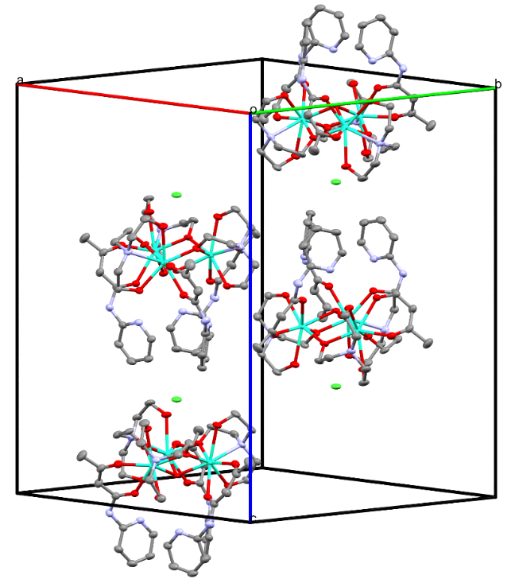
Figure 3.2. Crystallographic unit cell of Dy₃-2 containing four molecules. Solvent molecules and H atoms are omitted for clarity. Dy³⁺ trimers show opposing stacking within the unit cell.

as depicted in Figure 3.3. This data was plotted as χ_{M}T vs T, χ vs T, and 1/χ vs T to allow for comparison (Figure 3.4). The χ_{M}T value at 300 K for the powdered sample of Dy₃-2_{poly} is 39.06 cm³ K mol⁻¹, while the single-crystal values are 23.3 and 43.8 cm³ K mol⁻¹ for the Dy₃-2⊥ and Dy₃-2|| measurements, respectively (Figure 3.4). The Dy₃-2_{poly} and Dy₃-2|| measurements are consistent with the expected value of 42.5 cm³ K mol⁻¹ for 3 non-interacting Dy³⁺ ions, as well as comparable to Dy₃-1 which has a reported value of 41.63.²⁶¹ However, the Dy₃-2⊥ measurement is significantly lower. This is likely due to the antiferromagnetic coupling of spins along the normal direction, leading to a small saturated magnetic moment. From the χ_{M}T vs temperature (Figure 3.4a), there is an inflection point at 16 K and a broak maxima at 84 K. The χ vs T plot (Figure 3.4d) shows similar sharp changes at 16 K for Dy₃-2|| though the changes for Dy₃-2_{poly} and Dy₃-2⊥ are not as sharp and are around 7 K. At 2 K the χ_{M}T values reach 42.36, 29.84, and 10.68 cm³ K mol⁻¹ for Dy₃-2||, Dy₃-2_{poly}, and Dy₃-2⊥, respectively, showing anisotropic magnetism at both low and room temperatures. Further examination of the magnetization in relation to temperature shows that there is a loss of typical SMT behavior in the data collected for the Dy₃-2⊥ sample between 10 and 20 K (Figure 3.4b). This may explain the changes in ordering in the χ_{M}T versus T around 16 K.
Curie-Weiss paramagnetic behavior has been examined using the 1/χ vs T data, showing that the Curie-Weiss temperatures are -151 K, -15.8 K, and 25.45 K for the Dy₃-2⊥, Dy₃-2_{poly}, and Dy₃-2|| samples, respectively (Figure 3.4c). Negative and positive Curie-Weiss temperatures are indicative of antiferromagnetic (AFM) and ferromagnetic (FM) couplings, respectively. Thus, FM coupling dominates the in-plane direction and AFM coupling prevails in the interplane

H parallel to Hex surface
H perpendicular to Hex surface
Figure 3.3. Depiction of single-crystal orientation vs external field H for magnetic measurements.

b)
a)
d)
c)
Figure 3.4: Magnetic susceptibility data for Dy₃-2 showing the powder and single-crystal sample. (a) χT vs T; (b) Variable-temperature M vs H of Dy₃-2⊥ (M and H are lengths of magnetization M and external field H); (c) 1/χ vs T; (d) χ vs T.
direction from the single-crystal magnetization results. Determining how these Curie-Weiss temperatures are related to the coupling of magnetic moments, toroidal moments, and single-ion anisotropy is complicated, requiring multiple models to be applied to examine the AFM and FM couplings in SMTs. The Curie constant for each Dy³⁺ ion was also determined showing μ_{eff} values of 9.63 _{μB}, 10.42 _{μB} and 10.30 _{μB} for the Dy₃-2⊥, Dy₃-2_{poly}, and Dy₃-2|| samples, respectively, which is consistent with the moment of a Dy³⁺ ion.
Magnetization of all samples show the stereotypical shape of an SMT.^{35, 37, 44, 46} In the M vs H plots in Figure 3.5, hysteresis is only observed in the powdered sample. This may be expected when examining the crystal structure of Dy₃-2, which appears to have an alternating stacking structure that could lead to the cancellation of net toroidal moments within the single crystal. Differences between Dy₃-2|| and Dy₃-2⊥ show significant magnetic anisotropy, suggesting that the coupling among the Dy³⁺ ions within this molecule is retained regardless of direction of the external magnetic field. Interestingly, the magnetization obtained from a polycrystalline sample shows difference in the increasing and decreasing field conditions (Figure 3.5a). As M in the decreasing field condition is larger than that in the increasing condition, there is likely trapped flux due to impurities existing in the powder sample. Nevertheless, with magnetic anisotropy in single crystals, spin configuration may be detected by PND.

3.3.3. Polarized neutron diffraction
To understand the magnetic anisotropy of the Dy³⁺ spins in Dy₃-2, we have measured the local magnetic susceptibility tensor from spin of the Dy³⁺ ion by polarized neutron diffraction. The reflections were measured in the spin-up and spin-down neutron diffraction with an applied magnetic field along the ab plane where 27 good-quality flipping ratios were obtained.
a)
b)
c)
Figure 3.5. Magnetization vs field collected at 1.9 K: (a) Dy₃-2_{poly}; (b) Dy₃-2||; (c) Dy₃-2⊥.

The susceptibility tensor parameters χ₃₃ and χ₁₃ were fixed to be consistent with the bulk magnetization measurements. A plot of the experimental versus calculated flipping ratios in Figure 3.6 indicates that a suitable refinement of the flipping ratios was achieved.
The resulting refined magnetization tensor was found to be equal to
$${\overset{⃡}{χ}}_{Dy}=\frac{mi}{B}=\left[\begin{matrix}1.27(22) & -1.39(31) & -1(2) \\ -1.39(31) & 2.74(30) & 1.00 \\ -1(2) & 1.00 & 1.80\end{matrix}\right]$$
Due to the crystallographic symmetry of the compound, this tensor is symmetric among all three Dy³⁺ ions in the molecule. The magnetization ellipsoids are shown in Figure 3.6b, revealing that the overall spin arrangement gives the head-to-tail antiferromagnetic (AFM) coupling required of an SMT compound.
To improve the refinement parameters, the nuclear structure of Dy₃-2 determined by single-crystal X-ray diffraction (SCXRD) was used for the refinement of the flipping ratios. However, since the SCXRD structure data and the PND data were collected at 100 K and 5 K, respectively, the thermal differences may affect the tensor determination. From PND, one can also see the stacking of the toroidal magnetic moments within the crystal structure with the applied field, leading to an overall cancellation of moments. This is because, among the four Dy₃ molecules in a unit cell, there are two rotating clockwise and two counterclockwise Dy₃ molecules, as shown in Figure 3.8. Without the applied field, there is less ordering of the toroidal moment, showing a paramagnet state that would also lack hysteresis.
The susceptibility tensor for Dy³⁺ ions determined from PND also allows for simulation of magnetization data (Figure 3.7) and a comparison to our experimental data. The simulation shows that there should be a large difference in the magnetization of a crystal between the ab plane and the c axis. This is also observed in the magnetization data in Figure 3.5.
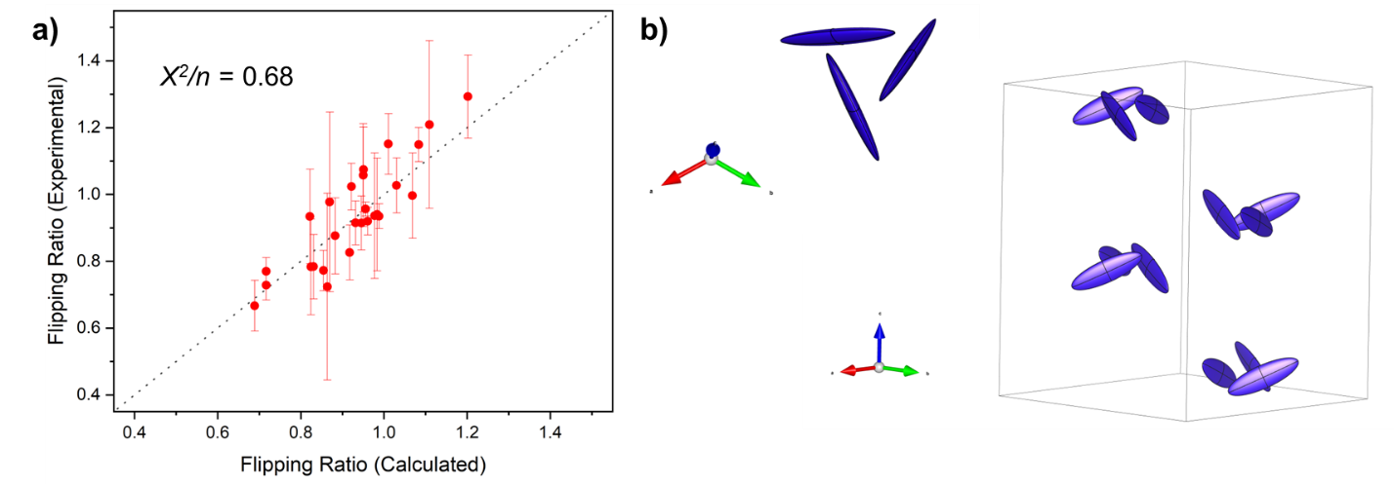
Figure 3.6. (a) Flipping ratios for Dy₃-2. (b) The refined susceptibility tensor for Dy₃-2 in the crystallographic unit cell. The head-to-tail spin arrangement is observed in the ab plane, while the toroidal moment would be pointed along the c axis.

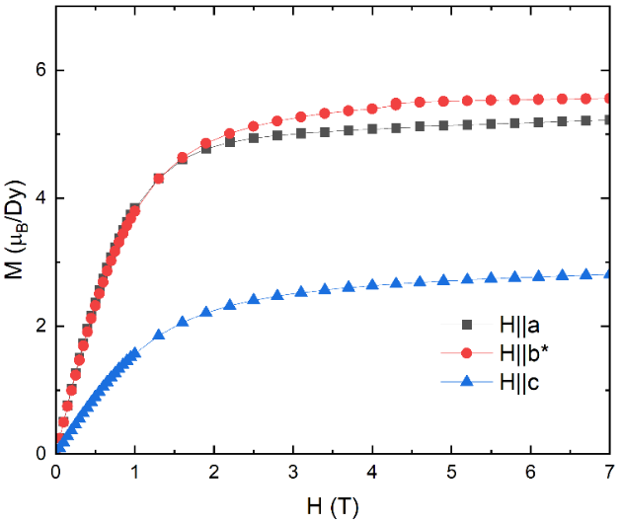
Figure 3.7. Simulation of magnetization based on one Dy³⁺ ion within the Dy₃-2 compound based on PND refinement of the susceptibility tensor.

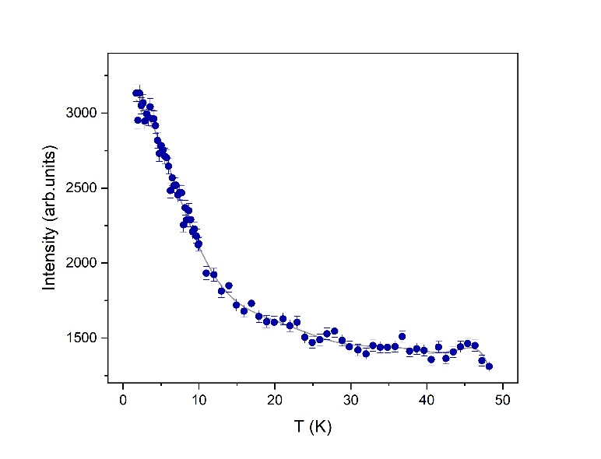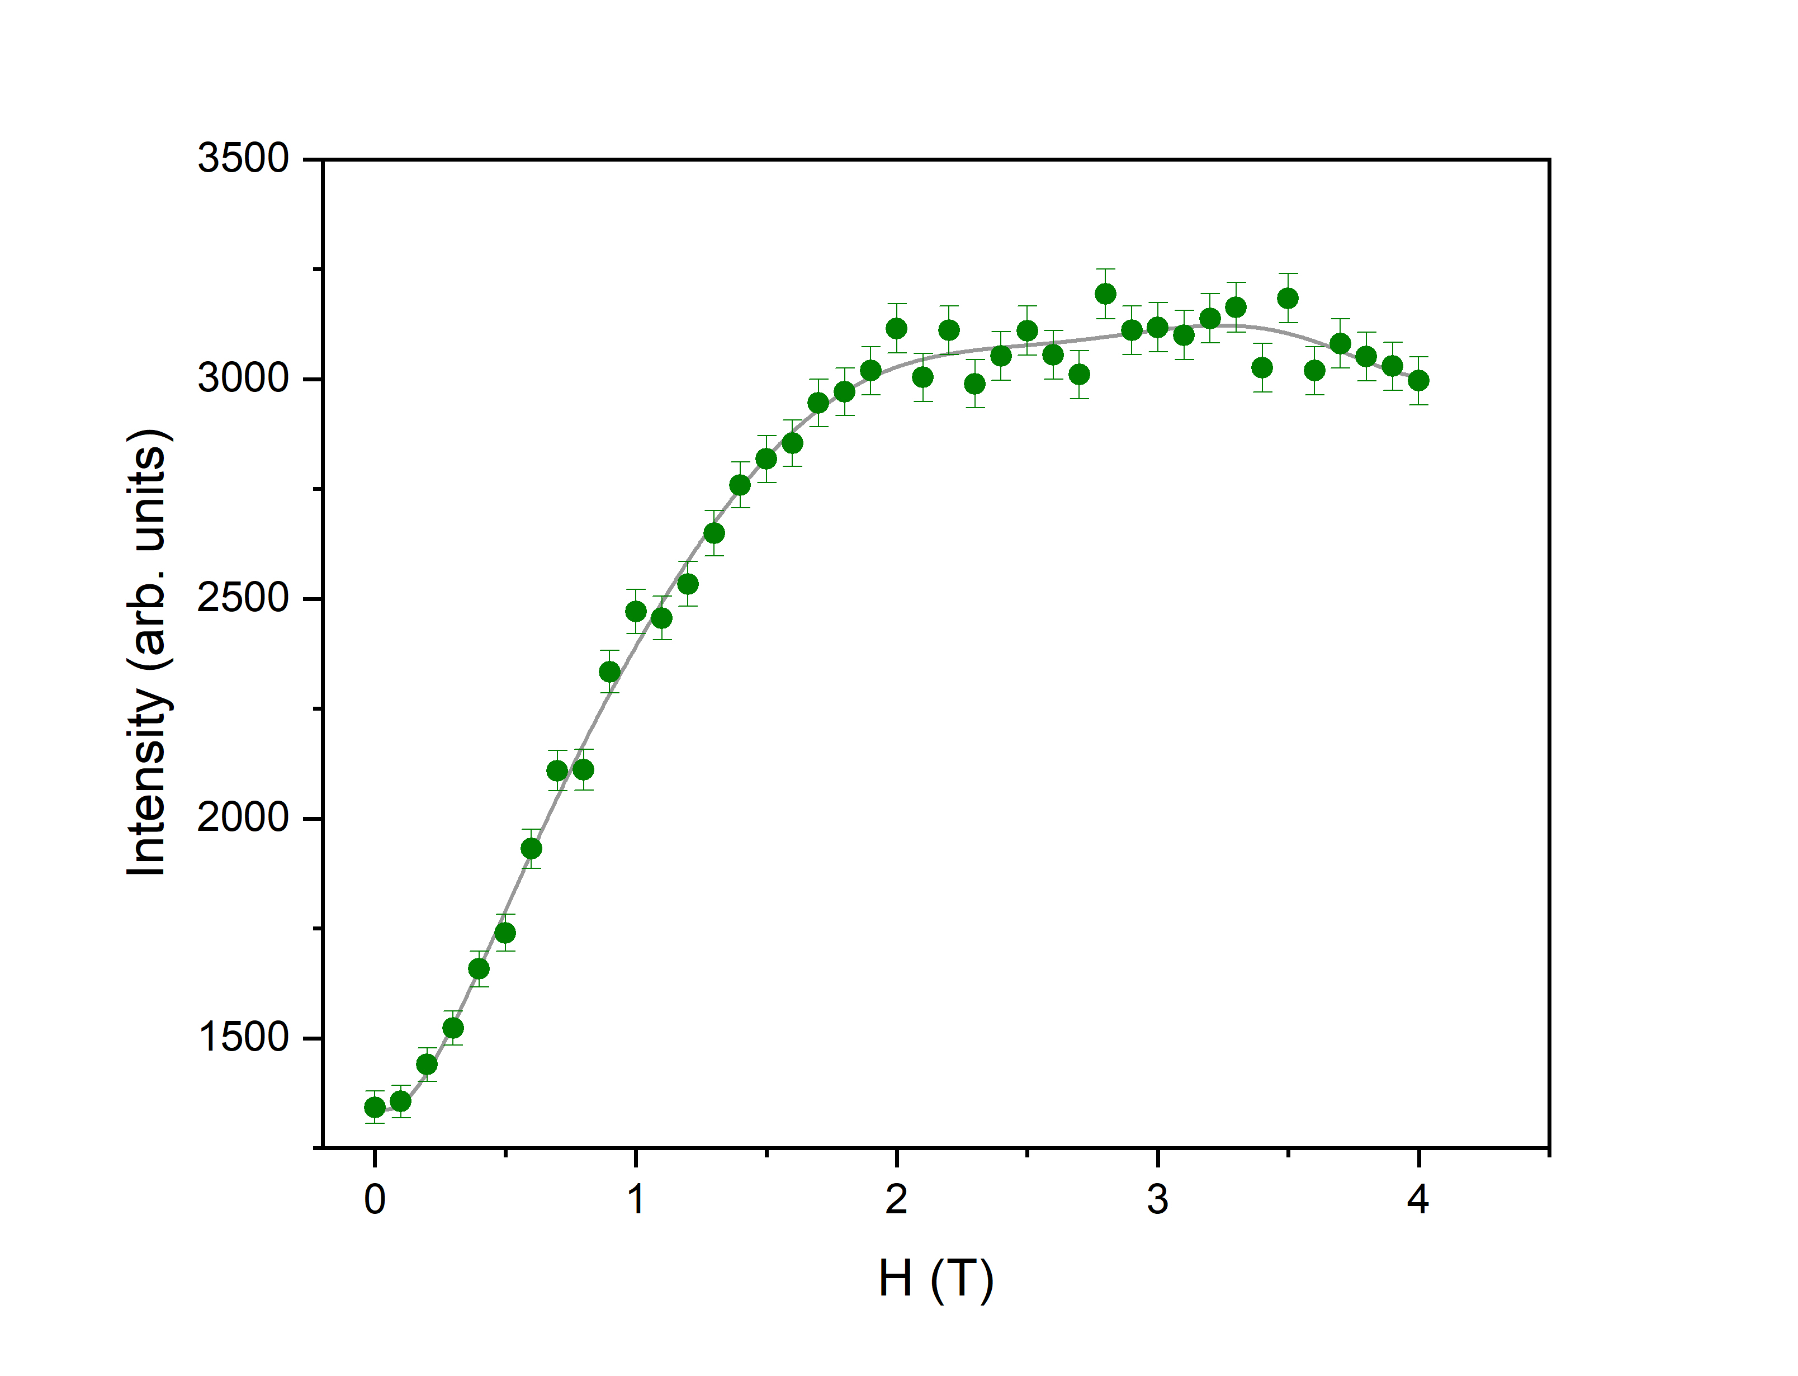
a)
b)
Figure 3.8. (a) Field-dependent order parameter with data collected at 5.0 K with 0.1 T/step. (b) Temperature-dependent order parameters for the magnetic form factor of Dy₃-2 at 4.0 T. Field induced magnetic order emerges at 0.2 T. Magnetic order appears at ~10 K with an applied magnetic field of 4.0 T.
The simulation from PND, when scaled to three Dy³⁺ ions, gives the magnetization of 16.2 when H‖a. In comparison, the experimentally determined magnetization constant is 17.4 for Dy₃-2||. Similarly, the simulation gives magnetization of 8.2 when H‖c, which is close to 8.4, the experimentally determined magnetization for Dy₃-2⊥. These simulations matching the experimental results show that the susceptibility tensor is accurate with the thermal effects between the single-crystal structure and the PND data.

3.3.4. Variable-magnetic-field single-crystal neutron diffraction
Single-crystal neutron diffraction has been used to examine the field-induced magnetic order and the toroidic order in solid-state materials. For Dy₃-2, there are two main phenomena to examine. The first is the direction of the magnetic moment within each toroidal dipole and the second is the field-induced antiferro-toroidic order due to the canted spins out-of-plane. Single-crystal neutron diffraction experiments were performed at different applied magnetic fields parallel to the c axis at 5.0 K. The magnetic fields varied between 0.0 T and 4.0 T with 0.1 T change each time, and magnetic scattering at (2 0 0) was measured. As shown in Figure 3.8a, field-induced magnetic order along the c axis begins to emerge at ~0.2 T and maximize at ~2 T. Temperature-dependent magnetic scattering at (2 0 0) was also measured between 1.5 K and 50.0 K with an applied magnetic field of 4.0 T. Below 10 K, the temperature was changed 0.25 K per step to collect the magnetic scattering intensity. Above 10 K, the data were collected with 1 K a step. As shown in Figure 3.8b, field-induced magnetic-ordering appears at ~10 K.

3.4. Conclusions
We have presented a new SMT candidate, [Dy₃(O)(teaH₂)₃(paa)₃]Cl·PhCN·4MeOH (Dy₃-2) and demonstrated that it fulfills key structural and magnetic criteria of an SMT compound. Through the combined use of magnetometry and neutron diffraction, we have unambiguously determined the head-to-tail spin arrangement for this Dy₃ SMT, confirming the toroidal moment. Dy₃-2 shows typical SMT characteristics in DC susceptibility studies, both for polycrystalline and single crystal samples. The use of PND allows for mapping the atomic susceptibility tensor of Dy³⁺ ions within the compound and confirms the toroidal spin arrangement. This is, to our knowledge, the first direct experimental determination of the toroidal spin arrangement in an SMT compound.

3.5. Experimental section
Syntheses of Dy₃-1, Dy₃-2, and paaH and the structure determination by single-crystal X-ray diffraction are given in Chapter 3 addenda.

3.5.1 Magnetic susceptibility measurements
DC Magnetic Susceptibility measurements were completed using a Quantum Design MPMS-7 T at the SmartState Center for Experimental Nanoscale Physics, University of South Carolina. Magnetization by variable temperature and variable magnetic field was collected. Measurements were taken of a powdered sample as well as single crystals oriented in multiple directions. Single crystals were coated with a thin layer of silicon grease to protect the crystal from degradation.

3.5.2. Polarized neutron diffraction (PND)
The HB-3A DEMAND³⁰¹ at the High Flux Isotope Reactor (HFIR), Oak Ridge National Laboratory (ORNL) was used to perform the polarized single crystal neutron diffraction measurements with a polarized neutron beam of 1.542 Å from a bent Si-220 monochromator³⁰² and a calibrated neutron polarization of 76%. The sample was measured at 5 K with H//ab and a permanent magnetic set was used to fix the field to 0.6 T. The CrysPy software⁶⁹ was used to analyze the measured flipping ratios.

3.5.3. Neutron diffraction under variable-magnetic fields
The HB-3A DEMAND³⁰¹ at the High Flux Isotope Reactor (HFIR), Oak Ridge National Laboratory (ORNL) was used to perform the single crystal neutron diffraction measurements. The sample was measured at 1.5 K with a variable magnetic field ranging from 0 to 4 T. Data subtraction and integration was completed using FulProf.^{303, 304}

Chapter 4: Ni(II)-based Haldane topological spin-1 chains within 2-dimensional metal-organic frameworks

This chapter is based on the following manuscript to be submitted for publication:
Michael J. Jenkins, Brandon Watson-Sanders, Daniel Duong, Silu Huang, Pagnareach Tin, Cheng Li, Qiang Zhang, Thomas Proffen, Luke L. Daemn, Rongying Jin, Zi-Ling Xue. Ni(II)-based Haldane topological spin-1 chains within metal-organic frameworks.
Author Contributions
Michael J. Jenkins and Pagnareach Tin synthesized compounds and prepared them for experimentation. Brandon Watson-Sanders collected DC magnetization data and performed gap fitting. Daniel Duong and Silu Huang collected preliminary specific heat measurements up to 14 T. Cheng Li, Qiang Zhang, and Thomas Proffen collected POWGEN data or helped interpret the data. Luke Daemen assisted in collection and interpretation of INS results. Jurek Krzystek collected HFESR spectra and helped interpret the results. Ziling Xue initiated the project and supervised the research. Jenkins and Xue wrote the manuscript with input from other authors.

4.1. Abstract
Haldane topological materials have been studied for their potential applications in spintronics and quantum computing, due to their symmetry-protected energy gaps from the spin chains. Here, we discuss the Haldane properties of two Ni(II)-based metal-organic frameworks [Ni(μ−bpa)(μ−ox)] [NiBaO; bpa = 1,2-di(pyridin-4-yl)ethane); ox²⁻ = oxalate] and [Ni(μ−bpe)(μ−ox)] [NiBeO, bpe = 1,2-di(pyridin-4-yl)ethene] that form two-dimensional sheets of Ni²⁺-ox²⁻ spin-1 chains with nitrogen-based organic linkers between the chains. These spin chains are probed by variable-temperature powder neutron diffraction, variable temperature inelastic neutron scattering (INS), DC susceptibility, specific heat measurements, and high-field and -frequency electron spin resonance (HFESR). Vibrational properties have been probed by INS and far-IR spectroscopy. The results suggest that interactions between Ni(ox) chains in NiBaO and NiBeO are weaker than in [Ni(μ−4,4′-bpy)(μ−ox)] (NiBO).

4.2. Introduction
In 1983, Haldane proposed that one-dimensional (1-D) antiferromagnetic Heisenberg spin chains show two distinct classes depending on whether the quantum spin number is an integer or half-integer.^{47, 48} For integer spin chains, the Haldane phase or ground state demonstrates a finite excitation gap and short-range antiferromagnetic order. The half-integer spin chain does not show a finite excitation gap but instead is in a gapless state.⁴⁷⁻⁵¹ Further research and modelling by Affleck, Kennedy, Lieb, and Tasaki (AKLT) later explain the gapped state in integer spins is due to a ground state with spin-1/2 edge states at the end of finite spin chains, which form singlet or triplet ground states depending on the configuration of boundary conditions (Figures 4.1 and 4.2).^{49, 50, 52-55} The nonzero energy gap is preserved under perturbation, showing the topological nature of the Haldane phase and that protected symmetries such as time-reversal are maintained.³⁰⁵ This behavior is significantly different from conventional antiferromagnetic materials such as nickel(II) oxide (NiO), in which long-range magnetic order emerges.⁵⁷ In NiO, the formation of a magnetic unit cell distinct from the crystallographic unit cell gives rise to additional magnetic Bragg reflections in diffraction patterns, indicative of the classical magnetic ordering absent in the quantum-disordered Haldane phase. There have been multiple Haldane spin-1 materials studied using Ni²⁺ as the metal ion, from cationic 1-D chains such as NENP [Ni(en)₂(μ-NO₂)](ClO₄)] (en = ethylenediamine), ³⁰⁶⁻³¹² NENB [Ni(en)₂(μ-NO₂)](BF₄)],³¹³ NINO [Ni(1,3-propanediamine)₂(μ-NO₂)](ClO₄)],^{307, 314} NDMAZ [Ni(dmpn)₂(μ-N₃)](ClO₄)] (dmpn = 1,3-diamino-2,2-dimethylpropane),³¹⁵ or neutral
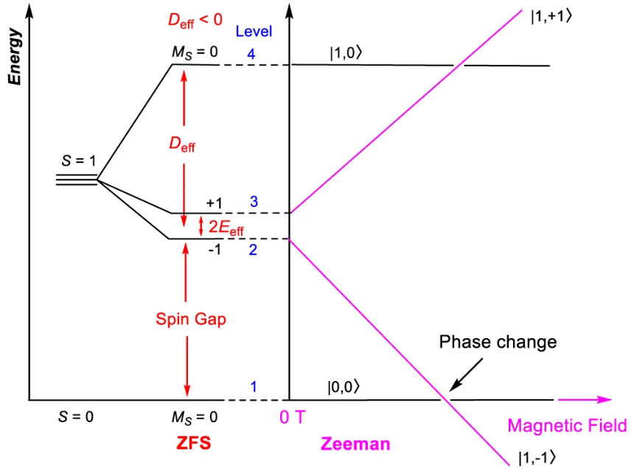
Figure 4.1. Energy diagram of the Haldane phase, showing perturbations of anisotropy leading to ZFS and the effects of magnetic field on Zeeman splitting. Adapted from P. Tin, M. J. Jenkins et. al.⁵⁶

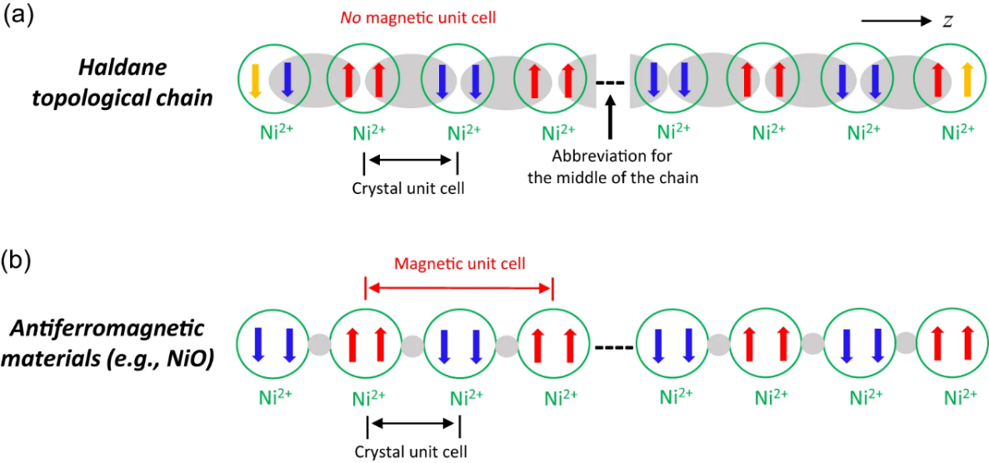
Figure 4.2. a) Scheme of the AKLT model representation of the spin-1 Haldane chain showing the coupling between two electrons of two neighboring Ni(II) ions within the chain, leaving one unpaired electron at each end of the chain. Green circles show individual Ni²⁺ ions, coupling is shown in the gray oval, quantum coupled electrons are shown as red and blue arrows, and unpaired electrons are shown in orange arrows at the end of the chain. b) Scheme showing typical antiferromagnetic structure in NiO below the Neel temperature. O²⁻ ions are shown as gray circles. Antiferromagnetic coupling gives a magnetic structure at twice the d-spacing of the crystal unit cell. Adapted from P. Tin, M. J. Jenkins et al.⁵⁶
MOF systems such as NiBO [Ni(μ−4,4′-bpy)(μ−ox)] (ox²⁻ = oxalate) which we reported recently,^{56, 316} NiBaO [Ni(μ−bpa)(μ−ox)] (bpa = 1,2-di(pyridin-4-yl)ethane),³¹⁷ and NiBeO [Ni(μ−bpe)(μ−ox)] (bpe = 1,2-di(pyridin-4-yl)ethene).³¹⁷ In the case of cationic chains, there must be a non-coordinating anion such as ClO₄⁻ or BF₄⁻ in the structures. In the case of the neutral MOF systems with Ni²⁺ ions, oxalate²⁻ ligand is used in addition to a neutral bridging N-based ligand. The use of a neutral MOF to form the Haldane spin-1 chain allows for, e.g., exfoliation of sufficiently large crystals giving 2-D nanosheets that should exhibit their low-dimensional topological properties. There is also the ability to compare the effect of interchain-ligands on the energy gap and perturbation stability of otherwise similar chains.
Syntheses of NiBaO and NiBeO were reported by Garcia-Couceiro, Castillo, Luqu, and coworkers.³¹⁷ Results of DC magnetic magnetometry suggest that NiBaO and NiBeO are Haldane materials.³¹⁷ Herein, we report detailed studies of these two MOF-based Haldane spin-1 chains. NiBaO, NiBeO, and NiBO are similar in the Ni²⁺-ox²⁻ spin-chains but different in the interchain ligands, 4,4′-bipyridine for NiBO, 1,2-di(pyridin-4-yl)ethane (bpa) for NiBaO, and 1,2-di(pyridin-4-yl)ethene (bpe) for NiBeO (Figure 4.3). We are interested in NiBaO and NiBeO for the following: (a) Confirming that NiBaO and NiBeO are Haldane by advanced techniques; (b) Effects of bpa and bpe on inter-chan magnetic interactions. The bpa and bpe bi-dentate ligands are longer than 4,4′-bpy. Also, the two pyridine ligands in bpe are potentially conjugated, while they are not in bpa. The Ni²⁺-ox²⁻ spin-1 chains are assumed to be essentially identical, with any differences in properties being derived from the difference in the bpa vs bpe ligand.

Figure 4.3. a) Simplified structure of NiBaO and b) NiBeO, showing a small portion of the polymeric 2-D MOF structure.

The increased conjugation of the bpe ligand may be expected to increase coupling between spin-1 chains, though the difference is expected to be small due to the large distance between the chains. NiBaO and NiBeO have been probed in the current work by a variety of techniques, including temperature-dependent powder neutron diffraction, DC magnetometry, high-field and -frequency electron spin resonance (HFESR), inelastic neutron scattering (INS), and specific-heat measurements. Temperature-dependent powder neutron diffraction results show no long-range antiferromagnetic ordering in NiBaO or NiBeO within the Haldane phase determined by magnetometry. DC magnetometry allows for antiferromagnetic phase determination, spin-gap fitting, and magnetic perturbation, showing that these materials are robust up to 7 T from the collapse of the Haldane phase. Similarly, specific heat measurements up to 14 T show no collapse of the Haldane phase. INS shows weak magnetic transitions that may be correlated to a spin gap, but further work is required to confirm the INS results.

4.3. Results and discussion

4.3.1 Synthesis
The synthesis of NiBaO and NiBeO were reported earlier,³¹⁷ and the conditions of the reactions were kept the same except changes discussed in the experimental section.
In attempts to decrease the incoherent scattering caused by H atoms in NiBaO and NiBeO and thus increase the S/N ratio in neutron scattering experiments, there were attempts to deuterate the interchain ligands bpa and bpe. The most effective method from our testing was based on base-mediated deuteration using DMSO-d₆ as the D source in a procedure inspired by the work of Kopf et al.³¹⁸ Details of the reactions and other attempted deuteration reactions are given in the experimental section.
The deuteration of the interchain ligands proceeds from the deprotonation of the pyridine-based rings by the dimsyl anion, following a typical anionic pathway for H/D exchange as documented for several classes of compounds.³¹⁸⁻³²¹ It was expected from Kopf’s work that there would be high levels of deuteration on the pyridine ring, specifically the ortho position, with a small amount of the alkyl- or alkene-chain deuteration. From mass spectrometry data, the base-mediated H/D exchange gave a dispersion from bpa-d₃ to bpa-d₈, and bpe-d₃ to bpe-d₆ as shown in Figure A4.1 and Figure A4.2. The average deuteration of the ligands was approximately 50%. The use of ¹H NMR on both the deuterated ligand and a reference non-deuterated sample allows for comparison and determination of which sites are deuterated (Figure A4.3).

4.3.2. Variable-temperature powder neutron diffraction
Variable-temperature powder neutron diffraction was conducted at 1.8, 10, 20, 100, and 200 K for NiBaO. For NiBeO data was collected at 10, 20, 50, 75, 100, 150, and 200 K. Variable-temperature powder neutron diffraction was chosen to study these compounds to examine potential phase transitions that might lead to long-range magnetic ordering. As discussed earlier, if the spin-1 chain is in the Haldane phase there should be no long-range magnetic ordering leading to new magnetic Bragg reflections at low temperatures. Instead, there should only be peaks associated with nuclear diffraction from the crystal unit cell.
As shown in Figure 4.4 and Figure 4.5, there were no new peaks in the Variable-temperature powder neutron diffraction for either NiBaO or NiBeO associated with new magnetic Bragg reflections, thus showing that there is no long-range antiferromagnetic ordering. Combining this

Figure 4.4. Patterns of powder neutron diffraction for NiBaO at 1.8 and 200 K.
Figure 4.5. Patterns of powder neutron diffraction for NiBeO at 10 and 200 K.

result with DC magnetometry, showing antiferromagnetic ordering in NiBaO and NiBeO, the antiferromagnetic order in both NiBaO and NiBeO is consistent with that of a Haldane phase.

4.3.3. DC magnetic susceptibility
Figure 4.6 and Figure 4.7 show temperature dependence of the DC magnetic susceptibility of NiBaO and NiBeO, respectively, using a powder sample at 0.1 T applied magnetic field. Lowering the temperature from 300 K to 1.8 K shows a broad maximum near 50 K for both samples and a sharp decrease afterward toward zero magnetic susceptibility around 5 K, after which there is a plateauing in the case of NiBaO and a sharp uptick in the case of NiBeO. This can be observed in the inset spectra of the low temperature data for NiBeO in Figure 4.7, where after 4 K there is a sharp increase in magnetic susceptibility, which would be indicative of a phase change from the quantumly entangled Haldane phase to a ferrimagnetic or ferromagnetic phase. The broad maxima, or Neel point, is indicative of short-range interchain correlations or suppression of long-range ordering due to weak interchain coupling. This is typical of Haldane materials as there is a slow thermal crossover from a quantum disordered Haldane phase to a classical paramagnetic material due to the breakdown of the topological protection to perturbation.^{322, 323}
The high temperature data can be fitted to the Curie-Weiss law:
$χ=\frac{C}{T-θ_{CW}}$ (Eq. 4.1)
Giving Curie-Weiss temperatures of -130 K and -207 K for NiBaO and NiBeO, respectively, indicating net antiferromagnetic interactions in the high temperature region. From fitting to the Curie-Weiss equation we can also determine the Curie constants, which are 1.72 and 1.94 cm³·K·mol⁻¹ for NiBaO and NiBeO, respectively, as shown in Figure 4.8.

Figure 4.6. DC magnetic susceptibility of NiBaO showing χ vs T (red) and χT vs T (blue) plots at 1.8-300 K. The inserted figure is a focus on the low temperature region (1.8–25 K) of the χ vs T plot.
Figure 4.7. DC magnetic susceptibility of NiBeO showing χ vs T (red) and χT vs T (blue) plots at 0.8-300 K. The inserted figure is a focus on the low temperature region (1.8–25 K) of the χ vs T plot.

Figure 4.8. a) Plot of ln[χ(T) - χ(0)] vs 1/T for data between 20 K and 4 K for NiBaO and b) NiBeO. The red line shows the fit used for extracting the spin gap.

The Curie constant can then be used to extract the effective magnetic moment for Ni²⁺ ions in the spin chains, giving μ_{eff} values of 3.70 and 3.94 μ_{B} for NiBaO and NiBeO, respectively. These values are higher than the spin-only magnetic moment of 2.83 μ_{B}. The results show that there are contributions to μ_{eff} from spin-orbit coupling or zero-field splitting, which would be expected in an octahedral Ni²⁺ system such as NiBaO and NiBeO.
The decrease in DC magnetic susceptibility at low temperature is indicative of antiferromagnetic coupling and of a magnetic excitation gap as seen in other spin-1 chain systems. Spin gap data fitting of the low-temperature DC magnetic susceptibility using the Eq. 4.2 gives a value of E_{g} = 7.5 and 7.8 cm⁻¹ for NiBaO and NiBeO, respectively.
$χ\left(T\right)= χ\left(0\right)+Ce^{\frac{-E_{g}}{k_{B}T}}$ (Eq. 4.2)
where E_{g} is the spin gap and χ(0) is an offset to account for low temperature diamagnetic interactions.
Collecting magnetization isotherms for the low temperature region allows us to probe the stability of the gapped magnetic phase, which is expected to be somewhat stable to external perturbation (Figures 4.9 and 4.10). If there is a sharp change in the characteristics of the magnetic isotherm, the change should indicate a critical field has been reached, closing the Haldane gap and allowing the triplet excited state to populate. There is also the ability to see thermal excitation population differences within the material, giving different magnetic moments for each temperature shown.
For NiBeO, isotherms at 1.8-3.7 K show features, at low fields, more like a ferro- or ferri-magnetic material. Then, at higher fields, the isotherms show features that are expected of a
Figure 4.9. Magnetic isotherm of NiBaO.
Figure 4.10. Magnetic isotherm of NiBeO.

Haldane phase, as shown in Figure 4.10. These changes are consistent with a field induced collapse of one magnetic phase into another, such as one might expect from a ferrimagnetic phase to the quantum order of a Haldane phase within this material. This phase difference at low temperatures is also observable in the DC susceptibility plot insert, with an uptick below 4 K that corresponds to a different magnetic ordering than the expected Haldane phase.
To further probe the stability of the Haldane phase, we measured specific heat up to 14 T. Neither NiBaO nor NiBeO showed the collapse of the Haldane phase with scans from 5 to 15 K (Figure A4.10 and Figure A4.11). This is significantly different from previous results of the similar Haldane material NiBO, showing a pronounced phase change around 9 T.⁵⁶ This comparison to NiBO shows that, although NiBaO, NiBeO, and NiBO are all spin-1chains, there is less interchain coupling leading to non-Haldane magnetic ordering NiBaO and NiBeO

4.3.4. High-field electron spin resonance
HFESR measurements were performed on powder samples of NiBaO and NiBeO (118 and 113 mg, respectively) at 4.5 K to probe transitions within the triplet excited state. The samples produce virtually identical spectra, showing two resonances, labeled as A and B in Figure 4.11. Resonance A is partly obscured by an oxygen signal but is real and can be followed over a range of frequencies, showing a linear correlation with frequency and with a g-factor of about 2.3. Its frequency dependence suggests that it is an equivalent of a “double quantum transition” ³²⁴ in paramagnetic complexes of Ni(II) and as such is probably of little or no interest. Resonance B, however, shows a different dependence and indicates a finite energy gap at zero field, on the order of 180 GHz = 6 cm^{–1}. This estimate was made with an assumption that the frequency dependence is linear, which does not have to be the case. In fact, spectra recorded in the 235–275 GHz range (Figure 4.12) do not show Resonance B which could mean two things:
Figure 4.11. HFESR spectrum of NiBaO and NiBeO at 4.5 K and 498 GHz. Letters A and B indicate resonances originating from the sample. The narrow signals at 8.6 and 15.9 T come from molecular dioxygen.
Figure 4.12. A field vs. frequency dependence of HFESR resonances of NiBeO at 4.5 K. Letters A and B indicate resonances originating from the sample shown in Figure 4.11.
(a) the frequency dependence is not linear, and branch B goes to zero field at frequency higher than 275 GHz, which would mean that the gap is larger than 9 cm^{–1}, or (b) the resonance gets broadened at low frequencies beyond recognition.

4.3.5. Inelastic neutron scattering
INS was completed at VISION to study the spin gaps in NiBaO and NiBeO. The measurements were conducted from 5-40 K (NiBaO) or 5-100 K (NiBeO) to examine the magnetic excitations from the ground state to triplet excited state, shown in Figures 4.13 and 4.14. The data collected was Bose-Einstein corrected to reduce phonon characteristics, giving temperature dependent magnetic peaks within the spectrum. The data collected did not give sufficient differences in temperature spectra to define magnetic transitions from the ground to excited states within the spectra.

4.3.6. Phonon characteristics from INS and far-IR magneto-spectroscopy (FIRMS)
The phonons described in these studies are both inter- and intra-molecular vibrations. Phonons from INS are based on the kinetic energy transfer by neutrons to the sample which removes symmetry-based selection rules required for optical spectroscopies such as IR or Raman. Figure 4.15 gives the INS spectra of NiBaO and NiBeO, showing major phonon features below 1700 cm⁻¹ with another distinct feature around 3200 cm⁻¹. We also attempted to study the phonon features and magnetic transitions of these 2-D MOFs using far-IR magneto-spectroscopy (FIRMS), but it was ineffective in elucidating any magnetic transitions (Figure A4.12). FIRMS has not successfully shown magnetic excitations of Haldane materials, possibly due to the low energy of such magnetic transitions or that they may not be the correct symmetry to view in IR spectroscopies.
Figure 4.13. INS data for NiBaO collected at 5, 10, 15, 20, 25, 30, and 35 K. There is a minor peak that may be related to magnetic transitions at 9 cm⁻¹.
Figure 4.14. INS Data for NiBeO collected at 5, 7.5, 10, 15, 25, 50, and 100 K. There are no peaks strong enough to claim they are related to magnetic transitions.

Figure 4.15. Bose-corrected INS spectra for a) NiBaO and b) NiBeO. Average of the forward- and back-scattering data are used here. The main phonon features are observed below 1700 cm⁻¹, except for a strong peak at ~3200 cm⁻¹.

4.4. Conclusions
Herein we have provided characterization and analysis of two 2D-MOFs showing Haldane spin-1 chain character. From a combined analysis of variable-temperature powder neutron diffraction, DC magnetometry, and HFESR we have characterized the magnetism of these MOFs. INS and far-IR spectroscopy have been used to characterize the low energy phonons of these compounds. We have shown that the Haldane phases of these compounds are stable to perturbation up to 14 T.

4.5. Experimental section

4.5.1. Synthesis
NiBaO was prepared by hydrothermal reactions of NiSO₄·6H₂O (1.0 mmol), H₂ox·2H₂O (1.0 mmol), and bpa (1.0 mmol) in 7 mL of water in a 1:1:1 molar ratio. Reactions were completed in a 23-mL digestion bomb for 144 h at 170 °C. The product was washed with cold water and diethyl ether and dried in air, giving a blue polycrystalline or powder product.
NiBeO was prepared by hydrothermal reactions of NiSO₄·6H₂O (1.0 mmol), H₂ox·2H₂O (1.0 mmol), and bpe (1.5 mmol) in 7 mL of water in a 2:2:3 molar ratio. Reactions were completed in a 23-mL digestion bomb for 144 h at 170 °C. The product was washed with cold water and diethyl ether and dried in air, giving a blue-grey polycrystalline or powder.
In attempts to grow crystals for these compounds suitable for single-crystal X-ray diffraction (SCXRD) multiple variations were made to the synthetic parameters, as discussed in the addenda for Chapter 4. The only modifications that give acceptable crystals used a 4:3 water/ethanol solvent mix, with the same heating and slow cooling as typically used. Although crystals from this procedure did diffract in SCXRD, their quality was still not high enough to give a publishable structure.
Deuteration of ligands was completed using a method inspired by the work of Kopf et al.³¹⁸ Here, the protio ligand of choice (bpa or bpe, 0.5 mmol, 92 mg) was loaded into a Schlenk flask with KOt-Bu (0.5 mmol) and a stir bar which was then evacuated and refilled with N₂, which was repeated 3 times. To the flask was then added DMSO-d₆ (17 eq., 600 μL) and deionized water (1.1 eq., 10 μL) under a slow nitrogen purge. The flask was then sealed and heated to 120 °C for 16 h with gentle stirring. The resulting thick brown mixture was then diluted with dichloromethane (DCM, 10 mL), washed with a saturated sodium chloride brine (20 mL), and extracted with DCM (2 × 20 mL). The organic layers were dried over sodium sulfate for 12 hours and then concentrated. The resulting product was dissolved in acetonitrile and passed through a silica plug. After removing the excess solvent, the dried ligand was recovered (~70% recovery). This process was also completed at a double scale, with identical results. Using MS and ¹H NMR it was determined that about 50% deuteration was achieved, as shown in Chapter 4 addenda. When sequential reactions were attempted to further deuteration, the compound seemed to decompose and there was a complete loss of product.
Other H/D exchange reactions were conducted, including the use of Pd/C in D₂O and the use of WCl₆ with C₆D₆ based on the literature methods.³²⁵⁻³²⁷ These trials were not as successful as the use of base-mediated methods and were therefore not used. Further discussion of these trials is given in Section A4.1.2 in the addenda for Chapter 4.

4.5.2. Magnetometry
DC magnetic susceptibility measurements at 0.1 T were conducted at the Center for Nanophase Materials Sciences (CNMS), Oak Ridge National Laboratory (ORNL) using the superconducting quantum interference device (SQUID) magnetometer by Quantum Design. Variable-temperature and variable-field DC magnetic susceptibility measurements were also collected.
Specific heat data was collected on a PPMS-SQUID magnetometer made by Quantum Design at the SmartState Center for Experimental Nanoscale Physics, University of South Carolina. Data was collected at 0 T and 14 T and showed essentially no difference besides what would be expected from magnetic field effects.

4.5.3. Inelastic neutron scattering
VT-INS data were collected by placing a powder sample (approximately 0.5 g) into a vanadium can specifically made for the neutron instrument. The sample vanadium can was placed into the neutron beamline at the Vibrational Spectrometer (VISION) at SNS, ORNL. There are two detector banks for the forward (low |Q |) and the back (high |Q |) scattering of neutrons.

4.5.4. Powder neutron diffraction
Neutron diffraction data were collected at the POWGEN diffractometer, Spallation Neutron Source (SNS), Oak Ridge National Laboratory (ORNL) between 1.8 K and 200 K using an Orange Cryostat (for NiBaO) or 10 K and 200 K and the standard sample environment (for NiBeO). A powder sample was loaded into a 6 mm-diameter, cylindrical vanadium sample can, and the data were collected for approximately 2 h in the high-resolution mode, using a center wavelength of 2.665 Å covering the d spacing from 1 Å to 15.0 Å.

4.5.6. High-frequency electron spin resonance
HFESR experiments were performed at the National High Magnetic Field Laboratory using a bespoke ESR spectrometer with a 17 T superconducting magnet that has been described previously.²⁰⁴

Chapter 5: Solvatochromism of cupric chloride and its conversion to copper oxide

This chapter is based on the following paper:
Michael J. Jenkins, Miranda A. Phillips, Zi-Ling Xue, Solvatochromism of Cupric Chloride and Its Conversion to Copper Oxide. J. Chem. Educ. 2023, 100, 12, 4772–4779. https://doi.org/10.1021/acs.jchemed.3c00493
M. J. Jenkins and M. Phillips conducted the synthesis and characterization of CuO. Jenkins conducted the UV-vis, IR and X-ray studies. Jenkins and Z.-L. Xue wrote the manuscript.

5.1. Abstract
This experiment demonstrates that copper(II) chloride dihydrate (CuCl₂·2H₂O) in different solvents (acetone, isopropyl alcohol or water) displays divergent colors and visible-near IR spectra. Both the reactions of these solutions with two equiv. of sodium hydroxide (NaOH) and the direct solid-state reaction of CuCl₂·2H₂O with 2NaOH using a mortar and pestle give copper(II) oxide (CuO). Undergraduate students learn the following: (1) d-d electronic transitions in a transition metal complex; (2) Effects of solvent polarity changes on the electronic ground and excited state of Cu²⁺ ions as well as color differences; (3) Direct solid-state reaction as a green synthetic method; (4) Gradual formation of CuO from solution reactions of CuCl₂·2H₂O with 2 equiv. of NaOH; (5) Characterization of chemical compounds in solutions by visible-near IR spectroscopy and solid products by IR and powder X-ray diffraction (PXRD). This experiment is suitable as a junior-level inorganic chemistry experiment.

5.3. Experimental section
CuCl₂·2H₂O (Analytical reagent, Mallinckrodt), acetone (Me₂C=O, Certified ACS, Fisher Scientific), isopropanol (i-PrOH, Certified ACS, Fisher Scientific), and NaOH (Certified ACS, Fisher Scientific) were used as received. Deionized water was prepared in house and used for the experiments below.
IR spectra were obtained on a Bruker Alpha II Compact FT-IR Spectrometer in the ATR (attenuated total reflectance) mode. UV-visible-near IR spectra were recorded on an Agilent 8453 UV-visible spectroscopy system or an Agilent Cary 100 UV-visible spectrophotometer. Powder X-ray diffraction (PXRD) was conducted on a Panalytical Empyrean diffractometer with a Cu K_{α} source.

5.3.1. UV-visible spectroscopic characterization of CuCl₂·2H₂O in acetone, isopropanol, and water
Three samples of CuCl₂·2H₂O (170 mg, 1.00 mmol) were each added to three vials along with 10 mL of acetone, isopropanol, and water, respectively. Spectra were taken for each solution at 380-900 nm as well as 300-1100 nm. A serial dilution using volumetric glassware was required to obtain a spectrum within the optimum absorbance range of the instruments, with concentrations of CuCl₂·2H₂O at 0.020 M, 0.002 M, and 0.0015 M in solutions of water, isopropanol, and acetone, respectively, showing the best spectra.

5.3.2. Formation of CuO in acetone, isopropanol, and water and from the solid-state reaction
CuCl₂·2H₂O (170 mg, 1.0 mmol) was dissolved in three vials containing 10 mL of acetone, isopropanol, and deionized water, respectively. NaOH pellets (80 mg, 2.0 mmol) were ground in a mortar and pestle, and then added to each solution. These solutions were kept stirring for 2 days. Supernatants were removed by filtration and the products were washed with their respective solvents and then washed with 15 mL of water. Products were further dried using a heat gun at 100(10) °C, leaving dark brown or black powders of CuO. Yield was determined to be 86.4%, 90.1%, and 89.1% for the reactions done in acetone, isopropanol and water reactions respectively.

For the solid-state reaction, CuCl₂·2H₂O (340 mg, 2.0 mmol) and NaOH (160 mg, 4.0 mmol) were added to a clean and dry mortar and pestle. The solid mixture was ground together until a color change to brown or black was observed. The color change typically occurs within a few minutes. The black powder product was then dried with a heat gun. After collection, washing with water to remove NaCl, and re-drying, the yield of the isolated product 52.2%. There were solids left on both mortar and pestle that could not be removed by spatula, likely reducing the yield.
The four solid products from the reactions were characterized by IR spectra at 400-4000 cm⁻¹. In addition, the products were characterized by powder X-ray diffraction in the 2θ range of 5-70 degree (°) to confirm that they were CuO.
The use of an oven or a hot plate at about 100 °C instead of the use of a heat gun to dry the products has been shown to yield similar results.

5.4. Results and discussion

5.4.1. Visible spectra of CuCl₂·2H₂O in different solvents
CuCl₂·2H₂O dissolved in water, isopropanol, and acetone gives solutions visibly blue, green, and yellow-green, respectively, as shown in Figure 5.1. Boeré has recently published the single-crystal structure of CuCl₂·2H₂O.³³⁷
Visible spectra of each solution in the range of 380-750 nm^{338, 339} were obtained (Figure 5.2a). For the visible spectra of all three solutions, there is a broad absorption peak >780 nm in the near-IR range, as shown in Figure 5.2b. These absorptions have maximums at 815 nm, 855 nm, and 927 nm for the water, isopropanol, and acetone solutions, respectively. The near-IR peaks extend into the right side of the visible spectra. For the water solution in Figure 5.2a the extended near-IR peak leads to the absorption in red wavelengths. According to the color circle/wheel,³⁴⁰⁻³⁴² absorption in one color leads to the observation of the complementary color. Thus, the absorption in red wavelengths gives the solution blue color, as seen in Figure 5.1a. For the isopropanol solution, there is a strong UV absorption at 346 nm extending to the left side of the visible spectrum (Figure 5.2a). The extension of this UV peak leads to the absorption of the violet-blue wavelengths of the solution. Using the color circle/wheel^{340, 341} or more simply the RGB (red, green and blue) model,³⁴³ absorptions of both red and blue colors for the isopropanol solution leaves green color to the solution, which is observed (Figure 5.1b). For the acetone solution, there are absorptions of both red (from the extension of the near-IR peak at 927 nm) and purple-blue color wavelengths (from the extension of the UV peak at 347 nm) as the isopropanol solution. In addition, there is a peak at 472 nm extending to about 550 nm in the blue-green range, making the isopropanol solution much darker (Figure 5.1c).
The near-IR peaks of the copper chloride solutions in the three solutions (Figure 5.2b) show the solvatochromic effect,^{339, 344} as shown in Figure 5.3 and Table A5.4. In acetone, the least polar of the three solvents, the near-IR peak is at 927 nm, the longest wavelength (and lowest energy) of the three absorption peaks. In water, the most polar of the three solvents, the near-IR peak is at 815 nm, the shortest wavelength (and highest energy) of the three absorption peaks. In isopropanol with polarity between acetone and water, its near-IR peak is 855 nm between those of acetone and water.
This solvatochromic property matches that described as negative solvatochromism,^{328, 329} when the transition energy increases as the solvent polarity increases, as shown in Figure 5.4.³⁴⁵ For the solute molecule with a dipole moment, the increase in solvent polarity leads to a larger dipole moment in the ground state than that in the excited state of the solute molecule.

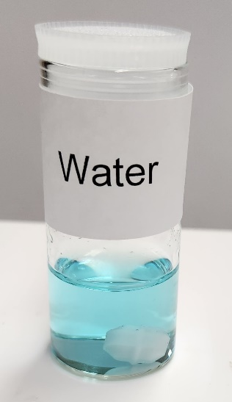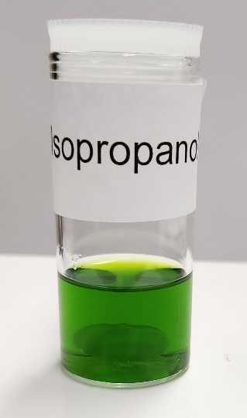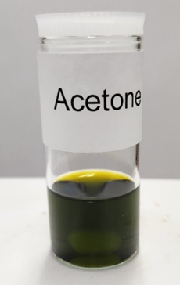
(c)
(b)
(a)
Figure 5.1. Solutions of CuCl₂·2H₂O in three different solvents: (a) Water; (b) Isopropanol; (c) Acetone.

Figure 5.2. (a) Visible spectra of CuCl₂·2H₂O in acetone, isopropanol, and water at 380-750 nm; (b) Spectra at 650-1000 nm focusing on the low energy visible and near-IR range. Pure solvents were used as references for the spectra. Full spectra at 300-1100 nm are given in Figure A5.3.

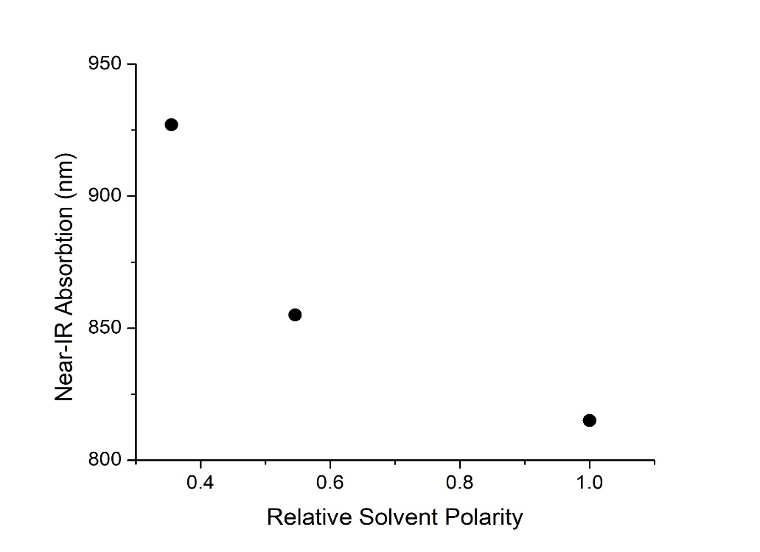
Isopropanol
Water
Acetone
Figure 5.3. Plot of near-IR peaks in water, isopropanol, and acetone vs. relative solvent polarities. The relative polarities are normalized from measurements of the transition energy at 25 °C of the long-wavelength visible absorption of a standard pyridinium N-phenolate betaine dye in Ref. 344.

Figure 5.4. Representation of solvent effects of polar solutes in polar solvents.^{329, 345} (a) Positive solvatochromism (bathochromic or red shift): Absorption energy decreases, or moves to longer wavelengths, as the solvent polarity increases. (b) Negative solvatochromism (hypsochromic or blue shift): Absorption energy increases, or moves to shorter wavelengths, as the solvent polarity increases. This figure is adapted with permission from Refs. 329, 345. Copyright 1988 John Wiley and Sons.
It should be pointed out that CuCl₂·2H₂O dissolved in isopropanol and acetone may lead to the coordination of the organic molecules as ligands to Cu²⁺ ions, affording in essence different complexes than Cu(H₂O)_{n}²⁺ (n = 4, 5 , 6), the Cu²⁺ complex in water.³⁴⁶⁻³⁵⁵ In fact, the spectrum in acetone (Figure 5.2) show a peak at 472 nm. The nature of this transition is not clear but it is likely from the interaction of acetone with, or its binding to, the Cu²⁺ ion.³⁵⁵⁻³⁵⁸ Thus, strictly speaking, the color differences among solutions of CuCl₂·2H₂O in water, isopropanol, and acetone discussed here may not fit the definition of solvatochromism originally developed for organic compounds dissolved in solvents with different polarities.^{328, 329} However, broadly speaking, the colors of the three solutions in Figure 5.1 and spectra in Figure 5.2 are a result of dissolving the compound CuCl₂·2H₂O in different solvents. Another note is that, even for the Cu²⁺-water complex, Cu(H₂O)_{n}²⁺, its aqueous structure, including the number of water ligands, n, is the subject of earlier^{355, 359} and recent experimental and theoretical studies.^{346-354, 359} Thus,
there are research opportunities to study the Cu²⁺ complexes in different solvents, including water, isopropanol, and acetone. For the current work, the discussions are limited to those at the undergraduate level, including solvatochromism that may include the same metal complex dissolved in different solvents.
In an octahedral transition metal complex with six ligands, five d orbitals of the metal ions are split into t_{2g} and e_{g} levels (Figure 5.5). For d⁹ complexes such as Cu(H₂O)₆²⁺, the nine electrons leave one hole in the d orbitals. For d_{x2-y2} and d_{z2} orbitals in the e_{g} level, one orbital contains two electrons and the other has just one electron. In order to lower the energy, Cu(H₂O)₆²⁺ undergoes the so-called Jahn-Teller distortion. The two H₂O ligands along the z axis are elongated, making the Cu-O bond lengths in the z direction longer than those in the x,y plane, as observed in the crystal structures of [Cu(H₂O)₆]SiF₆ and [Cu(H₂O)₆](BrO₃)₂.^{346, 349} One orbital
Figure 5.5. Splitting of the five d orbitals in a d⁹ octahedral complex into t_{2g} and e_{g} levels and Jahn-Teller distortion in Cu(H₂O)₆²⁺, giving a tetragonal-elongated structure.

in the e_{g} level, d_{z2} with two electrons in the case of Cu(H₂O)₆²⁺, is lower in energy than d_{x2-y2} with one electron. Electrons in the filled orbitals d_{z2}, d_{xz}, d_{yz} or d_{xy} in Figure 5.5 may be excited to the partially filled d_{x2-y2}, giving spectra in the UV, visible or near-IR range.³⁵⁸

5.4.2. Formation and characterization of CuO from solution and solid-state reactions
The synthesis of CuO from the reaction of CuCl₂·2H₂O with 2 equiv of NaOH in water, isopropanol, and acetone was completed within 72 hours. The reaction in the acetone solution finished the most quickly, with no further changes in color after 4 hours. The reaction in the isopropanol solution finished in around 8 hours with no further changes in color or increase in the amount of the product. Photos of the solutions before adding NaOH and at different times after NaOH addition are given in Table A5.1 in the addenda for Chapter 5. Throughout the
reaction, the isopropanol solution yielded green flecks inside the solution. They are most likely those of CuO nanoparticles, which tend to have green, green/brown, or brown/black coloring, though it could be Cu₂(OH)₃Cl which has a similar color.^{360, 361} Nanoparticles of the same material such as GaAs³⁶² and gold³⁶³ have been known to show different colors. After drying/heating the product solids in the current reactions, the green color disappeared, and all products were a dark brown/black color. Determination of nanoparticle synthesis, size, distribution, or other properties is outside of the scope of this experiment. The water solution took the longest to finish, with a lot of sol-gel-like materials in solution after 12 hours. This is most likely due to the large solubilities of both CuCl₂·2H₂O and NaOH in water, requiring longer time to complete the reaction.
The formation of CuO from the reaction in water may proceed through the so-called sol-gel process.³⁶⁴⁻³⁶⁹ In such a reaction, molecules are first converted into colloids (or sol) which act as precursors to form integrated networks (or gel) of either discrete particles or a network of coordinated ions, leading to the eventual formation of solids. Sol-gel processes typically refer to the hydrolysis of metal alkoxides or silicon alkoxides such as Ti(O-n-Bu)₄ or Si(OEt)₄, forming TiO₂ or SiO₂.^{364, 365} Such reactions have been used to make unique porous materials with different applications.^{364, 365, 367-373} Our speculation of the sol-gel process in the formation of CuO in the reaction of CuCl₂·2H₂O with NaOH is based in part on our observation of the reaction shown in Table A5.1. Henry and coworkers have synthesized Cu(II) hydroxide gels from the reaction of Cu(acetate)₂ with NH₃ in the presence of a small amount of K₂SO₄.³⁶⁶ The gels are a mixture of Cu₄(OH)₆(SO₄)·H₂O and acetate-based organic/inorganic polymers. Powder X-ray diffraction (PXRD) of powdered xerogels, which are formed from drying after water refluxing, show also the presence of CuO.³⁶⁶ Similar processes have been used to make CuO or mixed metal oxides containing CuO.³⁶⁷⁻³⁶⁹ If indeed the sol-gel process occurs in the current reaction of CuCl₂·2H₂O with NaOH, it may go through the steps in Figure 5.6.
CuO has also been formed directly by the reaction of CuCl₂·2H₂O solid with 2 equiv of NaOH solid in a mortar and pestle.^{331, 374} The two solids were first each ground into powders using different mortars and pestles. The first powder was then added to the second and grinding the mixture of powders quickly led to the formation of black CuO powder. No addition of a solvent is needed for the solid-state reaction.
Since NaCl is also a product of the reaction between CuCl₂ and 2 equiv. of NaOH, the solids from the reaction were washed by water to remove NaCl. Afterwards, the solids were each dried at about 100 °C before IR and PXRD analyses.
The products were analyzed via IR spectroscopy (Figure 5.7), indicating that four products are the same, showing the peaks at 475, 508, 588, 847, 895, and 987 cm⁻¹, although with different intensities. Two noticeable broad O-H stretching absorptions at about 3,300-3,500

Figure 5.6. Schematic depiction of the sol-gel process in the formation of CuO in water.

Figure 5.7. IR spectra of CuO products after drying. Individual spectrum is given in the addendum.

cm⁻¹ were also observed, indicating that the solids may still retain some water from the reactions. From the data published by Ghosh and Naskar,³⁷⁵ the bands around 480, 530, and 596 cm⁻¹ are Cu-O stretching vibrations in CuO.
Powder X-ray diffraction (PXRD) is a non-destructive technique to determine crystal phase of a solid.³⁷⁶ The CuO products from the reaction in the three solutions and sold state were analyzed, giving the diffraction patterns in Figure 5.8 showing similar crystalline phases. The most prominent peaks are at 2θ = 16.3°, 27.4°, 31.8°, 35.4°, 38.9°, 45.5°, 56.5°, 66.3°, and 68.1°. The CuO solid formed in water also shows peaks at 2θ = 53°, and 58°. From JCPDS-05-0661, the diffraction lines for the CuO monoclinic structure are 2θ = 32.47, 35.49, 38.68, 48.65, 53.36, 58.25 and 61.45. For CuO nanoparticles, Das et al. reported peaks at 2θ = 33.3°, 35.7°, 38.9°,
48.9°, 53.4°, and 58.2°.³⁷⁷ The PXRD patterns of the three solid products from the reactions here match those of the standard and published work. The broadness of the PXRD peaks in Figure 5.8 may indicate the CuO particles are not as crystalline as the standard. PXRD patterns of the products without washing by water are given in Figure A5.4, which show the presence of NaCl in the solids.
Comparison of the products from the reaction in three solutions and the solid-state shows that they all give CuO, as PXRD patterns show. The solid-state reaction is completed in a few minutes after grinding the mixture of the solids, while those in solutions take hours to show the formation of the products. One other advantage of the solid-state process is that no solvent is needed for the reaction, showing that it is greener than those conducted in solutions, especially those involving organic solvents of acetone and isopropanol. However, the isolated yield of CuO at 52.2% from the solid-state reaction is significantly lower than 86.4%-90.1% from the reactions
Figure 5.8. PXRD of CuO products from different processes. Products were dried in a furnace at 200 °C for 1 hour.

in solution. As indicated earlier, solids on the mortar and pestle lead to at least some of the lost product.

5.5. Assessment outcome
This experiment was performed in Chem 449 (Advanced Synthesis Laboratory, 2 credits) at the University of Tennessee-Knoxville. This senior lab course seeks to teach modern techniques of synthesis and characterization of organic and inorganic compounds and materials, as well as handling air-sensitive materials, chromatographic purification, spectroscopic characterization, and X-ray structure determination. Students conduct two 3 hr-labs per week and work with a partner(s). In Fall 2022, 15 students in Chem 449 conducted the experiment, including collecting visible-near IR spectra of the CuCl₂·2H₂O solutions as well as IR spectra and powder X-ray diffraction (PXRD) of the CuO products. The students had completed a junior-level inorganic chemistry course, in which metal complexes and d orbital splittings were discussed. A short prelab presentation (about 10 minutes) was given by the lecturer, introducing solvatochromism and X-ray diffraction. Students were then asked to submit a prelab report, providing their understanding of the chemistry, procedures, and hazards in the experiment. They easily completed the experiment in two lab periods. Each student was required to submit a laboratory report with the following sections: Introduction, Experimental Section, Results and Discussion, Conclusions, and References. While most understood well the chemistry in the experiment and characterization of the products, several students did not fully explain the results of the experiment. There was some confusion over how to correctly interpret the UV-visible spectra. Some students made correlations between the width of the peaks and solvatochromic effects, as the width of the absorption band in acetone at about 350 nm in Figure A5.3 was larger than those in water or isopropanol. That is, they did not focus on the shift of the local maxima, but the overall width of a whole absorption peak. Other students focused on the beginnings of peaks in the visible region rather than the absorption maxima and used the shifts in the beginnings in discussing the solvatochromic shift. To remedy these shortcomings, we suggest that, in the prelab, a more detailed discussion be made by the lecturer about how to interpret and compare absorption spectra. Although this experiment was used in a senior synthetic laboratory course, we think it is suitable for junior or sophomore course, as some students also noted.

5.6. Conclusion
This experiment provides students an opportunity to investigate the effects of solvents on synthetic reactions as well as examining solvatochromic effects. Negative solvatochromism was observed with solutions of CuCl₂·2H₂O in water, isopropanol, and acetone, in which the Cu²⁺ complex(es) absorbs the light of lower energy as solvent polarity decreases. Solvatochromism here is demonstrated qualitatively and quantitatively in the colors of the three solutions and their visible spectra. In the reaction of CuCl₂·2H₂O with 2 equiv. of NaOH in the solid state or in the three solutions, the final products were CuO, as identified by IR spectra and powder X-ray diffraction (PXRD). This experiment offers students opportunities to observe how solvents affect absorption spectra of a metal complex and study the formation CuO in different solutions and from a solid-state reaction. In addition, students will learn about the research opportunities in the area. Possible research topics may consist of the following: Structure of CuCl₂·2H₂O and other complexes in aqueous solution; Roles of organic solvents in the mixed aqueous-organic solutions of CuCl₂·2H₂O; Effects of other solvents such as methanol, ethanol, and butanol on the UV-visible absorption of CuCl₂·2H₂O; Kinetics and the mechanistic pathway in the process forming CuO, including confirming that the reaction indeed proceeds through the sol-gel procedure; Use of scanning electron microscopy (SEM) to characterize the transient flecks in the reaction in isopropanol.

Chapter 6: Concluding remarks and recommendations
This dissertation primarily focuses on the use of optical and neutron spectroscopies to study the magnetic properties of molecular compounds and the effects of structure and vibration on the magnetic excitations of these compounds. To accomplish this the use of inelastic neutron scattering (INS), far-IR magneto-spectroscopy (FIRMS), and high-field, and -frequency electron spin resonance (HFESR) has been employed. There has also been the inclusion of diffraction techniques such as powder neutron diffraction, polarized neutron diffraction (PND), single-crystal neutron diffraction, and powder X-ray diffraction to study structure of these materials. The combinations of these techniques, along with data fitting and calculation, lead to a better understanding of the fundamental correlations between structure and magnetism.
The work in this dissertation has the following overall contributions: (1) Better understanding of fundamental properties of SMMs, an SMT, and Haldane topological materials; (2) Demonstration that PND is an advanced technique to directly observe a toroidal moment in SMT molecules. The studies of Co-MST-H₂O in Chapter 2 show that the local molecular symmetry may dominate, even though the crystallographic symmetry is lower. Results of Dy₃-2 in Chapter 3 demonstrate that PND directly reveals a toroidal moment, confirming its presence in the SMT molecule. The use of the longer interchain ligands (than 4-4′-bpy), bpa and bpe, reduces interactions and coupling between Haldane spin-1 chains in NiBaO and NiBeO when compared to NiBO as shown in Chapter 4, making NiBaO and NiBeO potentially better topological materials.
Chapter 2 focuses on the use of advanced spectroscopies to study the magnetic properties of Co-MST-H₂O and Ni-MST-H₂O compounds and the effects of structure and vibration on their magnetic excitations. To accomplish this, the use of INS, FIRMS, and density functional theory (DFT) calculations have been employed. There has also been the inclusion of Hirshfeld surface analysis to study intermolecular interactions in these materials. For Co-MST-H₂O, INS studies have delivered spin-Hamiltonian parameters and phonon properties of the complex, with DFT phonon calculations providing calculated spectra that fit well with experimental results. The calculations have also determined phonon symmetries, energies, and spin density distributions on the Co²⁺ ion and other atoms. For Ni-MST-H₂O, phonon properties and intermolecular interactions have been characterized, though magnetic transitions were not observed through spectroscopic techniques. The combination of these techniques, along with data fitting and theoretical calculations, allows one to better understand the fundamental correlations between structure, vibration, and magnetism in these molecular systems, with magnetometry serving as the primary technique for determining spin-Hamiltonian parameters when spectroscopic methods prove insufficient.
Opportunities to examine the M-MST family of complexes remain, such as observing further ligand interactions, replacing the bound water with a positively charged ligand such as 1-methylpyrazin-1-ium, shown in Figure 6.1. This will lead to large changes in intermolecular interactions due to a removal of the counterions within the crystal lattice, potentially leading to changes in relaxation mechanisms. Changes to the ligand environment might also lead to complexes that are less air sensitive, leading to broader applications. Additionally, the study of other SMMs with C_{3v} symmetry might elucidate further understanding of the lack of spin-phonon coupling within our studies, so that one might better understand the correlation between structure, magnetism, and the causes of spin-phonon coupling.
The work of Chapter 3 presents a new SMT candidate, Dy₃-2, and demonstrates that it fulfills key structural and magnetic criteria of an SMT compound. The use of magnetometry and
Figure 6.1. Structure of 1-methylpyrazin-1-ium.
neutron diffraction has been employed to unambiguously determine the head-to-tail spin arrangement for this Dy₃ SMT and confirm the toroidal moment. Included also is polarized neutron diffraction and variable-field neutron diffraction techniques, examining the magnetic structure of this material. Dy₃-2 shows typical SMT characteristics in DC susceptibility studies for both polycrystalline and single crystal samples. The use of PND allows for mapping the atomic susceptibility tensor of Dy³⁺ ions within the compound and confirms the toroidal spin arrangement, while variable-field neutron diffraction enables modeling of the magnetic structure and demonstrates the AFM ordering of the Dy³⁺ ions within the crystal structure. The combination of these techniques allows one to better understand the fundamental correlations between structure and magnetism in SMT compounds, providing what is, to our knowledge, the first direct experimental determination of the toroidal spin arrangement in a SMT compound.
One of the characteristics of SMTs important to understand for applications within devices is their electromagnetic properties. There are not clear ways to study the effects of an electric field on the toroidal moment, especially not in a manner that allows one to directly determine those changes. This area is ripe for development of characterization techniques, as well as for studying potential application of SMTs for device integration.
Chapter 4 shows results from experiments to determine the effects of interchain ligands on Ni(II)-based spin-1 Haldane chain 2-D MOFs. This work primarily focuses on the use of neutron scattering and magnetic spectroscopies to study the Haldane spin-1 chain character of NiBaO and NiBeO, which differ in structure by their interchain ligands. To accomplish this, the use of variable-temperature powder neutron diffraction, DC magnetometry, and high-field electron spin resonance has been employed to thoroughly characterize the magnetism of these compounds. There has also been the inclusion of inelastic neutron scattering and far-IR spectroscopy to characterize the low energy phonons of these materials. The Haldane phase of these compounds has been shown to be stable to perturbation up to 14 T through high-field studies. The combination of these techniques allows one to better understand the fundamental correlations between structure and low-dimensional magnetism in MOF systems. Future research opportunities include the use of specific heat studies at magnetic fields higher than 14 T to further probe the Haldane phase behavior and stability to perturbation, exfoliation of the MOFs to investigate low-dimensional magnetic properties in reduced dimensions, and theoretical calculations to examine the differences between the two MOFs' magnetic properties at the molecular level.
Chapter 5 concentrates on the use of solvatochromic studies and synthetic methods to investigate the effects of solvents on Cu²⁺ complexes and the formation of CuO in different reaction media. The use of UV-visible spectroscopy, infrared spectroscopy, and powder X-ray diffraction has been employed to characterize the solvatochromic behavior and reaction products. There has also been the inclusion of solid-state synthetic methods to study the formation of CuO from different reaction conditions. Negative solvatochromism has been observed with solutions of CuCl₂·2H₂O in water, isopropanol, and acetone, where the Cu²⁺ complex(es) absorbs light of lower energy as solvent polarity decreases. The solvatochromic effects are demonstrated both qualitatively through solution colors and quantitatively through visible spectra. In reactions of CuCl₂·2H₂O with 2 equiv. of NaOH in solid state or in the three solutions, CuO has been identified as the final product through IR spectroscopy and PXRD analysis. The combination of these techniques allows one to better understand the fundamental correlations between solvent effects, spectroscopic properties, and synthetic outcomes in Cu²⁺ systems. Future research opportunities include structural studies of CuCl₂·2H₂O complexes in solution, investigation of organic solvent roles in mixed aqueous-organic systems, kinetic and mechanistic studies of CuO formation pathways, and characterization of reaction intermediates using scanning electron microscopy.

References
(1) Pedersen, K. S.; Ariciu, A.-M.; McAdams, S.; Weihe, H.; Bendix, J.; Tuna, F.; Piligkos, S. Toward molecular 4f single-ion magnet qubits. J. Am. Chem. Soc. 2016, 138 (18), 5801-5804. DOI: 10.1021/jacs.6b02702.
(2) Collet, E. Ultrafast control of anisotropy. Nat. Chem. 2020, 12 (5), 429-430. DOI: 10.1038/s41557-020-0462-z.
(3) Furrer, A.; Waldmann, O. Magnetic cluster excitations. Rev. Mod. Phys. 2013, 85 (1), 367-420. DOI: 10.1103/RevModPhys.85.367.
(4) Bogani, L.; Wernsdorfer, W. Molecular spintronics using single-molecule magnets. Nat. Mater. 2008, 7, 179-186. DOI: 10.1038/nmat2133.
(5) Ferrando-Soria, J.; Vallejo, J.; Castellano, M.; Martínez-Lillo, J.; Pardo, E.; Cano, J.; Castro, I.; Lloret, F.; Ruiz-García, R.; Julve, M. Molecular magnetism, quo vadis? A historical perspective from a coordination chemist viewpoint. Coord. Chem. Rev. 2017, 339, 17-103. DOI: 10.1016/j.ccr.2017.03.004.
(6) Gobbi, M.; Novak, M. A.; Del Barco, E. Molecular spintronics. J. Appl. Phys. 2019, 125 (24). DOI: 10.1063/1.5113900 (acccessed 12/13/2024).
(7) Holynska, M. Single-Molecule Magnets: Molecular Architectures and Building Blocks for Spintronics; Wiley-VCH, 2019. DOI: 10.1002/9783527809929.
(8) Hymas, K.; Soncini, A. Molecular spintronics using single-molecule magnets under irradiation. Phys. Rev. B 2019, 99 (24), 245404. DOI: 10.1103/PhysRevB.99.245404.
(9) Moreno-Pineda, E.; Wernsdorfer, W. Measuring molecular magnets for quantum technologies. Nat. Rev. Phys. 2021, 3 (9), 645-659. DOI: 10.1038/s42254-021-00340-3.
(10) Rocha, A. R.; Garcia-Suarez, V. M.; Bailey, S. W.; Lambert, C. J.; Ferrer, J.; Sanvito, S. Towards molecular spintronics. Nat. Mater. 2005, 4, 335-339. DOI: 10.1038/nmat1349.
(11) Sanvito, S. Molecular spintronics. Chem. Soc. Rev. 2011, 40 (6), 3336-3355. DOI: 10.1039/C1CS15047B.
(12) Sanvito, S.; Rocha, A. R. Molecular-spintronics: The art of driving spin through molecules. J. Comput. Theor. Nanosci. 2006, 3 (5), 624-642. DOI: 10.1166/jctn.2006.3047.
(13) Frost, J. M.; Harriman, K. L. M.; Murugesu, M. The rise of 3-d single-ion magnets in molecular magnetism: towards materials from molecules? Chem. Sci. 2016, 7, 2470-2491. DOI: 10.1039/C5SC03224E.
(14) Feng, M.; Tong, M.-L. Single Ion Magnets from 3d to 5f: Developments and Strategies. Chem. Eur. J. 2018, 24 (30), 7574-7594. DOI: 10.1002/chem.201705761.
(15) Sessoli, R.; Gatteschi, D.; Caneschi, A.; Novak, M. A. Magnetic bistability in a metal-ion cluster. Nature 1993, 365 (6442), 141-143. DOI: 10.1038/365141a0.
(16) Gatteschi, D.; Sessoli, R.; Villain, J. Molecular Nanomagnets; Oxford University Press, 2006. DOI: 10.1093/acprof:oso/9780198567530.001.0001.
(17) Neese, F.; Pantazis, D. A. What is not required to make a single molecule magnet. Faraday Discuss. 2011, 148 (0), 229-238. DOI: 10.1039/C005256F.
(18) Ruiz, E.; Cirera, J.; Cano, J.; Alvarez, S.; Loose, C.; Kortus, J. Can large magnetic anisotropy and high spin really coexist? Chem. Comm. 2008, (1), 52-54. DOI: 10.1039/B714715E.
(19) Waldmann, O. A Criterion for the Anisotropy Barrier in Single-Molecule Magnets. Inorg. Chem. 2007, 46 (24), 10035-10037. DOI: 10.1021/ic701365t.
(20) Ishikawa, N.; Sugita, M.; Ishikawa, T.; Koshihara, S.-y.; Kaizu, Y. Lanthanide Double-Decker Complexes Functioning as Magnets at the Single-Molecular Level. J. Am. Chem. Soc. 2003, 125 (29), 8694-8695. DOI: 10.1021/ja029629n.
(21) Benelli, C.; Gatteschi, D. Introduction to Molecular Magnetism: From Transition Metals to Lanthanides; John Wiley & Sons, 2015. DOI: 10.1002/9783527690541.
(22) Bar, A. K.; Pichon, C.; Sutter, J.-P. Magnetic Anisotropy in Two- to Eight-Coordinated Transition-Metal Complexes: Recent Developments in Molecular Magnetism. Coord. Chem. Rev. 2016, 308, 346-380. DOI: 10.1016/j.ccr.2015.06.013.
(23) Stavretis, S. E.; Cheng, Y.; Daemen, L. L.; Brown, C. M.; Moseley, D. H.; Bill, E.; Atanasov, M.; Ramirez‐Cuesta, A. J.; Neese, F.; Xue, Z. L. Probing Magnetic Excitations in Co^{II} Single‐Molecule Magnets by Inelastic Neutron Scattering. Eur. J. Inorg. Chem. 2019, 2019, 1119-1127. DOI: 10.1002/ejic.201801088.
(24) Hay, M. A.; Sarkar, A.; Craig, G. A.; Marriott, K. E. R.; Wilson, C.; Rajaraman, G.; Murrie, M. A large axial magnetic anisotropy in trigonal bipyramidal Fe(II). Chem. Commun. 2020, 56, 6826-6829. DOI: 10.1039/D0CC02382E.
(25) Kumar, P.; SantaLucia, D. J.; Kaniewska-Laskowska, K.; Lindeman, S. V.; Ozarowski, A.; Krzystek, J.; Ozerov, M.; Telser, J.; Berry, J. F.; Fiedler, A. T. Probing the Magnetic Anisotropy of Co(II) Complexes Featuring Redox-Active Ligands. Inorg. Chem. 2020, 59, 16178-16193. DOI: 10.1021/acs.inorgchem.0c01812.
(26) Liu, M.; Yang, Y.; Jing, R.; Zheng, S.; Yuan, A.; Wang, Z.; Luo, S.-C.; Liu, X.; Cui, H.-H.; Ouyang, Z.-W.; et al. Slow magnetic relaxation in dinuclear Co(III)–Co(II) complexes containing a five-coordinated Co(II) centre with easy-axis anisotropy. Dalton Trans. 2022, 51, 8382-8389. DOI: 10.1039/D2DT00857B.
(27) Lv, W.; Cui, H.-H.; Chen, L.; Zhang, Y.-Q.; Chen, X.-T.; Wang, Z.; Ouyang, Z.-W.; Xue, Z.-L. Magnetic anisotropy of two tetrahedral Co(II)-halide complexes with triphenylphosphine ligands. Dalton Trans. 2022, 51, 7530-7538. DOI: 10.1039/D2DT00121G.
(28) Gopal Patra, S.; Kumar Chattaraj, P. Three coordinated first row-transition metal complexes, [M{N(SiMe3)2}3]−1/0: Structure, bonding, and magnetic properties. Polyhedron 2024, 256, 116990. DOI: 10.1016/j.poly.2024.116990.
(29) Hay, M. A.; Sarkar, A.; Craig, G. A.; Bhaskaran, L.; Nehrkorn, J.; Ozerov, M.; Marriott, K. E. R.; Wilson, C.; Rajaraman, G.; Hill, S.; et al. In-depth investigation of large axial magnetic anisotropy in monometallic 3d complexes using frequency domain magnetic resonance and ab initio methods: a study of trigonal bipyramidal Co(II). Chem. Sci. 2019, 10, 6354-6361. DOI: 10.1039/C9SC00987F.
(30) Hastings, C. D.; Huffman, L. S. X.; Tiwari, C. K.; Betancourth, J. G.; Brennessel, W. W.; Barnett, B. R. Coordinatively Unsaturated Metallates of Cobalt(II), Nickel(II), and Zinc(II) Guarded by a Rigid and Narrow Void. Inorg. Chem. 2023, 62 (30), 11920-11931. DOI: 10.1021/acs.inorgchem.3c01335.
(31) Boča, R. Zero-Field Splitting in Metal Complexes. Coord. Chem. Rev. 2004, 248, 757-815. DOI: 10.1016/j.ccr.2004.03.001.
(32) Shrivastava, K. N. Theory of Spin–Lattice Relaxation. Phys. Stat. Sol. (b) 1983, 117, 437-458. DOI: 10.1002/pssb.2221170202.
(33) Pilbrow, J. R. Effective g values for S = 3/2 and S = 5/2. J. Magn. Reson. 1978, 31, 479-490. DOI: 10.1016/S0022-2364(78)80015-8.
(34) Jinkui Tang, I. H., N. T. Madhu, Guillaume Chastanet, Wolfgang Wernsdorfer, Christopher E. Anson, Cristiano Benelli, Roberta Sessoli, and Annie K. Powell. Dysprosium Triangles Showing Single-Molecule Magnet Behavior of Thermally Excited Spin States. Angew. Chem. Int. Ed. 2006, 45 (11), 1729-1733. DOI: 10.1002/anie.200503564.
(35) Liviu F. Chibotaru, L. U., and Alessandro Soncini. The Origin of Nonmagnetic Kramers Doublets in the Ground State of Dysprosium Triangles: Evidence for a Toroidal Magnetic Moment. Angew. Chem. Int. Ed. 2008, 120, 4194-4197. DOI: 10.1002/ange.200800283.
(36) Aravena, D.; Ruiz, E. Spin dynamics in single-molecule magnets and molecular qubits. Dalton Trans. 2020, 49 (29), 9916-9928. DOI: 10.1039/D0DT01414A.
(37) Li, X.-L.; Ma, Z.; Tang, J. Recent Developments of Nontraditional Single-Molecule Toroics. Chem. Eur. J. 2024, 30 (27), e202304369. DOI: 10.1002/chem.202304369.
(38) Bernot, K. Get under the Umbrella: A Comprehensive Gateway for Researchers on Lanthanide-Based Single-Molecule Magnets. Eur. J. Inorg. Chem. 2023, 26 (35), e202300336. DOI: 10.1002/ejic.202300336.
(39) Murray, E. Single Molecule Toroics; 2022. DOI: 10.1007/978-3-031-11709-1.
(40) Hymas, K.; Soncini, A. The Role of Magnetic Dipole—Dipole Coupling in Quantum Single-Molecule Toroics. Magnetochemistry 2022, 8 (5), 58. DOI: 10.3390/magnetochemistry8050058.
(41) Chen, Y.-C.; Tong, M.-L. Single-molecule magnets beyond a single lanthanide ion: the art of coupling. Chem. Sci. 2022, 13 (30), 8716-8726. DOI: 10.1039/D2SC01532C.
(42) Zhang, H.-L.; Zhai, Y.-Q.; Qin, L.; Ungur, L.; Nojiri, H.; Zheng, Y.-Z. Single-Molecule Toroic Design through Magnetic Exchange Coupling. Matter 2020, 2 (6), 1481-1493. DOI: 10.1016/j.matt.2020.02.021.
(43) Pavlyukh, Y. Toroidal spin states in molecular magnets. Physical Review B 2020, 101 (14), 144408. DOI: 10.1103/PhysRevB.101.144408.
(44) Li, X.-L.; Tang, J. Recent developments in single-molecule toroics. Dalton Trans. 2019, 48 (41), 15358-15370. DOI: 10.1039/C9DT02113B.
(45) Das, C.; Vaidya, S.; Gupta, T.; Frost, J. M.; Righi, M.; Brechin, E. K.; Affronte, M.; Rajaraman, G.; Shanmugam, M. Single-Molecule Magnetism, Enhanced Magnetocaloric Effect, and Toroidal Magnetic Moments in a Family of Ln₄ Squares. Chem. Eur. J. 2015, 21 (44), 15639-15650. DOI: 10.1002/chem.201502720.
(46) Ungur, L.; Lin, S.-Y.; Tang, J.; Chibotaru, L. F. Single-molecule toroics in Ising-type lanthanide molecular clusters. Chem. Soc. Rev. 2014, 43 (20), 6894-6905. DOI: 10.1039/C4CS00095A.
(47) Haldane, F. D. M. Nonlinear Field Theory of Large-Spin Heisenberg Antiferromagnets: Semiclassically Quantized Solitons of the One-Dimensional Easy-Axis Néel State. Phys. Rev. Lett. 1983, 50, 1153-1156. DOI: 10.1103/PhysRevLett.50.1153.
(48) Haldane, F. D. M. Continuum dynamics of the 1-D Heisenberg antiferromagnet: Identification with the O(3) nonlinear sigma model. Phys. Lett. A 1983, 93, 464-468. DOI: 10.1016/0375-9601(83)90631-X.
(49) Date, M.; Kindo, K. Elementary excitation in the Haldane state. Phys. Rev. Lett. 1990, 65, 1659-1662. DOI: 10.1103/PhysRevLett.65.1659.
(50) Kennedy, T. Exact diagonalisations of open spin-1 chains. J. Phys. Condens. Matter 1990, 2, 5737. DOI: 10.1088/0953-8984/2/26/010.
(51) Yamashita, M.; Ishii, T.; Matsuzaka, H. Haldane gap systems. Coord. Chem. Rev. 2000, 198, 347-366. DOI: 10.1016/S0010-8545(99)00212-X.
(52) Affleck, I.; Kennedy, T.; Lieb, E. H.; Tasaki, H. Rigorous results on valence-bond ground states in antiferromagnets. Phys. Rev. Lett. 1987, 59, 799-802. DOI: 10.1103/PhysRevLett.59.799.
(53) Affleck, I.; Kennedy, T.; Lieb, E. H.; Tasaki, H. Valence bond ground states in isotropic quantum antiferromagnets. Commun. Math. Phys. 1988, 115, 477-528. DOI: 10.1007/BF01218021.
(54) Affleck, I. Quantum spin chains and the Haldane gap. J. Phys. Condens. Matter 1989, 1, 3047. DOI: 10.1088/0953-8984/1/19/001.
(55) Affleck, I. Theory of Haldane-gap antiferromagnets in applied fields. Phys. Rev. B 1990, 41 (10), 6697-6702. DOI: 10.1103/PhysRevB.41.6697.
(56) Tin, P.; Jenkins, M. J.; Xing, J.; Caci, N.; Gai, Z.; Jin, R.; Wessel, S.; Krzystek, J.; Li, C.; Daemen, L. L.; et al. Haldane topological spin-1 chains in a planar metal-organic framework. Nat. Commun. 2023, 14, 5454. DOI: 10.1038/s41467-023-41014-1.
(57) Shull, C. G.; Strauser, W. A.; Wollan, E. O. Neutron Diffraction by Paramagnetic and Antiferromagnetic Substances. Phys. Rev. 1951, 83, 333-345. DOI: 10.1103/PhysRev.83.333.
(58) Mugiraneza, S.; Hallas, A. M. Tutorial: a beginner’s guide to interpreting magnetic susceptibility data with the Curie-Weiss law. Commun. Phys. 2022, 5 (1), 95. DOI: 10.1038/s42005-022-00853-y.
(59) Dougan, B. A.; Xue, Z. Polarized neutron diffraction and its application to spin density studies. Sci. China, Ser. B: Chem. 2009, 52 (12), 2083. DOI: 10.1007/s11426-009-0199-4.
(60) Ridier, K.; Mondal, A.; Boilleau, C.; Cador, O.; Gillon, B.; Chaboussant, G.; Le Guennic, B.; Costuas, K.; Lescouëzec, R. Polarized Neutron Diffraction to Probe Local Magnetic Anisotropy of a Low‐Spin Fe(III) Complex. Angew. Chem. Int. Ed. 2016, 55 (12), 3963-3967. DOI: 10.1002/anie.201511354.
(61) Klahn, E. A.; Gao, C.; Gillon, B.; Gukasov, A.; Fabrèges, X.; Piltz, R. O.; Jiang, S. D.; Overgaard, J. Mapping the Magnetic Anisotropy at the Atomic Scale in Dysprosium Single‐Molecule Magnets. Chem. Eur. J. 2018, 24 (62), 16576-16581. DOI: 10.1002/chem.201803300.
(62) Gukasov, A.; Brown, P. J. Determination of atomic site susceptibility tensors from polarized neutron diffraction data. J. Condens. Matter Phys. 2002, 14 (38), 8831. DOI: 10.1088/0953-8984/14/38/307.
(63) Gukasov, A.; Brown, P. J. Determination of atomic site susceptibility tensors from neutron diffraction data on polycrystalline samples. J. Condens. Matter Phys. 2010, 22 (50), 502201. DOI: 10.1088/0953-8984/22/50/502201.
(64) Gukasov, A. G.; Rogl, P.; Brown, P. J.; Mihalik, M.; Menovsky, A. Site susceptibility tensors and magnetic structure of U₃Al₂Si₃: a polarized neutron diffraction study. J. Condens. Matter Phys. 2002, 14 (38), 8841. DOI: 10.1088/0953-8984/14/38/308.
(65) Ridier, K.; Gillon, B.; Gukasov, A.; Chaboussant, G.; Cousson, A.; Luneau, D.; Borta, A.; Jacquot, J. F.; Checa, R.; Chiba, Y. Polarized neutron diffraction as a tool for mapping molecular magnetic anisotropy: Local susceptibility tensors in Co^{II} complexes. Chem. Eur. J. 2016, 22 (2), 724-735. DOI: 10.1002/chem.201503400.
(66) Brown, P. J. Experimental attempts to measure non-collinear local magnetisation. J. Phys. Chem. Sol. 2004, 65 (12), 1977-1983. DOI: 10.1016/j.jpcs.2004.08.009.
(67) Gukasov, A.; Cao, H.; Mirebeau, I.; Bonville, P. Spin density and non-collinear magnetization in frustrated pyrochlore Tb₂Ti₂O₇ from polarized neutron scattering. Physica B 2009, 404 (17), 2509-2512. DOI: 10.1016/j.physb.2009.06.017.
(68) Figgis, B. N.; Kucharski, E. S.; Vrtis, M. Spin and charge transfer through hydrogen bonding in [Co(NH₃)₅(OH₂)][Cr(CN)₆]. J. Am. Chem. Soc. 1993, 115 (1), 176-181. DOI: 10.1021/ja00054a024.
(69) Kibalin, I. A.; Gukasov, A. Local magnetic anisotropy by polarized neutron powder diffraction: Application of magnetically induced preferred crystallite orientation. Phys. Rev. res. 2019, 1 (3), 033100. DOI: 10.1103/PhysRevResearch.1.033100.
(70) Bragg, W. H.; Bragg, W. L. The reflection of X-rays by crystals. Proceedings of the Royal Society of London. Series A, Containing Papers of a Mathematical and Physical Character 1913, 88 (605), 428-438. DOI: 10.1098/rspa.1913.0040.
(71) Santisteban, J.; Edwards, L.; Steuwer, A.; Withers, P. Time-of-flight Neutron Transmission Diffraction. J. Appl. Crystallogr. 2001, 34. DOI: 10.1107/S0021889801003260.
(72) Schwartz, L. H. Intensity and resolution in the time-of-flight method for neutron diffraction. Nuclear Instruments and Methods 1966, 42 (1), 81-86. DOI: 10.1016/0029-554X(66)90273-4.
(73) Leuenberger, M. N.; Loss, D. Quantum computing in molecular magnets. Nature 2001, 410 (6830), 789-793. DOI: 10.1038/35071024.
(74) Zabala-Lekuona, A.; Seco, J. M.; Colacio, E. Single-Molecule Magnets: From Mn₁₂-ac to dysprosium metallocenes, a travel in time. Coord. Chem. Rev. 2021, 441, 213984. DOI: 10.1016/j.ccr.2021.213984.
(75) Soncini, A.; Chibotaru, L. F. Molecular spintronics using noncollinear magnetic molecules. Phys. Rev. B 2010, 81, 132403. DOI: 10.1103/PhysRevB.81.132403.
(76) Nowack, K. C.; Koppens, F. H. L.; Nazarov, Y. V.; Vandersypen, L. M. K. Coherent control of a single electron spin with electric fields. Science 2007, 318, 1430-1433. DOI: 10.1126/science.1148092.
(77) Gao, S. Molecular Nanomagnets and Related Phenomena; 2015. DOI: 10.1007/978-3-662-45723-8.
(78) Winpenny, R. E. P. Quantum Information Processing Using Molecular Nanomagnets As Qubits. Angew. Chem. Int. Ed. 2008, 47, 7992-7994. DOI: 10.1002/anie.200802742.
(79) Perlepe, P. S.; Maniaki, D.; Pilichos, E.; Katsoulakou, E.; Perlepes, S. P. Smart Ligands for Efficient 3d-, 4d- and 5d-Metal Single-Molecule Magnets and Single-Ion Magnets. Inorganics 2020, 8 (6), 39. DOI: 10.3390/inorganics8060039.
(80) Shao, D.; Wang, X.-Y. Development of Single-Molecule Magnets. Chin. J. Chem. 2020, 38, 1005-1018. DOI: 10.1002/cjoc.202000090.
(81) Ruamps, R.; Maurice, R.; Batchelor, L.; Boggio-Pasqua, M.; Guillot, R.; Barra, A. L.; Liu, J.; Bendeif, E.-E.; Pillet, S.; Hill, S.; et al. Giant Ising-Type Magnetic Anisotropy in Trigonal Bipyramidal Ni(II) Complexes: Experiment and Theory. J. Am. Chem. Soc. 2013, 135, 3017-3026. DOI: 10.1021/ja308146e.
(82) Świtlicka, A.; Machura, B.; Cano, J.; Lloret, F.; Julve, M. A Study of the Lack of Slow Magnetic Relaxation in Mononuclear Trigonal Bipyramidal Cobalt (II) Complexes. ChemistrySelect 2021, 6, 576-582. DOI: 10.1002/slct.202100061.
(83) Goodwin, C. A. P. Blocking like it's hot: a synthetic chemists’ path to high-temperature lanthanide single molecule magnets. Dalton Trans. 2020, 49, 14320-14337. DOI: 10.1039/D0DT01904F.
(84) Sarkar, A.; Dey, S.; Rajaraman, G. Role of Coordination Number and Geometry in Controlling the Magnetic Anisotropy in Fe^{II}, Co^{II}, and Ni^{II} Single-Ion Magnets. Chem. Eur. J. 2020, 26, 14036-14058. DOI: 10.1002/chem.202003211.
(85) Cui, H.-H.; Ding, M.-M.; Zhang, X.-D.; Lv, W.; Zhang, Y.-Q.; Chen, X.-T.; Wang, Z.; Ouyang, Z.-W.; Xue, Z.-L. Magnetic anisotropy in square pyramidal cobalt(II) complexes supported by a tetraazo macrocyclic ligand. Dalton Trans. 2020, 49, 14837-14846. DOI: 10.1039/D0DT01954B.
(86) Hu, Z.-B.; Feng, X.; Li, J.; Zhang, Y.-Q.; Yin, L.; Wang, Z.; Ouyang, Z.; Kurmoo, M.; Song, Y. Optimal diamagnetic dilution concentration for suppressing the dipole–dipole interaction in single-ion magnets. Dalton Trans. 2020, 49 (7), 2159-2167. DOI: 10.1039/C9DT04403E.
(87) Hay, M. A.; McMonagle, C. J.; Wilson, C.; Probert, M. R.; Murrie, M. Trigonal to Pentagonal Bipyramidal Coordination Switching in a Co(II) Single-Ion Magnet. Inorg. Chem. 2019, 58 (15), 9691-9697. DOI: 10.1021/acs.inorgchem.9b00515.
(88) Nagelski, A. L.; Ozerov, M.; Fataftah, M. S.; Krzystek, J.; Greer, S. M.; Holland, P. L.; Telser, J. Electronic Structure of Three-Coordinate Fe^{II} and Co^{II} β-Diketiminate Complexes. Inorg. Chem. 2024, 63 (10), 4511-4526. DOI: 10.1021/acs.inorgchem.3c03388.
(89) Boča, R.; Dlháň, L. u.; Linert, W.; Ehrenberg, H.; Fuess, H.; Haase, W. Ligand sphere-enhanced magnetic anisotropy in cobalt(II) and manganese(II) 2,6-bis-(benzimidazol-2′-yl)-pyridine dichloride. Chem. Phys. Lett. 1999, 307, 359-366. DOI: 10.1016/S0009-2614(99)00519-9.
(90) Rajnák, C.; Titiš, J.; Šalitroš, I.; Boča, R.; Fuhr, O.; Ruben, M. Zero-field splitting in pentacoordinate Co(II) complexes. Polyhedron 2013, 65, 122-128. DOI: 10.1016/j.poly.2013.08.029.
(91) Smolko, L.; Černák, J.; Kuchár, J.; Rajnák, C.; Titiš, J.; Boča, R. Field-Induced Slow Magnetic Relaxation in Mononuclear Tetracoordinate Cobalt(II) Complexes Containing a Neocuproine Ligand. Eur. J. Inorg. Chem. 2017, 2017, 3080-3086. DOI: 10.1002/ejic.201700293.
(92) Hou, X.; Wang, X.; Liu, X.; Wang, J.; Tang, L.; Ju, P. Fine-tuning the effects of auxiliary ligands on two trigonal-bipyramid cobalt(II) complexes exhibiting field-induced slow magnetic relaxation. New J. Chem. 2018, 42, 8583-8590. DOI: 10.1039/C8NJ01201F.
(93) Stetsiuk, O.; El-Ghayoury, A.; Lloret, F.; Julve, M.; Avarvari, N. Mononuclear and One-Dimensional Cobalt(II) Complexes with the 3,6-Bis(picolylamino)-1,2,4,5-tetrazine Ligand. Eur. J. Inorg. Chem. 2018, 2018, 449-457. DOI: 10.1002/ejic.201701224.
(94) Shao, F.; Cahier, B.; Wang, Y.-T.; Yang, F.-L.; Rivière, E.; Guillot, R.; Guihéry, N.; Tong, J.-P.; Mallah, T. Magnetic Relaxation Studies on Trigonal Bipyramidal Cobalt(II) Complexes. Chem. Asian J. 2020, 15, 391-397. DOI: 10.1002/asia.201901511.
(95) Tin, P.; Bone, A. N.; Bui, N. N.; Zhang, Y.-Q.; Chang, T.; Moseley, D. H.; Ozerov, M.; Krzystek, J.; Cheng, Y.; Daemen, L. L.; et al. Advanced Spectroscopic and Computational Studies of a Cobalt(II) Coordination Polymer with Single-Ion-Magnet Properties. J. Phys. Chem. C 2022, 126 (31), 13268-13283. DOI: 10.1021/acs.jpcc.2c03083.
(96) Moseley, D. H.; Liu, Z.; Bone, A. N.; Stavretis, S. E.; Singh, S. K.; Atanasov, M.; Lu, Z.; Ozerov, M.; Thirunavukkuarasu, K.; Cheng, Y.; et al. Comprehensive Studies of Magnetic Transitions and Spin–Phonon Couplings in the Tetrahedral Cobalt Complex Co(AsPh₃)₂I₂. Inorg. Chem. 2022, 61, 17123-17136. DOI: 10.1021/acs.inorgchem.2c02604.
(97) Jurca, T.; Farghal, A.; Lin, P.-H.; Korobkov, I.; Murugesu, M.; Richeson, D. S. Single-Molecule Magnet Behavior with a Single Metal Center Enhanced through Peripheral Ligand Modifications. J. Am. Chem. Soc. 2011, 133 (40), 15814-15817. DOI: 10.1021/ja204562m.
(98) Ruamps, R.; Batchelor, L. J.; Guillot, R.; Zakhia, G.; Barra, A.-L.; Wernsdorfer, W.; Guihéry, N.; Mallah, T. Ising-type magnetic anisotropy and single molecule magnet behaviour in mononuclear trigonal bipyramidal Co(II) complexes. Chem. Sci. 2014, 5, 3418-3424. DOI: 10.1039/C4SC00984C.
(99) Cahier, B.; Maurice, R.; Bolvin, H.; Mallah, T.; Guihéry, N. Tools for Predicting the Nature and Magnitude of Magnetic Anisotropy in Transition Metal Complexes: Application to Co(II) Complexes. Magnetochemistry 2016, 2 (3), 31. DOI: 10.3390/magnetochemistry2030031.
(100) Mondal, A. K.; Jover, J.; Ruiz, E.; Konar, S. Investigation of easy-plane magnetic anisotropy in P-ligand square-pyramidal Co^{II} single ion magnets. Chem. Commun. 2017, 53, 5338-5341. DOI: 10.1039/C7CC02584J.
(101) Acharya, J.; Sarkar, A.; Kumar, P.; Kumar, V.; Flores Gonzalez, J.; Cador, O.; Pointillart, F.; Rajaraman, G.; Chandrasekhar, V. Influence of ligand field on magnetic anisotropy in a family of pentacoordinate Co^{II} complexes. Dalton Trans. 2020, 49, 4785-4796. DOI: 10.1039/D0DT00315H.
(102) Shao, F.; Cahier, B.; Rivière, E.; Guillot, R.; Guihéry, N.; Campbell, V. E.; Mallah, T. Structural Dependence of the Ising-type Magnetic Anisotropy and of the Relaxation Time in Mononuclear Trigonal Bipyramidal Co(II) Single Molecule Magnets. Inorg. Chem. 2017, 56 (3), 1104-1111. DOI: 10.1021/acs.inorgchem.6b01966.
(103) Krzystek, J.; Swenson, D. C.; Zvyagin, S. A.; Smirnov, D.; Ozarowski, A.; Telser, J. Cobalt(II) “Scorpionate” Complexes as Models for Cobalt-Substituted Zinc Enzymes: Electronic Structure Investigation by High-Frequency and -Field Electron Paramagnetic Resonance Spectroscopy. J. Am. Chem. Soc. 2010, 132, 5241-5253. DOI: 10.1021/ja910766w.
(104) McInnes, E. J. L.; Winpenny, R. E. P. Molecular Magnets. In Comp. Inorg. Chem. II, Poeppelmeier, K. Ed.; Elsevier, 2013.
(105) McGavin, D. G. Symmetry constraints on EPR spin-Hamiltonian parameters. J. Magn. Reson. 1987, 74, 19-55. DOI: 10.1016/0022-2364(87)90077-1.
(106) Schulte, K. A.; Vignesh, K. R.; Dunbar, K. R. Effects of coordination sphere on unusually large zero field splitting and slow magnetic relaxation in trigonally symmetric molecules. Chem. Sci. 2018, 9, 9018-9026. DOI: 10.1039/C8SC02820F.
(107) Shao, F.; Cahier, B.; Guihéry, N.; Rivière, E.; Guillot, R.; Barra, A.-L.; Lan, Y.; Wernsdorfer, W.; Campbell, V. E.; Mallah, T. Tuning the Ising-type anisotropy in trigonal bipyramidal Co(II) complexes. Chem. Commun. 2015, 51, 16475-16478. DOI: 10.1039/C5CC07741A.
(108) Schweinfurth, D.; Sommer, M. G.; Atanasov, M.; Demeshko, S.; Hohloch, S.; Meyer, F.; Neese, F.; Sarkar, B. The Ligand Field of the Azido Ligand: Insights into Bonding Parameters and Magnetic Anisotropy in a Co(II)–Azido Complex. J. Am. Chem. Soc. 2015, 137, 1993-2005. DOI: 10.1021/ja512232f.
(109) Cui, H.-H.; Xu, H.; Zhang, M.; Luo, S.; Tong, W.; Wang, M.; Sun, T.; Chen, L.; Tang, Y. Magnetic Anisotropy from Easy-Plane to Easy-Axial in Square Pyramidal Cobalt(II) Single-Ion Magnets. Cryst. Growth Des. 2022, 22, 2742-2748. DOI: 10.1021/acs.cgd.2c00160.
(110) Habib, F.; Luca, O. R.; Vieru, V.; Shiddiq, M.; Korobkov, I.; Gorelsky, S. I.; Takase, M. K.; Chibotaru, L. F.; Hill, S.; Crabtree, R. H.; et al. Influence of the Ligand Field on Slow Magnetization Relaxation versus Spin Crossover in Mononuclear Cobalt Complexes. Angew. Chem. Int. Ed. 2013, 52, 11290-11293. DOI: 10.1002/anie.201303005.
(111) Hand, A. T. Investigation of Molecular Transition Metal Complexes: Structures, Magnetic Properties, and Reactivities. University of Tennessee, Knoxville, 2024. https://trace.tennessee.edu/utk_graddiss/10463/.
(112) Malinová, N.; Juráková, J.; Brachňaková, B.; Midlíková, J. D.; Čižmár, E.; Santana, V. T.; Herchel, R.; Orlita, M.; Mohelský, I.; Moncol, J.; et al. Magnetization Slow Dynamics in Mononuclear Co(II) Field-Induced Single-Molecule Magnet. Cryst. Growth Des. 2023, 23, 2430-2441. DOI: 10.1021/acs.cgd.2c01388.
(113) Rajnák, C.; Titiš, J.; Miklovič, J.; Kostakis, G. E.; Fuhr, O.; Ruben, M.; Boča, R. Five mononuclear pentacoordinate Co(II) complexes with field-induced slow magnetic relaxation. Polyhedron 2017, 126, 174-183. DOI: 10.1016/j.poly.2017.01.028.
(114) Choroba, K.; Palion-Gazda, J.; Machura, B.; Bieńko, A.; Wojtala, D.; Bieńko, D.; Rajnák, C.; Boča, R.; Ozarowski, A.; Ozerov, M. Large Magnetic Anisotropy in Mono- and Binuclear cobalt(II) Complexes: The Role of the Distortion of the Coordination Sphere in Validity of the Spin-Hamiltonian Formalism. Inorg. Chem. 2024, 63, 1068-1082. DOI: 10.1021/acs.inorgchem.3c03405.
(115) Dey, A.; Ali, J.; Moorthy, S.; Gonzalez, J. F.; Pointillart, F.; Singh, S. K.; Chandrasekhar, V. Field induced single ion magnet behavior in Co^{II} complexes in a distorted square pyramidal geometry. Dalton Trans. 2023, 52, 14807-14821. DOI: 10.1039/D3DT01769A.
(116) Świtlicka, A.; Machura, B.; Penkala, M.; Bieńko, A.; Bieńko, D. C.; Titiš, J.; Rajnák, C.; Boča, R.; Ozarowski, A.; Ozerov, M. Slow Magnetic Relaxation in Cobalt(II) Field-Induced Single-Ion Magnets with Positive Large Anisotropy. Inorg. Chem. 2018, 57, 12740-12755. DOI: 10.1021/acs.inorgchem.8b01906.
(117) Cui, Y.; Xu, Y.; Liu, X.; Li, Y.; Wang, B.-L.; Dong, Y.; Li, W.; Lei, S. Field-Induced Single-Ion Magnetic Behavior in Two Mononuclear Cobalt(II) Complexes. Chem. Asian J. 2019, 14, 2620-2628. DOI: 10.1002/asia.201900258.
(118) Gast, P.; Groenen, E. J. J. EPR Interactions – Anisotropy. eMagRes 2016, 5, 1435-1444. DOI: 10.1002/9780470034590.emrstm1500.
(119) Widener, C. N.; Bone, A. N.; Ozerov, M.; Richardson, R.; Lu, Z.; Thirunavukkuarasu, K.; Smirnov, D.; Chen, X.-T.; Xue, Z.-L. Direct Observation of Magnetic Transitions in a Nickel(II) Complex with Large Anisotropy. Chin. J. Inorg. Chem. 2020, 35, 1149-1156. DOI: 10.11862/CJIC.2021.126.
(120) Marriott, K. E. R.; Bhaskaran, L.; Wilson, C.; Medarde, M.; Ochsenbein, S. T.; Hill, S.; Murrie, M. Pushing the limits of magnetic anisotropy in trigonal bipyramidal Ni(II). Chem. Sci. 2015, 6, 6823-6828. DOI: 10.1039/C5SC02854J.
(121) Craig, G. A.; Sarkar, A.; Woodall, C. H.; Hay, M. A.; Marriott, K. E. R.; Kamenev, K. V.; Moggach, S. A.; Brechin, E. K.; Parsons, S.; Rajaraman, G.; et al. Probing the origin of the giant magnetic anisotropy in trigonal bipyramidal Ni(II) under high pressure. Chem. Sci. 2018, 9, 1551-1559. DOI: 10.1039/C7SC04460G.
(122) Georgiev, M.; Chamati, H. Magnetic Behavior of Trigonal (Bi-)pyramidal 3d⁸ Mononuclear Nanomagnets: The Case of [Ni(MDABCO)₂Cl₃]ClO₄. ACS Omega 2023, 8, 28640-28650. DOI: 10.1021/acsomega.3c03208.
(123) Lau, N.; Sano, Y.; Ziller, J. W.; Borovik, A. S. Terminal Ni^{II}−OH/−OH₂ complexes in trigonal bipyramidal geometries derived from H₂O. Polyhedron 2017, 125, 179-185. DOI: 10.1016/j.poly.2016.11.015.
(124) Gómez-Coca, S.; Cremades, E.; Aliaga-Alcalde, N.; Ruiz, E. Huge Magnetic Anisotropy in a Trigonal-Pyramidal Nickel(II) Complex. Inorg. Chem. 2014, 53, 676-678. DOI: 10.1021/ic402256v.
(125) Cahier, B.; Perfetti, M.; Zakhia, G.; Naoufal, D.; El-Khatib, F.; Guillot, R.; Rivière, E.; Sessoli, R.; Barra, A.-L.; Guihéry, N.; et al. Magnetic Anisotropy in Pentacoordinate Ni^{II} and Co^{II} Complexes: Unraveling Electronic and Geometrical Contributions. Chem. Eur. J. 2017, 23, 3648-3657. DOI: 10.1002/chem.201604872.
(126) Escuer, A.; Vicente, R.; Salah El Fallah, M.; Solans, X.; Font-Bardia, M. Synthesis, structure and magnetic properties of several nickel-azido complexes with tetraamines as blocking ligands. Inorg. Chim. Acta 1996, 247, 85-91. DOI: 10.1016/0020-1693(95)04945-2.
(127) Lacy, D. C.; Park, Y. J.; Ziller, J. W.; Yano, J.; Borovik, A. S. Assembly and Properties of Heterobimetallic Co^{II/III}/Ca^{II} Complexes with Aquo and Hydroxo Ligands. J. Am. Chem. Soc. 2012, 134, 17526-17535. DOI: 10.1021/ja304525n.
(128) Park, Y. J.; Cook, S. A.; Sickerman, N. S.; Sano, Y.; Ziller, J. W.; Borovik, A. S. Heterobimetallic Complexes with M(III)-(μ-OH)-M(II) Cores (M(III) = Fe, Mn, Ga; M(II) = Ca, Sr, and Ba): Structural, Kinetic, and Redox Properties. Chem. Sci. 2013, 4, 717-726. DOI: 10.1039/C2SC21400H From NLM.
(129) Krzystek, J.; Telser, J. Measuring giant anisotropy in paramagnetic transition metal complexes with relevance to single-ion magnetism. Dalton Trans. 2016, 45, 16751-16763. DOI: 10.1039/C6DT01754A.
(130) Hand, A. T.; Watson-Sanders, B. D.; Xue, Z.-L. Spectroscopic techniques to probe magnetic anisotropy and spin–phonon coupling in metal complexes. Dalton Trans. 2024, 53, 4390-4405. DOI: 10.1039/D3DT03609J.
(131) Krzystek, J.; Ozarowski, A.; Telser, J. Multi-frequency, high-field EPR as a powerful tool to accurately determine zero-field splitting in high-spin transition metal coordination complexes. Coord. Chem. Rev. 2006, 250, 2308-2324. DOI: 10.1016/j.ccr.2006.03.016.
(132) Dubroca, T.; Ozarowski, A.; Sunatsuki, Y.; Telser, J.; Hill, S.; Krzystek, J. Benefitting from Magnetic Field-Induced Torquing in Terahertz EPR of a Mn^{III} Coordination Complex. Appl. Magn. Reson. 2025, 56, 137-149. DOI: 10.1007/s00723-024-01706-3.
(133) Bone, A. N.; Widener, C. N.; Moseley, D. H.; Liu, Z.; Lu, Z.; Cheng, Y.; Daemen, L. L.; Ozerov, M.; Telser, J.; Thirunavukkuarasu, K.; et al. Applying Unconventional Spectroscopies to the Single-Molecule Magnets Co(PPh₃)₂X₂ (X = Cl, Br, I): Unveiling Magnetic Transitions and Spin-Phonon Coupling. Chem. Eur. J. 2021, 27, 11110-11125. DOI: 10.1002/chem.202100705.
(134) Lv, W.; Chen, L.; Chen, X.-T.; Yan, H.; Wang, Z.; Ouyang, Z.-W.; Xue, Z.-L. Structures and magnetic anisotropies of two seven-coordinate Co(II)–nitrate complexes showing slow magnetic relaxation. New J. Chem. 2023, 47, 15553-15560. DOI: 10.1039/D3NJ02160B.
(135) Cui, H.-H.; Zhang, Y.-Q.; Chen, X.-T.; Wang, Z.; Xue, Z.-L. Magnetic anisotropy and slow magnetic relaxation processes of cobalt(II)-pseudohalide complexes. Dalton Trans. 2019, 48, 10743-10752. DOI: 10.1039/C9DT00644C.
(136) Chen, S.-Y.; Cui, H.-H.; Zhang, Y.-Q.; Wang, Z.; Ouyang, Z.-W.; Chen, L.; Chen, X.-T.; Yan, H.; Xue, Z.-L. Magnetic anisotropy and relaxation behavior of six-coordinate tris(pivalato)-Co(II) and -Ni(II) complexes. Dalton Trans. 2018, 47, 10162-10171. DOI: 10.1039/C8DT01554F.
(137) Rechkemmer, Y.; Breitgoff, F. D.; van der Meer, M.; Atanasov, M.; Hakl, M.; Orlita, M.; Neugebauer, P.; Neese, F.; Sarkar, B.; van Slageren, J. A Four-Coordinate Cobalt(II) Single-Ion Magnet with Coercivity and a Very High Energy Barrier. Nat. Commun. 2016, 7, 10467. DOI: 10.1038/ncomms10467.
(138) Bunting, P. C.; Atanasov, M.; Damgaard-Møller, E.; Perfetti, M.; Crassee, I.; Orlita, M.; Overgaard, J.; van Slageren, J.; Neese, F.; Long, J. R. A linear cobalt(II) complex with maximal orbital angular momentum from a non-Aufbau ground state. Science 2018, 362, eaat7319. DOI: 10.1126/science.aat7319.
(139) Stavretis, S. E.; Moseley, D. H.; Fei, F.; Cui, H. H.; Cheng, Y.; Podlesnyak, A. A.; Wang, X.; Daemen, L. L.; Hoffmann, C. M.; Ozerov, M. Spectroscopic Studies of the Magnetic Excitation and Spin‐Phonon Couplings in a Single‐Molecule Magnet. Chem. Eur. J. 2019, 25, 15846-15857. DOI: 10.1002/chem.201903635.
(140) Bone, A. N.; Stavretis, S. E.; Krzystek, J.; Liu, Z.; Chen, Q.; Gai, Z.; Wang, X.; Steren, C. A.; Powers, X. B.; Podlesnyak, A. A.; et al. Manganese tetraphenylporphyrin bromide and iodide. Studies of structures and magnetic properties. Polyhedron 2020, 184, 114488.
(141) Tin, P.; Stavretis, S. E.; Ozerov, M.; Krzystek, J.; Ponomaryov, A. N.; Zvyagin, S. A.; Wosnitza, J.; Chen, C.-C.; Chen, P. P. Y.; Telser, J.; et al. Advanced Magnetic Resonance Studies of Tetraphenylporphyrinatoiron(III) Halides. Appl. Magn. Reson. 2020, 51, 1411-1432. DOI: 10.1007/s00723-020-01236-8.
(142) Viciano-Chumillas, M.; Blondin, G.; Clémancey, M.; Krzystek, J.; Ozerov, M.; Armentano, D.; Schnegg, A.; Lohmiller, T.; Telser, J.; Lloret, F.; et al. Single-Ion Magnetic Behaviour in an Iron(III) Porphyrin Complex: A Dichotomy Between High Spin and 5/2–3/2 Spin Admixture. Chem. Eur. J. 2020, 26, 14242-14251. DOI: 10.1002/chem.202003052.
(143) Hughey, K. D.; Harms, N. C.; O’Neal, K. R.; Clune, A. J.; Monroe, J. C.; Blockmon, A. L.; Landee, C. P.; Liu, Z.; Ozerov, M.; Musfeldt, J. L. Spin–Lattice Coupling Across the Magnetic Quantum-Phase Transition in Copper-Containing Coordination Polymers. Inorg. Chem. 2020, 59, 2127-2135. DOI: 10.1021/acs.inorgchem.9b02394.
(144) Vallejo, J.; Viciano-Chumillas, M.; Lloret, F.; Julve, M.; Castro, I.; Krzystek, J.; Ozerov, M.; Armentano, D.; De Munno, G.; Cano, J. Coligand Effects on the Field-Induced Double Slow Magnetic Relaxation in Six-Coordinate Cobalt(II) Single-Ion Magnets (SIMs) with Positive Magnetic Anisotropy. Inorg. Chem. 2019, 58, 15726-15740. DOI: 10.1021/acs.inorgchem.9b01719.
(145) Devkota, L.; SantaLucia, D. J.; Wheaton, A. M.; Pienkos, A. J.; Lindeman, S. V.; Krzystek, J.; Ozerov, M.; Berry, J. F.; Telser, J.; Fiedler, A. T. Spectroscopic and Magnetic Studies of Co(II) Scorpionate Complexes: Is There a Halide Effect on Magnetic Anisotropy? Inorg. Chem. 2023, 62, 5984-6002. DOI: 10.1021/acs.inorgchem.2c04468.
(146) Ferentinos, E.; Tzeli, D.; Sottini, S.; Groenen, E. J. J.; Ozerov, M.; Poneti, G.; Kaniewska-Laskowska, K.; Krzystek, J.; Kyritsis, P. Magnetic anisotropy and structural flexibility in the field-induced single ion magnets [Co{(OPPh₂)(EPPh₂)N}₂], E = S, Se, explored by experimental and computational methods. Dalton Trans. 2023, 52, 2036-2050. DOI: 10.1039/D2DT03335F.
(147) Landart-Gereka, A.; Quesada-Moreno, M. M.; Palacios, M. A.; Díaz-Ortega, I. F.; Nojiri, H.; Ozerov, M.; Krzystek, J.; Colacio, E. Pushing up the easy-axis magnetic anisotropy and relaxation times in trigonal prismatic Co^{II} mononuclear SMMs by molecular structure design. Chem. Commun. 2023, 59, 952-955. DOI: 10.1039/D2CC06012D.
(148) Kragskow, J. G. C.; Marbey, J.; Buch, C. D.; Nehrkorn, J.; Ozerov, M.; Piligkos, S.; Hill, S.; Chilton, N. F. Analysis of vibronic coupling in a 4f molecular magnet with FIRMS. Nat. Commun. 2022, 13, 825. DOI: 10.1038/s41467-022-28352-2.
(149) Perfetti, M.; Gysler, M.; Rechkemmer-Patalen, Y.; Zhang, P.; Taştan, H.; Fischer, F.; Netz, J.; Frey, W.; Zimmermann, L. W.; Schleid, T.; et al. Determination of the electronic structure of a dinuclear dysprosium single molecule magnet without symmetry idealization. Chem. Sci. 2019, 10, 2101-2110. DOI: 10.1039/C8SC03170C.
(150) Baltzer, P.; Furrer, A.; Hulliger, J.; Stebler, A. Magnetic properties of nickelocene. A reinvestigation using inelastic neutron scattering and magnetic susceptibility. Inorg. Chem. 1988, 27, 1543-1548. DOI: 10.1021/ic00282a007.
(151) Andres, H.; Basler, R.; Güdel, H.-U.; Aromí, G.; Christou, G.; Büttner, H.; Rufflé, B. Inelastic neutron scattering and magnetic susceptibilities of the single-molecule magnets [Mn₄O₃X(OAc)₃(dbm)₃] (X = Br, Cl, OAc, and F): Variation of the anisotropy along the series. J. Am. Chem. Soc. 2000, 122, 12469-12477. DOI: 10.1021/ja0009424.
(152) Xue, Z.-L.; Ramirez-Cuesta, A. J.; Brown, C. M.; Calder, S.; Cao, H.; Chakoumakos, B. C.; Daemen, L. L.; Huq, A.; Kolesnikov, A. I.; Mamontov, E.; et al. Neutron Instruments for Research in Coordination Chemistry. Eur. J. Inorg. Chem. 2019, 1065-1089. DOI: 10.1002/ejic.201801076.
(153) Amoretti, G.; Caciuffo, R.; Carretta, S.; Guidi, T.; Magnani, N.; Santini, P. Inelastic neutron scattering investigations of molecular nanomagnets. Inorg. Chim. Acta. 2008, 361, 3771-3776. DOI: 10.1016/j.ica.2008.03.047.
(154) Mitchell, P. C. H.; Parker, S. F.; Ramirez-Cuesta, A. J.; Tomkinson, J. Vibrational Spectroscopy with Neutrons: With Applications in Chemistry, Biology, Materials Science and Catalysis; World Scientific Publishing Company, 2005. DOI: 10.1142/5628.
(155) Dunstan, M. A.; Mole, R. A.; Boskovic, C. Inelastic Neutron Scattering of Lanthanoid Complexes and Single-Molecule Magnets. Eur. J. Inorg. Chem. 2019, 2019, 1090-1105. DOI: 10.1002/ejic.201801306.
(156) McInnes, E. J. L. Spectroscopy of Single-Molecule Magnets; 2006. DOI: 10.1007/430_034.
(157) Colacio, E.; Ruiz, J.; Ruiz, E.; Cremades, E.; Krzystek, J.; Carretta, S.; Cano, J.; Guidi, T.; Wernsdorfer, W.; Brechin, E. K. Slow Magnetic Relaxation in a Co^{II}–Y^{III} Single-Ion Magnet with Positive Axial Zero-Field Splitting. Angew. Chem. In. Ed. 2013, 52, 9130-9134. DOI: 10.1002/anie.201304386.
(158) Pedersen, K. S.; Ungur, L.; Sigrist, M.; Sundt, A.; Schau-Magnussen, M.; Vieru, V.; Mutka, H.; Rols, S.; Weihe, H.; Waldmann, O.; et al. Modifying the Properties of 4f Single-Ion Magnets by Peripheral Ligand Functionalisation. Chem. Sci. 2014, 5, 1650-1660. DOI: 10.1039/C3SC53044B.
(159) Feng, X.; Liu, J.-L.; Pedersen, K. S.; Nehrkorn, J.; Schnegg, A.; Holldack, K.; Bendix, J.; Sigrist, M.; Mutka, H.; Samohvalov, D.; et al. Multifaceted magnetization dynamics in the mononuclear complex [Re^{IV}Cl₄(CN)₂]²⁻. Chem. Commun. 2016, 52, 12905-12908, 10.1039/C6CC05473K. DOI: 10.1039/C6CC05473K.
(160) Sørensen, M. A.; Hansen, U. B.; Perfetti, M.; Pedersen, K. S.; Bartolomé, E.; Simeoni, G. G.; Mutka, H.; Rols, S.; Jeong, M.; Zivkovic, I.; et al. Chemical tunnel-splitting-engineering in a dysprosium-based molecular nanomagnet. Nat. Commun. 2018, 9, 1292. DOI: 10.1038/s41467-018-03706-x.
(161) Perfetti, M.; Sørensen, M. A.; Hansen, U. B.; Bamberger, H.; Lenz, S.; Hallmen, P. P.; Fennell, T.; Simeoni, G. G.; Arauzo, A.; Bartolomé, J.; et al. Magnetic Anisotropy Switch: Easy Axis to Easy Plane Conversion and Vice Versa. Adv. Funct. Mater. 2018, 28, 1801846. DOI: 10.1002/adfm.201801846.
(162) Vonci, M.; Giansiracusa, M. J.; Van den Heuvel, W.; Gable, R. W.; Moubaraki, B.; Murray, K. S.; Yu, D.; Mole, R. A.; Soncini, A.; Boskovic, C. Magnetic Excitations in Polyoxotungstate-Supported Lanthanoid Single-Molecule Magnets: An Inelastic Neutron Scattering and ab Initio Study. Inorg. Chem. 2017, 56, 378-394. DOI: 10.1021/acs.inorgchem.6b02312.
(163) Vonci, M.; Giansiracusa, M. J.; Gable, R. W.; Van den Heuvel, W.; Latham, K.; Moubaraki, B.; Murray, K. S.; Yu, D.; Mole, R. A.; Soncini, A.; et al. Ab initio calculations as a quantitative tool in the inelastic neutron scattering study of a single-molecule magnet analogue. Chem. Commun. 2016, 52, 2091-2094. DOI: 10.1039/C5CC07541F.
(164) Bonde, N. A.; Petersen, J. B.; Sørensen, M. A.; Nielsen, U. G.; Fåk, B.; Rols, S.; Ollivier, J.; Weihe, H.; Bendix, J.; Perfetti, M. Importance of Axial Symmetry in Elucidating Lanthanide–Transition Metal Interactions. Inorg. Chem. 2020, 59, 235-243. DOI: 10.1021/acs.inorgchem.9b02064.
(165) Hunter, S. C.; Podlesnyak, A. A.; Xue, Z.-L. Magnetic Excitations in Metalloporphyrins by Inelastic Neutron Scattering: Determination of Zero-Field Splittings in Iron, Manganese, and Chromium Complexes. Inorg. Chem. 2014, 53, 1955-1961. DOI: 10.1021/ic4028354.
(166) Stavretis, S. E.; Atanasov, M.; Podlesnyak, A. A.; Hunter, S. C.; Neese, F.; Xue, Z.-L. Magnetic Transitions in Iron Porphyrin Halides by Inelastic Neutron Scattering and Ab Initio Studies of Zero-Field Splittings. Inorg. Chem. 2015, 54, 9790-9801. DOI: 10.1021/acs.inorgchem.5b01505.
(167) Chen, S.-Y.; Lv, W.; Cui, H.-H.; Chen, L.; Zhang, Y.-Q.; Chen, X.-T.; Wang, Z.; Ouyang, Z.-W.; Yan, H.; Xue, Z.-L. Magnetic anisotropies and slow magnetic relaxation of three tetrahedral tetrakis(pseudohalido)–cobalt(II) complexes. New J. Chem. 2021, 45, 16852-16861. DOI: 10.1039/D1NJ01916C.
(168) Caciuffo, R.; Guidi, T.; Amoretti, G.; Carretta, S.; Liviotti, E.; Santini, P.; Mondelli, C.; Timco, G.; Muryn, C. A.; Winpenny, R. E. P. Spin dynamics of heterometallic Cr 7 M wheels (M= Mn, Zn, Ni) probed by inelastic neutron scattering. Phys. Rev. B 2005, 71, 174407. DOI: 10.1103/PhysRevB.71.174407.
(169) Hagen, W. R. High-frequency EPR of transition ion complexes and metalloproteins. Coord. Chem. Rev. 1999, 190, 209-229. DOI: 10.1016/S0010-8545(99)00079-X.
(170) Spackman, M. A.; Jayatilaka, D. Hirshfeld surface analysis. CrystEngComm 2009, 11, 19-32. DOI: 10.1039/B818330A.
(171) Moseley, D. H.; Stavretis, S. E.; Zhu, Z.; Guo, M.; Brown, C. M.; Ozerov, M.; Cheng, Y.; Daemen, L. L.; Richardson, R.; Knight, G. Inter-Kramers transitions and spin–phonon couplings in a lanthanide-based single-molecule magnet. Inorg. Chem. 2020, 59, 5218-5230. DOI: 10.1021/acs.inorgchem.0c00523.
(172) Moseley, D. H.; Stavretis, S. E.; Thirunavukkuarasu, K.; Ozerov, M.; Cheng, Y.; Daemen, L. L.; Ludwig, J.; Lu, Z.; Smirnov, D.; Brown, C. M.; et al. Spin–phonon couplings in transition metal complexes with slow magnetic relaxation. Nat. Commun. 2018, 9 (1), 2572. DOI: 10.1038/s41467-018-04896-0.
(173) Spackman, P. R.; Turner, M. J.; McKinnon, J. J.; Wolff, S. K.; Grimwood, D. J.; Jayatilaka, D.; Spackman, M. A. CrystalExplorer: a program for Hirshfeld surface analysis, visualization and quantitative analysis of molecular crystals. J. Appl. Crystallogr. 2021, 54, 1006-1011. DOI: 10.1107/S1600576721002910.
(174) Darii, M.; van Leusen, J.; Kravtsov, V. C.; Chumakov, Y.; Krämer, K.; Decurtins, S.; Liu, S.-X.; Kögerler, P.; Baca, S. G. {Mn₆^{III}Mn^{IV}Dy₂^{III}} Single-Molecule Magnet Based on Cubane Subunits. Cryst. Growth Des. 2023, 23, 6944-6952. DOI: 10.1021/acs.cgd.3c00783.
(175) Hunter, S. C.; Smith, B. A.; Hoffmann, C. M.; Wang, X.; Chen, Y.-S.; McIntyre, G. J.; Xue, Z.-L. Intermolecular Interactions in Solid-State Metalloporphyrins and Their Impacts on Crystal and Molecular Structures. Inorg. Chem. 2014, 53, 11552-11562. DOI: 10.1021/ic5015835.
(176) Kelly, C. T.; Jordan, R.; Felton, S.; Müller-Bunz, H.; Morgan, G. G. Spontaneous Chiral Resolution of a Mn^{III} Spin-Crossover Complex with High Temperature 80 K Hysteresis. Chem. Eur. J. 2023, 29, e202300275. DOI: 10.1002/chem.202300275.
(177) Ou, S.; Wu, C.; Fan, Z.; Chen, J.; Tian, H.; Bao, X. Cooperative Spin Crossover Near Room Temperature in Fe(II) Complexes Based on Acylhydrazone Ligands. Cryst. Growth Des. 2023, 23, 3275-3283. DOI: 10.1021/acs.cgd.2c01443.
(178) Roy, S.; Du, J.; Manohar, E. M.; Aziz, T.; Pal, T. K.; Sun, L.; Ahmed, N.; Das, S. Syntheses, Structures, and Magnetic Properties of Novel [3×1 + 2×1] Pentanuclear Zinc(II)-Lanthanide(III) Cocrystal Complexes: Slow Magnetic Relaxation Behavior of the Dy(III) Analogue. Cryst. Growth Des. 2023, 23, 2218-2230. DOI: 10.1021/acs.cgd.2c01256.
(179) Hagiwara, H.; Matsuyama, T.; Udagawa, T. Solvent Coligand-Induced Spin State Variation in Iron(II) Complexes Bearing Pentadentate N5 Ligand Toward the Construction of an N5O Spin Crossover Center. Cryst. Growth Des. 2023, 23, 1622-1632. DOI: 10.1021/acs.cgd.2c01239.
(180) Wang, J.; Li, Y.; Wei, R.-J.; Tang, Z.; Yao, Z.-S.; Tao, J. Spin-Crossover Behaviors of Iron(II) Complexes Bearing Halogen Ligands in Solid State and Solution. Inorg. Chem. 2023, 62, 1354-1361. DOI: 10.1021/acs.inorgchem.2c02815.
(181) Stati, D.; van Leusen, J.; Ahmed, N.; Kravtsov, V. C.; Kögerler, P.; Baca, S. G. A {Co(III)₂Dy(III)₄} Single-Molecule Magnet with an Expanded Core Structure. Cryst. Growth Des. 2023, 23, 395-402. DOI: 10.1021/acs.cgd.2c01085.
(182) Ghosh, S.; Ghosh, S.; Kamilya, S.; Mandal, S.; Mehta, S.; Mondal, A. Impact of Counteranion on Reversible Spin-State Switching in a Series of Cobalt(II) Complexes Containing a Redox-Active Ethylenedioxythiophene-Based Terpyridine Ligand. Inorg. Chem. 2022, 61, 17080-17088. DOI: 10.1021/acs.inorgchem.2c02313.
(183) Garci, F.; Chebbi, H.; Rouzbeh, N.; Rochels, L.; Disch, S.; Klein, A.; Zid, M. F. Structure, optical and magnetic properties of the pyridinium cobaltate (C₆H₉N₂)₂[CoCl₄]. Inorg. Chim. Acta 2022, 539, 121003. DOI: 10.1016/j.ica.2022.121003.
(184) Spillecke, L.; Tripathi, S.; Koo, C.; Bahr, A.; Swain, A.; Haldar, R.; Ansari, M.; Jasinski, J.; Rajaraman, G.; Shanmugam, M.; et al. Role of Coordination Geometry on the Magnetic Relaxation Dynamics of Isomeric Five-Coordinate Low-Spin Co(II) Complexes. Inorg. Chem. 2022, 61, 317-327. DOI: 10.1021/acs.inorgchem.1c02881.
(185) Athira, S.; Mondal, D. J.; Shome, S.; Dey, B.; Konar, S. Effect of intermolecular anionic interactions on spin crossover of two triple-stranded dinuclear Fe(II) complexes showing above room temperature spin transition. Dalton Trans. 2022, 51, 16706-16713. DOI: 10.1039/D2DT02115C.
(186) Ghosh, S.; Bagchi, S.; Kamilya, S.; Mehta, S.; Sarkar, D.; Herchel, R.; Mondal, A. Impact of counter anions on spin-state switching of manganese(III) complexes containing an azobenzene ligand. Dalton Trans. 2022, 51, 7681-7694. DOI: 10.1039/D2DT00660J.
(187) Mavragani, N.; Errulat, D.; Gálico, D. A.; Kitos, A. A.; Mansikkamäki, A.; Murugesu, M. Radical-Bridged Ln₄ Metallocene Complexes with Strong Magnetic Coupling and a Large Coercive Field. Angew. Chem. Int. Ed. 2021, 60, 24206-24213. DOI: 10.1002/anie.202110813.
(188) Nesterova, O. V.; Vassilyeva, O. Y.; Skelton, B. W.; Bieńko, A.; Pombeiro, A. J. L.; Nesterov, D. S. A novel o-vanillin Fe(III) complex catalytically active in C–H oxidation: exploring the magnetic exchange interactions and spectroscopic properties with different DFT functionals. Dalton Trans. 2021, 50, 14782-14796. DOI: 10.1039/D1DT02366G.
(189) Yu, Z.-M.; Zhao, S.-Z.; Wang, Y.-T.; Xu, P.-Y.; Qin, C.-Y.; Li, Y.-H.; Zhou, X.-H.; Wang, S. Anion-driven supramolecular modulation of spin-crossover properties in mononuclear iron(IIII) Schiff-base complexes. Dalton Trans. 2021, 50, 15210-15223. DOI: 10.1039/D1DT02394B.
(190) Rajnák, C.; Titiš, J.; Moncol’, J.; Valigura, D.; Boča, R. Effect of the Distant Substituent to Slow Magnetic Relaxation of Pentacoordinate Fe(III) Complexes. Inorg. Chem. 2020, 59, 14871-14878. DOI: 10.1021/acs.inorgchem.0c00647.
(191) Díaz-Torres, R.; Phonsri, W.; Murray, K. S.; Liu, L.; Ahmed, M.; Neville, S. M.; Harding, P.; Harding, D. J. Spin Crossover in Iron(III) Quinolylsalicylaldiminates: The Curious Case of [Fe(qsal-F)₂](Anion). Inorg. Chem. 2020, 59, 13784-13791. DOI: 10.1021/acs.inorgchem.0c02201.
(192) Schneider, J. D.; Smith, B. A.; Williams, G. A.; Powell, D. R.; Perez, F.; Rowe, G. T.; Yang, L. Synthesis and Characterization of Cu(II) and Mixed-Valence Cu(I)Cu(II) Clusters Supported by Pyridylamide Ligands. Inorg. Chem. 2020, 59, 5433-5446. DOI: 10.1021/acs.inorgchem.0c00008.
(193) Banerjee, A.; Banerjee, S.; Gómez García, C. J.; Benmansour, S.; Chattopadhyay, S. Field-induced single molecule magnet behavior of a dinuclear cobalt(II) complex: a combined experimental and theoretical study. Dalton Trans. 2020, 49, 16778-16790. DOI: 10.1039/D0DT02158J.
(194) I, M.; Shahid, M.; Ahmad, M.; Rahisuddin; Arif, R.; Tasneem, S.; Sama, F.; Ansari, I. A. Synthesis, crystal structures, photoluminescence, magnetic and antioxidant properties, and theoretical analysis of Zn(II) and Cu(II) complexes of an aminoalcohol ligand supported by benzoate counter anions. New J. Chem. 2019, 43, 622-633. DOI: 10.1039/C8NJ04122A.
(195) Sran, B. S.; Gonzalez, J. F.; Montigaud, V.; Le Guennic, B.; Pointillart, F.; Cador, O.; Hundal, G. Structural and magnetic investigations of a binuclear coordination compound of dysprosium(III) dinitrobenzoate. Dalton Trans. 2019, 48, 3922-3929. DOI: 10.1039/C8DT04253E.
(196) Maniaki, D.; Mylonas-Margaritis, I.; Mayans, J.; Savvidou, A.; Raptopoulou, C. P.; Bekiari, V.; Psycharis, V.; Escuer, A.; Perlepes, S. P. Slow magnetic relaxation and luminescence properties in lanthanide(III)/anil complexes. Dalton Trans. 2018, 47, 11859-11872. DOI: 10.1039/C8DT01264D.
(197) Brackett, G. C. Far-Infrared Magnetic Resonance in Fe(III) and Mn(III) Porphyrins, Myoglobin, Hemoglobin, Ferrichrome A, and Fe(III) Dithiocarbamates. Dissertation, University of California, Berkeley, 1970. https://escholarship.org/uc/item/2wt5m8qp.
(198) Brackett, G. C.; Richards, P. L.; Caughey, W. S. Far-Infrared Magnetic Resonance in Fe(III) and Mn(III) Porphyrins, Myoglobin, Hemoglobin, Ferrichrome A, and Fe(III) Dithiocarbamates. J. Chem. Phys. 1971, 54, 4383-4401. DOI: 10.1063/1.1674688.
(199) Stavretis, S. E.; Mamontov, E.; Moseley, D. H.; Cheng, Y.; Daemen, L. L.; Ramirez-Cuesta, A. J.; Xue, Z.-L. Effect of magnetic fields on the methyl rotation in a paramagnetic cobalt(II) complex. Quasielastic neutron scattering studies. Phys. Chem. Chem. Phys. 2018, 20, 21119-21126. DOI: 10.1039/C8CP01660G.
(200) Reinhard, P.-G.; Suraud, E. Gross Properties and Trends. In Introduction to Cluster Dynamics, Wiley-VCH Verlag GmbH, 2008; pp 133-178.
(201) Saber, M. R.; Dunbar, K. R. Ligands effects on the magnetic anisotropy of tetrahedral cobalt complexes. Chem. Commun. 2014, 50, 12266-12269. DOI: 10.1039/C4CC05724D.
(202) Chen, L.; Wang, J.; Wei, J.-M.; Wernsdorfer, W.; Chen, X.-T.; Zhang, Y.-Q.; Song, Y.; Xue, Z.-L. Slow Magnetic Relaxation in a Mononuclear Eight-Coordinate Cobalt(II) Complex. J. Am. Chem. Soc. 2014, 136, 12213-12216. DOI: 10.1021/ja5051605.
(203) Park, Y. J.; Ziller, J. W.; Borovik, A. S. The Effects of Redox-Inactive Metal Ions on the Activation of Dioxygen: Isolation and Characterization of a Heterobimetallic Complex Containing a MnIII–(μ-OH)–CaII Core. J. Am. Chem. Soc. 2011, 133, 9258-9261. DOI: 10.1021/ja203458d.
(204) Hassan, A. K.; Pardi, L. A.; Krzystek, J.; Sienkiewicz, A.; Goy, P.; Rohrer, M.; Brunel, L. C. Ultrawide Band Multifrequency High-Field EMR Technique: A Methodology for Increasing Spectroscopic Information. J. Magn. Reson. 2000, 142, 300-312. DOI: 10.1006/jmre.1999.1952.
(205) Kresse, G.; Furthmüller, J. Efficient iterative schemes for ab initio total-energy calculations using a plane-wave basis set. Phys. Rev. B 1996, 54 (16), 11169-11186. DOI: 10.1103/PhysRevB.54.11169.
(206) Blöchl, P. E. Projector augmented-wave method. Phys. Rev. B 1994, 50 (24), 17953-17979. DOI: 10.1103/PhysRevB.50.17953.
(207) Kresse, G.; Joubert, D. From ultrasoft pseudopotentials to the projector augmented-wave method. Phys. Rev. B 1999, 59 (3), 1758-1775. DOI: 10.1103/PhysRevB.59.1758.
(208) Perdew, J. P.; Burke, K.; Ernzerhof, M. Generalized Gradient Approximation Made Simple. Phys. Rev. Lett. 1996, 77, 3865-3868. DOI: 10.1103/PhysRevLett.77.3865.
(209) Klimeš, J.; Bowler, D. R.; Michaelides, A. Chemical accuracy for the van der Waals density functional. J. Phys. Cond. Matt. 2010, 22 (2), 022201. DOI: 10.1088/0953-8984/22/2/022201.
(210) Togo, A.; Tanaka, I. First principles phonon calculations in materials science. Scr. Mater. 2015, 108, 1-5. DOI: 10.1016/j.scriptamat.2015.07.021.
(211) Cheng, Y. Q.; Daemen, L. L.; Kolesnikov, A. I.; Ramirez-Cuesta, A. J. Simulation of Inelastic Neutron Scattering Spectra Using OCLIMAX. J. Chem. Theory Comput. 2019, 15 (3), 1974-1982. DOI: 10.1021/acs.jctc.8b01250.
(212) Meier, F.; Levy, J.; Loss, D. Quantum computing with antiferromagnetic spin clusters. Phys. Rev. B 2003, 68 (13), 134417. DOI: 10.1103/PhysRevB.68.134417.
(213) Carretta, S.; Santini, P.; Amoretti, G.; Troiani, F.; Affronte, M. Spin triangles as optimal units for molecule-based quantum gates. Phys. Rev. B 2007, 76 (2), 024408. DOI: 10.1103/PhysRevB.76.024408.
(214) Trif, M.; Troiani, F.; Stepanenko, D.; Loss, D. Spin-electric coupling in molecular magnets. Phys Rev. Lett. 2008, 101 (21), 217201. DOI: 10.1103/PhysRevLett.101.217201.
(215) Georgeot, B.; Mila, F. Chirality of triangular antiferromagnetic clusters as a qubit. Phys Rev. Lett. 2010, 104 (20), 200502. DOI: 10.1103/PhysRevLett.104.200502.
(216) Timco, G. A.; Faust, T. B.; Tuna, F.; Winpenny, R. E. P. Linking heterometallic rings for quantum information processing and amusement. Chem. Soc. Rev. 2011, 40 (6), 3067-3075. DOI: 10.1039/C0CS00151A.
(217) Aromí, G.; Aguilà, D.; Gamez, P.; Luis, F.; Roubeau, O. Design of magnetic coordination complexes for quantum computing. Chem. Soc. Rev. 2012, 41 (2), 537-546. DOI: 10.1039/C1CS15115K.
(218) Crabtree, J. M.; Soncini, A. Toroidal quantum states in molecular spin-frustrated triangular nanomagnets with weak spin-orbit coupling: Applications to molecular spintronics. Phys. Rev. B 2018, 98 (9), 094417. DOI: 10.1103/PhysRevB.98.094417.
(219) von Kugelgen, S.; Freedman, D. E. A chemical path to quantum information. Science 2019, 366 (6469), 1070-1071. DOI: 10.1126/science.aaz4044.
(220) Rao, S. V.; Ashtree, J. M.; Soncini, A. Toroidal moment in a family of spin-frustrated heterometallic triangular nanomagnets without spin-orbit coupling: Applications in a molecular spintronics device. Physica B 2020, 592, 412237. DOI: 10.1016/j.physb.2020.412237.
(221) Chiesa, A.; Santini, P.; Garlatti, E.; Luis, F.; Carretta, S. Molecular nanomagnets: a viable path toward quantum information processing? Rep. Prog. Phys. 2024, 87 (3), 034501. DOI: 10.1088/1361-6633/ad1f81.
(222) Vignesh, K. R.; Rajaraman, G. Strategies to Design Single-Molecule Toroics Using Triangular {Ln₃}_{n} Motifs. ACS Omega 2021, 6 (48), 32349-32364. DOI: 10.1021/acsomega.1c05310.
(223) Talebi, N.; Guo, S.; Aken, P. A. v. Theory and applications of toroidal moments in electrodynamics: their emergence, characteristics, and technological relevance. Nanophotonics 2018, 7 (1), 93-110. DOI: 10.1515/nanoph-2017-0017.
(224) Rosado Piquer, L.; Sañudo, E. C. Heterometallic 3d–4f single-molecule magnets. Dalton Trans. 2015, 44 (19), 8771-8780. DOI: 10.1039/C5DT00549C.
(225) Soncini, A.; Chibotaru, L. F. Toroidal magnetic states in molecular wheels: Interplay between isotropic exchange interactions and local magnetic anisotropy. Phys. Rev. B 2008, 77 (22), 220406. DOI: 10.1103/PhysRevB.77.220406.
(226) Tang, J.; Hewitt, I.; Madhu, N. T.; Chastanet, G.; Wernsdorfer, W.; Anson, C. E.; Benelli, C.; Sessoli, R.; Powell, A. K. Dysprosium Triangles Showing Single-Molecule Magnet Behavior of Thermally Excited Spin States. Angew. Chem. Int. Ed. 2006, 45 (11), 1729-1733. DOI: 10.1002/anie.200503564.
(227) Layfield, R. A.; Murugesu, M. Lanthanides and actinides in molecular magnetism; John Wiley & Sons, 2015. DOI: 10.1002/9783527673476.
(228) Lu, J.; Guo, M.; Tang, J. Recent Developments in Lanthanide Single-Molecule Magnets. Chem. Asian J. 2017, 12, 2772-2779. DOI: 10.1002/asia.201701032.
(229) Zhu, Z.; Guo, M.; Li, X.-L.; Tang, J. Molecular magnetism of lanthanide: Advances and perspectives. Coord. Chem. Rev. 2019, 378, 350-364. DOI: 10.1016/j.ccr.2017.10.030.
(230) Murray, K. Ed., Single Molecule Toroics; Springer, 2022. DOI: 10.1007/978-3-031-11709-1.
(231) Boudalis, A. K. Half-Integer Spin Triangles: Old Dogs, New Tricks. Chem. Eur. J. 2021, 27 (24), 7022-7042. DOI: 10.1002/chem.202004919.
(232) Biswas, S.; Das, S.; Gupta, T.; Singh, S. K.; Pissas, M.; Rajaraman, G.; Chandrasekhar, V. Observation of Slow Relaxation and Single-Molecule Toroidal Behavior in a Family of Butterfly-Shaped Ln₄ Complexes. Chem. Eur. J. 2016, 22 (51), 18532-18550. DOI: 10.1002/chem.201603640.
(233) Biswas, S.; Kumar, P.; Swain, A.; Gupta, T.; Kalita, P.; Kundu, S.; Rajaraman, G.; Chandrasekhar, V. Phosphonate-assisted tetranuclear lanthanide assemblies: observation of the toroidic ground state in the Tb^{III} analogue. Dalton Trans. 2019, 48 (19), 6421-6434. DOI: 10.1039/C9DT00592G.
(234) Chauhan, D.; Tiwari, R. K.; Rajaraman, G. Surface Stabilization to Enhance Single Molecule Toroidal Behavior in {Dy₃} Molecules: the Impact of Au(111), MgO, and Graphene Surfaces. Small 2025, 21 (11), 2412283. DOI: 10.1002/smll.202412283.
(235) Dmitriev, V.; Kupriianov, A. S.; Silva Santos, S. D.; Tuz, V. R. Symmetry analysis of trimer-based all-dielectric metasurfaces with toroidal dipole modes. J. Phys. 2021, D54 (11), 115107. DOI: 10.1088/1361-6463/abccf1.
(236) Dmitriev, V.; Santos, S. D. S.; Evlyukhin, A. B.; Kupriianov, A. S.; Tuz, V. R. Toroidic and antitoroidic orders in hexagonal arrays of dielectric trimers: Magnetic group approach. Phys. Rev. B 2021, 103 (16), 165402. DOI: 10.1103/PhysRevB.103.165402.
(237) Gharu, A.; Vignesh, K. R. Theoretical exploration of single-molecule magnetic and single-molecule toroic behaviors in peroxide-bridged double-triangular {M^{II}₃Ln^{III}₃} (M = Ni, Cu and Zn; Ln = Gd, Tb and Dy) complexes. Dalton Trans. 2024, 53 (32), 13394-13408. DOI: 10.1039/D4DT01800A.
(238) Gusev, A.; Herchel, R.; Nemec, I.; Shul’gin, V.; Eremenko, I. L.; Lyssenko, K.; Linert, W.; Trávníček, Z. Tetranuclear Lanthanide Complexes Containing a Hydrazone-type Ligand. Dysprosium [2 × 2] Gridlike Single-Molecule Magnet and Toroic. Inorg. Chem. 2016, 55 (23), 12470-12476. DOI: 10.1021/acs.inorgchem.6b02449.
(239) Tian, H.; Zheng, L.-M. Cyclic Lanthanide-based Molecular Clusters: Assembly and Single Molecule Magnet Behavior. Acta Chim. Sinica 2020, 78 (1), 34-55.
(240) Hymas, K.; Soncini, A.; Vignesh, K. R.; Chauhan, D.; Swain, A.; Benjamin, S. L.; Borah, D.; Shanmugam, M.; Wernsdorfer, W.; Rajaraman, G.; et al. Discriminating ferrotoroidic from antiferrotoroidic ground states using a 3d quantum spin sensor. npj Quantum Mater. 2024, 9 (1), 106. DOI: 10.1038/s41535-024-00712-9.
(241) Mondal, S.; Chauhan, D.; Guizouarn, T.; Pointillart, F.; Rajaraman, G.; Steiner, A.; Baskar, V. Self-Assembled Lanthanide Phosphinate Square Grids (Ln = Er, Dy, and Tb): Dy₄ Shows SMM/SMT and Tb₄ SMT Behavior. Inorg. Chem. 2024, 63 (47), 22338-22348. DOI: 10.1021/acs.inorgchem.4c02567.
(242) Popov, A. I.; Plokhov, D. I.; Zvezdin, A. K. Magnetoelectricity of single molecular toroics: The Dy₄ ring cluster. Phys. Rev. B 2016, 94 (18), 184408. DOI: 10.1103/PhysRevB.94.184408.
(243) Wang, H.; Zhu, Z.; La Droitte, L.; Liao, W.; Cador, O.; Le Guennic, B.; Tang, J. Toroidal moment and dynamical control in luminescent 1D and 3D terbium calixarene compounds. Chem. Sci. 2023, 14 (26), 7208-7214. DOI: 10.1039/D3SC00541K.
(244) Wang, Y.-X.; Zhou, Y.; Ma, Y.; Lu, P.; Zhang, Y.-Q.; Sun, Y.; Cheng, P. Magnetodielectric Effect in a Triangular Dysprosium Single-Molecule Toroics. Adv. Sci. 2024, 11 (10), 2308220. DOI: 10.1002/advs.202308220.
(245) Yang, Q.; Ungur, L.; Wernsdorfer, W.; Tang, J. Toroidal magnetic moments in Tb4 squares. Inorg. Chem. Front. 2022, 9 (4), 784-791. DOI: 10.1039/D1QI01459E.
(246) Bernot, K. Get under the Umbrella: A Comprehensive Gateway for Researchers on Lanthanide-Based Single-Molecule Magnets. European Journal of Inorganic Chemistry 2023, 26 (35), e202300336. DOI: 10.1002/ejic.202300336.
(247) Shao, D.; Wang, X.-Y. Development of Single-Molecule Magnets†. Chin. J. Chem. 2020, 38 (9), 1005-1018. DOI: 10.1002/cjoc.202000090.
(248) Woodruff, D. N.; Winpenny, R. E. P.; Layfield, R. A. Lanthanide Single-Molecule Magnets. Chem. Rev. 2013, 113 (7), 5110-5148. DOI: 10.1021/cr400018q.
(249) Ungur, L.; Van den Heuvel, W.; Chibotaru, L. F. Ab initio investigation of the non-collinear magnetic structure and the lowest magnetic excitations in dysprosium triangles. New J. Chem. 2009, 33 (6), 1224-1230. DOI: 10.1039/B903126J.
(250) Wu, J.; Zhang, F.; Wang, G.-L.; Demeshko, S.; Dechert, S.; Zhang, Y.-Q.; Meyer, F. Ligand Modulation of the Structures and Magnetic Relaxation in Triangular Dy3 Complexes Based on a Tricompartmental Scaffold. Chem. Eur. J. 2023, 29 (24), e202203494. DOI: 10.1002/chem.202203494.
(251) Wu, J.; Liu, D.; Yang, Q.; Ge, Y.; Tang, J.; Qi, Z. Magnetic investigation in di- and tetranuclear lanthanide complexes. New J. Chem. 2021, 45 (4), 2200-2207. DOI: 10.1039/D0NJ04247A.
(252) Hussain, B.; Savard, D.; Burchell, T. J.; Wernsdorfer, W.; Murugesu, M. Linking high anisotropy Dy₃ triangles to create a Dy₆ single-molecule magnet. Chem. Comm. 2009, (9), 1100-1102. DOI: 10.1039/B818295G.
(253) Hewitt, I. J.; Tang, J.; Madhu, N. T.; Anson, C. E.; Lan, Y.; Luzon, J.; Etienne, M.; Sessoli, R.; Powell, A. K. Coupling Dy₃ triangles enhances their slow magnetic relaxation. Angew. Chem. Int. Ed. 2010, 49 (36), 6352-6356. DOI: 10.1002/anie.201002691.
(254) Langley, S. K.; Moubaraki, B.; Forsyth, C. M.; Gass, I. A.; Murray, K. S. Structure and magnetism of new lanthanide 6-wheel compounds utilizing triethanolamine as a stabilizing ligand. Dalton Trans. 2010, 39 (7), 1705-1708. DOI: 10.1039/B921843B.
(255) Plokhov, D. I.; Zvezdin, A. K.; Popov, A. I. Macroscopic quantum dynamics of toroidal moment in Ising-type rare-earth clusters. Phys. Rev. B 2011, 83 (18), 184415. DOI: 10.1103/PhysRevB.83.184415.
(256) Guo, P.-H.; Liu, J.-L.; Zhang, Z.-M.; Ungur, L.; Chibotaru, L. F.; Leng, J.-D.; Guo, F.-S.; Tong, M.-L. The first {Dy₄} single-molecule magnet with a toroidal magnetic moment in the ground state. Inorg. Chem. 2012, 51 (3), 1233-1235. DOI: 10.1021/ic202650f.
(257) Xue, S.; Chen, X.-H.; Zhao, L.; Guo, Y.-N.; Tang, J. Two bulky-decorated triangular dysprosium aggregates conserving vortex-spin structure. Inorg. Chem. 2012, 51 (24), 13264-13270. DOI: 10.1021/ic301785v.
(258) Lin, S. Y.; Wernsdorfer, W.; Ungur, L.; Powell, A. K.; Guo, Y. N.; Tang, J.; Zhao, L.; Chibotaru, L. F.; Zhang, H. J. Coupling Dy₃ triangles to maximize the toroidal moment. Angew. Chem. Int. Ed. 2012, 51 (51), 12767-12771. DOI: 10.1002/anie.201206602.
(259) Novitchi, G.; Pilet, G.; Ungur, L.; Moshchalkov, V. V.; Wernsdorfer, W.; Chibotaru, L. F.; Luneau, D.; Powell, A. K. Heterometallic Cu^{II}/Dy^{III} 1D chiral polymers: chirogenesis and exchange coupling of toroidal moments in trinuclear Dy₃ single molecule magnets. Chem. Sci. 2012, 3 (4), 1169-1176. DOI: 10.1039/C2SC00728B.
(260) Ungur, L.; Langley, S. K.; Hooper, T. N.; Moubaraki, B.; Brechin, E. K.; Murray, K. S.; Chibotaru, L. F. Net toroidal magnetic moment in the ground state of a {Dy₆}-triethanolamine ring. J. Am. Chem. Soc. 2012, 134 (45), 18554-18557. DOI: 10.1021/ja309211d.
(261) Langley, S. K.; Moubaraki, B.; Murray, K. S. Trinuclear, octanuclear and decanuclear dysprosium(III) complexes: Synthesis, structural and magnetic studies. Polyhedron 2013, 64, 255-261. DOI: 10.1016/j.poly.2013.05.007.
(262) Baniodeh, A.; Magnani, N.; Bräse, S.; Anson, C. E.; Powell, A. K. Ligand field variations: tuning the toroidal moment of Dy₆ rings. Dalton Trans. 2015, 44 (14), 6343-6347. DOI: 10.1039/c5dt00237k.
(263) Vignesh, K. R.; Langley, S. K.; Moubaraki, B.; Murray, K. S.; Rajaraman, G. Large Hexadecametallic {Mn^{III}–Ln^{III}} Wheels: Synthesis, Structural, Magnetic, and Theoretical Characterization. Chem. Eur. J. 2015, 21 (46), 16364-16369. DOI: 10.1002/chem.201503424.
(264) Li, X.-L.; Wu, J.; Tang, J.; Le Guennic, B.; Shi, W.; Cheng, P. A planar triangular Dy₃ + Dy₃ single-molecule magnet with a toroidal magnetic moment. Chem. Comm. 2016, 52 (61), 9570-9573. DOI: 10.1039/C6CC05326B.
(265) Gysler, M.; El Hallak, F.; Ungur, L.; Marx, R.; Hakl, M.; Neugebauer, P.; Rechkemmer, Y.; Lan, Y.; Sheikin, I.; Orlita, M. Multitechnique investigation of Dy₃–implications for coupled lanthanide clusters. Chem. Sci. 2016, 7 (7), 4347-4354. DOI: 10.1039/C6SC00318D.
(266) Giansiracusa, M. J.; Vonci, M.; Van den Heuvel, W.; Gable, R. W.; Moubaraki, B.; Murray, K. S.; Yu, D.; Mole, R. A.; Soncini, A.; Boskovic, C. Carbonate-Bridged Lanthanoid Triangles: Single-Molecule Magnet Behavior, Inelastic Neutron Scattering, and Ab Initio Studies. Inorg. Chem. 2016, 55 (11), 5201-5214. DOI: 10.1021/acs.inorgchem.6b00108.
(267) Lin, S.-Y.; Wu, J.; Xu, Z. The effect of additional methyl on the magnetic relaxation and toroidal moment of Dy₆ complex. RSC Adv. 2017, 7 (75), 47520-47526. DOI: 10.1039/C7RA09619D.
(268) Goura, J.; Colacio, E.; Herrera, J. M.; Suturina, E. A.; Kuprov, I.; Lan, Y.; Wernsdorfer, W.; Chandrasekhar, V. Heterometallic Zn₃Ln₃ Ensembles Containing (μ₆-CO₃) Ligand and Triangular Disposition of Ln³⁺ ions: Analysis of Single-Molecule Toroic (SMT) and Single-Molecule Magnet (SMM) Behavior. Chem. Eur. J. 2017, 23 (65), 16621-16636. DOI: 10.1002/chem.201703842.
(269) Hu, P.; Yin, L.; Mao, N.-n.; Yu, F.; Li, B.; Wang, Z.-x.; Zhang, T. A series of six-membered lanthanide rings based on 2,2-bis(hydroxymethyl)-2,2′,2″-nitrilotriethanol: synthesis, crystal structures and magnetic properties. CrystEngComm 2017, 19 (32), 4807-4814. DOI: 10.1039/C7CE01063J.
(270) Vignesh, K. R.; Soncini, A.; Langley, S. K.; Wernsdorfer, W.; Murray, K. S.; Rajaraman, G. Ferrotoroidic ground state in a heterometallic {Cr^{III}Dy^{III}₆} complex displaying slow magnetic relaxation. Nat. Comm. 2017, 8 (1), 1023. DOI: 10.1038/s41467-017-01102-5.
(271) Wu, J.; Lin, S.-Y.; Shen, S.; Li, X.-L.; Zhao, L.; Zhang, L.; Tang, J. Probing the magnetic relaxation and magnetic moment arrangement in a series of Dy₄ squares. Dalton Trans. 2017, 46 (5), 1577-1584. DOI: 10.1039/C6DT04456E.
(272) Zhu, Z.-H.; Ma, X.-F.; Wang, H.-L.; Zou, H.-H.; Mo, K.-Q.; Zhang, Y.-Q.; Yang, Q.-Z.; Li, B.; Liang, F.-P. A triangular Dy₃ single-molecule toroic with high inversion energy barrier: magnetic properties and multiple-step assembly mechanism. Inorg. Chem. Front. 2018, 5 (12), 3155-3162. DOI: 10.1039/C8QI01069B.
(273) Vignesh, K. R.; Langley, S. K.; Swain, A.; Moubaraki, B.; Damjanović, M.; Wernsdorfer, W.; Rajaraman, G.; Murray, K. S. Slow Magnetic Relaxation and Single‐Molecule Toroidal Behaviour in a Family of Heptanuclear {Cr^{III}Ln^{III}₆} (Ln = Tb, Ho, Er) Complexes. Angew. Chem. Int. Ed. 2018, 57 (3), 779. DOI: 10.1002/anie.201711844.
(274) Fernandez Garcia, G.; Guettas, D.; Montigaud, V.; Larini, P.; Sessoli, R.; Totti, F.; Cador, O.; Pilet, G.; Le Guennic, B. A Dy₄ Cubane: A New Member in the Single-Molecule Toroics Family. Angew. Chem. Int. Ed. 2018, 57, 17089. DOI: 10.1002/anie.201810156.
(275) Wu, J.; Li, X.-L.; Guo, M.; Zhao, L.; Zhang, Y.-Q.; Tang, J. Realization of toroidal magnetic moments in heterometallic 3d–4f metallocycles. Chem. Comm. 2018, 54 (9), 1065-1068. DOI: 10.1039/C7CC09391H.
(276) Langley, S. K.; Vignesh, K. R.; Gupta, T.; Gartshore, C. J.; Rajaraman, G.; Forsyth, C. M.; Murray, K. S. New examples of triangular terbium(III) and holmium(III) and hexagonal dysprosium(III) single molecule toroics. Dalton Trans. 2019, 48. DOI: 10.1039/c9dt02419k.
(277) Zhang, Q.; Baker, M. L.; Li, S.; Sarachik, M. P.; Baldoví, J. J.; Gaita-Ariño, A.; Coronado, E.; Alexandropoulos, D. I.; Stamatatos, T. C. Experimental determination of single molecule toroic behaviour in a Dy₈ single molecule magnet. Nanoscale 2019, 11 (32), 15131-15138. DOI: 10.1039/C9NR05182A.
(278) Langley, S. K.; Vignesh, K. R.; Moubaraki, B.; Rajaraman, G.; Murray, K. S. Oblate versus prolate electron density of lanthanide ions: A design criterion for engineering toroidal moments? A case study on {Ln^{III}₆} (Ln = Tb, Dy, Ho and Er) wheels. Chem. Eur. J. 2019, 25 (16), 4156-4165. DOI: 10.1002/chem.201805765.
(279) Scherthan, L.; Ruppert, T.; Peng, Y.; Baniodeh, A.; Auerbach, H.; Hochdörffer, T.; Wolny, J. A.; Bi, W.; Zhao, J.; Hu, M. Y. Influence of ligand substitution on magnetic hyperfine interaction in Dy₆-based single-molecule magnets/toroics. Hyperfine Interact. 2019, 240, 1-6. DOI: 10.1007/s10751-019-1669-5.
(280) Zhong, L.; Chen, W.-B.; OuYang, Z.-J.; Yang, M.; Zhang, Y.-Q.; Gao, S.; Schulze, M.; Wernsdorfer, W.; Dong, W. Unprecedented one-dimensional chain and two-dimensional network dysprosium(III) single-molecule toroics with white-light emission. Chem. Comm. 2020, 56 (17), 2590-2593. DOI: 10.1039/C9CC08852K.
(281) Caporale, C.; Sobolev, A. N.; Phonsri, W.; Murray, K. S.; Swain, A.; Rajaraman, G.; Ogden, M. I.; Massi, M.; Fuller, R. O. Lanthanoid pyridyl-β-diketonate ‘triangles’. New examples of single molecule toroics. Dalton Trans. 2020, 49 (47), 17421-17432. DOI: 10.1039/D0DT02855J.
(282) Kaemmerer, H.; Baniodeh, A.; Peng, Y.; Moreno-Pineda, E.; Schulze, M.; Anson, C. E.; Wernsdorfer, W.; Schnack, J.; Powell, A. K. Inorganic Approach to Stabilizing Nanoscale Toroidicity in a Tetraicosanuclear Fe₁₈Dy₆ Single Molecule Magnet. J. Am. Chem. Soc. 2020, 142 (35), 14838-14842. DOI: 10.1021/jacs.0c07168.
(283) Ashtree, J. M.; Borilović, I.; Vignesh, K. R.; Swain, A.; Hamilton, S. H.; Whyatt, Y. L.; Benjamin, S. L.; Phonsri, W.; Forsyth, C. M.; Wernsdorfer, W.; et al. Tuning the Ferrotoroidic Coupling and Magnetic Hysteresis in Double-Triangle Complexes {Dy₃M^{III}Dy₃} via the M^{III}-linker. Eur. J. Inorg. Chem. 2021, 2021 (5), 435-444. DOI: 10.1002/ejic.202001082.
(284) Yang, Q.; Ungur, L.; Chibotaru, L. F.; Tang, J. Toroidal versus centripetal arrangement of the magnetic moment in a Dy₄ tetrahedron. Chem. Comm. 2022, 58 (11), 1784-1787. DOI: 10.1039/D1CC06265D.
(285) Li, H.-Q.; Sun, Y.-C.; Shi, L.; Chen, F.-L.; Shen, F.-X.; Zhao, Y.; Wang, X.-Y. Modulating the Structures and Magnetic Properties of Dy(III) Single-Molecule Magnets through Acid–Base Regulation. Inorg. Chem. 2022, 61 (4), 2272-2283. DOI: 10.1021/acs.inorgchem.1c03639.
(286) Wang, Y.-X.; Ma, Y.; Wang, J.-S.; Yang, Y.; Guo, Y.-N.; Zhang, Y.-Q.; Jin, K.-J.; Sun, Y.; Cheng, P. Ferroelectric Single-Molecule Magnet with Toroidal Magnetic Moments. Adv. Sci. 2022, 9 (26), 2202979. DOI: 10.1002/advs.202202979.
(287) Li, X.-L.; Zhao, L.; Wu, J.; Shi, W.; Struch, N.; Lützen, A.; Powell, A. K.; Cheng, P.; Tang, J. Subcomponent self-assembly of circular helical Dy₆(L)₆ and bipyramid Dy₁₂(L)₈ architectures directed via second-order template effects. Chem. Sci. 2022, 13 (34), 10048-10056. DOI: 10.1039/D2SC03156F.
(288) Kumar, P.; Swain, A.; Acharya, J.; Li, Y.; Kumar, V.; Rajaraman, G.; Colacio, E.; Chandrasekhar, V. Synthesis, Structure, and Zero-Field SMM Behavior of Homometallic Dy₂, Dy₄, and Dy₆ Complexes. Inorg. Chem. 2022, 61 (30), 11600-11621. DOI: 10.1021/acs.inorgchem.2c01041.
(289) Chauhan, D.; Vignesh, K. R.; Swain, A.; Langley, S. K.; Murray, K. S.; Shanmugam, M.; Rajaraman, G. Exploiting Strong {Cr^{III}–Dy^{III}} Ferromagnetic Exchange Coupling to Quench Quantum Tunneling of Magnetization in a Novel {Cr^{III}₂Dy^{III}₃} Single-Molecule Magnet. Cryst. Growth Des. 2023, 23 (1), 197-206. DOI: 10.1021/acs.cgd.2c00888.
(290) Feng, L.; Yang, Y.; Wang, Y.-X.; Zhao, Y.; Liu, Z.-Y.; Cong, J.; Zhang, Y.-Q.; Cheng, P. Reversible single-crystal to single-crystal transformation between triangular single-molecule toroics. Dalton Trans. 2023, 52 (45), 16596-16600. DOI: 10.1039/D3DT03191H.
(291) Su, D.; Zhang, Y.-Q.; Liu, E.-K.; Sun, Y. Unusual magnetic relaxation in a single-molecule magnet with toroidal magnetic moments. Chin. Phys. B. 2023, 32 (8), 087505. DOI: 10.1088/1674-1056/acd622.
(292) Tuz, V. R.; Evlyukhin, A. B.; Fesenko, V. I. Transition between radial and toroidal orders in a trimer-based magnetic metasurface. Phys. Rev. Appl. 2023, 20 (4), 044024. DOI: 10.1103/PhysRevApplied.20.044024.
(293) Ishikawa, N.; Sugita, M.; Wernsdorfer, W. Nuclear spin driven quantum tunneling of magnetization in a new lanthanide single-molecule magnet: bis(phthalocyaninato) holmium anion. J. Am. Chem. Soc. 2005, 127 (11), 3650-3651. DOI: 10.1021/ja0428661.
(294) Ding, L.; Xu, X.; Jeschke, H. O.; Bai, X.; Feng, E.; Alemayehu, A. S.; Kim, J.; Huang, F.-T.; Zhang, Q.; Ding, X. Field-tunable toroidal moment in a chiral-lattice magnet. Nat. Comm. 2021, 12 (1), 5339. DOI: 10.1038/s41467-021-25657-6.
(295) Ma, Q.; Bai, X.; Feng, E.; Zhang, G.; Cao, H. CrysFieldExplorer: rapid optimization of the crystal field Hamiltonian. J. Appl. Crystallogr. 2023, 56 (4), 1229-1241. DOI: 10.1107/S1600576723005897
(296) Gnewuch, S.; Rodriguez, E. E. The fourth ferroic order: Current status on ferrotoroidic materials. J. Solid State Chem. 2019, 271, 175-190. DOI: 10.1016/j.jssc.2018.12.035.
(297) Klahn, E. A.; Thiel, A. M.; Degn, R. B.; Kibalin, I.; Gukassov, A.; Wilson, C.; Canaj, A. B.; Murrie, M.; Overgaard, J. Magnetic anisotropies of Ho(III) and Dy(III) single-molecule magnets experimentally determined via polarized neutron diffraction. Dalton Trans. 2021, 50 (40), 14207-14215. DOI: 10.1039/D1DT01959G.
(298) Gillon, B.; Sangregorio, C.; Caneschi, A.; Gatteschi, D.; Sessoli, R.; Ressouche, E.; Pontillon, Y. Experimental spin density in the high spin ground state of the Fe₈pcl cluster. Inorg. Chim. Acta 2007, 360, 3802-3806. DOI: 10.1016/j.ica.2007.01.006.
(299) Yamashita, T.; Shinichi, K.; Nobuya, S.; Hiori, K.; Kei, T.; Hikaru, S.; Takumi, S.; Futoshi, U.; Koji, T.; Takashi, M.; et al. CrySPY: a crystal structure prediction tool accelerated by machine learning. Sci. Technol. Adv. Mater. Meth. 2021, 1 (1), 87-97. DOI: 10.1080/27660400.2021.1943171.
(300) TOPAZ, Single-Crystal Diffractometer: https://neutrons.ornl.gov/topaz.
(301) Cao, H.; Chakoumakos, B. C.; Andrews, K. M.; Wu, Y.; Riedel, R. A.; Hodges, J.; Zhou, W.; Gregory, R.; Haberl, B.; Molaison, J. DEMAND, a dimensional extreme magnetic neutron diffractometer at the high flux isotope reactor. Crystals 2018, 9 (1), 5. DOI: 10.3390/cryst9010005.
(302) Chakoumakos, B. C.; Cao, H.; Ye, F.; Stoica, A. D.; Popovici, M.; Sundaram, M.; Zhou, W.; Hicks, J. S.; Lynn, G. W.; Riedel, R. A. Four-circle single-crystal neutron diffractometer at the High Flux Isotope Reactor. J. Appl. Crystallogr. 2011, 44 (3), 655-658. DOI: 10.1107/S0021889811012301.
(303) Rodríguez-Carvajal, J. Recent advances in magnetic structure determination by neutron powder diffraction. Phys. B 1993, 192 (1), 55-69. DOI: 10.1016/0921-4526(93)90108-I.
(304) Rodriguez-Carvajal, J. Recent developments of the program FULLPROF, commission on powder diffraction. IUCr Newsl. 2001, 26.
(305) Pollmann, F.; Berg, E.; Turner, A. M.; Oshikawa, M. Symmetry protection of topological phases in one-dimensional quantum spin systems. Phys. Rev. B 2012, 85, 075125. DOI: 10.1103/PhysRevB.85.075125.
(306) Sologubenko, A. V.; Lorenz, T.; Mydosh, J. A.; Rosch, A.; Shortsleeves, K. C.; Turnbull, M. M. Field-Dependent Thermal Transport in the Haldane Chain Compound NENP. Phys. Rev. Lett. 2008, 100, 137202. DOI: 10.1103/PhysRevLett.100.137202.
(307) Sieling, M.; Löw, U.; Wolf, B.; Schmidt, S.; Zvyagin, S.; Lüthi, B. High magnetic-field ESR in the Haldane spin chains NENP and NINO. Phys. Rev. B 2000, 61, 88-91. DOI: 10.1103/PhysRevB.61.88.
(308) Regnault, L. P.; Renard, J. P. Spin dynamics under high magnetic field in the Haldane-gap system NENP. Phys. B: Condens. Matter 1997, 234-236, 541-543. DOI: 10.1016/S0921-4526(96)01168-4.
(309) Koda, A.; Kobayashi, T.; Tabuchi, Y.; Amaya, K.; Yosida, T. Heat capacity anomaly of Haldane-gap antiferromagnet NENP below 1K. Phys. B: Condens. Matter 1994, 194-196, 1261-1262. DOI: 10.1016/0921-4526(94)90960-1.
(310) Regnault, L. P.; Vettier, C.; Rossat-Mignod, J.; Renard, J. P. Field dependences of Haldane gaps in the S = 1 one-dimensional antiferromagnet NENP. Phys. B: Condens. Matter 1992, 180-181, 188-190. DOI: 10.1016/0921-4526(92)90702-T.
(311) Kobayashi, T.; Tabuchi, Y.; Amaya, K.; Ajiro, Y.; Yosida, T.; Date, M. Heat Capacities of Haldane-Gap Antiferromagnet NENP in Magnetic Field. J. Phys. Soc. Jpn. 1992, 61, 1772-1776. DOI: 10.1143/JPSJ.61.1772.
(312) Lu, W.; Tuchendler, J.; von Ortenberg, M.; Renard, J. P. Direct observation of the Haldane gap in NENP by far-infrared spectroscopy in high magnetic fields. Phys. Rev. Lett. 1991, 67, 3716-3719. DOI: 10.1103/PhysRevLett.67.3716.
(313) Čižmár, E.; Ozerov, M.; Ignatchik, O.; Papageorgiou, T. P.; Wosnitza, J.; Zvyagin, S. A.; Krzystek, J.; Zhou, Z.; Landee, C. P.; Landry, B. R.; et al. Magnetic properties of the Haldane-gap material [Ni(C₂H₈N₂)₂NO₂](BF₄). New J. Phys. 2008, 10, 033008. DOI: 10.1088/1367-2630/10/3/033008.
(314) Hagiwara, M.; Katsumata, K. ESR studies on the Haldane material Ni(C₃H₁₀N₂)NO₂ClO₄: Polarization analysis and frequency-field diagram. Phys. Rev. B 1996, 53, 14319-14322. DOI: 10.1103/PhysRevB.53.14319.
(315) Takeuchi, T.; Yosida, T.; Inoue, K.; Yamashita, M.; Kumada, T.; Kindo, K.; Merah, S.; Verdaguer, M.; Renard, J. P. Magnetic properties of new Haldane gap materials. J. Mag. Mag. Mat. 1995, 140-144, 1633-1634. DOI: 10.1016/0304-8853(94)01094-3.
(316) Černák, J.; Farkašová, N.; Tomás, M.; Kavečanský, V.; Čižmár, E.; Orendáč, M. [Ni(bpy)(ox)]: a candidate in the class of Haldane gap systems (bpy = 2,2ʹ-bipyridine, ox = oxalate). J. Coord. Chem. 2015, 68, 2788-2797. DOI: 10.1080/00958972.2015.1058485.
(317) García-Couceiro, U.; Castillo, O.; Luque, A.; García-Terán, J. P.; Beobide, G.; Román, P. Rational Design of 2D Magnetic Metal−Organic Coordination Polymers Assembled from Oxalato and Dipyridyl Spacers. Cryst. Growth Des. 2006, 6, 1839-1847. DOI: 10.1021/cg0601608.
(318) Kopf, S.; Liu, J.; Franke, R.; Jiao, H.; Neumann, H.; Beller, M. Base‐Mediated Remote Deuteration of N‐Heteroarenes–Broad Scope and Mechanism. Eur. J. Org. Chem. 2022, 2022 (19), e202200204. DOI: 10.1002/ejoc.202200204.
(319) Huang, L.; Liu, W.; Zhao, L.-L.; Zhang, Z.; Yan, X. Base-Catalyzed H/D Exchange Reaction of Difluoromethylarenes. J. Org. Chem. 2021, 86 (5), 3981-3988. DOI: 10.1021/acs.joc.0c02827.
(320) Trofimov, B. A.; Schmidt, E. Y. Acetylenes in the Superbase-Promoted Assembly of Carbocycles and Heterocycles. Acc. Chem. Res. 2018, 51 (5), 1117-1130. DOI: 10.1021/acs.accounts.7b00618.
(321) Hu, Y.; Liang, L.; Wei, W.-t.; Sun, X.; Zhang, X.-j.; Yan, M. A convenient synthesis of deuterium labeled amines and nitrogen heterocycles with KOt-Bu/DMSO-d₆. Tetrahedron 2015, 71 (9), 1425-1430. DOI: 10.1016/j.tet.2015.01.015.
(322) Pitcairn, J.; Iliceto, A.; Cañadillas-Delgado, L.; Fabelo, O.; Liu, C.; Balz, C.; Weilhard, A.; Argent, S. P.; Morris, A. J.; Cliffe, M. J. Low-Dimensional Metal–Organic Magnets as a Route toward the S = 2 Haldane Phase. J. Am. Chem. Soc. 2023, 145 (3), 1783-1792. DOI: 10.1021/jacs.2c10916.
(323) Yasuda, C.; Todo, S.; Hukushima, K.; Alet, F.; Keller, M.; Troyer, M.; Takayama, H. Neel Temperature of Quasi-Low-Dimensional Heisenberg Antiferromagnets. Phys. Rev. Lett. 2005, 94 (21), 217201. DOI: 10.1103/PhysRevLett.94.217201.
(324) Collison, D.; Helliwell, M.; Jones, V. M.; Mabbs, F. E.; McInnes, E. J. L.; Riedi, P. C.; Smith, G. M.; Pritchard, R. G.; Cross, W. I. Single and double quantum transitions in the multi-frequency continuous wave electron paramagnetic resonance (cwEPR) of three six co-ordinate nickel(II) complexes: [Ni(EtL)₂(Me₅dien)] and [Ni(5-methylpyrazole)₆]X₂, X = (ClO₄)⁻ or (BF₄)⁻. The single crystal X-ray structure at room temperature of [Ni(5-methylpyrazole)₆](ClO₄)₂. J. Chem. Soc., Faraday Trans. 1998, 94 (19), 3019-3025. DOI: 10.1039/A804489I.
(325) Sajiki, H.; Aoki, F.; Esaki, H.; Maegawa, T.; Hirota, K. Efficient C−H/C−D Exchange Reaction on the Alkyl Side Chain of Aromatic Compounds Using Heterogeneous Pd/C in D₂O. Org. Lett. 2004, 6 (9), 1485-1487. DOI: 10.1021/ol0496374.
(326) Qiao-Xia, G.; Bao-Jian, S.; Hai-Qing, G.; Tamotsu, T. Aromatic H/D Exchange Reaction Catalyzed by Groups 5 and 6 Metal Chlorides. Chin. J. Chem. 2005, 23 (3), 341-344. DOI: 10.1002/cjoc.200590341.
(327) Esaki, H.; Ito, N.; Sakai, S.; Maegawa, T.; Monguchi, Y.; Sajiki, H. General method of obtaining deuterium-labeled heterocyclic compounds using neutral D2O with heterogeneous Pd/C. Tetrahedron 2006, 62 (47), 10954-10961. DOI: 10.1016/j.tet.2006.08.088.
(328) Nigam, S.; Rutan, S. Principles and Applications of Solvatochromism. Appl. Spectros. 2001, 55, 362A-370A. DOI: 10.1366/0003702011953702.
(329) Reichardt, C.; Welton, T. Solvents and Solvent Effects in Organic Chemistry; 4th Ed.; Ch. 6, Solvent Effects on the Absorption Spectra of Organic Compounds, pp. 359-424.; 2011.
(330) Takacs, L. The historical development of mechanochemistry. Chem. Soc. Rev. 2013, 42, 7649-7659. DOI: 10.1039/C2CS35442J.
(331) Chen, T.; Liang, B.; Xin, X. Studies on Solid–Solid Reactions between 4-Methylbenzenamine and CuCl₂·2H₂O, CoCl₂·6H₂O, and NiCl₂·6H₂O. J. Solid State Chem. 1997, 132, 291-293. DOI: 10.1006/jssc.1997.7458.
(332) U.S. Environmental Protection Agency (EPA), Basics of Green Chemistry (https://www.epa.gov/greenchemistry/basics-green-chemistry), accessed on Apr. 2, 2023. 2022. (accessed.
(333) American Chemical Society, 12 Principles of Green Chemistry (https://www.acs.org/greenchemistry/principles/12-principles-of-green-chemistry.html), accessed on Apr. 2, 2023.
(334) H. Clark, J. Green chemistry: challenges and opportunities. Green Chem. 1999, 1, 1-8. DOI: 10.1039/A807961G.
(335) Clarke, C. J.; Tu, W.-C.; Levers, O.; Bröhl, A.; Hallett, J. P. Green and Sustainable Solvents in Chemical Processes. Chem. Rev. 2018, 118, 747-800. DOI: 10.1021/acs.chemrev.7b00571.
(336) Reichardt, C.; Welton, T. Solvents and Solvent Effects in Organic Chemistry; 4th Ed.; Ch. 8, Solvents and Green Chemistry, pp. 509-548.; 2011.
(337) Boeré, R. T. Crystal Structures of CuCl₂·2H₂O (Eriochalcite) and NiCl₂∙6H₂O (Nickelbischofite) at Low Temperature: Full Refinement of Hydrogen Atoms Using Non-Spherical Atomic Scattering Factors. Crystals 2023, 13, 293. DOI: 10.3390/cryst13020293.
(338) Starr, C. Biology: Concepts and Applications; Thomson Brooks/Cole, 2006.
(339) NASA. Visible Light (https://science.nasa.gov/ems/09_visiblelight), accessed on Apr. 2, 2023.
(340) Birren, F. Color Dimensions: Creating New Principles of Color Harmony and a Practical Equation in Color Definition; Crimson Press, 1934.
(341) Nassau, K. Color in Encyclopaedia Britannica (https://www.britannica.com/science/color/The-visible-spectrum), Accessed on Apr. 2, 2023.
(342) Jennings, S. Artist's color manual: The complete guide to working with color; Chronicle Books, 2003.
(343) Hirsch, R. Exploring Colour Photography: A Complete Guide; Laurence King Publishing, 2004.
(344) Reichardt, C.; Welton, T. Solvents and Solvent Effects in Organic Chemistry; 4th Ed.; Table A-1, pp. 550-553; Wiley-VCH, 2011.
(345) Reichardt, C. Solvents and Solvent Effects in Organic Chemistry, 2nd Ed., p. 296.; VCH, 1988.
(346) Persson, I. Hydrated metal ions in aqueous solution: How regular are their structures? Pure Appl. Chem. 2010, 82, 1901-1917. DOI: 10.1351/PAC-CON-09-10-22.
(347) Yang, C.; Watanabe, Y.; Yoshida, N.; Nakano, H. Three-Dimensional Reference Interaction Site Model Self-Consistent Field Study on the Coordination Structure and Excitation Spectra of Cu(II)–Water Complexes in Aqueous Solution. J. Phys. Chem. A 2019, 123 (15), 3344-3354. DOI: 10.1021/acs.jpca.9b01364.
(348) Pasquarello, A.; Petri, I.; Salmon, P. S.; Parisel, O.; Car, R.; Tóth, É.; Powell, D. H.; Fischer, H. E.; Helm, L.; Merbach, A. E. First Solvation Shell of the Cu(II) Aqua Ion: Evidence for Fivefold Coordination. Science 2001, 291, 856-859. DOI: 10.1126/science.291.5505.856.
(349) Persson, I.; Persson, P.; Sandström, M.; Ullström, A.-S. Structure of Jahn–Teller distorted solvated copper(ii) ions in solution, and in solids with apparently regular octahedral coordination geometry. Dalton Trans. 2002, 1256-1265. DOI: 10.1039/B200698G.
(350) Schwenk, C. F.; Rode, B. M. Influence of Electron Correlation Effects on the Solvation of Cu²⁺. J. Am. Chem. Soc. 2004, 126, 12786-12787. DOI: 10.1021/ja046784o.
(351) Bryantsev, V. S.; Diallo, M. S.; van Duin, A. C. T.; Goddard III, W. A. Hydration of Copper(II): New Insights from Density Functional Theory and the COSMO Solvation Model. J. Phys. Chem. A 2008, 112, 9104-9112. DOI: 10.1021/jp804373p.
(352) Liu, X.; Lu, X.; Jan Meijer, E.; Wang, R. Hydration mechanisms of Cu²⁺: tetra-, penta- or hexa-coordinated? Phys. Chem. Chem. Phys. 2010, 12, 10801-10804. DOI: 10.1039/C001916J.
(353) Moin, S. T.; Hofer, T. S.; Weiss, A. K. H.; Rode, B. M. Dynamics of ligand exchange mechanism at Cu(II) in water: An ab initio quantum mechanical charge field molecular dynamics study with extended quantum mechanical region. J. Chem. Phys. 2013, 139, 014503. DOI: 10.1063/1.4811114.
(354) Penna, G. L.; Minicozzi, V.; Morante, S.; Rossi, G. C.; Stellato, F. A first-principle calculation of the XANES spectrum of Cu²⁺ in water. J. Chem. Phys. 2015, 143, 124508. DOI: 10.1063/1.4931808.
(355) Friedman, N. J.; Plane, R. A. Solvation of copper(II) ion in acetone-water and ethanol-water solutions. Inorg. Chem. 1963, 2, 11-14. DOI: 10.1021/ic50005a003.
(356) Carlin, R. L. Electronic spectra of transition metal complexes. J. Chem. Educ. 1963, 40, 135. DOI: 10.1021/ed040p135.
(357) Cotton, F. A. I-Ligand field theory. J. Chem. Educ. 1964, 41, 466. DOI: 10.1021/ed041p466.
(358) Warzecha, E.; Berto, T. C.; Wilkinson, C. C.; Berry, J. F. Rhodium Rainbow: A Colorful Laboratory Experiment Highlighting Ligand Field Effects of Dirhodium Tetraacetate. J. Chem. Educ. 2019, 96, 571-576. DOI: 10.1021/acs.jchemed.6b00648.
(359) Bjerrum, J.; Ballhausen, C. J.; Jorgensen, C. K. Studies on absorption spectra. Acta Chem. Scand. 1954, 8, 1275-1289. DOI: 10.3891/ACTA.CHEM.SCAND.08-1275.
(360) Dagher, S.; Haik, Y.; Ayesh, A. I.; Tit, N. Synthesis and optical properties of colloidal CuO nanoparticles. J. Lumin. 2014, 151, 149-154. DOI: 10.1016/j.jlumin.2014.02.015.
(361) Bhusari, R.; Thomann, J.-S.; Guillot, J.; Leturcq, R. Morphology control of copper hydroxide based nanostructures in liquid phase synthesis. J. Cryst. Growth 2021, 570, 126225. DOI: 10.1016/j.jcrysgro.2021.126225.
(362) Byrne, E. K.; Parkanyi, L.; Theopold, K. H. Design of a Monomeric Arsinogallane and Chemical Conversion to Gallium Arsenide. Science 1988, 241, 332-334. DOI: 10.1126/science.241.4863.332.
(363) Huang, X.; El-Sayed, M. A. Gold nanoparticles: Optical properties and implementations in cancer diagnosis and photothermal therapy. J. Adv. Res. 2010, 1, 13-28. DOI: 10.1016/j.jare.2010.02.002.
(364) Hench, L. L.; West, J. K. The Sol-Gel Process. Chem. Rev. 1990, 90, 33-72. DOI: 10.1021/cr00099a003.
(365) Brinker, C. J.; Scherer, G. W. Sol-Gel Science: The Physics and Chemistry of Sol-Gel Processing; Academic Press, 1990.
(366) Henry, M.; Bonhomme, C.; Livage, J. Synthesis and characterisation of copper(II) hydroxide gels. J. Sol-Gel Sci. Technol. 1996, 6, 155-167. DOI: 10.1007/BF00425973.
(367) Yarbrough, R.; Davis, K.; Dawood, S.; Rathnayake, H. A sol–gel synthesis to prepare size and shape-controlled mesoporous nanostructures of binary (II–VI) metal oxides. RSC Adv. 2020, 10, 14134-14146. DOI: 10.1039/D0RA01778G.
(368) Wang, F.; Li, H.; Yuan, Z.; Sun, Y.; Chang, F.; Deng, H.; Xie, L.; Li, H. A highly sensitive gas sensor based on CuO nanoparticles synthetized via a sol–gel method. RSC Adv. 2016, 6, 79343-79349. DOI: 10.1039/C6RA13876D.
(369) Ravishankar, T. N.; Vaz, M. d. O.; Teixeira, S. R. The effects of surfactant in the sol–gel synthesis of CuO/TiO₂ nanocomposites on its photocatalytic activities under UV-visible and visible light illuminations. New J. Chem. 2020, 44, 1888-1904. DOI: 10.1039/C9NJ05246A.
(370) Rosolina, S. M.; Bragg, S. A.; Ouyang, R.; Chambers, J. Q.; Xue, Z.-L. Highly sensitive detection of hexavalent chromium utilizing a sol-gel/carbon nanotube modified electrode. J. Electroanal. Chem. 2016, 781, 120-125. DOI: 10.1016/j.jelechem.2016.08.001.
(371) Dansby-Sparks, R. N.; Jin, J.; Mechery, S. J.; Sampathkumaran, U.; Owen, T. W.; Yu, B. D.; Goswami, K.; Hong, K.; Grant, J.; Xue, Z.-L. Fluorescent-Dye-Doped Sol−Gel Sensor for Highly Sensitive Carbon Dioxide Gas Detection below Atmospheric Concentrations. Anal. Chem. 2010, 82, 593-600. DOI: 10.1021/ac901890r.
(372) Carrington, N. A.; Thomas, G. H.; Rodman, D. L.; Beach, D. B.; Xue, Z.-L. Optical determination of Cr(VI) using regenerable, functionalized sol–gel monoliths. Anal. Chim. Acta 2007, 581, 232-240. DOI: 10.1016/j.aca.2006.08.032.
(373) Carrington, N. A.; Xue, Z.-L. Inorganic Sensing Using Organofunctional Sol–Gel Materials. Acc. Chem. Res. 2007, 40 (5), 343-350. DOI: 10.1021/ar600017w.
(374) Vidyasagar, C. C.; Arthoba Naik, Y.; Venkatesha, T. G.; Viswanatha, R. Solid-state synthesis and effect of temperature on optical properties of CuO nanoparticles. Nano-Micro Lett. 2012, 4, 73-77. DOI: 10.1007/BF03353695.
(375) Ghosh, S.; Naskar, M. K. A rapid one-pot synthesis of hierarchical hollow mesoporous CuO microspheres and their catalytic efficiency for the decomposition of H₂O₂. RSC Adv. 2013, 3, 13728-13733. DOI: 10.1039/C3RA41242C.
(376) Holder, C. F.; Schaak, R. E. Tutorial on Powder X-ray Diffraction for Characterizing Nanoscale Materials. ACS Nano 2019, 13, 7359-7365. DOI: 10.1021/acsnano.9b05157.
(377) Das, D.; Nath, B. C.; Phukon, P.; Dolui, S. K. Synthesis and evaluation of antioxidant and antibacterial behavior of CuO nanoparticles. Colloids Surf. B 2013, 101, 430-433. DOI: 10.1016/j.colsurfb.2012.07.002.
(378) Bittencourt, V. A. S. V.; Liberal, I.; Viola Kusminskiy, S. Light propagation and magnon-photon coupling in optically dispersive magnetic media. Phys. Rev. B 2022, 105, 014409. DOI: 10.1103/PhysRevB.105.014409.
(379) Zaleska, B.; Trzewik, B.; Stodolak, E.; Grochowski, J.; Serda, P. One-Pot Synthesis of 3, 4-Dihydro-2H-pyrido [1, 2-a][1, 3, 5] triazin-2-one Derivatives from N-(2'-Pyridinyl)benzoylacetamide and Nitrosobenzenes. Synthesis 2004, 2004 (18), 2975-2979. DOI: 10.1055/s-2004-834892.
(380) Dolomanov, O. V.; Bourhis, L. J.; Gildea, R. J.; Howard, J. A. K.; Puschmann, H. OLEX2: a complete structure solution, refinement and analysis program. J. Appl. Crystallogr. 2009, 42 (2), 339-341. DOI: 10.1107/S0021889808042726.
(381) Krause, L.; Herbst-Irmer, R.; Sheldrick, G. M.; Stalke, D. Comparison of silver and molybdenum microfocus X-ray sources for single-crystal structure determination. J. Appl. Crystallogr. 2015, 48 (1), 3-10. DOI: 10.1107/S1600576714022985.
(382) Sheldrick, G. M. SHELXT–Integrated space-group and crystal-structure determination. Acta Crystallogr. A 2015, 71 (1), 3-8. DOI: 10.1107/S2053273314026370.
(383) Pinsky, M.; Avnir, D. Continuous Symmetry Measures. 5. The Classical Polyhedra. Inorg. Chem. 1998, 37 (21), 5575-5582. DOI: 10.1021/ic9804925.
(384) Casanova, D.; Llunell, M.; Alemany, P.; Alvarez, S. The Rich Stereochemistry of Eight-Vertex Polyhedra: A Continuous Shape Measures Study. Chem. Eur. J. 2005, 11 (5), 1479-1494. DOI: 10.1002/chem.200400799.
(385) Reichardt, C.; Welton, T. Solvents and Solvent Effects in Organic Chemistry, Table A-1, pp. 550-553; Wiley-VCH, 2011.

Appendix

Addenda for Chapter 2

A2.1. Additional results for Co-MST-H₂O

A2.1.1. PXRD of Co-MST-H₂O
There are no significant differences between the samples used for INS and FIRMS/HFEPR (Figure A2.1). The dehydration of Co-MST-H₂O may be due to the experimental conditions used for the FIRMS experiment. In FIRMS, there is a significant low pressure (~1.5 × 10⁻⁴ mbar) while spectra are collected. There may have been cracks in the eicosane, leading to the exposure of the sample to low pressure and dehydration of Co-MST-H₂O to Co-MST.
In INS, the Co-MST-H₂O sample was sealed at ambient pressure in a metal sample can. Thus, dehydration is not likely.

A2.1.2. Additional FIRMS results
Shown in Figures A2.2-3.

A2.1.3. Additional HFEPR results
Shown in Figures A2.4-5.

A2.1.4. Additional INS results
Shown in Figures A2.6-10.

A2.2. DFT calculations for Co-MST-H₂O

A2.2.1. Calculated phonons with symmetry
Shown in Table A2.1.

Figure A2.1. PXRD patterns at 296 K of Co-MST-H₂O samples for INS and FIRMS/HFEPR compared to the calculated pattern from the reported single-crystal structure at 100 K.¹⁰⁶
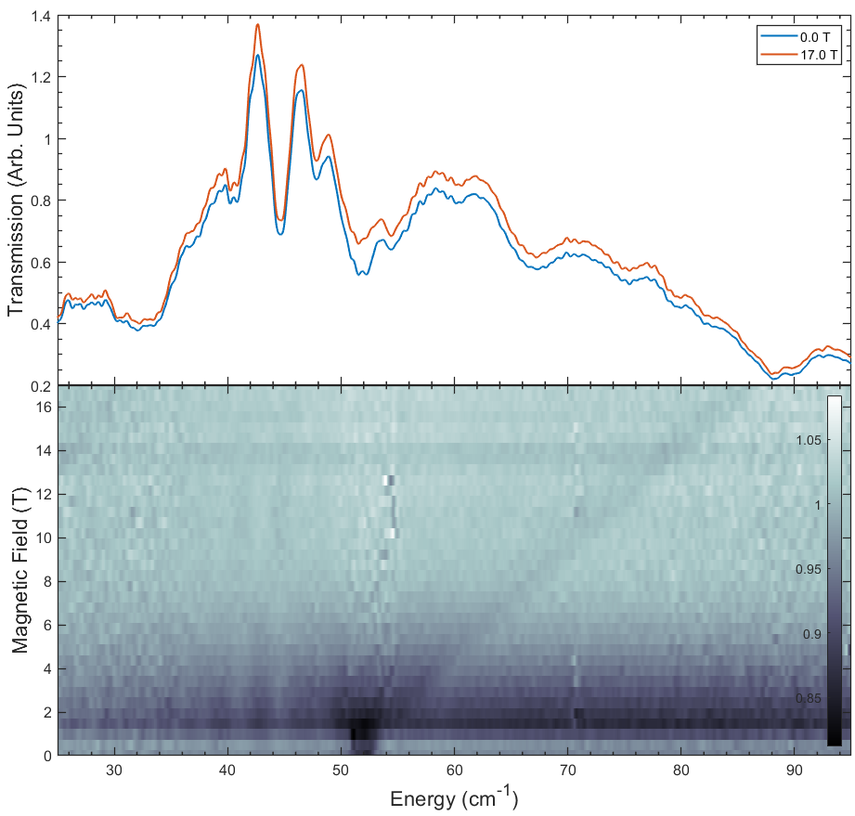
(a)
(b)

Figure A2.2. (a) FIRMS transmission spectra for a Co-MST-H₂O sample placed in the Voigt configuration.³⁷⁸ (b) 2D plot of the normalized (by average) transmission. Figure 2.3 shows the FIRMS transmission spectra for a sample in the Faraday configuration.³⁷⁸ There is a greater field dependence of data collected by Voigt transmission.

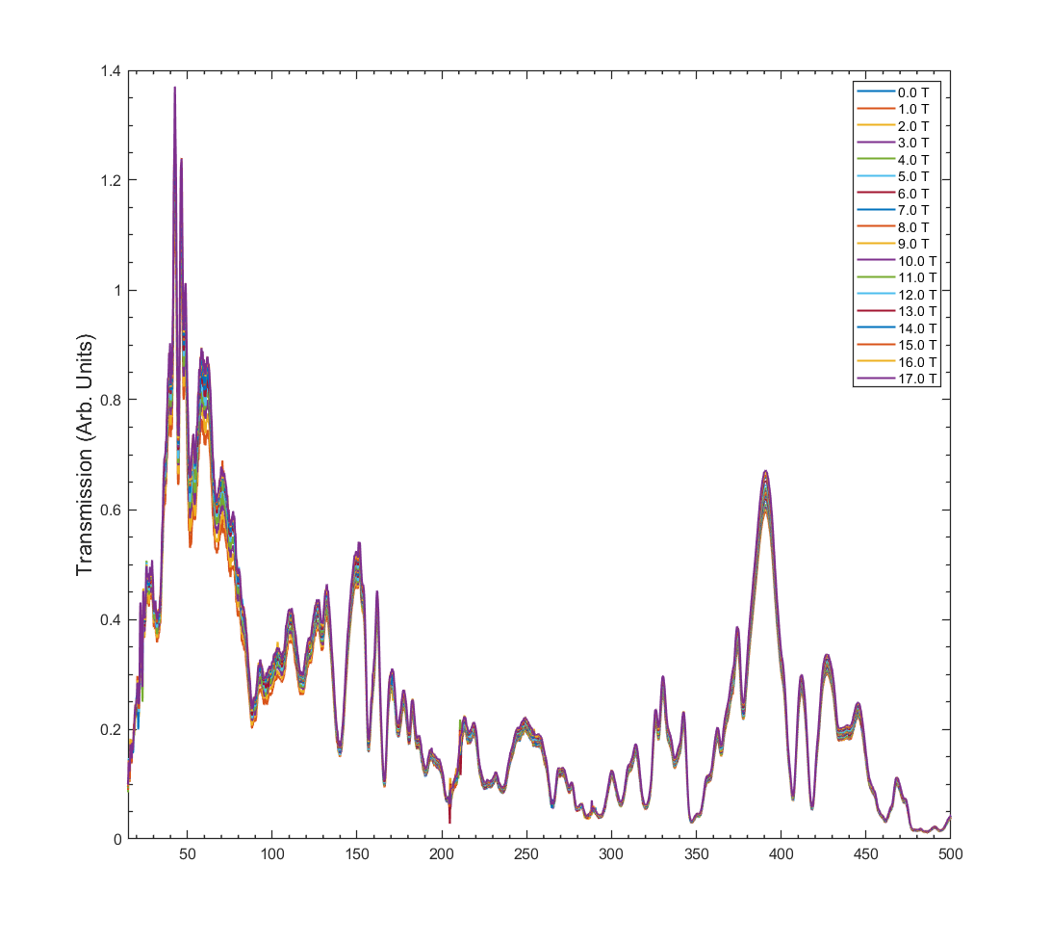
Figure A2.3. Averaged data of Co-MST-H₂O with all T-value scans, showing phonon features at 10-500 cm⁻¹.

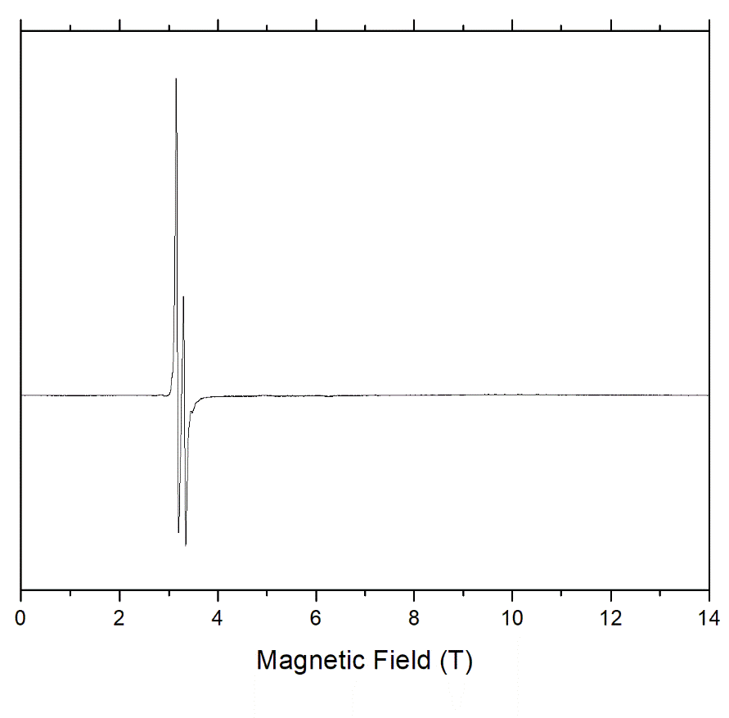
Figure A2.4. HFEPR spectrum of an unconstrained (loose) sample of Co-MST-H₂O at 10 K and 203 GHz. The two resonances with different intensities correspond to different spin species A and B, with the lower intensity being that of B. Species A can be identified as compound Co-MST-H₂O, and species B as the dehydrated compound Co-MST.

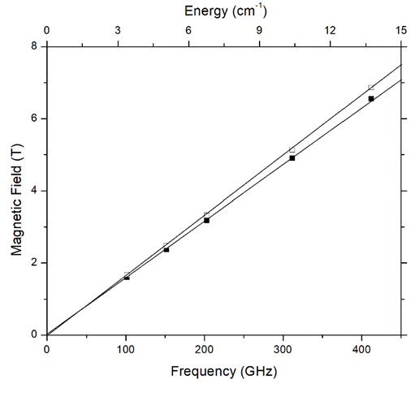
Figure A2.5. Frequency dependence of the EPR resonances observed in the unconstrained (loose) sample of Co-MST-H₂O at 10 K and 203 GHz. The lines correspond to g-values of 2.20 and 2.30 for the high-intensity (A) and low-intensity (B) resonances respectively.

Figure A2.6. Forward scattering spectra of Co-MST-H₂O at 20-80 cm⁻¹. There are two temperature-dependent peaks at 28.5 and 40.2 cm⁻¹ that are not in the backward scattering spectra in Figure 2.5. These peaks show both temperature and Q dependence. (Q = k_{i} – k_{f} is the momentum transfer and Q is the magnitude of Q, where k_{i} refers to the momentum of the incoming neutron and k_{f} of the outgoing neutron.)¹⁵² The observations suggest the peaks are magnetic. The sources giving these peaks are not clear. Impurities from degradation of Co-MST-H₂O or starting materials may contribute to these peaks, though they were not observed in PXRD (Figure A2.1).
Figure A2.7. INS spectra of Co-MST-H₂O at 5 K in comparison with the calculated phonon spectrum in the low energy (15-80 cm⁻¹) region with both forward- and back-scattering spectra.
Figure A2.8. INS spectra of Co-MST-H₂O at 10-5000 cm⁻¹.

Figure A2.9. Calculated vs experimental spectra of Co-MST-H₂O at 5-4000 cm⁻¹. Differences between the calculated and 5 K spectra are not sufficient to determine magnetic excitations clearly.

Figure A2.10. Waterfall powder neutron diffraction from VISION for Co-MST-H₂O. Lack of changes to peak shape and location indicates a lack of phase change from high to low temperature.

Table A2.1. Calculated phonons from VASP calculations for Co-MST-H₂O with symmetry
Phonon No. | Frequency (cm⁻¹) | Symmetry | Phonon No. | Frequency (cm⁻¹) | Symmetry
1 | 5.28 | A_{u} | 34 | 68.05 | A_{g}
2 | 6.54 | A_{g} | 35 | 68.71 | A_{u}
3 | 13.57 | A_{u} | 36 | 70.51 | A_{g}
4 | 18.02 | A_{g} | 37 | 70.54 | A_{u}
5 | 19.61 | A_{u} | 38 | 73.93 | A_{u}
6 | 25.18 | A_{g} | 39 | 75.65 | A_{g}
7 | 27.86 | A_{g} | 40 | 76.73 | A_{g}
8 | 28.58 | A_{u} | 41 | 77.25 | A_{u}
9 | 29.88 | A_{u} | 42 | 80.22 | A_{g}
10 | 30.21 | A_{g} | 43 | 80.95 | A_{u}
11 | 32.51 | A_{g} | 44 | 83.72 | A_{g}
12 | 35.06 | A_{g} | 45 | 84.85 | A_{u}
13 | 35.27 | A_{u} | 46 | 85.95 | A_{g}
14 | 37.90 | A_{g} | 47 | 87.16 | A_{u}
15 | 37.94 | A_{g} | 48 | 89.18 | A_{g}
16 | 38.69 | A_{u} | 49 | 90.55 | A_{u}
17 | 42.08 | A_{u} | 50 | 92.02 | A_{g}
18 | 44.37 | A_{g} | 51 | 92.40 | A_{g}
Table A2.1 Continued
19 | 45.11 | A_{u} | 52 | 93.08 | A_{u}
20 | 45.69 | A_{u} | 53 | 96.56 | A_{g}
21 | 45.98 | A_{u} | 54 | 96.63 | A_{u}
22 | 46.76 | A_{g} | 55 | 100.42 | A_{u}
23 | 47.65 | A_{g} | 56 | 101.22 | A_{g}
24 | 50.62 | A_{g} | 57 | 102.21 | A_{g}
25 | 53.95 | A_{g} | 58 | 107.21 | A_{u}
26 | 54.59 | A_{u} | 59 | 107.65 | A_{g}
27 | 56.59 | A_{g} | 60 | 109.69 | A_{u}
28 | 56.95 | A_{u} | 61 | 115.81 | A_{g}
29 | 58.28 | A_{u} | 62 | 116.33 | A_{u}
30 | 60.62 | A_{g} | 63 | 117.90 | A_{g}
31 | 60.83 | A_{u} | 64 | 122.31 | A_{u}
32 | 65.85 | A_{u} | 65 | 122.64 | A_{g}
33 | 66.44 | A_{g} | 66 | 127.63 | A_{u}
67 | 130.80 | A_{g} | 103 | 211.43 | A_{u}
68 | 131.07 | A_{u} | 104 | 211.68 | A_{g}
69 | 133.40 | A_{u} | 105 | 216.35 | A_{g}
70 | 135.09 | A_{g} | 106 | 216.95 | A_{u}
71 | 138.77 | A_{g} | 107 | 218.45 | A_{g}
72 | 139.50 | A_{u} | 108 | 218.86 | A_{u}
Table A2.1 Continued
73 | 145.17 | A_{u} | 109 | 220.10 | A_{u}
74 | 145.86 | A_{g} | 110 | 220.61 | A_{g}
75 | 156.06 | A_{u} | 111 | 222.35 | A_{u}
76 | 156.78 | A_{g} | 112 | 223.88 | A_{g}
77 | 159.28 | A_{g} | 113 | 224.99 | A_{u}
78 | 159.95 | A_{u} | 114 | 227.96 | A_{g}
79 | 162.57 | A_{g} | 115 | 233.18 | A_{g}
80 | 164.09 | A_{g} | 116 | 233.76 | A_{u}
81 | 164.25 | A_{u} | 117 | 235.68 | A_{g}
82 | 166.05 | A_{u} | 118 | 236.14 | A_{u}
83 | 168.56 | A_{u} | 119 | 237.87 | A_{g}
84 | 169.94 | A_{g} | 120 | 239.85 | A_{u}
85 | 171.87 | A_{u} | 121 | 240.53 | A_{g}
86 | 172.98 | A_{g} | 122 | 240.95 | A_{u}
87 | 182.18 | A_{g} | 123 | 245.00 | A_{u}
88 | 182.81 | A_{u} | 124 | 247.39 | A_{g}
89 | 186.80 | A_{u} | 125 | 256.11 | A_{g}
90 | 187.24 | A_{g} | 126 | 257.90 | A_{u}
91 | 193.20 | A_{g} | 127 | 259.59 | A_{g}
92 | 193.39 | A_{u} | 128 | 260.55 | A_{u}
93 | 193.70 | A_{u} | 129 | 271.80 | A_{g}
Table A2.1 Continued
94 | 195.54 | A_{g} | 130 | 272.32 | A_{u}
95 | 197.95 | A_{u} | 131 | 275.44 | A_{u}
96 | 198.63 | A_{g} | 132 | 275.93 | A_{g}
97 | 199.05 | A_{u} | 133 | 277.26 | A_{u}
98 | 205.10 | A_{g} | 134 | 278.57 | A_{g}
99 | 205.44 | A_{g} | 135 | 281.31 | A_{u}
100 | 205.86 | A_{u} | 136 | 281.62 | A_{g}
101 | 207.26 | A_{u} | 137 | 284.11 | A_{g}
102 | 208.16 | A_{g} | 138 | 286.56 | A_{g}
139 | 287.01 | A_{u} | 175 | 363.30 | A_{u}
140 | 288.11 | A_{u} | 176 | 363.85 | A_{g}
141 | 297.50 | A_{u} | 177 | 365.84 | A_{u}
142 | 298.59 | A_{g} | 178 | 366.43 | A_{g}
143 | 298.99 | A_{u} | 179 | 376.66 | A_{g}
144 | 300.43 | A_{g} | 180 | 376.96 | A_{u}
145 | 303.76 | A_{g} | 181 | 387.47 | A_{g}
146 | 303.96 | A_{u} | 182 | 387.57 | A_{u}
147 | 304.45 | A_{g} | 183 | 394.11 | A_{u}
148 | 307.06 | A_{u} | 184 | 394.60 | A_{g}
149 | 307.42 | A_{g} | 185 | 432.00 | A_{u}
150 | 308.13 | A_{u} | 186 | 432.07 | A_{g}
Table A2.1 Continued
151 | 310.30 | A_{u} | 187 | 441.70 | A_{u}
152 | 311.24 | A_{g} | 188 | 442.84 | A_{g}
153 | 315.05 | A_{g} | 189 | 444.14 | A_{g}
154 | 317.06 | A_{u} | 190 | 445.79 | A_{u}
155 | 317.10 | A_{g} | 191 | 451.01 | A_{g}
156 | 318.03 | A_{u} | 192 | 453.18 | A_{u}
157 | 331.81 | A_{g} | 193 | 467.02 | A_{u}
158 | 332.52 | A_{u} | 194 | 467.44 | A_{g}
159 | 338.58 | A_{u} | 195 | 471.72 | A_{u}
160 | 340.71 | A_{g} | 196 | 472.43 | A_{g}
161 | 341.06 | A_{u} | 197 | 480.83 | A_{u}
162 | 341.78 | A_{g} | 198 | 481.37 | A_{g}
163 | 347.96 | A_{g} | 199 | 498.82 | A_{u}
164 | 348.97 | A_{u} | 200 | 500.01 | A_{g}
165 | 351.53 | A_{g} | 201 | 504.35 | A_{u}
166 | 352.32 | A_{u} | 202 | 504.86 | A_{g}
167 | 353.65 | A_{g} | 203 | 505.13 | A_{u}
168 | 354.22 | A_{u} | 204 | 505.14 | A_{g}
169 | 358.84 | A_{u} | 205 | 505.63 | A_{u}
170 | 359.02 | A_{g} | 206 | 506.94 | A_{g}
171 | 360.09 | A_{g} | 207 | 508.01 | A_{u}
Table A2.1 Continued
172 | 360.71 | A_{g} | 208 | 508.39 | A_{g}
173 | 360.78 | A_{u} | 209 | 512.95 | A_{u}
174 | 360.98 | A_{u} | 210 | 513.48 | A_{g}
211 | 515.49 | A_{g} | 247 | 585.91 | A_{g}
212 | 515.97 | A_{u} | 248 | 586.80 | A_{g}
213 | 517.29 | A_{g} | 249 | 589.28 | A_{g}
214 | 517.30 | A_{u} | 250 | 591.27 | A_{u}
215 | 518.51 | A_{u} | 251 | 612.89 | A_{g}
216 | 518.58 | A_{g} | 252 | 613.21 | A_{u}
217 | 520.23 | A_{g} | 253 | 621.57 | A_{g}
218 | 520.30 | A_{u} | 254 | 621.66 | A_{u}
219 | 522.45 | A_{g} | 255 | 628.93 | A_{u}
220 | 524.07 | A_{u} | 256 | 629.88 | A_{g}
221 | 527.38 | A_{u} | 257 | 634.94 | A_{g}
222 | 527.82 | A_{g} | 258 | 635.69 | A_{u}
223 | 528.82 | A_{g} | 259 | 675.29 | A_{u}
224 | 529.49 | A_{u} | 260 | 676.83 | A_{u}
225 | 538.39 | A_{u} | 261 | 676.99 | A_{g}
226 | 538.77 | A_{g} | 262 | 681.78 | A_{g}
227 | 544.75 | A_{u} | 263 | 691.93 | A_{u}
228 | 545.03 | A_{g} | 264 | 693.76 | A_{g}
Table A2.1 Continued
229 | 545.05 | A_{u} | 265 | 706.29 | A_{u}
230 | 545.62 | A_{g} | 266 | 706.52 | A_{g}
231 | 549.94 | A_{g} | 267 | 707.97 | A_{u}
232 | 550.71 | A_{u} | 268 | 709.09 | A_{g}
233 | 559.47 | A_{u} | 269 | 711.29 | A_{g}
234 | 560.77 | A_{g} | 270 | 711.31 | A_{u}
235 | 565.91 | A_{g} | 271 | 723.49 | A_{g}
236 | 566.10 | A_{u} | 272 | 723.71 | A_{u}
237 | 567.55 | A_{g} | 273 | 737.90 | A_{u}
238 | 567.94 | A_{u} | 274 | 738.29 | A_{g}
239 | 568.70 | A_{g} | 275 | 781.20 | A_{u}
240 | 570.92 | A_{u} | 276 | 782.05 | A_{g}
241 | 572.15 | A_{u} | 277 | 800.10 | A_{u}
242 | 573.25 | A_{g} | 278 | 800.47 | A_{g}
243 | 574.66 | A_{u} | 279 | 824.72 | A_{u}
244 | 576.79 | A_{g} | 280 | 825.25 | A_{g}
245 | 584.39 | A_{u} | 281 | 828.33 | A_{u}
246 | 585.89 | A_{u} | 282 | 830.43 | A_{g}
283 | 833.11 | A_{u} | 319 | 947.48 | A_{g}
284 | 836.82 | A_{g} | 320 | 947.97 | A_{u}
285 | 843.75 | A_{g} | 321 | 952.14 | A_{u}
Table A2.1 Continued
286 | 843.87 | A_{u} | 322 | 952.28 | A_{g}
287 | 855.87 | A_{u} | 323 | 955.68 | A_{u}
288 | 860.35 | A_{g} | 324 | 956.07 | A_{g}
289 | 865.80 | A_{g} | 325 | 958.85 | A_{g}
290 | 865.82 | A_{u} | 326 | 959.04 | A_{u}
291 | 867.80 | A_{u} | 327 | 994.19 | A_{g}
292 | 869.53 | A_{g} | 328 | 994.23 | A_{u}
293 | 869.83 | A_{g} | 329 | 996.29 | A_{u}
294 | 870.01 | A_{u} | 330 | 996.39 | A_{g}
295 | 883.57 | A_{u} | 331 | 997.67 | A_{u}
296 | 885.66 | A_{g} | 332 | 997.69 | A_{g}
297 | 908.69 | A_{g} | 333 | 1001.29 | A_{g}
298 | 909.17 | A_{u} | 334 | 1001.87 | A_{u}
299 | 914.40 | A_{u} | 335 | 1002.09 | A_{g}
300 | 914.72 | A_{g} | 336 | 1002.71 | A_{u}
301 | 917.87 | A_{g} | 337 | 1004.07 | A_{g}
302 | 917.89 | A_{u} | 338 | 1004.68 | A_{u}
303 | 918.29 | A_{g} | 339 | 1007.86 | A_{g}
304 | 919.02 | A_{u} | 340 | 1008.07 | A_{u}
305 | 919.68 | A_{g} | 341 | 1009.73 | A_{u}
306 | 920.23 | A_{u} | 342 | 1009.76 | A_{g}
Table A2.1 Continued
307 | 920.63 | A_{g} | 343 | 1010.84 | A_{u}
308 | 921.96 | A_{u} | 344 | 1011.63 | A_{g}
309 | 930.93 | A_{g} | 345 | 1012.70 | A_{u}
310 | 931.10 | A_{u} | 346 | 1013.24 | A_{g}
311 | 932.48 | A_{u} | 347 | 1013.32 | A_{u}
312 | 933.03 | A_{g} | 348 | 1014.23 | A_{g}
313 | 935.14 | A_{g} | 349 | 1015.55 | A_{u}
314 | 935.51 | A_{u} | 350 | 1015.97 | A_{u}
315 | 939.29 | A_{g} | 351 | 1016.13 | A_{g}
316 | 939.94 | A_{u} | 352 | 1016.44 | A_{g}
317 | 941.63 | A_{u} | 353 | 1017.24 | A_{g}
318 | 942.12 | A_{g} | 354 | 1017.31 | A_{u}
355 | 1019.27 | A_{g} | 391 | 1073.87 | A_{u}
356 | 1019.52 | A_{u} | 392 | 1075.46 | A_{g}
357 | 1020.52 | A_{g} | 393 | 1077.94 | A_{u}
358 | 1020.80 | A_{u} | 394 | 1082.16 | A_{g}
359 | 1022.17 | A_{u} | 395 | 1127.84 | A_{u}
360 | 1022.30 | A_{g} | 396 | 1128.88 | A_{g}
361 | 1023.42 | A_{g} | 397 | 1132.39 | A_{u}
362 | 1023.71 | A_{u} | 398 | 1133.54 | A_{g}
363 | 1024.17 | A_{u} | 399 | 1134.71 | A_{u}
Table A2.1 Continued
364 | 1024.32 | A_{g} | 400 | 1134.98 | A_{g}
365 | 1026.07 | A_{u} | 401 | 1145.51 | A_{u}
366 | 1026.43 | A_{g} | 402 | 1146.13 | A_{g}
367 | 1027.05 | A_{u} | 403 | 1150.09 | A_{g}
368 | 1027.06 | A_{g} | 404 | 1152.89 | A_{u}
369 | 1028.26 | A_{g} | 405 | 1154.28 | A_{g}
370 | 1028.94 | A_{u} | 406 | 1154.33 | A_{u}
371 | 1031.26 | A_{u} | 407 | 1161.55 | A_{u}
372 | 1031.75 | A_{u} | 408 | 1162.93 | A_{g}
373 | 1033.70 | A_{u} | 409 | 1165.87 | A_{u}
374 | 1034.11 | A_{g} | 410 | 1165.92 | A_{g}
375 | 1041.91 | A_{g} | 411 | 1167.04 | A_{u}
376 | 1044.88 | A_{u} | 412 | 1167.11 | A_{g}
377 | 1046.44 | A_{g} | 413 | 1169.61 | A_{g}
378 | 1047.43 | A_{u} | 414 | 1169.66 | A_{u}
379 | 1048.88 | A_{g} | 415 | 1183.92 | A_{u}
380 | 1048.91 | A_{u} | 416 | 1187.04 | A_{g}
381 | 1049.91 | A_{g} | 417 | 1212.63 | A_{g}
382 | 1050.07 | A_{u} | 418 | 1213.84 | A_{u}
383 | 1050.83 | A_{u} | 419 | 1226.74 | A_{g}
384 | 1051.01 | A_{g} | 420 | 1228.11 | A_{u}
Table A2.1 Continued
385 | 1051.93 | A_{u} | 421 | 1230.27 | A_{g}
386 | 1052.69 | A_{g} | 422 | 1230.45 | A_{u}
387 | 1059.61 | A_{u} | 423 | 1230.49 | A_{g}
388 | 1059.91 | A_{g} | 424 | 1230.74 | A_{u}
389 | 1063.15 | A_{u} | 425 | 1234.53 | A_{u}
390 | 1067.97 | A_{g} | 426 | 1234.55 | A_{g}
427 | 1236.93 | A_{u} | 463 | 1350.40 | A_{u}
428 | 1236.99 | A_{g} | 464 | 1350.57 | A_{g}
429 | 1242.99 | A_{g} | 465 | 1351.99 | A_{g}
430 | 1244.58 | A_{u} | 466 | 1352.21 | A_{u}
431 | 1254.53 | A_{g} | 467 | 1353.00 | A_{u}
432 | 1256.19 | A_{u} | 468 | 1353.35 | A_{g}
433 | 1257.80 | A_{g} | 469 | 1354.91 | A_{g}
434 | 1258.74 | A_{u} | 470 | 1355.40 | A_{u}
435 | 1261.19 | A_{u} | 471 | 1356.22 | A_{u}
436 | 1261.23 | A_{g} | 472 | 1356.23 | A_{g}
437 | 1263.63 | A_{g} | 473 | 1359.59 | A_{g}
438 | 1265.09 | A_{u} | 474 | 1360.00 | A_{u}
439 | 1268.05 | A_{g} | 475 | 1360.81 | A_{g}
440 | 1268.44 | A_{u} | 476 | 1360.86 | A_{u}
441 | 1268.74 | A_{g} | 477 | 1362.41 | A_{u}
Table A2.1 Continued
442 | 1271.25 | A_{u} | 478 | 1362.52 | A_{g}
443 | 1276.65 | A_{g} | 479 | 1367.25 | A_{g}
444 | 1276.66 | A_{u} | 480 | 1367.27 | A_{u}
445 | 1277.63 | A_{u} | 481 | 1369.21 | A_{g}
446 | 1277.86 | A_{g} | 482 | 1370.20 | A_{u}
447 | 1278.85 | A_{g} | 483 | 1371.06 | A_{g}
448 | 1278.88 | A_{u} | 484 | 1371.66 | A_{u}
449 | 1304.56 | A_{u} | 485 | 1381.23 | A_{u}
450 | 1304.63 | A_{g} | 486 | 1381.34 | A_{g}
451 | 1306.40 | A_{g} | 487 | 1382.45 | A_{g}
452 | 1306.61 | A_{u} | 488 | 1382.78 | A_{u}
453 | 1307.25 | A_{g} | 489 | 1382.89 | A_{g}
454 | 1307.26 | A_{u} | 490 | 1383.28 | A_{u}
455 | 1314.41 | A_{g} | 491 | 1385.25 | A_{g}
456 | 1314.99 | A_{u} | 492 | 1385.55 | A_{u}
457 | 1317.87 | A_{g} | 493 | 1386.11 | A_{u}
458 | 1318.21 | A_{u} | 494 | 1386.77 | A_{g}
459 | 1322.14 | A_{g} | 495 | 1387.41 | A_{g}
460 | 1324.19 | A_{u} | 496 | 1388.21 | A_{u}
461 | 1347.16 | A_{g} | 497 | 1388.31 | A_{g}
462 | 1347.30 | A_{u} | 498 | 1389.47 | A_{u}
Table A2.1 Continued
499 | 1392.82 | A_{g} | 535 | 1431.86 | A_{u}
500 | 1395.25 | A_{u} | 536 | 1433.13 | A_{g}
501 | 1404.45 | A_{u} | 537 | 1434.90 | A_{g}
502 | 1405.31 | A_{g} | 538 | 1434.91 | A_{u}
503 | 1408.53 | A_{u} | 539 | 1436.51 | A_{g}
504 | 1408.71 | A_{g} | 540 | 1436.92 | A_{u}
505 | 1411.99 | A_{g} | 541 | 1439.95 | A_{u}
506 | 1412.10 | A_{u} | 542 | 1440.18 | A_{g}
507 | 1412.39 | A_{g} | 543 | 1440.32 | A_{g}
508 | 1412.73 | A_{g} | 544 | 1441.80 | A_{u}
509 | 1412.83 | A_{u} | 545 | 1442.79 | A_{u}
510 | 1413.33 | A_{u} | 546 | 1443.39 | A_{g}
511 | 1415.74 | A_{u} | 547 | 1444.37 | A_{u}
512 | 1415.80 | A_{g} | 548 | 1444.53 | A_{g}
513 | 1418.14 | A_{g} | 549 | 1445.42 | A_{u}
514 | 1418.50 | A_{u} | 550 | 1445.83 | A_{g}
515 | 1419.37 | A_{g} | 551 | 1446.66 | A_{g}
516 | 1419.61 | A_{u} | 552 | 1447.13 | A_{u}
517 | 1420.25 | A_{g} | 553 | 1448.11 | A_{g}
518 | 1420.93 | A_{u} | 554 | 1449.92 | A_{u}
519 | 1421.53 | A_{g} | 555 | 1451.65 | A_{g}
Table A2.1 Continued
520 | 1421.75 | A_{u} | 556 | 1451.67 | A_{u}
521 | 1422.20 | A_{u} | 557 | 1452.60 | A_{u}
522 | 1422.78 | A_{g} | 558 | 1452.70 | A_{g}
523 | 1424.29 | A_{g} | 559 | 1455.60 | A_{u}
524 | 1424.30 | A_{u} | 560 | 1455.78 | A_{g}
525 | 1425.30 | A_{u} | 561 | 1456.63 | A_{u}
526 | 1425.53 | A_{g} | 562 | 1457.70 | A_{g}
527 | 1425.82 | A_{g} | 563 | 1459.48 | A_{u}
528 | 1426.67 | A_{u} | 564 | 1460.09 | A_{g}
529 | 1428.38 | A_{u} | 565 | 1466.93 | A_{u}
530 | 1428.96 | A_{g} | 566 | 1471.04 | A_{u}
531 | 1429.67 | A_{u} | 567 | 1471.08 | A_{g}
532 | 1430.40 | A_{u} | 568 | 1477.37 | A_{g}
533 | 1430.48 | A_{g} | 569 | 1477.46 | A_{u}
534 | 1430.61 | A_{g} | 570 | 1482.57 | A_{g}
571 | 1546.53 | A_{g} | 607 | 2935.92 | A_{g}
572 | 1546.94 | A_{u} | 608 | 2935.92 | A_{u}
573 | 1548.60 | A_{u} | 609 | 2936.20 | A_{u}
574 | 1548.72 | A_{g} | 610 | 2936.71 | A_{g}
575 | 1550.27 | A_{u} | 611 | 2938.22 | A_{u}
576 | 1550.31 | A_{g} | 612 | 2938.29 | A_{g}
Table A2.1 Continued
577 | 1558.35 | A_{g} | 613 | 2938.50 | A_{g}
578 | 1558.46 | A_{u} | 614 | 2938.61 | A_{u}
579 | 1579.58 | A_{g} | 615 | 2939.34 | A_{g}
580 | 1579.85 | A_{u} | 616 | 2939.47 | A_{u}
581 | 1580.53 | A_{g} | 617 | 2941.53 | A_{g}
582 | 1580.90 | A_{u} | 618 | 2941.58 | A_{u}
583 | 1582.50 | A_{g} | 619 | 2942.41 | A_{g}
584 | 1582.72 | A_{u} | 620 | 2942.45 | A_{u}
585 | 1632.72 | A_{u} | 621 | 2946.28 | A_{g}
586 | 1633.23 | A_{g} | 622 | 2946.54 | A_{u}
587 | 2879.21 | A_{u} | 623 | 2950.72 | A_{g}
588 | 2879.48 | A_{g} | 624 | 2950.83 | A_{u}
589 | 2885.38 | A_{u} | 625 | 2950.99 | A_{u}
590 | 2885.70 | A_{g} | 626 | 2951.35 | A_{g}
591 | 2901.20 | A_{u} | 627 | 2953.75 | A_{u}
592 | 2901.24 | A_{g} | 628 | 2954.10 | A_{g}
593 | 2908.11 | A_{u} | 629 | 2961.56 | A_{u}
594 | 2908.22 | A_{g} | 630 | 2962.23 | A_{g}
595 | 2909.57 | A_{g} | 631 | 2964.35 | A_{g}
596 | 2909.69 | A_{u} | 632 | 2964.48 | A_{u}
597 | 2915.07 | A_{u} | 633 | 2966.21 | A_{u}
Table A2.1 Continued
598 | 2916.27 | A_{g} | 634 | 2967.51 | A_{g}
599 | 2918.13 | A_{u} | 635 | 2971.85 | A_{u}
600 | 2918.80 | A_{g} | 636 | 2972.66 | A_{g}
601 | 2924.83 | A_{u} | 637 | 2983.05 | A_{g}
602 | 2924.84 | A_{g} | 638 | 2983.13 | A_{u}
603 | 2932.01 | A_{g} | 639 | 2983.98 | A_{u}
604 | 2932.19 | A_{u} | 640 | 2984.00 | A_{g}
605 | 2932.99 | A_{g} | 641 | 2988.48 | A_{u}
606 | 2933.08 | A_{u} | 642 | 2988.48 | A_{g}
643 | 2989.41 | A_{g} | 678 | 3040.86 | A_{g}
644 | 2989.64 | A_{u} | 679 | 3041.14 | A_{u}
645 | 2990.81 | A_{g} | 680 | 3041.77 | A_{g}
646 | 2990.83 | A_{u} | 681 | 3041.95 | A_{u}
647 | 2992.37 | A_{u} | 682 | 3042.46 | A_{g}
648 | 2992.45 | A_{g} | 683 | 3043.68 | A_{g}
649 | 2999.30 | A_{g} | 684 | 3043.72 | A_{u}
650 | 2999.37 | A_{u} | 685 | 3046.92 | A_{g}
651 | 2999.84 | A_{g} | 686 | 3047.07 | A_{u}
652 | 3000.06 | A_{u} | 687 | 3047.58 | A_{u}
653 | 3001.02 | A_{g} | 688 | 3047.95 | A_{g}
654 | 3001.48 | A_{u} | 689 | 3048.28 | A_{g}
Table A2.1 Continued
655 | 3005.97 | A_{g} | 690 | 3048.29 | A_{u}
656 | 3006.03 | A_{u} | 691 | 3049.57 | A_{g}
657 | 3008.22 | A_{u} | 692 | 3049.64 | A_{u}
658 | 3008.22 | A_{g} | 693 | 3052.67 | A_{u}
659 | 3008.59 | A_{g} | 694 | 3053.37 | A_{g}
660 | 3008.72 | A_{u} | 695 | 3054.18 | A_{u}
661 | 3010.48 | A_{u} | 696 | 3055.10 | A_{g}
662 | 3010.62 | A_{g} | 697 | 3056.64 | A_{u}
663 | 3011.25 | A_{u} | 698 | 3056.66 | A_{g}
664 | 3011.65 | A_{g} | 699 | 3070.15 | A_{g}
665 | 3015.61 | A_{g} | 700 | 3070.26 | A_{u}
666 | 3015.63 | A_{u} | 701 | 3073.66 | A_{g}
667 | 3020.47 | A_{g} | 702 | 3076.40 | A_{u}
668 | 3020.56 | A_{u} | 703 | 3104.96 | A_{u}
669 | 3023.15 | A_{g} | 704 | 3105.52 | A_{g}
670 | 3023.22 | A_{u} | 705 | 3183.24 | A_{u}
671 | 3035.01 | A_{g} | 706 | 3184.84 | A_{g}
672 | 3035.05 | A_{u} | 707 | 3283.62 | A_{g}
673 | 3038.75 | A_{g} | 708 | 3283.72 | A_{u}
674 | 3038.83 | A_{u} | 709 | 3401.30 | A_{g}
675 | 3039.13 | A_{u} | 710 | 3403.19 | A_{u}
Table A2.1 Continued
676 | 3039.78 | A_{g} | 711 | 3526.00 | A_{u}
677 | 3040.79 | A_{u} | 712 | 3526.95 | A_{g}

A2.2.2 Spin density calculations
Shown in Figure A2.11 and Table A2.2.

A2.2.3. Additional Hirshfeld surface results
Shown in Figure A2.12.

A2.3. Additional results for Ni-MST-H₂O

A2.3.1. PXRD of Ni-MST-H₂O
Shown in Figure A2.13.

A2.3.2. Additional FIRMS results
Shown in Figures A2.14-15.

A2.3.3. Additional INS results
Shown in Figures A2.16-18.

A2.3.4. Additional Hirshfeld surface results
Shown in Figure A2.19.

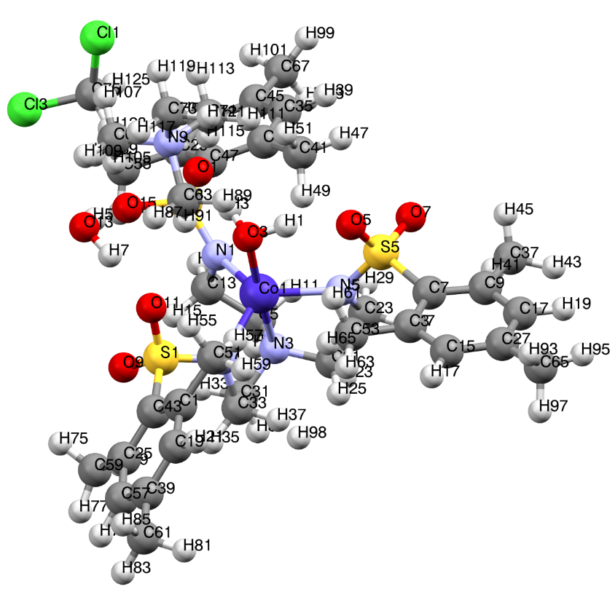
Figure A2.11. Structure of Co-MST-H₂O with labels associated with spin density calculations.

Table A2.2. Spin densities of atoms from VASP calculations for Co-MST-H₂O. There is a second identical molecule in the lattice, and its spin density is not listed.
Atom label | Spin density | Atom label | Spin density | Atom label | Spin density
H1 | 0 | H81 | 0 | C35 | 0
H3 | 0 | H83 | 0 | C37 | 0
H5 | 0 | H85 | 0 | C39 | 0.001
H7 | 0 | H87 | 0 | C41 | 0
H9 | 0.001 | H89 | 0 | C43 | 0.002
H11 | 0 | H91 | 0 | C45 | 0.001
H13 | 0.001 | H93 | 0 | C47 | 0.002
H15 | 0.001 | H95 | 0 | C49 | 0
H17 | 0 | H97 | 0 | C51 | 0
H19 | 0 | H99 | 0 | C53 | 0
H21 | 0 | H101 | 0 | C55 | 0
H23 | 0.001 | H103 | 0 | C57 | 0
H25 | 0 | H105 | 0 | C59 | 0
H27 | 0.001 | H107 | 0 | C61 | 0
H29 | 0.001 | H109 | 0 | C63 | 0
H31 | 0.001 | H111 | 0 | C65 | 0
H33 | 0 | H113 | 0 | C67 | 0
H35 | 0.001 | H115 | 0 | C69 | 0
H37 | 0 | H117 | 0 | C71 | 0
Table A2.2. Continued
H39 | 0 | H119 | 0 | C73 | 0
H41 | 0 | H121 | 0 | C75 | 0
H43 | 0 | H123 | 0 | N1 | 0.037
H45 | 0 | H125 | 0 | N3 | 0.045
H47 | 0 | C1 | 0.001 | N5 | 0.036
H49 | 0 | C3 | 0.001 | N7 | 0.037
H51 | 0 | C5 | 0 | N9 | 0
H53 | 0 | C7 | 0.002 | O1 | 0
H55 | 0 | C9 | 0.001 | O3 | 0.03
H57 | 0 | C11 | 0.001 | O5 | 0
H59 | 0 | C13 | -0.001 | O7 | 0.006
H61 | 0 | C15 | 0 | O9 | 0.004
H63 | 0 | C17 | 0 | O11 | 0.001
H65 | 0 | C19 | 0 | O13 | 0
H67 | 0 | C21 | -0.001 | O15 | 0.006
H69 | 0 | C23 | -0.001 | S1 | 0.004
H71 | 0 | C25 | 0.002 | S3 | 0.005
H73 | 0 | C27 | 0.001 | S5 | 0.004
H75 | 0 | C29 | 0.001 | Cl1 | 0
H77 | 0 | C31 | 0 | Cl3 | 0
H79 | 0 | C33 | -0.001 | Co1 | 2.627

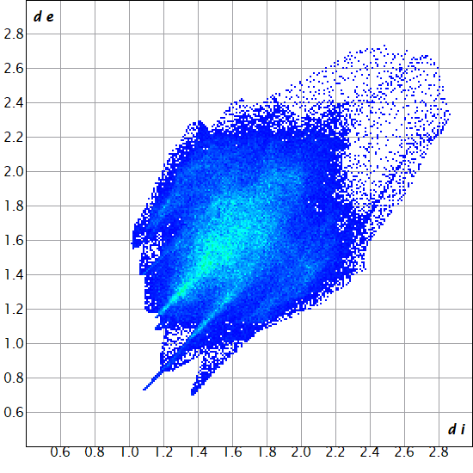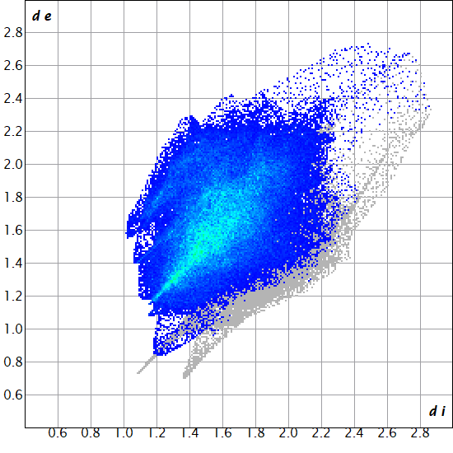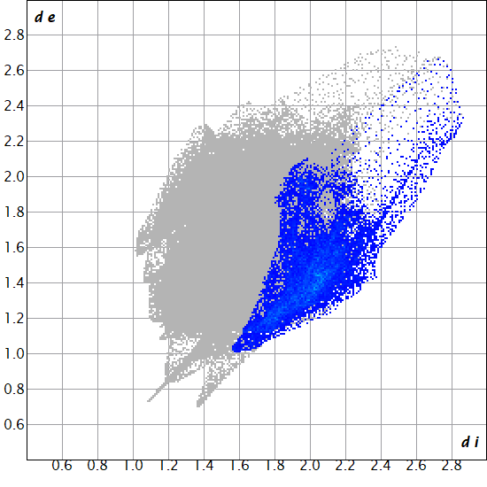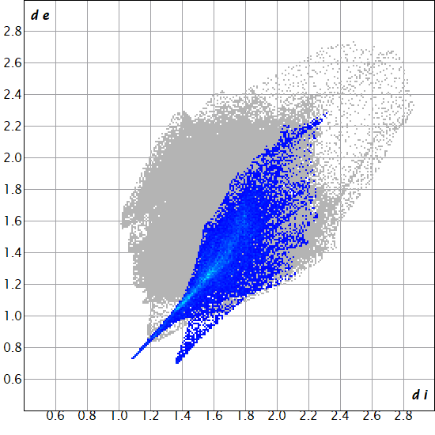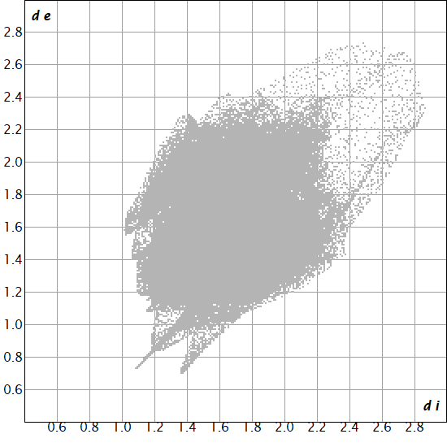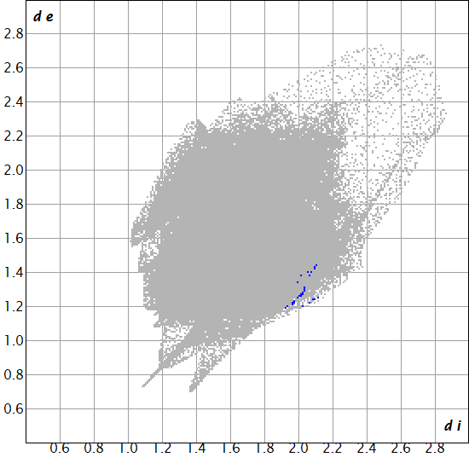
H
C
O
Co
N
S
Figure A2.12. Fingerprint plots for the Co-MST-H₂O⁻ anion showing the interactions of the listed element inside the Hirshfeld surface to all outer atoms.

Figure A2.13. PXRD pattern of the Ni-MST-H₂O sample for INS compared to the calculated pattern from reported structure.¹⁰⁶

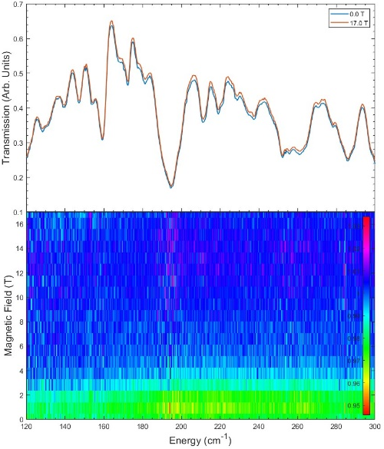
Figure A2.14. FIRMS and contour plot of spectra of Ni-MST-H₂O with no distinct magnetic peak.
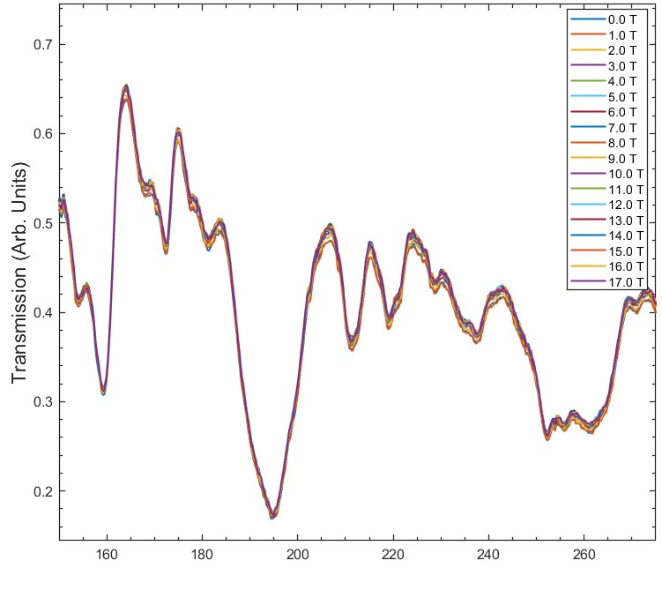
Figure A2.15. Averaged spectral data for Ni-MST-H₂O with all T-values showing vibrational features near the expected magnetic transition. There are several strong phonons in this region, which may be coupled to magnetic transitions.
Figure A2.16. INS spectra of Ni-MST-H₂O at 10-5000 cm⁻¹.

Figure A2.17. Calculated vs experimental spectra of Ni-MST-H₂O at 10-5000 cm⁻¹.

Figure A2.18. INS spectra of Ni-MST-H₂O showing calculated and experimental phonons in the 180-240 cm⁻¹ region. A comparison of the calculated INS spectrum with observed INS spectrum in the 180-240 cm⁻¹ region in the figure below does not clearly show the magnetic peak.

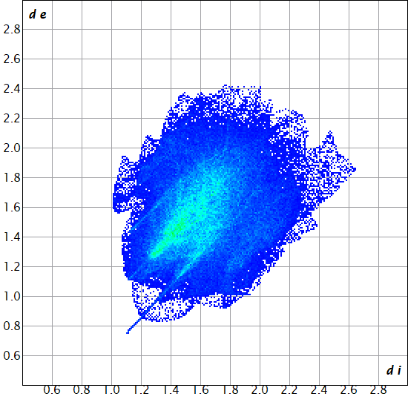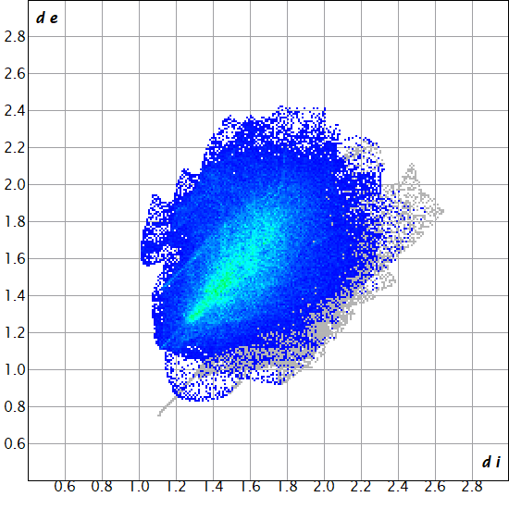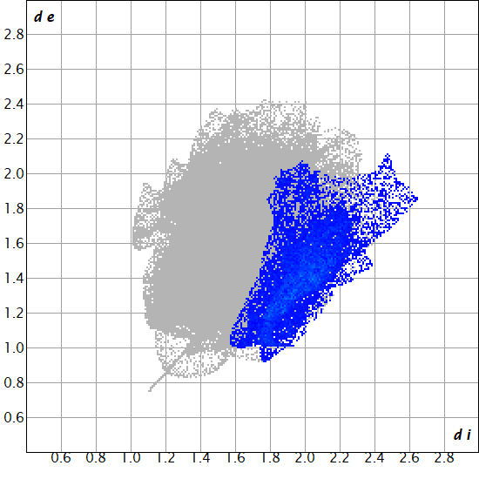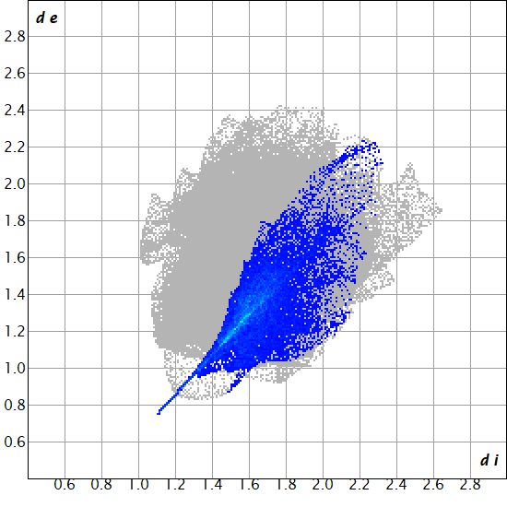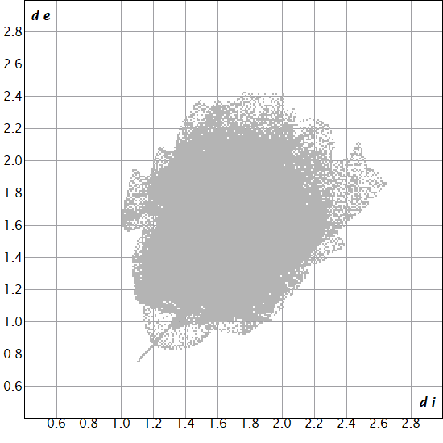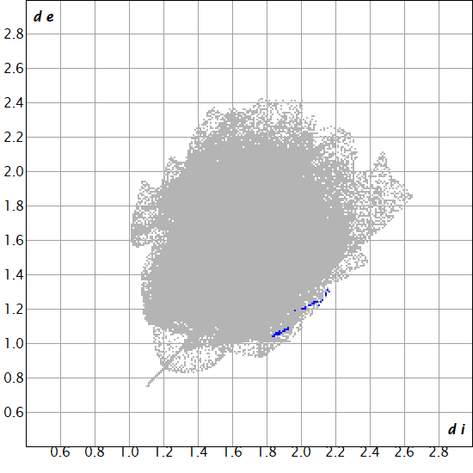
H
C
O
Ni
N
S
Figure A2.19. Fingerprint plots for Ni-MST-H₂O⁻ showing the interactions of the listed element inside the Hirshfeld surface to all outer atoms.

A2.4. Spin densities in [Co(12-crown-4)₂](I₃)₂ and Co(AsPh₃)₂I₂

A2.4.1 Spin densities in [Co(12-crown-4)₂](I₃)₂
Single-molecule magnet (SMM) properties of [Co(12-crown-4)₂](I₃)₂ were reported by Chen and coworkers.²⁰² Its magnetic transitions, spin Hamiltonian parameters, and spin-phonon properties have been probed by advanced spectroscopies.¹³⁹ Its spin densities have been calculated by a DFT calculation similar to that used to calculate the spin densities in Co-MST-H₂O. The spin densities are reported here.

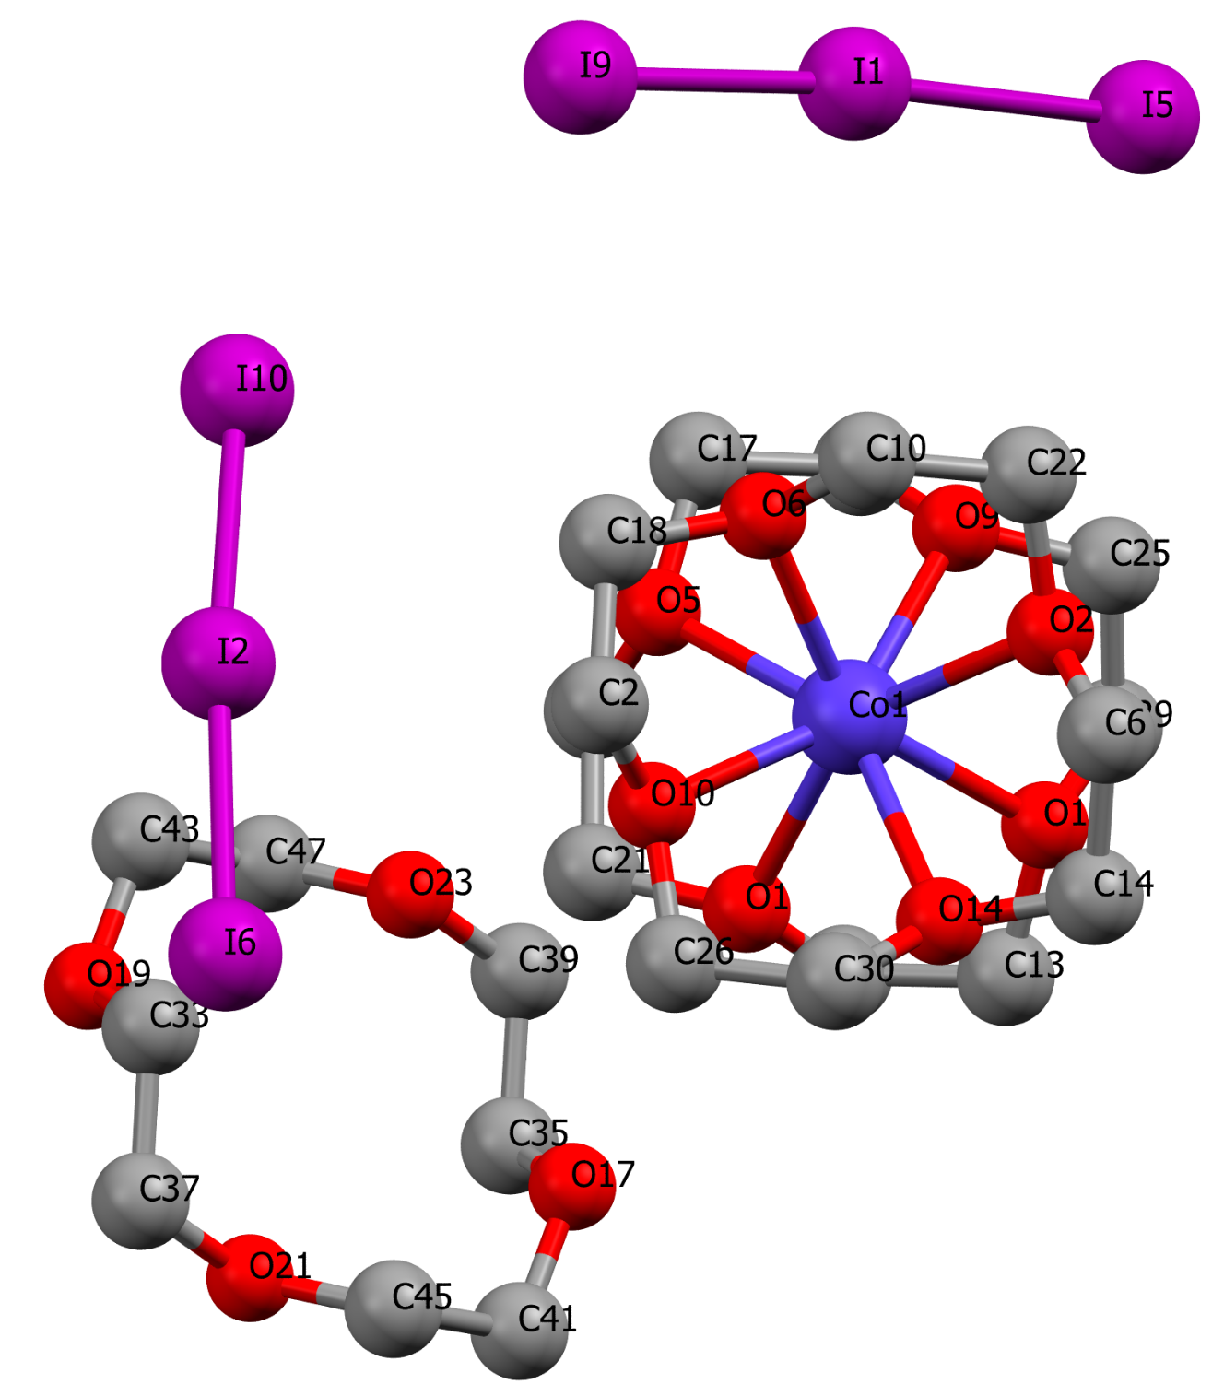
Figure A2.20. Model for the spin densities of [Co(12-crown-4)₂](I₃)₂.

Table A2.3. Spin densities of atoms from VASP calculations for [Co(12-crown-4)₂](I₃)₂. There is a second identical molecule in the lattice, and its spin density is not listed.
Atom Label | Spin Density | Atom Label | Spin Density
H1 | 0.000 | H80 | 0.000
H2 | 0.000 | H82 | 0.000
H5 | 0.001 | H84 | 0.000
H6 | 0.001 | H86 | 0.000
H9 | 0.000 | H88 | 0.000
H10 | 0.000 | H90 | 0.000
H13 | 0.001 | H92 | 0.000
H14 | 0.001 | H94 | 0.000
H17 | 0.000 | H96 | 0.000
H18 | 0.000 | C1 | 0.001
H21 | 0.001 | C2 | 0.001
H22 | 0.001 | C5 | 0.001
H25 | 0.000 | C6 | 0.001
H26 | 0.000 | C9 | 0.001
H29 | 0.000 | C10 | 0.001
H30 | 0.000 | C13 | 0.000
H33 | 0.000 | C14 | 0.000
H34 | 0.000 | C17 | 0.000
H37 | 0.000 | C18 | 0.000
Table A2.3. Continued
H38 | 0.000 | C21 | 0.000
H41 | 0.000 | C22 | 0.000
H42 | 0.000 | C25 | 0.000
H45 | 0.000 | C26 | 0.000
H46 | 0.000 | C29 | 0.001
H49 | 0.000 | C30 | 0.001
H50 | 0.000 | C33 | 0.000
H53 | 0.000 | C35 | 0.000
H54 | 0.000 | C37 | 0.000
H57 | 0.000 | C39 | 0.000
H58 | 0.000 | C41 | 0.000
H61 | 0.001 | C43 | 0.000
H62 | 0.001 | C45 | 0.000
H65 | 0.000 | C47 | 0.000
H66 | 0.000 | O1 | 0.016
H68 | 0.000 | O2 | 0.016
H69 | 0.000 | O5 | 0.017
H72 | 0.000 | O6 | 0.017
H74 | 0.000 | O9 | 0.016
H76 | 0.000 | O10 | 0.016
Table A2.3. Continued
H78 | 0.000 | O13 | 0.016
O14 | 0.016 | I1 | 0.000
O17 | 0.000 | I2 | 0.000
O19 | 0.000 | I5 | 0.000
O21 | 0.000 | I6 | 0.000
O23 | 0.000 | I9 | 0.000
Co1 | 2.819 | I10 | 0.000
Total | 2.615

Table A2.4. Summary of spin densities for [Co(12-crown-4)₂](I₃)₂
Atoms | Ranges of spin densities
Co^{II} | 2.819
O | 0.000–0.017
I | 0.000
C | 0.000–0.001
H | 0.000–0.001

A2.4.2. Spin densities in Co(AsPh₃)₂I₂
Magnetic properties of Co(AsPh₃)₂I₂ were previously studied by Saber and Dunbar, showing slow magnetic relaxation and SMM behavior with easy-axis ZFS (D = -74.7 cm⁻¹, E = -0.82 cm⁻¹) from magnetometric studies.²⁰¹ Its spin Hamiltonian parameters and spin-phonon properties have been probed by advanced spectroscopies.⁹⁶ Its spin densities have been calculated by a DFT calculation similar to that used to calculate the spin densities in Co-MST-H₂O. The spin densities are reported here.

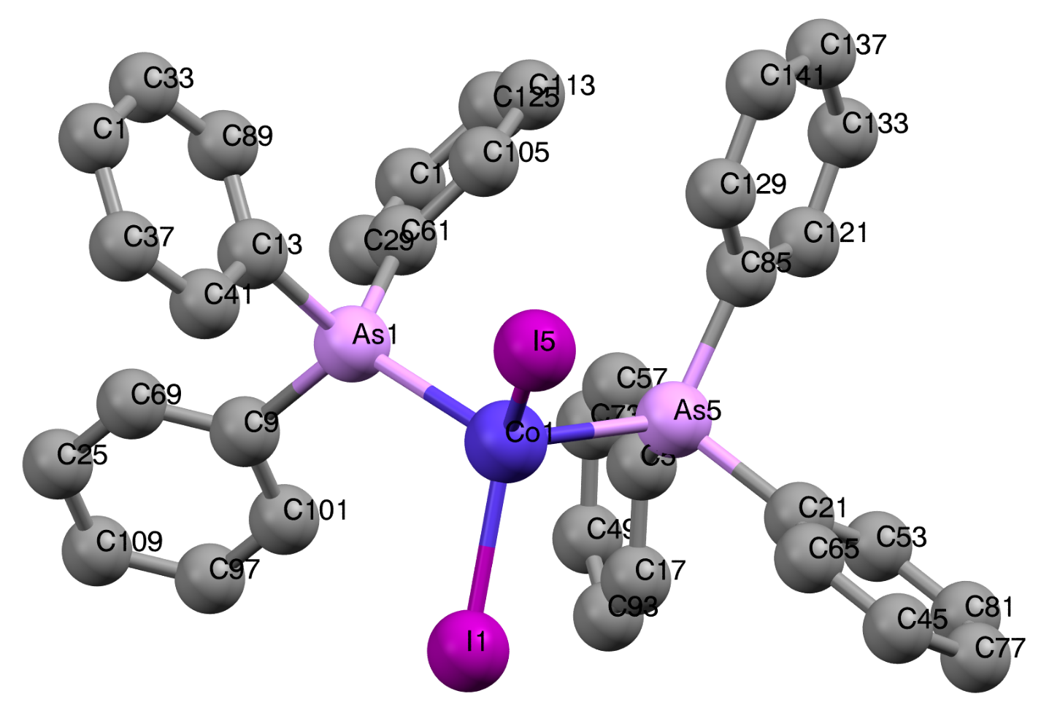

Figure A2.21. Model for the spin densities for Co(AsPh₃)₂I₂.

Table A2.5. Spin densities of atoms from VASP calculations for Co(AsPh₃)₂I₂. There are three other identical molecules in the lattice and their spin densities are not listed.
Atom label | Spin density | Atom label | Spin density
H1 | 0.000 | C25 | 0.000
H5 | 0.000 | C29 | 0.001
H9 | 0.000 | C33 | 0.000
H13 | 0.000 | C37 | 0.000
H17 | 0.000 | C41 | 0.000
H21 | 0.000 | C45 | 0.000
H25 | 0.000 | C49 | 0.003
H29 | 0.000 | C53 | 0.001
H33 | 0.000 | C57 | 0.002
H37 | 0.000 | C61 | 0.003
H41 | 0.000 | C65 | 0.000
H45 | 0.000 | C69 | 0.001
H49 | 0.000 | C73 | 0.000
H53 | 0.000 | C77 | 0.000
H57 | 0.000 | C81 | 0.000
H61 | 0.000 | C85 | 0.005
H65 | 0.000 | C89 | 0.001
H69 | 0.000 | C93 | 0.000
H73 | 0.000 | C97 | 0.000
Table A2.5. Continued
H77 | 0.000 | C101 | 0.000
H81 | 0.000 | C105 | 0.001
H85 | 0.000 | C109 | 0.001
H89 | 0.000 | C113 | 0.000
H93 | 0.000 | C117 | 0.000
H97 | 0.000 | C121 | 0.002
H101 | 0.000 | C125 | 0.001
H105 | 0.000 | C129 | 0.000
H109 | 0.000 | C133 | 0.001
H113 | 0.000 | C137 | 0.000
H117 | 0.000 | C141 | 0.000
C1 | 0.001 | Co1 | 2.558
C5 | 0.003 | As1 | 0.015
C9 | 0.004 | As5 | 0.019
C13 | 0.003 | I1 | 0.067
C17 | 0.003 | I5 | 0.064
C21 | 0.002 | Total | 2.7635

Table A2.6. Summary of spin densities for Co(AsPh₃)₂I₂
Atoms | Ranges of spin densities
Co^{II} | 2.558
I | 0.064–0.067
As | 0.015–0.019
C | 0.000–0.005
H | 0.000

Addenda for Chapter 3

A3.1. Experimental section
The reactions were carried out in room temperature aerobic conditions. Unless otherwise noted, chemicals and solvents were obtained from commercial sources and used without purification. Triethylamine was distilled before use.

A3.1.1. Synthesis of n-(2′-pyridinyl)acetoacetamide (paaH) (2)
Compound 2 was synthesized as previously reported, and purified using a silica gel column.³⁷⁹ Purity was confirmed by ¹H NMR.

A3.1.2. Synthesis of [Dy₃(O)(teaH₂)₃(paa)₃]Cl·PhCN·4MeOH (Dy₃-2)
Dy₃-2 was synthesized using a procedure similar to the reported.²⁶¹ Solvents were changed from MeCN/MeOH to PhCN/MeOH. In addition, diethyl ether vapor diffusion (Figure A3.1) was used to grow crystals large enough for single-crystal X-ray and neutron diffraction (Figure A3.2). Into 14 mL of a solution of PhCN/MeOH (1:1 v/v), 0.38 g (1.0 mmol) of DyCl₃·6H₂O is dissolved (with 10 min mixing) followed by the addition of 0.18 g (1.0 mmol) of paaH and 0.55 mL (0.40 g, 4.0 mmol) of triethylamine. The solution is mixed for a few minutes, and then 0.13 mL (1.0 mmol) triethanolamine (teaH₃) is added. The solution is stirred continuously for 3 h. This mother liquor is then filtered through a fine filter paper, and an ether vapor solution is set up. Crystals are initially observed within 3-4 days, with large, hexagonal block-like crystals taking up to 4 weeks to form, to give 0.252 g (0.144 mmol, 43% yield) of Dy₃-2 based on DyCl₃·6H₂O. The crystals were used in subsequent studies. IR spectrum of a crystal is given in Figure A3.3.
Inner vial with Dy₃-2 mother liquor
Outer vial with diethyl ether
Figure A3.1. Depiction of diethyl ether vapor diffusion setup used for growth of Dy₃-2 crystals. The system is sealed, and the ether vapor slowly mixes with the mother liquor of PhCN/MeOH to precipitate out crystals. Crystals are then removed from the walls of the inner vial for collection.
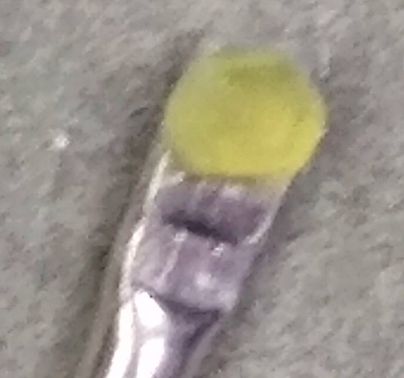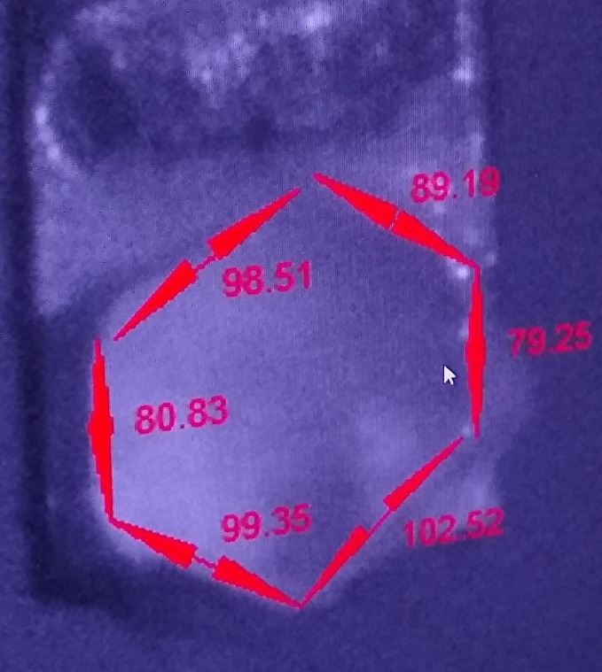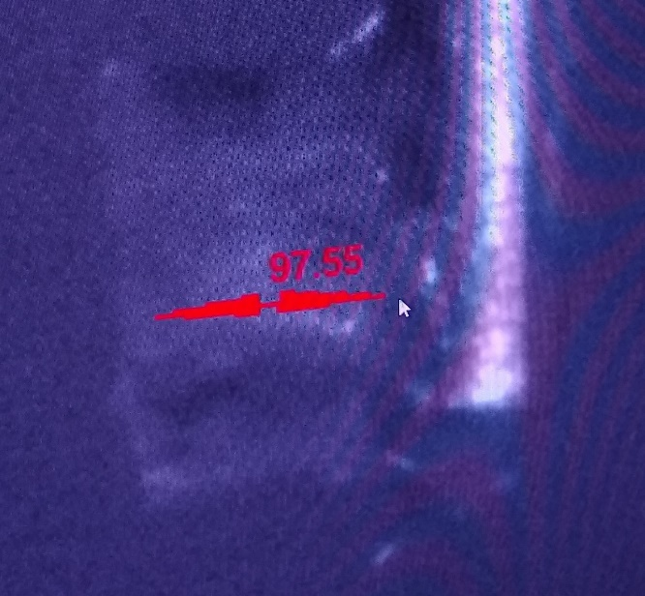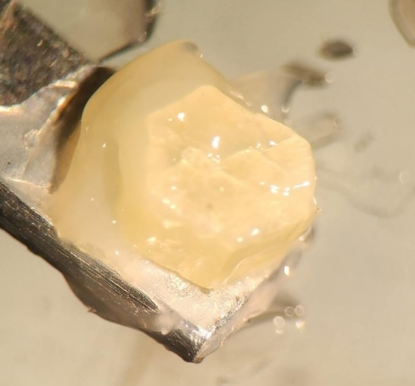
a
d
c
b
Figure A3.2. Images of the crystal used of PND experiment. a) is the sample before applying grease and measuring; b) the sample weeks after the experiment; c) and d) show the size of the crystal when mounted in the instrument.

Figure A3.3. IR spectrum of a crystal of Dy₃-2 at 23 °C.

A3.2. Physical measurements

A3.2.1. X-ray crystallography
Single-crystal X-ray diffraction data for Dy₃-2 was collected using a Bruker D8 Venture at 100 K with Mo Kα radiation. Data collection and integration was completed using APEX 3 programs, reduced using Bruker SAINT, and corrected for absorption using the SADABS multi-scan program. Reflections were merged using SHELXL, with computing graphics by Olex2.³⁸⁰⁻³⁸²

Table A3.1. Crystallographic details for Dy₃-1 (previously reported by Langley et al.^{261, 276}) and Dy₃-2
 | Dy₃-2 | Dy₃-1^{261, 276}
Formula | Dy₃C₅₆H₉₀N₁₀O₂₀Cl | Dy₃C₄₇H₈₁O₂₀N₁₀Cl₂
M | 1746.32 | 1664.55
Crystal System | Trigonal | Trigonal
Space group | P3̅c1 (165) | P3̅ (147)
a, b, c (Å) | 17.5420(6), 17.5420(6), 26.4299(13) | 17.5986(3), 17.5986(3), 13.1888(5)
α, β, γ (°) | 90, 90, 120 | 90, 90, 120
V (Å³) | 7043.43 | 3537.46(16)
T (K) | 100(2) | 123(2)
Z | 4 | 2
ρ_{calc} | 1.647 | 1.555
λ (Å) | 0.71073 | 0.710773
Data measured | 269480 | 36880
Independent reflections | 7678 | 5400
R_{int} | 0.0362 | 0.0382
Parameters | 285 | 308
Restraints | 20 | 51
R1c (I ˃ 2σ(I), wR2c (All data) | 0.0297, 0.0703 | 0.0247, 0.0680
Goodness of fit | 1.115 | 1.128

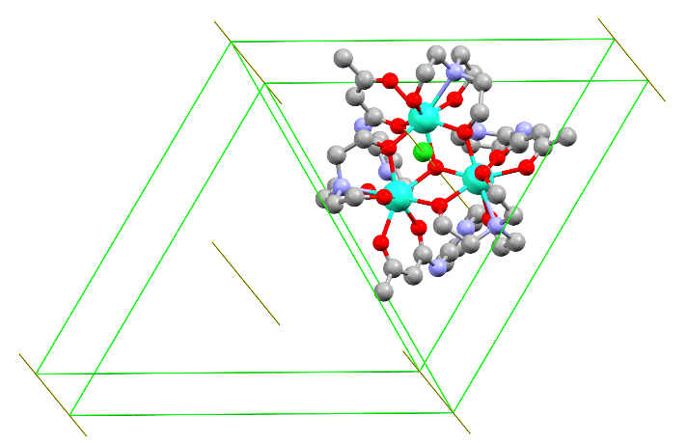

Figure A3.4. Rotational symmetry elements for Dy₃-2. Green lines show 2-fold rotation, while yellow lines show 3-fold rotation. There is a 3-fold rotation through the center of the Dy₃-2 molecule.

Table A3.2. Continuous shape measurements (CShM) for Dy₃-2 and Dy₃-1. Values closer to zero show a better fit to the symmetry described.
CShM | Symmetry | Dy₃-2 | Dy₃-1
Octagon | D_{8h} | 31.829 | 31.968
Heptagonal pyramid | C_{7v} | 23.728 | 23.736
Hexagonal bipyramid | D_{6h} | 14.289 | 14.214
Cube | O_{h} | 12.171 | 12.177
Square antiprism | D_{4d} | 2.508 | 2.579
Triangular dodecahedron | D_{2d} | 1.344 | 1.368
Johnson - Gyrobifastigium (J26) | D_{2d} | 9.743 | 9.686
Johnson - Elongated triangular bipyramid (J14) | D_{3h} | 26.979 | 26.938
Johnson - Biaugmented trigonal prism (J50) | C_{2v} | 2.150 | 2.142
Biaugmented trigonal prism | C_{2v} | 2.098 | 2.099
Snub disphenoid (J84) | D_{2d} | 2.378 | 2.378
Triakis tetrahedron | T_{d} | 12.591 | 12.665
Elongated trigonal bipyramid | D_{3h} | 22.562 | 22.551

The best symmetrical fit for both Dy₃-1 and Dy₃-2 is the triangular dodecahedron showing local D_{2d} symmetry. Minor differences in bonding and bond angles are observed in the local geometry between these two complexes. These differences in local symmetry around the Dy³⁺ ion may lead to changes in the magnetic character of these complexes.
Reference polyhedral and cartesian coordinates were generated using the cif previously discussed for Dy₃-2 in the CrystalExplorer program.^{170, 173} Cartesian coordinates were then used to make an input file for Continuous Shape Measurement (CShM) following typical procedures referenced in the manual.^{383, 384} Cartesian coordinates for Dy₃-1 were taken from a previously reported cif.²⁶¹

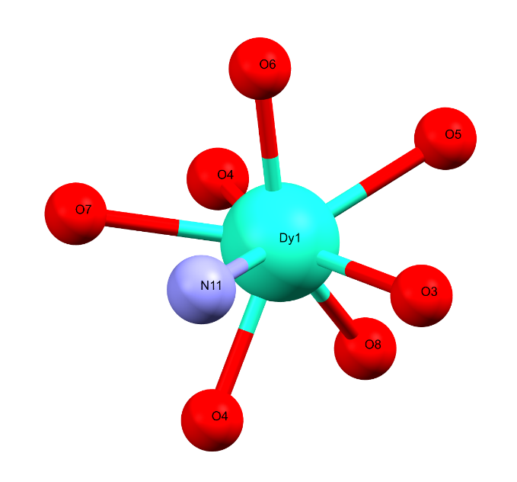
Figure A3.5. The Dy₃-2 model used for CShM.

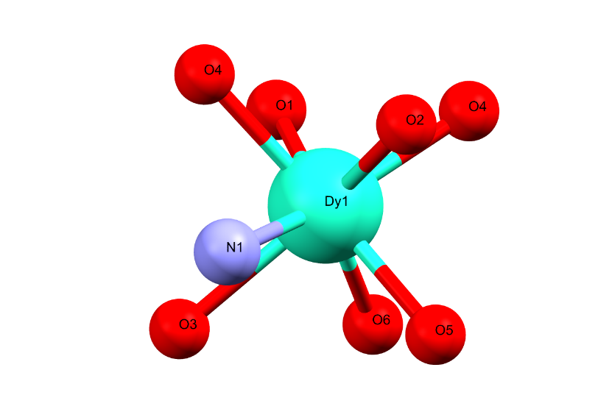
Figure A3.6. The Dy₃-1 model used for CShM.

A3.2.3. Magnetic susceptibility measurements
DC magnetic susceptibility measurements were completed using a Quantum Design MPMS-7 T at the SmartState Center for Experimental Nanoscale Physics, University of South Carolina. Magnetization by variable temperature and variable magnetic field was collected. Measurements were taken of a powdered sample as well as single crystals oriented in multiple directions. Single crystals were coated with a thin layer of silicon grease to protect the crystal from degradation.

Figure A3.7. M vs H plots for Dy₃-2_{poly}, Dy₃-2‖, and Dy₃-2⊥. This is data from Figure 3.5 compiled together to show magnetic anisotropy of the single crystal sample orientation.

A3.2.4. Polarized neutron diffraction (PND)
The HB-3A DEMAND³⁰¹ at the High Flux Isotope Reactor (HFIR) at Oak Ridge National Laboratory (ORNL) was used to perform the polarized single crystal neutron diffraction measurements with a polarized neutron beam of 1.542 Å from a bent Si-220 monochromator³⁰² and a calibrated neutron polarization of 76%. The sample was measured at 5 K with H//ab and a permanent magnetic set was used to fix the field to 0.6 T. The CrysPy software⁶⁹ was used to analyze the measured flipping ratios.

A3.2.5. Neutron diffraction under variable-magnetic fields
The HB-3A DEMAND³⁰¹ at the High Flux Isotope Reactor (HFIR), Oak Ridge National Laboratory (ORNL) was used to perform the single crystal neutron diffraction measurements. The sample was measured at 1.5 K with a variable magnetic field ranging from 0 to 4 T. Data subtraction and integration was completed using FulProf.^{303, 304}

Addenda for Chapter 4

A.4.1. Synthesis

A4.1.1. Crystal growth trials
In attempts to obtain more crystalline products and grow crystals suitable for SCXRD, a variety of testing were performed. These variations include changes in the concentration of reactants from 1.0mmol of Ni(II) salts to a 20% scale, or 0.2 mmol of Ni(II) salts, within the same 7 mL of solvent. The second main variation was to change solvent. This included a 5:2 ratio of water/alcohol as well as the 4:3 ratio of water to alcohol. Alcohols that were used in the tests were methanol, ethanol, isopropanol, and t-butanol. Of all these tests, the alcohols producing the most crystalline materials were ethanol and isopropanol. Butanol decreased crystalline size and increased the amount of powder produce. Methanol seemed to not change the crystallization of the products. The reaction conditions that produced the highest volume of crystalline product was at a 25% scale of reactants within a 4:3 water/ethanol solvent.
There were also attempts at reducing reaction time from 144 h to 72 h. This led to the completion of the reaction when checked by PXRD and IR, but the product was a very fine powder, even when a 25% scale was used.
NiBaO-d_{n} and NiBeO-d_{n} were synthesized using the standard reaction conditions (7 mL of water and 144 h at 170 °C and concentrations (1.0 mmol) with the partially deuterated ligands.

A4.1.2. Deuteration reactions
Deuteration of 1,2-di(pyridin-4-yl)ethane (bpa) and 1,2-di(pyridin-4-yl)ethene (bpe) was completed as described in the experimental portion of the text. There were other reactions and attempts for deuteration, with very low levels of success. These included the use of WCl₆ and C₆D₆,³²⁶ or the use of Pd/C with D₂O,^{325, 327} which were similar to previously reported H/D exchanges. These H/D exchange reactions gave significantly lower levels of deuteration than the base-mediated reaction during initial testing and therefore were not studied further.
Figure A4.1. Schematic showing locations of H atoms for H/D exchange for a) bpa and b) bpe.

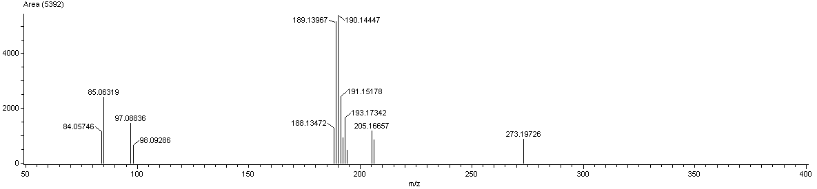
Figure A4.2. Mass spectrometry data representative of bpa deuteration. Without any deuterium, bpa should have a main mass peak of 184. Each main mass peak of 1 m/z higher should be correlated to an H-D exchange. The two strongest peaks at 189 and 190 m/z are related to bpa-d₅ and bpa-d₆, respectively.

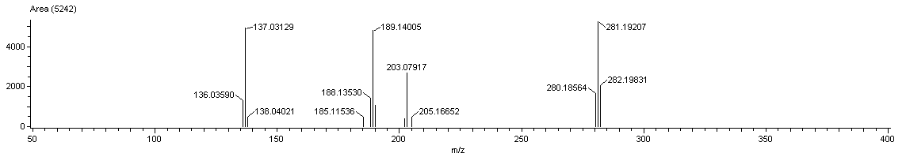
Figure A4.3. Mass spectrometry data representative of bpe deuteration. Without any deuterium, bpe should have a main mass peak of 182. The two strongest peaks at 188 and 189 m/z are related to bpe-d₆ and bpe-d₇, respectively.

Figure A4.4. ¹H NMR of bpa standard before deuteration.
Figure A4.5. ¹H NMR of bpa after deuteration.
Figure A4.6. ¹³C NMR of bpa standard before deuteration

Figure A4.7. ¹³C NMR of bpa after deuteration

A4.2. Physical measurements

A4.2.1. Variable temperature powder neutron diffraction
Additional variable temperature powder neutron diffraction plots of the low d-spacing region show that there is not significant data to reveal a phase change or the appearance of magnetic structure peaks in the PND data.

Figure A4.8. Emphasis on low d-spacing for NiBaO.
Figure A4.9. Emphasis on low d-spacing for NiBeO.

A.4.2.2. DC magnetic susceptibility
Figure A4.10. Fitting data for the high-temperature region of DC magnetometry.

A.4.2.2. Specific heat measurements
Figure A4.11. Heat capacity results of NiBaO from 1.8 K to 16 K at 0 and 14 T. There is no sharp uptick correlated to a phase change.
Figure A4.12. Heat capacity measurements of NiBeO from 1.8 K to 400 K. Inset is from 1.8 K to 10 K. There are no sharp changes indicating a phase change.

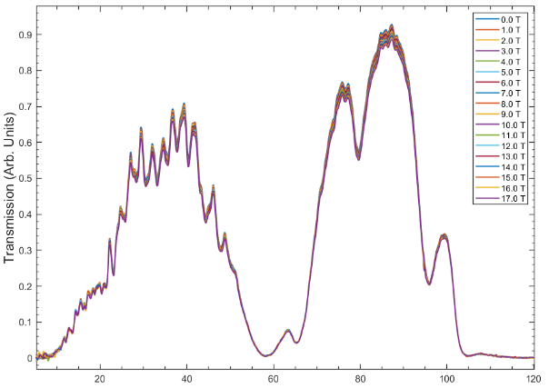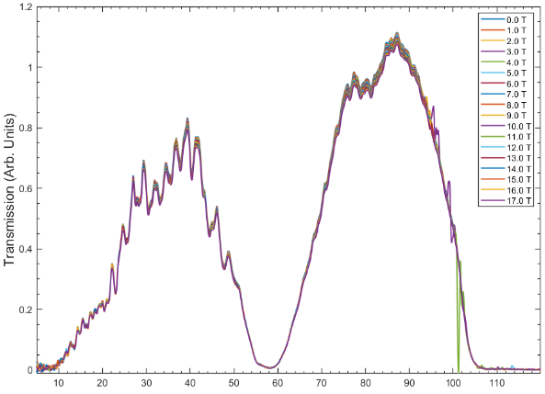
Energy (cm-1) Energy (cm-1)
Figure A4.13. FIRMS spectra for (left) NiBaO and (right) NiBeO. There is no indication of magnetic transition within these spectra.

Addenda for Chapter 5

Table A5.1. Images of the reactions at different stages in the formation of CuO in three solutions
Notes | Acetone | Isopropanol | Water
Addition of CuCl₂·2H₂O to solvent with 3 min of mixing | 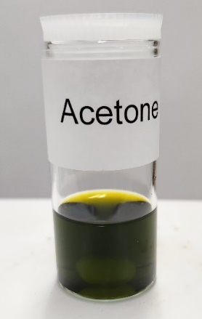 | 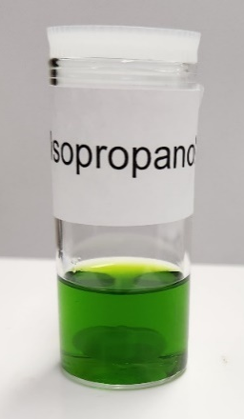 | 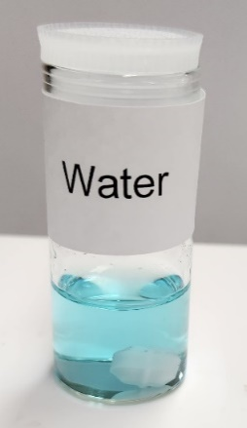
Addition of NaOH to solution with 3 min mixing | 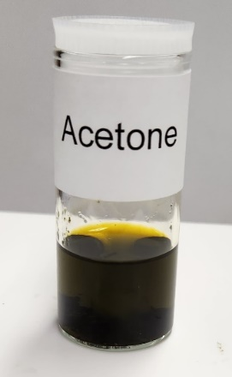 | 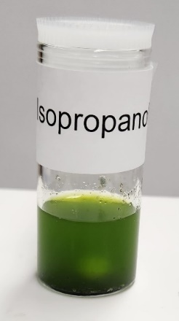 | 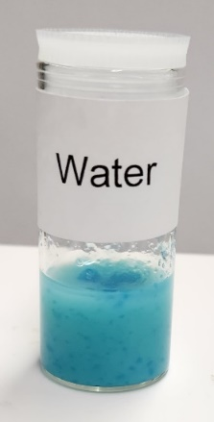
After 10 min mixing | 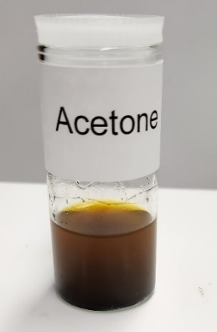 | 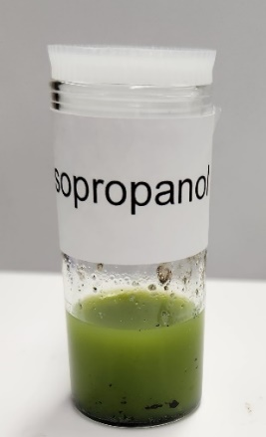 | 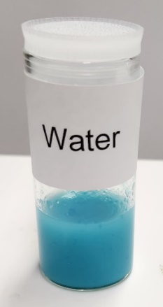
Table A5.1. Continued
After 1 h mixing | 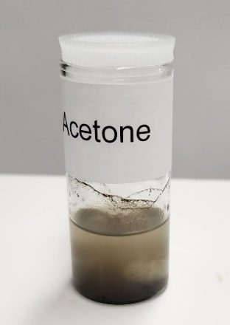 | 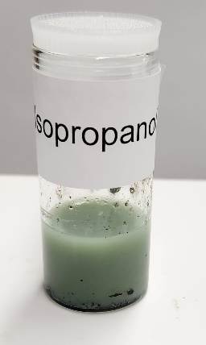 | 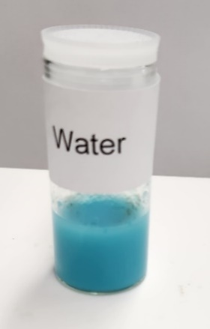
After 2 h mixing | 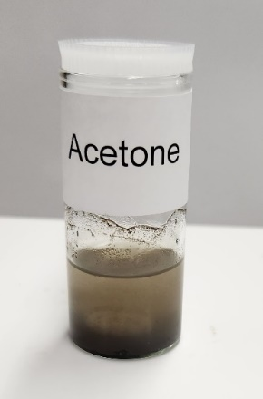 | 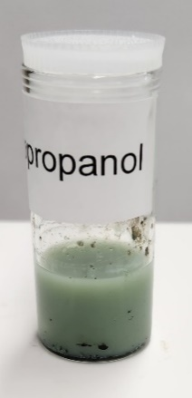 | 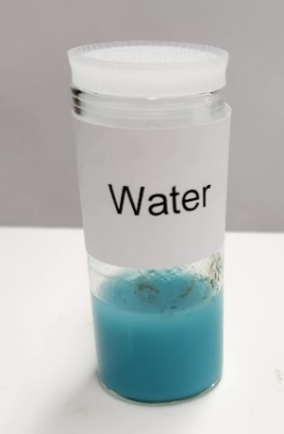
After 4 h mixing | 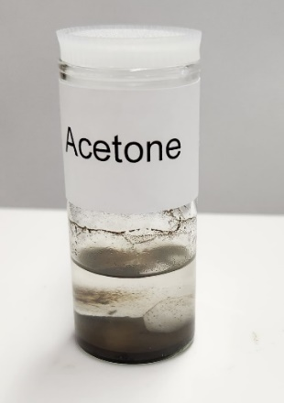 | 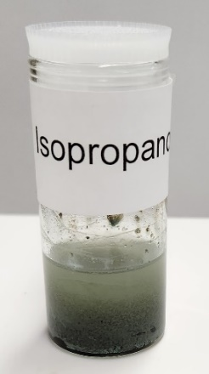 | 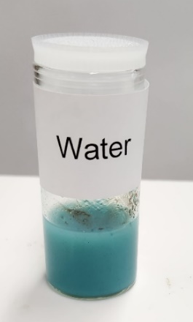
Table A5.1. Continued
After 6 h mixing | 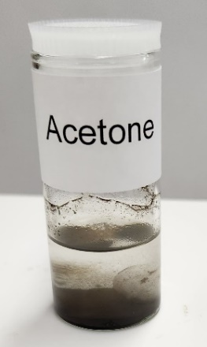 | 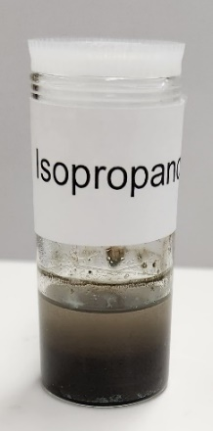 | 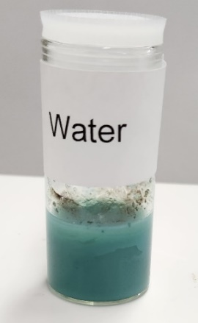
After 8 h mixing | 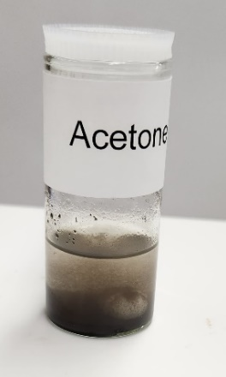 | 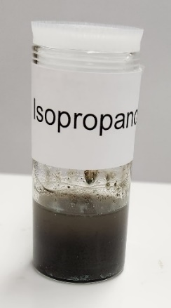 | 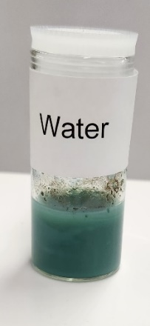
After 10 h mixing | 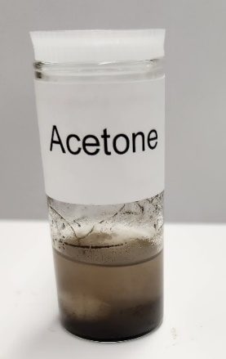 | 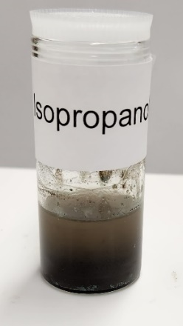 | 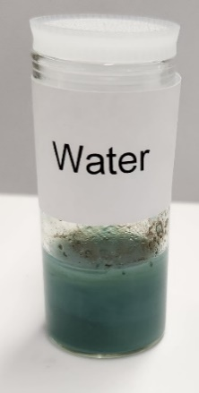
Table A5.1. Continued
After 12 h mixing | 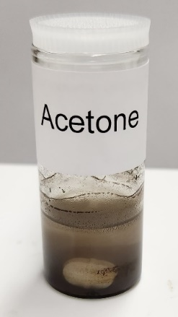 | 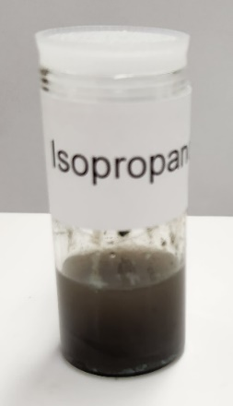 | 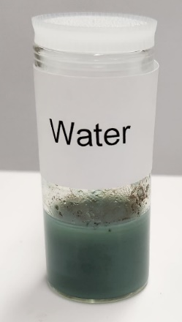
After 12 h mixing and settling for 1 min | 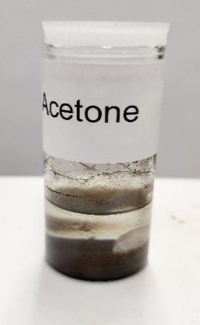 | 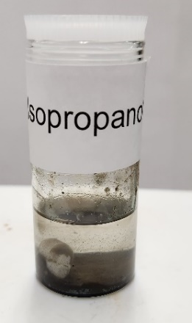
After 28 h mixing | No change from 12 h mark | No change from 12 h mark | 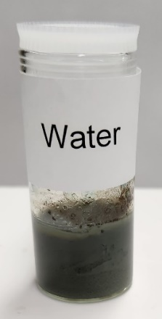
Table A5.1. Continued
After 72 h mixing and 5 min settling | No change from 12 h mark | No change from 12 h mark | 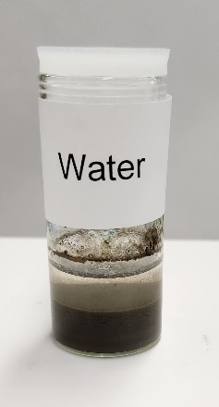

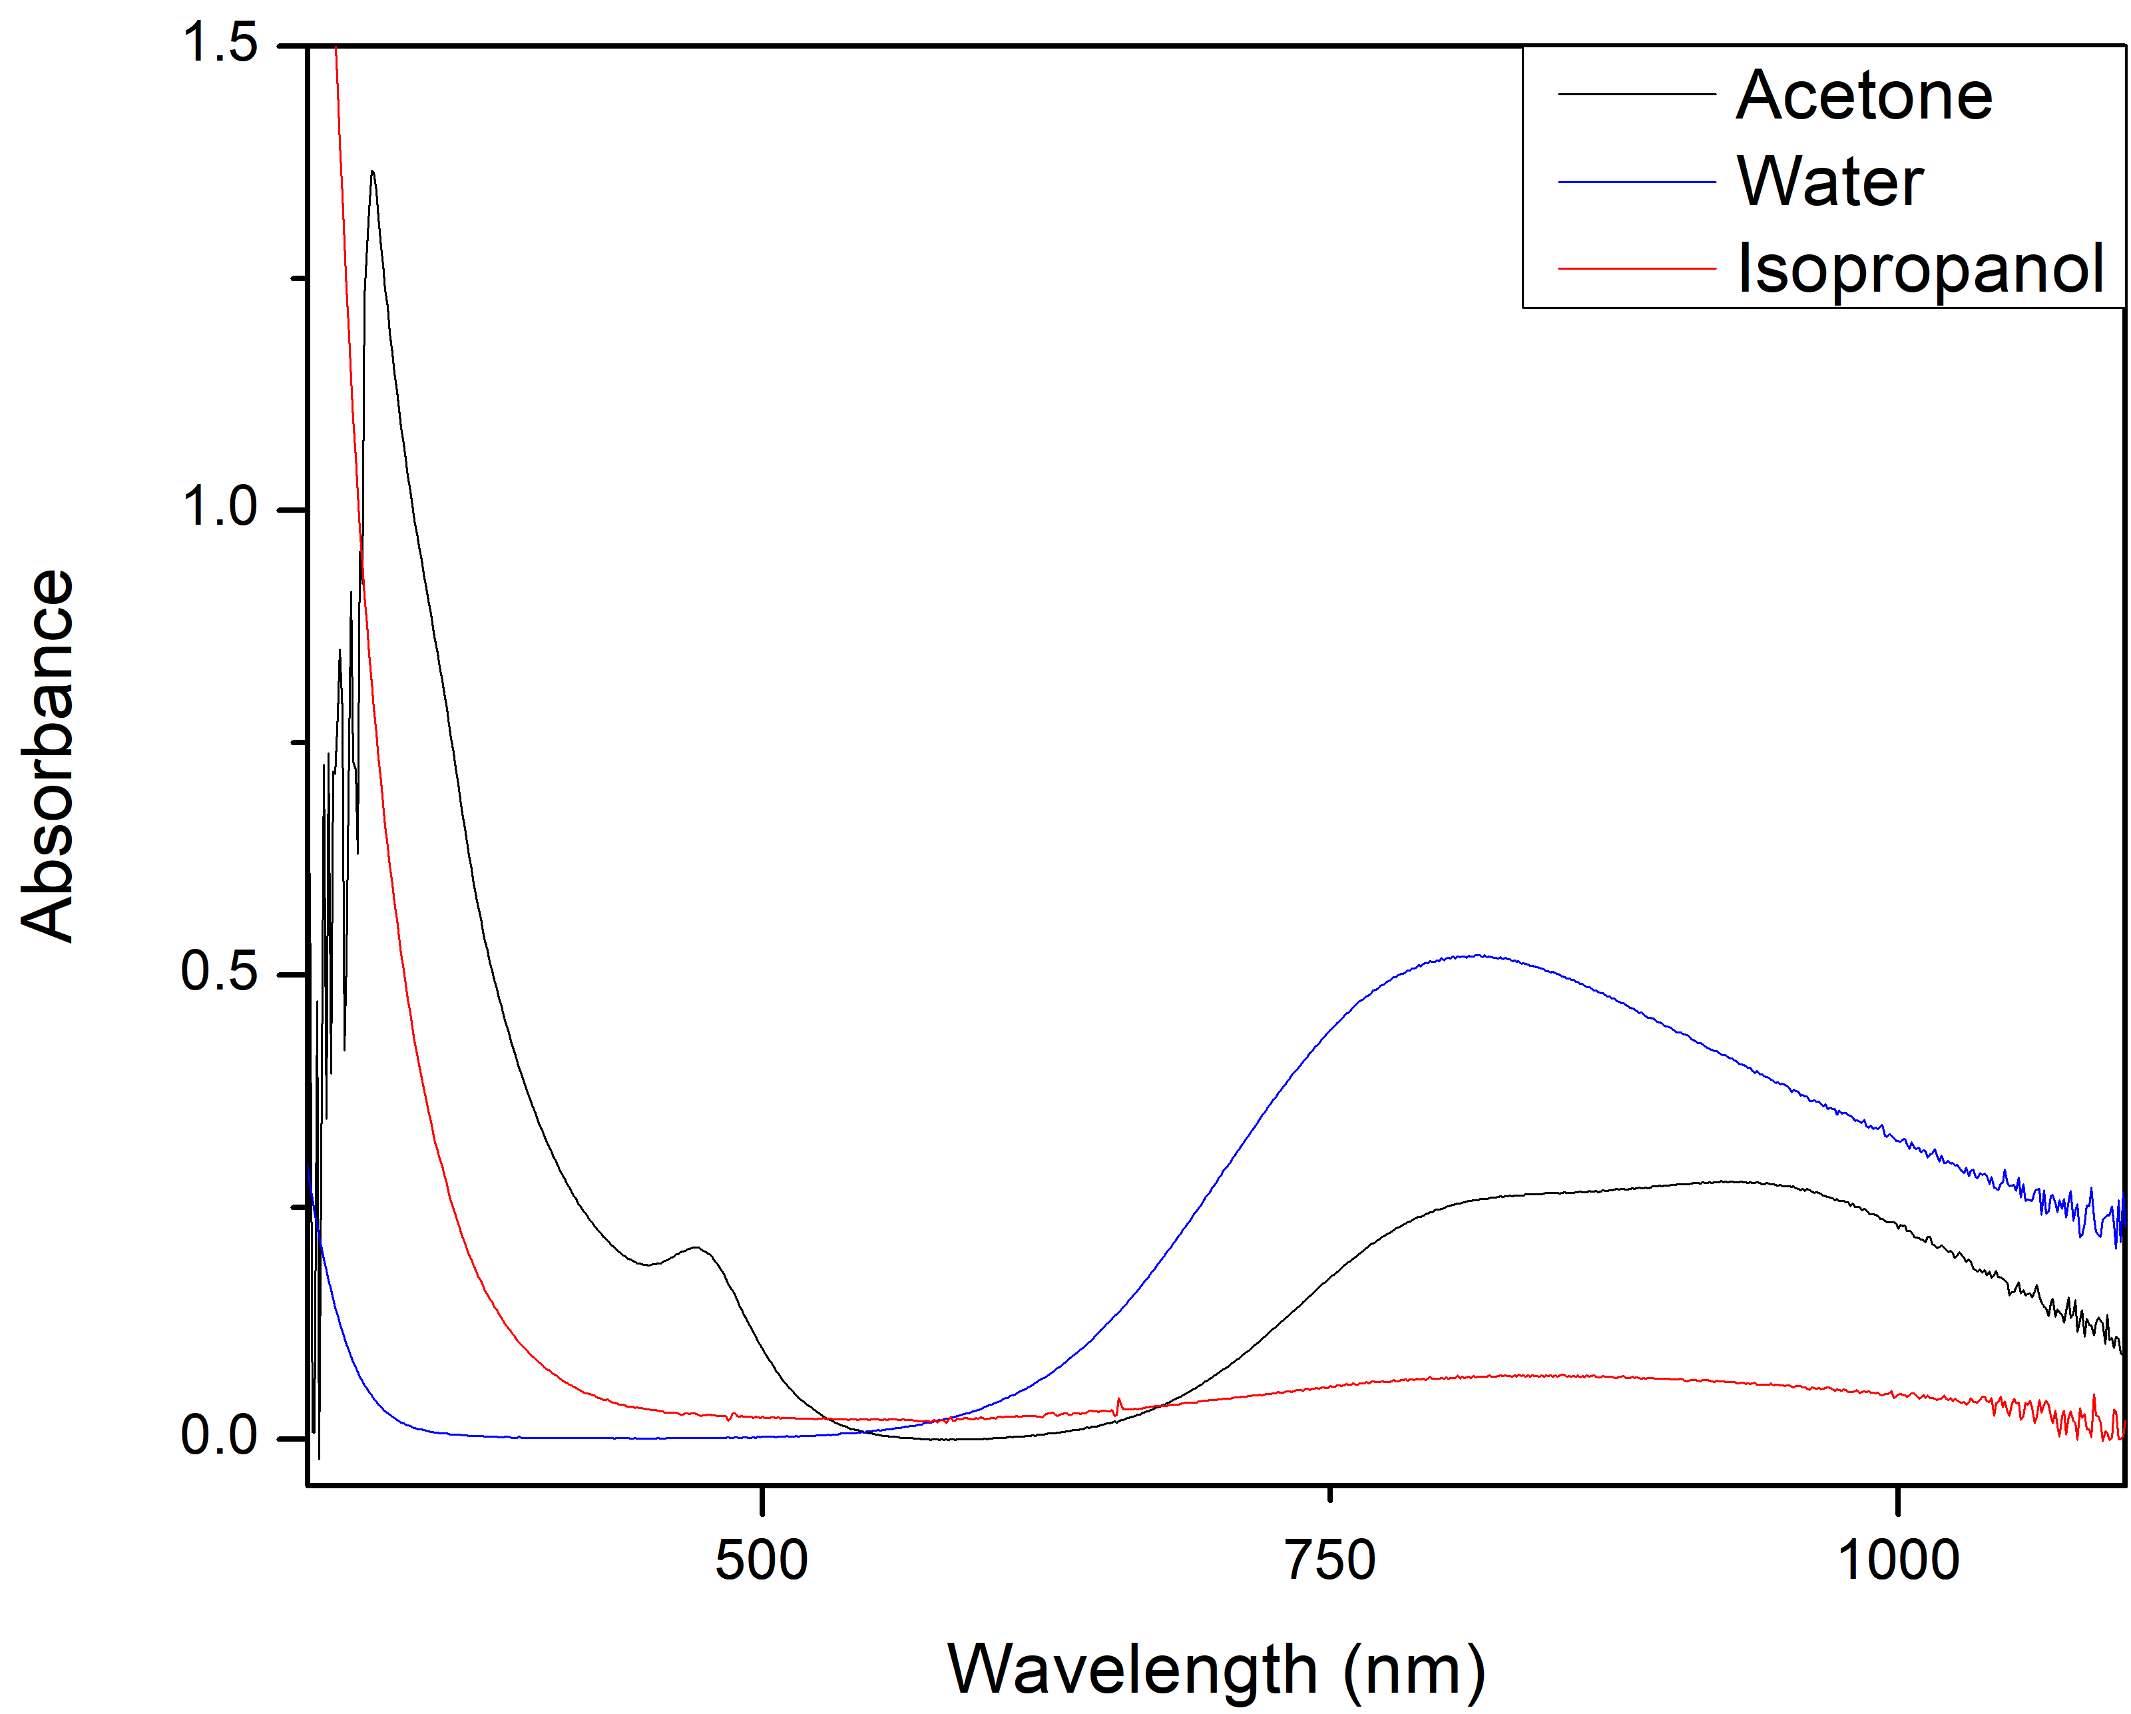
Figure A5.1. Full range of electronic absorption spectra at 300-1100 nm.

Table A5.2. List of solutions, their relative polarities,^{a, 339, 385} and the near-IR absorptions
Solvent | Relative Polarity^{339, 385} | Local Maxima (nm)
Acetone | 0.355 | 927
Isopropanol | 0.546 | 855
Water | 1.00 | 815
ª The relative polarities are normalized from measurements of the transition energy at 25 °C of the long-wavelength visible absorption of a standard pyridinium N-phenolate betaine dye in Ref. 385.

Figure A5.2. PXRD patterns of the products without washing from reactions conducted in isopropanol, acetone, water, and solid-state. The patterns of CuO and NaCl standards are given for comparison. The solids were heated in a 200 °C furnace for 20 min.

Figure A5.3. PXRD of CuO products dried with a heat gun. For the product from water, the solid was dried first, followed by washing. Trace NaCl diffraction peaks are visible in this PXRD pattern.

Figure A5.4. IR spectra of the products separated for clarity.

Vita
Michael J. Jenkins was born in Nampa, ID to Lawrence and Elaine Jenkins. He attended public school in the Vallivue School system, graduating from Vallivue Senior High School in 2012. He went on to attend Idaho State University and graduate with a B.S. in Chemistry. During undergraduate studies, Michael interned for ON Semiconductor in Pocatello in the EHS department focusing on improvements in wastewater treatment and updates to chemical monitoring. He also conducted undergraduate research under Dr. Andrew Holland, studying the formation of molecular precursors for I-III-VI₂ nanoparticles with photovoltaic applications. In 2020 Michael entered the graduate program of the University of Tennessee, where he studied molecular magnetism in the group of Dr. Zi-Ling Xue. During this time as a graduate student and researcher, he presented his work at the National Meeting of the American Chemical Society in August 2024 and co-authored several publications, including Nat. Commun. 2023, 14, 5454, with additional manuscripts in preparation for submission.

