Executive Summary:

Table of Contents:

Section Page
1.1 Executive Summary .………………………………………………… 1
2.1 Figures and Tables Referenced ……………………………………… 3
2.1.1 Figures …………………………………………………….. 3
2.1.2 Tables ……………………………………………………… 3
3.1 Introduction ………………………………………………………….. 4
3.1.1 Objectives ………………………………………………….. 4
3.1.2 Background ………………………………………………... 5
4.1 Prototype Design ……………………………………………………... 6
4.1.1 Design Concept …………………………………………….. 6
4.1.2 Component Analysis ……………………………………….. 8
5.1 Assembly and Testing ………………………………………….…….. 10
5.1.1 Final Prototype ………………………….………………….. 10
5.1.2 Assembly Plan ……………………………………………… 12
5.1.3 Results ……………..…………….………………..………... 13
6.1 Conclusions and Recommendations …………………………………. 16
6.1.1 Project Results ………………………….…………………... 16
6.1.2 Future Considerations …….………………………………... 16
7.1 Bibliography …………………………………………………………. 17

8.1 Appendices
8.1.1 Appendix A: Organization ………………………………… 18
8.1.2 Appendix B: Drawings and Schematics ……………………. 20
8.1.3 Appendix C: Preliminary Testing …………………………. 24
8.1.4 Appendix D: Raw Data ……………………………………. 25

Figures and Tables Referenced:

Figures Page
Figure 1 – Paper Redirector 6
Figure 2 – Front Arm Assembly 7
Figure 3 – Rear Roller Assembly 7
Figure 4 – Motor Drive Assembly 8
Figure 5 – Paper Redirector Prototype 10
Figure 6 – Gantt Chart – Task Allotment 18
Figure 7 – Gantt Chart – Scheduling 18
Figure 8 – Final Drawing 20
Figure 9 – 2D Drawing – Output Tray 21
Figure 10 – 2D Drawing – Rotational Arms 21
Figure 11 – 2D Drawing – Rear Brackets 22
Figure 12 – 2D Drawing – Mechanism Housing 22
Figure 13 – Motor Wiring 23

Tables
Table 1 – Bill of Materials 11
Table 2 – Results of Stresses 13
Table 3 – Results of Dimensions 14
Table 4 – Work Structure Breakdown Report 19
Table 5 – Preliminary Testing 24

Introduction:

Objectives
Client’s Problem Statement

Several of Lexmark’s current models employ a paper path that is concentrated within the front section of the printers in order to provide easy access for internal paper jams. However, this construction introduces complications associated with the accompanying output tray, as it necessitates a backward-facing paper feed which ejects sheets away from the user. This presents an inconvenience to the consumer if there are any obstructions above the paper tray. For example, if the printer is placed inside a cubby, on a shelf, or utilizes one of Lexmark’s attachment devices, access to the printed sheets becomes greatly restricted.
As such, the task presented to the design team was to devise a mechanism which could circumvent this issue. Particularly, the client requested an attachment which could be added to existing printers or future models which would provide the consumer with a redirected output. The resultant output would bring the printed sheets forward, providing users with much easier access to the paper output in any situation.

Functional Requirements

As an attachment prototype which could be used with a variety of Lexmark printer models, the output redirector was required to be designed with respect to several key factors:

- It must be able to handle all possible types of printed media ranging from 3” x 5” cards to 14” legal paper.
- The redirector should be capable of working with various thicknesses of paper, with the weight range being from 16 lbs. to 110 lbs.
- Paper collation must be retained, with the order of printed sheets being unchanged.
- The designed attachment should not affect the existing speed of simplex and duplex print jobs.
- The device should be consumer installable.

Design Requirements

Due to the prototype request’s need to be compatible with a wide line of existing Lexmark models, the mechanism was designed with a few general guidelines in mind:

- Height of attachment must not exceed 6”.
- Redirector should not interfere with consumer’s ability to access the user interface.
- It should be designed to handle paper output as an edge-reference print, as opposed to a center-reference print.
- The mechanism must be capable of handling the given speed of 40 pages per minute for simplex printing.
- Output tray should be able to handle a stack of paper 200 pages high.
- Paper must not be bent in excess of a radius of 30 mm for normal thicknesses and 50 mm for thicker pages.
- The base model for which the attachment should be designed is the Lexmark C543dn.

Background
As is common for all engineering design ventures, the first portion of this project’s timeframe was dedicated to concept development, initial design, critical analysis, and dimensional derivations – reserving the second semester for fabrication, assembly, and testing. However, upon presentation of the first semester’s findings to the client, it became clear that the overall aim of the project had been reformed, thus requiring a fresh start for the second semester. Building upon the foundation and the knowledge acquired from the design team’s previous research, the second semester was focused on developing a new design that is dedicated to redirecting the output “per print job” rather than “per page.” Approaching this final term of the project, it was necessary to see the concept through in its entirety – from its beginning design stages to completion of assembly.

Prototype Design:

Design Concept
Mechanism Description

Consistent with the functional requirements of the project, the underlying basis for this design is simply to collect all printed jobs and convey the output tray forward to the user. Once all of the printed sheets have been accumulated, regardless of the paper’s weight or size, the mechanism redirects the output toward a more accessible position at the front of the printer through a simple rotational range of motion, as exemplified below in Figure 1.

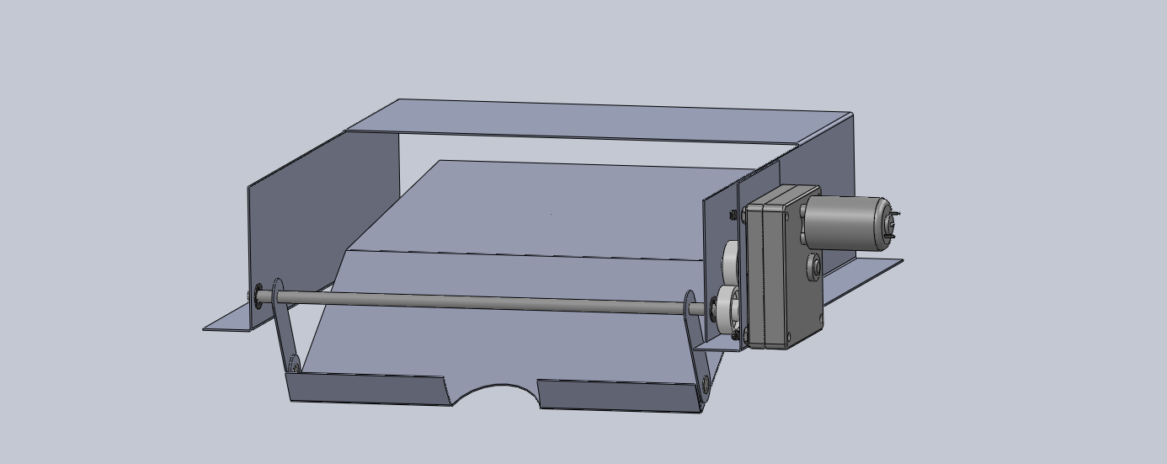
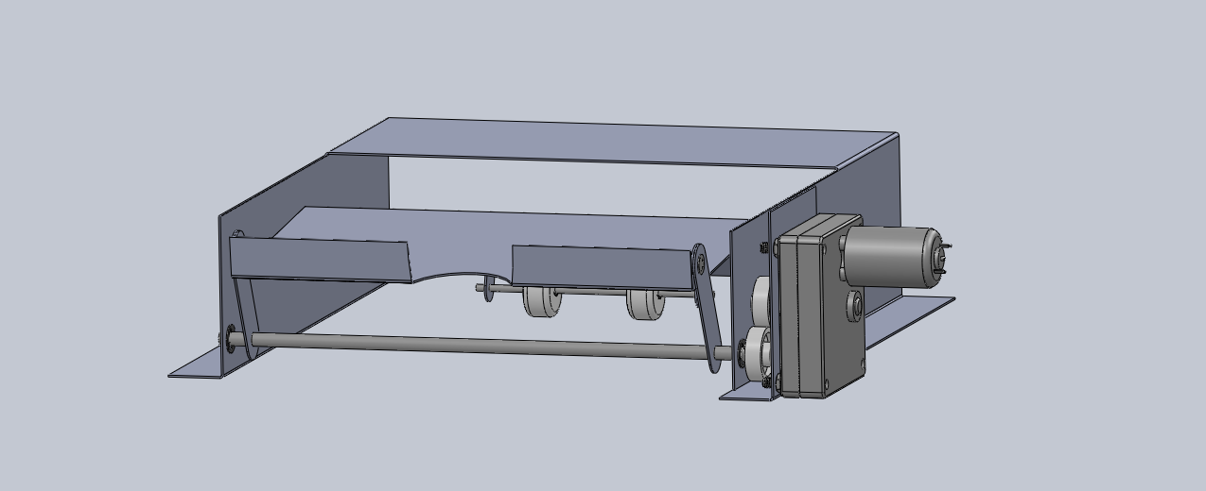
Figure 1. Illustration of mechanism’s redirected output. Starting at an initial position
of the output tray being in a downward location (top), the mechanism rotates
to redirect the print jobs to a more convenient retrieval space (bottom).

As noted by Dym and Little, an excellent approach to design is to focus of limiting the number of components to the fewest that are essential to the working of the finished product. [1] Accordingly, in order to implement this design, the overall concept was broken down into several simple components – each tasked with conducting a small portion of the mechanism’s motion. The first and most integral constituent of this attachment is the rotating front arm assembly. As shown below by Figure 2, this portion consists simply of two similar pieces on either side of the output tray which are initially extended downward into the existing printer depression for the paper output. By rotating the attached shaft, the arms move in a circular motion until the tray reaches a more convenient output position.

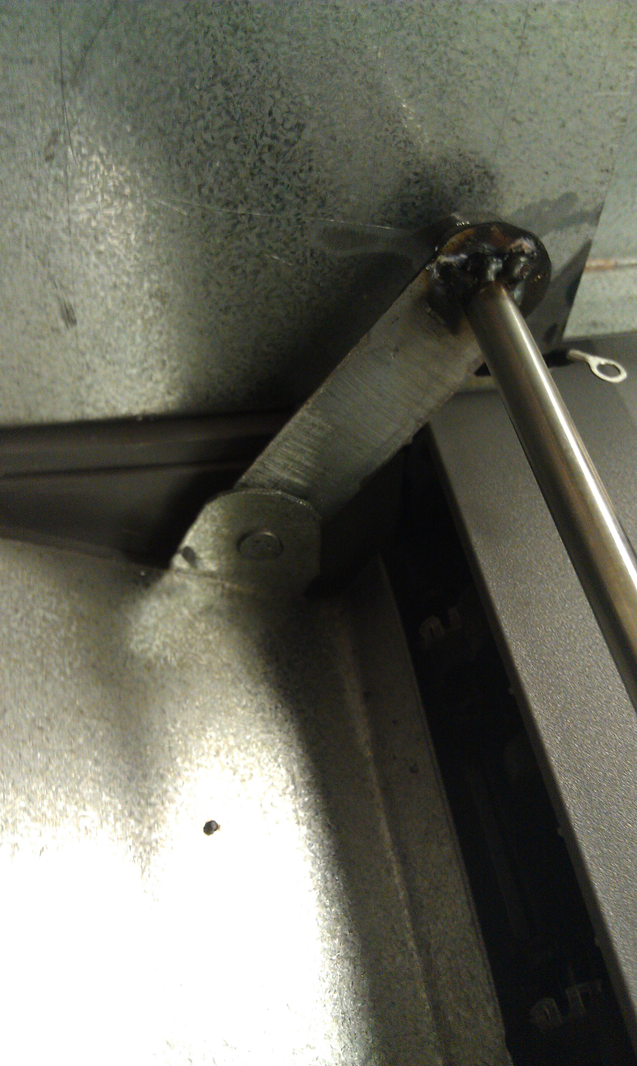
Figure 2. Detail of mechanism’s rotational front arm assembly. This functionality
is accomplished by welding the arm rigidly to the front shaft and riveting it to the tray.

Furthermore, this component is complemented by the translational movement of a rear roller assembly located on the underside of the tray. Illustrated by Figure 3 below, this consists of two simple wheels attached to a shaft. This shaft is constrained within two brackets rigidly welded to the bottom of the tray.

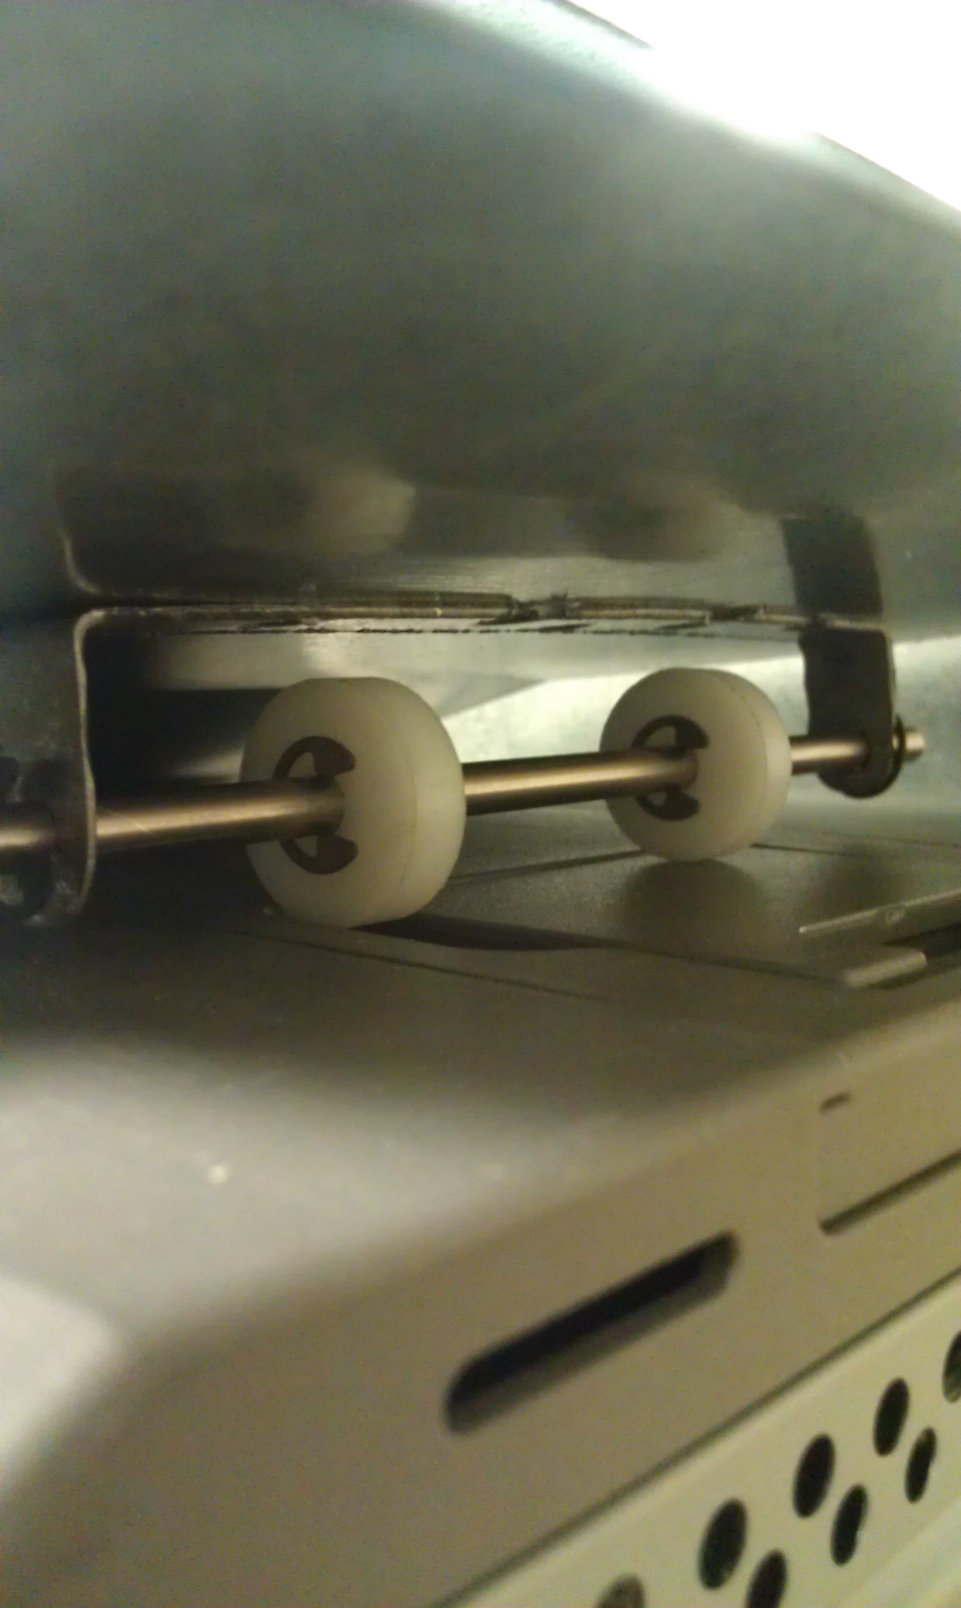
Figure 3. Detail of mechanism’s rear roller assembly. Small retaining rings are placed
on either side of the wheels to maintain the integrity and restrict skew.

For the purposes of this initial prototype, the mechanism is driven by a compact DC motor which is connected to an external 12 V power source and a controlling 3-way switch. This entire assembly is located within a casing attached to the housing of the mechanism, as shown by Figure 4 below.

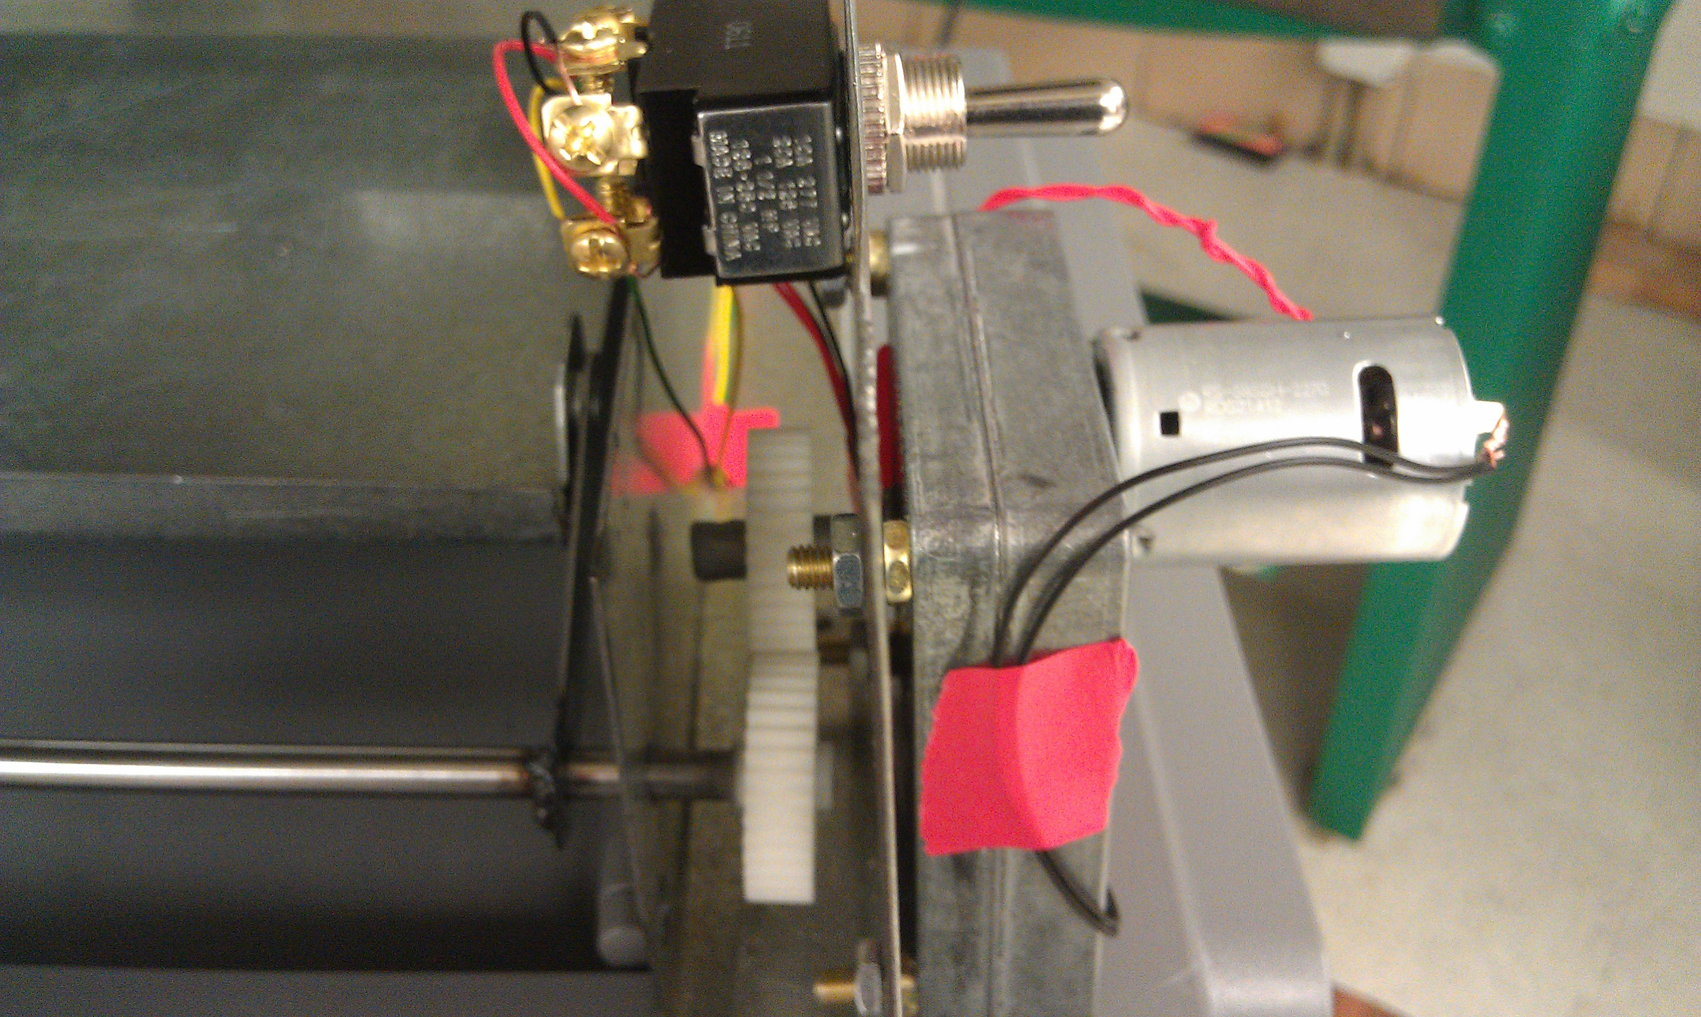
Figure 4. Detail of mechanism’s attached electric motor drive. The motor powers the
shaft through a simple one-to-one gear scheme.

For complete detail of each component and accompanying dimensions, a catalog of the engineering drawings developed for the respective fabrications, as well as the motor’s accompanying wiring schematic, is given in Appendix B.

Component Analysis
In order to ultimately facilitate the desired functionality of the mechanism, each individual component was subject to a critical examination. The first and most integral component to this design was the output tray itself. As the most important facet of the paper tray is the structural integrity, several things were carefully studied. Firstly, it was necessary to match the shape of the tray exactly to the contour on the top of the existing base model printer. Applying this curve, one can instantly see that two analyses are needed to ensure proper reliability: the resultant forces of the weight at critical points and the maximum tray deflection. Using a maximum paper stack weight of 5 lbs., the forces at each of the front arm pivots was found to be 0.927 lbs. while the equivalent weights at each of the rear brackets which connect to the shaft was determined to be 1.57 lbs. The total deflection of this tray was a minimal -0.000473” due to the selection of a prototype constructed from sturdy sheet metal.
In a similar manner, the rotating front arms were subject to a comparable examination. The assembly responsible for this function consists of the arms themselves, the front shaft on which they are welded, and the riveting pins which connect the arms to the tray. Applying the derived weight at each of these arms, the resultant stress in the arms and the shear stresses present in the shaft and pins were found to be 68.9 psi, 100.7 psi, and 50.4 psi, respectively. As these stresses did not exceed the allowable yield strengths of the selected material, they were conclusively acceptable.
Additionally, the rear roller assembly underwent a critical investigation to determine the proper design and sizing for the translational components. Similarly to the front shaft, the shear stress was analyzed to inspect the shear stress present on the rear roller – ultimately found to be 170.6 psi. Furthermore, perhaps the most critical of the analyses upon this component was the proper placement of the roller underneath the paper tray. By applying an in-depth exploration of the trigonometric relationships between the diameter of the rear wheels and the resultant angles present in the tray’s movement, it was determined that the shaft should be anchored at a point 2.75” from the back of the paper tray and utilize wheels of a diameter of 1” and a tray clearance of 0.125” – greater than the maximum tray deflection.
As specified by Riley, Sturges, and Morries, a problem frequently encountered in design of machinery tends to arise from the transmittal of torque from one plane to a parallel plane. [2] Accordingly, for the purposes of motor sizing and electrical capabilities, the torque yielded at a precisely horizontal position was derived. This maximum torque was calculated to be 3.71 in-lbs., providing an accurate baseline for the estimation of motor specifications.

See Appendix D for full detail on all calculations.

Assembly and Testing:

Final Prototype
Fabrication and Procurement
While it is certain that any redirector attachment put into production by Lexmark would consist almost entirely of parts formed from plastic to minimize costs, a metal design was pursued for the purposes of the design team’s prototype (Figure 5 below). Specifically, most of the main parts – the mechanism housing, the paper output tray, and the rear roller assembly – were all fabricated utilizing 20 gauge sheet metal; the lone exception was the front arm assembly, which was fabricated with 18 gauge sheet metal to provide a thinner arm width. The engineering drawings associated with the components fabricated from this sheet metal are given in Appendix B. Accompanying these parts were some additional components consisting of different materials. Specifically, the rear roller assembly relied on small plastic wheels that were available to the team, the front arms were attached using a small riveting shaft, and the electrical motor drive assembly drew upon several components obtained from various outside vendors.

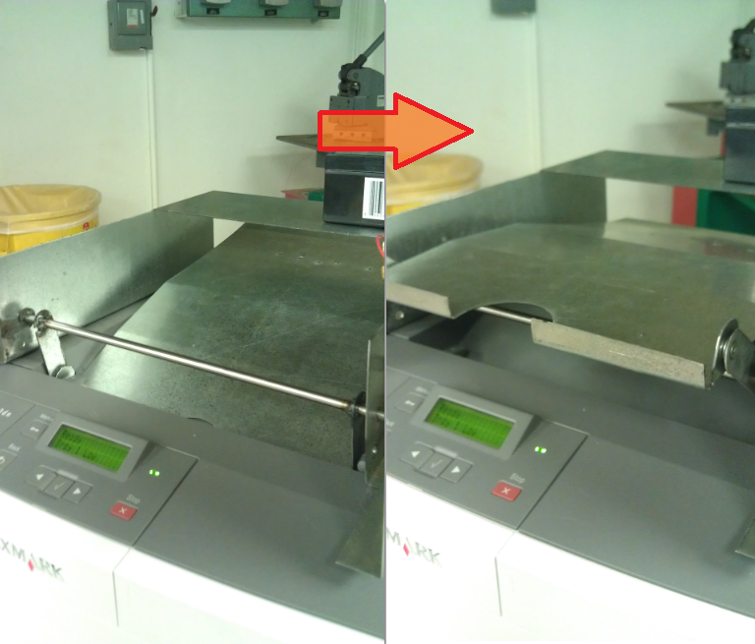
Figure 5. Final Prototype after being attached to printer. As shown, the redirector mechanism relocates the output to a position which is more accessible and convenient for users.

Bill of Materials

A complete detail of all parts, along with descriptions and their associated prices is given by Table 1 below:

Table 1. Collection of all costs of producing a metal prototype. Details include manufacturer,
specific part numbers, pricing, and number of units used in construction.
Component | Detail | Price | Quantity
Front Shaft | Miniature Hardened Precision 17-4 SS Shaft  -McMaster Carr  -1/4" Diameter, 12" Length  -Part #: 1162K66 | $19.61 | 1
Sheet Metal | Costs associated with producing a metal tray prototype  -Approx. 24 in. x 24 in. | $15.00 | 1
Rivets | Attachment pieces for tray rotation | $0.01 | 2
Wheels | Small Plastic Wheels | $0.99 | 2
Retaining Rings | Small Retaining Rings to hold wheels in place  -McMaster Carr  -Sold 100 units per package | $3.99 | 1
DC Motor | Compact DC Gearmotor 12 VDC, 25 rpm  -McMaster Carr  -Part #: 6409K17 | $37.42 | 1
Motor Switch | Toggle Switch DPDT, Fwd-Off-Rev, 6 Amps | $7.99 | 1
Battery | UPG Sealed Lead-Acid Battery  -12V, 1.3 Amps  -Northern Tool & Equipment  -Model# UB1213 | $12.99 | 1
Electrical Wires | Connecting wires between battery and motor -Approx. 1 ft. | $0.85 | 1
Nuts | Size 10-32" Nuts to Securce Motor | $0.17 | 4
 | Total Cost |  | $100.53

Budgeting

The design team was supplied a target attachment price from Lexmark of $60. While one can see that the total cost of the prototype exceeds this price, it can be noted that the price would drop considerably for future models. Specifically, upon examination of the Bill of Materials, one can see that the hand wheel was not used in this design. Furthermore, it is determined that the costs associated with each of the shafts, the housing, the output tray, the motor drive, and the rolling wheels would all be greatly reduced or completely removed upon development by Lexmark. All shafts and wheels are most likely already in production for other printer models, while the prices of the sheet metal construction will all be substituted for those associated with the development of formed plastic components instead. Finally, the mechanism will not rely on its own drive system; it will instead be able to be powered directly by the printer’s existing power source, significantly reducing the costs greatly. Upon estimation, this creates a base price of $20, considerably lower than the given budget.

Assembly Plan
For an accurate and successful construction of this prototype, an explicit order of assembly was defined. By determining the specific methodology to be followed during this process, unforeseen issues were avoided as much as possible. Upon completion of fabrication and development of each component, the following steps were taken:

- Connect rear wheel assembly to bottom of output tray.
- Connect rotating arms to front of output tray.
- Insert tray into mechanism housing and connect using front shaft.
- Weld rotating arms to front shaft for stability and rigidity of rotation.
- Attach motor assembly (motor, battery, switch, and gears) to front shaft.
- Attach to printer.

Results
Results of Critical Stresses

As detailed in the previous Component Analysis section and the accompanying Appendix D, it was beneficial for the design team to perform a series of analytical formulations. The results of these derivations, as shown by Table 2 below, are concurrent with expected results. Due to the choices in material and dimensions, each stress was deemed to be acceptable. Likewise, the sizing of the motor allowed for a torque of 20 in.-lbs. – a rating more than capable of withstanding the maximum torque present.

Table 2. Presentation of critical stress results. This table presents the maximum weights at each component and directly compares it to the maximum calculated stresses.
Component | Maximum Force (lbs) | Critical Trait | Resultant Value | Results
Output Tray | 5 | Deflection (in) | -0.000473 | Acceptable
Rotating Arm | 0.927 | Pull-Out Stress (psi) | 68.9 | Acceptable
Rivets | 0.927 | Shear Stress (psi) | 100.7 | Acceptable
Front Shaft | 0.927 | Shear Stress (psi) | 50.4 | Acceptable
Rear Roller | 1.57 | Shear Stress (psi) | 170.6 | Acceptable
Motor Drive | 20 in-lb | Maximum Torque (in-lb) | 3.71 | Acceptable

Results of Dimensional Examination

While it was valuable to compare the resultant stresses to the material properties in order to analyze the integrity of the structure, it was also beneficial to record a series of measurements to ensure the fitting of the attachment was appropriate. From Table 3 below, one can observe that the validity and applicability of the developed attachment to the base model printer is confirmed. All critical dimensions were found to be within the restrictions and requirements provided by the printer’s specifications. The lone exception to this pattern of acceptable dimensions was the minimum clearance present at the top of mechanism’s rotation. At this point, the clearance does not seem capable of accommodating the height of a full stack of paper. However, as the design requirements allow for a maximum attachment height of 6” and the developed prototype is 3.5”, there should be no problems resolving this issue.

Table 3. Presentation of dimensional measurements. Comparing the original dimensions to the developed mechanism’s sizing, one is able to investigate the validity of the prototype.
Printer Specification | Printer Dimensions (in) | Mechanism Specification | Mechanism Dimensions (in) | Results
Tray Length | 11.75 | Length | 11.6 | Acceptable
Output Depression | 1.875 | Arm Axis (Radius) | 2.5 | Acceptable
Height at paper exit | 1.25 | Lip | 0.5 | Acceptable
Distance to Display | 1.5 | Display Clearance at Output | 3 | Acceptable
Side Space | 4.5 | Motor Casing | 3 | Acceptable
Max paper stack | 0.75 | Minimum Clearance | 0.75 | Unacceptable
Total inlet width | 9.25 | Attachment Width | 9 | Acceptable
Stack Sensor Clearance* | 0.25 | Width of Arm | 0.125 | Acceptable
 |  | Arm Shaft Diameter | 0.25 | Acceptable
 |  | Back Roller Length | 5 | Acceptable
 |  | Back Roller Placement | 2.75 | Acceptable
 |  | Back Roller Diameter | 0.125 | Acceptable
 |  | Back Wheel Diameter | 1 | Acceptable
*In order for the rotating arm to fit in the paper exit depression, the stack sensor width was reduced.

Results of Preliminary Testing

For a clearer representation of the validity of the construction of this prototype, a testing plan was devised which would be able to provide a proof of concept. Through a closer experimental investigation of each component, as well as the mechanism as a whole, one is able to comment on the success of the preliminary design. This testing plan, recorded in its entirety in Appendix C, yielded several important results. Primarily, the successes associated with these tests seem to be the prevailing trend. Using a series of weights, it was found that not only did the mechanism continue to accurately function under extreme duress, but that it exceeded expectations in not creating any additional friction which could produce problems.
Furthermore, the tests revealed that the functional requirements were all met, including the capability to operate at the same rate as the printer. Specifically, this was found by recording the time for the mechanism to output: found to be an average of 0.84 seconds. Overall, these tests yielded results which were concurrent with expectations, deeming the mechanism as an accurately produced replica of the design team’s original concept and target redirector attachment.

Conclusions and Recommendations:

Project Results
Over the past two semesters, several things contributed to the team’s maturation as design engineers. Due to setbacks, unforeseen circumstances, and expected delays, the team was able to work together to contribute to the accurate concept development, design research, critical analysis, planning of fabrication, construction and assembly, and preliminary testing of the redirector mechanism. The coordination of these tasks ultimately culminated in the successful development and assembly of the attachment.

Future Considerations
Throughout the design and construction of this prototype, several things were noted which should be taken into consideration for the development of future models:

- Minimum Clearance: The minimum clearance internally within the redirector attachment was not sufficient to accommodate a full stack of papers. The maximum allowance for height was not met, so the housing dimensions should simply be increased as appropriate.
- Full Sensor: To accommodate this attachment, the width of the stack sensor was reduced to allow for arm rotation. To circumvent this, the stack sensor should either be moved inward or a smaller design should be investigated.
- Legal Attachment: For a legal paper size, the model was designed such that the existing sliding legal attachment could be directly implemented.
- Attaching: A plan for attaching this redirector the printer models both structurally and electrically must be developed. It is believed that this technology is already well-explored by Lexmark and is currently employed by several existing attachments.
- Motor: While the motor specifications for this prototype were well-explored, the change to an attachment formed from plastic will allow the use for a smaller motor – most likely one of the current models Lexmark commonly uses.
- Material: The calculations and derivations presented in this design should be repeated for a plastic model to ensure proper functionality.
- Programming: Upon attaching to the printer’s power source, the attachment will require some simple programming. Namely, the attachment tray should be moved to the down position at all times when printing.
- Static Guard: An additional obstruction was the static guard. While this is an important component, the bulky static guard design was deemed inefficient and a better design is recommended.
- Stapler: The initial requirement for a dedicated stapler paper path was removed, yet it should be relatively simple due to the basic translational paper tray concept utilized for this design.

Bibliography:

- Dym, Clive, and Patrick Little. Engineering Design. Third Edition. Danvers: John Wiley and Sons, 2009. Print.
- Riley, W, and L Sturges. Mechanics of Materials. 6th Edition. Wiley & Sons, 2007. Print.

Appendix A: Organization

Gantt Chart

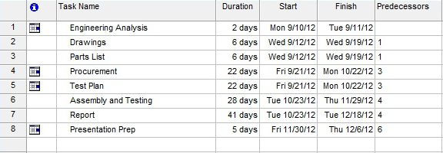
Figure 6. Complete detail of all design tasks and respective time allotted.

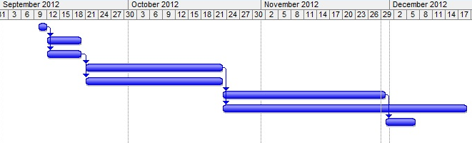
Figure 7. Accompanying illustration representing the prerequisites for each task and dedicated time periods.

Work Structure Breakdown Report

Table 4. Detail representation of major design tasks and accountable team leads.
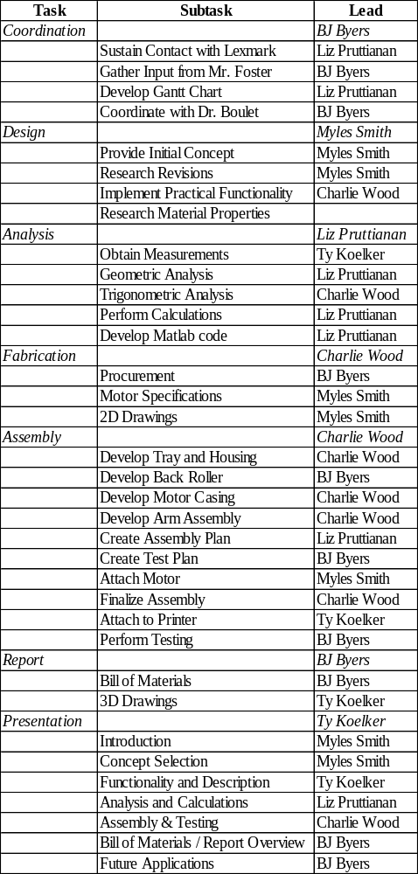
Appendix B: Drawings and Schematics

Prototype Drawings
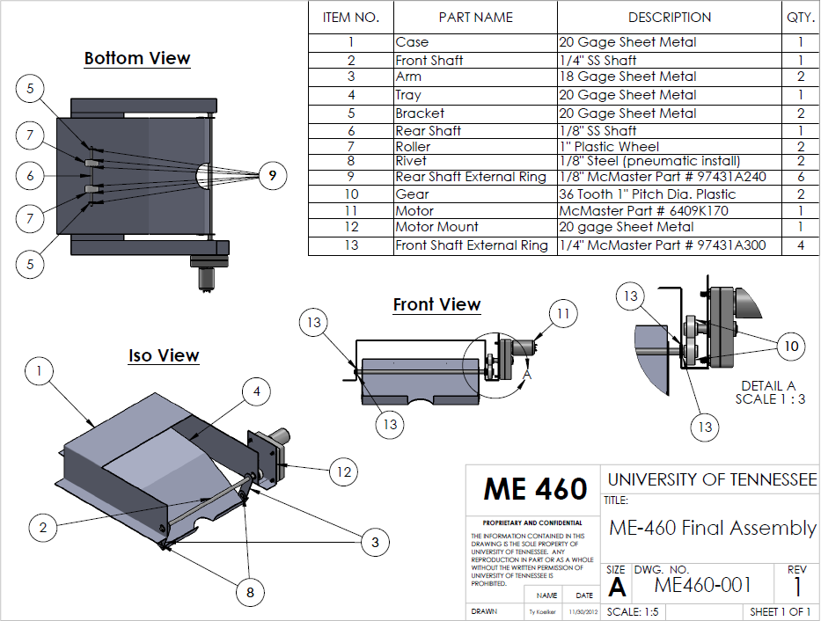
Figure 8. Final summary drawings produced for the attachment prototype.
Component Drawings

Output Tray
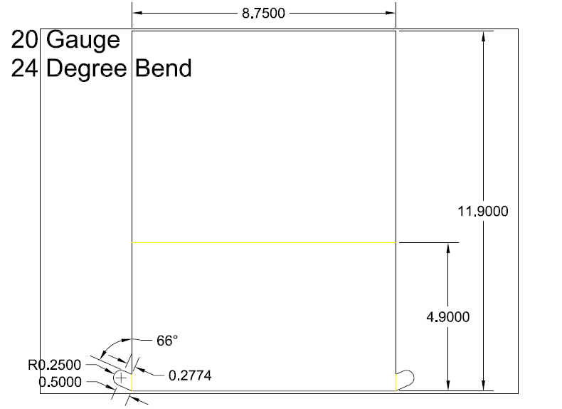
Figure 9. Detailed engineering drawing presenting dimensions for output tray.

Rotating Arms
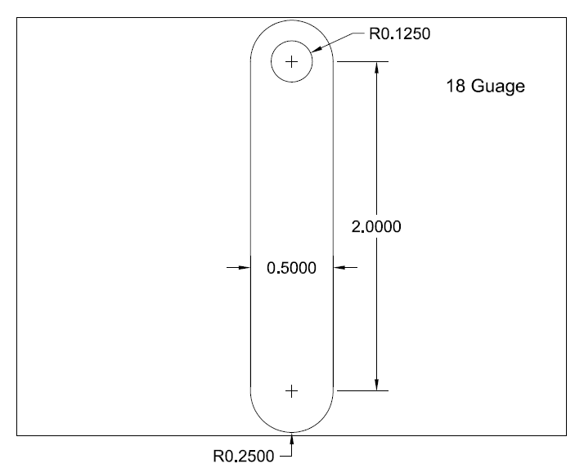
Figure 10. Detailed engineering drawing presenting dimensions for rotating arms.

Rear Brackets
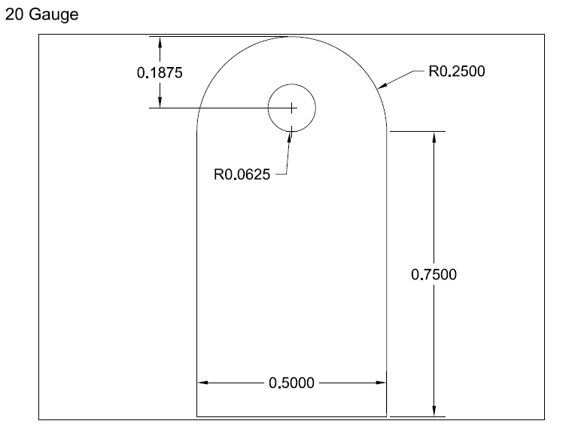
Figure 11. Detailed engineering drawing presenting dimensions for rear brackets.

Mechanism Housing
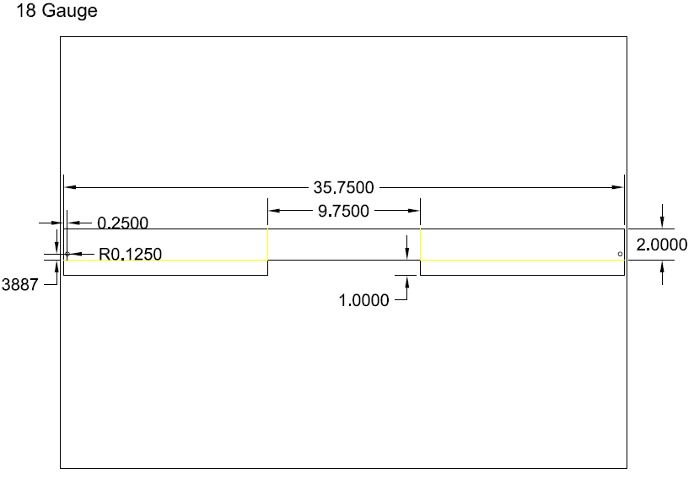
Figure 12. Detailed engineering drawing presenting dimensions for mechanism housing.

Schematics

Motor Wiring
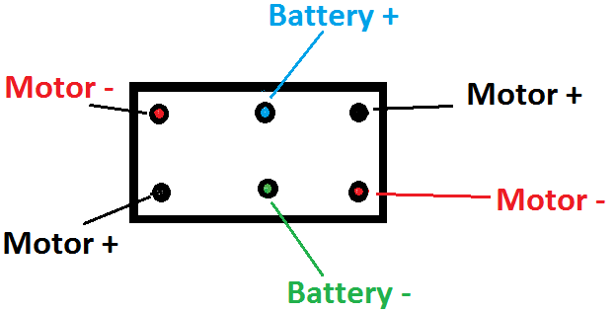
Figure 13. Simple schematic presenting appropriate wiring plans for a motor, power source, and 3-way controlling switch.

Appendix C: Preliminary Testing

For a more developed representation of the capabilities and accuracy of this mechanism, a basic testing plan was developed by the design team. In order to obtain a complete experimental depiction of the mechanism, each individual component was subject to a critical analysis, as well as the prototype’s functional capabilities. The results of this series of trials are recorded within Table 5 below.

Table 5. Presentation of results of experimental testing. As recorded, each test resulted in acceptable results, showing an overall pattern of successful functionality.
Testing Plan
Component | Analysis | Trial | Weight | Integrity of Mechanism
Strength of Tray | Weight at Critical Points | 1 | 0 | √
Strength of Tray | Weight at Critical Points | 2 | 2.5 | √
Strength of Tray | Weight at Critical Points | 3 | 5 | √
Strength of Tray | Tray Deflection | Trial | Weight | Δ (in)
Strength of Tray | Tray Deflection | 1 | 0 | 0
Strength of Tray | Tray Deflection | 2 | 5 | 0.0001
Strength of Tray | Tray Deflection | 3 | 10 | 0.0002
Front Arm Assembly | Joint Friction | Trial | Friction Present
Front Arm Assembly | Joint Friction | 1 | Negligible
Front Arm Assembly | Joint Friction | 2 | Negligible
Front Arm Assembly | Joint Friction | 3 | Negligible
Front Arm Assembly | Rotational Accuracy | Trial | Rigidity | Synchronization
Front Arm Assembly | Rotational Accuracy | 1 | √ | √
Front Arm Assembly | Rotational Accuracy | 2 | √ | √
Front Arm Assembly | Rotational Accuracy | 3 | √ | √
Rear Roller Assembly | Wheel Sizing | Position |  | Tray Clearance (in)
Rear Roller Assembly | Wheel Sizing | 1 | Receive | 1.5
Rear Roller Assembly | Wheel Sizing | 2 | Midpoint | 1
Rear Roller Assembly | Wheel Sizing | 3 | Output | 0.5
Motor Drive | Timing | Trial | Time to Output (s)
Motor Drive | Timing | 1 | 0.78
Motor Drive | Timing | 2 | 0.84
Motor Drive | Timing | 3 | 0.89
Target Design | Functionality | Trial | # Paper | Success
Target Design | Functionality | 1 | 1 | √
Target Design | Functionality | 2 | 5 | √
Target Design | Functionality | 3 | 10 | √
Appendix D: Raw Data

Calculations

The design of this attachment required an in-depth critical evaluation of each component in order to ensure the success of the mechanism. It is important to note that in these calculations, all derived values are conservative, as the weight taken into consideration was 5 lbs. – providing an overall safety factor of 2 for the predicted weight load of the maximum paper stack.
Critical Points
To determine the effects of this weight, it was initially necessary to determine the locations of each affected point: the two front pivoting arms and the two points where the rear wheels are mounted. To accomplish this, the total length of the tray along with its angle of curvature was applied to the Law of Cosines.

Law of Cosines: $c^{2}=a^{2}+b^{2}-2abcos(α)$

Length of tray = 11.9 in | Length from pivot arm to bend in tray = 4.9 in | Length from bend to end of tray = 7 in | Angle = 24 degrees | Center of paper weight from pivot arm = 5.5 in

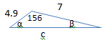

$$c^{2}={4.9}^{2}+7^{2}-2\left(4.9\right)\left(7\right)cos\left(156\right), c=11.648 in$$
$$7^{2}={4.9}^{2}+{11.648}^{2}-2\left(4.9\right)\left(11.648\right)cos\left(α\right), α=14.15°$$
$${4.9}^{2}={11.648}^{2}+7^{2}-2\left(11.648\right)\left(7\right)cos\left(β\right), β=9.85°$$
$$4.9\cos\left(α\right)=4.75 \left| 0.6\cos\left(β\right)=0.59 \right| 4.75+0.59=5.34 in | c-5.34=6.31 in$$

Length of tray with bend = 11.648 in | a = b = pivot arm | c = d = back roller | P = 5 lb

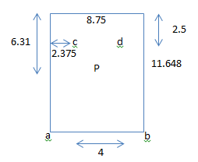

$$d_{aP}=d_{bP}=\sqrt{{\left(\frac{8.75}{2}\right)}^{2}+{\left(\frac{11.648}{2}\right)}^{2}}=7.28 in$$
$$d_{cP}=d_{dP}=\sqrt{{\left(6.31-2.5\right)}^{2}+{\left(\frac{4}{2}\right)}^{2}}=4.30 in$$

Following this series of derivations, one is able to find the maximum weights exerted on each of the four critical points: the two front pivot arms and the rear axle contact points. These were found to be:

$$2a\left(7.28\right)=2c\left(4.30\right)| 2a+2c=5$$

$$a=b=0.927 lb, c=d=1.57 lb$$

Rotating Arm
By applying this maximum force to each of the two rotating arms of the mechanism, one is able to analyze each for its tendency to fail. It was important at this point to consider the particular design of this component. As portrayed by Figure 10, this design requires that the “pull-out” stress be multiplied by two to take the shape into account. The critical failure stresses of these were determined to be:

$$σ=\frac{F}{A}=\frac{2F}{t(w)}=\frac{2(0.927lb)}{0.0359in(0.75in)}=68.9 psi$$

(F) Force = 0.927 lb | (t) thickness = 0.0359 in | (w) width = 0.75 in

Rivets
In a similar manner, it was beneficial to examine the rivets which connected the rotating arms to the output tray. By applying the fundamental theory of shear forces to a circular cross section, this analysis yielded:

$$τ=\frac{4V}{3A}=\frac{4V}{3\left[\frac{π}{4}d^{2}\right]}=\frac{4(0.927lb)}{3\left[\frac{π}{4}{\left(0.125in\right)}^{2}\right]}=100.7 psi$$

(V) Force = 0.927 lb | (d) diameter = 0.125 in

Front Shaft
Likewise, this process was repeated to determine the critical shear forces for the circular front shaft:

$$τ=\frac{4V}{3A}=\frac{4V}{3\left[\frac{π}{4}d^{2}\right]}=\frac{4(1.854lb)}{3\left[\frac{π}{4}{\left(0.25in\right)}^{2}\right]}=50.4 psi$$

(V) Force = 2(0.927) = 1.854 lb | (d) diameter = 0.25 in

Back Roller
This process was followed once more for the analysis upon the shear present on the back shaft:

$$τ=\frac{4V}{3A}=\frac{4V}{3\left[\frac{π}{4}d^{2}\right]}=\frac{4(1.57lb)}{3\left[\frac{π}{4}{\left(0.125in\right)}^{2}\right]}=170.6 psi$$

(V) Force = 1.57 lb | diameter = 0.125 in

Tray Deflection
To ensure the maximum stack of paper’s weight would not negatively affect the functionality of the mechanism by compromising any of the critical dimensions (back roller clearance, tray shape, etc.), the following static analysis was performed:

$$v_{max}=\frac{-PL^{2}}{48EI}=\frac{-PL^{2}}{48E\left[\frac{bh^{3}}{12}\right]}=\frac{-(5lb){(2.5in)}^{2}}{48(30E6psi)\left[\frac{11.9in({0.0359in)}^{3}}{12}\right]}=-0.000473 in.$$

(P) Force = 5 lb | (L) length = 2.5 in | (E) Young’s Modulus = 30E6 psi | (b) base of tray = 11.9 in | (h) thickness of tray = 0.0359 in

Maximum Torque
Finally, the rotation of the mechanism was examined at the instance when the pivot arm is horizontal. At this point, the torque is at a maximum, yielding the necessary specifications for motor sizing.

$$T=F\left(d\right)=1.854\left(2\right)=3.71 in.-lb$$

(F) Force = 2(0.927) = 1.854 lb | (d) distance = 2 in

Matlab Code

Due to the dynamic nature of this project and the repeated revisions of the prototype, a Matlab code was developed in order to provide a means to quickly and accurately recalculate the resultant stresses and dimensions. This series of derivations is recorded below:

clc; close all; clear all;
% Force and Distance Calculations
traylength=11.9;
B=7;
A=traylength-B;
W=8.75;
h=0.0359; %20 gauge
bendangle=24;
gamma=180-24;
C=sqrt(A^2+B^2-2*A*B*cosd(gamma));
alpha=acosd((B^2-A^2-C^2)/(-2*A*C));
beta=acosd((A^2-C^2-B^2)/(-2*C*B));
distbroll=2.5;
distCD=4;
distP=C-(A*cosd(alpha)+0.6*cosd(beta));
distAP=sqrt((0.5*W)^2+(0.5*C)^2);
distBP=distAP;
distCP=sqrt((distP-distbroll)^2+(0.5*distCD)^2);
distDP=distCP;
m=[2*distAP -2*distCP
2 2];
n=[0
5];
ABCD=m\n;
FA=ABCD(1,1);
FB=FA;
FC=ABCD(2,1);
FD=FC;
% Stress Calculations
%1. Pivot Arm

F1=FA;
thick1=h;
width1=0.75;
area1=thick1*width1;
sigmapivot=2*F1/area1;
%2. Pin
V2=FA;
dia2=0.125;
area2=0.25*pi*dia2^2;
taopin=4*V2/(3*area2);
%3. Front Shaft
V3=2*FA;
dia3=0.25;
area3=0.25*pi*dia3^2;
taoshaft=4*V3/(3*area3);
%4. Back Rollers
V4=FC;
diain4=0.125;
area4=0.25*pi*diain4^2;
taoroll=4*V4/(3*area4);
%5. Tray Deflection
P=5;
length=2;
E=30E6;
I=traylength*h^3/12;
deflection=-P*length^2/(48*E*I);
%6. Max Torque
F6=2*FA;
distance=2;
torque=F6*distance;

Numbers in brackets refer to entries in the bibliography.

