Angiogenic roles of VEGFB and VEGFR1 In Vitro and In Vivo

Honors Thesis
Chancellor’s Honors Program
University of Tennessee, Knoxville

Jacob Cecil
UTK advisor: Dr. Gladys Alexandre
University of Helsinki advisor: Dr. Marius Robciuc and Dr. Kari Alitalo
December
Abstract
Angiogenesis, the formation of new blood vessels from pre-existing vascular structures, is a crucial process in growing and maintaining the vascular system. This process is controlled primarily by the VEGF family of molecules and their receptors (VEGFRs). Poor vascularization of adipose tissue is often associated with impairment of insulin sensitivity and metabolism; thus, the improvement of angiogenesis holds therapeutic potential as a strategy to combat obesity and its complications. This paper builds on research by Dr. M.R. Robciuc et al. to explore the capabilities of the VEGFB/VEGFR1 pathway in promoting angiogenesis. Particularly, we examined whether in vitro cultures of human umbilical vein endothelial cells (HUVECs) can be used to confirm a previously described interplay between VEGFB/VEGFR1 and VEGFA/VEGFR2. Furthermore, we assessed the phenotypic effects of AAV-delivered VEGF-B, namely whether it could increase angiogenesis in inguinal white adipose tissue in apoE^{KO} mice. Finally, we attempted to characterize a ubiquitous deletion of VEGFR1 (Flt-1) with ROSA promoter Cre-Lox mice. With the understanding that the VEGFB/VEGFR1 pathway can be a potential treatment option to combat obesity, these experiments examine the pathway in different circumstances in vitro and in vivo as both an exploration and assessment of translational viability.
Introduction
VEGF’s and VEGFR’s
Blood vessels grow in a stalk-like manner to vascularize tissues in a process known as angiogenesis. Endothelial cells grow with the guidance of filopodia towards proangiogenic signals, eventually meeting other endothelial cell stalks to form vessels. These blood vessels are necessary to provide oxygen and nutrients to tissues, making angiogenesis a crucial aspect of physiological development and homeostasis. Pathological angiogenic activity can be a major contributor in various forms of inflammation, cancer, and obesity/obesity-related complications.
The Vascular Endothelial Growth Factors (VEGF’s) are secreted dimeric glycoproteins that regulate vascular development by modulating endothelial cell proliferation, growth, directionality, and permeability. Members of the VEGF family relevant to mammalian physiology are VEGFA, VEGFB, VEGFC, and VEGFD. VEGF’s interface with endothelial cells via VEGFRs, which have their own intrinsic properties. VEGFR1(Flt-1) and VEGFR2(Flk-2) are involved in angiogenesis, while VEGFR3 is more relevant in lymphangiogenesis. VEGFR’s are endothelial cell transmembrane proteins characterized by an extracellular domain consisting of seven homologous immunoglobulin (Ig) ligand binding subunits. These subunits dimerize upon VEGF ligand binding, activating an intercellular tyrosine-kinase domain. This interaction produces responses characteristic of auto-phosphorylated tyrosine kinase receptors, namely the activation of phospholipase C/protein kinase C and PI3K/MAPK pathways, culminating in proliferation programs and vasculature formation. In this way, VEGF’s and VEGFR’s drive the growth of endothelial cells to form blood vessels, which eventually create the vasculature necessary for homeostasis and nutrient supply.
This signaling pathway is contextual to the specific interactions between the VEGF’s and the VEGFR’s. VEGFA is the most important and effective angiogenic molecule with respect to growth and vessel formation; both knockout (VEGFA-/-) and heterozygous (VEGFA +/-) mutations are embryonically lethal due to poor blood vessel formation. Alternative splicing of VEGFA can produce four isoforms, all of which possess a heparin-binding element to facilitate ligand binding with VEGR1 and VEGFR2. VEGFA binding to VEGFR2 (Flk-2) is essential for angiogenesis to occur and leads to strong increases in endothelial cell proliferation, migration, and permeability. Meanwhile, growth signaling and response from VEGFA ligand binding to VEGFR1 (Flt-1) are far weaker and less robust. VEGFR1 deficient mice are not viable due to a disorganized and overgrown vasculature, however this phenomena is reversed when only the tyrosine kinase portion of VEGFR1 is deleted. This, along with the discovery of a soluble isoform of VEGFR1 (sVEGFR1) lacking the intercellular domain altogether, indicates that VEGFR1 acts to regulate VEGFA concentrations by “trapping” it in an otherwise poorly-angiogenic receptor. This regulation prevents the endothelial cell overgrowth and over-permeability which might otherwise occur if VEGFA binding to VEGFR2 is left unchecked. Thus, ligand binding of VEGFA with VEGFR2 is a robust angiogenic pathway, while VEGFA binding to VEGFR1 serves a more regulatory role.
Recent research has uncovered a further nuance to angiogenic regulation involving a related angiogenic molecule, VEGFB. Historically less characterized, this ligand exists in two main isoforms, VEGFB₁₆₅ and VEGF_{186,} and has been shown to interact with VEGFR1, VEGFR2, and NRP-1, another receptor protein relevant to angiogenesis. VEGFB has similar affinity for VEGFR1 as VEGFA and excess VEGFB can displace VEGFA from its ligand interactions with VEGFR1, thus freeing endogenous VEGFA molecules to bind to VEGFR2. Thus, by outcompeting VEGFA for ligand interactions with VEGFR1, VEGFB can be considered an angiogenic factor, in spite of the weak signaling from VEGB/VEGFR1 ligand interaction. Metaphorically speaking, VEGFB can “spring” VEGFA from the “trap” of VEGFR1, increasing the VEGFA concentration available to bind to VEGFR2. As we will see, this pathway holds translational relevance in activating adipose tissue angiogenesis.
VEGF’s and Obesity
Obesity is one of the major public health epidemics of our time, with more than one in three American adults considered to be obese. Oftentimes, obesity is associated with a poor vascularization of adipose tissues and recent translational research indicates that improved angiogenesis can help combat the metabolic complications presented in obesity. VEGFA deficient mice have shown exaggeration of obesity-related complications such as adipose tissue hypoxia and inflammation on a High Fat Diet (HFD); overexpression of VEGFA in the same study found improved adipose tissue functioning and reduced hypoxia. Unfortunately, direct VEGFA administration can be accompanied by dangerous side effects, such endothelial cell permeability and microvascular disruptions. Thus, it would seem that direct VEGFA targeting could be too “potent,” and as such alternatives to VEGFA must be found if angiogenesis-targeted therapies are to possess translational viability.
In a paper published in April 2016, Robciuc et al. undertook the first known studies targeting VEGFB interactions in adipose tissue. Their investigation revealed promising findings: VEGFB upregulation via VEGFB₁₈₆ AAV (AAVB-186) increased white adipose tissue vascularization in white adipose tissues, which they found reversed metabolic complications from obesity in HFD mice. Crucially, VEGFB was shown to greatly increase insulin sensitivity and functioning in HFD mice. The most striking finding of the paper was how partial VEGFR1 endothelial cell deletion in Cre-lox recombinant mice (Flt-1 EC^{KO}) retained metabolic health and a lean physique even under a HFD. These mice exhibited an increased adipose tissue capillary density and improved tolerance of glucose and insulin, factors crucial in diabetes prevention. This result is expected as per the mechanism described earlier, reducing the concentration of “trap” VEGFR1 thus allowing more VEGFA/VEGFR2 angiogenesis. AAV-B186 further optimized the capillary density and tissue perfusion results in Flt-1 EC^{KO} mice, building the case for dual VEGFB/VEGFR1 targeting. The unprecedented metabolic health and resistance to HFD in Flt-EC^{KO}/AAVB-186 mice prompted further investigation, revealing an increase in thermogenic genes from qPRC data (PRDM16, UCP-1, Cidea) as well as increased respiration and energy usage without harmful side effects. Since then, Robciuc et al. has been interested in studying how this metabolic re-programming occurs via VEGFB. Thus, in optimizing tissue vascularization and promoting thermogenic pathways in adipose tissue, VEGFB/VEGFR1 targeting holds therapeutic potential as a treatment strategy to reverse obesity and its metabolic complications.
CreLox System
Before I continue into the results section, I would like to briefly define the CreLox system and its implications in the field of translational vascular medicine. The CreLox construct is a recombinant technology which allows for precise and controlled gene silencing. 34-bp, unidirectional loxP sites are inserted via cloning vector immediately upstream and downstream of a targeted or “floxed” gene. Cre recombinase recognizes the loxP sequences and catalyzes homologous recombination between the two sites; if the loxP sites hold the same orientation this will result in an excision of the targeted gene, thus preventing further transcription or replication. Expression is further nuanced by inserting the Cre gene in tissue-specific promoters, ensuring the silencing activity occurs only a particular tissue. Temporal control of this system is possible using the Cre-ER^{T} fusion protein, which incorporates a mutated form of the estrogen receptor into the Cre recombinase protein. Under normal circumstances, this protein is localized to the cytoplasm and binds to Hsp-90. In the presence of tamoxifen (4-hydroxytamoxifen), Cre-ER^{T} dissociates from Hsp-90, uncovering a nuclear localization signal in the ER component which relocates the protein to the nucleus, where Cre recombinase can then catalyze gene silencing at loxP sites. In mice, this technology allows silencing of a target gene during adulthood using a tamoxifen gavage. Robciuc et al. used tamoxifen-induced used the Cre-Lox system to generate VEGFR-1 EC^{KO} mice, which under VEGFB AAV-transduction exhibited a stark resistance to HFD and obesity-related complications. VEGFR1 deletion leads to embryonic lethality due to disorganized and overgrown vasculature; Cre-ER^{T} technology circumvented this issue allowing investigation into VEGFR1 pathway manipulation. As such, this technology provides a useful tool to study gene deletions in in vivo systems which might otherwise be embryonically lethal.
Objectives
Working in Dr. Kari Alitalo’s group at the University of Helsinki with Dr. M.R Robcuic, my first objective was to observe the interplay between VEGFA and VEGFB in HUVEC in vitro models. Finding evidence of a robust but attenuated angiogenic response to VEGFB in the HUVEC cultures would provide mechanistic credence to future studies in vivo. Thus, our objective in these experiments was to pinpoint the VEGFR1/VEGFB boosting of VEGFA/VEGFR2 angiogenesis in HUVEC models.
I then moved to in vivo work, where I worked with Dr. Robciuc to investigate how human VEGFBex1-5, an isoform of VEGFB which does not bind to NRP-1, could induce angiogenesis in adipose tissue. This special selectivity for VEGFR1 by VEGF-Bex1-5 can allow more exact targeting of the VEGFR1 pathway without concern of NRP-1 binding. Based on the previously proposed mechanism, we hypothesize that administration of VEGFB ex1-5 through AAV injection will lead to a robust angiogenic response, increasing the vascular content of white adipose tissue.
My final work with Dr. Robciuc was an exploratory project to characterize the effects of a tissue-wide deletion of VEGFR1. We believe that using the ROSA site, a promoter found in all mice cell types, a Cre-Lox construct can delete VEGFR1 in all tissues with endothelial cells. Robciuc planned for future studies to characterize how such a tissue-wide deletion might affect mammalian vasculature and physiology as a whole. We also decided to analyze CD31, a mammalian endothelial cell marker, and how it would be effected by VEGFR1 deletion and AAVB-186 transduction in both adipose tissue and serum.
Results
In Vitro HUVEC model
To investigate how VEGFB and VEGFA work together in endothelial cells, we used P6 HUVEC (Human Umbilical Vein Endothelial Cells) cultures in a signaling/starvation assay in which cultured cells are placed in minimal basal media to prevent further proliferative signaling. After 48 hours in this condition, the cells are then exposed to growth factors for 10 minutes, after which the cells are lyzed and their contents extracted. Protein analysis by Western blot can indicate the activity of signaling molecules. We examined ERK/pERK (extracellular signaling related kinase, aka MAPK), a signaling protein in the downstream cascade of VEGFR2. Phosphorylated ERK will affect secondary messengers further down the VEGFR2 pathway to activate proliferative cellular programs; thus a high ratio of pERK/ERK in the context of endothelial cells is indicative of angiogenic signals. Hsc-70 concentrations were also measured to serve as a housekeeping protein for data normalization.
While initial investigation into the mechanism of VEGFB in HUVEC models revealed promising findings, the results were difficult to replicate. LICOR imaging software was used to generate quantitative data from Western blot images; pERK/ERK phosphorylation ratios were determined by comparing relative signal density from the bands. pERK/ERK ratios for the dual VEGFA/VEGFB cultures reside between the low concentration and high concentration VEGFA standards, indicating a nuanced angiogenic response (Fig.1). VEGFR2 phosphorylation also showed better ratios in the VEGFA/VEGFB cultures, further providing support for VEGFB/VEGFR1 targeted angiogenesis(Fig.2). However, these results proved difficult to isolate and reproduce; incorporation of a VEGFB large-dose standard exhibited high levels of pERK/ERK phosphorylation (results not shown), indicating the need for more trials would be necessary to make definitive conclusions on VEGFA/VEGFB dual interaction in vitro. Still, the findings presented in Fig.1 provide an example of the VEGFA/VEGFB interaction that begs further investigation.
AAV-transduced mVEGFB ex1-5 can increase vascularity in white adipose tissue
Next, we assessed the angiogenic capabilities of a mouse VEGFBex1-5 AAV in ApoE mice models. Due to the fatty composition of adipose tissues, paraffin processing and embedding was selected as the sectioning method over OCT cryosectioning. For blood vessel visualization, a streptavidin/biotin-conjugated lectin procedure was used. Sections were first stained with biotinylated lectin, which would detect proteoglycan molecules indicative of endothelial cell extracellular matrices. Fluorescent streptavidin secondary antigens would then interact with the biotin groups of the primary lectin antigens, allowing visualization under fluorescent microscopy. Our results show a consistent and robust angiogenic response from mVEGFB AAV treatment (Fig.4). Image quantification using ImageJ software confirmed these findings. Western Blot analysis with a mVEGFBex1-5 antibody indicates target antigen expression in transduced samples, providing validation to our findings.

VEGFR1 Deletion via ROSA-promoter CreER fl/fl mice
The 2016 Robciuc et al. paper established a case for how dual AAVB-186/Flt-1EC^{KO} strategies can aid angiogenesis and improve metabolic health in adipose tissue. Still, more characterization of the Flt-1 EC^{KO} may be necessary to advance its potential as a safe therapeutic strategy. Thus, my work has also included an exploratory study investigating this strategy not only in adipose tissue but across the many cells at once. To do this, the Cre-Lox deletion of Flt-1 was placed under the control of the ubiquitous ROSA promoter. Select samples of which were provided Vegfb gene transduction via AAVB-186. To account for dimorphic responses to these treatments, the results were divided between males and females. We performed qPCR and ELISA for Flt-1 to measure the effectiveness of the cross-tissue deletion in the subcutaneous fat and serum, respectively. VEGFB transduction was also measured via qPCR and ELISA.
Our results found that the CreLox system holds potential to generate the Flt-1^{KO} across tissues. qPCR data from subcutaneous adipose tissue indicates decrease in Flt-1 expression in both males and females, (Fig.5A,B). ELISA results from serum also showed a decrease in VEGFR1 detection, indicating a successful deletion across cell types (Fig.5C,D). VEGFB and CD31, an endothelial cell marker, were also measured for however the results from these were unexpectedly variable and are not reported.
Discussion & Conclusion
Experiments targeting the VEGFB signaling in HUVEC cells were meant to highlight the VEGFB/VEGFR1 interaction with VEGFA/VEGFR2 in an isolated, controlled environment. Ideally, this in vitro data can explain the way these growth factors act in mice models. To this end, the signaling experiments had some early success, as seen with Fig.1 and to some degree Fig.2. This figure shows that VEGFB administration, working with what are essentially endogenous concentrations of VEGFA, will activate the proliferative ERK pathway, but not to the dangerous degree as direct VEGFA administration. Unfortunately, further experiments showed this result was difficult to isolate from the direct effects of direct VEGFB stimulation, as shown in Fig.4. This experiment was also hampered by ineffective positive controls of VEGFA. One issue with these experiments is the passage number; usage of P8 cells can result in inconsistent results. To truly examine a pathway under a controlled situation, lower passage numbers would be necessary. Despite the difficulty in replicating the results, these in vitro studies are still important avenues of continued investigation. Through in vitro work, the precise mechanisms of the VEGFB/VEGFR1 pathway can be observed without the biological complexity of an in vivo system.
The experiments using hVEGFB ex1-5 in the ApoE^{KO} mice are a promising finding with respect to AAV-mediated VEGFB targeting to induce angiogenesis. Lectin staining shows that the VEGFB transduction is efficient in increasing capillary density, a sign of angiogenesis. That this can occur in ApoE^{KO} mice, a model of heart disease and cholesterol problems endemic of the modern Western diet provides hope that angiogenic stimulation via VEGFB can be a viable treatment. The result is also promising in a phylogenic sense- the fact that a VEGFB vector can achieve its intended purpose in a mouse model makes a promising case for use in human trials, given the relative reliability of the murine disease model system. The effectiveness of the VEGFBex1-5 isoform is encouraging as well, assuring that VEGFR1 targeting is sufficient to induce adipose tissue angiogenesis (and that NRP-1 activation is not necessary). Thus, these results show AAV-mediated VEGFBex1-5 transduction could hold a possible therapeutic application in the future.
The ROSACre Flt-1^{KO} model shows potential for further mechanistic studies involving the deletion of Flt-1 in a variety of cell lines. The down-regulation in subcutaneous tissue qPCR and lowered detection in serum ELISA of VEGFR1 (Flt-1) indicate an effective knockout of the receptor not only in adipose tissue cells but in other cells as well. Previous studies have mostly focused on the local effects of VEGFR1 deletion in adipose endothelial cells; however the deletion of this receptor across cell types may give further insight into its role in the cell. For example, might VEGFR1deletion in cell types other than endothelial cells also indirectly boost angiogenesis by reducing the concentration of “trap” receptors? If this ROSACre could be optimized to work consistently, histological analysis could provide more valuable information about how ROSA-site deletion of VEGFR1 can affect the vasculature.
The hallmark of translational medical research is the exporting of theoretical treatment strategies, characterized in vitro or in vivo, to a treatment strategy relevant to human physiology and thus clinical trial. As an exploration study based on the findings of Robciuc et al.’s 2016 paper, the work I have presented in this thesis represents aspects of VEGFB/VEGFR1 targeting that are necessary to address before manipulation of this pathway can become a viable therapeutic option.

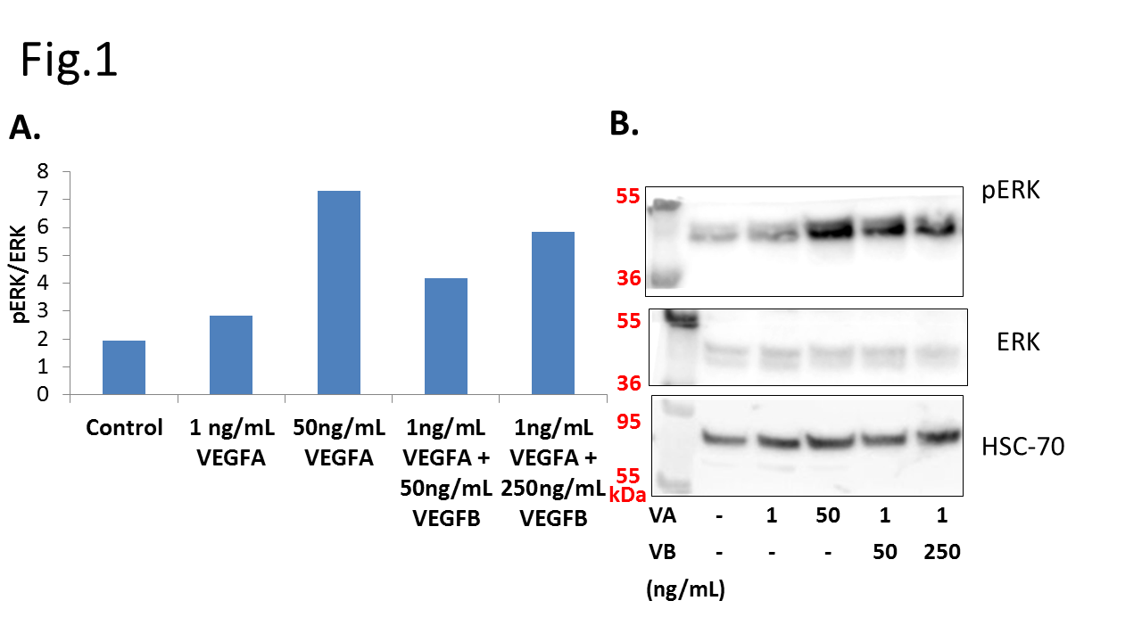
Figure 1: HUVEC signaling assay comparing VEGFA and VEGFB administration in terms of Western Blot signal intensity measured by LICOR imaging software.(A) shows the phosphorylation ratio of pERK to ERK, indicating a nuanced growth in the VEGFA/VEGFB samples. (B) provides the images of the Western Blots used in the assay.

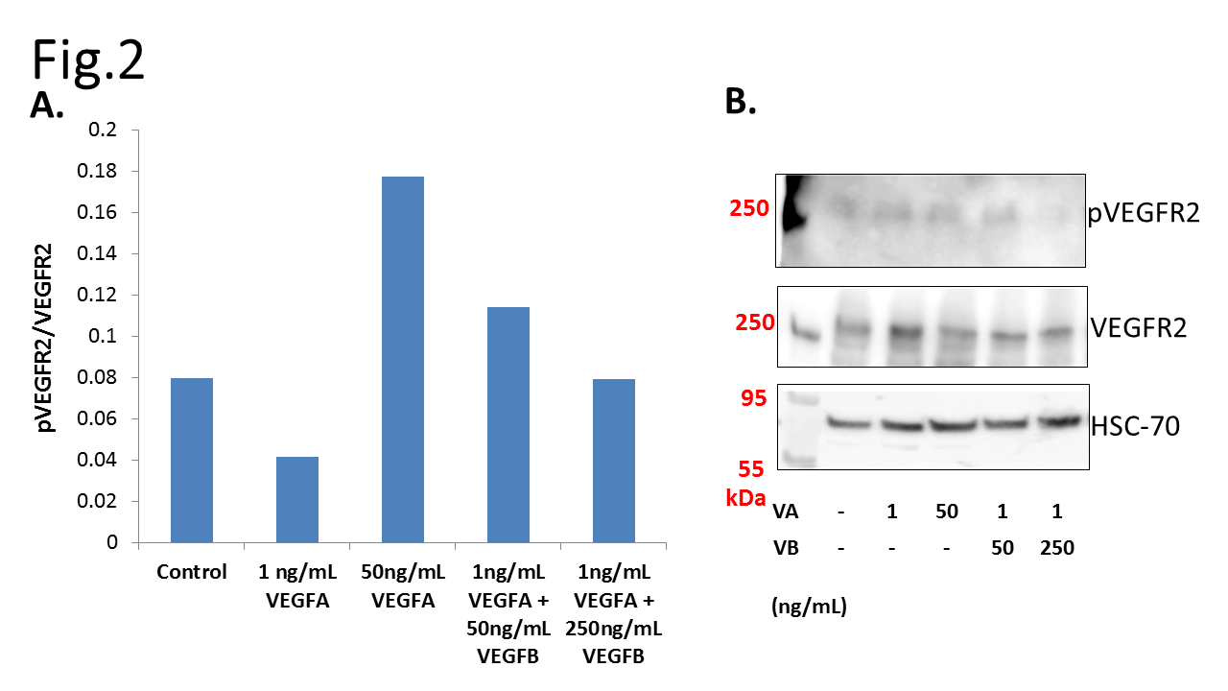

Figure 2: Measurement of VEGFR2/pVEGFR2 phosphorylation ratio in HUVEC signaling assay.(A) shows attenuated response at the 1:50 VEGFA/VEGFB condition but an unexpected drop in receptor activation at the 1:250 condition.

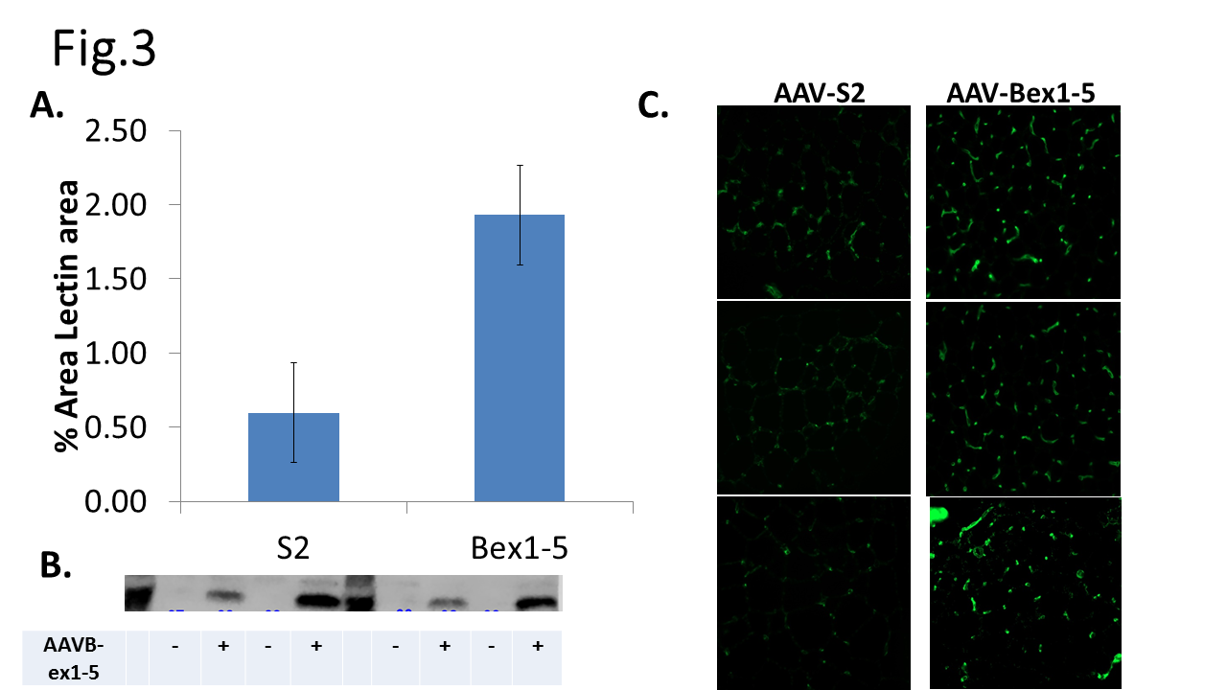Figure 3: VEGFB ex1-5 AAV-transduction of ApoE^{KO} mice can strengthen angiogenesis in adipose tissue. (A) Image J quantification of percent Lectin area from microscopy photos, indicative of capillaries and thus angiogenic growth. (B) Validation of results in the context of VEGFB transduction with VEGFB bands. (C) Characteristic images from slides comparing Lectin stainings of capillaries (in green).
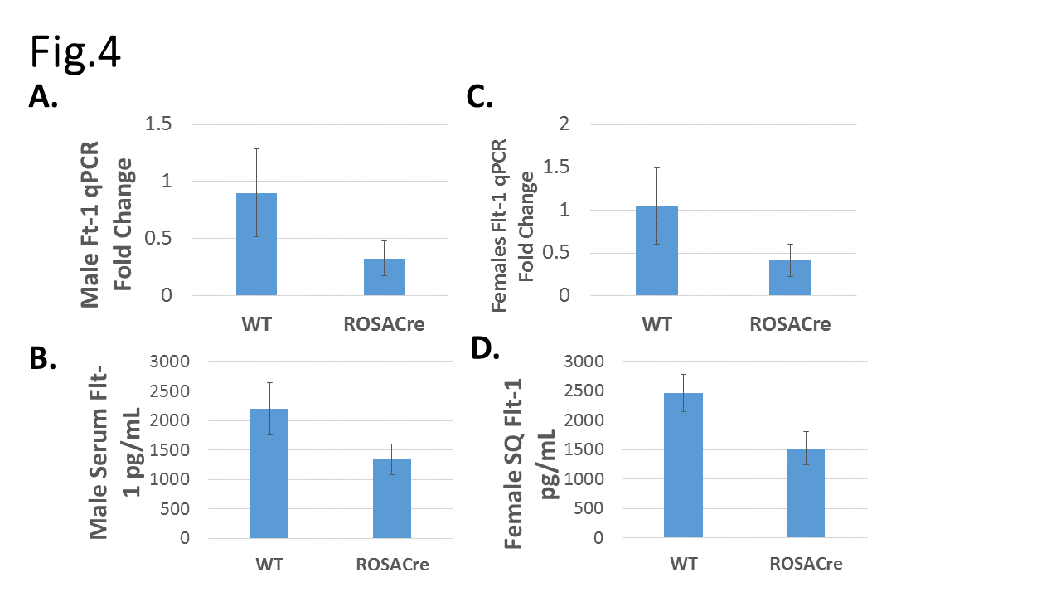
Figure 4: ROSACre-ubiquitous deletion of Flt-1. (A) and (C) show qPCR fold change for Flt-1 expression in males and females, respectively. Likewise, (B) and (D) are ELISA detection of Flt-1 from serum samples. Negative fold change and decreased serum concentration of Flt-1 indicate ROSACre-Lox deletion of Flt-1 can create a successful Flt-1^{KO} model.
References
Anisimov, A. Leppänen, V.M., Jeltsch, M., Holopainen, T. and Alitalo, K. (2013). “The Basis for the Distinct Biological Activity of Vascular Endothelial Growth Factor Receptor-1 Ligands.” ScienceSignaling. Vol. 6 Issue 282.

Fong et al. (1995) “Role of the Flt-1 receptor tyrosine kinase in regulating the assembly of vascular endothelium.” Nature.

Hiratsuka, Sachie et al. (1998) “Flt-1 lackign the tyrosine kinase domain is sufficient for normal development and angiogenesis in mice.” Natl. Acad. Sci. USA: Developmental Biology.

Jeltsch, Michael; Leppänen, Veli-Matti; Saharinen, Pipsa; Alitalo, Kari. (2013).Receptor Tyrosine Kinase-Mediated Angiogenesis. Cold Spring Harbor Perspectives in Biology. a009183.

Koch, Sina and Claesson-Welsh, Lena. (2012)“Signal Transduction by Vascular Endothelial Growth Factor Receptors.” Cold Spring Harbor Perspectives in Medicine.

Lohela et al. (2009) “VEGFs and receptors involved in angiogenesis versus lymphangiogenesis.” Cell Biology.

Potente, M., Gerhardt,H. , and Carmeliet,P. (2011) “Basic and Therapeutic Aspects of Angiogenesis.” Cell.

Robciuc, MR et al. (2016). “VEGFB/VEGFR1-Induced Expansionof Adipose Vasculature Counteracts Obesity and Related Metabolic Complications.” Cell Biology.

Shibuya, Masabumi. (2012) ”Vascular endothelial growth factor and its receptor system: physiological functions in angiogenesis and pathological roles in various diseases.”

Sung, Hoon-Ki et al. (2013) “Adipose Vascular Endothelial Growth Factor Regulates Metabolic Homeostasis through Angiogenesis.” Cell Biology.

Weight-control Information Network.(2012) “Overweight and Obesity Statistics.” NIH and U.S. Department of Health and Human Services

Materials and Methods
Cells –Cells were cultured using supplemented endothelial cell growth media from PromoCell (C-22210). Assays occurred consistently at P8.

Cell Lysis-Cellular or tissue samples are lyzed in 5%sucrose, .5% TRITON-X, .5%NP-40 lysis buffer. Additional phosphotase (1:10) and Roche proteinase inhibitors (1:25) are added to lysis buffer in cell work. On ice, adhesive cell samples are washed twice with PBS, then administered 150 microliters of lysis solution. Wells are then scratched with a pipette tip to detach adhesive cells, and the lysates are collected.
Tissue samples are homogenized in lysis buffer with MoBio Power Lyzer 24 in microcentrifuge tubes with 300 microliters of high-density zirconium oxide beads at 3500 rpm x2 for 10 second intervals, with 10 seconds of rest between each interval.

Western Blot- Lysed samples were examined for protein content using BCA assay kits from ThermoFisher (23225) to equal protein concentration in loading. Western blot ran with SDS Page solution using Bio-Rad Mini PROTEAN TGX Gels, 4-20% at 150 V for 75 mins. Transfer used Imobilion-FL PVDF membranes in a transfer solution consisting of 700mL H20, 200mL MeOH, and 100 mL Transfer mix (288g Glycine, 62g TRIS ad 2L). Transfer occurred at 400mA for 1 hr. Ponceau staining used to visualize protein bands. LI-COR Odyssey blocking solution diluted ½ in TBS used for blocking and antibody dilution. Membranes blocked in solution for 1hr. Primary antibodies applied over night at +4C. Fluroescent secondary antibodies applied for one hour; imaging with LICOR Odyssey Fc imaging occurred up to 15 mins after.
Antibodies used in western blot:
ERK: Rb, Cell Signaling, 9102S, 1:1000
pERK: Rb, Cell Signaling, 9101L, 1:1000
hsc70: Ms, sc-7298, Santa Cruz Biotechnology, 1:10000
VEGFB: Ms, AF590, R&D, 1:500

Mice – Mice were obtained from Jackson Laboratories through the Provet system under license of the University of Helsinki. Mice were raised to maturity under a standard diet.

Tissue Collection- Mice were euthanized using Ketamine/xylasine anesthesia mixture and cervical dislocation. Liver and inguinal white adipose tissue (eWAT) were harvested and snap-frozen in liquid nitrogen.

qPCR- RNA separated from tissue samples using Mo Bio Power Lyzer 24 in zirconium oxide bed microcentrifuge tubes containing 1 mL TRISure extraction buffer (Bioline, BIO38032). 200 microliters chloroform added to lysates, which are then centrifuged 12000 rcf at 4ºC for 15 minutes. 350 microliters of aqueous phase are mixed with 350 microliters of ethanol. RNA extracts then purified using QIAGEN RNA purification kit. The purified RNA is then used to create cDNA with the Bio-Rad cDNA iSCRIPT synthesis kit and a Bio-Rad Thermocycler. qPCR data was generated using VEGFB, HPRT, and 36B4 primers (Bio-RadSYBR) as well as Flt-1 primers (Bio-Rad Taqman).

Flt-1 ELISA-96 well Maxisorp Nunc-Immuno Plate covered overnight with FLT-1 capture antibodies overnight. R&D DuoSet Flt-1 ELISA kit protocol was followed. Serum samples diluted 1/5 in PBS +.1%BSA +.1% TWEEN.

Potente, M., Gerhardt,H. , and Carmeliet,P. (2011) “Basic and Therapeutic Aspects of Angiogenesis.” Cell.
Jeltsch, Michael; Leppänen, Veli-Matti; Saharinen, Pipsa; Alitalo, Kari. (2013).Receptor Tyrosine Kinase-Mediated Angiogenesis. Cold Spring Harbor Perspectives in Biology. a009183.
Koch, Sina and Claesson-Welsh, Lena. (2012)“Signal Transduction by Vascular Endothelial Growth Factor Receptors.” Cold Spring Harbor Perspectives in Medicine.
Shibuya, Masabumi. (2012) ”Vascular endothelial growth factor and its receptor system: physiological functions in angiogenesis and pathological roles in various diseases.”
Lohela et al. (2009) “VEGFs and receptors involved in angiogenesis versus lymphangiogenesis.” Cell Biology.
Fong et al. (1995) “Role of the Flt-1 receptor tyrosine kinase in regulating the assembly of vascular endothelium.” Nature.
Hiratsuka, Sachie et al. (1998) “Flt-1 lackign the tyrosine kinase domain is sufficient for normal development and angiogenesis in mice.” Natl. Acad. Sci. USA: Developmental Biology.
Koch, Sina and Claesson-Welsh, Lena
Robciuc, MR et al. (2016). “VEGFB/VEGFR1-Induced Expansionof Adipose Vasculature Counteracts Obesity and Related Metabolic Complications.” Cell Biology.
Koch, Sina and Claesson-Welsh, Lena.
Weight-control Information Network.(2012) “Overweight and Obesity Statistics.” NIH and U.S. Department of Health and Human Services
Sung, Hoon-Ki et al. (2013) “Adipose Vascular Endothelial Growth Factor Regulates Metabolic Homeostasis through Angiogenesis.” Cell Biology.
Robciuc, MR et al. (2016). “VEGFB/VEGFR1-Induced Expansionof Adipose Vasculature Counteracts Obesity and Related Metabolic Complications.” Cell Biology.
Robciuc, MR et al. Ibid
Zhang et al. (2012)“Conditional Gene Manipulation: Cre-Ating a New Biological Era.” Journal of Zhejiang University Science. 13(7): 511-524

