Microplastic Transportation Through Wastewater Treatment and Accumulation in the Little River of East Tennessee
Earth, Environmental, and Planetary Sciences Department, University of Tennessee, Knoxville
Michael Kyriakoudes

Abstract
Understanding the transportation of microplastics through waterways is an area of expanding research. Due to their small size, water, and especially wastewater, is a main mode of transportation for microplastics through our environment. Studies in other regions have shown that wastewater treatment plants are vessels for transporting microplastics into waterways, however, little is known about East Tennessee wastewater’s contribution to microplastics. This study presents a quantitative analysis of microplastic counts found in both the influent and effluent coming from one wastewater plant releasing into the Little River. Additionally, this study analyzed the microplastic counts upriver and downriver of the release to see if there are increased microplastics after the release of effluent. A total of 20 samples were collected with 5 being plant influent, 5 more as plant effluent, 5 as upriver samples, and 5 as downriver samples. These samples were then filtered and analyzed for microplastic count, color, size, and type using microscopy. After analysis, microplastic counts were found to not be significantly higher downriver of the treatment plant when compared to the upriver count. However, when comparing effluent and influent, there was a 78% reduction in microplastics. The Little River flows into the Tennessee River which is a major source of drinking water for Knoxville making this research important for identifying microplastic exposure to humans.
Introduction
In recent decades, the presence of microplastics in bodies of water has become of greater concern to ecologists and health experts alike, causing a massive growth in research on the topic. Microplastics are defined as synthetic polymers smaller than 5mm (Li et al., 2018). They come from many different sources but often stem from splintered plastic that can then easily infiltrate natural environments. Currently, there are no US regulations that require the removal of microplastics from wastewater (Vuori & Ollikainen, 2022). Not only does this pose a threat to ecosystems, but it also makes entry of microplastics into drinking water much easier. On average, humans ingest 175 MPs per day through drinking water (Zhu et al., 2024). While the direct effects of MPs on humans are still relatively unknown, they can act as a vector for heavy metals and other toxins (Lee et al., 2023). This makes the issue of understanding the flow and entry of MPs in waterways of the utmost importance.
Several studies have been conducted analyzing microplastic movement through wastewater treatment plants. In these studies, wastewater treatment plants are shown to be a mode of transport for microplastics to enter aquatic environments (Conley et al., 2019.) However, there is no literature looking at East Tennessee wastewater plants. Given the ecological importance of the area, some analysis needed to be carried out.
Methods
I chose a plant off of the Little River for several reasons. First, this area has significant biodiversity. The little river starts within the Great Smoky Mountains National Park and empties into the Tennessee River with an array of endangered species present (Miles, 2024). Second, it takes in waste from a large area discharging 9.5 million gallons of water a day (Plant Operations, 2025). Finally, the Little River empties into the Tennessee River which provides drinking water and recreation for urban centers such as Knoxville and Chattanooga. Because of these implications, understanding this plant is of particular importance.
I wanted to analyze this plant both on its efficacy in removing microplastics and its contribution of microplastics to the Little River. Given these goals, I chose four sample groups: Upstream of the plant, downstream of the plant, influent, and effluent. Comparing a site upstream of the discharge point to a site downstream, you can gauge the accumulation of plastics from the wastewater plant. Then, comparing the influent (pre-treatment water) to the effluent (post-treatment water), you can measure the microplastic removal efficacy.
When studying plastics, it is important to avoid contamination of plastics from sources other than your samples. For this reason, the samples were collected only using glass jars. Within a two-hour span, 5 samples were collected from each sample group. Following collection, the samples were filtered through a .45µm membrane filter. As needed, KOH was added for digestion because of its ability to break down much organic matter while leaving most plastics intact. Following filtration, the filter blanks were analyzed under a microscope with the count, size, type, and color being recorded. Once I recorded all the samples, the data was entered into Microsoft Excel and analyzed. The upstream and downstream sites were compared using a paired mean t-test. Then, the effluent and influent were analyzed using the same method to keep consistency and show significance.
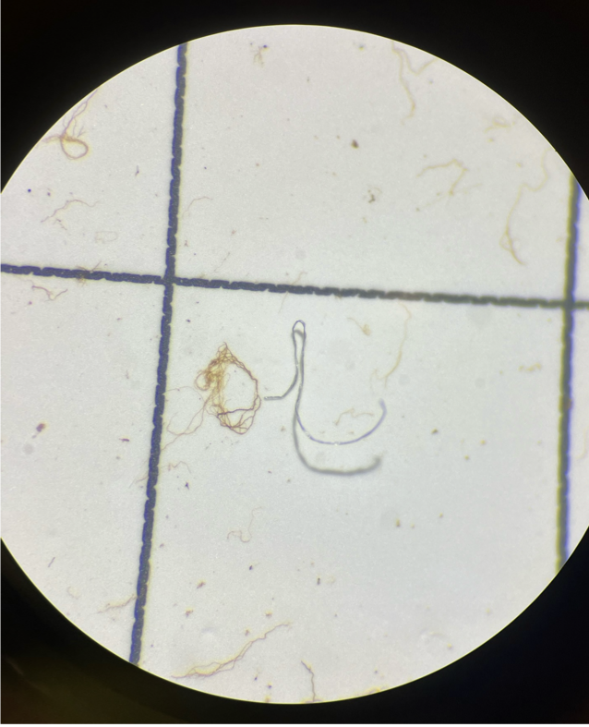
Figure 1: A microplastic fiber under the microscope.
Results
In total, there were 501 microplastics found in a total volume of 2 liters of sampled water. The influent (pre-treatment) unsurprisingly had the highest share of microplastics with 296 total and an average of 59.2 per 100ml sample. Comparatively, the effluent (post-treatment) had significantly fewer plastics with a total of 65 microplastics and an average of 13 per sample. This data showed a 78% reduction in microplastics from influent to effluent.
Comparing the upstream to the downstream, there was no significant difference found. The downstream site count averaged 15.4 microplastics per sample with a total of 77. The upstream site averaged 12.6 microplastics per sample and had a total count of 63.
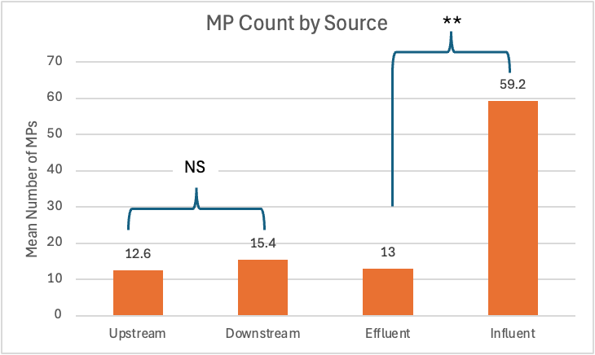Figure 2: Microplastic (MP) count comparing the upstream to downstream samples (T-test, P >.05) and the effluent to the influent (T-test, P<.01). The effluent had significantly fewer MPs than the influent while upstream and downstream showed no significant difference.
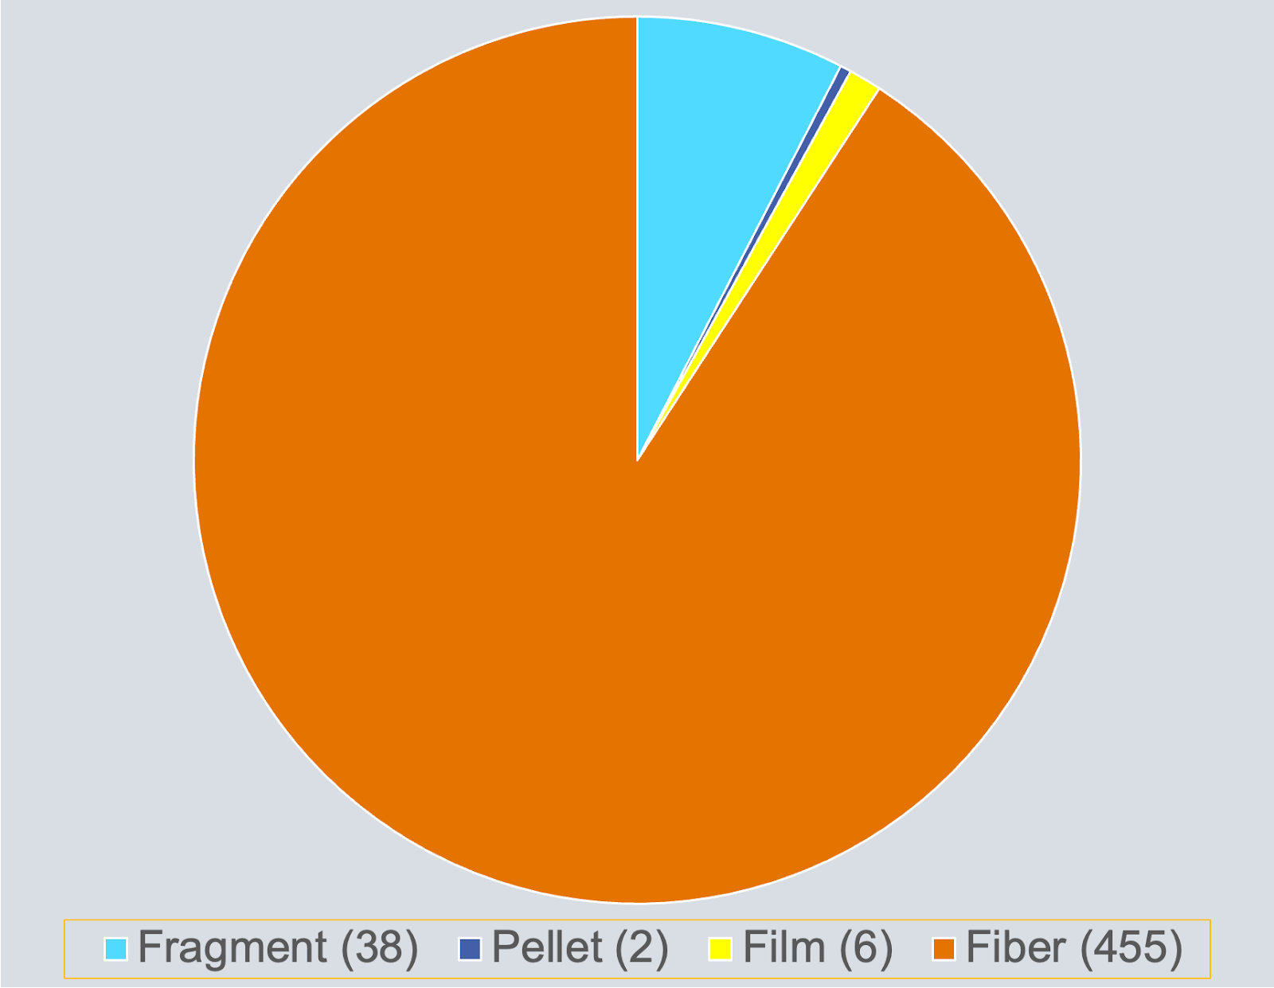
Figure 3: Fiber was the most common type of microplastic found among all samples.
Microplastic fibers were by far the most prevalent type of microplastic found. Behind fibers, fragments had a significant representation in the samples as well. By color, Black and Clear tied for the most common color of microplastic.
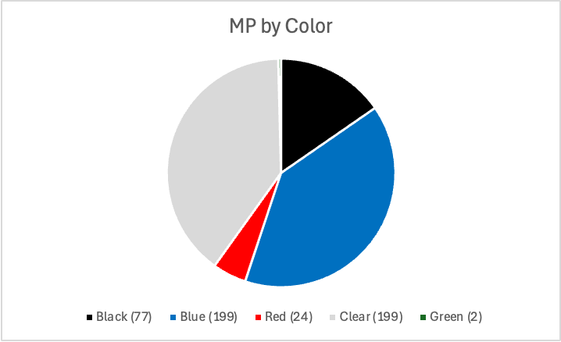
Figure 4: Blue and clear were the two most common microplastic colors found.
Amongst microplastic colors, there was a dominance of blue and clear plastics. These two colors were tied for the most common color with 199 microplastics each. Following clear and blue, black had 77, red had 24, and green had 2 microplastics.
Microplastics are ubiquitous, but there are ways to reduce their infiltration into the environment. Adding filters to wastewater treatment would be a first step. While these plants remove much sediment, microplastics can still get through. Adding filtration would reduce the number of microplastics making it through the wastewater treatment process. Given the high count of microplastics entering these facilities, this step is important to contain microplastic infiltration in aquatic environments.

Discussion
The results found were contradictory to several similar studies. While many studies found that wastewater plants were modes of transport for microplastics to enter waterways, the data for this plant did not support this. Between the upstream and downstream sites, there was no significant difference in microplastic count. While the downstream site did have slightly higher microplastic counts, this difference between the upstream average count was not large. Additionally, it was found that the wastewater plant significantly reduced the number of plastics from influent to effluent. This was a reduction of 78% from start to finish. The levels of microplastics in the effluent being discharged were almost identical to the levels of microplastics in the upstream sample group. This shows that the effluent is not straying from the river's standing microplastic prevalence.
Finally, it was shown that the plant was most effective at removing large plastics and fragments. The proportion of large microplastics in the effluent (2.4mm-3.3mm) was reduced by 10 times when compared to the influent. Additionally, the highest proportion of fragments were found in the influent samples with about 12% of microplastics being fragments from that sample group. This is in line with other studies that found wastewater treatment plants are much more effective at removing microplastics from cosmetics and other sources than it is at removing synthetic fibers from domestic washing (Hu et al., 2019).
With this study, there are several limitations that could impact the data. First, because this method of analysis uses a microscope, it is subject to mistakes by the person identifying plastics. Second, there was a limited sample size. Due to constrictions on time, only 20 samples were able to be collected, but a larger sample size would show a more complete picture. Third, some technologies such as mass spectrometry allow for more accurate results when identifying microplastics, especially as size decreases. However, due to availability and lack of funding, this resource was not available. Despite these limitations, the findings of this study remain significant.
Moving forward, East Tennessee still needs more research on microplastics in its wastewater. This was a study focusing on one wastewater treatment plant, however, including a larger number of plants across the state would provide a more holistic view of microplastic removal and accumulation. Understanding this issue is imperative to the future health of our natural environment and human population.

References
Conley, K., Clum, A., Deepe, J., Lane, H., & Beckingham, B. (2019). Wastewater treatment plants as a source of microplastics to an urban estuary: Removal efficiencies and loading per capita over one year. Water Research, 3, 100030. https://doi.org/10.1016/j.wroa.2019.100030
Hu, Y., Gong, M., Wang, J., & Bassi, A. (2019). Current research trends on microplastic pollution from wastewater systems: A critical review. Reviews in Environmental Science and Bio/Technology, 18(2), 207–230. https://doi.org/10.1007/s11157-019-09498-w
Lee, Y., Cho, J., Sohn, J., &amp; Kim, C. (2023). Health effects of microplastic exposures: current issues and perspectives in South Korea. Yonsei Medical Journal, 64(5), 301. https://doi.org/10.3349/ymj.2023.0048
Li, J., Liu, H., &amp; Chen, J. P. (2018). Microplastics in freshwater systems: A review on occurrence, environmental effects, and methods for microplastics detection. Water Research, 137, 362–374. https://doi.org/10.1016/j.watres.2017.12.056
Miles, J. L. (2024). (thesis). A habitat assessment of rare and endangered species in the Upper Little Tennessee River Basin.
Plant Operations. City of Maryville. (2025). https://www.maryvillegov.com/plant-operations.html#:~:text=The%20Maryville%20Regional%20Wastewater%20Treatment,the%20Knox%2DChapman%20Utility%20District.
Prata, J. C., Da Costa, J. P., Duarte, A. C., &amp; Rocha-Santos, T. (2019). Methods for sampling and detection of microplastics in water and sediment: A critical review. TrAC Trends in Analytical Chemistry, 110, 150–159. https://doi.org/10.1016/j.trac.2018.10.029
Vuori, L., & Ollikainen, M. (2022). How to remove microplastics in wastewater? A cost-effectiveness analysis. Ecological Economics, 192, 107246. https://doi.org/10.1016/j.ecolecon.2021.107246
Zhu, L., Pan, W., Zhao, X., Wang, F., Wang, C., Kang, Y., Dong, Z., Shao, B., Wu, F., &amp; An, L. (2024). Insights into human exposure to microplastics through drinking water: Current
state of the science. Critical Reviews in Environmental Science and Technology, 1–27.
https://doi.org/10.1080/10643389.2024.2371622

