Microbial Community Structure And Ecosystem Function In A Changing World

A Dissertation Presented for the
Doctor of Philosophy
Degree
The University of Tennessee, Knoxville

Melissa A. Cregger
August 2012

Copyright © 2012 by Melissa A Cregger
All rights reserved.

Acknowledgements

I would like to sincerely thank Dr. Aimée Classen for her advice, guidance, and support during my work towards the Doctor of Philosophy degree. Aimée supported and encouraged my intellectual and personal growth throughout my entire time at the University of Tennessee. She put in an unimaginable amount of time and effort into my scientific development, and my research would not have been possible without her help. Additionally, I owe Aimée an enormous amount of gratitude for her willingness to accept me into her laboratory. Although my background was not in ecology, she took a chance on me, and helped ease my transition from cancer biology to this new field. I would also like to thank my committee members, Dr. Nathan Sanders, Dr. Jennifer Schweitzer, and Dr. Chris Schadt, for their advice and time over the last five years. I learned numerous laboratory and statistical techniques from them all, and my research would not have been possible without them. I am grateful to Nate McDowell and William Pockman for establishing and maintaining the precipitation manipulation, their willingness to collaborate with me on multiple projects, and for their valuable edits to chapters one and two of my dissertation. I owe a debt of gratitude to my undergraduate advisor, Dr. Brian Metscher, for his insistence that I could succeed in graduate school. I don’t know if I would have ever taken that leap without his guidance and advice. Graduate school is an emotionally trying and stressful endeavor, I would not have succeeded without the unwavering support and love of my family and friends. Therefore, I’d like to thank my mother, Deborah Cregger, my father, Roy Cregger, my husband, Austin Lea, my brothers, Mark and Bryan Cregger, and my best-friend Sara Milanowski for their support and love over the years. Thanks also to Lara Souza, Emmi Felker-Quinn, Emily Austin, Mark Genung, Ivan Juric, Katie Stuble, Sara Kuebbing, and Leigh Moorhead for their encouragement and friendship during graduate school
Abstract
Understanding the effects climate change will have on the structure and function of global ecosystems is a pressing ecological and social issue. Global change driven changes in atmospheric warming and precipitation régimes have begun to alter the distribution of plants and animals in, as well as the function of, ecosystems. Using two large-scale climate change manipulations, I assessed the effect of changing precipitation and temperature regimes on soil microbial community structure and function. Soil microbial communities regulate decomposition and nutrient cycling rates in ecosystems, thus understanding their response to climatic changes will enable scientists to better predict carbon feedbacks to the atmosphere as well as functional shifts within ecosystems. My first two chapters took advantage of a large-scale precipitation manipulation in a semi-arid woodland. My first chapter aimed to understand how changing precipitation amounts altered the structure and abundance of soil bacteria and fungi; while my second chapter measured how changing precipitation altered soil nitrogen cycling. Overall, I found that soil microbial community composition and function were responsive to changes in precipitation, but these responses were contingent upon seasonal variability in precipitation and the aboveground plant community. My final experiment examined how changing temperature altered soil microbial community structure and function in two temperate forests. Using a large scale warming experiment at two locations, I examined how changes in temperature altered microbial composition, abundance, potential enzyme activity, and decomposition. I found that the effects of warming were contingent upon location; microbial community composition responded to alterations in soil temperature and soil moisture at the warmer site, but not at the cooler site. Unexpectedly, the change in microbial community composition did not result in changes in the rate of decomposition. I conclude that the soil is relatively buffered from atmospheric warming thus changes in microbial community structure and function may take longer than a few years to develop. Taken together, my research demonstrates that understanding the effects of climate change on microbial community structure and function is complex and contingent upon the background abiotic and biotic variability within an ecosystem.
Table of Contents
Introduction………………………………………………………………………………...…….1

References………………………………………………………………………………..………10

Chapter 1. Soil microbial community response to precipitation change in a semi-arid ecosystem
- Introduction………………………………………………………………………………..…17
- Methods…………………………………………………………………………………..…..19
- Results……………………………………………………………………………………..…26
- Discussion……………………………………………………………………………….…...39
- References……………………………………………………………………………….…...43
Chapter 2. The response of soil nitrogen cycling, litter biomass, and microbial community function to precipitation change

- Introduction………………………………………………………………………………..…53
- Methods…………………………………………………………………………………...….57
- Results……………………………………………………………………………………..…64
- Discussion………………………………………………………………………………..…..75
- References………………………………………………………………………………..…..82
Chapter 3. Effect of experimental warming on microbial communities is contingent upon background climatic variability
- Introduction…………………………………………………………………………….….…94
- Methods…………………………………………………………………………………...….95
- Results…………………………………………………………………………………...….100
- Discussion…………………………………………………………………………………..107
- References…………………………………………………………………………………..109
Conclusions and future directions………………………………………………………………113
Vita……………………………………………………………………………………………...121

List of Tables
Table 1. Season, precipitation change, and plant species had significant effects on microbial composition, richness, and abundance………………………………………...…………………31
Table 2. Volumetric water content had a significant impact on microbial richness and abundance………………………………………………………………………………………..32

Table 3. F statistics and p values (in parentheses) for the interactive effect of precipitation × plant species and the main effects of precipitation and plant species on litter biomass, nitrogen availability, potential nitrogen mineralization, net-nitrogen mineralization, and amoA abundance......................................................................................................................................67
Table 4. Mean (± 1 standard error) for litter biomass, nitrogen availability, potential nitrogen mineralization, net-nitrogen mineralization, and amoA abundance divided by treatment………68
Table 5. Mean (± 1 standard error) for litter biomass, nitrogen availability, potential nitrogen mineralization, net-nitrogen mineralization, and amoA abundance divided by tree type……….69
Table 6. Mean volumetric water content beneath juniper and piñon crowns across treatments in June, July, and August of 2009 (published in Pangle et al. 2012)……………………………….70
Table 7. Microbial community structure and function differed significantly between the northern and southern sites. F and p statistics (in parentheses) show the main effects of site, soil temperature, and soil moisture and the interactive effects of site × soil temperature, site × soil moisture, soil temperature × soil moisture, and site × soil temperature × soil moisture on all variables measured……………………………………………………………………………...103
Table 8. Soil temperature and soil moisture independently and interactively altered microbial community structure and function. F and p statistics (in parentheses) are given showing the main effects of soil temperature and soil moisture and the interactive effect of soil temperature × moisture within each site……………………………………………………………………….104

List of Figures

Figure 1. Precipitation manipulation at the Sevilleta LTER site in central New Mexico showing precipitation treatments, - water (water reduction) and + water (water addition), and controls…..5

Figure 2. Precipitation change can alter plant community composition, soil community composition, and nitrogen cycling directly (shown with black arrows) via changes in water availability…………………………………………………………………………………………6
Figure 3. Twelve chambered, experimental plots (chamber volume is 21.7 m³) were established in hardwood forests at a southern location and a northern location………………………………8

Figure 4. Warming may have significant impacts on microbial community structure and function. I took a step-wise, bottom-up approach to link microbial community structure and function……9

Figure 5. Microbial communities were compositionally distinct in the pre-monsoon and monsoon season………………………………………………………………………………….33

Figure 6. Microbial communities beneath piñon and juniper crowns were compositionally distinct from one another………………………………………………………………………...34

Figure 7. Seasonal variability in rainfall and our precipitation treatments interacted to alter: A. total microbial richness, B. fungal richness, and C. bacterial richness………………………….35

Figure 8. Season and tree type interacted to alter: A. total microbial richness, B. fungal richness, and C. bacterial richness…………………………………………………………………………36

Figure 9 Precipitation treatment and tree type interacted to alter: A. fungal:bacterial ratio, B. fungal abundance, and C. bacterial abundance…………………………………………………..37

Figure 10. Season and precipitation treatment interacted to alter A. fungal:bacterial ratio, B. fungal abundance, and C. bacterial abundance…………………………………………………..38

Figure 11. Precipitation treatment altered microbial biomass in the pre-monsoon season of 2009………………………………………………………………………………………………39

Figure 12. Mean ammonium and nitrate availability (±1 standard error) in 2008, monsoon season 2009, and 2011 across treatments, - water (water reduction) and + water (water addition), cover control (removal control), and control (unamended plot)…………………………………71

Figure 13. Mean ammonium and nitrate availability (±1 standard error) in the pre-monsoon, monsoon, and post-monsoon season of 2009……………………………………………………72

Figure 14. Mean potential mineralization and nitrification 30 and 60 days after incubation (±1 standard error) across treatments, - water (water reduction) and + water (water addition), cover control (removal control), and control (unamended plot)………………………………………..73

Figure 15. Mean ammonium and nitrate availability (±1 standard error) in 2008, monsoon season 2009, and 2011 beneath juniper and piñon………………………………………………74

Figure 16. Mean potential mineralization and nitrification 30 and 60 days after incubation (±1 standard error) beneath piñon and juniper trees………………………………………………….75

Figure 17. Site, soil temperature, and soil moisture interactively altered bacterial abundance (F = 18.17, p < 0.01)…………………………………………………………………………………105

Figure 18. Site, soil temperature, and soil moisture interactively altered potential xylosidase activity (F = 10.22, p = 0.01) and nagase activity (F = 5.42, p = 0.03)………………………...106

Introduction.
Understanding how climate change will alter the structure of ecosystems and their function is a pressing issue in ecological research. Currently, climate change is altering the distributions of organisms globally, which will have large consequences for the functioning of ecosystems (Matthes 2008, Parmesan and Yohe 2003). Much work has been done to understand how aboveground communities respond to climate change, but less is known about the response of belowground microorganisms. Since microorganisms regulate nutrient transformations in the soil, understanding their response enables researchers to address climatic driven changes in their structure and function. My dissertation research aimed to understand how two different climate change factors, precipitation change and atmospheric warming, altered belowground community structure and function.
Soil and litter microbial communities are responsible for the majority of decomposition and nutrient mineralization in terrestrial ecosystems (Bardgett 2005) and their abundance, community structure, and activity is often directly influenced by abiotic factors such as temperature and precipitation (Angel et al. 2010, Castro et al. 2010, Collins et al. 2008, Rinnan et al. 2007, Schadt et al. 2003, Schimel et al. 2007, Williams and Rice 2007, Zogg et al. 1997). Additionally, factors such as plant community composition may have large effects on belowground community structure and function (Buyer et al. 2002). As plant distributions shift in response to climate change, it is important to assess both the direct effect of climate change on belowground communities and the indirect effect mediated by changes in the plant community.
The work presented here took advantage of two large-scale experimental manipulations in an effort to understand how different climate change factors altered microbial community structure and ecosystem function. In chapters 1 and 2, I examined how changes in precipitation, season, and plant species interactively and independently altered soil microbial community structure and function in a piñon-juniper woodland. In chapter 3, I examined how warming altered soil microbial structure and function in two different locations in temperate forests to understand how background climatic variability influenced the microbial response to experimental warming.

The effect of precipitation change on microbial structure and nitrogen cycling
Over the past century, human activities have caused unprecedented changes in the physical and chemical structure of the world. These changes include a 37% increase in atmospheric [CO₂] and a 0.7 °C increase in mean annual temperature (Solomon 2007). Furthermore, climate models predict that the frequency and severity of drought and other extreme weather events will increase globally (Easterling et al. 2000). Increased drought will be especially important in the southwestern US (Gregory et al. 1997, Pan et al. 1998, Hanson and Weltzin 2000, Rosenberg et al. 2003, Cook et al. 2004) where piñon-juniper (PJ) woodlands, the third largest vegetation type in the Continental US, cover >36 million acres (Mueller et al. 2005, Shaw et al. 2005). In the last decade, consistent with climate model projections, areas encompassing PJ woodlands have experienced some of the most extreme years of drought to date (Breshears et al. 2005). These droughts have important consequences for PJ woodlands, including changes in plant community composition (Mueller et al. 2005), changes in the associated soil bacterial and fungal (collectively microbial) communities (Swaty et al. 2004), and changes in ecosystem processes such as carbon and nutrient cycling (Padien and Lajtha 1992, Hanson and Weltzin 2000).
Changes in precipitation may directly alter soil microbial communities that are responsible for decomposition and nutrient cycling via changes in soil water availability. Soil bacterial and fungal communities exhibit a variety of responses to changes in precipitation. These responses tend to be ecosystem specific and come in the form of altered diversity, function, and abundance. The response of the microbial community may be related to nutrient availability, stress induced by abiotic factors or herbivory, or even the duration of the extreme weather event (either drought or increased precipitation) (Stark and Firestone 1995, Williams and Ehleringer 2000, Kuske et al. 2003, Kerkhoff et al. 2004, Sowerby et al. 2005, Williams 2007, Williams and Rice 2007). Because soil microbial community structure and function is highly responsive to fluxes in precipitation (Schimel et al. 2007), individual members or the communities collectively, may serve as potential facilitators or inhibitors of vegetational shifts in piñon-juniper woodlands.
Changes in precipitation regime and soil communities may result in large and sustained vegetational shifts in PJ woodlands (Kerkhoff et al. 2004, Breshears et al. 2005, Mueller et al. 2005) where increased mortality of large piñon (Pinus edulis) may result in piñon–juniper woodlands becoming dominated by juniper (Juniperus monosperma) (McHugh and Gehring 2006). As piñon die, the population of their associated symbionts (e.g., ectomycorrhizas) will also decline (Swaty et al. 2004, Haskins and Gehring 2005, Mueller et al. 2005). Reductions in these symbiotic fungi may inhibit piñon from re-colonizing an area thus leading to the persistence of observed vegetation shifts (Mueller et al. 2005). Because piñon and juniper utilize different mycorrhizal symbionts that can be important for water acquisition (piñon associate with ectomycorrhizae whereas juniper associate with arbuscular mycorrhizae), changes in mycorrhizal abundance and distribution may be an important factor in the response of these trees to precipitation changes. Changes in precipitation may indirectly affect decomposition and nutrient cycling through changes in the soil bacterial and fungal communities responsible for these processes, or through feedbacks from these communities that will alter the plant community composition thus changing litter inputs and quality.
Understanding the direct and indirect effects of precipitation change on plant and soil communities and the feedbacks that occur is imperative to understanding how these changes alter both ecosystem structure and function in this dominant woodland. By elucidating the links between above and belowground communities, better predictions may be made as to how ecosystems will respond to climatic change to understand what factors are important in facilitating the ecosystem response to climatic change.
To assess drought-associated changes in PJ woodlands, I took advantage of an ongoing precipitation manipulation at the Sevilleta Long-Term Ecological Research (LTER) site in central New Mexico (34 degrees 23.16' N, 106 degrees 31.51' W). In 2007, 12 plots (each 1600 m²) were established in a PJ woodland to determine the hydraulic mechanisms of piñon and juniper survival and mortality during drought in the southwestern US (McDowell et al. 2008). The treatments are as follows: decreased precipitation (50% reduction), increased precipitation (20% increase), a precipitation removal and reapplication control (cover control), and an unmanipulated control (ambient control) (Figure 1). The vegetation in this area consists of extensive stands of piñon and juniper that have sustained little mortality during the recent droughts in New Mexico. I used this experiment to ask two main questions: 1. How do precipitation change, season, and the plant community alter microbial composition and abundance and 2. How do precipitation change, season, and the plant community alter litter biomass, nitrogen cycling, and microbial function (Figure 2)? Overall, I found that microbial communities in this ecosystem are subjected to large variations in rainfall seasonally, which possibly minimized the effect of our precipitation treatments. I also found that the structure and abundance of the microbial community varied beneath piñon and juniper crowns. Similarly, I found that season, precipitation treatment, and the plant community influenced nitrogen cycling in this ecosystem. Surprisingly, this change was not because of changes in biomass production or microbial function, but instead was due to alterations in plant uptake of nitrogen. I conclude that understanding the effect of climate change on microbial community structure and function is contingent upon the underlying variability in rainfall and composition of the associated plant community.
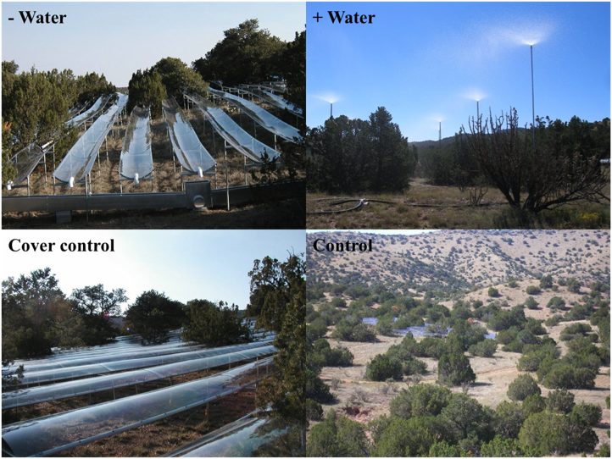
Figure 1. Precipitation manipulation at the Sevilleta LTER site in central New Mexico showing precipitation treatments, - water (water reduction) and + water (water addition), and controls.

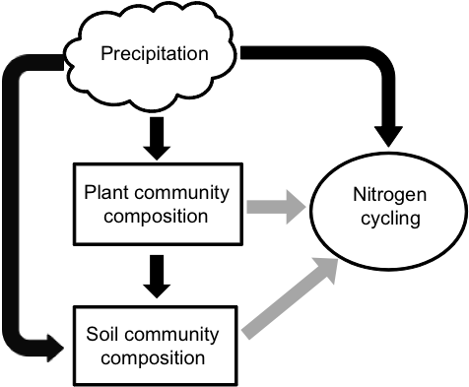
Figure 2. Precipitation change can alter plant community composition, soil community composition, and nitrogen cycling directly (shown with black arrows) via changes in water availability. Precipitation change can indirectly (shown with gray arrows) alter soil microbial structure and function through changes in plant community composition. The cloud represents the abiotic factor of interest, while the rectangles represent biological communities. The circle represents the ecosystem process of interest, nitrogen cycling.

The effect of warming on microbial structure, function, and decomposition
Over the past century, increasing atmospheric CO₂ has resulted in a temperature increase of 0.7° C since 1850. Climate models predict that global temperatures will continue to increase by another 1.1° C ~ 6.4° C at the end of this century (Solomon 2007). These changes in the global temperature may have significant impacts on ecosystem function and on the microbial communities that regulate these processes (Rustad et al. 2001).
Microbial communities are key players in decomposition and nutrient cycling, so changes to these communities in terms of community composition, abundance, or function may have large effects on ecosystem processes. Previous studies have shown that warming may have significant impacts on ecosystem processes (Rustad et al. 2001), but few have actually examined how warming alters the microbial communities responsible for these processes (Rinnan 2006). Therefore, for the final chapter of my dissertation, I explored how experimental warming altered soil microbial community composition and activity, and an ecosystem process, decomposition, using a pre-existing warming experiment at a northern location in Massachusetts and a southern location in North Carolina (Figure 3). In 2009, 12 chambered, experimental plots (chamber volume is 21.7 m³) were established in hardwood forests at each of these sites. Nine of the open top chambered plots were heated, while three were unheated chamber controls. Plots were warmed using heated air in a regression design at 0.5° C half steps from 1.5° C to 5.5° C above ambient. The warming treatments began in January of 2010.
My study took a bottom up approach in an effort to link the composition of the soil community with ecosystem function (Figure 4, Zak et al. 2006). I assessed bacterial and fungal community composition and abundance, potential microbial extracellular enzyme activity, and rates of decomposition in warming chambers at both locations. This stepwise analysis of the microbial community allowed me to assess warming impacts on these communities at the broadest level, leading to potential changes in activity, which may result in larger changes in ecosystem function. Additionally, I assessed these parameters at two different latitudes in order to understand how background climatic variability altered the response of the microbial community to atmospheric warming.
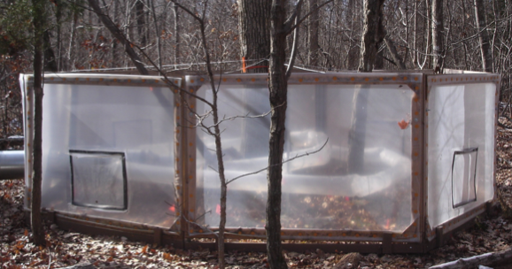
Overall, I found that changes in soil temperature and soil moisture at our warmest site had significant impacts on microbial community structure and function, but I did not see large changes at our cooler site. I conclude that global warming may have more drastic effects in warmer locations where small increases in temperature will result in more extreme temperature regimes for microbial communities.

Figure 3. Twelve chambered, experimental plots (chamber volume is 21.7 m³) were established in hardwood forests at a southern location and a northern location. A chambered plot at the southern location is pictured above. Plots were warmed using heated air in a regression design at 0.5° C half steps from 1.5° C to 5.5° C above ambient.

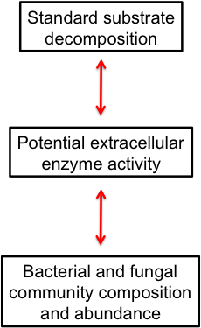

Figure 4. Warming may have significant impacts on microbial community structure and function. I took a step-wise, bottom-up approach to link microbial community structure and function. Starting at the smallest level of organization, I assessed microbial community composition and abundance. I next moved a step up and assessed potential changes in microbial function by quantifying potential microbial extracellular enzymatic activity. Finally, I moved a step up and assessed the actual function of decomposition. This design enabled me to examine the effects of warming at each step, thus even if warming was not currently altering ecosystem function, I could make predictions about the potential effect of warming on microbial structure and function as warming impacts compounded over time.

References
Angel R., M.I.M. Soares, E.D. Ungar, and O. Gillor. 2010. Biogeography of soil archaea and bacteria along a steep precipitation gradient. Isme Journal 4: 553-563.
Bardgett, R.D. 2005. The Biology of Soil: A Community and Ecosystem Approach. Oxford University Press, New York.
Breshears, D.D., N.S. Cobb, P.M. Rich, K.P. Price, C.D. Allen, R.G. Balice, W.H. Romme, J.H. Kastens, M.L. Floyd, J. Belnap, J.J. Anderson, O.B. Myers, and C.W. Meyer. 2005. Regional vegetation die-off in response to global-change-type drought. Proceedings of the National Academy of Sciences of the United States of America 102: 15144-15148.
Buyer, J.S., D.P. Roberts, and E. Russek-Cohen. 2002. Soil and plant effects on microbial community structure. Canadian Journal of Microbiology 48: 955-964.
Castro, H.F., A.T. Classen, E.E. Austin, R.J. Norby, and C.W. Schadt. 2010. Soil Microbial Community Responses to Multiple Experimental Climate Change Drivers. Applied and Environmental Microbiology 76: 999-1007.
Collins, S.I., R.L. Sinsabaugh, C. Crenshaw, L. Green, A. Porras-Alfaro, M. Stursova, and L.H. Zeglin. 2008. Pulse dynamics and microbial processes in aridland ecosystems. Journal of Ecology 96: 413-420.
Cook, E.R., C.A. Woodhouse, C.M. Eakin, D.M. Meko, and D.W. Stahle. 2004. Long-term aridity changes in the western United States. Science 306: 1015-1018.
Easterling, D.R., G.A. Meehl, C. Parmesan, S.A. Changnon, T.R. Karl, and L.O. Mearns. 2000. Climate extremes: Observations, modeling, and impacts. Science 289: 2068-2074.

Gregory, J.M., J.F.B. Mitchell, and A.J. Brady. 1997. Summer drought in northern midlatitudes in a time-dependent CO2 climate experiment. Journal of Climate 10: 662-686.
Hanson, P.J. and J.F. Weltzin. 2000. Drought disturbance from climate change: response of United States forests. Science of the Total Environment 262: 205-220.
Haskins, K.E. and C.A. Gehring. 2005. Evidence for mutualist limitation: the impacts of conspecific density on the mycorrhizal inoculum potential of woodland soils. Oecologia 145: 123-131.
Kerkhoff, A.J., S.N. Martens, G.A. Shore, and B.T. Milne. 2004. Contingent effects of water balance variation on tree cover density in semiarid woodlands. Global Ecology and Biogeography 13: 237-246.
Kuske, C.R., L.O. Ticknor, J.D. Busch, C.A. Gehring, and T.G. Whitham. 2003. The pinyon rhizosphere, plant stress, and herbivory affect the abundance of microbial decomposers in soils. Microbial Ecology 45: 340-352.
Matthes, F.C. 2008. Climate change 2007. The physical science basis, impacts, adaptation and vulnerability mitigation of climate change. Internationale Politik 63: 130-132.
McDowell, N., W.T. Pockman, C.D. Allen, D.D. Breshears, N. Cobb, T. Kolb, J. Plaut, J. Sperry, A. West, D.G. Williams, and E.A. Yepez. 2008. Mechanisms of plant survival and mortality during drought: why do some plants survive while others succumb to drought? New Phytologist 178: 719-739.
McHugh, T.A. and C.A. Gehring. 2006. Below-ground interactions with arbuscular mycorrhizal shrubs decrease the performance of pinyon pine and the abundance of its ectomycorrhizas. New Phytologist 171: 171-178.
Mueller, R.C., C.M. Scudder, M.E. Porter, R.T. Trotter, C.A. Gehring, and T.G. Whitham. 2005. Differential tree mortality in response to severe drought: evidence for long-term vegetation shifts. Journal of Ecology 93: 1085-1093.
Padien, D.J. and K. Lajtha. 1992. Plant Spatial Pattern and Nutrient Distribution in Pinyon-Juniper Woodlands Along an Elevational Gradient in Northern New-Mexico. International Journal of Plant Sciences 153: 425-433.
Pan, Y.D., J.M. Melillo, A.D. McGuire, D.W. Kicklighter, L.F. Pitelka, K. Hibbard, L.L. Pierce, S.W. Running, D.S. Ojima, W.J. Parton, and D.S. Schimel. 1998. Modeled responses of terrestrial ecosystems to elevated atmospheric CO2: a comparison of simulations by the biogeochemistry models of the Vegetation/Ecosystem Modeling and Analysis Project (VEMAP). Oecologia 114: 389-404.
Parmesan, C., and G. Yohe. 2003. A globally coherent fingerprint of climate change impacts across natural systems. Nature 421: 37-42.
Rinnan, R., A. Michelsen, E. Baath, and S. Jonasson. 2007. Fifteen years of climate change manipulations alter soil microbial communities in a subarctic heath ecosystem. Global Change Biology 13: 28-39.
Rosenberg, N.J., R.A. Brown, R.C. Izaurralde, and A.M. Thomson. 2003. Integrated assessment of Hadley Centre (HadCM2) climate change projections on agricultural productivity and irrigation water supply in the conterminous United States - I. Climate change scenarios and impacts on irrigation water supply simulated with the HUMUS model. Agricultural and Forest Meteorology 117: 73-96.
Rustad, L.E., J.L. Campbell, G.M. Marion, R.J. Norby, M.J. Mitchell, A.E. Hartley, J.H.C. Cornelissen, J. Gurevitch, and N. Gcte. 2001. A meta-analysis of the response of soil respiration, net nitrogen mineralization, and aboveground plant growth to experimental ecosystem warming. Oecologia 126: 543-562.
Schadt, C.W., A.P. Martin, D.A. Lipson, and S.K. Schmidt. 2003. Seasonal dynamics of previously unknown fungal lineages in tundra soils. Science 301: 1359-1361.
Schimel, J., T.C. Balser, and M. Wallenstein. 2007. Microbial stress-response physiology and its implications for ecosystem function. Ecology 88: 1386-1394.
Shaw, J.D., B.E. Steed, and L.T. DeBlander. 2005. Forest Inventory and Analysis (FIA) annual inventory answers the question: What is happening to pinyon-juniper woodlands? Journal of Forestry 103: 280-285.
Solomon, S., D. Qin, M. Manning, Z. Chen, M. Marquis, K.B. Averyt, M. Tignor and H.L. Miller (eds.). 2007. Contribution of Working Group I to the Fourth Assessment Report of the Intergovernmental Panel on Climate Change. United Kingdom and New York, NY, USA.
Sowerby, A., B. Emmett, C. Beier, A. Tietema, J. Penuelas, M. Estiarte, M.J.M. Van Meeteren, S. Hughes, and C. Freeman. 2005. Microbial community changes in heathland soil communities along a geographical gradient: interaction with climate change manipulations. Soil Biology and Biochemistry 37: 1805-1813.
Stark, J.M. and M.K. Firestone. 1995. Mechanisms for Soil-Moisture Effects on Activity of Nitrifying Bacteria. Applied and Environmental Microbiology 61: 218-221.
Swaty, R.L., R.J. Deckert, T.G. Whitham, and C.A. Gehring. 2004. Ectomycorrhizal abundance and community composition shifts with drought: Predictions from tree rings. Ecology 85: 1072-1084.
Williams, D.G., and J.R. Ehleringer. 2000. Intra- and interspecific variation for summer precipitation use in pinyon-juniper woodlands. Ecological Monographs 70: 517-537.
Williams, M. A. 2007. Response of microbial communities to water stress in irrigated and drought-prone tallgrass prairie soils. Soil Biology and Biochemistry 39:2750-2757.
Williams, M.A. and C.W. Rice. 2007. Seven years of enhanced water availability influences the physiological, structural, and functional attributes of a soil microbial community. Applied Soil Ecology 35: 535-545.
Zak, D.R., C.B. Blackwood, and M.P. Waldrop. 2006. A molecular dawn for biogeochemistry. Trends Ecol Evol 21: 288-295.
Zogg, G.P., D.R. Zak, D.B. Ringelberg, N.W. Macdonald, K.S. Pregitzer, and D.C. White. 1997. Compositional and functional shifts in microbial communities due to soil warming. Soil Science Society of America Journal 61: 475-481.

Chapter 1.
Soil microbial community response to precipitation change in a semi-arid ecosystem

Abstract
Microbial communities regulate many belowground carbon cycling processes, thus the impact of climate change on the structure and function of soil communities could in turn impact the release or storage of carbon in soils. Here we used a large-scale precipitation manipulation (+18%, -50%, or ambient) in a piñon-juniper woodland (Pinus edulis-Juniperus monosperma) to investigate how changes in precipitation amounts altered soil microbial communities as well as what role seasonal variation in rainfall and plant composition played in the microbial community response. Seasonal variability in precipitation had a larger role in determining the composition of soil communities than the direct effect of the experimental precipitation treatments. Bacterial and fungal communities in the dry, relatively moisture limited pre-monsoon season were compositionally distinct relative to communities in the monsoon season, when soil moisture levels and periodicity varied more widely across treatments. Fungal abundance in the drought plots during the dry pre-monsoon season was particularly low, and was 4.7 × greater upon soil wet up in the monsoon season suggesting that soil fungi were water limited in the driest plots which may result in a decrease in fungal degradation of carbon substrates. Additionally, we found both bacterial and fungal communities beneath piñon pine versus juniper were distinct; suggesting that microbial function beneath these trees is different. We conclude that predicting the response of microbial communities to climate change is highly dependent on seasonal dynamics, underlying environmental variability, and the composition of the associated aboveground community.

Introduction
Soil and litter microbial communities are responsible for the majority of decomposition and nutrient mineralization in terrestrial ecosystems (Bardgett 2005) and their abundance, community structure, and activity is often directly influenced by abiotic factors such as temperature and precipitation (Schimel et al. 2007, Williams and Rice 2007, Collins et al. 2008, Angel et al. 2010). Because global climate change may have significant impacts on the global hydrologic cycle (Matthes 2008) understanding how changes in precipitation shape soil communities and their function is important if we are to predict carbon feedbacks to the atmosphere (Knapp et al. 2008). Changes in precipitation regimes can alter soil communities by causing shifts in community composition through the local extinction of certain operational taxonomic units (OTUs) (Fierer et al. 2003, Clark et al. 2009) or by shifting the abundance of bacteria and fungi in one group over those in another group (Nazih et al. 2001, Uhlirova et al. 2005, Clark et al. 2009, Gray et al. 2011). Soil microbial communities may be more resilient to environmental change relative to their aboveground plant counterparts, and changes to soil communities may only occur when abiotic variables are outside the range normally experienced by the communities (Cruz-Martinez et al. 2009).
In addition to the direct effect of precipitation change on soil microbial community abundance and diversity, soil communities are influenced by changes in plant community abundance and composition (Zak et al. 2003, Clark et al. 2009). Plant inputs via exudates or litter are food for soil communities, which then use those inputs to mineralize nutrients (Hobbie 1992, Chapman et al. 2006, de Graaff et al. 2010). These associations can be tightly coupled. In many studies, distinct microbial communities develop beneath individual plant species and function differently when placed beneath a new plant species (Buyer et al. 2002, Zak et al. 2003, Kardol et al. 2010, Mitchell et al. 2010). These associations can be particularly important when considering the response of symbiotic relationships like mycorrhizae to projected changes in plant distributions (Haskins and Gehring 2004, Bellgard and Williams 2011). It is important to consider how climate change might alter both plant distributions and the distributions of the associated soil community.
Seasonal and temporal shifts in rainfall, especially in ecosystems where organisms may be at their physiological tolerance limit, can have a large impact on the diversity, abundance, and responsiveness of soil microbial communities (Schadt et al. 2003, Lipson and Schmidt 2004, Hullar et al. 2006, Waldrop and Firestone 2006). Seasonal variation in rainfall may ameliorate the direct effects of climate change on soil communities because a wide range of physiological tolerances may already exist within the community (Cruz-Martinez et al. 2009, Hawkes et al. 2011). Alternatively climate change may increase the severity of this variation resulting in new dynamics within the microbial community such as changes in species richness or composition (Waldrop and Firestone 2006, Hawkes et al. 2011). Therefore, measuring the responses of soil communities across seasons and years enables researchers to better predict microbial responses to climate change.
Semi-arid piñon-juniper woodlands provide a model test case to understand and possibly predict how both seasonal dynamics and how the dominant plant community may influence the response of soil communities to climate change. Piñon-juniper woodlands are defined by a long dry season followed by monsoonal rains that can saturate the soil system (Greenland et al. 2003), thus soil communities in these woodlands likely have a large range of physiological tolerances to high and low moisture regimes (Schwinning and Sala 2004). In addition, piñon-juniper woodlands in the southwestern US have experienced multiple years of severe drought since 2000, which is leading to a significant shift in the plant community (Mueller et al. 2005). Junipers, that are more drought resistant, are able to persist, while piñon pine populations are declining (Breshears et al. 2009). Given climate models predict that the frequency and severity of drought will continue to increase in the southwestern US (Gregory et al. 1997, Pan et al. 1998, Hanson and Weltzin 2000, Rosenberg et al. 2003, Cook et al. 2004) where these woodlands cover >17 million hectares (39), understanding how climate change may directly or indirectly alter soil communities and the processes they regulate is important.
Large-scale manipulation of climate variables can inform scientists how ecosystems, and their associated communities, will respond in the future (Luo et al. 2011). We took advantage of a large-scale precipitation manipulation in a piñon-juniper woodland to investigate how precipitation, increases and decreases, alter soil community composition and abundance beneath piñon and juniper trees across seasons. We predicted that: (1) soil microbial community composition and abundance would vary with moisture availability due to changes in precipitation both seasonally and across experimental precipitation treatments, (2) that soils beneath piñon and juniper would harbor distinct microbial communities, and (3) that relative to juniper, soil communities beneath piñon would be more responsive to increases and decreases in precipitation because previous work at our site shows that piñon is more stressed than juniper by drought (Pangle et al. 2012, Plaut et al. 2012).

Methods
Site and experimental description
To assess how precipitation change, including both increases and decreases, tree species, and season altered the soil microbial community; we examined microbial community composition, abundance, and biomass beneath piñon and juniper at a precipitation manipulation experiment in Central New Mexico (see Pangle et al. 2012 for extensive experimental design details). The experiment is located in a piñon-juniper woodland at the Sevilleta National Wildlife Refuge in central New Mexico (1900 m elevation), where the Sevilleta LTER program is located (32º 20’ N, 106º50’ W). Climate records from the Sevilleta LTER meteorological station (Cerro Montoso #42; http://sev.lternet.edu/) indicate the mean annual temperature around our study site is 13 °C and the mean annual precipitation is 368 mm. The largest amount of precipitation comes during the monsoon season (July, August, September). Monsoon precipitation accounts for over half of the total annual precipitation; but high evapotranspiration rates prevent monsoon rain events from recharging soil moisture to depth (Greenland et al. 2003).
We established 12 experimental plots (each 1600 m²) in mid-summer 2007. These plots consist of a decreased precipitation treatment (~50% reduction), an increased precipitation treatment (~18% addition), a precipitation removal control treatment (cover control), and an ambient control treatment (n = 3). Precipitation was reduced using a throughfall displacement design (Sala 2000). Troughs were constructed of clear UV-coated acrylic sheets and installed in each drought plot at a height of approximately 1 m. The cover controls were constructed by inverting the troughs. To increase precipitation, sprinklers were installed in each precipitation addition plot, where 57 mm of precipitation was added in three separate 19 mm rain events in 2008. The ambient control treatments were unmanipulated plots located within the experimental plot matrix. These plots serve as the control for the water addition treatment and as an unmanipulated control for the precipitation exclosure plots. Volumetric water content (VWC) is monitored at -5 cm depth using EC-20 ECH₂O probes (Decagon, Pullman, WA; 42).

Soil sampling and DNA extraction
We collected soil samples in the pre-monsoon and during the monsoon season because we expected that seasonal variability in rainfall might alter soil microbial community characteristics. Combined with drought, the dry pre-monsoon season may represent a threshold for changes in microbial community structure not evident during the rainy monsoon season. In order to understand how our precipitation treatments altered microbial biomass, we also measured microbial biomass nitrogen during the 2009 pre-monsoon season. We collected soil cores (10 cm depth, 5 cm diameter) in June (pre-monsoon) and August (monsoon) of 2008 from three randomly chosen locations beneath piñon (Pinus edulis) and juniper (Juniperus monosperma) crowns in each treatment plot. We combined and homogenized the soil by cover type within each treatment and flash froze a soil subsample from each in liquid nitrogen for subsequent molecular analyses. Subsamples were placed on dry ice, and stored at -80 °C in the laboratory until the DNA was extracted. The remainder of the soil was homogenized, sieved to 2 mm, and used to assess gravimetric water content.
We extracted DNA from 1 g of soil in each of our samples using the UltraClean Soil DNA Isolation kit (MoBio Laboratories, Carlsbad, CA). DNA concentration and purity were evaluated spectrophotometrically using a Synergy HT microplate reader (Biotek Instruments, Winooski, VT). OD₂₆₀/OD₂₈₀ ratios were used to assess DNA quality. Ratios ranged from approximately 1-2. Ratios below 1.8 indicated the presence of proteins such as humic acids in the soil, which may inhibit PCR reactions therefore sample DNA was diluted 1:10 in sterile water before PCR reactions.

Microbial community composition
Bacterial and fungal community fingerprints were obtained using terminal-restriction fragment length polymorphism (TRFLP) following a modified protocol outlined by Singh and Thomas 2006. Due to decreases in fluorescence when multiplexed (data not shown), we opted to perform the analyses for the bacterial and fungal communities in separate reactions. Polymerase chain reaction (PCR) was performed to amplify the 16S rRNA gene from bacteria using primers 63f (Marchesi et al. 1998): 5'- AGGCCTAACACATGCAAGTC -3' and 1087r (Hauben et al. 1997): 5' (VIC)- TCGTTGCGGGACTTACCCC -3'. PCR was performed to amplify the ribosomal ITS region from fungi using primers ITS1f (Gardes and Bruns 1993): 5' (6-FAM) – CTTGGTCATTTAGAGGAAGTAA -3' and ITS4r (Singh et al. 2006): 5’ – TCCTCCGCTTATTGATATGC -3’. PCR mixtures contained 5 μl 10x KCL reaction buffer, 2 μl 50 mM MgCl₂, 5 μl 10 mM dNTPs (Bioline, Tauton, MA), 1 μl 20 mg/ml BSA (Roche, location), 0.5 μl (2.5 Units) Taq DNA polymerase (Bioline, Tauton, MA), either 1 μl of each bacterial primer or 2 μl of each fungal primer (Labeled primers - Invitrogen, by Life Technologies, Grand Island, NY, unlabeled primers – Integrated DNA Technologies, Coralville, IA) and 2 μl of sample DNA diluted 1:10 with sterile water. All PCR reactions were performed on 96-well Tgradient thermocycler (Biometra, Goettingen, Germany). Amplification of DNA consisted of an initial step of 95 °C for 5 min, followed by 30 cycles of denaturation at 95 °C for 30 s, annealing at 55 °C for 30 s, and elongation at 72 °C for 1 min. The last cycle was followed by extension at 72 °C for 10 minutes. At completion, PCR product quality was assessed with 1% agarose gel electrophoresis.
PCR products were cleaned using the QIAquick PCR purification kit (Qiagen, Valencia, CA). After cleanup, PCR products were quantified using a Synergy HT microplate reader (Biotek, Winooski, Vermont, USA). All PCR products were digested individually with MspI. Reactions contained 14 μl PCR product, 2 μl 10X buffer B, 2 μl MSP1 (Fisher Scientific, USA), and 2 μl 10 mg/ml acetylated BSA (Promega, Madison, WI). Reactions were brought up to a final volume of 20 μl with sterile water. Samples were incubated at 37 °C for 3 hours followed by a deactivation step at 95 °C for 10 min. After digestion, a cocktail was made containing 0.5 μl LIZ labeled GeneScan 1200 internal size standard (Applied Biosystems, Grand Island, NY), 12.5 μl Hi-Di formamide (Applied Biosystems, Grand Island, NY), and 1 μl of digested product. Samples were centrifuged then incubated at 94 °C for 4 min followed by incubation at 4 °C for 5 min. Fragments were analyzed on an ABI Prism 3100 genetic analyzer (Applied Biosystems, Grand Island, NY).
TRFLP profiles were produced using the GeneMapper software (Applied Biosystems, Grand Island, NY). Only terminal restriction fragments (TRFs) at positions beyond 55 bp were considered in order to avoid TRFs caused by primer-dimers. The relative abundance of a TRF in a TRFLP profile was calculated by dividing the peak height of the TRF by the total peak height of all TRFs in the profile (Singh et al. 2006). Community analyses of fragments were conducted using Primer 6 (Primer-E Ltd, United Kingdom). All data were square root transformed before subsequent analyses. A 3-way interactive PERMANOVA was conducted to assess differences in the total microbial, bacterial, and fungal community by tree type, treatment, and season. When significant effects were found, subsequent pair wise comparisons were assessed. Community data were used for ordination by nonmetric multidimensional scaling. Additionally, total microbial, bacterial, and fungal richness were calculated using Primer 6.

Microbial abundance
To assess bacterial and fungal gene copy number (a proxy for abundance; (Strickland and Rousk 2010)), we ran quantitative polymerase chain reaction (qPCR) on each individual sample of DNA in conjunction with primers Eub 338 (ACT CCT ACG GGA GGC AGC AG) and Eub 518 (ATT ACC GCG GCT GCT GG) for bacterial 16S ribosomal DNA and nuSSU1196F (GGA AAC TCA CCA GGT CCA GA) and nuSSU1536R (ATT GCA ATG CYC TAT CCC CA) for fungal 18S ribosomal DNA (Castro et al. 2010).
PCR mixtures for both 16S rRNA and 18S rRNA gene amplification contained 15 μl of SYBR green master mix (Invitrogen, Life Technologies, Grand Island, NY), 5 μmol of each primer (Eurofins mwg operon, Huntsville, AL), and 1 μl of sample DNA diluted 1:10 with sterile water. All reactions were brought up to a final volume of 30 μl with sterile water. Amplification protocol for 16S rRNA gene consisted of an initial denaturing cycle of 95 °C for three minutes. This cycle was followed by 39 cycles of 95 °C for 15 s, 53 °C for 15 s, and 72 °C for 1 minute. Amplification of 18S rRNA gene consisted of an initial denaturing cycle of 95 °C for three minutes. This cycle was followed by 39 cycles of 95 °C for 15 s, 53 °C for 15 s, and 70 °C for 30 s. Abundance was quantified by comparing unknown samples to serial dilutions of 16S and 18S rDNA from Escherichia coli and Saccharomyces cerevisiae respectively in each PCR run. For both bacterial and fungal assays, the R² value for the linear regression of threshold (C_{t}) value and standard abundance was greater than 0.95 indicating that the assays were quantitative across the range of DNA concentrations tested. After completion, for both ribosomal genes, a melting curve analysis was conducted to ensure purity of the amplification product. All products showed the same overlapping melting peak indicating the specificity of the primers (Rajeevan et al. 2001). PCR amplification was performed on a 96-well Chromo4 thermocycler (Bio-Rad Laboratories, Hercules, CA).

Microbial biomass nitrogen
In June of 2009, we randomly collected soil cores (15 cm depth, 5 cm diameter) beneath three juniper and three piñon crowns in each of the treatments. Samples were sieved to 2 mm, assessed for GWC, and microbial biomass nitrogen. To assess microbial biomass nitrogen, we used the fumigation-extraction method (Haubensak et al. 2002). Approximately 15 g of soil was extracted with 75 mL of 0.5 M K₂SO₄ on a shaker for 1 hour. It was then filtered through Whatman number 1 filter paper previously leached with DI water. Another subsample was fumigated in a vacuum desiccator with CHCl₃ for 5 days. After fumigation, the sample was extracted and filtered as above. A 20-milliliter aliquot of each extract was digested using a micro-Kjeldahal digestion. Samples were analyzed for total nitrogen using a SmartChem chemistry discrete analyzer (Westco Scientific Instruments, Inc., Brookfield, CT). Microbial biomass nitrogen was determined by subtracting the initial sample nitrogen from the fumigated sample nitrogen. A K_{EN} correction factor of 0.2 was used to estimate biomass nitrogen from chloroform labile nitrogen (Davidson et al. 1989).

Data analysis
Prior to analysis, data were tested for normality and log transformed to meet analysis of variance (ANOVA) assumptions when needed. We used a 3-way ANOVA with a split-plot design with the main effects of season, precipitation, plant species, and the interactive effects of season × precipitation, season × plant species, precipitation × plant species, and season × precipitation × plant species on gravimetric water content (GWC), volumetric water content (VWC), fungal abundance, bacterial abundance, fungal:bacterial ratio, microbial richness, fungal richness, and bacterial richness. We used a 2-way ANOVA with a split-plot design with the main effects of precipitation and plant species, and the interactive effect of precipitation × plants species on microbial biomass N. A student’s t test was used to differentiate between treatments means when 2 levels were present (i.e. tree differences or seasonal differences), and a Tukey HSD test was used to differentiate between treatment means when more than 2 levels were present (i.e. precipitation treatment differences). All data were analyzed using JMP 8 (Cary Institute, Cary, NC).
To understand how changing soil moisture, regardless of treatment or season, altered microbial richness, abundance, and biomass we ran linear regressions between these factors and the average monthly volumetric water content in the month soil samples were taken. This allowed us to assess the effect of a continuous measurement of water availability on microbial richness and abundance.

Results
Soil moisture. As expected, soil gravimetric water content (GWC) fluctuated seasonally with higher levels of GWC during the monsoon season (Table 1; F = 128.10, p < 0.01). GWC was approximately 5.5 × higher in August (during the monsoon season) compared to June (pre-monsoon). Similarly, volumetric water content (VWC) in the water reduction treatments during the monsoon season was significantly different from all other plots during both seasons. (Table 1; F = 3.89, p = 0.02). Relative to all treatment plots in the pre-monsoon season, VWC was increased in the water reduction plots during the monsoon season, but it was significantly decreased relative to all plots during the monsoon season. Overall, VWC was 1.6 × less in the water reduction plots relative to all other plots across both seasons (Table 1; F = 2.53, p = 0.13). VWC was also 10 × greater during the monsoon relative to the pre-monsoon (Table 1; F = 268.49, p < 0.01; 42).

Microbial community composition. Bacterial and fungal community composition responded significantly to the precipitation treatments, season, and the aboveground plant community.
Specifically, fungal community composition in the water reduction plots was distinct from control plots during the dry pre-monsoon season but not during the wet monsoon season (Table 1; pseudo F = 1.22, p = 0.10). On average across both seasons, fungal community composition in the water reduction plots was significantly different from the cover control plots (t = 1.25, p = 0.04) and marginally different from control plots (t = 1.23, p = 0.06). Total microbial community composition in the water addition plots was also distinct from the cover control plots (t = 1.29, p = 0.04). We were unable to detect any effect of our precipitation treatments on bacterial community composition (Table 1; pseudo F = 1.11, p = 0.35).
Season also played a large role in structuring soil microbial communities in this semi-arid woodland. Microbial communities in the dry pre-monsoon season were compositionally different than in the wet monsoon season (Figure 5A; pseudo F = 15.89, p < 0.01). This pattern held for both fungal and bacterial communities, where fungal composition (Figure 5B; pseudo F = 4.52, p < 0.01) and bacterial composition (Figure 5C; pseudo F = 30.39, p < 0.01) were different in the pre-monsoon and monsoon season.
Overall, there were significant differences in microbial community composition between the two tree species. Specifically, soil microbial community composition beneath juniper was distinct from composition beneath piñon crowns (Figure 6A; pseudo F = 3.11, p < 0.01). There were significantly distinct communities of both fungi (Figure 6B; pseudo F = 2.40, p < 0.01) and bacteria (Figure 6C; pseudo F = 3.53, p < 0.01) beneath piñon and juniper trees.

Microbial Richness. Microbial richness, in particular fungal richness, responded significantly to both changes in water availability and the aboveground plant community. There were 7.6 × more fungal OTUs beneath piñon in the control and cover control plots in the pre-monsoon season relative to juniper in the drought and control plots in the same season (Table 1; F = 3.86, p = 0.03). In general, fungal richness increased during the monsoon season relative to the pre-monsoon season across all treatments except the control plots (Figure 7B; F = 3.80, p = 0.03). Consistent with this result, fungal richness was 2.2 × greater beneath piñon in the pre-monsoon season relative to juniper, and fungal richness was 1.2 × greater beneath piñon in the monsoon season relative to juniper in the pre-monsoon season (Figure 7B; F = 11.31, p < 0.01).
In general, bacterial richness increased with increasing volumetric water content regardless of treatment or season, but the relationship was relatively noisy (Table 2; F = 5.39, p = 0.03, r² = 0.12). Bacterial richness was 2.4 × greater in the water addition plots relative to cover control plots in the pre-monsoon season, but there were no differences evident during the monsoon season (Figure 7C; F = 3.80, p = 0.03). Additionally, bacterial richness was 1.5 × greater in the cover control plots relative to the water addition plots across both seasons (Table 1; F = 4.20, p = 0.04).
Microbial richness varied between piñon and juniper crowns. Soils associated with piñon had greater total microbial richness relative to juniper in the pre-monsoon season (Figure 8A; 4.79, p = 0.04). Across all plots, piñon had higher microbial richness relative to juniper (Figure 8A; F = 5.49, p = 0.03). On average, piñon had 37 OTUs while juniper had 29. Similarly, tree type strongly influenced fungal richness (Figure 8B; F = 12.34, p < 0.01). There were 1.5 × more fungal OTUs beneath piñon crowns than beneath juniper crowns. We did not detect a significant effect of tree type on bacterial richness (Table 1; F = 0.02, p = 0.89).

Microbial abundance. Consistent with our composition results, we found that season, treatment, and tree type had strong interactive effects on the ratio of fungi and bacteria in the soil. The fungal:bacterial ratio was significantly greater beneath piñon in the cover control plots during the monsoon season relative to piñon in the + water plots and juniper in all treatment plots in the pre-monsoon season (Table 1; F = 3.05, p = 0.05). The fungal:bacterial ratio was also higher beneath piñon in the cover control plots relative to all other treatment plots (Figure 9A; F = 3.48, p 0.03). We did not find a significant main effect of our precipitation treatments on the fungal:bacterial ratio (Figure 10A; F = 0.66, p = 0.60), but we did find that across all treatments and seasons, the fungal:bacterial ratio increased with increasing volumetric water content (Table 2; F = 7.23, p = 0.01, r² = 0.14).
There were significant effects of precipitation treatment, season, and tree type on fungal and bacterial abundance. Fungal abundance was 4.7 × greater during the monsoon season in the water removal plots relative to the pre-monsoon season in these same plots (Figure 10B; F = 4.36, p = 0.01). There was a marginal increase in bacterial abundance beneath piñon in the water addition plots relative to all other plots (Figure 9C; F = 5.04, p = 0.01). Surprisingly, across all treatments and seasons, bacterial abundance decreased with increasing volumetric water content (Table 2; F = 5.41, p = 0.03, r² = 0.11).
Across all the factors measured, there were significant main effects of season, precipitation treatment, and tree type on microbial abundance. The fungal:bacterial ratio was 2.02 beneath piñon and 1.23 beneath juniper across all treatments (Figure 9A; F = 7.10, p = 0.01). In addition, fungal abundance was 2 × greater beneath piñon relative to juniper (Figure 9B; F = 10.21, p < 0.01). Season also had an effect on microbial abundance. The fungal:bacterial ratio increased from 0.82 in the pre-monsoon season to 2.4 during the monsoon season (Figure 10A; F = 18.61, p < 0.01). Contrary to this, fungal abundance did not vary significantly by season, although there was a trend for increased fungal abundance during the monsoon season (Figure 10B; F = 2.71, p = 0.11). Additionally, bacterial abundance was greater in the pre-monsoon season relative to the monsoon season (Figure 10C; F = 5.59, p = 0.03).

Microbial biomass nitrogen. Overall, there was a trend for higher microbial biomass in the water addition plots relative to all other treatment plots (Figure 11; F = 3.18, p = 0.06). Consistent with our expectations, microbial biomass in the water reduction plots was lowest, and there were intermediate levels of microbial biomass in the control plots. Across all plots, we found that microbial biomass N increased with increasing volumetric water content (Table 2; F = 4.14, p = 0.05, r² = 0.16), but we did not find an effect of tree type on microbial biomass nitrogen (Table 1; F = 0.23, p = 0.64).

Table 1. Season, precipitation change, and plant species had significant effects on microbial composition, richness, and abundance. F and p values (in parentheses) show the independent and interactive effect of these variables on soil gravimetric water content GWC, soil volumetric water content (VWC), fungal abundance, bacterial abundance, fungal:bacterial ratio, microbial community composition, fungal community composition, bacterial community composition, total microbial richness, fungal richness, and bacterial richness.
Response variable | Full model | Precip. | Plant species | Season | Precip. × plant | Precip. × season | Plant × season | Precip. × plant × season
Soil moisture (GWC) | 6.25 (<0.01) | 1.59 (0.27) | 0.35 (0.56) | 128.10 (<0.01) | 0.28 (0.84) | 1.33 (0.29) | 0.44 (0.51) | 0.23 (0.87)
Soil moisture (VWC*) | 16.05 (< 0.01) | 2.53 (0.13) | 2.66 (0.12) | 268.49 (< 0.01) | 1.34 (0.29) | 3.89 (0.02) | 0.66 (0.43) | 2.34 (0.10)
Microbial community composition | NA | 1.34 (0.04) | 3.11 (<0.01) | 15.89 (<0.01) | 1.04 (0.39) | 1.23 (0.11) | 1.11 (0.33) | 0.68 (0.97)
Fungal community composition | NA | 1.41 (0.01) | 2.40 (<0.01) | 4.52 (<0.01) | 1.12 (0.22) | 1.32 (0.03) | 1.45 (0.06) | 1.13 (0.20)
Bacterial community composition | NA | 1.11 (0.35) | 3.53 (<0.01) | 30.39 (<0.01) | 1.03 (0.43) | 1.38 (0.14) | 0.89 (0.52) | 0.63 (0.89)
Microbial richness | 1.57 (0.16) | 1.41 (0.31) | 5.49 (0.03) | 0.57 (0.46) | 0.76 (0.53) | 2.60 (0.08) | 4.79 (0.04) | 2.06 (0.14)
Fungal richness | 2.41 (0.03) | 1.40 (0.31) | 12.34 (<0.01) | 0.65 (0.43) | 1.67 (0.21) | 3.80 (0.03) | 11.31 (<0.01) | 3.86 (0.03)
Bacterial richness | 1.81 (0.10) | 4.20 (0.04) | 0.02 (0.89) | 4.16 (0.06) | 1.37 (0.28) | 3.80 (0.03) | 0.83 (0.37) | 0.22 (0.88)
Fungal abundance | 1.61 (0.13) | 0.63 (0.61) | 10.21 (<0.01) | 2.71 (0.11) | 1.21 (0.33) | 4.36 (0.01) | 0.01 (0.92) | 0.37 (0.78)
Bacterial abundance | 2.14 (0.04) | 0.31 (0.82) | 0.06 (0.80) | 5.59 (0.03) | 5.04 (0.01) | 1.92 (0.15) | 1.12 (0.30) | 2.65 (0.07)
Fungal:bacterial ratio | 2.46 (0.02) | 0.56 (0.66) | 7.10 (0.01) | 18.61 (<0.01) | 3.48 (0.03) | 0.56 (0.65) | 0.32 (0.57) | 3.05 (0.05)
Microbial biomass nitrogen | 1.27 (0.34) | 3.18 (0.06) | 0.23 (0.64) | NA | 0.41 (0.75) | NA | NA | NA
*Published in Pangle et al., 2012

Table 2. Volumetric water content had a significant impact on microbial richness and abundance. F and p value show the effect of volumetric water content on microbial richness, abundance, and microbial biomass nitrogen.

Response Variable | F | P
Microbial richness | 0.07 | 0.79
Fungal richness | 0.001 | 0.98
Bacterial richness | 5.39 | 0.03
Fungal:bacterial ratio | 7.23 | 0.01
Fungal abundance | 0.14 | 0.71
Bacterial abundance | 5.41 | 0.03
Microbial biomass nitrogen | 4.14 | 0.05

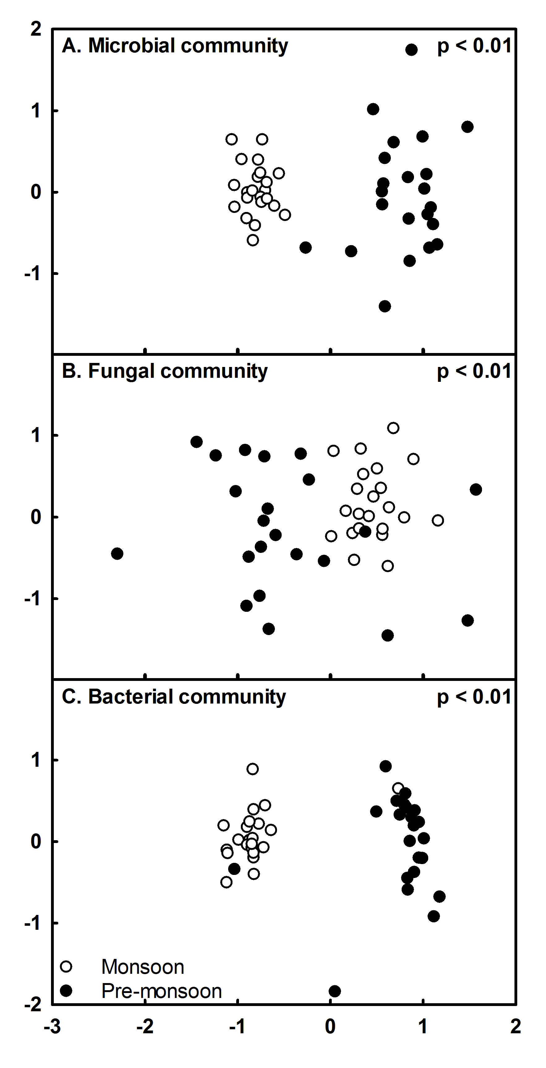
Figure 5. Microbial communities were compositionally distinct in the pre-monsoon and monsoon season. Non-metric multi-dimensional scaling demonstrates: A. total microbial (bacterial and fungal), B. fungal, and C. bacterial community composition in the pre-monsoon (black circles) and in the monsoon (white circles) of 2008. Each point represents a specific community either in the pre-monsoon or monsoon season. Points that are close together are more similar to one another than points that are far apart.

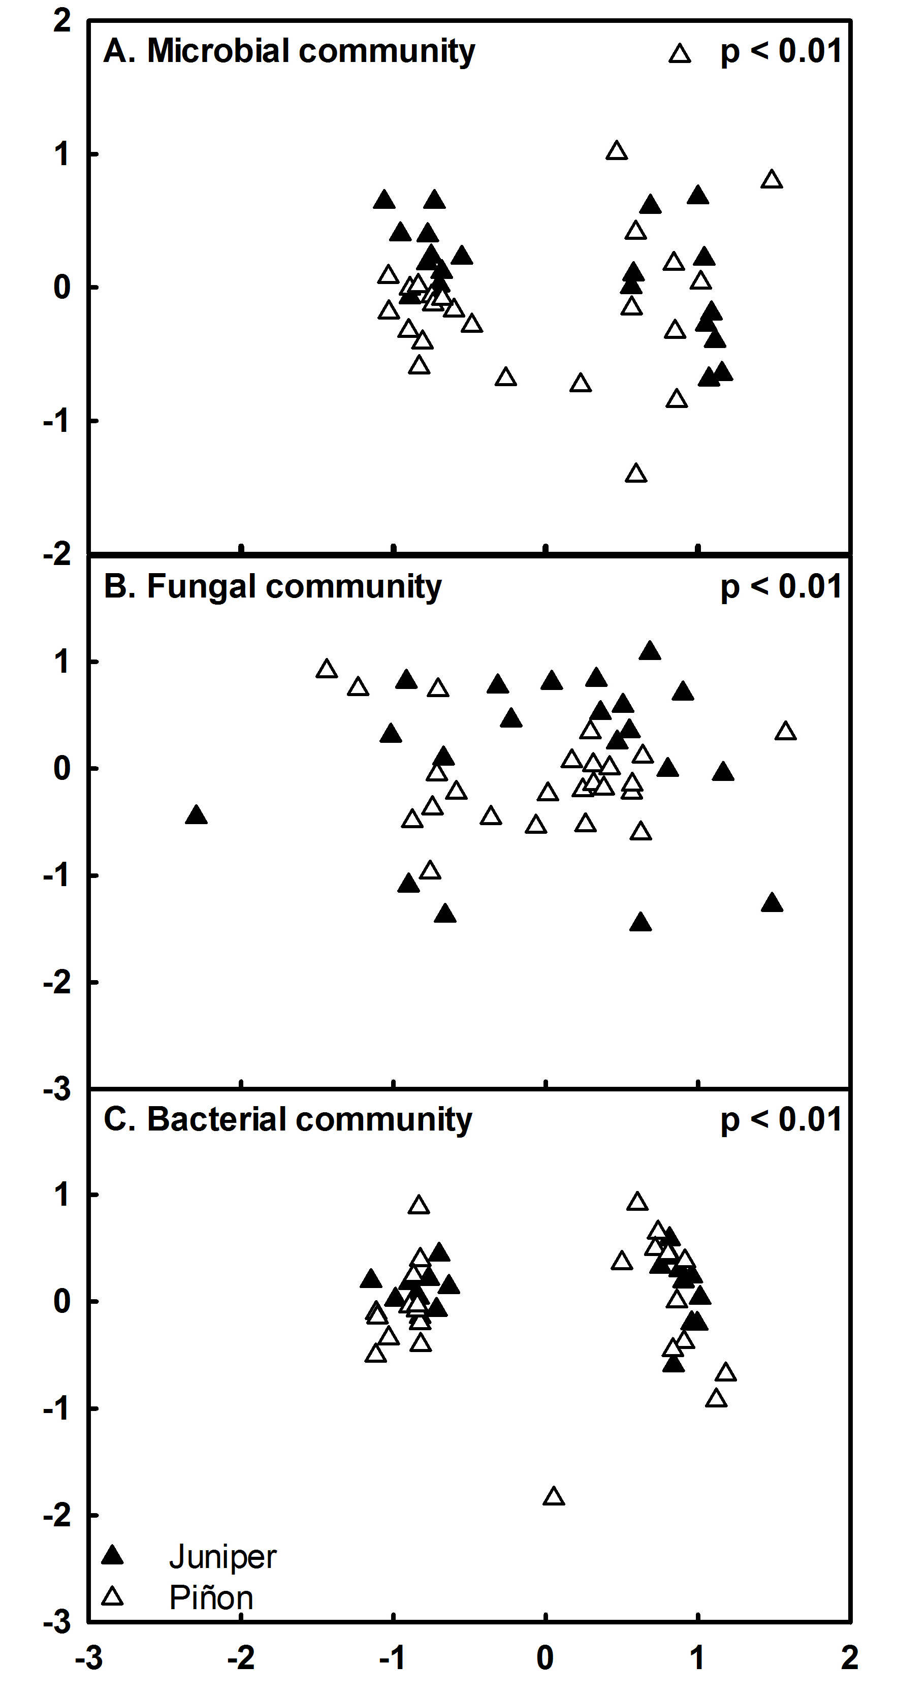
Figure 6. Microbial communities beneath piñon and juniper crowns were compositionally distinct from one another. Non-metric multi-dimensional scaling demonstrates A. total microbial (bacterial and fungal), B. fungal, and C. bacterial community composition beneath juniper (black triangles) and piñon (white triangles) in 2008. Each point represents a specific community beneath piñon or juniper crowns. Points that are close together are more similar to one another than points that are far apart.
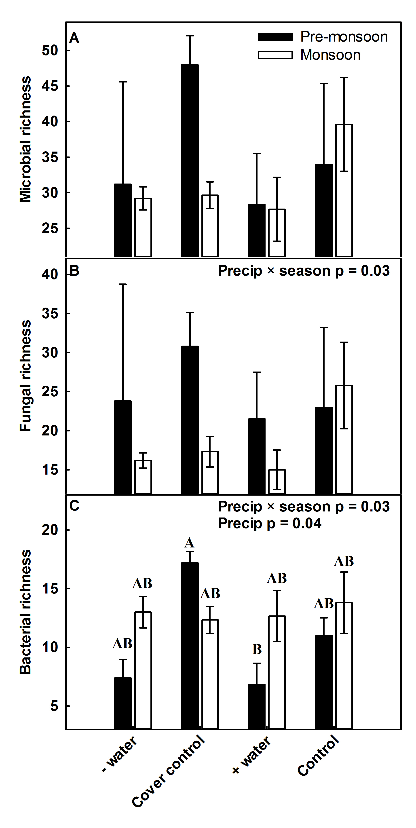
Figure 7. Seasonal variability in rainfall and our precipitation treatments interacted to alter: A. total microbial richness, B. fungal richness, and C. bacterial richness. Different letters denote the significant interactive differences.

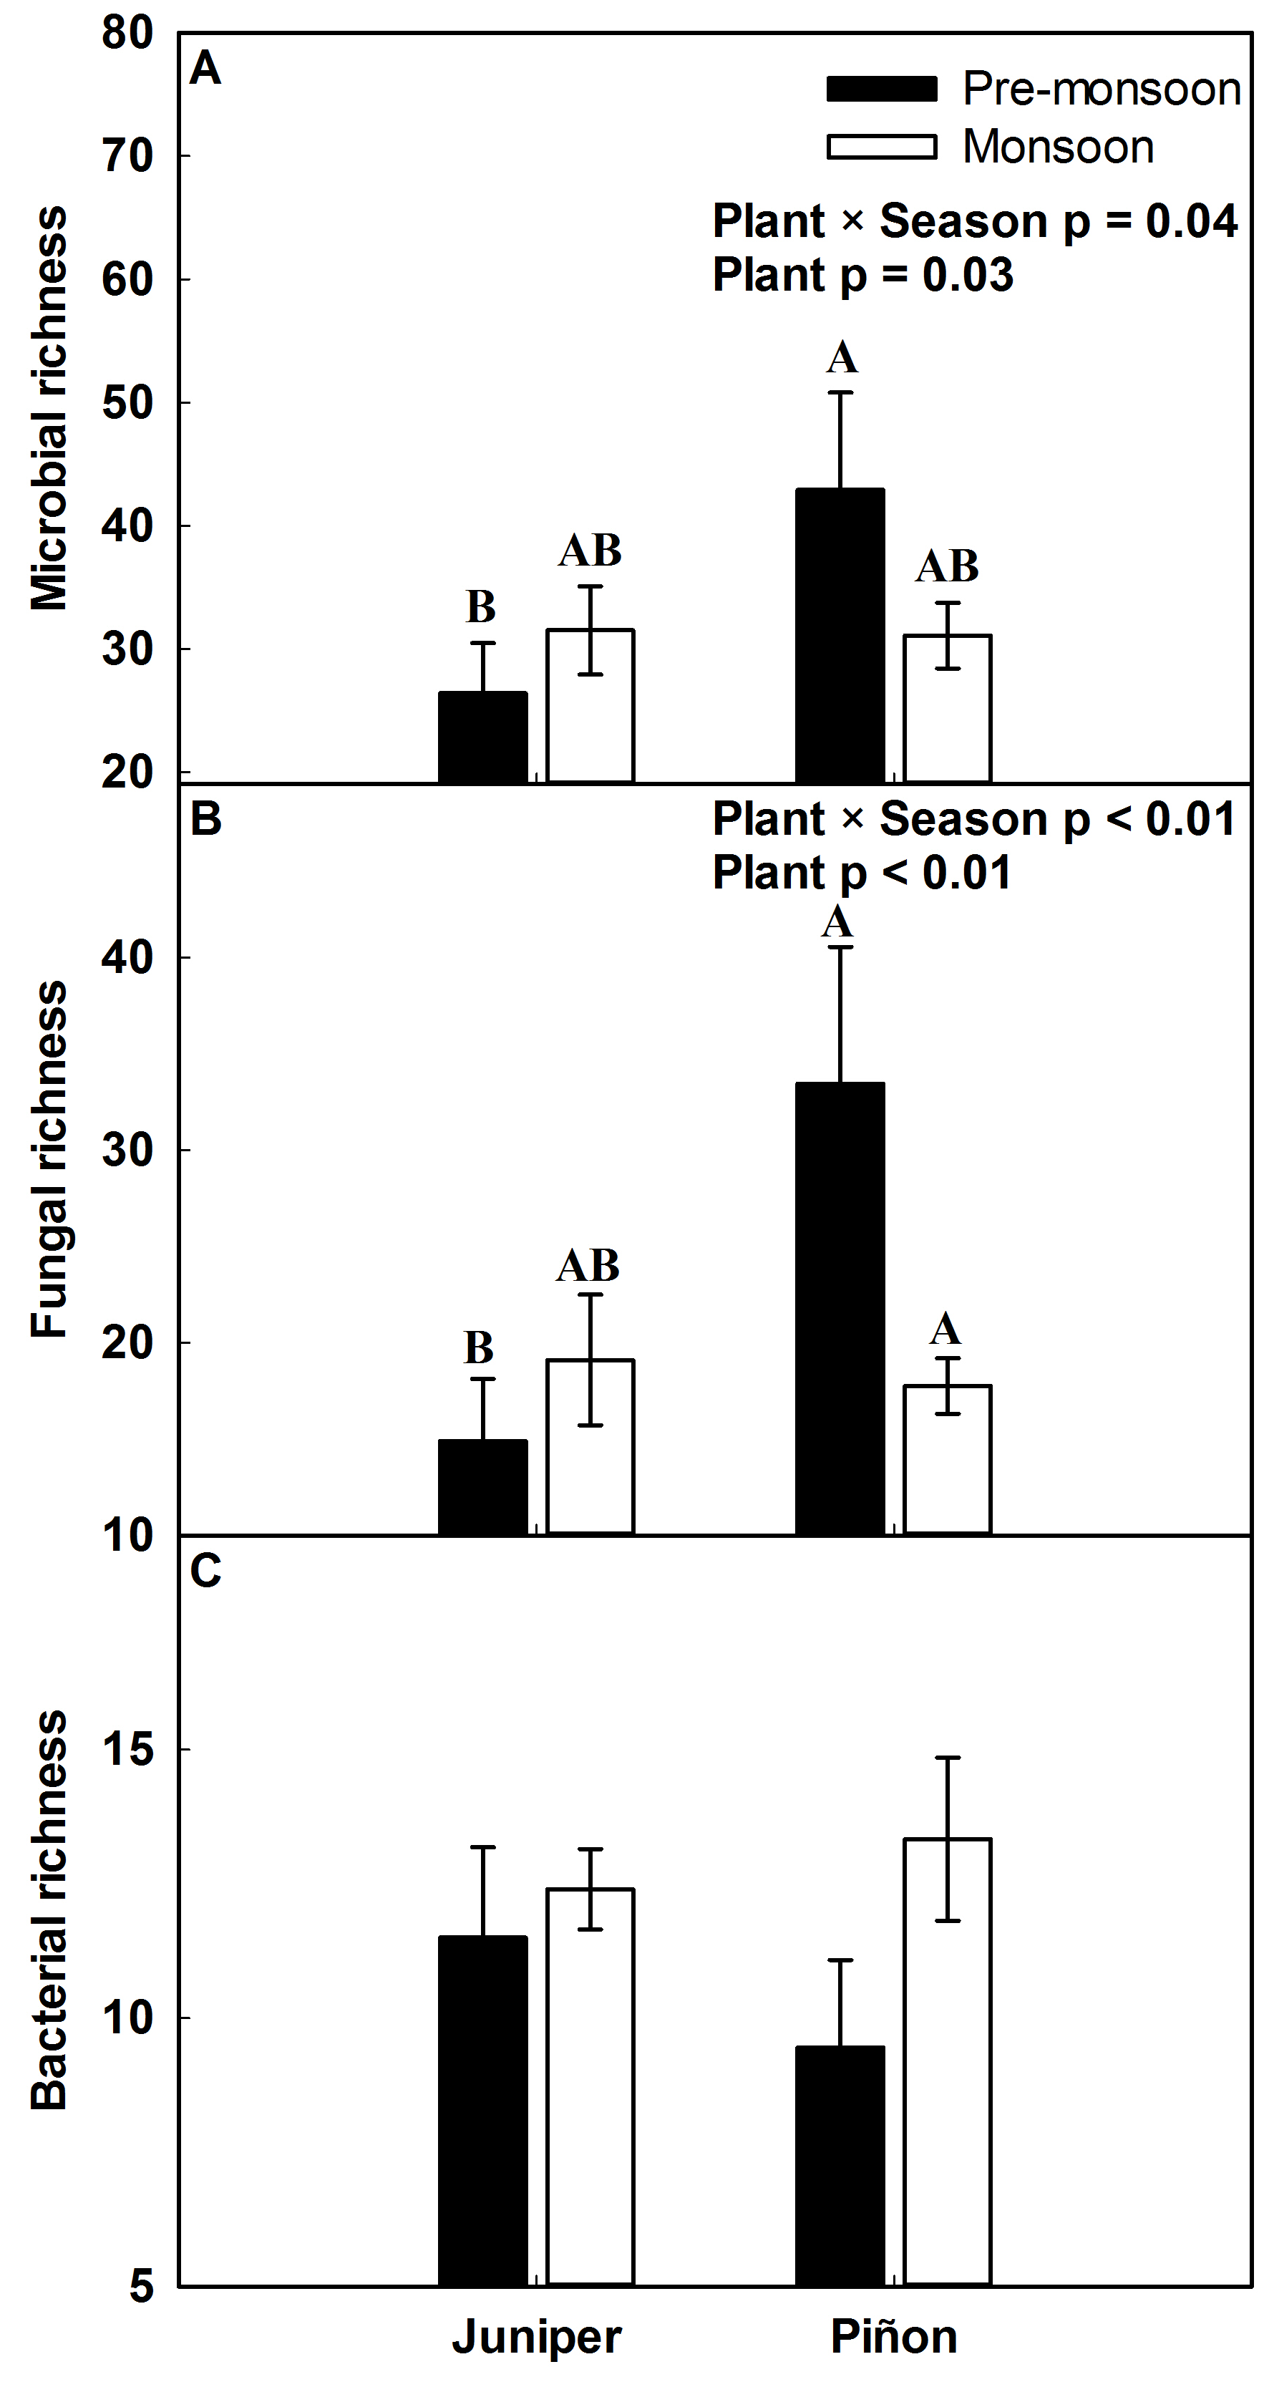
Figure 8. Season and tree type interacted to alter: A. total microbial richness, B. fungal richness, and C. bacterial richness. Different letters denote significant interactive differences.
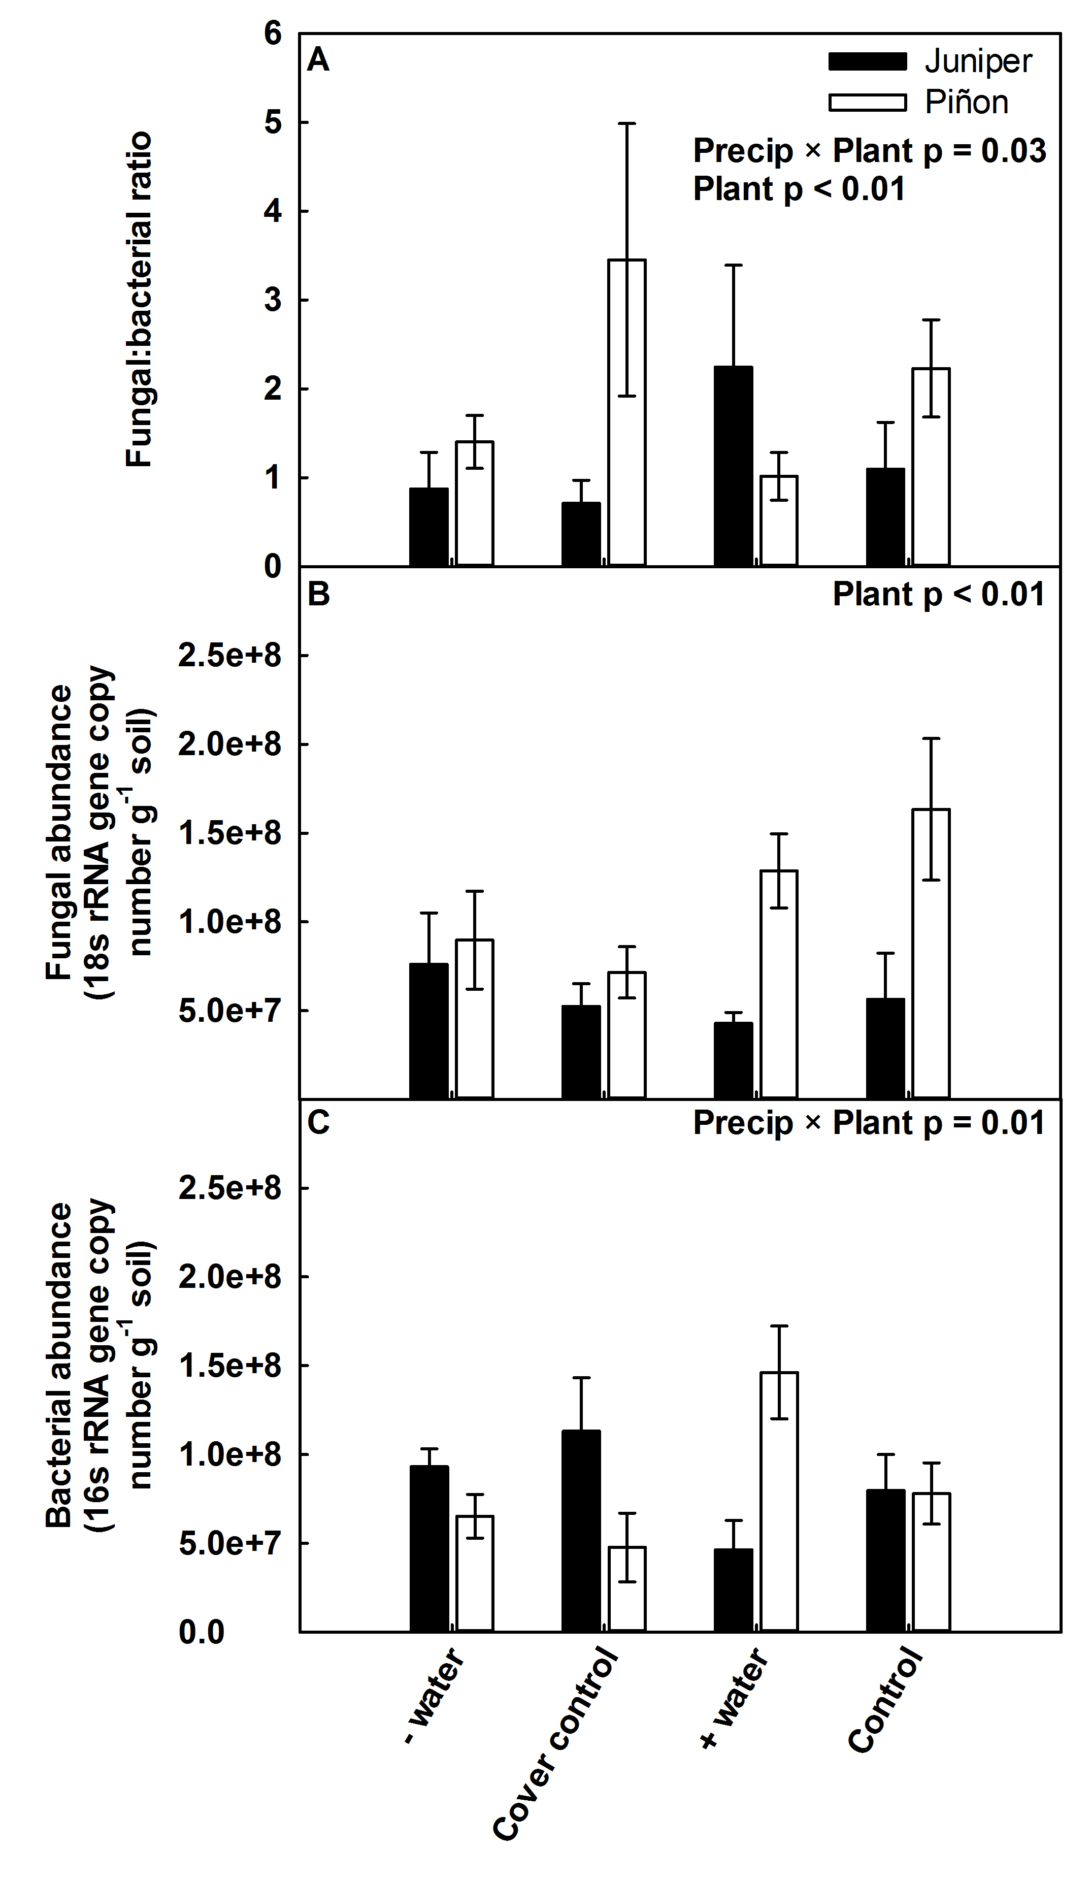
Figure 9. Precipitation treatment and tree type interacted to alter: A. fungal:bacterial ratio, B. fungal abundance, and C. bacterial abundance. Different letters denote significant interactive differences.

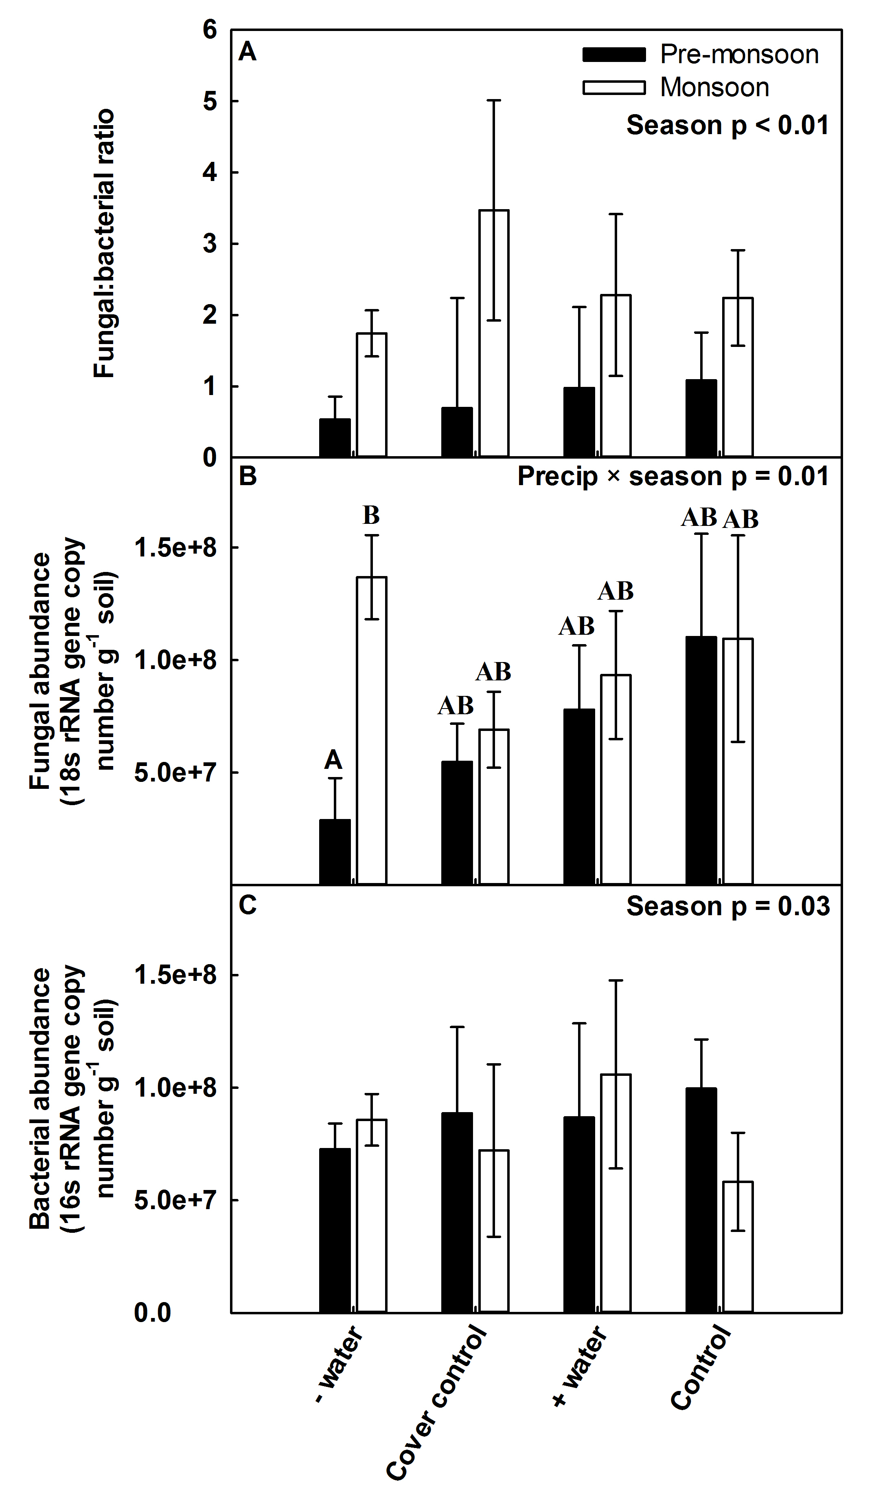
Figure 10. Season and precipitation treatment interacted to alter A. fungal:bacterial ratio, B. fungal abundance, and C. bacterial abundance. Different letters denote significant interactive differences.
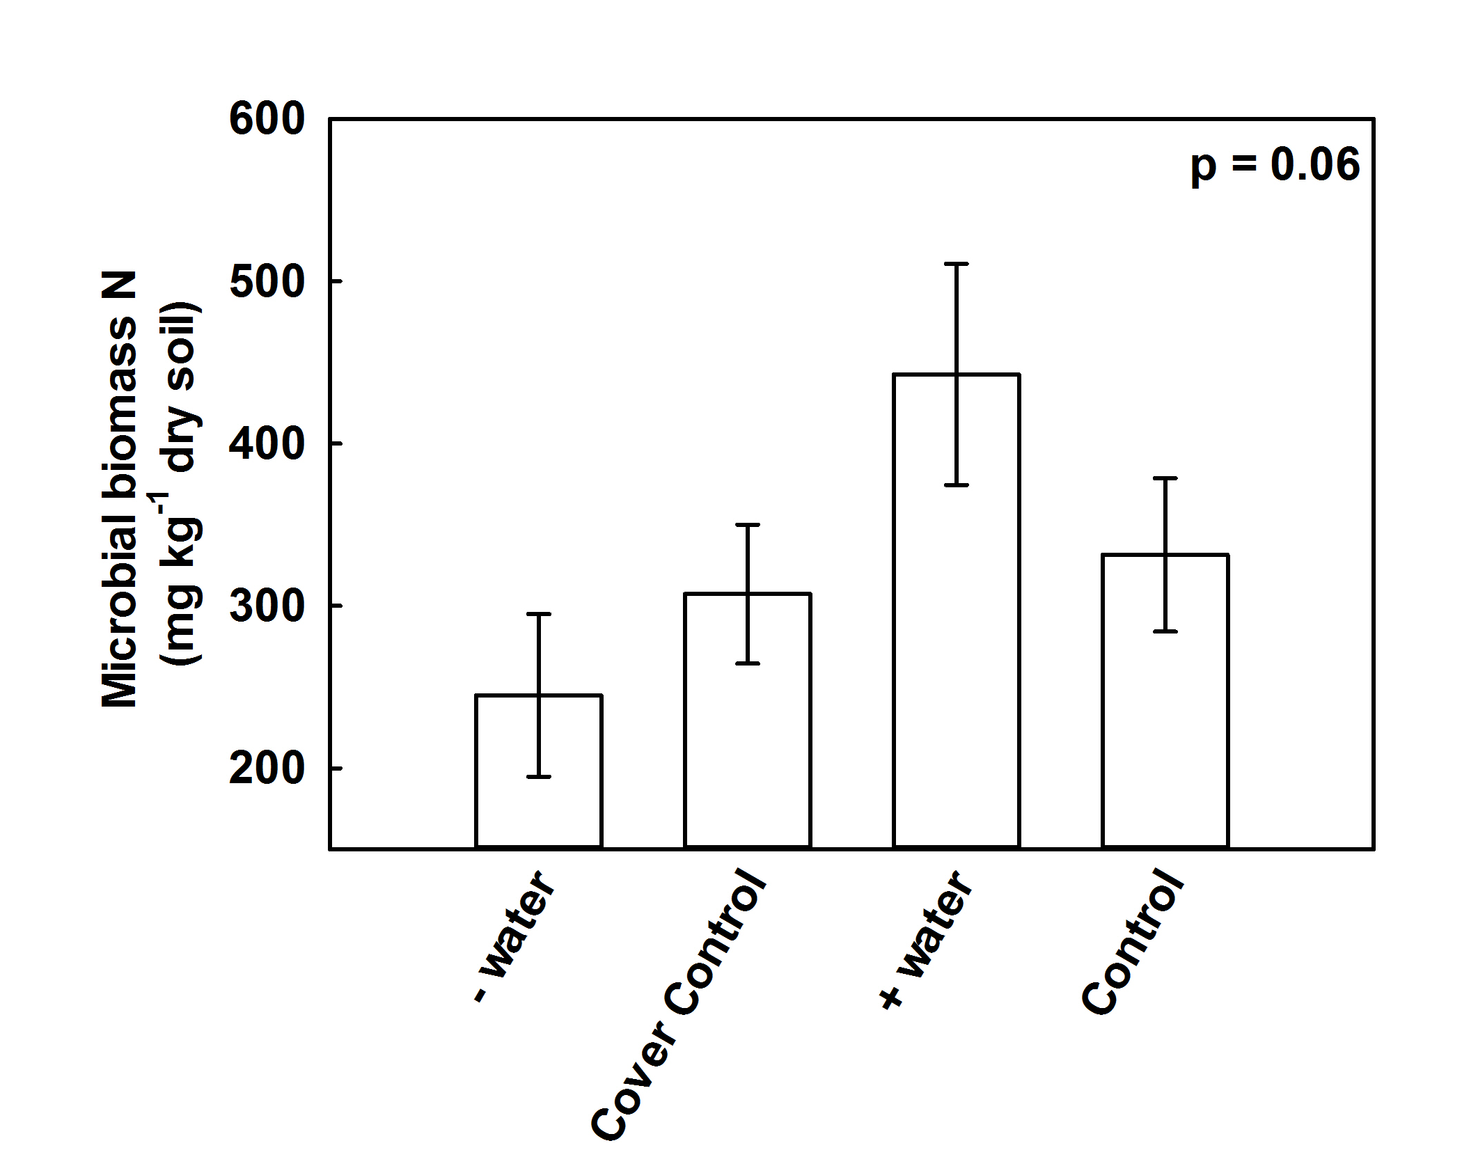
Figure 11. Precipitation treatment altered microbial biomass in the pre-monsoon season of 2009.

Discussion
Precipitation change due to global climate change can alter the composition and abundance of belowground microbial communities directly by changing soil water availability or indirectly by altering plant community composition, production, and allocation (Breshears et al. 2009, Clark et al. 2009, Castro et al. 2010, Gray et al. 2011). Consistent with this, we found that seasonal fluctuations in rainfall, precipitation treatments, and tree type interactively and independently altered microbial community composition, richness, and abundance. Long-term changes in microbial communities due to changes in precipitation or the plant community may have large implications for the future trajectory of this ecosystem with climate change and the functioning of this ecosystem.
Seasonal variation in rainfall may result in a microbial community seasonally acclimated to fluctuations in precipitation thus resulting in a diminished response to the precipitation manipulation (Fierer et al. 2003, Steenwerth et al. 2005, Evans and Wallenstein 2012). Consistent with this, we found that soil microbial community structure and abundance were more responsive to fluctuations in seasonal rainfall than to our relatively constant precipitation treatments. Throughout the year, the microbial community at this site is subjected to excessive drought followed by rapid changes in rainfall during the monsoon season (Greenland et al. 2003). This variability greatly exceeds that provided by our precipitation manipulation. For example, during the monsoon season of 2008, we added 57 mm of precipitation in the water addition plots. This addition is 3 × less than the precipitation received from June to the end of August in 2008 (Pangle et al. 2012). Other studies have demonstrated that when microbial communities are acclimated to multiple dry-wet episodes, their response (measured by microbial respiration or changes in community composition) is diminished with each repeated event, and the magnitude of this response is dependent upon precipitation history and the associated aboveground community (Fierer et al. 2003, Steenwerth et al. 2005). Unexpectedly, our results showed increased microbial richness in the cover control plots during the pre-monsoon season only. This result may be driven by changes in microclimate or the accumulation of water between cover control troughs in these plots. During the pre-monsoon season, when water is limiting and very little water was added to the water addition plots, the design of the cover controls might result in plots that have variable soil moisture levels. Soil beneath the troughs will have very low levels of soil water, while the soil in between the troughs will accumulate extra water during rare rain events due to runoff from the troughs themselves. This heterogeneous distribution of soil water may result in increases in gram-positive bacteria and soil fungi between the troughs (Vangestel et al. 1993, Schimel et al. 2007).
Biotic mechanisms, like competition, predation, and niche differentiation, may be relatively more important for the structure and abundance of soil microbial communities in semi-arid ecosystems when water is not limiting. Unexpectedly, soil fungal and bacterial abundance did not always increase with increasing water availability. Contrary to other studies, we found a significant decline in bacterial abundance in association with increasing water availability (Bell et al. 2008, Sheik et al. 2011). This shift in bacterial abundance may be driven by competitive interactions between soil fungi and soil bacteria, or predator-prey dynamics between soil microorganisms and soil protozoa or arthropods. As soil fungi increase with increasing water availability, they may exclude soil bacteria thus reducing their abundance (Mille-Lindblom et al. 2006). Alternatively, increases in soil protozoa or arthropods preying on bacteria may increase when water is no longer limiting resulting in a reduction in soil bacteria. Although we did not measure protozoa or arthropod abundance, other studies have shown that these organisms do indeed increase during periods of increased water availability (Clarholm 1981, Classen et al. 2006, Kardol et al. 2011) and may decrease bacterial abundance.
Given piñon are dying more quickly than juniper with drought events in this ecosystem (Plaut et al. 2012), differences in the microbial communities found in soils beneath their crowns could scale to alter the function of this ecosystem over time (Mueller et al. 2005, Breshears et al. 2009). Distinct fungal communities beneath piñon and juniper crowns with varying richness and abundance may be primarily attributed to their differences in mycorrhizal association; piñon associate with ecto-mycorrhizal (EM) fungi, while juniper associate with arbuscular mycorrhizal (AM) fungi (Haskins and Gehring 2004), although we did not test for this. As piñon die in this ecosystem due to drought, their associated fungal symbiont may also decline, decreasing the ability of piñon to re-establish in this ecosystem and aiding in the transition to a juniper dominated ecosystem. Further, differences between both bacterial and fungal communities beneath piñon and juniper crowns may indicate a difference in the function of these two communities (Cregger et al, in review). As piñon die with drought, a distinct microbial community may be lost from this ecosystem resulting in a functional shift.
When taken together, our results indicate that the response of microbial communities to climate change is complex and highly dependent upon the underlying seasonal variability and associated plant community. These changes have important effects on how we design microbial community assessments in such systems, as a one-time snap shot look at the microbial community to predict their response to climate change will not reflect the overall structure of these systems and their dynamic nature. Seasonal and temporal variation as well as plant community compositional changes will play a large role in the response of these communities and should be incorporated into future climate change experimental manipulations especially with advances in molecular techniques that allow higher throughput of community samples.

Acknowledgments
We thank Veronica Brown, Hector F. Castro, and Marilyn Kerley for their assistance optimizing the qPCR and TRFLP protocols. M. Cregger was supported by the Graduate Research for the Environment Fellowship sponsored by the Department of Energy Global Change Education Program and The University of Tennessee. The field experiment was funded by the Department of Energy’s Office of Science (BER) via awards to Nate McDowell and Will Pockman.
References
Angel, R., M. I. M. Soares, E. D. Ungar, and O. Gillor. 2010. Biogeography of soil archaea and bacteria along a steep precipitation gradient. Isme Journal 4:553-563.
Bardgett, R. D. 2005. The Biology of Soil: A Community and Ecosystem Approach. Oxford University Press, New York.
Bell, C., N. McIntyre, S. Cox, D. Tissue, and J. Zak. 2008. Soil microbial responses to temporal variations of moisture and temperature in a Chihuahuan Desert Grassland. Microbial Ecology 56:153-167.
Bellgard, S. E. and S. E. Williams. 2011. Response of mycorrhizal diversity to current climatic changes. Diversity 3:8-90.
Breshears, D. D., O. B. Myers, C. W. Meyer, F. J. Barnes, C. B. Zou, C. D. Allen, N. G. McDowell, and W. T. Pockman. 2009. Tree die-off in response to global change-type drought: mortality insights from a decade of plant water potential measurements. Frontiers in Ecology and the Environment 7:185-189.
Buyer, J. S., D. P. Roberts, and E. Russek-Cohen. 2002. Soil and plant effects on microbial community structure. Canadian Journal of Microbiology 48:955-964.
Castro, H. F., A. T. Classen, E. E. Austin, R. J. Norby, and C. W. Schadt. 2010. Soil Microbial Community Responses to Multiple Experimental Climate Change Drivers. Applied and Environmental Microbiology 76:999-1007.
Chapman, S. K., J. A. Langley, S. C. Hart, and G. W. Koch. 2006. Plants actively control nitrogen cycling: uncorking the microbial bottleneck. New Phytologist 169:27-34.
Clarholm, M. 1981. Protozoan Grazing of Bacteria in Soil - Impact and Importance. Microbial Ecology 7:343-350.
Clark, J., J. Campbell, H. Grizzle, V. Acosta-Martinez, and J. Zak. 2009. Soil Microbial Community Response to Drought and Precipitation Variability in the Chihuahuan Desert. Microbial Ecology 57:248-260.
Classen, A. T., J. DeMarco, S. C. Hart, T. G. Whitham, N. S. Cobb, and G. W. Koch. 2006. Impacts of herbivorous insects on decomposer communities during the early stages of primary succession in a semi-arid woodland. Soil Biology and Biochemistry 38:972-982.
Collins, S. L., R. L. Sinsabaugh, C. Crenshaw, L. Green, A. Porras-Alfaro, M. Stursova, and L. H. Zeglin. 2008. Pulse dynamics and microbial processes in aridland ecosystems. Journal of Ecology 96:413-420.
Cook, E. R., C. A. Woodhouse, C. M. Eakin, D. M. Meko, and D. W. Stahle. 2004. Long-term aridity changes in the western United States. Science 306:1015-1018.
Cruz-Martinez, K., K. B. Suttle, E. L. Brodie, M. E. Power, G. L. Andersen, and J. F. Banfield. 2009. Despite strong seasonal responses, soil microbial consortia are more resilient to long-term changes in rainfall than overlying grassland. Isme Journal 3:738-744.
Davidson, E. A., R. W. Eckert, S. C. Hart, and M. K. Firestone. 1989. Direct extraction of microbial biomass nitrogen from forest and grassland soils of California. Soil Biology and Biochemistry 21:773-779.
de Graaff, M. A., A. T. Classen, H. F. Castro, and C. W. Schadt. 2010. Labile soil carbon inputs mediate the soil microbial community composition and plant residue decomposition rates. New Phytologist 188:1055-1064.
Evans, S. E. and M. D. Wallenstein. 2012. Soil microbial community response to drying and rewetting stress: does historical precipitation regime matter? Biogeochemistry 109:101-116.
Fierer, N., J. P. Schimel, and P. A. Holden. 2003. Influence of drying-rewetting frequency on soil bacterial community structure. Microbial Ecology 45:63-71.
Gardes, M., and T. D. Bruns. 1993. Its Primers with Enhanced Specificity for Basidiomycetes - Application to the Identification of Mycorrhizae and Rusts. Molecular Ecology 2:113-118.
Gray, S. B., A. T. Classen, P. Kardol, Z. Yermakov, and R. M. Miller. 2011. Multiple Climate Change Factors Interact to Alter Soil Microbial Community Structure in an Old-Field Ecosystem. Soil Science Society of America Journal 75:2217-2226.
Greenland, D., D. G. Goodin, and R. C. Smith. 2003. Climate Variability and Ecosystem Response at Long-Term Ecological Research Sties. Oxford University Press, New York, New York.
Gregory, J. M., J. F. B. Mitchell, and A. J. Brady. 1997. Summer drought in northern midlatitudes in a time-dependent CO2 climate experiment. Journal of Climate 10:662-686.
Hanson, P. J., and J. F. Weltzin. 2000. Drought disturbance from climate change: response of United States forests. Science of the Total Environment 262:205-220.
Haskins, K. E., and C. A. Gehring. 2004. Interactions with juniper alter pinyon pine ectomycorrhizal fungal communities. Ecology 85:2687-2692.
Hauben, L., L. Vauterin, J. Swings, and E. R. B. Moore. 1997. Comparison of 16S ribosomal DNA sequences of all Xanthomonas species. International Journal of Systematic Bacteriology 47:328-335.
Haubensak, K. A., S. C. Hart, and J. M. Stark. 2002. Influences of chloroform exposure time and soil water content on C and N release in forest soils. Soil Biology and Biochemistry 34:1549-1562.
Hawkes, C. V., S. N. Kivlin, J. D. Rocca, V. Huguet, M. A. Thomsen, and K. B. Suttle. 2011. Fungal community responses to precipitation. Global Change Biology 17:1637-1645.
Hobbie, S. E. 1992. Effects of plant species on nutrient cycling. Trends in Ecology and Evolution 7:336-339.
Hullar, M. A. J., L. A. Kaplan, and D. A. Stahl. 2006. Recurring seasonal dynamics of microbial communities in stream habitats. Applied and Environmental Microbiology 72:713-722.
Kardol, P., M. A. Cregger, C. E. Campany, and A. T. Classen. 2010. Soil ecosystem functioning under climate change: plant species and community effects. Ecology 91:767-781.
Kardol, P., W. N. Reynolds, R. J. Norby, and A. T. Classen. 2011. Climate change effects on soil microarthropod abundance and community structure. Applied Soil Ecology 47:37-44.
Knapp, A. K., C. Beier, D. D. Briske, A. T. Classen, Y. Luo, M. Reichstein, M. D. Smith, S. D. Smith, J. E. Bell, P. A. Fay, J. L. Heisler, S. W. Leavitt, R. Sherry, B. Smith, and E. Weng. 2008. Consequences of More Extreme Precipitation Regimes for Terrestrial Ecosystems. Bioscience 58:811-821.
Lipson, D. A., and S. K. Schmidt. 2004. Seasonal changes in an alpine soil bacterial community in the Colorado Rocky Mountains. Applied and Environmental Microbiology 70:2867-2879.
Luo, Y. Q., J. Melillo, S. L. Niu, C. Beier, J. S. Clark, A. T. Classen, E. Davidson, J. S. Dukes, R. D. Evans, C. B. Field, C. I. Czimczik, M. Keller, B. A. Kimball, L. M. Kueppers, R. J. Norby, S. L. Pelini, E. Pendall, E. Rastetter, J. Six, M. Smith, M. G. Tjoelker, and M. S. Torn. 2011. Coordinated approaches to quantify long-term ecosystem dynamics in response to global change. Global Change Biology 17:843-854.
Marchesi, J. R., T. Sato, A. J. Weightman, T. A. Martin, J. C. Fry, S. J. Hiom, D. Dymock, and W. G. Wade. 1998. Design and evaluation of useful bacterium-specific PCR primers that amplify genes coding for bacterial 16S rRNA. Applied and Environmental Microbiology 64:2333-2333.
Matthes, F. C. 2008. Climate change 2007. The physical science basis, impacts, adaptation and vulnerability mitigation of climate change. Internationale Politik 63:130-132.
Mille-Lindblom, C., H. Fischer, and L. J. Tranvik. 2006. Antagonism between bacteria and fungi: substrate competition and a possible tradeoff between fungal growth and tolerance towards bacteria. Oikos 113:233-242.
Mitchell, R. J., C. D. Campbell, S. J. Chapman, and C. M. Cameron. 2010. The ecological engineering impact of a single tree species on the soil microbial community. Journal of Ecology 98:50-61.
Mueller, R. C., C. M. Scudder, M. E. Porter, R. T. Trotter, C. A. Gehring, and T. G. Whitham. 2005. Differential tree mortality in response to severe drought: evidence for long-term vegetation shifts. Journal of Ecology 93:1085-1093.
Nazih, N., O. Finlay-Moore, P. G. Hartel, and J. J. Fuhrmann. 2001. Whole soil fatty acid methyl ester (FAME) profiles of early soybean rhizosphere as affected by temperature and matric water potential. Soil Biology and Biochemistry 33:693-696.
Pan, Y. D., J. M. Melillo, A. D. McGuire, D. W. Kicklighter, L. F. Pitelka, K. Hibbard, L. L. Pierce, S. W. Running, D. S. Ojima, W. J. Parton, and D. S. Schimel. 1998. Modeled responses of terrestrial ecosystems to elevated atmospheric CO2: a comparison of simulations by the biogeochemistry models of the Vegetation/Ecosystem Modeling and Analysis Project (VEMAP). Oecologia 114:389-404.
Pangle, R. E., J. P. Hill, J. A. Plaut, E. A. Yepez, J. R. Elliott, N. Gehres, N. G. McDowell, and W. T. Pockman. 2012. Methodology and performance of a rainfall manipulation experiment in a piñon-juniper woodland. Ecosphere.
Plaut, J. A., E. A. Yepez, J. P. Hill, R. E. Pangle, J. S. Sperry, W. T. Pockman, and N. G. McDowell. 2012. Hydraulic limits on water use under experimental drought in a piñon-juniper woodland. Plant Cell Environment.
Rajeevan, M. S., D. G. Ranamukhaarachchi, S. D. Vernon, and E. R. Unger. 2001. Use of real-time quantitative PCR to validate the results of cDNA array and differential display PCR technologies. Methods 25:443-451.
Rosenberg, N. J., R. A. Brown, R. C. Izaurralde, and A. M. Thomson. 2003. Integrated assessment of Hadley Centre (HadCM2) climate change projections on agricultural productivity and irrigation water supply in the conterminous United States - I. Climate change scenarios and impacts on irrigation water supply simulated with the HUMUS model. Agricultural and Forest Meteorology 117:73-96.
Sala, O. E., Robert B. Jackson, Harold A. Mooney, and Robert W. Howarth. 2000. Methods in Ecosystem Science. Springer-Verlag New York, Inc, New York.
Schadt, C. W., A. P. Martin, D. A. Lipson, and S. K. Schmidt. 2003. Seasonal dynamics of previously unknown fungal lineages in tundra soils. Science 301:1359-1361.
Schimel, J., T. C. Balser, and M. Wallenstein. 2007. Microbial stress-response physiology and its implications for ecosystem function. Ecology 88:1386-1394.
Schwinning, S. and O. E. Sala. 2004. Hierarchy of responses to resource pulses in and and semi-arid ecosystems. Oecologia 141:211-220.
Sheik, C. S., W. H. Beasley, M. S. Elshahed, X. H. Zhou, Y. Q. Luo, and L. R. Krumholz. 2011. Effect of warming and drought on grassland microbial communities. Isme Journal 5:1692-1700.
Singh, B. K., L. Nazaries, S. Munro, I. C. Anderson, and C. D. Campbell. 2006. Use of multiplex terminal restriction fragment length polymorphism for rapid and simultaneous analysis of different components of the soil microbial community. Applied and Environmental Microbiology 72:7278-7285.
Steenwerth, K. L., L. E. Jackson, F. J. Calderon, K. M. Scow, and D. E. Rolston. 2005. Response of microbial community composition and activity in agricultural and grassland soils after a simulated rainfall. Soil Biology and Biochemistry 37:2249-2262.
Strickland, M. S. and J. Rousk. 2010. Considering fungal:bacterial dominance in soils - Methods, controls, and ecosystem implications. Soil Biology and Biochemistry 42:1385-1395.
Uhlirova, E., D. Elhottova, J. Triska, and H. Santruckova. 2005. Physiology and microbial community structure in soil at extreme water content. Folia Microbiologica 50:161-166.
Waldrop, M. P., and M. K. Firestone. 2006. Seasonal dynamics of microbial community composition and function in oak canopy and open grassland soils. Microbial Ecology 52:470-479.
Williams, M. A., and C. W. Rice. 2007. Seven years of enhanced water availability influences the physiological, structural, and functional attributes of a soil microbial community. Applied Soil Ecology 35:535-545.
Zak, D. R., W. E. Holmes, D. C. White, A. D. Peacock, and D. Tilman. 2003. Plant diversity, soil microbial communities, and ecosystem function: Are there any links? Ecology 84:2042-2050.

Chapter 2.
The response of soil nitrogen cycling, litter biomass, and microbial community function to precipitation change

Abstract
Atmospheric and climatic change is altering ecosystem structure and function, especially in the semi-arid southwestern United States where trees are near their physiological water stress threshold. Climate driven shifts in plant community composition may lead to alterations in soil processes and atmospheric feedbacks. In the southwestern U.S., prolonged drought is causing differential mortality of piñon pine in piñon-juniper woodlands resulting in an ecosystem that is juniper dominated. Using a large-scale precipitation manipulation, with increases and decreases, we assessed how changes in precipitation altered litter biomass accumulation, soil nitrogen cycling, and microbial functional capacity for nitrification beneath piñon and juniper trees in a piñon-juniper woodland from 2007-2011. We hypothesized that there would be an effect of precipitation on biomass accumulation, nitrogen cycling, and microbial functional capacity that would vary by associations with plant species. Because piñon are thought to be less drought resistant than juniper, we predicted that processes and communities beneath piñon would be more responsive to changes in precipitation than beneath juniper. Surprisingly, we found no difference in litter biomass inputs among our treatments or beneath piñon and juniper. Over the four years measured, there was twice as much available nitrate in drought plots relative to water addition plots, and a decrease in soil potential mineralization in drought plots relative to the water addition plots. However, there were no large differences between the precipitation treatments and the unmanipulated control plots. Piñon and juniper also differ beneath their crowns; we found higher levels of available soil nitrate beneath piñon relative to juniper across the four years measured and increased soil potential nitrification rates. These shifts in soil nitrogen cycling do not appear to be from changes in the abundance of microbes involved in nitrification, but instead may be driven by decreases in plant uptake of nitrogen. We speculate that the loss of piñon from this ecosystem may have dramatic long-term effects on nitrogen cycling.

Introduction
Climate models predict that the frequency and severity of drought will increase globally over the next century (Seager et al. 2007, Allison 2009). Increased droughts are expected to have a large impact on ecosystems in the southwestern United States (Gregory et al. 1997, Pan et al. 1998, Hanson and Weltzin 2000, Rosenberg et al. 2003, Cook et al. 2004), a region dominated by piñon-juniper (PJ) woodlands, which cover >17 million hectares (Mueller et al. 2005, Shaw et al. 2005). The southwestern United States has experienced extreme drought events in recent years, which have resulted in high mortality rates for piñon pines (Pinus edulis), reaching 100% in some areas (Breshears et al. 2005, Shaw et al. 2005). These drought-associated mortality events in piñon-juniper woodlands led to a shift in plant community composition resulting in the mixed piñon-juniper woodlands becoming increasingly dominated by the more drought-resistant juniper (Juniperus monosperma; Mueller et al. 2005, Gitlin et al. 2006, Sthultz et al. 2009). Changes in precipitation amounts and distribution, as well as associated shifts in plant community composition may lead to significant shifts in plant productivity and nutrient cycling in this ecosystem (Padien and Lajtha 1992). Further, alterations in nutrient cycling may feedback to interact with decreased water availability on plant re-establishment in this ecosystem following mortality events.
Precipitation directly alters nitrogen cycling in a number of ways via its impact on soil water availability. For example, shifts in the distribution of rainfall might lead to large leaching and runoff events (Nearing et al. 2005), which could lead to increased nutrient loss and decreased nutrient retention. Recent research demonstrated that nitrate might be more readily leached down the soil profile in arid ecosystems than previously thought. For example, Walvoord et al. (2003) found that nitrogen may accumulate at depth beneath the reaches of plant roots during occasional deep wetting events resulting in accumulation of nitrate over thousands of years. In addition, increases in precipitation can increase the frequency of runoff events. This additional runoff water can absorb nutrients and redistribute them among tree types and from the intercrown space to intercrown vegetated areas (Wilcox 1994, Reid et al. 1999). Due to microtopography and other surface features, areas beneath tree crowns tend to not collect runoff water or sediment. Most runoff water flows away from the tree canopies and into the intercanopy vegetated areas leading to nutrient loss beneath tree crowns during periods of intense rainfall.
Increases and decreases in precipitation can alter nitrogen cycling by influencing plant nutrient uptake as well as plant productivity. In ecosystems that are limited by soil moisture, when precipitation and soil water availability increase, plant nutrient uptake from the soil and overall plant productivity resulting in a decrease in soil nutrient availability (Stark and Firestone 1995, Austin 2002, Knapp et al. 2008). However, during periods of extreme drought, nitrogen may accumulate in the active soil zone due to decreased plant transpiration and slower rates of microbial activity and turnover as well as decreased water and nutrient uptake (Stark and Firestone 1995, Weltzin et al. 2003). Additionally, piñon and juniper vary in their hydraulic mechanisms in response to drought; piñon are isohydric while juniper are anisohydric. This physiological difference in hydraulic mechanism may influence transpiration (Breshears et al. 2009) and nutrient uptake resulting in increases in available nitrogen beneath piñon but not juniper crowns due to the inability of piñon to uptake water during severe drought.
Changes in precipitation can also induce shifts in the structure of plant communities (Zak et al. 2003, Breshears et al. 2005, Mueller et al. 2005, Allen 2010, Kardol et al. 2010) that may alter ecosystem nutrient cycling (Hobbie 1992, Mitchell et al. 2010, Knapp et al. 2008). Changes in plant composition may have a larger impact on nutrient cycling in areas of low species diversity where shifts in a single species may cause significant shifts in input quantity or quality (Schlesinger et al. 1996, Murphy et al. 1998, Rodriguez et al. 2011). In many arid and semi-arid ecosystems such as piñon-juniper woodlands, plants form islands of fertility that result in a patchy distribution of vegetation and a heterogeneous distribution of soil water and nutrients on the landscape (Austin et al. 2004). If large-scale mortality of a species occurs in these ecosystems the distribution of nutrients on the landscape could be altered. For example, during periods of drought, water stressed piñon and juniper drop their needles, which increases litter biomass accumulation beneath their crowns (Chapman 2003). This accumulation of litter biomass may result in increased available nitrogen at a time when plants are unable to take up this limiting resource (Classen et al. 2007a, Austin and Vitousek 1998).
Nitrogen cycling is highly dependent on the microbial community actively decomposing organic matter (Schlesinger et al. 1996). In dry areas where nutrient cycling processes and the microbes that regulate them are often water limited (Sala et al. 1988), soil microbial communities respond to rain pulses by increasing their activity and rapidly immobilizing nutrients (Schimel et al. 2007, Xiang et al. 2008). When droughts occur, soil microbial communities may mineralize nitrogen, although depending on the severity of the drought this may not translate into increases in plant uptake, resulting in increases in nitrogen availability (Kreuzwieser and Gessler 2010). Previous work in piñon-juniper woodlands found that water availability may regulate decomposition processes and soil microbial activity to a greater extent than changes in temperature or litter quality (Classen et al. 2006, Classen et al. 2007a, Classen et al. 2007b, Murphy et al. 1998) suggesting that even small changes in precipitation may have a disproportionate impact on nutrient cycling in these ecosystems over time.
To better understand how precipitation change will alter litter inputs, nutrient cycling, and microbial function in a semi-arid woodland, we measured litterfall biomass, soil nitrogen availability, soil nitrogen mineralization, and the functional capacity of the microbial community involved in nitrification in a large-scale precipitation manipulation located at the Sevilleta Long Term Ecological Research Site (LTER) in New Mexico, USA from 2007-2011. Plots at this site have precipitation added (+ 20%), precipitation removed (- 50%), as well as an unmanipulated area and a removal control site, which assesses the impacts of the removal troughs. Because moisture tends to regulate decomposition and nutrient cycling in these ecosystems and piñon experience needle loss and death during drought, we hypothesized that: (1) nitrogen availability and net-nitrogen mineralization would be higher in drought treatments relative to ambient and water addition treatments; (2) the effects of drought on nitrogen cycling would vary in areas that vary by plant species. We expected increases in both nitrogen availability and nitrogen mineralization beneath piñon areas relative to juniper areas in the drought plots due to increases in piñon mortality and piñon needle litterfall, leading to an increase in microbial nitrification (indicated by the abundance of the amoA gene). We also predicted that piñon areas, relative to juniper areas, would be more responsive to the water addition plots because pinyon overall are thought to be more water stressed in this ecosystem.

Methods
Site Description: To assess how precipitation change altered nitrogen cycling, precipitation was manipulated at the Sevilleta National Wildlife Refuge long-term ecological research (LTER) site in central New Mexico (32° 20’ N, 106° 50’ W) (Greenland 2003). The precipitation manipulation was implemented across natural PJ woodlands (≈25 hectares) at 1911 m elevation in the Los Piños Mountains. Climate records (20-yr) from the Sevilleta LTER meteorological station (Cerro Montoso #42; http://sev.lternet.edu/) reported a mean annual air temperature of 13 °C and mean annual precipitation of 368 mm. On average, the greatest period of precipitation at the site occurs during the monsoon months of July, August, and September. The monsoon precipitation accounts for over half of all annual precipitation inputs; but high evapotranspiration rates in piñon-juniper woodlands prevent summer moisture from recharging soil moisture to depth (Greenland 2003). The study area is dominated by extensive stands of intermixed piñon (Pinus edulis) and juniper (Juniperus monosperma).
In 2007, we established 3 experimental plots (1600 m²) in each of the decreased precipitation treatment (~50% reduction), the precipitation-removal control treatment (cover control), the increased precipitation treatment (~20%), and an unamended plot (12 plots total). Precipitation was reduced in the decreased precipitation treatment using a throughfall displacement design (Pangle et al. 2012, Sala 2000). Troughs were constructed of clear UV-coated acrylic sheets and installed in each drought plot at a height of approximately 1 m. The cover control treatments were constructed by inverting the troughs and were instituted to control for possible unintended impacts of the troughs. The elevated precipitation treatments were created using water sprinklers. The sprinklers were tested in October of 2007 and 2 mm supplemental water was added. In 2008, 57 mm of precipitation was added to each of the treatment plots, 69.5 mm was added in 2009, 112 mm was added in 2010, and 107 mm was added in 2011 (Appendix 2). The ambient treatment plots were unmanipulated but located within the experimental plot matrix. These plots serve as unamended reference plots for the study.

Litter biomass collection: To assess whether our precipitation treatments altered litter biomass inputs of both piñon and juniper, we measured litterfall biomass beneath piñon and juniper in each of our experimental plots. Rectangular litter traps (32.5 cm × 41.5 cm) were randomly installed beneath the crowns of three piñon and the crowns of three juniper in each treatment on June 21, 2007 (six traps per plot). Litterfall was collected from individual traps yearly from 2007 to 2008, and again from January of 2009 to January of 2010. Collected litter was air-dried, sorted to remove non-needle and leaf debris, dried to a constant mass in a drying oven, and weighed. Litter data were averaged for each individual piñon and each individual juniper within each plot across each year in order to estimate litterfall biomass. Litterfall data are reported as g dry mass m⁻² year⁻¹.

Soil collection: To explore how changes in precipitation were altering the nitrogen cycle and soil microbial communities, in June of 2008 we randomly collected three soil cores (5 cm diameter, 0 - 10 cm depth) beneath five piñon and five juniper crowns within each treatment plot using a hammer core. A subsample from each individual tree was immediately flash frozen in liquid nitrogen for subsequent molecular analyses. The remaining collected soil was bulked within plant species for each plot (so each plot had a bulked piñon sample and a bulked juniper sample), and homogenized. The soil was kept cool until it was returned to the laboratory, sieved to 2 mm, and analyzed as described below.
Nitrogen cycling: Changes in precipitation can differentially alter components of the nitrogen cycle, thus we measured changes in nitrogen availability, potential nitrogen mineralization, and net-nitrogen mineralization beneath piñon and juniper in each of our treatments. During the growing season of 2008, 2009 and 2011 we assessed nitrogen availability (nitrate and ammonium) using plant root simulator (PRS) probes (Western Ag Innovations, Inc, Saskatoon, Saskatchewan, Canada). PRS probes were employed due to their ability to measure plant available nitrogen over time, their ease of use, and their cost effectiveness (Qian an Schoenau, 2002). Because season might play a role, the first and last year of availability data assessed ammonium and nitrate availability across the peak of the growing season, while in 2009 we quantified seasonal changes (pre-monsoon, monsoon, and post-monsoon). We placed probes randomly beneath the crowns of five piñon and five juniper in each of the treatment plots (n = 3). Each tree had eight PRS probes located randomly (0-10 cm depth) beneath the drip line of the tree. Four probes assessed ammonium (NH₄⁺) and four assessed nitrate (NO₃⁻) availability. In 2008, the PRS probes were deployed on June 23rd and collected after 6-weeks of incubation. In July of 2011, PRS probes were again deployed and incubated for seven weeks in the field. Upon collection, PRS probes were washed with DI water and returned to Western Ag Innovations, Inc where they were analyzed for NH₄⁺ using a reaction of ammonia, sodium salicylate, sodium nitroprusside and sodium hypochlorite in a buffered alkaline medium at pH 12.3-13 to produce a measurable green color, and NO₃⁻ using a colorimetric reaction with a copper cadmium column reactor.
In 2009, we deployed PRS probes again for six-week incubations, but this time we assessed changes in availability pre- (June 5 – July 22), during (July 22 – September 15), and post- (September 15 - October 27) monsoon season. Probes in 2009 were placed and analyzed as described above. The 4 replicate probes per tree and ammonium and nitrate values for each replicate tree were averaged across each plot prior to statistical analysis. Because nutrient supply rates are not linear over time, all data are shown as available NH₄⁺ or NO₃⁻ in µg per membrane area over the incubation period.

Potential net nitrogen mineralization: Changes in precipitation can alter nitrogen cycling by changing inputs to the soil or by changing the microclimate (e.g., water available) for the microbial community. To tease this apart we measured potential net nitrogen mineralization, which removes the influence of environmental temperature and precipitation by incubating the soils under ideal temperature and moisture in the laboratory. To assess potential ammonification and nitrification rates, a 60-day laboratory incubation was established. Bulked field soils taken beneath piñon pine and juniper across all treatments were brought up to field capacity and subsamples (~20 g) were incubated in mason jars over 60 days (Robertson 1999). Each jar contained two subsamples (one removed after 30 days, one removed after 60 days) and each jar contained a standard amount of deionized water to maintain humidity. Samples were removed and jars were flushed with air every seven days over the course of the incubation to reduce CO₂ buildup from microbial activity. Subsamples were extracted with 2 M KCl immediately and then after 30 and 60 days of incubation. Ammonium and nitrate concentrations were analyzed using a Lachat flow ion analyzer (Lachat Instruments, Loveland, CO). The difference in inorganic nitrogen pools in the incubated soil minus initial soil pools were used to estimate rates of potential nitrogen transformations over the incubation period (Robertson et al. 1999). Data are shown on an oven-dry mass basis.

Net nitrogen mineralization: We were also interested in exploring how shifts in precipitation altered net rates of nitrogen mineralization. Because net nitrification cores are incubated in situ, net rates of mineralization incorporate environmental variability into measures of the nitrogen cycle (Roberston et al. 1999, Stark 2000). Measuring net and potential rates of nitrogen mineralization enabled us to explore potential mechanisms for shifts in the nitrogen cycle. Net mineralization and net nitrification rates were measured in an in situ field soil incubation using the resin-core method over the growing season (May – October) in 2009. Paired soil cores (0 - 15 cm) were randomly taken beneath the crowns of piñon and juniper. One core of each pair was returned to the laboratory for gravimetric water content and inorganic nitrogen analyses. The other core was incubated in a PVC pipe with an ion exchange resin bag placed at the bottom to collect inorganic N leached from the core (Binkley 1989, Robertson et al. 1999, Stark 2000). Atmospheric nitrogen inputs to these ecosystems are very low (Klopatek 1987, Classen et al. unpublished data), thus we did not put resin on the top of the cores. Additionally, because we were interested in how changes in precipitation might influence net N mineralization, we chose the open resin core technique and not the closed core technique (Adams and Attiwill 1986). Upon removal from the field, soils were homogenized and sieved to 2 mm. Collected soils and resins were extracted with 2 M KCl and analyzed for NH₄⁺ and NO₃⁻ on a Lachat Flow ion analyzer (Lachat Instruments, Loveland, CO). The difference in inorganic nitrogen pools in the incubated soil core and inorganic nitrogen collected on the resin bag minus initial soil pools were used to estimate rates of soil net nitrogen transformations over the incubation period (Binkley 1989). These data are shown on an oven-dry mass basis.

Ammonia oxidation (amoA) gene abundance: Changes in microbial community function could result in shifts in the nitrogen cycle. To assess how microbial community function may be responding to our treatments we measured the relative abundance of the ammonia oxidation gene (amoA). AmoA is a key gene involved in ammonia oxidation and codes for key enzymes in nitrification. Although changes in DNA abundance do not necessarily result in a change in function, it does allow us to assess how the abundance of the bacteria capable of this function respond to fluctuations in precipitation as well as the plant species present. To assay this community, we extracted DNA from approximately 0.75 g of field soil following the standard protocol using the UltraClean Soil DNA Isolation kit (MoBio Laboratories, Carlsbad, CA) collected beneath one piñon and one juniper across all experimental plots (n = 3) in the pre-monsoon season of 2008. DNA concentration and purity were evaluated using a microplate reader (Biotek Instruments, Winooski, VT). To assess the bacterial community capable of ammonia oxidation, we ran quantitative polymerase chain reaction (qPCR) using primers for ammonia monooxygenase (forward primer - GGGGTTTCTACTGGTGGT, reverse primer – CCCCTCKGSAAAGCCTTCTTC) (Rotthauwe et al., 1997). PCR mixtures contained 12.5 μl of SYBR green master mix (Invitrogen, Life Technologies, location), 0.4 μmol of each primer (Eurofins mwg operon, Huntsville, AL), and 1 μl of sample DNA diluted 1:10 in sterile water. All reactions were brought up to a final volume of 25 μl with sterile water. Amplification protocol consisted of an initial denaturing cycle of 95 °C for fifteen minutes. This cycle was followed by 45 cycles of 94 °C for 30 s, 54 °C for 45 s, and 72 °C for 30 s (Wallenstein and Vilgalys 2005). After completion, a melting curve analysis was conducted to ensure purity of the amplification product. PCR amplification was performed on a 96-well Chromo4 thermocycler (Bio-Rad Laboratories, Hercules, CA).

Statistical analysis: To test for seasonal effects on nitrogen availability, we used a repeated measures analysis of variance (ANOVA) with the main effects of season, precipitation, tree type, and the interactive effects of season × precipitation, season × tree type, and season × precipitation × tree type on ammonium and nitrate availability (Gotelli and Ellison 2004). We then used a series of 2-way ANOVAs to test for the main effects of tree type, precipitation, and their interactive effects on ammonium and nitrate availability, litter biomass and amoA abundance for each season separately. When no interactive effect was found, a 1-way ANOVA was used to examine the main effect of precipitation treatment or tree type (Underwood 1997). All data were analyzed using JMP 8 (Cary Institute, Cary, NC). A student’s t test was used to differentiate between treatment means. When data were not distributed normally, log and square root transformations were used prior to running all ANOVA analyses (Quinn and Keough 2002). Additionally, a Brown-Forsythe’s test was employed to test for homogeneity of variance (Brown and Forsythe 1974). Variances were found to be equal across significant response variables.
Prior to analysis, samples were averaged per tree type within each precipitation treatment (i.e., piñon/juniper in each treatment plot) in order to avoid pseudo replication. In the 1-way ANOVA addressing the main effect of precipitation, we averaged the data across tree type in each treatment (n = 3) to avoid inflating our sample size. Additionally, in the 1-way ANOVA addressing the main effect of tree type, we used tree as the independent replicate per plot (n = 12) because this was the unit of interest for these analyses.

Results
Contrary to our hypothesis, across all analyses there were minimal significant interactions between our precipitation treatments and tree type (piñon or juniper) (Table 3). Thus, we analyzed the effects of our precipitation treatments and the effect of plant species on our response variables independently (Underwood 1997).

Litter biomass: Contrary to our predictions, there was no increase in litter biomass accumulation in the drought plots relative to all other plots in 2008 or 2010 or a difference between pinyon vs. juniper (Table 4).

Nitrogen cycling: Across four years of measurement, we found increases in nitrogen availability associated with drought and increases in nitrogen cycling beneath the crowns of piñon relative to juniper. While there were minimal differences in soil nitrogen availability across our treatments, we found greater nitrate availability in the drought plots relative to the water addition plots in 2008, 2009, and 2011 (Figure 12: 2008, F = 1.9, p = 0.20; monsoon 2009, F = 5.1, p = 0.03; 2011, F = 2.7, p = 0.11). Further, in 2011 ammonium availability was 6 × greater beneath juniper in the drought plots relative to both trees across all other plots (Table 4; F = 5.9, p = 0.01). Ammonium availability was also significantly increased in the drought plots relative to all other plots in 2011 (Table 4; F = 3.9, p = 0.06). Interestingly, during the monsoon season of 2009, nitrate availability was 1.8 × greater in the drought soils compared to water addition soils (Figure 12; F = 5.1, p = 0.03). There were strong seasonal fluctuations in nitrogen availability. Soil ammonium availability was highest during the monsoon season, and lowest following the monsoon in 2009 (Figure 13; F = 2.4, p < 0.01). Soil nitrate availability showed the opposite trend. Nitrate availability in soil was 25% lower during the monsoon season relative to the pre- and post-monsoon seasons (Figure 13; F = 1.1, p < 0.01).
We found minimal effect of our precipitation treatments on net nitrogen mineralization. In general, ammonium was immobilized and nitrate was released in soils across all treatments. However, there were changes in potential nitrogen mineralization. Potential mineralization in the water addition and control plots was very low (almost zero) after 30 days of laboratory incubation (Figure 14; F = 13.1, p < 0.01), but increased in the water addition and control plots after 60 days of incubation, resulting in the release of ammonium for plant uptake (Figure 14; F = 6.4, p = 0.02). We saw no effect of precipitation on potential nitrification or net ammonification and nitrification (Table 3). Rates for potential nitrogen mineralization were, as expected, higher than those for net nitrogen mineralization.
Across all years measured, we found increased available nitrogen and increased rates of potential nitrification in soils beneath piñon relative to juniper. Specifically, ammonium availability was 2 × higher in soils beneath piñon relative to soils beneath juniper in the 2009 pre-monsoon season (Table 5; F = 6.7, p = 0.02). Nitrate availability was approximately 35 % higher in soils beneath piñon crowns than juniper crowns in the 2009 monsoon and post-monsoon seasons (Figure 15; Monsoon: F = 4.3, p = 0.05; Table 5; Post-monsoon: F = 5.4, p = 0.03). Again in 2011, we found a trend for increased nitrate availability beneath piñon relative to juniper (Figure 15; F = 2.6, p = 0.12).
Across both plant species, ammonium was immobilized in soils and nitrate was released (Figure 16). There were no differences in net-nitrogen mineralization or net-nitrification rates in soils incubated in the field; however, piñon had 1.9 × higher potential nitrification rates than did juniper after 30 days of incubation in the laboratory (Figure 16; F = 11.7, p < 0.01). Potential nitrification after 60 days of laboratory incubation remained higher beneath piñon relative to juniper, but this trend was not statistically significant (Table 5; F = 3.7, p = 0.07).

AmoA abundance: Surprisingly, we found no difference among our treatments in amoA abundance, despite its importance in nitrification. In the pre-monsoon season of 2008, we found on average of 2,792 gene copies ng⁻¹ DNA of amoA across all treatments (Table 4). This abundance is within the range of previously published results across managed and forested ecosystems (Wallenstein and Vilgalys 2005, Adair and Schwartz 2008, Hayden et al. 2010).
Although we found significant differences in nitrogen cycling between piñon and juniper soils, these changes were not driven by changes in the functional gene involved in nitrification. There were on average 2,891 (± 1278 std error) gene copies ng⁻¹ DNA of amoA beneath juniper and 2,692 (± 750 std error) gene copies ng⁻¹ DNA beneath piñon. We did not find a significant effect of plant species on amoA abundance (Table 5; F = 0.02, p = 0.90).

Table 3. F statistics and p values (in parentheses) for the interactive effect of precipitation × plant species and the main effects of precipitation and plant species on litter biomass, nitrogen availability, potential nitrogen mineralization, net-nitrogen mineralization, and amoA abundance. Results with a p value < 0.05 are in bold.
Response variable | Date | Precipitation | Plant Species | Precipitation × Plant Species
Litter biomass | 2007-2008 | 0.21 (0.89) | 0.49 (0.49) | 0.56 (0.65)
Litter biomass | 2009-2010 | 0.72 (0.57) | 0.13 (0.72) | 0.24 (0.87)
Ammonium availability | 2008 | 1.58 (0.27) | 0.07 (0.80) | 0.09 (0.96)
Nitrate availability | 2008 | 1.94 (0.20) | 2.50 (0.13) | 0.39 (0.76)
Ammonium availability | Pre-monsoon 2009 | 0.10 (0.96) | 6.73 (0.02) | 0.13 (0.94)
Nitrate availability | Pre-monsoon 2009 | 2.43 (0.14) | 2.03 (0.17) | 0.09 (0.97)
Ammonium availability | Monsoon 2009 | 1.79 (0.23) | 1.20 (0.29) | 0.43 (0.73)
Nitrate availability | Monsoon 2009 | 5.12 (0.03) | 4.34 (0.05) | 0.57 (0.65)
Ammonium availability | Post-monsoon 2009 | 0.07 (0.97) | 0.50 (0.49) | 0.22 (0.88)
Nitrate availability | Post-monsoon 2009 | 3.01 (0.09) | 5.38 (0.03) | 0.92 (0.45)
Ammonium availability | 2011 | 3.86 (0.06) | 1.13 (0.30) | 5.94 (0.01)
Nitrate availability | 2011 | 2.74 (0.11) | 2.57 (0.12) | 0.30 (0.83)
Potential mineralization | 2008, 30 days | 13.05 (<0.01) | 0.55 (0.47) | 1.20 (0.34)
Potential nitrification | 2008, 30 days | 1.69 (0.25) | 11.73 (<0.01) | 2.01 (0.15)
Potential mineralization | 2008, 60 days | 6.39 (0.02) | 0.18 (0.68) | 0.73 (0.55)
Potential nitrification | 2008, 60 days | 0.85 (0.50) | 3.70 (0.07) | 2.99 (0.06)
Net mineralization | 2009 | 0.89 (0.49) | 2.85 (0.11) | 2.20 (0.13)
Net nitrification | 2009 | 0.27 (0.84) | 0.12 (0.73) | 0.56 (0.65)
AmoA abundance | 2008 | 1.53 (0.28) | 0.02 (0.90) | 0.44 (0.73)

Table 4. Mean (± 1 standard error) for litter biomass, nitrogen availability, potential nitrogen mineralization, net-nitrogen mineralization, and amoA abundance by precipitation treatment.

Response variable | Date | - water | Cover control | + water | Control
Litter biomass  g dry mass m⁻² year⁻¹ | 2007-2008 | 379.3  (93.9) | 459.6  (33.6) | 413.9  (56.5) | 417.8  (85.3)
Litter biomass  g dry mass m⁻² year⁻¹ | 2009-2010 | 292.1  (14.1) | 252.6  (42.4) | 219.1  (15.1) | 308.8  (87.3)
Ammonium availability  µg 10 cm⁻² 6 week⁻¹ | 2008 | 6.1  (2.1) | 3.9  (1.4) | 2.1  (1.3) | 2.4  (0.4)
Nitrate availability  µg 10 cm⁻² 6 week⁻¹ | 2008 | 153.3  (24.6) | 122.4  (31.3) | 80.2  (13.5) | 108.9  (11.4)
Ammonium availability  µg 10 cm⁻² 6 week⁻¹ | Pre-monsoon 2009 | 1.5  (0.4) | 1.9  (0.7) | 1.5  (0.6) | 1.5  (0.7)
Nitrate availability  µg 10 cm⁻² 6 week⁻¹ | Pre-monsoon 2009 | 78.5  (6.2) | 44.8  (2.7) | 54.2  (16.9) | 69.1  (6.4)
Ammonium availability  µg 10 cm⁻² 6 week⁻¹ | Monsoon 2009 | 4.3  (1.7) | 2.1  (0.4) | 1.9  (0.4) | 1.7  (0.1)
Nitrate availability  µg 10 cm⁻² 6 week⁻¹ | Monsoon 2009 | 62.1  (12.0) | 27.8  (4.4) | 34.9  (7.4) | 59.2  (3.5)
Ammonium availability  µg 10 cm⁻² 6 week⁻¹ | Post-monsoon 2009 | 0.5  (0.1) | 0.5  (0.1) | 0.6  (0.4) | 0.6  (0.1)
Nitrate availability  µg 10 cm⁻² 6 week⁻¹ | Post-monsoon 2009 | 92.0  (21.0) | 43.9  (6.6) | 56.37  (9.8) | 47.6  (7.7)
Ammonium availability  µg 10 cm⁻² 7 week⁻¹ | 2011 | 3.2  (1.3) | 0.2  (0.1) | 0.2  (0.2) | 0.6  (0.6)
Nitrate availability  µg 10 cm⁻² 7 week⁻¹ | 2011 | 234.8  (19.6) | 172.3  (42.9) | 122.3  (11.1) | 199.2  (19.3)
Potential mineralization  mg m⁻² | 2008, 30 days | -873.8  (185.1) | -1436.5  (152.8) | -17.27  (215.1) | -116.8  (183.7)
Potential nitrification  mg m⁻² | 2008, 30 days | 3373.2  (614.6) | 2869.2  (326.6) | 2322.0  (216.0) | 3597.8  (482.3)
Potential mineralization  mg m⁻² | 2008, 60 days | -777.6  (328.0) | -1149.6  (357.9) | 414.5  (212.5) | 198.5  (274.1)
Potential nitrification  mg m⁻² | 2008, 60 days | 7070.0  (756.2) | 7047.6  (858.2) | 6270.3  (592.6) | 8106.0  (1006.1)
Net mineralization  mg m⁻² | 2009 | -13.5  (112.4) | -220.18  (176.4) | -157.7  (63.2) | -19.1  (54.5)
Net nitrification  mg m⁻² | 2009 | 2567.7  (73.9) | 3246.0  (408.3) | 3022.1  (745.8) | 2748.6  (769.0)
AmoA abundance  copy # ng⁻¹ DNA | 2008 | 1097.0 (142.1) | 2284.0 (950.6) | 2190.5 (1233.0) | 5595.6 (3065.1)

Table 5. Mean (± 1 standard error) for litter biomass, nitrogen availability, potential nitrogen mineralization, net-nitrogen mineralization, and amoA abundance by tree type.
Response variable | Date | Juniper | Piñon
Litter biomass (g dry mass m⁻² year⁻¹) | 2007-2008 | 398.6  (42.0) | 436.7  (34.9)
Litter biomass (g dry mass m⁻² year⁻¹) | 2009-2010 | 272.1  (24.8) | 264.2  (29.3)
Ammonium availability (µg 10 cm⁻² 6 week⁻¹) | 2008 | 3.7  (1.0) | 3.6  (0.6)
Nitrate availability (µg 10 cm⁻² 6 week⁻¹) | 2008 | 101.7  (11.8) | 130.7  (14.0)
Ammonium availability (µg 10 cm⁻² 6 week⁻¹) | Pre-monsoon 2009 | 1.1  (0.3) | 2.1  (0.3)
Nitrate availability (µg 10 cm⁻² 6 week⁻¹) | Pre-monsoon 2009 | 54.7  (7.9) | 68.7  (5.9)
Ammonium availability (µg 10 cm⁻² 6 week⁻¹) | Monsoon 2009 | 3.0  (0.9) | 2.0  (0.3)
Nitrate availability (µg 10 cm⁻² 6 week⁻¹) | Monsoon 2009 | 37.5  (5.4) | 54.6  (6.2)
Ammonium availability (µg 10 cm⁻² 6 week⁻¹) | Post-monsoon 2009 | 0.6  (0.1) | 0.6  (0.1)
Nitrate availability (µg 10 cm⁻² 6 week⁻¹) | Post-monsoon 2009 | 47.1  (6.4) | 72.8  (11.1)
Ammonium availability (µg 10 cm⁻² 7 week⁻¹) | 2011 | 1.6  (1.0) | 0.5  (0.3)
Nitrate availability (µg 10 cm⁻² 7 week⁻¹) | 2011 | 150.8  (14.2) | 213.5  (24.8)
Potential mineralization (mg m⁻²) | 2008, 30 days | -443.2  (322.0) | -779.0  (318.5)
Potential nitrification (mg m⁻²) | 2008, 30 days | 2065.8  (296.2) | 4015.3  (485.9)
Potential mineralization (mg m⁻²) | 2008, 60 days | -224.0  (322.1) | -433.1  (381.7)
Potential nitrification (mg m⁻²) | 2008, 60 days | 6321.5  (590.4) | 7925.4  (588.1)
Net mineralization (mg m⁻²) | 2009 | -227.6  (103.6) | 17.8  (56.1)
Net nitrification (mg m⁻²) | 2009 | 2816.0  (306.6) | 2976.2  (343.1)
AmoA abundance (copy # ng⁻¹ DNA) | 2008 | 2891.2  (1278.4) | 2692.3  (750.0)

Table 6. Mean volumetric water content beneath juniper and piñon crowns across treatments in June, July, and August of 2009 (published in Pangle et al. 2012).

Treatment | Tree type | June 2009 | July 2009 | August 2009
- water | Juniper | 0.027 | 0.074 | 0.052
Cover control | Juniper | 0.043 | 0.093 | 0.067
+ water | Juniper | 0.050 | 0.081 | 0.047
Control | Juniper | 0.047 | 0.075 | 0.047
- water | Piñon | 0.018 | 0.055 | 0.030
Cover control | Piñon | 0.035 | 0.089 | 0.065
+ water | Piñon | 0.061 | 0.100 | 0.063
Control | Piñon | 0.032 | 0.079 | 0.048

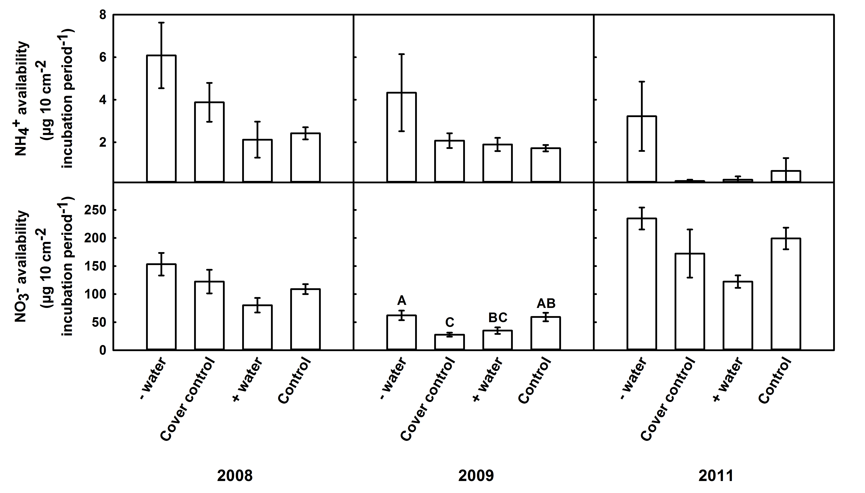
Figure 12. Mean ammonium and nitrate availability (±1 standard error) in 2008, monsoon season 2009, and 2011 across treatments, - water (water reduction) and + water (water addition), cover control (removal control), and control (unamended plot). Different letters denote significant differences among treatments.

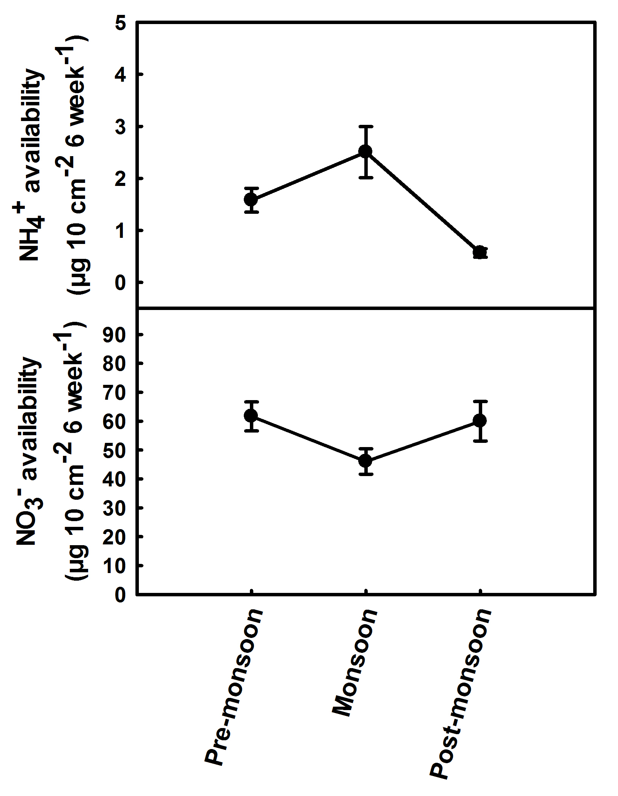
Figure 13. Mean ammonium and nitrate availability (±1 standard error) in the pre-monsoon, monsoon, and post-monsoon season of 2009.

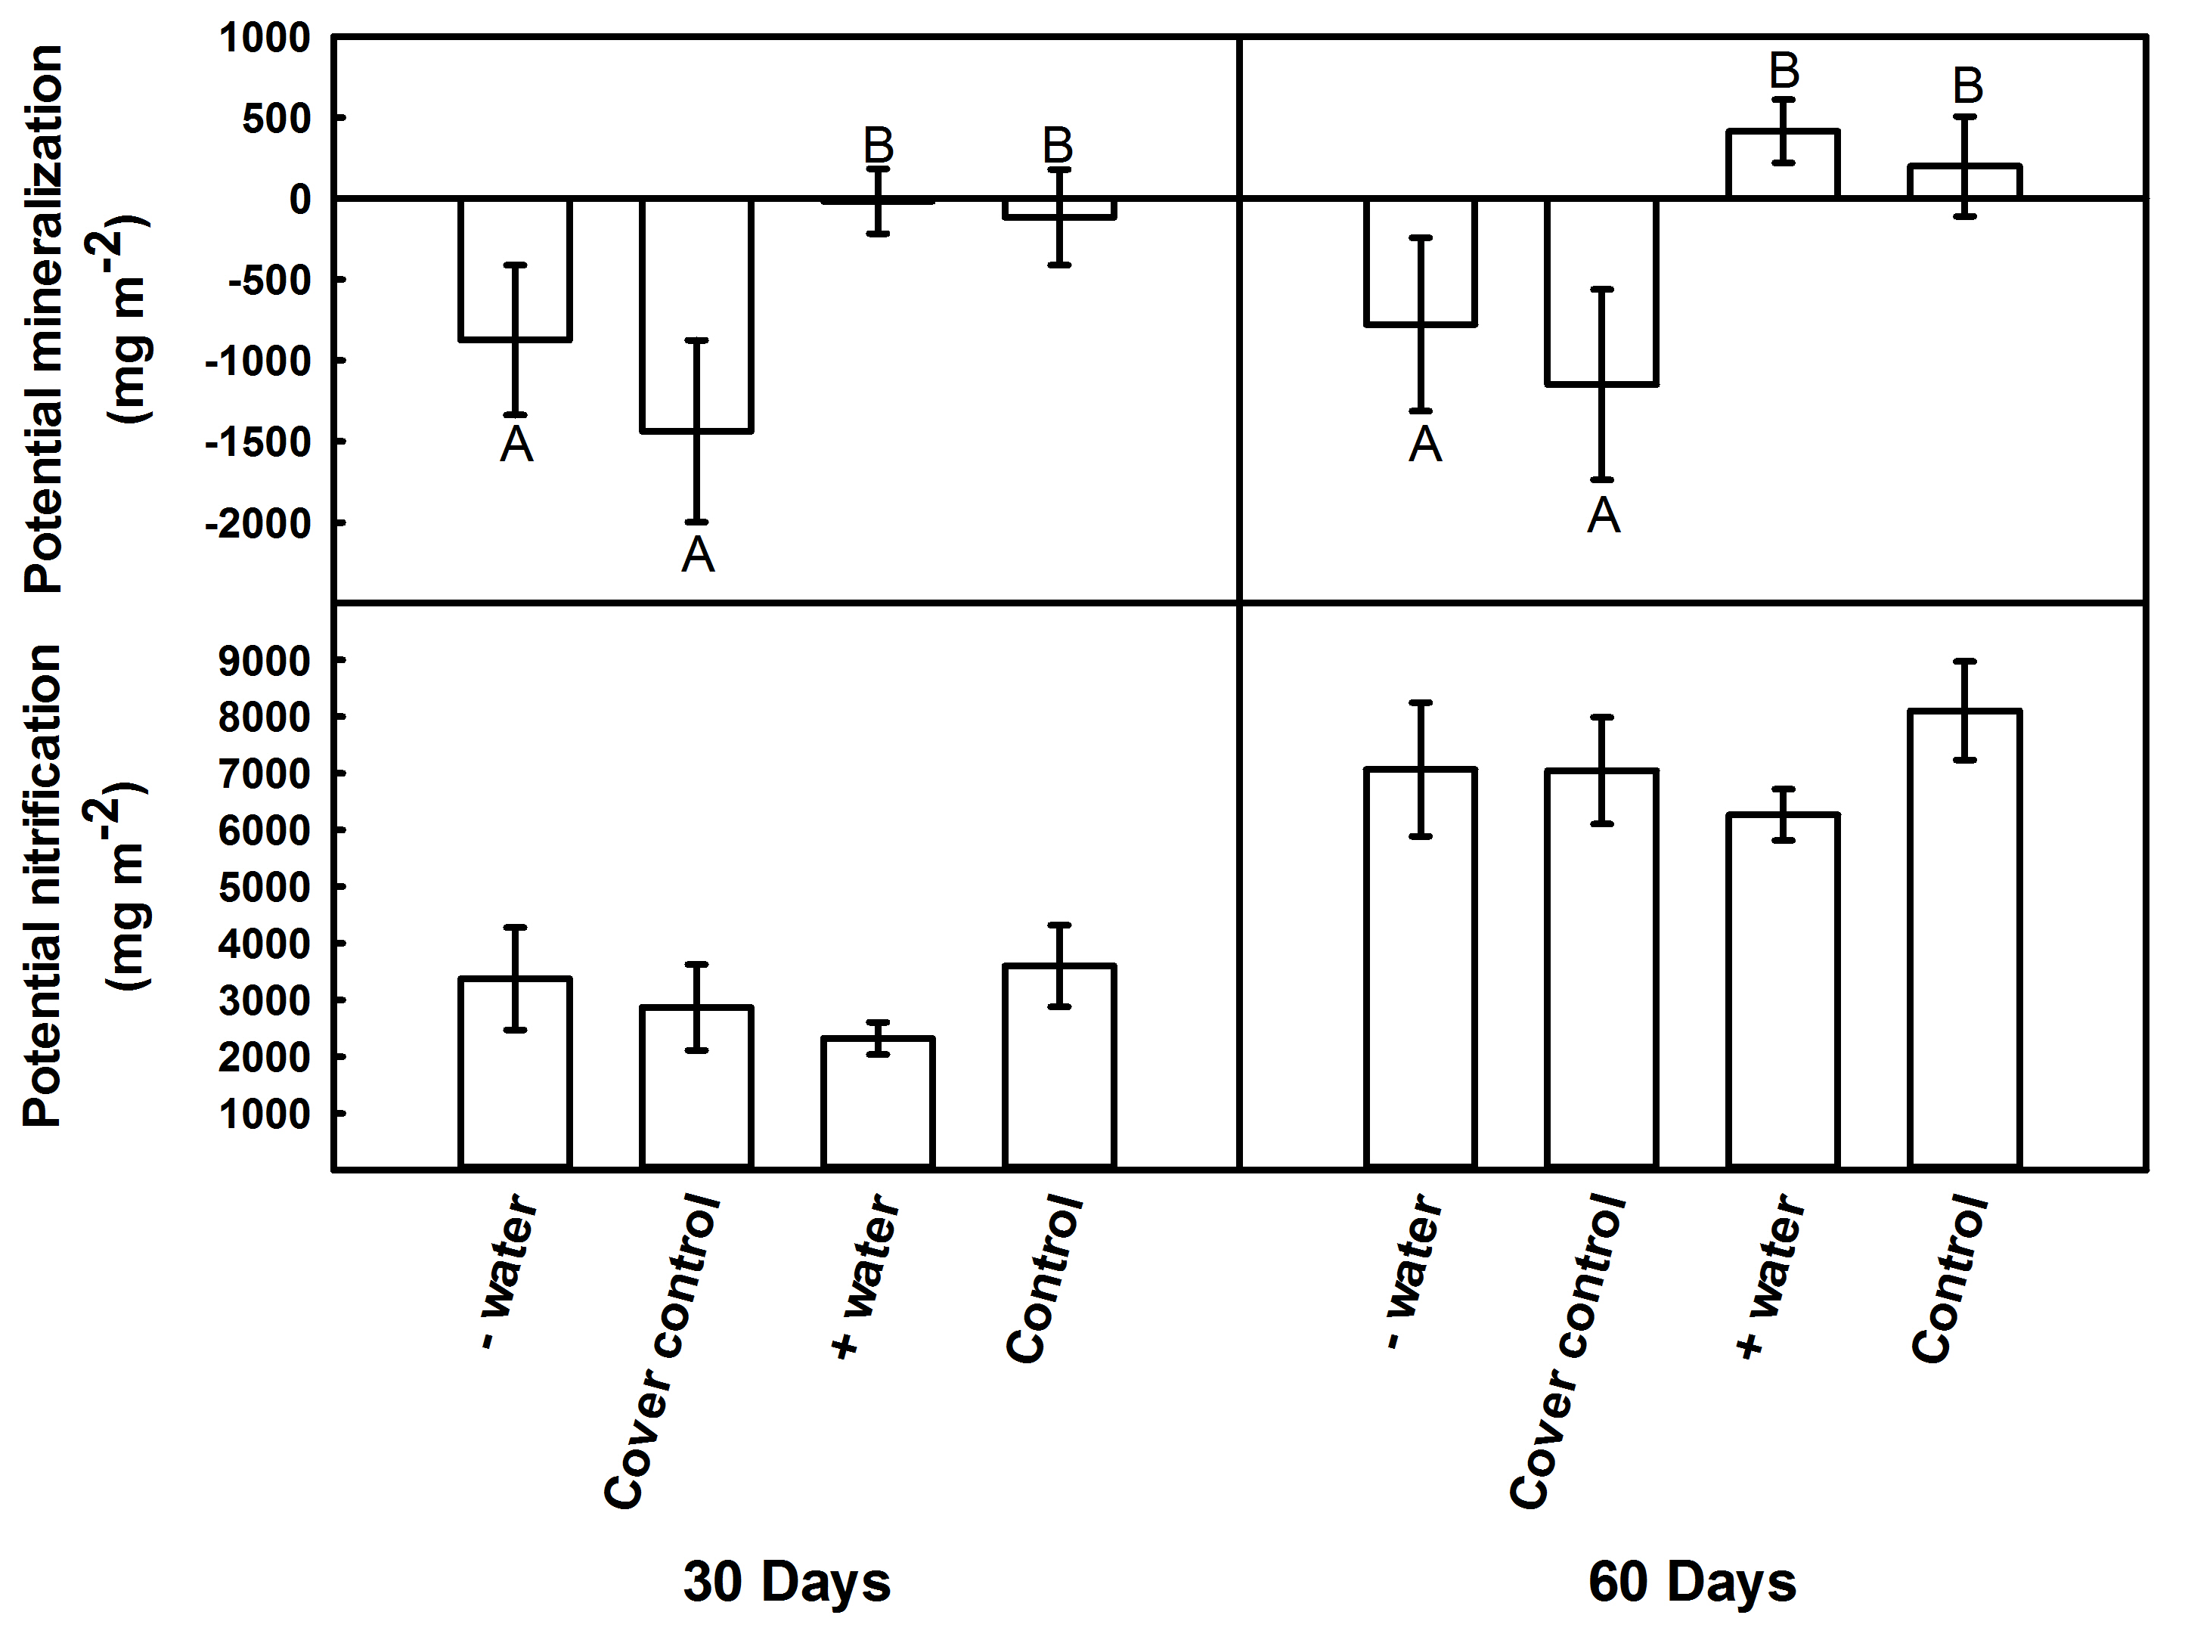
Figure 14. Mean potential mineralization and nitrification 30 and 60 days after incubation (±1 standard error) across treatments, - water (water reduction) and + water (water addition), cover control (removal control), and control (unamended plot). Different letters denote significant differences among treatments.

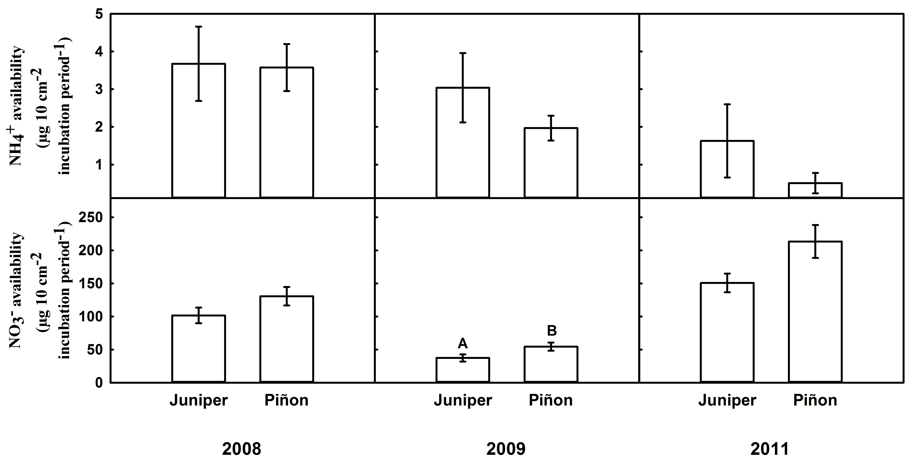

Figure 15. Mean ammonium and nitrate availability (±1 standard error) in 2008, monsoon season 2009, and 2011 beneath juniper and piñon. Different letters denote significant differences between piñon and juniper.

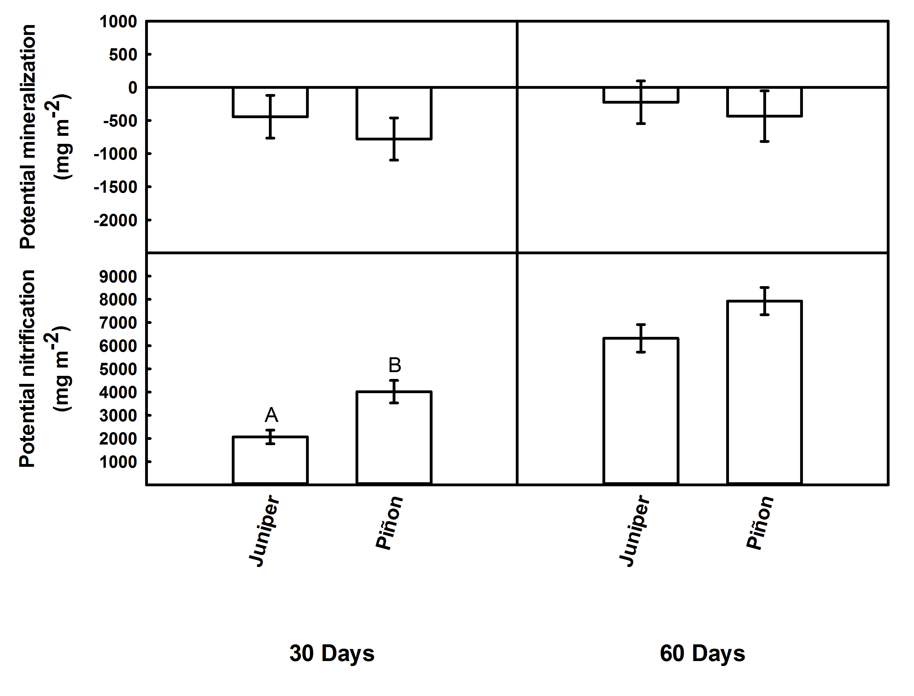
Figure 16. Mean potential mineralization and nitrification 30 and 60 days after incubation (±1 standard error) beneath piñon and juniper trees. Different letters denote significant differences between piñon and juniper.

Discussion

Combined impacts of season, precipitation, and plant species on soil nitrogen cycling
Piñon-juniper woodlands are a model ecosystem for examining the role of precipitation and species composition on nutrient cycling because they are simple (they have two co-dominant species), they are regionally dominant (Shaw et al. 2005), and representative of semi-arid ecosystems worldwide (Breshears 2005). Using a large-scale precipitation manipulation in a piñon-juniper woodland in New Mexico, we found both precipitation and plant species can influence the nitrogen cycle. Across four years, nitrate availability increased while potential mineralization decreased in response to changes in precipitation amounts. In addition, there was 1.4 × more available nitrate beneath piñon relative to juniper and 1.9 × increased rate of potential nitrification in soils beneath piñon relative to juniper. Contrary to our predictions, we found minimal interactive effects between our precipitation treatments and plant species.
Consistent with other studies, we expected an increase in litter quantity due to early needle abscission beneath piñon in drought plots due to increased tree stress and mortality (Chapman et al. 2003, Breshears et al. 2005, Brando et al. 2008, Ozolincius et al. 2009). Initial increases in litter accumulation due to tree stress are common in response to drought followed by a plateau of this effect as droughts persist (Brando et al. 2008). Although we saw more litter biomass accumulation in the beginning of our experiment, there were no significant differences based on treatment. Contrary to our predictions, factors that were not measured, such as decreased leaching and decreased plant uptake of nitrogen may play a larger role in the accumulation of nitrate during drought conditions than changes in litter abundance or microbial potential. Our seasonal data on nitrate availability demonstrate that nitrate is lost from the ecosystem during the monsoon season when leaching is more prevalent and plant uptake increases (Figure 13). Consistent with our results, a review by Austin et al. (2004) demonstrates that nitrogen may be lost in arid ecosystems during periods of increased water availability due to increases in denitrification, leaching, or plant uptake.

Precipitation impacts on soil nitrogen cycling
Similar to other studies in arid and semi-arid ecosystems, we found almost 2 × more available nitrate over four years in the drought plots compared to water addition plots (Figure 12; Yahdjian et al. 2006). Water removal and addition plots could represent the physiological thresholds for soil communities and trees in this semi-arid ecosystem. We would expect these processes and communities to diverge further from the unamended plots as the impacts of stress (removal of water) or release of stress (addition of water) compound over time. Occasionally we saw differences between the cover control and the unamended plots, indicating that our experimental design is not perfect. There can be unintended impacts of our removal experiment, however it is a common design and regarded as the best designs available (Hanson et al. 2001, Limousin et al. 2008). Due to the shape of the cover controls, water may collect in between the troughs resulting in greater water availability in between individual troughs. We sampled away from the troughs in both of these treatments in order to reduce the impact of the experimental infrastructure on the processes we were measuring. Given this caveat, it is also possible that a threshold of minimum or maximum precipitation is necessary for soil microbial communities before changes in nitrogen cycling occur (Table 6; Stark and Firestone 1995). For example, using a laboratory incubation Fisher and Whitford (1995) showed minimal changes in nitrogen mineralization in response to experimentally altered soil moisture contents until -1 MPa water potential was achieved, where microbial activity was halted and nitrogen mineralization was no longer detected. Our results suggest this threshold has been crossed and microbial activity has slowed in the water removal and control plots, resulting in no measurable change in mineralization but increased availability due to other mechanisms like decreased plant uptake or decreased soil runoff and leaching of nitrate.
Increased nitrogen availability is common during drought conditions and may occur due to abiotic factors like leaching and biotic factors like plant and microbial responses. Decreased photosynthesis and transpiration during drought has been well documented (Boyer 1982, Flexas and Medrano 2002, Chaves et al. 2003, Griffin et al. 2004), as has increased nitrogen uptake in association with irrigation (Nilsson and Wiklund 1994) and decreased mycorrhizal uptake of nitrogen when water is limiting (Gessler et al. 2005). Decreased water uptake by plants, as well as reduced leaching during drought periods, will both allow accumulation of soil nitrogen (Stark and Firestone 1995, Austin et al. 2004). Consistent with other studies, transpiration of piñon and juniper is significantly lower in drought plots and higher in irrigation plots, relative to the controls in our experiment (Pangle et al. 2012; Plaut et al. 2012), which may result in our observed increases in nitrogen availability in drought treatments. In addition, nitrogen may also increase in the soil due to reduced microbial uptake, reduced microbial turnover, or differences in microbial communities (Wardle 1992, Augustine and McNaughton 2004, Sheik et al. 2011). Changes in microbial uptake are evident in potential mineralization. Consistent with other studies, upon soil rewetting at the start of the lab incubation, the microbial communities from the drought plots increased immobilization of ammonium (Figure 14; Schimel et al. 1989). This increase in immobilization may be due to increases in microbial biomass production and activity that is commonly seen upon rewetting dry soils (Landesman and Dighton 2011). Surprisingly, this increase in microbial immobilization of ammonium did not result in increases in nitrification (Schimel et al. 1989, Fierer and Schimel 2002). Additionally, we did not find differences in the abundance of the nitrifying community across our treatments. This may be due to the time (pre-monsoon) at which we measured amoA abundance when water was extremely limiting. Alternatively, nitrifying archaea may play a larger role than bacteria in this ecosystem. Adair and Schwartz (2008) found that ammonia-oxidizing archaea had increased abundance relative to ammonia-oxidizing bacteria across a range of arid ecosystems including piñon-juniper woodlands. Additionally, they found that ammonia-oxidizing bacterial abundance increased with increasing precipitation in these same ecosystems (Adair and Schwartz 2008).

Species influence on soil nitrogen cycling
Overall, we found significantly more nitrate and potential nitrification beneath piñon areas relative to juniper areas across all treatments (Figures 15 and 16). Research examining baseline levels of carbon and nitrogen stocks beneath piñon and juniper in the field show increased total nitrogen beneath juniper relative to piñon (Shukla et al. 2006) leading us to conclude that other factors are responsible for the increase in nitrogen beneath piñon. Stress, induced by drought or herbivory, can cause piñon to drop their needles before resorbing their nutrients resulting in increased litter quality and quantity, and subsequent acceleration of decomposition during these periods (Chapman et al. 2003, Classen et al. 2007a). Because piñon experience elevated mortality during drought (Mueller et al. 2005, McDowell et al. 2008) we predicted an increase in litter beneath piñon driving changes in nitrogen cycling beneath their crowns. Contrary to this, we did not find significant differences in litterfall biomass between these two plant species. Thus, we infer mechanisms other than changes in litter quantity are driving the increases in nitrogen cycling, such as increased litter quality or decreased uptake of nitrogen by drought stressed piñon.
Our results suggest that plant uptake of nitrogen, not litter inputs or shifts in the microbial community may be the driving force for changes we observed in the nitrogen cycle. Previous research showed that juniper continue to uptake water during extreme drought when other plants have closed their stomata (West et al. 2008), therefore this trait may result in increased nitrogen uptake and decreased nitrogen beneath juniper crowns. In our drought plots, juniper indeed maintained higher transpiration rates than piñon (Pangle et al. 2012, Plaut et al. 2012). As juniper continued transpiring it can be inferred that they also continue to uptake nitrogen in the water. Alternatively, since piñon have decreased transpiration the nitrogen in the soil solution beneath them may remain inaccessible for plant use. Since no other vegetation inhabits the crown area, nitrate can accumulate beneath piñon in the soil over time. To further understand nitrogen dynamics in this ecosystem, we should examine the different water use patterns by the two dominant trees in relation to their belowground differences in litter inputs and soil microbial communities.

Conclusion
Changes in precipitation and plant communities can directly and indirectly alter ecosystem function (Kardol et al. 2010). However, in longer-lived ecosystems that develop more slowly, such as semi-arid piñon-juniper woodlands, these shifts could take longer than five years to develop. While our study showed that the nitrogen cycle was responding to our precipitation treatments and that nitrogen cycling differed between the two dominant plant species (piñon or juniper), we were surprised that there was no interaction between tree species and our precipitation treatments. However, because piñon had higher levels of available nitrogen relative to juniper, the presence of piñon pine may maintain higher nitrogen availability in this ecosystem. Piñon are dying at a faster rate than juniper due to their differential response to drought (Mueller et al. 2005), and the loss of piñon from this ecosystem may result in a landscape-level shift in woodland nitrogen cycling.

Acknowledgments
We thank T. Gass, J. Hill, S. White, and E. Yepez for help with sample collection and processing. We are grateful to E. Austin, L. Souza, and multiple anonymous reviewers for their valuable comments. M. Cregger was supported by the Graduate Research for the Environment Fellowship sponsored by the Department of Energy Global Change Education Program and The University of Tennessee. The field experiment was supported by a grant from the Department of Energy, Program for Biological and Environmental Research and startup funds to ATC from the University of Tennessee.

References
Adair, K.L., and E. Schwartz. 2008. Evidence that ammonia-oxidizing archaea are more abundant than ammonia-oxidizing bacteria in semiarid soils of northern Arizona, USA. Microbial Ecology 56: 420-426.
Adams, M.A., and Attiwill. 1986. Nutrient cycling and nitrogen mineralization in eucalypt forests of southeastern Australia v2 indexes of nitrogen mineralization. Plant and Soil 92: 341-362.
Allen, C.D., et al. 2010. A global overview of drought and heat-induced tree mortality reveals emerging climate change risks for forests. Forest Ecology and Management 24.
Allison, et al. 2009. The Copenhagen Diagnosis: Updating the World on the Latest Climate Science. The University of New South Wales Climate Change Research Centre (CCRC), Sydney, Australia, 60pp.
Augustine, D.J., and S.J. McNaughton. 2004. Temporal asynchrony in soil nutrient dynamics and plant production in a semiarid ecosystem. Ecosystems 7: 829-840.
Austin, A.T., and P.M. Vitousek. 1998. Nutrient dynamics on a precipitation gradient in Hawai'i. Oecologia 113: 519-529.
Austin, A.T. 2002. Differential effects of precipitation on production and decomposition along a rainfall gradient in Hawaii. Ecology 83: 328-338.
Austin, A.T., L. Yahdjian, J.M. Stark, J. Belnap, A. Porporato, U. Norton, D.A. Ravetta, and S.M. Schaeffer. 2004. Water pulses and biogeochemical cycles in arid and semiarid ecosystems. Oecologia 141: 221-235.
Binkley, D. 1989. The components of nitrogen availability assessments in forest soils. Advanced Soil Science: 57-112.
Boyer, J.S. 1982. Plant Productivity and Environment. Science 218: 443-448.
Brando, P.M., D.C. Nepstad, E.A. Davidson, S.E. Trumbore, D. Ray, and P. Camargo. 2008. Drought effects on litterfall, wood production and belowground carbon cycling in an Amazon forest: results of a throughfall reduction experiment. Philosophical Transactions of the Royal Society Biological Sciences 363: 1839-1848.
Breshears, D.D., et al. 2005. Regional vegetation die-off in response to global-change-type drought. Proceedings of the National Academy of Sciences of the United States of America 102: 15144-15148.
Breshears, D.D., O.B. Myers, C.W. Meyer, F.J. Barnes, C.B. Zou, C.D. Allen, N.G. McDowell, and W.T. Pockman. 2009. Tree die-off in response to global change-type drought: mortality insights from a decade of plant water potential measurements. Frontiers in Ecolology and the Environment 7: 185-189.
Brown, M.B., and A.B. Forsythe. 1974. Robust tests for the equality of variances. Journal of the American Statistical Association 69: 364-367.
Chapman, S.K., S.C. Hart, N.S. Cobb, T.G. Whitham, and G.W. Koch. 2003. Insect herbivory increases litter quality and decomposition: An extension of the acceleration hypothesis. Ecology 84: 2867-2876.
Chapman, S.K., J.A. Schweitzer, and T.G. Whitham. 2006. Herbivory differentially alters plant litter dynamics of evergreen and deciduous trees. Oikos 114: 566-574.
Chaves, M.M., J.P. Maroco, and J.S. Pereira. 2003. Understanding plant responses to drought - from genes to the whole plant. Functional Plant Biology 30: 239-264
Classen, A.T., J. DeMarco, S.C. Hart, T.G. Whitham, N.S. Cobb, and G.W. Koch. 2006. Impacts of herbivorous insects on decomposer communities during the early stages of primary succession in a semi-arid woodland. Soil Biology and Biochemistry 38: 972-982.
Classen, A.T., S.K. Chapman, T.G. Whitham, S.C. Hart, and G.W. Koch. 2007a. Genetic-based plant resistance and susceptibility traits to herbivory influence needle and root litter nutrient dynamics. Journal of Ecology 95: 1181-1194.
Classen, A.T., S.T. Overby, S.C. Hart, G.W. Koch, and T.G. Whitham. 2007b. Season mediates herbivore effects on litter and soil microbial abundance and activity in a semi-arid woodland. Plant and Soil 295: 217-227.
Cook, E.R., C.A. Woodhouse, C.M. Eakin, D.M. Meko, and D.W. Stahle. 2004. Long-term aridity changes in the western United States. Science 306: 1015-1018.
Fierer, N., and J.P. Schimel. 2002. Effects of drying-rewetting frequency on soil carbon and nitrogen transformations. Soil Biology and Biochemistry 34: 777-787.
Flexas, J., and H. Medrano. 2002. Drought-inhibition of photosynthesis in C-3 plants: Stomatal and non-stomatal limitations revisited. Annals of Botany 89: 183-189.
Floyd, M.L., J. Belnap, J.J. Anderson, O.B. Myers, and C.W. Meyer. 2005. Regional vegetation die-off in response to global-change-type drought. Proceedings of the National Academy of Sciences of the United States of America 102: 15144-15148.
Gessler, A., K. Jung, R. Gasche, H. Papen, A. Heidenfelder, E. Borner, B. Metzler, S. Augustin, E. Hildebrand, and H. Rennenberg. 2005. Climate and forest management influence nitrogen balance of European beech forests: microbial N transformations and inorganic N net uptake capacity of mycorrhizal roots. European Journal of Forest Research. 124: 95-111.
Gitlin, A.R., C.M. Sthultz, M.A. Bowker, S. Stumpf, K.L. Paxton, K. Kennedy, A. Munoz, J.K. Bailey, and T.G. Whitham. 2006. Mortality gradients within and among dominant plant populations as barometers of ecosystem change during extreme drought. Conservation Biology 20: 1477-1486.
Gotelli, N., and A. Ellison. 2004. A primer of ecological statistics. Sinauer Associates, Inc., Massachusetts.
Greenland, D., D.G. Goodin, and R.C. Smith. 2003. Climate Variability and Ecosystem Response at Long-Term Ecological Research Sites. Oxford University Press, New York.
Gregory, J.M., J.F.B. Mitchell, and A.J. Brady. 1997. Summer drought in northern midlatitudes in a time-dependent CO2 climate experiment. Journal of Climate 10: 662-686.
Griffin, J.J., T.G. Ranney, and D.M. Pharr. 2004. Heat and drought influence photosynthesis, water relations, and soluble carbohydrates of two ecotypes of redbud (Cercis canadensis). Journal of the American Society for Horticultural Science 129: 497-502.
Hanson, P.J., and J.F. Weltzin. 2000. Drought disturbance from climate change: response of United States forests. Science of the Total Environment 262: 205-220.
Hanson, P.J., D.E. Todd, and J.S. Amthor. 2001. A six-year study of sapling and large-tree growth and mortality responses to natural and induced variability in precipitation and throughfall. Tree Physiology 21: 1158-1158.
Hayden, H.L., J. Drake, M. Imhof, A.P.A. Oxley, S. Norng, and P.M. Mele. 2010. The abundance of nitrogen cycle genes amoA and nifH depends on land-uses and soil types in South-Eastern Australia. Soil Biology and Biochemistry 42: 1774-1783.
Hobbie, S.E.. 1992. Effects of Plant-Species on Nutrient Cycling. Trends in Ecology and Evolution 7: 336-339.
Kardol, P., M.A. Cregger, C.E. Campany, and A.T. Classen. 2010. Soil ecosystem functioning under climate change: plant species and community effects. Ecology 91: 767-781.
Klopatek, J.M. 1987. Nitrogen Mineralization and Nitrification in Mineral Soils of Piñon-Juniper Ecosystems. Soil Science Society of America Journal 51: 453-457.
Knapp, A.K., et al. 2008. Consequences of More Extreme Precipitation Regimes for Terrestrial Ecosystems. Bioscience 58: 811-821.
Kreuzwieser, J., and A. Gessler. 2010. Global climate change and tree nutrition: influence of water availability. Tree Physiology 30: 1221-1234.
Landesman, W.J., and J. Dighton. 2011. Shifts in Microbial Biomass and the Bacteria: Fungi Ratio Occur Under Field Conditions Within 3 h After Rainfall. Microbial Ecology 62: 228-236.
Limousin, J.M., S. Rambal, J.M. Ourcival, and R. Joffre. 2008. Modelling rainfall interception in a Mediterranean Quercus ilex ecosystem: Lesson from a throughfall exclusion. Journal of Hydrology 357: 57-66.
McDowell, N., W.T. Pockman, C.D. Allen, D.D. Breshears, N. Cobb, T. Kolb, J. Plaut, J. Sperry, A. West, D. G. Williams, and E.A. Yepez. 2008. Mechanisms of plant survival and mortality during drought: why do some plants survive while others succumb to drought? New Phytologist 178: 719-739.
Mitchell, R.J., C.D. Campbell, S.J. Chapman, and C.M. Cameron. 2010. The ecological engineering impact of a single tree species on the soil microbial community. Journal of Ecology 98: 50-61.
Mueller, R.C., C.M. Scudder, M.E. Porter, R.T. Trotter, C.A. Gehring, and T.G. Whitham. 2005. Differential tree mortality in response to severe drought: evidence for long-term vegetation shifts. Journal of Ecology 93: 1085-1093.
Murphy, K.L., J.M. Klopatek, and C.C. Klopatek. 1998. The effects of litter quality and climate on decomposition along an elevational gradient. Ecological Applications 8: 1061-1071.
Nearing M.A.,et al. 2005. Modeling response of soil erosion and runoff to changes in precipitation and cover. Catena 61: 131-154.
Nilsson, L., and K. Wiklund. 1994. Nitrogen Uptake in a Norway Spruce Stand Following Ammonium-Sulfate Application, Fertigation, Irrigation, Drought and Nitrogen-Free-Fertilization. Plant and Soil. 164: 221-229.
Ozolincius, R., V. Stakenas, I. Varnagiryte-Kabasinskiene, and R. Buozyte. 2009. Artificial drought in Scots pine stands: effects on soil, ground vegetation and tree condition. Annales Botanici Fennici 46: 299-307.
Padien D.J., and K. Lajtha. 1992. Plant Spatial Pattern and Nutrient Distribution in Piñon-Juniper Woodlands Along an Elevational Gradient in Northern New-Mexico. International Journal of Plant Sciences 153: 425-433.
Pan, Y.D., J.M. Melillo, A.D. McGuire, D.W. Kicklighter, L.F. Pitelka, K. Hibbard, L.L. Pierce, S.W. Running, D.S. Ojima, W.J. Parton, and D.S. Schimel. 1998. Modeled responses of terrestrial ecosystems to elevated atmospheric CO2: a comparison of simulations by the biogeochemistry models of the Vegetation/Ecosystem Modeling and Analysis Project (VEMAP). Oecologia 114: 389-404.
Pangle, R.E., J.P. Hill, J.A. Plaut, E.A. Yepez, J.R. Elliot, N. Gehres, N.G. McDowell, W.T. Pockman. 2012. Methodology and performance of a rainfall manipulation experiment in a piñon-juniper woodland. Ecosphere.
Plaut, J.A., E.A. Yepez, J. Hill, R. Pangle, J.S. Sperry, W.T. Pockman, N.G. McDowell. 2012. Hydraulic limits on water use under experimental drought in a piñon-juniper woodland. Plant Cell Environment.
Qian, P., and J.J. Schoenau. 2002. Practical applications of ion exchange resins in agricultural and environmental soil research. Canadian Journal of Soil Science. 82: 9-21.
Quinn, G.P., and M.J. Keough. 2002. Experimental design and data analysis for biologists. Cambridge University Press, Cambridge, UK.
Reid, K.D., B.P. Wilcox, D.D. Breshears, and L. MacDonald. 1999. Runoff and erosion in a pinon-juniper woodland: Influence of vegetation patches. Soil Science Society of America Journal 63: 1869-1879.
Robertson, G. P., D. Wedin, P. M. Groffman, J. M. Blair, E. A. Holland, K. J. Nadelhoffer, and D. Harris. 1999. Soil carbon and nitrogen availability. Nitrogen mineralization, nitrification, and soil respiration potentials. Pages 258-271 in G. P. Robertson, D. C. Coleman, C. S. Bledsoe, and P. Sollins, editors. Standard soil methods for long-term ecological resaerch. Oxford University Press, New York.
Rodriguez, A., J. Duran, F. Covelo, J.M. Fernandez-Palacios, and A. Gallardo. 2011. Spatial pattern and variability in soil N and P availability under the influence of two dominant species in a pine forest. Plant and Soil 345: 211-221.
Rosenberg, N.J., R.A. Brown, R.C. Izaurralde, and A.M. Thomson. 2003. Integrated assessment of Hadley Centre (HadCM2) climate change projections on agricultural productivity and irrigation water supply in the conterminous United States - I. Climate change scenarios and impacts on irrigation water supply simulated with the HUMUS model. Agricultural and Forest Meteorology 117: 73-96.
Rotthauwe, J.H., K.P. Witzel, and W. Liesack. 1997. The ammonia monooxygenase structural gene amoA as a functional marker: Molecular fine-scale analysis of natural ammonia-oxidizing populations. Applied and Environmental Microbiology 63: 4704-4712.
Sala, O.E., W.J. Parton, L.A. Joyce, and W.K. Lauenroth. 1988. Primary Production of the Central Grassland Region of the United-States. Ecology 69: 40-45.
Sala, O.E., R.B. Jackson, H.A. Mooney, and R.W. Howarth. 2000. Methods in Ecosystem Science. Springer-Verlag New York, Inc, New York.
Schimel, J.P., L.E. Jackson, and M.K. Firestone. 1989. Spatial and Temporal Effects on Plant Microbial Competition for Inorganic Nitrogen in a California Annual Grassland. Soil Biology and Biochemistry 21: 1059-1066.
Schimel, J., T.C. Balser, and M. Wallenstein. 2007. Microbial stress-response physiology and its implications for ecosystem function. Ecology 88: 1386-1394.
Schlesinger, W.H., J.A. Raikes, A.E. Hartley, and A.E. Cross. 1996. On the spatial pattern of soil nutrients in desert ecosystems. Ecology 77: 364-374.
Seager, R., et al. 2007. Model projections of an imminent transition to a more arid climate in southwestern North America. Science 316: 1181-1184.
Shaw, J.D., B.E. Steed, and L.T. DeBlander. 2005. Forest Inventory and Analysis (FIA) annual inventory answers the question: What is happening to piñon-juniper woodlands? Journal of Forestry 103: 280-285.
Sheik, C.S., W.H. Beasley, M.S. Elshahed, X.H. Zhou, Y.Q. Luo, and L.R. Krumholz. 2011. Effect of warming and drought on grassland microbial communities. International Society of Microbial Ecology Journal 5: 1692-1700.
Shukla, M.K., R. Lal, A. Ebinger, and C. Meyer. 2006. Physical and chemical properties of soils under some pinon-juniper-oak canopies in a semi-arid ecosystem in New Mexico. Journal of Arid Environments 66: 673-685.
Stark, J.M., and M. K. Firestone. 1995. Mechanisms for Soil-Moisture Effects on Activity of Nitrifying Bacteria. Applied and Environmental Microbiology 61: 218-221.
Stark, J.M. 2000. Nutrient Transformations. Pages 215-231 in O.E. Sala, R.B. Jackson, H.A. Mooney, R.W. Howarth, editors. Methods in Ecosystem Science. Springer, New York.
Sthultz, C.M., C.A. Gehring, and T.G. Whitham. 2009. Deadly combination of genes and drought: increased mortality of herbivore-resistant trees in a foundation species. Global Change Biology 15: 1949-1961.
Underwood, A.J. 1997. Experiments in ecology. Cambridge University Press, Cambridge, UK.
Wallenstein, M.D., and R.J. Vilgalys. 2005. Quantitative analyses of nitrogen cycling genes in soils. Pedobiolgia 49: 665-672.
Walvoord, M.A., F.M. Phillips, D.A. Stonestrom, R.D. Evans, P.C. Hartsough, B.D. Newman, and R.G. Striegl. 2003. A reservoir of nitrate beneath desert soils. Science 302: 1021-1024.
Wardle, D.A. 1992. A Comparative-Assessment of Factors Which Influence Microbial Biomass Carbon and Nitrogen Levels in Soil. Biological Reviews 67: 321-358.
Weltzin, J.F., et al. 2003. Assessing the response of terrestrial ecosystems to potential changes in precipitation. Bioscience 53: 941-952.
West, A.G., K.R. Hultine, J.S. Sperry, S.E. Bush, and J.R. Ehleringer. 2008. Transpiration and hydraulic strategies in a pinon-juniper woodland. Ecological Applications 18: 911-927.
Wilcox, B.P. 1994. Runoff and Erosion in Intercanopy Zones of Piñon-Juniper Woodlands. Journal of Range Management 47: 285-295.
Xiang, S.R., A. Doyle, P.A. Holden, and J.P. Schimel. 2008. Drying and rewetting effects on C and N mineralization and microbial activity in surface and subsurface California grassland soils. Soil Biology and Biochemistry 40: 2281-2289.
Yahdjian, L., O. Sala, and A.T. Austin. 2006. Differential controls of water input on litter decomposition and nitrogen dynamics in the Patagonian steppe. Ecosystems 9: 128-141.
Zak, D.R., W.E. Holmes, D.C. White, A.D. Peacock, and D. Tilman. 2003. Plant diversity, soil microbial communities, and ecosystem function: Are there any links? Ecology 84: 2042-2050.

Chapter 3.
Microbial communities respond to experimental warming, but not consistently between sites

Abstract
Soil microbial community activity is responsible for nutrient transformations in ecosystems and is often regulated by temperature. Thus, the direct impact of global warming on soil temperature may increase microbial activity particularly in temperature-limited ecosystems. Here we use a large-scale warming experiment established at the northern and southern boundaries of US eastern deciduous forests, to examine how climatic warming alters microbial community structure and function. Surprisingly, soil bacterial and fungal community structure and function responded to warming at the southern, but not the northern site. Additionally, changes in microbial community structure and function at the southern site did not ‘scale-up’ to alter cellulose decomposition rates, an indication of an ecosystem-level response. Our data highlight that geography can play an important role in a communities’, as well as ecosystems’, response to global warming.

Introduction
Because soil microbial communities respond strongly to temperature and generally have short generation times, global warming may quickly influence their structure and function in ecosystems. Indeed, numerous studies have demonstrated that temperature manipulations can lead to shifts in microbial community structure and functions, but the effects are often idiosyncratic and vary among ecosystems (Frey et al. 2008, Schindlbacher et al. 2011, Zogg et al. 1997). Moreover, most studies to date have employed only two levels of experimental warming - warmed and ambient – and do so at only a single site (Rustad et al. 2001, Wolkovich et al. 2012). This approach, while valuable, requires a step-change in warming which does not reflect the way warming is happening, or will happen, globally. Such variation and idiosyncratic responses among studies, the focus on single sites, and the step-function approach to warming all make it challenging to predict future responses of microbial communities to ongoing climatic warming.
One potential solution is to conduct warming experiments where treatments are applied in a continuous fashion (Cottingham et al. 2005) and replicated across the geographic range of species. Such designs allow for making predictions about nonlinear responses to temperature and to assess geographic variation in responses of common taxa (Diamond et al. 2012, Pelini et al. 2011). Microbial responses to warming may not be evident until temperatures exceed a threshold that hinders microbial composition, abundance, and/or activity. Additionally, recent work has demonstrated that the effects of temperature are not the same everywhere. That is, species that operate near their critical thermal maximum at low latitudes are more likely to be threatened by climatic warming than are species that operate farther from their critical thermal maximum (Diamond et al. 2012, Tewksbury et al. 2008). Thus, it is likely that warming will have more pronounced effects on species and ecosystems at low latitudes than at high latitudes.
Here, we report on the responses of soil microbial communities to experimental warming at a northern (Harvard Forest; Massachusetts; ≈42° N lat.) and a southern site (Duke Forest; North Carolina, ≈36° N lat.) in temperate deciduous forests in the eastern US. At both sites, warming has been manipulated using open-top chambers in a regression design that boosts air temperatures from 1.5 to 5.5 °C above ambient since January 2010. The range of temperatures chosen encompasses future warming scenarios (Solomon 2007) and enables us to observe non-linearities in soil community response to warming at the southern and northern range of an ecosystem. Given the broad range of temperatures across two sites, we predicted that warming would shift soil microbial community structure and increase function, with higher temperatures having a larger impact at the southern site than at the northern site.

Methods
Our sites and the experiment were previously described (Pelini et al. 2011). Two hardwood sites were selected in the southern and northern range of mixed hardwood forests in the eastern USA. The southern site is an 80-year-old oak-hickory stand in Duke Forest (35° 52’ 0” N, 79° 59’ 45” W) where mean annual temperature is 15.5 °C and mean annual precipitation is 1140 mm. The northern site is a 70-year-old oak-maple stand in Harvard Forest (42° 31’ 48” N, 72° 11’ 24” W) where mean annual temperature is 7.1 °C and mean annual precipitation is 1066 mm. In 2009, 12 open topped warming chambers (octagonal 5 m diameter × 1.2 m high) were established at each site; warming treatments began in January of 2010 (Pelini et al. 2011). Chambers at each site manipulate air temperature incrementally from ambient to 5.5 °C above ambient in half degree steps beginning at 1.5 °C using hydronic heating and forced air. Air temperature, soil temperature (CR1000; Campbell Scientific, Inc.), and soil moisture (Model CS616 TDR probes, Campbell Scientific, Inc.) were measured continuously in each chamber in both the organic and mineral layer using automated data loggers.
Soils were collected from each chamber in 2011. In an effort to maintain seasonal consistency between sites, we sampled soils in mid-April in NC and in mid-May in MA when average temperatures were similar (18 °C in NC and 14 °C in MA). Five soil cores (2-cm diameter, 5-cm depth) were collected from each chamber and homogenized in the field; 15 g were immediately removed from the sample, stored on dry ice in the field, and kept frozen at -80 °C until analyzed. The remaining soil was sieved and assayed for potential extracellular enzymatic activity and soil gravimetric water content within 48 hours of collection.
To assess microbial community structure, we extracted DNA from collected soil (1g) using the UltraClean Soil DNA Isolation kit (MoBio Laboratories, Carlsbad, CA). To assess bacterial and fungal gene copy number (a proxy for abundance), we ran quantitative polymerase chain reaction (qPCR) on each individual sample in conjunction with primers Eub 338 and Eub 518 for 16S ribosomal DNA and nuSSU1196F and nuSSU1536R for 18S ribosomal DNA (Castro et al., 2010). PCR mixtures for both 16S rRNA and 18S rRNA gene amplification contained 15 μl of SYBR green master mix (Invitrogen, Life Technologies, Grand Island, NY), 5 μmol of each primer (Eurofins mwg operon, Huntsville, AL), and 1μl of sample DNA diluted 1:10 in sterile water. Reactions were brought up to 30 μl with sterile water. Amplification protocol for the 16S rRNA gene consisted of an initial denaturing cycle of 95 °C for three minutes. This cycle was followed by 39 cycles of 95 °C for 15 s, 53 °C for 15 s, and 72 °C for 1 minute. Amplification of the 18S rRNA gene consisted of an initial denaturing cycle of 95 °C for three minutes. This cycle was followed by 39 cycles of 95 °C for 15 s, 53 °C for 15 s, and 70 °C for 30 s. Abundance was quantified by comparing unknown samples to serial dilutions of 16S and 18S rDNA from Escherichia coli and Saccharomyces cerevisiae respectively in each PCR run. After completion, for both ribosomal genes, a melting curve analysis was conducted to ensure purity of the amplification product. PCR amplification was performed on a 96-well Chromo4 thermocycler (Bio-Rad Laboratories, Hercules, CA).
To assess microbial community composition, we measured bacterial and fungal community fingerprints using terminal-restriction fragment length polymorphism (TRFLP; (Singh et al. 2006). Due to decreases in multiplexed fluorescence, we performed bacterial and fungal TRFLPs in separate reactions. PCR was performed to amplify the 16S rRNA gene from bacteria using primers 63f (Marchesi et al. 1998) and 1087r (Hauben et al. 1997) and the fungal ITS region using primers ITS1f (Gardes and Bruns, 1993) and ITS4r (Singh et al. 2006). PCR mixtures contained 5 μl 10× KCL reaction buffer, 2 μl 50 mM MgCl₂, 5μl 10 mM dNTPs (Bioline, Tauton, MA), 1 μl 20 mg/ml BSA (Roche, location), 0.5 μl (2.5 Units) Taq DNA polymerase (Bioline, Tauton, MA), either 1 μl of each bacterial primer or 2 μl of each fungal primer (Labeled primers - Invitrogen, Life Technologies, Grand Island, NY, unlabeled primers – Integrated DNA Technologies, Coralville, IA), and 1 μl sample DNA diluted 1:10 in sterile water. All PCR reactions were performed using a 96-well Tgradient thermocycler (Biometra, Germany). DNA was amplified with an initial step of 95 °C for 5 min, followed by 30 cycles at 95 °C for 30 s, 55 °C for 30 s, and 72 °C for 1 min. This was followed by extension at 72 °C for 10 minutes. PCR product quality was assessed with 1% agarose gel electrophoresis. PCR products were cleaned using the QIAquick PCR purification kit (Qiagen, Valencia, CA), quantified using a Synergy HT microplate reader (Biotek, Winooski, Vermont, USA), and digested with MspI. After digestion, a cocktail was made containing 0.5 μl LIZ labeled GeneScan 1200 internal size standard (Applied Biosystems, Grand Island, NY), 12.5 μl Hi-Di formamide (Applied Biosystems, Grand Island, NY), and 1 μl of digested product which was centrifuged, then incubated at 94 °C for 4 min followed by incubation at 4 °C for 5 min. Fragments were analyzed on an ABI Prism 3100 genetic analyzer (Applied Biosystems, Grand Island, NY).
TRFLP profiles were obtained using the GeneMapper software (Applied Biosystems, NY) with a cutoff of 55 bp. The relative abundance of a TRF in a TRFLP profile was calculated by dividing the peak height of the TRF by the total peak height of all TRFs in the profile (Singh et al. 2006). Community analyses of fragments were conducted using Primer 6 with site as a factor and soil temperature and soil moisture as covariates (Primer-E Ltd, United Kingdom). Since soil temperature and soil moisture varied significantly between the southern and northern site (soil temperature, F = 187.8, p < 0.01; soil moisture, F = 17.6, p < 0.01), we followed up the community analyses by separating the data by site and using a distance based linear model (DISTLM) to assess the effect of soil temperature and soil moisture on total microbial, fungal, and bacterial community composition at each site (Anderson 2005, Langlois et al. 2006). Additionally, bacterial, fungal and total microbial richness for all chambers at both sites were calculated by summing the unique number of TRFs in each sample.
We assayed microbial activity by measuring potential extracellular enzyme activity using methylumbelliferone (MUB) linked substrates and 3,4 Dihydroxyphenylalanine (L-DOPA). Soils were assayed for nine ecologically relevant enzymes in order to assess the functional diversity of the soil community: sulfatase (hydrolysis of sulfate esters), nitrogen acetylglucosaminidase (nagase; mineralization of nitrogen from chitin), xylosidase (hemicellulose degradation), phosphatase (hydrolysis of phosphomonoesters and phosphodiesters releasing phosphate), α-glucosidase (degradation of storage carbohydrates), β-glucosidase (degradation of cellulose and other -1,4 glucans), cellobiohydrolase (cellulose degradation), phenol oxidase (lignin degradation), and peroxidase (lignin degradation). Soils were prepared by adding 125 mL of 0.5 M sodium acetate buffer (buffer, pH 5) to approximately 1 g of soil and homogenized for 2 minutes by immersion blending. Sulfatase, nagase, xylosidase, phosphatase, α-glucosidase, β-glucosidase, and cellobiohydrolase were measured using MUB linked substrates. We prepared 96 well plates with blanks, experimental controls, and samples, which were replicated 8 times each. All plates were incubated at room temperature in the dark. The nagase and phosphatase reactions were incubated for 0.5 h, while sulfatase, xylosidase, α-glucosidase, β-glucosidase, and cellobiohydrolase were incubated for 2 h. Fluorescence was read at an excitation of 365 nm and an emission of 450 nm (Biotek, Winooski, Vermont, US). Phenol oxidase and peroxidase activity were measured using L-DOPA. Assays were replicated 16 times and reactions were incubated in the dark for 24 hours. Absorbance was read at 460 nm on a Synergy HT microplate reader (Biotek, Winooski, Vermont, US). Potential enzymatic activity is presented as nmol h⁻¹g⁻¹ (Saiya-Cork et al. 2002, Sinsabaugh 1994).
Decomposition of a standard cellulose substrate was measured in each chamber to determine how warming might alter carbon degradation, a microbially mediated process. Twelve mesh decomposition bags (10 cm × 10 cm; 3mm mesh on top and 1.3mm mesh on bottom) containing 10 g of Whatman # 1 filter paper were deployed in each of the chambers and collected after 3, 6, 9, and 12 months. All data are shown on an ash-free oven dry mass basis. K-constants were calculated for each chamber at each site following Olson (1963).
Because microbial communities directly experience changes in soil temperature and soil moisture as a result of changing air temperature we used an analysis of covariance (ANCOVA) to examine the effect of site, soil temperature (average soil temperature in the organic layer on the day samples were taken), and soil moisture (average daily volumetric water content (VWC) on the day samples were taken), and the interactions of these factors on microbial community composition, abundance, potential extracellular enzymatic activity, and rates of decomposition. When three way interactions between site, soil temperature, and soil moisture were detected, we followed up these analyses by separating our data by site and running linear regressions using soil temperature and soil moisture as factors. We also assessed the effect of minimum and maximum temperature and moisture and the variance of these factors over a year on microbial structure and function, but found no significant effects, so those results are not presented.

Results
Bacterial, but not fungal, abundance was altered by our treatments. There was a significant 3-way interactive effect of site, soil temperature, and soil moisture on bacterial abundance (F₁ = 18.17, p < 0.01), such that bacterial abundance was greatest when soil moisture was high and soil temperatures were very high or very low at the southern site (Figure 17A, F₁ = 16.11, p < 0.01). However, there was no effect of soil temperature or soil moisture on bacterial abundance at the northern site (Figure 17B, F₁ = 0.86, p = 0.50). There was also a 2-way interactive effect of soil temperature and soil moisture on bacterial abundance (F₁ = 11.75, p < 0.01) and a 2-way interactive effect of site and soil moisture on bacterial abundance (F₁ = 10.24, p = 0.01). There was a main effect of site on bacterial abundance (gene copy numbers) such that bacterial abundance was 1.6 × higher at the southern site relative to the northern site (F₁ = 9.22, p = 0.01). Interestingly, there was a significant 2-way interactive effect of soil temperature and soil moisture on the fungal:bacterial ratio, which was greatest at high levels of soil moisture and low soil temperatures at both sites (F₁ = 5.04, p = 0.04).
Similarly, we found significant effects of our treatment on bacterial richness, but not fungal richness (F₁ = 1.65, p = 0.19) or total microbial richness (F₁ = 1.40, p = 027). There was a significant 2-way interactive effect of soil temperature and soil moisture on bacterial richness (F₁ = 6.10, p = 0.03). Bacterial richness was greatest at low soil temperatures and intermediate soil moistures at both sites. Additionally, there was a significant 2-way interactive effect of site and soil temperature on bacterial richness (F₁ = 4.31, p = 0.05). At the southern site, bacterial richness was lowest at high soil temperatures and low soil moisture levels (F₁ = 21.39, p <0.01), but we were unable to detect an effect of soil temperature and soil moisture on bacterial richness at the northern site (F₁ = 2.09, p = 0.19).
There was a significant main effect of soil temperature on total microbial community composition (F₁ = 16.61, p < 0.01), fungal community composition (F₁ = 4.21, p < 0.01), and bacterial community composition (F₁ = 42.71, p < 0.01). Additionally, total microbial community composition (F₁ = 1.70, p = 0.02) and bacterial community composition (F₁ = 3.50, p < 0.01) differed significantly between the two sites. When sites were analyzed separately, we were unable to detect any effect of soil temperature or soil moisture on total microbial, fungal, or bacterial community composition demonstrating the largest effect of soil temperature on microbial community composition was driven by large differences in soil temperature at the two sites (Table 8).
Site, soil temperature, and soil moisture significantly impacted potential microbial activity. There was a 3-way interactive effect of site, soil temperature, and soil moisture on xylosidase (Figure 18A and B, F₁ = 10.22, p = 0.01) and nagase activity (Figure 18C and D, F₁ = 5.42, p = 0.03). At the southern site, xylosidase activity was highest at intermediate temperatures and low levels of soil moisture (Figure 18A, F₁ = 29.57,p < 0.01), but there was no effect of soil temperature and soil moisture on xylosidase activity at the northern site (Figure 18B, F₁ = 0.13, p = 0.72). Contrary to this, at the northern site, nagase activity was highest at intermediate levels of soil moisture and high soil temperatures (Figure 18D, F₁ = 5.25, p = 0.05), but there was no effect of soil temperature and soil moisture on nagase activity at the southern site (Figure 18C, F₁ = 1.19, p = 0.31). There was also a significant 2-way interactive effect of site and soil temperature on β-glucosidase activity (F₁ = 5.10, p = 0.04). When divided by site, we were unable to detect an effect of soil temperature on β-glucosidase activity at either site (Table 7). Interestingly, this change in potential activity did not scale up to cause changes cellulose decomposition across sites or among treatments (Table 8).

Table 7. Microbial community structure and function differed significantly between the northern and southern sites. F and p statistics (in parentheses) show the main effects of site, soil temperature, and soil moisture and the interactive effects of site × soil temperature, site × soil moisture, soil temperature × soil moisture, and site × soil temperature × soil moisture on all variables measured. P values less than 0.05 are shown in bold. The PERMANOVA community analyses use site as a factor and soil temperature and soil moisture as covariates thus there are no F and p values for the full model.
 | Full model | Site | Soil  temperature | Soil  moisture | Site ×  temperature | Site ×  Moisture | Temperature × moisture | Site × temperature × moisture
Microbial community  composition | na | 1.70 (0.02) | 16.61 (<0.01) | 0.88 (0.62) | 0.82 (0.70) | 0.86 (0.65) | 1.14 (0.30) | 0.89 (0.61)
Fungal community  composition | na | 0.86 (0.66) | 4.21 (<0.01) | 0.89 (0.61) | 1.06 (0.39) | 0.97 (0.51) | 1.27 (0.19) | 0.93 (0.56)
Bacterial community  Composition | na | 3.50 (<0.01) | 42.71 (<0.01) | 0.87 (0.57) | 0.49 (0.89) | 0.64 (0.79) | 0.79 (0.66) | 0.77 (0.67)
Total richness | 1.40 (0.27) | 7.32 (0.02) | 8.31 (0.01) | 3.26 (0.09) | 0.95 (0.35) | 0.15 (0.70) | 0.06 (0.81) | 4.35 (0.05)
Fungal richness | 1.65 (0.19) | 4.37 (0.05) | 6.52 (0.02) | 3.54 (0.08) | 2.45 (0.14) | 0.55 (0.47) | 0.54 (0.47) | 3.91 (0.07)
Bacterial richness | 4.65 (0.01) | 2.75 (0.12) | 0.73 (0.41) | 0.001 (0.97) | 4.31 (0.05) | 3.42 (0.08) | 6.10 (0.03) | 0.01 (0.93)
Fungal:bacterial | 2.74 (0.05) | 0.05 (0.83) | 0.69 (0.42) | 2.10 (0.17) | 1.76 (0.20) | 3.67 (0.07) | 5.04 (0.04) | 1.82 (0.20)
Fungal abundance | 4.73 (<0.01) | 2.68 (0.12) | 0.36 (0.55) | 0.16 (0.70) | 1.33 (0.26) | 1.24 (0.28) | 2.16 (0.16) | 0.19 (0.67)
Bacterial abundance | 3.78 (0.01) | 9.22 (0.01) | 9.66 (0.01) | 17.34 (<0.01) | 3.45 (0.08) | 10.24 (0.01) | 11.75 (<0.01) | 18.17 (<0.01)
Xylosidase | 3.47 (0.02) | 4.39 (0.05) | 4.52 (0.05) | 9.03 (0.01) | 13.50 (<0.01) | 13.92 (<0.01) | 13.94 (<0.01) | 10.22 (0.01)
Sulfatase | 2.84 (0.04) | 3.62 (0.08) | 0.80 (0.39) | 2.33 (0.15) | 0.47 (0.50) | 0.002 (0.96) | 0.43 (0.52) | 0.82 (0.38)
Cellobiohydrolase | 0.84 (0.57) | 0.87 (0.37) | 1.44 (0.25) | 0.50 (0.49) | 2.68 (0.12) | 0.60 (0.45) | 1.05 (0.32) | 1.05 (0.32)
ß-glucosidase | 5.04 (<0.01) | 0.19 (0.67) | 0.71 (0.41) | 0.59 (0.46) | 5.10 (0.04) | 3.29 (0.09) | 3.93 (0.06) | 1.33 (0.27)
∝-glucosidase | 2.11 (0.10) | 4.11 (0.06) | 2.20 (0.16) | 2.17 (0.16) | 0.50 (0.49) | 2.48 (0.13) | 1.30 (0.27) | 1.99 (0.18)
Nagase | 4.72 (<0.01) | 7.67 (0.01) | 3.22 (0.09) | 5.55 (0.03) | 0.69 (0.42) | 1.07 (0.32) | 0.51 (0.49) | 5.42 (0.03)
Phosphatase | 1.24 (0.34) | 0.70 (0.42) | 1.55 (0.23) | 0.03 (0.86) | 3.33 (0.09) | 4.02 (0.06) | 3.79 (0.07) | 0.15 (0.70)
Phenol oxidase | 3.43 (0.02) | 0.74 (0.40) | 1.95 (0.18) | 1.07 (0.32) | 1.27 (0.28) | 1.78 (0.20) | 0.89 (0.36) | 0.31 (0.59)
Peroxidase | 2.23 (0.09) | 0.56 (0.46) | 1.45 (0.25) | 0.001 (0.98) | 1.45 (0.25) | 0.001 (0.98) | 0.001 (0.98) | 0.001 (0.98)
Decomposition  (k constant) | 4.06 (0.01) | 2.58 (0.13) | 0.26 (0.62) | 0.06 (0.81) | 0.03 (0.86) | 0.005 (0.95) | 0.001 (0.98) | 0.03 (0.86)

Table 8. Soil temperature and soil moisture independently and interactively altered microbial community structure and function. F and p statistics (in parentheses) are given showing the main effects of soil temperature and soil moisture and the interactive effect of soil temperature × moisture within each site. P values less than 0.05 are shown in bold. A distance based linear model (DISTLM) was used to assess community composition thus F and p values were not obtained for the full model or the interaction term.
 | Southern site |  |  |  | Northern site
 | Full model | Soil  temperature | Soil  moisture | Soil temp × soil moist | Full model | Soil  temperature | Soil  moisture | Soil temp × soil moist
Microbial community composition | na | 0.82 (0.74) | 0.92 (0.55) | na | na | 0.77 (0.79) | 1.10 (0.33) | na
Fungal community composition | na | 0.90 (0.63) | 0.99 (0.46) | na | na | 0.62 (0.88) | 1.28 (0.20) | na
Bacterial community composition | na | 0.75 (0.74) | 0.89 (0.56) | na | na | 1.01 (0.41) | 0.64 (0.83) | na
Total richness | 2.56 (0.13) | 5.26 (0.05) | 0.17 (0.69) | 2.62 (0.14) | 0.88 (0.49) | 0.72 (0.42) | 0.91 (0.37) | 1.84 (0.21)
Fungal richness | 3.01 (0.09) | 5.59 (0.05) | 0.10 (0.76) | 3.77 (0.09) | 0.27 (0.84) | 0.05 (0.84) | 0.06 (0.82) | 0.79 (0.40)
Bacterial richness | 10.10 (<0.01) | 0.86 (0.38) | 15.48 (<0.01) | 21.39 (<0.01) | 1.24 (0.36) | 1.38 (0.27) | 1.55 (0.25) | 2.09 (0.19)
Fungal:bacterial | 1.64 (0.26) | 0.03 (0.87) | 0.38 (0.55) | 4.86 (0.06) | 0.58 (0.66) | 0.02 (0.90) | 1.12 (0.32) | 0.56 (0.48)
Fungal abundance | 0.38 (0.77) | 0.02 (0.90) | 0.86 (0.38) | 0.56 (0.48) | 0.79 (0.52) | 0.37 (0.56) | 0.72 (0.42) | 1.86 (0.21)
Bacterial abundance | 5.40 (0.03) | 0.002 (0.97) | 0.64 (0.45) | 16.11 (<0.01) | 0.86 (0.50) | 1.86 (0.21) | 0.17 (0.69) | 0.97 (0.35)
Xylosidase | 10.39 (<0.01) | 1.98 (0.20) | 0.61 (0.46) | 29.57 (<0.01) | 0.68 (0.59) | 1.79 (0.22) | 0.13 (0.73) | 0.13 (0.72)
Sulfatase | 0.52 (0.68) | 0.32 (0.59) | 0.08 (0.79) | 1.28 (0.29) | 2.57 (0.13) | 0.003 (0.96) | 7.42 (0.03) | 0.03 (0.86)
Cellobiohydrolase | 1.49 (0.29) | 1.57 (0.25) | 1.78 (0.22) | 1.47 (0.26) | 0.16 (0.92) | 0.40 (0.55) | 0.03 (0.87) | 0.0000 (0.99)
ß-glucosidase | 1.56 (0.27) | 0.70 (0.43) | 1.62 (0.24) | 3.12 (0.12) | 0.88 (0.49) | 1.89 (0.21) | 0.34 (0.58) | 0.63 (0.45)
∝-glucosidase | 0.72 (0.57) | 0.50 (0.50) | 1.43 (0.27) | 0.05 (0.83) | 1.37 (0.32) | 0.32 (0.59) | 0.82 (0.39) | 2.87 (0.13)
Nagase | 0.50 (0.70) | 0.01 (0.94) | 0.63 (0.45) | 1.19 (0.31) | 2.06 (0.18) | 0.62 (0.45) | 0.48 (0.51) | 5.25 (0.05)
Phosphatase | 0.97 (0.45) | 0.22 (0.65) | 0.52 (0.49) | 1.38 (0.27) | 1.46 (0.30) | 3.13 (0.12) | 0.11 (0.75) | 2.64 (0.14)
Phenol oxidase | 3.50 (0.07) | 7.63 (0.02) | 1.76 (0.22) | 2.14 (0.18) | 1.53 (0.28) | 1.98 (0.20) | 1.87 (0.21) | 0.69 (0.43)
Peroxidase | na | na | na | na | 1.85 (0.22) | 4.91 (0.06) | 0.0004 (0.98) | 0.001 (0.97)
Decomposition (k constant) | 0.01 (0.10) | 0.02 (0.90) | 0.004 (0.95) | 0.01 (0.92) | 2.10 (0.18) | 4.67 (0.06) | 1.01 (0.34) | 0.12 (0.73)

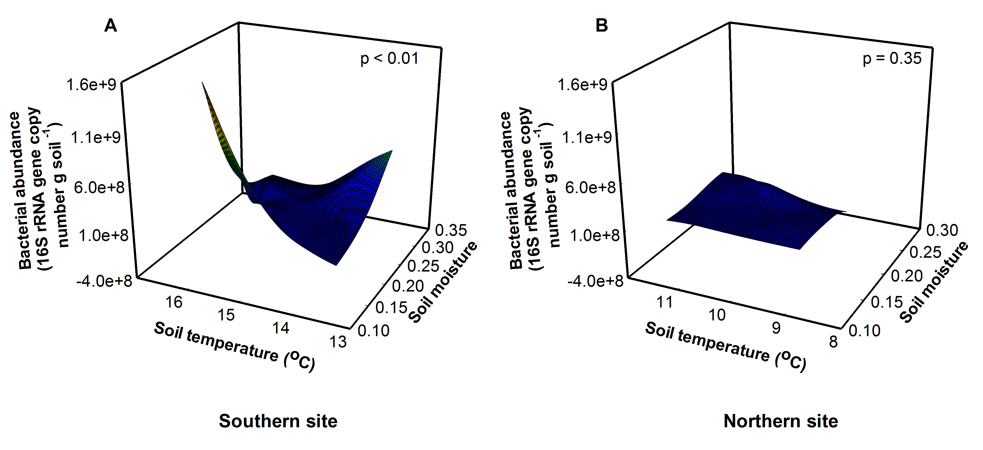

Figure 17. Site, soil temperature, and soil moisture interactively altered bacterial abundance (F = 18.17, p < 0.01). 1A. At the southern site, abundance was greatest at low soil moistures and high soil temperatures. 1B. There was no effect of soil temperature and soil moisture at the northern site.

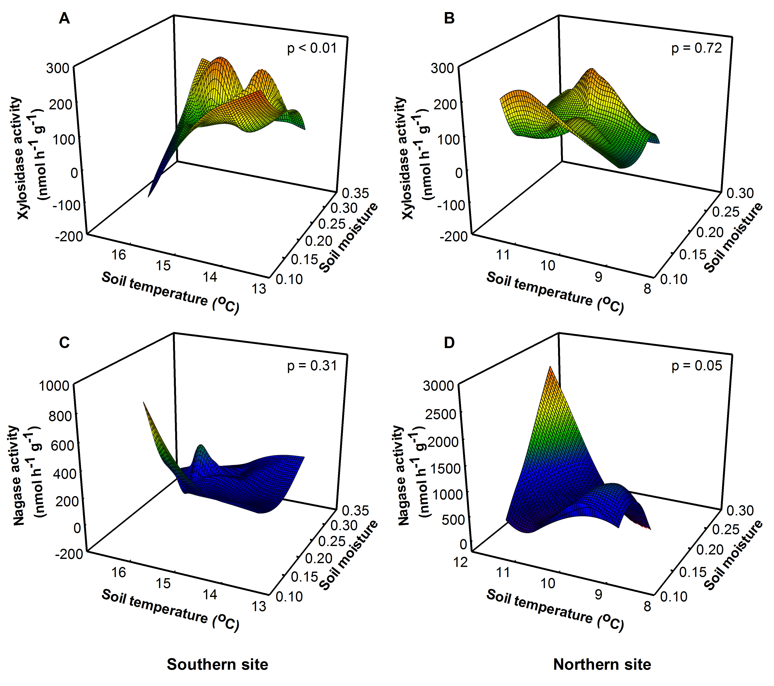

Figure 18. Site, soil temperature, and soil moisture interactively altered potential xylosidase activity (F = 10.22, p = 0.01) and nagase activity (F = 5.42, p = 0.03). 2A. At the southern site, xylosidase activity was lowest at high soil temperatures and low soil moistures. 2B. At the northern site, there was no effect of soil temperature and soil moisture on xylosidase activity. 2C. At the southern site, there was no effect of soil temperature and soil moisture on nagase activity. 2D. At the northern site, nagase activity was greatest at high soil temperatures and soil moistures.

Discussion
Taken together, our results demonstrate that increases in temperature brought about by global warming may have effects that vary by location and depend on underlying levels of soil moisture. Overall, we found that soil temperature and soil moisture altered bacterial richness, abundance, and potential microbial activity at the southern site, but not the northern site. More drastic effects at the southern site may evident because communities are being pushed beyond their thermal tolerances. Surprisingly, the change in microbial community structure and potential function did not scale up to alter an ecosystem function - decomposition.
Soil bacteria are highly responsive to changing soil temperature and soil moisture (Pietikainen et al. 2005, Rinnan et al. 2007, Zogg et al. 1997). Consistent with this, we found this portion of the community to be most responsive to the treatments after 16 months of warming at the warmer, southern site. Optimal soil temperatures for bacterial growth tend to be between 25 and 30 °C (Pietikainen et al. 2005). At the northern site, organic soil temperatures ranged from -6 to 26 °C, while at the southern site soil temperatures ranged from -5 to 37 °C throughout the year. At the warmer, southern site, soil temperatures exceed the optimum temperature for bacterial growth. This increase in temperature altered bacterial richness and abundance. This indicates that further changes in the bacterial community may be evident as soil temperature increases over time (Rinnan et al. 2007).
Although we detected significant changes in the microbial community at the southern site, we were able to detect only small changes in potential function and no change in the rate of decomposition. This suggests that changes in these communities have resulted in functionally redundant new communities. The species lost or gained do not currently have an impact on the functioning of this ecosystem. Other studies have demonstrated that changes in ecosystem functioning in response to warming may take longer than just one year before they become evident (Bell and Henry 2011, Rinnan et al. 2007). We have started to see changes in potential extracellular enzymatic activity, thus we expect that increases in temperature will begin to alter ecosystem function, as temperatures increase within the community over time.

Acknowledgments
We thank S. Pelini, M. Pelini, and L. Nichols for their help with collecting soil and decomposition bags. We are grateful to K. Stuble for her insightful comments on a previous version of this manuscript. M. Cregger was supported by the Graduate Research for the Environment Fellowship sponsored by the Department of Energy Global Change Education Program and The University of Tennessee. The warming experiment was funded by a US DOE PER award (DE-FG02-08ER64510) to R.R. Dunn, A. M. Ellison, N. J. Gotelli and N. J. Sanders.
References
Anderson, M.J. 2005. DistLM v.5: A FORTRAN computer program to calculate a distance-based multivariate analysis for a linear model. New Zealand, University of Auckland.
Bell, T.H., H. Henry. 2011. Fine scale variability in soil extracellular enzyme activity is insensitive to rain events and temperature in a mesic system. Pedobiologia 54: 141-146.
Cottingham, K.L., J.T. Lennon, and B.L. Brown. 2005. Knowing when to draw the line: designing more informative ecological experiments. Frontiers in Ecology and the Environment 3: 145-152.
Diamond, S.E., D.M. Sorger, J. Hulcr, S.L. Pelini, I Del Toro, C. Hirsch, E. Oberg, and R.R. Dunn. 2012. Who likes it hot? A global analysis of the climatic, ecological, and evolutionary determinants of warming tolerance in ants. Global Change Biology 18: 448-456.
Frey, S.D., R. Drijber, H. Smith, and J. Melillo. 2008. Microbial biomass, functional capacity, and community structure after 12 years of soil warming. Soil Biology and Biochemistry 40: 2904-2907.
Gardes, M. and T.D. Bruns. 1993. Its Primers with Enhanced Specificity for Basidiomycetes - Application to the Identification of Mycorrhizae and Rusts. Molecular Ecology 2: 113-118.
Hauben, L., L. Vauterin, J. Swings, and E. Moore. 1997. Comparison of 16S ribosomal DNA sequences of all Xanthomonas species. International Journal of Systematic Bacteriology 47: 328-335.
Langlois, T.J., M.J. Anderson, and R.C. Babcock. 2006. Inconsistent effects of reefs on different size classes of macrofauna in adjacent sand habitats. Journal of Experimental Marine Biology and Ecology 334: 269-282.
Marchesi, J.R., T. Sato, A.J. Weightman, T.A. Martin, J.C. Fry, S.J. Hiom, D. Dymock, and W.G. Wade. 1998. Design and evaluation of useful bacterium-specific PCR primers that amplify genes coding for bacterial 16S rRNA. Applied and Environmental Microbiology 64: 2333-2333.
Olson, J.S. 1963. Energy storage and balance of producers and decomposers in ecological systems. Ecology 44: 322.
Pelini, S.L., F.P. Bowles, A.M. Ellison, N.J. Gotelli, N.J. Sanders, and R.R. Dunn. 2011 Heating up the forest: open-top chamber warming manipulation of arthropod communities at Harvard and Duke Forests. Methods in Ecology and Evolution 2: 534-540.
Pietikainen, J., M. Pettersson, and E. Baath. 2005. Comparison of temperature effects on soil respiration and bacterial and fungal growth rates. Fems Microbiology Ecology 52: 49-58.
Rinnan, R., A. Michelsen, E. Baath, and S. Jonasson. 2007. Fifteen years of climate change manipulations alter soil microbial communities in a subarctic heath ecosystem. Global Change Biology 13: 28-39.
Rustad, L.E., J.L. Campbell, G.M. Marion, R.J. Norby, M.J. Mitchell, A.E. Hartley, J.C. Cornelissen, J Gurevitch, and N. Gcte. 2001. A meta-analysis of the response of soil respiration, net nitrogen mineralization, and aboveground plant growth to experimental ecosystem warming. Oecologia 126: 543-562.
Saiya-Cork, K.R., R.L. Sinsabaugh, and D.R. Zak. 2002. The effects of long term nitrogen deposition on extracellular enzyme activity in an Acer saccharum forest soil. Soil Biology and Biochemistry 34: 1309-1315.
Schindlbacher, A., A. Rodler, M. Kuffner, B. Kitzler, A. Sessitsch, and S. Zechmeister-Boltenstern. 2011. Experimental warming effects on the microbial community of a temperate mountain forest soil. Soil Biology and Biochemistry 43: 1417-1425.
Singh, B.K., L. Nazaries, S. Munro, I.C. Anderson, and C.D. Campbell. 2006. Use of multiplex terminal restriction fragment length polymorphism for rapid and simultaneous analysis of different components of the soil microbial community. Applied and Environmental Microbiology 72: 7278-7285.
Sinsabaugh, R.L. 1994. Enzymatic analysis of microbial pattern and process. Biology and Fertility of Soils 17: 69-74.
Solomon, S., D. Qin, M. Manning, Z. Chen, M. Marquis, K.B. Averyt, M. Tignor and H.L. Miller (eds.). 2007. Contribution of Working Group I to the Fourth Assessment Report of the Intergovernmental Panel on Climate Change. United Kingdom and New York, NY, USA.
Tewksbury, J. J., R.B. Huey, and C.A. Deutsch. 2008. Ecology - Putting the heat on tropical animals. Science 320: 1296-1297.
Wolkovich, E.M., B.I. Cook, J.M. Allen, T.M. Crimmins, J.L. Betancourt, S.E. Travers, S. Pau, J Regetz, T.J. Davies, N.J.B. Kraft, T.R. Ault, K. Bolmgren, S.J. Mazer, G.J. McCabe, B.J. McGill, C. Parmesan, N. Salamin, M.D. Schwartz, and E.E. Cleland. 2012. Warming experiments underpredict plant phenological responses to climate change. Nature 485: 494-497.
Zogg, G.P., D.R. Zak, D.B. Ringelberg, N.W. Macdonald, K.S. Pregitzer, and D.C. White. 1997. Compositional and functional shifts in microbial communities due to soil warming. Soil Science Society of America Journal 61: 475-481.

Conclusions and future directions.
My dissertation work has demonstrated that understanding the effect of climate change on microbial community structure and ecosystem function is complex and contingent upon the underlying abiotic variability experienced in an ecosystem and biotic interactions between the belowground and aboveground communities. Overall, I found that seasonal variability and the aboveground plant community played a large role in the response of soil microbes to precipitation change in a semi-arid woodland. Additionally, I found that increasing temperature altered microbial structure and function in a temperate forest, but this effect was not consistent across two locations. Although I have begun addressing key questions related to the effects of climate change on ecosystems, my work has left many questions unanswered.
- My work addressed the short-term effects of precipitation change and atmospheric warming on microbial community structure and function. To truly understand the effects of this chronic disturbance, long-term, detailed measurements are warranted. Specifically, I recommend using pyrosequencing to understand species level shifts in these communities, using functional gene assays to understand potential changes in function, and measuring carbon and nitrogen cycling in depth in association with climatic changes.
- My work demonstrated that microbial communities respond to seasonal variation in rainfall. This leads me to conclude that snapshot studies during one season may not provide enough information to understand the response of microbial communities to climate change. Therefore, more studies should be conducted assessing the seasonal response and year-to-year fluctuations of the microbial community to climate change factors.
- My work showed that microbial community structure and function varied beneath two plant species. Understanding this link is important in predicting the response of microbial communities to climate change. Therefore, I suggest this area needs addressing in future climate change studies. Additionally, this research area could be extended to examine genotypic differences in plants and how these differences alter belowground community structure and function.
- Finally, my research showed that the response of the microbial community to climate change is not consistent across ecosystems. Thus, more studies should be done in a variety of ecosystems before broad generalizations and patterns are inferred.
Although my dissertation research was focused to understand how climatic change altered microbial community structure and function in ecosystems, for my future research, I am broadly interested in understanding how different factors shape archaeal, bacterial, and fungal communities within ecosystems, and how disturbance, both acute and chronic, alters these communities. Specifically, I am interested in understanding how microbial community composition influences ecosystem function, and what role microbial diversity plays in ecosystem functioning. Although I have previously studied large ecosystems such as forests or desert woodlands, I’m also interested in evaluating these dynamics within smaller ecosystems like the human body. For my post-doctoral research, I am joining the host-microbe group at the Institute for Genomic Biology at the University of Illinois where I will use metagenomic techniques to evaluate microbial communities within the human body and identify variation in microbial community composition, both bacterial, and fungal. I am interested in understanding how microbial communities affect the functioning of the human body, and what role they play in acute and chronic infection and disease. I am interested in examining how factors such as obesity, dietary preferences, lifestyle choices, and heredity influence the microbiome and if there are factors associated with an abnormal microbiome, which leads to disease states.

APPENDICES.
Appendix 1. . Microbial richness, abundance and biomass, mean (± standard error), across all treatments and beneath piñon and juniper crowns in the pre-monsoon and monsoon season of 2008 and pre-monsoon season of 2009.
Response variable |  | - water | Cover  control | + water | Control | - water | Cover  control | + water | Control
 |  | Juniper |  |  |  | Piñon
Microbial richness | Pre-monsoon | 15.0 (6.0) | 42.7 (4.1) | 25.0 (1.0) | 15.5 (3.5) | 42.0 (23.1) | 56.0 (3.0) | 31.7 (15.7) | 46.3 (15.3)
Fungal richness | Pre-monsoon | 5.0 (3.0) | 25.0 (4.2) | 18.0 (3.2) | 5.0 (3.0) | 36.3 (23.3) | 39.5 (3.5) | 25.0 (12.5) | 35.0 (12.7)
Bacterial richness | Pre-monsoon | 10.0 (3.0) | 17.7 (1.7) | 7.0 (2.5) | 10.5 (0.5) | 5.7 (1.2) | 16.5 (0.5) | 6.7 (3.2) | 11.3 (2.7)
Fungal:bacterial | Pre-monsoon | 0.25 (0.05) | 0.45 (0.09) | 0.69 (0.19) | 0.44 (0.05) | 0.82 (0.30) | 0.94 (0.16) | 1.26 (0.54) | 1.73 (0.46)
Fungal abundance | Pre-monsoon | 2.2 x 10⁷  (6.7 x 10⁶) | 4.2 x 10⁷  (6.7 x 10⁶) | 5.0 x 10⁷  (8.2 x 10⁶) | 4.2 x 10⁷  (9.3 x 10⁶) | 3.6 x 10⁷  (2.0 x 10⁷) | 6.7 x 10⁷  (1.7 x 10⁷) | 1.1 x 10⁸  (3.2 x 10⁷) | 1.8 x 10⁸  (4.1 x 10⁷)
Bacterial abundance | Pre-monsoon | 8.7 x 10⁷  (7.3 x 10⁶) | 9.6 x 10⁷  (1.6 x 10⁷) | 7.8 x 10⁷  (1.7 x 10⁷) | 9.2 x 10⁷  (9.7 x 10⁶) | 5.9 x 10⁷  (2.6 x 10⁷) | 8.1 x 10⁷  (2.8 x 10⁷) | 9.5 x 10⁷  (2.1 x 10⁷) | 1.1 x 10⁸  (1.2 x 10⁷)
Microbial richness | Monsoon | 32.0 (3.0) | 30.7 (3.8) | 23.0 (5.5) | 45.0 (12.0) | 27.3 (1.2) | 28.7 (1.5) | 32.3 (7.0) | 36.0 (9.0)
Fungal richness | Monsoon | 16.5 (1.5) | 18.3 (4.1) | 12.3 (4.1) | 33.0 (12.0) | 16.0 (1.5) | 16.3 (1.2) | 17.7 (2.9) | 21.0 (5.0)
Bacterial richness | Monsoon | 15.5 (1.5) | 12.3 (0.9) | 10.7 (1.5) | 12.0 (0.0) | 11.3 (1.3) | 12.3 (2.4) | 14.7 (4.2) | 15.0 (4.6)
Fungal:bacterial | Monsoon | 1.50 (0.67) | 0.97 (0.52) | 3.80 (2.03) | 1.75 (0.98) | 1.98 (0.12) | 5.97 (2.33) | 0.77 (0.10) | 2.73 (1.02)
Fungal abundance | Monsoon | 1.3 x 10⁸  (3.5 x 10⁷) | 6.3 x 10⁷  (2.6 x 10⁷) | 3.6 x 10⁷  (8.7 x 10⁶) | 7.1 x 10⁷  (5.5 x 10⁷) | 1.4 x 10⁸  (2.1 x 10⁷) | 7.6 x 10⁷  (2.7 x 10⁷) | 1.5 x 10⁸  (2.6 x 10⁷) | 1.5 x 10⁸  (7.7 x 10⁷)
Bacterial abundance | Monsoon | 1.0 x 10⁸  (2.0 x 10⁷) | 1.3 x 10⁸  (6.3 x 10⁷) | 1.5 x 10⁷  (5.1 x 10⁶) | 6.8 x 10⁷  (4.2 x 10⁷) | 7.2 x 10⁷  (7.6 x 10⁶) | 1.5 x 10⁷  (3.7 x 10⁶) | 2.0 x 10⁸  (2.0 x 10⁷) | 4.9 x 10⁷  (2.2 x 10⁷)
Microbial biomass N | 2009 | 199.2 (80.0) | 282.0 (59.4) | 425.6 (82.3) | 367.6 (87.1) | 290.5 (64.0) | 332.6 (70.8) | 459.8 (127.0) | 295.1  (48.1)

Appendix 2. Timing and amount of rainfall events across years at the Sevilleta precipitation manipulation.
Year | Date | Amount water added (mm)
2008 | June 24 | 19
2008 | July 15 | 19
2008 | August 26 | 19
2009 | April 24 | 12.5
2009 | May 19 | 19
2009 | June 30 | 19
2009 | October 28 | 19
2010 | May 5 | 19
2010 | June 2 | 19
2010 | June 29 | 19
2010 | August 3 | 19
2010 | August 31 | 19
2010 | October 5 | 17
2011 | April 19 | 14
2011 | May 17 | 19
2011 | June 21 | 19
2011 | July 19 | 17
2011 | August 23 | 19
2011 | October 4 | 19

Appendix 3. Warming altered microbial community structure and function at the southern site. Raw data values for all response variables are listed below.
 | Southern site
Chamber temperature | 0 | 1.5 | 2.0 | 2.5 | 3.0 | 3.5 | 4.0 | 4.5 | 5.0 | 5.5
Soil temperature (ºC) | 14.1 | 14.6 | 14.4 | 14.9 | 15.7 | 14.4 | 15.6 | 15.4 | 15.7 | 16.1
Soil moisture | 0.29 | 0.27 | 0.26 | 0.32 | 0.19 | 0.17 | 0.26 | 0.27 | 0.23 | 0.29
Total richness (Total OTUs) | 89 | 89 | 96 | 90 | 154 | 77 | 95 | 89 | 81 | 115
Fungal richness (Fungal OTUs) | 34 | 31 | 42 | 31 | 106 | 23 | 38 | 34 | 27 | 55
Bacterial richness (Bacterial OTUs) | 55 | 58 | 54 | 59 | 48 | 54 | 57 | 55 | 54 | 60
Fungal:bacterial | 2.5 | 3.2 | 3.5 | 6.3 | 0.2 | 5.8 | 1.7 | 9.0 | 3.8 | 1.9
Fungal abundance (copy number g⁻¹ soil) | 1.89 x 10⁸ | 2.81 x 10⁸ | 1.95 x 10⁸ | 2.75 x 10⁸ | 9.92 x 10⁷ | 1.86 x 10⁸ | 2.25 x 10⁸ | 3.12 x 10⁸ | 1.80 x 10⁸ | 1.05 x 10⁸
Bacterial abundance (copy number g⁻¹ soil) | 1.90 x 10⁸ | 8.78 x 10⁷ | 5.52 x 10⁷ | 4.40 x 10⁷ | 5.53 x 10⁸ | 3.21 x 10⁷ | 1.31 x 10⁸ | 3.47 x 10⁷ | 4.72 x 10⁷ | 5.70 x 10⁷
Xylosidase (nmol h⁻¹ g soil ⁻¹) | 88.1 | 189.3 | 133.8 | 66.6 | 16.4 | 204.2 | 75.8 | 183.3 | 58.3 | 112.6
Sulfatase (nmol h⁻¹ g soil ⁻¹) | 9.6 | 9.2 | 14.3 | 9.2 | 10.9 | 11.0 | 9.8 | 3.6 | 0 | 16.6
Cellobiohydrolase (nmol h⁻¹ g soil ⁻¹) | 52.9 | 124.8 | 202.9 | 24.0 | 5.4 | 47.5 | 21.2 | 194.0 | 24.2 | 32.0
ß-glucosidase (nmol h⁻¹ g soil ⁻¹) | 93.8 | 165.4 | 175.5 | 77.3 | 23.7 | 141.0 | 104.8 | 405.5 | 55.4 | 80.2
Α-glucosidase (nmol h⁻¹ g soil ⁻¹) | 11.0 | 34.0 | 24.3 | 5.2 | 5.2 | 4.5 | 14.4 | 24.2 | 3.2 | 6.7
Nagase (nmol h⁻¹ g soil ⁻¹) | 141.5 | 134.4 | 97.3 | 125.7 | 291.3 | 200.8 | 315.3 | 140.9 | 53.1 | 75.2
Phosphatase (nmol h⁻¹ g soil ⁻¹) | 671.4 | 1376.5 | 1871.7 | 806.4 | 1185.9 | 1372.1 | 1335.5 | 1665.2 | 544.8 | 900.7
Phenol oxidase (nmol h⁻¹ g soil ⁻¹) | 877.8 | 1343.4 | 409.6 | 987.0 | 738.7 | 779.9 | 891.8 | 2548.2 | 1834.8 | 2535.6
Peroxidase (nmol h⁻¹ g soil ⁻¹) | 0 | 0 | 0 | 0 | 0 | 0 | 0 | 0 | 0 | 0
Decomposition (k constant) | 0.27 | 0.12 | 0.36 | 0.23 | 0.17 | 0.35 | 0.37 | 0.55 | 0.13 | 0.18

Appendix 4. Warming had minimal effect on microbial community structure and function at the northern site. Raw data values for all response variables at the northern site are listed below.
 | Northern site
Chamber temperature | 0 | 1.5 | 2.0 | 2.5 | 3.0 | 3.5 | 4.0 | 4.5 | 5.0 | 5.5
Soil temperature (ºC) | 9.5 | 9.5 | 10.2 | 10.5 | 11.1 | 10.9 | 10.3 | 10.4 | 11.6 | 11.1
Soil moisture | 0.18 | 0.18 | 0.14 | 0.24 | 0.24 | 0.14 | 0.18 | 0.24 | 0.17 | 0.16
Total richness (Total OTUs) | 92 | 91 | 131 | 120 | 106 | 105 | 107 | 72 | 92 | 77
Fungal richness (Fungal OTUs) | 23 | 29 | 53 | 37 | 34 | 34 | 45 | 22 | 17 | 16
Bacterial richness (Bacterial OTUs) | 69 | 62 | 78 | 83 | 72 | 71 | 62 | 50 | 75 | 61
Fungal:bacterial | 8.4 | 13.2 | 22.3 | 4.4 | 5.6 | 5.1 | 5.2 | 9.6 | 14.0 | 3.2
Fungal abundance (copy number g⁻¹ soil) | 6.25 x 10⁸ | 1.25 x 10⁹ | 1.57 x 10⁹ | 5.89 x 10⁸ | 7.71 x 10⁸ | 4.44 x 10⁸ | 3.65 x 10⁸ | 4.33 x 10⁸ | 1.02 x 10⁹ | 2.84 x 10⁸
Bacterial abundance (copy number g⁻¹ soil) | 7.25 x 10⁷ | 9.47 x 10⁷ | 7.05 x 10⁷ | 1.35 x 10⁸ | 1.38 x 10⁸ | 8.72 x 10⁷ | 7.04 x 10⁷ | 4.50 x 10⁷ | 7.24 x 10⁷ | 8.95 x 10⁷
Xylosidase (nmol h⁻¹ g soil ⁻¹) | 57.7 | 41.5 | 121.9 | 181.6 | 123.2 | 190.1 | 112.1 | 77.3 | 44.5 | 63.9
Sulfatase (nmol h⁻¹ g soil ⁻¹) | 1.1 | 11.6 | 6.2 | 0 | 0 | 22.8 | 0 | 0.4 | 0 | 9.3
Cellobiohydrolase (nmol h⁻¹ g soil ⁻¹) | 44.1 | 47.7 | 129.5 | 96.9 | 83.0 | 77.9 | 84.5 | 20.1 | 30.9 | 24.1
ß-glucosidase (nmol h⁻¹ g soil ⁻¹) | 253.3 | 311.9 | 635.5 | 396.4 | 625.4 | 338.8 | 403.0 | 323.5 | 416.0 | 143.6
Α-glucosidase (nmol h⁻¹ g soil ⁻¹) | 3.2 | 22.2 | 2.1 | 4.9 | 0 | 29.4 | 3.7 | 0 | 1.8 | 2.4
Nagase (nmol h⁻¹ g soil ⁻¹) | 396.2 | 1025.4 | 698.6 | 492.7 | 1646.0 | 151.7 | 633.7 | 422.5 | 775.4 | 155.1
Phosphatase (nmol h⁻¹ g soil ⁻¹) | 842.1 | 291.3 | 889.3 | 527.6 | 1299.2 | 1196.0 | 966.7 | 1702.2 | 1542.3 | 352.4
Phenol oxidase (nmol h⁻¹ g soil ⁻¹) | 195.9 | 0 | 0 | 2768.0 | 3098.9 | 0 | 1248.2 | 0 | 0 | 1073.1
Peroxidase (nmol h⁻¹ g soil ⁻¹) | 620.4 | 0 | 0 | 0 | 0 | 0 | 0 | 0 | 0 | 0
Decomposition (k constant) | 0.09 | 0.06 | 0.14 | 0.06 | 0.06 | 0.04 | 0.05 | 0.05 | 0.09 | 0.03

VITA.
Melissa Cregger was born in Indiana where she grew up as the daughter of a union steel worker and a stay-at-home mom. She was the first in her family to receive a college degree in 2003 when she received her Bachelor of Science degree in Biology at the University of Southern Indiana. In 2004, she accepted a job as a research assistant at Yale University where she evaluated protein expression in breast cancer and melanoma using quantitative immunohistochemistry and tissue microarrays. In August of 2006, she moved on to accept a position in research and development at HistoRx, where she continued examining protein expression in cancer. In August of 2007, Melissa began a Ph.D. program in the Department of Ecology and Evolutionary Biology at the University of Tennessee where she investigated the effects of climate change on soil microbial community structure and ecosystem function. While at the University of Tennessee, she was awarded the Global Change Education Fellowship through the Department of Energy, and in 2011 was awarded the Marvin L. Wesely award for the best use of DOE mentors and achievement. In 2011, she was also awarded the Cokkinias graduate award for outstanding scholarly achievement. During her time as a graduate student, she was invited to attend the Boreal Forest Ecology Course in Umeå, Sweden and the Microbial Diversity Course in Woods Hole, Massachusetts. She worked on numerous collaborative projects at the University of Tennessee resulting in three publications in ecological journals (Genung et al. 2010, Kardol et al. 2010, Lessard et al. 2012). She presented her research numerous times at various meetings like the Ecological Society of America annual meeting, the Argonne Soils Workshop, and the Association of Southeastern Biologists meeting. She completed her dissertation in the summer of 2012. In September
of 2012, she will begin a post-doctoral research fellowship at the Institute for Genomic Biology at the University of Illinois, where she will examine how different factors alter microbial community structure in the human body, and what effect changes in this community have on human health.

