Introduction
Using my knowledge that I have gained while majoring in accounting, I will be analyzing the metrics and statistics of my team’s (Pedalworks) performance in the Marketplace simulation in BUAD 453.
Some of the accounting frameworks and principles utilized will be the Audit Risk model (COSO standard), a reactionary audit response on gauged risk of material statement, and others. The goal of this capstone is to use a hyper realistic case that will interact with my team’s decision-making and analysis. This simulation provides the perfect environment for an accounting focused capstone as the simulation provides numerous financial statements and highly reactive outcomes resulting from our decisions.
Abstract
I believe that I have learned a lot about the application of accounting principles to a very reactive and interactive simulation like Marketplace. While my team did not perform as well as I hoped, I still was able to help the team by monitoring ratios and how they showed our next best course of action. We ran into many challenges and problems, and I believe that my insights made a significant difference in how we approached those problems.
Goals and Strategy
The initial strategy for Pedalworks is a high margin of profit from concentrated sales. While a sizeable market share is a priority, our team was willing to shrink our presence in return for a larger profit margin by streamlining marketing and emphasizing cost management. However, this focus on reducing COGS and other expenses was never to be prioritized over the quality of the products as our team utilized a heavy differentiation strategy.

Q1: A Look into Potential Risks for the Company
While Q1 does not provide much financial information, a deeper understanding of how Pedalworks could and should address risk of material misstatement can help contextualize the financial statements and warn us of possible misrepresentation of actual revenues and expenses.
By applying COSO-based accounting assertions (refer to Addendum for Q1) to all main accounts excluding equity, we can find what types of misstatements can occur that would compromise the validity of the financial statements and misconstrue performance to current and potential shareholders.
Account: Assets
Assertions
Existence: There is possible risk with the overstatement of assets; however, this risk is less than most companies as Pedalworks creates bikes to order. Building bikes to order reduces the risk of overestimating inventory as expenses and revenues have a significant connection within the journal entries.
Completeness: There is no risk of unrecorded liabilities as a created bike is a result of a direct sale.
Valuation: Valuation is the highest possible assertion risk as it is very possible to over or underestimate the COGS for inventory, especially as the game progresses with more and more features on a bike.
Presentation and Disclosures: There is no risk for misplacement of assets on the financial statements.
Rights and Obligations: No risk of misrepresentation of rights and obligations as there is no way for other companies’ assets to be presented as our own.
Account: Liabilities
Assertions
Existence: There is no possible risk with the overstatement of liabilities as this would not be of any advantage to misstate.
Completeness: There is a risk of unrecorded liabilities as accounts payable and other such accounts that would eventually turn into expenses could be understated to create the illusion of less liabilities.
Valuation: Valuation is also a risk as undervalued liabilities could provide the same advantages as a lack of completeness.
Presentation and Disclosures: There is no risk for misplacement of liabilities on the financial statements.
Rights and Obligations: No risk of misrepresentation of rights and obligations as there is no way for other companies’ liabilities to be presented as our own.

Account: Revenues
Assertions
Existence: There is possible risk with the overstatement of revenues; however, this risk is less than most companies as Pedalworks creates bikes to order (same reasoning for the existence assertion for assets.)
Completeness: There is a risk of unrecorded revenues as a created bike is a result of a direct sale but deferring this revenue could be possible to misrepresent gross profit for tax purposes.
Valuation: Valuation is not a risk in the revenue account directly as a misvalued
Presentation and Disclosures: There is no risk for misplacement of revenues on the financial statements.
Rights and Obligations: No risk of misrepresentation of rights and obligations as there is no way for other companies’ revenues to be presented as our own.
Account: Expenses
Assertions
Existence: There is no possible risk with the overstatement of expenses.
Completeness: There is a risk of unrecorded expenses, but since a created bike is a result of a direct sale, the risk is not high.
Valuation: Valuation for expenses is not a high risk, but it is a possible risk in accounts such as COGS.
Presentation and Disclosures: There is no risk for misplacement of expenses on the financial statements.
Rights and Obligations: No risk of misrepresentation of rights and obligations as there is no way for other companies’ expenses to be presented as our own.

Q2: Further Gauging Risk
Using the basic equation for Audit Risk (Audit Risk= Inherent Risk + Control Risk + Detection Risk), the account-based risk can be identified and possible mitigations to this risk could be created.
We can set control risk to low as if we were setting our controls for auditing and bookkeeping. Low control risk is a result of good measures and standards set up by the auditing committee. Detection risk is the only risk we can set ourselves. If we set it to low, it means we do more intensive work as we are minimizing the possibility of a detection risk. While adjusting detection risk, the end goal is to have low audit risk while also not doing more work than necessary as time schedules for audits are extremely in depth and exhaustive, especially for audit teams with multiple clients.
Assets: Audit Risk= Inherent Risk + Control Risk + Detection Risk
Low=High + Low + Low
Liabilities: Audit Risk= Inherent Risk + Control Risk + Detection Risk
Low=Medium + Low + Medium
Revenues: Audit Risk= Inherent Risk + Control Risk + Detection Risk
Low=Low + Low + Medium
Expenses: Audit Risk= Inherent Risk + Control Risk + Detection Risk
Low=Low + Low + Medium
Factoring Assertion-based Risk into the Audit Model
Since overall audit risk is low, we can settle for an easier time schedule of auditing as well as not having to provide relatively high-quality nature or extent for an audit.
The nature of the audit information relates to how reliable the financial data is. In GAAP (Accounting Principles), the highest level of nature is direct personal knowledge (i.e., you kick a 3D printer and know that it is a printer). That level is not necessary in this situation. We can rely on lower quality information such as pay stubs, invoices, and confirmations with the bank.
Extent refers to substantive analysis of accounts. Most of this would be done in an excel sheet. Extent is inversely related to the testing scopes used to identity a misstatement in the financials. For example, a smaller scope means a greater amount of extent.
Most control and recording testing can take place during the interim of the fiscal year, with more in-depth substantive analysis backlogged to the year-end wrapping up procedures.
To summarize, extent, timing, and nature all relate to how accurately we can detect a material misstatement in the financials of the company.

Q3: First Results and Revisiting the Audit Risk from Q1
Our aim for Q3 is to see how our strategy integrates into the market, and then quickly pivot or bear down if need be. These first sets of analytics will not have a lot of context, but they still give meaningful information about certain aspects to tweak or overhaul.
While attempting to realize the aforementioned plan, our team needs to find the right metrics and ratios that will help us gauge efficiency and profit margins. By highlighting a handful of ratios early in the simulation, we should glean useful and easy to understand information for the rest of the simulation.
Ratios to monitor:
Earnings per share: This ratio is paramount to receiving investment that can drive Pedalworks to the top of the marketplace. An investor will surely look at EPS in the first few moments of looking to invest in this company. An attractive EPS can give a huge advantage along the lines of investment and capital to reinvest in the company.
Return on assets: Large revenues are great to see, but profitability is the main goal. Large revenues do not inherently signal a huge profit as the more assets you have, the smaller the ROA figure is.
Total Asset Turnover: ROA deals more with profitability where this ratio is activity based. In this case, TAT is an auxiliary figure that gives more context to ROA. Being able to compare profitability and activity will allow analysis of the company to ensure that operations are as lean and efficient as possible.
Demand per Salesperson (Store): As Pedalworks is focusing on a differentiation strategy, the total demand created is less important than the demand per Salesperson. This helps minimize cost while maximizing the profit margin. The goal for this ratio is to find the peak figure and maintain that amount of salespeople.
Demand per Salesperson (Web): This figure is obviously very similar to the former, and the reasonings and goals are the same.
Net Profit Margin: This ratio is a direct profitability ratio and will be the most apparent number to monitor for profitability. The goal should be to always attempt to increase this number every quarter. If this number drops, the team should drop everything to address it.
How do these ratios relate to our team’s goals?
These ratios are not the only figures that are monitored, but they are the most compatible with Pedalworks’ differentiation strategy. Profitability is the main goal while supporting ratios give us more context and milestones to aim for to ensure efficiency. Since the Pedalworks’ model is even more directly linked to demand as all bikes are made to order, the two demand figures are the numbers that will be the most important first step as Pedalworks attempts to navigate the steep S-curve this industry will experience.

First Statistics Received
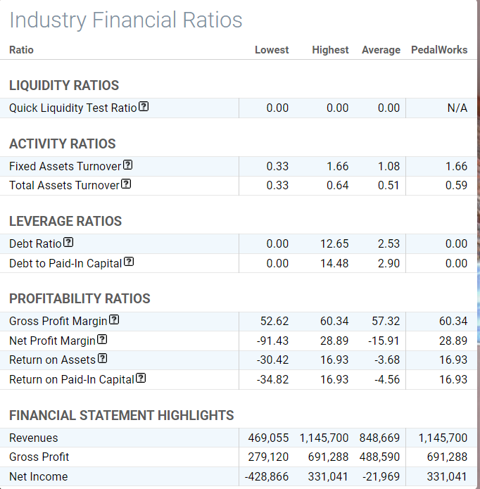
With Earnings per share at 17, the company will look attractive to investors, but one must remember that the amount of equity (the denominator of EPS) will shoot up exponentially over the next few quarters, a fact which proves that revenues need to be leaner and larger.
The gross and net profit margin are great signs that profitability is already at a good level. If we can maintain this level of profitability, growth will be attainable without taking any loans which is a goal of ours.
The activity ratios are also very positive. If we can keep our activity up, we can maintain our advantage over other companies in the industry.

Q4: Overall Materiality and Financials
Determining Overall Materiality
Finding overall materiality gives a threshold for auditors in order to find what misstatements and transactions are material. If a misstatement is over the threshold, it is material, and therefore should be disclosed or brought before the audit committee.
Materiality can be found several ways, but it is always found by multiplying a certain account on the balance sheet or income statement by a range of 0.5-10% depending on what account is used and the size of the company. The lower range is used for larger companies or public companies. We will be using the lower range as this company will eventually grow to deal with fairly large sums of cash and other capital.
The accounts we can use to find overall materiality are earnings before tax, total assets, or total revenues. Since we will be using earnings before tax, we are allowed to use a range of 5-10%. Again, we will use the lower range of 5%.
Earnings before tax amounted to $331,041, and therefore our overall materiality is $16,552 rounded. If we have a misstatement above this amount, we are legally entitled to either fix this amount before the annual 10-k is released or release a “Big R” statement (see addendum for definition) if the financials are already out for the year.

Second Set of Ratios
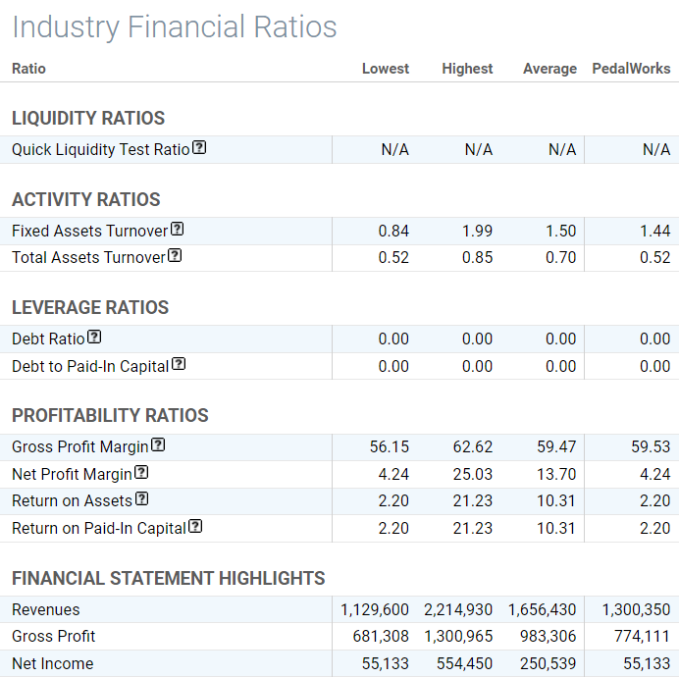
With Earnings per share at 2, the company will not look attractive to investors, but there was a large change in the amount of equity (the denominator of EPS). We must either try to address this immediately or delay for a quarter to invest in more fixed capacity and R&D in an attempt to create a huge increase in EPS in the future.
The gross and net profit margin have shrunk which is not a good sign in our long-term goal for high profitability. This could be due to a huge amount of recent investment; however, this investment should already be contributing to a better margin. We have to reassess how we are utilizing our assets to gain revenue, which leads us to our activity ratios
The activity ratios are also posing a challenge. If we are to improve this number, we have to create better quality bikes and advertisements to increase activity around the company.

Diagnosis for Underperformance
Our advertisements were subpar, as well as our mountain bike. This mistake probably led to the huge decrease in overall performance. The increase in store expenses and advertisements did not lead to the increase in profit that we were expecting due to these shortcomings.
What can we do to get back on track? We will invest in another 3D printer and carry on with our huge push in R&D in an attempt to reestablish our brand’s superior quality.

Q5: Finding Tolerable Misstatement and Financials
Finding Tolerable Misstatement
Tolerable misstatement is derived from overall materiality, usually by multiplying it anywhere from 50-70%. We will again use the lower range of 50%. However, we will recalculate overall materiality for this quarter. We suffered a major dip in earning before tax, so we will now use total assets. This formula uses a much smaller percentage range of 0.5%-2%. We will multiply $2,510,173 by 0.5% to get a Tolerable misstatement of $12,551.
How is tolerable misstatement different from overall materiality? Tolerable misstatement focuses on what accounts are significant to scrutinize further than other accounts rather than singular errors. For example, odds are that the office supplies account should not be as scrutinized as the PP&E account. These accounts that are above the tolerable misstatement threshold are called significant accounts or in-scope accounts. If the annual change in these accounts is greater than the tolerable misstatement, it is heavily recommended to fully analyze the account with an array of analyses such as vertical or flux analysis.
Since the balance sheet for this quarter is not very in depth, we can estimate what significant accounts exist based on general business practice. Accounts noted with an asterisk signify even more significance as these accounts are usually the accounts used for fraud or misstatements. These accounts are usually large in nature and are difficult to truly value, therefore making them easy to misstate.
Possible Significant Accounts: PP&E*, Wages Payable, Accounts Receivable*, Advertising Costs, R&D Assets*, Cash and Cash equivalents*, Inventories*, Prepaid expenses, Operating lease assets, other long-term assets, Accounts payable*, Current operating lease liabilities, Other long-term liabilities, Common Stock or other equity accounts, Additional paid-in capital, and Retained Earnings
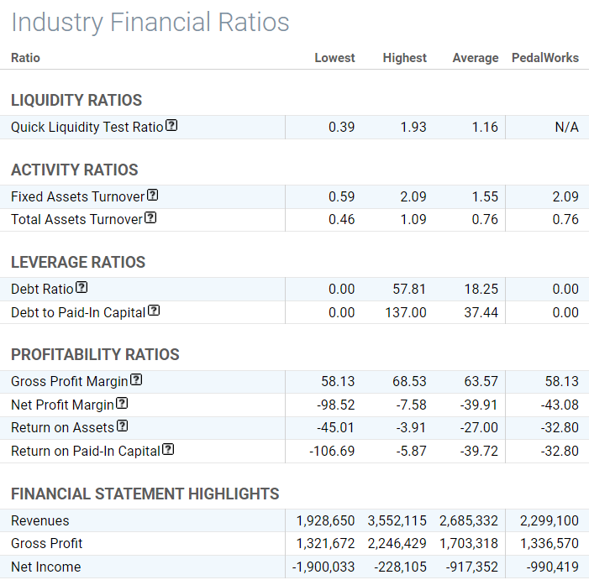
With Earnings per share at -25, we were expecting an unattractive number as we tried to heavily reinvest last quarter to make up for our advertisement and brand failures. While monitoring our other ratios, it seemed that we were still level with most of our competitors.
The gross and net profit margin are both below average. We did heavily invest
The activity ratios are also very positive in relation to other companies. Our fixed assets turnover was the top in the industry, while our total assets were right at average. This means that we are probably holding onto cash than most companies, but we have less fixed capacity than our competitors. This could be an advantage for our company that could allow us to hold more market share.
Diagnosis for Q5
We suffered a huge loss for this quarter, but most other companies also heavily invested in R&D, which led to the same result.
We are presented with an opportunity to use our excess cash and heavily invest in order to create a bigger market presence. Overall, we have a few problems to deal with, but we are presented with a great opportunity and window to maintain as much of a foothold in the market as possible before our high-quality bikes come in via our extensive spending into R&D.

Q6: Financials and Conclusions
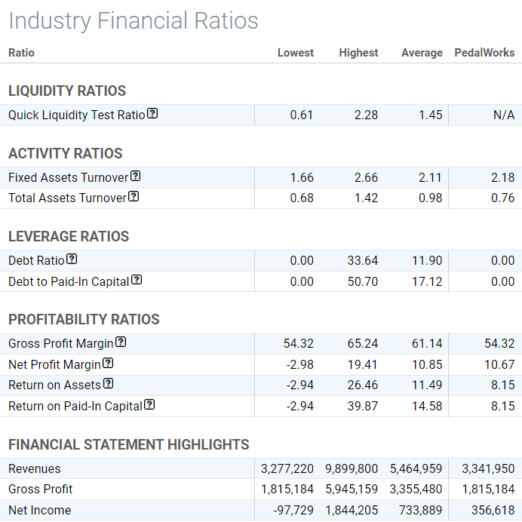
Final Results from Q6
These financial ratios above are the last information and last opportunity to establish ourselves in the industry. We have one more window to make decisions that will give us the profitability that we have been working for this entire simulation.
The Earnings per Share was at 7, so we are slowly making the profit that we are looking for. However, our gross profit and net profit margins are far below average, so we must try to make our operations more efficient to achieve a better profitability.
Our activity ratios are around the average, and with our investment in fixed capacity and constant improvement in advertisements we should be able to improve these with more demand.
Final Decisions
In a final move to make our operations as efficient as possible, we will fully focus on our differentiation strategy by making the highest quality bikes and advertisements but being more selective on ad placements only in the most lucrative positions. We will also omit overtime in an attempt to keep our profit margin as high as possible.
We had a difficult decision whether to invest in R&D or more fixed capacity to keep our balanced scorecard as high as possible. We came to the decision to invest minimally in R&D as our investment scores have always been good. Therefore, we prioritized financial performance over our Investment in the Future score for this quarter.
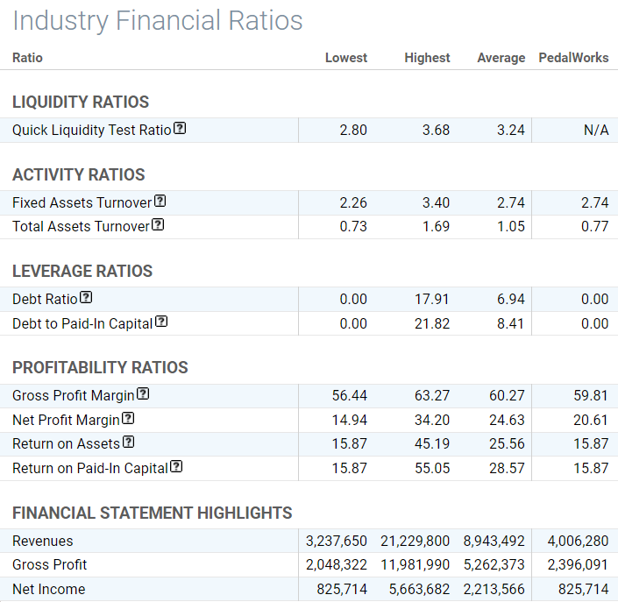

Final Results
Since we are comparing two separate ratio sheets from before and after Q6, we can get a very accurate view into how our decisions affected our performance.
With Earnings per share at 17, we have made a great bound in profitability as signified by our massive increases in profitability ratios.
The gross and net profit margin show that our decisions the trim the fat of our company worked. We doubled in three out of the four profitability ratios, with the other ratio still increasing noticeably. In relation to other companies, we were still below average, but we did make a great jump from the previous quarter.
The activity ratios are also fairly positive feedback. We increased our fixed asset turnover dramatically, but our total assets turnover could have been better.
Final Thoughts from Q6 Results
Overall, I wish we would have performed better overall, but we fought through multiple issues crunching numbers and predictive analysis to get ourselves out of very challenging issues. I believe that if we had a few more quarters, we could have fully rebounded to be a very competitive company.
What could we have done differently? Looking at our financials throughout the quarters, I believe I have gleaned a few strategies that could have placed us much higher in the industry.
Quality branding and advertisements from the start could have set us on the road to success. These problems cause long term losses in market presence and capital that could have given us an advantage that would have made it difficult for any company to try to close the gap.
Another strategy we should have taken was more investment in fixed capacity. We crippled our own success by not investing in more printer as our activity ratios showed us. Those ratios are a result of not investing in enough fixed capacity to keep up with demand.
One final strategy is to have waited to do more deals at the licensing fair rather than invest in all of the most expensive Research projects. This could have cause us to make more money faster and use that money for fixed capacity.
I really enjoyed being able to use concepts learned in accounting to try to solve these problems in the simulation, and even though the team could have performed much better, I think that I have learned a lot by combining these accounting principles and the marketplace simulation.

Addendum
Concepts From Q1 Summary
Assertions: Assertions are concepts that we apply while scoping out how financial statements could be misstated. Another description for an assertion could be “what could go wrong”. When applying an assertion to an account, we must try to find how someone could misrepresent information in a way that makes the financial statements look better. Since there is much less risk in someone changing the books in the attempt to make them look bad, we only focus on how the financial statements could look better. Below are very simple descriptions of each assertion.
Existence: Overstatement of an account. i.e., We have more merchandise on the books than we have in the warehouse.
Completeness: Understatement of an account. i.e., We have less accounts payable in our books than we have on our loan statement.
Valuation: Valuation of an account to be more or less than the actual sum. i.e., We have merchandise in our warehouse that is overvalued.
Presentation and Disclosures: Misplacement of assets or figures into different accounts. i.e., We disclosed an expense as a liability.
Rights and Obligations: Disclosing an object or figure as owned by the company when it is not. i.e., We have a licensing revenue on our financial statements that is the revenue of another company.

Concepts from Q4
A “Big R” statement means that we have made a material misstatement on our financial statements and have already published them. The steps to fix this are an 8-k release correcting these errors and a statement to legally protect our company saying that our previous financial statements should not be used by investors seeking to invest in our company.

