Contribution of microRNAs and Robo4 signaling after herpes simplex virus infection: Role for regulatory mechanisms

A Dissertation presented for the
Doctor of Philosophy Degree
The University of Tennessee, Knoxville

Sachin Vishvas Mulik
May 2013

Dedicated to my advisor, Barry Rouse

Acknowledgements

“You are one, they are many. If you don't work hard night and day, they will crush you like a roach" (Günter Blobel)
I express my sincere thanks towards my advisor Dr. Barry T Rouse for his penetrative insights, enthusiastic support, constructive criticism and steadfast encouragement throughout the course of my research. I am extremely grateful to other members of my advisory committee, Dr. Timothy Sparer, Dr. Seung Baek and Dr. Stephen Kennel for their valuable suggestions and insights. I also thank Dr. David Brian, Dr. McEntee and Dr. Nathan Schmidt for their unfailing help, support and guidance.
Words fail to express my gratitude towards my loving lab members Pradeep, Naveen, Tamara, Fernanda, Sid and Leon for their affection, kindness, encouragement and their care and interest in my educational and personal matters. I wish to extend whole hearted thanks to my friends Amol, Aman, Pranay, Sathish, Sujata, Nancy, Kim and Misty for their understanding, support, pleasurable company and timely help in crisis.
I admit myself incapable to pay regards in words to the affection, caring, encouragement and dedications of my parents and brother who instilled in me confidence, curiosity and taught me to dream big.
“Anything worth doing is worth doing poorly--until you can learn to do it well”
Zig Ziglar

Abstract

Herpes simplex virus (HSV) infection of the eye results in chronic immunopathological response in corneal stroma orchestrated by CD4 T cells. Due to its neurotrophic nature, HSV can also invade brain and leads to deadly encephalitis. HSV infection of the eyes leads to corneal neovascularization (CV), which is an important step in the pathogenesis of herpetic stromal keratitis (HSK), an important cause of human blindness. This study was undertaken to investigate the contribution of miRNAs and Robo4 signaling in HSK. The role of miR-132 and miR-155 was evaluated. In the first chapter, we review literature regarding the contribution of miRNAs in several human diseases and speculate about the role of those miRNAs in herpes viral latency and HSK. We also discuss involvement of Robo4 signaling in the context of pathological angiogenesis.
In the second chapter, we show that HSV infection of the eyes of mice leads to appearance of Robo4+ blood vessel endothelial cells in corneas but levels of Slit2 (a ligand for Robo4 receptor) were minimal. The provision of exogenous Slit2 protein reduced CV following HSV infection.
In the third chapter, we report the role of miR-132 in angiogenesis following ocular HSV infection. We observed VEGF and IL-17 driven upregulation of miR-132 during HSK. miR-132 was shown to augment VEGF induced angiogenic responses and blockade of miR-132 using antagomir nanoparticles reduced pathological angiogenesis in eyes after HSV infection.
In the fourth chapter, we analyzed the involvement of miR-155 after ocular infection with HSV. The mice unable to produce miR-155 were found to be highly susceptible to encephalitis after HSV infection with the majority of mice dyeing by day 9. We further show that virus replication in brain was responsible for death in miR-155 null mice. When T cell responses were measured, miR-155 knockout animals demonstrated attenuated CD4 and virus specific CD8 T cell immunity. Additionally, we also evaluated the role of miR-155 in HSK. miR-155KO survivors from herpes simplex encephalitis were relatively resistant to HSK. In conclusion, we demonstrated that the miR-155 is a regulator of herpes simplex encephalitis but it promotes inflammation during HSK.

Table of contents
Part I 1
Background and Overview 1
Potential role of miRNAs in herpetic stromal keratitis 2
Abstract 2
Introduction 2
What are microRNAs 3
Herpetic stromal keratitis 4
microRNAs and latency 6
miRNAs and angiogenesis 9
miRNAs and inflammation 12
miRNAs and anti-inflammation and resolution 17
Potential of miRNA targeting 20
Concluding remarks 21
List of references 23
Appendix 37
Activation of endothelial roundabout receptor 4 (Robo4) reduces the severity of virus induced keratitis 43
Abstract 44
Introduction 45
Materials and methods 47
Results 52
Discussion 58
List of references 63
Appendix 69
Role of microRNA-132 in angiogenesis after ocular infection with herpes simplex virus 81
Abstract 82
Introduction 83
Materials and methods 84
Results 89
Discussion 94
List of references 100
Appendix 105
MicroRNA-155: Regulator of HSV-1 encephalitis but promotes stromal keratitis 116
Abstract 117
Introduction 117
Materials and methods 118
Results and Discussion 121
List of references 126
Appendix 130

List of Tables
Table 1.1. Speculative role of miRNAs, their blockade/overexpression and reduction in HSK lesion severity 37

List of figures

Figure 1.1. miRNA biogenesis 38
Figure 1.2. Speculative role of miRNAs in HSV-1 reactivation from latency 39
Figure 1.3. Illustration of antagomir-132 mediated inhibition of corneal neovascularization (CV) 40
Figure 1.4. Specialized pro-resolution mediators (SPM) and miRNA mediated resolution of HSV induced ocular inflammation: Speculations 41
Figure 2.1. Expression of Robo4 and Slit2 after HSV infection 69
Figure 2.2. Robo4+ blood vessel endothelial cells in corneas after HSV infection 70
Figure 2.3. Slit2 is dispensable during SK 72
Figure 2.4. Preventive administration of recombinant Slit2 protein diminishes angiogenesis and HSK 74
Figure 2.5. Provision of recombinant Slit2 protein therapeutically diminishes angiogenesis and HSK 75
Figure 2.6. Blockade of Arf 6 and Rac 1 activity after Slit2 treatment 76
Figure 2.7. Slit2 may reduce anti apoptotic and cell cycle signal molecules in endothelial cells 77
Figure 2.8. Reduction in cytokine and chemokine levels after Slit2 treatment 78
Figure 2.9. Slit2 inhibits Arf 6 and Rac 1 activity in endothelial cells during HSK 79
Figure 2.10. Increased caspase 3 activity in endothelial cells after Slit2 treatment 80
Figure 3.1. Expression of miR-132 after HSV infection 105
Figure 3.2. IL-17A and VEGF-A upregulates miR-132 in corneas 106
Figure 3.3. Knockdown of miR-132 by antagomir-132 nanoparticles in eyes 107
Figure 3.4. Reduction in angiogenic Ras activity after antagomir-132 treatment 109
Figure 3.5. Preventive administration of antagomir-132 diminishes angiogenesis and SK 110
Figure 3.6. Provision of antagomir-132 nanoparticles therapeutically diminishes angiogenesis and SK 111
Figure 3.7. Illustration of antagomir-132 mediated inhibition of corneal neovascularization (CV) 112
Figure 3.8. Neutrophil depletion after anti Ly6G antibody treatment in mice 113
Figure 3.9. Antagomir-132 reduces CV and endothelial Ras activity in corneas after HSV infection 114
Figure 3.10. Late antagomir-132 treatment slightly diminishes angiogenesis and SK 115
Figure 4.1. miR-155 null mice are very susceptible to HSV-1 encephalitis 130
Figure 4.2. Ocular and TG viral clearance from WT and KO animals 131
Figure 4.3. Microglial response from WT and KO animals 132
Figure 4.4. Compromised CD4 T cell responses in miR-155 deficient mice 133
Figure 4.5. Compromised CD8 T cell responses in miR-155 deficient mice 134
Figure 4.6. Compromised virus specific CD8 T cell responses in miR-155 deficient mice 135
Figure 4.7. miR-155 deficiency makes mice resistant to SK 136
Figure 4.8. miR-155KO animals demonstrate diminished Th-1 responses 137

Abbreviations
CD Cluster of differentiation
EAE Experimental autoimmune encephalomyelitis
HSE Herpes simplex encephalitis
HSK Herpes simplex keratitis
HSV Herpes simplex virus
IFN Interferon
miRNA microRNA
MMP Matrix metalloproteinase
PFU Plaque forming unit
QPCR Quantitative polymerase chain reaction
RA Rheumatoid arthritis
SOCS Suppressor of cytokine signaling
SPM Specialized pro-resolving mediators
sVR1 soluble receptor 1 for VEGF
TG Trigeminal ganglia
TLR Toll like receptor
VEGF Vascular endothelial growth factor
WB Western Blotting

Part I

Background and overview

Background and overview are modified from a review accepted in IOVS by Sachin Mulik, Siddheshvar Bhela and Barry T Rouse.
Mulik S, Bhela S, Rouse BT. Potential function of miRNAs in herpetic stromal keratitis. Invest Ophthalmol Vis Sci. 2013: in press. Copyrights held by ARVO.
Potential function of miRNAs in herpetic stromal keratitis

Abstract
MicroRNAs (miRNAs), the newly discovered regulators of gene expression, act by promoting degradation of mRNA and by inhibiting protein expression. Dysregulation of miRNA expression has been noted in an expanding number of diseases and in some instances manipulating miRNA expression holds promise as a new form of therapy. Herpetic stromal keratitis (HSK) is an important vision impairing lesion and currently any role that miRNA dysregulation plays during its pathogenesis is only just beginning to be investigated. In this review we discuss the likely participation of specific miRNAs during HSK and discuss the prospect of modulating their expression as a means of therapy.

Introduction
The discovery of a novel mechanism of gene regulation by miRNAs in nematodes by Ambros and colleagues¹ stimulated an intense search for similar regulatory mechanisms in mammalian cells. The search has yielded abundantly with at least 800 different miRNA species identified with many of them dysregulated in metabolic pathways that result in neoplasia, autoimmunity and an expanding number of other human diseases. In several instances either restoring miRNA levels or blocking their activity represents a valuable means of therapy. Currently our understanding of miRNA involvement during the pathogenesis of stromal keratitis caused by herpes simplex virus (HSV) is very much in its infancy. This topic is discussed along with a speculative assessment of the prospects of manipulating selected species of miRNAs as a therapeutic maneuver that could reach the clinic.

What are microRNAs?
miRNA’s are genome encoded small, single stranded RNAs that post transcriptionally down regulate gene expression either by degradation or translation repression of the target mRNA. All canonical miRNA biogenesis process begins in the nucleus where stem loops in the pri-miRNA are recognized by the enzyme Drosha and its cofactor DGCR8, which cause nuclear cleavage to result in 60 nt precursor called pre-miRNA (figure 1.1). The pre-miRNA is exported to the cytoplasm with the help of Exportin 5 and further processed with the help of another enzyme, Dicer. The Dicer reduces the RNA size further to about 21 nt and also helps in the loading of the miRNA single strand into the miRNA-induced silencing complex (miRISC). The miRNA guides the miRISC to the target mRNA and the degree of complementarity between the miRNA and the target mRNA determines the fate of the mRNA. If the two have high complementary sequences the target mRNA is degraded by miRISC consisting of Argonaut proteins. If there is only partial complimentary sequences between the miRNA and the target mRNA, this would result in transcriptional repression by several miRISC complexes bound to different sites on the target mRNA. Accordingly, miRNAs usually act to fine tune gene expression rather than to act as on/off switches. It is important to note that not all cellular miRNAs use the canonical pathways, there are few other mechanisms used by cells to generate functional miRNAs which have been reviewed in detail by others² and theses are not discussed herein.
Most miRNA genes are expressed under control of their own promoters and regulatory sequences and act alone in gene regulation. However, others are arranged in clusters and are expressed and function together (for example the miR-19-92 cluster). The impact of miRNA expression during human and animal diseases has become known from a variety of experimental approaches. These have included measuring the consequences of gene knockout or over-expression, as can be done in experimental rodent studies. Alternatively, miRNA expression can be reduced in vivo by antagomir (miRNA inhibitory sequences) nanoparticle approaches, or be enhanced either by administrating miRNA in nanoparticles, or by causing their biosynthesis using vectors encoding miRNAs.

Herpetic Stromal keratitis: Role of Robo4 signaling and microRNAs
Infection with HSV generally leads to lesions on surface structures that include the cornea of the eye. The infection can be acute, involving largely the epithelium and resolve quite quickly, especially if treated with antivirals. Some cases, however, result in chronic lesions that involve the corneal stroma and these impair vision and can even result in blindness. HSK lesions in humans are commonly the consequence of one or more episodes of HSV reactivation from latency³. The tissue damage that occurs in HSK is thought to result in large part from the host inflammatory reaction and residual scarring set off by the infection. The strongest case that tissue damage in HSK represents an immunopathological response to infection comes from animal studies, particularly the mouse⁴. Such studies have identified several essential steps in lesion pathogenesis some or all of which could be subject to regulation by yet to be identified miRNA species. Several miRNAs are expressed by healthy mouse corneas under physiological conditions⁵. Among these miR-132, miR-182 and miR-1 are expressed at low levels, miR-146b shows intermediate expression while miR-21, miR-23b and miR-24 are expressed at high levels in corneas. However, their contribution in modulating critical events in corneal immunopathology during HSK remains largely unknown. The details of HSK pathogenesis have received some recent reviews^{6, 7} and herein we mention only a few essential points. Firstly, the inciting HSV infection in humans usually derives from a breakdown of latent infection in the trigeminal ganglia, which is caused by exposure to a variety of stressful stimuli. Accordingly, understanding how to sustain latency and prevent reactivation is an important issue, and miRNAs could influence these events.
Early steps following HSV infection largely represent the response of innate defenses and these may be sufficient to control virus before significant inflammatory lesions occur. The overt HSK lesions appear to be inflammatory reactions orchestrated mainly by T cells, particularly CD4 T cells of the Th-1 subset⁸. However, the principal tissue damage and resultant corneal scarring is mainly attributed to inflammatory products derived from nonlymphoid inflammatory cells such as neutrophils and macrophages^{9, 10}. Finally, the onset and extent of HSK lesions is influenced by the neovascularization that occurs in the normally transparent avascular cornea¹¹. Understanding how to limit and resolve corneal neovascularization (CV) is an important therapeutic objective. As we discuss, the CV process is subject to control by one or more species of miRNAs with a recent publication implicating the relevance of miR-132¹².

miRNAs and Latency
The hallmark of all herpes virus infections is their ability to persist indefinitely in the body in a state called latency. In the case of HSV, latency is maintained in neuronal tissue, which with ocular infection means the trigeminal ganglion. During latency, the virus produces no proteins so the agent may be invisible to the adaptive immune system. Unfortunately, latency terminates in occasional neurons, which is probably a continual process¹³. Productive replication occurs in such neurons and virus disseminates to peripheral sites where it can cause recurrent lesions. It is conceivable that the regulatory effects of miRNAs could influence the initiation, maintenance and breakdown of latency, as well as whether or not the productive infection is sufficient to induce lesions. All of these points here have yet to be firmly established.
With regard to the establishment of latency, HSV itself encodes a number of miRNAs and these could influence the extent to which either latent or productive infection of neurons occurs¹⁴. For example, the transcript expressed uniquely during latency, LAT, serves as a primary miRNA precursor that encodes four distinct miRNAs in HSV infected cells. One of these miRNAs, mir-H2-3p, can influence the expression of the viral immediate early gene ICP0¹⁴. Another miRNA, miR-H6, which lies upstream of the LAT promoter, modulates the expression of ICP4¹⁴. These observations came from in vitro transfection assays, but if, as is likely, the same effect occurs in vivo, the miRNA regulation could be highly relevant since both ICP4 and ICP0 proteins are involved in the initial phases of productive replication following primary and recurrent infections^{15, 16} Conceivably, virus encoded miRNAs could influence the amount of ICP4 and ICP0 expression in a latently infected neuron and this might determine if the productive cycle is initiated. However, viral encoded miRNA regulation of HSV latency in vivo remains an unresolved and debatable issue¹⁷, that merits more investigation.
Perhaps more amenable to therapeutic manipulation to influence latency will be to identify any host encoded miRNAs that are responsible for maintaining latency and which may lose this function in response to circumstances that cause reactivation. Such circumstances include changes in hormone levels caused by stress or other events, changes in immune status and exposure to UV irradiation being among the most investigated. The herpetic recurrences that follow stressful experiences could be mediated by changes in glucocorticoid levels and many studies have documented that glucocorticoids can influence miRNA expression¹⁸. For example, glucocorticoids can cause upregulation of the miRNA clusters miR-15/16 or miR-233¹⁹, but as yet none have been related to latency. It would be of interest to determine if any changes of these miRNA clusters precede the onset of viral reactivation. Additionally, glucocorticoids may also influence gene expression changes by histone modifications, an event also implicated in the maintenance of latency²⁰. The glucocorticoid binding to cytoplasmic glucocorticoid receptors triggers events that lead to induction of some anti-inflammatory genes. These effects occur in part via recruitment of histone modifying transcriptional coactivators and other cofactors to glucocorticoid responsive elements in the responsive genes²¹. Moreover, glucocorticoid signaling can recruit histone deacetylases to the NFkB complex and inhibit inflammatory gene expression²². These epigenetic events influenced by glucocorticoids could be caused by miRNA expression changes. For example, miR-449 and miR-1 are involved in regulating the activity of histone acetylation^{23, 24}. It remains to be seen whether glucocorticoids may promote virus reactivation via changing the levels of histone modification associated miRNAs (fig 1.2).
Another event that often causes the onset of recurrent herpes lesions is exposure to excessive sunlight, such as sunburn. Exposure to UV light can also trigger reactivation of HSV in a keratitis model in mice²⁵. How UV irradiation or sunburn induces herpes virus reactivation remains unclear, but recent reports indicate a potential role for miRNAs in this process. For instance, the knockdown of Ago2 and Dicer, essential components of the miRNA processing pathway, reduces survival of HELA cells exposed to UV radiation²⁶. This could mean that miRNAs play a critical role in UV induced cell cycle events and apoptosis. Perhaps of more relevance, dysregulation in miR-21, miR-203, miR-205, miR-24, let-7a and miR-376b is observed in murine epidermal tissue and human kertatinocytes upon UV exposure²⁷. At least two of these, miR-21 and miR-24^{28, 29}, can influence CD8 T cell functionality which, as mentioned subsequently, may participate in the maintenance of latency^{30, 31} (fig 1.2).
Another well studied situation that may influence the stability and breakdown of latency is immune status. For example, immunosuppressed patients are more likely to suffer herpes recrudescence with severe lesions occurring in those with AIDS³². As discussed subsequently, miRNA are known to influence the functional capacity of both innate and adaptive immune components. The role of innate immune events in the control of latency has received minimal attention, but there is strong evidence that the functional competence of viral specific CD8 T cell responses in the trigeminal ganglion influences the stability of latency^{30, 31}. Currently, we do not know if miRNA dysregulation impacts on the immune control of latency, but this topic is under active investigation by many groups that include our own.

miRNAs, Robo4 signaling and angiogenesis
The cornea’s function depends on its transparency since it must minimally interfere with the passage of light to the retina. This may be one reason the normal cornea lacks a blood vasculature since vessels diffract light. However, a significant consequence of HSV ocular infection is that pathological angiogenesis occurs, a process driven and facilitated by many factors⁶. A major angiogenic factor involved in corneal neovascularization (CV) is VEGF and counteracting VEGF and events set off when it binds to its specific receptors represents a valuable means of therapy³³. We evaluated the role of anti-angiogenic roundabout 4 (Robo4) signaling in HSK. Robo4 is a guidance molecule expressed in brain that helps migration of neurons. But when expressed in blood vessels, it regulates angiogenesis^{34, 35}. Slit2, a ligand for Robo4, when binds to trans membrane Robo4 receptor on blood vessel endothelial cells halts VEGF signaling in cancer systems and retinal models^{36, 37}. We also observed Robo4+ blood vessel endothelial cells during HSK but the expression levels of Slit2 were found to be minimal in infected corneas. The provision of additional Slit2 protein resulted in significantly reduced CV after ocular HSV infection³⁸. It remains to be seen whether additional angiogenesis regulatory mechanisms help to fine tune HSK pathological process.
Pathological angiogenesis is also a major problem in neoplastic diseases and several species of miRNAs show changes that may account for the neovascularization. The miRNA that showed the largest change of expression during angiogenesis was miR-132³⁹. We have also shown that miR-132 is also upregulated in animals with CV following HSV infection¹². In the HSV system, the upregulation of miR-132 may be in part the consequence of stimulation, by an as yet unidentified mechanism by IL-17, a cytokine produced early in HSK pathogenesis by gamma delta cells of the innate immune system⁴⁰. The upregulated miR-132 appears to act to augment VEGF signaling via an inhibitory effect on a negative regulator of VEGF function, Ras-GAP³⁹. Of interest, inhibiting the expression of miR-132 using antagomirs in the form of nanoparticles was an effective means of diminishing CV as well as reducing the severity of HSK (figure 1.3) (Table 1.1). Additionally, miR-132 blockade results in potent reduction in pathological angiogenesis in retinal models (Westenskow PD, et al. IOVS 2012; 53: ARVO E-Abstract 4120). Of note, this modality seems to work better than VEGF trap approaches and resulted in fewer off target effects and lower compensatory increases in angiogenic molecules, which is often the case with VEGF inhibition approaches⁴¹. It is also to be noted that miR-132 function depends on context. Thus, miR-132 promotes IFN production in Kaposi sarcoma herpes virus infected lymphatic endothelial cells⁴², regulates dendritic maturation in newborn neurons⁴³. However, while it exerts anti-inflammatory effect at neural immune interface⁴⁴. Although we realize that miR-132 has an antiangiogenic function during HSK it is also possible that it interacts with other miRNAs in its modulation of tissue damage.
In addition to VEGF, matrix metalloproteinase-9 (MMP-9) and other metalloproteinases play pivotal roles in promoting pathological blood vessel development during HSK⁴⁵. Recent reports indicate that the regulation of MMP-9 expression involves modulating effect by miRNAs. Accordingly, miR-885-5p, miR-491-5p, miR-212 and miR-132 negatively regulate the levels of MMP-9 expression in mammary glands and in cancer models^{46, 47}. Our recent reports suggest upregulation of miR-132 and MMP-9 in corneas during HSK^{12, 48}. miR-132 blockade induced reduction in CV and expression of miR-132 in blood vessel endothelial cells while MMP-9 in neutrophils make MMP-9 an unlikely target of miR-132 during HSK. While simultaneous expression of Ras-GAP and miR-132 in blood vessel endothelial cells from HSK or retinal models sets the angiogenic wheels in motion. However, targeting of MMP-9 with one or more species of inhibitory miRNAs with antagomir nanoparticles might represent a useful approach to therapy (Table 1.1).
Almost certainly there are additional miRNAs that influence the many stages of CV. For example it is known that the activity of VEGF in the cornea is limited by being bound to a soluble form of one of its receptors⁴⁹. HSV infection disrupts the balance between VEGF and its soluble receptor⁴⁸, a process that likely involves expression changes in miRNAs. Additional events that could be regulated by miRNAs include disruption of blood vessel endothelial junctions, pericyte detachment, invasion of endothelial cells towards the center of the cornea as well as their proliferative effects. It is also likely that miRNAs fine tune the activity of apoptotic/anti apoptotic molecules in pathological blood vessel endothelial cells. Accordingly, the provision of appropriate miRNAs may induce apoptosis of endothelial cells and this may result in regression of established blood vasculature during HSK. Furthermore pathological blood vessels, which occur in corneas during HSK, are leaky and whether miRNAs influence leakiness of such vessels by modulating the activity of src kinases or by regulating the functionality of proteins involved in maintenance of endothelial junction integrity requires exploration.

miRNAs and Inflammation
Several types of innate immune sensors are triggered when HSV infects the cornea and many molecules with diverse function are rapidly produced. These include pro-inflammatory cytokines, chemokines, interferons and angiogenic factors such as VEGF. Among the best studied innate sensors are the toll like receptors with TLR2, TLR3 and TLR9 all involved as HSV sensors^{50, 51}. Additional intracellular sensors may also recognize HSV and these include the recently described sensor STING that recognizes HSV induced membrane fusion and inflammasomes which lead to production of the pro-inflammatory cytokine IL-1b⁵²⁻⁵⁴. The innate recognition phase sets the scene for both infection control, mediated by interferons and innate effectors such as granulocytes, macrophages and NK cells, as well as establishing conditions that result in tissue damage orchestrated by adaptive components of immunity. Most persons with HSV keratitis resolve infection with little or no stromal disease. Those less fortunate develop HSK with this outcome most likely to occur after one or more recurrences from latency. Why individuals differ in their response pattern to HSV infection remains poorly understood but differential regulation of innate and adaptive immunity by one or more species of miRNA is a likely possibility that merits investigation.
With regard to the extent of innate immune sensing, evidence accumulates showing that TLR function is subject to control by numerous miRNA species. As lucidly reviewed by O'Neil and colleagues⁵⁵, miRNAs may regulate the strength, location and timing of TLR responses and also appear to control the switch from an early innate immune induced pro-inflammatory response to conditions that represent the resolution phase of the inflammatory process. In fact, at least 10 miRNAs are upregulated when one or more TLRs engage their ligands and others are down regulated. Apparently the TLRs themselves are not targeted by miRNAs and regulation mainly affects the activity of signaling molecules⁵⁵. In this context, TLR signal transducers such as MyD88, IRAK, TAB, TRAF6, IKK are all targets of one or more species of miRNAs. In addition, transcriptional factors induced by TLR ligation are subject to miRNA regulation and some miRNAs also degrade the products of TLR signaling⁵⁵. One such miRNAs is let-7 that binds to the mRNA of IL-6 and decreases expression of this cytokine which is a major participant in HSK pathogenesis and also a stimulant of the angiogenic factor VEGF⁵⁶. Additionally, other cytokines such as TNF-α, IL-10, IL-12 and IFN-γ are directly repressed by miRNA action⁵⁵. However, what role if any these aforementioned miRNAs play during the innate phase of HSK pathogenesis remains to be seen.
Additional components of innate responses to HSV include granulocytes, macrophages and NK cells. The function of all of these cell types is influenced by miRNA expression⁵⁷⁻⁵⁹. For example, miR-223 regulates the proliferation and activation status of neutrophils⁶⁰. Furthermore, its also conceivable that miRNAs are involved in regulating tissue damaging molecules such as the production of reactive oxygen and nitrogen radicals by neutrophils and the generation of neutrophil extracellular traps. Macrophage function during infection is influenced my several miRNAs that include miR-155, miR-146, miR-132, miR-147, miR-9, let-7e, miR-27b and miR-125b^{61, 62}. Similarly NK cell killer function, such as granzyme activity, is influenced by miR-155 and miR-27a*^{63, 64}.
Although it is still early days, it has become evident that miRNAs derived from innate immune cells, and perhaps exported from such cells in the form of exosomes⁶⁵, are important regulators of inflammation and the miRNAs also influence the balance of adaptive immune responses that determine whether immunity or tissue damage ensues. Indeed, the enforced expression of TLR induced miRNAs might well turn out to be useful negative regulators of the inflammatory process, as well as tools to shape the desired pattern of adaptive immunity to one that has minimal tissue damage.
As mentioned in a previous section, the tissue damaging events in HSK are orchestrated predominantly by effector CD4 T cells with the actual damage mainly mediated by neutrophils and macrophages^{9, 66, 67}. Multiple miRNAs are known to influence the induction and effector function of T cells, the recruitment and activation of inflammatory cells as well as the participation of additional cell types such as regulatory T cells involved in lesion resolution. The topic is complex and fast moving. In consequence, we mention only what may be the most pertinent miRNA expression events that impact on the pathogenesis of HSK and which represent promising candidates for therapeutic manipulation to change the outcome of disease.
The miRNA miR-23b, generally implicated in liver regeneration^{68, 69}, is a likely candidate since it also acts as a critical regulator in several autoimmune syndromes in humans and mice whose pathogenesis has similarity to HSK⁷⁰. Accordingly, miR-23b normally plays an anti-inflammatory role by inhibiting the transcription factor NFkB that in turn regulates the production of numerous proteins involved in tissue damage, as well as the recruitment of pro-inflammatory cells. The expression of miR-23b is down regulated by a still poorly understood mechanism when the pro-inflammatory cytokine IL-17 binds to its receptor. As a consequence, NFkB becomes hyperactivated and inflammation progresses. Although HSK is mainly orchestrated by inflammatory Th1 cells, the cytokine IL-17A produced by innate cells does play a prominent role during the onset of HSK and may also participate in neovascularization^{40, 71}. Thus, it is conceivable that miR-23b dysregulation occurs during HSK and this may influence the severity of lesions that ensue. This aspect merits investigation, as does the prospect that administration of additional miR-23b may represent a useful adjunct to therapy (Table 1.1).
miR-155 is another miRNA frequently implicated in inflammatory lesions and serves to positively regulate inflammation⁷²⁻⁷⁴. It is also required for normal immune function^{75, 76} as well as for generation of pathogenic T cells ⁷⁷ and act as an oncomir in various cancers^{78, 79}. Animals deficient in miR-155 because of gene knockout (KO) are resistant to the induction of some autoimmune diseases^{72, 77}. We have also observed that miR-155 KO animals develop significantly reduced HSK lesions, although they become highly susceptible to virus induced encephalitis (S. Mulik, S. Bhela and B.T. Rouse, unpublished observations). The miR-155 may influence tissue damage in several ways that include regulating the production of critical chemokines such as those for neutrophils which play a prominent role in HSK pathogenesis⁷³. Our preliminary results in the HSK system indicate that chemokines such as the neutrophil attracting CXCL1, are reduced in miR-155 deficient animals. In addition, as is shown in some autoimmune models, miR-155 deficiency may also result in the increased production of the critical anti-inflammatory mediator IL-10, as well as reduced generation of Th1 and Th17 effectors that orchestrate HSK lesions⁷⁷. In some inflammatory and autoimmune settings, loss of miR-155 also results in profound reduction in the inflammatory milieu as well as tissue damage⁷⁴. Since counteracting T cell function and inflammation would be useful to limit tissue damage, administering antagomirs to diminish miR-155 expression may be a valuable approach to achieve this objective during HSK, as we are currently evaluating (Table 1.1).
There are other miRNAs that we speculate may significantly influence the pathogenesis of HSK. In this regard, miR-29 was recently shown to target Tbet and Eomes transcription factors, both of which promote IFN-γ production by Th1 cells⁸⁰, central orchestrators of HSK pathogenesis. Similarly, miR-326 and miR-301a are involved in the generation of Th-17 cells, a subset recently shown to influence the later stages of HSK⁴⁰. Inhibition of miR-326/301a resulted in attenuated EAE lesions in mice via effects on Th-17 cells^{81, 82}. miRNAs are also known to be involved in sequential steps of T cell proliferation. For example, miR-142-3p/5p, miR-17 and miR-20a inhibit T cell activation^{83, 84}. On the other hand, IL-2 induced miR-182 degrades Foxo 1 and promotes clonal expansion of activated helper T lymphocytes⁸⁵.
It is now realized that fully differentiated T cells, once considered a stable population, may take on other activities depending on environmental cues. For example, Tregs can lose their regulatory function and adopt effector phenotypes⁸⁶. It appears that changes in miRNA expression may be involved in this cellular functional plasticity⁸⁷. For example, in response to retinoic acid and TGFb, Tregs increase miR-10a expression that limits their conversion into follicular helper T cells and Th-17 cell subsets. Whether and how miRNAs influence various stages of T cell activation or T cell flexibility during HSK is largely unknown (Table 1.1).

miRNAs in anti-inflammation and resolution
The aim of all research on inflammatory diseases is to discover optimal ways to resolve lesions and understand how they function at a mechanistic level. Under natural circumstances, inflammatory responses are usually resolved either because the inciting stimuli are removed and/or because the balance of host events changes. Such changes could be influenced, at least in part, by dysregulation of one or more species of miRNAs. Several host events can push inflammation towards resolution. These include the expansion of regulatory T cells, the increased activity of several cytokines particularly IL-10 and TGFb, the production of one or more species of host galectins as well as multiple specialized proresolving mediators derived from polyunsaturated fatty acids. How miRNA changes relate to the increased activity of these anti-inflammatory and inflammation resolving events is beginning to be unraveled, at least for some of them. Two such candidates are miR-146a and miR-21 that play prominent roles in protecting tissues from inflammatory damage⁶².
miR-146a exerts this regulatory effect by policing NF-κB dysregulation. In the context of innate immunity, miR-146a inhibits TLR signaling and NF-κB activation and dampens the production of pro-inﬂammatory mediators such as IL-6 and TNF-α⁸⁸. A diminished miR-146a response also results in malfunction of the adaptive immune responses. Of note, regulatory T cells express high levels of miR-146a and Treg specific deletion of miR-146a expression leads to severe autoimmune disease due to uncontrolled Th-1 responses⁸⁹. This further corroborates a regulatory role of miR-146a in restraining inflammation and maintaining peripheral tolerance. In addition miR-146a was implicated in resolving both CD4 and CD8 T cell mediated immunopathological responses⁹⁰. In mice, TCR stimulation induced expression of miR-146a and T cell specific miR-146a deficiency resulted in hyperactive acute antigenic responses, chronic inflammatory autoimmune responses as well as T cell mediated autoimmune disease⁹⁰. It will be of interest to see what effects miR-146a overexpression will have on the balance between protective Tregs and eye damaging Th-1 cells during HSK. We speculate that the potent regulatory environment induced by miR-146a may hamper lesion development (Table 1.1). Moreover, dampening of pro-inflammatory milieu by administering additional miR-146a could represent a useful form of therapy.
Another miRNA likely involved in resolution is miR-21. This miRNA halts inflammation in various models partly via its ability to induce IL-10^{91, 92}, a molecule previously shown to suppress HSK lesions⁹³. However, miR-21 may enhance vascular inflammation in atherosclerosis⁹⁴. miR-21 may also shift the Th1/Th2 balance towards the Th2 type⁹⁵ with miR-21 deficient mice demonstrating enhanced Th1 associated responses⁹⁶. Conceivably, overexpression of miR-21 could help to modulate Th1 mediated tissue damage during HSK an issue that merits further investigation (Table 1.1).
An additional approach to modulate the severity of inflammatory diseases is to expand or activate regulatory T cells whose activity is also influenced by expression levels of several miRNAs^{97, 98}. These include miR-10a, miR-146a and miR-155^{89, 99-101}, but their contribution in modulating ocular damage is yet to be analyzed. Conceivably, the above mentioned miRNAs will help shift the balance towards resolution events in tissue damaging settings.
In the resolving phase of inflammation, changes in expression of several mediators occur. One prominent change is in the lipid mediators derived from polyunsaturated fatty acids. Thus whereas during the pro-inflammatory phase leukotrienes and prostaglandins predominate, during resolution there is a switch to lipid mediators referred to as specialized prosesolving mediators (SPM)¹⁰². This switch may be regulated, at least in part, by changes in miRNA expression. For example, miR-292-2 levels increase for reasons that include neutrophil death with miR-292-2 targeting the mRNA of the lipoxygenase enzyme responsible for generating the pro-inflammatory leukotrienes¹⁰³. Additionally miR-292-2 increases, by an unknown mechanism, the synthesis of SPM such as resolvins and protectins. In HSK, where in some instances resolution can be delayed, it is conceivable that miR-292-2 levels are suppressed perhaps in situations when viral replication levels are elevated.
The observation that SPMs appear to account for resolution under natural circumstances has led to the development of synthetic formulations that are proving valuable to control inflammatory lesions that include HSK^{104, 105}. It has also become evident in recent studies from the Serhan group that levels of multiple miRNAs change in response to synthetic SPM therapy¹⁰⁶. For example, resolvin administration fine-tunes levels of miRNAs such as miR-21, miR-146b, miR-208a and miR-292-2 in various tissue damaging settings^{106, 107}. These miRNAs act by changing the expression of several inflammatory mediators. For example, miR-21 and miR-208a induce IL-10 production during the resolution phase thus exerting strong anti-inflammatory effect. miR-146b also regulates levels of IL-8 and RANTES, both powerful chemo attractants that recruit leukocytes into inﬂamed areas, while miR-292-2 induces the production of more SPM. We speculate that the provision of SPM during HSK may act by inducing the expression of pro resolution miRNAs that include miR-21, miR-146b, miR-292-2 while levels of inflammatory and angiogenic miRNAs (miR-155 and miR-132) might diminish (fig 1.4) (Table 1.1). Our unpublished observations support this claim. Whether any group of miRNAs are sufficient to activate a resolution program is currently not known. If it can be accomplished the inclusion of pro-resolution miRNAs would be valuable when designing therapeutics to counteract HSK lesions.

Potential of miRNA targeting
Manipulation of disease associated microRNAs offers unique opportunities but poses challenges as regards of delivery, target site accessibility and off target effects. Progress on this topic has occurred with several reports showing amelioration of diseases via blockade of miRNAs using modified antagomirs as is the case with locked nucleic acid (LNA) or antagomirs given in nanoparticles^{108, 109}. Our own study evaluated the potential of miR-132 inhibition using antagomir-132 histidine lysine nanoparticle approaches that led to potent reduction of CV. This was also recently confirmed in retinal models by Martin Friedlander and David Cheresh groups who showed that nanoparticle mediated miR-132 blockade is more efficacious (Westenskow PD, et al. IOVS 2012; 53: ARVO E-Abstract 4120) than conventional VEGF inhibition therapies and results in lower off target effects and fewer compensatory increases in angiogenic genes compared to VEGF targeting. Several other recent reports support miRNA inhibition approaches to modulate disease pathologies. For example, miR-122 shows effects against Hepatitic C virus infection¹¹⁰; miR-155 is effective in the inflammatory disease models, EAE^{111, 112} as well as against B cell lymphoma^{79, 113}. Additionally, miR-21 is effective to inhibit lupus²⁸. We are investigating the potential of slow antagomir release eye drop formulated nanoparticles to intercept HSK pathogenesis and believe that the cocktail of miRNAs given in nanoparticles locally may confer therapeutic benefit against HSK.

Concluding remarks
Although published information about the regulatory role of miRNAs during HSK is minimal we can surmise that multiple miRNAs are likely to influence all of the many events that occur during HSK pathogenesis. We can also surmise that changing miRNA responses could represent a useful approach to therapy especially because several phases of HSK could be targeted simultaneously using cocktails of multiple miRNAs mimics and antagomirs. The major practical problem would be how to administer the cocktail and how frequently this must be done to achieve therapeutic efficacy. There have been some reports that show the ease of delivery of siRNA to localized areas such as the eye, lung and skin and these siRNAs were shown to be effective in in vivo silencing^{114,115}. In fact most of these siRNAs are under clinical trials. Although only one such miRNA targeting drug is in clinical trial (miravirsen). It is conceivable many more miRNA intervention therapies could enter clinic in the near future.
It is also likely that the composition of the therapeutic cocktail would need to differ at different phases of HSK lesions. Most likely treatment close to the onset of lesions would stand the best chance of success. We would speculate that using miRNAs or antagomirs to increase IL-10 expression, to block the recruitment of inflammatory cells to the corneas and to limit the extent of CV would be successful strategies. At later stages switching the inflammation to the resolution phase would be desirable as might be achieved by changing the expression of miRNAs involved in SPM production. Although therapy with miRNA has therapeutical advantages, it remains to be seen if the approach would be practical or economical compared to traditional therapies in current use. Answering these questions will require further research. Optimistically nanoparticles containing multiple miRNAs and antagomirs would be administered once or twice daily and be therapeutically effective.

Acknowledgements: We thank Tamara Veiga-Parga and Fernanda Gimenez for their immense help in manuscript formatting in many ways.

References
1. Lee RC, Feinbaum RL, Ambros V. The C. elegans heterochronic gene lin-4 encodes small RNAs with antisense complementarity to lin-14. Cell 1993;75:843-854.
2. Yang JS, Lai EC. Alternative miRNA biogenesis pathways and the interpretation of core miRNA pathway mutants. Mol Cell 2011;43:892-903.
3. S. PJ, N. HG, R. WK. Herpes simplex virus disease: Anterior segment of the eye. St. Louis, Mo, USA: Mosby; 1996:pp. 905–932.
4. Biswas PS, Rouse BT. Early events in HSV keratitis--setting the stage for a blinding disease. Microbes Infect 2005;7:799-810.
5. Karali M, Peluso I, Gennarino VA, et al. miRNeye: a microRNA expression atlas of the mouse eye. BMC Genomics 2010;11:715.
6. Giménez F, Suryawanshi A, Rouse BT. Pathogenesis of herpes stromal keratitis - A focus on corneal neovascularization. Prog Retin Eye Res 2012.
7. Stuart PM, Keadle TL. Recurrent herpetic stromal keratitis in mice: a model for studying human HSK. Clin Dev Immunol 2012;2012:728480.
8. Deshpande SP, Zheng M, Lee S, Rouse BT. Mechanisms of pathogenesis in herpetic immunoinflammatory ocular lesions. Vet Microbiol 2002;86:17-26.
9. Thomas J, Gangappa S, Kanangat S, Rouse BT. On the essential involvement of neutrophils in the immunopathologic disease: herpetic stromal keratitis. J Immunol 1997;158:1383-1391.
10. Tumpey TM, Chen SH, Oakes JE, Lausch RN. Neutrophil-mediated suppression of virus replication after herpes simplex virus type 1 infection of the murine cornea. J Virol 1996;70:898-904.
11. Zheng M, Schwarz MA, Lee S, Kumaraguru U, Rouse BT. Control of stromal keratitis by inhibition of neovascularization. Am J Pathol 2001;159:1021-1029.
12. Mulik S, Xu J, Reddy PB, et al. Role of miR-132 in Angiogenesis after Ocular Infection with Herpes Simplex Virus. Am J Pathol 2012;181:525-534.
13. Feldman LT, Ellison AR, Voytek CC, Yang L, Krause P, Margolis TP. Spontaneous molecular reactivation of herpes simplex virus type 1 latency in mice. Proc Natl Acad Sci U S A 2002;99:978-983.
14. Umbach JL, Kramer MF, Jurak I, Karnowski HW, Coen DM, Cullen BR. MicroRNAs expressed by herpes simplex virus 1 during latent infection regulate viral mRNAs. Nature 2008;454:780-783.
15. Everett RD. ICP0, a regulator of herpes simplex virus during lytic and latent infection. Bioessays 2000;22:761-770.
16. Chen SH, Kramer MF, Schaffer PA, Coen DM. A viral function represses accumulation of transcripts from productive-cycle genes in mouse ganglia latently infected with herpes simplex virus. J Virol 1997;71:5878-5884.
17. Kramer MF, Jurak I, Pesola JM, Boissel S, Knipe DM, Coen DM. Herpes simplex virus 1 microRNAs expressed abundantly during latent infection are not essential for latency in mouse trigeminal ganglia. Virology 2011;417:239-247.
18. Cochrane DR, Cittelly DM, Richer JK. Steroid receptors and microRNAs: relationships revealed. Steroids 2011;76:1-10.
19. Rainer J, Ploner C, Jesacher S, et al. Glucocorticoid-regulated microRNAs and mirtrons in acute lymphoblastic leukemia. Leukemia 2009;23:746-752.
20. Kent JR, Zeng PY, Atanasiu D, Gardner J, Fraser NW, Berger SL. During lytic infection herpes simplex virus type 1 is associated with histones bearing modifications that correlate with active transcription. J Virol 2004;78:10178-10186.
21. Karin M. New twists in gene regulation by glucocorticoid receptor: is DNA binding dispensable? Cell 1998;93:487-490.
22. Ito K, Barnes PJ, Adcock IM. Glucocorticoid receptor recruitment of histone deacetylase 2 inhibits interleukin-1beta-induced histone H4 acetylation on lysines 8 and 12. Mol Cell Biol 2000;20:6891-6903.
23. Noonan EJ, Place RF, Pookot D, et al. miR-449a targets HDAC-1 and induces growth arrest in prostate cancer. Oncogene 2009;28:1714-1724.
24. Chen JF, Mandel EM, Thomson JM, et al. The role of microRNA-1 and microRNA-133 in skeletal muscle proliferation and differentiation. Nat Genet 2006;38:228-233.
25. Shimeld C, Hill T, Blyth B, Easty D. An improved model of recurrent herpetic eye disease in mice. Curr Eye Res 1989;8:1193-1205.
26. Pothof J, Verkaik NS, van IJcken W, et al. MicroRNA-mediated gene silencing modulates the UV-induced DNA-damage response. EMBO J 2009;28:2090-2099.
27. Dziunycz P, Iotzova-Weiss G, Eloranta JJ, et al. Squamous cell carcinoma of the skin shows a distinct microRNA profile modulated by UV radiation. J Invest Dermatol 2010;130:2686-2689.
28. Garchow BG, Bartulos Encinas O, Leung YT, et al. Silencing of microRNA-21 in vivo ameliorates autoimmune splenomegaly in lupus mice. EMBO Mol Med 2011;3:605-615.
29. Brunner S, Herndler-Brandstetter D, Arnold CR, et al. Upregulation of miR-24 is associated with a decreased DNA damage response upon etoposide treatment in highly differentiated CD8(+) T cells sensitizing them to apoptotic cell death. Aging Cell 2012;11:579-587.
30. Liu T, Khanna KM, Chen X, Fink DJ, Hendricks RL. CD8(+) T cells can block herpes simplex virus type 1 (HSV-1) reactivation from latency in sensory neurons. J Exp Med 2000;191:1459-1466.
31. Reddy PB, Sehrawat S, Suryawanshi A, et al. Influence of galectin-9/Tim-3 interaction on herpes simplex virus-1 latency. J Immunol 2011;187:5745-5755.
32. Schacker T, Zeh J, Hu HL, Hill E, Corey L. Frequency of symptomatic and asymptomatic herpes simplex virus type 2 reactivations among human immunodeficiency virus-infected men. J Infect Dis 1998;178:1616-1622.
33. Zheng M, Deshpande S, Lee S, Ferrara N, Rouse BT. Contribution of vascular endothelial growth factor in the neovascularization process during the pathogenesis of herpetic stromal keratitis. J Virol 2001;75:9828-9835.
34. Park KW, Morrison CM, Sorensen LK, et al. Robo4 is a vascular-specific receptor that inhibits endothelial migration. Dev Biol 2003;261:251-267.
35. Koch AW, Mathivet T, Larrivée B, et al. Robo4 maintains vessel integrity and inhibits angiogenesis by interacting with UNC5B. Dev Cell 2011;20:33-46.
36. Jones CA, London NR, Chen H, et al. Robo4 stabilizes the vascular network by inhibiting pathologic angiogenesis and endothelial hyperpermeability. Nat Med 2008;14:448-453.
37. Jones CA, Nishiya N, London NR, et al. Slit2-Robo4 signalling promotes vascular stability by blocking Arf6 activity. Nat Cell Biol 2009;11:1325-1331.
38. Mulik S, Sharma S, Suryawanshi A, et al. Activation of endothelial roundabout receptor 4 reduces the severity of virus-induced keratitis. J Immunol 2011;186:7195-7204.
39. Anand S, Majeti BK, Acevedo LM, et al. MicroRNA-132-mediated loss of p120RasGAP activates the endothelium to facilitate pathological angiogenesis. Nat Med 2010;16:909-914.
40. Suryawanshi A, Veiga-Parga T, Rajasagi NK, et al. Role of IL-17 and Th17 cells in herpes simplex virus-induced corneal immunopathology. J Immunol 2011;187:1919-1930.
41. Bergers G, Hanahan D. Modes of resistance to anti-angiogenic therapy. Nat Rev Cancer 2008;8:592-603.
42. Magill ST, Cambronne XA, Luikart BW, et al. microRNA-132 regulates dendritic growth and arborization of newborn neurons in the adult hippocampus. Proc Natl Acad Sci U S A 2010;107:20382-20387.
43. Lagos D, Pollara G, Henderson S, et al. miR-132 regulates antiviral innate immunity through suppression of the p300 transcriptional co-activator. Nat Cell Biol 2010;12:513-519.
44. Shaked I, Meerson A, Wolf Y, et al. MicroRNA-132 potentiates cholinergic anti-inflammatory signaling by targeting acetylcholinesterase. Immunity 2009;31:965-973.
45. Lee S, Zheng M, Kim B, Rouse BT. Role of matrix metalloproteinase-9 in angiogenesis caused by ocular infection with herpes simplex virus. J Clin Invest 2002;110:1105-1111.
46. Yan W, Zhang W, Sun L, et al. Identification of MMP-9 specific microRNA expression profile as potential targets of anti-invasion therapy in glioblastoma multiforme. Brain Res 2011;1411:108-115.
47. Ucar A, Vafaizadeh V, Jarry H, et al. miR-212 and miR-132 are required for epithelial stromal interactions necessary for mouse mammary gland development. Nat Genet 2010;42:1101-1108.
48. Suryawanshi A, Mulik S, Sharma S, Reddy PB, Sehrawat S, Rouse BT. Ocular neovascularization caused by herpes simplex virus type 1 infection results from breakdown of binding between vascular endothelial growth factor A and its soluble receptor. J Immunol 2011;186:3653-3665.
49. Ambati BK, Nozaki M, Singh N, et al. Corneal avascularity is due to soluble VEGF receptor-1. Nature 2006;443:993-997.
50. Sato A, Linehan MM, Iwasaki A. Dual recognition of herpes simplex viruses by TLR2 and TLR9 in dendritic cells. Proc Natl Acad Sci U S A 2006;103:17343-17348.
51. Zhang SY, Jouanguy E, Ugolini S, et al. TLR3 deficiency in patients with herpes simplex encephalitis. Science 2007;317:1522-1527.
52. Holm CK, Jensen SB, Jakobsen MR, et al. Virus-cell fusion as a trigger of innate immunity dependent on the adaptor STING. Nat Immunol 2012;13:737-743.
53. Muruve DA, Pétrilli V, Zaiss AK, et al. The inflammasome recognizes cytosolic microbial and host DNA and triggers an innate immune response. Nature 2008;452:103-107.
54. Paludan SR, Bowie AG, Horan KA, Fitzgerald KA. Recognition of herpesviruses by the innate immune system. Nat Rev Immunol 2011;11:143-154.
55. O'Neill LA, Sheedy FJ, McCoy CE. MicroRNAs: the fine-tuners of Toll-like receptor signalling. Nat Rev Immunol 2011;11:163-175.
56. Biswas PS, Banerjee K, Kinchington PR, Rouse BT. Involvement of IL-6 in the paracrine production of VEGF in ocular HSV-1 infection. Exp Eye Res 2006;82:46-54.
57. Ward JR, Heath PR, Catto JW, Whyte MK, Milo M, Renshaw SA. Regulation of neutrophil senescence by microRNAs. PLoS One 2011;6:e15810.
58. Izumi B, Nakasa T, Tanaka N, et al. MicroRNA-223 expression in neutrophils in the early phase of secondary damage after spinal cord injury. Neurosci Lett 2011;492:114-118.
59. Sullivan RP, Leong JW, Schneider SE, et al. MicroRNA-deficient NK cells exhibit decreased survival but enhanced function. J Immunol 2012;188:3019-3030.
60. Johnnidis JB, Harris MH, Wheeler RT, et al. Regulation of progenitor cell proliferation and granulocyte function by microRNA-223. Nature 2008;451:1125-1129.
61. O'Connell RM, Rao DS, Chaudhuri AA, Baltimore D. Physiological and pathological roles for microRNAs in the immune system. Nat Rev Immunol 2010;10:111-122.
62. O'Connell RM, Rao DS, Baltimore D. microRNA regulation of inflammatory responses. Annu Rev Immunol 2012;30:295-312.
63. Trotta R, Chen L, Ciarlariello D, et al. miR-155 regulates IFN-γ production in natural killer cells. Blood 2012;119:3478-3485.
64. Kim TD, Lee SU, Yun S, et al. Human microRNA-27a* targets Prf1 and GzmB expression to regulate NK-cell cytotoxicity. Blood 2011;118:5476-5486.
65. Valadi H, Ekström K, Bossios A, Sjöstrand M, Lee JJ, Lötvall JO. Exosome-mediated transfer of mRNAs and microRNAs is a novel mechanism of genetic exchange between cells. Nat Cell Biol 2007;9:654-659.
66. Daheshia M, Kanangat S, Rouse BT. Production of key molecules by ocular neutrophils early after herpetic infection of the cornea. Exp Eye Res 1998;67:619-624.
67. Bauer D, Mrzyk S, van Rooijen N, Steuhl KP, Heiligenhaus A. Macrophage-depletion influences the course of murine HSV-1 keratitis. Curr Eye Res 2000;20:45-53.
68. Rogler CE, Levoci L, Ader T, et al. MicroRNA-23b cluster microRNAs regulate transforming growth factor-beta/bone morphogenetic protein signaling and liver stem cell differentiation by targeting Smads. Hepatology 2009;50:575-584.
69. Yuan B, Dong R, Shi D, et al. Down-regulation of miR-23b may contribute to activation of the TGF-β1/Smad3 signalling pathway during the termination stage of liver regeneration. FEBS Lett 2011;585:927-934.
70. Zhu S, Pan W, Song X, et al. The microRNA miR-23b suppresses IL-17-associated autoimmune inflammation by targeting TAB2, TAB3 and IKK-α. Nat Med 2012.
71. Suryawanshi A, Veiga-Parga T, Reddy PB, Rajasagi NK, Rouse BT. IL-17A differentially regulates corneal vascular endothelial growth factor (VEGF)-A and soluble VEGF receptor 1 expression and promotes corneal angiogenesis after herpes simplex virus infection. J Immunol 2012;188:3434-3446.
72. Blüml S, Bonelli M, Niederreiter B, et al. Essential role of microRNA-155 in the pathogenesis of autoimmune arthritis in mice. Arthritis Rheum 2011;63:1281-1288.
73. Bhattacharyya S, Balakathiresan NS, Dalgard C, et al. Elevated miR-155 promotes inflammation in cystic fibrosis by driving hyperexpression of interleukin-8. J Biol Chem 2011;286:11604-11615.
74. Kurowska-Stolarska M, Alivernini S, Ballantine LE, et al. MicroRNA-155 as a proinflammatory regulator in clinical and experimental arthritis. Proc Natl Acad Sci U S A 2011;108:11193-11198.
75. Rodriguez A, Vigorito E, Clare S, et al. Requirement of bic/microRNA-155 for normal immune function. Science 2007;316:608-611.
76. Thai TH, Calado DP, Casola S, et al. Regulation of the germinal center response by microRNA-155. Science 2007;316:604-608.
77. O'Connell RM, Kahn D, Gibson WS, et al. MicroRNA-155 promotes autoimmune inflammation by enhancing inflammatory T cell development. Immunity 2010;33:607-619.
78. Jiang S, Zhang HW, Lu MH, et al. MicroRNA-155 functions as an OncomiR in breast cancer by targeting the suppressor of cytokine signaling 1 gene. Cancer Res 2010;70:3119-3127.
79. Babar IA, Cheng CJ, Booth CJ, et al. Nanoparticle-based therapy in an in vivo microRNA-155 (miR-155)-dependent mouse model of lymphoma. Proc Natl Acad Sci U S A 2012;109:E1695-1704.
80. Steiner DF, Thomas MF, Hu JK, et al. MicroRNA-29 regulates T-box transcription factors and interferon-γ production in helper T cells. Immunity 2011;35:169-181.
81. Du C, Liu C, Kang J, et al. MicroRNA miR-326 regulates TH-17 differentiation and is associated with the pathogenesis of multiple sclerosis. Nat Immunol 2009;10:1252-1259.
82. Mycko MP, Cichalewska M, Machlanska A, Cwiklinska H, Mariasiewicz M, Selmaj KW. MicroRNA-301a regulation of a T-helper 17 immune response controls autoimmune demyelination. Proc Natl Acad Sci U S A 2012;109:E1248-1257.
83. Cox MB, Cairns MJ, Gandhi KS, et al. MicroRNAs miR-17 and miR-20a inhibit T cell activation genes and are under-expressed in MS whole blood. PLoS One 2010;5:e12132.
84. Ding S, Liang Y, Zhao M, et al. Decreased microRNA-142-3p/5p expression causes CD4+ T cell activation and B cell hyperstimulation in systemic lupus erythematosus. Arthritis Rheum 2012;64:2953-2963.
85. Stittrich AB, Haftmann C, Sgouroudis E, et al. The microRNA miR-182 is induced by IL-2 and promotes clonal expansion of activated helper T lymphocytes. Nat Immunol 2010;11:1057-1062.
86. Zhou L, Chong MM, Littman DR. Plasticity of CD4+ T cell lineage differentiation. Immunity 2009;30:646-655.
87. Takahashi H, Kanno T, Nakayamada S, et al. TGF-β and retinoic acid induce the microRNA miR-10a, which targets Bcl-6 and constrains the plasticity of helper T cells. Nat Immunol 2012;13:587-595.
88. Taganov KD, Boldin MP, Chang KJ, Baltimore D. NF-kappaB-dependent induction of microRNA miR-146, an inhibitor targeted to signaling proteins of innate immune responses. Proc Natl Acad Sci U S A 2006;103:12481-12486.
89. Lu LF, Boldin MP, Chaudhry A, et al. Function of miR-146a in controlling Treg cell-mediated regulation of Th1 responses. Cell 2010;142:914-929.
90. Yang L, Boldin MP, Yu Y, et al. miR-146a controls the resolution of T cell responses in mice. J Exp Med 2012;209:1655-1670.
91. Sheedy FJ, Palsson-McDermott E, Hennessy EJ, et al. Negative regulation of TLR4 via targeting of the proinflammatory tumor suppressor PDCD4 by the microRNA miR-21. Nat Immunol 2010;11:141-147.
92. Liu PT, Wheelwright M, Teles R, et al. MicroRNA-21 targets the vitamin D-dependent antimicrobial pathway in leprosy. Nat Med 2012;18:267-273.
93. Sarangi PP, Sehrawat S, Suvas S, Rouse BT. IL-10 and natural regulatory T cells: two independent anti-inflammatory mechanisms in herpes simplex virus-induced ocular immunopathology. J Immunol 2008;180:6297-6306.
94. Zhou J, Wang KC, Wu W, et al. MicroRNA-21 targets peroxisome proliferators-activated receptor-alpha in an autoregulatory loop to modulate flow-induced endothelial inflammation. Proc Natl Acad Sci U S A 2011;108:10355-10360.
95. Lu TX, Munitz A, Rothenberg ME. MicroRNA-21 is up-regulated in allergic airway inflammation and regulates IL-12p35 expression. J Immunol 2009;182:4994-5002.
96. Lu TX, Hartner J, Lim EJ, et al. MicroRNA-21 limits in vivo immune response-mediated activation of the IL-12/IFN-gamma pathway, Th1 polarization, and the severity of delayed-type hypersensitivity. J Immunol 2011;187:3362-3373.
97. Liston A, Lu LF, O'Carroll D, Tarakhovsky A, Rudensky AY. Dicer-dependent microRNA pathway safeguards regulatory T cell function. J Exp Med 2008;205:1993-2004.
98. Zhou X, Jeker LT, Fife BT, et al. Selective miRNA disruption in T reg cells leads to uncontrolled autoimmunity. J Exp Med 2008;205:1983-1991.
99. Jeker LT, Zhou X, Gershberg K, et al. MicroRNA 10a marks regulatory T cells. PLoS One 2012;7:e36684.
100. Lu LF, Thai TH, Calado DP, et al. Foxp3-dependent microRNA155 confers competitive fitness to regulatory T cells by targeting SOCS1 protein. Immunity 2009;30:80-91.
101. Kohlhaas S, Garden OA, Scudamore C, Turner M, Okkenhaug K, Vigorito E. Cutting edge: the Foxp3 target miR-155 contributes to the development of regulatory T cells. J Immunol 2009;182:2578-2582.
102. Serhan CN. Novel lipid mediators and resolution mechanisms in acute inflammation: to resolve or not? Am J Pathol 2010;177:1576-1591.
103. Fredman G, Li Y, Dalli J, Chiang N, Serhan CN. Self-Limited versus Delayed Resolution of Acute Inflammation: Temporal Regulation of Pro-Resolving Mediators and MicroRNA. Sci Rep 2012;2:639.
104. Schwab JM, Chiang N, Arita M, Serhan CN. Resolvin E1 and protectin D1 activate inflammation-resolution programmes. Nature 2007;447:869-874.
105. Rajasagi NK, Reddy PB, Suryawanshi A, Mulik S, Gjorstrup P, Rouse BT. Controlling herpes simplex virus-induced ocular inflammatory lesions with the lipid-derived mediator resolvin E1. J Immunol 2011;186:1735-1746.
106. Recchiuti A, Krishnamoorthy S, Fredman G, Chiang N, Serhan CN. MicroRNAs in resolution of acute inflammation: identification of novel resolvin D1-miRNA circuits. FASEB J 2011;25:544-560.
107. Krishnamoorthy S, Recchiuti A, Chiang N, Fredman G, Serhan CN. Resolvin D1 receptor stereoselectivity and regulation of inflammation and proresolving microRNAs. Am J Pathol 2012;180:2018-2027.
108. Krützfeldt J, Rajewsky N, Braich R, et al. Silencing of microRNAs in vivo with 'antagomirs'. Nature 2005;438:685-689.
109. Stenvang J, Petri A, Lindow M, Obad S, Kauppinen S. Inhibition of microRNA function by antimiR oligonucleotides. Silence 2012;3:1.
110. Lanford RE, Hildebrandt-Eriksen ES, Petri A, et al. Therapeutic silencing of microRNA-122 in primates with chronic hepatitis C virus infection. Science 2010;327:198-201.
111. Murugaiyan G, Beynon V, Mittal A, Joller N, Weiner HL. Silencing microRNA-155 ameliorates experimental autoimmune encephalomyelitis. J Immunol 2011;187:2213-2221.
112. Worm J, Stenvang J, Petri A, et al. Silencing of microRNA-155 in mice during acute inflammatory response leads to derepression of c/ebp Beta and down-regulation of G-CSF. Nucleic Acids Res 2009;37:5784-5792.
113. Zhang Y, Roccaro AM, Rombaoa C, et al. LNA-mediated anti-miR-155 silencing in low-grade B-cell lymphomas. Blood 2012;120:1678-1686.
114. Nguyen T, Menocal EM, Harborth J, Fruehauf JH. RNAi therapeutics: an update on delivery. Curr Opin Mol Ther 2008;10:158-167.
115. Kim B, Tang Q, Biswas PS, et al. Inhibition of ocular angiogenesis by siRNA targeting vascular endothelial growth factor pathway genes: therapeutic strategy for herpetic stromal keratitis. Am J Pathol 2004;165:2177-2185.

Appendix
Table 1.1: Speculative role of miRNAs, their blockade/overexpression and reduction in HSK lesion severity (Mild +, Moderate ++, Severe +++).
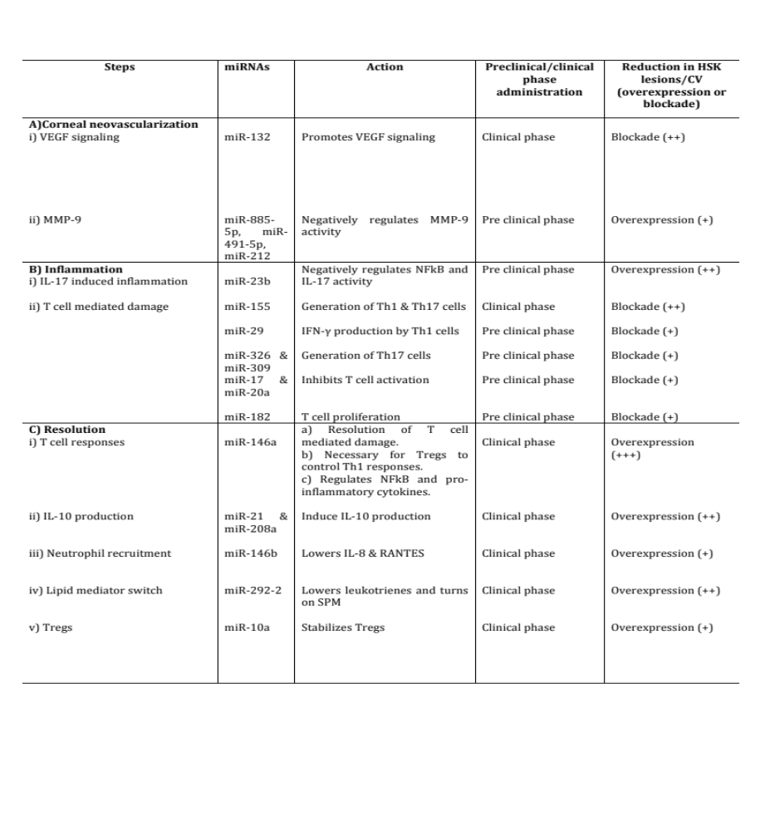

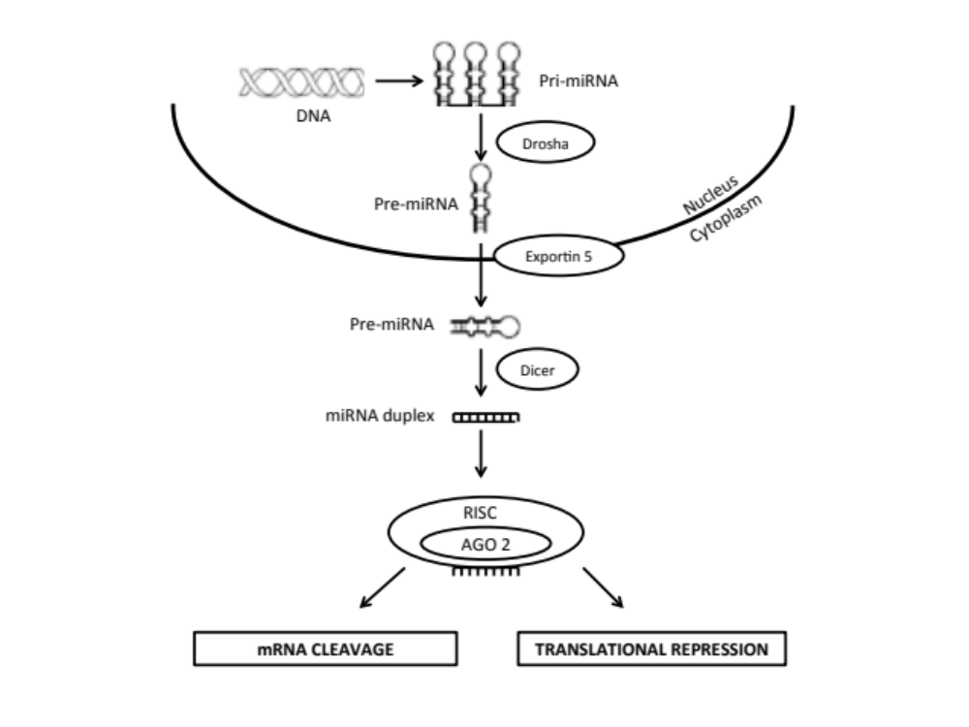
Figure 1.1. miRNA biogenesis: The generation of miRNAs involves nuclear and cytoplasmic processing steps. In the nucleus, pri-miRNAs, transcribed by RNA polymerase from DNA, are processed by Drosha into pre-miRNAs which are then transported to cytoplasm via exportin 5. Once in cytoplasm, these pre-miRNAs are recognized and cleaved by Dicer into 20-22 bp duplexes that enter RISC. In RISC, passenger strand is cleaved while guide strand directs RISC machinery to target mRNAs resulting in mRNA degradation or inhibition of protein translation. 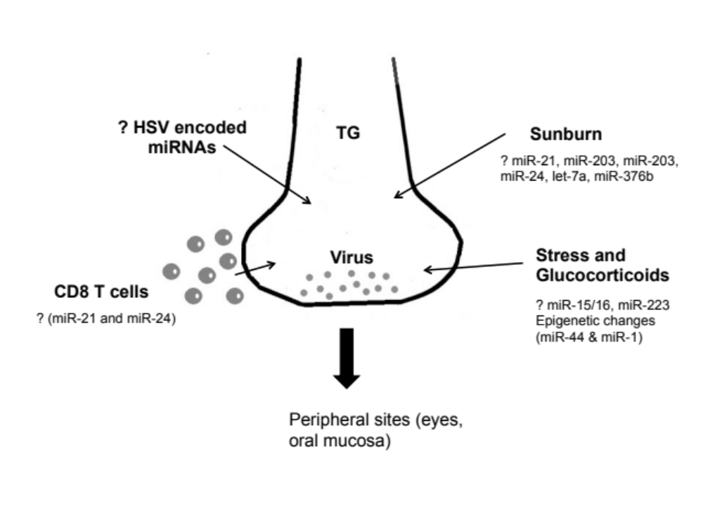 Figure 1.2. Speculative role of miRNAs in HSV-1 reactivation from latency. After primary infection, HSV-1 becomes latent in trigeminal ganglia. Certain conditions such as sunburn, stress, impaired T cell responses, immunosuppression can reactivate virus to come to the peripheral sites (eyes, oral mucosa) to induce lesions. miRNAs may regulate all of these above mentioned stimuli. Sunburn can trigger HSV reactivation and it involves changes in expression levels of miRNAs (miR-21, miR-203). Likewise, stress induced glucocorticoids induce changes in miRNAs (miR-15/16 and miR-223) and also lead to epigenetic modifications, a process which involves miRNA change (miR-44 and miR-1) and is implicated in maintenance of latency. CD8 T cells patrol trigeminal ganglia and inhibit HSV reactivation but functionality of CD8 T cells can also be modulated by miRNA activity (miR-21 and miR-24). The role of HSV encoded miRNAs in HSV reactivation remains unknown so far.
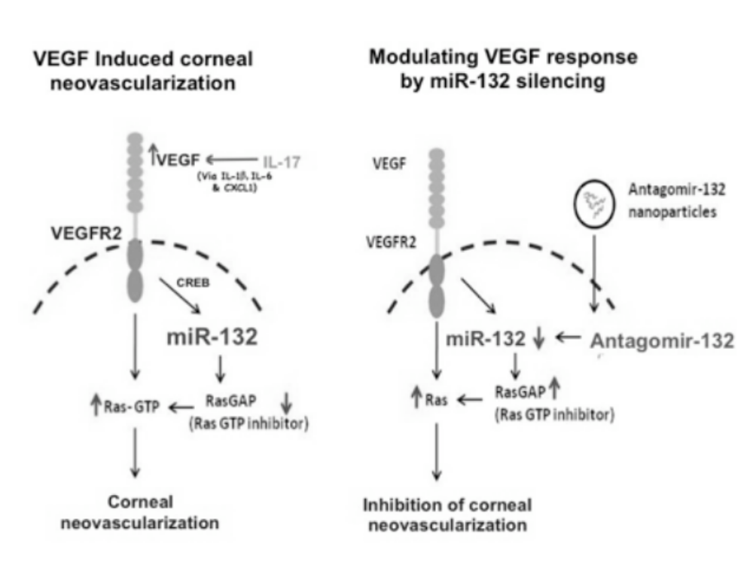 Figure 1.3 Illustration of antagomir-132 mediated inhibition of corneal neovascularization (CV). Left panel describes outcome (CV) in HSV infected untreated mice: HSV infection leads to upregulation of IL-17 in corneas. IL-17 (along with IL-6 and virus infected epithelial cells) increases VEGF (probably via increasing IL-1b, IL-6 and Cxcl1) levels in the eyes. VEGF thus acting through VEGFR2 receptors on the blood vessel endothelial cells upregulates miR-132 expression via CREB transcription factor. MiR-132 removes RasGAP (intrinsic inhibitor of Ras) leading to activation of Ras and CV. Right panel describes modulation of CV by miR-132 silencing: Administration of antagomir-132 nanoparticles leads to deposition of antagomir-132 cargo in blood vessel endothelial cells resulting in silencing of miR-132. This leads to higher levels of RasGAP, which thereby inhibits angiogenic Ras activity resulting in inhibition of CV (Reprinted from Am J Pathol 2012, 181:525-534 with permission from the American Society for Investigative Pathology). 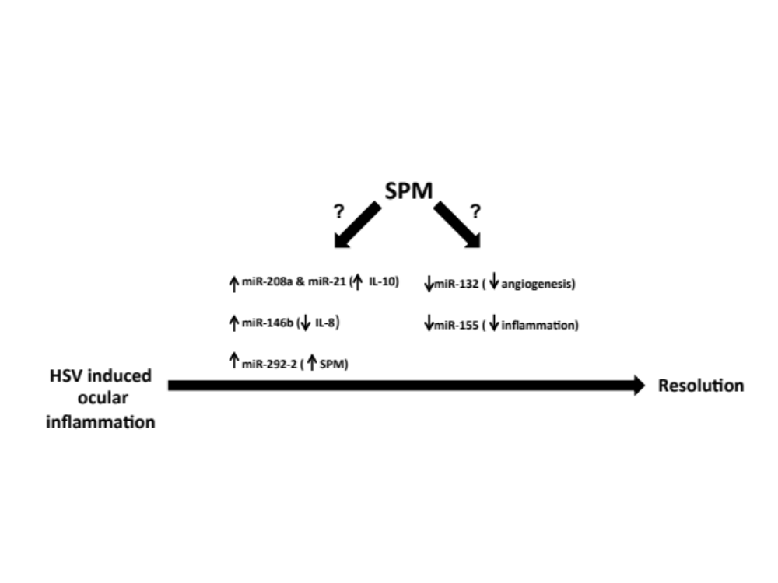 Figure 1.4. Specialized pro-resolution mediators (SPM) and miRNA mediated resolution of HSV induced ocular inflammation: Speculations. The provision of SPM during HSK may result in changes in levels of various miRNAs associated with resolution. SPM could increase expression of miR-21 and miR-208a both of which induce anti-inflammatory cytokine, IL-10. SPM can also increase miR-146b expression and miR-146 lowers levels of IL-8, a chemokine crucial for neutrophil recruitment to eyes. miR-292-2 induced by SPM gives positive feedback for more SPM production. The administration of SPM may also lower levels of miR-132 and miR-155 involved in CV and inflammation respectively.

Part II

Activation of endothelial roundabout receptor 4 (Robo4) reduces the severity of virus induced keratitis

Research described in this chapter is reproduced from a publication accepted in Journal of Immunology by Mulik S, Sharma S, Suryawanshi A, Veiga-Parga T, Reddy PB, Rajasagi NK and Rouse BT.
Mulik S, Sharma S, Suryawanshi A, Veiga-Parga T, Reddy PB, Rajasagi NK, Rouse BT. Activation of endothelial roundabout receptor 4 reduces the severity of virus-induced keratitis. J Immunol. 2011 Jun 15; 186(12): 7195-204. Copyright 2011. The American Association of Immunologists, Inc.
Abstract
Anti angiogenic molecules exert a feedback control to restrain pathological angiogenesis, which include physical binding or inhibition of angiogenic signaling in blood vessel endothelial cells. The latter is the case when Slit2 ligand dependent activation of the blood vessel endothelial cell receptor roundabout 4 (Robo4) occurs. In this study, we demonstrate that Robo4 receptors are up regulated following herpes simplex virus (HSV) infection of the eye on the majority of the new blood vessel endothelial cells that occur in the corneal stroma. However, expression levels of the ligand for Robo4 receptors, Slit2, was not significantly increased during the disease process and the knockdown of Slit2 gene expression using lentiviral shRNAs had no effect on the extent of pathological angiogenesis. In contrast, providing additional Slit2 protein by subconjunctival administration resulted in significantly reduced angiogenesis. The Slit2 binding to Robo4 was shown to block the downstream VEGF signaling molecules Arf 6 and Rac 1 and reduced the anti-apoptotic molecule Bcl-xL in blood vessel endothelial cells. Our results indicate that augmenting the host Robo4/Slit2 system could provide a useful therapeutic approach to control pathological angiogenesis associated with HSV induced stromal keratitis (SK).

Introduction
Ocular Herpes simplex virus (HSV) infection may result in a chronic immuno-inflammatory lesion in the corneal stroma that often results in blindness (1-4). Understanding the pathogenesis of stromal keratitis (SK) lesions has mainly come from animal model studies, particularly using the mouse (5). Such studies have revealed that neovascularization of the normally avascular cornea is a key event in SK pathogenesis (6-8). In consequence, understanding how to control pathological angiogenesis, which is also a critical event in human SK, is relevant since it could result in improved therapy.
Many molecules induced in the eye in response to infection can contribute to neovascularization with the VEGF family molecules, particularly VEGF-A signaling via VEGFR-2 receptors, being the major stimulus for angiogenesis (9-11). Curiously, VEGF-A is produced within the normal cornea, but it fails to drive blood vessel development since it is bound to an excess of the soluble form of one of its receptors (12-14). Virus infection results in the increased synthesis of VEGF-A as well as some other angiogenic molecules (15, 16) and, in addition, causes the breakdown of the VEGF-A/soluble receptor bond (Manuscript accetped for publication). Interference with VEGF levels, or blocking the binding or signaling of receptors are the major approaches so far evaluated to control pathological neovascularization (6, 7, 9, 17). However, the host itself also has one or more means of shutting down VEGF induced angiogenesis (13). For example, the Robo4 receptor that is expressed by endothelial cells in newly formed blood vessels can transduce signals to the cell that will negate or counteract the positive stimulus caused by VEGF binding to its receptors (18, 19). Robo4 receptors can be activated by the host ligand, Slit2, that is produced in some pathological lesions by vascular endothelial cells (18, 20). Accordingly, the balance between the positive signals produced by VEGF may become modulated and perhaps terminated by Slit2 induced Robo4 receptor activation. In some circumstances, such as in laser induced retinopathy, Robo4 knockout mice revealed an accelerated pathological angiogenesis process (18). Additionally, Slit2/Robo4 signaling reduced vessel permeability in the lung and other organs and protected mice from a pathogen induced cytokine storm (21).
Currently, no reports have evaluated the relevance of the Slit2/Robo4 regulatory system in an infectious disease that involves pathological angiogenesis. This issue is addressed herein using ocular infection with HSV that causes neovascularization of the cornea and the blinding lesion stromal keratitis. Our results show that following HSV infection, Robo4 transcripts were significantly up regulated in corneal tissues with the majority of endothelial cells of the newly developed blood vessels expressing Robo4 receptors. However, the Robo4 ligand, Slit2 transcripts and protein were not significantly increased after HSV ocular infection. This could mean that the amount of Slit2 available for binding to Robo4 receptors was limited and that the Slit2/Robo4 host regulatory system was not contributing to effectively control angiogenesis during SK. In support of this notion, blocking Slit2 gene expression using lentiviral shRNA vectors had no effect on the extent of angiogenesis, but in contrast, the provision of additional Slit2 protein by sub-conjunctival injection significantly reduced neovascularization. The results of these studies have therapeutic implications for the control of HSV-induced vision loss.
Materials and Methods
Mice: Female 6-8 wks old C57 BL/6 mice were purchased from Harlan Sprague Dawley Inc. (Indianapolis, Indiana, USA). All mice were housed conventionally in animal facility at the University of Tennessee. All investigations followed guidelines of the Association for Research in Vision and Ophthalmology resolution on the use of animals in research.
Virus: HSV-1 strain RE Tumpey was propagated in Vero cell monolayers (ATCC nol CCL81). Infected Vero cells were harvested, titrated and stored in aliquots at -80⁰C until used.
Corneal HSV-1 infection and scoring: Corneal infections of mice were performed under deep anesthesia. The mice were lightly scarified on their corneas with a 27-gauge needle, and a 3 µl drop containing 10⁴ PFU of HSV-1 RE Tumpey was gently applied to one eye. The development of SK lesion severity and angiogenesis in the eyes of mice was examined by slit-lamp biomicroscopy (Kowa Company, Nagoya, Japan). The scoring system used was as follows: 0, normal cornea; 1, mild corneal haze; 2, moderate corneal opacity; 3, severe corneal opacity; 4, opaque cornea and ulcer; 5, corneal rupture. The severity of angiogenesis was recorded as described previously (22). According to this system, a grade of 4 for a given quadrant of the circle represents a centripetal growth of 1.5 cm towards the corneal center. The score of the four quadrants of the eye were then summed to derive the neo vessel index (range 0‐16) for each eye at a given time point.
Sub-conjunctival injections: Sub-conjunctival injections were performed as reported previously (22). Briefly, these injections were carried out using a 2-cm, 32-gauge needle and syringe (Hamilton, Reno, NV) to penetrate the perivascular region of conjunctiva and appropriate amount of Slit2 protein (R & D systems, Minneapolis, MN) was administered into sub-conjunctival space. Slit2 protein used in this study is a Gln26-Gln900 amino terminal fragment, which is expressed in CHO cells. Mock treatment was given in control mice.
Mice treatment with recombinant Slit2 protein: The mice ocularly infected with HSV-1 RE Tumpey were separated into two groups. The Slit2 protein (1 µg) was given to one group in 10 µl PBS sub-conjunctivally at 2 days p.i. with additional doses on alternate days until day 12 post infection. The Slit2 treatment was begun at day 7 in another experiment with additional doses on alternate days until day 13 post infection. Control group received mock drug sub-conjunctivally with the same regimen for respective experiment. These animals were carefully followed for the progression of angiogenesis and SK development. All experiments were repeated at least two times.
Purification of endothelial cells: The excised corneas were pooled and digested with 60 U/ml Liberase for 35 minutes at 37⁰C in a humidified atmosphere of 5% CO₂. The single cell suspension was prepared and stained with anti CD 31-FITC for 30 minutes on ice. The FITC+ endothelial cells (CD 31+) were sorted using a FACS sorter. The purity at the extent of 80-90% was achieved. These sorted endothelial cells were used for pull down assays, for detection of Bcl-xL, cyclin D1 and caspase 3 proteins and for confocal microscopy.
Confocal microscopy. For confocal staining, the purified endothelial cells were taken on a slide using cytospin and fixed in 4% para‐formaldehyde at room temperature for 10 min. The cells were blocked with 10% goat serum containing 0.05% Tween20 and 1:200 dilution of Fc block (Clone 2.42G2; BD Biosciences Pharmingen, San Diego, CA). Rat anti‐Robo4-PE (R & D systems, Minneapolis, MN) and Rat anti‐CD31-FITC (Clone: 390, BD Pharmingen) were diluted in 1% BSA containing 0.1% Triton‐X and incubated at room temp for 1 hr. After incubations, slides were washed several times with PBST and mounted with Prolong gold antifade mounting media (Invitrogen) and visualized under a confocal microscope.
Flow Cytometry: The corneal single cell suspensions were prepared following Liberase digestion of corneas. These corneal cell suspensions were stained for different cell surface molecules for FACS. Shortly, cell suspensions were incubated with CD45-allophycocyanin (30-F11), CD11b-PerCP (M1/79), Gr1-PE (1A8), CD 4-allophycocyanin (RM4.5), CD31-FITC (All from BD Biosciences Pharmingen) and Robo4-PE (R & D systems, Minneapolis, MN) for 30 minutes on ice. Thereafter, cells were washed thrice and resuspended in 1% para-formaldehyde. The stained samples were acquired with a FACS Calibur (BD Biosciences) and the data were analyzed using the FlowJo software.
Quantitative PCR (QPCR): Total mRNA was isolated from corneal cells using TRIzol LS reagent (Invitrogen). The cDNA prepared using 1 μg of RNA was used for subsequent analysis. QPCR was done using SYBR Green PCR Master Mix (Applied Biosystem, Foster City, CA) with iQ5 real-time PCR detection system (Bio Rad, Hercules, CA). The expression levels of Slit2 and Robo4 were normalized to β-actin with ΔCt method and relative quantification between control and infected mice was performed using the 2‐^{ΔΔCt} formula. The primers used were as follows. β-actin forward CTACCTCATGAAGATCCTGACC, β-actin reverse GTCTAGAGCAACATAGCACAGC; Slit2 forward CCTTCTGAATGTACCTGCTTGG, Slit2 reverse GTAGTTAGAGAGTTCCTTCGGG; Robo4 forward GACCTATATGTGTATGGCCACC, Robo4 reverse CTCTAGATGTTCCTTGTGGTCC, Cxcl2 forward CCAACCACCAGGCTACAG, Cxcl2 reverse CTTCAGGGTCAAGGCAAAC, Nos2 forward TGGATTGTCCTACACCACA and Nos2 reverse CTCCAATCTCTGCCTATCC. The primers for Il1b, IFNg, Il6 and Cxcl1 were already available in the lab (Manuscript accepted for publication in Journal of Virology).
Reverse Transcription Polymerase chain reaction (RT-PCR): RT-PCR for the presence of Slit2 and Robo4 transcripts was done according to the manufacturers protocol (Promega, Madison, WI). The amplified products were resolved on 1% agarose gel. Primers for RT-PCR were as follows. β-actin forward CTACCTCATGAAGATCCTGACC, β-actin reverse GGCATAGAGGTCTTTACGGATG; Slit2 forward GGGAACGACAGTTTCATAGGACTC, Slit2 reverse GTAGTTAGAGAGTTCCTTCGGG; Robo4 forward GGAGTGACCTTAAGATCTGGCAAC and Robo4 reverse CTAGTAGCAGCAACCAGAGTAG.
Western blot analysis: The corneal cells were lysed and total protein in the supernatants was quantified using BCA protein assay kit (Thermo scientific, Waltman, MA). Samples were denatured in Laemmli buffer and resolved by SDS-PAGE and proteins were transfered onto a PVDF membrane. The membrane was blocked with 5% BSA in Tris-buffered saline with Tween 20 at 4⁰C overnight and subjected to incubation with specific primary and secondary antibodies. Proteins bands were visualized using chemiluminiscent HRP substrate (Millipore, Billerica, MA). After keeping in stripping buffer for 10 minutes, the membrane was re-probed using anti β-actin antibody. The antibodies used were as follows: goat anti mouse Robo4 (C-20), goat anti mouse Slit2 (D-16), anti β-actin (C 4), mouse Bcl-xL (4), mouse cyclin D 1(72-13G), goat caspase 3 (T-20), goat anti mouse IgG-HRP and donkey anti goat IgG-HRP (All these antibodies were procured from Santa Cruz biotechnology), mouse Arf 6 (26186D) (Thermo scientific, USA) and mouse Rac 1(89856D)(Thermo scientific).
Arf 6 activation assay: Arf 6 activation assays were performed as reported previously (19). These experiments were carried out using Active Arf 6 pull down and detection kit (Thermo scientific) according to manufacturer’s protocol. Briefly, resin slurry was added to the spin cup in a collection tube and 100 μg GST GGA3-PBD fusion protein with 800 μg total protein (corneal cell lysate) was added to this slurry. This was incubated at 4ºC for 1 hour and finally 50 μl reducing sample buffer was added and GTP-Arf 6 was pulled down and subsequently analyzed by WB. These experiments were repeated two times.
Rac 1 activation assay: The Rac 1 activation assays were carried out as described previously (19). The EZ-Detect™ Rac 1 activation kit (Thermo scientific) was used to isolate active Rac 1 from corneal cell lysates. The immobilized glutathione disc was place into a spin column and 20 μg of GST-human Pak1-PBD was added to it. Immediately, 700 μg total protein (corneal cell lysate) was added to the spin column and it was incubated for 1 hour at 4ºC with gentle rocking. Finally, 50 μl of 2X SDS sample buffer containing β-mercaptoethanol was added to the resin and mixture was heated at 100ºC for 5 min. Samples were analyzed by WB. These experiments were repeated two times.
Retrovirus based RNAi: Slit2 shRNA lentiviral particles and control lentiviral particles were procured from Santa Cruz biotechnology. These lentiviral particles contain 3-5 expression constructs each encoding Slit2 specific shRNA while control lentiviral particles encode scrambled sequences. The knockdown of Slit2 in MKT cells was performed using the manufacturer’s protocol. Briefly, cells were transfected when they were 50% confluent. Polybrene was added at a final concentration 5 μg/ml and Slit2 shRNA/ control lentiviral particles (ranging from 1 x 10⁵- 5 x 10⁵) were added to cells. Medium was changed after 12 hrs and cells were analyzed by QPCR for Slit2 knockdown over 2-4 days after transduction. For in vivo experiments in HSV infected mice, 1 x 10⁵ Slit2 shRNA/control lentiviral particles were inoculated sub-conjunctivally starting at day 1 with additional doses on alternate days until day 11 and mice were monitored for the progression of angiogenesis and SK.
Statistics: The statistical significance for SK lesion severity and angiogenesis between two groups was determined using unpaired two-tailed student's t test. One way ANOVA with Bonferroni’s post hoc test was used to calculate the level of significance for some experiments. P ≤ 0.001 (***), P ≤ 0.01 (**), P ≤ 0.05 (*) were considered as significant. All experiments were repeated at least two times and results are expressed as means ±SEM. For all statistical analysis, GraphPad Prism software was used.

Results
Expression of Robo4 and Slit2 after HSV infection
The pattern of expression of Robo4 and Slit2 gene and protein expression was measured at various time points after HSV infection focusing on time points when neovascularization was prominent and SK lesions clinically apparent. Thus, our aim was to find evidence for a possible role of the Robo4/Slit2 interaction in constraining VEGF driven angiogenesis and vascular permeability. Corneas were collected at different times post HSV infection, dissected free of normal limbal blood vessels and samples processed either to collect vascular endothelial cells for phenotyping, or to prepare corneal RNA samples to quantify Robo4 and Slit2 mRNA levels by quantitative PCR (QPCR). As shown in fig 2.1A, naïve avascular corneal samples do express Robo4 mRNA (likely produced by corneal epithelial cells) but Slit2 mRNA was barely detectable. The fact that naïve corneas express Robo4 and Slit2, was also demonstrable by western blotting (fig 2.1B&C) and the positive controls for Robo4 and Slit2 were kept kidney and brain due to the expression pattern of these molecules reported previously (23, 24). Changes in the levels of Robo4 mRNAs (probably from blood vessel endothelial cells) occurred as early as day 2 after HSV infection, and levels peaked during the clinical phase (day 7-day 14) reflecting the appearance of neovascularization in the infected eye (fig 2.1D). However Slit2 expression levels did not change significantly over the course of events (fig 2.1E).
By day 2, mRNA levels for Robo4 were increased by 28 fold but Slit2 only by 2.9 fold. At the time of overt neovascularization, on day 9 post infection, Robo4 mRNA was elevated by 51 fold, but Slit2 mRNA only 3.6 fold (fig 2.1D&E). Corneal extracts were also analyzed for Robo4 and Slit2 proteins by western blotting on day 9. Compared to controls, the elevated expression of Robo4 was evident with little change in Slit2 levels (fig 2.1F).
Cells isolated from infected corneas at different times post infection were sorted for CD31+ cells (a marker for vascular endothelial cells) and the expression of Robo4 was measured on such cells (fig 2.2A). Firstly, we could show that the percentage of CD31+ cells that expressed Robo4 protein changed with time. Thus, at the earliest time point (day 1) 23.8% of cells were Robo4 positive, whereas at a later time (day 11) the expression increased to 59.2% average. Secondly, we also compared the numbers of Robo4+ CD31+ cells at different time points. Maximal numbers of Robo4+ CD31+ cells were evident in samples collected at day 11 and day14 p.i (fig 2.2B). At this time point, levels of Slit2 protein were minimal and, as already mentioned, mRNA levels were also low in comparison to Robo4. We also attempted to sort endothelial cells from naïve uninfected and day 11 p.i. corneas (fig 2.2C&D). Accordingly, we could not sort any endothelial cells from naïve corneas but large numbers of endothelial cells were sorted from day 11 p.i. corneas (fig 2.2C&D). These sorted endothelial cells from day 11 p.i. corneas revealed the presence of Robo4 by WB (fig 2.2E). Additionally, the fact that blood vessel endothelial cells during SK expressed Robo4 was also demonstrable by confocal microscopy. Eyes taken from day 11 time point and subjected to confocal microscopy revealed endothelial cells with Robo4 receptors (fig 2.2F-H). Thus, taken together, our results could mean that although Robo4 is abundantly expressed by the new blood vessels that result from HSV infection, there may be an inadequacy of the ligand Slit2 to trigger an effective anti angiogenic response.
Endogenous Slit2 is dispensable during SK.
Additional experiments were performed to determine if the inhibition of Slit2 production in HSV infected animals had any effect on the extent of the ocular angiogenesis. To inhibit Slit2 expression, a lentiviral vector was used that expressed Slit2 shRNAs. Initial experiments in vitro using a MKT cell line expressing Slit2 (fig 2.3A) were performed to assess the efficacy of the lentivial knockdown system. The MKT cell line was transduced with lentiviruses expressing Slit2 shRNA/scrambled sequences. Fig 2.3B demonstrates the average Slit2 gene expression values of two independent experiments. We could achieve around 55% reduction in Slit2 mRNA transcripts when Slit2 shRNAs were introduced into MKT cells compared to controls. We did not observe any Slit2 knockdown using scrambled sequences, which confirmed in vitro knockdown of Slit2 gene. In vivo experiments were done in HSV infected animals to determine if the lentiviral vector expressing Slit2 shRNAs had any effect on the extent of angiogenesis. The subconjunctival delivery (25) of lentiviruses encoding Slit2 shRNAs was started from day 1 post HSV infection with additional administrations on alternate days (fig 2.3C). Corneas collected at day 9 revealed diminished Slit2 mRNA and protein compared to controls (fig 2.3D&E) suggesting a reduction in Slit2 mRNA and protein in vivo after lentiviral Slit2 shRNA administrations. However, when lentiviruses expressing Slit2 shRNA treatment was further continued in another group of mice until day 11 and animals were observed at the end of the experiment (day 15) (fig 3F), no increase in angiogenesis or SK lesion severity was observed (fig 2.3G&H). These experiments were repeated three times, and the results suggest that endogenous Slit2 is dispensable during SK (due to low amounts).
Provision of recombinant Slit2 diminishes angiogenesis and HSK.
These experiments were carried out to observe the effect of subconjuctival Slit2 protein administration on HSV-1 induced angiogenesis. As shown in fig 2.4A, sub-conjunctival administration of Slit2 protein (starting from day 2 p.i. with additional doses on alternate days up to day 12) with different doses was done in mice and animals were examined at the end time of the experiment (day 15). This resulted in a dose dependent inhibition of angiogenesis with peak reduction achieved at the maximum dose of 1 µg Slit2 protein when mice were examined at day 15 time point (fig 2.4B). Thus, preventive administration of Slit2 resulted in reduction in SK and angiogenesis scores (fig 2.4C-E). The eyes from the Slit2 treated group revealed reduction in visible angiogenesis compared to the mock treated group (figure 2.8A-C). The frequency and numbers of CD31+ endothelial cells (fig 2.4F&G), CD4+ T cells (fig 4H&I) and neutrophils (fig 2.4J&K) were reduced in mice receiving Slit2 protein compared to mock treated animals. Curiously, even though the treatment of mice with Slit2 protein was delayed up to day 7 post HSV-1 infection (with additional doses on alternate day until day 13), this treatment modality also resulted in diminished angiogenesis and SK lesion severity (day 15) (fig 2.5A-C). Additionally, there was a reduction in the frequency and numbers of CD31+ endothelial cells (fig 2.5D&E), CD4+ T cells (fig 2.5F&G) and neutrophils (fig 2.5H&I) and in the Slit2 treated group. Additionally, when levels of various cytokines (IL1b, IFNγ, IL6 & Nos2) and chemokine’s (Cxcl1 & Cxcl2) were examined in Slit2/mock treated group, a reduction in the levels of different cytokines and chemokines was evident in Slit2 treated mice compared to infected controls at both day 11 and day 15 post infection (figure 2.8D&E). Taken together, our results demonstrate that Slit2 protein driven activation of endothelial Robo4 receptors can serve to modulate the extent of angiogenesis and subsequent immunopathology that occurs following HSV infection.
Possible mechanism by which Slit2 exerts anti angiogenesis
Blockade of Arf 6 and Rac 1 activity during HSK by Slit2 treatment
Recent reports show that Slit2 inhibits angiogenesis by blockade of Arf 6 (19). GTP^{ase} activation assays for Arf 6 and Rac 1 were performed to see whether exogenously delivered Slit2 protein causes similar effects in an infectious disease setting. Mice infected with ocular HSV-1 were provided with 1µg Slit2 protein subconjuctivly starting from day 2 with additional doses at day 4, day 6, day 8 and day 10. Active Arf 6 and Rac 1 were pulled down from 6 corneas collected from each group at day 11 post infection (fig 2.6A). These were subjected to western blotting to determine levels of active Arf 6 and Rac 1. As shown in fig 6B&C, total Arf 6 levels were similar in all groups, but there was an increase in GTP-Arf 6 in the case of mock treated animals compared to uninfected controls. In contrast, a reduction in GTP-Arf 6 in the Slit2 treatment group was observed indicating that Slit2 treatment resulted in the blockade of Arf 6 activity. Similar results were obtained in analyses from GTP-Rac 1 activation assays. There was an increase in GTP-Rac 1 in the mock treatment group over uninfected control animals but levels of GTP-Rac 1 were undetectable in the Slit2 treated group (fig 2.6D&E). Total Rac 1 activity was similar in these groups. The above experiments were repeated two times. Additionally, the blood vessel endothelial cells (CD 31+) were sorted from mock/Slit2 treated corneas at day 11 post infection (purity up to the extent of 85-90% was achieved) and active Arf 6 and Rac 1 were pooled down from the endothelial cells of the respective groups. As shown in figure 2.9A-E, levels of active Arf 6 and Rac 1 were lower in endothelial cells taken from Slit2 treated mice compared to mock while total Arf 6 and Rac 1 levels were similar in both groups. These experiments were repeated two times. These results indicate that the provision of excess Slit2 to HSV-1 infected mice reduces angiogenic Arf 6 and Rac 1 activity in the corneas.
Slit2 may reduce anti apoptotic and cell cycle signal molecules in blood vessel endothelial cells
The observed reduced numbers and frequency of blood vessel endothelial cells in Slit2 treated animals prompted us to investigate whether Slit2 treatments induced apoptosis of endothelial cells in vivo. To evaluate the situation in HSV infected ocular disease, infected mice were treated with 1 µg Slit2/ mock starting from day 2 up to day 10 on every alternate day and corneas collected at day 11 p.i were subjected to analysis (fig 2.7A). The blood vessel endothelial cells (CD 31+) were sorted from mock/Slit2 treated corneas at day 11 (purity up to the extent of 90% was achieved) and analyzed for the expression of anti apoptotic Bcl-xL and cell cycle signal molecule Cyclin D1 by western blotting. As shown in fig 2.7B-E, levels of Bcl-xL and Cyclin D1 were down regulated in endothelial cells isolated from Slit2 treated mice compared to the mock treated group. These experiments were repeated two times. Additionally, these sorted blood vessel endothelial from both groups were subjected to WB and analyzed for the expression of active caspase 3 (indicating apoptosis). As shown in figure 2.10A-C, the level of caspase 3 was higher in endothelial cells taken from Slit2 treated mice (indicating more apoptosis) compared to the mock treated group. The above experiments were repeated two times. The results of these experiments indicate that Slit2 treatments reduce anti apoptotic and cell cycle signal molecules while increase caspase 3 in blood vessel endothelial cells during SK.

Discussion
HSV ocular infection results in neovascularization of the normally avascular cornea. This represents a key event in the pathogenesis of a chronic inflammatory reaction in the eye (5-7, 9). In consequence, understanding how to control pathological angiogenesis is relevant since it could result in improved therapy of a lesion, stromal keratitis that is an important cause of human blindness. In the present report, we have evaluated if a host feedback anti-angiogenesis mechanism, namely the stimulation by Slit2 ligand of Robo4 receptors on vascular endothelial cells, is operative in an infectious disease situation and to determine if manipulating the feedback system could represent a useful approach to constrain lesion severity. We demonstrate that Robo4 receptors are up regulated following HSV infection and that the majority of new blood vessel endothelial cells express Robo4. However, the expression levels of the Robo4 ligand, Slit2 were not significantly increased during the disease process. Moreover, the inhibition of Slit2 gene expression using lentiviral shRNAs had no effect on the extent of pathological angiogenesis. In contrast, providing additional Slit2 protein by subconjunctival administration resulted in significantly reduced angiogenesis. Mechanistically, the Slit2/Robo4 interaction was shown to block the downstream VEGF signaling molecules Arf 6 and Rac 1 and reduced the anti-apoptotic molecule Bcl-xL in blood vessel endothelial cells. Our results indicate that augmenting the host Robo4/Slit2 anti-angiogenesis system could provide a useful therapeutic approach to control pathological angiogenesis associated with HSV induced stromal keratitis.
Stromal keratitis remains a significant cause of vision impairment and new forms of therapy are needed. Controlling the extent of neovascularization, a key event in SK pathogenesis, represents a logical target for therapy. In animal models of SK, we and others have shown that reducing angiogenesis, as can be achieved by inhibiting the expression of angiogenic factors, results in milder lesions (6, 15, 16, 26). Similarly, angiogenesis is damaging to the retina and one treatment finding favor in the clinic is to use the anti VEGF monoclonal antibody, bevacizumab (27, 28). Recently, it became apparent that the host itself has one or more systems that counteract the stimuli for new blood vessel development and malfunction. We chose to investigate the Slit2/Robo4 system since this anti-angiogenic feedback mechanism was shown recently to influence vascular disease induced by trauma to the retina (18, 19). Moreover, both Slit2 and Robo4 can be artificially induced in the cornea by implants containing the angiogenic factor FGF (29). However, it was not known if the Slit2/Robo4 feedback mechanism had any regulatory effect in any natural infectious disease models where typically, as in SK, multiple angiogenic factors are involved in driving the pathological angiogenesis.
Our results clearly show that the Robo4 up regulation becomes evident early after infection. We could show that the majority of the endothelial cells recovered from the neovascularized corneas expressed Robo4 receptors. Accordingly, the Robo4 mediated anti-angiogenesis system was poised to perform its regulatory function. Nevertheless, we advocate that this potential regulatory event may be inadequate during SK lesion pathogenesis since the ligand for Robo4, Slit2 was in limited supply. The reasons for this were not established, but they could relate to an inhibitory effect of virus on Slit2 gene expression which may be derived from corneal epithelial cells (29-32). This issue is currently under investigation. Following infection, a modestly increased expression of Slit2 did occur but this was considered as insignificant. Moreover, when Slit2 gene expression was reduced in the cornea, as was achieved using a lentivirus system that expressed shRNA for Slit2, an anticipated increase in the extent of pathological angiogenesis (20) was not observed. Accordingly, we must conclude that during the pathogenesis of HSV ocular lesions, the host Slit2/Robo4 anti-angiogenesis feedback mechanism fails to influence the outcome of events. Nevertheless, we could also show that the anti-angiogenic system could be activated and play a modulatory effect on the virus induced angiogenesis. This was done by providing an additional supply of Slit2 protein locally to the eye by subconjunctival injection. This procedure, which could be started as late as day 7 p.i resulted in significantly reduced angiogenesis and SK lesion severity compared to untreated controls. Additionally, we could observe a reduction in levels of various cytokines and chemokines in the corneas of Slit2 treated mice which is in line with recent findings of others (21). Our results support the observations of Jones et al (18, 19) using a non infectious vascular disease model in the retina that intravitreal administration of additional Slit2 protein can diminish vascular disease.
Previous reports indicate that a number of biochemical events could explain the mechanisms by which Slit2 exerts its anti-angiogenic effect (18, 19, 33). These include activation of Robo4 receptors, which recruits paxillin and GIT 1 that in turn blocks angiogenic Arf 6 (VEGF downstream signaling) activity (18, 19). However, others suggest that Slit2 accelerates apoptosis in tumor systems by reducing the expression of the anti-apoptotic molecule Bcl-xL as well as diminishing cell cycle signal molecules such as Cyclin D 1 (33). Our results demonstrate that the Slit2 treatment in HSV infected mice resulted in significant reduction in Arf 6 and Rac 1 activity in corneas but the treatment modality also led to reduction in anti apoptotic Bcl-xL and cell cycle signal molecule Cyclin D1 while increased caspase 3 levels in blood vessel endothelial cells of Slit2 treated mice. Future studies are under investigation to determine whether blockade of downstream signaling molecules of VEGF such as Arf 6 or increasing cell cycle inhibitors in blood vessel endothelial cells will lead to modulation of angiogenesis and SK.
In conclusion, we have demonstrated that enhancing natural Slit2/Robo4 anti-angiogenic host feedback mechanism reduces virus induced angiogenesis and subsequent immunopathology. Here we show that the majority of the blood vessel endothelial cells recovered from the neovascularized corneas during SK expressed the Robo4 receptors. Nevertheless, the ligand Slit2, was found to be minimal leading to ineffectiveness of this natural feedback mechanism to control angiogenesis during this blinding immunopathology. Thus, the provision of additional amount of Slit2 protein led to significant reduction in angiogenesis and diminished immunopathology during SK. Accordingly, we advocate that manipulating the function of the host feedback mechanism holds promise as a potential approach for therapy of SK.
Acknowledgements: We thank Dr. Naveen Kumar (Dept of Pathology and laboratory medicine, Emory University) for his invaluable discussions during RNAi work. We appreciate Nancy Nielsen for her help on FACS sorting. We thank Dr. John Dunlop for his assistance on confocal microscopy. We also thank Greg Spencer for his great assistance during manuscript editing in many ways.

References
1. Streilein, J. W., M. R. Dana, and B. R. Ksander. 1997. Immunity causing blindness: five different paths to herpes stromal keratitis. Immunology Today 18:443-449.
2. Zhao, Z. S., F. Granucci, L. Yeh, P. A. Schaffer, and H. Cantor. 1998. Molecular mimicry by herpes simplex virus type 1: autoimmune disease after viral infection. Science 279:1344-1347.
3. Biswas, P. S., and B. T. Rouse. 2005. Early events in HSV keratitis - setting the stage for a blinding disease. Microbes and Infection 7:799-810.
4. Deshpande, S. P., S. Lee, M. Zheng, B. Song, D. Knipe, J. A. Kapp, and B. T. Rouse. 2001. Herpes simplex virus-induced keratitis: Evaluation of the role of molecular mimicry in lesion pathogenesis. Journal of Virology 75:3077-3088.
5. Russell, R. G., M. P. Nasisse, H. S. Larsen, and B. T. Rouse. 1984. Role of lymphocytes in the pathogenesis of herpetic stromal keratitis. Investigative Ophthalmology & Visual Science 25:938-944.
6. Kim, B., Q. Q. Tang, P. S. Biswas, J. Xu, R. M. Schiffelers, F. Y. Xie, A. M. Ansari, P. V. Scaria, M. C. Woodle, P. Lu, and B. T. Rouse. 2004. Inhibition of ocular angiogenesis by siRNA targeting vascular endothelial growth factor pathway genes - Therapeutic strategy for herpetic stromal keratitis. American Journal of Pathology 165:2177-2185.
7. Zheng, M., M. A. Schwarz, S. J. Lee, U. Kumaraguru, and B. T. Rouse. 2001. Control of stromal keratitis by inhibition of neovascularization. American Journal of Pathology 159:1021-1029.
8. Gong, Y., and D. R. Koh. 2010. Neutrophils promote inflammatory angiogenesis via release of preformed VEGF in an in vivo corneal model. Cell and Tissue Research 339:437-448.
9. Zheng, M., S. Deshpande, S. Lee, N. Ferrara, and B. T. Rouse. 2001. Contribution of vascular endothelial growth factor in the neovascularization process during the pathogenesis of herpetic stromal keratitis. Journal of Virology 75:9828-9835.
10. Nagy, J. A., A. M. Dvorak, and H. F. Dvorak. 2007. VEGF-A and the induction of pathological angiogenesis. Annual Review of Pathology-Mechanisms of Disease 2:251-275.
11. Ferrara, N., H. P. Gerber, and J. LeCouter. 2003. The biology of VEGF and its receptors. Nature Medicine 9:669-676.
12. Ambati, B. K., M. Nozaki, N. Singh, A. Takeda, P. D. Jani, T. Suthar, R. J. C. Albuquerque, E. Richter, E. Sakurai, M. T. Newcomb, M. E. Kleinman, R. B. Caldwell, Q. Lin, Y. Ogura, A. Orecchia, D. A. Samuelson, D. W. Agnew, J. St Leger, W. R. Green, P. J. Mahasreshti, D. T. Curiel, D. Kwan, H. Marsh, S. Ikeda, L. J. Leiper, J. M. Collinson, S. Bogdanovich, T. S. Khurana, M. Shibuya, M. E. Baldwin, N. Ferrara, H. P. Gerber, S. De Falco, J. Witta, J. Z. Baffi, B. J. Raisler, and J. Ambati. 2006. Corneal avascularity is due to soluble VEGF receptor-1. Nature 443:993-997.
13. Ambati, B. K., E. Patterson, P. Jani, C. Jenkins, E. Higgins, N. Singh, T. Suthar, N. Vira, K. Smith, and R. Caldwell. 2007. Soluble vascular endothelial growth factor receptor-1 contributes to the corneal antiangiogenic barrier. British Journal of Ophthalmology 91:505-508.
14. Kendall, R. L., and K. A. Thomas. 1993. Inhibition of vascular endothelial cell growth factor activity by an endogenously encoded soluble receptor. Proceedings of the National Academy of Sciences of the United States of America 90:10705-10709.
15. Klinman, D. M., M. Zheng, M. Gierynska, and B. T. Rouse. 2002. DNA containing bioactive CpG motifs promote angiogenesis. Drug News & Perspectives 15:358-363.
16. Biswas, P. S., K. Banerjee, P. R. Kinchington, and B. T. Rouse. 2006. Involvement of IL-6 in the paracrine production of VEGF in ocular HSV-1 infection. Experimental Eye Research 82:46-54.
17. Kim, B., S. Suvas, P. P. Sarangi, S. Lee, R. A. Reisfeld, and B. T. Rouse. 2006. Vascular endothelial growth factor receptor 2-based DNA immunization delays development of herpetic stromal keratitis by antiangiogenic effects. Journal of Immunology 177:4122-4131.
18. Jones, C. A., N. R. London, H. Y. Chen, K. W. Park, D. Sauvaget, R. A. Stockton, J. D. Wythe, W. Suh, F. Larrieu-Lahargue, Y. Mukouyama, P. Lindblom, P. Seth, A. Frias, N. Nishiya, M. H. Ginsberg, H. Gerhardt, K. Zhang, and D. Y. Li. 2008. Robo4 stabilizes the vascular network by inhibiting pathologic angiogenesis and endothelial hyperpermeability (vol 14, pg 448, 2008). Nature Medicine 14:585-585.
19. Jones, C. A., N. Nishiya, N. R. London, W. Q. Zhu, L. K. Sorensen, A. C. Chan, C. J. Lim, H. Y. Chen, Q. S. Zhang, P. G. Schultz, A. M. Hayallah, K. R. Thomas, M. Famulok, K. Zhang, M. H. Ginsberg, and D. Y. Li. 2009. Slit2-Robo4 signalling promotes vascular stability by blocking Arf6 activity. Nature Cell Biology 11:1325-U1146.
20. Grone, J., O. Doebler, C. Loddenkemper, B. Hotz, H. J. Buhr, and S. Bhargava. 2006. Robo1/Robo4: Differential expression of angiogenic markers in colorectal cancer. Oncology Reports 15:1437-1443.
21. London, N. R., W. Q. Zhu, F. A. Bozza, M. C. P. Smith, D. M. Greif, L. K. Sorensen, L. M. Chen, Y. Kaminoh, A. C. Chan, S. F. Passi, C. W. Day, D. L. Barnard, G. A. Zimmerman, M. A. Krasnow, and D. Y. Li. 2010. Targeting Robo4-Dependent Slit Signaling to Survive the Cytokine Storm in Sepsis and Influenza. Sci. Transl. Med. 2.
22. Dana, M. R., S. N. Zhu, and J. Yamada. 1998. Topical modulation of interleukin-1 activity in corneal neovascularization. Cornea 17:403-409.
23. Park, K. W., C. M. Morrison, L. K. Sorensen, C. A. Jones, Y. Rao, C. B. Chien, J. Y. Wu, L. D. Urness, and D. Y. Li. 2003. Robo4 is a vascular-specific receptor that inhibits endothelial migration. Dev. Biol. 261:251-267.
24. Ba-Charvet, K. T. N., K. Brose, V. Marillat, T. Kidd, C. S. Goodman, M. Tessier-Lavigne, C. Sotelo, and A. Chedotal. 1999. Slit2-mediated chemorepulsion and collapse of developing forebrain axons. Neuron 22:463-473.
25. Yoon, K. C., J. A. Bae, H. J. Park, S. K. Im, H. J. Oh, X. H. Lin, M. Y. Kim, J. H. Lee, S. E. Lee, K. Y. Ahn, and K. K. Kim. 2009. Subconjunctival gene delivery of the transcription factor GA-binding protein delays corneal neovascularization in a mouse model. Gene Therapy 16:973-981.
26. Lee, S., M. Zheng, B. Kim, and B. T. Rouse. 2002. Role of matrix metalltoproteinase-9 in angiogenesis caused by ocular infection with herpes simplex virus. Journal of Clinical Investigation 110:1105-1111.
27. Finger, P. T. 2008. Radiation retinopathy is treatable with anti-vascular endothelial growth factor bevacizumab (avastin). International Journal of Radiation Oncology Biology Physics 70:974-977.
28. Avery, R. L., J. Pearlman, D. J. Pieramici, M. D. Rabena, A. A. Castellarin, M. A. Nasir, M. J. Giust, R. Wendel, and A. Patel. 2006. Intravitreal bevacizumab (Avastin) in the treatment of proliferative diabetic retinopathy. Ophthalmology 113:1695-1705.
29. Han, X., and M. C. Zhang. 2010. Potential anti-angiogenic role of Slit2 in corneal neovascularization. Experimental Eye Research 90:742-749.
30. Fenwick, M. L., and J. Clark. 1982. Early and delayed shut-off of host protein-synthesis in cells infected with herpes simplex virus. Journal of General Virology 61:121-125.
31. Fenwick, M. L., and M. J. Walker. 1978. Suppression of synthesis of cellular macromolecules by herpes simplex virus. Journal of General Virology 41:37-51.
32. Kanangat, S., J. S. Babu, D. M. Knipe, and B. T. Rouse. 1996. HSV-1-mediated modulation of cytokine gene expression in a permissive cell line: Selective upregulation. Virology 219:295-300.
33. Kim, H. K., H. Zhang, H. Li, T. T. Wu, S. Swisher, D. He, L. Z. Wu, J. M. Xu, C. A. Elmets, M. Athar, X. Xu, and H. Xu. 2008. Slit2 Inhibits Growth and Metastasis of Fibrosarcoma and Squamous Cell Carcinoma. Neoplasia 10:1411-1420.
34. Suryawanshi, A., S. Mulik, S. Sharma, P.B.J. Reddy, S. Sehrawat, B. T. Rouse. 2010. Ocular neovascularization caused by HSV-1 infection results from breakdown of binding between VEGF-A and its soluble receptor. Journal of Immunology 6:3653-65.
35. Sharma, S., S. Mulik, N. Kumar, A. Suryawanshi, B. T. Rouse. 2011. An anti inflammatory role of VEGFR2/src kinase inhibitor in HSV induced immunopathology. Journal of Virology 12:5995-6007.

Appendix
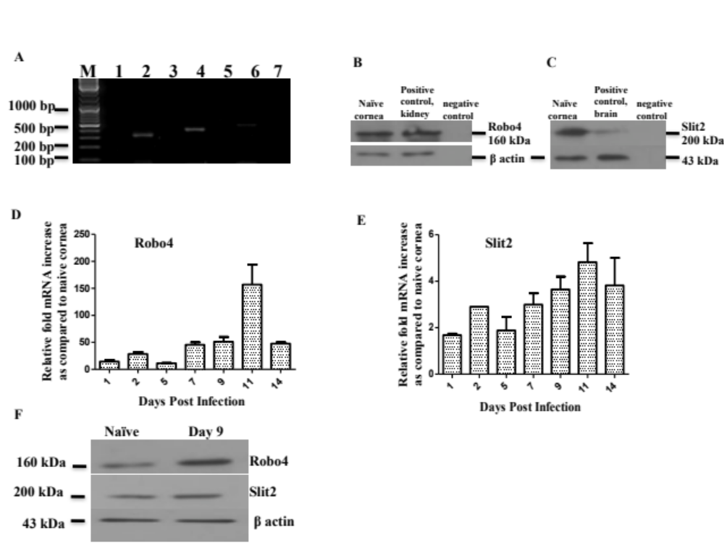
Figure 2.1. Expression of Robo4 and Slit2 after HSV infection. WT mice were sacrificed and 6 corneas were collected and pooled for mRNA analysis by RTPCR and for protein analysis by WB. (A) Agarose gel analysis of Robo4 (394 bp)(Lane 4) and Slit2 (465 bp) (Lane 6) transcripts from naive corneas (Pooled n=6 corneas). Lane M-Marker, lane 2 is beta actin (325 bp). Lane 1, 3, and 5 are RT negative control for beta actin, Robo4 and Slit2 while lane 7 is negative control (water). Data are representative of three independent experiments. Reducing Western blot (WB) analysis of Robo4 (B) and Slit2 (C) protein in naïve corneas is shown. The kidney and brain were used as positive controls for Robo4 and Slit2 respectively. These experiments were repeated three times. WT mice were infected with HSV-1 RE in one eye and 6 corneas were collected and pooled for analysis ether by QPCR or by WB. (D) Kinetic analysis of the expression of Robo4 mRNA levels shows peaks around day 7-day 14 p.i. Data are mean ± SEM (Pooled n=6 mice). (E) Quantification of Slit2 mRNA at different time points post HSV infection. Data are mean ± SEM (Pooled n=6 mice). (F) Reducing WB analysis of corneal samples from naive uninfected and day 9 p.i. reveals increase in Robo4 protein in infected corneas while slight change in Slit2 protein at day 9 p.i (Pooled n=6 mice). These experiments were repeated three times. 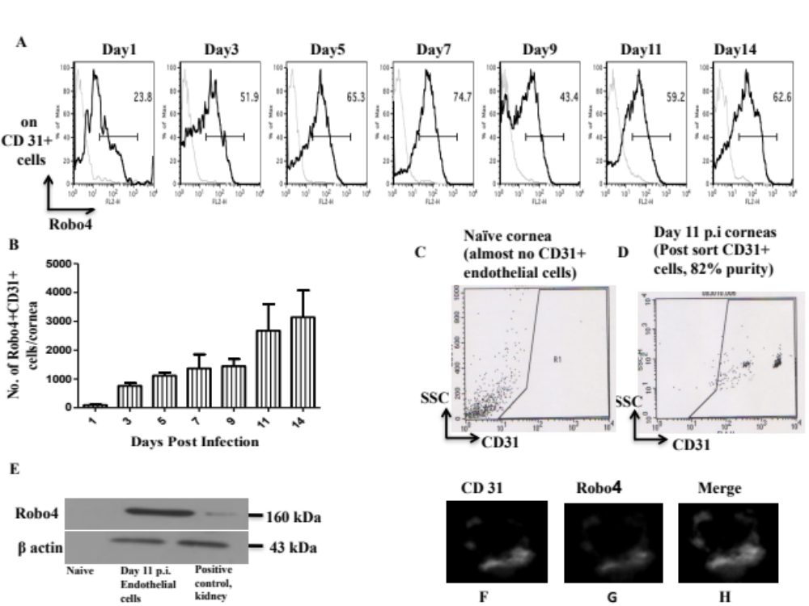 Figure 2.2. Robo4+ blood vessel endothelial cells in corneas after HSV infection. WT mice were infected with HSV-1 RE in one eye and 6 corneas were collected and pooled for analysis by flow cytometry. (A) Representative FACS plots from each time point show the percentage of Robo4+ blood vessel endothelial cells. Isotype controls are shown as faint grey lines. Data are representative of three independent experiments. (B) Total number of Robo4+ blood vessel endothelial cells per cornea at each time point post HSV-1 infection reveals an increase in Robo4+ endothelial cells over time during SK with maximum number of cells observed at day 11 and day 14 p.i. Data are mean ± SEM (Pooled n=6 mice). These experiments were repeated three times. The sorting of CD31+ endothelial cells from naive uninfected mice (C) and day 11 p.i. corneas (D) is shown which reveals absence of endothelial cells in naive corneas while large number of endothelial cells were present in day 11 p.i. corneas. These sorted endothelial cells from HSV infected corneas were further subjected to WB to detect the presence of Robo4 (E) while kidney was used as a positive control for Robo4 detection. Representative immunofluorescence staining of endothelial cells sorted from day 11 p.i. corneas for blood vessel endothelial cells (green) (F), Robo4 (red) (G) and merge (Robo4+ endothelial cells) (H) reveals the presence of Robo4 on the blood vessel endothelial cells during SK. Single endothelial cell is shown. Image is the representative of two independent experiments. Original magnification x60.
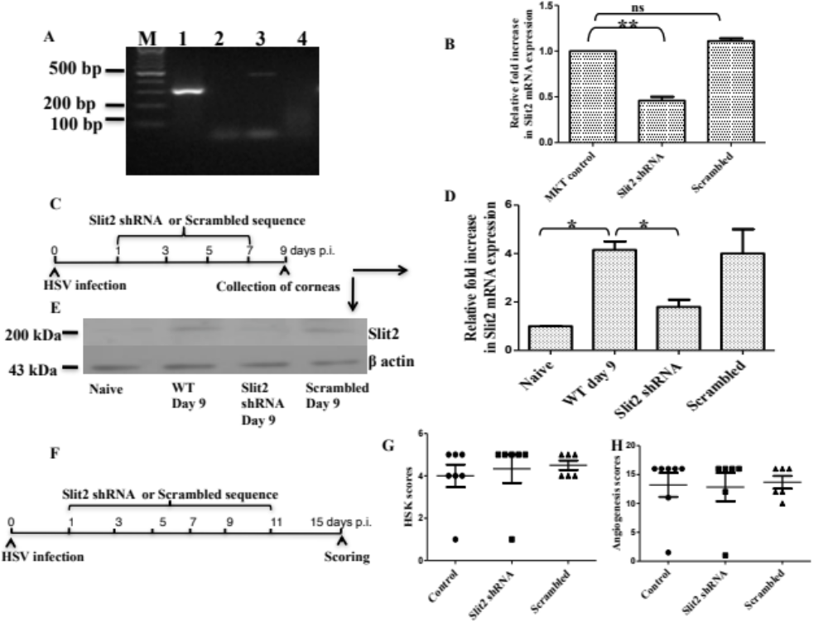 Figure 2.3. Slit2 is dispensable during SK. (A) MKT cells expressing Slit2 mRNA transcripts. Agarose gel analysis of Slit2 (465 bp) (Lane 3) transcripts in MKT cells. Lane M-Marker, lane 1 is beta actin (325 bp). Lane 2 and lane 4 are RT negative control for beta actin and Slit2 respectively. Image is representative of three independent experiments. (B) Knockdown of Slit2 in MKT cells. Lentiviruses expressing Slit2 shRNA/scrambled sequences were introduced into MKT cells and quantification of Slit2 mRNA was carried out to evaluate Slit2 knockdown. One way ANOVA with Bonferroni’s post hoc test was used to calculate the level of significance. **P ≤ 0.01. These experiments were repeated three times. WT mice were infected with HSV-1 RE in one eye and 6 corneas were collected and pooled for analysis by QPCR or WB. (C) Lentiviruses expressing Slit2 shRNA/scrambled sequences were injected subconjunctively in HSV infected mice as indicated. (D) Quantification of Slit2 mRNA from corneas isolated from different groups revealed knockdown of Slit2 mRNA in Slit2 shRNA treatment group (Pooled n=6 mice/group). The level of significance was determined by student’s t test (unpaired). *P ≤ 0.05. These experiments were repeated three times. (E) Reducing WB for Slit2 protein after treatment of HSV infected mice with Slit2 shRNA/scrambled sequences (Pooled n=6 mice/group). WT mice were infected with HSV-1 RE in one eye and mice were monitored for the development of angiogenesis and SK up to day 15. (F) Lentiviruses expressing Slit2 shRNA/scrambled sequences were injected subconjunctively in HSV infected mice as indicated. HSK scores (G) and angiogenesis scores (H) at day 15 after the treatment of mice with either lentiviruses expressing Slit2 shRNAs/scrambled sequences. One way ANOVA with Bonferroni’s post hoc test was used to calculate the level of significance. No statistical significant differences among groups were observed. These experiments were repeated three times. 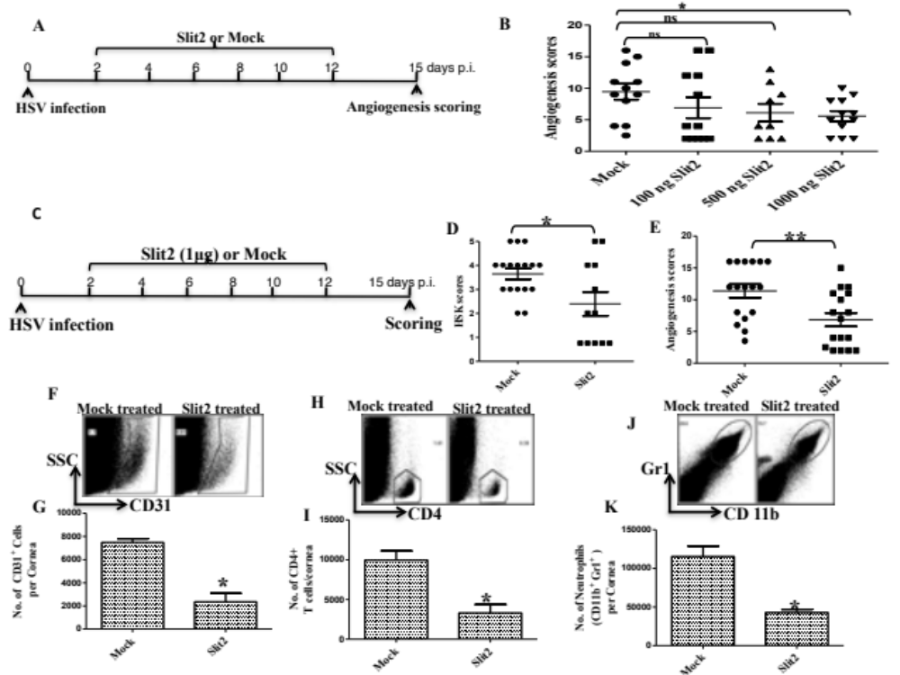 Figure 2.4. Preventive administration of recombinant Slit2 protein diminishes angiogenesis and HSK. WT mice were infected with HSV-1 RE in one eye and 6 corneas were collected and pooled for analysis by flow cytometry. (A) The Slit2/mock treatment was given to HSV infected mice as shown. (B) The dose dependent inhibition of angiogenesis scores after Slit2 treatment with maximum reduction in angiogenesis at 1 µg Slit2 protein dose. These experiments were repeated two times. The Slit2 treatment regimen (C) resulted in reduction in HSK (D) and angiogenesis scores (E) in HSV infected animals. The frequency and total cell number per cornea for endothelial cells (CD31+ cells) (F & G), CD4+ T cells (H & I) and neutrophils (Gr1+, CD11b+ cells) (J & K) showed significant reduction in frequency and total cell number per cornea after preventive Slit2 treatment (Pooled n=6 mice/group). The level of significance was determined by student’s t test (unpaired). **P ≤ 0.01, *P ≤ 0.05. These experiments were repeated two times.
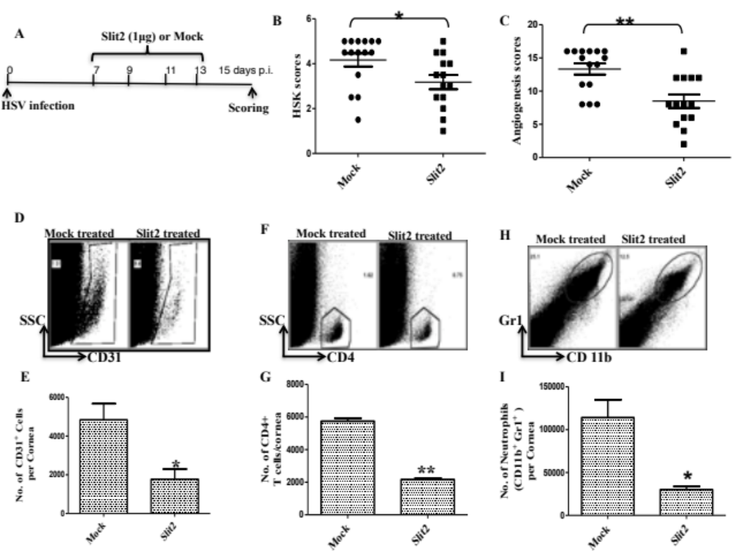 Figure 2.5. Provision of recombinant Slit2 protein therapeutically diminishes angiogenesis and HSK. WT mice were infected with HSV-1 RE in one eye and 6 corneas were collected and pooled for analysis by flow cytometry. The therapeutic Slit2 treatment (A) resulted in reduction in HSK (B) and angiogenesis (C) scores in HSV infected animals. The frequency and total cell number per cornea for endothelial cells (CD31+ cells) (D & E), CD4+ T cells (F & G) and neutrophils (Gr1+, CD11b+ cells) (H & I) showed significant reduction in total cell number per cornea after therapeutic Slit2 treatment (Pooled n=6 mice/group). The level of significance was determined by student’s t test (unpaired). **P ≤ 0.01, *P ≤ 0.05. These experiments were repeated two times. 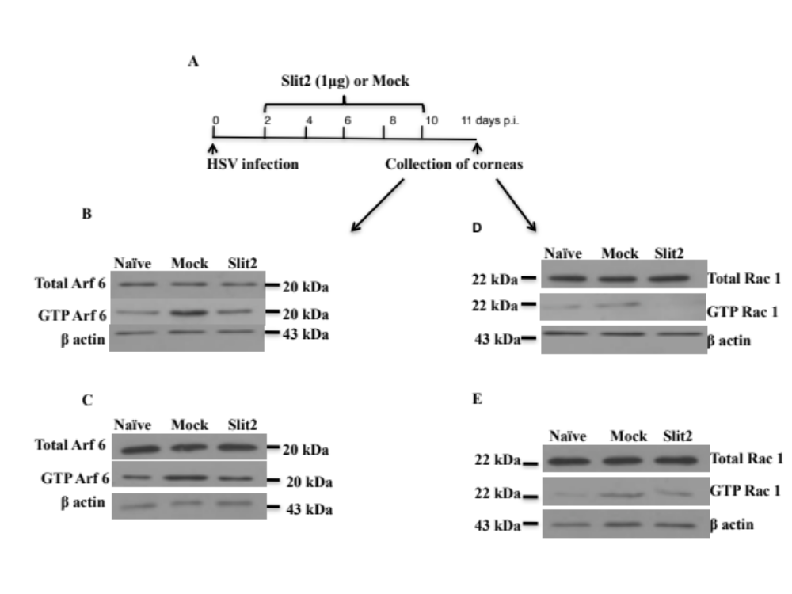 Figure 2.6. Blockade of Arf 6 and Rac 1 activity after Slit2 treatment. WT mice were infected with HSV-1 RE in one eye and 6 corneas were collected and pooled for analysis by GTP^{ase} activation assays. (A) WT mice infected with HSV were treated with Slit2/mock as shown. The corneas collected at day 11 p.i. after Slit2/mock treatment were subjected to Arf 6 (B&C) and Rac 1 (D&E) pull down followed by reducing WB analysis for Arf 6 and Rac 1 of the respective groups (Pooled n=6 mice/group). The results of two independent experiments are shown. 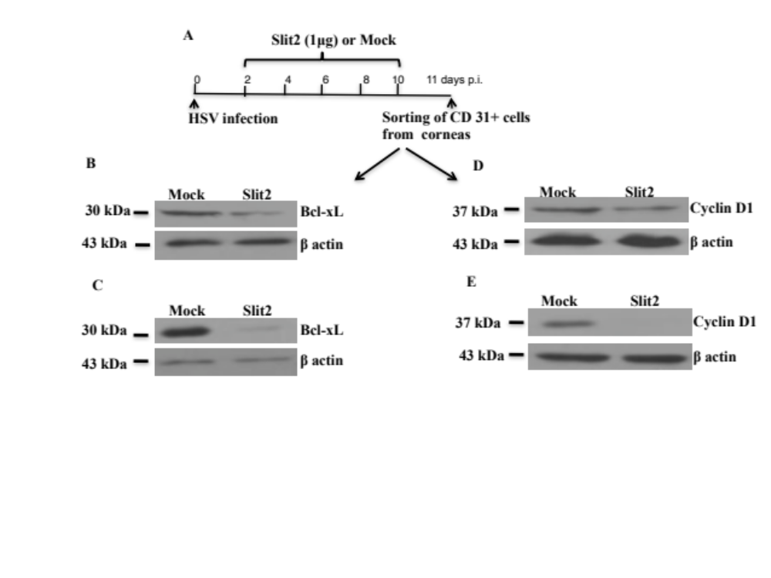
Figure 2.7. Slit2 may reduce anti apoptotic and cell cycle signal molecules in endothelial cells. WT mice were infected with HSV-1 RE in one eye and 6 corneas were collected and pooled for analysis by WB. The HSV infected mice were treated with Slit2/mock as shown (A) and CD 31+ cells were sorted from mock and Slit2 treated mice corneas. These sorted CD 31+ cells from respective groups were subjected to reducing WB for anti apoptotic molecule Bcl-xL (B&C) and cell cycle signal molecule cyclin D1 (D&E) (Pooled n=6 mice/group). The results of two independent experiments are shown. 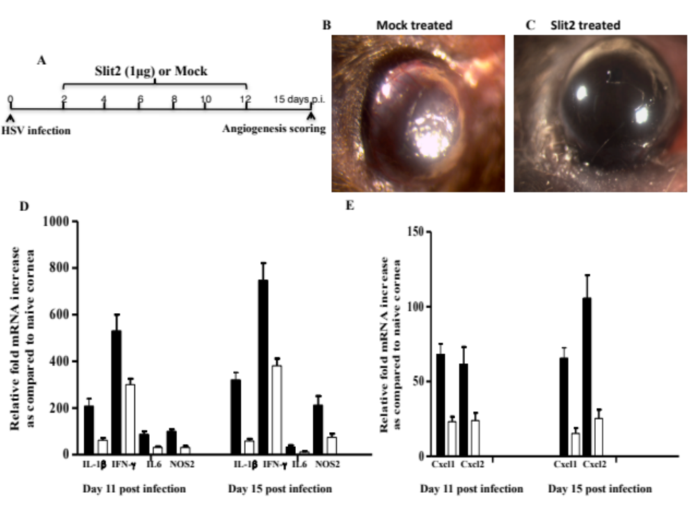 Figure 2.8. Reduction in cytokine and chemokine levels after Slit2 treatment. WT mice were ocularly infected with 10⁴ PFU HSV-1 RE in one eye and monitored for the development of angiogenesis and SK. A) Slit2 or mock was administered at an indicated time points to these HSV infected mice. Representative eye photographs from (B) Slit2/mock (C) treated group at day 15 post HSV infection are shown. These experiments were repeated two times. The Slit2/mock treated mice were sacrificed at day 11 and day 15 p.i. and 6 corneas were collected and pooled for analysis by QPCR. Levels of various cytokines (IL1b, IFNγ, IL6 & Nos2) and chemokine’s (Cxcl1 & Cxcl2) in Slit2 (white bars)/mock (black bars) treated group at day 11 (D) and day 15 (E) p.i. are shown (Pooled n=6 mice/group). These experiments were repeated two times.
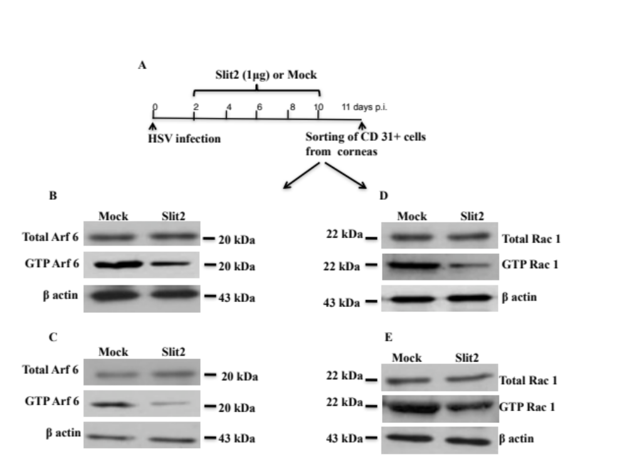
Figure 2.9. Slit2 inhibits Arf 6 and Rac 1 activity in endothelial cells during HSK. WT mice were infected with HSV-1 RE in one eye and 12 corneas were collected and pooled for analysis by WB. The HSV infected mice were treated with Slit2/mock as shown (A) and CD 31+ cells were sorted from mock and Slit2 treated mice corneas. These sorted CD 31+ cells from respective groups were subjected to Arf 6 (B&C) and Rac 1 (D&E) pull down followed by reducing WB analysis for Arf 6 and Rac 1 of the respective groups (Pooled n=12 mice/group). The results of two independent experiments are shown.
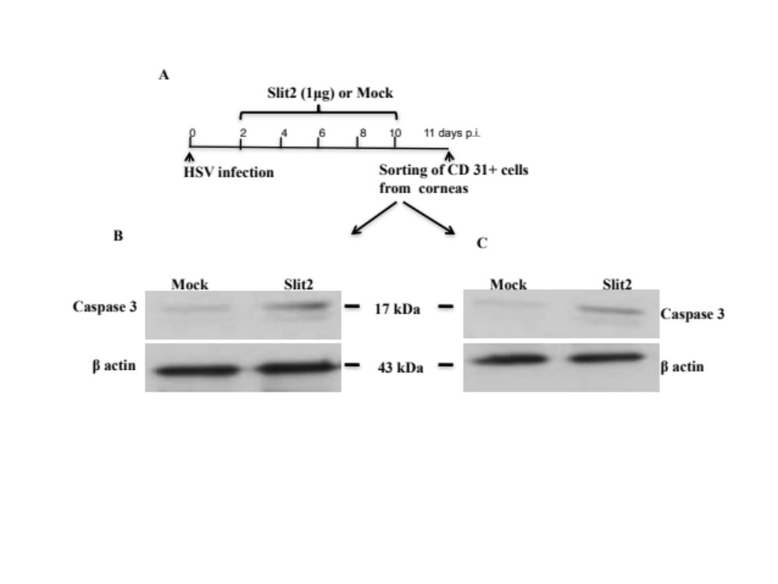 Figure 2.10. Increased caspase 3 activity in endothelial cells after Slit2 treatment. WT mice were infected with HSV-1 RE in one eye and 12 corneas were collected and pooled for analysis by WB. The HSV infected mice were treated with Slit2/mock as shown (A) and CD 31+ cells were sorted from mock and Slit2 treated mice corneas. These sorted CD 31+ cells from respective groups were subjected to WB for the analysis of active caspase 3 protein (B&C). The results of two independent experiments are shown (Pooled n=12 mice/group).

Part III

Role of microRNA-132 in angiogenesis after ocular infection with herpes simplex virus

Research described in this chapter is reproduced from a publication accepted in American journal of pathology by Mulik S, Xu J, Reddy PB, Rajasagi NK, Gimenez F, Sharma S, Lu PY and Rouse BT.
Mulik S, Xu J, Reddy PB, Rajasagi NK, Gimenez F, Sharma S, Lu PY, Rouse BT. Role of microRNA-132 in angiogenesis after ocular infection with herpes simplex virus. Am J Pathol. 2012 Aug; 181(2): 525-34. Reprinted from Am J Pathol 2012, 181:525-534 with permission from the American Society for Investigative Pathology.

Abstract
MicroRNAs (miRNAs) are small regulatory molecules that control diverse biological processes that include angiogenesis. Herpes simplex virus (HSV) infection of the eye may result in corneal neovascularization (CV) during blinding immunopathological lesion stromal keratitis (SK). miR-132 is a highly conserved miRNA which is induced in endothelial cells in response to growth factors. In this study, we show that miR-132 expression was up regulated (10-20 fold) after ocular infection with HSV an event that involved VEGF-A and IL-17 production. Thus, blocking VEGF-A activity using soluble VEGF receptor 1 resulted in significantly lower corneal miR-132 levels following HSV infection. Additionally, IL-17RKO mice revealed low levels of corneal miR-132 levels after HSV infection. In vivo silencing of miR-132 by the provision of anti miR-132 (antagomir-132) nanoparticles to HSV infected mice led to reduced CV and diminished SK lesions. The anti-angiogenic effect of antagomir-132 was reflected by reduction in angiogenic Ras activity in corneal CD31 enriched cells (presumably blood vessel endothelial cells) during SK. To our knowledge, this is one of the first reports of miRNA involvement in an infectious ocular disease. Manipulating miRNA expression holds promise as a therapeutic approach to control an ocular lesion that is an important cause of human blindness.

Introduction
Herpes simplex virus (HSV) causes a chronic immuno-inflammatory response in the eye that is a significant cause of human blindness ¹. The blinding lesion represents a T cell orchestrated reaction in the corneal stroma set off by the infection ². These stromal keratitis (SK) lesions involve cellular and cytokine events that resemble those seen in some autoimmune diseases and control measures found effective in autoimmunity often similarly act to control SK. One major feature of SK that is not usually a prominent part of an autoimmune lesion is pathological angiogenesis ³. Thus the corneal site where SK occurs is normally an avascular tissue, which is a requisite for normal vision. Once corneal neovascularization (CV) has occurred, inflammatory cells can easily gain access to the eye, vision is impaired and blood vessels, once formed, are difficult to remove ². Hence, a major objective of therapies to control SK and several other ocular lesions is to prevent or control the extent of neovascularization ⁴. Several approaches have been evaluated to achieve this objective but none have proven to be fully effective and alternative strategies are needed. Conceivably, controlling the expression of one or more species of microRNAs (miRNAs) is one such strategy. Thus several recent studies have indicated that miRNAs are exploitable gene regulators and many of them may be dysregulated during tissue damaging inflammatory reactions as well as during pathological angiogenesis ^{5, 6}. Of particular interest miR-132 was shown to act as a switch to activate embryonic human vascular endothelial cells to undergo vasculogenesis ⁷. The miR-132 was also upregulated during pathological angiogenesis in a tumor model and inhibiting miR-132 by antagomir nanoparticles was inhibitory to tumor angiogenesis ⁷.
To date the role for miRNA in tissue damage and angiogenesis caused by an infectious agent is poorly understood. Some recent reports, however, have indicated that miRNA encoded by virus can play a role in the expression of latency ⁸, the induction of tumors ⁹ and may be involved in human cytomegalovirus immune evasion ¹⁰. We show herein that targeting miR-132 represents a potentially valuable approach for the control of the CV that occurs during SK. Accordingly, miR-132 expression is upregulated following infection and blockade of VEGF-A activity resulted in significantly lower corneal miR-132 levels. Of particular interest, IL-17RKO mice produced less miR-132 in corneas after infection. Additionally, administration of antagomir-132 nanoparticles led to diminished angiogenic Ras activity that was reflected by significantly reduced angiogenesis and diminished SK lesions. The results of these studies indicate that manipulating miRNAs, as shown here by targeting miR-132, might provide an additional avenue for the control of an important cause of vision loss.

Materials and methods
Mice: Female 6-8 wks old C57 BL/6 mice were purchased from Harlan Sprague Dawley Inc. (Indianapolis, Indiana, USA). IL-17RKO mice on C57BL/6 background were obtained from Amgen (Thousand Oaks, CA). The animals were housed in American Association of Laboratory Animal Care-approved facilities at the University of Tennessee Knoxville. All investigations followed guidelines of the institutional animal care and use committee.
Virus: HSV-1 strain RE Tumpey was propagated in Vero cell monolayers (ATCC no: CCL81). Virus was grown in Vero cell monolayers (American Type Culture Collection, Manassas, VA), titrated, and stored in aliquots at –80˚C until used.
Corneal HSV-1 infection and scoring: Corneal infections of mice were performed under deep anesthesia. The mice were lightly scarified on their corneas with a 27-gauge needle, and a 3 µl drop containing 10⁴ PFU of HSV-1 RE Tumpey was applied to one eye. The development of SK lesion severity and angiogenesis in the eyes of mice was examined by slit-lamp biomicroscopy (Kowa Company, Nagoya, Japan). The scoring system used was as follows: 0, normal cornea; 1, mild corneal haze; 2, moderate corneal opacity; 3, severe corneal opacity; 4, opaque cornea and ulcer; 5, corneal rupture. The severity of angiogenesis was recorded as described previously ¹¹. According to this system, a grade of 4 for a given quadrant of the circle represents a centripetal growth of 1.5 cm towards the corneal center. The score of the four quadrants of the eye were then summed to derive the neo vessel index (range 0-16) for each eye at a given time point.
Sub-conjunctival injections: Sub-conjunctival injections were performed as reported previously ¹². Briefly, these injections were carried out using a 2-cm, 32-gauge needle and syringe (Hamilton, Reno, NV) to penetrate the perivascular region of conjunctiva and appropriate amount of soluble VEGF receptor 1 protein/isotype or scrambled sequences/antagomir-132 nanoparticles was administered into sub-conjunctival space.
Antagomir sequences: Anti miR-132 and scrambled sequences were procured from Ambion and used as reported previously ⁷.
Nanoparticle preparation: Optimized histidine-lysine polymers (HKP) have been applied for siRNA deliveries in vitro and in vivo ¹³. One HK polymer species, H3K4b, having a Lysine backbone with four branches containing multiple repeats of histidine and lysine, was used for packaging siRNAs against miR-132 or scrambled sequences with a nanoparticle to sequences ratio of 4:1 by mass. The nanoparticles (average size of 150 nm in diameter) were self-assembled and these HKP-siRNA nanoparticles were used in mice.
Mice treatment with antagomir-132 nanoparticles: Mice ocularly infected with HSV-1 RE Tumpey were separated into two groups. Antagomir-132 nanoparticle treatment was begun at day 2 with additional doses on alternate days until day 13 post infection. In another group of experiments, the antagomir-132 treatment was started at day 7 or day 10 with additional doses on alternate days until day 13 post infection. Control group received nanoparticles containing scrambled sequences sub-conjunctively with the same regimen for respective experiments. These animals were carefully followed for the progression of angiogenesis and SK development. All experiments were repeated two times.
Purification of CD31 enriched cells: Purification of CD31 enriched cells (presumably endothelial cells) from HSV infected corneas was carried out as described previously ¹⁴. Briefly, the excised corneas were pooled and digested with 60 U/ml Liberase for 35 minutes at 37⁰C in a humidified atmosphere of 5% CO₂. Single cell suspension was prepared and stained with anti CD31-FITC for 30 minutes on ice and FITC⁺ CD31⁺ cells were sorted using a FACS sorter. Purity to an extent of 80-90% was achieved. These sorted CD31 enriched cells were used for pull down assays.
Flow Cytometry: Corneal single cell suspensions were prepared following Liberase digestion of corneas. These corneal cell suspensions were then stained for different cell surface molecules. Briefly, cell suspensions were incubated with CD45-allophycocyanin (30-F11), CD11b-PerCP (M1/79), Gr1-PE (1A8), CD 4-allophycocyanin (RM4.5) and CD31-FITC (BD Biosciences) for 30 minutes on ice. Thereafter, cells were washed three times and resuspended in 1% para-formaldehyde. Stained samples were acquired with a FACS Calibur (BD Biosciences) and the data were analyzed using the FlowJo software.
Quantitative PCR (QPCR): Total mRNA was isolated from corneal cells using TRIzol LS reagent (Invitrogen, Carlsbad, California, USA). The cDNA prepared using 1 μg of RNA was used for subsequent analysis. QPCR was done using SYBR Green PCR Master Mix (Applied Biosystem, Foster City, CA, USA) with iQ5 real-time PCR detection system (Bio Rad, Hercules, CA, USA). The expression levels of the target genes were normalized to β-actin with ΔCt method and relative quantification between control and infected mice was performed using the 2^{-ΔΔCt} formula. The primers used are as follows. RasGAPF 5’GAGAAGAAGATCCACACGAAGG3’ and RasGAPR 5’CTCCAGGAGTATTATCTGAGGG3’, β-actinF 5’CTACCTCATGAAGATCCTGACC3’ and β-actinR 5’GTCTAGAGCAACATAGCACAGC3’.
TaqMan miRNA Quantitative PCR (TaqMan QPCR): The miRNAs were extracted from HSV infected mice corneas using mirVana™ miRNA Isolation Kit (Ambion, Austin, TX, USA). These extracted miRNAs were converted to cDNAs using TaqMan MicroRNA Reverse Transcription Kit (Applied Biosystems, USA) and primers for miR-132 and miR-133a. TaqMan MicroRNA Assays (Applied Biosystems, USA) for miR-132 and miR-133a were used to quantify these microRNAs using real-time PCR detection system (Applied Biosystems, USA). Data were normalized to the internal control small nucleolar RNA 202. miR-133a (which is generally expressed in muscle cells) was used as a negative control for miRNA quantification from corneas ¹⁵.
Neutrophil depletion with mAb: Depletion of neutrophils during SK was performed as described previously ^{16, 17}. Mice ocularly infected with HSV-1 RE Tumpey were separated into two groups. One group of animals was administered with 200 μg of anti Ly6G mAb (1A8; BioXcell, West Lebanon, NH) intraperitoneally on alternate days starting from day 7 until day 13 post infection. Experiments were terminated on day 14 pi and corneal samples were collected for further analysis. Animals in control group were given isotype control (IgG2b) Ab (LTF-2; BioXcell) following the same regimen. These experiments were repeated two times.
Western blot analysis: The corneal cells were lysed and total protein in the supernatants was quantified using BCA protein assay kit (Thermo scientific, Waltman, MA). Samples were denatured in Laemmli buffer and resolved by SDS-PAGE and proteins were transferred onto a PVDF membrane. The membrane was blocked with 5% BSA in Tris-buffered saline with Tween 20 at 4⁰C overnight and subjected to incubation with specific primary and secondary antibodies. Proteins bands were visualized using chemiluminiscent HRP substrate (Millipore, Billerica, MA). After keeping in stripping buffer for 10 minutes, the membrane was re-probed using anti β-actin antibody. The antibodies used were as follows: mouse Ras (Thermo scientific, USA), anti β-actin (C4), anti Ras-GAP (B4F8), mouse anti VEGF-A (EE02), goat anti mouse IgG-HRP and donkey anti goat IgG-HRP (All these antibodies were procured from Santa Cruz biotechnology).
Ras activation assay: Ras activation assays were carried out using Active Ras pull down and detection kit (Thermo scientific) according to manufacturer’s protocol. Briefly, resin slurry was added to the spin cup in a collection tube and 100 μg GST GGA3-PBD fusion protein with 800 μg total protein (corneal cell lysate) was added to this slurry. This was incubated at 4ºC for 1 hour and finally 50 μl reducing sample buffer was added and GTP-Ras was pulled down and subsequently analyzed by WB. These experiments were repeated two times.
Viral plaque assay: Virus titers were measured in the eye swabs taken from HSV infected mice using plaque assays as described previously by others ¹⁸.
Statistics: The statistical significance for SK lesion severity and angiogenesis between two groups was determined using unpaired two-tailed student's t test. One way ANOVA with Bonferroni’s post hoc test was used to calculate the level of significance for some experiments. P ≤ 0.001 (***), P ≤ 0.01 (**), P ≤ 0.05 (*) were considered as significant and results are expressed as mean ±SEM. For all statistical analysis, GraphPad Prism software was used.

Results
miR-132 is upregulated in mice corneas after ocular infection with herpes simplex virus
To measure changes in miR-132 levels following ocular HSV infection, tissues were collected at various times and miRNAs quantified by QPCR. Changes in the levels of miR-132, but not control miR-133a, were evident by day 2 p.i. in infected samples with peak expression levels evident in day 7 and day 14 p.i. samples (figure 3.1A&B). Uninfected scratch controls at the same time points showed no changes in the levels of miR-132 (data not shown). These data demonstrate that miR-132 expression is elevated at multiple time points after ocular HSV infection.
Blockade of VEGF-A activity diminishes corneal miR-132 levels during SK
The increased expression of miR-132 at time points when virus was cleared from the eyes and CV becomes quite evident (usually by day 7 p.i) raised the issue as to the triggers responsible for miR-132 upregulation. Since VEGF-A levels are increased following HSV infection and remain so throughout the disease syndrome ¹⁷, VEGF-A was suspected to be an agonist for miR-132 up-regulation. Moreover, VEGF-A can induce miR-132 expression in the human cell line HUVEC ⁷. To investigate the role for VEGF-A, we measured the effect of VEGF-A blockade on the expression of miR-132 levels. To effect VEGF-A blockade, animals were treated after infection with 5µg VEGF trap (soluble VEGF receptor 1) or isotype control on alternate days starting from day 2 up to day 12 p.i. These conditions were shown previously to markedly suppress VEGF-A protein activity and also to significantly inhibit CV ¹⁷. The corneas were collected at day 7 and day 14 p.i and miR-132 levels were compared in isotype control and VEGF trap treated animals. When compared to uninfected scratch controls, the miR-132 levels were elevated at day 7 p.i. in isotype treated animals. However, miR-132 in the recipients of the VEGF trap were on average 4 fold less than in isotype treated animals (figure 3.2A). The same pattern was evident at day 14 p.i. in mice treated with VEGF trap compared to isotype treated animals (figure 3.2A).
In another set of experiments, neutrophils were depleted ¹⁶ during the clinical stage of SK (figure 3.2B). Neutrophils are a source of VEGF-A and their depletion results in lower VEGF-A levels in corneas obtained from HSV infected mice ¹⁷. Depletion (using 200µg anti Ly6G antibody) was begun at day 7 p.i with additional doses on alternate days up to day 13. Neutrophil depletion was clearly evident in spleen and corneas of HSV infected mice treated with anti Ly6G antibody (figure 3.8A-C). Expression levels of miR-132 were compared in corneal pools from depleted and isotype control mice on day14 p.i. VEGF-A levels were reduced after depletion of neutrophils in these experiments (figure 3.2C). As shown in figure 3.2D, miR-132 expression levels were reduced by on average 3 fold in the neutrophil depleted mice compared to isotype treated animals. Taken together the two approaches support the notion that VEGF-A could be responsible for the upregulation of miR-132 expression during HSV induced CV.
Diminished levels of miR-132 in IL-17RKO mice after HSV infection
Our recent observations that mice unable to respond to IL-17A showed reduced corneal VEGF-A levels ¹⁹ led us to investigate the possible role of IL-17A on miR-132 expression after HSV infection. To this end, IL-17A receptor knockout (IL-17RKO) mice or WT mice were infected with HSV and miR-132 levels were measured at day 2, 7 and 14 p.i while Ras-GAP levels (miR-132 target) were measured at day 7 p.i. The significant increase in the levels of Ras-GAP was evident in IL-17RKO mice (figure 3.2E). As shown in figure 3.2F&G, IL-17RKO mice showed reduced CV and SK lesions compared to WT animals. Additionally, when miR-132 levels were measured in the infected corneas at day 7 and 14 p.i, IL-17RKO mice showed two fold reduction in miR-132 levels compared to WT mice (figure 3.2H). The results from these experiments indicate that the cytokine IL-17A is involved in miR-132 upregulation after HSV infection.
In vivo silencing of miR-132 by antagomir-132 nanoparticles reduces angiogenic Ras 1 in corneas
Experiments were done using nanoparticles containing an antagomir for miR-132 or scrambled sequences to determine the effect of antagomir treatment on miR-132 levels in post infection corneas. A dose of 2.5µg antagomir-132 provided significant miR-132 knock down when measured at day 7 p.i (fig 3.3A&B). Since miR-132 targets RasGAP mRNA ⁷, levels of both RasGAP mRNA and protein were measured. These were elevated in mice treated with antagomir-132 nanoparticles compared to scrambled sequence recipients (fig 3.3C&D).
Additional experiments were performed to measure expression of active Ras 1 following in vivo knockdown in infected animals, since miR-132 promotes VEGF signaling by influencing active Ras levels in HUVEC cells ⁷. Mice infected with HSV were given 2.5µg antagomir-132, or scrambled sequences, subconjuctivaly starting from day 2 p.i with additional doses on alternate days until day 10 p.i. Active Ras 1 was pulled down from 6 corneas collected from each group at day 11 p.i (figure 3.4A). As shown in figure 4B&C, total Ras 1 levels were similar in all groups, but an increase in GTP-Ras 1 was evident in animals treated with scrambled sequences compared to uninfected controls. In contrast, a reduction in GTP-Ras 1 was observed in the antagomir-132 treatment group. Additionally, active Ras 1 pulled down from the CD31 enriched cells (presumably blood vessel endothelial cells) sorted from scrambled sequences or antagomir-132 treated mice corneas at day 11 p.i, revealed reduction in active Ras 1 in antagomir-132 treated mice (figure 3.9D&E). Curiously there was no difference in VEGF-A levels between these groups (figure 3.4D&E). Collectively, these results indicate that the provision of antagomir-132 to HSV-1 infected mice reduces the angiogenic Ras 1 activity but does not affect VEGF-A levels in the corneas.
Provision of antagomir-132 nanoparticles diminishes corneal neovascularization
To evaluate the effect of inhibiting miR-132 expression on the extent of angiogenesis induced following infection, animals were given an optimal dose subconjunctivally of antagomir-132, or control nanoparticles, either starting treatment at day 2 or day 7. As shown in fig 3.5A-C, treatment begun on day 2 resulted in significantly reduced CV in the antagomir treated animals and SK severity was also significantly reduced. Visible reduction in angiogenesis was evident in eyes of mice treated with antagomir-132 (figure 3.9A-C). Examination of collagen digested corneas at the termination of experiments on day 14 revealed that inflammatory cells were significantly diminished in numbers in the antagomir-132 treated group (fig 3.5D-I). We also measured the ocular viral titers on day 5 p.i. after administration of antagomir-132 or scrambled sequences and slight increase in viral levels was evident in antagomir-132 treated animals (figure 3.10A&B).
In the experiments where treatment was begun on day 7 p.i. significantly diminished angiogenesis was also evident in the antagomir-132 treated animals (figure 3.6A-C). At the end of experiments on day 14, subpools of corneal collagen digests were analyzed by flow cytometry to enumerate the numbers of the CD31⁺ cells (a marker for vascular endothelial cells) as well as Gr1+CD11b+ cells (figure 3.6D-G). Both cell populations were significantly reduced in number in the recipients of antagomir-132 compared to those that received the scrambles sequence nanoparticles. In addition, the infiltration of CD4⁺ T cells was reduced in antagomir-132 treated animals compared to scrambled sequence controls (figure 3.6H&I). Curiously, even when antagomir-132 treatment was started as late as day 10 p.i. (after establishment of blood vessels in eyes), this treatment modality resulted in reduction in corneal neovascularization (figure 3.10C-E) but these changes were not statistically significant. Taken together, our results demonstrate that the silencing of miR-132 in the HSV infected eyes modulates the extent of angiogenesis and the subsequent immunopathology that occurs following HSV infection.

Discussion
Ocular HSV infection results in corneal neovascularization (CV) in the normally avascular cornea. This represents a key event in the pathogenesis of a chronic inflammatory lesion in the eye that impairs vision. In consequence, understanding how to control pathological angiogenesis is a significant therapeutic objective. Recently, it has become evident that the process of neovascularization in tumors is influenced by a number of miRNAs, particularly miR-132, that act to control the response of vascular endothelial cells to angiogenic factors such as VEGF-A. We have evaluated the role of miR-132 in an infectious disease model involving angiogenesis that represents an important cause of human blindness. We show that miR-132 is upregulated in the corneas soon after infection with levels remaining elevated throughout the chronic inflammatory reaction caused by the infection. Of notable interest, the extent of CV could be significantly diminished by local administration to the eye of nanoparticles containing antagomirs that blunted the miR-132 response. Furthermore, inhibition of CV could still be achieved when the therapy was begun 7 days p.i, a time when CV was underway, the chronic inflammatory reaction clinically evident and replicating virus infection no longer present in the eye. However, inhibition of CV was not complete after antagomir-132 treatment and it is possible that using additional approaches along with antagomirs might be more successful. One critical event influenced by miR-132 was the response of VEGFR2 expressing vascular endothelial cells to VEGF-A as was recently described by the Cheresh group ⁷. MiR-132 was shown to target Ras-GAP, an endogenous inhibitor of Ras, which when activated is responsible for causing vascular endothelial cells to proliferate. In agreement with these observations, we could show in our study that the administration miR-132 antagomirs diminished Ras activity in the CD31 enriched cells (presumably blood vessel endothelial cells). Our results indicate that modulating miRNA represents an effective approach to control CV which reflects in reducing the severity of SK lesions caused by HSV infection. The results are summarized in figure 3.7.
MiRNAs are becoming well known as regulators of immunity and inflammation and manipulating their expression holds promise as a therapeutic maneuver ²⁰. Few studies to date have focused on the relevance of miRNA in the control of pathological angiogenesis. However, it is becoming evident that levels of several miRNA species are changed during tumor angiogenesis which to date have been the systems mainly investigated. The miRNA with changed expression include miR-132, miR-20a, miR-21 and miR-106a ⁵. Recently, the Cheresh group drew attention to a likely major role for miR-132 during angiogenesis since miRNA screens of embryonic vascular endothelial cell (HUVEC) responses to VEGF-A stimulation, revealed that miR-132 expression was the most elevated ⁷. Moreover, they could show that normal expression of miR-132 was necessary for vascular development and that preventing its upregulation was beneficial in a tumor angiogenesis system.
Apart from effects of miR-132 on angiogenesis, the miRNA may also influence aspects of neural function, which has been reported to occur in some other systems ²¹⁻²³. Since the pathogenesis of HSV often involves stress related effects on a latent infection in the nervous system, it is conceivable that regulation by miR-132 is involved in this process. This issue merits further investigation.
In addition, rapid responses to some viruses, that include HSV, may induce miR-132 ²⁴, although such responses are likely to represent innate reactions to the virus rather than being responses to virus gene expression. In line with this LPS, a TLR-4 ligand, may also cause the rapid expression of miR-132 in macrophages in vitro ²². In our studies, we noted early upregulation (by 48 hr pi) of miR-132 which might represent a response to the well characterized TLR ligand activity of HSV ^{25, 26}. Preliminary unpublished in vitro experiments support this interpretation and our past observations that TLR-2 and TLR-9 knockout mice have diminished CV compared to wild type animals is in line with the same interpretation¹⁸.
There are reasons, however, to consider that the direct binding effects by virus to cells may not be the major stimulus for miR-132 production, particularly by vascular endothelial cells. Accordingly, in the mouse model, virus replication is usually confined to the corneal epithelium, but neovascularization occurs in the underlying stroma ². Since miRNAs exert regulatory effects only in cells that produce them, any effect of infection is expected to be mediated indirectly via soluble molecules, such as cytokines and cell breakdown products, generated during the course of infection. Our data, along with the published report of others ⁷, indicate that one agonist responsible for causing miR-132 production in vascular endothelial cells was VEGF-A. Evidence for this conclusion came from in vivo observations that procedures that caused diminished VEGF-A production or activity resulted in reduced levels of miR-132. For example, lowering VEGF-A levels by a VEGF trap approach, or reducing the presence of some cell types such as neutrophils that produce VEGF-A, resulted in diminished miR-132 levels. Perhaps more convincing in favor of VEGF-A as responsible for miR-132 production, we showed that animals treated with nanoparticles containing miR-132 antagomirs had reduced levels of downstream signaling products of VEGF-A stimulation such as active Ras in the CD31 enriched cells (presumably blood vessel endothelial cells) than controls (figure 7).
An unsolved issue, however, is to explain the connection between the virus infection and the VEGF-A production. Some have advocated that virus infected cells themselves produce VEGF-A ²⁷, but perhaps the more common circumstance is VEGF-A production by several uninfected cell types in response to one or more agonists generated as a consequence of the infection. These agonists include proinflammatory cytokines such as IL-6 that we showed in previous study can cause inflammatory cell types to produce VEGF-A ²⁸. An additional cytokine that could participate in causing VEGF-A production is IL-17A. This cytokine is produced in the cornea after HSV infection mainly by innate immune cells in initial stages and later on by CD4 Th17 T cells ²⁹. In support of IL-17A as involved in miR-132 production, we showed that levels of miR-132 produced in WT mice after infection were higher than those in animals unable to respond to IL-17A because they lacked the IL-17A receptor. Accordingly, IL-17RKO animals displayed more miR-132 target, Ras-GAP in corneas after HSV infection.
Our observation that miR-132 appears involved in orchestrating CV in an infectious disease situation is a novel finding. It leads to the question as to the therapeutic potential of targeting miRNAs as a means to control clinical diseases. Progress on this topic has already been accomplished in some autoimmune and neoplastic diseases ³⁰. Many studies focus on miR-155 that is involved in regulating inflammatory pathways ³¹. MiR-155 can be upregulated by exposure to several TLR ligands and is over-expressed during some autoimmune diseases as well as a diverse array of immune cell cancers ²⁰. Of particular interest, knockout mice exist that lack miR-155. Such mice are resistant to experimental autoimmune encephalomyelitis and collagen induced arthritis and generate T cell responses that emphasize the Th2 pattern ³². In preliminary studies, we have shown that miR-155 may also be involved in the pathogenesis of SK (unpublished results). In disease situations that involve changes in one or more species of miRNAs, the issue will be to determine if modulating their expression represents a more viable approach to control inflammatory and neoplastic diseases than other procedures. We are attempting to answer this question in the SK system by comparing the miRNA antagomirs in nanoparticles approach with other control procedures. So far there are no results to report. Whatever occurs, there is at least one theoretical advantage of targeting miR-132 to control angiogenesis. Thus, anti-angiogenic therapies that target single pathways such as VEGFR signaling often develop resistance by upregulating alternative angiogenic growth factors ³³. This problem can be avoided using miR-132 since it removes an endogenous regulator (RasGAP) involved in controlling responses to several angiogenic factors. On the other hand, since miRNAs have multiple mRNA targets, a potential downside of the approach could be a crossfire effect that turns off some useful gene expression alongside that of the gene being selected for silencing. The results of future studies will reveal when situations are most appropriate for the use of miRNA for therapy.
Acknowledgements: We thank Ms. Sujata Agarwal, Jane Li and Nancy Nielsen for their help with miRNA quantification and FACS sorting. We also thank Tamara Veiga-Parga, Greg Spencer and Sid Bhela for their immense help in manuscript formatting in many ways.

References
1. Pepose JS: Herpes simplex keratitis-Role of viral infection versus immune response, Surv Ophthalmol 1991, 35:345-352
2. Biswas PS, Rouse BT: Early events in HSV keratitis - setting the stage for a blinding disease, Microbes Infect 2005, 7:799-810
3. Zheng M, Schwarz MA, Lee SJ, Kumaraguru U, Rouse BT: Control of stromal keratitis by inhibition of neovascularization, Am J Pathol 2001, 159:1021-1029
4. Kim B, Tang QQ, Biswas PS, Xu J, Schiffelers RM, Xie FY, Ansari AM, Scaria PV, Woodle MC, Lu P, Rouse BT: Inhibition of ocular angiogenesis by siRNA targeting vascular endothelial growth factor pathway genes - Therapeutic strategy for herpetic stromal keratitis, Am J Pathol 2004, 165:2177-2185
5. Volinia S, Calin GA, Liu CG, Ambs S, Cimmino A, Petrocca F, Visone R, Iorio M, Roldo C, Ferracin M, Prueitt RL, Yanaihara N, Lanza G, Scarpa A, Vecchione A, Negrini M, Harris CC, Croce CM: A microRNA expression signature of human solid tumors defines cancer gene targets, Proc Natl Acad Sci U S A 2006, 103:2257-2261
6. Zhou QB, Gallagher R, Ufret-Vincenty R, Li XY, Olson EN, Wang SS: Regulation of angiogenesis and choroidal neovascularization by members of microRNA-23 similar to 27 similar to 24 clusters, Proc Natl Acad Sci U S A 2011, 108:8287-8292
7. Anand S, Majeti BK, Acevedo LM, Murphy EA, Mukthavaram R, Scheppke L, Huang M, Shields DJ, Lindquist JN, Lapinski PE, King PD, Weis SM, Cheresh DA: MicroRNA-132-mediated loss of p120RasGAP activates the endothelium to facilitate pathological angiogenesis, Nat Med 2010, 16:909-U109
8. Umbach JL, Kramer MF, Jurak I, Karnowski HW, Coen DM, Cullen BR: MicroRNAs expressed by herpes simplex virus 1 during latent infection regulate viral mRNAs, Nature 2008, 454:780-U108
9. Gottwein E, Mukherjee N, Sachse C, Frenzel C, Majoros WH, Chi JTA, Braich R, Manoharan M, Soutschek J, Ohler U, Cullen BR: A viral microRNA functions as an orthologue of cellular miR-155, Nature 2007, 450:1096-U1017
10. Nachmani D, Lankry D, Wolf DG, Mandelboim O: The human cytomegalovirus microRNA miR-UL112 acts synergistically with a cellular microRNA to escape immune elimination, Nat Immunol 2010, 11:806-U857
11. Rajasagi NK, Reddy PBJ, Suryawanshi A, Mulik S, Gjorstrup P, Rouse BT: Controlling Herpes Simplex Virus-Induced Ocular Inflammatory Lesions with the Lipid-Derived Mediator Resolvin E1, Journal of Immunology 2011, 186:1735-1746
12. Dana MR, Zhu SN, Yamada J: Topical modulation of interleukin-1 activity in corneal neovascularization, Cornea 1998, 17:403-409
13. Leng Q, Scaria P, Lu P, Woodle MC, Mixson AJ: Systemic delivery of HK Raf-1 siRNA polyplexes inhibits MDA-MB-435 xenografts, Cancer Gene Ther 2008, 15:485-495
14. Mulik S, Sharma S, Suryawanshi A, Veiga-Parga T, Reddy PBJ, Rajasagi NK, Rouse BT: Activation of Endothelial Roundabout Receptor 4 Reduces the Severity of Virus-Induced Keratitis, Journal of Immunology 2011, 186:7195-7204
15. Koutsoulidou A, Mastroyiannopoulos NP, Furling D, Uney JB, Phylactou LA: Expression of miR-1, miR-133a, miR-133b and miR-206 increases during development of human skeletal muscle, BMC Dev Biol 2011, 11:
16. Zhang X, Majlessi L, Deriaud E, Leclerc C, Lo-Man R: Coactivation of Syk Kinase and MyD88 Adaptor Protein Pathways by Bacteria Promotes Regulatory Properties of Neutrophils, Immunity 2009, 31:761-771
17. Suryawanshi A, Mulik S, Sharma S, Reddy PBJ, Sehrawat S, Rouse BT: Ocular Neovascularization Caused by Herpes Simplex Virus Type 1 Infection Results from Breakdown of Binding between Vascular Endothelial Growth Factor A and Its Soluble Receptor, Journal of Immunology 2011, 186:3653-3665
18. Sarangi PP, Kim B, Kurt-Jones E, Rouse BT: Innate recognition network driving herpes simplex virus-induced corneal immunopathology: role of the toll pathway in early inflammatory events in stromal keratitis, Journal of virology 2007, 81:11128-11138
19. Suryawanshi A, Veiga-Parga T, Reddy PB, Rajasagi NK, Rouse BT: IL-17A Differentially Regulates Corneal Vascular Endothelial Growth Factor (VEGF)-A and Soluble VEGF Receptor 1 Expression and Promotes Corneal Angiogenesis after Herpes Simplex Virus Infection, Journal of immunology 2012, 188:3434-3446
20. O'Connell RM, Rao DS, Chaudhuri AA, Baltimore D: Physiological and pathological roles for microRNAs in the immune system, Nat Rev Immunol 2010, 10:111-122
21. Luikart BW, Bensen AL, Washburn EK, Perederiy JV, Su KG, Li Y, Kernie SG, Parada LF, Westbrook GL: miR-132 Mediates the Integration of Newborn Neurons into the Adult Dentate Gyrus, PLoS One 2011, 6:
22. Shaked I, Meerson A, Wolf Y, Avni R, Greenberg D, Gilboa-Geffen A, Soreq H: MicroRNA-132 Potentiates Cholinergic Anti-inflammatory Signaling by Targeting Acetylcholinesterase, Immunity 2009, 31:965-973
23. Nudelman AS, DiRocco DP, Lambert TJ, Garelick MG, Le J, Nathanson NM, Storm DR: Neuronal Activity Rapidly Induces Transcription of the CREB-Regulated MicroRNA-132, In Vivo, Hippocampus 2010, 20:492-498
24. Lagos D, Pollara G, Henderson S, Gratrix F, Fabani M, Milne RSB, Gotch F, Boshoff C: miR-132 regulates antiviral innate immunity through suppression of the p300 transcriptional co-activator, Nat Cell Biol 2010, 12:513-U232
25. Zheng M, Klinman DM, Gierynska M, Rouse BT: DNA containing CpG motifs induces angiogenesis, Proceedings of the National Academy of Sciences of the United States of America 2002, 99:8944-8949
26. Zhang SY, Jouanguy E, Ugolini S, Smahi A, Elain G, Romero P, Segal D, Sancho-Shimizu V, Lorenzo L, Puel A, Picard C, Chapgier A, Plancoulaine S, Titeux M, Cognet C, von Bernuth H, Ku CL, Casrouge A, Zhang XX, Barreiro L, Leonard J, Hamilton C, Lebon P, Heron B, Vallee L, Quintana-Murci L, Hovnanian A, Rozenberg F, Vivier E, Geissmann F, Tardieu M, Abel L, Casanova JL: TLR3 deficiency in patients with herpes simplex encephalitis, Science 2007, 317:1522-1527
27. Wuest TR, Carr DJJ: VEGF-A expression by HSV-1-infected cells drives corneal lymphangiogenesis, J Exp Med 2010, 207:101-115
28. Biswas PS, Banerjee K, Kinchington PR, Rouse BT: Involvement of IL-6 in the paracrine production of VEGF in ocular HSV-1 infection, Exp Eye Res 2006, 82:46-54
29. Suryawanshi A, Veiga-Parga T, Rajasagi NK, Reddy PBJ, Sehrawat S, Sharma S, Rouse BT: Role of IL-17 and Th17 Cells in Herpes Simplex Virus-Induced Corneal Immunopathology, Journal of Immunology 2011, 187:1919-1930
30. O'Neill LA, Sheedy FJ, McCoy CE: MicroRNAs: the fine-tuners of Toll-like receptor signalling, Nat Rev Immunol 2011, 11:163-175
31. O'Connell RM, Kahn D, Gibson WSJ, Round JL, Scholz RL, Chaudhuri AA, Kahn ME, Rao DS, Baltimore D: MicroRNA-155 Promotes Autoimmune Inflammation by Enhancing Inflammatory T Cell Development, Immunity 2010, 33:607-619
32. Rodriguez A, Vigorito E, Clare S, Warren MV, Couttet P, Soond DR, van Dongen S, Grocock RJ, Das PP, Miska EA, Vetrie D, Okkenhaug K, Enright AJ, Dougan G, Turner M, Bradley A: Requirement of bic/microRNA-155 for normal immune function, Science 2007, 316:608-611
33. Bergers G, Hanahan D: Modes of resistance to anti-angiogenic therapy, Nat Rev Cancer 2008, 8:592-603

Appendix
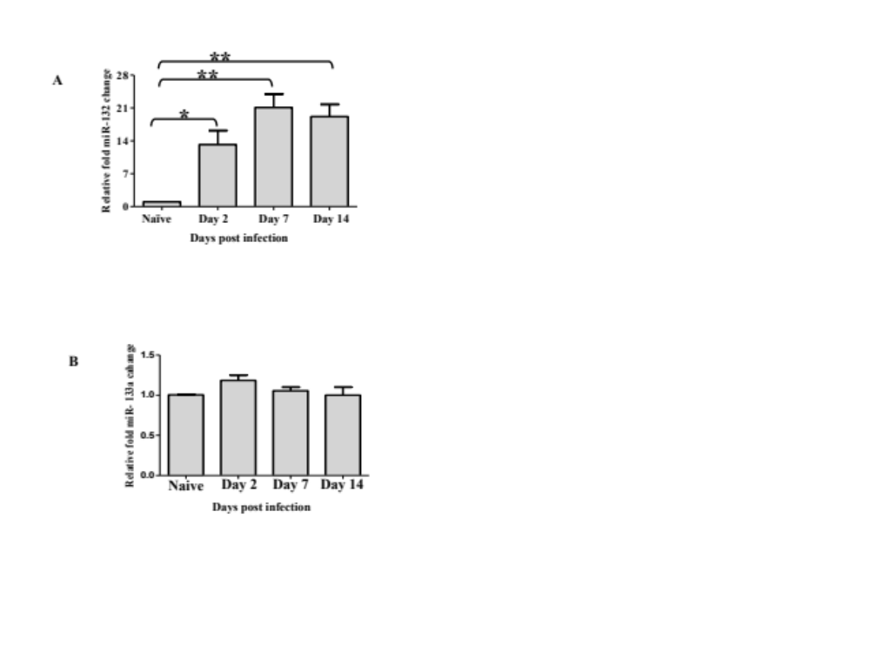 Figure 3.1. Expression of miR-132 after HSV infection. miRNA quantification in HSV infected mice corneas: WT mice were infected with HSV-1 RE in one eye and 6 corneas were collected and pooled for miRNA analysis by TaqMan QPCR. The expression levels of miR-132 (A and miR-133a (B) at different time points post HSV infection in mice corneas are shown (Pooled n=6 mice/group). One way ANOVA with Bonferroni’s post hoc test was used to calculate the level of significance. P ≤ 0.01 (**), P ≤ 0.05 (*). Error bars represent means ± SEM. The above experiments were repeated three times.
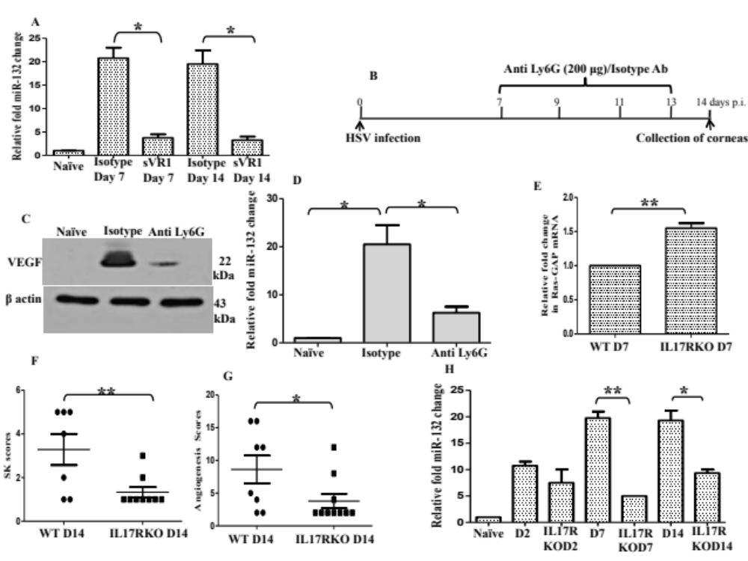 Figure 3.2. IL-17A and VEGF-A upregulates miR-132 in corneas. WT mice were infected with HSV-1 RE in one eye and 6 corneas were collected and pooled for miR-132 analysis by TaqMan QPCR. The 5 µg soluble VEGFR1/isotype treatment was begun on day 2 p.i with additional doses on alternate days until day 6 and and miR-132 quantification was carried out at day 7 p.i (Pooled n=6 mice/group). In another set of experiments, 5 µg soluble VEGFR1/isotype treatment was continued up to day 12 p.i and corneas were analyzed for miR-132 expression at day 14 p.i (A) (Pooled n=6 mice/group). One way ANOVA with Bonferroni’s post hoc test was used to calculate the level of significance. P ≤ 0.05 (*). Error bars represent means ± SEM. Neutrophil depletion was carried out using anti Ly6G antibody as shown (B). The HSV infected mice were treated with 200 µg of anti Ly6G/isotype antibody as shown and corneas were analyzed for VEGF-A levels by western blotting and for miR-132 expression by QPCR at day 14 p.i (C&D) (Pooled n=6 mice/group). The level of significance was determined by student’s t test (unpaired). P ≤ 0.01 (**), P ≤ 0.05 (*). WT and IL-17RKO mice were infected with HSV-1 RE in one eye and 6 corneas were collected and pooled for Ras-GAP mRNA analysis at day 7 p.i (E) and miR-132 analysis by TaqMan QPCR at day 14 p.i. SK lesions (F), angiogenesis scores (G) and miR-132 expression (H) in HSV infected IL-17RKO mice and WT mice at day 2, 7 and 14 p.i. are shown. (Pooled n=6 mice/group). Error bars represent means ± SEM. All experiments were repeated two times.
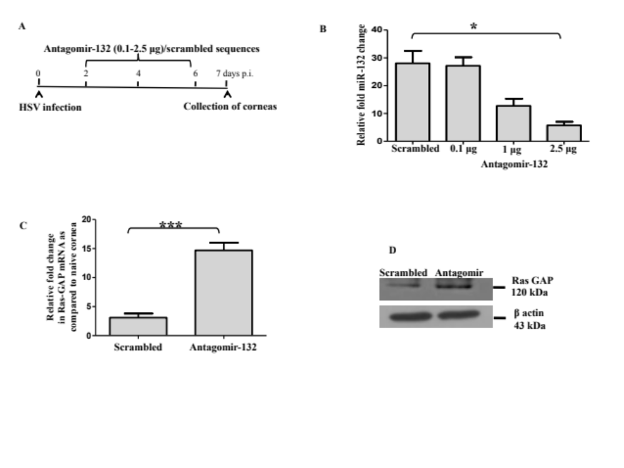 Figure 3.3. Knockdown of miR-132 by antagomir-132 nanoparticles in eyes. (A) The different doses of antagomir-132/scrambled sequences nanoparticle treatment was given to HSV infected mice as shown. The 2.5µg antagomir-132 treatment regimen resulted in peak miR-132 knockdown in the corneas (B) (Pooled n=6 mice/group). One way ANOVA with Bonferroni’s post hoc test was used to calculate the level of significance. P ≤ 0.05 (*). These experiments were repeated two times. WT mice were infected with HSV-1 RE in one eye and 6 corneas were collected and pooled for analysis by QPCR or WB. The 2.5µg antagomir-132/scrambled sequences were injected subconjunctively in HSV infected mice and the quantification of RasGAP mRNA (C) from corneas isolated from different groups was carried out (Pooled n=6 mice/group). The level of significance was determined by student’s t test (unpaired). ***P ≤ 0.001. These experiments were repeated two times. Error bars represent means ± SEM. Reducing WB for Ras-GAP protein after treatment of HSV infected mice with 2.5µg antagomir-132/scrambled sequences (D) (Pooled n=6 mice/group). The representative WB image of two independent experiments is shown. 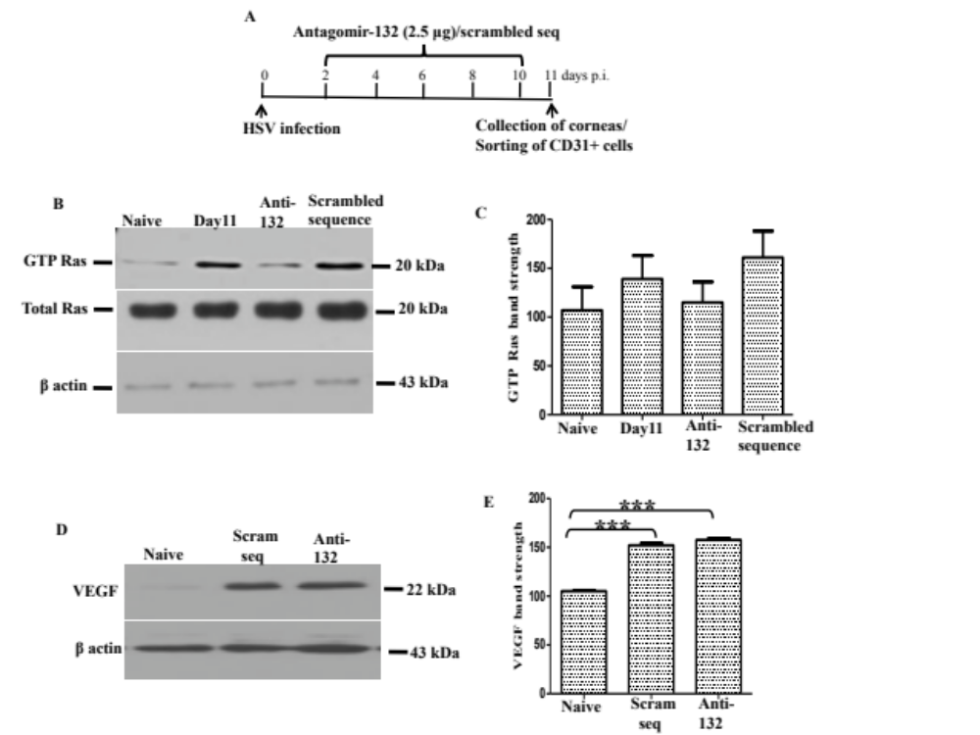 Figure 3.4. Reduction in angiogenic Ras activity after antagomir-132 treatment. WT mice were infected with HSV-1 RE in one eye and 6 corneas were collected and pooled for analysis by GTP^{ase} activation assays. (A) WT mice infected with HSV were treated with antagomir-132/scrambled sequences nanoparticle as shown. The corneas collected at day 11 p.i. after antagomir-132/scrambled sequences nanoparticle treatment were subjected to Ras (B&C) pull down followed by reducing WB analysis for Ras of the respective groups (Pooled n=6 mice/group). The representative WB image is shown. The corneas collected at day 11 p.i. after antagomir-132/scrambled sequences nanoparticle treatments were subjected to WB for the detection of VEGF (D&E). The representative WB image is shown. These experiments were repeated two times and densitometry analysis of the band strength is shown. One way ANOVA with Bonferroni’s post hoc test was used to calculate the level of significance. P ≤ 0.001 (***). Error bars represent means ± SEM.
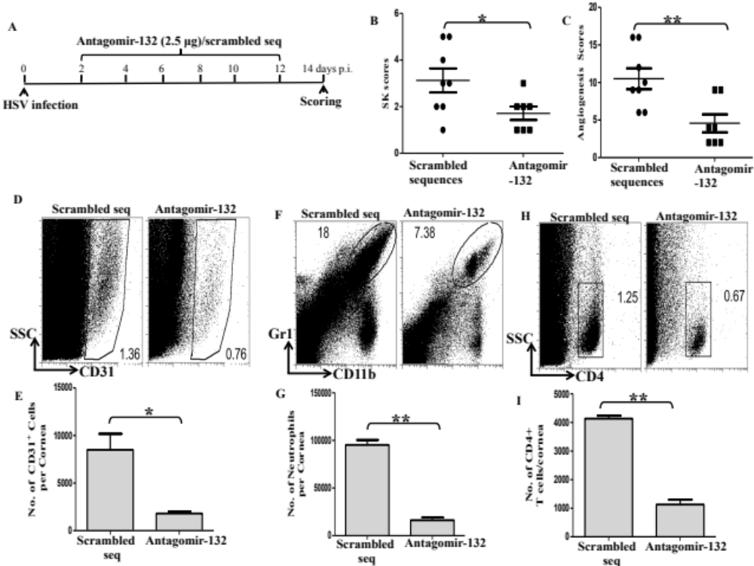 Figure 3.5. Preventive administration of antagomir-132 diminishes angiogenesis and SK. WT mice were infected with HSV-1 RE in one eye and 6 corneas were collected and pooled for analysis by flow cytometry. (A) The 2.5µg antagomir-132/scrambled sequences nanoparticle treatment was given to HSV infected mice as shown. The antagomir-132 treatment regimen resulted in reduction in SK (B) and angiogenesis scores (C) in HSV infected animals. The frequency and total cell number per cornea for endothelial cells (CD31⁺ cells) (D & E), Gr1⁺, CD11b⁺ cells (presumably neutrophils) (F & G) and CD4⁺ T cells (H & I) showed significant reduction in frequency and total cell number per cornea after preventive antagomir-132 treatment (n=6-8 mice/group). The level of significance was determined by student’s t test (unpaired). P ≤ 0.01 (**), P ≤ 0.05 (*). Error bars represent means ± SEM. These experiments were repeated two times. 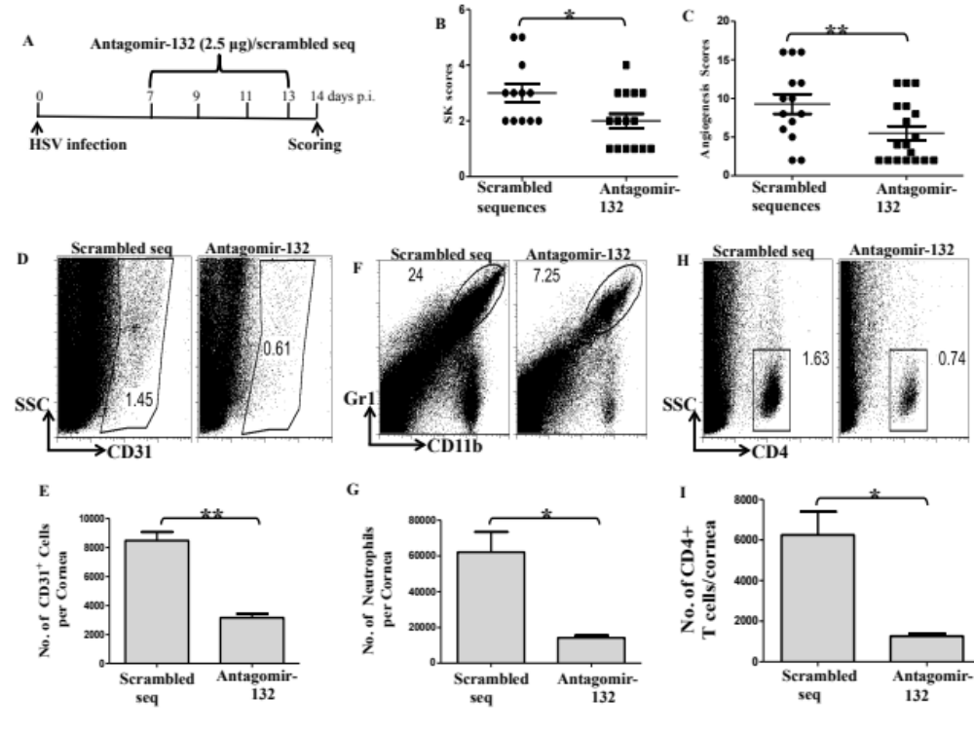 Figure 3.6. Provision of antagomir-132 nanoparticles therapeutically diminishes angiogenesis and SK. WT mice were infected with HSV-1 RE in one eye and 6 corneas were collected and pooled for analysis by flow cytometry. The therapeutic 2.5µg antagomir-132 nanoparticles treatment (A) resulted in reduction in SK (B) and angiogenesis (C) scores in HSV infected animals. The frequency and total cell number per cornea for endothelial cells (CD31⁺ cells) (D & E), Gr1⁺, CD11b⁺ cells (F & G) and CD4+ T cells (H & I) showed significant reduction in total cell number per cornea after therapeutic antagomir-132 nanoparticle treatment (n=12-18 mice/group). The level of significance was determined by student’s t test (unpaired). P ≤ 0.01 (**), P ≤ 0.05 (*). Error bars represent means ± SEM. These experiments were repeated two times.
Figure 3.7. Illustration of antagomir-132 mediated inhibition of corneal neovascularization (CV). Left panel describes outcome (CV) in HSV infected untreated mice: HSV infection leads to upregulation of IL-17 in corneas. IL-17 (along with IL-6 and virus infected epithelial cells) increases VEGF (probably via increasing IL-1b, IL-6 and Cxcl1) levels in the eyes. VEGF thus acting through VEGFR2 receptors on the blood vessel endothelial cells upregulates miR-132 expression via CREB transcription factor. MiR-132 removes RasGAP (intrinsic inhibitor of Ras) leading to activation of Ras and CV. Right panel describes modulation of CV by miR-132 silencing: Administration of antagomir-132 nanoparticles leads to deposition of antagomir-132 cargo in blood vessel endothelial cells resulting in silencing of miR-132. This leads to higher levels of RasGAP, which thereby inhibits angiogenic Ras activity resulting in inhibition of CV. 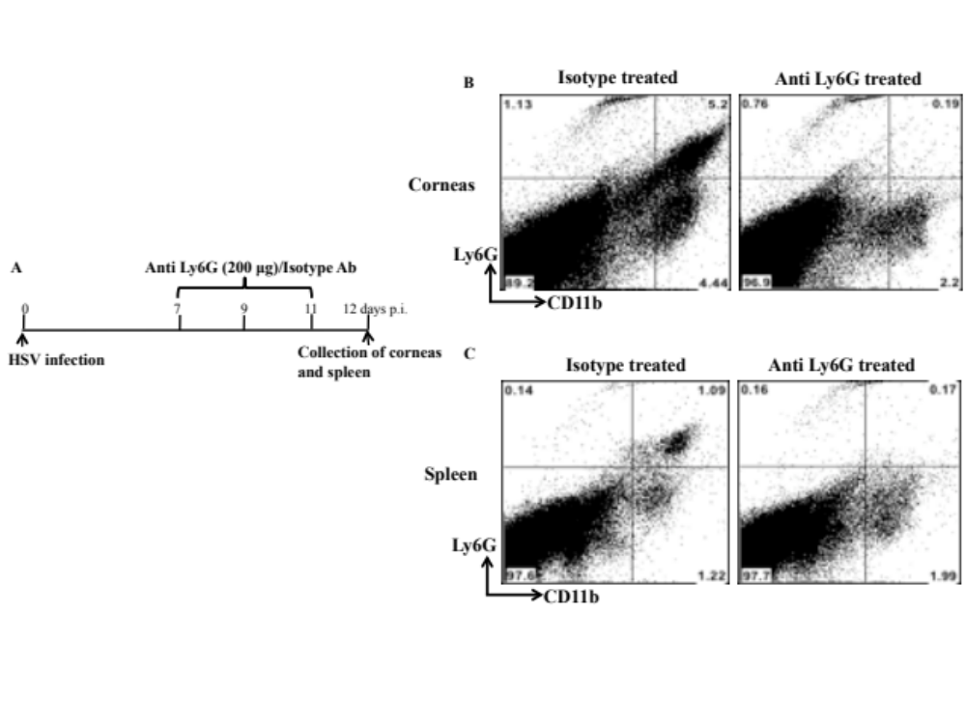 Figure 3.8. Neutrophil depletion after anti Ly6G antibody treatment in mice. Neutrophil depletion was carried out using anti Ly6G antibody as shown (A). The HSV infected mice were treated with 200 µg of anti Ly6G/isotype antibody as shown and corneas (B) and spleen (C) were analyzed for the presence of Ly6G+ CD11b+ cells. Representative FACS plots from both groups are shown (n=5 mice/group). 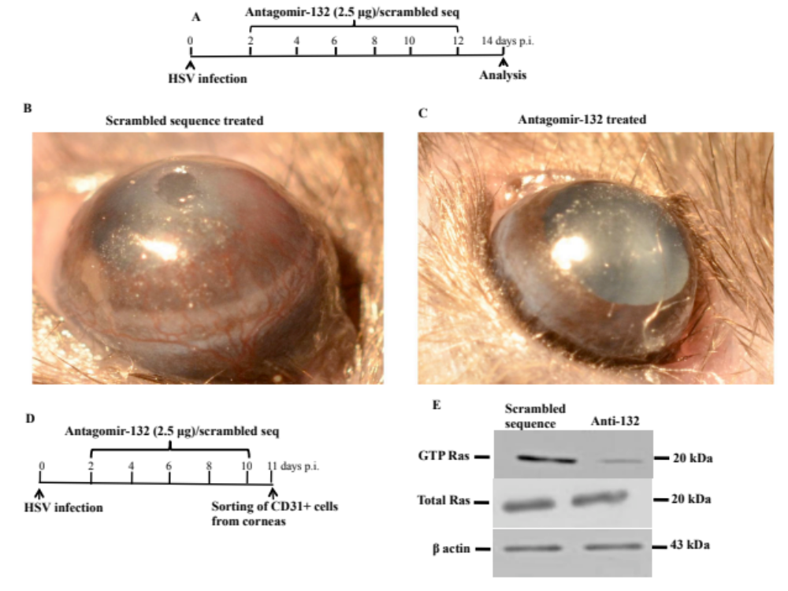 Figure 3.9. Antagomir-132 reduces CV and endothelial Ras activity in corneas after HSV infection. WT mice were infected with HSV-1 RE in one eye and monitored for the development of angiogenesis and SK. The therapeutic 2.5µg antagomir-132 nanoparticles treatment (A) resulted in visible reduction in angiogenesis in antagomir-132 treated animals (B) compared to mice treated with scrambled sequences (C). The HSV infected mice were treated with antagomir-132/scrambled sequences nanoparticle as shown (D) and CD31 enriched cells were sorted from antagomir-132/scrambled sequences nanoparticle treated mice corneas. The purity up to the extent of 80-90% was achieved. These CD31 enriched cells from respective groups were subjected to Ras (E) pull down followed by reducing WB analysis for Ras of the respective groups (Pooled n=12 mice/group). The representative WB image of the two independent experiments is shown. 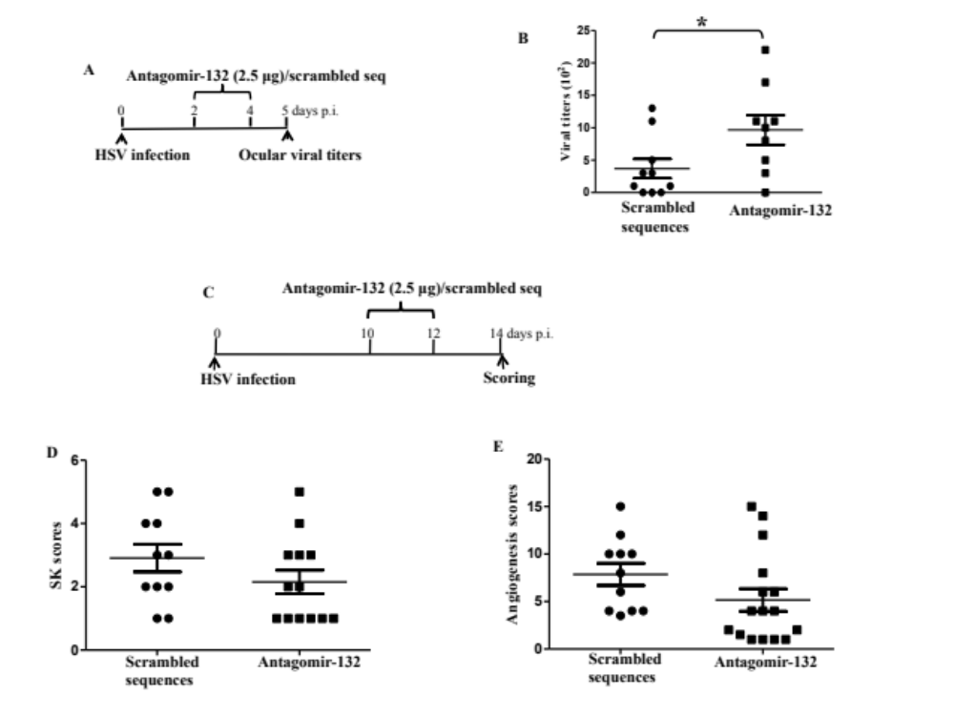 Figure 3.10. Late antagomir-132 treatment slightly diminishes angiogenesis and SK. WT mice were infected with HSV-1 RE in one eye. The 2.5µg antagomir-132/scrambled sequences nanoparticle treatment was given to HSV infected mice as shown (A). The antagomir-132 treatment regimen resulted in slight reduction in SK (B) and angiogenesis scores (C) in HSV infected animals but these changes were not significant. The level of significance was determined by student’s t test (unpaired). P ≤ 0.05 (*). These experiments were repeated two times.

Part IV
MicroRNA-155: Regulator of HSV-1 encephalitis but promotes stromal keratitis

Abstract
Herpes simplex virus (HSV) infection of humans can lead to life threatening herpes simplex encephalitis (HSE) and sometimes blinding ocular lesion, stromal keratitis (SK). Here, we show that mice with a deficiency of miR-155 are highly susceptible to HSE with a majority of mice (75-80%) dyeing after ocular infection with HSV. Acyclovir treatment (a day after virus reaches brain) reduced brain viral levels and protected miR-155 knockout mice from HSE thus supporting the role for virus replication in brain as the cause of encephalitis. Furthermore, HSV infected miR-155 deficient mice developed compromised virus specific CD8 T cell responses. Additionally, miR-155KO survivors developed attenuated HSK lesions in eyes. This phenotype was also evident after knockdown of miR-155 in WT mice. miR-155 deficiency demonstrated diminished Th1 responses in corneas and lymphoid organs accompanied by a profound reduction in inflammatory and angiogenic molecules in corneas. Furthermore, combinatorial blockade of miR-132 and miR-155 led to potent reduction in ocular immunopathology. In conclusion, we have discovered dual role for miR-155, a regulator of HSV encephalitis but an enhancer of HSK.

Introduction
Herpes simplex virus infection generally causes mucocutaneous disease at oral and genital surfaces. In some instances, HSV can induce lesions in the eyes leading to blinding disease, stromal keratitis (SK)(Giménez, Suryawanshi et al. 2012) and due to its neurotrophic nature HSV can also invade brain. HSV-1 is a major cause of encephalitis, which is primarily controlled by IFNs, NK cells and CD8 T cells. MicroRNAs are small RNAs that regulate gene expression post transcriptionally(Lee, Feinbaum et al. 1993; O'Connell, Rao et al. 2010). Whether miRNAs play any role in regulating herpes simplex encephalitis (HSE) is currently unknown. miR-155 positively regulates inflammation(O'Connell, Rao et al. 2012), is required for normal immune function(Rodriguez, Vigorito et al. 2007; Thai, Calado et al. 2007), is involved in generation of pathogenic T cells(O'Connell, Kahn et al. 2010) and also functions as an oncomir in various cancers(Jiang, Zhang et al. 2010). Animals deficient in miR-155 because of gene knockout (KO) are resistant to the induction of some autoimmune diseases(Blüml, Bonelli et al. 2011; Kurowska-Stolarska, Alivernini et al. 2011). In this report, we show that miR-155 deficiency leads to increased susceptibility of mice to HSV-1 encephalitis with majority of mice dyeing of encephalitis. miR-155 null mice also demonstrated attenuated HSV specific CD8 T cell responses in peripheral lymphoid organs. Additionally, miR-155 deficiency leads to resistance to HSK. Thus, miR-155 protects brain from HSE but increases ocular immunopathology after ocular HSV infection.

Methods
Mice: Female 6-8 wks old C57 BL/6 mice were purchased from Harlan Sprague Dawley Inc. (Indianapolis, Indiana, USA). miR-155KO mice on a C57BL/6 background were obtained from Jackson laboratories. The animals were housed in American Association of Laboratory Animal Care-approved facilities at the University of Tennessee Knoxville. All investigations followed guidelines of the institutional animal care and use committee.
Virus: HSV-1 strain RE was propagated in Vero cell monolayers (ATCC no: CCL81). Virus was grown in Vero cell monolayers (American Type Culture Collection, Manassas, VA), titrated, and stored in aliquots at –80˚C until used.
Corneal HSV-1 infection and scoring: Corneal infections of mice were performed under deep anesthesia. The mice were lightly scarified on their corneas with a 27-gauge needle, and a 3 µl drop containing 10⁴ PFU of HSV-1 RE was applied to one eye. These mice were monitored for the development of encephalitis. The SK lesion severity and angiogenesis in the eyes of mice were examined by slit-lamp biomicroscopy (Kowa Company, Nagoya, Japan) as described previously(Rajasagi, Reddy et al. 2011).
Purification of astrocytes and microglia: Purification of astrocytes from < day 8 neonatal brains of WT and miR-155 deficient mice was carried out as per manufacturers guidelines (Miltenyl Biotech). The purity to the extent of 90-95% was achieved in these experiments and astrocytes were infected with HSV as described previously (Reinert, Harder et al. 2012) and virus was quantified in the supernatant. For microglia isolation, adult WT and miR-155 null mice brains were used. The microglial cells were stimulated with TLR-2 ligand, TLR-4 ligand and HSV and inflammatory cytokines and chemokines were measured.
Flow Cytometry: Single cell suspensions were prepared from cornea, cervical DLN, and spleen of mice at different time points pi. The single cell suspensions obtained from corneas, DLN, and spleen were stained for different cell surface molecules for FACS. All steps were performed at 4°C. A total of 1×10⁶ cells were first blocked with an unconjugated anti-CD32/CD16 mAb for 30 min in FACS buffer. After washing with FACS buffer, fluorochrome-labeled respective antibodies were added for 30 min on ice. Finally, the cells were washed three times and re-suspended in 1% para-formaldehyde. The stained samples were acquired with a FACS Calibur (BD Biosciences) and the data were analyzed using the FlowJo software. For corneas, total cell numbers were calculated by acquiring the totality of the sample and taking in consideration of the total number of corneas in the sample. To enumerate the number of IFN-γ and IL-17 producing CD4⁺ T cells or IFN-γ and TNF producing CD8⁺ T, cells were stimulated under appropriate conditions (PMA/IONO for CD4 T cells while gB or PMA/IONO for CD8 T cells) and intracellular cytokine staining was performed.
Quantitative PCR (QPCR) and TaqMan QPCR: QPCR and Taqman miRNA QPCR was performed as previously described. The primers used for QPCR were as follows: IL-1b, IFN-g, TNF, CXCL1, CCL2, CXCL10, CXCR3, CXCR4, MMP-9, IL-6, IL-12, IL-10, TGFb and beta actin. TaqMan MicroRNA Assay (Applied Biosystems, USA) for miR-155 was used for quantification using a real-time PCR detection system and data were normalized to the internal control small nucleolar RNA 202.
Viral plaque assay: Virus titers were measured in the brain, TG and eye swabs taken from HSV infected mice using plaque assays as described previously by others(Mulik, Xu et al. 2012).
Statistics: The statistical significance for SK lesion severity and angiogenesis between two groups was determined using unpaired two-tailed student's t test. One way ANOVA with Bonferroni’s post hoc test was used to calculate the level of significance for some experiments. P ≤ 0.001 (***), P ≤ 0.01 (**), P ≤ 0.05 (*) were considered as significant and results are expressed as mean ±SEM. For all statistical analysis, GraphPad Prism software was used.
Acknowledgements: We thank Ms. Sujata Agarwal and Nancy Nielsen for their help with miRNA quantification and FACS sorting. We also thank Pranay Dogra for helping in manuscript formatting in many ways.

Results and Discussion
miR-155 deficient mice die due to encephalitis after HSV-1 infection. miR-155 is an intensely studied miRNA which plays critical role in inflammation(Bhattacharyya, Balakathiresan et al. 2011), innate immunity and antibody production(Thai, Calado et al. 2007; O'Neill, Sheedy et al. 2011). No reports have yet evaluated the role of miRNAs in regulation of HSE. We studied this using miR-155 deficient mouse on a C57B/6 background (miR-155KO). WT C57B/6 mice and miR-155KO animals were infected ocularly with HSV-1 and monitored for ocular disease and neurological signs. All WT mice were free from any neurological signs and resistant to HSE as observed previously(Lundberg, Welander et al. 2007). Surprisingly, 75-80% of the miR-155 deficient mice developed encephalitis and died by day 9 post infection (figure 4.1A). When virus levels in brain were measured in both groups at day 9 p.i. WT mice were negative for HSV by plaque assay while all miR-155 deficient mice had very high titers of virus in the brain (figure 4.1B). However, virus was cleared efficiently from corneas and trigeminal ganglia in miR-155 null mice similar to results in WT animals (figure 4.2A-B). Overall, these results indicate that mice with a deficiency of miR-155 are highly susceptible to HSE.
Virus replication in brain as a cause of death in miR-155 deficient mice. A series of publications by Casanova and Zheng et al demonstrate that mutations in TLR-3-IFN axis are strongly associated with HSE thus supporting the role of uncontrolled virus replication as a cause of HSE(Zhang, Jouanguy et al. 2007; Pérez de Diego, Sancho-Shimizu et al. 2010; Guo, Audry et al. 2011; Sancho-Shimizu, Pérez de Diego et al. 2011; Herman, Ciancanelli et al. 2012; Lafaille, Pessach et al. 2012; Reinert, Harder et al. 2012). However, this issue remains debatable in mice with several reports showing inflammation as a trigger of HSE and death(Kurt-Jones, Chan et al. 2004; Mansur, Kroon et al. 2005; Wang, Bowen et al. 2012). We performed experiments in miR-155 deficient mice to determine the exact cause of death (virus replication versus inflammation). HSV after corneal infection enters brain by day 2-day 4 post infection(Shimeld, Efstathiou et al. 2001). Similarly, we could detect virus in the brain of HSV infected miR-155 deficient mice by day 3 post infection (figure 4.1C). Previous reports in mice show that even though virus replication is inhibited in brain via administration of acyclovir, a day after viral entry into brain, mice succumb to deadly encephalitis. This was explained by the initiation of an inflammatory response by HSV in brain, which resulted in severe damage. In those models, when the inflammatory responses were inhibited by neutrophil or macrophage depletion studies, mice were protected from HSE. Surprisingly, when we administered acyclovir to HSV infected miR-155 deficient mice (from day 4 p.i.), the majority (80%) of mice were protected from encephalitis and this acyclovir treatment significantly lowered brain viral titers in miR-155KO mice (figure 4.1D-E). In summary, these results indicate that viral replication in the brain is the cause of encephalitis in miR-155 null mice. Other groups have shown that TLR-2 mediated induction of inflammatory cytokines by microglia is a major reason for death in HSE in mice. In our experiments, miR-155 deficient microglia produced equivalent or in some cases even lesser amounts of inflammatory molecules, which also disfavors inflammation as a cause of encephalitis in our case (figure 4.3A-L). Furthermore, experiments were performed to see whether astrocytes from miR-155 null mice were more susceptible to HSV-1 as recently observed by Paludan group with TLR-3 deficiency. Our results show that astrocytes isolated from miR-155 deficient mice are slightly more susceptible to HSV-1 infection than their WT counterparts but differences were not significant (data not shown). In additional experiments, brain IFNb levels were evaluated in WT and miR-155KO animals at different time points after infection. Interestingly, IFNb levels were slightly higher in miR-155 null animals at all the time points tested (figure 4.2C) suggesting no global defect in IFNb production in miR-155 deficient animals.
Impaired CD4 and CD8 T cell responses in miR-155 null mice after HSV-1 infection. miR-155 deficient mice demonstrate defects in the CD4 T cell and B cell responses(Rodriguez, Vigorito et al. 2007; O'Connell, Kahn et al. 2010; Murugaiyan, Beynon et al. 2011). Since CD4 and CD8 T cells are required to control HSV replication in brain, experiments were carried out to measure the magnitude of T cell responses in WT and miR-155 deficient mice infected with HSV. Recent report by the Paludan group showed that even though TLR-3 null mice succumbed to HSV-2 mediated encephalitis, those mice demonstrated equivalent CD4 and CD8 T cell responses to those of WT mice(Reinert, Harder et al. 2012). We infected WT and miR-155KO mice and studied T cell responses at day 9 p.i. In line with previous reports, miR-155 deficient mice produced fewer CD4 T cells making IFNg in LN and spleen (figure 4.4A-D, G-J). The lesser numbers of CD4 T cells producing IL-17A was also evident in LNs and spleens taken from miR-155KO mice (data not shown). Also in accord with recent reports(Kohlhaas, Garden et al. 2009), miR-155 null mice revealed lesser Treg numbers in LN and spleen than WT animals(Liston, Lu et al. 2008; Lu, Thai et al. 2009) (figure 4.4E-F, K-L). When CD8 T cell responses were analyzed, miR-155 deficient mice generated lesser total CD8 T cells and virus specific (gB tetramer specific) CD8 T cell responses (figure 4.5 and figure 4.6). When CD8 T cells from LN or spleen were stimulated with gB (immunodominat epitope of HSV), miR-155 deficient animals showed significantly fewer IFNg producing or IFNg and TNFa secreting CD8 T cells compared to WT animals (figure 4.6A-L). This was also evident after non specific stimulation of CD8 T cells (PMA/Ionomycin). As in this case, miR-155 deficient mice produced lesser IFNg or IFNg and TNFa secreting CD8 T cells in LN and spleen (figure 4.5A-L). In conclusion, these results support viral replication as the cause of encephalitis in miR-155 deficient mice and such defect in viral clearance could be due to compromised CD4 and CD8 T cell responses in peripheral lymphoid organs.
miR-155 deficiency leads to attenuated SK lesions and demonstrate diminished Th1 responses. Mice infected ocularly with HSV develop ocular immunopathology(Niemialtowski and Rouse 1992). We did these experiments to see whether miR-155 deficient mice differ in susceptibility to SK. Recent reports show that miR-155KO mice are resistant to multiple sclerosis and rheumatoid arthritis models(O'Connell, Kahn et al. 2010; Blüml, Bonelli et al. 2011). All WT mice infected with HSV developed SK but miR-155 KO survivors from encephalitis were relatively resistant to SK and revealed significantly lower SK lesion scores and the extent of angiogenesis (figure 4.7A-D). Recently, Baltimore group demonstrated that miR-155 KO animals generate significantly lower pathogenic Th1 and Th-17 cells(O'Connell, Kahn et al. 2010). In line with these reports, HSV infected miR-155 deficient mice produced fewer Th1 cells in LN, spleen and corneas (figure 4.8A-I). In another set of experiments, we locally knocked down miR-155 using antagomir-155 nanoparticles in eyes of WT mice. This treatment modality did not increase susceptibility of those mice to encephalitis after HSV infection but resulted in significant reduction in ocular immunopathology, led to a potent reduction in inflammatory and angiogenic molecules in eyes (figure 4.7E-J)(Bhattacharyya, Balakathiresan et al. 2011). Interestingly, silencing of both miR-155 and miR-132 (angiogenic)(Zheng, Schwarz et al. 2001; Anand, Majeti et al. 2010; Mulik, Xu et al. 2012) led to potent reduction in severity of SK and an extent of angiogenesis (figure 4.7) meaning combinatorial blockade(Kim, Tang et al. 2004) of both miRNAs could have translational potential to treat SK.

References:
Anand, S., B. K. Majeti, et al. (2010). "MicroRNA-132-mediated loss of p120RasGAP activates the endothelium to facilitate pathological angiogenesis." Nat Med 16(8): 909-914.
Bhattacharyya, S., N. S. Balakathiresan, et al. (2011). "Elevated miR-155 promotes inflammation in cystic fibrosis by driving hyperexpression of interleukin-8." J Biol Chem 286(13): 11604-11615.
Blüml, S., M. Bonelli, et al. (2011). "Essential role of microRNA-155 in the pathogenesis of autoimmune arthritis in mice." Arthritis Rheum 63(5): 1281-1288.
Giménez, F., A. Suryawanshi, et al. (2012). "Pathogenesis of herpes stromal keratitis - A focus on corneal neovascularization." Prog Retin Eye Res.
Guo, Y., M. Audry, et al. (2011). "Herpes simplex virus encephalitis in a patient with complete TLR3 deficiency: TLR3 is otherwise redundant in protective immunity." J Exp Med 208(10): 2083-2098.
Herman, M., M. Ciancanelli, et al. (2012). "Heterozygous TBK1 mutations impair TLR3 immunity and underlie herpes simplex encephalitis of childhood." J Exp Med 209(9): 1567-1582.
Jiang, S., H. W. Zhang, et al. (2010). "MicroRNA-155 functions as an OncomiR in breast cancer by targeting the suppressor of cytokine signaling 1 gene." Cancer Res 70(8): 3119-3127.
Kim, B., Q. Tang, et al. (2004). "Inhibition of ocular angiogenesis by siRNA targeting vascular endothelial growth factor pathway genes: therapeutic strategy for herpetic stromal keratitis." Am J Pathol 165(6): 2177-2185.
Kohlhaas, S., O. A. Garden, et al. (2009). "Cutting edge: the Foxp3 target miR-155 contributes to the development of regulatory T cells." J Immunol 182(5): 2578-2582.
Kurowska-Stolarska, M., S. Alivernini, et al. (2011). "MicroRNA-155 as a proinflammatory regulator in clinical and experimental arthritis." Proc Natl Acad Sci U S A 108(27): 11193-11198.
Kurt-Jones, E. A., M. Chan, et al. (2004). "Herpes simplex virus 1 interaction with Toll-like receptor 2 contributes to lethal encephalitis." Proc Natl Acad Sci U S A 101(5): 1315-1320.
Lafaille, F. G., I. M. Pessach, et al. (2012). "Impaired intrinsic immunity to HSV-1 in human iPSC-derived TLR3-deficient CNS cells." Nature 491(7426): 769-773.
Lee, R. C., R. L. Feinbaum, et al. (1993). "The C. elegans heterochronic gene lin-4 encodes small RNAs with antisense complementarity to lin-14." Cell 75(5): 843-854.
Liston, A., L. F. Lu, et al. (2008). "Dicer-dependent microRNA pathway safeguards regulatory T cell function." J Exp Med 205(9): 1993-2004.
Lu, L. F., T. H. Thai, et al. (2009). "Foxp3-dependent microRNA155 confers competitive fitness to regulatory T cells by targeting SOCS1 protein." Immunity 30(1): 80-91.
Lundberg, P., P. V. Welander, et al. (2007). "Tumor necrosis factor (TNF) protects resistant C57BL/6 mice against herpes simplex virus-induced encephalitis independently of signaling via TNF receptor 1 or 2." J Virol 81(3): 1451-1460.
Mansur, D. S., E. G. Kroon, et al. (2005). "Lethal encephalitis in myeloid differentiation factor 88-deficient mice infected with herpes simplex virus 1." Am J Pathol 166(5): 1419-1426.
Mulik, S., J. Xu, et al. (2012). "Role of miR-132 in Angiogenesis after Ocular Infection with Herpes Simplex Virus." Am J Pathol 181(2): 525-534.
Murugaiyan, G., V. Beynon, et al. (2011). "Silencing microRNA-155 ameliorates experimental autoimmune encephalomyelitis." J Immunol 187(5): 2213-2221.
Niemialtowski, M. G. and B. T. Rouse (1992). "Predominance of Th1 cells in ocular tissues during herpetic stromal keratitis." J Immunol 149(9): 3035-3039.
O'Connell, R. M., D. Kahn, et al. (2010). "MicroRNA-155 promotes autoimmune inflammation by enhancing inflammatory T cell development." Immunity 33(4): 607-619.
O'Connell, R. M., D. S. Rao, et al. (2012). "microRNA regulation of inflammatory responses." Annu Rev Immunol 30: 295-312.
O'Connell, R. M., D. S. Rao, et al. (2010). "Physiological and pathological roles for microRNAs in the immune system." Nat Rev Immunol 10(2): 111-122.
O'Neill, L. A., F. J. Sheedy, et al. (2011). "MicroRNAs: the fine-tuners of Toll-like receptor signalling." Nat Rev Immunol 11(3): 163-175.
Pérez de Diego, R., V. Sancho-Shimizu, et al. (2010). "Human TRAF3 adaptor molecule deficiency leads to impaired Toll-like receptor 3 response and susceptibility to herpes simplex encephalitis." Immunity 33(3): 400-411.
Rajasagi, N. K., P. B. Reddy, et al. (2011). "Controlling herpes simplex virus-induced ocular inflammatory lesions with the lipid-derived mediator resolvin E1." J Immunol 186(3): 1735-1746.
Reinert, L. S., L. Harder, et al. (2012). "TLR3 deficiency renders astrocytes permissive to herpes simplex virus infection and facilitates establishment of CNS infection in mice." J Clin Invest 122(4): 1368-1376.
Rodriguez, A., E. Vigorito, et al. (2007). "Requirement of bic/microRNA-155 for normal immune function." Science 316(5824): 608-611.
Sancho-Shimizu, V., R. Pérez de Diego, et al. (2011). "Herpes simplex encephalitis in children with autosomal recessive and dominant TRIF deficiency." J Clin Invest 121(12): 4889-4902.
Shimeld, C., S. Efstathiou, et al. (2001). "Tracking the spread of a lacZ-tagged herpes simplex virus type 1 between the eye and the nervous system of the mouse: comparison of primary and recurrent infection." J Virol 75(11): 5252-5262.
Thai, T. H., D. P. Calado, et al. (2007). "Regulation of the germinal center response by microRNA-155." Science 316(5824): 604-608.
Wang, J. P., G. N. Bowen, et al. (2012). "Role of specific innate immune responses in herpes simplex virus infection of the central nervous system." J Virol 86(4): 2273-2281.
Zhang, S. Y., E. Jouanguy, et al. (2007). "TLR3 deficiency in patients with herpes simplex encephalitis." Science 317(5844): 1522-1527.
Zheng, M., M. A. Schwarz, et al. (2001). "Control of stromal keratitis by inhibition of neovascularization." Am J Pathol 159(3): 1021-1029.
Appendix
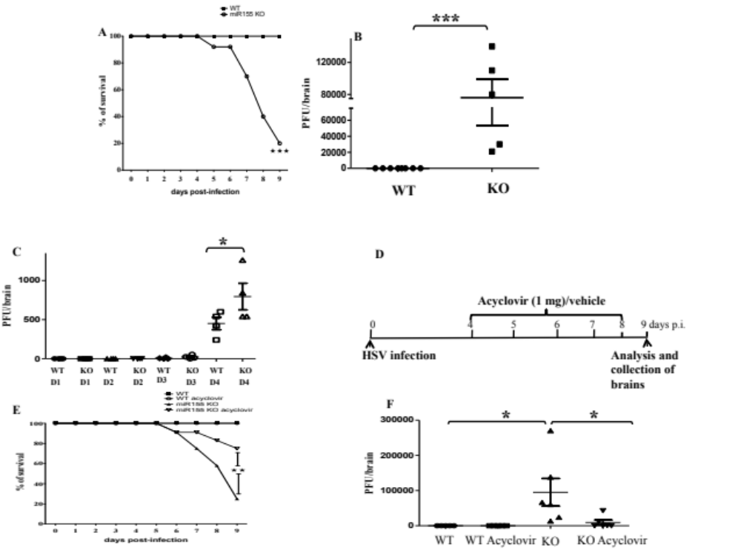 Figure 4.1. miR-155 null mice are very susceptible to HSV-1 encephalitis. A) WT and miR-155 deficient mice were ocularly infected with HSV and monitored for the development of encephalitis and death. B) Brian viral titers in WT and miR-155 null mice at day 9 p.i. C) Brain histopathology performed at day 9 p.i. D) WT and miR-155KO mice were infected with HSV and given acyclovir as shown and monitored for the mortality. E) Brain viral titers in WT, miR-155 deficient mice and acyclovir treated animals at day 9 p.i. These experiments were repeated three times. 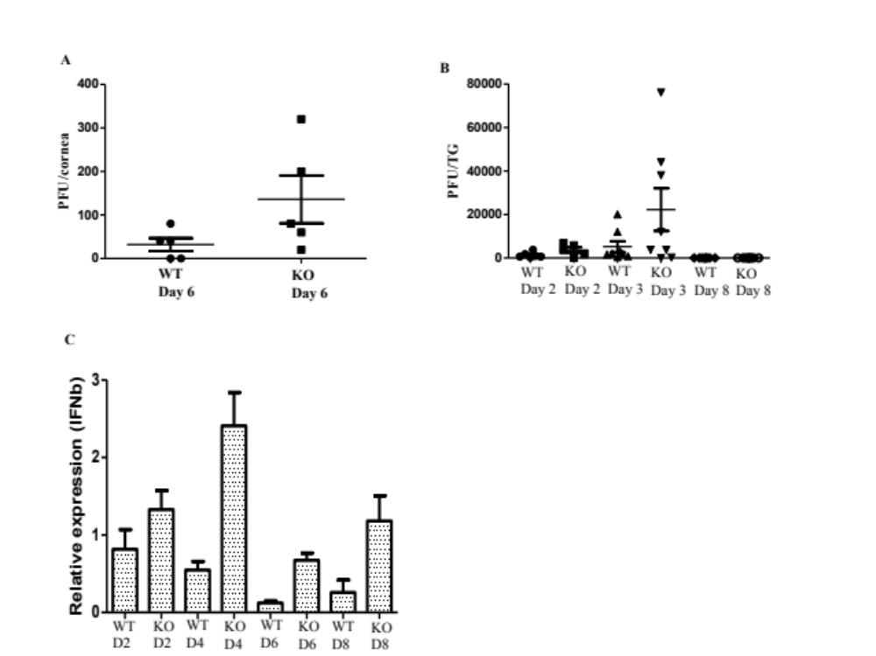 Figure 4.2. Ocular and TG viral clearance from WT and KO animals. A) WT and miR-155 deficient mice were ocularly infected with HSV and eye swabs were collected for virus quantification. Virus levels are shown. B) TG viral titers in WT and miR-155 null mice at day 2, 3 and day 8 p.i. C) Brainstem IFNb levels at various time points post infection are shown. 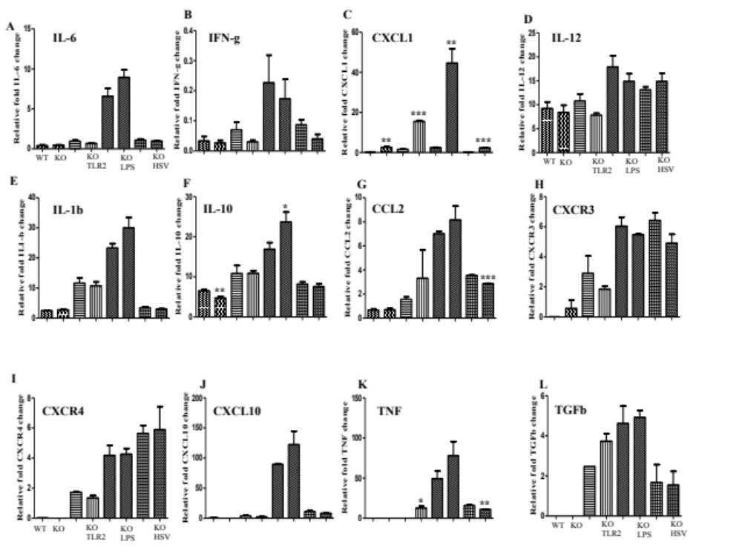Figure 4.3. Microglial response from WT and KO animals. A-L) WT and miR-155 deficient microglia were purified and stimulated with TLR-2 ligand, TLR-4 ligand and HSV and various molecules were quantified at 6 hours p.i. 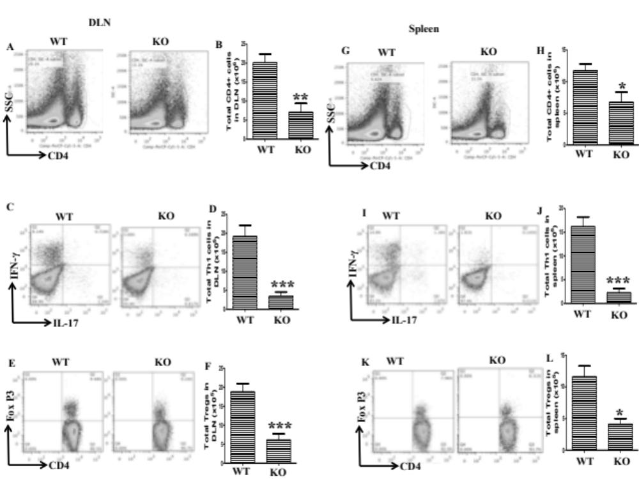 Figure 4.4. Compromised CD4 T cell responses in miR-155 deficient mice. DLN cells and splenocytes were stimulated with PMA/IONO for 4 hrs and ICCS was performed. A, B) The frequencies and total numbers of total CD4 T cells in DLN in WT and miR-155KO mice. The frequencies and total numbers of IFNg+ (C, D) and FoxP3+ (E,F) CD4 T cells in DLN. (G, H) The frequencies and total numbers of total CD4 T cells in spleen in WT and miR-155KO mice. The frequencies and total numbers of IFNg+ (C, D) and FoxP3+ (E,F) CD4 T cells in spleen. These experiments were repeated three times.
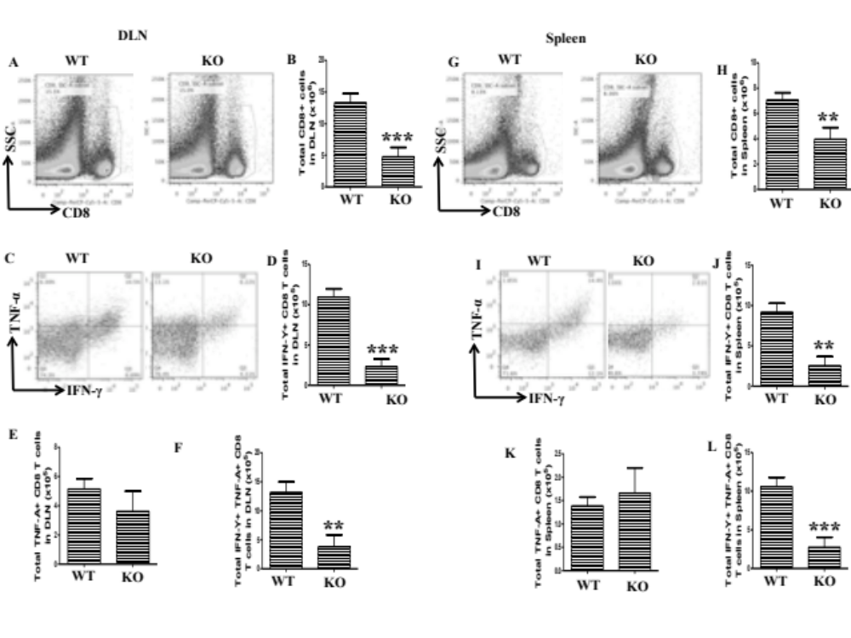 Figure 4.5. Compromised CD8 T cell responses in miR-155 deficient mice. DLN cells and splenocytes were stimulated with PMA/IONO for 4 hrs and ICCS was performed. A, B) The frequencies and total numbers of CD8 T cells in DLN in WT and miR-155KO mice. The frequencies and total numbers of IFNg+ (C, D), TNF+ (C, E), IFN-g and TNF+ (C, F) CD8 T cells in DLN. G, H) The frequencies and total numbers of CD8 T cells in spleen in WT and miR-155KO mice. The frequencies and total numbers of IFNg+ (I, J), TNF+ (I, K), IFN-g and TNF+ (I, L) CD8 T cells in spleen. These experiments were repeated three times.
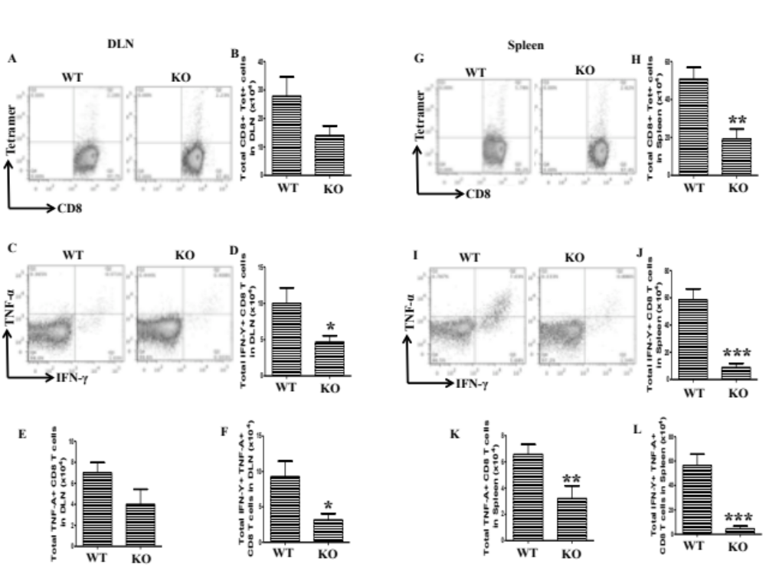
Figure 4.6. Compromised virus specific CD8 T cell responses in miR-155 deficient mice. DLN cells and splenocytes were stimulated with gB for 6 hrs and ICCS was performed. A, B) The frequencies and total numbers of gB tetramer+ CD8 T cells in DLN in WT and miR-155KO mice. The frequencies and total numbers of IFNg+ (C, D), TNF+ (C, E), IFN-g and TNF+ (C, F) CD8 T cells in DLN. G, H) The frequencies and total numbers of gB tetramer+ CD8 T cells in spleen in WT and miR-155KO mice. The frequencies and total numbers of IFNg+ (I, J), TNF+ (I, K), IFN-g and TNF+ (I, L) CD8 T cells in spleen. These experiments were repeated three times.
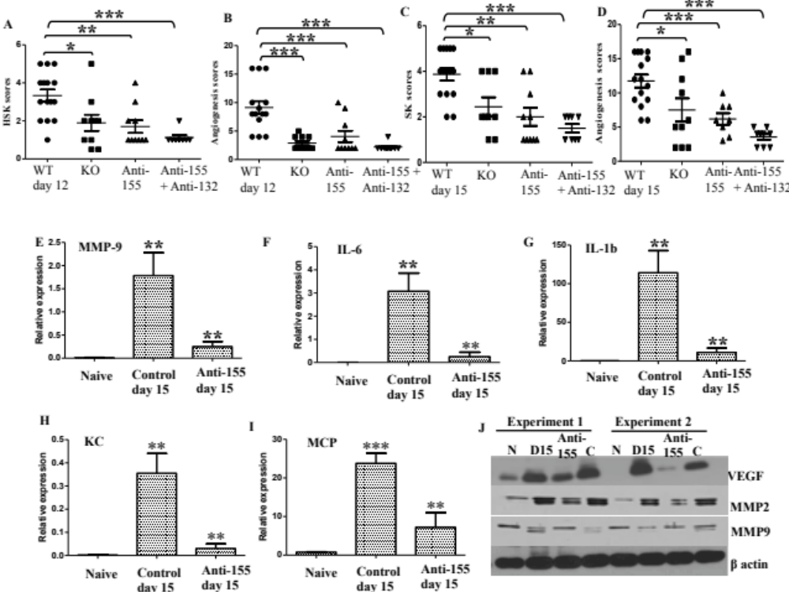 Figure 4.7. miR-155 deficiency makes mice resistant to SK. A-D) WT and miR-155 deficient mice were ocularly infected with HSV and monitored for the development of SK and angiogenesis. These experiments were repeated three times. SK and angiogenesis scores (A-D) after knockdown of miR-155 or miR-155 and miR-132 at day 12 and day 15 p.i. QPCR was performed to measure levels of MMP-9 (E), IL-6 (F), IL-1b (G), KC (H) and MCP (I) after miR-155 silencing. J) WB images for VEGF, MMP-2 and MMP-9 after miR-155 knockdown are shown. 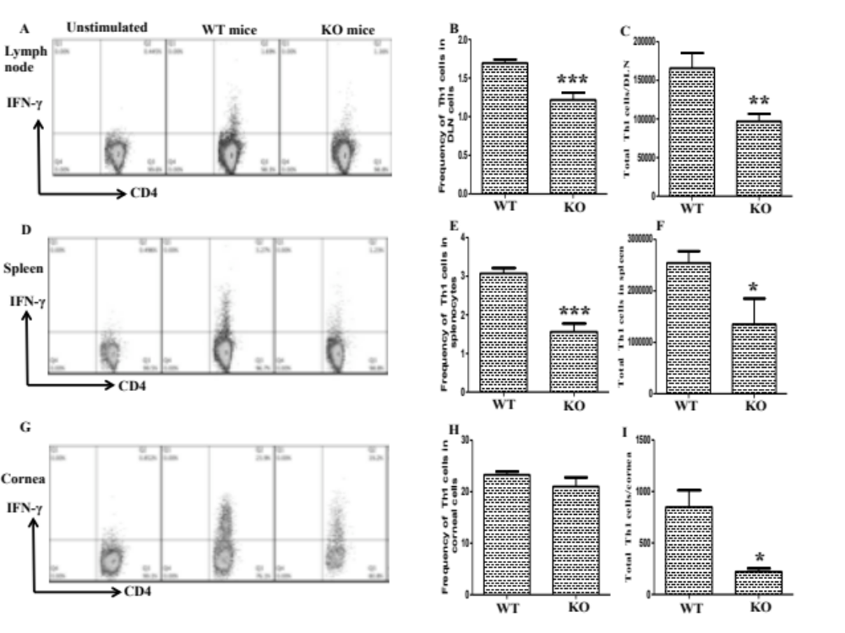 Figure 4.8. miR-155KO animals demonstrate diminished Th-1 responses. A-H) WT and miR-155 deficient mice were ocularly infected with HSV and LN, spleen and corneas were analyzed for Th1 cells by ICCS assay. Representative frequency plots; frequencies and total numbers of Th1 cells in LN (A-C), spleen (D-F) and corneas (G-I) are shown.

Conclusions and future perspectives

Herpes simplex virus infection generally leads to lesions on oral surface. In rare instances, virus can induce damage of the eyes (herpetic stromal keratitis) or brain (herpes simplex encephalitis). HSK remains the leading cause of infectious blindness in the western world and the current therapies are unsatisfactory. Corneal neovascularization is a critical step in the pathogenesis of HSK and studies using mouse models demonstrate that inhibition of corneal blood vessel development may halt disease progression. Our past studies have firmly established an essential role of VEGF in CV and therapies that remove the source of VEGF, or inhibit VEGF activity or VEGF signaling have shown promise in treating HSK in mouse models.
Our first approach to inhibit CV was augmentation of regulatory pathways. We chose Slit2-Robo4 signaling as it was shown to play a modulatory role in cancer models. After virus infection, we found upregulation of Robo4 but Slit2 expression was diminished. Additionally, our results demonstrate that potentiation of Robo4 signaling by administration of Slit2 significantly reduced CV. We plan to extend our observations and look in depth at molecular mechanisms to determine why Slit2 induction is inhibited in eyes after HSV infection. In this aspect, we will look at the expression of several microRNAs targeting Slit2 in eyes. We will also perform experiments in vitro in a corneal cell line and in vivo in mice by addition of certain cytokines or using cytokine-neutralizing antibodies to evaluate Slit2 expression. We intend to administer Slit2 in nanoparticles to HSV infected mice. Additionally, we plan to use Arf6 or Rac1 inhibitor (which will mimic Slit2-Robo4 signaling) and will study the expression of HSK after such treatment modalities. Optimistically, potentiation of Slit2-Robo4 signaling may help to reduce human SK.
Our other attempts to reduce HSK involved manipulation of microRNAs, which have been recently shown to play a role in several human diseases. miRNAs are post transcriptional regulators of gene expression and they do it so by promoting degradation of mRNA or inhibition of protein translation. miRNA blockade offers new opportunities to halt the progression of human diseases. We focused on miR-132 and miR-155 since these miRNAs play a pivotal role in angiogenesis and inflammation respectively.
miR-132 is one of the highly conserved miRNA and its function depends on the context where it is expressed. Accordingly, miR-132 induced neuronal differentiation in brain, performed anti-inflammatory action at neural immune interface, and promoted IFNs in KSHV infected lymphatic endothelial cells while it induced an angiogenic switch in cancer. Our results show that miR-132 expression is upregulated in corneas and it enhanced VEGF signaling during HSK. Inhibition of miR-132 significantly reduced CV. We plan to perform future experiments in miR-132 deficient mice, which we believe could be relatively resistant to CV. We intend to investigate miR-132 targets in depth in collaboration using various 3’UTR gene mutated plasmids. We also plan to investigate development of lymphatic vessels in corneas of miR-132 deficient mice after HSV infection. Additionally, we will block the activity of other angiogenic or tissue damaging molecules in miR-132 deficient mice and will look at the expression of HSK. Furthermore, we will also attempt to design slow drug release antagomir-132 nanoparticles that could be given topically to the eyes. We hope that miR-132 blockade approaches will someday be useful for human HSK therapy.
miR-155 is one of the intensely studied miRNA and it is required for normal immune function. Recent reports suggest that miR-155 is tightly linked with the inflammatory processes and is needed for the generation of pathogenic Th1 and Th17 cells. Consequently, mice deficient in miR-155 are resistant to some inflammatory and autoimmune diseases such as EAE and RA. We observed induction of miR-155 in eyes after herpes infection. Surprisingly, after infection with HSV, 80% miR-155KO mice died by encephalitis due to uncontrolled virus replication and those miR-155 deficient mice demonstrated a defect in CD8 T cells as well as other immune cells. We also studied miR-155KO survivors and those animals were relatively resistant to HSK. This phenotype was also evident after local knockdown of miR-155 in eyes. Finally, when miR-132 and miR-155 were inhibited together, this treatment modality potently reduced CV and HSK lesion severity. Future experiments will be performed to investigate the CD8 T cell defect in miR-155 KO mice as well as study of the miR-155 targets after local miR-155 silencing.

VITA
Sachin Mulik, a citizen of India, completed his Bachelors in veterinary science and animal husbandry from Krantisinsh Nana Patil College of veterinary sciences, Shirval, Maharashtra in 2005. Then he moved to Indian Veterinary Research Institute for earning his Masters in Veterinary Virology and finished degree in 2008. With strong fundamentals in basic virology and molecular biology, he joined lab of Dr. Barry T Rouse at University of Tennessee, Knoxville, Tennessee, USA for his PhD program in Viral immunology.
During his PhD, he first authored 3 research articles (PMID: 22659469, PMID: 21572022 and PMID: 21325621) while coauthored 6 others in prestigious journals. He was also involved in attending conferences and presented his research work in program conference three times. He has mostly worked on microRNAs and opened new avenues of research in herpetic stromal keratitis that is an important cause of human blindness.

