Growth Condition for Leptospira: Assessing Metabolomic Regulation in Variable Media and Temperature

A Thesis Presented for the
Master of Science
Degree
The University of Tennessee, Knoxville

Maliha Tabassum
December 2025

Copyright © by Maliha Tabassum.
All rights reserved

Acknowledgements.
I want to thank my advisor, Dr. Shawn R. Campagna for the guidance over the couple of years. It was an amazing opportunity to learn about metabolomics via mass spectrometry.
I also want to thank Dr. Katarina Jones and Dr. Courtney Cristopher for teaching me the several analytical laboratory techniques. I am grateful for the unlikely friendship I have formed in the Department of Chemistry through appreciation over Pink Floyd with Matt Tom and Bo Bishop, who have supported me through their expertise, and the occasional tea.
Finally, I want to thank my family and friends who supported me throughout my graduate school journey 8000 miles away from home. Special thanks to my spouse, Tanzil Mahmud, who has always cheered me on. Deepest gratitude to my friends Meher Afroze Ony, Mehraj Ahmed, and Fawzaan Ahmed who has been a critical part of my personal and academic life throughout. I am grateful for your support and prayers.
Abstract
Leptospirosis is a global zoonotic disease which is significant yet quite underrecognized. It is caused by Leptospira, which is transpired to humans from animals. There is no definitive identification of Leptospira infection in human. The objective of this study was to investigate the metabolites of Leptospira in vitro to create a metabolomic profile of the pathogenic bacteria. The metabolomic profile from the pellet, supernatant, and the control media allowed the development of an intracellular and extracellular metabolomic signature. The unique metabolomic signatures will further enable searches for biomarkers that will be significant for identification of leptospirosis in human. It this study it is found that purine metabolic pathway plays a key role in leptospira growth when it is inoculated in the EMJH (in house) media at both 28°C and 37°C. From pairwise comparison of the intracellular, extracellular and media control hints to a stress during growth in the currently available commercial media EMJH (Difco). The evidence of usage of multiple metabolic pathway remediation alternative to purine metabolic pathway in EMJH (Difco) in notable.
These results reveal distinct temperature-media interactions affecting both cellular composition and secreted factors, with significant differences observed in growth yield and metabolite secretion profiles. These findings provide new insights into the environmental adaptability of leptospira and offer guidance for optimizing laboratory cultivation and downstream analyses.

Table of Contents
Chapter One: Introduction...............................................................................................................1
Leptospira and leptospirosis......................................................................................................1
Leptospira and metabolomics....................................................................................................2
Purpose of study and specific aim.............................................................................................3
Chapter Two: Materials and Methods............................................................................................5
Sample Preparation ...................................................................................................................5
Metabolomic extraction.............................................................................................................5
Metabolomic data acquisition....................................................................................................6
Metabolomics data processing ..................................................................................................6
Handling missing values............................................................................................................6
Statistical analysis......................................................................................................................7
Random Forest analysis.......................................................................................................7
PLS-DA ..............................................................................................................................7
VIP Score Plot .....................................................................................................................7
Volcano Plot.........................................................................................................................8
Chapter Three: Results and Analysis...............................................................................................9
Chapter Four: Discussion...............................................................................................................84
References......................................................................................................................................87
Vita.................................................................................................................................................97

List of Tables
Table 1: Overview of comparisons between individual sample fractions.....................................20
Table 2: Overview of cross comparison .......................................................................................56
Table 3: Overview of integrated comparisons...............................................................................70

List of Figures
Figure 1: Heatmap for pellet EMJH (in house) media at 28℃ and 37℃........................................11
Figure 2: PLS-DA for pellet EMJH (in house) media at 28℃ and 37℃.........................................12
Figure 3: VIP Score plot for pellet EMJH (in house) media at 28℃ and 37℃ ...............................13
Figure 4: Volcano plot for pellet EMJH (in house) media at 28℃ and 37℃ .................................14
Figure 5: Heatmap for pellet EMJH (in house) & EMJH (Difco) media at 28℃ ............................16
Figure 6: PLS-DA for pellet EMJH (in house) & EMJH (Difco) media at 28℃ ............................17
Figure 7: VIP Score plot for pellet EMJH (in house) & EMJH (Difco) media at 28℃....................18
Figure 8: Volcano plot for pellet EMJH (in house) & EMJH (Difco) media at 28℃ ......................19
Figure 9: Heatmap for pellet & supernatant in EMJH (in house) media at 28℃.............................22
Figure 10: PLS-DA for pellet & supernatant in EMJH (in house) media at 28℃............................23
Figure 11: VIP Score plot for pellet & supernatant in EMJH (in house) media at 28℃..................24
Figure 12: Volcano plot for pellet & supernatant in EMJH (in house) media at 28℃.....................25
Figure 13: Heatmap for pellet & media in EMJH (in house) media at 28℃....................................26
Figure 14: PLS-DA for pellet & media in EMJH (in house) media at 28℃....................................27
Figure 15: VIP Score plot for pellet & media in EMJH (in house) media at 28℃...........................28
Figure 16: Volcano plot for pellet & media in EMJH (in house) media at 28℃..............................29
Figure 17: Heatmap for supernatant & media in EMJH (in house) media at 28℃..........................30
Figure 18: PLS-DA for supernatant & media in EMJH (in house) media at 28℃...........................31
Figure 19: VIP Score plot for supernatant & media in EMJH (in house) media at 28℃..................32
Figure 20: Volcano plot for supernatant & media in EMJH (in house) media at 28℃....................33
Figure 21: Heatmap for pellet & supernatant in EMJH (in house) media at 37℃...........................35
Figure 22: PLS-DA for pellet & supernatant in EMJH (in house) media at 37℃............................36
Figure 23: VIP Score plot for pellet & supernatant in EMJH (in house) media at 37℃..................37
Figure 24: Volcano plot for pellet & supernatant in EMJH (in house) media at 37℃.....................38
Figure 25: Heatmap for pellet & media in EMJH (Difco) media at 28℃........................................39
Figure 26: PLS-DA for pellet & media in EMJH (Difco) media at 28℃........................................40
Figure 27: VIP Score plot for pellet & media in EMJH (Difco) media at 28℃...............................41
Figure 28: Volcano plot for pellet & media in EMJH (Difco) media at 28℃..................................42
Figure 29: Heatmap for pellet & supernatant in EMJH (Difco) media at 28℃...............................43
Figure 30: PLS-DA for pellet & supernatant in EMJH (Difco) media at 28℃................................44
Figure 31: VIP Score plot for pellet & supernatant in EMJH (Difco) media at 28℃......................45
Figure 32: Volcano plot for pellet & supernatant in EMJH (Difco) media at 28℃.........................46
Figure 33: Heatmap for supernatant & media in EMJH (Difco) media at 28℃..............................47
Figure 34: PLS-DA for supernatant & media in EMJH (Difco) media at 28℃...............................48
Figure 35: VIP Score plot for supernatant & media in EMJH (Difco) media at 28℃......................49
Figure 36: Volcano plot for supernatant & media in EMJH (Difco) media at 28℃........................50
Figure 37: Heatmap for supernatant & media in EMJH (Difco) media at 37℃..............................51
Figure 38: PLS-DA for supernatant & media in EMJH (Difco) media at 37℃...............................52
Figure 39: 3-D PLS-DA for supernatant & media in EMJH (Difco) media at 37℃........................53
Figure 40: VIP Score plot for supernatant & media in EMJH (Difco) media at 37℃......................54
Figure 41: Volcano plot for supernatant & media in EMJH (Difco) media at 37℃........................55
Figure 42: Heatmap for inter-condition comparison for pellets......................................................58
Figure 43: PLS-DA for Inter-condition comparison for pellets......................................................59
Figure 44: 3-D PLS-DA for Inter-condition comparison for pellets...............................................60
Figure 45: VIP Score plot for Inter-condition comparison for pellets.............................................61
Figure 46: Heatmap for Inter-condition comparison for media.......................................................62
Figure 47: PLS-DA for Inter-condition comparison for media.......................................................63
Figure 48: VIP Score plot for Inter-condition comparison for media..............................................64
Figure 49: Heatmap for Inter-condition comparison for supernatants............................................65
Figure 50: PLS-DA for Inter-condition comparison for supernatants.............................................66
Figure 51: Three Dimensional PLS-DA for Inter-condition comparison for supernatants.............67
Figure 52: VIP Score plot for Inter-condition comparison for supernatants...................................69
Figure 53: PLS-DA for integrated comparison among sample fraction in EMJH (in house) media at 28℃ and 37℃............................................................................................................................71
Figure 54: Three Dimensional PLS-DA for integrated comparison among sample fraction in EMJH (in house) media at 28℃ and 37℃.................................................................................................72
Figure 55: VIP Score plot for integrated comparison among sample fraction in EMJH (in house) media at 28℃ and 37℃..................................................................................................................73
Figure 56: PLS-DA for integrated comparison among sample fraction in EMJH (Difco) media at 28℃ and 37℃................................................................................................................................74
Figure 57: Three Dimensional PLS-DA for integrated comparison among sample fraction in EMJH (Difco) media at 28℃ and 37℃.....................................................................................................75
Figure 58: VIP Score plot for integrated comparison among sample fraction in EMJH (Difco) media at 28℃ and 37℃..................................................................................................................76
Figure 59: PLS-DA for integrated comparison among sample fraction in EMJH (in house) &EMJH (Difco)............................................................................................................................................78
Figure 60: Three Dimensional PLS-DA for integrated comparison among sample fraction in EMJH (in house) &EMJH (Difco) media at 28℃......................................................................................79
Figure 61: VIP Score plot for integrated comparison among sample fraction in EMJH (in house) &EMJH (Difco) media at 28℃......................................................................................................80
Figure 62: PLS-DA for integrated comparison among sample fraction in EMJH (in house) &EMJH (Difco) media at 37℃.....................................................................................................................81
Figure 63: Three Dimensional PLS-DA for integrated comparison among sample fraction in EMJH (in house) &EMJH (Difco) media at 37℃......................................................................................82
Figure 64: VIP Score plot for integrated comparison among sample fraction in EMJH (in house) &EMJH (Difco) media at 37℃......................................................................................................83

Chapter 1
Introduction
Leptospira and leptospirosis
Leptospirosis is a significant zoonotic disease caused by spirochetes of the genus leptospira. It is prevalent globally, affecting both humans and a wide range of animals.¹ Leptospirosis is also known as Weil’s disease, after its first discovery in 1886 by Adolph Weil.² The symptoms noted by Adolph Weil for leptospirosis was jaundice, kidney complications, eye inflammation, enlarged spleen, and skin rashes.² Until 1900, the cause of Weil’s disease was not attributed to Leptospira. In 1907, when leptospira was first observed in a patient suspected of yellow fever, later in 1917 this virulent pathogen was distinctively linked to leptospirosis based on a study on Japanese coal miners.^{2,3,4} Extreme leptospirosis, also known as Weil’s disease, which result into multi-organ failure, jaundice, pulmonary hemorrhage, and acute renal and hepatic complications.^{5,6}
The clinical symptoms of leptospirosis in humans are varied, spanning from mild, flu-like symptoms to often life-threatening ones. The diagnosis of leptospirosis is often complicated, especially in the tropical region because of co-circulating diseases with similar symptoms.⁷ While typically more prevalent in rural area with warm and humid climate, leptospirosis is also highly prevalent in urban areas as it transmits through contaminated water and soil.^{8,9,10} Every year, roughly one million leptospirosis infection is diagnosed and the death toll of leptospirosis is approximately 60,000 annually.¹¹ Despite a fatality ratio of 6.85%, leptospirosis often remains neglected due to its symptoms aligning with common fever, lack of specific antibiotic treatment, and wide range of 300 pathogenic serovars.¹²
Leptospira is a gram-negative, thin spiral shaped pathogenic bacteria. Leptospira belongs to spirochete group. It is physiologically related to multiple pathogens such as syphilis causing bacteria Treponema, Lyme disease causing Borrelia, and even animal pathogen Brachyspira.⁶ Its unique spirochete motile ability provides fast movement enabling rapid dissemination in the mammalian or animal host.^{13,14,15,16} This pathogenic bacterium survives and thrives in host organism with an ability to persist, especially in soil, standing water and in other diverse reservoirs. Leptospires can enter the host tissue through skin or mucous membrane, and attack liver, lungs, and kidney – specifically the renal tubules.^{1,17} The persistent transmission cycle makes the eradication process complicated.^{9,18,19} Biofilm formation and adaptive metabolism allow leptospires to survive through hostile condition favoring bacterial survival, eventually maintaining virulence.^{20,21,22} The outer membrane protein, surface exposed liposaccharides plays a key role in evading the host immune system and colonization infecting multiple organs.^{23,24} Utilizing advance genomics techniques and molecular biology, leptospires are classified into more than 20 species. Genetic and serological subdivision includes pathogenic, saprophytic groups.^{25,26,27}
There are two types of Leptospira hosts: incidental (or unintentional) hosts and maintenance hosts.²⁸ Long-term urine shedding of the pathogen is possible in maintenance hosts, which are typically animals, who can harbor the bacteria in their kidneys asymptomatically.²⁹ On the other hand, accidental hosts, like people or other animals, have observable symptoms and lose the bacteria more quickly.³⁰ Some serovars exhibit host specialization, whereas others infect a broad variety of species. Copenhageni, Grippotyphosa, Icterohaemorrhagiae, Pomona, Australis, and Ballum are some of the most common serovars. Rats, cattle, dogs, and pigs are common reservoirs for these serovars.³¹ For instance, dogs are typically connected with serovar Canicola, while Grippotyphosa is found in numerous animal species.^{32,31}
Leptospira and metabolomics
Metabolomics, the study of small molecules, helps elucidate the molecular information of microorganisms of interest. Investigation of the metabolic features of an organism is an extraordinary opportunity to unravel the understanding of several significant underlying reasons of a microorganism’s functions.³³ Ongoing research employing metabolomics can uncover an organism’s survival, pathogenicity, dissemination, virulence. Exploiting the ecophysiology of pathogens can be utilized to improve diagnostic measures and treatment.^{34,35} Technological advancements provide new opportunities to leverage these techniques in order to discover the metabolic adaptations of leptospira during its growth in presence of environmental stressors.^{36,21}
Over the past two decades, omics technologies have helped expanding the understanding of leptospira biology. Molecular genomics, transcriptomics, proteomics enabled determination of taxonomy, pathogenic vs. nonpathogenic species of leptospira, their virulence, and host pathogen interaction.^{10,20,21} Integrated transcriptomics and metabolomics study on murine model investigated renal injuries caused by leptospirosis.³⁷ Despite these advances, the metabolome of leptospira has remained uninvestigated. Metabolic activities, biochemical pathways, environmental persistence of leptospira is still unknown. Investigation of dynamic state of metabolism of leptospira in vitro could potentially bridge this gap by underpinning the causes of its phenotypical pathogenicity, environmental durability.³⁸ High throughput methods such as metabolomics, specially employed in vitro could potentially characterize a large number of intracellular and extracellular metabolites. Leveraging this resource, discovery of the molecular basis of virulence, innovation of diagnostic marker and intervention strategies towards pathogenesis³⁹ becomes a possibility.^{40,41}
Untargeted metabolomics is a widely known and recognized tool in studying small molecules. The biological samples contain a wide array of small molecule which could be investigated leveraging LC-MS (Liquid chromatography mass spectrometry) based untargeted metabolomics.⁴² This advanced technique could detect alteration in cellular metabolism providing insight to the physiological regulation.⁴³ Untargeted metabolomics technique investigates the entire metabolome to find as many metabolomes as possible causing the changes in regulation of metabolomes in samples, unlike targeted metabolomics which only concentrates on specific metabolome.⁴⁴ For this holistic approach, untargeted metabolomics is often able to discover novel biomarkers, uncover unanticipated metabolic changes.⁴⁵
Untargeted metabolomics has emerged as an invaluable tool in the research specially in the studies of microbes. The advantage of using this technique towards microscopic species, is that it allows investigation at a molecular level.⁴⁶ The host pathogen interaction, molecular fingerprint correlated to those interactions could be elucidated, uncovering the metabolic pathways, biomarkers, disease causes and eventual treatments possibilities exploiting the metabolic pathway. This tool plays a critical role in studying pathogenic microorganism such as leptospira. It allows to distinguish between the pathogenicity and non-pathogenicity among species.⁴⁷ For example, integrated omics study of murine models has highlighted significant upregulated level of N-carnitine associated with acute kidney injury during leptospirosis. Such findings reinforce necessity of using untargeted in order to find potential biomarkers which could lead to the finding vaccines for disease maintenance and regulation.³⁷
Purpose of study and specific aim
To improve the diagnostic method and prevention strategies of leptospirosis, it is imperative to study its pathogenesis.^{32,48} To investigate the metabolic profile of pathogenic leptospira, understanding of variables influencing its growth is necessary. To achieve that, outcome of metabolomic study of in vitro culture will give an insight to the metabolic profiles of leptospira interrogan serovar were cultured under 4 different controlled laboratory condition. Two different media formulation EMJH (in house) and EMJH (Difco) were used for incubation at 28°C and 37°C separately to simulate environmental condition and host-like condition. From each set of culture conditions pellets, supernatants, media control samples were collected which serve as intracellular content, extra cellular content, and control respectively. These sample fractions are representative of cytophysiology, secreted metabolic product, and nutrient consumption during growth phase. Evaluation of these sample fractions with LC-MS based untargeted metabolomic enables elucidation of leptospira metabolism modulation, response to environmental factor, and potential metabolic signature dependent on environmental and growth conditions.
Purpose of the study
The purpose of the study is to characterize the intracellular and extracellular metabolic profiles of the leptospira interorgan serovar and to develop a metabolic profile of it using LC-MS based untargeted metabolomics.
Specific Aims
- Characterization of leptospira metabolic composition under two distinct media and at two temperatures condition to identify intracellular and extracellular metabolites.
- Development of a global metabolomics profile for leptospira to inspect for potential biomarker for diagnosis of leptospirosis
Chapter 2
Materials and Methods
Sample Preparation
Pathogenic species Leptospira interrogans serovar Copenhageni strain Fiocruz L1-130 (kindly provided by Dr. Andre Grassmann, University of Connecticut) was grown in two different compositions of EMJH media (Ellinghausen and McCullough, 1965; Johnson and Harris, 1967). A commercial version of EMJH medium (EMJH Difco) was prepared and supplemented with Enrichment EMJH according to manufacturer’s instructions (BD, NJ, US), and an In-house prepared EMJH medium (EMJH in house) was prepared as previously described^{49,50}. Leptospira inoculum containing 10⁵ /ml was added to 4.5 ml of each medium and incubated at 28°C or 37°C until it reached the mid-log phase of growth. Intact and motile Leptospira were enumerated daily for 14 days using the Petroff-Hauser chamber under dark-field microscopy. The cultures were also evaluated to confirm the absence of visible contamination, cell degradation, or any atypical motility. At the end of the incubation, 3 ml of each culture was centrifuged at 10000 xg for 10 minutes at room temperature. The supernatants were collected, and the pellets were washed twice with 1 mL of nuclease-free water (Thermo Scientific, MA, US). The uninoculated media was used as negative control for all analyses. All samples were frozen and stored in liquid nitrogen until processed for metabolomic analysis. Two independent experiments with three technical replicates were performed.
Metabolomics extraction
Samples were stored at 4°C throughout the metabolomic extraction process. Using an acidic acetonitrile extraction method modified from Rabinowitz and Kimball [33], water-soluble metabolites were extracted. In short, 1.3 mL of 4:4:2 acetonitrile: methanol: water with 0.1 M formic acid was used to extract metabolites from the aliquoted samples. Every solvent was of HPLC quality. After being combined with the extraction solvent, the samples were stored at -20°C for 20 minutes. The mixture was then centrifuged for five minutes, and the supernatant was gathered. The supernatant was collected and mixed with the previously collected supernatant after a further 20 minutes at -20°C and 5 minutes of centrifugation. Each sample's supernatant was dried using pure nitrogen. After drying, each sample was prepared for mass spectrum analysis by adding 300 µL of LC-MS-grade water.

Metabolomics data acquisition (HPLC)
Global metabolomic analysis was conducted using a previously reported ultra high-performance liquid chromatography—high resolution mass spectrometry (UHPLC-HRMS) approach.⁵¹ Metabolites were stored in an UltiMate 3000 RS autosampler (Dionex, Sunnyvale, CA, USA) at 4 °C before analysis. A tributylamine ion pairing reagent, a Synergi 2.6 µm Hydro RP column (100 mm × 2.1 mm, 100 Å; Phenomenex, Torrance, CA, USA), an UltiMate 3000 pump (Dionex), a previously described 25 min gradient elution, and a reverse phase ion-paring method were used to achieve chromatographic separation. Before performing a full scan mass spectral analysis using an Exactive Plus Orbitrap mass spectrometer (Thermo Fisher Scientific, Waltham, MA, USA)⁵², the metabolites in the chromatographic eluent were first ionized using negative mode electrospray ionization (ESI), as previously mentioned

Metabolomics Data Processing

Raw mass spectral files were converted to mzML files using the msConverter package from ProteoWizard^{53,54}. Metabolites were manually identified using an internal library based on precise mass (±5 ppm) and retention time (±1 min) after all mzML files were imported into the open-source program Metabolomics Analysis and Visualization Engine (El-MAVEN)^{55,56}. After integrating metabolite peaks, El-MAVEN exported the raw peak intensities for each identified metabolite to a CSV file.

Handling Missing Values

The experiment was completed in two parts keeping the experimental setup identical in each case. In the first part of the experiment, leptospira was grown using EMJH (Difco) media, and in the second part, EMJH (in house) media was used. A total of 100 metabolites was detected in the first experiment, and 81 in the second. When combined, the total sum enumerated to 121 metabolites. To construct a unified matrix of metabolites where a metabolite was absent in one batch, the one-fifth (1/5th) of the average intensity of that metabolite corresponding to the other batch was assigned in place of the missing value. For downstream analysis, the unified list of all the metabolites from both experiments were taken, resulting in a list of 121 metabolites altogether.

Statistical Analysis
Random Forest:
Technical variation in the metabolomics dataset can be corrected using random forest analysis. This approach uses an algorithm based on machine learning to reduce batch effects, signal drift. It applies a random forest regression modeling after systematic variation. Quality control (QC) samples, injected at a random interval throughout the batch experiments, are used by the machine learning model to adjust for injection order trend to capture and correct for instrument fluctuation. For each detected metabolite, it predicts probable intensities contingent upon the quality control (QC) samples. Followed by this step, the algorithm calibrates the metabolite intensities of each sample accordingly. This yields greater consistency among all samples while retaining original biological differences.⁵⁷ As the study was carried out in two parts, instead of typical normalization methods, random forest normalization was performed to leverage its advantages. Systematic Error Removal using Random Forest (SERRF)⁵⁷ was used to perform the normalization. Sample-based normalization was not performed since the pellet was not weighed separately after sample was centrifuged to separate pellet and supernatant. However, data-based normalization SERRF corrects for not only for quality control and system injection order, but it also corrects based on the behavior of other compounds.
Partial Least Squares Discriminant Analysis (PLS-DA)
Multivariate statistical analysis Partial Least Squares Discriminant Analysis PLS-DA method was applied on the data after it underwent random forest normalization by SERRF. PLS-DA maximizes the separation between predefined groups as it is a supervised multivariate statistical method.^{58,59} It projects the data in new axes to capture the highest variance corresponding to the predefined groups. The newer axes are considered to be latent variables. In complex, large, high dimensional dataset like a metabolomics dataset, it is an efficient tool to reduce the dimensionality yet providing group separation accounting for group structure. It enables detailed visualization for underlying metabolic separation providing information on distinct metabolic profile. All PLS-DA models were prepared using MetaboAnalyst 6.0.⁶⁰
Variable Importance in Projection (VIP) scores
Variable Importance in Projection (VIP) scores are part or extension of the PLS-DA model that identifies the top variables that are guiding the variance projected in the axes of the PLS-DA.⁶¹ It provides a measure of the variable’s contribution in the discrimination among groups displayed in the PLS-DA model. The higher-ranking variable has the greater influence on the variance component driving the separate classification in groups.⁶² To analyze the VIP score plot, the variables with VIP scores higher than 1 are generally considered significant contributors to the class separation and are further investigated for their relevance to the system studied.⁶³ In this study, the variables refer to the metabolites detected and of significance. All the VIP score plots are generated using MetaboAnalyst 6.0. These VIP score plots complemented the PLS-DA model facilitating deeper understanding of metabolic alteration in leptospira growth under the experimental conditions of the study.
Volcano plot
To visualize metabolites with significant alteration in abundance, volcano plots were used. Usually log-10 (or log-2) fold changes are plotted on the x-axis referring to the magnitude of change, and log-10 (or log-2) p-values are plotted on the y-axis to signify the importance of that alteration. Thus, it provides an immediate display of which metabolic feature are of high difference compared to the groups relative to it.⁶⁴ For statistical analysis using volcano plot MetaboAnalyst 6.0 was used for visualization.6⁰ Metabolites displayed on the far right of the plot shows the metabolites of highest fold changes and significance, which could make those metabolites a candidate of biological relevance.⁶⁵

Chapter Three

Results and Analysis
In the experimental design, a total of seven variables were present across the whole dataset in the study of metabolic profiling during the growth of Leptospira in vitro. Due to the complex nature of the dataset consisting of these variables, analysis and interpretation of data was carried out considering one parameter at a time.
  - Choice of Media:
    - EMJH (in house)
    - EMJH (Difco)
  - Choice of temperatures:
    - 28°C. 28°C-30°C temperatures are optimal temperature for leptospira bacterial growth.⁶⁶
    - 37°C. 37°C mimics temperature for mammalian host. Moreover, a temperature shift from 37°C-37°C shows a overrepresentation of leptospira gene.⁶⁷
  - Sample fraction
    - Cell pellets
    - Supernatants
    - Control media.
To analyze this complex dataset, the data analysis was broken down to 5 different groups.
- Metabolomics investigation of the Temperature Effect on Growth of Leptospira
- Metabolomics investigation of the Media Effect on Growth of Leptospira
- Cross comparison among sample fractions in each media and temperature component
- Cross comparison of each sample fraction in all growth parameters
- Integrative comparison of among sample fraction in both growth parameters
- Metabolomics investigation of the Temperature Effect on Growth of Leptospira
Temperature is known to affect the growth rate of a bacterial inoculation.^{68,69} To investigate how temperature affects the leptospira growth and influences its metabolic profile, comparisons were performed between pellets grown in media at varying temperatures. The comparisons performed were-
- Pellets grown in in EMJH (in house) media at 28°C and 37°C temperature
- Pellets grown in in EMJH (Difco) media at 28°C and 37°C temperature
However, no growth of leptospira was observed in EMJH (Difco) media at 37°C. Therefore, comparison between pellets grown in in EMJH (Difco) media at 28°C and 37°C temperature could not be performed.
Temperature effect comparison on growth of leptospira
Figures 1-4 displays the heatmap, PLS-DA, VIP score plot, and the volcano plot for comparison between pellets grown in in EMJH (in house) media at 28°C and 37°C temperature respectively. According to the volcano plot (Figure 4), phosphoryl ethanolamine, thymidine, glutamate, methionine, cystathionine are upregulated in pellet when grown in EMJH (in house) at 28°C. Phosphoryl ethanolamine is integral to phosphate group of lipid A, a constituent of the outer membrane of lipopolysaccharides^{70,71} in gram negative-bacteria such as leptospira in order to maintain their structural and functional role.^{72,73} It is associated with maintaining structural membrane integrity, stress response and virulence.⁷² Glutamate is linked to amino acid metabolism for some leptospira species but is not specifically noted as leptospira specific growth marker. However, lack of a l-glutamate reducing enzyme predicts a lower growth in L. interorgan.⁴⁸ Evidence of glutamate being upregulated in cell pellets in EMJH(in house) media at 28°C builds upon the prediction of glutamate being a potential marker for growth factor of l. interorgan. Thymidine is involved in nucleoside metabolism and is associated with DNA replication. Thus far, it has not been strictly associated with a leptospira growth model. However, for pathogenic bacteria, thymidine has been linked to DNA replication velocity.⁷⁴ The primary reason Leptospira typically do not grow in EMJH (Difco) medium at 37°C is because this condition does not provide the required environment for the leptospira survival and growth at that temperature. The ideal growth temperature for EMJH (Difco) medium, the only commercially available media for leptospira, is between 28 and 30°C^{75,66}, which roughly resembles the environments these bacteria experience outside of a host.
When inoculated at 37°C, which mimics the mammalian host temperature, the nutrient constituents in EMJH may become less stable, less bioavailable lacking buffering mechanism against metabolic stress⁷⁶ that leptospira undergoes at the specified temperature.⁶⁶
- Metabolomics investigation of the Media Effect on Growth of Leptospira
Media composition can affect the leptospira growth. Evaluating the differences in growth support, growth factor, nutrient availability, and viability, two media EMJH(Difco) and
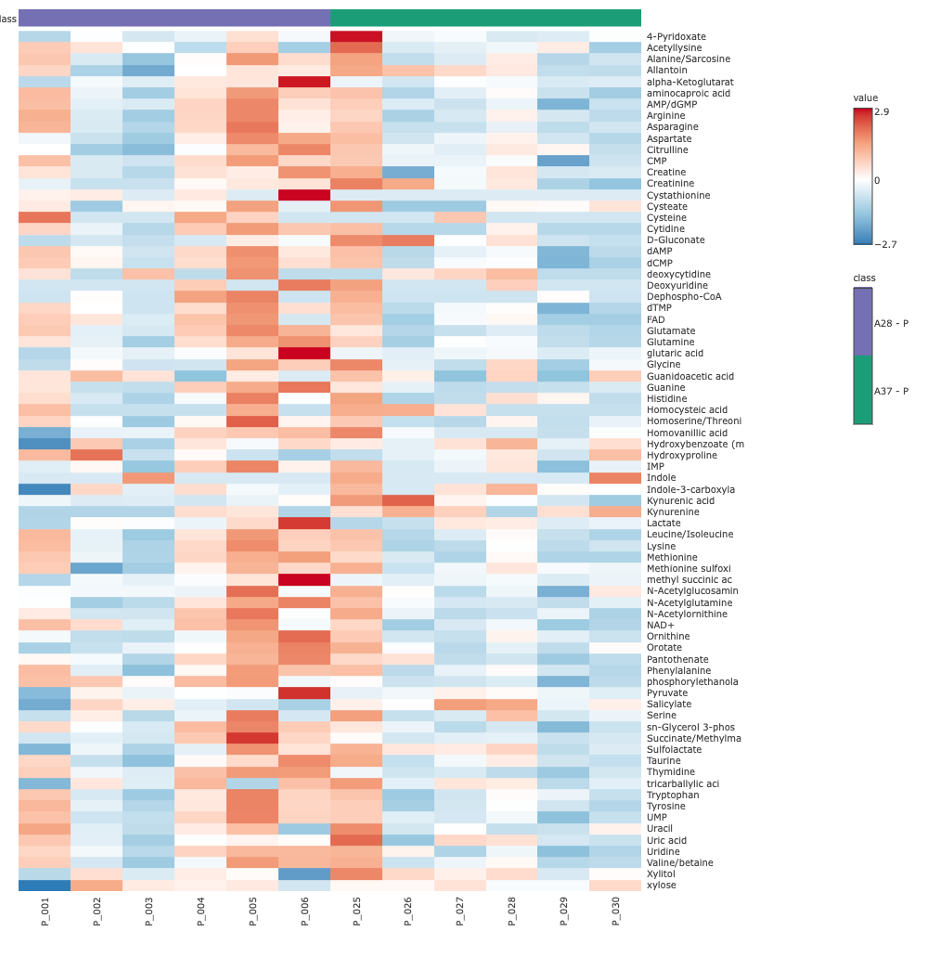
Figure 1: Visualization of abundance of metabolites across the cell pellets in EMJH (in house) media at 28°C and 37°C. The media is represented as “A” in the figure. Data underwent log2 transformation and pareto scaling.
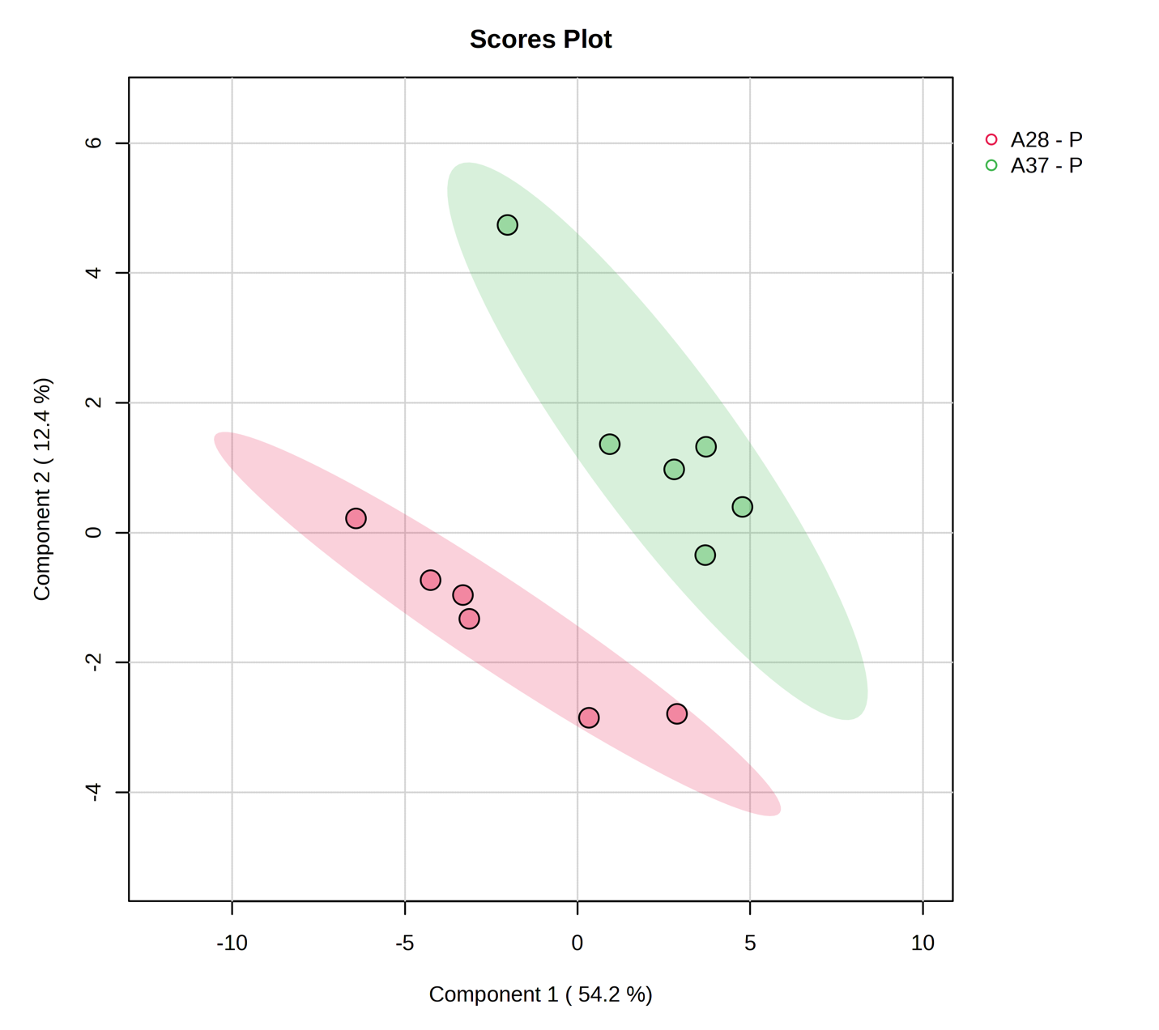
Figure 2: Partial Least Squares Discriminant Analysis PLS-DA plot shows 2 distinct groups between pellets grown in EMJH (in house) media at 28°C and 37°C. The multivariate analysis distinctive individual metabolic profile between pellets grown in different temperatures.

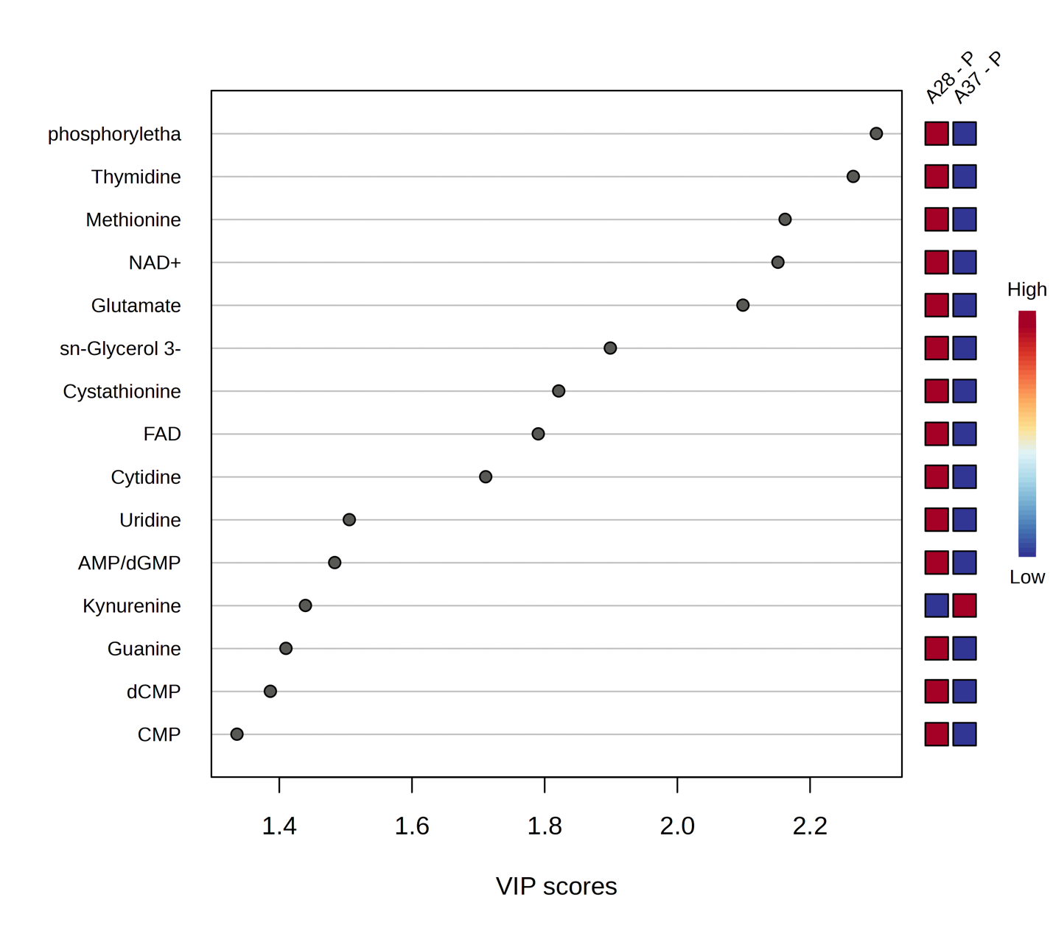
Figure 3: Variable importance in projection (VIP) score plot demonstrates the importance of a variable in the PLS-DA model. Each metabolite is assigned a VIP score representing its contribution for separation in PLS-DA. A score $≥$ 1 indicates higher contribution to the variance between groups – pellets grown in EMJH (in-house) media (referred to as A in the figure) at 28°C and 37°C respectively.

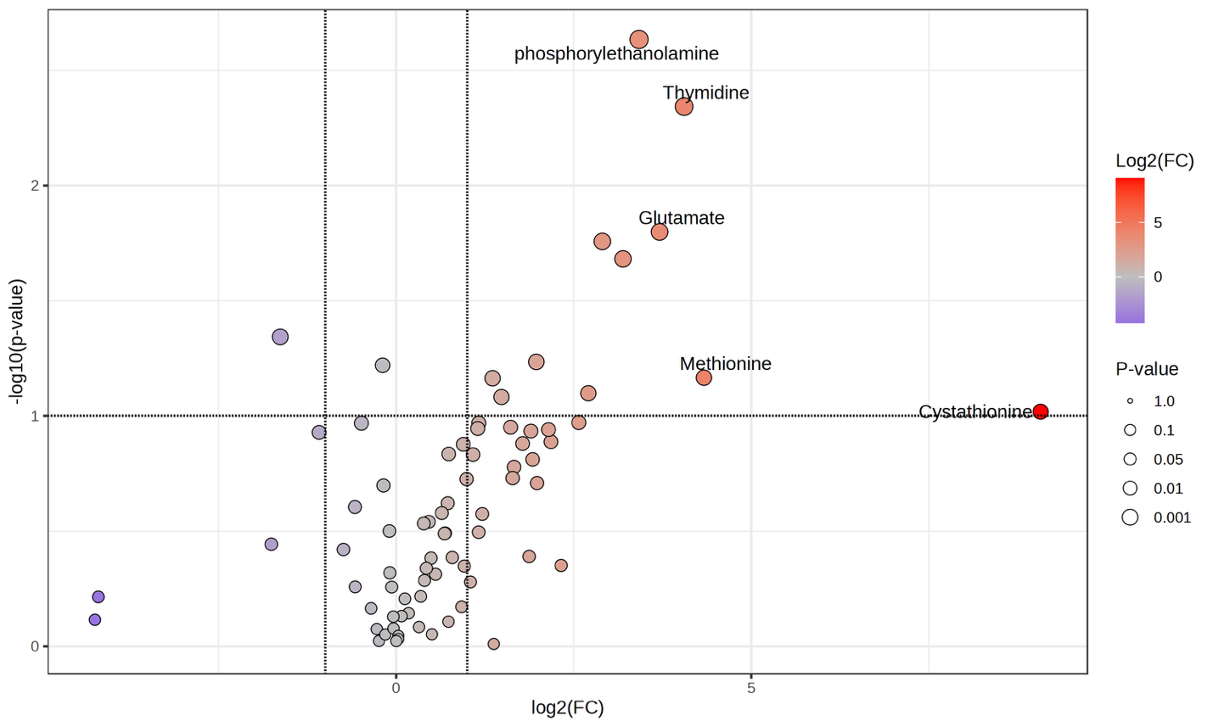
Figure 4: Volcano plot representing upregulation and downregulation of metabolites while comparing growth of leptospira cells at EMJH (in-house) at 28°C. On the x-axis, the log2 fold change of cell pellets (P) against media control. The y axis displays the negative log of p-values. The orange dots represent the metabolites that are upregulated in pellets and the blue dots represents the metabolites that are upregulated in the media. The size of the dots is scaled according to the p-values presented in the legend.

EMJH (in house) were used to inoculate leptospira species at 28°C and 37°C.
Media samples were the same at 28°C & 37°C for EMJH (in house). Hence the metabolic evaluation of growth only at 28°C was performed. Inoculation of leptospira did not show any evidence of growth at EMJH (Difco) media at 37°C. Therefore, assessment of growth of leptospira in EMJH (Difco) media at variable temperature could not be conducted. Growth comparisons were carried out between the cell pellet collected from the inoculation in EMJH (in house) at 28°C and in EMJH (Difco) at 28°C. Figure 5-8 displays the heatmap, PLS-DA, VIP score plot, and the volcano plot for comparison between pellets grown in in EMJH (in house) media and EMJH (Difco) media at 28°C temperature respectively. Homocarnosine, ADP-glucose, FAD, NAD+, phosphoryl ethanolamine, homocitrulline appears to be the major metabolites driving the separation between the pellet groups (Figure 7) resulting in the unique metabolic profile of leptospira while grown in different media. While homocitrulline, ADP, and glucose were upregulated in EMJH (in Difco), homocarnosine, FAD, NAD+ were also in higher abundance in EMJH (in house) pellets.
- Cross comparison between sample fractions in each media and temperature component
The distribution of intracellular contents and extracellular components and can provide significant insight in understanding the metabolic activity and signature as well as physiological adaptations. The pellet, containing bacterial cells represents the internal metabolites, while the supernatant contains the secreted ones. The extracellular contents may be composed of degraded cell products as well. However, metabolic investigation from comparing metabolites from pellets and supernatants allows insight towards cellular metabolism and secretory process. Comparisons between individual sample fraction components reveals the up-regulations or down-regulations of metabolites specific to media-temperature combination. It also identifies intracellular metabolites separately from the exo-metabolome.
Table 1 shows the list of comparisons that were carried out to analyze the metabolomics data to perform the cross comparisons among sample fractions. However, without the cell pellets from the EMJH (Difco) at 37°C and no media samples from EMJH (in-house), comparison 5,6, 10, 11 from Table 1 could not be conducted.
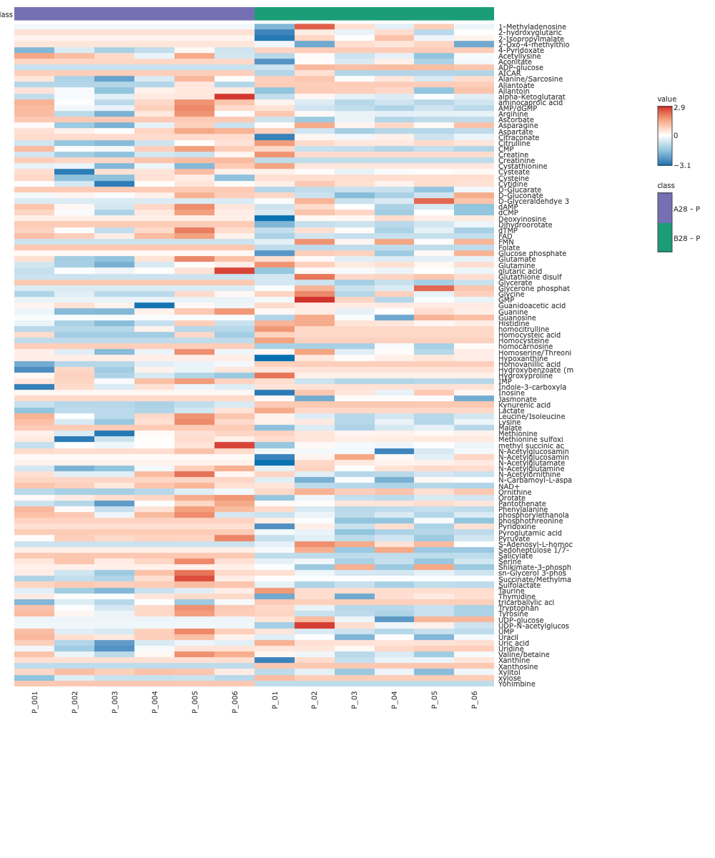
Figure 5: Visualization of abundance of metabolites across the cell pellets in EMJH (in house) and EMJH (Difco) media at 28°C. The media EMJH (in house) is represented as “A” and EMJH (Difco) is represented as “B” in the figure. Data underwent log2 transformation and pareto scaling.
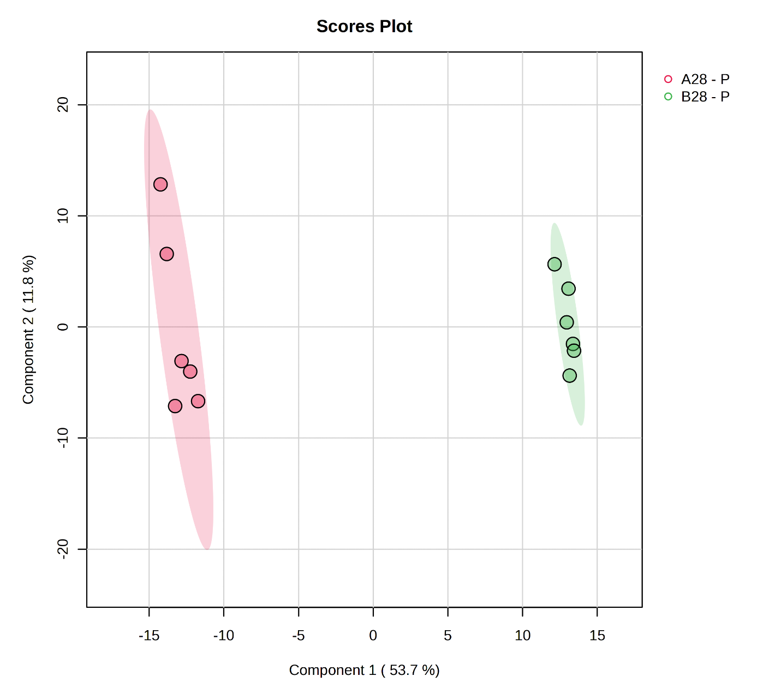
Figure 6: Partial Least Squares Discriminant Analysis PLS-DA plot shows 2 distinct groups between pellets grown in EMJH (in house) (A) and in EMJH (Difco) (B) media at 28°C. The multivariate analysis shows distinctive individual metabolic profile between pellets grown in different media.

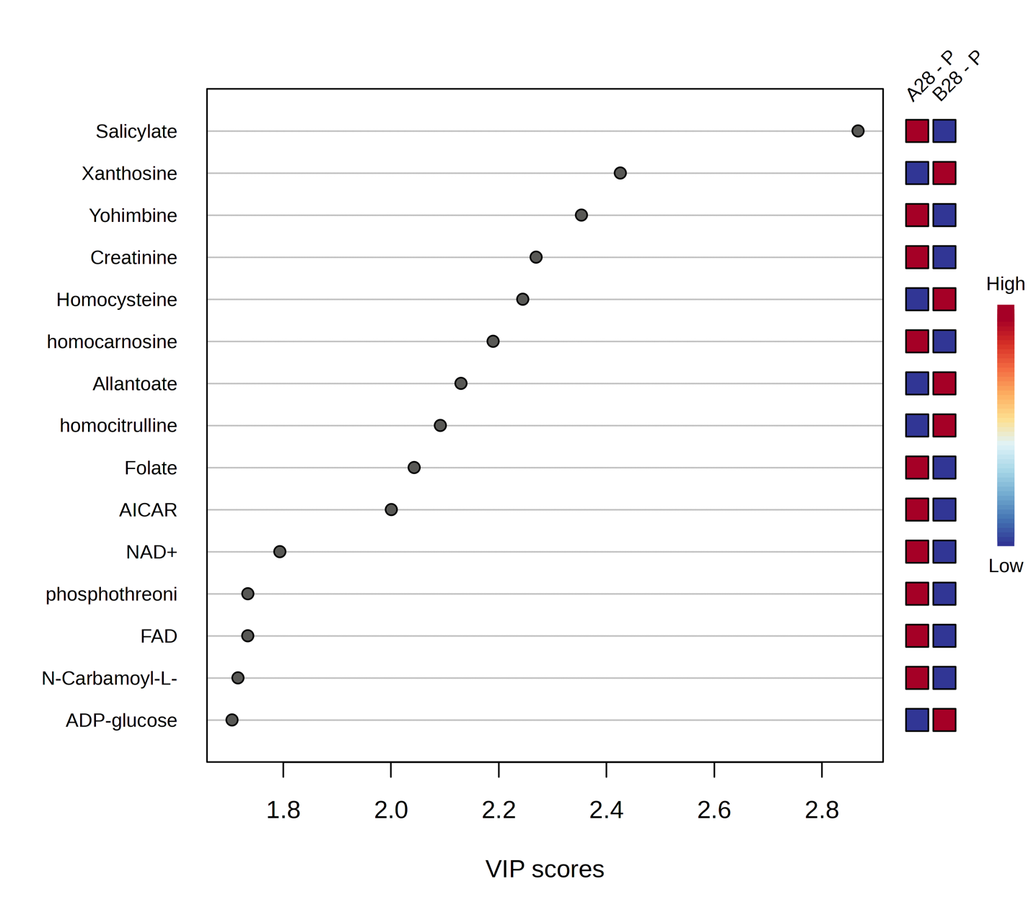Figure 7: Variable importance in projection (VIP) score plot demonstrating the significance of metabolites in the PLS-DA model between two groups – pellets grown in EMJH (in-house) media (referred as A in the figure) and EMJH (Difco) media (referred as B in the figure) at 28°C.
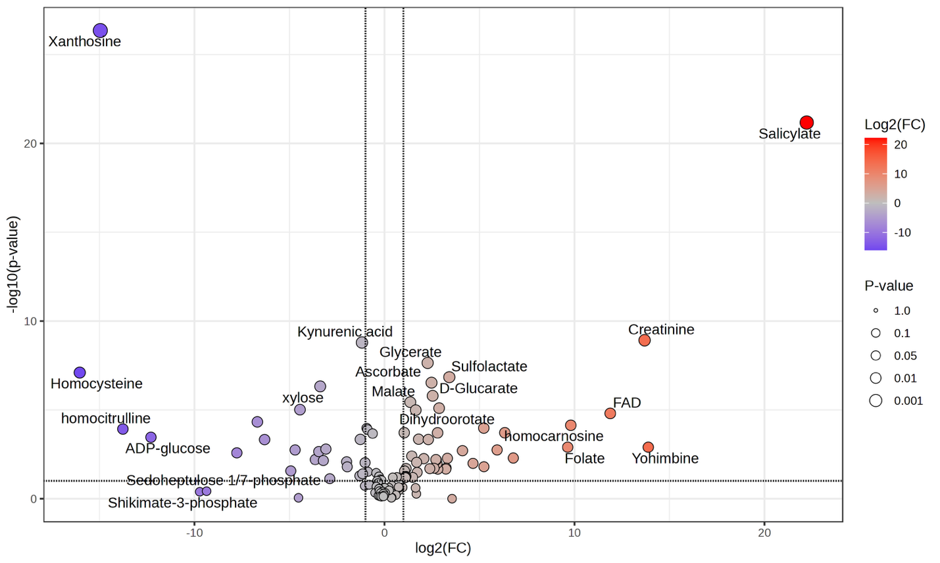
Figure 8: Volcano plot representing upregulation and downregulation of metabolites while comparing growth of leptospira cells in EMJH (in-house) and in EMJH (Difco) media at 28°C. On x-axis, the log2 fold change is displayed for the P-A28/P-B28 ratio where A and B represents EMJH (in-house) and in EMJH (Difco) media at 28°C respectively.
Table 1: Overview of comparisons performed to carry out sample fraction comparison in two different media and temperature combinations.
Sample Fraction Comparison | Media type | Temperature
- Pellet / Supernatant | EMJH (in house) | 28°C
- Pellet / Media | EMJH (in house) | 28°C
- Supernatant /Media | EMJH (in house) | 28°C
- Pellet / Supernatant | EMJH (in house) | 37°C
- Pellet / Media | EMJH (in house) | 37°C
- Supernatant /Media | EMJH (in house) | 37°C
- Pellet / Supernatant | EMJH (Difco) | 28°C
- Pellet / Media | EMJH (Difco) | 28°C
- Supernatant / Media | EMJH (Difco) | 28°C
- Pellet / Supernatant | EMJH (Difco) | 37°C
- Pellet / Media | EMJH (Difco) | 37°C
- Supernatant / Media | EMJH (Difco) | 37°C

Comparison between Pellet and Supernatant in EMJH (in house) at 28°C
First, the comparison between the pellet and the supernatant collected from the inoculation of leptospira in EMJH (in house) media at 28°C was carried out. The visualization of this comparison is displayed via the heatmap, PLS-DA, VIP score plot, and volcano plot in Figure 9-12. From the volcano plot (Figure 12) it is observed that NAD, IMP, CMP are upregulated in pellet when compared to extracellular contents. These are essential metabolites correlated to growth, redox balance, cell replication and nucleotide biosynthesis. Upregulation of these metabolites in pellets can be attributed to leptospira positive growth.⁷⁷
Comparison between Pellet and Media in EMJH (in house) at 28°C
The next comparison that was carried out was between the pellet grown in EMJH (in house) media at 28°C and the control media. The visualization of this comparison is displayed via the heatmap, PLS-DA, VIP score plot, and volcano plot in Figure 13-16. From the PLS-DA (Figure 15), it is noted that CMP and IMP were one of the major metabolites driving the separation between the pellet and media group. This finding is congruent with the finding from the sample fraction comparison between pellet and supernatant in EMJH (in-house) at 28°C. The volcano plot (Figure 16) shows that FAD and NAD+ are upregulated in the cell pellets; while homocitrulline, xanthosine and homocysteine were upregulated in the media. Creatine is one of the metabolites in media highly contributing to the separation between the media and pellet. Leptospirosis can affect the renal function causing acute kidney injury (AKI) resulting into kidney damage. Creatine, the by-product of creatinine confirms the detrimental function of creatinine on renal function.⁷⁸
Comparison between Supernatant and Media in EMJH (in house) at 28°C
The visualization for the comparison between supernatant from Leptospira inoculation in EMJH (in house) at 28°C is displayed via the heatmap, PLS-DA, VIP score plot, and volcano plot in Figure 17-20. Comparison between the supernatants and the control media sample provides insights on the extracellular metabolites. It is to be noted that the supernatants do not consist only of the secreted bacterial metabolite, it could also contain dead cell integrated, and degradation products of such content.
Homocitrulline, creatine, and cystathionine from the media fraction is driving the separation (Figure 18 & 19) between these two groups is highly consistent with the finding from the pellet to media control comparison. In the volcano plot (Figure 20), it is observed that
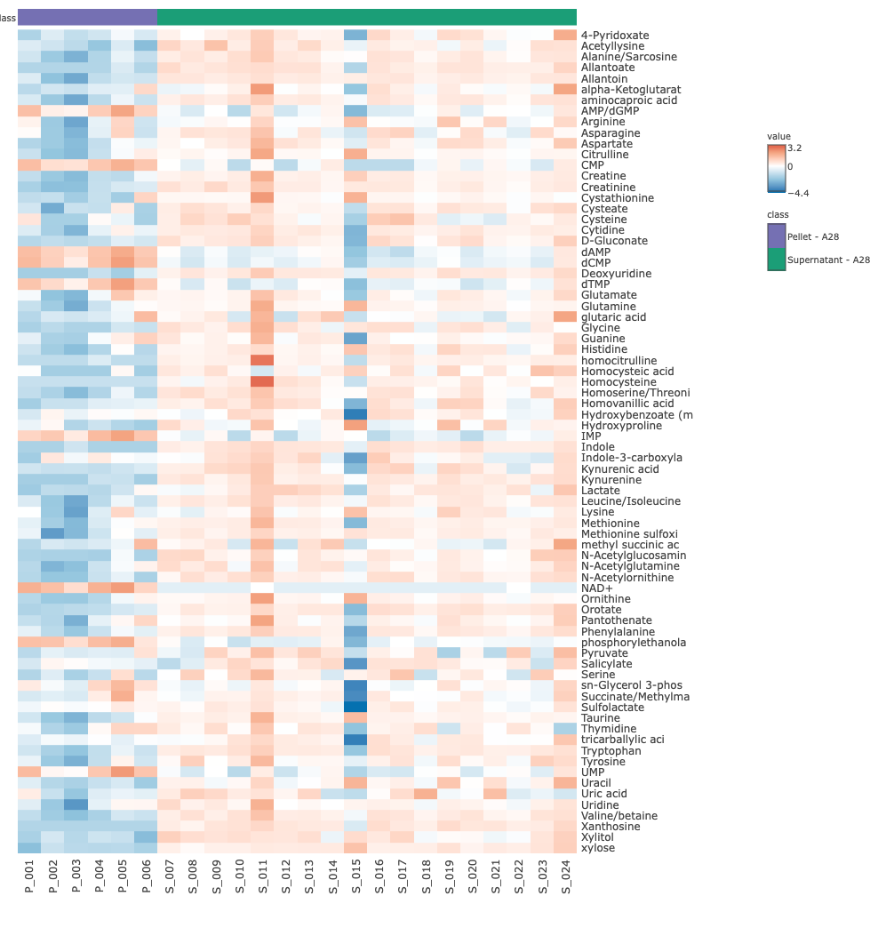
Figure 9: Visualization of metabolites abundance across the cell pellets and the supernatant in EMJH (in house) at 28°C. The media EMJH (in house) is represented as “A” Data underwent log2 transformation and pareto scaling.
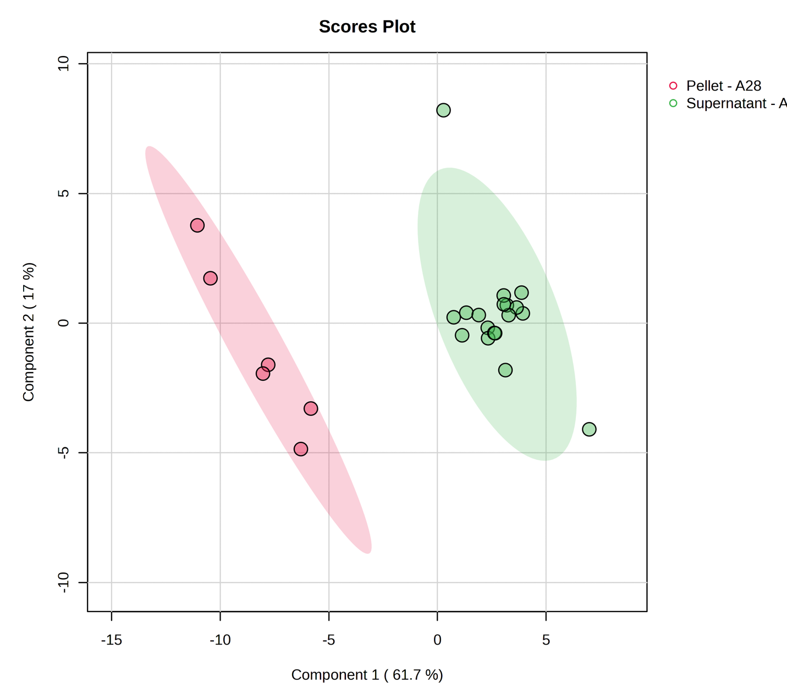
Figure 10: Partial Least Squares Discriminant Analysis PLS-DA plot shows 2 distinct groups between pellets grown in EMJH (in house) media and its supernatant. The multivariate analysis shows distinctive individual metabolic profile between the pellets and supernatant grown in the EMJH (in-house) media at 28°C.

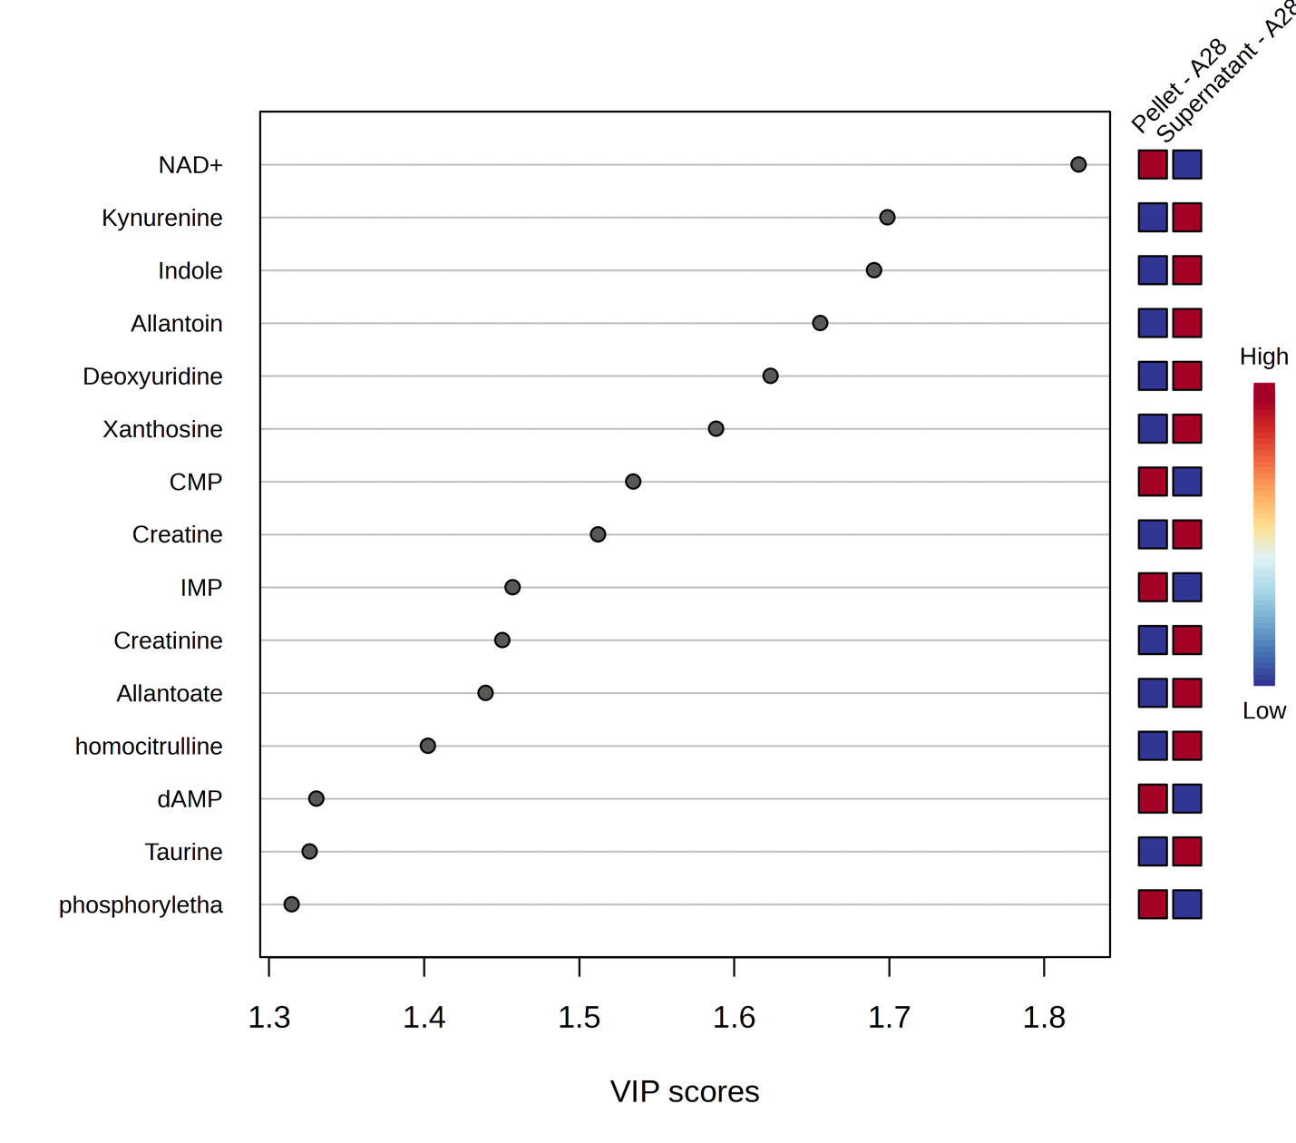
Figure 11: Variable importance in projection (VIP) score plot demonstrating the significance of metabolites in the PLS-DA model between two groups – pellets grown in EMJH (in-house) media and the supernatants at 28°C.

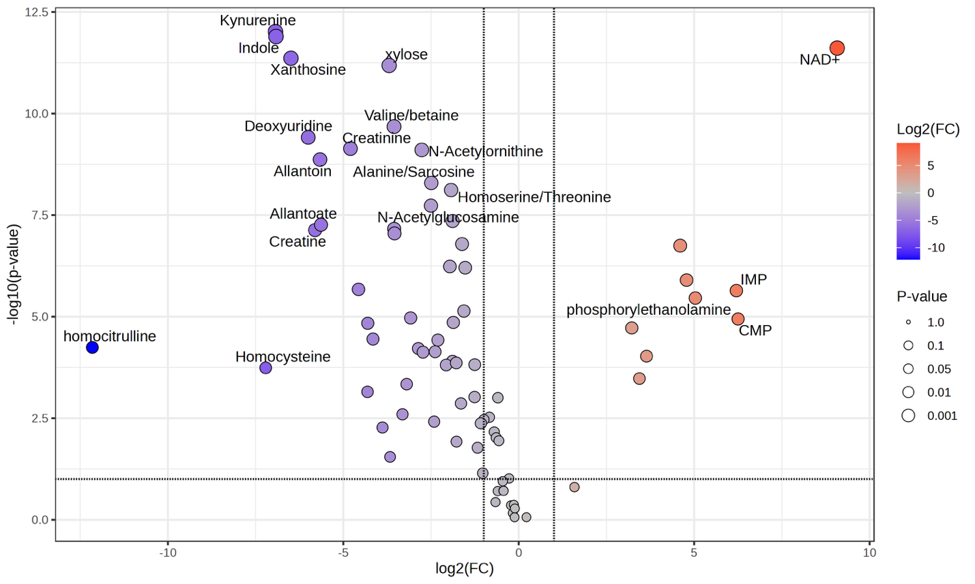
Figure 12: Volcano plot representing upregulation and downregulation of metabolites while comparing growth of leptospira cell pellets in EMJH (in-house) and its supernatant at 28°C. On x-axis, the log2 fold change of the ratio of pellets to supernatant is displayed.

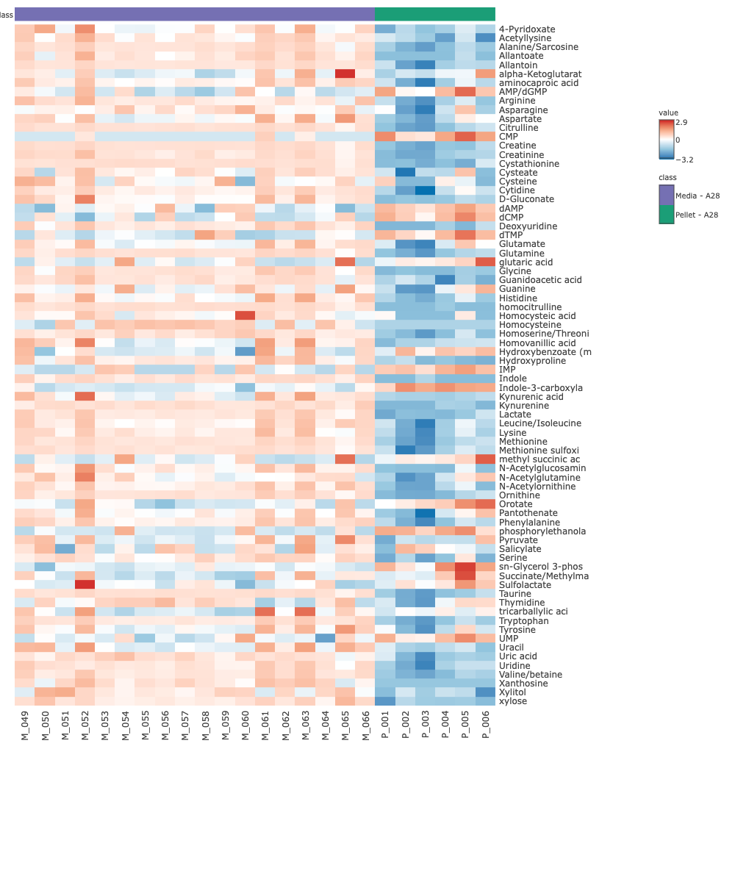
Figure 13: Visualization of metabolites abundance across the cell pellets in EMJH (in house) media and the control media EMJH (in house) at 28°C. The media EMJH (in house) is represented as “A”. Data underwent log2 transformation and pareto scaling.
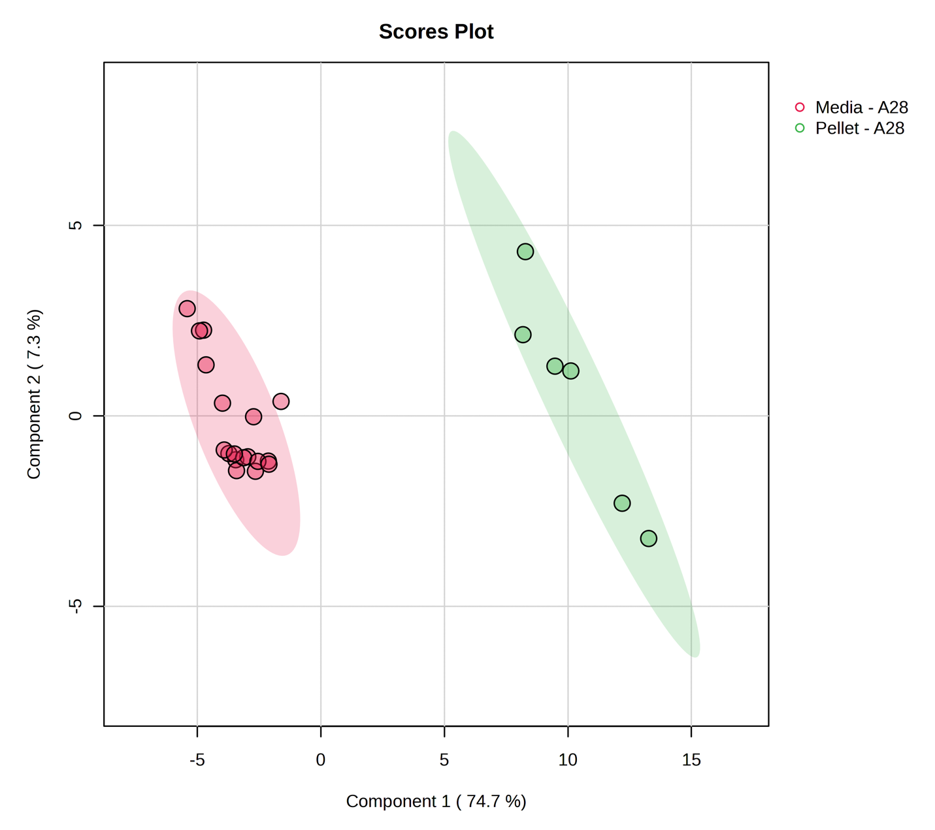
Figure 14: Partial Least Squares Discriminant Analysis PLS-DA plot shows 2 distinct groups between pellets grown in EMJH (in house) media and the media control. The multivariate analysis shows distinctive individual metabolic profile between the pellets and media grown in the EMJH (in house) media at 28°C.
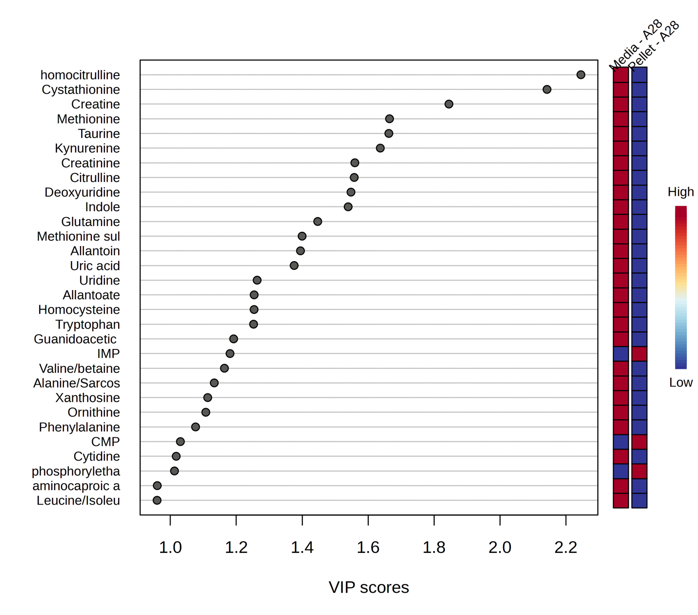
Figure 15: Variable importance in projection (VIP) score plot demonstrating the metabolites of significance in the PLS-DA model between two groups – pellets grown in EMJH (in-house) media and the media control at 28°C.

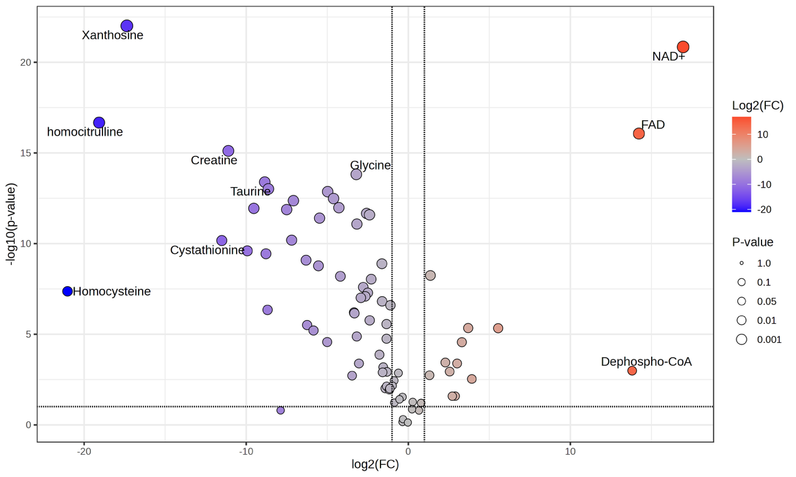

Figure 16: Volcano plot representing upregulation and downregulation of metabolites while comparing growth of leptospira cell pellets in EMJH (in-house) 28°C. On x-axis, the log2 fold change of the ratio of pellets to media control is displayed.

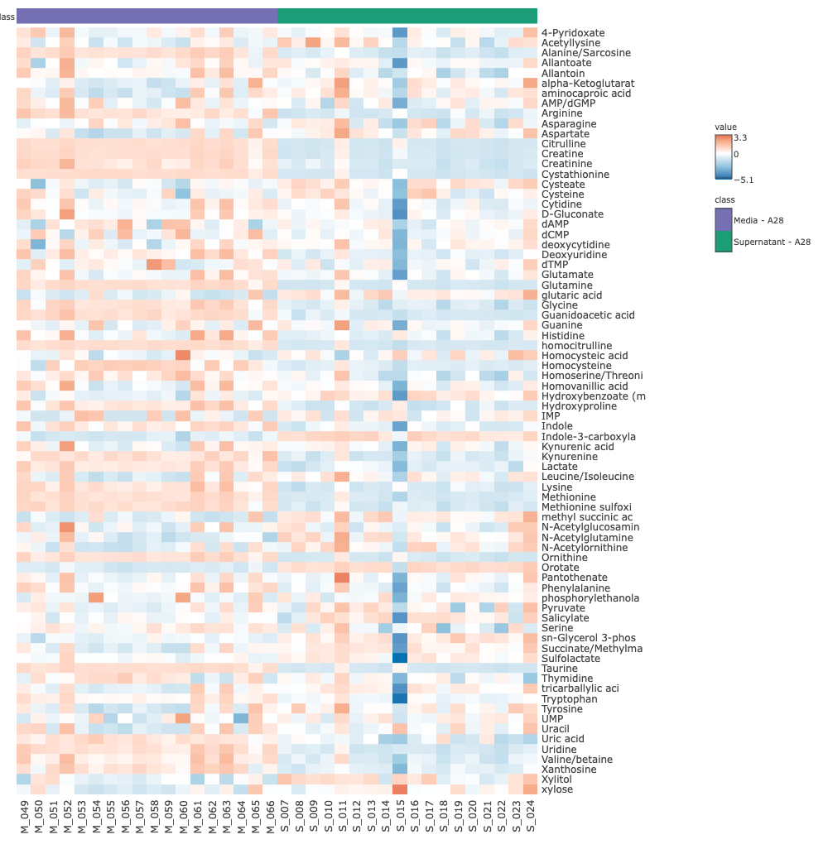
Figure 17: Visualization of metabolites abundance across the supernatant in EMJH (in house) media and the control media EMJH (in house) at 28°C. The media EMJH (in house) is represented as “A”. Data underwent log2 transformation and pareto scaling.
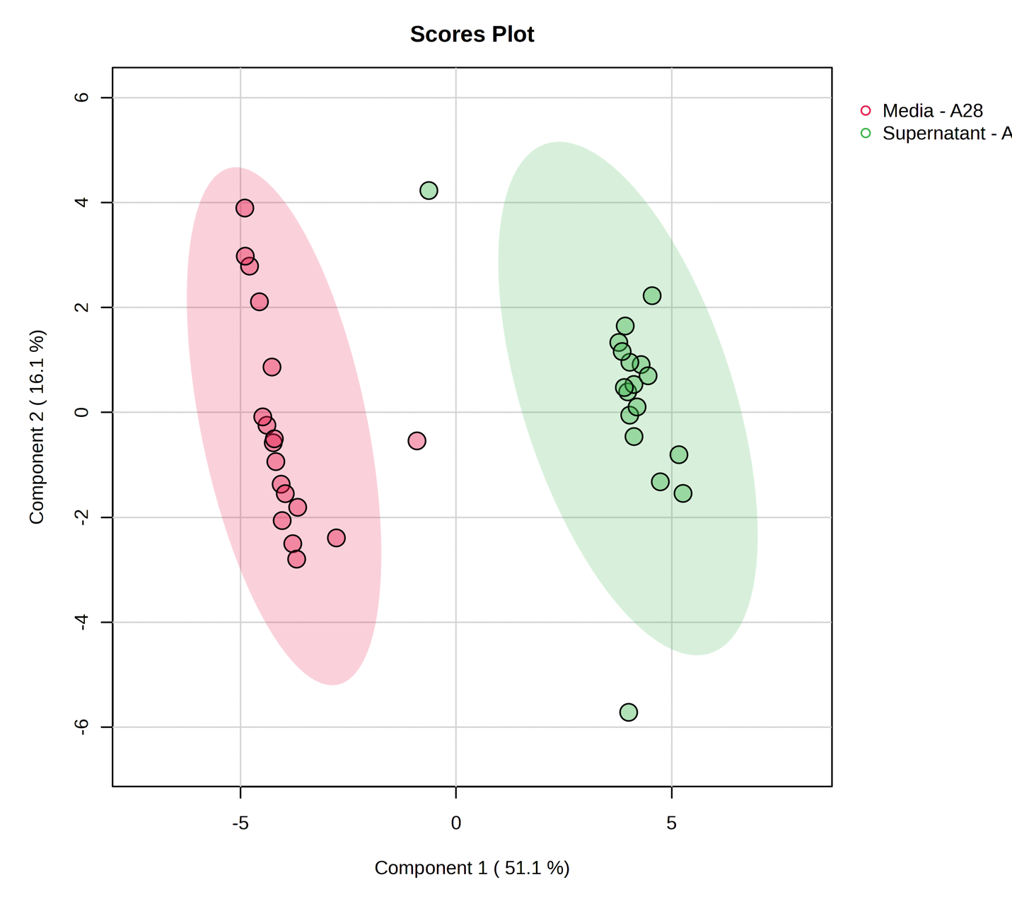
Figure 18: Partial Least Squares Discriminant Analysis PLS-DA plot shows 2 distinct groups between supernatant from cell culture in EMJH (in house) media, and the media control. The multivariate analysis shows distinctive individual metabolic profile between the supernatant and media grown in the EMJH (in house) media at 28°C

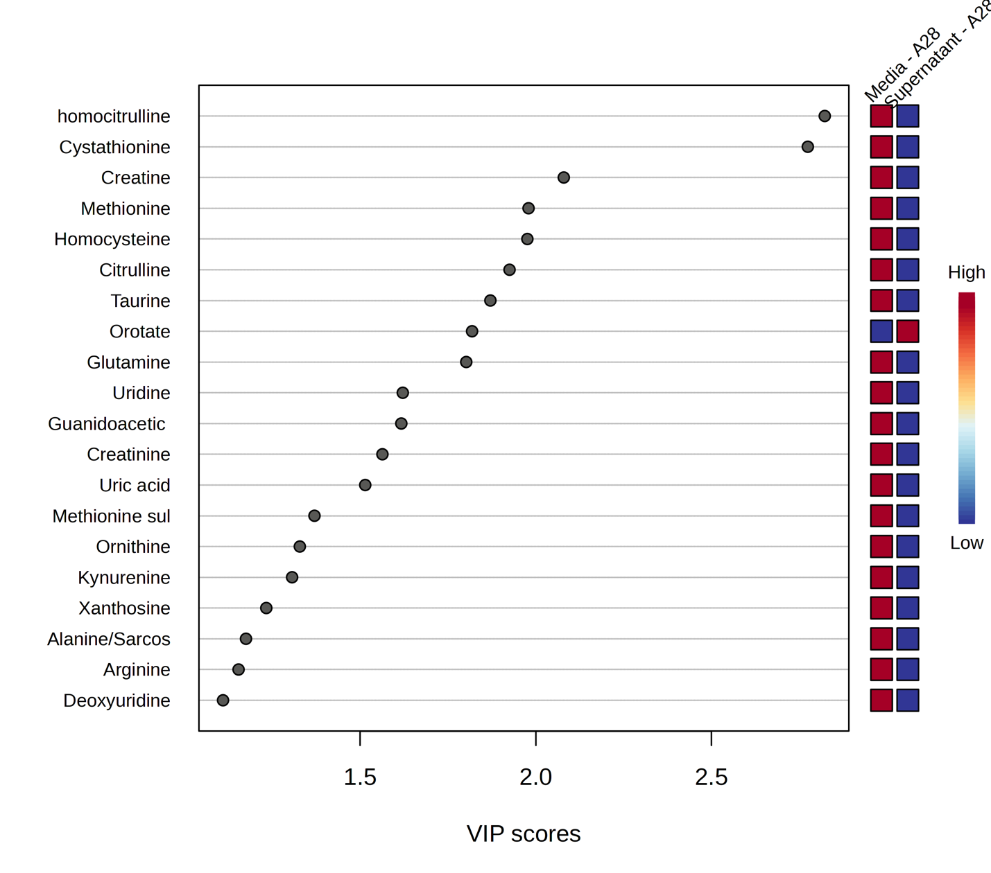
Figure 19: Variable importance in projection (VIP) score plot demonstrating the metabolites of significance in the PLS-DA model between two groups – supernatant from cells grown in EMJH (in-house) media and the media control at 28°C.

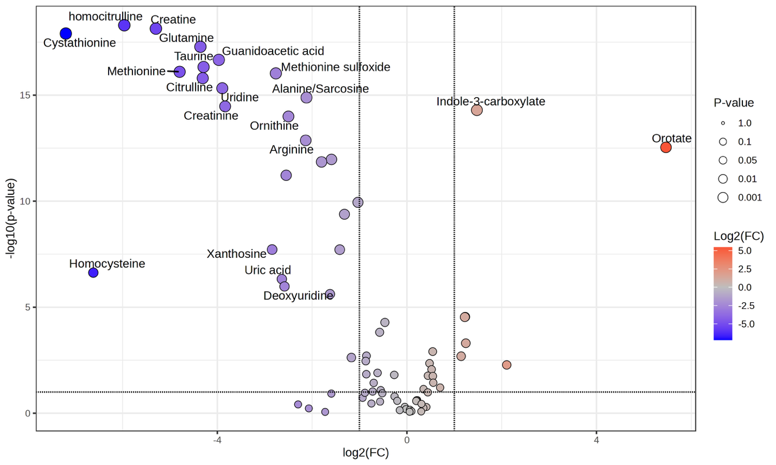
Figure 20: Volcano plot representing upregulation and downregulation of metabolites while comparing leptospira supernatants in EMJH (in-house) 28°C after the inoculated cells are separated. On x-axis, the log2 fold change for the ratio of supernatant to media control is displayed.

Orotate was upregulated in the supernatant. It is a key component in pyrimidine biosynthesis which is a precursor to RNA and DNA neucleotides.^{79,80} Higher abundance of orotate in supernatant can be attributed to the bioavailability of nucleotide that could be utilized for pyrimidine biosynthesis.⁸¹ Detection and upregulation of indole-3-carboxylate in supernatant (Figure 20) could suggest the utilization of amino acid degradation pathways that was used to secrete this metabolite. It is often associated with bacterial stress response.⁸²
Comparison between Pellet and Supernatant in EMJH (in house) at 37°C
The visualization for the comparison between pellet and supernatant from Leptospira inoculation in EMJH (in house) at 37°C is displayed via the heatmap, PLS-DA, VIP score plot, and volcano plot in Figure 21-24.
In the volcano plot (Figure 24), upregulation of IMP, phosphoryl ethanolamine, CMP in pellet is observed while cells are grown in EMJH (in house) at 37°C. This is consistent with the notion of bioenergetic driven metabolite utilization for growth. However, the VIP score plots (Figure 23) shows that the major drivers for separation between these pellet and media at 37°C are different from the ones at 28°C (Figure 15) which leads to the proposal of different nutrient availability at different temperatures.
Comparison between Pellet and Media in EMJH (Difco) at 28°C
The next comparison that was carried out was between the pellet grown in commercial media EMJH (Difco) at 28°C and the control media. The visualization of this comparison is displayed via the heatmap, PLS-DA, VIP score plot, and volcano plot in Figure 25-28.
Comparison between the pellets grown in EMJH (Difco) at 28°C and the media shows that CMP, ADP-glucose, UDP-glucose, and phosphoryl ethanolamine have both a higher abundance and are significant according to the p-values in volcano plot in (Figure 28) in pellets. Detection and upregulation of ADP-Glucose and UDP-glucose shows evidence of starch metabolism when cells are grown in EMJH (Difco media) at 28°C. Both ADP-glucose, and UDP-glucose serves intermediary in glycogen synthesis pathway in order to preserve energy in unfavorable environment.⁸³ Detection of phosphoryl ethanolamine and upregulation of it is congruent with the pellet metabolic upregulation in EMJH (in-house) media at 28°C. Leptospira grown at 28°C in both EMJH (in house) and EMJH (Difco) media shows evidence of upregulation of phosphoryl ethanolamine suggest that it is integral for their structural maintenance.
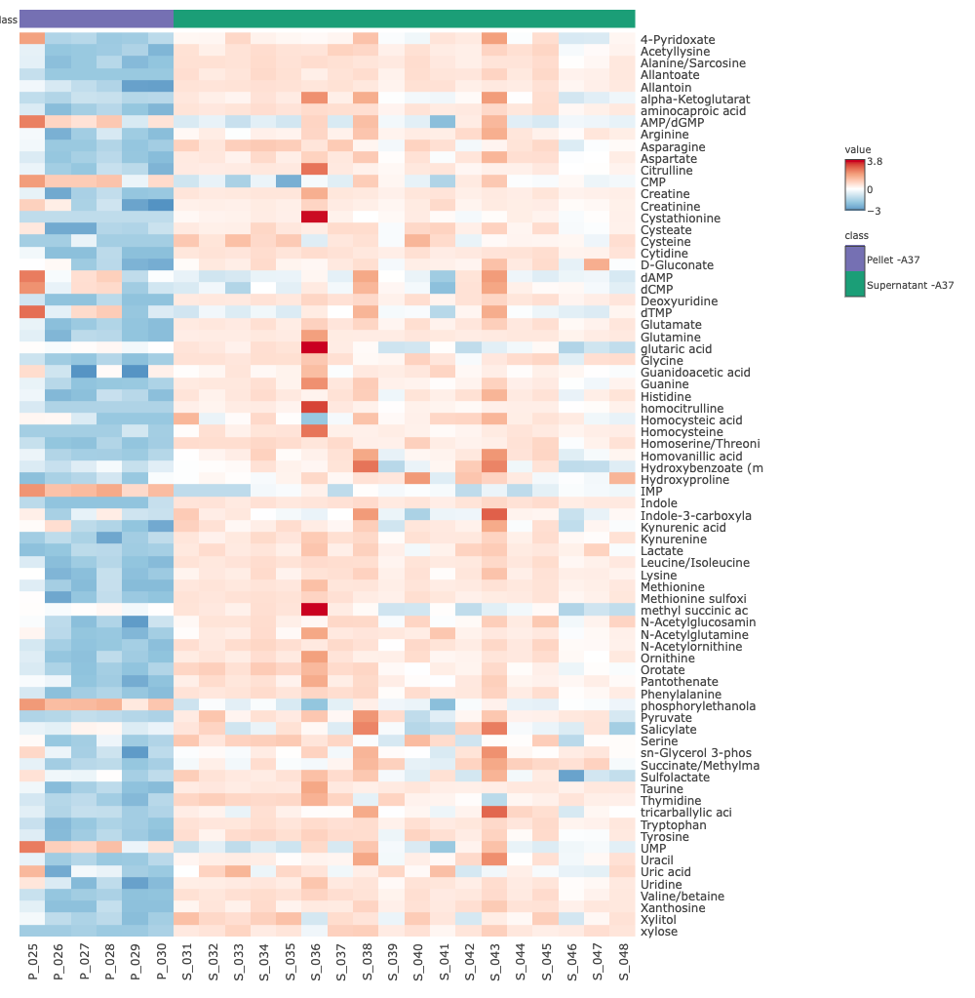
Figure 21: Visualization of metabolites abundance across the pellets grown in EMJH (in house) media and its supernatant 37°C. The media EMJH (in house) is represented as “A”. Data underwent log2 transformation and pareto scaling.

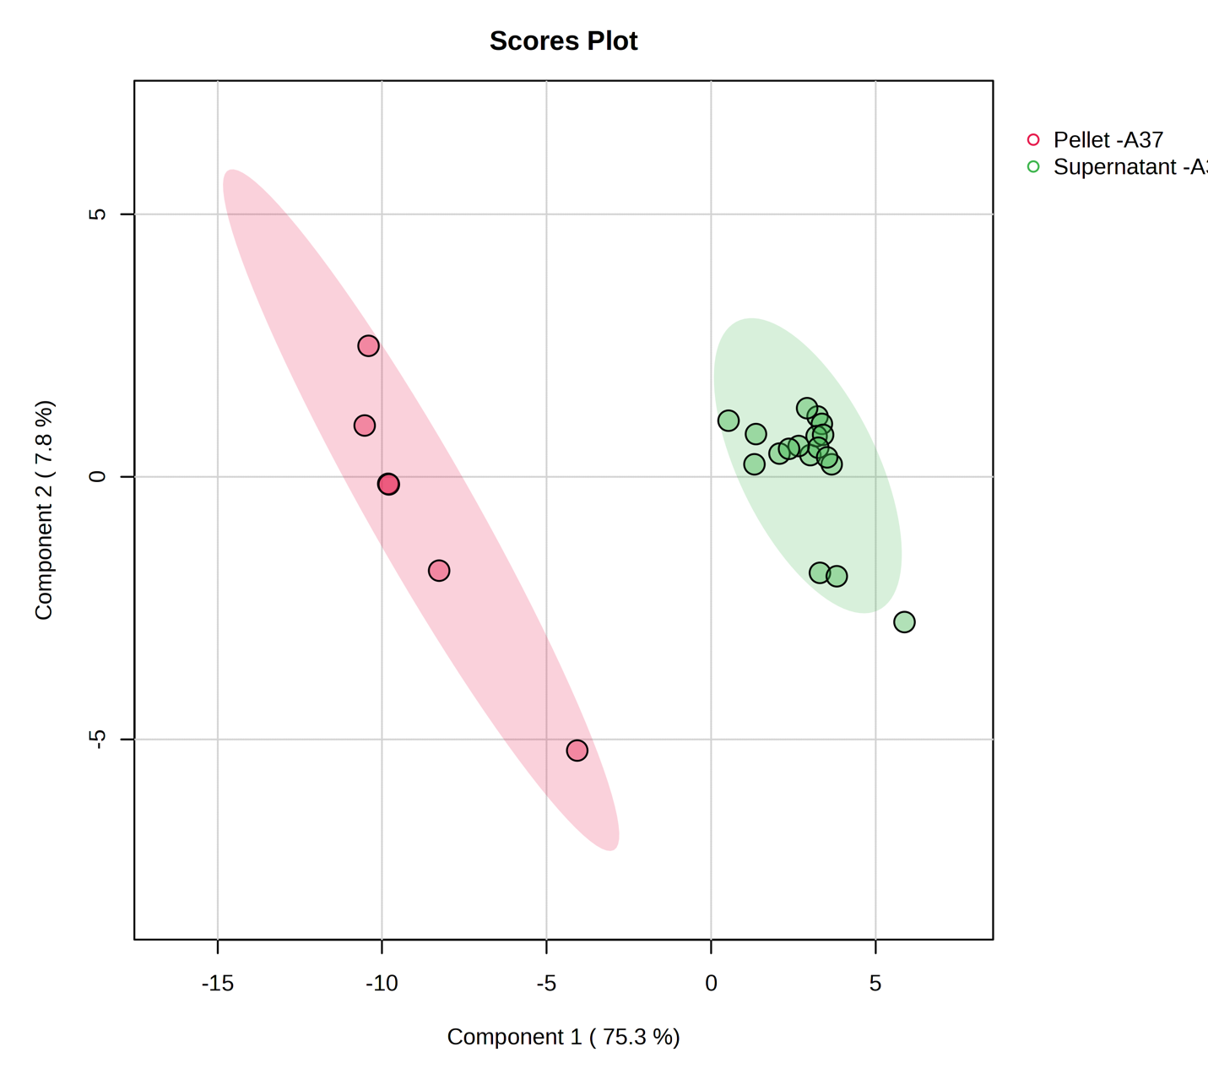
Figure 22: Partial Least Squares Discriminant Analysis PLS-DA plot shows 2 distinct groups between pellets from cell culture in EMJH (in house) media, and its supernatant. The multivariate analysis shows distinctive individual metabolic profile between the supernatant and media grown in the EMJH (in house) media at 37°C

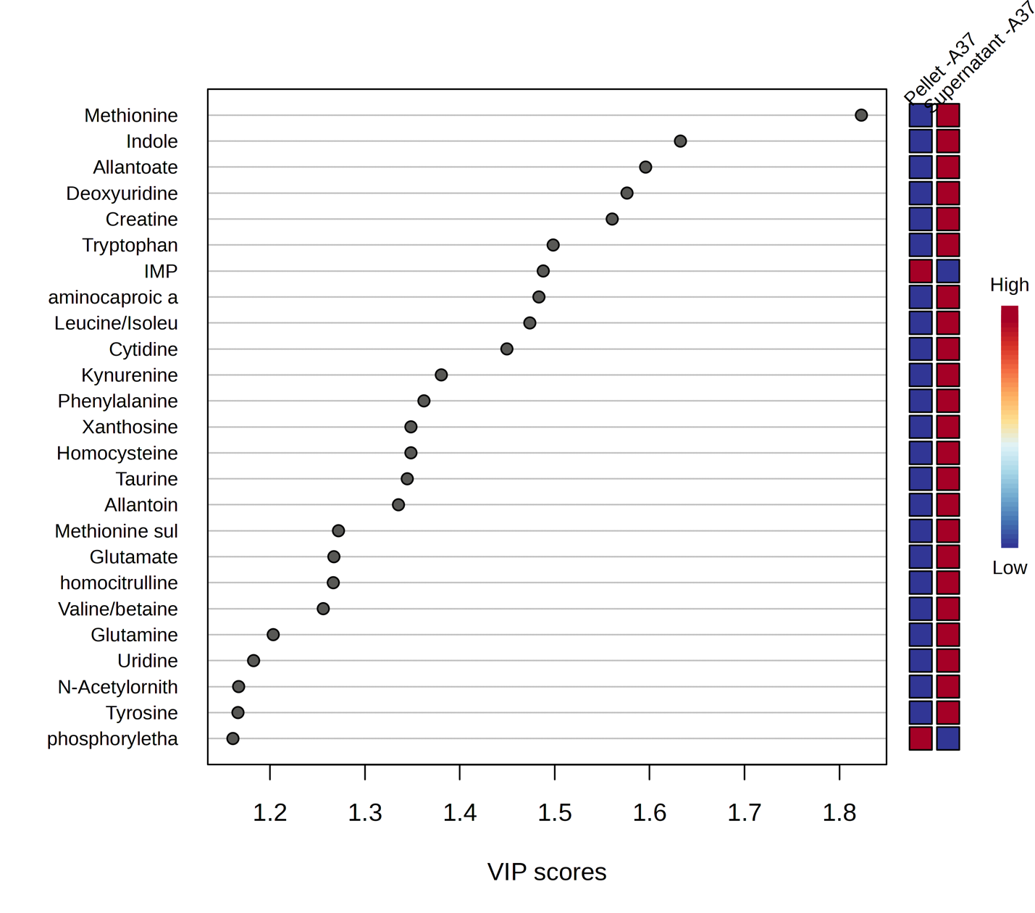
Figure 23: Variable importance in projection (VIP) score plot demonstrating the metabolites of significance in the PLS-DA model between two groups –cells pellets grown in EMJH (in-house) media and the supernatant at 37°C.

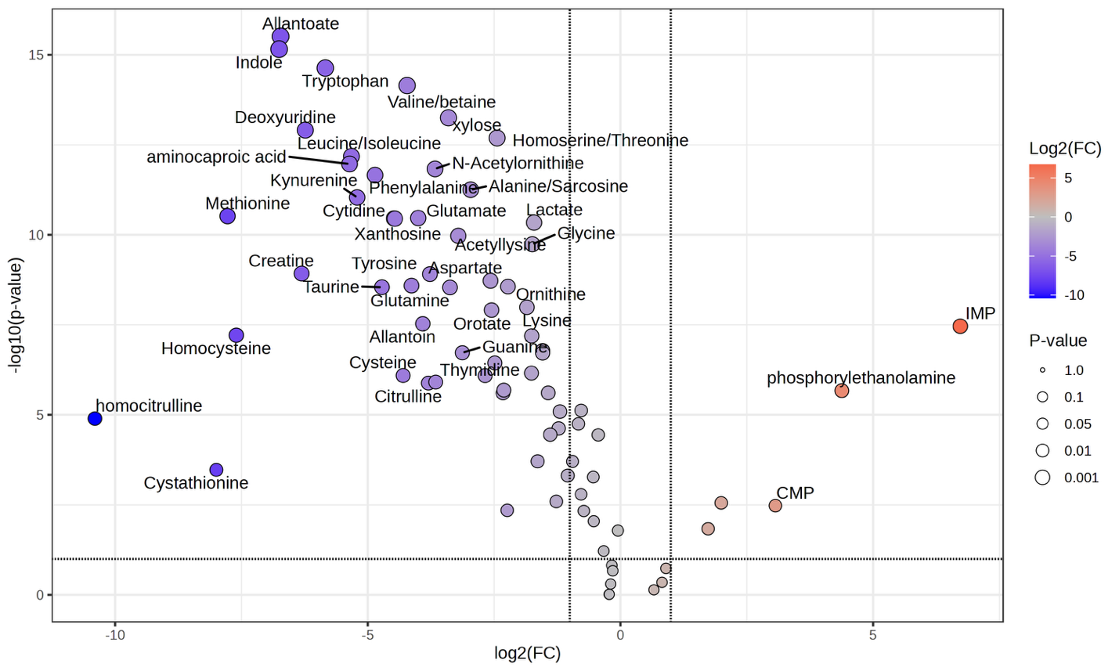
Figure 24: Volcano plot representing upregulation and downregulation of metabolites while comparing leptospira pellets in EMJH (in-house) 37°C. and its supernatant after the inoculated cells are separated. On x-axis, the log2 fold change for the ratio of pellets to supernatants is displayed.
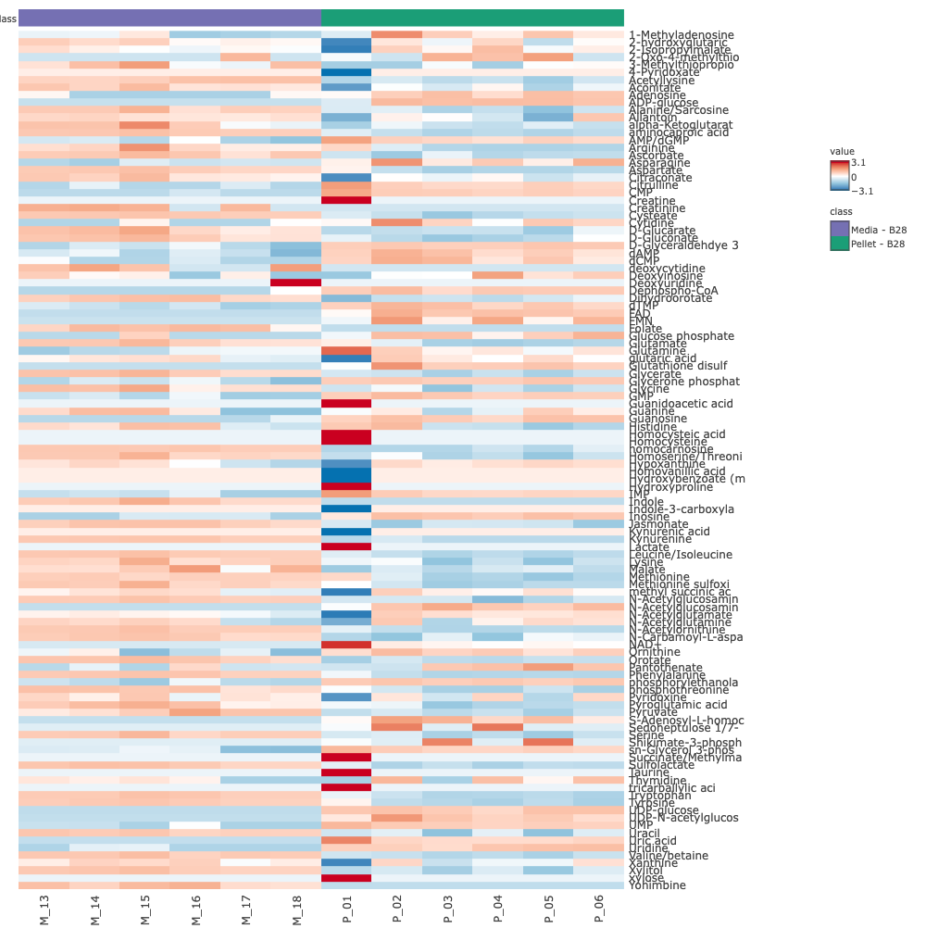
Figure 25: Visualization of metabolites abundance across the pellets grown in EMJH (Difco) media and the media at 28°C. The media EMJH (Difco) is represented as “B”. Data underwent log2 transformation and pareto scaling.
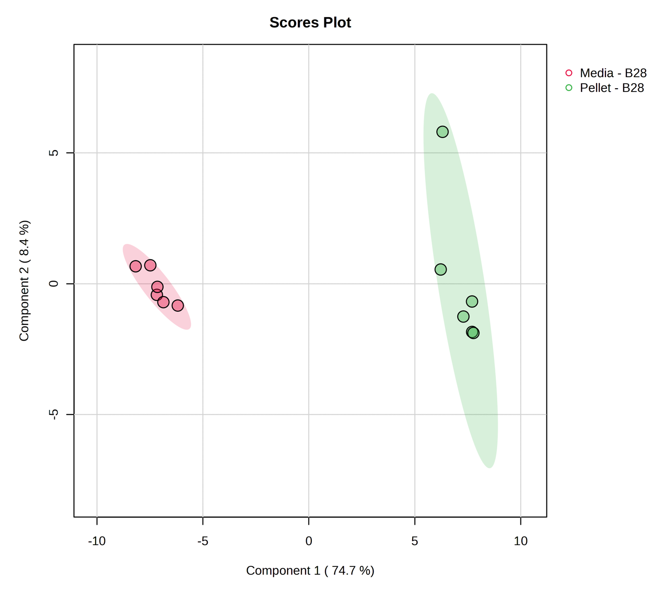Figure 26: Partial Least Squares Discriminant Analysis PLS-DA plot shows 2 distinct groups between pellets from cell culture in EMJH (Difco) media, and the media control. The multivariate analysis shows distinctive individual metabolic profile between the supernatant and media grown in the EMJH (in house) media at 28°C.

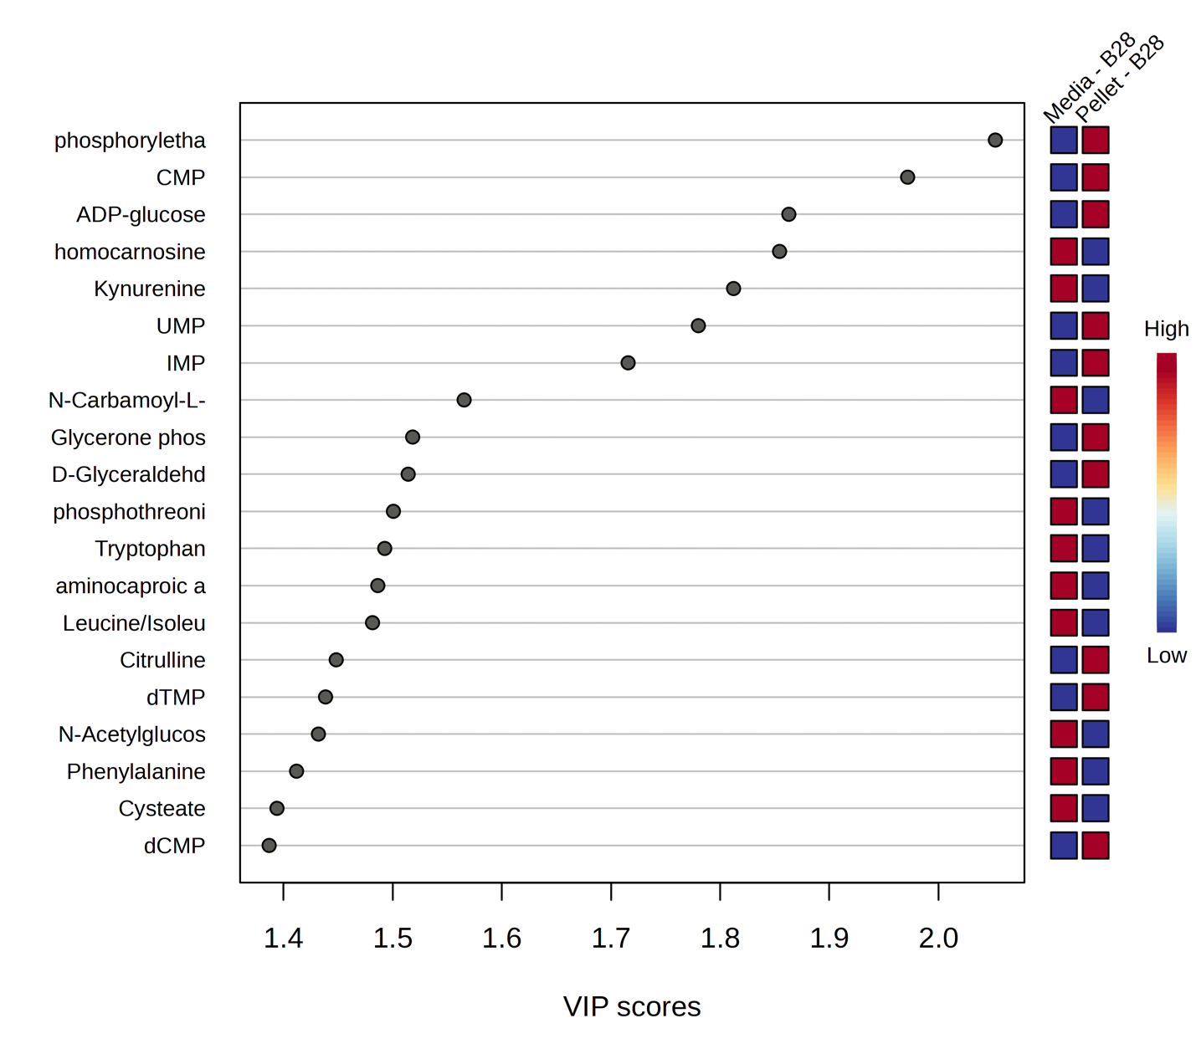Figure 27: Variable importance in projection (VIP) score plot demonstrating the metabolites of significance in the PLS-DA model between two groups – pellets from cells grown in EMJH (Difco) media and the media control at 28°C.

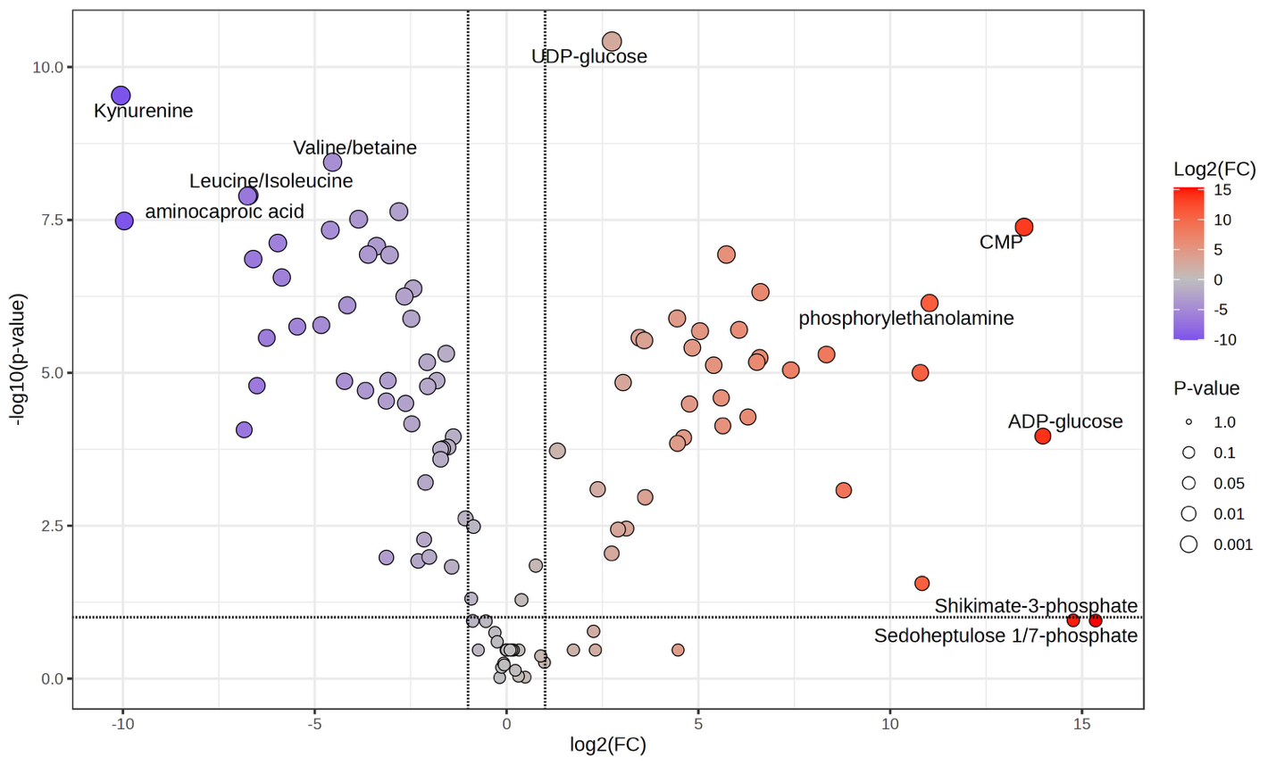
Figure 28: Volcano plot representing upregulation and downregulation of metabolites while comparing leptospira cell pellets in EMJH (Difco) 28°C and the media respectively. On x-axis, the log2 fold change of the ratio of pellet to media control is displayed.
Comparison between Pellet and Supernatant in EMJH (Difco) at 28°C
Comparison between the contents of pellet and the supernatant collected from the inoculation of leptospira in EMJH (Difco) media at 28°C illustrates the intracellular and extracellular metabolic alterations. The visualization of this comparison is displayed via the heatmap, PLS-DA, VIP score plot, and volcano plot in Figure 29-32. The volcano plot (Figure 32) shows the upregulation of glutathione disulfide and FMN in the pellets. Glutathione disulfide plays a key role in regulating cellular redox balance under oxidative stress.⁸⁴ Glutathione disulfide can potentially be a biomarker of oxidative stress in this case. Moreover, The other upregulated metabolite FMN (flavin mononucleotide) is an essential riboflavin derived cofactor that is involved in redox reaction when Vitamin B-12 is not readily available to the specimen.⁸⁵ The long list of metabolites upregulated in the supernatant could suggest that the nutrients available to the strain were not utilized sufficiently for the growth hence under an unfavorable yet growth compatible environment, the pellets displayed a stress response.
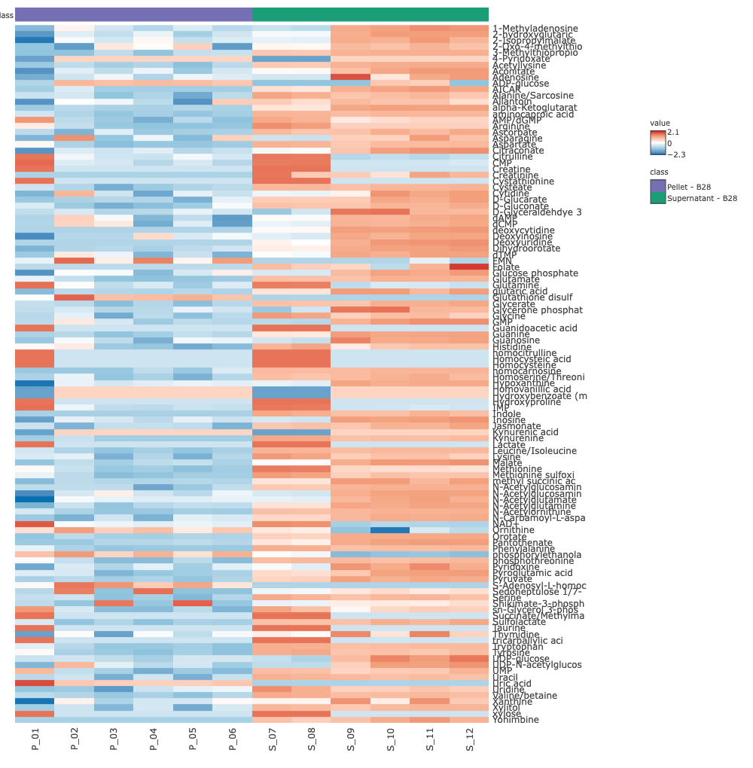
Figure 29: Visualization of metabolites abundance across the pellets grown in EMJH (Difco) media and supernatants at 28°C. The media EMJH (Difco) is represented as “B”. Data underwent log2 transformation and pareto scaling.
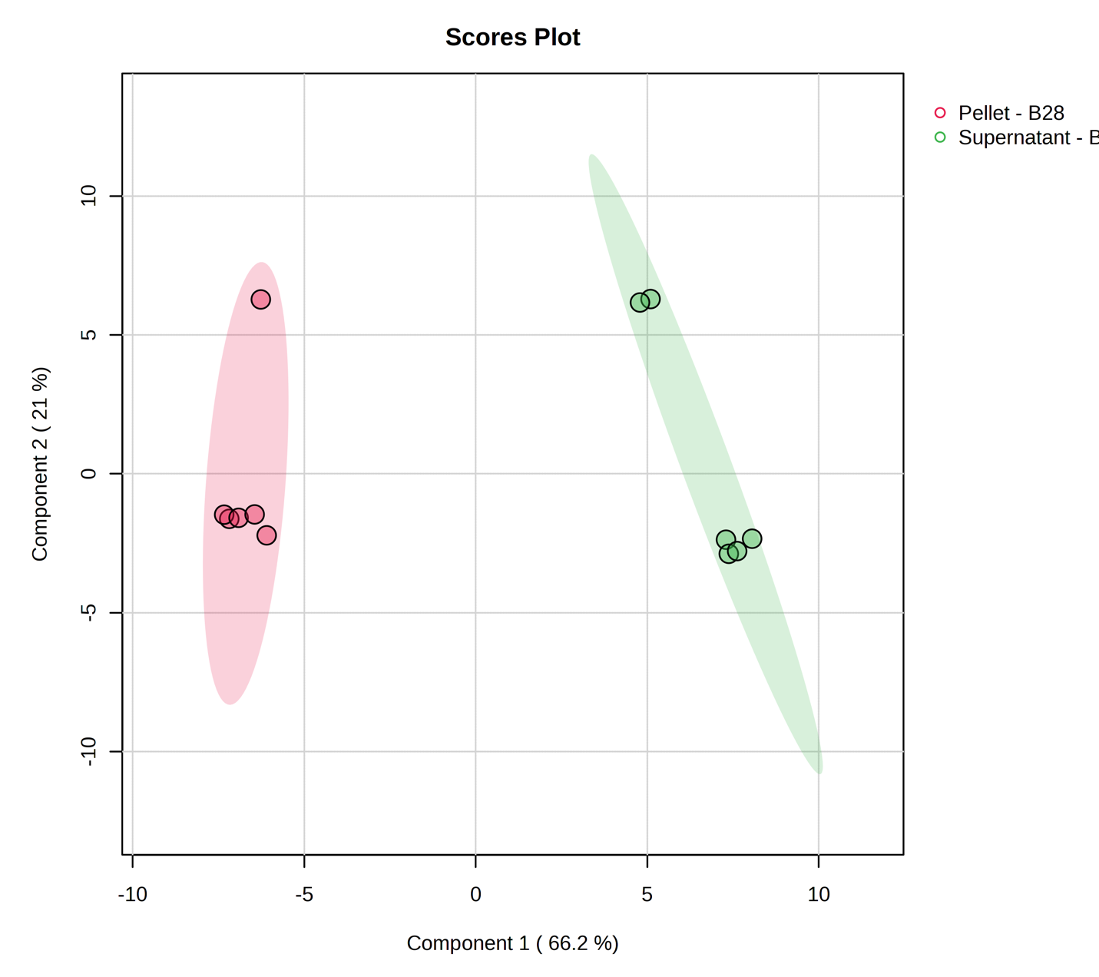
Figure 30: Partial Least Squares Discriminant Analysis PLS-DA plot shows 2 distinct groups between supernatant from cell culture in EMJH (Difco) media, and the cell pellets of inoculated leptospira. The multivariate analysis shows distinctive individual metabolic profile between the supernatant and pellets grown in the EMJH (Difco) media at 28°C
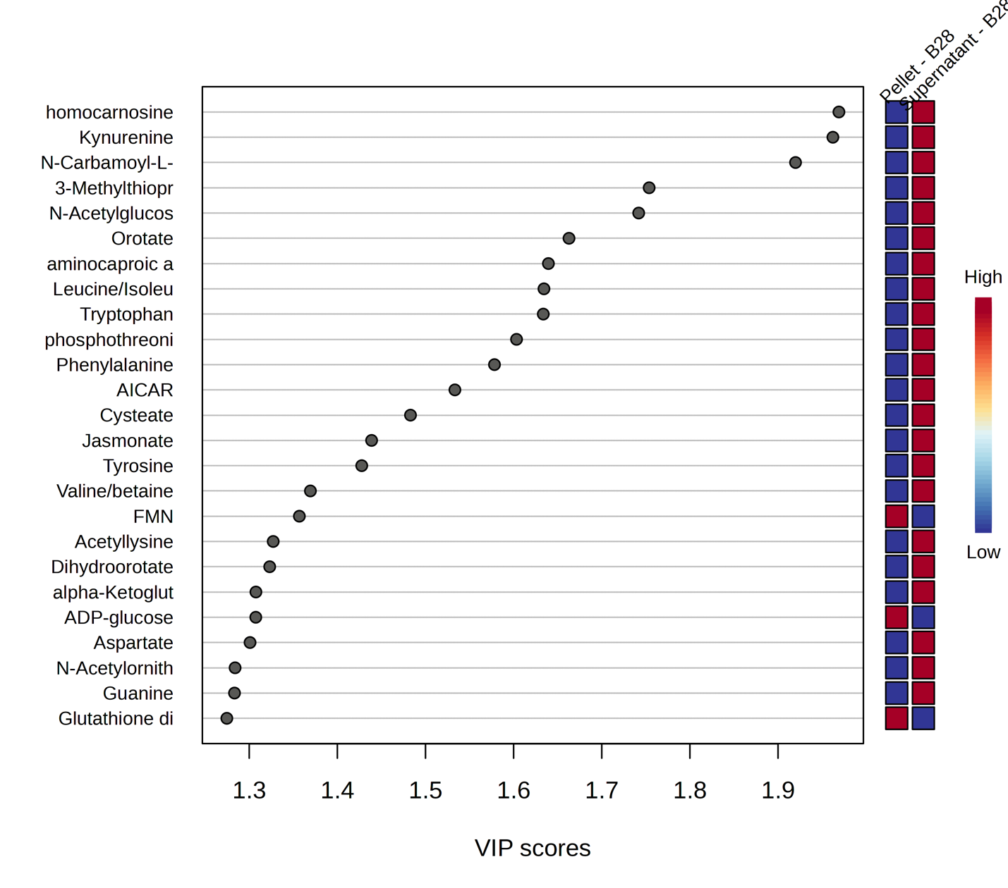

Figure 31: Variable importance in projection (VIP) score plot demonstrating the metabolites of significance in the PLS-DA model between two groups – pellets and supernatant from cells grown in EMJH (Difco) media at 28°C.
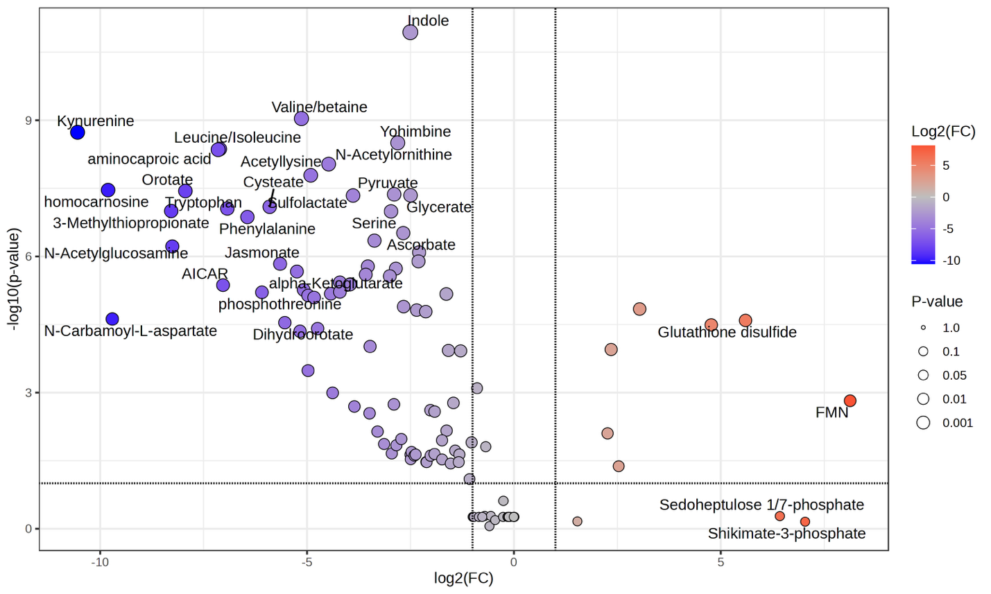
Figure 32: Volcano plot representing upregulation and downregulation of metabolites while comparing leptospira pellets and supernatants in EMJH (Difco) 28°C On x-axis, the log2 fold of the ratio of pellet to supernatant is given.
Comparison between Supernatant and Media in EMJH (Difco) at 28°C
The visualization for the comparison between supernatant from Leptospira inoculation in EMJH (Difco) at 28°C is displayed via the heatmap, PLS-DA, VIP score plot, and volcano plot in Figure 33-36.
The volcano plot (Figure 36) shows several metabolites upregulated in the supernatant. Most of the metabolites upregulated in the supernatant can be attributed to the arginine and pyrimidine biosynthesis pathway. Chiefly citrulline, N-carbamoyl-l-aspartate are essential to the arginine biosynthesis pathway. The catabolism of arginine pathway utilization is a major source of nitrogen for pathogen in order to obtain nitrogen containing compounds when there is a lower availability of glutamate and glutamine.⁸⁶
Downstream product of arginine catabolism could also lead to pyrimidine metabolism pathway. Pyrimidine pathway products and involved enzymes are a quintessential for cell activity in pathogen, majorly in cell division.⁷⁹

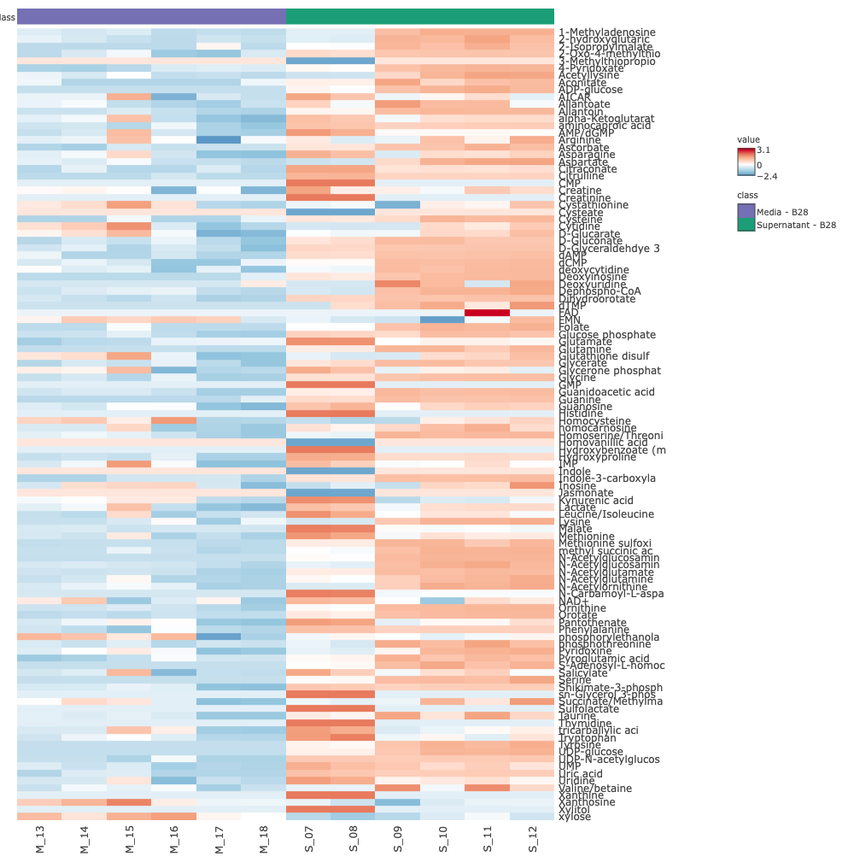

Figure 33: Visualization of metabolites abundance across the pellets grown in EMJH (Difco) media and media control at 28°C. The media EMJH (Difco) is represented as “B”. Data underwent log2 transformation and pareto scaling.
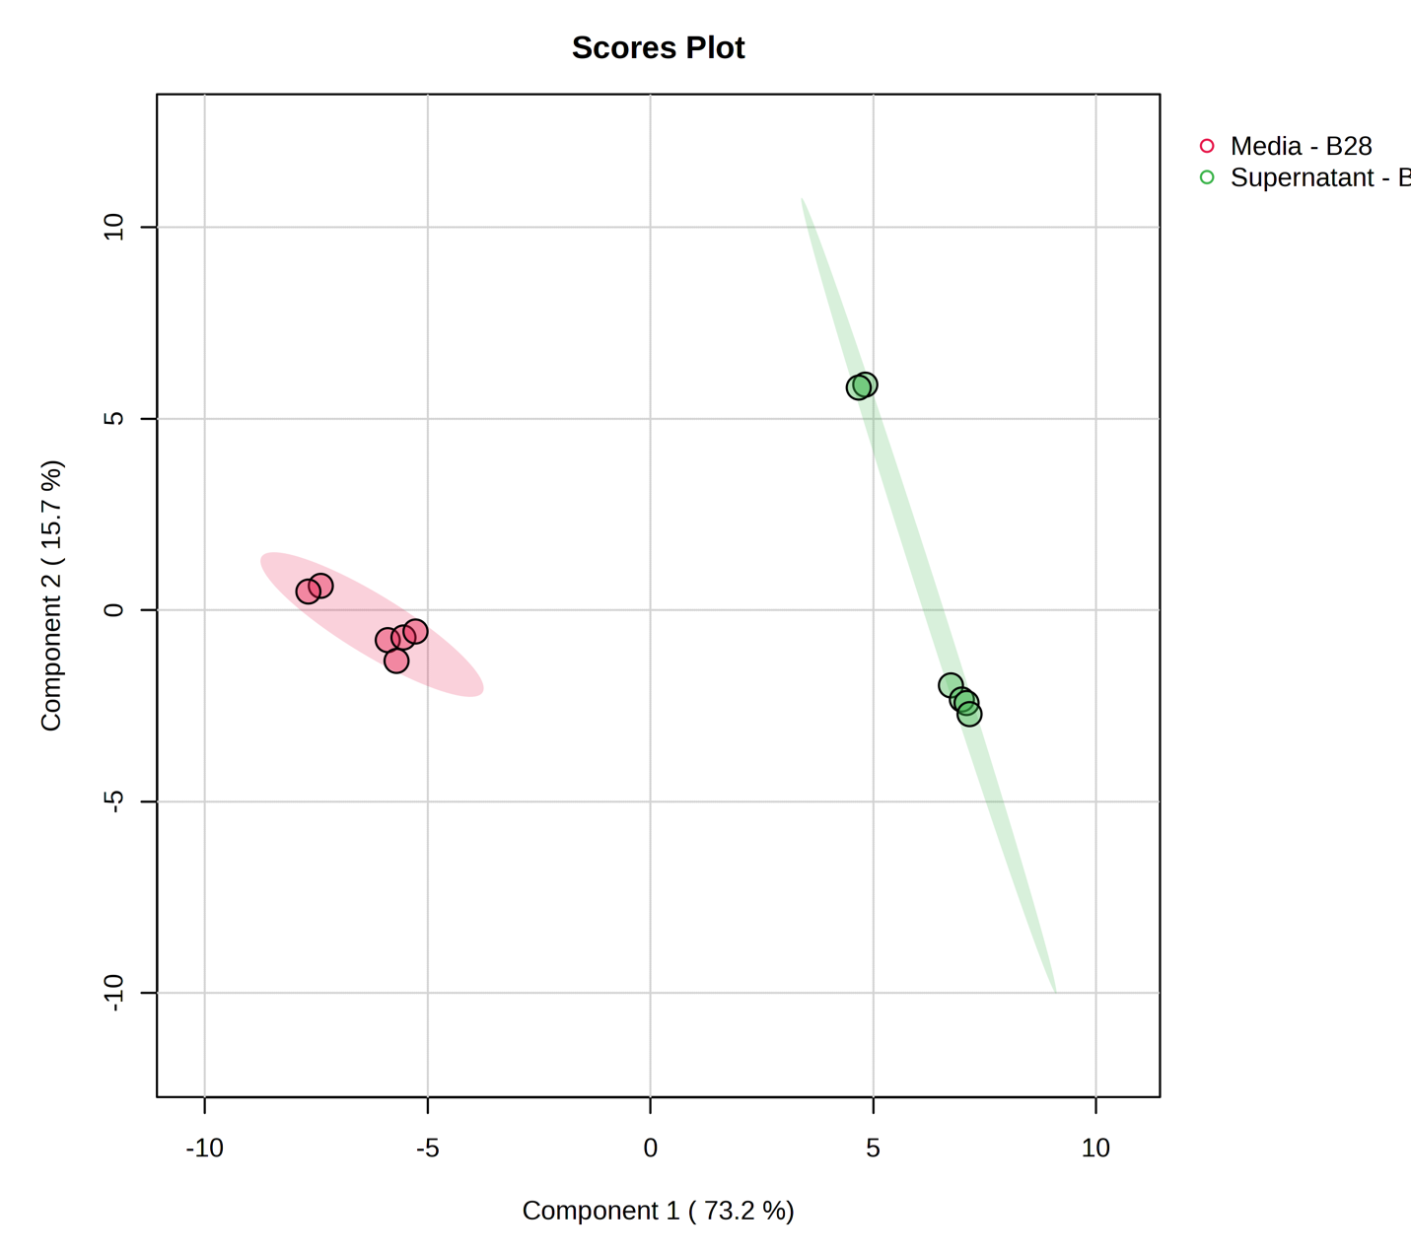
Figure 34: Partial Least Squares Discriminant Analysis PLS-DA plot shows 2 distinct groups between supernatant from cell culture in EMJH (in house) media, and the media control. The multivariate analysis shows distinctive individual metabolic profile between the supernatant and media grown in the EMJH (in house) media at 28°C.
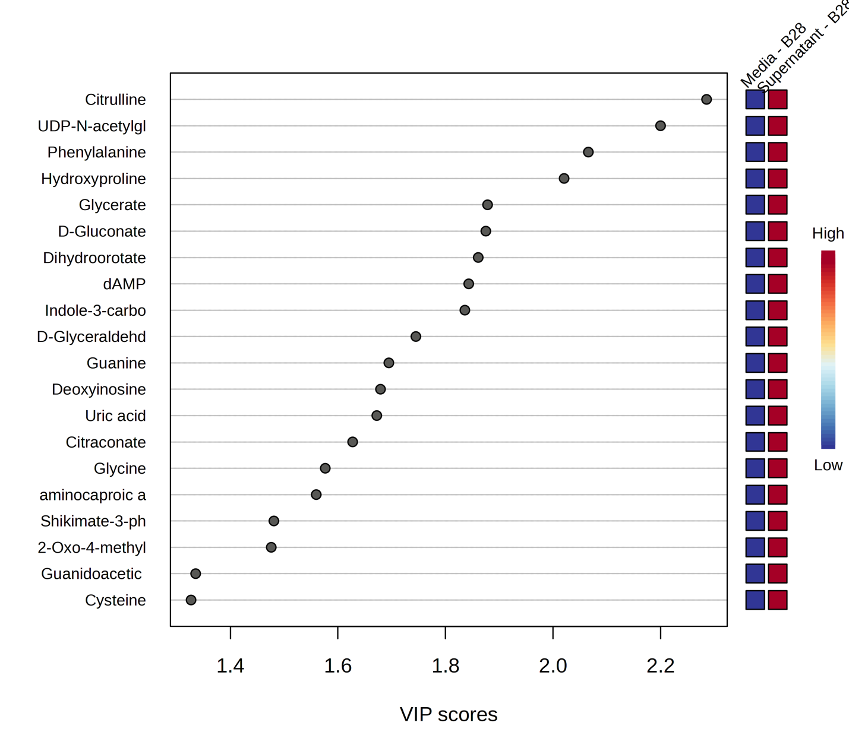
Figure 35: Variable importance in projection (VIP) score plot demonstrating the metabolites of significance in the PLS-DA model between two groups – media control and supernatant from cells grown in EMJH (Difco) media at 28°C.

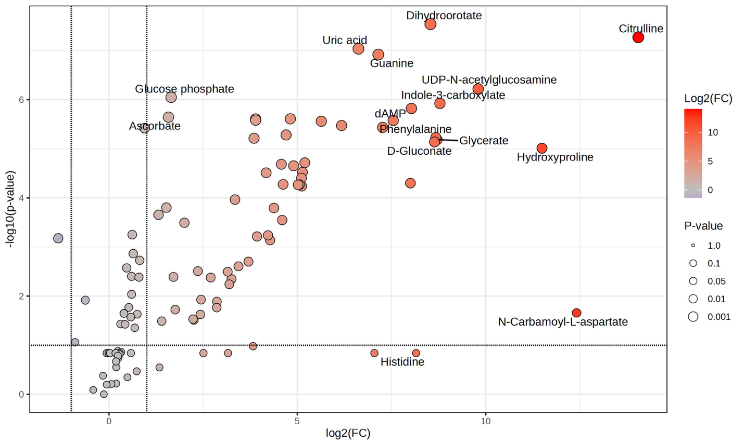
Figure 36: Volcano plot representing upregulation and downregulation of metabolites while comparing leptospira supernatants in EMJH (Difco) 28°C after the inoculated cells are separated. On x-axis, the log2 fold change of the ratio of supernatant to media control is plotted.
Comparison between Supernatant and Media in EMJH (Difco) at 37°C
The visualization for the comparison between the extracellular contents and the control media at 37°C is displayed in Figure 37-41 via heatmap, PLS-DA (2D & 3D), VIP score plot, and volcano plot. The volcano plot (Figure 41) shows a higher abundance of several metabolites in the media. This could be ascribed to unutilized nutrients from the media. Most of these are associated with the cysteine, pyruvate, pyrimidine, or purine metabolic pathways. No evidence of growth was observed in this media – temperature combination of EMJH (Difco) – 37°C. This confirms the statement that at 37°C the nutrient unavailability is a major factor that becomes insufficient to facilitate growth of leptospira.
5. Inter-condition comparison for each sample fraction
In this section, each type of sample fractions (pellets, supernatants, control media fractions) are put together against their growth condition. Table 2 enlists the comparisons were carried out to achieve this analysis.
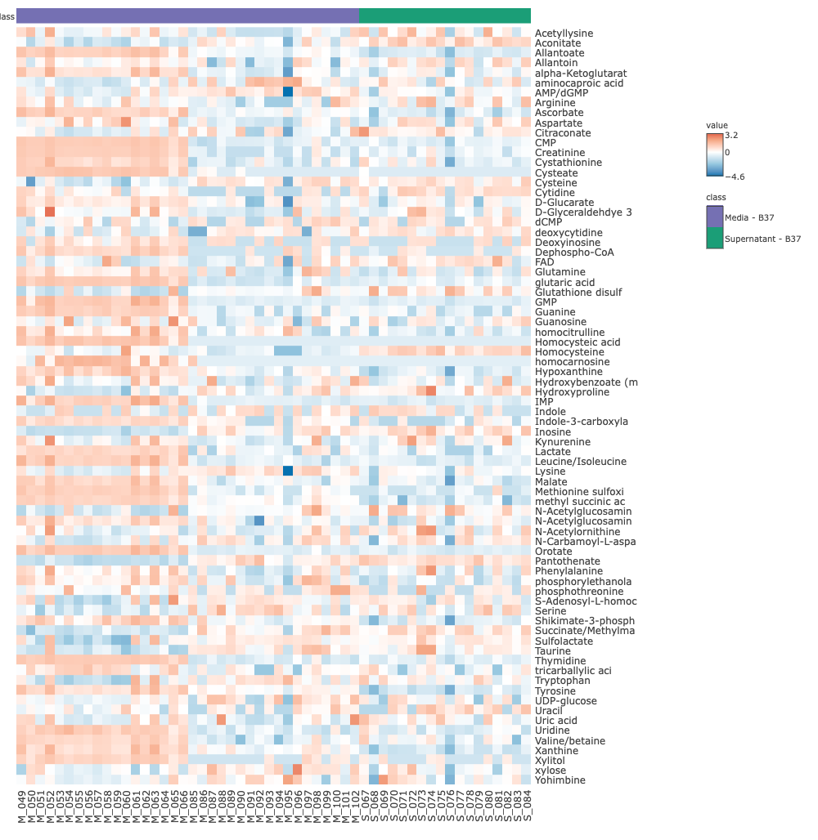
Figure 37: Visualization of metabolites abundance across the supernatants separated from the cell pellets grown in EMJH (Difco) media and media control at 37°C. The media EMJH (Difco) is represented as “B”. Data underwent log2 transformation and pareto scaling.
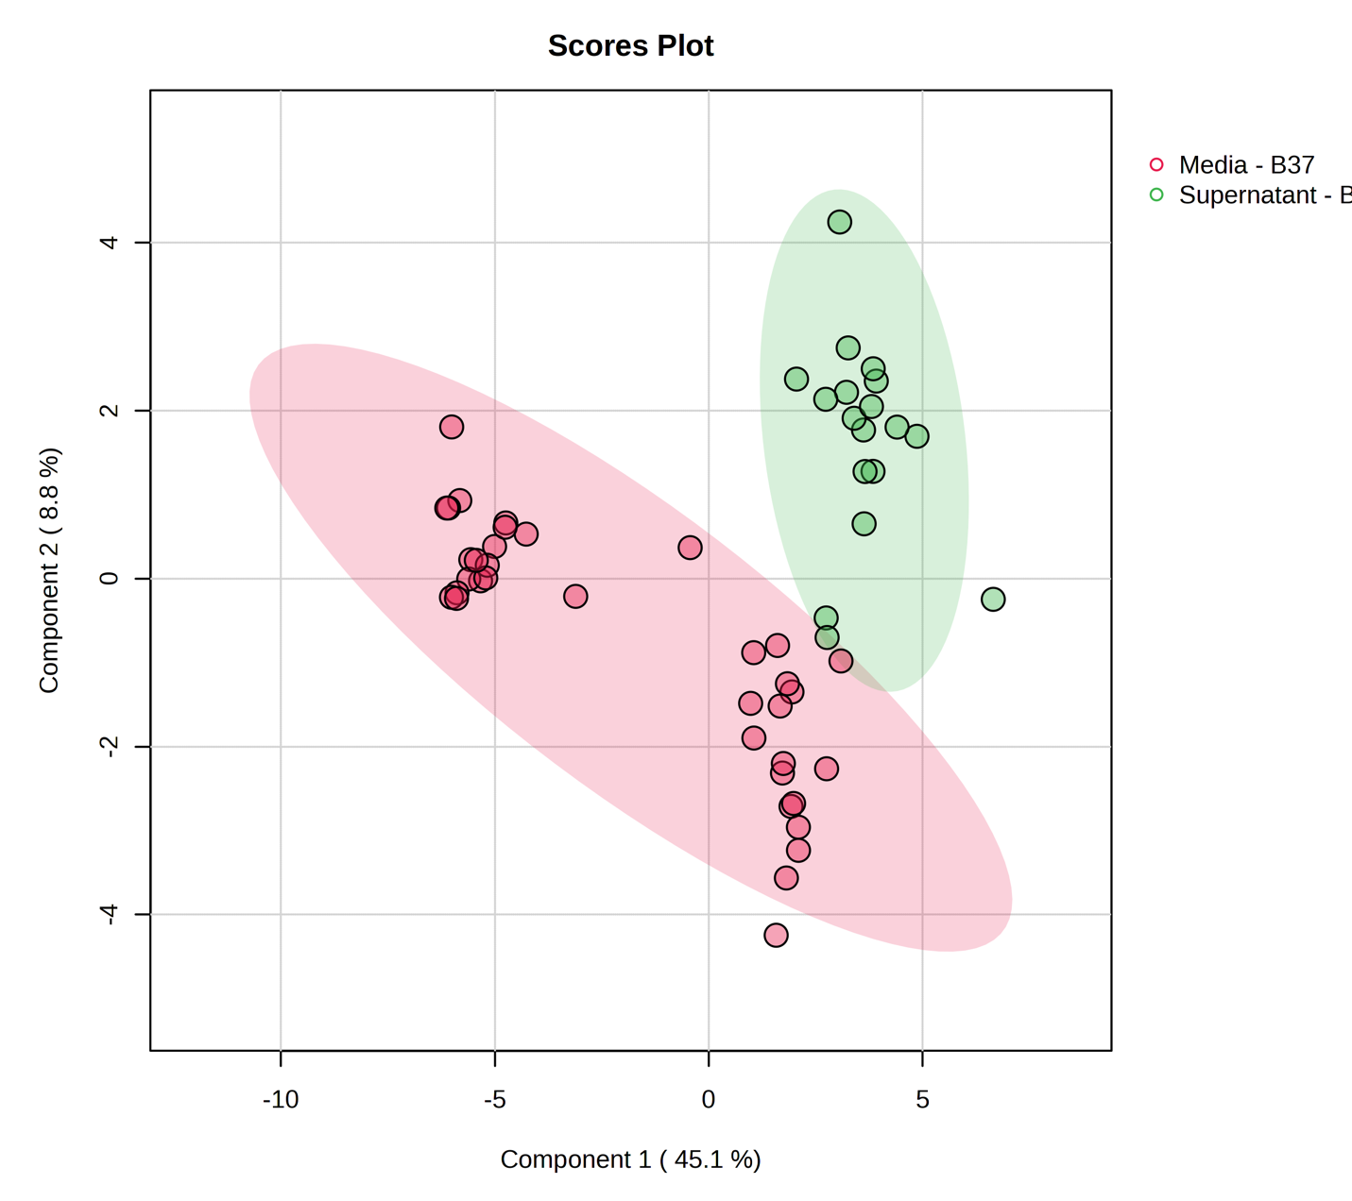
Figure 38: Partial Least Squares Discriminant Analysis PLS-DA plot shows 2 distinct groups between supernatant from cell culture in EMJH (in house) media, and the media control. The multivariate analysis shows distinctive individual metabolic profile between the supernatant and media grown in the EMJH (in house) media at 28°C.
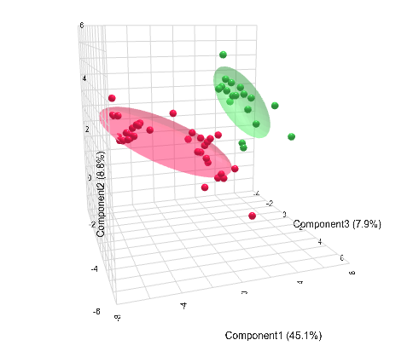
Figure 39: Three-dimensional representation of the PLS-DA for improved visualization of the separation between two groups – supernatant and media EMJH (Difco) at 37°C.

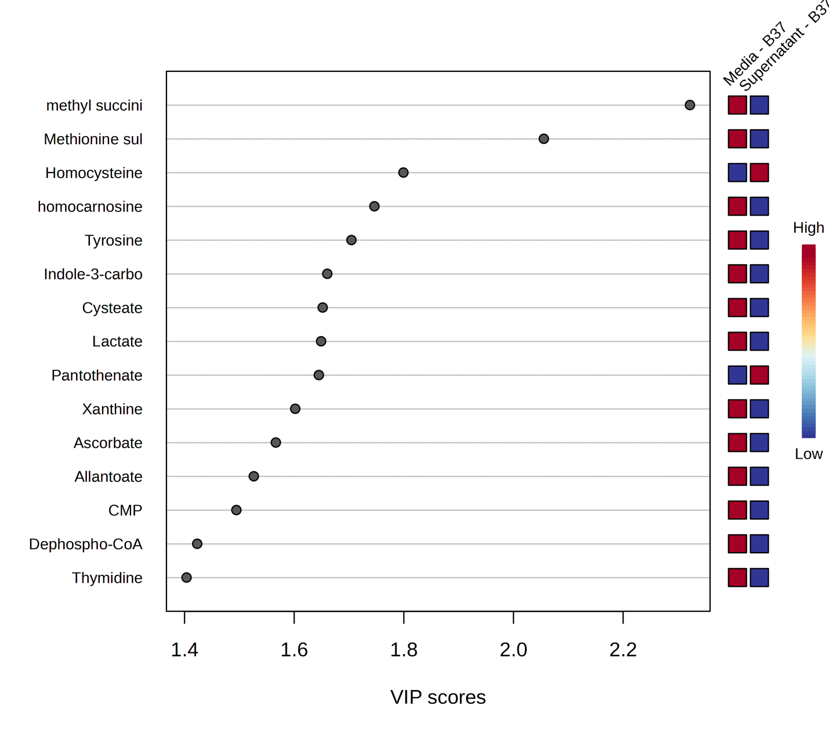
Figure 40: Variable importance in projection (VIP) score plot demonstrating the metabolites of significance in the PLS-DA model between two groups – media control and supernatant at 37°C.

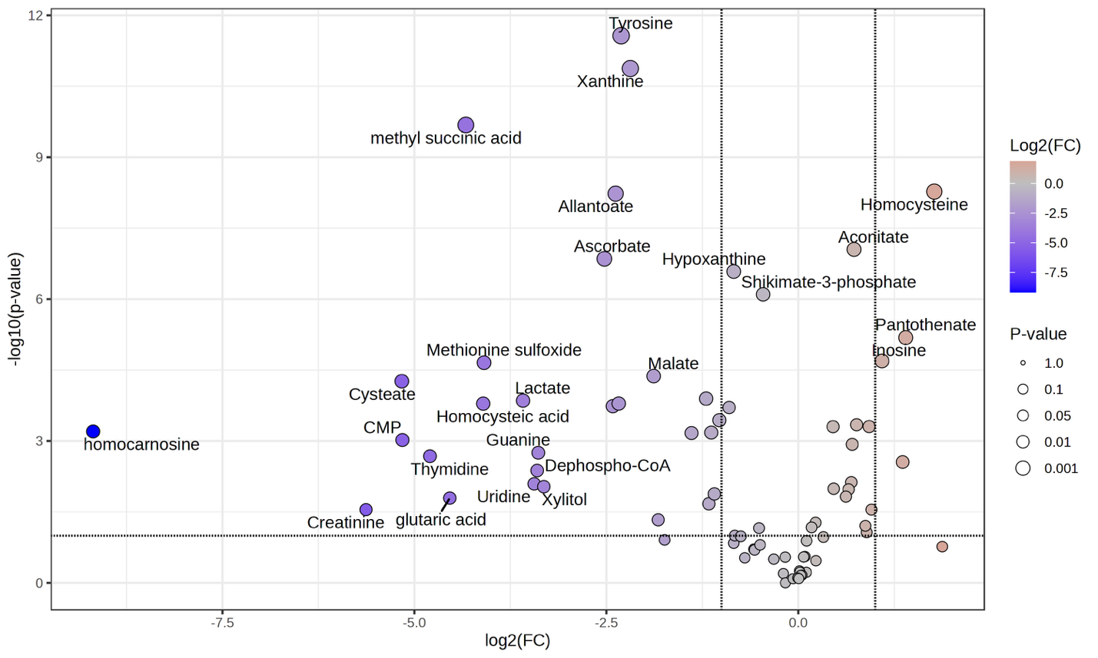
Figure 41: Volcano plot representing upregulation and downregulation of metabolites while comparing leptospira supernatants in EMJH (Difco) 28°C. On x-axis, the log2 fold change of the ratio of supernatant to media control is graphed.
Table 2: Overview of cross comparisons of sample fractions in variable growth parameters.
Sample | Media | Temperature
All pellet | EMJH (in house) | 28°C
All pellet | EMJH (in house) | 37°C
All pellet | EMJH (Difco) | 28°C
All pellet | EMJH (Difco) | 37°C
All supernatant | EMJH (in house) | 28°C
All supernatant | EMJH (in house) | 37°C
All supernatant | EMJH (Difco) | 28°C
All supernatant | EMJH (Difco) | 37°C
All media | EMJH (in house) | 28°C
All media | EMJH (in house) | 37°C
All media | EMJH (Difco) | 28°C
All media | EMJH (Difco) | 37°C

Pellets across variable growth condition:
First, three sets of pellets (since the inoculation was not successful in one of the growth conditions) from the growth conditions were put together for comparative analysis. This comparison (Figure 42-45) shows a summary of effect of temperature and media on the intra cellular metabolites. This aids the visualization in the internal metabolism of the cells under different environmental conditions. Although pellets from EMJH (in house) at 28°C and EMJH (in house) at 37°C show an overlap in the PLS-DA model (Figure 43), the three-dimensional visualization of the PLS-DA displays that these groups are indeed separated and have unique metabolic profiles. Pellets grown in three different environments appears to have completely distinctive metabolic profile (Figure 44). The bioenergetics driven metabolites NAD+ and FAD contribute to the separation in the pellet groups in EMJH (in house) media, while starch metabolism driven metabolites are more prevalent in the pellets from EMJH (Difco) media.
Control media across variable growth condition:
Analysis of control media across all four environmental conditions (Figure 46-48) portrays a picture to discern metabolic contribution from the media itself. This helped to identify the metabolites solely contributed from the media, which may not have been utilized for growth but have the potential for bioavailability to the species. Control media samples from the EMJH (in house) cultures were not available, hence Figure 47 only displays 3 groups of media. The three different groups portray complete separation displaying unique metabolite profile corresponding to each group. It is to be noted that some of the major metabolic drivers of the separations, creatine, uric acid, and uridine are highly associated with deteriorated kidney functions. This could imply that the higher level of these metabolites in the host may result into a compatible environment for leptospira infection.
Supernatants across variable growth condition:
Assessment of supernatants across all the growth parameters provides comprehension of the exo-metabolome in leptospira growth (Figure 49-52). The exo-metabolome can give a deeper insight to the signaling molecules, secreted metabolites, and by-products of biosynthetic metabolites by the cell.³⁹,⁸⁷ This may allow to elucidate the secretion pattern as well as the resource utilization by the species. The overlapping groups portrays that the media EMJH (in house) at both 28°C and 37°C have similarities in their metabolic profile (Figure 50). The three- dimensional view (Figure 51) of the PLS-DA model confirms that the metabolic profile of the
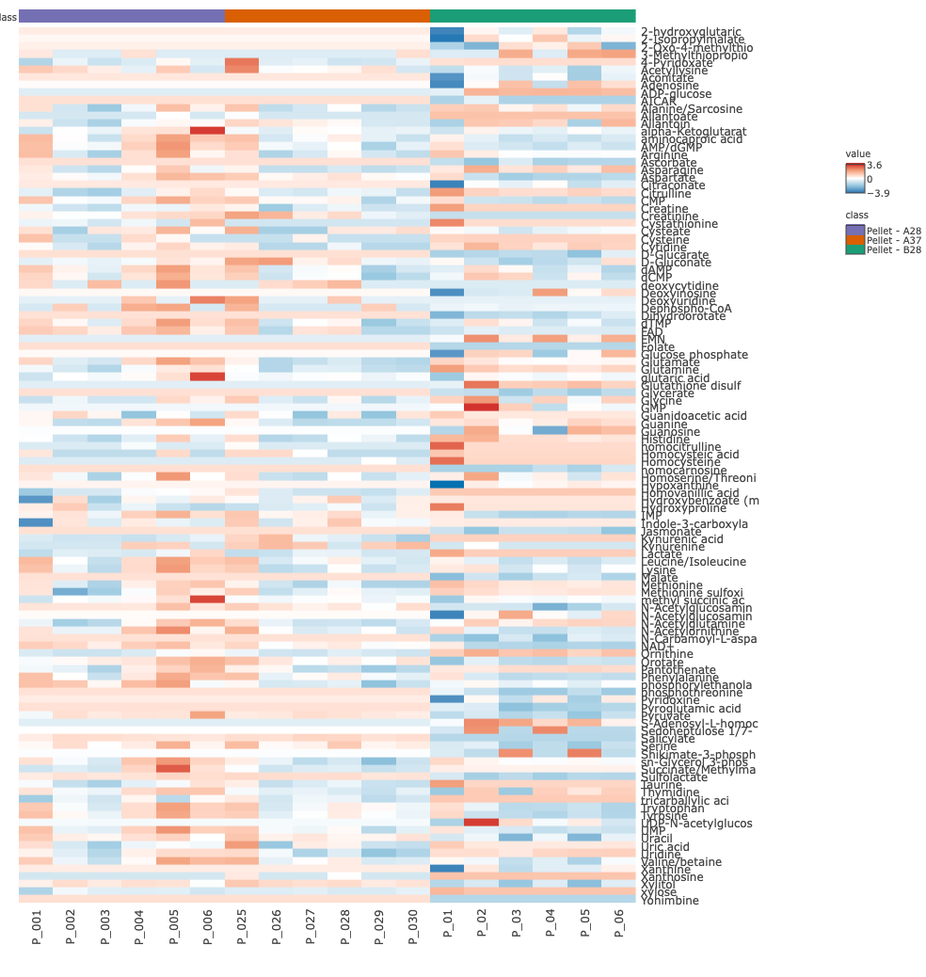
Figure 42: Visualization of metabolites abundance across the pellets grown in A28, A37°C, and B28. A represents the EMJH (in house) media and B represents the EMJH (Difco) media with 28 and 37°C representing the temperature at which the pellets were inoculated. Data underwent log2 transformation and pareto scaling
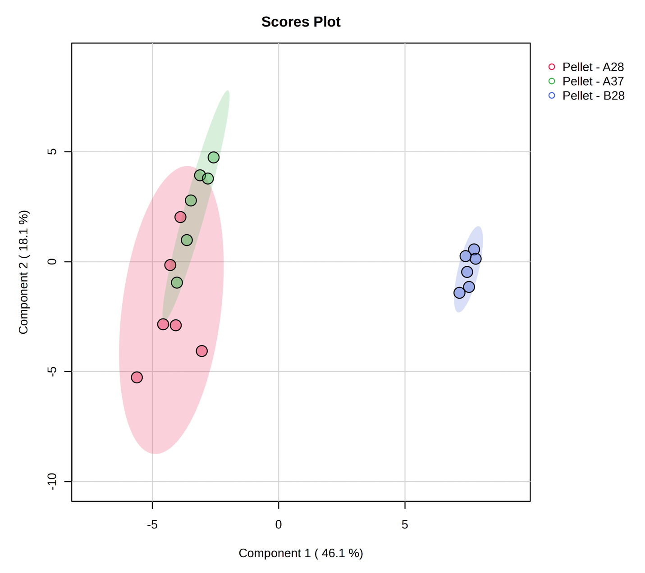
Figure 43: Partial Least Squares Discriminant Analysis PLS-DA plot shows 2 distinct groups and one overlapping group among the cell pellets EMJH (in house) media, and EMJH (Difco media).

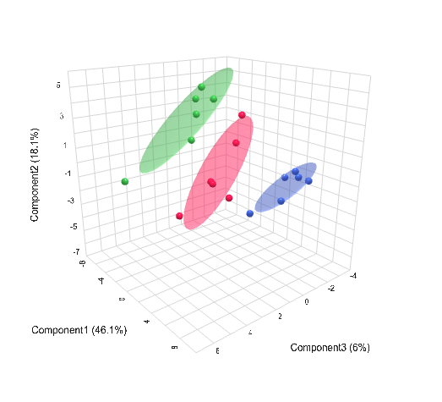
Figure 44: Three-dimensional representation of the PLS-DA for improved visualization of the separation between the 3 groups.

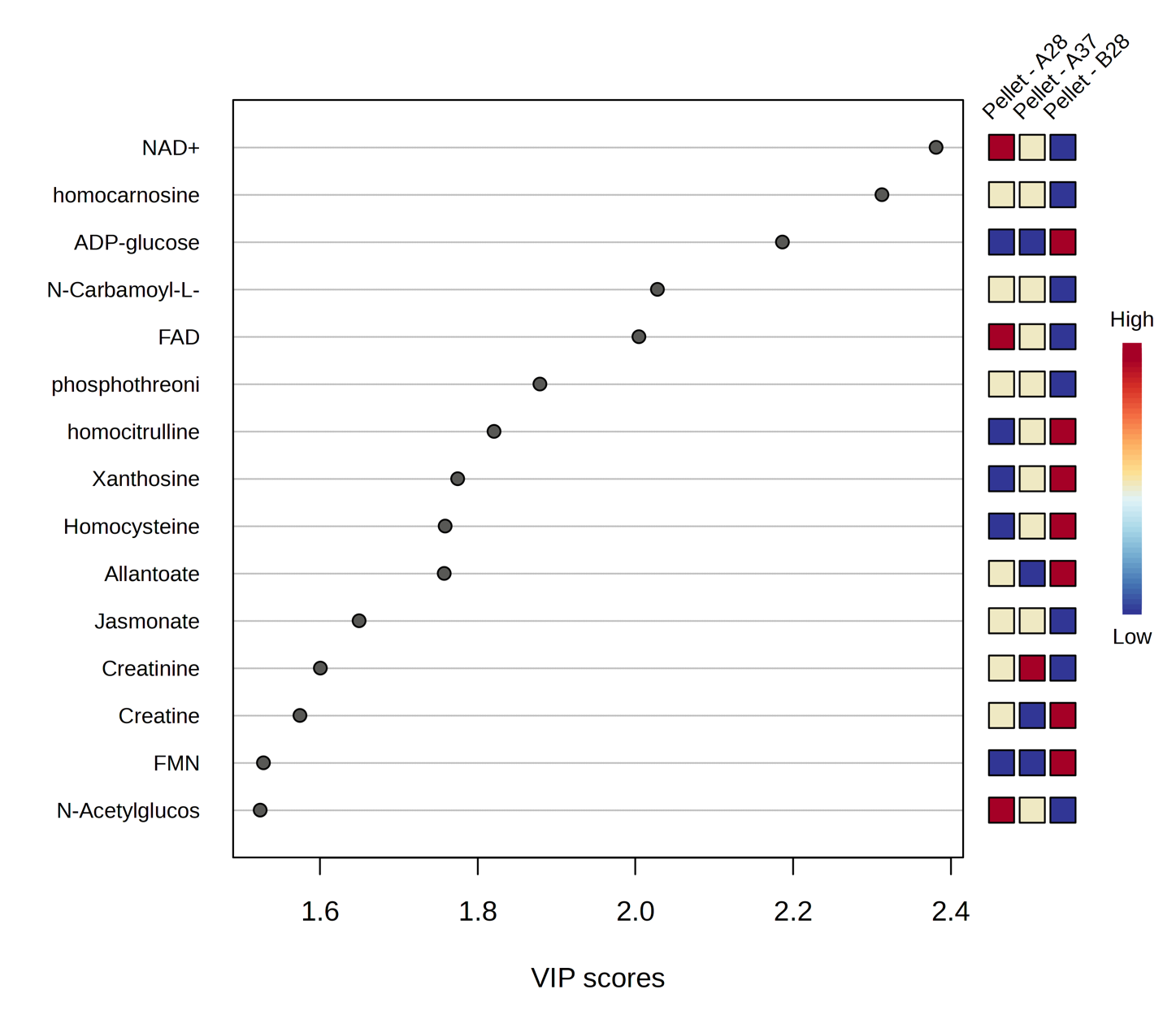

Figure 45: Variable importance in projection (VIP) score plot demonstrating the metabolites of significance in the PLS-DA model among the three groups – pellets from media EMJH (in house) at 28°C, EMJH (in house) at 37°C, EMJH (Difco) at 28°C.

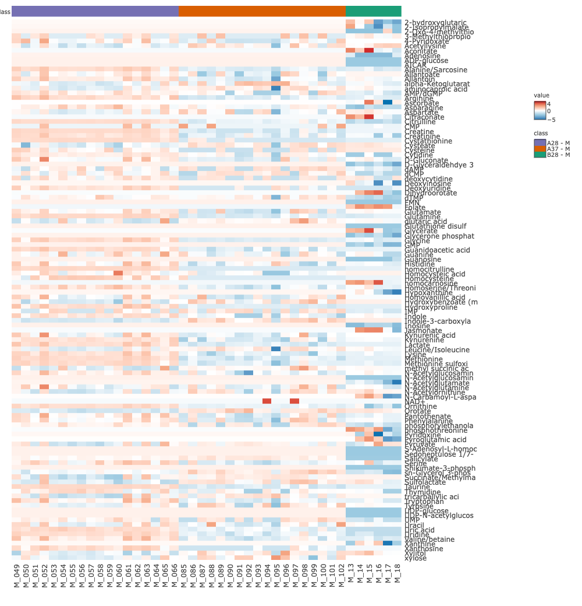
Figure 46: Visualization of metabolites abundance across the media samples. The media EMJH (Difco) is represented as “B”, and media EMJH (in house) is represented as “A”. The numbers 28 and 37°C associated with A and B are representative of the corresponding temperatures. Data underwent log2 transformation and pareto scaling.
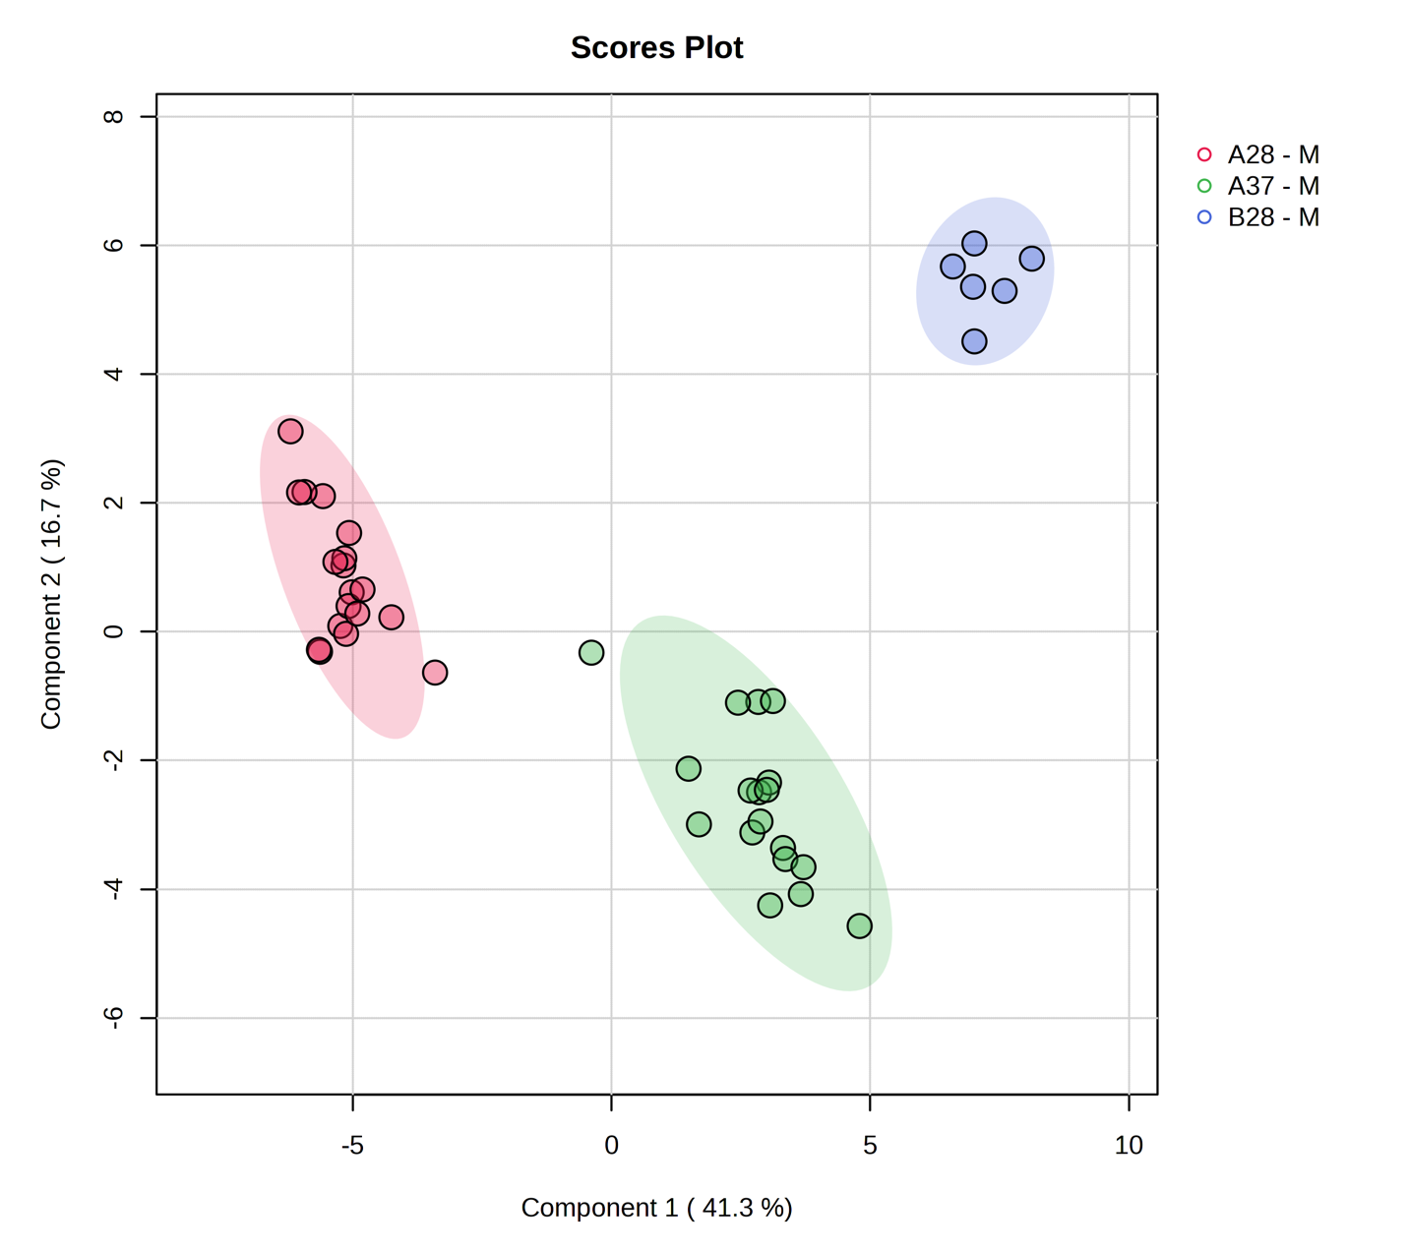
Figure 47: Partial Least Squares Discriminant Analysis PLS-DA plot shows 3 distinct groups of the media samples at different temperatures. The media EMJH (Difco) is represented as “B”, and media EMJH (in house) is represented as “A”. The numbers 28 and 37°C associated with A and B are representative of the corresponding temperatures.

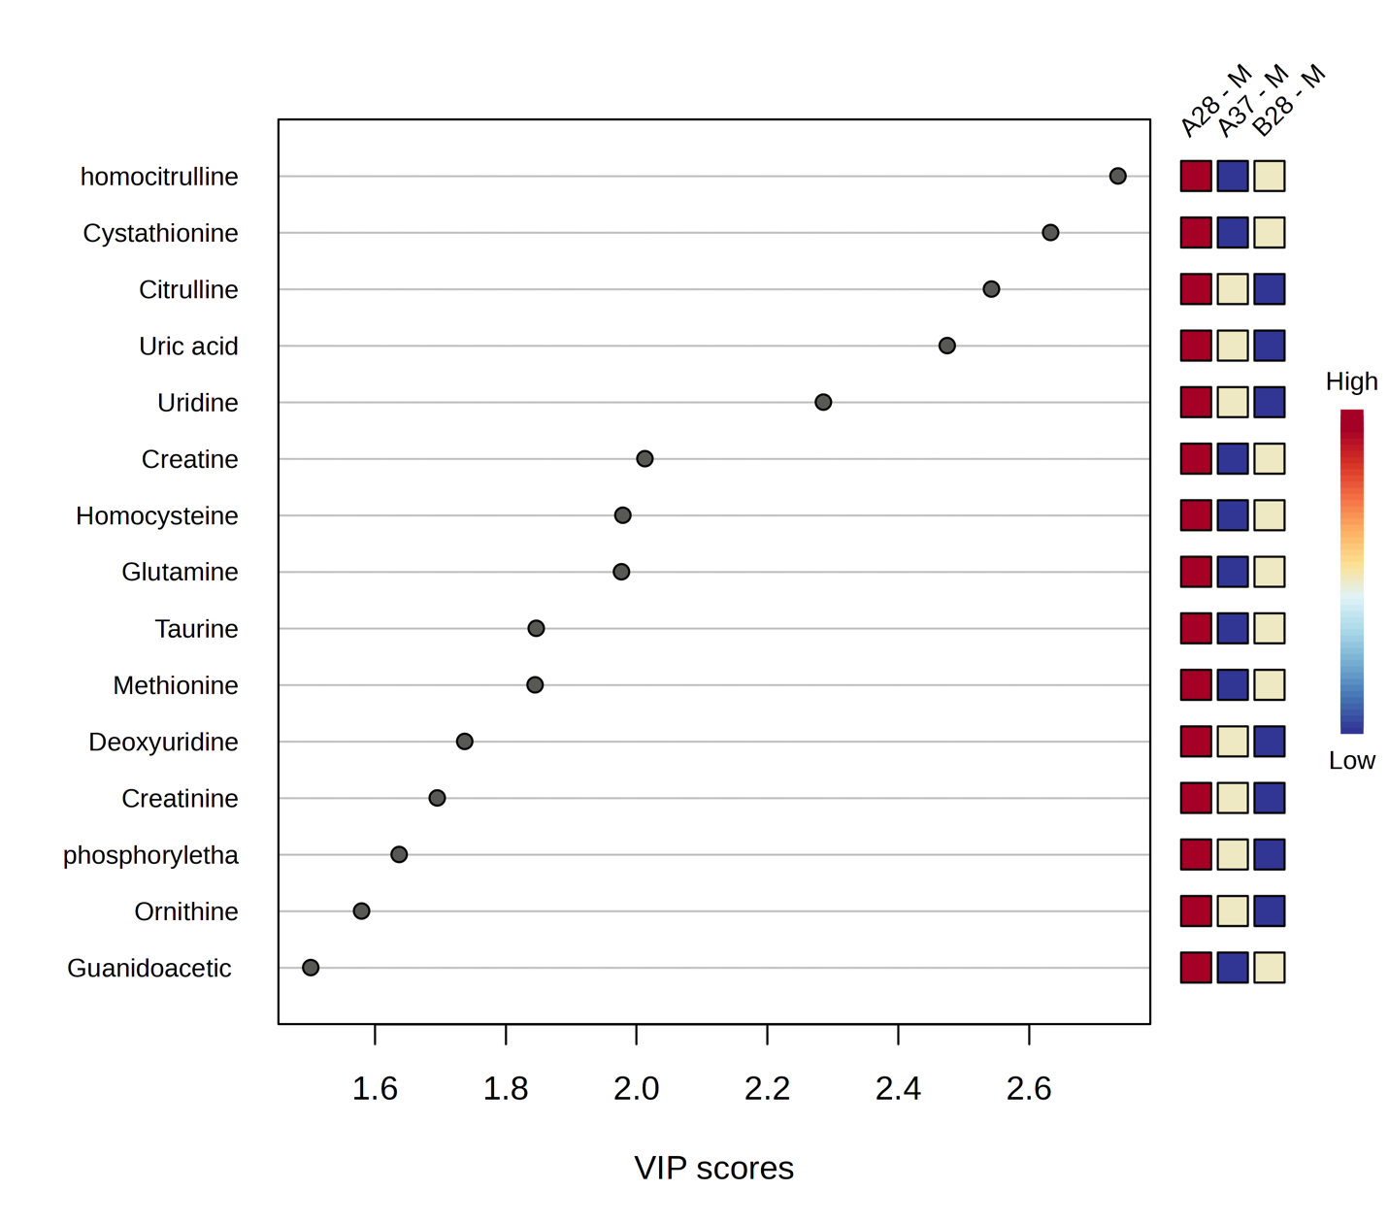

Figure 48: Variable importance in projection (VIP) score plot demonstrating the metabolites of significance in the PLS-DA model between the three groups in Figure 47.

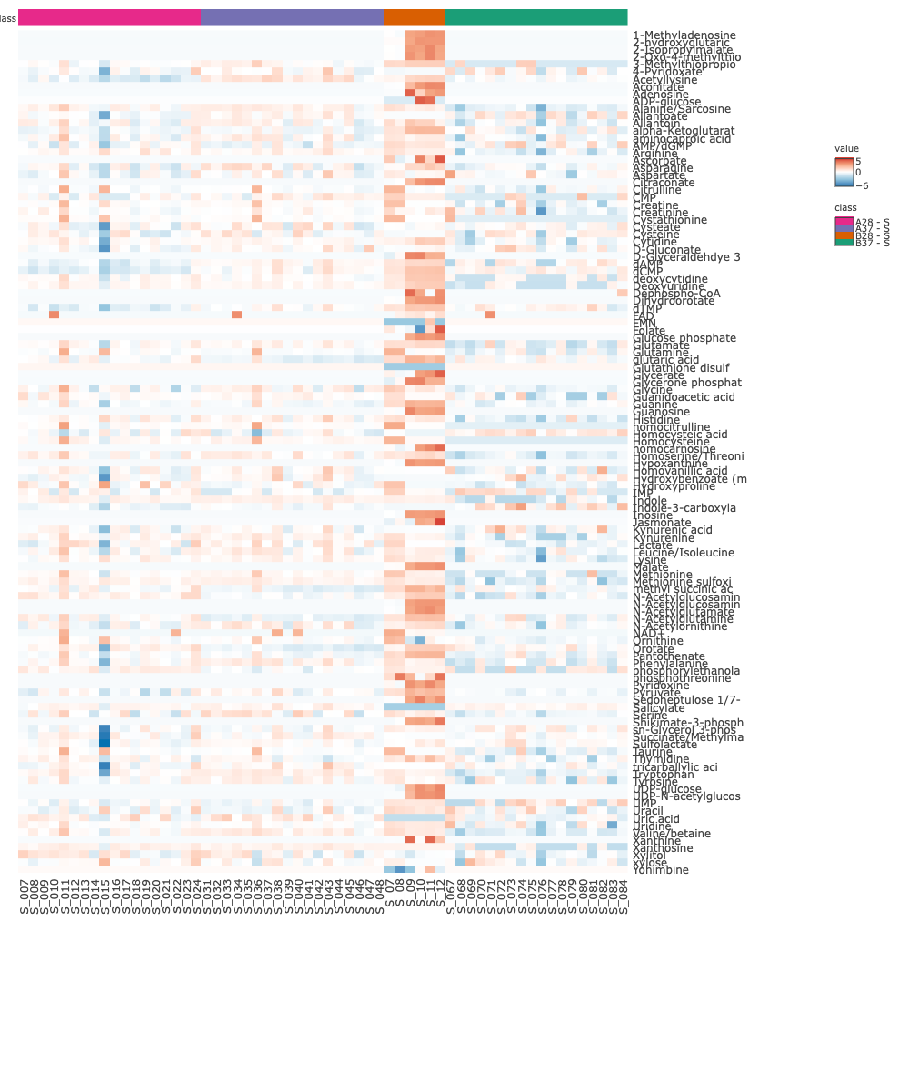
Figure 49: Visualization of metabolites abundance across the supernatant samples. The media EMJH (Difco) is represented as “B”, and media EMJH (in house) is represented as “A”. The numbers 28 and 37°C associated with A and B are representative of the corresponding temperatures. Data underwent log2 transformation and pareto scaling.
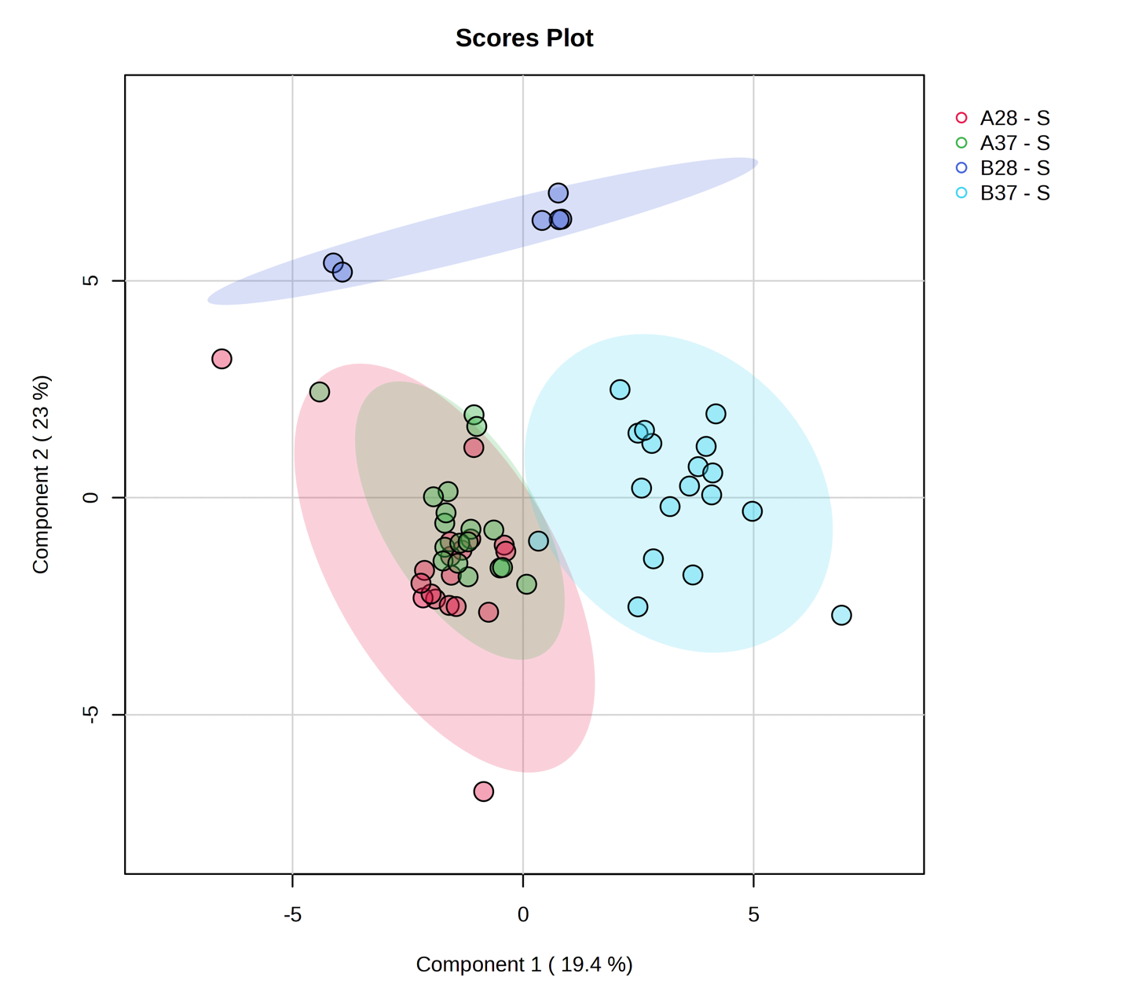
Figure 50: Partial Least Squares Discriminant Analysis PLS-DA plot shows separation between supernatant from cell culture in two different media and temperatures. The multivariate analysis shows distinctive individual metabolic profile between the group.

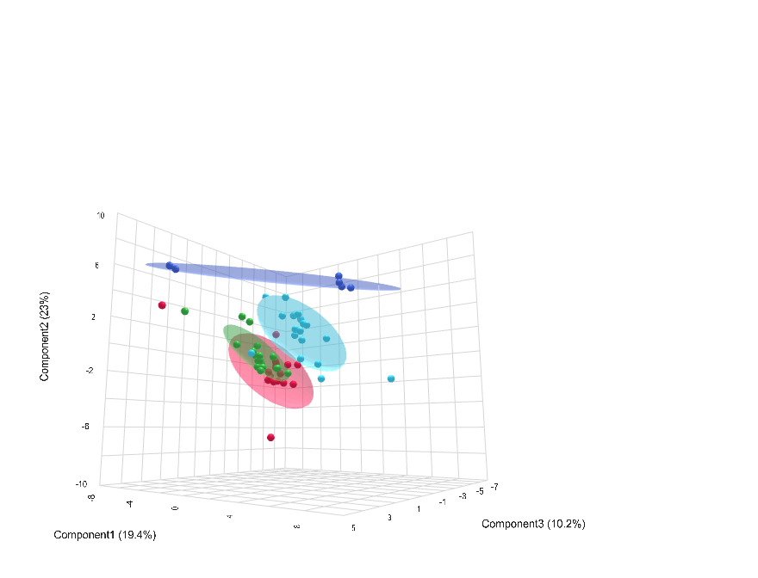
Figure 51: Three-dimensional representation of the PLS-DA for improved visualization of the separation between the groups of supernatants from EMJH (in house) and EMJH (Difco) at 28°C and 37°C.

supernatants collected from EMJH (in house) at 28°C and 37°C are not highly distinctive.
- Integrated comparison of sample fraction across temperature and media conditions
The integrated comparisons of sample fractions and varying media compositions altogether is a holistic approach that provides how each of the variable parameters could influence the phenotypic metabolic profile of leptospira. The integrated analysis offers revelation of interaction of the variable growth conditions to biological variations.
Integrated comparison among pellet, supernatant, and media control in EMJH (in house) at 28°C and 37°C
In the first integrated analysis, all the sample fractions (pellet, supernatant, media control) from EMJH (in house) at 28°C and 37°C are put together for visualization (Figure 53-55).
While there are multiple overlapping groups demonstrating the similarities in metabolic profile (Figure 53), the three-dimensional view of the PLS-DA model (Figure 54) provides an improved understanding. The only overlapping groups are the supernatants (in cyan and magenta) from the media at 28°C and 37°C (Figure 54). The pellets grown in the EMJH (in house) media at different temperatures hold their unique metabolic profile. Control media sample of EMJH (in house) at 37°C was not available. The EMJH (in house) at 28°C displays its distinct metabolic profile.
In PLS-DA, sample separation could be linked to specific metabolic alteration as it searches for independent variations.^{88,89} While the supernatants groups in different temperature combinations are overlapping, separation between pellet groups shows that alteration in temperature leads the leptospiral cells to opt out for unique metabolic pathways.^{90,91}
Integrated comparison among pellet, supernatant, and media control in EMJH (Difco) at 28°C and 37°C
The next integrated analysis is among all the sample fractions (pellet, supernatant, media control) from EMJH (Difco) at 28°C and 37°C. The analysis is visualized in Figure 56-58. While there are multiple overlapping groups demonstrating the similarities in metabolic profile (Figure 56), the three-dimensional view of the PLS-DA model (Figure 57) provides an improved visualization for better understanding. The leptospira inoculation did not show any evidence of growth in the EMJH(Difco) media at 37°C. Hence the pellets from that experiment could not be incorporated. However, the three-dimensional view of the PLS-DA shows separations for the pellets grown in the EMJH (Difco) media 28°C, the supernatants from EMJH
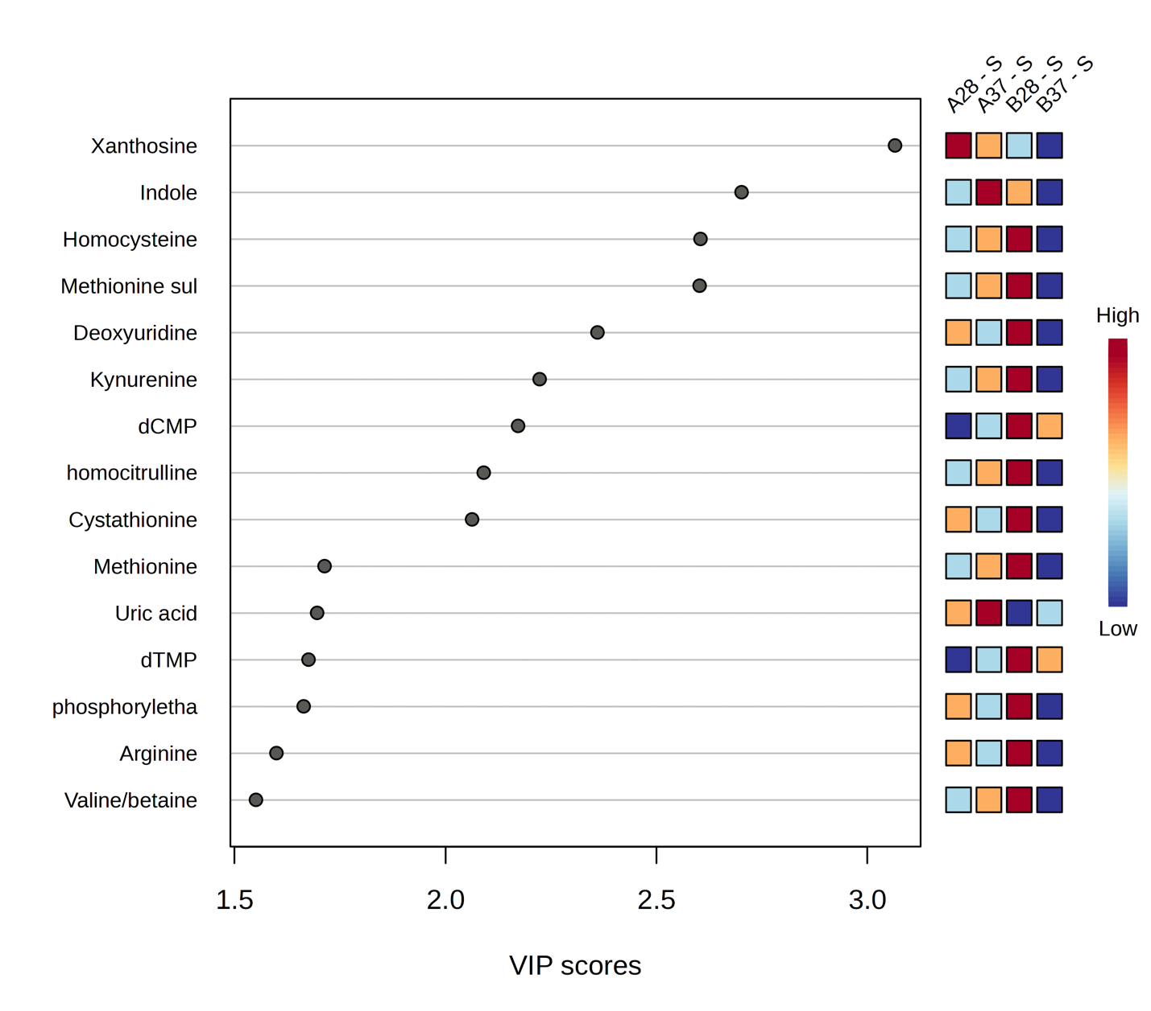
Figure 52: Variable importance in projection (VIP) score plot demonstrating the metabolites of significance in the PLS-DA model between the supernatant groups from EMJH (in house) and EMJH (Difco) at 28°C and 37°C.

Table 3: Overview of integrated comparison of sample fractions in variable growth parameters
Sample fraction | Media | Temperature
Pellet, Supernatant, and Media control | EMJH (in house) | 28°C
Pellet, Supernatant, and Media control | EMJH (in house) | 37°C
Pellet, Supernatant, and Media control | EMJH (Difco) | 28°C
Pellet, Supernatant, and Media control | EMJH (Difco) | 37°C
Pellet, Supernatant, and Media control | EMJH (in house) | 28°C
Pellet, Supernatant, and Media control | EMJH (Difco) | 28°C
Pellet, Supernatant, and Media control | EMJH (in house) | 37°C
Pellet, Supernatant, and Media control | EMJH (Difco) | 37°C

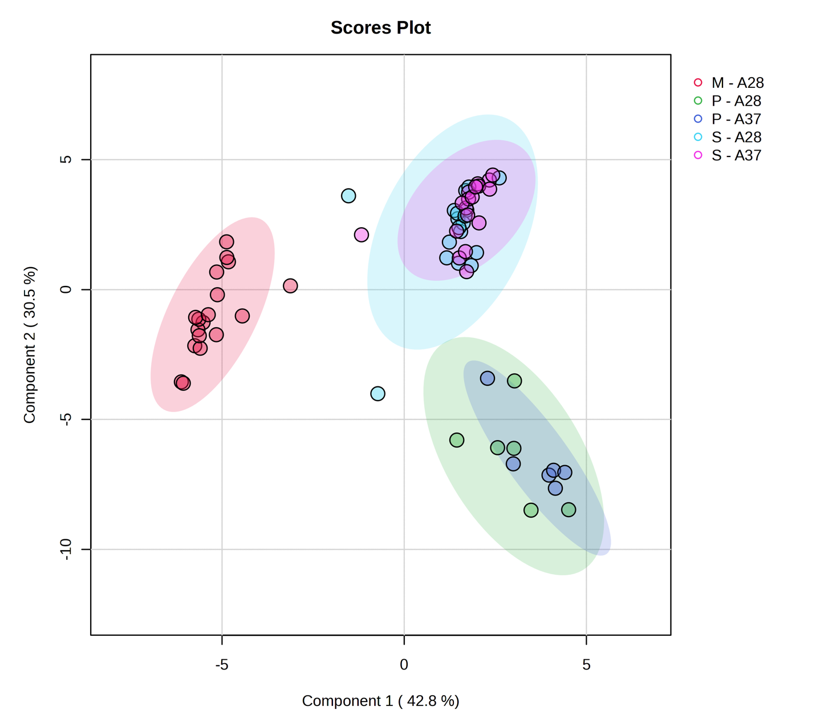
Figure 53: Partial Least Squares Discriminant Analysis PLS-DA plot among the pellets, supernatant collected from EMJH (in house) media at both 28°C and 37°C are represented.
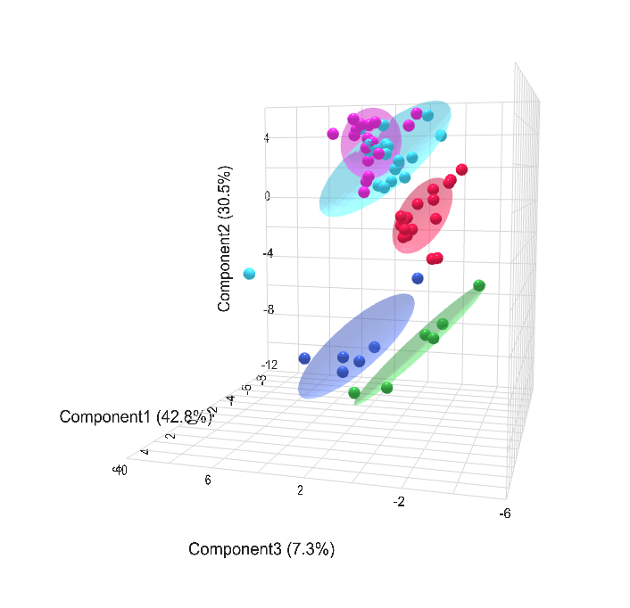
Figure 54: Three-dimensional representation of the PLS-DA of Figure 53 for improved visualization.

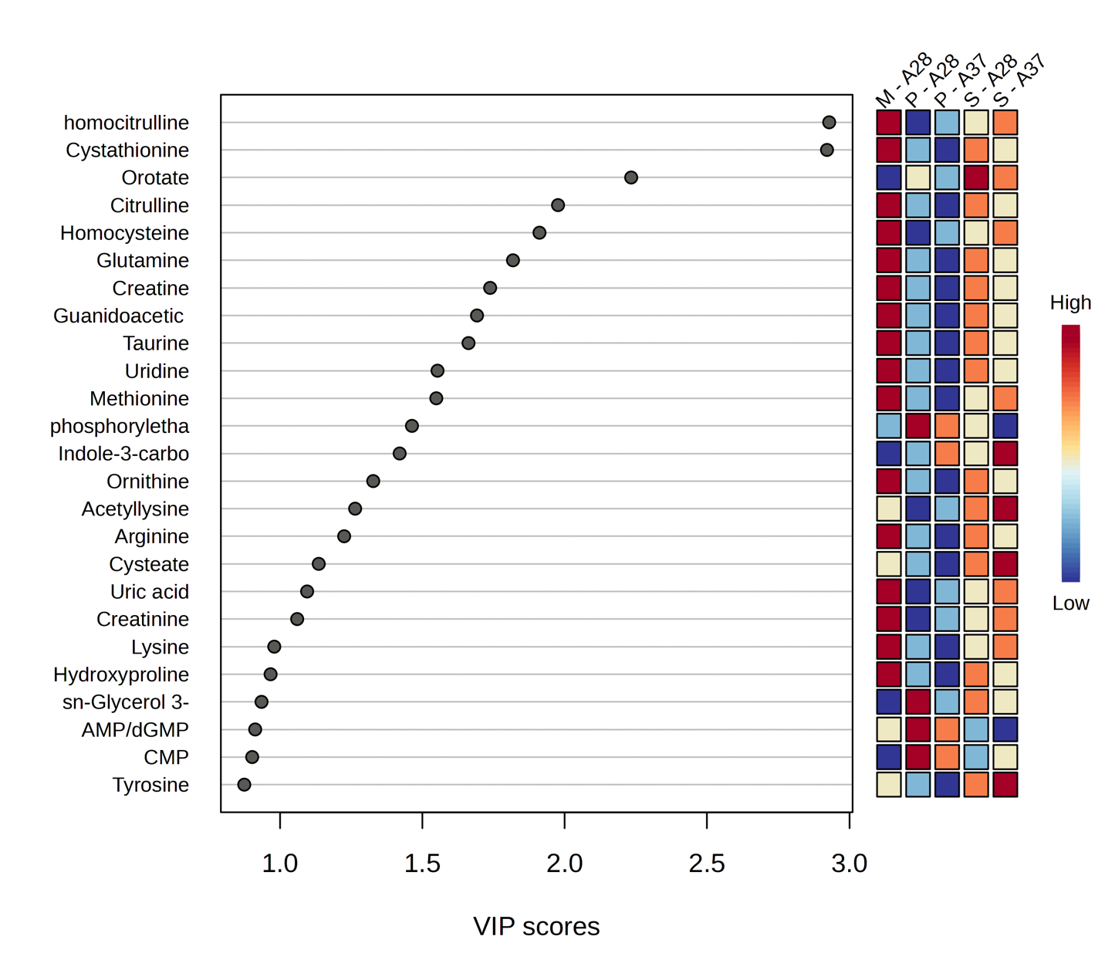

Figure 55: Variable importance in projection (VIP) score plot demonstrating the metabolites of significance in the PLS-DA model of Figure 54.

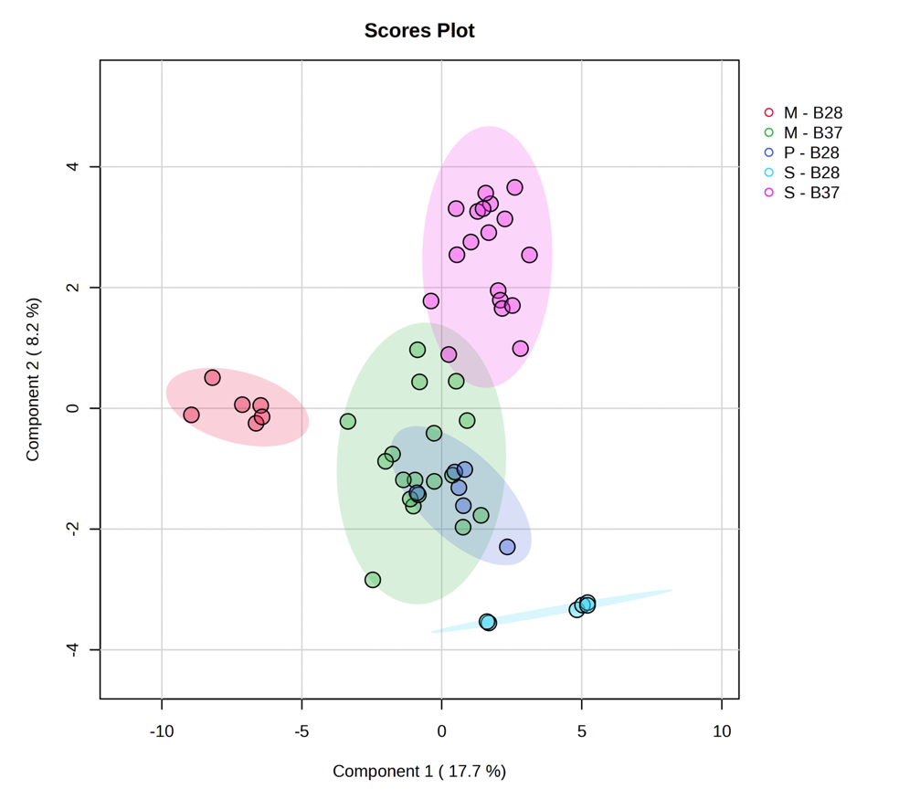
Figure 56: Partial Least Squares Discriminant Analysis (PLS-DA) plot among the pellets, supernatant collected from EMJH (Difco) media at both 28°C and 37°C are represented.

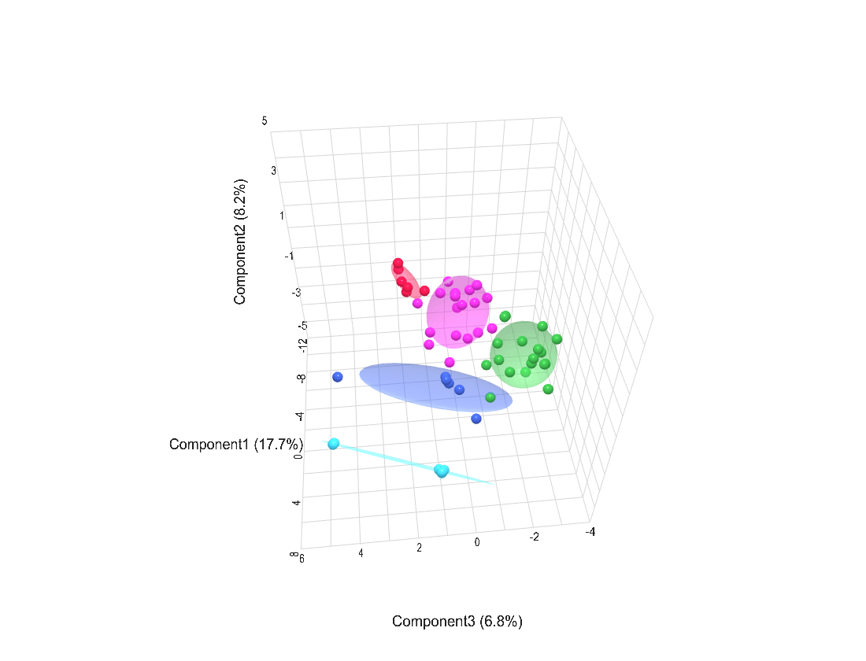

Figure 57: Three-dimensional representation of the PLS-DA of Figure 56 for improved visualization.

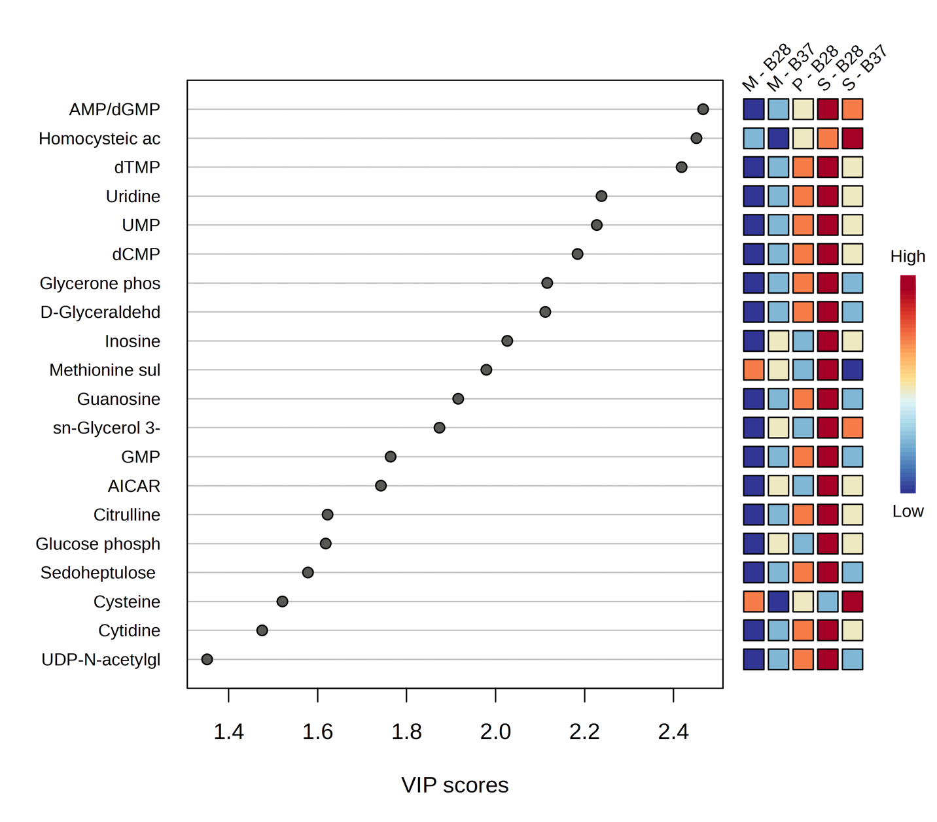
Figure 58: Variable importance in projection (VIP) score plot demonstrating the metabolites of significance in the PLS-DA model of Figure 57.
Difco) at 28°C and 37°C, and the media controls at 28°C and 37°C referring to unique metabolic profiles across each sample fraction. The key metabolites contributing to the variations in each group are of high impact in supernatants (Figure 58), attributing to the metabolites upregulated from the supernatants. This finding is consistent with the findings from Figure 41.
Integrated comparison among pellet supernatant and media control in EMJH (in house) and EMJH (Difco) media at 28°C
The next integrated analysis is among all the sample fractions (pellet, supernatant, media control) from two media used in the experiment – EMJH (in house) and EMJH (Difco) at 28°C. The analysis is visualized in Figure 59-61. While there are multiple overlapping groups demonstrating the similarities in metabolic profile (Figure 59), the three-dimensional view of the PLS-DA model (Figure 60) provides an improved visualization for better understanding. The three-dimensional view of the PLS-DA shows unique profiles for each sample fraction from EMJH (in house) and EMJH (Difco) media even when the temperature remains constant at 28°C. In this comparison, each group is showing separation referring to the unique metabolic profile of leptospira. Although the temperature is kept constant during both inoculations, the variation in media provided an environment suited for distinctive metabolic profile for growth. This insight could lead to investigation towards adaptive strategies of growth based on nutrient availability.
Integrated comparison among pellet, supernatant, and media control in EMJH (in house) and EMJH (Difco) media at 37°C
The final integrated analysis is among all the sample fractions (pellet, supernatant, media control) from two media used in the experiment – EMJH (in house) and EMJH (Difco) at 37°C. The analysis is visualized in Figure 62-64. While there are multiple overlapping groups demonstrating the similarities in metabolic profile (Figure 62), the three-dimensional view of the PLS-DA model (Figure 63) provides an improved visualization for better understanding. The three-dimensional view of the PLS-DA shows unique profiles for each sample fraction from EMJH (in house) and EMJH (Difco) media even when the temperature remains constant at 37°C.
While the VIP score plot is displaying that the key metabolites driving the separations in Figure 63 are coming from the supernatants, drawing a conclusion only from this integrative comparison may lead to erroneous conclusion as no growth was observed in the EMJH (Difco) media at 37°C and the metabolite upregulation in the supernatant at that media-temperature composition was
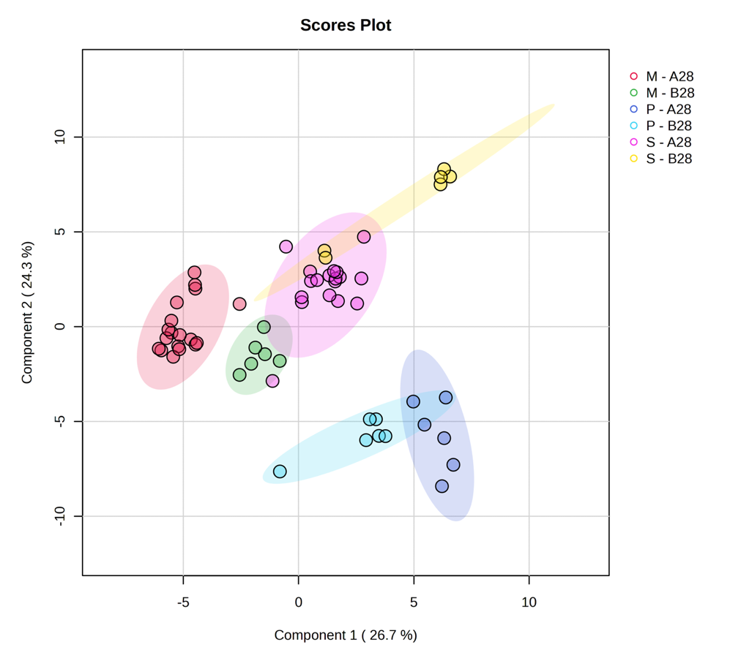
Figure 59: Partial Least Squares Discriminant Analysis PLS-DA plot for all the sample fractions (pellet, supernatant, and media control) from A28 and B28. The media EMJH (Difco) is represented as “B”, and media EMJH (in house) is represented as “A”. The numbers 28 associated with A and B are representative of the temperature.

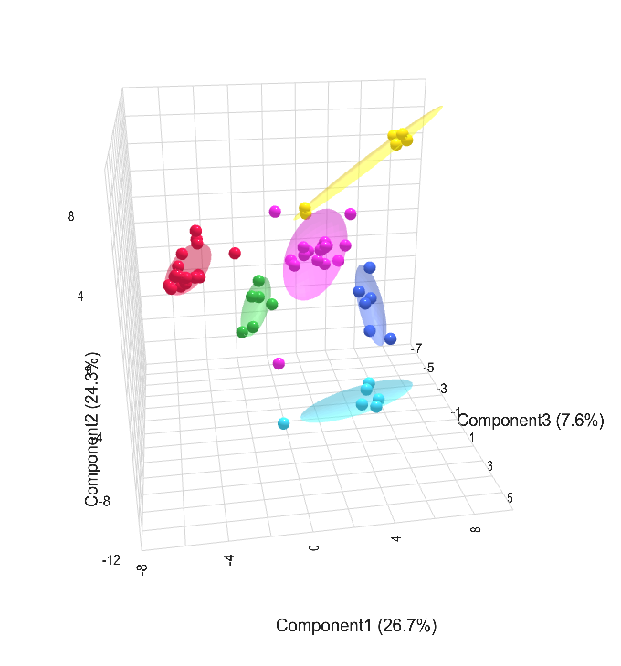
Figure 60: Three-dimensional representation of the PLS-DA of Figure 59 for improved visualization.

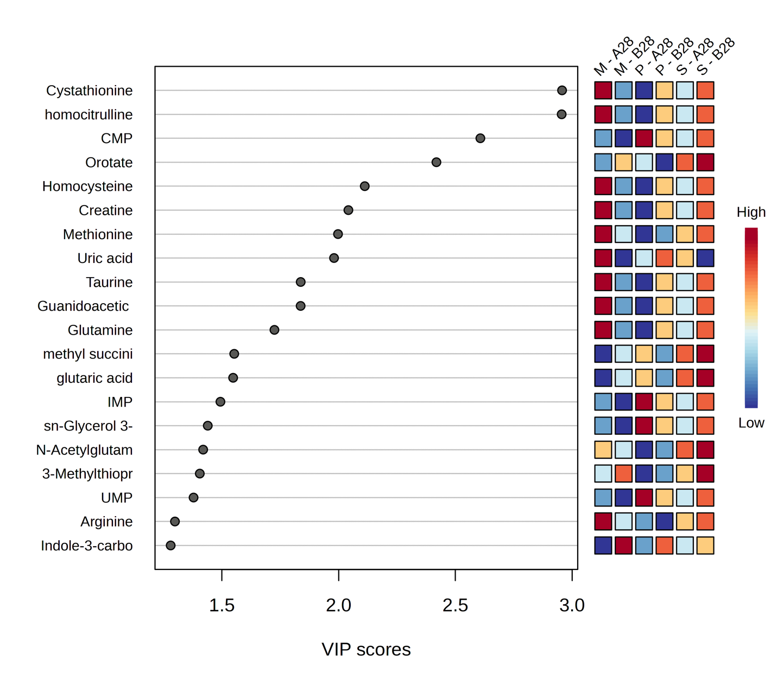
Figure 61: Variable importance in projection (VIP) score plot demonstrating the metabolites of significance in the PLS-DA model of Figure 60.

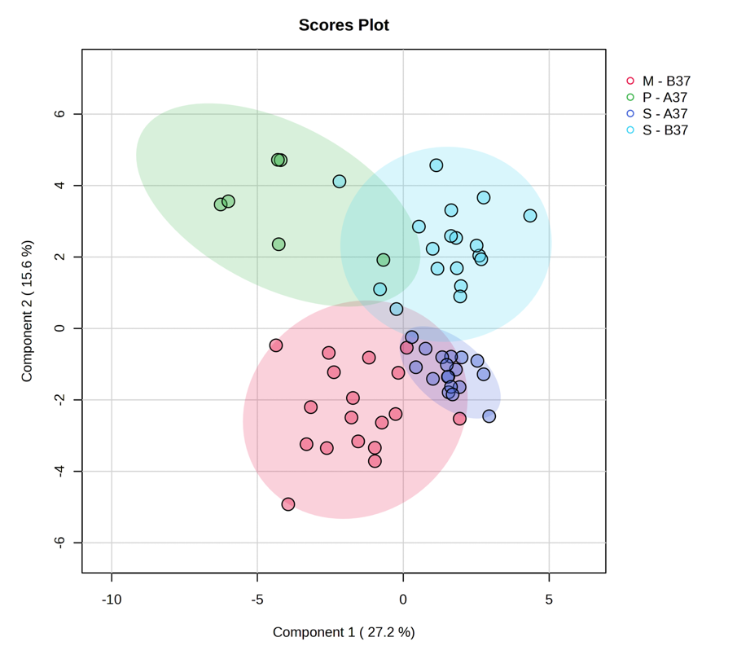
Figure 62: Partial Least Squares Discriminant Analysis PLS-DA plot for all the sample fractions (pellet, supernatant, and media control) from A37°C and B37°C. The media EMJH (Difco) is represented as “B”, and media EMJH (in house) is represented as “A”. The numbers 37°C associated with A and B are representative of the temperatures.

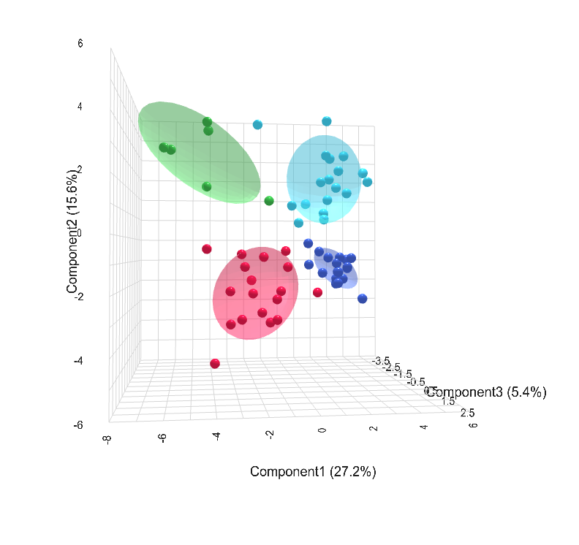
Figure 63: Three-dimensional representation of the PLS-DA of Figure 62 for improved visualization.

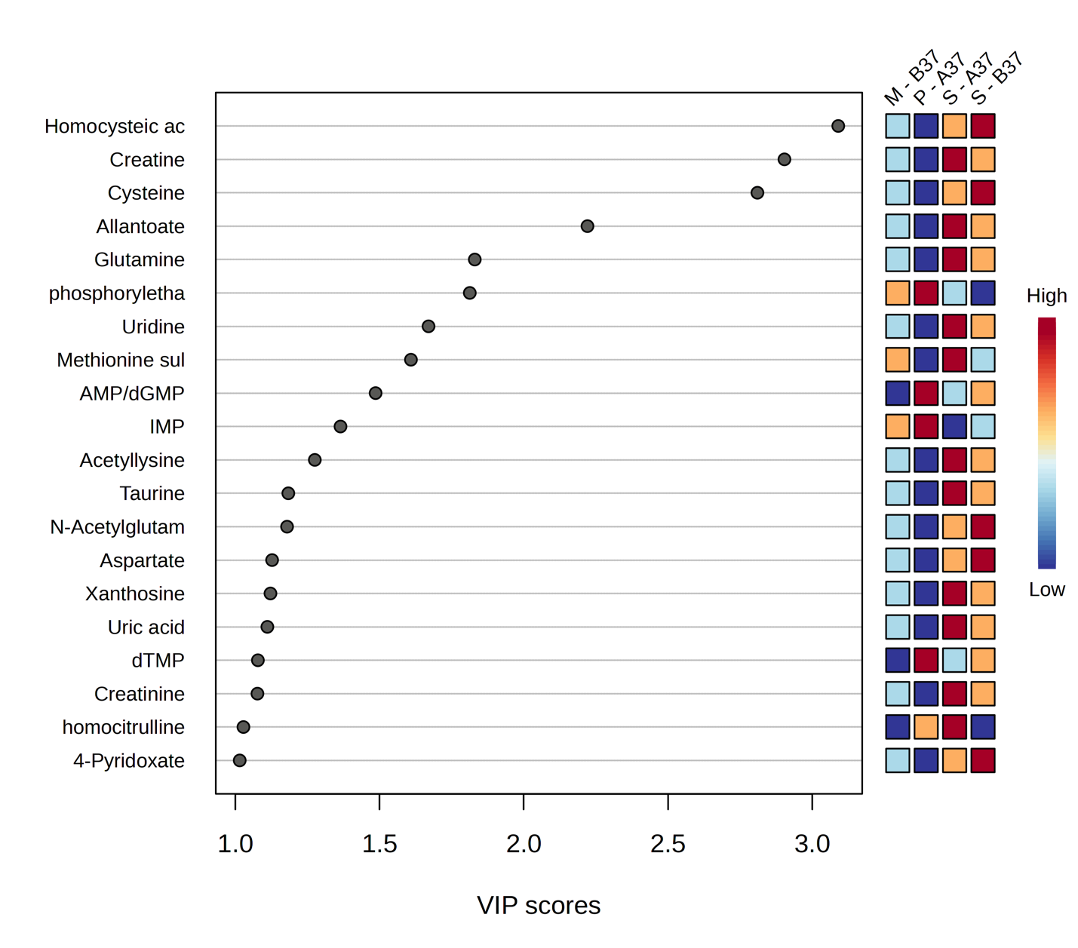
Figure 64: Variable importance in projection (VIP) score plot demonstrating the metabolites of significance in the PLS-DA model of Figure 63.

high. For a deeper insight, inspecting the individual fraction component comparison (Figures 39, 40, 41) may provide a better insight.

Chapter 4
Discussion
The purpose of this study was to determine the growth pattern of Leptospira, and the metabolites profile linked to it under varying growth conditions, emphasizing the variations in in vitro growth parameters that is possibly associated with Leptospira's altered virulence.
The influence of environmental factors on the metabolic profile of leptospira cultures is evident from the exclusive metabolic signature at different temperature composition. The influence of phosphoryl ethanolamine at 28°C is to be noted for its contribution to structural stability and integrity in pathogens.^{92,93} Upregulation of Glutamate at 28°C was also found to be significant and is consistent with amino acid metabolism contributing to the growth phenotype. Media type comparisons showed a distinct metabolic profile of leptospira in different media at 28°C. Utilization of bioenergetics driven metabolites was more prominent in growth using EMJH (Difco) media. Bioenergetics driven metabolites such as CMP and IMP were also observed in leptospira when cultured in EMJH (in house) at both 28°C and 37°C. This indicates the dependence on environmental nutrient availability for biosynthesis and redox balance for growth.⁹⁴ Like any other organism, leptospira is dependent on vitamin B₁₂ metabolism for its growth. The interesting finding from the media effect analysis is that while grown in the EMJH (in house) media at 28°C, it utilizes a folate mediated purine-based pathway towards vitamin metabolism. When it is grown in the commercial EMJH (Difco) media at 28°C, it follows a homocysteine remediated pyruvate-based pathway towards vitamin B metabolism. Both pathways eventually lead to One Carbon Metabolism (OCM) but remediated via unalike vitamin metabolism.
The sample fraction analysis of pellet and media control, and pellet and supernatant in EMJH (in house) media at 28°C suggests a purine and pyrimidine metabolism pathway utilization for growth of l. interrogans. The higher abundance of orotate and indole-3-carboxale in the exo-metabolome of leptospira in EMJH (in house) is highly interesting because it is consistent with utilization of pyrimidine biosynthesis pathway which is responsible for DNA replication.⁷⁹ However, abundance of homocysteine and cystathionine in the media suggest that a pyruvate-based vitamin-B metabolic pathway was not followed. This further confirms the purine metabolic pathway is chiefly utilized.
Analysis of paired sample fractions in EMJH (Difco) at 28°C provide some key metabolic feature for leptospira metabolic profile. Detection of CMP, ADP-glucose, Glutathione disulfide, FMN in pellet refers to utilization of starch metabolism, redox balance. This is similar to the finding of the metabolic profile of leptospira during growth in EMJH (in house) at 28°C. Detection of phosphoryl ethanolamine and upregulation of it is congruent with the pellet metabolic upregulation in EMJH (in-house) media at 28°C as well. Upregulation of ADP-glucose, and UDP-glucose in pellet when compared to media control suggests a glycogen synthesis pathway as these are intermediary metabolites of starch metabolism. This is highly intriguing as glycogen synthesis pathway is utilized by pathogen when there is a need for preserving energy in unfavorable environment. In pairwise comparison between pellet and supernatant in the commercial media at 28°C, upregulated metabolites in the supernatants suggest a pyruvate metabolic pathway utilization through glycine-serine-threonine metabolism leading to a thymine metabolic pathway. In the same environmental setup, comparison between supernatant and media shows an upregulation of thymine regulated metabolite in the supernatant. Having thymine mediated extracellular contents suggest that thymine pathway was utilized and byproducts of it are secreted while scavenging for vitamin for survival.
Upregulation of citrulline, N-carbamoyl-l-aspartate in supernatant follows the pyrimidine biosynthesis pathway^{95,96,97} Downstream product of arginine catabolism could also lead to pyrimidine metabolism pathway. Pyrimidine pathway products and involved enzymes are a quintessential for cell activity in pathogen, majorly in cell division. Overall, in the commercial media, multiple pathways are mediated for growth alternate to purine metabolic pathway,
However, inoculation at 37°C in EMJH (Difco) media did now support any measurable growth of leptospira interogan. There was a high abundance of several metabolites such as lactate, malate, uridine, CMP, thymidine at EMJH (Difco) media at 37°C. Most of these are associated with the cysteine, pyruvate, pyrimidine, or purine metabolic pathways. While thymidine could have protective effect on DNA damage on mammalian cell⁹⁸, in gram-negative pathogens such as E. coli it could sensitize pathogen to antibiotics.⁹⁹ Whereas cyclic CMP through pyrimidine pathway could provide bacterial immunity accelerating immune response against phage.¹⁰⁰ This trend could be ascribed to unutilized nutrients from the media is mediating the lack of growth in EMJH (Difco) at 37°C.^{101,66}
It is to be noted that a sample-based normalization (cell count/mass/volume) was not performed in this study. Multiple data-based normalization techniques such as SERRF, log₂ transformation, pareto scaling was availed. In the future, sample-based normalization approach will be taken into consideration for more robust analysis.
As a direction towards further progress of this study, the impact of these metabolites could be assessed focusing on the absence of growth in EMJH (Difco) medium at 37°C. Compounded with this, expansion of metabolic profiling among additional pathogenic leptospiral strains could be of interest to investigate the growth adaptive metabolic strategies.

References
1. Costa F, Hagan JE, Calcagno J, et al. Global Morbidity and Mortality of Leptospirosis: A Systematic Review. Small PLC, ed. PLoS Negl Trop Dis. 2015;9(9):e0003898. doi:10.1371/JOURNAL.PNTD.0003898’,
2. Adler B. History of Leptospirosis and Leptospira. Curr Top Microbiol Immunol. 2015;387:1-9. doi:10.1007/978-3-662-45059-8_1
3. Inada R, Ido Y, Hoki R, Kaneko R, Ito H. The etiology, mode of infection, and specific therapy of Weil’s disease. (Spirochaetosis icterohaemorrhagica). J Exp Med. 1916;23(3):377-402. doi:10.1084/jem.23.3.377
4. Arean VM. The pathologic anatomy and pathogenesis of fatal human leptospirosis (Weil’s disease). Am J Pathol. 1962;40(4):393.
5. Haake DA, Levett PN. Leptospirosis in Humans. Curr Top Microbiol Immunol. 2015;387:65-97. doi:10.1007/978-3-662-45059-8_5
6. Picardeau M. Virulence of the zoonotic agent of leptospirosis: Still terra incognita? Nat Rev Microbiol. 2017;15(5):297-307. doi:10.1038/NRMICRO.2017.5
7. Goarant C, Tarantola A. Leptospirosis in French Historical Medical Literature: Weil’s Disease or Kelsch’s Disease? Am J Trop Med Hyg. 2018;99. doi:10.4269/ajtmh.18-0629
8. Bierque E, Thibeaux R, Girault D, Soupé-Gilbert ME, Goarant C. A systematic review of Leptospira in water and soil environments. PLoS One. 2020;15(1). doi:10.1371/JOURNAL.PONE.0227055;
9. Bradley EA, Lockaby G. Leptospirosis and the Environment: A Review and Future Directions. Pathogens. 2023;12(9). doi:10.3390/PATHOGENS12091167
10. Vincent AT, Schiettekatte O, Goarant C, et al. Revisiting the taxonomy and evolution of pathogenicity of the genus Leptospira through the prism of genomics. PLoS Negl Trop Dis. 2019;13(5). doi:10.1371/JOURNAL.PNTD.0007270;
11. Punjabi NH, Taylor WRJ, Murphy GS, et al. Etiology of acute, non-malaria, febrile illnesses in Jayapura, Northeastern Papua, Indonesia. Am J Trop Med Hyg. 2012;86(1):46-51. doi:10.4269/AJTMH.2012.10-0497
12. Torgerson PR, Hagan JE, Costa F, et al. Global Burden of Leptospirosis: Estimated in Terms of Disability Adjusted Life Years. PLoS Negl Trop Dis. 2015;9(10). doi:10.1371/JOURNAL.PNTD.0004122
13. Xu J, Koizumi N, Nakamura S. Crawling Motility on the Host Tissue Surfaces Is Associated With the Pathogenicity of the Zoonotic Spirochete Leptospira. Front Microbiol. 2020;11:566997. doi:10.3389/FMICB.2020.01886/BIBTEX
14. Daroz BB, Fernandes LGV, Cavenague MF, et al. A Review on Host-Leptospira Interactions: What We Know and Future Expectations. Front Cell Infect Microbiol. 2021;11:777709. doi:10.3389/FCIMB.2021.777709/XML
15. Wang W, Gao Y, Ji J, Huang Z, Xiong B, Xiang S. Trends and advances in Leptospira, a bibliometric analysis. Front Microbiol. 2024;15:1514738. doi:10.3389/FMICB.2024.1514738/XML
16. Ambroise L, Naoko T, W. CN, Mathieu P. Chemotactic Behavior of Pathogenic and Nonpathogenic Leptospira Species. Appl Environ Microbiol. 2012;78(23):8467-8469. doi:10.1128/AEM.02288-12
17. Yamaguchi T, Higa N, Okura N, et al. Characterizing interactions of Leptospira interrogans with proximal renal tubule epithelial cells. BMC Microbiol. 2018;18(1):64. doi:10.1186/s12866-018-1206-8
18. Yasutake Y, M. VSYA, Naoki N, et al. Leptospira Is an Environmental Bacterium That Grows in Waterlogged Soil. Microbiol Spectr. 2022;10(2):e02157-21. doi:10.1128/spectrum.02157-21
19. Hopkins SR, Jones IJ, Buck JC, et al. Environmental Persistence of the World’s Most Burdensome Infectious and Parasitic Diseases. Front Public Heal. 2022;10:892366. doi:10.3389/FPUBH.2022.892366/FULL
20. Silva DC, Hanzen PM. Leptospira biofilms: implications for survival, transmission, and disease management. Appl Environ Microbiol. 2025;91(2):e01914-24. doi:10.1128/aem.01914-24
21. Davignon G, Pietrosemoli N, Benaroudj N, et al. Leptospira interrogans biofilm transcriptome highlights adaption to starvation and general stress while maintaining virulence. npj Biofilms Microbiomes. 2024;10(1):95. doi:10.1038/s41522-024-00570-0
22. Thibeaux R, Iraola G, Ferrés I, et al. Deciphering the unexplored Leptospira diversity from soils uncovers genomic evolution to virulence. Microb genomics. 2018;4(1):e000144. doi:10.1099/MGEN.0.000144/CITE/REFWORKS
23. Faisal SM, Varma VP, Subathra M, et al. Leptospira surface adhesin (Lsa21) induces Toll like receptor 2 and 4 mediated inflammatory responses in macrophages. Sci Rep. 2016;6(1):39530. doi:10.1038/srep39530
24. Hsu SH, Yang CW. Insight into the Structure, Functions, and Dynamics of the Leptospira Outer Membrane Proteins with the Pathogenicity. Membr 2022, Vol 12, Page 300. 2022;12(3):300. doi:10.3390/MEMBRANES12030300
25. Evangelista K V., Coburn J. Leptospira as an emerging pathogen: A review of its biology, pathogenesis and host immune responses. Future Microbiol. 2010;5(9):1413-1425. doi:10.2217/FMB.10.102;
26. Daroz BB, Fernandes LG V, Cavenague MF, et al. A Review on Host-Leptospira Interactions: What We Know and Future Expectations. Front Cell Infect Microbiol. 2021;Volume 11. https://www.frontiersin.org/journals/cellular-and-infection-microbiology/articles/10.3389/fcimb.2021.777709
27. Samrot A V., Sean TC, Bhavya KS, et al. Leptospiral Infection, Pathogenesis and Its Diagnosis—A Review. Pathog 2021, Vol 10, Page 145. 2021;10(2):145. doi:10.3390/PATHOGENS10020145
28. Hartskeerl PA, Terpstra WJ. Leptospirosis in wild animals. Vet Q. 1996;18:149-150. doi:10.1080/01652176.1996.9694722
29. Bertelloni F, Ebani VV. Leptospirosis in Unconventional Mammal Pets. Vet Sci 2025, Vol 12, Page 285. 2025;12(3):285. doi:10.3390/VETSCI12030285
30. Ellis WA. Animal Leptospirosis. Curr Top Microbiol Immunol. 2015;387:99-137. doi:10.1007/978-3-662-45059-8_6
31. Hagedoorn NN, Maze MJ, Carugati M, et al. Global distribution of Leptospira serovar isolations and detections from animal host species: A systematic review and online database. Trop Med Int Heal. 2024;29(3):161-172. doi:10.1111/TMI.13965;
32. Adler B, de la Peña Moctezuma A. Leptospira and leptospirosis. Vet Microbiol. 2010;140(3-4):287-296. doi:10.1016/j.vetmic.2009.03.012
33. Holbrook-Smith D, Trouillon J, Sauer U. Metabolomics and Microbial Metabolism: Toward a Systematic Understanding. Annu Rev Biophys. 2024;53(Volume 53, 2024):41-64. doi:https://doi.org/10.1146/annurev-biophys-030722-021957
34. Tedersoo L, Drenkhan R, Anslan S, Morales-Rodriguez C, Cleary M. High-throughput identification and diagnostics of pathogens and pests: Overview and practical recommendations. Mol Ecol Resour. 2019;19(1):47-76. doi:https://doi.org/10.1111/1755-0998.12959
35. Acierno C, Barletta F, Nevola R, et al. Metabolic Rewiring of Bacterial Pathogens in Response to Antibiotic Pressure—A Molecular Perspective. Int J Mol Sci. 2025;26(12). doi:10.3390/ijms26125574
36. Thibeaux R, Soupé-Gilbert ME, Kainiu M, et al. The zoonotic pathogen Leptospira interrogans mitigates environmental stress through cyclic-di-GMP-controlled biofilm production. npj Biofilms Microbiomes. 2020;6(1). doi:10.1038/S41522-020-0134-1
37. Chen K-H, Chou L-F, Hung C-C, et al. Integrated Metabolomic and Transcriptomic Analysis of Acute Kidney Injury Caused by Leptospira Infection. Pathogens. 2022;11(7). doi:10.3390/pathogens11070764
38. Xue F, Dong H, Wu J, et al. Transcriptional Responses of Leptospira interrogans to Host Innate Immunity: Significant Changes in Metabolism, Oxygen Tolerance, and Outer Membrane. PLoS Negl Trop Dis. 2010;4(10):e857. https://doi.org/10.1371/journal.pntd.0000857
39. Chugh S, Létisse F, Neyrolles O. The exometabolome as a hidden driver of bacterial virulence and pathogenesis. Trends Microbiol. 2025;33(5):546-557. doi:https://doi.org/10.1016/j.tim.2024.11.009
40. Kavela S, Vyas P, CP J, Kushwaha SK, Majumdar SS, Faisal SM. Use of an Integrated Multi-Omics Approach To Identify Molecular Mechanisms and Critical Factors Involved in the Pathogenesis of Leptospira . Microbiol Spectr. 2023;11(2). doi:10.1128/SPECTRUM.03135-22,
41. Xu R. Using Multi-Omics Data to Study Leptospira sp. Across Multiple Biological Scales. Published online 2023.
42. Ivanisevic J, Zhu Z-J, Plate L, et al. Toward ‘Omic Scale Metabolite Profiling: A Dual Separation–Mass Spectrometry Approach for Coverage of Lipid and Central Carbon Metabolism. Anal Chem. 2013;85(14):6876-6884. doi:10.1021/ac401140h
43. Leacy E, Batten I, Sanelli L, et al. Optimal LC-MS metabolomic profiling reveals emergent changes to monocyte metabolism in response to lipopolysaccharide. Front Immunol. 2023;Volume 14. https://www.frontiersin.org/journals/immunology/articles/10.3389/fimmu.2023.1116760
44. Ribbenstedt A, Ziarrusta H, Benskin JP. Development, characterization and comparisons of targeted and non-targeted metabolomics methods. PLoS One. 2018;13(11):e0207082.
45. Lin C, Tian Q, Guo S, et al. Metabolomics for Clinical Biomarker Discovery and Therapeutic Target Identification. Molecules. 2024;29(10). doi:10.3390/molecules29102198
46. Chitiva LC, Lozano-Puentes HS, Londoño X, et al. Untargeted metabolomics approach and molecular networking analysis reveal changes in chemical composition under the influence of altitudinal variation in bamboo species. Front Mol Biosci. 2023;Volume 10. https://www.frontiersin.org/journals/molecular-biosciences/articles/10.3389/fmolb.2023.1192088
47. Depke T, Thöming JG, Kordes A, Häussler S, Brönstrup M. Untargeted LC-MS Metabolomics Differentiates Between Virulent and Avirulent Clinical Strains of Pseudomonas aeruginosa. Biomolecules. 2020;10(7). doi:10.3390/biom10071041
48. Fouts DE, Matthias MA, Adhikarla H, et al. What Makes a Bacterial Species Pathogenic?:Comparative Genomic Analysis of the Genus Leptospira. PLoS Negl Trop Dis. 2016;10(2). doi:10.1371/JOURNAL.PNTD.0004403
49. Zuerner RL. Laboratory Maintenance of Pathogenic Leptospira. Curr Protoc Microbiol. 2006;00(1):12E.1.1-12E.1.13. doi:https://doi.org/10.1002/9780471729259.mc12e01s00
50. Nally JE, Grassmann AA, Planchon S, et al. Pathogenic Leptospires Modulate Protein Expression and Post-translational Modifications in Response to Mammalian Host Signals. Front Cell Infect Microbiol. 2017;7(AUG):362. doi:10.3389/fcimb.2017.00362
51. Lu W, Clasquin MF, Melamud E, Amador-Noguez D, Caudy AA, Rabinowitz JD. Metabolomic analysis via reversed-phase ion-pairing liquid chromatography coupled to a stand alone orbitrap mass spectrometer. Anal Chem. 2010;82(8):3212-3221. doi:10.1021/AC902837X/SUPPL_FILE/AC902837X_SI_001.PDF
52. Bazurto J V, Dearth SP, Tague ED, Campagna SR, Downs DM. Untargeted metabolomics confirms and extends the understanding of the impact of aminoimidazole carboxamide ribotide (AICAR) in the metabolic network of Salmonella enterica. Microb cell (Graz, Austria). 2017;5(2):74-87. doi:10.15698/mic2018.02.613
53. Martens L, Chambers M, Sturm M, et al. mzML - A community standard for mass spectrometry data. Mol Cell Proteomics. 2011;10(1). doi:10.1074/mcp.R110.000133
54. Chambers MC, Maclean B, Burke R, et al. A cross-platform toolkit for mass spectrometry and proteomics. Nat Biotechnol. 2012;30(10):918-920. doi:10.1038/nbt.2377
55. Melamud E, Vastag L, Rabinowitz JD. Metabolomic analysis and visualization engine for LC-MS data. Anal Chem. 2010;82(23):9818-9826. doi:10.1021/ac1021166
56. Clasquin MF, Melamud E, Rabinowitz JD. LC-MS data processing with MAVEN: A metabolomic analysis and visualization engine. Curr Protoc Bioinforma. 2012;(SUPPL.37). doi:10.1002/0471250953.bi1411s37
57. Fan S, Kind T, Cajka T, et al. Systematic Error Removal Using Random Forest for Normalizing Large-Scale Untargeted Lipidomics Data. Anal Chem. 2019;91(5):3590-3596. doi:10.1021/ACS.ANALCHEM.8B05592/SUPPL_FILE/AC8B05592_SI_001.PDF
58. Tang J, Wang Y, Luo Y, et al. Computational advances of tumor marker selection and sample classification in cancer proteomics. Comput Struct Biotechnol J. 2020;18:2012-2025. doi:10.1016/j.csbj.2020.07.009
59. Lee LC, Liong C-Y, Jemain AA. Partial least squares-discriminant analysis (PLS-DA) for classification of high-dimensional (HD) data: a review of contemporary practice strategies and knowledge gaps. Analyst. 2018;143(15):3526-3539.
60. Pang Z, Lu Y, Zhou G, et al. MetaboAnalyst 6.0: towards a unified platform for metabolomics data processing, analysis and interpretation. Nucleic Acids Res. 2024;52(W1):W398-W406. doi:10.1093/nar/gkae253
61. Mahieu B, Qannari EM, Jaillais B. Extension and significance testing of Variable Importance in Projection (VIP) indices in Partial Least Squares regression and Principal Components Analysis. Chemom Intell Lab Syst. 2023;242:104986. doi:https://doi.org/10.1016/j.chemolab.2023.104986
62. Banerjee P, Ghosh S, Dutta M, et al. Important features identified by PLS-DA and VIP scores. PLoS One. 2015;10.
63. Zheng R, Chen Z, Guan Z, Zhao C, Cui H, Shang H. Variable importance for projection (VIP) scores for analyzing the contribution of risk factors in severe adverse events to Xiyanping injection. Chin Med. 2023;18(1):15. doi:10.1186/s13020-023-00718-8
64. Mildau K, Ehlers H, Meisenburg M, et al. Effective data visualization strategies in untargeted metabolomics. Nat Prod Rep. 2025;42(6):982-1019. doi:10.1039/D4NP00039K
65. Chen Y, Li EM, Xu LY. Guide to Metabolomics Analysis: A Bioinformatics Workflow. Metabolites. 2022;12(4):357. doi:10.3390/METABO12040357
66. Hornsby RL, Alt DP, Nally JE. Isolation and propagation of leptospires at 37 °C directly from the mammalian host. Sci Rep. 2020;10(1):9620. doi:10.1038/S41598-020-66526-4;SUBJMETA=1320,1647,2234,2537,326,41,631;KWRD=BACTERIAL+TECHNIQUES+AND+APPLICATIONS,BACTERIOLOGY,MICROBIOLOGY,MICROBIOLOGY+TECHNIQUES
67. Matsunaga J, Lo M, Bulach DM, Zuerner RL, Adler B, Haake DA. Response of Leptospira interrogans to physiologic osmolarity: Relevance in signaling the environment-to-host transition. Infect Immun. 2007;75(6):2864-2874. doi:10.1128/IAI.01619-06/SUPPL_FILE/SUPPLEMENTAL_DATA_REV2.ZIP
68. Membré J-M, Leporq B, Vialette M, et al. Temperature effect on bacterial growth rate: quantitative microbiology approach including cardinal values and variability estimates to perform growth simulations on/in food. Int J Food Microbiol. 2005;100(1):179-186. doi:https://doi.org/10.1016/j.ijfoodmicro.2004.10.015
69. Bååth E, Kritzberg ES. Temperature Adaptation of Aquatic Bacterial Community Growth Is Faster in Response to Rising than to Falling Temperature. Microb Ecol. 2024;87(1):38. doi:10.1007/s00248-024-02353-8
70. Garcia-Vello P, Di Lorenzo F, Zucchetta D, Zamyatina A, De Castro C, Molinaro A. Lipopolysaccharide lipid A: A promising molecule for new immunity-based therapies and antibiotics. Pharmacol Ther. 2022;230:107970. doi:https://doi.org/10.1016/j.pharmthera.2021.107970
71. Maeshima N, Fernandez R. Recognition of lipid A variants by the TLR4-MD-2 receptor complex. Front Cell Infect Microbiol. 2013;Volume 3-. https://www.frontiersin.org/journals/cellular-and-infection-microbiology/articles/10.3389/fcimb.2013.00003
72. Anna S, Ahmed G, Martin W. The multifaceted roles of phosphoethanolamine-modified lipopolysaccharides: from stress response and virulence to cationic antimicrobial resistance. Microbiol Mol Biol Rev. 2024;88(4):e00193-23. doi:10.1128/mmbr.00193-23
73. Paracini N, Schneck E, Imberty A, Micciulla S. Lipopolysaccharides at Solid and Liquid Interfaces: Models for Biophysical Studies of the Gram-negative Bacterial Outer Membrane. Adv Colloid Interface Sci. 2022;301:102603. doi:https://doi.org/10.1016/j.cis.2022.102603
74. O’Donovan GA. Thymidine Metabolism in Bacteria (and “How, or How Not, to Label DNA”) BT - DNA Synthesis: Present and Future. In: Molineux I, Kohiyama M, eds. Springer US; 1978:219-253. doi:10.1007/978-1-4684-0844-7_17
75. Fraser T, Brown PD. Temperature and Oxidative Stress as Triggers for Virulence Gene Expression in Pathogenic Leptospira spp. Front Microbiol. 2017;Volume 8-. https://www.frontiersin.org/journals/microbiology/articles/10.3389/fmicb.2017.00783
76. LeGrand EK. Beyond nutritional immunity: immune-stressing challenges basic paradigms of immunometabolism and immunology. Front Nutr. 2025;Volume 12. https://www.frontiersin.org/journals/nutrition/articles/10.3389/fnut.2025.1508767
77. Gamberini M, Gómez RM, Atzingen M V., et al. Whole-genome analysis of Leptospira interrogans to identify potential vaccine candidates against leptospirosis. FEMS Microbiol Lett. 2005;244(2):305-313. doi:10.1016/J.FEMSLE.2005.02.004;
78. Zhou B, Hong M, Jin L, Ling K. Exploring the relationship between creatine supplementation and renal function: insights from Mendelian randomization analysis. Ren Fail. 2024;46(2):2364762. doi:10.1080/0886022X.2024.2364762
79. Garavito MF, Narváez-Ortiz HY, Zimmermann BH. Pyrimidine Metabolism: Dynamic and Versatile Pathways in Pathogens and Cellular Development. J Genet Genomics. 2015;42(5):195-205. doi:10.1016/J.JGG.2015.04.004
80. Löffler M, Carrey EA, Zameitat E. Orotic Acid, More Than Just an Intermediate of Pyrimidine de novo Synthesis. J Genet Genomics. 2015;42(5):207-219. doi:https://doi.org/10.1016/j.jgg.2015.04.001
81. Yu JSL, Correia-Melo C, Zorrilla F, et al. Microbial communities form rich extracellular metabolomes that foster metabolic interactions and promote drug tolerance. Nat Microbiol. 2022;7(4):542-555. doi:10.1038/s41564-022-01072-5
82. Vega-Celedón P, Castillo-Novales D, Bravo G, Cárdenas F, Romero-Silva MJ, Seeger M. Synthesis and Degradation of the Phytohormone Indole-3-Acetic Acid by the Versatile Bacterium Paraburkholderia xenovorans LB400 and Its Growth Promotion of Nicotiana tabacum Plant. Plants. 2024;13(24). doi:10.3390/plants13243533
83. STRANGE RE. Bacterial “Glycogen” and Survival. Nature. 1968;220(5167):606-607. doi:10.1038/220606a0
84. Milhelm Z, Zanoaga O, Pop L, et al. Evaluation of oxidative stress biomarkers for differentiating bacterial and viral infections: a comparative study of glutathione disulfide (GSSG) and reduced glutathione (GSH). Med Pharm Reports. 2025;98(1):46. doi:10.15386/MPR-2821
85. Rivera-Lugo R, Light SH, Garelis NE, Portnoy DA. RibU is an essential determinant of Listeria pathogenesis that mediates acquisition of FMN and FAD during intracellular growth. Proc Natl Acad Sci. 2022;119(13):e2122173119. doi:10.1073/pnas.2122173119
86. Schneider BL, Kiupakis AK, Reitzer LJ. Arginine Catabolism and the Arginine Succinyltransferase Pathway in Escherichia coli. J Bacteriol. 1998;180(16):4278. doi:10.1128/JB.180.16.4278-4286.1998
87. Silva LP, Northen TR. Exometabolomics and MSI: deconstructing how cells interact to transform their small molecule environment. Curr Opin Biotechnol. 2015;34:209-216. doi:https://doi.org/10.1016/j.copbio.2015.03.015
88. Song W, Wang H, Maguire P, Nibouche O. Collaborative representation based classifier with partial least squares regression for the classification of spectral data. Chemom Intell Lab Syst. 2018;182:79-86. doi:https://doi.org/10.1016/j.chemolab.2018.08.011
89. Gromski PS, Muhamadali H, Ellis DI, et al. A tutorial review: Metabolomics and partial least squares-discriminant analysis – a marriage of convenience or a shotgun wedding. Anal Chim Acta. 2015;879:10-23. doi:10.1016/J.ACA.2015.02.012
90. Roncarati D, Vannini A, Scarlato V. Temperature sensing and virulence regulation in pathogenic bacteria. Trends Microbiol. 2025;33(1):66-79. doi:https://doi.org/10.1016/j.tim.2024.07.009
91. De Silvestri A, Ferrari E, Gozzi S, Marchi F, Foschino R. Determination of Temperature Dependent Growth Parameters in Psychrotrophic Pathogen Bacteria and Tentative Use of Mean Kinetic Temperature for the Microbiological Control of Food. Front Microbiol. 2018;Volume 9-. https://www.frontiersin.org/journals/microbiology/articles/10.3389/fmicb.2018.03023
92. St Germain M, Iraji R, Bakovic M. Phosphatidylethanolamine homeostasis under conditions of impaired CDP-ethanolamine pathway or phosphatidylserine decarboxylation. Front Nutr. 2023;Volume 9-. https://www.frontiersin.org/journals/nutrition/articles/10.3389/fnut.2022.1094273
93. Cassilly CD, Reynolds TB. PS, It’s Complicated: The Roles of Phosphatidylserine and Phosphatidylethanolamine in the Pathogenesis of Candida albicans and Other Microbial Pathogens. J Fungi. 2018;4(1). doi:10.3390/jof4010028
94. Gamberini M, Gómez RM, Atzingen M V., et al. Whole-genome analysis of Leptospira interrogans to identify potential vaccine candidates against leptospirosis. FEMS Microbiol Lett. 2005;244(2):305-313. doi:10.1016/J.FEMSLE.2005.02.004
95. Fouts DE, Matthias MA, Adhikarla H, et al. What Makes a Bacterial Species Pathogenic?:Comparative Genomic Analysis of the Genus Leptospira. PLoS Negl Trop Dis. 2016;10(2):e0004403. doi:10.1371/JOURNAL.PNTD.0004403
96. Rath M, Müller I, Kropf P, Closs EI, Munder M. Metabolism via Arginase or Nitric Oxide Synthase: Two Competing Arginine Pathways in Macrophages. Front Immunol. 2014;Volume 5-. https://www.frontiersin.org/journals/immunology/articles/10.3389/fimmu.2014.00532
97. José QM, María M-PA, Antonia H, Enrique F. Arginine Catabolism in the CyanobacteriumSynechocystis sp. Strain PCC 6803 Involves the Urea Cycle and Arginase Pathway. J Bacteriol. 2000;182(4):1008-1015. doi:10.1128/jb.182.4.1008-1015.2000
98. Li Y, Guo J, Zhang H, et al. Protective Effect of Thymidine on DNA Damage Induced by Hydrogen Peroxide in Human Hepatocellular Cancer Cells. ACS Omega. 2020;5(34):21796-21804. doi:10.1021/acsomega.0c02843
99. Liu Y, Yang K, Jia Y, Shi J, Tong Z, Wang Z. Thymine Sensitizes Gram-Negative Pathogens to Antibiotic Killing. Front Microbiol. 2021;Volume 12. https://www.frontiersin.org/journals/microbiology/articles/10.3389/fmicb.2021.622798
100. Tal N, Morehouse BR, Millman A, et al. Cyclic CMP and cyclic UMP mediate bacterial immunity against phages. Cell. 2021;184(23):5728-5739.e16. doi:https://doi.org/10.1016/j.cell.2021.09.031
101. Kristel L, M. CG, A. WE, Mathieu P. Inactivation of clpB in the Pathogen Leptospira interrogans Reduces Virulence and Resistance to Stress Conditions . Infect Immun. 2011;79(9):3711-3717. doi:10.1128/iai.05168-11

VITA
Maliha Tabassum was born on September 10th, 1996, in Bangladesh. She completed her Bachelor of Science degree from the Department of Applied Chemistry and Chemical Engineering at the University of Dhaka in 2019. Afterwards, she worked in BRAC JPG School of Public Health for a while. Later she pursued higher education in the Department of Chemistry, University of Tennessee, Knoxville (UTK) in 2021. She carried out her graduate research work under the supervision of Dr. Shawn R. Campagna and earned her master’s degree in August 2025.

