A COMPARISON OF TIME SERIES
METHODS FOR POST-COVID
TRANSIT RIDERSHIP FORECASTING

A Thesis Presented for the
Master of Science
Degree
The University of Tennessee, Knoxville

Ashley M. Hightower
May 2024
Copyright © 2024 by Ashley M. Hightower
All rights reserved.

ACKNOWLEDGEMENTS

Thank you to Dr. Brakewood for your mentorship and guidance through my academic career, and to my grandmother and partner for supporting me every step of the way.

PREFACE

ABSTRACT

Transit agencies conduct system level ridership forecasting for planning, budgeting, and other administrative purposes. However, the COVID-19 pandemic introduced substantial changes in transit ridership levels and seasonal patterns, which has impacted the performance of ridership forecasting. Although time series methods are commonly used for forecasting transportation demand, they have received limited use in practice for public transit ridership forecasting. This study compares the performance of seven time series forecasting methods for predicting system-wide monthly transit ridership for heavy rail agencies in the continental United States. The forecasting methods are: ETS, ARIMA, STL with ETS, STL with ARIMA, TBATS, a neural network, and a hybrid model. Ridership was forecasted for pre- and post-COVID periods (pre- and post- March 2020), as well as for the full series (January 2002 to August 2023). The MAPE and MASE were used to compare forecast performance. Most pre-COVID models performed well, with 43% producing a MAPE below 5% and 82% producing a MAPE below 10%. Most of the full-series and post-COVID models underperformed, with only approximately 10% producing a MAPE below 5% and roughly half producing a MAPE below 10%. The ARIMA method outperformed the other models for the full series period, and the TBATS, neural network, and hybrid methods outperformed the other methods for the post-COVID period. The findings suggest that even three years into the post-COVID era, patterns that were typical of heavy rail ridership pre-pandemic have not returned, which have impacts on the performance of forecasts for post-COVID ridership.

Table of Contents

Chapter One Introduction 1
Chapter Two Literature Review 2
Chapter Three Data and Methods 5
Data and Period of Analysis 5
Software 11
Time Series Models 13
Exponential Smoothing (ETS) 13
Autoregressive integrated moving average (ARIMA) 13
Seasonal and Trend Decomposition using Loess (STL) with ETS or ARIMA 15
Exponential smoothing state space model with trigonometric seasonality, Box-Cox transform, autoregressive moving average errors, trend, and seasonal periods (TBATS) 15
Feed-forward autoregressive neural network with a single hidden layer (NNET) 15
Hybrid 16
Performance Measures 16
Chapter Four Results and Discussion of the Pre-COVID Forecasts 18
Results of the Pre-COVID Analysis 18
Chapter Five results and discussion of the full series forecasts 35
Results of the Full Series Analysis 35
Chapter Six results and discussion of the Post-covid forecasts 53
Results of the Post-COVID Analysis 53
Chapter Six Conclusions 70
List of References 72
Appendix 77
Vita 78

LIST OF TABLES

Table 3.1 Heavy rail agencies in the continental US showing minimum, maximum, and average unlinked passenger trips (UPT) pre- and post-COVID 6
Table 4.1 Performance of pre-COVID forecasts 34
Table 4.2 Performance of the full series forecasts 51
Table 4.4 Performance of post-COVID ridership forecasting models 68

LIST OF FIGURES

Figure 3.1 Ridership at MTA New York City Transit from January 2002 to August 2023 8
Figure 3.2 Ridership at larger heavy rail agencies from January 2002 to August 2023 9
Figure 3.3 Ridership at smaller heavy rail agencies from January 2002 to August 2023 10
Figure 3.4 The three forecasting time periods used in this study 12
Figure 3.5 Types of forecasting methods used in this study 14
Figure 4.1 Pre-COVID ridership forecasts for the Chicago Transit Authority 19
Figure 4.2 Pre-COVID ridership forecasts for the County of Miami-Dade 20
Figure 4.3 Pre-COVID ridership forecasts for the Los Angeles County Metropolitan Transportation Authority 21
Figure 4.4 Pre-COVID ridership forecasts for the Maryland Transit Administration 22
Figure 4.5 Pre-COVID ridership forecasts for the Massachusetts Bay Transportation Authority 23
Figure 4.6 Pre-COVID ridership forecasts for the Metropolitan Atlanta Rapid Transit Authority 24
Figure 4.7 Pre-COVID ridership forecasts for MTA New York City Transit 25
Figure 4.8 Pre-COVID ridership forecasts for the Port Authority Trans-Hudson Corporation 26
Figure 4.9 Pre-COVID ridership forecasts for the Port Authority Transit Corporation 27
Figure 4.10 Pre-COVID ridership forecasts for the San Francisco Bay Area Rapid Transit District 28
Figure 4.11 Pre-COVID ridership forecasts for the Southeastern Pennsylvania Transportation Authority 29
Figure 4.12 Pre-COVID ridership forecasts for the Staten Island Rapid Transit Operating Authority 30
Figure 4.13 Pre-COVID ridership forecasts for the Greater Cleveland Regional Transit Authority 31
Figure 4.14 Pre-COVID ridership forecasts for the Washington Metropolitan Area Transit Authority 32
Figure 5.1 Full series ridership forecasts for Chicago Transit Authority 37
Figure 5.2 Full series ridership forecasts for the County of Miami-Dade 38
Figure 5.3 Full series ridership forecasts for the Los Angeles County Metropolitan Transportation Authority 39
Figure 5.4 Full series ridership forecasts for the Maryland Transit Administration 40
Figure 5.5 Full series ridership forecasts for the Massachusetts Bay Transportation Authority 41
Figure 5.6 Full series ridership forecasts for the Metropolitan Atlanta Rapid Transit Authority 42
Figure 5.7 Full series ridership forecasts for MTA New York City Transit 43
Figure 5.8 Full series ridership forecasts for the Port Authority Trans-Hudson Corporation 44
Figure 5.9 Full series ridership forecasts for the Port Authority Transit Corporation 45
Figure 5.10 Full series ridership forecasts for the San Francisco Bay Area Rapid Transit District 46
Figure 5.11 Full series ridership forecasts for the Southeastern Pennsylvania Transportation Authority 47
Figure 5.12 Full series ridership forecasts for the Staten Island Rapid Transit Operating Authority 48
Figure 5.13 Full series ridership forecasts for the Greater Cleveland Regional Transit Authority 49
Figure 5.14 Full series ridership forecasts for the Washington Metropolitan Area Transit Authority 50
Figure 6.1 Post-COVID ridership forecasts for Chicago Transit Authority 54
Figure 6.2 Post-COVID ridership forecasts for the County of Miami-Dade 55
Figure 6.3 Post-COVID ridership forecasts for the Los Angeles County Metropolitan Transportation Authority 56
Figure 6.4 Post-COVID ridership forecasts for the Maryland Transit Administration 57
Figure 6.5 Post-COVID ridership forecasts for the Massachusetts Bay Transportation Authority 58
Figure 6.6 Post-COVID ridership forecasts for the Metropolitan Atlanta Rapid Transit Authority 59
Figure 6.7 Post-COVID ridership forecasts for MTA New York City Transit 60
Figure 6.8 Post-COVID ridership forecasts for the Port Authority Trans-Hudson Corporation 61
Figure 6.9 Post-COVID ridership forecasts for the Port Authority Transit Corporation 62
Figure 6.10 Post-COVID ridership forecasts for the San Francisco Bay Area Rapid Transit District 63
Figure 6.11 Post-COVID ridership forecasts for the Southeastern Pennsylvania Transportation Authority 64
Figure 6.12 Post-COVID ridership forecasts for the Staten Island Rapid Transit Operating Authority 65
Figure 6.13 Post-COVID ridership forecasts for the Greater Cleveland Regional Transit Authority 66
Figure 6.14 Post-COVID ridership forecasts for the Washington Metropolitan Area Transit Authority 67

Introduction

Transit agencies need system-level ridership forecasts for various planning and administrative functions, such as creating their operating budget, prioritizing long-term investments, and planning service frequency (1; 2). Transit agencies historically have forecasted ridership using various methods such as professional judgement, rules of thumb, direct ridership models, and the four step travel demand model (2). However, these forecasting methods might not be suitable in the wake of the COVID-19 pandemic due to its continued impacts on travel behavior. Therefore, transit agencies may want to consider different methods to forecast ridership. This study aims to explore the performance of one potential method: time series forecasting.

Time series forecasting is used in many disciplines including transportation. Prior studies have applied time series analysis to forecast demand in different transportation sectors including roadways, airlines, and freight (3-8). Time series analyses typically depend on understanding the data generating mechanism to predict future values. This feature gives time series methods an advantage over other methods in the wake of the COVID-19 pandemic, since the assumptions used for other methods (e.g. ridership elasticities that depend on the relationship between ridership and other variables) may not be consistent during or after COVID-19. Therefore, this study seeks to compare the performance of several classical and some newer, more complex time series methods to forecast ridership for heavy rail in the continental United States (US) in the wake of the COVID-19 pandemic. This study can help inform transit agencies as they explore various forecasting approaches that could handle uncertainty in the post-COVID era.

This paper proceeds as follows. First, a literature review that focuses specifically on the use of time series analysis for forecasting post-COVID transit ridership is presented. Next, the research questions are articulated. The data and method section is then introduced. Then, the results of the pre-COVID (before March 2020), full series (from January 2002 to August 2023), and post-COVID (after March 2020) analyses are presented. Last, conclusions and areas for future research are discussed.

Literature Review

This section discusses the findings of prior studies that used time series methods to explore transit ridership, particularly since the start of the COVID-19 pandemic. It should be noted that before COVID-19, numerous prior studies used time series forecasting methods such as autoregressive moving average (ARIMA) models (e.g., (9)), exponential smoothing (e.g., (10)), and machine learning methods to forecast transit ridership (e.g., (9-16)). Many more pre-COVID studies have used a variety of other forecasting methods such as time series multiple regression models (e.g., (17)), ordinary least squares regression models (e.g., (18)), and mode choice models (e.g., (19)). Some pre-COVID studies have also explored the accuracy of transit forecasting and have generally found a tendency towards optimism bias, or forecasts that overestimate ridership (20; 21). While these and other prior studies forecasted transit ridership, they will not be further discussed since the focus of this section is on studies of ridership in the COVID-era.

The first relevant study sought to forecast daily ridership from January 1, 2021 to May 31, 2021 at “L” train stations in downtown Chicago using a random forest model. The training data was from March 1, 2020 through December 31, 2020, and the testing dataset was from January 1, 2021 through May 31, 2021. The data were used to forecast out five months. The performance measures used were the mean squared error and mean absolute error (MSE and MAE). The results showed that the daily ridership forecasts were accurate for the first month, but the performance of the forecasts decreased as the forecast horizon increased. The researchers also found that the average temperature had an impact on ridership, more so than the stay-at-home executive order (14). This Chicago-based paper is relevant to this study because the researchers attempted to forecast COVID-era rail ridership. However, the focus was only on Chicago, while this study considers all heavy rail systems in the continental US.

The second relevant study is a 2022 publication that examined forecasting COVID-era transit ridership using daily turnstile data from January 2019 to July 2020 for the New York City subway using piecewise stationary time series methods. The goal was to produce a non-stationary time series model using several independent ARIMA models to bridge between “break points,” or points where the data becomes non-stationary due to anomalies caused by unforeseen events. Station-level subway data taken at four-hour increments were used to measure ridership. In the first method, an ARIMA model was applied to the entire dataset, ignoring the break points. The performance of the model was examined using the Akaike information criteria (AIC), the corrected AIC (AICc), the Bayesian information criteria (BIC), and p-values from the white noise Li-McLeod’s test. In the second method, a machine learning algorithm was used to detect break points in the ridership dataset. The break points were generally found to be around March 12th or 13th, 2020. Then, the dataset was separated into two, with the break point being the boundary. An ARIMA model was applied to each dataset, and the same performance measures were recorded. The performance measures from both methods were then compared, and the piecewise ARIMA model used in the second method was found to have performed substantially better than the single ARIMA model used in the first method (15). While this study is very relevant, the authors did not include a discussion of the performance of the forecasts from either model. Additionally, the study used only ARIMA models, only focused on one agency, and did not consider methods such as exponential smoothing, seasonal and trend decomposition, Fourier transforms for trigonometric seasonality, neural networks, or hybrid models.

A third relevant study predicted the impacts of the COVID-19 pandemic on US transit ridership in the five most populous cities in the US (New York City, Los Angeles, Chicago, Houston, and Philadelphia) using monthly transit ridership data and epidemic data from March 2020 to April 2022. The researchers used the ARIMA and Prophet models to forecast ridership given COVID infections. The forecasting accuracy of the ARIMA model was found to be between 6-10%, and the forecasting accuracy of the Prophet model was found to be between 8-12%. The researchers stated that the insufficient stationarity, periodicity, and seasonality of the time series contributed to the difficulty in refining the Prophet model (22).

A fourth relevant study developed a neural architecture and feature search approach to automatically fine-tune the architecture and features of a deep neural network to predict any given route-level public transit ridership. The approach utilized a randomized local hyper-parameter search that searched for a set of parameters that would minimize both the prediction errors and the model complexity. The approach was tested on automatic passenger count data from five routes of the Chattanooga Area Regional Transportation Authority, from January 2019 to October 2021. The study found that optimizing neural networks for each route significantly improved their performance compared to generic neural networks (23).

One last relevant study produced real-time, one-day ahead forecasts at 147 bus rapid transit stations in Bogota, Columbia using data from August 2015 to May 2021, during which time there existed highly dynamic and uncertain conditions (COVID-19 and a month-long protest). The researchers developed an open-source infrastructure with five forecasting methods: ARIMA, seasonal ARIMA, multilayer perceptron (MLP), convolutional neural networks (CNN), and long-short-term memory (LSTM). The models were applied using two learning strategies: static (estimated using only the test data) and online (model was re-trained as new data became available). Under stable conditions, all models had similar performance, although the static CNN model consistently underperformed, and the online LSTM outperformed the other models. For COVID-19 conditions, the online LSTM outperformed the other models. All models performed substantially worse under the dynamic conditions compared to the stable conditions. The researchers also found that it took the machine learning models one and a half months to learn the new demand patterns (24).

This brief review shows that time series methods have been used in a limited number of studies to forecast transit ridership in the wake of the COVID-19 pandemic. However, these prior studies did not compare the forecasting performance of time series methods for all of the heavy rail agencies in the continental US, which could provide insight into the general suitability of time series forecasting for heavy rail, as well as the post-COVID ridership patterns on heavy rail. This study aims to compare the performance of several different time series forecasting methods for pre-COVID and post-COVID transit ridership for all heavy rail agencies in the continental US. The results of this study could inform transit agencies on which forecasting methods may perform best with minimal complexity, especially for system-level, post-COVID, heavy rail forecasts.

Data and Methods

In this section, the data source and methods used in this study are discussed in four parts. First, the ridership data from the different transit agencies used in this study are explained, and the historical context of recent ridership changes is briefly discussed. Next, information regarding the software and code used to develop the models is provided. Then, the time series methods used in this study are described. Last, the measures used to evaluate the forecasting performance are discussed.

Data and Period of Analysis
Monthly ridership data in terms of unlinked passenger trips (UPT) were downloaded from the National Transit Database website (25). The dataset used in this study included ridership for heavy rail in the continental US. The fourteen agencies used in this study are shown in Table 3.1. In Table 3.1, the minimum, maximum, and average monthly unlinked passenger trips on heavy rail are shown for pre- and post-COVID periods. The percent decrease in ridership as of the last observation available at the time of this writing, August 2023, was also compared to pre-COVID ridership in August 2019; ridership decreases were found to range from about 20-50%.

Prior to the pandemic, ridership at many agencies was already declining, but the onset of the pandemic led to dramatic decreases in ridership. The effects of the pandemic on heavy rail ridership were first apparent in March of 2020, which was when many American states and cities initially implemented a mandatory or advisory stay-at-home order (19). The pre-pandemic downward trend and the effect of the pandemic on transit ridership can be seen in Figure 3.1 (for the largest heavy rail agency in the US), Figure 3.2 (for nine mid-sized heavy rail agencies), and Figure 3.3 (for the four smallest heavy rail agencies). The agencies are placed on separate plots according to the scale of their ridership so that the trends and ridership changes are clearly visible. At most agencies there is a clear decrease in ridership starting approximately around 2015, although the ridership decline started earlier at some agencies. An exception to the trend is the agencies in and around the New York City area; the ridership levels at these agencies appear to have had minimal decreases. However, all agencies had dramatic ridership decreases in March and April of 2020. From February to March of 2020, ridership
Table 3.1 Heavy rail agencies in the continental US showing minimum, maximum, and average unlinked passenger trips (UPT) pre- and post-COVID
Agency Name | Pre-COVID (before March 2020) |  |  | Post-COVID (after March 2020) |  |  | Difference from August 2019 to August 2023
Agency Name | Mean | Min | Max | Mean | Min | Max | Ridership in August 2019 | Ridership in August 2023 | % Diff.
Chicago Transit Authority | 17,532,551 | 9,794,464 | 22,663,990 | 7,221,254 | 2,235,078 | 11,111,570 | 19,408,958 | 11,111,570 | -42.8
County of Miami-Dade | 1,530,449 | 1,027,319 | 1,996,221 | 892,899 | 337,696 | 1,239,510 | 1,463,646 | 1,174,138 | -19.8
Los Angeles County MTA | 3,592,917 | 616,954 | 4,629,231 | 1,962,209 | 1,320,140 | 2,528,557 | 3,442,323 | 2,195,851 | -36.2
Maryland Transit Administration | 1,055,702 | 124,877 | 1,367,600 | 175,878 | 84,936 | 352,425 | 654,491 | 322,909 | -50.7
Massachusetts Bay Transportation Authority | 12,848,365 | 6,630,030 | 16,679,922 | 5,624,942 | 1,323,557 | 7,826,452 | 13,561,795 | 7,826,452 | -42.3
Metropolitan Atlanta Rapid Transit Authority | 6,013,292 | 3,002,038 | 7,982,627 | 2,066,117 | 1,081,891 | 2,775,632 | 5,279,691 | 2,775,632 | -47.4
MTA New York City Transit | 204,791,493 | 119,654,860 | 253,609,943 | 123,284,054 | 25,405,507 | 183,903,625 | 229,171,856 | 168,009,408 | -26.7
Port Authority Trans-Hudson Corporation | 6,611,104 | 2,687,713 | 8,620,158 | 3,094,196 | 584,696 | 4,636,709 | 7,774,917 | 4,303,304 | -44.7
Port Authority Transit Corporation | 837,836 | 500,503 | 1,044,748 | 341,632 | 98,066 | 476,433 | 930,001 | 462,172 | -50.3
San Francisco Bay Area Rapid Transit District | 9,649,881 | 4,308,934 | 12,556,439 | 2,831,651 | 771,234 | 4,497,899 | 10,922,850 | 4,462,769 | -59.1
Southeastern Pennsylvania Transportation Authority | 7,762,086 | 5,089,673 | 9,821,204 | 3,711,504 | 1,451,975 | 5,499,497 | 7,095,415 | 3,724,461 | -47.5
Staten Island Rapid Transit Operating Authority | 610,379 | 361,469 | 828,475 | 256,916 | 42,773 | 384,106 | 562,645 | 304,272 | -45.9
The Greater Cleveland Regional Transit Authority | 504,871 | 223,497 | 851,608 | 223,998 | 167,208 | 328,061 | 408,208 | 296,284 | -27.4
Washington Metropolitan Area Transit Authority | 21,830,698 | 10,046,999 | 27,860,355 | 6,681,774 | 1,270,947 | 12,859,358 | 19,892,131 | 12,381,853 | -37.8
Data Source: National Transit Database, August 2023 Adjusted Database (25)

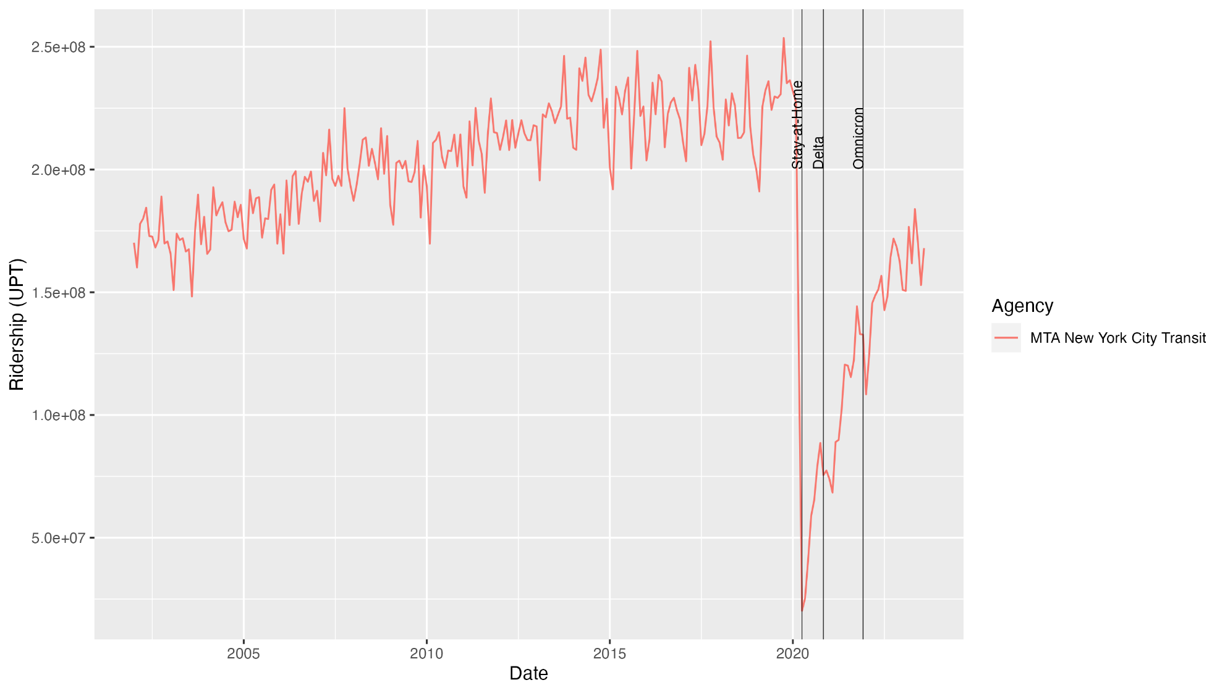
Figure 3.1 Ridership at MTA New York City Transit from January 2002 to August 2023
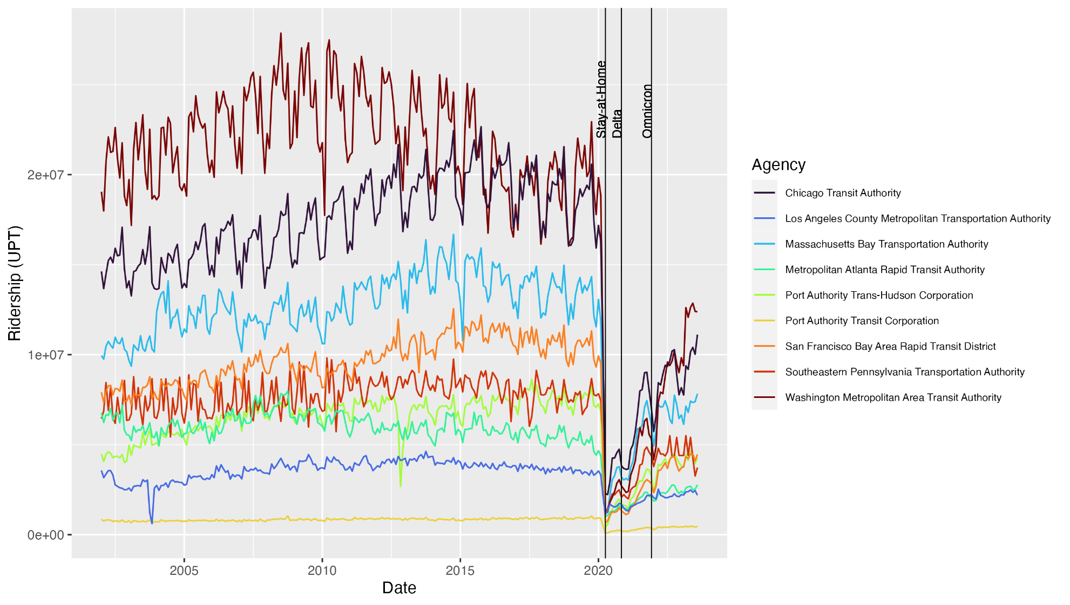
Figure 3.2 Ridership at larger heavy rail agencies from January 2002 to August 2023
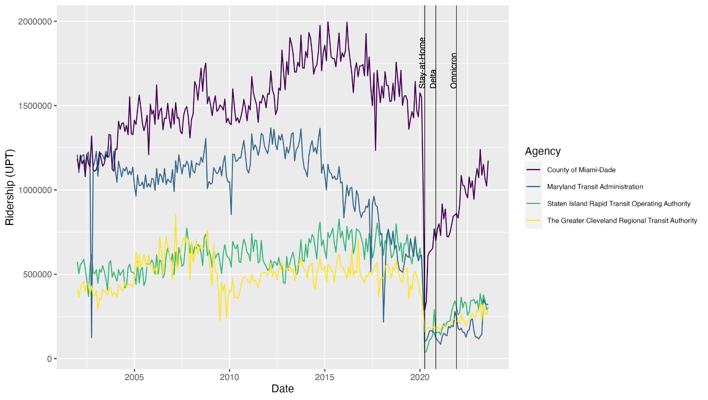
Figure 3.3 Ridership at smaller heavy rail agencies from January 2002 to August 2023

declines at the heavy rail agencies in this study ranged from 32-55%, and from February to April ridership declines ranged from 55-94%. Therefore, February 2020 was considered to be the last pre-COVID month, and April 2020 was considered to be the first COVID-era month. The periods of analysis were selected based on these findings.

Models with multiple time periods were tested in this study in order to: 1) compare forecasting performance pre- and post-COVID, 2) investigate the impact of the number of observations on the forecasting performance, and 3) isolate the effects of the pandemic on post-COVID ridership trends and patterns. Figure 3.4 shows a visualization of the three time periods selected for analysis. In each time period, the last 12 observations were held out to be used as testing data. The first time period used in this study was the pre-COVID period. The training data were from January 2002 to February 2019, and the test data were from March 2019 to February 2020. This time period was used to establish a baseline performance for the seven forecasting methods under “normal” conditions. The second time period was the full data series. The training data were from January 2002 through August 2022, and the testing data were from September 2022 to August 2023. This time period was used to forecast post-COVID ridership while incorporating pre-pandemic ridership trends. The third time period was the post-COVID period. The training data were from April 2020 through August 2022, and the testing data were from September 2022 to August 2023, which was the latest available data point at the time of writing. This time period was used to evaluate the performance of the forecasting methods under the “new normal” conditions, without considering prior patterns in transit ridership. All forecasts were made for the following 12 months in order to compare the forecasted ridership to the actual ridership from the testing datasets.

Software
The software used in this paper initially was based on a web application called Route Trends and Info created by staff from Minneapolis Metro Transit (26). The application runs off R Software (27). Metro Transit’s application supports seven forecasting methods: (1) exponential smoothing (ETS); (2) autoregressive integrated moving average (ARIMA); (3) and (4) Seasonal and Trend Decomposition using Loess, using ETS or ARIMA (STL-ETS and STL-ARIMA); (5) the exponential smoothing state space model with trigonometric seasonality, Box-Cox transform, ARMA errors, trend, and seasonal periods (TBATS); (6) a feed-forward autoregressive neural network with a single hidden layer (NNET); and (7) a hybrid model with equal weights of the ETS, STL, TBATS, and NNET methods (26; 28).

The source code for Minneapolis Metro’s application is available to the public on GitHub (29). The source code was modified substantially by the authors of this paper and used directly in R (v4.3.1) in order to change the model parameters, output additional performance measures (e.g., mean absolute scared error), and output customized graphs (27). For example, Minneapolis Metro’s application uses the ETS method in their hybrid

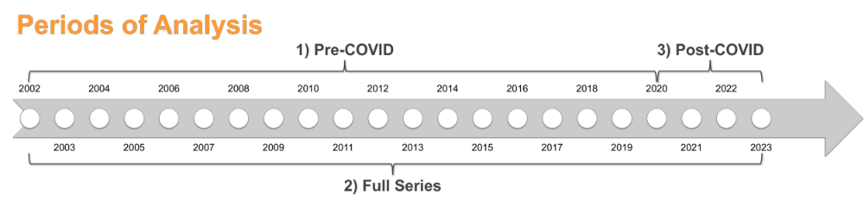
Figure 3.4 The three forecasting time periods used in this study

model, but in this study, the ARIMA method was used because it improved the mean absolute percent error of many of the post-COVID forecasts by over 1%. Also, the original GitHub code produces a single interactive plot using the “dygraphs” package (30), but these were changed to non-interactive plots with seven graphs using the “ggplot2” package (31). The functions used to produce the forecasts in this study have been made publicly available on Github at the following web address: https://github.com/ashley2876/forecasting_repo.

Time Series Models
Seven time series models were estimated in this study, also shown below in Figure 3.5: ETS, ARIMA, STL-ETS, STL-ARIMA, TBATS, NNET, and a hybrid model with equal weights of the ARIMA, NNET, TBATS, and STL methods (Hybrid ANST). This study focused on the first four classical time series models because they are widely established, well understood, and familiar to academics and some practitioners. The last three models were selected due to their ability to handle complex seasonality in time series using non-linear functions. This study does not focus on other machine learning methods or deep learning methods for several reasons. First, the short length of the data used in this study is not likely to be suitable to such methods. Second, to the authors’ knowledge, no US transit agency is using other machine learning or deep learning methods to conduct ridership forecasts, and this study is intended to be aimed at practitioners. Last, machine learning methods, especially deep learning methods, are expensive to conduct, require extensive set up, and the results are more difficult to interpret.

Each of the chosen forecasting methods are briefly discussed below. The equations have been omitted for brevity but interested readers are referred to the following references (28; 32).

Exponential Smoothing (ETS)
There are 18 potential equations for an ETS model. A general notation can be denoted as ETS(error, trend, seasonal), and each component has multiple possibilities. Errors can be “A” additive or “M” multiplicative. Trends can be “N” none, “A” additive, or “Ad” additive damped. Seasonal components can be “N” none, “A” additive, or “M” multiplicative. By using the “ets()” function in the “forecast” package, the best fit model was selected from the 18 options by minimizing the corrected Akaike information criterion (AICc) (33-35). For more details on the ETS method, readers are referred to (35).

Autoregressive integrated moving average (ARIMA)
Similarly, there exist a large number of potential equations for an ARIMA model. A general notation for a non-seasonal ARIMA model is ARIMA (p, d, q). The “p” is the order of the autoregressive (AR) part, the “d” is the degree of first differencing (the
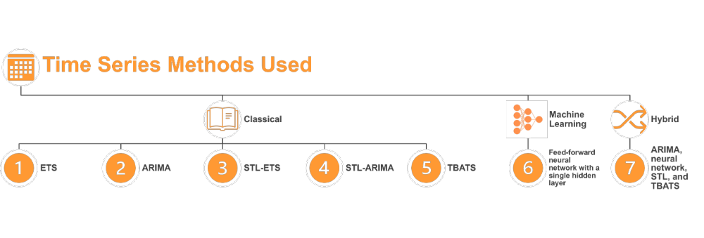

Figure 3.5 Types of forecasting methods used in this study
integrated (I) part), and the “q” is the order of the moving average (MA) part. A general notation for a seasonal ARIMA model is ARIMA(p, d, q)(P, D, Q)_{m}, where “P,” “D,” and “Q” are the seasonal AR, differencing, and MA orders, respectively, and “m” is the number of observations per year. In this study, the number of observations per year is always 12. Using the “auto.arima()” function from the “forecast” package with the argument “stepwise = FALSE,” R automatically chose the best fit ARIMA model based on a combination of the following criteria: unit root tests, minimizing the AICc, and minimizing the maximum likelihood estimation (33; 34; 36). For more details on the ARIMA method, readers are referred to (36).

Seasonal and Trend Decomposition using Loess (STL) with ETS or ARIMA
STL is a method to decompose a time series into the seasonal, trend-cycle, and remainder components, where Loess is a method of evaluating nonlinear relationships. In this study, the STL method was used to de-seasonalize the data. This is useful for transit ridership data because transit ridership tends to vary substantially by season. The seasonal component “S_{t}” is forecasted separately from the non-seasonal components “T_{t}” and “R_{t}” using the seasonal naïve method. A seasonal naïve forecast means all forecasts were set equal to the last observed value from the same season (28). The non-seasonal components can then be forecast using any non-seasonal forecasting method (28). The “stlm()” function from the “forecast” package was used to forecast using the STL-ETS and STL-ARIMA methods (33; 34; 37). For more details about STL decomposition, readers are referred to (37).

Exponential smoothing state space model with trigonometric seasonality, Box-Cox transform, autoregressive moving average errors, trend, and seasonal periods (TBATS)
The TBATS model is an exponential smoothing state-space model that can consider a Box-Cox transformation to handle non-linearity in the data, the autoregressive moving average model to de-correlate the residuals, trend components for long- and short-term trend (with and without dampening), and trigonometric functions based on Fourier representations with time-varying components to handle complex seasonality (32). By using the “tbats()” function in the “forecast” package, R selected the best fit model by adjusting the above parameters to find a model configuration that minimized the Akaike information criterion (AIC) (38). For more details on the TBATS model, readers are referred to (32).

Feed-forward autoregressive neural network with a single hidden layer (NNET)
R's nnetar() function from the “forecast” package was used to estimate a feed-forward autoregressive neural network with a single hidden layer (33). In order to ensure reproducibility, the seed was set to “1234”; setting a seed was required for this study because the neural network randomly selects the initial parameters, which caused the performance measures for the same forecasts to vary slightly from run to run (39). The seasonal model is represented by NNAR(p,P,k)_{m}, where “P”, the number of seasonal lags, defaults to one, “p”, the number of non-seasonal lags, is selected from the optimal linear model fitted to the seasonally adjusted data, “k”, the number of neurons in the hidden layer, is equal to (p + P + 1)/2, and “m” is the number of observations per year (always 12 in this study). Prediction intervals were derived for the neural network forecasts by setting the forecast() function to simulate 1,000 future sample paths (28; 40). With a larger data set, the performance of the forecasts may be improved when “P,” the number of seasonal lags, is set to a context-appropriate value (e.g., 12 for monthly data). However, the short length of the data in this study caused the neural network to overfit the model when P was set to 12, so the default of one was used. For more details on the neural network model, readers are referred to (40).

Hybrid
The hybridModel() function from the “forecastHybrid” package was used to estimate a hybrid model with equal weights of the ARIMA, NNET, TBATS, and STL methods. Minneapolis Metro’s hybrid model uses ETS instead of ARIMA; for this study, the ARIMA model was selected instead because it improved the performance of many the post-COVID forecasts by improving the mean absolute percent error by over one percent. The method for the STL component of the hybrid model was ARIMA. Parallel processing was used between models to shorten the computation time. The weights of each model were set to be equal because this has been shown empirically to give good performance. For more details on the hybrid model, readers are referred to (41).

Performance Measures
The performance measures used in this study were the mean absolute percent error (MAPE) and the mean absolute scaled error (MASE) of the testing data. The MAPE is a percentage error and is unitless. Therefore, the MAPE is a good measure to compare between datasets that have different scales. The MASE is a scaled error and can be used to compare between datasets with different units. A MASE less than one indicates that, according to the mean absolute error (MAE), the forecast performed better than the average naïve forecast. In the case of seasonal data, a naïve forecast means all forecasts were set equal to the last observed value from the same season (28). The MAPE and MASE for the testing data were recorded to provide a measure of the forecast accuracy (28). The formula for the MAPE is provided in Equation 1. The formula for the MASE for a seasonal forecast is given in Equation 2.

$MAPE=mean(\left|\frac{100e_{t}}{y_{t}}\right|)$ 1)

Where
t = time (in months)
y_{t} = the fitted values (ridership in UPT)
e_{t} = the forecast error (the difference between an observed value and its forecast) (28).

$MASE=mean(\left|\frac{e_{j}}{\frac{1}{T-m}\sum_{t=m+1}^{T}{\left|y_{t}-y_{t-m}\right|}}\right|)$ 2)

Where
t = time (in months)
m = number of observations per year (always 12 in this study)
y_{t} = the fitted values (ridership in UPT)
y_{t-m} = the fitted values from the previous season (ridership in UPT)
T = time at the last observation
e_{j} = the forecast error (the difference between an observed value and its forecast) (28).

Results and Discussion of the Pre-COVID Forecasts

In this chapter, the results of the pre-COVID (from January 2002 to February 2020) forecasts are presented. In the following two chapters, the results of the full series (from January 2002 to August 2023) and post-COVID (from April 2020 to August 2023) forecasts are presented. The results are shown in this order to demonstrate the impact of the pandemic on the forecast accuracy, and to show the impact of the series length on the models’ performance. For all periods, each of the 14 heavy rail agencies was analyzed using the seven forecasting methods, and the MAPE and MASE were calculated.

To assess the fit of the models, the Ljung-Box test was used to assess the white noise of the residuals for each model, and histograms of the residuals were examined to check for normality and influential outliers. The residuals were checked using the “checkresiduals()” function from the “forecast” package (33; 34). For the majority of the pre-COVID models, the histograms were normally distributed with the means close to zero, meaning the models were unbiased. The Ljung-Box test showed that for many of the models, some autocorrelation patterns remained that the models were not able to capture; this means that while the forecasts could be quite good, the prediction intervals may have been inaccurate. Generally, the residuals showed that the models produced unbiased results (28). Even though the pre-COVID residuals showed some remaining patterns, the results below show that the overwhelming majority of the models still produced good or acceptable forecasts.

Results of the Pre-COVID Analysis
For the pre-COVID analysis, the training dataset was from January 2002 through February 2019. The testing dataset was from March 2019 through February 2020. Visualizations of the forecasts for each of the 14 the transit agencies are provided in the following figures (Figure 4.1 through Figure 4.2) to show examples of the outputs that were created for each of the fourteen agencies. In the figures, the x-axis is the date, and the y-axis is ridership (UPT). The blue line is the forecasted ridership, and the red line is the actual ridership (testing data). The light purple shaded area is the 95% prediction interval, and the dark purple shaded area is the 80% prediction interval. Although the data was trained from 2002 to 2019, only the training data after 2010 is shown so that both the forecasts
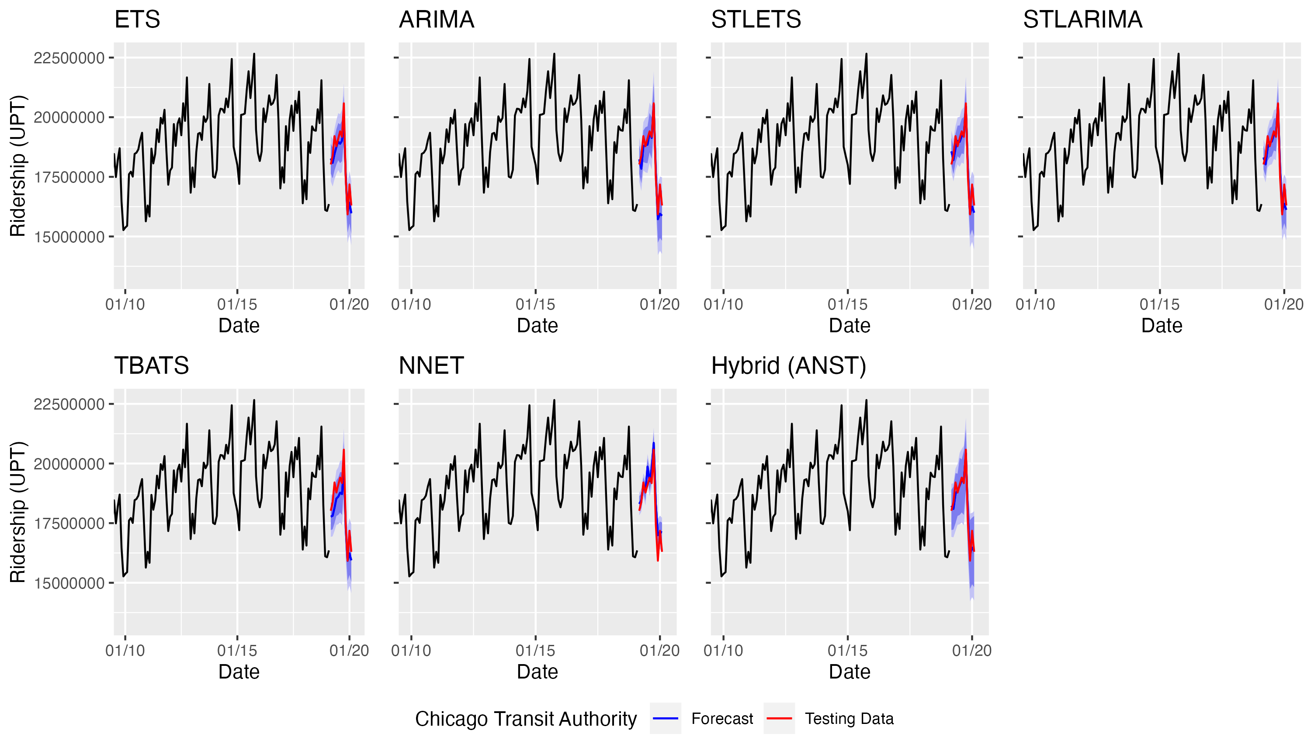
Figure 4.1 Pre-COVID ridership forecasts for the Chicago Transit Authority
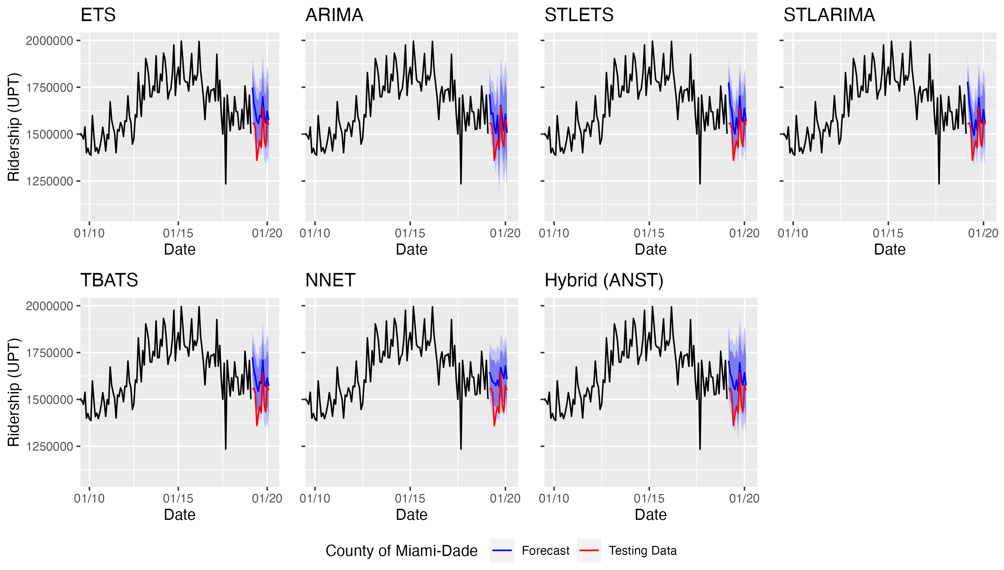
Figure 4.2 Pre-COVID ridership forecasts for the County of Miami-Dade
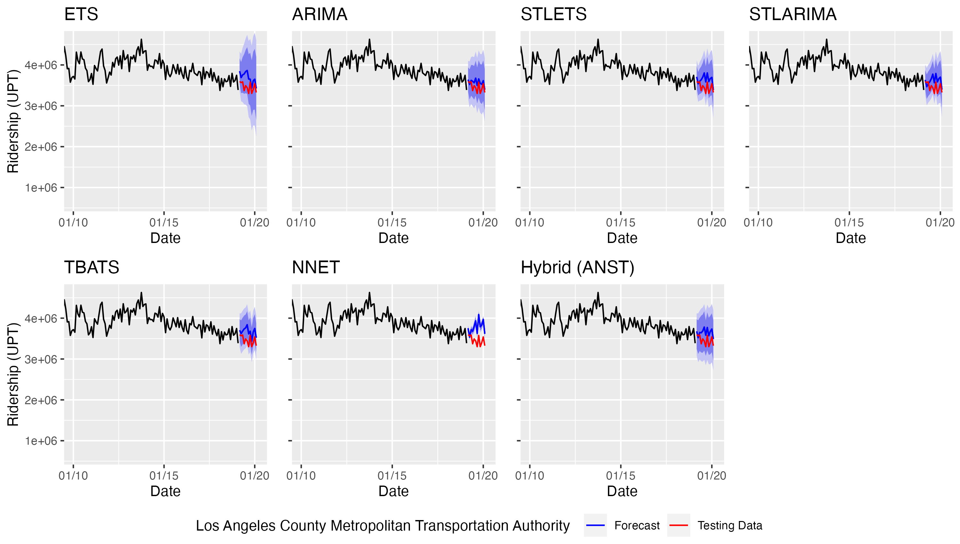
Figure 4.3 Pre-COVID ridership forecasts for the Los Angeles County Metropolitan Transportation Authority
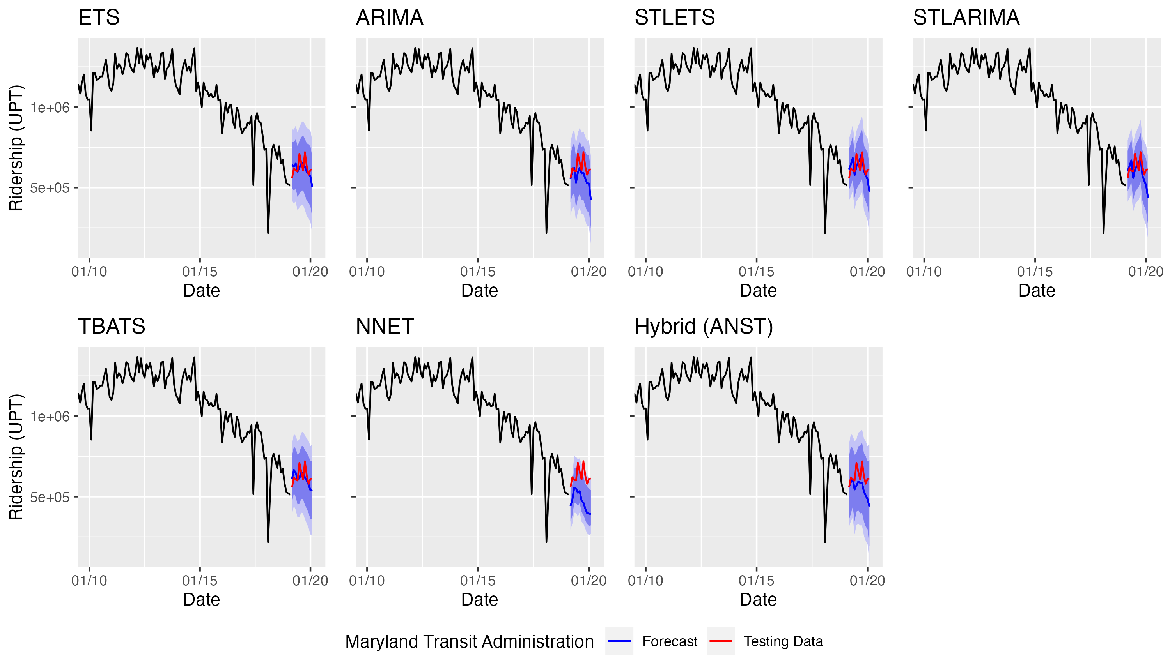
Figure 4.4 Pre-COVID ridership forecasts for the Maryland Transit Administration
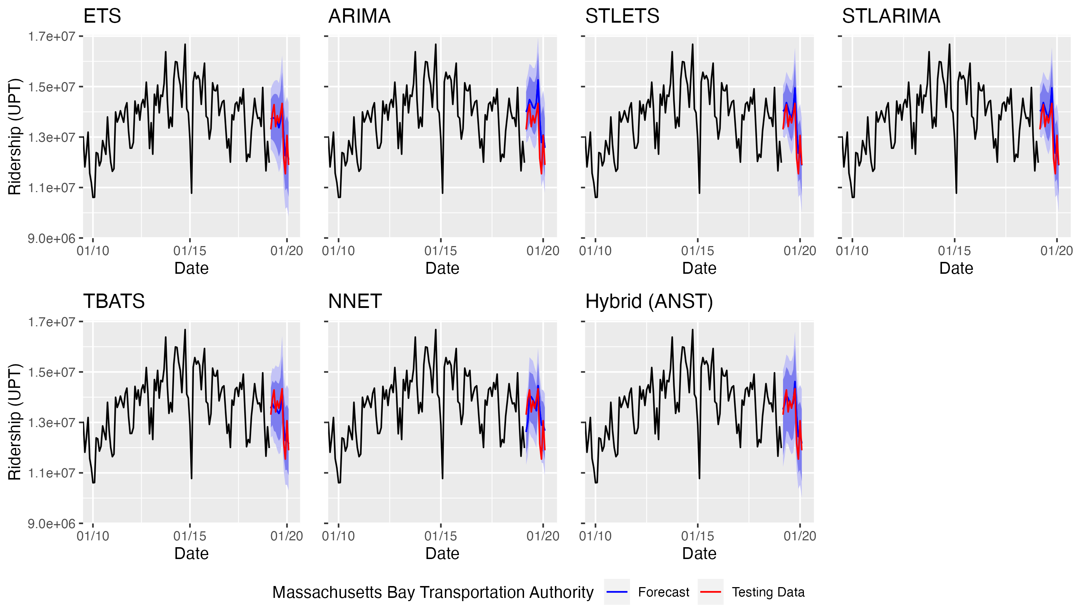
Figure 4.5 Pre-COVID ridership forecasts for the Massachusetts Bay Transportation Authority
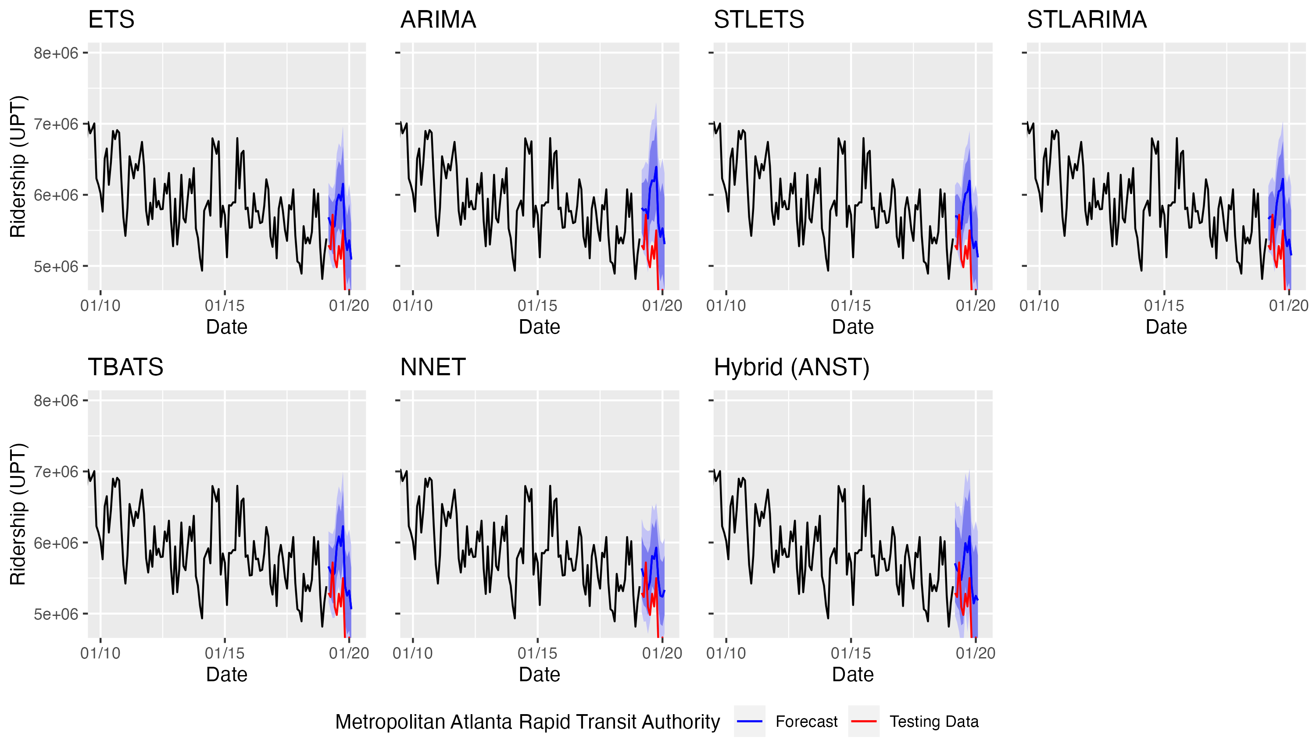
Figure 4.6 Pre-COVID ridership forecasts for the Metropolitan Atlanta Rapid Transit Authority
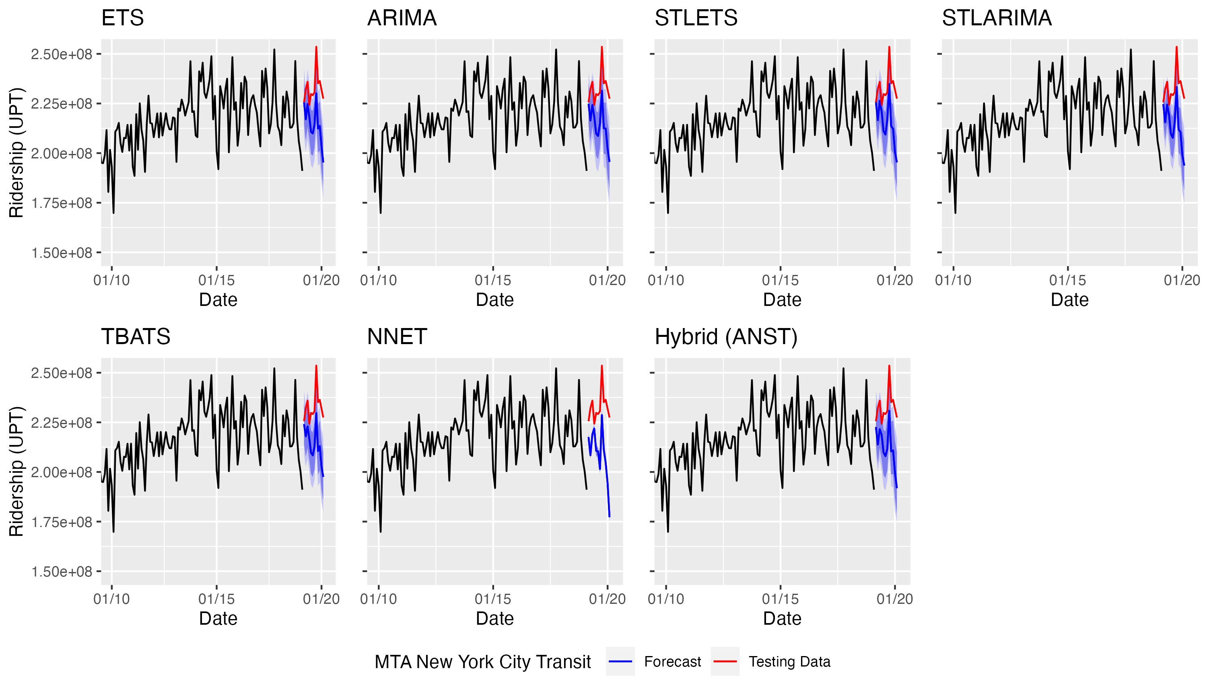
Figure 4.7 Pre-COVID ridership forecasts for MTA New York City Transit
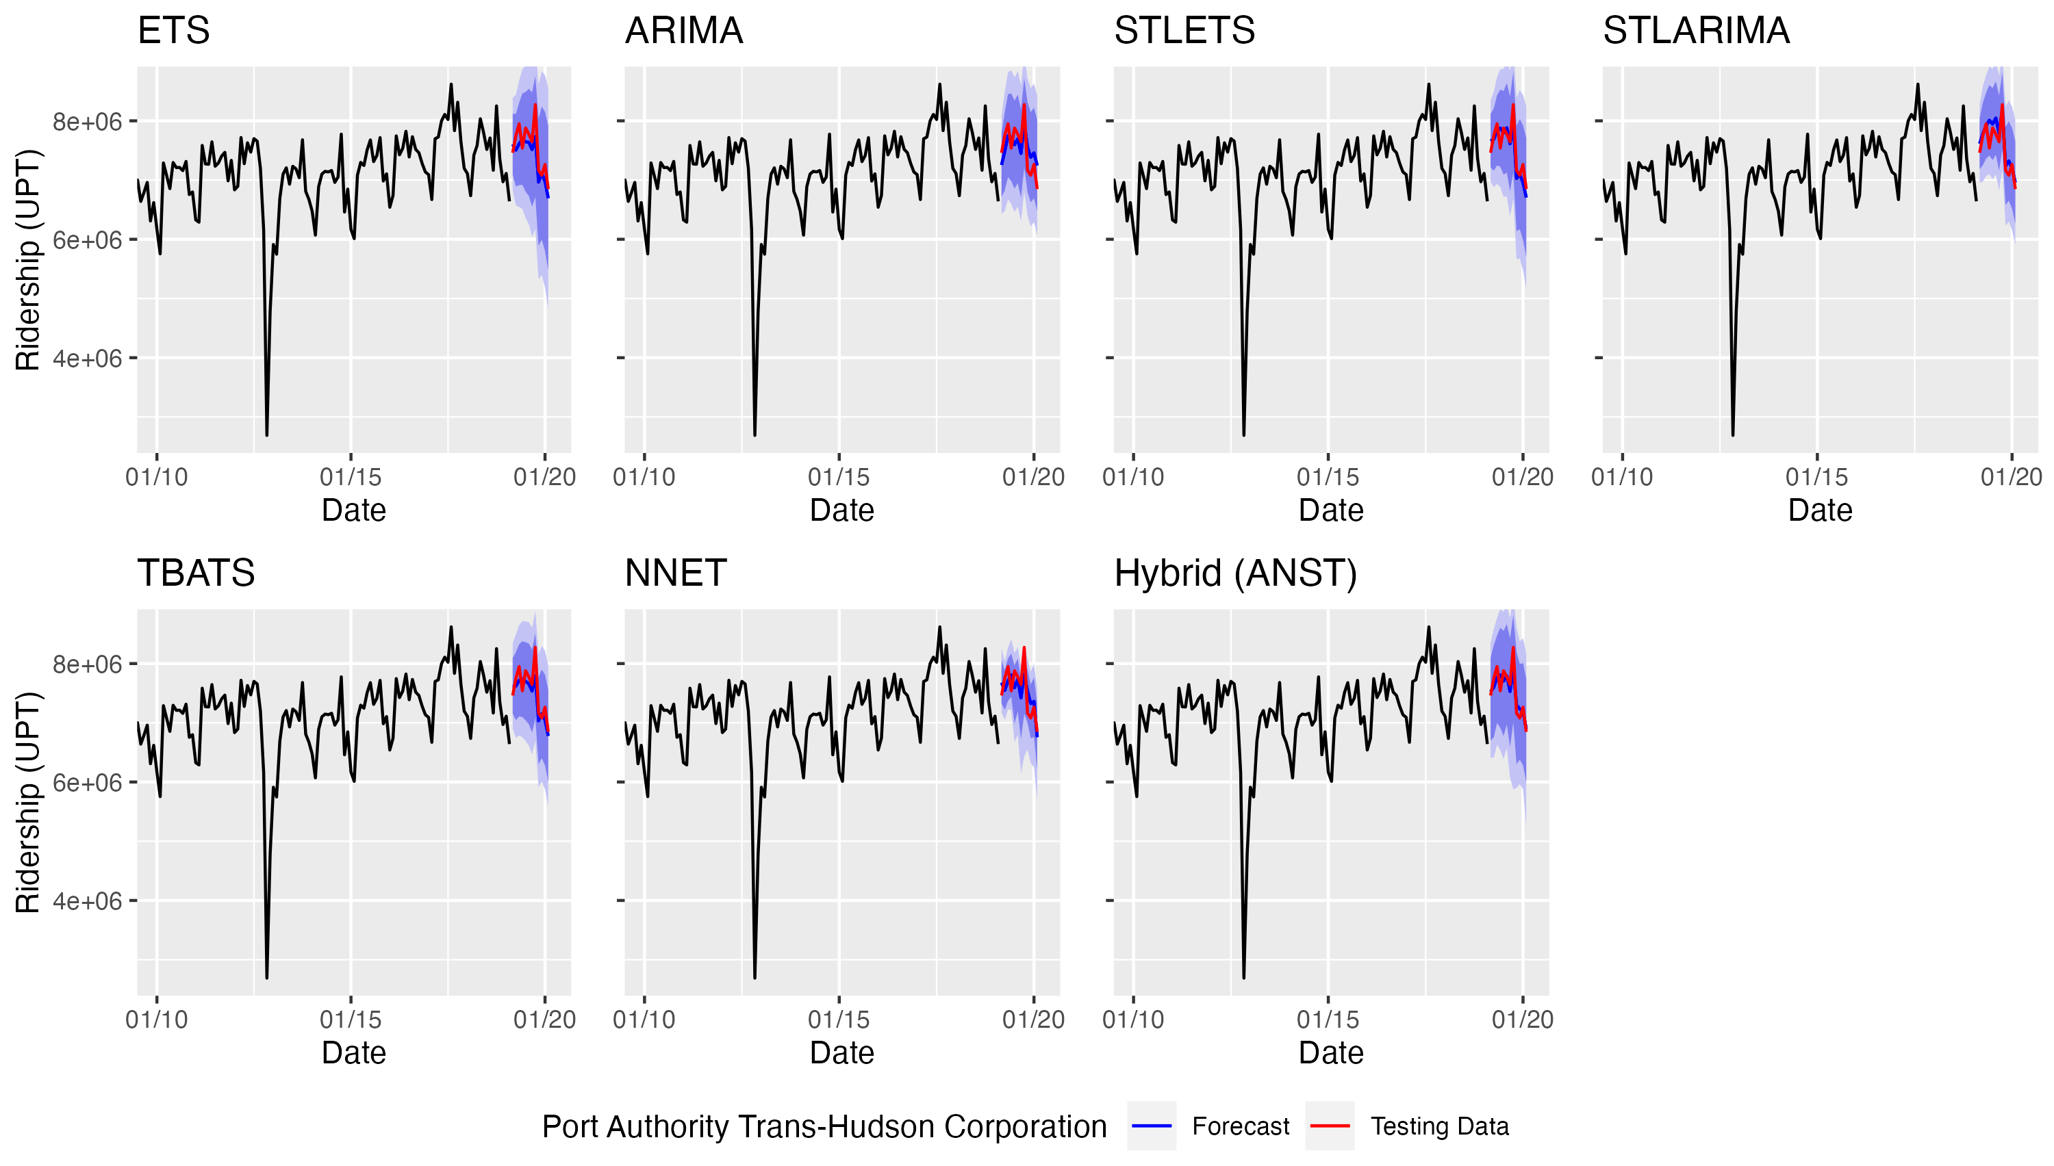
Figure 4.8 Pre-COVID ridership forecasts for the Port Authority Trans-Hudson Corporation
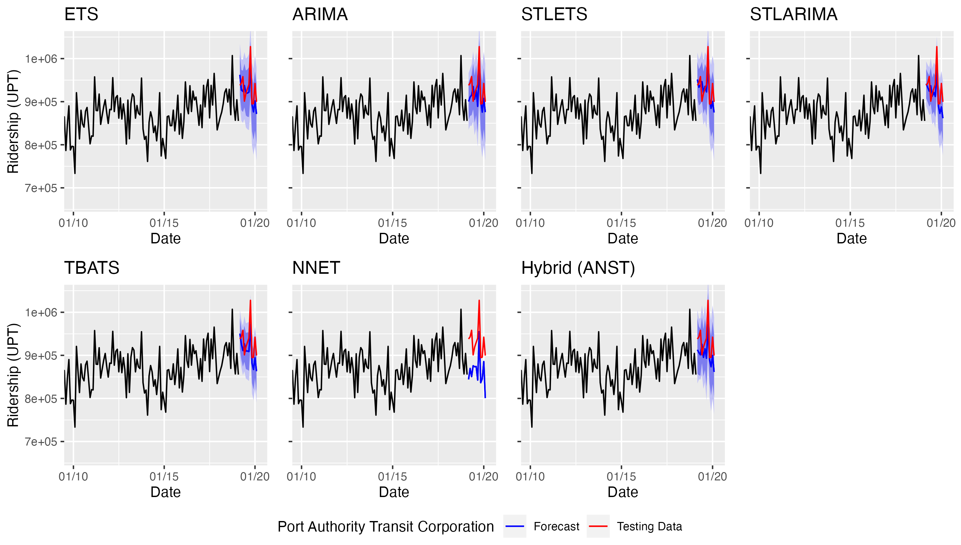
Figure 4.9 Pre-COVID ridership forecasts for the Port Authority Transit Corporation
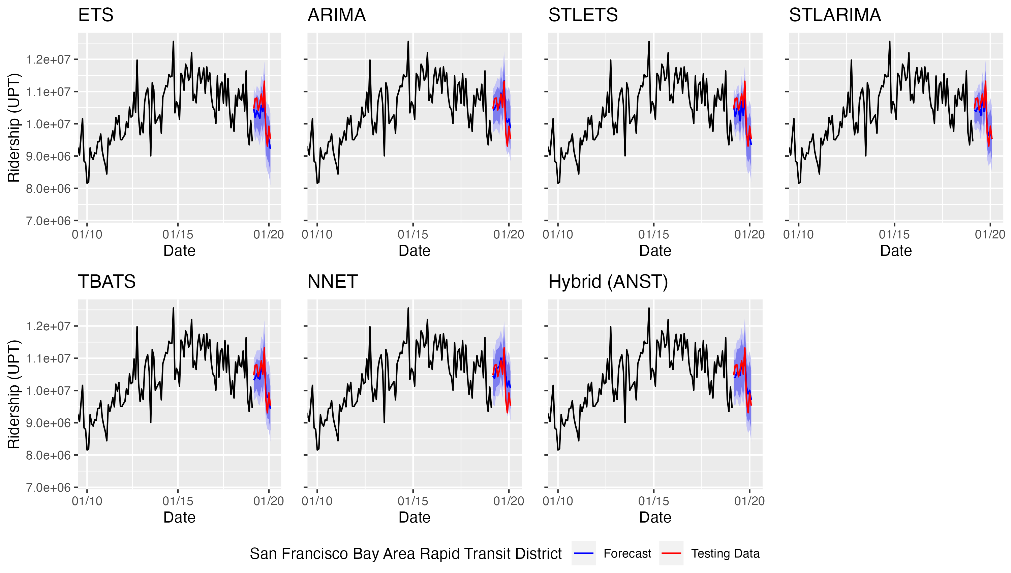
Figure 4.10 Pre-COVID ridership forecasts for the San Francisco Bay Area Rapid Transit District
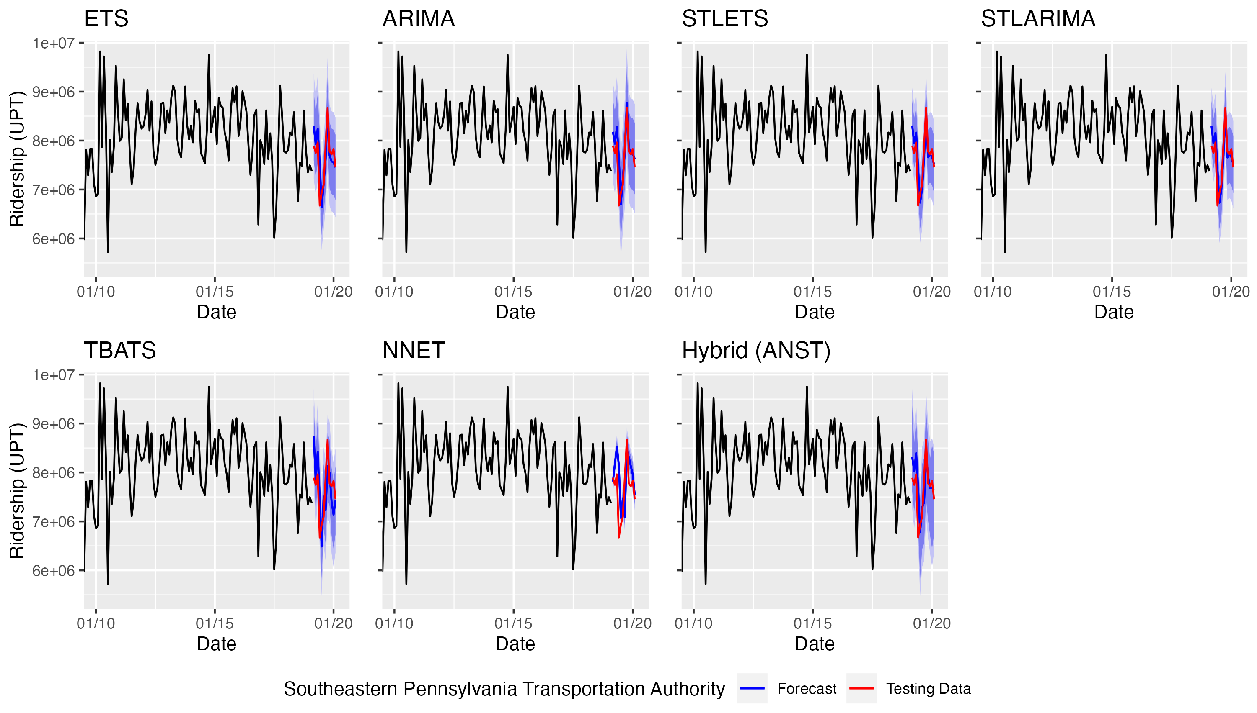
Figure 4.11 Pre-COVID ridership forecasts for the Southeastern Pennsylvania Transportation Authority
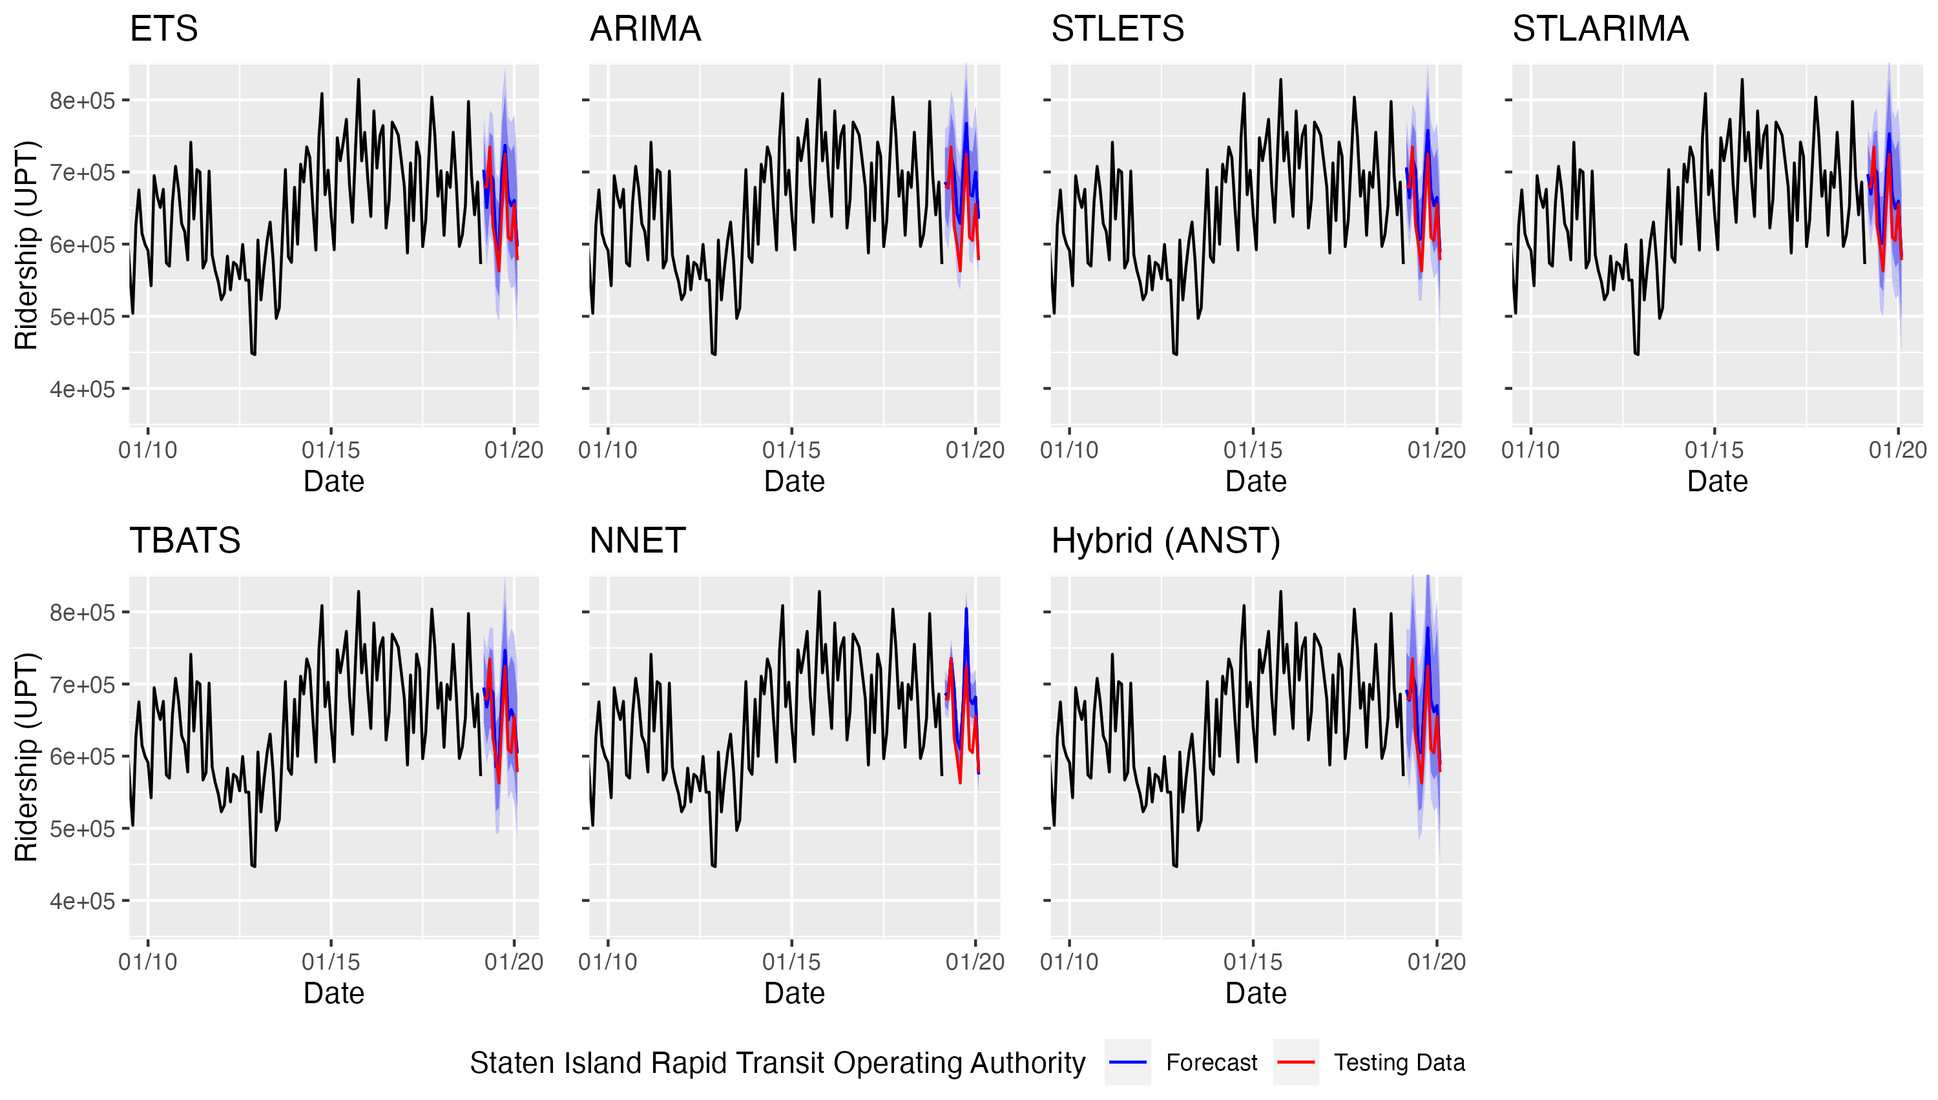
Figure 4.12 Pre-COVID ridership forecasts for the Staten Island Rapid Transit Operating Authority
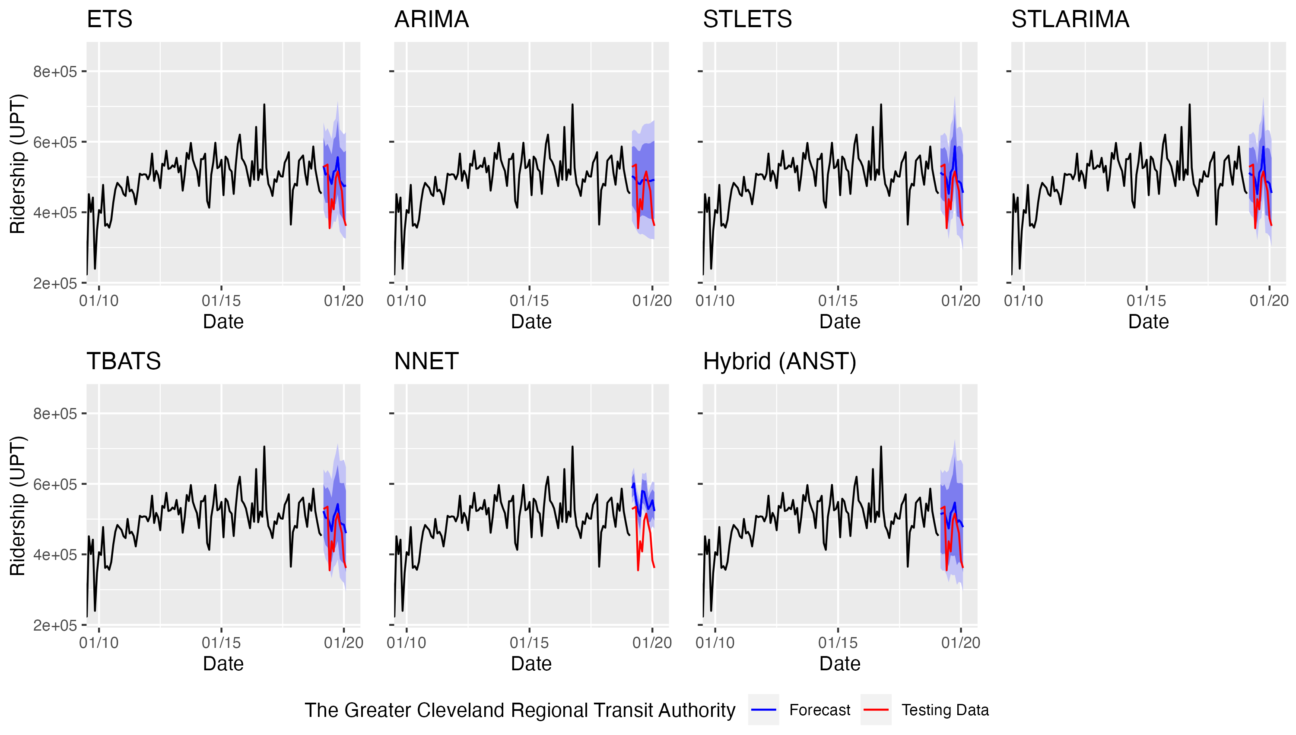

Figure 4.13 Pre-COVID ridership forecasts for the Greater Cleveland Regional Transit Authority
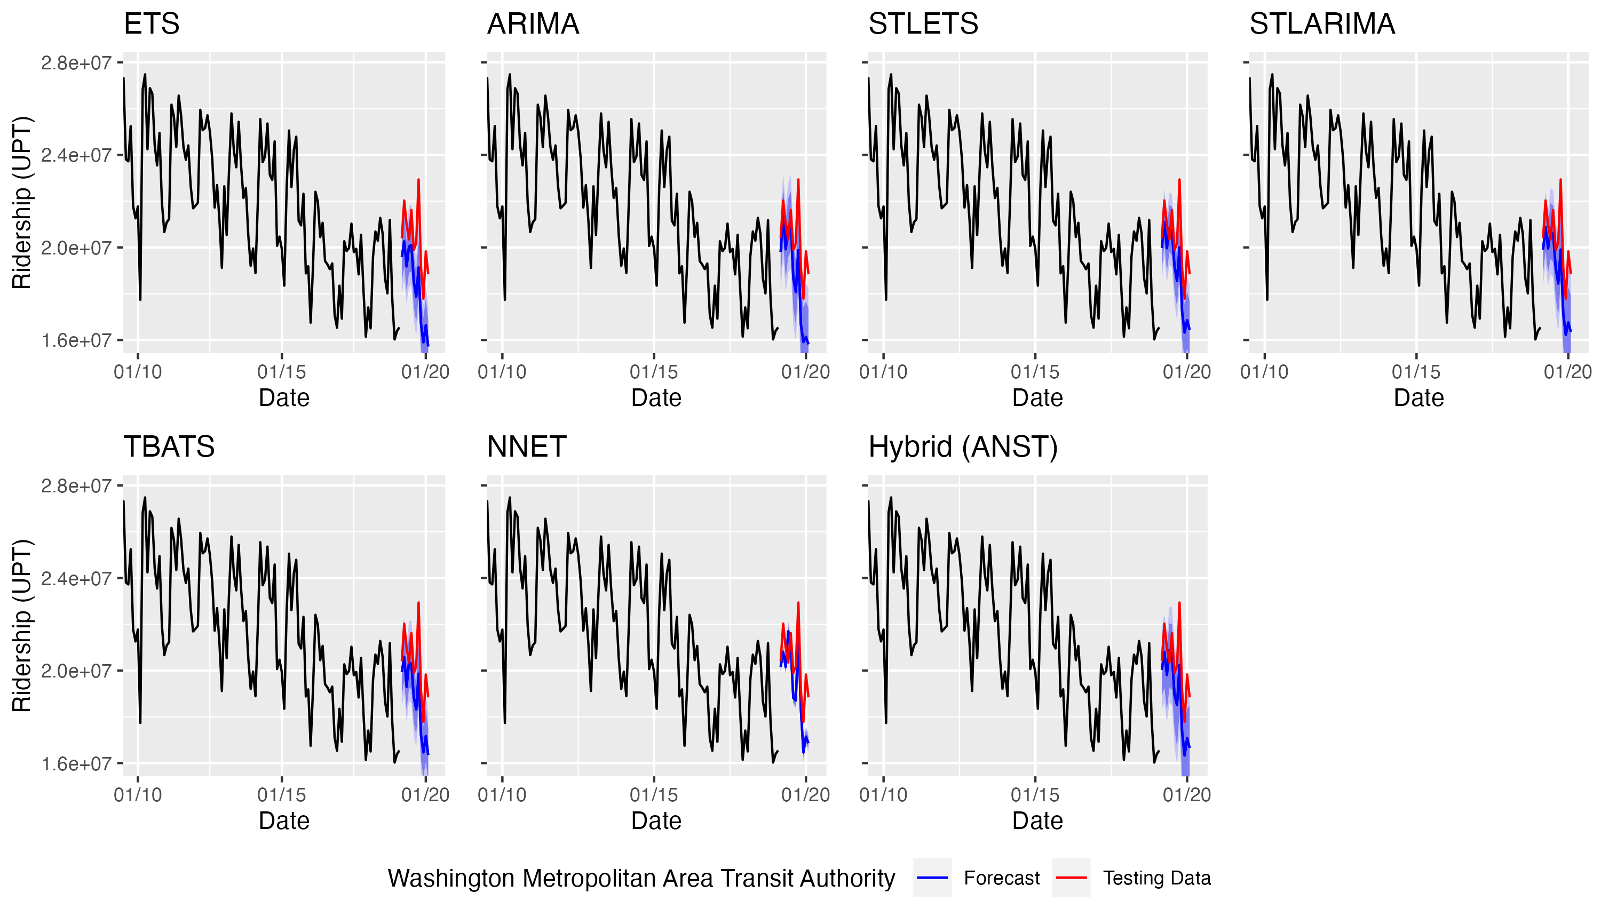
Figure 4.14 Pre-COVID ridership forecasts for the Washington Metropolitan Area Transit Authority
and the trends are shown more clearly. At many agencies, for example at the Chicago Transit Authority, the graphs showed clear seasonal patterns and a downward trend prior to the pandemic. Other agencies, such as the Greater Cleveland Regional Transit Authority, had weaker seasonal patterns and had a less dramatic downward ridership trend.
Table 4.2 presents the results of the pre-COVID model performance for each agency. The lowest/highest MAPE and MASE for the testing data (referred to simply as “errors”) are shown, with the highest error indicating the poorest performance and the lowest error indicating the best performance. In this study, models with a MAPE less than 5% were considered to have good performance, and models with a MAPE less than 10% were considered to have acceptable performance (28). In the table, a MAPE below 5% (good performance) is highlighted green, a MAPE below 10% (acceptable performance) is highlighted yellow, and a MASE over 1.00 (did not outperform the naïve method) is highlighted red.
For 81.6% (80 out of 98) of the models, the MAPEs were acceptable (below 10%), and for 42.9% (42 out of 98) of the models the MAPEs were good (below 5%). These results show that, using R software to automatically select model parameters, the seven time series forecasting methods were capable of producing good or acceptable pre-COVID transit ridership forecasts at most of the selected agencies.
Despite generally good performance, at four of the agencies, no model produced a MAPE below 5% (MTA New York City Transit, Washington Metropolitan Area Transit Authority, Maryland Transit Administration, and the County of Miami-Dade). At those four agencies, the MASEs were generally over 1.00, indicating that the models did not outperform the naïve method. At the Metropolitan Atlanta Rapid Transit Agency and Greater Cleveland Regional Transit Authority, none of the models produced a MAPE below 10%. None of the Metropolitan Atlanta Rapid Transit Agency models outperformed the naïve method, while almost all the Greater Cleveland Regional Transit Authority models did.
Among the seven methods, no one method stood out as having the best performance, as they all performed well for most agencies. The neural network overwhelmingly underperformed compared to the other methods, likely due to the relatively short length of the data for which machine learning methods are generally not suitable.
In general, the pre-COVID results suggest that these seven methods of time series forecasting perform well when the ridership data have strong seasonal patterns. However, for agencies without strong seasonal patterns, ridership forecasting with time series methods may be more challenging.

Table 4.1 Performance of pre-COVID forecasts
Agency | Measure | ETS | ARIMA | STL-ETS | STL-ARIMA | TBATS | NNET | Hybrid (ANST) | Minimum | Maximum
Chicago Transit Authority | MAPE | 1.79 | 1.76 | 1.64 | 1.49 | 2.65 | 2.40 | 1.33 | Hybrid (ANST) | TBATS
Chicago Transit Authority | MASE | 0.53 | 0.50 | 0.47 | 0.42 | 0.78 | 0.67 | 0.38
County of Miami-Dade | MAPE | 7.99 | 5.52 | 7.25 | 6.78 | 7.67 | 8.03 | 7.64 | ARIMA | NNET
County of Miami-Dade | MASE | 1.22 | 0.84 | 1.12 | 1.04 | 1.17 | 1.22 | 1.17
Los Angeles County Metropolitan Transportation Authority | MAPE | 6.53 | 3.53 | 5.52 | 5.25 | 6.10 | 9.46 | 5.76 | ARIMA | NNET
Los Angeles County Metropolitan Transportation Authority | MASE | 0.94 | 0.50 | 0.79 | 0.75 | 0.87 | 1.35 | 0.82
Maryland Transit Administration | MAPE | 7.42 | 10.46 | 7.60 | 9.69 | 7.41 | 24.76 | 11.94 | TBATS | NNET
Maryland Transit Administration | MASE | 0.49 | 0.70 | 0.49 | 0.63 | 0.50 | 1.64 | 0.80
Massachusetts Bay Transportation Authority | MAPE | 2.92 | 5.07 | 3.39 | 3.39 | 3.09 | 4.48 | 2.96 | ETS | ARIMA
Massachusetts Bay Transportation Authority | MASE | 0.49 | 0.85 | 0.57 | 0.57 | 0.52 | 0.74 | 0.49
Metropolitan Atlanta Rapid Transit Authority | MAPE | 12.75 | 16.10 | 12.99 | 13.25 | 12.99 | 10.98 | 11.81 | NNET | ARIMA
Metropolitan Atlanta Rapid Transit Authority | MASE | 1.71 | 2.16 | 1.74 | 1.78 | 1.75 | 1.45 | 1.58
MTA New York City Transit | MAPE | 7.71 | 7.87 | 7.44 | 8.09 | 8.05 | 10.25 | 8.65 | STL-ETS | NNET
MTA New York City Transit | MASE | 1.99 | 2.03 | 1.92 | 2.08 | 2.08 | 2.64 | 2.23
Port Authority Trans-Hudson Corporation | MAPE | 2.82 | 3.36 | 2.03 | 1.96 | 2.27 | 3.01 | 1.90 | Hybrid (ANST) | ARIMA
Port Authority Trans-Hudson Corporation | MASE | 0.49 | 0.57 | 0.35 | 0.33 | 0.40 | 0.52 | 0.33
Port Authority Transit Corporation | MAPE | 2.45 | 3.06 | 2.14 | 2.63 | 3.05 | 7.44 | 3.47 | STL-ETS | NNET
Port Authority Transit Corporation | MASE | 0.69 | 0.86 | 0.60 | 0.74 | 0.86 | 2.08 | 0.98
San Francisco Bay Area Rapid Transit District | MAPE | 2.81 | 2.40 | 2.55 | 1.78 | 2.11 | 3.11 | 2.05 | STL-ARIMA | NNET
San Francisco Bay Area Rapid Transit District | MASE | 0.65 | 0.53 | 0.59 | 0.41 | 0.48 | 0.68 | 0.46
Southeastern Pennsylvania Transportation Authority | MAPE | 3.35 | 3.19 | 2.87 | 2.87 | 6.09 | 5.93 | 4.29 | STL-ETS | TBATS
Southeastern Pennsylvania Transportation Authority | MASE | 0.60 | 0.57 | 0.52 | 0.52 | 1.12 | 1.07 | 0.78
Staten Island Rapid Transit Operating Authority | MAPE | 4.88 | 7.07 | 5.23 | 4.60 | 4.66 | 5.60 | 5.16 | STL-ARIMA | ARIMA
Staten Island Rapid Transit Operating Authority | MASE | 0.63 | 0.89 | 0.67 | 0.59 | 0.60 | 0.72 | 0.66
The Greater Cleveland Regional Transit Authority | MAPE | 13.30 | 13.51 | 13.20 | 13.12 | 12.64 | 22.65 | 13.77 | TBATS | NNET
The Greater Cleveland Regional Transit Authority | MASE | 0.73 | 0.74 | 0.73 | 0.73 | 0.69 | 1.28 | 0.75
Washington Metropolitan Area Transit Authority | MAPE | 10.00 | 8.62 | 7.33 | 7.72 | 7.93 | 6.19 | 7.29 | NNET | ETS
Washington Metropolitan Area Transit Authority | MASE | 2.04 | 1.73 | 1.49 | 1.57 | 1.62 | 1.25 | 1.48
Green - MAPE below 5%, Yellow - MAPE below 10%, Red - MASE above 1.00

results and discussion of the full series forecasts

In this chapter, the results of the full series (from January 2002 to August 2023) forecasts are presented. Each of the 14 heavy rail agencies was analyzed using the seven forecasting methods, and the MAPE and MASE were calculated.

To assess the fit of the models, the Ljung-Box test was used to assess the white noise of the residuals for each model, and histograms of the residuals were examined to check for normality and influential outliers. For the full series forecasts, the histograms were normally distributed with the means close to zero, and most of the results from the Ljung-Box test showed that the residuals were white noise; however, some of the models, especially the STL methods, were not able to capture all the patterns in the data, meaning that while the STL forecasts could be quite good, the prediction intervals may have been inaccurate. Generally, the residuals showed that the models produced unbiased results and captured most of the patterns in the data for each series (28).

Results of the Full Series Analysis
For the full series analysis, the training dataset was from January 2002 through August 2022, and the testing dataset was from September 2022 through August 2023. Similar to the pre-COVID results, visualizations of the forecasts for the transit agencies in Chicago and Cleveland are provided in Figure 4.3 and Figure 4.4 to show examples of the outputs that were created for each of the fourteen agencies. Although the data was trained from 2002 to 2022, only the training data after 2020 is shown so that the post-COVID forecasts can be shown clearly. Once again, most of the forecasts, like those for the Chicago Transit Authority, appear to have captured fairly well the patterns in the data and have forecasted approximately the correct scale of ridership. However, for a small number of agencies, such as the Greater Cleveland Regional Transit Authority and the Maryland Transit Administration, the forecasts appeared to over- or under-estimated ridership and failed to capture much of a pattern at all.
Table 4.2 presents the results of the full series model performance for each agency. The lowest/highest errors were again used to measure the performance of each method. For 57.1% (52 out of 91) of the models, the MAPEs were below 10%, and for 11.0% (10 out of 91) of the models the MAPEs were below 5%. It should be noted that the data from the Southeastern Pennsylvania Transportation Authority had a quality control issue that impacted the performance of the forecasts; therefore, the results for the Southeastern Pennsylvania Transportation Authority were omitted from the discussion.
The ARIMA method overwhelmingly outperformed the other methods by producing the lowest MAPE for half of the agencies. The hybrid and STL-ETS methods also performed well, together accounting for the lowest MAPE at another five agencies. The neural network once again overwhelmingly underperformed, likely due to the relatively short length of the data.
Again, there was a division of model performance between transit agencies; at two of the three smallest agencies, Maryland Transit Authority and the Greater Cleveland Regional Transit Authority, none of the models produced a MAPE below 10%. At the Washington Metropolitan Area Transit Authority, only the ARIMA model produced an MAPE below 10%, and at the Metropolitan Atlanta Rapid Transit Authority, only the ARIMA and STL methods produced a good (below 5%) or acceptable (below 10%) MAPE, respectively.
At the Massachusetts Bay Transportation Authority, only the ARIMA and hybrid models produced a MAPE below 10%, whereas for the pre-COVID period all models except ARIMA produced a MAPE below 5%. For the pre-COVID period, none of the MTA New York City Transit models produced a MAPE below 5%, and the MAPE for the neural network was above 10%. For the full series time period, the neural network and hybrid models have now produced a MAPE below 5%, and the rest of the models for MTA New York City Transit have a MAPE below 10%. Similarly, for the transit agency in the County of Miami-Dade, the pre-COVID models only produced a MAPE below 10%, but for the full series, the ETS, TBATS, and hybrid models all produced a MAPE
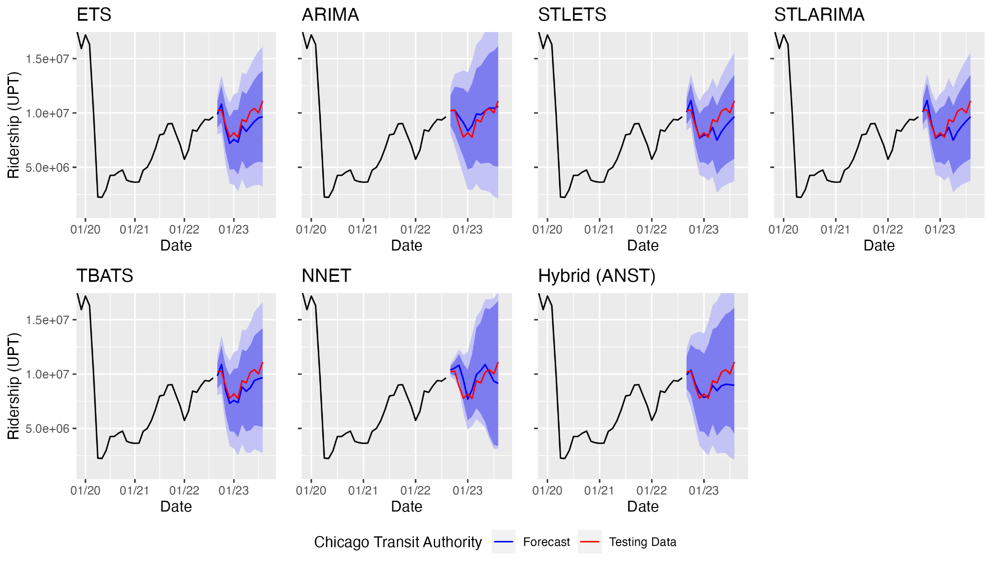
Figure 5.1 Full series ridership forecasts for Chicago Transit Authority
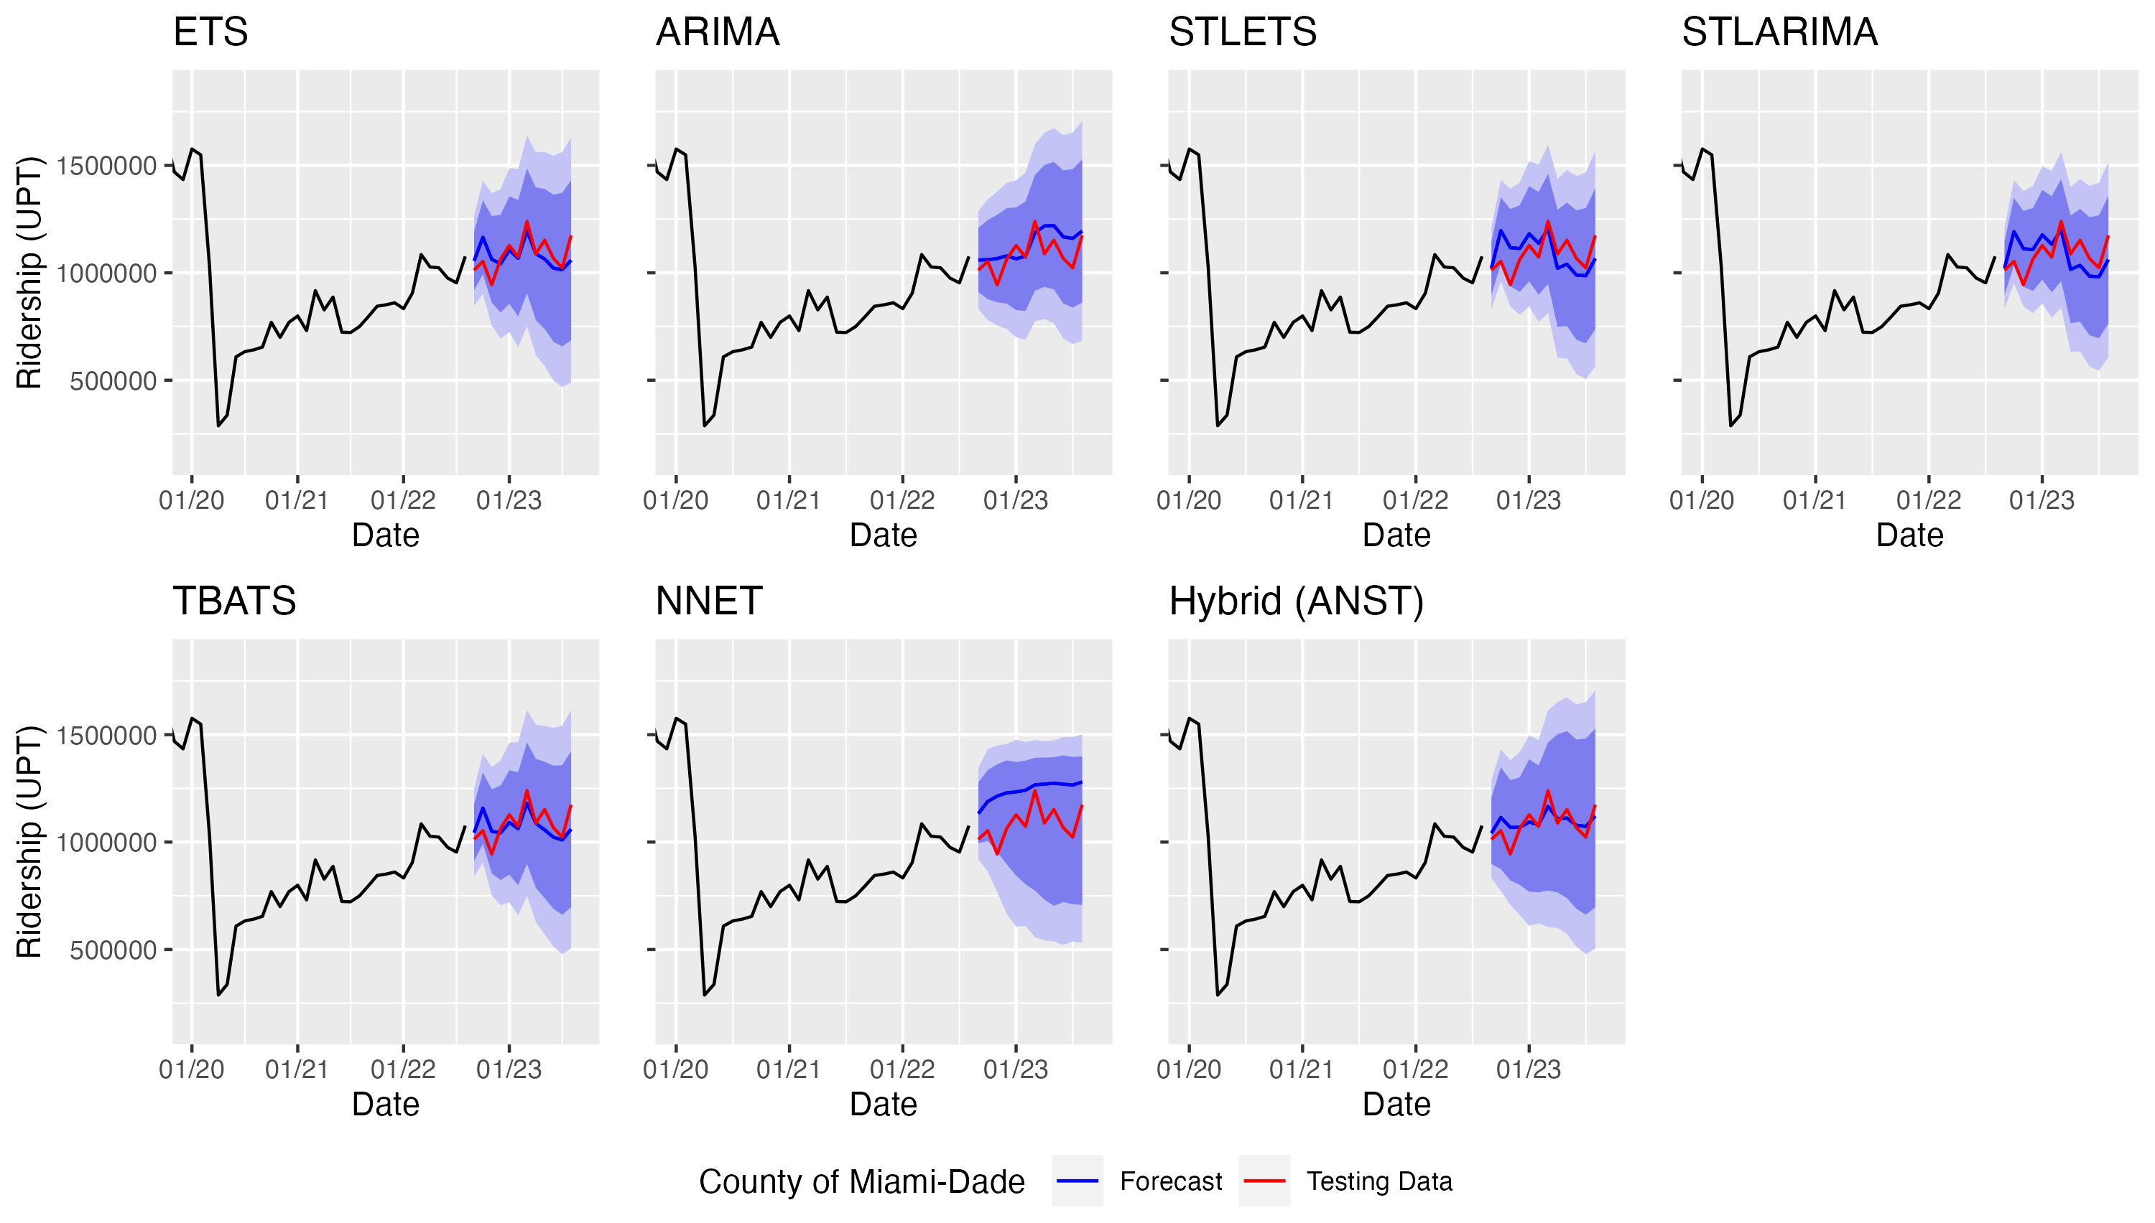
Figure 5.2 Full series ridership forecasts for the County of Miami-Dade
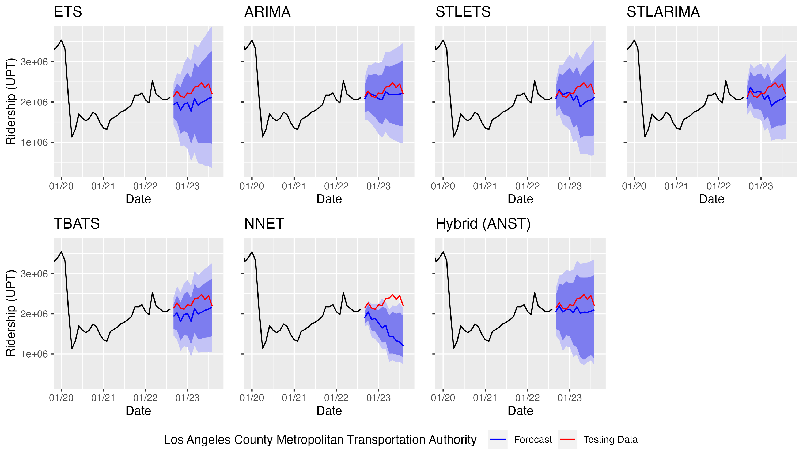
Figure 5.3 Full series ridership forecasts for the Los Angeles County Metropolitan Transportation Authority
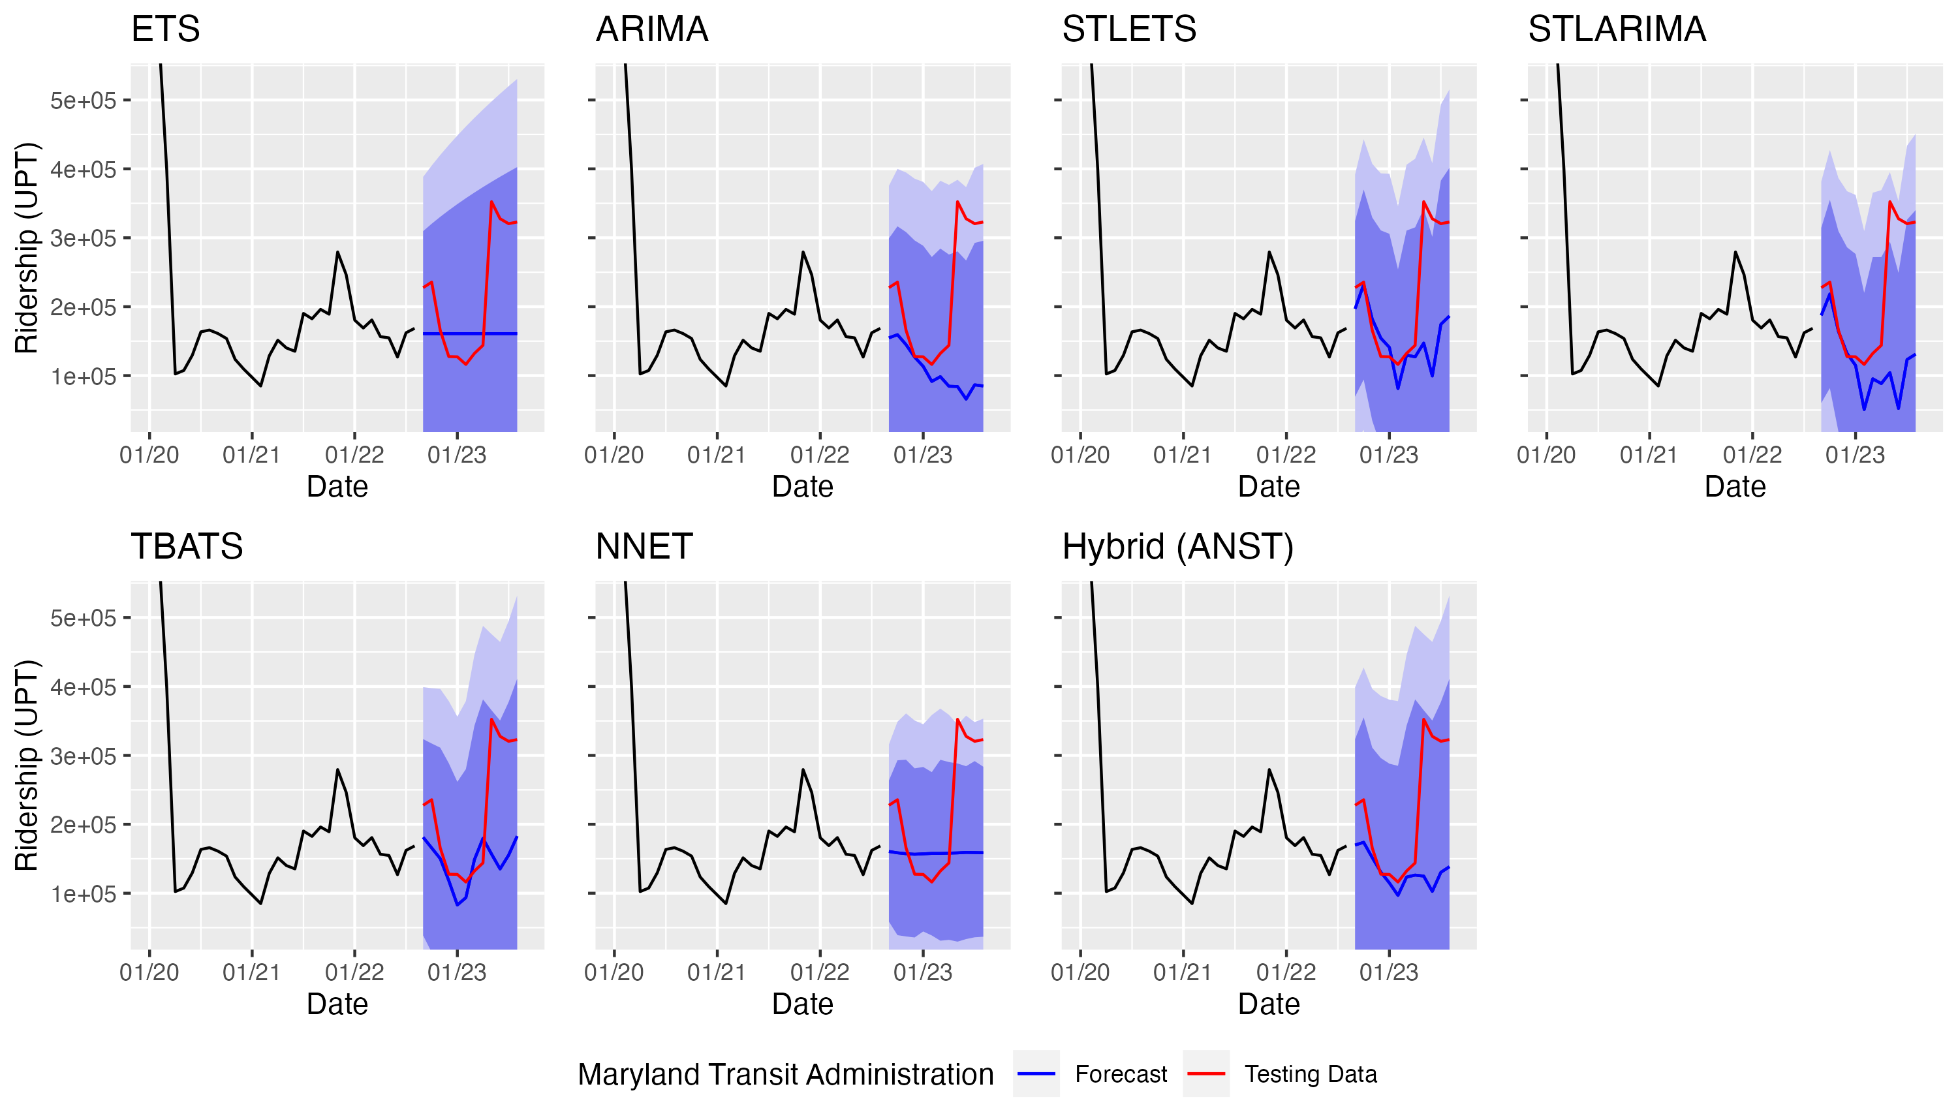
Figure 5.4 Full series ridership forecasts for the Maryland Transit Administration
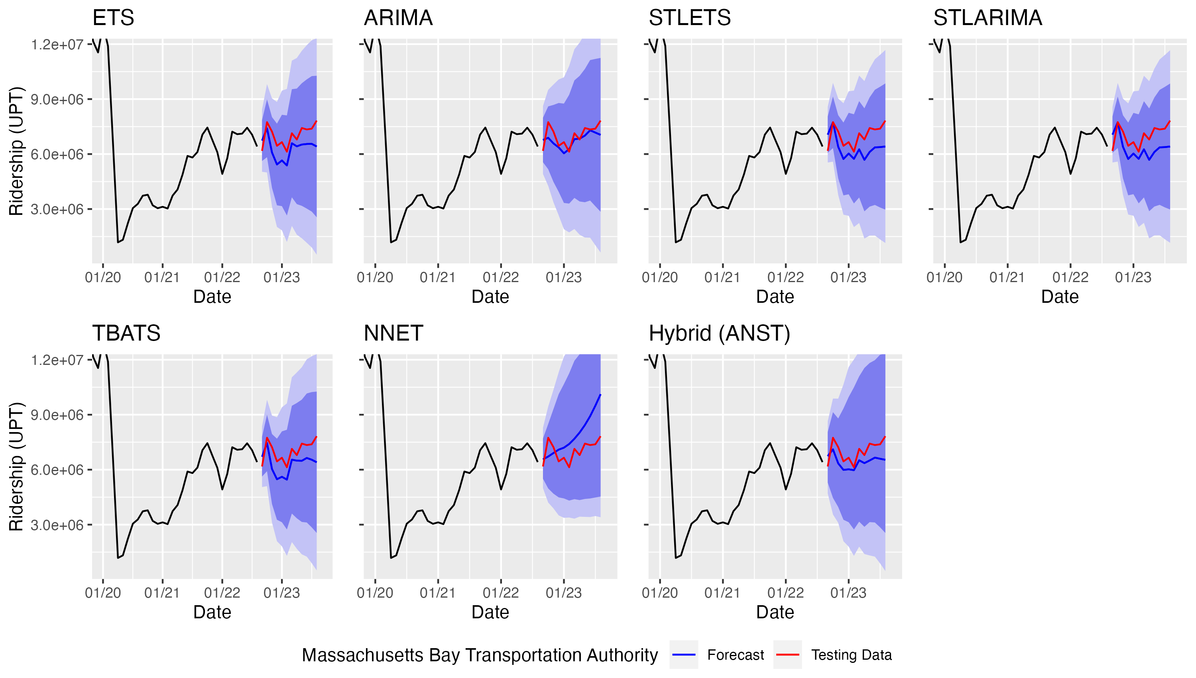
Figure 5.5 Full series ridership forecasts for the Massachusetts Bay Transportation Authority
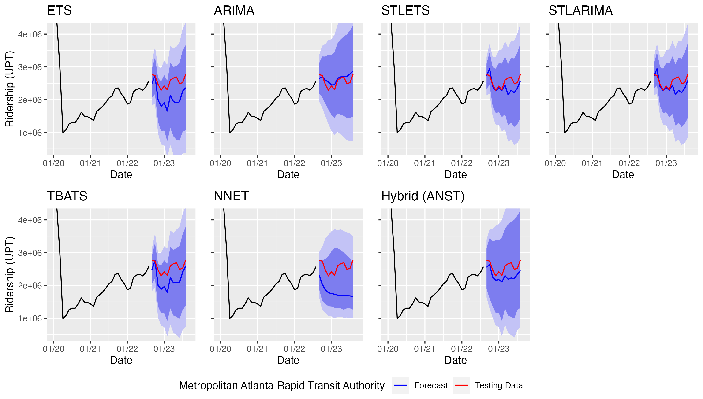
Figure 5.6 Full series ridership forecasts for the Metropolitan Atlanta Rapid Transit Authority
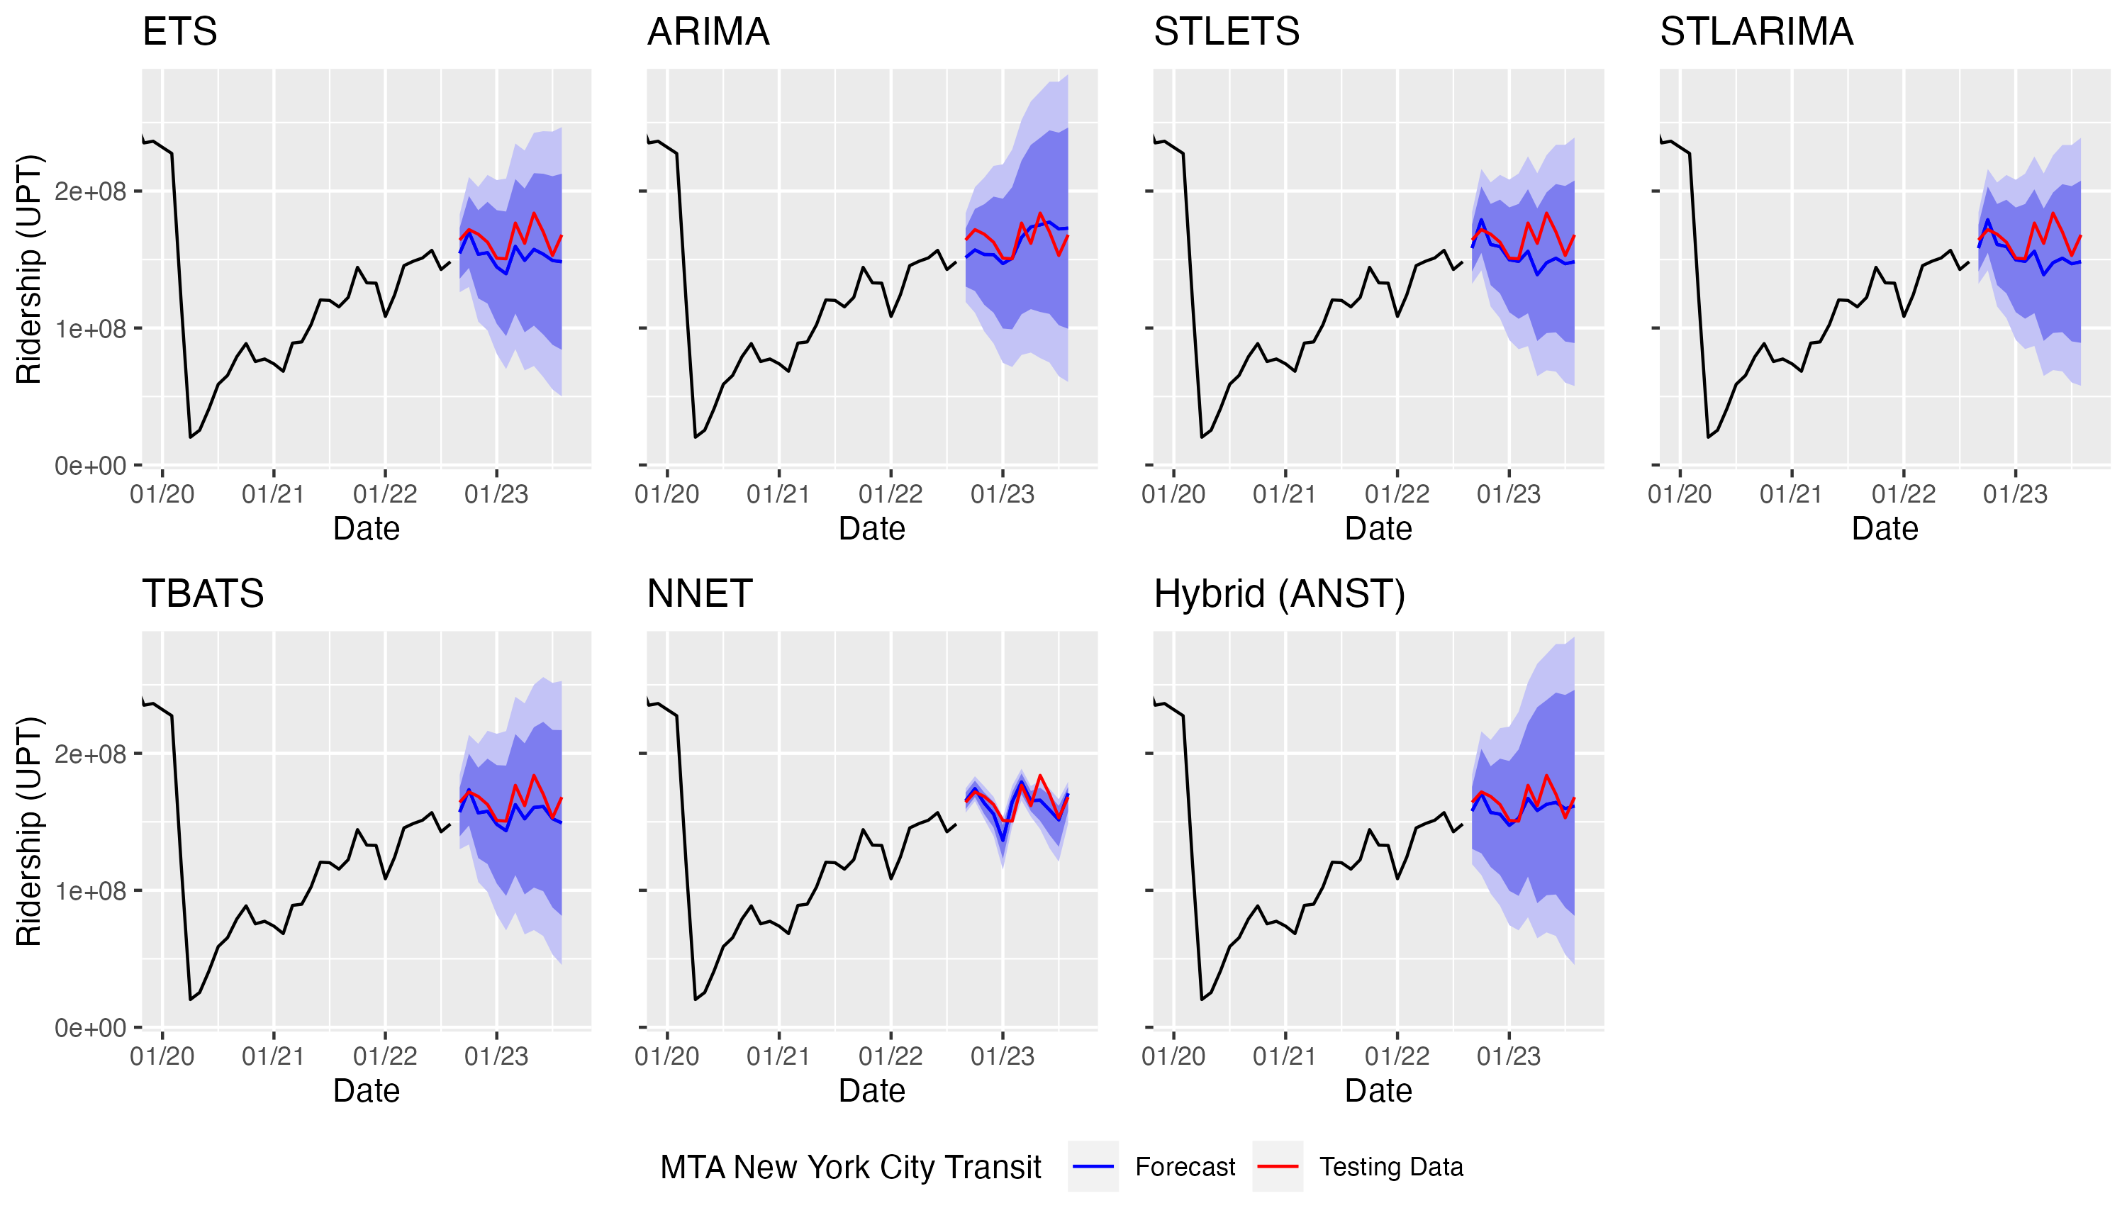
Figure 5.7 Full series ridership forecasts for MTA New York City Transit
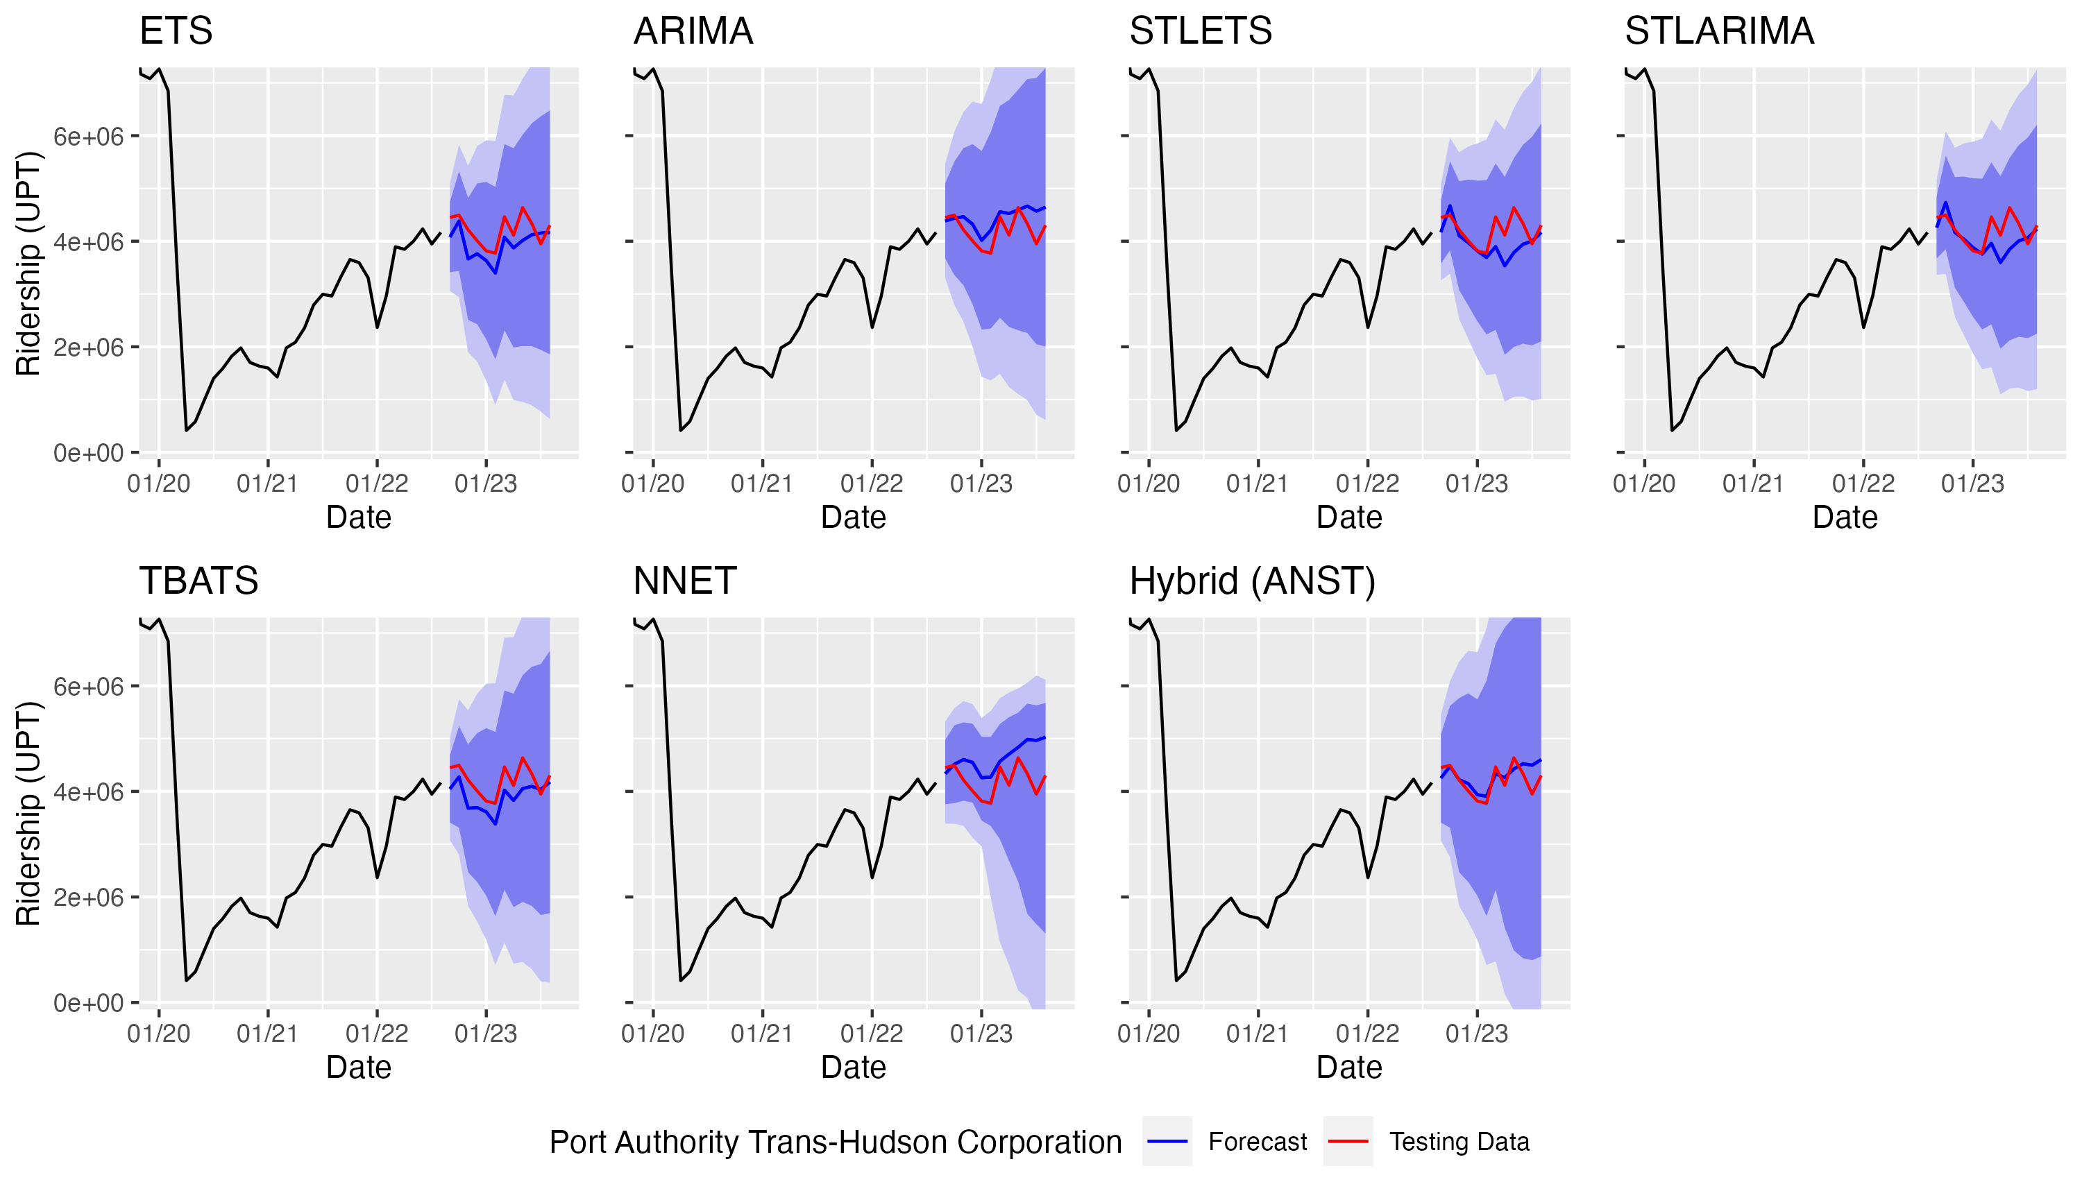
Figure 5.8 Full series ridership forecasts for the Port Authority Trans-Hudson Corporation
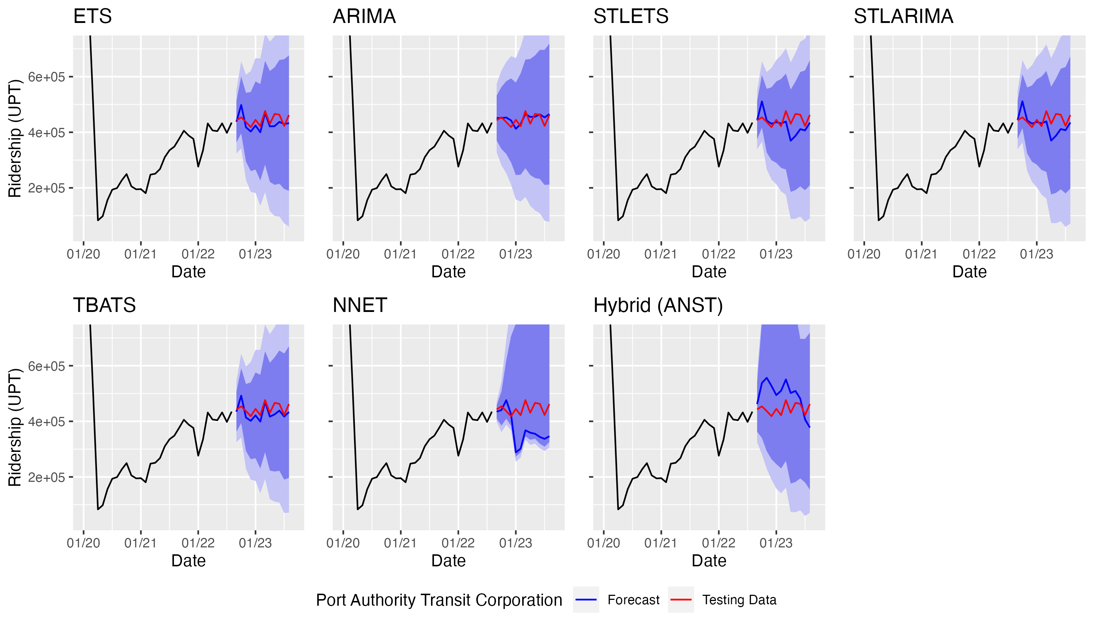
Figure 5.9 Full series ridership forecasts for the Port Authority Transit Corporation
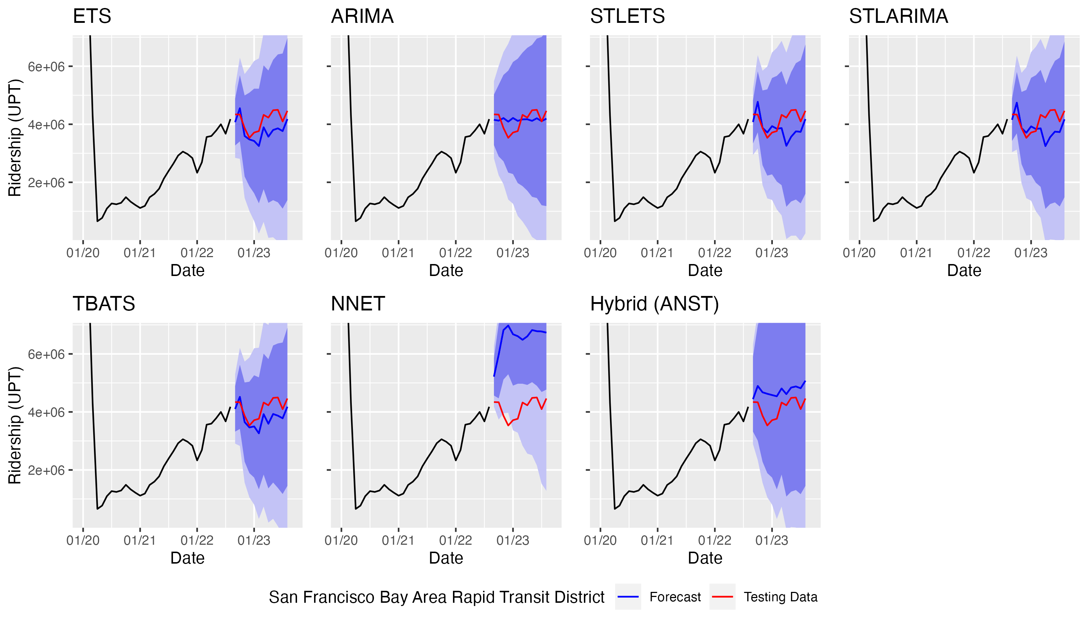
Figure 5.10 Full series ridership forecasts for the San Francisco Bay Area Rapid Transit District
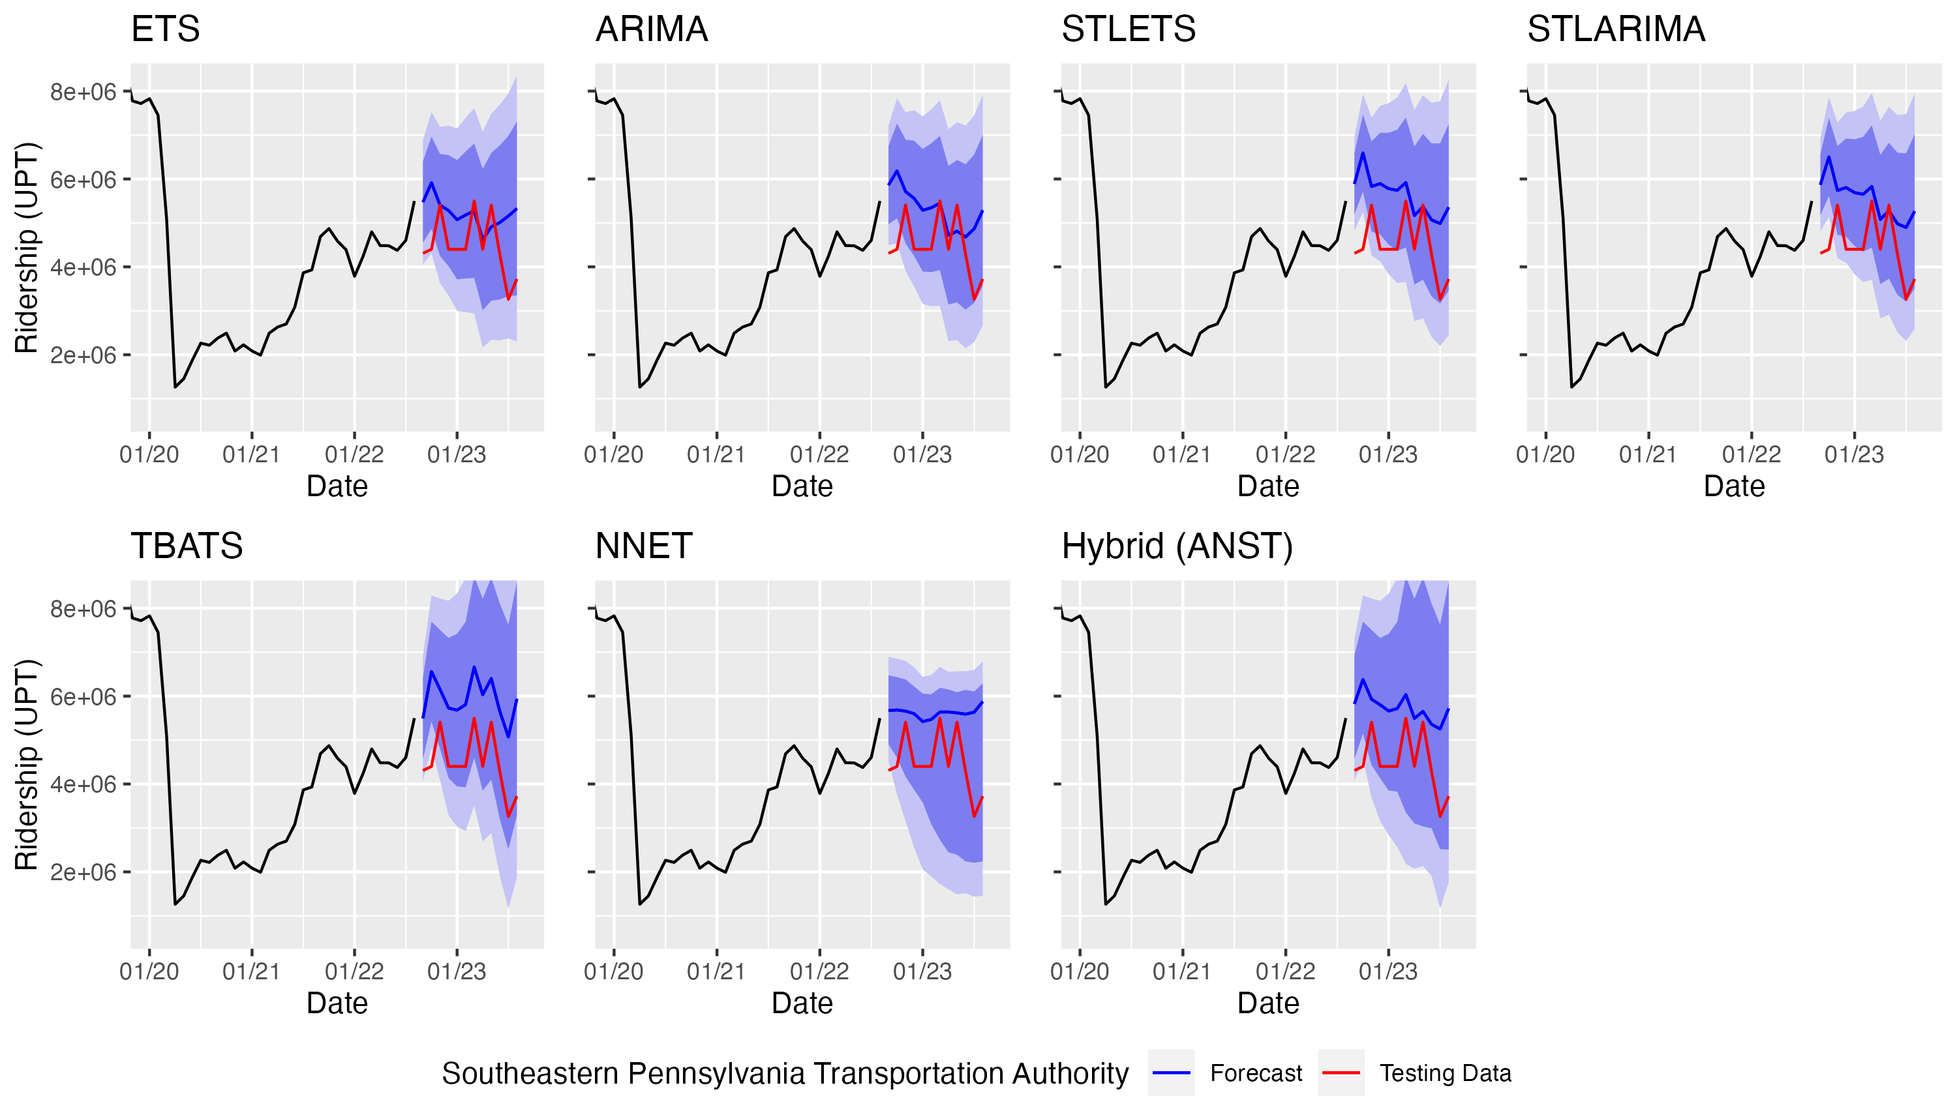
Figure 5.11 Full series ridership forecasts for the Southeastern Pennsylvania Transportation Authority
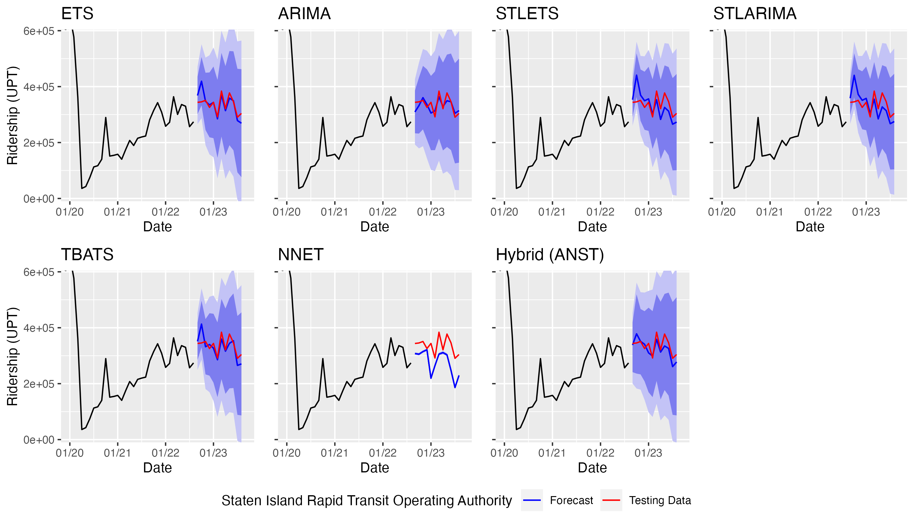
Figure 5.12 Full series ridership forecasts for the Staten Island Rapid Transit Operating Authority

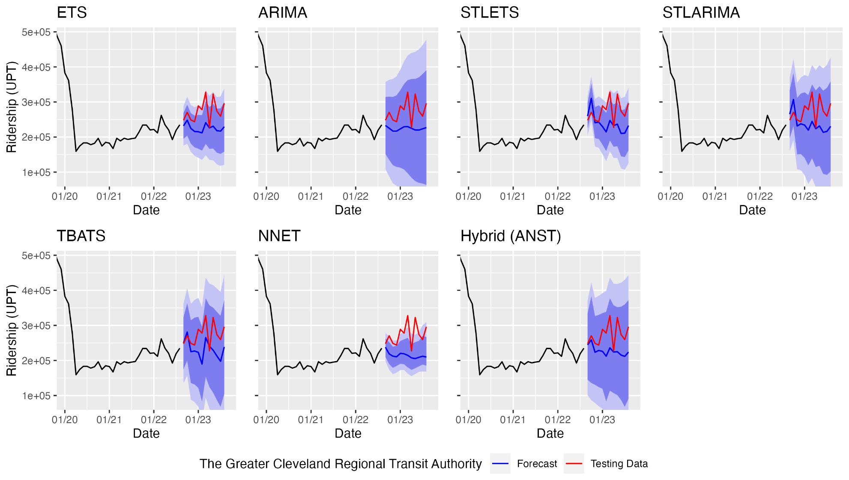
Figure 5.13 Full series ridership forecasts for the Greater Cleveland Regional Transit Authority
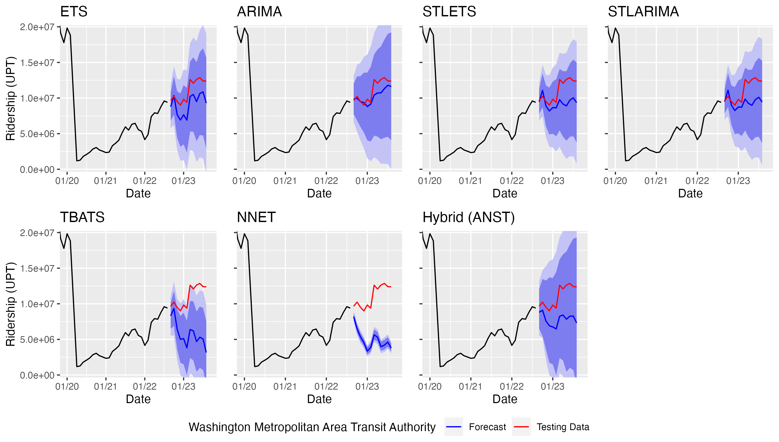
Figure 5.14 Full series ridership forecasts for the Washington Metropolitan Area Transit Authority

Table 4.2 Performance of the full series forecasts
Agency | Measure | ETS | ARIMA | STL-ETS | STL-ARIMA | TBATS | NNET | Hybrid (ANST) | Minimum | Maximum
Chicago Transit Authority | MAPE | 7.61 | 5.36 | 8.21 | 8.21 | 7.27 | 9.77 | 7.16 | ARIMA | NNET
Chicago Transit Authority | MASE | 0.48 | 0.31 | 0.54 | 0.54 | 0.46 | 0.59 | 0.47
County of Miami-Dade | MAPE | 4.84 | 6.04 | 7.26 | 7.29 | 4.88 | 14.62 | 4.01 | Hybrid (ANST) | NNET
County of Miami-Dade | MASE | 0.37 | 0.45 | 0.54 | 0.55 | 0.37 | 1.08 | 0.30
Los Angeles County Metropolitan Transportation Authority | MAPE | 13.38 | 5.60 | 8.73 | 8.77 | 11.78 | 28.05 | 8.43 | ARIMA | NNET
Los Angeles County Metropolitan Transportation Authority | MASE | 0.91 | 0.39 | 0.61 | 0.61 | 0.80 | 1.93 | 0.59
Maryland Transit Administration | MAPE | 32.80 | 39.93 | 26.31 | 36.47 | 30.62 | 32.16 | 29.80 | STL-ETS | ARIMA
Maryland Transit Administration | MASE | 0.74 | 0.98 | 0.65 | 0.86 | 0.72 | 0.74 | 0.77
Massachusetts Bay Transportation Authority | MAPE | 11.47 | 5.55 | 11.99 | 12.00 | 11.26 | 15.14 | 9.41 | ARIMA | NNET
Massachusetts Bay Transportation Authority | MASE | 0.59 | 0.29 | 0.62 | 0.62 | 0.58 | 0.79 | 0.49
Metropolitan Atlanta Rapid Transit Authority | MAPE | 18.43 | 4.70 | 6.73 | 6.74 | 14.54 | 29.55 | 10.12 | ARIMA | NNET
Metropolitan Atlanta Rapid Transit Authority | MASE | 0.84 | 0.21 | 0.32 | 0.32 | 0.66 | 1.37 | 0.47
MTA New York City Transit | MAPE | 7.27 | 5.97 | 7.39 | 7.39 | 5.47 | 4.26 | 4.20 | Hybrid (ANST) | STL-ETS
MTA New York City Transit | MASE | 0.59 | 0.48 | 0.61 | 0.61 | 0.45 | 0.34 | 0.34
Port Authority Trans-Hudson Corporation | MAPE | 7.17 | 6.48 | 6.22 | 5.57 | 7.51 | 10.77 | 4.28 | Hybrid (ANST) | NNET
Port Authority Trans-Hudson Corporation | MASE | 0.38 | 0.33 | 0.34 | 0.31 | 0.40 | 0.56 | 0.22
Port Authority Transit Corporation | MAPE | 4.61 | 3.26 | 6.75 | 6.73 | 4.71 | 17.78 | 14.65 | ARIMA | NNET
Port Authority Transit Corporation | MASE | 0.27 | 0.18 | 0.39 | 0.39 | 0.27 | 1.03 | 0.84
San Francisco Bay Area Rapid Transit District | MAPE | 9.21 | 6.88 | 9.61 | 9.43 | 8.42 | 59.39 | 14.92 | ARIMA | NNET
San Francisco Bay Area Rapid Transit District | MASE | 0.40 | 0.29 | 0.43 | 0.42 | 0.37 | 2.51 | 0.62
Southeastern Pennsylvania Transportation Authority¹ | MAPE | 20.93 | 22.49 | 27.59 | 25.96 | 33.78 | 28.01 | 29.93 | ETS | TBATS
Southeastern Pennsylvania Transportation Authority¹ | MASE | 1.11 | 1.21 | 1.50 | 1.41 | 1.88 | 1.48 | 1.62
Staten Island Rapid Transit Operating Authority | MAPE | 5.15 | 5.17 | 9.37 | 9.41 | 6.45 | 17.62 | 6.11 | ETS | NNET
Staten Island Rapid Transit Operating Authority | MASE | 0.22 | 0.23 | 0.41 | 0.42 | 0.28 | 0.77 | 0.27
The Greater Cleveland Regional Transit Authority | MAPE | 16.70 | 17.22 | 15.30 | 15.52 | 16.24 | 20.61 | 15.96 | STL-ETS | NNET
The Greater Cleveland Regional Transit Authority | MASE | 0.60 | 0.62 | 0.55 | 0.56 | 0.58 | 0.74 | 0.58
Washington Metropolitan Area Transit Authority | MAPE | 17.73 | 7.39 | 15.82 | 15.19 | 46.67 | 54.03 | 28.20 | ARIMA | NNET
Washington Metropolitan Area Transit Authority | MASE | 0.96 | 0.43 | 0.91 | 0.88 | 2.59 | 2.98 | 1.57
Green - MAPE below 5%, Yellow - MAPE below 10%, Red - MASE above 1.00
¹ Southeastern Pennsylvania Transportation Authority's ridership data had a quality control issue that negatively impacted the performance of the models.

below 5%. With the exception of the neural network, almost all of the models produced a MASE below 1.00, indicating better performance compared to the simple naïve method.
Additionally, the residual tests showed that almost all of the full series models captured all patterns that were present in the data, leaving only white noise. However, for many of the pre-COVID models, the residuals still contained some patterns. These findings may reflect a continued interruption in the strong seasonal and periodic transit ridership trends that were present at most agencies pre-COVID, which has made it more difficult to extract patterns from the post-COVID data. As a result, the full series forecast results are mixed, reflecting much more uncertainty; for some agencies, the models were able to predict the general periodic trend and produce good or acceptable forecasts, but for other agencies, the models were not able to capture much of a pattern at all, and the forecasts underperformed. Nevertheless, the classical models (especially the ARIMA model) as well as the TBATS and hybrid models were able to produce good or acceptable forecasts at most agencies, and for some agencies (e.g., MTA New York City Transit and the Metropolitan Atlanta Rapid Transit Agency) the models produced better forecasts than were produced using the pre-COVID-only series. In the next section, the post-COVID ridership is isolated in order to try to better understand the shift in trends.

results and discussion of the Post-covid forecasts
In this chapter, the results of the post-COVID (from April 2020 to August 2023) forecasts are presented. Each of the 14 heavy rail agencies was analyzed using the seven forecasting methods, and the MAPE and MASE were calculated.

To assess the fit of the models, the Ljung-Box test was used to assess the white noise of the residuals for each model, and histograms of the residuals were examined to check for normality and influential outliers. The residuals were checked using the “checkresiduals()” function from the “forecast” package (33; 34). For the post-COVID series, the histograms were approximately normally distributed with the means close to zero, and the Ljung-Box test showed that almost all models captured all available patterns in the data, leaving the residuals with only white noise. Generally, the residuals showed that the models produced unbiased results and captured almost all of the patterns in the data for each series (28).

Results of the Post-COVID Analysis
For the post-COVID period, the training dataset was from April 2020 through August 2022, and the testing dataset was from September 2022 through August 2023. A visualization of the forecasts for Chicago Transit Authority and the Greater Cleveland Regional Transit Authority are provided in Figure 4.5 and Figure 4.6, as examples of the outputs that were created for each of the 14 heavy rail agencies. Despite having used only the post-COVID data, the forecast results are overall somewhat similar to the forecasts produced from the full data series. The major differences between the full series plots and the post-COVID plots are that the post-COVID forecasts tend to be smoother and have more of an upward trend compared to the full series forecasts. The prediction intervals for the two STL methods, the TBATS method, and the neural network also tended to be much smaller for the post-COVID forecasts, which could indicate that the models may have struggled with overfitting the data (42).
Table 4.4 presents the results of post-COVID model performance for each agency. The lowest/highest errors were again used to measure the performance of each method. For 48.4% (44 out of 91) of the models, the MAPEs were acceptable (below 10%), and for 9.9% (9 out of 91) of the models the MAPEs were good (below 5%). Once again, the results for Southeastern Pennsylvania Transportation Authority were omitted from the discussion due to a quality control issue in their data.
The overall performance of the models is similar to that of the full series; 52 of the full series models and 44 of the post-COVID models had at least an acceptable MAPE. Also, 10 of the full series models and 9 of the post-COVID models had a good MAPE. Despite potentially overfitting the data, the TBATS and neural network methods performed rather
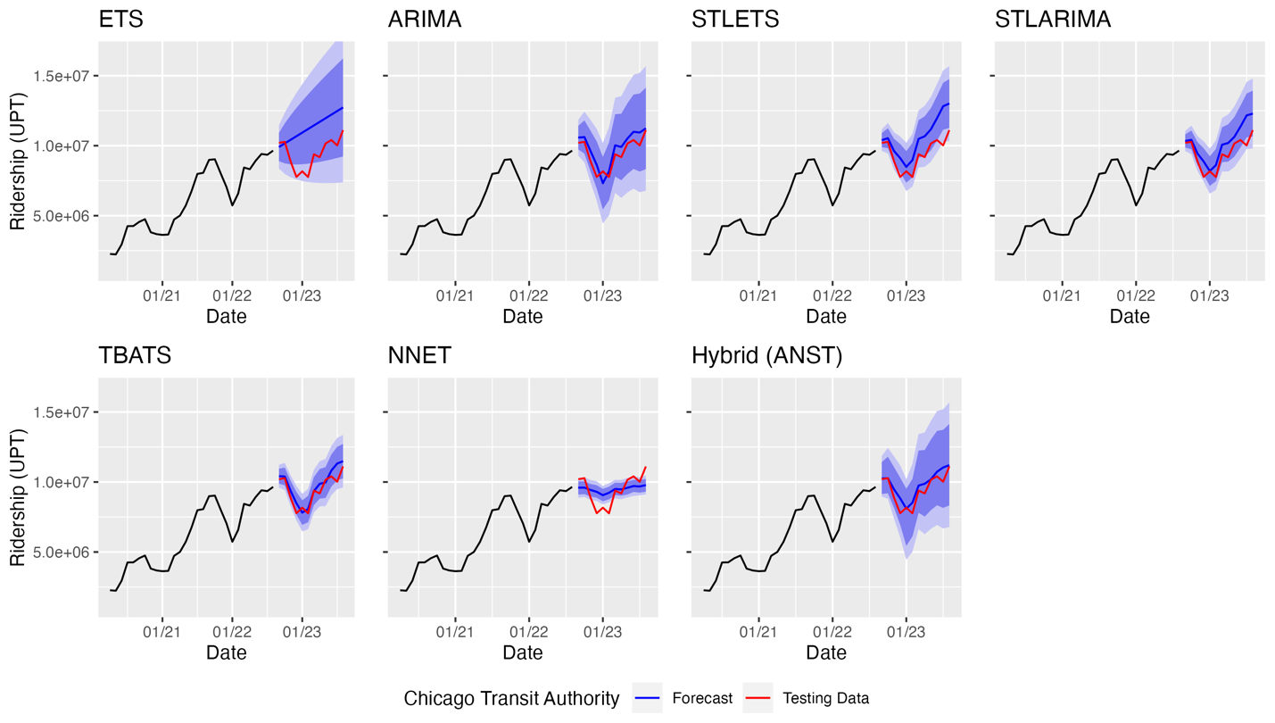
Figure 6.1 Post-COVID ridership forecasts for Chicago Transit Authority
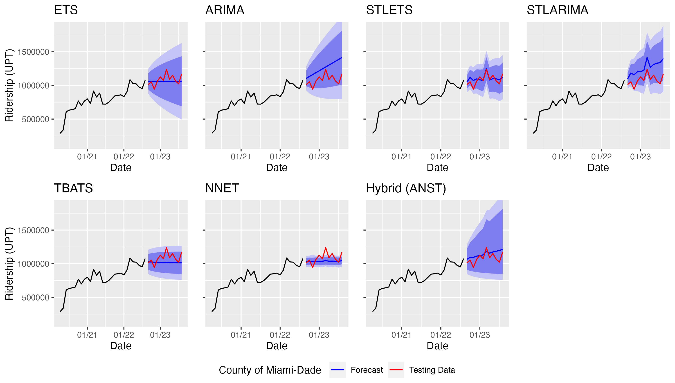
Figure 6.2 Post-COVID ridership forecasts for the County of Miami-Dade
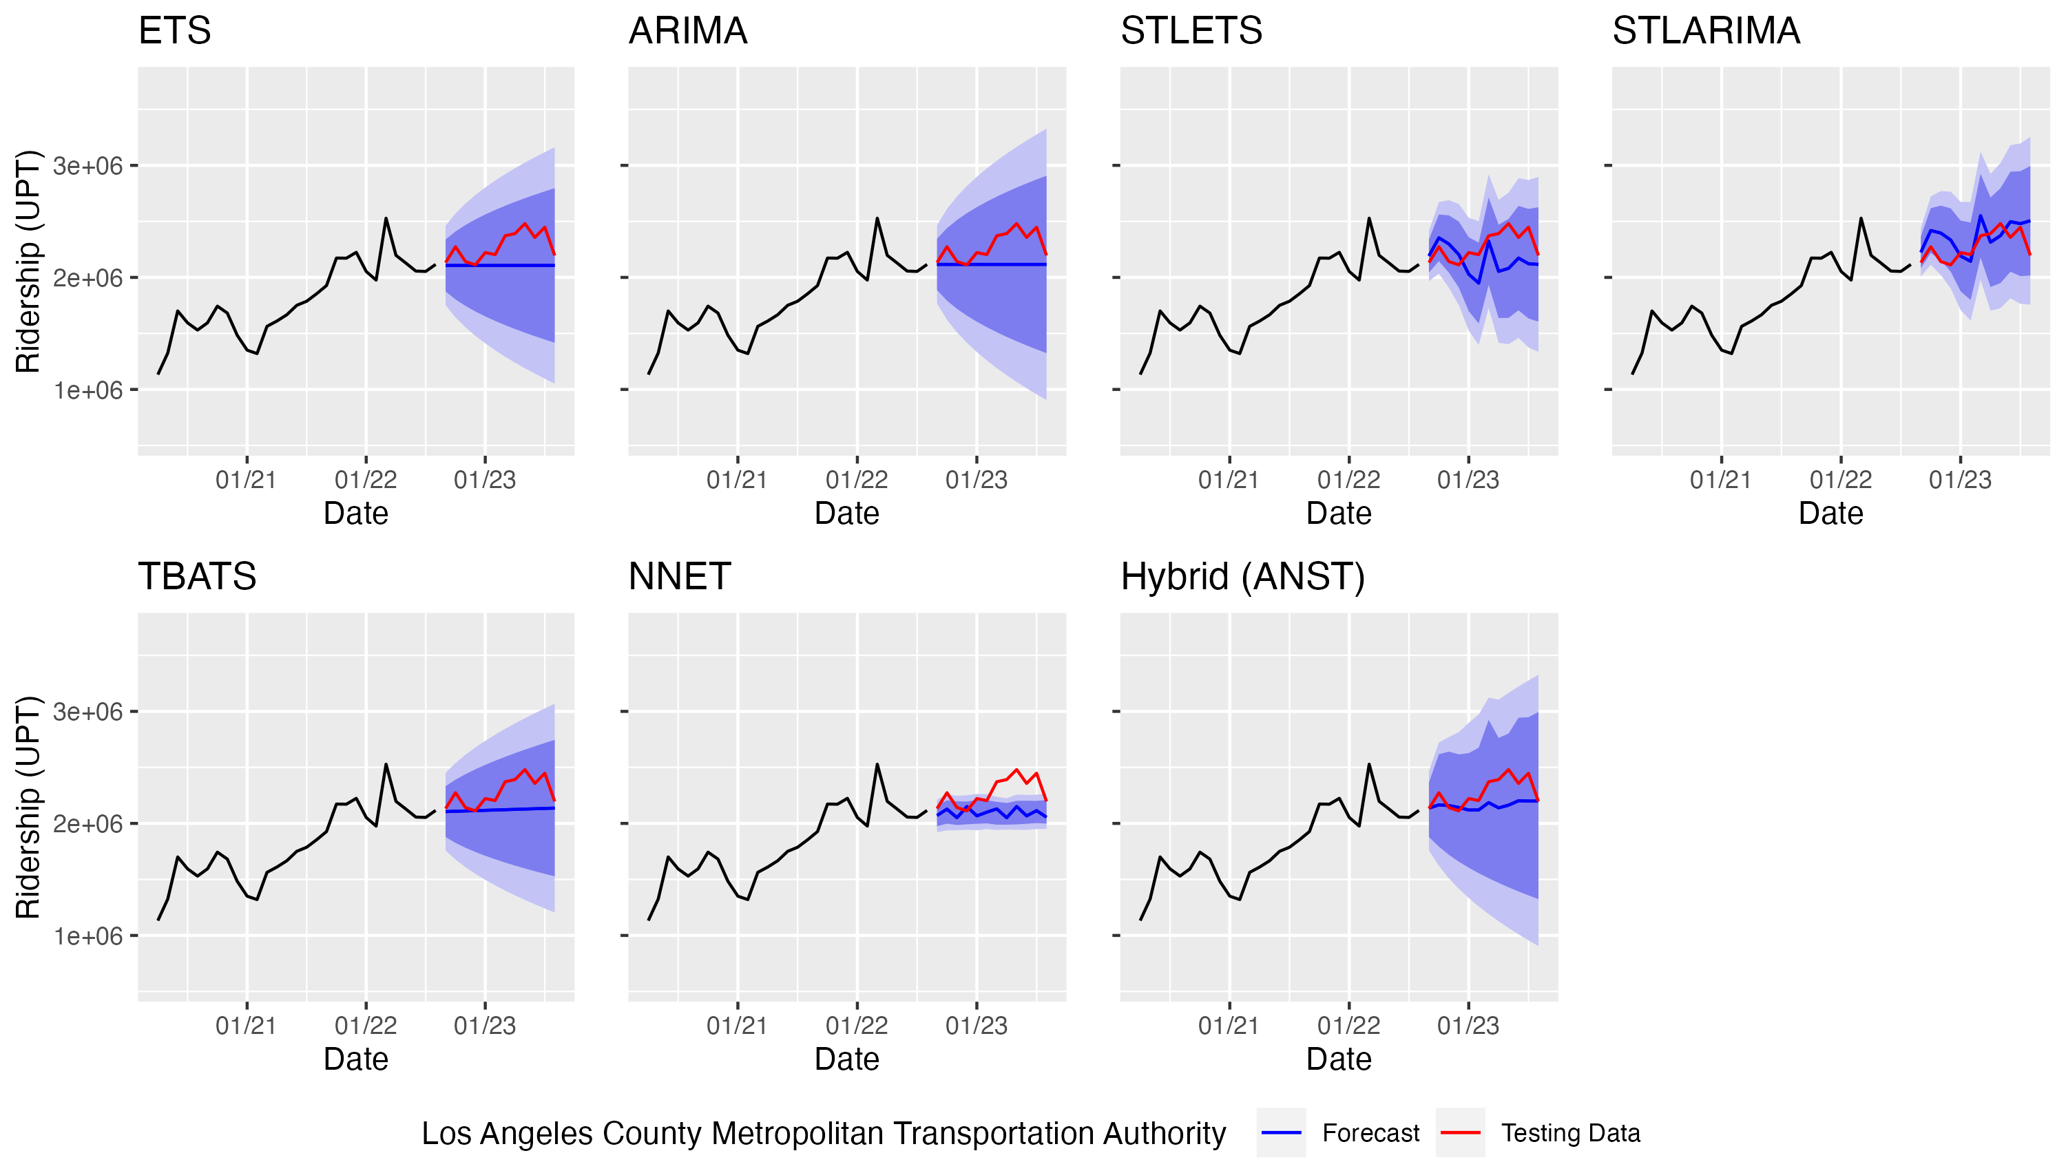
Figure 6.3 Post-COVID ridership forecasts for the Los Angeles County Metropolitan Transportation Authority
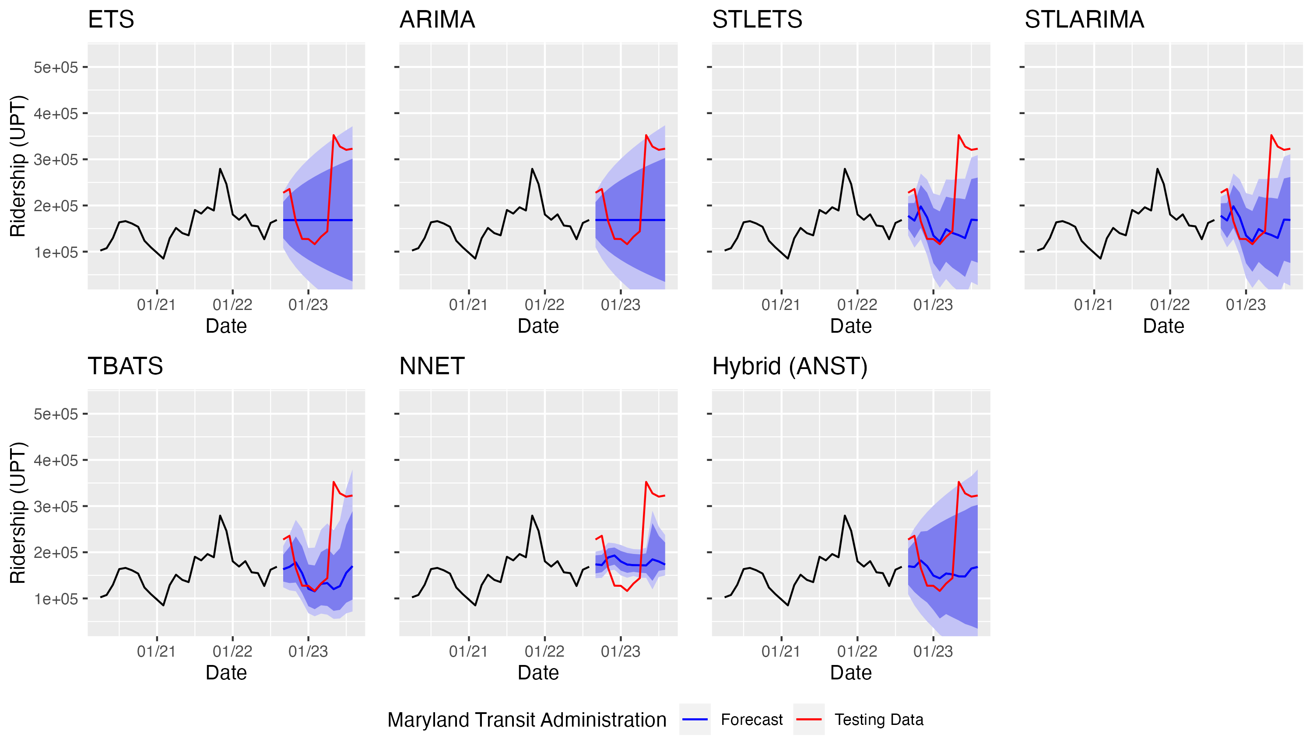
Figure 6.4 Post-COVID ridership forecasts for the Maryland Transit Administration
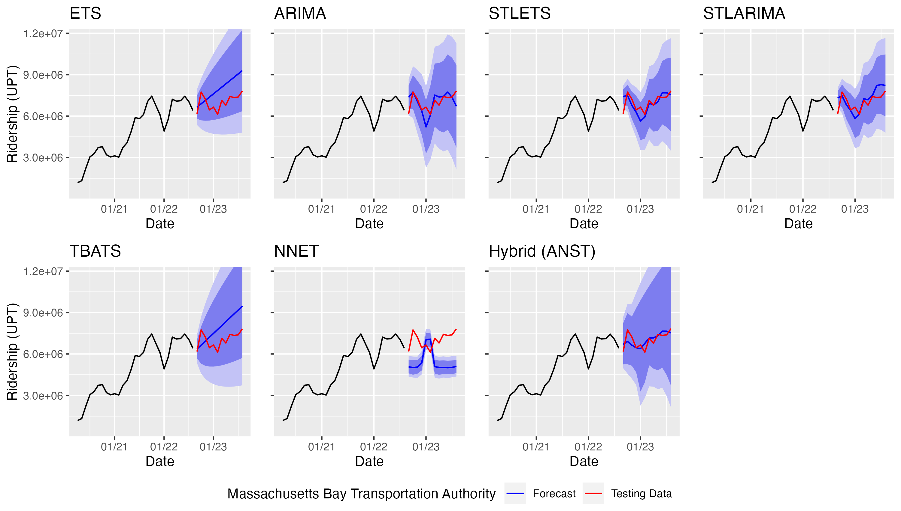
Figure 6.5 Post-COVID ridership forecasts for the Massachusetts Bay Transportation Authority
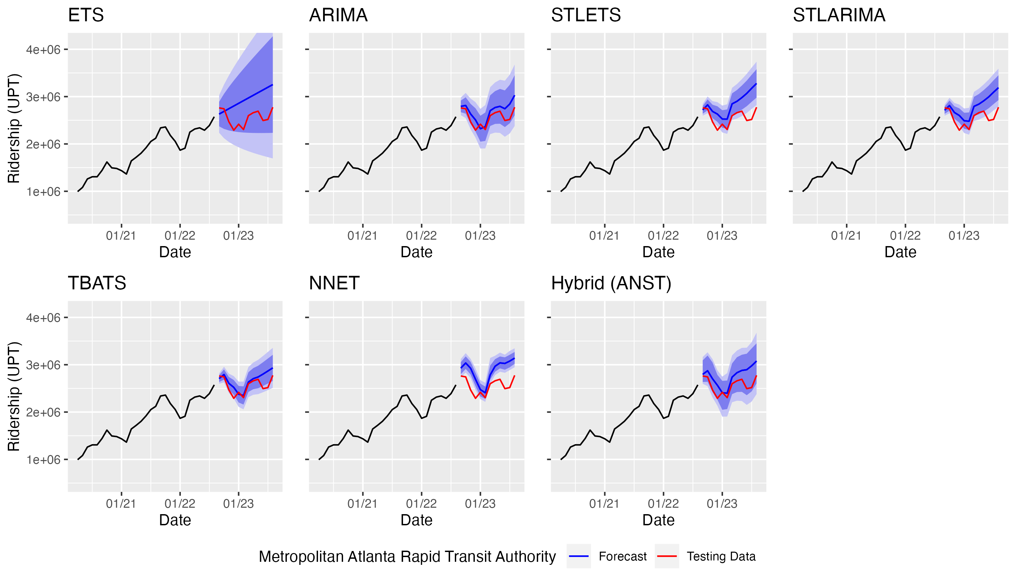
Figure 6.6 Post-COVID ridership forecasts for the Metropolitan Atlanta Rapid Transit Authority
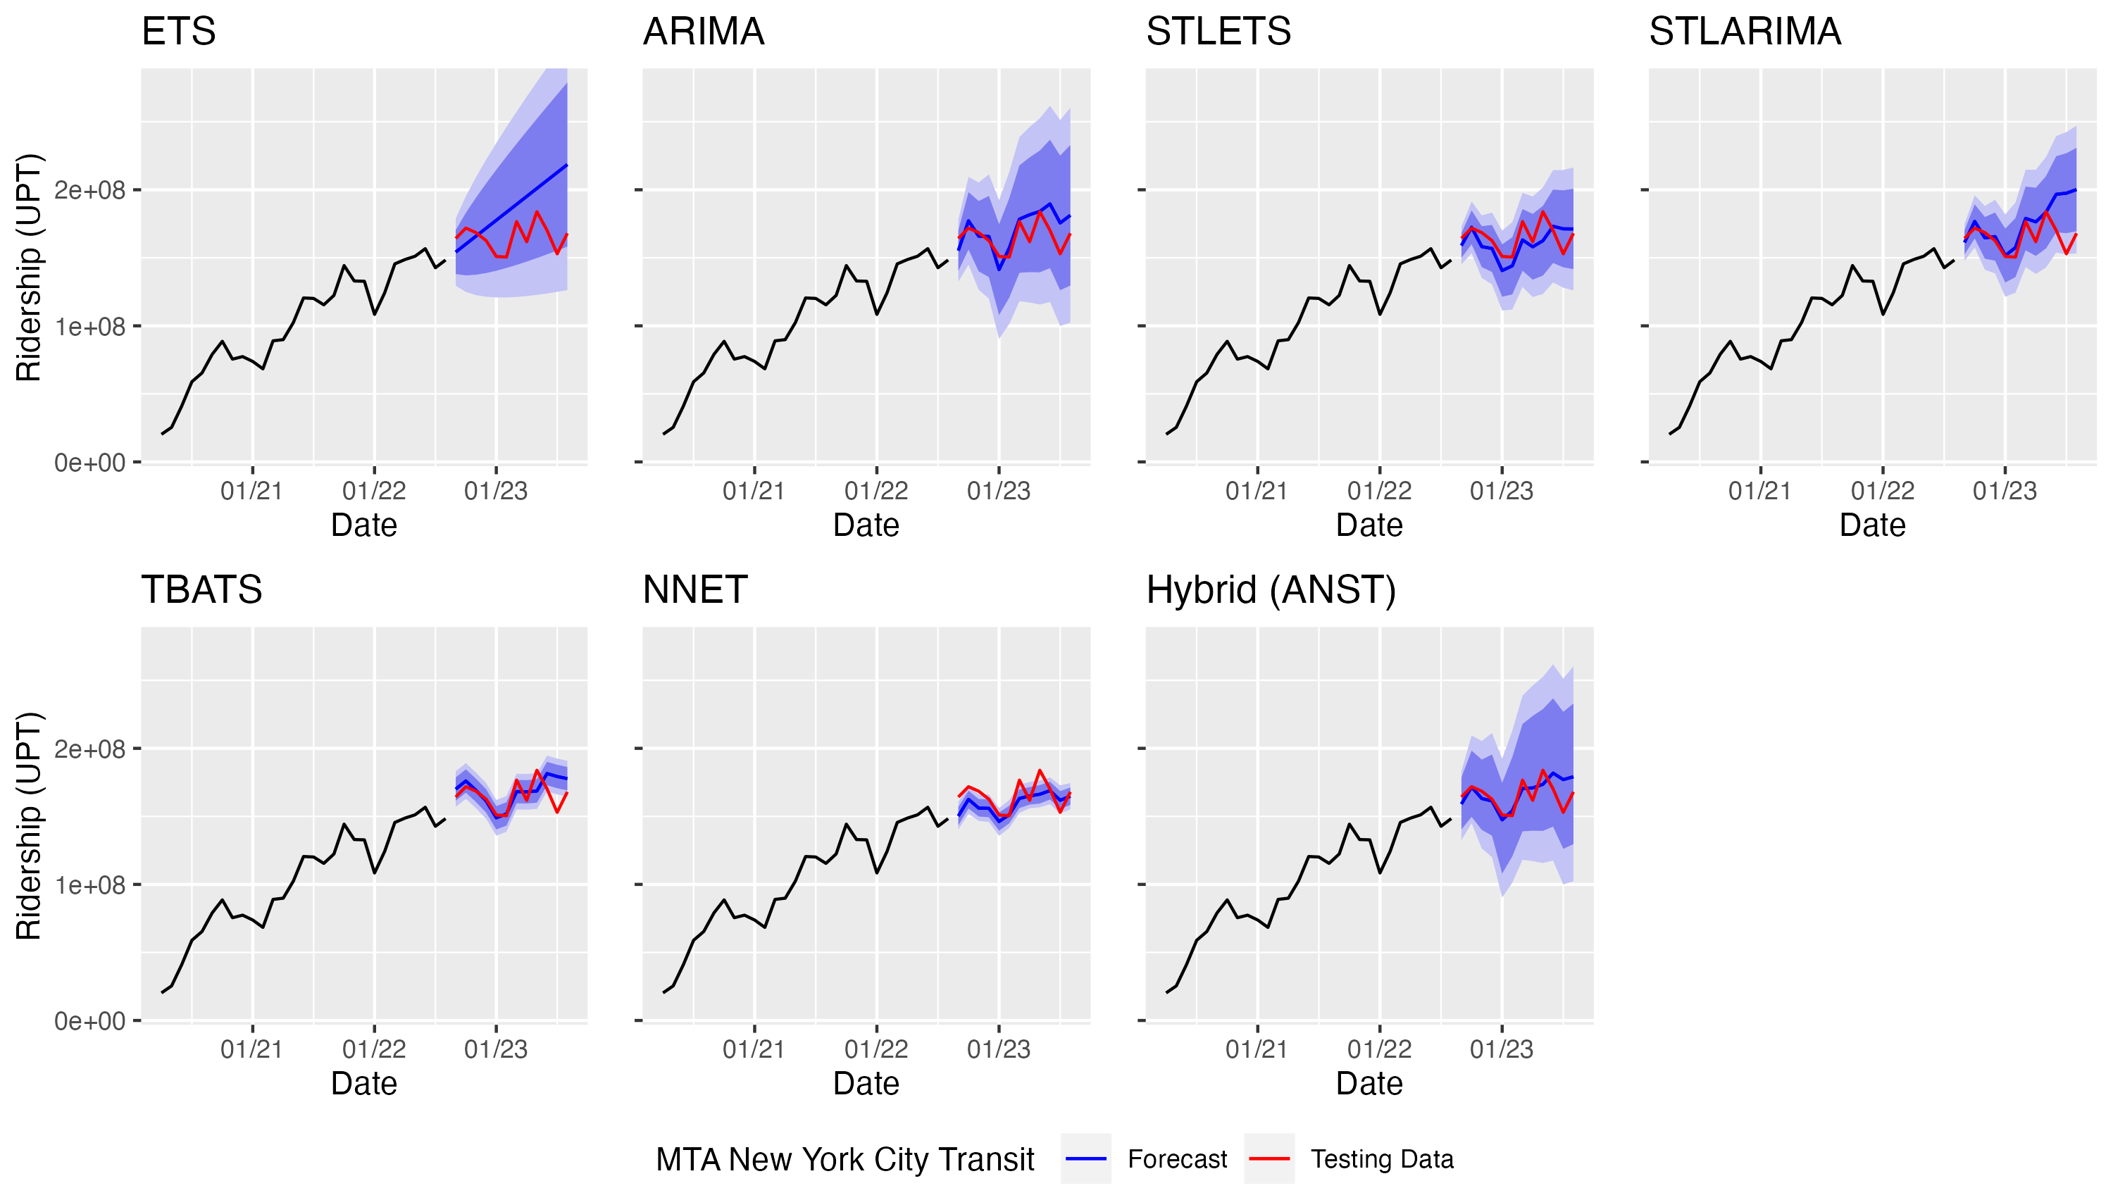
Figure 6.7 Post-COVID ridership forecasts for MTA New York City Transit
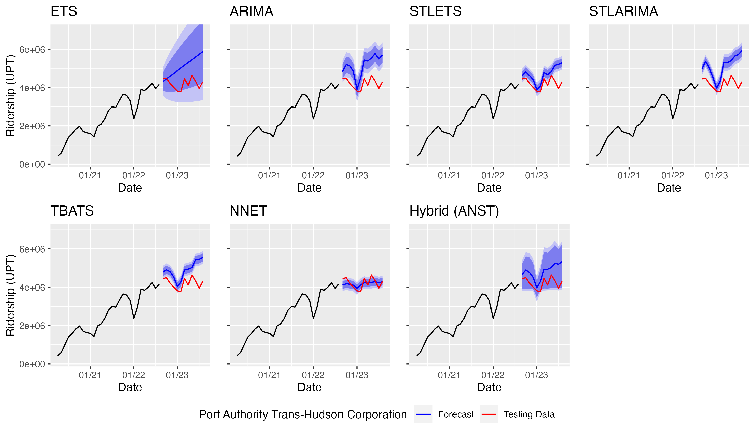
Figure 6.8 Post-COVID ridership forecasts for the Port Authority Trans-Hudson Corporation
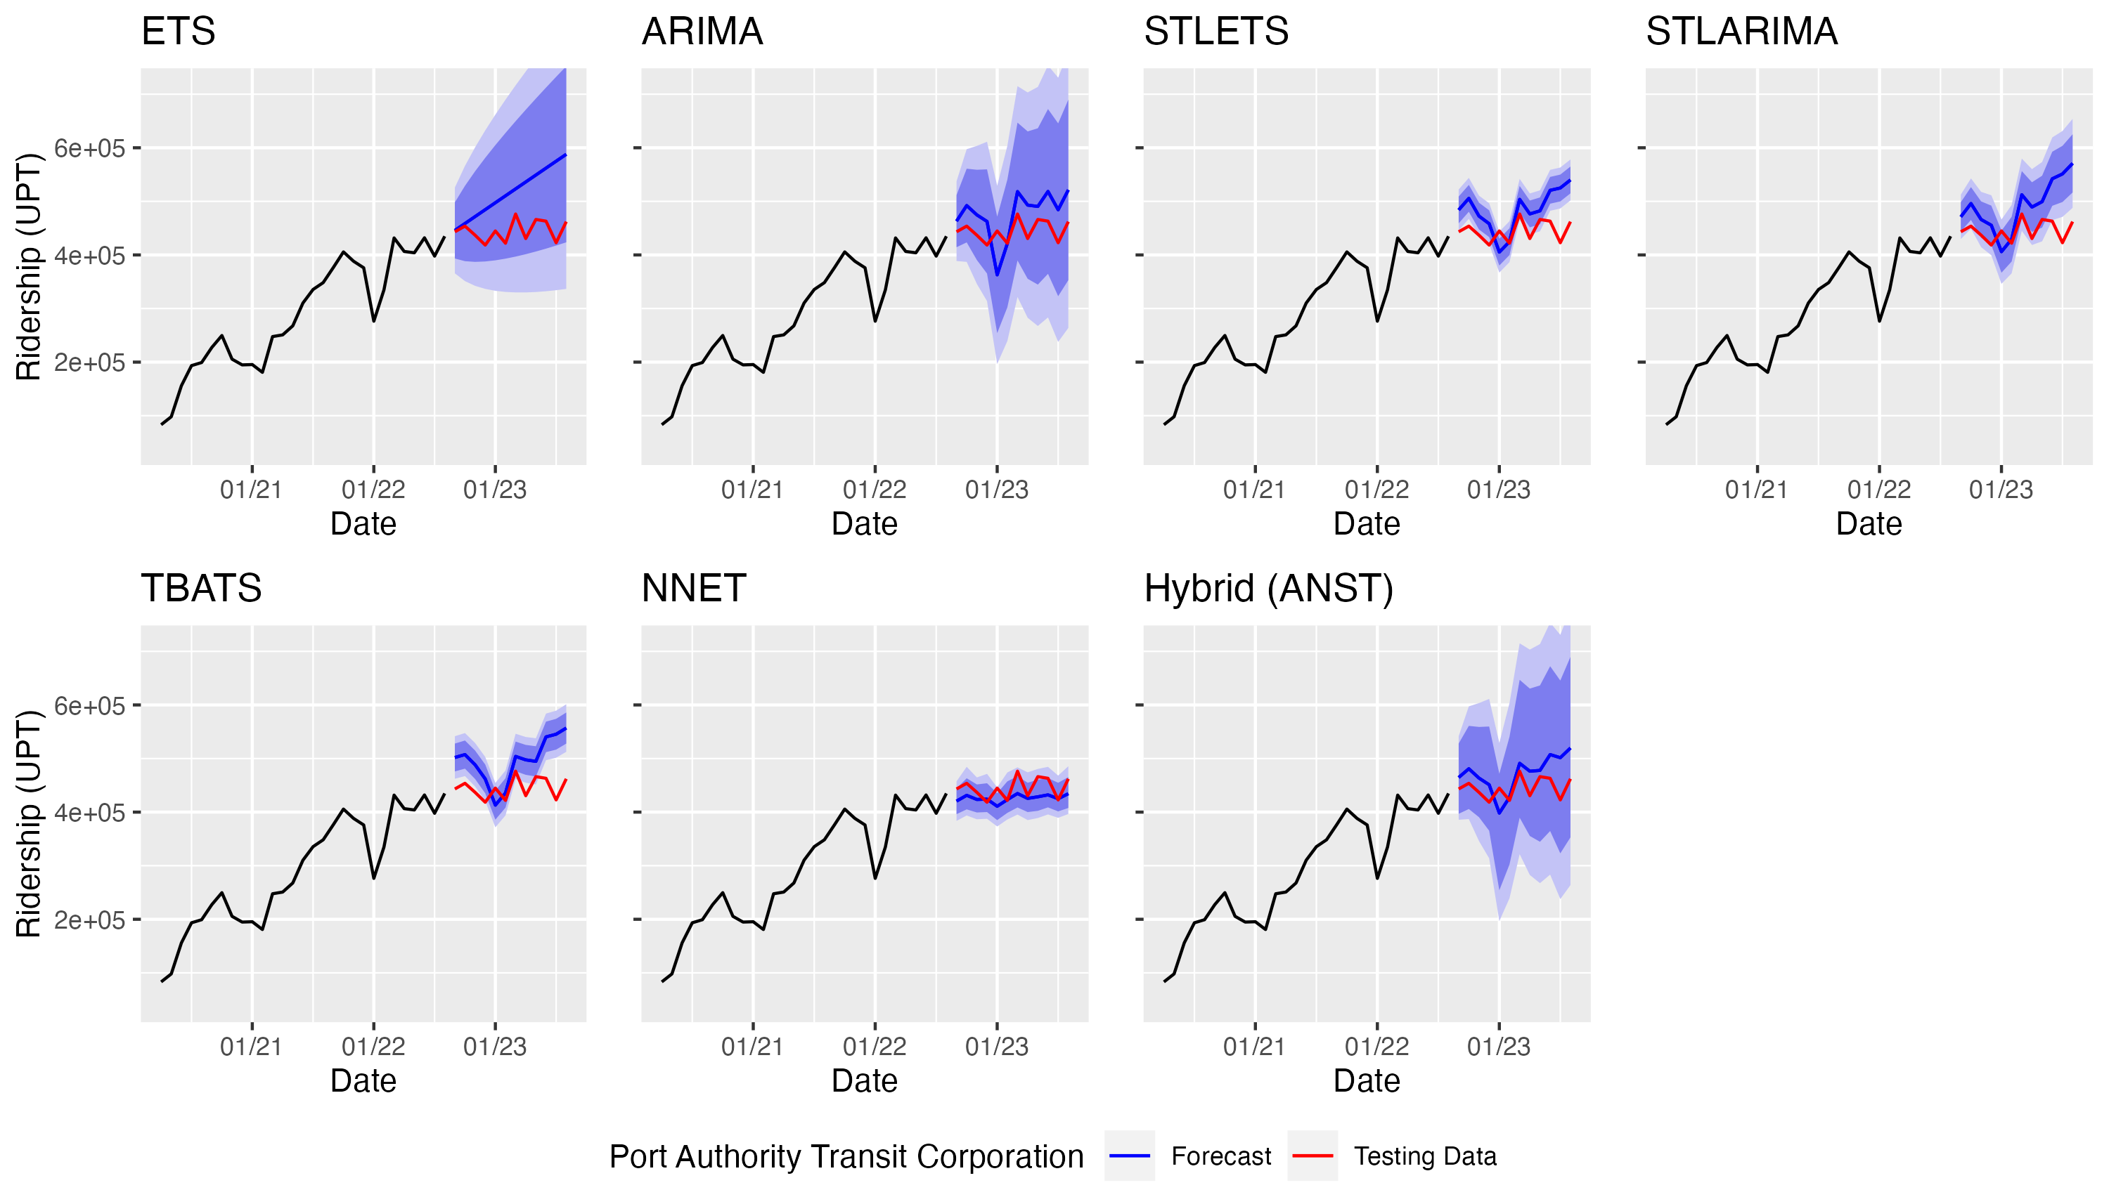
Figure 6.9 Post-COVID ridership forecasts for the Port Authority Transit Corporation
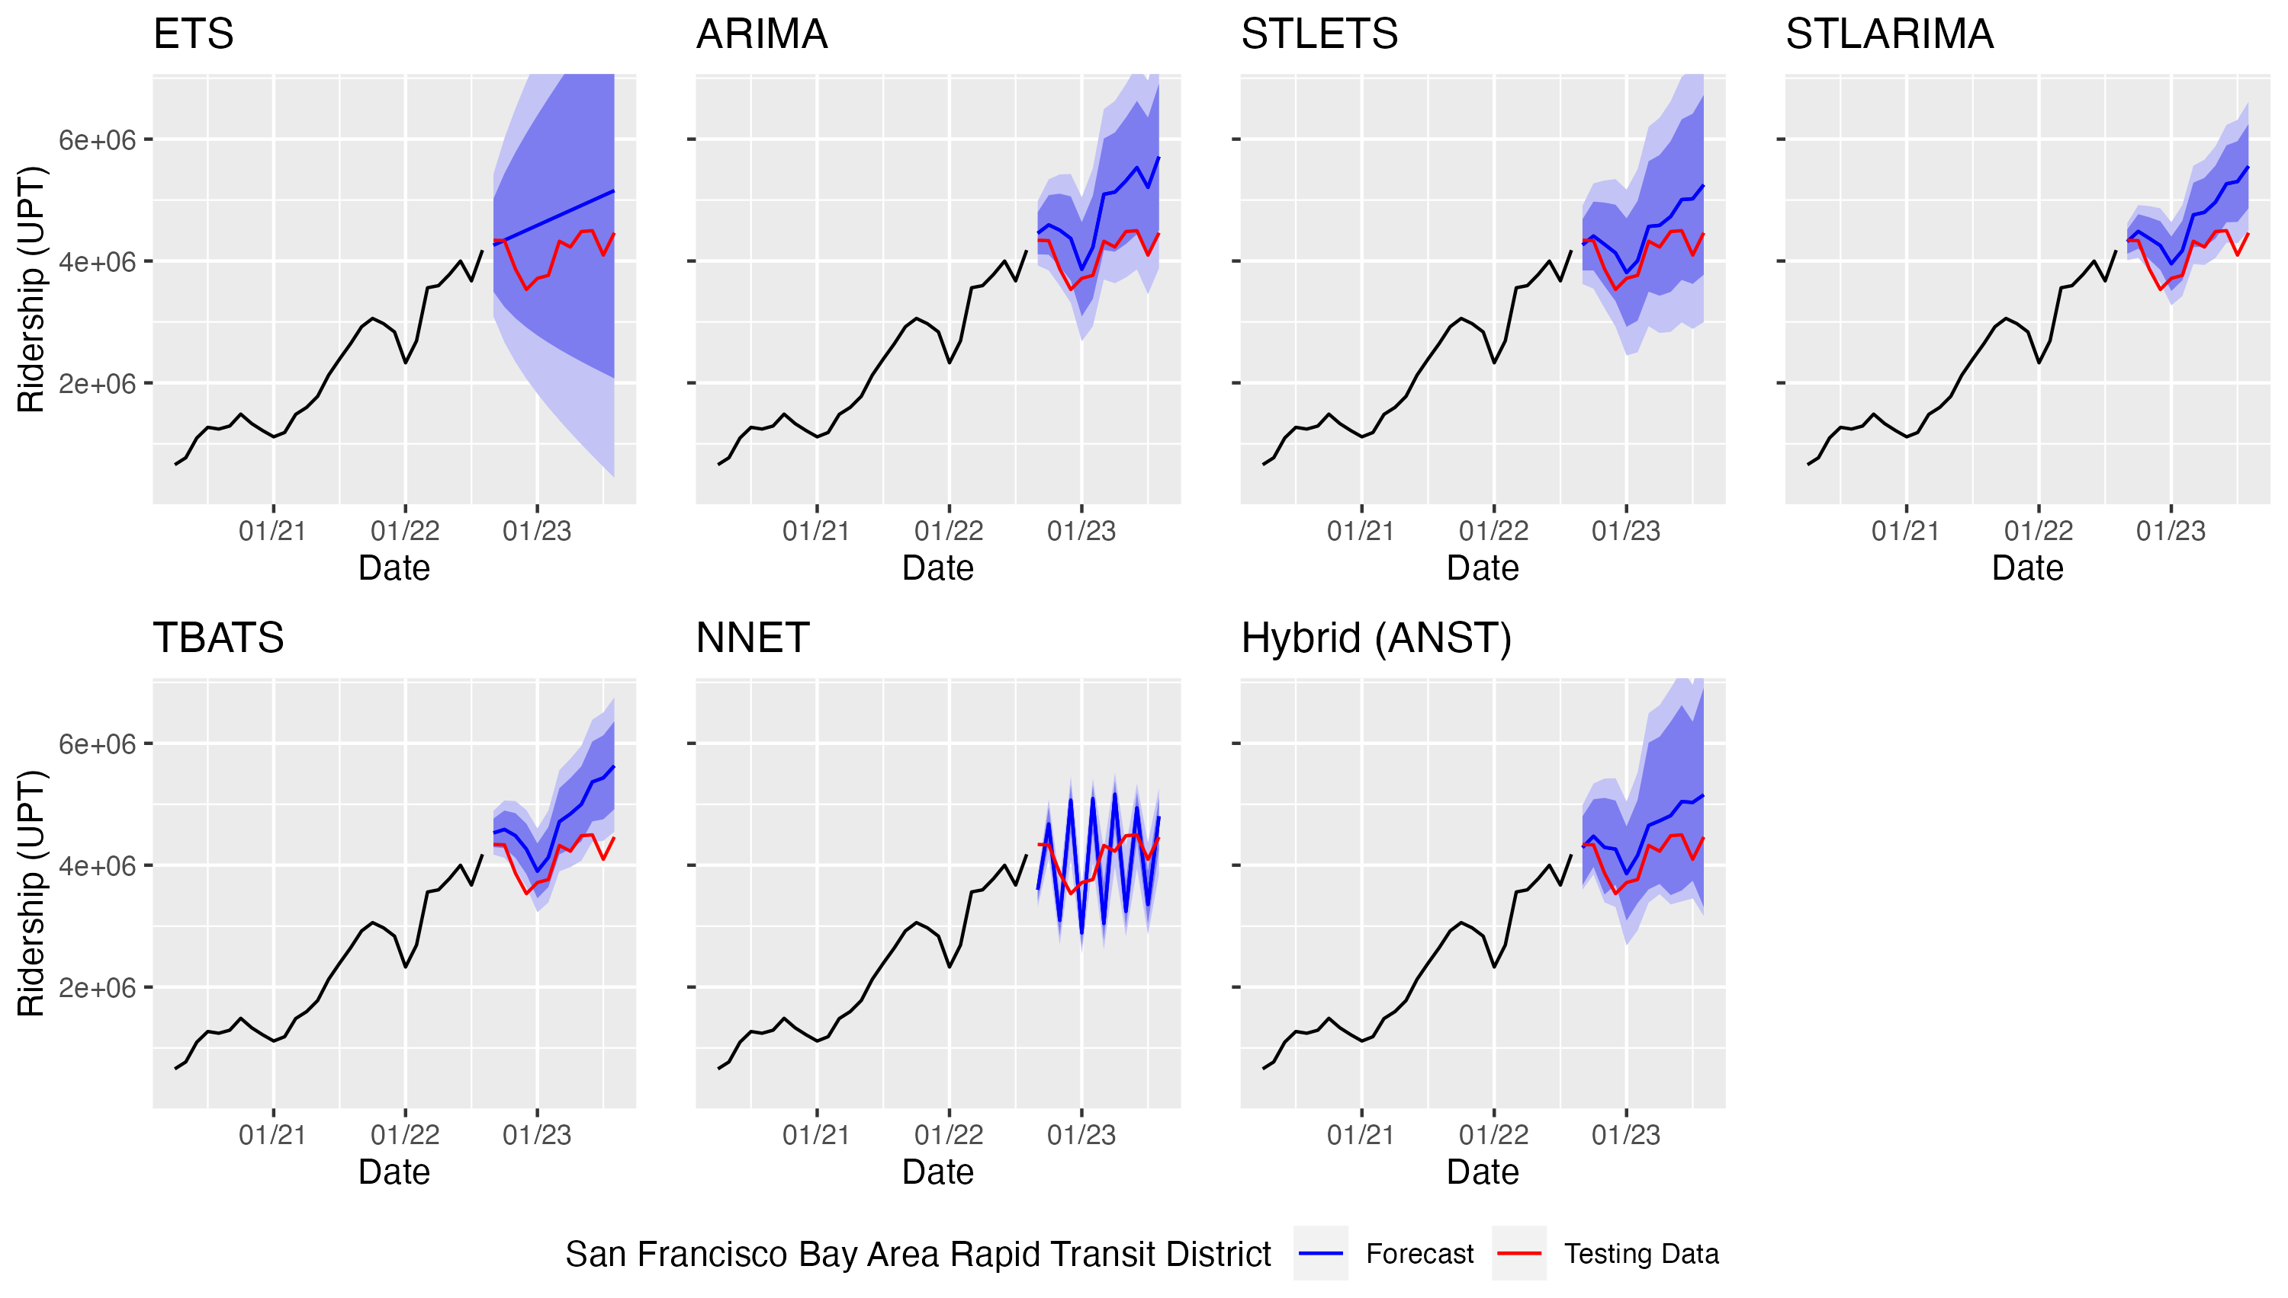
Figure 6.10 Post-COVID ridership forecasts for the San Francisco Bay Area Rapid Transit District
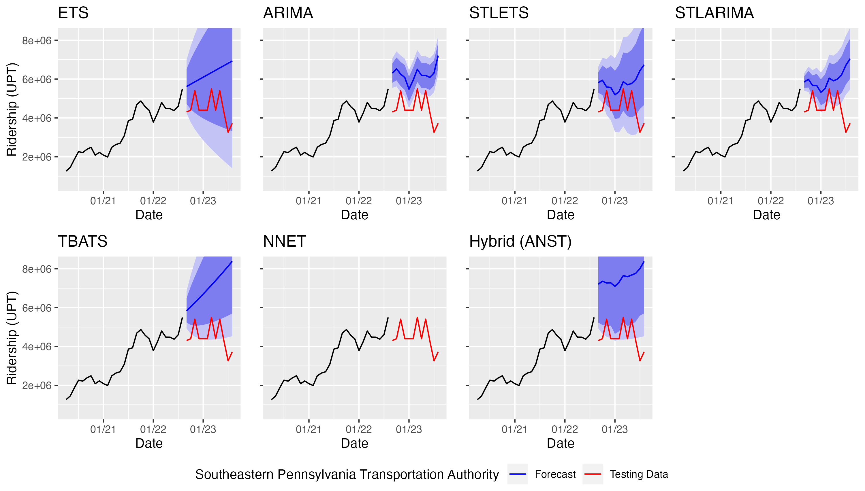
Figure 6.11 Post-COVID ridership forecasts for the Southeastern Pennsylvania Transportation Authority
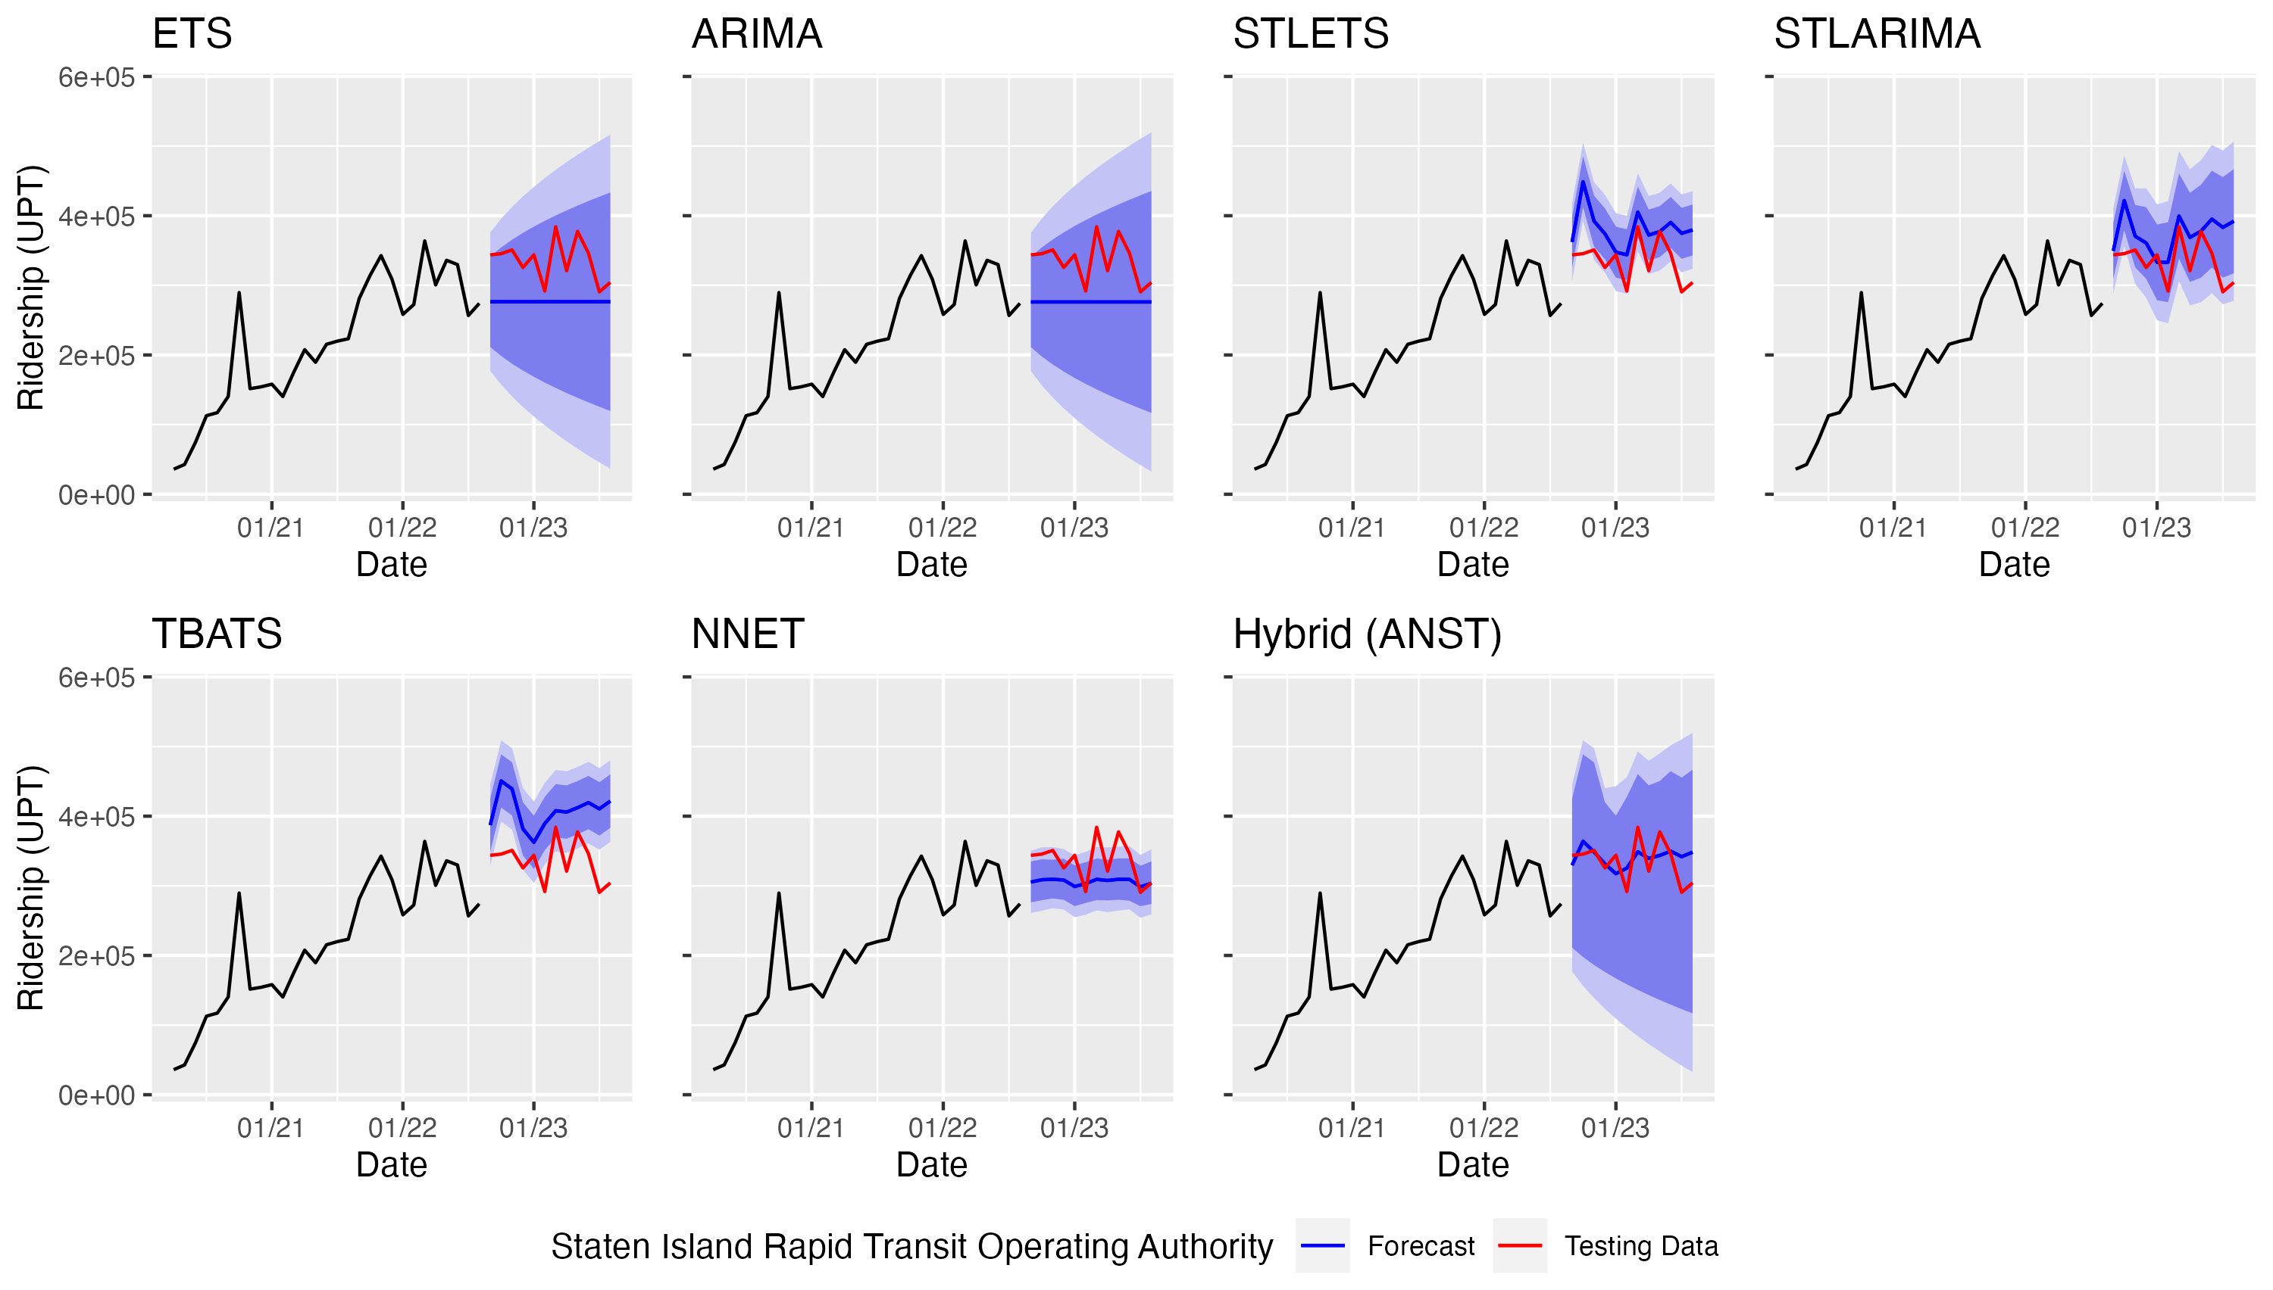
Figure 6.12 Post-COVID ridership forecasts for the Staten Island Rapid Transit Operating Authority
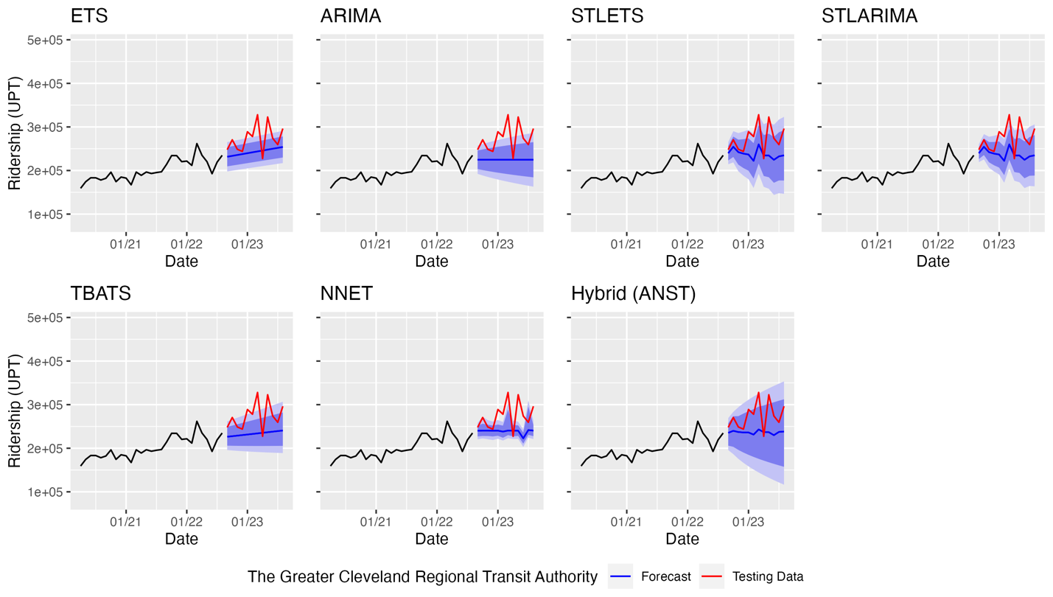
Figure 6.13 Post-COVID ridership forecasts for the Greater Cleveland Regional Transit Authority
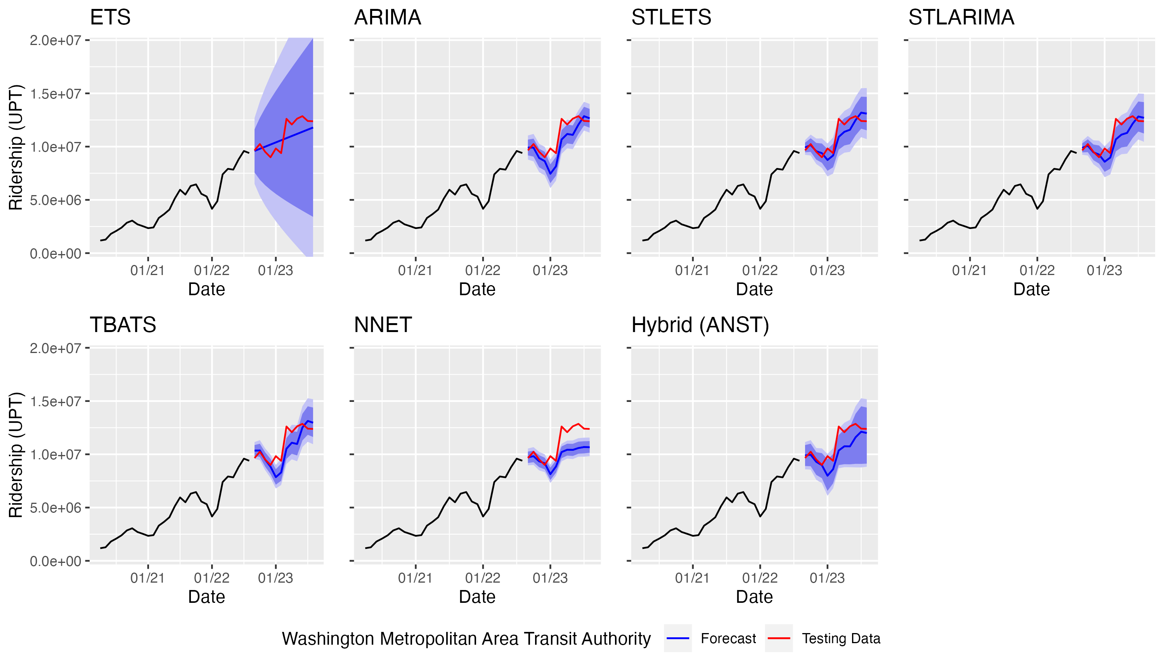
Figure 6.14 Post-COVID ridership forecasts for the Washington Metropolitan Area Transit Authority

Table 4.4 Performance of post-COVID ridership forecasting models
Agency | Measure | ETS | ARIMA | STL-ETS | STL-ARIMA | TBATS | NNET | Hybrid (ANST) | Minimum | Maximum
Chicago Transit Authority | MAPE | 21.70 | 6.35 | 12.30 | 8.22 | 4.70 | 8.35 | 4.79 | TBATS | ETS
Chicago Transit Authority | MASE | 0.60 | 0.18 | 0.36 | 0.24 | 0.13 | 0.23 | 0.13
County of Miami-Dade | MAPE | 5.29 | 16.40 | 4.17 | 16.41 | 7.20 | 6.08 | 6.66 | STL-ETS | STL-ARIMA
County of Miami-Dade | MASE | 0.29 | 0.88 | 0.22 | 0.89 | 0.41 | 0.34 | 0.35
Los Angeles County Metropolitan Transportation Authority | MAPE | 7.23 | 6.85 | 7.94 | 6.14 | 6.63 | 8.09 | 5.31 | Hybrid (ANST) | NNET
Los Angeles County Metropolitan Transportation Authority | MASE | 0.38 | 0.36 | 0.41 | 0.31 | 0.35 | 0.42 | 0.28
Maryland Transit Administration | MAPE | 33.81 | 33.86 | 29.13 | 29.16 | 27.11 | 36.75 | 30.82 | TBATS | NNET
Maryland Transit Administration | MASE | 1.76 | 1.76 | 1.72 | 1.72 | 1.70 | 1.80 | 1.74
Massachusetts Bay Transportation Authority | MAPE | 15.84 | 6.58 | 5.90 | 6.63 | 15.90 | 25.60 | 5.03 | Hybrid (ANST) | NNET
Massachusetts Bay Transportation Authority | MASE | 0.41 | 0.17 | 0.15 | 0.17 | 0.42 | 0.68 | 0.13
Metropolitan Atlanta Rapid Transit Authority | MAPE | 16.49 | 5.87 | 11.58 | 9.72 | 5.00 | 12.33 | 8.00 | TBATS | ETS
Metropolitan Atlanta Rapid Transit Authority | MASE | 0.67 | 0.24 | 0.48 | 0.40 | 0.20 | 0.51 | 0.33
MTA New York City Transit | MAPE | 15.62 | 5.86 | 5.12 | 7.35 | 4.66 | 4.73 | 4.66 | TBATS | ETS
MTA New York City Transit | MASE | 0.48 | 0.18 | 0.16 | 0.23 | 0.15 | 0.15 | 0.15
Port Authority Trans-Hudson Corporation | MAPE | 22.06 | 22.14 | 11.70 | 21.68 | 16.14 | 4.64 | 14.47 | NNET | ARIMA
Port Authority Trans-Hudson Corporation | MASE | 0.59 | 0.61 | 0.32 | 0.59 | 0.44 | 0.13 | 0.39
Port Authority Transit Corporation | MAPE | 16.24 | 9.87 | 10.10 | 11.74 | 12.61 | 4.47 | 7.78 | NNET | ETS
Port Authority Transit Corporation | MASE | 0.50 | 0.31 | 0.31 | 0.36 | 0.39 | 0.14 | 0.24
San Francisco Bay Area Rapid Transit District | MAPE | 14.59 | 16.75 | 9.25 | 13.34 | 14.55 | 21.75 | 10.64 | STL-ETS | NNET
San Francisco Bay Area Rapid Transit District | MASE | 0.39 | 0.47 | 0.25 | 0.37 | 0.40 | 0.59 | 0.29
Southeastern Pennsylvania Transportation Authority¹ | MAPE | 43.31 | 42.60 | 33.42 | 37.35 | 61.96 | 157.95 | 72.31 | STL-ETS | NNET
Southeastern Pennsylvania Transportation Authority¹ | MASE | 1.01 | 1.00 | 0.76 | 0.85 | 1.46 | 3.88 | 1.73
Staten Island Rapid Transit Operating Authority | MAPE | 16.95 | 17.06 | 14.08 | 12.62 | 22.26 | 9.27 | 7.34 | Hybrid (ANST) | TBATS
Staten Island Rapid Transit Operating Authority | MASE | 0.49 | 0.49 | 0.38 | 0.33 | 0.60 | 0.27 | 0.20
The Greater Cleveland Regional Transit Authority | MAPE | 11.75 | 16.97 | 12.71 | 12.71 | 14.40 | 12.72 | 13.34 | ETS | ARIMA
The Greater Cleveland Regional Transit Authority | MASE | 1.08 | 1.55 | 1.17 | 1.17 | 1.32 | 1.17 | 1.23
Washington Metropolitan Area Transit Authority | MAPE | 8.28 | 8.36 | 5.36 | 5.80 | 7.75 | 10.57 | 7.83 | STL-ETS | NNET
Washington Metropolitan Area Transit Authority | MASE | 0.28 | 0.28 | 0.19 | 0.20 | 0.27 | 0.38 | 0.27
Green - MAPE below 5%, Yellow - MAPE below 10%, Red - MASE above 1.00
¹ Southeastern Pennsylvania Transportation Authority's ridership data had a quality control issue that negatively impacted the performance of the models.

well, having produced a good MAPE for a collective five agencies. The hybrid model also performed rather well, having produced a good or acceptable MAPE at nine agencies. Also, both the neural network and ARIMA models were able to produce a good or acceptable MAPE at half the agencies.
Despite producing a good MAPE for MTA New York City Transit, Port Authority Transit Corporation, and Port Authority Trans-Hudson Transit Corporation, the neural network produced the highest MAPE at five of the other agencies (Southeastern Pennsylvania Transportation Authority is not included in this number). The ETS method also produced the highest MAPE at four agencies; in fact, the ETS method seemed to struggle the most of all methods at capturing any seasonality in the data. Generally, all models produced a MASE below 1.00, with the exception of two of the three smallest agencies, the Greater Cleveland Regional Transit Authority and the Maryland Transit Administration. This means that the models at those two agencies did not outperform the simple naïve forecasting method.
To summarize, the more complex models (TBATS, neural network, and hybrid models) performed quite well for the post-COVID-only forecasts. This is an interesting finding, given that the same models performed poorly relative to the simpler, classical models when provided with more observations. This could indicate that these models were better able to detect patterns using fewer training observations, or that the post-COVID data contains more complex patterns that these models are better suited to deal with. Additionally, the ARIMA model still produced an acceptable MAPE at half the agencies; given that the ARIMA method also performed well in the pre-COVID and full series forecasts, this model may continue to be well-suited for transit ridership forecasting in the post-COVID era.
Another interesting finding is that for the Greater Cleveland Regional Transit Authority, no combination of model and number of observations was able to produce acceptable forecasts. At another small agency, the Maryland Transit Administration, there were similar struggles to produce acceptable forecasts, although some models were able to produce acceptable forecasts for the pre-COVID data. Generally, some of the larger agencies tended to produce good or acceptable forecasts regardless of the time period used to estimate the models (e.g., Chicago Transit Authority, MTA New York City Transit, Washington Metropolitan Area Transit Authority). This could suggest that the time series forecasting methods used in this study are better suited for larger systems, at least for monthly, system-level ridership forecasting. Different methods of forecasting may be necessary to overcome the challenges associated with identifying patterns at some agencies, particularly at agencies with limited number of heavy rail lines like the Greater Cleveland Regional Transit Authority and the Maryland Transit Administration.

Conclusions

This study compared the performance of seven time series forecasting methods for pre-COVID and post-COVID transit ridership for the fourteen heavy rail providers in the continental United States. Two key findings emerged from this analysis. First, time series forecasting prior to the COVID-19 pandemic could be done in a relatively straightforward manner for most agencies. Ridership data at most heavy rail agencies in the US contained steady, seasonal trends that could be modeled fairly well using classical time series forecasting methods as well as newer, more complex methods like the TBATS, neural network, and hybrid methods. From the findings, it can be concluded that time series forecasting is a simple, quick, and efficient method to forecast ridership at agencies with strong and regular seasonality, periodicity, and/or trends, which was typical prior to the COVID-19 pandemic.

A second noteworthy conclusion is that forecasting monthly ridership post-COVID is still challenging, likely due to competing trends, changing travel behavior, limited datasets, and other variables reflected in the time series data. Nevertheless, time series forecasting methods such as those used in this study were capable of producing good or acceptable post-COVID ridership forecasts using both the full series of data, as well as only post-COVID data. Given the full series of ridership data, the ARIMA method produced acceptable forecasts for 11 of 14 agencies, and given post-COVID-only data, the ARIMA method produced acceptable forecasts for half of the agencies. These results may indicate that the ARIMA method is generally well-suited to ridership forecasting at heavy rail agencies. The TBATS, neural network, and hybrid methods performed particularly well when forecasting with the post-COVID-only dataset. These methods may have outperformed the other methods in the post-COVID period due to their ability to deal with complex seasonality and nonlinearity in the data; these features are likely an enduring effect of the pandemic on heavy rail ridership, which caused substantial changes in ridership behavior across most rider groups. Especially at agencies with more limited heavy rail service (i.e., smaller heavy rail agencies like the Greater Cleveland Regional Transit Authority), there seemed to be a lack of patterns in the heavy rail ridership data, as demonstrated by the white noise test and the performance of the forecasts, which were generally poor.

Based on the findings of this study, the strong, stable ridership patterns found at many US heavy rail agencies prior to the pandemic have still not returned, which this could be due to external factors such as unemployment, telework, and people relocating (43). However, at some agencies in major US cities (e.g., New York City and Washington D.C.), monthly transit ridership has become more predictable or has remained about as predictable post-COVID as compared to before the pandemic. For some cities with more limited heavy rail service (for example, Cleveland), ridership remains just as unpredictable as it was prior to the pandemic. These mixed findings demonstrate a need for agency-specific solutions to ridership forecasting.

Several areas for future research that have emerged from this study. First, more post-COVID data will become available in the future, allowing for further exploration of the post-pandemic trends. Future research should compare forecasts between cities to understand the differences in trends at some agencies, especially at smaller agencies where the time series methods struggled to produce good forecasts. Additionally, other methods may be used in future research to identify external factors that have an impact on heavy rail ridership and to quantify their impact; for example, a recently published study quantified the impact of external factors on post-COVID bus ridership levels using a multiple mediation analysis and found that unemployment, telework, and people relocating explained 13% to 38% of the ridership declines (43). Future studies could consider including exogenous regressors in the models to account for other factors impacting ridership and possibly improve the performance of the forecasts. Last, future studies may use larger datasets, e.g., daily or weekly data with a length of at least 1,000 datapoints, and more complex time series forecasting methods such as deep learning methods may then be suitable.

Based on the findings of this study, time series forecasting is likely to be a promising method of predicting system-level transit agency ridership at many heavy rail agencies, even in the post-COVID era. By making the code used in this study publicly available, as well as bringing more visibility to Minneapolis Metro’s forecasting app and the code that powers it, transit agencies may find these methods of transit ridership forecasting more accessible, helping them to produce accurate and low-cost ridership forecasts more frequently and with a wider variety of methods. This is critical to practitioners, planners, and policy makers as they attempt to forecast system-wide ridership levels in the post-COVID era to set budget levels, plan schedules, and perform other important real world tasks using transit ridership forecasts.

List of References
1. Plotch, P. Transit Ridership: Not Expected to Return to Pre-Pandemic Levels This Decade. Eno Center for Transportation. https://www.enotrans.org/article/transit-ridership-not-expected-to-return-to-pre-pandemic-levels-this-decade/. Accessed July 10, 2022.

2. Boyle, D. TCRP Synthesis 66: Fixed-Route Transit Ridership Forecasting and Service Planning Methods. Transit Cooperative Research Program, 2006. https://dx.doi.org/10.17226/14001. Accessed December 14, 2023.

3. Washington, S., M. Karlaftis, F. Mannering, and P. Anastasopoulos. Statistical and Econometric Methods for Transportation Data Analysis. CRC Press, New York, NY. 2020. Accessed December 15, 2023.

4. Nihan, N. L., and K. O. Holmesland. Use of the Box and Jenkins Time Series Technique in Traffic Forecasting. Transportation, Vol. 9, 1980, pp. 125-143. https://doi.org/10.1007/BF00167127. Accessed July 15, 2022.

5. Babcock, M. W., X. Lu, and J. Norton. Time Series Forecasting of Quarterly Railroad Grain Carloadings. Transportation Research Part E: Logistics and Transportation Review, Vol. 35, No. 1, 1999, pp. 43-57. Accessed July 15, 2022.

6. Wickham, R. R. Evaluation of Forecasting Techniques for Short-Term Demand of Air Transportation. Boston, MA, 1995. Massachusetts Institute of Technology. http://hdl.handle.net/1721.1/11584. Accessed July 15, 2022.

7. Jayanthi, G., and P. Jothilakshmi. Traffic Time Series Forecasting on Highways - A Contemporary Survey of Models, Methods and Techniques. International Jounal of Logistics Systems and Management, Vol. 39, No. 1, 2021, pp. 77-110. https://doi.org/10.1504/IJLSM.2021.115068. Accessed July 15, 2022.

8. Zheng, X., and P. Wei. Air Transportation Direct Share Time Series Forecasting: A Hybrid Model. Journal of Advanced Transportation, Vol. 3, 2020, pp. 1-13. http://dx.doi.org/10.1155/2020/8924095. Accessed July 15, 2022.

9. Kyte, M., J. Stoner, and J. Cryer. A Time-Series Analysis of Public Transit Ridership in Portland, Oregon, 1971-1982. Transportation Research Part A: General, Vol. 22, No. 5, 1988, pp. 345-359. https://doi.org/10.1016/0191-2607(88)90012-X. Accessed July 1, 2022.

10. Ge, S. Y., C. J. Zheng, and M. M. Hou. Forecast of Bus Passenger Traffic Based on Exponential Smoothing and Trend Moving Average Method. Applied Mechanics and Materials, Vol. 433-435, 2013, pp. 1374-1378. http://dx.doi.org/10.4028/www.scientific.net/AMM.433-435.1374. Accessed July 1, 2022.

11. Egu, O., and P. Bonnel. Medium-term Public Transit Route Ridership Forecasting: What, how and why? A Case Study in Lyon. Transport Policy, Vol. 105, 2021, pp. 124-133. https://doi.org/10.1016/j.tranpol.2021.03.002. Accessed June 30, 2022.

12. Ding, C., J. Duan, Y. Zhang, and G. Yu. Using an ARIMA-GARCH Modeling Approach to Improve Subway Short-Term Ridership Forecasting Accounting for Dynamic Volatility. IEEE Transactions on Intelligent Transportation Systems, Vol. 19, No. 4, 2018, pp. 1054-1064. http://dx.doi.org/10.1109/TITS.2017.2711046. Accessed June 30, 2022.

13. Chen, D., J. Zhang, and S. Jiang. Forecasting the Short-Term Metro Ridership with Seasonal and Trend Decomposition Using Loess and LSTM Neural Networks. IEEE Access, Vol. 8, 2020. 10.1109/ACCESS.2020.2995044. Accessed June 30, 2022.

14. Azimian, A., and J. Jiao. Prediction of “L” Train’s Daily Ridership in Downtown Chicago During the COVID-19 Pandemic. Findings, No. December, 2021. https://doi.org/10.32866/001c.30181. Accessed July 15, 2022.

15. Moghimi, B., C. Kamga, A. Safikhani, S. Mudigonda, and P. Vicuna. Non-Stationary Time Series Model for Station-Based Subway Ridership During COVID-19 Pandemic: Case Study of New York City. Transportation Research Record, Vol. 2677, No. 4, 2022. https://doi.org/10.1177/03611981221084698. Accessed June 21, 2022.

16. Wang, X., N. Zhang, Y. Chen, and Y. Zhang. Short-Term Forecasting of Urban Rail Transit Ridership Based on ARIMA and Wavelet Decomposition. Presented at 6th International Conference on Computer-Aided Design, Manufacturing, Modeling and Simulation, Busan, South Korea. AIP Conference Proceedings 1967, 2018. doi:10.1063/1.5039099. Accessed June 22, 2022.

17. Doi, M., and W. B. Allen. A Time Series Analysis of Monthly Ridership for an Urban Rail Rapid Transit Line. Transportation, Vol. 13, 1986, pp. 257-269. https://doi.org/10.1007/BF00148619. Accessed July 1, 2022.

18. Mucci, A., and G. D. Erhardt. Evaluating the Ability of Transit Direct Ridership Models to Forecast Medium-Term Ridership Changes: Evidence from San Francisco. Transportation Research Record, Vol. 2672, No. 46, 2018. https://doi.org/10.1177/0361198118758632. Accessed October 23, 2022.

19. Chen, C.-H. P., and G. A. Naylor. Development of a Mode Choice Model for Bus Rapid Transit in Santa Clara County, California. Journal of Public Transportation, Vol. 14, 2011, pp. 41-62. https://doi.org/10.5038/2375-0901.14.3.3. Accessed October 23, 2022.

20. Perry, J. Measuring the Accuracy of Bus Rapid Transit Forecasts. Journal of Public Transportation, Vol. 20, 2017, pp. 119-138. https://doi.org/10.5038/2375-0901.20.1.7. Accessed October 23, 2022.

21. Hoque, J. M., G. D. Erhardt, D. Schmitt, M. Chen, A. Chaudhary, M. Wachs, and R. R. Souleyrette. The changing accuracy of traffic forecasts. Transportation, Vol. 49, 2021, pp. 445-466. https://doi.org/10.1007/s11116-021-10182-8. Accessed December 14, 2023.

22. Gao, Y., J. Li, J. Wang, and Z. Yang. U.S. public transportation ridership analysis and prediction based on COVID-19. International Society for Optical Engineering, Vol. 12596, 2023. https://doi.org/10.1117/12.2672649. Accessed November 15, 2023.

23. Ayman, A., J. Martinez, P. Pugliese, A. Dubey, and A. Laszka. Neural Architecture and Feature Search for Predicting the Ridership of Public Transportation Routes. Presented at 2022 IEEE International Conference on Smart Computing (SMARTCOMP), Helsinki, Finland. 2022. 10.1109/SMARTCOMP55677.2022.00023. Accessed December 15, 2023.

24. Caicedo, J. D., M. C. Gonzàlez, and J. L. Walker. Public Transit Demand Prediction During Highly Dynamic Conditions: A Meta-Analysis of State-of-the-ART Models and Open-Source Benchmarking Infrastructure. 2023. https://doi.org/10.48550/arXiv.2306.06194. Accessed December 15, 2023.

25. Federal Transit Administration. Monthly Module Adjusted Data Release. Federal Transit Administration. https://www.transit.dot.gov/ntd/data-product/monthly-module-adjusted-data-release. Accessed November 15, 2023.

26. Minneapolis Metro Transit. Route Trends and Info, Minneapolis. https://metrotransitmn.shinyapps.io/route-trends/. Accessed July 13, 2022.

27. R Core Team. R: A language and environment for statistical computing. R Foundation for Statistical Computing, Vienna, Austria. http://www.r-project.org/. Accessed July 25, 2022.

28. Hyndman, R. J., and G. Athanasopoulos. Forecasting: Principles and Practice, 2nd Edition. Melbourne, Australia. OTexts.com/fpp2. 2018. Accessed December 15, 2023.

29. Lind, E., J. Reid, and K. E. Ky. MetroTransit / Route-Trends, Build Complete Base Function App. https://github.com/metrotransit/route-trends/commit/752d7b50fd250d66e334c8dc31487890f8d1b8ab. Accessed December 14, 2023.

30. Vanderkam, D., J. Allaire, J. Owen, D. Gromer, and B. Thieurmel. dygraphs: Interface to “Dygraphs” Interactive Time Series Charting Library. R package version 1.1.1.6. 2018. Accessed February 2, 2022.

31. Wickham, H. ggplot2: Elegant Graphics for Data Analysis. Springer-Verlag New York, New York, 2016. Accessed July 25, 2022.

32. Livera, A. M. D., R. J. Hyndman, and R. D. Snyder. Forecasting Time Series with Complex Seasonal Patterns Using Exponential Smoothing. Journal of the American Statistical Association, Vol. 106, No. No. 496, 2011, pp. 1513-1527. Accessed November 11, 2023.

33. Hyndman, R., G. Athanasopoulos, C. Bergmeir, G. Caceres, L. Chhay, M. O’Hara-Wild, F. Petropoulos, S. Razbash, E. Wang, and F. Yasmeen. forecast: Forecasting functions for time series and linear models. R package version 8.15. 2021. Accessed July 18, 2022.

34. Hyndman, R., and Y. Khandakar. Automatic time series forecasting: the forecast package for R. Journal of Statistical Software, Vol. 26 (3), 2008, pp. 1-22. https://www.jstatsoft.org/article/view/v027i03. Accessed December 15, 2023.

35. Hyndman, R. J., and G. Athanasopoulos. A taxonomy of exponential smoothing methods. In Forecasting: principles and practice, 2nd edition, OTexts, Melbourne, Australia, 2018. Accessed December 15, 2023.

36. Hyndman, R., and G. Athanasopoulos. 8.8 Forecasting. In Forecasting: principles and practice, 2nd edition, OTexts, Melbourne, Australia, 2018. Accessed December 15, 2023.

37. Hyndman, R. J., and G. Athanasopoulos. 6.8 Forecasting with decomposition. In Forecasting: principles and practice, 2nd edition, OTexts, Melbourne, Australia, 2018. Accessed December 15, 2023.

38. Razbash, S., and R. J. Hyndman. tbats: TBATS model (Exponential smoothing state space model with Box-Cox transformation, ARMA errors, Trend and Seasonal components). RDocumentation.org. https://www.rdocumentation.org/packages/forecast/versions/8.21.1/topics/tbats. Accessed November 11, 2023.

39. Hyndman, R. J. Prediction intervals for NNETAR models. Rob J. Hyndman. https://robjhyndman.com/hyndsight/nnetar-prediction-intervals/. Accessed December 15, 2023.

40. Hyndman, R. J., and G. Athanasopoulos. 11.3 Neural network models. In Forecasting: principles and practice, 2nd edition, OTexts, Melbourne, Australia, 2018. Accessed December 15, 2023.

41. Shaub, D. Using the “forecastHybrid” package. cran.r-project.org. https://cran.r-project.org/web/packages/forecastHybrid/vignettes/forecastHybrid.html#forecasting. Accessed November 11, 2023.

42. Halloway, B. S. Understanding Prediction Intervals. Bryan S. Halloway. https://www.bryanshalloway.com/2021/03/18/intuition-on-uncertainty-of-predictions-introduction-to-prediction-intervals/#a-few-things-to-know-about-prediction-intervals. Accessed December 14, 2023.

43. Ziedan, A., L. Lima, and C. Brakewood. A multiple mediation analysis to untangle the impacts of COVID-19 on nationwide bus ridership in the United States. Transportation Research Part A: Policy and Practice, Vol. 173, 2023. https://doi.org/10.1016/j.tra.2023.103718. Accessed December 15, 2023.

Appendix
[Remove this note, but DO NOT REMOVE THIS PAGE – you can change “Appendix” to “Appendices” if you would like. The appendix material should start at the top of THIS page unless you are using separator sheets for your chapter headings, in which case the appendix material should start at the top of the NEXT page. Please note that you should remove both this page and the next one if you are not including an appendix at all – “do not remove this page” refers only to students who ARE including an appendix]

Vita
Jane X. Doe was born. She wrote a thesis. She graduated. She followed instructions and wrote her vita in third person and paragraph form (as opposed to a resume or CV), which made her thesis consultant very happy. This page is required.

