University Students’ Perspectives of Visual-based Cyberbullying on Instagram

A Thesis Proposal Presented for the
Doctoral of Philosophy
Degree
The University of Tennessee, Knoxville

Li-Min Huang

ABSTRACT

This is a sample Word document that can be used as a template in formatting your thesis/dissertation. It cannot exceed 350 words.

If you use any special characters (including superscripts and subscripts) in your abstract, you must write out the term in plain English in square brackets immediately following the first use of the character. For example: H₂O [water] and µ [micron]. This has nothing to do with how common the term is in your field of study-- our catalogers have to enter the abstract in our records using a plain text format that cannot accommodate the special characters, but has no problem with word substitutes.

Table of Contents

Chapter One Introduction and General Information 7
Rationale 7
Background 7
Problem Statement 8
Research Questions 10
Significance of the Study 10
Theoretical Frameworks 11
Social-Ecological Model (SEM) 11
Cognitive-affective-behavioral framework 14
Definition of Terms 15
Cyberbullying 15
Perspective 15
Instagram features 16
Summary 18
Chapter Two Literature Review 19
Literature search approach 19
Overview of cyberbullying research 20
Cyberbullying research related to university students 22
Methods 22
Sample characteristics 22
Prevalence of Cyberbullying. 22
Individual Level 26
Microsystem Level 35
Mesosystem Level 36
Exosystem Level 37
Macrosystem Level 39
Summary 39
Visual-based cyberbullying and cyberbullying on visual-based social media 40
The social media norm of the young generation 40
Cyberbullying research on visual-based social media sites 42
Summary 44
Summary and Research gap 44
Chapter Three Materials and Methods 46
Research Methodology 46
Research Questions 46
Research Design 47
Survey 49
Individual interviews and visual narrative inquiry 54
Scan of policy documents 64
Ethical Considerations 67
Respect of persons 67
Beneficence 67
Justice 68
Role of Researcher 68
Chapter Four Results and Discussion 69
Overview 69
Survey 69
Interview 69
Visual Narrative Inquiry 69
Scan of Policy Document 70
Chapter Five Conclusions and Recommendations 73
List of References 74
Appendix 88
Appendix A-Survey Invitation Email 89
Appendix B-Survey Informed Consent Form 90
Appendix C Survey Instrument 92
Appendix D-Research Interview Invitation Email 95
Appendix E-Research Information 96
Appendix F-Interview Instrument 99
Appendix G-Reliability and Validity Report of Lee et al.’s (2017) Scales 103
Appendix H-Qualitative Data Codebook 104
Vita 109

LIST OF TABLES

Table 1. Literature search queries and parameters across databases 19
Table 2. Summary of the reviewed studies related to university students 24
Table 3. Cyberbullying perpetration behaviors investigated in literature 28
Table 4. Codebook overview 62
Table 5. Coding scheme for policy documents 66
Table 6. Coding scheme for policy documents 66
Table 7. Scan of policy overview 72
LIST OF FIGURES

Figure 1. Bronfenbrenner’s (1977) original social-ecological model 12
Figure 2. The Five C’s framework 13
Figure 3. Huang’s proposed holistic theoretical framework 15
Figure 4. An example of an Instagram post 16
Figure 5. An example of an Instagram Reel 17
Figure 6. An example of Instagram stories with various elements 18
Figure 7. A concept map of elements in cyberbullying perpetration behaviors 27
Figure 8. Explanatory design: Participant selection model (QUAL emphasized) 48
Figure 9. Mapping of RQs with the research design 48
Figure 10. Mapping of RQs, research design, and theoretical framework 49
Figure 11. Model of the Visual/sexual Cyberbullying behavior scales 52
Figure 12. Visual scenario 2 for use in the interview 59
Figure 13. Images in the supplemental question 1 61

Introduction and General Information

Rationale

When I was about to begin my doctoral program, I heard that a young female actress in my hometown committed suicide after suffering from cyberbullying. Then, I found many similar sad stories across the world. For example, Amanda Todd’s tragedy in 2012 (Dean, 2012). Later on, I became aware of cyberbullying and developed an interest in researching this topic for my dissertation

Background

“No one knows for certain how much impact they have on the lives of other people.”
Hannah Baker, 13 Reasons of Why.

From Netflix films to real life, bullying is an issue that causes sad and severe consequences. In many cases, a bad word may take away one human life. In the academic field, bullying has been extensively discussed and researched. Back at the end of the 20th century, Olweus (1994) defined bullying as the exposure of the victim to repeated, intentional harmful actions by one or more other people.

As information and communication technology (ICT) has become a more common tool in everyday life, bullying behaviors have gradually transferred to the online environment. This phenomenon is called “cyberbullying”. Other terms that indicate a similar meaning include online bullying, online perpetration, and Internet bullying, among others (De Bourdeaudhuij et al., 2015). Pioneer cyberbullying research was conducted around a decade ago (e.g., Servance, 2003; Strom & Strom, 2006), and this issue has recently become a public concern. Scholars across disciplines and nations are paying attention to different aspects of cyberbullying. For example, in López-Meneses et al.’s (2020) bibliometric study, scholarly articles on cyberbullying have appeared in the field of Social Sciences (28.51%), Psychology (23.71%), Medicine (14.81%), Computer Science (11.26%), Arts and Humanities (7.45%), and other ten subject areas. These articles are authored by scholars from all over the world, including the USA (27.66%), Spain (14.1%), the UK (8.69%), Australia (7.09%), Canada (6.03%), and many other countries.

Earlier studies indicate that cyberbullying occurs in using cell phones, computers, and personal digital devices (Li, 2006; Smith et al., 2008). Harmful messages originate from e-mails, instant messages, chat rooms, dashboards, websites, and voting booths (Beale & Hall, 2007; Brady, 2010; Shariff, 2008). The format of cyberbullying messages is usually verbal (e.g., text, voice). In the age of social media, cyberbullying has gradually infiltrated social networking sites and social media apps, such as Facebook, Twitter, WhatsApp, and Instagram.

Given that an increasing number of people use social media as a tool to connect with one another, it is not surprising that more and more cyberbullying incidents occur on social media. In the latest social media report published by the Pew Research Center, over 70% of Americans used at least one type of social media. For the young generation (aged 18-29), the most popular social media sites include YouTube (95%), Instagram (71%), Facebook (70%), Snapchat (65%), and TikTok (48%) (Pew Research Center, 2021). Except for Facebook that is a hybrid (i.e., text-visual-mixed) platform, the top used social media sites/apps among the young generation are mainly visual-based.

In fact, visual communication has been a mainstream in this era and has shaped the way young people perceive the world (Russmann & Svensson, 2017). With a smartphone in hand, everyone easily becomes a photographer and can take a picture or selfie, record a video, and post them to social media sites. This technology has facilitated for young people to self-disclose online (Morgan et al., 2010) and share their feelings about visual posts (Zappavigna, 2016).

Research has found that information presented in visual format tends to last longer in memories, as compared to textual format. For example, in Dale’s Cone of experience model (1969), people remembered 10% of what they read (i.e., text) and 30% of what they saw (i.e., picture, video). Other studies indicated that images have a more powerful impact on people’s cognitive and affective reactions and may influence their behaviors (Baloglu, 2000). Sometimes the influences of visuals may trigger problematic behaviors, such as self-harm (Jacob, et al., 2017) and alcohol drinking (Morgan et al., 2010). Cyberbullying moves beyond texts to include visuals as well (Steinmetz. 2019). For example, young people may be targeted in appearance-related cyberbullying because of posting their own photos on social media that could result in lower self-esteem and negative feelings (Berne, 2014).

Problem Statement

Researchers have started to pay attention to cyberbullying from the early 21st century (López-Meneses et al., 2020), which generated a rich body of studies. These studies have investigated various aspects of cyberbullying, such as the digital nature of this phenomenon (Peter & Petermann, 2018), the differences among demographic variables (e.g., age, gender); and the physical, mental, and technological components related to perpetration and victimization (Guo, 2016; Marciano et al., 2020). It can be observed that scholars have paid more attention to cyberbullying targeted toward children and teens (i.e., under age 18) (Chen et al., 2017) than to other populations. However, cyberbullying has been experienced by older age groups but has not been researched as extensively. For example, studies have reported that university students do, in fact, experience or witness cyberbullying incidents (see for example, Chadha et al., 2020; Martínez-Monteagudo et al., 2019; Sobba et al., 2017). Most of cyberbullying research that involved university students has investigated individuals’ general cognitive viewpoints of cyberbullying (see for examples, Abaido, 2020; Crosslin & Golman, 2014; Sobba et al., 2019), perpetration behaviors (See for examples, Lee, 2017; Ozden & Icellioglu, 2014; Rachoene & Oyedemi, 2015), and various approaches of behavioral coping strategies (See for examples, Byrne, 2021; Davis et al., 2015; Francisco et al., 2015). Nonetheless, a handful of studies has examined cyberbullying within the broader university context, such as the reporting systems (Abaido, 2020; Cunningham et al., 2015; Smith et al., 2012) and cyberbullying-related policies (Baldasare et al., 2012; Faucher et al., 2015; O’Connor et al., 2018).

Given that the young generation, aged 18-29, uses social media heavily in their daily lives (Pew Research Center, 2021), cyberbullying on various social media sites has become a critical issue (Chan et al., 2020). For example, visual-based social media platforms have gained much more attention in recent years, and studies revealed that Instagram is more powerful than text-based platforms (e.g., Twitter) in affecting young people’s emotions (Pittman & Reich, 2016), causing significant psychological impact (Soni & Singh, 2018). While there is a rich body of cyberbullying literature focusing on text-based platforms, only a handful of studies have investigated cyberbullying on visual-based platforms. These studies (Kumar & Sachdeva, 2021; Singh et al., 2017; Soni & Singh, 2018; Vishwamitra et al., 2021) examined visual-based cyberbullying aiming to develop machine learning (ML) models to detect cyberbullying. To fulfill the need for training models, researchers in these studies spend a considerable amount of time and effort to extract visual features. For example, a large dataset of visual data was first extracted from social media Application Programming Interfaces (APIs) and search engines, then judged by crowdsourcing workers, such as Amazon Mechanical Turk (http://mturk.com). Given that the crowdsourcing approach can only determine cyberbullying features based on visual data, it may lack context and interpretation from the victims’ or witnesses’ perspectives. As Vishwamitra et al. (2021) indicate, there is a need for research on visual-based cyberbullying scenarios from the victims’ or witnesses’ perspectives to gain insights into their first-hand experiences so that we develop a better understanding of cyberbullying. In addition, Soni and Singh (2018) also indicated that possible limitation of future research may cause by social media companies’ API access restrictions.

As was mentioned earlier, Instagram is the most popular visual-based platform among young people aged 18 to 29 (Pew Research Center, 2021). This study will focus on Instagram due to popularity and ease of use, allowing users to share various types of visual media (e.g., images, videos), unique interaction approaches (e.g., Story, Reel) (Instagram.com, n.d.), and common usage among peers (Oladimeji & Kyobe, 2021). Given that Stories disappear 24 hours after posting, combined with excessive use, this new interaction approach might potentially bring a unique environment of cyberbullying. Thus, this dissertation study aims to explore university students’ perspectives on visual-based cyberbullying using Instagram.

In addition, there is a rich body of cyberbullying research that investigated individual factors, such as a user’s demographic attributes, personal knowledge, peers, family, and school. However, little attention has been paid to factors that may influence the nature of cyberbullying at a higher level, including cyberbullying-related policies. This study will examine university policies related to visual-based cyberbullying in the University of Tennessee System (https://tennessee.edu/). The research questions that will guide this study are addressed in the next section.

Research Questions

RQ1: What is the nature of visual-based cyberbullying experienced by undergraduate university students on Instagram?
RQ2: What are undergraduate university students’ perspectives of visual-based cyberbullying incidents on Instagram?
RQ2a: What definitions or meanings do students attach to visual-based cyberbullying?
RQ2b: Informed by Ostrom's (1969) attitude components, what students' cognitive, affective, and behavioral responses toward cyberbullying?
RQ3: How do undergraduate university students create and describe visual-based cyberbullying scenarios based on incidents they witnessed on Instagram?
RQ3a: Informed by the Five Cs model, what elements do these scenarios reflect?
RQ3b: Informed by the coping mechanism in Agnew’s (1992) General Strain Theory, how do students describe the coping strategies of the victims or witness exposed to visual-based cyberbullying incidents in the created scenarios?
RQ4: How do current university policies in the University of Tennessee system address visual-based cyberbullying?
RQ4a: How are undergraduate students aware of these policies?

Significance of the Study

Visual-based communication such as Instagram has been a trend. However, it also raises issues in relation to cyberbullying (Vishwamitra et al., 2021). Therefore, we need to develop better understanding of visual-based cyberbullying on this media platform in order to suggest effective interventions and/or preventions. This dissertation study will have its significance in the following aspects. Theoretically, the findings from this study will provide empirical evidence on university students’ cognitive, affective, and behavioral aspects toward visual content on Instagram, which will introduce new insights to the existing theoretical foundation of cyberbullying. Methodologically, the visual features (e.g., gestures, emojis) extracted from scenarios created by students may serve as identifiers for training auto-detection models in detecting cyberbullying. In addition, Instagram scenarios created by students provide cyberbullying context visually from students’ cognitive, affective and behavioral aspects, which may enable us to discover hidden clues that were less revealed by traditional research methods, such as survey. Practically, analyzing the UTK system’s cyberbullying policies could provide understanding of current practices (e.g., reporting system, support provided) as well as identify potential gaps that need to be addressed. Additionally, findings from this study should contribute to developing prevention and intervention educational resources for university personnel and students on cyberbullying in general, and visual-based cyberbullying in particular.

Theoretical Frameworks

This dissertation study will be grounded in the Social Ecological Model (SEM) originally developed by Bronfenbrenner (1977). SEM explores elements that impact human development. It has been applied in many bullying-related studies of populations, including children and emerging adults. The human development consists of five levels (described next) that will be described in the next subsection. Another framework used in this study is the Cognitive-Affective-Behavioral by Ostrom (1969), particularly the notion of “attitude,” and General Strain Theory by Agnew (1992), especially the coping mechanism. The Cognitive-Affective-Behavioral framework is commonly used for investigating individuals’ attitudes towards a phenomenon to unveil their thoughts, feelings, and behaviors, as well as coping strategies. These elements will be examined in this study to develop an understanding of undergraduate students’ perspectives of visual-based cyberbullying on Instagram.
The main part of literature review (Chapter 2_Cyberbullying research related to university students) is organized based on the proposed frameworks. Similarly, the research design described in the Methodology (Chapter 3) is informed by the frameworks. These frameworks are described next.

Social-Ecological Model (SEM)
The Social Ecological Model was introduced by Urie Bronfenbrenner in the early 1970s. Bronfenbrenner states that human development is embedded with the enduring environment. In 1977, he proposed the five-layer nested model that aims to generate interrelationships among the elements of child development within a dynamic environment. Based on the model, an individual’s behaviors are shaped by five levels in the whole ecological system (Figure 1): 1) Individual level consists of demographic features, personal attitude, and knowledge; 2) Microsystem level, the people with whom the individual interacts or builds relationships, such as peers, parents, and teachers; 3) Mesosystem level, the interaction of personnel in the Microsystem, such as the communication between teachers and parents (represented as red arrows in the orange circle in Figure 1); 4) Exosystem level, the indirect contacts that have impacts on the individual, such as school climate and mass media; 5) Macrosystem level, the overall factors that influence the individual’s life, such as social norms and regulations/laws.

SEM has been applied in various research fields. For example, The Center for Disease Control and Prevention (CDC) presents the model as a violence prevention framework that consists of four levels: individual, relationship, community, and societal. The factors in each level may reveal the risky influence on an individual’s violent behavior. CDC suggests that violence intervention practices considering four levels concurrently may enhance efforts much more than focusing only on a specific level (CDC, 2021).

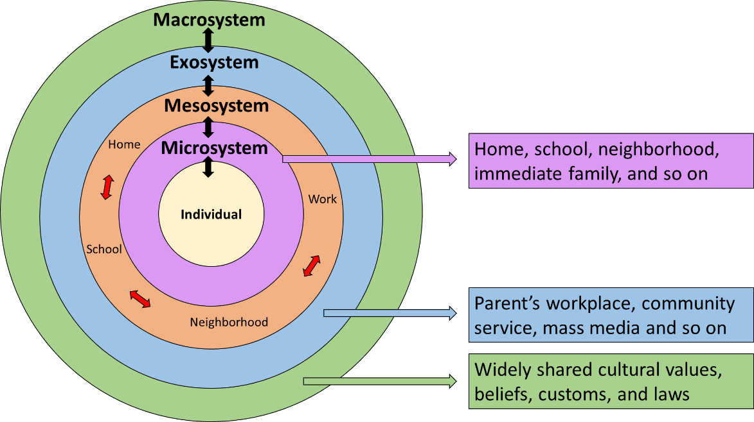

Figure 1. Bronfenbrenner’s (1977) original social-ecological model
(Image reproduced from https://psychology.wikia.org/wiki/Bioecological_model)

Cross, et al. (2015) applied the SEM to integrate cyberbullying mediation factors for adolescents using a literature review approach. Their model consists of five levels that may influence an individual’s cyberbullying behaviors: individual, family, peer, online, and community (Figure 2), which are adapted from the original SEM model. Cross and her colleagues also adopted Valcke et al. (2011) “Five Cs” to describe adolescents’ interaction with the online environment (e.g., social media). The Five Cs consists of 1) context (i.e., the virtual platform environment); 2) contact (i.e., social relationship); 3) confidentiality (i.e., privacy); 4) conduct (i.e., online technical skills and self-regulation); and 5) content (i.e., information access, use, and file upload).

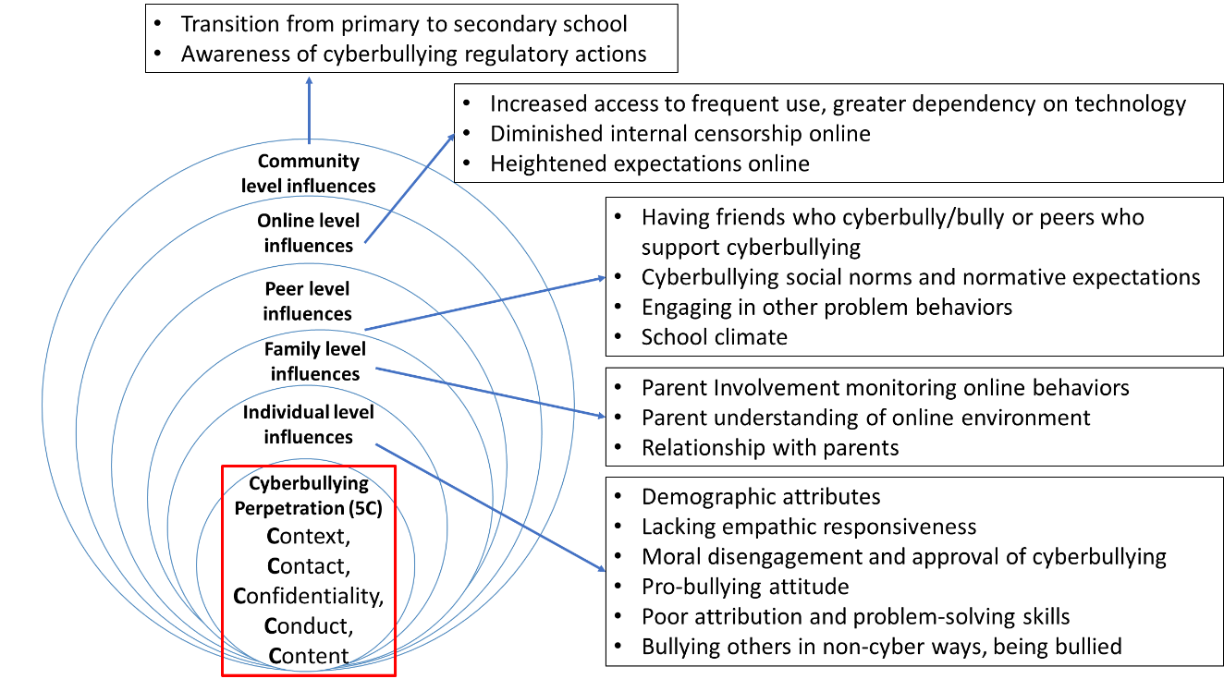

Figure 2. The Five C’s framework
Individual, family, peer, online, and community influences on cyberbullying perpetration among adolescents (Image reproduced from Cross, et al., 2015, p.111)

Although the SEM was first introduced to describe elements influencing child development, many studies applied it to examine adults’ risky behaviors, such as the relationship between college students’ physical exercise and binge drinking (Dinger et al., 2018). In another study, Crosslin and Golman (2014) used SEM to analyze first- and second-year college students’ perceptions of cyberbullying. Crosslin and Golman mapped students’ suggestions on cyberbullying intervention into individual, organizational, community, and policy levels. In their study, the authors mainly focused on text-based cyberbullying. In other words, my study may contribute to adding new insights on visual-based cyberbullying beyond existing knowledge.
This dissertation study is guided by the SEM framework. It focuses on university students’ perspectives of visual-based cyberbullying at four levels (See Figure 3).
- Individual level: age, gender, Instagram usage, online interactions (i.e., the Five Cs), general attitude, and coping mechanism (See the next section).
- Microsystem level: students’ relationship with other personnel in the university (e.g.., peers).
- Mesosystem level: collaboration on the practice of intervention or prevention (e.g., reporting system).
- Exosystem level: university policy and social media norm.
Ostrom’s “attitude” and Agnew’s “coping mechanism” are described next.

Cognitive-affective-behavioral framework
In the social science field, it is common that researchers investigate individuals’ thoughts, emotions and reactions to phenomena (e.g., Chi et al., 2018). That is, cognition, affect, and behaviors as key aspects influencing how human beings interpret and interact with the world around them. Since this study will focus on university students’ general attitude, as well as the coping strategies toward visual-based cyberbullying, I adopt Ostrom’s (1969) notion of “attitude” and the coping mechanism in Agnew’s (1992) General Strain Theory to guide my study.

Ostrom (1969) considers “attitude” as a combination of cognition, affect, and behavior, including “desirable to undesirable thoughts,” “favorable to unfavorable feelings,” and a description of “past action, future intentions, and predicted behavior in hypothetical situations.” (Ostrom, 1969, p.16). These components will guide the analysis of college students' general perspectives of cyberbullying, especially if a student is a witness to an incident.

Strain models were developed from a sociological perspective in the 1930s. In 1992, Robert Agnew proposed a more detailed framework for the social-psychological level. Agnew’s General Strain Theory (1992) explains how “strain” relates to a negative relationship with others. Strain is considered to be the obstacle between an individual and a positive outcome. A strained individual may have some degree of negative emotions, such as anger, fear, depression, and disappointment, that could potentially cause criminal actions, such as bullying behaviors. Moreover, Agnew proposed a coping mechanism that strained individuals may use for managing strain situations. This mechanism consists of cognitive, emotional, and behavioral aspects. Cognitive coping strategies include ignoring the adversity (e.g., It’s not important), minimizing the negative outcome/maximizing the positive outcome (e.g., It’s not that bad.), and putting the responsibility on themselves (e.g., I deserve it). (Agnew, 1992, p.66). Behavioral coping strategies include minimizing the negative outcome/maximizing the positive outcome and revenge behaviors. Emotional coping means reducing the negative feelings but not “cognitively reinterpreting or behaviorally altering the situation that produced those emotions by acting directly on the negative emotions that result from adversity” (Agnew, 1992, p.70). I will use these three aspects to categorize the cyberbullying coping strategies mentioned by the study participants. In addition, to be consistent with Ostrom’s framework, the emotional aspect in the original theory will be revised to the affective aspect in this dissertation study.

To augment our understanding of undergraduate university students’ visual-based cyberbullying, I propose a holistic theoretical framework (Figure 3) that combines the previously mentioned theories/model. The holistic framework will guide the research questions, the structure of the Literature Review (Chapter 2), and the research design described in the Methodology (Chapter 3).

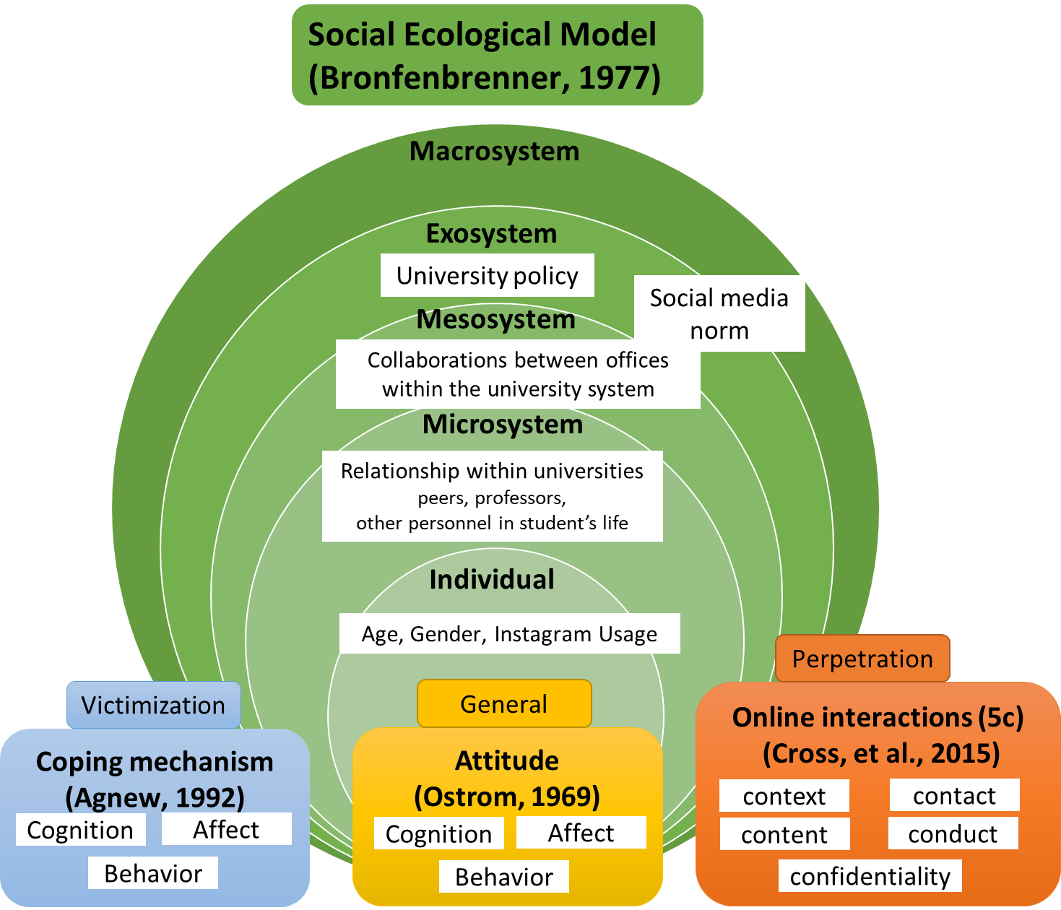

Figure 3. Huang’s proposed holistic theoretical framework

Definition of Terms

Cyberbullying
In this study, I will use Peter & Petermann’s (2018, p.359) definition to conceptualize cyberbullying: “cyberbullying as using information and communication technologies (ICT) to repeatedly and intentionally harm, harass, hurt and/or embarrass a target. To be more specific, the ICT in this study is Instagram. A more detailed description can be found in the “Overview of cyberbullying research” section in Chapter 2.

Perspective
According to the Merriam-Webster Dictionary, Perspective is defined as “a mental view or prospect” (https://www.merriam-webster.com/dictionary/perspective). In Cambridge Dictionary, Perspective is “a particular way of considering something” or “a feeling or opinion about something or someone” (https://dictionary.cambridge.org/us/dictionary/english/perspective). In this dissertation, the perspective will be investigated through the cognitive, affective, and behavioral aspects.

Instagram features
Instagram is a free visual-sharing social media platform. It has a mobile app version that enables all features and a web version that only enables limited functions. Instagram allows users to post things in different visual formats. Below are features that students in this study might use and will be revised after data collection.

1) Posts: Usually include one or multiple photos/figures/videos in one post. Some users include a short description and hashtags in their posts. See the example in Figure 4.

2) Reels: Users can create or upload multi-clip videos for up to 30 seconds and can also insert text, AR filters, and audio. See the example in Figure 5.

3) Story: Users can add one or multiple pieces of visual content (e.g., live stream) with various elements (e.g., degree of feelings) to their “Story”. Each piece of steady content (e.g., a photo) will last 4 seconds, while dynamic content (e.g., video) varies. The story will disappear in 24 hours. Other users can interact with the story, but only the person who posts the story can see the interactions. See the example in Figure 6.

4) Messenger: Private chat between two users.

5) Interactions with other users: Users can “like” or comment on a post/story/reel, as well as share the post/story/reel to other people’s Instagram chat or the user’s reel/story, and users can also save the post/story/reel to their own account. See the example in Figure 4 and Figure 6.

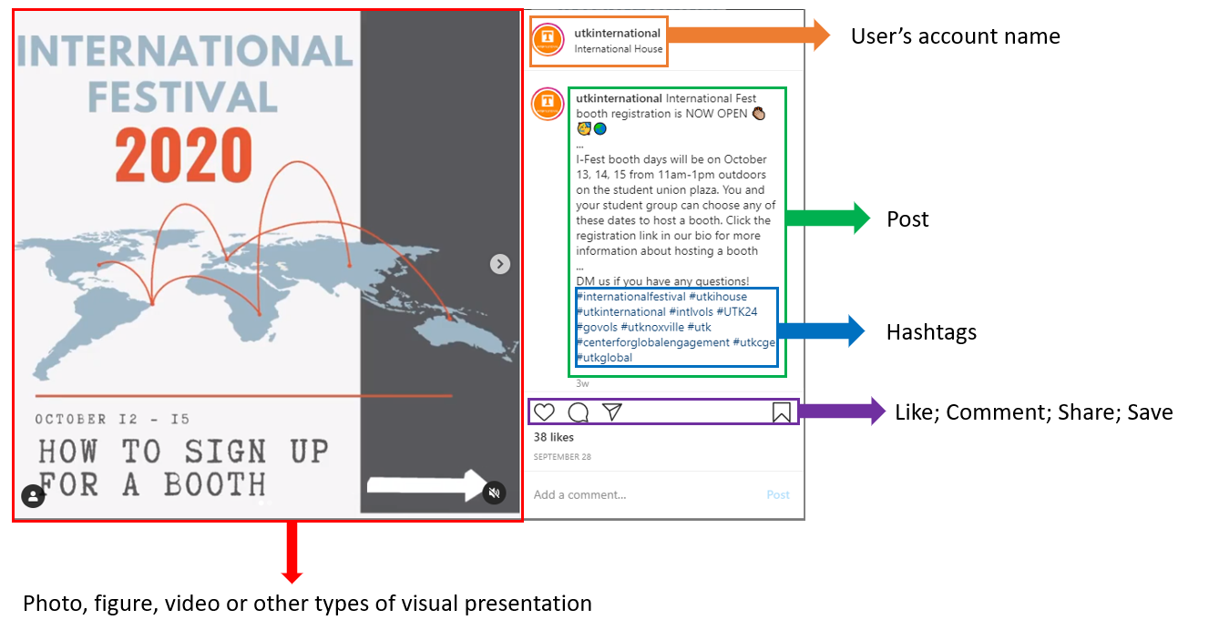
Figure 4. An example of an Instagram post
(Screenshot from UTK International House’s Instagram https://www.instagram.com/utkinternational/?hl=en)

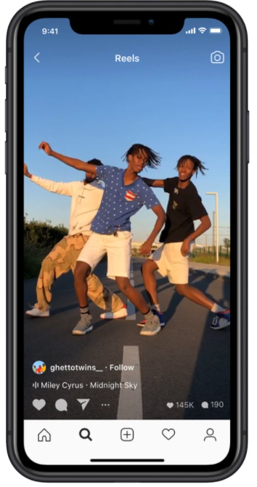
Figure 5. An example of an Instagram Reel
(Screenshot from Instagram blog: https://about.instagram.com/blog/announcements/introducing-instagram-reels-announcement)

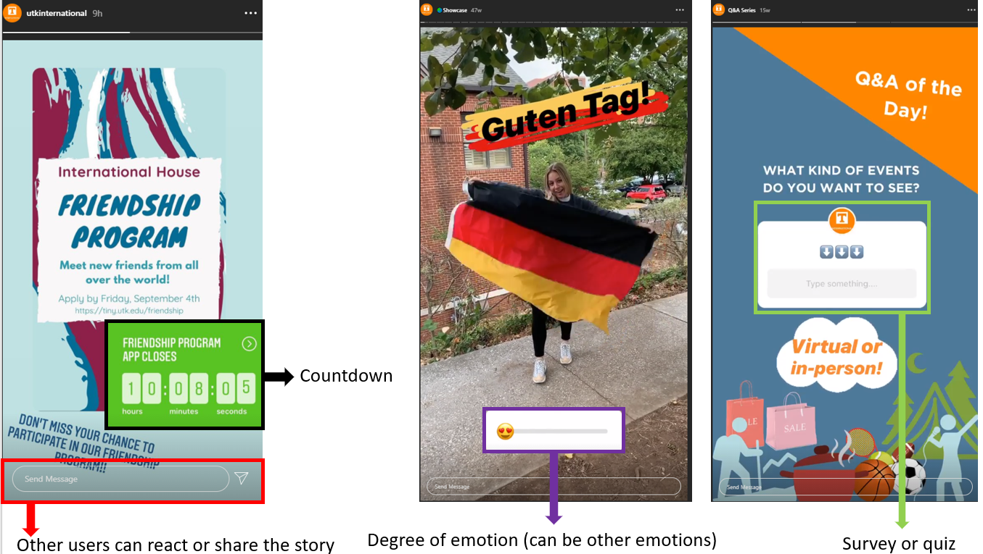

Figure 6. An example of Instagram stories with various elements
(Screenshots from UTK International House’s Instagram: https://www.instagram.com/utkinternational/?hl=en)

Summary

Cyberbullying has received attention globally and across disciplines. There is a rich body of cyberbullying literature at both the individual level and microsystem level focusing on young populations (i.e., children and teens), but scarce research has considered university students. Additionally, studies have investigated cyberbullying extensively on factors in the individual and microsystem level. However, the factors at the mesosystem and exosystem level, have hardly been examined to identify their depth and breadth in preventing or suggesting interventions. Moreover, the majority of existing studies have either focused on text-based cyberbullying or aimed to develop auto-detection models for cyberbullying based on using multimedia formats and without viewing cyberbullying from a holistic students’ perspectives. This study will fill these gaps by exploring undergraduate university students’ perspectives of visual-based cyberbullying on Instagram from the cognitive, affective, and behavioral aspects using a holistic approach. It will also examine and synthesize the current university policies on visual-based cyberbullying and identify the extent to which students are aware of them.

Literature Review

The primary goal of this dissertation is to explore undergraduate university students’ perspectives of visual-based cyberbullying on Instagram. The literature review covers three main parts. First, to provide an overview of cyberbullying research, I briefly synthesize topics of past cyberbullying studies. Second, I use the proposed holistic theoretical framework to structure my review on cyberbullying research involving university students, including general attitude, preparation behaviors, coping strategies, reporting, and policies. Third, I review research of visual-based cyberbullying.

Literature search approach
I used Google Scholar (https://scholar.google.com/) and databases through the UTK library to search and access the full-text documents. The databases I used are Academic Search Complete by EBSCOhost and Web of Science Core Collection by Clarivate. The search queries and parameters I applied are presented in Table 1. To have a comprehensive search result, I did not set filters of publication time or disciplines. I scanned search results by title to determine potentially relevant articles on the topic. For those, I downloaded the full-text and scanned the abstracts to judge relevant ones. I also identified relevant articles by chaining respective articles’ references. This process resulted in sixty-seven relevant studies total (Table 1).

Table 1. Literature search queries and parameters across databases
Topic: Overview of cyberbullying research
Relevant articles selected for review=6
Google Scholar | (cyberbully* OR “cyber bully*”) AND “meta analysis”
Academic Search Complete | (cyberbully* OR “cyber bully*”) in Subject Terms OR Abstract AND “meta analysis” in Abstract
Web of Science | (cyberbully* OR “cyber bully*”) in Topic OR Abstract AND “meta analysis” in Abstract
Topic: Cyberbullying research of university students
Relevant articles selected for review=44
Google Scholar | (cyberbully* OR “cyber bully*”) AND (“university student*” OR “college student*” OR undergraduate)
Academic Search Complete | (cyberbully* OR “cyber bully*”) in Subject Terms OR Abstract AND (“university student*” OR “college student*” OR undergraduate) in Abstract
Web of Science | (cyberbully* OR “cyber bully*”) in Topic OR Abstract AND (“university student*” OR “college student*” OR undergraduate) in Abstract
Topic: Research of cyberbullying on visual-based social media and visual-based cyberbullying
Relevant articles selected for review= 17
Google Scholar | (cyberbully* OR “cyber bully*”) AND (Instagram OR “social media” OR visual OR image OR video)
Academic Search Complete | (cyberbully* OR “cyber bully*”) in Topic OR Abstract AND (Instagram OR “social media” OR visual OR image OR video) in Abstract
Web of Science | (cyberbully* OR “cyber bully*”) in Topic OR Abstract AND (Instagram OR “social media” OR visual OR image OR video) in Abstract

Overview of cyberbullying research

Research on cyberbullying started in the early 21st century. To provide an overview of the trends and major findings of cyberbullying research, I synthesized the meta-analysis literature review studies published in the past five years, focusing on trends, definitions, age, gender differences, perpetration, consequences, and victimization.

Research trend on cyberbullying is reported in a recent bibliometric study by López-Meneses et al. (2020), who analyzed 1,128 studies on cyberbullying in the educational context published from 2004 to 2019. López-Meneses and his colleagues analyzed the keywords used in these studies, concluding that seven key research lines have emerged roughly in sequence: 1) general studies on the cyberbullying topic, in particular, the digital nature of cyberbullying; 2) general investigation of cyberbullying phenomenon of the adolescent population; 3) psychological factors that impact perpetrators and victims, such as antisocial behaviors and depressive symptoms; 4) academic and school-related factors concerning students, such as perceptions of the school; 5) characteristics of victims; 6) crime-related investigations, such as child abuse and self-harm behaviors; 7) new research trends on more diverse aspects, such as cyberbullying of minority groups and cyberbullying associated theories.

In terms of the definition of cyberbullying, Peter and Petermann (2018) stated that there are various definitions and conceptualizations of cyberbullying, which make it hard for researchers to follow a universally accepted definition. Thus, they applied a concept analysis approach to examine the definition and attributes of cyberbullying in 24 scholarly publications published between 2012 and 2017. Focusing on cyberbullying and cyber victimization, they identified the five most addressed attributes, resulting in the following definition, “cyberbullying as using information and communication technologies (ICT) to repeatedly and intentionally harm, harass, hurt and/or embarrass a target.” (p.359). Given the fast advances in technology, it is almost impossible to include every potential platform and online interaction behaviors (e.g., posting information) in the definition of cyberbullying. Thus, in their definition of cyberbullying, ICTs generally refer to “electronic forms to contact” (p.359). To be noted, “repeated” and “intentional” actions have been addressed in the traditional bullying definition (Olweus, 1994), and have been adopted by most cyberbullying researchers. Peter and Petermann (2018) provided new insights on the meaning of “repeated action”. Although we see an incident happening once, the reposting of the incident by others constitutes a repeated action.

As for the age groups and gender differences, Guo (2016) analyzed 77 empirical studies published from 2004 to 2013. They found that over 80% of the studies included participants aged 9 to 17, and only 12% involved young adults (aged 18 to 24). Guo pointed out that males have a higher tendency to be cyber perpetrators, while females have a higher risk of victimization. In addition, older adolescents (i.e., age closer to 18) or young adults are more likely to be perpetrators. In a later meta-analysis study, Marciano et al. (2020) meta-analyzed 56 longitudinal studies on cyberbullying perpetration and victimization of adolescents up to age 18. They found that males are more likely to become perpetrators at an older age, while females have a higher tendency to have negative consequences after being victimized.

Perpetration and victimization have been researched extensively. In Guo’s (2016) and Marciano et al.’s (2020) study findings, the factors they found to be significantly associated with both perpetrators and victimization include engaging in more online activities than others, possessing antisocial personality (e.g., narcissism), and having negative relationships with family, peers, and in school. Adolescents (i.e., under age 18 in Marciano et al., 2020) who engaged in cyberbullying perpetration/victimization in the past also have a higher risk to experience victimization/perpetration in the future. As for perpetration tendency, being a traditional school bully, and having problematic behaviors (e.g., substance use), as well as possessing a high level of moral disagreement and lower level of empathy are related to cyberbullying. On the other hand, cyber victimization is associated with traditional bullying victimization, long-term psychological problems (e.g., depression, loneliness), and negative self-perceptions (e.g., low self-satisfaction).

The consequences of cyberbullying experiences may lead to future risky behaviors, such as self-harm. Kwan et al. (2020) reviewed 11 meta-analysis studies and eight summative synthesis studies focusing on the mental health of children and young people. The data corpus consisted of 832 primary empirical studies published between 2010 to 2018. They found that the most measured mental health outcomes of cyberbullying are depression, suicidality, anxiety, hostility, and aggression; while the most measured psychosocial outcomes include peer problem/traditional bullying, self-esteem, substance (mis)use, and stress/distress. In addition, they reported that cyberbullying studies that applied qualitative approaches are far fewer than those that applied quantitative approaches.

Besides those traditional factors associated with cyberbullying in Guo (2016) and Marciano et al., (2020), Chen et al. (2017) identified technology-related factors. They analyzed 81 empirical studies that were published from 2004 to 2015. The majority (88.8%) focused on teens and children and only nine studies (11.1%) had participants over age 18. Chen and his colleagues statistically tested 14 predictors of cyberbullying perpetration and 11 predictors of victimization, revealing that media exposure factors (i.e., risky ICT use and frequency of ICT use) significantly correlated with both cyberbullying perpetration and victimization, particularly the use of social media sites. It is not surprising that people who spend more time and engage in risky behaviors online (e.g., sharing personal photos unconsciously) are more likely to be engaged in cyberbullying.

The findings of the reviewed meta-analysis studies on cyberbullying showed that the majority focused on populations under age 18 and fewer studies involved university students. A review of cyberbullying literature involving university students follows.

Cyberbullying research related to university students

As addressed in the previous section, I searched cyberbullying literature related to university/college/undergraduate students. I reviewed 44 most relevant empirical studies in this section. In this section, I first report research methods, sample characteristics, and cyberbullying prevalence rate (i.e., the percentage of victimization, perpetration and witness) reported in these studies. Then, I report the findings from these studies based on the proposed holistic theoretical framework consisting of five levels: individual level, microsystem level, mesosystem level, exosystem level, and macrosystem level.

Methods
In the 44 reviewed studies, 41 involved human subjects (See citations in Table 2), of which 31 studies applied quantitative methods such as scientific experiment and survey approaches, and six employed qualitative methods, such as focus groups, interviews, and open-ended surveys. Four studies used mixed methods, such as open- and close-ended surveys, and a combination of surveys and interviews/focus groups. Of the three studies that did not involve human subjects, one study applied a content analysis of comments on a cyberbullying story, one used document analysis of university policies on cyberbullying, and one employed digital ethnography and content analysis using six Facebook pages to which university students and township youth subscribed.

Sample characteristics
Of the 41 studies that involved human subjects, the number of participants ranged from four to 4,626 students. In most studies that included males and females, the percentage of female participants tended to be higher than the percentage of male participants (43.5%-85.1% vs. 14.8%-56.5%, respectively). One study had only females and two studies had other sex identities. The age of participants ranged from 18 to 68 years (Mean age range=19 to 24.95 years). Three studies reported the participants’ grades as first-year to fourth-year college students, while the other three studies involved students from first-year to beyond the fourth-year. To be noted, Cho & Yoo (2017) included cross age participants, consisting of middle school students, university students, and working adults. Given that the focus of this dissertation study is on university students, I will focus on the findings pertaining to this population.

Prevalence of Cyberbullying.
Table 2 shows four types of cyberbullying prevalence. Twenty-three studies reported the percentage of victimization (%V) (5.7% to 83%); 11 reported the percentage of perpetration (%P) (2.9% to 19.4%); 5 mentioned the percentage of engaging in both perpetration and victimization (%V/P) (2.4% to 37.1%); and 8 studies indicated the percentage of witnesses (%W) (15% to 59.7%).

Table 2. Summary of the reviewed studies related to university students
 | Research Method |  | Sample Characteristics |  |  | Prevalence
Study | Method | Approach | Sample size | % of Male/Female | Age or Grade | %V | %P | %V/P | %W
Involving human subjects
Abaido (2020) | Quan | Survey | 200 | 46.5/53.5 | 18-25+
Alipan et al. (2021) | Qual | Focus Group | 39 | 36/64 | 18-25, M=21.33
Baldasare et al. (2012) | Qual | Focus Group | 30 | 26.7/73.3 | 18-28, M=20.47
Balta et al. (2020) | Quan | Survey | 507 | 45.6/54.4 | 18-44, M=21.37
Barlett & Gentile (2012) | Quan | Survey  Longitudinal | 507 | 46/54 | M=19.42
Byrne (2021) | Quan | Survey | 459 | 31.4/59.9/1.7 | 1st-4th grade
Cénat et al. (2019) | Quan | Survey | 4626 | 19.9/80.1 | 15-23, M=20.08 | 19
Chadha et al. (2020) | Qual | Interview | 23 | 0/100 | 18-24 | 83
Cho & Yoo (2017) | Quan | Survey | 1200 | 51.8/48.3 | 10-39
Çimke & Cerit (2021) | Quan | Survey | 518 | 17/83 | M=20.1
Crosslin & Golman (2014) | Qual | Focus Group | 54 | 14.8/85.2 | 19-27, M=19
Cunningham et al. (2015) | Quan | Survey | 1004 | 27.1/72.9 | 1st- beyond 4th grade | 5.7 | 4.5 | 4.9 | 45.7
Di̇Lmaç (2009) | Quan | Survey | 648 | 32.9/67.1 | 18-22, M=19.29 | 35.7 | 3 | 19.5
Doane et al. (2014) | Quan | Survey | 375 | 34.1/65.6 | 18-23, M=19.05
Finn (2004) | Quan | Survey | 339 | 35.1/64.9 | 1st-4th grade | 15; 58.7
Francisco et al. (2015) | Mixed | Interview  Survey | 519 | 22.4/77.6 | 19-24 | 27.94 | 8 |  | 45.7
Gahagan et al. (2016) | Mixed | Survey  (Close/open ended) | 196 | 20.9/79.1 | 18-25 | 19 |  |  | 46
Gibb & Devereux (2014) | Quan | Survey | 297 | 39.1/60.9 | M=22.7
Goodboy et al. (2016) | Quan | Survey | 149 | 48.3/51.7 | 18-25, M=18.25
Goodboy & Martin (2015) | Quan | Survey | 227 | 45.8/49.3/4.8 | 18-40, M=20.97 | 8.5 | 14.3 | 37.1
Ho & Gu (2021) | Quan | Survey | 606 | 23.8/76.2 | 18-25, M=21.03
Johnson et al. (2016) | Quan | Survey | 170 | 26.9/73.1 | 18-above 25 | 36.28 | 6.1
Kırcaburun et al. (2019) | Quan | Survey | 760 | 40/60 | 18-40, M=21.48
Kokkinos et al. (2014) | Quan | Survey | 430 | 42.1/56.7 | 18-22, M=20.3 | 11 | 14 | 33
Table 2. (Count.) Summary of the reviewed studies related to university students
 | Research Method |  | Sample Characteristics |  |  | Prevalence
Study | Method | Approach | Sample size | % of Male/Female | Age or Grade | %V | %P | %V/P | %W
Involving human subjects
Lee (2017) | Quan | Survey | 321 | 48.9/51.1 | M=21.52
Marr & Duell (2021) | Quan | Experiment | 176 | 47.7/52.3 | 18-25 | 63 | 15
Martínez-Monteagudo et al. (2019) | Quan | Survey | 1282 | 46.3/53.7 | 18-46, M=21.65 | 18.6 | 19.4
Mishna et al. (2018) | Mixed | Survey  Focus group | 1373 | 38.3/61.7 | M=22.3 | 54.4; 57.4 |  |  | Over 1/3
Na et al. (2015) | Quan | Survey | 121 | N/A | 18-25, M=19.68 | 54; 37
O’Connor et al. (2018) | Quan | Survey | 184 | 34.2/65.8 |  | 3 |  |  | 15
Orel et al. (2017) | Quan | Survey | 282 | 27.7/72.3 | 18-25, M=19.73
Ozden & Icellioglu (2014) | Quan | Survey | 136 | 39/61 | 18-29
Peled (2019) | Quan | Survey | 638 | 24/76 |  | 57.4
Rafferty & Vander Ven (2014) | Qual | Survey | 221 | 44.3/55.7 | 18-24, M=19.77
Rivituso (2014) | Qual | Interview | 4 | 25/75
Schenk et al. (2013) | Quan | Survey | 799 | 28.4/71.6 | 1st- beyond 4th grade | 8.6
Schenk & Fremouw (2012) | Quan | Survey | 799 | 28.4/71.6 | 1st- beyond 4th grade |  | 7.5 | 2.4
Smith et al. (2012) | Mixed | Survey  (Close/open ended) | 340 | 37.9/62.1 | 1st-4th grade | 16.7 | 2.9 |  | 37.2
Sobba et al. (2017) | Quan | Survey | 248 | 56.5/43.5 | M=24.95 | 21.4 | 9.2 |  | 59.7
Sobba et al. (2015) | Quan | Survey | 248 | 56.5/43.5 | 18-68, M= 24.95 | 21.4 | 9.2 |  | 59.7
Wang et al. (2019) | Quan | Survey | 476 | 30.9/69.1 | 1st-4th grade | M=14.9
No human subjects
Davis et al. (2015) | Quan | Content analysis |  | 1094 comments on a blog post about Amanda Todd’s cyberbullying related suicide
Faucher et al. (2015) | Quan | Document analysis |  | 465 policies relevant to the handling of cyberbullying in 74 Canadian universities
Rachoene & Oyedemi (2015) | Qual | Digital ethnography  Content analysis |  | 6 Facebook pages that university students and township youth subscribed

Individual Level
At the individual level, I report findings from the reviewed literature in relation to five factors: 1) age and gender, 2) technology usage, 3) cyberbullying perpetration (informed by the Five Cs framework), 4) general attitude of cyberbullying (informed by Ostrom’s model), and 5) coping mechanism on victimization (informed by Agnew’s strain theory) (See Figure 4).

1. Gender and age
In general, studies revealed that male students are more likely to engage in cyberbullying perpetration (Di̇Lmaç, 2009; Kritsotakis et al., 2017; Lee, 2017; Mishna et al., 2018) or both perpetration and victimization (Çimke & Cerit, 2021; Kokkinos et al., 2014) than female students (Di̇Lmaç, 2009); are more likely to be aware of cyberbullying incidents (Cho & Yoo, 2017; Cunningham et al., 2015; Smith et al., 2012), and are more commonly perceived to be victims than male students (Abaido, 2020). As for a specific type of cyberbullying behavior, spreading mean or embarrassing rumors, male students are more likely to be perpetrators (Ozden & Icellioglu, 2014) and victims (Cénat et al, 2019). In terms of age, engagement in cyberbullying decreases as students grow older (Gibb & Devereux, 2014; Kritsotakis et al., 2017; Mishna et al., 2018), and older students tend to consider cyberbullying as a serious problem. (Sobba et al., 2017).

2. Technology usage in daily life
Studies revealed that victims usually spent a longer time online (Çimke & Cerit, 2021; Schenk et al., 2013; Sobba et al., 2019). As Cho & Yoo (2017) reported, on social networking sites, students who read less, write more, and have more friends, tended to have more experiences in both perpetration and victimization. Surprisingly, in Cho and Yoo’s (2017) study, students who spent less time online were reported to have a stronger intention of perpetration; however, the authors did not mention the possible reasons. In addition, students who engaged in more “information use” (e.g., information searches, news, email, and community) on the internet than others were more likely to report victimization. Cho and Yoo noted that higher exposure to content on the internet might increases students’ vulnerability to cyberbullying.

3. Cyberbullying perpetration behaviors (Informed by the Five Cs’ framework)
Using the reviewed literature on cyberbullying university students, I categorized the cyberbullying perpetration behaviors using Willard’s (2007, p.265-267) categories (see Table 3). However, given that the categories were developed around a decade ago and that recent studies have reported perpetration behaviors related to both sexual content and use of visual content, I added these two sub-categories (see Table 3. Count.).

Applying the Five Cs’ framework to findings from the reviewed literature resulted in the conceptual map shown in Figure 7, which includes: Context (i.e., the virtual platform environment): the online context that cyberbullying occurs reported by university students include traditional ICTs, social networking sites/apps, other virtual spaces, and web-based instructional platforms. Contact (i.e., one’s social relationship): among most cyberbullying behaviors, the perpetrators have some sort of relationship and contact with the victims. Confidentiality (i.e., the extent that one manages the privacy settings): in some scenarios, the victims are unaware of their personal information settings or privacy. Perpetrators use content such as contacts information to cyberbully the victims. Conduct (i.e., self-regulation and technical skills): most cyberbullying contents are relatively negative, malicious, or threatening. In addition, some behaviors may require a higher level of technical skills, such as stealing one’s personal information or pretending to be someone else. Content (i.e., information access, use, and upload): the most common content format is textual, and visual contents have recently become popular; cyberbullying behaviors in vocal (i.e., voice or audio) format and sexual-related contents are also mentioned.

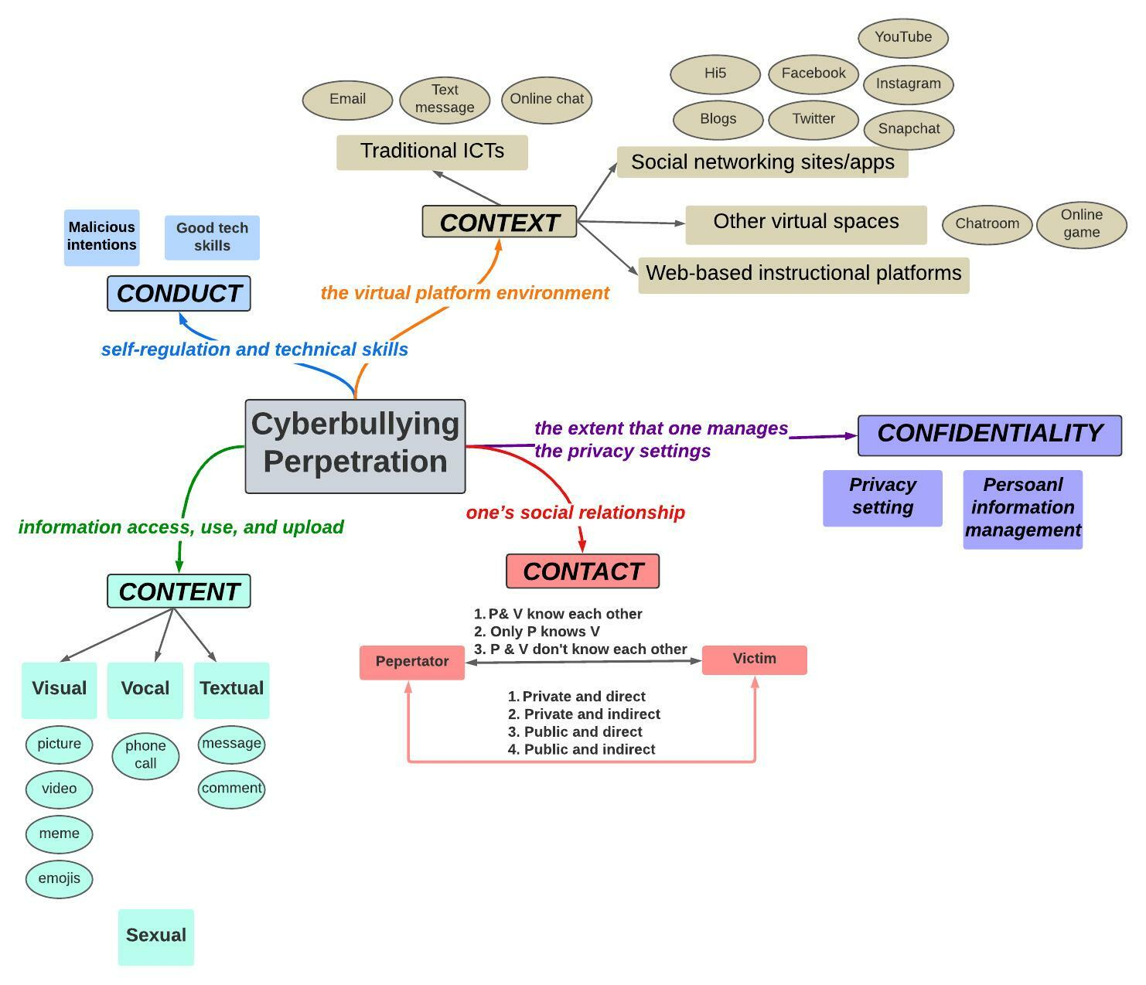

Figure 7. A concept map of elements in cyberbullying perpetration behaviors
(As represented in the Five Cs’ framework)
Table 3. Cyberbullying perpetration behaviors investigated in literature
Perpetration behaviors investigated in the literature | Citations
Denigration: Sending or posting gossip or rumors about a person to damage his or her reputation or friendships (Willard, 2007, p.266).
Posting demeaning/insulting/name callings posts to target someone | Byrne, 2021; Gahagan et al., 2016; Kokkinos et al., 2014
Posting demeaning/insulting/name calling comments under posts to target someone | Abaido, 2020; Gahagan et al., 2016; Mishna et al., 2018
Spreading negative/derogatory/offensive/ malicious contents of someone to others | Kokkinos et al., 2014
Spreading rumors to hurt someone's reputation | Abaido, 2020; Byrne, 2021; Baldasare et al., 2012; Francisco et al., 2015; Lee, 2017; Mishna et al., 2018; Ozden & Icellioglu, 2014
Ridiculing/joking/mocking of someone | Baldasare et al., 2012; Crosslin & Golman, 2014; Francisco et al., 2015; Lee, 2017
Flaming: Online fights using electronic messages with angry and vulgar language (Willard, 2007, p.265).
Sending mean/negative/hate messages to someone | Abaido, 2020; Gahagan et al., 2016; Kokkinos et al., 2014; Lee, 2017; Mishna et al., 2018; Ozden & Icellioglu, 2014
Harassment: Repeatedly sending nasty, mean, and insulting messages (Willard, 2007, p.266).
Harassing/threatening/coercing/intimidating/cyber sanctioning someone | Baldasare et al., 2012; Byrne, 2021; Finn, 2004; Francisco et al., 2015; Kokkinos et al., 2014
Harassing/threatening someone devoted to a partner in a romantic relationship | Ozden & Icellioglu, 2014
Harassing/threatening someone by demonstrating to have one's private information | Francisco et al., 2015
Cyberstalking: Repeated, intense harassment and denigration that includes threats or creates significant fear (Willard, 2007, p.267).
Anonymous calls | Ozden & Icellioglu, 2014
Sending spam mails or viruses | Ozden & Icellioglu, 2014
Sending unwanted contact to someone | Doane et al., 2013
Stalking/continuously posting or messaging someone | Abaido, 2020
Exclusion: Intentionally and cruelly excluding someone from an online group (Willard, 2007, p.266).
Deliberately excluding someone from an online group | Baldasare et al., 2012; Kokkinos et al., 2014; Lee, 2017; Mishna et al., 2018
Outing and trickery: Sharing someone’s secrets or embarrassing information or images online, and talking someone into revealing secrets or embarrassing information, then sharing it online (Willard, 2007, p.266).
Sharing someone's secrets/compromising information without permission | Kokkinos et al., 2014

Table 3. (Count.) Cyberbullying perpetration behaviors investigated in literature
Perpetration behaviors investigated in the literature | Citations
Impersonation: Pretending to be someone else and sending or posting material to get that person in trouble or danger or to damage that person’s reputation or friendships (Willard, 2007, p.266).
Posting fake portfolio/creating fake page of someone | Byrne, 2021; Ozden & Icellioglu, 2014
Impersonating /masquerading/pretending to be someone | Byrne, 2021; Crosslin & Golman, 2014; Francisco et al., 2015; Kokkinos et al., 2014; Mishna et al., 2018
Hacking to someone's ICT devices or accounts to cause trouble | Lee, 2017; Ozden & Icellioglu, 2014
Unwanted sexual content
Sending request for sexual intercourse | Ozden & Icellioglu, 2014
Sending sexual content | Finn, 2004
Harassing/threatening someone with sexual content | Francisco et al., 2015
Inappropriate use of visual content
Taking pictures/recording videos while a group laughs and forces another person to do something humiliating or ridiculous | Lee, 2017
Taking pictures/recording videos while someone hits or hurts another person | Lee, 2017
Taking pictures/recording videos of someone that contain a sexual nature | Lee, 2017
Posting embarrassing/mean photos/videos to shame someone | Abaido, 2020; Byrne, 2021; Gahagan et al., 2016; Kokkinos et al., 2014
Posting mean/negative/derogatory/offensive/ malicious comments on pictures/videos to target someone's intelligence/physical appearance | Gahagan et al., 2016; Rachoene & Oyedemi, 2015
Using emojis as a form of ridicule | Abaido, 2020
Using someone’s personal picture/video without permission | Francisco et al., 2015
Sharing/forwarding/spreading someone's embarrassing photos/videos to others to ridicule someone | Gahagan et al., 2016; Kokkinos et al., 2014; Mishna et al., 2018; Ozden & Icellioglu, 2014
Sharing/forwarding/spreading someone's photos/videos that contain a sexual nature | Lee, 2017; Rachoene & Oyedemi, 2015
Sending (links of) humiliating images/videos | Lee, 2017

4. General attitude of cyberbullying
As described in Chapter 1, Ostrom (1969, p.16) defined cognitive attitude as “desirable to undesirable thoughts”; affective attitude as “favorable to unfavorable feelings”; and behavioral attitude as “past action, future intentions, and predicted behavior in hypothetical situations.” The reviewed studies in the next section are reported within the context of Ostrom’s cognitive-affective behavioral framework.

Cognitive aspect
In general, most university students consider that cyberbullying is a serious problem, just like bullying in the real world, and should be considered illegal or criminal (Abaido, 2020; Sobba et al., 2019). In particular, females (Marr & Duell, 2021; Sobba et al., 2019) and those who witnessed or experienced cyberbullying perceived a higher level of severity of cyberbullying, compared with males and those who had no related experiences (Sobba et al., 2019). In the digital era, almost anyone has access to the online world, and it makes some people less aware of proper manners (Baldasare et al., 2012; Crosslin & Golman, 2014). Conversely, some students may think that cyberbullying is normal in the world of social media (Abaido, 2020), and even have a more accepting attitude and possibly underrate the consequences (Lee, 2017). For example, Crosslin and Golman (2014) found that, when asked if cyberbullying is a significant problem at their university, only a small percentage (13.2%) of students thought that cyberbullying occurred but they ignored it, while other students considered cyberbullying does not occur in their college (20.7%), or that it is more dependent on the environment of a university (26.4%).

Students believe that cyberbullying is very subjective in a broad scope. Simply speaking, when an action is interpreted by the information receivers or audiences as intentional to harm, it can be cyberbullying, no matter whether the sender’s behavior is intentional or unintentional. However, miscommunication sometimes happens on the part of unintentional senders due to lack of nonverbal expressions online. For example, sarcasm and joking words online without tones or facial expression are sometimes misunderstood as cyberbullying by a receiver, even if the sender unintentionally hurt the receiver (Baldasare et al., 2012). On the other hand, when a sender repeatedly or continuously sends/posts harmful content, it is considered cyberbullying (Gahagan et al., 2016). Interestingly, Crosslin and Golman (2014) found that some students believe the term “cyberbullying” is outdated because the term “bully” may reflect back on traditional school bullying they experienced at a younger age (Gibb & Devereux, 2014) and, therefore, they believe that using “cyber-attack” or “online harassment” is a better terminology than cyberbullying (Byren, 2021).

Students consider cyberbullying as hostile or a threat that mostly causes negative consequences (Gahagan et al., 2016). But some students also consider it as a chance for a challenge that could empower victims to confront cyberbullying (Na et al., 2015) and to find truly supportive friends (Baldasare et al., 2012). Students believe that both relationships and content matter. That is, the closer relationship a victim has with a perpetrator, the greater the impact of cyberbullying. If the incident contains sensitive content, such as personal photos and sex-related pictures, the impact is even greater (Baldasare et al., 2012; Mishna et al., 2018). On the other hand, Baldasare et al. (2012) found that students consider that perpetrators may experience both positive (e.g., satisfaction, empowerment, attention, and boost in confidence) and negative outcomes (e.g., feeling guilty; regret, decrease in self-esteem and others’ respect, and engagement in legal actions).

In terms of the motivation of perpetrators, students indicated that revenge or self-empowerment, dislike/hate/against the target, personal or mental issues (e.g., jealousy, frustration, feeling of insecurity, feeling of exclusion), desire to be popular, discrimination based on differences, gossip, the victim’s behaviors (e.g., he/she probably deserves it), social norm (i.e., because other people do, so I can do), and boredom as possible reasons or motivation (Abaido, 2020; Baldasare et al., 2012; Francisco et al., 2015; Johnson et al., 2016).

Affective aspect
As previously indicated, students consider that perpetrators may be motivated by various emotions and intend to impact the victims’ feelings. In Gahagan et al. (2016, p.1101), for example, a student said, “When I think of cyberbullying, I think of extremely cruel, emotionally driven comments posted in the hopes of hurting another person.” Gahagan et al. also indicated that, from the students’ point of view, intentional perpetrators usually aim to cause embarrassing, harmful or painful feelings, while unintentional cyberbullying often originates from being humorous, which turns out to be perceived as offensive.

Most students reported not being willing to see someone being cyberbullied (e.g., 87.88% in Johnson et al., 2016). Students with a higher level of empathy or emotional reactivity usually have negative feelings toward cyberbullying (Doane et al., 2014; Kokkinos et al., 2014). However, some students still feel cyberbullying is childish or even funny, as a student in Crosslin & Golman ‘s study (2014, p. 41) mentioned: “You just feel like it is funny... I know it’s not funny but just like seems a little more childish to me.’’

Behavioral aspect
The behavioral aspect of attitude concerns how students act/will react toward cyberbullying in general, which is from a witness’ perspective. Related literature of this section overlaps with studies that discussed behavioral coping strategies for victims and bystanders. Thus, in the next section, studies on the coping mechanism of cyberbullying-behavioral aspect are reported in the context of Agnew’s (1992) coping mechanism

5. Coping strategies of cyberbullying Agnew (1992) proposed that a strained individual (i.e., a cyberbullying victim here) may generate a coping mechanism from the cognitive, emotional (i.e., in my dissertation, I use “affective”), and behavioral aspects.

Cognitive aspect
In Alipan et al.’s (2021) study, university students mentioned cognitive reframing, a “reappraising or restructuring the situation in a different or more positive way.” (p.27) to cope with cyberbullying. Students also used a “self-talk” approach.

Examples including 1) moving forward and leaving negative thoughts behind, “let it go, who cares what people say about me.” (Byrne, 2021, p.169);

2) normalizing cyberbullying as part of life, “it’s just a part of normal life.” (Chadha et al., 2020, p. 248);

3) attribute the responsibility back to the perpetrator, “…he has just done this because this and this and [I] think I’m a lot better than that…” (Alipan et al., 2021, p.26)

and 4) self-defeating humor by accepting the cyberbullying situation, “…the bad photos, I think they’re hilarious ... and I like to think I’m pretty funny ... and if I didn’t I would be perceiving it as bullying.” (Alipan et al., 2021, p.28).

Students considered the cognitive approach to be effective in gaining back cognitive control of the mind and reducing stress (Alipan et al., 2021; Davis et al., 2015; Na et al., 2015) and recommended it to cyberbullying victims. However, some students did not agree with this approach because they considered that the victims should not cognitively accept the teasing/cyberbullying to please others.

Affective aspect
Having negative emotions is a natural reaction when being cyberbullied, which may increase the risk of depression and social anxiety (Wang et al., 2019). Schenk and Fremouw (2012) reported that victims feel frustrated, stressed, hurt and angry. Rivituso (2014) mentioned that victims have feelings of vulnerability and fear due to safety concerns, and feel stressed, depressed, and embarrassed because of no escape from the perpetrators and acquaintances. The victimization experiences also make victims feel disappointed and distrustful of their peers in colleges. In Cénat’s et al. (2019) study, the female victims of online harassment expressed their feelings using terms like “upset”, “bothered”, “disturbed”, “confused”, “violated”, “horrible”, and “angry”. Peled (2019) noted that female and sexual minority victims have a higher tendency of experiencing anxiety and depression than male and non-minority counterparts.

In terms of coping with these negative emotions, students in Alipan et al.’s (2021) study mentioned that they might try to reduce the bad feelings and protect their emotions. However, if the practical situation does not change, this coping seems limited in helping victims. For example, if the nasty photo was already being spread, the victim would not feel better unless all the spread photos were removed. Thus, victims may turn to friends and peers to seek emotional support. Rivituso’s (2014) study indicates the significance of friendship in college. All participants who experienced victimization in this study mentioned that friends might comfort negative feelings and strengthen their self-esteem.

Behavior aspect
Behavioral coping mechanism is the most investigated aspect in the literature. Various strategies involve behavioral actions. In the section below, I cover two categories of coping, traditional approaches and technological approaches.

Traditional coping approaches. Victims may passively cope with the incident, such as ignoring it, while some people may actively fight back or report the incident. Based on the reviewed studies, the coping strategies include five types: seek social support, ignore it/do nothing, avoid contact in real life, respond/confront the bully, and report to university/law enforcement.

Seek social support. This is the most frequently mentioned strategy. Different from seeking emotional comfort, victims usually seek practical help by talking to someone trusted (Byrne, 2021; Davis et al., 2015; Francisco et al., 2015; Na et al., 2015; Orel et al., 2017), or sharing the story online to seek advice (Byrne, 2021). In Davis et al.’s study, around one-third of victims reported this strategy; in other studies, however, it seems a lower percentage of students were willing to talk to others (e.g., only 8.2% in Byrne, 2021).

Ignore it/do nothing. This is another frequently mentioned strategy. (Abaido, 2020; Davis et al., 2015; Francisco et al., 2015; Mishna et al., 2018; Orel et al., 2017; Rachoene & Oyedemi, 2015). Around one-third of the victims in Abaido’s (2020) study reported ignoring the harmful contents. Mishna et al.’s (2018) study show that over half of victims use this strategy to deal with the “being excluded” situation. To be noted, Rachoene & Oyedemi (2015) found that a single individual victim is more likely to cope with ignorance. In addition, compared with victims, other people who witness cyberbullying may choose to ignore it as well (e.g., 27% of students in Abaido, 2020).

Avoid contact in real life. Victims may feel vulnerable to face the perpetrators and embarrassed to face friends. Some students (e.g., 22% of students in Francisco et al., 2015) chose not to contact the perpetrators in real life, and a few students (8%) even avoided joining face-to-face events (Byrne, 2021). Francisco et al. (2015) reported that over 20% of the victims stopped answering an anonymous call.

Respond/confront the bully. Compared with the aforementioned strategies, this coping is more active and has been investigated by many scholars (Abaido, 2020; Alipan et al., 2021; Byrne, 2021; Chadha et al., 2020; Francisco et al., 2015; Ho & Gu, 2021; Mishna et al., 2018; Orel et al., 2017; Rachoene & Oyedemi, 2015; Schenk et al., 2013). Some researchers call this strategy the “Approach Coping” (e.g., Alipan et al., 2021).

Some victims may ask the perpetrators to stop the behavior or delete the contents, while a few victims, usually male, may seek revenge (Orel et al., 2017; Schenk et al., 2013). To be noted, the tendency that victims apply this strategy varies across different scenarios. For example, Rachoene and Oyedemi (2015) found that if the victimized target is a group of people, the group is more likely to confront the perpetrator. In Mishna et al.’s (2018) study, more victims (14%) fought back when receiving rude or intimidating messages, and fewer victims (3%) confronted the perpetrators when their private videos or photos were shared with others. In addition, this strategy was found to effectively reduce symptoms of depression (Ho & Gu, 2021). However, some female victims in Chadha et al.’s (2020) study perceived that fighting back was “not worth it” and “not really productive” (p. 248) because the same episodes persisted.

Report (to university/law enforcement). This strategy was investigated in a few studies (Byrne, 2021; Francisco et al., 2015; Johnson et al., 2016; Mishna et al., 2018; Orel et al., 2017). Some participants (9.76%) in Johnson et al.’s study (2016) said they would file an abuse report if they experienced cyberbullying. However, only a small percentage of victims (1% to 8% across four of the cited studies above) and bystanders (1.6%) chose to report to the university personnel (i.e., lecturer, staff) or law enforcement. The suggestions that students provide to improve the reporting system will be discussed in the “Exosystem Level” section.

Technological coping approaches. These approaches refer to dealing with cyberbullying incidents virtually through ICTs. Based on the reviewed literature, seven approaches were revealed, including blocking/unfriending the perpetrator, reporting the cyberbullying account/content on the social media site, changing account setting, leaving the online group/platform, deleting the account, stopping acting online, and paying attention to the use of ICTs.

Block/unfriend the perpetrator. This is the most frequently mentioned and applied strategy, in general. For example, 55% of the victims in Byrne’s (2021) study, 37% of the bystanders in Abaido’s (2020) study, and 61.59% of the participants in Johnson et al. (2016) reported they (would) block or unfriend the perpetrator. Interestingly, in Orel et al.’s (2017) study, non-victims showed a higher tendency than victims to block the perpetrators because victims consider that there are always other ways if the perpetrators really want to target someone. Still, this strategy requires the least effort to prevent victims from being bothered (Chadha et al., 2020).

Report the cyberbullying account/content on the social media site/Contact the social media site manager. The “report” here means to report the perpetrator’s account or the harmful content to the social media site so that the account/content will be removed on the platform. Many victims applied this strategy (e.g., 39.1% in Abaido, 2020; and 22% in Byrne, 2021). However, Alipan et al.’s (2021) participants considered that this approach might not be effective because people can always create new accounts on social media. Even if the harmful content has been removed, the hurt is already there.
Change visibility access/privacy setting/personal information. Byrne (2021) reported that 44% of victims used this strategy. To be noted, Francisco et al. (2015) indicated that students who were victimized by visual usage (i.e., using images without their permission) reported a higher tendency of changing privacy settings than those who experienced intimidation. In general, it is an effective strategy, yet, participants in Alipan et al. (2021) mentioned that, on social media sites, perpetrators can still locate the victims based on their friends, followers and email address, and it is hard for victims to escape entirely.

Leave the online group/platform of cyberbullying incidents. If victims seek to get rid of most perpetrations, the coping strategies might be extreme. For example, In Byrne’s study (2021), 20.2% of victims reported that they stopped using the platforms, and 15.7% withdrew from the online forum. Similarly, in Abaido’s (2020) study, 13.5% of bystanders said they would leave the platforms.

Delete account permanently/temporarily. A more extreme strategy to escape is to delete accounts, usually on social media sites (Chadha et al., 2020). Byrne (2021) reported 14.2%, and Francisco et al. (2015) indicated that less than 10% of victims chose this approach. Compared with the aforementioned strategies, students considered this approach might not be ideal because they did not want to isolate themselves from friends on social media sites (Alipan et al., 2021). To be noted, similar to the changing privacy strategy, Francisco et al. (2015) found that victims of visual-based incidents were twice more likely to delete Facebook pages than those victimized by intimidation.

Stop going online/posting online. Students in Alipan et al.’s (2021) study mentioned that “don’t go online if you don’t like to be cyberbullied”. But students also admitted that it might be unrealistic for university students and even may lead to further distress of online isolation. Using a more moderate strategy, over one-third of victims in Byrne’s (2021) study tried not to post particular content online. Similarly, some participants in Chadha et al.’s study (2020) stopped posting on sensitive or controversial topics, such as politics and feminism.

Pay attention to the use of ICTs. Being more aware of technology usage (e.g., Webcam) seems to be a fundamental way for minimizing the chance of being victimized. Yet, only a few victims (4.2%) mentioned this approach in Francisco et al.’s (2015) study.

Microsystem Level
In the original SEM, the Microsystem includes home/family, peers, school, and neighborhoods. In this section, I focus on peers and academic university personnel (e.g., faculty; academic counselors).

1. Peers and friends
As described in the “coping mechanism” section, friendship plays a vital role for university students when engaged in cyberbullying. For example, Smith et al. (2012) found that 95% of the victims choose to talk to a friend. Compared with other university personnel, friends and peers may have more chances to become aware of cyberbullying incidents and can provide emotional support and backup to the victims in confronting the perpetrator. Thus, students who have more friends and receive more social support in the real world are less likely to engage in cyberbullying. (Baldasare et al., 2012; Martínez-Monteagudo et al., 2019; Sobba et al., 2019).

However, not all types of friendship are positive. Those who have more friends online and perceive more substantial support from the “weak ties formed in anonymous online environments” are more likely to involve in perpetration (Cho & Yoo, 2017). Moreover, if students perceive that their peers have a higher level of tolerance for cyberbullying, they are more likely to perform unwanted contact (e.g., send a pornographic picture to others who do not want to receive it) and mean behaviors. Similarly, Doane et al. (2013) found a correlation between peers’ cyberbullying engagement and students’ involvement in mean behaviors and humiliation. Given the strong influence of peers, researchers suggest providing peer education and bystander intervention in the university environment (Smith et al., 2012; Sobba et al., 2019).

2. Academic university personnel
Unlike talking with peers, a few victims may be willing to talk with university personnel about cyberbullying incidents. For example, Abaido’s (2020) found that only 1.5% of the victims chose to speak to a professor or an academic counselor about it. However, in Orel et al.’s (2017) study, when asked if they did/would seek help from academic university personnel, victims (Mean number=1.9) are more willing to seek help from lecturers, compared with non-victims (Mean number=1.6). Thus, Baldasare et al. (2012) suggested that faculty who teach online should incorporate online etiquette into their courses and that all faculty members should be trained to deal with cyberbullying.

Mesosystem Level
The Mesosystem level concerns the interactions between the factors at the Microsystem level. In the context of this study, the Mesosystem level includes the interconnection of personnel within the university who are responsible for attending to cyberbullying, including intervention. In the section below, I review studies that investigated university students’ perceptions of existing intervention programs and their suggestions for implementing new programs.

Intervention practices
Rowe (2014) investigated university students’ perspectives on how a university should monitor inappropriate contents on non-university social media sites that are run by university students. Students strongly stated that the university should not monitor these sites, and that the person affected by the site contents should report it to the social media site or police. Similarly, in Baldasare et al.’s study (2012), participants in focus groups initially said that universities should not be involved in cyberbullying on campus. They consider that a university is “powerless” mainly because of the anonymity of the online environment, limited human resources, and the “constitutional protections for free speech.” They suggested providing training and educational resources, such as informative workshops on cyberbullying, and resources at freshmen orientations. In addition, students suggested that special training programs be offered to various levels of personnel (e.g., dean of students ofﬁce, campus police, campus counseling center, campus health center, and residence life personnel) to support prevention and intervention. As for the counseling services, students mentioned that the information should be visible, for example, via posters, links on university webpages, and other creative techniques such as an online cyberbullying quiz.

In Smith et al.’s (2012) study, students were surveyed about their opinions on how the university should address cyberbullying. The authors categorized several suggestions from students. First, there is a need for intervention and informative websites, especially on confronting perpetrators that are acquaintances and coping strategies from anonymous perpetrators. Second, the university may consider promoting different forms of campaigns and programs, such as activities for the residence hall community, speech by past victims, group discussions, or even public forums or debates. Third, information technology offices and specialists could be involved in the intervention in various ways. For example, they can guide victims to adjust the privacy settings on their web browsers and also block unwanted contacts; and in a more active way, the university could monitor or even ban the gossip websites from the network on campus.

Cunningham et al. (2015) investigated students’ preferences in different roles (i.e., victim, perpetrator, victim/perpetrator, witness, non-involved) on a cyberbullying prevention program. It is interesting that students had similar preferences regardless of their role. First, inform students about the impacts of cyberbullying on victims. Second, consider the role at famous actors, rock stars, and athletes play in combatting cyberbullying. Third, encourage the reporting of cyberbullying anonymous and optional. Fourth, the “loss of university internet” privileges seem to be the best punishment for engaging in cyberbullying. In addition, compared with other roles, victims are more willing to contribute to the anti-cyberbullying program.

Exosystem Level
This level includes the indirect contacts of the individual that still impact the individual, such as the school climate and mass media. In this section, I report key study findings related to cyberbullying report systems and policies at universities as these shape the social climate in these academic institutions. Given that social media sites can be considered as mass media, I also synthesize the safety policy of Instagram from its official site (https://about.instagram.com/).

1. Report system
Trackback to the past decade, Finn’s (2004) study shows that only 6.8% of victims had reported the harassment incident to the university internet provider, residence hall advisor, and related student offices. However, nearly half of those who reported cyberbullying said that the situation was not satisfactorily resolved. Other victims did not report mainly because they just preferred to deal with it by themselves, but around 12.5% said they did not know who to report to.

Recent studies show a positive signal on students’ perceptions of reporting cyberbullying. Around 61.6% of students in Abaido’s (2020) study replied that they would report if being cyberbullied. And around 48% of students in O’Connor et al.’s (2018) study knew where to report cyberbullying incidents. However, when students face cyberbullying, willingness to report the incident may be much lower, as revealed by Byrne (2021), where only 22% of the victims reported the incident to the university's online service. As for students who witness cyberbullying, 18.2% reported the incident (Sobba et al., 2019). Reasons may be that students feel less comfortable reporting cyberbullying to university personnel that offers psychological or legal guidance (Smith et al., 2012). Thus, universities may need to design a reporting system that is in line with students’ preferences (Cunningham et al., 2015). For example, the information technology office at a university can develop an anonymous reporting system with a feature that enables students to flag inappropriate content in the online learning environment anonymously (Baldasare et al., 2012), or establish a hotline, and/ or create a mobile app for reporting cyberbullying incidents (Abaido, 2020).

2. University policies
In Baldasare et al.’s (2012) study, students in most focus groups reported their dissatisfaction with their university policy on cyberbullying and considered it outdated. As one student mentioned, “Everyone gets the school policies or the student handbook when you ﬁrst come to the university, and there is not a word, not one word on social behavior on the Internet.” (p.146).

However, students may overestimate their knowledge of the university’s policy and vice versa. O’Connor et al. (2016) found that a majority (70%) of students were unaware of the social media-related policy within their university, especially younger students and those who care less about privacy protection. Similar to Rowe’s (2014) study findings, O’Conner et al. indicated that around half of students agreed that people posting culturally insensitive content should be disciplined, but there was still around one-third of the students considered that their private social media posts are protected by the First Amendment. In a later study, O’Connor et al. (2018) investigated students’ knowledge of university policy and reporting procedures on cyberbullying. They found that only 45% of the students thought that there was an anti-cyberbullying policy in their university, and only 21% had been trained on the policy. In addition, only 42% of the students believed that perpetrators were really punished by the policy.

In Faucher et al.’s (2015) content analysis study on 465 cyberbullying policies at 74 Canadian universities, they found that, on average, each university had 6.3 policies related to cyberbullying. The most documented types of policies are codes of student conduct and discipline (32%), electronic communications (21.5%), and harassment or discrimination (17%). The authors further analyzed the content of policies in relation to specific aspects of cyberbullying, including the definition of cyberbullying (45.4% contained a definition and 92.5% provided examples); types and context of behaviors (35.7%), cyberbullying due to demographic attributes (e.g., gender, sexual orientation) (41.9%), possible penalties (73.5%), information of complaint procedure (22.8%), and prevention practices (21.7%). Overall, Faucher et al. stated that the majority of the policies were far behind the rapid-developing ICT environment in that they had insufficient information describing cyberbullying behaviors, coping strategies, reporting, and guidance for students when cyberbullying happens.

3. Safety policy of Instagram
Users can access the safety policy from the Instagram Help Center webpage. There are three main categories of safety tips: 1) Privacy/visibility control: manage who can view your account information, posts, story, etc. 2) Harmful content/message report system: information about how to block someone; where and how to report inappropriate visual content (e.g., suicide images) and messages that include threatening content, such as asking you to share sexual images. 3) Safety issues addressed: resources about addressing abuse and cyberbullying, including the Cyberbullying Research Center (https://cyberbullying.org/), and information for law enforcement.

Macrosystem Level
The Macrosystem level in SEM represents factors that may influence the individual’s life in a grand view, such as regulations/laws and social norms. Very little cyberbullying scholarly research focuses on factors at this level. Patchin et al. (2020) and Willard (2012) discussed the legal aspect of cyberbullying, in general. However, to the best of my knowledge, there are no existing cyberbullying studies that investigated university students’ knowledge and perspectives of cyberbullying-related laws. As for another factor at this level, “social norm”, I consider this concept the same as the “social media norm” in the context of my study. Since not all reviewed studies of the social media norm are focused on both cyberbullying and university student population, I address this part in the next section (Visual-based cyberbullying and cyberbullying on visual-based social media).

Summary
In this section, I reviewed cyberbullying studies that focus on university students. The majority of these studies applied quantitative approaches. The number of participants ranged from 4 to 4,626 students and the Mean age range was from 19 to 25 years. The prevalence of cyberbullying of any sort of engagement (i.e., perpetration, victimization, witness) ranges from 2.4% to 59.7%.

At the individual level, male students and younger students are more likely to engage in cyberbullying, compared with female students and older students. In general, students who are more exposed to the online environment tend to be more vulnerable to cyberbullying. Nine categories of cyberbullying behaviors were measured or reported in the review studies for which I reported aspects in the context of the Five Cs’ framework. As for the general attitude, students consider cyberbullying a severe problem and can cause negative consequences. Students also provided various coping strategies from the cognitive, affective, and traditional and technological viewpoints.

At the Microsystem level, research findings related to peer/friend and academic university personnel are reviewed. Peers serve a crucial role in cyberbullying engagement, while fewer students were willing to consult with university academic personnel when facing cyberbullying. At the Mesosystem level, scholars investigated students’ perspectives of university intervention practices and provided suggestions. At the exosystem level, several researchers examined students’ perceptions of university policies and reporting practices on cyberbullying. At the macrosystem level, scarce studies have investigated cyberbullying regulations and laws. As for the social norm, I will address it as the “social media norm” in the next section.

Visual-based cyberbullying and cyberbullying on visual-based social media

The social media norm of the young generation
Doubtlessly that using social media has become a normal life of the young generation. In this section, I synthesize past studies on university students’ usage and preference for different types of social media.

It is not surprising that university students spend more time online. Smith et al. (2012) reported that most students’ (65%) usage of online media and social media sites had increased, as compared to the time they were in high school. There are 28.2% of them spent less than two hours, 46.6% spent two to four hours, and 24.9% of students spent more than four hours. Five years later, another study reported that 18.6% of university students spent less than two hours online; 48.1% spent 3 to 7 hours, and 32.7% spent more than 7 hours (Lee, 2017).

University students reported having accounts on various social media sites, such as YouTube, Instagram, Facebook, and Twitter (Aparicio-Martínez et al., 2020; Johnson et al., 2016; Lee, 2017; Shane-Simpson et al., 2018; Thomas et al., 2020). To investigate students’ preferences for social media sites, Shane-Simpson et al. (2018) surveyed 663 college students aged 18 to 25. Overall, Instagram is more popular than Facebook and Twitter. To look at the gender differences, the percentage of males who prefer Facebook and Twitter is 28% vs. 22%, respectively) is higher than females (20% vs.15%, respectively), because of the greater capability for online connections and social capital. While females like Instagram (64%) more than males (50%) due to its visual affordances.

Usage on text-based and visual-based sites not only differ by gender, but also by affective states. Pittman and Reich (2016) investigated 253 undergraduates’ affective perceptions and usage of social media (i.e., Instagram and Snapchat), text-based (i.e., Twitter and YikYak), and mixed (i.e., Facebook). They found that students who use image-based platforms more (i.e., use more frequently or use more types of image-based platforms) show a lower degree of loneliness, a higher degree of happiness, and higher satisfaction with life. The authors explained the results based on students’ replies to one open-ended survey question. First, seeing visuals can help them be close to each other’s lives, and second, visual contents give a sense that of a friend’s physical presence. In another study of a visual-based site, Kim (2020) investigated 321 female college students’ usage of Instagram. On average, students reported using Instagram for 30 minutes to an hour every day. The results showed that students’ selfie-posting behavior decreases dissatisfaction with their body appearance because their self-esteem was enhanced through the posting.

Although visual-based sites have positive influences, they could also result in problematic behaviors, such as reinforcement of narcissistic personality (Pittman and Reich, 2016), or increasing behaviors of escaping from the world of reality. Kırcaburun and Griffiths (2019) investigated 333 young users aged 14-23 about the use of Instagram and escapism. They found that people who watch more live-streamed videos and “like” or comment on posts more frequently show a greater degree of escapism. The result refers to that people seek a feeling of social presence on Instagram to escape their loneliness in real life. In another study, Moon et al. (2016) examined the self-promotion behaviors on Instagram among 239 young users aged 20-39. They found that people who have a higher level of narcissism usually spend more time on Instagram and post more physically attractive photos of themselves.

In addition, the content on visual-based social media sites may impact an individual’s cognitive and affective states. For example, Morgan et al. (2010) surveyed 314 university students about their perception of posting images or videos about alcohol drinking and marijuana use on MySpace, Facebook, and YouTube. Almost all participants (97%) reported that they had seen or posted such content. In general, students felt more positive about images and videos related to alcohol drinking on social media sites, while they were more negative about substance use. In Jacob et al.'s (2017) interview of 21 young adults aged 16-24 who had self-harm behaviors, participants admitted that they use self-harming images online to reinforce or encourage themselves. The power of the retrieved images provides a sense of “self-harm in the real world”, which help young adults reflect on their previous experiences, or even be inspired by others’ actions (Jacob et al., 2017, p.143).

Cyberbullying research on visual-based social media sites
Recently, researchers have paid attention to cyberbullying on visual-based social media sites. Hosseinmardi et al. (2014), for example, collected a large data set of 32,000 public Instagram profiles, and examined the relationships between cyberbullying and using positive words, negative words, and non-standard writings (e.g., wtf) in profile narrations. Their findings revealed that Instagram users who were considered as the most vulnerable cyberbullying victims have the following features on their profiles: more negative words, a greater number of negative posts, and little positive interactions with others. The authors mentioned that future studies may need to specify the negative terms associated with cyberbullying because some words might not actually be negative, such as, “that’s f**king amazing”.

Arslan et al. (2019) examined the context of cyberbullying, emotion, and sentiment of 1,000 Instagram comments. They found that cyberbullying comments are significantly correlated to angry emotions and negative sentiments, while joy, no-emotion, positive and natural sentiments are less likely to be considered as cyberbullying.

Kao et al. (2019) examined user behaviors on Instagram and their role in cyberbullying (i.e., perpetrator, victim, and witness). They collected 14,063 Instagram accounts with 1,738,850 images/videos posted by users, and 6,816,844 associated comments. Using a machine learning detection model, they classified aggressive content related to sexual, body, swear, and “power words that target someone in addition to large sentence with a lot of upper-case words and internet language” (p.185). They found that a user may receive aggressive comments from 8,445 users at the maximum, while a user may send aggressive comments to 487 users at the most. The authors also found that perpetrators and victims tend to stay in a consistent role. In comparison, witnesses develop more complicated behavior patterns. For example, they may support a victim but also perpetrate another person as the author stated that this dual behavior requires further investigation.

Hassan et al.’s (2018) study investigated witnesses’ behaviors toward cyberbullied celebrities. They observed online behaviors on 30 selected celebrities’ Instagram accounts and interviewed seven celebrities and ten followers. They found that followers who tended to be active bystanders that support the victims are usually avid fans, or have a high degree of empathy, whereas those who chose not to support victims said that, if they were unsure of the cyberbullying context, or if they had no offline relationship with the victims, they would keep silent. Additionally, bystanders may worry about becoming victims themselves if they confront the perpetrators.

To be noted, although the reviewed studies above focused on cyberbullying on visual-based social media sites, they analyzed “textual” content. Research that analyzed cyberbullying contents associated with visuals emerged in the past five years. For example, in their cyberbullying detection project, Singh et al. (2017) and Soni and Singh (2018) aimed to identify cyberbullying incidents in multimedia that are not easily detected by pure textual information. The dataset includes media sessions (i.e., short videos with comments) consisting of textual, audio, and visual contents. The dataset was generated from Vine (i.e., a short-form video hosting service) by Rafiq et al. (2015). In Rafiq et al. (2015), the media sessions had been labeled by Crowd Source workers on CrowdFlower. Singh and his colleagues further selected 165 cyberbullying-labeled media sessions as their sample that demonstrate perpetration directly in audio-video posts (i.e., audio refers to the vocal content in the media session, and video refers to the visual content) and associated textual comments. Next, they analyzed the potential cyberbullying features (i.e., in textual, visual, and audio formats) in the sample. These features were proposed from the General Aggression Model and the Limited Capacity Model of Motivated Mediated Message Processing. The analysis of visual features represented in cyberbullying-labeled media sessions showed several tendencies. First, there were more people in the video; second, videos include contents that are controversial, explicit, or suggestive; and third, videos involving inappropriate content are more likely to raise negative content posted on the thread. The authors applied the analyzed features to the auto-detection model. They tested three types of model: textual only, audio+visual, and textual+audio+visual. They found that the model with all features (i.e., textual+audio+visual) performed the most accurately (90%) in detecting cyberbullying. However, there is still room to improve for the audio+visual model.

In a more recent study, Vishwamitra et al. (2021) examined potential elements in real-world cyberbullying images and designed a detection model of visual cyberbullying. They extracted cyberbullying-related keywords from 30 self-reported stories (Cyberbullying Research Center, 2020). These keywords were applied in image search through online search engines and social media sites, resulting in 19,300 images. Next, they recruited 104 participants through Amazon mTurk (http://mturk.com) to annotate the images. In total, 4,719 images were identified as cyberbullying images. Next, they used current detectors (i.e., Google API, Yahoo Open SFW, Clarifai NSFW, DeepAI, and Amazon Rekognition) to detect offensive images. They found that the precision rate ranged from (35.65%-77.44%) among the different detectors.

Based on the factors Vishwamitra and his colleagues identified, they characterized four common features in cyberbullying images. 1) Body pose factor- images with a person directly posing towards the viewer is considered more threatening; 2) Hand gesture factor-hand gestures in the images, in particular the loser hand sign and the middle-finger sign, were highly correlated with cyberbullying; 3) Object factor- threatening objects, such as guns, knives, and nooses, are considered to be threatening or intimidating to viewers; and 4) Social factor-symbolism of anti-LGBT, “black-face,” and historical references to hanging are also considered as strong elements of cyberbullying. However, the authors did not find a significant correlation between a specific emotion and cyberbullying in the images. They also indicated that visual cyberbullying is highly contextual and complicated in nature. For example, scenarios with both images and text, or videos need to be further investigated to enhance the auto-detection capability.

Kumar and Sachdeva (2021) developed a cyberbullying detection model for three types of information presentations: textual, visual, and infographic (i.e., text embedded along with an image). They trained the detection model using 10,000 comments and posts that included text, images, and infographics (i.e., image that includes text) from YouTube, Instagram, and Twitter. In their training sample, they found that cyberbullying occurs more in info-graphic samples than in image-only samples, which echoes the suggestion provided by Vishwamitra et al. (2021). In addition, Kumar and Sachdeva indicated that the growing use of various information presentations, such as creative spellings, emojis, videos, and GIFs needs to be investigated as well.

Summary
In this section, the reviewed studies that investigated the young generation’s social media usage and preferences revealed that visual-based platforms seem to be more popular and powerful in terms of impacting people’s emotions and behaviors positively and negatively. In the past five years, researchers have developed auto-detection models using algorithms and artificial intelligence (AI) to detect visual-based cyberbullying and cyberbullying on visual-based social media sites.

Summary and Research gap

In this chapter, I reviewed three bodies of relevant literature on cyberbullying, including an overview of cyberbullying research; cyberbullying research involving university students, and cyberbullying research related to visual-based social media platforms and visual-based cyberbullying.

This review revealed a rich body of research on cyberbullying in the past decade that focused on various factors, including demographic attributes (e.g., gender, age); impact of cyberbullying on victims (e.g., physical and mental abilities), as well as influence of technology usage on perpetration and victimization. Findings from the meta-analysis studies revealed that the majority focused on populations under age 18. However, findings from the 44 studies related to university students showed that the percentage of university students that experienced cyberbullying victimization ranged from 5.7% to 83%. The most frequently investigated aspects of cyberbullying include general cognitive viewpoints and coping approaches, which are situated at the Individual Level of the SEM. While a few studies reported findings that related to micro/meso/exosystem, factors at these levels have not been widely investigated and, in particular, university policies. Furthermore, given that the young generation uses social media heavily, scholars have recently started to pay attention to young people’s usage of visual-based social media sites. Currently, cyberbullying studies of university students mainly focus on text-based content or investigate visual-based behaviors as part of a textual survey. Even in those qualitative studies, visual-based cyberbullying was mostly investigated through narration, lacking visually-represented contexts. On the other hand, studies that examined visual-based cyberbullying employed auto-detection models to identify cyberbullying. Nonetheless, given that visual-based cyberbullying is highly contextual and includes different information representation formats (e.g., image-video), visual-based scenarios should be used to identify university students’ perspectives of the variations in these formats.

The reviewed literature revealed a number of gaps that this dissertation study aims to fill. From the theoretical aspect, existing theories related to cyberbullying have predominantly addressed textual formats. From the methodological perspective, the majority of studies employed quantitative approaches and only a handful of studies applied qualitative or mixed-method approaches. Additionally, scarce studies have applied visual representation of cyberbullying in instruments to collect data on visual-based cyberbullying. From the practical viewpoint, cyberbullying phenomenon also applies to adults, including university students. Of importance, the definition of cyberbullying from university students’ perspectives is outdated, and so are university policies related to cyberbullying. Although scholars have provided many suggestions on cyberbullying policies and reporting systems, very few studies investigated students’ perspectives of these policies. In relation to visual-based social media, the variety of functions and design features (e.g., Stories disappear within 24 hours) might create a unique context since we lack knowledge of how these functions and features impact cyberbullying.

In the next chapter, I describe the research methods and designs of this study.

Materials and Methods

Research Methodology

At the epistemology level, the pragmatism paradigm will guide this dissertation. Pragmatism philosophical tradition can trace back to the early 20th century when John Dewey introduced it. The central belief of pragmatism is that the nature of knowledge is practical, and it can be studied in multiple ways in order to solve problems (Bohman, 2002). In the case of my dissertation, cyberbullying is doubtlessly a problematic social issue, and I seek to explore the visual-based cyberbullying phenomenon from both the objective aspect and subjective experiences. A pragmatic approach of research aims to make pluralistic interpretations of social facts usually related to problematic situations in the real world (Bohman, 2002). The purpose of my dissertation is to investigate visual-based cyberbullying on Instagram among university students.

Pragmatists make interpretation of social issues from the human subject's experiences of the past consequences that resulted from past actions or decisions (Kaushik & Walsh, 2019), and researchers put emphasis on a combination of the inductive-subjective-contextual approach and the deductive-objective-generalizing approach (Morgan, 2007). From the objective aspect, I am interested in investigating the prevalence of visual-based cyberbullying on Instagram among students, as well as the current practice addressed in the university policies. From the subjective aspect, I seek to understand what students’ cognitive and affective perspectives on the visual-based cyberbullying on Instagram are, as well as how they would act toward these incidents.

Pragmatism paradigm is the philosophical tradition of the mixed-method research methodology (Mertens, 2014). Thus, applying the mixed-method research methodology should elicit insights from undergraduate students. I used the survey as the quantitative approach, while interviews with the visual narrative inquiry as to the qualitative approach. Parallelly, I also applied a scan approach (Faucher et al., 2015) of university policy documents related to cyberbullying.

Research Questions

To develop an understanding of undergraduate students’ perspectives on visual-based cyberbullying on Instagram, four research questions guided this dissertation study. In terms of how the research questions map with the holistic theoretical framework and the data collection approaches, see the Research Design section.

RQ1: What is the nature of visual-based cyberbullying on Instagram experienced by undergraduate university students?
RQ2: What are undergraduate university students’ perspectives of visual-based cyberbullying incidents on Instagram?
RQ2a: What definitions or meanings do students attach to visual-based cyberbullying?
RQ2b: Informed by Ostrom's (1969) attitude components, what students' cognitive, affective, and behavioral responses toward cyberbullying?
RQ3: How do undergraduate university students create and describe visual-based cyberbullying scenarios based on incidents they witnessed on Instagram?
RQ3a: Informed by the Five Cs model, what elements do these scenarios reflect?
RQ3b: Informed by the coping mechanism in Agnew’s (1992) General Strain Theory, how do students describe the coping strategies of the victims or witness exposed to visual-based cyberbullying incidents in the created scenarios?
RQ4: How do current university policies in the University of Tennessee system address visual-based cyberbullying?
RQ4a: How are undergraduate students aware of these policies?

Research Design

I apply an explanatory mixed-method research design, namely, the participant selection model (Creswell & Clark, 2007). This model incorporates quantitative data collection and qualitative data collection sequentially, as shown in Figure 8. Quantitative data was collected and analyzed in the first phase, and the results serve as the pool for purposively selecting participants for the next phase. In my case, I employed a survey to collect quantitative data from undergraduate students at the University of Tennessee, followed by a qualitative data collection that were generated from interviews and visual inquiry narrative (see Figure 8 and subsequent section). Due to cyberbullying experience is a sensitive topic, I did not select interview participants based on their survey response. Instead, I asked survey participants who were interested in interview to provide their emails in a separate survey. Then I used the data collected in the separate survey to select interview participants. Details are in the section “Interview-Participants”. The results from both phases were integrated into the stage of interpretation, but the entire process puts a heavier emphasis on the qualitative than the quantitative data (Creswell et al., 2003).

As to the UT system’s cyberbullying policy documents, I applied a scan approach of policy documents guided by Faucher et al. (2015). The “scan” approach means that I only focus on the content in a policy document that is related to my topic, rather than in-depth reading and analysis of a whole document. In addition, data from interview was also served as reference to locate potentially relevant policies. Details are described in the Procedure section of “Scan of policy documents”.

Figure 8 shows how the research questions map with the research design, and Figure 9 displays how the RQs and research design map with the holistic theoretical framework.

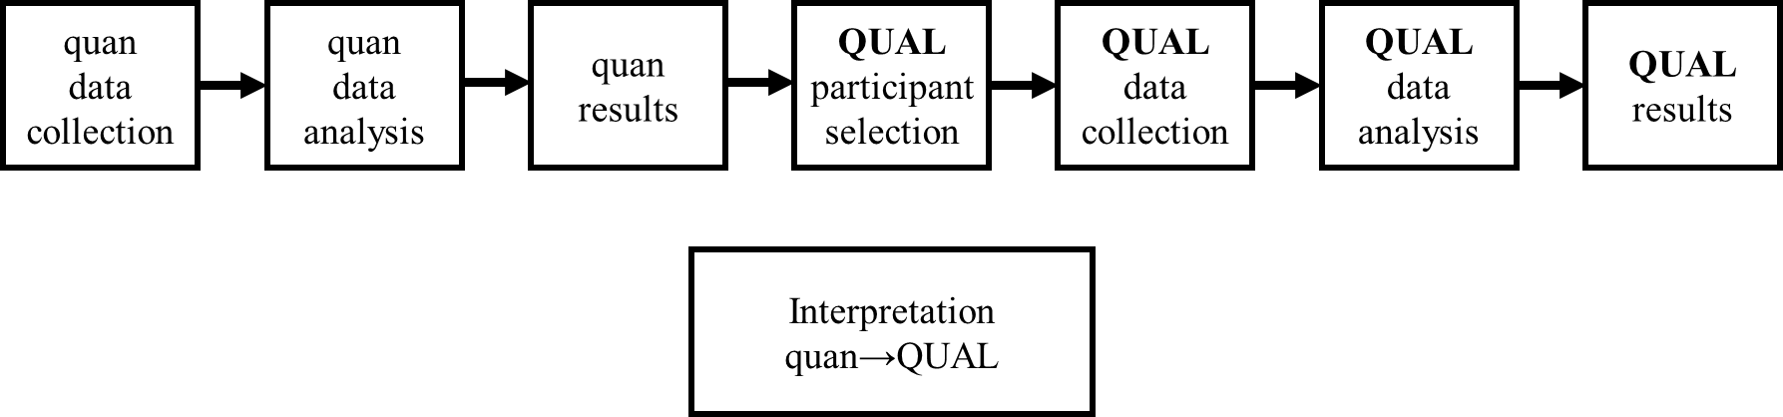
Figure 8. Explanatory design: Participant selection model (QUAL emphasized)
QUAL is qualitative and quan is quantitative. (Creswell & Clark, 2007, p.73).

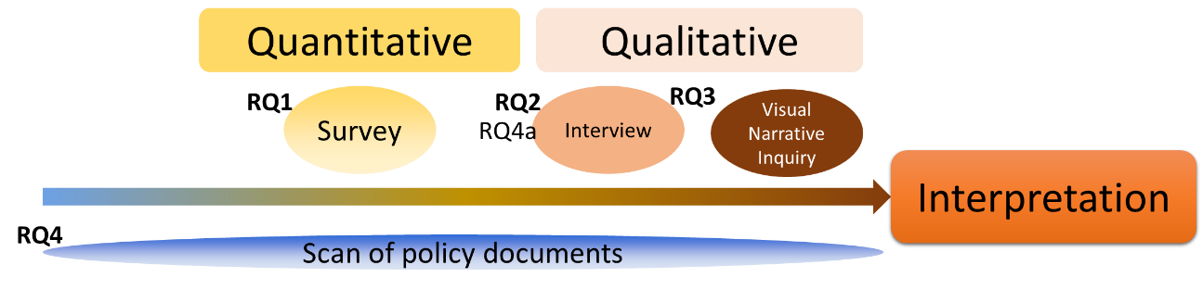
Figure 9. Mapping of RQs with the research design

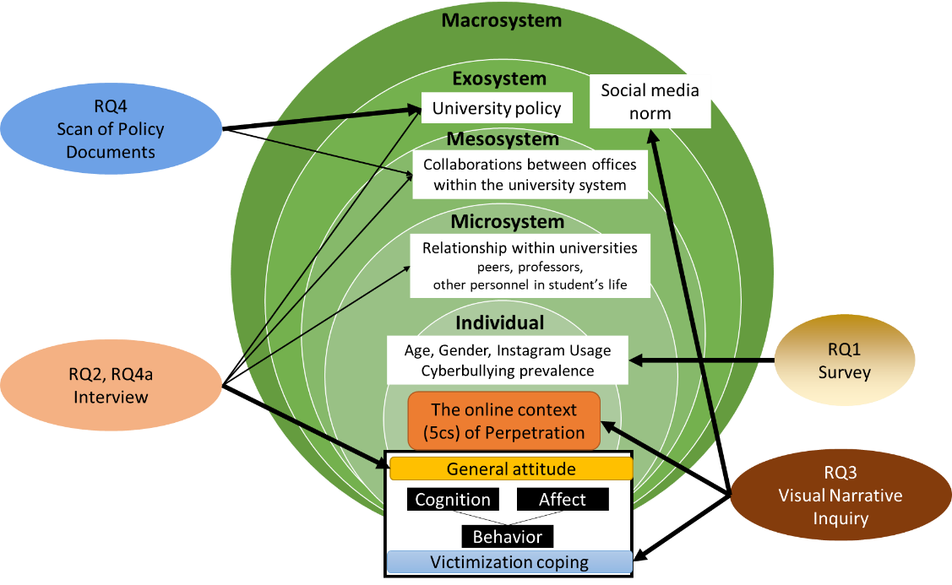
Figure 10. Mapping of RQs, research design, and theoretical framework

Survey

1. Introduction
A survey was distributed in the first phase of data collection. The rationale of using a survey is two-folds. First, data collected from the survey may reveal the trend on a topic of a certain population, and the analysis may identify the relationships between variables (Blair et al., 2013) (i.e., age and gender in my case). Second, the survey responses served as a pool for purposive sampling for the qualitative phase (Creswell et al., 2003). In my study, survey is a proper approach to unveil the prevalence of visual-based cyberbullying on Instagram among undergraduate students at UTK and their experiences with cyberbullying. The survey addresses the first research question.

RQ1: What is the nature of visual-based cyberbullying on Instagram experienced by undergraduate university students?

2. Sample
The target population of the survey is all undergraduate students enrolled full-time at the UTK, in Spring 2022. As of March 1, there were 22,192 undergraduate students aged 18 or older who were enrolled full-time (12 or more credits) for the Spring 2022 semester. I requested lists that include 10,001 random student emails from the UTK Data Central (https://data.utk.edu/) and received the approval and the list in March 2022 (see details in the next section). The survey was distributed to all students on the list. The random sample accounts for 45.07% of the target population. There were 518 total responses, and the overall response rate is 5.18%. However, only 357 were valid for the analysis. See data exclusion details in 4. Data analysis section. Detailed demographic information is reported the Chapter Four.

3. Procedures

Pilot test
Given that I adopted my main survey instrument from Lee et al. (2017) (see Instrument Part 3: Cyberbullying Experiences), the pilot test of the survey instrument was only for identifying the average time needed to complete and whether any of the questions need refinements. In July 2021, I invited three students from my personal network to complete the survey instrument of whom two had completed their second semester at the Pellissippi State Community College, and one was entering her fourth year at UTK. All of them were over 18 years old. On average, they spent around 10 minutes taking the survey, and provide feedback on the questions (see Instrument section).

Formal study
I minorly revised the survey language following committee members’ suggestions. Then I submitted the IRB application for the survey, interview and visual narrative inquiry. The IRB approved my study in February. Then I submitted the email request to the Data Central (data_requests@utk.edu). The request was routed to the Registrar's Office in Data Central’s automated workflow to obtain permission. In March 2022, the Data Central provided me with a random sample set of 5,000 students. The randomized formula (=RAND()) was performed in Excel to extract the random samples by the Data Central.

The survey was distributed by QuestionPro, the software available through the UTK Office of Information Technology (https://oit.utk.edu/research/websurveys/). I first input the “Cyberbullying Research Survey Invitation” letter (See Appendix A), Survey Informed Consent (See Appendix B), Survey Instrument (See Appendix A), and the 5,000 emails into QuestionPro. Then I distributed the survey directly from QuestionPro on March 22. A follow-up reminder was sent on March 29.

After distributing the survey for two weeks, there were 286 responses, which did not meet my goal. Thus, I contacted the Data Central and they agreed to provide with me another random sample set of 5,001 students. The second-round distribution started from April 11 and a reminder was sent on April 18. I kept the survey open until the last day of classes (May 9). There were another 232 responses received, totaling 518 responses.

4. Instrument (See Appendix C for the entire survey instrument).

Display
As students click the survey URL that embedded in the “Cyberbullying Research Survey Invitation” letter, they would see the Informed Consent Form (See Appendix B) in QuestionPro. Students have the option to click “I’m over 18, and I agree to participate” or “I’m under 18, or I do not agree to participate.” Upon clicking the Agree button, the survey questions were displayed. Participants can exit the survey at any time without penalty by clicking the “Exit Survey” button at the top right side of the page.

Part 1: Demographic information
There were four parts in the survey. The first part includes four questions about the student’s major, age, year in the program, and gender. As suggested by one participant during the pilot-testing of the survey, I made the gender question open-ended.

Part 2: Instagram usage
The second part includes 14 questions of Instagram usage using a 5-point Likert Scale (Very often, Often, Sometimes, Rarely, Never). Question 1 was a screening question that asked the frequency of using Instagram. Those who answered “Never” were terminated. I developed all questions in this part. Because, to the best of my knowledge, there is no survey instrument that investigates Instagram usage that include the current functions (e.g., Reel). Questions covered users’ behaviors (i.e., post, record, share, react, comment) on different functions (Feed, Story, Direct Message, Reel, Live Stream).

Part 3: Cyberbullying experiences
This part collects data on students’ cyberbullying experiences, including being a witness, victimization, and perpetration. Questions was adopted from Lee et al. (2017), who developed this scale to measure cyberbullying perpetration and victimization in emerging adulthood, which applies to university students.

Lee et al. (2017) divided cyberbullying experience into two subscales: cyberbullying perpetration (CBP) and cyberbullying victimization (CBV). Both subscales include three subsections: Verbal/written, Visual/sexual, and Social exclusion. Based on their statistical tests, both CBP and CBV presents high reliability, good model-data fit for factorial validity, and significant convergent validity.

Since this dissertation study focuses on visual-based cyberbullying behaviors, I extracted only the Visual/sexual subsection from both CBP and CBV. In Lee et al. (2017), the reliability scores of Visual/sexual subsections were acceptable (α= .73, CBP ) to good (α=.85, CBV). In terms of factorial validity, CBP and CBV models can explain 77% and 87% in Visual/sexual perpetration and victimization. As for the convergent validity, both subscales significantly correlated with existing scales (i.e., Aggression Questionnaire and Multidimensional Peer Victimization Scale) (γ=.34 and .28, CBP and CBV, respectively). See Appendix G for the reliability and validity details of Lee et al.'s (2017) scales and Visual/sexual subscales. See discussions on issues of combing Visual and Sexual subscales in the “Discussion-Data Collection Technique” section.

Lee et al.'s (2017) scales address cyberbullying behaviors in a general way instead of focusing on a specific social media platform. Thus, I modified the concepts to align with “Instagram” terminology. For example, the word “online” in this original survey question, “I have posted embarrassing pictures or videos of someone online without their permission to damage the person's reputation.” was changed to “Instagram” in my survey.

In addition, since there is no measure for witness in Lee et al.'s (2017) scale, I used questions from the CBV-Visual/sexual to develop items for measuring witnesses’ experience. The changes I made to the questions are illustrated in this original and modified example. The original question, “Someone has sent private pictures or videos of mine on websites without my permission to upset me,” was modified to, “I have seen/I know someone sent private pictures or videos of the other person on Instagram without their permission to upset them.”

The next, advised by two committee members that the language used by the original questions might deterred participants from revealing their actual cyberbullying experiences, I modified the language by adding “might” or “possibly” into the questions to mitigate the tone: I might have made sexual jokes about someone on Instagram to damage the person’s reputation; Someone has sent private pictures or videos of mine on Instagram without my permission possibly to upset me.

The final version of the Visual/Sexual cyberbullying experience scale is consistent with 25 questions (Figure 11). Each question is measured using a 5-point Likert scale (Very often, Often, Sometimes, Rarely, Never).

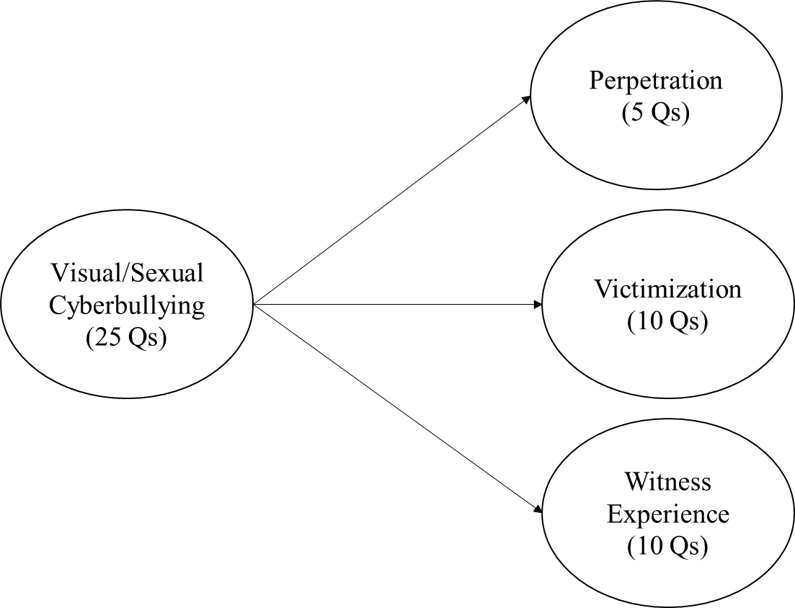

Figure 11. Model of the Visual/sexual Cyberbullying behavior scales

Part 4: Follow-up interview information
At the end of the survey, participants were asked if they are interested in participating in the interview and visual narrative inquiry. To avoid potential biases, I only provided a general description about the follow-up interview and the amount of incentive, without any screening information.

Participants who clicked the “Yes, I’m interested in participating the follow-up interview” button were directed to the separate “Follow-up” survey URL. In this “Follow-up” survey.
There is one screening question about if they have witnessed any cyberbullying incident on Instagram before. Those who never witnessed cyberbullying were terminated. Those who have witness experiences were asked to provide their age, gender, Instagram usage frequency (Very often, Often, Sometimes, Rarely, Never) and their email address.

In addition, to minimize the risk of participating in this study, I included the contact information of the UTK Counseling Center and the UT 24-Hour Helpline in both the Informed Consent Form and at the end of the survey.

5. Data Analysis

Exclusion of invalid responses
Based on the record retrieved in QuestionPro, there were 518 students clicked the survey URL. I first checked invalid responses that include following five situations: (1) Decline to answer the survey; (2) Did not start the survey; (3) Never use Instagram; (4) Did not answer any questions of Instagram usage; (5) Did not answer any questions of the cyberbullying experiences. Overall, there were 124 invalid responses.

In addition, 18 participants who aged over 26, or identified themselves other than males and females (e.g., queer, nonbinary) were also excluded. First, because the survey instrument was developed for emerging adults (age 18-25) (Lee et al, 2015); second, the number of participants who self-identified as other genders were too small for preforming statistic analysis. The final data set is consisted of 376 responses.

Data preparation
There are three questions (i.e., Q3 in Perpetration, Q4 in Victimization, and Q4 in Witnesses) in the survey instrument are designed in a opposite narrative direction (e.g., I have never…). Thus, responses of these three items were revered to the same direction with other items. Then responses in each subscale were averaged that resulted in four continuous variables: Instagram usage (IG), Perpetration (P), Victimization (V), and Witnesses (W). The Gender variable was dummy coded (i.e., 0=male, 1=female).

Missing data treatment
Across variables, the percentages of missing data range from 0.3% to 5.6%. Little’s (2013) MCAR (Missing Completely at Random) analysis was performed in SPSS 27. Results indicated that data were missing completely at random, χ2 (138) = 104.849, p = .991. All missing data were replaced using the Expectation-Maximization (EM) method in SPSS.

Normality and linearity test
The normality test (i.e., the Shapiro-Wilk test) was performed on the four continuous variables. However, none of them was normally distributed: IG (W=.944, p<.001); P (W=.707, p<.001); V (W=.836, p<.001); W (W=.911, p<.001). Linearity test.

Justification of the result here. Wall, M. M., Guo, J., & Amemiya, Y. (2012).

Confirmatory factor analysis
Due to these changes, after the data collection, I will conduct the reliability test among the adopted scales.

Reverse:
χ2 (272) = 1165.972, p = .000; RMSEA=.096; CFI=.798; TLI=.777; SRMR=.075.
second-order factor
χ2 (260) = 942.08, p = .000; RMSEA=.086; CFI=.846; TLI=.822; SRMR=.071.

Remove sexual-related question
χ2 (41) = 96.756, p = .000; RMSEA=.062; CFI=.958; TLI=.944; SRMR=.041.

Regression analysis

Individual interviews and visual narrative inquiry

1. Introduction
Individual interviews allow researchers to capture the ways participants “see and experience the world” (McCracken, 1988, p.65). In my case, interview can illustrate students’ definition of cyberbullying, as well as their attitude toward visual-based cyberbullying on Instagram. Visual narrative inquiry is a method that researchers “intentionally, reflectively and actively” ask participants to provide meanings of their experiences through both visual (e.g., picture drawings) and narrative (e.g., verbal storytellings) approaches (Bach, 2007, p.280, 285), to develop understanding of a participant’s world (Mannay, 2015).

In my dissertation, participants created and described a cyberbullying Instagram scenario based on a real cyberbullying incident that they witnessed in the past. This visual narrative approach provides rich understandings of visual-based cyberbullying from undergraduate students’ perspectives.

The data generated from the interviews answer RQ2 and RQ4a, while the data generated from the visual narrative inquiry activity answer RQ3.

RQ2: What are undergraduate university students’ perspectives of visual-based cyberbullying incidents on Instagram?
RQ2a: What definitions or meanings do students attach to visual-based cyberbullying?
RQ2b: Informed by Ostrom's (1969) attitude components, what students' cognitive, affective, and behavioral responses toward cyberbullying?
RQ3: How do undergraduate university students create and describe visual-based cyberbullying scenarios based on incidents they witnessed on Instagram?
RQ3a: Informed by the Five Cs model, what elements do these scenarios reflect?
RQ3b: Informed by the coping mechanism in Agnew’s (1992) General Strain Theory, how do students describe the coping strategies of the victims or witness exposed to visual-based cyberbullying incidents in the created scenarios?
RQ4: How do current university policies in the University of Tennessee system address visual-based cyberbullying?
RQ4a: How are undergraduate students aware of these policies?

2. Participants
As mentioned in the previous section, at the end of the survey, participants were asked their willingness of participating in the interview. The pool of participants includes 125 qualified students (i.e., who has witnessed cyberbullying incidents on Instagram before). Within this pool, six students were excluded because they are either over age 25 or seldom use Instagram. The final pool is consisted with 119 students. Originally, I used a stratified random sampling method to select participants and emailed them the interview invitation (Appendix D). However, the number of replies were small. Thus, I decided to email to every student in the final pool. The final sample includes 37 participants. Detailed demographic information is reported the Chapter Four.

3. Procedures

Pilot test
As mentioned in the survey procedure, I invited three students from my personal network to test the survey process. In August 2021, I invited two of them for the pilot testing of the interview and visual narrative inquiry activity. One just finished their second semester in the Pellissippi State Community College, and she participated in person, and the other one is entering her fourth year at UTK, and she participated via Zoom. On average, they took nearly 60 minutes to complete the entire process. They also provided feedback on the Consent procedure, one visual scenario, and the inquiry task, which will be described later. They were given a $10 Walmart e-gift card as a token of appreciation.

Formal study
The interview invitation emails were sent to qualified students on a rolling basis started at April 1. One reminder email was sent three days after the initial invitation email if the student did not reply. As students agreed to participate in the interview and scheduled a time slot, I emailed them the Research Information consent document (Appendix E).

The interview setting was hybrid, participants had options of in-person or Zoom participation. Seven participants chose to meet in person at a study room in the Hodges Library at UTK, while 30 participants chose to meet via Zoom using my person meeting room.

All participants were fully informed and orally consent before participating in the interview and the visual narrative inquiry. I also emphasized to participants that 1) no judgement would be made on any of their responses; 2) no need to share anything that were private or made them uncomfortable to share.

All participants agreed to be recorded. In-person interviews were audio recorded by an audio recorder; Zoom interviews were video recoded in Zoom. To be noted, to keep all data anonymous, Zoom participants were asked to turn off their camera and change their names to a pseudonym before starting recording, and I also hide their profile pictures in Zoom. Thus, no identifiers of participants were recorded in Zoom.

The interview instrument was designed as PowerPoint slides. For in-person interviews, the slides were displayed on an I-pad. In this way, the visual scenarios (See details in the Instrument section in the next) would be more social media authentic. For Zoom interviews, the slides were displayed via the “Share Screen” function in Zoom.

In the interview part, I presented three hypothetical scenarios that represent visual-based cyberbullying incidents on Instagram. After participants viewed through all scenarios, they were asked about their perceptions on the scenarios. Then they answered the questions about as their views on university policies and social media norm of visual-based cyberbullying. After the interview, participants were given a break if needed.

In the visual narrative inquiry part, participants were asked to recall a cyberbullying incident that they have witnessed before, then they recreated that scenario on Instagram. I first provided participants with the account name and password for two Instagram accounts that I registered for this study. Participant were asked to log into the accounts using their own mobile device. In some cases, participants only log into one account; in other cases, participants used both accounts to present conversation/comments between two people. These two accounts are private and are not linked to any other people. Thus, no one else could see the scenarios created by participants.

To ensure all visual materials in the recreated scenarios were copy-right free, I provided three sources that are available in the public domain and downloadable for free use: Snappy Goat (https://snappygoat.com/#,0,0.); Pixabay (https://pixabay.com/); and Unsplash (https://unsplash.com/). To keep privacy and confidentiality, participants were also asked NOT to use visual contents in their own cameral rolls on the mobile devices.

To be noted here, one participant did not use images from the three provided sources to create the scenarios. She just searched images on Google. I figured it out at a later stage of the interview and was out of time for her to redo the scenarios. Thus, after her interview, I searched copyright-free images with the same concepts (i.e., a girl’s selfie and a girl in a bikini on a beach) and replaced the original images in the scenarios.

In addition, five participants did not create a scenario. Two of them did not want to use their own devices to log in to a new Instagram account (i.e., the accounts I registered for this study). Two of them experienced internet connection issues with their phones and could not assess Instagram during the interview. One participant’s phone was at a very low battery level, and she could not find a charger. All of them agreed to verbally share real cyberbullying incidents they had witnessed before.

When the above procedure completed, I logged into the Instagram accounts to view the recreated scenarios. Participant were asked to share narrations of the scenarios/real incidents verbally. There were also asked about how people in the scenarios/real incidents reacted or coped with the situations.

After all interview questions were completed, I screenshotted the scenarios to save to my computer. To keep the scenarios private and prevent them from being seen by the next participant, the content were deleted in the Instagram either by participants or by me. And participants were asked to log out of the Instagram accounts. All participants were given a $15 Amazon or Walmart e-gift card as a token of appreciation.

After each interview, I changed the Instagram accounts passwords to prevent the participant from accessing after participation. Then I checked recordings for proper operation, and the screenshots of scenarios for properly saved.

There were 37 participants, seven of them participated in person while 30 of them participated in Zoom. The overall interview duration ranges from 35 minutes to 75 minutes, with an average of 48.2 minutes. All interviews were conducted in April 2022.

4. Instrument
The interview instrument and visual narrative inquiry activity consist of three parts: 1) visual scenarios, 2) interview questions, 3) visual inquiry questions.

Part 1: Visual scenarios
In Chapter Two, I synthesized the cyberbullying behaviors reported in the review of the literature. One behavioral category identified as “Inappropriate use of visual content” (Table 3. Count). This category includes ten types of behaviors. I applied the three most frequently investigated behaviors as a reference for designing the scenarios for the interview:

Scenario 1: Posting embarrassing/mean photos/videos to shame someone (Investigated in Abaido, 2020; Byrne, 2021; Gahagan et al., 2016; Kokkinos et al., 2014)

Scenario 2: Posting mean/negative/derogatory/offensive/ malicious comments on pictures/videos to target someone's intelligence/physical appearance (Investigated in Gahagan et al., 2016; Rachoene & Oyedemi, 2015)

Scenario 3: Sharing/forwarding/spreading someone's embarrassing photos/videos to others to ridicule someone (Investigated in Gahagan et al., 2016; Kokkinos et al., 2014; Mishna et al., 2018; Ozden & Icellioglu, 2014)

I used my private Instagram account to create the visual scenarios. I searched and downloaded images from Snappy Goat (https://snappygoat.com/#,0,0), Pixabay (https://pixabay.com/), and Unsplash (https://unsplash.com/). Then I used the Paint tool to modify them. In addition, I included the two visual-based cyberbullying factors, thumb down and loser hand gestures that mentioned by Vishwamitra et al. (2021). All scenarios were revised after receiving suggestions from the pilot participants and committee members. Each scenario includes an image representing a cyberbullying behavior and a short description of the incident. See the second scenario as an example in Figure 12. See all scenarios in Appendix F.
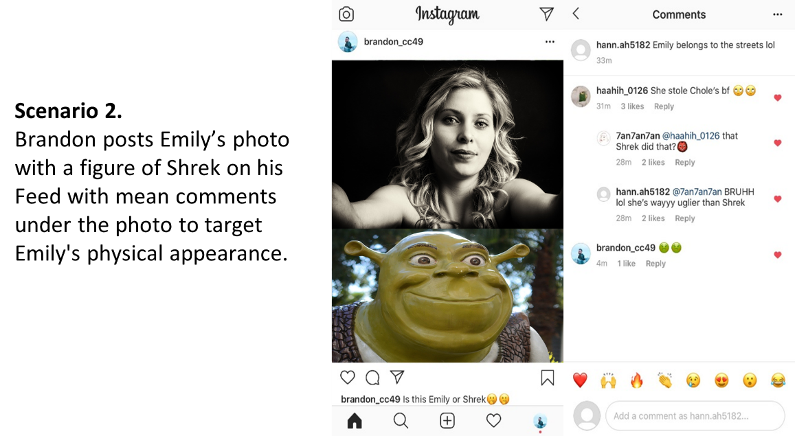

Figure 12. Visual scenario 2 for use in the interview

Part 2: Interview questions
In the beginning of the interview, there was two icebreaking question about what social media participants usually use and what they usually do on Instagram.

Then five main interview questions were designed based on the holistic theoretical framework. These questions aim to investigate participants’ perspectives on the given scenarios using Ostrom’s (1969) cognitive, affective, and behavioral attitudes. As well as to observe how participants identify related factors in the microsystem (e.g., friend), Mesosystem (i.e., reporting system) and Exosystem (i.e., policy, social media norm) in addressing the cyberbullying issue. The sub-questions serve as follow-up questions. Questions might not be asked sequentially, depend on the flow of participants’ responses.

1. What do you think about these scenarios?
1-1 Are any of them you think is cyberbullying?
1-2 What elements in that scenario(s) cause cyberbullying?

2. If these scenarios happened to 1) you, 2) your friend, 3) someone you don’t know, then 1) what would you think? 2) how would you feel? 3) what you might do?

3. In your word, what do you think is “visual cyberbullying”?

4. Do you think there is any policy at UT related to cyberbullying?
4-1 Do you know any cyberbullying policies at UT?
4-2 If you want to report a cyberbullying incident to the university, do you know how to report it?
4-3 How do you think UT should be involved if someone reports cyberbullying?

5. How do you think social media platform can do to reduce cyberbullying?
5-1 If you want to report a cyberbullying incident on Instagram, do you know how to report it?
5-2 How do you think users can do to avoid engaging in cyberbullying?

Part 3: Visual narrative inquiry questions
Three main questions were designed for the visual narrative inquiry based on the holistic theoretical framework. The first question aims to investigate the Five C elements (i.e., context, content, conduct, contact, and conﬁdentiality) shown in the recreated scenarios. As well as to understand the coping strategies that victims applied in those incidents. The sub-questions serve as follow-up questions. Questions might not be asked sequentially, depend on the flow of participants’ responses. The second question is related to the fifth interview question. The rationale of this sequence is because participants may be more reminded on social media feature after they recreated the scenarios. The third question is a closing question.

1. Could you tell me what happened in that scenario/that real case?
1-1 What was the relationship between the perpetrator and the victim?
1-2 Do you know what the victim did/reacted on this incident?
1-3 Was the account a public one or a private one?
1-4 How did other people who witness this incident react on it?
1-5 Do you think this kind of incident often happens on Instagram?

2. What kind of social media features do you think might increase cyberbullying?

3. Is there anything else you would like to share in terms of visual cyberbullying?

Part 4: Supplemental questions
If there was still time remining, and I didn’t observe any impatience or tiredness from participants, I presented and asked participants supplemental questions. Thus, not all participants answered these questions. In the first question, I extracted five example images that were considered as cyberbullying in Vishwamitra et al.’s (2021, p.6) study (Figure 13).

1. These images were from a scholarly visual cyberbullying study. Do you think any of these images represents cyberbullying?

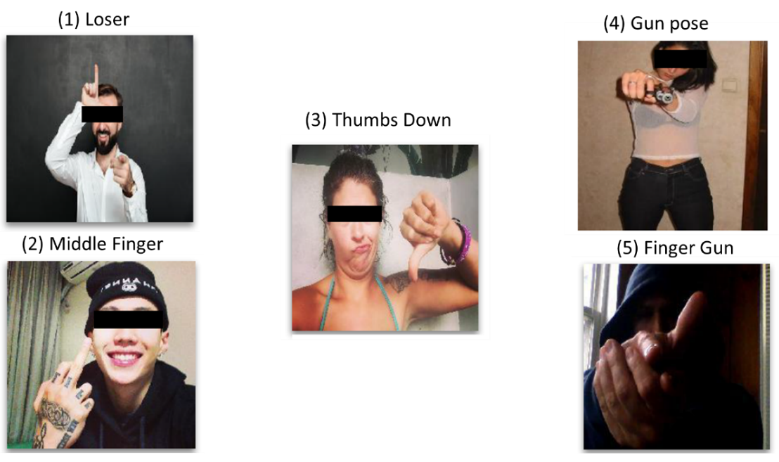
Figure 13. Images in the supplemental question 1
(Image sources: Vishwamitra et al., 2021, p.6)

In the second question, I asked participants whether they have witnessed other inappropriate usages of visual content. These behaviors were extracted from my literature review (Table 3. Count.)

2. Have you ever witnessed any of these behaviors on social media in general? If yes, and if you feel comfortable to share, could you tell me what did you see?

2-1 Sharing/forwarding/spreading someone’s photos/videos that contain a sexual nature
2-2 Taking pictures/recording videos while a group laughs and forces another person to do something humiliating or ridiculous
2-3 Taking pictures/recording videos while someone hits or hurts another person
2-4 Taking pictures/recording videos of someone that contain a sexual nature
2-5 Using emojis as a form of ridicule
2-6 Using someone’s personal picture/video without permission
2-7 Sending (links of) humiliating images/videos

5. Data analysis
Both the interview and the visual narrative inquiry activity emphasize a lot on interpreting how a phenomenon (i.e., a cyberbullying incident on Instagram) means to a participant. Participants make meanings of visual-based cyberbullying on Instagram through verbal interviews and visual scenarios (Bach, 2017; McCracken, 1988).

In my study, participants experiences, assumptions, and understanding of cyberbullying were categorize and map into the theoretical framework during the analysis. Thus, I used “theoretical thematic analysis” as the main approach on my qualitative data. As indicated by Braun and Clarke (2006, p.84), theoretical thematic analysis “tends to be driven by the researcher’ theoretical interest” and it is “more explicitly analyst driven”. The themes generated in this analysis approach may be highly associated with the patterns discussed in theoretical framework. On the other hand, the holistic theoretical framework routed on bullying and cyberbullying, while the focus and novelty of my study is the visual aspect of cyberbullying. Thus, I also applied an inductive way to develop codes that specifically around the visual aspect. This results a hybrid approach with an emphasis on theoretical foundation.

Fereday and Muir-Cochrane (2006) adopted a Six Stage of Data Coding procedures for the hybrid thematic analysis from Boyatzis (1998), and Crabtree and Miller (1999). Braun and Clarke (2006) also provided an outline of Six Phases of thematic analysis. I adopt both guidelines and describe my steps of data analysis below.

Stage 1: Familiarizing yourself with your data (Braun & Clarke, 2006, p.87)
The audio recordings of in-person interviews were transcribed using an automatic transcription tool, the desktop version of Descript for transcription (https://www.descript.com/transcription). Zoom interviews were recorded to the cloud and a text file of captions was automatically processed for each recording.

To familiarize data, I listened to each recording and verified its transcription against the recording word by word. At the same time, I made note on distinct emotional reactions of participants when listening their voices. Then I read the transcription line by line and aggregate sentences into proper paragraphs. The paragraph serves as a coding unit. The next, I integrated screenshots of scenarios created by participants. As mentioned before, five participants did not create a scenario, while another five participants created two scenarios. Thus, the total number of visual scenarios for analysis is 37. The total word counts of all transcriptions (n=37) are 97,891. All transcriptions were saved as pdf files for analysis.

Stage 2: Developing the code manual (Fereday & Muir-Cochrane, 2006, p.84)
I developed a code book for coding all qualitative data. Started from the theoretical/deductive direction, I developed parent codes using the main structure from the holistic theoretical framework: Bystander General Attitude; Victim Coping; Perpetration; Microsystem; Mesosystem; Exosystem; Macrosystem. Then I input child codes under each parent codes from my literature review.

From the inductive direction, as I read through the transcriptions, I took notes of potential codes, then I added additional parent codes and child codes into the codebook. The next, for each parent code and child code, I developed operational definitions (Hsieh, & Shannon, 2005) that applied to my research scope. After discussing and revising during the intercoder reliability process (see the next section), the final codebook is consisted with nine parent codes and 64 child codes. The majority of codes were developed deductively. Only the fifth parent code and its child codes; child code 2.4; 3.13; 4.8; 6.2; 8.5; 8.6 were developed inductively. See the full codebook in Appendix H.

Table 4. Codebook overview
Parent code | Operational definition N of child code
1. Individual- Social media usage | Participants’ usage of Instagram and other social media sites | 2
2. Bystander General Attitude | Participants’ attitude toward hypothetical scenarios/real CB incidents as a bystander. | 6
3. Victim Coping | Participants’ descriptions of victims’ coping strategies in real CB incidents. | 20
4. Perpetration- Transcript | Participants’ descriptions of perpetrators’ behaviors in real CB incidents. | 8
5. Perpetration-Visual inquiry | CB elements showed in participants’ recreated scenarios and the associated narrative | 15
6. Microsystem | personnel in the microsystem mentioned by participants | 4
7. Mesosystem | Participants’ cognitions on what/how university should intervene CB that happened to students. | 1
8. Exosystem | Participants’ cognitions on CB regulations within the university; and on social media site. | 6
9. Macrosystem | Personnel in the microsystem mentioned by participants. | 2
Total |  | 64

Stage 3: Testing the reliability of the code (Fereday & Muir-Cochrane, 2006, p.85)
The codebook was manually input into NVivo (Version 1.6) for coding. The transcriptions were all saved as pdf files and imported into NVivo as well. To enhance the trustworthiness of data analysis, intercoder reliability was implemented as the first step of data analysis (O’Connor & Joffe, 2020). I recruited the second coder from my personal network. He has a master’s degree in Information Management and had qualitative data coding experiences using NVivo in the past. As a rule of thumb, using 10% to 25% of the whole data set is typical for conducting the statistic intercoder reliability test (O’Connor & Joffe, 2020). Thus, I randomly selected nine transcriptions, around 24% of the data, for testing the intercoder reliability.

First, I presented to the second coder the whole interview process and used the same material (i.e., PowerPoint presentation) I used in the formal interview. This process is to help the second coder make sense of the data sequence in the transcriptions. Then I briefly introduced the holistic theoretical framework, and explained operational definitions of each code in the codebook. The next, I briefly shared my reflection on each transcription, and asked him to read the transcriptions line by line to familiarize the data before coding (Kurasaki, 2000; O’Connor & Joffe, 2020). Both of us coded documents independently. Coding unit is a paragraph. This means if there is only one sentence in the paragraph belongs to a certain code, the entire paragraph was coded into that code. This approach ensures the data context, as well as the efficiency of conducting intercoder reliability test. For the visual scenarios done by participants, we used “Region” selection to code. After we completed the first three documents, we discussed issues we experienced, and I revised the language of operational definitions for clarity (O’Connor & Joffe, 2020). Then we completed the rest six document.

The intercoder reliability test was conducted using the Kappa coefficients (κ), one of the most frequently used measurement (McHugh, 2012) and the only measurement available in NVivo. Unfortunately, the result from the first round of test was not satisfied. Thus, we examined paragraphs that existed disagreement in every code, discussed it thoroughly, and revised the coding if we reached to an agreement. The codebook and was revised again at this stage. Then I conducted the second round of the test (O’Connor & Joffe, 2020). The Kappa values from the second test ranged from 0.8 to 1, with an average of 0.96, indicating a strong to almost perfect level of agreement (McHugh, 2012, p.279). See kappa value of each code in Appendix H. In addition, NVivo was unable to process intercoder reliability test when coding units are “Region”. I reported the percentage of agreement for child codes under the fifth parent code: Perpetration-Visual inquiry.

In a typical process of qualitative data coding that implement intercoder reliability, after both coders complete coding the same subset of data, they will divide and code the rest of data separately. However, since this is my dissertation and I dedicated to investigating my data thoroughly, I coded the rest 26 transcription documents without the second coder’s help.

Stage 4: Generate and review themes by connecting and comparing codes
In this stage, themes were identified by generating relevant concepts across codes (Braun & Clarke, 2006; Fereday & Muir-Cochrane, 2006). My study aims to investigate the visual based cyberbullying, thus, key themes were generated focusing on the visual aspect, as well as the differences between visual-based cyberbullying and text-based cyberbullying.

Stage 5: Producing the report (Braun & Clarke, 2006, p.93)
This is the final step of the qualitative data analysis. In my study, qualitative data answers RQ2 (perspective), RQ3 (visual element) and RQ4a (policy awareness). In Chapter Four, key themes are reported under the structure of associated RQs. Notable quotes from participants are extracted as examples of the theme. In addition, the themes are triangularly discussed with the results generated from survey and policy analysis. See Chapter Four for result reporting.

Scan of policy documents

1. Introduction
Policy analysis can be a powerful tool to observe trends and patterns in documents and yield suggestions for program planning and evaluation. (Bardach & Patashnik, 2000). Smith P.K., one of the most cited cyberbullying scholars (López-Meneses et al., 2020), has applied the content analysis approach to examine the anti-bullying policies of 100 primary and secondary schools in the UK since 2008 (Purdy & Smith, 2016). As for cyberbullying-related university policies, Faucher et al. (2015) applied a scan approach to examine 465 policies in 74 Canadian universities (see Chapter Two). Examining policies allow researchers and university administrators to identify the gap between existing policies and real-world practices as the technology evolves.

In my study, I am interested in investing the gap between the current university cyberbullying policies and university students’ perspective of these policies. Thus, guided by Faucher et al. (2015), I applied a scan approach on policies related to cyberbullying, to get an overview of how cyberbullying and visual content usage regulation, have been addressed in university policies.

My study participants were undergraduate students at UTK. To triangulate the analysis, I limited my scope of policy scanning within the five institutions that have undergraduate programs affiliated with the UT system (https://tennessee.edu/campus-guide/). These institutions include UT Knoxville (UTK), UT Chattanooga (UTC), UT Southern (UTS), UT Martin (UTM), and UT Health Science Center (UTHSC) at Memphis.

Data generated from the policy scanning answers the last main research question:

RQ4: How do current university policies in the University of Tennessee system address visual-based cyberbullying?

2. Procedures

Policy search
The procedure of identify relevant policies were informed by Faucher et al.’s (2015). First, I located a list of all policies for the five affiliated institutions on the UT System Policy Website (https://policy.tennessee.edu/). I used the full-text search bar offered by this website to search for possible relevant policies.

I conducted the first round of policy searches in the last week in February 2022. I applied following searching keywords used by Faucher et al.’s (2015, p.108): cyberbullying, bullying, human rights, appropriate conduct, ethical conduct, harassment, intimidation, slander, libel, threat, computer use, code of conduct, hazing, and discrimination. Given that my research scope focuses on the visual aspect, I also used the searching keywords related to visual and social media: social media, Instagram, image, photo, picture, selfie, video, live video, and visual.

After completed coding the interview data, I reviewed participants’ responses related to university policies from codes 6.1 (University personnel), 6.2 (Student organization), 7.1 (Cognition on intervention practices), 8.1 (Knowledge on university policy), 8.2 (Cognition on university policy), and 8.3 (Reporting -university) (see Appendix H). Then I selected terms that potentially related to cyberbullying policies. These terms include professional behavior; hate speech; screenshot; GroupMe; inappropriate; student housing; sorority/fraternity; Title IX; blackmail; digital footprint; Dean of students; student engagement; Student Union; student life; alcohol. Then I conducted the second round of policy search in the first week in July. In total, 232 non-duplicate policy documents were retrieved in two rounds of search.

Determine relevancy
I determined the relevancy by browsing policy titles and section headings. First, the scope of the policy should be applied to “undergraduate student” or “student”. Documents that include statements of how other university personnel (e.g., faculty, employee) should treat students are also within the scope. Second, to include as many policies as possible, I followed Faucher et al.’s (2015, p.108) strategy by including documents that mention all types of “behaviors that might be considered as cyberbullying if occurring online without specifically referring to the online context”. Third, I included policies that address social media regulations, visual content usage regulations, and alcohol regulations. In total, 26 documents were considered relevant. The full list is presented in Table 7 in Chapter Four. All policy documents were downloaded as pdf files for scanning and coding in NVivo (Version 1.6).

3. Analysis

Coding scheme
I also applied a hybrid approach (Fereday & Muir-Cochrane, 2006) to develop the coding scheme. First, I adopted the coding scheme from Purdy and Smith (2016) and Faucher et al.’s (2015) studies to establish a baseline. I combined coding schemes from these two studies and removed irrelevant categories (e.g., traditional bullying terms and content). Second, during the scanning process, I added new codes that represent relevant concepts in my study (e.g., social media usage conduct). The final coding scheme is shown in Table 5, which includes four categories and eleven concepts. I used “Category” and “Concept” instead of “Parent code” and “Child code” in this section. Because the purpose of this analysis was only to extract content from policy documents that related to cyberbullying, rather than to code entire documents in detail.

Table 5. Coding scheme for policy documents
Category | Concept
1. Definition of cyberbullying | (1) Meaning of cyberbullying.  (2) Mention behaviors that might constitute cyberbullying  (3) Mention behaviors that might constitute cyberbullying through visual forms
2. Reporting and responding to cyberbullying incidents | (4) Any possible penalties or sanctions, including whether the policy makes a distinction between formal and informal modes of resolving a complaint.  (5) Information about the complaint procedure to follow or the office to contact when cyberbullying occurs.  (6) Statement of the responsibilities to whom witness incidents.
3. Strategies for intervention and prevention | (7) Suggestions for supporting victims.  (8) The university’s role in raising the awareness of or “sensitizing” the university community on this issue.
4. Other related concepts | (9) Mention appropriate or inappropriate social media usage.  (10) Mention appropriate or inappropriate visual content usage.  (11) Mention alcohol related offense of misconduct.

Analysis process
As mentioned before, my purpose is only to look for cyberbullying related concepts that represented in the documents, and is not attempting to evaluate or judge the quality of those policies. Thus, I first check the documents against my coding scheme by using “Ctrl + F” to search keywords in the full text. Keywords for each category are shown in Table 6. Then I browsed the paragraphs that include these keywords to determine if they were relevant to my analysis.
Table 6. Coding scheme for policy documents
Category | Keywords used for full-text searching
1. Definition of cyberbullying | Cyberbullying, bullying, internet, electronic, definition, harassment, intimidation, threat, haz(ing), discriminat(ion), denigration, flaming, cyberstalking, stalking, exclusion, outing, trickery, imperson(ation), inappropriate, hate speech, privacy
2. Reporting and responding to cyberbullying incidents | report, procedure, sanction, “student organization”, responsibilit(y/ies), complaint, witness, observe
3. Strategies for intervention and prevention | Interevent/intervention, prevent(ion), awareness, support
4. Other related concepts | “Social media”, Instagram, image, photo, picture, video, visual, screenshot, alcohol

Second, after completing all keywords search, I look at the table of content or the subheadings in the document to see if there were other relevant sections, then I browse through the sections to determine the relevancy.

Although this analysis is in a descriptive level without further interpretation, the result from the policy scan still enables triangulate data interpretation with empirical data collected from participants. The data interpretation is in the discussion section in Chapter Four.

Ethical Considerations
Given that cyberbullying is a sensitive topic, I recognize that there are some ethical considerations. According to the Belmont Report (HHS.gov, n.d.), researchers who work on the human subject must follow three Basic Ethical Principles: Respect for Persons, Beneficence and Justice and the IRB regulations. I describe my approaches and collect the data ethically and responsibly below.

Respect of persons
I made a voluntary nature of research participation in both quantitative and qualitative phases. In the quantitative phase, the survey was distributed to a random sample set, and students participated in this survey voluntarily. In the qualitative phase, participation was voluntary, and participants were judged based on their prior experiences with cyberbullying.

Beneficence
The guidelines of beneficence are (1) do not harm, and (2) maximize possible benefits and minimize possible harms.

In the quantitative phase, students were clearly informed about the procedure and potential risk in the Informed Consent Form. The contact information of the UTK Counseling Center and UT 24-Hour Helpline is provided in both the Informed Consent Form and at the end of the survey.

In the qualitative phase, students were clearly informed about the procedure and potential risk in the invitation email, Research Informed consent document, and before the data collection process. In particular, I described the visual scenarios to the participants in written/verbal forms. The contact information of the UTK Counseling Center and UT 24-Hour Helpline is provided in both the Informed Consent Form and the beginning and at the end of the data collection.

In the interview, participants were asked about their general attitude on the given hypothetical visual scenarios and NOT about those related to their personal perpetration/victimization experiences. In the visual inquiry, participants were asked to recreate and describe a visual scenario based on what they had witnessed before, NOT about those related to their personal perpetration/victimization experiences. None of the participants reported discomfort during the data collection process.

Lastly, in terms of privacy and confidentiality, I followed the requirements of UTK IRB. Data was de-identified before analysis. Each interview data file was provided with alphabetical and numerical codes (e.g., P10) when interpreting and presenting the results. All data will be securely stored in my UTK OneDrive that is password-protected. UTK uses a two-factor authentication to protect data and has firewalls to secure data stored on its web servers. Only the researcher, my Dissertation Chair, and Committee members may access the data.

Justice
There is no cost other than time for students to participate in this study. In the quantitative phase, the survey was distributed to a random sample set, which means each student in the population will have an equal opportunity to be randomly selected to participate in the survey. Every participant in the interview and visual inquiry activity received the same amount of gift card.

Role of Researcher
As I stated in the previous section, I followed the ethical principles to respect and protect the right of participants. During the research process, particularly, the data collection in the qualitative phase, I maintained a non-leading, unbiased attitude (Mertens, 2014). The approaches include, tell participants that “I want to hear as many different things as possible, so if you are willing and comfortable to share, please do not hesitate to do.”; and “there is no judgment, and the story you share with me will be helpful and important to my dissertation”. Also, if they want to pause or take a short break, they would be able to do so.

Results and Discussion

Overview

In this chapter, I first sequentially report the study results by answering four research questions, and triangularly discuss key findings. I applied four data collection techniques in this study. Each of the technique answer one main research question.

Survey

Interview

with the following demographic information: eight males and 29 females; seven freshmen, 11 sophomores, 11 juniors, and 8 seniors; age ranged from 18 to 23 (Mean age=20). As for the frequency of their Instagram usage, 22 participants repot “Very often”, 10 report “Often”, and 5 report “Sometimes”.

RQ2: What are undergraduate university students’ perspectives of visual-based cyberbullying incidents on Instagram?
RQ2a: What definitions or meanings do students attach to visual-based cyberbullying?
RQ2b: Informed by Ostrom's (1969) attitude components, what students' cognitive, affective, and behavioral responses toward cyberbullying?
RQ3: How do undergraduate university students create and describe visual-based cyberbullying scenarios based on incidents they witnessed on Instagram?
RQ3a: Informed by the Five Cs model, what elements do these scenarios reflect?
RQ3b: Informed by the coping mechanism in Agnew’s (1992) General Strain Theory, how do students describe the coping strategies of the victims or witness exposed to visual-based cyberbullying incidents in the created scenarios?

Visual Narrative Inquiry

Scan of Policy Document

In this section, I report the findings of the scan of policy documents that answer the fourth main RQ.
RQ4: How do current university policies in the University of Tennessee system address visual-based cyberbullying?
In total, there were 25 documents that I considered include relevant concepts of my study. I adopted coding schemes from Purdy and Smith’s (2016) and Faucher et al.’s (2015) studies. I also added new concepts that related to my study, resulting in four categories and eleven concepts in my coding scheme.
As mentioned before, the purpose of the scan of policy documents is only to look for cyberbullying related concepts that presented in the documents, and is not attempting to evaluate or judge the quality of those policies. Thus, I first report the occurrence of each concept in the policies, then provide a general report of each category.
Overview
I classified the 25 documents into four types. 1) Codes of conduct, handbooks and procedures (n=12): includes student conduct and faculty handbook from five institutions, one system-wide employ conduct, one student complaint procedure from UTHSC. 2) Sexual Harassment related policies (n=6): namely the Title IX policies from five institutions, and one system-wide policy of sexual harassment and other discriminatory harassment. 3) Anti-discrimination policies (n=2): one anti-discrimination policy and one procedure from UTHSC. 4) Social media and visual content related conduct (n=5): two social media policy from UTHSC; three information technology policies that include one system-wide policy, one form UTC and one from UTHSC. See Table 7 for the full list of policies.
As for the occurrence of each concept in policies, in Table 7, “v” means the policy includes descriptions of a certain concept for students; “*” means the policy includes descriptions of a certain concept for employees (i.e., university personnel other than students); “/” means the policy includes descriptions of a certain concept in a more general way. I describe the details in the next section.
Definition of cyberbullying
In this category, I looked for descriptions or statements in the policy documents that define cyberbullying, or mention behaviors that might constitute cyberbullying. For Concept 1, unfortunately, none of the polices mention the terms “cyberbullying” or “bullying”. However, a majority of the documents includes descriptions of some types of behaviors that might constitute cyberbullying if happened in an online context (Concept 2). These behaviors include threat (n=17), discrimination (n=15), harassment (n=14), stalking (n=10), harm (n=8), hazing (n=6), intimidation (n=7). Threat and intimidation usually used in a statement of retaliation behaviors, while harassment and stalking are almost always under the frame of sexual harassment.
As for Concept 3, behaviors that might constitute cyberbullying through visual forms were mentioned in 12 documents, basically cover two types of behavior. One is “Sexual Exploitation”. Title IX policies provides examples under this behavior: “Surreptitiously observing, photographing, audiotaping, videotaping, or recording an image of a person who is engaging in sexual act(s)” (See p.6 in UTK Title IX policy as an example). The other behavior is “Invasion of Privacy”. For example, “using electronic or other means to make a video or photographic record of any person in a location in which the person has a reasonable expectation of privacy, without the person’s knowledge or consent.” (See p.6 in UTK Student Code of Conduct as an example).
Based on my scan, only in the policy “HR0280 - Sexual Harassment & Other Discriminatory Harassment” mentioned the online context: “Sexual harassment is not limited to personal interactions, but can occur via telephone, texting, social media, the internet, and other methods of communication.” (p.1). Other than this policy, the behaviors reported above were not particularly mentioned in an online context.

Table 7. Scan of policy overview
Polity title | Concept
Type of policy | 1 | 2 | 3 | 4 | 5 | 6 | 7 | 8 |  | 9 | 10 | 11
Codes of conduct and handbooks and procedures (n=12)
UTC Student Code of Conduct |  | v | v | v | v | v | / | v |  |  | v | v
UTHSC Student Code of Conduct |  | v | v | v | v | v | / | v |  |  | v | v
UTK Student Code of Conduct |  | v | v | v | v | v | / | v |  |  | v | v
UTM Student Handbook |  | v | v | v | v | v | / | v |  |  | v | v
UTS Student Handbook and Code of Conduct |  | v | v | v | v | v | / | v |  |  | v | v
UTC Faculty Handbook |  | * |  | * | / | * |  | *
UTHSC Faculty handbook |  | * |  | * | * | * |  | *
UTK Faculty Handbook |  | * |  | * | / | * |  | *
UTM Faculty Handbook |  | * |  | * | / | * |  | *
UTS Faculty Handbook |  | * |  | * | * | * |  | *
HR0580 - Employee code of conduct |  | * |  |  | * | *
SA110 - Student Complaint Procedure |  | v |  |  | v |  | v
Sexual Harassment related policies (Title IX) (n=6)
UTC Title IX |  | v | v | v | v | v | v | v |  | v | v | v
UTHSC Title IX |  | v | v | v | v | v | v | v |  | v | v | v
UTK Title IX |  | v | v | v | v | v | v | v |  | v | v | v
UTM Title IX |  | v | v | v | v | v | v | v |  | v | v | v
UTS Title IX |  | v | v | v | v | v | v | v |  | v | v | v
HR0280 - Sexual Harassment & Other |  | * |  |  | v | v |  | v |  | v | v
Anti-discrimination (n=2)
COM119 - Anti-Discrimination |  | v |  | v | v | v |  | v
ED200 - Discrimination Complaint Procedure |  | v |  |  | v | v |  | v
Social media and visual content related conduct (n=5)
CM0006-H - Social Media |  |  |  |  |  |  |  |  |  | v | v
H200 - Use of Social Media – Patient Privacy |  |  |  |  |  |  |  | v |  | v
GP-004 - Acceptable Use of IT Resources |  | v | v |  | / |  |  |  |  |  | v
IT0110 - Acceptable Use of Use of IT Resources |  | v | v |  |  |  |  | v |  |  | v
IT0132-C - Identification and Authentication |  |  |  |  |  |  |  |  |  | v
Total | 0 | 22 | 12 | 16 | 21 | 19 | 11 |  | 20 | 9 | 14 | 10
*Policy content for employee; /Policy content partially related to the study

Conclusions and Recommendations

List of References

Abaido, G. M. (2020). Cyberbullying on social media platforms among university students in the United Arab Emirates. International Journal of Adolescence and Youth, 25(1), 407–420.
Agnew, R. (1992). Foundation for a general strain theory of crime and delinquency. Criminology, 30(1), 47-88.
Alipan, A., Skues, J. L., & Theiler, S. (2021). “They will find another way to hurt you”: Emerging adults’ perceptions of coping with cyberbullying. Emerging Adulthood, 9(1), 22–34. https://doi.org/10.1177/2167696818816896
Aparicio-Martínez, P., Ruiz-Rubio, M., Perea-Moreno, A.-J., Martínez-Jiménez, M. P., Pagliari, C., Redel-Macías, M. D., & Vaquero-Abellán, M. (2020). Gender differences in the addiction to social networks in the Southern Spanish university students. Telematics and Informatics, 46, 101304. https://doi.org/10.1016/j.tele.2019.101304
Arslan, P., Corazza, M., Cabrio, E., & Villata, S. (2019). Overwhelmed by negative emotions?: Maybe you are being cyber-bullied! Proceedings of the 34th ACM/SIGAPP Symposium on Applied Computing, 1061–1063. https://doi.org/10.1145/3297280.3297573
Babbie, E. R. (2009). The practice of social research, 12th edition. Nelson Education.
Bach, H. (2007). Composing a visual narrative inquiry. Handbook of narrative inquiry: Mapping a methodology, 280-307.
Baldasare, A., Bauman, S., Goldman, L., & Robie, A. (2012). Cyberbullying? Voices of college students. In L. A. Wankel & C. Wankel (Eds.), Cutting-Edge Technologies in Higher Education (pp. 127–155). Emerald Group Publishing Limited. https://doi.org/10.1108/S2044-9968(2012)0000005010
Baloglu, S. (2000). A path analytic model of visitation intention involving information sources, socio-psychological motivations, and destination image. Journal of Travel & Tourism Marketing, 8(3), 81-90.
Balta, S., Emirtekin, E., Kircaburun, K., & Griffiths, M. D. (2020). The mediating role of depression in the relationship between body image dissatisfaction and cyberbullying perpetration. International Journal of Mental Health and Addiction, 18(6), 1482–1492. https://doi.org/10.1007/s11469-019-00151-9
Barlett, C. P., & Gentile, D. A. (2012). Attacking others online: The formation of cyberbullying in late adolescence. Psychology of Popular Media Culture, 1(2), 123–135. https://doi.org/10.1037/a0028113
Beale, A. V., & Hall, K. R. (2007). Cyberbullying: What school administrators (and parents) can do. The Clearing House: A Journal of Educational Strategies, Issues and Ideas, 81(1), 8-12.
Berne, S., Frisén, A., & Kling, J. (2014). Appearance-related cyberbullying: A qualitative investigation of characteristics, content, reasons, and effects. Body image, 11(4), 527-533.
Blair, J., Czaja, R. F., & Blair, E. A. (2013). Designing surveys: A guide to decisions and procedures. Sage Publications.
Bohman, J. (2002). How to Make a Social Science Practical: Pragmatism, Critical Social Science and Multiperspectival Theory. Millennium: Journal of International Studies, 31(3), 499–524. https://doi.org/10.1177/03058298020310030701
Bowen, G. A. (2009). Document analysis as a qualitative research method. Qualitative research journal, 9(2), 27.
Brady, K.P. (2010). Cyberbullying. In Russo, C.J. (Ed.), Encyclopedia of law and higher education.
Bronfenbrenner, U. (1977). Toward an experimental ecology of human development. American psychologist, 32(7), 513-531
Brown, T. A. (2015). Confirmatory factor analysis for applied research. Guilford publications.
Byrne, V. L. (2021). Blocking and self-silencing: Undergraduate students’ cyberbullying victimization and coping strategies. TechTrends, 65(2), 164–173. https://doi.org/10.1007/s11528-020-00560-x
Calvin, A. J., Bellmore, A., Xu, J. M., & Zhu, X. (2015). # bully: Uses of hashtags in posts about bullying on Twitter. Journal of School Violence, 14(1), 133-153.
Cénat, J. M., Smith, K., Hébert, M., & Derivois, D. (2019). Cybervictimization and suicidality among French undergraduate Students: A mediation model. Journal of Affective Disorders, 249, 90–95. https://doi.org/10.1016/j.jad.2019.02.026
Center for Disease Control and Prevention (CDC) (2021). The Social-Ecological Model: A Framework for Prevention. Retrieved from https://www.cdc.gov/violenceprevention/about/social-ecologicalmodel.html
Chadha, K. (2020). Women’s responses to online harassment. International Journal of Communication, 14, 239–257.
Chan, T. K. H., Cheung, C. M. K., & Lee, Z. W. Y. (2021). Cyberbullying on social networking sites: A literature review and future research directions. Information & Management, 58(2), 103411. https://doi.org/10.1016/j.im.2020.103411
Chen, L., Ho, S. S., & Lwin, M. O. (2017). A meta-analysis of factors predicting cyberbullying perpetration and victimization: From the social cognitive and media effects approach. New Media & Society, 19(8), 1194–1213. https://doi.org/10.1177/1461444816634037
Chi, Y., Jeng, W., Acker, A., & Bowler, L. (2018, March). Affective, behavioral, and cognitive aspects of teen perspectives on personal data in social media: A model of youth data literacy. In International Conference on Information (pp. 442-452). Springer, Cham.
Cho, Y.-K., & Yoo, J. (2017). Cyberbullying, internet and SNS usage types, and perceived social support: A comparison of different age groups. Information, Communication & Society, 20(10), 1464–1481. https://doi.org/10.1080/1369118X.2016.1228998
Choi, J., Peters, M., & Mueller, R. O. (2010). Correlational analysis of ordinal data: from Pearson’sr to Bayesian polychoric correlation. Asia Pacific education review, 11(4), 459-466.
Çimke, S., & Cerit, E. (2021). Social media addiction, cyberbullying and cyber victimization of university students. Archives of Psychiatric Nursing, 35(5), 499–503. https://doi.org/10.1016/j.apnu.2021.07.004
Collins, K. (2010). Advanced sampling designs in mixed research: current practices and emerging trends in the social and behavioral sciences. In SAGE handbook of mixed methods in social & behavioral research (pp. 353-378). SAGE Publications, Inc.
Creswell, J. W., & Clark, V. L. P. (2007). Designing and conducting mixed methods research. Sage publications.
Creswell, J. W., Plano Clark, V. L., Gutmann, M. L., & Hanson, W. E. (2003). An expanded typology for classifying mixed methods research into designs. A. Tashakkori y C. Teddlie, Handbook of mixed methods in social and behavioral research, 209-240.
Cross, D., Barnes, A., Papageorgiou, A., Hadwen, K., Hearn, L., & Lester, L. (2015). A social–ecological framework for understanding and reducing cyberbullying behaviours. Aggression and Violent Behavior, 23, 109-117.
Crosslin, K., & Golman, M. (2014). “Maybe you don’t want to face it”–College students’ perspectives on cyberbullying. Computers in Human Behavior, 41, 14-20.
Cunningham, C. E., Chen, Y., Vaillancourt, T., Rimas, H., Deal, K., Cunningham, L. J., & Ratcliffe, J. (2015). Modeling the anti‐cyberbullying preferences of university students: Adaptive choice‐based conjoint analysis. Aggressive Behavior, 41(4), 369–385. https://doi.org/10.1002/ab.21560
Cyberbullying Research Center (n.d.). Share Your Cyberbullying Story. Retrieved https://cyberbullying.org/stories
Dale, E. (1969). Audiovisual methods in teaching.
Davis, K., Randall, D. P., Ambrose, A., & Orand, M. (2015). ‘I was bullied too’: Stories of bullying and coping in an online community. Information, Communication & Society, 18(4), 357–375. https://doi.org/10.1080/1369118X.2014.952657
De Bourdeaudhuij, I., Jacobs, N. C., DeSmet, A., & Gunther, N. (2015). Comparing Associated Harm with Traditional Bullying and Cyberbullying: A narrative overview of mental, physical and behavioural negative outcomes. In Cyberbullying-From theory to intervention (pp. 54-76). Routledge.
Dean, M. (2012). The story of Amada Todd. The new Yorker. Retrieved from https://www.newyorker.com/culture/culture-desk/the-story-of-amanda-todd
Dickinson, W. (2010). Visual displays for mixed methods findings. In SAGE handbook of mixed methods in social & behavioral research (pp. 469-504). SAGE Publications, Inc.
Dillman, D. A., Smyth, J. D., & Christian, L. M. (2014). Internet, phone, mail, and mixed-mode surveys: the tailored design method. John Wiley & Sons.
Di̇Lmaç, B. (2009). Psychological needs as a predictor of cyber bullying: A preliminary report on college students. Educational Sciences: Theory and Practice, 9(3), 1307-1325.
Dinger, M. K., Brittain, D. R., O’Mara, H. M., Peterson, B. M., Hall, K. C., Hadley, M. K., & Sharp, T. A. (2018). The Relationship between Physical Activity and Binge Drinking among College Students: A Qualitative Investigation. American Journal of Health Education, 49(1), 33–39.
Ditch the Label (2017). The annual bullying survey 2017. Retrieved https://www.ditchthelabel.org/wp-content/uploads/2017/07/The-Annual-Bullying-Survey-2017-1.pdf
Doane, A. N., Kelley, M. L., Chiang, E. S., & Padilla, M. A. (2013). Development of the cyberbullying experiences survey. Emerging Adulthood, 1(3), 207–218. https://doi.org/10.1177/2167696813479584
Doane, A. N., Pearson, M. R., & Kelley, M. L. (2014). Predictors of cyberbullying perpetration among college students: An application of the Theory of Reasoned Action. Computers in Human Behavior, 36, 154–162. https://doi.org/10.1016/j.chb.2014.03.051
Dredge, R., Gleeson, J., & De la Piedad Garcia, X. (2014). Presentation on Facebook and risk of cyberbullying victimisation. Computers in Human Behavior, 40, 16-22.
Espelage, D. L. (2014). Ecological theory: Preventing youth bullying, aggression, and victimization. Theory into Practice, 53(4), 257-264.
Facebook Business Team (2020). Facebook for business. Retrieved 2020/10/10 from https://www.facebook.com/business/marketing/instagram#
Faucher, C., Jackson, M., & Cassidy, W. (2015). When online exchanges byte: An examination of the policy environment governing cyberbullying at the university level. Canadian Journal of Higher Education, 45(1), 102–121. https://doi.org/10.47678/cjhe.v45i1.184215
Fereday, J., & Muir-Cochrane, E. (2006). Demonstrating rigor using thematic analysis: A hybrid approach of inductive and deductive coding and theme development. International journal of qualitative methods, 5(1), 80-92.
Finn, J. (2004). A survey of online harassment at a university campus. Journal of Interpersonal Violence, 19(4), 468–483. https://doi.org/10.1177/0886260503262083
Francisco, S. M., Veiga Simão, A. M., Ferreira, P. C., & Martins, M. J. das D. (2015). Cyberbullying: The hidden side of college students. Computers in Human Behavior, 43, 167–182. https://doi.org/10.1016/j.chb.2014.10.045
Gahagan, K. (2016). College student cyberbullying on social networking sites: Conceptualization, prevalence, and perceived bystander responsibility. Computers in Human Behavior, 55, 1097–1105.
Gibb, Z. G., & Devereux, P. G. (2014). Who does that anyway? Predictors and personality correlates of cyberbullying in college. Computers in Human Behavior, 38, 8–16. https://doi.org/10.1016/j.chb.2014.05.009
Goodboy, A. K., & Martin, M. M. (2015). The personality profile of a cyberbully: Examining the Dark Triad. Computers in Human Behavior, 49, 1–4. https://doi.org/10.1016/j.chb.2015.02.052
Goodboy, A. K., Martin, M. M., & Goldman, Z. W. (2016). Students’ experiences of bullying in high school and their adjustment and motivation during the first semester of college. Western Journal of Communication, 80(1), 60–78. https://doi.org/10.1080/10570314.2015.1078494
Guest, G., Bunce, A., & Johnson, L. (2006). How many interviews are enough? An experiment with data saturation and variability. Field methods, 18(1), 59-82.
Guo, S. (2016). A meta-analysis of the predictors of cyberbullying perpetration and victimization: Cyberbullying perpetration and victimization. Psychology in the Schools, 53(4), 432–453. https://doi.org/10.1002/pits.21914
Hamm, M. P., Newton, A. S., Chisholm, A., Shulhan, J., Milne, A., Sundar, P., ... & Hartling, L. (2015). Prevalence and effect of cyberbullying on children and young people: A scoping review of social media studies. JAMA pediatrics, 169(8), 770-777.
Hassan, S., Yacob, M. I., Nguyen, T., & Zambri, S. (2018). Should I Intervene? The Case of Cyberbullying on Celebrities from the Perspective of the Bystanders. 6.
HHS.gov. (n.d.). The Belmont Report. Retrieved from https://www.hhs.gov/ohrp/regulations-and-policy/belmont-report/index.html
Hinduja, S., & Patchin, J. (2011). Traditional and Nontraditional Bullying Among Youth: A Test of General Strain Theory. Youth & Society., 43(2), 727–751.
Ho, MA, T. T. Q., & Gu, PhD, C. (2021). Cyberbullying victimization and depression: Self-esteem as a mediator and approach coping strategies as moderators. Journal of American College Health, 1–8. https://doi.org/10.1080/07448481.2021.1877718
Hong, J. S., Lee, J., Espelage, D. L., Hunter, S. C., Patton, D. U., & Rivers Jr, T. (2016). Understanding the correlates of face-to-face and cyberbullying victimization among US adolescents: a social-ecological analysis. Violence and victims, 31(4), 638-663.
Hosseinmardi, H., Mattson, S. A., Rafiq, R. I., Han, R., Lv, Q., & Mishra, S. (2015, December). Analyzing labeled cyberbullying incidents on the instagram social network. In International conference on social informatics (pp. 49-66). Springer, Cham.
Hosseinmardi, H., Rafiq, R. I., Li, S., Yang, Z., Han, R., Mishra, S., & Lv, Q. (2014). A Comparison of Common Users across Instagram and Ask.fm to Better Understand Cyberbullying. ArXiv:1408.4882 [Cs]. http://arxiv.org/abs/1408.4882
Howell, D. C. (2016). Fundamental statistics for the behavioral sciences. Cengage learning.
Instagram Help Center (2020). Retrieved 2020/10/10 from https://help.instagram.com/
Jacob, N., Evans, R., & Scourfield, J. (2017). The influence of online images on self-harm: A qualitative study of young people aged 16–24. Journal of Adolescence, 60, 140–147. https://doi.org/10.1016/j.adolescence.2017.08.001
Jacobs, N., Völlink, T., Dehue, F., & Lechner, L. (2015). The development of a self-report questionnaire on coping with cyberbullying: The cyberbullying coping questionnaire. Societies, 5(2), 460–491. https://doi.org/10.3390/soc5020460
Johnson, L. D., Haralson, A., Batts, S., Brown, E., Collins, C., Buren-Travis, A. V., & Spencer, M. (2016). Cyberbullying on Social Media Among College Students. 8.
Johnson, R. B., & Christensen, L. (2008). Educational research: Quantitative, qualitative, and mixed approaches. Sage publications.
Kao, H.-T., Yan, S., Huang, D., Bartley, N., Hosseinmardi, H., & Ferrara, E. (2019). Understanding Cyberbullying on Instagram and Ask.fm via Social Role Detection. Companion Proceedings of The 2019 World Wide Web Conference, 183–188. https://doi.org/10.1145/3308560.3316505
Kaushik, V., & Walsh, C. A. (2019). Pragmatism as a Research Paradigm and Its Implications for Social Work Research. Social Sciences, 8(9), 255. https://doi.org/10.3390/socsci8090255
Kim, M. (2020). Instagram selfie-posting and young women’s body dissatisfaction: Investigating the role of self-esteem and need for popularity. Cyberpsychology: Journal of Psychosocial Research on Cyberspace, 14(4). https://doi.org/10.5817/CP2020-4-4
Kırcaburun, K., Kokkinos, C. M., Demetrovics, Z., Király, O., Griffiths, M. D., & Çolak, T. S. (2019). Problematic online behaviors among adolescents and emerging adults: Associations between cyberbullying perpetration, problematic social media use, and psychosocial factors. International Journal of Mental Health and Addiction, 17(4), 891-908. https://doi.org/10.1007/s11469-018-9894-8
Kline, R. B. (2015). Principles and practice of structural equation modeling. Guilford publications.
Kokkinos, C. M., Antoniadou, N., & Markos, A. (2014). Cyber-bullying: An investigation of the psychological profile of university student participants. Journal of Applied Developmental Psychology, 35(3), 204–214. https://doi.org/10.1016/j.appdev.2014.04.001
Kowalski, R. M., Giumetti, G. W., Schroeder, A. N., & Lattanner, M. R. (2014). Bullying in the digital age: A critical review and meta-analysis of cyberbullying research among youth. Psychological bulletin, 140(4), 1073-1136.
Kraft, E. (2006). Cyberbullying: A worldwide trend of misusing technology to harass others. WIT Transactions on Information and Communication Technologies, 36, 155-166.
Kritsotakis, G., Papanikolaou, M., Androulakis, E., & Philalithis, A. E. (2017). Associations of bullying and cyberbullying with substance use and sexual risk taking in young adults: Bullying, cyberbullying, and health risk behaviors. Journal of Nursing Scholarship, 49(4), 360–370. https://doi.org/10.1111/jnu.12299
Kumar, A., & Sachdeva, N. (2019). Cyberbullying detection on social multimedia using soft computing techniques: A meta-analysis. Multimedia Tools and Applications, 78(17), 23973–24010. https://doi.org/10.1007/s11042-019-7234-z
Kumar, A., & Sachdeva, N. (2021). Multimodal cyberbullying detection using capsule network with dynamic routing and deep convolutional neural network. Multimedia Systems. https://doi.org/10.1007/s00530-020-00747-5
Kwan, I., Dickson, K., Richardson, M., MacDowall, W., Burchett, H., Stansfield, C., Brunton, G., Sutcliffe, K., & Thomas, J. (2020). Cyberbullying and children and young people’s mental health: A systematic map of systematic reviews. Cyberpsychology, Behavior, and Social Networking, 23(2), 72–82. https://doi.org/10.1089/cyber.2019.0370
Lau, W. W. F. (2017). Effects of social media usage and social media multitasking on the academic performance of university students. Computers in Human Behavior, 68, 286–291. https://doi.org/10.1016/j.chb.2016.11.043
Lee, E. B. (2017). Cyberbullying: Prevalence and predictors among african american young adults. Journal of Black Studies, 48(1), 57–73. https://doi.org/10.1177/0021934716678393
Lee, J., Abell, N., & Holmes, J. L. (2017). Validation of measures of cyberbullying perpetration and victimization in emerging adulthood. Research on Social Work Practice, 27(4), 456-467.
Li, Q. (2006). Cyber-bullying in schools: a research of gender differences. School Psychology International, 27, 157–170.
Li, Q. (2009). Cyberbullying in schools: An examination of preservice teachers’ perception. Canadian Journal of Learning and Technology, 34(2).
López-Meneses, E., Vázquez-Cano, E., González-Zamar, M.-D., & Abad-Segura, E. (2020). Socioeconomic effects in cyberbullying: Global research trends in the educational context. International Journal of Environmental Research and Public Health, 17(12), 4369. https://doi.org/10.3390/ijerph17124369
Lozano-Blasco, R., Cortés-Pascual, A., & Latorre-Martínez, M. P. (2020). Being a cybervictim and a cyberbully – The duality of cyberbullying: A meta-analysis. Computers in Human Behavior, 111, 106444. https://doi.org/10.1016/j.chb.2020.106444
Mannay, D. (2015). Visual, narrative and creative research methods: Application, reflection and ethics. Routledge.
Marciano, L., Schulz, P. J., & Camerini, A.-L. (2020). Cyberbullying perpetration and victimization in youth: A meta-analysis of longitudinal studies. Journal of Computer-Mediated Communication, 25(2), 163–181. https://doi.org/10.1093/jcmc/zmz031
Marr, K. L., & Duell, M. N. (2021). Cyberbullying and cybervictimization: Does gender matter? Psychological Reports, 124(2), 577–595. https://doi.org/10.1177/0033294120916868
Martínez-Monteagudo, M. C., Delgado, B., Inglés, C. J., & García-Fernández, J. M. (2019). Cyberbullying in the university setting. Relationship with family environment and emotional intelligence. Computers in Human Behavior, 91, 220–225. https://doi.org/10.1016/j.chb.2018.10.002
McCracken, G. (1988). The long interview (Vol. 13). Sage.
Mertens, D. M. (2014). Research and evaluation in education and psychology: Integrating diversity with quantitative, qualitative, and mixed methods. Sage publications.
Mishna, F., Regehr, C., Lacombe-Duncan, A., Daciuk, J., Fearing, G., & Van Wert, M. (2018). Social media, cyber-aggression and student mental health on a university campus. Journal of Mental Health, 27(3), 222–229. https://doi.org/10.1080/09638237.2018.1437607
Moon, J. H., Lee, E., Lee, J.-A., Choi, T. R., & Sung, Y. (2016). The role of narcissism in self-promotion on Instagram. Personality and Individual Differences, 101, 22–25. https://doi.org/10.1016/j.paid.2016.05.042
Morgan, D. L. (2007). Paradigms Lost and Pragmatism Regained: Methodological Implications of Combining Qualitative and Quantitative Methods. Journal of Mixed Methods Research, 1(1), 48–76. https://doi.org/10.1177/2345678906292462
Morgan, E. M., Snelson, C., & Elison-Bowers, P. (2010). Image and video disclosure of substance use on social media websites. Computers in Human Behavior, 26(6), 1405–1411. https://doi.org/10.1016/j.chb.2010.04.017
Myers, C.-A., & Cowie, H. (2017). Bullying at university: The social and legal contexts of cyberbullying among university students. Journal of Cross-Cultural Psychology, 48(8), 1172–1182. https://doi.org/10.1177/0022022116684208
Na, H., Dancy, B. L., & Park, C. (2015). College student engaging in cyberbullying victimization: Cognitive appraisals, coping strategies, and psychological adjustments. Archives of Psychiatric Nursing, 29(3), 155–161. https://doi.org/10.1016/j.apnu.2015.01.008
Ng, E. D., Chua, J. Y. X., & Shorey, S. (2020). The effectiveness of educational interventions on traditional bullying and cyberbullying among adolescents: A systematic review and meta-analysis. Trauma, Violence, & Abuse, 152483802093386. https://doi.org/10.1177/1524838020933867
O’Connor, K. W., Schmidt, G. B., & Drouin, M. (2016). Suspended because of social media? Students’ knowledge and opinions of university social media policies and practices. Computers in Human Behavior, 65, 619–626. https://doi.org/10.1016/j.chb.2016.06.001
O’Connor, K., Drouin, M., Davis, J., & Thompson, H. (2018). Cyberbullying, revenge porn and the mid-sized university: Victim characteristics, prevalence and students’ knowledge of university policy and reporting procedures. Higher Education Quarterly, 72(4), 344–359. https://doi.org/10.1111/hequ.12171
Oladimeji, A., & Kyobe, M. (2021). Factors Influencing Cyberbullying on Instagram Among University Students. 2021 Conference on Information Communications Technology and Society (ICTAS), 139–144. https://doi.org/10.1109/ICTAS50802.2021.9394974
Olweus, D. (1994). Bullying at school: basic facts and effects of a school based intervention program. Journal of child psychology and psychiatry, 35(7), 1171-1190.
Onwuegbuzie, A. & Combs, J. (2010). Emergent data analysis techniques in mixed methods research: a synthesis. In SAGE handbook of mixed methods in social & behavioral research (pp. 397-430). SAGE Publications, Inc.
Onwuegbuzie, A. J., Jiao, Q. G., & Bostick, S. L. (2004). Library anxiety: Theory, research, and applications. Lanham, MD: Scarecrow Press.
Orel, A., Campbell, M., Wozencroft, K., Leong, E., & Kimpton, M. (2017). Exploring university students’ coping strategy intentions for cyberbullying. Journal of Interpersonal Violence, 32(3), 446–462. https://doi.org/10.1177/0886260515586363
Ostrom, T. M. (1969). The relationship between the affective, behavioral, and cognitive components of attitude. Journal of experimental social psychology, 5(1), 12-30.
Ozden, M. S., & Icellioglu, S. (2014). The perception of cyberbullying and cybervictimization by university students in terms of their personality factors. Procedia - Social and Behavioral Sciences, 116, 4379–4383. https://doi.org/10.1016/j.sbspro.2014.01.951
Patchin, J. W., & Hinduja, S. (2006). Bullies move beyond the schoolyard: A preliminary look at cyberbullying. Youth violence and juvenile justice, 4(2), 148-169.
Patchin, J. W., Schafer, J., & Jarvis, J. P. (2020). Law enforcement perceptions of cyberbullying: Evolving perspectives. Policing: An International Journal, 43(1), 137–150. https://doi.org/10.1108/PIJPSM-08-2019-0136
Peck, R., Olsen, C., & Devore, J. L. (2015). Introduction to statistics and data analysis. Cengage Learning.
Peled, Y. (2019). Cyberbullying and its influence on academic, social, and emotional development of undergraduate students. Heliyon, 5(3), e01393. https://doi.org/10.1016/j.heliyon.2019.e01393
Peter, I.-K., & Petermann, F. (2018). Cyberbullying: A concept analysis of defining attributes and additional influencing factors. Computers in Human Behavior, 86, 350–366. https://doi.org/10.1016/j.chb.2018.05.013
Pew Research Center (2019, February). Social media fact sheet. Pew Research Center. Retrieved https://www.pewresearch.org/internet/fact-sheet/social-media/
Pew Research Center (2021, April). Social media use in 2021. Pew Research Center. Retrieved https://www.pewresearch.org/internet/2021/04/07/social-media-use-in-2021/
Pew Research Center. (2019). Share of U.S. adults using social media, including Facebook, is mostly unchanged since 2018. Retrieved https://www.pewresearch.org/fact-tank/2019/04/10/share-of-u-s-adults-using-social-media-including-facebook-is-mostly-unchanged-since-2018/
Pink, S. (2020). Doing visual ethnography. Sage.
Pittman, M., & Reich, B. (2016). Social media and loneliness: Why an Instagram picture may be worth more than a thousand Twitter words. Computers in Human Behavior, 62, 155–167. https://doi.org/10.1016/j.chb.2016.03.084
Potha, N., & Maragoudakis, M. (2014). Cyberbullying detection using time series modeling. 2014 IEEE International Conference on Data Mining Workshop, 373–382. https://doi.org/10.1109/ICDMW.2014.170
Purdy, N., & Smith, P. K. (2016). A content analysis of school anti-bullying policies in Northern Ireland. Educational Psychology in Practice, 32(3), 281-295.
Putri, S., & Prihandari Satvikadewi, A. (2017). A Critical Discourse Analysis Study of Cyberbullying in LGBTQ’s Instagram Account. In Proceedings of SHS Web of Conferences, 33, 71–77.
Rafiq, R. I., Hosseinmardi, H., Han, R., Lv, Q., Mishra, S., & Mattson, S. A. (2015, August). Careful what you share in six seconds: Detecting cyberbullying instances in Vine. In 2015 IEEE/ACM International Conference on Advances in Social Networks Analysis and Mining (ASONAM) (pp. 617-622). IEEE.
Rachoene, M., & Oyedemi, T. (2015). From self-expression to social aggression: Cyberbullying culture among South African youth on Facebook. Communicatio, 41(3), 302–319. https://doi.org/10.1080/02500167.2015.1093325
Rafferty, R., & Vander Ven, T. (2014). “I hate everything about you”: A qualitative examination of cyberbullying and on-line aggression in a college sample. Deviant Behavior, 35(5), 364–377. https://doi.org/10.1080/01639625.2013.849171
Rigby, K. (2001). Health consequences of bullying and its prevention. In Juvonen, J., & Graham, S. (Eds.). Peer harassment in school: The plight of the vulnerable and victimized, 310-331. Guilford Press.
Rowe, J. (2014). Student use of social media: When should the university intervene? Journal of Higher Education Policy and Management, 36(3), 241–256. https://doi.org/10.1080/01587919.2014.899054
Royse, D., Thyer, B. A., & Padgett, D. K. (2015). Program evaluation: An introduction to an evidence-based approach. Cengage Learning.
Rubin, H. J., & Rubin, I. S. (2011). Qualitative interviewing: The art of hearing data. sage.
Runions, K., Shapka, J., Dooley, J., & Modecki, K. (2013). Cyber-aggression and victimization and social information processing: Integrating the medium and the message. Psychology of Violence, 3(1), 9–26.
Russmann, U., & Svensson, J. (2017). Introduction to visual communication in the age of social media: Conceptual, theoretical and methodological challenges. Media & Communication, 5(4), 1-5.
Schenk, A. M., & Fremouw, W. J. (2012). Prevalence, psychological impact, and coping of cyberbully victims among college students. Journal of School Violence, 11(1), 21–37. https://doi.org/10.1080/15388220.2011.630310
Schenk, A. M., Fremouw, W. J., & Keelan, C. M. (2013). Characteristics of college cyberbullies. Computers in Human Behavior, 29(6), 2320–2327. https://doi.org/10.1016/j.chb.2013.05.013
Servance, R. L. (2003). Cyberbullying, cyber-harassment, and the conflict between schools and the first amendment. Wisconsin law review (6), 1213-1244.
Shane-Simpson, C., Manago, A., Gaggi, N., & Gillespie-Lynch, K. (2018). Why do college students prefer Facebook, Twitter, or Instagram? Site affordances, tensions between privacy and self-expression, and implications for social capital. Computers in Human Behavior, 86, 276–288. https://doi.org/10.1016/j.chb.2018.04.041
Shariff, S. (2008). Cyber-bullying: issues and solutions for the school, the classroom and the home. New York: Routledge.
Singh, V. K., Ghosh, S., & Jose, C. (2017, May). Toward multimodal cyberbullying detection. In Proceedings of the 2017 CHI Conference Extended Abstracts on Human Factors in Computing Systems (pp. 2090-2099).
Smith, K. J., Grimm, J., Lombard, A. E., & Wolfe, B. (2012). Cyberbullying: It doesn’t stop after high school graduation. In L. A. Wankel & C. Wankel (Eds.), Cutting-Edge Technologies in Higher Education (pp. 207–242). Emerald Group Publishing Limited. https://doi.org/10.1108/S2044-9968(2012)0000005013
Smith, P. K., Mahdavi, J., Carvalho, M., Fisher, S., Russell, S., & Tippett, N. (2008). Cyberbullying: its nature and impact in secondary school pupils. Journal of child psychology and psychiatry, 49, 376-385.
Sobba, K. N., Paez, R. A., & ten Bensel, T. (2017). Perceptions of cyberbullying: An assessment of perceived severity among college students. TechTrends, 61(6), 570–579. https://doi.org/10.1007/s11528-017-0186-0
Sobba, K. N., Prochaska, B. F., Radu, M. B., Gass, W. M., & Glidden, M. D. (2019). College students’ perceptions of cyberbullying on a nontraditional campus: An assessment of victims and witnesses. International Journal of Law, Crime and Justice, 57, 116–125. https://doi.org/10.1016/j.ijlcj.2019.03.006
Soni, D., & Singh, V. K. (2018). See no evil, hear no evil: Audio-visual-textual cyberbullying detection. Proceedings of the ACM on Human-Computer Interaction, 2(CSCW), 1-26.
Sprugnoli, R., Menini, S., Tonelli, S., Oncini, F., & Piras, E. (2018). Creating a whatsapp dataset to study pre-teen cyberbullying. In Proceedings of the 2nd Workshop on Abusive Language Online, pp. 51-59.
Steinmetz, K. (2019). Inside Instagram's war on bullying. Time magazine. Retrieved from https://time.com/5619999/instagram-mosseri-bullying-artificial-intelligence/
Stemler, S. (2000). An overview of content analysis. Practical Assessment, Research, and Evaluation, 7(1), 17.
Sutherland, K., Davis, C., Terton, U., & Visser, I. (2018). University student social media use and its influence on offline engagement in higher educational communities. Student Success, 9(2), 13–24. https://doi.org/10.5204/ssj.v9i2.400
The University of Tennessee System. (n.d.). About the UT System. Retrieved from https://tennessee.edu/about/
Thomas, L., Orme, E., & Kerrigan, F. (2020). Student Loneliness: The Role of Social Media Through Life Transitions. Computers & Education, 146, 103754. https://doi.org/10.1016/j.compedu.2019.103754
Tokunaga, R. S. (2010). Following you home from school: A critical review and synthesis of research on cyberbullying victimization. Computers in human behavior, 26(3), 277-287.
U.S. Bureau of Labor Statistic (n.d). Southeast Information Office. Retrieved https://www.bls.gov/regions/southeast/
UTK Office of Institutional Research and Assessment (2021). Full-Time Equivalent Enrollment By Full-Time/Part-Time, Level, Gender, and Race/Ethnicity Fall 2020. Retrieved https://oira.utk.edu/wp-content/uploads/sites/66/2021/01/Full-Time-Equivalent-Enrollment-By-Full-Time_Part-Time-Level-Gender-and-Race_Ethnicity_2020-21.pdf.
Uusiautti, S., & Määttä, K. (2014). I am no longer alone – How do university students perceive the possibilities of social media? International Journal of Adolescence and Youth, 19(3), 293–305. https://doi.org/10.1080/02673843.2014.919600
Valcke, M., De Wever, B., Van Keer, H., & Schellens, T. (2011). Long-term study of safe Internet use of young children. Computers & Education, 57(1), 1292-1305.
Vishwamitra, N., Hu, H., Luo, F., & Cheng, L. (2021). Towards Understanding and Detecting Cyberbullying in Real-world Images. Proceedings 2021 Network and Distributed System Security Symposium. Network and Distributed System Security Symposium, Virtual. https://doi.org/10.14722/ndss.2021.24260
Wang, W., Xie, X., Wang, X., Lei, L., Hu, Q., & Jiang, S. (2019). Cyberbullying and depression among Chinese college students: A moderated mediation model of social anxiety and neuroticism. Journal of Affective Disorders, 256, 54–61. https://doi.org/10.1016/j.jad.2019.05.061
Whittaker, E., & Kowalski, R. M. (2015). Cyberbullying via social media. Journal of school violence, 14(1), 11-29.
Willard, N. (2012). Cyberbullying and the Law. In Cyberbullying Prevention and Response (pp. 47-67). Routledge.
Willard, N. E. (2007). Cyberbullying and cyberthreats: Responding to the challenge of online social aggression, threats, and distress. Research press.
Zappavigna, M. (2016). Social media photography: construing subjectivity in Instagram images. Visual Communication, 15(3), 271-292.

Appendix

Appendix A-Survey Invitation Email

Dear student,

My name is Li-Min Huang, a doctoral student in the College of Communication and
Information at the University of Tennessee, Knoxville (UTK). I’m looking for research
participants who are undergraduate students over age 18 attending UTK. You are
invited to participate in this study.

The purpose of my study is to investigate undergraduate students’ perspectives of
visual-based cyberbullying on Instagram. You will be answering an online survey that
may take you around 10 minutes. Your participation will be constructive for my thesis
research.

Your participation in this study will be entirely voluntary. If you are interested in
participating, please click the URL to direct you to the online survey page.
https://utk.questionpro.com/a/TakeSurvey?tt=BdMVzzhEJi8%3D
You can use a laptop, a desktop, a smart phone, a tablet to access the survey.

I appreciate your time and sincerely thank you if you decide to complete the survey.

In addition, I will be conducting a follow-up interview after this survey. If you are
interested in participating the follow-up interview, please click “YES” at the end of the
survey to provide further information. I will randomly select students who volunteer for
the follow-up interview, and I will give those who complete the follow-up interview a
$15 Walmart e-gift card (or a $15 Amazon e-gift card, upon the participant’s preference).

If you have any questions, please contact me via email (lhuang23@vols.utk.edu) or my
supervisor Dr. Dania Bilal (dania@utk.edu).

Sincerely,
Li-Min Huang
Ph.D. Candidate & Graduate Teaching Associate
The University of Tennessee, Knoxville
lhuang23@vols.utk.edu 865-964-0956

IRB NUMBER: UTK IRB-22-06759-XP
IRB APPROVAL DATE: 02/16/2022

Appendix B-Survey Informed Consent Form

Research Study Title: University Students’ Perspectives of Visual-based Cyberbullying on Instagram
Researchers: Li-Min Huang, PhD Candidate at the University of Tennessee, Knoxville
Supervising Investigator: Dr. Dania Bilal, Professor at the University of Tennessee, Knoxville
You are invited to participate in this survey because you are an undergraduate student at the University of Tennessee, Knoxville. You must be age 18 or older to participate in the study.

Why is the research being done?
The purpose of this dissertation study is to explore visual-based cyberbullying on Instagram among undergraduate university students.

What will I do in this study?
If you agree to be in this study, you will complete an online survey, which may take around 10 minutes. The survey includes demographic questions; Instagram usage questions; and cyberbullying experiences on Instagram.

Can I say “No”?
Being in this study is up to you. You can exit the survey at any time without penalty. After you submit the survey, we cannot remove your response because we will not know which response came from you.

Are there any risks to me?
The survey will ask questions regarding your cyberbullying experiences on Instagram, which may be potentially distressing. Although it is unlikely that you will experience harm or distress. However, in the unlikely event that any problems arise, you can contact:

UTK Counseling Center: https://counselingcenter.utk.edu/making-an-appointment/
UT 24-Hour Helpline: (865) 974-HELP (4357)

Are there any benefits to me?
Possible benefits include providing you with some insight into your own use of information and communication technologies and some knowledge of cyberbullying. Even if you don’t benefit from being in the study, your participation may help us to learn more about university students’ experience of cyberbullying on Instagram. We hope the knowledge gained from this study will benefit others in the future.

What will happen with the information collected for this study?
The survey is anonymous, and no one will be able to link your responses back to you. Your responses to the survey will not be linked to your computer, email address or other electronic identifiers. Please do not include your name or other information that could be used to identify you in your survey responses. Information provided in this survey can only be kept as secure as any other online communication. Information collected for this study will be published and possibly presented at scientific meetings.

We will conduct a follow-up interview after this survey. If you are interested in participating in the follow-up study, we will invite you to leave your email on a separate survey page. Your contact information will be kept secure and stored separately from your survey response and will be deleted once we complete the data collection of the follow-up study.

Who can answer my questions about this research study?
If you have questions or concerns about this study or have experienced a research-related
problem or issue, contact the researchers, Li-Min Huang (lhuang23@vols.utk.edu) or Dr.
Dania Bilal (dania@utk.edu).

For questions or concerns about your rights or to speak with someone other than the research team about the study, please contact:

Institutional Review Board, The University of Tennessee, Knoxville
1534 White Avenue Blount Hall, Room 408Knoxville, TN 37996-1529
Phone: 865-974-7697
Email: utkirb@utk.edu

Statement of Consent
I have read this form, been given a chance to ask questions and have my questions answered. If I have more questions, I have been told who to contact. By selecting “I Agree” below, I am providing my signature by electronic means and agree to be in this study. I can print or save a copy of this consent information for future reference. If I do not want to be in this study, I can select “I Do Not Agree” to exit the survey.

- I am over age 18, and I agree to participate
- I am under age 18, or I do not agree to participate

IRB NUMBER: UTK IRB-22-06759-XP
IRB APPROVAL DATE: 02/16/2022
IRB EXPIRATION DATE: 02/15/2025

Appendix C Survey Instrument

Part 1: Demographic questions
1. You are a Freshman Sophomore Junior Senior Fifth year or above
2. How old are you? ________________
3. What is your gender? ________________

Part 2: Instagram usage questions
*Please select one answer to each question that best describes your Instagram usage.
**Options: Very often, Often, Sometimes, Rarely, Never
1. How often do you use Instagram?
2. I post photos.
3. I post videos.
4. I post infographics (text embedded along with an image or a video).
5. I post on Feed.
6. I post on Stories.
7. I create Reels.
8. I record Live Streams.
9. I share content from other’s Instagram on my feed
10. I share content from others’ Instagram to my story.
11. I share content from others’ Instagram in a private message.
12. I react or leave comments on others’ Feeds.
13. I react or leave comments on others’ Stories.
14. I react or leave comments on others’ Reel.

Part 3: Cyberbullying experiences
*Please select one answer to each question that best describes your experiences.
**Options: Very often, Often, Sometimes, Rarely, Never
Witnesses experience
1. I have seen/I know someone who posted embarrassing pictures or videos of the other person on Instagram without their permission possibly to damage their reputation.
2. I have seen/I know someone sent private pictures or videos of the other person on Instagram without their permission possibly to upset them.
3. I have seen/ I know someone who posted humiliating pictures or videos of the other person on Instagram possibly to embarrass them.
4. I have never seen sexually explicit things from someone on Instagram which embarrassed them.
5. I know someone who received unwanted sexual suggestions from others on Instagram which possibly embarrassed them.
6. I have seen/I know someone who has made sexual jokes about the other person on Instagram possibly to damage their reputation.
7. I have seen/I know someone has attempted possibly to humiliate the other person by posting sexual comments or photos on Instagram.
8. I have seen/I know someone has spread sexual rumors about the other person on Instagram possibly to damage their reputation.
9. I have seen/I know someone who sent sexually explicit things to the other person on Instagram repeatedly which possibly made him/her uncomfortable.
10. I have seen/I know someone has teased the other person about their appearance on Instagram repeatedly possibly to upset them.
Perpetration experience
1. I might have posted embarrassing pictures or videos of someone on Instagram without their permission to damage the person's reputation.
2. I might have posted humiliating pictures or videos of someone on Instagram to embarrass the person.
3. I have never sent sexually explicit things to someone on Instagram to embarrass the person.
4. I might have teased someone about their appearance on Instagram to emotionally harm the person.
5. I might have made sexual jokes about someone on Instagram to damage the person’s reputation.
Victimization experience
1. Someone has posted embarrassing pictures or videos of me on Instagram without my permission possibly to damage my reputation.
2. Someone has sent private pictures or videos of mine on Instagram without my permission possibly to upset me.
3. People have posted humiliating pictures or videos of mine on Instagram possibly to embarrass me.
4. I have never received sexually explicit things from someone on Instagram which embarrassed me.
5. I have received unwanted sexual suggestions from someone on Instagram which embarrassed me.
6. People have made sexual jokes about me on Instagram to possibly damage my reputation.
7. People have possibly attempted to humiliate me by posting sexual comments or photos on Instagram.
8. People have spread sexual rumors about me on Instagram possibly to damage my reputation.
9. I have been sent sexually explicit things from someone on Instagram repeatedly which made me uncomfortable.
10. Someone has teased me about my appearance on Instagram repeatedly possibly to upset me.

Thanks for your participation!

We will be conducting a follow-up interview after this survey. If you are interested in participating, please click “YES” to be routed to another page for providing further information. We will randomly select students who volunteer for the follow-up interview, and we will give those who complete the follow-up interview a $15 Walmart e-gift card (or a $15 Amazon e-gift card upon the participant’s preference).

YES.

If not, please click Done at the bottom. We sincerely appreciate your participation in this survey!
In addition, if you experience any discomfort regarding the survey, you may contact

UTK Counseling Center: https://counselingcenter.utk.edu/making-an-appointment/
UT 24-Hour Helpline: (865) 974-HELP (4357)

Follow-up survey
If participants click YES in the main study, they will be directed to this separate Follow-up survey page.

Introduction
If you are interested in participating in the follow-up study, please click Start. You will be answering a screening question, and if you are qualified for the study, you will be answering three for stratified random sampling. Then you will provide your email address for further contact.

Screening question
Have you ever witnessed or heard about any cyberbullying incidents on Instagram?
- Yes. – Those who click Yes will be directed to the questions for stratified random sampling.
- No. – Those who click No will be directed to the Terminate Page.
Questions for stratified random sampling
How old are you? ____________
What is your gender? __________
How often do you use Instagram?
- Very often
- Often
- Sometimes
- Rarely
Please provide your email address. I will contact you within 30 days if you are being selected.

__________________________________________

Terminate Page
Your profile does not fit our criteria. Thank you for your time

Appendix D-Research Interview Invitation Email
Initial contact

Dear student,

My name is Li-Min Huang, a doctoral student in the College of Communication and Information at the UTK. I am writing this research invitation email to you because you participated in the survey portion of my study at _(Date)_ and you provided your email address indicating your willingness to participate in this research interview.

The purpose of the research interview is to investigate your perspective of visual-based cyberbullying on Instagram. Your participation will be entirely voluntary. You can choose to receive a $15 Walmart e-gift card OR a $15 Amazon gift after completing the study. You can stop the research interview at any time if you do not wish to continue. However, you will not receive the gift card if you do not complete the interview.

You can choose to participate in person, and we will meet in a study room in the Hodges Library. You can also choose to participate virtually via Zoom. The whole research interview process will take around 1 hour.

During the first part of the research interview, I will present three hypothesized visual scenarios that represent cyberbullying incidents on Instagram, and you will be asked to react to them. As a notice, these scenarios contain elements such as teasing, flaming, and emojis with negative connotations, which might make you feel uncomfortable. In the second part of the research interview, I will provide you usernames and passwords of two completely private Instagram accounts. I will ask you to log in to the accounts using your own mobile device. Then you will recreate a cyberbullying scenario based on what you have witnessed in the past, and I will ask you to provide a short narration on the scenario.

If you are interested in participating, please reply to this email. I look forward to hearing from you. Please contact me if you have any questions.

Sincerely,
Li-Min Huang
Ph.D. Candidate & Graduate Teaching Associate
The University of Tennessee, Knoxville
School of Information Sciences
lhuang23@vols.utk.edu

IRB NUMBER: UTK IRB-22-06759-XP
IRB APPROVAL DATE: 02/16/2022

Appendix E-Research Information

This study is approved by the UTK Institutional Review Board. Please read the following information before you decide to start this research interview and let me know if you have any questions.

Research Study Title: University Students’ Perspectives of Visual-based Cyberbullying on Instagram
Researcher: Li-Min Huang, University of Tennessee, Knoxville
Faculty Advisor: Dr. Dania Bilal, University of Tennessee, Knoxville

Why am I being asked to be in this research study?
You participated in the survey that the researcher previously conducted, and you provided your email to volunteer to participate in this study.

What is this research study about?
The purpose of this study is to investigate your perspective of visual-based cyberbullying on Instagram.

How long will I be in the research study?
If you agree to be in the study, your participation will last for around 1 hour.

What will happen if I say “Yes, I want to be in this research study”?
If you agree to be in this study in person, you will
- Meet in person with Li-Min in a study room in the Hodges Library.
- Answer questions to hypothetical scenarios. Li-Min will show you three short Instagram scenarios (printed on paper). You will be asked a few questions regarding your perspective on visual-based cyberbullying. It may take you around 20 minutes. As a warning, these scenarios contain elements such as teasing, flaming behaviors, and emojis with negative connotations, which might make you feel uncomfortable. You can stop at any time if you do not wish to continue.
- Recreate an Instagram scenario. After the hypothetical scenario questions, you will be guided to login to the Instagram accounts provided by Li-Min to recreate a scenario of a cyberbullying incident that you witnessed before. You will share a short narration to explain your scenario. Li-Min will also ask you some questions about your scenario. This process may take you around 30 minutes.
- The interview will be audio recorded by an audio recorder for transcribing purposes.
- At the end of the interview, you will logout of the study Instagram accounts.

If you agree to be in this study via Zoom, you will
- Meet with Li-Min in her Zoom room. Li-Min will lock the Zoom room once you join the meeting.
- Answer questions to hypothetical scenarios. Li-Min will share her screen to show you three short Instagram scenarios. You will be asked a few questions regarding your perspective on visual-based cyberbullying. It may take you around 20 minutes. As a warning, these scenarios contain elements such as teasing, flaming, and emojis with negative connotations, which might make you feel uncomfortable. You can stop at any time if you do not wish to continue.
- Recreate an Instagram scenario. After the hypothetical scenario questions, you will be guided to login to the Instagram accounts provided by Li-Min to recreate a scenario of a cyberbullying incident that you witnessed before. You will share a short narration to explain your scenario. Li-Min will ask you some questions about your scenario. This process may take you around 30 minutes.
- The interview will be audio recorded by an audio recorder for transcribing purposes; no video will be recorded.
- At the end of the interview, you will logout of the study Instagram accounts.

What happens if I say “No, I do not want to be in this research study”?
Participating in this study is voluntary and up to you. You can say no now or leave the study later. Your decision will not affect your grades, your relationship with your instructors, or standing with UTK.

What happens if I say “Yes” but change my mind later?
Even if you decide to be in the study now, you may change your mind and stop at any time during the interview. If you decide to stop before the interview is completed, Li-Min will destroy all your research data. However, once the interview is completed, Li-Min will not be able to remove your research data since there is no link between you and your research data and she will not be able to identify the data that was collected from you.

Are there any possible risks to me?
It is possible that someone could find out you were in this study or see your study information. However, we believe this risk is small because of the procedures we use to protect your information. These procedures are described later in this form.

The research interview will ask questions regarding your perspective of visual-based cyberbullying on Instagram, which may be potentially distressing. Although it is unlikely that you will experience harm or distress, in the unlikely event that any problems arise, you can contact:

UTK Counseling Center: https://counselingcenter.utk.edu/making-an-appointment/
UT 24-Hour Helpline: (865) 974-HELP (4357).
Are there any benefits to being in this research study?

Possible benefits include providing you with some insight into what cyberbullying is, behaviors considered to be cyberbullying, and you own use of information and communication technologies. Even if you do not benefit from being in the study, your participation may help us to learn more about university students’ perspective of cyberbullying on Instagram. We hope the knowledge gained from this study will benefit others in the future.

Who can see or use the information collected for this research study?
We will protect the privacy and confidentiality of your information by
- You will be assigned an ID (e.g., parstu01) that will be used throughout the study for naming the audio recording, the transcription, and the scenario you created. This ID will not be associated with any information about your identity.
- Your interview audio recording will be transcribed by Li-Min and then deleted. The transcript and visual scenario you create will be saved in Li-Min’s UTK Office 365 OneDrive account.
- The Instagram accounts that Li-Min provide to you in this study are completely private. No other people can see the content at all points of the study. The Instagram scenario you created will be exported to Li-Min’s UTK Office 365 OneDrive account and deleted from the Instagram right after you complete the study. Other participants will not see anything you create.
- Only Li-Min and her faculty advisor (Dr. Dania Bilal) will have access to the data. If data from this study is published or presented at scientific meetings, your name and other personal information will NOT be used.
- Li-Min will keep the research data for her future research. After the study is completed, Li-Min will delete your contact information from her email account.

Will I be paid for being in this research study?
After you complete the interview, you will receive a $15 Walmart or Amazon e-gift card upon your choice. Li-Min will send you the gift-card via UTK email and make sure you receive it before you leave the study.

Who can answer my questions about this research study?
If you have questions or concerns about this study, or have experienced a research related problem or injury, contact the researchers Li-Min Huang (lhuang23@vols.utk.edu) and Dr. Dania Bilal (dania@utk.edu). For questions or concerns about your rights or to speak with someone other than the research team about the study, please contact:
Institutional Review Board: The University of Tennessee, Knoxville, 1534 White Avenue, Blount Hall, Room 408, Knoxville, TN 37996-1529. Phone: 865-974-7697. Email: utkirb@utk.edu

CONSENT TO PARTICIPATE IN THIS STUDY
I have read this form and the research study has been explained to me. I have been given the chance to ask questions and my questions have been answered. If I have more questions, I have been told who to contact. By continuing with the interview, I am agreeing to be in this study, be recorded, and have the content I create used in the research.

IRB NUMBER: UTK IRB-22-06759-XP
IRB APPROVAL DATE: 02/16/2022

Appendix F-Interview Instrument

Briefing
Before we get started, I would like to let you know that…
Your response will be very constructive for my study.
There is no right or wrong answer, and you will NOT be judged.
Your response and scenario you create will be 100% anonymous.
So…
Feel free to share any thoughts and feelings you are comfortable to share with me

Icebreaking
What social media do you usually use?
What do you usually do on Instagram?

Instagram Scenarios
*These scenarios were created by me based on the literature and they are not real cases.
**If you feel uncomfortable during the interview process, please let me know immediately and I will stop the interview.
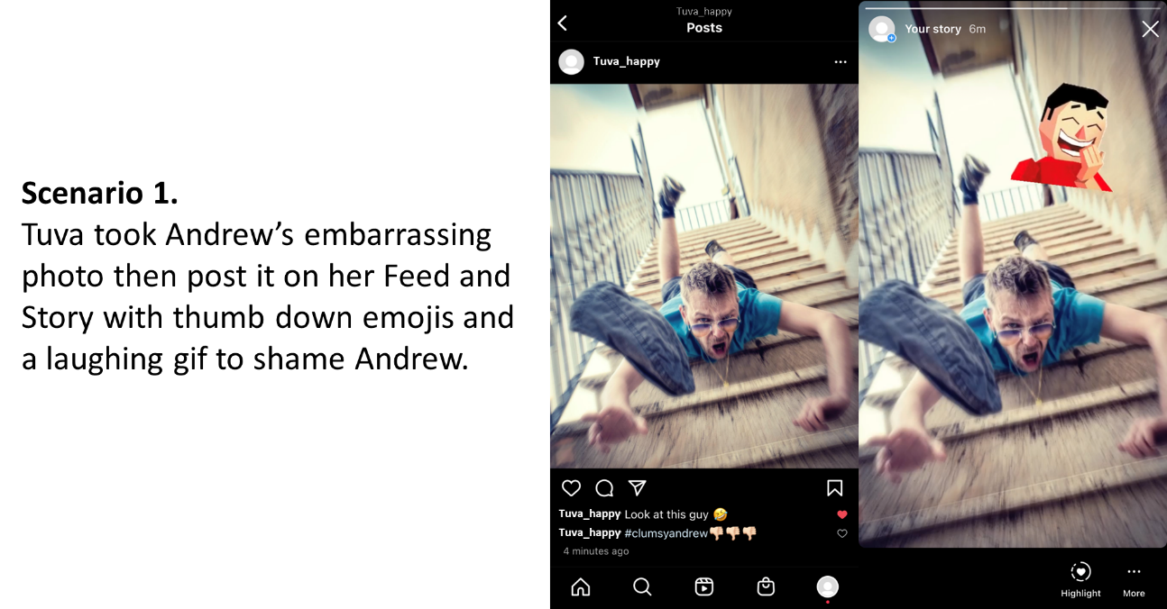
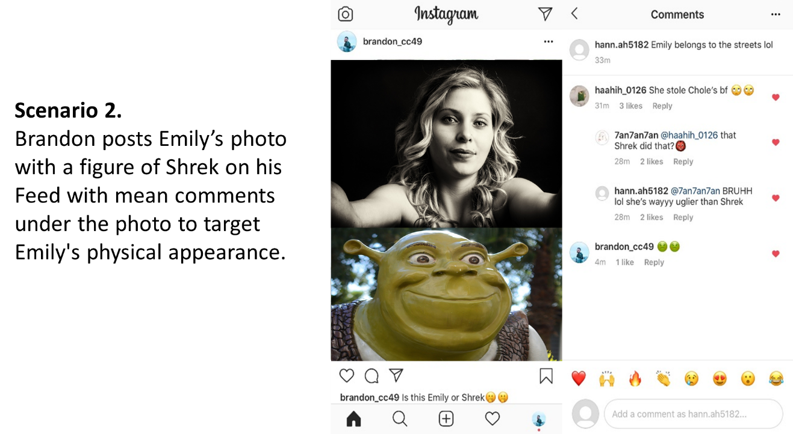

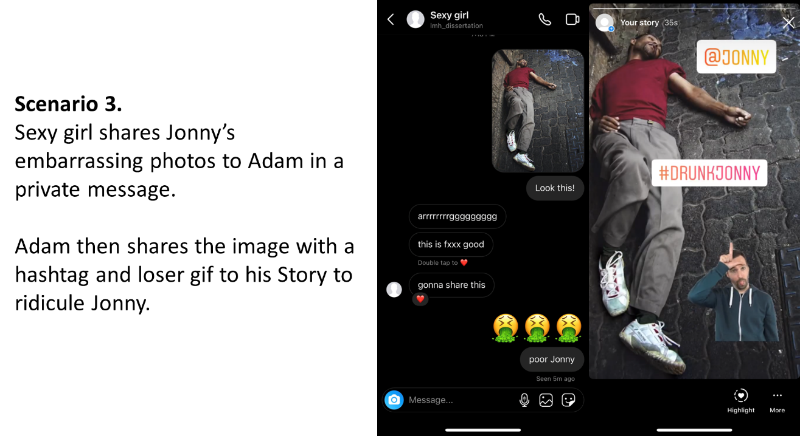

Interview Questions
1. What do you think about these scenarios?
1-1 Are any of them you think is cyberbullying?
1-2 What elements in that scenario(s) cause cyberbullying?

2-1 If these scenarios happened you, what would you think? how would you feel? what you might do?
2-2 If these scenarios happened your friend, what would you think? how would you feel? what you might do?
2-3 If these scenarios happened someone you don’t know, what would you think? how would you feel? what you might do?

3. In your word, what do you think is “visual cyberbullying”?

4. Do you think there is any policy at UT related to cyberbullying?
4-1 Do you know any cyberbullying policies at UT?
4-2 If you want to report a cyberbullying incident to the university, do you know how to report it?
4-3 How do you think UT should be involved if someone reports cyberbullying?

5. How do you think social media platform can do to reduce cyberbullying?
5-1 If you want to report a cyberbullying incident on Instagram, do you know how to report it?
5-2 How do you think users can do to avoid engaging in cyberbullying?

Visual narrative inquiry questions
1. Could you tell me what happened in that scenario/that real case?
1-1 What was the relationship between the perpetrator and the victim?
1-2 Do you know what the victim did/reacted on this incident?
1-3 Was the account a public one or a private one?
1-4 How did other people who witness this incident react on it?
1-5 Do you think this kind of incident often happens on Instagram?

2. What kind of social media features do you think might increase cyberbullying?

3. Is there anything else you would like to share in terms of visual cyberbullying?

Supplemental questions
1. These images were from a scholarly visual cyberbullying study. Do you think any of these images represents cyberbullying?
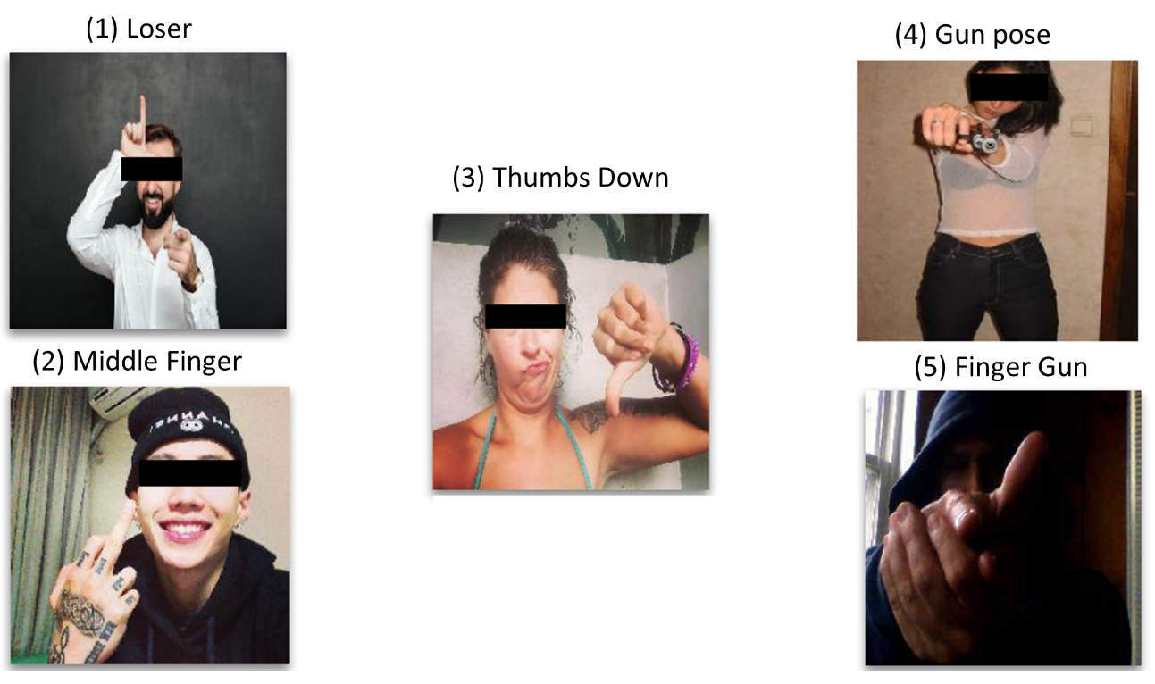

2. Have you ever witnessed any of these behaviors on social media in general? If yes, and if you feel comfortable to share, could you tell me what did you see?

2-1 Sharing/forwarding/spreading someone’s photos/videos that contain a sexual nature
2-2 Taking pictures/recording videos while a group laughs and forces another person to do something humiliating or ridiculous
2-3 Taking pictures/recording videos while someone hits or hurts another person
2-4 Taking pictures/recording videos of someone that contain a sexual nature
2-5 Using emojis as a form of ridicule
2-6 Using someone’s personal picture/video without permission
2-7 Sending (links of) humiliating images/videos

Appendix G-Reliability and Validity Report of Lee et al.’s (2017) Scales

 | Recommended | CBP | CBV | CBP-Visual/sexual | CBV-Visual/sexual
No. of items | N/A | 20 | 27 | 5 | 10
Reliability (α) | >.70 | .93 | .95 | .73 | .89
Factorial Validity
$$χ^{2}/df$$ | <3 | 1.97 | 2.86
CFI | >.90 | .95 | .97
TLI | >.90 | .94 | .95
RMSEA | <.08 | .08 | .08
SRMR | <.10 | .06 | .07
Convergent validity (γ) |  | .37** | .31** | .34** | .28**
CBP= Cyberbullying Perpetration Scale; CBV= Cyberbullying Victimization Scale
**p<.01

Appendix H-Qualitative Data Codebook

Code | Definitions | (κ)
1.Individual- Social media usage | Parent code: participants’ own usage of Instagram and other social media sites.
1.1 Instagram usage | Things participants usually do on Instagram. | 1.00
1.2 Social media usage | Different social media sites that participants usually use. | 1.00
2.Bystander General Attitude | Parent code: participants’ attitude toward hypothetical scenarios/real CB incidents as a bystander.
2.1 Cognitive attitude | Participants’ thoughts of hypothetical/real CB incidents as a bystander or as a hypothetical victim. | 0.98
2.2 Affective attitude | Participants’ feelings toward hypothetical/real CB incidents as a bystander or as a hypothetical victim. | 1.00
2.3 Behavioral attitude | Participants’ (possible)actions toward hypothetical/real CB incidents as a bystander or as a hypothetical victim. | 0.97
2.4 Definition | Participants’ own words of visual CB. | 1.00
2.5 Age related | Participants’ attitude toward age differences on visual CB. | 0.86
2.6 Gender related | Participants’ attitude toward gender differences on visual CB. | 0.90

Code | Definitions | (κ)
3.Victim Coping | Parent code: participants’ descriptions of victims’ coping strategies in real CB incidents.
3.1 Attribute on bully | Victims cognitively put responsibility of CB on the perpetrators. | 1.00
3.2 Attribute on victim | Victims cognitively put responsibility on themselves of being cyberbullied. | 1.00
3.3 Move forward; Ignore | Victims cognitively ignored the incident and move forward. | 1.00
3.4 Normalize | Victims cognitively considered CB is a normal phenomenon nowadays. | 1.00
3.5 Self-defeating humor | Victims joked on themselves about encounter in CB incidents. | 1.00
3.6 Think positively | Victims cognitively framed the CB incidents in an optimistic way. | 1.00
3.7 Victims’ feelings | Participants’ descriptions on victims’ emotional reaction. | 0.80
3.8 Avoid real life contact | Victims tried not to have face to face contact with perpetrators in their real life. | 1.00
3.9 Make disconnection | Victims blocked, unfriended, or unfollowed perpetrators on social media sites. | 1.00
3.10 Change account setting | Victims changed their social media account settings after being cyberbullied. | 1.00
3.11 Collect evidence | Victims saved evidence of perpetrators’ CB behaviors for further self-protection actions. | 1.00
3.12 Delete account | Victims deleted their social media account where they experienced CB. | 1.00
3.13 Delete comment/post | Victims deleted perpetrators’ CB comments or the original post. | *
3.14 Ignore it/do nothing | Victims behaviorally ignored the harmful contents on the social media sites. | 0.80
3.15 Leave the social media site | Victims stopped using social media sites after being cyberbullied. | 1.00
3.16 Be more precocious using ICTs | Victims were more aware of technology usage after being cyberbullied. | 1.00
3.17 Report to social media sites | Victims reported or asked others to report CB incidents to the social media site. | 1.00
3.18 Respond/confront the bully | Victims asked the perpetrators to stop the CB behavior, delete the contents, or seek revenge. | 0.92
3.19 Seek social support | Victims seek practical help by talking to someone trusted. | 0.80
3.20 Stop going online/posting online | Victims stopped going online or stopped posting on social media sites. | 1.00

Code | Definitions | (κ)
4. Perpetration- Transcript | Parent code: participants’ descriptions of perpetrators’ behaviors in real CB incidents.
4.1 Conduct | Perpetrators’ intensions of CB; how perpetrator used tech skills to CB | 1.00
4.2 Confidentiality | The privacy settings or poor personal information management mentioned in real CB incidents. | 1.00
4.3 Contact | The social relationship between perpetrators and victims | 0.90
4.4 Content | The format of CB content, e.g., picture, Gifs, emojis. | 0.93
4.5 Context | The venue of CB incidents, e.g., Story, Feed, direct message (DM) | 0.97
4.6 Age related | Perpetration behaviors related to age differences. | 0.93
4.7 Gender related | Perpetration behaviors related to gender differences. | 0.94
4.8 Victims’ background | The background information of victims in real CB incident, e.g., social media influencers | 0.96

Code | Definitions Agreement (%)
5. Perpetration-Visual inquiry | Parent code: CB elements showed in participants’ recreated scenarios and the associated narrative.
5.1 Content- Personal | Generic photos or contents, e.g., a profile picture. | 100
5.2 Content- Private | Visual content that the victim felt embarrassed or wanted to be keep secretly. | 100
5.3 Content- Alcohol/drug related | Visual content related to alcohol/drug or represents victims’ behaviors after consuming alcohol/drug. | 100
5.4 Content- Sextual related | Visual content in a sexual nature, e.g., nudity. | 100
5.5 Content- Caption | Captions of visual content in the recreated scenarios. | 100
5.6 Content- Check-in | Location check-in of visual content in the recreated scenarios. | 100
5.7 Content- Emoji | Emojis appeared in the recreated scenarios. | 100
5.8 Content- GIF | GIFs (graphics interchange format) appeared in the recreated scenarios. | 100
5.9 Content- Hashtags | Hashtags appeared in the recreated scenarios. | 100
5.10 Content- Tag | Tagging someone in the recreated scenarios. | 100
5.11 Context- Comments | CB behaviors presented through posting comments under an Instagram post. | 100
5.12 Context- Direct Message | CB behaviors presented through contacting victims in Instagram direct messages. | 100
5.13 Context- Fake account | CB behaviors presented through creating Instagram fake accounts targeting victims. | 100
5.14 Context- Feed | CB behaviors presented through posting a visual post on Instagram Feed. | 100
5.15 Context- Story | CB behaviors presented through posting a visual post on Instagram Story. | 100

Code | Definitions | (κ)
6. Microsystem | Parent code: personnel in the microsystem mentioned by participants
6.1 University personnel | Personnel affiliated with the university. | 1.00
6.2 Student organization | Usually related to fraternity and sorority and other similar student groups | *
6.3 Peers and friends | Peers and friends appeared in real CB incidents. | 0.81
6.4 Family member | Members in (victim’s) family. | 1.00
7. Mesosystem | Parent code
7.1 Cogni. on intervention practices | Participants’ cognitions on what/how university should intervene CB that happened to students. | 1.00
8. Exosystem | Parent code: Participants’ cognitions on CB regulations within the university; and on social media site.
8.1 Knowledge on university policy | Participants’ understandings of current CB related policies. | 1.00
8.2 Cognition on university policy | Participants’ thoughts of what/how university policies should address CB. | 0.96
8.3 Reporting (university) | Participants’ understandings/views /past actions related to the CB reporting system in the university. | 0.95
8.4 Reporting (social media) | Participants’ understandings/views/past actions related to the CB reporting system on social media. | 0.89
8.5 Safety practice on social media | Participants’ understandings/views of safety practice/function of social media. | 0.95
8.6 SM features increase CB | Participants’ views of social media feature that might worsen CB, e.g., anonymity. | 0.98
9. Macrosystem | Parent code: personnel in the microsystem mentioned by participants.
9.1 Social media norm | Participants’ view of CB prevalence/atmosphere on social media. | 0.95
9.2 Law enforcement | Participants’ views/Victims’ past actions in real CB incidents related to law/police engagement. | 1.00

Vita
Li-Min Huang is a PhD Candidate at the School of Information Sciences at the University of Tennessee. Her provisional dissertation title is " University Students’ Perspectives of Visual-based Cyberbullying on Instagram." Her dissertation chair is Dr. Dania Bilal.
She holds a bachelor's and a master's degree from the Department of Library and Information Science at National Taiwan University in 2012 and 2015. When she entered the doctoral program in late 2015, she heard a young actress in her hometown suicide after suffering from cyberbullying. Then she started to pay attention to the cyberbullying issue and brought it into her research agenda. Given the popularity of visually-based social media for the young generation, she considers it a vital need for academia to investigate the phenomenon of visually represented cyberbullying. Her long-term goal is to provide insights on visually-based cyberbullying preventions and interventions for practitioners.
Besides the cyberbullying topic, she has been working on research projects related to information behaviors, human and computer interaction, and social informatics. She currently involves a study that focuses on the cognitive and affective impact on information behaviors of fiction readers. She taught Technologies for Information Retrieval and Information Seeking: Resources and Strategies at the University of Tennessee.
Upon completion of her doctoral studies, she will continue her academic career back to her home country, Taiwan.

The authors used children, young people and young adults as search queries but did not clarify the age.
Since a study may be cited in various sections in the literature review, I provide the detailed information in Table 2 but will not report the information in each narration associated with a citation.
Percentage of victimization
Percentage of perpetration
Percentage of engaging in both victimization and perpetration
Percentage of witnesses
Percentage of participant with other sex identities
This study is a cross-age study that include middle school students, university students and working adults
Harassment: 10-15%; Unwanted pornography: 58.7%
Percentage of participant with other sex identities
Percentage of victimization
Percentage of perpetration
Percentage of engaging in both victimization and perpetration
Percentage of witness
Male=57.4%; Female=54.4%
Victimization via online interactions=54%; Victimization via cell text=37%
For example, a friend of you on Facebook, maybe the two of you join the same Facebook group, but do not know each other’s real identity offline
The authors in this study only provided Mean
These two studies are listed in the reference but not included in Table 2.
Some cited studies in this section are already included in Table 2. For these studies, I will not report detail information on their sample population.
This number was provided by the Data Central. The enrollment data on UTK Fact Book is still based on Fall 2021.
The instrument is described in the next section
The license of QuestionPro for UTK was ended on May 31, 2022
The place like one will see the posts, it is like the “Wall” on Facebook.
The place that any content will disappear in 24 hours.
The function that allows users to contact with others privately, it is like the Messenger.
The latest released function that allows users to create and edit short video clips that up to 90 seconds.
The video function that allows users to be live on Instagram.
The reliability of CBP and CBV are stratified α= .93 and α=.95, which is high (Brown, 2015).
The factorial validity of respecified model from the confirmatory factor analyses (CFA) are $χ^{2}/df$ =1.97 and 2.86 (CBP and CBV, respectively); CFI=.95 and .97; TLI=.94 and .95; RMSEA=.08 and .08; SRMR= .06 and .07, respectively (See Table 4). These numbers represent a good model-data fit (Kline, 2015).
The convergent validity was determined by comparing the variables in CBP and CBV with related variables or constructs with the existing scales (i.e., Aggression Questionnaire and Multidimensional Peer Victimization Scale). The correlation between CBP and Aggression Questionnaire (developed by Buss & Perry, 1992) is significant (γ=.37), while the correlation between CBV and the Multidimensional Peer Victimization Scale (developed by Mynard & Joseph, 2000) is significant as well (γ=.31).
Based on the expert panelists’ comments in Lee et al. (2017), some item concepts on visual cyberbullying and sexual cyberbullying overlap. Thus, Lee et al. combined these two constructs into the Visual/sexual subsection.
CBV-Visual/sexual (10 items, α=.89), includes more items for measuring these behaviors and has a higher reliability score than CBP-Visual/sexual (5 items, α=.73),
Written informed consent was waived by UTK IRB. See Appendix E for the Research Information that was provided to participants.
The Instagram app allows users to log in multiple accounts at the same time on a single device.
This question is a 3X3 matrix that includes nine sub-questions. Participants were asked one sub-question at a time, starting from “If these scenarios happened to you, what would you think?”.
Since participants recreated scenarios based on a real cyberbullying case, this question asks about the scenarios as well as the real cases.
https://help-nv.qsrinternational.com/20/mac/Content/about-nvivo/whats-new.htm
https://help-nv11.qsrinternational.com/desktop/procedures/run_a_coding_comparison_query.htm
Examples include but not limited to image, photo, video

