The Effects of ActiGraph Bandpass Filtering on Continuous and Intermittent Lifestyle Activities

A Thesis Presented for the
Master of Science
Degree
The University of Tennessee, Knoxville

Samuel Robert LaMunion
August 2016
DEDICATION

I would like to dedicate this thesis to my family, friends, and faculty. I would not have been able to achieve this accomplishment without your consistent love and support throughout. Thank you to my family for never doubting me, thank you to my friends for being there to celebrate when the time was right and to pick me up after failures, and thank you to my faculty for providing me with all of the resources and instruction to help me succeed both in and out of the classroom.

ACKNOWLEDGEMENTS

I would like to acknowledge and express my gratitude to all three of my committee members. Dr. Eugene Fitzhugh who always asked hard questions and pushed me to think outside the box on areas I’m less comfortable with. Dr. David Bassett for providing guidance and wisdom and for continuously helping me learn more. Dr. Scott Crouter, my major professor, for helping me find my place in the lab and get started with research early on so I had the chance to accomplish as much as possible during my time here and for teaching me constantly, you’ve been a great mentor to me and I know you will continue to be. I have truly enjoyed working with all of you and I am excited for what the future holds both in my time here at Tennessee and beyond thanks to all of you. You have all touched my life in an incredible way and shown me what I am truly capable of.
I would also like to acknowledge Dr. Brian Parr for the impact he had on not only my undergraduate education but my entire career as a student and professional. You sparked my interest in Exercise Physiology and taught me all the necessary skills I needed to succeed at the next level. Thank you for going above and beyond to help me get the most of my education and for preparing me for what was to come. You have been a tremendous professor, mentor, and friend.

ABSTRACT

PURPOSE: The purposes of this study were to 1) explore how increasing the bandpass filter frequency affected counts collected during treadmill walking and running, car driving and varying intensity lifestyle activities 2) investigate to see if increasing the bandpass filter would reduce the plateau in counts with increasing intensity during treadmill running, 3) explore how increasing the bandpass filter affected sedentary activities such as car driving with the low frequency extension (LFE) feature turned on, and 4) investigate to see if there was a plateau in counts for moderate to vigorous lifestyle activities. METHODS: This study was divided into two parts. Part A included treadmill walking and running plus car driving and included twenty participants (mean ± SD; age, 24.4 ± 3.4 years; Body Mass Index (BMI, 26.4 ± 3.3 kg/m²). Part B included ten lifestyle activities selected to represent light, moderate, and vigorous intensity physical activity and included thirty participants (mean ± SD; age, 23.0 ± 2.3 years; BMI, 25.1 ± 3.8 kg/m²). Each participant wore an ActiGraph accelerometer on the hip. The GT3X+ was used for walking, running, and car driving and the GT9X was used for lifestyle activities. Participants performing the lifestyle activities had oxygen consumption simultaneously measured using the Cosmed K4b² portable indirect calorimeter. Acceleration data were processed using a beta version of Actilife containing additional bandpass filter frequencies (5.0 Hz and 9.0 Hz) beyond the default filter. Data were converted to five second epochs and the low frequency extension feature was turned on. Cosmed data (VO₂ ml/min) were averaged over 30-second increments and then converted to relative VO₂ (ml/kg/min) for each activity. These values were then converted to metabolic equivalents (METs). RESULTS: Using a 9.0 Hz bandpass filter reduces the effects of the plateau phenomenon for treadmill walking and running and also improves the R² by 0.40 from the default for axis 1 and 0.37 for vector magnitude. Using a 9.0 Hz bandpass filter significantly increases count values for car driving for all axes and vector magnitude. Counts do increase significantly as the bandpass filter is increased for lifestyle activities but no discernable plateau in counts is seen. For the full routine of activities, the default filter produces the strongest association while the 5.0 Hz filter produces the strongest associations for lifestyle activities and the 9.0 Hz filter produces the strongest associations for locomotive activities. CONCLUSION: The plateau effect can be reduced by increasing the bandpass filter. Increasing the bandpass filter will significantly change counts for car driving. Increasing the bandpass filter causes a diverging of the regression lines for locomotive and lifestyle activities reducing the strength of association for the full routine but increases the strength of association when split out individually. The default bandpass filter works best for the full routine, 5.0 Hz for lifestyle activity, and 9.0 Hz for locomotive activity.

Key Words: Accelerometer; Indirect Calorimetry; Energy Expenditure, Physical Activity Counts

TABLE OF CONTENTS

CHAPTER I: INTRODUCTION
Statement of the Problem 13
Statement of the Purpose 14
Research Questions and Hypotheses 15
Delimitations 15
CHAPTER II: REVIEW OF LITERATURE
Introduction 16
Criterion Measures of Energy Expenditure 17
Measurement of Physical Activity – Subjective and Objective Methods 20
Validation of Energy Expenditure Prediction Equations 23
Plateau Phenomenon 32
CHAPTER III: MANUSCRIPT
Introduction 35
Methods 37
Results 41
Discussion 62
LIST OF REFERENCES 66
APPENDIX 72
Informed Consent Form 73
Physical Activity Readiness Questionnaire (PARQ) 76
VITA 77

LIST OF TABLES

Table 1. Characteristics of participants - walking, running, and car driving. Values are mean ± SD 41
Table 2. Characteristics of participants – lifestyle activities. Values are mean ± SD 41
Table 3. Treadmill walking and running ActiGraph GT3X+ mean hip axis 1 counts 42
Table 4. Treadmill walking and running ActiGraph GT3X+ mean hip axis 2 counts 42
Table 5. Treadmill walking and running ActiGraph GT3X+ mean hip axis 3 counts 43
Table 6. Treadmill walking and running ActiGraph GT3X+ mean hip vector magnitude counts 43
Table 7. Mean measured metabolic equivalents by activity. Values are mean ± SD. 46
Table 8. Lifestyle activities ActiGraph GT9X mean hip axis 1 counts 46
Table 9. Lifestyle activities ActiGraph GT9X mean hip axis 2 counts 47
Table 10. Lifestyle activities ActiGraph GT9X mean hip axis 3 counts 47
Table 11. Lifestyle activities ActiGraph GT9X mean hip vector magnitude counts 48

LIST OF FIGURES

Figure 1. ActiGraph GT3X+ mean hip counts per 5 seconds by bandpass filter: A) axis 1, B) axis 2, C) axis 3, D) vector magnitude 44
Figure 2. ActiGraph GT3X+ mean counts per minute bandpass filter by axis – hip car driving 45
Figure 3. Relationship between ActiGraph GT9X means counts per 5 seconds versus measured energy expenditure [metabolic equivalents (METs)] for hip axis 1 by bandpass filter frequency – full activity routine: A) Default, B) 5.0 Hz, C) 9.0 Hz 50
Figure 4. Relationship between ActiGraph GT9X means counts per 5 seconds versus measured energy expenditure [metabolic equivalents (METs)] for hip axis 2 by bandpass filter frequency – full activity routine: A) Default, B) 5.0 Hz, C) 9.0 Hz 51
Figure 5. Relationship between ActiGraph GT9X means counts per 5 seconds versus measured energy expenditure [metabolic equivalents (METs)] for hip axis 3 by bandpass filter frequency – full activity routine: A) Default, B) 5.0 Hz, C) 9.0 Hz 53
Figure 6. Relationship between ActiGraph GT9X means counts per 5 seconds versus measured energy expenditure [metabolic equivalents (METs)] for hip vector magnitude by bandpass filter frequency – full activity routine: A) Default, B) 5.0 Hz, C) 9.0 Hz 54
Figure 7. Relationship between ActiGraph GT9X means counts per 5 seconds versus measured energy expenditure [metabolic equivalents (METs)] for hip axis 1 by bandpass filter frequency – locomotive only: A) Default, B) 5.0 Hz, C) 9.0 Hz 55
Figure 8. Relationship between ActiGraph GT9X means counts per 5 seconds versus measured energy expenditure [metabolic equivalents (METs)] for hip axis 2 by bandpass filter frequency – locomotive only: A) Default, B) 5.0 Hz, C) 9.0 Hz 56
Figure 9. Relationship between ActiGraph GT9X means counts per 5 seconds versus measured energy expenditure [metabolic equivalents (METs)] for hip axis 3 by bandpass filter frequency – locomotive only: A) Default, B) 5.0 Hz, C) 9.0 Hz 57
Figure 10. Relationship between ActiGraph GT9X means counts per 5 seconds versus measured energy expenditure [metabolic equivalents (METs)] for hip vector magnitude by bandpass filter frequency – locomotive only: A) Default, B) 5.0 Hz, C) 9.0 Hz 58
Figure 11. Relationship between ActiGraph GT9X means counts per 5 seconds versus measured energy expenditure [metabolic equivalents (METs)] for hip axis 1 by bandpass filter frequency – lifestyle only: A) Default, B) 5.0 Hz, C) 9.0 Hz 59
Figure 12. Relationship between ActiGraph GT9X means counts per 5 seconds versus measured energy expenditure [metabolic equivalents (METs)] for hip axis 2 by bandpass filter frequency – lifestyle only: A) Default, B) 5.0 Hz, C) 9.0 Hz 60
Figure 13. Relationship between ActiGraph GT9X means counts per 5 seconds versus measured energy expenditure [metabolic equivalents (METs)] for hip axis 3 by bandpass filter frequency – lifestyle only: A) Default, B) 5.0 Hz, C) 9.0 Hz 61
Figure 14. Relationship between ActiGraph GT9X means counts per 5 seconds versus measured energy expenditure [metabolic equivalents (METs)] for hip vector magnitude by bandpass filter frequency – lifestyle only: A) Default, B) 5.0 Hz, C) 9.0 Hz 62

CHAPTER I: INTRODUCTION

Research has shown that being physically inactive across the lifespan can be detrimental to overall health. Physical inactivity has been linked to increased risk for development of non-communicable diseases, negative health consequences, and even premature death in some cases (29, 30, 36). Physical activity research is conducted in both healthy and diseased adult populations to develop general guidelines that when met can help adults achieve and maintain a healthy quality of life. These recommendations include performing a minimum of 150 minutes, or an equivalent amount, of moderate intensity aerobic activity per week to achieve most health benefits (1, 36). Despite the guidelines only recommending 150 minutes of physical activity per week, most U.S. adults do not reach that threshold. For instance, Troiano et al. (53), found when examining a sample of U.S. adults that less than 5% of the population were not meeting the recommendations for physical activity when data were broken down into 8-10 minute bouts. Between adults not getting enough physical activity and free-living physical activity being difficult to measure, more research must be conducted to help improve the measurements of free-living activity.
Researchers, using a variety of methods to measure physical activity, are able to establish guidelines for health, as well as gain insight into the metabolic requirements of various activities for locomotion and free-living activities. Historically, researchers have used short recall questionnaires and physical activity surveys and logs to get an estimate on how much physical activity was performed (57). These methods, while inexpensive and easy to administer leave too much variability to accurately estimate energy expenditure or intensity (57). The standard in measuring physical activity in recent years has shifted to using more objective measurement techniques that are better at measuring intensity and duration and estimating energy expenditure (57).
There are several criterion measures for developing energy expenditure prediction equations using objective monitors to measure physical activity. These methods include the doubly labeled water method, indirect calorimetry and direct observation. Of those measures, the gold standard of measuring free-living energy expenditure is the doubly labeled water method. This method while being very effective for measuring total daily energy expenditure does not allow for specific details related to type, duration, intensity, or frequency of physical activity in free-living settings. This method is also relatively expensive and is therefore not an option for many physical activity measurement validation studies (22). A second method for measuring energy expenditure is indirect calorimetry which involves gas exchange analysis through capturing ventilatory data during physical activity while wearing a mask over the nose and mouth. This method allows for physical activity energy expenditure to be calculated for an exact time frame and is often used to validate energy expenditure estimations made using other methods. An additional validation method that is used to further classify intensity of an activity or estimate energy expenditure is direct observation. This method is inexpensive and is used to validate time spent performing an activity but it is not ideal for classifying the intensity of an activity.
Motion sensors provide an additional method for measuring physical activity intensity, frequency, and duration and they can be used to estimate energy expenditure using the real-time data collected (4, 18, 57). Researchers have found that no one sensor can capture all data necessary to provide a clear snapshot of physical activity but they do allow researchers to forgo less precise methods previously used to gather physical activity information (18). One wearable monitor that uses motion sensor technology is an accelerometer. These devices are small, non-invasive, and can be worn for extended periods of time (4, 6, 18, 55). Accelerometers are traditionally worn on the hip attached to an elastic or nylon belt but can also be worn on the wrist, ankle, thigh, and other locations. This type of technology has evolved greatly in the last decade moving from uniaxial accelerometers, basic heart rate monitors, and pedometers to multiple sensor units that can collect all of that same data with sensors housed in just one unit. For example, most current generation accelerometers contain a triaxial accelerometer that measures acceleration in three planes, anteroposterior (z-axis), mediolateral (x-axis) and vertical (y-axis). This is an improvement from older generations that featured a uniaxial accelerometer that only measured acceleration in a single vertical plane.
Accelerometers work by measuring the magnitude of acceleration and deceleration of the body. This data is typically collected at a set frequency (e.g. 30 Hz). This frequency is preset when the device is initialized meaning all acceleration data captured will be recorded at this frequency and then filtered through what is known as a low pass filter in order to reduce the noise in the acceleration signal. After passing through the low pass filter, data is considered to be raw data. The raw data is used in some cases but more commonly, the raw data is converted into what are known as activity counts (10). These counts can be broken down by the minute or even into smaller intervals down to the second. These time blocks are known as epochs (10). These more refined time stamped activity counts can be used to develop regression models and energy expenditure prediction equations when paired with measured energy expenditure data from a criterion measure, most often indirect calorimetry.
In order to obtain a count per epoch value acceleration data can be filtered through what is known as a bandpass filter which only allows acceleration signal that falls within a preset frequency range to be recorded (10). This filter frequency varies based on the device that is used with some devices having a low filter frequency while others have a higher filter frequency. This accounts for some of the variability in the energy expenditure estimations across devices. This difference can account for additional acceleration to be recorded on the low end of the spectrum through activities such as driving or computer work. The wider the bandpass frequency filter range, the more sensitive the device is to recording a broader range of acceleration signal which will directly affect counts. An example of this is provided by work conducted by John et al., (24, 26) with the ActiGraph GT3X+ and the Actical as well as the ActiGraph and the GENEA. These devices have different filter frequency ranges with the ActiGraph using a filtering range of 0.25-2.5 Hz and the Actical using a higher filtering range of 0.5-3.0 Hz while the GENEA is open source and programs can be created through software such as Matlab (Matlab, Mathworks, Natick, MA) to establish bandpass filter ranges. An example of this process can be seen in the work done by Schaefer et al., in 2014. (48) that increased range for the Actical causes less acceleration to be filtered out while the ActiGraph filters out more acceleration (24, 26).
There has been substantial research conducted to establish the use of accelerometers as a valid and reliable method for estimating energy expenditure and measuring physical activity (5, 25). One of the more commonly used accelerometers is made by ActiGraph (Pensacola, FL). Researchers have shown that energy expenditure equations are most valid and reliable for the activities that were used to develop the equation meaning that an equation developed using walking and running data will underestimate energy expenditure for lifestyle activities (12, 13). Several researchers have identified that while ActiGraph counts increase linearly up to about 6 miles per hour (10 km/hr) at which point the counts begin to level off and eventually begins to decrease as speed continues to increase beyond this threshold. This is known as the inverted-U phenomenon (7, 21, 25, 43).
Since counts are used to predict energy expenditure, any alteration of the count values will directly impact the way energy expenditure is predicted. Therefore if count values are leveling off or decreasing as intensity is increasing then the estimation of energy expenditure will result in an underestimate as is seen in the John et al. (25) study. While energy expenditure was not estimated in the study, a clear plateau and decline in counts was seen beyond running at 10 km/hr. Researchers believe that the inverted-u phenomenon is partly due to the bandpass filter frequency ActiGraph uses (7, 21, 25, 43). It has been hypothesized that manipulating the bandpass filter frequency ActiGraph uses could alter count values generated potentially leading to a reduction in the plateau effect (7, 25). This could lead to the count values having a more linear relationship with intensity.
Statement of the Problem
The inverted-u phenomenon is known to occur occurs specifically when examining activity counts from a device placed on the hip (25). This statement was made in reference to the use of a uniaxial accelerometer. Researchers initially hypothesized that when using a triaxial accelerometer such as the ActiGraph GT3X+ that the acceleration would not decrease at the anteroposterior (z-axis) and mediolateral (x-axis) axes like they do at the vertical axis (y-axis) (7). With the anterioposterior and mediolateral axes not being affected by the inverted-U phenomenon, it was further hypothesized that using vector magnitude counts (VM) would not display the effects of the plateau effect (7, 25).
The intensity and acceleration that occurs when running at approximately 6 mph occurs frequently when performing other moderate intensity lifestyle activities such as playing basketball or tennis so it has been hypothesized that this same effect is occurring at the hip for these activities as well and that is one of the primary focuses of this study. The lifestyle activities could potentially be affected by the change in bandpass filter frequency similarly to walking and running because at intermittent points during the lifestyle activities acceleration generated can be equal to or greater than the acceleration generated when running at 6 mph. The aims of this study are split into two parts.
- Treadmill Walking and Running
- Aims to reduce the inverted-U phenomenon that occurs during treadmill walking and running and car driving by opening up the bandpass filter frequency.
- Lifestyle Activity
- Aims to investigate whether lifestyle activities also exhibit this phenomenon and if altering the bandpass filter frequency can reduce the effects of the inverted-u phenomenon if it occurs during lifestyle activity.
Statement of Purpose
The primary purpose of this study is to investigate if the plateau effect of activity counts is occurring while performing moderate intensity lifestyle activities that have approximately the same acceleration values as running at 6 mph and beyond. A secondary purpose of this study is to determine that if altering the band pass filter for the acceleration data collected at the hip will affect the relationship with measured energy expenditure estimation during those activities.

Research Questions
Question 1: Does increasing the bandpass filter frequency for acceleration data collected at the hip reduce the plateau in counts during walking, running, and car driving?

Hypothesis 1: It is hypothesized that increasing the bandpass filter frequency will reduce the plateau in counts during walking, running, and car driving.

Question 2: Are counts generated from performing various intensity lifestyle activities affected by the plateau effect? If so, will increasing the bandpass filter frequency reduce the plateau during these activities?

Hypothesis 2: It is hypothesized that counts generated while performing various intensity lifestyle activities will be affected by the plateau effect. It is also hypothesized that increasing the bandpass filter frequency will reduce the plateau effect during these activities.

Question 3: Does changing the frequency of the bandpass filter change the relationship between estimated and measured energy expenditure?

Hypothesis 3: It is hypothesized that increasing the bandpass filter frequency will change the relationship between estimated and measured energy expenditure.

Delimitations
1. Participants shall be between 18-65 years
2. Participants must be able to answer “No” to all questions on a PAR-Q.
3. Participants will be excluded if they are obese, pregnant, or have orthopedic or musculoskeletal issues that would limit activity.
Limitations
1. Participants will be exposed to some risk inherent to vigorous intensity PA, and are expected to answer the PAR-Q truthfully.
2. Weather and campus events may interfere with outdoor activities.
3. Reasonable time commitment for participants will limit the total duration of data collection; data should be collected within one hour and thirty minutes.

CHAPTER II: REVIEW OF LITERATURE
Introduction
Physical activity is defined as any bodily movement that requires the contraction of skeletal muscle which in turn increases energy expenditure above the resting value (9). Physical activity measurement has been of interest to researchers, physiologists, and epidemiologists alike for decades because of the implications of physical inactivity and related negative health outcomes such as chronic disease associated morbidity and mortality. Examples of these outcomes are summarized in a pair of reviews by Kokkinos et al. (29, 30). These reviews document the close inverse association between physical activity and fitness with chronic disease and overall mortality (29, 30). Chronic diseases highlighted by these reviews include Type 2 diabetes mellitus, obesity, and hypertension to name a few of the most common and also most prevalent conditions in U.S. adults. These reviews contrast one another by highlighting the detriments of physical inactivity on health across the lifespan compared with the health benefits gained from performing adequate levels of physical activity and the reduced mortality risk associated with it.
Troiano et al. (54) found that U.S. adults do not participate in enough physical activity. These results are found through nationally representative population surveys such as the National Health and Nutrition Examination Survey (NHANES). An example of this is seen in the 2003-2004 NHANES data analyzed by Troiano et al. (54) that was collected using accelerometers and was the first objective measurement of physical activity in a national survey. These data provided much insight into how much physical activity U.S. adults were getting from a method other than self-report. These findings were in contrast to the self-report data from other representative population surveys that found anywhere from 25-33% of U.S. adults were meeting the recommendations based on self-report. These findings call into question the reliability of the self-report measurements as well as how accurately the accelerometers are assessing physical activity. Additional evidence of this is seen in a 2011 paper by Tucker et al., (57) that showed similar lack of adherence to the Physical Activity Guidelines for U.S. Adults with less than 10% of American adults meeting the recommendation of 150 minutes of moderate or an equivalent amount of vigorous activity per week when measured by accelerometer. This is in stark contrast to the self-report data for the same population which showed over 60% meeting the recommendation (57).
There is a clear divide between the amount of physical activity being self-reported and the amount of physical activity being measured by accelerometers and with this being the case, researchers have set out to develop more accurate methods for using accelerometers to measure physical activity and estimate energy expenditure. The purpose of this review of literature is to examine further how physical activity and energy expenditure are measured, the validity and reliability of these methods, and lastly how accelerometers are used to estimate energy expenditure.
Criterion Measures of Energy Expenditure
Doubly Labeled Water
The doubly labeled water (DLW) method is the criterion measure for free-living energy expenditure. Originally developed for use in animals, this method was refined and approved for use in human subjects and has been found to be useful but somewhat cost inefficient in most situations. The DLW method involves taking a dose of ²H¹⁸O isotope water that is proportional to the amount of total body water a participant has which is often approximately 60% of total body weight. The loaded dose of DLW equilibrates with the body water within a few hours and over the course of one to several weeks is used to determine total energy expenditure. This is determined through the examination of bodily fluid, most commonly urine. The isotopes are excreted as carbon dioxide and water at different rates as energy is expended. Water is excreted through the body in several forms including urine and sweat whereas carbon dioxide exits only through expired breath. This being the case, the ¹⁸O isotope exits the body more quickly than the ²H isotope. The difference in rate at which the isotopes are lost from the body is used to determine the rate and amount of carbon dioxide produced and this in turn is used to estimate energy expenditure (38).
It has been noted that the DLW method is between 92-98% accurate for measuring total daily energy expenditure based upon the dosage level taken and amount of time given to expire (50). While this method is reliable and valid, many researchers are interested in more refined measures of energy expenditure that can be narrowed down to a more precise time period or interval rather than the broad total energy expenditure values obtained using the DLW method.
Room Calorimetry
Room calorimetry measures energy expenditure using an open circuit system that measures total daily energy expenditure. This measure includes the thermic effect of food, basal metabolic rate, resting energy expenditure and individual activity energy expenditure (32). This type of system is useful but for most research unfeasible. A room calorimetry system is very costly, often times a million dollars in addition to requiring a trained technician to run the system plus maintenance. For this reason, in addition to the fact that behavior is altered from normal daily life, these systems are not used as often. As useful as these systems are, Seale and Rumpler (51) concluded that room calorimetry underestimates total daily energy expenditure by 2-8% and they recommend using the DLW method instead when applicable.
Indirect Calorimetry
Indirect calorimetry involves measuring gas exchange, specifically the amount of oxygen consumed and carbon dioxide produced. These measurements allow a ratio to be calculated, the respiratory exchange ratio, which indicates which metabolic substrate is being used. Stationary metabolic carts such as the ParvoMedics metabolic cart are often used when performing exercise tests to obtain a measure of energy expenditure but due to their lack of portability they are limited to controlled, lab based activities such as treadmill walking and running and cycle ergometry. Portable versions of the metabolic cart have been developed and they too use indirect calorimetry for measurement. Two popular devices are the Cosmed K4b² and the Oxycon Mobile. Both devices have been validated as a reliable method of measuring energy expenditure and are both useful especially in free-living situations (2, 34, 39, 43). These devices use a facemask and tubes to capture expired gas for analysis. These tubes run into a battery powered unit that reads and records the values obtained during collection.
Cosmed K4b²
The Cosmed K4b² (Cosmed, Rome, Italy) is a portable indirect calorimeter (170 x 55 x 100 mm) that provides measures of oxygen consumption (VO₂) and carbon dioxide production (VCO₂). The Cosmed system has two units, a gas analyzer unit that is affixed to the chest and a battery unit that is affixed to the back, both via a manufacturer designed harness. The device is lightweight (approximately 800 grams) and is accompanied by a facemask that covers the mouth and nose for inspired and expired air collection. The Cosmed K4b² is valid for measuring oxygen consumption during physical activity (34, 39). In order to initialize the device there are four calibration steps to run through before each use. The calibration process involves a room air calibration using the temperature and relative humidity of the room as well as a known reference gas calibration with a specialized gas mixture 15.98% O2 and 4.008% CO2 (11). In addition to this, a turbine calibration is performed using a 3 L Hans Rudolf syringe. Lastly, a delay calibration is conducted to account for any delay that may occur between exhalation and measurement by the gas analyzer sensors (11).
Measurement of Physical Activity: Self-Report and Objective Methods
Self-Report Methods
Self-report measurements of physical activity have long been used in research for their practicality, feasibility, low cost, and general familiarity and acceptance in most populations (23, 46). Self-report methods include survey instruments, recall questionnaires, diaries and logs, all of which involve the subjective response that varies with each participant (23, 46). This subjectivity leaves room for large amounts of fluctuation in responses which leads to discrepancies in the types of activities being performed and at what intensity (23, 46). Comparisons between self-report methods and more direct measurements have been made in work by Prince et al. (42) who compiled an exhaustive review of these comparisons. Prince et al. (42) found that on average, accelerometers were used most often to directly measure physical activity and that the mean percent difference between self-report physical activity and the accelerometer measured physical activity was 44%. Correlations between self-report methods and directly measured methods varied greatly (-0.71 to 0.96) with the majority being low-to-moderately correlated (42).
Accelerometer Methods
Accelerometer-based monitors are used in physical activity research as a means of objectively measuring physical activity. Researchers have identified multiple advantages to using an accelerometer for physical activity measurement. These advantages include more specific information related to volume, frequency, intensity, and time spent in physical activity in activities of daily living in contrast to the DLW method which can provide accurate energy expenditure measurement over longer periods of time. A combination of these methods is recommended for best outcomes (41). It is noted that it is rarely feasible and that energy expenditure prediction equations derived from the DLW measurements are sufficient in most cases as they are found to be valid (41).
Acceleration data has been used to develop prediction equations for energy expenditure including everything from locomotive activities such treadmill walking and running to activities of daily living such as sweeping and cleaning as well as recreational sports like tennis and basketball. Accelerometers measure and store the magnitude of acceleration and deceleration and this raw acceleration signal can be processed and filtered using bandpass filters to provide researchers with output that can be interpreted to determine time spent in different activities as well as the intensity at which an activity is performed. There are a variety of prediction equations that exist in the literature, all of which are developed using a specific set of activities. Some equations are walking and running specific and valid only for those activities while others are more encompassing as they were developed using a more diverse routine of activities. Accelerometers have been widely used in the literature with models such as the ActiGraph even being used in nationally representative studies such as NHANES.
Accelerometer technology has evolved over time with early uniaxial (vertical axis) devices measuring acceleration in a single plane. Current models have triaxial accelerometers in addition to other sensors such as magnetometers to measure direction, gyroscopes to measure rotation, and even thermometers to measure temperature. Accelerometers operate based on a mechanical sensing element that is generally comprised of a seismic mass that is mechanically suspended (59). The mass is then acted on by inertial forces from both gravity and acceleration and the displacement of the mass is measured electrically and that is the raw acceleration signal recorded and stored on the device (59). The most commonly used types of accelerometers are piezoresistive, piezoelectric, and differential capacitive models.
The raw acceleration signal also known as device output is recorded and stored by the accelerometer and can be downloaded and post-processed so it can be reported in a usable understandable format most often referred to as counts. Data are usually reported as counts per unit of time, most commonly referenced as counts per epoch (e.g. Counts per 30 seconds) and this gives a frame of reference for the intensity at which an activity was performed during a specific time period. The processing of the raw acceleration signals for each device vary as the filtering of the signal is done differently across devices with much of the process being proprietary. This allows for little direct comparison across devices when using counts.
There have been many energy expenditure prediction equations developed using accelerometers with some being more frequently used than others. Some examples are the Freedson 1998 (20) and Swartz 2000 (53) equations both of which use a linear regression between measured energy expenditure via calorimetry to the predicted energy expenditure calculated using counts collected using the accelerometers. These equations were developed using a CSA accelerometer, now known as ActiGraph, which is one of the more commonly studied research devices. ActiGraph has produced several generations of accelerometers that have been researched heavily and have been shown to perform reliably and provide valid results when compared to criterion measures. de Vries et al (17) reported that the ActiGraph models were the most studied physical activity monitor and the literature supported the continued use of ActiGraph devices.

Validation of Energy Expenditure Prediction Equations
Validation of energy expenditure prediction equations is vital to ensure the proper performance and function of a device to collect reliable data for the activities on which the equations were developed. One of the main issues with equation validation is the wide variety of protocols used by researchers. The most common criterion measure that equations are validated against is indirect calorimetry since it can be used in free-living situations and provide measures of energy expenditure in small time intervals as well as provide information related to intensity of physical activity. This method is often used for validation procedures lasting for a few hours with anything longer than that requiring use of the DLW method. While indirect calorimetry is more cost effective, the gold standard for energy expenditure equation validation is the DLW method.
Plasqui and colleagues (40, 41) conducted reviews of the work done validating energy expenditure prediction equations against the DLW method. These reviews intended to identify the best DLW derived energy expenditure equations and corresponding accelerometer models to assess physical activity during free-living activities. In 2007, Plasqui et al. (41) identified a total of 28 studies highlighting 8 different accelerometer models. Of these models, the CSA/MTI/ActiGraph was one of the two most extensively validated devices along with the Tracmor. The authors note that many of the other devices including the Lifecorder, Caltrac, Actiwatch AW16, Tritrac-R3D, and ActiReg, performed poorly and had little to no correlation for count values and obtained from the devices and energy expenditure (41). In 2013, Plasqui and colleagues (39), reviewed additional models of accelerometers validated against the DLW method including 25 studies published between 2007 and 2011 that highlighted 18 different models of accelerometers from 15 different manufacturers. There was high variability found among devices with correlations ranging from 0.06 for the Lifecorder between physical activity level and activity counts up to 0.91 for the Actiheart when predicting Total Energy Expenditure (TEE) after correcting for participant characteristics (40). These reviews highlighted that the ActiGraph was the most validated accelerometer and that when used to predict Activity Energy Expenditure (AEE) accounting for body mass the correlation with activity counts was 0.37 (40, 41). The sample populations for the studies reviewed were broad and included participants of all age groups, both healthy and unhealthy, men and women, children and adults, and pregnant and nonpregnant so the results cover a diverse range of populations which makes it more challenging to compare results across devices. Plasqui at al., (40) noted that while more sensors are being added to current accelerometers, there is yet to be evidence to show that these additional sensors improve energy expenditure estimation.
ActiGraph
The newest model ActiGraph is the GT9X Link which is small (3.5 x 3.5 x 1.0 cm), lightweight (14 grams) and water resistant. In addition to using a triaxial accelerometer like the previous GT3X+ model, the Link has a magnetometer and a gyroscope to measure direction of movement and rotation respectively. These features are available through an additional output known as the Inertial Measurement Unit (IMU) file. The device can be initialized between 30-100 Hz using ActiGraph’s Actilife software. The device measures and records acceleration signal and stores it on the device for download and post-processing through the Actilife software.
John et al., (28) published a study comparing four different ActiGraph models in 2010 to determine if there was any variability between models for measuring activity counts for walking and running. Participants walked and ran at ten different speeds ranging from 3 km/hr to 20 km/hr on a treadmill for three minutes at each stage. The study compared three versions of the GT1M model as well as the 7164 model. The monitors were worn on the left and right hips using an elastic belt and testing was done on separate days to account for differences between device placements to account for test-retest bias (28). No significant differences between count values at any speed for walking and running were seen (28). This indicates that all devices are valid for use in research investigating walking and running and that using any of the four models will be sufficient as there are no significant differences in performance. A major finding of this study was that energy expenditure prediction equations developed using the ActiGraph 7164 can also be used for all generations of the ActiGraph GT1M as well (28).
In 2011, Sasaki et al. (48) conducted a study to compare the ActiGraph GT1M model and the newer GT3X model during treadmill walking and running (4.8, 6.4, 9.7, and 12 km/hr). Fifty participants were recruited and all wore the ActiGraph devices on the hip in addition to an Oxycon Mobile portable metabolic system which was the criterion measure. Data for participants who could complete all four stages for at least 1 minute were included in analyses with the mean counts per minute for each stage being used as the metric. This allowed the authors to compare the count values across devices for the vertical (VT) axis as well as the anterioposterior (AP) axis and vector magnitude (VM2) of both axes (48). Results indicated significant differences between the mean AP counts between ActiGraph models. The GT1M AP counts were significantly higher than GT3X AP counts at 4.8 km/hr, 9.7 km/hr, and 12 km/hr with absolute mean percent differences of 21%, 38%, and 45% respectively. There were no significant differences between VT counts between devices but there were differences between VM2 counts between devices that the authors attributed to the significant differences between AP counts between devices. The VM2 counts for the GT1M were significantly higher than the VM2 counts for the GT3X by 5%, 15%, and 25% at the speeds of 4.8, 9.7, and 12 km/hr, respectively. Authors noted a leveling off in count values for the VM2 in the GT1M while a downward trend in counts was seen at 12 km/hr for the GT3X (48).
Crouter, Churilla, and Bassett (12) examined in 2006 energy expenditure prediction equations developed for the ActiGraph, Actical, and AMP-331 accelerometers. There were 14 ActiGraph equations, two Actical equations, and one AMP equation. Forty-eight participants were asked to complete a minimum of one out of three structured activity routines comprised of six activities, each lasting for ten minutes allotting one to two minutes rest between each activity. In total there were 18 activities between the three routines. Each of the three routines was completed by at least 20 participants with most participants completing only one routine. Throughout each routine, participants wore all three devices in addition to a Cosmed K4b². A primary finding from the study was that no one equation was found to predict energy expenditure accurately for all 18 activities. Overall, the results indicate that the equations do not work well across light, moderate, and vigorous intensity activities as there was misclassification between categories as well as time spent in each category. Most notably, the equations developed on lifestyle activities overestimated all sedentary activities in addition to slow and fast walking and underestimated all activities over 6 METs meaning that only light to moderate intensity lifestyle activities between 3 and 6 METs were measured closely which is a pretty narrow window. In addition to this, the equations developed on walking and running activities closely measured those activities while overestimating light intensity activity but underestimating moderate and vigorous intensity activities (12). Despite the results being in agreement with the Bassett et al. 2000 (4) paper that saw the Hendelman lifestyle equation for the ActiGraph estimate on average for 28 different activities energy expenditure within 0.5 METs of the criterion measurement using the Cosmed K4b², there was an overestimation for walking and an underestimation for nearly all of the other lifestyle activities (12).
Crouter, Clowers, and Bassett (13) developed a novel approach for estimating energy expenditure by developing a two regression model to improve the under- and over-estimation of energy expenditure encountered with previously developed equations. Forty-eight participants were asked to complete at least one of three structured activity routines comprised of six activities, each lasting for ten minutes allowing for a one to two minute rest between each activity. In total there were 18 activities between the three routines. Each of the three routines was completed by a minimum of 20 participants with most participants completing only one of the three routines. Throughout each routine, participants wore a Cosmed K4b² in addition to the Actigraph on the hip. Of the tests completed, 45 tests were selected at random for analyses and development of the two-regression model (C2RM). Fifteen of the 45 tests were selected for cross-validation against previously developed single regression models. To determine which regression equation should be used, the coefficient of variation (CV) was used. If the CV ≤ 10, a walking/running equation was used and if CV > 10 then a lifestyle equation was used (13). The results of the study determined that the new predictions made with the C2RM were more accurate than using any single regression equation previously developed for the ActiGraph for either walking and running or lifestyle or leisure time physical activities for (13).
Lyden et al. in 2011 (33) performed an evaluation of the most commonly used energy expenditure and MET prediction equations. The study included 277 participants that completed on average six treadmill tests ranging from 1.34-2.23 m/s and between 0-3% grade in addition to five self-paced activities of daily living chosen at random from a list of fourteen different activities ranging from sweeping and doing laundry to basketball and tennis (33). Participants wore accelerometers (ActiGraph GT1M, Actical, RT3) in addition to the Oxycon mobile portable metabolic system which was used as the criterion measure. In total, eleven different energy expenditure prediction models were used for analyses, four ActiGraph, five Actical, and 2 RT3 (33). Results showed that for all activities each model used significantly underestimated energy expenditure (-0.1 to -1.4 METS, -0.5 to -1.3 kcals). In addition to this, energy expenditure for the activities of daily living was also significantly underestimated by all models (-0.2 to -2.0 METS and -0.2 to -2.8 kcals) (33). On the contrary, there were mixed results of over- and under-estimation for the treadmill activity with seven equations underestimating and four equations overestimating energy expenditure. Lastly, it should be noted that vigorous activity was most often misclassified as moderate activity. Authors concluded that there are limitations with current methodologies to estimate energy expenditure using accelerometer count values (33).
McMinn et al. in 2013 (35) compared energy expenditure predictions using an ActiGraph GT3X+ and an Actiheart accelerometer to measured energy expenditure for 19 participants during three categories of treadmill walking speeds (slow, medium, and fast) for ten minutes at each speed. Participants wore an ActiGraph GT3X+ on the right wrist and right hip, an Actiheart on the chest, and an Ultima CPX indirect calorimeter. All devices were calibrated and initialized prior to each trial which was conducted in the same environmental conditions of 18°C and 50% humidity inside a controlled chamber. Results showed that mean speeds for the three phases were 2.59, 3.74, and 5.12 km/hr for slow, medium, and fast, respectively. There were no significant differences between device derived EE using the Freedson VM3 equation (48) and measured EE using the Ultima CPX for the medium walking trial but there were significant differences for the slow and fast trials (p < 0.01; p = 0.02) for both the waist and the wrist (35). For the slow trial, the ActiGraph underestimated EE at the waist and wrist significantly (p = 0.04; p = 0.02) and for the fast trial the ActiGraph overestimated EE at the waist and wrist significantly (p < 0.01). Authors note that there were no significant differences between measured EE using the Ultima CPX and EE estimates for the Actiheart, made using the branched heart rate equation, for any of the three trials (35). Conclusions drawn from the study include the high correlation between EE estimates using the ActiGraph GT3X+ on the waist and wrist and measured EE. It should be noted that authors warn against using the Freedson VM3 (48) equation for the wrist since it was developed on waist worn device data. It should also be noted that the low frequency extension feature was turned on for this study to register the slow walking data yet despite this precaution, energy expenditure was significantly underestimated during slow walking.
Santos-Lozano et al. (47) conducted a study in 2013 to compare EE estimates m,ade using the Work-Energy Theorem, the combined equation, and the Freedson VM3 equation (48) to measured EE using indirect calorimetry. The study involved 97 participants across three age group categories of youth (N = 31), adults (N = 31), and older adults (N = 35). Participants completed six activities for ten minutes each. The activities included rest, treadmill walking and running at 4 speeds (3, 5, 7, and 9 km/hr), and repeated sit to stand exercises. The analyses included three factors, (METs, Activity, and Age) to determine between EE predictions and EE obtained through indirect calorimetry. It was determined that the GT3X counts increased as speed increased for the treadmill activities (47). These findings including the VM results obtained using the GT3X for treadmill walking and running were in accordance with the results of previous work such as that of Sasaki et al. in 2011 (48).
Dannecker et al. in 2013 (16) conducted a device validation for a new physical activity monitor, a prototype device that is shoe based. In this validation, comparisons were made with other popular research accelerometers, among those were the Actical and the ActiGraph GT3X. Nineteen total subjects were used for the study all of which fasted for four hours prior to a four hour testing window in a room calorimeter (16). EE estimates made using the respective devices were compared to total energy expenditure (TEE) from the three and a half hours of testing as the first half hour was omitted. Authors used the Actical as the primary device for comparing the new prototype shoe device to but some general conclusions were drawn about the performance of the ActiGraph. Results determined that like other previous studies, the ActiGraph does significantly underestimate EE over a range of low intensity to vigorous intensity lifestyle activities. In fact, the Freedson equation (20) underestimated EE by an average of 132.6 kcals (26.8%) which does model performance seen in other studies using DLW and portable indirect calorimetry methods (16). The primary reason listed for this error in estimation was the wide range of activities used and the flaw in accelerometry based EE estimation not mirroring the metabolic demand of such a range of activities (16).
Anastasopoulou et al. (3) conducted a comparison and validation study on two means of studying energy expenditure during activities of daily living, namely, locomotion. The study compared using a single regression model for the entire bout of activities to an activity specific model that is entirely activity dependent. For the single regression model EE estimate, an ActiGraph GT3X was used (3). Participants included nineteen participants, a mix of males and females and all wore the ActiGraph GT3X as well as the Move II accelerometers during the entire bout of locomotive activities. A portable indirect calorimeter, the MetaMax 3B was used as the criterion measure for this study (3). Activities performed were mostly locomotive in nature including sitting, standing, slow and fast walking, jogging, walking up and down a hill and walking up and down stairs. Results showed that the Freedson VM3 equation (47) overestimated EE using the single regression model for both walking speeds, as well as walking up and down the hill and walking up and down stairs and then underestimated EE for sitting, standing, and jogging (3). The largest differences were seen for walking up and down stairs (-2.45 and 1.92 kcals/min). These results are understandable as this shortcoming is well known about accelerometers, especially those worn on the hip and using a single regression model to predict EE for free-living activities.
Strath et al. (50) conducted a study examining the accuracy of accelerometer equations to predict time in different intensity categories (light, moderate, hard) over a six hour period. The equations examined include the Freedson equation (20), the Swartz equation (53), the Nichols equation (36), and two versions of the Hendelman equation (24), one for lifestyle activity and one for walking and running only: Hendelman1 and Hendelman2, respectively. For all equations, the prediction of time spent in hard activity did not differ from the Cosmed values. The Freedson (20) equation significantly overestimated time spent in light intensity activity by 13% and significantly underestimated time spent in moderate intensity activity by 60%. Hendelman1 (24) significantly underestimated light intensity activity by 29% and significantly overestimated moderate activity by 120%. In contrast, Hendelman2 (24) significantly overestimated light intensity activity by 14% and significantly underestimated moderate intensity by 60%. Additionally, the Nichols (36) equation significantly overestimated light intensity activity by 12% and significantly underestimated moderate intensity by 55%. Finally, there were no significant mean differences for all three categories using the Swartz equation (53). These findings illustrate that there is great variability between prediction equations for time spent in intensity using accelerometers worn on the hip. This serves as a warning that it is difficult to accurately determine time spent in activity intensity using current methods.
Crouter et al. (14) examined the validity of the 2006 Crouter (13) and 2010 Crouter (15) algorithms for assessing free-living activity over the course of a six hour period. These algorithms use a two regression approach instead of the standard single regression approach that had been previously used. When compared to mean measured energy expenditure (1.90 ± 0.68 METs) for the bout, the Crouter 2010 (15) algorithm (2.08 ± 0.77 METs) was not significantly different but the 2006 Crouter (13) algorithm (2.32 ± 0.84 METs) was significantly different (p < 0.05). The Crouter 2010 (15) algorithm significantly underestimated sedentary time by 20.8% (p < 0.05) but significantly underestimated time spent in light, moderate and vigorous activity by 9.5%, 44.5% and 62.4% (p < 0.05) respectively. In contrast, the Crouter 2006 (13) algorithm showed no significant differences between measured time and time spent in sedentary behavior and vigorous activity. Light intensity activity was significantly underestimated by 34.4% (p < 0.05) and moderate intensity activity was significantly overestimated by 76.5% (p < 0.05). Additionally, there were significant differences between algorithms for time spent in sedentary, light and moderate activity but not vigorous activity (p < 0.05). The findings in this study call in to question the ability of two regression models to be more accurate than single regression models. While the Crouter 2010 (15) algorithm was an improvement from the Crouter 2006 (13) algorithm, there are still issues that need to be resolved to reduce the over-and under-estimation that occurs across all activity types.
Inverted-U Phenomenon
One major flaw that has been with the ActiGraph is best known as the inverted-u phenomenon. This issue stems from the error that occurs when count values do not increase as energy expenditure and intensity increases. Several notable articles have been published outlining some this flaw with the ActiGraph devices (7, 12, 13, 22, 25, 26, 28, 44). The most studied example of this occurs during high intensity vigorous running at and above approximately 6 miles per hour (22, 25, 26, 28). This phenomena was first noted when Brage et al (7) were reexamining the ActiGraph, formerly CSA, accelerometer model 7164 for walking and running activities. The results indicated that the device output increased linearly for walking but not during running beginning at speeds of 9 km/hr. The margins of error ranged from 11% at 10 km/hr all the way up to 48% at 16 km/hr (7). The error was attributed to the fact that there is relatively constant vertical acceleration at faster running speeds and the model 7164 device utilizes a uniaxial accelerometer exclusively (7).
The inverted-u phenomenon has been seen not only in the uniaxial models of the ActiGraph but also in the triaxial GT3X devices for the vertical axis as well (25, 27). It should also be noted that the activity counts were similar across all generations of ActiGraph models for the vertical axis (25). The underlying issue is the inability of the ActiGraph to detect acceleration frequency above a specific threshold of approximately 2.5 Hz, the known upper limit of the ActiGraph’s bandpass filter frequency (7, 44, 45). This means that as intensity increases count values actually decrease due to the higher acceleration signal frequency associated with higher intensity activity being filtered out by the bandpass filter limits. This results in similar activity count values and thus similar EE prediction values for two very different intensities (22). In addition to the upper limit of the bandpass filter being important, recent research has explored the low frequency extension (LFE) feature available for the ActiGraph GT3X+ devices in the Actilife software. Cain et al. (8) studied whether the LFE being turned on or off impacted results, specifically for low intensity activities. Results indicated that the LFE feature should be used for low intensity activities as it increases sensitivity at the low end of the bandpass frequency filter range. In doing so, results gathered using newer ActiGraph devices such as the GT3X+ can be more readily compared to older devices such as the 7164 (8).
A primary question about this phenomenon has been where the cause of this issue stems from. An early theory suggested that it was because the ActiGraph models were uniaxial and only measured acceleration for the vertical axis (7, 25). This theory was incorrect as even the triaxial GT3X+ model still experiences the plateau phenomena for other axes including the vector magnitude of the axes for data collected at the hip. Another theory leaned more towards the error lying in the acceleration signal filtering properties of the device (7, 44, 45). John et al., noted that peak acceleration was measured between 10 and 12 km/hr which as listed is at the upper end of the frequency range for the bandpass filter employed by Actigraph (26). This leaves room to believe that increasing the upper limit of the bandpass filter would reduce the amount of acceleration signal being filtered out that corresponds to the higher intensity running speeds and thus given a more true representation of the EE for those intensities via more accurate count values.

CHAPTER III: MANUSCRIPT
INTRODUCTION
Obtaining an accurate measure of physical activity is vital for establishing guidelines for health and to better understand the metabolic requirements of physical activity, especially free-living physical activity which can be more challenging for researchers to measure. Objective monitoring through accelerometers has been shown to be an effective method for adequately measuring physical activity over short durations and in a free-living environment (12, 13, 14, 33). One of these devices, the ActiGraph, has been shown to provide valid and reliable measures of physical activity for a wide ranging of lifestyle and locomotive activity (33). The ActiGraph can be used to estimate energy expenditure through the use of prediction equations developed using a criterion method such as indirect calorimetry or doubly labeled water (12, 13, 33). This process utilizes the device output from the ActiGraph, typically counts, to predict energy expended during specific time points and activities (10).
Counts are derived from the magnitude of acceleration detected by the accelerometer within the device which corresponds to the intensity of an activity (10). Therefore if the acceleration signal is not adequately measured count values will consequently be affected. This is evident for vigorous intensity activities, specifically fast running above 6 miles per hour where count values begin to level off and eventually begin decreasing (7, 22, 26, 45). This is known as the inverted-u phenomenon and has been seen in output from all ActiGraph models (26). This issue is believed to be related to the filtering properties of the ActiGraph, specifically the high pass or bandpass filter employed by ActiGraph (7, 22, 26). The bandpass filter is the upper limit frequency at which acceleration signal can be sampled before being filtered out. With this issue being well documented in the literature, it has become of point of interest to resolve the issue and with the help of ActiGraph and a beta version of their ActiLife software that allows for structured manipulation of the bandpass filter frequency, this is now possible.
To date, no study has investigated altering the bandpass filter frequency of the ActiGraph mostly due to the inability to do so in the device software, Actilife. In order to explore the effects of the bandpass filter issue further, ActiGraph provided a beta version of Actilife with additional bandpass frequency filtering options. The purposes of this study were to: 1) explore how increasing the bandpass filter frequency affected counts collected during treadmill walking and running, car driving and light, moderate, and vigorous intensity lifestyle activities 2) investigate to see if increasing the bandpass filter would reduce the plateau in counts with increasing intensity during treadmill running, 3) explore how increasing the bandpass filter affected sedentary activities such as car driving with the low frequency extension (LFE) feature turned on, and 4) investigate to see if there was also a plateau in counts for moderate to vigorous lifestyle activities with a similar MET value to running at 6 mph and if so how the plateau would be affected by increasing the bandpass filter frequency. It was hypothesized that 1) increasing the bandpass filter frequency would reduce the plateau in counts with increasing intensity and result in a more linear relationship 2) counts for sedentary activity such as car driving will increase as the bandpass frequency filter is increased 3) moderate to vigorous intensity lifestyle activities would experience a plateau in counts but increasing the bandpass filter frequency would reduce the plateau resulting in a more linear relationship between counts and intensity.
METHODS
Participants
Participants were recruited via word of mouth, flyers, and email from The University of Tennessee, Knoxville and the Knoxville Community. Exclusion criteria included pregnancy, Class II obesity (BMI ≥ 35 kg/m²), or orthopedic or musculoskeletal issues that would limit activity. Participants were given a verbal explanation of the study, screened for exclusion criteria using the Physical Activity Readiness Questionnaire (PAR-Q), and prior to participation, signed an informed consent form. This study was conducted with approval from The University of Tennessee Institutional Review Board.
Procedures
This study was divided into two parts. Part A included treadmill walking and running plus car driving and included twenty participants (mean ± SD; age, 24.4 ± 3.4 years; Body Mass Index (BMI, 26.4 ± 3.3 kg/m²). Part B included lifestyle activities and included thirty participants (mean ± SD; age, 23.0 ± 2.3 years; BMI, 25.1 ± 3.8 kg/m²).
Walking, running, and car driving participants (N = 20) were asked to walk (3, 5, 7 km/hr) and run (8, 10, 12, 14, 16, 18, 20 km/hr) on a treadmill for 30 seconds at each speed with a 30 second rest between stages. Following the treadmill walking and running, participants drove a car for approximately 12 minutes around a pre-measured loop totaling about three miles with a maximum speed of 45 miles per hour. Lifestyle participants (N = 30) were asked to complete a structured routine of physical activities consisting of ten total activities that took approximately 90 minutes to complete. Start and completion times for each activity were recorded. Participants were asked to perform each activity for seven minutes, with a minimum of two minutes of transition time between activities. Activities were completed as follows:
1) Supine rest
2) Seated computer work
3) Table top cleaning
4) Sweeping the floor
5) Overground walking at a self-selected pace on a tennis court, track, or gym floor
6) Ascending and descending stairs at a self-selected pace
7) One-on-one basketball
8) Singles tennis
9) Over-ground slow running at a self-selected pace on a tennis court, track, or gym floor
10) Over-ground fast running at a self-selected pace on a tennis court, track, or gym floor

Participant’s height and weight were measured in light clothing and without shoes, using a stadiometer and calibrated physician’s scale, respectively. Participants were fitted with a heart rate monitor and walking, running, and car driving participants wore an ActiGraph GT3X+ and lifestyle participants wore an ActiGraph GT9X (right hip, each wrist, each ankle). In addition to the ActiGraph GT9X, lifestyle participants were fitted with a Cosmed K4b² portable calorimeter.
Devices
ActiGraph GT3X+: The ActiGraph GT3X+ is a small (4.6 x 3.3 x 1.5 cm) triaxial accelerometer that can be mounted to the wrist, ankle, waist, and thigh. It is lightweight (19 grams) and has a sampling rate of 30-100 Hz that measures acceleration in the dynamic range of ±6 G’s. Devices were initialized to sample data at 30 Hz.
ActiGraph GT9X Link: The ActiGraph GT9X is a small (3.5 x 3.5 x 1.0 cm) triaxial accelerometer that is lightweight (14 grams) and has a sampling rate of 30-100 Hz that measures acceleration in the dynamic range of ±8 G’s. Devices were initialized to sample data at 80 Hz.

Cosmed K4b²: Participants wore a Cosmed K4b² (Cosmed, Rome, Italy) portable metabolic system (170 x 55 x 100 mm) for the entirety of the activity routine. The Cosmed system consists of a gas analyzer unit and a battery unit. The device is lightweight (approximately 800 grams) and is worn using a harness designed by the manufacturer in addition to a facemask. The Cosmed K4b² is valid for use in measuring oxygen consumption during physical activity (30, 34). Following manufacturer guidelines, four step calibration was used before each test (11). The calibration process involves a room air calibration using the temperature and relative humidity of the room. Next, a reference gas calibration with a specialized gas mixture 15.98% O₂ and 4.008% CO₂ is performed. In addition to this, a flow meter calibration is performed using a 3 L Hans Rudolf syringe. Lastly, a delay calibration is conducted to account for any delay that may occur between exhalation and the gas analyzer sensors.
Data Processing
All acceleration data collected were analyzed using a beta version of ActiGraph’s Actilife software that was exclusively provided for the purpose of this study. This software includes several band pass filters that allowed the data to be filtered at several different frequencies including ActiGraph’s default filter as well filters with upper limits of 5.0 Hz and a 9.0 Hz, respectively. All acceleration data were downloaded and converted to five second epochs to provide a mean count value per five seconds. The low frequency extension (LFE) feature was on for all analyses.
VO₂ (ml/min) data collected by the Cosmed were averaged over 30-second increments and then converted to relative VO₂ (ml/kg/min) for each activity performed. Participant’s body weight in kilograms was used for supine rest and computer work. An additional 4 kilograms was added to bodyweight for the other eight activities to account for the weight of all devices. These values were then converted to METs by dividing by 3.5. MET values from the average of minutes 1.5-5.5 for each activity were used for comparative analysis between measured energy expenditure and count values for each bandpass filter frequency.
Statistical Analysis
Statistical analyses were conducted through IBM SPSS statistical software version 23 (IBM, Armonk, NY). For all analyses, alpha of 0.05 was used to denote statistical significance. All data are presented as mean ± standard deviation. For the treadmill walking and running repeated measures analyses of variances (ANOVAs) were used to identify differences between speed for each bandpass filter frequency using the ActiGraph count values. These analyses were performed for all speeds. For car driving, a repeated measures ANOVA was used to determine differences between counts for each axis between bandpass filter frequencies. For the lifestyle activities repeated measures ANOVAs were used to identify differences between counts for each activity for each bandpass filter frequency. Regression analyses were performed to determine the relationship between count values and measured energy expenditure. These analyses were performed for all activities. Strong associations were defined as R = 0.8 – 1.0, moderate associations were R = 0.4 - 0.79, and weak associations were R = 0.1 - 0.39.

RESULTS
Participant characteristics are presented in Table 1 for treadmill walking, running and car and in Table 2 for lifestyle activities. No participants were excluded from analysis as all participants completed all stages of the protocols.

Table 1. Physical characteristics of participants – treadmill walking, running, and car driving. Values are mean ± SD.
 | Male (n = 17 ) | Female (n = 3) | All Participants (N=20 )
Age (years) | 24.4 ± 3.4 | 23.0 ± 3.0 | 24.2 ± 3.3
Height (cm) | 181.2 ± 5.2 | 168.0 ± 5.7 | 179.2 ± 11.3
Weight (kg) | 86.6 ± 8.3 | 64.8 ± 6.8 | 83.4 ± 11.3
BMI (kg/m²) | 26.4 ± 2.2 | 22.9 ± 2.1 | 25.9 ± 2.5
BMI: body mass index.
Table 2. Physical characteristics of participants – lifestyle activities. Values are mean ± SD.
 | Male (n = 20 ) | Female (n = 10) | All Participants (N=30 )
Age (years) | 23.1 ± 2.5 | 22.9 ± 1.9 | 23.0 ± 2.3
Height (cm) | 179.0 ± 7.6 | 161.8 ± 6.4 | 173.2 ± 10.9
Weight (kg) | 85.1 ± 15.0 | 59.4 ± 12.6 | 76.5 ± 18.7
BMI (kg/m²) | 26.4 ± 3.3 | 22.5 ± 3.5 | 25.1 ± 3.8
BMI: body mass index.
For treadmill walking and running, differences between speeds within each bandpass filter were examined. Table 3 shows count values for axis 1 using the default bandpass filter increasing significantly (p < 0.05) between speeds up to 10 km/hr at which point counts begin to level off and eventually decrease significantly (p < 0.05) between speeds from 16 to 20 km/hr . For axis 1 using the 5.0 Hz filter, counts increase significantly (p < 0.05) up to 12 km/hr at which point they continue to increase but not significantly up to 16 km/hr where counts level off and decrease but not significantly. For axis 1 using the 9.0 Hz filter, counts increase significantly (p < 0.05) up to 16 km/hr at which point they continue to increase but not significantly.
Table 4 presents results for axis 2 that showed intermittent significant (p < 0.05) increases across speeds for all three bandpass filter frequencies with the most consistent significant increases in counts between speeds occurring when using the 9.0 Hz filter. For all three bandpass filter frequencies, counts increased across speed with no leveling off or decreases in counts occurring. Table 5 presents results for axis 3 which similarly to axis 2 shows continuous increases between speeds for all three bandpass filter frequencies. There were no significant differences between speeds for the default filter and only intermittent significant (p < 0.05) increases in speeds for the 5.0 and 9.0 Hz filters.
Table 6 shows results for the vector magnitude of axes 1, 2, and 3. Similarly to axis 1, the default filter showed significant (p < 0.05) increases in counts up to 10 km/hr at which point counts begin to level off and decrease and eventually significantly decrease from 18-20 km/hr. Using the 5.0 Hz filter showed significant (p < 0.05) increases in counts up to 12 km/hr at which point counts continued to increase and eventually leveled off between 18-20 km/hr. The 9.0 Hz filter showed significant (p < 0.05) increases in counts between all speeds.
Figure 1 illustrates the relationship between mean counts per five seconds and speed for all three axes and vector magnitude. For all axes and vector magnitude, an improvement in R² was seen indicating an improvement in the linearity of the relationship between counts and intensity. This is most evident in the change in R² for the default filter to 9.0 Hz filter for axis 1 and vector magnitude. R² changed from 0.43 to 0.83 for axis 1 and 0.53 to 0.90 for vector magnitude showing significant improvement.

Table 3. Mean counts ± SD treadmill walking and running ActiGraph GT3X+ hip axis 1.
Speed | Default Mean ± SD | 5.0 Hz Mean ± SD | 9.0 Hz Mean ± SD
3 km/hr | 94.1 ± 27.3 | 189.9 ± 42.2 | 246.0 ± 58.0
5 km/hr | 268.1 ± 45.1* | 475.3 ± 69.9* | 550.2 ± 76.0*
7 km/hr | 417.1 ± 84.9* | 866.2 ± 262.5* | 990.4 ± 330.3*
8 km/hr | 662.3 ± 134.1* | 1742.0 ± 340.1* | 2037.5 ± 405.9*
10 km/hr | 728.0 ± 129.7* | 2022.6 ± 312.6* | 2368.7 ± 356.6*
12 km/hr | 735.5 ± 123.1 | 2160.0 ± 316.1* | 2558.5 ± 359.3*
14 km/hr | 706.9 ± 125.5 | 2208.3 ± 308.1 | 2663.4 ± 342.5*
16 km/hr | 664.5 ± 118.5* | 2237.5 ± 301.0 | 2754.5 ± 337.4*
18 km/hr | 603.6 ± 121.3* | 2211.4 ± 336.8 | 2785.9 ± 368.6
20 km/hr | 543.7 ± 109.7* | 2157.4 ± 339.3 | 2802.0 ± 386.1
Average Counts per 5 seconds; * significantly different from previous speed, Alpha < p = 0.05

Table 4. Mean counts ± SD treadmill walking and running ActiGraph GT3X+ hip axis 2.
Speed | Default Mean ± SD | 5.0 Hz Mean ± SD | 9.0 Hz Mean ± SD
3 km/hr | 109.6 ± 43.4 | 189.1 ± 56.0 | 236.6 ± 60.7
5 km/hr | 147.6 ± 43.0* | 306.8 ± 80.6* | 390.0 ± 98.0*
7 km/hr | 202.7 ± 56.9* | 467.0 ± 117.2* | 605.1 ± 145.3*
8 km/hr | 143.2 ± 65.8* | 410.2 ± 133.1 | 570.9 ± 147.9
10 km/hr | 163.3 ± 86.8 | 484.6 ± 175.5* | 690.8 ± 191.3*
12 km/hr | 183.4 ± 94.0* | 560.0 ± 193.8* | 834.0 ± 227.2*
14 km/hr | 189.8 ± 87.7 | 623.0 ± 186.6 | 956.3 ± 238.7*
16 km/hr | 210.9 ± 88.4* | 689.3 ± 185.4* | 1096.4 ± 263.1*
18 km/hr | 240.1 ± 98.5* | 779.8 ± 191.6* | 1291.7 ± 286.2*
20 km/hr | 272.4 ± 102.8 | 897.7 ± 169.9* | 1554.5 ± 276.4*
Average Counts per 5 seconds; * significantly different from previous speed, Alpha < p = 0.05

Table 5. Mean counts ± SD treadmill walking and running ActiGraph GT3X+ hip axis 3.
Speed | Default Mean ± SD | 5.0 Hz Mean ± SD | 9.0 Hz Mean ± SD
3 km/hr | 94.1 ± 54.0 | 126.2 ± 56.0 | 142.7 ± 51.9
5 km/hr | 94.4 ± 45.6 | 169.3 ± 64.1* | 206.4 ± 65.6*
7 km/hr | 110.7 ± 64.8 | 239.4 ± 103.0* | 308.4 ± 110.5*
8 km/hr | 142.0 ± 71.5 | 378.9 ± 172.9* | 427.5 ± 191.4*
10 km/hr | 152.5 ± 79.3 | 410.1 ± 189.1 | 522.7 ± 205.7*
12 km/hr | 161.1 ± 76.6 | 428.7 ± 203.2 | 569.3 ± 226.5
14 km/hr | 178.5 ± 73.9 | 480.2 ± 202.2 | 647.7 ± 237.7
16 km/hr | 190.8 ± 74.3 | 494.5 ± 196.5 | 692.3 ± 229.5*
18 km/hr | 203.1 ± 64.0 | 525.1 ± 199.8 | 776.8 ± 238.0*
20 km/hr | 219.7 ± 68.2 | 551.1 ± 193.4 | 867.5 ± 246.1*
Average Counts per 5 seconds; * significantly different from previous speed, Alpha < p = 0.05

Table 6. Mean counts ± SD treadmill walking and running ActiGraph GT3X+ hip vector magnitude.
Speed | Default | 5.0 Hz | 9.0 Hz
3 km/hr | 184.7 ± 37.4 | 306.0 ± 51.1 | 377.5 ± 68.8
5 km/hr | 328.0 ± 42.1* | 599.7 ± 75.6* | 713.6 ± 94.7*
7 km/hr | 483.8 ± 93.8* | 1024.1 ± 267.4* | 1213.2 ± 337.8*
8 km/hr | 698.4 ± 142.3* | 1841.0 ± 349.2* | 2179.9 ± 417.5*
10 km/hr | 769.4 ± 140.6* | 2135.1 ± 318.0* | 2536.3 ± 368.9*
12 km/hr | 783.1 ± 135.7 | 2288.1 ± 327.8* | 2766.0 ± 384.9*
14 km/hr | 761.3 ± 136.3 | 2360.0 ± 315.7 | 2920.2 ± 368.2*
16 km/hr | 731.2 ± 127.2 | 2408.4 ± 301.0 | 3063.2 ± 352.0*
18 km/hr | 690.1 ± 130.1* | 2420.1 ± 329.8 | 3188.1 ± 380.6*
20 km/hr | 657.9 ± 117.0* | 2417.1 ± 321.7 | 3341.8 ± 371.7*
Average Counts per 5 seconds; * significantly different from previous speed, Alpha < p = 0.05

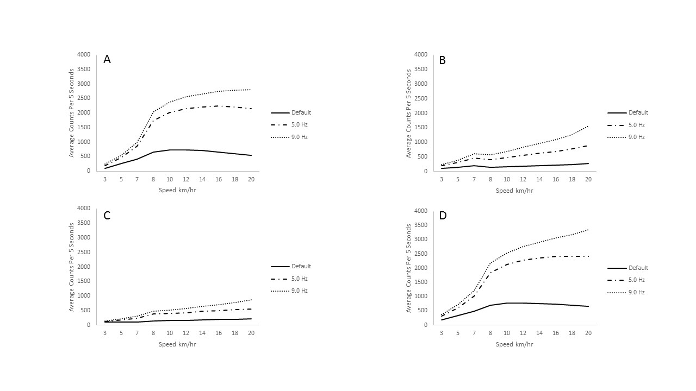
Figure 1: ActiGraph GT3X+ mean hip counts per 5 seconds by bandpass filter: A) axis 1, B) axis 2, C) axis 3, D) vector magnitude

*#
* Significantly different from Default, # significantly different from 5.0 Hz, Alpha < p = 0.05

Figure 2: ActiGraph GT3X+ mean counts per 5 seconds, bandpass filter by axis – hip car driving

Mean measured METs for each of the ten lifestyle activities are presented in Table 7. Significant differences between count values were seen across bandpass filter frequency for table cleaning, sweeping, walking, stair walking, basketball, tennis, slow running, and fast running for all axes including vector magnitude (Tables 8 through 11, p < 0.05). No significant differences in counts were seen between the default and 5.0 Hz filter for supine rest. For computer work there were no significant differences between the default and 5.0 Hz bandpass filter frequency for axis 3 only.

Table 7: Mean ± SD measured metabolic equivalents (METs) by activity.

Activity | METS ± SD
Supine Rest | 1.45 ± 0.25
Computer Work | 1.52 ± 0.27
Table Cleaning | 2.78 ± 0.68
Sweeping | 3.39 ± 0.93
Walking (m/min) | 3.62 ± 0.85
Stair Walking | 6.48 ± 1.22
Basketball | 7.83 ± 1.72
Tennis | 7.40 ± 1.85
Slow Running (m/min) | 8.14 ± 1.48
Fast Running (m/min) | 9.68 ± 1.62

Table 8. Mean counts ± SD lifestyle activities ActiGraph GT9X hip axis 1.
Activity | Mean Default Counts ± SD | Mean 5.0 Hz Counts ± SD | Mean 9.0 Hz Counts ± SD
Supine Rest | 0.0 ± 0.04 | 0.0 ± 0.06 | 62.7 ± 68.9*#
Computer Work | 0.1 ± 0.16 | 1.0 ± 0.98* | 331.2 ± 64.6*#
Table Cleaning | 32.7 ± 32.0 | 74.5 ± 40.2* | 342.1 ± 52.0*#
Sweeping | 44.7 ± 36.9 | 93.0 ± 42.7* | 370.1 ± 57.7*#
Walking | 285.1 ± 85.8 | 508.8 ± 158.8* | 680.1 ± 145.8*#
Stair Walking | 327.6 ± 56.5 | 551.7 ± 111.2* | 709.9 ± 112.3*#
Basketball | 424.3 ± 111.3 | 765.5 ± 200.6* | 976.4 ± 207.1*#
Tennis | 314.9 ± 74.6 | 618.9 ± 162.0* | 876.9 ± 214.2*#
Slow Running | 701.0 ± 121.1 | 1890.7 ± 307.4* | 2280.9 ± 330.8*#
Fast Running | 767.5 ± 107.2 | 2151.3 ± 257.8* | 2568.8 ± 304.7*#
Average Counts per 5 seconds; * significantly different from Default, # significantly different from 5.0 Hz, Alpha < p = 0.05

Table 9. Mean counts ± SD lifestyle activities ActiGraph GT9X hip axis 2 counts.
Activity | Mean Default Counts ± SD | Mean 5.0 Hz Counts ± SD | Mean 9.0 Hz Counts ± SD
Supine Rest | 0.0 ± 0.0 | 0.0 ± 0.1 | 256.6 ± 65.8*#
Computer Work | 0.7 ± 1.0 | 0.9 ± 1.2* | 20.9 ± 34.7*#
Table Cleaning | 81.8 ± 27.0 | 119.3 ± 36.3* | 172.4 ± 50.9*#
Sweeping | 104.5 ± 47.4 | 138.3 ± 53.0* | 192.2 ± 79.4*#
Walking | 165.2 ± 38.4 | 337.1 ± 88.7* | 441.7 ± 119.3*#
Stair Walking | 157.4 ± 25.0 | 300.9 ± 61.0* | 398.9 ± 83.6*#
Basketball | 266.8 ± 40.3 | 465.8 ± 79.5* | 604.4 ± 104.1*#
Tennis | 279.0 ± 33.6 | 469.1 ± 74.2* | 607.4 ± 105.6*#
Slow Running | 221.0 ± 59.1 | 558.0 ± 151.5* | 812.6 ± 204.1*#
Fast Running | 272.5 ± 69.2 | 732.1 ± 167.3* | 1107.3 ± 237.5*#
Average Counts per 5 seconds; * significantly different from Default, # significantly different from 5.0 Hz, Alpha < p = 0.05

Table 10. Mean counts ± SD lifestyle activities ActiGraph GT9X hip axis 3.
Activity | Mean Default Counts ± SD | Mean 5.0 Hz Counts ± SD | Mean 9.0 Hz Counts ± SD
Supine Rest | 0.0 ± 0.1 | 0.0 ± 0.1 | 150.9 ± 85.4*#
Computer Work | 1.8 ± 3.0 | 2.1 ± 3.7 | 50.3 ± 61.7*#
Table Cleaning | 110.0 ± 53.6 | 120.9 ± 55.6* | 134.1 ± 57.7*#
Sweeping | 141.6 ± 62.8 | 153.4 ± 65.6* | 170.8 ± 66.0*#
Walking | 113.8 ± 55.5 | 184.5 ± 74.3* | 233.7 ± 81.0*#
Stair Walking | 188.1 ± 39.0 | 234.2 ± 41.6* | 269.2 ± 50.0*#
Basketball | 267.3 ± 51.5 | 372.1 ± 85.4* | 429.3 ± 100.2*#
Tennis | 289.9 ± 48.0 | 392.8 ± 65.4* | 449.4 ± 71.8*#
Slow Running | 170.8 ± 67.3 | 422.4 ± 160.9* | 553.4 ± 180.0*#
Fast Running | 213.1 ± 71.8 | 495.5 ± 167.6* | 648.5 ± 200.4*#
Average Counts per 5 seconds; * significantly different from Default, # significantly different from 5.0 Hz, Alpha < p = 0.05

Table 11. Mean counts ± SD lifestyle activities ActiGraph GT9X hip vector magnitude.
Activity | Mean Default Counts ± SD | Mean 5.0 Hz Counts ± SD | Mean 9.0 Hz Counts ± SD
Supine Rest | 0.0 ± 0.1 | 0.0 ± 0.1 | 323.5 ± 62.3*#
Computer Work | 2.3 ± 3.1 | 3.2 ± 3.9* | 343.3 ± 66.1*#
Table Cleaning | 152.0 ± 61.9 | 195.5 ± 70.1* | 419.1 ± 54.6*#
Sweeping | 193.7 ± 80.7 | 236.9 ± 88.0* | 463.3 ± 87.1*#
Walking | 356.3 ± 83.7 | 645.2 ± 173.0* | 849.4 ± 849.4*#
Stair Walking | 418.4 ± 53.6 | 680.6 ± 111.7* | 864.6 ± 127.9*#
Basketball | 581.8 ± 112.1 | 985.8 ± 211.5* | 1238.5 ± 231.3*#
Tennis | 527.1 ± 81.5 | 888.0 ± 172.2* | 1169.9 ± 230.1*#
Slow Running | 761.3 ± 117.8 | 2029.4 ± 303.0* | 2499.1 ± 333.2*#
Fast Running | 849.3 ± 104.0 | 2338.9 ± 256.6* | 2888.3 ± 316.5*#
Average Counts per 5 seconds; * significantly different from Default, # significantly different from 5.0 Hz, Alpha < p = 0.05

Regression lines were generated for each axis for 1) the full activity routine (Figures 3, 4, 5, 6), 2) locomotive activity only (Figures 7, 8, 9, 10), and 3) lifestyle activity only (Figures 11, 12, 13, 14).
For the full activity routine axis 1 (Figure 3), all three bandpass filters showed strong associations (R ≥ 0.80) with the default filter producing the best result (R = 0.87). For axis 2 (Figure 4), all three bandpass filters again showed strong associations between counts and energy expenditure with the 5.0 Hz filter producing the strongest result (R = 0.87). For axis 3 (Figure 5), the 5.0 Hz and 9.0 Hz filter produced strong associations (R ≥ 0.80) while the default filter showed a moderate association (R = 0.74). The best result for axis 3 was the 5.0 Hz filter with an R = 0.85. Lastly, the results from the vector magnitude (Figure 6) showed that similar to axis 1 the default filter performed the best with an R = 0.91 but all three bandpass filters produced a strong association between counts and energy expenditure.
For the locomotive activity axis 1 (Figure 7) and vector magnitude (Figure 10) showed the 5.0 and 9.0 Hz filters produced similar results both having strong associations (R ≥ 0.80) between counts and energy expenditure with R = 0.92. Axis 2 (Figure 8) and axis 3 (Figure 9) showed lower R values with the highest being the moderate associations of the 9.0 Hz filter with an R = 0.77 and R = 0.71, respectively.
For the lifestyle activities (Figures 11 through 14), all three bandpass filters produced strong associations (R ≥ 0.80) for all axes including vector magnitude. The highest performing bandpass filter was the 5.0 Hz filter with R values = 0.94, 0.93, 0.87, and 0.95 for axis 1 (Figure 11), 2 (Figure 12), 3 (Figure 13), and vector magnitude (Figure 14), respectively

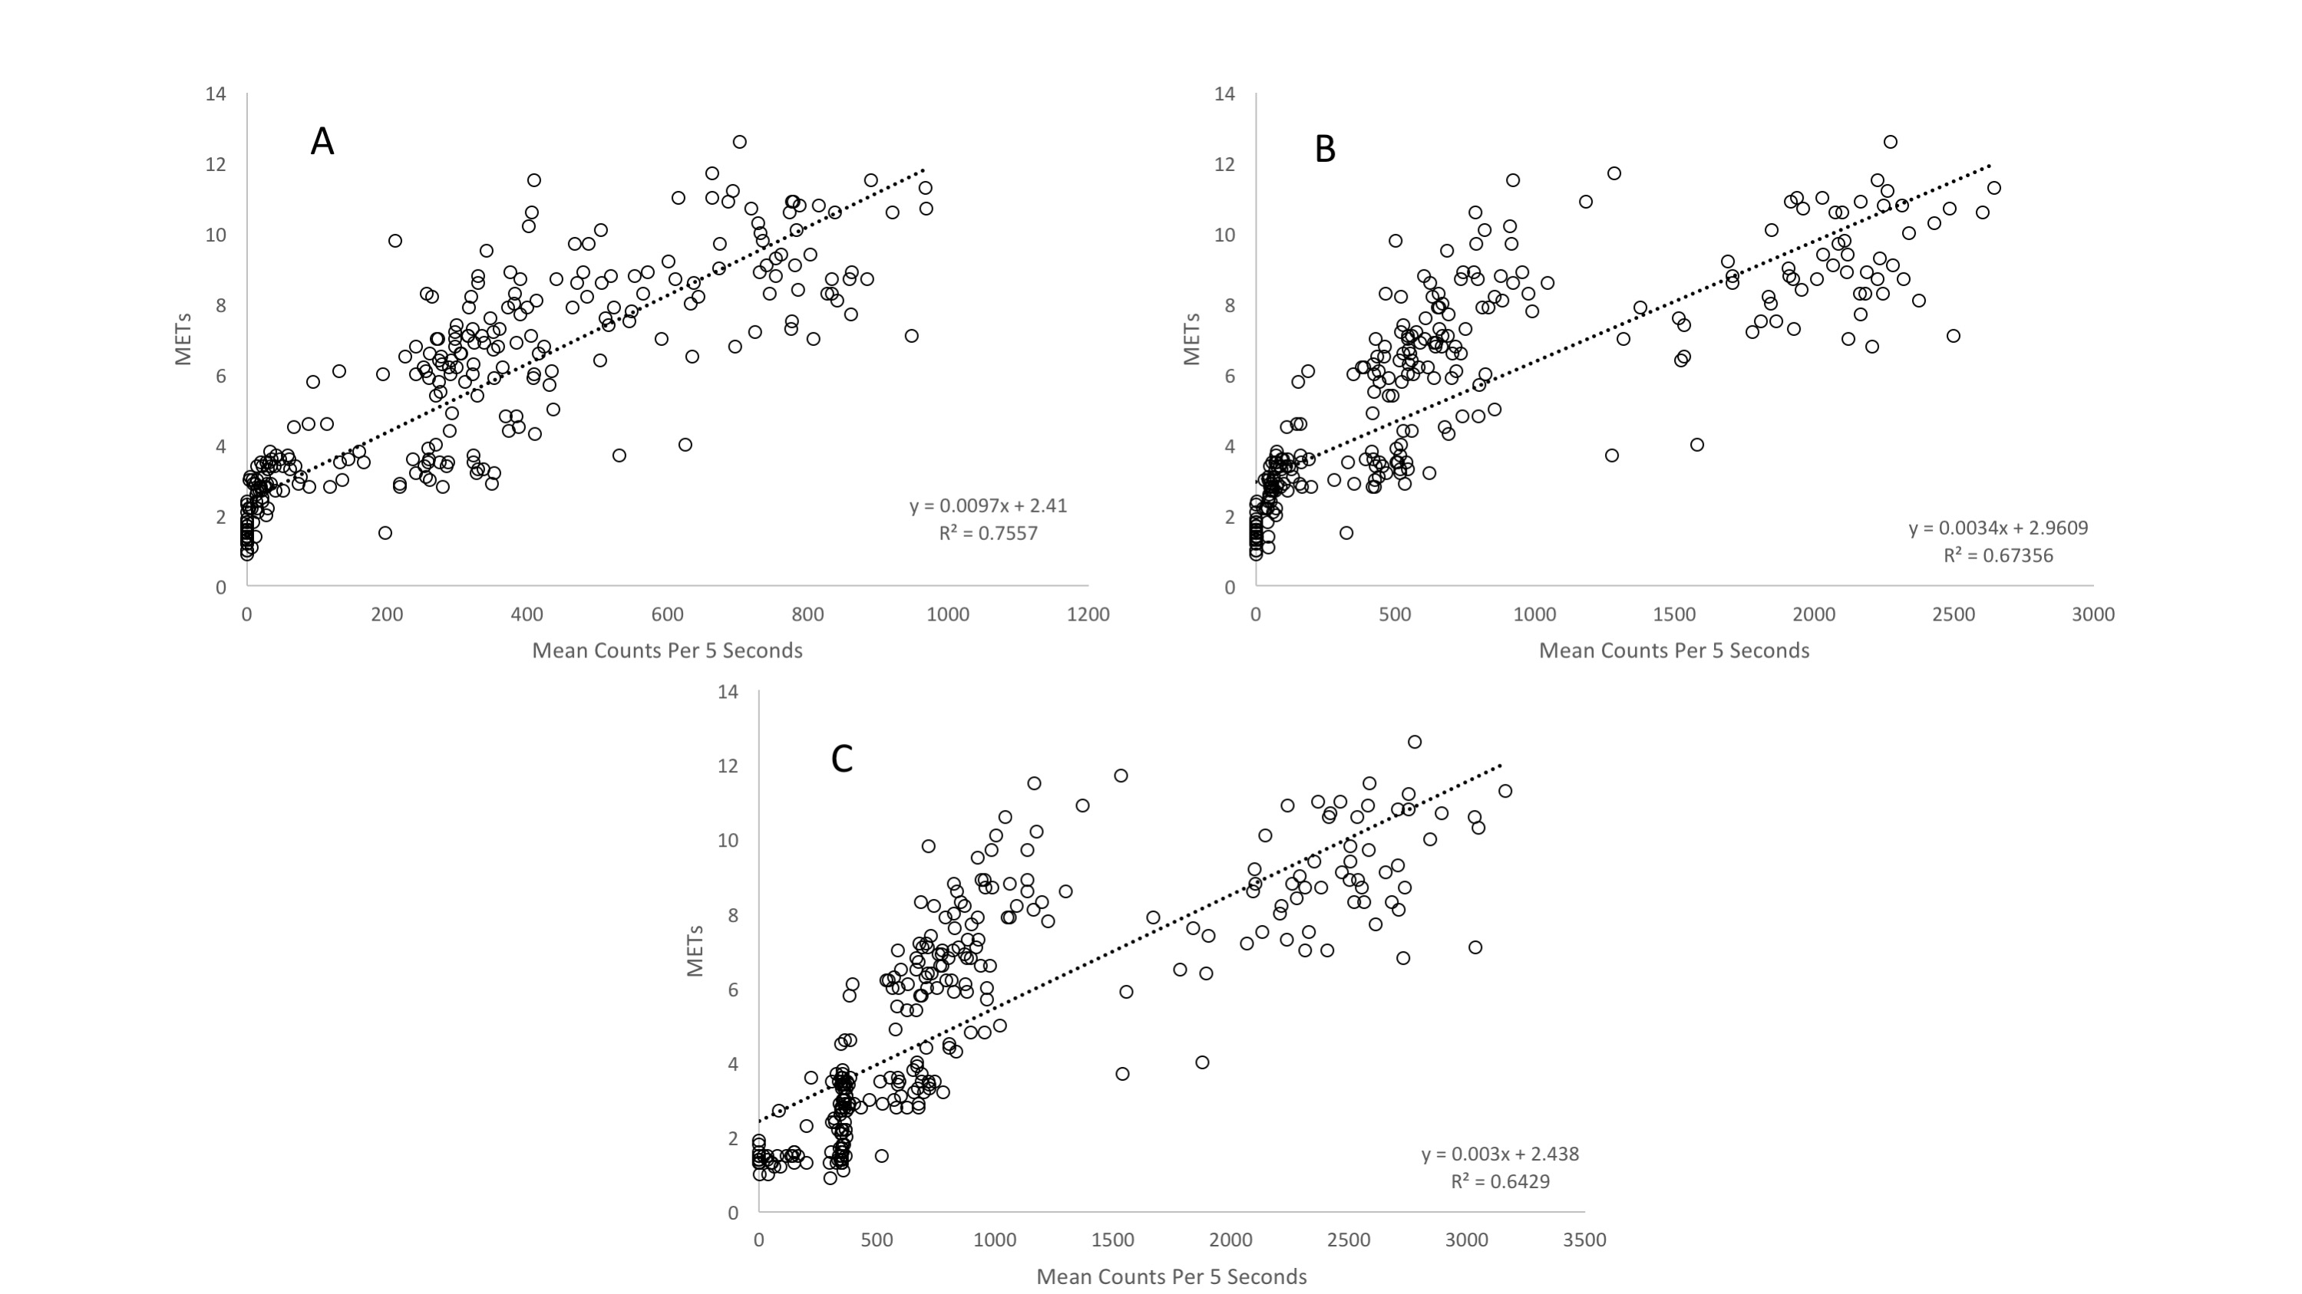
Figure 3: Relationship between ActiGraph GT9X means counts per 5 seconds versus measured energy expenditure [metabolic equivalents (METs)] for hip axis 1 by bandpass filter frequency – full activity routine: A) Default, B) 5.0 Hz, C) 9.0 Hz

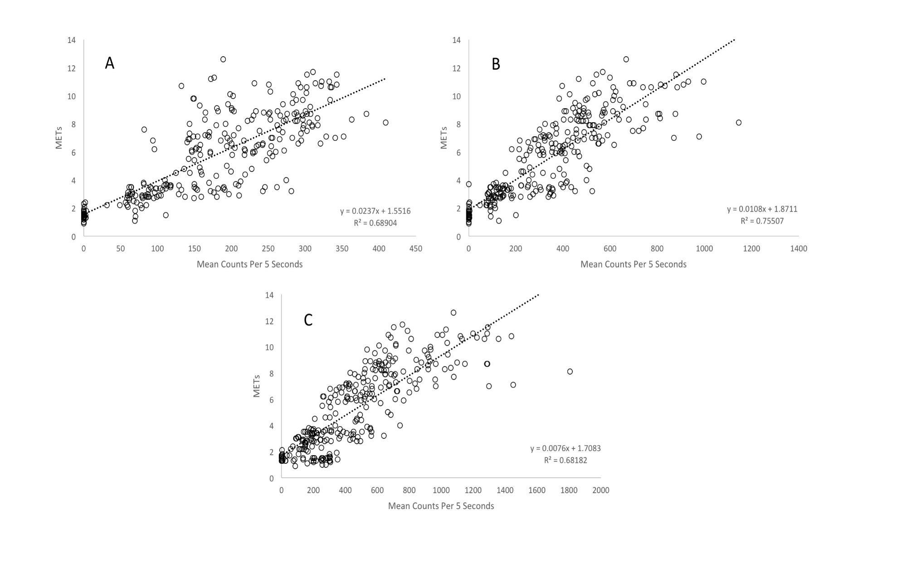
Figure 4: Relationship between ActiGraph GT9X means counts per 5 seconds versus measured energy expenditure [metabolic equivalents (METs)] for hip axis 2 by bandpass filter frequency – full activity routine: A) Default, B) 5.0 Hz, C) 9.0 Hz

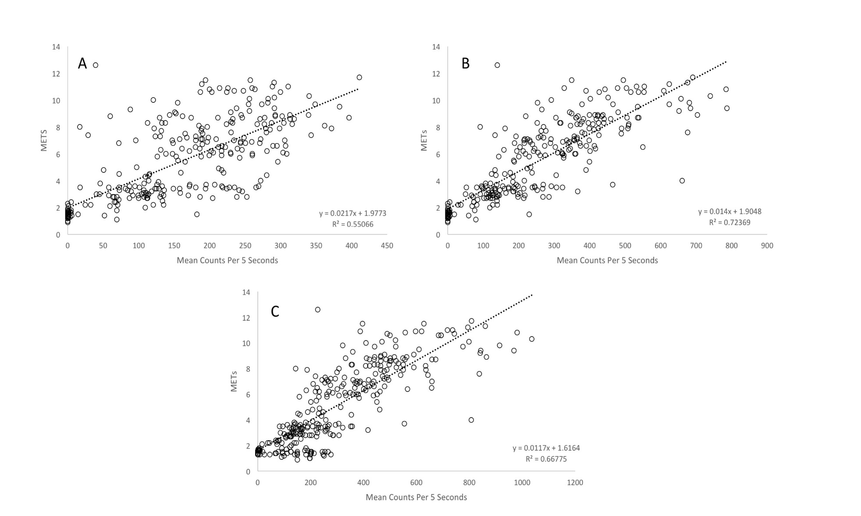
Figure 5: Relationship between ActiGraph GT9X means counts per 5 seconds versus measured energy expenditure [metabolic equivalents (METs)] for hip axis 3 by bandpass filter frequency – full activity routine: A) Default, B) 5.0 Hz, C) 9.0 Hz

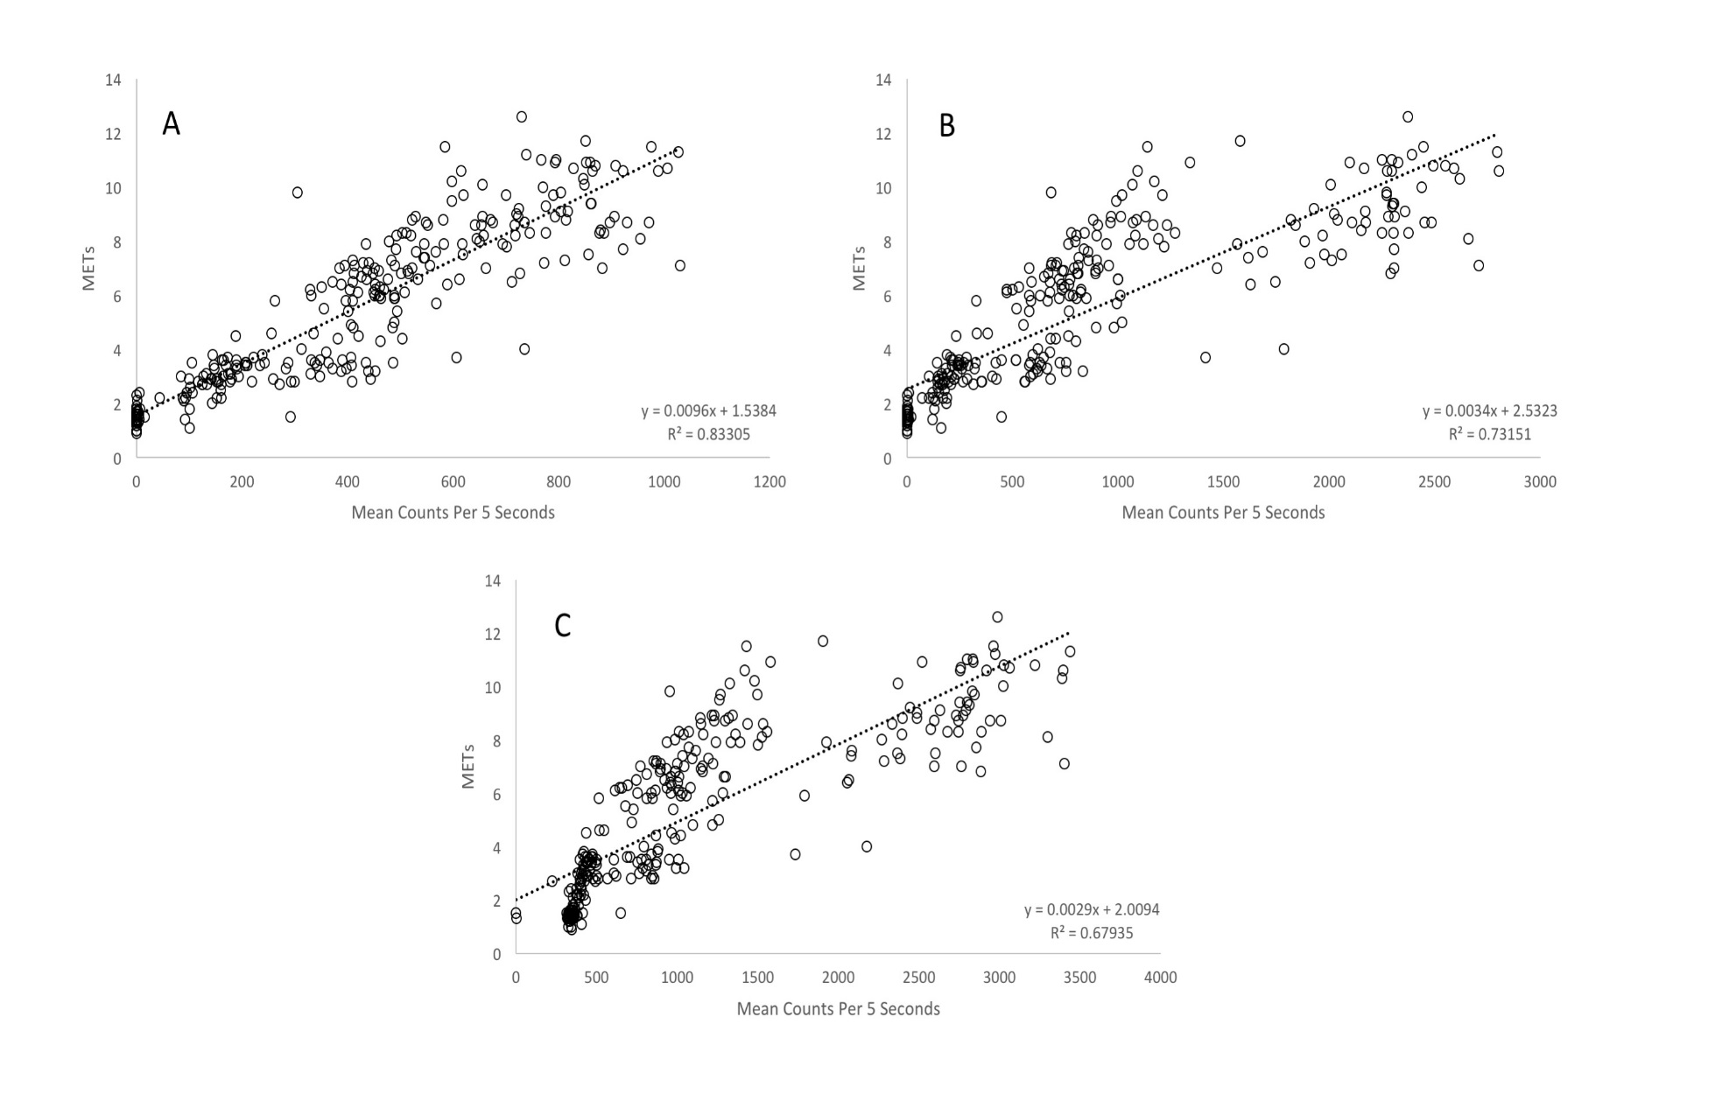
Figure 6: Relationship between ActiGraph GT9X means counts per 5 seconds versus measured energy expenditure [metabolic equivalents (METs)] for hip vector magnitude by bandpass filter frequency – full activity routine: A) Default, B) 5.0 Hz, C) 9.0 Hz

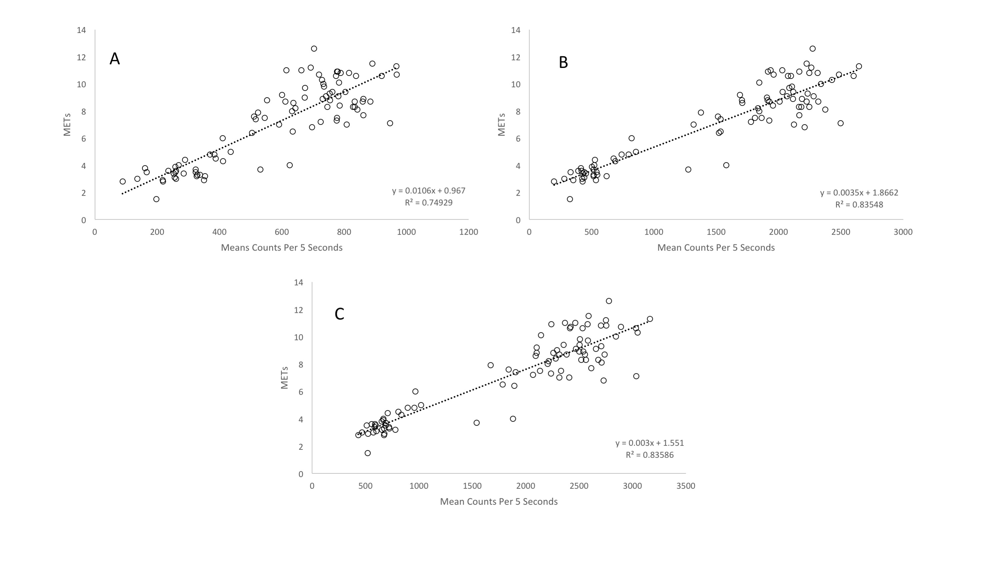
Figure 7: Relationship between ActiGraph GT9X means counts per 5 seconds versus measured energy expenditure [metabolic equivalents (METs)] for hip axis 1 by bandpass filter frequency – locomotive activities only: A) Default, B) 5.0 Hz, C) 9.0 Hz

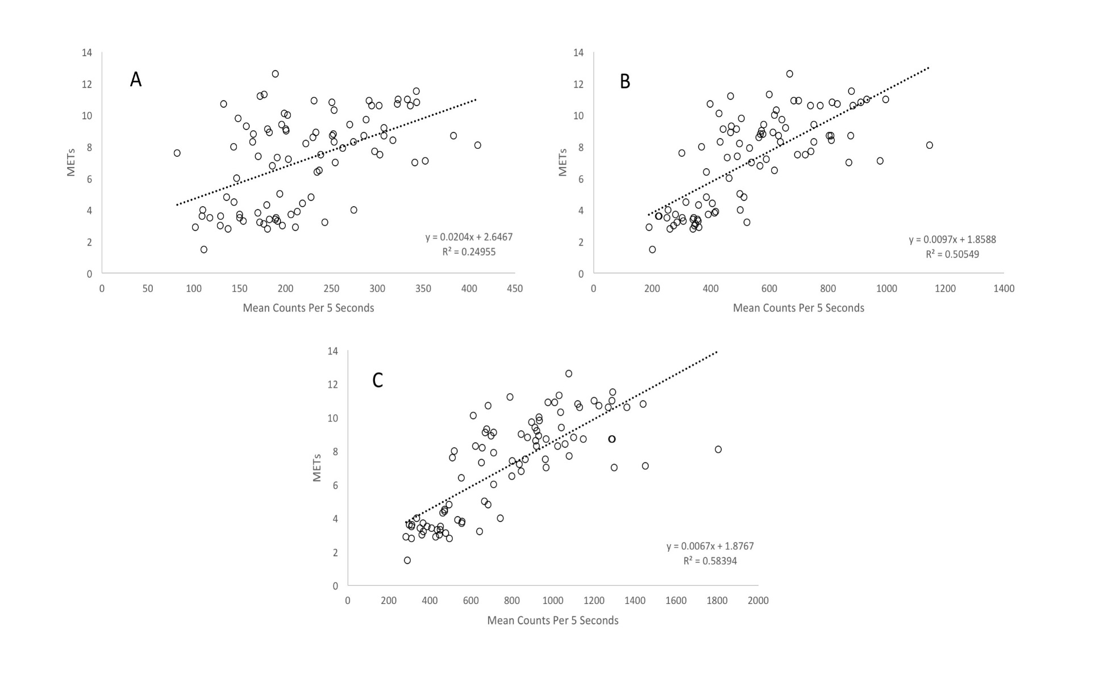
Figure 8: Relationship between ActiGraph GT9X means counts per 5 seconds versus measured energy expenditure [metabolic equivalents (METs)] for hip axis 2 by bandpass filter frequency – locomotive activities only: A) Default, B) 5.0 Hz, C) 9.0 Hz

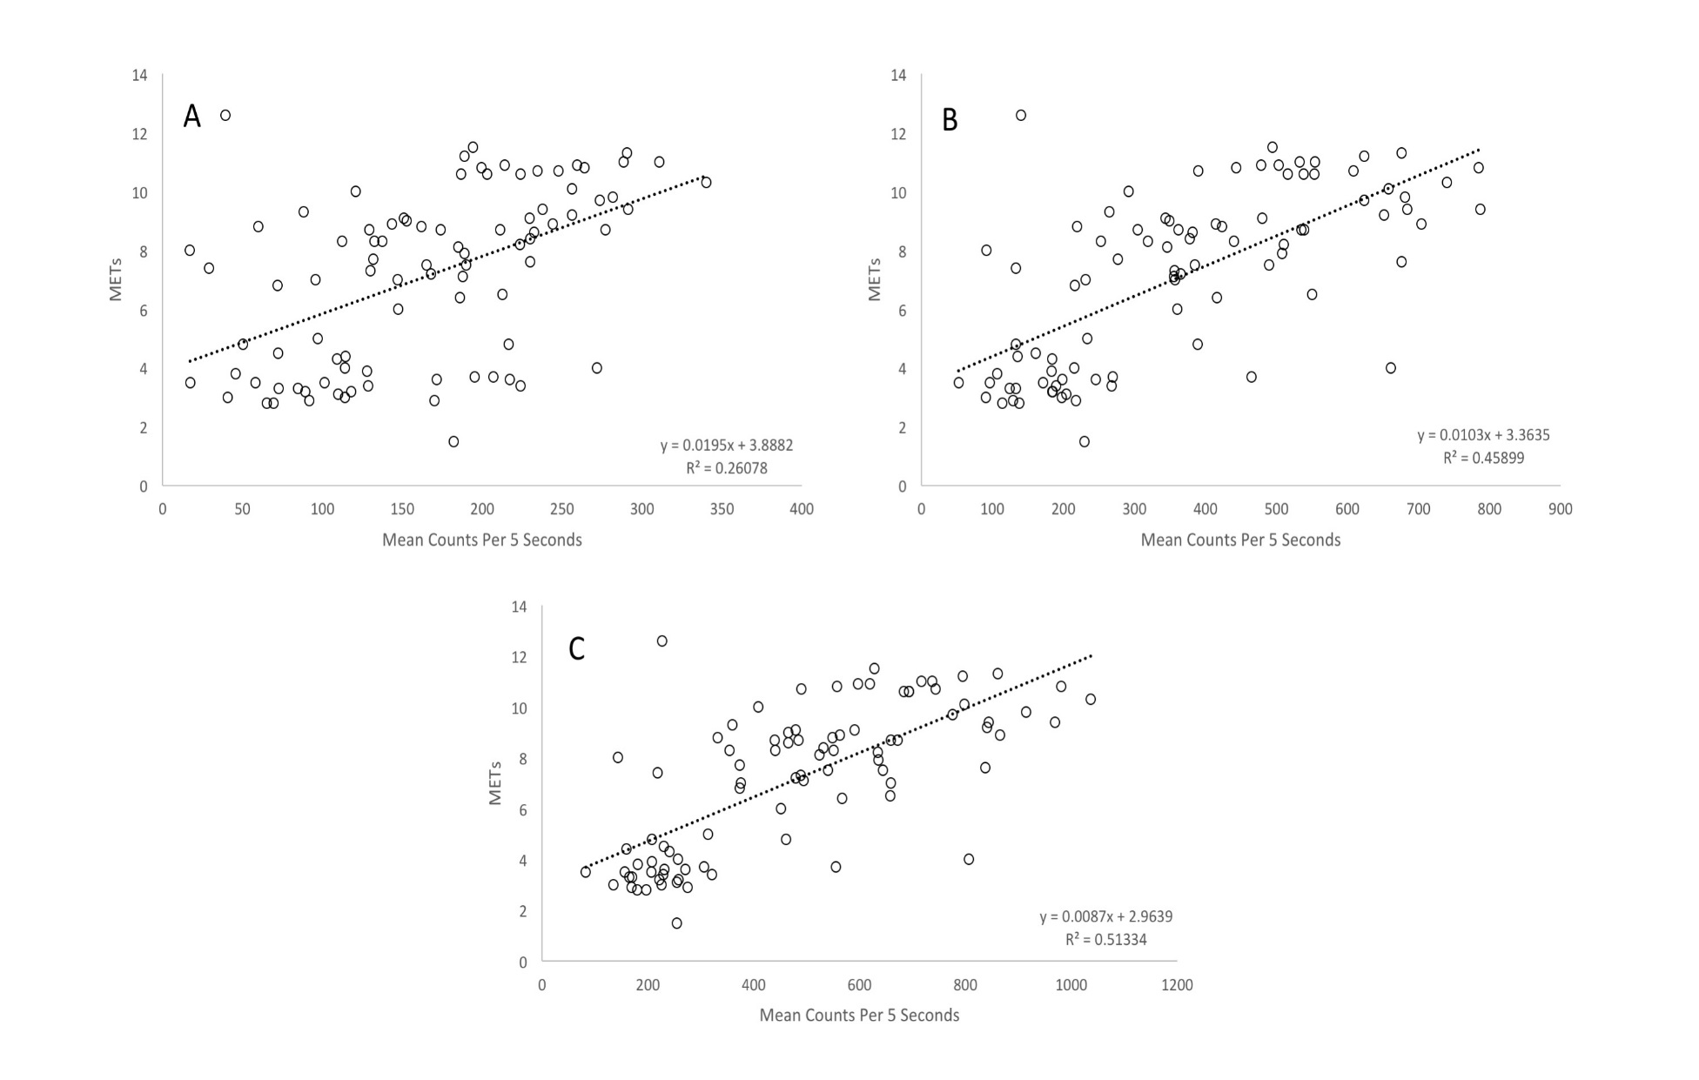
Figure 9: Relationship between ActiGraph GT9X means counts per 5 seconds versus measured energy expenditure [metabolic equivalents (METs)] for hip axis 3 by bandpass filter frequency – locomotive activities only: A) Default, B) 5.0 Hz, C) 9.0 Hz

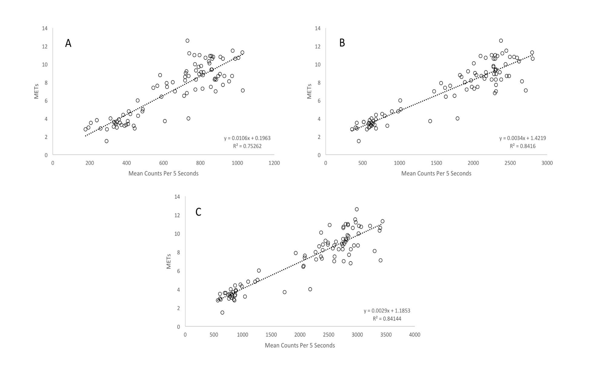
Figure 10: Relationship between ActiGraph GT9X means counts per 5 seconds versus measured energy expenditure [metabolic equivalents (METs)] for hip vector magnitude by bandpass filter frequency – locomotive activities only: A) Default, B) 5.0 Hz, C) 9.0 Hz

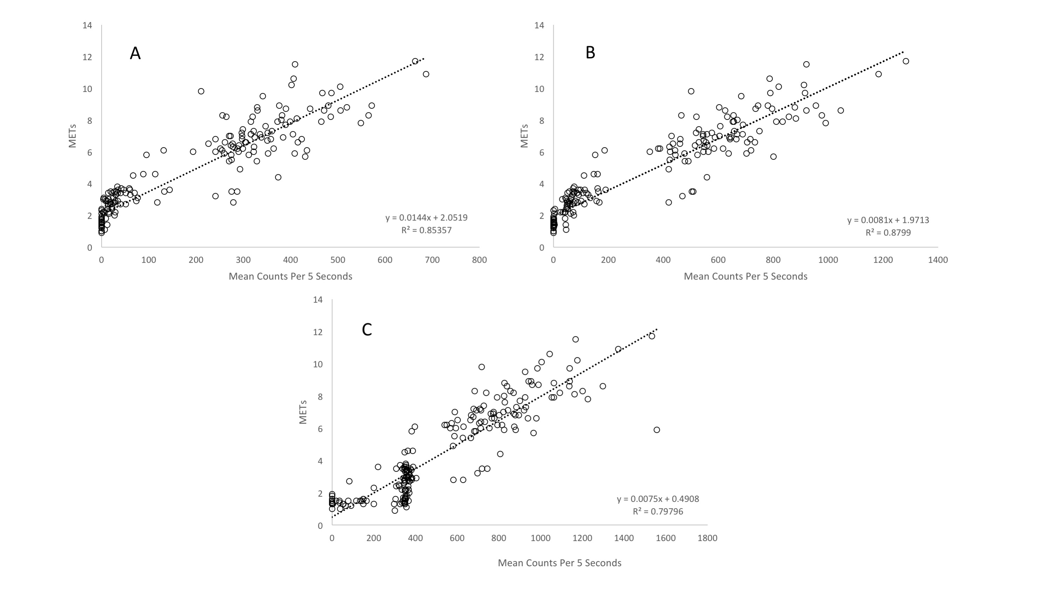
Figure 11: Relationship between ActiGraph GT9X means counts per 5 seconds versus measured energy expenditure [metabolic equivalents (METs)] for hip axis 1 by bandpass filter frequency – lifestyle activities only: A) Default, B) 5.0 Hz, C) 9.0 Hz

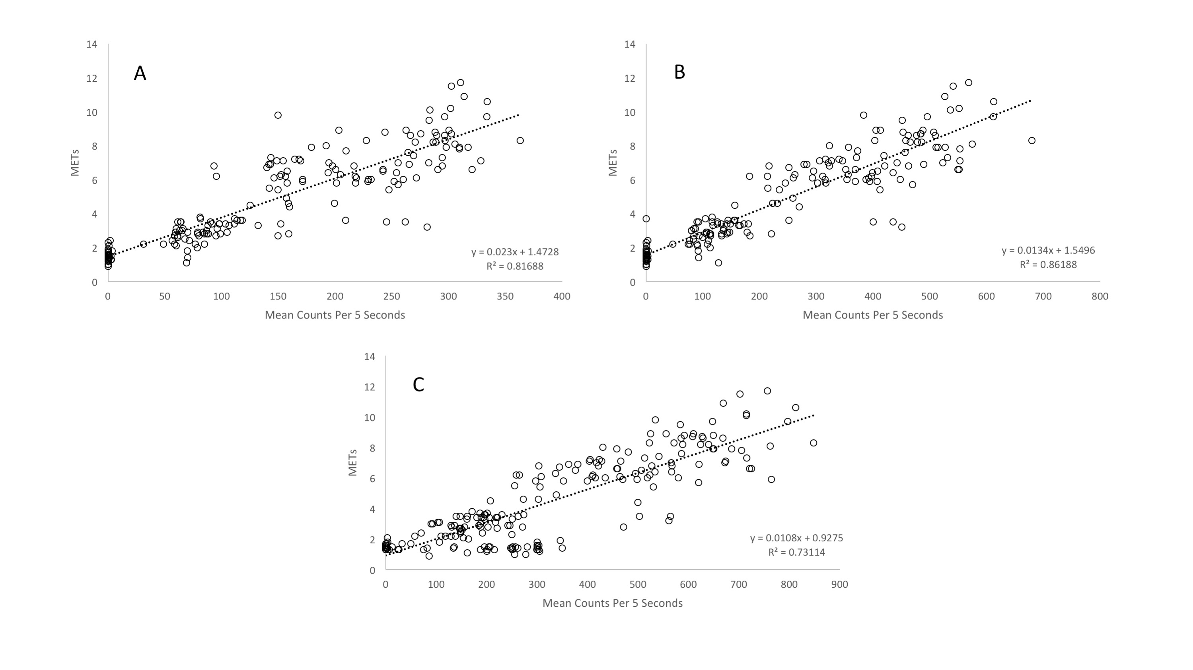
Figure 12: Relationship between ActiGraph GT9X means counts per 5 seconds versus measured energy expenditure [metabolic equivalents (METs)] for hip axis 2 by bandpass filter frequency – lifestyle activities only: A) Default, B) 5.0 Hz, C) 9.0 Hz

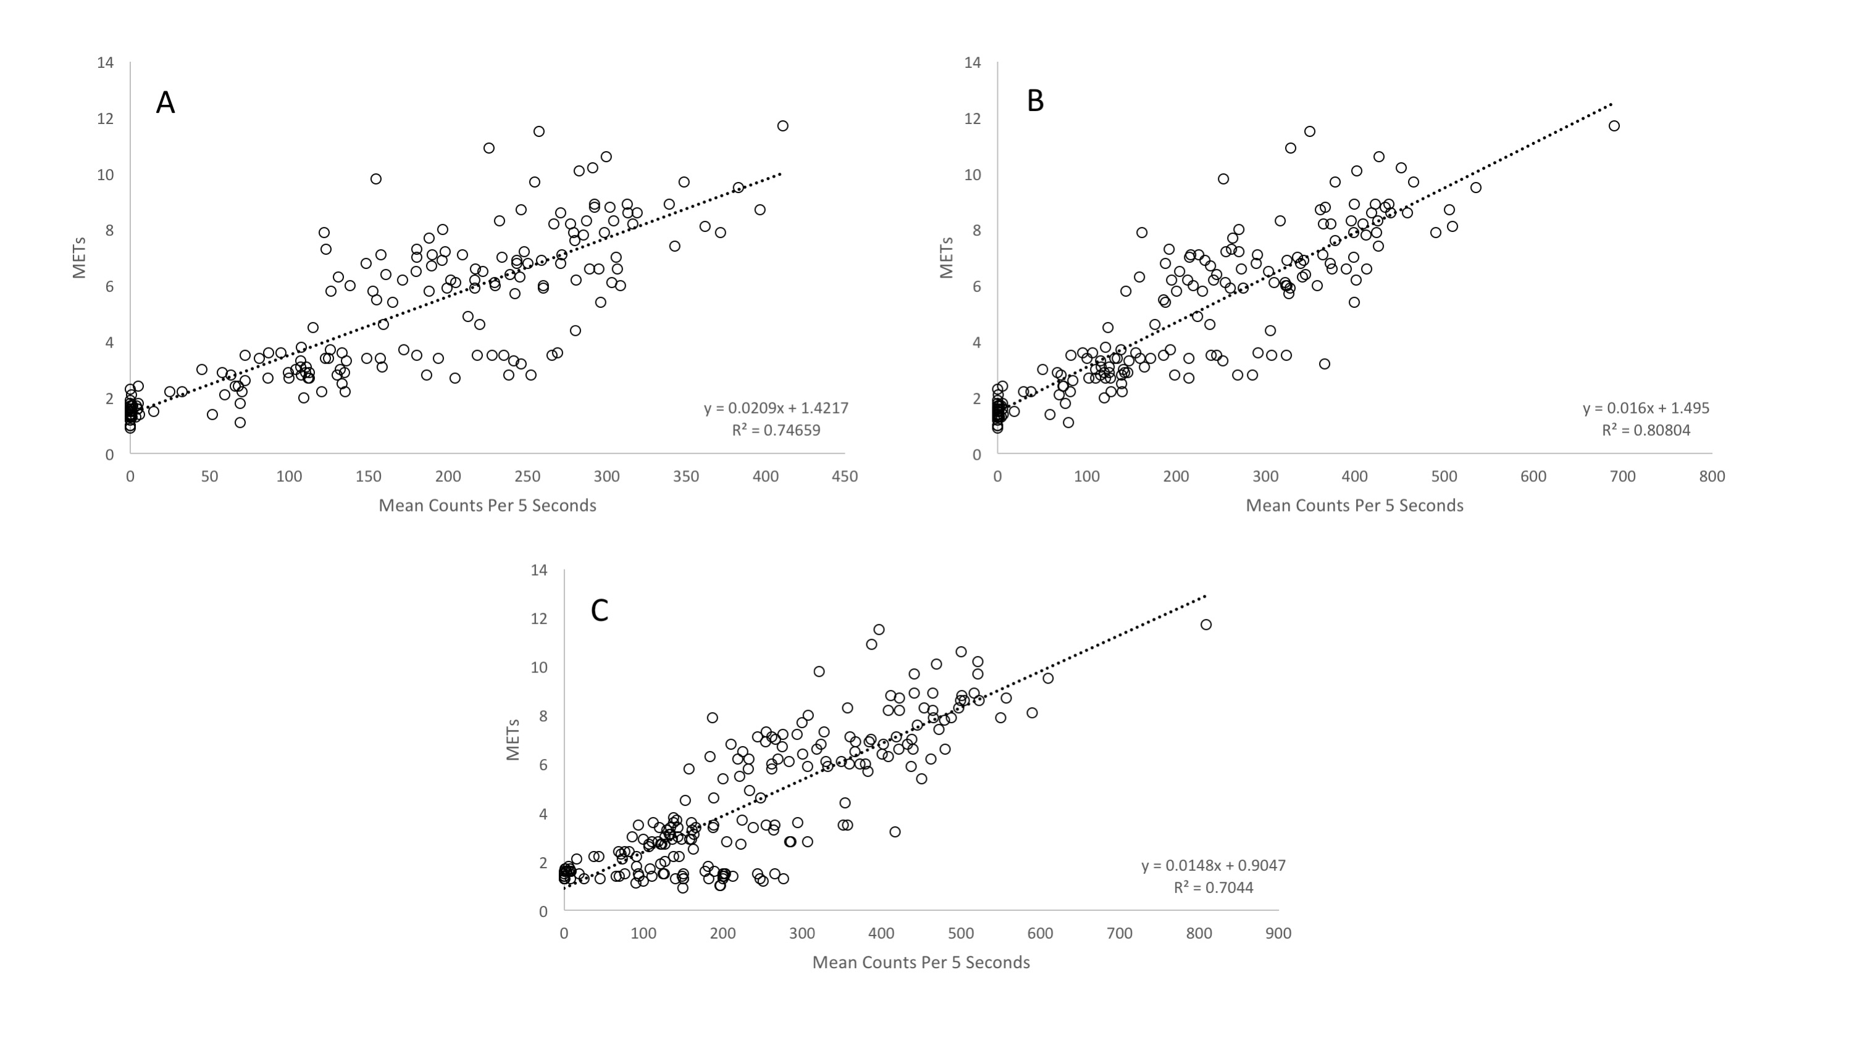
Figure 13: Relationship between ActiGraph GT9X means counts per 5 seconds versus measured energy expenditure [metabolic equivalents (METs)] for hip axis 3 by bandpass filter frequency –lifestyle activities only: A) Default, B) 5.0 Hz, C) 9.0 Hz

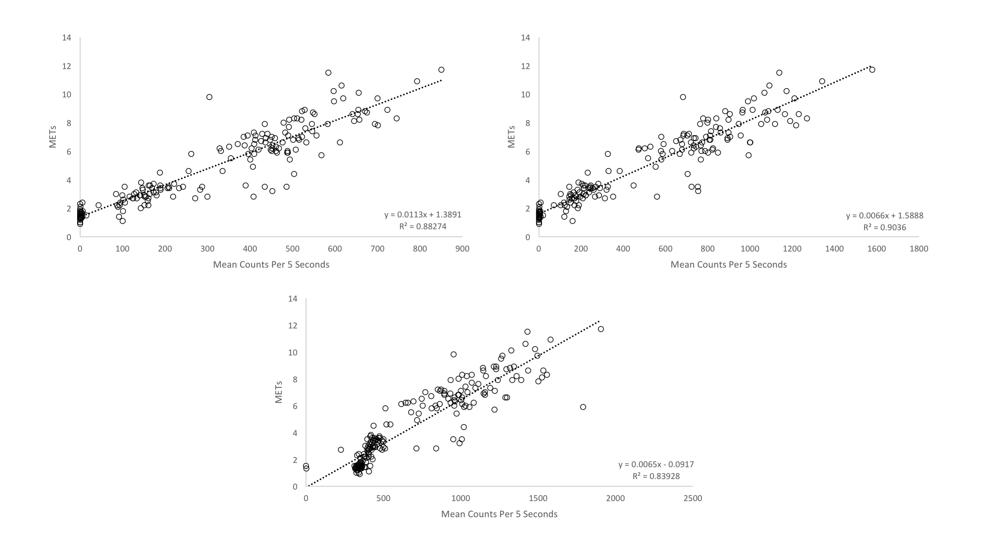
C
B
A
Figure 14: Relationship between ActiGraph GT9X means counts per 5 seconds versus measured energy expenditure [metabolic equivalents (METs)] for hip vector magnitude by bandpass filter frequency – lifestyle activities only: A) Default, B) 5.0 Hz, C) 9.0 Hz

Discussion

The primary findings from this study are that: 1) increasing the bandpass filter frequency does significantly alter count values for all activities both laboratory based as well as free-living, 2) increasing the bandpass filter frequency does reduce the plateau in counts as speed increases for treadmill walking and running, and 3) There is no discernable plateau in counts for lifestyle activities based on the results for the activities chosen for this study.
As hypothesized, increasing the bandpass filter frequency did improve the relationship between counts and intensity for treadmill walking and running. The relationship between counts and speed becomes more linear as counts no longer decrease and the plateau lessens with increasing intensity. Improvement was seen from the default setting by increasing the bandpass filter frequency to 5.0 Hz but the best results are seen using the 9.0 Hz filter as there is a significant increase in counts between all speeds for vector magnitude. This should allow for improved energy expenditure estimation for these activities since the effects of plateau phenomenon can be reduced. Conversely, increasing the bandpass frequency filter also significantly altered the count values for car driving which is one of the reasons the lower limit of the bandpass frequency filter limit exists to begin with. As the filter frequency was increased, count values for each axis also significantly increased producing nearly 40 counts per 5 seconds for vector magnitude with the 9.0 Hz filter. This could significantly impact energy expenditure estimation for sedentary activities such as car driving since count values could be going from < 100 counts per minute to nearly 500 counts per minute. This would become an issue since the standard cut-point for sedentary activity is 100 counts per minute, car driving would then be considered light intensity physical activity based on these findings.
It was hypothesized that there would be a plateau in counts for moderate to vigorous lifestyle activities that generate similar acceleration values and have similar MET values to running at or above 6 mph, the known threshold for the plateau phenomenon. This however was not the case as no discernable plateau was seen in the counts for the lifestyle activities with increasing intensity for the activities selected for this study. It was, however, hypothesized that increasing the bandpass filter frequency would affect the counts for light, moderate, and vigorous intensity lifestyle activities. This hypothesis was correct as significant differences were seen in count values across bandpass filters and the strength of association and linearity of the relationship between count and METs also varied across bandpass filter conditions depending on the type of activity being performed.
After studying the results from the Crouter 2-regression (13) model (C2RM) it was believed that increasing the bandpass frequency filter would cause counts to increase leading to a converging of the two regression lines in the C2RM model. The C2RM model was developed to use two regression lines instead of the traditional single regression to better fit the locomotive activity and lifestyle activity. Together those two regression lines do a better job in most cases. Results from this study show the opposite occurring with the two lines diverging instead of converging and becoming singularly more linear. This is evident with the default filter producing the most linear results for axis 1 and vector magnitude when looking at the full routine. As the bandpass filter is increased, the counts for locomotive and lifestyle activities diverge and produce a less linear relationship for the full activity routine. When split out individually, the linearity of the relationship was affected differently for locomotive and lifestyle activity. Increasing the bandpass filter frequency to 9.0 Hz for locomotive activity produced the best results similarly to what is seen with the results from treadmill walking and running while the 5.0 Hz filter produced the strongest results for lifestyle activities.
There are several strengths and limitations to this study with one of the main limitations stemming from the 9.0 Hz bandpass filter. ActiGraph confirmed after consultation that there is an error in the software for the 9.0 Hz filter that led to errors with counts most notably the low intensity lifestyle activities such as supine rest and computer work. This issue will be resolved and results corrected to reflect the changes but it should be noted that the significant differences seen for supine rest and computer work across bandpass filters may be due to this software error. A major strength of this study is the combination of lifestyle activities coupled with treadmill walking and running as well as car driving. These activities give a broad overview of how the bandpass filter affects different activities for all axes as well as vector magnitude at the hip. Additionally, this study is the first to look at and gain access to the ability to manipulate the bandpass filter frequency for the ActiGraph.
The results of this study are promising for the continued use of ActiGraph devices. More work needs to be done to refine this process but there is promise in the ability to manipulate the bandpass filter frequency for future research. This ability could lead to more accurate energy expenditure prediction equations developed using counts obtained through a higher bandpass filter frequency which would be a major shift for this line of research.
In conclusion, it should be noted that increasing the bandpass filter frequency to 9.0 Hz for the ActiGraph will improve the relationship between counts and intensity for treadmill walking and running therefore reducing the plateau effect. Additionally, increasing the bandpass filter frequency for lifestyle activities can produce more linear results between measured METs and counts but this should be done with caution as this improvement is activity specific. Using the 9.0 Hz filter for locomotive activities and the 5.0 Hz filter for lifestyle activities excluding locomotive activity such as walking and running worked best in this. If the dataset contains a mix of both types of activities the default bandpass filter setting remains the most effective option. These results suggest a combination of bandpass filter frequencies would be most effective and it is recommended that future research investigate the practicality and feasibility to apply multiple bandpass filter frequencies to a single dataset to achieve better results based on activity type.

LIST OF REFERENCES

- American College of Sports Medicine. ACSM's guidelines for exercise testing and prescription. 9th ed: Lippincott Williams & Wilkins; 2013.

- Akkermans MA, Sillen MJH, Wouters EFM, and Spruit MA. Validation of the Oxycon Mobile Metabolic System in Healthy Subjects. Journal of Sports Science and Medicine. 2012;11:182-83.

- Anastasopoulou P, Tubic M, Schmidt S, Neumann R, Woll A, Hartel S. Validation and Comparison of Two Methods to Assess Human Energy Expenditure during Free-Living Activities. PLoS One. 2014;9(2)

- Bassett DR. Validity and Reliability Issues in Objective Monitoring of Physical Activity. Res Q Exerc Sport. 2000;71(S2):S30-6.

- Bassett DR Jr., Rowlands A, Trost SG. Calibration and validation of wearable monitors. Med Sci Sports Exerc. 2012;44(1 Suppl 1):S32-38.

- Berlin JE, Storti KL, Brach JS. Using Activity Monitors to Measure Physical Activity in Free-Living Conditions. Phys. Ther. 2006;86:1137-45.

- Brage S, Wedderkopp N, Franks PW, Anderson LB, Froberg K. Reexamination of Validity and Reliability of the CSA Monitor in Walking and Running. Med Sci Sports Exerc. 2003;35(8):1447-54.

- Cain KL, Conway TL, Adams MA, Husak LE, Sallis JF. Comparison of Older and Newer Generations of ActiGraph Accelerometers with the Normal Filter and the Low Frequency Extension. International Journal of Behavioral Nutrition and Physical Activity. 2013;10:51-6.

- Caspersen CJ, Powell KE, Christenson GM. Physical Activity, Exercise, and Physical Fitness: Definitions and Distinctions for Health-Related Research. Public Health Reports. 1985;100(2):126-131.

- Chen KY, Bassett DR Jr. The Technology of Accelerometry-Based Activity Monitors: Current and Future. Med Sci Sports Exerc. 2005;37(11(Suppl)):S490-S500.

- Cosmed S.r.l. K4b² user manual. Rome, Italy. Cosmed S.r.l. 1998

- Crouter SE, Churilla JR, Bassett, DR Jr. Estimating energy expenditure using accelerometers. Eur J Appl Physiol. 2006;98(6):601-12.

- Crouter SE, Clowers KG, Bassett DR Jr. A novel method for using accelerometer data to predict energy expenditure. J Appl Physiol. 2005;100(4):1324-31.

- Crouter SE, DellaValle DM, Haas JD, Frongillo EA, Bassett DR. Validity of ActiGraph 2-Regression Meodel, Matthews Cut-Points, and NHANES Cut-Points for Assessing Free-Living Physical Activity. Journal of Physical Activity and Health. 2013;10:504-14.

- Crouter SE, Kuffel E, Haas JD, Frongillo EA, Bassett DR. Refined Two-Regression Model for the ActiGraph Accelerometer. Med Sci Sports Exerc. 2010;42(5):1029-37.

- Dannecker KL, Sazonova NA, Melanson EL, Sazonov ES, Browning RC. A comparison of energy expenditure estimation of several physical activity monitors. Med Sci Sports Exerc. 2013;45(11):2105-12.

- de Vries SI, Bakker I, Hopman-Rock M, Hirasing RA, van Mechelen W. Cinimetric Review of Motion Sensors in Children and Adolescents. Journal of Clinical Epidemiology. 2006;59:670-80.

- Feito Y, Bassett DR Jr, Thompson DL. Evaluation of activity monitors in controlled and free-living environments. Med Sci Sports Exerc. 2012;44(4):733-41.

- Freedson P, Bowles HR, Troiano R, Haskell W. Assessment of physical activity using wearable monitors: recommendations for monitor calibration and use in the field. Med Sci Sports Exerc. 2012;44(1 Suppl 1):S1-4.

- Freedson PS, Melanson E, Sirard J. Calibration of the Computer Science and Applications, Inc. accelerometer. Med Sci Sports Exerc. 1998;30(5):777-81.

- Freedson PS, Miller K. Objective Monitoring of Physical Activity using Motion Sensors and Heart Rate. Res Q Exerc Sport. 2000;71(S2):S21-9.

- Fudge BW, Wilson J, Easton C, et al. Estimation of Oxygen Uptake during Fast Running Using Accelerometry and Heart Rate. Med Sci Sports Exerc. 2007;39(1):192-98.

- Haskell WL. Physical Activity by Self-Report: A Brief History and Future Issues. Journal of Physical Activity and Health. 2012;9(Suppl 1):S5-S10.

- Hendelman D, Miller K, Bagget C, Debold E, Freedson P. Validity of Accelerometry for the Assessment of Moderate Intensity Physical Activity in the Field. Med Sci Sports Exerc. 2000;32;S442-S449.

- John D and Freedson P. Actigraph and Actical Physical Activity Monitors: A Peek Under the Hood. Med Sci Sports Exerc. 2012;44(1 Suppl 1):S86-S89

- John D, Miller R, Kozey-Keadle S, Caldwell G, Freedson P. Biomechanical Examination of the ‘Plateau Phenomenon’ in ActiGraph Vertical Activity Counts. Physiol Meas. 2012;33(2):219-30.

- John D, Sasaki J, Staudenmeyer J, Mavilia M, Freedson PS. Comparison of Raw Acceleration from the GENEA and ActiGraph GT3X+ Activity Monitors. Sensors. 2013;13:14754-63.

- John D, Tyo B, Bassett DR. Comparison of Four ActiGraph Accelerometers during Walking and Running. Med Sci Sports Exerc. 2010;42(2):368-74.

- Kokkinos P. Physical Activity, Health Benefits, and Mortality Risk. ISRN Cardiology. 2012;2012:p14. Article ID 718789

- Kokkinos P, Sheriff H, Kheirbek R. Physical Inactivity and Mortality Risk. Cardiology Research and Practice. 2011;2011:p10. Article ID 924945

- Lee I, Shiroma EJ, Lobelo F, Puska P, Blair SN, Katzmarzyk PT. Impact of Physical Inactivity on the World’s Major Non-Communicable Diseases. Lancet. 2012;380(9838):219-29.

- Levine JA. Measurement of Energy Expenditure. Public Health Nutrition. 2005;8(7A):1123-32.

- Lyden K, Kozey SL, Staudenmeyer JW, Freedson PS. A Comprehensive Evaluation of Commonly Used Energy Expenditure and MET Prediction Equations. Eur J Appl Physiol. 2011;111:187-201.

- McLaughlin JE, King GA, Howley ET, Bassett Jr. DR, Ainsworth BE. Validation of the COSMED K4b² Portable Metabolic System. Int J Sports Med. 2001;22:280-84.

- McMinn D, Acharya R, Rowe DA, Gray SR, Allan JL. Measuring Activity Energy Expenditure: Accuracy of the GT3X+ and Actiheart Monitors. International Journal of Exercise Science. 2013;6(3):217-229.

- Nichols JF, Morgan CG, Chabot LE, Sallis JF, Calfas KJ. Assessment of Physical Activity with the Computer Science and Applications, Inc. Accelerometer: Laboratory versus Field Validation. RQES. 2000;71:36-43.

- Office of Disease Prevention and Health Promotion Web site [Internet]. Rockville (MD): Health.gov; [cited 2015 September 10]. Available from http://health.gov/paguidelines/guidelines/chapter2.aspx

- Park J, Kazuko IT, Kim E, Kim J, Yoon J. Estimating Free-Living Human Energy Expenditure: Practical Aspects of the Doubly Labeled Water Method and its Applications. Nutrition Research and Practice. 2014;8(3):241-48.

- Parr BB, Strath SJ, Bassett DR, Howley ET. Validation of the Cosmed K4b2 Portable Metabolic Validation System. Med Sci Sports Exerc. 2001

- Plasqui g, Bonomi AG, Westerterp KR. Daily Physical Activity Assessment with Accelerometers: New Insights and Validation Studies. Obesity Reviews. 2013;14:451-62.

- Plasqui G and Westerterp KR. Physical Activity Assessment with Accelerometers: An Evaluation Against Doubly Labeled Water. Obesity. 2007;15:2371-79.

- Prince SA, Adamo KB, Hamel ME, Hardt J, Gorber SC, Tremblay M. A Comparison of Direct Versus Self-Report Measures for Assessing Physical Activity in Adults: A Systematic Review. International Journal of Behavioral Nutrition and Physical Activity. 2008;5:56-80.

- Rosdahl H, Gullstrand L, Salier-Eriksson J, Johansson P, Schantz P. Evaluation of the Oxycon Mobile Metabolic System Against the Douglas Bag. Eur J Appl Physiol. 2010;109:159-71.

- Rothney MP, Apker GA, Song Y, Chen KY. Comparing the Performance of Three Generations of ActiGraph Accelerometers. J Appl Physiol. 2008;105(4):1091-97.

- Rowlands AV, Stone MR, Eston RG. Influence of Speed and Step Frequency during Walking and Running on Motion Sensor Output. Med Sci Sports Exerc. 2007;39(4):716-27.

- Sallis JF and Saelens BE. Assessment of Physical Activity by Self-Report: Status, Limitations, and Future Directions. Research Quarterly for Exercise and Sport. 2000;71(2):1-14.

- Santos-Lozano A, Santin-Medeiros F. Cardon G et al. ActiGraph GT3X: Validation and Determination of Physical Activity Intensity Cut Points. Int J Sports Med. 2013;34:975-82.

- Sasaki JE, John D, Freedson PS. Validation and Comparison of ActiGraph Activity Monitors. Journal of Science and Medicine in Sport. 2011;14:411-16.

- Schaefer CA, Nigg CR, Hill JO, Brink LA, Browning RC. Establishing and Evaluating Wrist Cutpoints for the GENEActiv Accelerometer in Youth. Med Sci Sports Exerc. 2014;46(4):826-33.

- Schoeller DA. Measurement of energy expenditure in free-living humans by using doubly labeled water. J Nutr. 1988;118(11):1278-89.

- Seale JL and Rumpler WV. Comparison of Energy Expenditure MEasurements by Diet Records, Energy Intake Balance, Doubly Labeled Water and Room Calorimetry. European Journal of Clinical Nutrition. 1997;51:856-63.

- Strath SJ, Bassett DR, Swartz AM. Comparison of MTI Accelerometer Cut-Points for Predicting Time Spent in Physical Activity. Int J Sports Med. 2003;24:298-303.

- Swartz AM, Strath SJ, Bassett DR Jr, O’brien WL, King GA, Ainsworth BE. Estimation of Energy Expenditure using CSA accelerometers at the Hip and Wrist Sites. Med Sci Sports Exerc. 2000;32(9 Suppl):S450-6.

- Troiano RP, Berrigan D, Dodd KW, Masse LC, Tilert T, McDowell M. Physical Activity in the United States Measured by Accelerometer. Med Sci Sports Exerc. 2008;40(1):181-88.

- Troiano RP. Evolution of Accelerometer Methods for Physical Activity. Br J Sports Med. 2014;48(13):1019-23.

- Trost SG, McIver KL, Pate RR. Conducting Accelerometer-Based Activity Assessments in Field-Based Research. Med Sci Sports Exerc. 2005;36(11(Suppl)): S531-43.

- Tucker JM, Welk GJ, Beyler NK. Physical Activity in U.S. Adults Compliance with the Physical Activity Guidelines for Americans. Am J Prev Med. 2011;40(4):454-61.
- Warren JM, Ekelund U, Besson H, Mezzani A, Geladas N, Vanhees L. Assessment of Physical Activity - A Review of Methodologies with Reference to Epidemiological Research: A Report of the Exercise Physiology Section of the European Association of Cardiovascular Prevention and Rehabilitation. European Journal of Preventative Cardiology. 2010;17(2):127-39.

- Yang CC and Hsu YL. A Review of Accelerometry-Based Wearable Motion Detectors for Physical Activity Monitoring. Sensors. 2010;10:7772-88.

APPENDIX

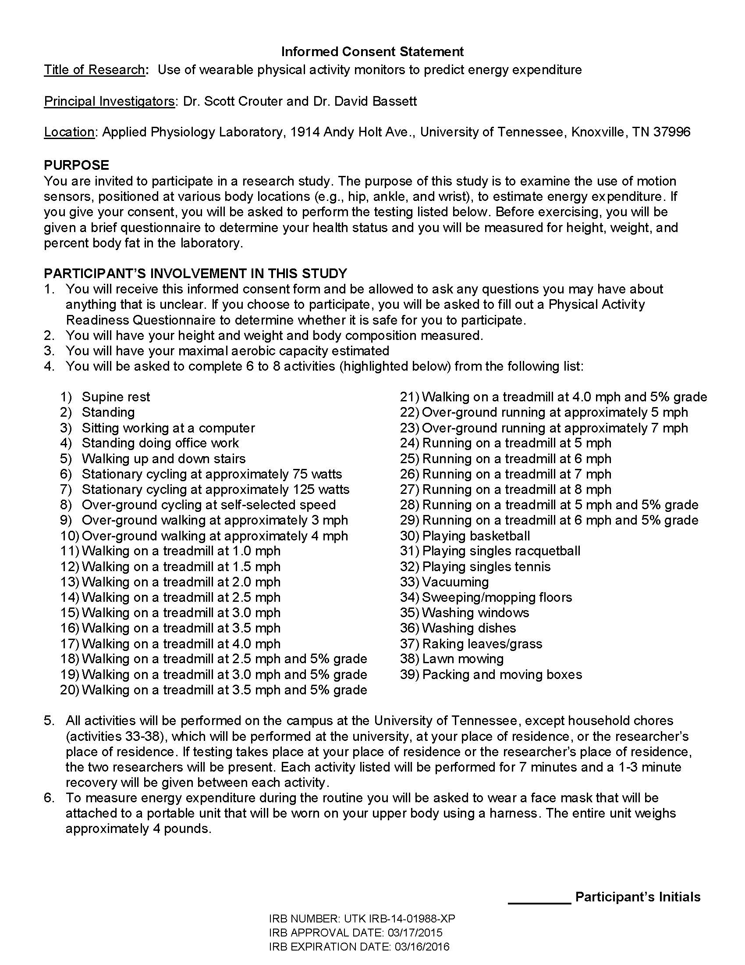

Physical Activity Readiness Questionnaire (PARQ)

Regular physical activity is fun and healthy, and increasingly more people are starting to
become more active every day. Being more active is very safe for most people.
However, people should check with their doctor before they start becoming much more
physically active.

If you are planning to become much more physically active than you are now, start by
answering the seven questions in the box below. If you are between the ages of 15 and
69, the PAR-Q will tell you if you should check with your doctor before you start. If you
are over 69 years of age, and you are not used to being very active, check with your
doctor.

Common sense is your best guide when you answer these questions. Please read the
questions carefully and answer each one honestly: check YES or NO.

YES NO 1. Has your doctor ever said that you have a heart condition and that
you should only do physical activity recommended by a doctor?

YES NO 2. Do you feel pain in your chest when you do physical activity?

YES NO 3. In the past month, have you had chest pain when you were not
doing physical activity?

YES NO 4. Do you lose your balance because of dizziness or do you ever lose
consciousness?

YES NO 5. Do you have a bone or joint problem that could be made worse by
a change in your physical activity?

YES NO 6. Do you know of any other reason why you should not be doing
physical activity?

I have read, understood and completed this questionnaire. Any questions I had were
answered to my full satisfaction.

Name (Print): _______________________________

Signature: _________________________________ Date: _________________
VITA

Samuel Robert LaMunion, born January 29, 1992 to Hurshel V. LaMunion and Sara Catherine “Cathy” Corley LaMunion. Samuel completed his Bachelor’s of Science with magna cum laude honors in Exercise and Sports Science with a Basic Sciences concentration at the University of South Carolina Aiken in August of 2014. In Fall of 2014 he enrolled in the Kinesiology Master’s of Science program with a concentration in Exercise Physiology at The University of Tennessee Knoxville. Samuel Graduated from the Master’s program in the August of 2016 at which time he re-enrolled at The University of Tennessee Knoxville for Fall 2016 to begin work as a doctoral candidate in Kinesiology and Sports Studies with a concentration in Kinesiology and a specialization in Exercise Physiology. Samuel intends to pursue a post-doctoral research fellowship upon completion of his doctoral studies and then begin a career teaching at the University level as well as doing research.

