Broadscale Outcome and Monitoring Assessment to Evaluate Protected Area Effectiveness in Northern Patagonia

A Dissertation Presented for the

Doctor of Philosophy

Degree

The University of Tennessee, Knoxville

María Daniela Rivarola

May 2022

Copyright © 2022 by María Daniela Rivarola.
All rights reserved.

DEDICATION
I dedicate my work to my family for their unstoppable support and love.

ACKNOWLEDGEMENTS
I would like to thank my advisor Dr. Dan Simberloff for his guidance, support, and help. I want to thank to all my field assistants: Ludovico Zeller, Isabela Zeller, Emmanuel Imizcoz, Lucila Amione, Flavia Casinelli, Marlene Zaracho, Edgardo Balverdi, Ana Paula Blazina, Thais Efron, Maria Celeste Lado, Florencia Mallou, Laura Barbieri, Sofia Jones, Julieta D’Amario, Carolina Mansilla Ferro, Maria Belen Dri, Antonio Navarro, Sabrina Ignacio, Mauro Ricci, Carolina Alonso, Natanael Griffa, Francisco Molina; and lab assistants: Brianna Jacobs and Isabella Ritchie. To my collaborators, Juan Morales, Hannah Herrero and Jake Dein, thank you. Finally, this project would not have been possible without the support of the following institutions: University of Tennessee, Ecology and Evolutionary Biology Department, Administracion de Parques Nacionales, Prefectura Naval Argentina, and British Ecological Society.

ABSTRACT
Biomes worldwide have been affected by biodiversity loss and habitat degradation for more than a century. Protected Areas (PAs) have been established in almost every country, as they represent one of the most important tools in biodiversity conservation. Nevertheless, the relentless biodiversity loss trend has not stopped. Concern about PA effectiveness has risen, and several methods to evaluate it have been implemented over the last few decades. Nahuel Huapi National Park (NHNP) is the first PA in Argentina and one of the largest. The area is considered a biodiversity hotspot, and its conservation is essential, as unique ecological and evolutionary processes have resulted in a high degree of endemism and mutualism. Three levels of protection have been designated in NHNP, Strict Natural Reserve (SNR), National Park (NP), and National Reserve (NR), corresponding to IUCN levels Ia, II, and VI respectively. In this study we evaluated NHNP effectiveness, comparing outcomes at each level of protection and the neighboring unprotected area. We assessed the effectiveness using two complementary approaches: broadscale outcome based on remote sensing data, and direct monitoring of the small mammal community. We evaluated broadscale outcome based on 20 years of Normalized Difference Vegetation Index (NDVI) data from period 2000-2020. We included other variables in our analysis such as dominant tree species, precipitation, elevation, temperature, and wildfires. We assessed its small mammal community using a capture-mark-recapture study conducted over two consecutive summers with a total trapping effort of 41,600 trap/nights, resulting in 1259 individuals identified, from eight native species. Both assessments suggested that a key role is played by the highest level of protection, SNR. Nevertheless, lack of investment and the effects of climate change threaten the future of NHNP. We also analyzed variation of small mammal communities by developing multiple occupancy models to understand species distributions, co-occurrence, and habitat use at a small scale, supporting previous findings about differences among effectiveness of the three levels of protection, species-by-species, and providing evidence at a fine scale regarding those differences.
.

TABLE OF CONTENTS

INTRODUCTION 1

CHAPTER I ASSESSING PROTECTED AREAS ZONING EFFECTIVENESS WITH REMOTE SENSING DATA, THE CASE OF NAHUEL HUAPI NATIONAL PARK, ARGENTINA 6

Abstract 7

Introduction 8

Methods 12

Results 18

Discussion 27

References 34

CHAPTER II CONSERVATION STATUS OF SMALL MAMMAL IN NORTHERN PATAGONIAN TEMPERATE FOREST 47

Abstract 48

Introduction 48

Methods 50

Results 53

Discussion 57

References 64

Appendix 70

CHAPTER III EXPLAINING SMALL MAMMAL COMMUNITY VARIATION IN A TEMPERATE FOREST IN NORTHERN PATAGONIA 76

Abstract 77

Introduction 78

Methods 80

Results 88

Discussion 99

References 106

Appendix 1 114

Appendix 2 116

Appendix 3 136

CONCLUSION 138

VITA 140

LIST OF TABLES
Table 1.1. Results from a Bonferroni test indicating precipitation differences 22
Table 1.2. Colocation Analysis Summary 28
Table 2.1. Capture summary 55
Table 2.2. Community vs Protection 56
Table 3.1. Exploratory models predicting occupancy probability of small mammals 92
Table 3.2 Estimated detection probability per species for each model 93
Table 3.3. Models indicating predictor’s effects on the community as a whole 95

LIST OF FIGURES
Figure 1.1. Map of Nahuel Huapi National Park 13
Figure 1.2. Land cover of NHNP 15
Figure 1.3. Variation in mean NDVI at different levels of protection 19
Figure 1.4. NDVI values over time recorded for a total of 375 random points 19
Figure 1.5. Comparison of the NDVI increase over time 20
Figure 1.6. Comparison of the NDVI increase over time for dominant tree species 20
Figure 1.7. Annual precipitation changes per level of protection 22
Figure 1.8. Estimated mean annual precipitation for each level of protection 23
Figure 1.9. Map with areas with NDVI increase and decrease 24
Figure 1.10. Percent of area with an increase in NDVI 25
Figure 1.11. Percent of area with a decrease in NDVI 25
Figure 1.12. Total number of pixels where NDVI decreased over a 20-year period 26
Figure 1.13. Fires and campsites within the study area 29
Figure 2.1. Study site map 51
Figure 2.2. Season 2015. Diversity and abundance 55
Figure 2.3. Season 2016. Diversity and abundance 56
Figure 2.4. Plots vs Principal Components 58
Figure 2.5. Native and non-native plant species richness at each level of protection 59
Figure 2.6. Proportion of non-native plant species at each level of protection 59
Figure 2.7. Proportion of cover of non-native plant species across 60
Figure 3.1. Map of Nahuel Huapi National Park 81
Figure 3.2. Percentage of total individuals captured per species per year 90
Figure 3.3. Small mammal capture success during sampling seasons 2015 and 2016 90
Figure 3.4. Species-specific capture success at each sampling location 91
Figure 3.5. Cattle, Road distance, and Traffic intensity coefficients 96
Figure 3.6. Herbaceous cover, Bush cover, Tree cover, and Coleopteran’s abundance coefficients 97

INTRODUCTION

There are currently 251,922 terrestrial protected areas (PAs) in the world covering 15.73% of the global land surface. Furthermore, 17,721 marine protected areas have been established, accounting for 7.93% of the global sea surface. The number of PAs per country varies greatly; while some countries count thousands of them (United States 42,826 PAs, Australia 11,149 PAs, Ukraine 5,622 PAs), other countries tally only dozens, such as Iraq (23 PAs) and Botswana (22 PAs). Country size is not closely related to the number of PAs. For example, China has 122 PAs while Austria has 1,663 PAs (UNEP-WCMC and IUCN, 2022). Despite this disparity in PA representation per country, the global trend has been toward increasing creation of PAs, since these conservation units remain the cornerstone strategy for biodiversity conservation (Geldmann et al., 2018). While the global extent of land and sea currently protected seems promising, biodiversity continues to decline. Several studies have questioned to what extent PAs are effective at preserving biodiversity (Barnes et al., 2017; Bruner et al., 2001; Coad et al., 2019). Target 11 of the Aichi Biodiversity Targets (CBD, 2010) states that PAs must be effectively and equitable managed (CBD, 2010). Several approaches have been proposed to evaluate PA effectiveness (Leverington et al., 2010). One of the most widely used is Protected Area Management Effectiveness or PAME (Hockings et al., 2006). Currently, there is a Global Database of Protected Areas Management Effectiveness (GD-PAME) that is updated monthly, and it constitutes the most comprehensive database regarding this approach (UNEP-WCMC and IUCN, 2022). At the time this manuscript is being written, only 19,926 PAME are reported in the GD-PAME.
The history of PAs, including times of creation and further effectiveness evaluations, is unique for each country. Argentina is a pioneer nation in Latin America, setting land aside to create a PA as early as 1906 (Rivarola et al., 2021). Despite this apparent early conservation concern in Argentina, the original intention was to delimit an international border with Chile after years of dispute (Rivarola et al., 2021). Argentina was a powerful and promising country at the beginning of the 20th century (Lewis, 2015a), but political and economic instability compromised its future (Lewis, 2015b). Previous research identified the negative effects that frequent Argentinean crises triggered by this instability had on the conservation movement in general and on its PA system in particular (Rivarola et al., 2021) Nevertheless, there are 463 PAs in Argentina (including national, provincial, municipal, and private designations), a lower number than that of its neighbouring country, Brazil (3,202 PAs) but doubling the number of its western neighbor, Chile (222 PAs). However, Chile has performed effectiveness evaluations for more than half its current PAs (120), while Brazil and Argentina have reported fewer assessments (588 and 74 for Brazil and Argentina respectively) (UNEP-WCMC and IUCN, 2022).
The first PA in Argentina and one of the biggest is Nahuel Huapi National Park (NHNP), located in the northern portion of Patagonia. Patagonian temperate forests are considered a hotspot of biodiversity (BirdLife International 2018), with high rates of endemism (Barnosky et al., 2001) and mutualistic relations among species (Aizen & Escurra, 1998). Two decades ago, a PAME reported that NHNP had “Fairly Satisfactory” management effectiveness (scoring between 51-75% of the optimum) (Rusch, 2002). New data are needed, as effectiveness assessments should be performed regularly, ideally every five years (UNEP-WCMC, 2017). PAME is a popular tool that uses qualitative, perception-based data produced by extensive questionnaires answered by people working in the PAs. It is relatively inexpensive and can readily be applied to multiple sites (Hockings et al., 2006); however, it is not the only possible approach. PA effectiveness can also be assessed by GAP analysis (biodiversity represented within PAs), broadscale outcome (general trends found inside and outside PAs, usually performed with remote sensing data), and monitoring (quantitative information regarding populations or communities within PAs).
For my dissertation, I proposed to evaluate NHNP conservation effectiveness using two approaches. In Chapter 1, I used broadscale outcomes assessment, based on 20 years of remote sensing data. Particularly, I evaluated changes in Normalized Difference Vegetation Index (NDVI) among its three levels of protection (National Reserve, National Park, and Strict Nature Reserve) and neighboring unprotected areas. Furthermore, I incorporated in this analysis precipitation, dominant tree species, and wildfire data. In Chapter 2, I applied a monitoring assessment; specifically, I used a capture-mark-recapture method to investigate its small mammal communities across the four protection categories mentioned above. The high variability reported in Chapter 2led to the research reported in Chapter 3, where I developed seven occupancy models using natural variables as well as anthropogenic disturbances to shed light on the habitat preferences and distributions of these important, often neglected, native species.

References
Aizen, M., Escurra, C., 1998. High incidence of plant-animal mutualisms in the woody flora of the temperate forest of southern South America: biogeographical origin and present ecological significance. Ecología Austral 8, 217-236.
Barnes, M. D., Craigie, I. D., Dudley, N., Hockings, M., 2017. Understanding local-scale drivers of biodiversity outcomes in terrestrial protected areas. Annals of the New York Academy of Sciences 1399, 42-60, doi:10.1111/nyas.13154.
Barnosky, A. D., Hadly, E. A., Maurer, B. A., Christie, M. I., 2001. Temperate terrestrial vertebrate faunas in North and South America: Interplay of Ecology, Evolution, and Geography with Biodiversity. Conservation Biology 15, 658-674.
BirdLife International 2018. World database of key biodiversity areas (KBA). http://www.keybiodiversityareas.org/what/are/kbas
Bruner, A. G., Gullison, R. E., Rice, R. E., da Fonseca, G. A., 2001. Effectiveness of parks in protecting tropical biodiversity. Science 291, 125-8, doi:10.1126/science.291.5501.125.
CBD, 2010. Decision adopted by the CoP to the CBD at its 10th meeting (UNEP/CBD/COP/DEC/X/2). Montreal: Secretariat of the CBD.
Coad, L., Watson, J. E., Geldmann, J., Burgess, N. D., Leverington, F., Hockings, M., Knights, K., Di Marco, M., 2019. Widespread shortfalls in protected area resourcing undermine efforts to conserve biodiversity. Frontiers in Ecology and the Environment 17, 259-264, doi:https://doi.org/10.1002/fee.2042.
Geldmann, J., Coad, L., Barnes, M. D., Craigie, I. D., Woodley, S., Balmford, A., Brooks, T. M., Hockings, M., Knights, K., Mascia, M. B., McRae, L., Burgess, N. D., 2018. A global analysis of management capacity and ecological outcomes in terrestrial protected areas. Conservation Letters 11, e12434, doi:https://doi.org/10.1111/conl.12434.
Hockings, M., Stolton, S. U. E., Leverington, F., Dudley, N., Courrau, J., Valentine, P., 2006. Evaluating Effectiveness. A framework for assessing management effectiveness of protected areas. IUCN The World Conservation Union, Gland, Switzerland and Cambridge, UK.
Leverington, F., Costa, K. L., Pavese, H., Lisle, A., Hockings, M., 2010. A Global analysis of protected area management ffectiveness. Environmental Management 46, 685-698, doi:10.1007/s00267-010-9564-5.
Lewis, D. K., 2015a. Argentina's "Golden age" (1880-1910). In The History of Argentina (2nd ed., pp 53-72). Greenwood Publishing Group, Inc.
Lewis, D. K., 2015b. Democracy's appearance (1890-1943). In The History of Argentina (2nd ed., pp 73-92). Greenwood Publishing Group, Inc.
Rivarola, M. D., Simberloff, D., Leppanen, C., 2021. History of Protected Areas in Argentina: a seesaw of shifting priorities and policies in a developing country. Environment and History 27, 515-548, doi:https://doi.org/10.3197/096734019X15740974883825.
Rusch, V., 2002. Estado de Situacion de las areas Pprotegidas de la porcion Argentina de la ecoregion Valdiviana. Fundacion Vida Silvestre Argentina, WWF, Argentina, pp. 98.
UNEP-WCMC, 2017. Protected Planet. Base de datos mundial sobre la efectividad del manejo de areas protegidas. Manual del usuario 1.0. UNEP-WCMC: Cambridge, UK, doi:http://wcmc.io/GD-PAME_User_Manual_ES.
UNEP-WCMC and IUCN, 2022. Protected planet: the world database on protected areas (WDPA) and world database on other effective area-based conservation measures (WD-OECM). UNEP-WCMC and IUCN, Cambridge, UK.

CHAPTER I
Assessing protected areas zoning effectiveness with remote sensing data, the case of nahuel huapi national park, argentina

A version of this chapter is in review process in Frontiers in Remote Sensing, Special Issue Women in Remote Sensing, authored by María Daniela Rivarola, Jacob Dein, Daniel Simberloff and Hannah V. Herrero.
María Daniela Rivarola conducted a search literature in order to gather all the information needed, analyzed the data, and wrote the whole article. Jacob Dein obtained the data. Dan Simberloff revised and edited the article. Hannah Herrero revised and edited the article.

Abstract

Protected areas (PAs) remain the most important tool to prevent biodiversity loss and habitat degradation worldwide, but the formal creation of a PA constitutes only the first step. In recent decades, concerns about PA effectiveness have arisen, and several PAs have been evaluated using different methods. Results show that while some PAs are achieving their conservation goals, others have been less effective. Particularly, assessing broadscale outcomes is a method that allows us to monitor change over time at a large scale, using remote sensing data. In this study, we evaluated the effectiveness of Nahuel Huapi National Park, with particular attention to its three protection categories: Strict Natural Reserve (SNR), National Park (NP), and National Reserve (NR) (IUCN categories Ia, II, and VI respectively). We compared changes in Normalized Difference Vegetation Index (NDVI) among sites in these categories and between them and neighboring unprotected areas, over the period 2000-2020. Overall, habitat degradation was low, and we found no difference among the four categories evaluated. Nevertheless, a greening process has been conspicuous in the entire area, with higher values both in the SNR and in the unprotected area. We propose possible explanations as we take into account variables such as dominant tree species, precipitation, temperature, elevation, and wildfires. This study supports the importance of NHNP at the regional and national levels, particularly its SNR areas.

Introduction

The biodiversity loss occurring nowadays is considered by some to be the worst biological disaster since the last mass extinction 65 million years ago (Soulé, 1987). Although protecting some areas or ecosystems is not enough to stop and reverse this trend, the creation of protected areas (PAs) remains one of the most important measures in conservation biology (Hunter & Gibbs, 2007), as shown by the fact that protected area coverage rapidly achieved the goal of 17% of land and inland water protected set by the Convention of Biological Diversity in 2010 (CBD, 2010; WDPA, 2021).
Establishing a PA is the first step toward ecosystem conservation; however, creating a PA does not by itself guarantee its effectiveness at achieving its conservation and management goals. The need to assess PA effectiveness has been widely noted, resulting in a growing number of studies addressing the outcome from different perspectives (Barnes et al., 2017; Barnes et al., 2016; Coad et al., 2015; Coad et al., 2019; F. Leverington et al., 2010; Nagendra, 2008). Leverington et al. (2010) summarized different approaches used to assess PA effectiveness as follows: Coverage – studies biodiversity representation within PAs, also known as Gap Analysis (Armenteras & Villareal, 2003; Chape et al., 2005; Rodriguez-Cabal et al., 2008; Scott et al., 1993); Broadscale Outcomes – compares environmental changes within and outside protected areas, generally using remotely sensed data (Herrero et al., 2016; Nagendra et al., 2013); Protected Area Management Effectiveness Assessments (PAME) – uses the scoring framework developed by the IUCN (Coad et al., 2015; Hockings, 2003) or a similar approach; and lastly, Detailed Monitoring – generally reporting animal population trends, vegetation conditions, or socioeconomic impacts of a particular PA (Barnes et al., 2016). These different approaches are complementary, as each one addresses the outcome from a singular perspective (Hockings et al., 2006).
The term protected area comprises areas known by different names, often referring to different types of management. The International Union for Conservation of Nature (IUCN) recognizes six management categories organized from more to less strict as follow: Ia-Strict nature reserve, Ib-Wilderness area, II-National Park, III-Natural monument or feature, IV-Habitat/species management area, V-Protected landscape or seascape, and VI-Protected area with sustainable use of natural resources (Dudley, 2013). While extractive use is forbidden or minimal in categories from I to IV, the restrictions are reduced in categories V and VI. The idea that a stricter management category will yield better habitat preservation has been widely explored in a variety of environments, with contrasting results. A study conducted in Bolivia, Costa Rica, Indonesia, and Thailand found that, although deforestation was generally lower inside the strictest PAs, it was unclear whether this outcome was related to the management category or instead to the remote location of most of the strict PAs (Ferraro et al., 2013). The Royal Chitwan National Park in Nepal allows use by and involvement of local residents, while Celaque National Park in Honduras has a more traditional management approach in which local residents do not participate in this endeavor. Although deforestation rate was lower inside both PAs, the regeneration and conservation of the buffer zones surrounding the PAs were better where local residents were involved, suggesting that a regulated use of PAs could be more effective in the long run (Nagendra et al., 2004). Fire incidence in tropical forest located in strict PAs in Latin America and Asia was lower than in the unprotected area; however, multi-use PAs in these continents sustained an even lower fire incidence (Nagendra, 2008).
While most studies looked at entire units belonging to one particular management category, the division of a PA into zones with differing categories of protection has been less studied (Hull et al., 2011). A common management approach is subdividing a PA into more than one management category, resulting in more strictly regulated areas surrounded by less regulated categories acting as buffer zones between the most highly protected area and the unprotected area (Geneletti & van Duren, 2008). This is the situation in Nahuel Huapi National Park (NHNP), located in the northern portion of the temperate forests in Patagonia, Argentina. This protected area, originally created in 1922 as National Park (NP; category II IUCN), was later subdivided into National Reserve (NR; category VI IUCN) and Strict Nature Reserve (SNR; category I IUCN) (Rivarola et al., 2021a). The National Reserve was established in 1970 as a buffer zone between the National Park (west) and the unprotected area (east); furthermore, most of the private properties that existed at the time were included in this new (lower) category, allowing for regulated extractive use. Finally, in 1990 pristine and remote areas within the National Park were declared Strict Nature Reserve with no human intervention allowed (Martin & Chehébar, 2001; Rivarola et al., 2021a). NHNP has one city and two small towns on its borders, accounting for a total population of approximately 170,000 people. This region had a low human population density for most of the 20th century, a situation that changed in the 1980s, during which an annual population growth rate above 100% resulted in an unplanned and unregulated urbanization expansion in which social and economic inequity are evident, pressing on natural resources in a complex manner (Madariaga, 2007).
The economic development of this region was historically based on agriculture, livestock, and logging but later switched to tourism, the main source of income nowadays (Nuñez & Vejsbjerg, 2010; Schlüler, 1994). Three biomes are protected by NHNP: high Andes, Patagonian temperate forests, and steppe, with Patagonian temperate forests accounting for the largest extent (Monjeau et al., 2005). These forests have been isolated from other temperate forests since the mid-Tertiary Period (Axelrod et al., 1991; Villagrán & Hinojosa, 1997), and, as a result, 90% of the woody species are endemic (Arroyo et al., 1996) and the region is characterized by one of the highest known rates of plant-animal mutualisms (Aizen & Escurra, 1998). Despite the existence of multiple PAs incorporating Patagonian forests in Chile and Argentina (Armesto et al., 1998; Burkart, 2005), more than 1/3 of the Patagonian forests have been lost since the arrival of Europeans in the 19th century (Tecklin et al., 2002). The assessment of NHNP effectiveness in preserving its biodiversity is crucial. Integral and pluralistic approaches are needed in order to assess PA performance (Caro et al., 2009). Three of the effectiveness assessment methods suggested by Leverington et at (2010) have been implemented in this PA. The first was a PAME assessment that found that NHNP management falls in the fairly satisfactory category (Rusch, 2002). Secondly, a coverage study concluded that the hotspot of Patagonian biodiversity is not fully covered by the current PAs (Rodriguez-Cabal et al., 2008). Lastly, a detailed monitoring of the small mammal community of NHNP concluded that there is no clear evidence that a stricter category preserves this community better, with the exception of the endemic marsupial Dromiciops gliroides (Rivarola et al., 2021b). The fourth type of PA effectiveness assessment, broadscale outcome, has not been yet performed, and it is the main goal of the present study.
Ecological applications of satellite remote sensing (SRS) can potentially improve environmental management by providing verifiable and standardized data at a large temporal and spatial scale (Pettorelli et al., 2014). For decades, access to SRS data was very expensive, limiting its use in many countries and regions. The shift toward free SRS databases provided the opportunity for better and wider use of these data (Woodcock et al., 2008). Concomitantly, advances in processing methods have allowed such data to be used in a more comprehensive manner (Hansen & Loveland, 2012). An increasing number of studies have used SRS to assess PA broadscale outcomes, facilitating the evaluation of large areas that would not have been possible to assess from the ground (Buchanan et al., 2008; Nagendra et al., 2004; Wiens et al., 2009). Among all sensors, Landsat provides the longest consistently calibrated data set registering surface changes since 1972 (Markham & Helder, 2012), providing an excellent source of data for habitat monitoring, allowing detection of habitat fragmentation and disturbances in PAs (Nagendra et al., 2013).
Several vegetation indices have been developed in order to make inferences about vegetation structure, photosynthetic capacity, and leaf water content among other ecological data. Normalized Difference Vegetation Index (NDVI) is the most widely used index and is defined as the ratio of the difference between the spectral reflectance in near-infrared (NIR) and the red (RED) wavelengths divided by the sum of both, where NIR and RED are the light reflected by the vegetation in the NIR and RED wavelength bands respectively (Gandhi et al., 2015; Yengoh et al., 2016). This index is based on the fact that chlorophyll absorbs RED, while the mesophyll disperses NIR (Pettorelli et al., 2005), and its values range between -1 and +1, where negative values correspond to unvegetated areas (Myneni et al., 1995). This index is highly sensitive to changes in canopy photosynthetic activity, and such changes can be used as an early warning of habitat modification (Leisher et al., 2013; Nagendra et al., 2013). In terrestrial ecosystems, the amount and distribution of vegetation directly influence the abundance and distribution of resident and migrant animals; thus, NDVI is a valuable tool not only for assessing photosynthetic activity but also to infer overall ecosystem status at a large spatial and temporal scale (Pettorelli et al., 2005). Time series analysis of NDVI has been used to assess PA effectiveness, allowing researchers to differentiate between seasonal and yearly changes (Herrero et al., 2020; Herrero et al., 2016; Southworth et al., 2016; Waylen et al., 2014).
The research reported here explores vegetation status of NHNP among its three protection categories along with a neighboring unprotected area. We aimed to determine the effectiveness of the three levels of protection in the NHNP during the 21st century by comparing NDVI time series analyses from 2000 to 2020 of areas under each level of protection to that for “matching” (or “apples-to-apples”) unprotected areas in order to reduce variation associated with different land characteristics (Joppa & Pfaff, 2011). Variation in NDVI can be associated with other features including land cover, precipitation, temperature, and elevation. We further analyzed these factors as potential factors determining the observed NDVI.

Methods

Nahuel Huapi National Park is located between the parallels 40° 08’ 18” and 41° 35’ 19” South and the longitudes 71°50’ 52” and 71° 04’ 45” West (Fig. 1). It is bordered in the west by Chile, in the north by Lanin National Park, in the east by the Patagonian steppe (a small area of which is included within NR), and in the south by the Manso river. It covers a total area of 7,172.61 km² subdivided into different management categories. The eastern 2,253.8 km² are designated National Reserve (NR), IUCN category VI, while the western 4,918.81 km² are designated National Park (NP), IUCN category II (WDPA, 2021). In 1990, pristine areas within the National Park were declared Strict Nature Reserve (SNR, IUCN category Ia), covering 755.25 km²; and later in 1994, a new subdivision of the NP was proclaimed Wilderness Natural Reserve (WNR, IUCN category Ib) (Rivarola et al., 2021a). In this study, we investigated NR, NP, and SNR, insofar as we lacked access to shape files that included WNR. Additionally, we evaluated 2,423.8 km² of unprotected area located south of the Manso river, using the same NHNP longitudinal range (Fig. 1.1).
NHNP lies within the Valdivian Ecoregion, where High Andean, Patagonian Forests, and Steppe biomes are represented (Burkart et al., 1999). It has a mean annual precipitation of 1,800 mm, with a marked west-east gradient (from above 2,000 mm to approximately 200 mm), owing to the shadow effect of the Andes Mountains (Cabrera, 1976). Most of the NHNP is covered by forest dominated by evergreen or deciduous species of the genus Nothofagus (N. pumilio - Lenga, N. antarctica - Ñire, N. dombeyi - Coihue, N. betuloides - Guindo, and N. nitida - Coihue de Chiloé), and Araucaria araucana (Araucaria) in the northern area, and

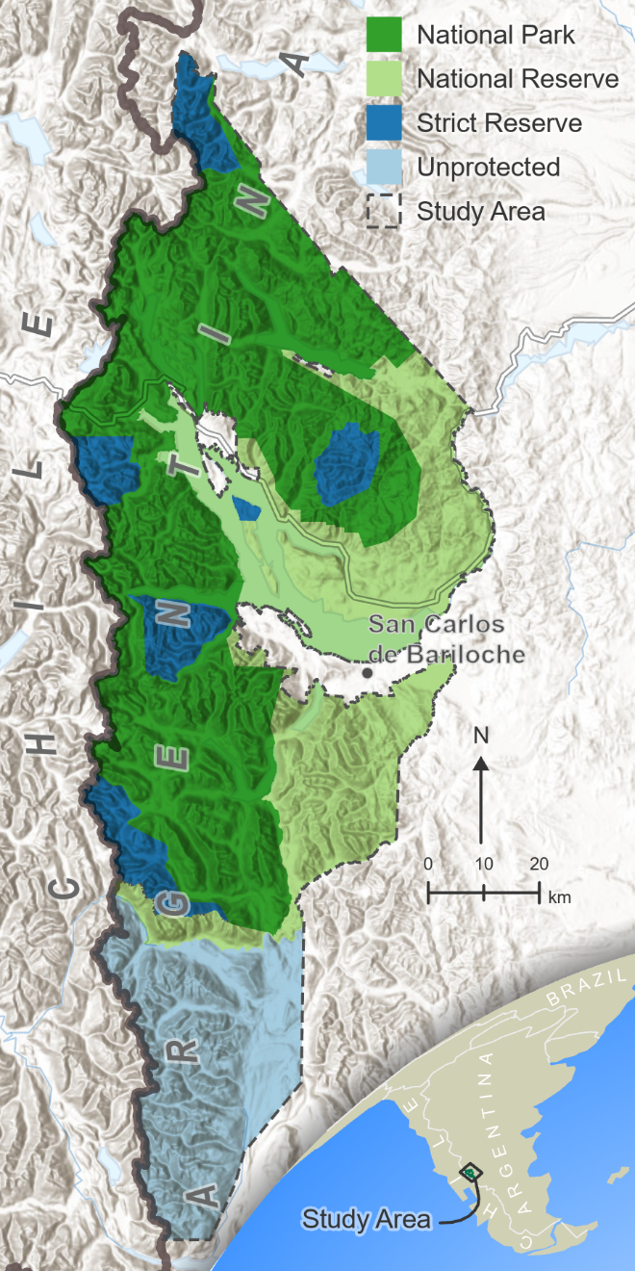
Figure 1.1 Map of Nahuel Huapi National Park. Levels of protection indicated by different colors.

Austrocedrus chilensis -cypress - along the eastern fringe in the ecotone between forest and steppe (Cabrera, 1976).
To quantify NDVI change in the study area in relation to significant environmental variables, we collected satellite imagery, precipitation, and temperature data from available remote sensing products from years 2000 to 2020, leveraging the resources of Google Earth Engine (Gorelick et al., 2017). While limited remote sensing data are available before 2000, sufficient data available starting in year 2000 allowed us to analyze vegetation change from when the strict reserves were first established. In addition to remote sensing data, we also acquired fire history (Mermoz et al., 2005), land cover provided from CIEFAP (Centro de Investigación y Extensión Forestal Andino Patagónico), and tourism data from APN (Administración de Parques Nacionales).
We created cloudless composites using Landsat data by selecting the “greenest” pixel from all scenes captured between December 1 and March 1 of each summer season. We selected only summer data because the presence of evergreen and deciduous forests prevents us from evaluating photosynthetic activity in fall and winter, while frequent presence of snow during the spring would also bias our analysis. The greenest pixel was taken to be that with the highest NDVI, which we computed for each available scene during each season. At least 25 scenes were available for each season. Composites before 2013 were created using Landsat 7 scenes, and composites 2013 and after were created using Landsat 8.
Selecting the greenest pixel allowed for the best interseason NDVI comparisons. However, while the method works well for creating cloudless composites in areas with vegetation present, pixels containing clouds are often selected over areas with low NDVI values, such as water bodies, urban areas, and areas above the tree line. Because these areas contained little to no vegetation, they were not relevant to our analysis, and we masked them from the resulting composites to exclude them from analysis. The mask was taken from land cover data provided to us by CIEFAP (Centro de Investigación y Extensión Forestal Andino Patagónico) and shown in Fig. 1.2.

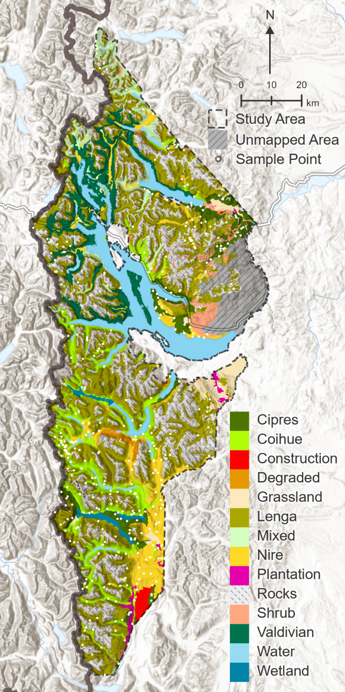
Figure 1.2 Land cover of NHNP and neighboring area.

We collected precipitation data within the study area from the Global Precipitation Measurement (GPM) Integrated Multi-satellitE Retrievals for GPM (IMERG) dataset (Huffman et al., 2019). IMERG provides total precipitation for every month at 0.1 x 0.1 degree (approximately 11.1 x 11.1 km) spatial resolution and calibrates multiple satellite estimates with ground sources.
We collected temperature data within the study area from the MOD11A1 V6 product derived from data collected by satellites equipped with the Moderate Resolution Imaging Spectroradiometer (MODIS) instrument (Wan et al., 2015). The data provide daily (one daytime and one nighttime) land surface temperature estimates at 1 x 1 km resolution. We computed the mean daytime temperature for every year (Jan 1st-Dec 31st) for use in analysis.
We calculated the mean NDVI per austral summer from 2000 to 2020 at each level of protection (SNR, NP, NR, Unprotected). We evaluated the synergistic effect of protection and time on changes in mean NDVI using ANCOVA, followed by a post hoc Bonferroni adjustment test. Level of protection and years (2000-2020) were the categorical and continuous variables, respectively. Since differences in NDVI among the levels of protection do not necessarily mean healthier vegetation, but rather could be related to differences in dominant species cover (e.g., NP mostly dominated by N. dombeyi vs NR mostly dominated by A. chilensis), precipitation, elevation, or temperature, in a second step we selected random points in each of the Unprotected, NR, NP, and SNR levels. Using the available data regarding dominant species cover across NHNP (Margutti & Arosteguy, 2019), we selected 25 random points per area dominated by one of the four most common dominant tree species: N. dombeyi, N. antarctica, N. pumilio, and A. chilensis, accounting for a total of 100 random points each for NP, NR and Unprotected area, and 75 random points for SNR, because no area is dominated by A. chilensis within this category (Fig. 2). For these 375 random points we extracted the elevation, and their NDVI values, temperature, and precipitation from 2000 to 2020.
For each random point we ran a linear regression in which we evaluated NDVI change over time, resulting in a total of 375 linear regressions. From each linear regression, we extracted the slope, as it provided us with information regarding the general trend of NDVI change per level of protection. Lastly, we ran an ANOVA test to evaluate if the slopes (indicating NDVI change over time) varied among the four levels of protection, followed by a Tukey HSD test.
Nothofagus dombeyi, N. antarctica, N. pumilio, and A. chilensis respond differently to disturbances such as wildfire, drought, livestock, and windstorm (Raffaele et al., 2014). To investigate if these species experienced a different trend among the levels of protection, we ran a two-way ANOVA test, grouping by level of protection and dominant species and using as dependent variable the 375 slopes from the random points mentioned above, followed by a Bonferroni test.
Previous studies have indicated that precipitation plays an important role in determining NDVI (Herrero et al., 2020). Other characteristics, such as elevation and temperature, might also affect the NDVI values. In order to reduce the number of physical variables used to explain changes in NDVI, we used Pearson's product-moment correlation to evaluate the correlation between precipitation and elevation (t=2.16, df=7810, p-value=0.03) and correlation between precipitation and temperature (t=-36.20, df=7810, p-value=<1.1e-16). We ran a linear regression to evaluate if annual precipitation in the studied area affected its NDVI. We transformed NDVI values using a Box-Cox transformation to satisfy the normality assumption, then evaluated by ANCOVA whether different levels of protection differed in annual precipitation.
To identify areas where changes in NDVI over the 20-year period were more notable, we filtered those pixels where values changed by more than 1 standard deviation (1 SD), both positive and negative changes. We ran a linear regression to evaluate if increases in NDVI were related to the level of protection, and we ran a second linear regression to analyze the relation between NDVI decreases and level of protection. As mentioned above, total area differs among levels of protection. To standardize the measure among them, we used the percent of area (of each level of protection) where NDVI changed by more than 1 SD. While an increase in NDVI is associated with vegetation growth, it does not necessarily mean that natural vegetation is thriving; in fact, several undesired landscape modifications can induce that change, such as land abandonment and agriculture expansion (Pan et al., 2018). On the other hand, a decrease in NDVI in areas dominated by a particular tree species could reflect disturbances with negative effects on that species. To investigate this situation further, we conducted an ANOVA test to evaluate if decreases in NDVI were related to the type of forest.
We performed the statistical analyses using R 4.0.3 (R Core Team, 2014).
The study area is highly visited during the summer months, when the risk of wildfire is higher owing to low seasonal precipitations. Campsites distributed in NP, NR, and in the neighboring unprotected area receive thousands of visitors, increasing the risk of wildfires. We performed a colocation analysis to determine if fires were more likely to occur near designated campsites. Colocation analysis yields a colocation quotient for each fire centroid, where values less than 1 indicate isolation and values greater than 1 indicate spatial correlation (Leslie & Kronenfeld, 2011). We performed the analysis using the Spatial Statistics toolbox in ESRI ArcGIS Pro version 2.8 using the four nearest neighbors. Fire data were provided by INIBIOMA (Instituto de Investigaciones en Biodiversidad y Medioambiente) and campsite data were provided by NHNP.

Results

We performed an ANCOVA to determine the effect of level of protection on the NDVI after controlling for time (years). There was a statistically significant difference in NDVI between the groups (F(3,91)=170.43, p<0.0001). Mean NDVI in the Strict Nature Reserve (0.724 ± 0.003) significantly exceeded that in the National Park (0.711 ±0.003), Unprotected area (0.707 ±0.003), and National Reserve (0.642±0.003), p < 0.001 (Fig. 1.3).
Linear regressions based on the 375 random points showed an overall NDVI increase over time (Fig. 1.4). We analyzed differences in slope per protection category with ANOVA. The greening process (NDVI increase over time) was significantly higher in the unprotected area than in the Natural Reserve (p=0.022), the National Park (p=0.01), and the Strict Nature Reserve (p=0.03) (Fig. 1.5).
We further investigated if dominant tree species had a different trend of NDVI change over time in each protection category with a two-way ANOVA. The interaction term between level of protection and dominant tree species was not significant (DF= 8, 357, F= 0.283, p=0.971), indicating that the tree species did not follow different trends over time in different protection categories (Fig. 1.6). Nevertheless, the "Group” term indicated that different species did follow a different trend without accounting for the protection level (DF=
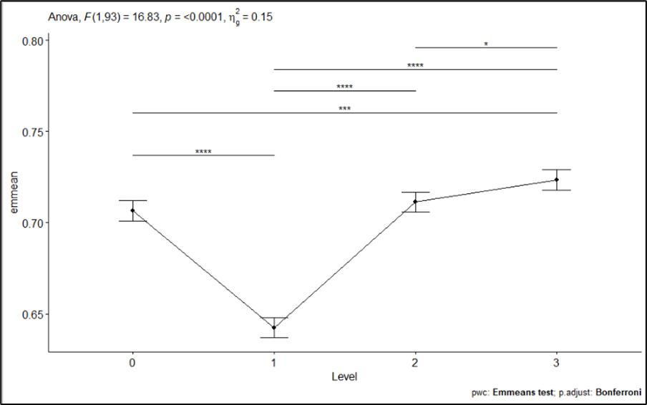
Figure 1.3 Variation in mean NDVI at different levels of protection (0: Unprotected area, 1: National Reserve, 2: National Park, 3: Strict Nature Reserve). Horizontal lines on top indicate statistical differences between paired levels of protection.

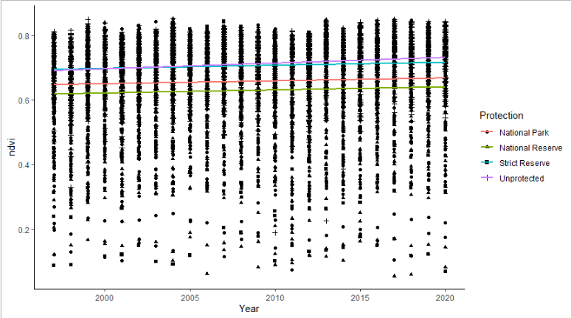
Figure 1.4 NDVI values over time recorded for a total of 375 random points equally distributed among the four levels of protection and four dominant tree species (Nothofagus dombeyi, N. antarctica, N. pumilio, and Austrocedrus chilensis).
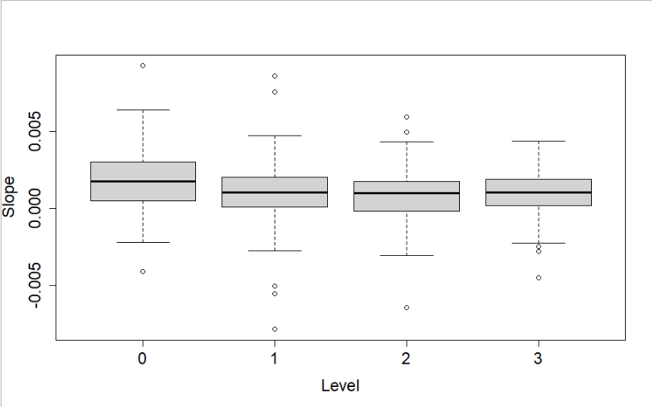
Figure 1.5 Comparison of the NDVI increases over time, indicated as positive slope values, among the different levels of protection (DF=3, 368, F=4.366, p=0.005, ges=0.034). 0: unprotected area, 1: National Reserve, 2: National Park, and 3: Strict Nature Reserve.

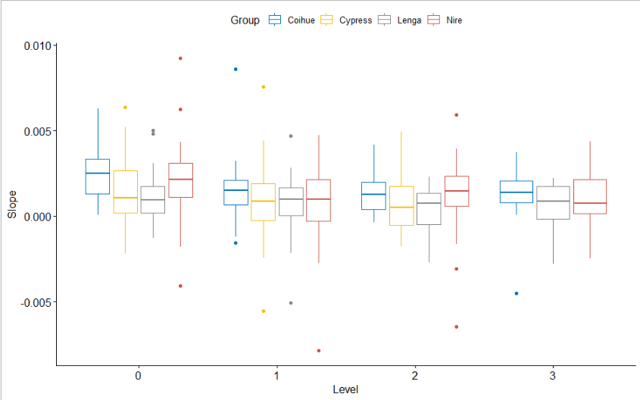
Figure 1.6 Comparison among the NDVI increases over time, indicated as positive slope values, for each of the four most common dominant tree species, among the different levels of protection. 0: unprotected area, 1: National Reserve, 2: National Park, and 3: Strict Nature Reserve.

3, 357, F= 4.036, p=0.008). We then computed a pairwise comparison using a Bonferroni test and found that the trend of NDVI change over time was more pronounced in N. dombeyi than in N. pumilio (p=0.0009), with no differences among the other species.
Precipitation and temperature were negatively correlated (t = -36.198, df = 7810, p-value < 2.2e-16, r= -0.38), and areas with higher temperature had lower NDVI. On the other hand, precipitation and elevation were positively correlated (t = 2.1616, df = 7810, p-value = 0.03, r=0.02). We further analyzed the effects of precipitation on NDVI, since it was the physical variable that explained the highest fraction of the variation. We found a positive correlation between annual precipitation and NDVI (F(1,82)=17.87, p=6.1e-05). We conducted an ANCOVA in order to determine if annual precipitation has changed in the studied area, and furthermore, if this change is consistent among the different levels of protection. We found an overall decrease in annual precipitation (F(1,79)=38.428, p=2.42e-08), although this decrease differed among levels of protection (F(3,79)=21.469, p=2.88e-10) (Fig. 1.7). In addition, a post-hoc Bonferroni analysis showed that estimated mean annual precipitation in the National Reserve was significantly lower than in the other three categories and that the estimated mean precipitation in the Strict Nature Reserve was higher than in the unprotected area (Table 1.1, Fig. 1.8).
Areas where NDVI changed by more than 1 standard deviation (both positive and negative) are indicated in Fig. 1.9. The percent of greening areas in the unprotected area significantly exceeded that in the NR (Adj. R-squared=0.435, F(4, 91)=19.26, p=1.666e-11), while no significant differences with and among the other categories were found (Fig. 1.10). On the contrary, the same analysis applied to percent of areas with a decreased NDVI yielded no relationship with years or level of protection (Adj, R-squared=0.001, F(4, 91)=1.039, p=0.392) (Fig. 1.11).
To evaluate if negative changes in NDVI were more frequent in forests dominated by a particular tree species, we conducted an ANOVA. We found a significant difference between the number of pixels with a decreased NDVI and the type of forest (F(4,15)=3.922, p=0.023, ges=0.511). Forests dominated by N. pumilio contained larger proportional areas with a decreased NDVI than did mixed forests (p=0.0339) and forests dominated by shrub species (p=0.026) (Fig. 1.12).

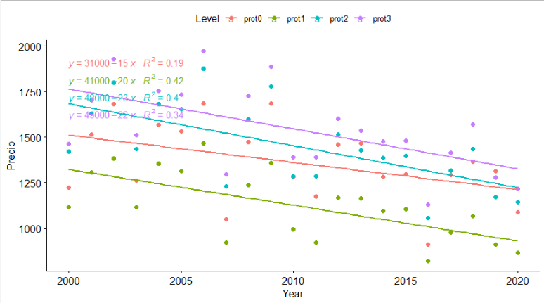
Figure 1.7 Annual precipitation change for each level of protection. prot0: unprotected area, prot1: National Reserve, prot2: National Park, prot3: Strict Nature Reserve.

Table 1.1 Results from a Bonferroni test indicating differences between changes in annual precipitation at each protection category. Statistical significance is indicated with *.
Levels compared | DF | F | p
Unprotected vs NR | 79 | 4.28 | 5.16e-5 ***
Unprotected vs NP | 79 | -1.66 | 0.100
Unprotected vs SNR | 79 | -3.35 | 1.24e-3 **
NR vs NP | 79 | -5.97 | 7.07e-8 ****
NR vs SNR | 79 | -7.63 | 4.5e-11 ****
NP vs SNR | 79 | -1.69 | 0.096

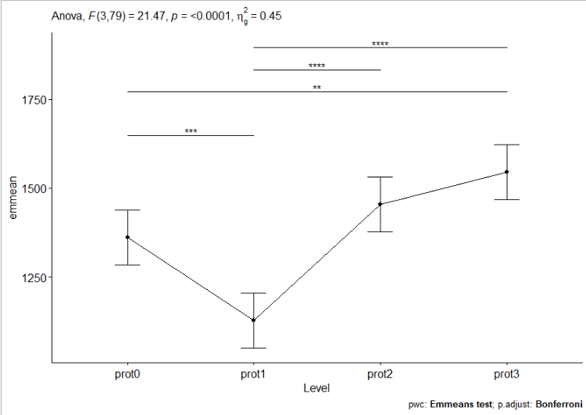
Figure 1.8 Estimated mean annual precipitation for each level of protection based on 20 years of precipitation data (period 2000-2020). Statistical differences among the protection categories are indicated with *. prot0: unprotected area, prot1: National Reserve, prot2: National Park, prot3: Strict Nature Reserve. Horizontal lines on top indicate statistical differences between paired levels of protection.

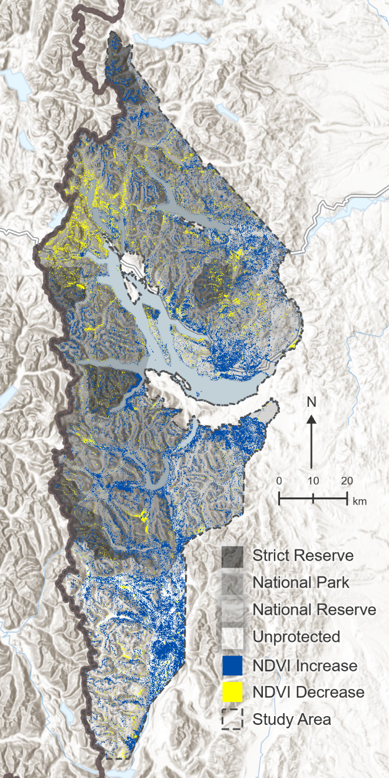
Figure 1.9 Map with areas with NDVI increase (blue) and decrease (yellow) in the period 2000-2020.
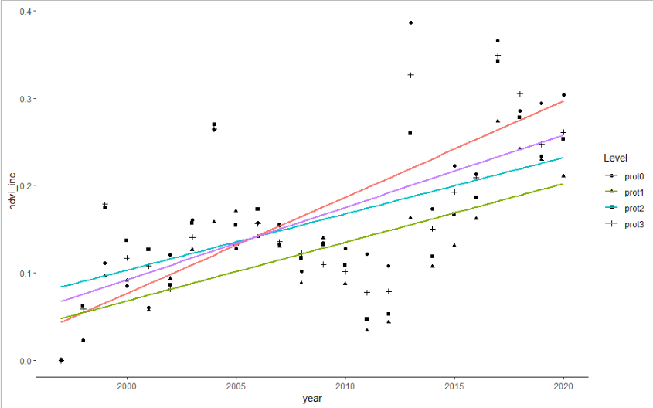
Figure 1.10 Percent of area with an increase in NDVI, per level of protection, over time. prot0: unprotected area, prot1: National Reserve, prot2: National Park, prot3: Strict Nature Reserve.

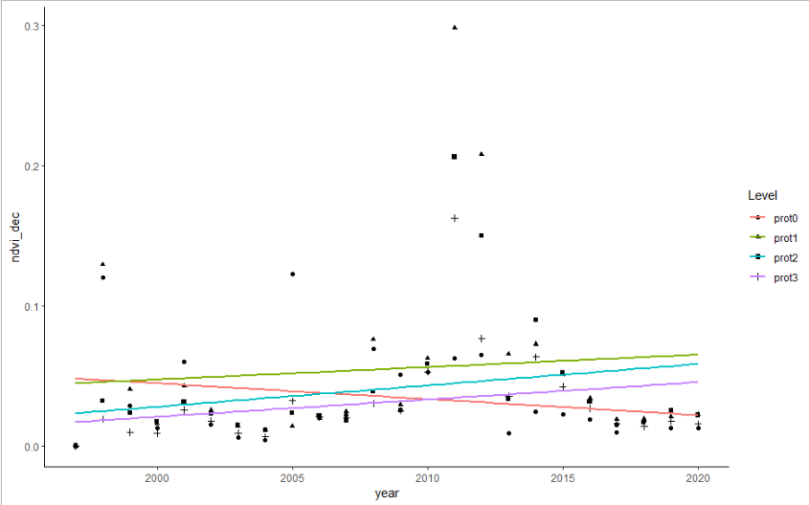
Figure 1.11 Percent of area with a decrease in NDVI, per level of protection, over time. prot0: unprotected area, prot1: National Reserve, prot2: National Park, prot3: Strict Nature Reserve.

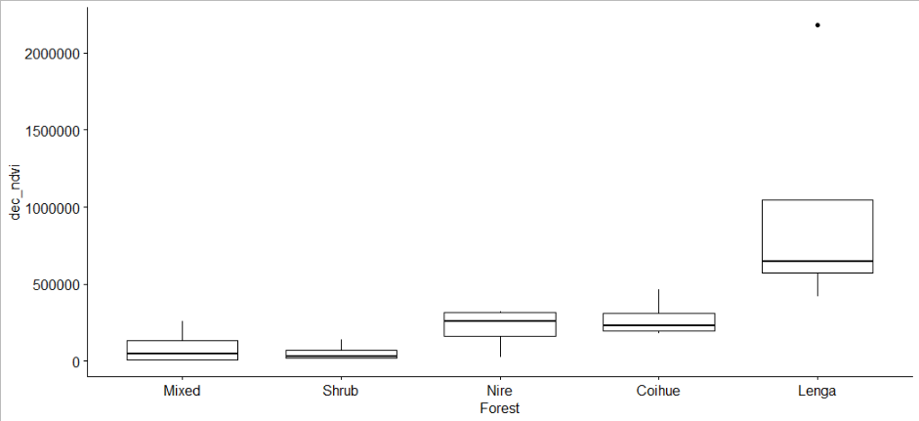
Figure 1.12 Total number of pixels where NDVI decreased over a 20-year period for each type of forest.

As shown in Figure 1.13 and Table 1.2, colocation analysis suggests that some fires were more likely to occur near campsites than if they were randomly distributed. However, none of the quotients are statistically significant, which could be due to the low number of both fires (n=23) and campsites (n=28). Overall, approximately 1.7% of the land within the study area burned between 2000 and 2020.

Discussion

Remote sensing data provide an excellent opportunity to evaluate land surface changes over time at different scales, from local to global assessments, and they have been widely used to evaluate fragmentation and degradation within protected areas (Nagendra et al., 2013). Leisher et al. (2013) analyzed land and forest degradation in 1788 PAs in Latin America between 2004 and 2009, concluding that the rate of degradation increased from 0.04% to 0.10% per year, resulting in 1,097,618 hectares degraded. They evaluated 166 Argentinean PAs, concluding that almost 20% of them have experienced land and forest degradation, despite having a funding level three times the average for the Latin American countries (US$ 8.60 versus US$ 2.50 per hectare). In this study, we evaluated in detail the conservation status of the oldest and one of the largest of the Argentinean PAs, Nahuel Huapi National Park (NHNP). The second NHNP Management Plan published in 2019 (Margutti & Arosteguy, 2019) highlighted the importance of unifying the criteria used to subdivide the PA following its formal and legal delimitation between different conservation categories (Strict Nature Reserve, Wilderness Natural Reserve, National Park, National Reserve; IUCN categories Ia, Ib, II and VI respectively) rather than by zoning categories based on its uses, as the first management plan proposed (Gil et al., 1986). Because the strictest category was created in 1990, our study spanning from 2000 to 2020 provides the best up-to-date evidence regarding the effectiveness of this high conservation category. NDVI values were consistently higher in the SNR compared to the other protection categories and the unprotected area with an assessment based on the average NDVI per category per year.
This result would provide an optimistic assessment of the effectiveness of the strictest category. However, differences in area, location (affecting precipitation,
Table 1.2 Colocation Analysis Summary: relation between wildfires and campsites.
ID | Year | Area (ha) | Colocation Quotient | p-value | Colocation label
2 | 2013 | 201.2 | 1.4 | 0.5 | Colocated
3 | 1999 | 99.4 | 0.0 | 0.06 | Isolated
4 | 2002 | 14.8 | 1.1 | 0.96 | Colocated
9 | 1999 | 593.8 | 1.2 | 0.86 | Colocated
10 | 1999 | 2.1 | 1.4 | 0.76 | Colocated
11 | 1999 | 145.0 | 0.3 | 0.2 | Isolated
12 | 1999 | 3830.6 | 1.4 | 0.48 | Colocated
13 | 1999 | 513.4 | 0.0 | 0.06 | Isolated
15 | 2002 | 191.8 | 1.4 | 0.42 | Colocated
19 | 2015 | 459.9 | 0.9 | 0.74 | Isolated
20 | 1999 | 123.1 | 1.4 | 0.72 | Colocated
21 | 1999 | 8.6 | 1.4 | 0.52 | Colocated
1 | 1999 | 1933.2 | Not analyzed
22 | 1999 | 177.8 | Not analyzed
23 | 2004 | 272.4 | Not analyzed
5 | 2013 | 1.0 | Not analyzed
6 | 2006 | 246.8 | Not analyzed
7 | 2012 | 322.3 | Not analyzed
8 | 2009 | 2160.0 | Not analyzed
14 | 2012 | 39.6 | Not analyzed
16 | 2002 | 2364.4 | Not analyzed
17 | 2002 | 317.0 | Not analyzed
18 | 2004 | 278.6 | Not analyzed

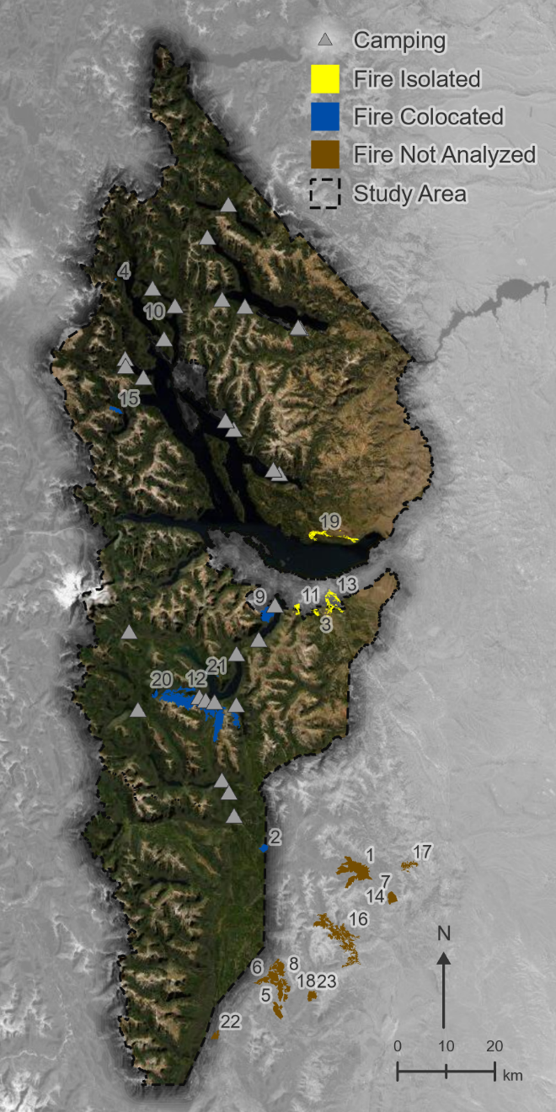
Figure 1.13 Fires and campsites within the study area.

temperature, elevation), and dominant tree species among the protection categories might bias our understanding of differences among them in effectiveness. To address this situation, we re-evaluated NDVI changes based on the selection of 375 random points, with an equal representation of different dominant tree species among the four levels. Surprisingly, with this second analysis, the unprotected area shows the highest values of NDVI, which differ statistically from those values reported in the three categories inside the PA. A common approach is to compare vegetation inside and outside PAs. However, the border of a PA may coincide with a natural change in habitat type leading to misinterpretation regarding the effectiveness of such a PA (Ferraro et al., 2013; Joppa & Pfaff, 2011; Mas, 2005). We purposely selected as unprotected area the neighboring southern region based on landscape, climatic conditions, and floral similarities with the PA, since the eastern area transitions into steppe and the western area is in a different nation, Chile. Finally, NDVI values within NHNP coincided with the levels of protection (NDVI values SNR>NP>NR).
The general NDVI change trend was positive for all four categories. We found similar results with both assessments (average NDVI per category and using 375-pixel values). The observation of increasing NDVI values agrees with the greening phenomenon reported globally (Zhu et al., 2016). There is not a direct interpretation of the process; greener does not necessarily mean better conserved. Seasonal or annual changes in NDVI could be associated with an increase in leaf size, number of leaves per plant, plant density, and crop grown per year, but it can also reflect replacement of natural ecosystems by agricultural lands, or non-native species colonization after disturbances (Piao et al., 2020). Interpreting positive NDVI changes remains challenging because no rigorous method has yet been validated (Leisher et al., 2013). In the case of NHNP, no forest has been replaced by agricultural land. Presence of non-native species, extensive livestock, logging, and wildfires were identified as the main threats in this PA (Margutti & Arosteguy, 2019). While a compelling body of evidence depicts negative effects associated with non-native plant species in NHNP (Franzese & Ghermandi, 2014; Nunez, 2008; Simberloff et al., 2002; Svriz et al., 2013), where 25% of the plant species are non-native (Raffaele et al., 2014), further studies are needed to evaluate if this colonization is related to the increased NDVI values reported here. Furthermore, introduced animals have also impacted forest structure and regeneration in NHNP (Barrios-Garcia & Simberloff, 2013; Martin-Albarracin et al., 2015; Nunez et al., 2013; Rodriguez-Cabal et al., 2013). The combination of cattle and wildfires negatively affected regeneration of Nothofagus dombeyi - Austrocedrus chilensis mixed forests in NHNP, facilitating a post-fire transition from forest to bamboo-dominated shrubland (Blackhall et al., 2008), which could increase NDVI values (Franco et al., 2020). Specific studies addressing this question are needed.
We found a positive relationship between NDVI and precipitation, supporting previous findings (Herrero et al., 2020). Furthermore, the variation in precipitation among the levels of protection resembles the differences found among their NDVI values (SNR>NP>Outside>NR, see Fig. 3 and Fig. 8), suggesting that precipitation might be the cause of these differences in NDVI rather than levels of protection. However, mean annual precipitation fluctuated over time across this region, but the overall trend manifests a decreasing pattern. Precipitation therefore cannot explain the increasing NDVI trend.
Despite the general greening pattern explained above, we further investigated this process by extracting pixels where the NDVI changed more than 1 SD during the period studied. The unprotected area accounted for a larger increase compared to the NR, while this difference was not evident between unprotected and NP, unprotected and SNR, or within the three levels of protection inside NHNP. As stated above, interpretation of increasing NDVI is difficult; however, as a similar pattern or tendency was observed inside and outside the PA, the greening process could be a consequence of a global phenomenon such as climate change and increased ${CO}_{2}$ (Ogunkoya et al., 2021), further exacerbated in the unprotected area where extensive livestock and logging are common.
Negative NDVI change could be more easily related to degradation and habitat fragmentation (Leisher et al., 2013; Morton et al., 2005). We found no evidence that degradation was more extensive in the unprotected area compared to that in areas under any level of protection. Interestingly, during the year 2012 there was a peak in the percentage of area with a negative NDVI change inside the PA (NR ~ 30%, NP ~ 20% , SNR ~ 16%), but this value remained low in the unprotected area (~5%), which could be explained by the massive ash deposit as consequence of the Puyehue-Cordón Caulle volcanic eruption that dispersed about 100 million metric tons of ash, covering 7.5 million ha in Patagonia (Wilson et al., 2013). While the central and northern area of NHNP were severely affected by ash deposition, the southern portion of NHNP and the unprotected area evaluated in this study remained free of ash. The area more severely affected by ash deposition (Bignami et al., 2014) coincides with the red area observed in the NW section of Fig.9.
Fragmentation or degradation were more striking in areas dominated by Nothofagus pumilio (both inside and outside the PA) compared to areas dominated by mixed forests and shrublands. Nothofagus pumilio forests are distributed at high elevations along approximately 3,000 km of the southern Andes Mountain chain (Mathiasen & Premoli, 2010). A previous study found a positive correlation between N. pumilio growth and precipitation, and a negative correlation with mean annual temperature (Lara et al., 2005). Severe droughts in the 20th century following relatively wet and cool years have been associated with a persistent decline in N. pumilio growth, suggesting that current and future trends with lower precipitation and higher temperatures associated with climate change would further promote the decline of these forests (Rodríguez-Catón et al., 2016). Furthermore, wildfires have historically affected forests of N. pumilio by direct burning (Veblen et al., 2003) and also by reducing root ectomycorrhizal colonization after fire (Longo et al., 2011).
Wildfires in the region are common between September and April, with record numbers in January and February, due to the combination of low precipitation and high temperatures during the austral summer months. The causes of most of these wildfires remain unknown owing to lack of trained personnel and low budgets. However, human activities are thought to be closely related to their occurrence (Margutti & Arosteguy, 2019; Monjeau et al., 2005). Although tourists arrive in NHNP throughout the year, more than 23% of the total annual visitation occurs during two summer months (Área Técnica y Estadística, 2015). Campsites are distributed in NP, NR, and the unprotected area, and camping during summer is one of the favorite activities for both residents and tourists. Since the establishment of campsites within the PA is regulated by the APN (National Park Administration), we explored if the locations of wildfires were associated with the authorized campsites. We used available data (date, location, and area burnt) for 22 wildfires that occurred between 1999 and 2015 within NHNP. Although we found no relationship between these two variables, it is important to notice that there were a total of 239 fires recorded in this period, most of which (150) affected less than 0.5 ha (Margutti & Arosteguy, 2019), and no location data were available, so we could not include such data in our analysis. Furthermore, illegal campfires are common across the region, and the low number of personnel and lack of appropriate vehicles make it difficult for authorities to prevent them (Rivarola et al., 2021a). On the other hand, the current trend of warmer and drier summers following unusually dry springs (phenomena associated with La Niña events), uncommon electrical storms during the summer, and the massive accumulation of fuel material in the forests constitute a permanent threat for these forests, across all levels of protection. The remote and isolated location of most of the SNR areas makes them particularly vulnerable to fires, since ground access is difficult, preventing prompt response to many fires. Thousands of hectares are affected. On December 7th, 2021, lighting ignited a wildfire in the southern area of NHNP, within the SNR. The initial, small fire could not be controlled because firefighters could not access the area. The wildfire is spreading and remains active at the time this manuscript is being written, one and half months after the initiation of the fire. It is estimated that more than 6,000 ha of pristine native forests within NHNP (both in SNR and NP) have been burned (ADN SUR, 2022; Sala de Noticias, 2022).
Effective management of PAs is essential to conserve natural ecosystems. Their role in ecosystem services and preserving biodiversity goes beyond the limits of a PA, and they constitute a substantial fraction of a country’s national capital, supporting national sustainable development and human well-being (Bovarnick et al., 2010). The Argentinean PA system has a long history, and despite political and economic instability in the country, the general trend of PA establishment and management by the APN is promising (Rivarola et al., 2021a). Weaknesses and threats were well identified in the latest management plan for NHNP, and general and specific goals were established for both the short and the long term. This study provides further evidence supporting the regional importance of NHNP and particularly the strict nature reserve component.

References
ADN SUR, 2022. Río Negro: el incendio cerca del Lago Steffen ya afectó unas 5.438 hectáreas. AND Sur Agencia de Noticias. https://www.adnsur.com.ar, Comodoro Rivadavia, Chubut, Argentina.
Aizen, M., Escurra, C., 1998. High incidence of plant-animal mutualisms in the woody flora of the temperate forest of southern South America: biogeographical origin and present ecological significance. Ecología Austral 8, 217-236.
Área Técnica y Estadística, 2015. Temporada estival enero y febrero, comparación anual. Secretaría Municipal de Turismo, San Carlos de Bariloche, pp. 16.
Armenteras, D., Villareal, G. H., 2003. Andean forest fragmentation and the representativeness of protected natural areas in the eastern Andes, Colombia. Biological Conservation 113, 245-256, doi:10.1016/s0309-1740(03)00100-1.
Armesto, J. J., Rozzi, R., Smith-Ramírez, C., Arroyo, M. T. K., 1998. Conservation targets in South American temperate forests. Science 282, 1271-1272, doi:doi:10.1126/science.282.5392.1271.
Arroyo, M. T. K., Riveros, M., Peñaloza, A., Cavieres, L., Faggi, A. M., 1996. Phytogeographic r0elationships and regional richness patterns of the cool temperate rainforest flora of southern South America. In: Lawford, R. G., et al., Eds.), High-latitude rainforests and associated ecosystems of the West Coast of the Americas: Climate, Hydrology, Ecology, and Conservation. Springer New York, New York, NY, pp. 134-172.
Axelrod, D. I., Kalin Arroyo, M. T., Raven, P. H., 1991. Historical development of temperate vegetation in the Americas. Revista Chilena de Historia Natural 64, 413-446.
Balazote Oliver, A., Amico, G. C., Rivarola, M. D., & Morales, J. M. (2017). Population dynamics of Dromiciops gliroides (Microbiotheriidae) in an austral temperate forest [Article]. Journal of Mammalogy, 98(4), 1179-1184. https://doi.org/10.1093/jmammal/gyx051
Barnes, M. D., Craigie, I. D., Dudley, N., Hockings, M., 2017. Understanding local-scale drivers of biodiversity outcomes in terrestrial protected areas. Annals of the New York Academy of Sciences 1399, 42-60, doi:10.1111/nyas.13154.
Barnes, M. D., Craigie, I. D., Harrison, L. B., Geldamann, J., Collen, B., Whitmee, S., Balmford, A., Burgess, N. D., Brooks, T. M., Hockings, M., Woodley, S., 2016. Wildlife population trends in protected areas predicted by national socio-economic metrics and body size. Nature Communications 7, 1-9, doi:10.1038/ncomms12747.
Barrios-Garcia, M. N., Simberloff, D., 2013. Linking the pattern to the mechanism: How an introduced mammal facilitates plant invasions. Austral Ecology 38, 884-890, doi:10.1111/aec.12027.
Bignami, C., Corradini, S., Merucci, L., de Michele, M., Raucoules, D., de Astis, G., Stramondo, S., 2014. Multisensor satellite monitoring of the 2011 Puyehue-Cordon Caulle eruption. IEEE Journal of Selected Topics in Applied Earth Observations and Remote Sensing 7, 2786-2796, doi:10.1109/JSTARS.2014.2320638.
Blackhall, M., Raffaele, E., Veblen, T. T., 2008. Cattle affect early post-fire regeneration in a Nothofagus dombeyi–Austrocedrus chilensis mixed forest in northern Patagonia, Argentina. Biological Conservation 141, 2251-2261, doi:https://doi.org/10.1016/j.biocon.2008.06.016.
Bovarnick, A., Fernandez Baca, J., Galindo, J., Negret, H., 2010. Financial Sustainability of protected areas in Latin America and the Caribbean: investment policy guidance. United Nations Development Program (UNDP) and The Nature Conservancy (TNC).
Buchanan, G. M., Butchart, S. H. M., Dutson, G., Pilgrim, J. D., Steininger, M. K., Bishop, K. D., Mayaux, P., 2008. Using remote sensing to inform conservation status assessment: Estimates of recent deforestation rates on New Britain and the impacts upon endemic birds. Biological Conservation 141, 56-66, doi:10.1016/j.biocon.2007.08.023.
Burkart, R., 2005. Las Areas Protegidas de la Argentina. Conservacion y uso sustentable de la biodiversidad. La situacion ambiental Argentina. Administracion de Parques Nacionales, Buenos Aires, Argentina, pp. 399-431.
Burkart, R., Barbaro, N. O., Sanchez, R. O., Gomez, D. A., 1999. Eco-Regiones de la Argentina. In: Administracion de Parques Nacionales, S. d. R. N. y. D. S., (Ed.). Presidencia de la Nacion, Buenos Aires, Argentina, pp. 45.
Cabrera, L. A., 1976. Regiones fitogeográficas argentinas. ACMA, Buenos Aires.
Caro, T., Gardner, T. A., Stoner, C., Fitzherbert, E., Davenport, T. R. B., 2009. Assessing the effectiveness of protected areas: paradoxes call for pluralism in evaluating conservation performance. Diversity and Distributions 15, 178-182, doi:https://doi.org/10.1111/j.1472-4642.2008.00522.x.
CBD, 2010. Decision adopted by the CoP to the CBD at its 10th meeting (UNEP/CBD/COP/DEC/X/2). Montreal: Secretariat of the CBD.
Chape, S., Harrison, J., Spalding, M., Lysenko, I., 2005. Measuring the extent and effectiveness of protected areas as an indicator for meeting global biodiversity targets. Philos Trans R Soc Lond B Biol Sci 360, 443-55, doi:10.1098/rstb.2004.1592.
Coad, L., Watson, J. E., Geldmann, J., Burgess, N. D., Leverington, F., Hockings, M., Knights, K., Di Marco, M., 2019. Widespread shortfalls in protected area resourcing undermine efforts to conserve biodiversity. Frontiers in Ecology and the Environment 17, 259-264, doi:https://doi.org/10.1002/fee.2042.
Coad, L., Leverington, F., Knights, K., Geldmann, J., Eassom, A., Kapos, V., Kingston, N., de Lima, M., Zamora, C., Cuardros, I., Nolte, C., Burgess, N. D., Hockings, M., 2015. Measuring impact of protected area management interventions: current and future use of the Global Database of Protected Area Management Effectiveness. Philos Trans R Soc Lond B Biol Sci 370, 20140281, doi:http://dx.doi.org/10.1098/rstb.2014.0281.
Dudley, N., 2013. Guidelines for applying protected area management categories including IUCN WCPA best practice guidance on recognising protected areas and assigning management categories and governance types. IUCN, Gland, pp. 86.
Ferraro, P. J., Hanauer, M. M., Miteva, D. A., Canavire-Bacarreza, G. J., Pattanayak, S. K., Sims, K. R. E., 2013. More strictly protected areas are not necessarily more protective: evidence from Bolivia, Costa Rica, Indonesia, and Thailand. Environmental Research Letters 8, 025011, doi:https://doi.org/10.1088/1748-9326/8/2/025011.
Franco, M. G., Mundo, I. A., Veblen, T. T., 2020. Field-validated burn-severity mapping in north Patagonian forests. Remote Sensing 12, 214.
Franzese, J., Ghermandi, L., 2014. Early competition between the exotic herb Rumex acetosella and two native tussock grasses with different palatability and water stress tolerance. Journal of Arid Environments 106, 58-62, doi:10.1016/j.jaridenv.2014.03.004.
Gandhi, G. M., Parthiban, S., Thummalu, N., Christy, A., 2015. Ndvi: Vegetation change detection using remote sensing and Gis – A case study of Vellore District. Procedia Computer Science 57, 1199-1210, doi:https://doi.org/10.1016/j.procs.2015.07.415.
Gelman, A., Hwang, J., & Vehtari, A. (2014). Understanding predictive information criteria for Bayesian models. Statistics and Computing, 24(6), 997-1016. https://doi.org/10.1007/s11222-013-9416-2
ADN SUR, 2022. Río Negro: el incendio cerca del Lago Steffen ya afectó unas 5.438 hectáreas. AND Sur Agencia de Noticias. https://www.adnsur.com.ar, Comodoro Rivadavia, Chubut, Argentina.
Aizen, M., Escurra, C., 1998. High incidence of plant-animal mutualisms in the woody flora of the temperate forest of southern South America: biogeographical origin and present ecological significance. Ecología Austral 8, 217-236.
Área Técnica y Estadística, 2015. Temporada estival enero y febrero, comparación anual. Secretaría Municipal de Turismo, San Carlos de Bariloche, pp. 16.
Armenteras, D., Villareal, G. H., 2003. Andean forest fragmentation and the representativeness of protected natural areas in the eastern Andes, Colombia. Biological Conservation 113, 245-256, doi:10.1016/s0309-1740(03)00100-1.
Armesto, J. J., Rozzi, R., Smith-Ramírez, C., Arroyo, M. T. K., 1998. Conservation targets in South American temperate forests. Science 282, 1271-1272, doi:doi:10.1126/science.282.5392.1271.
Arroyo, M. T. K., Riveros, M., Peñaloza, A., Cavieres, L., Faggi, A. M., 1996. Phytogeographic relationships and regional richness patterns of the cool temperate rainforest flora of southern South America. In: Lawford, R. G., et al., Eds.), High-latitude rainforests and associated ecosystems of the West Coast of the Americas: Climate, Hyrology, Ecology, and Conservation. Springer New York, New York, NY, pp. 134-172.
Axelrod, D. I., Kalin Arroyo, M. T., Raven, P. H., 1991. Historical development of temperate vegetation in the Americas. Revista Chilena de Historia Natural 64, 413-446.
Barnes, M. D., Craigie, I. D., Dudley, N., Hockings, M., 2017. Understanding local-scale drivers of biodiversity outcomes in terrestrial protected areas. Annals of the New York Academy of Sciences 1399, 42-60, doi:10.1111/nyas.13154.
Barnes, M. D., Craigie, I. D., Harrison, L. B., Geldamann, J., Collen, B., Whitmee, S., Balmford, A., Burgess, N. D., Brooks, T. M., Hockings, M., Woodley, S., 2016. Wildlife population trends in protected areas predicted by national socio-economic metrics and body size. Nature Communications 7, 1-9, doi:10.1038/ncomms12747.
Barrios-Garcia, M. N., Simberloff, D., 2013. Linking the pattern to the mechanism: How an introduced mammal facilitates plant invasions. Austral Ecology 38, 884-890, doi:10.1111/aec.12027.
Bignami, C., Corradini, S., Merucci, L., de Michele, M., Raucoules, D., de Astis, G., Stramondo, S., 2014. Multisensor satellite monitoring of the 2011 Puyehue-Cordon Caulle Eruption. IEEE Journal of Selected Topics in Applied Earth Observations and Remote Sensing 7, 2786-2796, doi:10.1109/JSTARS.2014.2320638.
Blackhall, M., Raffaele, E., Veblen, T. T., 2008. Cattle affect early post-fire regeneration in a Nothofagus dombeyi–Austrocedrus chilensis mixed forest in northern Patagonia, Argentina. Biological Conservation 141, 2251-2261, doi:https://doi.org/10.1016/j.biocon.2008.06.016.
Bovarnick, A., Fernandez Baca, J., Galindo, J., Negret, H., 2010. Financial sustainability of protected areas in Latin America and the Caribbean: investment policy guidance. United Nations Development Program (UNDP) and The Nature Conservancy (TNC).
Buchanan, G. M., Butchart, S. H. M., Dutson, G., Pilgrim, J. D., Steininger, M. K., Bishop, K. D., Mayaux, P., 2008. Using remote sensing to inform conservation status assessment: Estimates of recent deforestation rates on New Britain and the impacts upon endemic birds. Biological Conservation 141, 56-66, doi:10.1016/j.biocon.2007.08.023.
Burkart, R., 2005. Las áreas protegidas de la Argentina. Conservación y uso sustentable de la biodiversidad. La situación ambiental Argentina. Administración de Parques Nacionales, Buenos Aires, Argentina, pp. 399-431.
Burkart, R., Barbaro, N. O., Sanchez, R. O., Gomez, D. A., 1999. Eco-Regiones de la Argentina. In: Administración de Parques Nacionales, S. d. R. N. y. D. S., (Ed.). Presidencia de la Nación, Buenos Aires, Argentina, pp. 45.
Cabrera, L. A., 1976. Regiones fitogeográficas argentinas. ACMA, Buenos Aires.
Caro, T., Gardner, T. A., Stoner, C., Fitzherbert, E., Davenport, T. R. B., 2009. Assessing the effectiveness of protected areas: paradoxes call for pluralism in evaluating conservation performance. Diversity and Distributions 15, 178-182, doi:https://doi.org/10.1111/j.1472-4642.2008.00522.x.
CBD, 2010. Decision adopted by the CoP to the CBD at its 10th meeting (UNEP/CBD/COP/DEC/X/2). Montreal: Secretariat of the CBD.
Chape, S., Harrison, J., Spalding, M., Lysenko, I., 2005. Measuring the extent and effectiveness of protected areas as an indicator for meeting global biodiversity targets. Philos Trans R Soc Lond B Biol Sci 360, 443-55, doi:10.1098/rstb.2004.1592.
Coad, L., Watson, J. E., Geldmann, J., Burgess, N. D., Leverington, F., Hockings, M., Knights, K., Di Marco, M., 2019. Widespread shortfalls in protected area resourcing undermine efforts to conserve biodiversity. Frontiers in Ecology and the Environment 17, 259-264, doi:https://doi.org/10.1002/fee.2042.
Coad, L., Leverington, F., Knights, K., Geldmann, J., Eassom, A., Kapos, V., Kingston, N., de Lima, M., Zamora, C., Cuardros, I., Nolte, C., Burgess, N. D., Hockings, M., 2015. Measuring impact of protected area management interventions: current and future use of the Global Database of Protected Area Management Effectiveness. Philos Trans R Soc Lond B Biol Sci 370, 20140281, doi:http://dx.doi.org/10.1098/rstb.2014.0281.
Dudley, N., 2013. Guidelines for applying protected area management categories including IUCN WCPA best practice guidance on recognising protected areas and assigning management categories and governance types. IUCN, Gland, pp. 86.
Ferraro, P. J., Hanauer, M. M., Miteva, D. A., Canavire-Bacarreza, G. J., Pattanayak, S. K., Sims, K. R. E., 2013. More strictly protected areas are not necessarily more protective: evidence from Bolivia, Costa Rica, Indonesia, and Thailand. Environmental Research Letters 8, 025011, doi:https://doi.org/10.1088/1748-9326/8/2/025011.
Franco, M. G., Mundo, I. A., Veblen, T. T., 2020. Field-validated burn-severity mapping in north Patagonian Forests. Remote Sensing 12, 214.
Franzese, J., Ghermandi, L., 2014. Early competition between the exotic herb Rumex acetosella and two native tussock grasses with different palatability and water stress tolerance. Journal of Arid Environments 106, 58-62, doi:10.1016/j.jaridenv.2014.03.004.
Gandhi, G. M., Parthiban, S., Thummalu, N., Christy, A., 2015. NDVI: Vegetation change detection using remote sensing and Gis – A case study of Vellore District. Procedia Computer Science 57, 1199-1210, doi:https://doi.org/10.1016/j.procs.2015.07.415.
Geneletti, D., van Duren, I., 2008. Protected area zoning for conservation and use: A combination of spatial multicriteria and multiobjective evaluation. Landscape and Urban Planning 85, 97-110, doi:https://doi.org/10.1016/j.landurbplan.2007.10.004.
Gil, J., Malvarez, I., Martín, C., 1986. Plan de manejo del Parque Nacional Nahuel Huapi. In: Nacionales, A. d. P., (Ed.). APN, Bariloche - Argentina, pp. 101.
Gorelick, N., Hancher, M., Dixon, M., Ilyushchenko, S., Thau, D., Moore, R., 2017. Google Earth Engine: Planetary-scale geospatial analysis for everyone. Remote Sensing of Environment 202, 18-27, doi:https://doi.org/10.1016/j.rse.2017.06.031.
Hansen, M. C., Loveland, T. R., 2012. A review of large area monitoring of land cover change using Landsat data. Remote Sensing of Environment 122, 66-74, doi:https://doi.org/10.1016/j.rse.2011.08.024.
Herrero, H., Southworth, J., Muir, C., Khatami, R., Bunting, E., Child, B., 2020. An evaluation of vegetation health in and around southern African National Parks during the 21st Century (2000–2016). Applied Sciences 10, 2366.
Herrero, H. V., Southworth, J., Bunting, E., 2016. Utilizing multiple lines of evidence to determine landscape degradation within protected area landscapes: A case study of Chobe National Park, Botswana from 1982 to 2011. Remote Sensing 8, 623.
Hockings, M., 2003. Systems for assessing the effectiveness of management in protected areas. BioScience 53, 823, doi:10.1641/0006-3568(2003)053[0823:sfateo]2.0.co;2.
Hockings, M., Stolton, S. U. E., Leverington, F., Dudley, N., Courrau, J., Valentine, P., 2006. Evaluating effectiveness. A framework for assessing management effectiveness of protected areas. IUCN The World Conservation Union, Gland, Switzerland and Cambridge, UK.
Huffman, G. J., Stocker, E. F., Bolvin, D. T., Nelkin, E. J., Tan, J., 2019. GPM IMERG Final Precipitation L3 1 month 0.1 degree x 0.1 degree V06, Greenbelt, MD, Goddard Earth Sciences Data and Information Services Center (GES DISC).
Hull, V., Xu, W., Liu, W., Zhou, S., Viña, A., Zhang, J., Tuanmu, M.-N., Huang, J., Linderman, M., Chen, X., Huang, Y., Ouyang, Z., Zhang, H., Liu, J., 2011. Evaluating the efficacy of zoning designations for protected area management. Biological Conservation 144, 3028-3037, doi:https://doi.org/10.1016/j.biocon.2011.09.007.
Hunter, M. L., Gibbs, J. P., 2007. Fundamentals of conservation biology. Blackwell Publishing, Maden, MA, USA.
Joppa, L. N., Pfaff, A., 2011. Global protected area impacts. Proc Biol Sci 278, 1633-8, doi:10.1098/rspb.2010.1713.
Lara, A., Villalba, R., Wolodarsky-Franke, A., Aravena, J. C., Luckman, B. H., Cuq, E., 2005. Spatial and temporal variation in Nothofagus pumilio growth at tree line along its latitudinal range (35°40′–55° S) in the Chilean Andes. Journal of Biogeography 32, 879-893, doi:https://doi.org/10.1111/j.1365-2699.2005.01191.x.
Leisher, C., Touval, J., Hess, S. M., Boucher, T. M., Reymondin, L., 2013. Land and Forest Degradation inside protected areas in Latin America. Diversity 5, 779-795.
Leslie, T. F., Kronenfeld, B. J., 2011. The colocation quotient : a new measure of spatial association between categorical subsets of points. Geographical analysis 43, 306-326.
Leverington, F., Costa, K. L., Pavese, H., Lisle, A., Hockings, M., 2010. A global analysis of protected area management effectiveness. Environ Manage 46, 685-98, doi:10.1007/s00267-010-9564-5.
Longo, M. S., Urcelay, C., Nouhra, E., 2011. Long term effects of fire on ectomycorrhizas and soil properties in Nothofagus pumilio forests in Argentina. Forest Ecology and Management 262, 348-354, doi:https://doi.org/10.1016/j.foreco.2011.03.041.
Madariaga, M., 2007. Interacción entre ambiente y población en San Carlos de Bariloche. INTA, pp. 40.
Margutti, L., Arosteguy, C., 2019. Plan de gestión del parque nacional Nahuel Huapi. In: Nacionales, A. d. P., (Ed.), San Carlos de Bariloche.
Markham, B. L., Helder, D. L., 2012. Forty-year calibrated record of earth-reflected radiance from Landsat: A review. Remote Sensing of Environment 122, 30-40, doi:https://doi.org/10.1016/j.rse.2011.06.026.
Martin-Albarracin, V. L., Nunez, M. A., Amico, G. C., 2015. Replacement of native by non-native animal communities assisted by human introduction and management on Isla Victoria, Nahuel Huapi National Park. PeerJ 3, e1328.
Martin, C. E., Chehébar, C., 2001. The national parks of Argentinian Patagonia — management policies for conservation, public use, rural settlements, and indigenous communities. Journal of the Royal Society of New Zealand 31, 845-864, doi:10.1080/03014223.2001.9517680.
Mas, J.-F., 2005. Assessing protected area effectiveness using surrounding (buffer) areas environmentally similar to the target area. Environmental Monitoring and Assessment 105, 69-80, doi:10.1007/s10661-005-3156-5.
Mathiasen, P., Premoli, A. C., 2010. Out in the cold: genetic variation of Nothofagus pumilio (Nothofagaceae) provides evidence for latitudinally distinct evolutionary histories in austral South America. Molecular Ecology 19, 371-385, doi:https://doi.org/10.1111/j.1365-294X.2009.04456.x.
Mermoz, M., Kitzberger, T., Veblen, T. T., 2005. Landscape influences on occurrence and spread of wildfires in Patagonian forests and shrublands. Ecology 86, 2705-2715, doi:https://doi.org/10.1890/04-1850.
Monjeau, A., Nazar Anchorena, S., Montoni, V., Marquez, J., Alcalde, D., D'Iorio, A., Galván, H., Denholm, C., Di Vincenzo, A., Gonzalez, F., 2005. Perfil del area protegida Argentina: parque nacional Nahuel Huapi. http://www.parkswatch.org/parkprofile.php?l=eng&country=arg&park=nhnp.
Morton, D. C., DeFries, R. S., Shimabukuro, Y. E., Anderson, L. O., Del Bon Espírito-Santo, F., Hansen, M., Carroll, M., 2005. Rapid assessment of annual deforestation in the Brazilian Amazon Using MODIS Data. Earth Interactions 9, 1-22, doi:10.1175/ei139.1.
Myneni, R. B., Hall, F. G., Sellers, P. J., Marshak, A. L., 1995. The interpretation of spectral vegetation indexes. IEEE Transactions on Geoscience and Remote Sensing 33, 481-486, doi:10.1109/TGRS.1995.8746029.
Nagendra, H., 2008. Do Parks Work? Impact of protected areas on land cover clearing. AMBIO: A Journal of the Human Environment 37, 330-337, doi:10.1579/06-r-184.1.
Nagendra, H., Tucker, C., Carlson, L., Southworth, J., Karmacharya, M., Karna, B., 2004. Monitoring parks through remote sensing: studies in Nepal and Honduras. Environ Manage 34, 748-60, doi:10.1007/s00267-004-0028-7.
Nagendra, H., Lucas, R., Honrado, J. P., Jongman, R. H. G., Tarantino, C., Adamo, M., Mairota, P., 2013. Remote sensing for conservation monitoring: Assessing protected areas, habitat extent, habitat condition, species diversity, and threats. Ecological Indicators 33, 45-59, doi:10.1016/j.ecolind.2012.09.014.
Nunez, M. A., 2008. Experiments on multiple factors affecting Pinaceae invasions on Isla Victoria, Nahuel Huapi National Park, Argentina. Ecology and Evolutionary Biology, Vol. Phd. University of Tennessee, pp. 102.
Nunez, M. A., Hayward, J., Horton, T. R., Amico, G. C., Dimarco, R. D., Barrios-Garcia, M. N., Simberloff, D., 2013. Exotic mammals disperse exotic fungi that promote invasion by exotic trees. PLoS One 8, e66832, doi:10.1371/journal.pone.0066832.
Nuñez, P., Vejsbjerg, L., 2010. Tourism between economic activity and social right. Nahuel Huapi National Park, 1934-1955. Estudios y Perspectivas en Turismo 19, 930-945.
Ogunkoya, A., Kaplan, J., Whitlock, C., Nanavati, W., Roberts, D. W., Poulter, B., 2021. Drivers of recent forest cover change in southern South America are linked to climate and CO2. Landscape Ecology, doi:10.1007/s10980-021-01330-7.
Pettorelli, N., Vik, J. O., Mysterud, A., Gaillard, J.-M., Tucker, C. J., Stenseth, N. C., 2005. Using the satellite-derived NDVI to assess ecological responses to environmental change. Trends in Ecology & Evolution 20, 503-510, doi:https://doi.org/10.1016/j.tree.2005.05.011.
Pettorelli, N., Laurance, W. F., O'Brien, T. G., Wegmann, M., Nagendra, H., Turner, W., Milner-Gulland, E. J., 2014. Satellite remote sensing for applied ecologists: opportunities and challenges. Journal of Applied Ecology 51, 839-848, doi:10.1111/1365-2664.12261.
Piao, S., Wang, X., Park, T., Chen, C., Lian, X., He, Y., Bjerke, J. W., Chen, A., Ciais, P., Tømmervik, H., Nemani, R. R., Myneni, R. B., 2020. Characteristics, drivers and feedbacks of global greening. Nature Reviews Earth & Environment 1, 14-27, doi:10.1038/s43017-019-0001-x.
R Core Team, 2014. R: A language and environment for statsitical computing. R Foundation for Statistical Computing, Vienna, Austria.
Raffaele, E., de Torres Curth, M., Morales, C. L., Kitzberger, T., 2014. Ecologia e Historia Natural de la Patagonia Andina. Fundacion de Historia Natural Felix de Azara, Ciuddad Autonoma de Buenos Aires, Argentina.
Rivarola, M. D., Simberloff, D., Leppanen, C., 2021a. History of Protected Areas in Argentina: a seesaw of shifting priorities and policies in a developing country. Environment and History 27, 515-548, doi:https://doi.org/10.3197/096734019X15740974883825.
Rivarola, M. D., Simberloff, D., Leppanen, C., 2021b. Nahuel Huapi National Park, Argentina: conservation effectiveness assessment through monitoring small mammal communities. PARKS 27, 15-26, doi:10.2305/IUCN.CH.2021.PARKS-27-2MDR.en.
Rodriguez-Cabal, M. A., Nuñez, M. A., MartÍnez, A. S., 2008. Quantity versus quality: Endemism and protected areas in the temperate forest of South America. Austral Ecology 33, 730-736, doi:10.1111/j.1442-9993.2008.01841.x.
Rodriguez-Cabal, M. A., Barrios-Garcia, M. N., Amico, G. C., Aizen, M. A., Sanders, N. J., 2013. Node-by-node disassembly of a mutualistic interaction web driven by species introductions. PNAS 110, 16503-7, doi:10.1073/pnas.1300131110.
Rodríguez-Catón, M., Villalba, R., Morales, M., Srur, A., 2016. Influence of droughts on Nothofagus pumilio forest decline across northern Patagonia, Argentina. Ecosphere 7, e01390, doi:https://doi.org/10.1002/ecs2.1390.
Rusch, V., 2002. Estado de situacion de las areas protegidas de la porcion Argentina de la ecoregion Valdiviana. Fundacion Vida Silvestre Argentina, WWF, Argentina, pp. 98.
Sala de Noticias, 2022. Incendios en Bariloche: ya hay más de 6.000 hectáreas afectadas y esperan la ayuda de la lluvia. El Noticiero Digital. https://elnoticierodigital.com.ar.
Schlüler, R. G., 1994. San Carlos de Bariloche: costos y beneficios del ecoturismo. Estudios y Perspectivas en Turismo 3, 149-196.
Scott, J. M., Davis, F., Csuti, B., Noss, R., Butterfield, B., Groves, C., Anderson, H., Caicco, S., D'Erchia, F., Edwards, T. C., Ulliman, J., Wright, R. G., 1993. Gap Analysis: a geographic approach to protection of biological diversity. Wildlife Monographs, 3-41.
Simberloff, D., Relva, M. A., Nunez, M. A., 2002. Gringos en el bosque: introduced tree invasion in native Nothofagus/Austrocedrus forest. Biological Invasions 4, 35-53.
Soulé, M. E., 1987. History of the Society for Conservation Biology: how and why we got here. Conservation Biology 1, 4-5.
Southworth, J., Zhu, L., Bunting, E., Ryan, S. J., Herrero, H., Waylen, P. R., Hill, M. J., 2016. Changes in vegetation persistence across global savanna landscapes, 1982–2010. Journal of Land Use Science 11, 7-32, doi:10.1080/1747423X.2015.1071439.
Svriz, M., Damascos, M. A., Zimmermann, H., Hensen, I., 2013. The exotic shrub Rosa rubiginosa as a nurse plant. Implications for the restoration of disturbed temperate forests in Patagonia, Argentina. Forest Ecology and Management 289, 234-242, doi:10.1016/j.foreco.2012.09.037.
Tecklin, D., Vila, A. R., Palminteri, S., 2002. A biodiversity vision for the Valdivian temperate rain forest ecoregion of Chile and Argentina. WWF, Washington, D.C.
Veblen, T. T., Kitzberger, T., Raffaele, E., Lorenz, D. C., 2003. Fire History and Vegetation Changes in northern Patagonia, Argentina. In: Veblen, T. T., et al., Eds.), Fire and climatic change in temperate ecosystems of the Western Americas. Springer New York, New York, NY, pp. 265-295.
Villagrán, C., Hinojosa, L. F., 1997. Historia de los bosques del sur de Sudamérica, II: Análisis fitogeográfico. Revista Chilena de Historia Natural 70, 241-267.
Wan, Z., Hook, S., Hulley, G., 2015. MOD11A1 MODIS/Terra Land Surface Temperature/Emissivity Daily L3 Global 1km SIN Grid V006 [Data set]. NASA EOSDIS Land Processes DAAC.
Waylen, P., Southworth, J., Gibbes, C., Tsai, H., 2014. Time series analysis of land cover change: developing statistical tools to determine significance of land cover changes in persistence analyses. Remote Sensing 6, 4473-4497.
WDPA, 2021. World Database of Protected Areas - Protected Planet. Vol. 2021.
Wiens, J., Sutter, R., Anderson, M., Blanchard, J., Barnett, A., Aguilar-Amuchastegui, N., Avery, C., Laine, S., 2009. Selecting and conserving lands for biodiversity: The role of remote sensing. Remote Sensing of Environment 113, 1370-1381, doi:https://doi.org/10.1016/j.rse.2008.06.020.
Wilson, T., Stewart, C., Bickerton, H., Baxter, P., Outes, A. V., Villarosa, G., Rovere, E., 2013. Impacts of the June 2011 Puyehue-Cordón Caulle volcanic complex eruption on urban infrastructure, agriculture and public health. Vol. 2012. Institute of Geology and Nucelar Sciences; GNS Science, pp. 88.
Woodcock, C. E., Allen, A. A., Anderson, M., Belward, A. S., Bindschadler, R., Cohen, W. B., al., e., 2008. Free access to Landsat imagery. Science 320, 1011.
Yengoh, G. T., Dent, D. L., Olsson, L., Tengberg, A. E., Tucker III, C., 2016. Use of the Normalized Difference Vegetation Index (NDVI) to assess land degradation at multiple scales: current status, future trends, and practical considerations. Cham: Springer International Publishing AG, New York.
Zhu, Z., Piao, S., Myneni, R. B., Huang, M., Zeng, Z., Canadell, J. G., Ciais, P., Sitch, S., Friedlingstein, P., Arneth, A., Cao, C., Cheng, L., Kato, E., Koven, C., Li, Y., Lian, X., Liu, Y., Liu, R., Mao, J., Pan, Y., Peng, S., Peñuelas, J., Poulter, B., Pugh, T. A. M., Stocker, B. D., Viovy, N., Wang, X., Wang, Y., Xiao, Z., Yang, H., Zaehle, S., Zeng, N., 2016. Greening of the Earth and its drivers. Nature Climate Change 6, 791-795, doi:10.1038/nclimate3004.

CHAPTER II
CONSERVATION STATUS OF SMALL MAMMALS IN NORTHER PATAGONIAN TEMPERATE FOREST

A version of this chapter was published by María Daniela Rivarola, Christy Leppanen and Daniel Simberloff in 2021 in PARKS, 27(2), 15-26.
María Daniela Rivarola conducted a search literature in order to gather all the information needed and wrote the whole article, designed and carried on the fieldwork, analyzed the data and wrote the article. Christy Leppanen revised and edited. Dan Simberloff revised and edited the article.

Abstract

Protected Areas are the cornerstone of conservation strategies, but their effectiveness is increasingly questioned. In Argentina’s Nahuel Huapi National Park (NHNP) we compared small mammals in unprotected areas and areas with three protection levels: (1) human activity forbidden, (2) recreation can be authorized, and (3) authorized tourism and extractive uses. A capture-mark-recapture study on five plots in each type of area included a trapping effort of 41,600 traps/night. In 2015, we trapped seven native rodent species and an endemic marsupial. In 2016, we captured the same species except for one rodent. Species richness did not vary among protection levels. However, greatest abundances were in the highest protection level and lowest abundances in the lowest level. We found no evidence that the NHNP protection system substantially conserves small mammals. However, higher abundances in the highest protection level suggest direct human interaction negatively affects this assemblage.

Introduction

Protected areas (PAs) are a key component of biodiversity conservation (Mascia and Pailler, 2011). Target 11 of the Aichi Biodiversity Targets proposes that they must be effectively and equitably managed (CBD, 2010), yet recent publications increasingly question the success of PAs in conserving biodiversity (Barnes et al., 2016; Bruner et al., 2001; Carey et al., 2000; Chape et al., 2005; Coad et al., 2015; Coetzee et al., 2014; Gardner et al., 2009).
We assessed the effectiveness of Nahuel Huapi National Park (NHNP) in northwestern Argentinian Patagonia. Its 750,000 ha are subdivided into three categories or protection levels (Martin and Chehébar, 2001):
- Strict Nature Reserve: Category I, World Database of Protected Areas (WDPA 2017): In these areas, surrounded by National Park, human activity, apart from scientific research, is forbidden.
- National Park: Category II, World Database of Protected Areas (WDPA 2017): Extractive use and tourist infrastructures are disallowed. Recreational use can be authorized.
- National Reserve: Category VI, World Database of Protected Areas (WDPA 2017): These areas, with tourist infrastructure allowed, are buffer zones between protected and unprotected lands. Extractive use may be authorized.
NHNP, including Strict Natural Reserve, National Park, and National Reserve, aims to protect an ecological gradient comprising high Andean Forest, Valdivian temperate forest, and steppe. While large and medium-sized mammals are poorly represented in NHNP’s forests (Barnosky et al., 2001), small mammal diversity equals that found in temperate forest elsewhere (Pearson, 1983).
Agricultural economies conflict with natural area protection (Raffaele et al., 2014). Additionally, tourism constitutes a risk; the number of visitors increases annually in NHNP and generates a service demand and consequent economic-ecosystem conflicts (Martin and Chehébar, 2001; Monjeau et al., 2005). Introduced plants, vertebrates, and invertebrates have substantially affected NHNP forests (Arbetman et al., 2012; Barrios Garcia Moar, 2012; Correa et al., 2012; Franzese and Ghermandi, 2014; Nunez et al., 2013; Rodriguez-Cabal et al., 2013; Simberloff et al., 2002; Svriz et al., 2013). Also, a combination of natural and anthropogenic factors has increased wildfire severity in Patagonia (Davis et al., 2019; Godoy et al., 2019; Paritsis et al., 2013; Raffaele et al., 2014; Tiribelli et al., 2019; Urretavizcaya and Defossé, 2019).
Many problems in NHNP have been identified through scoring or PA management effectiveness evaluations (Rusch, 2002), but no clear evidence shows to what extent they impact resident small mammals. In an ecosystem with low vertebrate diversity like NHNP, small mammals (particularly rodents) affect forest dynamics and constitute the main food of many other species (Raffaele et al., 2014). Nevertheless, because rodents are small and fecund, the general perception is that they occur in high density and require little area, so they can persist in a fragmented landscape, which may not be true for all species (Lidicker, 1989). Small mammal species extinctions and distribution contractions have been reported in Northern Patagonia (Teta et al., 2014).
We aimed to assess the conservation effectiveness of NHNP by monitoring its small mammals. We proposed that communities inhabiting Strict Nature Reserve Areas will be richer and more abundant because they lack human intervention. Increasing contact with human activities and presence along the gradient National Park-National Reserve-unprotected area could be reflected in impoverished small mammal communities.

Methods

We conducted our study in 2015 and 2016 in NHNP in the Andean foothills of Argentina (Fig. 2.1). Average temperatures range from 3°C (July) to 15°C (January). Precipitation is greatest in autumn and winter, averaging 1,800 mm annually. The area lies within the southern temperate forest in the sub-Antarctic biogeographic province, with the Patagonian Steppe Ecoregion also represented along the eastern, drier fringe (Mermoz and Martin, 1986). Southern beeches (Nothofagus dombeyi, N. pumilio, N. antarctica) and Chilean cedar (Austrocedrus chilensis) dominate the canopy, and bamboo (Chusquea culeou) and several species of shrubs and smaller trees the understory (Dimitri, 1977). Elevation (from 3554 to 500 m a.s.l.), water availability, and dominant species are inter-related. Differences in biological outcomes measured in different ecological conditions might reflect variation of those conditions rather than the management approach (Barnes et al., 2017). To reduce such variation, we worked entirely in N. dombeyi-dominated forest between 500 and 700 m a.s.l.
We implemented a widely used strategy to assess PA effectiveness, comparing communities inside and outside of PAs (Coetzee et al., 2014). We conducted a capture-mark-recapture study to evaluate small mammal communities across different protection levels

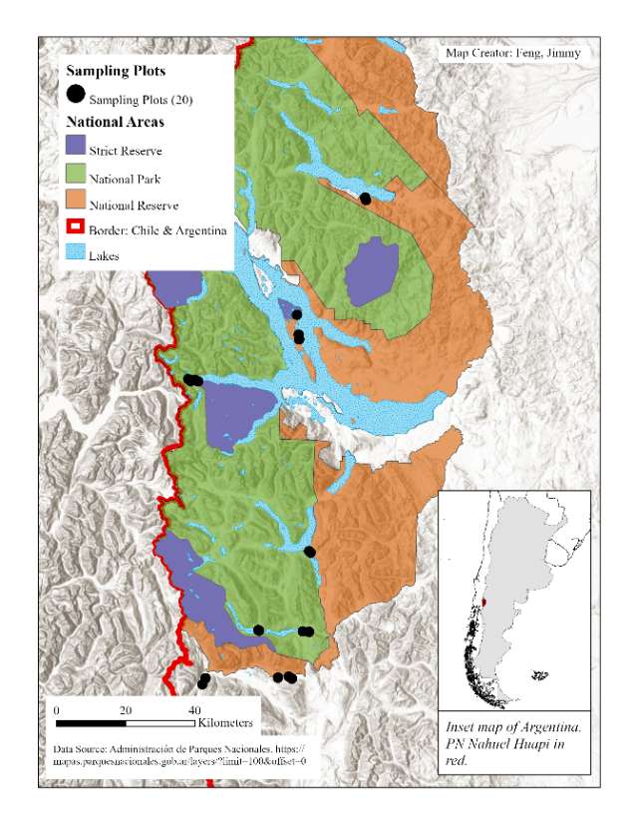
Figure 2.1 Study site map. Map of NHNP with its protection categories indicated with different colors. Purple: Strict Nature Reserve, Green: National Park, Orange: National Reserve. Dots indicate sampling plots. Overlapping dots does not mean overlapping sampling plots. Sampling plots were at least 1,000 m apart.

and outside of NHNP, establishing 20 plots (60 x 60 m) at least 1 km apart, five each in the Strict Nature Reserve, National Park, National Reserve, and outside PAs (Fig. 2.1).
In 2015 we also established two extra plots on Isla Victoria (largest island in Nahuel Huapi Lake) in an area where natural forest was replaced by Douglas fir (Pseudotsuga menziesii) plantations approximately 70 years ago. To assess sampling area equivalences, we measured vegetation cover and plant species composition in 100 squares (1 x 1 m) per plot both years; we classified the species based on native or non-native status. To estimate forest structure we superimposed over each plot a 13 x 13-transect grid, with transects 5 m apart. We defined 169 nodes (one at each transect intersection) where we measured the diameter at breast height (DBH) of the nearest tree (within 1 m radius) or recorded zero for treeless nodes. We estimated tree density by the number of trees over the plot area (3,600 m²). We converted DBH values to obtain basal area per plot (G):
$$G=\frac{\sum{g_{i}}}{S_{T}}$$
Where $g_{i}$ is the stem cross-section area of tree $i$ in $m^{2}$ and $S_{T}$ is the plot area in hectares.
Invertebrates are components of small mammal diets in Patagonian temperate forests (Pearson, 1983). We established nine pitfall traps per plot: plastic containers 10 cm in diameter and 15 cm deep half-filled with a water/dishwashing liquid solution. We activated pitfall traps simultaneously with small mammal trapping sessions. We preserved samples in 70% ethanol and recorded abundances.
We used a star design for each plot, establishing 25 trap stations 10 m apart, georeferencing the central trap station with a Garmin GPS60. At each station, we activated a Sherman trap (10 x 10 x 29 cm) baited with oats and peanut butter (Pearson and Pearson, 1982) on the ground and a Tomahawk trap (30 x 14 x 14 cm) baited with apple and banana slices (Fonturbel and Jimenez, 2009; Rivarola, 2010) in vegetation 1 m above the ground. We conducted monthly capture sessions during austral summers in 2015 and 2016, activating traps four consecutive nights and checking them at sunrise and at sunset, yielding a total capture effort of 41,600 traps/night. Trap success was calculated as number of small mammals caught divided by number of active traps.
We identified to species each individual captured. Before releasing individuals, we marked marsupials with Passive Integrated Transponders (PIT-Tags, TXP148511B model, Biomark 8.5 mm X 2.12 mm, 134.2 kHz ISO, 0.067g) by subcutaneous implantation on the back and rodents with ear-tags (National Band and Tag Company, style 1005-1). We handled captured animals following UTK-IACUC protocol # 2409-0116 (Institutional Animal Care and Use Committee, University of Tennessee).
To compare small mammal diversity between sites under different protection levels, we used species richness (S), assemblage abundance, and abundance of each species. We used Kruskal-Wallis tests to compare each index across protection levels and conducted post-hoc Tukey’s Honest Significance Differences analyses with 95% confidence level when an index varied in response to protection level. To evaluate habitat equivalence between plots, we used ANOVA and Kruskal-Wallis tests to compare vegetation cover, plant species richness, tree basal area, tree density, and arthropod abundance. Finally, we analyzed these environmental variables with Principal Component Analysis (PCA) to evaluate clustering of plots within protection levels.
Small mammals can deter the colonization of non-native plant species, a process known as biotic resistance (Pearson et al., 2014). We analyzed the proportion of non-native plants (both richness and cover) across the different levels of protection, with Kruskal-Wallis test followed by post-hoc Dunn test. Furthermore, we used a generalized linear model to explore the relationship between the abundance of small mammals and the richness and cover proportions of non-native plant species.

Results

We had a higher capture effort in 2016 but higher capture success in 2015 (Table 2.1). We trapped no small mammals in the two plots established in 2015 in areas dominated by Douglas fir, despite a capture effort of 2,100 traps/night.
In 2015, we trapped seven rodents – long-haired mouse Abrothrix hirta, olive grass mouse A. olivacea, long-tailed pygmy rice rat Oligoryzomys longicaudatus, long-clawed mole mouse Geouxus valdivianus, Andean long-clawed mouse Chelemys macronyx, Chilean climbing
mouse Irenomys tarsalis, southern big-eared mouse Loxodontomys micropus – and the endemic marsupial monito del monte Dromiciops gliroides (Fig. 2.2).
In 2016, we captured the same species except for C. macronyx. Abrothrix hirta, D. gliroides and O. longicaudatus were by far most abundant across the four protection levels both years (Fig. 2.3).
Species richness did not vary among protection levels in 2015 or 2016 (Table 2.2). However, assemblage abundances were greatest in the highest protection level and lowest in the lowest protection level each year (Table 2.2; Tukey test [p=0.0287 for 2015 and p=0.0399 for 2016]). Finally, abundance by species across the NHNP system and outside PAs differed only for L. micropus and D. gliroides (Appendix, Table 1). Loxodontomys micropus was trapped only outside the PA in 2015; this difference did not persist in 2016.
A Kruskal-Wallis test on abundance of D. gliroides vs protection level yielded p = 0.0381 in 2016; however, the subsequent Tukey test did not indicate a significant difference between any pair; thus those results should be cautiously interpreted. Nevertheless, D. gliroides abundances appeared greater in National Park and Strict Nature Reserve than in National Reserve and outside PA. To evaluate these unequal abundances further, we combined capture numbers from the Strict Nature Reserve and National Park as “High protection” and National Reserve and outside NHNP as “Low-no protection.” Each year saw a difference between these groups (2015, t=3.2188, df=9.4882, p-value=0.0098; 2016: t=2.8567, df=10.16, p-value=0.0168).
Most environmental variables showed no differences among treatments, suggesting habitat equivalence. We evaluated forest structure with two variables (tree basal area and tree density). While the former manifested no difference among protection levels (F= 2.162, DF 3, 16, p=0.1324), the latter showed a marginal difference between National Reserve and National Park (F=3.218, DF=3, 16, p=0.051, Tukey test p=0.049). Ground vegetation cover and plant richness were analyzed separately by year. While vegetation cover did not differ among treatments both years (F=1.801, DF 3, 16, p=0.187, and KW chi-squared=3.549, DF=3, 16, p=0.314 for 2015 and 2016, respectively), plant species richness was consistently higher in the unprotected area (F=7.813, DF= 3, 16, p=0.002 for 2015, and KW chi-squared=13.16, DF= 3, 16, p=0.004 for 2016, Appendix, Fig. 1).

Table 2.1 Capture summary. Small mammals captured during 2015 and 2016. Capture effort for two extra plots located in an area dominated by Douglas fir during 2015 not included here.
 | Summer 2015 | Summer 2016
Capture effort | 20,600 traps/night | 21,000 traps/night
Number of individuals caught | 727 | 532
Total number of captures | 2102 | 1894
Capture Success | 10.20% | 9.02%

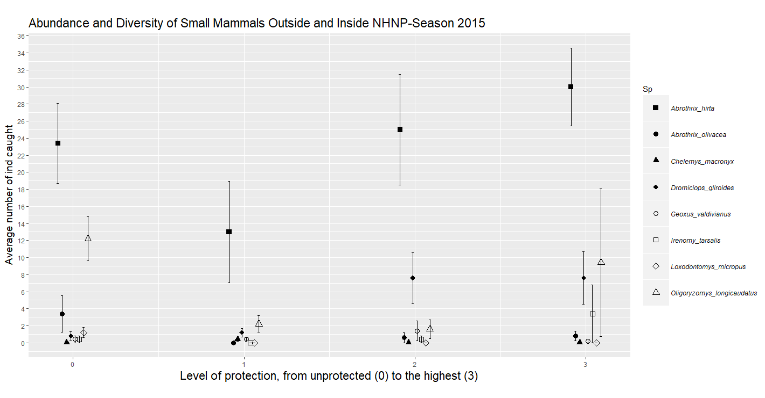
Figure 2.2 Season 2015. Diversity and average abundance of small mammals caught across different protection levels in NHNP during summer 2015. (0) outside NHNP, (1) National Reserve, (2) National Park, (3) Strict Nature Reserve.
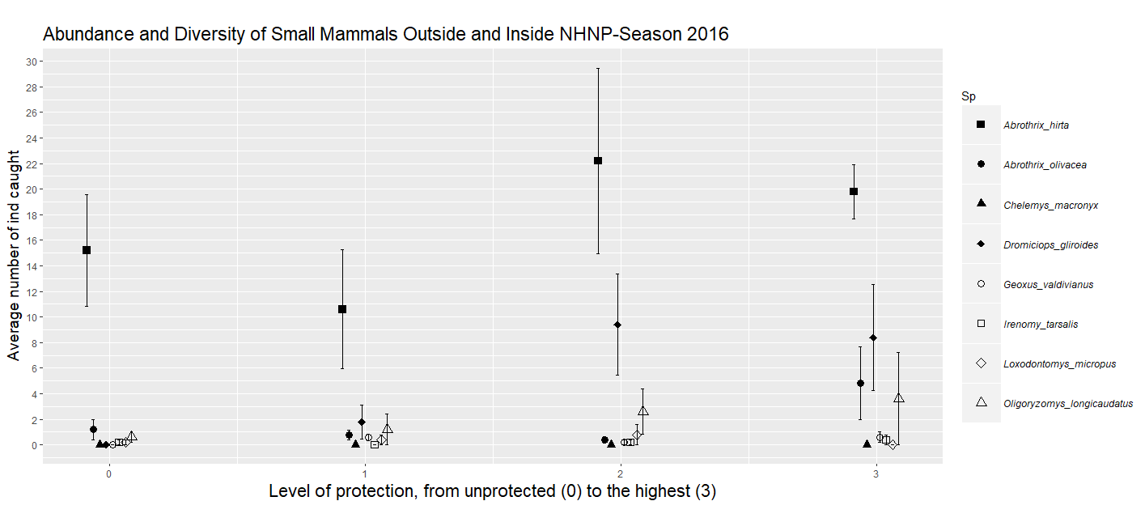
Figure 2.3 Season 2016. Diversity and average abundance of small mammals caught across different protection levels in NHNP during summer 2016. (0) outside NHNP, (1) National Reserve, (2) National Park, (3) Strict Nature Reserve.

Table 2.2 Community vs Protection. Comparison among small mammal communities across different protection levels in the NHNP system and outside. Each variable (column 1) was analyzed for each year independently (top 2015, bottom 2016) by Kruskal-Wallis’s Test. Mean$±$standard error is indicated in each cell. * Indicates statistical significance.
 | Outside NHNP | National Reserve | National Park | Strict Nature  Reserve | KW chi² | Df | p-value
Species Richness | 3.8$±$0.66  2.2$±$0.49 | 3.0$±$0.74  3.0$±$0.32 | 3.0$±$0.54  2.8$±$0.66 | 3.2$±$0.37  3.0$±$0.54 | 0.853  4.1315 | 3,16  3,16 | 0.8368  0.2476
Assemblage Abundance | 41.8$±$8.45  17.0$±$3.99 | 17.2$±$5.91  15.4$±$5.55 | 36.6$±$7.86  35.8$±$7.08 | 51.4$±$8.26  37.6$±$3.75 | 7.6316  9.2491 | 3,16  3,16 | 0.0542*  0.0261*

Finally, arthropod abundance did not vary among protection levels (chi-squared= 1.1102, DF 3, p=0.7746 and chi-squared=5.7657, DF=3, p=0.1236, for 2015 and 2016 respectively).
We evaluated clustering of plots within protection levels using PC1, PC2 and PC3, which accounted for over 80% of environmental variation (Appendix, Table 2). No clear clustering of plots occurred within protection levels (Fig. 2.4).
Native plants had higher richness and cover than non-native plants across the four levels of protection (Fig. 2.5). However, the proportion of non-native richness varied among the levels of protection (KW chi-squared=19.113, df=3, p=0.0002). This proportion was higher in the unprotected area compared to National Reserve (p=0.03) and to National Park (p=0.0004). Furthermore, the proportion was higher in the Strict Nature Reserve compared to National Park (p=0.017) (Fig. 2.6). The same pattern was found for the proportion of non-native species cover (KW chi-squared=21.104, df=3, p=0.0001), with the cover proportion higher in the unprotected area compared to the National Reserve (p=0.016) and to National Park (p=0.00008). As before, the proportion of non-native cover was higher in the Strict Nature Reserve compared to National Park (p=0.03) (Fig. 2.7).
The proportion of non-native plant species cover did not present a significant relationship with the abundance of small mammals (t=-0.915, p=0.366), neither did the proportion of richness of non-native plant species (t=0.424, p=0.673).

Discussion

Several PA effectiveness evaluation methods have been implemented since the 1990s, suggesting need for a generic approach (Hockings, 2003). There are four complementary levels to assessing PA effectiveness: 1) coverage, 2) broad-scale outcomes, 3) protected area management effectiveness assessments (PAME), and 4) biological outcomes obtained from monitoring (Hockings et al., 2006; Leverington et al., 2010).
Biological outcomes inform us to what extent a PA is achieving its goal of biodiversity conservation (Barnes et al., 2017). Quantitative data from population or community
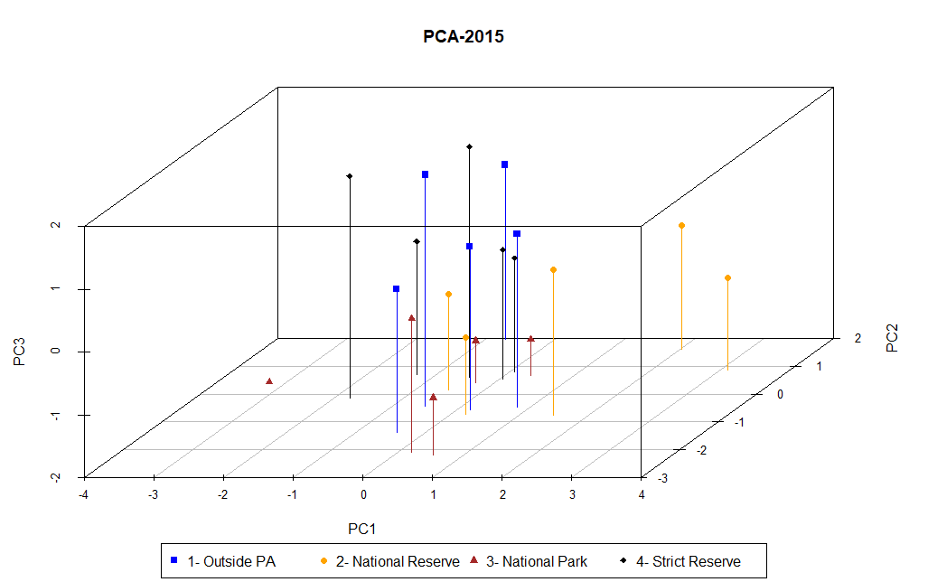
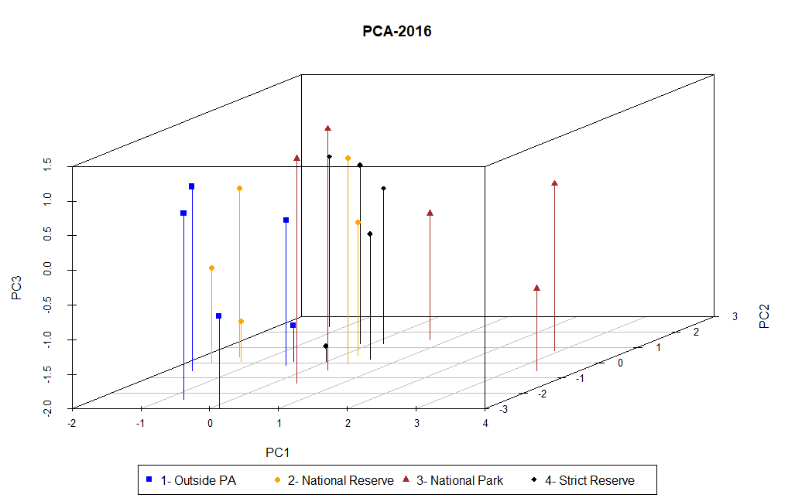
Figure 2.4 Plots vs Principal Components. Lack of clustering of plots within protection levels using PC1, PC2 and PC3. Top 2015, bottom 2016.

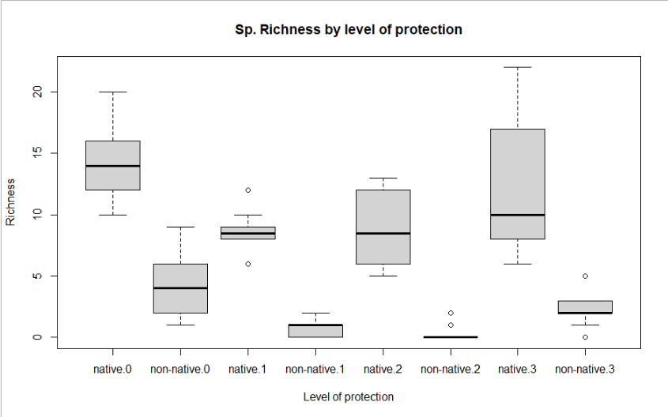
Figure 2.5 Native and non-native plants species richness at each level or protection (0: unprotected area, 1: National Reserve, 2: National Park, 3: Strict Natural Reserve).

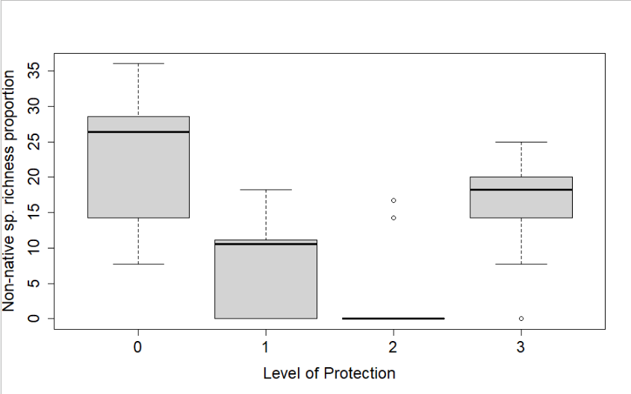
Figure 2.6 Proportion of non-native species at each level of protection (0: unprotected area, 1: National Reserve, 2: National Park, 3: Strict Natural Reserve).

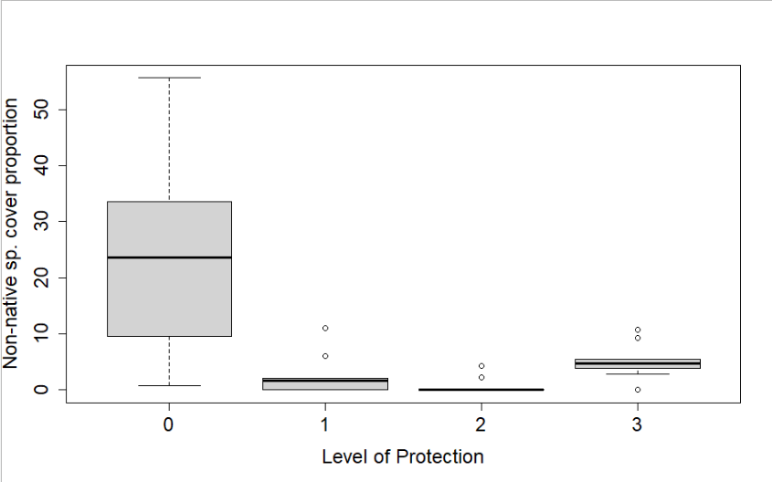
Figure 2.7 Proportion of cover of non-native plant species across the four levels of protection (0: unprotected area, 1: National Reserve, 2: National Park, 3: Strict Nature Reserve).

monitoring complement the overall assessment, providing information regarding the effects of those factors on particular species or groups (Christie, 1984a). A management effectiveness evaluation of NHNP using PAME concluded that performance was “Fairly satisfactory” (scoring 51-75% of optimal) (Rusch, 2002). However, lack of monitoring for most resident species, particularly small mammals, prevents assessment of the effect of current management on these communities.
To minimize the effect of landscape variation on species presence/absence and abundance, we restricted our plots to forest dominated by N. dombeyi, between 500 and 700 masl, aiming to relate community and population variation to protection levels. The absence of native small mammals in pine plantation agrees with previous studies in northern Patagonia (Lantschner et al., 2011). Pearson (1983) described nine species in the most comprehensive small mammal study in northern Patagonian forests. We recorded all but Aconaemys fuscus, whose distribution occurs north of NHNP (Roach, 2016). Our analysis yielded no clear evidence that the NHNP different protection categories are effectively conserving small mammals.
Creating a species conservation priority list of Patagonian vertebrates was proposed as an inexpensive, rapid tool to use resources allotted to biodiversity protection efficiently (Christie, 1984a). Detailed monitoring methods such as that presented here could help validate or update such lists. The conservation status of the 32 resident mammal species of NHNP was assessed in 1994 (Úbeda et al., 1994). The study considered two protection levels, National Park (high) and National Reserve (low) and defined 14 variables believed relevant for species survival and conservation, assigning scores to each. However, using variables such as body size, feeding behavior, and reproductive potential yielded low scores for small mammals, which could bias results against this group as suggested for previous studies (Lidicker, 1989). Most species recorded in our study occupy the bottom part of the priority list proposed by Úbeda (1994), except for D. gliroides, ranked tenth. Dromiciops gliroides, declared vulnerable in Argentina (Diaz and Ojeda, 2000), is listed as Near Threatened because its population is declining mainly owing to habitat changes, especially forest conversion to agriculture and habitat fragmentation (IUCN Red List; (Martin et al., 2015). It is remarkable that D. gliroides was the third and second most abundant species in 2015 and 2016 respectively (Appendix, Fig. 2). However, these populations were smaller than those previously reported in Argentina (Rivarola, 2010) and Chile (Fonturbel et al., 2012). The first long-term study tracking population changes in this species demonstrated yearly variation associated with natural events (Balazote Oliver et al., 2017). Importantly, most individuals were trapped in plots with a high protection level (Strict Nature Reserve and National Park).
Abrothrix hirta exceeded in abundance and distribution all other species (Appendix, Fig. 2 and 3). This result agrees with previous studies (Christie, 1984b; Pearson and Pearson, 1982). Although a typical forest species, A. hirta is found in steppe with sufficient ground cover and bushes (Pearson, 1983). This habitat breadth plus its omnivorous feeding behavior could be associated with its numerical dominance. Oligorizomys longicaudatus has been described as scarce in dense forest (Pearson, 1983). However, it was the second most abundant species trapped during 2015 (Appendix, Fig. 2). Its numbers dropped in 2016, but it was the third most abundant species (Appendix, Fig. 2). As abundance and protection level were unrelated, this decline could be due to a natural process. The remaining species combined accounted for 8.84% of the assemblage abundance in 2015, and 10.17% in 2016. Their low numbers and uneven distribution (Appendix, Fig. 2 and 3) suggest that conclusions based on these data are preliminary (Appendix).
Small mammal populations commonly undergo cycles of different length responding to biotic and abiotic factors (Armas et al., 2016; Murua et al., 1986). Lack of this information for the communities in this area renders tenuous our conclusion regarding NHNP effectiveness and highlights the importance of long-term studies and regularly scheduled monitoring programs.
The higher assemblage abundance recorded both years inside the Strict Nature Reserve suggests that direct human interaction negatively affects this assemblage, a situation particularly important for the marsupial D. gliroides. The different protection categories did not actually differ as much as one might expect in terms of anthropogenic impacts. For instance, we found cattle (domestic, semi-wild, or wild) in almost every plot. Species inhabiting plots near human settlements might suffer predation by domestic cats. Dromiciops gliroides was preyed on by domestic cats in a municipal PA in Bariloche (Di Virgilio et al., 2014). Interestingly, the four plots located in the area of Puerto Blest, where no domestic cats are present, recorded the highest abundances of D. gliroides. Areas where we found more diversity and abundance were located in zones with more difficult access, possibly implying it is not the protection category but primarily the inaccessibility that is preserving these communities, as has happened in PAs elsewhere (Struhsaker et al., 2005).
Non-native plant species are a threat worldwide, particularly in NHNP where 25% of the flora diversity are non-native species (Raffaele et al., 2014). We found that the proportion of richness and cover of non-native plants were higher in the unprotected area, shielding a positive effect of NHNP at preventing the invasion of non-native species. Interestingly, while no non-native species was identified in National Park, both their richness and cover in the Strict Nature Reserve were higher. The five plots under this higher category were isolated, with no near human settlement, and only accessible by boat. While direct anthropogenic effects seem an unlike reason for the colonization of non-native species, both native and non-native animal species might facilitate this process (Nunez et al., 2013). Small mammals, particularly rodents, have been identified as an effective biotic resistant in central Argentina, where rodent exclusion increased seedling recruitment by 100-300% in eight out of nine non-native species (Pearson et al., 2014). However, we did not find a relation between the proportion of non-native species and small mammal abundance. Further studies are needed to understand this pattern.

References

Arbetman, M. P., Meeus, I., Morales, C. L., Aizen, M. A., Smagghe, G., 2012. Alien parasite hitchhikes to Patagonia on invasive bumblebee. Biological Invasions 15, 489-494, doi:10.1007/s10530-012-0311-0.
Armas, C., Gutiérrez, J. R., Kelt, D. A., Meserve, P. L., 2016. Twenty-five years of research in the north-central Chilean semiarid zone: The Fray Jorge Long-Term Socio-Ecological Research (LTSER) site and Norte Chico. Journal of Arid Environments 126, 1-6, doi:http://dx.doi.org/10.1016/j.jaridenv.2015.12.008.
Balazote Oliver, A., Amico, G. C., Rivarola, M. D., Morales, J. M., 2017. Population dynamics of Dromiciops gliroides (Microbiotheriidae) in an austral temperate forest. Journal of Mammalogy 98, 1179-1184, doi:10.1093/jmammal/gyx051.
Barnes, M. D., Craigie, I. D., Dudley, N., Hockings, M., 2017. Understanding local-scale drivers of biodiversity outcomes in terrestrial protected areas. Annals of the New York Academy of Sciences 1399, 42-60, doi:10.1111/nyas.13154.
Barnes, M. D., Craigie, I. D., Harrison, L. B., Geldamann, J., Collen, B., Whitmee, S., Balmford, A., Burgess, N. D., Brooks, T. M., Hockings, M., Woodley, S., 2016. Wildlife population trends in protected areas predicted by national socio-economic metrics and body size. Nature Communications 7, 1-9, doi:10.1038/ncomms12747.
Barrios García Moar, M. N., 2012. Multi-level impacts of introduced wild boar on Patagonian ecosystems. Ecology and Evolutionary Biology, Vol. PhD. University of Tennessee, Knoxville, University of Tennessee, Knoxville. Trace: Tennessee Research and Creative Exchange, pp. 151.
Bruner, A. G., Gullison, R. E., Rice, R. E., da Fonseca, G. A., 2001. Effectiveness of parks in protecting tropical biodiversity. Science 291, 125-8, doi:10.1126/science.291.5501.125.
Carey, C., Dudley, N., Stolton, S., 2000. Squandering paradise? The importance and vulnerability of the world’s protected areas. WWF-World Wide Fund For Nature (Formerly World Wildlife Fund) International, Gland, Switzerland, Gland, Switzerland, pp. 232.
CBD, 2010. Decision adopted by the CoP to the CBD at its 10th meeting (UNEP/CBD/COP/DEC/X/2). Montreal: Secretariat of the CBD.
Chape, S., Harrison, J., Spalding, M., Lysenko, I., 2005. Measuring the extent and effectiveness of protected areas as an indicator for meeting global biodiversity targets. Philos Trans R Soc Lond B Biol Sci 360, 443-55, doi:10.1098/rstb.2004.1592.
Christie, M. I., 1984a. Determinacion de prioridades conservacionistas para la fauna de vertebrados patagonicos. Rev. Mus. Arg. Cs. Nat., Zoologia 13, 535-544.
Christie, M. I., 1984b. Informe preliminar del Relevamiento de Fauna de los Parques Nacionales Lanin y Nahuel Huapi. In: Inventario, A. d. P. N.-P., (Ed.), Vol. III, pp. 72.
Coad, L., Leverington, F., Knights, K., Geldmann, J., Eassom, A., Kapos, V., Kingston, N., de Lima, M., Zamora, C., Cuardros, I., Nolte, C., Burgess, N. D., Hockings, M., 2015. Measuring impact of protected area management interventions: current and future use of the global database of protected area management effectiveness. Philos Trans R Soc Lond B Biol Sci 370, 20140281, doi:http://dx.doi.org/10.1098/rstb.2014.0281.
Coetzee, B. W., Gaston, K. J., Chown, S. L., 2014. Local scale comparisons of biodiversity as a test for global protected area ecological performance: a meta-analysis. PLoS One 9, e105824, doi:10.1371/journal.pone.0105824.
Correa, C., Bravo, A. P., Hendry, A. P., 2012. Reciprocal trophic niche shifts in native and invasive fish: salmonids and galaxiids in Patagonian lakes. Freshwater Biology 57, 1769-1781, doi:10.1111/j.1365-2427.2012.02837.x.
Davis, K. T., Maxwell, B. D., Caplat, P., Pauchard, A., Nuñez, M. A., 2019. Simulation model suggest that fire promotes lodgepole pine (Pinus contorta) invasion in Patagonia. Biological Invasions 21, 2287-2300, doi:https://doi.org/10.1007/s10530-019-01975-1.
Di Virgilio, A., Amico, G. C., Morales, J. M., 2014. Behavioral traits of the arboreal marsupial Dromiciops gliroides during Tristerix corymbosus fruiting season. Journal of Mammalogy 95, 1189-1198, doi:10.1644/13-MAMM-A-281.
Díaz, G. B., Ojeda, R. A., 2000. Libro Rojo de los mamíferos Amenazados de la Argentina. SAREM, Mendoza. SAREM Mendoza.
Dimitri, M. J., 1977. Pequeña flora ilustrada de los parques nacionales Andino Patagonicos. Separata de Anales de Parques Nacionales, Vol. XIII. Ministerio de Economia de la Nacion. Secretaria de Estado de Agricultura y Ganaderia. Sub-secretaria de Recursos Naturales Renovables y Ecologia. Servicio Nacional de Parques Nacionales, Buenos Aires, Argentina, pp. 1-122.
Fontúrbel, F. E., Jiménez, J. E., 2009. Underestimation of abundance of the Monito del Monte (Dromiciops gliroides) due to a sampling artifact. Journal of Mammalogy 90, 1357-1362.
Fontúrbel, F. E., Franco, M., Rodriguez-Cabal, M. A., Rivarola, M. D., Amico, G. C., 2012. Ecological consistency across space: a synthesis of the ecological aspects of Dromiciops gliroides in Argentina and Chile. Naturwissenschaften 99, 873-81, doi:10.1007/s00114-012-0969-2.
Franzese, J., Ghermandi, L., 2014. Early competition between the exotic herb Rumex acetosella and two native tussock grasses with different palatability and water stress tolerance. Journal of Arid Environments 106, 58-62, doi:10.1016/j.jaridenv.2014.03.004.
Gardner, B., Royle, J. A., Wegan, M., 2009. Hierarchical models for estimating density from DNA mark-recapture studies. Ecology 90, 1106-1115, doi:10.1890/07-2112.1.
Godoy, M. M., Martinuzzi, S., Kramer, H. A., Defossé, G. E., Argañaraz, J., Radeloff, V. C., 2019. Rapid WUI growth in a natural amenity-rich region in central-western Patagonia, Argentina. International Journal of Wildland Fire 28, 473-484.
Hockings, M., 2003. Systems for assessing the effectiveness of management in protected areas. BioScience 53, 823, doi:10.1641/0006-3568(2003)053[0823:sfateo]2.0.co;2.
Hockings, M., Stolton, S. U. E., Leverington, F., Dudley, N., Courrau, J., Valentine, P., 2006. Evaluating effectiveness. A framework for assessing management effectiveness of protected areas. IUCN The World Conservation Union, Gland, Switzerland and Cambridge, UK.
Lantschner, M. V., Rusch, V., Hayes, J. P., 2011. Influences of pine plantations on small mammal assemblages of the Patagonian forest-steppe ecotone. Mammalia 75, doi:10.1515/mamm.2011.031.
Leverington, F., Costa, K. L., Pavese, H., Lisle, A., Hockings, M., 2010. A global analysis of protected area management effectiveness. Environ Manage 46, 685-98, doi:10.1007/s00267-010-9564-5.
Lidicker, W. Z. J., 1989. Rodents: A world survey of species of conservation concern. World Conservation Union.
Martin, C. E., Chehébar, C., 2001. The national parks of Argentinian Patagonia — management policies for conservation, public use, rural settlements, and indigenous communities. Journal of the Royal Society of New Zealand 31, 845-864, doi:10.1080/03014223.2001.9517680.
Martin, G. M., Flores, D., Teta, P., 2015. Dromiciops gliroides. The IUCN Red List of Threatened Species 2015: e.T6834A22180239. http://dx.doi.org/10.2305/IUCN.UK.2015-4.RLTS.T6834A22180239.en.
Mascia, M. B., Pailler, S., 2011. Protected area downgrading, downsizing, and degazettement (PADDD) and its conservation implications. Conservation Letters 4, 9-20, doi:10.1111/j.1755-263X.2010.00147.x.
Mermoz, M., Martin, C., 1986. Mapa de vegetacion del parque y la reserva nacional Nahuel Huapi. In: Nacion, D. R. P. S. d. C. y. T. d. l., (Ed.). Secretaria de Ciencia y Tecnica de la Nacion, Bariloche, Argentina, pp. 22.
Monjeau, A., Nazar Anchorena, S., Montoni, V., Marquez, J., Alcalde, D., D'Iorio, A., Galván, H., Denholm, C., Di Vincenzo, A., Gonzalez, F., 2005. Perfil del Área Protegida Argentina: Parque Nacional Nahuel Huapi. http://www.parkswatch.org/parkprofile.php?l=eng&country=arg&park=nhnp.
Murúa, R., Gonzalez, L. A., Meserve, P. L., 1986. Population ecology of Oryzomys longicaudatus philippii (Rodentia: Cricetidae) in Southern Chile. Journal of Animal Ecology 55, 281-293.
Nuñez, M. A., Hayward, J., Horton, T. R., Amico, G. C., Dimarco, R. D., Barrios-Garcia, M. N., Simberloff, D., 2013. Exotic mammals disperse exotic fungi that promote invasion by exotic trees. PLoS One 8, e66832, doi:10.1371/journal.pone.0066832.
Paritsis, J., Holz, A., Veblen, T. T., Kitzberger, T., 2013. Habitat distribution modeling reveals vegetation flammability and land use as drivers of wildfire in SW Patagonia. Ecosphere 4, 53.
Pearson, O. P., 1983. Characteristics of a mammalian fauna from forests in Patagonia, southern Argentina. Journal of Mammalogy 64, 476-492.
Pearson, O. P., Pearson, A. K., 1982. Ecology and biogeography of the southern rainforest of Argentina. In: Mares, M. A., Genoways, H. H., Eds.), Mammalian biology in South America, Vol. 6. Pymatuning Laboratory of Ecology, Pymatuning Symposium Ecology, pp. 129-142.
Raffaele, E., de Torres Curth, M., Morales, C. L., Kitzberger, T., 2014. Ecologia e historia natural de la Patagonia Andina. Fundacion de Historia Natural Felix de Azara, Ciuddad Autonoma de Buenos Aires, Argentina.
Rivarola, M. D., 2010. Interacción entre un muérdago y un marsupial: estructura poblacional y área de acción de Dromiciops gliroides, y caracterización de la remoción de frutos de Tristerix corymbosus. Vol. Licenciatura. Universidad Nacional del Comahue, Bariloche, Argentina, pp. 110.
Roach, N., 2016. Aconaemys fuscus. The IUCN Red List of Threatened Species 2016: e.T278A78318793. http://dx.doi.org/10.2305/IUCN.UK.2016-2.RLTS.T278A78318793.en.
Rodríguez-Cabal, M. A., Barrios-García, M. N., Amico, G. C., Aizen, M. A., Sanders, N. J., 2013. Node-by-node disassembly of a mutualistic interaction web driven by species introductions. PNAS 110, 16503-7, doi:10.1073/pnas.1300131110.
Rusch, V., 2002. Estado de situación de las áreas protegidas de la porción Argentina de la ecorregión Valdiviana. Fundación Vida Silvestre Argentina, WWF, Argentina, pp. 98.
Simberloff, D., Relva, M. A., Nuñez, M. A., 2002. Gringos en el bosque: introduced tree invasion in native Nothofagus/Austrocedrus forest. Biological Invasions 4, 35-53.
Struhsaker, T. T., Struhsaker, P. J., Siex, K. S., 2005. Conserving Africas rain forests: problems in protected areas and possible solutions. Biological Conservation 123, 45-54.
Svriz, M., Damascos, M. A., Zimmermann, H., Hensen, I., 2013. The exotic shrub Rosa rubiginosa as a nurse plant. Implications for the restoration of disturbed temperate forests in Patagonia, Argentina. Forest Ecology and Management 289, 234-242, doi:10.1016/j.foreco.2012.09.037.
Teta, P., Formoso, A., Tammone, M., de Tommaso, D. C., Fernández, F. J., Torres, J., Pardiñas, U. F. J., 2014. Micromamíferos, cambio climático e impacto antrópico: Cuánto han cambiado las comunidades del sur de América del Sur en los últimos 500 años? Therya 5, 7-38, doi:10.12933/therya-14-183.
Tiribelli, F., Morales, J. M., Gowda, J. H., Mermoz, M., Kitzberger, T., 2019. Non-additive effects of alternative stable states on landscape flammability in NW Patagonia: fire history and simulation modelling evidence. International Journal of Wildland Fire 28, 149-159, doi:https://doi.org/10.1071/WF18073.
Úbeda, C. A., Grigera, D. E., Reca, A. R., 1994. Conservación de la fauna de tetrápodos. II. Estado de conservación de los mamíferos del Parque y Reserva Nacional Nahuel Huapi. Mastozoologia Neotropical 1, 29-44.
Urretavizcaya, M. F., Defossé, G. E., 2019. Restoration of burned and post-fire logged Austrocedrus chilensis stands in Patagonia: effects of competition and environmental conditions on seedling survival and growth. International Journal of Wildland Fire 28, 365-376, doi:https://doi.org/10.1071/WF18154.

Appendix
This appendix was published as “Supplementary tables, figures and species information” in PARKS https://parksjournal.com/parks-27-2-november-2021

Table 2.3 Species vs Protection. Comparison among small mammal communities across different protection levels in the NHNP system and outside. Each diversity variable (column 1) was analyzed for each year independently (top 2015, bottom 2016) by Kruskal-Wallis Test. Mean$±$standard error is indicated in each cell. * Indicates statistical significance.
 | Outside NHNP | National Reserve | National Park | Strict Nature Reserve | KW chi² | DF | P-value
A hirta | 23.4$±$4.69  15.2$±$4.37 | 13.0$±$5.98  10.6$±$4.65 | 25.0$±$4.46  22.2$±$7.27 | 30.0$±$4.57  19.8$±$2.11 | 4.1562  2.9045 | 3,16  3,16 | 0.2451  0.4066
O. longicaudatus | 12.2$±$2.59  0.6$±$0.4 | 2.2$±$0.97  1.2$±$1.2 | 1.6$±$1.12  2.6$±$1.78 | 9.4$±$8.66  3.6$±$3.6 | 7.1228  0.5515 | 3,16  3,16 | 0.0681  0.9074
D. gliroides | 0.8$±$0.49  No capture | 1.2$±$0.49  1.8$±$1.32 | 7.6$±$2.99  9.4$±$3.95 | 7.6$±$3.07  8.4$±$4.16 | 5.7734  8.417 | 3,16  3,16 | 0.1232  0.0381*
A. olivacea | 3.4$±$2.13  1.2$±$0.8 | No capture  0.8$±$0.37 | 0.6$±$0.6  0.4$±$0.24 | 0.8$±$0.58  4.8$±$2.85 | 2.3911  1.4184 | 3,16  3,16 | 0.4953  0.7012
G. valdivianus | 0.4$±$0.4  No capture | 0.4$±$0.24  0.6$±$0.24 | 1.4$±$1.16  0.2$±$0.2 | 0.2$±$0.2  0.6$±$0.4 | 0.8742  4.3244 | 3,16  3,16 | 0.8316  0.2285
C. macronyx | No capture  No capture | 0.4$±$0.24  No capture | No capture  No capture | No capture  No capture | 6.3333  - | 3,16  - | 0.0965  -
I. tarsalis | 0.4$±$0.4  0.2$±$0.2 | No capture  No capture | 0.4$±$0.4  0.2$±$0.2 | 3.4$±$3.4  0.4$±$0.4 | 1.1333  0.1333 | 3,16  3,16 | 0.7690  0.7690
L. micropus | 1.2$±$0.58  0.2$±$0.2 | No capture  0.4$±$0.4 | No capture  0.8$±$0.8 | No capture  No capture | 9.9805  1.1385 | 3,16  3,16 | 0.0187*  0.7678

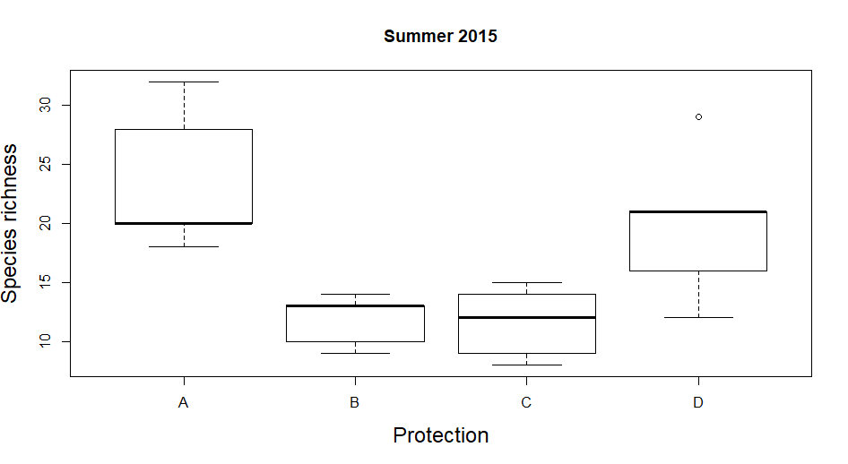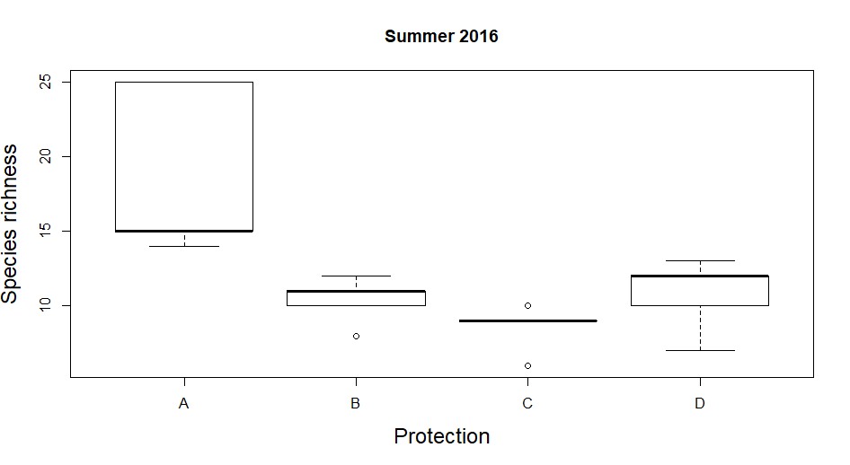
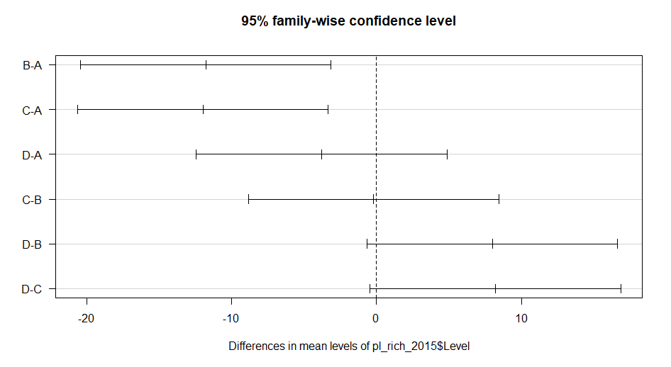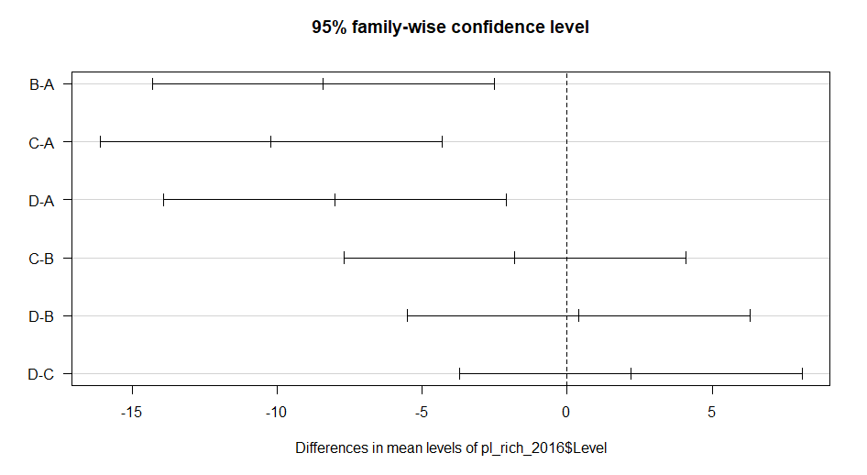
Figure 2.8 Plant species richness. Variations in sites with different protection levels in NHNP. Top left corresponds to 2015, top right to 2016. (A) outside PA, (B) National Reserve, (C) National Park, (D) Strict NatureReserve. Results from Tukey’s HSD test at bottom for each year. Differences between group A and B (Outside PA and National Reserve) and A and C (Outside PA and National Park) occurred both years (A-B p=0.0063 for 2015 and p=0.0044 for 2016, A-C p=0.0055 for 2015 and p=0.0007 for 2016). Also, differences between groups A and D (Outside PA and Strict Nature Reserve) were found in 2016 (p=0.0065).

Table 2.4 Principal Component Analysis. Five environmental variables used: vegetation cover, plant species composition, tree density, tree basal area and arthropods abundance. The first three components account for more than 80 percent of the variation.
 |  | PC1 | PC2 | PC3 | PC4 | PC5
2015 | Standard Deviation | 1.3347 | 1.0880 | 1.0229 | 0.7352 | 0.6693
2015 | Proportion of Variance | 0.3563 | 0.2368 | 0.2093 | 0.1081 | 0.0896
2015 | Cumulative Proportion | 0.3563 | 0.5930 | 0.8023 | 0.9104 | 1.0000
2016 | Standard Deviation | 1.3097 | 1.2275 | 0.9013 | 0.8440 | 0.50316
2016 | Proportion of Variance | 0.3431 | 0.3014 | 0.1625 | 0.1424 | 0.05063
2016 | Cumulative Proportion | 0.3431 | 0.6444 | 0.8069 | 0.9494 | 1.0000

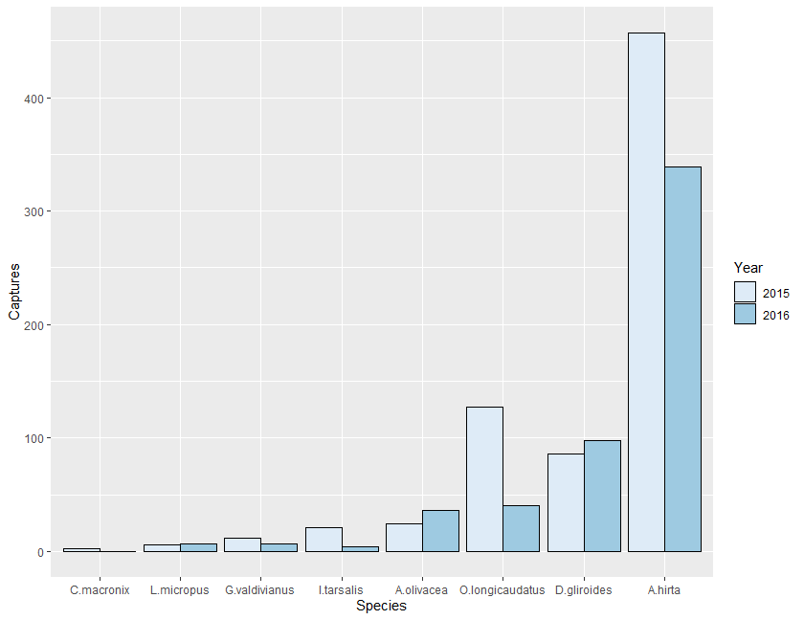
Figure 2.9 Small mammal abundance. Number of small mammals trapped, per species, during sampling seasons 2015 and 2016.

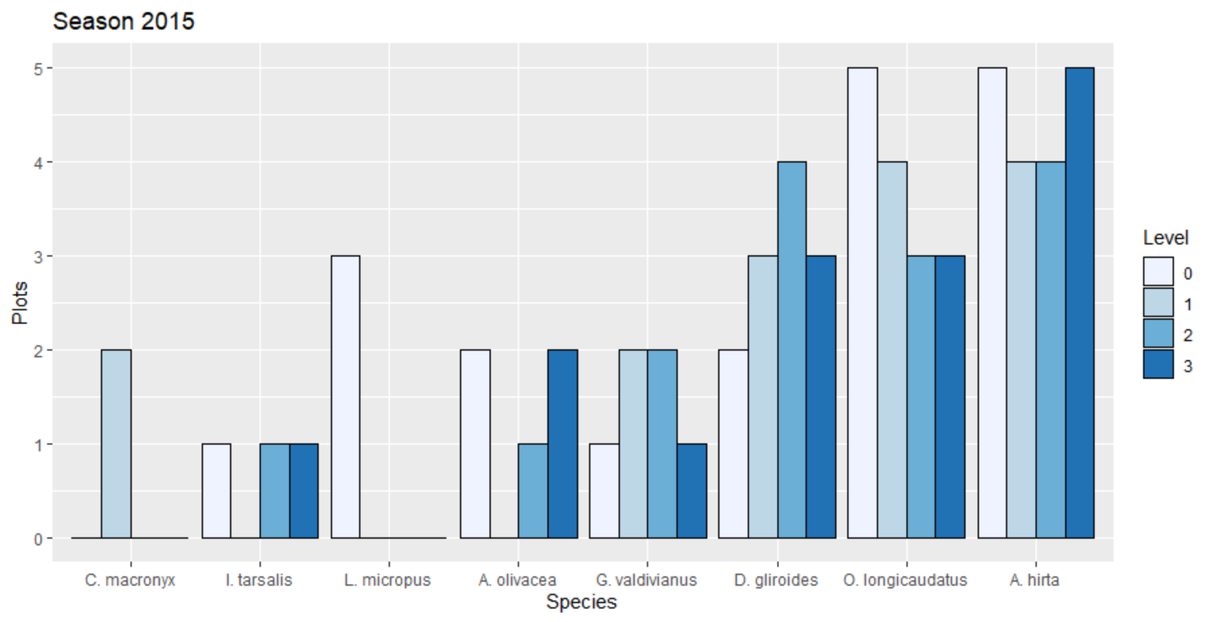

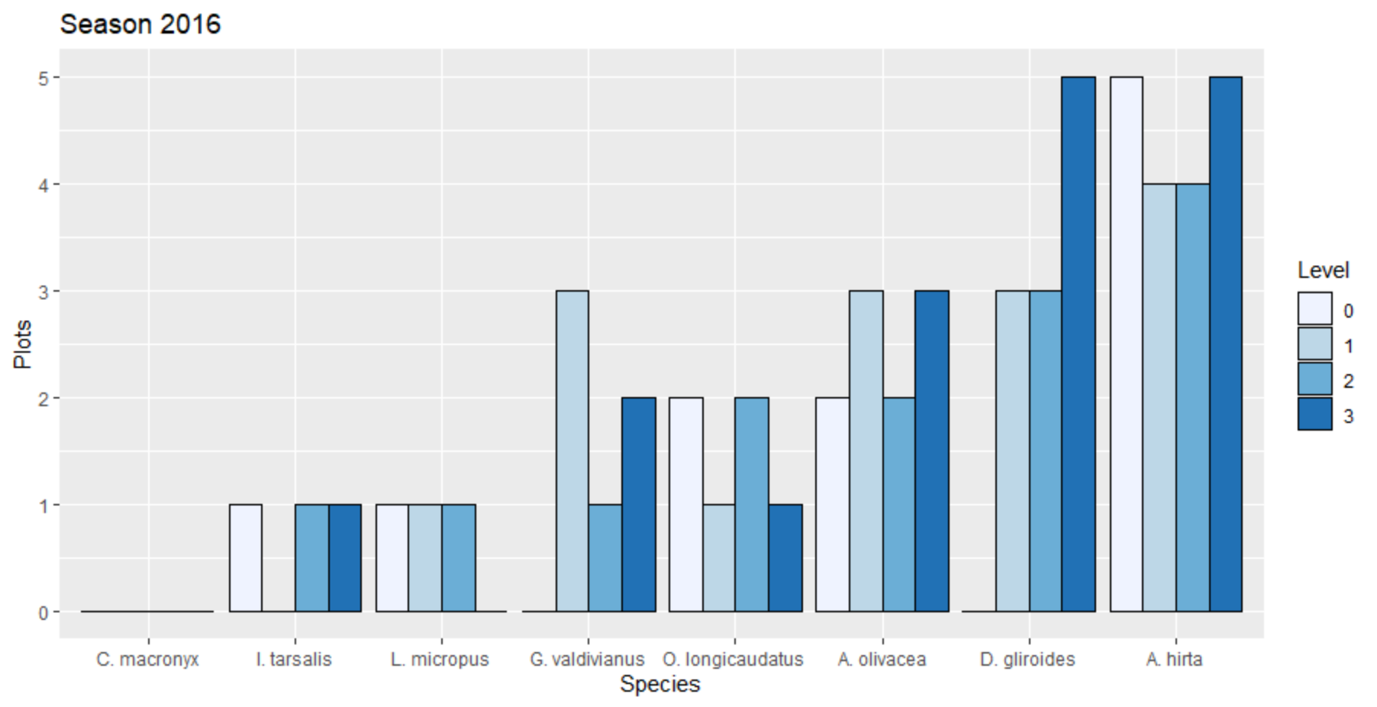
Figure 2.10 Species plot occupancy. Number of plots per level of protection where the species were trapped. Top: Season 2015. Bottom: Season 2016. Level of protection 0: Outside PA, 1: National Reserve, 2: National Park, 3: Strict Nature Reserve.

Species Less Frequently Trapped
Abrothrix olivacea inhabits areas with thick grass, marshes, and forest with sufficient ground cover (Pearson, 1983), preferring microhabitats with vegetation cover from above (Murua et al., 1986). All of our plots had good ground cover; nevertheless, the species was undetected in most of them in 2015 but doubled in occurrence and abundance in 2016 (Fig. 3). This change highlights the importance of long-term studies and also of looking more closely at variables that might affect the occurrence of this species, beyond protection level.
Irenomys tarsalis occupies dense forest with understory dominated by bamboo Chusquea culeou (Pearson, 1983). Plots with bamboo as a dominant species had flowered in 2010 (Herrero, 2013). Chusquea culeou usually grows vegetatively, but after 50-70 years, it flowers synchronously, produces a massive amount of seeds, then dies. Recovery is slow (Giordano et al., 2009; Marchesini et al., 2009). This could account for our low capture rate (n= 21 in 2015 and n=4 in 2016). Nonetheless, the presence/absence variation among plots between years (Fig. 3) cannot be explained with our current data.
Geouxus valdivianus is the only species whose diet consists solely of invertebrates (Pearson, 1983). Invertebrate abundance across protection levels did not differ (chi-squared= 1.1102, DF 3, p=0.7746 and chi-squared=5.7657, DF=3, p=0.1236, for 2015 and 2016 respectively). The species is widely distributed, although in low abundance.
Loxodontomys micropus is mainly herbivorous and prefers forest with sufficient ground vegetation. (Pearson, 1983). Despite the apparently suitable condition of our plots, we trapped only six individuals in 2015, all outside PAs. A study in Chile in mature and second growth forest reported ten individuals with a trapping effort of 1936 traps/night (Garcia et al., 2013). Further studies are needed to determine the reason for the low abundance we recorded with a total trapping effort of 41,600 traps/night.
Finally, Chelemys macronyx has been found mainly in lenga forest (N. pumilio) (Garcia et al., 2013). The species has not been detected previously in N. dombeyi forest (Pearson, 1983). Although we detected the species only in 2015, this study provides novel information regarding habitat preference/suitability for this species. We detected the species in our northernmost samples, in the National Reserve category. This area was still blanketed by volcanic ash (from the June 2011 Cordon Caulle eruption). Research on ash effect on arthropods has demonstrated its insecticidal action (Buteler et al., 2011). Although C. macronyx is omnivorous, invertebrates constitute most of its diet (Sage et al., 2007), so it is interesting that we found them only in that particular area. To increase capture probability, traps must be set near their burrow entrances instead of randomly distributed in a grid as we did (Ojeda R., personal communication).

CHAPTER III
EXPLAINING SMALL MAMMAL COMMUNITY VARIATION IN A TEMPERATE FOREST IN NORTHERN PATAGONIA

A version of this chapter will be published by María Daniela Rivarola, Daniel Simberloff, and Juan Manuel Morales.
María Daniela Rivarola conducted a search literature, designed and carried on the fieldwork, analyzed the data and wrote the article. Dan Simberloff revised and edited the article. Juan Manuel Morales designed the models, revised and edited the article.

Abstract

The Anthropocene is characterized by severe landscape modifications, often resulting in habitat loss with detrimental effects on biodiversity. Understanding species distributions and habitat selection is required to assess current and future impacts of such modifications on biodiversity. Small mammal communities inhabiting Patagonian temperate forest have been evaluated both in Chile and Argentina; however, community heterogeneity across a similar habitat remains poorly understood. Furthermore, imperfect species detection biases our understanding of species distributions and habitat associations. Recent advances in occupancy modeling deal with this uncertainty. We studied small mammal communities distributed in the northern portion of Argentinian temperate forest during the austral summers of 2015 and 2016, restricting our study to forests dominated by a southern beech, Nothofagus dombeyi, within 500-700 m.a.s.l. We established 20 plots with a total capture effort of 41,600 trap/nights. We proposed eight hierarchical multi-year occupancy models to determine what factors might play an important role in the heterogeneous distribution of these communities. Among such factors we included food and shelter availability, habitat complexity, anthropogenic disturbances, and the existence of protected areas with different levels of protection. We evaluated habitat preferences for seven rodent species and one endemic marsupial. While some of our results support previous studies of habitat selection, we also provide evidence that some habitat characteristics previously assumed to be relevant for species distribution fail to explain the observed heterogeneity.

Introduction

Species distributions across different landscapes have been studied for decades. While it is generally known what kinds of organisms can be found for example in temperate forests, temperate forests around the world harbor completely different sets of species. Furthermore, often species with similar habitat requirements are never found in the same area (Vellend, 2016). The study of natural ecosystems provides a first step toward a full understanding of heterogeneous species distributions and possible consequences of habitat alteration and species loss.
Biodiversity loss has increased greatly in the Anthropocene, and absence of a species from a site with apparently suitable habitat may have resulted from this process, which may have occurred regionally and for reasons not apparent from phenomena occurring at the site itself. An alternative possibility is that subtly different habitat requirements or preferences between species may mean that a superficially suitable habitat for an absent species is not in fact suitable. If anthropogenic activity has created the subtly different habitat, then the puzzling heterogeneous distribution of the species may be an early stage in a change in regional biodiversity. Understanding the causes of surprising distributional gaps is thus of great conservation importance. Research toward this end requires detailed local studies at the community level.
South America has the second highest continental mammal species richness. The conservation status of most of these species is uncertain, but research on threats to its small mammals has revealed that habitat modification (e.g., deforestation) and climate change (i.e., changing rainfall regimes and fire dynamics) are the main factors that will potentially affect species in various ways, altering entire communities (Kelt & Meserve, 2014). Conservation efforts include the creation of protected areas. Currently more than 10,000 sites in Latin America and the Caribbean are under some designated level of protection; nevertheless, only 1283 have been evaluated for management effectiveness (UNEP-WCMC, 2021).
Patagonian Temperate forests throughout Chile and Argentina harbor similar small mammal communities (Meserve et al., 1991). Research on small mammal habitat associations in Patagonia has evaluated variation in communities at different elevations on both sides of the Andes Mountains (Andrade & Monjeau, 2014; Patterson et al., 1990). Vegetation type has also been studied as a potential determinant of small mammal community variation: comparisons between grassland and shrubland (Lozada et al., 2010; Novillo et al., 2017), grassland and forest (Murua & Gonzalez, 1982), and even between forests with different dominant tree species (Kelt et al., 1994;1999). Patagonian temperate forests have been substantially fragmented since the beginning of the 20th century (Kelt & Meserve, 2014). Effects of forest fragmentation on small mammal species have also been evaluated in both countries (Kelt, 2000; Rodriguez-Cabal et al., 2007).
The aforementioned studies conducted in Chile and Argentina found associations between particular small mammal species and different habitat characteristics. However, the numbers of samples used to evaluate community differences between environments (e.g., different elevations, fragmented vs. intact forest, forest vs. grassland, etc.) were low – in general, two or three plots were sampled for each habitat type. Although this sampling design is appropriate to compare certain attributes of such distinct environments, it assumes that those sampled locations adequately represent small mammal communities inhabiting each habitat type. However, a previous study conducted in Nahuel Huapi National Park, northern Patagonia, could imply otherwise. Dissimilarities between 20 small mammal communities sampled in forest dominated by Nothofagus dombeyi and in a narrow elevational range revealed that a small number of sampling locations might affect our understanding of species distributions and habitat preferences at a fine scale (Rivarola et al. 2021). Furthermore, home ranges of most of these small mammals are no bigger than 1 ha (Contreras, 1972; Fonturbel et al., 2012; Pearson, 1983; Rivarola, 2010), which increases the importance of investigating their distributions at a small spatial scale.
Another important factor that might bias our understanding of species distributions is imperfect species detection: the detection probability for a species of interest that is present at a site is usually less than one (Gu & Swihart, 2004; MacKenzie et al., 2002). Factors such as a species' elusive behavior or low population density, inappropriate sampling technique, and an observer’s inability to identify a species may contribute to a non-detection of the species in a particular time and location even if it is present (Dorazio et al., 2005). The recent development of occupancy models has accounted for imperfect species detection, improving our estimates of species occurrence and of how it relates to environmental variables (Dorazio et al., 2005; MacKenzie et al., 2002; Royle & Dorazio, 2008). Despite their high diversity, small mammal communities of Patagonian temperate forests have never been evaluated within this occupancy model framework.
In order to explore small mammal distributions in the northern portion of Patagonian temperate forests, we evaluated communities’ similarities and differences in a forest dominated by Nothofagus dombeyi. We used hierarchical multi-year occupancy models to assess the effects of a different levels of protection, direct anthropogenic disturbances, food availability, shelter, and patch complexity on small mammal community composition.

Methods

We conducted this study in Nahuel Huapi National Park in the northern part of Argentinian temperate forest (Fig. 3.1). Average monthly temperatures are 3°C for the coldest month (July) and 15°C for the warmest month (January), with frost most nights throughout the year. Average annual precipitation is 1,800 mm, mostly during fall and winter, decreasing from west to east (Cabrera, 1976). Dominant tree species are Nothofagus dombeyi, N. pumilio, N. antartica, (Nothofagaceae), and Austrocedrus chilensis (Cupressaceae), and the bamboo Chusquea culeou (Poaceae) and several species of bushes and smaller trees are present in the understory: Lomatia hirsuta (Proteaceae), Schinus patagonicus (Anacardiaceae), Maytenus boaria (Celastreaceae), Aristotelia chilensis (Elaeocarpaceae), Luma apiculata (Myrtaceae), and Azara microphylla (Salicaceae) (Mermoz & Martin, 1986). Berberis buxifolia, B. serratodentata (Berberidaceae), Ribes cucullatum (Grossulariaceae), Acaena ovalifolia (Rosaceae), Vicia nigricans (Fabaceae), and Fragaria chiloensis (Rosaceae) are common in the lower strata (Dimitri, 1977). Common nonnative species in NHNP include Douglas fir (Pseudotsuga menziesii) (Pinaceae) and Rosa spp. (Rosaceae).
In the austral summers of 2015 and 2016, we sampled small mammal communities in 20 plots (60 x 60 m) located at least 1 km apart in areas dominated by the southern beech N. dombeyi (coihue) between 500 and 700 m.a.s.l. We used a star design to set four transects
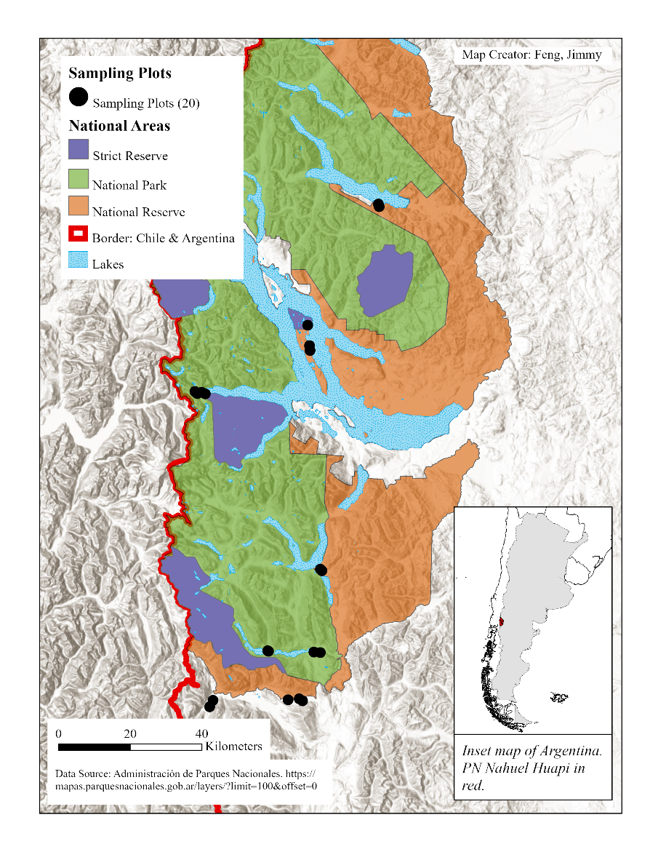
Figure 3.1 Map of Nahuel Huapi National Park. Sampling locations indicated with black dots.

60 m long, converging at their centers. This star or web trap arrangement provides a better estimation of species abundance than do grid-based approaches (Parmenter et al., 2003). We located one trapping station every 10 m along each transect, accounting for a total of 25 trapping stations per plot. A trapping station consisted of a Sherman trap baited with oat and peanut butter on the ground and a Tomahawk trap baited with apple and banana in a branch 1m above the ground. We sampled each plot three times per austral summer 2015 and 2016 on a monthly basis, each time activating each trap for four consecutive days. We checked the traps twice a day, at sunrise and at sunset, and marked trapped rodents with numbered metal ear tags and the marsupial Dromiciops gliroides with PIT-tags (model TXP148511B: Biomark, Boise, Idaho; 8.5 x 2.12 mm, 134.2 kHz ISO, 0.067 g) for subsequent identification. We recorded the exact trap location and species for each captured individual and then released them at the trap location.
To measure coleopteran abundance, we set nine pitfall traps per plot, one at the plot center point and one 20 meters from the center along each transect. Each pitfall trap consisted of a plastic container 10 cm in diameter and 15 cm deep half-filled with a solution of water and dishwashing liquid. Each month we combined individuals trapped in the nine traps. We preserved the samples in 70% ethanol, identified organisms to the lowest taxonomic level possible, and recorded their abundances.
We measured microhabitat characteristics at all trapping stations (N=500 stations) once each austral summer in 2015 and 2016. Around each Sherman trap we set a 2 x 2 m square in which we documented ground vegetation diversity and abundance. We used percentage of species cover to indicate abundance. We identified plant species and recorded logs, bare ground, and litter percentage of cover.
We also defined a 2 m diameter vertical cylinder around each Tomahawk trap as a sampling unit. We estimated by eye three variables: a) connectivity, measured as the percentage of available branches that an individual could potentially use to enter the trap without descending to the ground; b) understory cover, measured as the percentage of branches directly above the trap; and c) canopy cover, measured as the percentage of canopy in the highest forest stratum.
The 20 plots surveyed in this study were located in temperate forest dominated by Nothofagus dombeyi, but these forests were in different successional stages and subject to different uses. Tree growth rings of N. dombeyi studied in the Puerto Blest area indicated an estimated age of 200 years for a DBH of 120 cm (Pearson & Pearson, 1982). In the austral summer of 2016, we superimposed over each plot a 13 x 13-transect grid, with transects 5 m apart. We defined a node at each point where an N-S transect intersected an E-W transect, resulting in 169 nodes per grid. At each node, we located the nearest tree (within 1 m radius) and measured tree diameter at breast height. If we did not find a tree within a 1 m radius, we recorded zero for that node. We estimated tree density as the number of trees per plot area and we calculated the average tree diameter per plot.
We recorded three indicators of human disturbances at each plot: presence/absence of cattle-grazing, distance to the nearest road (measured in straight-line meters from the plot center to the road), and traffic intensity for each road (low: private or semi-private road, unpaved, one car width; intermediate: open to public, unpaved, two car widths, connecting few destinations; high: paved, two car widths, connecting highly frequented locations).
A limitation in community studies is the uncertainty associated with a report of no detection of a species at a particular time and location (Dorazio et al., 2005). Failure to detect a species implies either the species is not present or the species is present but undetected. The multi-species occupancy model within a Bayesian framework proposed by Dorazio et al. (2005) combines attributes at the community level, such as species richness, with attributes at the species level, such as occurrence. This approach allows variation of detection and occurrence between species and does not assume that each species is present at each location. These models have been expanded to include site-level covariates to estimate their effects on rates of occurrence or detection among sites (Gomez et al., 2018; Kéry & Royle, 2016; Moore et al., 2019). This approach, combining information across multiple sites while introducing covariates, allows us to treat statistical uncertainty in parameter estimates in two-stage analyses: a first stage determining species detectability and a second stage using these estimates as data and relating them to the covariates (Kéry & Royle, 2008). Another advantage of this hierarchical modelling framework is that, because it accounts for species-level effects and habitat-aggregated effects on the community as a whole, it allows a more efficient use of data and better precision in occupancy estimates, especially for infrequently observed species (Zipkin et al., 2009).
To estimate heterogeneity in occurrence and detection of species, we applied the models proposed by Dorazio and Royle (2005). Probability of occurrence of species $k$ at site $i$ and year $l$ is denoted by $ψ_{i,k,l}$, while its detection probability is denoted by $θ_{i,k,l}$. Occurrence (z) is a hidden variable that we do not observe directly. The occurrence of species is assumed to have a Bernoulli distribution with parameter $ψ_{i, k, l}$
$$z_{i,k,l} \sim Bern(ψ_{i, k, l})$$
where $z$ is the occurrence of species $k$= 1, 2, …, 8 at sites $i$= 1, 2, …, 20 in year $l=1,2$, and $ψ_{i, k, l}$ is the probability that species $k$ occurs at site $i$ in year l. Detection is conditional on occurrence. It is assumed that if species $k$ occurs at site$i$ and year l $(z_{i,k,l}=1)$, then the number (frequency) of detections will have a binomial distribution with parameters $(J,θ_{i,k,l})$
$$p\left(y_{i,k,l} | z_{i,k,l}, θ_{i,k,l}\right)={\left[\left({J \atop y_{i,k,l}}\right)θ_{i,k,l}^{y_{i,k,l}}{(1-θ_{i,k,l})}^{J-y_{i,k,l}}\right]}^{z_{i,k,l}}$$
where J is the total number of trapping sessions and $y_{i,k,l}$ is the detection frequency (number of sampling sessions out of J in which the species was detected). If the species is absent $(z_{i,k,l}=0)$, then $y_{i,k,l}=0$ with probability 1.
By removing $z_{i,k,l}$ from the joint density of the observed number of detections and the indicator of occurrence, we obtained the marginal density of the observed number of detections:
$$p\left(y_{i,k,l} | θ_{i,k,l}, ψ_{i,k,l}\right)=ψ_{i,k,l}\left({J \atop y_{i,k,l}}\right)θ_{i,k,l}^{y_{i,k,l}}{(1-θ_{i,k,l})}^{J-y_{i,k,l}}+\left(1-ψ_{i,k,l}\right)I(y_{i,j,l}=0)$$
Where I(.) denotes an indicator function. We modeled no detection $(y_{i,j,l}=0)$ under two possible scenarios, the species is truly absent with probability $\left(1-ψ_{i,k,l}\right)$ or present but undetected with probability $ψ_{i,k,l}{(1-θ_{i,k,l})}^{J}$. We estimated the detection probability for each species allowing for yearly variation.
We applied multi-species occupancy models accounting for multiple years with known species richness (Brooms et al., 2016), using a Bayesian approach to estimate the effects of level of protection, anthropogenic disturbances, food availability, shelter availability, and environmental complexity on small mammal species. We used models in which occupancy and detection probability varied between years. We fitted eight linear models (logit link) to evaluate the effect that different site-level covariates might have on the occupancy probabilities for the community as a whole and for each species. We estimated the parameters for every covariate “n” $(β_{n_{\left[k,l\right]}})$ and the intercept $(β_{0_{\left[k,l\right]}})$for each species and year.
Model 1: Level of Protection. In a previous study, we had evaluated the effect that three different protection categories (from lowest to highest, National Reserve, National Park, Strict Nature Reserve) and lack of protection had on the small mammal community, using raw counts of species (Rivarola et al., 2021). Here we propose a model in which we evaluated the protection effect while accounting for imperfect species detection and including covariates. We modelled the difference in occupancy probability between each protection level and the unprotected area as:
$$logit\left(ψ_{\left[i,k,l\right]}\right)=β_{0_{\left[k,l\right]}}+β_{1_{\left[k,l\right]}}R_{\left[i,l\right]}+β_{2_{\left[k,l\right]}}P_{\left[i,l\right]}+β_{3_{\left[k,l\right]}}S_{\left[i,l\right]}$$
$R_{\left[i,l\right]}$, $P_{\left[i,l\right]}$, and $S_{\left[i,l\right]}$ are the covariates National Reserve, National Park and Strict Nature Reserve at site i and year l respectively. The latest protection level, Strict Nature Reserve, was established in 1990 and the three categories have remained constant since that time (Rivarola et al., 2021a).
We predicted that a higher protection level would harbor communities with more species.
Model 2: Anthropogenic Effects. We used a model that estimated the effect of cattle grazing, total distance to the nearest road, and road traffic intensity on the small mammal community.
$$logit\left(ψ_{\left[i,k,l\right]}\right)=β_{0_{\left[k,l\right]}}+β_{1_{\left[k,l\right]}}{Ca}_{\left[i,l\right]}+β_{2_{\left[k,l\right]}}{RD}_{\left[i,l\right]}+β_{3_{\left[k,l\right]}}{TI}_{\left[k,l\right]}$$
The covariate Ca, for cattle, indicates presence/absence of cattle grazing within the sampling plot. Road distance, RD, was measured in straight-line meters from the center of the plot to the nearest road. TI, traffic intensity of that road was classified as 0 (low traffic), 1 (intermediate traffic), or 2 (high traffic).
We predicted that cattle would negatively affect small mammal communities, and similarly for proximity of a road and for high traffic intensity on nearby roads.
Model 3: Food availability. We modeled the effect of cover by herbaceous vegetation, bushes, and trees along with coleopteran abundance on the small mammal community.
$$logit\left(ψ_{\left[i,k,l\right]}\right)=β_{0_{\left[k,l\right]}}+β_{1_{\left[k,l\right]}}H_{\left[i,l\right]}+β_{2_{\left[k,l\right]}}B_{\left[i,l\right]}+β_{3_{\left[k,l\right]}}T_{\left[i,l\right]}+β_{4_{\left[k,l\right]}}{Co}_{\left[i,l\right]}$$
The covariates herbaceous (H), bushes (B) and tree (T) were measured in terms of cover percentage while coleopterans (Co) were recorded as the total number of individuals caught over the sampling season.
Although all the mammals studied here are omnivorous to some extent, vegetation dominates the diet of certain species (Pearson, 1983), and we used vegetation cover and coleopterans abundance as a proxy for food availability. We predicted plots with greater food availability would hold more small mammal species, and each food category (herbaceous, bush, tree, or coleopterans) would affect occupancy probabilities of the various species differently depending on species' food preferences.
Model 4: Shelter. We incorporated habitat features that might function as protection for small mammals against predators, both at ground level and higher up. As predictor variables we used bush (B), tree (T), and log and timber cover (L), understory (U) and canopy cover (CC), and connectivity (Con).
$$logit\left(ψ_{\left[i,k,l\right]}\right)=β_{0_{\left[k,l\right]}}+β_{1_{\left[k,l\right]}}B_{\left[i,l\right]}+β_{2_{\left[k,l\right]}}T_{\left[i,l\right]}+β_{3_{\left[k,l\right]}}L_{\left[i,l\right]}+β_{4_{\left[k,l\right]}}U_{\left[i,l\right]}+β_{5_{\left[k,l\right]}}{CC}_{\left[i,l\right]}+β_{6_{\left[k,l\right]}}{Con}_{\left[i,l\right]}$$
We predicted that greater shelter availability in a plot would positively affect small mammals. Ground-dwelling species and arboreal species could respond differently to shelter at different heights.
Model 5: Plot Complexity. We evaluated the effect that patch complexity might have on the small mammal community, measuring complexity as the combination of forest (F), bare ground cover (BG), and vegetation species richness (Rich). We defined forest (F) as the product of tree densities (the number of trees measured along 13 transects 60 m long) and the average diameter at breast height.
$$logit\left(ψ_{\left[i,k,l\right]}\right)=β_{0_{\left[k,l\right]}}+β_{1_{\left[k,l\right]}}F_{\left[i,l\right]}+β_{2_{\left[k,l\right]}}{BG}_{\left[i,l\right]}+β_{3_{\left[k,l\right]}}{Rich}_{\left[i,l\right]}$$
We predicted a positive effect of forest and vegetation richness on small mammal species occupancy, and a negative effect of bare ground.
Model 6: Strata Complexity. We grouped the vegetation per stratum - herbaceous, bushes, and trees - and we used their richnesses as an indicator of strata complexity, where HRich, BRich and TRich represent herbaceous, bush, and tree richness respectively.
$$logit\left(ψ_{\left[i,k,l\right]}\right)=β_{0_{\left[k,l\right]}}+β_{1_{\left[k,l\right]}}{HRich}_{\left[i,l\right]}+β_{2_{\left[k,l\right]}}{BRich}_{\left[i,l\right]}+β_{3_{\left[k,l\right]}}{TRich}_{\left[i,l\right]}$$
We predicted that richness of each stratum would affect small mammal species differently.
Model 7: Strata Complexity and Cover. Here we extended model 6 to incorporate not just the stratum richness but also the area occupied by each vegetation type. We obtained a richness-cover index by multiplying herbaceous cover by herbaceous richness (hcr), bush cover by bush richness (bcr), and tree cover by tree richness (tcr).
$$logit\left(ψ_{\left[i,k,l\right]}\right)=β_{0_{\left[k,l\right]}}+β_{1_{\left[k,l\right]}}{hcr}_{\left[i,l\right]}+β_{2_{\left[k,l\right]}}{bcr}_{\left[i,l\right]}+β_{3_{\left[k,l\right]}}{tcr}_{\left[i,l\right]}$$
We predicted that each predictor variable would affect small mammal species differently.
Model 8: Saturated Model. We ran six Principal Component Analyses (PCA). In each PCA we used the predictors proposed for the model (for models 2 to 7). Then, we used the first principal component from each analysis as a regressor for the saturated model. Protect represents the level of protection, PC._An is the first principal component obtained from the PCA evaluating the predictors from the Anthropogenic model; similarly, PC_Fo from the Food model, PC_Sh from the Shelter model, PC_PC from the Plot Complexity Model, PC_SC from the Strata Complexity model, and lastly, PC_SCo from the Strata Complexity and Cover model.
$$logit\left(ψ_{\left[i,k,l\right]}\right)=β_{0_{\left[k,l\right]}}+β_{1_{\left[k,l\right]}}{Protec}_{\left[i,l\right]}+β_{2_{\left[k,l\right]}}{PC_An}_{\left[i,l\right]}+β_{3_{\left[k,l\right]}}{PC_Fo}_{\left[i,l\right]}+β_{4_{\left[k,l\right]}}{PC_Sh}_{\left[i,l\right]}+β_{5_{\left[k,l\right]}}{PC_PC}_{\left[i,l\right]}+β_{6_{\left[k,l\right]}}{PC_SC}_{\left[i,l\right]}+β_{7_{\left[k,l\right]}}{PC_SCo}_{\left[i,l\right]}$$

For each model, the intercept $β_{0_{\left[k,l\right]}}$ and the parameters denoting covariate effects $β_{n_{\left[k,l\right]}}$were estimated. Continuous predictor variables were standardized by subtracting the mean and dividing by the standard deviation before being used in the models. We observed the effect of covariates on the community as a whole and on each species. We proposed exploratory models in order to identify site-level variables that could help explain the uneven distribution of species within the same habitat type. We compared models using the Watanabe-Akaike information criterion (Watanabe, 2010) to rank the models in terms of explaining observed occupancy for each species. We made inferences based on 95% Bayesian credible intervals (95% BCI), considering an effect as important when the interval overlapped zero less than 25% (f>0.75), and an effect as strong when the interval does not overlap with zero.
Bayesian methods are the most appropriate for analyzing hierarchical models (Gelman & Hill, 2007). We estimated the posterior distribution of all parameters using Markov Chain Monte Carlo methods implemented in JAGS (Plummer, 2003) interfaced via jagsUI. We used independent weakly informative priors (Normal with mean 0 and standard deviation of 1) for the hyperparameters. We assessed model fit using posterior predictive checks with a Bayesian p-value. The Bayesian p-value was defined as the probability $Pr⁡\left(D>D^{sim}\right)$, where $D^{sim}$ is the discrepancy measure for the simulated data set. Discrepancy measure was defined as $D=\sum_{i}{{\left(y_{i}-p_{i}\right)}^{2}}$, where $y_{i}$ are the observed values and $p_{i}$ their expected values. A Bayesian p-value close to 0.5 indicates a good fit while values close to 0 or 1 indicate the model is inadequate (Gelman et al., 1996). We ran five MCMC chains with 50,000 iterations, where 25,000 iterations were discarded (burn-in), thinning by five to reduce autocorrelation. We evaluated chain convergence by looking at $\hat{R}$ (R-hat), the potential scale reduction factor (Gelman & Rubin, 1992). Successful convergence is based on $\hat{R}<1.1$ for all the values estimated.
The 20 plots sampled were not equidistant from one another; some plots were 1 km apart while others were separated by more than 100 km. To evaluate spatial autocorrelation between small mammal richness across the sampled area, we calculated Moran’s I on the residuals obtained from each model, for each year individually, with the package “ape” in software R.

Results

We captured a total of 1266 individuals, 735 in summer 2015 and 531 in summer 2016. We identified eight native species in 2015, seven rodent species - Abrothrix hirta (Thomas, 1895), A. olivacea (Waterhouse, 1837), Oligoryzomys longicaudatus (Bennett, 1832), Geoxus valdivianus (Philippi, 1858), Irenomys tarsalis (Philippi, 1900), Loxodontomys micropus (Waterhouse, 1837), and Chelemys macronyx (Thomas, 1894) (Cricetidae) - and one marsupial, Dromiciops gliroides (Thomas, 1894) (Microbiotheriidae). In 2016, we detected the same species except for Chelemys macronyx.
Three species were consistently more abundant, A. hirta, O. longicaudatus and D. gliroides, accounting for approximately 90 % of the captures in both years (Fig. 3.2). Community capture success measured as the total number captured (including first time capture and re-captures) divided by the trapping effort (the product of the number of traps and the number of trapping sessions) were 10.20% and 9.02% for 2015 and 2016 respectively, with species-specific values ranging from 8.16% (A. hirta) to 0 (C. macronyx) (Fig. 3.3). Nevertheless, capture success per species varied significantly between different sampling locations (Fig. 3.4).
Our eight exploratory models had Bayesian p-values close to 0.5, which indicates a good general fit to the data. The models had similar Watanabe-Akaike information criterion values (WAIC). WAIC values are used to evaluate how well models explain the data. Specifically, the WAIC difference between models reflects differences in how well the models explain the data. Differences on the order of two provide no greater support for one particular model; if the difference is on the order of ten or more, then the model with the lower WAIC is considered better at explaining our data, without a statement about statistical differences between the models (Gelman et al., 2014). The independent variables proposed for the anthropogenic effect model better explained the variation in the species occurrence probability (lowest WAIC) (Table 3.1).
Each species had highly similar detection probabilities estimated by all the models, with little variation between years 2015 and 2016. Probability of detection in general was low for most of the species (p < 0.27), with A. hirta the only exception, with mean p= 0.78 and p= 0.81 for 2015 and 2016 respectively (Table 3.2).
As explained in the methods section, to determine whether the predictors had an important effect on the dependent variables (richness at the community level, or occupancy probability for each particular species), we evaluated the Bayesian credible interval. If BCI did not overlap with zero, then the variable effect would be strong, if BCI overlapped < 25% with zero, then the variable effect would be considered important. Finally, if the BCI overlapped >25% with zero, the variable effect is unclear and should not be used to explain richness or species occupancy probabilities. We identified five predictors with potential effect (f<0.75) on the occupancy probability at the community level (Table 3.3). While bare ground cover showed a negative effect on small mammal community richness, the presence
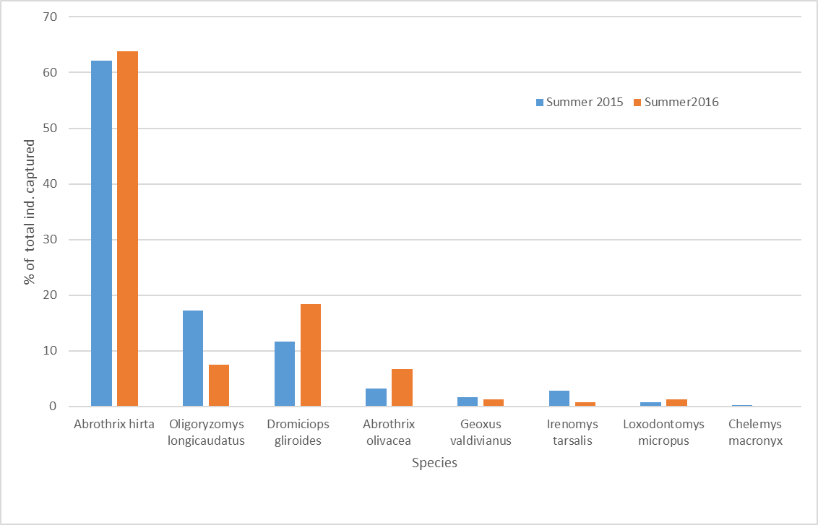
Figure 3.2 Percentage of total individuals captured per species during the summers of 2015 and 2016 in a temperate forest of northern Patagonia.

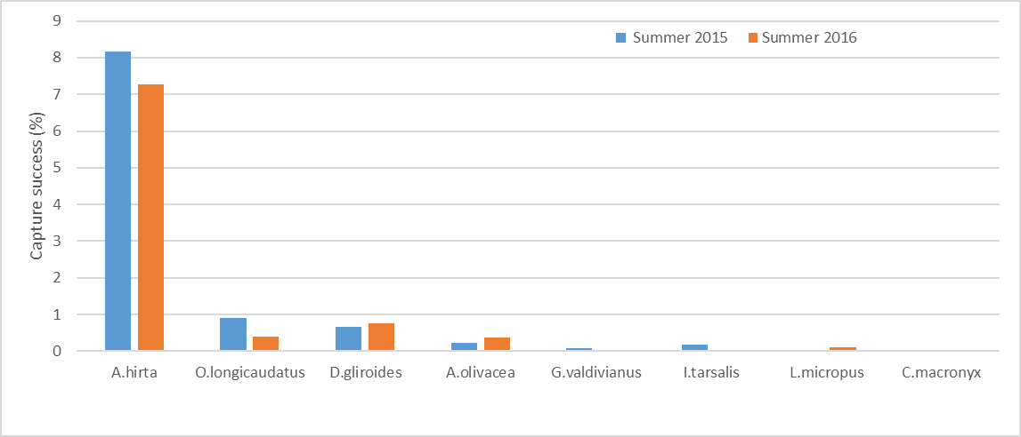
Figure 3.3 Small mammal capture success during sampling seasons 2015 and 2016.

Figure 3.4 Species-specific capture success at each sampling location. For example, 10% of the traps at location 1 caught A. hirta, both years.

Table 3.1 Exploratory models predicting occupancy probability of small mammals in a temperate forest of northern Patagonia, organized from lowest to highest WAIC.
Model | Deviance | WAIC | ΔWAIC | P-value
Anthropogenic effect | 797.85 | 1119.66 |  | 0.508
Food availability | 800.27 | 1131.95 | 12.29 | 0.506
Saturated model | 801.68 | 1131.99 | 12.33 | 0.515
Strata complexity and cover | 798.19 | 1139.66 | 20 | 0.512
Plot complexity | 798.62 | 1153.17 | 33.51 | 0.514
Level of protection | 795.77 | 1153.45 | 33.79 | 0.509
Shelter | 805.39 | 1153.75 | 34.09 | 0.510
Strata complexity | 797.41 | 1157.95 | 38.29 | 0.511

Table 3.2 Estimated detection probabilities per species for each model.
Species | Models
Species | AE | FA | SCC | PC | LP | SA | SC
Abrothrix hirta | 0.78±0.02 | 0.78±0.02 | 0.78±0.02 | 0.78±0.02 | 0.78±0.02 | 0.78±0.02 | 0.78±0.02
Abrothrix hirta | 0.81±0.02 | 0.81±0.02 | 0.81±0.02 | 0.81±0.02 | 0.81±0.02 | 0.81±0.02 | 0.81±0.02
Oligoryzomys longicaudatus | 0.22±0.02 | 0.22±0.02 | 0.22±0.02 | 0.22±0.02 | 0.22±0.02 | 0.22±0.02 | 0.22±0.02
Oligoryzomys longicaudatus | 0.25±0.03 | 0.25±0.03 | 0.25±0.03 | 0.25±0.03 | 0.25±0.03 | 0.25±0.03 | 0.25±0.03
Dromiciops gliroides | 0.25±0.02 | 0.25±0.02 | 0.25±0.02 | 0.24±0.02 | 0.25±0.02 | 0.25±0.02 | 0.25±0.02
Dromiciops gliroides | 0.27±0.03 | 0.27±0.03 | 0.27±0.03 | 0.27±0.03 | 0.27±0.03 | 0.27±0.03 | 0.27±0.03
Abrothrix olivacea | 0.20±0.03 | 0.20±0.03 | 0.20±0.03 | 0.20±0.03 | 0.20±0.03 | 0.20±0.03 | 0.20±0.03
Abrothrix olivacea | 0.21±0.03 | 0.21±0.03 | 0.21±0.03 | 0.21±0.03 | 0.21±0.03 | 0.21±0.03 | 0.21±0.03
Irenomys tarsalis | 0.21±0.05 | 0.21±0.05 | 0.21±0.05 | 0.21±0.05 | 0.21±0.05 | 0.21±0.05 | 0.21±0.05
Irenomys tarsalis | 0.09±0.04 | 0.08±0.04 | 0.08±0.04 | 0.08±0.04 | 0.08±0.04 | 0.08±0.04 | 0.08±0.04
Geoxus validivianus | 0.11±0.03 | 0.11±0.03 | 0.10±0.03 | 0.11±0.03 | 0.11±0.03 | 0.10±0.03 | 0.11±0.03
Geoxus validivianus | 0.06±0.02 | 0.06±0.02 | 0.06±0.02 | 0.06±0.02 | 0.06±0.02 | 0.06±0.02 | 0.06±0.02
Loxodontomys micropus | 0.12±0.05 | 0.12±0.05 | 0.13±0.04 | 0.12±0.05 | 0.13±0.04 | 0.11±0.04 | 0.12±0.05
Loxodontomys micropus | 0.23±0.05 | 0.23±0.05 | 0.23±0.05 | 0.23±0.05 | 0.23±0.05 | 0.24±0.05 | 0.23±0.05
Chelemys macronix | 0.15±0.05 | 0.14±0.05 | 0.14±0.05 | 0.14±0.05 | 0.14±0.05 | 0.14±0.06 | 0.15±0.05
Chelemys macronix | 0.20±0.16 | 0.17±0.15 | 0.17±0.16 | 0.18±0.16 | 0.18±0.16 | 0.16±0.15 | 0.18±0.16
AE: Anthropogenic Effect, FA: Food Availability, SCC: Strata Complexity and Cover, PC: Plot Complexity, LP: Level of Protection, SA: Shelter Availability, SC: Strata Complexity. Detection probabilities are expressed as mean ± SD. Top 2015, bottom 2016.

of cattle, higher understory cover, and more canopy cover had a positive effect on the communities studied. Furthermore, the variability captured by the first PC with the Anthropogenic model and the Strata Complexity and Cover model had a positive effect at the community level, while those variables from the Shelter and the Strata Complexity model negatively affected the communities (Table 3). The first principal component for each model explained less than 55% of the total variability among the predictors (Appendix 1). Based on this saturated model, larger values of PC_Ah were associated with smaller values of road distance, while larger values of PC_ SCo were associated with higher values of bush cover multiplied by bush richness in 2015, and lower values of connectivity in 2016. The negative effect of Shelter was dominated by logs cover in 2015 and by connectivity in 2016. Loadings for these two predictors were negative. Similarly, bush cover had a negative loading and was the predictor accounting for most of the variability of the PC_SC. (Appendix 1).
Four species had higher occurrence probabilities in environments shared with cattle in 2015 (A. hirta, A. olivacea, C. macronyx, and G. valdivianus, with more than 75% of the interval having the same sign as the mean effect), whereas there was no effect of cattle on the other species (Fig. 5, Appendix 2). However, this effect remained only for A. hirta (f=0.833) and A. olivacea (f=0.971) during 2016 (Fig. 5, Appendix 2). Abrothrix hirta, D. gliroides, and G. valdivianus presented a consistent higher occurrence probability in plots farther from roads (Fig. 5, Appendix 2), while O. longicaudatus, I. tarsalis, C. macronix, and L. micropus behaved in the opposite way (Fig. 5, Appendix 2). The model did not predict a relation between occurrence of A. olivacea and road distance (Fig. 5, Appendix 2). Roads with higher traffic intensity increased the occurrence probability of A. hirta and G. valdivianus and reduced it for I. tarsalis (Fig. 5, Appendix 2); nevertheless, the model did not provide evidence for traffic effects on A. olivacea and L. micropus (Fig. 5, Appendix 2).
Herbaceous cover seems to be a weak predictor of occupancy probabilities for the rodent species (Fig. 6, Appendix 2). However, it had a consistent negative effect on the occurrence probability of the arboreal D. gliroides (Fig 6., Appendix 2). Similarly, bush cover and coleopteran abundance had a consistent positive effect only on A. hirta (Fig. 6, Appendix 2). Finally, the model did not provide clear evidence regarding tree cover effects (Fig. 6, Appendix 2).

Table 3.3 Models indicating predictor’s effects on the community as a whole. Coefficients expressed in the logit scale. The percentage of the BCI interval with same sign as the mean is indicated in the “f” column, f>75% in bold.
Model | Predictor | $$\hat{β}$$ |  | 95% BCI |  | f
Model | Predictor | Mean | SD | 2.5% | 97.5% | f
Anthropogenic effect | Cattle | 0.429 | 0.479 | -0.519 | 1.378 | 0.820
Anthropogenic effect | Road dist. | -0.083 | 0.441 | -0.980 | 0.783 | 0.576
Anthropogenic effect | Road traffic | 0.182 | 0.357 | -0.510 | 0.918 | 0.700
Food availability | Herbaceous | 0.046 | 0.353 | -0.708 | 0.703 | 0.571
Food availability | Bush | 0.083 | 0.362 | -0.638 | 0.816 | 0.596
Food availability | Tree | 0.093 | 0.274 | -0.446 | 0.640 | 0.634
Food availability | Coleopterans | 0.094 | 0.328 | -0.565 | 0.739 | 0.621
Saturated model | Protection | -0.047 | 0.391 | -0.845 | 0.710 | 0.544
Saturated model | PC_An | 0.288 | 0.418 | -0.552 | 1.110 | 0.765
Saturated model | PC_Fo | -0.149 | 0.363 | -0.867 | 0.558 | 0.660
Saturated model | PC_Sh | -0.577 | 0.372 | -1.321 | 0.158 | 0.944
Saturated model | PC_PC | -0.130 | 0.349 | -0.817 | 0.567 | 0.654
Saturated model | PC_SC | -0.433 | 0.379 | -1.177 | 0.318 | 0.876
Saturated model | PC_SCo | 0.690 | 0.393 | -0.090 | 1.464 | 0.961
Strata complexity and cover | hcr | -0.173 | 0.419 | -1.062 | 0.612 | 0.660
Strata complexity and cover | bcr | 0.203 | 0.317 | -0.422 | 0.840 | 0.747
Strata complexity and cover | tcr | 0.041 | 0.255 | -0.471 | 0.537 | 0.572
Plot complexity | Forest | 0.024 | 0.275 | -0.524 | 0.561 | 0.539
Plot complexity | Bare ground | -0.227 | 0.323 | -0.869 | 0.410 | 0.768
Plot complexity | Richness | 0.149 | 0.352 | -0.543 | 0.861 | 0.678
Level of protection | R-O | -0.045 | 0.476 | -0.999 | 0.895 | 0.537
Level of protection | P-O | -0.166 | 0.446 | -1.056 | 0.714 | 0.651
Level of protection | S-O | 0.079 | 0.524 | -0.968 | 1.111 | 0.566
Shelter | Bush | 0.075 | 0.408 | -0.702 | 0.918 | 0.565
Shelter | Log | -0.259 | 0.380 | -1.012 | 0.495 | 0.757
Shelter | Tree | -0.046 | 0.317 | -0.681 | 0.570 | 0.557
Shelter | Understory | 0.351 | 0.375 | -0.392 | 1.059 | 0.824
Shelter | Canopy | 0.587 | 0.384 | -0.165 | 1.351 | 0.940
Shelter | Connectivity | -0.166 | 0.446 | -1.035 | 0.729 | 0.652
Strata complexity | Herb rich | 0.050 | 0.370 | -0.701 | 0.784 | 0.565
Strata complexity | Bush rich | 0.122 | 0.275 | -0.422 | 0.668 | 0.677
Strata complexity | Tree rich | -0.033 | 0.257 | -0.541 | 0.486 | 0.560
hcr: herbaceous cover * richness, bcr: bush cover * richness, tcr: tree cover * richness, Forest: tree density * average dbh, Richness: total vegetation richnesss, R-O: National Reserve-Outside, N-O: National Park-Outside, S-O: Strict Nature Reserve-Outside, Herb rich: herbaceous richness, Bush rich: bush richness, Tree rich: tree richness.

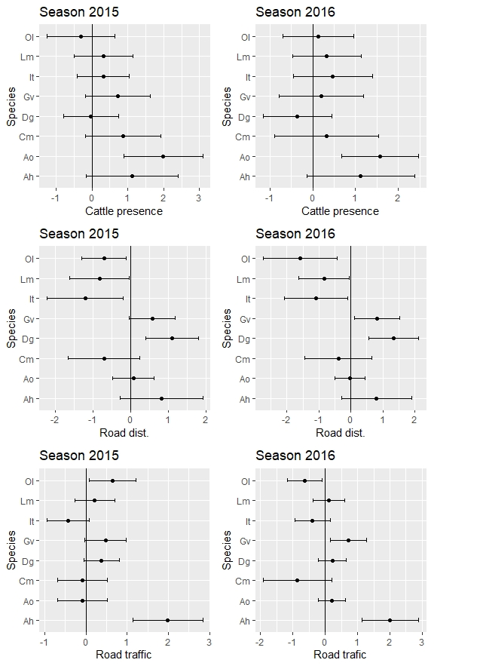
Figure 3.5 Cattle (top), Road distance (center) and Road traffic intensity (bottom) coefficients in the logit scale ($\hat{β}±SD, 95\% BCI)$ on logit occupancy (logit $\left(\hat{psi}\right)$) of each small mammal species by year for the Anthropogenic model. Ah. Abrothrix hirta, Ao. Abrothrix olivacea, Cm. Chelemys macronyx, Dg. Dromiciops gliroides, Gv. Geoxus valdivianus, It. Irenomys tarsalis, Lm. Loxodontomys micropus, Ol. Oligoryzomys longicaudatus.

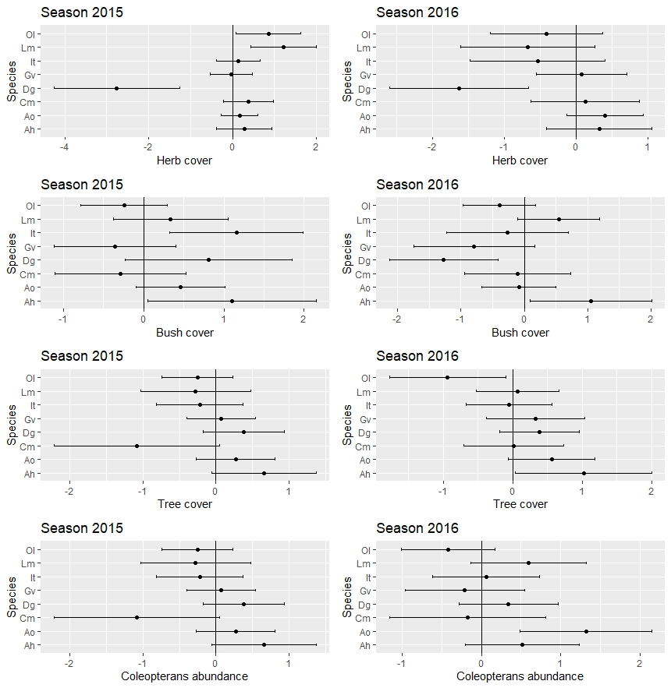
Figure 3.6 Herbaceous cover (top), Bush cover (2nd), Tree cover (3rd), and Coleopteran’s abundance (bottom) coefficients in the logit scale $\left(\hat{β}±SD, 95\% BCI\right)$ on logit occupancy $\left(logit \left(\hat{psi}\right)\right)$ of each small mammal species by year for the Food Availability Model. Ah. Abrothrix hirta, Ao. Abrothrix olivacea, Cm. Chelemys macronyx, Dg. Dromiciops gliroides, Gv. Geoxus valdivianus, It. Irenomys tarsalis, Lm. Loxodontomys micropus, Ol. Oligoryzomys longicaudatus.
The model “Strata complexity and cover” used as predictors the products of strata richness (herbaceous, bush, and tree) and their cover. The herbaceous stratum had a negative effect on the occurrence probability of the arboreal D. gliroides (mean±SD: -1.977±1.012, f=0.997 in 2015, and -1.721±1.248, f=0.945 in 2016) and the fossorial G. valdivianus (mean±SD: -1.019±0.875, f=0.918 in 2015, and -0.874±1.043, f=0.827 in 2016), while it did not provide clear evidence for the other species (Appendix 2). The only consistent pattern for the bush stratum was the positive response of A. hirta and L. micropus (Appendix 2). The tree stratum measured at this level did not have a consistent effect (Appendix 2).
Geoxus valdivianus’ occurrence probability was higher in response to the forest predictor for the Plot Complexity Model (mean±SD: 0.395±0.513, f=0.788 in 2015, and 0.426±0.589, f=0.782 in 2016) and lower in plots with higher vegetation richness (mean±SD: -0.777±0.656, f=0.909 in 2015, and -0.773±0.929, f=0.832 in 2016). By contrast, A. hirta responded positively to vegetation richness (mean±SD: 1.786±1.178, f=0.977 in 2015, and 1.443±1.097, f=0.938 in 2016). Bare ground had a consistent negative effect on A. olivacea, I. tarsalis and L. micropus occurrence. We found no consistent response for the remaining species (Appendix 2).
We used the model “Levels of protection” to compare differences in occurrence probabilities between each level of protection within NHNP (National Reserve < National Park < Strict Nature Reserve) and the unprotected neighboring area (outside). Surprisingly, two species responded negatively to the protection system; I. tarsalis presented a lower occupancy probability within the National Reserve protection level than in the unprotected area both years (mean±SD: -1.036±1.237, f=0.819 in 2015, and -0.990±1.269, f=0.801 in 2016), while L. micropus occurrence probability was lower at each level of protection than in the unprotected area in 2015, while in 2016 the only difference was between the highest level of protection and the unprotected area (Appendix 2). On the contrary, D. gliroides was more likely to occur within the two highest protection categories, National Park and Strict Nature Reserve, and at least for the 2016 sampling season it also had higher occupancy probability within the National Reserve (Appendix 2). Although present in almost every plot, A. hirta had a higher occupancy probability within the Strict Nature Reserve (Appendix 2).
The “Shelter model” used as predictors environmental variables that could shelter both arboreal (D. gliroides, I. tarsalis, and O. longicaudatus) and ground-dwelling species. The ground-dwelling A. hirta had a higher occurrence probability in plots with more bush cover, while protection from above (canopy cover) appears to be more important for D. gliroides, A. olivacea, G. valdivianus and L. micropus. Abrothrix olivacea and I. tarsalis had higher occurrence probability in plots with higher understory cover. Log cover negatively affected occurrence probability of I. tarsalis and L. micropus. Finally, connectivity did not affect most of the species occurrence probabilities with the sole exception of the ground-dwelling A. olivacea, which had a lower occurrence probability in plots with higher connectivity measured 1m above the ground (Appendix 2).
Finally, our “Strata complexity model” evaluated vegetation richness divided into herbaceous, bush, and tree strata. None of the variables analyzed in the model had an effect at the community level. Herbaceous richness positively affected the occurrence probability of A. hirta and O. longicaudatus while having the opposite effect on D. gliroides and G. valdivianus. The predictor variables bush and tree richness either had no effect on the species or the sign of the effect switched between years (Appendix 2).
There was no spatial autocorrelation between community richness for most of the analyses, with the only exceptions the model Level of Protection for the season 2015 and the model Strata Complexity for the season 2016 (Appendix 3).

Discussion

The total diversity of species found in the present study agrees with that documented in previous studies conducted in NHNP (Christie, 1984; Pearson, 1995), except for the endemic marsupial Rhyncholestes raphanurus. However, this marsupial is distributed almost entirely in Chile with only two records in Argentina (Martin, 2011).
The overall trap success was comparable to those reported for La Picada (Chile) for elevations between 505 m.a.s.l (7.2%) and 715 m.a.s.l. (8.0%) (Patterson et al., 1989); however, trap success for an eight-year study regarding small mammal communities in NHNP was almost double the one reported here (Pearson, 1995). This difference might be due to seasonal variation in small mammal abundance, since our study was conducted in summer while Pearson (1995) sampled in fall and spring. Nevertheless, demographic trends of small mammals in temperate rainforest of southern Chile show an increasing number of individuals captured throughout the summer with peaks in fall (Meserve et al., 1991; Meserve et al., 1999), emphasizing the importance of multi-season studies. Furthermore, the El Niño Southern Oscillation (ENSO) event has been linked to variation in small mammal abundances, with varying effect at different latitudes in Chile. Small mammal densities of certain species were higher in central and northern Chile during ENSO events followed by rapid decline during a La Niña event (Iriarte et al., 1989; Meserve et al., 2003; Milstead et al., 2007), while this pattern was not as clear for small mammals inhabiting Patagonian rainforests (Meserve et al., 1999). The Oceanic Index Niño (ONI) recorded during the austral summer was above the 0.5°C threshold for both 2015 and 2016, indicating the occurrence of an ENSO, but while ONI for summer 2015 was 0.6°C (weak ENSO), the index increased to 2.5°C during austral summer 2016 (very strong ENSO) (National Weather Service – Climate Prediction Center). The 27% decline in captures reported for 2016 could suggest a negative effect of a very strong ENSO on small mammal communities in Argentinian Temperate Forests; nevertheless, multi-year studies are needed to evaluate these fluctuations over time.
Pearson (1995) reported a higher species trap success for all the rodents; on the contrary, our overall trap success for the marsupial D. gliroides was higher. The low abundance of D. gliroides reported by Pearson (1995) might be due to a sampling artifact, as it has been demonstrated that D. gliroides abundance is underestimated by Sherman traps (Fonturbel & Jimenez, 2009). Furthermore, D. gliroides is active from late spring to early fall, falling into a winter torpor during the coolest months (Franco et al., 2011). In our study, we included both Sherman and Tomahawk traps at each sampling location to avoid such a sampling artifact. Nevertheless, both our average marsupial trap success and our trap success per plot (ranging from 0% to 3.90%) were markedly lower than those reported in a seven-year study conducted in Llao Llao Municipal Park in the vicinity of NHNP (trap success ranged from 5.63% to 21%) (Balazote Oliver et al., 2017). The variability per plot of relative abundance found in the current study and the high abundance of D. gliroides in the small area sampled by Balazote et al. (2017) support our view that the species has a patchy distribution and that small-scale analyses with multiple sampling locations, such as the one proposed here, are needed to understand what causes such an uneven distribution.
The use of hierarchical models allows us to assess the community-level response to the predictor variables and to make inferences about the effects on each observed species. The advantage of using hierarchical models to conduct composite analyses of community response resides in the effective use of all the data, including data on rare or infrequent species, instead of data only from the most common and abundant species (Russell et al., 2009; Zipkin et al., 2009). The scale of analysis influences our understanding of ecological processes, so the scale selected must reflect the processes being studied (Morris, 1987). We evaluated community responses at a macrohabitat level, based on the fact that macrohabitat areas are similar in size to species home ranges and constitute distinguishable units within the same habitat type (N. dombeyi dominant temperate forest in our study) (Morris 1987). Furthermore, by using 20 sampling units of equal dimensions and conducting the small mammal captures almost simultaneously across the 20 plots, we eliminated scale-dependent effects while minimizing temporal effects (Whittaker et al., 2001).
In a previous study we specifically evaluated the effectiveness of the NHNP protection system in conserving its small mammal community, concluding that these different levels of protection afforded only minor protection to most of the species, with the only exception being substantial protection of the marsupial D. gliroides (Rivarola et al. 2021). The new approach in this study confirms the importance of the protection system in conserving this endemic marsupial.
Results from our Anthropogenic model suggest that cattle presence positively affects several small mammals. Occupancy probability of Abrothrix hirta, A. olivacea, Geoxus valdivianus, and Chelemys macronyx were higher in areas with livestock, although these results need to be carefully considered, since browsing intensity was not evaluated. A synthesis of cattle grazing effects on natural environments worldwide concluded that positive, negative, and neutral effects reported are related to the specific attribute measured (Mazzini et al., 2018). Small mammal diversity indexes were greater on ungrazed than on grazed areas in a protected area in Oregon (US) where domestic livestock and native elk coexisted (Moser & Witmer, 2000). Livestock can negatively affect small mammals indirectly by modifying vegetation characteristics (Mazzini et al., 2018). A study conducted in Patagonian temperate forest found that degraded environment has both negative and positive effects on arboreal small mammal species: while Dromiciops gliroides was more abundant in low-degradation patches, the opportunistic Oligoryzomys longicaudatus was more abundant in degraded areas (Fonturbel, 2011). We did not find a clear response by these arboreal species to the presence or absence of cattle. Importantly, with the exception of one plot outside the protected area (plot A3), none of the plots surveyed in the current study where cattle were present could be considered “degraded”, suggesting that browsing intensity may be low. In Nahuel Huapi National Park high browsing intensity produces herb-dominated communities with reduction of woody plants (Veblen et al., 1992). We evaluated these variables under other proposed models. Only two species were captured in plot A3, the opportunistic O. longicaudatus and the dominant A. hirta, in low abundance both years. Livestock were present in four plots in the unprotected area, while the fifth plot (A2) was established in an area fenced since 1999 to facilitate forest restoration. Small mammal abundance and diversity in plot A2 were higher than in the neighboring plots in 2015; however, in 2016, only one species was trapped in this plot. Finally, studies on cattle in Patagonian temperate forest found that they feed on native woody species including N. dombeyi, with detrimental effects on native forest (Vila & Borrelli, 2011).
Roads alter natural landscapes with a wide array of implications for wildlife conservation (Forman & Alexander, 1998). Roadways negatively affect small mammal communities in forest areas by movement inhibition and road mortality, while traffic intensity alone does not explain reduced small mammal movement (Oxley et al., 1974). We did not find a clear effect of road distance and traffic intensity at the community level. On the contrary, our study indicates that A. hirta, D. gliroides, and G. valdivianus occupancy probabilities are higher in areas near roads while O. longicaudatus, I. tarsalis, and L. micropus responded in an opposite manner. Traffic intensity positively affected A. hirta and G. valdivianus occupancy probabilities. To interpret these results further, it is important to take into account species behavior and activity patterns. For instance, D. gliroides and O. longicaudatus are almost entirely nocturnal, and we did not discriminate between car road use at different times throughout the day. While translocation studies of small mammals have revealed that roads can reduce the probability of successful return, small mammal densities where not affected by road proximity or traffic intensity (McGregor et al., 2008). Road edge effect has been correlated with higher abundance of opportunistic species (Goosem, 2002). In our study, only three plots were at the edge of a road; however, these roads were narrow (one car wide) and unpaved, traffic was less than one car per day, and canopy almost entirely covered the road. These features diminished the edge effect. While macrohabitat is related to individual home range, microhabitats are smaller sub-units quantified by variables able to influence the time and energy allocated per individual of different species (Morris 1987). To secure a good determination of plot quality, we measured 100 microhabitats per plot, plus a grid of 169 nodes to characterize the forest. Analyses conducted at the microhabitat level provide evidence regarding habitat use rather than habitat selection (Morris, 1992). We conducted our analyses at the macrohabitat level, and quality of macrohabitats results from their combinations of microhabitats.
It has been proposed that microhabitats are enhanced in complex landscapes, and that more microhabitats would provide more refuges and food allowing the coexistence of more small mammal species (Novillo et al., 2017). Our results suggest that this pattern is not evident within the same habitat type, as the community responses in evaluations of food availability, shelter availability, and plot complexity were inconclusive (no effect or switching effect between years). None of the models proposed seemed to explain well the heterogeneity among the 20 community samples studied; nevertheless, some variables provided useful information regarding individual species habitat selection.
The dominant species Abrothrix hirta preferred areas with high vegetation diversity, particularly herbaceous vegetation and shrubs; furthermore, shrub cover increased its occurrence probability, a pattern also reported in Chile (Kelt et al., 1999) and in its ecotonal distribution in Argentina (Lozada et al., 2010). It is an omnivorous species reported as highly insectivorous in shrubland (Pearson, 1983). We observed higher occupancy probability correlated with arthropod abundance, suggesting that beetles are an important part of their diet also in forested areas, at least during the summer season.
Bare ground cover negatively correlated with A. olivacea occupancy probability. This association with ground cover has been found in temperate forests in Chile (Murua & Gonzalez, 1982) and Argentina (Pearson, 1983). However, another study conducted in temperate forest in Chile suggests that the species prefers habitat with more bare ground cover and more species of trees, and less bush and herbaceous cover (Kelt et al., 1994; Kelt et al., 1999). We did not find an association with tree diversity. However, canopy and understory cover were important habitat variables associated with the presence of the species, which agrees with selection of habitats that facilitate avoidance of predation from above, as has been previously suggested (Murua & Gonzalez, 1982).
Oligoryzomys longicaudatus has been described as an irrupting species, with high abundances followed by almost complete disappearance (Meserve et al., 1991; Murua et al., 1986), a situation observed in our study where 127 specimens were captured in 15 plots in 2015 versus only 40 individuals identified in six plots in 2016. Our results regarding habitat selection are inconclusive; habitat characteristics associated with higher occurrence probability in 2015 were not important in 2016 or switched effects toward a negative correlation. The species’ absence from nine previously occupied plots might have affected the statistical power of our models and hidden the effect of variables. Herbaceous richness was associated with higher occurrence probability both years. Although this variable alone does not necessarily imply shelter, habitat selection that favors protection from horizontal viewing has been suggested for this species (Kelt et al., 1994).
The nocturnal and scansorial marsupial Dromiciops gliroides (Pearson, 1983) was among the most abundant and widely distributed species in our study (third most abundant in 2015 and present in 13 plots, and second most abundant in 2016 and present in 11 plots). Studies conducted with camera traps in Chile (Franco et al., 2011) and Argentina (Di Virgilio et al., 2014) concluded that it is the most common species in the arboreal stratum in old-growth Nothofagus forests. Based on our models, tree cover and canopy cover were related to higher occurrence probability. The species has been associated with environments with dense understory dominated by bamboo (Fonturbel et al., 2012; Rodriguez-Cabal & Branch, 2011), but we did not find this pattern. Its wide distribution among our sampling locations provides further evidence that the species might be able to thrive or at least persist in more habitats than previously thought (Fonturbel, 2011; Rodriguez-Cabal et al., 2007), as suggested by its presence in pine-dominated forest (Uribe et al., 2017). Nevertheless, more than 60% of the individuals captured in our study resided in the vicinity of Puerto Blest, a remote area accessed only by boat, with a high daily load of tourists (diurnal use only), low number of permanent residents, and total absence of domestic animals, particularly cats, which are known to prey on D. gliroides (Di Virgilio et al., 2014).
The semifossorial Geoxus valdivianus is a small mole-like rodent with enlarged forefoot claws for digging (Patterson et al., 1990; Pearson, 1983). In Argentina it inhabits pure or mixed Nothofagus forests as well as marsh and meadow but does not extend into the steppe (Pearson, 1983). It eats small animals (annelids, arthropods, mollusks) (Pearson, 1983) and fungi (Patterson et al., 1990). We found no relation between arthropod abundance and occupancy probability. We found this species in six plots both years, but only three plots where the species was identified in 2015 remained occupied in 2016. Furthermore, at each site we usually trapped only a single individual, making this an uncommon species (Meserve et al., 1991). Two of these sites were heavily covered by volcanic ash from a volcanic eruption in June of 2011, suggesting the volcanic fine particulate material would not affect the persistence of this species. It has been associated with habitats with loose soil (Kelt et al., 1994) and many fallen trees and substantial bare ground (Meserve et al., 1991). In our study, occupancy probability was unrelated to bare ground cover and log cover. Finally, herbaceous cover and herbaceous richness negatively correlated with occupancy probability, indirectly supporting the pattern of preference for areas with more bare ground.
The Chilean climbing mouse Irenomys tarsalis is distributed between 39.5° and 45° S and is endemic to Nothofagus forests in Chile and Argentina (Chébez et al., 2014). It has been suggested that low captures of this species using ground traps might be due to a trap artifact since the species is mainly arboreal (Patterson et al., 1990). However, we recorded more captures in Sherman traps set on the ground than in Tomahawk traps placed 1 m above ground both years (25 out 36 captures in 2015, and 3 out of 5 captures in 2016). We found that understory cover, measured as percent of area aboveground where the animal can move and access the trap without descending to the ground, was positively correlated with its occupancy probability, as expected by its movement patterns.
Loxodontomys micropus is a large mouse with an extensive latitudinal distribution from northern Mendoza to Santa Cruz in Argentina, and from Ñuble to the Strait of Magellan in Chile. It is mostly associated with forests, with some records in humid grasslands in the steppe (Teta et al., 2009). It prefers shrubby habitats (Patterson et al., 1990) and forest with abundant ground cover (Pearson, 1983). Accordingly, we found higher occupancy probability linked to bush cover, bush diversity, and canopy cover. We captured few individuals both years, distributed in three plots, although only one plot remained occupied between years.
Finally, Chelemys macronix has been described as a moderately abundant species inhabiting both forest and steppe (Chébez et al., 2014). Nevertheless, we captured only two specimens in 2015 in the vicinity of Traful Lake in the two northernmost plots. This result is unexpected given the high trapping effort and large area sampled. Further studies are needed to elucidate its low prevalence.
Most research on small mammal microhabitat selection in Patagonia compared different habitat types. To the best of our knowledge, this is the first study that examined small mammal heterogeneity within the same habitat, providing evidence that a reduced number of sampling locations per habitat could limit our understanding of species distributions and their habitat preferences.

References

Andrade, A., & Monjeau, A. (2014). Patterns in community assemblage and species richness of small mammals across an altitudinal gradient in semi-arid Patagonia, Argentina. Journal of Arid Environments, 106, 18-26. https://doi.org/10.1016/j.jaridenv.2014.02.004
Brooms, K. M., Hooten, M. B., & Fitzpatrick, R. M. (2016). Model selection and assessment for multi-species occupancy models. Ecology, 97(7), 1759–1770.
Cabrera, L. A. (1976). Regiones fitogeográficas argentinas. ACMA.
Chébez, J. C., Pardiñas, U. F. J., & Teta, P. (2014). Mamíferos Terrestres la Patagonia Sur de Argentina y Chile. Vázquez-Mazzini.
Christie, M. I. (1984). Informe preliminar del Relevamiento de Fauna de los Parques Nacionales Lanin y Nahuel Huapi.
Contreras, J. R. (1972). El home range en una poblacion de Oryzomis longicaudatus Philippi (Landbeck) (Rodentia, Cricetidae). PHYSIS, 83, 353-361.
Di Virgilio, A., Amico, G. C., & Morales, J. M. (2014). Behavioral traits of the arboreal marsupial Dromiciops gliroides during Tristerix corymbosus fruiting season. Journal of Mammalogy, 95(6), 1189-1198. https://doi.org/10.1644/13-MAMM-A-281
Dimitri, M. J. (1977). Pequeña Flora Ilustrada de Los Parques Nacionales Andino Patagonicos (Separata de Anales de Parques Nacionales, Issue.
Dorazio, R. M., Royle, A., & Royle, J. A. (2005). Estimating Size and Composition of Biological Communities by Modeling the Occurrence of Species. Journal of the American Statistical Association, 100(470), 389-398. https://doi.org/10.1198/016214505000000015
Fonturbel, F. E. (2011). Does habitat degradation couse change in the composition of arboreal small mammals? A small-scale assessment in Patagonian Temperate Rainforest fragments. Latin Amercan Journal of Conservation, 2(2), 68-72.
Fonturbel, F. E., Franco, M., Rodriguez-Cabal, M. A., Rivarola, M. D., & Amico, G. C. (2012). Ecological consistency across space: a synthesis of the ecological aspects of Dromiciops gliroides in Argentina and Chile [Research Support, Non-U.S. Gov't
Review]. Naturwissenschaften, 99(11), 873-881. https://doi.org/10.1007/s00114-012-0969-2
Fonturbel, F. E., & Jimenez, J. E. (2009). Understimation of abundance of the Monito del Monte (Dromiciops gliroides) due to a sampliing artifact. Journal of Mammalogy, 90(6), 1357-1362.
Forman, R. T. T., & Alexander, L. E. (1998). Road and their major ecological effects. Annual Review of Ecology and Systematics, 29(1), 207-231. https://doi.org/10.1146/annurev.ecolsys.29.1.207
Franco, M., Quijano, A., & Soto-Gamboa, M. (2011). Communal nesting, activity patterns, and population characteristics in the near-threatened monito del monte, Dromiciops gliroides. Journal of Mammalogy, 92(5), 994–1004.
Gelman, A., & Hill, J. (2007). Data Analysis Using Regression and Multilevel/Hierarchical Models. Cambridge University Press.
Gelman, A., Meng, X. L., & Stern, H. (1996). Posterior predictive assessment of model fitness via realized discrepancies. Statistica Sinica, 6, 733-759.
Gelman, A., & Rubin, D. B. (1992). Inference from Iterative Simulation Using Multiple Sequences. Statistical Science, 7(4), 457-472, 416. https://doi.org/10.1214/ss/1177011136
Gomez, M. D., Goijman, A. P., Coda, J., Serafini, V., & Priotto, J. (2018). Small mammal responses to farming practices in central Argentinian agroecosystems: The use of hierarchical occupancy models. Austral Ecology. https://doi.org/10.1111/aec.12625
Goosem, M. (2002). Effects of tropical rainforest roads on small mammals: fragmentation, edge effects and traffic disturbance. Wildlife Research, 29(3), 277-289. https://doi.org/https://doi.org/10.1071/WR01058
Gu, W., & Swihart, R. K. (2004). Absent or undetected? Effects of non-detection of species occurrence on wildlife–habitat models. Biological Conservation, 116, 195–203.
Iriarte, J. A., Contreras, L. C., & Jaksić, F. M. (1989). A Long-Term Study of a Small-Mammal Assemblage in the Central Chilean Matorral. Journal of Mammalogy, 70(1), 79-87. https://doi.org/10.2307/1381671
Kelt, D. A. (2000). Small mammal communities in rainforest fragments in Central Southern Chile. Biological Conservation, 92, 345-358.
Kelt, D. A., & Meserve, P. L. (2014). Status and challenges for conservation of small mammal assemblages in South America. Biol Rev Camb Philos Soc. https://doi.org/10.1111/brv.12080
Kelt, D. A., Meserve, P. L., & Lang, B. K. (1994). Quantitative Habitat Associations of Small Mammals in a Temperate Rainforest in Southern Chile: Empirical Patterns and the Importance of Ecological Scale. Journal of Mammalogy, 75(4), 890-904.
Kelt, D. A., Meserve, P. L., Patterson, B. D., & Lang, B. K. (1999). Scale Dependence and Scale Independence in Habitat Associations of Small Mammals in Southern Temperate Rainforest. Oikos, 85(2), 320-334.
Kéry, M., & Royle, A. (2008). Hierarchical Bayes estimation of species richness and occupancy in spatially replicated surveys. Journal of Applied Ecology, 45, 589-598. https://doi.org/doi: 10.1111/j.1365-2664.2007.01441.x
Kéry, M., & Royle, A. (2016). Applied Hierarchical Modeling in Ecology: Analysis of distribution, abundance and species richness in R and BUGS: Volume 1: Prelude and Static Models. Elsevier Inc. . https://doi.org/https://doi.org/10.1016/C2013-0-19160-X
Lozada, M., Guthmann, N., & Baccala, N. (2010). Microhabitat selection of five sigmodontine rodents in a forest-steppe transition zone in northwestern Patagonia. Studies on Neotropical Fauna and Environment, 35(2), 85-90.
MacKenzie, D. I., Nichols, J. D., Lachman, G. B., Droege, S., Royle, A., & Langtimm, C. A. (2002). Estimating site occupancy rates when detection probabilities are less than one. Ecology, 83(8), 2248-2255.
Martin, G. M. (2011). Geographic distribution of Rhyncholestes raphanurus Osgood, 1924 (Paucituberculata: Caenolestidae), an endemic marsupial of the Valdivian Temperate Rainforest. Australian Journal of Zoology, 59, 118-126.
Mazzini, F., Relva, M. A., & Malizia, L. R. (2018). Impacts of domestic cattle in forest and woody ecosystems in southern South America. Plant Ecology, 219, 913-925. https://doi.org/https://doi.org/10.1007/s11258-018-0846-y
McGregor, R. L., Bender, D. J., & Fahrig, L. (2008). Do small mammals avoid roads because of the traffic? Journal of Applied Ecology, 45(1), 117-123. https://doi.org/https://doi.org/10.1111/j.1365-2664.2007.01403.x
Mermoz, M., & Martin, C. (1986). Mapa de Vegetacion del Parque y la Reserva Nacional Nahuel Huapi.
Meserve, P. L., Kelt, D. A., Milstead, W. B., & GutiÉrrez, J. R. (2003). Thirteen Years of Shifting Top-Down and Bottom-Up Control. BioScience, 53(7), 633-646. https://doi.org/10.1641/0006-3568(2003)053[0633:Tyosta]2.0.Co;2
Meserve, P. L., Lang, B. K., Murua, R., Munozpedreros, A., & Gonzalez, L. A. (1991). Characteristics of a Terrestrial Small Mammal Assemblage in a Temperate Rain-Forest in Chile. Revista Chilena de Historia Natural, 64(1), 157-169. <Go to ISI>://WOS:A1991JD56000014
Meserve, P. L., Martinez, D. R., Rau, J. R., Murua, R., Lang, B. K., & Munoz-Pedreros, A. (1999). Comparative demography and diversity of small mammals in precordilleran temperate rainforests of southern Chile. Journal of Mammalogy, 80(3), 880-890. https://doi.org/Doi 10.2307/1383256
Milstead, W. B., Meserve, P. L., Campanella, A., Previtali, M. A., Kelt, D. A., & Gutiérrez, J. R. (2007). Spatial Ecology of Small Mammals in North-central Chile: Role of Precipitation and Refuges. Journal of Mammalogy, 88(6), 1532-1538, 1537. https://doi.org/10.1644/16-MAMM-A-407R.1
Moore, J. L., Hines, J. E., Mulindahabi, F., & Masozera, M. K. (2019). Factors affecting species richness and distribution spatially and temporally within a protected area using multi-season occupancy models. Animal Conservation, 22(5), 503-514. https://doi.org/doi:10.1111/acv.12491
Morris, D. W. (1987). Ecological Scale and Habitat Use. Ecology, 68(2), 362-369. https://doi.org/10.2307/1939267
Morris, D. W. (1992). Scales and Costs of Habitat Selection in Heterogeneous Landscapes. Evolutionary Ecology, 6(5), 412-432. https://doi.org/Doi 10.1007/Bf02270701
Moser, B. W., & Witmer, G. W. (2000). The efects of elk and cattle foraging on the vegetation, birds, and small mammals of the Bridge Creek Wildlife Area, Oregon. International Biodeterioration & Biodegradation, 45, 151-157.
Murua, R., & Gonzalez, L. A. (1982). Microhabitat Selection in Two Chilean Cricetid Rodents. Oecologia 52, 12-15.
Murua, R., Gonzalez, L. A., & Meserve, P. L. (1986). Population Ecology of Oryzomys longicaudatus philippii (Rodentia: Cricetidae) in Southern Chile. Journal of Animal Ecology, 55(1), 281-293.
Novillo, A., Cuevas, M. F., Ojeda, A. A., Ovejero, R. J. A., Mosca Torres, M. E., & Ojeda, R. A. (2017). Habitat selection and coexistence in small mammals of the southern Andean foothills (Argentina). Mammal Research, 62(3), 219-227.
Oxley, D. J., Fenton, M. B., & Carmody, G. R. (1974). The Effects of Roads on Populations of Small Mammals. Journal of Applied Ecology, 11(1), 51-59. https://doi.org/10.2307/2402004
Parmenter, R. R., Dunnum, J. L., Miller, M., Yates, T. L., Franklin, A. B., Olson, G. S., Shenk, T. M., Anderson, D. R., Friggens, M. T., Parmenter, C. A., Burnham, K. P., Lubow, B. C., Pollard, J., Rexstad, E., Stanley, T. R., & White, G. C. (2003). Small-mammal density estimation: a field comparison of grid-based vs, web-based density estimators. Ecological Monographs, 73(1), 1-26.
Patterson, B. D., Meserve, P. L., & Lang, B. K. (1989). Distribution and Abundance of Small Mammals Along an Elevational Transect in Temperate Rainforests of Chile. Journal of Mammalogy, 70(1), 67-78. https://doi.org/Doi 10.2307/1381670
Patterson, B. D., Meserve, P. L., & Lang, B. K. (1990). Quantitative Habitat Associations of Small Mammals along an Elevational Transect in Temperate Rainforests of Chile. Journal of Mammalogy, 71(4), 620-633.
Pearson, O. P. (1983). Characteristics of a Mammalian Fauna from Forests in Patagonia, Southern Argentina. Journal of Mammalogy, 64(3), 476-492.
Pearson, O. P. (1995). Annotated keys for identifying small mammals living in or near Nahuel Huapi National Park of Lanin National Park, Southern Argentina. Mastozoologia Neotropical, 2(2), 99-148.
Pearson, O. P., & Pearson, A. K. (1982). Ecology and biogeography of the southern rainforest of Argentina. In M. A. Mares & H. H. Genoways (Eds.), Mammalian biology in South America (Vol. 6, pp. 129-142). Pymatuning Laboratory of Ecology.
Plummer, M. (2003). JAGS: A progam for analysis of Bayesian graphical models using Gibbs sampling. Proceedings of the 3er International Workshop on Distributed Statistical Computing, Vienna, Austria.
Rivarola, M. D. (2010). Interacción entre un muérdago y un marsupial: estructura poblacional y área de acción de Dromiciops gliroides, y caracterización de la remoción de frutos de Tristerix corymbosus Universidad Nacional del Comahue]. Bariloche, Argentina.
Rivarola, M. D. (2018). Protected Areas: When good intentions are not enough University of Tennessee]. Knoxville, TN, USA.
Rivarola, M. D., Simberloff, D., & Leppanen, C. (2021). History of Protected Areas in Argentina: A Seesaw of Shifting Priorities and Policies in a Developing Country. Environment and History, 27(4), 515-548. https://doi.org/https://doi.org/10.3197/096734019X15740974883825
Rodriguez-Cabal, M., Aizen, M., & Novaro, A. (2007). Habitat fragmentation disrupts a plant-disperser mutualism in the temperate forest of South America. Biological Conservation, 139(1-2), 195-202. https://doi.org/10.1016/j.biocon.2007.06.014
Rodriguez-Cabal, M. A., & Branch, L. C. (2011). Influence of habitat factors on the distribution and abundance of a marsupial seed disperser. Journal of Mammalogy, 92(6), 1245-1252. https://doi.org/10.1644/10-mamm-a-315.1
Royle, J. A., & Dorazio, R. M. (2008). Hierarchical Modeling and Inference in Ecology The Analysis of Data from Populations, Metapopulations and Communities. Elsevier Ltd.
Russell, R. E., Royle, A., Saab, V. A., Lehmkuhl, J. F., Block, W. M., & Sauer, J. R. (2009). Modeling the effects of environmental disturbance on wildlife communities: avian responses to prescribed fire. Ecological Applications, 19(5), 1253-1263.
Teta, P., Pardiñas, U. F. J., Sauthier, D. E. U., & D'ElÍa, G. (2009). Loxodontomys micropus (Rodentia: Cricetidae). Mammalian Species, 2009(837), 1-11, 11. https://doi.org/10.1644/837.1
Uribe, S. V., Chiappe, R. G., & Estades, C. F. (2017). Persistence of Dromiciops gliroides in landscapes dominated by Pinus radiata plantations. Revista Chilena de Historia Natural, 90. https://doi.org/ARTN 2
10.1186/s40693-017-0065-2
Veblen, T. T., Mermoz, M., Martin, C., & Kitzberger, T. (1992). Ecological Impacts of Introduced Animals in Nahuel Huapi National Park, Argentina. Conservation Biology, 6(1), 71-83.
Vellend, M. (2016). The Theory of Ecological Communities (Vol. 57). Princeton University Press.
Vila, A. R., & Borrelli, L. (2011). Cattle in the Patagonian forests: Feeding ecology in Los Alerces National Reserve. Forest Ecology and Management, 261, 1306-1314. https://doi.org/doi:10.1016/j.foreco.2011.01.009
Watanabe, S. (2010). Asymptotic Equivalence of Bayes cross validation and widely applicable information criterion in singular learning theory. Journal of Machine Learning Research, 11, 3571-3594.
Whittaker, R. J., Willis, K. J., & Field, R. (2001). Scale and Species Richness: Towards a General, Hierarchical Theory of Species Diversity. Journal of Biogeography, 28(4), 453-470. http://www.jstor.org/stable/827394
Zipkin, E. F., DeWan, A., & Royle, A. (2009). Impacts of forest fragmentation on species richness: a hierarchical approach to community modelling. Journal of Applied Ecology, 46, 815-822.

Appendices
Appendix 1

Table 3.4 PCA results, values for the first PC from each model (2015)
Year | Model | PC | Cumulative prop. PC1 | Variables | Load
2015 | Anthropogenic | PC_An | 0.47 | Cattle | 0.58
 |  |  |  | Road dist. | -0.75
 |  |  |  | Traffic | -0.32
2015 | Food availability | PC_Fo | 0.37 | herb | 0.59
 |  |  |  | Bush | 0.11
 |  |  |  | Tree | -0.56
 |  |  |  | coleoptera | -0.58
2015 | Shelter | PC_Sh | 0.38 | Bush | 0.16
 |  |  |  | Tree | 0.25
 |  |  |  | Logs | -0.6
 |  |  |  | Understory | 0.16
 |  |  |  | Canopy | -0.55
 |  |  |  | Connectivity | -0.46
2015 | Plot Complexity | PC_PC | 0.47 | Forest* | -0.59
 |  |  |  | Bare ground | 0.71
 |  |  |  | Vegetation richness | -0.38
2015 | Strata Complexity | PC_SC | 0.51 | Herb richness | -0.61
 |  |  |  | Bush richness | -0.67
 |  |  |  | Tree richness | -0.43
2015 | Strata Complexity and Cover | PC_SCo | 0.50 | Herb_cov_richn | 0.60
 |  |  |  | Bush_cov_richn | 0.65
 |  |  |  | Tree_cov_richn | -0.47

Table 3.5 PCA results, values for the first PC from each model (2016)
Year | Model | PC | Cumulative prop. PC1 | Variables | Load
2016 | Anthropogenic | PC_An | 0.47 | Cattle | 0.58
 |  |  |  | Road dist. | -0.75
 |  |  |  | Traffic | -0.32
2016 | Food availability | PC_Fo | 0.48 | herb | 0.30
 |  |  |  | Bush | -0.51
 |  |  |  | Tree | 0.52
 |  |  |  | coleoptera | -0.61
2016 | Shelter | PC_Sh | 0.38 | Bush | -0.31
 |  |  |  | Tree | 0.17
 |  |  |  | Logs | 0.33
 |  |  |  | Understory | -0.57
 |  |  |  | Canopy | -0.30
 |  |  |  | Connectivity | -0.59
2016 | Plot Complexity | PC_PC | 0.55 | Forest* | -0.40
 |  |  |  | Bare ground | 0.68
 |  |  |  | Vegetation richness | 0.61
2016 | Strata Complexity | PC_SC | 0.44 | Herb richness | -0.70
 |  |  |  | Bush richness | -0.71
 |  |  |  | Tree richness | 0.02
2016 | Strata Complexity and Cover | PC_SCo | 0.53 | Herb_cov_richn | -0.69
 |  |  |  | Bush_cov_richn | -0.72
 |  |  |  | Tree_cov_richn | 0.13

Appendix 2

Brackets indicate species and year as follow:

[1,1] Abrothrix hirta, 2015
[2,1] Abrothrix olivacea, 2015
[3,1] Chelemys macronix, 2015
[4,1] Dromiciops gliroides, 2015
[5,1] Geoxus valdivianus, 2015
[6,1] Irenomys tarsalis, 2015
[7,1] Loxodontomys micropus, 2015
[8,1] Oligoryzomys longicaudatus, 2015

[1,1] Abrothrix hirta, 2016
[2,1] Abrothrix olivacea, 2016
[3,1] Chelemys macronix, 2016
[4,1] Dromiciops gliroides, 2016
[5,1] Geoxus valdivianus, 2016
[6,1] Irenomys tarsalis, 2016
[7,1] Loxodontomys micropus, 2016
[8,1] Oligoryzomys longicaudatus, 2016

co.lpsi: intercept
co.beta: refers to the effect of such predictor (number) at the community level.
For example, co.beta1 = cattle
beta: refers to the effect of such predictor (number) for one species and one year.
For example, beta1[1,1] for the Anthropogenic model expresses coefficient for the predictor “cattle”, species A. hirta, in 2015.

Anthropogenic Model

logit(psi[i,k,l]) <- lpsi[k,l] +
beta1[k,l]*cattle[i,l] +
beta2[k,l]*road[i,l] +
beta3[k,l]*traffic[i,l]
JAGS output for model 'OcMod_anthrop.bug', generated by jagsUI.
Estimates based on 5 chains of 50000 iterations,
adaptation = 100 iterations (sufficient),
burn-in = 25000 iterations and thin rate = 5,
yielding 25000 total samples from the joint posterior.

mean sd 2.5% 50% 97.5% overlap0 f Rhat n.eff
co.lpsi -1.414 0.741 -2.910 -1.399 -0.002 FALSE 0.975 1.001 3439
co.beta1 0.429 0.479 -0.519 0.432 1.378 TRUE 0.820 1.001 3392
co.beta2 -0.083 0.441 -0.980 -0.079 0.783 TRUE 0.576 1.000 7727
co.beta3 0.182 0.357 -0.510 0.173 0.918 TRUE 0.700 1.001 5640
mean sd 2.5% 50% 97.5% overlap0 f Rhat n.eff
beta1[1,1] 1.123 1.279 -0.977 0.970 4.124 TRUE 0.836 1.001 2540
beta1[2,1] 1.985 1.102 0.178 1.872 4.508 FALSE 0.987 1.000 23356
beta1[3,1] 0.874 1.051 -0.999 0.790 3.233 TRUE 0.816 1.000 16848
beta1[4,1] -0.025 0.760 -1.583 -0.003 1.431 TRUE 0.501 1.000 25000
beta1[5,1] 0.718 0.899 -0.897 0.656 2.671 TRUE 0.801 1.001 3971
beta1[6,1] 0.023 0.914 -1.960 0.079 1.704 TRUE 0.536 1.000 25000
beta1[7,1] 0.320 0.812 -1.326 0.330 1.919 TRUE 0.670 1.000 17695
beta1[8,1] -0.305 0.941 -2.472 -0.208 1.267 TRUE 0.600 1.001 2862

beta1[1,2] 1.119 1.259 -0.986 0.977 3.996 TRUE 0.833 1.001 3098
beta1[2,2] 1.578 0.899 -0.054 1.526 3.476 TRUE 0.971 1.000 20974
beta1[3,2] 0.321 1.215 -2.346 0.384 2.643 TRUE 0.651 1.001 3698
beta1[4,2] -0.356 0.799 -2.091 -0.296 1.054 TRUE 0.653 1.000 17451
beta1[5,2] 0.203 0.988 -1.847 0.230 2.094 TRUE 0.608 1.000 10005
beta1[6,2] 0.470 0.928 -1.310 0.436 2.437 TRUE 0.707 1.000 25000
beta1[7,2] 0.332 0.808 -1.313 0.339 1.947 TRUE 0.675 1.000 13551
beta1[8,2] 0.129 0.833 -1.552 0.141 1.788 TRUE 0.572 1.001 4226

---
beta2[1,1] 0.809 1.094 -0.910 0.646 3.422 TRUE 0.776 1.000 11966
beta2[2,1] 0.068 0.545 -1.023 0.067 1.163 TRUE 0.554 1.000 20252
beta2[3,1] -0.713 0.951 -2.935 -0.587 0.820 TRUE 0.778 1.000 16352
beta2[4,1] 1.095 0.704 -0.086 1.030 2.678 TRUE 0.962 1.000 12987
beta2[5,1] 0.566 0.608 -0.500 0.523 1.913 TRUE 0.846 1.001 3036
beta2[6,1] -1.211 1.004 -3.605 -1.070 0.333 TRUE 0.920 1.002 1298
beta2[7,1] -0.833 0.792 -2.651 -0.734 0.440 TRUE 0.878 1.001 3549
beta2[8,1] -0.713 0.591 -1.967 -0.687 0.375 TRUE 0.899 1.001 4568

beta2[1,2] 0.807 1.098 -0.933 0.650 3.442 TRUE 0.773 1.001 3412
beta2[2,2] -0.024 0.479 -1.012 -0.014 0.904 TRUE 0.512 1.000 17630
beta2[3,2] -0.383 1.049 -2.643 -0.323 1.587 TRUE 0.644 1.002 2233
beta2[4,2] 1.349 0.776 0.092 1.257 3.131 FALSE 0.984 1.000 8097
beta2[5,2] 0.829 0.710 -0.339 0.751 2.474 TRUE 0.908 1.001 25000
beta2[6,2] -1.094 0.988 -3.406 -0.967 0.471 TRUE 0.896 1.003 1204
beta2[7,2] -0.837 0.785 -2.652 -0.742 0.430 TRUE 0.879 1.001 2409
beta2[8,2] -1.586 1.154 -4.515 -1.341 -0.007 FALSE 0.976 1.004 953

---
beta3[1,1] 1.986 0.846 0.575 1.896 3.908 FALSE 0.999 1.003 1413
beta3[2,1] -0.259 0.501 -1.329 -0.223 0.634 TRUE 0.685 1.000 5774
beta3[3,1] -0.086 0.602 -1.292 -0.082 1.113 TRUE 0.555 1.000 25000
beta3[4,1] 0.381 0.432 -0.434 0.367 1.270 TRUE 0.819 1.000 16550
beta3[5,1] 0.479 0.503 -0.423 0.447 1.574 TRUE 0.840 1.002 1840
beta3[6,1] -0.425 0.512 -1.508 -0.397 0.511 TRUE 0.797 1.001 3956
beta3[7,1] 0.217 0.486 -0.687 0.194 1.250 TRUE 0.668 1.001 4236
beta3[8,1] 0.641 0.569 -0.423 0.620 1.829 TRUE 0.880 1.001 3465

mean sd 2.5% 50% 97.5% overlap0 f Rhat n.eff
beta3[1,2] 2.009 0.880 0.555 1.911 4.007 FALSE 0.998 1.002 2761
beta3[2,2] 0.206 0.427 -0.632 0.200 1.065 TRUE 0.691 1.001 4392
beta3[3,2] -0.851 1.057 -3.516 -0.669 0.715 TRUE 0.805 1.004 1100
beta3[4,2] 0.229 0.428 -0.631 0.232 1.063 TRUE 0.712 1.000 11811
beta3[5,2] 0.712 0.557 -0.218 0.659 1.946 TRUE 0.924 1.002 1715
beta3[6,2] -0.388 0.550 -1.522 -0.365 0.638 TRUE 0.766 1.000 5387
beta3[7,2] 0.116 0.480 -0.823 0.108 1.089 TRUE 0.594 1.001 4306
beta3[8,2] -0.627 0.540 -1.774 -0.597 0.353 TRUE 0.886 1.001 2784

Successful convergence based on Rhat values (all < 1.1).
Rhat is the potential scale reduction factor (at convergence, Rhat=1).
For each parameter, n.eff is a crude measure of effective sample size.

overlap0 checks if 0 falls in the parameter's 95% credible interval.
f is the proportion of the posterior with the same sign as the mean;
i.e., our confidence that the parameter is positive or negative.

DIC info: (pD = var(deviance)/2)
pD = 92.5 and DIC = 890.115
DIC is an estimate of expected predictive error (lower is better).

Food Availability Model

logit(psi[i,k,l]) <- lpsi[k,l] +
beta1[k,l]*herb[i,l] +
beta2[k,l]*bush[i,l] +
beta3[k,l]*tree[i,l] +
beta4[k,l]*coleop[i,l]

JAGS output for model 'oc_food_avail.bug', generated by jagsUI.
Estimates based on 5 chains of 50000 iterations,
adaptation = 100 iterations (sufficient),
burn-in = 25000 iterations and thin rate = 5,
yielding 25000 total samples from the joint posterior.

mean sd 2.5% 50% 97.5% overlap0 f Rhat n.eff
co.lpsi -0.636 0.648 -1.930 -0.641 0.666 TRUE 0.844 1.000 25000
co.beta1 0.046 0.353 -0.708 0.059 0.703 TRUE 0.571 1.000 5821
co.beta2 0.083 0.362 -0.638 0.080 0.816 TRUE 0.596 1.000 17049
co.beta3 0.093 0.274 -0.446 0.089 0.640 TRUE 0.634 1.001 3794
co.beta4 0.094 0.328 -0.565 0.095 0.739 TRUE 0.621 1.001 3003

beta1[1,1] 0.283 0.661 -0.906 0.228 1.766 TRUE 0.665 1.000 25000
beta1[2,1] 0.168 0.436 -0.705 0.169 1.035 TRUE 0.664 1.000 19874
beta1[3,1] 0.376 0.599 -0.766 0.353 1.611 TRUE 0.747 1.000 13676
beta1[4,1] -2.760 1.495 -6.496 -2.470 -0.691 FALSE 0.999 1.002 2059
mean sd 2.5% 50% 97.5% overlap0 f Rhat n.eff
beta1[5,1] -0.034 0.504 -1.070 -0.019 0.953 TRUE 0.517 1.000 22877
beta1[6,1] 0.141 0.515 -0.898 0.142 1.167 TRUE 0.619 1.000 6238
beta1[7,1] 1.220 0.786 -0.014 1.135 3.000 TRUE 0.973 1.001 11203
beta1[8,1] 0.855 0.781 -0.298 0.720 2.732 TRUE 0.902 1.001 3936

beta1[1,2] 0.326 0.734 -0.969 0.258 2.012 TRUE 0.673 1.000 7549
beta1[2,2] 0.404 0.534 -0.527 0.353 1.608 TRUE 0.785 1.000 10744
beta1[3,2] 0.129 0.755 -1.538 0.159 1.563 TRUE 0.602 1.000 8807
beta1[4,2] -1.628 0.971 -3.824 -1.526 -0.005 FALSE 0.975 1.001 5409
beta1[5,2] 0.080 0.630 -1.148 0.071 1.427 TRUE 0.555 1.001 7292
beta1[6,2] -0.536 0.943 -2.858 -0.344 0.806 TRUE 0.706 1.001 5964
beta1[7,2] -0.669 0.935 -2.830 -0.545 0.807 TRUE 0.752 1.001 4172
beta1[8,2] -0.412 0.782 -2.245 -0.294 0.815 TRUE 0.672 1.001 3356

---
beta2[1,1] 1.101 1.055 -0.464 0.914 3.608 TRUE 0.884 1.001 8366
beta2[2,1] 0.460 0.556 -0.482 0.409 1.724 TRUE 0.808 1.000 25000
beta2[3,1] -0.290 0.817 -2.200 -0.193 1.083 TRUE 0.613 1.001 5209
beta2[4,1] 0.807 1.041 -0.817 0.658 3.187 TRUE 0.769 1.000 8918
beta2[5,1] -0.357 0.762 -1.905 -0.323 1.149 TRUE 0.707 1.001 6157
beta2[6,1] 1.157 0.834 -0.126 1.036 3.155 TRUE 0.956 1.000 9955
beta2[7,1] 0.335 0.716 -1.040 0.309 1.864 TRUE 0.710 1.000 6733
beta2[8,1] -0.244 0.540 -1.384 -0.215 0.726 TRUE 0.682 1.000 25000

beta2[1,2] 1.055 0.962 -0.401 0.908 3.306 TRUE 0.897 1.000 13066
beta2[2,2] -0.082 0.585 -1.351 -0.042 0.983 TRUE 0.531 1.000 12886
beta2[3,2] -0.105 0.837 -1.875 -0.079 1.520 TRUE 0.544 1.001 5663
beta2[4,2] -1.269 0.857 -3.159 -1.183 0.154 TRUE 0.955 1.000 25000
beta2[5,2] -0.790 0.956 -3.105 -0.642 0.691 TRUE 0.820 1.002 2071
beta2[6,2] -0.264 0.956 -2.335 -0.194 1.491 TRUE 0.595 1.000 7276
beta2[7,2] 0.546 0.646 -0.566 0.484 1.985 TRUE 0.814 1.000 15128
beta2[8,2] -0.391 0.574 -1.678 -0.342 0.616 TRUE 0.752 1.001 4096

---
beta3[1,1] -0.449 0.642 -1.854 -0.391 0.659 TRUE 0.747 1.000 15796
beta3[2,1] -0.327 0.502 -1.424 -0.277 0.536 TRUE 0.735 1.000 23286
beta3[3,1] 0.121 0.564 -0.992 0.112 1.292 TRUE 0.593 1.000 19217
beta3[4,1] 0.078 0.427 -0.799 0.086 0.902 TRUE 0.586 1.000 17305
beta3[5,1] 0.008 0.440 -0.892 0.019 0.866 TRUE 0.516 1.001 4498
beta3[6,1] 0.040 0.480 -0.940 0.046 0.999 TRUE 0.542 1.000 6190
beta3[7,1] 0.123 0.529 -0.932 0.115 1.210 TRUE 0.600 1.000 8586
beta3[8,1] 0.664 0.539 -0.277 0.624 1.827 TRUE 0.905 1.000 5398

beta3[1,2] 1.025 0.984 -0.411 0.840 3.369 TRUE 0.884 1.000 25000
beta3[2,2] 0.561 0.625 -0.438 0.476 1.970 TRUE 0.823 1.000 6553
beta3[3,2] 0.019 0.719 -1.565 0.054 1.387 TRUE 0.540 1.001 2680
beta3[4,2] 0.382 0.574 -0.577 0.307 1.743 TRUE 0.753 1.001 3268
mean sd 2.5% 50% 97.5% overlap0 f Rhat n.eff
beta3[5,2] 0.330 0.706 -0.766 0.221 2.078 TRUE 0.684 1.001 4896
beta3[6,2] -0.048 0.619 -1.416 -0.012 1.107 TRUE 0.509 1.000 24835
beta3[7,2] 0.072 0.591 -1.179 0.083 1.238 TRUE 0.567 1.000 13306
beta3[8,2] -0.963 0.838 -2.842 -0.878 0.389 TRUE 0.885 1.000 7783

---
beta4[1,1] 0.658 0.717 -0.451 0.541 2.379 TRUE 0.847 1.000 11420
beta4[2,1] 0.268 0.542 -0.806 0.265 1.350 TRUE 0.706 1.001 7885
beta4[3,1] -1.084 1.130 -3.775 -0.860 0.524 TRUE 0.849 1.002 2213
beta4[4,1] 0.382 0.555 -0.566 0.328 1.637 TRUE 0.756 1.001 4151
beta4[5,1] 0.066 0.468 -0.875 0.069 0.989 TRUE 0.566 1.001 5407
beta4[6,1] -0.219 0.592 -1.599 -0.153 0.766 TRUE 0.618 1.001 5583
beta4[7,1] -0.227 0.755 -2.018 -0.121 0.969 TRUE 0.580 1.001 5482
beta4[8,1] -0.255 0.486 -1.256 -0.246 0.675 TRUE 0.703 1.000 11420

beta4[1,2] 0.517 0.714 -0.748 0.444 2.136 TRUE 0.778 1.001 5585
beta4[2,2] 1.321 0.831 -0.003 1.227 3.165 TRUE 0.975 1.000 9458
beta4[3,2] -0.172 0.985 -2.266 -0.136 1.772 TRUE 0.570 1.001 4093
beta4[4,2] 0.342 0.627 -0.823 0.298 1.705 TRUE 0.716 1.000 11496
beta4[5,2] -0.207 0.750 -1.947 -0.117 1.069 TRUE 0.581 1.002 3528
beta4[6,2] 0.062 0.672 -1.274 0.051 1.502 TRUE 0.537 1.001 3306
beta4[7,2] 0.595 0.731 -0.647 0.505 2.269 TRUE 0.803 1.000 8417
beta4[8,2] -0.420 0.588 -1.736 -0.361 0.589 TRUE 0.766 1.000 15888

Successful convergence based on Rhat values (all < 1.1).
Rhat is the potential scale reduction factor (at convergence, Rhat=1).
For each parameter, n.eff is a crude measure of effective sample size.

overlap0 checks if 0 falls in the parameter's 95% credible interval.
f is the proportion of the posterior with the same sign as the mean;
i.e., our confidence that the parameter is positive or negative.

DIC info: (pD = var(deviance)/2)
pD = 103 and DIC = 903.316
DIC is an estimate of expected predictive error (lower is better).

Strata Complexity and Cover Model

logit(psi[i,k,l]) <- lpsi[k,l] +
beta1[k,l]*hcr[i,l] +
beta2[k,l]*bcr[i,l] +
beta3[k,l]*tcr[i,l]

hcr: herbaceous cover richness= total_herb* herb_richness
bcr: bush cover richness= total_bush * bush_richness
tcr: tree cover richness = tree_cover * tree_richness

JAGS output for model 'OcMod_StrataComplexity_AND_Cover.bug', generated by jagsUI.
Estimates based on 5 chains of 50000 iterations,
adaptation = 100 iterations (sufficient),
burn-in = 25000 iterations and thin rate = 5,
yielding 25000 total samples from the joint posterior.

mean sd 2.5% 50% 97.5% overlap0 f Rhat n.eff
co.lpsi -0.683 0.617 -1.884 -0.691 0.563 TRUE 0.871 1.000 23493
co.beta1 -0.173 0.419 -1.062 -0.159 0.612 TRUE 0.660 1.000 14728
co.beta2 0.203 0.317 -0.422 0.197 0.840 TRUE 0.747 1.001 5997
co.beta3 0.041 0.255 -0.471 0.046 0.537 TRUE 0.572 1.000 18865

beta1[1,1] 0.717 1.043 -0.807 0.521 3.270 TRUE 0.746 1.002 2061
beta1[2,1] 0.254 0.443 -0.576 0.236 1.193 TRUE 0.722 1.000 10564
beta1[3,1] -0.596 0.870 -2.683 -0.456 0.757 TRUE 0.754 1.000 9653
beta1[4,1] -1.977 1.012 -4.362 -1.835 -0.433 FALSE 0.997 1.003 1731
beta1[5,1] -1.019 0.875 -3.102 -0.882 0.290 TRUE 0.918 1.000 25000
beta1[6,1] -0.049 0.507 -1.087 -0.037 0.926 TRUE 0.533 1.000 7845
beta1[7,1] 1.383 0.876 0.046 1.254 3.475 FALSE 0.980 1.001 11810
beta1[8,1] 0.796 0.836 -0.387 0.630 2.891 TRUE 0.866 1.003 3090

beta1[1,2] 0.449 1.026 -1.239 0.307 2.900 TRUE 0.649 1.001 6948
beta1[2,2] 0.246 0.563 -0.810 0.220 1.459 TRUE 0.673 1.000 25000
beta1[3,2] -0.305 0.957 -2.313 -0.253 1.492 TRUE 0.638 1.001 5270
beta1[4,2] -1.721 1.248 -4.574 -1.570 0.347 TRUE 0.945 1.001 3585
beta1[5,2] -0.874 1.043 -3.270 -0.748 0.923 TRUE 0.827 1.000 10945
beta1[6,2] -0.322 0.844 -2.292 -0.234 1.154 TRUE 0.647 1.001 5399
beta1[7,2] -0.838 1.084 -3.385 -0.689 0.836 TRUE 0.780 1.000 25000
beta1[8,2] -0.212 0.792 -2.067 -0.126 1.139 TRUE 0.581 1.000 10843

---
beta2[1,1] 0.940 0.872 -0.359 0.779 3.064 TRUE 0.901 1.001 3430
beta2[2,1] 0.297 0.461 -0.572 0.277 1.283 TRUE 0.751 1.000 25000
beta2[3,1] 0.004 0.648 -1.464 0.053 1.168 TRUE 0.538 1.001 4244
beta2[4,1] 1.281 0.950 -0.272 1.179 3.411 TRUE 0.935 1.000 24134
beta2[5,1] 0.173 0.721 -1.061 0.092 1.939 TRUE 0.567 1.000 25000
beta2[6,1] 1.237 0.842 -0.060 1.118 3.216 TRUE 0.966 1.001 5079
beta2[7,1] 0.405 0.648 -0.874 0.388 1.775 TRUE 0.768 1.001 7226
beta2[8,1] 0.006 0.520 -0.991 -0.004 1.092 TRUE 0.496 1.000 8238

beta2[1,2] 0.788 0.758 -0.398 0.670 2.592 TRUE 0.884 1.000 5696
beta2[2,2] 0.099 0.422 -0.786 0.112 0.901 TRUE 0.616 1.000 25000
beta2[3,2] 0.109 0.686 -1.350 0.132 1.424 TRUE 0.592 1.001 12279
beta2[4,2] -1.146 0.784 -2.876 -1.068 0.178 TRUE 0.949 1.000 11416
beta2[5,2] -0.535 0.892 -2.742 -0.387 0.812 TRUE 0.731 1.002 2392
beta2[6,2] -0.313 0.854 -2.247 -0.214 1.149 TRUE 0.615 1.000 6474
beta2[7,2] 0.548 0.527 -0.403 0.507 1.707 TRUE 0.868 1.000 9901
mean sd 2.5% 50% 97.5% overlap0 f Rhat n.eff
beta2[8,2] -0.187 0.492 -1.274 -0.147 0.683 TRUE 0.632 1.000 8408

---
beta3[1,1] 0.095 0.511 -0.905 0.084 1.179 TRUE 0.574 1.000 13840
beta3[2,1] -0.323 0.497 -1.507 -0.252 0.470 TRUE 0.733 1.000 17256
beta3[3,1] 0.241 0.574 -0.791 0.206 1.493 TRUE 0.673 1.001 13926
beta3[4,1] 0.357 0.472 -0.443 0.306 1.443 TRUE 0.785 1.000 11236
beta3[5,1] -0.302 0.512 -1.461 -0.247 0.569 TRUE 0.717 1.000 12993
beta3[6,1] 0.018 0.526 -1.039 0.016 1.065 TRUE 0.513 1.000 25000
beta3[7,1] -0.129 0.556 -1.381 -0.086 0.872 TRUE 0.570 1.000 8927
beta3[8,1] 0.400 0.506 -0.438 0.334 1.564 TRUE 0.794 1.000 8591

beta3[1,2] 0.495 0.658 -0.495 0.373 2.104 TRUE 0.788 1.000 10206
beta3[2,2] 0.084 0.402 -0.680 0.068 0.936 TRUE 0.577 1.000 25000
beta3[3,2] 0.067 0.666 -1.379 0.088 1.381 TRUE 0.569 1.000 17882
beta3[4,2] 0.231 0.447 -0.611 0.211 1.184 TRUE 0.702 1.000 14906
beta3[5,2] 0.290 0.572 -0.675 0.225 1.623 TRUE 0.690 1.000 8715
beta3[6,2] -0.616 0.792 -2.560 -0.460 0.521 TRUE 0.791 1.000 13418
beta3[7,2] -0.130 0.520 -1.313 -0.086 0.792 TRUE 0.580 1.001 4785
beta3[8,2] -0.216 0.477 -1.292 -0.162 0.595 TRUE 0.652 1.000 9695

Successful convergence based on Rhat values (all < 1.1).
Rhat is the potential scale reduction factor (at convergence, Rhat=1).
For each parameter, n.eff is a crude measure of effective sample size.

overlap0 checks if 0 falls in the parameter's 95% credible interval.
f is the proportion of the posterior with the same sign as the mean;
i.e., our confidence that the parameter is positive or negative.

DIC info: (pD = var(deviance)/2)
pD = 92.2 and DIC = 890.385
DIC is an estimate of expected predictive error (lower is better)

Plot complexity Model

logit(psi[i,k,l]) <- lpsi[k,l] +
beta1[k,l]*forest[i,l] +
beta2[k,l]*bareg[i,l] +
beta3[k,l]*richness[i,l]

Forest= product between tree density and average DBH
Richness= number of plant species around the Sherman traps

JAGS output for model 'OcMod_PlotComplexity.bug', generated by jagsUI.
Estimates based on 5 chains of 50000 iterations,
adaptation = 100 iterations (sufficient),
burn-in = 25000 iterations and thin rate = 5,
yielding 25000 total samples from the joint posterior.

mean sd 2.5% 50% 97.5% overlap0 f Rhat n.eff
co.lpsi -0.596 0.635 -1.828 -0.605 0.695 TRUE 0.834 1.000 12968
co.beta1 0.024 0.275 -0.524 0.027 0.561 TRUE 0.539 1.001 2277
co.beta2 -0.227 0.323 -0.869 -0.223 0.410 TRUE 0.768 1.000 25000
co.beta3 0.149 0.352 -0.543 0.147 0.861 TRUE 0.678 1.000 6888

beta1[1,1] 0.352 0.588 -0.739 0.307 1.656 TRUE 0.736 1.000 7732
beta1[2,1] -0.186 0.430 -1.107 -0.156 0.597 TRUE 0.657 1.000 8435
beta1[3,1] -0.506 0.701 -2.084 -0.422 0.635 TRUE 0.767 1.000 25000
beta1[4,1] 0.804 0.568 -0.148 0.749 2.057 TRUE 0.943 1.001 5047
beta1[5,1] 0.395 0.513 -0.519 0.353 1.535 TRUE 0.788 1.000 25000
beta1[6,1] -0.531 0.557 -1.765 -0.476 0.404 TRUE 0.840 1.000 7646
beta1[7,1] -0.326 0.555 -1.532 -0.280 0.661 TRUE 0.720 1.000 7092
beta1[8,1] -0.074 0.421 -0.967 -0.062 0.733 TRUE 0.566 1.000 15510

beta1[1,2] 0.374 0.559 -0.620 0.325 1.616 TRUE 0.753 1.000 5985
beta1[2,2] 0.094 0.421 -0.703 0.078 0.981 TRUE 0.582 1.000 11203
beta1[3,2] -0.102 0.727 -1.577 -0.097 1.408 TRUE 0.567 1.001 15647
beta1[4,2] 0.000 0.481 -1.018 0.025 0.903 TRUE 0.478 1.000 18466
beta1[5,2] 0.426 0.589 -0.604 0.368 1.739 TRUE 0.782 1.001 10287
beta1[6,2] -0.138 0.558 -1.261 -0.135 0.992 TRUE 0.610 1.000 9596
beta1[7,2] -0.075 0.518 -1.119 -0.072 0.982 TRUE 0.562 1.001 3844
beta1[8,2] 0.008 0.401 -0.788 0.004 0.826 TRUE 0.505 1.000 12189

---
beta2[1,1] 0.110 0.660 -1.034 0.040 1.607 TRUE 0.528 1.001 3943
beta2[2,1] -0.676 0.582 -1.967 -0.627 0.346 TRUE 0.899 1.001 3772
beta2[3,1] 0.460 0.775 -0.852 0.383 2.164 TRUE 0.712 1.001 8038
beta2[4,1] 0.081 0.538 -0.850 0.028 1.290 TRUE 0.523 1.000 23635
beta2[5,1] -0.170 0.576 -1.333 -0.175 0.991 TRUE 0.638 1.001 7161
beta2[6,1] -0.493 0.667 -1.968 -0.444 0.727 TRUE 0.786 1.000 21389
beta2[7,1] -0.568 0.705 -2.189 -0.493 0.679 TRUE 0.814 1.001 3936
beta2[8,1] 0.036 0.501 -0.926 0.018 1.086 TRUE 0.515 1.000 7212

beta2[1,2] 0.032 0.643 -1.109 -0.019 1.470 TRUE 0.486 1.001 8755
beta2[2,2] -0.773 0.525 -1.943 -0.725 0.106 TRUE 0.954 1.000 5688
beta2[3,2] -0.145 0.813 -1.884 -0.123 1.359 TRUE 0.574 1.001 8894
beta2[4,2] -0.414 0.487 -1.496 -0.376 0.463 TRUE 0.813 1.000 22629
beta2[5,2] -0.040 0.649 -1.227 -0.082 1.416 TRUE 0.563 1.000 14060
beta2[6,2] -1.002 0.888 -3.201 -0.831 0.273 TRUE 0.922 1.001 8386
beta2[7,2] -0.732 0.700 -2.419 -0.626 0.364 TRUE 0.884 1.001 6908
beta2[8,2] 0.255 0.462 -0.568 0.220 1.255 TRUE 0.697 1.000 8320

---
mean sd 2.5% 50% 97.5% overlap0 f Rhat n.eff
beta3[1,1] 1.786 1.178 0.021 1.612 4.533 FALSE 0.977 1.004 1162
beta3[2,1] 0.186 0.407 -0.609 0.178 1.026 TRUE 0.681 1.000 25000
beta3[3,1] -0.569 0.847 -2.571 -0.435 0.751 TRUE 0.740 1.001 3516
beta3[4,1] -0.035 0.444 -0.884 -0.047 0.871 TRUE 0.545 1.000 14287
beta3[5,1] -0.777 0.656 -2.261 -0.710 0.297 TRUE 0.909 1.001 3053
beta3[6,1] 0.267 0.468 -0.654 0.262 1.204 TRUE 0.724 1.000 9620
beta3[7,1] 0.923 0.624 -0.101 0.853 2.329 TRUE 0.960 1.000 25000
beta3[8,1] 0.633 0.548 -0.260 0.573 1.834 TRUE 0.905 1.003 2416

beta3[1,2] 1.443 1.097 -0.309 1.301 3.957 TRUE 0.938 1.003 1394
beta3[2,2] 0.108 0.513 -0.955 0.112 1.136 TRUE 0.600 1.000 25000
beta3[3,2] 0.019 0.908 -1.833 0.027 1.864 TRUE 0.515 1.001 6196
beta3[4,2] -0.686 0.703 -2.313 -0.592 0.425 TRUE 0.854 1.000 15164
beta3[5,2] -0.773 0.929 -2.934 -0.650 0.715 TRUE 0.832 1.001 25000
beta3[6,2] 0.178 0.665 -1.191 0.178 1.529 TRUE 0.630 1.000 17804
beta3[7,2] 0.183 0.689 -1.350 0.229 1.440 TRUE 0.641 1.000 7513
beta3[8,2] 0.221 0.571 -1.013 0.244 1.305 TRUE 0.683 1.001 4224

Successful convergence based on Rhat values (all < 1.1).
Rhat is the potential scale reduction factor (at convergence, Rhat=1).
For each parameter, n.eff is a crude measure of effective sample size.

overlap0 checks if 0 falls in the parameter's 95% credible interval.
f is the proportion of the posterior with the same sign as the mean;
i.e., our confidence that the parameter is positive or negative.

DIC info: (pD = var(deviance)/2)
pD = 93.9 and DIC = 892.518
DIC is an estimate of expected predictive error (lower is better).

Level of protection Model

logit(psi[i,k,l]) <- lpsi[k,l] +
beta1[k,l]*prot1[i,l] +
beta2[k,l]*prot2[i,l] +
beta3[k,l]*prot3[i,l]

prot1: difference in occupancy probability between National Reserve and Outside the PA
prot2: difference in occupancy probability between National Park and Outside the PA
prot3: difference in occupancy probability between Strict Nature Reserve and Outside the PA

JAGS output for model 'OcMod_Level_of_proteccion.bug', generated by jagsUI.
Estimates based on 5 chains of 50000 iterations,
adaptation = 100 iterations (sufficient),
burn-in = 25000 iterations and thin rate = 5,
yielding 25000 total samples from the joint posterior.

mean sd 2.5% 50% 97.5% overlap0 f Rhat n.eff
co.lpsi -0.561 0.569 -1.678 -0.561 0.579 TRUE 0.846 1.000 5440
co.beta1 -0.045 0.476 -0.999 -0.041 0.895 TRUE 0.537 1.002 1419
co.beta2 -0.166 0.446 -1.056 -0.169 0.714 TRUE 0.651 1.003 978
co.beta3 0.079 0.524 -0.968 0.078 1.111 TRUE 0.566 1.002 1318

beta1[1,1] -0.261 0.888 -2.086 -0.243 1.479 TRUE 0.621 1.001 5859
beta1[2,1] -0.957 1.173 -3.791 -0.769 0.837 TRUE 0.808 1.001 3497
beta1[3,1] 1.073 1.164 -0.838 0.945 3.659 TRUE 0.828 1.001 5062
beta1[4,1] 0.415 0.825 -1.153 0.386 2.124 TRUE 0.690 1.001 2758
beta1[5,1] 0.510 0.924 -1.193 0.453 2.452 TRUE 0.714 1.001 3940
beta1[6,1] -1.036 1.237 -3.966 -0.838 0.857 TRUE 0.819 1.002 2847
beta1[7,1] -0.816 1.104 -3.401 -0.659 0.945 TRUE 0.776 1.000 7399
beta1[8,1] 0.071 0.851 -1.506 0.026 1.951 TRUE 0.514 1.001 5286

beta1[1,2] -0.252 0.886 -2.085 -0.228 1.472 TRUE 0.615 1.000 6555
beta1[2,2] 0.224 0.859 -1.354 0.175 2.044 TRUE 0.589 1.001 4868
beta1[3,2] -0.013 1.277 -2.883 0.060 2.406 TRUE 0.477 1.001 3580
beta1[4,2] 0.815 0.897 -0.716 0.739 2.776 TRUE 0.822 1.002 2038
beta1[5,2] 0.956 1.068 -0.750 0.828 3.416 TRUE 0.830 1.001 3067
beta1[6,2] -0.990 1.269 -3.996 -0.801 0.990 TRUE 0.801 1.002 3000
beta1[7,2] -0.340 0.926 -2.323 -0.283 1.391 TRUE 0.639 1.001 4927
beta1[8,2] -0.420 0.844 -2.298 -0.352 1.071 TRUE 0.682 1.000 6267

---
beta2[1,1] -0.295 0.840 -2.018 -0.278 1.358 TRUE 0.647 1.001 4085
beta2[2,1] -0.352 0.760 -1.994 -0.314 1.054 TRUE 0.680 1.001 3145
beta2[3,1] -0.595 1.088 -3.125 -0.464 1.233 TRUE 0.711 1.001 2784
beta2[4,1] 0.617 0.870 -0.827 0.526 2.576 TRUE 0.753 1.001 3984
beta2[5,1] 0.121 0.811 -1.396 0.079 1.838 TRUE 0.543 1.001 3288
beta2[6,1] -0.102 0.806 -1.760 -0.100 1.505 TRUE 0.556 1.001 2395
beta2[7,1] -0.804 1.085 -3.425 -0.634 0.861 TRUE 0.791 1.001 4130
beta2[8,1] -0.323 0.757 -1.913 -0.295 1.105 TRUE 0.671 1.001 3235

beta2[1,2] -0.301 0.834 -2.025 -0.286 1.364 TRUE 0.649 1.001 4983
beta2[2,2] -0.209 0.721 -1.695 -0.202 1.229 TRUE 0.622 1.001 2658
beta2[3,2] -0.509 1.115 -3.093 -0.387 1.441 TRUE 0.681 1.001 3312
beta2[4,2] 0.347 0.791 -1.102 0.299 2.044 TRUE 0.659 1.000 6458
beta2[5,2] -0.122 0.856 -1.874 -0.116 1.595 TRUE 0.563 1.002 2497
beta2[6,2] -0.049 0.839 -1.733 -0.067 1.708 TRUE 0.535 1.001 6021
beta2[7,2] -0.318 0.858 -2.148 -0.289 1.332 TRUE 0.648 1.001 3732
beta2[8,2] -0.127 0.740 -1.580 -0.138 1.404 TRUE 0.583 1.001 2212

---
beta3[1,1] 1.037 1.326 -1.083 0.856 4.194 TRUE 0.798 1.002 2217
beta3[2,1] 0.347 0.796 -1.234 0.342 1.920 TRUE 0.675 1.001 5955
mean sd 2.5% 50% 97.5% overlap0 f Rhat n.eff
beta3[3,1] -0.721 1.344 -3.834 -0.545 1.468 TRUE 0.689 1.001 10538
beta3[4,1] 1.357 1.067 -0.495 1.272 3.682 TRUE 0.918 1.002 1937
beta3[5,1] -0.051 0.922 -1.965 -0.023 1.726 TRUE 0.512 1.001 5676
beta3[6,1] 0.029 0.907 -1.844 0.054 1.784 TRUE 0.526 1.001 4099
beta3[7,1] -1.310 1.363 -4.488 -1.129 0.799 TRUE 0.852 1.001 12880
beta3[8,1] -0.442 0.854 -2.201 -0.417 1.189 TRUE 0.698 1.001 2676

beta3[1,2] 1.042 1.325 -1.087 0.856 4.193 TRUE 0.799 1.001 2700
beta3[2,2] 0.472 0.794 -1.022 0.440 2.132 TRUE 0.729 1.000 9864
beta3[3,2] -0.630 1.360 -3.743 -0.468 1.703 TRUE 0.663 1.001 5877
beta3[4,2] 1.938 1.257 -0.116 1.796 4.793 TRUE 0.966 1.001 4873
beta3[5,2] 0.403 0.998 -1.398 0.333 2.544 TRUE 0.652 1.001 4799
beta3[6,2] 0.090 0.947 -1.813 0.096 1.968 TRUE 0.546 1.000 12661
beta3[7,2] -1.315 1.374 -4.490 -1.124 0.807 TRUE 0.850 1.001 18689
beta3[8,2] -0.574 0.873 -2.461 -0.518 0.994 TRUE 0.744 1.001 2712

Successful convergence based on Rhat values (all < 1.1).
Rhat is the potential scale reduction factor (at convergence, Rhat=1).
For each parameter, n.eff is a crude measure of effective sample size.

overlap0 checks if 0 falls in the parameter's 95% credible interval.
f is the proportion of the posterior with the same sign as the mean;
i.e., our confidence that the parameter is positive or negative.

DIC info: (pD = var(deviance)/2)
pD = 85.1 and DIC = 881.047
DIC is an estimate of expected predictive error (lower is better).

Shelter Model

logit(psi[i,k,l]) <- lpsi[k,l] +
beta1[k,l]*bush[i,l] +
beta2[k,l]*logs[i,l] +
beta3[k,l]*tree[i,l] +
beta4[k,l]*uncov[i,l] +
beta5[k,l]*canopy[i,l] +
beta6[k,l]*connect[i,l]

JAGS output for model 'OcMod_Shelter.bug', generated by jagsUI.
Estimates based on 5 chains of 50000 iterations,
adaptation = 100 iterations (sufficient),
burn-in = 25000 iterations and thin rate = 5,
yielding 25000 total samples from the joint posterior.

mean sd 2.5% 50% 97.5% overlap0 f Rhat n.eff
co.lpsi -0.653 0.667 -1.976 -0.654 0.660 TRUE 0.845 1.000 25000
mean sd 2.5% 50% 97.5% overlap0 f Rhat n.eff
co.betalpsi1 0.075 0.408 -0.702 0.061 0.918 TRUE 0.565 1.003 1075
co.betalpsi2 -0.259 0.380 -1.012 -0.256 0.495 TRUE 0.757 1.000 6475
co.betalpsi3 -0.046 0.317 -0.681 -0.044 0.570 TRUE 0.557 1.001 2534
co.betalpsi4 0.351 0.375 -0.392 0.356 1.059 TRUE 0.824 1.002 1530
co.betalpsi5 0.587 0.384 -0.165 0.587 1.351 TRUE 0.940 1.001 2573
co.betalpsi6 -0.166 0.446 -1.035 -0.175 0.729 TRUE 0.652 1.003 1680

beta1[1,1] 1.342 1.193 -0.456 1.164 4.180 TRUE 0.901 1.001 2928
beta1[2,1] 0.469 0.622 -0.583 0.406 1.896 TRUE 0.778 1.001 4724
beta1[3,1] -0.470 0.857 -2.424 -0.371 0.998 TRUE 0.714 1.001 21416
beta1[4,1] 0.589 0.753 -0.648 0.506 2.285 TRUE 0.779 1.000 9019
beta1[5,1] -0.354 0.862 -2.135 -0.329 1.392 TRUE 0.687 1.001 16860
beta1[6,1] 0.913 0.905 -0.501 0.788 3.009 TRUE 0.864 1.001 3254
beta1[7,1] 0.550 1.125 -1.182 0.340 3.358 TRUE 0.670 1.005 881
beta1[8,1] -0.332 0.648 -1.608 -0.329 0.942 TRUE 0.724 1.000 25000

beta1[1,2] 1.250 1.081 -0.421 1.099 3.787 TRUE 0.904 1.000 7964
beta1[2,2] 0.301 0.554 -0.722 0.273 1.475 TRUE 0.704 1.000 6416
beta1[3,2] -0.207 0.906 -2.126 -0.169 1.520 TRUE 0.590 1.000 20353
beta1[4,2] -0.923 0.843 -2.868 -0.805 0.413 TRUE 0.886 1.001 6641
beta1[5,2] -0.570 0.922 -2.704 -0.467 1.037 TRUE 0.743 1.001 25000
beta1[6,2] -0.625 1.147 -3.251 -0.483 1.302 TRUE 0.707 1.001 8911
beta1[7,2] 0.708 0.799 -0.565 0.599 2.544 TRUE 0.824 1.003 1155
beta1[8,2] -0.767 0.679 -2.331 -0.696 0.347 TRUE 0.893 1.000 14942

---
beta2[1,1] 0.010 0.774 -1.400 -0.044 1.713 TRUE 0.474 1.001 3796
beta2[2,1] -0.143 0.608 -1.292 -0.171 1.169 TRUE 0.619 1.000 21845
beta2[3,1] -0.357 0.786 -2.017 -0.335 1.175 TRUE 0.691 1.001 4923
beta2[4,1] 0.500 0.648 -0.633 0.450 1.908 TRUE 0.776 1.000 25000
beta2[5,1] 0.341 0.861 -1.144 0.244 2.301 TRUE 0.639 1.001 2588
beta2[6,1] -1.276 0.919 -3.365 -1.170 0.195 TRUE 0.949 1.000 16922
beta2[7,1] -1.462 0.981 -3.691 -1.335 0.092 TRUE 0.964 1.001 8643
beta2[8,1] -0.534 0.670 -2.051 -0.478 0.653 TRUE 0.803 1.001 5969

beta2[1,2] -0.347 0.674 -1.807 -0.308 0.904 TRUE 0.700 1.000 10670
beta2[2,2] -0.397 0.507 -1.452 -0.382 0.558 TRUE 0.787 1.000 7760
beta2[3,2] -0.254 0.838 -1.976 -0.254 1.424 TRUE 0.637 1.001 3401
beta2[4,2] 0.344 0.563 -0.698 0.319 1.516 TRUE 0.722 1.000 10858
beta2[5,2] 0.434 0.804 -0.955 0.357 2.219 TRUE 0.693 1.001 6830
beta2[6,2] -0.698 0.861 -2.565 -0.641 0.883 TRUE 0.812 1.001 9814
beta2[7,2] -0.981 0.813 -2.743 -0.919 0.458 TRUE 0.904 1.001 4648
beta2[8,2] -0.268 0.523 -1.310 -0.262 0.758 TRUE 0.705 1.000 23100

---
beta3[1,1] -0.645 0.713 -2.200 -0.585 0.582 TRUE 0.821 1.001 4035
mean sd 2.5% 50% 97.5% overlap0 f Rhat n.eff
beta3[2,1] -0.374 0.509 -1.506 -0.328 0.511 TRUE 0.769 1.000 7006
beta3[3,1] -0.043 0.599 -1.255 -0.040 1.163 TRUE 0.532 1.001 5328
beta3[4,1] 0.385 0.484 -0.466 0.348 1.451 TRUE 0.789 1.000 7135
beta3[5,1] 0.193 0.656 -1.008 0.148 1.647 TRUE 0.612 1.000 21208
beta3[6,1] -0.244 0.572 -1.476 -0.213 0.837 TRUE 0.668 1.000 14258
beta3[7,1] -0.297 0.608 -1.598 -0.266 0.833 TRUE 0.694 1.000 6692
beta3[8,1] 0.390 0.569 -0.604 0.345 1.628 TRUE 0.748 1.001 6017

beta3[1,2] 0.989 1.023 -0.539 0.832 3.397 TRUE 0.848 1.001 16841
beta3[2,2] 0.284 0.601 -0.704 0.215 1.670 TRUE 0.659 1.000 11854
beta3[3,2] -0.112 0.783 -1.834 -0.086 1.423 TRUE 0.556 1.001 6586
beta3[4,2] 0.205 0.531 -0.825 0.187 1.330 TRUE 0.657 1.001 3223
beta3[5,2] 0.290 0.773 -1.032 0.209 2.102 TRUE 0.640 1.000 20491
beta3[6,2] -0.340 0.733 -2.024 -0.272 0.980 TRUE 0.689 1.000 8004
beta3[7,2] -0.475 0.719 -2.143 -0.388 0.723 TRUE 0.750 1.000 12908
beta3[8,2] -1.142 0.841 -3.001 -1.064 0.234 TRUE 0.933 1.000 9840

---
beta4[1,1] 0.277 0.630 -1.001 0.288 1.526 TRUE 0.686 1.001 2473
beta4[2,1] 0.516 0.594 -0.628 0.507 1.743 TRUE 0.819 1.001 2769
beta4[3,1] -0.552 1.021 -3.056 -0.378 0.953 TRUE 0.678 1.001 7262
beta4[4,1] 0.233 0.530 -0.859 0.243 1.244 TRUE 0.688 1.000 6687
beta4[5,1] -0.239 0.819 -2.128 -0.144 1.107 TRUE 0.581 1.000 8730
beta4[6,1] 0.683 0.663 -0.532 0.641 2.122 TRUE 0.867 1.001 6131
beta4[7,1] 0.393 0.699 -0.981 0.383 1.850 TRUE 0.735 1.002 2433
beta4[8,1] 0.671 0.725 -0.567 0.598 2.335 TRUE 0.842 1.000 17042

beta4[1,2] 0.355 0.763 -1.167 0.351 1.965 TRUE 0.706 1.001 5828
beta4[2,2] 0.920 0.838 -0.395 0.799 2.895 TRUE 0.899 1.000 18905
beta4[3,2] 0.535 1.109 -1.438 0.424 3.100 TRUE 0.700 1.002 3033
beta4[4,2] 0.451 0.666 -0.803 0.416 1.912 TRUE 0.770 1.000 8516
beta4[5,2] 0.560 0.913 -1.073 0.477 2.655 TRUE 0.747 1.000 14218
beta4[6,2] 0.640 0.870 -0.931 0.577 2.596 TRUE 0.800 1.000 16965
beta4[7,2] 0.598 0.791 -0.814 0.533 2.388 TRUE 0.795 1.001 2534
beta4[8,2] -0.211 0.858 -2.222 -0.088 1.153 TRUE 0.545 1.000 11884

---
beta5[1,1] 0.631 0.751 -0.794 0.597 2.280 TRUE 0.818 1.000 6824
beta5[2,1] 1.077 0.650 -0.036 1.012 2.527 TRUE 0.970 1.001 4191
beta5[3,1] 0.342 0.781 -1.311 0.378 1.832 TRUE 0.699 1.001 2910
beta5[4,1] 0.805 0.590 -0.283 0.773 2.074 TRUE 0.929 1.000 5490
beta5[5,1] 1.489 0.971 0.027 1.347 3.774 FALSE 0.977 1.003 2071
beta5[6,1] 0.336 0.744 -1.296 0.382 1.705 TRUE 0.708 1.001 2874
beta5[7,1] 0.840 0.890 -0.938 0.824 2.641 TRUE 0.846 1.001 3738
beta5[8,1] -0.324 0.696 -1.809 -0.288 0.961 TRUE 0.672 1.001 4821

mean sd 2.5% 50% 97.5% overlap0 f Rhat n.eff
beta5[1,2] 0.308 0.631 -0.997 0.332 1.521 TRUE 0.705 1.001 6244
beta5[2,2] 0.738 0.502 -0.210 0.724 1.775 TRUE 0.937 1.000 5785
beta5[3,2] 0.442 0.830 -1.231 0.453 2.122 TRUE 0.731 1.000 11094
beta5[4,2] 0.630 0.505 -0.347 0.616 1.655 TRUE 0.902 1.000 5725
beta5[5,2] 1.292 0.830 -0.098 1.200 3.194 TRUE 0.965 1.001 3710
beta5[6,2] 0.665 0.718 -0.664 0.633 2.182 TRUE 0.847 1.001 5289
beta5[7,2] 1.660 0.891 0.215 1.550 3.693 FALSE 0.991 1.001 3397
beta5[8,2] -0.453 0.595 -1.698 -0.423 0.613 TRUE 0.773 1.000 7524

---
beta6[1,1] 0.239 0.961 -1.372 0.120 2.493 TRUE 0.559 1.000 17255
beta6[2,1] -1.016 0.831 -2.782 -0.961 0.524 TRUE 0.905 1.002 1439
beta6[3,1] 0.007 0.871 -1.739 -0.013 1.825 TRUE 0.494 1.002 2226
beta6[4,1] -0.116 0.666 -1.433 -0.131 1.244 TRUE 0.583 1.001 6325
beta6[5,1] 0.235 0.846 -1.267 0.162 2.105 TRUE 0.587 1.001 3837
beta6[6,1] -0.395 0.869 -2.318 -0.352 1.227 TRUE 0.679 1.001 5281
beta6[7,1] -0.443 0.847 -2.286 -0.392 1.112 TRUE 0.704 1.003 1690
beta6[8,1] 0.434 0.826 -1.004 0.353 2.273 TRUE 0.686 1.001 3399

beta6[1,2] -0.452 0.884 -2.392 -0.396 1.178 TRUE 0.698 1.001 4210
beta6[2,2] -1.465 0.934 -3.531 -1.383 0.099 TRUE 0.965 1.001 2294
beta6[3,2] 0.289 1.060 -1.549 0.172 2.776 TRUE 0.582 1.001 5070
beta6[4,2] -0.110 0.669 -1.426 -0.125 1.259 TRUE 0.579 1.001 5496
beta6[5,2] -0.224 0.895 -2.172 -0.190 1.493 TRUE 0.603 1.000 25000
beta6[6,2] -0.055 0.888 -1.751 -0.086 1.871 TRUE 0.546 1.000 17510
beta6[7,2] -0.242 0.860 -1.995 -0.248 1.513 TRUE 0.629 1.002 3607
beta6[8,2] 0.141 0.772 -1.342 0.105 1.756 TRUE 0.561 1.002 2049

Successful convergence based on Rhat values (all < 1.1).
Rhat is the potential scale reduction factor (at convergence, Rhat=1).
For each parameter, n.eff is a crude measure of effective sample size.

overlap0 checks if 0 falls in the parameter's 95% credible interval.
f is the proportion of the posterior with the same sign as the mean;
i.e., our confidence that the parameter is positive or negative.

DIC info: (pD = var(deviance)/2)
pD = 113.6 and DIC = 919.177
DIC is an estimate of expected predictive error (lower is better).

Strata complexity

logit(psi[i,k,l]) <- lpsi[k,l] +
beta1[k,l]*hrichness[i,l] +
beta2[k,l]*brichness[i,l] +
beta3[k,l]*trichness[i,l]

hrichness: Herbaceous richness
brichness: Bush richness
trichness: Tree richness

JAGS output for model 'OcMod_StrataComplexity.bug', generated by jagsUI.
Estimates based on 5 chains of 50000 iterations,
adaptation = 100 iterations (sufficient),
burn-in = 25000 iterations and thin rate = 5,
yielding 25000 total samples from the joint posterior.

mean sd 2.5% 50% 97.5% overlap0 f Rhat n.eff
co.lpsi -0.662 0.632 -1.898 -0.671 0.623 TRUE 0.860 1.000 7684
co.beta1 0.050 0.370 -0.701 0.055 0.784 TRUE 0.565 1.000 16672
co.beta2 0.122 0.275 -0.422 0.124 0.668 TRUE 0.677 1.003 1068
co.beta3 -0.033 0.257 -0.541 -0.038 0.486 TRUE 0.560 1.002 2768

beta1[1,1] 1.383 1.006 -0.170 1.241 3.691 TRUE 0.952 1.000 12380
beta1[2,1] 0.315 0.429 -0.491 0.300 1.211 TRUE 0.773 1.000 25000
beta1[3,1] -1.230 1.071 -3.793 -1.058 0.360 TRUE 0.908 1.002 2577
beta1[4,1] -0.404 0.450 -1.335 -0.387 0.445 TRUE 0.821 1.000 25000
beta1[5,1] -1.125 0.740 -2.881 -1.034 0.050 TRUE 0.968 1.001 8208
beta1[6,1] 0.198 0.486 -0.782 0.198 1.154 TRUE 0.670 1.000 13911
beta1[7,1] 0.849 0.654 -0.205 0.771 2.357 TRUE 0.936 1.000 25000
beta1[8,1] 0.569 0.520 -0.317 0.517 1.726 TRUE 0.878 1.001 3823

beta1[1,2] 1.085 0.928 -0.462 0.991 3.167 TRUE 0.900 1.000 12970
beta1[2,2] 0.106 0.495 -0.925 0.121 1.060 TRUE 0.604 1.000 25000
beta1[3,2] -0.293 1.023 -2.424 -0.273 1.762 TRUE 0.624 1.000 14202
beta1[4,2] -0.571 0.588 -1.883 -0.524 0.449 TRUE 0.849 1.000 25000
beta1[5,2] -1.006 0.844 -2.908 -0.920 0.448 TRUE 0.910 1.001 6411
beta1[6,2] 0.237 0.680 -1.042 0.209 1.704 TRUE 0.647 1.001 12050
beta1[7,2] 0.071 0.705 -1.494 0.123 1.346 TRUE 0.578 1.000 10093
beta1[8,2] 0.353 0.520 -0.653 0.341 1.415 TRUE 0.760 1.000 11943

---
beta2[1,1] 0.379 0.607 -0.704 0.324 1.768 TRUE 0.746 1.000 11927
beta2[2,1] -0.078 0.455 -1.023 -0.065 0.813 TRUE 0.563 1.001 5721
beta2[3,1] 0.107 0.592 -1.125 0.107 1.299 TRUE 0.587 1.001 4550
beta2[4,1] 0.600 0.581 -0.424 0.557 1.839 TRUE 0.857 1.000 6876
beta2[5,1] 0.579 0.592 -0.394 0.504 1.936 TRUE 0.855 1.001 6050
beta2[6,1] 0.254 0.516 -0.726 0.230 1.370 TRUE 0.700 1.001 3140
beta2[7,1] 0.622 0.677 -0.463 0.521 2.192 TRUE 0.843 1.000 21295
beta2[8,1] 0.322 0.474 -0.517 0.290 1.359 TRUE 0.757 1.001 9804

beta2[1,2] 0.325 0.550 -0.733 0.292 1.509 TRUE 0.735 1.000 10723
beta2[2,2] -0.296 0.458 -1.293 -0.258 0.508 TRUE 0.735 1.000 7823
mean sd 2.5% 50% 97.5% overlap0 f Rhat n.eff
beta2[3,2] 0.246 0.699 -1.079 0.203 1.818 TRUE 0.647 1.000 9339
beta2[4,2] -0.966 0.718 -2.539 -0.905 0.236 TRUE 0.927 1.001 4842
beta2[5,2] -0.182 0.721 -1.954 -0.070 0.938 TRUE 0.552 1.001 10226
beta2[6,2] 0.035 0.549 -1.139 0.060 1.090 TRUE 0.551 1.000 6330
beta2[7,2] -0.044 0.554 -1.225 -0.011 0.996 TRUE 0.509 1.000 9607
beta2[8,2] 0.005 0.438 -0.914 0.026 0.823 TRUE 0.525 1.001 4709

---
beta3[1,1] 0.399 0.655 -0.672 0.308 1.921 TRUE 0.722 1.000 18745
beta3[2,1] -0.142 0.397 -0.985 -0.128 0.623 TRUE 0.641 1.001 3865
beta3[3,1] 0.382 0.665 -0.730 0.298 1.929 TRUE 0.712 1.002 1945
beta3[4,1] 0.164 0.421 -0.593 0.137 1.070 TRUE 0.643 1.000 19262
beta3[5,1] -0.597 0.609 -1.992 -0.509 0.366 TRUE 0.859 1.000 25000
beta3[6,1] 0.114 0.543 -0.888 0.078 1.296 TRUE 0.564 1.001 6111
beta3[7,1] -0.264 0.489 -1.338 -0.226 0.613 TRUE 0.707 1.000 13166
beta3[8,1] -0.090 0.428 -0.987 -0.079 0.742 TRUE 0.584 1.001 4706

beta3[1,2] 0.173 0.568 -0.894 0.134 1.408 TRUE 0.610 1.000 25000
beta3[2,2] -0.110 0.395 -0.931 -0.101 0.671 TRUE 0.616 1.001 7036
beta3[3,2] 0.104 0.729 -1.410 0.093 1.562 TRUE 0.565 1.000 12078
beta3[4,2] 0.092 0.444 -0.778 0.081 1.014 TRUE 0.580 1.000 14583
beta3[5,2] 0.098 0.599 -1.019 0.056 1.413 TRUE 0.543 1.000 25000
beta3[6,2] -0.945 0.919 -3.176 -0.773 0.359 TRUE 0.883 1.000 25000
beta3[7,2] -0.113 0.487 -1.138 -0.102 0.843 TRUE 0.595 1.000 7553
beta3[8,2] -0.010 0.405 -0.826 -0.015 0.812 TRUE 0.516 1.001 4567

Successful convergence based on Rhat values (all < 1.1).
Rhat is the potential scale reduction factor (at convergence, Rhat=1).
For each parameter, n.eff is a crude measure of effective sample size.

overlap0 checks if 0 falls in the parameter's 95% credible interval.
f is the proportion of the posterior with the same sign as the mean;
i.e., our confidence that the parameter is positive or negative.

DIC info: (pD = var(deviance)/2)
pD = 86.6 and DIC = 884.033
DIC is an estimate of expected predictive error (lower is better).

Saturated Model

logit(psi[i,k,l]) <- lpsi[k,l] +
betalpsi1[k,l]*protec[i,l] +
betalpsi2[k,l]*PC_An[i,l] +
betalpsi3[k,l]*PC_Fo[i,l] +
betalpsi4[k,l]*PC_Sh[i,l] +
betalpsi5[k,l]*PC_PC[i,l] +
betalpsi6[k,l]*PC_SC[i,l] +
betalpsi7[k,l]*PC_SCo[i,l]

protec: level of protection
PC_An: 1st PC from predictors used in Anthropogenic Model
PC_Fo: 1st PC from predictors used in Food Availability Model
PC_Sh: 1st PC from predictors used in Shelter Model
PC_PC: 1st PC from predictors used in Plot Complexity Model
PC_SC: 1st PC from predictors used in Strata Complexity Model
PC_SCO: 1st PC from predictors used in Strata Complexity and Cover Model

JAGS output for model 'modelo_PCA.bug', generated by jagsUI. Estimates based on 5 chains of 50000 iterations, adaptation = 100 iterations (sufficient), burn-in = 25000 iterations and thin rate = 5, yielding 25000 total samples from the joint posterior.

mean sd 2.5% 50% 97.5% overlap0 f Rhat n.eff
co.lpsi -0.842 0.775 -2.396 -0.840 0.701 TRUE 0.867 1.000 25000
co.beta1 -0.047 0.391 -0.845 -0.041 0.710 TRUE 0.544 1.002 1786
co.beta2 0.288 0.418 -0.552 0.290 1.110 TRUE 0.765 1.001 5401
co.beta3 -0.149 0.363 -0.867 -0.148 0.558 TRUE 0.660 1.001 4541
co.beta4 -0.577 0.372 -1.321 -0.571 0.158 TRUE 0.944 1.000 5721
co.beta5 -0.130 0.349 -0.817 -0.130 0.567 TRUE 0.654 1.001 3296
co.beta6 -0.433 0.379 -1.177 -0.439 0.318 TRUE 0.876 1.001 4891
co.beta7 0.690 0.393 -0.090 0.691 1.464 TRUE 0.961 1.001 3827

beta1[1,1] 0.026 0.745 -1.481 0.020 1.537 TRUE 0.511 1.002 1490
beta1[2,1] 0.203 0.520 -0.808 0.192 1.263 TRUE 0.657 1.001 4133
beta1[3,1] -0.343 0.831 -2.199 -0.271 1.145 TRUE 0.645 1.000 5946
beta1[4,1] 0.326 0.627 -0.894 0.315 1.605 TRUE 0.702 1.001 4408
beta1[5,1] -0.407 0.789 -2.094 -0.360 1.066 TRUE 0.704 1.001 2513
beta1[6,1] 0.688 0.713 -0.546 0.621 2.280 TRUE 0.846 1.000 6006
beta1[7,1] -1.503 0.975 -3.672 -1.418 0.102 TRUE 0.963 1.001 10992
beta1[8,1] -0.667 0.648 -2.104 -0.613 0.442 TRUE 0.862 1.000 12915
beta1[1,2] 0.301 0.755 -1.059 0.238 1.982 TRUE 0.645 1.002 1669
beta1[2,2] 0.178 0.547 -0.890 0.167 1.299 TRUE 0.633 1.001 4642
beta1[3,2] -0.109 0.907 -2.001 -0.086 1.685 TRUE 0.546 1.001 5217
beta1[4,2] 1.273 0.945 -0.185 1.141 3.486 TRUE 0.948 1.000 12190
beta1[5,2] 0.078 0.861 -1.490 0.019 2.043 TRUE 0.510 1.001 2956
beta1[6,2] 0.372 0.711 -0.996 0.347 1.842 TRUE 0.707 1.001 2145
beta1[7,2] -1.260 0.992 -3.492 -1.165 0.404 TRUE 0.922 1.001 5755
beta1[8,2] -0.328 0.574 -1.482 -0.316 0.791 TRUE 0.722 1.000 25000
beta2[1,1] -0.401 0.786 -2.130 -0.336 1.001 TRUE 0.686 1.000 9890
beta2[2,1] 1.542 0.836 0.225 1.437 3.480 FALSE 0.991 1.000 8263
beta2[3,1] 0.993 1.073 -0.739 0.834 3.534 TRUE 0.850 1.008 577
beta2[4,1] -0.640 0.746 -2.265 -0.583 0.682 TRUE 0.808 1.001 3441
beta2[5,1] 0.356 0.859 -1.132 0.276 2.304 TRUE 0.646 1.001 7953
beta2[6,1] 0.835 0.851 -0.728 0.781 2.656 TRUE 0.853 1.001 3164
beta2[7,1] 0.436 0.798 -1.093 0.407 2.153 TRUE 0.723 1.000 23171
mean sd 2.5% 50% 97.5% overlap0 f Rhat n.eff
beta2[8,1] 0.187 0.595 -1.041 0.209 1.307 TRUE 0.641 1.001 4057
beta2[1,2] -0.638 0.808 -2.491 -0.550 0.694 TRUE 0.784 1.001 4950
beta2[2,2] 0.990 0.588 -0.093 0.958 2.237 TRUE 0.965 1.001 3422
beta2[3,2] 0.474 1.019 -1.473 0.441 2.647 TRUE 0.695 1.004 1873
beta2[4,2] -0.992 0.832 -2.899 -0.888 0.362 TRUE 0.908 1.001 3597
beta2[5,2] -0.872 0.979 -3.074 -0.764 0.751 TRUE 0.821 1.001 3569
beta2[6,2] 1.300 0.977 -0.214 1.158 3.657 TRUE 0.948 1.002 2550
beta2[7,2] 0.512 0.723 -0.789 0.462 2.097 TRUE 0.767 1.000 6241
beta2[8,2] 1.033 0.799 -0.180 0.905 2.926 TRUE 0.943 1.001 5717
beta3[1,1] -0.184 0.610 -1.459 -0.172 1.007 TRUE 0.625 1.001 5546
beta3[2,1] -0.007 0.578 -1.166 -0.020 1.173 TRUE 0.516 1.000 9627
beta3[3,1] 0.523 0.916 -0.941 0.382 2.677 TRUE 0.701 1.002 2672
beta3[4,1] -2.523 1.435 -5.729 -2.360 -0.224 FALSE 0.989 1.001 5462
beta3[5,1] -0.291 0.713 -1.765 -0.262 1.087 TRUE 0.659 1.000 11303
beta3[6,1] -0.081 0.682 -1.438 -0.095 1.347 TRUE 0.563 1.001 2485
beta3[7,1] -0.029 0.945 -1.765 -0.108 2.062 TRUE 0.554 1.001 2459
beta3[8,1] -0.247 0.574 -1.398 -0.244 0.918 TRUE 0.681 1.001 3729
beta3[1,2] -0.128 0.614 -1.409 -0.118 1.067 TRUE 0.587 1.001 3460
beta3[2,2] 0.042 0.522 -0.981 0.032 1.120 TRUE 0.526 1.000 6137
beta3[3,2] 0.088 0.870 -1.587 0.053 1.958 TRUE 0.528 1.002 2398
beta3[4,2] 0.282 0.771 -1.185 0.266 1.857 TRUE 0.639 1.001 2813
beta3[5,2] 1.007 1.136 -0.744 0.833 3.609 TRUE 0.820 1.000 12382
beta3[6,2] -0.165 0.758 -1.852 -0.132 1.265 TRUE 0.586 1.002 2621
beta3[7,2] -1.092 0.818 -2.947 -0.996 0.239 TRUE 0.937 1.001 4950
beta3[8,2] -0.537 0.591 -1.843 -0.480 0.459 TRUE 0.841 1.002 1806
beta4[1,1] -0.871 0.732 -2.529 -0.806 0.427 TRUE 0.908 1.001 5240
beta4[2,1] -0.935 0.617 -2.329 -0.866 0.106 TRUE 0.959 1.001 4547
beta4[3,1] -0.740 0.799 -2.436 -0.702 0.815 TRUE 0.850 1.000 16337
beta4[4,1] -0.578 0.572 -1.750 -0.565 0.537 TRUE 0.857 1.000 6494
beta4[5,1] -2.096 1.290 -5.265 -1.849 -0.313 FALSE 0.994 1.001 7507
beta4[6,1] 0.844 1.118 -0.924 0.711 3.382 TRUE 0.759 1.001 2618
beta4[7,1] -0.605 0.793 -2.162 -0.625 1.085 TRUE 0.805 1.001 6838
beta4[8,1] 0.199 0.627 -0.944 0.172 1.510 TRUE 0.614 1.000 16058
beta4[1,2] -0.789 0.637 -2.156 -0.759 0.395 TRUE 0.907 1.001 3130
beta4[2,2] -0.563 0.495 -1.552 -0.563 0.420 TRUE 0.880 1.000 7048
beta4[3,2] -0.516 0.864 -2.252 -0.520 1.280 TRUE 0.761 1.001 6005
beta4[4,2] -0.588 0.604 -1.863 -0.572 0.573 TRUE 0.854 1.000 6498
beta4[5,2] -1.171 1.008 -3.495 -1.081 0.635 TRUE 0.910 1.001 10016
beta4[6,2] -1.077 0.989 -3.327 -0.952 0.527 TRUE 0.897 1.001 5157
beta4[7,2] -1.125 0.781 -2.895 -1.036 0.184 TRUE 0.952 1.001 5032
beta4[8,2] 0.370 0.579 -0.666 0.339 1.604 TRUE 0.729 1.000 8124
beta5[1,1] -0.106 0.630 -1.387 -0.113 1.179 TRUE 0.577 1.000 20344
beta5[2,1] -0.362 0.600 -1.638 -0.340 0.785 TRUE 0.735 1.000 6332
beta5[3,1] 1.295 1.068 -0.384 1.175 3.661 TRUE 0.911 1.000 12691
beta5[4,1] -0.042 0.540 -1.078 -0.057 1.081 TRUE 0.543 1.000 25000
beta5[5,1] 0.027 0.610 -1.141 0.002 1.338 TRUE 0.501 1.000 14818
beta5[6,1] 0.120 0.696 -1.189 0.070 1.619 TRUE 0.546 1.000 10151
mean sd 2.5% 50% 97.5% overlap0 f Rhat n.eff
beta5[7,1] -0.391 0.734 -2.034 -0.328 0.924 TRUE 0.707 1.000 19786
beta5[8,1] -0.175 0.535 -1.290 -0.164 0.865 TRUE 0.634 1.001 4883
beta5[1,2] 0.068 0.715 -1.260 0.018 1.661 TRUE 0.511 1.001 6052
beta5[2,2] -0.919 0.749 -2.637 -0.816 0.272 TRUE 0.923 1.000 16336
beta5[3,2] 0.007 1.065 -2.269 0.039 2.109 TRUE 0.518 1.001 2819
beta5[4,2] -0.091 0.620 -1.351 -0.097 1.175 TRUE 0.571 1.000 21582
beta5[5,2] -0.362 0.810 -2.229 -0.277 1.063 TRUE 0.675 1.001 2384
beta5[6,2] -0.553 0.820 -2.472 -0.440 0.816 TRUE 0.756 1.000 8049
beta5[7,2] -0.480 0.735 -2.148 -0.406 0.812 TRUE 0.749 1.000 25000
beta5[8,2] 0.057 0.562 -0.966 0.024 1.278 TRUE 0.520 1.000 11073
beta6[1,1] -1.451 0.967 -3.639 -1.327 0.123 TRUE 0.962 1.002 2366
beta6[2,1] -0.286 0.535 -1.314 -0.298 0.814 TRUE 0.719 1.000 22548
beta6[3,1] -0.054 0.799 -1.478 -0.116 1.709 TRUE 0.568 1.000 11346
beta6[4,1] -0.841 0.713 -2.436 -0.771 0.395 TRUE 0.901 1.001 5697
beta6[5,1] 0.410 0.822 -1.016 0.345 2.180 TRUE 0.677 1.001 3011
beta6[6,1] -0.617 0.647 -1.970 -0.600 0.641 TRUE 0.846 1.001 3617
beta6[7,1] -0.853 0.779 -2.618 -0.781 0.511 TRUE 0.889 1.002 1529
beta6[8,1] -0.623 0.587 -1.912 -0.585 0.409 TRUE 0.875 1.001 3256
beta6[1,2] -1.601 1.050 -4.001 -1.455 0.077 TRUE 0.968 1.003 1344
beta6[2,2] -0.357 0.606 -1.581 -0.367 0.881 TRUE 0.743 1.000 9224
beta6[3,2] -0.214 0.898 -1.997 -0.244 1.671 TRUE 0.625 1.001 3394
beta6[4,2] 0.012 0.867 -1.449 -0.099 1.990 TRUE 0.449 1.001 4531
beta6[5,2] 0.453 1.001 -1.208 0.336 2.729 TRUE 0.654 1.002 2070
beta6[6,2] -0.808 0.807 -2.599 -0.738 0.648 TRUE 0.873 1.001 8057
beta6[7,2] -0.376 0.734 -1.764 -0.404 1.204 TRUE 0.723 1.000 8207
beta6[8,2] -0.409 0.625 -1.617 -0.424 0.896 TRUE 0.766 1.000 6983
beta7[1,1] 0.862 0.791 -0.560 0.803 2.638 TRUE 0.884 1.001 6467
beta7[2,1] 0.959 0.661 -0.191 0.900 2.434 TRUE 0.947 1.000 8959
beta7[3,1] -0.083 0.985 -2.389 0.059 1.510 TRUE 0.475 1.001 2470
beta7[4,1] 0.514 0.781 -1.112 0.548 2.031 TRUE 0.764 1.000 8662
beta7[5,1] 0.452 0.763 -1.193 0.497 1.868 TRUE 0.760 1.001 5448
beta7[6,1] 1.043 0.737 -0.280 0.980 2.659 TRUE 0.941 1.002 2171
beta7[7,1] 1.226 0.809 -0.141 1.127 3.076 TRUE 0.961 1.003 1070
beta7[8,1] 0.153 0.707 -1.361 0.200 1.420 TRUE 0.614 1.000 10245
beta7[1,2] 0.269 0.930 -1.942 0.392 1.791 TRUE 0.682 1.001 2763
beta7[2,2] 0.219 0.658 -1.222 0.274 1.363 TRUE 0.663 1.000 6837
beta7[3,2] 0.567 0.967 -1.334 0.547 2.621 TRUE 0.751 1.002 1567
beta7[4,2] 1.843 1.320 0.011 1.557 5.156 FALSE 0.976 1.002 2152
beta7[5,2] 1.008 1.000 -0.674 0.886 3.368 TRUE 0.889 1.001 25000
beta7[6,2] 1.137 0.903 -0.413 1.041 3.222 TRUE 0.934 1.002 1263
beta7[7,2] 0.979 0.725 -0.356 0.938 2.562 TRUE 0.928 1.004 929
beta7[8,2] 1.044 0.779 -0.217 0.943 2.864 TRUE 0.942 1.001 2557

Successful convergence based on Rhat values (all < 1.1).
Rhat is the potential scale reduction factor (at convergence, Rhat=1).
For each parameter, n.eff is a crude measure of effective sample size.
overlap0 checks if 0 falls in the parameter's 95% credible interval.
f is the proportion of the posterior with the same sign as the mean;
i.e., our confidence that the parameter is positive or negative.
DIC info: (pD = var(deviance)/2)
pD = 104.9 and DIC = 906.56
DIC is an estimate of expected predictive error (lower is better).

Appendix 3

Table 3.6 Moran’s I results.
Model | 2015 | 2016
Level of Protection | $observed  [1] 0.4033439  $expected  [1] -0.05263158  $sd  [1] 0.1944259  $p.value  [1] 0.01901484 | $observed  [1] -0.1090975  $expected  [1] -0.05263158  $sd  [1] 0.1710963  $p.value  [1] 0.7413815
Anthropogenic effects | $observed  [1] -0.06572317  $expected  [1] -0.05263158  $sd  [1] 0.1980007  $p.value  [1] 0.9472831 | $observed  [1] -0.007431069  $expected  [1] -0.05263158  $sd  [1] 0.1726363  $p.value  [1] 0.7934563
Food availability | $observed  [1] -0.05257602  $expected  [1] -0.05263158  $sd  [1] 0.01193508  $p.value  [1] 0.9962856 | $observed  [1] -0.02751336  $expected  [1] -0.05263158  $sd  [1] 0.172085  $p.value  [1] 0.8839498
Shelter | $observed  [1] 0.1174161  $expected  [1] -0.05263158  $sd  [1] 0.1841433  $p.value  [1] 0.3557713 | $observed  [1] -0.07883622  $expected  [1] -0.05263158  $sd  [1] 0.1684389  $p.value  [1] 0.8763692
Plot Complexity | $observed  [1] 0.2486263  $expected  [1] -0.05263158  $sd  [1] 0.1965864  $p.value  [1] 0.1254127 | $observed  [1] -0.01258011  $expected  [1] -0.05263158  $sd  [1] 0.1714985  $p.value  [1] 0.8153434

Table 3.6 Continued

Model | 2015 | 2016
Strata Complexity | $observed  [1] -0.1090053  $expected  [1] -0.05263158  $sd  [1] 0.1538649  $p.value  [1] 0.7140783 | $observed  [1] 0.8439326  $expected  [1] -0.05263158  $sd  [1] 0.1538601  $p.value  [1] 5.638549e-09
Strata Complexity and Cover | $observed  [1] -0.06860322  $expected  [1] -0.05263158  $sd  [1] 0.158528  $p.value  [1] 0.9197492 | $observed  [1] -0.08399629  $expected  [1] -0.05263158  $sd  [1] 0.1719252  $p.value  [1] 0.8552435
Saturated model - PCA | $observed  [1] -0.0539426  $expected  [1] -0.05263158  $sd  [1] 0.01184008  $p.value  [1] 0.9118327 | $observed  [1] -0.06561918  $expected  [1] -0.05263158  $sd  [1] 0.1754665  $p.value  [1] 0.9409964
If p<0.05 there is spatial autocorrelation
If p>0.05 THERE IS NOT SPATIAL AUTOCORRELATION

CONCLUSIONS

An effective management of PAs is essential to conserve natural ecosystems. Their biodiversity assets and ecological services go beyond the limits of a PA, and constitute a country’s national capital, supporting national sustainable development and human well-being (Bovarnick et al., 2010). Our main conclusions are as follow:
- Canopy photosynthetic activity measured as Normalized Difference Vegetation Index is higher in the highest level of protection, Strict Natural Reserve. However, it is unclear if this difference in NDVI is due to the protection category or to the higher rate of precipitation recorded in SNR.
- Further studies are needed to understand if the overall greening process across the area reflects better forest conditions (more leaves produced per plant, bigger leaves, growth of natural forests), or if native forest has been increasingly replaced by non-native species, or if forests had increasing amounts of bamboo-dominated understory.
- Negative changes in NDVI during the period 2000-2020 was low, and they were similar inside NHNP and in adjacent unprotected areas, hindering the attempt to determine if this change was due to a global impact such as climate change, or if, on the contrary, protection measures inside the PAs were not sufficiently effective.
- While the use of remote sensing provides an excellent opportunity for studies at a large scale over long periods of time, ground truth data remain crucial and must be included in the analysis in order to arrive at meaningful conclusions and appropriate interpretations.
- A combination of remote sensing analysis with ground truth data allows detection of the species (Nothofagus pumilio) that has been most affected by environmental degradation, supporting previous studies.
- Strict Natural Reserve are at higher risk of degradation owing to wildfires, a situation that is exacerbated by climate change.
- While there was no clear evidence of the effect that NHNP has on the native small mammal community as a whole, higher abundance and richness were reported in Strict Natural Reserve and National Park, suggesting that direct human interaction negatively affects this fauna.
- A keystone species, the marsupial Dromiciops gliroides, manifested higher abundance in Strict Natural Reserve and National Park, implying that these categories are important in its conservation.
- Presence and abundance of small mammal species varies significantly at a small spatial scale.
- A higher number of replicates is needed to enable better understanding of small mammal distributions and habitat preferences.
- Long-term monitoring studies are needed to understand small mammal population dynamics, because periodic effects such as the El Niño Southern Oscillation (ENSO) and La Niña event differentially affect different species inhabiting southern latitudes.
- The use of hierarchical models allows the assessment of both community and species-specific responses to environmental variables. Furthermore, the effective use of all available data in this method permits assessment of the responses to protection level and particular habitat features of less frequently observed species, rather than responses of only the abundant and common ones.
- Effects of direct anthropogenic disturbances (livestock, road distance, and road traffic intensity) vary between different species in the small mammal community.
- Similarly, the natural conditions evaluated, such as vegetation diversity, understory cover, canopy cover, and arthropod abundance, were differentially associated with the abundance of the different small mammal species.
- This research provides a wealth of information regarding habitat preferences and distribution of small mammal species in the temperate forests of northern Patagonia. While some of our findings support those of previous studies, other do not.

VITA

María Daniela Rivarola was born in Ayacucho, Buenos Aires province, Argentina. She obtained her degree in Biological Sciences at Universidad Nacional del Comahue, located in Bariloche, northern Patagonia, Argentina, where she developed a strong love and bond with the native forest and its fauna. Daniela won a scholarship funded by the European Union to conduct undergraduate studies during eight months in Sweden (Swedish University of Agricultural Sciences, Umeå- SLU). She has participated in several studies monitoring small mammal populations and communities both in Argentina and Chile. Daniela has presented her research in national and international conferences along with scientific publications in high impact journals. Currently, she resides with her husband and two daughters in Denver, Colorado, where she has accepted a tenure-track assistant professor position at Regis University.

Landsat 7 Collection 1 Tier 1 TOA Reflectance courtesy of the U.S. Geological Survey
Landsat 8 Collection 1 Tier 1 TOA Reflectance courtesy of the U.S. Geological Survey

