To the Graduate Council:
I am submitting herewith a thesis written by Ernest Anene Iwuchukwu entitled, “Interaction between Primary Resources and Root Causes in Lean Production Systems.” I have examined the final electronic copy of this thesis for form and content and recommend that it be accepted in partial fulfillment of the requirement for the degree of Master of Science with a major in Industrial Engineering.

Rapinder Sawhney, Major Professor

We have read this thesis and recommend its acceptance:

Paul Frymier

Ramon Leon

Accepted for the Council:
Carolyn R. Hodges
Vice Provost and Dean of the
Graduate School

(Original signatures are on file with official student records.)

Interaction between Primary Resources and Root Causes in Lean Production Systems

A Thesis
Presented for
The Master of Science
Degree
The University of Tennessee, Knoxville

Ernest Anene Iwuchukwu
May 2011

Copyright © 2011 by Ernest Anene Iwuchukwu
All rights reserved.

Acknowledgments

I would like to express my deepest appreciation to my advisor and committee chair Dr. Rapinder Sawhney who availed me opportunity to pursue this work. His guidance and graceful attitude has enormous impact on me in developing understanding of this work.
I am heartily thankful to Dr. Paul Frymier for been part of my support in this work. I appreciate his understanding and persistent help.
I would like to thank Dr. Ramon Leon for his reviews and recommendations.
I duly express my appreciation to my loving wife Ifeyinwa, for her tremendous support. I also express appreciation to my daughter Ogechukwu and my son Ifechukwu for their inspiration.
I am grateful to all professors who taught me in my Master’s coursework and those I have had opportunity to interact with, Dr. Joseph Wilck, Dr. Xiaoyan Zhu, Dr. Xueping Li and Dr. Alberto Garcia.
I appreciate contributions of my colleagues in Department of Industrial Engineering for their collegiality, Research Computing Support staff especially Mike O’neil and Melissa Wauford for their assistance. This work would not have been successful without encouragement from James Slizewski in Center for Industrial Services (CIS).
Finally, I thank my mother and my brothers and sisters for their constant support.

Abstract

A model to analyze lean systems reliability developed based on the premises that lean production systems require four primary resources; materials, equipment, personnel, and schedule (Sawhney, R., Subburaman, K., Sonntag, C., Capizzi, C. and Rao, P.V., 2009). The four primary lean resources were independently analyzed, without due consideration to underlying relationships within each other. In this research, relationships and interaction between root causes and lean primary resources were conceptualized and developed. The development applied a five-phase approach: 1. review of related literature, 2. decompositions of lean primary resources, 3. selection of consensus root causes and questionnaire construct, 4. survey design and deployment, 5. collection and analysis of data and relationship and model building. This approach harnessed real world experiences of field experts. The result shows very significant levels of relationships and interactions within root causes and lean primary resources. This result, applied to lean implementation, is expected to enable experts to direct their efforts and resources to prevent undesired events that have greatest impact on lean system.

Table of Contents
List of Figures viii
List of Tables ix
Chapter 1 1
1.1 Introduction 1
1.2 Problem Statement 2
1.3 Conceptual Framework 3
1.4 Significance of the Study 4
1.4.1 Assumptions 5
1.5 General Approach 5
1.6 Organization of Thesis 6
Chapter 2 7
Literature Review 7
2.1 Pioneers of Lean Philosophy 7
2.2 The Concept of Lean 7
2.3 Lean Primary Resources 9
2.4 Lean Reliability 12
2.5 Root Causes 12
2.5.1 Root Cause Analysis 12
2.5.2 Fault Tree Analysis 13
2.6 Interactions and Relationships 13
Chapter 3 15
Methodology 15
3.1 Research Design 15
3.2 Identifying Root Causes 15
3.3 Instrument Development 20
3.3.1 Employee Workload 20
3.3.2 Running equipment beyond its design specification 21
3.3.3 Lack of cross functional training 21
3.3.4 Lack of effective communication between employee 21
3.3.5 Carrying cost of production materials 22
3.3.6 Inadequate Inspection 22
3.3.7 Change in equipment capacity 22
3.3.8 Change in equipment operator 22
3.3.9 Inventory level 23
3.3.10 Using production equipment beyond its useful life 23
3.3.11 Deviation from standard operating procedure 24
3.3.12 Inadequate cash flow 24
3.3.13 Lack of skill required to operate equipment 24
3.3.14 Lack of employee motivation 24
3.3.15 Multiple product mix 25
3.3.16 Change in product demand 25
3.3.17 Unscheduled equipment maintenance 25
3.3.18 Fatigue 25
3.3.19 Processing time variation 26
3.3.20 Ordering cost of required materials 26
3.3.21 Change of scheduled capacity 26
3.3.22 Supplier constraints 26
3.3.23 Inadequate Order Quantity 27
3.3.24 Employee absence at work 27
3.3.25 Inaccurate calibration of equipment 27
3.3.26 Poor crew teamwork 27
3.3.27 Poor forecast 27
3.3.28 Error in balancing production line 28
3.3.29 Workstation design error 28
3.3.30 Role ambiguity 28
3.4 Hypotheses 29
Chapter 4 31
Data Collection and Analysis 31
4.1 Sample Selection 31
4.2 Item Coding and Data collection 31
4.3 Statistical Analyses 33
4.3.1 Section One: Descriptive Statistics 33
4.3.3 Pearson Correlation 43
4.3.4 Interactions between a primary resource and its root cause items (I_{ii}) 43
Chapter 5 47
Conclusion 50
5.1 Derived Interaction 50
5.2 Interaction Leverage 50
5.3 Limitations and future research 50
Reference 52
Appendix 60
Appendix A 61
Appendix B 67
Vita 75

List of Figures
Figure 1: Lean Failure 2
Figure 2: Primary Components of Lean Production Systems. 3
Figure 3: Relationships and Interactions of Primary Components of Lean Production Systems. 4
Figure 4: General Approach. 6
Figure 5: Equipment Decomposition 16
Figure 6 Personnel Decomposition 17
Figure 7 Materials Decomposition 17
Figure 8 Schedules Decomposition 18
Figure 9: Common causes of equipment failure [1]. 18
Figure 10: Common causes of procedure-related problems [1]. 19
Figure 11: Common causes of training-related problems [1]. 19
Figure 12: Common causes of communications problems [1]. 20
Figure 13: Survey Response Time 32
Figure 14: Bar plot of respondents’ years of experience 34
Figure 15: bar plot of respondents’ job title 35
Figure 16: Identified interactions 42

List of Tables
Table 1: Lean Components 9
Table 2: Lean System Design – Operational instruments used to measure lean components 11
Table 3: Items Null Hypotheses 30
Table 4: Respondents years of experience 34
Table 5: Respondents job title 35
Table 6: Item one hypothesis test summary 39
Table 7: Wholes items hypotheses test summary 40
Table 8: Shows a visual row operation that clustered items based on significant yes/no responses 41
Table 9: Pearson correlations of clustered materials items 45
Table 10: Pearson’s correlations of clustered equipment items 45
Table 11: Pearson’s correlations of clustered personnel items 46

Chapter 1

1.1 Introduction
As businesses compete within a more global economy, the ability to decrease cost while increasing quality is a constant concern for business leaders worldwide. This concern in recent years has motivated many businesses, as never before to look for ways to gain competitive edge in challenging environment. Therefore, many businesses are attempting several methods, but common among these methods is lean production system (LPS). Lean is a business improvement methodology that offers an organization a framework and tools to identify, approach, and prioritize process improvement initiatives to reduce variation and waste [2-9]. Lean production is an integrated socio-technical system whose main objective is to eliminate waste by concurrently reducing or minimizing internal variability. It is also an integrated system composed of highly inter-related elements[10]. Understanding the basic concepts of lean methodology is an important step but does not guarantee successful lean implementation. Studies have shown that majority of the lean efforts have not been successful in sustaining lean [11-13]. One reason is that lean encourages system efficiency, but if not appropriately implemented would reduce system reliability. Reliability is generally, the ability of a system or component to perform its required functions under stated conditions for a specified period of time [14]. Therefore, not all organizations are successful in implementing and sustaining lean. A successful lean implementation is expected to realize its anticipated results. However, much effort is expended in developing processes, tooling and technology to support lean strategies. The four primary lean resources; materials, equipment, personnel, and schedule are conceived, in this study, to interact with each other. Interaction is the direct effect change of state, status or condition of a primary resource or its measurement items would have on other primary resources. Interaction as well as relationships within lean primary resources is an important factor that has not been thoroughly researched. This knowledge would reduce current lean implementation failure rate which is well over 50 percent according to many lean advocates and professionals [15-16]. Only 17% of businesses that set out to implement lean actually succeed in implementing and sustaining lean as shown in Figure 1[17].

Figure 1: Lean Failure

1.2 Problem Statement
A model to analyze lean system reliability has been developed in the department of Industrial Engineering of University Tennessee based on the premises that lean systems require four primary resources; materials, equipment, personnel and schedule [11]. This means that the functional status of each of these resources needs to be independently maintained to sustain the lean system. Hierarchal Tree Diagrams have also been developed for each of the four primary lean resources. However, the events within each resource tree were assumed to be independent as shown in figure 2, therefore this model may not be as robust as required. Independence assumptions mean that; the effect of changing status or condition of a measurement item of a primary resource exclusively resides within the primary resource. In figure 2, items that measure materials availability or root causes of failure were assumed to have no effect on equipment, personnel or schedules. In many operational procedures, if one does not take into consideration, the dependencies and interactions within these resources, a relevant knowledge would be missing, this eventually would reduce efficiency [18].

Figure 2: Primary Components of Lean Production Systems.

1.3 Conceptual Framework
A conceptual framework as shown in figure 3, attempts to provide in-depth understanding of components relationships. The importance of primary lean resources relationships as a way of exploring and enhancing lean system reliability, require a strategic approach for resource analysis. But it is important to base ideas on the development of relationships with a view to understand wider factors. Without a wide tree network view, any approach to relationships, runs the risk of degenerating into short-term. It may also mean that a company might not be aware of the potential effects failure of a component would have on its associated relationships in the tree network.
Therefore this thesis objective is:
- To determine primary resources dependencies and interactions.
  - I_{ij} = interactions between root causes of a primary resource and other primary resources.
  - I_{ji} = interactions between a primary resource and root causes of other primary resources.

This approach, when applied to lean implementation, is expected to enable experts to direct their efforts and resources to prevent undesired events that have the greatest impact on the system.

Figure 3: Relationships and Interactions of Primary Components of Lean Production Systems.

1.4 Significance of the Study
Lean implementation represents a fundamental change and most businesses have pursued change in a tactical manner. However, many lean implementation efforts begin with much fanfare and fizzle out within the first six months [19]. Also many businesses that introduced lean initiatives are not willing to do what is really required to ensure success. The current trend suggests that most businesses have not been able to capture or sustain the benefits of a lean transformation [11]. The motivation for this research is to understand underlying links in lean production systems that have not been given due consideration and bridge the gap which causes potential failure of lean implementation.

1.4.1 Assumptions
- Business leaders and consultants surveyed for this study have experience and knowledge of lean enterprise methodologies.
- Business leaders and consultants surveyed were involved in decision making at different points of lean implementation in their organizations.
- Respondents represent a random sample of the relevant population.
- Lean implementation experts, operation management experts, lean production researchers, industrial managers and supervisors and industrial engineering students are beneficiaries of this work.

1.5 General Approach
In this thesis five phases were followed to establish relationships and interactions between primary lean components and root causes, as shown in figure 4. The objective was defined in the first phase and available literature was use to identify components of lean systems design. The second phase involved decomposition of each primary resource to isolate probable root cause and the vetting of the isolated root causes in a pre-pilot test to select consensus root causes. In phase three, involved transformation of consensus root causes to measurement items as questionnaires constructed with respect to research objective. Phase four consist of survey design, coding and deployment. Finally, phase five consist of data collection and analysis, development of relationship, interaction and model building.

Figure 4: General Approach.

1.6 Organization of Thesis
There are five chapters in this thesis. Chapter one consist of six subtitles which are: introduction, problem statements, assumptions, significant of the study, general approach and organization of thesis. In chapter two; literature review referenced lean evolutionary trend and nomenclatures of lean components, also studies that determined lean components, measurement instruments and lean reliability. Chapter three explained the methodology, justified selected root causes as measurement items and presented research hypotheses while data analysis was presented in chapter four. Finally, chapter five discussed the results, presented the derived model, limitations and future research direction.

Chapter 2

Literature Review

2.1 Pioneers of Lean Philosophy
The field of lean methodology began with the Toyota Production System (TPS) [20]. Henry Ford may have presented ideas that motivated Toyota to develop lean processes, but he did not implement lean processes himself [21]. The two terms; lean methodology and TPS are used interchangeably in industry today. Despite the fact that United States (U.S.) firms only recently began to adopt the philosophy, lean enterprise techniques have been in existence for many decades [21].
The first widely known publication on lean enterprise was authored by Jones, Roos, and Womack [22]. Their work was a definitive publication on lean concepts and methodology in the automotive industry. It gained popularity quickly as Toyota became a force to be reckoned in the automotive industry. Womack has published numerous books on lean enterprise, but the emphasis in these works is related to methodology, tools, mechanics, and basic concepts.

2.2 The Concept of Lean
Lean represents a significant departure from the automated factory so popular in recent years. It is about doing more with less: less time, inventory, space, labor, and money. The "less is better" approach to manufacturing, leads to a vastly simplified, remarkably uncluttered environment that is carefully tuned to the customer's demands.
Products are manufactured one at a time in response to the customer's requirements rather than batch manufactured for stock. The goal is to produce only the quantity required and no more [23]. Lean manufacturing a short hand for a commitment to eliminating waste, simplifying procedures and speeding up production. Also its basic form is the systematic elimination of activities that do not add value: overproduction, waiting, transportation, inventory, motion, over processing, defective units and the implementation of the concepts of continuous flow and customer pull [24].
Shah et al. defined lean production as an integrated socio-technical system whose main objective is to eliminate waste by concurrently reducing or minimizing supplier, customer and internal variability. Their definition met criteria suggested by Wacker who suggested that a conceptual definition should show evidence of clarity, communicability, consistency, parsimony, differentiability, inclusivity, and exclusivity [10, 25]. However, there is no cookbook for manufacturing; each firm has its own unique set of products, processes, people, and history. While certain principles may be immutable, their application is not [26]. Therefore, as lean manufacturing grows in acceptance, its technique, metrics or assessment factors vary [27].
Furthermore, lean production is conceptually multifaceted, and its definition span philosophical characteristics that are often difficult to measure directly. In general, lean production is an integrated system composed of highly inter-related elements. In explaining inter-relationships, researchers frequently rely on the statistical significance of the empirical results. However, statistical significance is a necessary but not a sufficient condition to explain the inter-relationships in a system [10].
Above all, the main objective of lean production is to eliminate waste by reducing or minimizing variability. Reducing variability relating to one source at a time helps a firm in eliminating waste from the system; not all waste can be addressed unless firms attend to each type of variability concomitantly. That is, processing time variability cannot be eliminated unless supply and demand variability is reduced. Also, variability in setup times and delivery scheduled by suppliers contribute to firms holding excess inventory in order to prevent starving downstream works. But reducing set up time variability alone does not eliminate excess inventory from the system, because firms will continue to hold excess inventory to accommodate variability in supplier delivery [10]. This therefore, supports the need for in-depth understanding of lean resource relationship.

2.3 Lean Primary Resources
There are no consensus measurement scales, components or items for lean manufacturing primary resources as well as the resources’ nomenclature. However, there are different independent attempts that closely classified lean resources or lean components. These independent attempts seem to agree on broad perspective but differ a great deal on specific content of each resource.
The basic building block of manufacturing was described by Smalley as the basic stability, this implies general predictability and consistent availability of manpower, machines, materials and methods, the “4Ms” [28]. Sawhney et al. identified materials, equipment, personnel and schedules as four primary resources required in a lean production system [11]. Shah and Ward stated four bundles of inter-related and internally consistent practices: just-in-time (JIT), total quality management (TQM), total preventive maintenance (TPM) and human resource management (HRM) which were investigated on their effects on operational performance [29]. Similarly, Pont identified three main lean manufacturing bundles, namely Just in Time (JIT), Total Quality Management (TQM) and Human Resource Management (HRM) that mediate and directly affect operational performance [30]. Therefore, the four lean primary resources are similar to 4M’s of manufacturing, four lean bundles as three lean manufacturing bundles as shown in Table 1.
Table 1: Lean Components
4 M’s of Manufacturing [28] | Lean Primary Resources [11] | Four Lean Bundles [29] | Three Lean Manufacturing Bundles [30]
Materials | Materials | JIT (Just-In-Time) | JIT
Machine | Equipment | TPM (Total Preventive Maintenance)
Manpower | Personnel | HRM (Human Resource Management) | HRM
Methods | Schedules | TQM (Total Quality Management) | TQM

Therefore, there are substantive disagreement on what comprises lean production and how it could be measured operationally [10]. Many researchers argue that lean production system as an integrated manufacturing system, requires implementation of a diverse set of manufacturing practices. Literature indicates existence of many descriptions of lean production and its underlying resource components along with a few conceptual definitions. Some concepts have metamorphosed into new status over time, for instant, preventive maintenance has been used as one of the underlying dimensions of JIT, but is now established as independent construct and used to predict manufacturing performance [29].
The Table 2 shows literature based lean practices and measures that are common practice to lean production. These practices and measures also overlap with other methods. Most of the root causes used in this research was derived from these measures and practices. A practice would be classified as a root cause if its implementation is not effective. Decomposition of a practice to find out causes of its ineffectiveness results to root causes as used in this research. Also, root causes were used for questionnaire construct (a construct is not restricted to one set of observable indicators or attributes). However, there are root causes that were dropped because of repeated occurrence or glaring confounded with others.

Table 2: Lean System Design – Operational instruments used to measure lean components
Scale/individual measure | A | B | C | D | E | F | G | H | I | J
Continuous improvement |  |  |  |  |  | TQM | Lean | Lean | Lean
Statistical process control |  |  |  |  | TQM | TQM |  | Lean |  | X
Group problem solving |  |  |  |  |  |  |  | Lean
Training |  | TQM | TPM | Common | HRM | HRM |  | Lean | Lean | X
Cross functional team |  | TQM | TPM |  | HRM | HRM |  | Lean | Lean | X
Employee involvement |  |  |  | Common |  |  |  |  | Lean | X
Kanban/pull production | JIT |  |  | JIT | JIT | JIT | Lean | Lean | Lean
Equipment layout |  |  |  | JIT | JIT |  |  | Lean | Lean | X
(Continuous) flow |  |  |  |  |  | JIT |  | Lean
Daily schedule adherence |  | TPM |  | JIT | JIT |  |  |  |  | X
Cellular manufacturing | JIT |  |  |  |  | JIT |  | Lean |  | X
Just in time (JIT) principles |  | TQM
Quality Management (QM) | JIT |  |  |  |  | JIT |  |  | Lean
Workforce management |  |  |  |  |  |  |  |  | Lean | X
Setup time reduction | JIT |  |  | JIT | JIT | JIT | Lean | Lean | Lean
Small lot size (reduction) |  |  |  |  |  | JIT |  | Lean |  | X
Pull system (support)
Workforce commitment |  |  |  |  |  |  |  |  |  | X
Preventive maintenance | JIT |  |  |  |  | TPM |  | Lean |  | X
Product design |  |  |  | TQM
JIT delivery by suppliers |  |  |  | JIT | JIT |  |  | Lean | Lean
Supplier (quality) level |  |  |  | TQM |  |  |  |  |  | X
Supplier relationship/involvement |  | TQM |  |  | TQM |  | Lean | Lean | Lean | X
Customer focus/involvement |  | TQM |  | TQM | TQM |  |  | Lean | Lean
JIT link with customers |  |  |  |  | JIT |  |  | Lean
product mix |  |  |  |  |  |  |  |  | Lean | X
Communication |  |  |  |  |  |  |  |  |  | X
Forecast |  |  |  |  |  |  |  |  | Lean | X
Inventory management |  |  |  |  |  |  |  |  |  | X
Standard Operating Procedure |  |  |  |  |  |  |  |  | Lean | X
A [31]; B [32]; C [33]; D [34]; E [35]; F [29]; G [36]; H [10]; I [11]; J Current study

2.4 Lean Reliability
There are no substantial work that addressed lean systems reliability until Robert Keyser developed Lean System Reliability Model (LSRM), which principally modeled the reliability of lean subsystems as a basis for determining the reliability of the whole system [37]. In his model, he compared Monte Carlo simulation results with historical data results. However, what if historical data is not easily available? Also, Sawhney et al. used modified Failure Modes and Effect Analysis (FMEA) in their efforts to integrate lean principles with reliability models [11]. FMEA is a procedure in product development and operations management for analysis of potential failure modes within a system for classification by the severity and likelihood of the failures. A successful FMEA activity helps a team to identify potential failure modes based on past experience with similar products or processes, enabling the team to design those failures out of the system with the minimum of effort and resource expenditure, thereby reducing development time and costs. It is widely used in manufacturing industries in various phases of the product life cycle and is now increasingly finding use in the service industry. Despite potential benefits of FMEA or modified FMEA, effectiveness of its use depends on the cooperation of team members. What happens if team members are not responsive to the rigors of ranking measurement items? Fault Tree Analysis techniques have also been used for process improvement and process reliability.

2.5 Root Causes

2.5.1 Root cause analysis
Root cause analysis is a problem solving method aimed at identifying the root cause of an undesired event. The practice of Root Cause Analysis (RCA) is predicated on the belief that undesired events or problems are solved by attempting to address, correct or eliminate root causes, as opposed to merely addressing the immediately obvious symptoms. By directing corrective measures at root causes, it is more probable that problem recurrence will be prevented. However, it is recognized that complete prevention of recurrence by one corrective action is not always possible. Conversely, there may be several effective measures that address the root cause of a problem. Thus, RCA is often considered to be an iterative process, and is frequently viewed as a tool of continuous improvement [38]. However, knowledge of RCA is not sufficient [39].

2.5.2 Fault tree analysis
Fault trees analysis (FTA) is RCA technique in which an undesired state of a system is analyzed using boolean logic technique to combine series of lower-level events, also it can be applied to analyze system reliability and its related characteristics. Fault Tree Analysis (FTA) was originally developed in 1962 at Bell Laboratories by H.A. Watson, under a U.S. Air Force Ballistics System Division contract to evaluate the Minuteman I International Ballistic Missile (ICBM) Launch Control System. Following the first published use of FTA in the 1962 Minuteman I Launch Control Safety Study, Boeing and AVCO expanded use of FTA to the entire Minuteman II system in 1963-1964 [40]. The symbolic representation of a logical constructs used in a FTA is known as fault tree diagram (FTD). FTD consist of gates and events connected with lines. The diagram segment provides a visual model that very easily portrays system top-down relationships. The logic segment of the model provides a mechanism for qualitative and quantitative evaluation. The relationships in this analysis are explicit and it does not identify nor have the capability to address implicit relationships.

2.6 Interactions and Relationships
Interaction occurs when two or more objects have an effect upon one another. The idea of a two-way effect is essential in the concept of interaction, as opposed to a one-way causal effect. In statistics, the presence of interaction can have important implications for the interpretation of statistical models. If two variables of interest interact, the relationship between each of the interacting variables and a third dependent variable depends on the value of the other interacting variable. In practice, this makes it more difficult to predict the consequences of changing the value of a variable, particularly if the variables it interacts with are hard to measure or difficult to control [41].
Production systems do not have unique complexity, but varies upon structural configuration and product. However, lean efforts are geared toward reducing level of complexity to enhance smooth flow of raw materials through production processes and delivery of final product to the consumer or end user. The problem for managers is to find the appropriate way to organize resources, enable communication, and synchronize actions. The implication of such a dynamic approach is that managers and engineers must understand and take into account interdependencies and relations, and the information that needs to be exchanged, not only within each domain but also across domains. Managing complex systems is therefore a core competency to successfully run any business [18].

Chapter 3

Methodology

3.1 Research Design
The objective of this work is to study the relationships within root causes in lean primary resources as well as interactions across resources. This chapter presents a two-phase approach used in selecting probable root causes as items for questionnaire construct. The first phase, involved the decomposition of four lean resources to identify the root causes of failure as suggested by Sawhney et al. [11], itemizing and sorting identified root causes. The second phase, used identified root causes items to development appropriate questionnaire constructs and the determination of appropriateness of each construct used.
Effective requirement for a good measure is content validity, which means that the measurement items should cover major content of a construct [36]. The questionnaire constructs in this study passed through several iterations of reviews. Based on the feedback received, redundant and ambiguous items were modified or eliminated. Content validity is usually achieved through comprehensive literature review and interviews with practitioners as well as academia.

3.2 Identifying Root Causes
The determination of root causes followed a logical sequence that isolated the facts surrounding an event or failure as shown in figures 5-8. As an illustration, the decomposition of the equipment failure followed “five-why” steps [18]. There are different root causes for different equipment. Equipment in this instance requires proper calibration, adequate capacity and maintenance. These requirements are connected with an “OR” gate, which indicates that failure to meet any one of these requirement would impact equipment reliability. Also, work station design, imbalance line, processing time variation and change of scheduled capacity are possible causes of inadequate capacity. The paths or possible causes of failure at any level, to meet these requirements were deduced to the root causes. Imbalance line may be caused by design setup, lot size or product mix, while design setup error may be caused by using wrong part or caused by operator that was not adequately trained. Also, root causes for materials, personnel and schedules failures were deduced in similar manner, with OR gates [18]. Decomposition of equipment, procedure, training and communication failures as used by Keith Mobley are shown in figures 9-11.

Figure 5: Equipment Decomposition

Figure 6 Personnel Decomposition

Figure 7 Materials Decomposition

Figure 8 Schedules Decomposition

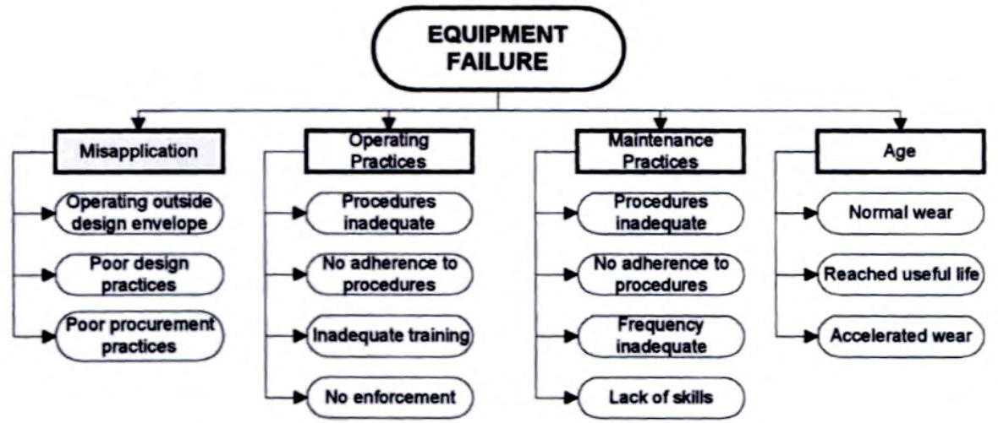

Figure 9: Common causes of equipment failure [1].

Figure 10: Common causes of procedure-related problems [1].
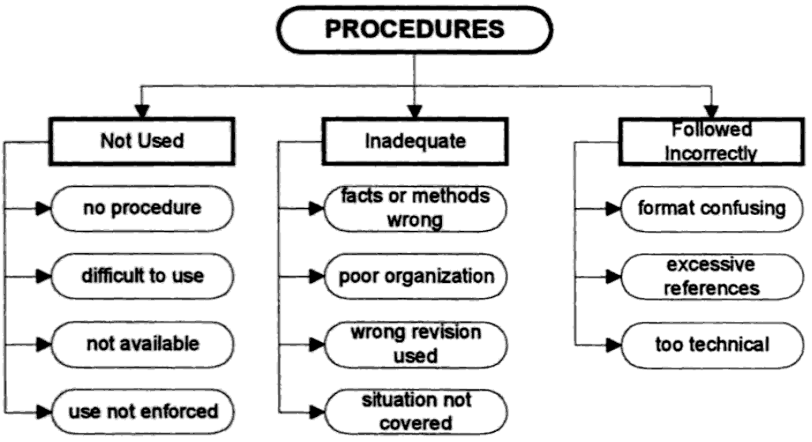

Figure 11: Common causes of training-related problems [1].
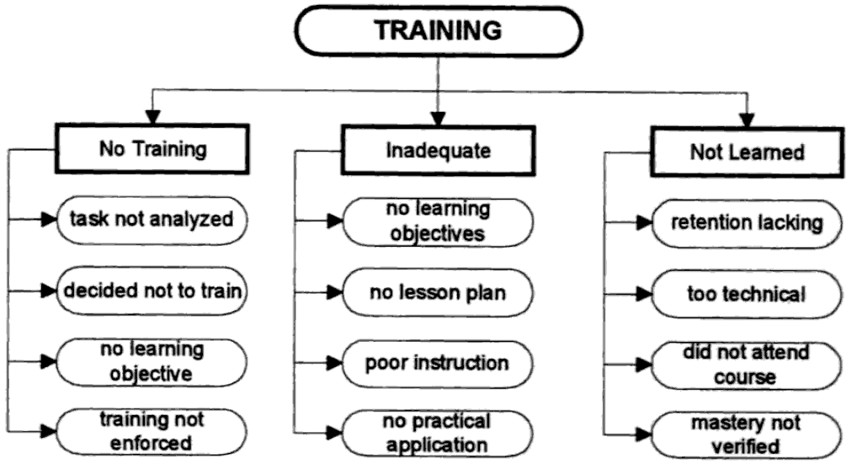

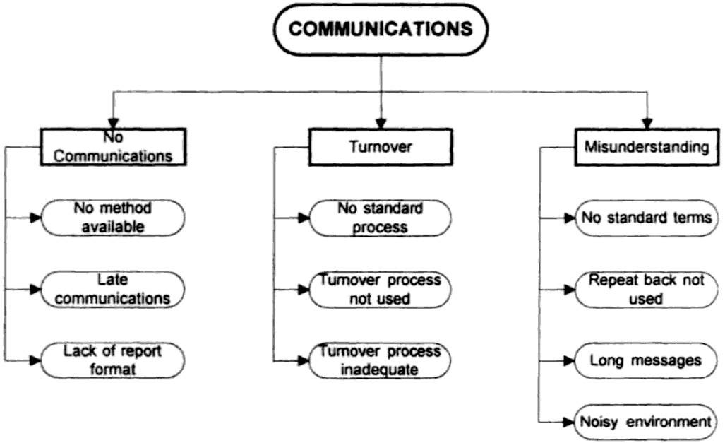

Figure 12: Common causes of communications problems [1].

3.3 Instrument Development
Instrument development has two sections. Section one was designed to categorize respondents based on relevant work experience and job title. Section two has thirty measurement items developed from decomposition of probable root causes of failure and the review of related literature as compiled in table 2. In the pre-test study, identified items were reviewed by 12 practitioners whose opinions were sort on the appropriateness of the constructs. The constructs were modified based on their feedback. The final instrument in Appendix B was adopted after a consensus by reviewers.

3.3.1 Employee workload
Workload is a hypothetical construct which has been developed and is widely applied within the domain of human factors (HF) psychology. Also, workload in the HF psychology sense has been demonstrated to be a key determinant of stress and fatigue levels among employees performing repetitive, manufacturing work tasks [42]. The practices and norms of most organizations tend to value workers who spend long hours at work. Some managers tend to believe that more work leads to better business out-put. Heavy employee workload is not necessarily more effective, in fact it is associated with poor business outcome and reduced employee innovation potential [43]. The worker is at the heart of application of the lean production model, hence the human asset is the key to long-term superior organizational performance [44].

3.3.2 Running equipment beyond its design specification
Misapplication of critical process equipment is one of the most common causes of equipment-related problems. In some cases, the reason for misapplication is uncontrolled modification or changes in the operating requirement of the machine [1]. Equipment modifications are sometimes necessary to meet customer specifications or other production needs. Also, modification of equipment beyond its design specification often undermine workers safety and constitute tremendous industrial hazard [45].

3.3.3 Lack of cross functional training
The ability to rapidly and continuously design, develop, and adapt a business processes in an agile fashion is a huge business advantage [46]. In essence, many organizations are going from a mode where one person handles a function to a team approach where every team can handle any task [47]. It is therefore imperative to train individual members of a production team across different functions.

3.3.4 Lack of effective communication between employee
The lack of effective employer-employee exchange of communication is the primary cause for corporate sabotage in the event of major corporate change [48]. A good style of management, as well as positive approach to communication, ensures that an employee and a supervisor understand each other, and are more effective at the workplace. Effective communication in the workplace provides employees with a clear understanding of what is demanded from them, with knowledge of what to expect [49].

3.3.5 Carrying cost of production materials
Carrying cost is the cost of maintaining, and holding inventory. Warehouse, insurance costs, financing costs, pilferage, obsolescence, and spoilage are the major components of this cost [50]. It is a critical factor in deciding what production materials to stock and when to reorder them and the best quantity to order [51]. Several important decisions are predicated on knowledge of the inventory carrying costs. Basic questions concerning inventory strategy can be properly made after knowledge of the cost of carrying inventory. Aspects of this vital cost can be described and evaluated from a variety of perspectives.

3.3.6 Inadequate inspection
One of the basic ideas behind lean production is to eliminate all forms of waste in a production system [52]. Strategic inspection is imperative to eliminate or reduce defects, reworks and scraps. To monitor the quality of the product, one needs to inspect the work-in-process inventory at various production stages [53]. Many authors have proposed different models of early in-line and multistage inspection [54], apparently inspection at the upstream level of a production system seems prevalent.

3.3.7 Change in equipment capacity
Change in equipment capacity affects overall equipment effectiveness [55]. Equipment failure, unplanned maintenance and change over time reduce equipment capacity. Equipment in a production system is part of the fixed cost and often requires huge capital investment. Many firms operate with fixed annual budgets which sometimes limit expenditure on equipment purchase [56].

3.3.8 Change in equipment operator
Shift change is common in a production system, and each shift involves different set of individuals. Equipment is operated by different operators depending on number of shifts a production system runs. Also, change in operator may be due to employment of temporary worker or new employee. The question is, does change in equipment operator affect a lean production system?

3.3.9 Inventory level
Inventory is a quantity or store of goods that is held for some purpose. In common terms it means a store quantity of goods that exceeds what is needed for the firm to function at the current time. A manufacturer must have certain purchased items (raw materials, components, or subassemblies) in order to manufacture its product. Running out of only one item can prevent a manufacturer from completing the production of its finished goods.
Inventory between successive dependent operations also serves to decouple the dependency of the operations. A machine or work center is often dependent upon the previous operation to provide it with parts to work on. If work ceases at a work center, then all subsequent centers will shut down for lack of work. If a supply of work-in-process inventory is kept between each work center, then each machine can maintain its operations for a limited time, hopefully until operations resume at the original center. Firms that carry hundreds or even thousands of different part numbers can be faced with the impossible task of monitoring the inventory levels of each part number [57].

3.3.10 Using production equipment beyond its useful life
Acquiring manufacturing equipment involves significant expenditure and some amount of risk due to uncertainty in economic conditions. Many manufacturing firms are more likely to use a piece of equipment beyond its useful life due to financial burden. Most often, decision to purchase new or replacement equipment is based on return on investment (ROI), payback period, safety, ergonomics, and bottleneck. The median payback period requirement set by most firms is two years [58]. However, meeting this requirement would be a daunting challenge for most firms, and absolute physical life is becoming a norm.

3.3.11 Deviation from standard operating procedure
Standard operating procedure is a set of instructions covering definite features of operations without loss of effectiveness. The procedure is applicable unless prescribed otherwise in a particular case; thus, the flexibility necessary in special situations is retained [59].

3.3.12 Inadequate cash flow
Cash flow is simply the net amount of cash generated and cash used by a business during a given period. The difference between the cash generated and used is the net cash flow and provided the cash generated is the higher number then the business should be solvent [60]. Financial constraints play a significant role in determining the probability of firm survival, even after controlling for size, age, profitability and productive efficiency [61].

3.3.13 Lack of skill required to operate equipment
It is widely known that untrained and unskilled operators increase the cost of maintenance due to improper use of equipment leading to equipment damage, downtime and safety hazards [62]. Acquisition of appropriate skill set by equipment operators is no doubt necessary for success of any firm.

3.3.14 Lack of employee motivation
Many contemporary authors have defined the concept of motivation as the psychological process that gives behavior purpose and direction [63]: a predisposition to behave in a purposive manner to achieve specific, unmet needs [64], an internal drive to satisfy an unsatisfied need [65] and the will to achieve [66]. Motivation is operationally defined as the inner force that drives individuals to accomplish personal and organizational goals [67]. Motivating employees in a lean production system is therefore necessary to attain and sustain organizational goals.

3.3.15 Multiple product mix
The product mix is generally defined as the total composite of products offered by a particular organization, consists of both product lines and individual products. A product line is a group of products within the product mix that are closely related, either because they are produced along the same line, function in a similar manner, are sold to the same customer groups, are marketed through the same types of outlets, or fall within given price ranges. A product is a distinct unit within the product line that is distinguishable by size, price, appearance, or some other attribute. Inappropriate product-mix may lead to under utilization of capacity, overproduction or failure in timely delivery [68].

3.3.16 Change in product demand
The demand analysis focuses on determining the demand schedule for product, in which the elasticity of demand is of particular importance. If a product has a particularly high elasticity of demand, small changes in price result in large changes in quantity [69]. Lean processes should be adaptive and adjustable to absorb changing demand.

3.3.17 Unscheduled equipment maintenance
Most complex manufacturing systems have interconnected machines where each machine is dependent on machines upstream that provide work-pieces for processing at machines downstream as well as accepting the finished work-pieces for further processing [70]. Therefore a good maintenance policy should not only consider single machine degradation, but also the dependencies between machines.

3.3.18 Fatigue
Work can be fulfilling, dynamic and challenging, but it can also be exhausting. Fatigue is the state of feeling very tired, weary or sleepy resulting from insufficient sleep, prolonged mental or physical work, or extended periods of stress or anxiety. Boring or repetitive tasks can intensify feelings of fatigue [71].

3.3.19 Processing time variation
Processing time is the time it takes to complete a prescribed procedure, usually decreasing processing time increases output. Accuracy in processing time estimation of manufacturing operations is fundamental to achieve more competitive edge [72-73].

3.3.20 Ordering cost of required materials
Also known as purchase cost or set up cost, this is the sum of the fixed costs that are incurred each time an item is ordered. These costs are not associated with the quantity ordered but primarily with physical activities required to process the order. For purchased items, these would include the cost to enter the purchase order and/or requisition, any approval steps, the cost to process the receipt, incoming inspection, invoice processing and vendor payment, and in some cases a portion of the inbound freight may also be included in order cost. It is important to understand that these are costs associated with the frequency of the orders and not the quantities ordered [74].

3.3.21 Change of scheduled capacity
In manufacturing, capacity scheduling is an approach to understanding how much work can be produced in a certain time period, taking limitations on different resources into consideration. The goal of finite capacity scheduling is to ensure that work proceeds at an even and efficient pace throughout the plant. Infinite capacity scheduling does not account for limitations that occur in real time [75].

3.3.22 Supplier constraints
Unreliable vendors that miss delivery dates or deliver wrong items can slow down or halt a manufacturing process. Most manufacturers are very careful about vetting their vendors. Relationship building with suppliers is highly correlated with firm performance [76].

3.3.23 Inadequate order quantity
It is sometimes difficult to determine the most economically efficient amount of materials to order at a given time. Economic factors such as volume discounts, inventory receiving and storage costs, usage rates, and risks associated with running out of stock, as well as the average time from order to delivery, are factored into the determination of optimal economic order quantity [77].

3.3.24 Employee absence at work
A satisfactory level of attendance by employees at work is necessary to allow the achievement of objectives and targets. Employee absences are both costly and disruptive. Productivity losses due to employee absence cost organizations millions of dollars each year [78-79].

3.3.25 Inaccurate calibration of equipment
The need to improve quality, measure tighter tolerance and comply with standards forces quality managers to continuously improve efficiencies. Measurement equipment should always be calibrated frequently. If equipment is not calibrated measurements would not be correct and data would lead to wrong interpretation and solution.

3.3.26 Poor crew teamwork
Manufacturing technologies that require simultaneous presence of an entire shift of workers or work team, show that the profitability of the firm depends on its ability to coordinate essentially identical hours for each worker [79]. Ideally, teams should be composed of members who can contribute a cross-section of ideas and views on the designated process. Working together, team members focus their own skills and the collective outcome of this cooperation should then extend beyond the sum of the contribution of each individual to form into a higher team performance capacity.

3.3.27 Poor forecast
There has never been greater pressure on businesses to forecast quickly and accurately, as companies seek to reduce work in progress (WIP), optimize value streams and drive profit through internal efficiencies such as reducing their working capital. Most manufacturing organizations need to reduce inventory or stock held against projected demand yet maintain the agreed customer service levels. Accurate and quick forecasting is therefore an obviously low cost way to achieve this. For many businesses however inaccurate and late forecasting is severely damaging their profitability and threatening their future survival [80].

3.3.28 Error in balancing production line
Assembly Line Balancing, or simply Line Balancing (LB), is the problem of assigning operations to workstations along an assembly line, in such a way that the assignment be optimal in some sense. LB has been an optimization problem of significant industrial importance, the difference between an optimal and sub-optimal assignment can yield or waste millions of dollars per year [81-83].

3.3.29 Workstation design error
Good workstation design can lead to more effective and contented employees [84]. Employees often spend long periods standing, performing repetitive motions over the course of their shift. Ergonomic interventions significantly reduce the physical impact of these industrial tasks. Customizing the industrial workstation from the bottom up provides extra support, decreasing work-related repetitive stress injuries and increasing productivity [85].

3.3.30 Role ambiguity
Lack of clarity about expected behavior from a job or position. Role ambiguity has a negative and direct impact on employee creativity [86]. Also, it may occur in newly created posts or in positions that are undergoing change. When role ambiguity extends to responsibilities or priorities it can lead to role conflict.

3.4 Hypotheses
Response for each item is dichotomous, mutually exclusive and equally likely, therefore, the null hypothesis for each item is thus; there is no significant difference between number of “yes” and “no” responses. The binomial test of significance determines if there is significant difference between number of “yes” responses and “no” responses for each item. The binomial test is useful for determining if the proportion of people in one of two categories is significantly different. Table 3, shows items null hypotheses. H₀ = null hypothesis, H₁ = alternative hypothesis, P = Probability, α = 0.05.
H₀: P_{yes} = P_{no} = 0.5

H₁: P_{yes} ≠ P_{no} ≠ 0.5

Table 3: Items Null Hypotheses
Hypotheses |  | Affects Materials | Affects Equipment | Affects Personnel | Affects Schedules
1 | Employee workload | H₀: | H₀: | H₀: | H₀:
2 | Running equipment outside design specification | H₀: | H₀: | H₀: | H₀:
3 | Lack of cross functional training | H₀: | H₀: | H₀: | H₀:
4 | Lac of effective communication between employee | H₀: | H₀: | H₀: | H₀:
5 | Carrying cost of production materials | H₀: | H₀: | H₀: | H₀:
6 | Inadequate inspection | H₀: | H₀: | H₀: | H₀:
7 | Sudden change in equipment capacity | H₀: | H₀: | H₀: | H₀:
8 | Change in equipment operator | H₀: | H₀: | H₀: | H₀:
9 | Inventory level | H₀: | H₀: | H₀: | H₀:
10 | Using production equipment beyond its useful life | H₀: | H₀: | H₀: | H₀:
11 | Deviation from standard operating procedure | H₀: | H₀: | H₀: | H₀:
12 | Inadequate cash flow | H₀: | H₀: | H₀: | H₀:
13 | Lack of skill required to operate equipment | H₀: | H₀: | H₀: | H₀:
14 | Lack of employee motivation | H₀: | H₀: | H₀: | H₀:
15 | Multiple product mix | H₀: | H₀: | H₀: | H₀:
16 | Change in product demand | H₀: | H₀: | H₀: | H₀:
17 | Unscheduled equipment maintenance | H₀: | H₀: | H₀: | H₀:
18 | Fatigue | H₀: | H₀: | H₀: | H₀:
19 | Processing time variation | H₀: | H₀: | H₀: | H₀:
20 | Ordering cost of required materials | H₀: | H₀: | H₀: | H₀:
21 | Change of scheduled capacity | H₀: | H₀: | H₀: | H₀:
22 | Supplier constraints | H₀: | H₀: | H₀: | H₀:
23 | Inadequate order quantity | H₀: | H₀: | H₀: | H₀:
24 | Employee absence at work | H₀: | H₀: | H₀: | H₀:
25 | Incorrect calibration of equipment | H₀: | H₀: | H₀: | H₀:
26 | Poor crew teamwork | H₀: | H₀: | H₀: | H₀:
27 | Poor forecast | H₀: | H₀: | H₀: | H₀:
28 | Error in balancing production line | H₀: | H₀: | H₀: | H₀:
29 | Work station design error | H₀: | H₀: | H₀: | H₀:
30 | Role ambiguity | H₀: | H₀: | H₀: | H₀:

Chapter 4

Data Collection and Analysis

4.1 Sample Selection
The idea behind this study is to harness experiences of industrials experts who have worked or are still working in production and production related firms. They consist of experts at different levels of business leadership but not limited to those that have successfully implemented lean processes. These respondents were sought because of their broad perspective and experience in organization’s activities. They are representative of general population of business and industrial leaders. Therefore, the resulting list is well suited for this study. However, the questionnaire asked respondents to indicate their years of experience, with a view to screening respondents based on years of experience.
A mailing list for industrial practitioners was obtained from the University of Tennessee, Center for Industrial Services (CIS). The CIS has being a major player in industrial growth in Tennessee and beyond [87]. They have a depository of names of large, medium and small scale industries in Tennessee. The list contains email addresses and job titles of 3042 industrial employees. Also, another mailing lists from Center for Productivity Innovation (CPI) in department of Industrial and Information Engineering at the University of Tennessee. This center has a reputation in process improvement and has many industrial clients in United States and Mexico [88]. The mailing lists contain names of organizations, employee name, job titles and email addresses of representatives of industrial clients. However, CIS was adopted as primary source for developing respondents’ profile.

4.2 Item Coding and Data Collection
Research Computing Support in the Office of Information Technology at the University of Tennessee hosted the server used in collecting data for this study. They also assisted in setting up mailing list for respondents. The software used by this office is mrInterview; Statistical Package for Social Science (SPSS) now known as Predictive Analytic Software (PASW) [89-90].
In an effort to increase the response rate and lower potential non-response bias, [91] total design method was followed. The survey link as well as carefully worded cover letter was mailed to all respondents in the mailing list. Many of the respondents were also contacted by telephone and email requesting their assistance by participation. After one week a follow-up letter, duplicating the first, was mailed to respondents and they were asked to forward the survey link to colleagues whose experiences they considered relevant to the survey. A total of 29 mails returned undelivered while 111 out-off office auto reply messages were received. The graph in Figure 13; shows number of survey responses plotted against time (days). This study however was performed following the guidelines of the University of Tennessee Institutional Research Board for Human Subjects, see Appendix B.

Figure 13: Survey Response Time

4.3 Statistical Analyses
The data in the first section are nominal data that categorized respondents by job title and years of work experience while the second section has dichotomous. With regards to statistical analyses, measuring frequency of occurrence of data categories and distribution of data are the most effective methods of translating survey inputs into meaningful results [92]. Bar charts, pie and histograms are appropriate for visual presentation for measurement of dispersion [93].

4.3.1 Section one: descriptive statistics
A total of 441 respondents completed the survey representing 15.2% response rate. The response rate for a 25 question online questionnaire is about 7% and average response rate is 13.4% [94] [95]. In the first section, descriptive statistics result shows that 86.8% of respondents have more than fifteen years of relevant experience in manufacturing or production systems, 7.1% have between ten and fifteen years experience, 3.1% have between six years and ten years experience, 1.4% have between four and six years experience, 1.0% have between two years and four years experience while 0.5% have less than two years as shown in table 4 and figure 14. The distribution by job title was: 22.0% senior managers, 18.7% middle managers, 17.0% managers, 11.9% vice presidents, 8.9% presidents, 3.6% academia/consultants, 1.3% executive presidents and others 12.3% as shown in table 5 and figure 15.

Table 4: Respondents years of experience
Item 1: How many years of work experience do you have?
Years of experience | Valid Percent (%)
Less than 2 years | 0.5
More than 2 years but less than 4 years | 1.0
More than 4 years but less than 6 years | 1.4
More than 6 years but less than 10 years | 3.1
More than 10 years but less than 15 years | 7.1
Above 15 years | 86.8

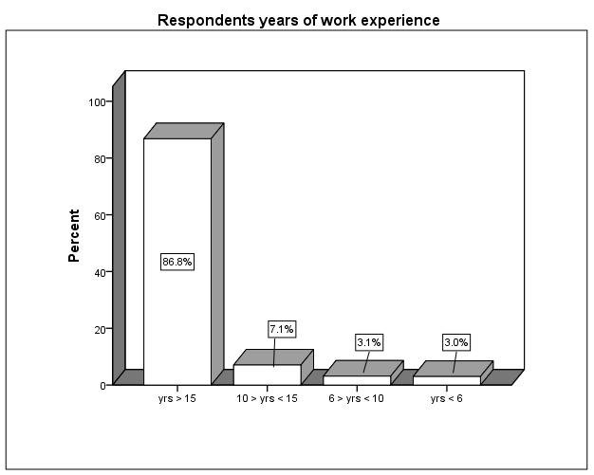
Figure 14: Bar plot of respondents’ years of experience

Table 5: Respondents job title
Item 2: Which of the following best describe your job title? | Valid Percent (%)
Academia/Consultant | 3.6
President | 8.9
Vice President | 11.9
Executive President | 1.3
Senior Manager | 22.0
Middle Manager | 18.7
Manager | 17.0
Supervisor | 4.2
None of the above | 12.3

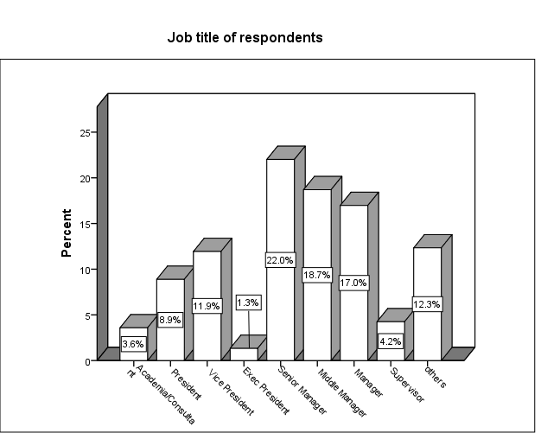
Figure 15: bar plot of respondents’ job title

4.3.2 Section two: hypotheses test results
The second section consists of yes/no (1/0) dichotomous data that are mutually exclusive and equally likely against each root cause item shown in Appendix B. A test of significant difference between the “yes” responses and “no” responses for employee workload and running equipment outside design specification are shown on table 6. The test is based on asymptotic significance two-tailed binomial test at significant level (α = .05). The binomial test of significance involves the determination of the probability of getting “yes” observations in one category of a dichotomy and “n – yes” observations in the other category when a sample of size ‘n’ is given table 3.
Step 2: Assumption of normal approximation for binomial test since P × n > 10 for both responses; where P = 0.5 and n = 441. With α = 0.05, the critical region is defined is defined as any z-score value greater than +1.6448 and less than - 1.6448.
Step 3: Calculating the test statistics for Employee workload-Materials; the data has 223 yes responses out of 441 respondents, so the proportion is
$$\frac{X_{yes}}{n}= \frac{223}{441}=0.5057$$
The corresponding Z-score is
$$Z= \frac{\frac{X_{yes}}{n}-P}{\sqrt{\frac{P_{yes}×P_{no}}{n}}}= \frac{0.5057-0.5000}{\sqrt{\frac{0.5000×0.5000}{441}}}= \frac{0.0057}{0.0238}=0.2394$$
The Probability: p-value is computed as P (z < - 0.2394 or Z > 0.2394)

= P (z < - 0.2394) + P (z > 0.2394)
= 0.4204 + 0.4204
= 0.8408
Step 4: Decision about H₀: The obtained z-score is not in the critical region, also p-value > 0.05. Therefore, the null hypothesis was not rejected, as shown in table 6 row 1. On the basis of these data, the proportion of yes responses for this survey item is not significantly different from “No” responses.
Repeating Steps 3 - 4 for Employee workload-Equipment
Calculating the test statistics for Employee workload-Equipment, the data has 334 yes responses out of 441 respondents, so the proportion is
$$\frac{X_{yes}}{n}= \frac{201}{441}=0.4558$$
The corresponding Z-score is
$$Z= \frac{\frac{X_{yes}}{n}-P}{\sqrt{\frac{P_{yes}×P_{no}}{n}}}= \frac{0.4558-0.5000}{\sqrt{\frac{0.5000×0.5000}{441}}}= \frac{-0.0442}{0.0238}=-1.8579$$
The Probability: p-value is computed as P(z < -1.8579 or Z > 1.8579)
= P(z < - 1.8579) + P(z > 1.8579)
= 0.0331 + 0.0331 = 0.0662
P = 0.0662
Step 4: Decision about H₀, the obtained z-score is not in the critical region also p-value > 0.05. Therefore, the null hypothesis was not rejected as shown in table 6 row 2. On the basis of the data, the proportion of “yes” responses for this survey item is not significantly different from “no” responses.
Also, repeating Steps 3 - 4 for Employee workload-Personnel;
Calculating the test statistics for Employee workload-Personnel, the data has 334 yes responses out of 441 respondents, so the proportion is
$$\frac{X_{yes}}{n}= \frac{334}{441}=0.7574$$
The corresponding Z-score is
$$Z= \frac{\frac{X_{yes}}{n}-p}{\sqrt{\frac{P_{yes}×P_{no}}{n}}}= \frac{0.7574-0.5000}{\sqrt{\frac{0.5000×0.5000}{441}}}= \frac{0.2574}{0.0238}=10.8138$$
The Probability: p-value is computed as P(z < -10.8138 or Z > 10.8138)

= P(z < - 10.8138) + P(z > 10.8138)
= 0.0000 + 0.0000 = 0.0000
P = 0.000
Step 4: Decision about H₀, the obtained z-score is in the critical region also p-value < .05. Therefore, the null hypothesis was rejected, as shown in table 6 row 3. On the basis of the data, the proportion of “yes” responses for this survey item is significantly different from “no” responses. Table 6, shows the calculated p-values as generated by PASW.
Also in table 6 row 4, Employee workload – schedules reliability has; p-value = .000, this p-value also indicates a significant difference between number of “yes or no” responses; therefore the null hypothesis was rejected.
Subsequently, other rows follow similar interpretation and were compiled for all items in table 7. In the table 7, items with significant “yes” and “no” are marked with two and three asterisks respectively.
Table 6: Item one hypothesis test summary
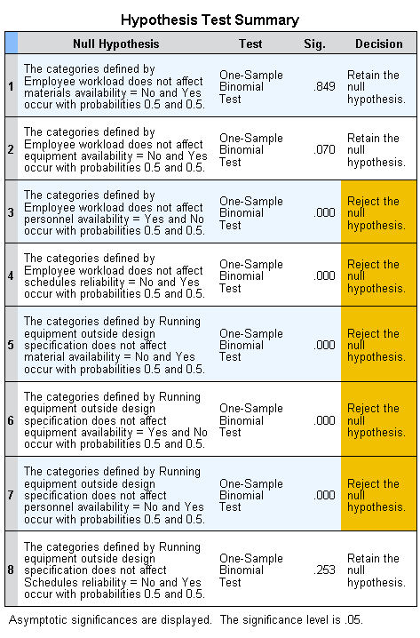
Table 7: Wholes items hypotheses test summary
Root cause Items |  | Materials  P-value |  | Equipment  P-value | Personnel  P-value | Schedules  P-value
1 | Employee workload |  | 0.849* | 0.070* | 0.000 ** | 0.000 **
2 | Running equipment outside design specification |  | 0.000 ** | 0.000 ** | 0.000*** | 0.253*
3 | Lack of cross functional training |  | 0.000 *** | 0.000*** | 0.000 ** | 0.000 **
4 | Lack of effective communication between employee |  | 0.488* | 0.005*** | 0.000 ** | 0.000 **
5 | Carrying cost of production materials |  | 0.000** | 0.000*** | 0.000*** | 0.208*
6 | Inadequate inspection |  | 0.152* | 0.000*** | 0.013 ** | 0.000 **
7 | Sudden change in equipment capacity |  | 0.461* | 0.000*** | 0.000*** | 0.000***
8 | Change of equipment operator |  | 0.000*** | 0.033* | 0.000 ** | 0.000 **
9 | Inventory level |  | 0.000** | 0.000*** | 0.000*** | 0.000 **
10 | Using production equipment beyond its useful life |  | 0.000*** | 0.000 ** | 0.000*** | 0.000 **
11 | Deviation from standard operating procedure |  | 0.748* | 0.004** | 0.963* | 0.000 **
12 | Inadequate cash flow |  | 0.000** | 0.31* | 0.000 ** | 0.025**
13 | Lack of skill required to operate equipment |  | 0.000*** | 0.002** | 0.000 ** | 0.000 **
14 | Lack of employee motivation |  | 0.000*** | 0.000*** | 0.000 ** | 0.000 **
15 | Multiple product mix |  | 0.000** | 0.002** | 0.000*** | 0.000 **
16 | Change in product demand |  | 0.000** | 0.025** | 0.039*** | 0.000 **
17 | Unscheduled equipment maintenance |  | 0.000*** | 0.000 ** | 0.000*** | 0.000 **
18 | Fatigue |  | 0.000*** | 0.000*** | 0.000 ** | 0.000 **
19 | Processing time variation |  | 0.06* | 0.000 ** | 0.436* | 0.000 **
20 | Ordering cost of required materials |  | 0.000** | 0.000*** | 0.000*** | 0.000 **
21 | Change of scheduled capacity |  | 0.000** | 0.000 ** | 0.126* | 0.000 **
22 | Supplier constraints |  | 0.000** | 0.000*** | 0.000*** | 0.000 **
23 | Inadequate order quantity |  | 0.000** | 0.000*** | 0.000*** | 0.000 **
24 | Employee absence at work |  | 0.000*** | 0.000*** | 0.000 ** | 0.000 **
25 | Incorrect calibration of equipment |  | 0.000*** | 0.000 ** | 0.000*** | 0.017**
26 | Poor crew teamwork |  | 0.000*** | 0.000*** | 0.000 ** | 0.000 **
27 | Poor forecast |  | 0.000** | 0.214* | 0.924* | 0.000 **
28 | Error in balancing production line |  | 0.214* | 0.000 ** | 0.000 ** | 0.000 **
29 | Work station design error |  | 0.000*** | 0.002** | 0.445* | 0.001**
30 | Role ambiguity |  | 0.000*** | 0.000*** | 0.000 ** | 0.152*
* No significant between yes/no response, ** significant “yes” response, *** significant “no” response, α=.05

Table 8: Shows a visual row operation that clustered items based on significant yes/no responses
Root-cause Items |  | Materials | Equipment | Personnel | Schedules
 |  | P-value (Yes/No) | P-value (Yes/No) | P-value (Yes/No) | P-value (Yes/No)
12 | Inadequate cash flow | Yes | 0.310* | Yes | Yes
1 | Employee work load | 0.729* | 0.069* | Yes | Yes
4 | Lack of effective communication between employee | 0.488* | No | Yes | Yes
8 | Change of equipment operator | No | No | Yes | Yes
3 | Lack of cross functional training | No | No | Yes | Yes
14 | Lack of employee motivation | No | No | Yes | Yes
18 | Fatigue | No | No | Yes | Yes
24 | Employee absence at work | No | No | Yes | Yes
26 | Poor crew teamwork | No | No | Yes | Yes
13 | Lack of skill required to operate equipment | No | Yes | Yes | Yes
28 | Error in balancing production line | 0.214* | Yes | Yes | Yes
11 | Deviation from standard operating procedure | 0.891* | Yes | 0.552* | Yes
19 | Processing time variation | 0.060* | Yes | 0.436* | Yes
10 | Using production equipment beyond its useful life | No | Yes | No | Yes
17 | Unscheduled equipment maintenance | No | Yes | No | Yes
25 | Incorrect calibration of equipment | No | Yes | No | Yes
29 | Work station design error | No | Yes | 0.445* | Yes
21 | Change of scheduled capacity | Yes | Yes | 0.126* | Yes
15 | Multiple product mix | Yes | Yes | No | Yes
16 | Change in product demand | Yes | Yes | 0.039* | Yes
27 | Poor forecast | Yes | 0.214* | 0.924* | Yes
9 | Inventory level | Yes | No | No | Yes
20 | Ordering cost of required materials | Yes | No | No | Yes
22 | Supplier constraints | Yes | No | No | Yes
23 | Inadequate order quantity | Yes | No | No | Yes
6 | Inadequate inspection | 0.193* | No | No | Yes
2 | Running equipment outside design specification | No | Yes | No | 0.603*
5 | Carrying cost of production materials | Yes | No | No | 0.260*
7 | Sudden change in equipment capacity | 0.665* | No | No | No
30 | Role ambiguity | No | No | Yes | 0.152*
“*” No significant difference between Yes/No Responses, α = .05

Table 8, shows a visual row operation that clustered items based on significant yes/no responses after substituting significant p-values with corresponding “yes” and “no” responses and moving table rows to cluster all ‘yes’ and ‘no’ responses. Based on the clusters, root cause items; change of scheduled capacity (21), multiple product mix (15) and change in product demand (16) significantly and simultaneously affect material, equipment and schedule. This simultaneous effect is an indicator for interaction that exists among the three primary resources. Similarly, error in balancing production line (28) affects equipment, personnel and schedules. The following items affects materials and schedules simultaneously: cash flow, change of scheduled capacity, multiple product mix, change in production demand, poor forecast, inventory level, ordering cost of required materials, supplier constraints and inadequate order quantity. Also, in table 8 almost every item has significant effect on schedules except sudden change in equipment capacity. While running equipment outside design specification, carrying cost of production materials and role ambiguity affect schedules by chance. Almost one-third of the root cause items impact each of these primary resources: materials, equipment and personnel. Although the items were randomized in the questionnaire, the row clustering operation identified these root causes along the primary resource they significantly impact, figure 16 also charts identified interactions.

Figure 16: Identified interactions

4.3.3 Pearson Correlation
A correlation is a number between -1 and +1 that measures the degree of association between two variables for instance X and Y. A positive value for the correlation implies a positive association (large values of X tend to be associated with large values of Y and small values of X tend to be associated with small values of Y). A negative value for the correlation implies a negative or inverse association (large values of X tend to be associated with small values of Y and vice versa). Suppose the means of X and Y are $\overline{X}$ and $\overline{Y}$ respectively and their standard deviations are $S_{X}$ and $S_{Y}$ respectively. The correlation is computed as:
$$r=\frac{\sum_{i=1}^{n}{\left(X_{i}-\overline{X}\right)\left(Y_{i}-\overline{Y}\right)} }{\left(n-1\right)S_{X}X_{Y}}$$
The Pearson correlation coefficient indicates the strength of a linear relationship between two variables, but its value generally does not completely characterize their relationship. Correlation can be taken as evidence for a possible causal relationship however it cannot indicate what the causal relationship, if any, might be [96].

4.3.4 Interactions between a primary resource and its root cause items (I_{ii})
Table 9-11, show Pearson’s correlations of clustered items for materials, equipment and personnel respectively. In table 9, materials root cause items: poor forecast-change in scheduled capacity, change in product demand-multiple product mix, poor forecast-change in product demand, inventory level-change in product demand, inventory level-poor forecast, supplier constraint-poor forecast, inadequate order quantity-poor forecast have fairly strong correlation. Also, ordering cost of required materials-inventory level, supplier constraint-inventory level, inadequate order quantity-inventory level, supplier constraints-inventory level and inadequate order quantity have fairly strong correlation. However, other pair-wise correlations are weak. There are few fairly strong correlations in equipment items as shown in table 10. Change of scheduled capacity-error in balancing production line, change in product demand-error in balancing production line and change of scheduled capacity-processing time variation have fairly strong correlations. While change in product demand-processing time variation, unscheduled equipment maintenance-using production equipment beyond its useful life and change in product demand-multiple product mix have fairly strong correlation.
In table 11, change of equipment operator-lack of effective communication between employees, employee absence at work-lack of employee motivation and poor crew teamwork-lack of employee motivation have fairly strong correlation. While employee absence at work-fatigue and poor crew teamwork-employee absence at work also have strong correlations.

Table 9: Pearson correlations of clustered materials items
Items- Materials | 29 | 15 | 16 | 27 | 9 | 20 | 22 | 23
29. Change in scheduled capacity | 1.000
15. Multiple product mix | .302** | 1.000
16. Change in product demand | .392** | .433** | 1.000
27. Poor forecast | .409** | .334** | .501** | 1.000
9. Inventory level | .335** | .367** | .487** | .414** | 1.000
20. Ordering cost of required materials | .264** | .274** | .297** | .321** | .403** | 1.000
22. Supplier constraints | .328** | .335** | .372** | .452** | .449** | .420** | 1.000
23. Inadequate order quantity | .353** | .272** | .307** | .416** | .442** | .398** | .509** | 1.000
**. Correlation is significant at the 0.01 level (2-tailed).

Table 10: Pearson’s correlations of clustered equipment items
Items - Equipment | 28 | 11 | 19 | 10 | 17 | 25 | 29 | 21 | 15 | 16
28. Error in balancing production line | 1.000
11. Deviation from standard operating procedure | .294** | 1.000
19. Processing time variation | .396** | .279** | 1.000
10. Using production equipment beyond its useful life | .281** | .313** | .259** | 1.000
17. Unscheduled equipment maintenance | .344** | .360** | .320** | .459** | 1.000
25. Incorrect calibration of equipment | .282** | .282** | .212** | .291** | .352** | 1.000
29. Work station design error | .286** | .179** | .262** | .251** | .222** | .361** | 1.000
21. Change of scheduled capacity | .501** | .299** | .412** | .302** | .329** | .279** | .226** | 1.000
15. Multiple product mix | .355** | .292** | .396** | .246** | .260** | .181** | .192** | .336** | 1.000
16. Change in product demand | .420** | .318** | .405** | .263** | .354** | .289** | .218** | .386** | .458** | 1.000
**. Correlation is significant at the 0.01 level (2-tailed).

Table 11: Pearson’s correlations of clustered personnel items
Items - Personnel | 12 | 1 | 4 | 8 | 3 | 13 | 14 | 18 | 24 | 26 | 28
12. Inadequate cash flow | 1.000
1. Employee workload | .244** | 1.000
4. Lack of effective communication between employee | .187** | .251** | 1.000
8. Change of equipment operator | .040 | .196** | .410** | 1.000
3. Lack of cross functional training | .199** | .336** | .397** | .371** | 1.000
13. Lack of skill required to operate equipment | .059 | .135** | .273** | .393** | .308** | 1.000
14. Lack of employee motivation | .170** | .263** | .373** | .247** | .278** | .366** | 1.000
18. Fatigue | .272** | .301** | .332** | .215** | .374** | .291** | .376** | 1.000
24. Employee absence at work | .272 | .235** | .290** | .189** | .352** | .355** | .450** | .498** | 1.000
26. Poor crew team work | .075 | .249** | .351** | .250** | .199** | .331** | .413** | .331** | .435** | 1.000
28. Error in balancing production line | .349** | .277** | .245** | .186** | .216** | .233** | .214** | .313** | .344** | .272** | 1.000
**. Correlation is significant at the 0.01 level (2-tailed).

Chapter 5

Risk Prioritization of Lean System (RPLS)

5.1 Integrating Interactions with RPLS
Phase 1: Development of Lean System Hierarchical Tree Diagram
Personnel
Equipment
Materials
Schedules

Phase 3: Prioritization of Lean Reliability
Phase 2:
Modified FMEA
Root Causes and Primary Resource Interactions

Comparison of actual operating conditions with lean design requirements

Severity, Probability of Occurrence, Effectiveness of Detection

Risk Assessment Value
Improvement Strategy

Phase 4:
Development of RPLS Tool
Adopted from Karthik’s thesis

Figure 17: Integrating interaction in risk prioritization of lean systems

Risk prioritization of lean system (RPLS) used by Karthik Subburaman allowed users of his modified FMEA software to evaluate and compare actual operating conditions with lean systems design requirements [97]. This comparison is focused on identifying and reducing risks by implementing effective lean controls.
However, in his efforts, he used four phases; Hierarchical Tree Diagrams (HTD) to derive a list of necessary operating conditions for lean systems, which resulted to identification of root causes as Risk Factors, comparison of actual operating conditions with lean design requirements, and finally used visual basic application to automate modified FMEA risk prioritization.
The results in chapter four of this work would be necessary at the third phase in his RPLS process as shown in figure 17. For instance, probability of occurrence determines the likelihood of occurrence of a risk factor referred to root causes in this study. In considering the likelihood of occurrence of any identified risk factor or root cause, knowledge of interaction established in chapter four would be necessary to link the risk factor or root cause to other resources and root causes it interact with. As shown in table 8 inadequate order quantity, though a risk factor or root cause under materials also impacts schedules. Similarly, in table 9 inadequate order quantity has fairly strong correlation with poor forecast, inventory level and supplier constraints. Therefore, in ranking inadequate order quantity with Karthik’s modified FMEA software, adequate adjustments need to be made to link it to schedules, poor forecast and supplier constraints to account for their effects. The factor by which a risk factor or root cause is adjusted would depend on the strength of the risk factor’s or root cause’s correlation with others. This study proposed adjusting ranking a risk factor by number of root causes or resources it affects.

Inventory Level

0.442
Inadequate Order Quantity

0.509
0.416
Supplier Constraints

Poor Forecast

Figure 17: Adjusting modified FMEA for correlations and interactions (using risk factors or root causes)

5.2 Interaction Effect in RPLS

Application of interaction effect in modified FMEA would influence decision at every level of prioritization. With this effect in mind and appropriate adjustment in the software, a user would be prompted to evaluate other risk factors that impact a risk factor under consideration. On the other hand, erroneous decisions might be made if interactions were not considered during prioritization.

Chapter 6

Conclusion

6.1 Derived Interaction
This study examined the interaction between primary resources and root causes in lean production system by constructing and using online survey to harness experiences of production, manufacturing and industrial employees and experts. The result supports interaction as defined and developed in this study.

6.2 Interaction Leverage
The patterns of lean resource interactions are not easily perceived, without a visual display as demonstrated in this study. However, these resources before now were perceived to be independent but the result of this study shows otherwise. This underscores the need to understand underlying relationships that are until now neglected. As stated earlier lean production is an integrated system of highly inter-related element. In explaining interrelationships, researchers frequently rely on the significance of the empirical result [10]. Also, this empirical result is in line with common sense and what obtains in practice. Therefore, this study would serves as a prioritization reference resource for production system managers and lean implementation experts. It would also enable experts to direct their efforts and resources to prevent undesired events that have the greatest impact on the system.

6.3 Limitations and Future Research
This study has a number of limitations which may affect the interpretation of the result. First, decomposition of primary resources was not exhaustive and did not consider all possible root causes. Also, using possible root causes and five or seven point Likert scale [98] on the multiple response items would have been appropriate, but would increase time required to complete the survey. However, survey lengths are generally found to have negative linear relation with response rate [99]. Second, paper survey mail was not used in this study, to capture attention of potential respondents who preferred not be solicited with email. The threat of viruses delivered from unsolicited email may discourage potential respondents from reading unsolicited email [95]. The data need to be populated by adding more potential respondents to the mailing list. However, the frequency count in each item is significantly large. Despite the potential of this approach, a new challenge would focus on integrating these established relationships in analyzing reliability of lean primary resources - materials, equipment, personnel and schedules. Application of data mining technique could identify possible trends or clusters.

Reference

1. Mobley, K.R., Root cause failure analysis. Plant engineering maintenance. 1999: Butterworth-Heinemann.
2. NGA. Industry Glossary. 2010 [cited 2010 20/7/]; Available from: http://www.windowanddoor.com/article/resource/industry-glossary.
3. Six Sigma Learning. 2010 [cited 2010 July 6]; Available from: http://www.sixsigmalive.net/glossaryE.htm.
4. ITI. Lean Concepts. 2010 [cited 2010 6/7/]; Available from: http://www.industrialtimestudy.com/lean.html.
5. Bryant, S. Glossary of terms. 2010 [cited 2010 6/7/]; Available from: http://www.qmisolutions.com.au/article.asp?aid=116.
6. LEC. Lean Engineering Concepts. 2010 [cited 2010 7/6/]; Available from: http://www.lean-engineering-concepts.com/what%20is%20lean.htm?nobid=1.
7. WFI. Lean manufacturing. 2010 26/7/2010 [cited 2010 28/7/]; Available from: http://en.wikipedia.org/wiki/Lean_manufacturing.
8. MF. Glossary. 2010 1/14/2010 [cited 2010 20/7/]; Available from: http://www.mayomedicallaboratories.com/about/quality/framework/glossary.html.
9. Sustainable Green Printing Partnership. Accessed July 2010; Available from: https://www.sgppartnership.org/index.php?PageID=38.
10. Shah, R. and P.T. Ward, Defining and developing measures of lean production. Journal of Operations Management, 2007. 25(4): p. 785-805.
11. Sawhney, R., et al., A Modified FMEA approach to Enhance Reliability of Lean Systems. International Journal of Quality and Reliability Management, 2009.
12. SSB. Why Lean Manufacturing and Six Sigma Fail? 2005 [cited 2010 7/7/]; Available from: http://www.sixsigmablog.org/2006/08/why_lean_manufa.html.
13. Bella, M., Lean Applications Often Fail to Deliver the Expected Benefits but could the Missing Link be Attitude? IIE Manufacturing Engineer, 2005.
14. 610.12, I.S., IEEE Standard Glossary of Software Engineering Terminology Institute of Electrical and Electronic Engineering, 1990.
15. Kallage, R.G. Lean Implemetation Failure. 2006 [cited 2011 02/23/2011]; Available from: http://www.thefabricator.com/article/shopstrategies/lean-implementation-failures.
16. Shraim, M. Where do we Start? 2011 January 22, 2010 [cited 2011 Febrary 23]; Available from: http://blog.shraimqps.com/2010/01/22/6/.
17. Casey, D. Why Lean Fails. 2010 [cited 2011 March 12]; Available from: http://www.xonitek.com/docs/BDDocument.asp?Action=View&ID={BBAEC451-5D80-4958-88E3-32195795032D}&NoPrint=1.
18. Iwuchukwu, E., et al., Establishment of Relationships in a Lean Manufacturing System, in Industrial Engineering Research Conference. 2010, Johnson and J. Miller, eds: Cancun Mexico.
19. Why Lean Manufacturing and Six Sigma Fail? 2006 [cited 2010 July 7]; Available from: http://www.sixsigmablog.org/2006/08/why_lean_manufa.html.
20. Liker, J.K., Becoming Lean: Inside Stories of U.S. Manufacturers., ed. N. Edition. 1998, Portland, Oregon: Productivity Press Inc.
21. Strategos, I. Lean manufacturing history. 2010 [cited 2010 7/7/]; Available from: http://www.strategosinc.com/just_in_time.htm.
22. Womack, J.P., D.T. Jones, and D. Roo, The Machine That Changed the World: The Story of Lean Production Toyota's Secret Weapon in the Global Car Wars That Is Now Revolutionizing World Industry. 1990, New York: Simon & Schuster, Inc.
23. Improve productivity and increase profits through lean manufacturing. (Supplier Showcase). 2003, Business News Publishing Company.
24. Capsule Summaries of Key Lean Concepts. [cited 2010 June 25]; Available from: http://www.google.com/#hl=en&source=hp&q=the+concept+of+lean&btnG=Google+Search&aq=f&aqi=&aql=f&oq=the+concept+of+lean&gs_rfai=&fp=36ec6be010d257f.
25. Wacker, J.G., A theory of formal conceptual definitions: developing theory-building measurement instruments. Journal of Operations Management, 2004. 22(6): p. 629-650.
26. Strategos, I. Lean manufacturing history. [cited 2010 July 7]; Available from: http://www.strategosinc.com/just_in_time.htm.
27. Olsen, E., Lean manufacturing management: The relationship between practice and firm level financial performance, in Business Administration. 2004, The Ohio State University. p. 237.
28. Smalley, A. Achieving Basic Stability. 2005 [cited 2010 May 10]; Available from: www.leaninstituut.nl/publications/achieving_basic_stability.pdf.
29. Shah, R. and P.T. Ward, Lean manufacturing: context, practice bundles, and performance. Journal of Operations Management, 2003. 21(2): p. 129-149.
30. Dal Pont, G., A. Furlan, and A. Vinelli, Interrelationships among lean bundles and their effects on operational performance. Operations Management Research, 2008. 1(2): p. 150-158.
31. Koufteros, X.A. and M.A. Vonderembse, The impact of organizational structure on the level of JIT attainment. International Journal of Production Research, 1998. 36(10): p. 2863-2878.
32. Dow, D., D. Samson, and S. Ford, Exploding the myth: do all quality management practices contribute to superior quality performance? Productioin and Operation Management, 1999. 8(1): p. 1-27.
33. McKone, K.E. and E.N. Weiss, Total productive maintenance: bridging the gap between practice and research. Productioin and Operation Management, 1999. 7(4): p. 335-351.
34. Cua, K.O., K.E. McKone, and R.G. Schroeder, Relationships between implementation of TQM, JIT, and TPM and manufacturing performance. Journal of Operations Management, 2001. 19(6): p. 675-694.
35. Ahmed, S., R.G. Schroeder, and K.K. Sinha, The role of infracstructure practices in the effectiveness of JIT practices: implication of plant comprtitiveness. Journal of Engineering Technology Management 2003. 20(3): p. 161-191.
36. Li, S., et al., Development and validation of a measurement instrument for studying supply chain management practices. Journal of Operations Management, 2005. 23(6): p. 618-641.
37. Keyser, Reliability in lean systems, in Industrial and Information Engineering. 2008, University of Tennessee: Knoxville. p. 173.
38. Root cause analysis. 2011 [cited 2011 March 21]; Available from: http://en.wikipedia.org/wiki/Root_cause_analysis.
39. Bloch, K., Extreme failure analysis: never again a repeat failuren - Apply root-cause failure analysis to recurring reliability problems. Hydrocarbon Processing, 2009. 88(4): p. 87-+.
40. Ericson, C., Fault Tree Analysis - A History, in International System Safety Conference. 1999: Orlando Florida.
41. WFI. Interaction. The Free Encyclopedia
Wikipedia 2010 21/6/2010 [cited 2010 9/7/]; Available from: http://en.wikipedia.org/wiki/Interaction.
42. MacDonald, W., The Impact of Job Demands and Workload on Stress and Fatigue. Australian Psychologist, 2003. 38(2): p. 102-117.
43. Kellogg, K. When Less Is More: Exploring the Relationship between Employee Workload and Innovation Potential. 2002 [cited 2010 July 13]; Available from: http://www.simmons.edu/som/docs/centers/insights_11.pdf.
44. Genaidy, A.M. and W. Karwowski, Human performance in lean production environment: Critical assessment and research framework. Human Factors and Ergonomics in Manufacturing, 2003. 13(4): p. 317-330.
45. Beiler, J., S. Howard, and J.E. Heimlich, Equipment Modification for Processing Newsprint Bedding, Ohio State University.
46. Microsoft, C., Enabling “People-Ready Processes” through Business Process Management (BPM) 2006.
47. Parker, G. Teaming with Strangers. 2006 [cited 2010 July 14]; Available from: http://www.glennparker.com/Freebees/teaming-with-strangers.html.
48. Jeffrey, G., The Role of Communication in Preventing Workplace Sabotage. 2001. p. 2439-2461.
49. Kondrat, A. Effective Communication in the Workplace
Importance of Communication Skills in Organizational Performance. 2009 [cited 2010 July ]; Available from: http://human-resources-management.suite101.com/article.cfm/effective_communication_at_workplace.
50. SML. Cost-Benefit-Analysis. 2004 [cited 2010 July]; Available from: http://www.solutionmatrix.com/carrying-cost.html.
51. ICM. Inventory Management Talk. 2008 [cited 2010 July]; Available from: http://inventorymanagementtalk.blogspot.com/2008/08/inventory-carrying-cost_7343.html.
52. Biswas, P. and B.R. Sarker, Optimal batch quantity models for a lean production system with in-cycle rework and scrap. 2008, Taylor & Francis. p. 6585 - 6610.
53. Tang, C.S., Designing an optimal production system with inspection. European Journal of Operational Research, 1991. 52(1): p. 45-54.
54. Emmons, H. and G. Rabinowitz, Inspection allocation for multistage deteriorating production systems. IIE Transactions, 2002. 34(12): p. 1031.
55. Vorne, I. The Fast Guide to OEE. 2008 [cited 2010 July]; Available from: http://www.oee.com/pdf/fast-guide-to-oee.pdf.
56. Rajagopalan, S., CAPACITY EXPANSION AND EQUIPMENT REPLACEMENT: A UNIFIED APPROACH. Operations Research, 1998. 46(6): p. 846-857.
57. Inman, A.R. Inventory Management
Reference for Business. Encyclopedia of Business 2010 [cited 2010 July]; Available from: http://www.referenceforbusiness.com/management/Int-Loc/Inventory-Management.html.
58. Hogan, B.J., Deciding to Buy. Manufacturing Engineering, 2002. 129(6).
59. Farlex, I. standing operating procedure. 2010 [cited 2010 July 16]; Available from: http://encyclopedia2.thefreedictionary.com/standard+operating+procedure.
60. SME. Discover how to effectively manage your business cash flow. 2010 [cited 2010 July]; Available from: http://www.smebusinesscashflow.com/.
61. Musso, P. and S. Schiavo, The impact of financial constraints on firm survival and growth. Journal of Evolutionary Economics, 2008. 18(2): p. 135-149.
62. VISTA. Equipment operator skill-based pay plan (SBPP). 2002 [cited 2010 July]; Available from: http://www.vista-training.com/equipment_operator_skill-based_pay_plan_description__2_.pdf.
63. Kreitner, R., Management. 1995, Boston: Houghton Mifflin company.
64. Buford, J.A.J., A.G. Bedeian, and J.R. Lindner, Management in Extension. 3rd ed. 1995, Columbus, Ohio.
65. Higgins, J.M., The management challenge. 1994, New York: Macmillan.
66. Bedeian, A.G., Management 3rd ed. 1993: Dryden Press.
67. Lindner, J.R., Understanding employee motivation. Journal of Extension, 1998. 36(3).
68. Gauri, S.K., Modeling product-mix planning for batches of melt under multiple objectives in a small scale iron foundry. Productioin Engineering, 2009. 3(2): p. 189-196.
69. LOE. Demand Analysis. 2010 [cited 2010 July]; Available from: http://www.lotsofessays.com/viewpaper/1688693.html.
70. Chang, Q., et al., Maintenance opportunity planning system. Journal of Manufacturing Science and Engineering-Transactions of the Asme, 2007. 129(3): p. 661-668.
71. CCOHS. Fatigue. 2007 [cited 2010 July 21]; Available from: http://www.ccohs.ca/oshanswers/psychosocial/fatigue.html.
72. Lejmi, T. and I. Sabuncuoglu, Effect of load, processing time and due date variation on the effectiveness of scheduling rules. International Journal of Production Research, 2002. 40(4): p. 945-974.
73. Manuel Mucientes, et al., Processing times estimation in a manufacturing industry through genetic programming, in
international workshop on genetic and evolving fuzzy systems. 2008: Witten-Bommerholz, Germany,.
74. Piasecki, D. Optimizing Economic Order Quantity (EOQ). 2001 [cited 2010 July 22]; Available from: http://www.inventoryops.com/economic_order_quantity.htm.
75. Huw, R. Finite capacity scheduling. 2009 April 4, 2009 [cited 2010 July 22]; Available from: http://searchmanufacturingerp.techtarget.com/definition/finite-capacity-scheduling.
76. Jayaram, J., S. Vickery, and C. Droge, Relationship building, lean strategy and firm performance: an exploratory study in the automotive supplier industry. International Journal of Production Research, 2008. 46(20): p. 5633-5649.
77. AC. Economic Order Quantity - EOQ. 2010 [cited 2010 July 13]; Available from: http://www.answers.com/topic/economic-order-quantity.
78. Hausknecht, J.P., N.J. Hiller, and R.J. Vance, WORK-UNIT ABSENTEEISM: EFFECTS OF SATISFACTION, COMMITMENT, LABOR MARKET CONDITIONS, AND TIME. Academy of Management Journal, 2008. 51(6): p. 1223-1245.
79. Heywood, J.S., U. Jirjahn, and X. Wei, Teamwork, monitoring and absence. Journal of Economic Behavior & Organization, 2008. 68(3-4): p. 676-690.
80. MXI. Poor forecasting or demand planning can damage your business. 2009 November 23, 2009 [cited 2010 July 22]; Available from: http://www.mxisoft.com/blog/bid/31118/Poor-forecasting-or-demand-planning-can-damage-your-business.
81. Falkenauer, E., Line Balancing in the Real World, in International Conference on Product Lifecycle Management. 2006, Inderscience Enterprises Ltd.
82. Boysen, N., M. Fliedner, and A. Scholl, A classification of assembly line balancing problems. European Journal of Operational Research, 2007. 183(2): p. 674-693.
83. Boysen, N., M. Fliedner, and A. Scholl, Assembly line balancing: Which model to use when? International Journal of Production Economics, 2008. 111(2): p. 509-528.
84. Syque. Workstation design. 2010 [cited 2010 July 22]; Available from: http://changingminds.org/disciplines/workplace_design/workstation_design.htm.
85. Kramer, A. Assembly-line Ergonomics: Customizing Workstations in Industrial Settings. 2009 [cited 2010 July 22]; Available from: http://www.askergoworks.com/news/48/Assembly-line-Ergonomics-Customizing-Workstations-in-Industrial-Settings.aspx.
86. Tang, Y. and C. Chang, Impact of role ambiguity and role conflict on employee
creativity. African Journal of Business Management, 2010. 4(6): p. 869-881.
87. CIS. Center for Industrial Services. 2010 [cited 2010 May 2010]; Available from: http://www.cis.utk.edu/.
88. CPI. Center for Productivity Innovation. 2010 [cited 2010 May 2010]; Available from: http://www.cpi.utk.edu.
89. SPSS
An IBM Company. 2010 [cited 2010 July ]; Available from: http://www.spss.com/?source=homepage&hpzone=nav_bar.
90. SPSS. 2010 [cited 2010 July ]; Available from: http://en.wikipedia.org/wiki/SPSS.
91. Dillman, D., Mail and Telephone Surveys: The Total Design Method. 1978, New York, NY: Wiley.
92. Leonard, B.S., Impeding and facilitating factors in the implementation of lean enterprise methodology. 2007, Purdue University: West Lafayette. p. 96.
93. Berman, E.M., Essential Statistics for Public Managers and Policy Analysts, ed. edition. 2007, Washington, DC: CQ Press. 224.
94. Hamilton. Online Survey Response Rates and Times. 2009 [cited 2011 March 31]; Available from: http://www.supersurvey.com/papers/supersurvey_white_paper_response_rates.pdf.
95. Sheehan, K.B., E-Mail Survey Response Rate. Journal of Computer-Mediated Communication, 2001. 6(2).
96. CRS. The survey system. 2010 [cited 2010 3/8/]; Available from: http://www.surveysystem.com/sscalc.htm.
97. Subburaman, K., A Modified FMEA approach to Enhance Reliability of Lean Systems, in Industrial Engineering 2010, The University of Tennessee: Knoxville. p. 90.
98. Dawes, J., Do data characteristics change according to the number of scale points used? International Journal of Market Research, 2008. 50(1): p. 61-77.
99. Fan, W. and Z. Yan, Factors affecting response rates of the web survey: A systematic review. Computers in Human Behavior, 2010. 26(2): p. 132-139.

Appendix

Appendix A

FORM A
Certification for Exemption from IRB Review for Research Involving Human Subjects

- PRINCIPAL INVESTIGATOR(s) and/or CO-PI(s) (For student projects, list both the student and the advisor.):

Ernest Iwuchukwu (student)
I&IE
416 East Stadium Hall
Knoxville, TN 37996
Phone (865) 974 3333
Fax: (865) 974 0588
Email: eiwuchuk@utk.edu

Dr. Rupy Sawhney
Director, Center for Productivity Innovation
Associate Prof. and Associate Department Head
Department of Industrial and Information Engineering
University of Tennessee, Knoxville
416 East Stadium Hall
Knoxville, TN 37996
Ph: 865-974-7653
Fax: 865-974-0588
Email: sawhney@utk.edu

- DEPARTMENT:
Industrial and Information Engineering

- COMPLETE MAILING ADDRESS AND PHONE NUMBER OF PI(s) and CO-PI(s): same as above

- TITLE OF PROJECT: Interaction Between Failure Modes and Root Causes in Lean Production Systems

- EXTERNAL FUNDING AGENCY AND ID NUMBER (if applicable): N/A

- GRANT SUBMISSION DEADLINE (if applicable): N/A

- STARTING DATE (NO RESEARCH MAY BE INITIATED UNTIL CERTIFICATION IS GRANTED.): Upon approval of IRB

- ESTIMATED COMPLETION DATE (Include all aspects of research and final write-up.): June 25, 2010

- RESEARCH PROJECT

- Objective(s) of Project (Use additional page, if needed.):
  - Establish interaction that exist within and across lean production system (LPS) primary components and root causes.
  - Determine levels of interactions where it exists
- Subjects (Use additional page, if needed.):
a. Industrial and Production Managers; in various U.S. companies
b. Lean Implementation Managers and Engineers; in various U.S. companies
- Methods or Procedures (Use additional page, if needed.):
Online Questionnaire; copy attached
Respondents will be asked to voluntarily answer some subjective questions based on their experience.
The questionnaire does not ask for person information of the respondents. There is no risk to the respondents. The data will be collected online via UTK Research Computing Support. The PI, CO-PI and a Research Computing Support staff.
Ernest Iwuchukwu,
Dr. Rupy Sawhney
and
Mike O'Neil
Statistics Consultant
Office of Information Technology
Support Organization
Research Computing Support
- CATEGORY(s) FOR EXEMPT RESEARCH PER 45 CFR 46 (See instructions for categories.):
- CERTIFICATION: The research described herein is in compliance with 45 CFR 46.101(b) and presents subjects with no more than minimal risk as defined by applicable regulations.
Principal Investigator: ____________________________________ ________________________________ ___________ Name Signature Date

Student Advisor: _______________________________________ __________________________________ ___________ Name Signature Date

Department Review Committee Chair: _____________________________ ___________________________ ___________ Name Signature Date

APPROVED:
Department Head: ______________________________________ __________________________________ ___________ Name Signature Date

COPY OF THIS COMPLETED FORM MUST BE SENT TO COMPLIANCE OFFICE IMMEDIATELY UPON COMPLETION.

Rev. 01/2005
INSTRUCTIONS FOR COMPLETING FORM A
PLEASE TYPE THE INFORMATION REQUESTED ON THE FRONT OF THIS FORM

Provide the required information in the space available if at all possible. If additional space is necessary, attach a separate sheet. Submit one copy of this form to the Chair of your Departmental Review Committee for review and approval. [PLEASE NOTE: This form may be reproduced on a personal computer and printed on a high quality printer (e.g., LaserJet, DeskJet). Form A was originally created under WordPerfect 6.1 and printed on a HP LaserJet III printer using a 9-point CG Times font.]

ALL SIGNATURES MUST BE ORIGINAL on this form. When certified by your department or unit head, a copy of the signed Form A will be returned to the Principal Investigator and a copy will be returned to the Research Compliance Services Section, Office of Research.

I.1. OBJECTIVES: Briefly state, in non-technical language, the purpose of the research, with special reference to human subjects involved.

I.2. SUBJECTS: Briefly describe the subjects by number to be used, criteria of selection or exclusion, the population from which they will be selected, duration of involvement, and any special characteristics necessary to the research.

I.3. METHODS OR PROCEDURES: Briefly enumerate, in non-technical language, the research methods which directly involve use of human subjects. List any potential risks, or lack of such, to subjects and any protection measures. Explain how anonymity of names and confidentiality of materials with names and/or data will be obtained and maintained. List the names of individuals who will have access to names and/or data.

I.4. CATEGORY(s) FOR EXEMPT RESEARCH PER 45 CFR 46: Referring to the extracts below from Federal regulations, cite the paragraph(s) which you deem entitle this research project to certification as exempt from review by the Institutional Review Board. 45 CFR 46.101(b): Research activities in which the only involvement of human subjects will be in one or more of the following categories are exempt from IRB review:

(1) Research conducted in established or commonly accepted educational settings, involving normal educational practices, such as: (i) research on regular and special education instructional strategies, or (ii) research on the effectiveness of or the comparison among instructional techniques, curricula, or classroom management methods.

(2) Research involving the use of educational tests (cognitive, diagnostic, aptitude, achievement), survey procedures, interview procedures or observation of public behavior, unless: (i) information obtained is recorded in such a manner that human subjects can be identified, directly or through identifiers linked to the subjects; and (ii) any disclosure of the human subjects' responses outside the research could reasonably place the subjects at risk of criminal or civil liability or be damaging to the subjects' financial standing, employability, or reputation.
PLEASE NOTE: An exemption cannot be used when children are involved for research involving survey or interview procedures or observations of public behavior, except for research involving observation of public behavior when the investigator(s) do not participate in the activities being observed. [45 CFR 46.401(b)]

(3) Research involving the use of educational tests (cognitive, diagnostic, aptitude, achievement), survey procedures, interview procedures, or observation of public behavior that is not exempt under paragraph (2) above, if: (i) the human subjects are elected or appointed public officials or candidates for public office; or (ii) Federal statute(s) require(s) without exception that the confidentiality of the personally identifiable information will be maintained throughout the research and thereafter.

(4) Research involving the collection or study of existing data, documents, records, pathological specimens or diagnostic specimens, if these sources are publicly available or if the information is recorded by the investigator in such a manner that subjects cannot be identified, directly or through identifiers linked to the subjects.

(5) Research and demonstration projects which are conducted by or subject to the approval of Federal Department or Agency heads, and which are designed to study, evaluate, or otherwise examine: (i) public benefit or service programs; (ii) procedures for obtaining benefits or services under those programs; (iii) possible changes in or alternatives to those programs or procedures; or (iv) possible changes in methods or levels of payment for benefits or services under those programs.

(6) Taste and food quality evaluation and consumer acceptance studies, if wholesome foods without additives are consumed or if a food is consumed that contains a food ingredient at or below the level and for a use found to be safe, or agricultural chemical or environmental contaminants at or below the level found to be safe, by the Food and Drug Administration or approved by the Environmental Protection Agency or the Food Safety and Inspection Service of the US Department of Agriculture.
For additional information on Form A, contact the Office of Research Compliance Officer by e-mail or by phone at (865) 974-3466.

Rev. 01/2005

Appendix B







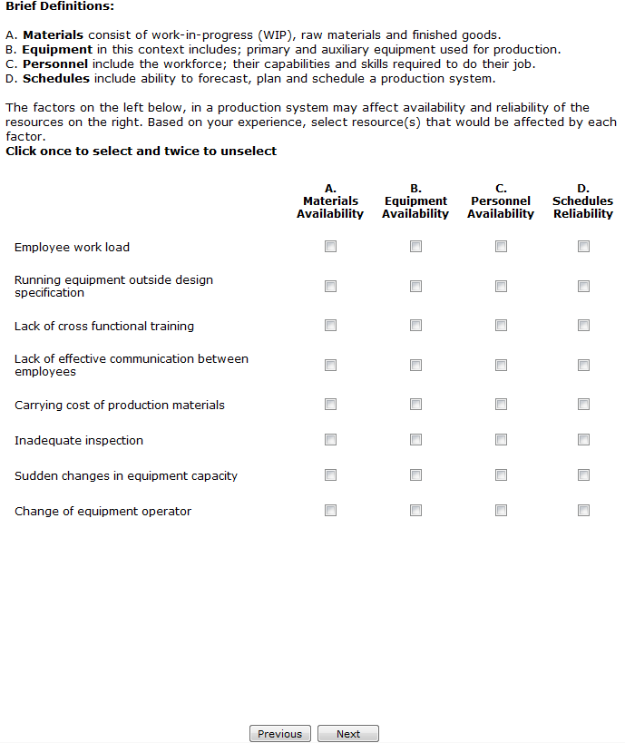

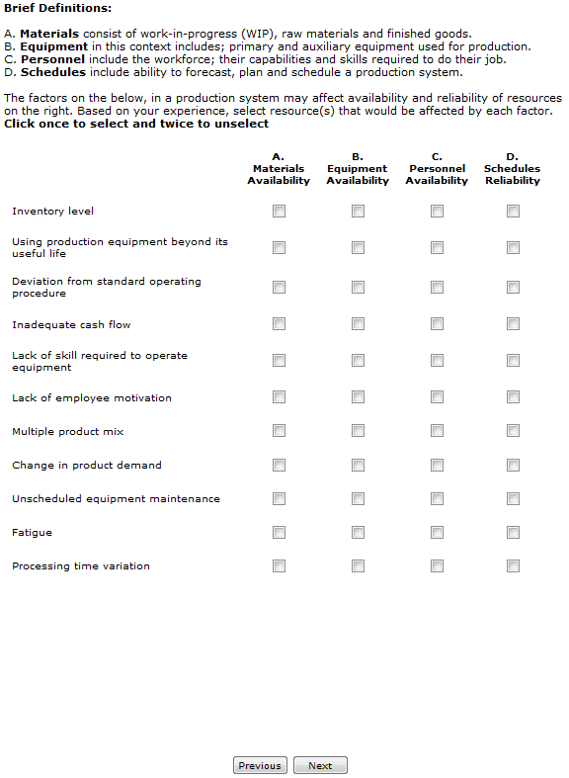

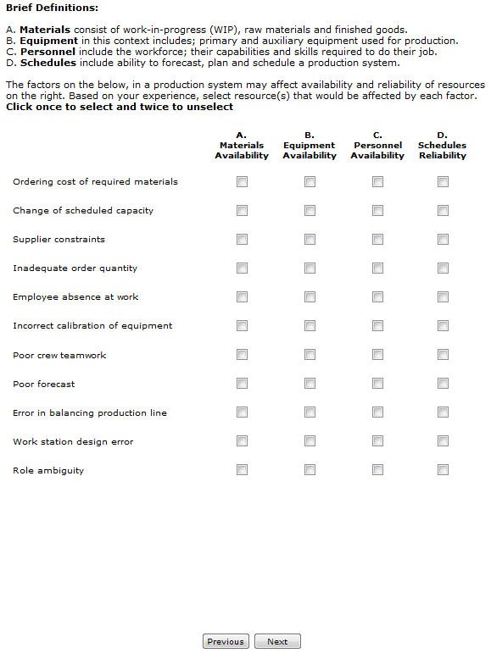

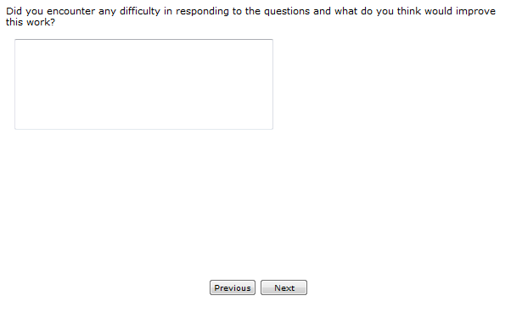



Vita
Ernest Iwuchukwu is a graduate research assistant under Dr. Rupy Sawhney at the Industrial and Information Engineering of University of Tennessee, Knoxville. He plans to graduate from the University of Tennessee with a Master of Science degree in Industrial and Information Engineering with a minor in Statistics in May 2011. Ernest received a Bachelor of Engineering degree in Mechanical Engineering in 1996. He was once a business owner and worked on several piping and machine installation projects as a project engineer.

