Incorporating Carbon Nanotubes into Carbon Fiber via Surface Modification

A Thesis Presented for the
Master of Science
Degree
The University of Tennessee, Knoxville

Robert Benjamin Ripy
May 2016

Copyright © 2016 by Robert Benjamin Ripy
All rights reserved.

DEDICATION

I would like to thank my parents Karen and Paul Ripy who are not around to see this, but I know it would make them elated. I love you.

ACKNOWLEDGEMENTS

This is a process that was a long and enduring one and would not have been accomplished without the help of many people. I would like to thank Jimmy Mays for believing I could do this. I would like to thank the rest of my committee, Alexei Sokolov, Sheng Dai, and Gajanan Bhat. I would also like to thank Nam-Goo Kang for his hands on approach and how he somehow knows the right direction to point me in. I have also had help from a great group that includes Xinyi Lu, Maria Cecilia Evora, Tom Malmgren, Adam Imel, Bradley Baker, Vikram Srivastava, and the rest of the Mays’ group. Without your help I would never have been able to achieve this.
ABSTRACT

Ever more advanced materials need to be designed to further the exploration of avenues of science and engineering. Metals and traditional composites are not meeting the needs of today’s stringent demands for lightweight and strong materials. There is a need for advanced materials that are lighter and stronger to replace conventional materials; carbon fiber composites became the obvious choice because of their outstanding mechanical properties. Polyacrylonitrile (PAN) based carbon fiber has reached its apex in terms of its strength to weight ratio. Carbon nanotubes (CNTs) offer a lightweight and potentially stronger alternative to PAN based fibers. However, it is difficult to translate the properties of individual CNTs macroscopically. The next step to overcome this barrier is to introduce highly aligned CNTs into carbon fiber. Carbon nanotube modified carbon fibers are imperative for the next step in achieving lightweight, ultra-strong fibers, to enhance their fuel efficient application in vehicles.

Table of Contents

Chapter One : Introduction 1
Chapter Two : Literature Review 4
A Brief History of Carbon Nanotubes 5
A Brief History of Carbon Fiber 5
Utilizing CNT’s Potential 7
Problems that arise with CNTs 7
Methods to solve these problems 9
This project’s method 12
Chapter Three : Materials and Methods 13
Materials 15
Method: 15
ARGET-ATRP Polymerization of PAN-g-CNTs 15
Synthesis of 4-EO-BCB 15
Synthesis of 4-EO-BCB-g-CNTs 17
Conversion to 4-BrIB-BCB-g-CNTs 18
Synthesis of PAN via ATRP 19
Synthesis of PAN via ARGET/ATRP 19
ARGET-ATRP synthesis of PAN-g-CNTs 20
Post Polymerization Processing 21
Fiber formation 21
Chapter Four : Results and Discussion 23
4-EO-BCB 24
Synthesis of 4-EO-BCB 24
NMR analysis of 4-EO-BCB 25
4-EO-BCB-g-CNT 28
Synthesis of 4-EO-BCB-g-CNT 28
NMR analysis of 4-EO-BCB-g-CNT 28
Thermogravimetric analysis of 4-EO-BCB-g-CNT 30
4-BrIB-BCB-g-CNT 32
Conversion to 4-BrIB-BCB-g-CNT 32
Thermogravimetric analysis of 4-BrIB-g-CNT 33
ARGET-ATRP of PAN 35
Synthesis of PAN via ARGET-ATRP 36
NMR analysis of PAN via ARGET-ATRP 36
Dilute Solution Viscometry of PAN-via-ATRP 38
PAN-g-CNT 38
Synthesis of PAN-g-CNT 38
Thermogravimetric analysis of PAN-g-CNT 41
Transmission electron microscopy of PAN-g-CNT 41
Post-polymerization Polymer Processing 44
Incorporation of PAN-g-CNT in fiber 44
Chapter Five : Conclusions and Recommendations 52
List of References 55
Vita 62

LIST OF TABLES

Table 1. 3.2 wt% of CNTs in PAN fiber 50
Table 2. 6.4 wt% of CNTs in PAN fiber 51

LIST OF FIGURES

Figure 1. SEM of CNT fiber at break 8
Figure 2. TEM of CNT fiber at break 8
Figure 3. Grignard reaction of 4-EO-BCB 16
Figure 4. Diels-Alder reaction of CNTs 18
Figure 5. Fiber spinning set-up 22
Figure 6. Anionic path for 4-EO-BCB 24
Figure 7. NMR spectrum of unpurified 4-EO-BCB 26
Figure 8. NMR spectrum of purified 4-EO-BCB 27
Figure 9. NMR spectrum of grafted 4-EO-BCB 29
Figure 10. Thermogram of 4-EO-BCB 31
Figure 11. NMR spectrum of 4-BrIB-BCB-g-CNT 33
Figure 12. Thermograms comparing 4-BrIB-g-CNTs vs 4-EO-BCB-g-CNTs 35
Figure 13. NMR spectrum of ATRP/ATRP PAN 37
Figure 14. Dilute solution viscosity plot of PAN in DMF 39
Figure 15. Dilute solution viscometry plot of PAN in DMF 40
Figure 16. Thermograms of PAN-g-CNT 42
Figure 17. Thermogram overlay of CNTs during grafting process 43
Figure 18. TEM of pristine CNTs 44
Figure 19. TEM of grafted CNTs 44
Figure 20. 3.2 wt% CNT based PAN fiber 47
Figure 21. SEM of 3.2 wt% CNT based PAN fiber 47
Figure 22. 6.4 wt% CNT based PAN fiber 48
Figure 23. SEM of 6.4 wt% CNT based PAN fiber 48
Figure 24. Plot of strength vs modulus of 3.2 and 6.4 wt% loaded PAN fiber 49

LIST OF ABBREVIATIONS

4-bromobenzocyclobutene | [4-Br-BCB]
4-bromoisobutyrate-benzocyclobutene grafted CNT | [4-BrIB-g-CNT]
4-ethoxy-benzocyclobutene | [4-EO-BCB]
4-ethoxy-benzocyclobutene grafted CNT | [4-EO-BCB-g-CNT]
4,4’-dinonyl-2,2’-bipyridine | [dNbpy]
acrylonitrile | [AN]
activators regenerated by electron transfer | [ARGET]
atom-transfer radical polymerization | [ATRP]
benzocyclobutene | [BCB]
bromoisobutyryl-bromide | [BrI-Br]
carbon nanotubes | [CNT]
dimethyl formamide | [DMF]
direct analysis in real time mass spectrometry | [DART]
deuterated chloroform | [CDCL3]
giga Pascal | [gPa]
hydrochloric acid | [HCl]
lithium chloride | [LiCl]
multi-walled nanotubes | [MWNT]
nuclear magnetic resonance spectroscopy | [NMR]
polyacrylonitrile | [PAN]
polyacrylonitrile grafted CNT | [PAN-g-CNT]
secondary butyl lithium | [sec-BuLi]
single-walled nanotubes | [SWNT]
tera Pascal | [tPA]
tetrahydrofuran | [THF]
thermogravimetric analysis | [TGA]
transmission electron microscopy | [TEM]
triethylamine | [TEA]
viscosity based molecular weight | [Mv]

:
Introduction

Carbon nanotubes have been hailed for their excellent thermal, electrical, and mechanical properties.^{1,2} Advances made in fundamental research have improved the ability to incorporate CNTs into composites.³ Unfortunately, it has been difficult to translate their mechanical properties into useful materials due to interfacial sliding, matrix/fiber dispersion, and the introduction of defects.^{4,5} Even though these carbon nanotubes have exceptional strength and modulus the difficulties in dispersing the unmodified nanotubes into polymers, as well as aligning them linearly, makes the progress on their integration into fiber slow.^{6,7} A technique must be developed to ensure dispersion and/or linear orientation.⁴ Furthermore, there is the need to prevent the aligned tubes from sliding past one another due to low inter-tube friction. How do we translate the CNT properties into carbon fiber? The method proposed here is to crosslink the CNTs using a grafting from approach to incorporate them into the fiber.⁸ How do we disperse the CNTs into fiber pre-cursors? Adding soluble moieties to CNTs can help disperse them in solution. The approach will be to add these moieties by modifying the CNT’s surface with 4-ethoxy-benzocyclobutene (4-EO-BCB), then converting these moieties to ATRP initiators,⁹ and polymerizing acrylonitrile (AN) from the surface. How will this approaches integrate CNT’s mechanical properties into the final fiber? This method will introduce strong covalent bonds between the CNTs and the PAN upon carbonization. The second approach will crosslink CNT yarns and produce highly oriented, covalently bound CNTs. I hypothesize that both of these approaches will covalently bond CNTs together, and to surrounding fiber; these bonds will be able to transfer the load on the fiber in to the stronger CNTs. This may result in a fiber that has a considerably higher strength and modulus.

Current technology is only yielding CNT carbon fibers with ~1/2 the tensile strength of non–CNT-based carbon fibers. Theoretical studies show that CNT fibers are capable of tensile strength greater than ten times that of current fibers.¹⁰ Progress in crosslinking CNTs through irradiation has created bundles with tensile strength up to 100 GPa, but this has only been carried out on bundles (not fiber) on the microscale.¹¹

In order to meet this project’s goals, I propose a method of modification to the improve interactions between the CNTs. The first approach is to attach an initiator to the nanotube surface and polymerize acrylonitrile (PAN) from the surface via atom transfer radical polymerization (ATRP); this has been shown to yield higher molecular weights and better control as compared to conventional free radical polymerization methods.¹² The attachment of benzocyclobutene (BCB) derivatives will provide a random distribution of polymer initiation sites along the CNTs.¹³ Once the PAN-g-CNTs are synthesized, they will be dispersed in a PAN solution and spun. Upon carbonization the grafted PAN will incorporate into the newly formed fibers.

:
Literature Review

A Brief History of Carbon Nanotubes

Carbon nanotubes (CNTs) were first discovered by Iijima in 1991, and since then there have been significant studies into the potential of this new material.¹⁴ This material has been shown to exhibit exceptional tensile strength and modulus.¹⁵ A cross-sectional analysis of individual multi-walled carbon nanotubes (MWNTs) yields a tensile strength of 100 GPa and a Young’s modulus approaching 1 TPa.¹⁶ This gives rise to the potential of CNTs being used in multiple materials covering a vast range of applications because of their unique electrical properties, high mechanical strength, low density, and high aspect ratio.¹⁷ Unfortunately, we have yet to take full advantage of these mechanical properties.^{18,10} Even with this potential, current CNT fibers and CNT-reinforced fibers are only exhibiting a fraction of these properties. The CNT based fiber’s strength is about half of current industry standard, HexTow® IM-7, only ranging from 0.9-3.3 GPa in tensile strength.¹⁹ There are many challenges to overcome before this technology is fully realized, especially incorporation into polymer matrices.¹⁸

A Brief History of Carbon Fiber
The first “carbon fiber” is not what a modern person would think of as a carbon fiber. When Thomas Edison was creating the light bulb, he experimented using many different materials as the filament, such as carbonized cotton thread and bamboo splinters. However, over the next 80 years, there was no real motivation to pursue carbon fiber research. Then, in 1956, Dr. Roger Bacon created modern-day carbon fiber at Union Carbide while looking for the triple point of graphite.²⁰ Shortly thereafter, carbon fiber was synthesized using rayon. However, rayon was not a suitable material because of its low strength and modulus. In the early 1960’s, Japan and the United Kingdom had discovered that they could make carbon fiber from PAN and create higher strength fibers than America’s rayon-based fibers. These countries dominated the market until the 1970’s when Union Carbide finally teamed up with Toray to bring America back into the carbon fiber game.²¹

Carbon fiber strength comes from the structure of the pre-cursor. The world’s most used pre-cursor for aerospace grade carbon fiber is polyacrylonitrile (PAN).²² Polyacrylonitrile is a polymer contains 68% carbon and is heat-treated to achieve carbonization. Synthesis of PAN is typically performed using either solution or emulsion polymerizations.²³ Once the acrylonitrile is polymerized, it is spun into fibers traditionally using one of three methods: dry spinning, wet spinning, and dry-jet wet spinning.²⁴ The nitrile group’s polarity in PAN gives rise to extremely strong intermolecular interactions. This makes the PAN extremely difficult to solvate so that it requires a highly polar or even ionic solvent to go into solution. These strong interactions also lend to PAN’s high melting point, which means it usually degrades before it melts.²⁵ To avoid such complications acrylonitrile is typically co-polymerized with one or more co-monomers; this increases solubility of the PAN and has an added effect, it decreases melt temperature one of the disadvantages of the pre-cursor is that it requires extremely high temperatures to form the carbon fiber itself. Current technology co-polymerizes acrylonitrile with acrylic acid, methyl methacrylate, methyl acrylate, itaconic acid, or a combination these co-monomers.²⁶ This requires co-polymerization of acrylonitrile with a monomer that can help induce easy cyclization, oxidation, and carbonization of the pre-cursor into the final product. Adding a co-monomer or mixture of co-monomers has greatly eased the production of carbon fiber, but the relationship between the composition of the polyacrylonitrile and the better performance has not been fully established. As carbon fiber becomes more widely used in various composite applications there is a need to understand the formation of the fiber itself.

Utilizing CNT’s Potential

Problems that arise with CNTs
CNTs are difficult to utilize, mainly due to insolubility and aggregation. CNTs have weak Van der Waals forces that bind them together in bundles making pristine CNTs insoluble in any solvent.²⁷ This unfortunate setback makes it difficult to uniformly functionalize the CNTs and reduces their mechanical properties due to aggregate bundles interfacial sliding as shown in Figure 1. In this figure (a) represent a simplified cartoon of the CNTs sliding past one another, while (b) is an SEM micrograph showing the fibrous material sliding past one another. Figure 2 is a TEM that demonstrates the drawing of the fiber at (a) and shows the fiber separating as demonstrated in Figure 1.
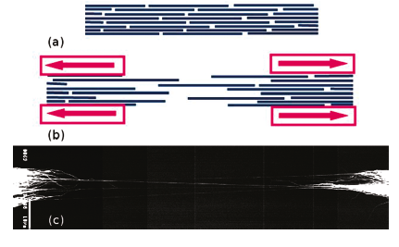
Figure 1. SEM of CNT fiber at break
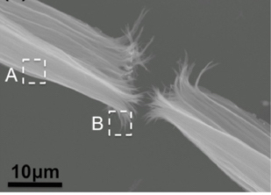
Several different methods for dispersing the nanotubes in polymer have been devised including sonication, applications of surfactants, and surface modification.²⁸ A problem that has arisen with sonication is that it has been shown to decrease the length of the CNTs with time, although mechanical shearing is hypothesized to be the reason, the actual mechanism for how this occurs is not well understood.³⁰ Applying surfactants to the CNTs is shown to be a good method to disperse CNTs in solvents and matrices, but it can introduce unwanted moieties into the final product.³¹ Surface modification is a good choice for dispersion because one has the ability to tailor ionic, covalent, or non-covalent interactions, but some of these methods can degrade the structure of the nanotubes as well.³²
Figure 2. TEM of CNT fiber at break

Methods to solve these problems
Surface modification is a good choice for dispersion and it offers a method to covalently incorporate CNTs into various solutions, but there are issues that need to be addressed with this method. Most methods of surface modification involve a harsh chemical treatment, which can introduce holes in the CNTs and these modifications have the tendency to occur at defect sites and the highly curved ends of the nanotubes, which are more reactive than the rest of the CNT surface.³³

Solvation of the CNTs is not the only challenge when attempting to realize their full potential.³⁵ For mechanical uses, one of the main issues is being able to increase the interactions between the tubes and/or interactions between surrounding polymer.³⁶ There have been several methods have been devised to increase CNT/CNT interaction.³⁷ One proposed method of increasing interactions between the CNTs themselves is the densification of CNT yarns. Liu and coworkers have designed a method to mass produce densified CNT yarns by using a technique that applies pressure to the nanotubes via spinning and then evaporates solvent from the yarn to densify³⁶. Another proposed method is to crosslink the nanotubes via functionalized polymers.
Yet another method to utilize CNTs excellent properties is to incorporate the nanotubes into a fiber. If properly incorporated the CNTs would increase the mechanical strength of the fiber due to a lack of intertube facile sliding. Methods have been employed to incorporate the CNTs into fiber in order to reinforce it. One of the first methods to incorporate the nanotubes into fiber was to solvate a polymer fiber and blend the CNTs to incorporate them into solution and then evaporate the solvent. This method is problematic because the large macromolecules do not diffuse into the CNTs. This resulted in fibers that were inhomogeneous and had little improvement in strength and modulus.³⁷

A technique that is demonstrating good results and even better potential is the polymer grafting of carbon nanotubes. This involves two different approaches, a “grafting to” and a “grafting from” technique. The “grafting to” approach typically involves the functionalization of the CNT surface and consequent reaction with a functionalized polymer. An early example of this was performed by Fu and co-workers; in this work CNTs were functionalized with carboxylic acid. This was then reacted with thionyl chloride to form acyl chloride moieties. Hydroxyl end-capped polyethylene glycol dendrimers were used in esterification reactions with the CNTs³⁸ This unfortunately resulted in low grafting levels, but did confirm esterification as a valid “grafting to” technique. Another “grafting to” technique used is anionic functionalization of the surface and attachment of polymer moieties. In 2004, Blake and co-workers organometallically functionalized MWNTs using sec-BuLi.³⁹ This was followed by the addition and coupling of chlorinated polypropylene and the formation of the LiCl salt.²⁶ For both of these methods it was reported that they suspected the functionalized moieties occurred around the strained bonds of the CNT end caps and defects along the surface of the nanotube. It was also reported that the grafting levels were low on the nanotube surface due to steric hindrance once the first few macromolecules attached.

This project’s method
The “grafting from” approach can solve some of the problems encountered with the grafting to approach. This approach can easily be tuned to increase and control the grafting density on the CNT surface. The “grafting from” method involves attaching an initiating moiety making it immobile with respect to the nanotube surface. This is then followed by an in-situ polymerization that ensures the macromolecules are attached to the surface. An early example of this was carried out in 2003; Viswanathan and co-workers grafted polystyrene from SWNT.⁴⁰ The nanotubes were dispersed in cyclohexane via sonication and calculated excess of sec-BuLi was added to neutralize any protic surface defects. It was allowed to sonicate for an hour and then styrene monomer was added and allowed to polymerize for 48 hours under sonication. Another method is to attach a radical or controlled polymerization initiator to the surface and grow polymer in this fashion. An example of this was performed by Kong and co-workers by using carboxylic acid functionalized nanotubes and converting them to acyl chloride moieties.⁴¹ These were then converted to ATRP initiators via the addition of glycol followed by 2-bromoisobutyrl bromide. Once the surface was grafted with initiators, methyl methacrylate was polymerized via traditional ATRP.⁴²

The method for “grafting from” is important to the overall load the CNT can
take. As previously reported, a higher load can be transferred to the CNTs through covalent bonds instead of ionic or physical interactions. While covalent bonds have been shown to increase load transfer, many of these techniques degrade the CNTs during the process. This can lead to tube shortening, which has also been shown to decrease the overall physical properties of the nanotubes. A method has been previously developed by the Mays’ group that can alleviate both of these problems. In this work, Mays’ and co-workers functionalized CNTs with benzocyclobutene derivatives.^{43,13} This work offers a technique that covalently bonds moieties to the surface of the CNTs that does not introduce defects into the CNT and grafts over the nanotubes randomly. The BCB derivative bonds by changing the hybridization of the sp² to sp³ carbons.

:

Materials & Methods

Materials:

Materials used in this project are: 4-bromo-benzocyclobutene from Shanghai Medicilon Inc.; ethylene oxide, tetrahydrofuran, hydrochloric acid, sodium bicarbonate, ethyl acetate, and copper[II] bromide from Fisher Chemical; magnesium turnings, sec-butyl-lithium, 1,2 dibromoethane, tetradecane, triethylamine, bromoisobutyryl-bromide, bromopropionitrile, acrylonitrile, tin[II] ethylhexanoate, 4,4’-dinonyl-2,2’-bipyridine, and N,N-dimethyl formamide from the Sigma Aldrich Corporation; high purity argon from Airgas; and multi-walled carbon nanotubes (5-20 μm [micron] length x 30 nm OD) from Nano-lab Inc.

Methods:

(Activators ReGenerated by Electron Transfer) ARGET-ATRP Polymerization of PAN-g-CNTs

Synthesis of 4-EO-BCB
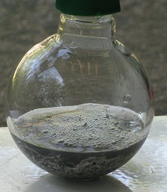
4-bromo-benzocyclobutene (4-Br-BCB) and THF were dried over calcium hydride overnight and vacuum distilled. Ethylene oxide was collected in a chilled flask with sec-butyl lithium and distilled to a separate flask were THF is added to form a 3 M solution. Magnesium turnings are dried overnight under vacuum. 20 mL of anhydrous THF is combined with 4 g magnesium in a round bottom flask, purged and placed under an argon atmosphere. A couple of drops of 1,2 dibromoethane is added to activate the magnesium and the reaction is refluxed for 15 minutes. A solution of 10 g 4-Br-BCB and 10 mL dry THF is made and added dropwise via syringe pump to the reactor to form the Grignard reagent. The reaction is refluxed for 45 minutes and chilled to 0°C. 20 mL of the ethylene oxide solution is added dropwise via syringe pump at a rate of 10 mL/hr and then the solution is refluxed for an additional 15 minutes forming a dark green solution as shown in Figure 3. The mixture is poured over 150 mL of ice, acidified to a pH of 4 with HCl, and neutralized with a saturated sodium bicarbonate solution; the 4-hydroxyethyl-benzocyclobutene (4-EO-BCB) is extracted with ethyl acetate. Once the solution has been extracted three times into a total of 300 mL of ethyl acetate, it is rotary evaporated and run through a column of 20:80 ethyl acetate and hexanes to separate any major impurities. Solvent is removed and the resultant solution is dried over calcium hydride overnight and then distilled to isolate and purify the 4-EO-BCB. The 4-EO-BCB is then analyzed for purity.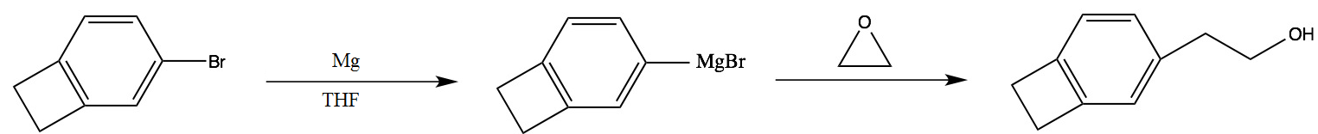
Figure 3. Grignard reaction of 4-EO-BCB

Synthesis of 4-EO-BCB-g-CNTs
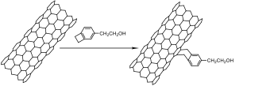
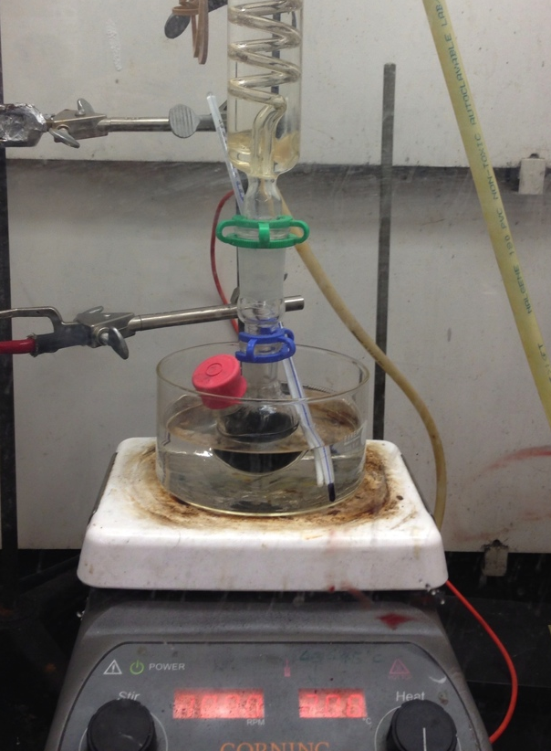
To a round bottom flask 0.100 g of pristine carbon nanotubes are added to 10 mL of tetradecane. The reactor is purged and kept under an argon atmosphere and the mixture was brought up to 250 °C. Figure 4 shows the reactor setup for the Diels-Alder reaction. One milliliter of 4-EO-BCB and is added dropwise via syringe pump at a rate of 1 mL/hr to the CNT/tetradecane mixture and then allowed to react for an additional 30 minutes. The nanotubes are collected and purified in a Soxhlet extraction apparatus, filtered, and dried..
Figure 4. Diels-Alder reaction of CNTs

Conversion to 4-BrIB-BCB-g-CNTs

To a round bottom flask the 0.135 g of functionalized CNTs and 10 mL of dry THF are added; the mixture is then purged and backfilled with argon gas. 0.020 g of triethylamine is added to the mixture which is stirred in an ice bath for 30 minutes. The mixture is then removed from the ice bath and 0.5 g of 4-bromoisobutyryl bromide in 1.5 mL of dry THF is added dropwise via syringe pump to the mixture at a rate of 2 mL/hr and allowed to stir rapidly at room temperature for 48 hours. Once the reaction is completed, the CNTs are purified in a Soxhlet extraction apparatus, filtered, and dried.
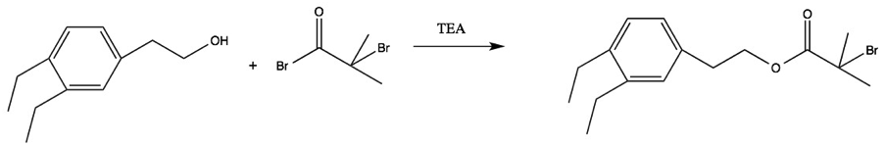

Synthesis of PAN via ATRP
Before polymerizing with the nanotubes ATRP was used to polymerize neat acrylonitrile. Five g of acrylonitrile, 25 mL of DMF, 0.160 g of 4,4’-dinonyl-2,2’-bipyridine, and 25 mg of copper(I) chloride are combined in a reactor. The solution is degassed via the freeze, pump, thaw method three times. The reactor is backfilled with argon. Once filled a solution of 2.5 mg pf 3-bromopropionitrile and 1 mL N,N-dimethylformamide (DMF) is added to initiate the reaction. The reaction was carried out for two days at 70°C under positive pressure. Once the reaction was completed the polymer was precipitated in methanol and collected and dried.

Synthesis of PAN via ARGET/ATRP
Before polymerizing with the nanotubes ATRP was used to polymerize neat acrylonitrile. Five g of acrylonitrile, 25 mL of DMF, 16 mg of 4,4’-dinonyl-2,2’-bipyridine, 2.5 mg of copper(II) chloride, and 2.5 mg pf 3-bromopropionitrile are combined in a reactor. The solution is degassed via the freeze, pump, thaw method three times. The reactor is backfilled with argon. Once filled a solution of 0.1 mL of tin(II)octonoate in 1 mL of DMF is added to initiate the reaction. The reaction was carried out for seven days at 70°C at positive pressure. Once the reaction was completed the polymer was precipitated in methanol and collected and dried.

ARGET-ATRP synthesis of PAN-g-CNTs
All reagents are dried and purified before use. 0.175 g of 4-BrIB-g-CNTs, 2.0 g of 4,4’-dinonyl-2,2’-bipyridine (dNbpy), 13.5 g of acrylonitrile (AN), 0.340 g of copper(II) chloride, and 20 mL of dimethylformamide (DMF), are combined in a round bottom flask. The solution is stirred rapidly until the ligand is dissolved; then the flask is degassed via the freeze, pump, thaw method and backfilled with an inert gas. The reaction is brought up to 70 °C and then 1.5 mL of the reducing agent tin(II)octonoate in 10 mL of DMF is added to start the reaction. The reaction is carried out under these conditions for seven days. Once the reaction is completed, the nanotubes are purified via Soxhlet extraction and then filtered and dried. The amount of monomer added was changed in order to vary molecular weight and thus to determine an ideal molecular weight for the polymer to entangle with surrounding polymers.
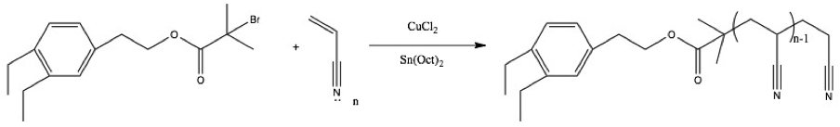

Post Polymerization Processing

Fiber formation
Once the CNTs have been modified CNTs are sent to Dr. Bhat’s lab to undergo suspension in a doped solution. This solution is varied in concentrations of CNTs and PAN that is suspended in DMF. This solution will be used to form the fiber. Next the solution will be extruded through a fiber head and undergo a series of baths that contain different concentrations of DMF and water that will slowly remove the solvent from the fiber as it is being drawn. This is demonstrated in the cartoon in Figure 5.

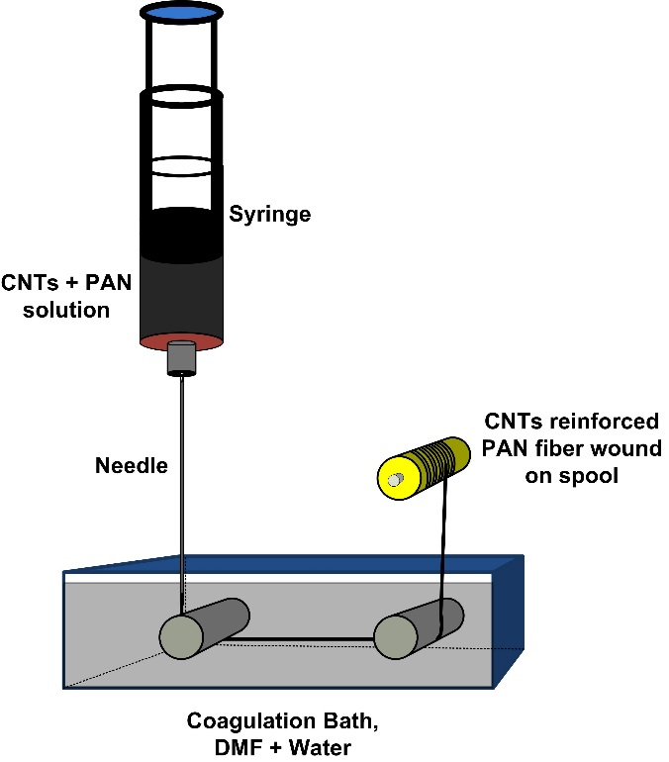

Figure 5. Fiber spinning set-up

:
Results and Discussion

4-EO-BCB

Synthesis of 4-EO-BCB
Two methods were employed to convert 4-Br-BCB into 4-EO-BCB. Both an anionic pathway as well as using the Grignard reaction were employed.
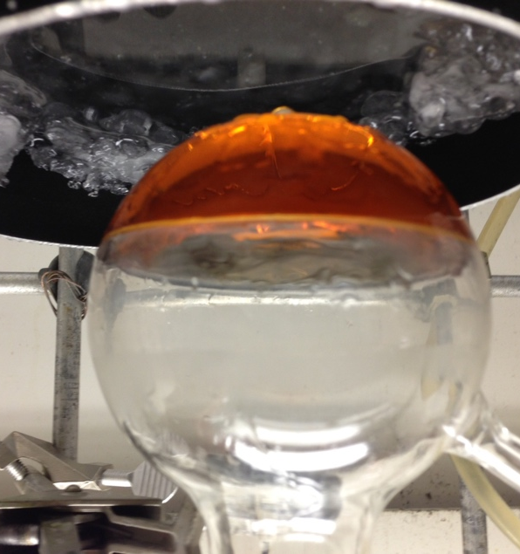
The anionic method was designed to remove the bromine and substitute it with an ethyoxy moiety. To reduce the chances of polymerization the stoichiometry was kept low and the pH was kept neutral. Unfortunately, this method was not successful. Figure 6 shows the formation of the anion on the benzocyclobutene derivative, but once the ethylene oxide was added it killed the anion turning the solution clear. Upon analyzing the resulting solution with NMR it revealed that the 4-bromobenzocyclobutene had been converted to benzocyclobutene.
Figure 6. Anionic path for 4-EO-BCB

NMR analysis of 4-EO-BCB
The Grignard reaction was initially unsuccessful as well, but by purifying all reagents rigorously and making the conditions of the reaction more stringent these problems were overcome. A Liquid State Varian VNMRS 500 MHz with a narrow-bore ultra shield plus magnet was used to obtain the spectrum and verify the desired compound and the removal of impurities shown in Figures 7 and 8. The impurities are attributed to side reactions and residual solvent held in the 4-EO-BCB solution. Upon elution through a column 20/80 ethyl acetate and hexanes it was discovered through NMR that the major impurity in the solution was benzocyclobutene. This is attributed to water or residual air in the system oxidizing the Grignard reagent and leaving only the original non-brominated substituent. As can be seen in Figure 8 the nearly all of the impurities have been removed. ¹H NMR (500MHz, Chloroform-d) δ 7.11-6.91 (m,1H), 3.82 (td, J=6.7,2.1Hz, 1H), 3.17 (d, J=2.0Hz, 2H), 2.84 (td, J=6.7, 2.0 Hz, 1H) Once the process was streamlined the yield averaged 76% with the highest being 80%. This occurred on all of the scales that were synthesized and that were between 1g - 50g batches.
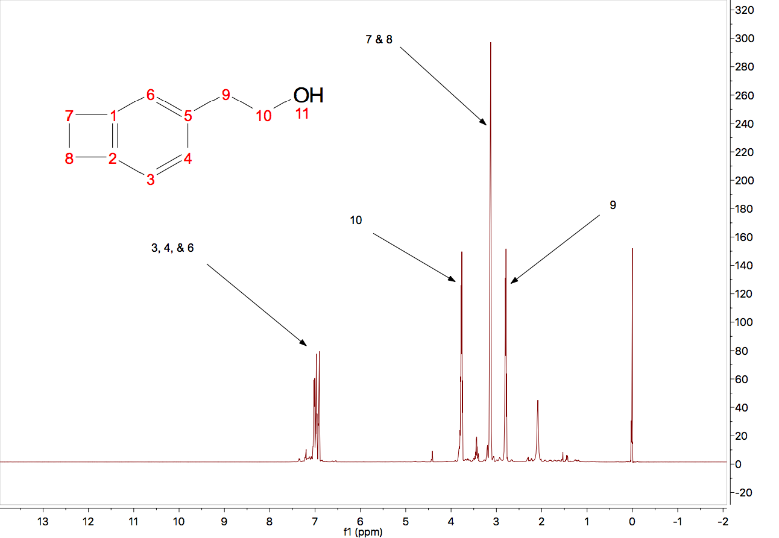
Figure 7. NMR spectrum of unpurified 4-EO-BCB

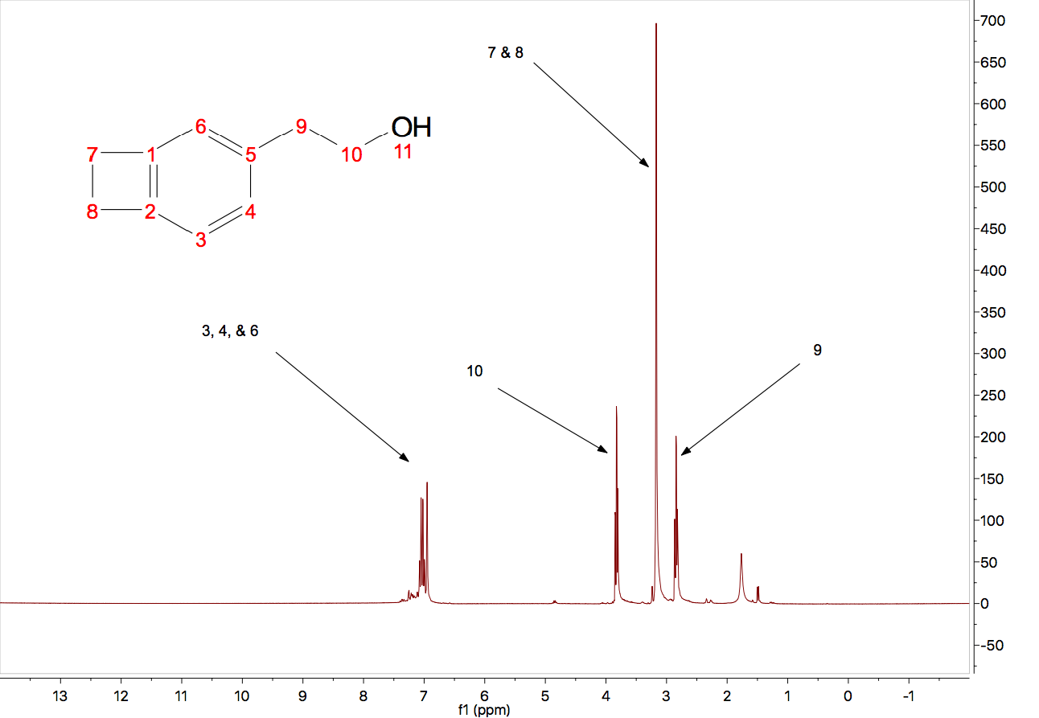
Figure 8. NMR spectrum of purified 4-EO-BCB

4-EO-BCB-g-CNT

Synthesis of 4-EO-BCB-g-CNT
Grafting the pre-initiator to the nanotubes was a tricky endeavor. Even under the same conditions the grafting level could vary greatly. When this procedure was scaled up there was a great decrease in grafting level; this was
attributed to a higher concentration of 4-EO-BCB due to using a smaller ratio of solvent. This was explored by matching lab scale (0.1 g) to the scale up (0.5 g) while there was an increase in grafting from the original scale up it was still lower than the percentage of grafting for the small scale. Several concentrations of 4-EO-BCB were used when conducting these experiments to determine if
concentration had an effect on the grafting density.

NMR analysis of 4-EO-BCB-g-CNT
Initially the Diels-Alder reaction was unsuccessful because the higher temperatures were difficult to maintain with the heating mantles at hand. Once this issue was resolved, by using hotplates that could obtain the desired temperature, the reaction was carried out. The spectrum in Figure 9 shows the familiar peaks that were seen in both Figures 7 and 8, but the all of the peaks have shifted upfield, except for the benzylic multiplet. 1H NMR (500 MHz,
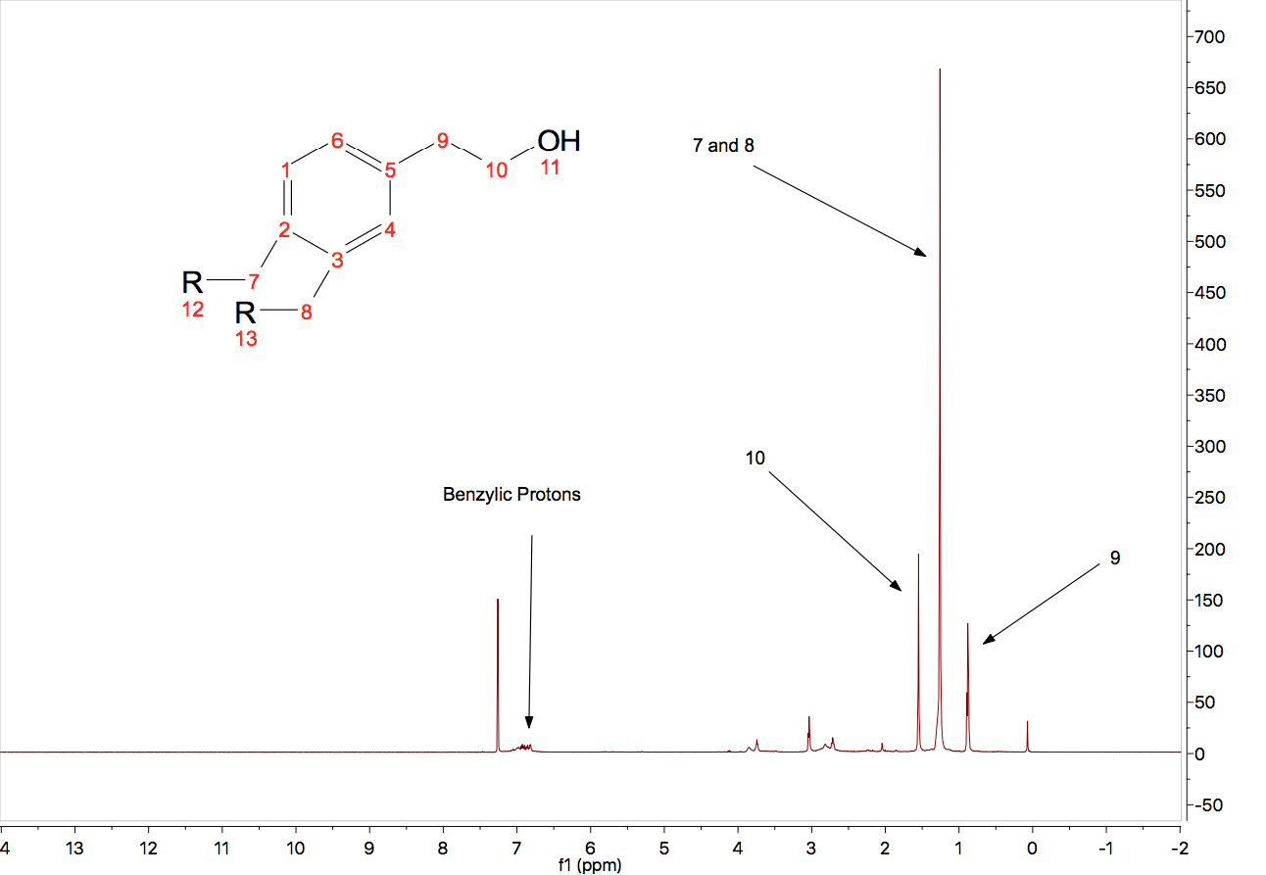
Figure 9. NMR spectrum of grafted 4-EO-BCB

Chloroform-d) δ 6.99-6.79 (m, 1H) , 1.31 (d, J=6.9 Hz, 0H), 1.29 (s, 1H), 1.26 (s, 12H), 0.88 (t, J=6.8 Hz, 3H) The upfield shift is attributed to the increase in shielding due to the electron density and the magnetic nature of the carbon nanotubes. This spectrum shows that the pre-initiator is attached to the nanotube, which was later verified with thermogravimetric analysis. There is a doublet at 3.04 ppm that cannot be explained. Traditionally, it would be attributed a methylene group adjacent to a chlorine, but with the distorted electronic characteristics of the carbon nanotubes it cannot be determined with any certainty.

Thermogravimetric analysis of 4-EO-BCB-g-CNT
The grafting density was determined for the CNTs by using a TA Instruments Q-50 TGA to determine the weight percentage of the grafted pre-initiator by determining the weight loss as a sample is heated. This is done under an inert atmosphere so the separation of constituents is not by oxidation. This method allows the weak bonds to be cleaved by a reverse Diels-Alder reaction and since the carbon nanotubes do not oxidize, the weight lost is the weight of grafting. There was a concern about physisorption vs the formation of chemical bonds. This was proven not to occur, because the same reaction was run with no heat and, while the thermograms initially looked similar, once the nanotubes were processing via Soxhlet extraction this was not an issue, because the impurities were removed through the extraction. Figure 10 shows the onset point of weight loss beginning at 226 °C; this is attributed to the loss of small molecules such as ethanol and any physisorbed 4-EO-BCB. The second more dramatic peak and the majority of the weight loss begins at approximately 400 °C and this is attributed to the reverse Diels-Alder reaction. Loading levels did not seem to affect the grafting density. It was discovered using DART mass spectrometry that the lower temperatures and longer reaction times led to the dimer of the BCB derivative. This is believed to be because at all loading levels it was more than the maximum needed for grafting. The temperature and duration of the reaction had a much larger effect. Maintaining the specific temperature was difficult and this is why the grafting levels differ from batch to batch as shown in Figure 10.

4-BrIB-BCB-g-CNT

Conversion to 4-BrIB-BCB-g-CNT
The conversion of 4-EO-BCB to 4-BrIB-BCB is relatively straightforward and gave a yield approaching 100%. This was determined by TGA based on weight change. The esterification reaction between the hydroxyl terminated initiator and the acid bromide functional group of the bromoisobutyryl-bromide is facilitated by the TEA neutralizing the hydrobromic acid and driving the reaction forward by negating the reverse reaction.
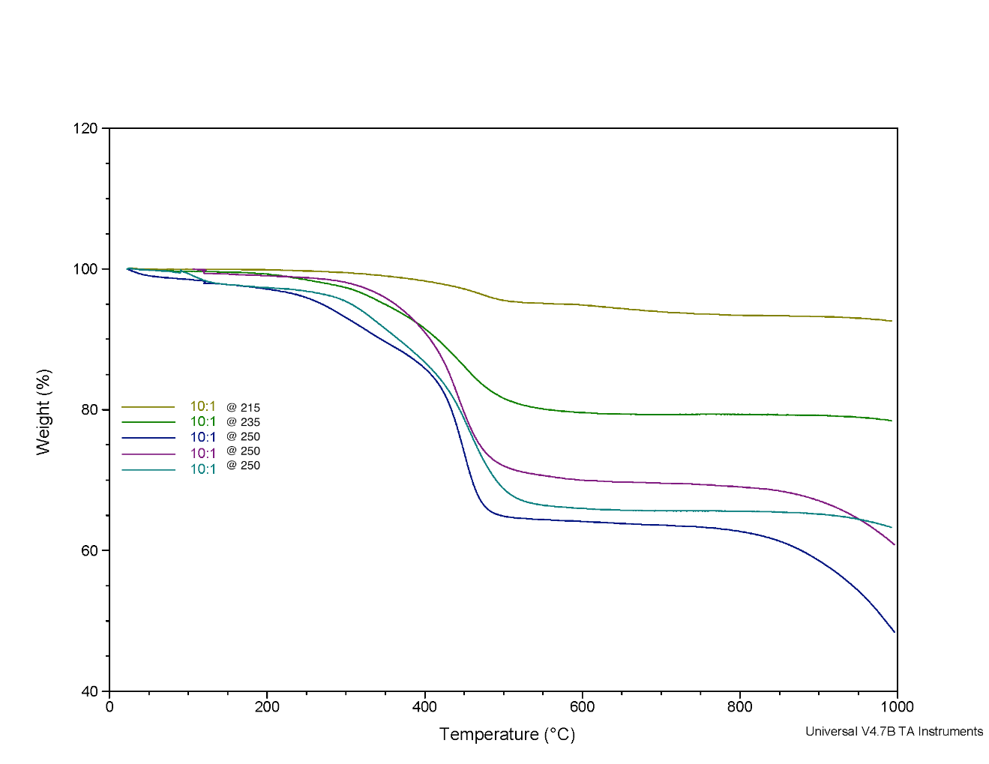
Figure 10. Thermogram of 4-EO-BCB-g-CNTs with 10 to 1 weight ratio of EO-BCB to CNTs

NMR analysis of 4-BrIB-BCB-g-CNT
The NMR spectrum in Figure 11 for 4-BrIB-BCB-g-CNT was more complicated than expected. ¹H NMR (500 Mhz, Chloroform-d) δ 7.26 (dd, J=5.6,. 3.4 Hz, 1H), 3.13 (tp, J=9.3, 5.3, 4.4 Hz), 1.59-1.53 (m, 2H), 1.45 (dq, J=6.8, 3.4
Hz, 3H) as shown above. The peaks at 3.13 ppm correspond to two protons beta to the ester carbonyl. The peaks at 1.59-1.53 are the protons corresponding to methylene protons gamma to the ester carbonyl and the peaks at 1.45 correspond to the methyl groups adjacent to the initiating bromine. The benzylic protons are not readily identifiable; that is attributed to the shielding of the CNTs. This was seen in Figure 10 as the signal for the aromatic group is diminished due to the complex magnetic interference from the presence of the CNTs.

Thermogravimetric analysis of 4-BrIB-g-CNT
TGA experiments were used to analyze the initiator grafted nanotubes. This gave an insight into how much of the precursor was converted into the initiator. Figure 12 shows the weight differences between the 4-EO-BCB-g-CNT vs 4-BrIB-g-CNT; when normalized to the molecular weights of the two moieties they are approximately stoichometrically equal. This suggests that there is a nearly complete conversion.

Figure 11. NMR spectrum of 4-BrIB-BCB-g-CNT

Figure 12. Thermograms comparing 4-BrIB-g-CNTs vs 4-EO-BCB-g-CNTs

ARGET-ATRP of PAN

Synthesis of PAN via ARGET-ATRP
The polyacrylonitrile was synthesized with multiple molecular weights, precipitated, and purified. The reaction took seven days to reach a conversion of 60%, and all subsequent reactions were carried for the same duration. Once this was complete gel permeation chromatography (GPC) was used to determine the molecular weight; unfortunately, the results were not conclusive due the interactions between the column and the polymer. So dilute solution viscometry was used to measure intrinsic viscosity.

NMR analysis of PAN via ARGET-ATRP
The NMR results confirmed polyacrylonitrile with water and DMSO impurities in it as shown in Figure 13. The samples were minimally purified because we were initially interested in proof of concept. The peaks reported are ¹H (500MHz, DMSO-d₆) δ 3.18-3.01 (m, 8Hz), 2.87 (s, 1H), 2.71 (d, J=0.6 Hz, 1H), 2.18-1.93 (m, 3H), 1.21 (s, 1H). The peaks at 3.11 are attributed to the methine carbon in the polymer background while the peaks at 2.07 are associated with the methylene group in the backbone. The singlets at 2.87 and 2.71 represent the methyl groups of the initiator.

Figure 13. NMR spectrum of ARGET/ATRP of PAN

Dilute Solution Viscometry of PAN-via-ATRP
Molecular weight determinations of the PAN could not be made with the GPC in the PCL; this was attributed to the polymer interactions with the column. The plots in Figures 14 and 15 are DSV plots used to determine viscosity based molecular weight, M_{v}, using the Mark-Houwink parameters K=0.000342 dL/g and a=0.70 in DMF at 30° C.⁴⁵ These plots yield an intrinsic viscosity of approximately 4.0 and 3.6; when using this information with the literature values as prescribed the molecular weight is 220,000 g/mol and 190,000 g/mol, respectively.

PAN-g-CNT

Synthesis of PAN-g-CNT
The synthesis of PAN-g-CNT proved to be especially complex. Traditional ATRP was initially used and upon doing some research it was found that ARGET-ATRP was a better choice. It offered an easier experimental set-up and because a reducing agent was there to recreate the copper(I) moiety it was considerably more tolerant of an oxidizing agent, such as water or air, being present. While the 4-EO-BCB-g-CNT and the 4-BrIB-BCB-g-CNT samples were able to be suspended in a solvent to provide NMR analysis, the PAN-g-CNT samples could not.
Figure 14. Dilute solution viscometry plot of PAN in DMF
Figure 15. Dilute solution viscometry plot of PAN in DMF

Thermogravimetric analysis of PAN-g-CNT
The thermogram of the PAN-g-CNT in Figure 16 samples reveal a significant increase in additional weight added to the CNTs. This is due to the grafting from the CNT, because the only initiating moieties were located on the surface of the nanotubes. In Figure 17 the amount of PAN that is grown from the surface is only 1.2 times the weight of the initiator in all of the samples measured, this suggests that the PAN grows to very low molecular weight no matter the amount of grafting. It is suspected that the molecular weight for the chains is ~500g/mol; this indicates there is a termination event that is not readily solved by the ATRP method. The doped solution and the fiber that was formed often showed aggregates or color variances indicating a heterogeneous mixture; this indicates that the molecular weight of entanglement, M_{e} ~3,200 g/mol⁴⁶, was not reached and the nanotubes were experiencing stronger molecular forces with themselves than the surrounding PAN. With this information it can be determined that the χ_{n} is between 10-60 repeat units. This was indicated at most loading levels except for the lower loading levels.

Transmission electron microscopy of PAN-g-CNT
The prepared nanotubes were examined with a ZEISS LIBRA 200 HT FE MC transmission electron microscope. Pristine nanotubes were examined and the results are seen in Figure 18. In this figure you can see amorphous carbon
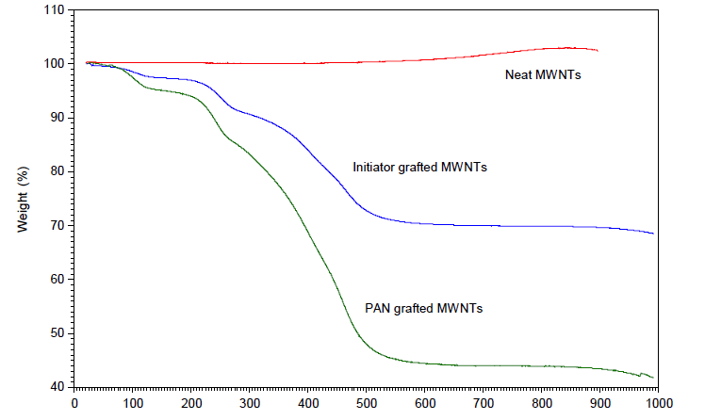
Figure 18. Thermogram of comparing grafted CNTs
Figure 16. Thermogram of grafted CNTs
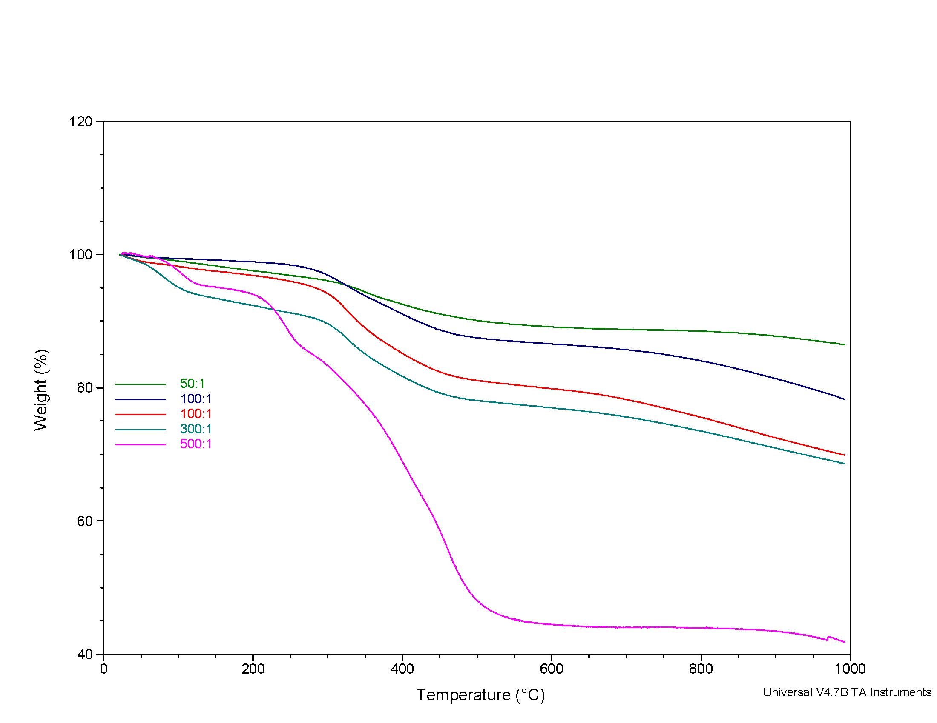
Figure 17. Thermogram overlay of grafted CNTs with molar acrylonitrile to initiator ratios

still attached to the CNTs, but it is also very clear that you can see the well defined walls of the MWNT. In Figure19 you can once again see the clearly defined nanotube walls on the inside, but there is also polymer wrapped around the tube as seen by the difference between the amount and thickness of the amorphous polymer enveloping the CNT.

Post-polymerization Polymer Processing

Incorporation of PAN-g-CNT in fiber
Once the grafted nanotubes were completed and washed they were transferred to Dr. Bhat’s group for incorporation into fiber. It was noticed that the polymer grafted nanotubes would stay suspended in DMF for a limited time before crashing to the bottom of the vial. The grafted nanotubes were loaded into a 15% PAN solution at two different loading levels, 3.2 and 6.4 weight percent of CNTs. The fibers that were formed appeared to be a uniform gray color as shown in Figures 20 and 22. The SEM images in Figures 21 and 23 show good fiber formation, but since there was increase in mechanical properties it is hypothesized that the CNTs are not interacting with the fiber. Unfortunately, the strength of the PAN was not increased at all, because the strength of the precursor fiber did not increase it has been shown that the strength of the final
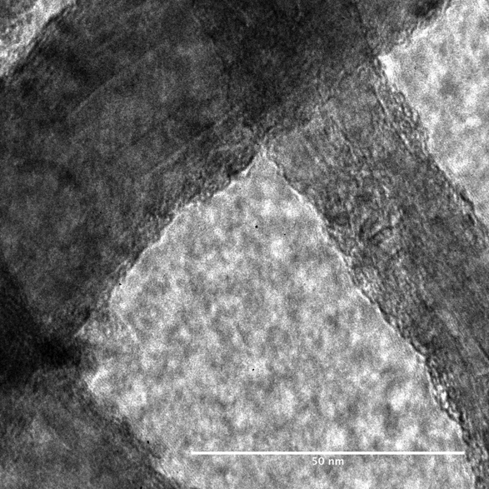
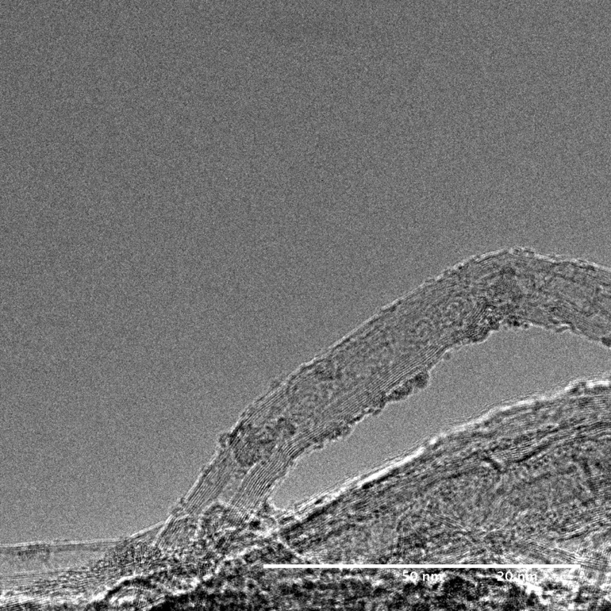
Figure 19. TEM of grafted CNTs
Figure 18. TEM of pristine CNTs

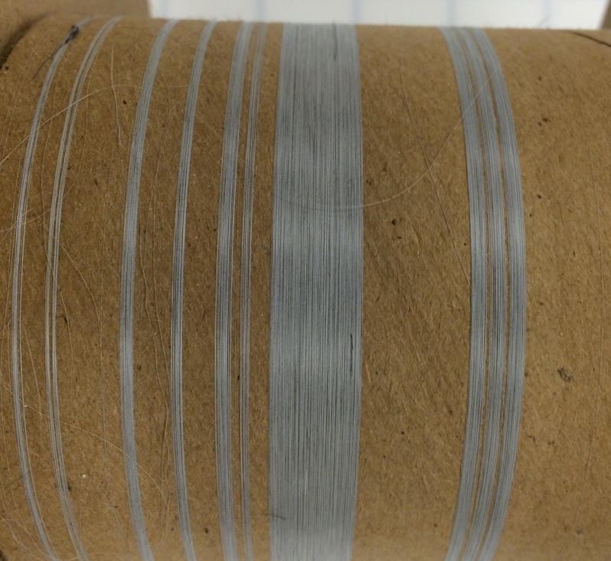

Figure 20. 3.2 wt.% CNT in PAN fiber
Figure 21. SEM of 3.2 wt% of CNTs in PAN fiber

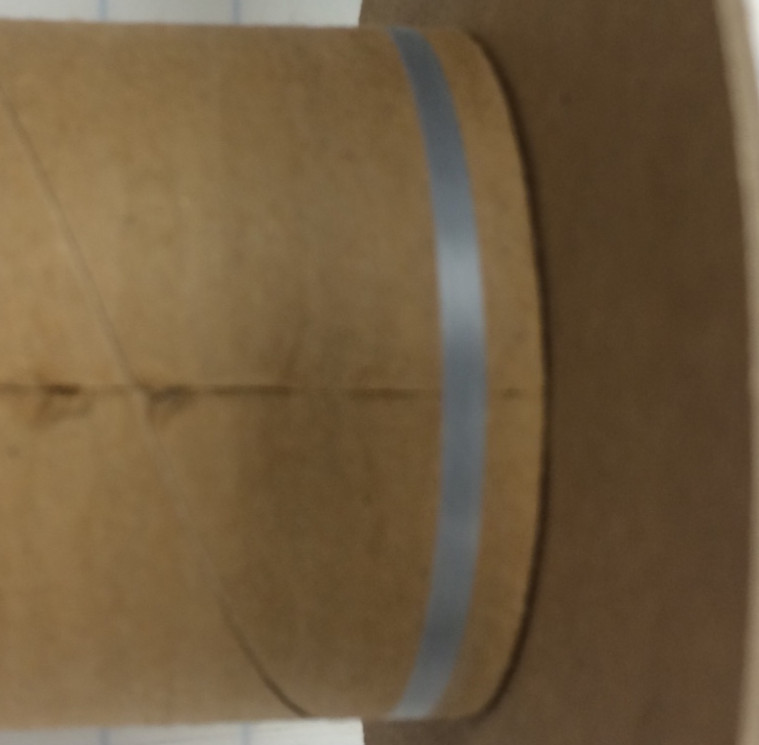
Figure 22. 6.4 wt.% CNT based PAN fibers

Figure 23. SEM of 6.4wt% CNT based fiber
fiber will not increase. The plot in Figure 24 of tables 1 and 2 confirm this; the trend line’s slope is virtually identical for both loading levels They show that even though the CNTs are in the fiber they do not increase the modulus of the fiber with any significance. When a trend line is added it demonstrates that there is only a 1% increase in the slope, and this can be attributed to the outliers. This is due to the aggregation of the CNTs of the fiber SEM imaging shows that the CNTs aggregate near the surface in large bundles ~10 micron in diameter. With this occurring they lend no structural support to the fiber, because they would encounter the same problems as discussed in Chapter 2. There are a few reasons this is hypothesized. First, the nanotubes used were only ~90% pure. This leaves amorphous carbon that can interfere with the reaction or become another moiety to react with. Second, the grafting density was not easily controlled so the variances between similarly prepared batches could vary greatly. Third, it is hypothesized that the target molecular weight was not achieved or that not enough of the grafted polymers were long enough to truly interact with the surrounding polymer.

Figure 24. Plot of strength vs modulus
Figure 24. Plot of strength vs modulus of 3.2 wt% and 6.4 wt% CNT loaded PAN fiber
Table 1. 3.2 wt.% of CNTs in PAN fiber

Sample | Diameter  micron | Peak Load  gf | Peak Stress  MPa | Modulus  GPa | Strain at Peak Stress  %
1 | 37.91 | 5.5 | 47.57 | 2.07 | 5.71
2 | 37.78 | 5.5 | 48.26 | 2.07 | 6.25
3 | 34.67 | 5.8 | 59.98 | 2.07 | 6.86
4 | 36.28 | 5.4 | 51.02 | 2.07 | 5.9
5 | 40.44 | 5.5 | 42.06 | 2.07 | 5.89
6 | 37.64 | 3.9 | 34.47 | 2.07 | 2.8
7 | 36.14 | 5.6 | 53.09 | 3.45 | 3.12
8 | 37.3 | 5.5 | 48.95 | 2.07 | 5.2
9 | 37.09 | 5.6 | 51.02 | 2.76 | 5.25
10 | 35.05 | 3.7 | 37.23 | 1.38 | 12.04
11 | 32.77 | 3.4 | 39.99 | 1.38 | 14.45
12 | 36.54 | 5.7 | 53.09 | 2.76 | 5.32
13 | 35.7 | 5.3 | 51.71 | 2.07 | 5.53
Mean | 36.56 | 5.1 | 47.57 | 2.07 | 6.49
Std. Dev. | 1.86 | 0.8 | 6.89 | 0.69 | 3.24
% COV | 5.09 | 16.36 | 104.52 | 155.61 | 49.99

Table 2. 6.4 wt.% of CNTs in PAN fiber
Sample | Diameter  micron | Peak Load  Gf | Peak Stress  MPa | Modulus  GPa | Strain at Peak Stress  %
1 | 38.32 | 5.1 | 43.44 | 2.07 | 4.88
2 | 40.39 | 5.4 | 40.68 | 1.38 | 5.96
3 | 38.33 | 5.2 | 44.13 | 1.38 | 5.72
4 | 30.19 | 5.4 | 74.46 | 3.45 | 4.73
5 | 39.54 | 4.9 | 39.30 | 1.38 | 4.9
6 | 39 | 4.9 | 39.99 | 2.07 | 5.64
7 | 38.22 | 5.1 | 43.44 | 2.07 | 5.31
8 | 38.57 | 4.4 | 37.23 | 2.07 | 4.36
9 | 38.2 | 5.2 | 44.82 | 2.07 | 5.47
10 | 29.32 | 5.2 | 75.15 | 3.45 | 5.06
11 | 38 | 5.2 | 44.82 | 2.07 | 5.93
12 | 38.82 | 5.1 | 42.06 | 2.07 | 4.96
13 | 39.05 | 5.2 | 42.06 | 2.07 | 5.43
Mean | 37.38 | 5.1 | 46.88 | 2.07 | 5.26
Std. Dev. | 3.45 | 0.2 | 12.41 | 0.69 | 0.49
% COV | 9.23 | 4.89 | 183.06 | 176.09 | 9.28

:
Conclusions and Recommendations

Poly(acrylonitrile) was grown from the surface of multi-walled carbon nanotubes using a grafting from technique where an initiator was grafted on the surface and the PAN was polymerized from these initiation sites. NMR, TGA, FT-IR, Raman Spectroscopy, DART, GPC, TEM, SEM, and DSV were used to characterize these products. FT-IR was not useful because, the nanotubes absorbed nearly all of the incoming radiation resulting in the functional groups being blocked out. The Raman spectroscopy was unable to be used due to such a low signal to noise ratio that the information between functionalized and non-functionalized could not be discerned, and the GPC information was not accurate, because the the highly polar polyacrylonitrile interacted with the column itself. The method did not meet expectations due a molecular weight considerably lower than the molecular weight of entanglement. In all of these cases using the ATRP method it was difficult to achieve high molecular weight as was also documented by Baskaran and co-workers.⁴⁷ This is attributed to the propagating radical interacting with the surface and terminating forming loops on the CNT surface, as well as the inherently heterogeneous nature of the grafting from reaction. This work is very valuable in helping take the next step in super strong materials, but there are many modifications that are required to achieve the next steps. The grafting method is a solid method to functionalize carbon nanotubes without sacrificing their strength. Unfortunately, the results suggest some improvements could be made to make it a more sustainable alternative. I do not believe this method is industrially viable due to the cost of materials involved and the necessary additional steps that are required to complete this material synthesis. A scale up of this method would involve many hurdles to overcome, such as the cost of copper compounds and ligands as well as the time invested to carry this out. While ATRP and its derivatives are very intriguing techniques, I do not believe there is as large of a need to control the molecular weight distribution of the propagating polyacrylonitrile. It is important to increase the molecular weight of the PAN on the nanotubes to interact more homogenously with PAN in the doped solution. A conventional free radical approach would encounter the same problems as ATRP; close proximity to the surrounding chains and a surface that is prone to radical attack makes this an unlikely to achieve success. An anionic initiator would make a viable alternative in both increasing molecular weight and increasing the speed at which this process can accomplished. To this extent I believe this opens the door for further research to implement a different method of polymerization.

List of References

- Saito, R. (1998) Physical properties of carbon nanotubes. London: Imperial College Press
- Adams, T. A. (2000) Physical properties of carbon nanotubes. East Lansing: Michigan State University
- Chou, T., Gao, L., Thostenson, E. T., Zhang, Z., & Byun, J. (2010) An assessment of the science and technology of carbon nanotube-based fibers and composites. Composites Science and Technology, 70(1), 1-19.
- Boncel, S., et al. (2011) Enhancement of the mechanical properties of directly spun CNT fibers by chemical treatment. ACS Nano, 5(12), 9339-9344.
- Liu, Z., et al. (2001) Co/carbon-nanotube monometallic system: The effects of oxidation by nitric acid. Physical Chemistry Chemical Physics, 3(12), 2518-2521.
- Koziol, K., et al. (2007) High-performance carbon nanotube fiber. Science, 318(5858), 1892-1895.
- Liu, T. & Kumar, S. (2003) Effect of orientation on the modulus of SWNT films and fibers. Nano Letters, 3, 647.
- Liu, C. & Choi, J. (2012) Improved dispersion of carbon nanotubes in polymers at high concentrations. Nanomaterials, 2, 329-347.
- Sakellariou, G., et al. (2008) Enhanced polymer grafting from multiwalled carbon nanotubes through living anionic surface-initiated polymerization. Chem. Mater., 20(19), 6217-6230.
- Peng, B., et al. (2008) Measurement of near-ultimate strength for multi-walled carbon nanotubes and radiation-induced crosslinking improvements. Nature Nanotechnology, 3, 626.
- Kis, A., et al. (2004) Reinforcement of single-walled carbon nanotube bundles by intertube bridging. Nature Materials, 3, 153.
- Mittal, V., (2011) Surface modification of nanotube fillers. Weinheim:
Wiley-VCH.
- Baskaran, D., Mays, J. W. & Bratcher, M. S. (2004), Polymer-grafted multiwalled carbon nanotubes through surface-initiated polymerization. Angew. Chem. Int. Ed., 43, 2138–2142.
- Iijima, S., (1991) Helical microtubules of graphitic carbon. Nature, 354(6348), 56-58.
- Salvetat-Delmotte, J. P., & Rubio, A. (2002). Mechanical properties of carbon nanotubes: A fiber digest for beginners. Carbon, 40(10), 1729-1734.
- De Volder, M. F., Tawfick, S. H., Baughman, R. H., & Hart, A. J. (2013) Carbon nanotubes: Present and future commercial applications. Science 339(6119), 535-539.
- Coleman, J. N., Khan, U., Blau, W. J., & Gun’ko, Y. K. (2006) Small but strong: A review of the mechanical properties of carbon nanotube–polymer composites. Carbon 44(9), 1624-1652.
- HexCel, (2014) HewTow Carbon Fiber IM7. Corporation, H., Ed.
- O'Connell, M., Carbon Nanotubes : Properties And Applications. Boca Raton: CRC Press.
- Bacon, R. (1960) Filamentary graphite and method for producing the same. Union Carbide Corp., U.S. Patent No. 2,957,756 A. Washington D.C.
- A.C.S. (2003, Sept. 17) High performance carbon fibers. ret. Feb 17, 2016 from American Chemical Society National Historic Chemical Landmarks. http://www.acs.org/content/acs/en/education/whatischemistry/landmarks/carbonfibers.html
- Peebles, L.H. (1995) Carbon fibers: Formation, structure, and properties. Boca Raton: CRC Press.
- Huang, X., "Fabrication and Properties of Carbon Fibers." Materials 2.4 (2009): 2369-403. Print.
- Morgan, P. Carbon Fibers and Their Composites. Boca Raton: Taylor & Francis, 2005.
- Chung, D. L. Carbon Fiber Composites. Boston: Butterworth-Heinemann, 1994.
- Bajaj, P., Paliwal, D. K., & Gupta, A. K. (1993) Acrylonitrile–acrylic acids copolymers: Synthesis and characterization. J. Appl. Polym. Sci., 49, 823–833.
- Lee, J., Kim, M., Hong, C. K., & Shim, S. E. (2007) Measurement of the dispersion stability of pristine and surface-modified multiwalled carbon nanotubes In various nonpolar and polar solvents. Meas. Sci. Technol. 18(12), 3707-3712.
- Karousis, N., Tagmatarchis, N., & Tasis, D. (2010) Current progress on the chemical modification of carbon nanotubes. Chem Rev., 110 (9), 5366-5397.
- Huang, Y. Y., & Terentjev, E. M. (2012) Dispersion of carbon nanotubes: Mixing, sonication, stabilization, and composite properties. Polymers-Basel, 4(1), 275-295.
- Kim, J. A., Seong, D. G., Kang, T. J., & Youn, J. R. (2006) Effects of surface modification on rheological and mechanical properties of CNT/epoxy composites. Carbon, 44(10), 1898-1905.
- Pagani, G., Green, M. J., Poulin, P., & Pasquali, M. (2012) Competing mechanisms and scaling laws for carbon nanotube scission by ultrasonication. P. Natl. Acad. Sci. USA, 109(29), 11599-11604.
- Rastogi, R., et al. (2008) Comparative study of carbon nanotube dispersion using surfactants. Journal of Colloid and Interface Science, 328 (2), 421-428.
- Datsyuk, V., et al. (2008) Chemical oxidation of multiwalled carbon nanotubes. Carbon, 46(6), 833-840.
- Jeon, I. Y., Chang, D. W., Kumar, N. A., & Baek, J. B. (2011) Functionalization of Carbon Nanotubes. Rijeka: InTech
- Chae, H. G., Minus, M. L., Rasheed, A., Kumar, S. (2007) Stabilization and carbonization of gel spun polyacrylonitrile/single wall carbon nanotube composite fibers. Polymer, 48(13), 3781-3789.
- Guo, W. H., et al. (2012) Aligned carbon nanotube/polymer composite fibers with improved mechanical strength and electrical conductivity. J. Mater. Chem., 22(3), 903-908.
- Liu, K., et al. (2010) Carbon nanotube yarns with high tensile strength made by a twisting and shrinking method. Nanotechnology, 21(4), 23.
- Baskaran, D., Mays, J. W., & Bratcher, M. S., (2005) Noncovalent and nonspecific molecular interactions of polymers with multiwalled carbon nanotubes. Chem. Mater., 17(13), 3389-3397.
- Fu, K. F., et al. (2001) Defunctionalization of functionalized carbon nanotubes. Nano Lett. 1(8), 439-441.
- Blake, R., et al. (2004) A generic organometallic approach toward ultra-strong carbon nanotube polymer composites. J. Am. Chem. Soc. 126(33), 10226-10227.
- Viswanathan, G., et al. (2003) Single-step in situ synthesis of polymer-grafted single-wall nanotube composites. J. Am. Chem. Soc. 125(31), 9258-9259.
- Kong, H., Gao, C., & Yan, D. Y. (2004) Controlled functionalization of multiwalled carbon nanotubes by in situ atom transfer radical polymerization. J. Am. Chem. Soc. 126(2), 412-413.
- Matyjaszewski, K., Dong, H., Jakubowski, W., Pietrasik, J., & Kusumo, A. (2007) Grafting from surfaces for “everyone”: ARGET ATRP in the presence of air. Langmuir 23(8), 4528-4531.
- Sakellariou, G., Ji, H., Mays, J. W., Hadjichristidis, N., & Baskaran, D. (2007) Controlled covalent functionalization of multiwalled carbon nanotubes using [4+2] cycloaddition of benzocyclobutenes. Chem. Mater. 19(26), 6370-6372.
- Mark, James E. (2007) Polymer Data Handbook. 2nd ed. New York: Oxford Univeristy Press.
- Wu, S. (1992) Predicting chain conformation and entanglement of polymers from chemical structure. Polymer Engineering and Science 32(12), 823-30.
- Sakellariou, G., Priftis D., & Baskaran D. (2013) Surface-initiated polymerization from carbon nanotubes: Strategies and perspectives. Chem. Soc. Rev. 42(2), 677-704.

Vita

Robert Benjamin Ripy was born in Ft. Lauderdale, Florida. He earned his Bachelor’s of Science in polymer science at the University of Southern Mississippi in 2012 and earned his Master’s of Science in polymer chemistry at the Univeristy of Tennessee, Knoxville in 2016.

