Proposed Methodologies for Pebble Bed Reactor Spent Fuel Characterization

A Dissertation Presented for the

Doctor of Philosophy

Degree

The University of Tennessee, Knoxville

Jonathan F. Wing

August 2025

Copyright © 2025 by Jonathan F. Wing
All rights reserved.

DEDICATION
I would like to dedicate this work to his wonderful wife, Dr. Jana Starks, who has been a tremendous source of support during my graduate studies. Without Jana and her encouragement and support, I do not feel like I would have finished this degree.

ACKNOWLEDGEMENTS
I would like to thank my advisor, Dr. Maldonado, for his mentorship and
support throughout my graduate school career. He has provided access to many unique opportunities for training, certifications, and many connections I would never have been able to achieve on my own.
I would also like to extend my thanks to Dr. Gordon Petersen and Dr. Robert Joseph at Idaho National Laboratory for their support in reviewing my research and providing me with resources, connections, and opportunities beyond the University of Tennessee.
I would like to thank the SCALE group at Oak Ridge National Laboratory for their responses and assistance through the SCALE help email system and the training provided at the numerous SCALE training classes that I attended.
I would like to thank Dr. Skutnik for his mentorship in my undergraduate days and the insights he provided during discussions held during SCALE training weeks.
This research was supported under the Office of Nuclear Energy by the Office of Storage and Transportation within the Office of Spent Fuel and High-Level Waste Disposition.
This research made use of the resources of the High-Performance Computing Center at Idaho National Laboratory, which is supported by the Office of Nuclear Energy of the U.S. Department of Energy and the Nuclear Science User Facilities under Contract No. DE-AC07-05ID14517.
This research work was supported by an Idaho National Laboratory subcontract to University of Tennessee, Knoxville. INL’s support is acknowledged and greatly appreciated.
I would like to extend my gratitude to my wife, Dr. Jana Starks, who has been an incredibly reliable and supportive partner over the course of my graduate studies.
Finally, I would like to thank all the family and friends who have supported and
believed in me as I work towards completing my education.
The conclusions expressed herein do not necessarily reflect the opinions of any funding agencies.
ABSTRACT

The management and handling of spent nuclear fuel (SNF) from pebble bed reactors (PBRs) requires reliable estimates of bulk fuel characteristics long after discharge. Historical efforts have been focused on light water reactor (LWR) fuels and have not been updated to reflect the distinctive features of PBR fuel, particularly the identification of the key parameters that would need to be tracked and recorded to achieve a reasonable prediction. This work addresses the question: “What reactor parameters and fuel conditions must be tracked to reasonably predict SNF characteristics from pebble bed reactors?”

The central hypothesis is that average discharge burnup and cooling time are sufficient to accurately estimate SNF characteristics relevant to radiological dose rate, criticality safety, and decay heat, provided that the effects of other parameters are incorporated through bounding calculations. To evaluate this claim, an extensive set of simulations was performed using SCALE 6.3.2, including TRITON, ORIGEN, KENO-VI, MAVRIC, TSUNAMI, and OBIWAN modules. Impactful parameters were identified, best modeling practices identified and utilized and impacts inherent to reactor’s operation were demonstrated. Lastly, a broad parameter space was explored—enrichment, specific power, fuel temperature, burnup, and cooling time—and automated via Python workflows on high-performance computing (HPC) resources using SLURM, an open-source workload manager and job scheduler for Linux clusters.

Key outputs such as criticality, decay heat, and radiological dose rates were analyzed for the spent fuel across the parameter space. A cluster-based statistical method was applied to group data and generate ±2σ uncertainty envelopes. Results demonstrate that once the impact of non-tracked parameters is captured as bounding variability, SNF behavior correlates strongly with only burnup and cooling time. These findings suggest that future SNF reporting and management strategies for PBRs can be streamlined, reducing data collection burdens while preserving safety margins. The results support regulatory, design, and operational planning efforts for entities responsible for handling advanced reactor spent fuel.

TABLE OF CONTENTS
Chapter 1: INTRODUCTION 14
Pebble Bed Reactors 14
Modeling and Simulation 15
Computational Tools: SCALE 6.3.2 16
Research Objectives and Key Questions 17
Chapter 2: LITERATURE REVIEW 18
TRISO Fuel and Pebble Bed Reactors 18
Pebble Bed Reactor History and Operations 23
Spent Nuclear Fuel Parameter Relationships in LWR Fuel 25
Spent Fuel Policy and Current Waste Management 25
Spent Fuel Regulations and Safety 26
Isotope Composition vs. Burnup and Enrichment 27
Decay Heat vs. Burnup, Enrichment 29
Radiological Dose Rate Relationships 30
Modeling of PBR Fuel 32
Modern Efforts 36
Summary 41
CHAPTER 3: Common Methodologies Across Chapters And Dissertation Structure 42
PBR Fuel Modeling 43
Equilibrium Core Generation 44
Enhanced SLICE (E-SLICE) Method Modifications 54
Possible Pebble Realization Generation 58
Blended Average Discharge Composition 60
Criticality 60
Radiological Dose Rate 63
Decay Heat 65
CHAPTER 4: Examining Spent PBR fuel under NRC Standards for Storage and Transportation 66
ABSTRACT 67
INTRODUCTION 68
METHODOLOGY 71
Criticality 71
Shielding 76
RESULTS 78
Criticality: Base Case 78
Criticality: Pebble Displacement Case 78
Criticality: Pebble Replacement 78
Criticality: Burnup Credit 83
Shielding 84
CONCLUSIONS 86
Criticality 86
Shielding 86
CHAPTER 5: A Proposed Methodology for Evaluating pebble bed reactor spent fuel discharge characteristics sensitivities to initial condtions and operating parameters 89
Abstract 90
Introduction 91
Methodology 92
Identifying Isotopes of Interest 94
Results 95
Decay Heat 96
Criticality 102
Dose Rate 104
Conclusions 104
Chapter 6: Evaluation of PBR modeling fidelity’s impact on SNF Calculations 107
Abstract 108
Introduction 109
Methodology 111
Employed Models 111
Source Strength 112
Decay Heat 113
Results 113
Source Strength 113
Decay Heat 116
Conclusions 120
Reflected Pebble Suitability 120
Slice Model Differences 120
Chapter 7: Examining Discharge Burnup and Composition Variability Inherent to Pebble Bed Reactor OPERATION 122
Abstract 123
Introduction 124
Methodology 125
Results 126
Reactor Operation Induced Variability 126
CONCLUSIONS 137
Chapter 8: EXAMINING THE SUITABILITY OF ESTIMATING SPENT PEBBLE BED REACTOR FUEL CHARACTERISTICS WITH DISCHARGE BURNUP AND COOLING TIME 139
ABSTRACT 140
Introduction 141
METHODOLOGY 142
Determining the Relevant Parameter Set 143
Equilibrium Core Generation and Analysis 144
RESULTS AND DISCUSSION 145
Criticality 145
Radiological Dose Rates 145
Decay Heat 152
Follow on Analysis 156
CONCLUSIONS 157
Criticality 160
Radiological Dose Rates 160
Decay Heat 161
Final Thoughts 162
Chapter 9: CONCLUSIONS 164
Applicability to other PBR Designs 164
Unique Contributions 164
Research Objectives and Key Questions 165
Future Work 168
References 170
VITA 186

LIST OF TABLES
Table 1: Fuel Parameters [25] 46
Table 2: TRISO Parameters [25] 47
Table 3: Reactor Properties [25] 47
Table 4: Generic Large Canister Properties 61
Table 5: Fuel Parameters [8] 72
Table 6: TRISO Parameters [25] 73
Table 7: Canister properties 74
Table 8: Fuel and Reflector Temperatures Examined 94
Table 9: Spent PBR Decay Heat Contributors 95
Table 10: The set of parameters used for equilibrium core generation 143

LIST OF FIGURES
Figure 1: A cutaway of a TRISO particle, revealing the fuel kernel and various protective layers [21] 19
Figure 2: A cross section of TRISO particles embedded in a graphite matrix [21] 20
Figure 3: An illustration of the components that comprise a TRISO based prismatic fuel and column [26] 21
Figure 4: An illustration of the process for determining if pebble fuel is to be discharged or recycled from a pebble bed reactor [24] 23
Figure 5: FCM Fuel manufacturing process 24
Figure 6: The double-het treatment used by SCALE [67] 44
Figure 7: Diagram of the Fuel Modeling Process 45
Figure 8: A slice model of the demo HTGR with 5 radial zones, rotated to demonstrate the axial slice geometry 49
Figure 9: A slice model without distinct radial zones or unique depletable pebbles 50
Figure 10: Top-down view of an HTGR slice model with 5 distinct radial zones 51
Figure 11: A labeled 2D view of the demo HTGR model 52
Figure 12: A full core model of the Xe-100 with 10 axial zones 53
Figure 13: The iterative process to produce PBR equilibrium cores with SCALE [9] 55
Figure 14: A full HTGR model with 10 axial zones(left), and the surrogate reflected slice models for each zone (right) 57
Figure 15: Process for generation of all pebble histories 59
Figure 16: The loaded Generic Large Canister with water reflector 62
Figure 17: The Generic Large Cask model 64
Figure 18: A flowchart for evaluating SNF from advanced reactors under NRC regulations 70
Figure 19: Fuel pebbles (red) and dummy pebbles (green) in a canister (left) and the distribution of dummy pebbles (green) without fuel pebbles (right) 74
Figure 20: The modified large canister with the transportation overpack and a homogenized spent fuel region 77
Figure 21: The water density vs. k-effective results of the HTR-10, PBMR-400, and Demo HTGR TRISO fuel pebbles in the examined containers 79
Figure 22: The large canister modified with fuel displacer cylinders for the HTR-10 and PBMR-400 pebbles (left) and the Demo HTGR TRISO fuel pebbles (right) 80
Figure 23: A wireframe model of the modified canister used for the HTR-10 and PBMR-400 pebbles (left) and a mid-plane, side view of the large canister loaded with pebbles and displacer cylinders (right) 81
Figure 24: The effect of additional geometries to displace pebbles and disrupt multiplication in the large canister filled with HTR-10, PBMR-400, and Demo HTGR TRISO fuel pebbles 82
Figure 25: The effect of SS304 and B4C replacement pebble methods 83
Figure 26: Burnup vs. K effective for 15.5% wt% demo TRISO fuel pebbles 84
Figure 27: The photon dose rate map of the shortest possible cooling time, units in Rem per hour 85
Figure 28: Neutron dose rate map of the shortest possible cooling time, units of Rem per hour 85
Figure 29: Neutron dose rate map of 85 day cooled spent PBR fuel, units of Rem per hour, 1 cm of B4C added 87
Figure 30: A rough flowchart of the evaluation process 93
Figure 31: Am-241 Inventory Sensitivity Plot 97
Figure 32: Ba-137m Inventory Sensitivity Plot 98
Figure 33: Cs-137 Inventory Sensitivity Plot 98
Figure 34: Cs-134 Inventory Sensitivity Plot 99
Figure 35: Pr-144 Inventory Sensitivity Plot 100
Figure 36: Pu-238 Inventory Sensitivity Plot 101
Figure 37: Rh-106 Inventory Sensitivity Plot 101
Figure 38: Cm-244 Inventory Sensitivity Plot 102
Figure 39: Y-90 Inventory Sensitivity Plot 103
Figure 40: Pu-241 Inventory Sensitivity Plot 103
Figure 41: U-235 Inventory Sensitivity Plot 104
Figure 42: Pu-239 Inventory Sensitivity Plot 105
Figure 43: Bar chart of the fuel temperature sensitivities of the identified key isotopes 105
Figure 44: Gamma Source Strength by Model 114
Figure 45: Neutron Source Strength by Model 115
Figure 46: Short Term Decay Heat by Modeling Method 117
Figure 47: Medium Term Decay Heat by Modeling Method 118
Figure 48: Long Term Decay Heat by Modeling Method 119
Figure 49: The Burnup Distribution of possible pebble histories 126
Figure 50: Possible pebble Cs-137 Discharge Concentration Distribution 127
Figure 51: Possible pebble Y-90 Discharge Concentration Distribution 128
Figure 52: Possible pebble Cm-244 Discharge Concentration Distribution 129
Figure 53: Possible pebble Am-241 Discharge Concentration Distribution 130
Figure 54: Possible pebble Pu-238 Discharge Concentration Distribution 131
Figure 55: Possible pebble U-235 Discharge Concentration Distribution 132
Figure 56: Possible pebble Pu-239 Discharge Concentration Distribution 133
Figure 57: U-235 Discharge Concentration Grouped by Initial Radial Zone Pass 134
Figure 58: U-235 Discharge Concentration Grouped by Final Pass Radial Zone 135
Figure 59: U-235 discharge concentration by radial zone 5 pass count 136
Figure 60: In package k-effective vs. Burnup, best fit plus uncertainty 146
Figure 61: Equilibrium Core Model K-effective vs. Average Burnup 146
Figure 62: Gamma and Neutron Dose Rates vs. Burnup at 0.5 years cooling time 148
Figure 63: Gamma and Neutron Dose Rates vs. Burnup at 1 year cooling time 149
Figure 64: Gamma and Neutron Dose Rates vs. Burnup at 3 years cooling time 150
Figure 65: Gamma and Neutron Dose Rates vs. Burnup at 5 years cooling time 151
Figure 66: Short Term Decay Heat Values, best fit with uncertainty 153
Figure 67: Medium Term Decay Heat Values, best fit with uncertainty 154
Figure 68: Long Term Decay Heat Values, best fit with uncertainty 155
Figure 69: Cumulative Burnup of Two Different Fuel Enrichments 158
Figure 70: The primary gamma dose rate contributors for 5 years cooling time and les 159

Chapter 1: INTRODUCTION
In recent years, interest has grown significantly in the deployment of advanced reactor designs that do not use water as a coolant which may offer several advantages over conventional light-water reactors (LWRs). Many advanced reactors operate at higher temperatures and efficiency, can be used for process heat functions, possess more robust fuel forms, and offer greater safety features, many by inherent, passive features of the reactor that do not require active systems like LWRs, and different spent nuclear fuel (SNF) considerations when compared to LWRs. Advanced reactors take on many different forms such as molten salt-cooled or fueled reactors, liquid metal fast breeder reactors that use fast neutrons and molten metal coolant with markedly different SNF characteristics, and high temperature gas reactors (HTGRs) that can take on several forms and use coated Tri-structural isotropic (TRISO) particle fuel in larger fuel compacts and achieve much higher burnups than LWRs.
Due to the historical prevalence of LWRs in power generation, regulatory frameworks have been largely built around the assumption that commercial nuclear power generation will utilize LWRs. Regulations, safety requirements, and modeling methods have historically been built preferentially for LWR purposes. However, the growing interest in advanced reactors has prompted a change, with a wealth of new modeling and simulation capabilities now available and under development with non-LWR systems as a primary consideration. The new capabilities are being studied and utilized to bring parity to the knowledge base between LWRs and advanced reactors. Some significant challenges remain as obstacles that require additional study and investigation as advanced reactors use different coolants, fuel forms, moderating materials, and different designs. The differences require consideration as to how the SNF might behave differently from LWRs [1] [2]. This thesis focuses on HTGRs, specifically pebble bed reactors (PBRs) and the discharged fuel as a focal point. To appropriately manage the discharged fuel, the characteristics of the fuel should be able to be predicted with confidence.

Pebble Bed Reactors
In this dissertation, PBRs represent a distinct class of HTGRs characterized by their use of spherical TRISO fuel particles embedded within graphite pebbles. These pebbles typically contain uranium oxycarbide (UCO) kernels and are designed to withstand extreme temperatures and retain fission products through multiple engineered layers. In modern PBR designs such as the PBMR-400 or Xe-100, fuel pebbles are continuously recirculated through the core, with each pebble undergoing multiple passes—typically six on average—before reaching its target burnup and being permanently discharged [3]. The nature of TRISO based fuel elements introduce low fuel density, low power densities, and very high burnup targets. The high burnup targets, low fuel density, graphite moderator, and the various reactor features not present in LWRs raise questions about the SNF characteristics of PBRs and what factors might influence those characteristics. The nature of the reactor operation introduces significant complexity to modeling effort and SNF characterization. Unlike the discrete, batchwise fuel assemblies of light water reactors (LWRs), where burnup histories can be approximated by fuel position and cycle length, PBRs exhibit a stochastic fuel history where each pebble experiences a unique combination of axial and radial core positions, local neutron fluxes, and differing thermal environments. These factors make modeling and simulation of PBRs challenging, thus SNF characterization of PBR fuels has been a largely open question. What factors influence SNF behavior for PBRs? Do the existing known SNF relationships and impact of different parameters still hold true? What factors are the most important in determining the SNF characteristics for PBR fuel? How much uncertainty do these factors introduce? What level of modeling fidelity do you need to employ to get good answers? Some factors exist for PBRs that have not been applicable to PBR fuels, such as high temperatures, non-local neutron spectrum effects, spectral effects from reflector regions, and a variable temperature history during depletion. While some of these factors have been examined and noteworthy effects have been observed, the downstream effect to the back end fuel cycle behavior has been unaddressed [4]. Answering these questions with confidence will help reduce uncertainty in spent fuel characterization, establish best practices for SNF modeling for PBR fuels, and identify the most important factors that change SNF behavior for PBR fuels.

Modeling and Simulation
Modeling and simulation efforts are a cornerstone of spent fuel analysis, enabling rapid, accurate, and reliable characterization of SNF characteristics. However, reliability of the results is contingent on a proper modeling effort and the assumptions and simplifications made that influence the results. As such, every method and model must face scrutiny in the truth of the results that are produced. How do we know the results are correct? In this instance, verification is largely an effort of code-to-code comparisons for simple problems and agreement with trusted benchmarks. However, agreement does not necessarily mean that the results are reliable. Both results may not be capturing true behavior due to shared deficiencies or missing data. Therefore, it’s important to validate simulations with experimental data from well designed, well understood experiments. The experimental data from such experiments can help determine if the models and methods are correct by closely reproducing the experiment results from modeling the relevant experiments. For PBRs a few benchmarks exist, such as the PBMR-400 computational benchmark and the HTR-PROTEUS benchmark [5] [6] [7] [8] [9].

Computational Tools: SCALE 6.3.2
The SCALE 6.3.2 code package, developed by Oak Ridge National Laboratory (ORNL), serves as the modeling foundation for this work. SCALE offers a modular suite of deterministic and stochastic tools for depletion, criticality, radiation shielding, and uncertainty analysis [10]. The SCALE code package possesses unique methods that enable analysis of non-LWR reactor types, and has been employed in recent years to assess various non-LWR reactor types, including a number of PBRs including Kairos Power’s Hermes reactor [11] [12] [13] [14]. Unique to SCALE is a multi-group treatment for fuels that are doubly heterogeneous in nature, such as TRISO based fuels. The double-het method performs calculations that account for the self-shielding in the fuel mixture regions to calculate a mean cross section that can be applied to a homogeneous fuel region. This method allows for the application of multigroup transport methods, allowing for very large speedups compared to continuous energy calculations that require the explicit placement of individual TRISO particles with no notable loss in fidelity [15].
In this work, several sequences are employed to achieve a rapid and accurate estimation of discharged PBR fuel and perform follow-on analyses by employing established methods for equilibrium core generation by ORNL scientists [16] [17] [18]. The method has also been successfully been applied by university researchers for the Xe-100 reactor, demonstrating generally good agreement between published and calculated values with a few notable exceptions [19] [20]. For the generation of equilibrium cores for depletion of fuel, the TRITON, Oak Ridge Isotope GENeration (ORIGEN) code, and ORIGEN Binary file Interrogation Without a SCALE iNput (OBIWAN) sequences are used extensively. Following the generation of the equilibrium core, KENO-VI is employed to examine the criticality aspects of the discharged fuel, the Monaco with Automated Variance Reduction using Importance Calculations (MAVRIC) sequence is used to perform shielding calculation using the discharged fuel composition for the radiation source information, and OPUS, a processing utility, it used to help output decay heat values generated by ORIGEN.

Research Objectives and Key Questions
The purpose of this thesis is to address existing gaps in PBR fuel modeling and in particular to address the following question: “What reactor operating parameters and initial fuel conditions do we need to know to reliably predict SNF characteristics for PBR fuels?” While the question is easy to answer within models and simulation, there remains a nagging problem: Even if we know what factors are impactful, there are some that we cannot reasonably track and record. Parameters like fuel temperature history, reflector temperature, pebble core history, final burnup. The nature of a PBR’s operation introduces many unknown factors that would keep the exercise of answering these questions largely academic. To address these issues and answer the primary question, this thesis seeks to answer the following key questions.
- What does SNF characterization look like for advanced reactors and how do PBR fuels fit into the current LWR infrastructure?
- Which isotopes primarily drive SNF behavior for PBRs and what reactor operating parameters and initial fuel conditions have dominant impacts on SNF characteristics?
- What modeling fidelity is required to accurately model PBR SNF? How much bias does a simple method introduce? What is the best modeling practice?
- What are the uncertainties introduced by the inherent operation of a PBR?
- Is a simplified parameter set of burnup and cooling time sufficient to estimate PBR SNF characteristics if the other factors are modeled and used as bounding calculations?
More specifically, the research tests the hypothesis that average discharge burnup and cooling time are sufficient to accurately estimate SNF characteristics relevant to shielding, criticality safety, and decay heat management.
In the effort to answer the hypothesis, all models, inputs, outputs, and results are written by and produced by the author.
Prismatic block fuel elements are comprised of multiple parts. TRISO particles are placed in some fuel compact and pressed into an annular pellet. The center is removed as the self-shielding of the pellet creates a significant flux depression so there is significantly less fuel utilization in

Chapter 2: LITERATURE REVIEW

TRISO Fuel and Pebble Bed Reactors
Tri-Structural Isotropic (TRISO) fuels are made up of a small central kernel of fissile material, such as Uranium Dioxide, Uranium Carbide, Uranium Oxycarbide, and others. TRISO fuel particles are very small, roughly one millimeter in diameter [21] and possess multiple layers that provide the particles with robust characteristics that well contain fission products and enable high fuel burnup. The first layer surrounding the fuel kernel is a porous carbon layer that acts as a buffer layer that provides a void volume for fission gases, allows for the swelling of the fuel kernel, and protects the other layers from the effects of fission product recoil. The next layer is a shell of pyrolytic carbon that acts as a diffusion barrier to fission products, a substrate for silicon carbide (SiC) deposition, and prevents chlorine gas from corroding the fuel kernel during the deposition of the silicon carbide layer. The next layer is silicon carbide, which is the primary fission product barrier and load bearing layer for the TRISO particles. The final layer is a second layer of pyrolytic carbon that accommodates compressive stress on the silicon carbide layer during irradiation, a bonding layer with the larger fuel compact, and acts as an additional fission product barrier [22] [23] [24]. Figure 1 illustrates a TRISO particle cross section, revealing the fuel kernel and encapsulating layers. Figure 2 illustrates a cross section of TRISO particles embedded in a graphite matrix. TRISO based fuels take on a variety of forms. Among the different fuel types are prismatic block type fuel elements, pebble type fuels elements, and fully ceramic microencapsulated (FCM) type fuels. As TRISO particles themselves lack a structure to keep themselves together, they are embedded in some type of fuel compact. Graphite is commonly selected as a fuel compact material as it not only provides a structural component but also provides for neutron moderation while possessing resistance to damage from irradiation, oxidation, chemical corrosion, and enables high temperature operation. The fuel compact itself also acts as a secondary barrier to the release of fission products should any of the TRISO particles somehow rupture [14] [21].
the center of these pellets. The pellets are stacked up and surrounded by cladding to form a fuel rod. The fuel rods are placed into an array inside of a fuel block. The fuel blocks are stacked to form fuel columns. The fuel columns are then arranged in a reactor core to achieve a critical configuration. The fuel blocks and columns have various channels used for coolant flow to remove heat from the fuel columns which is then used to generate power [14] [23]. Figure 3
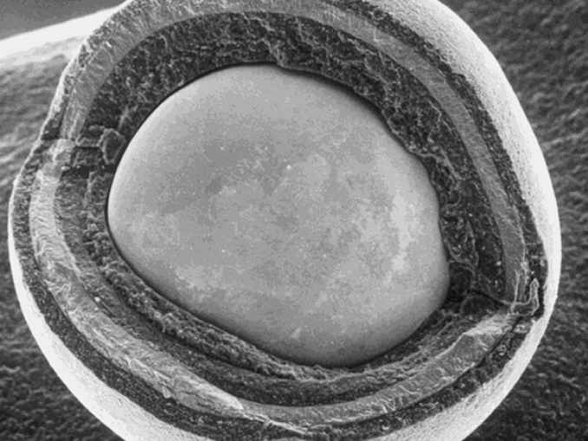
Figure 1: A cutaway of a TRISO particle, revealing the fuel kernel and various protective layers [21]

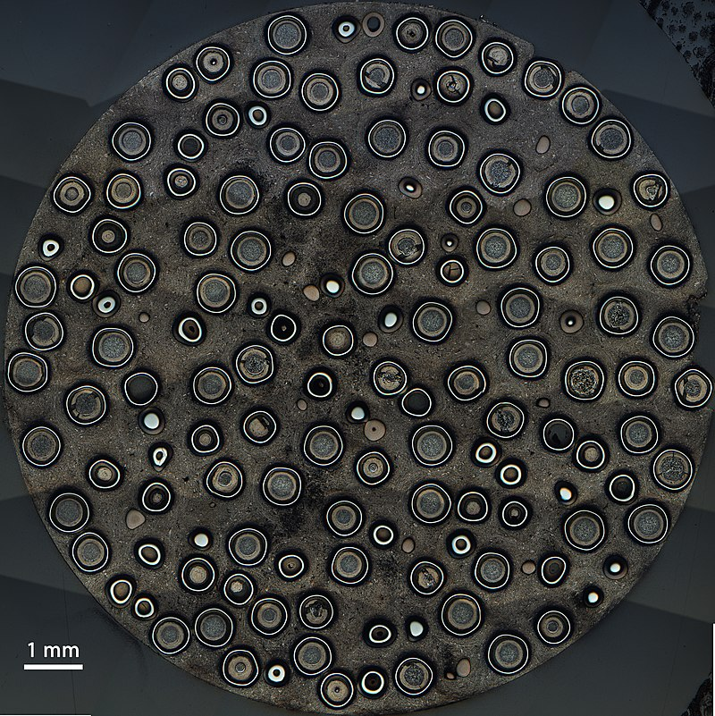
Figure 2: A cross section of TRISO particles embedded in a graphite matrix [21]

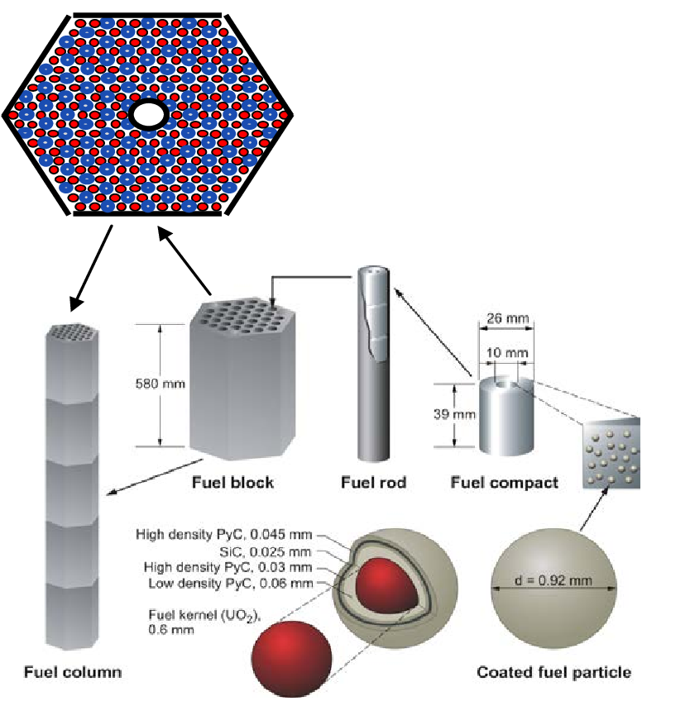
Figure 3: An illustration of the components that comprise a TRISO based prismatic fuel and column [26]

shows the composition of a prismatic block fuel element using TRISO particles [24].
Pebble bed reactor (PBR) fuels are mainly graphite pebbles with TRISO particles embedded in a graphite matrix. These tennis ball sized fuel pebbles are roughly 6 centimeters in diameters, with an inner region of 5 centimeters in diameter where the TRISO particles are embedded. The outer 5 millimeters of each pebble contains a fuel-free zone of graphite in which no TRISO particles are embedded. shows a rendering of a pebble packed with TRISO particles [25]. The fuel pebbles are loaded into a reactor in which the coolant is pumped through the regions between the
pebbles to remove heat. The pebbles are continuously removed from the bottom of the reactor and returned to the top of the reactor if they are suitable to be re-added. Initially, a fresh core of PBR fuel will have a lower average enrichment for the fuel in the TRISO particles and roughly two thirds of the reactor’s initial pebbles will be ‘dummy’ pebbles, or pebbles without any TRISO particles. The dummy pebbles and lower enrichment pebbles are used to keep the initial criticality of the core reasonable for the initial configuration. As the fuel undergoes fission over time, the reactivity of the fuel drops and the initial, lower enrichment pebbles and the dummy pebbles are replaced with ‘equilibrium’ pebbles, which contain a higher enrichment of uranium than pebbles intended for the initial reactor state [14].
PBR fuel will have a lower average enrichment for the fuel in the TRISO particles and roughly two thirds of the reactor’s initial pebbles will be ‘dummy’ pebbles, or pebbles without any TRISO particles. The dummy pebbles and lower enrichment pebbles are used to keep the initial criticality of the core reasonable for the initial configuration. As the fuel undergoes fission over time, the reactivity of the fuel drops and the initial, lower enrichment pebbles and the dummy pebbles are replaced with ‘equilibrium’ pebbles, which contain a higher enrichment of uranium than pebbles intended for the initial reactor state [14]. The pebbles act as a positive reactivity
insertion that makes up for the lost reactivity of the older, higher burnup pebbles. As pebbles are removed from the bottom of the reactor, they are subsequently checked for their burnup characteristics. If they are below some predetermined level of burnup, the pebble is placed back into the reactor and will make another pass through the reactor. If the pebble has greater than the threshold burnup, it is instead removed from the reactor and placed into a separate area for disposal [14] [23]. Figure 4 roughly illustrates the process of pebble removal, burnup measurement, then either placement back into the reactor vessel or placement into the disposal area [14].
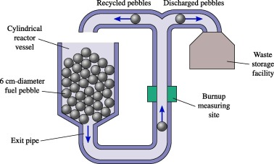
Figure 4: An illustration of the process for determining if pebble fuel is to be discharged or recycled from a pebble bed reactor [24]

Fully ceramic microencapsulated (FCM) fuel is a TRISO based fuel concept in which TRISO particles are packed into a dense silicon carbide matrix with either stainless steel or silicon carbide acting as the fuel cladding, replacing the traditional zirconium-alloy fuel cladding. Figure 5 illustrates the FCM fuel concept. The use of silicon carbide as the fuel’s matrix material provides for a high melting temperature, high thermal conductivity, a high degree of
a high degree of radiation resistance, and a very robust barrier to fission product release [26]. Notably, the silicon carbide matrix also greatly reduces the mobility and diffusion of isotopes that are present in spent TRISO particles. FCM fuels have the potential to act as drop-in replacements to current UO₂ ceramic fuels.

Pebble Bed Reactor History and Operations
The advantages of high temperature gas reactors and TRISO based fuels are numerous. The reactor type is effectively incapable of melting down, has additional barriers to prevent the release of fission products, is much more efficient due to its high operating temperatures, and has a multitude of safety features [14] [23]. The first high temperature gas reactor constructed and tested was the Dragon test reactor, constructed in the United Kingdom and operated from 1964 to 1975. The Dragon test reactor operated at 20 megawatts thermal (MWth) and used prismatic block fuel elements. Proceeding with the Dragon reactor, a pair of lower power reactors were
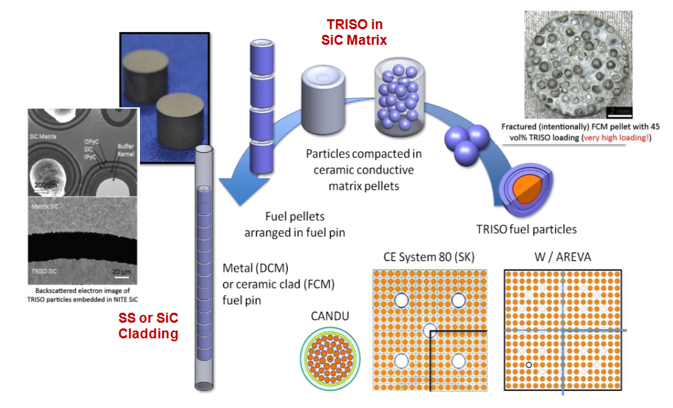
Figure 5: FCM Fuel manufacturing process

built. The first was the 115 MWth Peach Bottom Unit 1 reactor built in the United States. Peach Bottom Unit 1 operated from 1966 to 1974 and utilized a prismatic core with cylindrical fuel elements. The other reactor constructed in this time was the AVR reactor in Germany. The AVR reactor used a pebble-bed core design and operated from 1967 to 1988. The Peach Bottom Unit 1 and AVR reactors both successfully implemented the ability to produce electricity using the Rankine cycle. The low power AVR and Peach Bottom Unit 1 reactors were followed by the medium power Fort St. Vrain reactor (FSV) in the United States and the THTR reactor in Germany.
The FSV reactor operated at 842 MW(t) from 1976 through 1989 using a prismatic core design and the THTR operated at 750 MW(t) from 1985 through 1991 using a pebble-bed core design. Two additional reactors were constructed since then. The HTR-10, a 10 MWth pebble-bed reactor was constructed in China in the year 2000 and is currently operating today. The other is the HTTR, a 30 MW(t) prismatic block-based reactor constructed in 1998 in Japan. It was shut down in 2011 for a planned inspection and has sat idle since then [27] [28].
Beginning in the 1970s, prismatic block designs derived from the FSV technologies were developed and construction permits for said designs were submitted to the NRC and pursued by utilities. The regulatory process, including the NRC reviews for regulatory matters and the construction permit safety evaluation were actively pursued prior to the cancellation of the reactors near the end of the 1970s [27] [28].
By the 1980s, the German company INTERATOM, now Siemens, developed a new pebble-bed design with a reactor design that could remove heat passively, removing the requirement that pebble-bed reactors have an emergency cooling system for the reactor cores. In earlier designs, the pebble-bed design was optimized for neutron efficiency and leakage reduction. The newer design changed the height to diameter ratio to allow for the decay heat to be removed from the system passively at the cost of neutron leakage and higher core flow resistance. These changes carried over into more modern designs and the new safety aspects were preserved [27] [29].
In 1984 the modular HTGR concept originated due to the United States congress asking for the HTGR industry to produce safer and simpler nuclear reactor designs. The stated goal was to create an economically feasible reactor design implementing passive safety features. To meet these goals, in 1986 a consortium headed by the Department of Energy produced a report detailing a prototype design for a modular HTGR. The reactor size was limited, and the power capacity was limited to 250 MWth to preserve the TRISO particles structural integrity. The smaller size and lower power design was deemed to not meet the requirement that the reactor be economically competitive, so an annular cylindrical geometry was embraced, and a limit of 600 MWth was reached. The annular core design that arose from this coupled with the experience and knowledge produced by the German designs became the basis of modern HTGR designs [27] [28] [29].

Spent Nuclear Fuel Parameter Relationships in LWR Fuel

Spent Fuel Policy and Current Waste Management
In the United States, spent nuclear fuel is currently the federal government’s responsibility as mandated by the Nuclear Waste Policy Act of 1982 [30]. Currently the strategy used to manage spent nuclear fuel in the United States is to place spent fuel in safe containers and leave them in monitored areas at the reactor site while pursuing an eventual geologic repository for final disposal.
As of 2019, the United States has roughly 86,000 metric tons of commercial spent fuel and is growing at a rate of 2,000 metric tons of spent fuel annually for the coming decade. At the end of currently licensed reactors’ lifetimes in the 2030s, there is expected to be roughly 140,000 metric tons of commercial spent fuel in the United States [31] [32]. The impact of adding spent PBR fuels to the United States spent fuel inventory is complex, as PBR fuels are unlike any spent commercial fuel currently stored [33].
Compared to traditional LWR spent fuel, spent PBR fuel has a much lower density of spent fuel in its waste form, as PBR fuels are mostly graphite, only containing 7-9 grams of uranium per pebble [34]. Due to this low density of fissile material, the spent volume grows accordingly. In fact, spent PBR fuel would take up roughly 10 times more volume per unit of energy produced when compared to LWR fuels [35]. Accounting for the volume alone can be somewhat misleading, as the limiting factor for final disposition is not volume, but a more complex combination of total fissile mass and burnup. According to the license of Yucca Mountain, the former destination for spent fuel in the United States, 70,000 Metric tons of spent fuel is permitted in the license. The is impacted by burnup, cooling time, and heat generation among other considerations. TRISO based fuels and their characteristics are not in the license under commercial spent fuels but are accounted for in the first tier grouping for DoE spent fuel, namely the Fort St. Vrain and Peach Bottom Unit 1 spent fuels [36].

Spent Fuel Regulations and Safety
There are currently several regulations and guidelines for the management of
spent nuclear fuel. The regulations are written with a singular key goal of preventing radioactive release and exposure to the public and environment. For the storage of spent fuel, recommendations and rules have been set forth by the NRC to accomplish the goals of minimizing exposure [37] [38]. The packages for spent fuel must undergo a great deal of testing to ensure the fuel will maintain a subcritical configuration, maintain a dose to the public under a specific threshold, and not release any material under accident conditions [39] [40].
Previous work has been performed to analyze the transportation of highly enriched fuel [41]. Due to the choice of analyzing the Versa-pac, which is licensed for up to 100% enriched uranium metal, TRISO based fuels were not examined due to the license limit being based on the total mass of fissile content in the package. Some literature indicates that there is a need for newly designed packages to accommodate the unique nature of TRISO based fuels to meet the requirements for storage and transportation [42]. The NRC has gone as far as to acknowledge that there are significant knowledge gaps present in the transportation and storage of both fresh and spent TRISO based fuels [1].
Previous work has been performed to analyze the transportation of highly enriched fuel [41]. Due to the choice of analyzing the Versa-pac, which is licensed for up to 100% enriched uranium metal, TRISO based fuels were not examined due to the license limit being based on the total mass of fissile content in the package. Some literature indicates that there is a need for newly designed packages to accommodate the unique nature of TRISO based fuels to meet the requirements for storage and transportation [42].

Isotope Composition vs. Burnup and Enrichment
LWR SNF characteristics are strongly influenced by how the fuel was used in the reactor. Key parameters include the fuel’s burnup and its initial enrichment. These factors affect the SNF’s isotopic composition, which in turn determines the discharge characteristics such as decay heat and radiation dose rates from the fuel. Over the last two decades, typical LWR fuel enrichment levels have risen, up to 5% U-235 and assembly average burnups have increased into the range of ~60–70 gigawatt days (GWd) per metric ton of uranium (MTU) [43]. Higher burnup and enrichment yield higher decay heat and greater production of transuranic nuclides in SNF [44]. Understanding the quantitative relationships between reactor operations such as burnup and enrichment vs. SNF characteristics is crucial for safe and efficient fuel storage, transport, and disposal. Recent studies, both measured and simulated, have refined these relationships. Below, the author summarizes how burnup and enrichment affect LWR SNF isotopic composition, decay heat, and radiation dose, highlighting key data trends and findings from the last decade.

Burnup Effects
As fuel burnup increases, the isotopic inventory of SNF changes significantly. Higher burnup means more fission events and consequently a greater accumulation of fission products and transuranics. While fuel isotopes are consumed, the same neutron exposure causes other actinides like Cm-244 to breed and accumulate. Minor actinides like americium and curium are produced via neutron capture and beta-decay processes. Post-irradiation assays confirm these trends: higher burnup fuel has significantly less remaining U-235 and much higher amounts of plutonium and minor actinides [45]. For example, plutonium content in discharged fuel might rise from only ~1% to several percent of heavy metal at high burnups, accompanied by correspondingly higher actinide inventories. Most fission products also scale with burnup; notably, long-lived fission products like Cs-137 and Nd-148 accumulate roughly in proportion to the number of fissions and thus serve as classic burnup indicators in destructive analyses [46]. In fact, Nd-148, a stable fission product, has historically been used to determine burnup because its concentration is nearly linear with total fissions. Cs-137 is similarly used in gamma spectrometry methods, as its activity correlates with fuel burnup [44]. Measured data and simulations show that increasing assembly average burnup from ~13 GWd/MTU to ~22 GWd/MTU, a ~70% increase, raises the total gamma emitting inventory by about 50% [47], underscoring the roughly linear growth of many fission product inventories with burnup.

Actinides and Burnup
Minor actinide production, especially curium production, increases more dramatically with burnup. Cm-244 with a half-life of ~18 years is a key burnup-dependent nuclide. It is produced via neutron capture on Am-241 and subsequent reactions which occur to a greater extent at high burnup. Studies have identified Cm-244 as an excellent burnup indicator because its accumulation accelerates with higher burnup [48]. In contrast to fission products, curium grows non-linearly: for example, one report noted that doubling burnup from ~45 to 100 GWd/t results in about a four-fold increase in the specific activities of Pu-238 and Cm-244 in the spent fuel [48]. The response of several actinide species to burnup has been previously establish is and is well documented [49]. This exponential sensitivity of the curium inventory to burnup has practical consequences. Neutron emissions from Cm-244 at high burnup make it a useful proxy for burnup in nondestructive assay but also pose challenges for shielding and storage of high burnup fuel. Modern simulation studies (e.g. using ORIGEN and other depletion codes) corroborate these trends and provide fitted correlations. A recent analysis produced a simple power-law equation relating assembly burnup to neutron detector count rate due to Cm-244, enabling burnup verification via fork detectors [48]. Such nondestructive methods leverage the strong burnup dependence of curium’s neutron emissions.

Enrichment
The fuel’s initial enrichment influences isotopic outcomes primarily by altering how the burnup is achieved. At a given final burnup, a lower initial enrichment means more of the energy came from converted plutonium relative to U-235 whereas a higher enrichment fuel relies more on direct U-235 fission. Consequently, for the same burnup, lower-enriched fuel tends to end up with higher plutonium and minor actinide inventories as more conversion to Pu-239 is required to produce the same energy. Analyses have noted, for example, that at fixed burnup and cooling time, assemblies with lower initial U-235 enrichment produce a stronger residual neutron source than those with higher enrichment [50]. This is attributed to increased Pu and Am production in the lower-enriched case from a higher fraction of U-238 being present, leading to more Cm-244 buildup [51]. In contrast, fission product inventories, mostly gamma emitters, are tied mostly to total fission count and are less sensitive to whether those fissions came from U-235 or Pu-239. Thus, the primary effect of higher enrichment is enabling higher achievable burnups; differences in isotopic composition at identical burnups are second-order, affecting chiefly the actinide vector [51].

Decay Heat vs. Burnup, Enrichment
Decay heat is produced by the radioactive decay of unstable fission products and actinides in SNF after reactor shutdown. Just after shutdown, decay heat is a few percent of the reactor’s prior power, but it diminishes over time as short-lived nuclides decay. In LWR spent fuel, the major contributors to decay heat depend on the cooling period:
- Short cooling (months to years): Very short-lived fission products drive short-term decay heat, such as Pr-144 and Ru-106.
- Intermediate times (decades to century): Fission products with medium half-lives, notably Cs-137 and Sr-90 decay chains provide the bulk of decay heat. These two isotopes and their decay chains are beta emitters that account for a large fraction of heat in the first decades after discharge for LWR fuel. Cm-244 also contributes significantly to heat in the first few decades as well, especially for high-burnup fuel where their amounts are large [48].
- Long times (centuries and longer): The decay of actinides (e.g. Pu-239, Pu-240, Am-241) and their daughters become important as fission product activity diminishes. Pu-241 decays to Am-241, which with its long half-life is a dominant heat source in SNF on the scale of centuries.

Burnup and Decay Heat
Because higher burnup fuel generates more fission products and actinides, it will have higher decay heat at discharge and at subsequent times (for equal cooling intervals). Decay heat roughly scales with the number of fissions that occurred, so as a first approximation it increases nearly linearly with burnup for a given cooling time [48]. In other words, doubling the burnup of an assembly under identical conditions will approximately double the heat output after a fixed cooling period, although actinide buildup at high burnup can cause some deviation from strict linearity, notable for PBR SNF. A recent NEA review noted that decay heat per unit energy generated is fairly constant across burnup, implying that total decay heat is proportional to total energy output [44]. For example, calculations compared a “low burnup” UO₂ fuel (~34 GWd/t, from the 1990s) to a “high burnup” case (~62 GWd/tMTU, more enriched, from 20 years later): the higher burnup fuel showed significantly greater decay heat at cooling times from 1 to 100 years, on the order of ~30–50% higher heat output in that interval. For engineering purposes (pool cooling, cask design), the discharge to 100-year timeframe is of most interest, where differences due to burnup are most pronounced.

Enrichment and Decay Heat
Initial enrichment per se has a minor direct effect on decay heat if burnup and cooling time are held constant. The dominant factor is how much burnup was achieved. However, enrichment can indirectly influence decay heat by enabling higher burnups or different fission splits. At equal burnup, a fuel that started at lower enrichment will have slightly more decay heat coming from transuranics, as more Pu was produced and remains in the fuel, versus fission products. Conversely, a higher-enriched fuel might have a bit more fission product contribution (from greater U-235 fission fraction). In practice, these differences tend to cancel out in terms of total decay heat. Regulatory guidance often couples enrichment and burnup; for instance, one NRC regulatory guide limits the analyzed burnup to about 14 times the initial enrichment in weight percent (wt%) U-235, recognizing that higher enrichments are intended for higher burnups. As modern fuels push above 5% enrichment and toward burnups of ~70 GWd/MTU, the resultant decay heat is correspondingly larger, necessitating updates in decay heat estimation methods [44]. One notable distinction is MOX fuel. Nonetheless, for typical LWR fuel, one primary relationship holds: higher burnup = higher decay heat at any given cooling time of interest. Empirical and simulated decay heat curves consistently show this trend [44]. Therefore, reactor operators and waste managers account for burnup when predicting heat loads.

Radiological Dose Rate Relationships
The external dose rate from spent fuel is due to its emitted radiation, primarily: gamma rays (from fission products and activated materials) and neutrons (from spontaneous fission) Gamma radiation is largely from fission products such as Cs-137 while neutron radiation comes almost entirely from spontaneous fission of heavy nuclides like Cm-244. Key nuclides for dose are the same ones discussed above: Cs-137 and Cm-244 are particularly important for long-lived gamma and neutron output, respectively.

Burnup vs. Dose Rate
Higher burnup fuel, having more radiative isotopes, produces higher unshielded radiation fields. Gamma emission tends to increase roughly proportionally to burnup, while the neutron source tends to increase non-linearly [50]. This means the neutron dose component of SNF becomes significantly more pronounced at high burnup. For a spent PWR assembly with low burnup (~20 GWd/MTU), the neutron output (from a small amount of curium) is relatively low, and the dose around the assembly is dominated by gammas from fission products. For a high burnup assembly (~60 GWd/MTU), the curium content is many times higher, and neutron radiation can rival or exceed the gamma component in importance, especially after enough cooling time that short-lived gamma emitters have decayed.
Studies of dry cask storage confirm that dose rates rise with burnup. One shielding analysis noted that the neutron source, and thus neutron dose, for a fuel loaded in a cask is extremely sensitive to burnup, requiring much more shielding for high-burnup SNF [48]. Indeed, by 100 GWd/MTU the fuel source strength is about 4 times higher than that at 45 GWd/MTU, directly translating to higher neutron output. Consequently, cask designs or loading patterns may need adjustment for high burnup fuel. The IAEA has reported that as burnup increases, if spent fuel cannot be “diluted” with lower-burnup fuel, the allowable quantity per waste package might have to be reduced to stay within dose and heat limits [48]. In practical terms, an assembly with twice the burnup might produce significantly more than double the dose rate at the same cooling time, largely due to the neutron component.

Enrichment vs. Dose Rate
As previously discussed, initial fuel enrichment influences the radiation source term indirectly via isotopic composition. The reason is the same as for dose rates, lower enrichment leads to more plutonium and curium for the same burnup, boosting the neutron activity. For example, a calculation might find that at 45 GWd/MTU burnup and 10-year cooling, fuel that began at 3.5% enrichment yields a higher neutron dose rate outside a transport cask than fuel that began at 4.5% due to differences in Cm-244 [50]. On the other hand, gamma dose is mostly insensitive to initial enrichment at fixed burnup, since it depends on fission products that are a direct function of burnup [52]. Thus, when assessing shielding or radiological risk, one must consider both burnup and enrichment together. Regulators sometimes specify “source terms” for design basis fuel – for instance, assuming a maximum burnup and minimum initial enrichment to be conservative for neutron output.
In storage and transport scenarios, spent fuel assemblies are always heavily shielded whether by water in spent fuel pools or by steel/concrete in shielded casks. ORNL analysts examined various burnup/enrichment combinations for transport casks and found that the dose rate at 2 m from the cask could approach on the order of 0.1 mSv/h (10 mrem/h) for high-burnup, short-cooled fuel, even with shielding and that neutron dose increases with burnup both in absolute terms and relative to gamma dose [53]. The key point is that high burnup fuel contains a much more intense radiation source.

Modeling of PBR Fuel
One of the earliest comprehensive codes for pebble bed reactor analysis is VSOP (Verbundcode für Standardisierte Rechenprogramme zur Auslegung von Hochtemperaturreaktoren). Primarily developed in Germany for high-temperature gas-cooled reactor design, VSOP is a suite of coupled neutron physics and thermal-hydraulics codes that applies a deterministic approach to solve neutron transport equations and incorporates models to handle the unique geometry and burnup patterns in a pebble bed reactor. VSOP’s main advantage lies in its integrated treatment of core physics and thermal hydraulics in a single package, enabling reactor designers to iterate within one software environment. However, VSOP’s deterministic solver poses limitations in accurately modeling the random packing of pebbles and the strong heterogeneity introduced by TRISO particles. Additionally, computational approximations within VSOP can lead to moderate inaccuracies in complicated geometric regions or depletion scenarios. Despite these shortcomings, VSOP has proven useful in conceptual reactor designs, equilibrium core calculations, and scoping studies [25] and is not uncommon to see published VSOP results as a verification benchmark for other modeling software [54] [55].
PEBBED (Pebble Bed Dynamics) was another early attempt to capture the dynamic aspect of pebble flow and burnup [56]. It sought to represent the continuous fueling process in pebble bed reactors, where pebbles are inserted at the top of the core and removed from the bottom for burnup measurement and possible re-insertion. PEBBED provided simplified one-dimensional or two-dimensional representations of core geometry, often accompanied by empirical correlations for pebble flow [57]. Though PEBBED improved on some features by including a rudimentary model of burnup re-insertion, it remained constrained by limited computational resources of its time. The code primarily utilizes simplified neutron diffusion theory and coarse cross-section libraries. Consequently, while it could capture broad trends in core evolution, its fidelity and flexibility were limited compared to modern Monte Carlo approaches, but still achieved success in PBR modeling despite its limitations [58] [59].
MCNP (Monte Carlo N-Particle) is a general-purpose Monte Carlo code developed by Los Alamos National Laboratory. Originally designed for radiation transport problems across a wide range of applications, MCNP can been adapted for reactor physics, including PBRs. The Monte Carlo method offers an exact solution to the neutron transport equation, subject to uncertainties that can be reduced via sufficient sampling. For pebble bed reactors, MCNP’s capabilities are lacking in terms of explicit support, it is still capable of producing perfectly fine PBR fuel models [60] [61] [9]. While complex geometrical features, such as random pebble arrangements and intricate TRISO particle distributions, can be represented in MCNP with high fidelity, MCNP lacks native tools for streamlined TRISO particle placement and general array based methods are subject to issues of streaming paths created by the regular TRISO placement [62]. MCNP supports tallies for burnup, enabling users to simulate depletion via external or semi-integrated approaches. However, running full-core pebble simulations in MCNP remains computationally expensive, often necessitating advanced variance-reduction techniques or parallel computing environments [61].
Serpent is another Monte Carlo reactor physics code that has become particularly popular for research in advanced reactor systems. It implements a stochastic geometry routine well-suited to PBR problems and features an on-the-fly Doppler broadening approach. Serpent’s built-in burnup solver allows for higher-fidelity depletion calculations than some older codes and is more user-friendly when defining complex assemblies or random distributions of pebbles [63]. Serpent is a relatively common selection for modeling PBR fuels due to the user friendly TRISO placement methods and the robust solutions Serpent provides.
One of Serpent’s distinctive features is its geometry modeling capability with implicit geometry definitions for repeated or stochastically generated structures. While Serpent can handle large-scale simulations, performance and memory demands remain high, similar to MCNP. Nonetheless, research groups worldwide have applied Serpent to tasks including equilibrium core analysis, sensitivity studies on different pebble recirculation schemes, and parametric tests on burnup distributions in PBR cores [64].
OpenMC is a relatively newer open-source Monte Carlo code that has garnered attention due to its Python API, parallel scalability, and active development community. It offers geometry flexibility, user-friendly input formats, and a built-in depletion module, making it increasingly appealing for academic and research-oriented PBR modeling. Being open-source, OpenMC allows users to directly modify its solver algorithms to incorporate novel depletion or flow models. This extensibility is particularly relevant for pebble bed applications, where advanced features such as discrete element method (DEM) coupling or real-time fuel tracking may be beneficial [65].
The SCALE code package produced by ORNL is another code that is highly capable of solving for computational models of PBR fuel. Like with the other codes, SCALE possesses support for highly efficient methods for both modeling and running Monte Carlo transport for fuel with explicit TRISO particles. SCALE stands apart from the other mentioned code packages as it also possesses capabilities for both deterministic and Monte Carlo solution methods for the neutron transport equation. SCALE’s capabilities for modeling PBRs are well documented and there is a growing body of work utilization SCALE for modeling and analysis of PBRs and PBR fuels [7] [10] [66].
Equilibrium Core Modeling
Equilibrium core modeling is a standard approach in PBR physics to simplify the complexities of a continuously fueled reactor. In an equilibrium core state, the spatial distribution of fissile isotopes and fission products is assumed to have reached a steady pattern after many pebble passes. By focusing on this long-term, steady-state configuration, analysts can estimate key reactor parameters, such as the power distribution, k-effective, and fuel utilization, without being required to simulate individual pebble passes.
Codes like VSOP have traditionally used equilibrium core assumptions to enable faster computations. Deterministic solvers rely on diffusion or transport approximations, segmented into radial and axial zones where average properties are assigned. Modern Monte Carlo codes can also generate equilibrium core conditions by iteratively simulating multiple passes of pebble batches until isotopic compositions converge to stable profiles. This iterative method, although accurate, requires substantial computation, especially if the user employs a high-fidelity model of pebble geometry.
SCALE has been used to rapidly generate equilibrium cores for pebble bed reactors for various purposes [18]. As mentioned previously, an iterative method is used to converge to a stable isotope profile. The primary method used models a full core reactor with distinct axial zones with varying fuel composition to acquire an axial power profile, and therefore depletion history, for any pebble that passes through the core. A reflected slice model is used to converge the isotopes and neutron spectrum, determine updated axial zone compositions for the full core model to determine a new power profile, and is repeated until convergence is reached. By making the assumption that a reflected slice well approximates the neutron spectrum for the core axially, a large amount of computation is saved for a minimal loss in fidelity [16] [17] [67]. This equilibrium core method is not without its flaws, the primary one being that most models use a single fuel temperature, despite the very high thermal feedback effects that PBR fuels are known for [4] [20] [68].
Flowing Depletion Methods
Flowing depletion methods capture the continuous fueling characteristic of pebble bed reactors, wherein pebbles are cycled through the core multiple times until they reach a target burnup. Rather than assuming an equilibrium distribution, the core is sometimes discretized in time or in axial “flow slices,” and each pebble’s isotopic inventory updates as it moves through these slices. This approach can reveal localized variations in burnup, power distribution, and safety margins that would remain hidden in equilibrium models [12].
Implementing flowing depletion typically involves coupling a neutron transport solver with a pebble flow solver or approximate flow model. Deterministic codes, such as legacy PPBED or advanced versions of VSOP, often use simplified flow correlations and track an average depletion path for representative pebbles. Modern Monte Carlo codes can simulate pebbles via repeated “shuffling” or re-meshing steps, though this is computationally expensive [69]. Researchers sometimes reduce complexity by using pseudo-random or pre-computed pebble trajectories, effectively decoupling the detailed contact mechanics from the neutronics calculation.
Despite the progress made, the modeling of pebble bed reactors still confronts multiple challenges. Foremost is the correct representation of random pebble packing and its impact on neutron moderation and absorption pathways. While modern Monte Carlo codes can stochastically place pebbles and TRISO particles, the computational overhead grows significantly for high-fidelity, full-core analyses [69]. Another challenge is the coupling of neutronics with multi-physics phenomena, thermal-hydraulics, structural mechanics, and chemical processes, such as fission product release, that become particularly relevant in high-temperature gas-cooled reactors [70].
Flowing depletion remains an area in which improvements are required, particularly in bridging the scales between individual pebble collisions and the overall fueling cycle. Better approximations or more robust coupling with discrete element methods could help model pebble movement and contact forces more realistically [8]. Additionally, more data is required to validate the fluidization and flow models against experimental or operational reactor data given the relatively limited set of large-scale PBR experiments to date.
Furthermore, the development of advanced cross-section generation libraries, compatible with both deterministic and Monte Carlo methods, will be pivotal for increased accuracy in high-temperature reactor conditions. Growing interest in Machine Learning (ML) and Artificial Intelligence (AI) also opens possibilities for optimizing design parameters and bridging data gaps. These techniques can be employed to improve variance reduction, speed up Monte Carlo depletion routines, or predict flow distributions without resorting to full-scale simulations [71].

Modern Efforts
While computational modeling efforts for PBRs and TRISO based fuels are not themselves recent, the available methods made available to researchers due to the extremely rapid growth of computational resources are somewhat recent and abundant. Previous methods that would have been non-viable or too burdensome to calculate are now commonplace. Many modern codes now support the explicit random placement of TRISO particles and allow for calculations to be performed using Monte Carlo transport methods [65] [63]. Other code packages now support methods to perform cross section corrections that account for the doubly heterogenous fuel and perform deterministic multigroup transport enabling very rapid calculations for PBRs with minimal loss in fidelity [10] [11] [67] [72] [73].
A host of methods exist for modeling PBR fuel, in particular for capturing the equilibrium state of the reactor for analysis. In the calculation of the equilibrium core state, two primary approaches exist.
- Capture the “run in” by modeling the fuel cycling and depletion to arrive at the equilibrium core state.
- Perform a “jumping in” approximation to directly estimate the equilibrium core state
The running in process is beneficial in that it captures the evolution of the reactor’s characteristics as the reactor approaches an equilibrium state. The modeling of the running in process can help capture limiting states or configurations that a direct equilibrium core estimation may miss. Higher fidelity simulations in particular may incorporate feedback effects, discrete element modeling (DEM) calculations to determine pebble positions, local temperatures, thermal feedback effects, and individualization of pebbles can produce a truly high-fidelity core. However, given the expense of the calculation, it is not readily applicable to research that is not interested in individual pebble realizations or research that requires more rapid estimations of core or fuel properties.
Some research attempts to use reflected pebble models to approximate a full reactor for depletion but is known to produce errors in specific areas [18, 72]. However, the suitability of reflected pebble models in calculating bulk SNF characteristics has not been quantified or otherwise researched.
For the jumping in calculations, the benefit is that the expensive run in process does not need to be modeled, and the solution can converge directly upon the equilibrium state of the reactor. By iterating between depletion steps to converge the neutron spectrum and full core calculations to determine the depletion history.
Modern modeling efforts for pebble bed reactors have evolved significantly in the last several years, driven by the need to accurately predict reactor behavior, fuel isotopic inventories, and safety-relevant quantities in systems with circulating, stochastically distributed fuel.
One major milestone is the development of the SLICE methodology, as introduced by ORNL in the accident analysis of an FHR [17], which enables rapid estimation of the equilibrium state of PBRs. SLICE operates as a jumping in solution to the calculation of the equilibrium core state but using surrogate models, reflected axial slices to generate cross sections and estimate the neutron spectrum for the reactor and full core models to cover the depletion history of the fuel until a converged solution is achieved. The SLICE method has been successfully applied by multiple researchers [19] [74] [20] for various reasons, all with results in agreement for the same HTGR design, though all models failed to incorporate a temperature profile for the depletion history of the fuel, instead using a mono temperature assumption for the fuel’s entire history.
An extension on the SLICE method, a flowing pebble depletion capability was added to SCALE named ORIGAMI-FOLD. Later incorporated as the “fold mode” in ORIGAMI, the method utilizes pre-generated cross-section libraries using the SLICE method that are interpolated on for depletion using ORIGEN and ORIGAMI. The pre-generated libraries are generated for each radial zone, allowing users to bypass the need for costly transient modeling of each pebble’s life cycle while drastically reducing computational cost while maintaining the fidelity of the original models. It is especially valuable for its ability to generate irradiation histories and inventories with minimal user involvement as the ORIGAMI code directly handles the interpolation, fuel drift and movement, and cross section handling on the back end.
ORNL further extended this line of work in a broader SCALE 6.3 modeling campaign across five non-LWR designs, showing that SLICE and other SCALE tools could accurately compute reactivity, isotopic information, and decay heat across both HTGR and fluoride salt-cooled pebble bed systems and providing strategies for SCALE users to employ in the modeling of advanced reactors [67].
Complementing these equilibrium approaches are tools developed for full-core and high-resolution depletion. The Griffin code's equilibrium core depletion algorithm, as demonstrated by researchers at INL [55] that takes a novel approach by solving for a burnup-dependent pebble density distribution using deterministic transport and finite-element methods. Unlike traditional pass-count models, Griffin’s burnup-based formulation naturally accommodates low-pass systems and delivers fast convergence. Meanwhile, in the realm of Monte Carlo codes, researchers enhanced the Shift code to support large-scale PBR simulations by implementing double-heterogeneity handling and on-the-fly variance reduction. The improvements were demonstrated in the modeling and simulation for HTR-PM-scale reactors with high fidelity and reduced runtimes, making Shift a viable alternative to Serpent for whole-core Monte Carlo analysis [75].
Further refinements in modeling fidelity are demonstrated in the work by other researchers at ORNL who quantified uncertainties in pebble discharge burnup and isotopic inventory due to pebble motion randomness and residence time variability [76]. Using a random sampling approach coupled with SCALE’s depletion tools, the study revealed that while average burnup targets are typically achieved in ~6 passes, a statistically meaningful distribution exists in which some pebbles require 5 passes to hit the burnup target while other pebbles require 7 due to differences in flux intensity and zone-wise spectral differences. The probabilistic treatment of pebble burnup provides a framework for uncertainty-aware fuel management strategies.
Going even deeper, researchers at UC Berkley have presented a hyper-fidelity depletion model using Serpent 2, in which each pebble is individually tracked, moved, and depleted over many cycles [69]. Their discrete pebble motion model resolves per-pebble burnup and isotopic histories, capturing full distributions instead of just average quantities. This work not only validates equilibrium trends seen in lower-fidelity tools but also provides rich data for benchmarking and detailed safety analysis by allowing for the single most limiting case to be individual identified which is lost with models that rely on zone wise averages and approximations of fuel histories.
Dynamic behavior during startup, or “run-in,” is another area receiving significant attention. Researchers at INL have addressed this using a custom Python framework (kugelpy) coupled with Serpent to model the transient insertion and depletion of pebbles with realistic thermal feedback. Researchers showed that the temperature profile of the reactor significantly shapes power profiles and reactivity, emphasizing the need to include thermal-hydraulic feedback in PBR models. Their simulations achieved equilibrium values consistent with HTR-PM design data and provided practical insight into how startup behavior might affect control strategies and discharge burnup.
Beyond modeling neutronics and depletion, there is a growing emphasis on waste management and backend fuel characteristics for TRISO-based systems. Pacific Northwest National Laboratory (PNNL) researchers have performed a comparative study using SCALE to evaluate the decay activity of irradiated TRISO fuel from multiple reactor designs (prismatic HTGR, pebble-bed HTGR, and FHR), revealing that post-100-year radiotoxicity is strongly reactor- and spectrum-dependent [77]. Others expanded this line of inquiry by analyzing dose rate, criticality, and canister utilization under various TRISO fuel disposition pathways, including graphite separation and TRISO kernel immobilization. However, much of this work utilizes simplified models and approximations that may be inappropriate for the application, something this dissertation seeks to directly address.

Together, these studies illustrate a comprehensive and maturing ecosystem of advanced modeling tools for pebble bed reactors, ranging from rapid equilibrium solvers to hyper-detailed Monte Carlo frameworks. Their collective contributions lay the foundation for robust, uncertainty-informed design and licensing processes; capable of addressing the complexities of circulating fuel, temperature feedback, and post-shutdown fuel behavior with unprecedented resolution and computational efficiency.
A few notable trends have appeared in literature common among PBR modeling efforts.
- Reflected pebble models
- Mono-temperature depletion assumption
- Zone-wise averaging
For the reflected pebble models, most researchers seem to apply this method either due to unfamiliarity or due to convenience [78] [77] [79]. There is a very significant jump in both modeling effort and computational expense between utilizing a simple infinitely reflected pebble and attempting to implement the doubly iterative SLICE method. However, the SLICE method is known to account for the radial spectral effects of the reactor core, where the reflected pebble experiences a much harder neutron spectrum and as a result predicts inventories incorrectly. Additionally, reflected pebble models are often depleted by constant power, requiring an ever-increasing flux to meet the constant power requirement regardless of realism. Short term SNF characteristics are expected to be impacted the most.
Next, mono-temperature depletion assumptions are also quite common. While the temperature feedback effects on HTGR fuels are known [4] and reported to produce some differences from reference VSOP based calculations by up to ~15% [20], as well as the different power profile shape and impacts on discharge burnup [64], the mono-temperature depletion remains in use. The incorporation of a temperature profile is deemed to be the next logical step in improving the fidelity of SLICE based PBR models and is addressed later in this dissertation.
While the original version of the SLICE method did not incorporate distinct radial zones, and instead utilized depletable pebbles to capture the core averaged cross sections for the equilibrium core generation, the current version in use uses distinct radial zones to more properly capture the spectral effects due to radial position and reflector proximity [16]. Zone-wise averages are common and used to great effect in reducing the complexity while preserving fidelity by capturing local effects as regions that are influenced [64, 70, 80]. For most applications, zone-wise approximations well capture relevant reactor properties, but some details are lost when using such approximations. ORIGAMI-Fold, now ORIGAMI in fold mode, addresses the zone-wise step function issue by interpolating between the radial zone cross sections in a pre-generated library, effectively smoothing the step wise function into a smooth function, enhancing fidelity with little expense when needed. However, it still is based upon zone-wise approximations and would be incapable of producing fidelity on an individual pebble basis, though the space where such methods are required are few. Otherwise methods exist to model such situations, such as the hyper fidelity method [69].

Summary
This chapter has presented a review of the development of TRISO based fuels and a brief history of pebble bed reactor development, deployment, and operational history and the variety of TRISO based fuels and reactors were covered. Next, the known relationships of LWR SNF characteristics to known parameters were covered, setting the expectation for what PBR SNF should look like and what general rules are currently understood. Next, codes and capabilities for PBR fuel were covered, accompanied by modern efforts for modeling and simulation with their contributions noted. Common trends, assumptions, gaps, and weaknesses in the body of research were noted and are sought to be actively addressed.

CHAPTER 3: Common Methodologies Across Chapters And Dissertation Structure

In the following research conducted to answer the identified key questions pursuant to the hypothesis, several articles were written to address each individual question asked a disseminate the information to the broader scientific community. Thus, the format of the dissertation is that each chapter represents the current state of the relevant journal articles that have either been submitted or are planned to be submitted and in various stages of review.
Throughout the body of work that has become this dissertation, a common framework quickly developed with shared methodologies to provide a level of consistency within the analysis. With standard methods converged upon, each article would ordinarily possess a complete methodology that is self-contained within the article itself. However, doing so in this dissertation would require a large amount of repetition of figures and methods, as so many are shared despite the differing usage. Listed below are the methodologies that are shared across multiple articles. Within each chapter, the methods that are employed will be referenced with any difference unique to that particular chapter noted. Chapter 4 is a general exception to this rule and possesses some methods exclusive to that chapter.

PBR Fuel Modeling
For this dissertation, SCALE is primarily used for all modeling efforts. Some python scripts are used to aid in analyzing the output files, data, and presentation of information. Python scripts are also used extensively in the creation, running, interrogation of outputs, and automation of most processes. The ENDF-VII.1 252 group library with the addnux=4 parameter to expand which isotopes with transport cross sections are tracked during the depletion sequences. The fuel is modeled using SCALE’s double-het treatment, which accounts for the doubly heterogeneous nature of TRISO based fuels.
To begin the fuel modeling process, the TRISO materials are first defined in SCALE’s composition block to establish properties such as density, temperature, isotopic makeup, and composition. Non-TRISO pebble materials, such as the matrix material, pebble cladding, etc. are also defined in the composition block. The defined materials are passed to SCALE’s double-het treatment where additional information is provided, such as the number of layers and layer thickness, number of particles/packing fraction of TRISO particles. Specific fuel regions of the pebble, spacing between other pebbles, the pebble arrangement, and interstitial material are also provided. The provided parameters are then passed through SCALE’s double-het treatment where SCALE performs calculations that account for the self-shielding in the fuel mixture regions to calculate a mean cross section that can be applied to a homogeneous fuel region. This method allows for the application of multigroup transport methods, allowing for very large speedups compared to continuous energy calculations that require the explicit placement of individual TRISO particles with no notable loss in fidelity [15]. The double-het method is shown in Figure 6.
With the now homogenized fuel mixture obtained as an output, the fuel pebbles are modeled in SCALE’s geometry block consistent with the information provided to the double-het treatment method. An example of the fuel modeling process is shown Figure 7. Across this body of work, the fuel is modeled according to parameters in Table 1 and Table 2 unless mentioned otherwise. When other values are employed, the substitute values will be explicitly mentioned.

Equilibrium Core Generation
The base equilibrium core generation method employed throughout this dissertation is based on the SLICE method developed at ORNL for the US Nuclear Regulatory Commission (NRC), Office of Nuclear Reactor Regulation and Office of Nuclear Regulatory Research [17] and utilizes reactor properties established in Table 3.

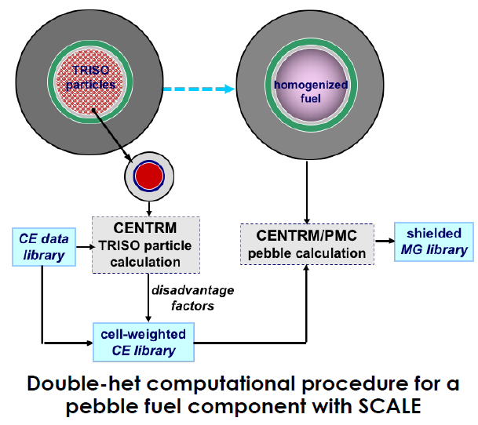
Figure 6: The double-het treatment used by SCALE [67]

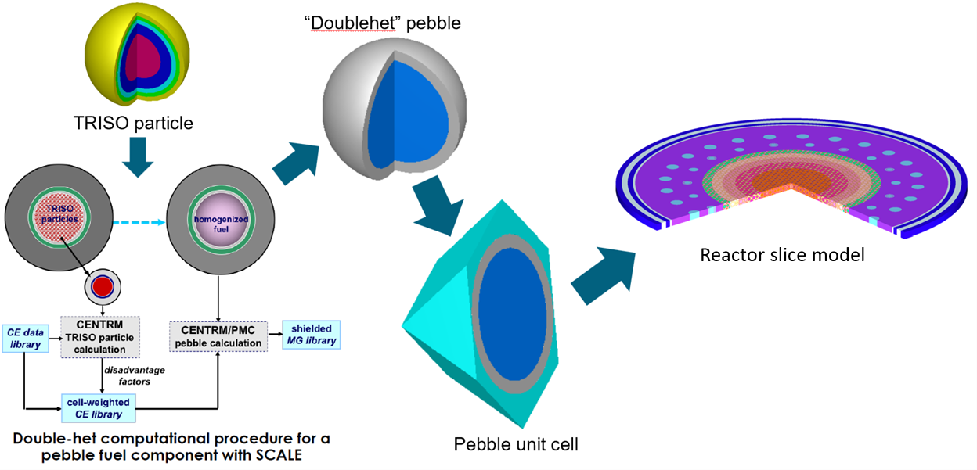
Figure 7: Diagram of the Fuel Modeling Process

Table 1: Fuel Parameters [25]
Fuel Parameters |  | Unit | Demo HTGR Fuel
Fuel Region Radius | cm |  | 2.5
Fuel Free Region Thickness | cm |  | 0.5
Total Fuel Pebble Radius | cm |  | 3.0
Unit cell inner radius (Storage/Reactor) | cm |  | 3.05 / 3.2
Graphite matrix density | grams/cm³ |  | 1.74

Table 2: TRISO Parameters [25]
TRISO Parameters | Unit |  | Demo HTGR Fuel
Fuel form | N/A |  | UCO
Fuel Density | grams/cm³ |  | 10.4
Fuel kernel radius |  | mm | 0.2125
Coating layers |  | N/A | C/PyC/SiC/PyC
Coating thicknesses |  | mm | 0.1/0.04/ 0.035/0.04
Coating densities |  | grams/cm³ | 1.05/1.9/3.2/1.9

Table 3: Reactor Properties [25]
Reactor Parameters | Unit | Demo Reactor Value
Reactor Power | MWth | 165
Fuel Specific Power | MW/MTU | 105.7
Target Discharge Burnup | GWd/MTU | 165
Active Fuel Height | Meters | 8.93
Outlet Temperature | K | 1050
Packing Fraction | % | 61
F Footnote: Many parameters are derived from visual information present in [25]

Previous work has found that the neutron spectrum in PBRs is not sensitive to the axial zone or zone-wise composition due to the long mean free path of neutrons in the core, the multi-pass fuel cycling, and the influence due to pebbles that may be further away in the reactor [4]. All these factors lead to PBRs behaving more like global systems and local effects on any particular pebble due to neighboring pebbles is reduced. The influence of distant pebbles elsewhere in the core increases relative to more localized systems, like LWRs. Consequently, pebbles are more sensitive to the radial position in the core, allowing for the neutron spectrum to be well estimated by modeling a radial slice that has reflective boundary conditions applied to the top and bottom with a core average composition, representing the global fuel average composition. To estimate the neutron spectrum, the core average fuel composition must be found first. To arrive at the core average composition and neutron spectrum a radial slice containing a layer of pebbles and a layer of bisected pebbles above and below the middle layer is modeled. The reflected slice approach assumes that the isotopic inventories of the pebbles are constant in a particular region or zone of the reactor.
To capture the radial dependent neutron spectrum, the reactor slice possesses both depletable pebbles to capture the neutron spectrum at specific locations and static, non-depletable pebbles that represent the global core average composition.
Early versions of the SLICE method have utilized a single depletable pebble placed across multiple radial zones to capture the spectral effects as a lumped average, while more recent versions employ distinct radial zones and unique pebbles to independently capture effects unique to each radial zone. Figure 8 shows a slice model, rotated slightly, to demonstrate the axial slice geometry employed The early version was largely employed for this work utilizing non-distinct radial zones, See Figure 9 for an example of such a SLICE model without distinct radial zones and a single pebble type distributed through the core while Figure 10 shows another version with distinct radial zones and depletable pebbles unique to each radial zone to more independently capture radial zone spectral effects and Figure 11 showing a labeled diagram of a 2D view of a quarter of the axial slice.
The reactor slice models possess both depletable pebbles and non-depletable pebbles. Initially, the composition of the non-depletable pebbles is fresh fuel, the same as the depletable pebbles. TRITON is run with the reactor operating parameters defined in Table 3 to generate cross sections for depletion by ORIGEN. The resulting cross sections are then used to deplete fresh
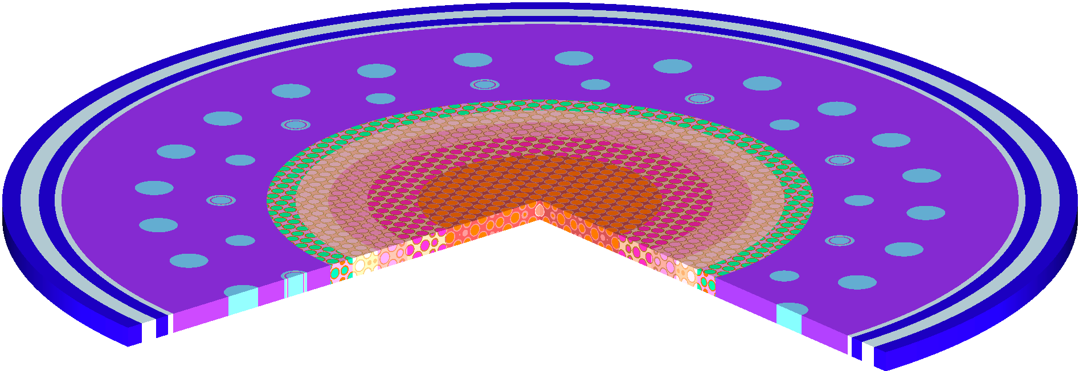
Figure 8: A slice model of the demo HTGR with 5 radial zones, rotated to demonstrate the axial slice geometry


Figure 9: A slice model without distinct radial zones or unique depletable pebbles

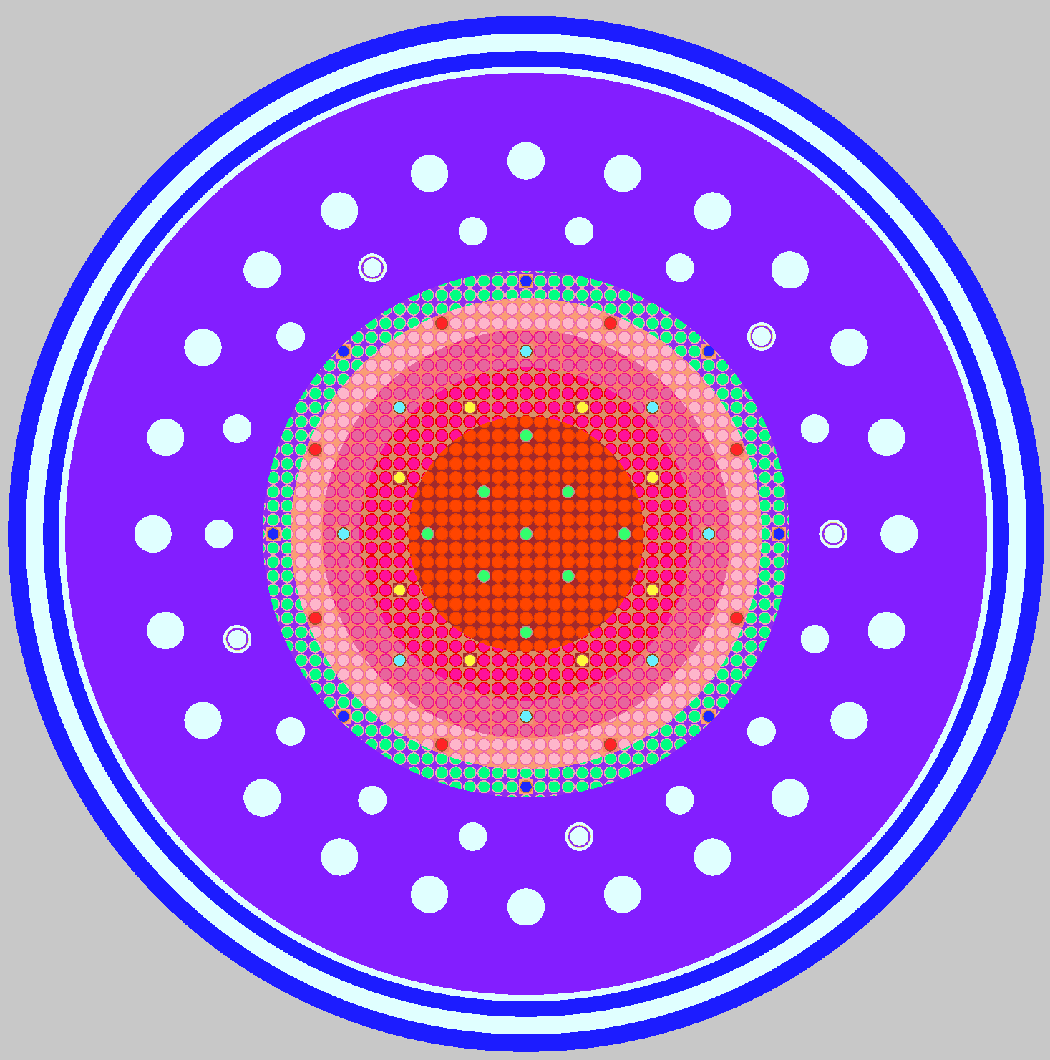
Figure 10: Top-down view of an HTGR slice model with 5 distinct radial zones

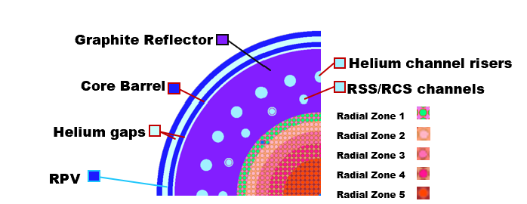
Figure 11: A labeled 2D view of the demo HTGR model

fuel in fine steps using ORIGEN and the TRITON produced one-group cross section libraries (f33 files) and depleted according to the reactor’s axial power profile, initially assumed to be flat, across the total number of times the fuel passes through the core. A core average composition is generated by taking the fuel composition at each depletion step in the depletion history and blending them into a core average composition for the fuel material used in the non-depletable pebbles. The composition of the non-depletable pebbles is replaced with the newly generated core average composition and the depletable pebbles remain as fresh fuel.
The process of depleting the depletable pebbles, generating cross sections, running the fine steps depletion in ORIGEN according to the axial power profile, determining a core average composition, updating the composition of the non-depletable pebble, and rerunning the depletion repeats until the discharged inventories of the model match very closely to the inventories from the previous iteration. The iterative process of converging the neutron spectrum via the reflected slice surrogate model is referred to as the “inner iterations” of the SLICE method.
Next, compositions are determined for each axial region of the reactor from the final fine steps depletion. Figure 12 shows a model of a demo HTGR with 10 axial zones. TRITON is run for the full core model and based upon the fission distribution in the core reported by TRITON; an axial power profile is determined. The iterative steps to determining the new power profile are referred to as “outer iterations” in the SLICE method.
The updated power profile is then used to update the depletion history used during the fine steps depletion using ORIGEN. The inner iterations and outer iterations are run until they no longer appreciably change when compared to the results of the previous set of iterations. In a typical case, between 7 and 10 iterations are required for the isotopes of interest to converge for the
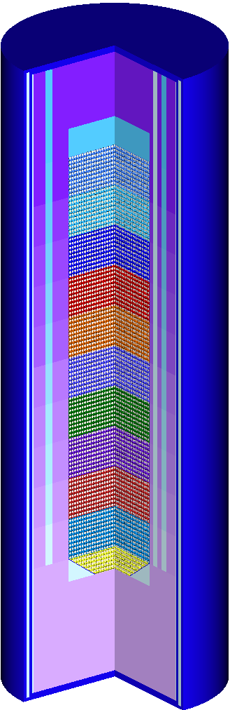
Figure 12: A full core model of the Xe-100 with 10 axial zones

inner iterations and up to 3 iterations are required for the outer iterations to converge. Figure 13 shows a flowchart of the iterative process used to produce equilibrium core estimations.
The iterative process is only valid for a single set of reactor parameters and assumes constant operation under those conditions. As the core average composition impacts the neutron spectrum and the neutron spectrum likewise impacts the core average composition produced, a new equilibrium core estimation is required to estimate for reactors of differing parameters.

Enhanced SLICE (E-SLICE) Method Modifications
With the SLICE method of estimating an equilibrium core established, a few changes are made to incorporate a temperature profile into the SLICE method. The fundamental idea is the same, to use a surrogate model that captures radial position effects on the neutron spectrum and coupled depletion of each radial zone using ORIGEN-ARP to iteratively converge on an average core composition to arrive at a stable neutron spectrum. Once this “inner iteration” is converged, zone-wise compositions are generated for the full core model and a new power profile is determined. The determination of the power profile is a step in the “outer iterations”. The depletion history used by ORIGEN is updated and the reflected slice model is started again. The process continues until both the core average composition (inner iterations) and the power profile (outer iterations) are well converged. One of the weaknesses of the SLICE method is that it assumes that material temperatures are constant throughout the depletion. While previous work has demonstrated the strong effects that fuel temperature makes when modeling HTGR fuel [4] [64], the importance of a time dependent temperature history has not been aptly quantified across all applications against an average depletion temperature assumption. As SCALE does not currently support timetable operations for temperature when the double-het method is in use, a temperature timetable is not able to be used. However, control rods are kept in an equilibrium position [25] and it is known when a pebble will have passed by the control rods.
With this information, E-SLICE accounts for control rod exposure by swapping out the control rod materials with helium in the axial zone models where the pebbles have passed the control rod equilibrium position. To incorporate a temperature profile, a unique TRITON model with adjusted fuel and material temperatures is required for each axial zone. An additional step is also required to pass the fuel composition to the next axial zone rather than assume the fresh depletable pebble composition. Another noteworthy effect largely neglected by the SLICE method is a slowing down effect where pebbles in near-wall regions exhibit longer transit times
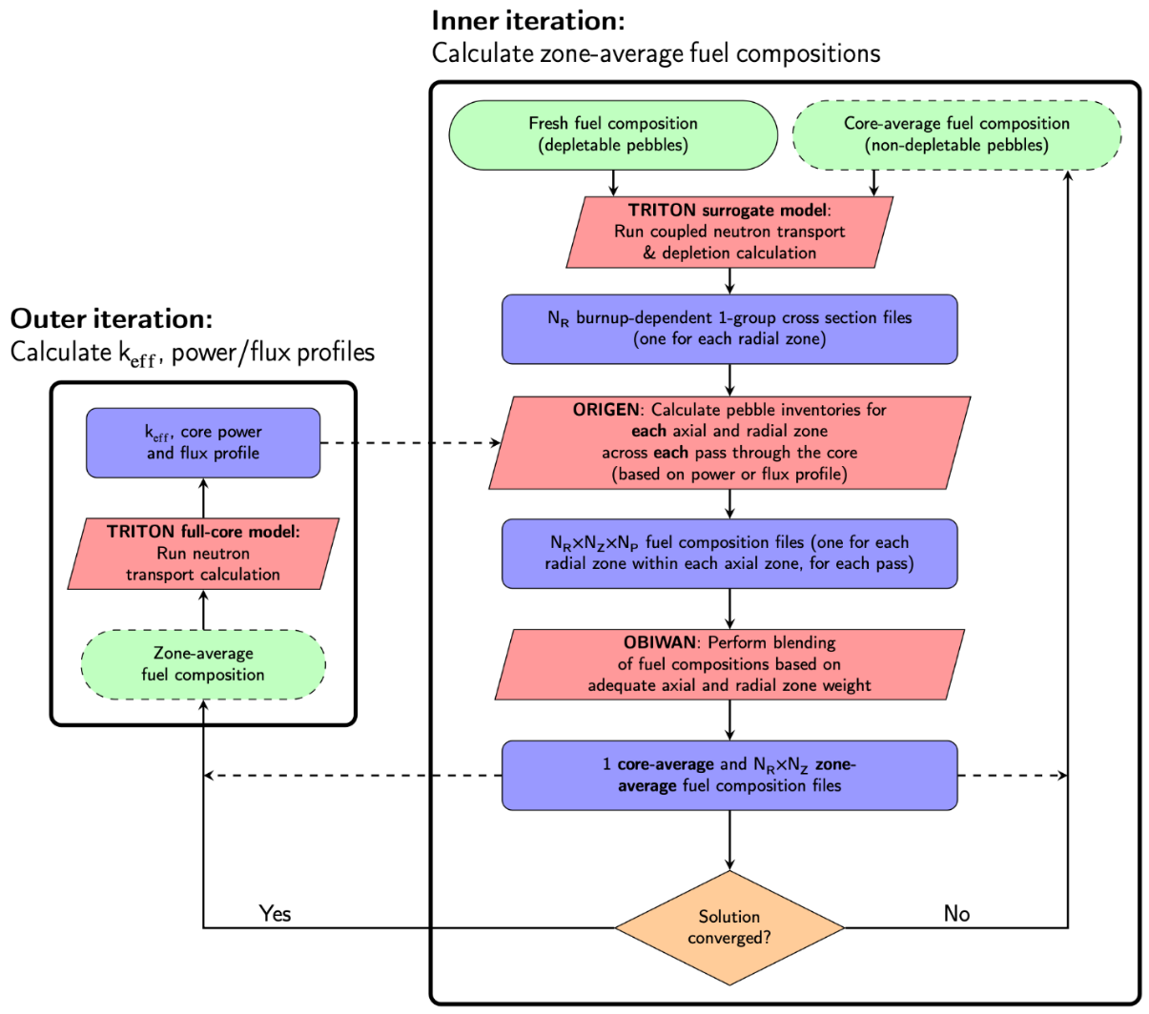
Figure 13: The iterative process to produce PBR equilibrium cores with SCALE [9]

through the reactor core, ~50%, when compared to pebbles passing through other regions [76]. To capture this effect, a wall adjustment factor is applied during the fine steps ORIGEN depletion for fuel pebbles that are passing through the near-wall radial regions. For this work, an enhanced version of the SLICE method, referred to in this work as E-SLICE, that incorporates a temperature profile and accounts for the slower movement of fuel through near-wall regions. Last, while early version of the SLICE method did not model distinct radial zones [17], newer versions do [16], and the distinct radial zones are incorporated into the E-SLICE method.
To keep the computational expense similar to the SLICE method, the E-SLICE method models each axial zone individually, weights the specific power for a given axial zone by the corresponding fractional power given by the power profile, and adjusts the fuel temperature. The fuel temperature for each zone is calculated by taking a declared operating efficiency, inlet temperature, and outlet temperature, and builds a function using python that relates the temperature gap to the efficiency. The function takes a user defined outlet temperature, calculates the required inlet temperature to meet the declared efficiency, and calculates the zone-wise temperatures by interpolating between the inlet and outlet temperature, weighted by the power profile acquired in the reactor modeling via TRITON. An additional step is taken to pass the current depletable pebble fuel composition between each axial zone and is continued until axial zone models have been run. Figure 14 shows a full core model and radial slices representing each temperature dependent axial zone.
Because the neutron spectrum in the equilibrium state is constant during the reactor operation, a python script is used to acquire the radial zone-wise fluxes for each axial zone directly from the TRITON output file. The full set of f33 cross section libraries generated by TRITON are imported into ORIGEN, one input file for each of the radial zones present with a new case block for each axial zone to pass the depletion off to the next axial zone. For the near wall regions, an increase in the fuel depletion time is applied. Each axial-radial zone combination has its corresponding flux value written to its case block by a python script. After all axial zone cases are written, a pass is complete. Additional cases are added in the same method until the desired number of passes is met, at which point the standard SLICE method workflow returns.
The E-SLICE method represents a relatively modest change to the original method, which has itself been improved upon over time. For the SNF work performed in this dissertation, the E-SLICE method is beneficial as it captures any variability introduced due to the temperature
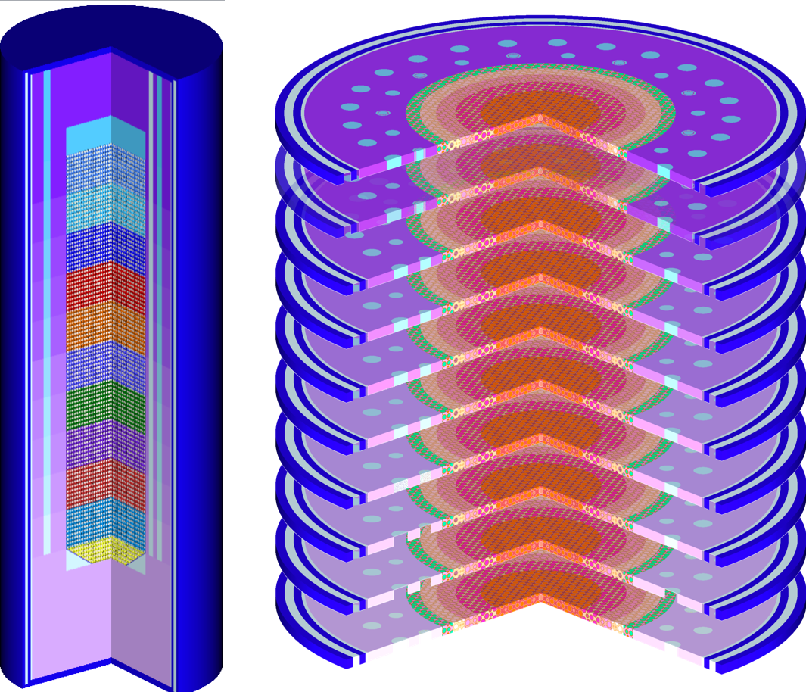
Figure 14: A full HTGR model with 10 axial zones(left), and the surrogate reflected slice models for each zone (right)

history of the fuel, time dependent control rod effects, and near-wall slowing down effects.

Possible Pebble Realization Generation
Once a final equilibrium core has been calculated, in this dissertation, exclusively by the E-SLICE method, the complete set of individual pebble realization is calculated based upon the number of radial zones and number of passes. For this work, unique pebble histories are calculated using ORIGEN, representing 5 radial zones and 6 average passes through the reactor core for 5⁶ total combinations. While a burnup measurement system (BUMS) is planned to be implemented to identify whether a pebble is to be recirculated or discarded in real world reactors, no such system is considered for this work. Many aspects arising from the stochastic nature of PBR fuel movement have already been examined [68, 76, 81] though for a different reactor model. Implementing a BUMS type function would more tightly group the system burnup by excluding pebbles that have exceeded the target burnup early and by recycling pebbles that have not met the target burnup. However, as the focus of a portion of this dissertation is to examine the uncertainty and variability introduced by the nature of the reactor’s operation, it is deemed that the additional variability is welcomed as part of this work to act as a larger uncertainty to help more fully bound the space being examined.
A dictionary of radial-axial zone fluxes is created from the final equilibrium core’s axial zone TRITON output files. A python script is employed to generate a unique ORIGEN input file for each possible set of paths through the reactor core. The script determines each possible path history and creates an input file that imports the radial-axial f33 files, then writes case blocks that passes the fuel between axial zone cases for the radial zone determined by the script for that pass, assigning the corresponding flux value for each zone pair and a wall correction effect if applicable until all radial zone histories are written to the file. Figure 15 shows a flowchart illustrating the production of the individual pebble histories.
Once the possible depletion histories have been calculated and run using ORIGEN, the resulting set of individual pebble histories are blended together into a single composition using ORIGEN to capture the impact on SNF due to the possible path differences. A python script calling OBIWAN calculates the burnups for each f71 file and calculates an average burnup for the new blended discharge composition. All individual pebble f71 concentration library files are called into ORIGEN and blended together into an average composition. The average composition is then decayed in a follow-on calculation in which ORIGEN settings are applied that allows the
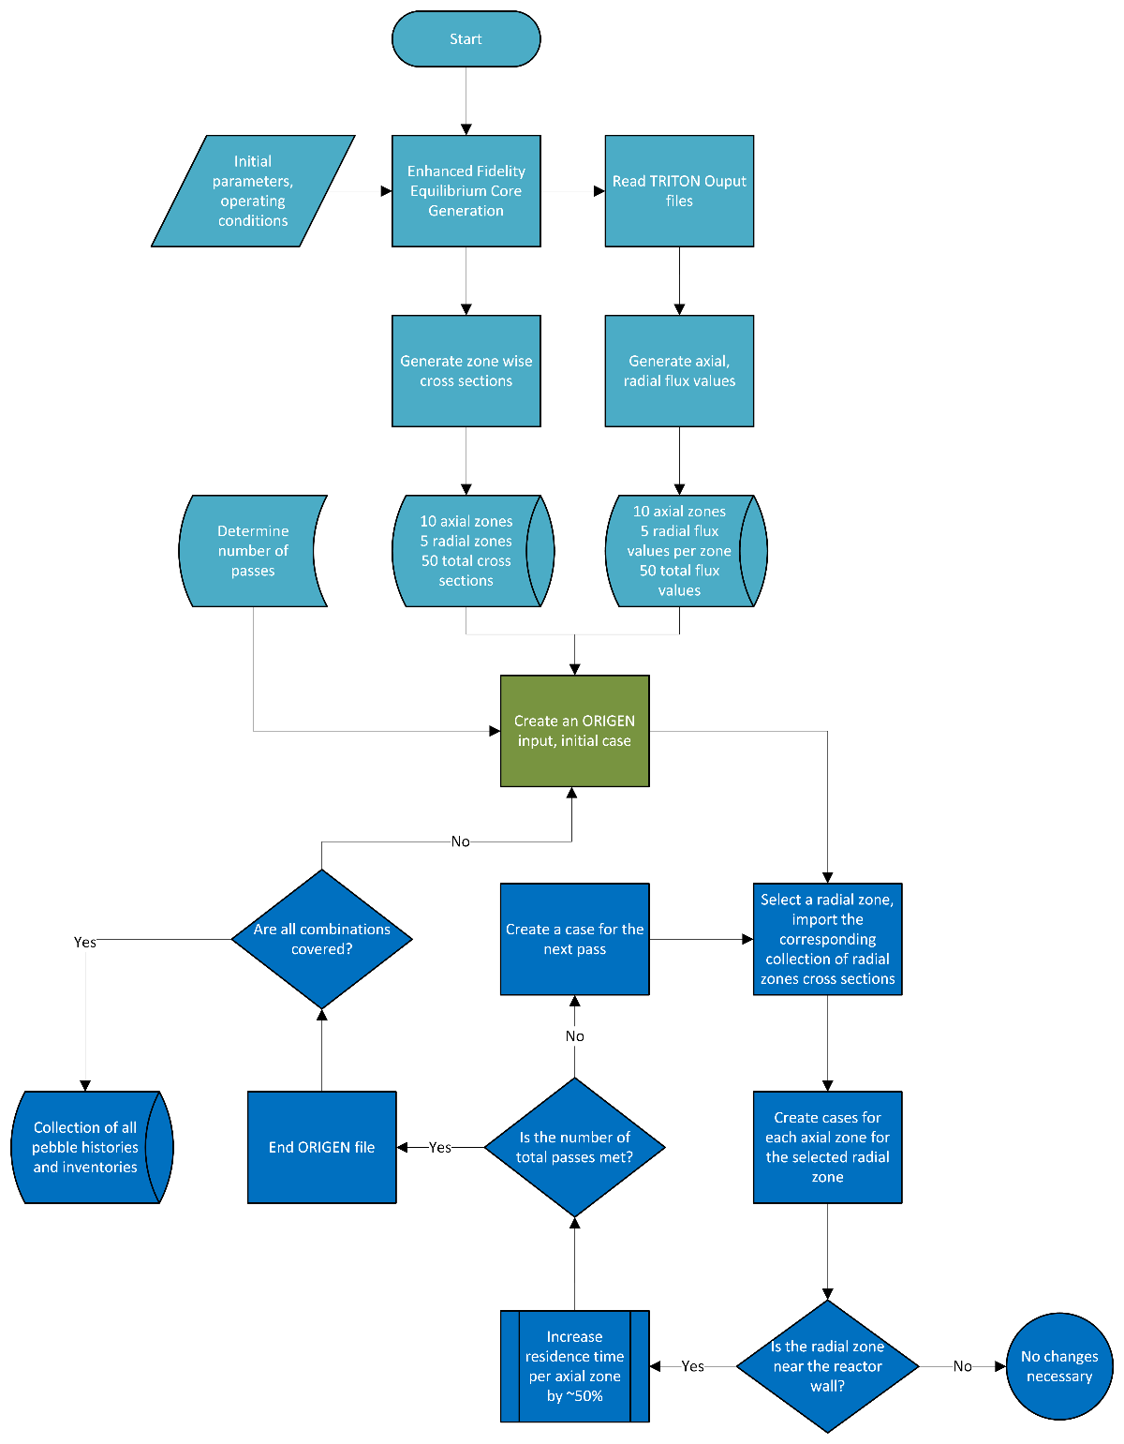
Figure 15: Process for generation of all pebble histories

resulting blended f71 file to be imported into MAVRIC to act as radiation source information and an additional OPUS block is added onto the end of the input file following the decay to write the decay heat values for each decay step to the output file. Another function is used in python to write the blended material composition into KENO input files for k-effective calculations.

Blended Average Discharge Composition
Once the possible depletion histories have been calculated and run using ORIGEN, the resulting set of individual pebble histories are blended together into a single composition using ORIGEN to capture the impact on SNF due to the possible path differences. A python script calling OBIWAN calculates the burnups for each f71 file and calculates an average burnup for the new blended discharge composition. All individual pebble f71 concentration library files are called into ORIGEN and blended together into an average composition. The average composition is then decayed in a follow-on calculation in which ORIGEN settings are applied that allows the resulting blended f71 file to be imported into MAVRIC to act as radiation source information and an additional OPUS block is added onto the end of the input file following the decay to write
the decay heat values for each decay step to the output file. Another function is used in python to write the blended material composition into KENO input files for k-effective calculations.

Criticality
PBR fuel pebbles are modeled using SCALE’s double-het multigroup treatment and placed into a large multi-purpose canister. The modeled canister will be referred to as the Generic Large Canister with properties described in Table 4. An additional meter of water is added to encompass the cask. An effective packing fraction of 0.66 is used with a center to center spacing of 3.05 cm between pebbles, a highly conservative packing fraction. Any pebble that clips into the wall of the cask is removed and replaced with interstitial material. An illustration of the loaded canister surrounded by water is shown in Figure 16.
To find the peak value for k-effective, the interstitial material is modeled as water and the density is varied between 0.0 g/cm³ and 1.0 g/cm³. KENO-VI is run to an uncertainty of under 50 percent mil (pcm) and the result of each run is recorded. A python script reads each output file, determines the maximum value, and records that value as the peak k-effective value.
When performing burnup credit k-effective calculations, the depleted fuel material is read via OBIWAN then processed to down select the composition to only include the isotopes that will positively contribute to k-effective, similar to actinide only burnup credit assumptions. Any
Table 4: Generic Large Canister Properties
Property | Generic Large Canister[82]
Geometry | Cylindrical
Radius (cm) | 94.615
Cavity Height (cm) | 429.26
Wall thickness (cm) | 1.27
Top thickness (cm) | 22.86
Bottom thickness (cm) | 7.62
Number of Pebbles | 70,983
Primary Materials | SS304

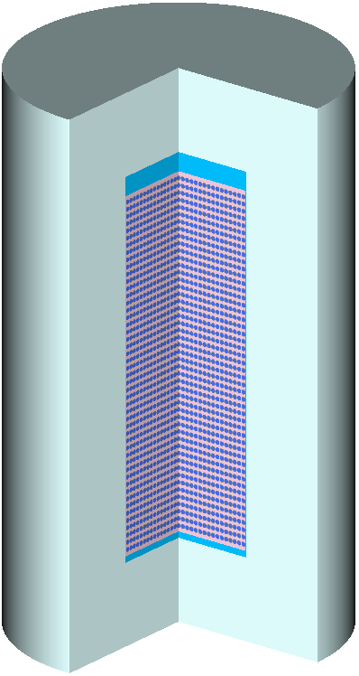
Figure 16: The loaded Generic Large Canister with water reflector

differences in implementation will be explicitly mentioned.

Radiological Dose Rate
In shielding calculations using MAVRIC, the cask modeled is the Generic Large Cask described previously. The model boundary is set to be 3 meters from the edge of the cask, and 3 detectors are placed. One is placed on the outside wall of the cask axial midpoint, acting as a contact dose. The second is placed 2 meters away from the previous point to measure the dose at 2 meters. A third detector is placed directly above the center of the lid at 2 meters. A block of concrete a meter thick is added below the cask and extends to the edge of the boundary. The remaining area outside the cask is modeled as dry air. Figure 17 illustrates the cask as modeled.
Decay times of 0.5, 1, 3, and 5 years are examined to capture both the time near discharge and early time periods when transportation is possible, but dose rates are maximal. The source strength is calculated by pulling the state information directly from the output file via python scripts and all cases are set to assume one Metric Ton of Initial Heavy Metal (MTIHM) of material is present in the cask interior. In reality the amount will be lower. The purpose is not to perform the exact dose calculation but to actively compare the upper and lower bound cases across the discharge burnup vs. the average value in the examined parameter space. Setting the source strength to 1 MTHM acts flexible set point that can be readily scaled as needed for future work. The absolute difference between dose rates is expected to diminish as time increases and become functionally indistinguishable after enough time has passed.
Gamma and neutron dose rate calculations are run separately to both speed up the calculations and to allow for comparison between neutron and gamma contributions and compare how their relative upper and lower bounds differ. Results for each detector and each cooling time are reported as a graph of each dose rate type at each cooling time examined with a lower bound and upper bound. No subcritical multiplication is considered in this calculation, so real world dose rates will require an adjustment based on the sub-critical k-effective of the cask. Likewise, coupled neutron gamma interactions are not considered. All output files are examined to verify the calculation has passed the statistical checks. If not, the number of particles and batches are adjusted, and the file is rerun.
MAVRIC is run, and dose rates and uncertainties are generated for the detectors. All dose rates reported are in units of mrem per hour. Both gamma dose and neutron dose are reported for each of the time decay times and for each detector present.
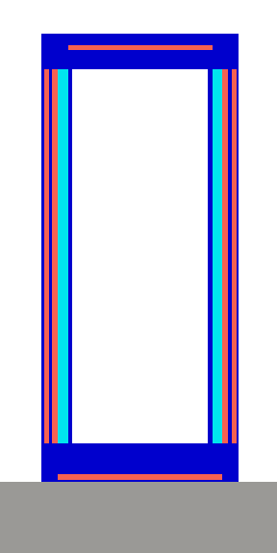
Figure 17: The Generic Large Cask model

Decay Heat
For decay heat, a follow-on decay calculation to the average discharge composition is performed covering 0.0, 0.5, 1, 3, 5, 10, 30, 50, 70, 100, 300, 500, 700, and 1000 years of decay time. The times selected spans everything from early term near discharge to long term decay heats. As the dominant isotopes that drive decay heat change significantly over time, the variation of time steps seeks to capture all relevant SNF time scales. The total decay heat for each cooling time step calculated is printed to the output file via OPUS. The results are then read via a python script and recorded, then plotted.

CHAPTER 4:
Examining Spent PBR fuel under NRC Standards for Storage and Transportation

A version of this chapter is planned for submission for a future journal article and is currently under review. It is largely a consolidation of previously published conference papers, sorted, organized, and refined and updated as necessary. Jonathan F. Wing is the sole content author with peer review contributions from the following: G. Ivan Maldonado, Gordon M. Petersen, Robert A. Joseph.

ABSTRACT
Spent Tri-Structural Isotropic (TRISO) based fuels have a strong track record in storage and transportation without documented incident. This work seeks to reduce uncertainty to aid in more informed spent fuel management of TRISO based fuels, specifically pebble bed reactor (PBR) fuels by modeling both fresh and spent pebble bed reactor spent fuel and comparing the results to the regulatory standards from 10 CFR part 71. SCALE is used for all modeling due to fast and accurate methods for handling PBR fuel modeling, as well as having an efficient method for shielding calculations in Monaco with Automated Variance Reduction using Importance Calculations (MAVRIC), which utilizes the Consistent Adjoint Driven Importance Sampling (CADIS) and Forward Weighted CADIS (FW-CADIS) methods. KENO-VI is used for all criticality calculations, TRITON and the Oak Ridge Isotope Generation code (ORIGEN) are both used for depletion of the fuel, and MAVRIC is used for shielding calculations.
For criticality assessments, this study focuses on the requirement that the value of the neutron multiplication factor, k-effective (k-effective), to not exceed a peak value of 0.95 including uncertainty with 95% confidence. Criticality is initially examined by modeling fresh fuel from three different designs; the HTR-10 fuel, the PBMR-400 fuel, and demonstration fuel representative of a TRISO-fueled modern HTGR design henceforth referred to as “demo HTGR” and placing them into various sized containers with conditions described in 10 CFR part 71 to quantify the peak k-effective state. When the peak value of 0.95 k-effective is exceeded, mitigation methods are examined in those scenarios. Burnup credit, pebble displacement in areas of strong neutron multiplication, and random pebble replacement using pebbles of various composition and replacement fractions are examined. In summary, criticality of PBR fuels can be well accounted for by restricting container size, taking credit for burnup, or by displacing/replacing pebbles.

For dose rate aspects, Nuclear Regulatory Commission (NRC) regulations require a maximum dose rate of 10 millirem per hour (mrem/hr) at 2 meters. In examining the dose rate behavior of spent PBR fuel, the representative demo HTGR fuel is modeled exclusively due to it possessing the highest target burnup of the examined fuels. Equilibrium cycle modeling methods are used to produce higher fidelity discharge isotopic composition than simple assumptions such as reflected pebbles. The discharge composition is used as a source term in fixed source transport shielding calculations and dose rates are calculated at 2 meters for the shortest possible cooling time. The low concentration of fuel material leads to dose rates that are in line with regulatory limits, despite the high burnup when compared to traditional light water reactor (LWR) fuels. The methods employed in this study would require more work to further verify and validate and are limited to the criticality and dose rate analyses performed.

INTRODUCTION
Nuclear power continues to evolve as a key energy source, with ongoing research focused on refining both reactor design and fuel cycle management. One promising approach involves the use of TRISO (TRi-structural ISOtropic) particle fuel. In this design, small fuel kernels are encapsulated by three layers of carbon and silicon carbide, providing robust containment of radioactive materials [83]. These TRISO particles can be embedded into graphite pebbles and used in Pebble Bed Reactors (PBRs), which benefit from low power densities, excellent resistance to radiation damage, and outstanding tolerance for high temperatures—qualities that make meltdown scenarios virtually impossible [84]. Moreover, decades of operational experience have demonstrated the reliability of spent TRISO fuels: for example, TRISO fuel compacts and blocks have been stored safely in dry storage at facilities such as INL and the FSV Independent Spent Fuel Storage Installation (ISFSI) for nearly 40 years without documented incidents, and similar successes have been noted in Germany with TRISO SNF in pebbles following the decommissioning of AVR [85].
While past experience with TRISO based fuels indicates the feasibility in managing TRISO SNF, advances in fuel materials, reactor operations, new reactor designs, and fuels targeting high burnup and power utilization introduce uncertainty. This uncertainty contributes to conservatism that is used in analyses for management of TRISO based SNF. Although existing licensed storage casks have demonstrated safe performance, reducing uncertainties in these areas could lead to more efficient management of SNF. Furthermore, using modern computational tools to re-examine criticality safety and dose rate assessments can provide a more refined understanding of the conditions under which TRISO fuel is managed.
This study seeks to evaluate spent PBR behavior in the context of the storage and transportation requirements found in10 CFR 72 and 10 CFR 71, which establishes the requirements for spent fuel storage and transportation in the United States [86]. Notably, this study seeks to identify what the bare minimum mitigation required is to meet regulatory guidance under the worst case, albeit non-credible scenarios for criticality and shielding. It is not intended to act as an evaluation of specific canisters or fuels. Quantities identified as prescribed limits include restricting the peak value of k-effective to below 0.95 under the most reactive conditions with 95% confidence. This includes effects such as potential fuel movement, different flooding fractions of a container, no accounting for any burnable poisons, burnup credit, or fixed absorbers. Additionally, a meter thick cylinder of water is assumed to surround the package to act as a neutron reflector. Conservative assumptions are used to account for items that may be more difficult to model, such as fuel movement or shuffling. Regarding dose rates, this study uses the restriction of dose rates to below 10 millirem (mrem) per hour (hr) at 2 meters from the vehicle’s outermost surface in 10 CFR 71 [40], but to add conservatism and simplify modeling, a distance of 2 meters from the container surface is used instead. Figure 18 shows a flowchart developed in this work for the evaluation of advanced reactor fuel and comparing the results to limiting regulatory criteria in 10 CFR 71.
Computer models of selected casks and canisters are built and analyzed with fresh PBR fuel. As various PBR fuel types exist, all fuel types are modeled for an initial criticality evaluation. In this study, the HTR-10, PMBR-400, and upcoming demo HTGR fuel types are examined. For criticality analysis, the KENO-VI module of Oak Ridge National Lab’s SCALE code package is employed [10].
The casks and canisters are modeled under a variety of water densities to determine the peak k-effective state possible during storage or transportation. If the fuel is found to exceed the limits, methods to mitigate the effects of the excess reactivity are undertaken. Following the criticality evaluation, MAVRIC is employed to examine dose rates from spent PBR fuel by importing radiation source information directly from files produced by previous work [87].

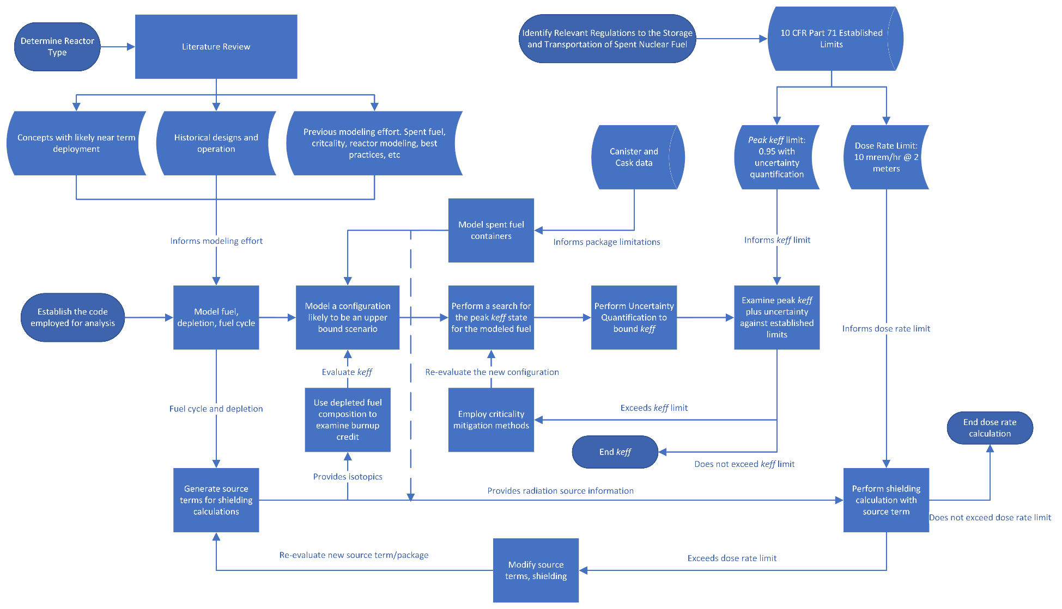
Figure 18: A flowchart for evaluating SNF from advanced reactors under NRC regulations

METHODOLOGY
To model the PBR fuel, the method described previously in section PBR Fuel Modeling is employed. The method employed here is consistent, but some additional modeling is performed in examining multiple fuel types. Two additional fuel types are modeled with the properties listed in Table 5 and Table 6.

Criticality
For the criticality analysis performed in this chapter, the methodology described in the Criticality section is employed, though the canister types and fuel types examined are slightly different. The fuel parameters are described in Table 5 and Table 6 and the canisters examined are described in Table 7. Additionally, methods unique to criticality mitigation are employed unique to this chapter and are described below.
The process is performed for the different types of fuel pebbles, the HTR-10, PBMR-400, and Demo HTGR TRISO pebbles. The results are then plotted with uncertainties to appropriately illustrate any trends and effects due to geometries and water densities. As k-effective is used as the assumed upper safety limit for criticality, if any model has a consistent value of k-effective that exceeds 0.95 then hollow, stainless-steel cylinders are placed inside the spent fuel space to displace pebbles and disrupt multiplication. The displaced pebbles are removed before they are examined again. The size of the cylinder is adjusted until the peak value of k-effective drops to below 0.95. Figures demonstrating the updated geometries may be found in the discussion section of this paper.
The second method explored for mitigating the established limit for k-effective is to replace fuel bearing pebbles with dummy pebbles that do not contain any fuel. The dimensions of the dummy pebbles are identical to the fuel pebbles, allowing a one for one replacement. Two different pebbles compositions are tested. Stainless steel and boron carbide pebbles are both examined. Figure 19 shows an example of pebble replacement with 5% of fuel pebbles replaced.
Only the Demo HTGR TRISO fuel pebbles are used to test the pebble replacement method. This is done because previous research [86] has demonstrated that this pebble type is more reactive and will be the limiting case in any comparison. The examined pebble types

Table 5: Fuel Parameters [8]
Fuel Parameters | Unit | HTR-10 | PBMR-400 | Demo HTGR
Fuel Region Radius | cm | 2.5 | 2.5 | 2.5
Fuel Free Region Thickness | cm | 0.5 | 0.5 | 0.5
Total Fuel Pebble Radius | cm | 3.0 | 3.0 | 3.0
Unit cell inner radius (Cask/Reactor) | cm | 3.05 / NA | 3.05 / NA | 3.05 / 3.2
Graphite matrix density | grams/cm³ | 1.74 | 1.74 | 1.74
Number of TRISO particles per pebble | number | 8385 | 15000 | 19000

Table 6: TRISO Parameters [25]
TRISO Parameters | Unit | HTR-10 | PBMR-400 | Demo HTGR
Fuel form | N/A | U02 | U02 | UCO
Fuel Density | grams/cm³ | 10.4 | 10.4 | 10.4
Fuel kernel radius | Mm | 0.250 | 0.250 | 0.2125
Coating layers | N/A | C/PyC/SiC/PyC | C/PyC/SiC/PyC | C/PyC/SiC/PyC
Coating thicknesses | Mm | 0.09 / 0.04/ 0.035 / 0.04 | 0.09 / 0.04/ 0.035 / 0.04 | 0.1/0.04/ 0.035/0.04
Coating densities | grams/cm³ | 1.05/1.9/3.2/ 1.9 | 1.05/1.9/3.2/1.9 | 1.05/1.9/3.2/1.9

Table 7: Canister properties
Canister | Keno [62] | Modified Keno | HLC [88] | Large Canister [82]
Geometry | Cylindrical | Cylindrical | Cuboid | Cylindrical
Radius (cm) | 35 | 45 | N/A | 94.615
Cavity side length (cm) | N/A | N/A | 34.3 | N/A
Cavity Height (cm) | 252 | 252 | 129.5 | 429.26
Wall thickness (cm) | 10 | 10 | 27.3 | 1.27
Top thickness (cm) | 10 | 10 | 16.52 | 22.86
Bottom thickness (cm) | 10 | 10 | 27.3 | 7.62
Number of Pebbles | 5,133 | 16,994 | 615 | 70,983
Primary Materials | SS304 | SS304 | SS304, lead | SS304

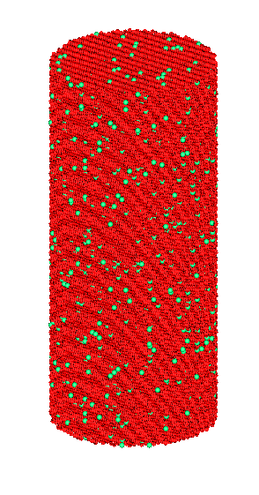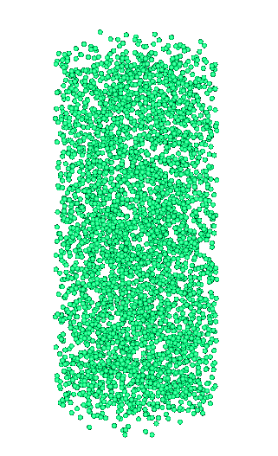
Figure 19: Fuel pebbles (red) and dummy pebbles (green) in a canister (left) and the distribution of dummy pebbles (green) without fuel pebbles (right)

behave very similarly to each other in response to changes in geometry and moderator densities.
Lastly, burnup credit is considered and follows a similar methodology as previous work [86]. The fuel composition at each burnup step from the equilibrium core discharged fuel is decayed for a year using ORIGEN to remove any neutron absorbers that may be present, such as Xe-135. Failing to perform this decay step can lead to an underestimation of k-effective of roughly 3 percent. The composition is then loaded into the fuel region of the pebbles and a criticality calculation is run. An initial distribution of a cosine shape across
the X, Y, and Z dimensions is chosen to speed up source convergence. Due to the large number of potential fission sites and the relatively long path length, 60,000 neutrons are run per generation. Following the skipped generations and convergence of the fission source, the calculation is run down to an uncertainty of 50 pcm.
The fuel in this analysis approximates a Demo HTGR TRISO fuel pebble. The canister dimensions are meant to approximate a large commercial canister and is likely to be a limiting case when applying burnup credit [86].
This study does not model a storage or transportation overpack. Instead, a layer of water at 1.0 g/cm³ surrounds the canister on all sides to act as a reflector. For this study, the canister is modeled without any fuel basket in the interior cavity. No finer details or neutron absorbers are modeled for the canister. When filled, the canister contains 70,983 pebbles inside its cavity volume. With a pebble pitch of 3.05 cm, the effective packing fraction of pebbles is 0.665, much higher than what would be seen with a random closed packed configuration.
The geometries and materials for the containers examined are defined and produced with all fuel baskets and other internal components removed, leaving an empty inner region for the placement of PBR fuel pebbles. An approximate description of the containers’ geometries and materials may be found in Table 7.
Next, the pebbles are placed within a container in a dodecahedral packed array that is made to fill the container volume. Like the fuel particles, the pebbles that clip into the walls of the examined containers are replaced with material identical to the interstitial material used in the pebble unit cell.

Shielding
In shielding calculations using MAVRIC, a simplification of homogenizing the cask interior is recommended for modeling. The boundary is set to be 5 meters from the edge of the cask, and the entire space is encompassed in a cylindrical mesh tally. A block of soil a meter thick is added below the cask that extends to the edges of the boundary. A calculation to transform the cask interior from explicit geometries to a homogenized mix is performed, and the mix is placed into the interior geometry in place of the pebble fuel spheres. The modified version of the large canister with a transportation overpack added over it is the subject of all dose rate results [89]. Figure 20 illustrates the canister with its overpack and homogenized interior. The additional fidelity in geometry in modeling the pebbles explicitly isn’t required to achieve high quality results according to interactions with the SCALE user community.
A calculation is performed to identify the earliest possible loading time for the spent pebble fuel. This calculation is based on the decay heat of the spent fuel and the listed heat rejection capacity for the cask and canister. The earliest possible loading is calculated within the thermal specification of the large canister [82]. The gamma and neutron total source values are saved for each state to define the source strength for the shielding problem. Results for the early spent PBR fuel are presented as it is the most limiting case. An adjustment is made to the saved source strength to match the mass of spent fuel in the cask interior for each time examined.
Next, a grid geometry is constructed to provide for the discretization and homogenization of material in each cell to use in the deterministic portion of the calculation. Planes are placed at each material boundary and divided up to provide a sufficient level of detail. Note that a finer mesh should be used in the cask and interior and a coarser mesh outside. The sources are then defined by entering the source strength and importing the correct isotope inventory state from an ORIGEN concentration library, which matches with the desired cooling times being examined.
The concentration library file provides MAVRIC with the emission energies and their probabilities, eliminating human error in data entry. The response function is defined using ANSI standard (1977) flux-to-dose-rate factors for neutrons and photons.
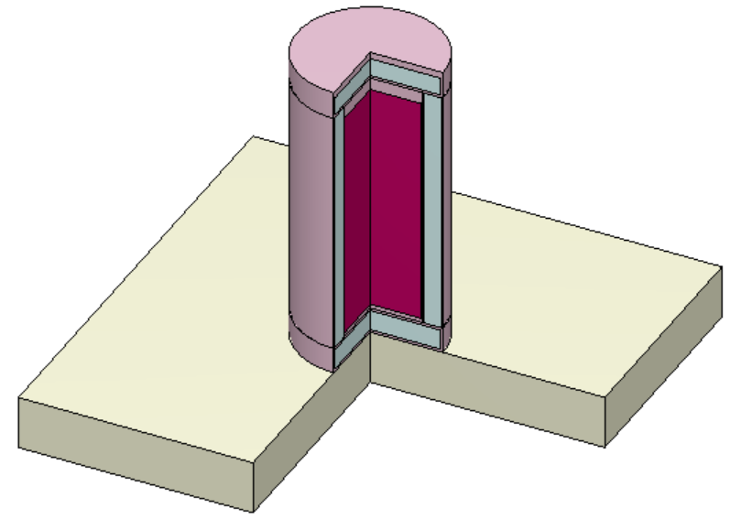
Figure 20: The modified large canister with the transportation overpack and a homogenized spent fuel region

This function is built into MAVRIC. Using a cylindrical mesh tally for dose eliminates potential position bias resulting from the square mesh of the grid geometry and the position around the cask itself. As the cylindrical mesh tally is radially symmetric like the cask, the potential for biasing outliers is minimized.
To evaluate the dose, the gamma dose and neutron dose are calculated separately. For the gamma dose, the transport of neutrons is disabled to save runtime. For neutrons, gamma transport is disabled, and secondary fission neutrons are not considered. This setting is not turned on, and neutrons are not considered for the gamma transport as there are 8 orders of magnitude between the two source strengths. Coupled gamma-neutron transport problems also take a significantly longer time to complete depending on the problem and the desired uncertainty.
MAVRIC is run, and dose rate maps are generated, as well as maps to visualize the grid geometry, mesh tally, sampling regions, and dose rate uncertainties. The flux maps and dose rate maps are both adjusted to have consistent scales and identical number of levels for the contours created. All dose rates reported are in units of rem per hour.

RESULTS

Criticality: Base Case
In the evaluation of the canisters and casks, only the large canister has a value of k-effective in excess of 0.95 across both the water density range examined and all three pebble types. The smaller containers don’t present any significant issues. Figure 21 shows the results of each pebble type in each container across the moderator densities tested.

Criticality: Pebble Displacement Case
To aid in reducing the value of k-effective, hollow, stainless-steel cylinders of 1 cm wall thickness with an outer radius of 9 cm are placed at 9 locations, including one in the center to displace pebbles. Figure 22 and Figure 23 show the configuration of the cylinders. For the Demo HTGR TRISO fuel pebbles, the same configuration is not sufficient to reduce the maximum value of k-effective below the upper safety limit of 0.95. The center cylinder’s radius is increased to 12.5 cm in the case of the modified large canister with the Demo HTGR TRISO fuel pebbles, bringing the maximum value of k-effective back below 0.95. shows the impact of the cylinder displacers on k-effective across the range of moderator densities. These results are consistent with prior work [86].
The addition of these cylinders reduces the value of k-effective in all cases, bringing the peak value below 0.95 for the HTR-10, PBMR-400, and Demo HTGR fuel pebbles in the modified large canister while cutting the capacity by slightly less than 15% [86]. The results are shown in Figure 24.

Criticality: Pebble Replacement
In the examination of randomized pebble replacement with different dummy pebble types, the results are very favorable, especially when compared to the rod displacement method. An initial examination found that replacement with filler graphite pebbles led to an increase in k-effective across the tested range. The replacement method does not consider any possible migration or movement. Further research is recommended for potential pebble migration or the use of smaller, filler pebbles that may fit between gaps in pebbles. Figure 25 shows the results.

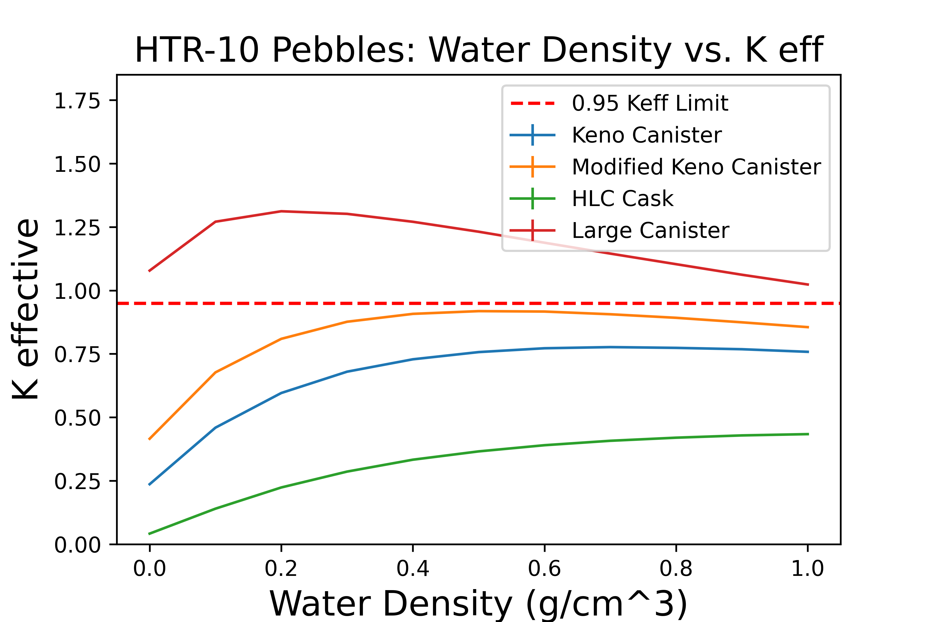
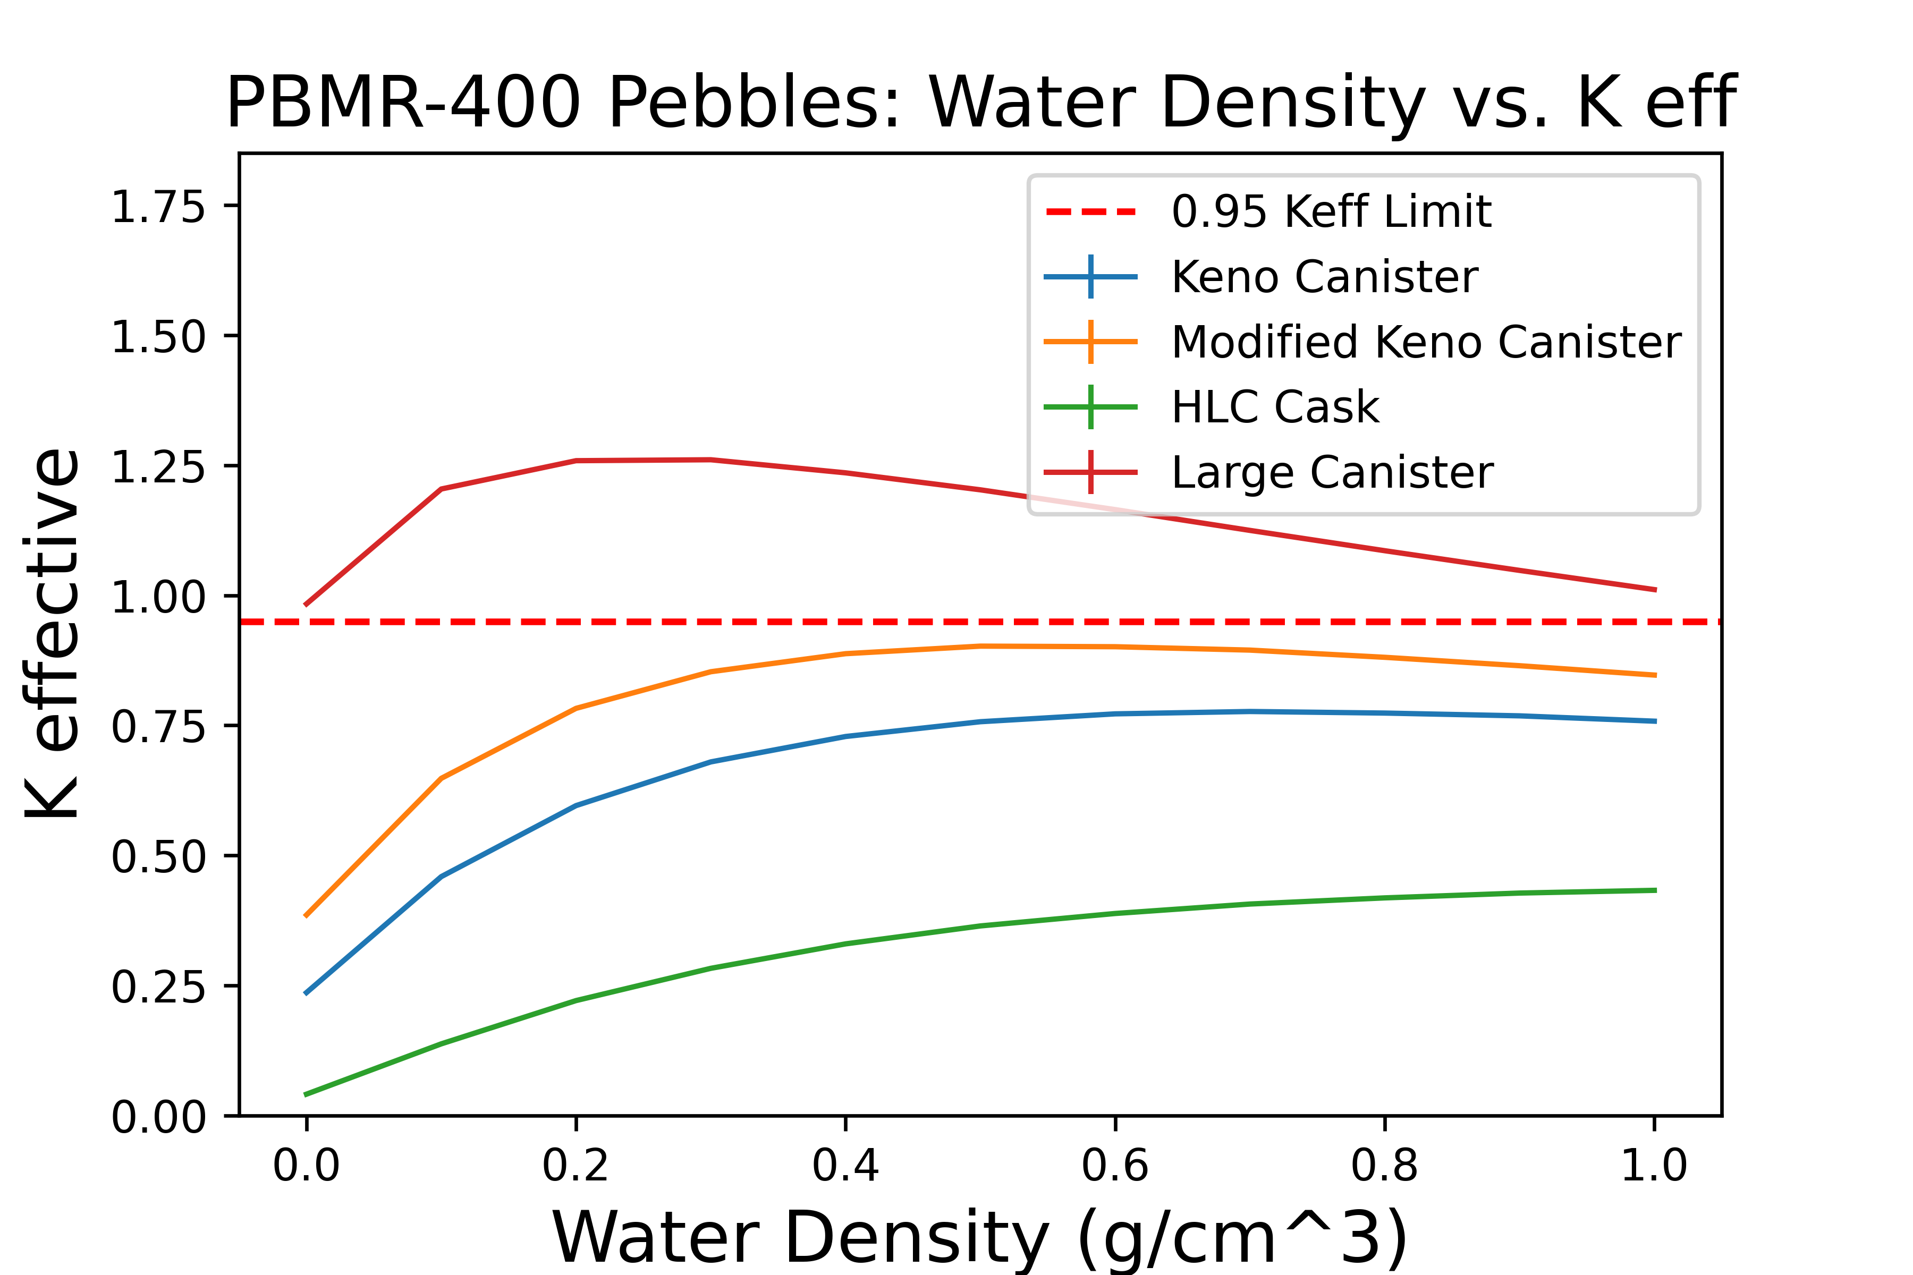
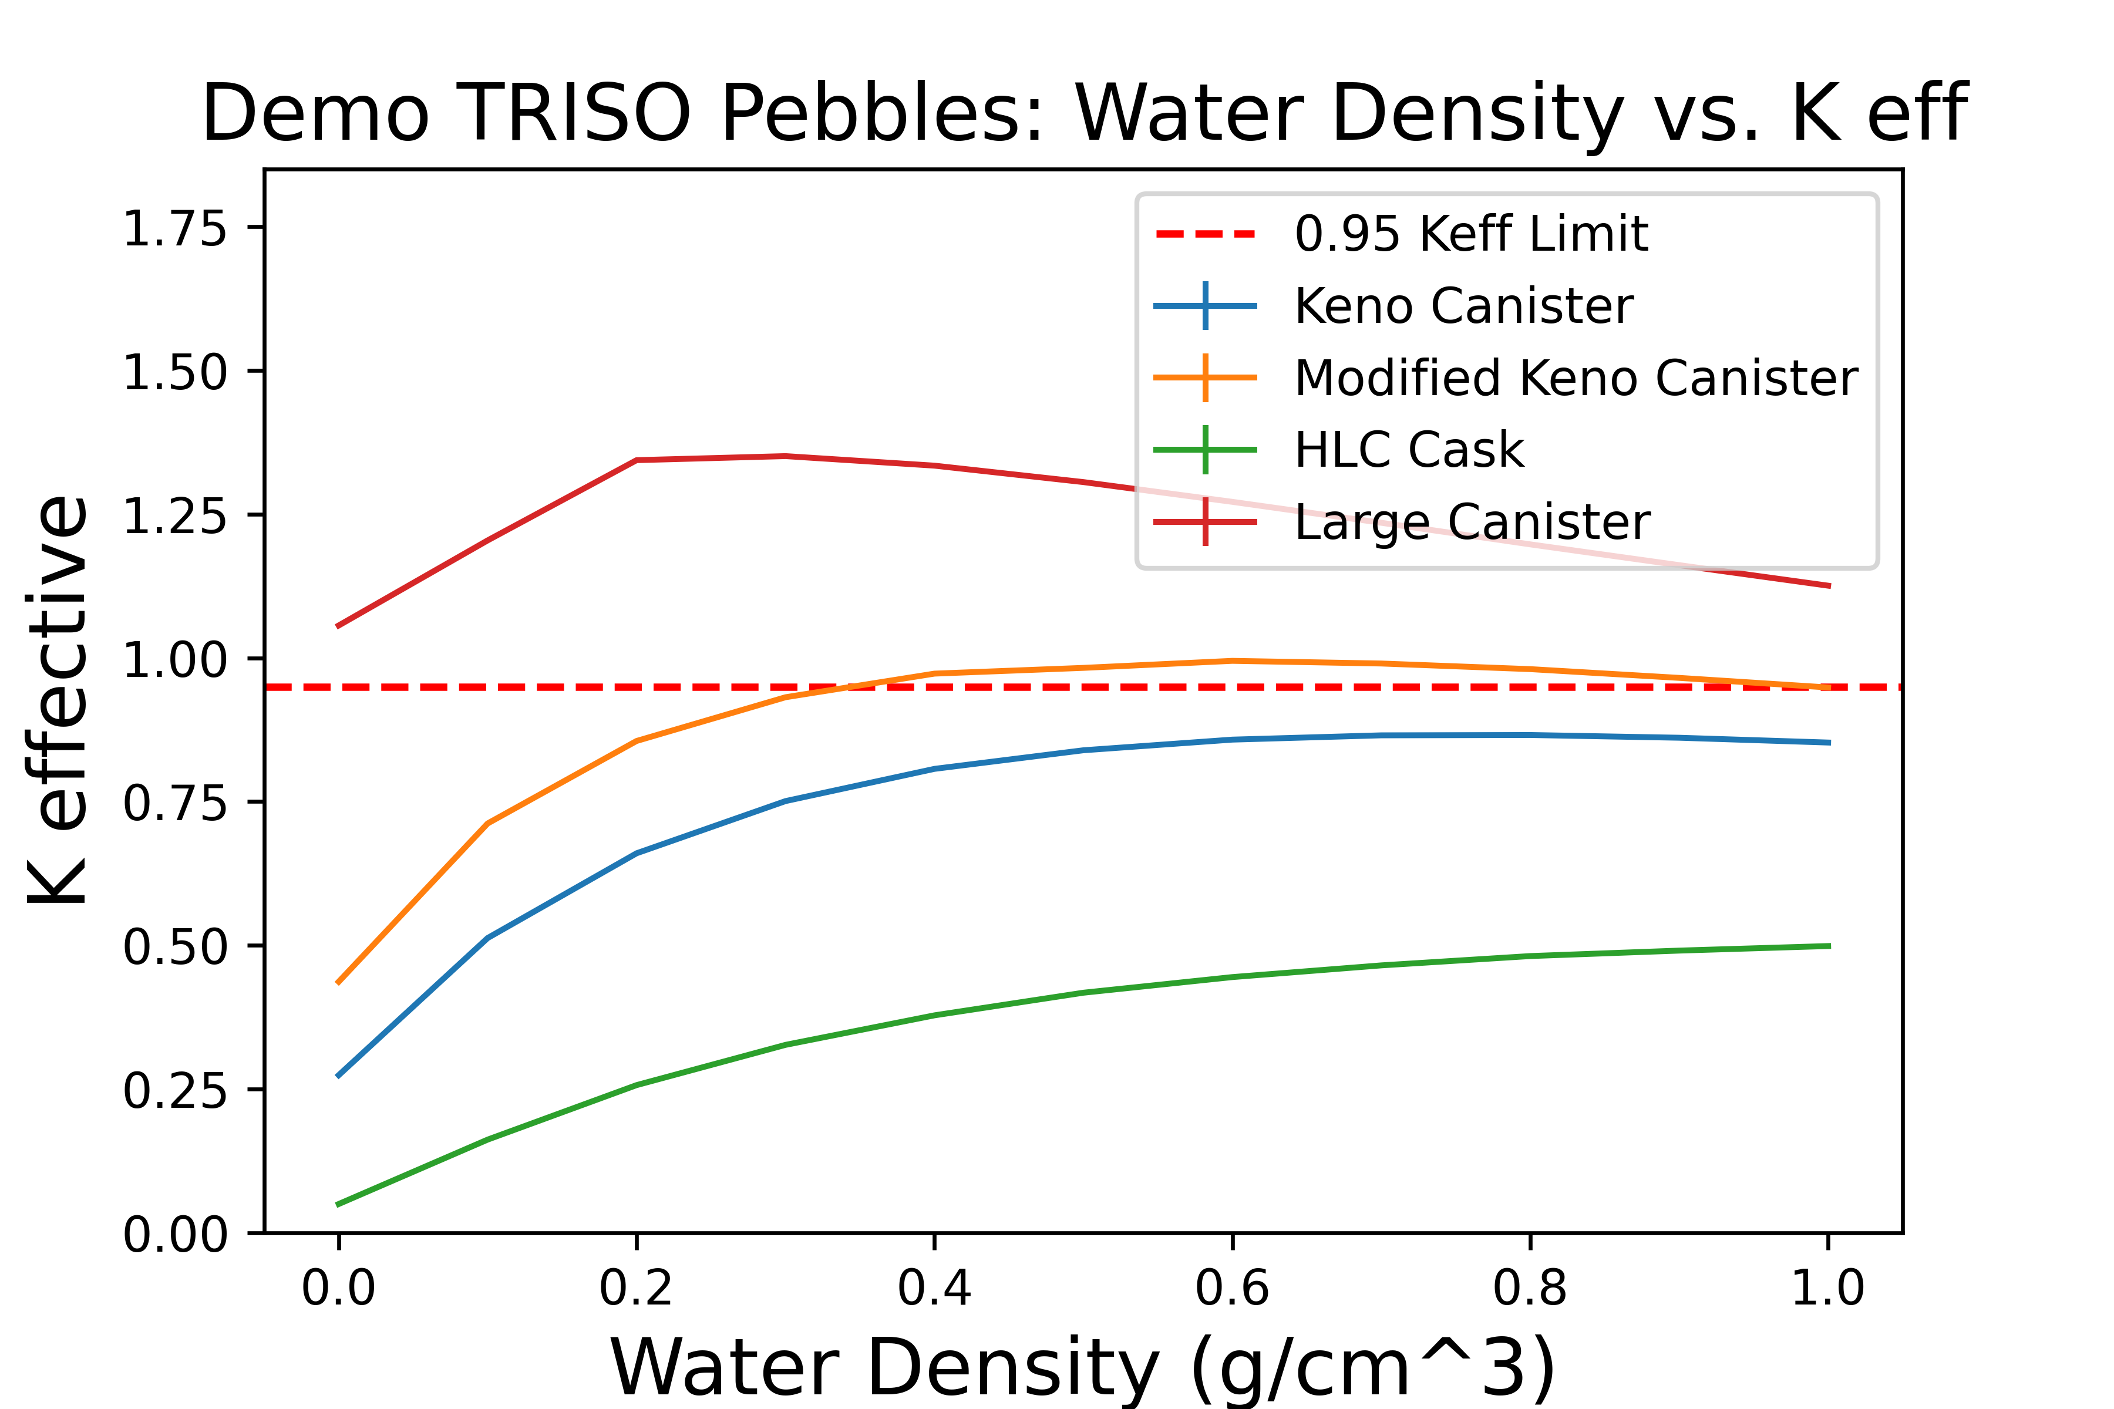
Figure 21: The water density vs. k-effective results of the HTR-10, PBMR-400, and Demo HTGR TRISO fuel pebbles in the examined containers

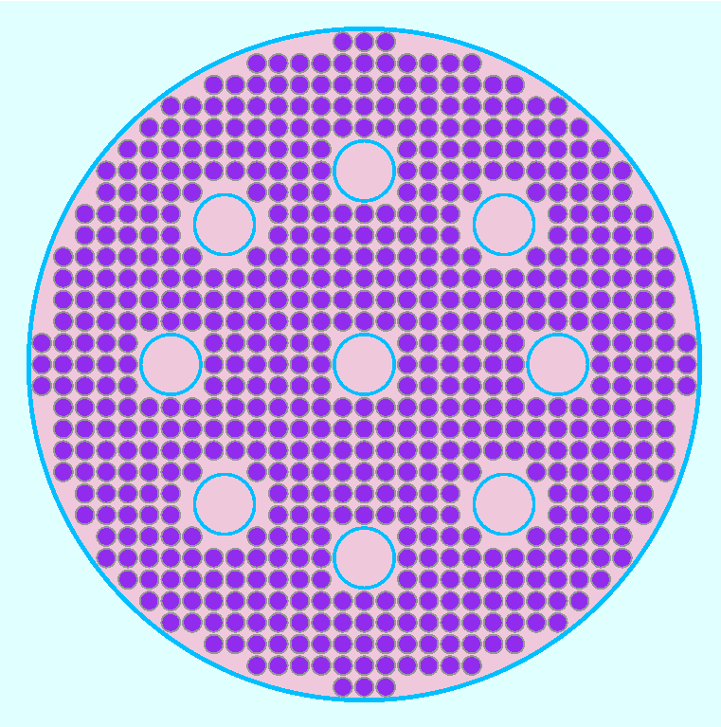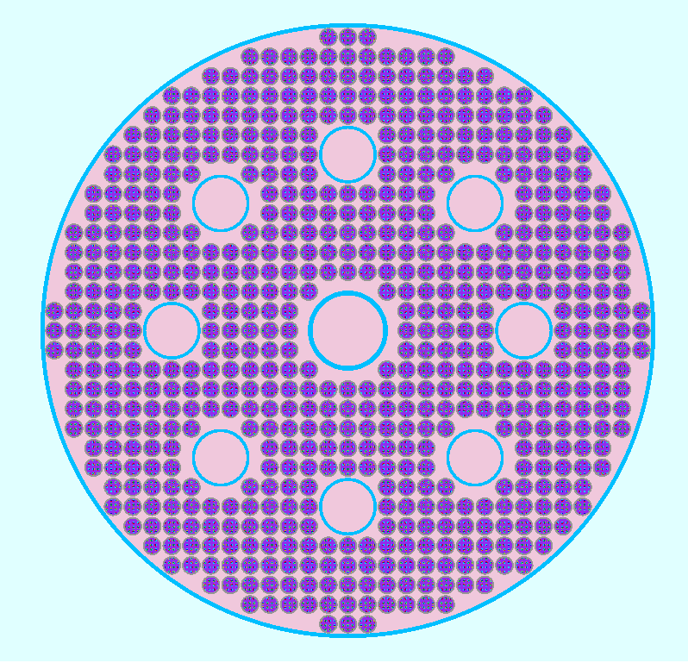
Figure 22: The large canister modified with fuel displacer cylinders for the HTR-10 and PBMR-400 pebbles (left) and the Demo HTGR TRISO fuel pebbles (right)

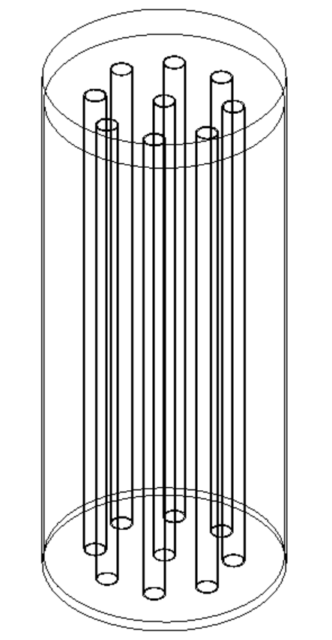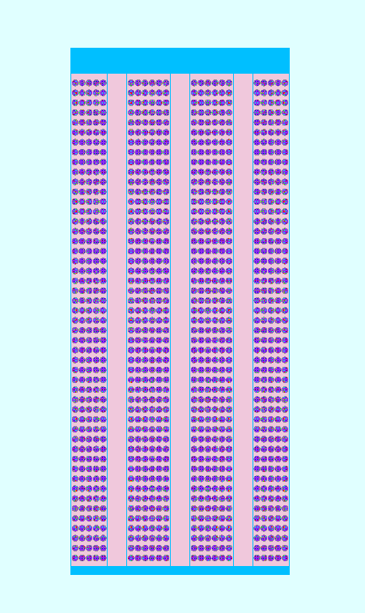
Figure 23: A wireframe model of the modified canister used for the HTR-10 and PBMR-400 pebbles (left) and a mid-plane, side view of the large canister loaded with pebbles and displacer cylinders (right)

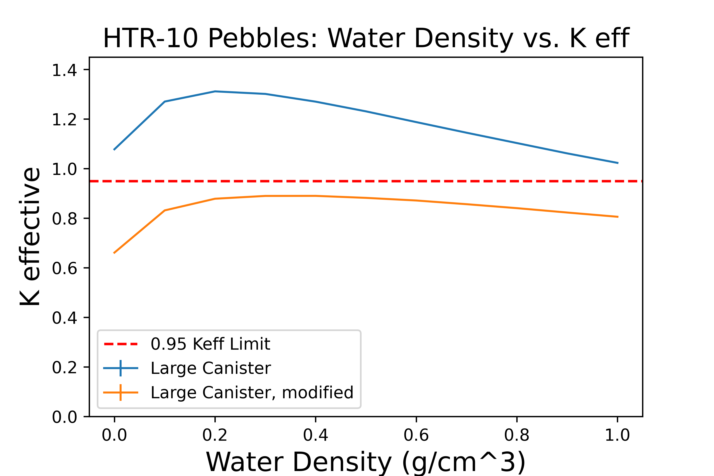
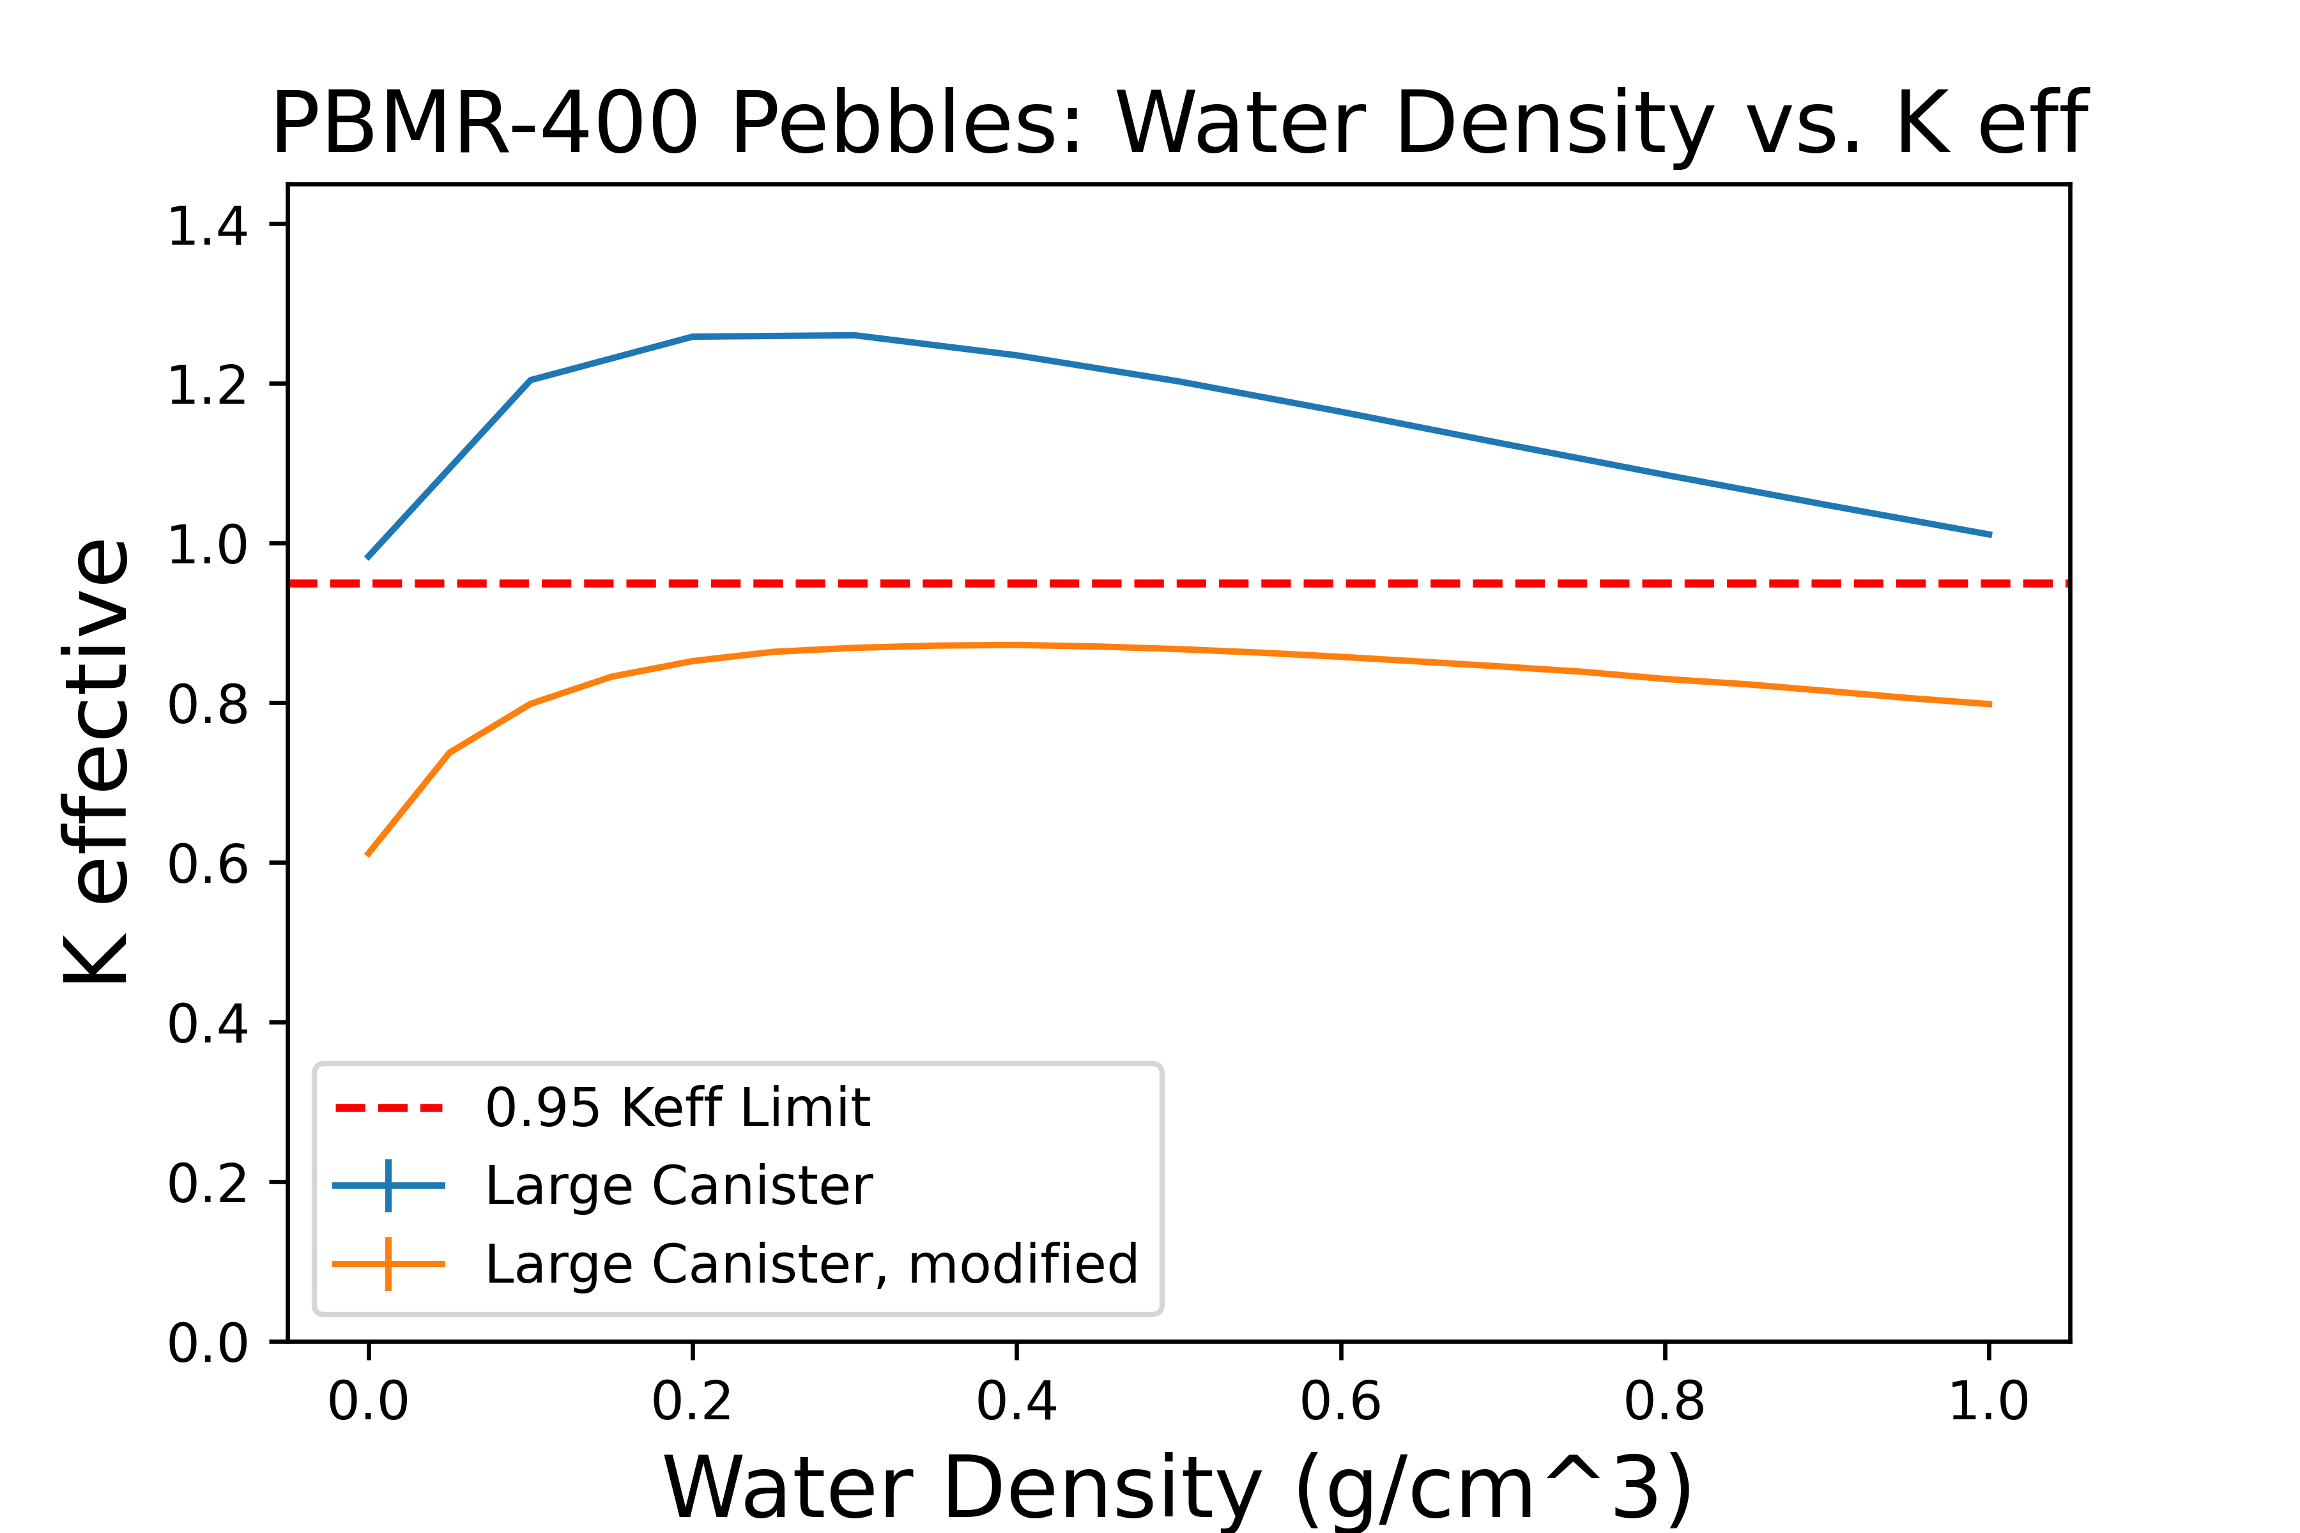
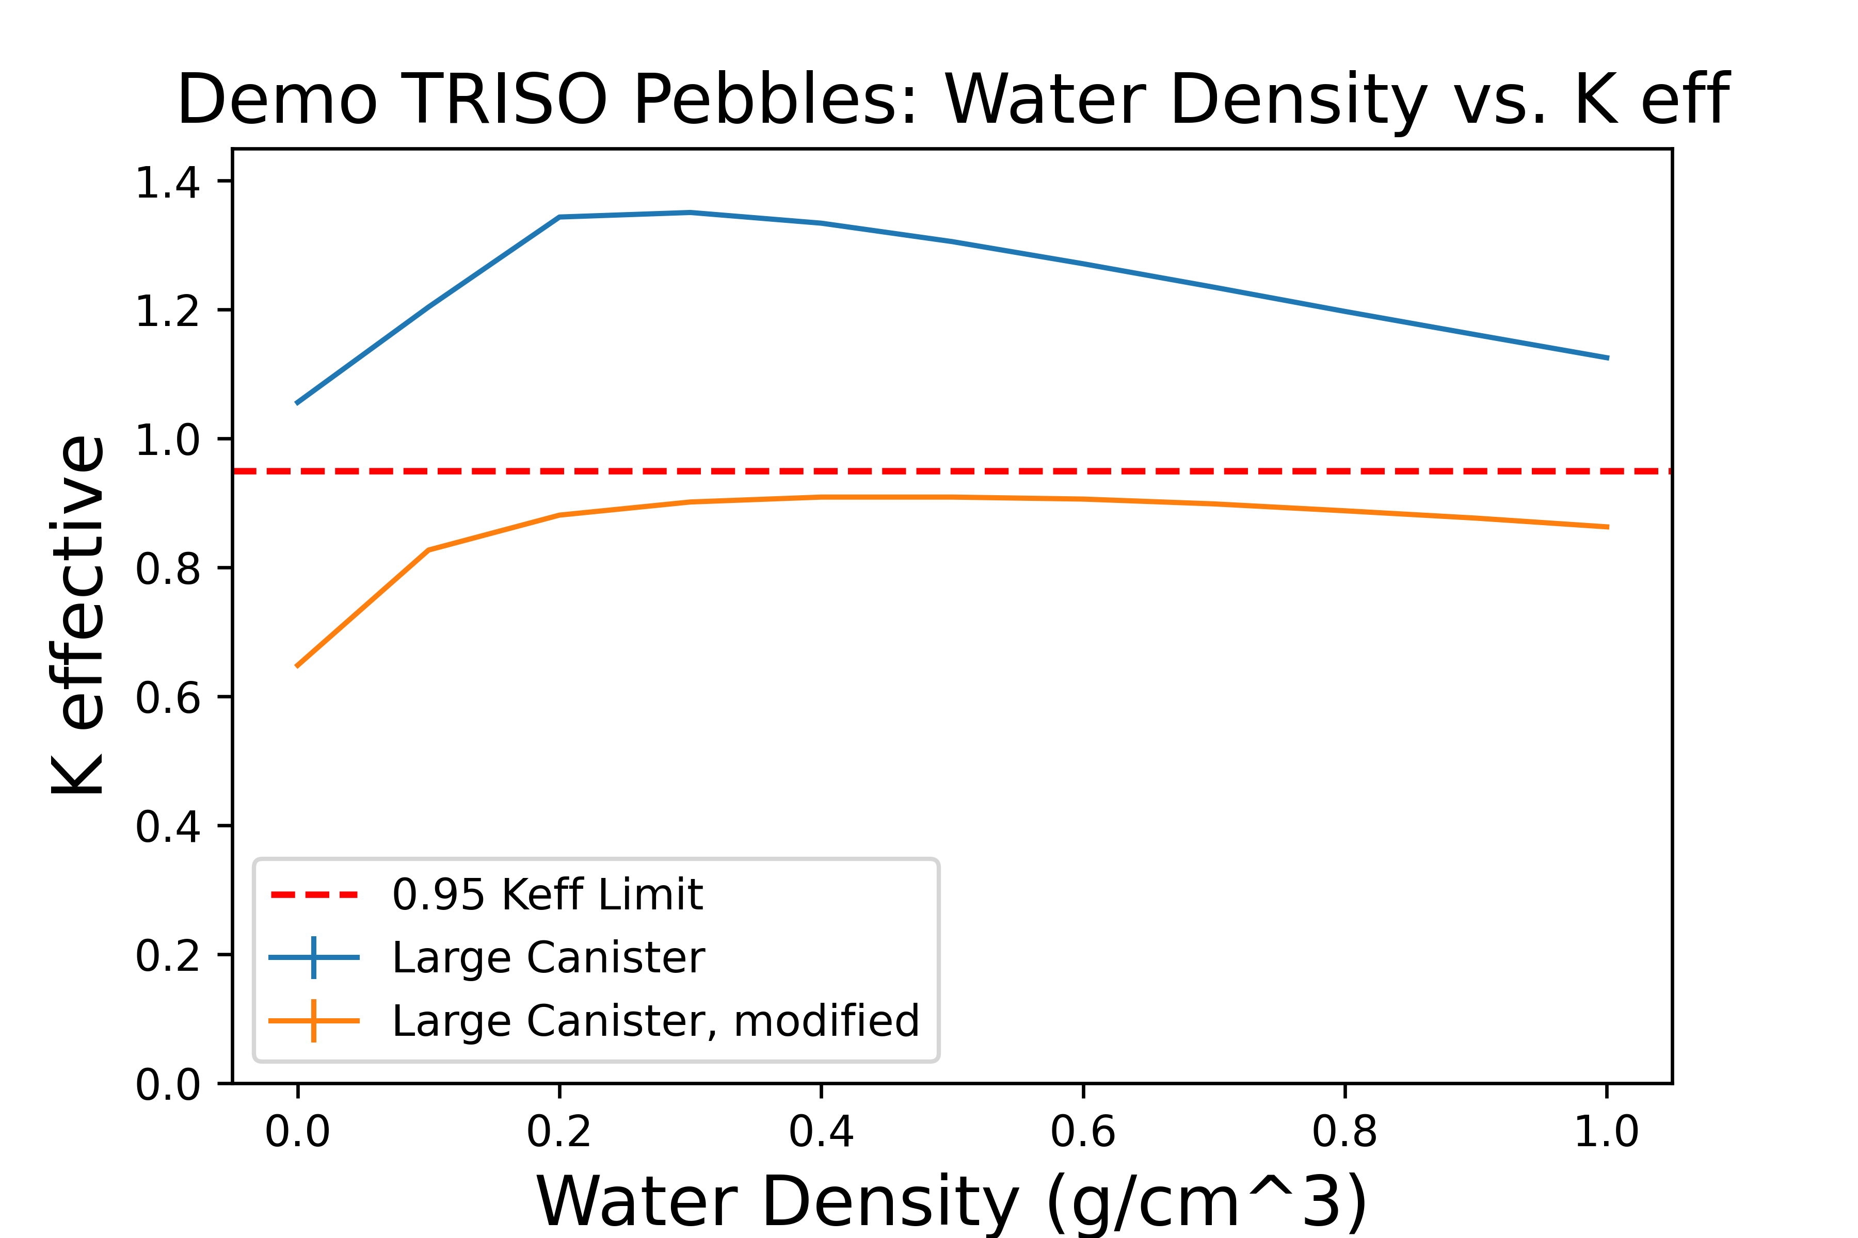
Figure 24: The effect of additional geometries to displace pebbles and disrupt multiplication in the large canister filled with HTR-10, PBMR-400, and Demo HTGR TRISO fuel pebbles

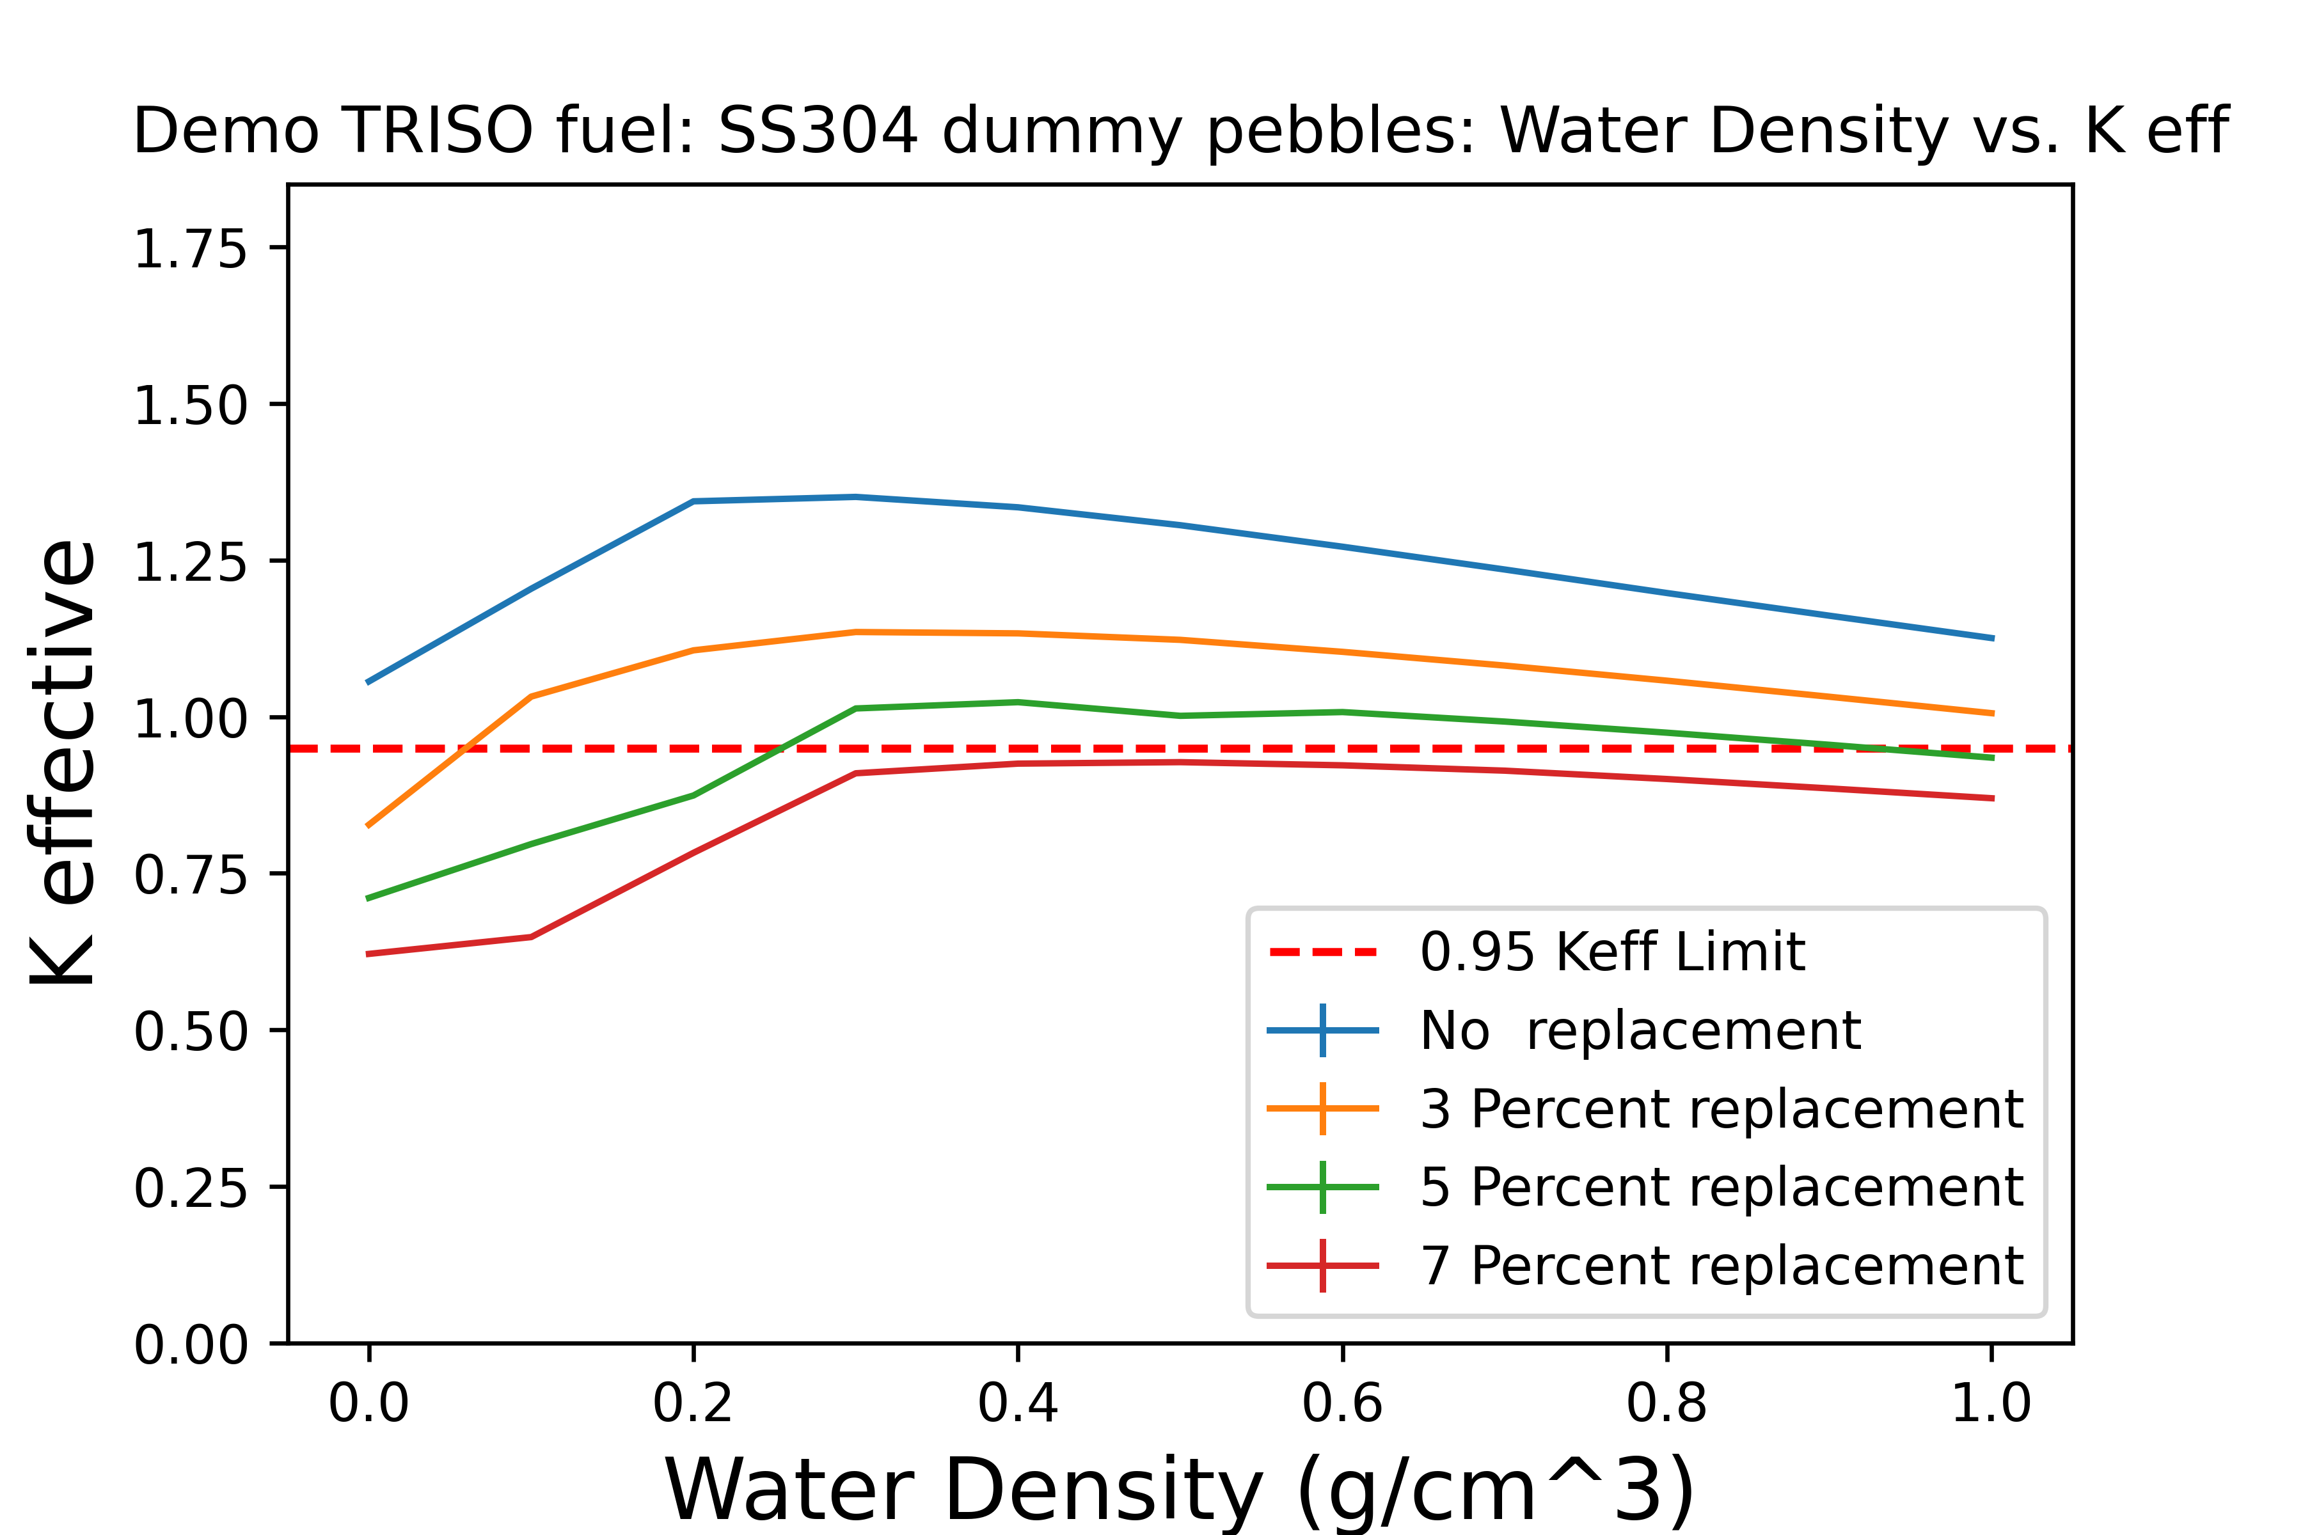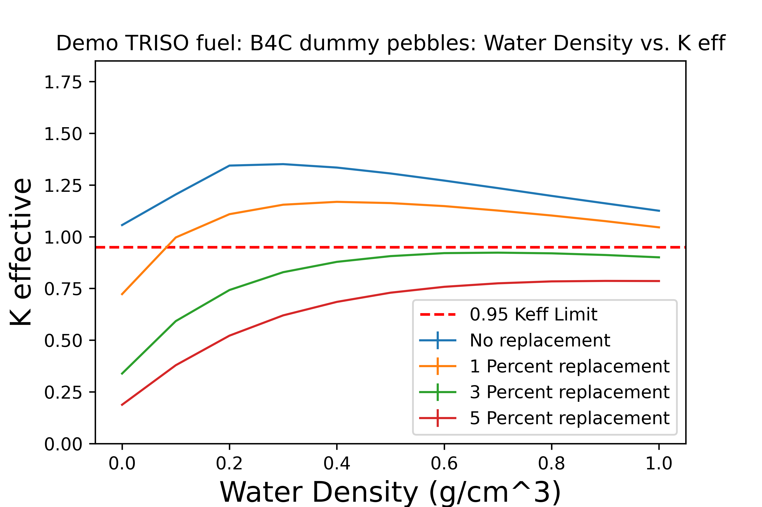
Figure 25: The effect of SS304 and B4C replacement pebble methods

In comparison to the rod displacement method, the random displacement of fuel pebbles is roughly twice as effective per pebble displaced with a ~7% replacement required to meet the 0.95 k-effective limit. The boron carbide pebbles are especially effective, only requiring 3% of fuel pebbles to be replaced in order to meet the 0.95 k-effective limit [86].

Criticality: Burnup Credit
The 15.5% U-235 enriched Demo HTGR TRISO fuel pebbles require burnup credit in excess of 100 GWd/MTU in order to meet the prescribed requirements. The target burnup of the demonstration HTGR reactor design is 168.5 GWd/MTU [25]. Figure 26 shows a graph of the results.
While the Demo HTGR TRISO fuel pebbles require a significant application of burnup credit to reduce the peak value of k-effective below 0.95, the target burnup remains significantly higher than the required burnup credit with no other mitigation measures in place, and as such only a fairly modest fraction of the total expected burnup is required, allowing for additional margin to be available if required.
Overall, the methods tested represent possible methods of managing excess criticality in SNF containers meant to contain spent or spent PBR fuels. All methods work very well, with the physical mitigation methods retaining at least 85% of the unmodified canister’s capacity remaining after implementation. All methods represent a great improvement over using the traditional fuel basket for pebble bed fuel, though the presence of a basket would certainly reduce k-effective further.
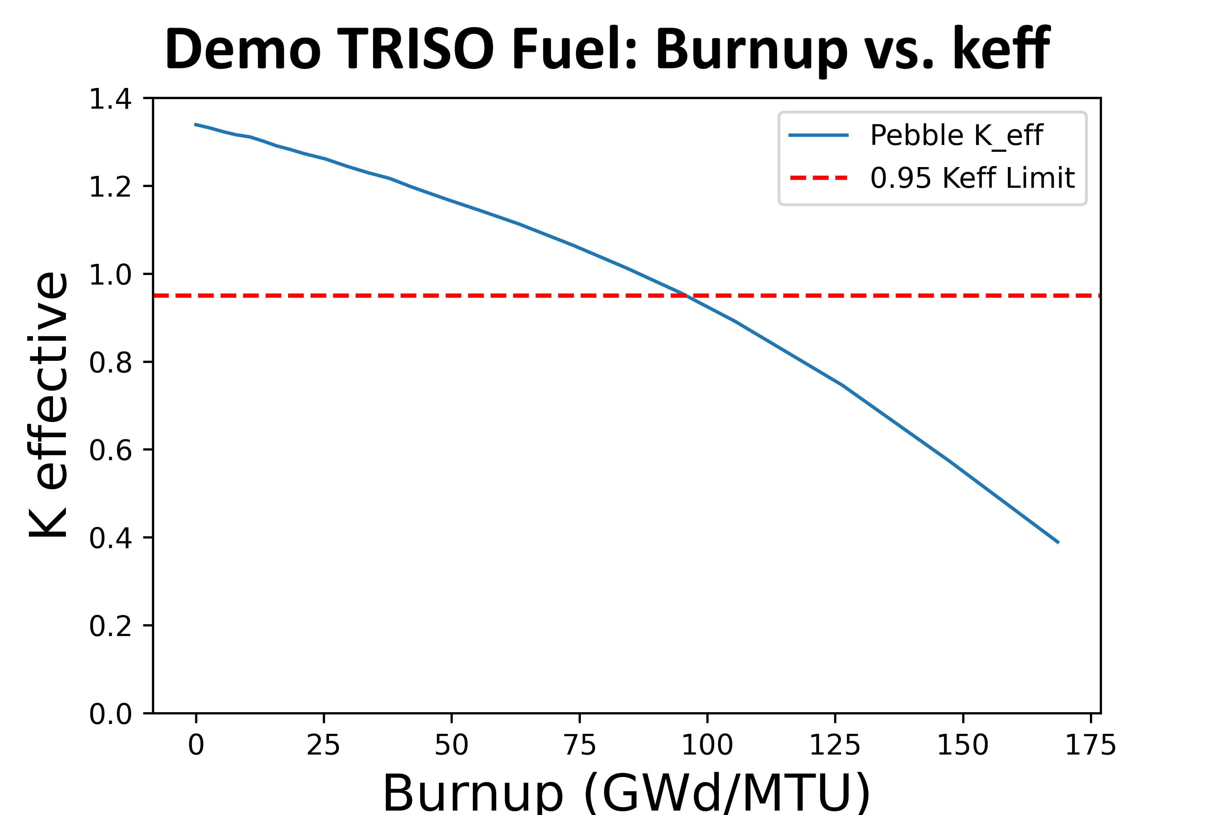
Figure 26: Burnup vs. K effective for 15.5% wt% demo TRISO fuel pebbles

Shielding
From the dose rate maps presented, at all discharge times the transportation overpack is more than sufficient to attenuate the incident radiation down to NRC-mandated levels. In fact, even the earliest discharge time, the fuel presents a maximum photon dose rate outside the cask of 1E-6 to 1E-5 Rem per hour, well below the NRC limit of 1E-2 Rem per hour [40]. Examining the later discharge cases, a trend can be observed of rapid declines in both the flux rate and dose rate maps with the prominent plume receding and the dose rate becoming even further below the limits. The results are shown in Figure 27.
The overpack is effective in reducing the photon flux through the cask body by several orders of magnitude. Following the analysis of photon dose rates, neutron dose rates are analyzed. Given the low source strength when compared to traditional LWR fuel, an initial examination is performed in which the neutron capture space (NCS) is absent, leaving only the lead shielding, a relatively ineffective neutron shield. Figure 28 shows a dose rate map of the neutron dose with the NCS absent. Despite the absence of the NCS and the shortest possible cooling time, the neutron dose rate at 2 meters is as high as 1.01E-2 rem per hour, marginally over the dose rate limit. However, it must be noted that

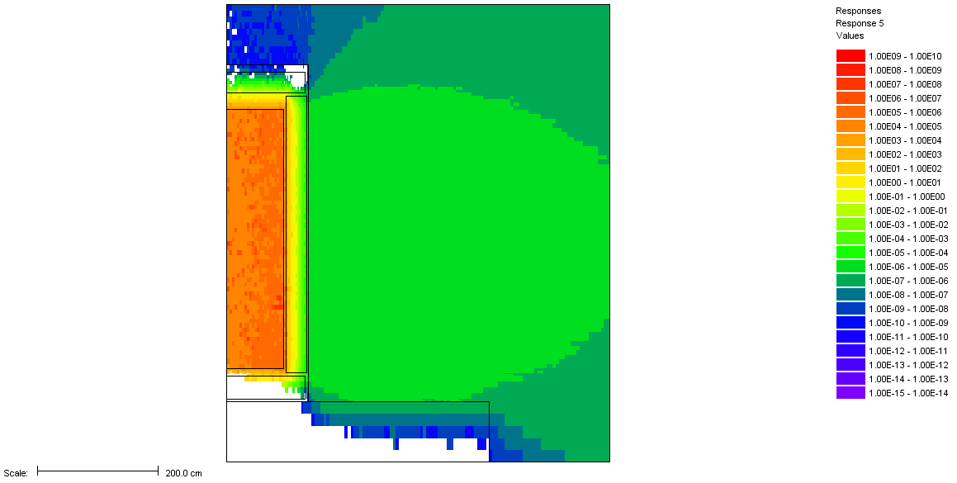
Figure 27: The photon dose rate map of the shortest possible cooling time, units in Rem per hour

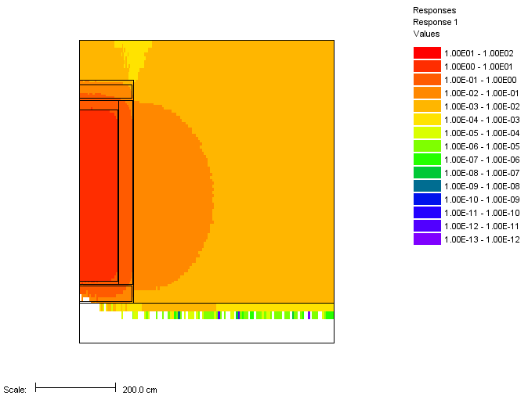
Figure 28: Neutron dose rate map of the shortest possible cooling time, units of Rem per hour

subcritical multiplication is not considered, so depending on the dry k-effective state of the cask in question extra margin may need to be applied.
The addition of a 1 cm thick layer of boron carbide cuts the effective dose at 2 meters down by roughly 23% to 7.70E-3 Rem per hour, well below the 1.0E-2 Rem per hour limit. A borated resin is likely much more effective.

CONCLUSIONS

Criticality
Regarding criticality safety of the canisters/casks analyzed, it can be concluded that packages of smaller capacities, such as the Keno and HLC packages, can store and transport fresh pebble bed fuel across the three pebble types examined. When it comes to larger packages, such as the modified Keno canister, it was shown to be within specifications for the HTR-10 and PBMR-400 pebbles but was exceeded in the case of the Demo HTGR TRISO fuel pebbles. Based on the modeled circumstances, reducing the total pebbles by adding hollow cylinders reduces the maximum k-effective below the upper safety limit. Each case displaced no more than 15% of the pebbles. In the case of the Keno canister and the large canister, the additional conservatisms must be highlighted. A much higher packing fraction of completely fresh fuel is modeled under unrealistic moderator density conditions with all normal internal hardware removed.
A critical configuration does not occur for spent PBR fuel when using small canisters; however, larger canisters require internal hardware or some modification to prevent a critical configuration of spent PBR fuel. Fuel baskets, already present in currently licensed designs, would certainly be adequate. Accounting for the reduction in reactivity due to high burnups is successful in dropping k-effective below 0.95 k-effective without any reduction in capacity. Pebble displacement is also successful, bringing the peak value of k-effective to below 0.95 in exchange for a 15% reduction in canister capacity. Pebble replacement is roughly twice as effective, requiring only 7% replacement for stainless steel pebbles and ~3% if using boron carbide pebbles as replacements. Migration or movement of the poison pebbles is not considered.

Shielding
Regarding storage and transportation safety of spent PBR fuel, the large canister with the
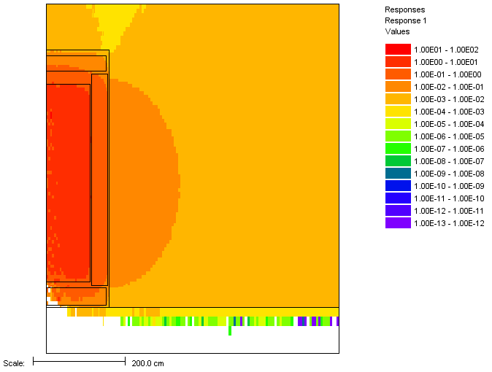
Figure 29: Neutron dose rate map of 85 day cooled spent PBR fuel, units of Rem per hour, 1 cm of B4C added

transportation overpack was examined. The modeling and analysis results show that, due to the low total mass of spent fuel in the container, the total activity is very low when
compared to traditional light water reactor fuel. Even at the earliest possible discharge time of 85 days without any neutron shielding, the transportation overpack modeled is shown to maintain a total dose rate in accordance with NRC spent fuel transportation regulations. A photon dose rate 3 orders of magnitude lower than the regulated limit was found for spent PBR fuel cooled for only 85 days after being discharged from a reactor. Even with the NCS absent in the initial, most conservative case of 85-day cooled spent PBR fuel, the dose rate is still within regulatory limits, although barely. The addition of typical neutron shielding or an increase in cooling time to bring the fuel age to typical values would likely bring the total dose rate below the regulated limits.
However, it must be noted that while several conversative assumptions have been applied, subcritical multiplication has not been accounted for and can dramatically raise the neutron dose rate based on the dry k-effective state of the package. While the 85-day cooling time does bring the dose below the required limit, even taking the most generous case of burnup credit k-effective for subcritical multiplication, the k-effective value of the package doubles, well exceeding the regulatory limits. A less generous case where the package is at 0.90 k-effective will lead to a dose rate that is an order of magnitude in excess of the regulatory limits. The dose rate results are limited to the work conducted in this chapter and exclusive to the configurations examined.
This evaluation and its results strongly support the viability of using existing, licensed canisters and casks for the storage and transportation of spent PBR fuel. In the case of criticality control, some modifications may be required to reduce the internal cavity, especially in larger containers, such as the modified Keno canister and large canister. In the case of shielding, effectively no modifications would be required, even in the hypothetical scenario of dedicated neutron shielding being absent from the design. This conclusion is limited to the burnups explored in this study. Some isotopes have strong dependency on burnup, such as Cm-244 inventories having a 4th power dependence on burnup. This effect may drastically change the neutron shielding requirement as some PBR concepts seek burnups of more than 160 GWd/MT [25]. Further research into the impacts of high burnup PBR fuels on shielding requirements is recommended.

CHAPTER 5:
A Proposed Methodology for Evaluating pebble bed reactor spent fuel discharge characteristics sensitivities to initial condtions and operating parameters

A version of this chapter is planned for submission for a future journal article and is currently under review. It is largely a consolidation of previously published conference papers, sorted, organized, and refined and updated as necessary. Jonathan F. Wing is the sole content author with peer review contributions from the following: G. Ivan Maldonado, Gordon M. Petersen, Robert A. Joseph.

Abstract
In the management of spent nuclear fuel (SNF), a few characteristics of spent fuel heavily inform the management, storage, transportation, and final disposition of the material. The key characteristics that are most relevant are the decay heat, criticality/fissile content, and the radiation emissions/resultant dose rate from the SNF. Despite the composition of SNF containing a myriad of isotopes, the characteristics of SNF are primarily driven by a relatively small subset of isotopes. The relationships of these primary isotopes are well known and understood for light water reactor (LWR) SNF regarding the factors that primarily influence them, but this is markedly less true for spent fuel from advanced reactors such as pebble bed reactors (PBRs) and sodium fast reactors. This work examines the sensitivity of these key isotopes to various parameters both present in LWRs and present only in pebble bed reactors to examine if the currently collected parameters are still impactful enough to warrant continue collecting. A reduced set of parameters in this study to investigate the potential for differences.
Rather than perform full calculations for criticality, dose rate, decay heat each possible state of the fuel within the examined solution space, this work first produces equilibrium cores in coarse steps across the examined parameters. Performing the examination in this method prevents obfuscation of how the drivers of the spent fuel characteristics are themselves changing. For example, a change in fuel temperature may to little change in k-effective, but it may mask shifts in Pu-239 and U-235 nuclide concentrations that balance out in the bulk data. In such a case of relative balanced changes between two or more primary drivers, a more in-depth study will be conducted later. However, if there are no significant shifts in nuclide concentrations that act as primary drivers of spent fuel characteristics, then it can be reasonably concluded that the examined parameter is of lower importance.
This work examines variables already known to have significant impacts on SNF characteristics and additionally examines a couple of variables that are not currently considered due to not being viable variables for LWRs. The examined variables are applicable for pebble bed reactors and other advanced reactors. Fuel temperature and reflector temperature are examined in increments of 150K from 600 to 1200K. These parameters are anticipated to be the most impactful parameters being considered and make for a strong proof of concept study for parameters that are not currently captured.
SCALE is used for all modeling due to fast and accurate methods for handling PBR fuel modeling, established and rapid equilibrium core modeling methods, and powerful tools for examining spent fuel inventories. TRITON and the Oak Ridge Isotope Generation code (ORIGEN) are both used for modeling of the equilibrium cores and depletion of the fuel and Origen Binary Interrogation Without a SCALE Input (OBIWAN) is paired with external python scripts to interrogate the discharged inventories to examine the sensitivities to input parameters.

Introduction
Nuclear power has faced many challenges since its inception. Competition from other energy resources, spent fuel questions delays and cost overruns with the construction of new nuclear plants, and the events at Fukushima have created challenges to be overcome in the advancement of nuclear power. These circumstances have prompted the nuclear engineering community to take a fresh look at advanced reactors that may address such challenges. One concept is that of using TRISO (TRi-structural ISOtropic) particle fuel. TRISO particles are made up of small fuel kernels, each of which is encapsulated by three layers of carbon and silicon carbide designed to prevent the release of radioactive material [21]. The TRISO fuel particles can be embedded into graphite pebbles roughly the size of a tennis ball and used as fuel in a Pebble Bed Reactor (PBR). PBR fuel types are very robust, offering a low power density, resistance to radiation damage, excellent corrosion and oxidation resistance, and outstanding tolerance for high temperatures, making a meltdown scenario effectively impossible [21]. These qualities make TRISO-based fuels an excellent candidate for advanced reactor designs and the focus of a great deal of research.
Current data collection practices have evolved to meet changing regulatory and data needs, including those highlighted by the Blue-Ribbon Commission on America’s Nuclear Energy Future. Some institutions collect detailed information on reactors, spent fuel discharges, storage capacities, non-fuel components, and greater-than-class-C (GTCC) low-level radioactive waste to better inform SNF management.
Most information collection is tailored around the LWR fuel cycle and current dry storage practices. The data collected would likely need a significant revision to accommodate SNF from advanced reactor systems if the fuel cycle information for those advanced reactors were to be collected in a similar manner. While a large amount of the data currently collected is also present in advanced reactor spent fuel, due to differences in how the reactors operate, the impact on inventories due to those parameters may behave very similarly or nearly identically to each other or completely differently. Whether or not it would be warranted to collect much of this data for advanced reactors is an open question and is further complicated by the fact that some collected parameters are simply not applicable to advanced reactors and uncollected parameters existed for advanced reactors that aren’t present in LWRs. Figure 30 shows a flowchart of the proposed method of evaluation for PBRs/SFRs.
This study seeks to evaluate spent PBR spent fuel characteristics and the fuel’s sensitivity to the assumed most impactful conditions of operating parameters and initial fuel conditions. Pebble bed reactors are capable of operating under a variety of conditions.

Methodology
To model the fuel, the method previously described in section PBR Fuel Modeling is utilized with no notable changes. PBR equilibrium core generation is performed in a manner consistent with the method described previously in section Equilibrium Core Generation, though fuel and reflector temperature are the subjects of examination and subject to changes. To examine the influence of fuel and reflector temperature on SNF key isotope discharge concentrations, a unique equilibrium core is produced for every set of temperature conditions in a set. The reflector temperature is made to never exceed the fuel temperature, as such a situation is not realistic for PBR operation. The temperatures utilized for equilibrium cores are shown in Table 8.
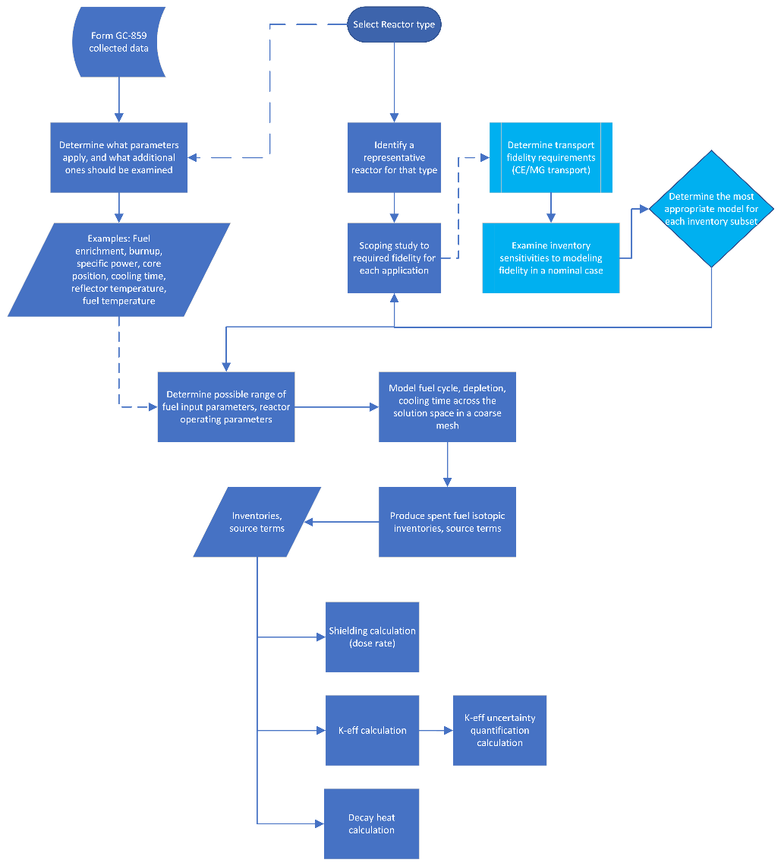
Figure 30: A rough flowchart of the evaluation process

Table 8: Fuel and Reflector Temperatures Examined
Fuel Temperature (K) | Possible Reflector Temperatures (K)
600 | 600
900 | 600, 900
1050 | 600, 900, 1050
1200 | 600, 900, 1050, 1200

Identifying Isotopes of Interest
A nominal case with a fuel temperature of 900K and a reflector temperature of 900K is run and the equilibrium core discharge inventories are established using OBIWAN. The isotopes of interest are determined by examining which individual isotopes contribute most to a particular parameter. In the case of dose rate and k-effective, previous literature and engineering intuition are relied upon to make those determinations.

Decay Heat
One of the primary drivers of spent fuel considerations is the passive decay heat. The selected isotopes are based on the primary heat contributors in the 1-10-, 10-100-, and 100-1000-year time frames. A follow-on ORIGEN calculation was done to identify the primary decay heat contributors for the described time frames to capture the time dependent behavior of decay heat. Table 9 lists the primary decay heat contributors by isotope and percentage of decay heat. The table values originate from a base case in which both the fuel and reflectors are set to 900K.

Dose Rate
In previous work, Cm-244 has been shown to be the dominant contributor to dose rates. Cm-244 has a well-known, non-linear inventory relationship to burnup, often being cited as having a 4th power dependency. Following the non-linear relationship and the extended burnup of fuel, one might expect that the concentration of Cm-244 may be over 100 times the concentration of traditional LWR fuel. However, the oft cited 4th power dependency assumption is complicated by fuel temperature and a different neutron spectrum and specific power. As PBRs can reach much higher operating temperatures and much higher burnups, the degree of Cm-244 production in PBRs is somewhat uncertain and may
Table 9: Spent PBR Decay Heat Contributors
Decay Heat Contributors Based on 1 MTHM (900K Fuel, Reflector)
Time (years) | Isotope  (% total) | Isotope  (% total) | Isotope  (% total) | Isotope  (% total) | Total (watts)
1 | Pr-144 (28.9%) | Rh-106 (24.3%) | Cs-134 (18.1%) | Y-90 (5.5%) | 37511.6
10 | Y-90 (27.8%) | Ba-137m (25.4%) | Cm-244 (11.2%) | Pu-238 (10.3%) | 6020
100 | Am-241 (29.1%) | Pu-238 (25.1%) | Y-90 (15.9%) | Ba-137m (15.9%) | 1210
1000 | Am-241 (62.7%) | Pu-240 (21.6%) | Pu-239 (10.4%) | Am-243 (3.5%) | 134

possess different sensitivities to operating parameters when compared to LWR fuels. As all isotopes relevant to dose rate are also significant decay heat contributors the results will be presented in the decay heat section and mentioned in the dose rate section.

K-effective
As a proxy for in-package criticality, the total fissile content will be examined instead. As the inventory of Pu-239 and U-235 almost directly corresponds to the behavior of k-effective, these inventories are an appropriate stand-in while more rigorous work is undertaken.

Results
Following the production of equilibrium core discharge inventories for each set of conditions, the inventories for each isotope are plotted and the sensitivity coefficients are calculated based on a defined set point. Given the possible non-linear nature of sensitivity coefficients, the coefficients are calculated based on the change in mass from one state point to another divided by both the total mass and the total temperature difference between the two states, then multiplied by 100 to calculate an effective % change in inventory per degree between the two states. The normalization of dividing by the initial state’s mass helps keep the relative change apparent when examining inventories that can vary between nearly 1MT of material and milligrams of material. A naïve approach of simply estimating the change in mass per degree K would be insufficient.
The two primary parameters examined in this work are fuel temperature and reflector temperature. Fuel temperature is expected to impact fuel inventories primarily via doppler broadening. Doppler broadening is an effect that leads to increased neutron capture as neutrons scatter through the resonance region down to thermal energies.
As for reflector temperature, a large portion of the moderation of neutrons is done by the graphite reflector that surrounds the fuel pebbles. The energy of the reflected neutrons depends partially on the temperature of the reflector. The temperature of the reflector changes the energy and therefore the spectrum of the returning neutrons, impacting how they interact with the fuel. Each following subsection contains plots of the isotopes of interest. Given the very low sensitivity of SNF behavior driving nuclides to reflector temperature, the presented results will focus on the effect due to fuel temperature effects.

Decay Heat
In examining the inventory of Am-241, it initially appears that this isotope inventory possesses a negative relationship to both fuel temperature and reflector temperature. Additionally, Am-241 in particular is slightly sensitive to both the fuel temperature and the reflector temperature. With only ~5 grams of variance between all cases across 89 total peak grams, the sensitivity is not particularly strong. Interestingly, after the 1050K fuel temperature the downward trend turns around and Am-241 begins increasing. Am-241 is the only examined isotope that exhibits this behavior. See Figure 31 for details.
The sensitivity to the reflector temperature is reasonably explained as a difference in the reflected neutron energy logically has a direct impact on the neutron spectrum available that Am-241 may absorb.
In the case of fuel temperature, there is likely a balance between the destruction of Am-241 and the production of it. These qualities seem to be unevenly impacted by doppler broadening going from 1050K fuel temperature to 1200K. It should also be noted that the sensitivity appears to be non-linear, as a decrease in the inventory sensitivity to fuel
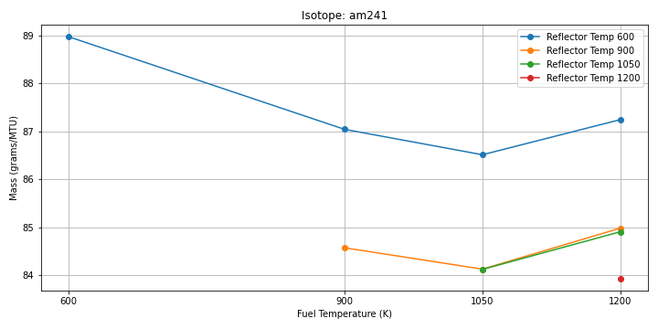
Figure 31: Am-241 Inventory Sensitivity Plot

temperature is seen in the 900K to 1050K range when compared to the 600K to 900K range. The recommendation for this isotope is to increase the number of states taken as well as expanding the solution space to examine how this trend extends out into higher and lower temperatures if learning the reason behind this behavior is desired.
Examining the sensitivities of Ba-137m, the intermediate decay product of Cs-137, to temperature, the inventory is extremely invariant to both fuel temperature and reflector temperature. As the inventory of Ba-137m is in secular equilibrium with the inventory of Cs-137, the changes in inventory for Ba-137m are expected to be miniscule, the invariance to temperature makes sense. See Figure 32 for details. In the examination of the inventory of Cs-137, there’s approximately 5 grams of spread between all fuel and reflector temperatures. The Cs-137 inventory is extremely invariant to temperature conditions. As expected, the sensitivity coefficients appear nearly identical to the Ba-137m inventory sensitivities. See Figure 33 for details. Examining the impact of fuel and reflector temperature on Cs-134 inventories, there appears to be a slightly negative sensitivity coefficient to fuel temperature and nearly no correlation to reflector temperature. See Figure 34 for the plotted curve. Similar to Cs-137, the inventory of Pr-144 shows effectively no sensitivity to either fuel or reflector temperature. The negative
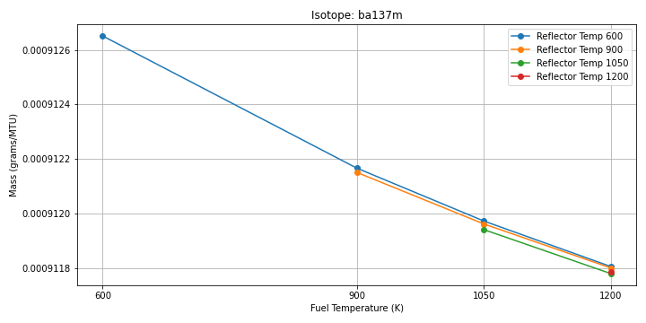
Figure 32: Ba-137m Inventory Sensitivity Plot

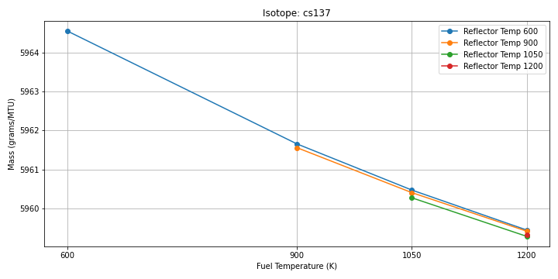
Figure 33: Cs-137 Inventory Sensitivity Plot

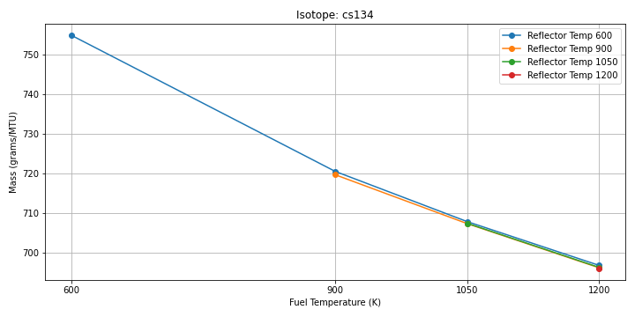
Figure 34: Cs-134 Inventory Sensitivity Plot

coefficient is likely due to increased neutron absorption due to doppler broadening, but the increase is very slight, likely due to the small neutron absorption cross section of Pr-144. See Figure 35 for details.
In contrast to most of the other decay heat contributors, Pu-238 not only shows a strong sensitivity to fuel temperature, but it also possesses a positive sensitivity coefficient to fuel temperature, increasing the inventory by roughly 20% in adjusting the fuel temperature from 600K to 1200K. As a primary contributor in the longer term (100 years) the Pu-238 sensitivity is noteworthy. See Figure 36 for the relevant plot.
Similar to the other fission products, Rh-106 shows little sensitivity to either fuel or reflector temperature. While the sensitivity coefficient is positive, the value of that coefficient is functionally zero. Being a fission product that is not very dependent on neutron spectrum, the observed behavior is expected. See Figure 37 for the full information. Cm-244 shares a rather large, positive sensitivity coefficient to fuel temperature. While largely invariant to the reflector temperature, Cm-244 has an even stronger relationship to fuel temperature than Pu-238 does. An increase from 600K to 1200K increases the inventory of Cm-244 by ~40%, by far the largest sensitivity in the decay heat contributor isotope groups. See Figure 38 for details. Examining the
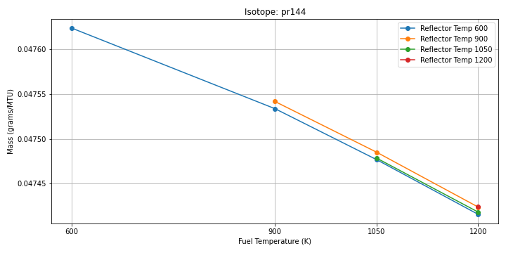
Figure 35: Pr-144 Inventory Sensitivity Plot

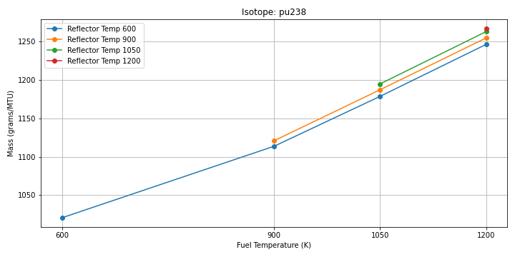
Figure 36: Pu-238 Inventory Sensitivity Plot

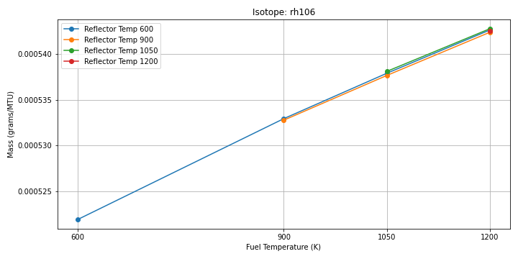
Figure 37: Rh-106 Inventory Sensitivity Plot

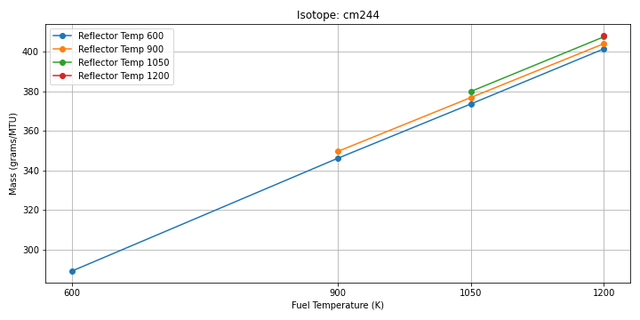
Figure 38: Cm-244 Inventory Sensitivity Plot

sensitivity of Y-90 to both fuel and reflector temperatures, just like the other fission products, there appears to be some sensitivity to the fuel temperature, this is likely due to the equilibrium state of its precursor, Sr-90, in the reactor. Increasing the temperature seems to dampen the inventory directly via increased neutron absorption from doppler broadening. See Figure 39 for further details.

Criticality
Pu-241 has a positive sensitivity to fuel temperature and a weak sensitivity to reflector temperature. The inventory sensitivity of Pu-241 is shown in Figure 40. Pu-241 shows an increase in inventory relative to fuel temperature while reflector temperature is largely unaffected. Pu-241 shows roughly a 16% increase across the fuel temperature range examined. The inventory of U-235 has the strongest positive sensitivity out of any isotope examined. The discharge inventory of U-235 varies greatly depending on the fuel temperature while being nearly invariant to the reflector temperature. As Pu-239 has a negative sensitivity coefficient, the positive coefficient from U-235, as the other primary power producing isotopes, is unsurprising. See Figure 41 for details. Pu-239 has a negative sensitivity to fuel temperature and a weak sensitivity to reflector temperature. The sensitivity also appears to flatten out at higher temperatures, demonstrating a non-
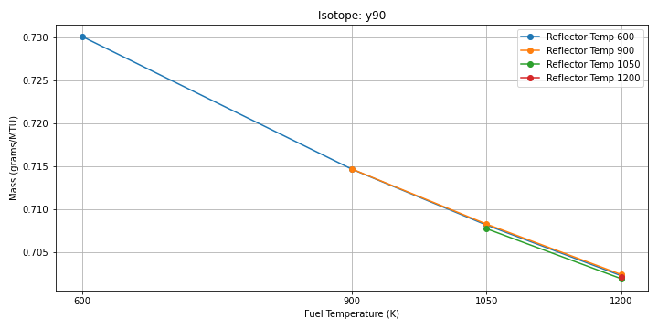
Figure 39: Y-90 Inventory Sensitivity Plot

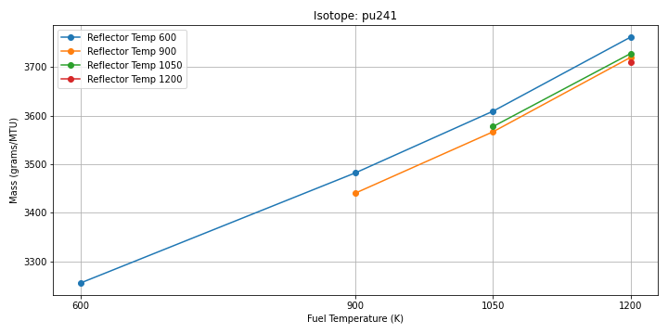
Figure 40: Pu-241 Inventory Sensitivity Plot

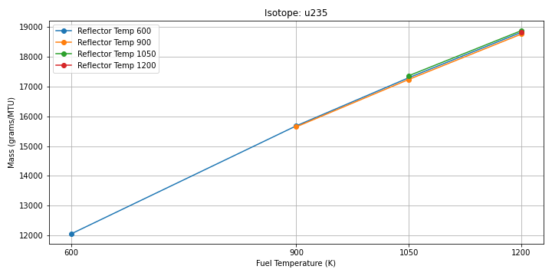
Figure 41: U-235 Inventory Sensitivity Plot

linear relationship between Pu-239 inventory and fuel temperature. Based on previous work [4] See Figure 42 for the graph and details.

Dose Rate
As stated previously, Cm-244, Pr-144, and Rh-106, Cs-134, and Cs-137 are the dominant dose rate contributors. In general, the fission products are relatively insensitive to fuel temperature and reflector temperature. Cm-244 is highly sensitive to fuel temperature, more so than any other isotope examined for dose rate. As Cm-244 is a dominant contributor to both decay heat and dose, this is particularly notable.

Conclusions
In summary, pebble bed reactor fuels have been modeled and the sensitivity of SNF management relevant inventories were examined. As this is early work, only fuel temperature and reflector temperature were examined in this work.
After closely examining the relevant isotope inventories and their sensitivity coefficients to both fuel and reflector temperature, a subset of key isotopes has been identified that are to some degree sensitive to the operating parameters examined in this work. The identified isotopes include U-235, Pu-239, Pu-238, Pu-241, Cm-244, and Cs-134. See Figure 43 for a bar chart of the sensitivity coefficients for the mentioned isotopes to fuel

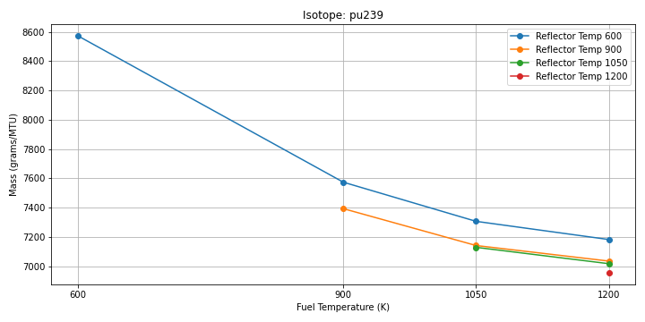
Figure 42: Pu-239 Inventory Sensitivity Plot
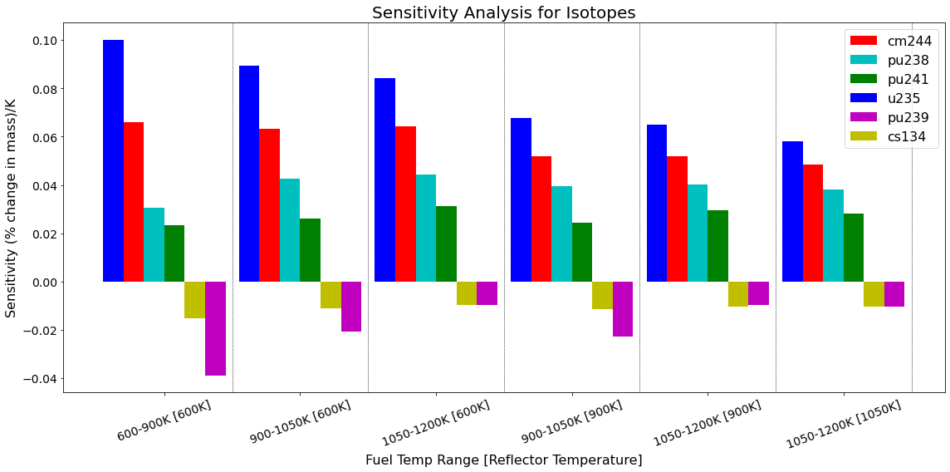
Figure 43: Bar chart of the fuel temperature sensitivities of the identified key isotopes

temperature.
All other isotopes examined were much less sensitive to any parameter when compared to the ones listed. While some sensitivity is observed to the reflector temperature and should be captured in future work, fuel temperature was by far the most impactful parameter examined. In future work, it is recommended to perform the full calculations. Isotope inventories were examined in this work to fully capture how the driver isotopes are changing to influence the end parameters. Future work should also seek to quantify the modeling error introduced by the assumption of a mono-temperature reactor. Doing so impacts both the power profile and the cross sections significantly. Other sources of modeling error should also be addressed and the total amount of error quantified to further inform our future spent fuel management from upcoming advanced reactors.

Chapter 6:
Evaluation of PBR modeling fidelity’s impact on SNF Calculations

A version of this chapter is planned for submission for a future journal article and is currently under review. It is largely a consolidation of previously published conference papers, sorted, organized, and refined and updated as necessary. Jonathan F. Wing is the sole content author with peer review contributions from the following: G. Ivan Maldonado, Gordon M. Petersen, Robert A. Joseph.

Abstract
In this work, the impact of different methods of modeling pebble bed reactor (PBR) fuel on the resultant spent nuclear fuel (SNF) characteristics (decay heat, dose rate, k-effective) is examined. Three methods are examined using SCALE, listed below from the simplest method to the most complex.
1) A reflected pebble is depleted at constant power
2) A mono-temperature equilibrium core model is depleted.
3) An equilibrium core model that employs a temperature profile to accurately model the conditions the pebble experiences as it passed through the core.
The reflected pebble model produces a much higher decay heat, gamma source strength, and plutonium when compared to an equilibrium core model. The depletion by power requirement produces a much higher decay heat and dose rate at discharge and in early term dose rates. The difference in decay heat grows between the reflected pebble models and the equilibrium core in the medium term when actinides more sensitive to neutron spectrum become more dominant. Similarly, the difference in spectrum between a reflected pebble model and an equilibrium core model produces different quantities of Cm-244, the primary dose rate contributor. Results show that the equilibrium core models produce additional Cm-244 and have a higher resultant dose rate based on shielding calculations performed.
Between the reflected pebble models, the pebble depleted by constant power requires an ever-increasing flux to maintain that level of power in the fuel. The increasing flux creates a significant difference in the decay heat and dose rate in the early term compared to the pebble depleted by constant flux. The relative difference persists throughout the decay of the fuel, but the absolute difference shrinks significantly as the half-lives of the relevant isotopes driving the behavior become longer.
Between the mono-temperature equilibrium core model and the enhanced fidelity equilibrium core model, the inclusion of the temperature profile had several significant impacts, most notably in dose rate and decay heat, where the production of the driver isotopes is more sensitive to the impacts of Doppler broadening in their production pathways. The change in k-effective, while not particularly strong, is notable.
Overall, this work shows that while the reflected pebble assumption is a valid approximation in some limited circumstances, the simplification more often than not leads to noteworthy inaccuracies. Likewise, between a mono-temperature reactor assumption and the enhanced fidelity models, the differences are notable in dose rate and decay heat, but the impact is smaller compared to the inaccuracies generated by using a reflected pebble model. In general, the mono-temperature assumption is a good enough approximation if one is willing to accept the associated uncertainty in the results.

Introduction
Pebble bed reactors (PBRs) offer a unique fuel management approach, continuously circulating pebbles through the reactor core until target burnup is achieved. New pebbles are introduced to replace the discharged pebbles and are added at a rate that counteracts the loss in fissile mass and reactivity from the depletion of the fuel. After the initial “run in” process, the fuel compositions, neutron spectrum, temperature profile, and power profiles stabilize into an equilibrium state. The run in process can be difficult to model as many neutron transport steps must be taken to capture the evolution of the reactor core characteristics. When calculating only the equilibrium state of the reactor is desired, a jumping in approximation can be used instead of modeling the full run in process. Jumping in approximations start with a fresh fuel composition and iterate between neutron transport and depletion of the fuel until the reactor characteristics converge. The power profile, discharge fuel composition, temperature profile, and neutron spectrum all converge and produce a reactor core model with very low excess reactivity that is unique to a given set of parameters.
While modeling the run in process and equilibrium state of the core may be important for the applications relating to the active fuel in the core or the reactor itself, the necessity of calculating the equilibrium core for spent fuel applications has been insufficiently examined. As an alternative to modeling the full equilibrium core, a simple approximation of modeling the system as an infinitely reflected pebble is frequently used instead for a variety of applications [90]. However, the reflected pebble approach has several potential issues. A reflected pebble approach produces a harder neutron spectrum that is known to incorrectly predict plutonium nuclide concentrations when compared to a more accurate model [4]. Additionally, acquiring a trustworthy depletion history is difficult without first performing calculations of higher fidelity models. First order approximations may include depletion by constant power or flux but may not properly model the coasting down in a pebble’s power production in relation to both the pebble passing through the core and the pebble’s depletion of fissile worth. The fuel characteristics at the moment of discharge are certainly different between a reflected pebble using a depletion history produced via the SLICE method and one produced using a constant flux or power for depletion, but the degree and kind of the differences have not been quantified. Likewise, the impact of the consequences of the modeling simplification has not been evaluated to determine the suitability of modeling PBR fuel is such a manner.
Similar, despite the SLICE method’s sound fundamental principles and success at establishing a rapid estimation for a PBR equilibrium core, the SLICE method as previously implemented is known to neglect the temperature profile of the reactor, and therefore the fuel’s temperature history during depletion is not considered. Prior work in this series has shown strong relationships between specific isotopes and the temperature of the fuel depletion and equilibrium core depletion. However, many key isotopes have similarly been shown to be insensitive to any temperature related parameter. Prior work [64] has shown that the inclusion of a temperature profile has pronounced impacts of some discharge characteristics, such as burnup, but the work stops short of quantifying the impact and sensitivity for SNF characteristics. The impact and importance of considering a temperature history of the fuel under depletion is uncertain, but early results show compelling reasons to investigate and quantify the impact. As such, an enhanced fidelity SLICE method, referred to as the E-SLICE method in this work, is considered that models a temperature profile. One potential difficulty would be determining how to find a temperature profile that is equivalent to a mono-temperature depletion. A simple solution would be to weight each temperature in the temperature profile by the burnup accumulated at each temperature and use the weighted average to determine the equivalent temperature.
The validity of the weighted average approach has not been explored nor quantified against using the full temperature profile. Another potential source of error would be that the inlet and outlet temperature may be different between temperature profiles, but the same weighted average may arise.
The gap in literature motivates a systematic study on how modeling fidelity, particularly the reflected pebble assumption and the depletion with and without temperature profiles, affects key spent-fuel metrics such as criticality (k-effective), radiological dose rate, and short- vs. long-term decay heat.

Methodology
To begin, the fuel pebbles are modeled in a manner that is consistent with methods described in section PBR Fuel Modeling without any notable changes. The modeled fuel is employed in various ways, described below and in previous sections. A reflected pebble model, a regular SLICE model, and an E-SLICE model are all investigated to determine the bias and validity of the model assumptions in approximating spent PBR fuel characteristics.

Employed Models
The reflected pebble model investigated in this work represents one of the simplest approaches to generating source terms and discharge nuclide concentrations for use in spent fuel calculations. The reflected pebble approach has been employed in various research [79] [90] due to its ease of use despite its known shortcomings [4]. However, the known shortcomings are not known to translate to significant differences when it comes to spent fuel relevant characteristics.
To keep the approximation as simple as possible, information is limited what can be garnered by examining the reflected pebble model only. Information that would be obtained from outside literature or higher fidelity models is explicitly excluded. The use of information that can only be obtained from higher fidelity simulations would undermine the simplicity of the models, whether or not it is present in the open literature. A wealth of potential corrections could be justified as existing in literature, where one could as readily apply a higher fidelity model. The motivating purpose of examining the reflected pebble model is to ascertain the general suitability of the model itself for spent fuel characterization for pebble bed reactors and quantify the differences between model assumptions.
The regular SLICE model is produced with the methods described in the Equilibrium Core Generation section of this dissertation. No other changes are made.
The E-SLICE model is produced with the methods described in the Enhanced SLICE (E-SLICE) Method Modifications without any notable changes. To examine the discharge concentrations for the E-SLICE model, the Possible Pebble Realization Generation method is used to produce ORIGEN concentration libraries which are then fed into the Blended Average Discharge Composition method to produce a single file representing discharge characteristics for the E-SLICE model. All methods produce ORIGEN concentration libraries, which are examined and compared in terms of neutron and gamma source strength as well as decay heat.

Source Strength
Decay times of 0.5, 1, 3, and 5 years are examined to capture both short-term impacts and longer-term effects. The source strength is calculated by pulling the state information directly from the output file via python scripts and all cases are set to assume 1 MTIHM of material is present. As the fission products have been shown to be previously insensitive to spectrum and temperature for gamma sources and Cm-244 is the dominant gamma source, the source strengths between the models are used as comparison points instead. The purpose is not to perform the exact dose calculation but to actively compare the differences that exist across the models examined. Setting the source strength to 1 MTIHM acts flexible set point that can be readily scaled as needed for future work. ORIGEN and OPUS are used to output the source characteristics to the output file for each model, where it is then run and compared.

Decay Heat
For examining decay heat, the method employed in the Decay Heat section in the common methods chapter is applied to all models and the results are compared.

Results
While the models employed are intended to produce identical burnups, there is a lack of ability for the SLICE models to produce the exact discharge burnup desired. Modeling method differences lead to slight variation in discharge burnup, which may be reflected in the results. The burnup differences are examined and found to be within 3 GWd/MTU of each other. The effect of incorporating a temperature profile has been documented in previous work and is having the expected effect [64].

Source Strength
First, the differences in the gamma source strength are examined. The gamma source strength difference between the reflected pebble model and the two SLICE based models is immediately apparent. The reflected pebble produces a short source strength far higher than either pebble model, driven by the inflated flux at discharge arising from the constant power depletion mode required of a simple pebble model. Depletion by flux may be an appropriate, low effort mitigation for this behavior, but has not been examined in this work. The gamma source strength is plotted in Figure 44.
Next, the neutron source strength differences are examined by model and the results are shown in Figure 45. Unlike the gamma source strength, the effects present in the neutron source strength are not due to the depletion mode inflating fluxes. The reflected pebble model is again shown to be a poor estimator for SNF characteristics, overpredicting the neutron source by nearly 50% compared to the E-SLICE model. The SLICE model also shows a significantly higher neutron source compared to the E-SLICE model, likely due to the core averaged spectrum due to lack of distinct radial zones and the mono-temperature depletion, despite the weighted average of all depletion being the same temperature. In calculation of the neutron source, the E-SLICE method is recommended for accuracy, though the other two models are acceptable if a significant amount of conservatism is desirable.

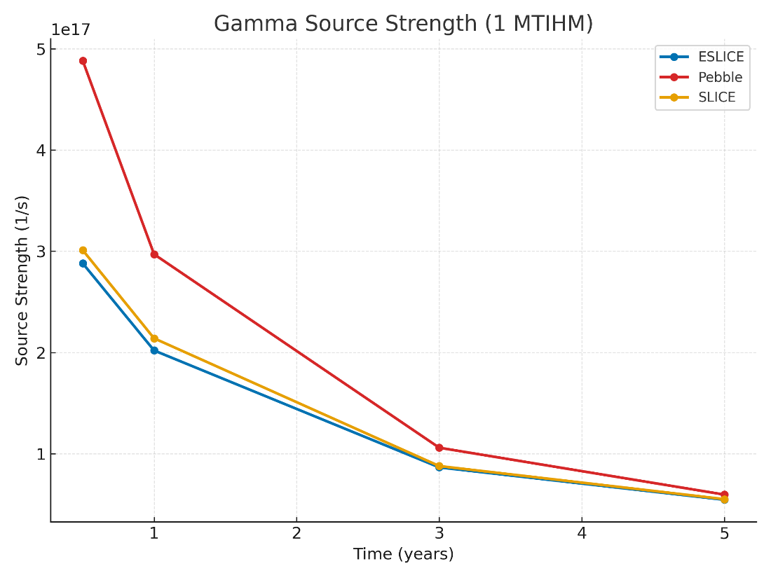
Figure 44: Gamma Source Strength by Model

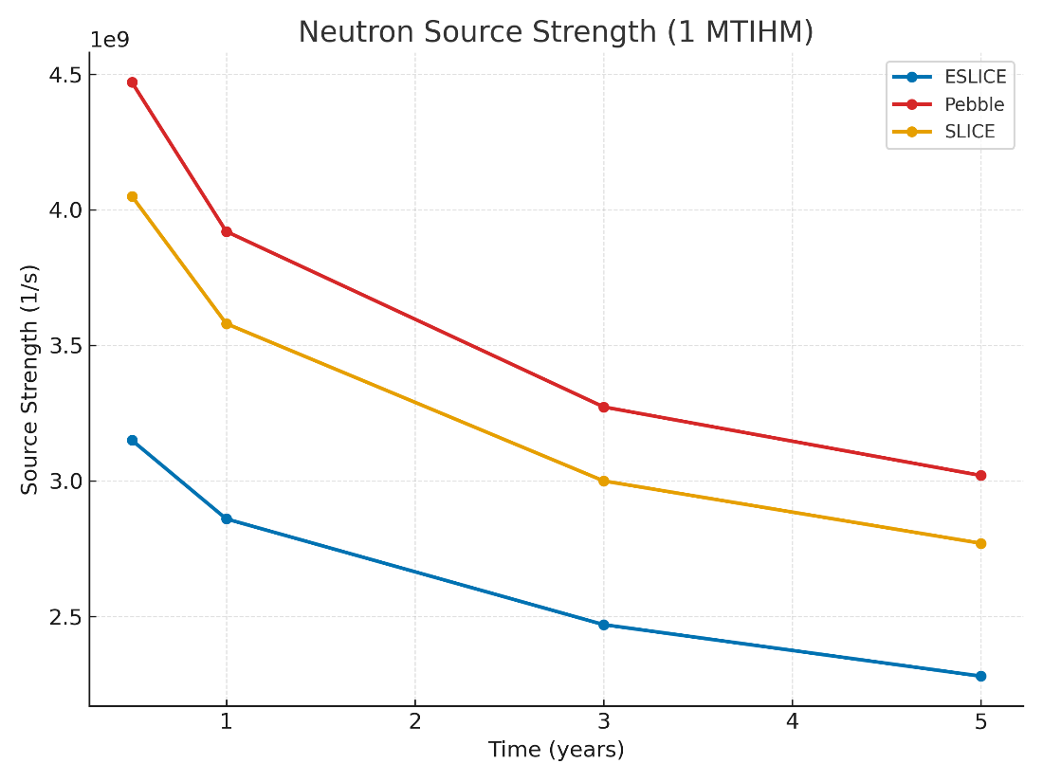
Figure 45: Neutron Source Strength by Model

As the effect of Doppler broadening is rooted in the relative velocity of the incident neutrons to the oscillating velocity of the target atoms, the use of an average temperature assumption, a measure of energy, is likely to always produce incorrect results. A possible correction factor may be to weight by the square root of the average temperature.

Decay Heat
In the calculation of decay heat, significant differences are noted that are similar in nature to the gamma source differences in the early term due to many of the isotopes that drive early gamma sources strength being major decay heat contributors. Figure 46 shows the results for 1 MTIHM of discharged fuel.
The reflected pebble depleted by power exhibits a decay heat that far outstrips the other SLICE based methods due to the constant power and increasing flux over time in the depletion of the fuel. The effect is short lived, but notable in producing a higher decay heat. The two slice models are very similar in early term decay heat as they both capture the coasting down in power of the fuel over time. In the early term, the relative differences between all models begin to shrink as the decay heat driver isotopes change.
In the medium term, where actinides are a growing share of decay heat, differences emerge between the SLICE based models. The decay heat values in the medium term are shown in Figure 47.
As the amount of cooling time grows and actinides become a larger share of the decay heat, the larger the relative difference becomes now that the actinide contribution is not obfuscated by the fission products contributors. The SLICE and reflected pebble models now show good agreement as they produce similar levels while the E-SLICE model shows a lower long term decay heat. The trend continues in long term decay heat, plotted in Figure 48.
For long term decay heat, the reflected pebble and SLICE models agree very closely, differing by roughly a single watt at 1000 years of decay. While the E-SLICE model has a slightly lower discharge burnup due to modeling differences, the difference is too great to be attributed to the slight difference present and is more likely due to the mono-temperature depletion assumption.

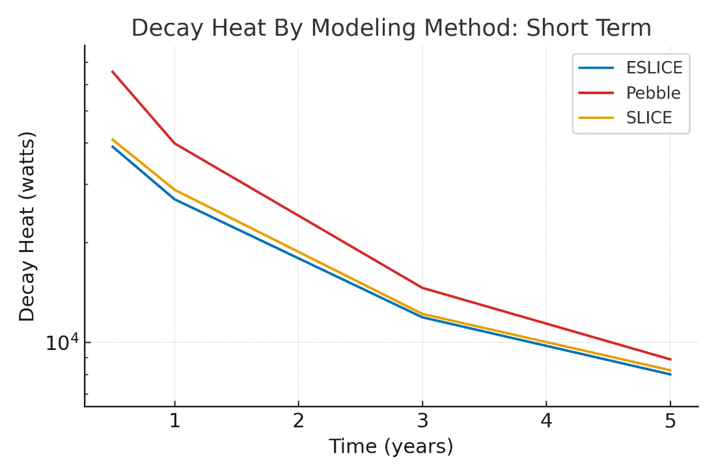
Figure 46: Short Term Decay Heat by Modeling Method

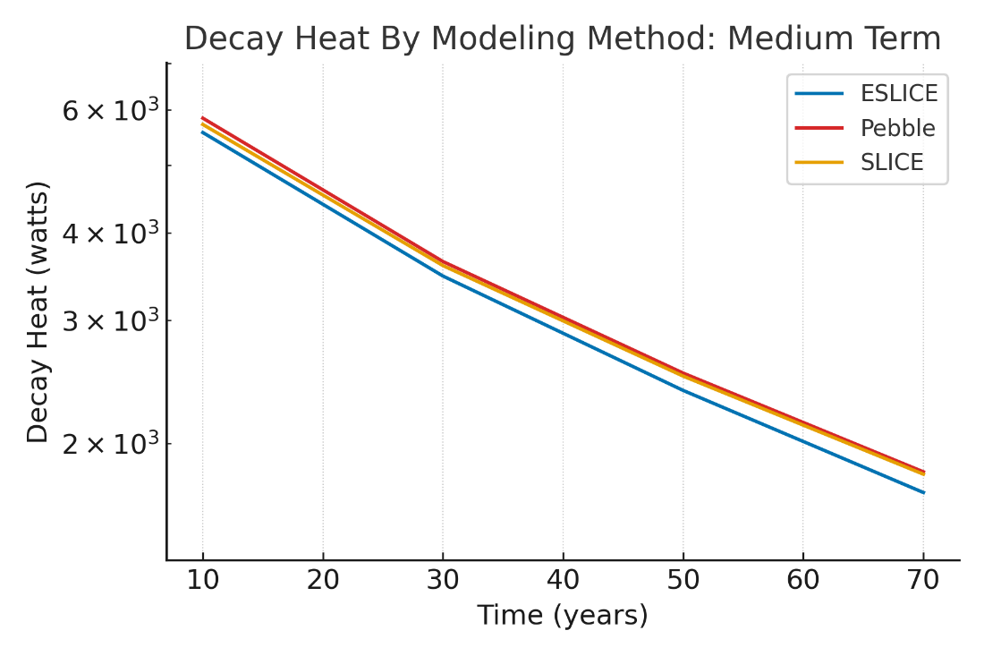
Figure 47: Medium Term Decay Heat by Modeling Method

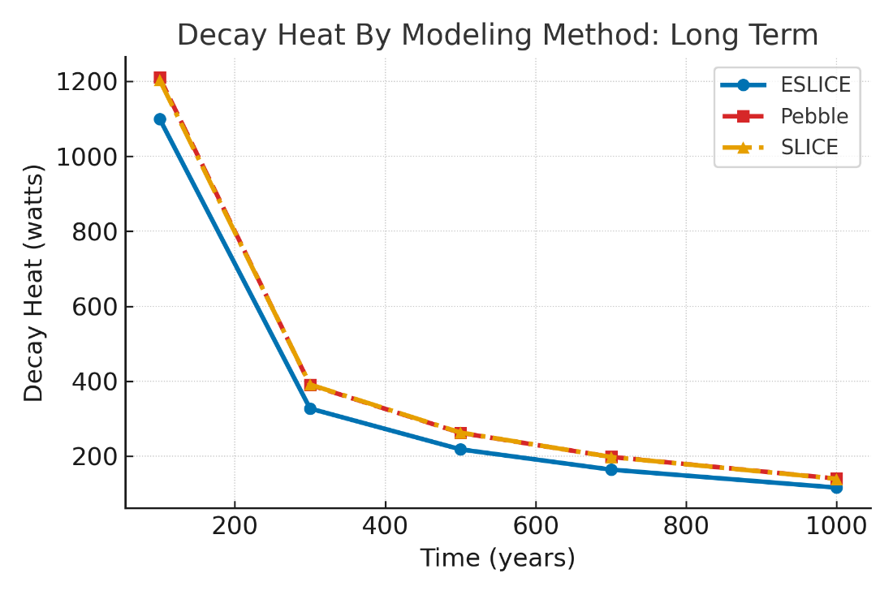
Figure 48: Long Term Decay Heat by Modeling Method

Conclusions

Reflected Pebble Suitability
The reflected pebble assumption is, in general, a poor choice of model to make when analyzing PBR spent fuel characteristics, especially for early estimations. The constant power depletion forces the flux to be very high at the time of discharge, opposite of real pebble behavior. The effect is that a reflected pebble model produces very poor short-term estimates for decay heat and source strength. The results tend to converge after additional time passes, though the relative differences persist. For the longer-term estimations, the reflected pebble model is fine as an approximation if one is willing to accept the relative difference between the reflected pebble and the full model, such as the difference in long term decay heat due to the reflected pebble’s harder neutron spectrum. In general, a reflected pebble model requires that the user know beforehand of the model’s applicability and the acceptable error in the work being performed.

Slice Model Differences
Largely, the SLICE and E-SLICE models show little difference between each other in terms of short-term decay heat and gamma dose rate. However, in the prediction medium-term decay heat, long-term decay heat, and neutron dose rate, the models differ greatly A mono-temperature SLICE based method is useful for estimating gamma source strength and early term decay heat, but greatly overpredicts actinides, affecting neutron source strength universally as well as medium and long-term decay heat predictions.
For gamma dose, As the same coast down in power is modeled, the relative insensitivity to temperature of fission products has been noted previously, the difference between the slice models is rather small for decay heat and gamma source strength. The inclusion of a temperature profile and distinct radial zones lends to differences in the production of certain isotopes, particularly actinides, leading to substantial differences in the neutron source strength and decay heat outside of the short term. The difference in discharge burnup between the methods is slight, but noticeable and may be responsible for the differences in long term effects and the general agreement between the pebble and SLICE models. In general, a mono-temperature SLICE based model should be employed with caution for SNF characterization with recognition of the bias on actinide production that the mono-temperature assumption produces when compared to the time dependent temperature history the E-SLICE method produces. While the SLICE method is still useful in producing the neutron spectrum and predicting power distributions, some cases where the method disagrees with published values have been documented [20] are now covered by the E-SLICE method modifications. The E-SLICE method represents a step forward in the modeling of PBR fuel as it retains the advantages of the SLICE method in its ability to rapidly estimate the equilibrium core properties while addressing its shortcomings and implementing fixes to the biases that the SLICE method introduces.

Chapter 7:
Examining Discharge Burnup and Composition Variability Inherent to Pebble Bed Reactor OPERATION

A version of this chapter is planned for submission for a future journal article and is currently under review. It is largely a consolidation of previously published conference papers, sorted, organized, and refined and updated as necessary. Jonathan F. Wing is the sole content author with peer review contributions from the following: G. Ivan Maldonado, Gordon M. Petersen, Robert A. Joseph.

Abstract
In this work, the uncertainty on spent fuel characteristics (decay heat, radiological dose rate, and fissile content) due to large number of possible individual pebble histories can take in a reactor is examined for a high burnup HTGR system with a single external reflector region. The inherent uncertainty of any individual pebble’s history is effectively unknowable, so bounding conditions are useful to capture possible edge cases that may arise.
A reactor is modeled in SCALE using an equilibrium core estimation method that incorporates a temperature profile. The core is divided into 5 radial regions to capture the radial position dependent neutron spectrum using TRITON. ORIGEN is used to simulate the possible fuel histories utilizing 5 radial zones and 6 passes, 15,625 possible realizations for discharge compositions are examined. Rather than perform an exhaustive set of calculations for k-effective, decay heat, and dose rate, the key driver isotopes are examined instead using OBIWAN and analysis scripts. The distribution of discharge burnup is examined to observe the amount of variability of burnup would exist in an unrestrained scenario of reactor operation. Additionally, the distribution of driver isotopes is examined and compared against the burnup distribution pursuant to elucidate the influence the variable burnup may have on the isotopes being examined without explicitly connecting the two. This work does not simulate a BUMS that would more tightly cluster the burnup distribution around the target value. The choice to exclude a BUMS from this work is motivated by a desire to view a case in which the maximum amount of variability from reactor operation may be observed.
The work performed demonstrates that several key driver isotopes exhibit very similarly shaped distributions for discharge composition when compared to burnup, primarily the actinides Cm-244, Am-241, and Pu-238. Other isotopes are tightly coupled to such a degree as to mirror artifacts due to modeling methods, such as Cs-137 and Y-90. However, a few isotopes, while possessing a small relative difference between the extreme cases, exhibit discharge concentrations that possess no relationship to the burnup distribution, such as Pu-239. Pu-239 is more likely affected by the nature of the reactor operation and neutron spectrum exposure present in the radial zones modeled. U-235 is a unique case in that it exhibits a unique clustering behavior, initially speculated to grouped by either the initial or final radial zone the fuel passes through the reactor core. A short inquiry into the results shows that the initial speculation is not supported by data and that the effect is due to a combination of the reactor operation and artifacts arising from modeling limitations. The cause of the effect is not determined as it is outside the scope of this body of work.

Introduction
PBRs offer a unique fuel management approach, continuously circulating pebbles through the reactor core until target burnup is achieved. New pebbles are introduced to replace the discharged pebbles and are added at a rate that counteracts the loss in fissile mass and reactivity from the depletion of the fuel. Pebbles that have met the burnup target as measured by a burnup measurement system are discarded, while pebbles that have not are recycled back into the reactor. A pebble may pass through different radial regions for each time it is recycled back into the core, potentially impacting the discharge characteristics significantly. A large number of pebbles are present in the reactor at any given time, and it is functionally impossible to know any individual pebble’s history of its path taken through the reactor for each pass of its depletion. The stochastic nature of fuel movement and the variety of possible histories inherently introduces some degree of variability to the fuel characteristics.
A pebble bed reactor’s fuel may undergo any number of possible paths through the reactor core. It is known from previous work that a pebble experiences little lateral movement [76, 81], a slowing down effect of roughly 50% when a pebble is near the vessel wall [76, 81], and a neutron spectrum that varies significantly with radial position [4]. Previous work has examined the variability in bulk discharge characteristics such as burnup [76, 81] and determined the pass-to-pass variation present. However, this work did not incorporate a temperature profile, shown to impact discharge characteristics [64], for the fuel depletion history and did not account for the slowing down effect of pebbles near the vessel walls [76]. Additionally, the work was performed using the PBMR-400 as the model reactor, which possesses a second inner reflector and targets a far lower burnup for fuel compared to more recent designs [25]. No previous work has sought to determine the isotopic distribution of possible pebble realizations for spent fuel applications and how the outliers might impact the understanding of the bulk behavior of spent fuel. This work seems to accomplish two specific goals. First, determine how the discharge burnup across the full set of individual pebble histories varies due to effects of reactor operation in a high burnup HTGR with a single outer reflector. Second, determine the resulting distributions and degree of variability for several key isotopes that drive spent nuclear fuel behavior for pebble bed reactor fuel. Examining the full set of possible pebble discharge compositions helps to both bound the extreme cases and provide more informed data regarding the potential pebble to pebble differences that may exist.

Methodology
In the pursuit of examining the reactor induced variability in key isotope discharge concentrations, it is imperative to cover the possible space of what pebbles may be produced during the reactor operation. To produce the set of possible pebble histories, the fuel is modeled consistent with the methods described in the PBR Fuel Modeling section. Next, a reactor is modeled based on the methods in the Enhanced SLICE (E-SLICE) Method Modifications section to produce cross section libraries to be used in the application of the Possible Pebble Realization Generation method previously described. Each individual pebble history produces an f71 ORIGEN concentration library which can be interrogated with OBIWAN. A python script is used to call OBIWAN to produce concentrations for the isotopes of interest, previously identified in Chapter 5 of this dissertation. The results are then binned and plotted across a variety of bin sizes and the most appropriate result is chosen and presented in the following results section. A similar process is used for discharge burnup. The results are plotted to visually examine the spread of the data and investigate further any artifacts or irregularities present.

Results

Reactor Operation Induced Variability
In the examination of how the reactor operation introduces variability, burnup is a key behavior of interest as burnup is known to heavily influence SNF characteristics. Figure 49 shows the burnup distribution from the individual pebble histories.
The burnup distribution has some very notable peaks in the burnup values left of the average burnup. The observed effect is likely due to a combination of the discretized radial zones and each radial zone being fixed for each pass. While the effect is noteworthy to observe, it should be noted that the total range of burnup is generally within 10 GWd/MTU of the average value, with the difference between the peaks being less than 1 GWd/MTU, making this effect likely an artifact of the computational methods or binning employed.
Next, Cs-137 and Y-90 are examined to further confirm the tight relationship to burnup that fission products possess. The distribution of discharge concentrations of Cs-137 and Y-90 are plotted in Figure 50 and Figure 51.

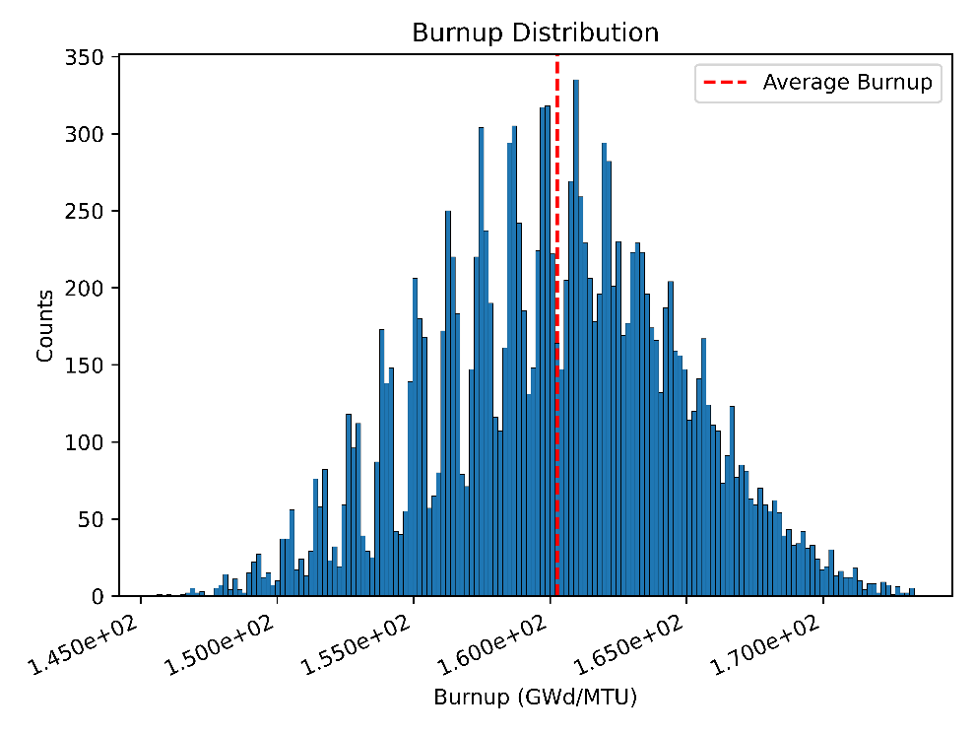
Figure 49: The Burnup Distribution of possible pebble histories

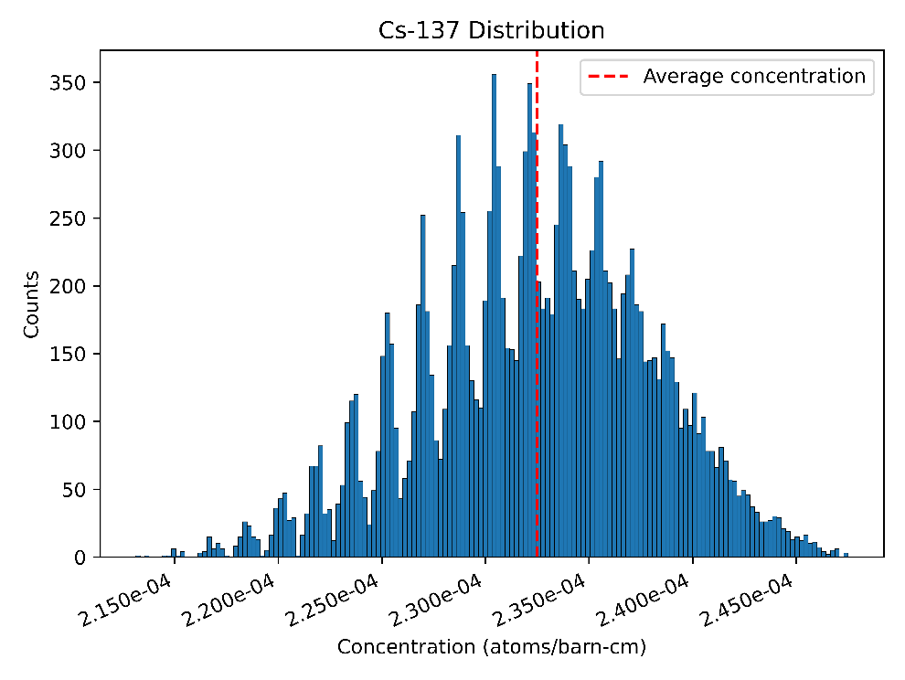
Figure 50: Possible pebble Cs-137 Discharge Concentration Distribution

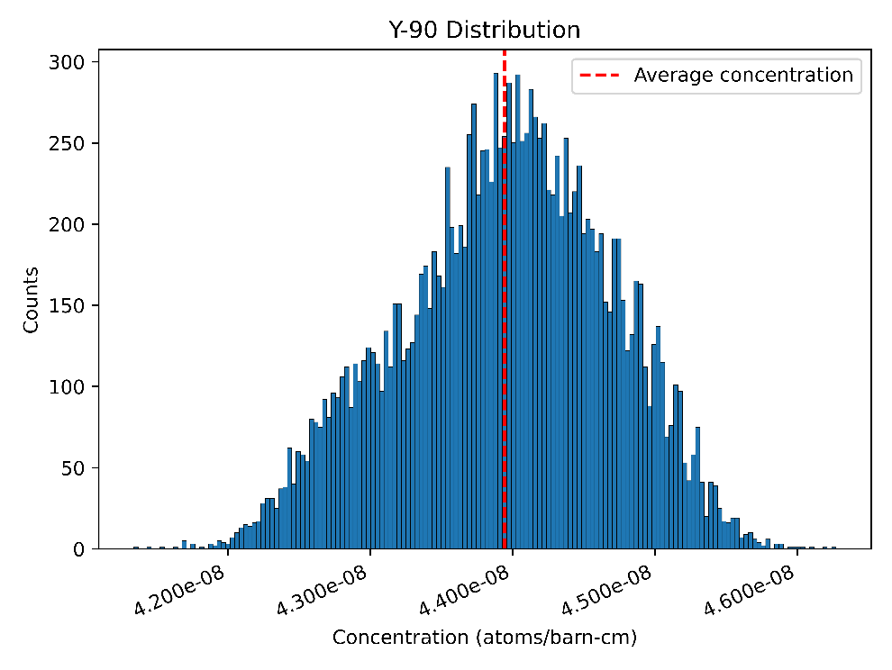
Figure 51: Possible pebble Y-90 Discharge Concentration Distribution

Both isotopes demonstrate their tight relationship to burnup, Cs-137 especially as it mirrors the burnup clustering artifact in the burnup plot. Y-90 is also highly correlated. Both fission products have lower variability due to reactor operation, roughly 10% between the most extreme cases. The tight grouping is expected as previous work in this series has demonstrated the insensitivity of fission product generation to neutron spectrum changes.
Next, Cm-244, Am-241, and Pu-238 are examined together as they are non-fuel actinides that contribute significantly to decay heat. Figure 52, Figure 53, and Figure 54 show the results.
Cm-244, Am-241, and Pu-238 all exhibit normal distributions centered around the average of the discharge concentration for each isotope and do not demonstrate notable impacts from the burnup artifacts.
Unlike the fission products examined, the distribution of concentrations between the outliers is much larger, with Cm-244 possessing a near factor of 3 difference between the extremes and a wide distribution. Am-241 has a ~2.5 factor difference between the
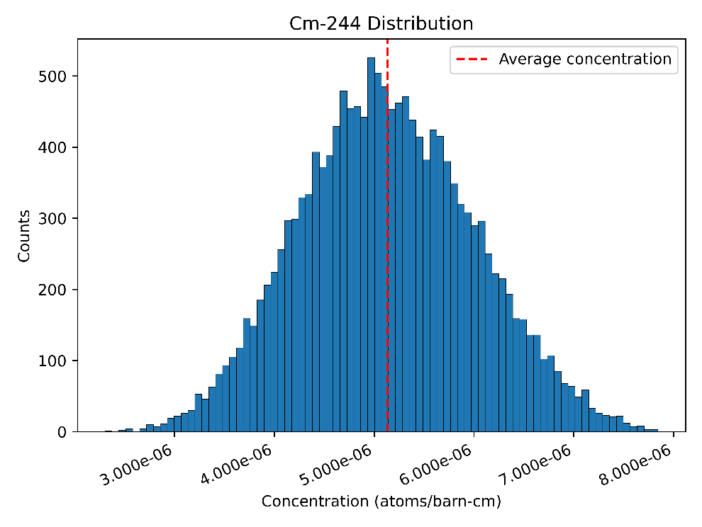
Figure 52: Possible pebble Cm-244 Discharge Concentration Distribution

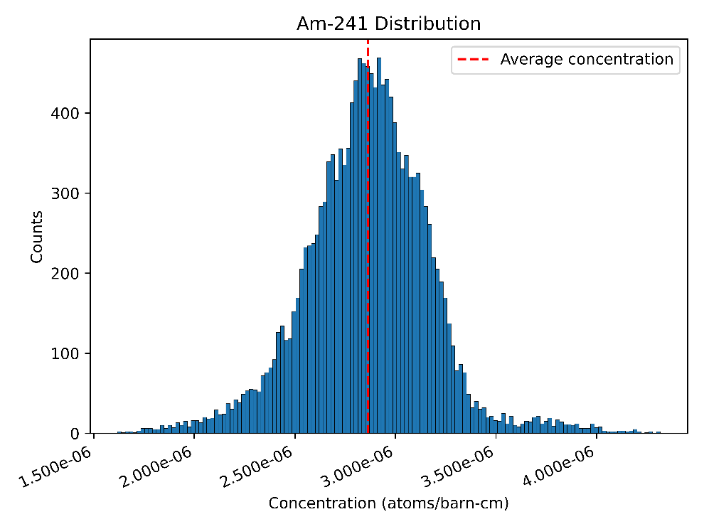
Figure 53: Possible pebble Am-241 Discharge Concentration Distribution

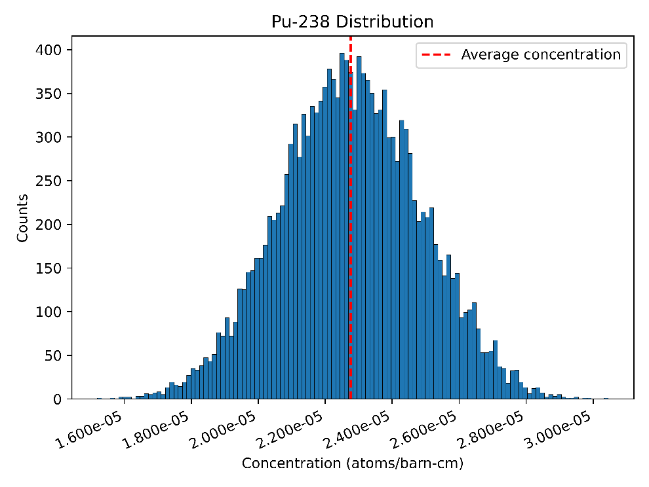
Figure 54: Possible pebble Pu-238 Discharge Concentration Distribution

lowest and highest values but possesses a more tightly grouped central peak. Lastly, Pu-238 exhibits the smallest difference in concentration between extremes, with less than a factor of 2.
Lastly, the fuel isotopes of U-235 and Pu-239 are examined. The distributions are plotted in Figure 55 and Figure 56.
The Pu-239 plot is somewhat chaotic and does not seem to have any specific clustering behavior. The factor separating the extreme values is relatively small, around 1.5, but the very sporadic distribution is noteworthy as while there are a few peaks, there are significant troughs and additional sporadic peaks spread throughout the plot.
While further investigation as to what underlying mechanisms give rise to the observed behavior, such additional work is outside of the scope of the current work.
The U-235 discharge distribution plot exhibits unique behavior. The discharge distribution of U-235 is clustered into five distinct peaks with a factor of four difference
between the extreme values. As the five peaks may possibly correspond to the five radial
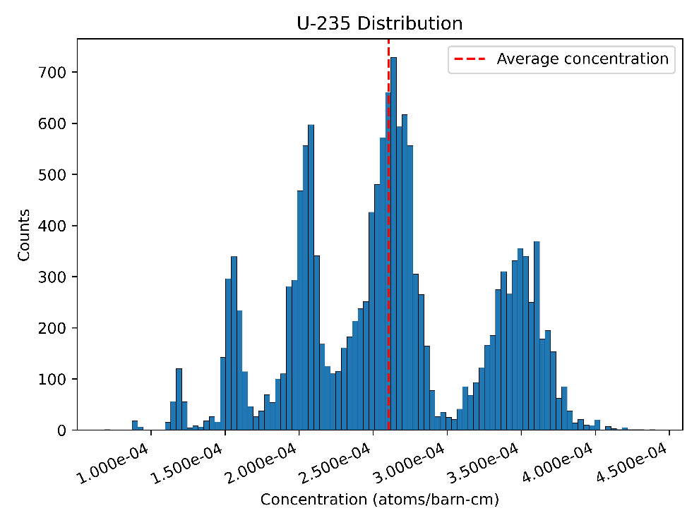
Figure 55: Possible pebble U-235 Discharge Concentration Distribution

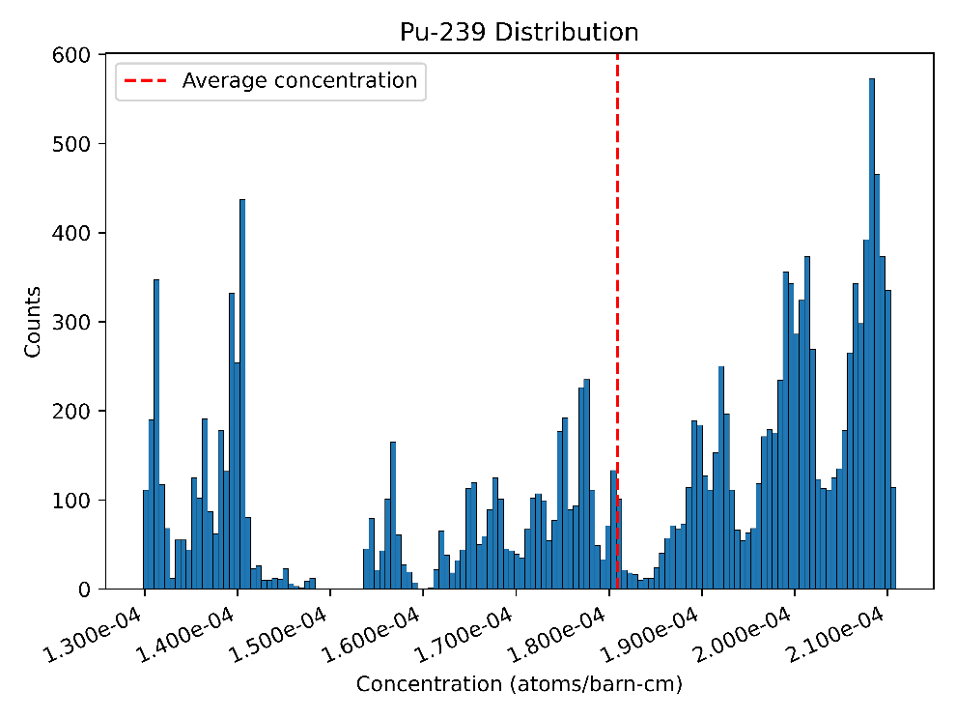
Figure 56: Possible pebble Pu-239 Discharge Concentration Distribution

zones implemented in the TRITON models, meaning that the discharge concentration may be heavily influenced by either the initial radial zone or the final radial zone. To investigate if the initial or final radial zone is responsible for the five distinct groups, the histogram is reproduced with data grouped by the initial and final radial zones. Figure 57 and Figure 58 show the grouped radial zone histograms.
Examining each radial zone’s contribution to each clustered set of discharge concentrations, it is readily observed that the clustering effect cannot be attributed to either the initial or final radial zone selections.
Both the initial and final radial zone grouped data indicate that the clusters with lower discharge concentrations are due to the impact of passes that more frequently pass through radial zone 4 as opposed to the other zones. From the left peak, the first three large peaks have a large fraction of the total occurrences contributed by passes with radial zone 5 as the initial or final selected radial zone. Meanwhile, the center group appears to have mostly contributions while the rightmost peak possesses very few bins that show an
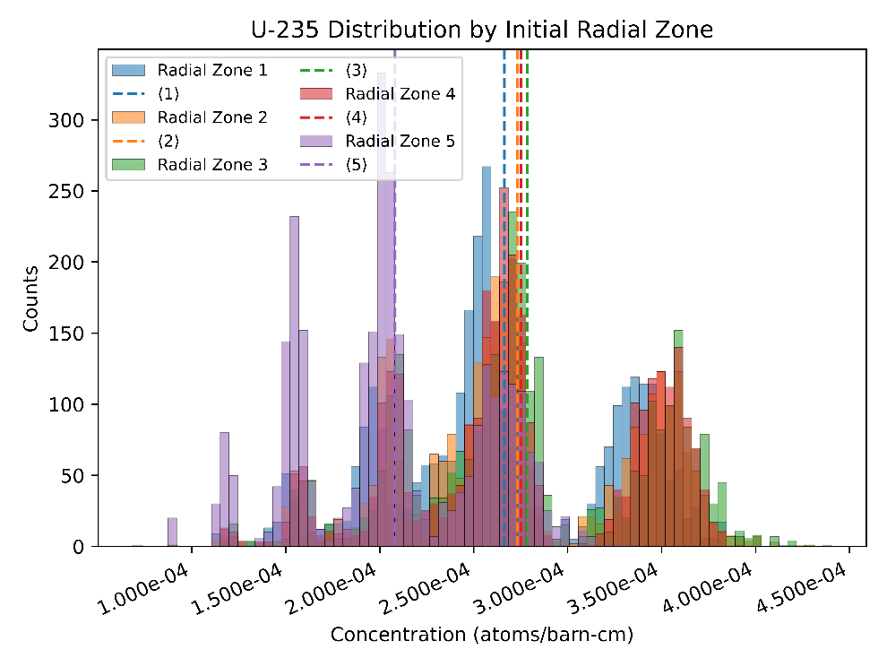
Figure 57: U-235 Discharge Concentration Grouped by Initial Radial Zone Pass

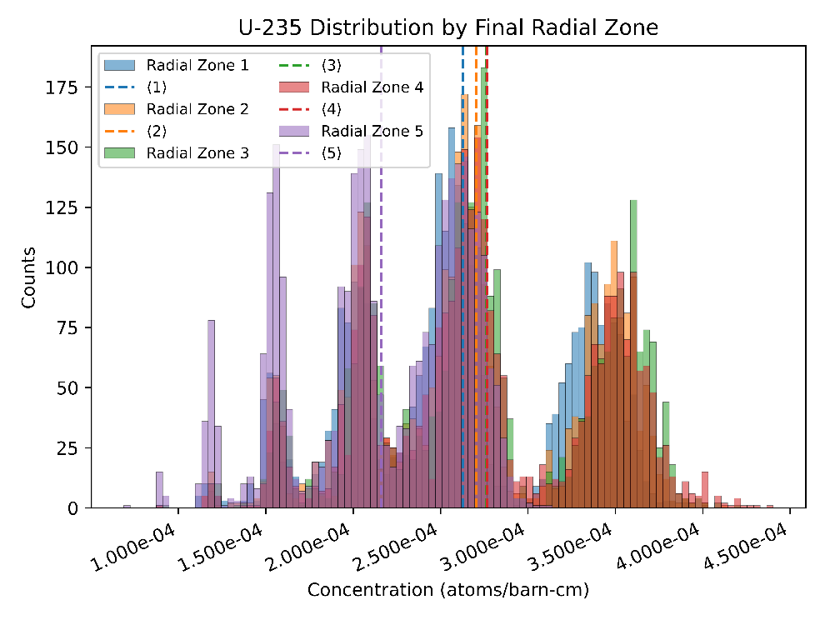
Figure 58: U-235 Discharge Concentration Grouped by Final Pass Radial Zone

initial or final pass through radial zone 5. More closely examining the plots, a small peak is observed, bringing the total number of clusters to 6, suggesting that the number of passes through the core may have some influence, in particular the number of passes through radial zone 5, given the differences seen in the initial and final radial zone plots.
To examine if the clustering effect is due to the number of passes through radial zone 5 combined, each individual pebble history is grouped based on the number of passes through radial zone 5, from 0 to 6. The U-235 discharge distribution is plotted by total radial zone 5 pass count instead in Figure 59.
Each individual cluster is grouped neatly by the total number of passes through radial zone 5. As radial zone 5 is nearest the reflector, it has both the wall correction factor applied that increases the fuel residence time for that pass and is the radial zone with the most thermal neutron spectrum. The factors combined lead to an outsized impact due to passes through radial zone 5, where a single pass is responsible for taking the rightmost cluster into a wholly separate cluster. As the total number of pass order variations peak

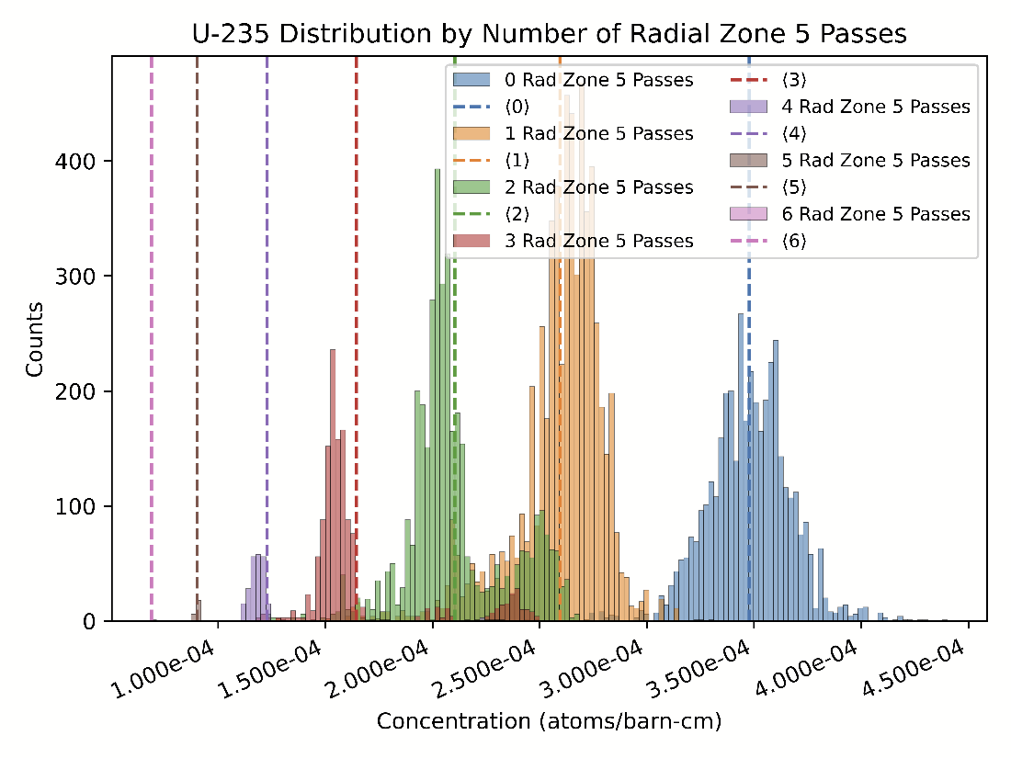
Figure 59: U-235 discharge concentration by radial zone 5 pass count

with 1 and 2 passes, some overlap exists in which the effects smooth out somewhat. However, as the number of possible variations declines with 3 and more passes through radial zone 5, the overlaps fade and distinct clusters appear again
For pass counts of 5 and 6, there are only 24 and 1 total variations, respectively, resulting in a very tight grouping. Both the order of the passes and the specific radial zones in an individual pebble’s history leads to a spread, even among identical pass counts through radial zone 5. Some individual inspection of randomly selected histories revealed that an earlier pass through radial zone 5 lead to a lower discharge concentrations than an equivalent case where the radial zone 5 pass was later in the pebble’s depletion history instead.

CONCLUSIONS
PBR SNF has some variability in discharge composition that is inherent to the operation of the reactor itself and the myriads of possible individual pebble realizations. The effect that the radial position has on the neutron spectrum can be quite large, meaning that it is important to examine the potential effects present in pass-to-pass variation. Variations include impacts on the fuel discharge burnup and the variability of key isotopes in the discharged inventory.
The burnup variability is generally a normal distribution with a notable sawtooth behavior that is mirrored in the fission products. The fission products exhibit a similar relative difference between extremes that the burnup distribution does with Cs-137 mirroring the sawtooth artifact. While Cm-244, Am-241, and Pu-238 all exhibit normal distributions, the spread between extremes is much greater due to the difference in production pathways in the reactor. U-235 is a unique case and exhibits a clustering behavior in its discharge distribution. Examining more closely revealed that the data clusters possess different numbers of pebble passes through radial zone 5. The more thermal spectrum and increased fuel residence time produces clean separation when a single pass through radial zone 5 compared to cases in which radial zone 5 is not present in a pebble’s depletion history. A closer examination of a sample of output files also shows that within each cluster, the fuel histories which have the radial zone 5 passes present at the beginning of depletion show a lower discharge concentration of U-235 while the cases where the radial zone 5 passes happen later in the fuel’s depletion history exhibit higher discharge concentrations. The possible set of combinations for pass counts of 2 and 3 leads to overlap given the large number of variations that can exist for the placement of the zone 5 pass vs. the other zones present. In short, the clustering effect is, while surprising, well explained by the outsized impact the near reflector region has given the distinct radial zones utilized in this work.
Due to the large number of fuel elements present in systems that would be impacted, the very large number of possible histories, and the long neutron path length in PBR fuels that reduce localized effects, the effects due to the outliers should not have a particularly strong impact on a system’s overall performance. While a BUMS would significantly decrease the variability of fuel, the work presented here represents an applied conservatism. Overall, the variation in both amount and kind is noteworthy to document the potential for edge case behavior that deviates from the expected average behavior to help provide more informed bounding scenarios for PBR SNF management.

Chapter 8:
EXAMINING THE SUITABILITY OF ESTIMATING SPENT PEBBLE BED REACTOR FUEL CHARACTERISTICS WITH DISCHARGE BURNUP AND COOLING TIME

A version of this chapter is planned for submission for a future journal article and is currently under review. It is largely a consolidation of previously published conference papers, sorted, organized, and refined and updated as necessary. Jonathan F. Wing is the sole content author with peer review contributions from the following: G. Ivan Maldonado, Gordon M. Petersen, Robert A. Joseph.

ABSTRACT
For evaluating SNF characteristics for discharged PBR fuel, it is important to be able to estimate the bulk characteristics of the fuel, especially given the vast number of fuel elements present in any given spent fuel system. Previous work has demonstrated the effects due to operating parameters, initial fuel conditions, and reactor operation variability showing both the influence of operating parameters on key drivers of spent fuel behavior and potential pebble to pebble variations in the discharged composition.
In this work, the uncertainty on spent fuel characteristics (decay heat, radiological dose rate, and fissile content) due to reactor operating parameters and initial fuel conditions are examined for a high burnup HTGR system with a single external reflector region. Some parameters are second order effects or may be difficult to track. This work examined the suitability of using only burnup and cooling time as known parameters to predict SNF characteristics for PBRs.
The work performed demonstrates that burnup and cooling time are suitable to use as the sole parameters for predicting PBR SNF characteristics, provided margin is applied that captures and bounds the effects of the excluded parameters. Once corrected for impacts from modeling assumptions, criticality is fairly well captured by applying uncertainty envelopes that capture parameters other than burnup and cooling time. Dose rate behavior is well captured, particularly by cooling time in the short term and by burnup and cooling time. Known relationships from LWRs persist for dose rate. Lastly, for decay heat, cooling time is the primary parameter, though burnup matters significantly in the variation for each examined time step.

Introduction
Pebble bed reactors (PBRs) offer a unique fuel management approach, continuously passing pebbles through the reactor core and recycling them until the reactor’s target burnup is achieved. A pebble is discharged from the reactor when its fissile worth no longer positively contributes to the criticality of the reactor. The fuel cycling scheme allows for greater utilization of the fuel than traditional light water reactors (LWRs). To compensate for the loss of fissile worth with rejected pebbles, new pebbles are regularly introduced. After a period of operation, the fuel compositions, neutron spectrum, temperature profile, and power profiles stabilize into an equilibrium state. When calculating only the equilibrium state of the reactor is desired, a jumping in approximation can be used instead of modeling the full run in process. A jumping in approximation starts with a fresh fuel composition and iterates between neutron transport and depletion of the fuel until the reactor characteristics converge. The power profile, discharge fuel composition, temperature profile, and neutron spectrum all converge and produce a reactor core model with very low excess reactivity under a given set of conditions. ORNL has for decades developed SCALE, a comprehensive nuclear modeling code package that possesses sequences that are well validated to lead efforts in the modeling of PBR fuel [10, 67, 91] while also possessing several highly effective and efficient methods for calculating spent fuel inventories using TRITON and the ORIGEN, k-effective calculations using KENO, dose rate and shielding calculations with MAVRIC, and decay heat via use of OPUS, a utility for outputting user defined information .
To model the equilibrium state, Dr. Bostelmann of ORNL has developed the SLICE method [16]. The SLICE method is a jumping in approximation method that is capable of quickly estimating an equilibrium core, but as previously implemented does not include a temperature profile, which may shift the depletion history and production of key isotopes that drive SNF characteristics. Previously published work had both quantified the variability of discharge characteristics [68, 76, 81] and examined temperature effects [4], shares the mono-temperature weakness. Work that has considered the inclusion of a temperature profile has shown that there are noteworthy impacts to the discharge burnup of a generic PBR [64] but does not provide insight as to how those factors impact SNF characteristics. To cover the gaps noted, prior work in this series has demonstrated the strong relationship between certain key isotopes behind SNF behaviors and fuel characteristics, in particular fuel temperature. The characteristics examined show strong effects on some of the key isotopes that drive spent fuel behavior, though some key isotopes, fission products in particular, are relatively insensitive. Previous work in this series has also examined the suitability of different modeling assumptions for SNF modeling efforts and has found that of the practices examined, the current best practice is to employ an equilibrium core with a temperature profile that captures the change in temperature across axial zones. Lastly, other work in this dissertation has examined the uncertainty introduced by the stochastic nature of individual pebble history while accounting for the variable temperature history during depletion.
While the effects on SNF behavior due to effects such as fuel temperature and radial position are shown to be meaningful, such characteristics are not practical nor reasonable to capture for real world data collection to inform PBR spent fuel management or predict SNF behavior. Therefore, the collection of the body of work presented asserts that by tracking only the burnup and cooling time of the discharged fuel, one can know with reasonable certainty the bulk characteristics of the discharged fuel in package by calculating effects of non-trackable parameters and modeling the effects as uncertainty.

METHODOLOGY
For the majority of researched performed in this chapter, the methodologies employed have been previously described in CHAPTER 3: Common Methodologies Across Chapters And Dissertation Structure. The specific methods will be mentioned and referenced, as well as how they are employed and any potential differences between the described methodology and how it is employed in this chapter.
For this work, the fuel modeling methodology from the PBR Fuel Modeling section of is employed. No substantial differences exist between the methodology or fuel parameters described previously and the ones employed for this chapter.

Determining the Relevant Parameter Set
The most noteworthy factors shown to impact SNF behavior in PBRs have been the fuel temperature, enrichment, radial position in the core, burnup, and cooling time. As tracking fuel temperature and radial position are not viable metrics to track to inform spent fuel management, burnup, enrichment, and cooling time are much more reasonable to have good knowledge of. The positional effects are captured by the average discharge composition and present in all results. Additionally, while enrichment has been shown in LWRs to have impacts on dose rate on fuel driven to the same burnup, the discharge burnup in PBRs is small, with a relatively narrow range of fuel burnups over a very large number of fuel elements, making burnup the more suitable characteristic to track, especially as PBRs seek to measure individual pebble burnups to determine if they should be discharged. Additionally, as burnup is tightly coupled to enrichment, a known average discharged burnup can likely be used to reverse engineer the initial fuel enrichment provided the reactor design is known. In order to preserve the other reactor characteristics. Five total values for initial fuel enrichment are examined, five fuel temperature values corresponding to the outlet temperature, and three specific powers are considered. Every combination of parameters is to be examined, resulting in 75 unique equilibrium cores. Table 10 shows the values for each parameter. Temperature is limited to the point at which thermally driven diffusion of isotopes through the silicon carbide layer becomes problematic [92].
Based on the initial enrichment, the target burnup is adjusted using a linear relationship assumption. As the target burnup of 15.5% enriched fuel is roughly 165 GWd/MTU, the ratio is applied to the other fuel enrichments examined to determine the target burnup. In
Table 10: The set of parameters used for equilibrium core generation
Outlet Temperature (K) | Initial Enrichment  (wt% U-235) | Specific Power (MW/MTU)
600 | 12.5 | 80.0
750 | 14.0 | 105.7
900 | 15.5 | 120.0
1050 | 17.0 | N/A
1200 | 18.5 | N/A

order to achieve the calculated target burnup without compromising specific power, the fuel residence time is increased by the same factor.
The outlet temperature is the declared value for temperature, but a temperature for the inlet is calculated based on the assumed efficiency of modern PBRs and the declared inlet/outlet temperatures for those systems. Utilizing the assumed efficiency as a basis and producing a correction factor for losses with the declared inlet/outlet temperatures, a temperature profile is generated based upon the converged power profile calculated for the reactor. Lastly, the specific power is adjusted by both changing the declared specific power and also changing the pebble residence time per pass so that the same target burnup is achieved.

Equilibrium Core Generation and Analysis
The base equilibrium core generation method utilized in this section is the E-SLICE method, described previously in the Enhanced SLICE (E-SLICE) Method Modifications section. The E-SLICE method is used to generate equilibrium cores for each parameter set, for a total of 75 unique equilibrium core configurations.
Next, the possible pebble histories are modeled for each equilibrium core using the common method described in the Possible Pebble Realization Generation section. Once the possible pebble realizations have been calculated using ORIGEN, the material is blended into an average discharge composition by the method previously described in the Blended Average Discharge Composition section. With each equilibrium core across the examined parameter set now represented by blended average discharge composition, the average discharge burnup for each parameter set is recorded and the SNF characteristics are examined for each equilibrium core for criticality, radiological dose rates, and decay heat and are consistent with the methods described in the Criticality section, the Radiological Dose Rate section, and the Decay Heat section and the values for each equilibrium core are recorded.
Each recorded value for each equilibrium core parameter set is plotted against that parameter set’s average discharge burnup value. After all values are plotted, a best fit line is estimated across the dataset and an uncertainty band is calculated based on the spread present in the data and its correlation with burnup. The uncertainty band is plotted as a bounding envelope to visualize the amount of uncertainty one would be required to apply for this specific parameter space if only burnup and cooling time were allowed as knowable quantities.

RESULTS AND DISCUSSION

Criticality
The peak k-effective state of each set of calculations is plotted against its associated discharge burnup. All results can be fit into a single graph, shown below in Figure 60.
As the discharge burnups on the x-axis are the final burnup values, the fundamental design of a PBR should lead to very similar fissile worth in the discharged fuel. The expected effect is observed, with k-effective vs. burnup function staying relatively flat.
There is a slight upward trend with burnup, indicating that the assumed linear relationship between burnup and enrichment may not be perfectly linear in nature.
To investigate, the k-effective value for each equilibrium core reactor model is recorded and plotted against the average discharge burnup reported, similar to the method employed for examining the in-canister criticality correlation to burnup. The results are shown in Figure 61.
The k-effective values for the equilibrium cores show a very similar trend to the one observed in peak k-effective values for the discharged fuel. The excess reactivity at the higher average burnup values indicates the linear relationship between burnup and enrichment is not perfectly linear and a more proper estimation would likely eliminate the excess reactivity in both the equilibrium core models and consequently remove the positive relationship of k-effective to burnup. Implementation of a BUMS would more tightly cluster burnup around the target value and reduce the excess reactivity.
In conclusion, the effect of final discharge burnup on k-effective is well correlated and the variation due to other effects, such as fuel depletion temperature, are readily captured as uncertainty in k-effective, requiring that only burnup need be tracked to well estimate k-effective based on the modeling efforts performed in this work.

Radiological Dose Rates
To understand the relationships that exist between burnup and cooling time and the gamma/neutron dose rates, a set of shielding evaluations are performed for both gamma
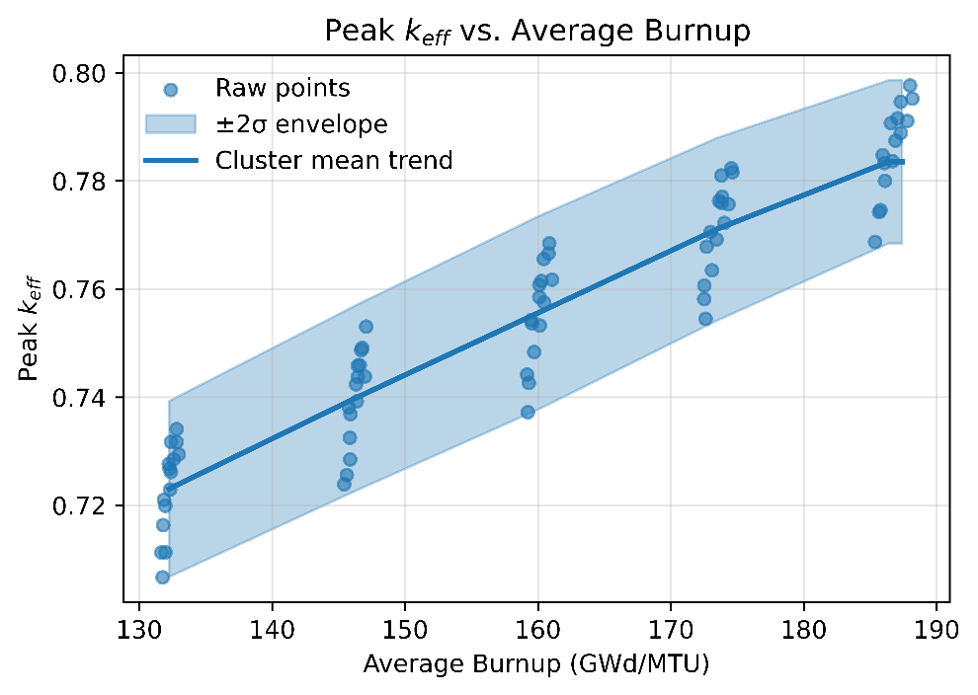
Figure 60: In package k-effective vs. Burnup, best fit plus uncertainty

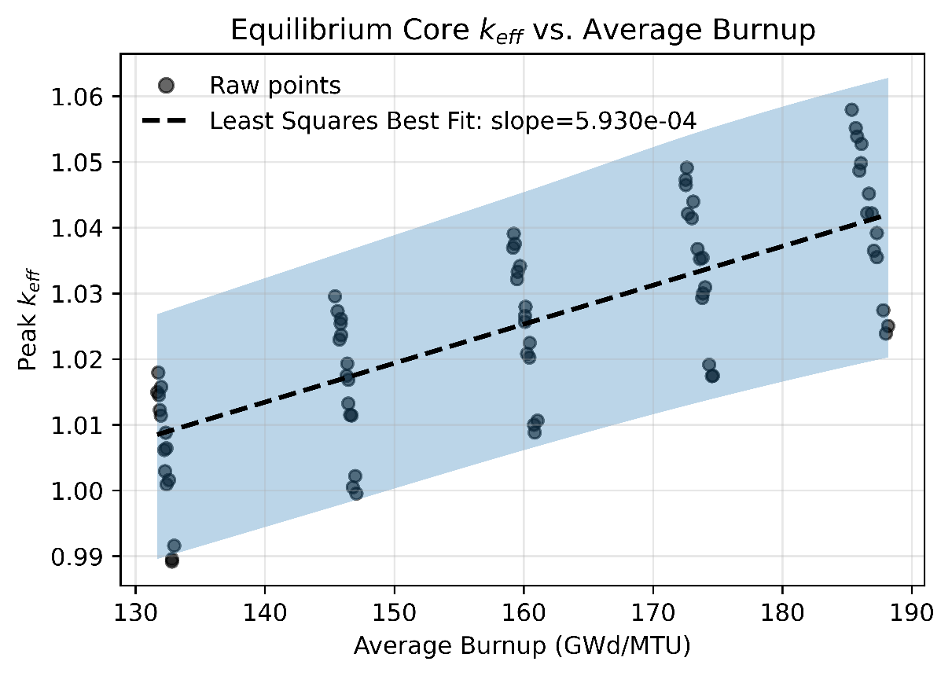
Figure 61: Equilibrium Core Model K-effective vs. Average Burnup

dose rates and neutron dose rates at 0.5, 1.0, 3.0, and 5.0 years of cooling time and the dose rate is collected using detectors at regulatory relevant locations. The dose rates for 0.5 years of cooling time are plotted in Figure 62. The gamma dose rate shows a wide range across all detectors. The gamma dose data points cluster into 3 distinct groupings, driven by specific power differences that influence the immediate discharge characteristics. An initial negative correlation with burnup is observed, inconsistent with known LWR relationships [53]. A follow-on analysis is conducted to examine this behavior. The neutron dose rates at 0.5 years show a positive relationship to burnup, changing greatly between the minimum and maximum burnup. At 1.0 years of cooling time, shown in Figure 63, the individual dose rates continue to demonstrate their burnup relationships present at 0.5 years. In fact, the relationships continue for neutron dose rates across all examined times, shown in Figure 63, Figure 64, Figure 65. The gamma dose rate continues to have significant uncertainty due to specific power and remains negatively correlated with burnup. As time passes, the effects of specific power seem to wash out as longer-lived products take over as primary contributors and the dose rate relationship to burnup flattens at 5.0 years.
The neutron dose rate shows a strong positive correlation to burnup with a significant uncertainty band driven by fuel temperature effects. The upper bound cases in the lower burnup region exhibit a similar neutron dose to the lower bound cases in the high burnup regions, showing the strong effect temperature has on neutron source strength and the production of neutron producing isotopes, most notably Cm-244. Within each individual burnup region, the uncertainty is relatively constant at ~40% difference in dose rates among the extreme values. The trend of neutron dose rate to burnup also appears to be not just positively correlated, but has an exponential relationship, consistent with prior literature.
Lastly, it should be noted that all of the results presented share a common caveat. The discharged properties of the fuel modeled assumes that all fuel is discharged at roughly the same time. However, pebble bed reactors continuously discharge fuel as each individual pebble hits the burnup target for the reactor design. For smaller containers which may hold ~5,000 pebbles, the container may take roughly a month to fill up, while a very large container may take over a year to fully fill. The distribution of pebble
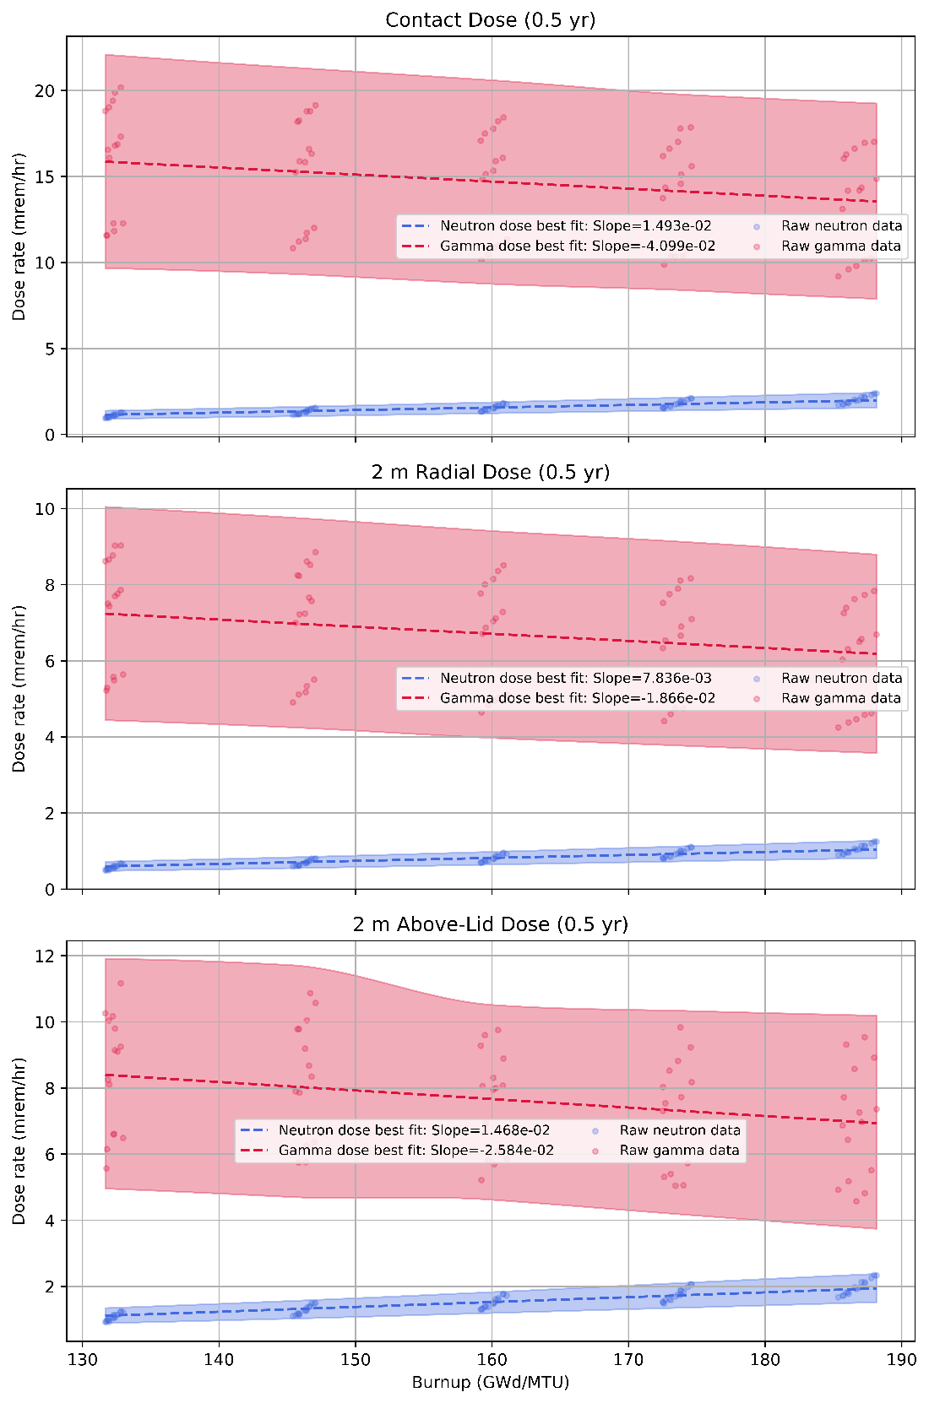
Figure 62: Gamma and Neutron Dose Rates vs. Burnup at 0.5 years cooling time

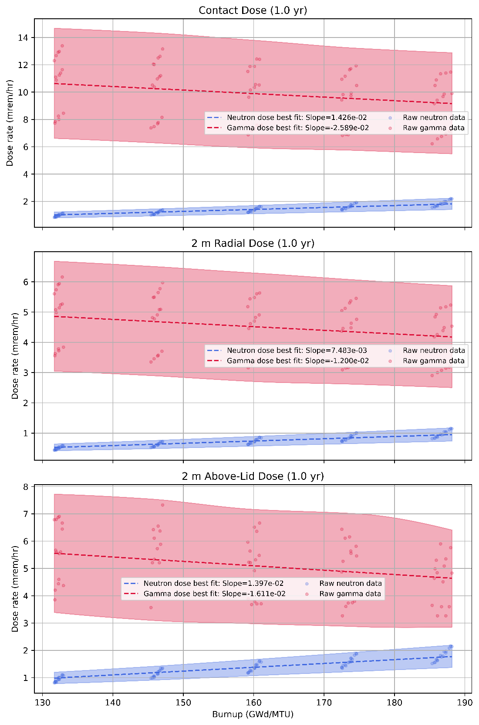
Figure 63: Gamma and Neutron Dose Rates vs. Burnup at 1 year cooling time

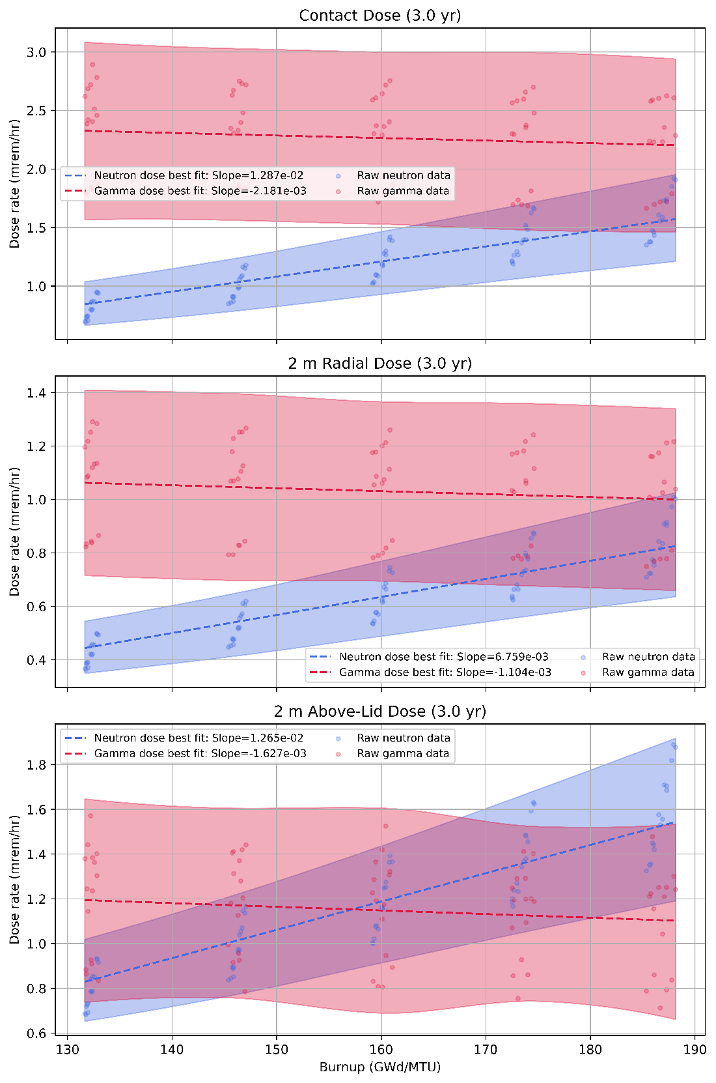
Figure 64: Gamma and Neutron Dose Rates vs. Burnup at 3 years cooling time

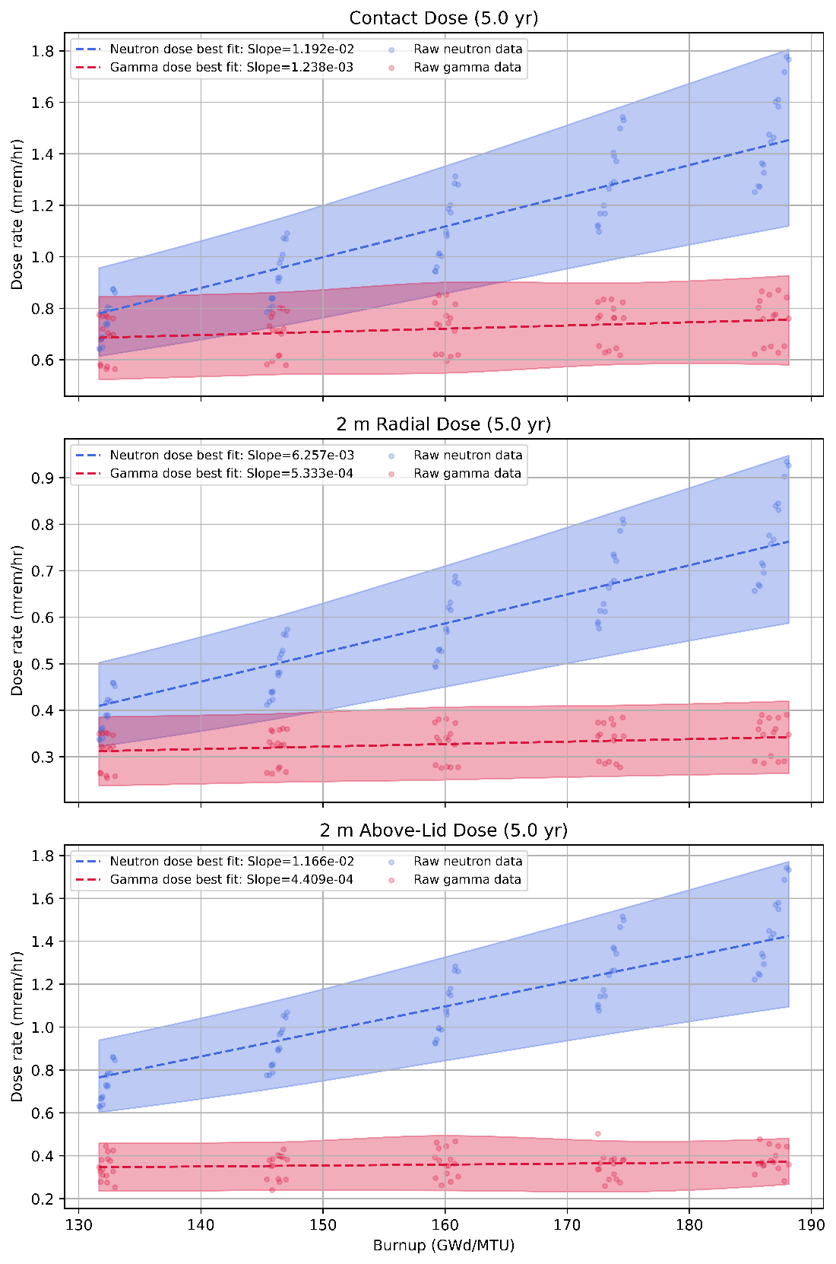
Figure 65: Gamma and Neutron Dose Rates vs. Burnup at 5 years cooling time

cooling times is likely to mute and dampen the effects demonstrated here, becoming a convolution of the discharge, half year, and full year results, as well as everything in between. Gamma dose rate holds a negative relationship to burnup through 3 years, and so is expected to continue to exhibit the new found behavior for longer given the influence of the most recent pebbles.

Decay Heat
Because the key isotopes that drive decay heat over time, decay heat values are plotted in three groups based on cooling time. A short-term group contains decay times from discharge to 5 years, a medium-term group contains decay times from 10 years to 70 years, and a long-term group contains the decay times between 100 and 1000 years. The results are plotted below in Figure 66, Figure 67, and Figure 68 and each group’s relationship to burnup and cooling time is examined.
For the short-term decay heat values, a few notable trends emerge. The decay heat values are clustered into three groups, representing the three specific power parameters utilized. The majority of the decay heat variability at the time of discharge is due to the active decay of very short-lived fission products that are a function of the fuel’s operating power at the time of discharge. The decay heat at discharge has a negative correlation with burnup, which is inconsistent with previous studies [37, 51, 93] as the impact of burnup on longer-lived fission products and actinides have not manifested at discharge and points to some other effects, perhaps due to a difference in the power coast down behavior as enrichment increases. A follow-on analysis demonstrates the fundamental reasons for these effects.
At 0.5 and 1.0 years of decay, the decay heat values in the two bands show a significant amount of overlap between due to the effects of specific power and shows a relatively flat, but positively correlated relationship with burnup. At 3.0 years of cooling time, the effects of specific power have been greatly diminished, and the uncertainty band has shrunk considerably as the decay heat points cluster more closely. The positive correlation to burnup strengthens as the more burnup sensitive isotopes that drive decay heat increase their fractional decay heat. Lastly, at 5 years of cooling time, the trend from 3.0 years continues with the uncertainty band narrowing further, the points becoming

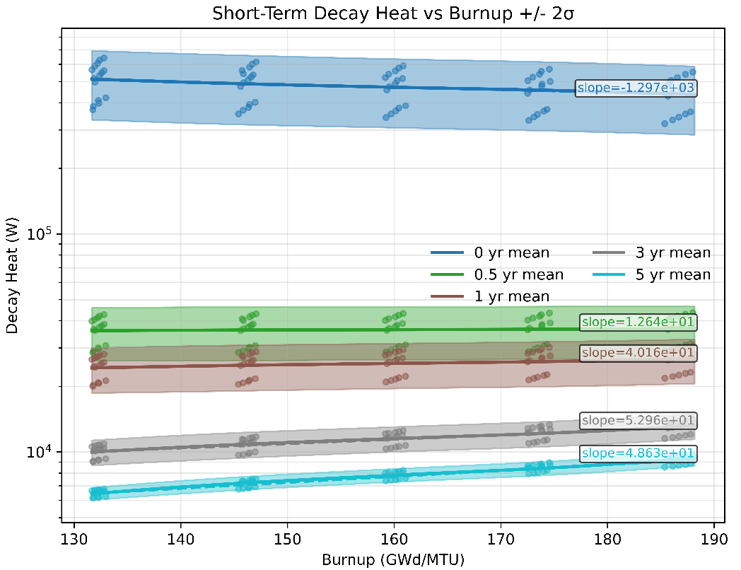
Figure 66: Short Term Decay Heat Values, best fit with uncertainty

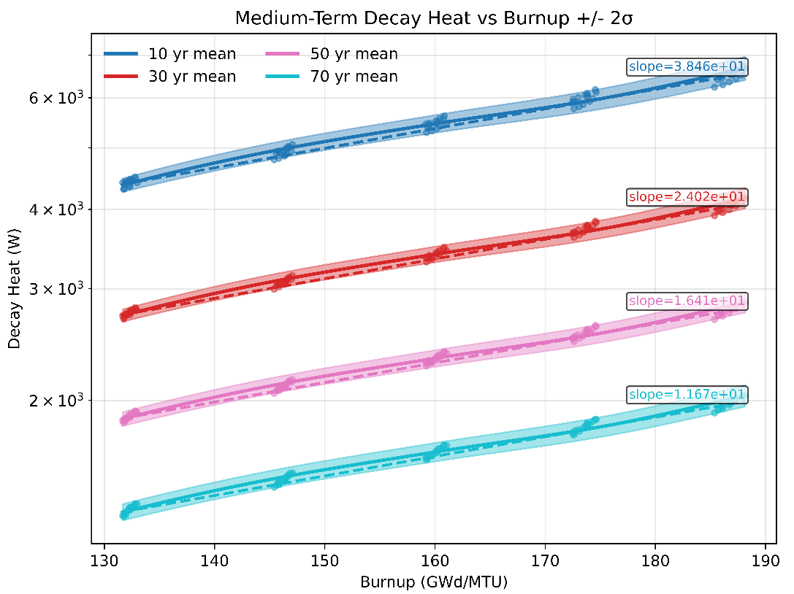
Figure 67: Medium Term Decay Heat Values, best fit with uncertainty

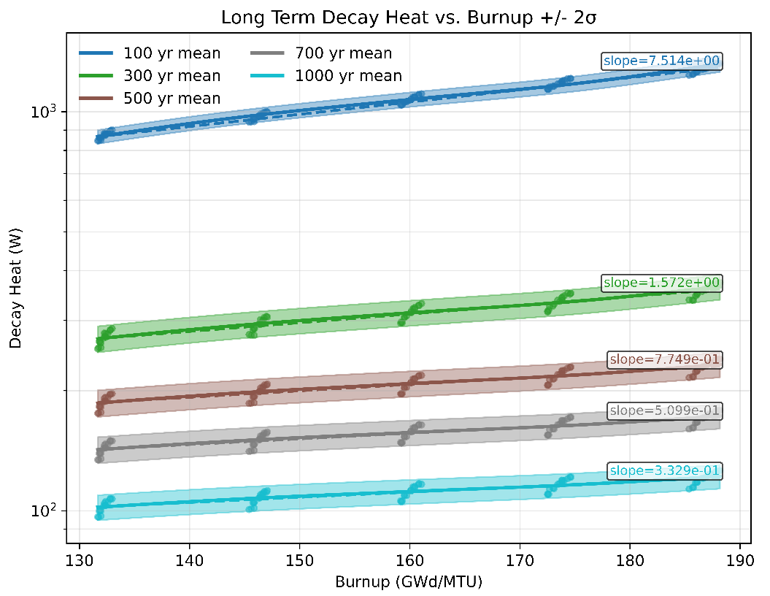
Figure 68: Long Term Decay Heat Values, best fit with uncertainty

closer, and the positive correlation to burnup strengthening further in terms of relative difference.
For the medium-term decay heat plots in Figure 67, the first order influence of burnup on decay heat becomes remains pronounced, far outstripping the impact from other effects. The uncertainty bands at high burnups grow compared to the lower burnup regions. Though the slope is decreasing, the relative difference is increasing as the actinides become a larger share of decay heat. The trends apply generally across all cooling times examined in the medium-term bin.
Lastly, the long-term decay heat values are plotted in Figure 68. For these time values, the decay heat is almost entirely driven by the longer lived actinides. The effects due to specific power have become indistinguishable while the effects from other factors continue to persist. At the time steps greater than 100 years, the connection to burnup has weakened somewhat with some apparent overlap between the lowest values in the maximum burnup and highest values at the minimum burnup, highlighting the necessity of factoring in temperature effects into the bounding calculations.

Follow on Analysis
The observed effects are highly unintuitive, calling into question the validity of the results. No errors were found in the inputs, outputs, or scripts used to perform the work with SCALE, nor in the post-processing. ORIGEN f71 files representing identical fuel passes through the core for 12.5% enriched fuel and 18.5% enriched fuel were examined to verify the burnup values declared, using both OBIWAN and SCALE’s graphical user interface Fulcrum to view the plots and trends of the isotope inventories. Immediately apparent was the large difference in power production for fuels, with the peak power of the fresh 12.5% enriched fuel pebble peaking at 231 MW/MTU while the 18.5% pebble peaked at 277 MW/MTU, ~20% higher while the discharge power is within 6%, but in the opposite direction with the lower enriched fuel producing more power at the time of discharge. The difference in power at discharge cannot account for the difference in dose rate, so further examination is undertaken.
First, the burnup accumulation profile is examined. To achieve higher discharge burnups while retaining important reactor characteristics, such as specific power and the number of average passes, the residence time of fuel per pass required significant adjustment. At most, an 18.5% enriched pebble will spend 7.65 years in the core compared to the longest residence time for a 12.5% enriched pebble at ~6.5 years. The difference in specific power may indicate an outsized accumulation of burnup occurring in the early operation of the reactor at higher enrichments. The early burnup accumulation in more highly enriched cases combined with the longer residence times may lead to major dose rate contributors produced earlier in the fuel’s depletion history ample time to decay away to levels below the lower enriched cases. The early accumulation of burnup and longer fuel residence time would change the average ‘age’ of the burnup, acting as an indicator for the proposed reasoning. Figure 69 shows the burnup accumulation curves for each case.
The results support the assertion that the average age of the burnup is significantly different to the fuel residence time and accumulation of burnup. To explore further, the primary gamma dose contributors are identified. According to previous literature Ce-144, Ru-106, Cs-134, Cs-137, Ru-106, and Eu-154 are dominant dose rate contributors at discharge times up to 5 years [51]. The inventories are plotted across the time of the fuel in the reactor core. Figure 70 shows the results.
The results show that of the primary gamma dose rate contributors examined, two of the three show higher peak values during the depletion of the fuel for the higher enriched fuel, but due to the requirement of longer fuel residence time to meet the desired burnup, the discharge concentration is lower for the higher enrichment/burnup case than for the lower enrichment/burnup case.

CONCLUSIONS
After a comprehensive effort, the conclusion strongly supports the researcher’s initial assertion that PBR SNF characteristics can be well estimated by only tracking burnup and cooling time when applying the effects of other parameters as bounding calculations. The relationship between burnup and SNF characteristics depends on which parameter is being examined and the exact circumstances the relationship is examined under, so some nuance is required when attempting to make predictions, especially for decay heat and spent fuel dose rates.

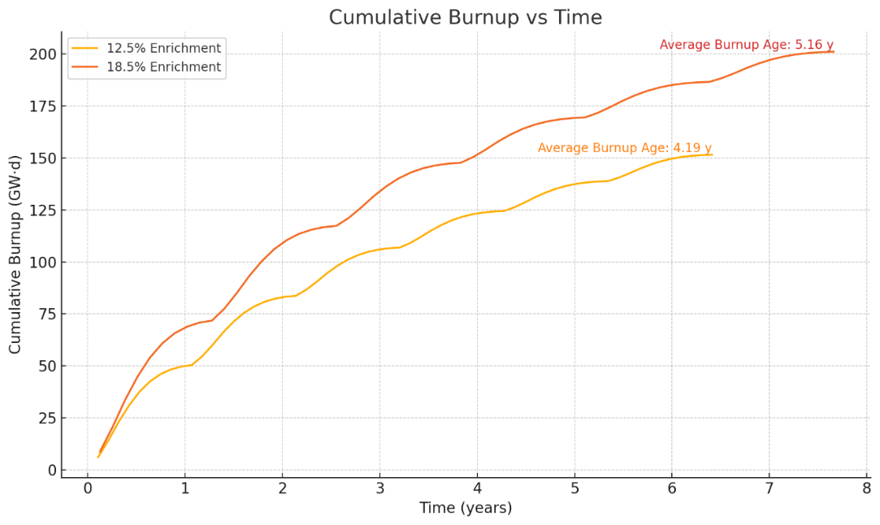
Figure 69: Cumulative Burnup of Two Different Fuel Enrichments

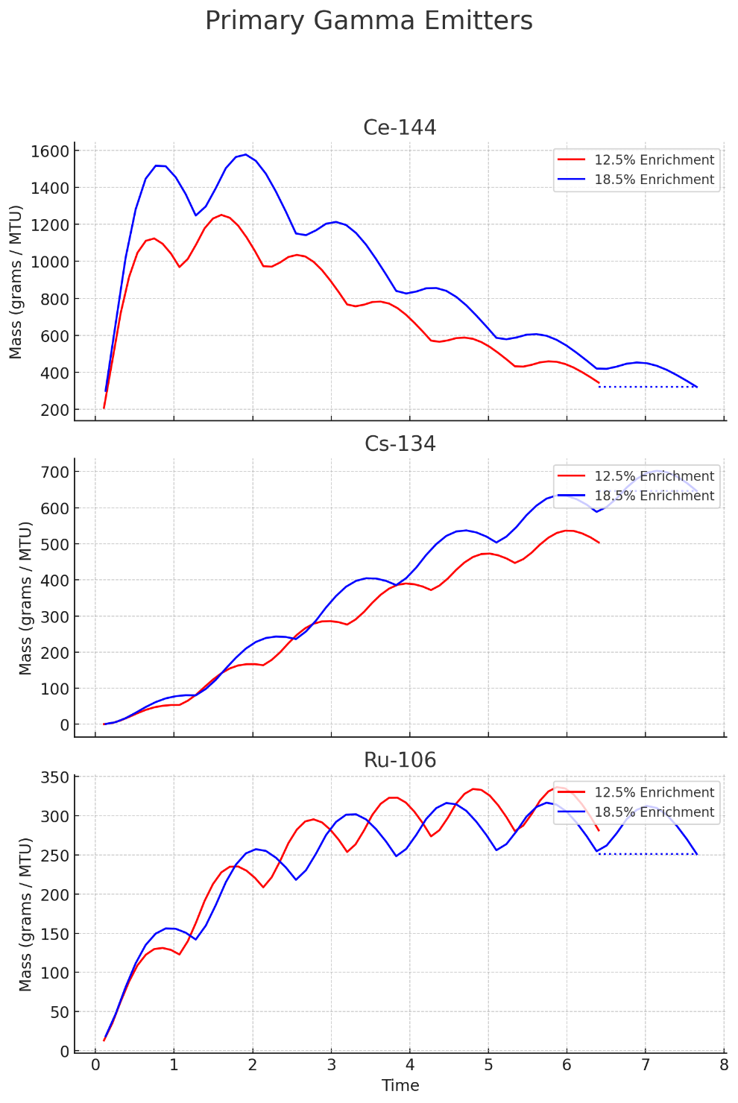
Figure 70: The primary gamma dose rate contributors for 5 years cooling time and less

Criticality
For the work performed in this study, burnup does not need to be tracked if the fuel has reached its target burnup. The results indicate that the resultant peak k-effective for the discharged fuel is consistent across the solved parameter space when factoring in the associated trends in excess reactivity with burnup in the produced equilibrium core models. Due to the fundamentals of how multi-pass PBRs operate, fuel rejection is dictated by the ability of the fuel to add fissile worth to the reactor core. Just as the core average composition leads to system very close to 1.00 k-effective, likewise is true for fuel that is rejected. That is, the fuel that is discharged from the reactor should average roughly the same peak k-effective value, with a relatively low amount of variance. Correcting for the excess reactivity is likely to significantly flatten the correlation to burnup, yielding a characteristic of spent nuclear fuel that may not need parameters to tracked at all, instead relying on the uncertainty in the bounding calculations to inform the spent fuel management of PBR fuel with respect to criticality.

Radiological Dose Rates
Radiological dose rate is likewise well predicted by tracking burnup and cooling time, provided the other contributing factors are captured in bounding calculations. Cooling time is the dominant factor to consider given the universal exponential decay relationship it possesses to all driving isotopes while burnup has a slightly negative correlation with gamma dose, inconsistent with prior literature [53] but consistent across the examined cooling times. While the opposite of what is expected, the follow-on analysis reveals that this behavior is not a mistake or modeling artifact but is due to the frontloading of burnup at higher enrichment values and the longer fuel residence time discharging lower concentrations of Ce-144 and Ru-106 compared to lower burnup fuels. Future work will implement a BUMS type system to correct for the impact of the assumed linear enrichment-burnup assumption. Neutron dose however has a strong positive correlation with burnup due to the strong effect burnup has on Cm-244 buildup during depletion. Cm-244 has a strong relationship with fuel temperature as well, widening the bounds to be considered for fuel at a specific burnup.

With the conclusion established, it should be noted that examining radiological dose rate relationships requires some additional nuance. Next, there is the fact that both the gamma dose and the neutron dose have different production pathways and are generally sensitive to different inputs. Third, different groups of isotopes drive the dose rate behavior at different cooling times. Therefore, the data should be considered in the appropriate context.
In conclusion, the dose rate of spent PBR fuel is shown to readily correlated with the discharge burnup of the fuel at identical cooling times, with contributing factors well accounted for when applying the solved lower and upper bounds. It should be noted that the analysis performed in this work did not account for fact that spent pebbles are not ejected all at once, but instead over time. If the discharge of fuel over time were accounted for, the mixture of fuel in a given canister would have significant variation in its source term strength depending on the size of the container utilized. For a large container, such as the one modeled in this work, it would take roughly 452 total days to fill the canister, resulting in a mixture of fuel at different cooling times. A smaller canister holding ~5,000 pebbles would take ~32 days to fill and have less variation within the canister. In either case, the impact due to the variation of cooling time would blur the relationship with cooling time somewhat, though more in cases with larger canisters.

Decay Heat
Decay heat is also well captured by knowledge of fuel burnup and cooling time. Like dose rate effects, the primary isotopes responsible for decay heat behavior change over time, so any correlation with burnup at one time step may not be naively applied to another value of cooling time. Cooling time is the primary factor due to its universal exponential decay relationship to all unstable isotopes. The correlation of decay heat to burnup changes over time with early term decay heat values showing a negative correlation with a wide bounding envelope that quickly narrows as the effects of specific power diminish. While the opposite of what is expected, a possible explanation lies in the excess reactivity of the full core models as enrichment increases, forcing the fuel to pass the fissile worth midpoint earlier and produce less power than a lower enriched pebble as the fuel approaches discharge. Future work will implement a BUMS type system to correct for the impact of the assumed linear enrichment-burnup assumption. Burnup becomes a strongly defining factor with increased cooling time as actinides take over as the primary drivers of decay heat. Like with dose rate, it is important to note that this work assumes that average discharge composition used to calculate cooling time is discharged from the reactor at the same time, when in reality any fuel holding system will hold fuel with a variety of cooling times due to the relatively slow but continuous discharge of fuel pebbles. The effect is not accounted for in this work.

Final Thoughts
By taking on various efforts to capture possible sources of variability, uncertainty, and directly addressing inaccuracies in previous modeling approaches, and performing a study that bounds the impact of other contributing factors, the results presented in this work firmly support the initial assertation that PBR SNF characteristics can be well known within some bounded margins with only the fuel burnup and fuel cooling time as known parameters for a specific fuel type and reactor.
It should be noted that the effects of specific power are almost exclusively responsible for the wide variability shown in the short-term decay heat and gamma dose rate. Specific power in this work is treated as an unknowable parameter to examine the potential uncertainty introduced if potential power uprates were to be applied in the future and the information was somehow lost or not documented. Operating specific power directly produces a difference of up to 50% for the values under 5 years that were examined in this work. As the more operating power effects fade when longer lived isotopes take over, the effect of specific power fades and eventually becomes indistinguishable from other data points. If short term characteristics are desired with greater accuracy and without needing to apply uncertainty,
Next steps in this work include implementing a BUMS simulator into the workflow to more narrowly predict the average discharge burnup spread and variation. Corrections in some of the models used in this work are recommended given the burnup discrepancy between declared values and actual burnup, as well as correcting for the effects on dose rate and decay heat present in the discharged fuel due to the coast down in power happening earlier in the fuel depletion than lower enriched fuel. Shielding models may be modeled with fuel present to examine effects of subcritical multiplication and any coupled effects as well. Taking into account the varied cooling times of individual pebbles would likely smear the results presented in this work somewhat, but to what degree depends on the specific container being used for storage. Once additional is performed to fine tune the equilibrium core models, a full set of ORIGEN reactor libraries will be generated for more general research use will be published.

Additionally, future work is strongly recommended to include the creation and training of predictive machine learning models or lookup tables on the wealth of data generated in this work. Potential targets include estimations for the equilibrium core compositions, flux profile estimators, spent fuel characteristics predictors, source term generation for shielding calculations, and general discharge composition prediction. With some additional data, a complete set of correlation and covariance information could be calculated for each nuclide across any desired set of parameters covered in the dataset.

Chapter 9: CONCLUSIONS
All results and discussion present in this dissertation are limited to the reactor design employed. The reactor design is specifically a high temperature gas cooled PBR with a single external reflector and a high burnup target. The results and conclusions of this dissertation should not be considered as broadly applicable to other PBR designs without further confirmatory research.

Applicability to other PBR Designs
Designs with a second reflector region, like the PBMR-400, will likely see different results in the following ways.
A second reflector region will reduce the difference between extremes in the neutron spectrum due to radial position. Radial position is expected to have less impact due to the smoothing of the neutron spectrum in the core. Results for key parameters impacting SNF characteristics are expected to be consistent with this dissertation. Fuel temperature is already known to be impactful to dual reflector designs, but to what degree is currently unknown, as there may be a coupling effect present with the spectral differences. For the impact of modeling fidelity study, both the SLICE and E-SLICE methods have the same materials and geometries, so the modeling impact between the two is due to the temperature profile. Absent any coupling effects of temperature and spectral differences due to the second reflector, the time dependent temperature history for the fuel is expected to remain as an important factor to consider for SNF characterization. In examining variability, a notable amount of uncertainty introduced by PBR operation is due to spectral differences per radial zones in the possible pebble histories. The reduction in variability in the neutron spectrum is expected to result in a reduction in the spread of nearly all discharge concentrations. U-235 specifically is not expected to demonstrate the same clustering behavior, at least not to the same degree. Burnup and cooling time are also expected to hold as reliable parameters for SNF characterizations as the fundamentals that drive the behaviors have not appreciably changed.

Unique Contributions
This dissertation has made the following noteworthy, novel contributions.

- Produced and applied a novel methodology for the evaluation of advanced reactor SNF under existing 10 CFR Part 71 standards
- Identified key isotopes that are responsible for driving PBR SNF behavior and quantified the sensitivities of those key isotopes due to fuel and reflector temperatures
- Performed a direct comparison of PBR fuel modeling methods and determined the suitability of common modeling methods for the modeling of PBR SNF
- Demonstrated that reflected pebble models introduce a large amount of bias and are generally poor choices in PBR SNF modeling
- Demonstrated that a mono-temperature or average temperature for PBR fuel depletion introduced a large amount of bias in specific instances
- Demonstrated the importance in incorporating a time dependent temperature history for depletion in PBR SNF characterization modeling
- Introduced the E-SLICE method, a modification of the existing SLICE method that addresses notable shortcomings while preserving the existing advantages
- Demonstrated the variability of isotopes key to SNF behavior that is fundamental to pebble bed reactor operations
- Examined the suitability of average discharge burnup and cooling time as parameters for predicting SNF characteristics by capturing other parameter impacts in bounding calculations
- Produced a set of high-fidelity ORIGEN reactor libraries for HTGRs across a broad parameter space for ready use in future work
- Demonstrated that known LWR SNF relationships are not universally valid or applicable for HTGRs
- Demonstrated that short term dose rate and decay heat violate expected behaviors in relation to fuel burnup

Research Objectives and Key Questions
In this dissertation, research was performed to identify the factors that impact PBR SNF characteristics finding that fuel temperature is a key factor. Different modeling methods are explored and the bias introduced by common modeling methods examined. The best modeling practice for PBR SNF characterization is established in this work and the current weaknesses in commonly used methods were both demonstrated, and the shortcomings addressed by the new E-SLICE method. The reactor induced uncertainty for key SNF isotopes was examined and showed that bulk SNF applications are likely not significantly impacted by the pebble-to-pebble differences and averages values are applicable for SNF applications. Lastly, all previous work was leveraged to examine the suitability of using burnup and cooling time as the only known factors for predicting SNF characteristics by considering other factors as applied uncertainty.
Returning to the original research objective and key questions presented in Chapter 1, this dissertation can now answer the initial key questions.
- What does SNF characterization look like for advanced reactors?
- A methodology for analyzing SNF from PBRs consistent with established standards was developed and applied and found that PBR SNF characterization fits well in current regulatory framework and infrastructure
- Which isotopes primarily drive SNF behavior for PBRs and what reactor operating parameters and initial fuel conditions have large impacts on SNF characteristics?
- As most SNF relationships are established and are based on fundamental physics, fuel temperature and reflector temperature were examined as variable parameters. The isotopes that drive SNF characteristics for PBRs are largely the same as LWR fuels, and while most are not particularly sensitive to the examined parameters, mostly fission products, several actinides were found to be very sensitive to fuel depletion temperature. Reflector temperature was not particularly important.
- What is the degree of bias introduced by common modeling methods for spent PBR fuel characteristics? Is the mono-temperature depletion assumption a valid one? What modeling method is best practice for simulating spent PBR fuel characteristics?

- For short term SNF characteristics, reflected pebble models introduce a large amount of bias and are not generally suitable for SNF characterization without allowing for a large amount of modeling bias. Few cases exist where reflected pebble models are appropriate choices. Work that employs these models warrants revisit in light of this dissertation.
The mono-temperature assumption is not a valid one for all applications. While the mono-temperature SLICE method generally performs well for short term decay heat and gamma dose, it makes a large overestimation of key SNF relevant isotopes, with actinides being the most impacted. Even when performing a correction for the average temperature based on the temperature burnup is accumulated in, the mono-temperature depletion assumption still generates a significant bias compared to incorporating a time dependent temperature history.
The newly introduced E-SLICE method demonstrates the importance of including a temperature profile during depletion and shows overpredictions of actinides by the SLICE method despite weighting temperatures to achieve the same average temperature.
- What uncertainty is introduced by PBR operations? Is it likely to impact SNF considerations?
- Uncertainty in key isotopes mostly follows the burnup distribution with some exceptions. Bulk applications are well suited to average values, but lower pebble count applications may see significant variation for specific isotopes
- Is a simplified parameter set of burnup and cooling time sufficient to estimate PBR SNF characteristics if the other factors are modeled and used as bounding calculations? If so, which parameters?
- Burnup and cooling time are suitable parameters for estimating PBR SNF characteristics when capturing the impact of other effects such as uncertainty, specifically fuel temperature and reactor specific power.
Revisiting the hypothesis, the body of research in this dissertation supports the hypothesis that average discharge burnup and cooling time are sufficient to accurately estimate the SNF characteristics of radiological dose rate, k-effective, and decay heat of PBR fuel.

Future Work
For future work, a large body of research has employed an average temperature depletion assumption, though for a different reactor design. Future work may include performing a similar analysis to this dissertation for other reactor types to examine the applicability of this body of research to PBR designs beyond the one examined. Examining the difference the E-SLICE method has on other reactor designs is prudent to examine the degree of impact the inclusion a time dependent temperature history has on those designs. Additional work would be to examine if there are any potential correction factors that may be applied to simulate a time dependent temperature history for depletion. If so, what are those factors and why are they valid? If not, is interpolation between multiple mono-temperature slice models sufficient to provide adequate correction? Given the large body of research that ORNL has produced based on the SLICE method, collaboration in future research employing the E-SLICE method is recommended to leverage both the existing expertise and the new advantages the E-SLICE method demonstrates for PBR research more broadly. In particular, E-SLICE method produces cross sections libraries that would be ideal to employ in conjunction with ORIGAMI-FOLD, now named ORIGAMI in fold mode.
Other potential work includes improving the E-SLICE model further. At the current moment, the E-SLICE method does not model a BUMS system. Simulating a BUMS system would represent a significant leap forward in realistic modeling without the leap in resources and difficulty in moving up to a method like hyper fidelity.
Lastly, the wealth of data generated for this work has a wealth of other potential research uses, including the revisiting of previous work to directly address the discovered biases by previously employed reflected pebble models and mono-temperature SLICE models as well. The amount of data generated also prompts the idea to leverage the generated data and produce some predictive tool for PBR SNF characterization on a pebble-by-pebble basis while skipping the expensive step of transport. Additional models may be run over a larger parameter space and the results condensed into either a machine learning model or otherwise a simple lookup table employing interpolation.

References
[1] E. National Academies of Sciences and Medicine, Merits and Viability of Different Nuclear Fuel Cycles and Technology Options and the Waste Aspects of Advanced Nuclear Reactors. Washington, DC: The National Academies Press (in English), 2023, p. 314.
[2] Waste from Innovative Types of Reactors and Fuel Cycles. Vienna: INTERNATIONAL ATOMIC ENERGY AGENCY, 2019.
[3] P. J. Pappano, "Xe-100 Pebble Bed Small Modular Reactor: Solving Critical Challenges to Enable the Xe-100 Pebble Bed Advanced Reactor Concept (ARC) (Final Scientific and Technical Report)," X Energy, LLC, Rockville, MD (United States), United States, 2023. [Online]. Available: https://www.osti.gov/biblio/1971498
[4] S. E. Skutnik and W. A. Wieselquist, "Assessment of ORIGEN Reactor Library Development for Pebble-Bed Reactors Based on the PBMR-400 Benchmark," Oak Ridge National Laboratory (ORNL), Oak Ridge, TN (United States), United States, 2021. [Online]. Available: https://www.osti.gov/biblio/1807271
https://www.osti.gov/servlets/purl/1807271
[5] F. Reitsma, K. Ivanov, T. Downar, H. De Haas, and H. D. Gougar, "The OECD/NEA/NSC PBMR coupled neutronics/thermal hydraulics transient benchmark: The PBMR-400 core design," presented at the Conference: PHYSOR-2006: American Nuclear Society's Topical Meeting on Reactor Physics - Advances in Nuclear Analysis and Simulation, Vancouver, BC (Canada), 10-14 Sep 2006; Other Information: Country of input: France; 13 refs., United States, 2006. [Online]. Available: https://www.osti.gov/biblio/22039681.
[6] J. D. Bess, L. Montierth, O. Köberl, and L. Snoj, "Benchmark Evaluation of HTR-PROTEUS Pebble Bed Experimental Program," (in English), Nuclear Science and Engineering, vol. 178, no. INL/JOU-13-30829; Journal ID: ISSN 0029-5639; TRN: US1600471, pp. Medium: ED; Size: p. 387-400, 2014, doi: 10.13182/nse14-13.
[7] G. Ilas, D. Ilas, R. Kelly, and E. E. Davidson, "Validation of SCALE for High Temperature Gas-Cooled Reactors Analysis," Oak Ridge National Lab. (ORNL), Oak Ridge, TN (United States), United States, 2012. [Online]. Available: https://www.osti.gov/biblio/1048709
https://www.osti.gov/servlets/purl/1048709
[8] S. Sen, "Benchmark for Fuel Shuffling and Depletion for Pebble-Bed Reactors," Idaho National Lab. (INL), Idaho Falls, ID (United States), United States, 2020. [Online]. Available: https://www.osti.gov/biblio/1708878
https://www.osti.gov/servlets/purl/1708878
[9] S. Johnson and K. Clarno, "Comparison of SCALE and MCNP results for computational pebble bed benchmarks," Transactions of the American Nuclear Society, vol. 96, pp. 420-422, 01/01 2007.
[10] W. Wieselquist and R. A. Lefebvre, "SCALE 6.3.1 User Manual," United States, 01 2023. [Online]. Available: https://www.osti.gov/biblio/1959594
https://www.osti.gov/servlets/purl/1959594
[11] R. Elzohery, D. Hartanto, R. Bostelmann, and W. A. Wieselquist, "SCALE Analyses of Scenarios in the High-Temperature Gas-Cooled Reactor Fuel Cycle," Oak Ridge National Laboratory (ORNL), Oak Ridge, TN (United States), United States, 2024. [Online]. Available: https://www.osti.gov/biblio/2455083
https://www.osti.gov/servlets/purl/2455083
[12] S. Skutnik, R. Bostelmann, and W. Wieselquist, "Rapid Depletion Analysis of Flowing-Pebble Reactor Systems at Equilibrium using SCALE," presented at the Conference: International Conference on Physics of Reactors 2022 (PHYSOR 2022) - Pittsburgh, Pennsylvania, United States of America - 5/15/2022 4:00:00 AM-5/20/2022 4:00:00 AM, United States, 2022. [Online]. Available: https://www.osti.gov/biblio/1871117
https://www.osti.gov/servlets/purl/1871117.
[13] F. Bostelmann, B. R. Betzler, D. Hartanto, and W. A. Wieselquist. SCALE Input and Result Files Supporting SCALE Inventory and Reactivity Analysis as Part of the Hermes 2021 PSAR Review, Oak Ridge National Laboratory (ORNL), Oak Ridge, TN (United States). Oak Ridge Leadership Computing Facility (OLCF), doi: 10.13139/olcf/2441162.
[14] R. F. Kile, N. R. Brown, O. R. Oak Ridge National Laboratory, TN 37830 ], F. Bostelmann, S. E. Skutnik, and W. A. Wieselquist, "Initial development of a generic fluoride salt-cooled reactor model," presented at the Conference: PHYSOR 2022: International conference on physics of reactors, Pittsburg (United States), 15-20 May 2022; Other Information: Country of input: France; 15 refs.; Related Information: In: Proceedings of the international conference on physics of reactors - Physor 2022| 3701 p., United States, 2022. [Online]. Available: https://www.osti.gov/biblio/23178705.
[15] B. Friederike, C. Cihangir, L. W. Mark, J. E. Ronald, I. Germina, and A. W. William, "SCALE capabilities for high temperature gas-cooled reactor analysis," Annals of Nuclear Energy, vol. 147, p. 107673, 2020, doi: https://doi.org/10.1016/j.anucene.2020.107673.
[16] SLICE. (2024). Oak Ridge National Laboratory (ORNL), Oak Ridge, TN (United States), United States. [Online]. Available: https://www.osti.gov/biblio/2477211
https://www.osti.gov/servlets/purl/2477211
[17] R. Bostelmann, C. Celik, R. F. Kile, and W. A. Wieselquist, "SCALE Analysis of a Fluoride Salt-Cooled High-Temperature Reactor in Support of Severe Accident Analysis," Oak Ridge National Laboratory (ORNL), Oak Ridge, TN (United States), United States, 2022. [Online]. Available: https://www.osti.gov/biblio/1854475
https://www.osti.gov/servlets/purl/1854475
[18] R. F. Kile, F. Bostelmann, S. E. Skutnik, W. A. Wieselquist, and N. R. Brown, "Assessment of SCALE and MELCOR for a generic pebble bed fluoride high-temperature reactor," (in English), Annals of Nuclear Energy, vol. 173, p. Medium: ED; Size: Article No. 109107, 2022, doi: 10.1016/j.anucene.2022.109107.
[19] Z. Ritcher, E. Davidson, S. Skutnik, and M. Munk, "Modeling and Simulation of Xe-100-type Pebble Bed Gas-Cooled Reactor with SCALE," Oak Ridge National Laboratory (ORNL), Oak Ridge, TN (United States), United States, 2023. [Online]. Available: https://www.osti.gov/biblio/1997735
https://www.osti.gov/servlets/purl/1997735
[20] A. Berens, F. Bostelmann, and N. R. Brown, "Equilibrium core modeling of a pebble bed reactor similar to the Xe-100 with SCALE," (in English), Progress in Nuclear Energy, vol. 171, p. Medium: ED; Size: Article No. 105187, 2024, doi: 10.1016/j.pnucene.2024.105187.
[21] D. o. Energy. "TRISO Particles: The Most Robust Nuclear Fuel on Earth." https://www.energy.gov/ne/articles/triso-particles-most-robust-nuclear-fuel-earth (accessed.
[22] High Temperature Gas Cooled Reactor Fuels and Materials. Vienna: INTERNATIONAL ATOMIC ENERGY AGENCY, 2010.
[23] J. Andrus, L. Nelson, J. Phillips, and J. Wheelwright, "TRISO Fuel’s Safety Functions, Contributions to Reactor Safety, and Necessary Safety Limits," Nuclear Technology, pp. 1-9, doi: 10.1080/00295450.2024.2431779.
[24] G. Strydom, W. Windes, R. Smith, and J. Kane, Role of Nuclear Grade Graphite in Controlling Oxidation in Modular HTGRs. 2014.
[25] E. J. Mulder and W. A. Boyes, "Neutronics characteristics of a 165 MWth Xe-100 reactor," Nuclear Engineering and Design, vol. 357, p. 110415, 2020/02/01/ 2020, doi: https://doi.org/10.1016/j.nucengdes.2019.110415.
[26] J. J. Powers et al., "Fully Ceramic Microencapsulated (FCM) Replacement Fuel for LWRs," Oak Ridge National Lab. (ORNL), Oak Ridge, TN (United States), United States, 2013. [Online]. Available: https://www.osti.gov/biblio/1087039
https://www.osti.gov/servlets/purl/1087039
[27] J. M. Beck and L. F. Pincock, "High Temperature Gas-Cooled Reactors Lessons Learned Applicable to the Next Generation Nuclear Plant," Idaho National Lab. (INL), Idaho Falls, ID (United States), United States, 2011. [Online]. Available: https://www.osti.gov/biblio/1023461
https://www.osti.gov/servlets/purl/1023461
[28] P. W. P. H. B. K. Kugeler and S. W, "PBMR—Early history and experience elsewhere," Transactions of the Royal Society of South Africa, vol. 56, no. 2, pp. 101--115, 2001, doi: 10.1080/00359190109520508.
[29] D. E. Shropshire and J. S. Herring, "Fuel-Cycle and Nuclear Material Disposition Issues Associated with High-Temperature Gas Reactors," presented at the Conference: Americas Nuclear Energy Symposium (ANES 2004), Miami, FL (US), 10/03/2004--10/06/2004; Other Information: PBD: 3 Oct 2004, United States, 2004. [Online]. Available: https://www.osti.gov/biblio/839371
https://www.osti.gov/servlets/purl/839371.
[30] Nuclear Waste Policy Act of 1982, 42 U.S.C. §10101 et seq.
[31] (Sept 2021). GAO-21-603 COMMERCIAL SPENT NUCLEAR FUEL Congressional Action Needed to Break Impasse and Develop a Permanent Disposal Solution.
[32] S. Peters, J. T. Carter, and K. Banerjee, "Spent Nuclear Fuel and Reprocessing Waste Inventory: Spent Fuel and Waste Disposition," Pacific Northwest National Laboratory (PNNL), Richland, WA (United States), United States, 2022. [Online]. Available: https://www.osti.gov/biblio/1974547
https://www.osti.gov/servlets/purl/1974547
[33] J. Hu, J. L. Peterson, I. C. Gauld, and S. M. Bowman, "U.S. Commercial Spent Nuclear Fuel Assembly Characteristics - 1968-2013," Oak Ridge National Lab. (ORNL), Oak Ridge, TN (United States), United States, 2016. [Online]. Available: https://www.osti.gov/biblio/1330516
https://www.osti.gov/servlets/purl/1330516
[34] P. A. Demkowicz, "TRISO Fuel: Design, Manufacturing, and Performance," presented at the Conference: NRC HTGR Training, Washington D.C., 07/16/2019 - 07/17/2019, United States, 2019. [Online]. Available: https://www.osti.gov/biblio/1633044
https://www.osti.gov/servlets/purl/1633044.
[35] R. Moormann, R. S. Kemp, and J. Li, "Caution Is Needed in Operating and Managing the Waste of New Pebble-Bed Nuclear Reactors," Joule, vol. 2, no. 10, pp. 1911-1914, 2018/10/17/ 2018, doi: https://doi.org/10.1016/j.joule.2018.07.024.
[36] Yucca Mountain Repository SAR DOE/RW-0573, Rev. 0
[37] G. Radulescu, "Updated Recommendations Related to Spent Fuel Transport and Dry Storage Shielding Analyses," Oak Ridge National Laboratory (ORNL), Oak Ridge, TN (United States), United States, 2023. [Online]. Available: https://www.osti.gov/biblio/1975357
https://www.osti.gov/servlets/purl/1975357
[38] J. T. Carter and R. H. Jones, "Containers for Commercial Spent Nuclear Fuel," in ASME 2017 Pressure Vessels and Piping Conference, 2017, vol. Volume 6B: Materials and Fabrication, V06BT06A066, doi: 10.1115/pvp2017-66247. [Online]. Available: https://doi.org/10.1115/PVP2017-66247
[39] 10 CFR 61 “Licensing Requirements for Land Disposal of Radioactive Waste.” Code of Federal Regulations, Washington, DC: Government Printing Office.
[40] Title 10, Code of Federal Regulations, Part 71—Packaging and Transportation of Radioactive Material. [Online] Available: https://www.nrc.gov/reading-rm/doc-collections/cfr/part071/
[41] R. Hall, W. J. Marshall, and W. A. Wieselquist, "Assessment of Existing Transportation Packages for Use with HALEU," Oak Ridge National Laboratory (ORNL), Oak Ridge, TN (United States), United States, 2020. [Online]. Available: https://www.osti.gov/biblio/1731046
https://www.osti.gov/servlets/purl/1731046
[42] P. Honnold, R. Montgomery, M. Billone, B. Hanson, and S. Saltzstein, "High Level Gap Analysis for Accident Tolerant and Advanced Fuels for Storage and Transportation," Sandia National Lab. (SNL-NM), Albuquerque, NM (United States), United States, 2021. [Online]. Available: https://www.osti.gov/biblio/1813674
https://www.osti.gov/servlets/purl/1813674
[43] D. Rochman et al., "An introduction to Spent Nuclear Fuel decay heat for Light Water Reactors: a review from the NEA WPNCS," EPJ Nuclear Sci. Technol., vol. 10, p. 9, 2024. [Online]. Available: https://doi.org/10.1051/epjn/2024010.
[44] D. Rochman et al., "An introduction to Spent Nuclear Fuel decay heat for Light Water Reactors: a review from the NEA WPNCS," EPJ - Nuclear Sciences & Technologies, vol. 10, 2024/12/02/ 2024, doi: https://doi.org/10.1051/epjn/2024010.
[45] " NEA (2011), Spent Nuclear Fuel Assay Data for Isotopic Validation - State-of-the-art Report, OECD Publishing, Paris ".
[46] A. C. Kaplan-Trahan et al., "Spent Fuel Measurements," in Nondestructive Assay of Nuclear Materials for Safeguards and Security, W. H. Geist, P. A. Santi, and M. T. Swinhoe Eds. Cham: Springer Nature Switzerland, 2024, pp. 605-637.
[47] A. Plukis, R. Plukiene, V. Remeikis, R. Davidonis, P. Ku, and D. Ridikas, "Evaluation of radiation shielding of RBMK-1500 reactor spent nuclear fuel containers," Lithuanian Journal of Physics - LITH J PHYS, vol. 46, pp. 367-374, 01/01 2006, doi: 10.3952/lithjphys.46309.
[48] Impact of High Burnup Uranium Oxide and Mixed Uranium-Plutonium Oxide Water Reactor Fuel on Spent Fuel Management. Vienna: INTERNATIONAL ATOMIC ENERGY AGENCY, 2011.
[49] H. Umezawa, I. Shin-ichi, S. Toshio, O. Hiroshi, and H. and Natsume, "Correlation of Amounts of Transplutonium Nuclides with Burnup in the JPDR-I Spent Fuel," Journal of Nuclear Science and Technology, vol. 10, no. 8, pp. 489-492, 1973/08/01 1973, doi: 10.1080/18811248.1973.9733052.
[50] p. f. t. N. Holtec International, "Topical Report on the Radiological Fuel Qualification Methodology for Dry Storage
Systems," 2023.
[51] G. Radulescu and P. Stefanovic, "A Study on the Characteristics of the Radiation Source Terms of Spent Fuel and Various Non-Fuel Hardware for Shielding Applications," Oak Ridge National Laboratory (ORNL), Oak Ridge, TN (United States), United States, 2022. [Online]. Available: https://www.osti.gov/biblio/1867782
https://www.osti.gov/servlets/purl/1867782
[52] E. Narkūnas, A. Šmaižys, P. Poškas, V. Naumov, and D. Ekaterinichev, "Neutron dose rate analysis of the new CONSTOR® storage cask for the RBMK-1500 spent nuclear fuel," Nuclear Engineering and Technology, vol. 53, no. 6, pp. 1869-1877, 2021/06/01/ 2021, doi: https://doi.org/10.1016/j.net.2020.11.022.
[53] R. Cumberland, G. Radulescu, and K. Banerjee, "The Relationship Between Dose Rate and Decay Heat for Spent Nuclear Fuel Casks," United States, 01 2020. [Online]. Available: https://www.osti.gov/biblio/1649326
https://www.osti.gov/servlets/purl/1649326
[54] M. Turkmen, P. Balestra, M. A. Elisabeth Aberg Lindell, N. George, and G. Yesilyurt, "Developing a Nuclear Quality Assurance Compliant Design Methodology for Neutronic Analysis of Xe-100 Design," presented at the Conference: International Conference on Mathematics and Computational Methods Applied to Nuclear Science and Engineering (M&C 2025), Denver, Colorado, 04/27/2025 - 04/30/2025, United States, 2025. [Online]. Available: https://www.osti.gov/biblio/2472845
https://www.osti.gov/servlets/purl/2472845.
[55] S. Schunert et al., "An equilibrium core depletion algorithm for pebble-bed reactors in the Griffin code," (in English), Annals of Nuclear Energy, vol. 192, no. INL/JOU-22-70685-Rev000; Journal ID: ISSN 0306-4549; TRN: US2404940, p. Medium: ED; Size: Article No. 109980, 2023, doi: 10.1016/j.anucene.2023.109980.
[56] H. D. Gougar and R. S. Sen, "On the evaluation of pebble bed reactor critical experiments using the PEBBED code," presented at the Conference: 7. International topical meeting on high temperature reactor technology (HTR 2014), WeiHai (China), 27-31 Oct 2014, United States, 2001. [Online]. Available: https://www.osti.gov/biblio/1167536
https://www.osti.gov/servlets/purl/1167536.
[57] B. D. Ganapol, H. A. Gougar, and A. O. Ougouag, "A 2D Benchmark for the Verification of the PEBBED Code," United States, 2008. [Online]. Available: https://www.osti.gov/biblio/940027
https://www.osti.gov/servlets/purl/940027.
[58] Reactor Design And Fuel Management For Pebble Bed High Temperature Reactors. (2018). Idaho National Laboratory (INL), Idaho Falls, ID (United States), United States. [Online]. Available: https://www.osti.gov/biblio/1492946
[59] H. D. Gougar, "Selected Profiles of Burnup and Isotopic Concentrations in Pebble Bed High Temperature Reactor Fuel," (in English), Transactions of the American Nuclear Society, vol. 114, pp. Medium: X; Size: page(s) 823-826, 2016. [Online]. Available: https://www.osti.gov/biblio/22992013.
[60] A. Carter, T. Lange, P. Balestra, and G. Strydom, "XE-100 modeling and simulation for neutronic analysis in MCNP6.2," presented at the Conference: PHYSOR 2022: International conference on physics of reactors, Pittsburg (United States), 15-20 May 2022; Other Information: Country of input: France; 8 refs.; Related Information: In: Proceedings of the international conference on physics of reactors - Physor 2022| 3701 p., United States, 2022. [Online]. Available: https://www.osti.gov/biblio/23178673.
[61] A. Abedi, An Exact MCNP Modeling of Pebble Bed Reactors. 2011.
[62] K. B. Bekar, J. B. Clarity, M. Dupont, R. A. Lefebvre, W. B. J. Marshall, and E. M. Saylor, "KENO-VI Primer: Performing Calculations using SCALE’s Criticality Safety Analysis Sequence (CSAS6) with Fulcrum," Oak Ridge National Laboratory (ORNL), Oak Ridge, TN (United States), United States, 2020. [Online]. Available: https://www.osti.gov/biblio/1760129
https://www.osti.gov/servlets/purl/1760129
[63] J. Leppänen, M. Pusa, T. Viitanen, V. Valtavirta, and T. Kaltiaisenaho, "The Serpent Monte Carlo code: Status, development and applications in 2013," Annals of Nuclear Energy, vol. 82, pp. 142-150, 2015/08/01/ 2015, doi: https://doi.org/10.1016/j.anucene.2014.08.024.
[64] R. Stewart, J. Cavaluzzi, P. Balestra, and G. Strydom, "Capturing the run-in of a pebble-bed reactor by using thermal feedback and high-fidelity neutronics simulations," (in English), Annals of Nuclear Energy, vol. 207, no. INL/JOU-23-75774-Rev001; Journal ID: ISSN 0306-4549, p. Medium: ED; Size: Article No. 110697, 2024, doi: 10.1016/j.anucene.2024.110697.
[65] P. K. Romano, N. E. Horelik, B. R. Herman, A. G. Nelson, B. Forget, and K. Smith, "OpenMC: A state-of-the-art Monte Carlo code for research and development," Annals of Nuclear Energy, vol. 82, pp. 90-97, 2015/08/01/ 2015, doi: https://doi.org/10.1016/j.anucene.2014.07.048.
[66] F. Bostelmann, C. Celik, M. L. Williams, R. J. Ellis, G. Ilas, and W. A. Wieselquist, "SCALE capabilities for high temperature gas-cooled reactor analysis," Annals of Nuclear Energy, vol. 147, p. 107673, 2020/11/01/ 2020, doi: https://doi.org/10.1016/j.anucene.2020.107673.
[67] F. Bostelmann, S. E. Skutnik, A. Shaw, D. Hartanto, and W. A. Wieselquist, "SCALE 6.3 Modeling Strategies for Reactivity, Nuclide Inventory, and Decay Heat of Non-LWRs," Oak Ridge National Laboratory (ORNL), Oak Ridge, TN (United States), United States, 2024. [Online]. Available: https://www.osti.gov/biblio/2351061
https://www.osti.gov/servlets/purl/2351061
[68] O. Dim, J. Hu, D. Hartanto, Y. Cui, C. Soto, and P. Gibbs, "Modeling and Simulation of Fuel Burnup in Pebble Bed Reactors," presented at the Conference: INMM/ESARDA Joint Annual Meeting 2023 - Vienna, , Austria - 5/22/2023 8:00:00 AM-5/26/2023 8:00:00 AM, United States, 2023. [Online]. Available: https://www.osti.gov/biblio/1986214
https://www.osti.gov/servlets/purl/1986214.
[69] Y. Robert and M. Fratoni, "Hyper-fidelity depletion coupled with discrete pebble motion in pebble bed reactors," presented at the Conference: PHYSOR 2022: International conference on physics of reactors, Pittsburg (United States), 15-20 May 2022; Other Information: Country of input: France; 17 refs.; Related Information: In: Proceedings of the international conference on physics of reactors - PHYSOR 2022| 3701 p., United States, 2022. [Online]. Available: https://www.osti.gov/biblio/23203859.
[70] Framework For Performing Time-dependent Pebble Bed Reactor Simulations. (2024). Idaho National Laboratory (INL), Idaho Falls, ID (United States), United States. [Online]. Available: https://www.osti.gov/biblio/2440558
https://www.osti.gov/servlets/purl/2440558
[71] C. X. Soto, O. Dim, Y. Cui, and W. Stern, "A Better Method to Calculate Fuel Burnup in Pebble Bed Reactors Using Machine Learning," (in English), Nuclear Technology, vol. 209, no. BNL-224200-2023-JAAM; Journal ID: ISSN 0029-5450, pp. Medium: ED; Size: p. 1282-1294, 2023, doi: 10.1080/00295450.2023.2200573.
[72] ORIGEN Library Manager. (2024). Oak Ridge National Laboratory (ORNL), Oak Ridge, TN (United States), United States. [Online]. Available: https://www.osti.gov/biblio/2301588
https://www.osti.gov/servlets/purl/2301588
[73] G. Radulescu and F. A. Alpan, "Review of SCALE Validations Applicable to Spent Nuclear Fuel Shielding Calculations," Oak Ridge National Laboratory (ORNL), Oak Ridge, TN (United States), United States, 2022. [Online]. Available: https://www.osti.gov/biblio/1906576
https://www.osti.gov/servlets/purl/1906576
[74] J. F. M. Wing, G.I.; Petersen, G.; Joseph III, R.A., "Uncertainty Quantification for Pebble Bed Reactor Fuels Burnup Credit," June 2024.
[75] T. Ghaddar, R. Bostelmann, T. Pandya, and M. Jessee, "Modeling Enhancements and Benchmarking of Pebble Bed Reactors in the Shift Monte Carlo Code," presented at the Conference: International Conference on Physics of Reactors (PHYSOR 2024) - San Francisco, California, United States of America - 4/21/2024 8:00:00 AM-4/24/2024 8:00:00 AM, United States, 2024. [Online]. Available: https://www.osti.gov/biblio/2397462
https://www.osti.gov/servlets/purl/2397462.
[76] D. Hartanto, W. Wieselquist, S. Skutnik, P. Gibbs, and D. N. Kovacic, "Uncertainty Quantification of Pebble's Discharge Burnup and Isotopic Inventory using SCALE," presented at the Conference: 2022 ANS Winter meeting - Phoenix, Arizona, United States of America - 11/13/2022 2:00:00 PM-11/17/2022 2:00:00 PM, United States, 2022. [Online]. Available: https://www.osti.gov/biblio/1905409
https://www.osti.gov/servlets/purl/1905409.
[77] P. Ivanusa, P. Jensen, C. A. Condon, and A. L. Bunn, "Comparison of Irradiated TRISO Fuel Radioactivity from Multiple Advanced Reactor Designs," (in English), Nuclear Technology, vol. 208, no. PNNL-SA-155805; Journal ID: ISSN 0029-5450; TRN: US2302525, pp. Medium: ED; Size: p. 575-585, 2021, doi: 10.1080/00295450.2021.1932174.
[78] S. T. Arm, G. B. Hall, G. J. Lumetta, and B. E. Wells, "Plan for Developing TRISO Fuel Processing Technologies," Pacific Northwest National Laboratory (PNNL), Richland, WA (United States), United States, 2022. [Online]. Available: https://www.osti.gov/biblio/1874375
https://www.osti.gov/servlets/purl/1874375
[79] C. A. Condon, P. Ivanusa, A. L. Bunn, and P. J. Jensen, "Internal Radiation Dose Evaluation For An Unruptured Post Release Tristructural Istropic Fuel Particle for Advanced and Micro-reactor Applications," (in English), Health Physics, vol. Publish Ahead of Print, no. PNNL-SA-151679; Journal ID: ISSN 0017-9078; TRN: US2206357, pp. Medium: ED; Size: p. 271-277, 2020, doi: 10.1097/hp.0000000000001310.
[80] R. H. Stewart, P. Balestra, D. Reger, E. Merzari, and G. Strydom, "High-fidelity simulations of the run-in process for a pebble-bed reactor," (in English), Annals of Nuclear Energy, vol. 195, no. INL/JOU-23-71113-Rev002; Journal ID: ISSN 0306-4549; TRN: US2408554, p. Medium: ED; Size: Article No. 110193, 2023, doi: 10.1016/j.anucene.2023.110193.
[81] D. Hartanto, S. Chirayath, D. N. Kovacic, J. Hu, and P. Gibbs, "Sensitivity Studies on Fuel Burnup and Plutonium Buildup in Pebble Bed Reactors for Fuel Parameter Perturbations," presented at the Conference: 2024 ANS Winter Conference and Expo - Orlando, Florida, United States of America - 11/17/2024 5:00:00 AM-11/21/2024 5:00:00 AM, United States, 2024. [Online]. Available: https://www.osti.gov/biblio/2481220
https://www.osti.gov/servlets/purl/2481220.
[82] S. R. Greene, J. S. Medford, and S. A. Macy, "Storage and Transport Cask Data For Used Commercial Nuclear Fuel," ENERGX, LLC, Oak Ridge, TN (United States); Advanced Technology Insights, LLC, Knoxville, TN (United States), United States, 2013. [Online]. Available: https://www.osti.gov/biblio/1553317
https://www.osti.gov/servlets/purl/1553317
[83] G. D. Del Cul, "TRISO-Coated Fuel Processing to Support High Temperature Gas-Cooled Reactors," Oak Ridge National Lab. (ORNL), Oak Ridge, TN (United States), United States, 2002. [Online]. Available: https://www.osti.gov/biblio/814326
https://www.osti.gov/servlets/purl/814326
[84] Z. Fu, I. J. van Rooyen, M. Bachhav, and Y. Yang, "Microstructure and fission products in the UCO kernel of an AGR-1 TRISO fuel particle after post irradiation safety testing," Journal of Nuclear Materials, vol. 528, p. 151884, 2020/01/01/ 2020, doi: https://doi.org/10.1016/j.jnucmat.2019.151884.
[85] N. Kirch, H. U. Brinkmann, and P. H. Brücher, "Storage and final disposal of spent htr fuel in the federal republic of Germany," Nuclear Engineering and Design, vol. 121, no. 2, pp. 241-248, 1990/07/02/ 1990, doi: https://doi.org/10.1016/0029-5493(90)90109-B.
[86] J. F.Wing, G.I.; Petersen, G.; Joseph III, R.A., "Examining the Criticality and Dose Rate Aspect Associated with Storage and Transportation of Spent Nuclear Fuel from Pebble Bed Reactors," presented at the Waste Management Symposia, Phoenix, AZ, Feb. 26-Mar. 2, 2023, 2023.
[87] J. C. R. C. GAULD, “Nuclide Importance to, D. H. Criticality Safety, and Source Terms Related, to Transport and Interim Storage of High-Burnup Fuel, U. S. N. R. C. NUREG/CR-6700, and (2001).
[88] T. E. Shokes, R. E. Spears, and M. M. Patterson, "Dry Cask Shipments of ATR Spent Nuclear Fuel at INL," presented at the Conference: Waste Management Symposium, Pheonix Convention Center, Pheonix, AZ, 03/03/2019 - 03/07/2019, United States, 2019. [Online]. Available: https://www.osti.gov/biblio/1497041
https://www.osti.gov/servlets/purl/1497041.
[89] Safety Analysis Report on the HI-STAR 190 Package, [Online] Available: https://www.nrc.gov/docs/ML1716/ML17166A448.pdf, (2017)
[90] H. Gadey et al., "Options for Managing Spent TRi-structural ISOtropic Nuclear Fuel," arXiv pre-print server, 2024-03-14 2024, doi: None
arxiv:2403.18849.
[91] F. A. Alpan, C. Celik, M. N. Dupont, and D. E. Peplow, "SCALE 6.3 Validation: Radiation Shielding," Oak Ridge National Laboratory (ORNL), Oak Ridge, TN (United States), United States, 2024. [Online]. Available: https://www.osti.gov/biblio/2462890
https://www.osti.gov/servlets/purl/2462890
[92] P. Ivanusa, A. L. Bunn, C. A. Condon, and P. J. Jensen, "Estimated Diffusion Out of a TRISO Particle Under Ambient Conditions," presented at the Conference: ANS Virtual Winter Meeting, November 16-19, 2020, United States, 2020. [Online]. Available: https://www.osti.gov/biblio/1755006.
[93] G. Radulescu, B. R. Grogan, and K. Banerjee, "Fuel Assembly Reference Information for SNF Radiation Source Term Calculations," Oak Ridge National Laboratory (ORNL), Oak Ridge, TN (United States), United States, 2021. [Online]. Available: https://www.osti.gov/biblio/1819561
https://www.osti.gov/servlets/purl/1819561

VITA
Jonathan Franklin Wing was born in Oak Ridge, Tennessee in November of 1992. He received an associates degree in 2017 from Pellissippi State Community College and transferred to the University of Tennessee-Knoxville where he received a Bachelor of Science degree in nuclear engineering in 2020. Jonathan then entered the masters degree program in nuclear engineering under Dr. Maldonado in Spring of 2022, graduating a year later with a masters degree. Jonathan then enrolled in the PhD program and is set to achieve his doctorate degree in nuclear engineering in May of 2025.
During his doctoral studies, Jonathan’s research focused on the characterization of spent fuel from pebble bed reactors, emphasizing decay heat, dose rate, criticality safety, and decay heat considerations for spent fuel storage and transportation. Jonathan’s work leveraged the SCALE code suite, Python-automated workflows, and equilibrium core modeling to analyze the behavior of TRISO based fuel in HTGR pebble bed type systems.
In 2024, Jonathan completed an internship at Idaho National Laboratory, where he investigated fuel discharge sensitivities to temperature in HTGR systems. His contributions to the field have been recognized with multiple honors, including a Superior Paper Award at the 2023 Waste Management Symposia and the Best Graduate Student Presentation Award at the ANS Student Conference held at the University of Tennessee for his work on excess criticality mitigation methods for pebble bed reactor fuel. Jonathan plans to pursue a career in nuclear fuel cycle analysis and advanced reactor modeling and simulation.

