Characterization of the Che4 signal transduction pathway in taxis behaviors of Azospirillum brasilense

A Thesis Presented for the
Master of Science
Degree
The University of Tennessee, Knoxville

Dhivya Kumar
July 2012

Copyright © 2012 by Dhivya Kumar
All rights reserved.

ACKNOWLEDGEMENTS

First and foremost, I would like to acknowledge my mentor, Dr. Gladys Alexandre. Without her help, patience and encouragement, this work would not have been possible. I feel extremely lucky to have had the opportunity to work with her. Her quest for knowledge and enthusiasm for science is infectious. I have learnt a lot from her and will forever look up to her.

I would also like to thank my committee members, Dr. Andreas Nebenfuhr and Dr. Barry Bruce, for their support and helpful advice throughout my graduate program.

I also thank all my lab members, especially, Dr. Amber Bible and Dr. Matt Russell for their help throughout this work.

Last, but not the least I would like to thank my friends and family, for without their support, I would not be here today.

ABSTRACT

Azospirillum brasilense is a gram negative, soil diazotroph that colonizes the roots of agronomically important crops. Studies have shown that swimming motility is an important trait for its survival and colonization of plant roots by these bacteria. Taxis responses, such as chemotaxis and aerotaxis, depend on the ability of the organism to bias its movements in the presence of gradients. The recently sequenced genome of A. brasilense has been shown to possess four chemotaxis operons, but the dominant pathway that modulates swimming behavior by affecting swimming bias in this organism is unknown. Characterization of one of the chemotaxis operons, Che1, revealed that it played a role in regulating swimming velocity in gradients and indirectly affected rate of change in swimming direction.
In this study, we determined that the Che4 pathway of Azospirillum brasilense plays a dominant role in controlling rate of change in swimming direction. Our data also suggests that cross-talk between Che4 and the previously characterized Che1 pathway possibly at the level of receptors also contributes to taxis responses in A. brasilense. Finally, characterization of double mutants lacking components of both pathways, suggest presence of additional chemosensory mechanisms that modulate taxis behavior in A. brasilense.

TABLE OF CONTENTS

CHAPTER I Introduction and General Information 1
CHAPTER II Literature Review 5
Molecular machinery of chemotaxis 7
Chemotaxis and chemotaxis-like pathways in other bacteria 15
Motility in Azospirillum brasilense 21
CHAPTER III Materials and Methods 26
CHAPTER IV Results and Discussion 33
A. Che4 is the dominant pathway controlling the probability of changes in the swimming direction (swimming reversal frequency) 33
B. Both Che1 and Che4 contribute to change in direction of swimming …………….48
C. Che4 and Che1-Che4 mutants are affected in their ability to modulate
swimming velocity………………………………………………………………………………………….59
D. Localization of chemotaxis proteins supports cross talk between Che1 and
Che4 pathways…………………………………………………………………………………………….…64
CHAPTER V Conclusions and future perspectives 75
LIST OF REFERENCES 81
Vita 88

LIST OF TABLES

Table Page

Table1. List of strains used in this study…….……………………………………………...27
Table 2: Steady state swimming behavior of Che4 mutants…………………….….36
Table 3: Chemotactic responses of A. brasilense wild type strain Sp7 and
Che4 pathway mutants in a temporal gradient assay……………………………….…47
Table 4: Steady state swimming behavior of Che1-Che4 double mutants….…50
Table 5: Chemotactic responses of A. brasilense wild type strain Sp7 and
Che1-Che4 pathway double mutants in a temporal gradient assay……………...58
Table 6: Mean swimming velocity of cells before and after removal of air
in a temporal aerotaxis assay…………………………………………………………………….61
Table 7: Mean swimming velocity of cells before and after addition of air
in a temporal aerotaxis assay………………………………………………………………..…...63

LIST OF FIGURES

Figure 1: Schematic representation of the bacterial flagella………………………………..11
Figure 2: Schematic representation of the prototypical chemotaxis system
of E. coli……………………………………………………………………………………………………………14
Figure 3: Chemotaxis operons of A. brasilense…………………………………………………….24
Figure 4: Schematic representation of aerotactic band formation in a spatial gradient assay…………………………………………………………………………………………….……..40
Figure 5: Capillary assays comparing aerotaxis behavior (taxis towards oxygen) among Che4 mutants……………………………………………………………………………………….…41
Figure 6: Temporal aerotaxis assay for Che4 mutants shows that Che4 pathway
plays an important role in controlling reversal frequency in A. brasilense……………..43
Figure 7: Chemotaxis swarm plate assays comparing chemotaxis/motility
behaviors among Che4 mutants………………………………………………………………………….46
Figure 8: Spatial gradient assays for double mutants…………………………………………...52
Figure 9: Temporal aerotaxis assay for Che1-Che4 double mutants shows that Che1 pathway also contributes to change in direction of swimming in A. brasilense………54
Figure 10: Chemotaxis swarm plate assays comparing chemotaxis/motility behaviors among Che1-Che4 mutants………………………………………………………………...57
Figure 11: Localization of CheA1-YFP in different genetic backgrounds…………….….66
Figure 12: Localization of CheY1-YFP in different genetic backgrounds………….…….68
Figure 13: Localization of CheA4-YFP in different genetic backgrounds…….………….70
Figure 14: Localization of CheY4-YFP in different genetic backgrounds………………..72
Figure 15: Localization of CheD4-YFP in different genetic backgrounds………………..74

CHAPTER I
Introduction and General Information

Most microorganisms inhabit niches where conditions are variable and in order to survive, they need to respond and adapt to the changes they encounter. Regulation of gene expression is one such cellular response to changes in their environment. Changes in gene expression patterns allow long term adaptations via significant changes in a cell’s physiology. A faster and more immediate adaptive respond is for motile bacteria to move away from a stressor or towards a more favorable environment. Motility, and the ability to orient the movement in a particular direction (taxis) thus play crucial roles in the lifestyle of many microorganisms. In fact, around eighty percent of known bacterial species are motile (Moens & Vanderleyden, 1996).
The peritrichously flagellated proteobacterium, Escherichia coli has been the model organism for understanding motility and directed motility, i.e. chemotaxis (taxis in chemical gradients). At the cellular level, taxis behaviors depend on a dedicated signal transduction system that controls the probability of change in the swimming direction. This chemotaxis signal transduction pathway and its protein components responsible for controlling changes in the swimming direction have been characterized to exquisite detail in this organism (reviewed in chapter II). In fact, very little about the extremely elegant system of chemotaxis remains unknown in E. coli (Wadhams & Armitage, 2004).
With the advent of complete genome sequences from diverse bacterial species, it has been realized that while E. coli chemotaxis model provides a blueprint from which the function of many chemotaxis systems can be predicted, there is also a tremendous variation in the structure and organization of most chemotaxis systems that are not reflected in that of E. coli. While E. coli has one operon (Che operon) encoding genes involved in chemotaxis, most other organisms have multiple chemotaxis pathways and that not all chemotaxis-like pathways are dedicated to controlling swimming behavior (Porter et al, 2011) (discussed in chapter II).
The model organism used in this study is the, motile, soil alpha-proteobacterium Azospirillum brasilense. These nitrogen-fixing, bacteria colonize the roots of cereals and grasses and help promote their growth (Okon & Itzigsohn, 1995). Motility is vital to the survival of A. brasilense in the competitive rhizosphere (Steenhoudt & Vanderleyden, 2000). The requirement of motility in root colonization in A. brasilense has been demonstrated in multiple studies (Greer-Phillips et al, 2004; Holguin, 1994). Taxis behaviors have been studied in this species and several quantitative assays have been developed to analyze the taxis responses of this microorganism. Similar to E. coli taxis responses, taxis in A. brasilense is characterized by transient changes in the swimming direction of the polar flagellum and hence, reorientation in a new direction (Zhulin & Armitage, 1993). However, and in contrast to E. coli, A. brasilense is also capable of transiently increasing its swimming speed in response to chemoeffector gradients (Bible et al, 2012). The taxis response of A. brasilense is thus comprised of transient changes in both velocity of flagellar rotation as well as direction of flagellar rotation, followed by adaptation. This makes A. brasilense an ideal organism for understanding taxis behavior. Moreover, genome sequence of A. brasilense strain Sp245 revealed that this organism has four chemotaxis operons, 41 chemoreceptors for sensing stimuli and additional chemotaxis proteins elsewhere in the genome (Wisniewski-Dye et al, 2011).
Characterization of one of the operons of A. brasilense (Che1) revealed that it plays an indirect role in regulating the probability and primarily controls swimming velocity in response to gradients (Bible et al, 2012; Bible et al, 2008). Hence, the dominant pathway that plays a role in controlling change of direction of swimming in response to stimuli remains unknown. This is the motivation for this study. We hypothesized that Che4, the chemotaxis operon with no assigned function and predicted to have been transferred laterally from other soil bacteria in the A. brasilense genome (Wisniewski-Dye et al, 2011) played a dominant role in controlling the swimming bias in Azospirillum brasilense.
We have characterized mutants lacking components of the Che4 pathway for defects in swimming behavior. We used various temporal and spatial gradient assays to discern the contribution of the proteins of this pathway in aerotaxis and chemotaxis of A. brasilense. Our results demonstrate that che4 is the major pathway controlling the swimming reversal frequency in response to changes in the environment. Our data also indicated cross talk between the Che4 and the Che1 pathway in the control of chemotaxis and aerotaxis via effect on the swimming velocity and the reversal frequency. We have therefore; also analyzed mutants lacking components of Che4 and the previously characterized Che1 pathway to better understand the collective contribution of the two pathways. The contribution of other chemotaxis proteins is also detected in mediating sensory adaptation as well as in mediating changes in the swimming reversal frequency. Finally, we have analyzed the subcellular localization of these proteins with respect to one another in order to gain a better understanding of the possible mechanism underlying the functional cross-talk between the two pathways and the intricate system responsible for controlling motility in A. brasilense.

CHAPTER II
Literature Review

Sensing and responding to environmental stimuli is critical to the survival of any organism. Different organisms have developed distinct strategies to overcome and thrive in adverse conditions. Most organisms regulate their gene expression to modulate their metabolism. The fastest response, however, for most unicellular motile organisms is to swim away from a negative stimulus or towards a positive one. This taxis behavior offers a significant growth advantage to the organism in a competitive microbial population (Pilgram & Williams, 1976). Bacteria are sensitive to a wide variety of environmental cues such as pH, light, oxygen and nutrients. Thus, taxis behaviors can be categorized as chemotaxis (directed movement in chemical gradients), aerotaxis (directed movement in oxygen gradients), phototaxis (movement in response to light) and energy taxis (movement to optimize metabolism) (Taylor et al, 1999).
Eukaryotic organisms are able to sense chemoeffectors across their cell body (Janetopoulos & Firtel, 2008). However, bacteria are too small to utilize a directional sensing mechanism and instead they depend on temporal sensing (Berg & Brown, 1972). Temporal sensing allows the bacteria to sample the environment over time, and compare trajectories on short timescales, in order to choose the most favorable one. At the cellular levels, non-motile bacteria behave as particles in solutions. Since the small size of bacteria imply that they are subjected to random Brownian motion, motility allows them to navigate in gradients and they achieve directional movement by alternating periods of straight or smooth runs with events of changes in the swimming direction. Motility in homogenous (absence of a gradient) environments, thus, consists of smooth swimming interrupted by random changes in the swimming direction, also known as a ‘random walk’. When moving up a gradient of attractant, the changes in swimming direction become less frequent, allowing the bacteria to bias their movement toward the attractant. In contrast, when moving up in a gradient of a repellent, the motile cells change swimming direction more frequently in the direction of the repellent and swim smoother for longer time away from it, thereby biasing their movement to move away from the repellent (Berg & Brown, 1972; Macnab & Koshland, 1972).
Depending on the number of flagella a cell possesses, and its natural habitat, motile bacteria may employ any one of the following chemotactic strategies: run-and-tumble, run-and-stop, run-and-arc and run-and-reverse (Mitchell, 2002). Run-and-tumble taxis behavior is one of the most studied, since it is the strategy used by peritrichously flagellated Escherichia coli. During a ‘run’, a flagellar bundle is formed along the long axis of the cell that propels the cell forward. This bundle is disrupted when there is a change in the rotation of at least one flagellar motor, resulting in a ‘tumble’ (Turner et al, 2000). Run-and-arc chemotaxis, which has been reported in marine bacteria such as Thiovulum majas, involves active reorientation of the cell, as opposed to change in direction due to Brownian motion (Fenchel, 1994). Run-and-stop chemotaxis, seen in the monotrichous bacteria, such as Rhodobacter sphaeroides utilizes brownian motion to steer the cell in a random direction during a stop in flagellar motor rotation (Armitage & Macnab, 1987). Polar monotrichous bacteria use run-and-reverse locomotion that results in a change in swimming direction when the direction of flagellar rotation is reversed. This kind of motility is prevalent in soil bacteria such as Azospirillum brasilense and marine bacteria such as Vibrio alginolyticus, Deleya marina and Shewanella putrefaciens (Jens Efsen Johansen, 2002; Mitchell et al, 1991; Stocker, 2011).

Molecular machinery of chemotaxis
Directed motility (taxis) requires highly complex molecular machinery, including receptors utilized for sensing ligands, proton conducting channels, flagella and regulatory proteins that modulate response (Wadhams & Armitage, 2004). The repertoire of ligands that a bacterium can sense depends on its receptors, also called the methyl-accepting proteins (MCPs) or chemoreceptors. In fact, most diversity in chemotaxis proteins amongst different bacteria is seen in the number of MCPs. The numbers range from 5 in E. coli to 60 in Magnetospirillum magnetotacticum (Miller et al, 2009). Thus, expression and number of receptors are possibly tightly regulated in bacteria in order to fine tune taxis response to different stimuli under different conditions (Wadhams & Armitage, 2004). Receptors are comprised of a highly conserved methyl-accepting domain (so called MA domain), a sensing domain that is highly variable and specific to the cue detected, transmembrane domains that anchor the receptors in the membrane and HAMP domains that function in signal transduction to link sensing in the periplasmic sensory domain to the C-terminal signaling domains. Some chemotaxis receptors lack transmembrane and HAMP domains and detect intracellular signals. MCPs form homodimers, which have recently been shown to associate with other receptors to form trimer of dimers that interact and form large macromolecular clusters at the cell poles of all bacteria studied in this respect. These higher order receptor clusters act as scaffolds to anchor all chemotaxis proteins, which serves to increase sensitivity and efficiency in the chemotaxis pathway (Sourjik & Armitage, 2010).
Downstream of the receptors are the chemotaxis proteins involved in controlling the chemotaxis response by affecting the direction of rotation of the flagellar motors. The core of a prototypical chemotaxis pathway is comprised of a two component system, also called the histidine-aspartate phosphorelay (HAP) system (West & Stock, 2001). The HAP system, which is also present in eukaryotes, regulates many important behaviors, such as osmoregulation in Saccharomyces cereviseae and fruit ripening in plants (Maeda et al, 1994; Wilkinson et al, 1995). The HAP system involved in mediating taxis responses in bacteria minimally comprises a histidine kinase (CheA) and its cognate response regulator (CheY). Signal transduction occurs by a phosphorylation cascade between kinase and response regulator. However, unlike eukaryotic receptor associated kinases, where the phosphorylated histidine kinase has the ability to phosphorylate several substrate proteins, in bacterial systems, the phosphate group is directly transferred to the response regulator. Though this direct transfer of phosphoryl group from the histidine kinase to the response regulator prevents signal amplification in the way that it is seen in eukaryotes (where the activated histidine kinase phosphorylates multiple down-stream targets), signal amplification is still achieved in chemotaxis by other means. The extreme sensitivity and signal amplification (by a factor of 100) in chemotaxis occurs due to receptor clustering and cooperative binding of the response regulator to the flagellar motor switch complex (Cluzel et al, 2000; Sourjik & Berg, 2002).
The chemosensory machinery in bacteria also has to perform other sophisticated roles. As described earlier, bacteria usually exhibit ‘random walks’ as they are trying to sample their environment over time. However, when presented with a gradient, they need to bias their motility to move up or down a concentration gradient. For bacteria, which make temporal comparisons, this can only be achieved by having a ‘short-term molecular memory’, which allows these cells to make motility decisions based on their “memory” of the environment they encountered recently. This sophisticated feature of bacterial chemotaxis is made possible due to a slight delay in the pathways that ‘reset’ the signaling system and those that cause a change in direction of swimming. Just like the phosphorylation and dephosphorylation cascade used in signaling during chemotaxis, memory is achieved by a system of methylation and demethylation at the level of receptors, which sense the environmental stimuli (Sourjik & Armitage, 2010; Vladimirov & Sourjik, 2009).
The bacterial flagellar motor mediates the output of the chemosensory pathway. This complex rotary organelle spans the cytoplasmic membrane and extends out in the environment. Bacterial flagella consist of three parts: the basal body, hook and filament. The FliM and FliN proteins, present in the cytoplasmic portion of the basal body, interact with the chemotaxis response regulator (CheY) to bring about a switch in the direction of flagellar rotation and thus a change in the swimming direction of the motile cells (Figure 1). Although it is known that these proteins interact with each other in a ‘switch complex’, the actual force generating mechanism of the flagellar motor is still unclear (Sowa & Berry, 2008). The hook is a curved structure connecting the flagellar motor to the flagellar filament. The filament is made up of multiple subunits of flagellin protein (FliC) that form a rigid helical structure (Figure 1). The energy source for flagellar rotation is the proton motive force (PMF) across the cytoplasmic membrane, though some bacterial species utilize Na⁺ based pumps. (Berg, 2003).

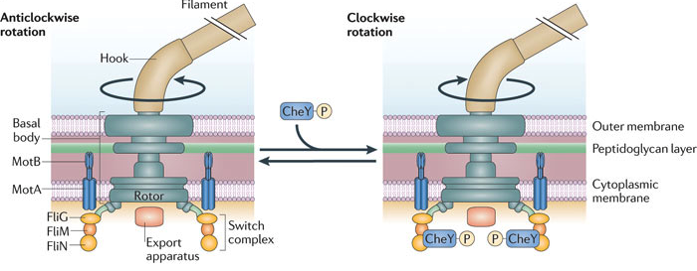
Figure 1: Schematic representation of the bacterial flagella. The flagella consists of three main parts: the filament, the hook and the basal body. The switch complex present in the basal body houses the FliG, FliM and FliN proteins that bind phosphorylated CheY. As more and more CheY-P binds the switch complex, the probablility of change in the direction of flagellar rotation increases (Porter et al, 2011).

The prototypical E. coli chemotaxis pathway
Chemotaxis has been extensively studied in the gram-negative, peritrichously flagellated bacterium, E. coli. The default rotation of the flagella is counterclockwise (CCW) during a run. A switch in the direction of rotation of one or more of the flagellar motors to clockwise (CW) direction results in tumbling. The E. coli genome encodes five receptors that are clustered at one or both cell poles, while flagella are distributed throughout the body (Wadhams & Armitage, 2004). These five receptors (so called MCPs) are able to detect various effectors such as sugars, temperature, amino acids, pH and intracellular energy levels (Falke & Hazelbauer, 2001). The MCPs are linked to the cytoplasmic histidine kinase, CheA, via a linker protein CheW. Binding of an effector to an MCP causes conformational changes that inhibit (attractant binding) or stimulate (repellent) CheA autophosphorylation. The activated phosphorylated CheA has the ability to phosphorylate two response regulators, which compete with each other: the CheY response regulator and the CheB methylesterase. CheA is a homodimer consisting of five structural domains, named P1 to P5. P3 is the dimerization domain, P2 binds response regulators, P1 is the histidine phosphotransfer (hpt) domain that contains the auto-phosphorylatable conserved histidine residue. P4 is the kinase domain that binds ATP and phosphorylates P1. P5 is the regulatory domain that also binds CheW (Wadhams & Armitage, 2004).
One of the two response regulators phosphorylated by CheA is CheY, which has the ability to diffuse and bind the flagellar switch complex to bring about a change in the direction of flagellar rotation and thus the swimming direction. Thus, upon binding of repellents to the MCPs, this phosphorylation cascade results in CW rotation of the flagella, causing tumbling and random changes in the swimming direction. Signal termination is critical to ensure continuous sensing and response to changes in the environment. Therefore, even though CheY-P can be dephosphorylated spontaneously, this process is hastened by a CheY-P- specific phosphatase, CheZ (Figure 2).
As discussed previously, adaptation is necessary for biasing movements in gradients. Biochemically, this short-term memory is created by changes in the methylation levels of the receptors (MCPs). The other response regulator phosphorylated by CheA is involved in adaptation since CheA also phosphorylates CheB, a methylesterase. Demethylation of conserved residues in the C-terminal domains of receptors by the CheB methylesterase, decreases the ability of receptors to activate CheA. An enzyme that antagonizes CheB activity is the constitutively active methytransferase, CheR, which adds methyl groups back to receptors making thereby adjusting their sensitivity to further changes in ligand concentrations (Vladimirov & Sourjik, 2009). However, lower copy numbers for both of these enzymes within the cells and slower kinetics of the methylation/demethylation reactions relative to the phosphorylation reactions, gives the receptors a “head start”, enabling methylation levels of receptors to lag behind the phosphorylation reaction of CheY and CheB. This time difference is sufficient to endow the chemotaxis signaling system with a molecular memory. Adaptation also allows cells

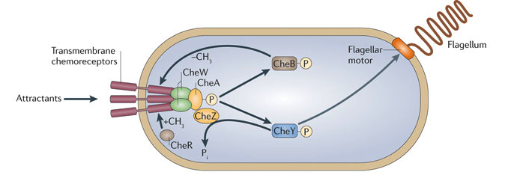
Figure 2. Schematic representation of the prototypical chemotaxis system of E. coli. Chemoeffectors are sensed by specific receptors that undergo a conformational change. The resulting phosphorylation cascade affects flagellar rotation and causes the cell to tumble and change swimming direction (Porter et al, 2011).

to detect minor changes in the level of stimulation, thus ensuring continued sensitivity even in the presence of basal level of stimulation.
Thus, adaptation is an essential feature of motility behavior that allows bacteria to make informed decisions about their environments (Vladimirov & Sourjik, 2009).
Fluorescence microscopy has revealed that most chemosensory proteins are found at the cell poles (Maddock & Shapiro, 1993; Sourjik & Berg, 2000). This is not surprising, considering that receptors also localize at the poles in huge hexagonal arrays consisting of trimers of homodimers (Khursigara et al, 2008). CheW and CheA directly or indirectly act as links between receptors and other components of the chemotaxis pathway, thereby forming a highly stable, efficient, and complex signaling cluster (Sourjik & Armitage, 2010).

Chemotaxis and chemotaxis-like pathways in other bacteria
Among gram-positive bacteria, chemotaxis pathways of Bacillus subtilis have been fairly well characterized, though some questions remain. Unlike the E. coli system where repellent binding or decrease in attractant concentration results in CheA activation and CheY phosphorylation, the opposite is true in case of B. subtilis. Increase in attractant binding activates CheA and leads to an increase in CheY-P, which causes CCW rotations of the flagella, correlating with a run in B. subtilis (Fuhrer & Ordal, 1991). A closer look at the adaptation mechanisms in B. subtilis reveals more variations compared to the E. coli paradigm. The B. subtilis genome encodes CheB methylesterase and CheR methyltransferase, though they function differently than the E. coli enzymes. In case of B. subtilis, methanol, the byproduct of CheB-dependent demethylation of receptors, is released both when an attractant is added and removed, suggesting that methylation of specific residues activates the CheA histidine kinase, while methylation of certain residues deactivates it (Kirby et al, 1999). This is in contrast with the E. coli methylation system where methanol is only released when the attractant is removed (Thoelke et al, 1989). Furthermore, apart from the receptor methylation system, B. subtilis has additional adaptation systems not present in E. coli. Some of these proteins include CheC, a CheY-P specific phosphatase (functionally similar to CheZ in E.coli) (Szurmant et al, 2004), CheD, a receptor deamidase that modifies glutamine residues to glutamic acid residues, which can then be methylated and thus become substrates for the CheR methyltransferase (Kristich & Ordal, 2002). In B. subtilis, CheD has also been shown to increase the phosphatase activity of CheC where it was shown to cycle between the chemoreceptors and CheY-P to mediate sensory adaptation. CheV is another adaptation protein not found in E. coli. CheV contains an N-terminal CheW-like (P5-like) domain and a C-terminal receiver domain. CheV couples CheA to the receptors and also inhibits CheA kinase activity, thereby providing yet another mechanism for resetting the sensory system (Rao et al, 2008).
Even though the chemotaxis pathway and its components have been thoroughly examined down to their molecular details in E. coli, much less is known in other organisms. Complete sequences of bacterial genomes have revealed the presence of multiple chemotaxis-like pathway components in many organisms (Szurmant & Ordal, 2004). For example, the alphaproteobacterium Rhodobacter sphaeroides has three chemotaxis pathways and two sets of flagellar genes controlled by different chemotactic receptor clusters (Hamblin, Maguire, Grishanin, & Armitage, 1997). Fla1 is controlled by products of the chemotaxis operon 2 (cheOp2) and the chemotaxis operon 3 (cheOp3), whereas, Fla2 is controlled by cheOp1 gene products (del Campo et al, 2007). Since, only Fla1 is expressed under laboratory conditions, it is presumed that the two different kinds of flagella are necessary under different growth conditions in natural environments (Poggio et al, 2007). Another striking difference between E. coli chemotaxis and R. sphaeroides chemotaxis is the presence of a cytoplasmic chemotaxis receptor cluster in R. sphaeroides. Four of the thirteen chemoreceptors in the organism are cytoplasmic and soluble and so are the products of cheOp3 (Porter & Armitage, 2004). These receptors could play a role in energy taxis by sensing intracellular metabolites and allowing the organism to optimize metabolic activity via taxis behavior.
The polar and cytoplasmic clusters formed in the cell are distinct and proteins found in one cluster are not found and do not intermix with those found in the other cluster. This raises the question as to whether these pathways function in isolation in the cell. Recent evidence suggests that these clusters do communicate with each other. For example, CheY₆, encoded in the cytoplasmic operon, cheOp3 has been shown to be the dominant flagellar motor binding protein. However, CheY₆ can be phosphorylated by either CheA₂ (present in the polar cluster) or CheA₃/A₄ (in the cytoplasmic cluster). Moreover, CheY₃ and CheY₄ from the polar clusters do not regulate the motor directly, but do affect CheY₆ activity (Porter et al, 2006). Another level of communication occurs at the level of receptors. Mathematical modeling suggests that CheB₂, a component of the cheOp3 pathway, acts as a link between the polar (CheA₂) and cytoplasmic histidine kinases (CheA₃/CheA₄) , and contributes to cross talk between the two clusters (Tindall et al, 2010).
Other organisms like Sinorhizobium meliloti, Rhodospirillum centenum, and Myxococcus xanthus have two, three or even eight chemotaxis clusters. Not all of the pathways are responsible for controlling taxis behaviors, rather they can control other complex processes such as cyst formation, biofilm formation and flagella synthesis (Porter et al, 2011). Examples include the Che3 pathway in Rhodospirillum centenum which controls cyst formation and the Wsp pathway in Pseudomonas aeruginosa, which modulates cyclic-di-GMP levels and hence biofilm formation in this species (Berleman & Bauer, 2005; Hickman et al, 2005).
The gram-negative, soil dwelling deltaproteobacterium, Myxococcus xanthus has a complex life cycle where it exhibits vegetative growth in the presence of nutrients, but can also undergo morphogenesis to develop fruiting bodies which leads to spore formation when nutrient are scarce. Spores are a means of protection against starvation and can germinate under favorable conditions. Motility in M. xanthus is under the control of two independent motility systems: the social (S-) motility and adventurous (A-) motility. Both types of motility are required for proper development and fruiting bodies formation in M. xanthus. As the names suggest, S-motility is used when a group of cells move together and depends on cell-to-cell interaction (Zusman et al, 2007). S-motility requires the use of type IV pili, which bind to polysaccharides present on the surface on which the cells move or on another, preceding cell. Subsequent retraction of the pili propels the cell forward. (Sun et al, 2000). Adventurous (or A-) motility, on the other hand, occurs in independent cells, i.e., isolated cells that do not move in groups. Evidence obtained thus far indicates that A-motility is powered by large focal adhesion complexes that move on a track of the bacterial cytoskeleton, formed from polymerization of the actin-like bacterial protein, MreB (Nan et al, 2011).
Just like flagellated bacteria such as E. coli and other chemotactic organisms, M. xanthus, which lacks flagella, also biases its A-motility and S-motility in response to chemoeffectors. How are environmental stimuli processed by M. xanthus to regulate changes in the direction of gliding and S-motility? Analysis of the M. xanthus genome revealed that this organism has eight chemotaxis-like operons, of which two have been implicated in controlling both A- and S-motility.
The M. xanthus frz (frizzy) genes encode for homologues of the E. coli canonical chemotaxis pathway components: a cytoplasmic chemoreceptor (FrzCD), two CheW homologues (FrzA and FrzB), a histidine kinase response regulator fusion protein (FrzE), a response regulator (FrzZ), a methylesterase (FrzG) and a methyltransferase (FrzF). Signaling occurs via FrzE and FrzZ and the response regulator domain of FrzE negatively regulates its own phosphorylation in the CheA domain. In frame deletion of FrzE caused hyporeversals in both types of gliding motility (A- and S-), suggesting that the Frz pathway is the dominant pathway mediating change in the motility direction in this organism. However, the mechanism by which signals are relayed by the Frz pathway to two motility systems (A and S motility) to modulate change in direction of cell gliding remains to be characterized (Inclan et al, 2007).
However, when characterizing chemotaxis of M. xanthus to phosphatidylethanolamine (PE), it was discovered that response was dependent not on the Frz pathway as expected, but on another chemosensory system, called the Dif pathway (Kearns & Shimkets, 2001). The Dif (defective in fruiting) pathway is so called since mutants cannot form fruiting bodies in response to starvation. These mutants are defective in S-motility since they lacked extracellular polysaccharides (EPS) that are necessary for S-motility mediated by type IV pili. Moreover, it was seen that adaptation during chemotaxis to PE required the presence of Frz genes suggesting directed movement of M. xanthus cells by A- motility depends on multiple pathways in M. xanthus. Out of the other remaining six Che pathways, the Che3 chemotaxis-like system controls developmental genes expression, which is required for fruiting body and spore formation while the Che4 pathway is important for S-motility. The exact function of other Che pathways is yet to be determined (Zusman et al, 2007).
A review of available literature on the multiple chemotaxis-like pathways not only tells us that a lot is yet to be discovered about the function of these pathways, but that these pathways cannot be studied in isolation since cross talk between multiple pathways encoded within a single genome appears widely distributed and thus might be more prevalent then previously thought.

Motility in Azospirillum brasilense
Azospirillum brasilense is a free-living, soil alphaproteobacterium that colonizes the roots of agronomically important cereals and grasses. These gram-negative bacteria are motile and have the ability to fix atmospheric nitrogen, but only under microaerophilic conditions, as the nitrogenase enzyme is inhibited by oxygen. Along with a versatile carbon and nitrogen metabolism, this organism has the ability to thrive under extreme conditions by forming non-motile cyst like cells (Sadasivan & Neyra, 1985). All these features are extremely advantageous to Azospirillum in the competitive rhizosphere environment, where nutrients can be limiting.
Motility and chemotaxis are critical traits of these soil bacteria that contribute to enhance competitivity in the rhizosphere by allowing them to actively sense and move towards plant root exudates. Azospirillum cells display positive chemotaxis towards organic acids, sugars and amino acids that are found in plant root exudates. A. brasilense cells detect most chemicals and conditions in the environment by energy taxis. Energy taxis describes a mechanism by which cells process sensory information. In energy taxis, cells sense chemicals or other cues by the effect they have on metabolism and on the energy status of the cells (redox, PMF etc). As a result, energy taxis navigate cells towards environments where maximum energy levels are supported. (Alexandre, 2010).
In A. brasilense, motility is mediated by two sets of flagella, a polar flagellum that is used to swim in liquid environments and multiple lateral flagella that are specifically expressed during ‘swarming’, or movement on viscous or solid media (Moens et al, 1995). Swarming motility has not been characterized very well, but initial root colonization is thought to involve the polar flagellum rather than lateral flagella (Chris L.Croes & Michiels, 1993), since the polar flagellum rotation and the cell’s swimming direction can be controlled by taxis machineries. The conditions under which swarming motility is used and the mechanism by which the lateral flagella are expressed are poorly known, mostly because it is difficult to consistently express lateral flagella and induce swarming behavior under laboratory conditions.
The complete genome sequence of Azosprillum brasilense Sp245 reveals the presence of 41 putative chemoreceptors and four chemotaxis-like operons (Wisniewski-Dye et al, 2011) (Figure 3). Azospirillum is closely related to Rhodospirillum centenum, an aquatic nitrogen fixing, photosynthetic bacterium. R. centenum has three chemotaxis like operons, the functions of which have been characterized. Che1 is similar to Che1 in Azospirillum, and is mainly involved in regulating swimming motility. Similarly, based on what is known in R. centenum, Che2 is involved in flagella biosynthesis and Che3 has been shown to be involved in cell differentiation during cyst formation (Berleman & Bauer, 2005; Jiang & Bauer, 1997; Jiang et al, 1997). Azospirillum therefore has an additional che operon not present in R. centenum, probably acquired by horizontal gene transfer (Wisniewski-Dye et al, 2011). Also, not encoded in these operons are additional chemotaxis proteins, such as two CheDs, two CheCs, three CheYs and four CheZs homologs. The presence of multiple chemotaxis-like pathways and so many additional chemotaxis proteins is indicative of a complex chemotaxis pathways and signal transduction in A. brasilense.
Though sequence homology to R. centenum Che1, indicated that A. brasilense Che1 might be the dominant pathway controlling swimming motility, this was not the case. Characterization of Che1 pathway mutants indicated that it only played a minor role in regulating chemotaxis. It was also demonstrated that Che1 plays a role in controlling swimming speed, but not swimming reversal frequency (i.e., changes in the swimming direction, equivalent to “tumbles” of E.coli) in A. brasilense. Furthermore, Che1 plays a role in regulating cell size and cell-to-cell interaction (clumping) and flocculation in A. brasilense (Bible et al, 2012; Bible et al, 2008).

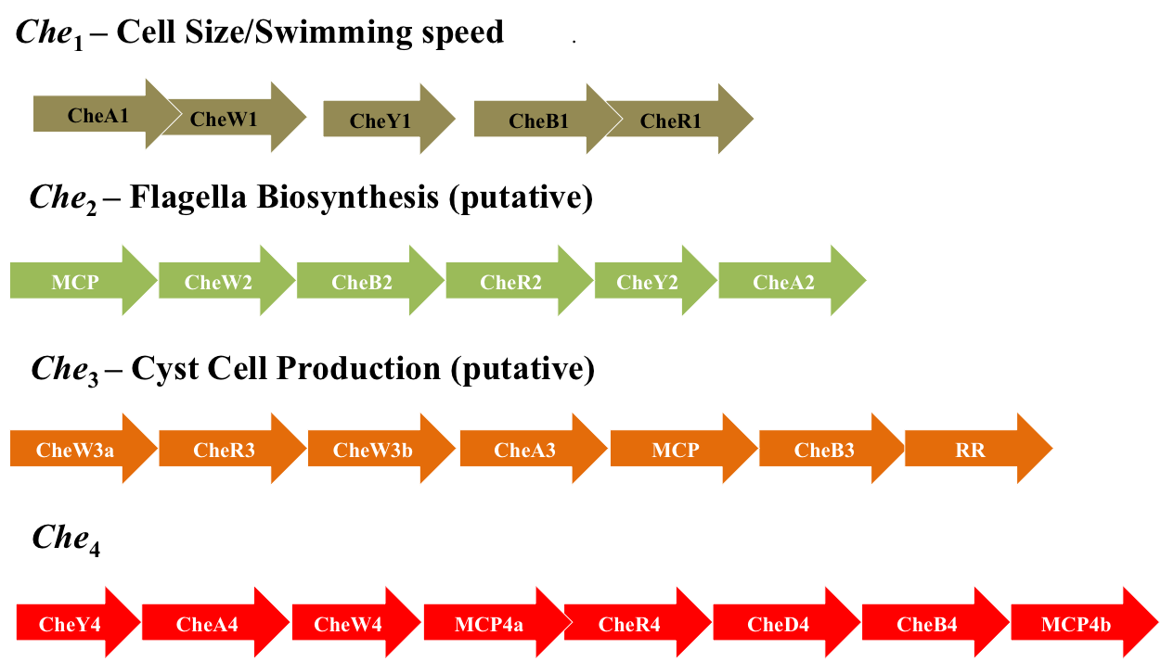
Figure 3: Chemotaxis operons of A. brasilense. Che1 has been shown to play a minor role in chemotaxis and regulates swimming speed, cell size and cell-to-cell clumping behavior. Homology suggests that Che2 and Che3 are involved in flagella biosynthesis and cyst cell production respectively. The role of Che4 is the focus of this study. Additional chemotaxis genes not shown here include CheCs, CheDs and CheYs. (Wisniewski-Dye et al, 2011)

What is the dominant pathway controlling taxis behavior in Azospirillum brasilense? Since Che4 has no predicted function and was acquired by lateral gene transfer, we hypothesized that it was the major pathway controlling motility bias and chemotaxis in this organism. In this study, we have characterized the role of this pathway in A. brasilense Sp7 (a strain closely related to Sp245). Our study confirms that Che4 is the dominant pathway controlling chemotaxis and other taxis behaviors in this organism. Our data also provide evidence that other proteins or pathways may have a role on controlling chemotaxis in A. brasilense. Our data, however, clearly identify a key role for CheA4 in chemotaxis and shed light on a signaling cross-talk that may involve receptors and/or adaptation proteins, consistent with previous data (Bible et al, 2008; Stephens et al, 2006). We also provide evidence to suggest cross talk between Che1 and Che4 pathways, at the level of receptors, which are indicative of an elaborate control of taxis behaviors with multiple chemosensory pathways modulating taxis and sensory specificity in A. brasilense.

CHAPTER III
Materials and Methods

Strains and growth conditions
All the bacterial strains used are listed in table 1. The A. brasilense strains were grown at 28°C with shaking. The MMAB (minimal medium for A. brasilense) medium was used to grow the A. brasilense strains and it was prepared by adding 3 g K₂HPO₄, 1 g NaH₂PO₄, 0.15 g KCl, trace amounts of Na₂MoO₄ in one liter of deionized water. Salts, 5ml of MgSO₄ (stock is 60g/lt), 500μl of CaCl₂ (stock concentration 20g/lt) and 250μl of FeSO₄ (0.631g FeSO₄.7H₂0 and 0.592g EDTA in 50ml water), were added after autoclaving. Carbon (final concentration of 10mM malate from a 1M stock in chemotaxis buffer (10mM phosphate buffer [pH 7.0], 1mM EDTA)) and nitrogen (final concentration of 18.7mM ammonium chloride from a 1M stock in chemotaxis buffer) sources were also added as required.
Cells were induced for nitrogen fixation by growing them in liquid MMAB to the desired optical density (O.D. _{600nm}) followed by three to four washes of the cell pellet in sterile chemotaxis buffer before resuspension in liquid MMAB medium lacking any nitrogen source. Cells were induced for nitrogen fixation by growth overnight at 28°C, without shaking to ensure low aeration conditions.
All culture stocks were routinely maintained on solid tryptone-yeast medium (10 g bacto tryptone, 5 g yeast extract and 15 g noble agar per liter) or solid MMAB medium lacking nitrogen.

Table 1: List of strains used in this study
Azospirillum brasilense strains | Genotype, relevant characteristics | Reference or Source
Sp7 | Wild type strain | ATCC 29145
ΔcheA4 | Δ(cheA4)::Gm | Alexandre lab, unpublished
ΔcheY4 | Δ(cheY4):: Cm | Alexandre lab, unpublished
Δche4 | Δ(che4):: Cm | Alexandre lab, unpublished
ΔcheA1cheA4 | Δ(cheA1):: Km ΔcheA4)::Gm | Alexandre lab, unpublished
ΔcheY1cheY4 | Δ(cheY1)::Km Δ(cheY4):: Cm | Alexandre lab, unpublished
Δche1che4 | Δ(che1)::Km Δ(che4)::Cm | Alexandre lab, unpublished
ΔcheD4 | ΔcheD4 (markerless) | Alexandre lab, unpublished

Antibiotic resistance abbreviations: Km (kanamycin), Cm (Chloramphenicol), Gm (Gentamycin).

Gas perfusion chamber assay for temporal aerotaxis assay
Cells were grown under high aeration conditions in MMAB supplemented with carbon and nitrogen sources to an O.D. _{600nm} of ~1.0 (~7.0x 10⁷cells/ml). Cells were washed twice in sterile chemotaxis buffer and resuspended in MMAB supplemented with carbon and nitrogen. A 10μl drop of cells was then placed on a slide in a gas perfusion chamber with controlled humidified oxygen and nitrogen, as previously described (Alexandre et al, 2000; Bible et al, 2012; Laszlo & Taylor, 1981; Stephens et al, 2006; Zhulin & Armitage, 1993; Zhulin et al, 1996). Cells were allowed to equilibrate in air (21% oxygen) for a few minutes before recording of cell taxis behavior. After videotaping the swimming behavior of cells in air for about a minute, pure inert nitrogen gas was introduced in the chamber (decrease in aeration conditions). Recording was continued until the airflow was switched back to air (increased in aeration conditions) and stopped after about a minute.

Motion tracking and Image analysis for swimming reversal frequency and speed analyses
The videotapes were converted to digital format using VirtualDub (http://www.virtualdub.org/) and visualized using ImageJ (http://rsbweb.nih.gov/ij/). Changes in swimming direction (swimming reversal frequency per cell and per sec) in steady state conditions were analyzed manually for 50 or more cells. For the temporal assay in aerotaxis, changes in the direction of cell swimming were analyzed every 5-10 seconds in 10-15 cells at each time point. Changes in swimming velocity (speed in micrometer/second) were analyzed in 50 or more cells for each strain by using the CellTrak 1.3 computerized motion analysis software, and all results were plotted by using sciDAVis graphing software (http://scidavis.sourceforge.net/).

Spatial gradient assay for aerotaxis
Cells were grown to desired O.D. _{600nm} (0.5-0.6 for log phase (~10⁷ cells/ml) and 1.0-1.2 for stationary phase (~7.0x 10⁷cells/ml)) in MMAB medium supplemented with carbon and nitrogen sources. Cells were motile under these conditions. Optical density was adjusted between cultures to ensure that similar number of cells were compared across different samples. Motile cells were gently washed with chemotaxis buffer by centrifugation (5000 rpm for 3-4 minutes) and concentrated in MMAB containing malate as a carbon source (10mM). Cells were then placed in an optically flat capillary tube (Vitro Dynamics, Inc., Rockaway, N.J.) and aerotaxis was visualized as the formation of a stable band of motile cells at a certain distance from the air-liquid interface (meniscus), under a light microscope, within 2-3 minutes (n=3 replicates). Temporal changes in aerotactic band formation, indicative of the ability of cells to sense changes in aeration (Miller et al, 2009; Zhulin et al, 1996) were also analyzed by placing the same capillary tubes in the gas perfusion chamber and switching air flow from air to nitrogen flow.

Chemotaxis assay (soft agar assay)
In order to assess chemotaxis behavior in a spatial gradient, cells were grown in MMAB liquid medium as described above. Equivalent number of cells was inoculated in the center of semisolid minimal medium plates solidified with 0.3% agar and supplemented with malate as a carbon source (10mM). Chemotactic ability of cells was measured both in plates supplemented with nitrogen (18.7mM) and lacking a nitrogen source. Chemosensitive motile cells are able to form chemotactic rings, visualized as a dense accumulation of cells (so-called “chemotactic ring”) at a certain distance from the point of inoculation, after incubation (Alexandre et al, 2000; Miller et al, 2009; Zhulin & Armitage, 1993). The diameter of the chemotactic rings formed are robust under any given conditions and are indicative of the ability of cells to navigate in spatial gradients of chemoffectors that result from metabolism and growth of the cells from the point of inoculation. The diameter of the chemotactic rings (n=3 replicates), relative to that formed by inoculating the wild type stain (taken as a value of 1) under the same conditions, were recorded at 24 and 48 hours, post inoculation.
Temporal gradient assay for chemotaxis
Cells grown to O.D. _{600nm} (0.5-0.6 for log phase (~10⁷ cells/ml)) in MMAB supplemented with malate were washed three to four times in sterile chemotaxis buffer to remove all traces of malate. Cells were resuspended in fresh chemotaxis buffer. A drop of cells was placed on a clean slide and motile cells were videotaped for about a minute. A chemoattractant response was induced by addition of malate (final concentration 10mM) and the swimming behavior of cells was recorded for another couple of minutes. Swimming behavior (reversal frequency) of cells was analyzed before and after the addition of chemoattractant from videotapes, as described above (Stephens et al, 2006). A chemorepellent assay was performed in the same way by videotaping swimming behavior of cells washed and re-suspended in MMAM supplemented with malate as a carbon source (10mM final concentration). A repellent response was induced by addition of sterile chemotaxis buffer to dilute the concentration of malate from 10mM to 2.5mM and swimming behavior of cells was recorded (Stephens et al, 2006). Reversal frequency of the cells (n=10-15 cells) was analyzed before and after the stimulus as described previously. The chemorepellent assay was used to analyze chemotaxis abilities of cells that possessed a smooth swimming bias since attractant responses cannot be detected in these cells.
Fluorescence microscopy and immunofluorescence
Strains expressing YFP tagged CheY1, CheD4, CheY4, in different strain backgrounds were grown in MMAB containing malate as the carbon source. Motile cells were immobilized on a pad of 1% low melting point agarose prepared in 1X PBS on a microscope slide. A coverslip was placed on top of the pad and the cells were visualized using a Nikon ECLIPSE 80i fluorescence microscope equipped with a Nikon CoolSnap HQ2 cooled CCD camera. FITC filters were used for collecting the images. Some images collected previously in the Alexandre Laboratory (localization of CheA1-YFP, CheA4-YFP etc.) were also used for quantification in this study.

The images were quantified using the Nikon NIS-Elements BR program (Nikon) by calculating the ratio of average fluorescence intensity in the foci and cell body. Cells with no foci and displaying diffuse localization were also analyzed by assuming presence of foci at the cell poles. Around 50 cells were analyzed for each strain and the results were graphed and analyzed statistically using Graphpad Prism software (http://www.graphpad.com/prism/prism.htm). All graphs display the mean and standard deviation.

CHAPTER IV
Results and Discussion

A. Che4 is the dominant pathway controlling the probability of changes in the swimming direction (swimming reversal frequency)
In E.coli and most bacteria studied in this respect, a switch in the direction of flagella rotation caused either by a changes in rotation from counterclockwise to clockwise (tumbles, e.g. E. coli) or brief stops in flagella rotation (stops, e.g. R. sphaeroides) cause the motile cells to randomly re-orient by Brownian motion in a new swimming direction (Armitage & Macnab, 1987; Berg & Brown, 1972). The probability of changes in the direction of flagellar rotation caused by any of these mechanisms is controlled by chemotaxis signal transduction in all bacterial species, regardless of the exact re-orientation system used (stops or tumbles). Previous work has clearly shown that during chemotaxis and aerotaxis in A. brasilense, cells change the swimming velocity as well as the probability of changes in the swimming direction (Alexandre et al, 2000; Bible et al, 2012).
Previous characterization of the Che1 pathway in Azospirillum brasilense revealed that it is primarily involved in regulating swimming velocity of cells in response to cues, rather than promoting changes in the swimming direction (Bible et al, 2012). This suggests that another chemosensory pathway controls the rate of change in the swimming direction in this organism. We hypothesized that if Che4 is the major pathway responsible for modulating taxis response in A. brasilense, then mutants of this pathway would be unable to change their swimming direction in response to changes in the environment, i.e., in gradients of physicochemical cues. Chemosensitive cells respond to an attractant by decreasing their reversal frequency and swimming smoothly transiently, and subsequently return to steady state swimming behavior (Miller et al, 2009). Response (immediate change in swimming direction) and adaptation (return to pre-stimulus swimming bias) comprise a true “chemotaxis” response. Lack of response or adaptation both implies a chemotactic defect (Miller et al, 2007). In other words, since binding of phosphorylated ‘active’ CheY to the flagella motor brings about this switch, mutations in CheA4 and CheY4 chemotaxis proteins should result in a ‘smoother’ swimming phenotype, where reversals during swimming are not observed. If the Che4 pathway is indeed the major pathway for controlling the probability of changes in the swimming direction, then the cells lacking functional Che4 should not be able to changes swimming direction whether a gradient of chemoeffector is present or not. To test this hypothesis, we first analyzed steady-state (absence of gradient) swimming behavior of cells and also analyzed the cells motility response in gradient of oxygen (temporal aerotaxis assay) and chemical gradients (chemotaxis assay).

1. Steady-state swimming behavior of Che4 mutants
Consistent with our hypothesis, the ΔcheA4 and ΔcheY4 mutants had a smooth swimming bias under steady state conditions (Table 2). Along with ΔcheA4 and ΔcheY4 deletion mutants, we also tested the behavior of a strain lacking the entire Che4 operon. Surprisingly, this analysis revealed that the Δche4 mutant was in fact able to change swimming direction under steady-state conditions and that it was not as “smooth” swimming as the ΔcheA4 or the ΔcheY4 strain (Table 2). The fact that the steady state swimming bias of Δche4 was different and greater than that of ΔcheY4 or ΔcheA4 suggests that other proteins also contribute to setting the steady state swimming bias of cells, in the absence of Δche4. Given that the increased swimming bias was seen in the Δche4 mutant but not in the ΔcheA4 or ΔcheY4 mutant, it follows that a Che4 protein other than CheA4 or CheY4 is involved in modulating the steady state swimming bias with the activity of this unknown protein depending on functional CheA4 and CheY4.

Table 2: Steady state swimming behavior of Che4 mutants *

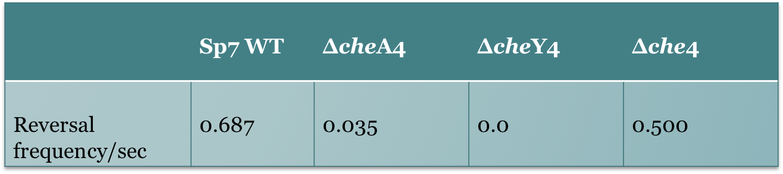
* Changes in swimming direction were determined by analyzing free-swimming cells grown to stationary phase in minimal medium supplemented with malate as a carbon source. The assay is described in detail in Materials and Methods.

2. Aerotaxis behavior of Che4 mutants- spatial gradient assay and temporal gradient assay
Aerotaxis is the strongest behavioral response displayed by Azospirillum. Motile A. brasilense cells actively seek optimum microaerophilic conditions (0.4% dissolved oxygen for A. brasilense) that act as an attractant and sense higher or lower oxygen concentrations as repellents. It was determined that the cellular energy levels were the highest at 3-5 μM oxygen concentration and nitrogen fixation was optimal under these conditions (Zhulin et al, 1996). Therefore, aerotaxis allows A. brasilense to use directed motility to seek niches that are compatible with optimum oxidative metabolism as well as nitrogen fixation.
One of the earliest assays used to study aerotactic responses in populations of cells was the modified capillary assay described by Adler (Adler, 1973; Zhulin et al, 1996). Aerotactic cells introduced in a small capillary formed a stable band near the air liquid interface, at a position that corresponds to low but optimal oxygen concentration for the cells metabolism. Aerotactic band formation occurs reproducibly very fast (0.5-3 minutes) and the response is also robust, i.e., the band dissipates on introduction of pure N₂ to the atmosphere and re-formed when air is returned in the atmosphere (Zhulin et al, 1996).
We used this spatial gradient assay for aerotaxis to monitor responses of the ΔcheA4, ΔcheY4 and Δche4 mutant strains in a gradient of oxygen established in a small capillary tube. Under these conditions, the wild type Sp7 cells form an aerotactic band within 2-3 minutes at some distance from the meniscus. The aerotactic band formed remains stable for hours, with cells remaining motile and moving rapidly to maintain a position in the gradient within the band and being repelled as they reach either edge of the band (Figure 4). When different strains are analyzed in this assay, controls to be performed are as following: the strains analyzed in the aerotaxis gradient assay should not be affected in metabolism to ensure that equivalent oxygen is consumed for growth by all strains compared. The cells should also be able to swim with similar speed and pattern and to be able to sense oxygen as both an attractant (position of the aerotactic band) and as a repellant (cells moving away from high and low oxygen concentration toward the band) with similar sensitivity. Any difference in the above mentioned characteristics affect the formation of the aerotactic band and is thus indicative of a defect in the aerotactic response. The ΔcheA4 mutant was unable to form an aerotactic band, indicating that CheA4 protein is essential for aerotaxis. The ΔcheY4 mutant initially formed an aerotactic band but the cells within the band seemed to interact with one another leading to clumping and resulting in the aerotactic band collapsing and disappearing within a few minutes (Figure 5). Clumping has recently been characterized in the lab as an alternative to aerotaxis and as an adaptive response that is implemented when taxis responses fail (Bible et al, 2012).
The behavior of the ΔcheY4 mutant is thus consistent with a defect in aerotaxis, although the cells apparently can initially respond to the oxygen gradient. The dissipation of the aerotactic band after a short time suggests that the response is not stable and thus does not comprise a true tactic response. Therefore, CheY4 is also essential for the aerotaxis response.
The Δche4 mutant also seemed to be able to respond to the oxygen gradient by accumulating toward the edge of the capillary but there was no formation of a sharp and well-defined aerotactic band as seen for the wild type strain with accumulation of motile cells at the optimum low oxygen concentration (Figure 5). Therefore, aerotaxis appears to be severely impaired in Δche4 mutant cells.

Figure 4: Schematic representation of aerotactic band formation in a spatial gradient assay. The band is formed a certain distance away from the meniscus, where oxygen concentration is optimal for cellular metabolism. Cells swimming away from the band, often reverse and re-enter the band (bent arrows), though cells entering the band do not reverse until they reach the opposite end of the band (straight arrows). Cell density in the band is greater that cell density behind the band (medium dark area). Also very few cells were present in front of the band (light grey area), indicating that cells are repelled by high oxygen concentrations (Mazzag et al, 2003).

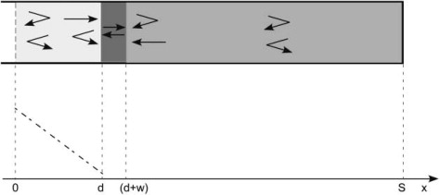

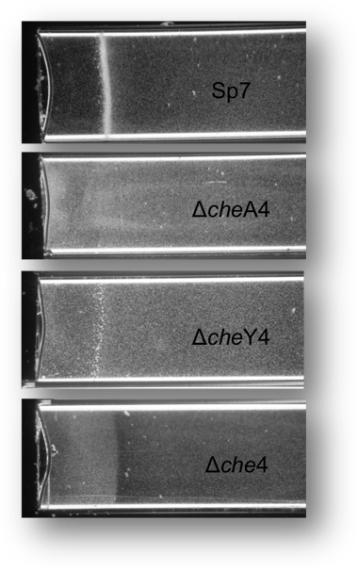

Figure 5: Capillary assays comparing aerotaxis behavior (taxis towards oxygen) among Che4 mutants. An equivalent number of cells (grown to mid-log phase) were inoculated in each capillary tube and photographs were taken after approximately 5 minutes. Mutations in which CheA4 was affected resulted in a null aerotaxis phenotype, while ΔcheY4 and Δche4 strains were impaired in aerotaxis.

A more straightforward way of analyzing aerotactic behavior of cells is to analyze the swimming behavior of single cells in response to changes in aeration. Wild type cells respond to an increase in oxygen concentration by decreasing their reversal frequency, resulting in a longer run (eliciting a chemoattractant response). However, as expected from the results of the spatial gradient assay, ΔcheA4 and ΔcheY4 mutants did not exhibit a similar response. Δche4 was unable to respond to temporal changes in oxygen concentration. This result is consistent with Che4 functioning to modulate taxis responses by acting on the probability of change in the swimming direction of cells (Figure 6).
The results of the spatial gradient assay for aerotaxis are thus consistent with the temporal assay for aerotaxis that indicates that these strains failed to respond to temporal changes in aeration conditions. The spatial gradient assay, however, reveal some subtle differences between the strains that remain to be deciphered.

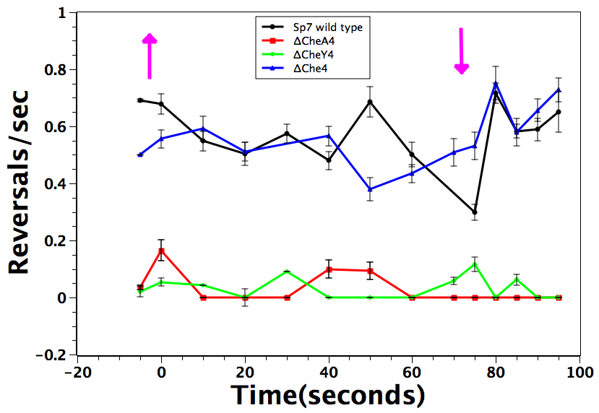

Figure 6: Temporal aerotaxis assay for Che4 mutants shows that Che4 pathway plays an important role in controlling reversal frequency in A. brasilense. ΔcheA4 and ΔcheY4 mutants display a smooth swimming bias and do not respond to a change in oxygen concentration, whereas, Δche4 mutant reverses in steady state conditions, but is unresponsive to a change in oxygen concentrations. The assay is described in detail in Materials and Methods.

3. Che4 mutants are defective in chemotaxis

A high throughput assay used to test chemotaxis is the swarm plate assay (also called the soft agar assay). Cells are inoculated in semi-solid plates (agar concentration 0.2-0.3%), and as they exhaust nutrients in the area of their growth, a gradient is established and they chemotact outwards towards areas of higher nutrient concentration, thereby forming a chemotactic ring. If the cells tested have similar growth characteristics and swimming abilities, then the size of the chemotaxis rings relates directly to the ability of cells to “sense” the chemical gradients formed in the soft agar plates. Results indicate that all the mutants are severely impaired in chemotaxis, compared to wild type Azospirillum brasilense Sp7. Interestingly, strains lacking CheA4 are null for chemotaxis, indicating that this protein plays a crucial role in this taxis behavior (Figure 7).
This is consistent with the temporal gradient assay for chemotaxis, where free swimming cells are challenged with an attractant or a repellent and the response is monitored for the next few seconds, rather than days. This assay is therefore more reflective of responses mediated by cells in a physiologically relevant setting. When cells resuspended in chemotaxis buffer are stimulated with an attractant (such as malate), wild type cells respond by decreasing their reversal frequency and prolonging the length of a ‘run’. When ΔcheA4 and ΔcheY4 cells were analyzed in a similar experiment, the cells failed to respond and remained smooth swimming. The Δche4 mutant did respond though the response was short lived (30 seconds as opposed to 60 seconds for wild type). This suggests that the Δche4 mutant is severely impaired in its sensitivity to the gradient experienced in this assay and that a secondary pathway might in fact be responsible for mediating this chemotactic response to an attractant (Table 3).
A similar experiment was also done for to analyze changes in swimming direction in response to a chemorepellent or decrease in the concentration of an attractant. Since the steady sate swimming bias of ΔcheA4 and ΔcheY4 is smooth, we reasoned that temporal responses might be more detectable in this assay, since the response of wild type cells to a decrease in the attractant concentration is an increase in the swimming bias.
The ΔcheA4 and ΔcheY4 cells failed to respond in a similar assay indicating that these Che4 proteins are essential for chemotaxis. Furthermore, the Δche4 mutant that responded briefly to a chemoattractant did not show an increase in reversal frequency in response to a chemorepellent (Table 3). This behavior is consistent with the Δche4 mutant being severely impaired in its sensitivity to chemoeffectors, especially chemorepellents and this also confirms the critical role of Che4 in chemotaxis and the contribution of another pathway to the chemotaxis response. Noticeably, a chemoattractant but not a chemorepellent could trigger chemotaxis in a Che4-independent manner.

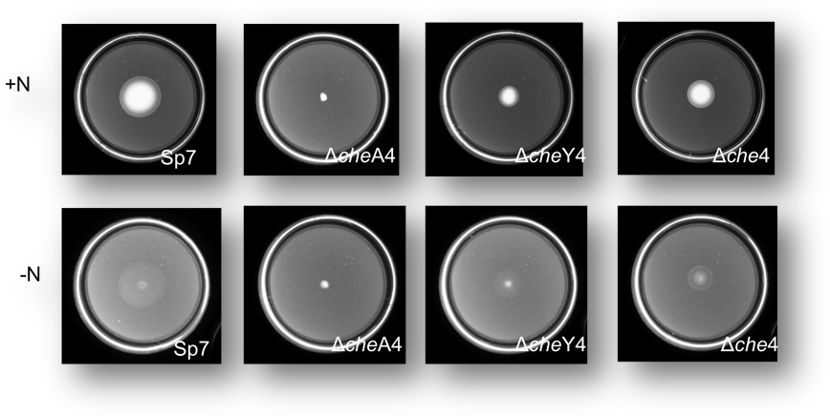
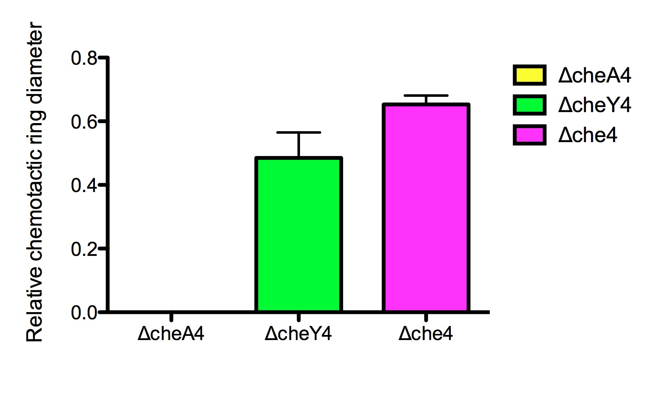

Figure 7: Chemotaxis swarm plate assays comparing chemotaxis/motility behaviors among Che4 mutants. Semi-solid agar plates (top row supplemented with nitrogen, bottom row lacking a nitrogen source) were inoculated with the indicated strains and incubated for approximately 48 hours at 28°C. Mutants within the Che4 pathway are severely impaired suggesting that Che4 plays a major role in regulating chemotaxis behavior. The average chemotactic ring diameter is expressed relative to wild type (expressed as 1). Error bars represent standard deviation from mean, determined by at least three independent replicates.

Table 3: Chemotactic responses of A. brasilense wild type strain Sp7 and Che4 pathway mutants in a temporal gradient assayª
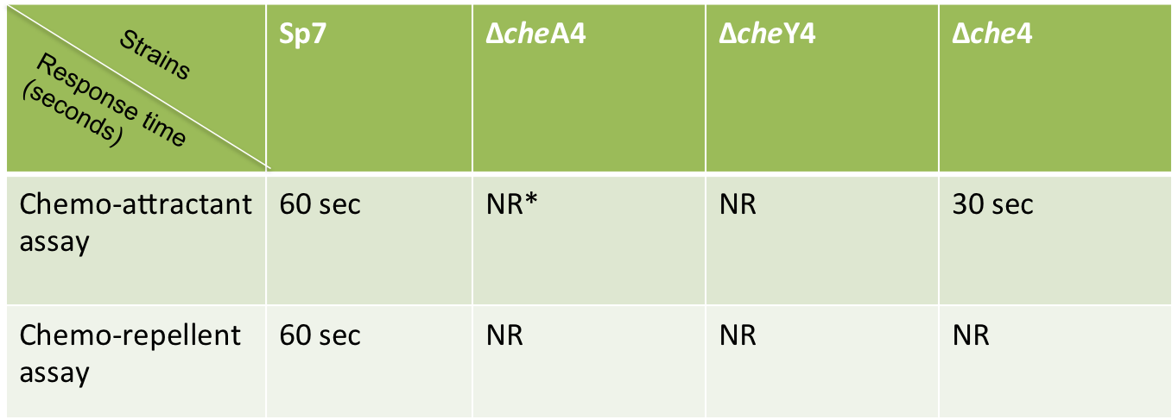
ª The experiment was performed as outlined in Material and methods.
*NR= no response/no change in swimming bias.

Both Che1 and Che4 contribute to change in direction of swimming
We also constructed double mutants lacking genes of che4 and of the previously characterized che1 in order to assess the collective contribution of these two operons to taxis responses in A. brasilense. We used the spatial gradient assay to monitor the ability of double mutants to sense and navigate in a spatial gradient of oxygen, i.e. aerotaxis.
- Steady state swimming bias
Che1 has been previously characterized and is known to play an indirect role in modulating the reversal frequency of cells (Bible et al, 2008; Stephens et al, 2006). ΔcheA1 and ΔcheY1 have a very mild effect on reversal frequency, while Δche1 had no noticeable difference when compared to changes in swimming directions with the wild type Sp7 (Bible et al, 2008). Furthermore, analysis of ΔcheB1 and ΔcheR1 mutants revealed that they were the only Che1 proteins for which mutations caused defects in swimming bias (Stephens et al, 2006). We analyzed reversal frequencies for double mutants ΔcheY1cheY4 and Δche1che4 in assays similar to ones used for the single mutants. ΔcheA1cheA4 could not be analyzed since the cells are extremely clumpy under the conditions of the assay. ΔcheY1cheY4 displayed a smooth swimming bias. Surprisingly, the Δche1che4 mutant lacking components of both the Che1 and Che4 operons also had a smooth swimming bias (Table 4). This was unexpected, given the fact that both the Δche4 and Δche1 mutants had a basal steady state swimming reversal frequency. This result indicates that both pathways contribute to setting the steady state swimming frequency levels. Given the steady state swimming bias of ΔcheA4 and ΔcheA1 as well as of ΔcheY1, ΔcheY4 or a mutant lacking both cheY1 and cheY4, combined with previous results (Stephens et al, 2006) we hypothesize that Che1 and Che4 both contribute to changes in swimming direction probably by affecting receptors, via adaptation proteins such as CheR1, CheB1, CheR4 and CheB4.

Table 4: Steady state swimming behavior of Che1-Che4 double mutants*

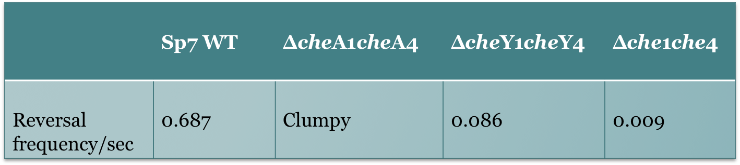
*Changes in swimming direction were determined by analyzing free-swimming cells grown to stationary phase in minimal medium supplemented with malate as a carbon source. The assay is described in detail in Materials and Methods.

2. Aerotaxis behavior of double mutants- spatial gradient assay and temporal gradient assay
ΔcheA1cheA4 did not form any band in the spatial gradient assay for aerotaxis, since the cells were extremely clumpy. Unexpectedly, both Δche1che4 and ΔcheY1cheY4 formed aerotactic bands in the capillary (though increased clumping was visible in both cases, indicating that the cells were able to sense the oxygen gradient, but failed to be aerotactic and thus implemented clumping response). We also observed that the band formed by Δche1che4, was unstable and collapsed after 10 minutes, whereas the Sp7 band remained stable, indicating that the cells are in fact not truly aerotactic and can not persistently swim and navigate the gradient of oxygen (Figure 8). Formation of a stable aerotactic band requires a sensing mechanism to detect the oxygen gradient and the presence of a functional adaptation system in order to ensure sustained sensing of the gradient. This is consistent with the lack of aerotactic band formation seen in ΔcheA1cheA4 mutant strain. The ΔcheY1cheY4 mutant formed a stable aerotactic band and it thus appears that while the position of the band was impaired this mutant can navigate and sense the oxygen gradient using directed motility, i.e., true aerotaxis. These results also suggest that in the absence of functional CheY1 and CheY4 additional proteins may modulate the signal output of the Che4 pathway to regulate the aerotaxis response.

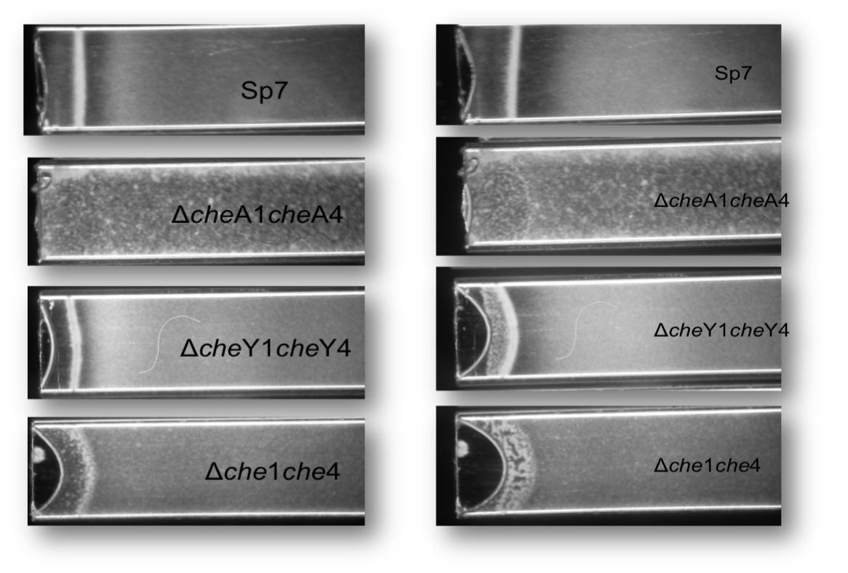
Figure 8: Spatial gradient assays for double mutants. ΔcheY1cheY4 and Δche1che4 form aerotactic bands, but cells are more clumpy. ΔcheA1cheA4 is extremely clumpy and does not form a band. The Δche1che4 band is unstable and collapses after a few minutes (second row), indicating that alternate mechanisms that contribute to aerotaxis in this mutant are impaired in adaptation.

We also analyzed the swimming behavior of the double mutants in response to changes in aeration in the temporal aerotaxis assay. We were unable to analyze the behavior of ΔcheA1cheA4, since the cells were very clumpy. We observed that both ΔcheY1cheY4 and Δche1che4 displayed an inverted response to addition of oxygen back into the chamber and increased their reversal frequencies instead of becoming smoother (Figure 9). While these results point to impaired sensing by these mutants, they also indicate the presence of additional chemosensory mechanisms that become active in the absence of these proteins.

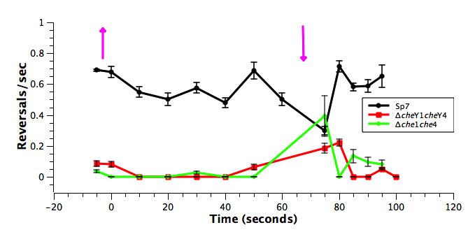

Figure 9: Temporal aerotaxis assay for Che1-Che4 double mutants shows that Che1 pathway also contributes to change in direction of swimming in A. brasilense. Δche1 (analyzed previously (Bible et al, 2008)) and Δche4 mutants are able to change swimming direction, but the double mutant Δche1che4 is not. This suggests that Che1 and Che4 both contribute to swimming bias in A. brasilense. The assay is described in detail in Materials and Methods.

3. Chemotaxis: spatial and temporal gradient assay

We checked responses of double mutants in a chemotaxis soft agar assay. ΔcheA1cheA4 was non chemotactic and did not form a ring in the semisolid agar plate. ΔcheY1cheY4 formed a ring, but the diameter was significantly smaller than that of the wild type, Sp7. On the other hand, the diameter of chemotactic ring formed by Δche1che4 was slightly larger than that of the wild type strain (Figure 10).
A chemotactic ring is formed when cells exhaust nutrients in the vicinity of their growth and swim outward to support their metabolism. Therefore cells need to not only respond to the newly established gradients, but also adapt so they can compare conditions in their current environment to their past. Thus, formation of rings that are either smaller and larger are indicative of impaired sensing/adaptation.
It is noteworthy to indicate that in order to form chemotactic rings in the soft agar assay, the cells must be able to grow and to swim though the agar, with the swimming pattern and speed affecting the final chemotactic ring size observed. In fact, swimming cells of Rhizobium leguminosarum bv viciae, in which the only two chemotaxis operons encoded within the genome have been deleted, form chemotactic rings on soft agar assay (Miller et al, 2007). Thus, a different swimming speed or swimming bias of the double mutants relative to the single mutants could explain their ability to form “chemotaxis-like” rings in this assay. These results provide evidence to support the hypothesis that an additional chemosensory mechanism plays a role in chemotaxis in the absence of Δche1che4, but the system is not very efficient in adaptation leading to formation of chemotactic rings larger than that of wild type cells.
We also measured temporal changes to chemotaxis in a temporal gradient assay to measure changes in swimming direction in response to addition of a chemoattractant (malate) or decrease in the concentration of a chemoattractant (to elicit a chemo-repellent response). Both ΔcheY1cheY4 and Δche1Δche4 did not respond to addition of chemoattractant and remained smooth swimming. Interestingly, ΔcheY1cheY4 responded to a decrease in the concentration of malate, by increasing its reversal frequency. Furthermore, cells were able to not only respond but also adapt in a manner similar to wild type strain and swimming bias returned to steady state after 60 seconds (Table 5).
Similarly, Δche1Δche4 also responded to decrease in the concentration of malate by increasing reversal frequency, though they did not adapt (adaptation time >125 seconds, as opposed to 60 seconds for wild type cells) (Table 5). This again suggests that additional proteins are involved in eliciting a chemotactic response in the absence of both Che1 and Che4 pathway components. However, it seems that the additional chemosensory mechanism relies on the presence of Che1 and Che4 for adaptation or is simply inefficient in adaptation.

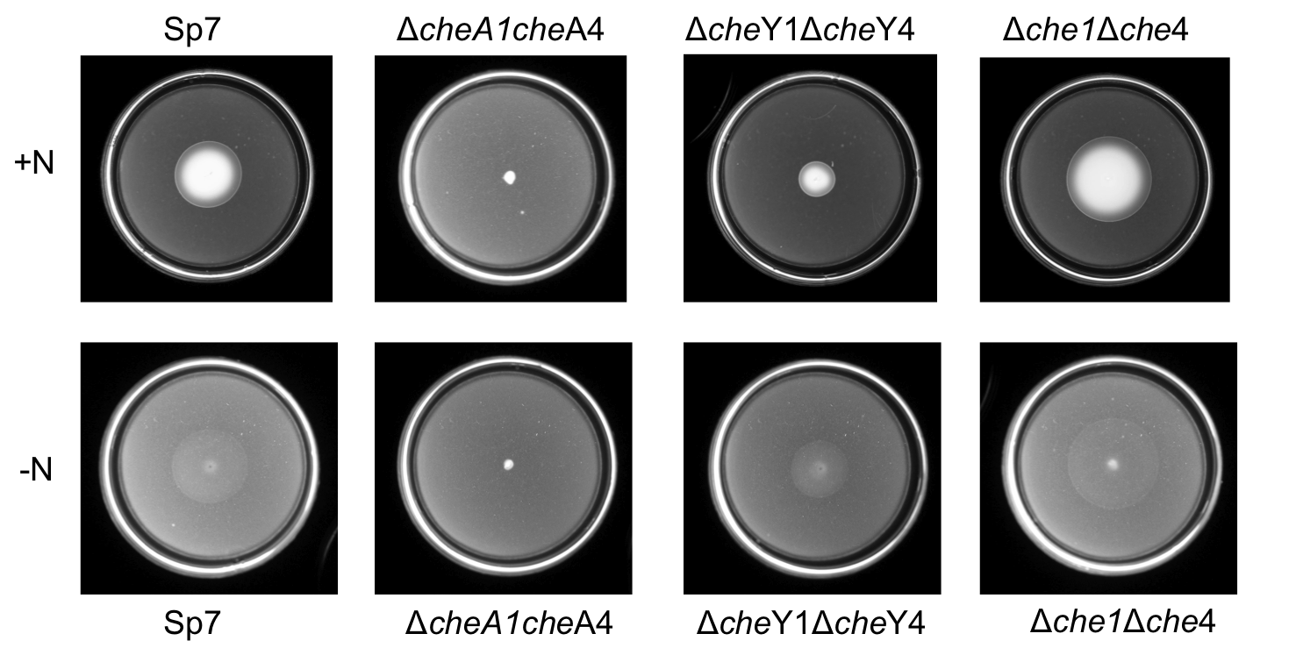

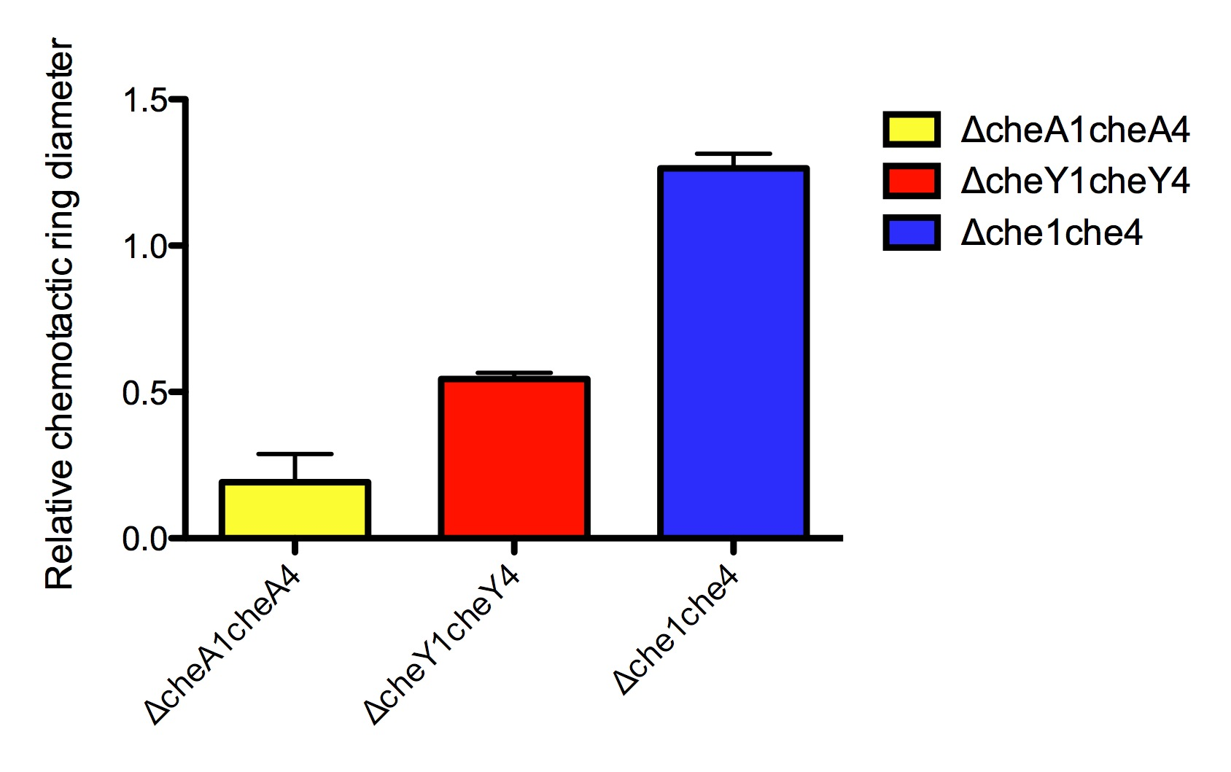

Figure 10: Chemotaxis swarm plate assays comparing chemotaxis/motility behaviors among Che1-Che4 mutants. Semi-solid agar plates were inoculated with the indicated strains and incubated for approximately 48 hours at 28°C. Chemotactic defects in some Che1-Che4 mutants are more pronounced than others, with Δche1che4 chemotactic rings being larger than wild type.

Table 5: Chemotactic responses of A. brasilense wild type strain Sp7 and Che1-Che4 pathway double mutants in a temporal gradient assay *

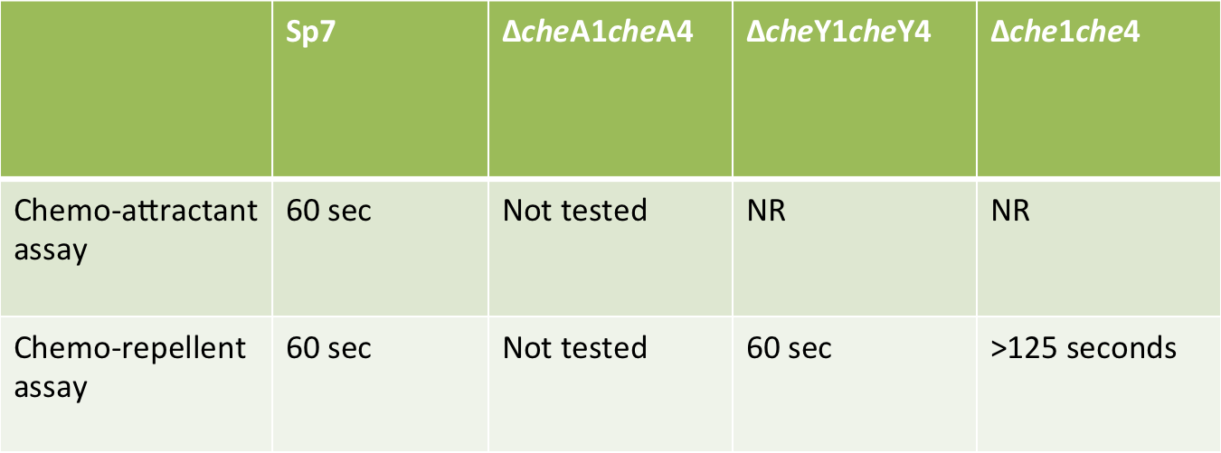
*The experiment was performed as outlined in Material and methods. ΔcheA1cheA4 was not tested in this experiment, as the cells are extremely clumpy and non-chemotactic.
NR= no response/no change in swimming bias.

C. Che4 and Che1-Che4 mutants are affected in their ability to modulate swimming velocity
The role of Che1 in regulating swimming speed during clumping has already been documented. Che1 transiently modulates swimming velocity in response to changes in aeration (Bible et al, 2012). In order to determine if Che4 mutants were affected in Che- specific locomotor response that would indicate signaling cross-talk, we analyzed swimming velocity of cells in a temporal aerotaxis assay.
Wild type A. brasilense cells respond to air removal by transiently increasing their swimming speed. (Bible et al, 2012). We observed that the steady state swimming speed of the ΔcheA4 and Δche4 mutants was higher than Sp7 and that they was unable to modulate swimming velocity in response to air removal. Interestingly, the ΔcheY4 cells swam at similar speeds as those of Sp7 in steady state conditions and also increased their swimming velocity in response to removal of oxygen (Table 6). This suggests that Che4 pathway might be indirectly involved in regulation of swimming speed and other proteins of the Che4 pathway (such as CheB4 and CheR4) might be important for this response.
We also analyzed double mutants- ΔcheY1cheY4 and Δche1che4 in the same assay (Table 6). We were unable to analyze ΔcheA1cheA4 for reasons stated previously. ΔcheY1cheY4 displayed an inverted response by decreasing swimming velocity in response to oxygen removal. This could be due to lack of CheY1, which has been shown to be important in regulating swimming speed under these conditions (Bible et al, 2012).
Interestingly, Δche1che4 cells responded to air removal by increasing their swimming velocity, in a manner resembling wild type cells, supporting our hypothesis that additional chemosensory mechanism were involved in chemotaxis in the absence of all components of Che1 and Che4 (Table 6).

Table 6: Mean swimming velocity of cells before and after removal of air in a temporal aerotaxis assay ª.

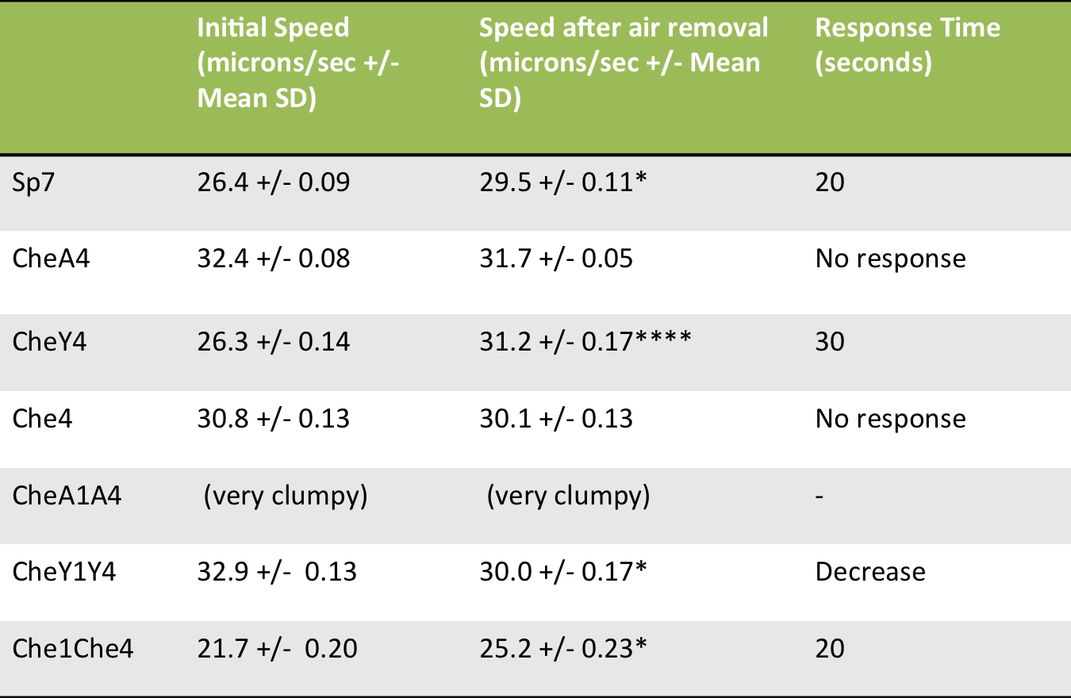
ª Speed after air removal represents the swimming speed 5 seconds after the stimulation and response time is the total time taken for cells to respond and come back to steady state. Asterisks indicate significance values obtained after a students t- test, where * represents p < 0.5 and **** represents p < 0.0001.

Increase in swimming velocity of wild type A. brasilense cells is more apparent upon air addition to the environment (Bible et al, 2012). So we analyzed changes in swimming velocity of all the Che4 and Che1-Che4 mutants in response to increase in aeration. ΔcheA4, which did not respond to air removal in fact shows a decrease in swimming velocity in the absence of oxygen in the chamber. The significance of such a response is unclear, but there seems to be a lack of adaptation is since swimming velocity does not go back to steady state levels until introduction of oxygen back to the atmosphere of the cells. Lack of response after both air removal and air addition indicates that CheA4 is important for regulating speed in response to changes in aeration.
Both ΔcheY4 and Δche4 mutants show no increase in swimming velocity upon air addition in the environment. Thus, the Che4 pathway plays a significant role in regulating speed in response to changes in aeration as well.
ΔcheY1cheY4 mutant showed an inverted response to air addition as well, suggesting that both CheY1 and CheY4 are important for modulating swimming speed in response to increase in aeration.
In response to air addition in the chamber, Δche1che4 cells increased their swimming velocity. However, while Sp7 cells regained their steady state swimming speed after 25 seconds, Δche1che4 swimming speed remained high, even after 60 seconds post stimulation, demonstrating a lack of adaptive mechanisms in this mutant (Table 7).

Table 7: Mean swimming velocity of cells before and after addition of air in a temporal aerotaxis assay ª
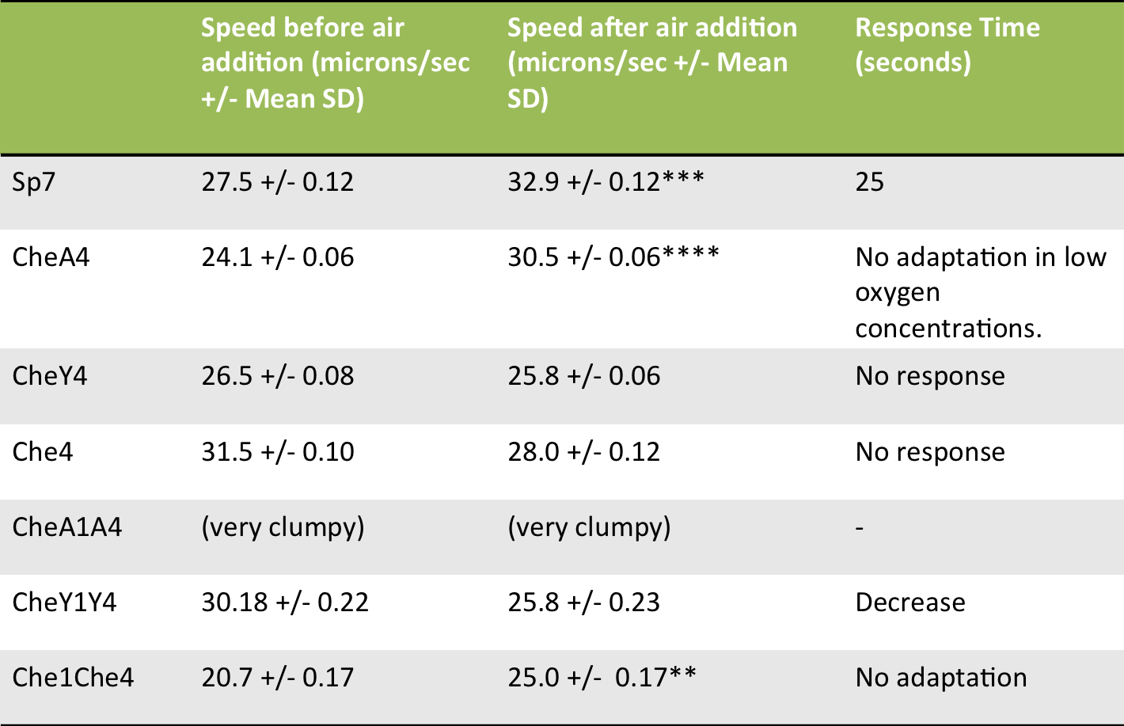
ª Speed after air removal represents the swimming speed 5 seconds after the stimulation and response time is the total time taken for cells to respond and come back to steady state. Asterisks indicate significance obtained after a students unpaired t- test, where ** represents p<0.01, *** represents p < 0.001 and **** represents p < 0.0001.

D. Localization of chemotaxis proteins supports cross talk between Che1 and Che4 pathways
Chemotaxis proteins are known to organize in chemotaxis signaling clusters that form large arrays at the cell poles and this organization was shown to be sufficient to explain the high sensitivity and signal amplification of chemotaxis signal transduction. Chemotaxis cluster formation is initiated by localization of membrane bound receptors to the cell poles. Clusters are stabilized by binding of CheW and CheA to the receptors, which further recruit other chemotaxis proteins leading to the formation of a macromolecular sensory complex (Kentner et al, 2006). In organisms such as R. sphaeroides, where more than one chemotaxis signaling clusters are present, the clusters are physically separated in the cell and proteins from one cluster are not present in the other (Sourjik & Armitage, 2010). Thus, localization of a protein to a cluster is only dependent on other proteins in the same operon/cluster.
One way to study cross talk between components of these pathways is by looking at the localization of different chemotaxis proteins in different genetic backgrounds. If components of Che1 and Che4 pathways do not cross-talk, deletion of proteins from one operon must not affect the localization of protein components of the other, and vice versa. In order to test this hypothesis, we analyzed localization of CheA1-YFP, CheY1-YFP, CheA4-YFP, CheY4-YFP and CheD4-YFP proteins in different genetic backgrounds.
CheA1-YFP localizes to the poles in the Sp7 wild type background. Its localization is unaffected by deletion of other components of Che1 pathway. In fact, quantification of the relative distribution of the protein in foci and the cell body indicate that localization to the foci is more in the Δche1 mutant background. This result suggests that CheA1 can interact with receptors even in the absence of CheW1 and enhanced localization could be due to lack of competition for receptor binding from untagged CheA1 protein, which is present in the wild type background. Localization of CheA1-YFP to the cell poles remains unaffected in Δche4 mutant background. Localization of CheA1 to the poles in the Δche1che4 mutant background, however is extremely weak and can only be seen in very few cells. In most cells CheA1 is diffuse throughout the cell body (Figure 11). The weak localization in Δche1che4 background could be due to direct interaction of CheA1 with receptors at the cell poles.

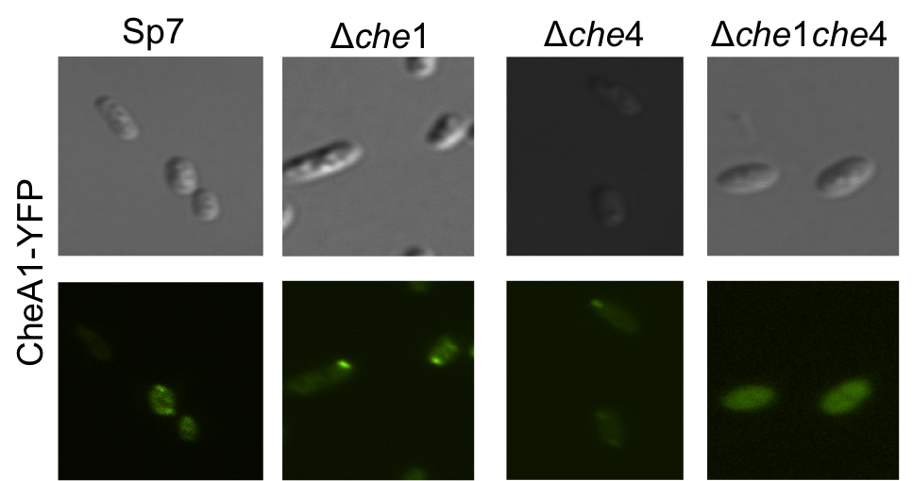

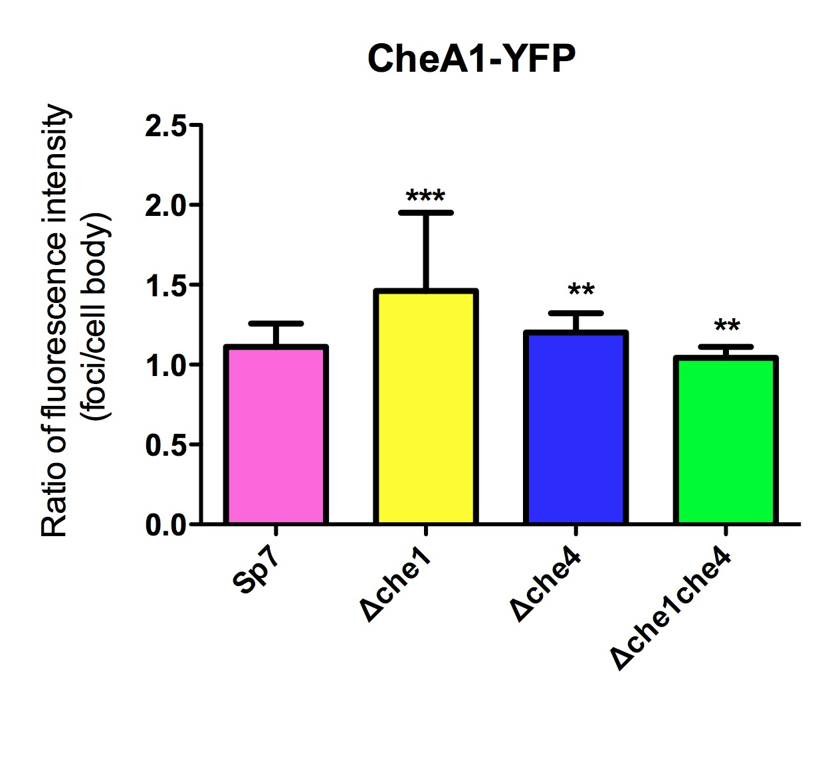

Figure 11: Localization of CheA1-YFP in different genetic backgrounds. CheA1-YFP localizes to the cell poles in the wild type strain (Sp7) and well as in the Δche1 and Δche4 mutant backgrounds, but its localization is diffuse in the Δche1che4 strain. Results were quantified by measuring the ratio of fluorescence intensity in the foci relative to the fluorescence of the rest of the cell body. ***, ** indicate a significant (p < 0.001, 0.01) difference in the mean ratios between different genetic backgrounds (One-Way ANOVA with Bonferroni post-hoc analysis).

In contrast, localization of CheY1-YFP is diffuse throughout the cell body regardless of the strain analyzed (Figure 12). The diffuse localization for cheY1-YFP is unexpected as in other bacteria species; CheY1-YFP is usually seen localized at the chemotaxis signaling clusters (Sourjik & Berg, 2000). One possibility to explain this result is that CheY1-YFP is not a functional fusion. However CheY1-YFP complements a ΔcheY1 mutation for chemotaxis and aerotaxis, suggesting it is functional. Another possibility is that CheY1-YFP is rapidly shuttles between different targets for which it has similar affinity in the cell and thus cannot be seen localized in any specific cellular site. This result is also consistent with the divergent function for cheY1 in regulating increase in cell speed in A. brasilense (Bible et al, 2012). Whether the diffuse localization of CheY1-YFP is related to this function is not known.

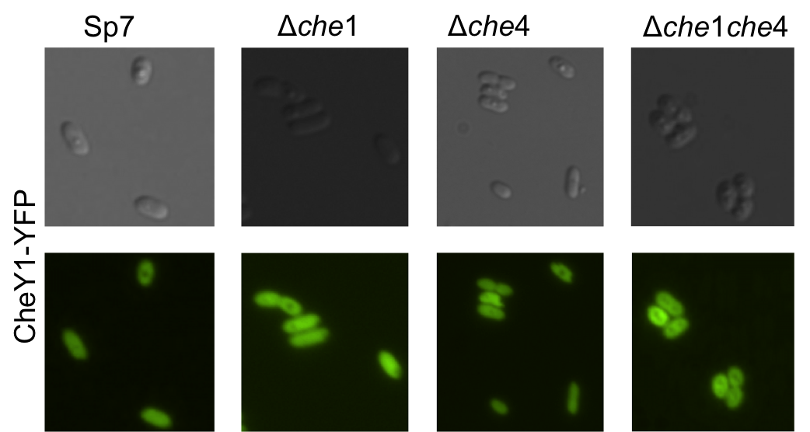

Figure 12: Localization of CheY1-YFP in different genetic backgrounds. CheY1-YFP remains diffuse in all genetic backgrounds.

CheA4-YFP localizes to one or both poles in the cell in the wild type background. Interestingly, its localization is not affected in the Δche4 mutant background. Since the Δche4 mutant lacks CheW4 and two of the receptors encoded in the operon, absence of any localization defects for CheA4 raises the possibility that CheA4-YFP localization at the cell pole may depend on proteins others than those of the Che4 pathway and perhaps also only on receptors. Surprisingly, CheA4 localization was reduced in strain lacking ΔcheA1 but it was not null (Figure 13). This suggests that loss of Δche1 impacts CheA4-YFP localization. One possible explanation for this is that CheA1 could impact chemotaxis cluster formation by playing a structural role in addition to its functions in chemotaxis.
CheA4 did not localize to the cell poles in foci in the Δche1che4 mutant background and was diffuse throughout the cell body. This suggests that components of both pathways are required for proper localization of CheA4 to the cell poles (Figure 13).

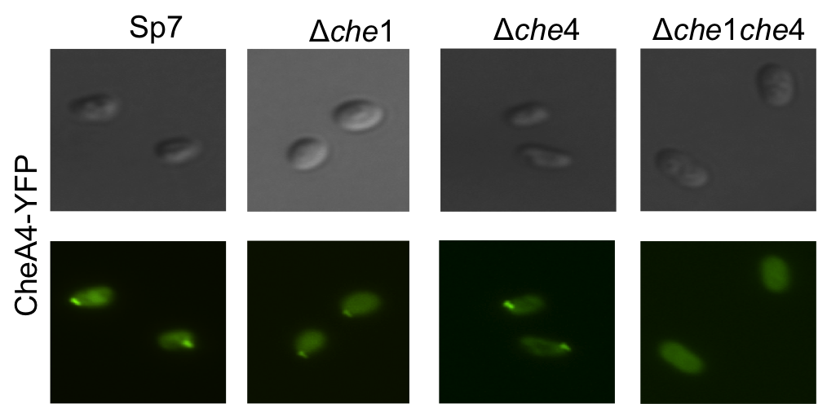
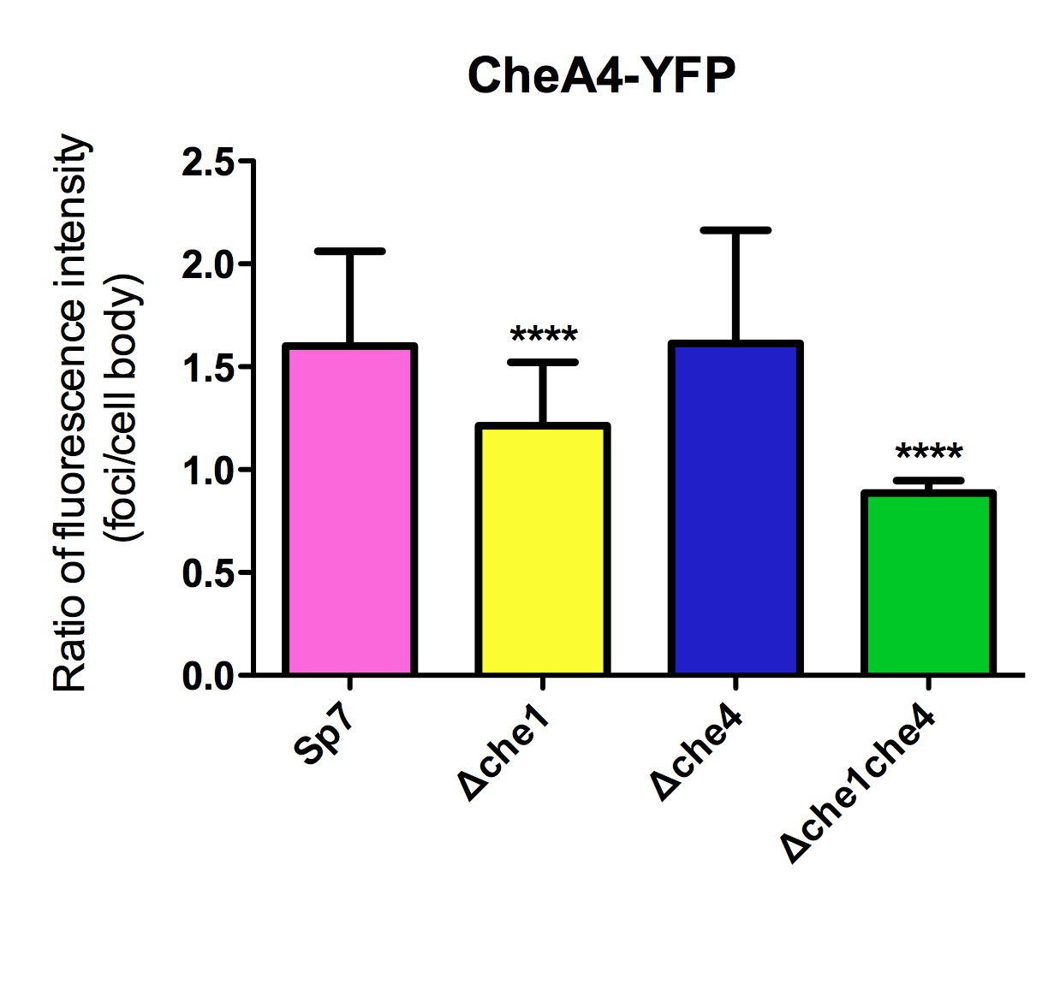

Figure 13: Localization of CheA4-YFP in different genetic backgrounds. CheA4 localizes to the poles in Sp7. CheA4 localization is affected more in the Δche1 background compared to Δche4 background. Its localization is diffuse in the Δche1che4 strain. Results were quantified by measuring the ratio of fluorescence intensity in the foci to the cell body. **** indicates a significant (p < 0.001) difference in the mean ratios between different genetic backgrounds (One-Way ANOVA with Bonferroni post-hoc analysis).

CheY4-YFP localized in a manner similar to CheA4-YFP in the wild type and the Δche1 backgrounds. Localization of CheY4-YFP to the cell poles was reduced in a Δche4 mutant background, which could be caused by the absence of CheA4, which is the molecular target that binds CheY4, as expected. Finally, loss of both Che1 and Che4 pathway components results in a diffuse localization of CheY4-YFP (Figure 14). These results provide strong evidence suggesting that components of both pathways are required for correct subcellular localization of Che4 chemotaxis proteins at the cell poles. This observation also provides support for cross talk between Che1 and Che4 that may rely, at least in part, on their inter-dependent localization at the cell poles.

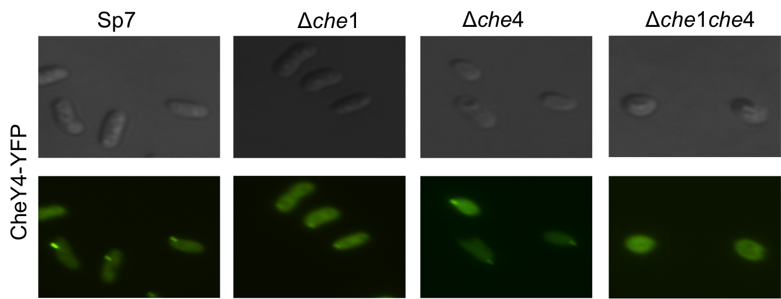

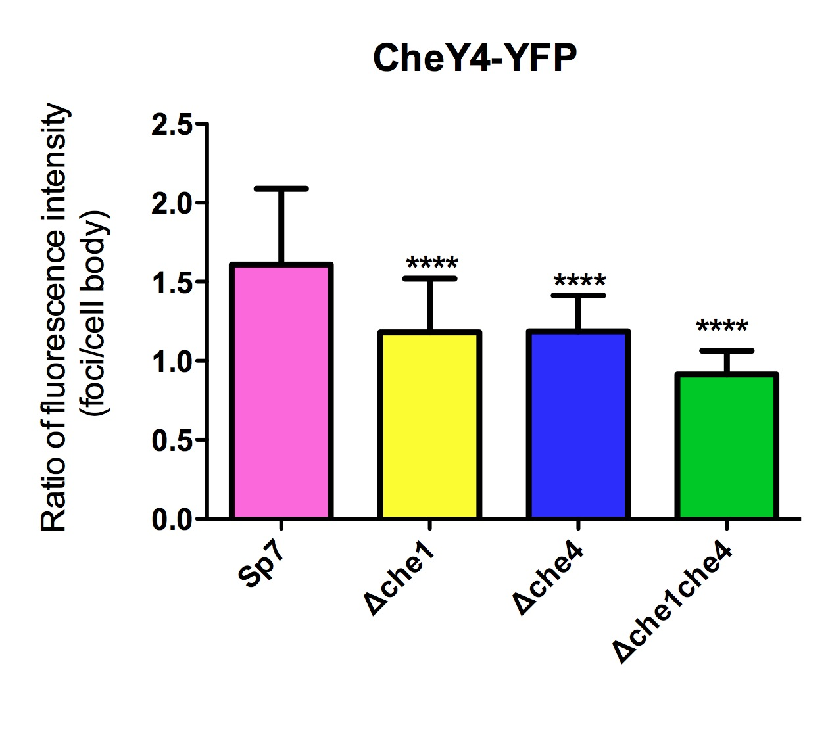

Figure 14: Localization of CheY4-YFP in different genetic backgrounds. CheY4 localizes to the poles in Sp7. Localization to the poles is weaker in Δche1 and Δche4, but it does not localize to the poles in the Δche1che4 strain. Results were quantified by measuring the ratio of fluorescence intensity in the foci to the cell body. **** indicates a significant (p < 0.001) difference in the mean ratios between different genetic backgrounds (One-Way ANOVA with Bonferroni post-hoc analysis).

We also analyzed localization of CheD4-YFP, a putative receptor deamidase that is suggested to function in chemosensory adaptation. As expected, CheD4-YFP localizes to the cell poles in the wild type background. Interestingly, similar to that of CheA4-YFP, localization of CheD4-YFP was affected by mutations of Che1, but not by mutations of Che4. This result is significant, because it tells us that CheD4-YFP localization is not specific to Tlp4a and Tlp4b, the receptors which genes are encoded within the che4 operon, and that it probably clusters with other proteins (likely receptors) in the signaling cluster. Also, localization of CheD4-YFP is more diffuse in Δche1che4 mutant background, but bright foci are still present, suggesting that it interacts with proteins not present in either operon and these could be chemotaxis receptors (Figure 15).
Our results support the hypothesis of cross talk between Che1 and Che4 pathways in A. brasilense. While Che4 seems to play the dominant role in change in direction of cell swimming, Che1 regulates swimming speed under certain conditions. Furthermore, previous work on adaptation proteins, CheB1 and CheR1 endorse this view (Stephens et al, 2006). Taken together, it seems that cross talk at the molecular level can be attributed to adaptation proteins that modify the chemoreceptors and thus, affect signaling from multiple Che pathways.

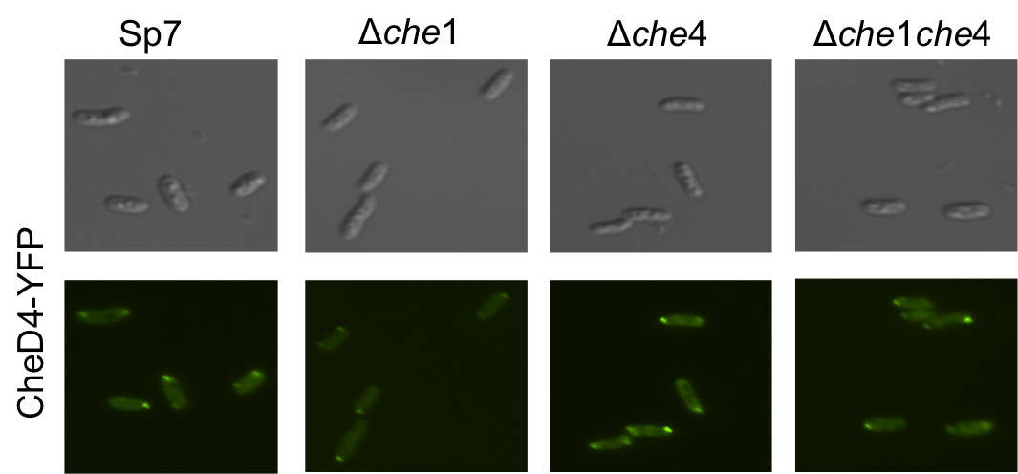

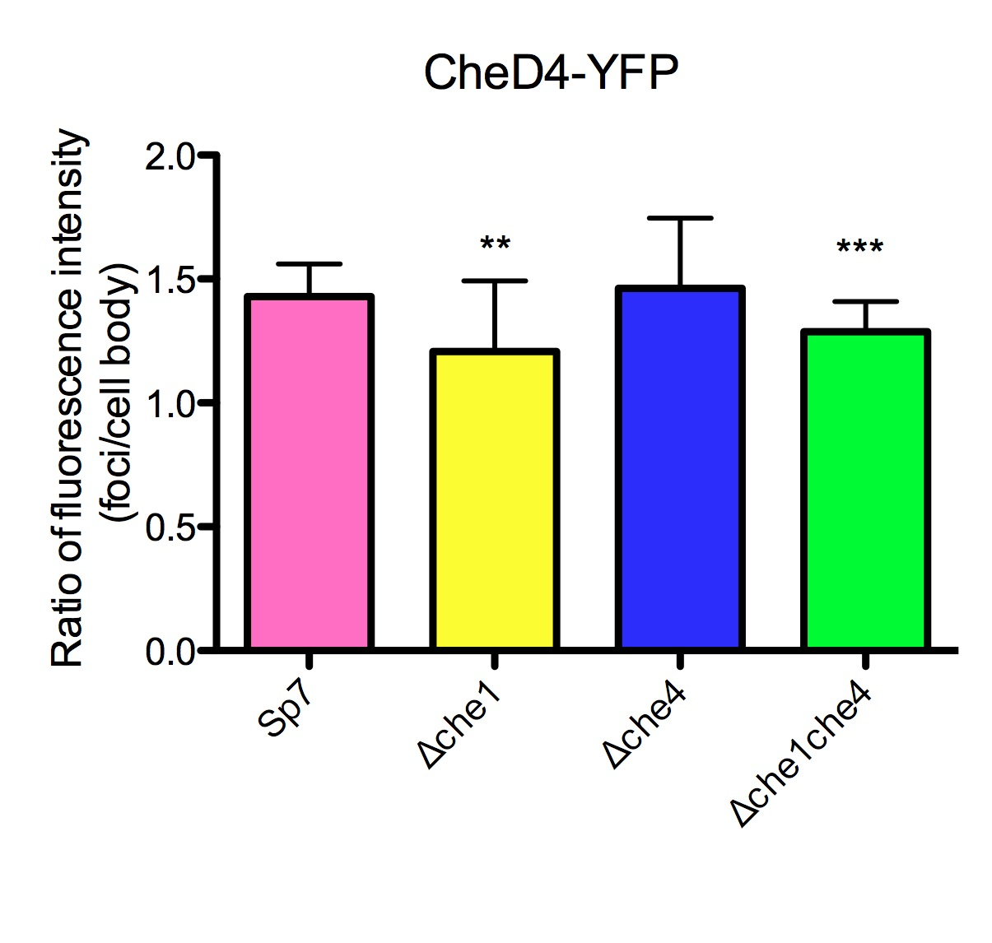

Figure 15: Localization of CheD4-YFP in different genetic backgrounds. CheY4 localizes to the poles in Sp7 and Che4 deletion background. Localization to the poles is weaker in Δche1 and the Δche1che4 strain. Results were quantified by measuring the ratio of fluorescence intensity in the foci to the cell body. ***, ** indicate a significant (p < 0.001, 0.01) difference in the mean ratios between different genetic backgrounds (One-Way ANOVA with Bonferroni post-hoc analysis).

CHAPTER V
Conclusions and FUTURE PERSPECTIVES

Our work has significantly advanced our understanding of the controls of the motility behavior in Azospirillum brasilense, and will potentially be applicable to other bacterial species that also possess multiple chemotaxis systems. Noticeably, this work has revealed astonishing complexities and intricate connections between multiple pathways to control the swimming behavior in this organism.
We have characterized the Che4 pathway of A. brasilense, which previously had no assigned function and find that it plays a dominant role in taxis behavior. The histidine kinase (CheA4) encoded in this pathway is crucial for responding to chemical (chemotaxis) and oxygen (aerotaxis) gradients. Chemotaxis is vital for the survival of A. brasilense in the rhizosphere, where it must competitively forage for food. Similarly, aerotaxis is an essential trait not only because the oxidative metabolism of this organism is adapted to microaerophilic conditions but also because A. brasilense is a diazotroph and the nitrogenase enzyme responsible for nitrogen fixation is inhibited by high oxygen concentrations.
Mutants lacking CheA4 and its cognate response regulator (CheY4) have a smooth swimming bias and are unable to change their swimming direction under steady state conditions as well as in the presence of a chemoeffector gradient (oxygen or malate). This strongly supports our hypothesis that Che4 pathway is essential for modulating swimming behavior in A. brasilense. However, a Δche4 mutant, lacking the entire Che4 pathway components was shown to be able to change swimming direction in steady state conditions, though they do not respond to chemoeffector gradients. These findings are consistent with the hypothesis that Che4 is the central pathway for the control of the chemo- and aerotaxis responses in A. brasilense. However, the results also indicate that other proteins or pathway contribute to setting the steady-state swimming reversal frequency, in the absence of Che4 proteins. The data also indicate that these other proteins are not active in a ΔcheA4 or a ΔcheY4 mutant background. Candidate Che4 proteins for this function in regulating the steady state swimming bias include CheB4, CheD4 and CheR4, which are predicted to function as chemotaxis receptor-specific modifying enzymes that facilitate adaptation. Proteins that function in adaptation have been shown in most bacteria, including A. brasilense (Stephens et al, 2006) to contribute to the steady state swimming bias (Szurmant & Ordal, 2004).
A similar situation was encountered previously while characterizing the role of Che1 in A. brasilense. Che1 mutants (ΔcheA1, ΔcheY1, Δche1) are capable of changing swimming direction, while other Che1 (ΔcheB1, ΔcheR1) mutants were defective (Bible et al, 2008; Stephens et al, 2006). These results suggested that these Che pathways (Che1 and Che4) might function together to control swimming bias, and that cross-talk probably occurred at the level of receptors.
To test this, we analyzed double mutants that lacked components of both pathways. The ΔcheA1cheA4 mutant was null for all behaviors and cells showed clumping (a stress response displayed by cells, when aerotaxis fails (Bible et al, 2012)). This result was not surprising given the central role played by CheA4 in chemo- and aerotaxis.
We found that ΔcheY1cheY4 formed rings in chemotaxis swarm plates and that it did in fact respond to changes in chemical gradient. This result was most intriguing since it indicates that in the absence of both CheY4 and CheY1 but not when CheY4 alone is missing, another protein is capable of binding to the flagellar motor. It is possible that greater affinity of CheY4 and CheY1 to the flagellar motor switch complex is why this alternate mechanism is only active in the ΔcheY1cheY4 background. Another possibility is that this unknown protein may be regulated in a manner that depends on the activity of CheY1 and/or CheY4, for example by a phosphatase that would target the flagellar-motor- bound CheY homologs. This protein also appears to be regulated by a chemotaxis system since the changes in the swimming direction could be detected in gradients of chemoeffectors. Together, the data however are consistent with CheY4 being the major protein that binds to the flagellar motor and the switch complex.
Interestingly, the mutant lacking both Che1 and Che4 pathway components had a smooth swimming bias in steady state conditions. This was surprising given the fact that both Δche1 and Δche4 had a ‘tumbly bias’ in steady state conditions, but it also indicated that both Che1 and Che4 were required for setting up the steady state swimming bias. This result was clear evidence of cross-talk occurring between Che1 and Che4 pathways. Furthermore, analysis of individual tactic behaviors, i.e. swimming velocity and swimming reversal frequency of the Δche1che4 mutant indicated that an additional chemosensory mechanism comes into play in the absence of both chemotaxis pathways. However, our results also suggest that this chemosensory mechanism is defective in adaptation, one of the hallmarks of a true chemotactic response. Thus, this weaker mechanism might be a minor contributor to the taxis behavior of A. brasilense since it was revealed only when both Che1 and Che4 were deleted. This system also appear to allow cells to respond briefly to chemoeffector gradients but the response is not sustained and the cells seem unable to adapt to the new conditions. While this behavior might explain the formation of unstable “aerotactic” bands and of chemotactic rings observed in spatial gradient assays, they also suggest that the candidate proteins or pathway for this function lacks proteins for adaptation.
Given the behavior of the mutants described above, the essential feature of the proteins or pathways that may contribute to affect the taxis response would include at a minimum the following features: A protein (or proteins) capable of receiving sensory signals from receptors and a protein capable of eliciting a change in the swimming direction by binding to the flagellar motor. Given the lack of sensory adaptation, it is likely that these set of proteins or pathway may have a defective adaptation system, either because it is absent (i.e. no CheB, CheR or CheD) or because it is defective (some receptors require other changes than methylation to adapt or some receptors or adaptation mechanisms include complex feedback loops with cheBs, CheCs (Kirby, 2009))
What other proteins are possible candidates for this function in A. brasilense? Sequence homology suggests that the Che2 pathway is involved in flagella biosynthesis. However, this has not yet been verified experimentally and this pathway could contribute to a minor chemotaxis response. Additionally, there are three more orphan CheY response regulators encoded elsewhere in the A. brasilense genome, which might also be involved in regulating taxis behaviors. If these are candidates, that would also imply that they are activated via a chemotaxis histidine kinase other than CheA4 or CheA1, (possibly CheA2 from Che2 or CheA3 from Che3). Implication from these findings is that all of these proteins would interact with similar set of receptors.
As a preliminary work to test this hypothesis, we analyzed the localization of these chemotaxis proteins in A. brasilense in different genetic backgrounds. It is possible that structural roles played by key proteins (such as CheA4 or CheA1) are partly responsible for cross-talk between these pathways. Our localization results provide additional support to our hypothesis of cross-talk between Che1 and Che4. The fact that CheA4 and CheY4 subcellular localization is most affected in the absence of both Che1 and Che4 components, but not in Δche1 or Δche4 backgrounds is strong evidence to support our hypothesis. Moreover, localization analysis of CheD4 shows that it does not just interact with receptors encoded in the Che4 pathway, which suggests that cross-talk occurs at the level of receptors.
Future work will aim to characterize the additional CheYs present in the genome and the Che2 pathway in order to elucidate their contribution, if any, to swimming motility behaviors in A. brasilense. Analyzing swimming velocity and reversal frequencies under different environmental conditions could shed light on the role of multiple pathways and chemotaxis proteins in this organism. It is interesting that different aspects of swimming behavior are controlled by different pathways in this organism. While the underlying advantages that such an intricate control may provide a cell with is unclear at this time, we can speculate that it may result from several events of lateral gene transfers in this organism (Wisniewski-Dye et al, 2011). It is interesting to note that chemotaxis pathways have been transferred laterally between various bacterial species, especially those inhabiting soil environments, and that, in these cases, the functions of the pathways are not lost but rather diverge once in a new genomic context (Wuichet et al, 2007; Wuichet & Zhulin, 2010). While it remains difficult to predict the function of these systems as illustrated here, we expect such complexities to be found in other soil microorganisms with multiple chemotaxis pathways since lateral gene transfer events have been extensive in these species and motility and taxis behaviors are known to provide competitive advantages.

LIST OF REFERENCES

Adler J (1973) A method for measuring chemotaxis and use of the method to determine optimum conditions for chemotaxis by Escherichia coli. J Gen Microbiol 74: 77-91

Alexandre G (2010) Coupling metabolism and chemotaxis-dependent behaviours by energy taxis receptors. Microbiology 156: 2283-2293

Alexandre G, Greer SE, Zhulin IB (2000) Energy taxis is the dominant behavior in Azospirillum brasilense. Journal of bacteriology 182: 6042-6048

Armitage JP, Macnab RM (1987) Unidirectional, intermittent rotation of the flagellum of Rhodobacter sphaeroides. Journal of bacteriology 169: 514-518

Berg HC (2003) The rotary motor of bacterial flagella. Annual review of biochemistry 72: 19-54

Berg HC, Brown DA (1972) Chemotaxis in Escherichia coli analysed by three-dimensional tracking. Nature 239: 500-504

Berleman JE, Bauer CE (2005) Involvement of a Che-like signal transduction cascade in regulating cyst cell development in Rhodospirillum centenum. Molecular microbiology 56: 1457-1466

Bible A, Russell MH, Alexandre G (2012) The Azospirillum brasilense Che1 chemotaxis pathway controls the swimming velocity which affects transient cell-to-cell clumping. Journal of bacteriology

Bible AN, Stephens BB, Ortega DR, Xie Z, Alexandre G (2008) Function of a chemotaxis-like signal transduction pathway in modulating motility, cell clumping, and cell length in the alphaproteobacterium Azospirillum brasilense. Journal of bacteriology 190: 6365-6375

Chris L.Croes SM, Els van Bastelarere,Jos Vanderleyden, Michiels AKW (1993) The polar flagellum mediates Azuspidlum brasifense adsorption to
wheat roots. Journal of General Microbiology 139: 2261-2269

Cluzel P, Surette M, Leibler S (2000) An ultrasensitive bacterial motor revealed by monitoring signaling proteins in single cells. Science 287: 1652-1655

del Campo AM, Ballado T, de la Mora J, Poggio S, Camarena L, Dreyfus G (2007) Chemotactic control of the two flagellar systems of Rhodobacter sphaeroides is mediated by different sets of CheY and FliM proteins. Journal of bacteriology 189: 8397-8401

Falke JJ, Hazelbauer GL (2001) Transmembrane signaling in bacterial chemoreceptors. Trends in biochemical sciences 26: 257-265

Fenchel T (1994) Motility and chemosensory behaviour of the sulphur bacterium Thiovulum majus. Microbiology 140: 3109-3103 3116

Fuhrer DK, Ordal GW (1991) Bacillus subtilis CheN, a homolog of CheA, the central regulator of chemotaxis in Escherichia coli. Journal of bacteriology 173: 7443-7448

Greer-Phillips SE, Stephens BB, Alexandre G (2004) An energy taxis transducer promotes root colonization by Azospirillum brasilense. Journal of bacteriology 186: 6595-6604

Hickman JW, Tifrea DF, Harwood CS (2005) A chemosensory system that regulates biofilm formation through modulation of cyclic diguanylate levels. Proceedings of the National Academy of Sciences of the United States of America 102: 14422-14427

Holguin YBaG (1994) Root-to-Root Travel of the Beneficial Bacterium Azospirillum brasilense. Applied and environmental microbiology 60: 2120–2131.

Inclan YF, Vlamakis HC, Zusman DR (2007) FrzZ, a dual CheY-like response regulator, functions as an output for the Frz chemosensory pathway of Myxococcus xanthus. Molecular microbiology 65: 90-102

Janetopoulos C, Firtel RA (2008) Directional sensing during chemotaxis. FEBS letters 582: 2075-2085

Jens Efsen Johansen JP, Nicholas Blackburn, Ulla Li Zweifel, Åke Hagström (2002) Variability in motility characteristics among marine bacteria. AQUATIC MICROBIAL ECOLOGY Vol. 28: 229–237

Jiang ZY, Bauer CE (1997) Analysis of a chemotaxis operon from Rhodospirillum centenum. Journal of bacteriology 179: 5712-5719

Jiang ZY, Gest H, Bauer CE (1997) Chemosensory and photosensory perception in purple photosynthetic bacteria utilize common signal transduction components. Journal of bacteriology 179: 5720-5727

Kearns DB, Shimkets LJ (2001) Lipid chemotaxis and signal transduction in Myxococcus xanthus. Trends in microbiology 9: 126-129

Kentner D, Thiem S, Hildenbeutel M, Sourjik V (2006) Determinants of chemoreceptor cluster formation in Escherichia coli. Molecular microbiology 61: 407-417

Khursigara CM, Wu X, Subramaniam S (2008) Chemoreceptors in Caulobacter crescentus: trimers of receptor dimers in a partially ordered hexagonally packed array. Journal of bacteriology 190: 6805-6810

Kirby JR (2009) Chemotaxis-like regulatory systems: unique roles in diverse bacteria. Annual review of microbiology 63: 45-59

Kirby JR, Saulmon MM, Kristich CJ, Ordal GW (1999) CheY-dependent methylation of the asparagine receptor, McpB, during chemotaxis in Bacillus subtilis. The Journal of biological chemistry 274: 11092-11100

Kristich CJ, Ordal GW (2002) Bacillus subtilis CheD is a chemoreceptor modification enzyme required for chemotaxis. The Journal of biological chemistry 277: 25356-25362

Laszlo DJ, Taylor BL (1981) Aerotaxis in Salmonella typhimurium: role of electron transport. Journal of bacteriology 145: 990-1001

Macnab RM, Koshland DE, Jr. (1972) The gradient-sensing mechanism in bacterial chemotaxis. Proceedings of the National Academy of Sciences of the United States of America 69: 2509-2512

Maddock JR, Shapiro L (1993) Polar location of the chemoreceptor complex in the Escherichia coli cell. Science 259: 1717-1723

Maeda T, Wurgler-Murphy SM, Saito H (1994) A two-component system that regulates an osmosensing MAP kinase cascade in yeast. Nature 369: 242-245

Mazzag BC, Zhulin IB, Mogilner A (2003) Model of bacterial band formation in aerotaxis. Biophysical journal 85: 3558-3574

Miller LD, Russell MH, Alexandre G (2009) Diversity in bacterial chemotactic responses and niche adaptation. Advances in applied microbiology 66: 53-75

Miller LD, Yost CK, Hynes MF, Alexandre G (2007) The major chemotaxis gene cluster of Rhizobium leguminosarum bv. viciae is essential for competitive nodulation. Molecular microbiology 63: 348-362

Mitchell JG (2002) The energetics and scaling of search strategies in bacteria. The American naturalist 160: 727-740

Mitchell JG, Martinez-Alonso M, Lalucat J, Esteve I, Brown S (1991) Velocity changes, long runs, and reversals in the Chromatium minus swimming response. Journal of bacteriology 173: 997-1003

Moens S, Michiels K, Keijers V, Van Leuven F, Vanderleyden J (1995) Cloning, sequencing, and phenotypic analysis of laf1, encoding the flagellin of the lateral flagella of Azospirillum brasilense Sp7. Journal of bacteriology 177: 5419-5426

Moens S, Vanderleyden J (1996) Functions of bacterial flagella. Critical reviews in microbiology 22: 67-100

Nan B, Chen J, Neu JC, Berry RM, Oster G, Zusman DR (2011) Myxobacteria gliding motility requires cytoskeleton rotation powered by proton motive force. Proceedings of the National Academy of Sciences of the United States of America 108: 2498-2503

Okon Y, Itzigsohn R (1995) The development of Azospirillum as a commercial inoculant for improving crop yields. Biotechnology advances 13: 415-424

Pilgram WK, Williams FD (1976) Survival value of chemotaxis in mixed cultures. Canadian journal of microbiology 22: 1771-1773

Poggio S, Abreu-Goodger C, Fabela S, Osorio A, Dreyfus G, Vinuesa P, Camarena L (2007) A complete set of flagellar genes acquired by horizontal transfer coexists with the endogenous flagellar system in Rhodobacter sphaeroides. Journal of bacteriology 189: 3208-3216

Porter SL, Armitage JP (2004) Chemotaxis in Rhodobacter sphaeroides requires an atypical histidine protein kinase. The Journal of biological chemistry 279: 54573-54580

Porter SL, Wadhams GH, Armitage JP (2011) Signal processing in complex chemotaxis pathways. Nature reviews Microbiology 9: 153-165

Porter SL, Wadhams GH, Martin AC, Byles ED, Lancaster DE, Armitage JP (2006) The CheYs of Rhodobacter sphaeroides. The Journal of biological chemistry 281: 32694-32704

Rao CV, Glekas GD, Ordal GW (2008) The three adaptation systems of Bacillus subtilis chemotaxis. Trends in microbiology 16: 480-487

Sadasivan L, Neyra CA (1985) Flocculation in Azospirillum brasilense and Azospirillum lipoferum: exopolysaccharides and cyst formation. Journal of bacteriology 163: 716-723

Sourjik V, Armitage JP (2010) Spatial organization in bacterial chemotaxis. The EMBO journal 29: 2724-2733

Sourjik V, Berg HC (2000) Localization of components of the chemotaxis machinery of Escherichia coli using fluorescent protein fusions. Molecular microbiology 37: 740-751

Sourjik V, Berg HC (2002) Receptor sensitivity in bacterial chemotaxis. Proceedings of the National Academy of Sciences of the United States of America 99: 123-127

Sowa Y, Berry RM (2008) Bacterial flagellar motor. Quarterly reviews of biophysics 41: 103-132

Steenhoudt O, Vanderleyden J (2000) Azospirillum, a free-living nitrogen-fixing bacterium closely associated with grasses: genetic, biochemical and ecological aspects. FEMS microbiology reviews 24: 487-506

Stephens BB, Loar SN, Alexandre G (2006) Role of CheB and CheR in the complex chemotactic and aerotactic pathway of Azospirillum brasilense. Journal of bacteriology 188: 4759-4768

Stocker R (2011) Reverse and flick: Hybrid locomotion in bacteria. Proceedings of the National Academy of Sciences of the United States of America 108: 2635-2636

Sun H, Zusman DR, Shi W (2000) Type IV pilus of Myxococcus xanthus is a motility apparatus controlled by the frz chemosensory system. Current biology : CB 10: 1143-1146

Szurmant H, Muff TJ, Ordal GW (2004) Bacillus subtilis CheC and FliY are members of a novel class of CheY-P-hydrolyzing proteins in the chemotactic signal transduction cascade. The Journal of biological chemistry 279: 21787-21792

Szurmant H, Ordal GW (2004) Diversity in chemotaxis mechanisms among the bacteria and archaea. Microbiology and molecular biology reviews : MMBR 68: 301-319

Taylor BL, Zhulin IB, Johnson MS (1999) Aerotaxis and other energy-sensing behavior in bacteria. Annual review of microbiology 53: 103-128

Thoelke MS, Kirby JR, Ordal GW (1989) Novel methyl transfer during chemotaxis in Bacillus subtilis. Biochemistry 28: 5585-5589

Tindall MJ, Porter SL, Maini PK, Armitage JP (2010) Modeling chemotaxis reveals the role of reversed phosphotransfer and a bi-functional kinase-phosphatase. PLoS computational biology 6

Turner L, Ryu WS, Berg HC (2000) Real-time imaging of fluorescent flagellar filaments. Journal of bacteriology 182: 2793-2801

Vladimirov N, Sourjik V (2009) Chemotaxis: how bacteria use memory. Biological chemistry 390: 1097-1104

Wadhams GH, Armitage JP (2004) Making sense of it all: bacterial chemotaxis. Nature reviews Molecular cell biology 5: 1024-1037

West AH, Stock AM (2001) Histidine kinases and response regulator proteins in two-component signaling systems. Trends in biochemical sciences 26: 369-376

Wilkinson JQ, Lanahan MB, Yen HC, Giovannoni JJ, Klee HJ (1995) An ethylene-inducible component of signal transduction encoded by never-ripe. Science 270: 1807-1809

Wisniewski-Dye F, Borziak K, Khalsa-Moyers G, Alexandre G, Sukharnikov LO, Wuichet K, Hurst GB, McDonald WH, Robertson JS, Barbe V, Calteau A, Rouy Z, Mangenot S, Prigent-Combaret C, Normand P, Boyer M, Siguier P, Dessaux Y, Elmerich C, Condemine G, Krishnen G, Kennedy I, Paterson AH, Gonzalez V, Mavingui P, Zhulin IB (2011) Azospirillum genomes reveal transition of bacteria from aquatic to terrestrial environments. PLoS genetics 7: e1002430

Wuichet K, Alexander RP, Zhulin IB (2007) Comparative genomic and protein sequence analyses of a complex system controlling bacterial chemotaxis. Methods in enzymology 422: 1-31

Wuichet K, Zhulin IB (2010) Origins and diversification of a complex signal transduction system in prokaryotes. Science signaling 3: ra50

Zhulin IB, Armitage JP (1993) Motility, chemokinesis, and methylation-independent chemotaxis in Azospirillum brasilense. Journal of bacteriology 175: 952-958

Zhulin IB, Bespalov VA, Johnson MS, Taylor BL (1996) Oxygen taxis and proton motive force in Azospirillum brasilense. Journal of bacteriology 178: 5199-5204

Zusman DR, Scott AE, Yang Z, Kirby JR (2007) Chemosensory pathways, motility and development in Myxococcus xanthus. Nature reviews Microbiology 5: 862-872

Vita

Dhivya Kumar was born December 12, 1986 in Tamil Nadu, India. She grew up in Delhi, where she attended Rai School and remained there, until she graduated high school in 2004. Her interest in life sciences motivated her to take up biotechnology, along with basic biology in high school. In 2004, she began her undergraduate education at Indraprastha University, Delhi and pursued a Bachelor in Technology degree in Biotechnology. During her undergraduate studies, she became interested in basic research and worked in two laboratories in Jawaharlal Nehru University, Delhi. Her undergraduate thesis work, in Dr. Swati Tiwari’s laboratory, was to characterize protein degradation pathways in a protozoan parasite. She graduated in May 2008 and started working in a laboratory at her university as a research assistant and came to Knoxville, Tennessee in the summer of 2009, to pursue her graduate study. She briefly worked with Dr. Rose Goodchild on molecular aspects of DYT1 Dystonia. For her master’s thesis, she worked in Dr. Gladys Alexandre’s laboratory where she studied bacterial chemotaxis and began appreciating the complexities in these tiny organisms.

