Complex Planting Patterns for Increasing the Structural Diversity of Shortleaf Pine Restoration Plantings

A Thesis Presented for the
Master of Science
Degree
The University of Tennessee, Knoxville

Jacob L. Webster
August 2022
Acknowledgements
I would like to express my gratitude to my major professor and advisor, Dr. David Buckley, for reaching out to me when he heard of an opportunity to work on this project in cooperation with the Tennessee Nature Conservancy. Dr. Buckley was also my undergraduate advisor and I had told him during the final stages of completing my bachelor’s degrees that I was interested in pursuing a graduate degree following graduation, and that I was especially interested in continuing to work with him. I have greatly enjoyed the opportunity to continue working with him for the last two years. Working with Dr. Buckley also allowed me to assist in teaching undergraduate students, which led me to the realization that I have a passion for teaching. I likely would not have had that realization for quite some time without this opportunity.
Throughout the process of completing this Master of Science degree there have been many other people that have also been influential and pivotal in reaching this point. My committee members Dr. Shang-I Yang and Dr. Joshua Granger have been a great help in getting this project lined out and headed in the right direction. Brittney Townsend and Trisha Johnson, on-site staff at the Bridgestone Nature Reserve at Chestnut Mountain were instrumental in getting this project on its feet and were always willing to help in the field.
There were several other people who came out and assisted in setup and data collection who I would like to thank for their contributions. Joshua Breitung, Jack Gugino, and Carson Parham were an immense help while in the field. We spent several hours and several days in pouring rain, blackberry thorns, tents filled with water, and nights with cold food but I could not have gotten the plots set up and the data collected as easily or efficiently without your help. Lastly, I would like to thank my parents for their support and guidance, not only in earning a Master of Science degree but for encouraging me to pursue it from the beginning.

Abstract
Structural complexity in natural ecosystems is vital for a variety of ecological benefits, ranging from carbon storage to enhanced wildlife habitat. Artificially regenerated pine plantations established for timber production and restoration of species such as shortleaf pine typically exhibit low levels of complexity. Due to the benefits of structural complexity, it can be hypothesized that implementation of more complex planting patterns in plantations established during restoration efforts may provide additional ecological benefits while maintaining the production of forest products and other important ecosystem services provided by pine plantations. The overarching objective of this research was to determine if the development of complex structure can be expedited within an artificially regenerated shortleaf pine stand by using complex planting patterns. Specific objectives were to: 1) Document any differences in the variability of understory vegetation horizonal and vertical structure between the complex planting pattern treatment and control; 2) Analyze differences in the richness of understory vegetation between the treatment and control; 3) Establish any differences in the variability of soil temperature and photosynthetically active radiation between the treatment and control; and 4) Analyze differences in planted shortleaf pine performance between the treatment and control, and also across different understory patch types. Results for the first growing season did not definitively support significant effects of the complex planting treatment on structural complexity, plant richness, microclimate factors, and shortleaf pine performance. The lack of strong treatment effects can likely be attributed to the limitations of baseline data collected during the first growing season of the shortleaf pine seedlings. Pre-burn patterns in the distribution of slash and understory plants and fire behavior during the burns conducted just prior to planting may have had much stronger effects on the variables measured than the complex planting treatment. Further data collection in subsequent years may provide more conclusive results regarding the effects of complex planting patterns on elements of structural complexity and shortleaf pine performance. Additional investigations of prescribed fire behavior and wildlife use will also be possible with continued development of the vegetation and soils on the study sites.

Table of Contents
Introduction ------------------------------------------------------------------------------------------------- 1
Materials and Methods ----------------------------------------------------------------------------------- 7
Study Site Description --------------------------------------------------------------------------- 7
Plot Layout ---------------------------------------------------------------------------------------- 10
Structural Variability Measurements ------------------------------------------------------- 12
Microclimate Measurements ------------------------------------------------------------------ 18
Shortleaf Pine Seedling Measurements ------------------------------------------------------ 19
Statistical Analysis ------------------------------------------------------------------------------- 20
Results ------------------------------------------------------------------------------------------------------- 22
Structural Variability --------------------------------------------------------------------------- 22
Microclimate -------------------------------------------------------------------------------------- 24
Shortleaf Pine Performance ------------------------------------------------------------------- 32
Discussion -------------------------------------------------------------------------------------------------- 41
Conclusion ------------------------------------------------------------------------------------------------- 49
References ------------------------------------------------------------------------------------------------- 51
Vita --------------------------------------------------------------------------------------------------------- 60

List of Figures
Figure 1. Map of Tennessee showing the location of White County (red star) within the state and the location of Tennessee in relation to surrounding states. Source: National Atlas of the United States “Tennessee State County Map”. ------------------------------------------------------ 8
Figure 2. Soil map of stands A, B, and C (from north to south, respectively) along Scotts Gulf Road. Red stars denote stand locations. Soil type abbreviations: LdC – Lonewood loam, RfD – Ramsey-Lilly complex, RmE – Ramsey-Lily-Rock outcrop complex. Source: NRCS Web Soil Survey (WSS). ----------------------------------------------------------------------------- 11
Figure 3. Satellite image showing the location of each plot within each stand. Latitude and longitude readings were collected at each plot center. The red pins accurately denote each of those locations. Source: 35.869110°, -85.289236° Google Earth, June 16, 2021. December 13, 2015. ------------------------------------------------------------------------------------------------ 13
Figure 4. Plot layout diagram for complex planting pattern in treatment plots. Numbers are in feet and indicate seedling locations. Diagram originally created and plot originally laid out utilizing 5-foot increments and so is denoted as such for true accuracy. X-axis and Y-axis are both 30.5 meters. --------------------------------------------------------------------------------------- 14
Figure 5. Plot layout diagram for standard planting pattern in control plots. Dots indicate seedling locations. Line through star represents line transect through plot center. ----------- 15
Figure 6. Photo illustrating how the transect tape was laid out when determining the width of an individual patch of vegetation, bare ground, or woody debris. ------------------------------ 17
Figure 7. Ground cover means across all plots. Mean ground cover patch width for bare ground, woody debris, and vegetation is indicated by different colored bars. Measurements are in tenths of meters. -------------------------------------------------------------------------------- 23
Figure 8. Ground cover sample standard deviation in patch width for all plots. The different bar colors illustrate mean ground cover patch width for each ground cover type. ------------ 23
Figure 9. Richness of genera within transects. Bars illustrate the number of genera found within specific transects. ------------------------------------------------------------------------------ 25
Figure 10. Nudds board mean coverage for all plots at all heights. Bars illustrate the means for all four cardinal directions (N, E, S, and W) and all heights (0.5, 1.0, 1.5, and 2.0 meters) within a single plot. ------------------------------------------------------------------------------------ 26
Figure 11. Nudds board coverage sample standard deviation for all plots calculated across all heights. -------------------------------------------------------------------------------------------------- 26
Figure 12. Nudds board mean coverage for all plots at 0.5 meters. The bars show the amount of coverage in ten percent increments. ------------------------------------------------------------- 27
Figure 13. Nudds board coverage sample standard deviation for all plots at 0.5 meters calculated across directions. -------------------------------------------------------------------------- 27
Figure 14. Nudds board mean coverage for all plots at 1.0 meters. The bars show the amount of coverage in ten percent increments. -------------------------------------------------------------- 28
Figure 15. Nudds board coverage sample standard deviation for all plots at 1.0 meters calculated across directions. -------------------------------------------------------------------------- 28
Figure 16. Nudds board mean coverage for all plots at 1.5 meters. The bars show the amount of coverage in ten percent increments. -------------------------------------------------------------- 29
Figure 17. Nudds board coverage sample standard deviation for all plots at 1.5 meters calculated across directions. -------------------------------------------------------------------------- 29
Figure 18. Nudds board mean coverage for all plots at 2.0 meters. The bars show the amount of coverage in ten percent increments. -------------------------------------------------------------- 30
Figure 19. Nudds board coverage sample standard deviation for all plots at 2.0 meters calculated across directions. -------------------------------------------------------------------------- 30
Figure 20. Soil temperature means for all plots. Bars illustrate temperature in degrees Celsius (°C), in one-half degree increments. ------------------------------------------------------- 31
Figure 21. Soil temperature sample standard deviations for all plots. ------------------------- 33
Figure 22. Photosynthetically active radiation (PAR) means for all plots. Bars illustrate the means in increments of 200.00 micromoles per meter squared per second (micromoles/m²/s). ------------------------------------------------------------------------------------------------------------ 33
Figure 23. Photosynthetically active radiation (PAR) sample standard deviation for all plots. ------------------------------------------------------------------------------------------------------------ 34
Figure 24. Shortleaf pine seedling height means for all plots. The bars illustrate mean heights in centimeters. ------------------------------------------------------------------------------------------ 34
Figure 25. Shortleaf pine seedling height sample standard deviation for all plots. ---------- 35
Figure 26. Shortleaf pine seedling diameter means for all plots. The bars illustrate mean diameters in millimeters. ----------------------------------------------------------------------------- 35
Figure 27. Shortleaf pine seedling diameter sample standard deviation for all plots. ------- 36
Figure 28. Shortleaf pine seedling mortality percentages for all plots. The bars illustrate mortality in five percent increments. ---------------------------------------------------------------- 38
Figure 29. Shortleaf pine seedling mean height in relation to vegetation patch type. Bar colors denote different plots. ------------------------------------------------------------------------- 38
Figure 30. Shortleaf pine seedling height sample standard deviation in relation to vegetation patch type. Bar colors denote different plots. ------------------------------------------------------ 39
Figure 31. Shortleaf pine seedling mean diameter in relation to vegetation patch type. Bar colors denote different plots. ------------------------------------------------------------------------- 39
Figure 32. Shortleaf pine seedling diameter sample standard deviations in relation to vegetation patch type. Bar colors denote different plots. ----------------------------------------- 40
Figure 33. Shortleaf pine seedling mortality percentages by to vegetation patch type. Bar colors denote different vegetation patch types. ---------------------------------------------------- 42

Introduction
Structural complexity of natural ecosystems is vital for the abundance of ecological benefits it provides in a wide range of ecosystem types, from broad-scale ecosystem services to smaller-scale effects on microclimate and wildlife habitat. Complexity is often considered when examining early successional ecosystems, yet structural complexity remains high over the continuum from early successional openings to closed canopy forests. Early successional ecosystems contain extremely high levels of complexity, along with remarkable levels of species richness and productivity among herbaceous and shrub species (Swanson, et al., 2011). Later successional stages dominated by canopy cover maintain high levels of structural complexity, often influenced by individual tree-level complexity, that continues into the overstory canopy (Seidel, et al., 2019). Structural complexity is also a vital factor in carbon sequestration and storage, often regardless of successional stage. Tallgrass and shortgrass prairies, often considered complex ecosystems, are able to sequester and store similar levels of carbon compared to forest ecosystems (Wohl and Pfeiffer, 2018). In temperate mixed forests, structural complexity maintains its role in driving aboveground carbon storage (Yuan, et al., 2018 and Aponte, et al., 2020). Structural complexity and carbon storage generally continues to increase with the age (time since disturbance) of a site, but carbon sequestration will begin decreasing as time continues (Bradford and Kastendick, 2010).
Aside from broad-scale ecosystem benefits, complex vegetative structure can also provide suitable habitat for a wide variety of wildlife species. Vertical and horizontal structural complexity provides varying amounts of vegetative cover, creating a spectrum from high to low vegetation density. Vegetation structured in this way is often utilized by ground nesting birds, such as northern bobwhite quail (Colinus virginianus), to provide nesting and brooding cover (Doggett and Locher, 2018). This same effect occurs similarly with many small mammals. Hispid cotton rats (Sigmodon hispidus) prefer heavy cover in movement corridors and slightly lighter cover in forested areas (Bowne, et al., 1999). While birds and mammals are often the wildlife of consideration when examining habitat usage, different habitats are also very important to insects. Structural complexity is equally important to this broad group of fauna and is vital to their survival. Low levels of structural complexity increase the risk of predation among insects due to lack of suitable cover (Norbury and Overmeire, 2019). Complex vegetative structure is also vital for herbaceous plant richness and distribution. Distribution and complexity of vegetation can substantially increase the plant richness of a site (Dazé Querry and Harper, 2017). Spatial complexity and variation are also important factors in determining the probability of invasion by non-native plants (Dodonov, et al., 2019).
Structural complexity in natural systems can be attributed to many factors. Factors with the greatest impact on complexity can depend on the age, or successional stage, of the system. For example, old-growth forests are well known for the complexity that they possess, namely large openings in the canopy and varying levels of vegetation cover on the forest floor. This complexity occurs largely from natural mortality. The cause of mortality shifts from competition-based mortality at younger stages to “agent-based” mortality at older stages as the forest approaches old-growth stature. The agents associated with mortality include fire, insect attacks, and disease (Franklin and Van Pelt, 2004).
While old growth forests are considered by many to be a good indicator of natural complexity, structural variation can occur in every ecosystem type and at every successional stage. Many of the causes of natural complexity are constant across different ecosystem types and successional stages. Fire events can degrade and deteriorate soil structure, even at low intensity (Jian, et al., 2018). Fire events can also result in water repellent soil (Chen, et al., 2020). The combination of these two post-fire effects may provide influence on plant germination and growth, resulting in patchy or complex plant growth and structure. Strong storms can result in blowdowns creating large openings in the forest canopy. Greater vegetation growth, especially height growth, often occurs within gap areas than in surrounding closed canopy areas (Wang, et al., 2017). Windthrow, one form of blowdown, also causes variations in microtopography due to the pit and mound effect that occurs when the tree roots are removed from the ground. Pit and mound topography results in variations in many soil attributes, including texture, nitrogen content and available nutrients, and earthworm populations, that are distinct from surrounding forest soils (Kooch, et al., 2013). These natural disturbances and several others can all result in variation of growth patterns, causing complex vegetative structure.
Native forest systems are generally highly complex and exhibit high levels of faunal biodiversity. Artificially regenerated forests do not typically exhibit similar levels of complexity or biodiversity. Plantations of a single tree species with simplified and uniform planting patterns are common throughout many regions of the United States. Loblolly pine (Pinus taeda) is the most common plantation type in the southern United States. This species has been greatly improved genetically over time to produce superior seed stock and is the most utilized species in lumber and pulp production in the southern United States (Self and Ezell, 2019, PB1466). Despite their prominence, pine plantations have been found to be less diverse in terms of structural complexity (Hickey, et al., 2019). Incorporating fine-scale complexity into artificial regeneration and restoration is vital for wildlife habitat (McCallum, et al., 2018).
Simple and uniform planting patterns are heavily implemented in plantations because they have several beneficial effects in terms of timber production goals. These goals can include rapid and efficient production of forest products and the ability to implement exact spacings and densities for specific goals (Smith, 1997). Although they are low in structural complexity, plantations provide wildlife and ecological benefits to varying degrees. Intensively managed pine plantations can support white-tailed deer (Odocoileus virginianus) populations at relatively high carrying capacities, depending on the type of management used within the plantation (Iglay, et al., 2010). Edges and interiors of young and mature pine stands are important foraging areas for insectivorous species of bats (Pedro and Simonetti, 2013). Young pine plantations, especially those receiving fertilizer treatments, are effective carbon storage sinks (Maier, et al., 2004).
Recognition of the importance of complexity has resulted in research on silvicultural practices that can create or optimize structural complexity in forest stands. Variable retention harvesting (VRH) is a technique that can be used to create structural complexity. This technique is based on structural components created by natural disturbances. VRH has been applied in native stands of Douglas-fir (Pseudotsuga menziesii) in the Pacific Northwest to effectively link structure, function, and composition among different forest generations (Franklin and Donato, 2020). VRH has also been used in red pine (Pinus resinosa) stands in northern Minnesota and has been found to improve wildlife habitat and species richness among birds (Atwell, et al., 2008). Long term effects of this silvicultural practice have shown that species diversity among early-succession and late-succession obligate bird species increases in response to increasing the complexity of overstory canopy by removing trees to create varying sizes of gaps. Understory complexity manipulation also plays a role, but on a species level basis (Shea, et al., 2017). However, harvest methods are not the only silvicultural techniques garnering research into ways of increasing the benefits of plantation forestry. Utilizing mixed-species plantings in place of plantation monocultures can increase production efficiency and economic gain (Kelty, 2006). Utilizing clumped planting patterns to artificially incorporate spatial complexity in restored forest stands has been found to improve several factors affecting productivity, including pollination and facilitation among neighboring plants (McCallum, 2018).
Shortleaf pine (Pinus echinata) ecosystems are now much less common than natural and planted loblolly pine, yet they were important as sources of myriad anthropogenic and ecological benefits (Sutter, 2019). Ecosystems with a significant shortleaf pine component can provide thermal cover, food, and nesting sites for many species of mammals and birds (Sukma, et al., 2019). Shortleaf pine is also a source of lumber and other forest products. Shortleaf pine populations and ecosystems are experiencing significant declines, primarily due to fire exclusion and conversion of naturally regenerated shortleaf pine systems to loblolly pine plantations (Elliot, et al., 2012). Biological disturbances, such as southern pine beetle and fusiform rust, have also been detrimental to native shortleaf pine populations (Wear and Greis, 2002).
Shortleaf pine is a major component in three forest cover types recognized by the Society of American Foresters, including Shortleaf Pine (Type 75), Shortleaf Pine-Oak (Type 76), and Loblolly Pine-Shortleaf Pine (Type 80), and a minor component in many others (Lawson, 1990). Many of the natural forests that contain a significant shortleaf pine component are relatively open forests and contain many niche areas for various wildlife species. Species found in these systems include Ruffed grouse (Bonasa unbellus), black bear (Ursus americanus), and timber rattlesnake (Crotalus horridus). Shortleaf pine systems also support many species of concern, including Bachman’s sparrow (Peucaea aestivalis) and Alleghany woodrat (Neotoma magister) (Nordman, et al., 2021).
Some of the aforementioned species that are associated with shortleaf pine ecosystems are in decline. An important species of concern that is associated with shortleaf pine ecosystems, and is experiencing population declines, is the Red-cockaded woodpecker (Picoides borealis) (Santos, et al., 2010). Mature longleaf pine (Pinus palustris) is the most preferred species for nest cavity construction, however, shortleaf pine is commonly utilized (Picoides borealis, FWS.gov). Conservation efforts to increase Red-cockaded woodpecker populations are also increasing the populations of other species that depend on similar systems, such as northern bobwhite quail (Doggett and Locher, 2018). Restoring shortleaf pine systems to a more natural state may allow for more effective restoration efforts for other species as many mammals and birds require complex vegetative structure for foraging and browsing (Sukma, et al., 2019).
Shortleaf pine is a shade intolerant species which requires fire to effectively regenerate naturally. One reason for effective regeneration following fire is its ability to resprout. The basal crook (J-hook root) found on shortleaf pine seedlings contains semi-dormant buds that will resprout following fire (Lawson, 1990). However, due to reduced natural regeneration resulting from lack of fire, shortleaf pine is most commonly restored through planting. As in most plantations of loblolly pine and other conifers, the most frequent artificial regeneration method is planting seedlings at specific distances on a uniform, predetermined grid. Altering the standard practice of planting seedlings on a set, evenly spaced grid (for example, 3 meters by 3 meters) may allow for heightened structural diversity by simulating patchy regeneration that occurs naturally. Novel planting patterns may allow for the management of forest products while theoretically increasing the structural diversity of shortleaf pine stands by varying the distances between seedlings and the degree of canopy development. Changes in planting patterns may change competitive interactions between planted seedlings and other vegetation, so an increased understanding of how shortleaf pine will perform in different understory patches is also important.
The overarching objective of this research was to determine if the development of complex structure can be expedited within an artificially regenerated shortleaf pine stand by using complex planting patterns. Specific objectives were to: 1) Document any differences in the variability of understory vegetation horizonal and vertical structure between the complex planting pattern treatment and control; 2) Analyze differences in the richness of understory vegetation between the treatment and control; 3) Establish any differences in the variability of soil temperature and photosynthetically active radiation between the treatment and control; and 4) Analyze differences in planted shortleaf pine performance between the treatment and control, and also across different understory patch types.
Materials and Methods
Study Site Description
The study site is located at the Bridgestone Nature Reserve at Chestnut Mountain. Located in White County, Tennessee, USA, this area is a large preserve dedicated to the preservation and conservation of important species native to Tennessee (Figure 1). The Bridgestone Nature Reserve at Chestnut Mountain, specifically, is comprised of approximately
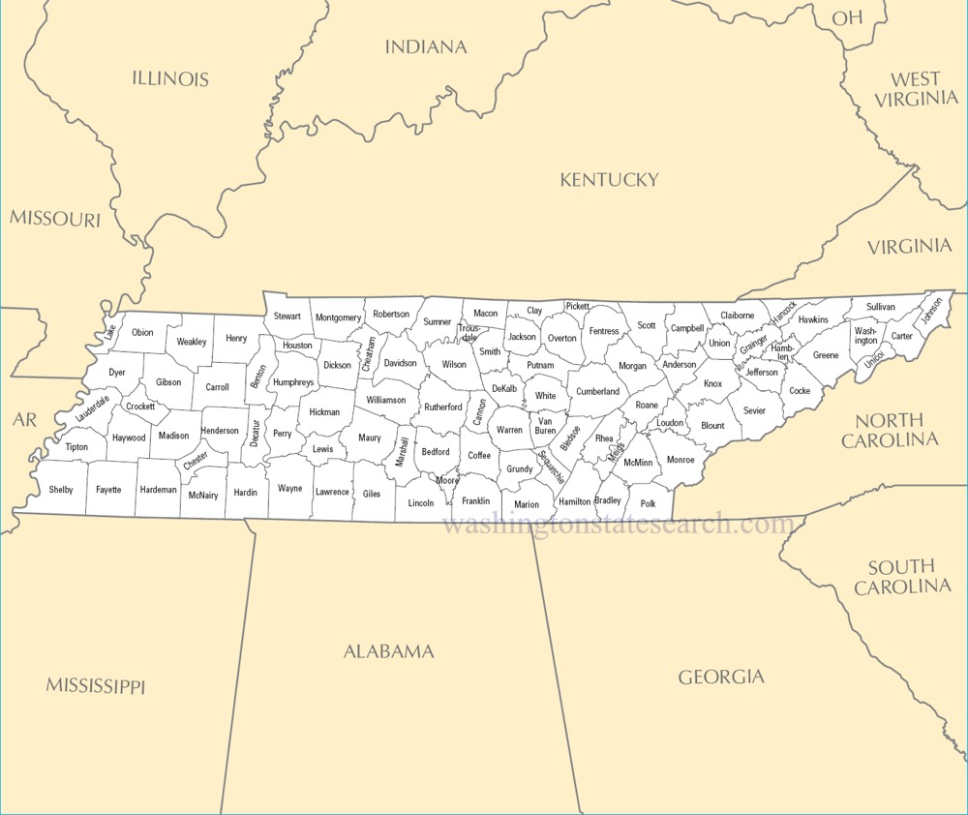
Figure 1. Map of Tennessee showing the location of White County (red star) within the state and the location of Tennessee in relation to surrounding states. Source: National Atlas of the United States “Tennessee State County Map”.

2,306 hectares (ha) of protected land within an approximately 24, 281-ha parcel of land owned by the Tennessee Nature Conservancy. This property was previously owned by the Firestone Tire and Rubber Company, later known as Bridgestone Americas, Inc. The Tennessee Nature Conservancy acquired the property as a donation in 2018 (Bridgestone Nature Reserve at Chestnut Mountain, 2022).
The area utilized for this study borders Bridgestone-Firestone Centennial Wilderness and Wildlife Management Area on Scotts Gulf Road. The stands chosen for plot locations were previously harvested between early-fall 2017 and late-spring 2018, leaving large open sections within the forest. The stands contained a few residual red and white oaks and shortleaf pines, averaging approximately 5-10 trees-per-acre (TPA). The residual TPA within the stands resulted in a grassland, approaching the lower limit of a savanna in certain areas. The plots were laid out so that there were no residual trees toward the center to reduce the possibility of shading. The plots are located relatively near the road for ease of access, particularly in the future if the sites are used for educational purposes. Plots A-1 and A-2 are approximately 21 meters from the road. Plots B-1 and B-2 are approximately 91.5 meters from the road. Plots C-1 and C-2 are approximately 30.5 meters from the road.
An herbicide treatment was applied to the sites between September and October, 2020, to reduce woody plant growth. The mixture and per-acre application rate (rates in parentheses) consisted of Glyphosate (5%), Garlon 3A (1.5%), MSO surfactant (0.25%), and Escort (1 ounce). A prescribed burn was also implemented for site preparation prior to planting in late winter, 2021. The firing techniques employed consisted of interior ignitions utilizing strip firing and dot firing. Additional firing techniques included the use of a very pistol when TNC staff were on-site.
The stands contained three separate soil types, including Lonewood loam (LdC), Ramsey-Lily complex (RfD), and Ramsey-Lily-Rock outcrop complex (RmE). Lonewood loam is a deep soil that contains loam, clay loam, and channery loam to bedrock at 2 meters. Ramsey-Lily complex is shallower containing loam and clay loam soils to bedrock at 1 meter in Lily. Ramsey is shallower but contains loam and channery loam to bedrock at only 0.6 meters.
Ramsey-Lily-Rock outcrop complex contains the shallowest areas of soil in the stands since it contains rock outcrop elements that are 0 meters to bedrock. The Ramsey and Lily components are similar to Ramsey-Lily complex previously mentioned (NRCS).
Stand A contains all three soil types. Stands B and C contain only Lonewood loam and Ramsey-Lily complex soil types. Areas within the stands that contain the plots are all comprised of Lonewood loam (Figure 2).
The lowest temperatures occur in the month of January and the lowest average annual temperature is 7.2°C. The highest temperatures occur in the month of July and the highest average annual temperature is 21.7°C. The greatest amounts of precipitation occur in the months of December and May with an average annual rainfall of 137.57 centimeters, and an average annual snowfall of 12.7 centimeters. Annual averages were collected in Sparta, White County, Tennessee (US Climate Data, 2022).
Plot Layout
Three stands were selected for this project based on the similarity to one another with respect to residual slash from past logging operations, vegetative growth, soil type, degree of
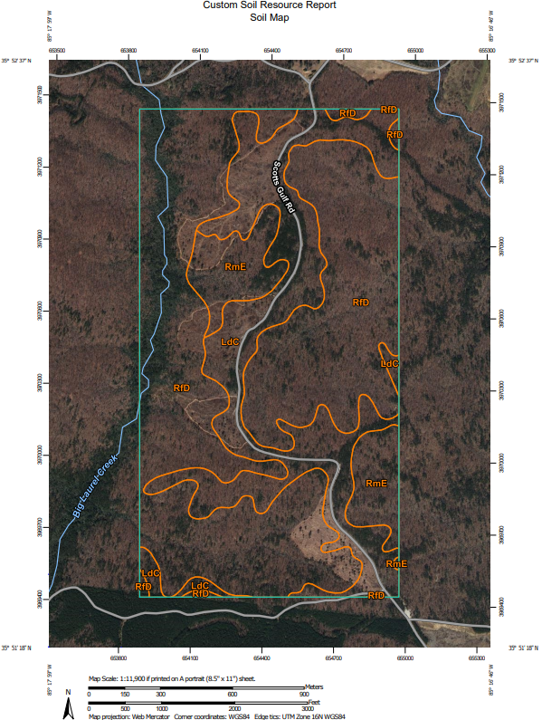
Figure 2. Soil map of stands A, B, and C (from north to south, respectively) along Scotts Gulf Road. Red stars denote stand locations. Soil type abbreviations: LdC – Lonewood loam, RfD – Ramsey-Lilly complex, RmE – Ramsey-Lily-Rock outcrop complex. Source: NRCS Web Soil Survey (WSS).
slope, and hydrology. Each stand contained a paired plot system. Each pair was comprised of a one-tenth (0.1) hectare treatment plot and a one-tenth (0.1) hectare control plot, situated directly adjacent to one another in each stand. The complex planting treatment was assigned at random to one of the two one-tenth (0.1) hectare plots in each site. This system was replicated three times for a total of three paired plots, with three treatment plots and three control plots. This constituted a total of six plots across the three stands (Figure 3).
Treatment plots were planted with containerized shortleaf pine seedlings obtained from IFCO Seedlings Nursery on March 18, 2021, by Williams Forestry & Associates at a spacing of approximately 1.5 meters by 1.5 meters in some groups within the standard 3 meter by 3 meter planting grid (Figure 4). This gave the desired effect of simulated natural spacing with small patches of closely grouped seedlings and larger distances of open space between each group. Control plots were planted entirely on a standard 3 meter by 3 meter grid pattern (Figure 5).
Each treatment and control plot was laid out within a 30.5 meter by 30.5 meter square area. The treatment plot X and Y distances were broken into 1.5-meter increments to aid implementation of the planting pattern mentioned previously. Each seedling was planted at a specific distance from the X axis tape designated in Figure 4. Each treatment plot contained 144 shortleaf pine seedlings. Each control plot contained 121 shortleaf pine seedlings.
Structural Variability Measurements
The first series of measurements were taken during the 2021 growing season, between late May and early June. Measurement parameters were comprised of vegetation species composition, horizontal structure, and vertical structure. These measurements were taken in each of the six plots.
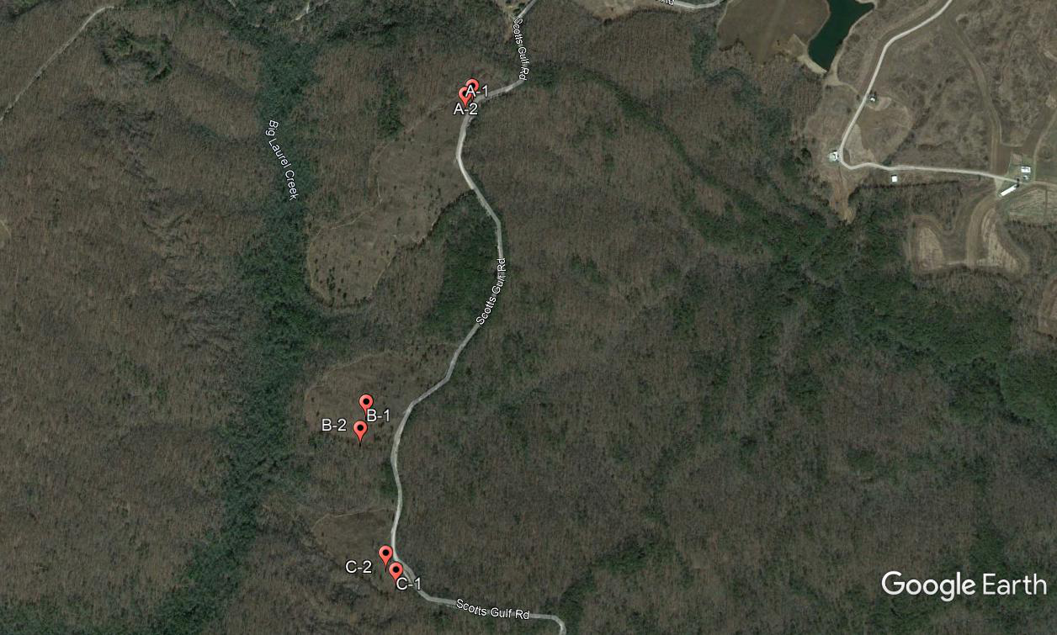
Figure 3. Satellite image showing the location of each plot within each stand. Latitude and longitude readings were collected at each plot center. The red pins accurately denote each of those locations. Source: 35.869110°, -85.289236° Google Earth, June 16, 2021. December 13, 2015.
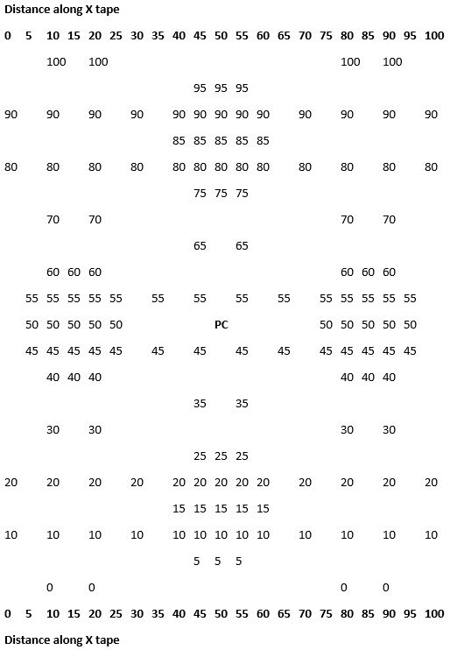
Figure 4. Plot layout diagram for complex planting pattern in treatment plots. Numbers are in feet and indicate seedling locations. Diagram originally created and plot originally laid out utilizing 5-foot increments and so is denoted as such for true accuracy. X-axis and Y-axis are both 30.5 meters.

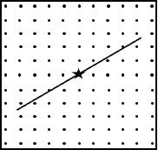
Figure 5. Plot layout diagram for standard planting pattern in control plots. Dots indicate seedling locations. Line through star represents line transect through plot center.

Vegetation composition and patch width were measured using a 30.5-meter line transect along a random azimuth. The random azimuths were placed to ensure that the transect line crossed through plot center. Vegetation composition and richness was determined by identifying each plant to genus in each patch that intersected the transect line. The size of each species patch was determined by measuring the length of the transect that the species covered (Figure 6). The 30.5-meter tape used to measure the line transects was broken into 3.05-centimeter increments to give as much detail as possible when distinguishing between ground cover patch sizes. The amount of transect covered by each species allowed us to determine horizontal variability in vegetation composition and patch size in the plots. Woody debris and bare ground were also measured and accounted for and included in the data sheets in the same fashion as patches of vegetation.
Vertical structure was measured using a 2-meter vegetation profile board, or Nudds board (Nudds, 1977). The Nudds board used was broken into four separate 0.5 meter tall by 0.3 meter wide sections, referred to hereafter as the 0.5, 1.0, 1.5, and 2.0 meter sections. These sections aided in estimation of approximate percent vegetation cover by each 0.5 meter stratum. Data from the Nudds board were collected in the four carinal directions from plot center to get an estimate of the overall vertical structure within each plot. The percentages were recorded to the
nearest 5%, with the exception of coverage below 5%. Coverage below 5% was recorded to the nearest 1%. The Nudds board was placed at 15 meters in all four cardinal directions from plot center. The four cardinal directions were due north (0° or 360°), east (90°), south (180°), and west (270°). The sole exception to this method occurred in plot B-1. A large, fully grown oak prevented the South (180°) reading from being taken. This azimuth was offset 10° to the East
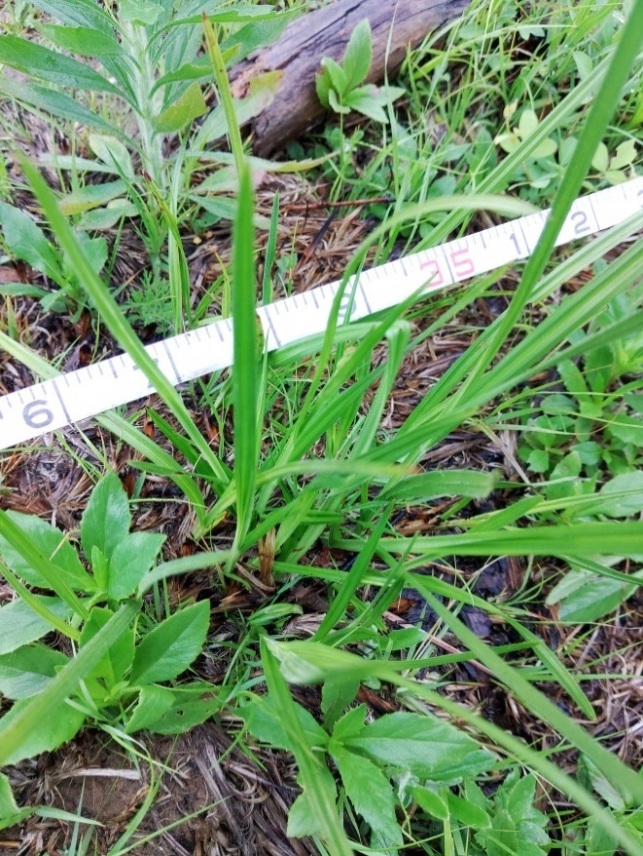
Figure 6. Photo illustrating how the transect tape was laid out when determining the width of an individual patch of vegetation, bare ground, or woody debris. Photo taken June 2, 2021.

and was taken at 170°. This allowed a measurement of vegetative structure to be taken, rather than sacrificing the fourth reading for the plot. The readings at 180° would have been 100% in each of the four sections of the Nudds board if the azimuth were not altered.
Microclimate Measurements
Photosynthetically active radiation (PAR) was measured in micromoles per meter squared per second using an LP-80 Accupar (METER Group Inc., Pullman, WA). These measurements were taken at 3.5-meter intervals along the same transect used to measure vegetation patch width. A total of 11 measurements were taken at ground-level along each line transect, from 0 meters to 30.5 meters. Certain sections of some transects were shaded significantly due to large trees within or near the plots. All PAR measurements were taken on May 29, 2021, within two hours of solar noon. Most measurements were taken between 10:00 am and 12:30 pm. Eastern Daylight Savings Time. The skies were clear during measurements, which ensured that the PAR readings from the instrument were influenced as little as possible by cloud cover.
Soil temperatures were also determined along each transect line in addition to the PAR measurements. Soil temperature measurements were taken at an average depth of 7.5 to 10 centimeters with a 12.7 centimeter soil thermometer (Reotemp Instrument Corp. San Diego, CA) at 3.5-meter intervals from 0 meters to 30.5 meters. Soil measurements along each transect line totaled 11 individual points. All soil temperature measurements were taken on May 29, 2021 between 1:00 pm and 4:00 pm. The ambient air temperature averaged approximately 14.4°C. There was slight intermittent precipitation, but no significant rainfall during measurements. There was no sunshine present, with very overcast skies.
Shortleaf Pine Seedling Measurements
Shortleaf pine performance was quantified during the first dormant season (October of 2021). Performance was documented in terms of height, diameter, and survival of each seedling in the three pairs of plots. A smaller sampling plot (0.09 ha) was installed in each treatment and control plot to take all seedling measurements. In each sampling plot, height of each seedling was measured to the nearest one-half centimeter (cm), for example 25 cm or 27.5 cm, with a meter stick. Total height was measured from ground level to the apical bud (base of uppermost fascicle of needles). Measurements were taken to the apical bud rather than the highest level of the needles to reduce variation in accurate representation of true growth performance. As the seedlings were not tall enough to measure diameter-at-breast-height (1.37 meters), diameter measurements to the nearest one-half millimeter (mm), for example 3.0 mm or 4.5 mm, were taken at the root collar using a Vernier caliper. All vegetation, rocks, and other obstacles were removed prior to measuring to ensure diameter measurements were taken directly at ground level.
Vegetation patch types present at the planting locations of seedlings were also recorded in addition to seedling height and diameter. Vegetation patch types were defined prior to data collection, after a preliminary visit to the sites. The most common heights and types of vegetation in the stands were noted and vegetation patch types were constructed from this information. Tall and short grass (above and below 30.5 centimeters, respectively), tall and short forb (above and below 91.5 centimeters, respectively), woody cane, woody shrub, and woody tree were the vegetation patch types used during data collection. To differentiate between the herbaceous (grass and forb) patch types, excluding height differentiation, parallel leaf venation was termed grass and netted leaf venation was termed forb. To differentiate woody patch types, single stems were termed woody trees, multiple stems were termed woody shrubs, and blackberry (Rubus spp.) relatives were termed woody cane. Mortality rate was also determined within the plots by counting dead seedlings and recording the patch type the seedling occurred within, which then allowed for calculation of mortality in relation to vegetation patch type.
The seedlings were measured in a particular order to facilitate consistent measurements in future sampling. The control and treatment plots were sampled at right angles to one another and the starting locations and order of sampling were recorded for repeated sampling in the future. This will allow for direct comparisons over time of individual seedlings.
Statistical Analysis
The study was established as a randomized complete block design (RCBD) and was analyzed utilizing models appropriate for an RCBD (Equation 1). The three individual stands containing the treatment and control plots varied slightly in different parameters (for example, soil type, hydrology, and topography) so different stands were treated as blocks to reduce statistical variation among sites. Statistical analyses were carried out utilizing analysis of variance (ANOVA) to determine the statistical significance of differences between treatments and controls. For a given response variable, a single estimate of the standard error was calculated using both control and treatment plots (i.e., each group has its own mean, but the variation about the mean is the same for all groups), which is based on the assumption of the homogeneous variance among groups. Variables include ground cover patch size width, Nudds board coverage data, temperature in degrees Celsius (°C), photosynthetically active radiation wavelength in nanometers, seedling height in centimeters, seedling diameter in millimeters, and mortality. Seedling height, diameter, and mortality in response to vegetation patch type were also analyzed for significant differences. ANOVA tests were performed at alpha-level of 0.05 (α = 0.05) utilizing SAS® software (SAS, Cary, NC, USA). Analyses for all measurements were performed in the same manner and showed suitably normal distributions in all tests. Shapiro-Wilk test statistic values were used to assist in determining normality, and all values ranged from 0.90 to 0.98.
Horizontal variability between the standard planting pattern and the complex planting pattern was determined by analyzing mean width of ground cover patch types. Three ground cover patch types were recorded (bare ground, woody debris, and vegetation) and an additional analysis was performed to determine statistical differences in mean patch width between each patch type regardless of the planting pattern. Vegetation richness was analyzed for each plot by counting the number of genera present in each transect. Nudds board coverage was analyzed in two ways. The first analysis involved calculating means and sample standard deviations across the four vertical strata and comparing them between the control and treatment plots. This was performed by calculating a mean across all four cardinal directions (N, E, S, and W) for each stratum (0.5, 1.0, 1.5, and 2.0 meters) within each plot, and then calculating a mean of these means and a sample standard deviation across the four vertical layers. The second analysis involved calculating means and sample standard deviations across the four sampling directions within a given stratum such as 0.5 or 1.0 meters as a measure of horizontal variability in Nudds board cover in control and complex treatment plots. For a third type of analysis, the four strata were considered different treatments in ANOVA to detect differences in cover between strata. Shortleaf pine seedling performance was compared between the treatment and control plots. Seedling performance was also analyzed in relation to vegetation patch type. These analyses were only performed for the control plots to reduce the amount of variation that may occur from additional factors within the treatment plots. Vegetation patch types were assigned as treatments in these analyses. For example, comparing the mean seedling height between vegetation patch types “Short grass-below 30.5 cm” and “Tall forb-above 91.5 cm” between the three control plots.
Equation 1: y_{ij} = µ + B_{i} + T_{j} + Ԑ_{ij}
Where, µ refers to the population mean, B_{i} refers to the effect of the _{i}th block, T_{j} refers to the effect of the _{j}th treatment, and Ԑ_{ij} refers to the error for the combination of the _{i}the block and _{j}th treatment (for example, plot _{ij}).
Results
Structural Variability
In terms of sources of horizontal structural variability along groundcover transects (Figures 7-8), control and treatment plots did not exhibit significant differences (p = 0.344) in average ground cover patch size (0.13 meters [m] ± 0.02 SE and 0.11 m ± 0.02 SE, respectively). Regardless of planting pattern, bare ground and vegetation ground cover types differed significantly (p = 0.047) from one another in patch size (0.15 m ± 0.02 SE and 0.08 m ± 0.02 SE, respectively). Patch size for woody debris ground cover did not differ (p = 0.669) from that of the bare ground or vegetation ground cover types (0.14 m ± 0.02 SE). Calculation of sample standard deviations for each type of groundcover within each plot (Figure 8) revealed greater variability in bare ground and woody debris than vegetation in all cases.
No significant difference was found (p = 0.192) in the mean number of genera between
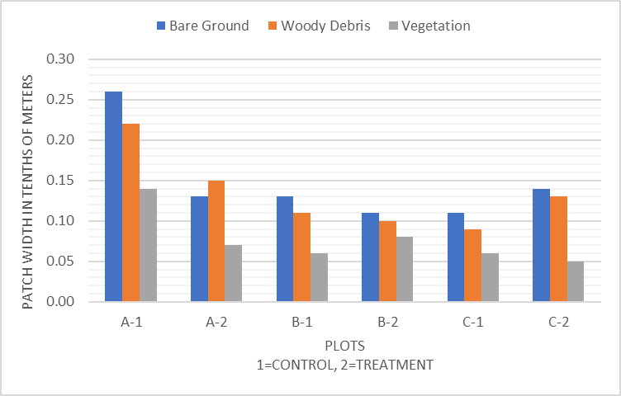
Figure 7. Ground cover means across all plots. Mean ground cover patch width for bare ground, woody debris, and vegetation is indicated by different colored bars. Measurements are in tenths of meters.

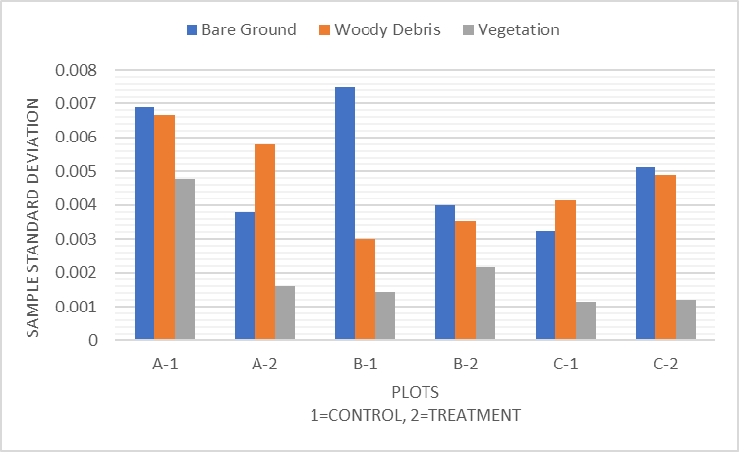
Figure 8. Ground cover sample standard deviation in patch width for all plots. The different bar colors illustrate mean ground cover patch width for each ground cover type.
the control and complex planting patterns (14.3 genera ± 2.40 SE and 19.7 genera ± 2.40 SE, respectively), although there was a trend toward a greater number of genera along the
transects in the complex plots (Figure 9). A total of 40 genera were sampled along transects (Table 1). Many of these were adapted to open conditions created by disturbance.
Nudds board nominal coverage percentages appear different among control and treatment plots (Figure 10). However, when comparing mean percent coverage for all directions (N, E, S, and W) and all heights (0.5, 1.0, 1.5, and 2.0 meters) combined, there were no significant differences found (p = 0.657) between the control and treatment plots (24.9 % ± 6.27 SE and 29.2 % ± 6.27 SE, respectively). Patterns in sample standard deviations were consistently higher in the treatment plots (Figure 11).
Nominal percentage values (Figures 12, 14, 16, and 18) and patterns in sample standard deviations (Figures 13, 15, 17, and 19) vary between heights. When comparing individual heights across plots, there were significant differences found (p < 0.001) between individual vegetation strata layers. Strata layers 0.5 and 1.0 differed from strata layers 1.5 and 2.0 but did not differ (p = 0.225) from one another (27.8 % ± 2.66 SE and 22.9 % ± 2.66 SE, respectively). Strata layers 1.5 and 2.0 differed (p = 0.018) from one another (11.9 % ± 1.88 SE and 4.4 % ± 1.88 SE, respectively). Sample standard deviations show patterns of lower variability in strata layer 0.5 (Figure 13) and higher variability in strata layers 1.0, 1.5, and 2.0 (Figures 15, 17, and 19).
Microclimate
Nominal values for mean soil temperature were greatest in the treatment plot at site B and least in the treatment plot at site A (Figure 20). However, no significant differences were found
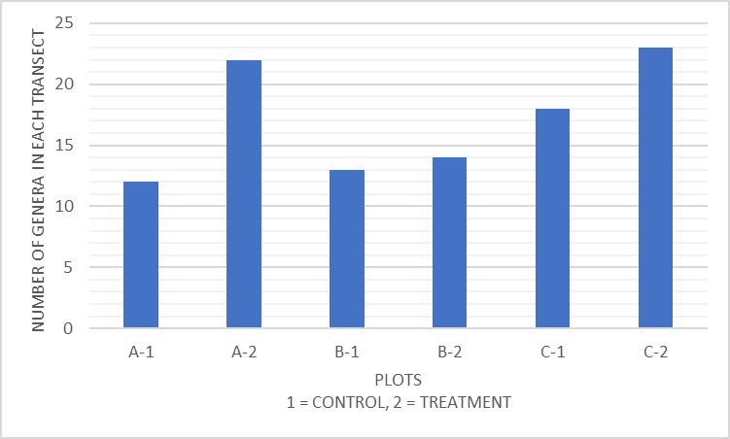
Figure 9. Richness of genera within transects. Bars illustrate the number of genera found within specific transects.

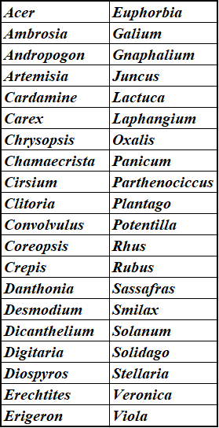
Table 1. Vegetation genera recorded in transects used during richness surveys.
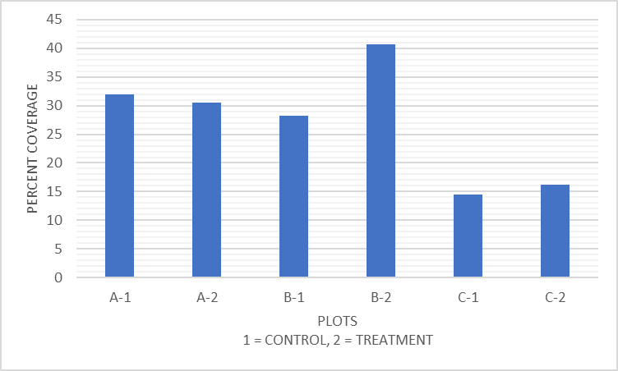
Figure 10. Nudds board mean coverage for all plots at all heights. Bars illustrate the means calculated across all four cardinal directions (N, E, S, and W) and all four heights (0.5, 1.0, 1.5, and 2.0 meters) within a single plot.

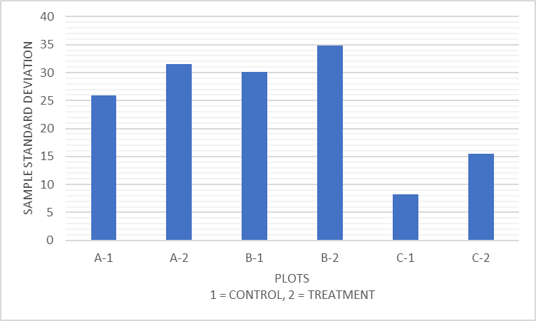
Figure 11. Nudds board coverage sample standard deviation for all plots calculated across all heights.

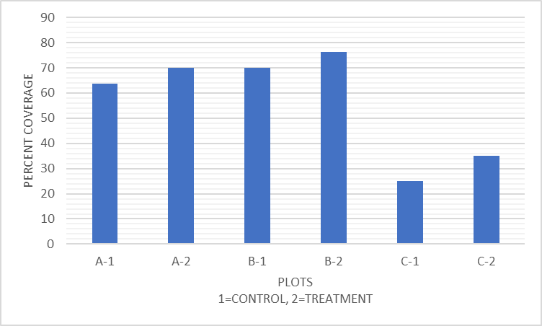
Figure 12. Nudds board mean coverage for all plots at 0.5 meters. The bars show the amount of coverage in ten percent increments.

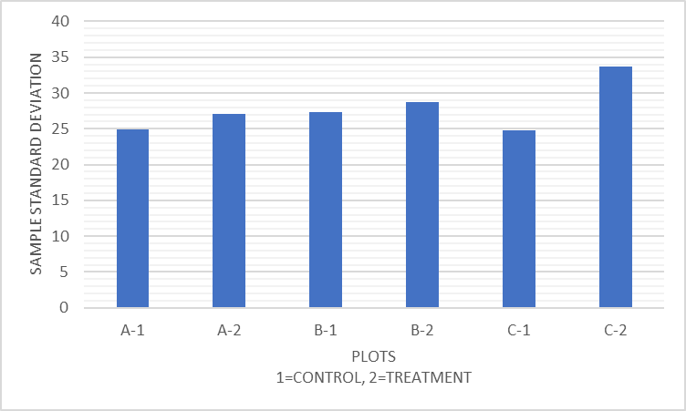
Figure 13. Nudds board coverage sample standard deviation for all plots at 0.5 meters calculated across directions.
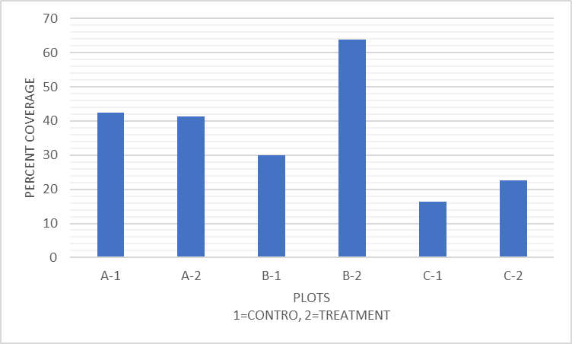
Figure 14. Nudds board mean coverage for all plots at 1.0 meters. The bars show the amount of coverage in ten percent increments.

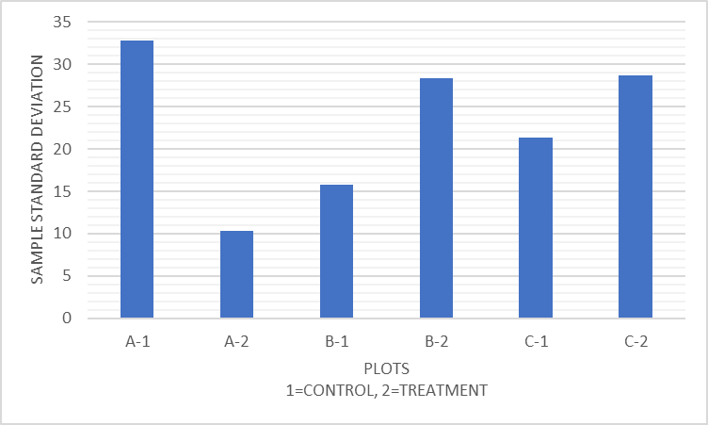
Figure 15. Nudds board coverage sample standard deviation for all plots at 1.0 meters calculated across directions.
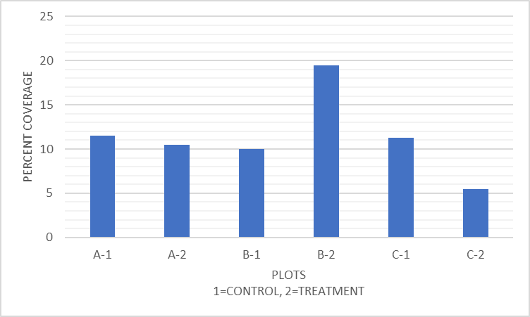
Figure 16. Nudds board mean coverage for all plots at 1.5 meters. The bars show the amount of coverage in ten percent increments.

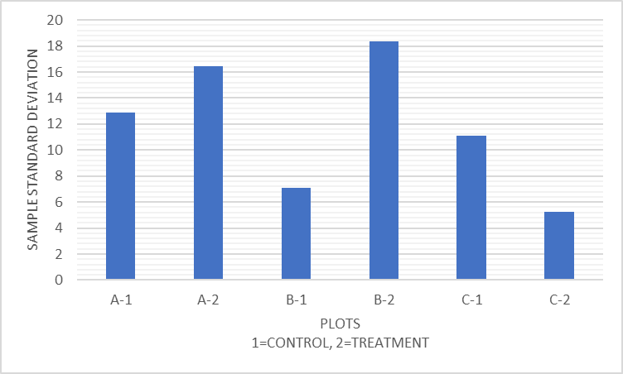
Figure 17. Nudds board coverage sample standard deviation for all plots at 1.5 meters calculated across directions.
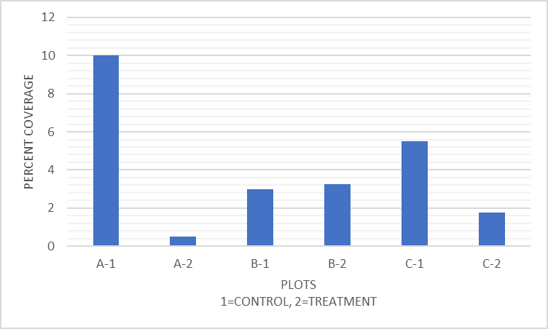
Figure 18. Nudds board mean coverage for all plots at 2.0 meters. The bars show the amount of coverage in ten percent increments.

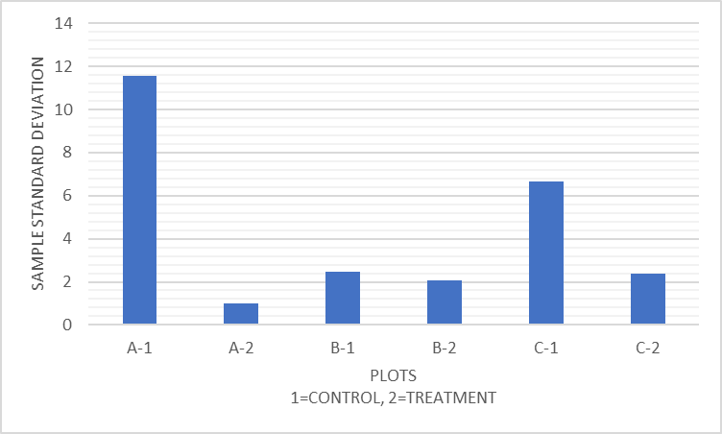
Figure 19. Nudds board coverage sample standard deviation for all plots at 2.0 meters calculated across directions.
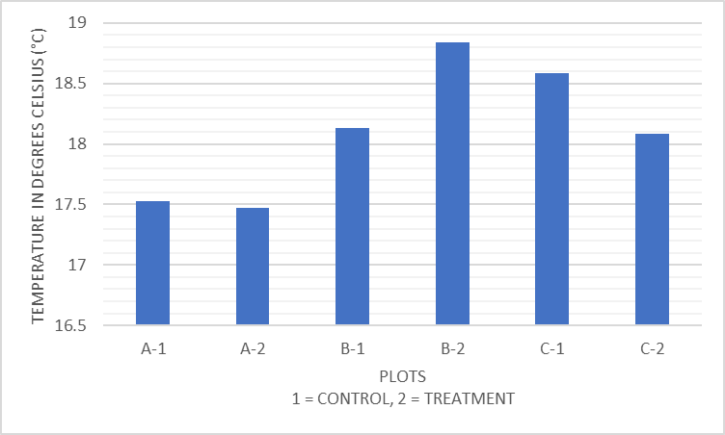
Figure 20. Soil temperature means for all plots. Bars illustrate temperature in degrees Celsius (°C), in one-half degree increments.

(p = 0.924) when comparing the control and treatment plots (64.5 °C ± 0.6 SE and 64.6 °C ± 0.6 SE, respectively). Patterns in the sample standard deviation in soil temperature across treatments were inconsistent across sites (Figure 21).
Photosynthetically active radiation (PAR) did not vary widely among plots (Figure 22). No significant difference was found (p = 0.569) in mean PAR between control and treatment plots (1375.82 micromoles/m²/s ± 106.77 SE and 1469.33 micromoles/m²/s ± 106.77 SE, respectively). Sample standard deviation in PAR fluctuated widely across plots, but patterns in standard deviations for treatments and controls were inconsistent across sites (Figure 23).
Shortleaf Pine Performance
Mean seedling heights for control and treatment plots were 25.5 centimeters (cm) and 23.4 cm, respectively. Mean shortleaf pine seedling height varied slightly across plots (Figure 24), but there was no significant difference (p = 0.178) between the control and treatment plots (25.5 cm ± 0.88 SE and 23.4 cm ± 0.88 SE, respectively). There was no consistent pattern in the sample standard deviation for shortleaf pine seedling height in treatment plots and controls across sites (Figure 25).
Mean seedling diameters for control and treatment plots were 4.2 millimeters (mm) and 4.1 mm, respectively. Shortleaf pine seedling diameters varied more across plots than heights (Figures 24 and 26). There was no significant difference (p = 0.463) in shortleaf pine seedling diameter between the control and treatment plots (4.2 mm ± 0.15 SE and 4.1 mm ± 0.15 SE, respectively). Sample standard deviations for shortleaf pine seedling diameter in controls were slightly greater than, or equal to those for treatment plots (Figure 27). Seedling

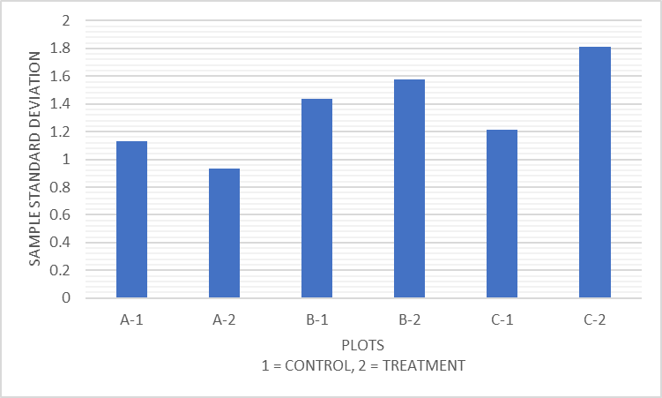
Figure 21. Soil temperature sample standard deviations for all plots.

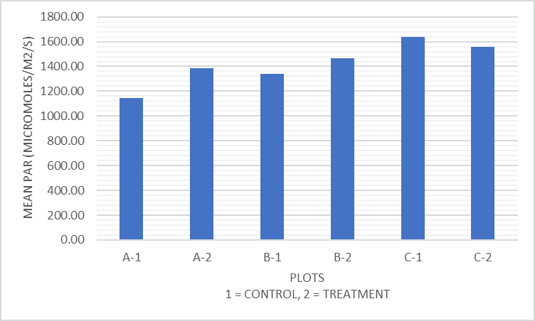
Figure 22. Photosynthetically active radiation (PAR) means for all plots. Bars illustrate the means in increments of 200.00 micromoles per meter squared per second (micromoles/m²/s).
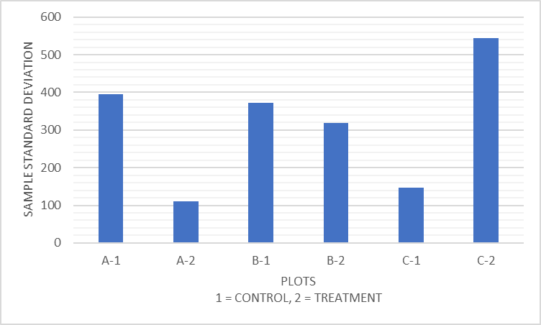
Figure 23. Photosynthetically active radiation (PAR) sample standard deviation for all plots.

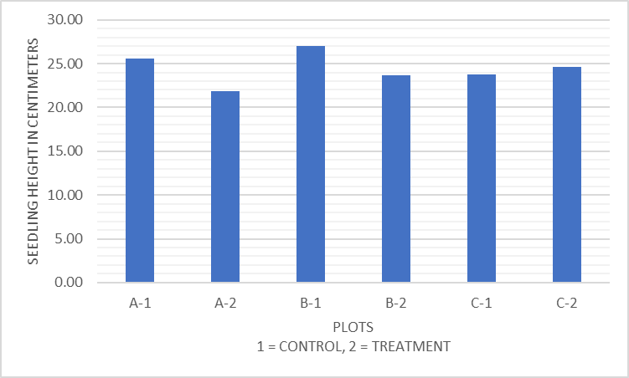
Figure 24. Shortleaf pine seedling height means for all plots. The bars illustrate mean heights in centimeters.
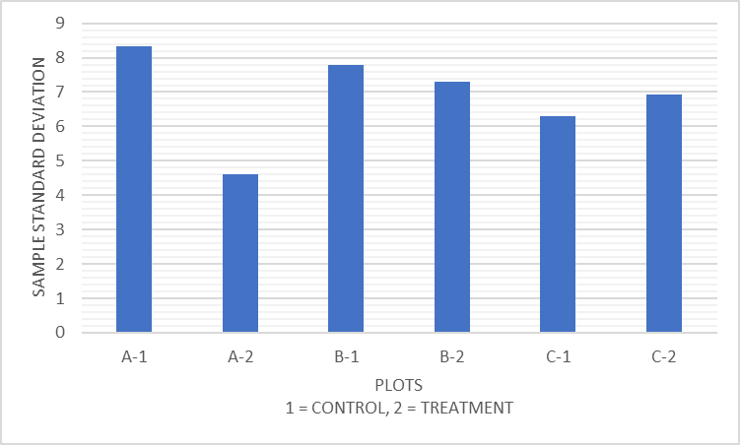
Figure 25. Shortleaf pine seedling height sample standard deviation for all plots.

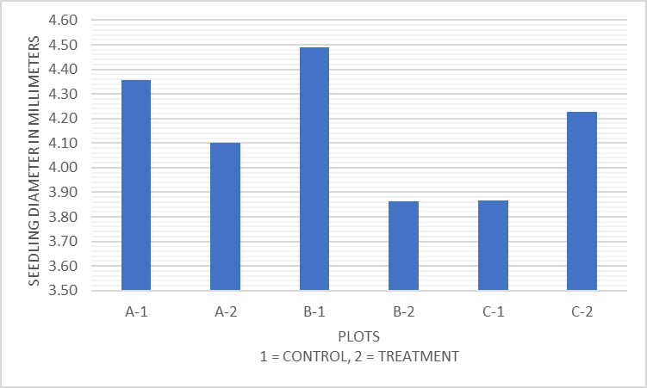
Figure 26. Shortleaf pine seedling diameter means for all plots. The bars illustrate mean diameters in millimeters.
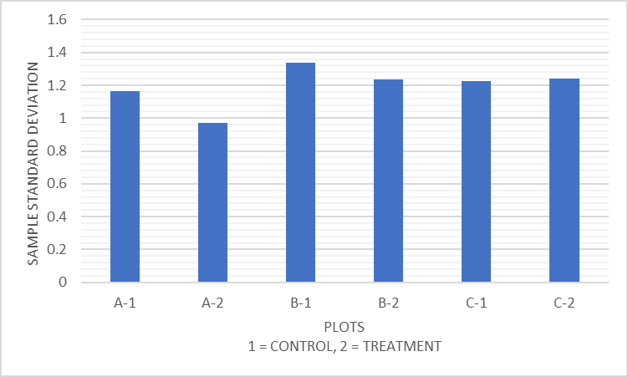
Figure 27. Shortleaf pine seedling diameter sample standard deviation for all plots.

mortality (Figure 28) showed no significant difference (p = 0.745) between the control and treatment plots (15.5 % ± 4.95 SE and 17.9 % ± 4.95 SE, respectively).
Shortleaf pine seedling heights, diameters, and mortality were also evaluated with respect to the vegetation patch type in which the seedlings occurred. Seven vegetation patch types were defined prior to measurements that were expected to be found in the plots. Only five vegetation patch types contained seedlings (Figure 29), so the sixth and seventh patch types (Woody-shrub and Woody-tree) were removed from analysis. There was no significant difference between any of the five patch types with respect to seedling heights or diameters (p = 0.595 and p = 0.433, respectively), although seedlings did not occur in all patch types. The greatest overall height performance occurred in “Woody-Cane” and the lowest overall height performance occurred in “Short grass-below 30.5 cm” (Figure 29). Sample standard deviation for seeding height was greatest in plot A-1 in “Tall grass-above 30.5 cm” and least in plot B-1 in “Tall grass-above 30.5 cm” (Figure 30).
The greatest overall diameter was found in “Short forb-below 91.5 cm” and the lowest overall diameter performance was found in “Tall grass-above 30.5 cm” (Figure 31). Diameter differences may be due to certain vegetation patch types not containing seedlings, as mentioned for seedling height (Figure 30). Sample standard deviation for seedling diameter was greatest in plot C-1 in “Short grass-below 30.5 cm” (Figure 32).
Two vegetation patch types, “Tall grass-above 30.5 cm” and “Short grass-below 30.5 cm”, did not occur in plot A-1. A value of zero (0) was assigned to plot A-1 for these two vegetation patch types in the original analysis. An additional analysis was run with these two patch types removed to check for significance between the other patch types that all occurred
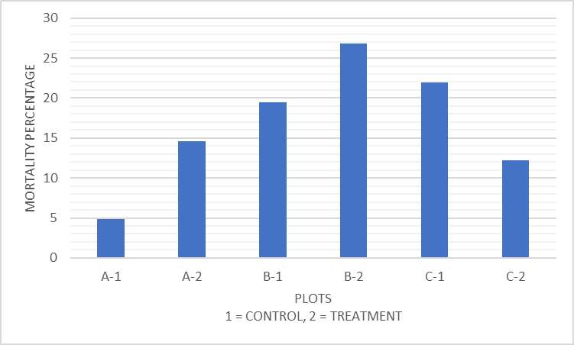
Figure 28. Shortleaf pine seedling mortality percentages for all plots. The bars illustrate mortality in five percent increments.

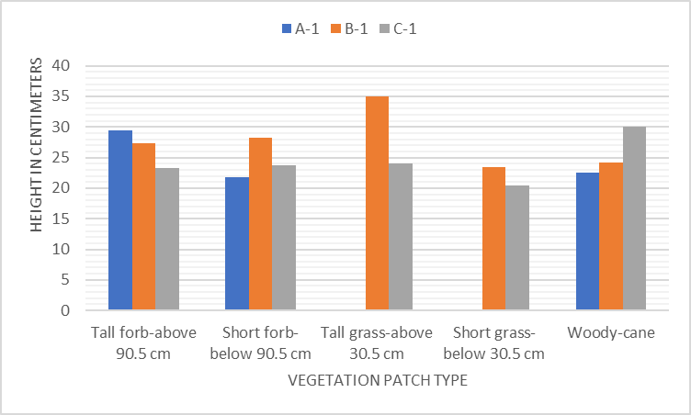
Figure 29. Shortleaf pine seedling mean height in relation to vegetation patch type. Bar colors denote different plots.
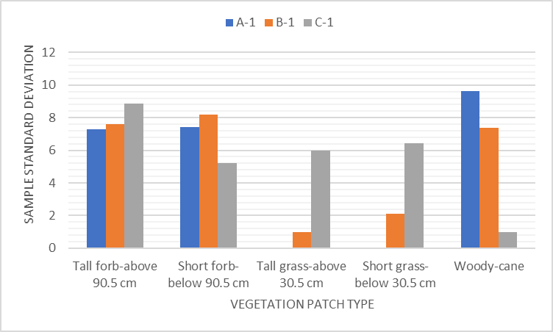
Figure 30. Shortleaf pine seedling height sample standard deviation in relation to vegetation patch type. Bar colors denote different plots.

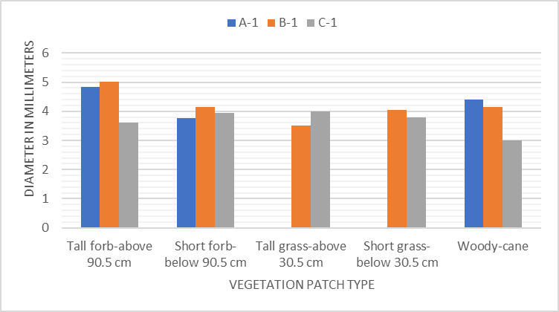
Figure 31. Shortleaf pine seedling mean diameter in relation to vegetation patch type. Bar colors denote different plots.
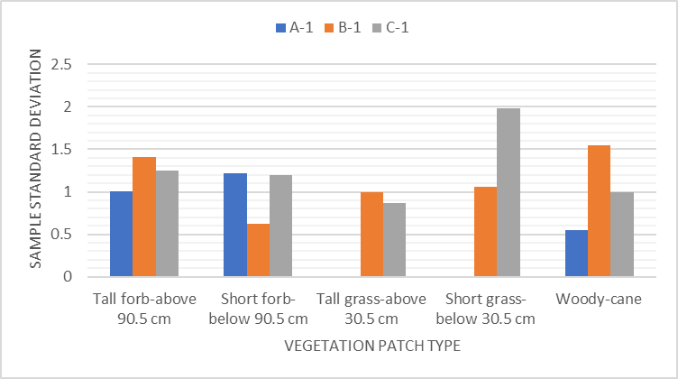
Figure 32. Shortleaf pine seedling diameter sample standard deviations in relation to vegetation patch type. Bar colors denote different plots.

within all plots. No significant differences were found between the three vegetation patch types for height or diameter (p = 0.770 and p = 0.447, respectively).
Mortality only occurred in three of the seven vegetation patch types that were identified (“Tall forb-above 91.5 cm”, “Short forb-below 90.5 cm”, and “Woody-cane”) so mortality was only analyzed for these three patch types. The mortality rate appears to vary widely between the different vegetation patch types (Figure 33). However, no significant differences (p = 0.395) were found. Mortality in vegetation patch type “Woody-cane” only occurred in plot B-1. Values of zero (0) were assigned to plots A-1 and C-1 for this vegetation patch type in the original analysis. An additional analysis was run with “Woody-cane” removed to check for significance between the patch types that occurred in all plots, but no significant differences
were found (p = 0.526). The highest mortality rate occurred in vegetation patch type “Short forb-below 91.5 cm” followed by “Tall forb-above 91.5 cm” and “Woody-cane” (19.3 % ± 7.58 SE, 10.5 % ± 7.58 SE, and 3.5 % ± 7.58 SE, respectively).
Discussion
Pine savanna ecosystems found in the southeastern United States contain incredible levels of biodiversity. The main driver in maintaining this diversity is the presence of fire, specifically temporal variation and spatial variation in fire intensity throughout a site. Highly variable fire intensity in longleaf pine savannas assists in reducing shrub components and maintaining vegetation diversity and complexity (Thaxton and Platt, 2006). Recurrence of fire in pine savanna ecosystems goes hand in hand with variation in intensity. Excluding frequent fire events, generally occurring every 1-3 years, from these systems results in extreme losses in the amount of biodiversity that is common in pine savannas. Bunch grasses, such as wiregrass
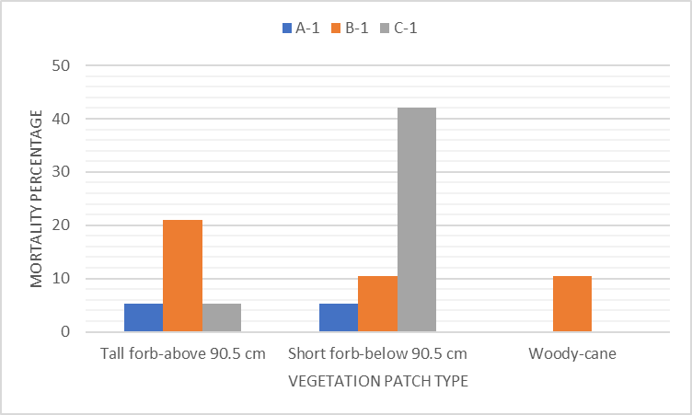
Figure 33. Shortleaf pine seedling mortality percentages by vegetation patch type. Bar colors denote different vegetation patch types.

(Aristida beyrichiana), are dependent on frequent fire and are influential in restoration of these ecosystems (Fill, et al., 2021). While fire frequency and intensity were not measured in this study, the pre-planting prescribed fire likely impacted the levels of groundcover complexity measured. Restoring the fire regime to these sites will be imperative in enhancing biodiversity to levels comparable to native pine savanna ecosystems.
The degrees and scales of complexity in the vicinity of the Bridgestone Nature Reserve at Chestnut Mountain that may have existed and sustained shortleaf pine ecosystems in the past is not well documented. However, assumptions could be made based on historical fire regimes of the Middle Tennessee Cumberland Plateau region generated from dendrochronological data. Fire scars in shortleaf pine suggest that fire occurred every 4.4-5.3 years prior to Euro-American settlement in the region and transitioned to 2.3-3.8 years following settlement (Stambaugh, et al., 2020). The suggested fire return interval following Euro-American settlement is remarkably similar to the timing prescribed for modern pine savanna management, leading to an assumption that historical complexity in these ecosystems was similar to what is seen today in managed pine savannas.
Natural tree regeneration and resprouting was prevalent following the prescribed burn that was performed for site preparation prior to planting the seedlings. Species found resprouting and regenerating included yellow-poplar (Liriodendron tulipifera), common persimmon (Diospyros virginiana), sassafras (Sassafras albidum), red maple (Acer rubrum), southern red oak (Quercus falcata), sourwood (Oxydendrum arboreum), and northern red oak (Quercus rubra). Shortleaf pine is also naturally regenerating in all the stands. The regeneration of broadleaf trees in the plots may eventually have a detrimental effect on shortleaf pine seedling performance by increasing the level of shade as seedling growth progresses, but shortleaf pine can persist in shade among competitive plants for several years (Kabrick, et al., 2015).
Prior cover for these sites was closed canopy mixed-hardwood forest with a Virginia pine (Pinus virginiana) component. These sites have been in the process of conversion to savanna ecosystems for only a short time, so patch widths and structure observed are likely to be mainly the result of what resided in the seedbank of the forest floor and short-term seed influx from wind and wildlife movement. Patch width variation and structural complexity will likely increase as the conversion process continues. Ground cover patch size results were as expected given the data collected and observations while in the field. On average, bare ground patch width was slightly wider than either woody debris or vegetation patch widths. The combination of seasonality of data collection and post-burn timing led to an assumption that the bare ground patch sizes would be large, yet similar among plots. The woody debris patch size was reasonable given the past timber harvest in these stands. Control plots having larger patch sizes of woody debris was also expected given the specific location of the plots. Woody debris abundance looked similar upon initial observations of the plot locations, but many large branches, sticks, and pieces of bark were found in the transects during data collection. The abundance of woody debris, although it is in small patches, may lead to increased vegetation growth. Vegetation near woody debris can, on average, reach greater sizes than similar vegetation not adjacent to woody debris (Logan, et al., 2020). Decomposition of woody debris may also eventually result in higher concentrations of organic matter on the surface of the soil, which may increase the width of vegetation patch sizes. Average vegetation patch size was as expected overall, however, more large patch sizes were expected given the previous presence of grasses and larger forbs. The prescribed burn performed for site preparation may have reduced the patch widths previously present due to the severity of the fire. However, it was unexpected that the control plots would have larger patch sizes of vegetation. Vegetation patch widths are expected to increase, but it is unknown if patch widths will be similar to current sizes or if they will increase following subsequent prescribed burns. Vegetation patches were not differentiated by species and were instead analyzed only as vegetation. Based on observations in the field, the patch size of different species of vegetation may differ between treatment and control plots. It should be possible to measure these changes at a later date.
Many of the plants recorded in the transects were not identifiable to the species level due to the time of year that measurements were taken. For many of these plants to be positively identified, the flowering parts or seeds must be present. Therefore, all plants found in the transects were only identified, as accurately as possible, to the genus level to mitigate false identifications of the plants recorded in the transects as much as possible. Richness was then determined based on the genera observed. No significant differences were found between plots, likely due to the similarity in growing conditions between control and treatment plots. The growing conditions are likely to vary between the control and treatment plots as the stands mature, which may alter plant richness in the future.
Nudds board coverage percentages exhibited few differences overall. No significant differences were found between the control and treatment plots when comparing all directions (N, E, S, and W) and heights (0.5, 1.0, 1.5, and 2.0 meters) together as a single average of percent cover. However, sample standard deviations showed consistently greater variation in the treatment plots than the control plots. When examining individual heights between plots there was a difference in variability between the four heights. 0.5 and 1.0 meters did not differ from one another, but they did differ from 1.5 and 2.0 meters. 0.5 and 1.0 meters were likely similar due to the presence of mostly short herbaceous vegetation and blackberry (Rubus spp.) growth. 1.5 and 2.0 meters also differed from one another, likely due to the general lack of vegetation cover at 2.0 meters. These differences may be attributed to the vegetation growth stage in the plots given the seasonality of data collection. This pattern does indicate slight complexity in vertical structure. However, the patterns of vertical structure complexity are not indicative of the complex planting pattern exhibiting higher levels of complexity over the standard planting pattern.
Microclimate data showed little difference in variability between the control and complex planting patterns. Soil temperature means varied slightly in the data, likely due to the differing levels of vegetation along the transects that may have provided additional shade in certain areas, but were not significantly different overall. This interaction was also observed in the PAR measurements. Certain sections of transects contained vegetation that was either taller or had larger leaf surface area that blocked light from reaching the ground which likely explain the slight variations in these measurements even more than for soil temperature.
Shortleaf pine seedling survival in this study was relatively high compared to some other studies performed on the same species. In a study performed near Estill Springs, Tennessee, USA, shortleaf pine performance was similar among seedlings, but overall survival was slightly lower (≤ 51.2 %) than was observed in this study (≥ 57.9 %) (Clabo and Clatterbuck, 2020). One assumption that could explain this is that greater seedling survival in the current study was due to utilizing containerized seedlings, whereas Clabo and Clatterbuck (2020) utilized bareroot seedlings. Containerized seedling survival compared to bareroot seedling survival is not well documented in pine species. However, containerized sugi (Cryptomeria japonica) tree seedlings exhibit higher levels of survival than bareroot sugi seedlings, so reduced transplant shock in containerized seedlings is a likely cause of higher survival rates (Ito, et al., 2019).
The planting pattern employed was complex, yet uniform in order to have the same effect in each of the three treatment plots. Truly random clumping may produce even greater complexity and have stronger effects on shortleaf pine performance, structural complexity, and microclimate. Natural shortleaf pine stands often have clumped regeneration patterns and spacing, though natural regeneration spacing is not well documented. However, observations in the field indicated that many stands, including the stands containing the experimental plots, contain seedlings that are naturally regenerating less than 20 centimeters apart. This is much closer than the typical 3 to 4.5 meter spacing in a plantation setting, and even closer than the 1.5 meter spacing in the smaller clumps within the complex planting pattern. Future studies utilizing a more truly random method to emulate natural shortleaf pine stands would be instructive.
It is possible that close, or clumped, spacing may result in sub-optimal performance in shortleaf pine seedlings from the perspective of wood production, especially as seedlings mature. However, there are factors associated with more complex or clumped patterns that may be beneficial aside from the production of lumber and other forest products. Natural mortality and competition across various stages of stand growth due to competition among shortleaf pine may produce snags (dead, standing trees) and greater amounts of dead wood on the ground than further spacing, both of which are important habitat components for wildlife and insects. Dead wood accumulation is vital for many beetle (Coleoptera) species (Klepzig, et al., 2012). Snags are also important nesting sites for cavity-nesting bird species. Carolina chickadee (Poecile carolinensis) and tufted titmouse (Baeolophus bicolor) are two species that will utilize pine snags for cavity construction in pine plantations (Homyack, et al., 2011). The close spacing provided by the complex planting pattern will also likely produce greater levels of shade than wider spacings. Many species of plants thrive in fully shaded sites, such as maidenhair fern (Adiantum pedatum) and spotted wintergreen (Chimaphila maculata) (Gardenia, 2022). There are more factors that could be considered, but these two factors alone could provide enough benefit, depending on the objective of a manager or landowner, to overlook the detriment to tree performance.
While there was no significant difference in seedling performance between the two planting patterns, there was a trend toward control plots having slightly better performance on average than the treatment plots in both height and diameter. These results may have been due to certain plots having more optimal growing conditions. For example, plot B-1 had excessive blackberry growth that may have influenced the height performance of the seedlings. The blackberry in plot B-1 produced a high level of shade which may have increased the amount of moisture the soil was able to maintain. Soil moisture was not measured, however. The overall mean height for plot B-1 is not much greater than that of the other plots, but there were several seedlings that were exceptionally tall (above 30 centimeters) which may have been influential in the results of the analysis. While seedlings in certain plots did seem to perform slightly better, specific vegetation patch type did not significantly influence shortleaf pine performance or survival. Further examination of the vegetation patch types used in this study over time may result in more concrete evidence of which vegetation patch types are best to plant shortleaf pine in and which are best to avoid. Based on vegetation patch type performance results, it is difficult to recommend a particular vegetation patch type that is best for planting shortleaf pine.
Results of this study suggest that few significant differences existed in plant richness, variability in vegetation structure, variability in microclimate, and shortleaf pine performance. This finding indicates short-term goals of increasing complexity in young stands were not met in the first growing season. Long-term examination of complexity may have a different outcome as the stands mature. Variability in shading, soil temperature, and soil water content may increase. These three factors may, in turn, cause variation in the level of structural complexity found within the plots. The combination of these factors with others may alter fire intensity and residence time within the plots. All of these factors combined may increase the overall complexity of the plots as plants with specific microsite requirements, including light, moisture, and disturbance, colonize different areas of the plots both spatially and temporally.
Conclusion
The first-year results of this study do not provide definitive evidence to support the hypotheses that planting shortleaf pine in a complex pattern would influence structural complexity or shortleaf pine performance. The complex and standard planting patterns exhibited similar levels of complexity and shortleaf pine performance. The patterns of complexity in the stands during the first growing season likely resulted from a combination of the pre-planting prescribed fire and residual seed sources from closed canopy forest previously occupying the sites. Seed from nearby areas brought in by wind and animal vectors may also have contributed to the complexity. It is assumed that subsequent growing seasons will exhibit complexity that varies from what was observed and measured during the first growing season. Complexity is low within plots but stand-level complexity appears to be slightly greater. However, this is based solely on observations in the field as stand-level complexity was not measured. Shortleaf pine performance also did not vary significantly across different vegetation patch types. Since the data are limited to the first growing season following seedling planting, the small size of the shortleaf pine seedlings likely diminished their influence on adjoining vegetation and microclimate factors, and likewise, the limited development of competitors in the first growing season after burning likely diminished their influence on the planted pines.
Additional data collection in subsequent years is expected to provide more insight into how the complex planting patterns implemented affect structural complexity and shortleaf pine performance as the stands continue to mature. Sampling additional variables in the future could also provide greater insights and information on many ecological and financial outcomes apart from structural complexity and shortleaf pine performance. The scope of this study could be broadened to include wildlife use and productivity, fire behavior, invasive species dynamics, hydrology, and fiber and timber production. Broadening the scope of the study in this way could lead to future refinement and implementation of complex planting patterns to expedite the recovery of structural complexity and its beneficial effects at multiple scales.

References
Aponte, Cristina, Sabine Kasel, Craig R. Nitschke, Mihai A. Tanase, Helen Vickers, Linda Parker, Melissa Fedrigo, Michele Kohout, Paloma Ruiz-Benito, Miguel A. Zavala, Lauren T. Bennett, Thomas Hickler. “Structural Diversity Underpins Carbon Storage in Australian Temperate Forests.” Global Ecology and Biogeography, vol. 29, no. 5, 2020, pp. 789–802, https://doi.org/10.1111/geb.13038.
Atwell, Ryan C., Lisa A. Schulte, Brian J. Palik. “Songbird Response to Experimental Retention Harvesting in Red Pine (Pinus resinosa) Forests.” Forest Ecology and Management, vol. 255, no. 10, Elsevier B.V, 2008, pp. 3621–31, https://doi.org/10.1016/j.foreco.2008.02.049.
Bradford, John B., and Douglas N. Kastendick. “Age-Related Patterns of Forest Complexity and Carbon Storage in Pine and Aspen-Birch Ecosystems of Northern Minnesota, USA.” Canadian Journal of Forest Research, vol. 40, no. 3, 2010, pp. 401–09, https://doi.org/10.1139/X10-002.
“Bridgestone Nature Reserve at Chestnut Mountain.” The Nature Conservancy, 2022, www.nature.org/en-us/get-involved/how-to-help/places-we-protect/bridgestone-nature-reserve-at-chestnut-mountain/.
Bowne, D. R., J. D. Peles, G. W. Barrett. “Effects of Landscape Spatial Structure on Movement Patterns of the Hispid Cotton Rat (Sigmodon hispidus).” Landscape Ecology, vol. 14, no. 1, Springer, 1999, pp. 53–65, https://doi.org/10.1023/A:1008025827895.
Chen, Jingjing, Kevin J. McGuire, Ryan D. Stewart. “Effect of Soil Water‐repellent Layer Depth on Post‐wildfire Hydrological Processes.” Hydrological Processes, vol. 34, no. 2, 2020, pp. 270–83, https://doi.org/10.1002/hyp.13583.
Clabo, David C., and Wayne K. Clatterbuck. “Establishment and Early Development of Even-Age Shortleaf Pine–Hardwood Mixtures Using Artificially Regenerated Shortleaf Pine and Various Site Preparation and Release Treatments.” Forest Science, vol. 66, no. 3, Oxford University Press, 2020, pp. 351–60, https://doi.org/10.1093/forsci/fxz082.
Dazé Querry, Natasha, and Karen Amanda Harper. “Structural Diversity as a Habitat Indicator for Endangered Lakeshore Flora Using an Assemblage of Common Plant Species in Atlantic Canada.” Plant Ecology, vol. 218, no. 11/12, 2017, pp. 1339–53, https://doi.org/10.1007/s11258-017-0772-4.
Dodonov, Pavel, Karen A. Harper, Rafael de Oliveira Xavier, Dalva M. Silva Matos. “Spatial Pattern of Invasive and Native Graminoids in the Brazilian Cerrado.” Plant Ecology, vol. 220, no. 7-8, 2019, pp. 741–56, https://doi.org/10.1007/s11258-019-00949-6.
Doggett, Jacob W., and Alexandra Locher. “Assessment of Northern Bobwhite Survival and Fitness in the West Gulf Coastal Plain Ecoregion.” PloS One, vol. 13, no. 7, Public Library of Science, 2018, pp. e0200544–e0200544, https://doi.org/10.1371/journal.pone.0200544.
Elliott, Katherine J., James M. Vose, Jennifer D. Knoepp, Barton D. Clinton. “Restoration of Shortleaf Pine (Pinus echinata)-Hardwood Ecosystems Severely Impacted by the Southern Pine Beetle (Dendroctonus frontalis).” Forest Ecology and Management, vol. 274, Elsevier B.V, 2012, pp. 181–200, doi:10.1016/j.foreco.2012.02.034.
Fill, Jennifer M., Cesar Zamora, Carolina Baruzzi, Javier Salazar-Castro, Raelene M. Crandall, Craig Eliot Coleman. “Wiregrass (Aristida beyrichiana) Survival and Reproduction after Fire in a Long-Unburned Pine Savanna.” PloS One, vol. 16, no. 2, 2021, pp. e0247159–e0247159, https://doi.org/10.1371/journal.pone.0247159.
Franklin, Jerry F., and Daniel C. Donato. “Variable Retention Harvesting in the Douglas-Fir Region.” Ecological Processes, vol. 9, no. 1, Springer Berlin Heidelberg, 2020, pp. 1–10, https://doi.org/10.1186/s13717-019-0205-5.
Franklin, Jerry F., and Robert Van Pelt. “Spatial Aspects of Structural Complexity in Old-Growth Forests.” Journal of Forestry, vol. 102, no. 3, Oxford University Press, 2004, pp. 22–28.
“Gardenia.” Gardenia.net, 2022, https://www.gardenia.net/.
“Google Earth Pro” 35.869110°, -85.289236° Google Earth. December 13, 2015. Accessed June 16, 2021.
Hickey, Laura J., Jeff Atkins, Robert T. Fahey, Mark T. Kreider, Shea B. Wales, Christopher M. Gough. “Contrasting Development of Canopy Structure and Primary Production in Planted and Naturally Regenerated Red Pine Forests.” Forests, vol. 10, no. 7, 2019, p. 566–, https://doi.org/10.3390/f10070566.
Homyack, Jessica A., Barton J. Paxton, Michael D. Wilson, Bryan D. Watts, Darren A. Miller. “Snags and Cavity-Nesting Birds Within Intensively Managed Pine Stands in Eastern North Carolina, USA.” Southern Journal of Applied Forestry, vol. 35, no. 3, 2011, pp. 148–54, https://doi.org/10.1093/sjaf/35.3.148.
Ito, Satoshi, Yumi Shimbo, Ryoko Hirata, Takuro Mizokuchi. “Survival and Its Factor of Containerized and Bare-root Sugi Cuttings Subjected to Different Watering Regimes after Summer Planting.” Nihon Shinrin Gakkaishi, vol. 101, no. 3, 2019, pp. 122–27, https://doi.org/10.4005/jjfs.101.122.
Iglay, Raymond B., Phillip D. Jones, Darren A. Miller, Stephen Demarais, Bruce D. Leopold, Wes L. Burger. “Deer Carrying Capacity in Mid-Rotation Pine Plantations of Mississippi.” The Journal of Wildlife Management, vol. 74, no. 5, The Wildlife Society, 2010, pp. 1003–12, https://doi.org/10.2193/2009-362.
Jian, M., M. Berli, T. A. Ghezzehei. “Soil Structural Degradation During Low‐Severity Burns.” Geophysical Research Letters, vol. 45, no. 11, 2018, pp. 5553–61, https://doi.org/10.1029/2018GL078053.
Kabrick, John M., Benjamin O. Knapp, Daniel C. Dey, David R. Larsen. “Effect of Initial Seedling Size, Understory Competition, and Overstory Density on the Survival and Growth of Pinus echinata Seedlings Underplanted in Hardwood Forests for Restoration.” New Forests, vol. 46, no. 5-6, Springer Netherlands, 2015, pp. 897–918, https://doi.org/10.1007/s11056-015-9487-3.
Kelty, Matthew J. “The Role of Species Mixtures in Plantation Forestry.” Forest Ecology and Management, vol. 233, no. 2, 2006, pp. 195–204, https://doi.org/10.1016/j.foreco.2006.05.011.
Klepzig, Kier D., Michael L. Ferro, Michael D. Ulyshen, Matthew L. Gimmel, Jolie B. Mahfouz, Allan E. Tiarks, Chris E. Carlton. “Effects of Small-Scale Dead Wood Additions on Beetles in Southeastern U.S. Pine Forests.” Forests, vol. 3, no. 3, 2012, pp. 632–52, https://doi.org/10.3390/f3030632.
Kooch, Yahya, Claudio Zaccone, Norbert P. Lamersdorf, Giustino Tonon. “Pit and Mound Influence on Soil Features in an Oriental Beech (Fagus orientalis Lipsky) Forest.” European Journal of Forest Research, vol. 133, no. 2, 2013, pp. 347–54, https://doi.org/10.1007/s10342-013-0766-2.
Lawson, Edwin R. pp. 625-647 in “Burns, Russell M; Honkala, Barbara H.; [Technical coordinators] 1990. Silvics of North America: Volume 1. Conifers. United States Department of Agriculture (USDA), Forest Service, Agriculture Handbook 654”
Logan, Alexandra T., Jonathan D. Goode, David J. Keellings, Justin L. Hart. “Microsite Influence on Woody Plant Regeneration in a Pinus Palustris Woodland Following Catastrophic Disturbance.” Forests, vol. 11, no. 5, 2020, p. 588–, https://doi.org/10.3390/f11050588.
McCallum, Kimberly P., Andrew J Lowe, Martin F. Breed, David C. Paton. “Spatially Designed Revegetation—why the Spatial Arrangement of Plants Should Be as Important to Revegetation as They Are to Natural Systems.” Restoration Ecology, vol. 26, no. 3, Wiley Periodicals, Inc, 2018, pp. 446–55, doi:10.1111/rec.12690.
Maier, Chris A., Timothy J. Albaugh, Allen H. Lee, Phillip M. Dougherty. “Respiratory Carbon Use and Carbon Storage in Mid-Rotation Loblolly Pine (Pinus taeda L.) Plantations: The Effect of Site Resources on the Stand Carbon Balance.” Global Change Biology, Received 20 August 2003; received in revised form and accepted 6 January 2004, vol. 10, no. 8, Blackwell Science Ltd, 2004, pp. 1335–50, https://doi.org/10.1111/j.1529-8817.2003.00809.x.
National Atlas of the United States. “Tennessee State County Map.” A Large Detailed Tennessee State County Map, United States Department of the Interior, 2021, https://www.washingtonstatesearch.com/United_States_maps/Tennessee/Tennessee_county_map.html.
Norbury, Grant, and Wouter Overmeire. “Low Structural Complexity of Nonnative Grassland Habitat Exposes Prey to Higher Predation.” Ecological Applications, vol. 29, no. 2, 2019, pp. 1–8, https://doi.org/10.1002/eap.1830.
Nordman, Carl, Don Faber-Langendoen, Joanne Baggs. “Rapid Ecological Integrity Assessment Metrics to Restore Wildlife Habitat and Biodiversity for Shortleaf Pine–Oak Ecosystems.” Forests, vol. 12, no. 12, MDPI AG, 2021, p. 1739–, https://doi.org/10.3390/f12121739.
Nudds, T.D. 1977. Quantifying the vegetative structure of wildlife cover. Wildlife Society Bulletin 5:113-117.
NRCS. “Web Soil Survey - Home.” Web Soil Survey - Home, https://websoilsurvey.sc.egov.usda.gov/.
PB1466 Tree Crops for Marginal Farmland - Loblolly Pine," The University of Tennessee Agricultural Extension Service, PB1466-2M-3/99 (Rev) E12-2015-00-182-99, https://trace.tennessee.edu/utk_agexfores/4
Pedro, Annia Rodríguez-San, and Javier A. Simonetti. “Foraging Activity by Bats in a Fragmented Landscape Dominated by Exotic Pine Plantations in Central Chile.” Acta Chiropterologica, vol. 15, no. 2, Museum and Institute of Zoology at the Polish Academy of Science, 2013, pp. 393–98, https://doi.org/10.3161/150811013X679017.
“Picoides borealis.” FWS.gov, https://www.fws.gov/species/red-cockaded-woodpecker-picoides-borealis.
Santos, Maria J., Jonathan A. Greenberg, Susan L. Ustin. “Using Hyperspectral Remote Sensing to Detect and Quantify Southeastern Pine Senescence Effects in Red-Cockaded Woodpecker ( Picoides Borealis) Habitat.” Remote Sensing of Environment, vol. 114, no. 6, Elsevier Inc, 2010, pp. 1242–50, doi:10.1016/j.rse.2010.01.009.
SAS. Copyright, SAS Institute Inc. SAS and all other SAS Institute Inc. product or service names are registered trademarks or trademarks of SAS Institute Inc., Cary, NC, USA.
Seidel, Dominik, Martin Ehbrecht, Peter Annighöfer, Christian Ammer. “From Tree to Stand-Level Structural Complexity — Which Properties Make a Forest Stand Complex?” Agricultural and Forest Meteorology, vol. 278, 2019, p. 107699–, https://doi.org/10.1016/j.agrformet.2019.107699.
Self, Brady, and Andrew W. Ezell. “Planting Southern Pines: A Guide to Species Selection and Planting.” Mississippi State University Extension Service, 2019, https://extension.msstate.edu/publications/planting-southern-pines-guide-species-selection-and-planting-techniques.
Shea, Eddie L., Lisa A. Schulte, Brian J. Palik. “Decade-Long Bird Community Response to the Spatial Pattern of Variable Retention Harvesting in Red Pine (Pinus resinosa) Forests.” Forest Ecology and Management, vol. 402, Elsevier B.V, 2017, pp. 272–84, https://doi.org/10.1016/j.foreco.2017.07.053.
Smith, David M. The Practice of Silviculture : Applied Forest Ecology. 9th ed., Wiley, 1997, pp. 318-319
Stambaugh, Michael C., Joseph M. Marschall, Erin R. Abadir. “Revealing Historical Fire Regimes of the Cumberland Plateau, USA, through Remnant Fire-Scarred Shortleaf Pines (Pinus echinata Mill.).” Fire Ecology, vol. 16, no. 1, 2020, https://doi.org/10.1186/s42408-020-00084-y.
Sukma, Hilman T., Julian Di Stefano, Matthew Swan, Holly Sitters. “Mammal Functional Diversity Increases with Vegetation Structural Complexity in Two Forest Types.” Forest Ecology and Management, vol. 433, Elsevier B.V, 2019, pp. 85–92, https://doi.org/10.1016/j.foreco.2018.10.035.
Sutter, Robert. “Ecological and Social History of Shortleaf Pine.” Shortleaf Pine Initiative, May 2019, https://shortleafpine.org/why-shortleaf/history.
Swanson, Mark E., Frederick J. Swanson, Ferry F. Franklin, Robert L Beschta, Charles M. Crisafulli, Dominick A DellaSala, Richard L. Hutto, David B. Lindenmayer. “The Forgotten Stage of Forest Succession: Early-Successional Ecosystems on Forest Sites.” Frontiers in Ecology and the Environment, vol. 9, no. 2, 2011, pp. 117–25, https://doi.org/10.1890/090157.
Thaxton, Jarrod M., and William J. Platt. “Small-Scale Fuel Variation Alters Fire Intensity and Shrub Abundance in a Pine Savanna.” Ecology (Durham), vol. 87, no. 5, 2006, pp. 1331–37, https://doi.org/10.1890/0012-9658(2006)87[1331:SFVAFI]2.0.CO;2.
US Climate Data. “Weather Averages Sparta, Tennessee.” Temperature - Precipitation - Sunshine - Snowfall, US Climate Data, 2022, https://www.usclimatedata.com/climate/sparta/tennessee/united-states/ustn0477.
Wang, Zhibin, Haihiao Yang, Boqian Dong, Mingming Zhou, Lvyi Ma, Zhongkui Jia, Jie Duan. “Regeneration Response to Canopy Gap Size in a Chinese Pine Plantation: Species Diversity Patterns, Size Structures and Spatial Distributions.” Forest Ecology and Management, vol. 397, 2017, pp. 97–107, https://doi.org/10.1016/j.foreco.2017.04.037.
Wear, David N., and John G. Greis. “Southern Forest Resource Assessment: Summary of Findings.” Journal of Forestry, vol. 100, no. 7, 2002, pp. 6–6.
Wohl, E., and A. Pfeiffer. “Organic Carbon Storage in Floodplain Soils of the U.S. Prairies.” River Research and Applications, vol. 34, no. 5, 2018, pp. 406–16, https://doi.org/10.1002/rra.3269.
Yuan, Zuoqiang, Shaopeng Wang, Arshad Ali, Antonio Gazol, Paloma Ruiz-Benito, Xugao Wang, Fei Lin, Ji Ye, Zhanqing Hao, Michel Loreau. “Aboveground Carbon Storage Is Driven by Functional Trait Composition and Stand Structural Attributes Rather Than Biodiversity in Temperate Mixed Forests Recovering from Disturbances.” Annals of Forest Science., vol. 75, no. 3, 2018, pp. 1–13, https://doi.org/10.1007/s13595-018-0745-3.

Vita
Originally from Northeastern Oklahoma, Jacob Webster spent most of his formative years in the Black Hills of South Dakota and the Western Highland Rim of Middle Tennessee. Following high school, he attended Austin Peay State University in Clarksville, Tennessee. He transferred to the University of Tennessee after completing his first two years of collegiate course work at APSU. He completed his undergraduate degrees at the University of Tennessee, receiving a Bachelor of Science in Forestry and a Bachelor of Science in Wildlife and Fisheries Science. As he was completing the final stages of his undergraduate studies, he decided he wanted to continue his academic career. This decision led him to pursue a Master of Science in Forestry degree at the University of Tennessee. His research is based on the interactions between shortleaf pine and vegetation structure in relation to planting pattern complexity. After completion of his degree, he will attain a position instructing students of all ages in outdoor and wilderness living skills while passing on knowledge he has gained on natural resources and sustainable conservation practices as they pertain to garnering resources from the natural world.

