To the Graduate Council:

I am submitting herewith a thesis written by Calvin Shay Green entitled “Characterizing cell-cell and cell-surface interactions in the rhizobacterium Azospirillum brasilense.” I have examined the final electronic copy of this thesis for form and content and recommend that it be accepted in partial fulfillment of the requirements for the degree of Master of Science with a major in Microbiology.

Gladys Alexandre, Major Professor

We have read this thesis and recommend its acceptance:

Alison Buchan

Beth Mullin

Accepted for the Council

Carolyn R. Hodges
Vice Provost and Dean of the Graduate School

Characterizing Cell-cell and Cell-surface Interactions in the Rhizobacterium Azospirillum brasilense

A Thesis

Presented for the

Master of Science Degree

The University of Tennessee – Knoxville

Calvin Shay Green
August 2010

Copyright ©
Calvin Shay Green, 2010

ACKNOWLEDGMENTS

First, I would like to acknowledge Dr. Gladys Alexandre for serving as my faculty mentor, advisor, and friend during my academic tenure as an undergraduate and Master’s candidate. Through leadership and example, she has helped show me the real definition of a scientist, and her personal contribution to my own professional development has been entirely too great for words. Her insight and guidance (and, of course, humor) will truly be missed. I would also like to extend thanks to Alison Buchan and Beth Mullin for serving on my committee and providing me with support, new ideas, and corrections when needed. Amber Bible and Matthew Russell, my fellow peers in the Alexandre laboratory, have been instrumental in more ways than one, and I will never forget our many laughs together. Lastly, I would like to thank Doctors Jeffrey Becker and Thandi Onami, who have always welcomingly offered a helping hand whenever one was needed.

ABSTRACT

Microaerophilic and chemotaxic diazotrophs, azospirilla are found in close association with certain cereals such as durum wheat and maize and are active in enriching these ecological niches with the macronutrient nitrogen as ammonia. Regarded as highly pleomorphic, Azospirillum spp. are highly motile, using either a single polar flagellum when grown in liquid environments or peritrichous lateral flagella in viscous environments. Additionally, azospirilla are able to adhere onto surfaces as a biological film or aggregate cell-to-cell as nonproliferating flocculi, and these two processes having been suggested as positively affecting the survival and dispersal of the bacteria in the soil. Even though both biofilm formation and flocculation have been characterized via the presence of bacterial extracellular polysaccharides, the nature of the observed exopolysaccharides is still obscure, as are the underlying molecular mechanisms facilitating their organization. Here, we identified the optimal conditions for biofilm formation as a high C:N ratio under conditions of low aeration. Cells showed an increased preference for hydrophobic plastic rather than hydrophilic glass when the bacteria were first grown in a rich medium, TY, then were subcultured in a minimal media under these conditions. Using transposon mutagenesis, we also identified metabolic and cell-surface functions perhaps involved in the flocculation potential of these bacteria and we present an initial characterization of their contribution to this cellular differentiation process.

TABLE OF CONTENTS

INTRODUCTION 1
RESEARCH OBJECTIVES 8
METHODOLOGY 9
Bacterial strains and growth conditions 9
Wheat-root adherence assay 9
Biofilm assays 11
Transposon mutagenesis 12
Enrichment and screen for mutants 13
Cloning and sequencing of transposon mutants 16
RESULTS 18
Azospirillum brasilense preferentially binds PVLC during stationary phase under low aeration 18
Adherence to PVLC is nutrient-biased 20
ΔcheA₁ and ΔcheY₁ adhere more to the root system 22
Flocculation likely involves an iron-sulfur cluster and genome-wide genes involved in modification of surface-exposed polysaccharides 25
DISCUSSION 33
Surface-adherence in Azospirillum brasilense is a multi-factorial process 33
Flocculation likely involves an iron-sulfur cluster and genome-wide genes involved in modification of surface-exposed polysaccharides 36
REFERENCES 40

LIST OF FIGURES

FIGURE 1 Schematic of the chemosensory system in Escherichia coli 5
FIGURE 2 Organization of the Che₁ operon and its insertion mutations 10
FIGURE 3 Enrichment of transposon mutants 15
FIGURE 4 Effect of aeration on binding of Sp7 to PVLC 18
FIGURE 5 Adherence to PVLC is growth-conditions biased 18
FIGURE 6 Nitrogen concentration and source influence surface adhesion 20
FIGURE 7 Azospirillum brasilense strains are affected in adherence to wheat 23
FIGURE 8 Extracellular proteins influence adherence to wheat roots 23
FIGURE 9 Insertion sites for Tn5-pRL27-induced flocculation mutants 29
FIGURE 10 Transposon mutants are affected in flocculation 29
FIGURE 11 Transposon mutants differ, not in clumping, but in flocculation 30
FIGURE 12 Expression of moaA in TY medium 30
FIGURE 13 Phenotypic analyses of transposon mutants 31

INTRODUCTION

The soil is a heterogeneous and complex ecosystem, niches for microorganisms including soil pores, soil aggregates, and the rhizosphere, the region of soil in the immediate milieu of plant roots (Alexandre and Zhulin, 2007). Soil bacteria such as Rhizobium and Azotobacter species are subjected to considerable seasonal fluctuations in environmental conditions and can survive via long-term adherence to the root system of certain host plants in a mutualistic relationship dependent on chemotaxis (Alexandre and Zhulin, 2007; Bible et al., 2008). Of these so-called rhizobacteria, species of the genus Azospirillum (phylum Alphaproteobacterium) are now being well studied, perhaps due to their commercial and industrial applications in agriculture as biofertilizers. Microaerophilic diazotrophs, azospirilla are found in association with certain cereals such as durum wheat and maize and are active in enriching these ecological niches with the macronutrient nitrogen (Tripathy and Ayyappan, 2005). In addition, an increase in plant growth and crop yield has also been observed in host plants, these beneficial properties perhaps being linked to the production of certain plant growth regulatory substances such as auxins, cytokinins and gibberllins, which facilitate such processes. (Steenhoudt and Vanderleyden, 2000; Wasim et al., 2009). Upon inoculation with azospirilla, for example, a modification in root morphology has been seen in several studies, an increased number of lateral roots and root hairs enlarging the root surface available for the uptake of water and utilization of minerals (Lin et al., 1983; Kapulnik et al., 1985; Okon and Kapulnik, 1986). In return, the colonizing bacteria likely receive sustenance via root exudates and are afforded relatively protected niches were cells are securely adhered, preventing dispersal of the cells into the surrounding nutrient-poor soil via water.
A posteriori, azospirilla-plant root symbioses are successful only if the bacteria are able to survive in the soil, accruing significant populations on the host root system through adsorption (Steenhoudt and Vanderleyden, 2000). In the rhizosphere, decreasing nutrient gradients from the root to the surrounding soil are generated via root exudates and rhizodesposition, and chemotaxis is thought to facilitate migration towards plant roots where the bacteria can gain access to required sources of carbon and nitrogen such as amino acids, sugars, and organic acids (Alexandre and Zhulin, 2007; Steenhoudt and Vanderleyden, 2000). Indeed, a chemotaxic mutant of Azospirillum brasilense carrying a genetically unknown mutation has been shown to be impaired in root surface colonization, suggesting chemotaxis is critical for the establishment of Azospirillum in the rhizosphere of host plants (Vande Broek et al., 1998). Defined, chemotaxis allows a bacterium to “sense” temporal physicochemical parameters in its environment using membrane-bound receptors and a dedicated signal transduction pathway, responding to changes in stimulus intensity via changing swimming direction or velocity (Whadams and Armitage, 2004; Fenchel, 2002). More specifically, chemotaxis allows motile bacteria to move towards favorable chemical conditions and shun deleterious ones, modulating the direction of flagellar rotation through modulations in a set of dedicated chemotaxis protein activities (Budrene and Berg, 1995; Eisenbach, 2005). In Escherichia coli, the well-studied and classical model for chemotaxis in bacteria such as Azospirillum spp., changes in direction are accomplished via a “run and tumble” phenotype, wherein the bacterium swims in a rapid and smooth manner in one direction, but then tumbles, allowing it to assess its environment and move towards a new desired location, avoiding undesirable locales (Berg, 1996). Azospirilla spp., however, are, thus far, known only to “run and reverse” in situ, swimming fluidly in one direction, then reversing in response to certain chemistimuli. Changes in direction can also be accomplished via “run and stop” or “run and slow” phenotypes, as seen in the root-nodule colonizing diazotroph Rhizobium leguminosarum (Miller et al., 2007).
In most bacteria, information processing in bacterial chemotaxis is mediated via a specific suite of dedicated proteins, operating in a signal transduction cascade dependent on the presence of a sensor histidine kinase and a cognate response regulator (Dahlquist, 2002). In E. coli, again, the model for Azospirillum spp. in which all the protein components responsible for excitation and adaptation have been identified and their enzymatic activities characterized, the signal cascade (i.e. excitation) begins when a group of chemoreceptors, methyl-accepting proteins or MCPs, perceive environmental cues and undergo a conformational change (Stock et al., 2002). A conformational change in a chemoreceptor modulates its interaction with the sensor histidine kinase and central regulator of chemotaxis CheA, and CheA, docked to the chemoreceptors via the auxiliary protein CheW, undergoes autophosphorylation. Phosphorylated CheA serves as a phosphodonor for the cognate response regulator, CheY, and CheY interacts with the flagellar motors, causing a change in the direction of flagellar rotation and a smooth to tumble swimming bias. CheZ is a phosphatase, functioning to desphosphorylate phosho-CheY and restore smooth swimming. This cascade of the chemoreceptor-CheW-CheA-CheY-flagellar motor is known as an excitation pathway (Whadams and Armitage, 2004; Alexandre and Zhulin, 2007). CheB and CheR, a methylesterase and constitutive methyltransferase respectively, also serve in this purpose, modulating the methylation status of the chemoreceptors and, thus, regulating their sensitivity to environmental stimuli or cues. An overview of the chemosensory system in Escherichia coli is seen in Figure 1.
The chemotaxis-dependent adsorption of Azospirillum spp. onto the root system is a rapid and reversible process and is the first step of a two-step process facilitating colonization. The final step in colonization, the irreversible anchoring of the bacteria to the root system, is slower, however, and is due to the synthesis and organization of a threadlike material consisting of exopolysaccharides, perhaps similar in structure and composition to the complex carbohydrate architectures seen in biological films or biofilms (Michiels et al., 1989; Steenhoudt and Vanderleyden, 2000). A priori, biofilms are ubiquitous structures, forming when free-living microorganisms sacrifice their pili- or flagellar-based locomotion in order to preserve energy and persevere in a nutrient-poor environment (Anderl et al., 2003; Pace et al., 2005). A distinguishing characteristic of biofilms is the presence of extracellular polymeric substances (EPS), often manifesting as surface saccharides (i.e. sugars) and, along with water and ecosystemic debris, encasing the cells in an adhesive matrix (Donlan, 2002). Several studies have elucidated the monosaccharide composition of Azospirillum brasilense EPS, revealing significant variation during bacterial growth, with glucose and arabinose being the main
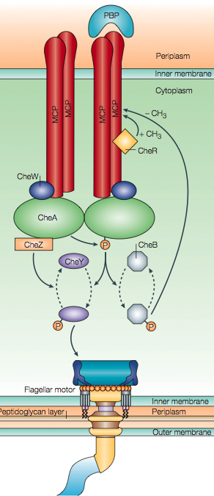
Figure 1 Schematic of the chemosensory system of Escherichia coli. Methyl-accepting chemotaxis proteins (MCPs) perceive environmental cues such as periplasmic binding proteins (PBPs) and modulate the activity of the histidine kinase CheA, which is associated to the chemoreceptors via the auxiliary protein CheW. CheA undergoes self-phosphorylation and transfers, via phosphotransfer, the phosphate group to the cognate response regulator CheY. Phosphorylated CheY then triggers a change in the direction of flagellar rotation from counterclockwise to clockwise. Phosphorylated CheA also phosphorylates the methyltransferase CheB, with phosphorylated CheB competing with the methyltransferase CheR to control the degree of methylation of the MCPs, thus, controlling their sensitivity and adaptation. The dephosphorylation of CheY is accelerated via the phosphotase CheZ. This figure was taken with permission from Wadhams and Armitage (2004).

monosaccharides during the exponential and stationary growth phases, respectively (Lerner et al., 2009). The production of surface polysaccharides has also been shown in Azospirillum spp. via growing colonies on media containing the fluorescent dye calcofluor white, which binds predominantly β-1,4- and β-1,3-linked glucans, polysaccharides of D-glucose monomers. Nonfluorescent mutant strains of A. brasilense and A. lipoferum, were incapable of anchoring to wheat roots, indicating the calcofluor-binding polysaccharide may be required for cell adherence to the root system (Burdman et al., 2000). The reserve material poly-β-hydroxybutyrate (PHB) has also been hypothesized to function in this fashion, although accruing evidence supports PHB and other poly-hydroxyalkanoates as important in the stress response of the bacteria (Kadouri et al., 2003; Lerner et al., 2009).
The anchoring-dependent production of exopolysaccharides in azospirilla has also been correlated with cell aggregation and flocculation, phenomena observed under nutritionally stressful conditions such as high C:N ratios (chiefly fructose:nitrate) and growth under high aeration. (Bible et al., 2008) Microscopic observations of the flocculation phenotype have revealed a dramatic shift in cell morphology, motile and vibrioid cells shedding their flagella and becoming nonmotile, highly refractile, and cyst-like flocs (Sadasivan and Neyra, 1985). Supporting this observation, Azospirillum brasilense has been shown to first clump then flocculate in response to an excess of aeration and a high C:N, with clumping characterized as a flagellar-based and transitory cell-to-cell adherence (Bible and Alexandre, unpublished results). Interestingly, clumping also appears to be required for flocculation; however, the capacity to clump does not necessarily lead to expression of the flocculation phenotype (Bible et al., 2008; Bible and Alexandre, unpublished). In A. brasilense, deletion mutations in genes of the Che₁ chemotaxis-like signal transduction pathway, the first of four supposed chemotaxis operons in the rhizobacterium, significantly affects clumping behavior and, thus, flocculation behavior, and this is consistent with studies implicating Che-like pathways in the modulation of cellular functions other than motility (Berleman et al., 2005; Hickman et al., 2005; Bible et al., 2008). Unlike the wild-type strain, Sp7, for example, ΔcheA₁ and ΔcheY₁, with deletions in the sensor histidine kinase and cognate response regulator, respectively, clumps earlier and flocculates quantitatively more under high C:N conditions and high aeration, as does ΔcheOp₁, which lacks the entire chemotaxis operon. The double-mutant ΔcheB₁R₁, lacking both a methylesterase and methyltransferase and, thus, perhaps being impaired in sensory adaptation, neither clumps nor flocculates. These atypical results suggest the Che₁ operon as a probable mediator in cell clumping and flocculation, and, thus, as a potential regulator of cell adherence (Bible et al., 2008).

RESEARCH OBJECTIVES

Although Azospirillum represents the best characterized genus of plant-growth promoting rhizobacteria, the precise mechanism of how azospirilla interacts with the root system remains unclear. Regarded as highly pleomorphic, Azospirillum spp. are highly motile, using either a single polar flagellum when grown in a liquid environments or peritrichous lateral flagella in viscous environments. Additionally, Azospirillum spp. are able to adhere onto a surface as a biological film or aggregate cell-to-cell as nonproliferating flocculi, and these two processes having been suggested as positively affecting the dispersal and survival of the bacteria in the soil. Even though both biofilm formation and flocculation have been characterized via the presence of bacterial extracellular polysaccharides, the nature of the observed exopolysaccharides is still obscure, as are the underlying molecular mechanisms facilitating their organization. Thus, this research was undertaken to further characterize both behavioral responses in Azospirillum brasilense, whose Che₁ operon has previously been shown to be involved in modulating such cellular differentiation processes. More specifically, this thesis sought to:
- Determine whether Che₁ modulated adherence of the bacteria to an abiotic surface, and, if so, could this be reproduced on the wheat root system.
- Genetically characterize the flocculation response using transposon mutagenesis.

METHODOLOGY

Bacterial strains and growth conditions
Seven distinctive strains of Azospirillum brasilense were characterized for the purpose of this research, and a map detailing the genetic organization of the Che₁ region and the location of the mutation is provided in Figure 2. Except where noted, all Azospirillum strains were routinely maintained on solid trypton-yeast (TY) medium (per liter: 10 g tryptone, 5 g yeast extract, and 15 g agar) with 100 mg ml⁻¹ ampicillin (Amp¹⁰⁰, to which the bacteria is naturally resistant) before use. For transposon mutagenesis, Escherichia coli strain EA145prL27 (Larsen et al., (2002), a gift from Alison Buchan, the University of Tennessee), a diamopimelic acid (DAP) auxotroph, was maintained on solid Luria-Bertani (LB) medium (per liter: 10 g tryptone, 5 g yeast extract, 10 g NaCl, and 15 g agar) with 50 mg ml⁻¹ kanamycin (Kan⁵⁰) and DAP. E. coli strain PIR1 was purchased from Invitrogen (Catalog No. C1010-10) and maintained on LB solid containing no antibiotics until the successful transformation of a transposon mutant, when it was then maintained on LB solid containing Kan⁵⁰.
Flocculation of all strains was performed as is described in Sadasivan and Neyra (1985); however, strains were first cultured to stationary phase in TY liquid medium then reinoculated in the described flocculation broth.

Wheat-root adherence assay
A. brasilense strains were cultured in TY liquid overnight (28°C, shaking) to stationary phase (1.0 – 1.8 A, O.D. _{600nm})
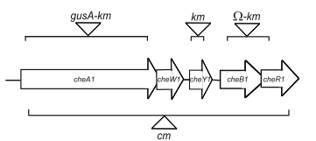
Figure 2 Organization of the Che₁ operon and its insertion mutations. Bars represent the regions deleted to create each mutant strain. Triangles represent the insertion of a gusA-kanamycin (Km) cassette within ΔcheA₁, a Km cassette within ΔcheY₁, an omegon-Km cassette within ΔcheB₁-R₁, and a chloramphenicol (Cm) cassette within ΔcheA₁-cheR₁. Mutant strains were previously constructed as detailed in Bible et al., (2008), from which, this figure was taken with permission.

and the overnight cultures were normalized to an optical density of 1.0 using a phosphate buffer (per liter: 1.7 g K₂HPO₄ and 1.36 g KH₂PO₄). Standardized cells were incubated on the benchtop for 1 hour and 200 μl of each strain was inoculated, in triplicate, into glass tubes containing 0.5 g of sterile, one-week-old wheat (Triticum aestivum) roots in 9.8 ml phosphate buffer. The inoculants were allowed to incubate for 2 hours with shaking at room temperature. Cells were washed three times with shaking in 5 ml of buffer and were then homogenized in 5 ml of fresh buffer using a mortar and pestle. Using 100 μl of the homogenized slurry, 10⁻⁶ serial dilutions were performed. 10 μl of each dilution was spot-inoculated in triplicate on a solid minimal media (MMAB) plates supplemented with carbon and lacking nitrogen as described earlier (Hauwaerts et al., 2002). Colony forming units (CFUs) were calculated after 5 days. Proteinase K digestions of standardized cells were 2 mg ml⁻¹ in final volume and were for 1 hour on the benchtop, 10 mg ml⁻¹ tetracycline (Tet¹⁰) also being incorporated to block further protein biosynthesis. Cells were then washed to remove enzyme and antibiotic and were resuspended in phosphate buffer. Two hundred μl of each digested strain was used to inoculate germinated wheat seeds as above. Cells were also treated with Tet¹⁰ alone as a control.

Biofilm assays
Azospirillum brasilense, strains were cultured in tryptone-yeast to stationary phase and standardized to an O.D_{600nm} of 1.0 A using phosphate Buffer. Cells were reinoculated into Corning 12-well plate polystyrene containers (Fisher, Catalog No. 3512) containing 3 ml TY liquid or MMAB (per liter: 3 g K₂HPO_{4,} 1 g NaH₂PO₄, 0.15 g KCl., trace amount Na₂MoO₄; after-autoclaving, 5 ml 60 g L⁻¹ MgSO₄²⁻, 500 μl 20 g L⁻¹ CaCl₂, and 250 μl FeSO₄ [per 50 ml, 0.631 g FeSO₄ and 0.592 EDTA)] liquid supplemented with nitrogen (1 mM or 10 mM NaNO₃ or 1mM NH₄Cl or 10 mM NH₄Cl or no nitrogen where decribed) and 5mM fructose and 5mM malic acid as carbon sources. Cells were inoculated for 1 and/or 7 days at 28°C, with shaking (110 rpm) on a rotary shaker were indicated. Following incubation, the O.D._{600nm} of each well was obtained and sterile water was used to remove loosely adhered cellular debris, subsequently adding crystal (gentian) violet to all wells used in the assay. The dye was allowed to incubate at room temperature for 30 minutes and the plates were then rinsed with sterile water to remove nonbinding dye. Seventy percent ethanol was added to each well and was allowed to solubilize for 1 hour with shaking as above. The O.D_{600nm} was measured, and the percent cell adherence was measured using the equation: [(O.D. of stained cells) ÷ (O.D. of well-culture)(O.D. of stained cells)(100)].

Transposon mutagenesis
Transposons were inserted into A. brasilense strain Sp7 (recipient strain) via bi-parental conjugation with E. coli strain EA145 carrying the suicide vector pRL27 (donor strain), essentially as described previously (Larsen et al., 2002; Vanstockem et al., 1987). Donor and recipient strains, which had been grown to mid-exponential phase (OD_{600nm} ≡ 0.6), were mixed and collected via filtration using a 0.45 μm analytical filter (Fisher, Catalog No.). The prL27 plasmid was conjugated into Sp7 by mixing cultures in a ratio of 1 (100 ml):3 (300 ml). The filter with which the cells had been collected was incubated overnight on TY agar medium at 28°C. After incubation, the cells were resuspended in MMAB liquid with antibiotics and 5 mM malic acid; nitrogen and DAP were omitted to select against the E. coli donor strain, which in addition to being a DAP auxotrophic, cannot fix atmospheric nitrogen.

Enrichment and screen for mutants
A schematic of the enrichment process is presented in Figure 3. Azospirillum brasilense mutants were isolated via screening for colonies that flocculated more or less than the wild-type strain, Sp7, and the presence of the transposon was confirmed in each mutant via PCR using the inwardly-directed and transposon-specific tpnRL 13-in and tpnRL 17-in primers (Larsen et al., 2002). A flocculation assay was performed to confirm the phenotype of each mutant using Sp7 as a control. EPS production of potential mutants was evaluated qualitatively by the ability of colonies to bind Congo red. Potential mutants were restreaked next to the wild-type strain on TY agar and MMAB agar to observe differences in colony morphology. Differences in motility were tested after inoculating standardized mutant cell cultures into TY semisolid medium (per liter: 10 g tryptone, 5 g yeast extract, and 3 g agar) and observing ring diameter after a 24 hour incubation at 28ºC. Congo red was added to TY agar and MMAB + 8mM Fructose + 0.5 mM NaNO₃ agar in a final volume of 40 mg ml⁻¹ to test for the presence of Congo red-binding surface sugars.

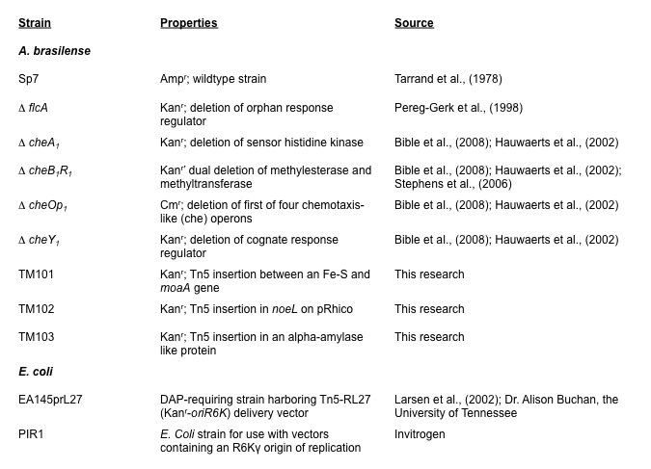
Table 1 Bacterial strains used in this study.
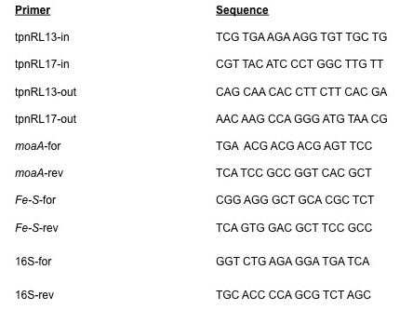
Table 2 Primers used in this study.

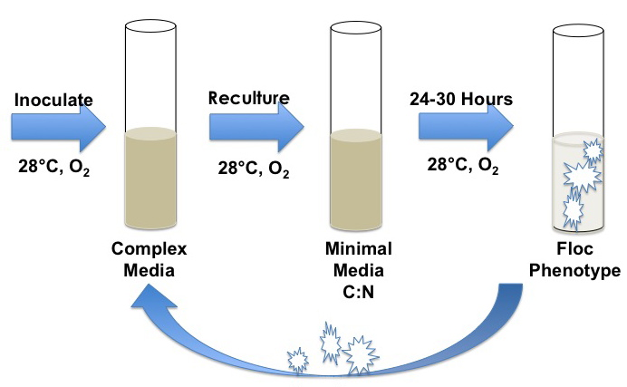
Figure 3 Enrichment of transposon mutants. Transformants were cultured to stationary phase in TY liquid and subsequently reinoculated in flocculation broth overnight. The resulting flocs and 100 μl of the supernatant were then reinoculated, respectively, in fresh TY, and the process was repeated.

Cloning and sequencing of transposon mutants
An arbitrary PCR protocol for sequencing of the DNA region flanking the transposon is described in O’Toole et al., (1999) and Larsen et al., (2002); however, this particular method of transposon-insertion site mapping failed to yield the end sequence of the transposon in our hand and had inconsistent results. Here, cloning of transposon insertions was accomplished via rescue cloning, taking advantage of the ori6K origin of replication in the transposon carried on the pRL27 vector, which allows transposed and flanking DNA to be propagated as a plasmid after transformation into E. coli strains expressing the pir protein. For this purpose, the transposed genomic DNA was digested with BamHI or EcoRI, which do not cut within the span of the transposon sequence. The digested DNA was then self-ligated using T4 DNA ligase and transformed into PIR1 cells.
Transposon junctions were identified on DNA sequences flanking the transposon and obtained from selected transformants after sequencing reactions using the outward directed and transposon-specific primers tnpnRL17-Out and tnp13-Out (Table 2), which anneal to the oriR6K and Km^{r} ends of the transposon sequence, respectively (Larsen et al, 2002). The ends of the transposon were identified in each sequence to identify the transposon-insertion site. DNA sequences flanking the transposon were then translated and compared to the protein sequence database (GenBank) using the Blast X algorithm (Altschul et al. 1990).

RESULTS

Azospirillum brasilense preferentially binds PVLC during stationary phase under low aeration
Upon inoculation, azospirilla adsorb onto the root system and proliferate on its surface. These bacteria are also able to flocculate; however, whether flocculation and wheat root adherence are similar processes and/or represent the manifestation of “biofilm”-forming abilities remains unclear. We, thus, strove to develop a well-plate assay to determine optimal biofilm formation in Azospirillum brasilense, The wild-type strain, Sp7, was selected to observe adherence on glass and polyvinyl chloride (PVLC) in a minimal medium supplemented with 5 mM fructose, 5 mM malic acid, and 18 mM NH₄Cl and a complex medium, respectively. As is seen in Figure 4, when initially cultured in TY to stationary phase, the wild-type strain formed more extensive biofilms within 24 hours on PVLC when subsequently reinoculated into wells containing minimal media, and this effect was most `pronounced when the plate was exposed to low, rather than high, aeration (p = 8.8 x 10⁻⁴). Conversely, adherence was significantly reduced (p = 0.001) when Sp7 was cultured in TY to exponential phase, then was subsequently reinoculated in MMAB with low aeration, suggesting a growth phase-bias of the bacteria in surface adherence (Figure 5). Interestingly, adherence was null on PVLC under both aeration conditions when cells were first cultured in MMAB then were subsequently transplanted into wells containing MMAB or TY (data not shown). Cells cultured in TY then reinoculated in TY-containing wells also failed to adhere under conditions of high and low aeration (data not shown).

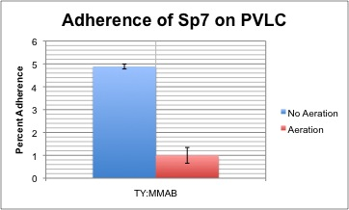
Figure 4 Effect of aeration on binding of Sp7 to PVLC. Cells were initially cultured in tryptone-yeast then reinoculated in a minimal media with or without shaking on a rotary shaker. Percent adherence to PVLC was measured after 24 hours.

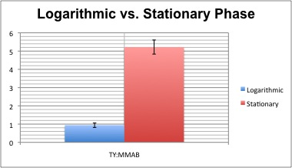
Figure 5 Adherence to PVLC is growth-conditions biased. Cells were first cultured in tryptone-yeast to logarithmic or stationary phase then reinoculated into minimal media without shaking. Percent adherence to PVLC was measured after 24 hours.

Adherence to glass was null under all conditions, although cultures left in MMAB for more than 72 hours without aeration did begin to develop marginal biofilms on glass slides (data not shown). Therefore, glass appears as an inadequate abiotic surface, failing to support adhesion of Azospirillum brasilense, regardless of the growth conditions.

Adherence to PVLC is nutrient-biased
Having concluded PVLC as a suitable surface for in vitro biofilm assays under low aeration, we next sought to determine additional growth conditions mediating surface adherence in Azospirillum brasilense. In Escherichia coli and other gram-negative microorganisms, an excess of available carbon substrate and limitations in other nutrients such as nitrogen, potassium, or phosphorous have been found to promote the synthesis of EPS and facilitate adhesion to abiotic surfaces (Sutherland, 2001). We, thus, tested the ability of Sp7 and the Che₁ mutants to adhere to PVLC when bathed in a minimal media supplemented with these macronutrients, and no changes in cell-surface adherence were observed when the concentrations of either phosphorous or potassium were reduced or increased, respectively (data not shown). Changes in nitrogen concentration and nitrogen source were shown to have a significant effect on surface adherence, however (Figure 6). Cells transplanted into wells containing MMAB with 1mM NH₄Cl or 1 mM NaNO₃ formed more biofilms on PVLC than did cells transplanted into wells containing 10 mM NH₄Cl or 10 mM NaNO₃, respectively, and adherence was most pronounced in sodium nitrate-containing media.
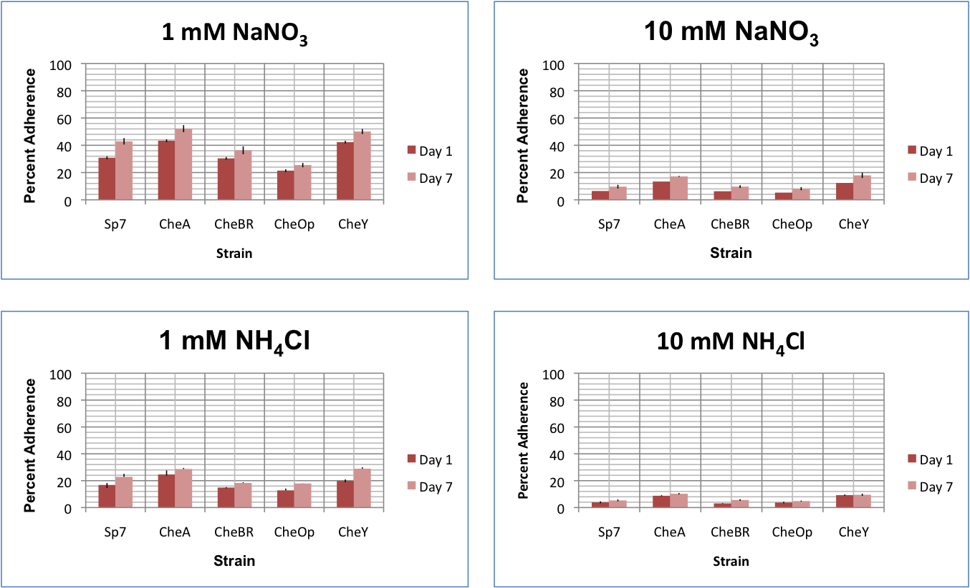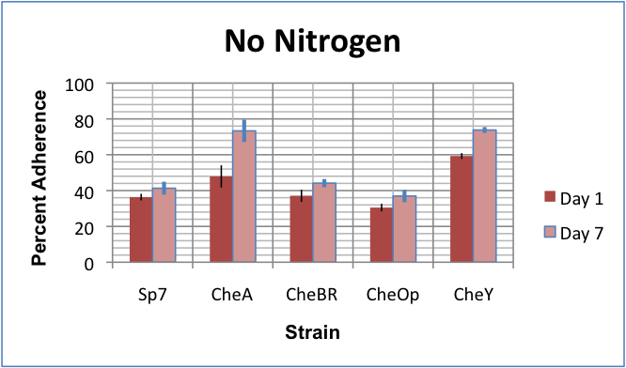
Figure 6 Nitrogen concentration and source influence surface adhesion. Sp7 and the Che₁ mutants where cultured in tryptone-yeast to stationary phase then were reinoculated into minimal media with or without nitrogen for 1 and 7 days without aeration. Percent adherence to PVLC after each incubation.

When observed with a standard bright-field microscope, cells in both 1mM NH₄Cl and 1 mM NaNO₃ appeared less motile than those cells in 10 mM NH₄Cl and 10 mM NaNO₃ and were smaller and more refractive. Observing the well plates, we noticed increased adherence near the air-liquid interface in these wells and adherence appeared to decline towards the bottom of the PVLC dish. Complete loss of nitrogen resulted in maximum adherence to PVLC, with ΔcheA₁ (p = 0.046) and ΔcheY₁ (p = 9.50 x 10⁻⁰⁵) adhering significantly more than the wild-type strain unlike ΔcheB₁R₁, and ΔcheOp₁ (Figure 6). Cells here were less motile than those seen in 10 mM and 1 mM nitrogen concentrations, but were not null in motility. Unlike above, adherence here was seen more in the bottom of the wells, with minimal crystal violet binding detected near the air-liquid interface.

ΔcheA₁ and ΔcheY₁ adhere more to the root system
Our in vitro assays indicated that certain Che₁ mutants, ΔcheA₁ and ΔcheY₁ adhered to PVLC more strongly than the wild-type strain under all tested conditions. We, therefore, next compared the ability of these strains to adhere to roots, and adapted a root system adherence assay, inoculating sterilized, two-week-old wheat seedlings with either wild-type A. brasilense (Sp7) or the Che₁ mutants in a no nitrogen medium based on our finding of maximum adherence under this condition (Figure 6). As seen in Figure 7, although Sp7 moderately adhered to the wheat roots, it did so significantly less than ΔcheA₁ (p = 7.8 x 10⁻⁴) and ΔcheY₁ (p = 0.011), consistent with results seen on PVLC earlier. Also consistent with these findings, adherence of both ΔcheB₁R₁ and ΔcheOp₁ was as was seen in the wild-type strain, suggesting that our assay seems to reflect the general ability of these strains to bind both biotic and abiotic surfaces. We also tested ΔflcA, which has been characterized as having a modified colonization pattern in its association with wheat roots (Katupitiya et al., 1995; Pereg-Gerk et al., 1998). Under the conditions used here, ΔflcA adhered as much as Sp7, suggesting that its increased colonization pattern, observed by others (Katupitiya et al., 1995; Pereg-Gerk et al., 1998) may not be caused by an increased ability to adhere to surfaces, including roots, under these conditions.
Extracellular proteins as well as EPS have been suggested as involved in the adherence of azospirilla to the root surface (Moens et al., 1995). In order to test whether surface adherence to the roots used here involved specific proteins, we treated Sp7 with Proteinase K to digest all surface-exposed proteins and incorporated tetracycline to block further protein biosynthesis. We also treated ΔcheA₁ and ΔcheY₁, for which we observed increased adherence to the root system. Under the conditions used, Proteinase K and tetracycline did not affect locomotion of A. brasilense Sp7 and caused no observable changes in cell morphology. Sp7-treated with Proteinase K was seen to be impaired in root adherence relative to the untreated Sp7 control (p = 0.019) , as were treated ΔcheA₁ (p = 0.003) and ΔcheY₁ (p = 0.04) when observed with their undigested controls (Figure 8). Attachment was still significant, however, suggesting that non-protein surface-associated factors also contribute to the root adherence under these conditions.

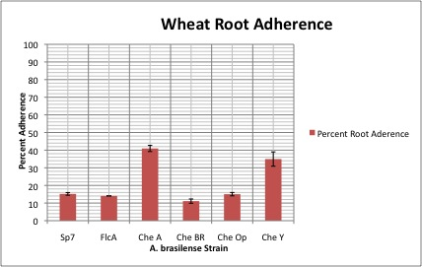
Figure 7 Azospirillum brasilense strains are affected in adherence to wheat. Azospirillum brasilense strains were inoculated into germinated wheat seedlings and allowed to incubate with shaking for 3 hours.

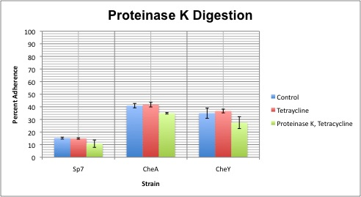
Figure 8 Extracellular proteins influence adherence to wheat roots. Strains were pretreated with 20 mg ml⁻¹ in the presence of tetracycline (10 mg ml⁻¹) to disrupt protein biosynthesis to determine whether surface proteins where involved in surface adherence. Strains were digested alone with tetracycline as a control.

Flocculation likely involves an iron-sulfur cluster and genome-wide genes involved in modification of surface-exposed polysaccharides
In this research, we sought to genetically characterize the flocculation phenotype, which has remained unclear save for the identification of a flocculation-null orphan response regulator, flcA. As a proof of concept, we identified and characterized three independent Azospirillum brasilense (strain Sp7) transposon-insertion mutants affected in flocculation ability, sequencing the site of transposition as well as the contiguous DNA
region (Figure 9). We identified: (1) TM101, with a mini-Tn5 insertion located in the intergenic space between a ferredoxin and moaA, a gene involved in manufacturing molybdopterin, a molybdenum cofactor; (2) TM102a and TM102b, two-independent clones found to possess a mini-Tn5 insertion in the GDP-mannose 4,6-dehydratase encoding noeL gene (1062 bp long) of the pRhico (p90) plasmid; and (3) TM103, whose transposon insertion is also located on the chromosome and is within an unnamed gene encoding for a homolog of an alpha-amylase like protein (3348 bp long). All mutant strains were impaired, but not null, in flocculation, flocculating less than the wild-type strain (Figure 10). TM101 was also impaired, but, unlike the other strains, this is likely due to the observed significant delay in initiating flocculation, which never reached a level comparable to that seen in the wild-type strain until circa 48 hours (Figure 10). Clumping ability was retained in all mutant strains, consistent with their ability to flocculate even though impaired, and, like the wild-type strain, clumping occurred in 9 to 12 hours post-inoculation (Figure 11). Therefore, the mutations identified contribute to flocculation per se and not to the timing of clumping, which was shown to affect flocculation and serve as its prerequisite (Bible et al, 2008; Bible and Alexandre, unpublished). In addition, all mutant strains retained the ability to fix atmospheric nitrogen (data not shown), consistent with our initial screen, which selected for A. brasilense transposon-insertion mutants and selected against auxotrophic E. coli in a liquid no nitrogen medium.
Interestingly, however, while the TM101 strain retained the ability to clump, it appeared to do so significantly less than the parent strain, most likely due to the severe reduction we observed in cellular motility (data not shown). Prior to sequencing, we, thus, expected characterization of this strain to lead to the identification of genes involved in locomotion such as a flagellin-encoding gene, which, if disrupted, could (hypothetically) impede clumping since the clumping phenotype relies on flagellar-based propulsion (Bible et al., 2008; Bible and Alexandre, unpublished). Surprisingly, however, the transposon was seen to lie between a ferredoxin and another iron-sulfur gene, moaA, with no known locomotion-involved genes immediately flanking the transposon. Even more, the transposon-insertion was seen to insert directly upstream of the moaA gene without disrupting its mRNA coding region or the coding region of the flanking ferredoxin, and this was unexpected as transposons generally inactivate a single gene or duplicate themselves and simultaneously interrupt multiple genes. We, thus, assumed the transposon disrupted not the moaA gene, but an unidentified promoter or some other regulatory region, and, in doing so, consequently knocked-down or knocked-out expression of the downstream gene. To assess this, we performed RT-PCR using mRNA-specific primers for moaA and the ferredoxin (as a control) and observed constitutive expression of moaA in TM101, but not the wild-type strain, when the bacteria were grown in TY to both logarithmic and stationary phase (Figure 12), but we were unable to isolate sufficient floc-RNA to monitor expression under this condition.
MoaA is a member of a protein superfamily, Radical SAM, and, via an unclear mechanism, aids in the formation of a pterin ring from GTP in molybdopterin biosynthesis (Sofia et al., 2001). Molybdopterin functions in a tungsten and molybdenum cofactor and is part of the active site of all tungsten- and molybdenum-dependent enzymes, although molybdenum-containing enzymes are better characterized (Kuper et al., 2004). With the exception of nitrogenase, which contains a unique iron-molybdenum cofactor un-interchangeable with other molybdoenzymes, molybdopterin has been seen with MoCo in xanthine dehydrogenase, sulfite oxidase, and DMSO and nitrate reductase (Johnson et al., 1990). Thus, molybdopterin functions with MoCo in a catalytic center, with a role in the global carbon, sulfur, and nitrogen cycles (Stiefel, 1996). Interestingly, and perhaps due to its role in a number of physiological processes, our mutant strain with irregular expression of moaA, was seen to produce a brown pigment reminiscent of melanin when cultures where allowed to age on MMAB plates containing a high C:N with ammonia as the nitrogen source, and this phenomenon was reproducible when plates were supplemented with EPS-binding Congo red, indicative of a change in surface-exposed sugars (Figure 13). No brown pigment was observed when the bacteria were allowed to age on high C:N MMAB with nitrate used as the nitrogen source, suggesting this phenotype is an ammonia-specific response. In addition, when spot-inoculated on a Congo red-containing minimal media supplemented with 8 mM fructose and 0.5 mM NO₃ (the composition of our flocculation medium), TM101 bound Congo red in a manner unseen in the wild-type, with binding mostly in the center of the colony (Figure 13). This observation is consistent with the discrepancies observed earlier in flocculation medium and indicates, at least, a difference in the ability of the strains to produce certain surface sugars.
Our second mutant strain, TM102 was seen to be disrupted in noeL (pRhico007), which encodes a GDP-mannose 4,6 dehyrdratase (GMD). This gene is located on the pRhico plasmid, which contains several genes involved in the biosynthesis of surface polysaccharides such EPS and lipopolysaccharides (LPS), as well as genes involved in chemotaxis, locomotion, and interactions with plant roots (Lerner et al., 2009; Vanbleu et al., 2004). GMD catalyzes the conversion of GDP-D-mannose to an intermediate product, GDP-L-fucose via another enzyme, GDP fucose synthetase, and we assumed that disruption of this gene reduced the flocculation potential of TM102 via making fucose unavailable, which could be required for robust flocculation in A. brasilense. We, thus, supplemented our flocculation broth with exogenous fucose and observed that 25 mM fucose could restore flocculation ability in the mutant strain, though to not as robust a level as seen in our untreated Sp7 control (Figure 10). As expected, we also observed a diminished ability of TM102 to bind Congo red on MMAB plates of floc composition, but the binding was not as diminished as seen in TM101, with Congo red failing to bind only at the edges (Figure 13). Also unlike TM101, cell motility was similar to wild-type (Figure 13).
TM103 was also seen to have a disruption in a protein-encoding gene (unnamed) involved in sugar metabolism which shares sequence homology with an alpha-amylase. Alpha-amylase is a glycoside hydrolase, catalyzing the hydrolysis of glycogen and starch into maltose, a disaccharide consisting of two glucose moieties, and other smaller and more soluble carbohydrates such as dextrins. Of our three transposon-containing strains, TM103 was seen to be the most impaired in flocculation, barely flocculating with a consistent increase in cell density. As above, we were successful in rescuing the flocculation response via the addition of exogenous maltose, suggesting flocculation was impaired due to the loss of this sugar intermediate involved in glycogen breakdown. Although we saw an increase in aggregating flocs, however, these flocs appeared smaller and more particulate-like than the normal boluses seen in Sp7 (Figure 10). Ironically, TM103 appeared to bind Congo red on MMAB plates of floc composition like the wild-type (Figure 13), suggesting that, while this screen is useful in determining modifications in certain surface-sugars, it is not a reliable measure of flocculation potential.

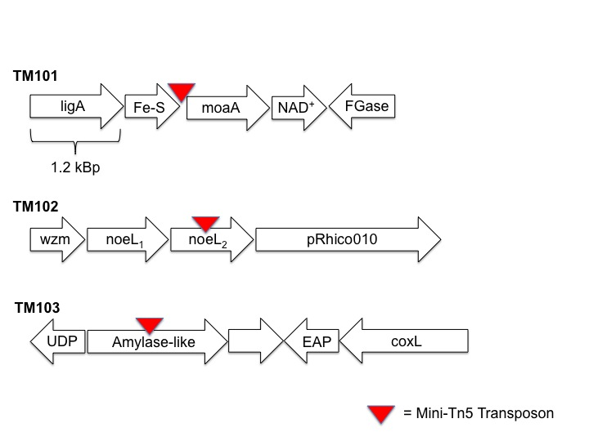
Figure 9 Insertion sites for Tn5-pRL27-induced flocculation mutants. We identified three A. brasilense (Sp7) transposon-insertion mutants affected in flocculation ability: TM101, with a mini-Tn5 insertion located in the intergenic space of an iron-sulfur cluster on the chromosome; TM102, with a mini-Tn5 insertion in the GDP-mannose 4,6-dehydratase encoding noeL gene (1062 bp) of the pRhico (p90) plasmid; and TM103, whose transposon insertion is also located on the chromosome and is in an unnamed gene encoding an alpha-amylase like protein (3348 bp).
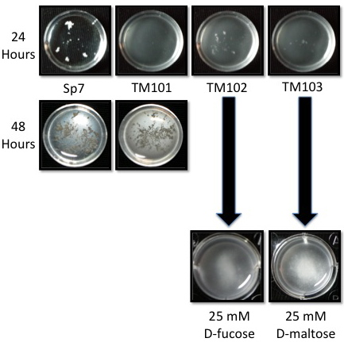
Figure 10 Transposon mutants are affected in flocculation. Unlike TM102 and 103, which are impaired in flocculation, TM101 is both delayed and impaired, flocculating well after the wild-type strain Sp7. The flocculation phenotype can be rescued in TM102 and TM103 via the addition of D-fucose and D-maltose, respectively.

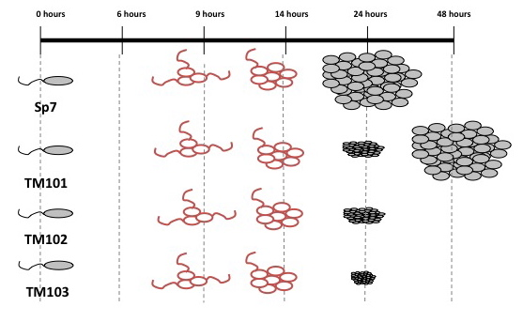
Figure 11 Transposon mutants differ, not in clumping, but in flocculation. Clumping is illustrated in red with flagella and flocculation, gray. In the wild-type strain, Sp7, clumping begins circa 9 hours and reaches a maximum near 14 hours. Flocculation, which is an unflagellated process in Sp7, begins circa 24 hours.

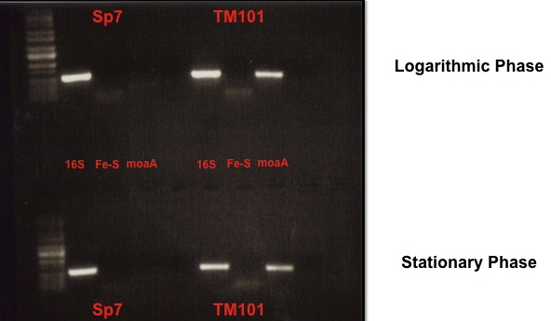
Figure 12 Expression of moaA in TY medium. RT-PCR was performed on Sp7 and TM101 RNA using mRNA-specific primers for moaA and the contiguous ferredoxin (Fe-S) immediately upstream. The extraction of RNA was described as in Methodology.
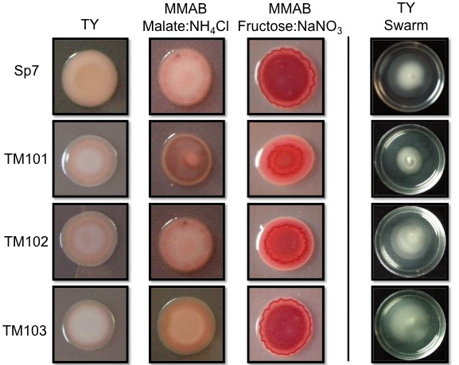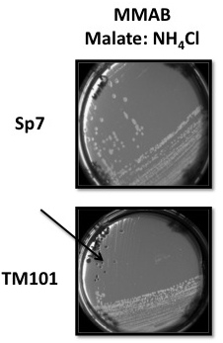
Figure 13 Phenotypic analyses of transposon mutants. (Left) Transposon mutants bind Congo red with dissimilar affinities and show differences in cellular motility in swarm plates. (Right) TM101 produces a brown pigment unseen in the parent strain Sp7 when on a minimal medium containing a high C:N with ammonium chloride as the nitrogen source.

DISCUSSION

This thesis strove to characterize two phenomena in the rhizobacterium Azospirillum brasilense: biofilm formation, a form of cell-to-surface adherence, and flocculation, a cell-to-cell interaction and supposed stress response in the microaerophilic soil diazotroph. Although both of these processes have been shown to involve the organization of extracellular bacterial polysaccharides, the nature of the observed exopolysaccharides is still obscure, as are the underlying molecular mechanisms facilitating their organization. Even more, biofilms in azospirilla have gone relatively unexplored, though research on the role of glycogen phosphorylase in stress endurance and biofilm formation has recently emerged (Lerner et al., 2009). This research, however, has, perhaps, shed light on both processes, observing previously unreported physicochemical parameters that mediate surface adherence in Azospirillum brasilense, as well as a subset of genes involved in its flocculation behavioral response.

Surface-adherence in Azospirillum brasilense is a multi-factorial process
To gain insight into biofilm organization in Azospirillum brasilense, we first sought to develop an abiotic model for surface adherence, testing whether it could serve as a proxy for root surface attachment, and we have identified polyvinyl chloride (PVLC) as a suitable abiotic surface for Azospirillum. In a number of studies, hydrophobic plastics such as PVLC, Teflon, and polystyrene have been seen to more rapidly facilitate the irreversible adherence of microorganisms to their surface than hydrophilic materials such as glass and certain metals (Donlan, 2001). In addition, PVLC is also rough and is rugose, and both roughness and rugosity have been observed to affect the adherence of bacterial cells to a surface via diminishing repulsive forces and increasing surface area (Goller and Romeo, 2008). Even more, azospirilla themselves are moderately hydrophobic, as seen in hydrophobic studies of Azospirillum cell walls, and an increase in cell surface hydrophobicity during growth has been correlated with an increase in cell adhesiveness to other hydrophobic surfaces (Bashin and Holguin, 1997). This finding supports not only our observation of increased surface adherence to hydrophobic PVLC rather than hydrophilic glass, but also our observation of increased surface adherence to polyvinyl chloride when cells were first cultured to stationary phase in TY, where cell growth is more robust and hydrophobicity is perhaps greater.
Alternatively, the preference of our TY-cultured cells to adhere to PVLC submerged in minimal media could also indicate a stress response not seen in other patterns of inoculation, with a transition from a rich to nutritionally limiting environment contributing to cause physiological changes that promote a switch from a planktonic to sessile mode of life. A priori, this observation suggests biofilm formation in Azospirillum brasilense as a probable survival mechanism in nutrient scarce conditions, with surface colonization providing a number of advantages such as the increased capture of nutrients, and, indeed, this trend is manifest in other gram-negative microorganisms. In Pseudomonas fluorescens, for example, irreversible adherence to quartz sand has been reported to increase when the bacteria are first cultured in LB then are thereafter reinoculated (Hinsa et al., 2003). Increased biofilm formation in Sinorhizobium meliloti has also been observed in response to inoculation in a standing minimal media, and both Escherichia coli O517:H7 and Myxococcus xanthus have been seen to adhere to a surface only in nutrient scarce conditions (O’Toole et al., 2000; Rinaudi et al., 2006).
Although the ratio of carbon (C), phosphorous (P), and potassium (K) have been indicated to influence bacterial adherence in species such as Bradyrhizobium japonicum and Sinorhizobium meliloti, we were unable to detect an influence of phosphorous or potassium on adherence of Azospirillum brasilense to PVLC when their concentrations were altered in minimal media. In contrast, a high C:N was observed to encourage proper biofilm formation, with surface adherence more pronounced in media supplemented with nitrate rather than ammonium and adhesion maximum in media containing no nitrogen. While this trend is manifest in certain clinically significant microorganisms such as Enterobacter cloacae and Citrobacter freundii, it has gone relatively unreported in the Alphaproteobacteria (Thompson et al., 2005). Pseudomonas fluorescens, for example, will adhere to a surface in minimal media supplemented with high concentration nitrogen, but will begin to detach as the nitrogen concentration is decreased (Delaquis et al., 1989). Even in the oligotrophic Alphaproteobacterium Caulobacter crescentus, the switch from a free-living to sessile modality, referred to as the sessile-stalked to flagellated-swarmer transition, is blocked via nitrogen (Levi and Jenal, 2006). Thus, along with the above, our research perhaps indicates a metabolic resourcefulness in Azospirillum brasilense, allowing adaptation in microaerophilic and low-nitrogen conditions reminiscent of the soil. Maximum adherence in no nitrogen media is perhaps indicative of nitrogen fixation, where atmospheric dinitrogen (N₂) is converted into a source of cell nitrogen such as ammonia. Energy is required to fix N₂ into ammonia and other reactive forms (Gutschick, 1978), and, a priori, adherence of A. brasilense to a surface makes available the energy used in flagellar-based locomotion for nitrogen fixation. In the same vein, nitrate is the unpreferred source of nitrogen for azospirilla and other bacteria such as Escherichia coli and must be assimilated to ammonia in a process dependent on ATP (Postgate, 1998; Reitzer et al., 2003). The observed increased in adherence of A. brasilense to PVLC in NaNO₃- rather than NH₄Cl-supplemented media is, perhaps, a behavioral (or stress) response allowing the assimilation of cellular nitrogen as ammonia without the expenditure of locomotive power.
Concomitant with our observation of increased surface adherence in low-nitrogen media, we noticed a preponderance of ΔcheA₁ and ΔcheY₁ adhesion in all media categories with respect to the wild-type strain, Sp7, and this observation was reproducible on the root system. These observations were unexpected since, deductively, both ΔcheA₁ and ΔcheY₁ would be expected to adhere in a manner similar to ΔcheOp₁, which, in and of itself, lacks cheA₁ and cheY₁ in addition to the adaptation genes cheB₁ and cheR_{1,} but bound all substrates like the wild-type under all conditions. We obtained similarly perplexing results when studying chemotaxis in these strains as described earlier in Bible et al., (2008), with ΔcheA₁ and ΔcheY₁ showing defects in chemotaxis and ΔcheOp₁ displaying a minor (if any) defect in chemotaxis. Currently, we are unable to afford an explanation for these trends; however, such is the focus of ongoing research in our laboratory.

Flocculation likely involves an iron-sulfur cluster and genome-wide genes involved in modification of surface-exposed polysaccharides
In this research, we characterized three Azospirillum brasilense (strain Sp7) transposon-insertion mutants affected in flocculation ability: (1) TM101, with a mini-Tn5 insertion located in the intergenic space of an iron-sulfur cluster on the chromosome; (2) TM102a and TM102b, with a mini-Tn5 insertion in the GDP-mannose 4,6-dehydratase encoding noeL gene of the pRhico (p90) plasmid; and (3) TM103, whose transposon insertion is also located on the chromosome and is in an unnamed gene encoding an alpha-amylase like protein. All strains were impaired, but not null, in flocculation and were capable of nitrogen fixation, and cellular clumping was as seen in the wild-type strain, with the exception of TM101, which showed a severe decrease in cell locomotion.
Above, we attributed the peculiarities in flocculation potential and colony morphology of TM101 to irregular expression of the moaA gene since the transposon was seen to insert upstream of its mRNA coding sequence without disruption of the gene proper. Although we have seen evidence of constitutive expression of the molybdopterin-biosynthesis gene in TY in this strain, we cannot, with certainty, however, describe expression as constitutive until gene expression has been monitored in minimal media such as flocculation broth. In addition, an uncharacterized promoter shown to be active under undefined conditions on the Tn5 transposon has been shown to have nonpolar effects on distal genes in both Escherichia coli and Sinorhizobium meliloti (Berg et al., 1980; Davies and Walker, 2006) and is perhaps able to influence expression in TM101, resulting in the observed phenotypes. To the best of our knowledge, moaA has no known role in cell locomotion, flocculation, or brown pigment formation; however, the full spectrum of this gene’s activities remains unclear. In Azospirillum brasilense ATCC 291145, brown pigment formation was also seen in aging cultures under conditions conducive for encystment such as prolonged flocculation conditions (Sasasivan and Neyra, 1987). Under these conditions, 291145 was seen to enter a vegetative state and lose its motility, assuming a spherical form and accumulating large granules of the reserve material PHB and producing a melanin-like pigment similar to that seen in TM101. Thus far, pigmentation in azospirilla has been primarily related, albeit indirectly, to the synthesis of carotenoids, which have been shown to protect the nitrogenase enzyme of A. brasilense and other strains from oxidative stress (Eskew et al., 1977; Nur et al., 1981). This seems unlikely in our strain, however, since TM101 accumulates this pigment only on MMAB plates containing ammonia and not plates containing nitrate or no nitrogen.
Our second transposon mutation was seen to occur in a gene located on pRhico, the 90 MDa plasmid in Azospirillum brasilense which has been unable to be cured from Sp7, indicating the relative importance of the p90 plasmid in cell viability and survival (Vanbleu et al., 2004). TM102 is disrupted in noeL (pRhico007), which encodes a GDP-mannose 4,6 dehyrdratase (GMD) and serves in a three-step reaction converting GDP-(D)-mannose to GDP-(L)-fucose. Fucose is found is complex bacterial carbohydrates and has been reported to be involved in the oligosaccharide fraction of both LPS (Vanbleu et al., 2005). Lerner et al., (2009) have previously constructed a noeL mutant in Azospirillum brasilense via an insertional knockout, observing both reduced biofilm formation and impaired LPS synthesis. Paradoxically, while an increased accumulation of cellular mannose was observed in the EPS of the knockout strain with respect to the wild-type, Sp7, the levels of fucose were also higher, and is attributed to decreased levels of galactose and glucose, which can be converted into fucose, perhaps circumventing the cellular requirement for GDP-4-keto-6-deoxy-D-mannose. Unlike Lerner et al., (2009), however, our mutation lies in a second noeL gene, which is immediately downstream of the first gene sequence with which it shares a 65% sequence similarity. Disruption of this gene was seen to impair flocculation, not null, in our strain, and the addition of exogenous fucose was able to restore this phenotype, though not to as robust as manner as seen in Sp7. The presence of an additional noeL gene on the pRhico plasmid in addition to another noeL gene sequence on the chromosome, perhaps, blocks a full flocculation-null behavior. Even more, although both mannose and fucose have been detected in Sp7 exopolysaccharides, mannose is often one of the main sugars, with smaller traces of fucose being identified (Burdman et al., 2000; Lerner et al., 2009). Thus, TM102 most likely remains flocculation-able because mannose remains viable for EPS organization, while fucose is either unavailable for use or is less available than that seen in the wild-type strain. A priori, a noeJ, noeL double-mutant would show a flocculation-null phenotype, since noeJ, also located on the pRhico plasmid, is involved in fructose-to-mannose interconversion via mannose-6-phosphate isomerase (also named phosphomannose isomerase).
Our last transposon-insertion strain, TM103, was also disrupted in a gene involved in sugar metabolism and encoded an alpha-amylase like protein, which catabolizes glycogen and starch into D-maltose. In Azospirillum, however, strains use dicarboxylic acids as carbon sources in preference to carbohydrates and are unable to degrade starch (Holguin et al., 1997), suggesting that the function of an amylase-like protein in our bacteria would be to act on glycogen or some other polymer of similar structure and function. Supporting this hypothesis, we were able to rescue the flocculation phenotype via adding exogenous D-maltose to the flocculation medium, suggesting that flocculation was impaired due to the loss of this sugar intermediate resulting from the breakdown of an unknown polysaccharide breakdown, possibly glycogen. In addition, other studies have noted the accumulation of glycogen in A. brasilense cyst-like and the involvement of glycogen phosphorylase, catalyzing the rate-limiting step involved in glycogen breakdown, in biofilm formation (Lerner et al., 2009), both of which implies the organization of EPS, albeit indirectly. Still, while we cannot definitively claim that glycogen breakdown is involved in flocculation until more work is done on this strain (e.g., observing the effects of other sugars, RT-PCR, etc.), our observations here indicate that this putative alpha-amylase may be a key player in the organization of EPS in Azospirillum brasilense.

REFERENCES

Alexandre, G., & Zhulin, I. B. (2007). Chemotaxis in Soil Diazotrophs: Survival and Adaptative Response. In C. Elmerich & W. E. Newton (Eds.), Associative and Endophytic Nitrogen-fixing Bacteria (Vol. 5, pp. 73-84): Springer Netherlands.
Altschul, S. F., Gish, W., Miller, W., Myers, E. W., & Lipman, D. J. (1990). Basic Local Alignment Search Tool. Journal of Molecular Biology, 215(3), 403-410.
Anderl, J. N., Zahller, J., Roe, F., & Stewart, P. S. (2003). Role of nutrient limitation and stationary-phase existence in Klebsiella pneumoniae biofilm resistance to ampicillin and ciprofloxacin. Antimicrobial Agents and Chemotherapy, 47(4), 1251-1256.
Bashan, Y., & Holguin, G. (1993). Anchoring of Azospirillum-Brasilense to Hydrophobic Polystyrene and Wheat Roots. Journal of General Microbiology, 139, 379-385.
Bashan, Y., Holguin, G., & de-Bashan, L. E. (2004). Azospirillum-plant relationships: physiological, molecular, agricultural, and environmental advances (1997-2003). Can J Microbiol, 50(8), 521-577.
Berg, H. C. (1996). Symmetries in bacterial motility. Proceedings of the National Academy of Sciences of the United States of America, 93(25), 14225-14228.
Bible, A. N., Stephens, B. B., Ortega, D. R., Xie, Z., & Alexandre, G. (2008). Function of a chemotaxis-like signal transduction pathway in modulating motility, cell clumping, and cell length in the alphaproteobacterium Azospirillum brasilense. J Bacteriol, 190(19), 6365-6375.
Budrene, E. O., & Berg, H. C. (1995). Dynamics of Formation of Symmetrical Patterns by Chemotactic Bacteria. Nature, 376(6535), 49-53.
Burdman, S., Jurkevitch, E., Schwartsburd, B., Hampel, M., & Okon, Y. (1998). Aggregation in Azospirillum brasilense: effects of chemical and physical factors and involvement of extracellular components. Microbiology, 144 ( Pt 7), 1989-1999.
Burdman, S., Jurkevitch, E., Schwartsburd, B., & Okon, Y. (1999). Involvement of outer-membrane proteins in the aggregation of Azospirillum brasilense. Microbiology, 145 ( Pt 5), 1145-1152.
Burdman, S., Jurkevitch, E., Soria-Diaz, M. E., Serrano, A. M., & Okon, Y. (2000). Extracellular polysaccharide composition of Azospirillum brasilense and its relation with cell aggregation. FEMS Microbiol Lett, 189(2), 259-264.
Dahlquist, F. W. (2002). Amplification of signaling events in bacteria. Sci STKE, 2002(132), pe24.
Delaquis, P. J., Caldwell, D. E., Lawrence, J. R., & Mccurdy, A. R. (1989). Detachment of Pseudomonas-Fluorescens from Biofilms on Glass Surfaces in Response to Nutrient Stress. Microbial Ecology, 18(3), 199-210.
Donlan, R. M. (2002). Biofilms: microbial life on surfaces. Emerg Infect Dis, 8(9), 881-890.
Eisenbach, M. (2005). Bacterial Chemotaxis. Antimicrobial Agents: Basis of Action to Bacterial Transcription Regulation, 0002, 506-519.
Eskew, D. L., Focht, D. D., & Ting, I. P. (1977). Nitrogen fixation, denitrification, and pleomorphic growth in a highly pigmented Spirillum lipoferum. Appl Environ Microbiol, 34(5), 582-585.
Fenchel, T. (2002). Microbial behavior in a heterogeneous world. Science, 296(5570), 1068-1071.
Fujishige, N. A., Kapadia, N. N., De Hoff, P. L., & Hirsch, A. M. (2006). Investigations of Rhizobium biofilm formation. Fems Microbiology Ecology, 56(2), 195-206.
Goller, C. C., & Romeo, T. (2008). Environmental influences on biofilm development. Curr Top Microbiol Immunol, 322, 37-66.
Gutschick, V. P. (1978). Energy and nitrogen fixation. Bioscience, 28(9), 571-575.
Harshey, R. M. (2003). Bacterial motility on a surface: many ways to a common goal. Annu Rev Microbiol, 57, 249-273.
Hauwaerts, D., Alexandre, G., Das, S. K., Vanderleyden, J., & Zhulin, I. B. (2002). A major chemotaxis gene cluster in Azospirillum brasilense and relationships between chemotaxis operons in alpha-proteobacteria. FEMS Microbiol Lett, 208(1), 61-67.
Hickman, J. W., Tifrea, D. F., & Harwood, C. S. (2005). A chemosensory system that regulates biofilm formation through modulation of cyclic diguanylate levels. Proceedings of the National Academy of Sciences of the United States of America, 102(40), 14422-14427.
Hinsa, S. M., Espinosa-Urgel, M., Ramos, J. L., & O'Toole, G. A. (2003). Transition from reversible to irreversible attachment during biofilm formation by Pseudomonas fluorescens WCS365 requires an ABC transporter and a large secreted protein. Molecular Microbiology, 49(4), 905-918.
Holguin, G., Patten, C. L., & Glick, B. R. (1999). Genetics and molecular biology of Azospirillum Biology and Fertility of Soils, 29, 10-23.
Johnson, J. L., Bastian, N. R., & Rajagopalan, K. V. (1990). Molybdopterin guanine dinucleotide: a modified form of molybdopterin identified in the molybdenum cofactor of dimethyl sulfoxide reductase from Rhodobacter sphaeroides forma specialis denitrificans. Proc Natl Acad Sci U S A, 87(8), 3190-3194.
Kadouri, D., Jurkevitch, E., & Okon, Y. (2003). Involvement of the reserve material poly-beta-hydroxybutyrate in Azospirillum brasilense stress endurance and root colonization. Appl Environ Microbiol, 69(6), 3244-3250.
Kapulnik, Y., Okon, Y., & Henis, Y. (1985). Changes in Root Morphology of Wheat Caused by Azospirillum Inoculation. Canadian Journal of Microbiology, 31(10), 881-887.
Katupitiya, S., Millet, J., Vesk, M., Viccars, L., Zeman, A., Lidong, Z., et al. (1995). A mutant of Azospirillum brasilense Sp7 impaired in flocculation with a modified colonization pattern and superior nitrogen fixation in association with wheat. Appl Environ Microbiol, 61(5), 1987-1995.
Kuper, J., Llamas, A., Hecht, H. J., Mendel, R. R., & Schwarz, G. (2004). Structure of the molybdopterin-bound Cnx1G domain links molybdenum and copper metabolism. Nature, 430(7001), 803-806.
Larsen, R. A., Wilson, M. M., Guss, A. M., & Metcalf, W. W. (2002). Genetic analysis of pigment biosynthesis in Xanthobacter autotrophicus Py2 using a new, highly efficient transposon mutagenesis system that is functional in a wide variety of bacteria. Arch Microbiol, 178(3), 193-201.
Lemon, K. P., Earl, A. M., Vlamakis, H. C., Aguilar, C., & Kolter, R. (2008). Biofilm development with an emphasis on Bacillus subtilis. Curr Top Microbiol Immunol, 322, 1-16.
Lerner, A., Castro-Sowinski, S., Lerner, H., Okon, Y., & Burdman, S. (2009). Glycogen phosphorylase is involved in stress endurance and biofilm formation in Azospirillum brasilense Sp7. Fems Microbiology Letters, 300(1), 75-82.
Lerner, A., Castro-Sowinski, S., Valverde, A., Lerner, H., Dror, R., Okon, Y., et al. (2009). The Azospirillum brasilense Sp7 noeJ and noeL genes are involved in extracellular polysaccharide biosynthesis. Microbiology-Sgm, 155, 4058-4068.
Lerner, A., Okon, Y., & Burdman, S. (2009). The wzm gene located on the pRhico plasmid of Azospirillum brasilense Sp7 is involved in lipopolysaccharide synthesis. Microbiology, 155(Pt 3), 791-804.
Levi, A., & Jenal, U. (2006). Holdfast formation in motile swarmer cells optimizes surface attachment during Caulobacter crescentus development. Journal of Bacteriology, 188(14), 5315-5318.
Lin, W., Okon, Y., & Hardy, R. W. (1983). Enhanced Mineral Uptake by Zea mays and Sorghum bicolor Roots Inoculated with Azospirillum brasilense. Appl Environ Microbiol, 45(6), 1775-1779.
Michiels, K., Vanderleyden, J., & Vangool, A. (1989). Azospirillum - Plant-Root Associations - a Review. Biology and Fertility of Soils, 8(4), 356-368.
Miller, L. D., Yost, C. K., Hynes, M. F., & Alexandre, G. (2007). The major chemotaxis gene cluster of Rhizobium leguminosarum bv. viciae is essential for competitive nodulation. Molecular Microbiology, 63(2), 348-362.
Moens, S., Michiels, K., & Vanderleyden, J. (1995). Glycosylation of the flagellin of the polar flagellum of Azospirillum brasilense, a Gram-negative nitrogen-fixing bacterium
. Microbiology, 141, 2651-2657.
Mora, P., Rosconi, F., Franco Fraguas, L., & Castro-Sowinski, S. (2008). Azospirillum brasilense Sp7 produces an outer-membrane lectin that specifically binds to surface-exposed extracellular polysaccharide produced by the bacterium. Arch Microbiol, 189(5), 519-524.
Nur, I., Steinitz, Y., Okon, Y., & Henis, Y. (1981). Carotenoid composition and function in nitrogen-fixing bacteria of the genus Azospirillum. Journal of General Microbiology, 122, 27-32.
O'Toole, G., Kaplan, H. B., & Kolter, R. (2000). Biofilm formation as microbial development. Annual Review of Microbiology, 54, 49-79.
O'Toole, G. A., Pratt, L. A., Watnick, P. I., Newman, D. K., Weaver, V. B., & Kolter, R. (1999). Genetic approaches to study of biofilms. Biofilms, 310, 91-109.
Okon, Y., & Kapulnik, Y. (1986). Development and Function of Azospirillum-Inoculated Roots. Plant and Soil, 90(1-3), 3-16.
Pace, J. L., Rupp, M., & Finch, R. G. (2005). Biofilms, infection, and antimicrobial therapy. Boca Raton: Taylor & Francis.
Palmer, R. J., Jr., & White, D. C. (1997). Developmental biology of biofilms: implications for treatment and control. Trends Microbiol, 5(11), 435-440.
Pereg-Gerk, L., Paquelin, A., Gounon, P., Kennedy, I. R., & Elmerich, C. (1998). A transcriptional regulator of the LuxR-UhpA family, FlcA, controls flocculation and wheat root surface colonization by Azospirillum brasilense Sp7. Mol Plant Microbe Interact, 11(3), 177-187.
Postgate, J. R. (1998). Nitrogen fixation: Cambridge, U.K. ; New York, NY, USA : Cambridge University Press.
Reitzer, L. (2003). Nitrogen assimilation and global regulation in Escherichia coli. Annu Rev Microbiol, 57, 155-176.
Rinaudi, L., Fujishige, N. A., Hirsch, A. M., Banchio, E., Zorreguieta, A., & Giordano, W. (2006). Effects of nutritional and environmental conditions on Sinorhizobium meliloti biofilm formation. Research in Microbiology, 157(9), 867-875.
Sadasivan, L., & Neyra, C. A. (1985). Flocculation in Azospirillum brasilense and Azospirillum lipoferum: exopolysaccharides and cyst formation. J Bacteriol, 163(2), 716-723.
Sadasivan, L., & Neyra, C. A. (1987). Cyst production and brown pigment formation in aging cultures of Azospirillum brasilense ATCC 29145. J Bacteriol, 169(4), 1670-1677.
Sofia, H. J., Chen, G., Hetzler, B. G., Reyes-Spindola, J. F., & Miller, N. E. (2001). Radical SAM, a novel protein superfamily linking unresolved steps in familiar biosynthetic pathways with radical mechanisms: functional characterization using new analysis and information visualization methods. Nucleic Acids Res, 29(5), 1097-1106.
Steenhoudt, O., & Vanderleyden, J. (2000). Azospirillum, a free-living nitrogen-fixing bacterium closely associated with grasses: genetic, biochemical and ecological aspects. FEMS Microbiol Rev, 24(4), 487-506.
Stephens, B. B., Loar, S. N., & Alexandre, G. (2006). Role of CheB and CheR in the complex chemotactic and aerotactic pathway of Azospirillum brasilense. J Bacteriol, 188(13), 4759-4768.
Stiefel, E. I. (1996). Molybdenum bolsters the bioinorganic brigade. Science, 272(5268), 1599-1600.
Stock, J. B., Levit, M. N., & Wolanin, P. M. (2002). Information processing in bacterial chemotaxis. Sci STKE, 2002(132), PE25.
Sutherland, I. (2001). Biofilm exopolysaccharides: a strong and sticky framework. Microbiology, 147(Pt 1), 3-9.
Tarrand, J. J., Krieg, N. R., & Dobereiner, J. (1978). Taxonomic Study of Spirillum-Lipoferum Group, with Descriptions of Anew Genus, Azospirillum Gen-Nov and 2 Species, Azospirillum-Lipoferum (Beijerinck) Comb Nov and Azospirillum-Brasilense Sp-Nov. Canadian Journal of Microbiology, 24(8), 967-980.
Thompson, L. J., Gray, V., Lindsay, D., & von Holy, A. (2006). Carbon : nitrogen : phosphorus ratios influence biofilm formation by Enterobacter cloacae and Citrobacter freundii. J Appl Microbiol, 101(5), 1105-1113.
Tripathy, P. P., & Ayyappan, S. (2005). Evaluation of Azotobacter and Azospirillum as biofertilizers in aquaculture. World Journal of Microbiology & Biotechnology, 21(8-9), 1339-1343.
Vanbleu, E., Marchal, K., Lambrecht, M., Mathys, J., & Vanderleyden, J. (2004). Annotation of the pRhico plasmid of Azospirillum brasilense reveals its role in determining the outer surface composition. Fems Microbiology Letters, 232(2), 165-172.
Vande Broek, A., Lambrecht, M., & Vanderleyden, J. (1998). Bacterial chemotactic motility is important for the initiation of wheat root colonization by Azospirillum brasilense. Microbiology-Sgm, 144, 2599-2606.
Vanstockem, M., Michiels, K., Vanderleyden, J., & Vangool, A. P. (1987). Transposon Mutagenesis of Azospirillum-Brasilense and Azospirillum-Lipoferum - Physical Analysis of Tn5 and Tn5-Mob Insertion Mutants. Applied and Environmental Microbiology, 53(2), 410-415.
Verstrepen, K. J., & Klis, F. M. (2006). Flocculation, adhesion and biofilm formation in yeasts. Mol Microbiol, 60(1), 5-15.
Wadhams, G. H., & Armitage, J. P. (2004). Making sense of it all: Bacterial chemotaxis. Nature Reviews Molecular Cell Biology, 5(12), 1024-1037.
Wasim, M., Bible, A. N., Xie, Z., & Alexandre, G. (2009). Alkyl hydroperoxide reductase has a role in oxidative stress resistance and in modulating changes in cell-surface properties in Azospirillum brasilense Sp245. Microbiology, 155(Pt 4), 1192-1202.

VITA

Calvin Green is from Memphis, Tennessee and is currently a first-year (OMS-I) medical student at Lincoln Memorial University. This vita is required – seriously.

