Influence of Tethered, Axially Coordinated Ligands on Rh(II,II)-Catalyzed Carbene Transfer Reactions

A Dissertation Presented for the
Doctor of Philosophy
Degree
The University of Tennessee, Knoxville

Cristian E. Zavala
May 2022

Copyright © 2022 by Cristian E. Zavala
All rights reserved.

ACKNOWLEDGEMENTS

ABSTRACT
Dirhodium (II,II) paddlewheel complexes have become ubiquitous in diazo-mediated carbene transfer reactions. The Rh(II,II)-carbene intermediate is capable of a large variety of transformations such as cyclopropanation, C-H and X-H (O, N, S, Si, B) insertion reactions, cyclopropenations, and ylide transformations. Cyclopropanation reactions resulting in the formation of functionalized cyclopropane structures has always been a major focus in Rh(II,II)-carbene chemistry. Improvements on catalytic performance in cyclopropanations has largely focused on the modification of the bridging ligands and has resulted in Rh(II,II) catalysts that exhibit high reactivity and selectivity in cyclopropanation reactions. However, high enantio- and diastereoselectivity is not easily achieved with all carbene types and other control elements on the catalyst, such as axial coordination, can possibly remedy this issue. Although there are some examples of axially coordinated Lewis Base additives affecting stereoselectivity, elucidation of the role the axial ligand plays in the reaction is still ambiguous. To gain more control over the axial stie and more accurately study the role axial coordination, the synthesis of axial ligands that are anchored to a bridging ligand site have been developed.
My work in the Darko group has focused on developing Rh(II,II) complexes that contain tethered, axially coordinated ligands (TACLs) and studying the effect the axial coordination has on diazo-mediated carbene transfer reactions, specifically cyclopropanations. Characterization in both the solid and solution state confirmed axial coordination. The complexes demonstrated higher cyclopropanation yields than control catalysts when using acceptor-type carbenes. It has also been determined that modifications to the axial ligands can have a small influence on the reaction’s sensitivity to changes in the substrate.

Table of Contents

1 Introduction and General Information 1
1.1 Rh(II,II) Complexes 4
1.1.1 Synthesis of Rh(II,II) Complexes 7
1.1.2 Asymmetric Cyclopropanation 9
1.1.2.1 Chiral Rh(II,II) Complexes 9
1.1.2.2 Chiral Rh(II,II) Carboxamidates 12
1.1.2.3 Chiral Rh(II,II) Phthalimides 19
1.1.2.4 Chiral Rh(II,II) Prolinates 22
1.1.3 Heteroleptic Rh (II,II) Complexes 31
1.1.4 Axial Coordination 36
1.2 Research Motivation 37
2 Tuning Rh(II,II)-Catalyzed Cyclopropanation with Tethered Thioether Ligands 42
2.1 Disclosure 42
2.2 Abstract 42
2.3 Introduction 43
2.3.1 General Background 43
2.3.2 Catalyst Design 44
2.4 Results and Discussion 46
2.4.1 Ligand Synthesis 46
2.4.2 Catalyst Synthesis 48
2.4.3 Characterization of Rh(II,II)-TACLs 53
2.4.3.1 X-Ray Structures 53
2.4.3.2 UV-Vis Spectroscopy 57
2.4.3.3 Cyclic Voltammetry 57
2.4.4 Cyclopropanation of Ethyl Diazoacetate 60
2.4.5 Computational Analysis 66
2.5 Conclusion 70
3 Effect of Tethered, Axially Coordinated Ligands (TACLs) on Dirhodium(II,II) Catalyzed Cyclopropanation: A Linear Free Energy Relationship Study 72
3.1 Disclosure 72
3.2 Abstract 72
3.3 Introduction 72
3.4 Results and Discussion 75
3.4.1 Rh(II,II)-TACLs Synthesis 75
3.4.2 EDA Cyclopropanation Linear Free Energy Relationship Study 78
3.4.3 Aryl Diazoacetate Cyclopropanation Linear Free Energy Relationship Study 84
3.5 Conclusion 87
4 Chiral Rh(II,II)-TACLs for stereoselective Cyclopropanation 88
4.1 Disclosure 88
4.2 Abstract 88
4.3 Introduction 88
5 Experimental Procedures 94
5.1 General Considerations 94
5.2 Ligand Synthesis 95
5.2.1 Thiocarbamoylbenzoate Ligand Synthesis 95
5.2.2 Oxazolidinone Ligand Synthesis 97
5.3 Rh(II,II) Complex Synthesis 98
5.4 Catalysis 103
List of References 106
Appendix 124
Vita 126

LIST OF TABLES

Table 1.1 Intramolecular cyclopropanation of allylic diazoacetates using chiral Rh(II,II)-carboxamidates 17
Table 1.2 Cyclopropanation of styrene with EDA using chiral Rh(II,II)-carboxamidates 18
Table 1.3 Intermolecular cyclopropanation of styrene with a α-diazobenzylphosphonate catalyzed by Rh(II,II)-phthalimides and a Rh(II,II)-prolinate complex 23
Table 1.4 Asymmetric cyclopropanation of styrene with α-nitro diazoacetophenones with Rh(II,II)-phthalimide complexes 26
Table 1.5 Asymmetric cyclopropanation of styrene and vinyl diazoacetates by Rh(II,II)-prolinate complexes 28
Table 1.6 Asymmetric cyclopropanation of styrene and methyl phenyldiazoacetate by Rh(II,II)-prolinate complexes 29
Table 2.1 Optimization of microwave synthesis parameters for Rh(II,II)-TACLs complex synthesis 52
Table 2.2 Optimization of reaction conditions in the cyclopropanation of styrene and EDA using 37a 61
Table 2.3 Initial screening of Rh(II,II) catalysts for the cyclopropanation of styrene with EDA 62
Table 2.4 Screening of Rh(II,II) TOX catalysts in the cyclopropanation of styrene with EDA 64
Table 2.5 Calculated geometric parameters and NBO analysis of 71 and 72. Calculated at the MO6-2X/def2-TZVPP level of theory 71
Table 3.1 Pairwise competition reactions between substituted aryl diazoacetates in a Si–H insertion reaction using Rh(II,II) complexes 77
Table 3.2 Relative rates for the EDA cyclopropanation competition study 81
Table 3.3 Relative rates for the cyclopropanation of styrene and 4-methoxystyrene using para-substituted aryl diazoacetate and σ and σ⁺ scales for para substituents. 85

LIST OF FIGURES

Figure 1.1 a) Examples of pharmaceutical and bioactive natural products that contain a cyclopropane ring and b) common methods for synthesizing cyclopropane rings 2
Figure 1.2 Catalytic cycle for metal-catalyzed carbene transfer cyclopropanation reactions 3
Figure 1.3 General structure of Rh(II,II) paddlewheel complexes 5
Figure 1.4 Classifications and reactivity trends of Rh(II,II)-carbenes 6
Figure 1.5 Synthesis of Rh(II,II) complexes from a) Rh(III) salts, b) Rh(III) hydrates, and c) other Rh(II,II) complexes 8
Figure 1.6 Mechanism of ligand exchange for Rh(II,II) complexes 10
Figure 1.7 Soxhlet method of Rh(II,II) ligand exchange 11
Figure 1.8 “Side-on” view of a Rh(II,II) paddlewheel, b) possible symmetry conformations for Rh(II,II) complexes, and c) symmetries of Rh(II,II) complexes with C₂-symmetric ligands 13
Figure 1.9 Cis-(2,2) isomer of Rh(II,II)-carboxamidates 14
Figure 1.10 Rh(II,II)-carboxamidates derived from oxooyrrolidines, oxazolidinones, azetidinones, and N-acylimidazolinones 16
Figure 1.11 a) Rh2(4S-MEPY)4 conformation of methyl ester blocking groups b) approach of substrate directed by chiral blocking groups 20
Figure 1.12 Rh(II,II) complexes derived from phthalimide protected amino acid ligands 21
Figure 1.13 a) Side-on view of the “chiral crown” of Rh₂(S-PTTL)₄, b) a top-down view of the X-ray crystal structure, and c) a visual representation of the chiral pocket directing substrate attack. 24
Figure 1.14 Interaction between side chain protons and phthaloyl aromatic carbons in Rh(II,II)-phthalimide complexes. Confirmed by 1H NMR NOESY experiments 25
Figure 1.15 a) General model for the directed substrate attack on the Rh2(S-DOSP)4 carbene species responsible for the observed enantioselectivity b) Second generation Rh(II,II)-prolinates with linked prolinate rings. 30
Figure 1.16 Possible isomers for heteroleptic Rh(II,II) complexes at a) mono, b)bis, c) tris, and d) tetrakis levels of substitution. 32
Figure 1.17 Synthetic methods towards heteroleptic complexes 34
Figure 1.18 a) asymmetric cyclopropanation of styrene and EDA with Rh2(DPTI)3OAc b) proposed tri-bridged carbene species responsible for observed enantioselectivity 35
Figure 1.19 First Rh(II,II)-NHC adduct synthesized and the proposed equilibrium during catalysis b) Rh(II,II)-NHC complex with bulky wingtip groups 38
Figure 1.20 Asymmetric cyclopropanation with a Rh(II,II) metallopeptide 39
Figure 2.1 Rh(II,II)-TACLs complexes with thioether axial ligands and a)benzoate or b) oxazolidinone bridging ligands 45
Figure 2.2 Application of Rh(II,II)-TACLs on diazo-mediated a) cyclopropanation and b) Si–H insertion reactions 47
Figure 2.3 a) TCB and TOX ligands previously reported by our group b) synthesis of the methyl variant of 39 c) synthetic pathway for the synthesis of the aspartic acid-derived oxazolidinone series of ligands and d) the synthetic pathway for the synthesis of the serine-derived oxazolidinone ligands 49
Figure 2.4 Synthesis of Rh(II,II)-TACLs complexes with a) TCB ligands and b) an oxidized TCB ligand 51
Figure 2.5 Rh(II,II)-TACLs with TOX ligands synthesized via microwave method 54
Figure 2.6 X-Ray structure of complex 56a with thermal ellipsoids at 50% probability. Only two of the four molecules in the asymmetric unit are shown. Selected bond lengths and angles as an average of the four structures of the asymmetric unit: Rh–Rh 2.42 Å, Rh–S 2.50 Å, Rh–N2 2.24 Å, Rh–Rh–S 175.5°. 55
Figure 2.7 Asymmetric unit of Rh₂(OAc)₃PhTOX·CH₃CN (36·CH3CN) with ellipsoids shown at 50% probability level and protons omitted for clarity 56
Figure 2.8 UV-Vis spectrum of complexes 38a, 55a. 56a, and 57a. 58
Figure 2.9 Cyclic voltammograms of complexes 38a, 55a, 56a, 57a, and Rh₂(OAc)₃OX. Electrolyte comprised of 0.1 M [TBA][PF₆] in DCM (scan rate of 100 mV s⁻¹). 59
Figure 2.10 Rh₂(OAc)₃PhTOX (56a)-catalyzed cyclopropanation of EDA. All yields calculated by ¹H NMR except compounds 60 and 69 65
Figure 2.11 Molecular orbitals of complex 56 in comparison to 58 calculated at the MO6-2X/def2-TZVPP level of theory 67
Figure 2.12 Calculated orbitals and energies of EDA carbenoid species 71 and 72. Calculated at the MO6-2X/def2-TZVPP level of theory. 68
Figure 3.1 Rh(II,II)-TACLs complexes, 37a, 73a-75a, 56a, and 38a, and their heteroleptic control complexes 59 and 58. Complexes 37a,38a, 56a, 58, and 59 have been previously disclosed by our lab. 74
Figure 3.2 Competition reactions with styrene, using Rh(II,II)-carbenoids. Comparison of an acceptor carbenoid and a donor/acceptor carbenoid. 76
Figure 3.3 a) synthesis of ligands and b) Rh(II,II) complexes with TACLs 79
Figure 3.4 Hammett plots of EDA cyclopropanation competition studies. 80
Figure 3.5 Hammett plot of the cyclopropanation of styrene and various para-substituted styrenes catalyzed by complexes 37a and 73a-75a. 83
Figure 3.6 Hammett plots for the cyclopropanation of styrene and 4-methoxystyrene using para-substituted aryldiazoacetates catalyzed by a) complex 56a and b) complex 59 86

List of Abbreviations
Bi – bismuth
Cu – copper
DCE – 1,2-dichloroethane
DFT – density functional theory
DCM – dichloromethane
dr – diastereomeric ratio
EDA – ethyl diazoacetate
EDG – electron-donating group
ee – enantiomeric excess
EtOH – ethanol
EWG – electron-withdrawing group
GC – Gas chromatography
HOMO – highest occupied orbital
HPLC – High performance liquid chromatography
hr – hour
LUMO – lowest unoccupied orbital
MeCN – acetonitrile
mg – milligram
mL – milliliter
MW – microwave
NMR – Nuclear Magnetic Resonance
NOESY – Nuclear Overhauser Effect Spectroscopy
OAc – acetate
Rh – rhodium
Rh₂(OAc)₄ – dirhodium tetraacetate
Rh₂(Oct)₄ – dirhodium(II) octanoate
Rh₂(S-BSP)₄ –
Rh₂(S-DOSP)₄ – dirhodium(II) tetrakis[1-[[4-dodecylphenyl]sulfonyl]-prolinate]
Rh₂(S-MACIM)₄ – dirhodium(II) tetrakis[methyl 1-acetyl-2-oxoimidazolidine-4-carboxylate]
Rh₂(S-MCPIM)₄ – dirhodium(II) tetrakis{methyl 1-[3’S)-phenyl-2(S)cyclopropanecarbonyl]-2-oxo-imidazolidine-4(S)-carboxylate]
Rh₂(S-MEPY)₄ – dirhodium(II)tetrakis[methyl 2-pyrrolidone-5(S)-carboxylate]
Rh₂(S-MEOX)₄ – dirhodium(II) tetrakis[methyl 2-oxo-oxazolidine-4(S)-carboxylate]
Rh₂(S-NTTL)₄ –
Rh₂(S-PTA)₄ –
Rh₂(S-PTAD)₄ – dirhodium(II) tetrakis[(S)-(-)-(1-adamantyl)-(N-phthalimido)acetato]
Rh₂(S-PTPA)₄ – dirhodium(II) tetrakis[ [N-phthaloyl-(S)-phenylalaninato]
Rh₂(S-PTTL)₄ – dirhodium(II) tetrakis[N-phthaloyl-(S)-tertleucinate]
Rh₂(S-PTTL)₃TPA – dirhodium(II) tris[N-phthaloyl-(S)-tert-leucinate] triphenylacetate
Rh₂(S-TBSP)₄ –
rt – room temperature
TBA – tetrabutylammonium
^{t}Bu – tert butyl
TFA – trifluoroacetic acid
THF – tetrahydrofuran
TLC – Thin-layer Chromatography

Introduction and General Information
Cyclopropanes are moieties consisting of 3 carbons in a triangular orientation with 60° bond angles that result in structures with high ring and torsional strain. Due to this co-planar structure, the C–H bonds in the ring are forced into an eclipsed conformation which leads to increased hydrophobicity.^{1, 2} Cyclopropanes have had positive effects in pharmaceutical drugs such as aqueous solubility, metabolic stability, brain permeability, and lipophilicity.³ They have also been known to be used as isosteres of phenyl rings.¹ Because of their unique properties, cyclopropanes play a pivotal role in the pharmaceutical industry. Of the 200 best-selling drugs on the market, 8 of them contain a cyclopropane moiety and there are almost as many cyclopropane containing drugs as there are drugs that contain fluorine¹, an extremely prevalent group in the pharmaceutical industry. Some notable cyclopropane containing drugs are Tranylcypromine, Lenvatinib, Drospirenone, and Milnacipran (Figure 1.1a).¹ This prevalence has led to the development of many different methods for synthesizing cyclopropanes. One of the most popular pathways towards cyclopropanes involve the formation of carbenes as intermediates (Figure 1.1b).⁴⁻⁷ Free carbenes are highly reactive species that have caused issues with selectivity in these transformations. A way to mitigate this issue is using stabilized carbenoids derived from the coordination of diazo compounds onto transition metals. Metal carbenoids have exhibited improved stability as intermediates in the cyclopropanation of olefins.⁸ The catalytic cycle for this cyclopropanation is largely the same for different transition metals and is depicted in (Figure 1.2).⁹ The cycle begins with association of the diazo onto the metal center (A). This is followed by extrusion of N₂, facilitated by the metal, to form the carbenoid species (B). A nucleophilic attack by the olefin onto the carbenoid in an asynchronous concerted step (C) then occurs, leading to the formation of a cyclopropane (D) and regeneration of the catalyst (E). A common and usually unfavorable side reaction can be observed when the metal carbenoid is trapped by another equivalent of the diazo compound, generating a homocoupled product (F).¹⁰
Group 9 and 11 transition metals, specifically copper and rhodium, have emerged as the most widely used metals for diazo-mediated cyclopropanation reactions. Copper complexes are inexpensive and have shown excellent stereoselective
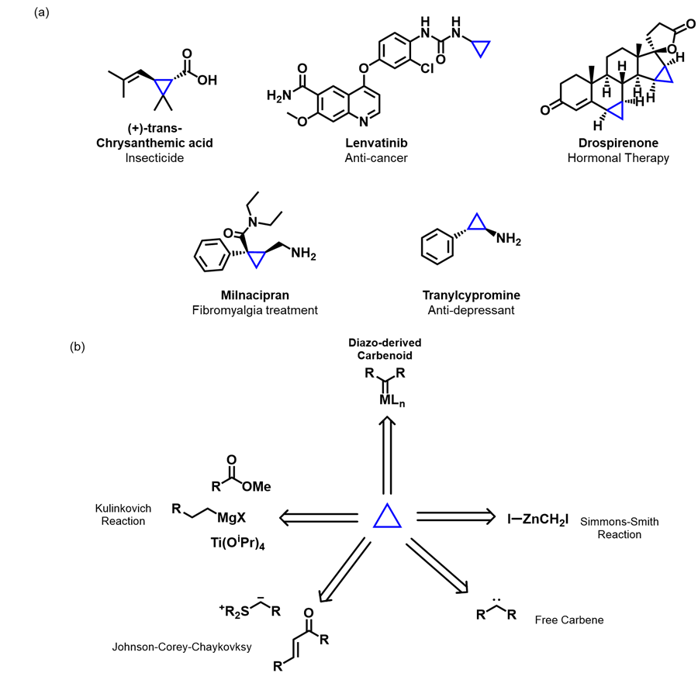
Figure 1.1 a) Examples of pharmaceutical and bioactive natural products that contain a cyclopropane ring and b) common methods for synthesizing cyclopropane rings
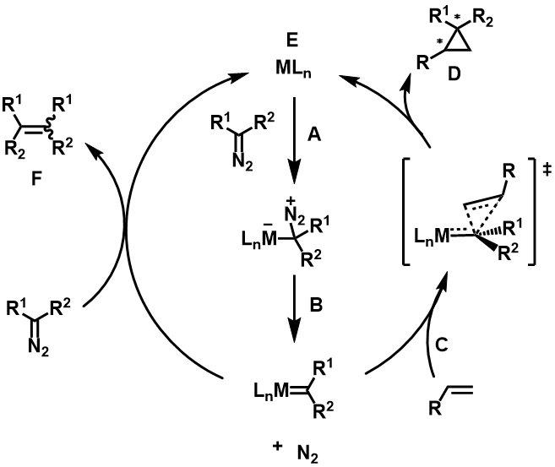
Figure 1.2 Catalytic cycle for metal-catalyzed carbene transfer cyclopropanation reactions
performance with a large library of ligand systems. However, these catalysts are hindered by a lack in the diversity of carbenes that they can catalyze, leading to limited applications. Another issue with copper catalysts is that the olefin substrates tend to bind to the metal and inhibit the catalyst.¹¹ The most common rhodium complexes for cyclopropanation reactions are dirhodium paddlewheel complexes (Rh(II,II)).¹²

Rh(II,II) Complexes
Rh(II,II) paddlewheel complexes are bimetallic structures consisting of a Rh–Rh bond that is surrounded by 4 bridging ligands and an axial site on each rhodium metal (Figure 1.3).^{13, 14} This results in a complex in which each rhodium center has an octahedral geometry.¹⁵ Various bridging ligand motifs have been developed such as: carboxylates,¹⁶ carboxamidates,¹⁷ ortho-metalated phosphines,¹⁸ and amidinates.¹⁹ The properties of the bridging ligand have been known to have a profound effect on the stereoelectronics and activity of the rhodium centers. The presence of more electron-withdrawing ligand leads to an increase in electrophilicity of the metal centers, while electron-rich ligands decrease it. This level of control through simple ligand modification has cemented Rh(II,II) paddlewheels as premiere catalysts in carbene transfer reactions. Ever since Teyssié and co-workers first decomposed diazo compounds with Rh(II,II) carboxylates,²⁰ catalytic applications of Rh(II,II) complexes have included C-H and X-H insertions (X = O, N, S, Si, B), cyclopropanations, and other diazo-mediated reactions.²⁰⁻²⁶ Synthetic pathways for these reactions involve a Rh(II,II)-carbene intermediate generated from the decomposition of the diazo compound at one of the rhodium axial sites. The reactivity of the diazo species towards association onto the metal is increased with more electron-rich diazo substrates. Rh(II,II) carbenes can be classified into three major groups: acceptor/acceptor, donor/acceptor, and acceptor carbenes (Figure 1.4)..^{13, 14, 26} Reactivity of these metal carbenes is inverse to that of diazos and increases as the carbene center becomes more electron-deficient while selectivity typically increases with more electron density.¹⁴ Selectivity is also affected by the steric bulk of the carbene substrates creating asymmetric faces for catalysis. For example, donor/acceptors derived from aryl or vinyl diazoacetates exhibit incredible selectivity not seen in other types like acceptors, as a result, they have seen extensive use in stereoselective and chemoselective cyclopropanations and C-H insertions with chiral catalysts.^{23, 27-30}
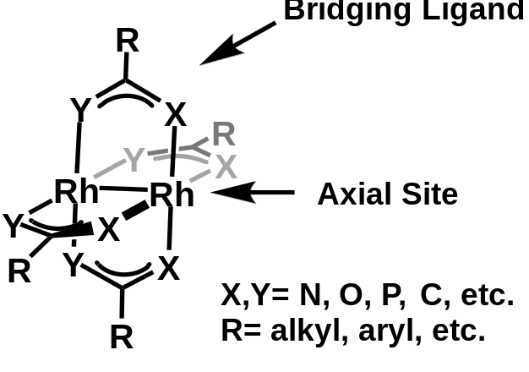
Figure 1.3 General structure of Rh(II,II) paddlewheel complexes

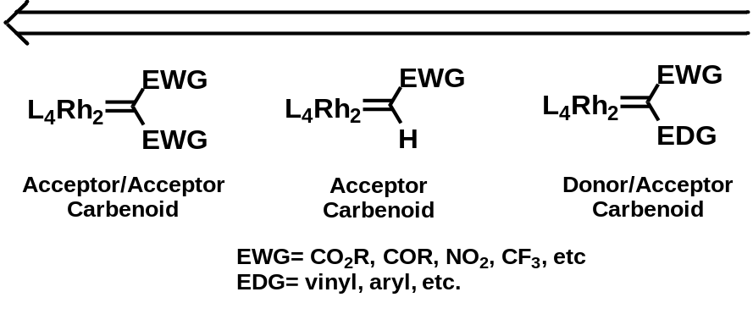
Figure 1.4 Classifications and reactivity trends of Rh(II,II)-carbenes
The bimetallic nature of Rh(II,II) paddlewheels results in a more complex relationship between the metal and carbene. Although formation of the carbene and subsequent catalysis occurs at one rhodium center, the other rhodium atom influences the electronics of the active metal. Berry and co-workers proposed that Rh(II,II)-carbenes follow a 3 center/4 electron (3c/4e) model.³¹ This model suggests that the Rh–Rh–C_{carbene} core contains two resonance structures, one in which the Rh–Rh bond is a 2 center/2 electron bond (2c/2e) with the carbene having a dative bond to one of the Rh metals. The other resonance structure has a formal oxidation of a Rh center (Rh(III)) and reduction of the other Rh (Rh(I)). This model essentially treats the distal Rh center that is not bound to the carbene as an electron sink and creates a dynamic environment when the Rh(II,II)-carbene is formed.

Synthesis of Rh(II,II) Complexes
Rh(II,II) paddlewheel complexes can be synthesized from Rh(I) or other Rh(II,II) species. The most common pathway towards making Rh(II,II) carboxylates in a paddlewheel structure involves the reduction of Rh(III) species.³² Some of the first Rh₂(O₂CR)₄L_{n} complexes were synthesized by refluxing [RhCl₆]³⁻ salts in an aqueous formic acid solution to form a Rh(II,II) formate paddlewheel complex X (Figure 1.5a).^{33, 34} Another method uses rhodium (III) hydrates in refluxing carboxylic acids or alcohol/carboxylic acid mixtures to make Rh(II,II) carboxylates. This results in subpar yields with large quantities of rhodium metal deposition.^{35, 36} Since then, one of the most efficient synthesis of Rh(II,II)-carboxylates is accomplished with by refluxing RhCl₃ in ethanol with acetic acid and sodium acetate (Figure 1.5b).³⁷⁻³⁹ Using this method with various acetates affords Rh₂(O₂CR)₄L_{n} complexes at yields upwards of 85% or quantitative amounts when using a large excess of carboxylic acid.³⁷
The synthesis of Rh(II,II) paddlewheels with functionalized bridging ligands has most commonly been through the substitution of the acetate ligands on Rh₂(OAc)₄ with carboxylates, carboxamidates, amidinates, and many other types of bridging ligands (Figure 1.5c).¹³ The conditions for this ligand exchange typically require an excess of ligand to the Rh(II,II) tetraacetate in a high boiling, non-coordinating solvent such as chlorobenzene (PhCl). The mechanism of this ligand exchange is thought to begin with coordination of the new ligand to one of the axial sites (Figure 1.6, A), which then
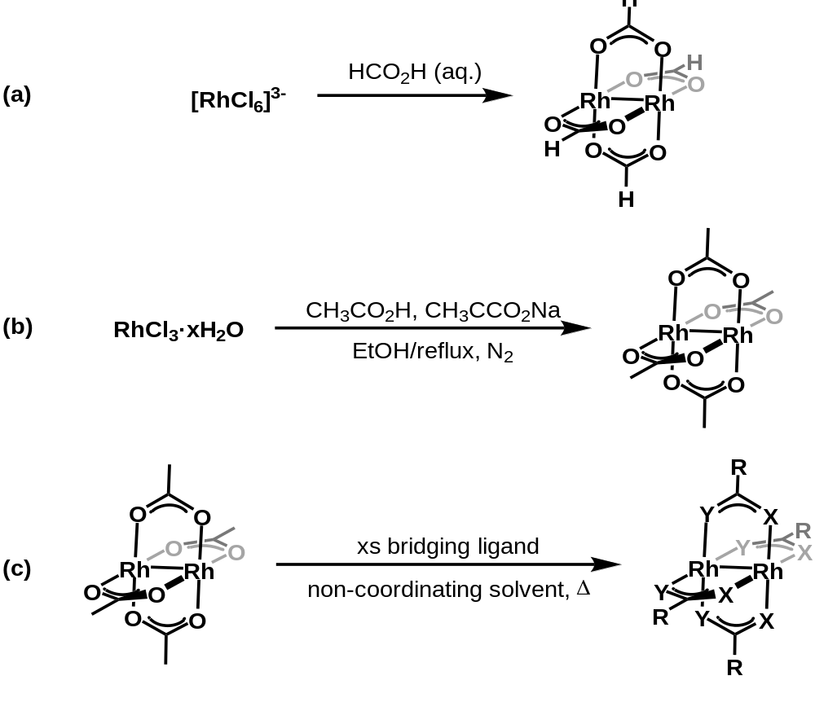
Figure 1.5 Synthesis of Rh(II,II) complexes from a) Rh(III) salts, b) Rh(III) hydrates, and c) other Rh(II,II) complexes
facilitates the release of an acetate ligand (Figure 1.6, B,C). This process is then repeated three more times for full conversion to the tetra-substituted complex. This mechanism has been supported by NMR studies conducted by Lahuerta and co-workers using orthometallated phosphine ligands exchanged on a very electrophilic Rh₂(TFA)₄ complex.⁴⁰ Formation of heteroleptic complexes with mono-, bis-, and tris-substitution are also possible and the distribution of these products is largely dependent on the type of ligands utilized.⁴¹ One NMR study determined that the relative rates of partially substituted products in the exchange of trifluoroacetic acid onto Rh₂(OAc)₄ was 1:2:0.1:0.25 for mono, bis, tris, and tetrakis respectively.⁴² To achieve complete exchange of bridging ligands, researchers’ efforts have focused on the equilibrium of ligand exchange. Removal of the dissociated ligand, acetic acid in the case of Rh₂(OAc)₄, prevents it from coordinating to the complex again and displacing the newly associated ligands. This removal drives the equilibrium towards complete substitution. This process is achieved by fitting the reaction flask with a Soxhlet extractor that contains a thimble filled with an inorganic base, such as CaCO₃, to trap the released acetic acid that azeotropes with the refluxing PhCl solvent (Figure 1.7).^{13, 43} The solvent is returns to the reaction flask, unaffected by the base.

Asymmetric Cyclopropanation
With the prevalence and proficiency of Rh(II,II) complexes in diazo-mediated carbene transfer reactions, their potential for asymmetric catalysis has been a major focus. In the early 1980s it was determined that Rh(II,II) paddlewheels were capable of supporting chiral bridging ligands and were immediately applied towards diazo-mediated transformations, namely cyclopropanation and C-H insertions.¹³ This section will summarize major advancements in the development of Rh(II,II) paddlewheel complexes and their applications towards asymmetric cyclopropanation reactions.

Chiral Rh(II,II) Complexes
As is the case for other chiral systems, symmetry plays an important role in how Rh(II,II) complexes are designed. Typically in metal catalysis, synthesizing high symmetry catalysts involves ligation of highly symmetric ligands such as C₂-symmetric bidentate binaphthyl or bisoxazoline (BOX) ligands, although less symmetric C₁ ligands can also be utilized.⁴⁴ In Rh(II,II) catalysis, C₁ ligands are commonly used because of the ease of synthesis and complexation onto the Rh(II,II) core.^{27, 45-47} The Rh(II,II) core can be
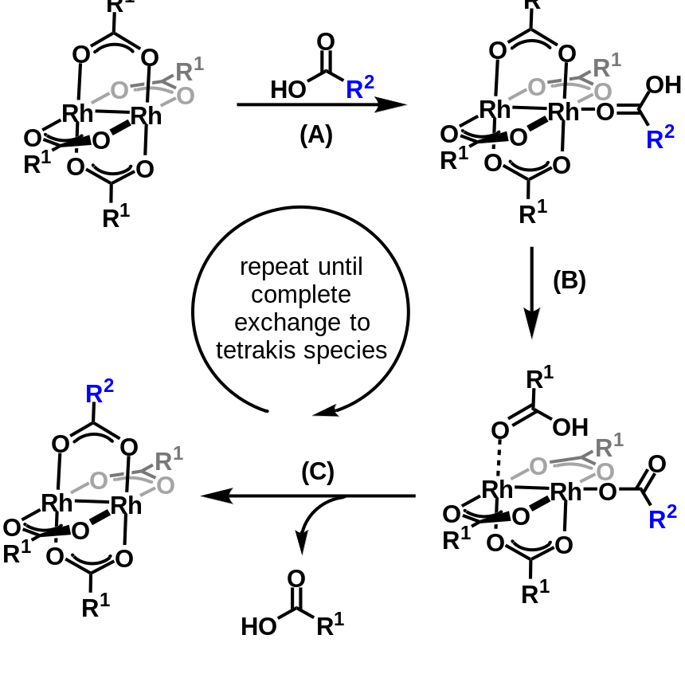
Figure 1.6 Mechanism of ligand exchange for Rh(II,II) complexes
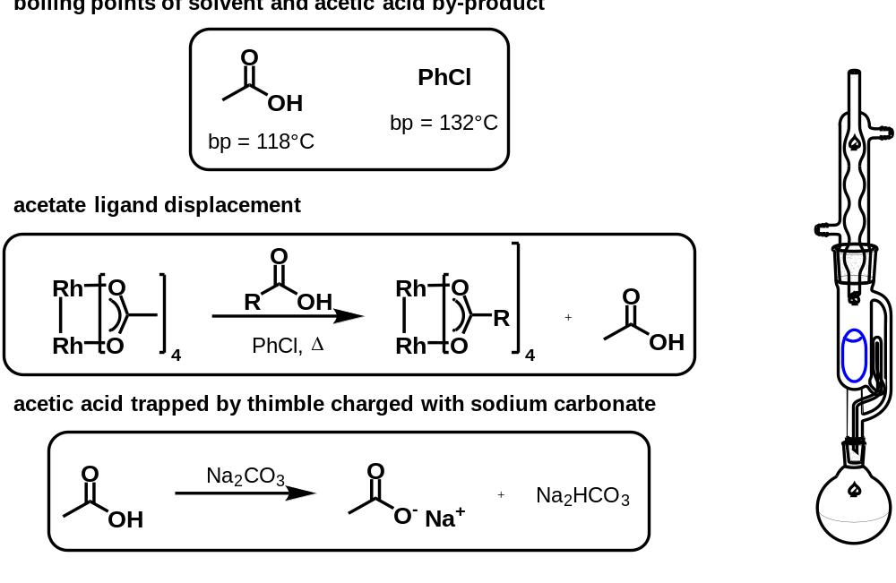
Figure 1.7 Soxhlet method of Rh(II,II) ligand exchange
considered to intrinsically be highly symmetric and as such, exchange of low symmetry ligands can produce symmetric chiral catalysts. Once chiral ligands are ligated at the bridging sites, the introduction of sterically blocking groups on the ligands create chiral pockets of varying symmetries at each axial site. These groups are thought to be situated either at the up (α) face or the down (β) face relative to a “side-on” view of the complex. It was initially thought that the blocking groups cannot lie on the periphery of the complex as to avoid steric clash with an adjacent ligand (Figure 1.8a).^{45, 48, 49} With these two faces in mind, four permutations of the ligands are possible: α,α,α,α (C₄-symmetry), α, α, α, β (C₁-symmetry), α, α, β, β (C₂-symmetry) and α, β, α, β (D₂-symmetry) (Figure 1.8b). Initially, it was believed that the C₁ and C₄ complexes would not be viable catalysts for enantiocontrol.^{45, 48} This was because the C₁ conformation contains non-equivalent chiral pockets. While high stereoselectivity was expected for the α face with three blocking groups, the converse was expected for the β side with only one blocking group. The C₄ conformation has a face that has no sterically blocking groups to direct substrate attack and since this axial site is more kinetically active, no enantiocontrol is expected.⁴⁹ Even higher symmetry Rh(II,II) complexes can be achieved by ligating C₂ -symmetric ligands instead of C₁. These C₂ ligands can create D₂ or even D₄-symmetric catalysts by influencing both faces of the complex (Figure 1.8c).^{45, 49} Efforts towards synthesizing and using chiral Rh(II,II) complexes has led to a vast library of diverse ligand architectures and catalyst designs that build upon previous breakthroughs. These have included prolinate, N-protected amino acid, phosphonate, and ortho-metallated phosphine derived systems. One of the first highly enantioselective chiral Rh(II,II) classes developed were Rh(II,II) carboxamidate complexes primarily pioneered by the Doyle group.^{17, 50}
      - Chiral Rh(II,II) Carboxamidates
Rh(II,II) carboxamidate complexes contain ligands that bridge the two rhodium metals with an oxygen and a nitrogen atom instead of two oxygen atoms. As a result, multiple isomers are possible, but the cis-2,2 orientation is the preferred isomer (Figure 1.9).^{51, 52} The rhodium centers of these complexes are also more electron rich than carboxylates due to the higher basicity of the nitrogen atoms on the carboxamidate ligands. This increase in electron density results in a catalyst that is less active in carbene reactions but with higher selectivity.^{13, 53, 54} Initially, when attempting to develop chiral carboxamidate complexes, Doyle and co-workers found that ligand exchange of acyclic
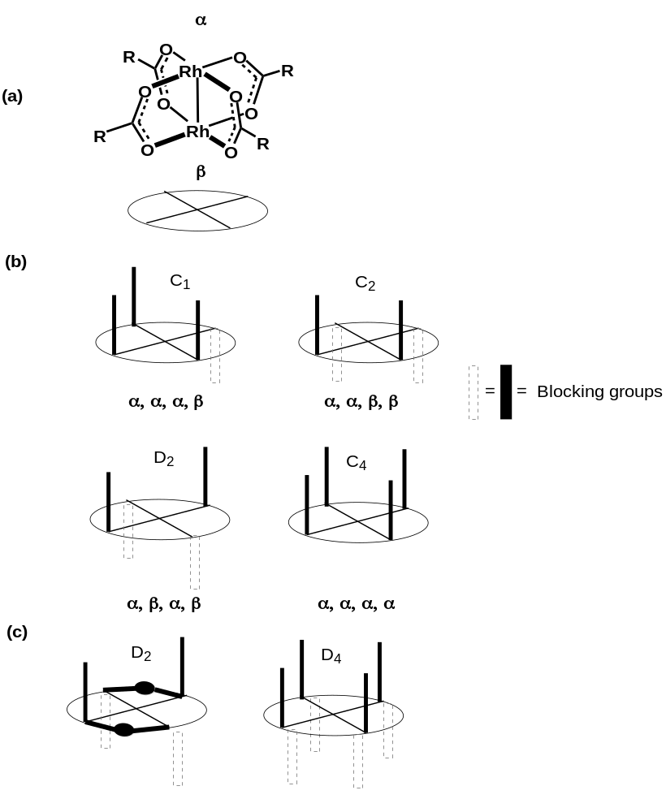
Figure 1.8 “Side-on” view of a Rh(II,II) paddlewheel, b) possible symmetry conformations for Rh(II,II) complexes, and c) symmetries of Rh(II,II) complexes with C₂-symmetric ligands
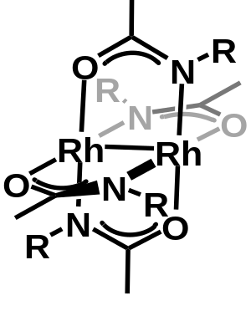
Figure 1.9 Cis-(2,2) isomer of Rh(II,II)-carboxamidates
amides was largely not possible due to free rotation creating unfavorable amide configurations.^{17, 55} This led to the use of cyclic carboxamidate ligands for exchange onto the paddlewheel and most Rh(II,II) carboxamidates use cyclic amides. The Doyle group proceeded to make a large library of carboxamidate complexes derived from azetidinones, 2-oxazolidinones, N-acylimidazolin-2-ones, and 2-oxopyrrolidines (Figure 1.10).^{14, 45} Rh(II,II) carboxamidates have been used extensively in asymmetric carbene transfer reactions where they have shown high proficiency in intramolecular allylic cyclopropanation reactions.⁴ With Rh(II,II) carboxamidates and allylic diazoacetates, Doyle and coworkers were able to form bicyclic lactones in up to 90% yield and enantiomeric excesses (ee) reaching >95% (Table 1.1).^{15, 17, 56} Rh₂(5S-MEPY₄) 1, the first highly selective Rh(II,II) carboxamidate, was an efficient catalyst in this study with very high ee’s while maintaining moderate to high yields with various substrates (Table 1.1, entries 1-3).⁵⁶ It should be noted that both the S and R enantiomers of the Rh₂(MEPY)₄ complex gave comparable enantiocontrol in the reaction but towards the opposite isomer (Table 1.1, entries 1 and 4). However, for the cases where it underperformed, the Rh₂(4S-MACIM)₄ 7 and Rh₂(4S-MPPIM)₄ 8 complexes improved enantiocontrol (Table 1.1, entries 5-7).⁵⁶
Unlike the intramolecular allylic systems, chiral Rh(II,II) carboxamidates have struggled to achieve high selectivity in ethyl diazoacetate (EDA) systems.^{27, 57-59} Traditionally, EDA reactions are better accomplished by chiral Cu(I) BOX catalysts for high enantioselectivity.¹⁷ Aside from a few examples, diastereoselectivity for EDA cyclopropanation using Rh(II,II) complexes is largely lacking.⁹ With EDA, it was found that the oxopyrrolidine, oxazolidinone, and azetidinone complexes catalyzed the reaction with moderate enantioselectivities and, interestingly, exhibited preference for the thermodynamically less stable cis-cyclopropane (Table 1.2, entries 1-4).^{57, 59} It should also be noted that all the carboxamidate complexes exhibited lower overall cyclopropane yields than the benchmark complex, Rh₂(OAc)₄ (Table 1.2, entry 5).
Rationalization for the observed stereoinduction involves the sterically blocking groups forming symmetric chiral pockets at each rhodium active site. Doyle and coworkers modeled these steric effects on the Rh₂(MEPY)₄ carbenoid species using X-ray crystallography and computational analysis.⁶⁰ It was determined that the chiral methyl ester blocking groups are arranged in an α, α, β, β (C₂-symmetric) conformation (Figure
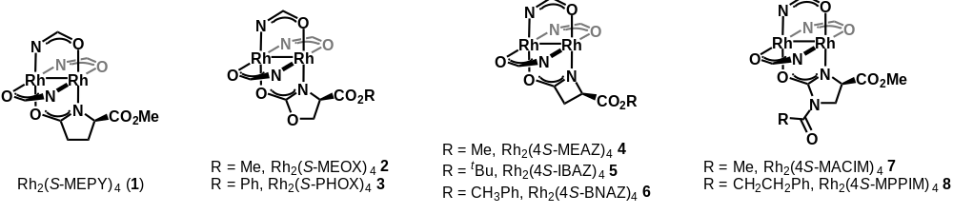
Figure 1.10 Rh(II,II)-carboxamidates derived from oxooyrrolidines, oxazolidinones, azetidinones, and N-acylimidazolinones
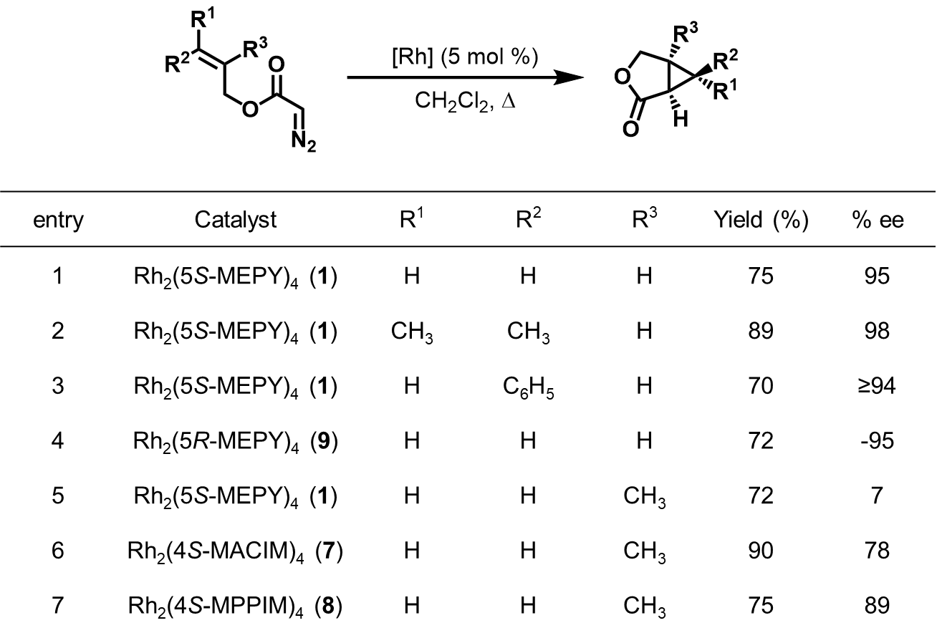
Table 1.1 Intramolecular cyclopropanation of allylic diazoacetates using chiral Rh(II,II)-carboxamidates
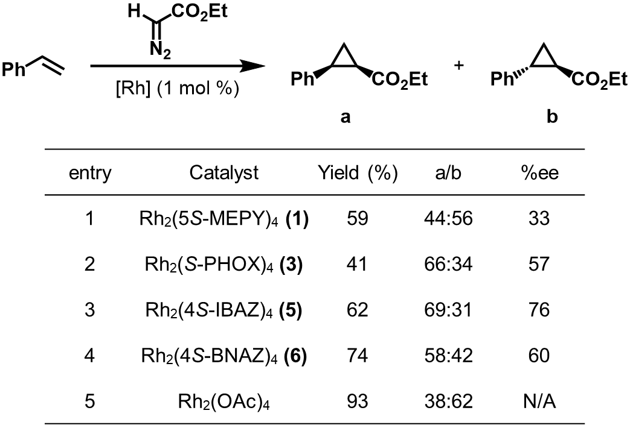
Table 1.2 Cyclopropanation of styrene with EDA using chiral Rh(II,II)-carboxamidates
1.11a). This arrangement creates active sites that contain two blocking groups, from adjacent bridging ligands, that form a barrier that directs substrate attack onto the carbene (Figure 1.11b). For intermolecular cyclopropanations, it is inferred that smaller diazo ester substituents, like the ethyl in EDA, are too small to be influenced by the blocking groups and will create racemic mixtures. Larger ester groups like the dicyclohexyl group of dicyclohexyl diazoacetate (DCDA) will have higher steric clash and increase enantioselectivity.
      - Chiral Rh(II,II) Phthalimides
In the early 1990s, Hashimoto, Ikegami, and coworkers introduced chiral Rh(II,II) complexes with phthalimide protected amino acid ligands (Figure 1.12a).¹³ Initially, alanine and phenylalanine derivatives, Rh₂(S-PTA)₄ 10 and Rh₂(PTPA)₄ 11 respectively, were developed and used to catalyze intramolecular C-H insertions.⁶¹ A few years later they synthesized the tert-leucine derived Rh₂(S-PTTL)₄ 12 which exhibited high enantiocontrol in cyclopropanation and C-H insertion reactions and provided a structural blueprint for other successful chiral catalysts.⁶²⁻⁶⁴ One of the initial hypotheses for this high enantiocontrol was the assumption that 12 adopts a C₂-symmetric conformation similar to Rh₂(S-MEPY)₄ in the solid state.^{65, 66} Based on this assumption, Hashimoto proposed a general model for enantioinduction with 12 wherein the subsequent carbene sits in the active site with its bulky substituents pointed away from the two blocking groups.⁶⁷⁻⁶⁹ The substrate attack is then directed towards the re-face resulting in the observed stereochemistry. Efforts towards improving this steric effect led to the Müller group developing the N-1,8-naphthaloyl tert-leucine derived catalyst, Rh₂(S-NTTL)₄ 14 (Figure 1.12b), which demonstrated impressive asymmetric cyclopropanation of donor/acceptor and acceptor/acceptor systems.⁷⁰⁻⁷³ Another method of utilizing steric bulk on the bridging ligands involves modification of the α-carbon of the amino acid derivative. In fact, a decrease in enantioselectivity when decreasing the bulk at the α-carbon, t-butyl 12 (74% ee) vs. i-Pr 13 (51% ee) vs. Me 10 (35% ee), has been observed.^{74, 75} The Davies group took notice of this and developed the L-adamantylglycine derived complex Rh₂(S-PTAD)₄ 15.⁷⁶ The bulkier complex afforded enhanced enantioselectivity in various asymmetric reactions, including intermolecular cyclopropanations of donor/acceptor diazos ⁷⁶⁻⁷⁹ The Rh₂(S-PTAD)₄ complex proved to be the superior catalyst for the enantioselective intermolecular cyclopropanation of styrene with α-diazobenzylphosphonates,
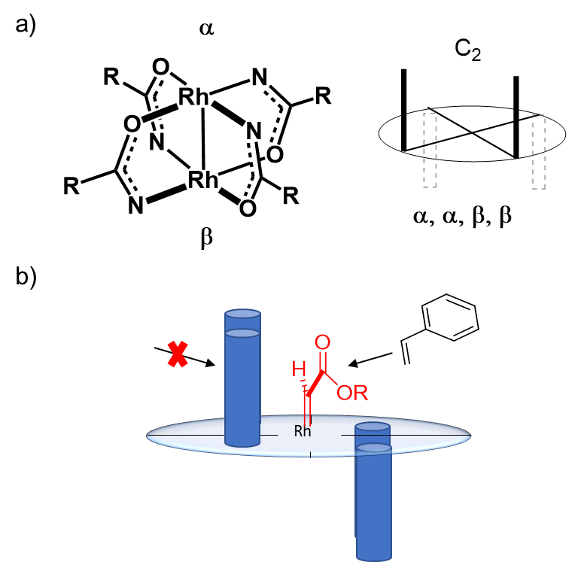
Figure 1.11 a) Rh2(4S-MEPY)4 conformation of methyl ester blocking groups b) approach of substrate directed by chiral blocking groups
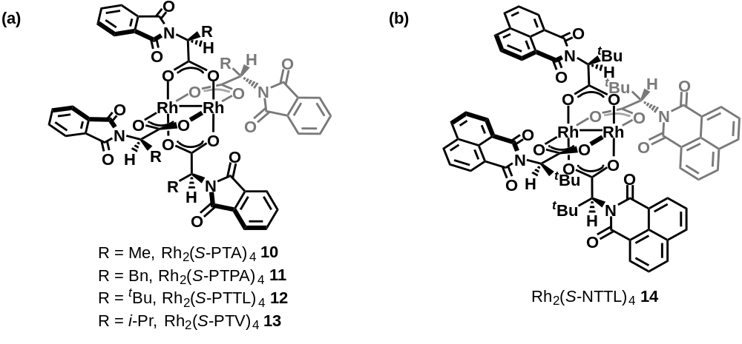
Figure 1.12 Rh(II,II) complexes derived from phthalimide protected amino acid ligands
outperforming its t-butyl analog Rh₂(S-PTTL)₄ and the prolinate derived Rh₂(S-DOSP)₄ 16 (Table 1.3, ).⁷⁶ Around this time, the idea that only C₂ and D₂-symmetric complexes could afford high enantiocontrol was challenged by the Fox group when they obtained an X-ray crystal structure of Rh₂(S-PTTL)₄ and determined that it adopted an all-up α, α, α, α conformation instead of the predicted α, α, β, β (C₂-symmetric) conformation.^{80, 81} However, this all-up conformation was not C₄-symmetric but C₂-symmetric as a result of the phthalimide rings creating a “chiral crown” configuration around one of the axial sites with a single ethyl acetate (EtOAc) solvent molecule coordinated(Figure 1.13a/b).⁸⁰ Fox and coworkers suggested that this chiral crown is maintained during catalysis and that the carbene orients itself in the chiral pocket in such a way that its si-face is open to attack by the substrate (Figure 1.13c). It was also suggested that the distal Rh active site is inaccessible due to steric blocking from the t-butyl groups.^{80, 81} Although this theory is in accordance with the improved enantiocontrol observed with the bulkier 15, several groups have challenged Fox’s claims. The idea that the distal Rh site is completely restricted was disproven by Adly and coworkers when they reported an X-ray crystal structure of Rh₂(S-PTAD)₄ and found that it existed as a bis(EtOAc) adduct.⁸² The Charette group conducted 2D heteronuclear NOESY experiments on 12 and discovered that the phthaloyl groups are flexible and can change conformation in solution, refuting Fox’s claim (Figure 1.14).⁶³ The same study also determined that the replacement of the phthaloyl hydrogens with halogens, complexes 17-18 led to a more conformationally rigid complex with no observed rotation of the blocking groups and improved enantioselectivity in the intermolecular cyclopropanation of styrene and α-nitro diazoacetophenones (Table 1.4).⁶³
      - Chiral Rh(II,II) Prolinates
The notion that C₂- and D₂-symmetric complexes, those with two equivalent active sites, will lead to high stereoselectivity was confirmed by the development of chiral Rh(II,II) prolinate complexes.^{45, 48} McKervey and co-workers developed the first prolinate complex, Rh₂(S-BSP)₄ 23, in the early 90s and saw good enantiocontrol in C-H insertion reactions.^{83, 84} However, prolinate complexes didn’t start realizing their potential until Davies expanded their use to cyclopropanations of donor/acceptor carbenes.^{48, 85} Donor/acceptor carbenoids are stabilized by the donor groups, and as such, are considered to be less active. Davies and co-workers tested various Rh(II,II) prolinates in the cyclopropanation of alkenes with vinyl diazoacetates.⁴⁸ It was found that changing the arylsulfonyl group
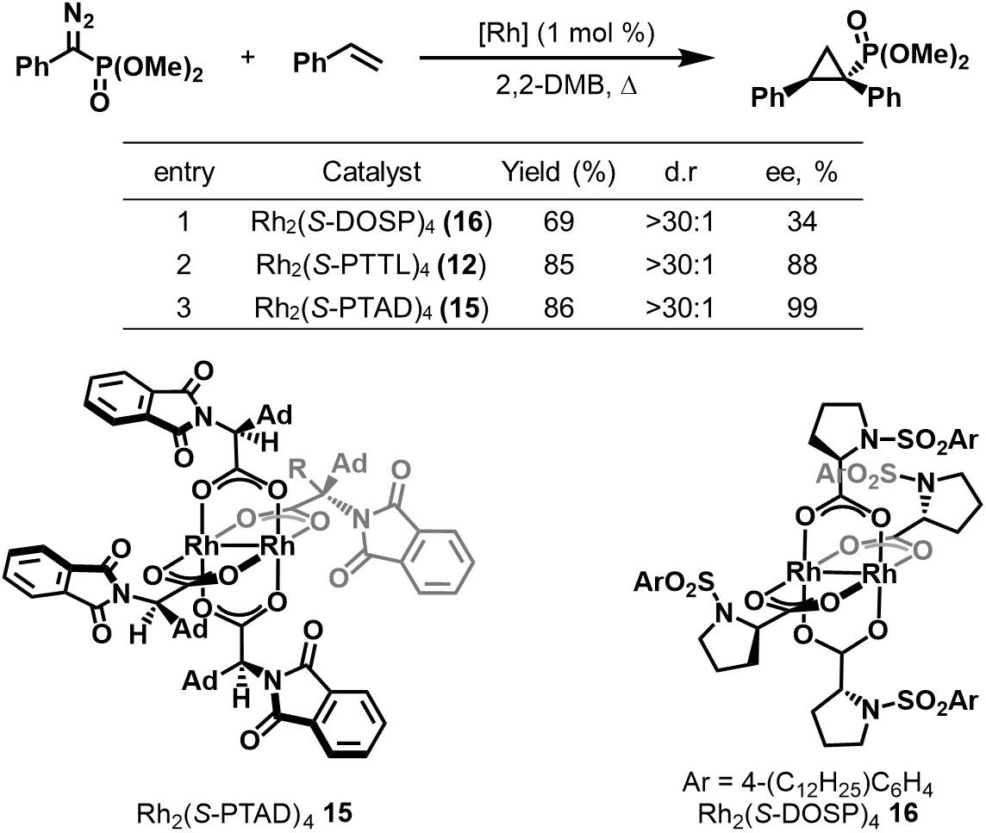
Table 1.3 Intermolecular cyclopropanation of styrene with a α-diazobenzylphosphonate catalyzed by Rh(II,II)-phthalimides and a Rh(II,II)-prolinate complex
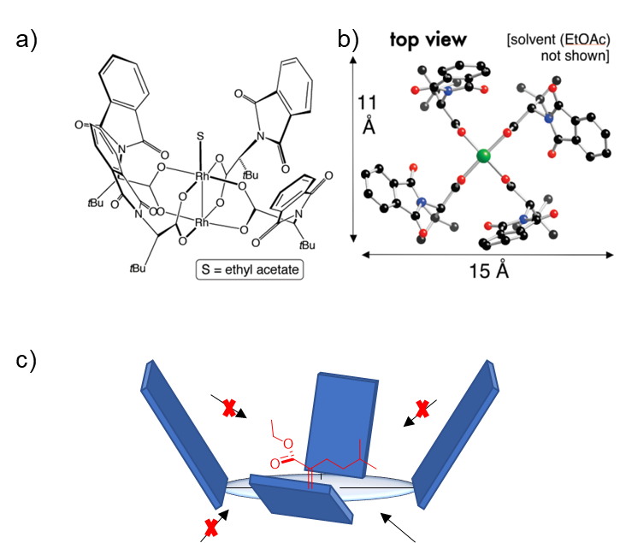
Figure 1.13 a) Side-on view of the “chiral crown” of Rh₂(S-PTTL)₄, b) a top-down view of the X-ray crystal structure, and c) a visual representation of the chiral pocket directing substrate attack.
a/b): Reprinted with permission from DeAngelis, A.; Dmitrenko, O.; Yap, G. P. A.; Fox, J. M., Chiral Crown Conformation of Rh2(S-PTTL)4: Enantioselective Cyclopropanation with α-Alkyl-α-diazoesters. Journal of the American Chemical Society 2009, 131 (21), 7230-7231. Copyright 2009 American Chemical Society."
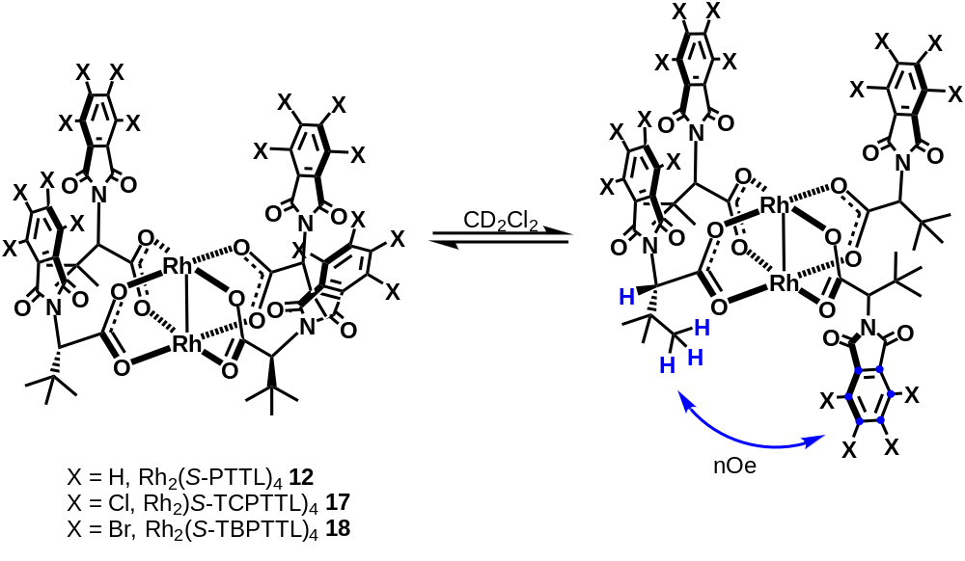
Figure 1.14 Interaction between side chain protons and phthaloyl aromatic carbons in Rh(II,II)-phthalimide complexes. Confirmed by 1H NMR NOESY experiments
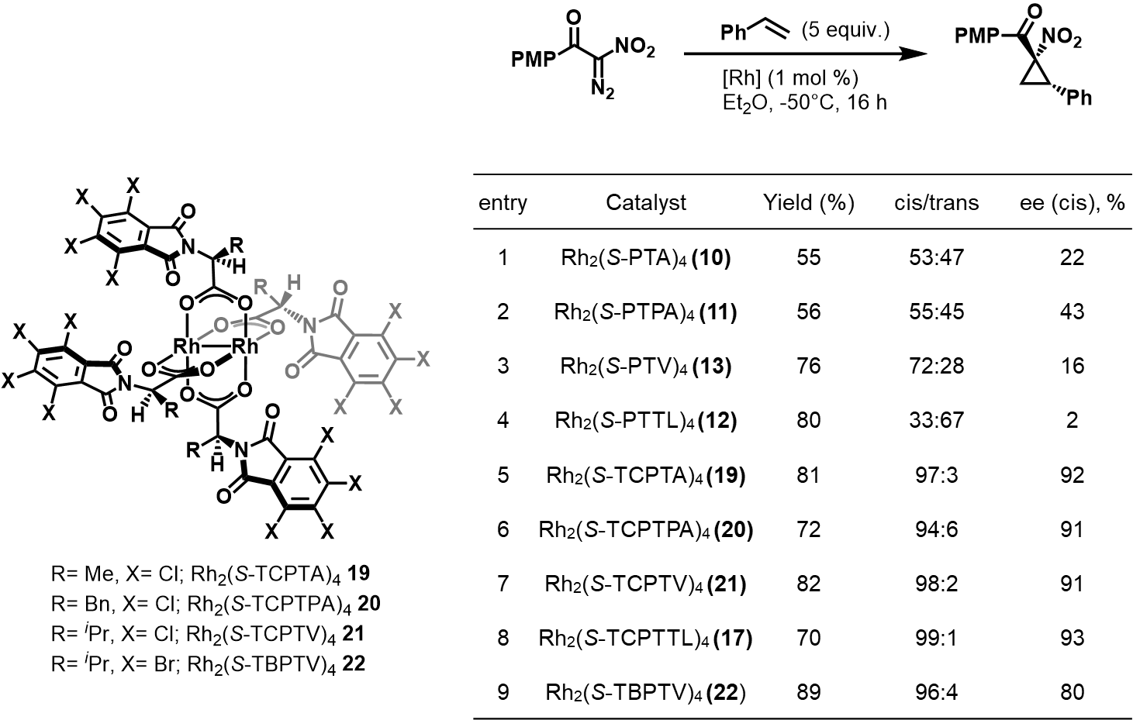
Table 1.4 Asymmetric cyclopropanation of styrene with α-nitro diazoacetophenones with Rh(II,II)-phthalimide complexes
had a small effect on enantioselectivity in DCM (Table 1.5, entries 1-5). However, when the solvent was changed to pentane, Rh₂(S-TBSP)₄ 26 and Rh₂(S-DOSP)₄ 16 exhibited high enantiocontrol (Table 1.5, entries 6-7). This improved performance of 16 in non-polar solvents was also seen in C-H insertion reactions.^{22, 49} Davies also tested acyclic N-sulfonyl carboxylates as catalysts in the cyclopropanation of alkenes (Table 1.5, entries 8-9) and found a substantial decrease in enantioselectivity, highlighting the necessity of a cyclic bridging ligand. Finally, ring size was also evaluated with azetidinecarboxylate (Table 1.5, entry 10) and picolinate (Table 1.5, entry 11) complexes. Although not as good as the five-membered prolinates, changes in ring size can be tolerated as evidenced by high enantioselectivities for both complexes. Increasing the steric bulk at the ester of the diazo also did not yield improved enantioselectivity (Table 1.5, entries 12-13).
Rh(II,II) prolinate cyclopropanation is not just limited to vinyl diazoacetates and has also seen success with aryl diazoacetates. Both 26 and 16 demonstrated exceptional enantioselectivity in the cyclopropanation of styrene with methyl phenyldiazoacetate (Table 1.6).⁸⁵ As observed with the vinyl diazoacetates, catalyst performance can be further tuned through changes in solvents evidenced by non-polar solvents improving enantiocontrol (Table 1.6, entries 1-4). It should be noted, however, that diastereoselectivity was largely independent of catalyst control. This was evidenced by comparable diastereomeric ratios (d.r.) between the chiral prolinate complexes and achiral complexes such as Rh₂(OAc)₄ (Table 1.6, compare entries 1-4 with 5). Increasing the electron-deficiency of the complex also had minimal change in product yield and diastereoselectivity (Table 1.6, entries 6).
High enantiocontrol with prolinate complexes has been attributed to the orientation of the arylsulfonyl groups. Rh(II,II) prolinate complexes likely adopt a D₂-symmetry in which the sterically blocking groups are in an α, β, α, β conformation. This conformation creates two identical active sites with blocking groups limiting certain trajectories for substrate attack and inducing stereoselectivity. Davies proposed a general model in which the 16 metal-carbene complex has its si-face blocked by one of the arylsulfonyl groups, forcing attack of the olefin to occur at the re-face (Figure 1.15a).⁴⁸ Another quadrant for approach is blocked by the sterics of the carbene ester group. Based on this stereochemical model, Davies and co-workers developed second generation D₂-symmetric prolinate complexes that locked the arylsulfonyl groups in a rigid α, β, α, β
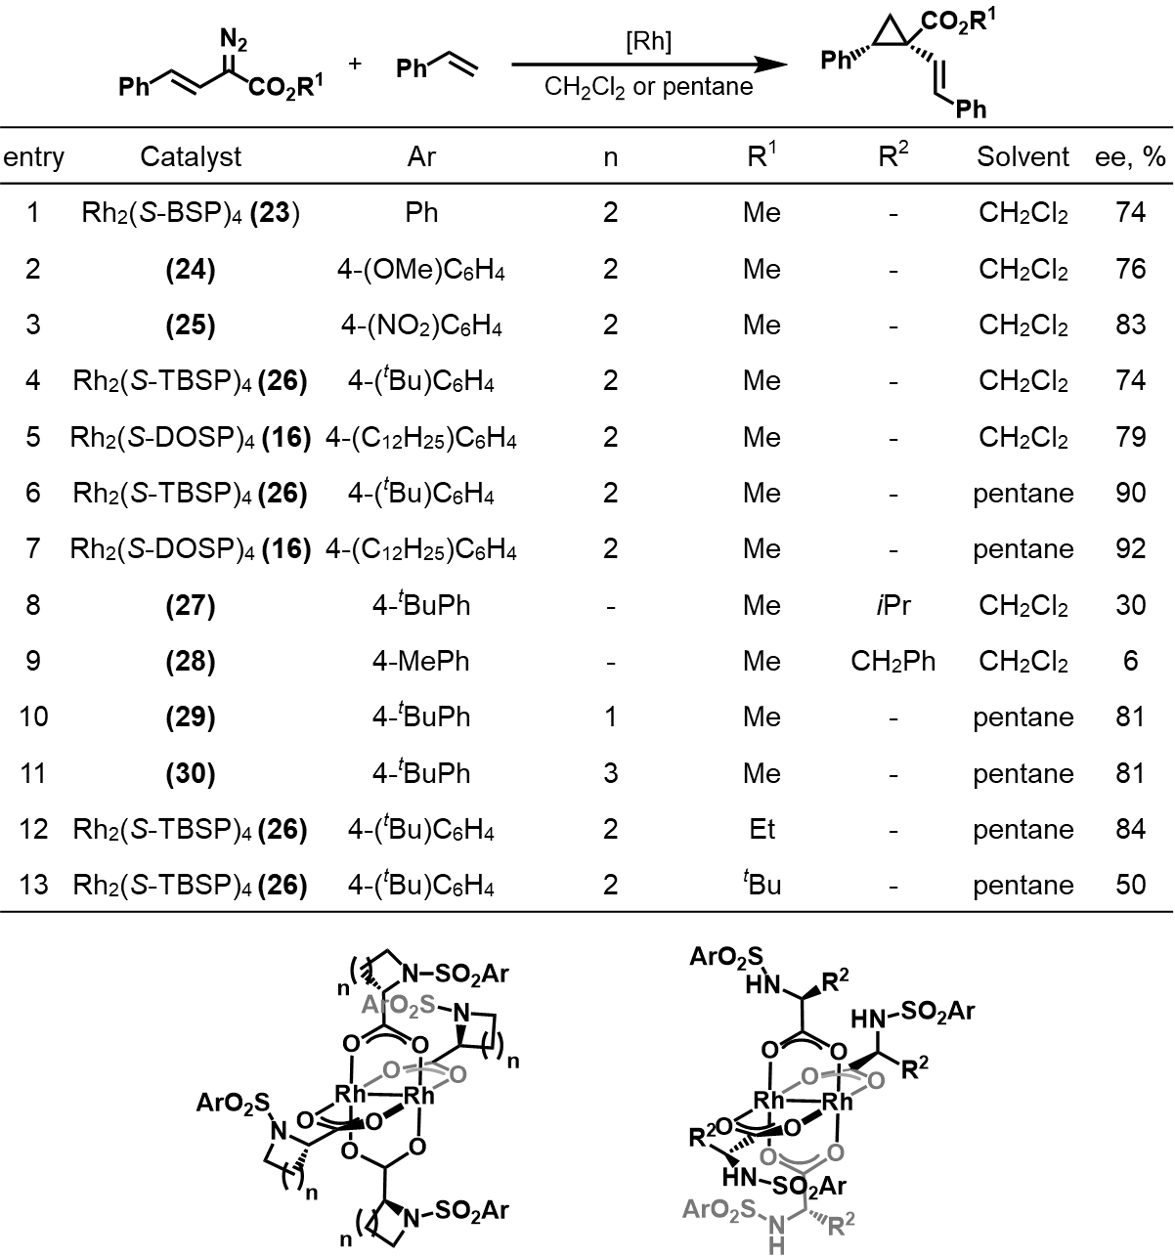
Table 1.5 Asymmetric cyclopropanation of styrene and vinyl diazoacetates by Rh(II,II)-prolinate complexes
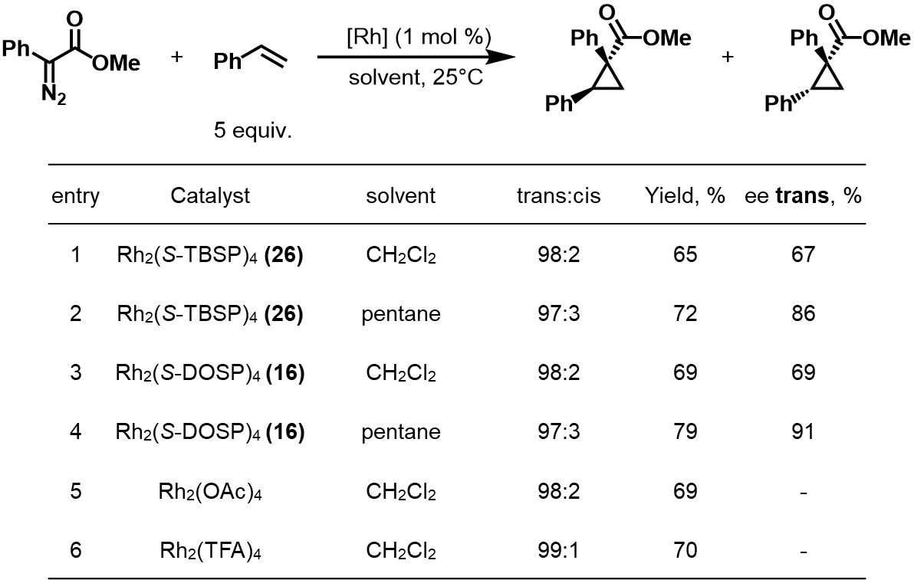
Table 1.6 Asymmetric cyclopropanation of styrene and methyl phenyldiazoacetate by Rh(II,II)-prolinate complexes
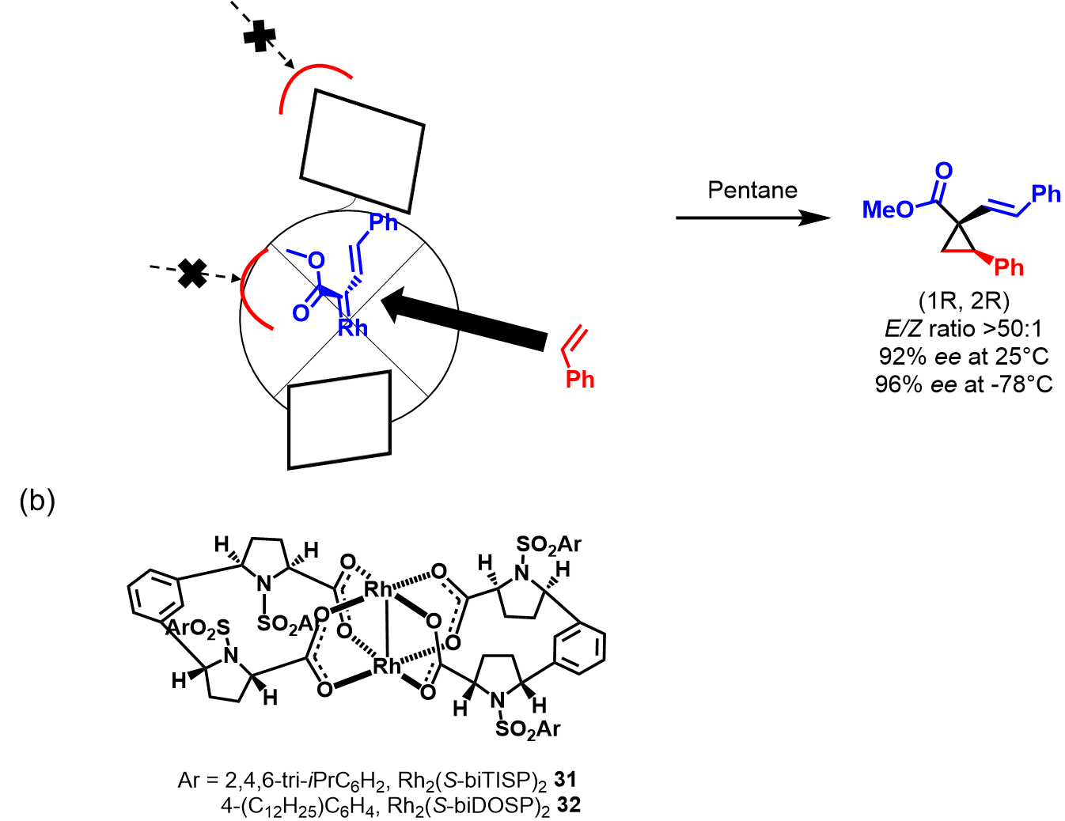
Figure 1.15 a) General model for the directed substrate attack on the Rh2(S-DOSP)4 carbene species responsible for the observed enantioselectivity b) Second generation Rh(II,II)-prolinates with linked prolinate rings.
conformation by exchanging C₂-symmetric dicarboxylate ligands that link two prolinates together through a meta-benzene bridge (Figure 1.15b).^{86, 87} These complexes exhibited high enantiocontrol in intermolecular cyclopropanations of methyl styryldiazoacetates, comparable to the first generation prolinates. Interestingly, the bridged complexes resulted in the opposite enantiomer of cyclopropanes as the first generation prolinates. This was attributed to the carbene adopting a different conformation in the chiral pocket resulting in an olefin attack that is onto the si-face rather than the re-face.⁴⁹

Heteroleptic Rh (II,II) Complexes
Incomplete substitution leads to a mixture of heteroleptic products that may also be separated into different isomeric structures. One example is in ligand exchanges with carboxamidate bridging ligands that contain a nitrogen and an oxygen atom coordinating to the rhodium metals.¹⁷ In total, 14 different geometric isomers can be formed when considering all substitution possibilities. The mono-substituted product contains no isomers because all the other bridging ligands are identical (Figure 1.16, a).^{88, 89} Bis-substituted complexes are characterized as cis if the two exchanged carboxamidate ligands are adjacent to each other or trans if they are exchanged at the opposite equatorial position. The bis-substituted complexes, however, have much more complex mixtures of isomers (Figure 1.16, b). These isomers are classified as either syn or anti depending on whether the two nitrogens (one from each ligand) are on the same rhodium metal or on different metals. Another level of isomerism is observed with the cis-anti configurations in which two rotational isomers can exist.⁸⁸ If the rotation occurs in a clockwise fashion, it is regarded as a P-cis-anti isomer and if counterclockwise, M-cis-anti (Figure 1.16, b). Tris-substitution can result in 4 isomers with no further complexity seen other than a general change in N and O pattern (Figure 1.16, c). Isomers are also possible with tetra-substituted complexes. The tetrakis complexes can be arranged with all the nitrogens on one rhodium metal and the oxygens on the other (4,0), three nitrogens (3,1), or two on each rhodium (2,2). The (2,2) complexes can be further isomerized between cis or trans relative to the positions of the nitrogen atoms on each metal. Ligand exchange towards the tetra-substituted species concluded that the cis-(2,2) isomer is the most thermodynamically favored product of the ligand exchange (Figure 1.16, d).^{88, 90}

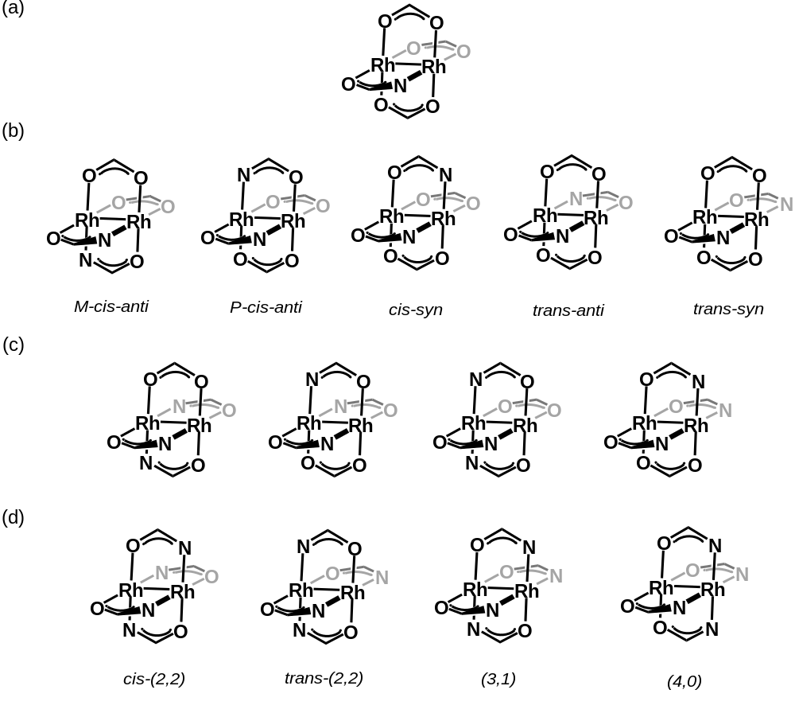
Figure 1.16 Possible isomers for heteroleptic Rh(II,II) complexes at a) mono, b)bis, c) tris, and d) tetrakis levels of substitution.
A common method for heteroleptic complex synthesis involves using a more labile bridging ligand to control the extent of ligand exchange and obtain the desired substitution pattern. This has been accomplished by using mixed acetate/trifluoroacetate complexes, Rh₂(OAc)_{n}(TFA)_{4-n}, as the starting material and exchanging the more labile trifluoroacetate ligands for the desired bridging ligand (Figure 1.17, a).⁴¹ The bis-substituted species, Rh₂(OAc)₂(TFA)₂, can be synthesized as either a cis or trans isomer and has been used by Corey and co-workers for the synthesis of diphenyl-N-triflylimidazolidinone (DPTI) ligated complexes, Rh₂(DPTI)_{4-n}(OAc)_{n}.⁸⁸ Charette and co-workers successfully synthesized heteroleptic complexes with different carboxylates by reacting Rh₂(OAc)₄ with two equivalents of ligands A and B in PhCl (Figure 1.17, b).⁹¹ Ligand A contained a fully halogenated aryl ring which acts as a “polarity-control group” that affected the retention factor (R_{f}) of each substituted product. This resulted in well-defined chromatographic separation of products and subsequent isolation of each. Yields of the chloro- tris-substituted species was enhanced by a process of isolating the products that are not fully substituted and resubjecting them to the same reaction conditions. This process was repeated multiple times to achieve a desired substitution pattern.^{91, 92} Another method of controlling substitution in heteroleptic complexes is using bidentate carboxylate ligands. This was first accomplished by the Taber group wherein they exchanged a benzenedipropanoic acid ligand onto a Rh₂(TFA)₄ complex, resulting in a bidentate Rh(II,II) heteroleptic complex as the only product (Figure 1.17, c).⁹³
Heteroleptic complexes have exhibited utility in asymmetric catalysis, despite having a lower symmetry than their homoleptic counterparts.⁴¹ Corey determined that using Rh₂(DPTI)₃(OAc) 33 in the cyclopropanation of EDA and styrene afforded excellent ee’s for both diastereomers, however, diastereoselectivity was lacking (Figure 1.18a).⁹⁴ The high enantioselectivity was theorized to be the result of a cleavage of the acetate ligand, forming a tri-bridged carbene species 34 (Figure 1.18b). This species allows for a stronger Rh–C_{carbene} dπ-bond and creates a preference for either cis or trans orientation of the ester portion relative to the N or O of the DPTI ligands. The carbene subsequently prefers the orientation where the ester is cis to the oxygen of the DPTI ligand, locking it in a specific geometric isomer. This model was challenged a year later by Singleton in which they conducted kinetic isotope effect experiments and computational studies and found
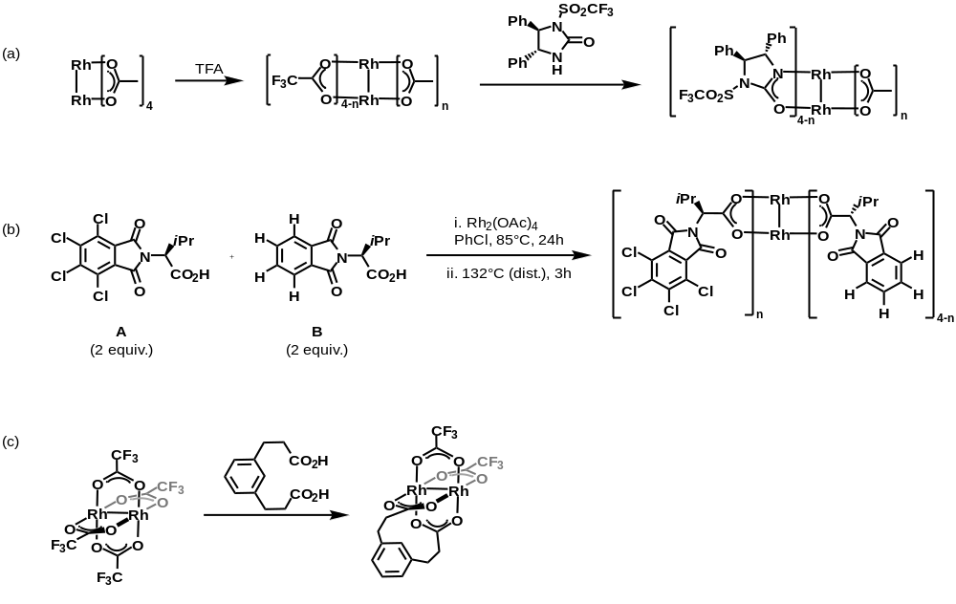
Figure 1.17 Synthetic methods towards heteroleptic complexes
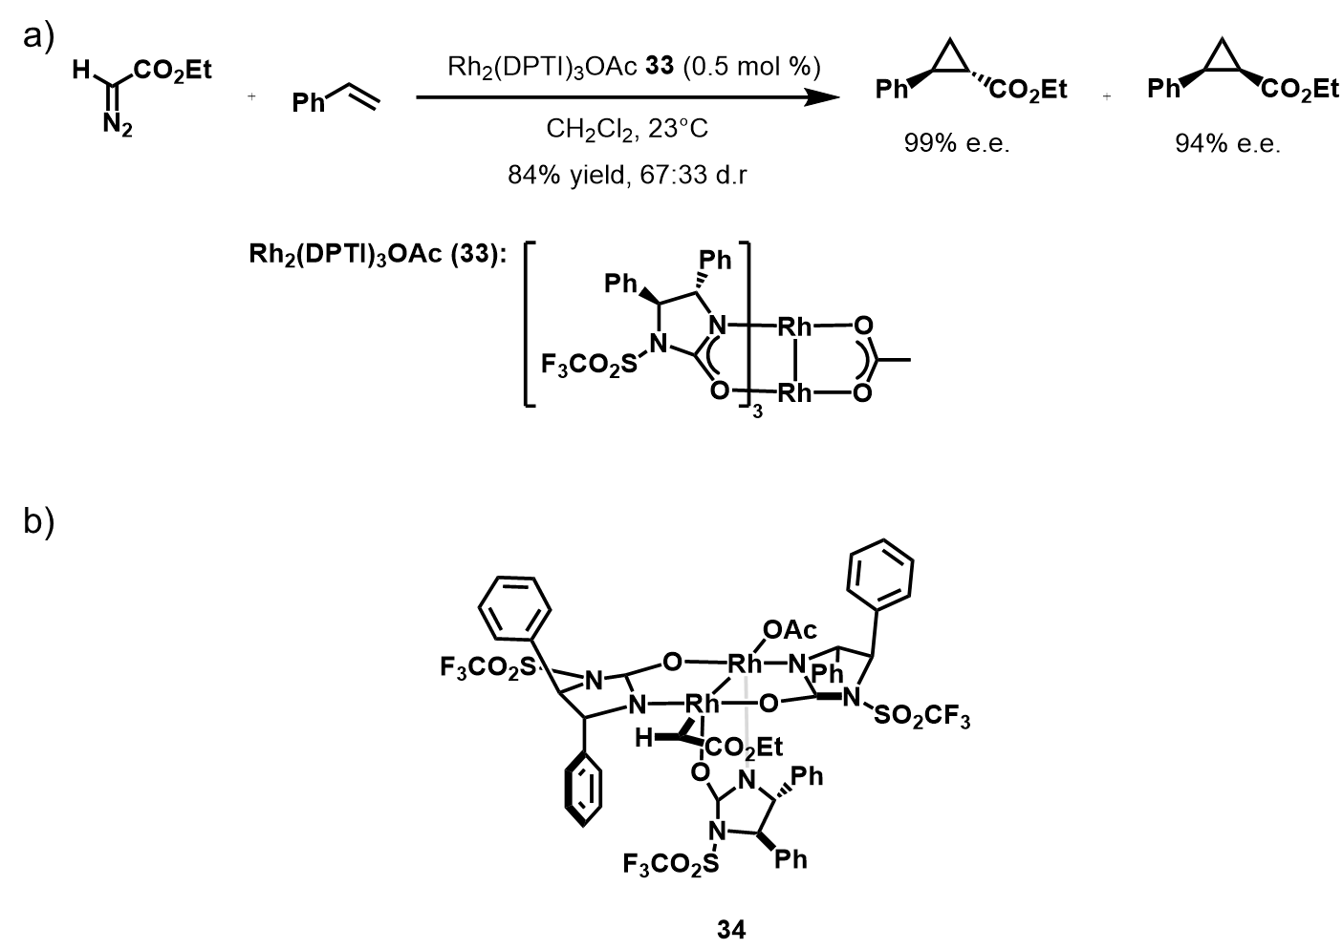
Figure 1.18 a) asymmetric cyclopropanation of styrene and EDA with Rh2(DPTI)3OAc b) proposed tri-bridged carbene species responsible for observed enantioselectivity
that the tri-bridged structure was 21.5 kcal/mol higher in energy than the tetra-bridged structure.⁹⁵
Although Corey’s intermediate was disproven, the report had implications for the use of heteroleptic complexes with chiral bridging ligands exchanged for an achiral ligand. Fox and co-workers synthesized the heteroleptic Rh₂(S-PTTL)₃TPA X (TPA = triphenylacetate) from Rh₂(S-PTTL)₄.⁹⁶ It was found that this complex exhibited comparable selectivity to homoleptic chiral complexes in the asymmetric cyclopropanation of styrene with ethyl 2-diazobutanoate. The mixed-ligand complex resulted in lower yields but better enantio- and diastereoselectivity than the parent Rh₂(S-PTTL)₄, despite the loss of one of the chiral ligands.⁹⁶
    - Axial Coordination
Most studies into axial coordination involve the use of exogenous Lewis bases (LB), but the weaker association of axially bound LBs compared to bridging ligands makes this approach problematic. Controlling formation of mono- and bis-adducts has proven difficult when axial coordination is facilitated by additives. Drago and coworkers found that at low concentrations of exogenous ligand, both free complex and 1:1 (ligand:catalyst) adducts are observed.⁹⁷ At high concentrations of exogenous ligand, a mixture of 1:1 and 2:1 adducts exist. Free complex, 1:1, and 2:1 adducts are all present when using intermediate concentrations of the ligand.⁹⁷ Indeed, studying axial coordination can be difficult since excess equivalents of the additive are needed for measurable effects, and as a result, determining the exact influence of the additive is more nuanced. There are reports of positive results in the presence of additives, while in other situations additives are a detriment. For example, using mild coordinative co-solvents such as tetramethyl urea or Hünig’s base resulted in improvements in O-H insertion reaction yields,⁹⁸ but the use of dimethylaminopyridine (DMAP) in cyclopropanation reactions gave lower yields.⁶⁴ Recently, Davies and co-workers reported improved asymmetric cyclopropanation of heteroaryl diazos using a 2-chloropyridine additive that binds to the axial site, though the exact effect this additive has on enantioselectivity has not been extensively explored.⁹⁹ N-Heterocyclic carbene (NHC) additives were implemented as a way to ensure axial coordination due to their strong coordinating ability.¹⁰⁰ The first Rh(II,II) paddlewheel complexes with NHC axially ligated adducts were used in intramolecular cyclization reactions, but the improved performance was attributed to a free complex (Figure 1.19a).¹⁰⁰ This was later remedied by the incorporation of bulky wingtip groups, however, the use of NHC axial ligands for carbene transfer reactions generally resulted in comparatively lower product yields (Figure 1.19b).^{101, 102} Lately, there have been renewed efforts to pursue an increased understanding of the role of axial coordination in carbene transfer reactions. For example, Laconsay and co-workers very recently disclosed a computational study on the effect of axial solvents on C-H insertion reactions and found that axial coordination affects barriers for N₂ extrusion and C–H insertion.¹⁰³
Experimentally, studying axial coordination by tethering them to bridging ligands has emerged as a viable strategy to circumvent the weak interaction associated with axial ligands.¹⁰⁴⁻¹⁰⁶ This provides a bias for the site of reactivity and ensures a high local concentration for axial coordination. These tethered ligands also take advantage of the chelate effect and allow for higher stability and stronger coordination to the axial site. Ball and co-workers developed Rh(II,II) metallopeptides that contain tripodal peptide bridging ligands with a histidine residue coordinated to the rhodium axial site (Figure 1.20) .¹⁰⁵ They found that tethering the bridging ligands to the axial ligand significantly improved catalytic performance in diazo-mediated cyclopropanations over their previous mono-peptide, non-tethered catalysts.^{105, 107} This improvement was theorized to be the result of controlling access to the axial site, as well as a conformational change in the peptide folding as a result of histidine binding to the rhodium metal.
  - Research Motivation
The synthesis of cyclopropanes has been an important area of research in the pharmaceutical and natural products industries for decades. A plethora of synthetic methods towards cyclopropanes have been developed, the most prevalent of which has been metal-catalyzed carbene transfer reactions. With this method, platinum group metal complexes have been the most common catalysts and Rh(II,II) paddlewheels have shown the most efficacy and versatility leading to their prevalence in these reactions. Although Rh(II,II)-catalyzed carbene transfer reactions have been extensively studied, efforts toward improving stereoselectivity have largely focused on bridging ligand modifications. Development of chiral bridging ligands with sterically bulky groups has been the predominant method for achieving higher levels of stereochemical control. Specifically,
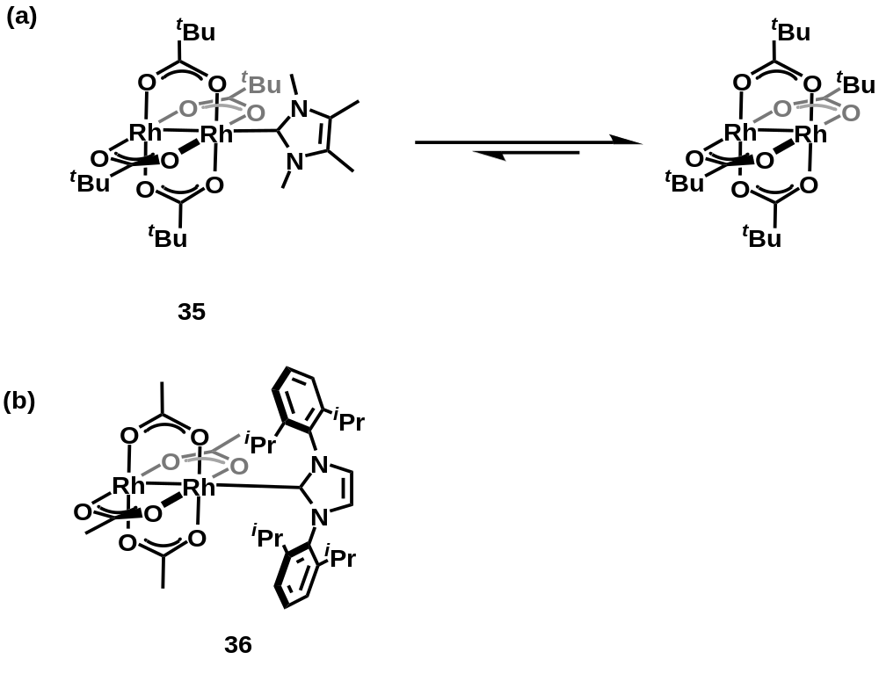
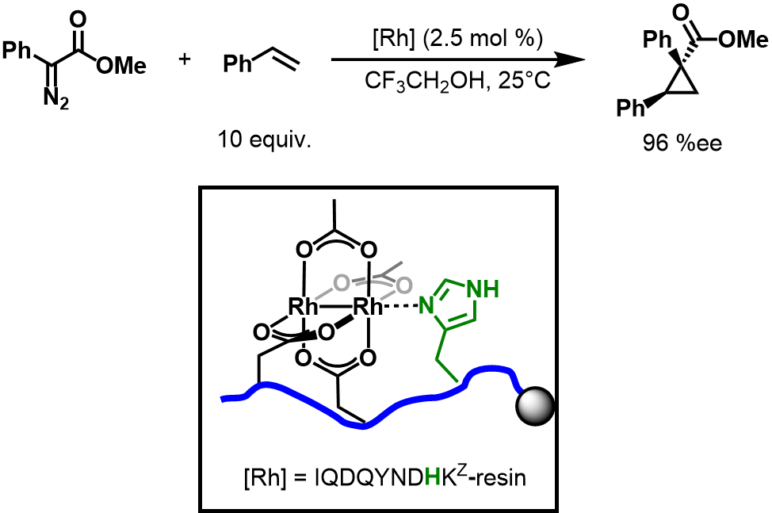
Figure 1.19 First Rh(II,II)-NHC adduct synthesized and the proposed equilibrium during catalysis b) Rh(II,II)-NHC complex with bulky wingtip groups
Figure 1.20 Asymmetric cyclopropanation with a Rh(II,II) metallopeptide
these studies have involved the use of homoleptic complexes with 4 identical bridging ligands and heteroleptic complexes have not been widely studied until recent years.^{14, 41, 45}
Not until recently have researchers made a large push towards understanding the influence of axial coordination and exploiting it to improve catalytic performance. The incorporation of additives that coordinate to the axial site has had mixed results with some additives improving reactivity and selectivity and other instances where they are a detriment. The influence of Lewis base coordination is complex and has not been widely studied. This is because it is difficult to accurately study the influence of the axial position with exogenous addition of the ligands in solution. An emerging method for axial coordination study is the development of axial ligands that are tethered to a bridging site through a linker. This creates an improved local concentration of the ligand at the axial site that is held in place by the chelate effect. Recent developments in using bridging ligands with a tethered axial ligand moiety have inspired our group to develop heteroleptic Rh(II,II) complexes with tethered, axially coordinated ligands (TACLs). By tuning the electronics of the axial ligands and tethers, we hypothesized that we could more accurately study the impact of the axial position on carbene transfer reactions. The donation from the coordinated LB is expected to be communicated through the Rh-Rh bond and into the carbene, which can have a stabilizing effect in more reactive carbenes and possibly improve yields by reducing dimerization. Our group proceeded to synthesize Rh(II,II)-TACLs complexes and in our seminal work, determined that these complexes could improve yields in cyclopropanation reactions.¹⁰⁸
With an initial blueprint for synthesizing Rh(II,II)-TACLs complexes, we then proceeded to test the effect of the tether on an acceptor-type carbene, EDA. Chapter two highlights the synthesis and characterization of Rh(II,II)-TACLs complexes, along with spectroscopic, electrochemical, and structural analysis to elucidate the influences of the axial tether. Application towards the cyclopropanation of alkenes with EDA and evaluation of the tether’s role in the catalysis is also presented. Chapter three focuses on kinetic analyses of the Rh(II,II)-TACLs, including linear free energy relationships (LFER) of competitive cyclopropanation reactions. Chapter four outlines our efforts to exchange TACLs onto chiral Rh(II,II) scaffolds and synthesize Rh₂(A)_{n}(B)_{4-n} heteroleptic complexes where ligand A is a chiral bridging ligand and ligand B is a TACLs. Application of heteroleptic chiral Rh(II,II)-TACLs towards asymmetric cyclopropanations of various diazo reagents is also highlighted in this chapter. Finally, all the supplementary information including NMR spectra, GC/HPLC traces, and computations are in the appendices.

2
Tuning Rh(II,II)-Catalyzed Cyclopropanation with Tethered Thioether Ligands

Disclosure
Portions of the following chapter were adapted from the article:
Cressy, D.; Zavala, C.; Abshire, A.; Sheffield, W.; Darko, A., Tuning Rh(II)-catalysed cyclopropanation with tethered thioether ligands. Dalton Transactions 2020, 49 (44), 15779-15787.
In this work, Dr. Derek Cressy was responsible for the synthesis, x-ray structure elucidation, UV-Vis, and electrochemical analysis of the Rh(II,II) oxazolidinone catalysts, as well as manuscript preparation. Cristian Zavala was responsible for catalytic testing of the catalysts and in manuscript preparation. Anthony Abshire was responsible for all calculations and William Sheffield aided in characterization and manuscript preparation. Prof. Ampofo Darko advised the work.

Abstract
Rh(II,II) paddlewheel complexes have high utility in diazo-mediated cyclopropanation reactions and ethyl diazoacetate is one of the most commonly used diazo compounds in this reaction. In this study, we report our efforts to use tethered thioether ligands to tune the reactivity of Rh(II,II)-carbene mediated cyclopropanation of olefins with ethyl diazoacetate. Microwave methods enabled the synthesis of a family of Rh(II,II) complexes in which tethered thioether moieties were coordinated to axial sites of the complex. Different tether lengths and thioether substituents were screened to optimize cyclopropane yields and minimize side product formation. Furthermore, good yields were obtained when equimolar diazo and olefin were used. Structural and spectroscopic investigation revealed that tethered thioethers changed the electronic structure of the rhodium core, which was instrumental in the performance of the catalysts. Computational modelling of the catalysts provided further support that the tethered thioethers were responsible for increased yields.

Introduction

General Background
Rh(II,II) paddlewheel complexes have become ubiquitous in carbene chemistry since the Teyssié group first demonstrated that they were capable of decomposing diazo compounds.^{8, 17, 20} The resulting Rh(II,II)-carbene is capable of a wide range of reactions including C–H and X–H (X = O, N, S, Si, B) insertion reactions, ylide transformations, and cyclopropanation, which have made it a versatile synthetic tool.²⁰⁻²⁶ Despite their wide utility, a common problem is the formation of side products due to competitive carbene dimerization (homocoupling).^{13, 109} Carbenoids derived from EDA are particularly prone to side products derived from carbene dimerization^{110, 111} and a well-used strategy to suppress dimer formation is to use an excess, typically 5–10 equivalents, of the substrate. This method can be problematic, however, in cases where precious substrates or late-stage applications are concerned.¹¹² Dimerization can also be mitigated by slow addition of the diazo into the reaction solution.⁹ In the infancy of Rh(II,II) catalyzed carbene transfer reactions, EDA cyclopropanations were very prevalent and much of the pioneering work on Rh(II,II)-carboxylates was conducted on them.^{11, 13, 20, 113-116} However, work on acceptor carbenes like EDA has significantly dropped and been replaced with acceptor/acceptors and donor/acceptors.^{5, 14} This is because of the difficulty for EDA systems to attain high stereoselectivities, specifically in cyclopropanation reactions.^{9, 28} As a result, acceptor carbenes are typically catalyzed by non-rhodium catalysts such as copper or ruthernium.^{13, 14}
While bridging ligand design is a major focus in the development of Rh(II,II) complexes,17, 27, 47, 91, 93, 96, 117-120 we hypothesized that axial sites on the complex can be used to modulate Rh-carbene reactivity such that side products due to dimerization could be minimized. Early studies of the axial sites of Rh(II,II) complexes focused on the role of solvents and other Lewis bases and their effect on the Rh–Rh bond.^{97, 121, 122} It was observed that coordination to the axial site occurs sequentially wherein the first equivalent binds stronger than the second due to the cooperative ability of the two Rh atoms.¹²³ Applying these fundamental studies to benefit catalytic performance has been somewhat ambiguous but has received attention as an alternative method for tuning Rh(II,II) catalysts.¹²⁴ It was clear that solvents such as acetonitrile (MeCN) decreased yields in catalytic applications by binding to the axial site and inhibiting catalysis.^{97, 125, 126} There are situations, though, in which Lewis base additives have improved yields^{98, 127} and selectivity^{64, 128, 129} in diazo-mediated reactions. In these instances, axial coordination of the additives was believed to be playing a role. The addition of exogenous ligands, however, is complicated by the inherent weakness of axial site coordination of neutral donors. As a result, the coordination exists in solution as an equilibrium, leading to uncertainty as to whether axial coordination is involved in the catalytically active species.¹³⁰ One strategy to circumvent the issue is to add a large excess of additive to increase the probability of axial coordination during catalysis.¹³¹ Another method that has been explored is to implement a strong σ donor, such as N-heterocyclic carbenes,^{101, 102} that will irreversibly bind to the axial site. Both strategies often lead to decreased catalyst performance or result in only marginal benefits in Rh(II,II)-carbene reactions.

Catalyst Design
To better utilize and enhance the effect of axial coordination on Rh(II,II) complexes, we have developed bridging ligands with tethered thioether moieties that are capable of axial coordination. Incorporation of a tether increases the local concentration of the axial coordinating group and gives significantly more control over the coordination to the axial site. The ligand design was inspired by similar scaffolds reported by Bera¹⁰⁶ and Ball,¹⁰⁵ in which tethered axial coordination resulted in interesting results in α-diazocarbonyl mediated C–H insertion and cyclopropanation. The first Rh(II,II) complexes with tethered, axially coordinated ligands (TACLs) synthesized contained benzoate bridging ligands that are tethered to a thioether LB (Figure 2.1, a) The linker between the two ligands contained a gem-dimethyl group that uses the Thorpe-Ingold effect to reduce the flexibility of the linker and improve the chelate effect, leading to a stronger association to the axial site.¹⁰⁸ The second series of complexes developed have cyclic oxazolidinones at the bridging site that results in less electrophilic complexes due to donation from the nitrogen atom (Figure 2.1, b). These oxazolidinone complexes were theorized to be more electrophilic than pyrrolidinone based complexes due to the inductive effects invoked by the oxygen on ring. Our group initially considered using nitrogenous LBs at the axial site, however, it is known that they bind strongly to the axial site¹³² and have reduced reactivity in some cases.¹²⁸ Weaker donors such as carbonyls, have been used as additives with little to no loss of reactivity and sometimes show improvements in stereoselectivity.¹³³ As a result, thioethers
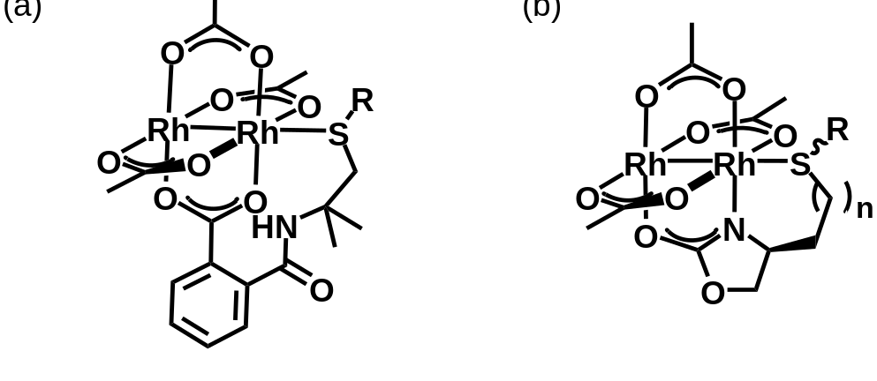
Figure 2.1 Rh(II,II)-TACLs complexes with thioether axial ligands and a)benzoate or b) oxazolidinone bridging ligands
were chosen to be the axial moiety for our tethered complexes. Thioethers have been known to coordinate well to Rh(II,II) paddlewheels¹³⁴ and although they are not as modular as phosphines, the stereoelectronics of thioethers are fairly tunable ring. Our group initially considered using nitrogenous LBs at the axial site, however, it is known that they bind strongly to the axial site¹³² and have reduced reactivity in some cases.¹²⁸ Weaker donors such as carbonyls, have been used as additives with little to no loss of reactivity and sometimes show improvements in stereoselectivity.¹³³ As a result, thioethers were chosen to be the axial moiety for our tethered complexes. Thioethers have been known to coordinate well to Rh(II,II) paddlewheels¹³⁴ and although they are not as modular as phosphines, the stereoelectronics of thioethers are fairly tunable.
Initial reports of our bespoke Rh(II,II) complexes proved that they were proficient in cyclopropanation¹⁰⁸ and Si–H insertion reactions¹³⁵ with donor/ acceptor carbenes (Figure 2.2, a and b respectively). Most importantly, we demonstrated that dimerization could be minimized by incorporating tethered, axially coordinated thioether groups. In the examples where cyclopropanation was concerned, excess substrate was required for adequate yields. Charette and co-workers were able to obtain good yields with 2 equivalents of alkene using conventional Rh(II,II) complexes in a biphasic system¹³⁶ but reports of good yields using equimolar alkene to diazo in Rh(II,II)-mediated intermolecular cyclopropanation reactions remain scarce.²⁶ To address this gap, we sought to fine-tune catalyst performance by varying tether lengths and thioether substituents on our oxazolidinone-based scaffold. Herein, we report the microwave-assisted synthesis of heteroleptic Rh(II,II) complexes comprised of oxazolidinone bridging ligands equipped with tethered thioether groups of varying tether lengths and substituents. The complexes were utilized to maximize yields in the cyclopropanation of alkenes with EDA. Further analysis of the complexes by UV-Vis, cyclic voltammetry, and computational chemistry was conducted to explain the observed reactivity.

Results and Discussion

Ligand Synthesis
As this study necessitated the use of our thiocarbamoylbenzoate (TCB) complexes, the synthesis of their ligands was required (Figure 2.3). Ligand 39 and its precursors were synthesized and characterized according to established procedures
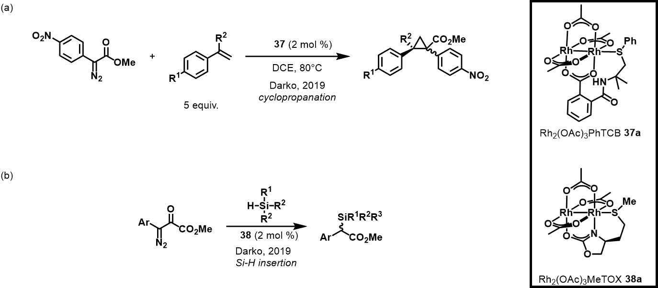
Figure 2.2 Application of Rh(II,II)-TACLs on diazo-mediated a) cyclopropanation and b) Si–H insertion reactions
previously reported by our group (Figure 2.3a).¹⁰⁸ The methyl variant, 41,was synthesized using some of the procedures used for 39 (Figure 2.3b). Thioetherification of 2-ammonio-2-methylpropyl sulfate in NaOH/H₂O resulted in formation of a methyl
aminothioether 41.¹³⁷ This is then followed by ring opening of phthalic anhydride with the aminothioether to arrive at the final 42 ligand.¹⁰⁸
The thiooxazolidinone (TOX) ligands made for this study were primarily synthesized by Dr. Derek Cressy and William Sheffield (Figure 2.3c). These oxazolidinone ligands are derivatives of aspartic acid and contain two methylene unit linkers between the bridging and
axial sites. The MeTOX ligand, 40, and precursors were synthesized according to procedures outlined in our previous work.¹⁰⁸ Other thioether variants derived from aspartic acid were explored to study the effect modifications at the axial ligand have on catalysis. Compound 44 was made by esterification and subsequent carbamate formation from 43. This was then reduced to a diol, 45, which is cyclized to form an oxazolidinone, 46. The oxazolidinone is tosylated to 47 and finally a nucleophilic substitution with a substituted thioether furnishes the final thiooxazolidinone, 48-49. Synthesis of the serine-derived ligands that contain just one methylene unit was similar to the aspartic acid derivatives with both methyl 51 and ^{t}butyl 52 thioethers made (Figure 2.3d).

Catalyst Synthesis
A challenge for the study of our axially coordinated catalysts is the need to synthesize heteroleptic complexes. Traditionally, homoleptic complexes are obtained through sequential substitution of the acetate bridging ligands of dirhodium acetate with the desired ligand.¹³ Full ligand substitution is driven by the removal of displaced acetate through trapping methods. When using this strategy to produce heteroleptic complexes, results are hampered by a complex statistical mixture of products.^{91, 96} Alternatively, one can start with a Rh(II,II) precursor with bridging ligands of varying aptitude for dissociation.^{88, 138} Corey used this method to synthesize heteroleptic imidazolidinate complexes, however, the number of isomers was further complicated by the orientation of the N and O atoms around each Rh atom.^{88, 90} We observed that the incorporation of the thioethers on our ligand scaffold significantly reduced the number of products in heteroleptic complex synthesis.¹⁰⁸ Each ligand substitution either slowed or blocked
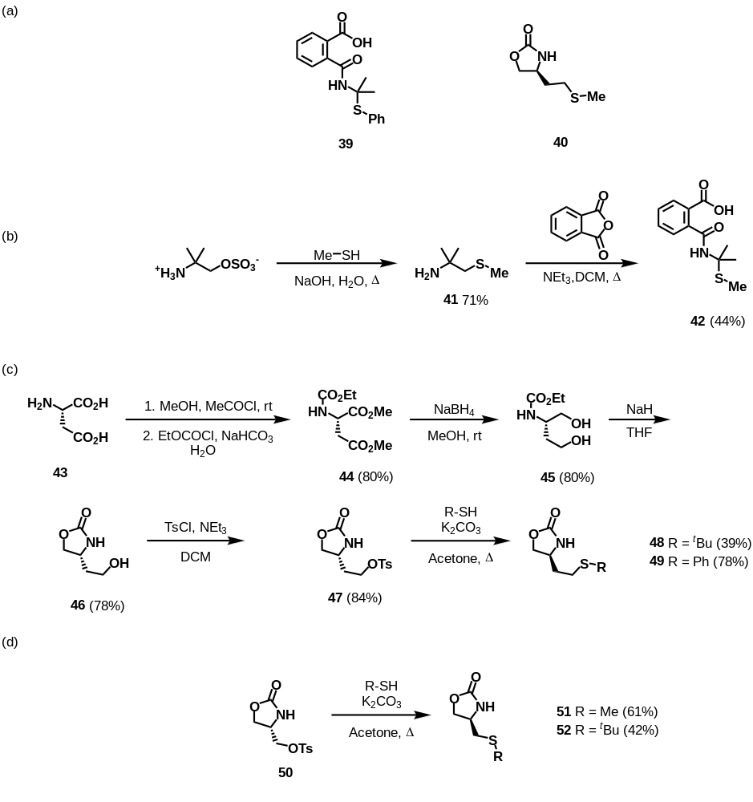
Figure 2.3 a) TCB and TOX ligands previously reported by our group b) synthesis of the methyl variant of 39 c) synthetic pathway for the synthesis of the aspartic acid-derived oxazolidinone series of ligands and d) the synthetic pathway for the synthesis of the serine-derived oxazolidinone ligands
further ligand substitution such that only products from mono- and bis-tethered adducts were produced.
The synthesis of Rh₂(OAc)₃PhTCB 37a and Rh₂(OAc)₂(PhTCB)₂ 37b/c has been documented in our previous work and involves refluxing the PhTCB ligand and Rh₂(OAc)₄ in DCE with N,N-diisopropylethylamine (Hünig’s base) (Figure 2.4a, R = Ph).¹⁰⁸ Rh₂(OAc)₃MeTCB 53a and Rh₂(OAc)₂(MeTCB)₂ 53b/c were obtained using the same procedure for the PhTCB (Figure 2.4a, R = Me). The sulfoxide version of the PhTCB complex, Rh₂(OAc)₃PhOTCB 54, was previously synthesized by undergraduate student Kimberly Hollister and used as is (Figure 2.4b).¹³⁹ Both the methyl and phenyl TCB complexes gave moderate yields of the mono and bis-substituted products in just three hours. However, reaction times were a bit sluggish in the case of the oxazolidinate scaffold, so we turned to microwave synthesis to accelerate the process.
Microwave conditions have previously been implemented for expediting the synthesis of homoleptic Rh(II,II) paddlewheel complexes,^{140, 141} and we were attracted to the microwave synthesis of each complex, even in small amounts, to facilitate rapid access to a range of catalysts for reaction studies. The synthesis of catalyst 38a¹⁰⁸ and 38b/c from ligand 40 and rhodium acetate was used for initial optimization studies. Product formation was initially observed in low yields at 160 °C (Table 2.1, entry 2). Prolonged time at 160 °C did not dramatically improve yields (Table 2.1, entries 3 and 4). Increased temperatures led to an increase in complexes 38a and 38b/c with preferred formation of 38 (Table 2.1, entry 5). A series of solvents with varied coordinating ability were then screened (Table 2.1, entries 5–9). Ethanol gave a high percent conversion (Table 2.1, entry 7) but provided low yields of 38a and 38b/c along with the presence of a grey solid. It has been reported that ethanol facilitates the reduction of Rh(II,II) to Rh(0), which would explain the grey solid residue in the reaction vessel.³⁵ As observed with other ligand exchange conditions, the weakly coordinating solvents DCE and chlorobenzene (PhCl) produced the highest yields (Table 2.1, entries 5 and 9). Although they gave similar yields, DCE was used in further reactions due to its convenience in reaction workup. A further increase in temperature to 190 °C afforded the optimal conversion and product yield while producing the desired mono-complex 38a preferentially to the bis-complexes 38b and 38c (Table 2.1, entry 10). Continuing to increase the temperature did not significantly improve yields (Table 2.1, entry 11).
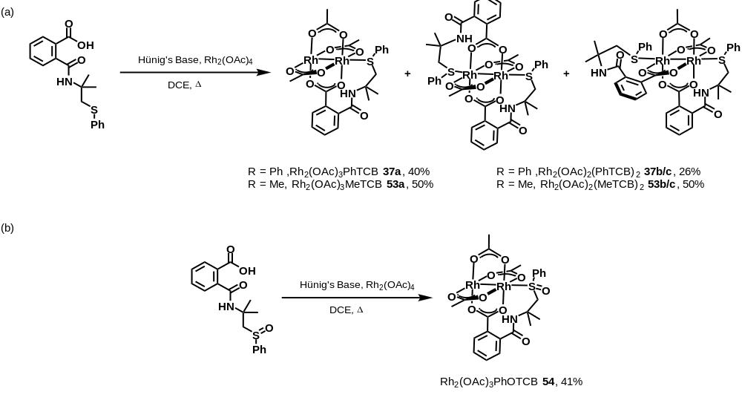
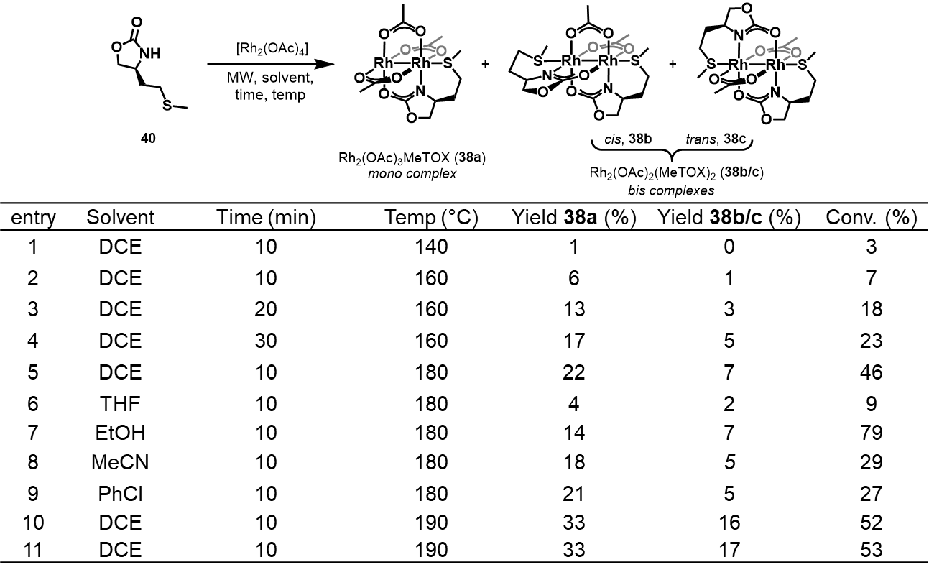
Figure 2.4 Synthesis of Rh(II,II)-TACLs complexes with a) TCB ligands and b) an oxidized TCB ligand
Table 2.1 Optimization of microwave synthesis parameters for Rh(II,II)-TACLs complex synthesis
Ligand exchange reactions with the other TOX ligands using the optimized microwave conditions furnished complexes 55-57 (Figure 2.5). The mono-substituted complexes formed preferentially in all cases, but the ratio of mono-to-bis increased according to donating strength of the thioether substituent. More specifically, the stronger donating t-butyl group in ligand 48 furnished a 3:1 ratio of complexes 55a to 55b/c compared with 1.3:1 for 56a to 56b/c in which the sulfur substituent was phenyl. Higher overall yields were obtained when the tether length was one methylene unit compared to two methylene units, as evidenced by comparing yields of complexes from ligand 51 to those from ligand 40 It is worthy to note that while ligands with pendant thioethers proceeded readily with one equivalent of the ligand under microwave conditions, synthesis of mixed ligand oxazolidinate/carboxylate complexes without axial coordination required excess ligand to drive the reaction forward,^{88, 135} suggesting that the tethered thioether facilitates ligand exchange.

Characterization of Rh(II,II)-TACLs

X-Ray Structures
We have previously reported the X-ray structure for complex 38a¹⁰⁸ and we were able to obtain suitable crystals for X-ray analysis for complex 56a via slow evaporation of a 1:1 mixture of acetonitrile and toluene (Figure 2.6). Despite our efforts, we were unable to obtain X-ray quality crystals of the other new complexes. Unlike complex 38a, Rh₂(OAc)₃PhTOX (56a) does not form an oligomeric chain in the solid state. Instead, the asymmetric unit is comprised of four distinct paddlewheel units in which the second axial site is occupied by acetonitrile (Figure 2.7). A stereogenic center is created at the sulfur atom upon coordination to the Rh centre.¹⁴²⁻¹⁴⁵ As a result, a mixture of diastereomers is present, (S_{C}, R_{S}) and (S_{C}, S_{S}), due to the sulfur stereogenic center and the S configuration at the asymmetric carbon on the bridging oxazolidinate (Figure 2.6). Of the four paddlewheel units, two are (S_{C}, R_{S}) and two structures are (S_{C}, S_{S}), with minor structural variations between them. Representatives of each pair are shown in (Figure 2.6). The Rh–Rh bond distances for each paddlewheel unit does not vary (average of 2.4217(5) Å) and is within the general range for Rh–Rh bonds in paddlewheel complexes, which are typically between 2.35–2.45 Å.³² The Rh–S bond distances of complex 56a range between 2.4730(12)–2.5195(12) Å. The observation that the Rh–S bonds are not constant suggests that the phenyl thioether axial ligand is in a fluxional state and is a weaker donor than the
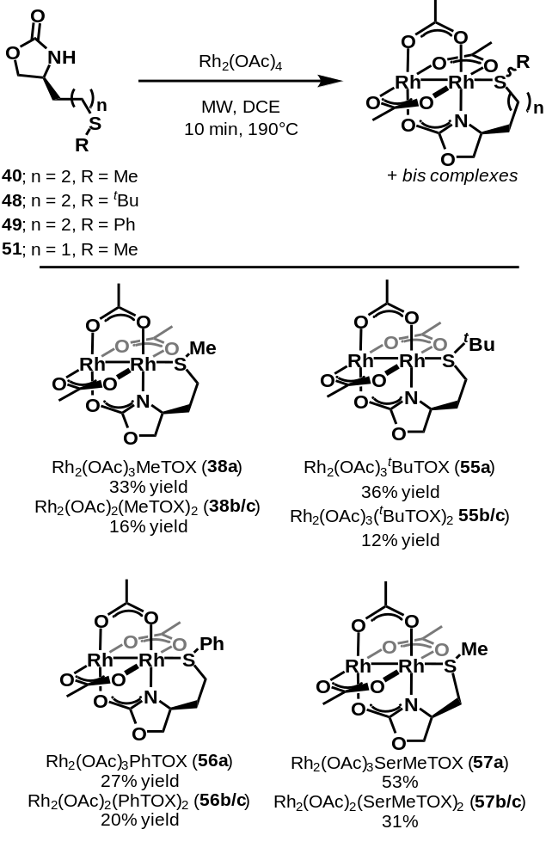
Figure 2.5 Rh(II,II)-TACLs with TOX ligands synthesized via microwave method
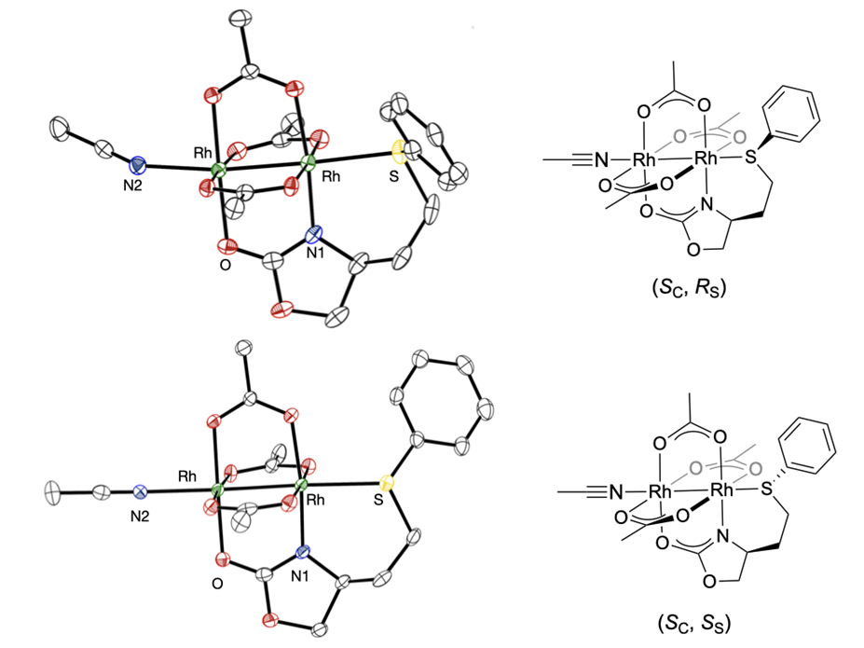
Figure 2.6 X-Ray structure of complex 56a with thermal ellipsoids at 50% probability. Only two of the four molecules in the asymmetric unit are shown. Selected bond lengths and angles as an average of the four structures of the asymmetric unit: Rh–Rh 2.42 Å, Rh–S 2.50 Å, Rh–N2 2.24 Å, Rh–Rh–S 175.5°.
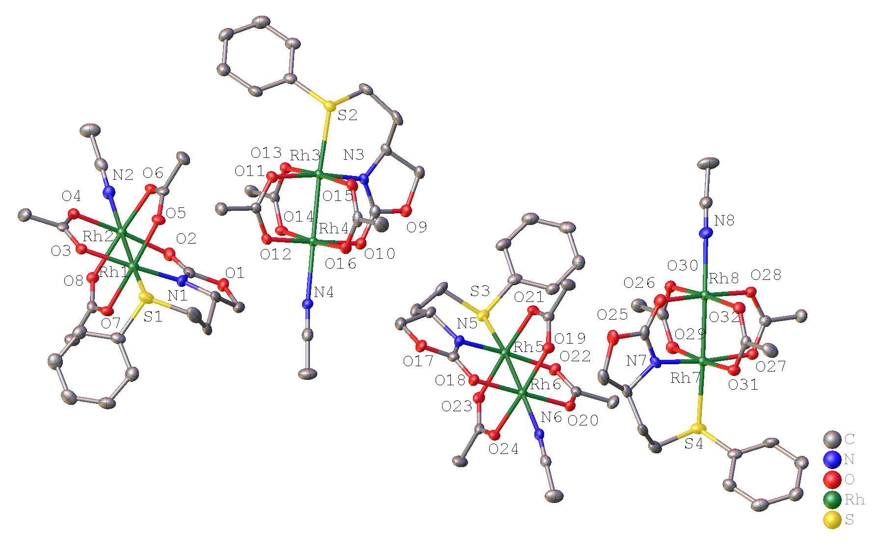
Figure 2.7 Asymmetric unit of Rh₂(OAc)₃PhTOX·CH₃CN (36·CH3CN) with ellipsoids shown at 50% probability level and protons omitted for clarity
methyl sulfide in 38a, in which the intramolecular Rh–S bond is 2.48 Å.¹⁰⁸ The Rh–N2 bond distance varies little and averages 2.236(4) Å between the paddlewheel structures, but pairs of the structures have differences in Rh–Rh–N angles. The (S_{C}, R_{S}) pair has slightly bent Rh–Rh–N angles of 171°, while the (S_{C}, S_{S}) pair has almost linear Rh–Rh–N angles of 175°. The variations are most likely a consequence of packing effects, but they give insight into the structural flexibility of the complex.

UV-Vis Spectroscopy
In general, axially coordinated molecules bind to the σ* orbital of the Rh–Rh center, which perturbs the π* to σ* HOMO–LUMO gap. This is manifested by shifts in the visible region of their UV-vis spectrum.³¹ Figure 2.8 shows the overlaid UV-vis spectra of the mono-complexes 38a, 55a, 56a, and 57a. The colors of the mono-complexes are shades of violet and the local maxima of their bands in the visible region are clustered between 572 nm to 582 nm. The similarity between them suggests that varying the tether length (between 1 or 2 methylene units) or varying the thioether substituent (Me, ^{t}Bu, or Ph) does not significantly alter the HOMO–LUMO energy gap of the complex (Figure 2.8).

Cyclic Voltammetry
Cyclic voltammetry experiments were performed to probe the effect of the tethered thioether ligands on the electronics at the Rh metal centers. Early studies demonstrated that the variance of the Rh₂^{4+/5+} oxidation potential could be used as a metric for the strength of axial coordination.¹²⁵ Our analysis was conducted in 0.1 M [TBA][PF₆] in dichloromethane. Figure 2.9 is a stack of the cyclic voltammograms of the Rh(II,II) complexes. Each of the complexes displayed a reversible, or quasi-reversible, oxidation event assigned to the Rh₂^{4+/5+} couple. Oxidation potentials of the mono-complexes followed the trend that increased σ donating ability of the tethered thioether corresponded to a higher oxidation potential (Figure 2.9). This is contrary to previous studies in which the sequential addition of exogenous axial ligands resulted in a lower oxidation potential.¹²⁶ This increased oxidation potential, though unexpected, is not unprecedented. We have shown this trend to be the case with respect to Rh₂(OAc)₃PhTCB 37 complexes which also contains a tethered thioether and showed a Rh₂^{4+/5+} E_{1/2} value 36 mV higher than Rh₂(OAc)₃OBz 59 (OBz = benzoate).¹⁰⁸ It is worth noting that the same trend was not observed when the CV experiments of complexes 38a, 55a, 56a, and 57a were conducted
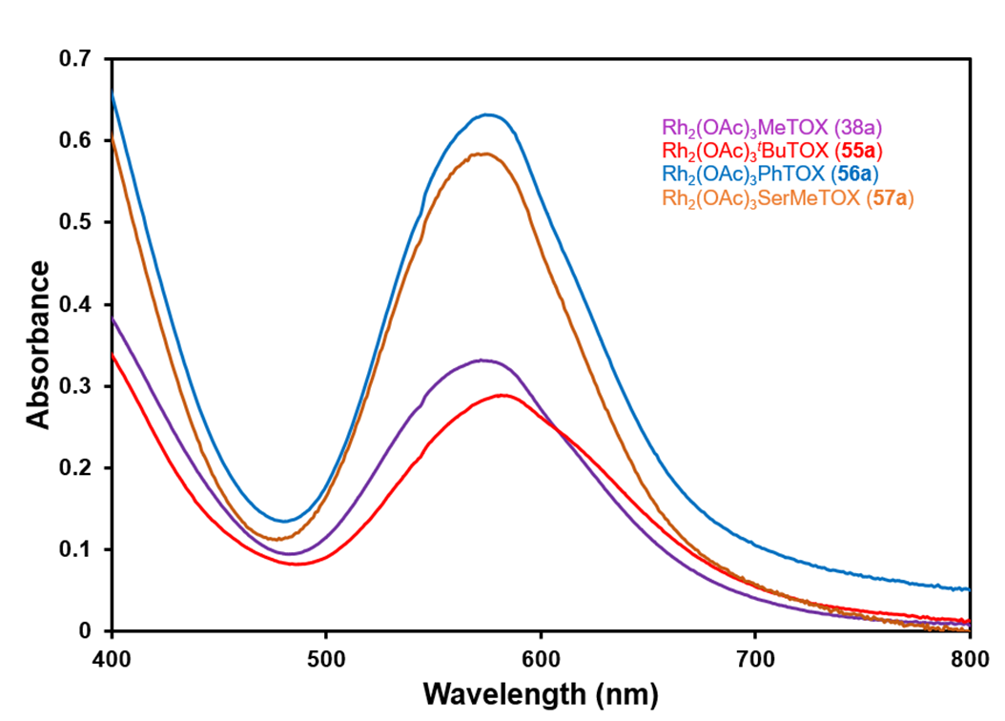
Figure 2.8 UV-Vis spectrum of complexes 38a, 55a. 56a, and 57a.
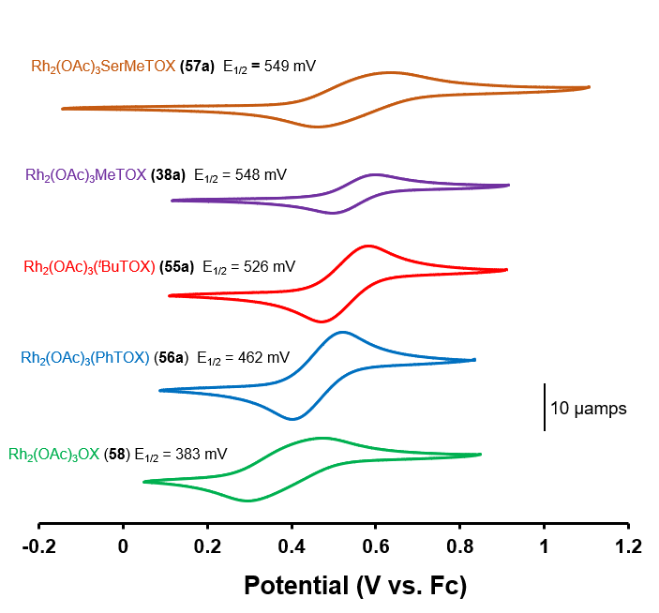
Figure 2.9 Cyclic voltammograms of complexes 38a, 55a, 56a, 57a, and Rh₂(OAc)₃OX. Electrolyte comprised of 0.1 M [TBA][PF₆] in DCM (scan rate of 100 mV s⁻¹).
in MeCN confirming that the electrochemical study of the complexes is sensitive to coordinating solvents.

Cyclopropanation of Ethyl Diazoacetate
We initially explored the reactivity of the various rhodium catalysts in the cyclopropanation of styrene with ethyl diazoacetate (EDA) using optimal conditions from our previous studies.¹⁰⁸ We anticipated that performing the reactions with excess styrene would likely result in high yields of the cyclopropane product for most of the catalysts. Therefore, to better distinguish the performance of reaction conditions, reactions were conducted with equimolar amounts of styrene to EDA. In this way, selectivity between carbene dimerization and cyclopropanation could be evaluated. Initial optimization of reaction conditions showed that cyclopropane yields are improved when the reaction is run at a higher concentration (Table 2.2, entries 1-2). Like our previous cyclopropanation work, DCE was found to be an adequate solvent with other chlorinated solvents giving subpar yields (Table 2.2, entries 3-4). A higher dielectric constant also seems to be detrimental to the reacton (Table 2.2, entry 5). The introduction of coordinating additives to the reaction solution either hindered the catalysis (Table 2.2, entry 6) or completely shut down the reaction all together (Table 2.2, entry 7). Strong binding of nitrogen to the axial site and formation of N-H insertion products are the most likely reasons for these results.
Once the reactions were optimized, the next step was a catalyst screen to determine the optimal catalyst for the reaction. Reactions remained at equimolar amounts of styrene to EDA to better analyze differences with each catalyst. Both the methyl and phenyl TCB complexes gave moderate yields at 60% and 54% respectively (Table 2.3, entries 1-2). Oxidation of the thioether seemed to decrease its performance in the reaction (Table 2.3, entry 3). Similar to the cyclopropanation of donor/acceptor diazos¹⁰⁸, the tethered TCB complexes outperform both the benchmark rhodium acetate and heteroleptic, untethered control complex Rh₂(OAc)₃OBz 59 (Table 2.3, entries 4-5).
In contrast to previous work in our group demonstrating low reactivity for catalyst 38a with donor/acceptor diazo compounds in the cyclopropanation of styrene,¹⁰⁸ it was a very competent catalyst when EDA was used, providing 63% yield of the cyclopropane and trace yields of dimer products (Table 2.4, entry 1). The length of the tether only had
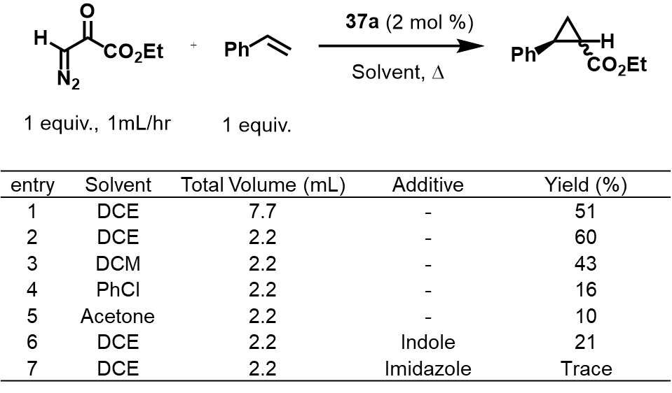
Table 2.2 Optimization of reaction conditions in the cyclopropanation of styrene and EDA using 37a
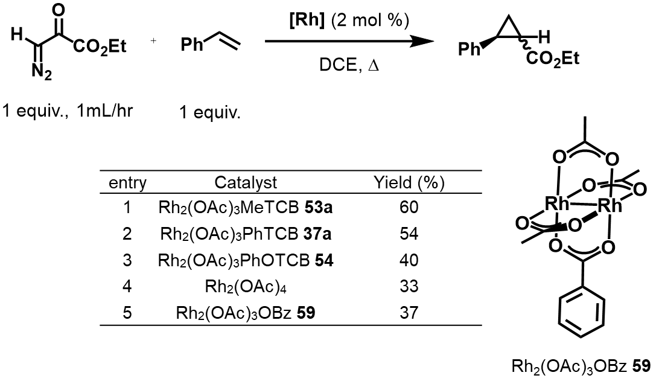
Table 2.3 Initial screening of Rh(II,II) catalysts for the cyclopropanation of styrene with EDA
a minor influence on the yield of the cyclopropane, but the change resulted in increased dimer formation (Table 2.4, compare entries 1 and 2). The thioether substituent had a more pronounced effect on cyclopropane yield. Complex 56a with a phenyl substituent on the thioether, provided the highest cyclopropane yield of the series (71%, Table 2.4, entry 3), while the complexes with alkyl substituents on the thioether (complexes 38a, 55a, and 57a) gave essentially comparable yields (Table 2.4, entries 1–4). Except for complex 57a, the mono-substituted tethered complexes had only trace amounts of dimer products. All of the tethered complexes outperformed rhodium acetate in cyclopropane yield (Table 2.4, entry 5). 58 was also tested to eliminate the possibility that the bridging oxazolidinate ligand was responsible for the yield increases. However, 58 also obtained the cyclopropane in a lower yield compared to the tethered complexes, further implicating the tethered thioether as the reason for increased yields (Table 2.4, entry 6). As observed in our previous work, the mixed bis-substituted complexes 38b/c exhibited greatly diminished catalytic activity (Table 2.4, entry 7).^{108, 135} In this reaction, some carbene dimerization was observed along with a high percentage of unreacted EDA. The dual tether of the bis-substituted complex likely blocks both axial sites, requiring displacement before catalysis is possible and thereby reducing reaction yield. Dimerization yields were more of an issue for non-tethered complexes when catalyst loading was reduced, but the side product was kept minimal when complex 56a was used, although a drop in cyclopropanation yield was observed (Table 2.4, entries 8–11). At 0.1 mol% of catalyst, complex 56a provided a 53% yield with 3% of the dimer products, while 58 gave a 30% yield of cyclopropane and 17% yield of dimer products (Table 2.4, entry 10 and 11). This result is evidence that the thioether tether may assist with catalyst turnover, an issue that is present when ethyl diazoacetate is used as the diazo precursor.¹⁴⁶
A substrate scope was conducted for the cyclopropanation reaction using 2 mol% of complex 56a (Figure 2.10). Styrene derivatives 60-70 generally maintained good yields at 1 equivalent of olefin and high yields of cyclopropane when 5 equivalents were used. 4-t-Butylstyrene provided similar yields of product 62 compared to styrene, while 4-chlorostyrene gave a slightly lower yield of compound 61. This is consistent with inductive withdrawing effects of the Cl resulting in a less nucleophilic olefin. Introduction of steric hindrance via disubstituted olefins also resulted in good to excellent yields, albeit slightly lower than monosubstituted olefins (63 and 64, Figure 2.10). Non-styrene derivatives
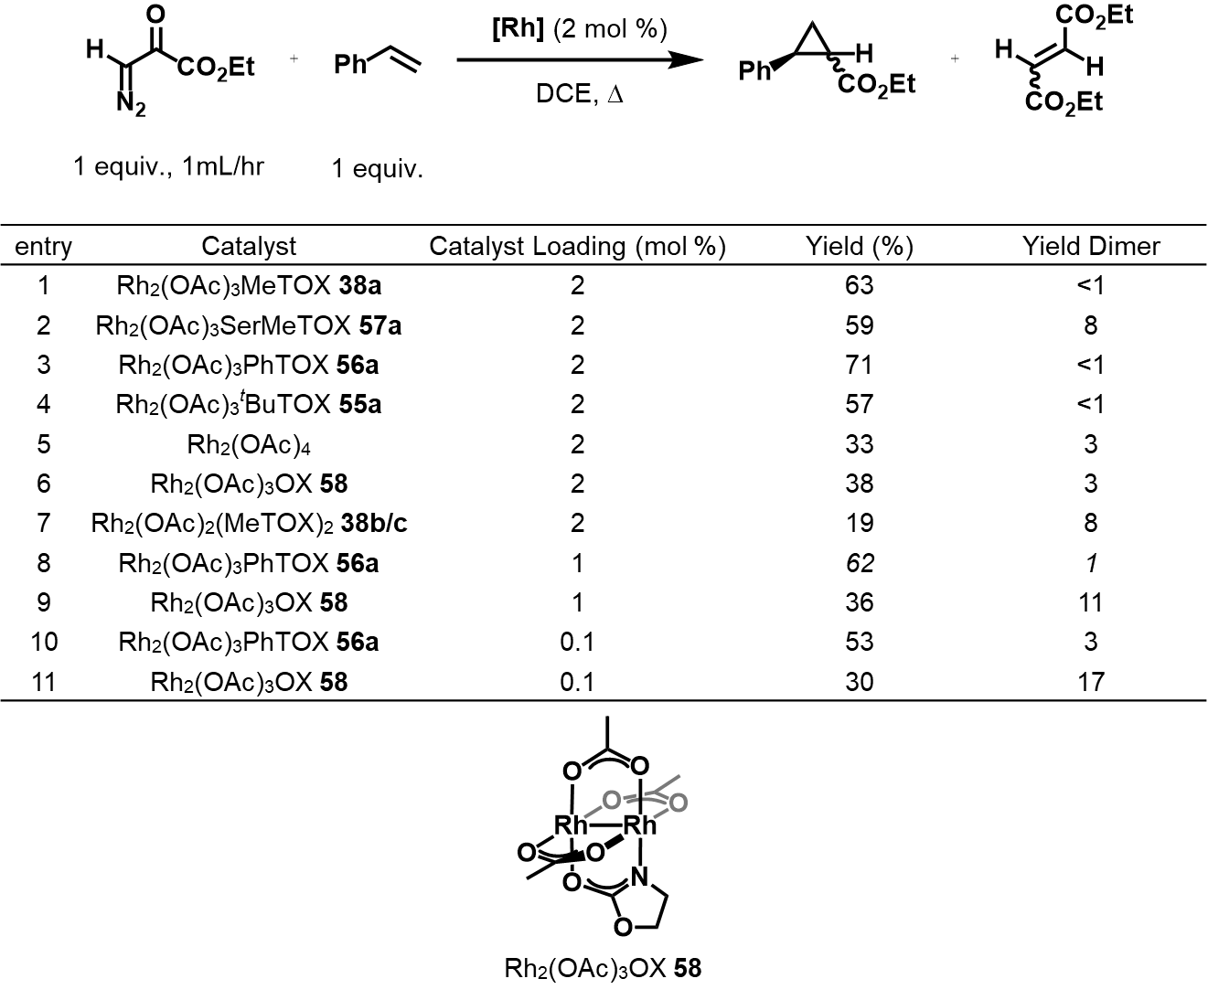
Table 2.4 Screening of Rh(II,II) TOX catalysts in the cyclopropanation of styrene with EDA
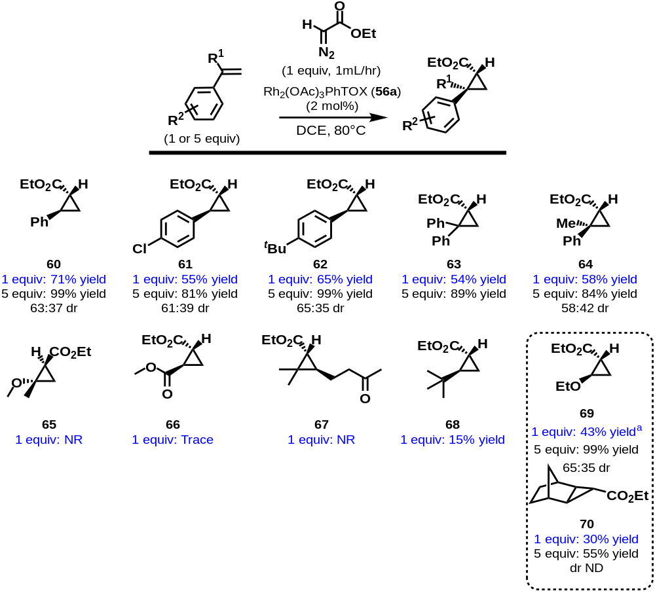
Figure 2.10 Rh₂(OAc)₃PhTOX (56a)-catalyzed cyclopropanation of EDA. All yields calculated by ¹H NMR except compounds 60 and 69
were also tested. Most of the non-aryl olefins tested gave either trace amounts or no cyclopropane products whatsoever (Figure 2.10, 65-68). Non-styrene derivatives 69 and 70 performed well in the reaction when 5 equivalents of olefin were used. Using 5 equivalents of the electron-rich ethyl vinyl ether afforded quantitative amounts of cyclopropane 69, but only 31% yield at 1 equivalent. We hypothesized that volatility of the vinyl ether was partly to blame for the low yield. Performing the experiment at room temperature slightly increased the yield to a 43% yield of 69. The synthetically challenging norbornene afforded moderate yields of its respective cyclopropane (compound 70) at 5 equivalents, but low yield at 1 equivalent. In all cases, the diastereomeric ratio of the cyclopropanes did not differ markedly from that observed in the literature.⁵ This was anticipated as EDA generally gives low diastereoselectivities in Rh(II,II)-carbene cyclopropanation reactions (Figure 2.10).^{9, 147-149}

Computational Analysis
DFT calculations were employed as a means of further understanding the electronic structure of the complexes. Theoretical calculations of the precursor complexes, as well as their carbene complexes with EDA, were calculated at the MO6-2X/def2-TZVPP level of theory. According to Berry’s three center/four electron (3c/4e) bonding model, the addition of axial ligands has the most impact in the energy of the Rh–Rh σ* orbital, which is the LUMO of the complex.³¹ The out of phase combination of the axial ligand’s lone pair σ orbitals interact with the Rh–Rh σ* orbital and raise the energy of the Rh–Rh σ* LUMO. When comparing complex 56a to 58, the most dramatic change was in the destabilization of the Rh–Rh σ* LUMO due to their interaction with the thioether lone pairs (Figure 2.11). The extent of destabilization is greater with 38a¹³⁵ than 56a, hence, stronger axial interactions lead to greater destabilization, which is in agreement with the 3c/4e model.^{31, 150} The effect of the axial ligands also raises the energy of the Rh–Rh π* HOMO, but this energy destabilization is minor compared to that of the LUMO. The combined effects lead to larger HOMO–LUMO gaps for the complexes with tethered thioethers when compared to 58.
Upon analysis of the LUMO of the carbene species, we found interesting differences in the electronic structure of the tethered complexes (Figure 2.12). The LUMO of Rh-carbene 71 comprises of an interaction of the p orbital of the carbene with a filled Rh–Rh π* orbital, which is normally the case with axially free rhodium complexes.¹⁵¹ The
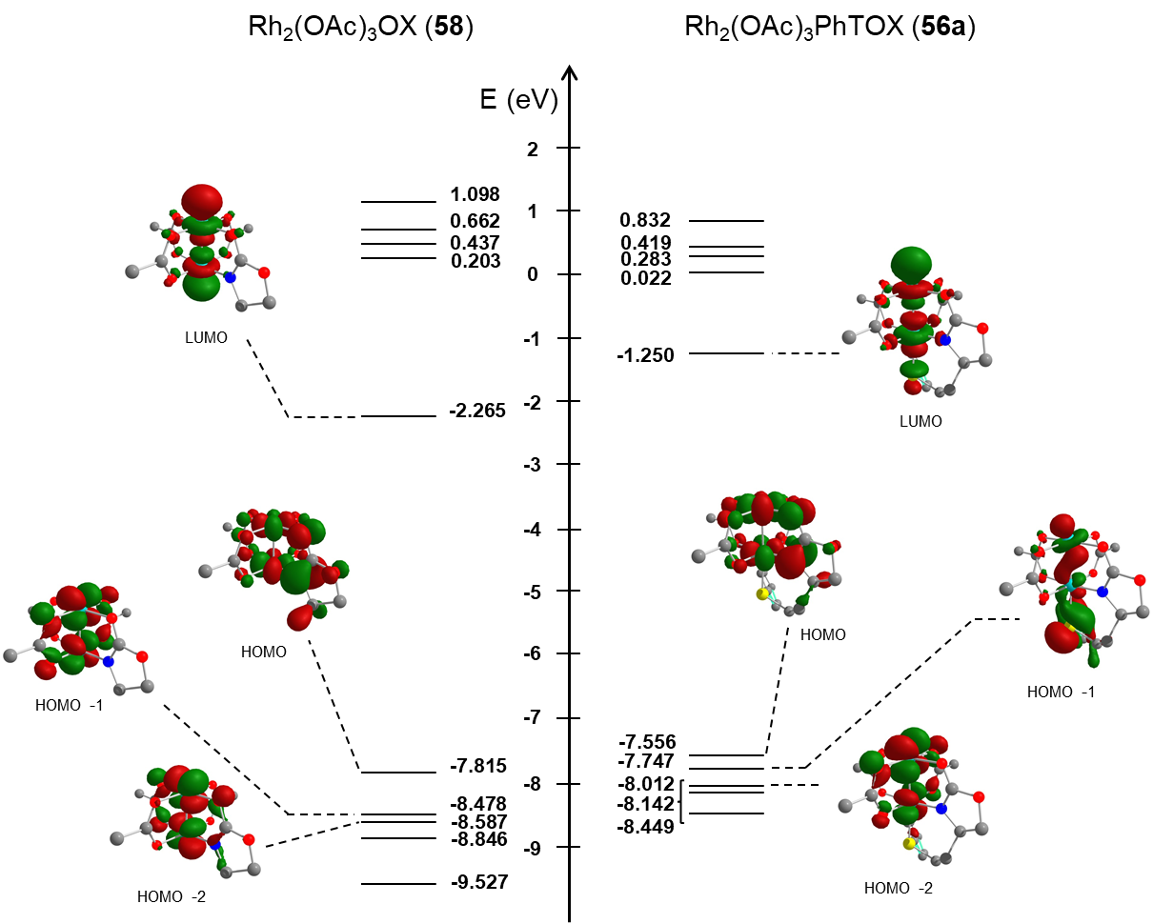
Figure 2.11 Molecular orbitals of complex 56 in comparison to 58 calculated at the MO6-2X/def2-TZVPP level of theory
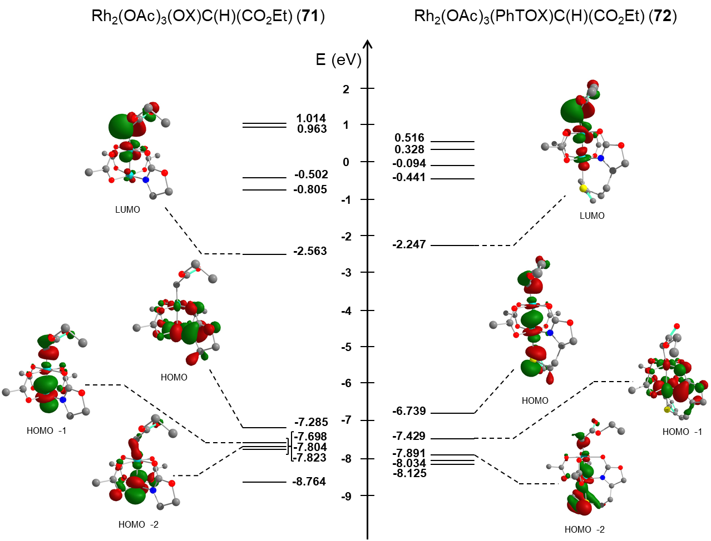
Figure 2.12 Calculated orbitals and energies of EDA carbenoid species 71 and 72. Calculated at the MO6-2X/def2-TZVPP level of theory.
extent of π backbonding decreases the electrophilicity of the carbene, but this interaction is polarized towards the Rh, leading to “super electrophilic” carbenes.^{31, 152} In the case of the tethered thioether carbene complex 72, the LUMO seems to include a mixed electronic environment at the Rh core—π symmetry at the Rh–C and σ symmetry at the Rh–S. Such mixing of σ and π components in metal–metal bonding has been reported for triruthenium extended metal-atom chains (EMACs) in which bending of the linear structure introduces mixing of σ and π orbitals in the Ru₃ core.¹⁵³ In our case, the calculated S–Rh–Rh (176°) and Rh–Rh–C (168°) angles in 72 deviate from linearity compared to 71 (Rh–Rh–C ∼177°) and this reduction in symmetry may be the driving force for the interaction of the σ and π orbitals. A result of this distortion is an increase in the energy of the LUMO orbital of 72 compared to 71. Although this is not a dramatic increase in energy (0.316 eV or 7.29 kcal mol−1), it opens the possibility of further perturbing the Rh(II,II)-carbene LUMO energy with distal axial coordination.
The more significant energy destabilization occurs in the HOMO of the carbene complexes with tethered thioether ligands. The HOMO of the carbene from tethered complex 72 is comprised of a Rh–Rh σ-bonding orbital with significant carbene character. Out-of-phase σ interactions characterize both the interaction of the tethered thioether and carbene with the Rh center. In contrast, in the untethered complex 71, the HOMO is a Rh–Rh π* orbital with no carbene character. It is plausible that the difference in the HOMOs is an important factor in the enhanced reactivity of the complexes with tethered thioether ligands. A similar change in the electronic character of the HOMO was observed when carboxylate paddlewheel complexes with Rh–Rh and Rh–Bi metal centers were compared. Fürstner and co-workers observed extreme electrophilicity of Rh–Bi acceptor carbene complexes and implicated 3c/4e interactions in the σ framework as the major contributor.¹⁵² Davies and co-workers also observed similar qualitative orbital topologies with Rh–Bi donor/acceptor carbene complexes and proposed that the HOMO of the Rh–Bi complex should result in a more nucleophilic carbenoid.¹⁵⁴ It is generally accepted that cyclopropanation occurs via a concerted, but asynchronous process that is initiated by nucleophilic attack on the carbene carbon by the olefin.¹⁵⁵ We speculate that since the HOMO of the tethered complexes partially lies on the carbene carbon, it could more readily facilitate the formation of the cyclopropane ring over other competing pathways.
Further support for σ interactions in the HOMO as a major factor is provided by the calculated bond distances for the carbene species, in which the tethered complex 72 possesses an elongated Rh–C bond in comparison to the untethered carbene complex 71 (Table 2.5). Natural population analysis of the carbene complexes shows increased electron density at the carbene carbon of 72 compared to 71 (0.095 vs. 0.174 respectively, Table 2.5), meaning that the tethered thioether can modulate the electron density at the distal carbene. This remote modulation of electron density could account for the reactivity and be a factor in reducing the barrier for the rate-limiting diazo extrusion step,^{155, 156} thereby increasing catalyst turnover. Theoretical calculations are underway to better address the effects of tethered ligands on transition states and energy barriers in diazo-mediated transformations.

Conclusion
In conclusion, heteroleptic Rh(II,II) paddlewheel complexes containing axially coordinated thioether ligands were synthesized using base in reflux conditions and a microwave-assisted approach. We have demonstrated that catalyst synthesis and reactivity is influenced by the tether length and the substituent of the thioether. The tethered complexes achieved higher yields that their non-tethered counterparts in the cyclopropanation of styrene with ethyl diazoacetate, even demonstrating good yields with equimolar amounts of styrene substrate. Electronic studies and computational methods provided insight into the effect of the donating strength of the tethered ligands on the observed reactivity. The calculations were of relevance, revealing the importance of the effect of the tethered thioether on the HOMO of the Rh(II,II)-carbene complexes. Efforts to further understand the interplay between the donor of the tether and reactivity in Rh(II,II)-carbene mediated reactions are currently ongoing.
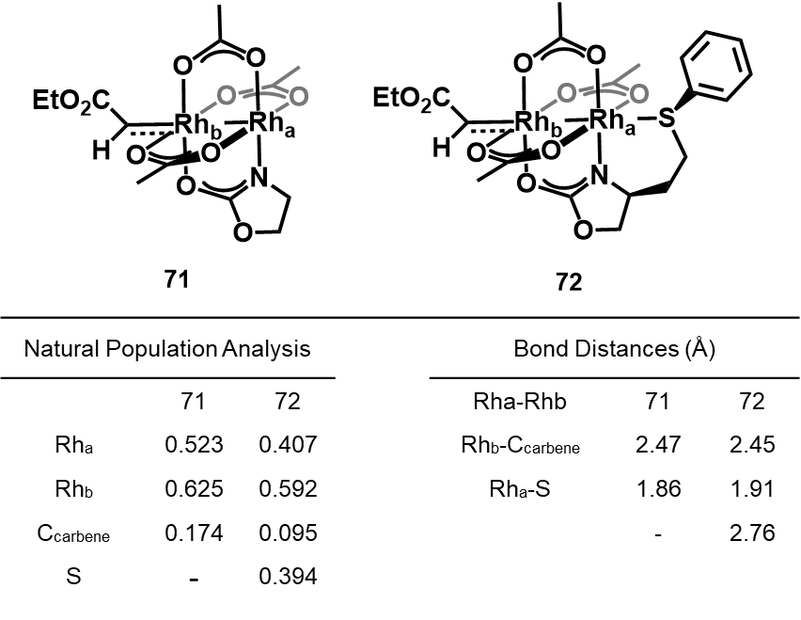
Table 2.5 Calculated geometric parameters and NBO analysis of 71 and 72. Calculated at the MO6-2X/def2-TZVPP level of theory

Effect of Tethered, Axially Coordinated Ligands (TACLs) on Dirhodium(II,II) Catalyzed Cyclopropanation: A Linear Free Energy Relationship Study

Disclosure
Portions of the following chapter were adapted from the article:
Zavala, C.; Darko, A., Effect of Tethered, Axially Coordinated Ligands (TACLs) on Dirhodium(II,II) Catalyzed Cyclopropanation: A Linear Free Energy Relationship Study. The Journal of Organic Chemistry 2022, In review.
Cristian Zavala was responsible for synthesis, characterization, catalytic screening of catalysts, and writing of the manuscript. Prof. Ampofo Darko advised the work.

Abstract
Hammett correlation experiments were used to determine the nature of the influence of Rh(II,II) paddlewheel complexes with tethered, axially coordinated ligands (TACLs) on the chemoselectivity of rhodium carbenoids using competitive cyclopropanation reactions. Reaction constants for the intermolecular cyclopropanation of ethyl diazoacetate with para-substituted styrene derivatives were found to differ when comparing TACLs complexes with conventional Rh(II,II) paddlewheel complexes. Although larger changes were observed when incorporating heteroleptic bridging ligands, the results suggest that Rh(II,II) paddlewheel complexes with TACLs are less sensitive to changes in electronics and reduce selectivity in cyclopropanation reactions with acceptor-substituted rhodium carbenoids. In addition, Hammett experiments with functionalized aryldiazoacetates resulted in a non-linear downward curvature of the Hammett plot. Hints of this deviation was also seen when para-substituents were modified on aryl thioethers on TACLs, suggesting a change in the rate-limiting step of the carbene transfer reaction in response to the changes.

Introduction
Rhodium carbenoids, largely derived from α-diazocarbonyl precursors, have proven to be efficient and versatile intermediates in organic synthesis with applications in cyclopropanation reactions,²³ ylide reactions,¹⁵⁷ and X-H insertion reactions (X = C, S, O, N, Si).^{13, 14, 23} The reactivity and selectivity of the complexes are driven by the selection of bridging ligands surrounding the bimetallic Rh(II,II) center. The choice of ligand can impart remarkable selectivity in carbene transfer reactions^{53, 119, 158, 159} and has been leveraged in the synthesis of many complex molecules.¹⁶⁰⁻¹⁶⁴ Although it has been known that changes to the bridging ligands have a direct effect on the control of selectivity in Rh(II,II) carbene transfer reactions,^{53, 119, 158} the effect of ligand coordination to the axial sites of Rh(II,II) catalysts on carbene transfer reactions are also important.¹²⁴ Over the years, it became apparent that an inductive effect as a result of Lewis Base (LB) coordination at one axial site is communicated through the Rh-Rh bond, which weakens Lewis acidity at the distal rhodium site.^{31, 121, 122, 165, 166} The increased electron density at the other rhodium can effectively slow down association of another ligand. Indeed, introduction of axial ligands can have profound effects on the electronics of the carbenoid.^{124, 156, 167}
Experimentally, studying axial coordination by tethering them to bridging ligands has emerged as a viable strategy to circumvent the weak interaction associated with axial ligands.^{104, 105, 168} This provides a bias for the site of reactivity and ensures a high local concentration for axial coordination. Tethered axial coordination has also been implicated in the reaction mechanisms as in the case of a three-component reaction involving carbene transfer when Rh₂(Oct)₄ was used with Xantphos as the ligand.¹⁶⁹ We have investigated the role of axial coordination by designing bridging ligands that have pendant thioether moieties that are capable of axial coordination (complexes 37a, 56a, and 38a, Figure 3.1).^{108, 135, 170} The use of a thioether group, well-known as components of hemilabile ligand structures,¹⁷¹⁻¹⁷⁶ ensured that catalysis was not completely inhibited at the distal Rh active site. The use of these tethered, axially coordinated ligands (TACLs) resulted in improved Si–H insertion¹³⁵ and cyclopropanation^{108, 170} yields compared to conventional Rh(II,II) catalysts (complexes 59 and 58 Figure 3.1). Our computational studies have also determined that the axial ligands could modulate the electron density of the carbene via electronic communication across the Rh-Rh bond.¹⁷⁰ To further evaluate this effect, we turned to linear free energy relationships (LFER) to determine the extent of the influence the axial tether has on the chemoselectivity of Rh(II,II) carbenes in competitive cyclopropanation reactions.

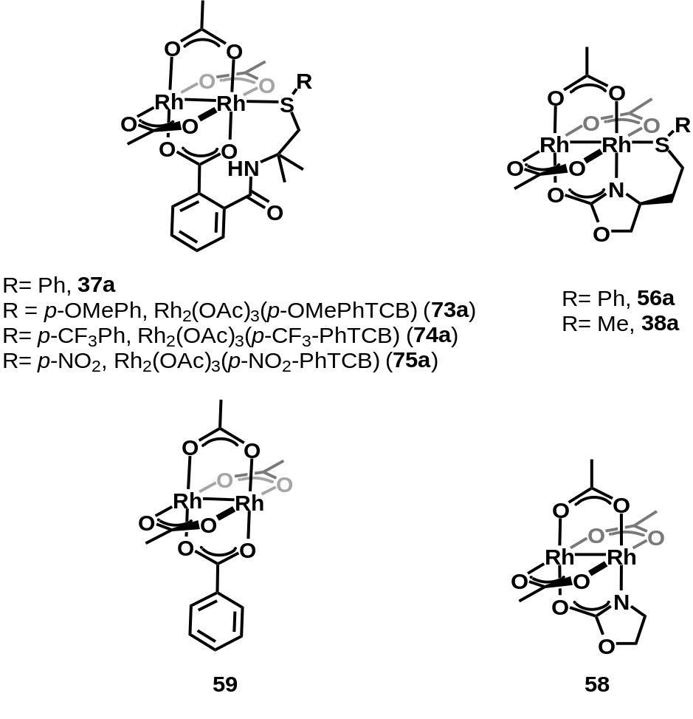
Figure 3.1 Rh(II,II)-TACLs complexes, 37a, 73a-75a, 56a, and 38a, and their heteroleptic control complexes 59 and 58. Complexes 37a,38a, 56a, 58, and 59 have been previously disclosed by our lab.
The use of Hammett constants to evaluate mechanisms in carbene transfer is precedented and has been used to confirm the electrophilic nature of Fisher-type metallocarbenoids^{177, 178} or radical mechanisms in metal-catalyzed olefin cyclopropanation.¹⁷⁹ A breakthrough in selectivity with Rh(II,II) carbenes came with the use of donor/acceptor carbeniods. Davies and co-workers determined that vinyl and aryldiazoacetates were much more chemoselective than unsubstituted acceptor diazoacetates by comparing relative rates of cyclopropanations between styrene and substituted styrene derivatives (Figure 3.2).²⁸ Rho(ρ) values across various catalysts also indicated that chemoselectivity in the cyclopropanation is largely affected by the structure of the carbenoid and only slightly affected by the Rh(II,II) catalyst used.²⁸ It was theorized that introduction of an electron-donating group (EDG) likely stabilizes the electron-deficient carbene and creates a later transition state so that more charge builds up at the reaction center.¹⁵⁵ This extra stability has led to a number of applications, most notably in C-H functionalization,¹⁸⁰ for donor/acceptor carbenoids resulting in highly diastereo-, chemo-, and enantioselective transformations when combined with the appropriate chiral Rh(II,II) paddlewheel catalyst.^{23, 85} Qu and co-workers also used Hammett correlations to gain more insight into the carbene transfer mechanism through pairwise competition reactions between a series of substituted aryldiazoacetates in a Si–H insertion reaction (Table 3.1).¹⁸¹ In that study, ρ values were catalyst dependent, with electron-poor catalysts resulting in greater charge buildup in the reaction. While previous studies with Rh(II,II) carbenes have focused on the role of electronics on the carbenoid, described herein would be the first example of using Hammett correlations to study the effects of axial coordination on Rh(II,II)-catalyzed carbene transfer reactions. These experiments were conducted with previously reported Rh(II,II) TACLs complexes^{108, 170} (complexes 37a, 56a, and 38a, Figure 3.1) along with newly synthesized complexes for further fine-tuning at the axial site (complexes 73a-75a, Figure 3.1).

Results and Discussion

Rh(II,II)-TACLs Synthesis
To evaluate the electronic influence of the axial ligand, aryl thiocarbamoyl benzoate (ArTCB) complexes with donating and withdrawing para substituents were synthesized. To this end, the necessary thiocarbamoylbenzoate ligands and their precursors were
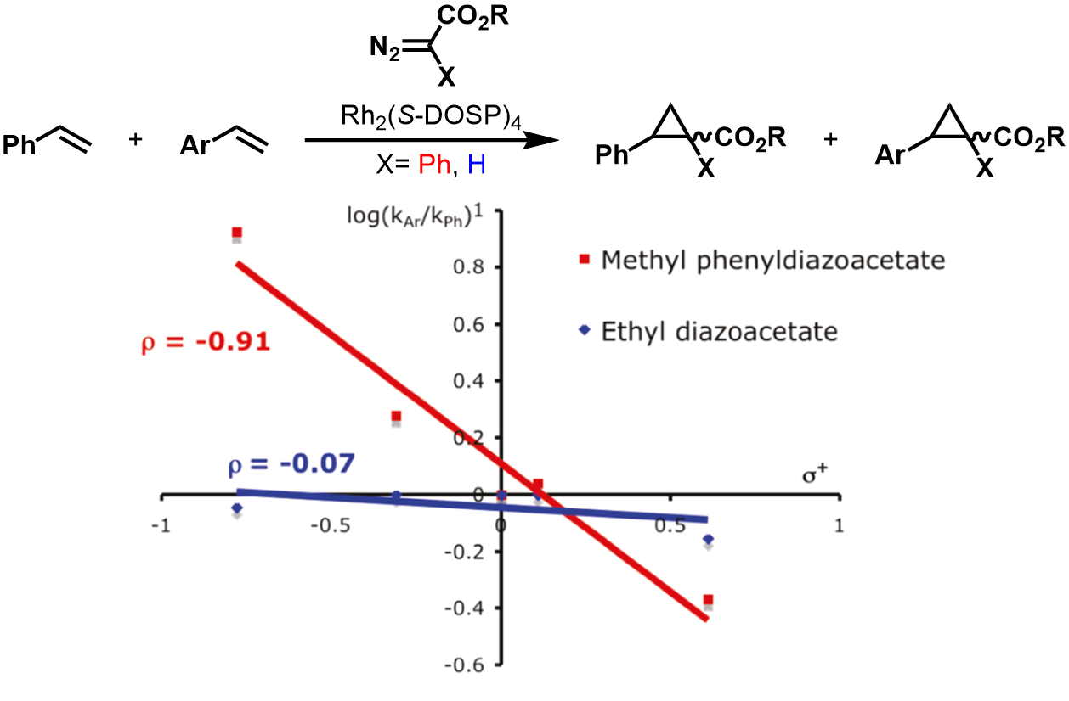
Figure 3.2 Competition reactions with styrene, using Rh(II,II)-carbenoids. Comparison of an acceptor carbenoid and a donor/acceptor carbenoid.
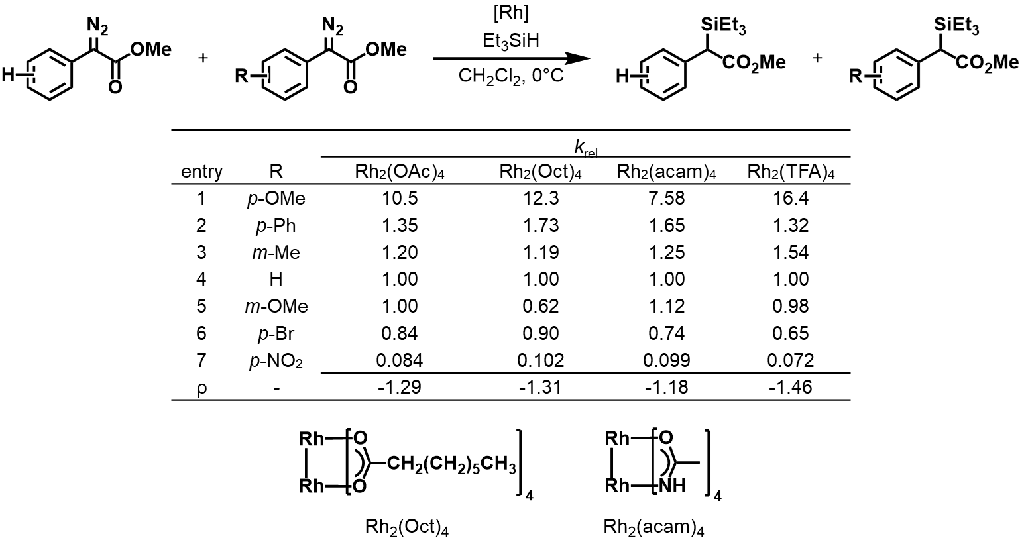
Table 3.1 Pairwise competition reactions between substituted aryl diazoacetates in a Si–H insertion reaction using Rh(II,II) complexes
prepared using modified procedures from the literature (Figure 3.3a).¹⁸²⁻¹⁸⁴ Sulfonation followed by Wenker aziridine synthesis leads to aminothioethers 76-78. Subsequent ring-opening of phthalic anhydride leads to ligands 79, 80, and 81. Complexes Rh₂(OAc)₃(p–OMe-PhTCB) 73a, Rh₂(OAc)₃(p–CF₃-PhTCB) 74a and Rh₂(OAc)₃(p–NO₂-PhTCB) 75a were synthesized using a modified procedure of our synthesis of Rh₂(OAc)₃PhTCB 37a (Figure 3.3b).¹⁰⁸ Ligand exchange was facilitated by refluxing Rh(II,II) tetraacetate dimer in DCE with 1.1 equivalents of ligand in the presence of Hünig’s base. At 1.1 equivalents of ligand, exchange predominantly formed the monosubstituted species with a mixture of cis and trans isomers of the disubstituted product (73b/c, 74b/c and 76b/c) in smaller quantities.

EDA Cyclopropanation Linear Free Energy Relationship Study
Reaction constants for the Rh(II,II)-catalyzed cyclopropanation of EDA with a series of para-substituted styrene derivatives were measured by the pairwise competition of styrene and a styrene derivative in the presence of 1 mol% Rh(II,II) TACLs complex in DCE at room temperature. The relative amounts of cyclopropane products in the reaction were determined using NMR spectroscopy. The competition experiments were used as a method to obtain relative rate data (1), which were then applied to the Hammett equation (2). Plotting log(k_{X}/k_{H}) vs. σ obtains the reaction constant, ρ, which gives insight into the sensitivity of the reaction to changes in the electronic nature of the substituents compared to a reference reaction with styrene.
k_{X}/k_{H} = P_{X}/P_{H} (1)
log(k_{X}/k_{H}) = ρ ∙ σ (2)
Initial experiments focused on evaluating changes in reaction sensitivity when incorporating an axial tethered thioether ligand. To this end, TACLs complexes 37a, 73a-75a, and 56a were subjected to the above reaction conditions and relative rates were determined and compared to conventional complexes with no tether, Rh₂(OAc)₃(OBz) 59 and Rh₂(OAc)₃(OX) 58. The negative slopes for all the complexes indicate the building of positive charge, although subtle, at the benzylic carbon center in the transition state (Figure 3.4a-f). The generally low ρ values for the complexes (Table 3.2) are common for EDA-mediated cyclopropanation reactions.^{28, 185} When comparing carboxylate-bridged complexes, the use of non-tethered complex 59 resulted in a reaction that is more
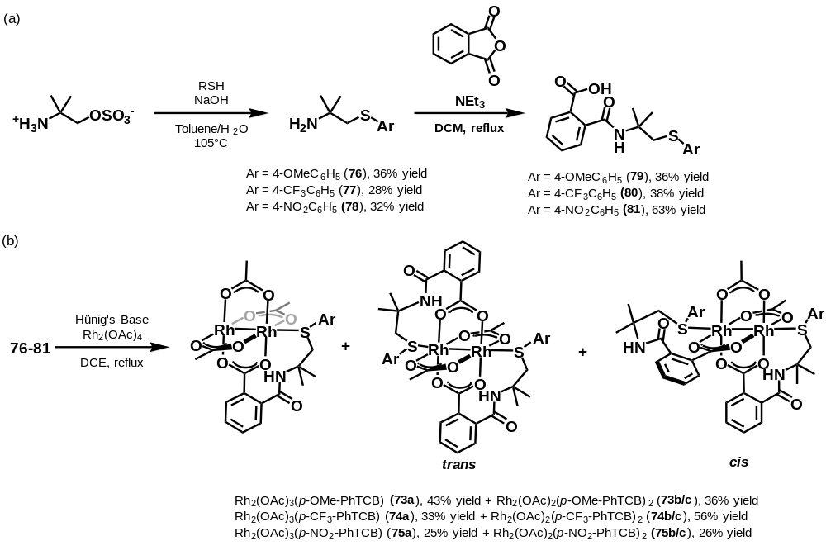
Figure 3.3 a) synthesis of ligands and b) Rh(II,II) complexes with TACLs
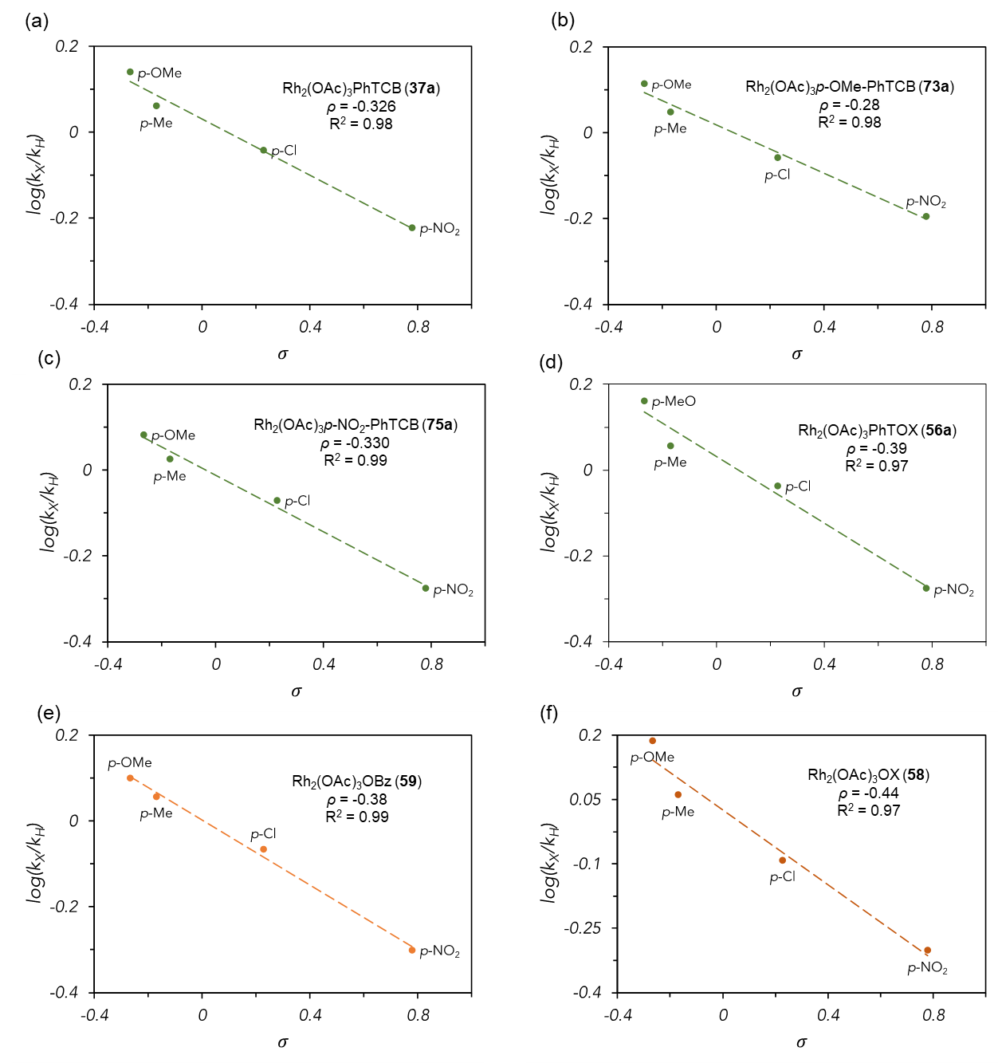
Figure 3.4 Hammett plots of EDA cyclopropanation competition studies.
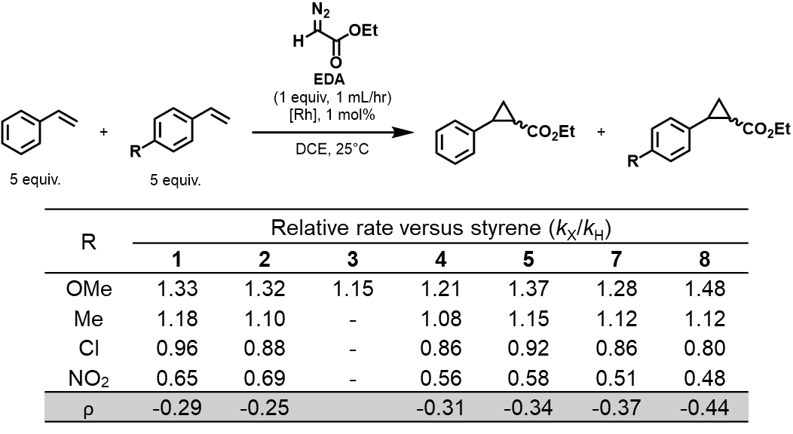
Table 3.2 Relative rates for the EDA cyclopropanation competition study
sensitive (more negative ρ value) to substituent changes with a slightly larger reaction constant compared to TACLs complexes 37a, 73a, and 75a, indicating that axial coordination lowers this sensitivity. As the axial ligand becomes more electron-releasing, the ρ values for the reaction become less negative, indicating a decrease in positive charge build-up in the system, giving the catalyst ρ value trend: 73a > 38a > 75a (Table 3.2).
It has previously been established that bridging ligands can have substantial influence on chemoselectivity in diazo-mediated Rh(II,II) catalysis.^{53, 158} When comparing complex 38a and complex 56a, where both axial ligands contain a phenyl thioether moiety but differ in their bridging ligands and tether type, the reaction catalyzed by 56a was determined to be more sensitive than 38a. The difference in reaction constants between them (∆⍴ (38a – 56a) = 0.062) was found to be slightly smaller than the extremes of the para-substituted ArTCB complexes (∆⍴ (73a – 75a) = 0.049). This larger difference indicates that changes at the axial site have larger impact on the system than at the bridging site of these catalysts, though an additional consideration is that both sites counteract each other electronically. There is an inverse relationship between the electron density trends for bridging ligand and axial ligand changes, evidenced by increased sensitivity when using the more electron-rich bridging ligand (compare ρ for 59 and 58, Table 3.1) while the opposite was observed for electronic changes at the axial site (vide supra).
Interestingly, analysis of the selectivity for the individual competition reaction of 4-methoxystyrene and styrene across substituted ArTCB TACLs complexes revealed a Hammett plot with poor correlation (Figure 3.5a). The relatively small rho value also indicates that the axial site is marginally sensitive to electronic changes in the reaction. Poor correlations were also observed for the competition of styrene with para-Me, -Cl, and -CF₃ styrene derivatives but not with the para-NO₂ derivative (Figure 3.5b-d), which gave a very linear correlation. A feature of the poorly correlated Hammett plots is a decreased rate when the aryl thioether substituent is methoxy, resulting in a downwards trend in that portion of the plot (Figure 3.5b-c). Downward curving Hammett plots¹⁸⁶ are associated with a shift in the rate-determining step (RDS) in the mechanism.^{187, 188} In Rh(II,II)-catalyzed cyclopropanations, the nitrogen extrusion step leading to the formation of the carbenoid is considered to be the RDS for Rh(II,II)-catalyzed cyclopropanations.^{155, 156} We
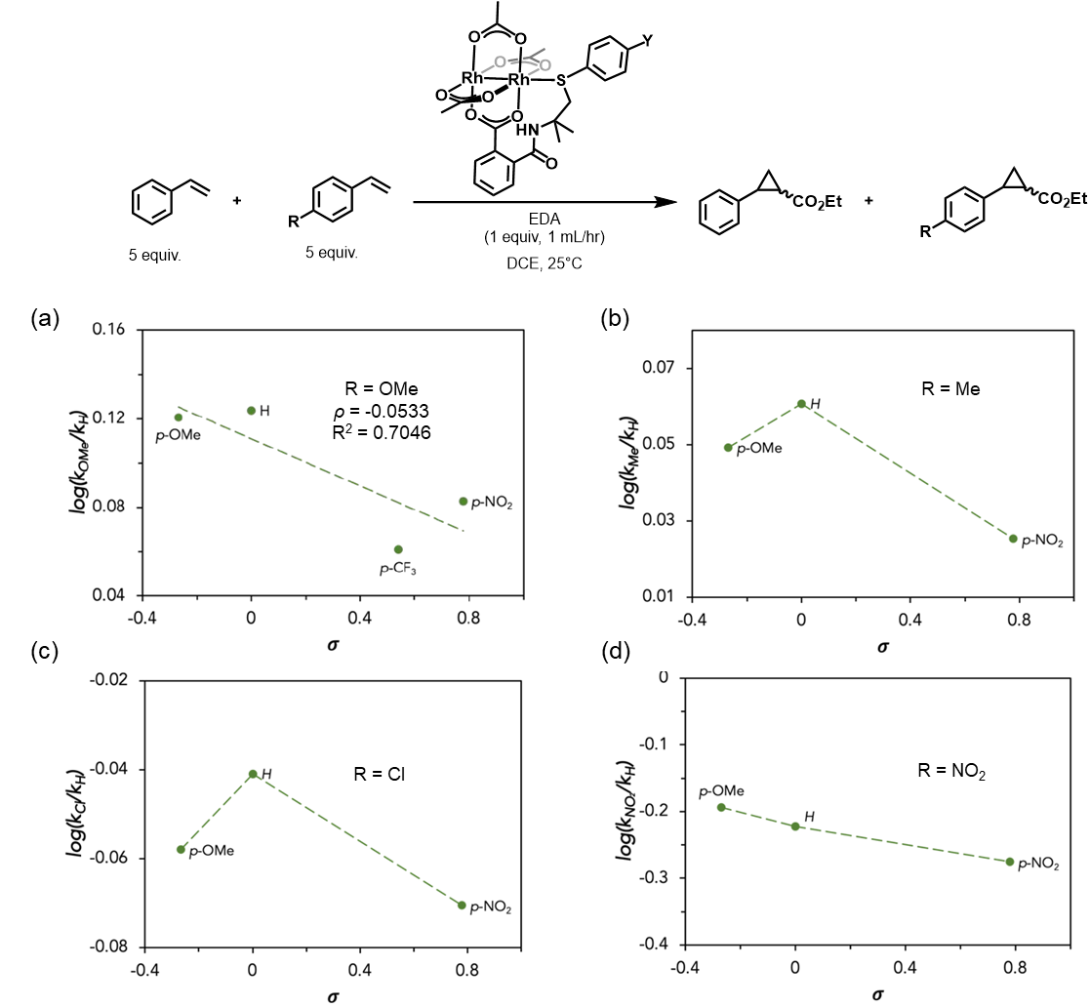
Figure 3.5 Hammett plot of the cyclopropanation of styrene and various para-substituted styrenes catalyzed by complexes 37a and 73a-75a.
have previously theorized that the thioether axial ligands have an inductive effect across the Rh(II)-Rh(II) bond that impacts the barrier for nitrogen extrusion.^{135, 170} Axial coordination with more electron-rich ligands may also contribute to increasing the barrier for cyclopropanation and makes the new slow-step the attack of olefin to the carbenoid.

Aryl Diazoacetate Cyclopropanation Linear Free Energy Relationship Study
To further investigate the effect carbene stabilization/destabilization has on the reaction, a linear free energy relationship was conducted with functionalized aryl diazoacetates in the pairwise competition of 4-methoxystyrene and styrene. Acquisition of reaction constants was achieved by reacting the desired para-substituted aryl diazoacetate with 1 mol% of a Rh(II,II) paddlewheel complex in the presence of both styrene and 4-methoxystyrene (Table 3.3). Relative rates were obtained with the same method as the EDA cyclopropanations. Complex 56a and its conventional counterpart, complex 58a, were used in this study since they were determined to be more sensitive to substituent changes than the carboxylate catalysts (Table 3.3). When plotting the relative rates for product distribution against substituent constants, a downwards curving Hammett plot was clearly observed for both complexes (Figure 3.6). A negative Hammett correlation was observed for electron-withdrawing substituents (σ > 0), while a positive Hammett correlation was observed for electron-releasing substituents (σ < 0). The positive slope indicates that the RDS has changed from one that builds positive charge to one that loses positive charge, as in the attack of the olefin to the carbenoid. This deviation was more pronounced than the ArTCB experiments and gives evidence that inductive donation to the carbene, either from across the Rh(II)-Rh(II) bond or from the diazo substituents, causes a change in the RDS of Rh(II,II)-catalyzed cyclopropanation reactions. The change in RDS when electronics are perturbed adjacent to the carbene carbon was independent of the catalyst used, since both the TACLs and conventional complexes exhibit this change, but the difference in the sensitivity of the two complexes was still determined. The positive and negative ρ values for the upward and downward trends were calculated separately for each complex and it was found that, in contrast to the EDA study, the system with the TACLs complex was more sensitive to substituent changes at the carbene center than the conventional complex (Figure 3.6). For electron-releasing substituents with complex 5, σ substituent constants resulted in a better linear correlation, while σ⁺ gave better correlation with the withdrawing groups (Figure 3.6a). This indicates that there is
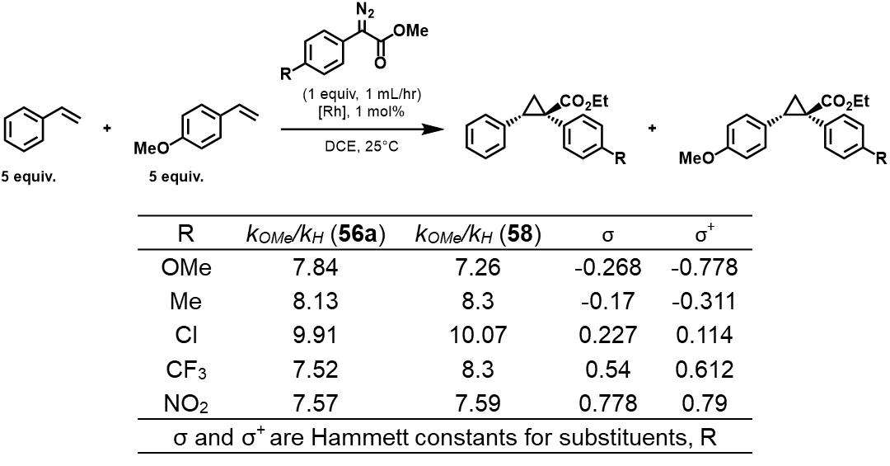
Table 3.3 Relative rates for the cyclopropanation of styrene and 4-methoxystyrene using para-substituted aryl diazoacetate and σ and σ⁺ scales for para substituents.
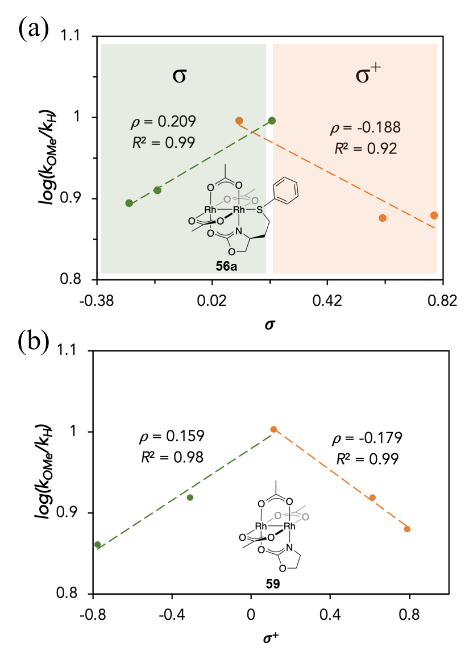
Figure 3.6 Hammett plots for the cyclopropanation of styrene and 4-methoxystyrene using para-substituted aryldiazoacetates catalyzed by a) complex 56a and b) complex 59
less of a mesomeric effect of the donating groups on the carbene when a tethered axial coordinating group is present. Results with complex 8, on the other hand, produced a better correlation with σ⁺ for both electron-withdrawing and electron-releasing substituents (Figure 3.6b). These results indicate that the tethered axial thioether ligands could play a beneficial role in enhancing selectivity when electronics are perturbed on the aryl diazo compound in donor/acceptor carbenes.

Conclusion
In conclusion, we have reported the use of linear free energy relationships in the form of Hammett experiments to determine the influence of tethered axially coordinated ligands on the chemoselectivity of Rh(II,II) catalyzed cyclopropanations. With the cyclopropanation of ethyl diazoacetate with styrene and styrene derivatives, it was determined that the reactions with conventional complexes were slightly more sensitive to electronic changes in the substrates. However, the differences across complexes were found to be minor. It also seems that a more sensitive reaction can be accomplished by decreasing electron donation into the axial site distal to the carbene. Larger changes were observed when bridging ligands were changed than when modulating the axial site. Hammett parameters were also applied to the cyclopropanation of a series of para-substituted phenyl diazoacetates, wherein a non-linear downward curvature was present in the Hammett plot. A downward deviation was observed when comparing the competition of styrene derivatives with various para-substituted ArTCB complexes. These deviations have been theorized to be the result of a change in the rate-determining step to the cyclopropanation step when using more electron-rich substituents adjacent to the carbene or at the distal axial site. Theoretical analysis of the transition states of these processes is currently underway in our lab to better understand the role the TACLs have on Rh(II,II) activity.

Chiral Rh(II,II)-TACLs for stereoselective Cyclopropanation

Disclosure
Portions of the following chapter were adapted from the article:
Dsjfklfjokifjsdlfdlsjfsdjf

Abstract
Hdsfhjhjfjhfdjsfjdsfdsfjsdkf

Introduction
The cyclopropane moiety exhibits unique properties that make them highly sought after in the pharmaceutical and natural products industries.^{1, 2} However, the target compounds in these fields typically involve many steps of which the cyclopropanation step could be at any point of the total synthesis. As a result, chemo- and stereoselective late-stage functionalization of complex molecules is imperative for the synthesis of cyclopropane containing pharmaceuticals or bioactive natural products.¹⁸⁹ A recent strategy for stereoselective cyclopropanation is the use of specialized enzymes with specific active sites. Fasan and co-workers have reported the engineering of hemoprotein myoglobin-based catalysts for the highly stereoselective cyclopropanation of acceptor-type diazo species (Figure 4.1).¹⁹⁰⁻¹⁹³ Mutation of a histidine residue on a wild-type sperm whale myoglobin (Mb) and systemic mutations of residues present in the enzyme’s active site led to incredible stereoselectivity in the cyclopropanations of diazoketones.¹⁹⁰ However, in some cases, diversification of the enzyme’s catalytic applications can be limited and separate mutations might be required for comparable performance.^{193, 194} The catalytic formation of cyclopropanes via transition-metal carbene transfer reactions is one of the most common strategies and has been extensively studied for decades.⁸
Rh(II,II)-paddlewheel complexes are highly efficient at carbene transfer reactions with many types of diazo species.¹² As discussed in Section 1.1.2, stereoselective cyclopropanation reactions with Rh(II,II) complexes can be achieved by using diverse bridging ligand architectures. Early studies led by the Doyle lab demonstrated the effectiveness of Rh(II,II)-carboxamidates in intramolecular cyclopropanations of allylic diazos, Section 1.1.2.2.^{4, 17} Chiral Rh(II,II)-carboxylates based on phthalimide-protected amino acids are generally efficient at asymmetric induction of various diazo types, but are most proficient at acceptor/acceptors (Section 1.1.2.3).^{14, 27, 45} By far the most impressive complexes for stereoselective carbene transfer reactions of donor/acceptor diazos are the Rh(II,II) complexes developed by the Davies lab (Section 1.1.2.4).^{14, 45, 46} Recently, Davies and co-workers have developed their “third generation” of carboxylate complexes that contain triarylcyclopropanecarboxylate (TPCP) bridging ligands (Figure 4.2a).¹⁹⁵ These complexes contain cyclopropane rings with sterically crowding aryl groups that give the catalyst the same α, β, α, β conformation as Rh₂(S-DOSP)₄ but with more conformational rigidity (Figure 4.2b). The first Rh(II,II)-TPCP complex synthesized, Rh₂(R-p-Br-TPCP)₄ X, was initially evaluated in the cyclopropanation of styryldiazoacetates with styrene (Table 4.1).¹⁹⁵ It was determined that the TPCP catalyst gave higher yields and enantioselectivity than the Rh₂(S-DOSP)₄ species in DCM (Table 4.1, entries 1-2). Increasing the size of the ester substituent was found to improve the enantioselectivity of the reaction, likely due to increased steric clash at the active site (Table 4.1, entries 3-4). Since this work, the Davies lab has developed even more sterically demanding TPCP complexes by the incorporation of larger groups on one of the aryl rings (Figure 4.3a).³⁰ This concept was expanded upon with the development of a complex with three para-substituted aryl rings on the cyclopropane, Rh₂(R-tris(p-^{t}BuC₆H₄)TPCP)₄ X (Figure 4.3b).¹⁹⁶ Complex X has also been used in the cyclopropanation of aryldiazoacetates, albeit at lower yields and enantioselectivity than the styryldiazoacetates (Table 4.2).¹⁹⁵ A recent in-situ kinetic study conducted by the Davies lab, they were able to conduct the cyclopropanation reaction at very low catalyst loading, 0.001%, with X (Table 4.2, entry 5).¹⁹⁷ The same study found that the larger TPCP complexes decomposed the diazo much slower than the prolinate or phthalimide complexes (2-13 hrs. to ~2 minutes respectively) but obtained higher enantioselectivities. Most efforts with the TPCP complexes, however, have been towards site-selective C-H functionalization reactions.
Although the cyclopropanation of EDA was one of the earliest applications of Rh(II,II) complexes, doing it with high stereoselectivity is still rare.^{9, 14} The chiral Rh(II,II)-azetidine-4-carboxylates developed by Doyle gave the best enantioselectivities at 68% but diastereoselectivity was still subpar at about 2:1 (Table 1.2). ^{57, 59} Perez-Prieto and co-workers developed the first Rh(II,II) complexes to exhibit high enantioselectivity in the cyclopropanation of EDA and styrene.¹⁴⁹ They synthesized heteroleptic complexes with two acetates and two ortho-metalated aryl phosphines in a heat to tail arrangement (Figure 4.4). These complexes have chirality on their backbone and as such, can be isolated as two pure enantiomers, M or P. Complexes X-X exhibited excellent ee’s in the cyclopropanation of EDA with styrene but with low yields (Table 4.3, entries 1-3). The more electron-deficient complex, X, gave lower ee’s but furnished the cyclopropane product in a higher yield (Table 4.3, entry 4). Enantioselectivity was severely diminished when the trifluoroacetate bridging ligand is replaced by a bulky TPA ligand (Table 4.3, entry 5). Incorporation of sterically bulky groups on the carbon meta to the metalated aryl carbon resulted in a substantial increase in diastereoselectivity (Table 4.3, entries 6-7).¹⁹⁸ The authors rationalized that the high stereoselectivity was due to the aryl groups of the metalated phosphorous are oriented into the active site, limiting the orientation of the carbene that forms and subsequent substrate attack (Figure 4.5). Discrimination between pathway A and B arises from the ester group preferring the less sterically hindered side with the acetate ligands. The incoming substrate, whether cis or trans to the ester, will prefer the carbene orientation of pathway A. Control of the diastereoselectivity is attributed to the substrate preferring a cis attack to avoid steric clash with the bulky substituent on the metalated aryl ring of the other bridging ligand in pathway A.
The control of the stereoselectivity, especially in EDA reactions, is mostly dependent on steric factors that affect the axial site of the Rh(II,II) complex. However, this has mainly been accomplished through the development of chiral bridging ligands with large sterically blocking groups. Axial ligand coordination is thought to slow catalysis by blocking the active sites of the catalyst, however, one axial site must be opened for catalysis to take place.¹⁵⁶ This would leave the other axial ligand at the distal rhodium to have some kind of electronic influence on the active Rh(II)-carbene. This influence and its role on asymmetric catalysis are still unclear in Rh(II,II) chemistry. The Charette lab has probed this influence in the cyclopropanation of acceptor/acceptor diazos with styrene (Table 4.4).^{71, 128} With the cyclopropanation of α-nitro diazoacetates and styrene, the addition of nitrogenous LBs resulted in increased enantioselectivity, albeit with drops in diastereoselectivity and cyclopropane yields (Table 4.4, entries 1-3).¹²⁸ Additives that did not result in higher enantioselectivity maintained about the same yield, diastereoselectivity, and enantioselectivity (Table 4.4, entries 4-6). At higher temperatures, there is no difference in selectivity with or without additive, indicating that lower temperatures allow for association and full influence of the additive. Additives don’t always result in an increase in enantioselectivity, however. In the same study, they also conducted cyclopropanations of styrene and amido diazoacetates, also acceptor/acceptors, and found that most additives either offered no change or decreased enantioselectivity (Table 4.5).¹²⁸ Indeed, elucidating the influence of the axial position on stereoselectivity is more nuanced than simply adding exogenous ligands. Previously, our group has used Rh(II,II) complexes with tethered, axially coordinated ligands (TACLs) to control the local concentration of the axially bound LB and more accurately assess its role in catalysis.^{108, 135, 170} We have observed increased yields in cyclopropanation^{108, 170} and Si–H insertion¹³⁵ reactions when using the TACLs complexes over conventional Rh(II,II) complexes with no axial tether. A Hammett study found that changes in axial site electronics can have small changes in cyclopropanation chemoselectivity. Changes in rate-determining steps are also possible when perturbing diazo substrate electronics. Our lab has developed Rh(II,II) complexes that incorporate TACLs onto chiral scaffolds. The influence of the axial tether’s stereoelectronics on asymmetric catalysis was then probed.

Experimental Procedures

General Considerations
Unless otherwise noted, all reagents were purchased and used as received from the manufacturer without further purification. 2-Ammonio-2-methylpropyl sulfate was synthesized from 2-amino-2-methylpropan-1-ol according to established procedures.¹⁸² Ligand 39 was synthesized using established procedures previously reported in our group.¹⁰⁸ Ligands 40 and 51 were synthesized via established literature procedures.^{199, 200} Methyl phenyldiazoacetate was prepared from benzylic acid according to established procedures.²⁰¹ Methyl 2-diazo-2-(4-methoxyphenyl)acetate,¹⁸³ methyl 2-diazo-2-(p-tolyl)acetate,¹⁸³ methyl 2-(4-chlorophenyl)-2-diazoacetate,¹⁸³ and methyl 2-diazo-(4-nitrophenyl)acetate were also prepared using literature procedures.²⁰²All products from previously reported procedures were verified, using ¹H NMR, against the values presented in the literature. Hexanes, THF, diethyl ether, DCM, and MeCN were dried with columns packed with alumnia using an Inert® PureSolv Micro Solvent Purification System and stored over molecular sieves. Reactions were monitored using TLC on Sorbent Technologies Silica XG TLC Plates. Column chromatography was performed using 60 Å, 40-63 μm silica from Sorbent Technologies. ¹H NMR, ¹³C, and ¹⁹F NMR spectra were recorded on a Varian Mercury Vx 300 MHz, Varian VNMRS 500MHz, or Bruker AVANCE NEO 500 MHz spectrometers. All NMR chemical shifts are reported in ppm on the δ scale. Signals were referenced by residual solvent signal for ¹H NMR (CHCl₃ = 7.26 ppm, acetone = 2.05 ppm, acetonitrile = 1.94 ppm) and ¹³C NMR (CHCl₃ = 77.16 ppm, acetone = 206.26 ppm, acetonitrile = 1.32 ppm). GC analysis was conducted using a Shimadzu GC-2010 instrument. HPLC analysis was performed on a Shimadzu LC-2030 Prominence-I instrument using a C18 column. Chiral HPLC analysis was also performed on a Shimadzu LC-2030 Prominence-I instrument using a Chiralcel OJ-H or a Lux Cellulose-3 chiral column. Cyclic voltammetry experiments were performed inside an N₂-filled electrochemical cell in MeCN with 0.1 M [TBA][PF₆] as the supporting electrolyte. Anhydrous MeCN and electrochemical grade [TBA][PF₆] were purchased from SigmaAldrich and used as received. The voltammograms were recorded with a BASi Epsilon potentiostat, using a 2.5 mm (o.d.) 1.0 mm (i.d.) Pt-disk working electrode, Ag-wire quasi-reference electrode, and a Pt wire auxiliary electrode. Reported potentials are referenced to the Fc/Fc⁺ redox couple, added as an internal standard at the conclusion of each experiment. The mass spectra for the ligands and their precursors were obtained using an AccuTOF Mass spectrometer equipped with a DART ionization apparatus. The mass spectra for all Rh(II,II) complexes were obtained using a Water SYNAPT H2-Si MALDI-TOF Mass Spectrometer. X-ray diffraction experiments were conducted using a Bruker APEX-II CCD diffractometer and solved with OLEX2. UV-Visible data was obtained in a 10mm quartz cell using a Cary 5000 spectrophotometer.²⁰³

Ligand Synthesis

Thiocarbamoylbenzoate Ligand Synthesis
2-methyl-1-(methylthio)propan-2-amine (41)
To a stirring solution of 21% sodium thiomethoxide in water (0.994 g, 1.2 equiv.) was added 2-ammonio-2-methylpropyl sulfate (2g, 1 equiv.) and NaOH (0.5g, 1 equiv.). The mixture was stirred at 90°C for 16 hours at which time two layers had formed. The top layer was separated and diluted with 10 mL of DCM. The organic layer was then dried over Na₂SO₄ and concentrated in vacuo to yield 41 as a colorless oil, (1g, 8 mmol, 71% yield). ¹H NMR (300 MHz, CDCl₃) δ 2.47-2.40 (s, 2H), δ 2.07-2.00 (s, 3H), δ 1.52-1.24 (s, 2H), δ 1.08-0.99 (s, 6H).
General Procedure A: Synthesis of Aminothioethers. Aminothioethers synthesized with modified procedures from established protocols.¹⁸² To a stirring solution of 2-ammonio-2-methylpropyl sulfate (1 equiv.) in 8 mL toluene:water (50/50) was added para-substituted thiophenol (1.5 equiv.). Mixture heated to reflux at which point 4 mL of 2M aq. NaOH solution was added at 2 mL/hr by syringe pump. Reaction stirred at reflux for 3 hours and then at 45°C for 17 hours. Toluene layer separated and washed with 1M NaOH. Organic layer dried over anhydrous MgSO4 and concentrated in vacuo. The residue was then partitioned between 20 mL EtOAc and 20 mL 1M HCl then stirred for 30 minutes. Aqueous layer was then separated and neutralized with 1M NaOH until white precipitate that forms persisted. Extracted 3 X 30 mL of EtOAc then dried over anhydrous MgSO4 and concentrated in vacuo to afford an oil.
1-((4-methoxyphenyl)thio)-2-methylpropan-2-amine (76)
General Procedure A was used with 4-methoxythiophenol (545 μL, 4.43 mmol) to obtain 76 as a yellow oil, (227 mg, 1.07 mmol, 36% yield). ¹H NMR (300 MHz, CDCl₃) δ 7.41-7.31 (d, 2H), 6.87-6.76 (d, 2H), 3.83-3.70 (s, 3H), 2.98-2.87 (s, 2H), 1.51-1.39 (s, 2H) 1.24-1.11 (s, 6H), ¹³C NMR (500 MHz) δ 158.84, 132.95, 128.15, 114.73, 55.43, 52.30, 51.02, 29.85. Calculated m/z: [M+H]⁺ = 212.1031, found m/z: [M+H]⁺ = 212.1085.
2-methyl-1-((4-(trifluoromethyl)phenyl)thio)propan-2-amine (77)
General Procedure A used with 4-trifluoromethylthiophenol (608 μL, 4.43 mmol) to obtain 77 as a yellow oil, (207 mg, 0.83 mmol, 28% yield). ¹H NMR (300 MHz, CDCl₃) δ 7.51-7.4 (dd, 4H), 3.10-3.02 (s, 2H), 2.08-1.89 (s, 2H), 1.29-1.20 (s, 6H), ¹³C δ 143.21, 128.05, 127.83, 127.58, 125.36, 123.2, 121.04, 50.90, 48.55, 30.08, 19F (500 MHz, CDC_{l3}) δ 62.46. Calculated m/z: [M+H]⁺ = 250.0872, found m/z: [M+H]⁺ = 250.0910.
2-methyl-1-((4-nitrophenyl)thio)propan-2-amine (78)
General Procedure A used with 4-nitrothiophenol (1.4 g, 9 mmol) to obtain 78 as an orange oil (433 mg, 1.9 mmol, 32% yield). ¹H NMR (300 MHz, CDCl₃) δ 8.12-8.04 (d, 2H), 7.41-7.33 (d, 2H), 3.01-3.06 (s, 2H), 1.61-1.48 (s, 2H), 1.28-1.21 (s, 6H), ¹³C NMR (500 MHz, CDCl3) δ 148.27, 145.10, 126.75, 123.94, 50.08, 47.57, 30.15. Calculated m/z: [M+H]⁺ = 227.0849, found m/z: [M+H]⁺ = 227.0904.
General Procedure B: Synthesis of Thiocarbamoylbenzoate Ligands. The following ligands were prepared using a modified procedure developed by Tohnishi.¹⁸⁴ A solution of aminothioether in DCM(4 mL) was added to a stirring solution of phthalic anhydride (1 equiv.) in DCM (4 mL). Triethylamine (10 mol%) was added and the mixture was stirred at reflux for 20 hours. A 10 mL portion of DI water was added, and the resulting solution was extracted 3 X 20 mL EtOAc and dried over anhydrous Na₂SO₄ then concentrated in vacuo. Recrystallized by addition of boiling EtOAc then adding a few drops of hexane and placed in freezer overnight. Filtration afforded thiocarbamoylbenzoates as white solids.
2-((2-methyl-1-(methylthio)propan-2-yl)carbamoyl)benzoic acid (42)
General Procedure B used with 2-methyl-1-(methylthio)propan-2-amine (509 mg, 4.26 mmol) to obtain 42 as a white solid (498 mg, 1.86 mmol, 44% yield). ¹H NMR (300 MHz, Acetone-d₆) δ 8.03-7.92 (d, 1H), 7.75-7.55 (m, 3H), 6.86-6.58 (s, 1H), 3.18-3.15 (s, 2H), 2.28-2.23 (s, 3H), 1.56-1.52 (s, 6H).
2-((1-((4-methoxyphenyl)thio)-2-methylpropan-2-yl)carbamoyl)benzoic acid (79)
General Procedure B used with 1-((4-methoxyphenyl)thio)-2-methylpropan-2-amine (219 mg, 1.04 mmol) to obtain 79 as a white solid (135 mg, 0.376 mmol, 36% yield). ¹H NMR (300 MHz, Acetone-d₆) δ 7.93-7.80 (d, 1H), 7.63-7.33 (m, 5H), 6.98-6.79 (d, 2H), 3.86-3.71 (s, 3H), 3.61-3.48 (s, 2H), 1.57-1.43 (s, 6H), ¹³C NMR (500 MHz, Acetone-d₆) δ 169.73, 167.92, 159.73, 140.40, 133.25, 132.28, 130.80, 129.80, 128.90, 128.77, 115.47, 55.63, 46.14, 26.64. Calculated m/z: [M+H]⁺ = 360.1270, found m/z: [M+H]⁺ = 360.1242.
2-((2-methyl-1-((4-(trifluoromethyl)phenyl)thio)propan-2-yl)carbamoyl)benzoic acid (80)
General Procedure B used with 2-methyl-1-((4-(trifluoromethyl)phenyl)thio)propan-2-amine (53 mg, 0.211 mmol) to obtain 80 as a white solid (32 mg, 0.08 mmol, 38% yield). ¹H NMR (500 MHz, Acetone-d6) δ 7.90-7.82 (d, 1H), 7.69-7.56 (s, 4H), 7.57-7.42 (m, 2H), 7.38-7.26 (d, 1H), 3.79-3.73 (s, 2H), 1.57-1.49 (s, 6H), ¹³C NMR (500 MHz, Acetone-d₆) δ 169.83, 167.83, 144.99, 140.44, 132.33, 130.73, 130.51, 129.80, 128.76, 128.50, 127.43, 127.17, 126.46, 126.43, 126.40, 126.37, 55.11, 42.16, 26.69, 19F (500 MHz, CDCl3) δ 62.82. Calculated m/z: [M+H]⁺ = 398.1032, found m/z: [M+H]⁺ = 398.1093.
2-((2-methyl-1-((4-nitrophenyl)thio)propan-2-yl)carbamoyl)benzoic acid (81)
General Procedure B used with 2-methyl-1-((4-nitrophenyl)thio)propan-2-amine (361 mg, 1.6 mmol) to obtain 81 as a yellow solid (374 mg, 1 mmol, 63% yield). ¹H NMR (300 MHz, Acetone-d₆) δ 8.20-8.10 (d, 2H), 7.93-7.81 (d, 2H), 7.68-7.33 (m, 5H), 3.88-3.80 (s, 2H), 1.61-1.50 (s, 6H), ¹³C NMR (500 MHz, Acetone-d₆) δ 170.03, 169.96, 167.94, 149.49, 145.87, 140.36, 132.32, 130.74, 130.63, 129.85, 128.75, 127.65, 124.74, 124.62, 54.98, 41.76, 26.76. Calculated m/z: [M+H]⁺ = 375.1015, found m/z: [M+H]⁺ = 375.1058.

Oxazolidinone Ligand Synthesis
(S)-4-((tert-butylthio)methyl)oxazolidin-2-one (48)
To a flame dried 5 mL flask equipped with a stir bar was added 47 (0.43 g, 1.5 mmol) followed by 2-methyl-2-propanethiol (1.5 mL, 13 mmol). The reagents were then dissolved in 6 mL acetone and refluxed at 45 °C for 24 hours. The reaction was allowed to cool to room temperature, then concentrated in vacuo. The resulting mixture was dissolved in 10 mL deionized water and extracted twice with 5 mL DCM. The combined organic layers were then washed with 5 mL brine solution, followed by 5 mL saturated sodium bicarbonate solution. The organics were separated and dried over anhydrous Na₂SO₄, filtered, and concentrated. The crude mixture was then purified by column chromatography (25% EtOAc/Hexanes to 50% EtOAc/Hexanes) to afford 48 as a pale-yellow oil (0.1181 g, 0.58 mmol, 39% yield). ¹H NMR (500 MHz, CDCl₃) δ 5.81 (s, 1H), 4.56 – 4.47 (m, 1H), 4.07 – 3.96 (m, 2H), 2.63 – 2.54 (m, 2H), 1.93 – 1.81 (m, 2H), 1.32 (s, 9H). ¹³C NMR (300 MHz, CDCl₃) δ 159.46, 70.24, 52.29, 42.69, 35.05, 30.97, 24.62. Calculated m/z: [M+H]⁺ = 204.1014, found m/z: [M+H]⁺ = 204.1069
(S)-4-(2-(phenylthiol)oxazolidin-2-one (49)
To a flame dried 5 mL flask equipped with a stir bar was added 47 (0.10 g, 0.36 mmol) followed by thiophenol (0.5 mL, 0.54 mmol). The reagents were then dissolved in 1 mL acetone and refluxed for 4 hours. The reaction was allowed to cool to room temperature, then concentrated in vacuo. The resulting mixture was dissolved in 2 mL DI water and extracted twice with 2 mL DCM. The organics were combined and washed with 1 mL brine solution, followed by 1 mL saturated sodium bicarbonate solution. The organics were separated, dried over anhydrous Na₂SO₄, filtered, and concentrated. The crude mixture was then purified by column chromatography (2.5% MeOH/DCM) to afford 49 as a yellow oil (68 mg, 0.29 mmol, 84% yield). ¹H NMR (500 MHz, CDCl₃) δ 7.38 – 7.21 (m, 4H), 5.73 – 5.65 (m, 1H), 4.55 – 4.47 (m, 1H), 4.09 – 3.99 (m, 2H), 2.97 (td, J = 7.0, 2.5 Hz, 2H), 1.99 – 1.83 (m, 2H). ¹³C NMR (126 MHz, CDCl₃) δ 159.18, 134.88, 129.88, 129.20, 126.79, 51.63, 34.33, 30.21. Calculated m/z: [M+H]⁺ = 224.0701, found m/z: [M+H]⁺ = 224.0691

Rh(II,II) Complex Synthesis
General Procedure C: Synthesis of Rh(II,II)-TCB Complexes. To a dry 25 mL Schlenk flask, was added Rh₂(OAc)₄ (1 equiv.) and dry DCE. To the mixture was added ligand (1.1 equiv.) and N,N-diisopropylethylamine (1.1 equiv.). The mixture was then heated to reflux and stirred for 3 hours. The resulting solution containing the complexes was concentrated in vacuo and the products separated via column chromatography (1:1 toluene/MeCN). Bis substituted complexes 53b/c, 73b/c, 74b/c, and 75b/c, eluted first as a mixture of cis and trans isomers. Bis complexes were further purified by crystallization by adding minimal hexanes to a mixture of toluene/MeCN and cooling in a freezer for 3 days. Mono complexes, 53a, 73a, 74a, and 75a eluted second with no further purification needed. Finally, unreacted Rh₂(OAc)₄ eluted last.
Rh₂(OAc)₃MeTCB (53a)
General procedure C used with ligand 41 (67 mg, 0.25 mmol) to obtain 53a as a blue-green solid (73.5 mg, 0.113 mmol, 45% yield). ). ¹H NMR (300 MHz, CD₃CN) δ 7.69-7.56 (d, 2H), 7.48-7.14 (m, 4H), 6.22-6.06 (s, 1H), 3.65-3.53 (s, 2H), 2.61-2.55 (s, 3H), 1.81-1.78 (s, 3H), 1.78-1.74 (s, 6H), 1.63-1.57 (s, 6H).
Rh₂(OAc)₂(MeTCB)₂ (53b/c)
General procedure C used with ligand 41 (67 mg, 0.25 mmol) to obtain 53b/c as a reddish-purple solid (53.5 mg, 0.063 mmol, 50% yield). ¹H NMR (300 MHz, CD₃CN) δ
Rh₂(OAc)₃(p-OMe-PhTCB) (73a)
General procedure C used with ligand 79. Isolated as a blue-green solid (36 mg, 0.049 mmol, 43% yield). ¹H NMR (500 MHz, CDCl₃) δ 7.97-7.90 (d, 2H), 7.78-7.68 (d, 1H), 7.42-7.34 (t, 1H), 7.31-7.27 (d, 1H), 7.23-7.17 (d, 1H), 7.03-6.94 (d, 2H), 5.70-5.58 (s, 1H), 4.11-3.94 (s, 2H), 3.90-3.73 (s, 3H), 2.49-2.44 (s, 2H), 2.01-1.92 (s, 6H), 1.92-1.86 (s, 3H), 1.77-1.72 (s, 6H), ¹³C NMR (500 MHz, CDCl₃) δ 192.41, 192.08, 170.78, 160.75, 160.52, 140.34, 134.75, 131.48, 130.14, 128.66, 128.38, 126.50, 126.08, 115.05, 55.59, 54.63, 49.89, 28.25, 24.07, 3.47. Calculated m/z: [M+K]⁺ = 779.9259, found m/z: [M+K]⁺ = 779.9258.
Rh₂(OAc)₂(p-OMe-PhTCB)₂ (73b/c)
General procedure C used with ligand 79. Isolated as a reddish-purple solid (21 mg, 0.020 mmol, 36% yield). ¹H NMR (500 MHz, CDCl₃) δ 8.04-7.97 (d, 4H), 7.79-7.71 (d, 2H), 7.38-7.28 (m, 2H), 7.25-7.13 (m, 4H), 7.02-6.93 (d, 4H), 5.73-5.66 (s, 2H), 4.30-3.99 (s, 4H), 3.89-3.78 (s, 6H), 1.90-1.85 (s, 6H), 1.79-1.73 (s, 12H). ¹³C NMR (500 MHz, CDCl₃) δ 192.55, 186.25, 171.10, 160.29, 140.18, 135.10, 131.04, 130.80, 128.88, 128.36, 127.47, 125.94, 115.02, 114.87, 55.59, 54.81, 49.91, 28.47, 28.29, 24.23. Calculated m/z: [M+K]⁺= 1079.0239, found m/z: [M+K]⁺= 1079.0211.
Rh₂(OAc)₃(p-CF₃-PhTCB) (74a)
General procedure C used with ligand 80. Isolated as a blue-green solid (18.3 mg, 0.023 mmol, 33% yield). ¹H NMR (500 MHz, CDCl₃) δ 8.12-8.02 (d, 2H), 7.80-7.63 (m, 3H), 7.46-7.28 (m, 3H), 5.67-5.56 (s, 1H), 4.26-3.98 (s, 2H), 2.00-1.89 (s, 6H), (1.88-1.82 (s, 3H), 1.81-1.73 (s, 6H), ¹³C NMR (500 MHz, CDCl₃) δ 192.43, 192.11, 185.20, 171.17, 140.48, 132.19, 132.03, 130.31, 129.42, 129.00, 128.88, 127.46, 126.55, 126.51, 126.48, 54.73, 47.62, 28.68, 24.29, 24.20, ¹⁹F (500 MHz, CDCl₃) δ 62.79. Calculated m/z: [M+K]⁺= 779.9463, found m/z: [M+K]⁺= 779.9740.
Rh₂(OAc)₂(p-CF₃-PhTCB)₂ (74b/c)
General procedure C used with ligand 80. Isolated as a reddish-purple solid (21.8 mg, 0.020 mmol, 56% yield). ¹H NMR (500 MHz, CDCl₃) δ 8.14-8.02 (d, 4H), 7.72-7.64 (d, 4H), 7.63-7.57 (d, 2H), 7.39-7.32 (d, 3H), 7.21-7.17 (d, 3H), 5.65-5.56 (s, 2H), 4.49-4.04 (d, 4H), 1.86-1.82 (s, 6H), 1.82-1.76 (s, 12H), ¹³C NMR (500 MHz, CDCl₃) δ 192.70, 186.02, 171.04, 140.76, 140.05, 134.60, 131.62, 131.46, 131.41, 130.18, 129.90, 129.15, 128.83, 128.71, 128.54, 127.12, 126.40, 126.17, 126.14, 126.11, 125.32, 65.52, 54.56, 46.57, 28.61, 24.12, ¹⁹F (500 MHz, CDCl₃) δ 62.63. Calculated m/z: [M+H]⁺= 1117.0211, found m/z: [M+H]⁺= 1117.0028.
Rh₂(OAc)₃(p-NO₂-PhTCB ) (75a)
General procedure C used with ligand 81. Isolated as a green solid (21 mg, 0.028 mmol, 25% yield). ¹H NMR (500 MHz, CDCl₃) δ 8.31-8.25 (d, 2H), 8.09-8.03 (d, 2H), 7.83-7.74 (d, 1H), 7.47-7.28 (m, 2H), 7.25-7.16 (d, 1H), 5.68-5.55 (s, 1H), 4.41-4.12 (s, 2H), 1.97-1.90 (s, 6H), 1.87-1.83 (s, 3H), 1.80-1.75 (s, 6H), ¹³C NMR (500 MHz, CDCl₃) δ 192.53, 192.23, 185.67, 170.89, 147.23, 144.17, 140.06, 131.16, 131.02, 128.92, 128.76, 124.36, 124.18, 54.42, 28.46, 28.31, 24.10, 23.95. Calculated m/z: [M+K]⁺ = 794.9004, found m/z: [M+K]⁺ = 794.9016.
Rh₂(OAc)₂(p-NO₂-PhTCB )₂ (75b/c)
General procedure C used with ligand 81. Isolated as a yellowish-purple solid (32 mg, 0.030 mmol, 26% yield) ¹H NMR (500 MHz, CDCl₃) δ 8.31-8.25 (d, 4H), 8.10-8.02 (d, 4H), 7.65-7.57 (d, 2H), 7.41-7.34 (t, 2H), 7.29-7.24 (t, 2H), 7.23-7.16 (d, 2H), 5.63-5.57 (s, 2H), 4.53-4.17 (s, 4H), 1.86-1.77 (s, 12H), 1.61-1.51 (s, 6H). ¹³C NMR (500 MHz, CDCl₃) δ 192.54, 185.79, 170.85, 146.90, 144.46, 139.81, 131.51, 130.72, 130.59, 129.78, 128.60, 128.47, 126.36, 124.09, 54.20, 45.30, 28.43, 23.98. Calculated m/z: [M+K]⁺= 1109.9730, found m/z: [M+K]⁺= 1109.9692.
General Microwave Procedure for Rh(II,II)-TOX Synthesis. All microwave reactions were conducted in sealed reaction vials with a Biotage Initiator+ equipped with an IR sensor for determination of reaction temperature. Power input was adjusted by the instrument achieve and maintain the desired reaction temperature. Reaction times are presented as hold times, not total reaction time. A 2-5 mL microwave vial equipped with a magnetic stir bar was charged with Rh₂(OAc)₄ (15 mg, 34 mmol) and the desired ligand (34 mmol). The edges of the flask were rinsed with 4 mL DCE. The vial was then capped and heated at 190°C for 10 minutes. The mixture was allowed to cool to room temperature, transferred to a round-bottom flask using DCM, and concentrated in vacuo. The crude mixture was then purified by column chromatography using a 1:1 toluene/MeCN mobile phase. Bis substituted products eluted first as a mixture of cis and trans isomers. The bis fractions were then recrystallised in MeCN to remove excess oxazolidinone starting material. Mono products eluted next with no further purification needed. Rh₂(OAc)₄ eluted last. The product distribution for the ligand exchange reaction with ligand 40 was quantified via HPLC using 75% 1:1 MeCN:MeOH with 0.1% TFA/25% water on a C18 column. Calibration curves were generated for 38a, 38b/c, and Rh₂(OAc₎₄. The yields for complexes 55-57 were determined by isolated material
Rh₂(OAc)₃MeTOX (38a)
¹H NMR (500 MHz, CDCl₃/CD₃CN) δ 4.31 (s, 1H), 3.62 (s, 2H), 3.04 (s, 2H), 2.55 (s, 3H), 1.96 (ddd, J = 4.9, 2.4, 0.8 Hz, 1H), 1.94 (s, 3H), 1.86 (m, J = 9.7, 5.1 Hz, 1H), 1.83 (s, 3H), 1.81 (s, 3H). ¹³C NMR (126 MHz, CDCl₃/CD₃CN) δ 191.91, 191.36, 190.90, 168.37, 69.73, 59.30, 35.64, 30.30, 23.82, 23.76, 23.28, 17.90 ppm. Calculated m/z: [M+H]⁺ = 543.9019, found m/z: [M+H]⁺ = 543.9011. Anal. Calcd for C₁₄H₂₂N₂O₈ Rh₂S: C, 28.78; H, 3.80; N, 4.80; S, 5.49. Found: C, 28.62; H, 3.71; N, 4.30; S, 5.39.
Rh₂(OAc)₂₍MeTOX)₂ (38b/c)
¹H NMR (400 MHz, CDCl₃) δ 4.33 – 4.23 (m, 1H), 3.76 – 3.53 (m, 2H), 3.23 (dd, J = 13.3, 5.5, 2.1 Hz, 1H), 3.11 – 3.04 (m, 1H), 2.98 (td, J = 13.2, 12.5, 2.6 Hz, 1H), 2.62 (s, J = 8.6 Hz, 3H), 2.09 – 1.70 (m, 6H). ¹³C NMR (400 MHz, CDCl₃) δ 192.09, 191.77, 140.34, 135.25, 132.44, 131.66, 129.49, 128.98, 128.67, 128.52, 126.17, 54.57, 48.65, 28.36, 23.99. Calculated m/z: [M+H]⁺ = 644.9319, found m/z: [M+H]⁺ = 644.9269. Anal. Calcd for C₁₆H₂₆N₂O₈Rh₂S₂: C, 29.83; H, 4.08; N, 4.35; S, 9.96. Found: C, 29.20; H, 3.94; N, 4.18; S, 9.47.
Rh₂(OAc)₃(^{t}BuTOX) (55a)
¹H NMR (500 MHz, CDCl₃) δ 4.45 – 4.39 (m, 1H), 3.76 – 3.65 (m, 1H), 3.11 (ddd, J = 12.7, 5.4, 2.7 Hz, 1H), 2.97 (td, J = 12.4, 3.0 Hz, 1H), 2.11 (dddd, J = 14.7, 5.4, 3.0, 1.3 Hz, 1H), 1.99 (s, 3H), 1.87 (s, 3H), 1.84 (s, 3H), 1.84 – 1.76 (m, 1H), 1.66 (s, 10H). ¹³C NMR (126 MHz, CDCl₃) δ 190.82, 190.79, 189.00, 167.23, 70.04, 58.95, 49.59, 31.96, 29.15, 29.03, 24.07, 23.90, 23.34. Calculated m/z: [M+H^{]+} = 585.9489 , found m/z: [M+H]⁺ 585.9444. Anal. Calcd for C₁₅H₂₅NO₈Rh₂S: C, 30.79; H, 4.31; N, 2.39; S, 5.48. Found: C, 32.80; H, 4.79; N, 2.42; S, 5.18.
Rh₂(OAc)₂(^{t}BuTOX)₂ (55b/c)
¹H NMR (500 MHz, CDCl₃) δ 4.31 – 4.25 (m, 1H), 3.74 – 3.54 (m, 2H), 3.19 (m, J = 13.1, 5.7, 2.5 Hz, 1H), 2.97 (m, J = 12.2, 9.1, 2.8 Hz, 1H), 1.99 (m, J = 17.5, 5.6, 2.8, 1.3 Hz, 1H), 1.90 (s, 2H), 1.85 (s, 1H), 1.81 – 1.72 (m, 1H), 1.65 (s, 10H). ¹³C NMR (126 MHz, CDCl₃) δ 189.25, 69.62, 59.84, 59.74, 48.19, 48.01, 32.70, 32.64, 29.84, 29.78, 29.75, 28.95, 23.94, 23.71. Calculated m/z: [M+H]⁺ = 729.0257, found m/z: [M+H]⁺ = 729.0233. Anal. Calcd for C₂₂H₃₈N₂O₈Rh₂S₂: C, 36.27; H, 5.27; N, 3.85; S, 8.81. Found: C, 39.08; H, 5.88; N, 3.62; S, 8.04
Rh₂(OAc)₃(PhTOX) (56a)
¹H NMR (500 MHz, CDCl₃) δ 7.93 – 7.89 (m, 2H), 7.44 – 7.40 (m, 3H), 4.45 – 4.38 (m, 1H), 3.83 – 3.73 (m, 2H), 3.55 (ddd, J = 13.1, 5.8, 2.3 Hz, 1H), 3.37 (ddd, J = 13.1, 11.8, 2.5 Hz, 1H), 2.18 (dddd, J = 14.8, 6.0, 2.6, 1.4 Hz, 1H), 2.02 (dddd, J = 14.6, 12.1, 9.9, 2.4 Hz, 1H), 1.96 (s, 3H), 1.88 (s, 3H), 1.81 (s, 3H). ¹³C NMR (126 MHz, CDCl₃) δ 191.27, 190.97, 189.55, 167.73, 133.00, 131.05, 129.04, 128.54, 69.89, 59.09, 37.26, 31.16, 23.94, 23.91, 23.35. Calculated m/z: [M+H]⁺ = 605.9176 , found m/z: [M+H]⁺ 605.9180. Anal. Calcd for C₁₇H₂₁NO₈Rh₂S: C, 33.74; H, 3.50; N,2.32; S, 5.30. Found: C, 37.79; H, 4.40; N, 2.51.
Rh₂₍OAc)₂(PhTOX)₂ (56b/c)
¹H NMR (500 MHz, CDCl₃) δ 7.95 – 7.84 (m, 2H), 7.42 – 7.29 (m, 3H), 4.41 – 4.07 (m, 2H), 3.77 – 3.61 (m, 3H), 3.43 – 3.30 (m, 1H), 2.12 – 1.93 (m, 3H), 1.89 (s, 1H), 1.86 (s, 1H). ¹³C NMR (126 MHz, CDCl₃) δ 189.65, 168.30, 131.41, 131.06, 128.91, 127.86, 69.39, 59.67, 37.09, 31.53, 23.64 Calculated m/z: [M+H]⁺ = 768.9632, found m/z: [M+H]⁺ = Anal. Calcd for C₂₆H₃₀N₂O₈Rh₂S₂: C, 40.64; H, 3.94; N, 3.65; S, 8.35. Found: C, 41.49; H, 4.24; N, 3.45; S, 7.73
Rh₂(OAc)₃(SerMeTOX) (57a)
¹H NMR (500 MHz, CDCl₃) δ 4.69 (t, J = 8.0 Hz, 1H), 4.11 (m, J = 11.4, 10.2, 7.8, 3.5 Hz, 1H), 3.98 (dd, J = 10.4, 8.2 Hz, 1H), 2.86 (dd, J = 12.2, 3.5 Hz, 1H), 2.55 (s, 3H), 2.26 (t, J = 12.0 Hz, 1H), 2.03 (s, 3H), 1.84 (d, J = 5.4 Hz, 6H). ¹³C NMR (126 MHz, CDCl₃) δ 192.49, 192.22, 191.04, 72.96, 59.70, 41.16, 24.27, 24.18, 23.77, 16.27. Calculated m/z: [M+H]⁺ = 529.8863, found m/z: [M+H]⁺ = 529.3375. Anal. Calcd for C₁₁H₁₇NO₈Rh₂S: C, 24.97; H, 3.25; N,2.65; S, 6.06. Found: C, 29.71; H, 4.26; N, 2.74.
Rh₂(OAc)₂(SerMeTOX)₂ (57b/c)
¹H NMR (500 MHz, CDCl₃) δ 4.71 – 4.59 (m, 1H), 4.00 – 3.89 (m, 1H), 2.84 (m, J = 12.2, 5.8, 3.4 Hz, 1H), 2.59 (d, J = 9.2 Hz, 1H), 2.52 (d, J = 5.8 Hz, 2H), 2.31 – 2.18 (m, 1H), 1.97 – 1.90 (m, 3H).¹³C NMR (126 MHz, CDCl₃) δ 190.32, 167.65, 72.29, 59.69, 23.72, 15.76. Calculated m/z: [M+H]⁺ = 616.9006 , found m/z: [M+H^{]+} = 616.8975. Anal. Calcd for C₁₄H₂₂N₂O₈Rh₂S₂: C, 27.29; H, 3.61; N, 4.45; S, 10.41. Found: C, 28.92; H, 3.91; N, 4.33; S, 9.95.

Catalysis
General Procedure for the Cyclopropanation of Styrene with EDA. Under an atmosphere of N₂, a 25 mL Schlenk flask equipped with a magnetic stir bar was flame dried and charged with styrene (0.19 mL, 1.7 mmol, 1.0 equiv.), Rh(II,II) catalyst (2 mol%), and DCE (0.5 mL). The solution was then brought to the desired temperature, followed by slow addition of EDA (1.7 mL, 0.17 mmol, 1.0 equiv.) by syringe pump (1 mL/hr). Once addition was complete, 16.54 µL of mesitylene standard was added to the reaction mixture and stirred. The solution was then eluted through a Nylon66 0.2 µm syringe filter into a 2 mL glass GC vial. Yields and diastereoselectivity were determined by gas chromatography using a multiple point internal standard of the cyclopropyl product and mesitylene as the internal standard.²⁰⁴
General Procedure for the Cyclopropanation of Olefin Substrates with 56a. Under an atmosphere of N₂, a 25 mL Schlenk flask equipped with a magnetic stir bar was flame dried and charged with olefin (1.0 or 5.0 equiv. with respect to EDA), 56a (2 mol%), and DCE (0.5 mL). The solution was then heated to 80°C, followed by slow addition of EDA (1.7 mL, 0.17 mmol, 1.0 equiv.) by syringe pump (1 mL/hr). After addition was complete, the reaction solution was filtered through 1.5-inch silica plug and eluted with 4 mL of DCM. The eluent was then concentrated in vacuo with a rotary evaporator. 10 µL of mesitylene was then added as an internal standard for ¹H NMR determination of cyclopropane product yield and diastereoselectivity.
Cyclopropanation of Olefin Substrates: 1 H NMR Yield Calculations. Yield and diastereoselectivity for each cyclopropanation reaction was calculated by ¹H NMR using mesitylene as an internal standard. Normalized integration of the methyl protons of mesitylene (2.26 ppm) was compared to the integration of the diastereotopic protons of the methylene unit of the cyclopropane for the cis (2.06 ppm) and trans (1.90 ppm) isomers to give the total yield of the cyclopropane product.
General Procedure for EDA Linear Free Energy Relationship Study. Under an atmosphere of argon, a 25 mL Schlenk flask equipped with a magnetic stir bar was flame dried and charged with styrene (96.82 μL, 0.85 mmol, 5 equiv.), p-substituted styrene (0.85 mmol, 5 equiv.), Rh(II) catalyst (1 mol%), and DCE (0.5 mL). EDA (1.7 mL, 0.17 mmol, 1 equiv.) was then added slowly by syringe pump (1 mL/hr). After addition was complete, the reaction was filtered through a 1.5-inch silica plug and eluted with 5 mL DCM. The eluent was then concentrated in vacuo with a rotary evaporator. The ratio of cyclopropane products was then determined using ¹H NMR to obtain relative rates and plot the Hammett relationship.
General Procedure for Aryl Diazoacetate Linear Free Energy Relationship Study. Under an atmosphere of argon, a 25 mL Schlenk flask equipped with a magnetic stir bar was flame dried and charged with styrene (96.82 μL, 0.85 mmol, 5 equiv.), 4-methoxystyrene (111.32 μL, 0.85 mmol, 5 equiv.), Rh(II,II) catalyst (1 mol%), and DCE (0.5 mL). To the stirring solution was added an aryl diazoacetate (0.17 mmol, 1 equiv.) by syringe pump (1 mL/hr). After addition was complete, the reaction was filtered through a 1.5-inch silica plug and eluted with 5 mL DCM. The eluent was then concentrated in vacuo with a rotary evaporator. The ratio of cyclopropane products was then determined using 1H NMR to obtain relative rates and plot the Hammett relationship.

List of References

1. Talele, T. T., The “Cyclopropyl Fragment” is a Versatile Player that Frequently Appears in Preclinical/Clinical Drug Molecules. Journal of Medicinal Chemistry 2016, 59 (19), 8712-8756.
2. Wu, W.; Lin, Z.; Jiang, H., Recent advances in the synthesis of cyclopropanes. Org Biomol Chem 2018, 16 (40), 7315-7329.
3. Lovering, F.; Bikker, J.; Humblet, C., Escape from Flatland: Increasing Saturation as an Approach to Improving Clinical Success. Journal of Medicinal Chemistry 2009, 52 (21), 6752-6756.
4. Lebel, H.; Marcoux, J.-F.; Molinaro, C.; Charette, A. B., Stereoselective Cyclopropanation Reactions. Chemical Reviews 2003, 103 (4), 977-1050.
5. Davies, H. M. L., Intermolecular Metal-Catalyzed Carbenoid Cyclopropanations. In Organic Reactions, Larry R. Overman, Ed. John Wiley & Sons: 2001; Vol. 57.
6. Lee, J.; Kim, H.; Cha, J. K., A New Variant of the Kulinkovich Hydroxycyclopropanation. Reductive Coupling of Carboxylic Esters with Terminal Olefins. Journal of the American Chemical Society 1996, 118 (17), 4198-4199.
7. Duan, Y.; Zhou, B.; Lin, J.-H.; Xiao, J.-C., Diastereoselective Johnson–Corey–Chaykovsky trifluoroethylidenation. Chemical Communications 2015, 51 (66), 13127-13130.
8. Doyle, M. P.; Forbes, D. C., Recent advances in asymmetric catalytic metal carbene transformations. Chemical Reviews 1998, 98 (2), 911-935.
9. Caballero, A.; Prieto, A.; Diaz-Requejo, M. M.; Perez, P. J., Metal-Catalyzed Olefin Cyclopropanation with Ethyl Diazoacetate: Control of the Diastereoselectivity. European Journal of Inorganic Chemistry 2009, (9), 1137-1144.
10. Pirrung, M. C.; Morehead, A. T., Saturation Kinetics in Dirhodium(II) Carboxylate-Catalyzed Decompositions of Diazo Compounds. Journal of the American Chemical Society 1996, 118 (34), 8162-8163.
11. Doyle, M. P.; Griffin, J. H.; Bagheri, V.; Dorow, R. L., Correlations between catalytic reactions of diazo compounds and stoichiometric reactions of transition-metal carbenes with alkenes. Mechanism of the cyclopropanation reaction. Organometallics 1984, 3 (1), 53-61.
12. Bartoli, G.; Bencivenni, G.; Dalpozzo, R., Asymmetric Cyclopropanation Reactions. Synthesis 2014, 46 (8), 979-1029.
13. Doyle, M. P.; McKervey, M. A.; Ye, T., Modern Catalytic Methods for Organic Synthesis with Diazo Compounds: from Cyclopropanes to Ylides. Wiley: New York, 1998; p xvii, 652 p.
14. Davies, H. M. L.; Parr, B. T., Rhodium Carbenes. In Contemporary Carbene Chemistry, Moss, R. A.; Doyle, M. P., Eds. John Wiley & Sons: Hoboken, NJ, USA, 2013; Vol. 7, p 363.
15. Doyle, M. P.; Morgan, J. P.; Fettinger, J. C.; Zavalij, P. Y.; Colyer, J. T.; Timmons, D. J.; Carducci, M. D., “Matched/Mismatched” Diastereomeric Dirhodium(II) Carboxamidate Catalyst Pairs. Structure−Selectivity Correlations in Diazo Decomposition and Hetero-Diels−Alder Reactions. The Journal of Organic Chemistry 2005, 70 (13), 5291-5301.
16. Boyar, E. B.; Robinson, S. D., Rhodium(Ii) Carboxylates. Coordination Chemistry Reviews 1983, 50 (1-2), 109-208.
17. Doyle, M. P., Perspective on Dirhodium Carboxamidates as Catalysts. Journal of Organic Chemistry 2006, 71 (25), 9253-9260.
18. Lahuerta, P.; Pérez-Prieto, J.; Stiriba, S.-E.; Ubeda, M. A., Novel unsymmetrical ortho-metalated dirhodium (II) catalysts: trans influence of the axial ligand. Tetrahedron Letters 1999, 40 (9), 1751-1754.
19. Piraino, P.; Bruno, G.; Tresoldi, G.; Loschiavo, S.; Zanello, P., Chemical Oxidation of Binuclear Rhodium(I) Complexes with Silver Salts - Synthesis, X-Ray Crystal-Structure, and Electrochemical Properties of the Rh-2(4+) Mixed-Ligand Complex Rh2(Form)2(O2ccf3)2(H2o)2.0.5c6h6 (Form = N,N'-Di-P-Tolylformamidinate Anion). Inorganic Chemistry 1987, 26 (1), 91-96.
20. Paulissen, R.; Reimlinger, H.; Hayez, E.; Hubert, A. J.; Teyssié, P., Transition metal catalysed reactions of diazocompounds - II insertion in the hydroxylic bond. Tetrahedron Letters 1973, 14 (24), 2233-2236.
21. Keipour, H.; Carreras, V.; Ollevier, T., Recent progress in the catalytic carbene insertion reactions into the silicon-hydrogen bond. Org Biomol Chem 2017, 15 (26), 5441-5456.
22. Davies, H. M. L.; Morton, D., Guiding principles for site selective and stereoselective intermolecular C-H functionalization by donor/acceptor rhodium carbenes. Chemical Society Reviews 2011, 40 (4), 1857-1869.
23. Chepiga, K. M.; Qin, C. M.; Alford, J. S.; Chennamadhavuni, S.; Gregg, T. M.; Olson, J. P.; Davies, H. M. L., Guide to enantioselective dirhodium(II)-catalyzed cyclopropanation with aryldiazoacetates. Tetrahedron 2013, 69 (27-28), 5765-5771.
24. Gillingham, D.; Fei, N., Catalytic X–H insertion reactions based on carbenoids. Chemical Society Reviews 2013, 42 (12), 4918-4931.
25. Pang, Y.; He, Q.; Li, Z.-Q.; Yang, J.-M.; Yu, J.-H.; Zhu, S.-F.; Zhou, Q.-L., Rhodium-Catalyzed B–H Bond Insertion Reactions of Unstabilized Diazo Compounds Generated in Situ from Tosylhydrazones. Journal of the American Chemical Society 2018, 140 (34), 10663-10668.
26. Davies, H. M. L.; Antoulinakis, E. G., Intermolecular Metal-Catalyzed Carbenoid Cyclopropanations. Organic Reactions 2001, 57, 1-326.
27. Deng, Y.; Qiu, H.; Srinivas, H. D.; Doyle, M. P., Chiral Dirhodium(II) Catalysts for Selective Metal Carbene Reactions. Curr. Org. Chem. 2016, 20 (1), 61-81.
28. Davies, H. M. L.; Panaro, S. A., Effect of Rhodium Carbenoid Structure on Cyclopropanation Chemoselectivity. Tetrahedron 2000, 56 (28), 4871-4880.
29. Wu, W.-T.; Yang, Z.-P.; You, S.-L., CHAPTER 1 Asymmetric C–H Bond Insertion Reactions. In Asymmetric Functionalization of C-H Bonds, The Royal Society of Chemistry: 2015; pp 1-66.
30. Liao, K.; Negretti, S.; Musaev, D. G.; Bacsa, J.; Davies, H. M. L., Site-selective and stereoselective functionalization of unactivated C–H bonds. Nature 2016, 533 (7602), 230-234.
31. Berry, J. F., The role of three-center/four-electron bonds in superelectrophilic dirhodium carbene and nitrene catalytic intermediates. Dalton Transactions 2012, 41 (3), 700-713.
32. Cotton, F. A.; Murillo, C. A.; Walton, R. A., Multiple bonds between metal atoms. 3rd ed.; Springer Science and Business Media: New York, NY, 2005.
33. Chernyaev, I. I. S., E. V.; Maiorova, A. G.; Koryagina, A. A., Formate Compounds of Rhodium. Russ. J. Inorg. Chem. 1965, 10, 290.
34. Chernyaev, I. I. S., E. V.; Maiorova, A. G.; Koryagina, A. A., Divalent Rhodium Formates. Russ. J. Inorg. Chem. 1966, 11, 1383.
35. Johnson, S. A.; Hunt, H. R.; Neumann, H. M., Preparation and Properties of Anhydrous Rhodium(II) Acetate and Some Adducts Thereof. Inorganic Chemistry 1963, 2 (5), 960-962.
36. Stephenson, T. A.; Morehouse, S. M.; Powell, A. R.; Heffer, J. P.; Wilkinson, G., 667. Carboxylates of palladium, platinum, and rhodium, and their adducts. Journal of the Chemical Society (Resumed) 1965, (0), 3632-3640.
37. Legzdins, P.; Mitchell, R. W.; Rempel, G. L.; Ruddick, J. D.; Wilkinson, G., The protonation of ruthenium- and rhodium-bridged carboxylates and their use as homogeneous hydrogenation catalysts for unsaturated substances. Journal of the Chemical Society A: Inorganic, Physical, Theoretical 1970, (0), 3322-3326.
38. Brunner, H.; Kluschanzoff, H.; Wutz, K., Enantioselective Catalysis .47. Rhodium(Ii)-Carboxylate Complexes and Their Use in the Enantioselective Cyclopropanation. Bulletin Des Societes Chimiques Belges 1989, 98 (1), 63-72.
39. Ezerskaya, N. A.; Toropchenova, E. S.; Kubrakova, I. V.; Krasheninnikova, S. V.; Kudinova, T. F.; Fomina, T. A.; Kiseleva, I. N., Preparation of Binuclear Rhodium(II) Tetraacetate (Initial Compound for the Coulometric Determination of Rhodium) under the Action of Microwave Radiation. Journal of Analytical Chemistry 2000, 55 (12), 1132-1135.
40. Lahuerta, P.; Ubeda, M. A.; Paya, J.; Garciagranda, S.; Gomezbeltran, F.; Anillo, A., Reactions of Rhodium Trifluoroacetate with Triphenylphosphine and Pyridine - Molecular-Structure of Rh₂(O₂CCF₃)₄(Py)₄. Inorganica Chimica Acta 1993, 205 (1), 91-97.
41. Abshire, A.; Moore, D.; Courtney, J.; Darko, A., Heteroleptic dirhodium(ii,ii) paddlewheel complexes as carbene transfer catalysts. Org Biomol Chem 2021, 19 (41), 8886-8905.
42. Bear, J. L.; Kitchens, J.; Willcott Iii, M. R., A kinetic study of the reaction of rhodium(II) acetate with trifluoroacetic acid. Journal of Inorganic and Nuclear Chemistry 1971, 33 (10), 3479-3486.
43. Forbes, D. C.; Patrawala, S. A.; Tran, K. L. T., Ionic Liquid Metal-Conjugates: Formation of an Imidazolium Dirhodium(II) Carboxylate. Organometallics 2006, 25 (10), 2693-2695.
44. Pfaltz, A.; Drury, W. J., Design of chiral ligands for asymmetric catalysis: From C<sub>2</sub>-symmetric P,P- and N,N-ligands to sterically and electronically nonsymmetrical P,N-ligands. Proceedings of the National Academy of Sciences of the United States of America 2004, 101 (16), 5723-5726.
45. Hansen, J.; Davies, H. M. L., High symmetry dirhodium(II) paddlewheel complexes as chiral catalysts. Coordination Chemistry Reviews 2008, 252 (5-7), 545-555.
46. Adly, F. G.; Bollard, H.; Gardiner, M. G.; Ghanem, A., Chiral Dirhodium(II) Carboxylates: New Insights into the Effect of Ligand Stereo-Purity on Catalyst Structure and Enantioselectivity. Catalysts 2018, 8 (7).
47. Adly, F. G., On the Structure of Chiral Dirhodium(II) Carboxylate Catalysts: Stereoselectivity Relevance and Insights. Catalysts 2017, 7 (11), 347.
48. Davies, H. M. L.; Bruzinski, P. R.; Lake, D. H.; Kong, N.; Fall, M. J., Asymmetric Cyclopropanations by Rhodium(II) N-(Arylsulfonyl)prolinate Catalyzed Decomposition of Vinyldiazomethanes in the Presence of Alkenes. Practical Enantioselective Synthesis of the Four Stereoisomers of 2-Phenylcyclopropan-1-amino Acid. Journal of the American Chemical Society 1996, 118 (29), 6897-6907.
49. L. Davies, H. M., Dirhodium Tetra(N-arylsulfonylprolinates) as Chiral Catalysts For Asymmetric Transformations of Vinyl- and Aryldiazoacetates. European Journal of Organic Chemistry 1999, 1999 (10), 2459-2469.
50. Doyle, M. P.; Dyatkin, A. B.; Protopopova, M. N.; Yang, C. I.; Miertschin, C. S.; Winchester, W. R.; Simonsen, S. H.; Lynch, V.; Ghosh, R., Enhanced Enantiocontrol in Catalytic Metal Carbene Transformations with Dirhodium(II) Tetrakis[Methyl 2-Oxooxazolidin-4(S)-Carboxylate], Rh₂(4S-MEOX)₄. Recl Trav Chim Pay B 1995, 114 (4-5), 163-170.
51. Ahsan, M. Q.; Bernal, I.; Bear, J. L., Reaction of Rh₂(OOCCH₃)₄ with Acetamide - Crystal and Molecular-Structure of [Rh₂(HNOCCH₃)₄・2H₂O]・3H₂O. Inorganic Chemistry 1986, 25 (3), 260-265.
52. Welch, C. J.; Tu, Q.; Wang, T. B.; Raab, C.; Wang, P.; Jia, X. J.; Bu, X. D.; Bykowski, D.; Hohenstaufen, B.; Doyle, M. P., Observations of rhodium-containing reaction intermediates using HPLC with ICP-MS and ESI-MS detection. Advanced Synthesis & Catalysis 2006, 348 (7-8), 821-825.
53. Padwa, A.; Austin, D. J.; Hornbuckle, S. F.; Semones, M. A.; Doyle, M. P.; Protopopova, M. N., Control of chemoselectivity in catalytic carbenoid reactions. Dirhodium(II) ligand effects on relative reactivities. Journal of the American Chemical Society 1992, 114 (5), 1874-1876.
54. Doyle, M. P.; Bagheri, V.; Wandless, T. J.; Harn, N. K.; Brinker, D. A.; Eagle, C. T.; Loh, K. L., Exceptionally High Trans (Anti) Stereoselectivity in Catalytic Cyclopropanation Reactions. Journal of the American Chemical Society 1990, 112 (5), 1906-1912.
55. Doyle, M. P.; Brandes, B. D.; Kazala, A. P.; Pieters, R. J.; Jarstfer, M. B.; Watkins, L. M.; Eagle, C. T., Chiral Rhodium(Ii) Carboxamides - a New Class of Catalysts for Enantioselective Cyclopropanation Reactions. Tetrahedron Letters 1990, 31 (46), 6613-6616.
56. Doyle, M. P.; Austin, R. E.; Bailey, A. S.; Dwyer, M. P.; Dyatkin, A. B.; Kalinin, A. V.; Kwan, M. M. Y.; Liras, S.; Oalmann, C. J.; Pieters, R. J.; Protopopova, M. N.; Raab, C. E.; Roos, G. H. P.; Zhou, Q. L.; Martin, S. F., Enantioselective Intramolecular Cyclopropanations of Allylic and Homoallylic Diazoacetates and Diazoacetamides Using Chiral Dirhodium(Ii) Carboxamide Catalysts. Journal of the American Chemical Society 1995, 117 (21), 5763-5775.
57. Muller, P.; Baud, C.; Ene, D.; Motallebi, S.; Doyle, M. P.; Brandes, B. D.; Dyatkin, A. B.; See, M. M., Enantioselectivity and Cis/Trans-Selectivity in Dirhodium(II)-Catalyzed Addition of Diazoacetates to Olefins. Helvetica Chimica Acta 1995, 78 (2), 459-470.
58. Doyle, M. P.; Zhou, Q. L.; Simonsen, S. H.; Lynch, V., Dirhodium(II) tetrakis[alkyl 2-oxaazetidine-4(S)-carboxylates]. A new set of effective chiral catalysts for asymmetric intermolecular cyclopropanation reactions with diazoacetates. Synlett 1996, (7), 697-698.
59. Doyle, M. P.; Davies, S. B.; Hu, W. H., Optimization of enantiocontrol in cis-selective cyclopropanation reactions catalyzed by dirhodium(II) tetrakis[alkyl 2-oxaazetidine-4(S)-carboxylates]. Chemical Communications 2000, (10), 867-868.
60. Doyle, M. P.; Winchester, W. R.; Hoorn, J. A. A.; Lynch, V.; Simonsen, S. H.; Ghosh, R., Dirhodium(II) Tetrakis(carboxamidates) with chiral ligands. Structure and selectivity in catalytic metal-carbene transformations. Journal of the American Chemical Society 1993, 115 (22), 9968-9978.
61. Hashimoto, S.-i.; Watanabe, N.; Ikegami, S., Enantioselecitve intramolecular CH insertion of α-diazo [β-keto esters catalyzed by homochiral rhodium(II) carboxylates. Tetrahedron Letters 1990, 31 (36), 5173-5174.
62. Hashimoto, S.-i.; Watanabe, N.; Sato, T.; Shiro, M.; Ikegami, S., Enhancement of enantioselectivity in intramolecular C-H insertion reactions of α-diazo β-keto esters catalyzed by chiral dirhodium(II) carboxylates. Tetrahedron Letters 1993, 34 (32), 5109-5112.
63. Lindsay, V. N. G.; Lin, W.; Charette, A. B., Experimental Evidence for the All-Up Reactive Conformation of Chiral Rhodium(II) Carboxylate Catalysts: Enantioselective Synthesis of cis-Cyclopropane α-Amino Acids. Journal of the American Chemical Society 2009, 131 (45), 16383-16385.
64. Lindsay, V. N. G.; Nicolas, C.; Charette, A. B., Asymmetric Rh(II)-Catalyzed Cyclopropanation of Alkenes with Diacceptor Diazo Compounds: p-Methoxyphenyl Ketone as a General Stereoselectivity Controlling Group. Journal of the American Chemical Society 2011, 133 (23), 8972-8981.
65. Anada, M., Kitagaki, S., and Hashimoto, S., Double Stereodifferentiation In Intramolecular C-H Insertion Reaction Toward The Synthesis of 1β-Methylcarbapenem Antibiotics. Heterocycles 2000, 52 (2).
66. Minami, K.; Saito, H.; Tsutsui, H.; Nambu, H.; Anada, M.; Hashimoto, S., Highly Enantio- and Diastereoselective Construction of 1,2-Disubstituted Cyclopentane Compounds by Dirhodium(II) Tetrakis[N-phthaloyl-(S)-tert-leucinate]-Catalyzed CH Insertion Reactions of α-Diazo Esters. Advanced Synthesis & Catalysis 2005, 347 (11‐13), 1483-1487.
67. Tsutsui, H.; Matsuura, M.; Makino, K.; Nakamura, S.; Nakajima, M.; Kitagaki, S.; Hashimoto, S., Enantioselective tandem formation and [2,3]-sigmatropic rearrangement of cyclic propargylic oxonium ylides catalyzed by dirhodium(II) tetrakis[N-phthaloyl-(S)-tert-leucinate]. Isr. J. Chem. 2001, 41 (4), 283-296.
68. Watanabe, N.; Ohtake, Y.; Hashimoto, S.-i.; Shiro, M.; Ikegami, S., Asymmetric creation of quaternary carbon centers by enantiotopically selective aromatic C-H insertion catalyzed by chiral dirhodium(II) car☐ylates. Tetrahedron Letters 1995, 36 (9), 1491-1494.
69. Nadeau, E.; Ventura, D. L.; Brekan, J. A.; Davies, H. M. L., Controlling Factors for C−H Functionalization versus Cyclopropanation of Dihydronaphthalenes. The Journal of Organic Chemistry 2010, 75 (6), 1927-1939.
70. Ghanem, A.; Gardiner, M. G.; Williamson, R. M.; Müller, P., First X-ray Structure of a N-Naphthaloyl-Tethered Chiral Dirhodium(II) Complex: Structural Basis for Tether Substitution Improving Asymmetric Control in Olefin Cyclopropanation. Chemistry – A European Journal 2010, 16 (11), 3291-3295.
71. Marcoux, D.; Charette, A. B., trans-Directing Ability of Amide Groups in Cyclopropanation: Application to the Asymmetric Cyclopropanation of Alkenes with Diazo Reagents Bearing Two Carboxy Groups. Angew Chem Int Edit 2008, 47 (52), 10155-10158.
72. Müller, P.; Ghanem, A., Rh(II)-Catalyzed Enantioselective Cyclopropanation of Olefins with Dimethyl Malonate via in Situ Generated Phenyliodonium Ylide. Organic Letters 2004, 6 (23), 4347-4350.
73. Müller, P.; Bernardinelli, G.; Allenbach, Y. F.; Ferri, M.; Flack, H. D., Selectivity Enhancement in the Rh(II)-Catalyzed Cyclopropanation of Styrene with (Silanyloxyvinyl)diazoacetates. Organic Letters 2004, 6 (11), 1725-1728.
74. Kitagaki, S.; Anada, M.; Kataoka, O.; Matsuno, K.; Umeda, C.; Watanabe, N.; Hashimoto, S.-i., Enantiocontrol in Tandem Carbonyl Ylide Formation and Intermolecular 1,3-Dipolar Cycloaddition of α-Diazo Ketones Mediated by Chiral Dirhodium(II) Carboxylate Catalyst. Journal of the American Chemical Society 1999, 121 (6), 1417-1418.
75. Tsutsui, H.; Shimada, N.; Abe, T.; Anada, M.; Nakajima, M.; Nakamura, S.; Nambu, H.; Hashimoto, S., Catalytic Enantioselective Tandem Carbonyl Ylide Formation/1,3-Dipolar Cycloaddition Reactions of α-Diazo Ketones with Aromatic Aldehydes using Dirhodium(II) Tetrakis[N-benzene-fused-phthaloyl-(S)-valinate]. Advanced Synthesis & Catalysis 2007, 349 (4-5), 521-526.
76. Reddy, R. P.; Lee, G. H.; Davies, H. M. L., Dirhodium Tetracarboxylate Derived from Adamantylglycine as a Chiral Catalyst for Carbenoid Reactions. Organic Letters 2006, 8 (16), 3437-3440.
77. Denton, J. R.; Sukumaran, D.; Davies, H. M. L., Enantioselective Synthesis of Trifluoromethyl-Substituted Cyclopropanes. Organic Letters 2007, 9 (14), 2625-2628.
78. Denton, J. R.; Cheng, K.; L. Davies, H. M., Stereoselective construction of nitrile-substituted cyclopropanes. Chemical Communications 2008, (10), 1238-1240.
79. Denton, J. R.; Davies, H. M. L., Enantioselective Reactions of Donor/Acceptor Carbenoids Derived from α-Aryl-α-Diazoketones. Organic Letters 2009, 11 (4), 787-790.
80. DeAngelis, A.; Dmitrenko, O.; Yap, G. P. A.; Fox, J. M., Chiral Crown Conformation of Rh2(S-PTTL)4: Enantioselective Cyclopropanation with α-Alkyl-α-diazoesters. Journal of the American Chemical Society 2009, 131 (21), 7230-7231.
81. DeAngelis, A.; Boruta, D. T.; Lubin, J.-B.; Plampin, I. I. I. J. N.; Yap, G. P. A.; Fox, J. M., The chiral crown conformation in paddlewheel complexes. Chemical Communications 2010, 46 (25), 4541-4543.
82. Adly, F. G.; Gardiner, M. G.; Ghanem, A., Design and Synthesis of Novel Chiral Dirhodium(II) Carboxylate Complexes for Asymmetric Cyclopropanation Reactions. Chemistry-a European Journal 2016, 22 (10), 3447-3461.
83. McKervey, M. A.; Ye, T., Asymmetric synthesis of substituted chromanones via C–H insertion reactions of α-diazoketones catalysed by homochiral rhodium(II) carboxylates. Journal of the Chemical Society, Chemical Communications 1992, (11), 823-824.
84. Roos, G. H. P.; Mckervey, M. A., A Facile Synthesis of Homochiral Rh(II) Carboxylates. Synthetic Communications 1992, 22 (12), 1751-1756.
85. Davies, H. M. L.; Rusiniak, L., Effect of catalyst on the diastereoselectivity of methyl phenyldiazoacetate cyclopropanations. Tetrahedron Letters 1998, 39 (48), 8811-8812.
86. Davies, H. M. L.; Kong, N., Synthesis and evaluation of a novel dirhodium tetraprolinate catalyst containing bridging prolinate ligands. Tetrahedron Letters 1997, 38 (24), 4203-4206.
87. Davies, H. M. L.; Panaro, S. A., Novel dirhodium tetraprolinate catalysts containing bridging prolinate ligands for asymmetric carbenoid reactions. Tetrahedron Letters 1999, 40 (29), 5287-5290.
88. Lou, Y.; Remarchuk, T. P.; Corey, E. J., Catalysis of Enantioselective [2+1]-Cycloaddition Reactions of Ethyl Diazoacetate and Terminal Acetylenes Using Mixed-Ligand Complexes of the Series Rh₂(RCO₂)_{n} (L*_{4—n}). Stereochemical Heuristics for Ligand Exchange and Catalyst Synthesis. Journal of the American Chemical Society 2005, 127 (41), 14223-14230.
89. Lifsey, R. S.; Lin, X. Q.; Chavan, M. Y.; Ahsan, M. Q.; Kadish, K. M.; Bear, J. L., Reaction of rhodium(II) acetate with N-phenylacetamide: substitution products and geometric isomers. Inorganic Chemistry 1987, 26 (6), 830-836.
90. Doyle, M. P.; Raab, C. E.; Roos, G. H. P.; Lynch, V.; Simonsen, S. H., (4,0)-Dirhodium(II) tetrakis[methyl 1-acetyl-2-oxoimidazolidine-4(S)-carboxylate]. Implications for the mechanism of ligand exchange reactions. Inorganica Chimica Acta 1997, 266 (1), 13-18.
91. Lindsay, V. N. G.; Charette, A. B., Design and Synthesis of Chiral Heteroleptic Rhodium(II) Carboxylate Catalysts: Experimental Investigation of Halogen Bond Rigidification Effects in Asymmetric Cyclopropanation. ACS Catalysis 2012, 2 (6), 1221-1225.
92. Takeda, K.; Oohara, T.; Anada, M.; Nambu, H.; Hashimoto, S., A Polymer-Supported Chiral Dirhodium(II) Complex: Highly Durable and Recyclable Catalyst for Asymmetric Intramolecular CH Insertion Reactions. Angewandte Chemie International Edition 2010, 49 (39), 6979-6983.
93. Taber, D. F.; Meagley, R. P.; Louey, J. P.; Rheingold, A. L., Molecular complex design: Bridging the tetrakiscarboxylatodirhodium core. Inorganica Chimica Acta 1995, 239 (1-2), 25-28.
94. Lou, Y.; Horikawa, M.; Kloster, R. A.; Hawryluk, N. A.; Corey, E. J., A New Chiral Rh(II) Catalyst for Enantioselective [2 + 1]-Cycloaddition. Mechanistic Implications and Applications. Journal of the American Chemical Society 2004, 126 (29), 8916-8918.
95. Nowlan, D. T., 3rd; Singleton, D. A., Mechanism and origin of enantioselectivity in the Rh2(OAc)(DPTI)3-catalyzed cyclopropenation of alkynes. J Am Chem Soc 2005, 127 (17), 6190-1.
96. Boruta, D. T.; Dmitrenko, O.; Yap, G. P. A.; Fox, J. M., Rh₂(S-PTTL)₃TPA—a mixed-ligand dirhodium(II) catalyst for enantioselective reactions of α-alkyl-α-diazoesters. Chemical Science 2012, 3 (5), 1589-1593.
97. Drago, R. S.; Long, J. R.; Cosmano, R., Metal Synergism in the Coordination Chemistry of a Metal-Metal Bonded System: Rh₂(C₃H₇COO)₄. Inorganic Chemistry 1981, 20 (9), 2920-2927.
98. Nelson, T. D.; Song, Z. J.; Thompson, A. S.; Zhao, M. Z.; DeMarco, A.; Reamer, R. A.; Huntington, M. F.; Grabowski, E. J. J.; Reider, P. J., Rhodium-carbenoid-mediated intermolecular O-H insertion reactions: a dramatic additive effect. Application in the synthesis of an ascomycin derivative. Tetrahedron Letters 2000, 41 (12), 1877-1881.
99. Sharland, J. C.; Wei, B.; Hardee, D. J.; Hodges, T. R.; Gong, W.; Voight, E. A.; Davies, H. M. L., Asymmetric synthesis of pharmaceutically relevant 1-aryl-2-heteroaryl- and 1,2-diheteroarylcyclopropane-1-carboxylates. Chemical Science 2021, 12 (33), 11181-11190.
100. Snyder, J. P.; Padwa, A.; Stengel, T.; Arduengo, A. J.; Jockisch, A.; Kim, H. J., A Stable Dirhodium Tetracarboxylate Carbenoid: Crystal Structure, Bonding Analysis, and Catalysis. Journal of the American Chemical Society 2001, 123 (45), 11318-11319.
101. Gomes, L. F. R.; Trindade, A. F.; Candeias, N. R.; Gois, P. M. P.; Afonso, C. A. M., Intramolecular C—H insertion using NHC-di-rhodium(II) complexes: the influence of axial coordination. Tetrahedron Letters 2008, 49 (52), 7372-7375.
102. Gomes, L. F. R.; Trindade, A. F.; Candeias, N. R.; Veiros, L. F.; Gois, P. M. P.; Afonso, C. A. M., Cyclization of Diazoacetamides Catalyzed by N-Heterocyclic Carbene Dirhodium(II) Complexes. Synthesis 2009, (20), 3519-3526.
103. Laconsay, C. J.; Pla-Quintana, A.; Tantillo, D. J., Effects of Axial Solvent Coordination to Dirhodium Complexes on the Reactivity and Selectivity in C–H Insertion Reactions: A Computational Study. Organometallics 2021, 40 (24), 4120-4132.
104. Rej, S.; Chatani, N., Effect of Sulfonamide and Carboxamide Ligands on the Structural Diversity of Bimetallic RhII–RhII Cores: Exploring the Catalytic Activity of These Newly Synthesized Rh2 Complexes. Inorganic Chemistry 2021, 60 (6), 3534-3538.
105. Sambasivan, R.; Zheng, W.; Burya, S. J.; Popp, B. V.; Turro, C.; Clementi, C.; Ball, Z. T., A tripodal peptide ligand for asymmetric Rh(II) catalysis highlights unique features of on-bead catalyst development. Chemical Science 2014, 5 (4), 1401-1407.
106. Sarkar, M.; Daw, P.; Ghatak, T.; Bera, J. K., Amide-Functionalized Naphthyridines on a Rh^{II}—Rh^{II} Platform: Effect of Steric Crowding, Hemilability, and Hydrogen-Bonding Interactions on the Structural Diversity and Catalytic Activity of Dirhodium(II) Complexes. Chemistry-a European Journal 2014, 20 (50), 16537-16549.
107. Sambasivan, R.; Ball, Z. T., Metallopeptides for Asymmetric Dirhodium Catalysis. Journal of the American Chemical Society 2010, 132 (27), 9289-9291.
108. Anderson, B. G.; Cressy, D.; Patel, J. J.; Harris, C. F.; Yap, G. P. A.; Berry, J. F.; Darko, A., Synthesis and Catalytic Properties of Dirhodium Paddlewheel Complexes with Tethered, Axially Coordinating Thioether Ligands. Inorganic Chemistry 2019, 58 (3), 1728-1732.
109. Hansen Jørn, H.; Parr Brendan, T.; Pelphrey, P.; Jin, Q.; Autschbach, J.; Davies Huw, M. L., Rhodium(II)‐Catalyzed Cross‐Coupling of Diazo Compounds. Angewandte Chemie International Edition 2011, 50 (11), 2544-2548.
110. Davies, H. M. L.; Mark Hodges, L.; Matasi, J. J.; Hansen, T.; Stafford, D. G., Effect of carbenoid structure on the reactivity of rhodium-stabilized carbenoids. Tetrahedron Letters 1998, 39 (25), 4417-4420.
111. Dragutan, I.; Dragutan, V.; Verpoort, F., Carbenoid transfer in competing reactions catalyzed by ruthenium complexes. Applied Organometallic Chemistry 2014, 28 (3), 211-215.
112. Liu, X.; Liu, J.; Zhao, J.; Li, S.; Li, C.-C., Toward the Total Synthesis of Eurifoloid A. Organic Letters 2017, 19 (10), 2742-2745.
113. Doyle, M. P.; Dorow, R. L.; Buhro, W. E.; Griffin, J. H.; Tamblyn, W. H.; Trudell, M. L., Stereoselectivity of Catalytic Cyclopropanation Reactions - Catalyst Dependence in Reactions of Ethyl Diazoacetate with Alkenes. Organometallics 1984, 3 (1), 44-52.
114. Alonso, M. E.; Garcia, M. D., Kinetics of the Dirhodium Tetraacetate Catalyzed Decomposition of Ethyl Diazoacetate in 1,4-Dioxane - Is Nitrogen Involved in the Transition-State. Tetrahedron 1989, 45 (1), 69-76.
115. Anciaux, A. J.; Hubert, A. J.; Noels, A. F.; Petiniot, N.; Teyssie, P., Transition-Metal-Catalyzed Reactions of Diazo-Compounds .1. Cyclopropanation of Double-Bonds. Journal of Organic Chemistry 1980, 45 (4), 695-702.
116. Hubert, A. J.; Noels, A. F.; Anciaux, A. J.; TeyssiÉ, P., Rhodium(II) Carboxylates: Novel Highly Efficient Catalysts for the Cyclopropanation of Alkenes with Alkyl Diazoacetates. Synthesis 1976, 1976 (09), 600-602.
117. Davies, H. M. L.; Parr, B. T., Rhodium Carbenes. In Contemporary Carbene Chemistry, Moss, R. A.; Doyle, M. P., Eds. John Wiley & Sons, Inc: Hoboken, New Jersey, 2013; Vol. 7, pp 363-403.
118. Qin, C.; Davies, H. M. L., Role of Sterically Demanding Chiral Dirhodium Catalysts in Site-Selective C–H Functionalization of Activated Primary C–H Bonds. Journal of the American Chemical Society 2014, 136 (27), 9792-9796.
119. Miah, S.; Slawin, A. M. Z.; Moody, C. J.; Sheehan, S. M.; Marino, J. P.; Semones, M. A.; Padwa, A.; Richards, I. C., Ligand effects in the rhodium(II) catalysed reactions of diazoamides and diazoimides. Tetrahedron 1996, 52 (7), 2489-2514.
120. Panne, P.; Fox, J. M., Rh-Catalyzed Intermolecular Reactions of Alkynes with α-Diazoesters That Possess β-Hydrogens: Ligand-Based Control over Divergent Pathways. Journal of the American Chemical Society 2007, 129 (1), 22-23.
121. Drago, R. S.; Long, J. R.; Cosmano, R., Comparison of the Coordination Chemistry and Inductive Transfer through the Metal-Metal Bond in Adducts of Dirhodium and Dimolybdenum Carboxylates. Inorganic Chemistry 1982, 21 (6), 2196-2202.
122. Bilgrien, C.; Drago, R. S.; Vogel, G. C.; Stahlbush, J., Trans Influence across a Rh-Rh Bond. Effect of a Series of Lewis Bases on the Stretching Frequency of Coordinated CO. Inorganic Chemistry 1986, 25 (16), 2864-2866.
123. Drago, R. S.; Tanner, S. P.; Richman, R. M.; Long, J. R., Quantitative Studies of Chemical-Reactivity of Tetra-Mu-Butyrato-Dirhodium(Ii) Complexes. Journal of the American Chemical Society 1979, 101 (11), 2897-2903.
124. Trindade, A. F.; Coelho, J. A. S.; Afonso, C. A. M.; Veiros, L. F.; Gois, P. M. P., Fine Tuning of Dirhodium(II) Complexes: Exploring the Axial Modification. ACS Catalysis 2012, 2 (3), 370-383.
125. Das, K.; Kadish, K. M.; Bear, J. L., Substituent and solvent effects on the electrochemical properties of tetra-μ-carboxylato-dirhodium(II). Inorganic Chemistry 1978, 17 (4), 930-934.
126. Chavan, M. Y.; Zhu, T. P.; Lin, X. Q.; Ahsan, M. Q.; Bear, J. L.; Kadish, K. M., Axial-ligand-dependent electrochemical and spectral properties of a series of acetate- and acetamidate-bridged dirhodium complexes. Inorganic Chemistry 1984, 23 (26), 4538-4545.
127. Davies, H. M. L.; Walji, A. M., Asymmetric intermolecular C-H activation, using immobilized dirhodium tetrakis((S)-N-(dodecylbenzenesulfonyl)-prolinate) as a recoverable catalyst. Organic Letters 2003, 5 (4), 479-482.
128. Marcoux, D.; Lindsay, V. N. G.; Charette, A. B., Use of achiral additives to increase the stereoselectivity in Rh(II)-catalyzed cyclopropanations. Chemical Communications 2010, 46 (6), 910-912.
129. Martin, S. C.; Vohidov, F.; Wang, H. P.; Knudsen, S. E.; Marzec, A. A.; Ball, Z. T., Designing Selectivity in Dirhodium Metallopeptide Catalysts for Protein Modification. Bioconjugate Chemistry 2017, 28 (2), 659-665.
130. Zaykov, A. N.; Ball, Z. T., Kinetic and stereoselectivity effects of phosphite ligands in dirhodium catalysis. Tetrahedron 2011, 67 (24), 4397-4401.
131. Poggiali, D.; Homberg, A.; Lathion, T.; Piguet, C.; Lacour, J., Kinetics of Rh(II)-Catalyzed α-Diazo-beta-ketoester Decomposition and Application to the [3+6+3+6] Synthesis of Macrocycles on a Large Scale and at Low Catalyst Loadings. Acs Catalysis 2016, 6 (8), 4877-4881.
132. Hirva, P.; Esteban, J.; Lloret, J.; Lahuerta, P.; Perez-Prieto, J., Determination of equilibrium constants and computational interaction energies for adducts of [Rh-2(RCO2)(4-n)(PC)(n)] (n=0-2) with Lewis bases. Inorganic Chemistry 2007, 46 (7), 2619-2626.
133. Davies, H. M. L.; Venkataramani, C., Dirhodium tetraprolinate-catalyzed asymmetric cyclopropanations with high turnover numbers. Organic Letters 2003, 5 (9), 1403-1406.
134. Glaszczka, R.; Jazwinski, J., In situ complexation of rhodium(II) tetracarboxylates with some derivatives of cysteine and related ligands studied by H-1 and C-13 nuclear magnetic resonance spectroscopy. Journal of Coordination Chemistry 2016, 69 (24), 3703-3714.
135. Sheffield, W.; Abshire, A.; Darko, A., Effect of Tethered, Axial Thioether Coordination on Rhodium(II)-Catalyzed Silyl-Hydrogen Insertion. European Journal of Organic Chemistry 2019, (37), 6347-6351.
136. Wurz, R. P.; Charette, A. B., Transition metal-catalyzed cyclopropanation of alkenes in water: Catalyst efficiency and in situ generation of the diazo reagent. Organic Letters 2002, 4 (25), 4531-4533.
137. Blaschhke, H. P., Sergiy PREPARATION OF THIOALKYLAMINES USING CHLOROSULFONIC ACID WO2007022901, 2007.
138. Martin, S. C.; Minus, M. B.; Ball, Z. T., Chemical Posttranslational Modification with Designed Rhodium(II) Catalysts. Method Enzymol 2016, 580, 1-19.
139. Sheffield, W. Investigating the Role of Tethered, Axially Coordinated Lewis Bases in Rhodium (II) Paddlewheel Complexes. University of Tennessee, Knoxville, 2020.
140. Gonzalez-Belman, O. F.; Varela, Y.; Flores-lamo, M.; Wrobel, K.; Gutierrez-Granados, S.; Peralta-Hernndez, J. M.; Jimnez-Halla, J. O. C.; Serrano, O., Microwave-Assisted Synthesis and Characterization of [Rh₂(OAc)₄(L)₂] Paddlewheel Complexes: A Joint Experimental and Computational Study. International Journal of Inorganic Chemistry 2017, 1-12.
141. Keaney, G. F.; Wood, J. L., Rhodium perfluorobutyramide (Rh₂(pfm)₄): a synthetically useful catalyst for olefin aziridinations. Tetrahedron Letters 2005, 46 (23), 4031-4034.
142. Major, M. M.; Rovid, G.; Balogh, S.; Benyei, A.; Lendvay, G.; Frigyes, D.; Bakos, J.; Farkas, G., Double stereoselective coordination of chiral N,S ligands: Synthesis, coordination chemistry and utilization in Pd-catalyzed allylic alkylation. Applied Organometallic Chemistry 2019, 33 (2), 1-14.
143. Bao, D. H.; Wu, H. L.; Liu, C. L.; Xie, J. H.; Zhou, Q. L., Development of Chiral Spiro P-N-S Ligands for Iridium-Catalyzed Asymmetric Hydrogenation of -Alkyl--Ketoesters. Angew Chem Int Edit 2015, 54 (30), 8791-8794.
144. Page, M. J.; Wagler, J.; Messerle, B. A., Pyridine-2,6-bis(thioether) (SNS) Complexes of Ruthenium as Catalysts for Transfer Hydrogenation. Organometallics 2010, 29 (17), 3790-3798.
145. Masdeu-Bulto, A. M.; Dieguez, M.; Martin, E.; Gomez, M., Chiral thioether ligands: coordination chemistry and asymmetric catalysis. Coordination Chemistry Reviews 2003, 242 (1-2), 159-201.
146. Pelphrey, P.; Hansen, J.; Davies, H. M. L., Solvent-free catalytic enantioselective C-C bond forming reactions with very high catalyst turnover numbers. Chemical Science 2010, 1 (2), 254-257.
147. Doyle, M. P.; Protopopova, M.; Muller, P.; Ene, D.; Shapiro, E. A., EFFECTIVE USES OF DIRHODIUM(II) TETRAKIS[METHYL 2-OXOPYRROLIDINE-5(R OR S)-CARBOXYLATE] FOR HIGHLY ENANTIOSELECTIVE INTERMOLECULAR CYCLOPROPENATION REACTIONS. Journal of the American Chemical Society 1994, 116 (19), 8492-8498.
148. Nobuhide Watanabe, H. M., Harumi Kuribayashi, Shun-ichi Hashimoto, Dirhodium(II) Tetrakis[3(S)-phthalimido-2-piperidinonate]: A Novel Dirhodium(II) Carboxamidate Catalyst for Asymmetric Cyclopropanation. Heterocycles 1996, 42 (2), 537-542.
149. Barberis, M.; Perez-Prieto, J.; Lahuerta, P.; Sanau, M., Enantiocontrol in the intermolecular cyclopropanation reaction catalyzed by dirhodium(II) complexes with ortho-metalated aryl phosphine ligands. Chemical Communications 2001, (5), 439-440.
150. Warzecha, E.; Berto, T. C.; Berry, J. F., Axial Ligand Coordination to the C-H Amination Catalyst Rh₂(esp)₂: A Structural and Spectroscopic Study. Inorganic Chemistry 2015, 54 (17), 8817-8824.
151. Nakamura, E.; Yoshikai, N.; Yamanaka, M., Mechanism of C—H Bond Activation/C—C Bond Formation Reaction between Diazo Compound and Alkane Catalyzed by Dirhodium Tetracarboxylate. Journal of the American Chemical Society 2002, 124 (24), 7181-7192.
152. Collins, L. R.; van Gastel, M.; Neese, F.; Fürstner, A., Enhanced Electrophilicity of Heterobimetallic Bi–Rh Paddlewheel Carbene Complexes: A Combined Experimental, Spectroscopic, and Computational Study. Journal of the American Chemical Society 2018, 140 (40), 13042-13055.
153. Mohan, P. J.; Georgiev, V. P.; McGrady, J. E., Periodic trends in electron transport through extended metal atom chains: comparison of Ru₃(dpa)₄(NCS)₂ with its first-row analogues. Chemical Science 2012, 3 (4), 1319-1329.
154. Ren, Z.; Sunderland, T. L.; Tortoreto, C.; Yang, T.; Berry, J. F.; Musaev, D. G.; Davies, H. M. L., Comparison of Reactivity and Enantioselectivity between Chiral Bimetallic Catalysts: Bismuth Rhodium- and Dirhodium-Catalyzed Carbene Chemistry. Acs Catalysis 2018, 8 (11), 10676-10682.
155. Nowlan, D. T.; Gregg, T. M.; Davies, H. M. L.; Singleton, D. A., Isotope Effects and the Nature of Selectivity in Rhodium-Catalyzed Cyclopropanations. J. Am. Chem. Soc. 2003, 125 (51), 15902-15911.
156. Pirrung, M. C.; Liu, H.; Morehead, A. T., Rhodium Chemzymes: Michaelis−Menten Kinetics in Dirhodium(II) Carboxylate-Catalyzed Carbenoid Reactions. Journal of the American Chemical Society 2002, 124 (6), 1014-1023.
157. Moody, C. J.; Slawin, A. M. Z.; Taylor, R. J.; Williams, D. J., Rhodium Carbenoid Mediated Cyclizations - Synthesis and X-Ray Structures of Cyclic Sulfoxonium Ylides. Tetrahedron Letters 1988, 29 (46), 6009-6012.
158. Padwa, A.; Austin, D. J.; Price, A. T.; Semones, M. A.; Doyle, M. P.; Protopopova, M. N.; Winchester, W. R.; Tran, A., Ligand Effects on Dirhodium(II) Carbene Reactivities - Highly Effective Switching between Competitive Carbenoid Transformations. Journal of the American Chemical Society 1993, 115 (19), 8669-8680.
159. Moody, C. J.; Miah, S.; Slawin, A. M. Z.; Mansfield, D. J.; Richards, I. C., Ligand effects in the metal catalysed reactions of N-aryldiazoamides: Ylide formation vs. insertion reactions. Tetrahedron 1998, 54 (33), 9689-9700.
160. McCabe, S. R.; Wipf, P., Eight-Step Enantioselective Total Synthesis of (−)-Cycloclavine. Angewandte Chemie International Edition 2017, 56 (1), 324-327.
161. Panish, R. A.; Chintala, S. R.; Fox, J. M., A Mixed-Ligand Chiral Rhodium(II) Catalyst Enables the Enantioselective Total Synthesis of Piperarborenine B. Angew. Chem. Int. Ed. 2016, 55 (16), 4983-4987.
162. He, J.; Hamann, L. G.; Davies, H. M. L.; Beckwith, R. E. J., Late-stage C–H functionalization of complex alkaloids and drug molecules via intermolecular rhodium-carbenoid insertion. Nat. Commun. 2015, 6.
163. Bedell, T. A.; Hone, G. A. B.; Valette, D.; Yu, J.-Q.; Davies, H. M. L.; Sorensen, E. J., Rapid Construction of a Benzo-Fused Indoxamycin Core Enabled by Site-Selective C−H Functionalizations. Angew. Chem. Int. Ed. 2016, 55 (29), 8270-8274.
164. Sim, J.; Park, H.; Lim, J.; Yoon, I.; Lim, C.; An, H.; Yun, H.; Choi, H. J.; Suh, Y.-G., Stereoselective Synthesis of 1,4,5-Tri-cis-guaiane Sesquiterpene: First Total Synthesis of (−)-Dendroside C Aglycon. Organic Letters 2018, 20 (3), 586-589.
165. Norman, J. G.; Kolari, H. J., Strength and Trans Influence of Rh-Rh Bond in Rhodium(II) Carboxylate Dimers. Journal of the American Chemical Society 1978, 100 (3), 791-799.
166. Christoph, G. G.; Koh, Y. B., Metal-Metal Bonding in Dirhodium Tetracarboxylates - Trans Influence and Dependence of the Rh-Rh Bond Distance Upon the Nature of the Axial Ligands. Journal of the American Chemical Society 1979, 101 (6), 1422-1434.
167. Kisan, H. K.; Sunoj, R. B., Axial Coordination Dichotomy in Dirhodium Carbenoid Catalysis: A Curious Case of Cooperative Asymmetric Dual-Catalytic Approach toward Amino Esters. Journal of Organic Chemistry 2015, 80 (4), 2192-2197.
168. Sarkar, M.; Daw, P.; Ghatak, T.; Bera, J. K., Amide-Functionalized Naphthyridines on a Rh^{II}—Rh^{II} Platform: Effect of Steric Crowding, Hemilability, and Hydrogen-Bonding Interactions on the Structural Diversity and Catalytic Activity of Dirhodium(II) Complexes. Chem. - Eur. J. 2014, 20 (50), 16537-16549.
169. Lu, B.; Liang, X.; Zhang, J.; Wang, Z.; Peng, Q.; Wang, X., Dirhodium(II)/Xantphos-Catalyzed Relay Carbene Insertion and Allylic Alkylation Process: Reaction Development and Mechanistic Insights. J Am Chem Soc 2021, 143 (30), 11799-11810.
170. Cressy, D.; Zavala, C.; Abshire, A.; Sheffield, W.; Darko, A., Tuning Rh(ii)-catalysed cyclopropanation with tethered thioether ligands. Dalton Transactions 2020, 49 (44), 15779-15787.
171. Romeo, R.; Scolaro, Luigi M.; Plutino, Maria R.; Romeo, A.; Nicolo’, F.; Zotto, Alessandro D., Ring Closure Kinetics of Bidentate Hemilabile P,N and P,S Ligands on a Platinum(II) Complex. European Journal of Inorganic Chemistry 2002, 2002 (3), 629-638.
172. Liu, Y.; Kean, Z. S.; d'Aquino, A. I.; Manraj, Y. D.; Mendez-Arroyo, J.; Mirkin, C. A., Palladium(II) Weak-Link Approach Complexes Bearing Hemilabile N-Heterocyclic Carbene—Thioether Ligands. Inorganic Chemistry 2017, 56 (10), 5902-5910.
173. Huynh, H. V.; Yeo, C. H.; Tan, G. K., Hemilabile behavior of a thioether-functionalized N-heterocyclic carbene ligand. Chemical Communications 2006, (36), 3833-3835.
174. Das, U. K.; Daifuku, S. L.; Iannuzzi, T. E.; Gorelsky, S. I.; Korobkov, I.; Gabidullin, B.; Neidig, M. L.; Baker, R. T., Iron(II) Complexes of a Hemilabile SNS Amido. Ligand: Synthesis, Characterization, and Reactivity. Inorganic Chemistry 2017, 56 (22), 13766-13776.
175. Chen, W. G.; Egly, J.; Pobtador-Bahamonde, A. I.; Maisse-Francois, A.; Bellemin-Laponnaz, S.; Achard, T., Synthesis, characterization, catalytic and biological application of half-sandwich ruthenium complexes bearing hemilabile (kappa 2-C,S)-thioether-functionalised NHC ligands. Dalton Transactions 2020, 49 (10), 3243-3252.
176. Elsby, M. R.; Son, M.; Oh, C.; Martin, J.; Baik, M. H.; Baker, R. T., Mechanistic Study of Metal-Ligand Cooperativity in Mn(II)-Catalyzed Hydroborations: Hemilabile SNS Ligand Enables Metal Hydride-Free Reaction Pathway. Acs Catalysis 2021, 11 (15), 9043-9051.
177. Anding, B. J.; Ellern, A.; Woo, L. K., Olefin Cyclopropanation Catalyzed by Iridium(III) Porphyrin Complexes. Organometallics 2012, 31 (9), 3628-3635.
178. Díaz-Requejo, M. M.; Pérez, P. J.; Brookhart, M.; Templeton, J. L., Substituent Effects on the Reaction Rates of Copper-Catalyzed Cyclopropanation and Aziridination of para-Substituted Styrenes. Organometallics 1997, 16 (20), 4399-4402.
179. Carminati, D. M.; Fasan, R., Stereoselective Cyclopropanation of Electron-Deficient Olefins with a Cofactor Redesigned Carbene Transferase Featuring Radical Reactivity. ACS Catalysis 2019, 9 (10), 9683-9697.
180. Davies, H. M. L., Finding Opportunities from Surprises and Failures. Development of Rhodium-Stabilized Donor/Acceptor Carbenes and Their Application to Catalyst-Controlled C–H Functionalization. J. Org. Chem. 2019, 84 (20), 12722-12745.
181. Qu, Z. H.; Shi, W. F.; Wang, J. B., A Kinetic Study on the Pairwise Competition Reaction of α-Diazo Esters with Rhodium(II) Catalysts: Implication for the Mechanism of Rh(II)-Carbene Transfer. J. Org. Chem. 2001, 66 (24), 8139-8144.
182. Li, X. Y.; Chen, N.; Xu, J. X., An Improved and Mild Wenker Synthesis of Aziridines. Synthesis-Stuttgart 2010, (20), 3423-3428.
183. Keipour, H.; Jalba, A.; Delage-Laurin, L.; Ollevier, T., Copper-Catalyzed Carbenoid Insertion Reactions of alpha-Diazoesters and alpha-Diazoketones into Si-H and S-H Bonds. Journal of Organic Chemistry 2017, 82 (6), 3000-3010.
184. Tohnishi, M.; Nakao, H.; Furuya, T.; Seo, A.; Kodama, H.; Tsubata, K.; Fujioka, S.; Kodama, H.; Hirooka, T.; Nishimatsu, T., Flubendiamide, a Novel Insecticide Highly Active against Lepidopterous Insect Pests. Journal of Pesticide Science (Tokyo, Japan) 2005, 30 (4), 354-360.
185. Hansen, J.; Autschbach, J.; Davies, H. M. L., Computational Study on the Selectivity of Donor/Acceptor-Substituted Rhodium Carbenoids. Journal of Organic Chemistry 2009, 74 (17), 6555-6563.
186. Schreck, J. O., Nonlinear Hammett relationships. Journal of Chemical Education 1971, 48 (2), 103.
187. Um, I.-H.; Han, H.-J.; Ahn, J.-A.; Kang, S.; Buncel, E., Reinterpretation of Curved Hammett Plots in Reaction of Nucleophiles with Aryl Benzoates: Change in Rate-Determining Step or Mechanism versus Ground-State Stabilization. J. Org. Chem. 2002, 67 (24), 8475-8480.
188. Dennis, J. M.; White, N. A.; Liu, R. Y.; Buchwald, S. L., Pd-Catalyzed C–N Coupling Reactions Facilitated by Organic Bases: Mechanistic Investigation Leads to Enhanced Reactivity in the Arylation of Weakly Binding Amines. ACS Catalysis 2019, 9 (5), 3822-3830.
189. Börgel, J.; Ritter, T., Late-Stage Functionalization. Chem 2020, 6 (8), 1877-1887.
190. Nam, D.; Steck, V.; Potenzino, R. J.; Fasan, R., A Diverse Library of Chiral Cyclopropane Scaffolds via Chemoenzymatic Assembly and Diversification of Cyclopropyl Ketones. Journal of the American Chemical Society 2021, 143 (5), 2221-2231.
191. Bordeaux, M.; Tyagi, V.; Fasan, R., Highly Diastereoselective and Enantioselective Olefin Cyclopropanation Using Engineered Myoglobin-Based Catalysts. Angewandte Chemie International Edition 2015, 54 (6), 1744-1748.
192. Bajaj, P.; Sreenilayam, G.; Tyagi, V.; Fasan, R., Gram-Scale Synthesis of Chiral Cyclopropane-Containing Drugs and Drug Precursors with Engineered Myoglobin Catalysts Featuring Complementary Stereoselectivity. Angewandte Chemie International Edition 2016, 55 (52), 16110-16114.
193. Wei, Y.; Tinoco, A.; Steck, V.; Fasan, R.; Zhang, Y., Cyclopropanations via Heme Carbenes: Basic Mechanism and Effects of Carbene Substituent, Protein Axial Ligand, and Porphyrin Substitution. Journal of the American Chemical Society 2018, 140 (5), 1649-1662.
194. Key, H. M.; Dydio, P.; Liu, Z.; Rha, J. Y. E.; Nazarenko, A.; Seyedkazemi, V.; Clark, D. S.; Hartwig, J. F., Beyond Iron: Iridium-Containing P450 Enzymes for Selective Cyclopropanations of Structurally Diverse Alkenes. ACS Central Science 2017, 3 (4), 302-308.
195. Qin, C.; Boyarskikh, V.; Hansen, J. H.; Hardcastle, K. I.; Musaev, D. G.; Davies, H. M. L., D₂-Symmetric Dirhodium Catalyst Derived from a 1,2,2-Triarylcyclopropanecarboxylate Ligand: Design, Synthesis and Application. Journal of the American Chemical Society 2011, 133 (47), 19198-19204.
196. Liao, K.; Yang, Y.-F.; Li, Y.; Sanders, J. N.; Houk, K. N.; Musaev, D. G.; Davies, H. M. L., Design of catalysts for site-selective and enantioselective functionalization of non-activated primary C–H bonds. Nature Chemistry 2018, 10 (10), 1048-1055.
197. Wei, B.; Sharland, J. C.; Lin, P.; Wilkerson-Hill, S. M.; Fullilove, F. A.; McKinnon, S.; Blackmond, D. G.; Davies, H. M. L., In Situ Kinetic Studies of Rh(II)-Catalyzed Asymmetric Cyclopropanation with Low Catalyst Loadings. ACS Catalysis 2020, 10 (2), 1161-1170.
198. Estevan, F.; Lloret, J.; Sanaú, M.; Úbeda, M. A., Enantio- and Diastereocontrol in Intermolecular Cyclopropanation Reaction of Styrene Catalyzed by Dirhodium(II) Complexes with Bulky ortho-Metalated Aryl Phosphines: Catalysis in Water as Solvent. Study of a (+)-Nonlinear Effect. Organometallics 2006, 25 (21), 4977-4984.
199. Sibi, M. P.; Rutherford, D.; Renhowe, P. A.; Li, B. Q., Investigations of a nucleophilic alaninol synthon derived from serine. Journal of the American Chemical Society 1999, 121 (33), 7509-7516.
200. Basarab, G. S.; Gowravaram, M. R.; Hauck, S. I.; Zhou, F. Compounds and methods for treating bacterial infections. US 2014/0206677, July 24, 2014, 2014.
201. Taber, D. F.; Sheth, R. B.; Joshi, P. V., Simple Preparation of α-Diazo Esters. The Journal of Organic Chemistry 2005, 70 (7), 2851-2854.
202. Chan, W.-W.; Yeung, S.-H.; Zhou, Z.; Chan, A. S. C.; Yu, W.-Y., Ruthenium Catalyzed Directing Group-Free C2-Selective Carbenoid Functionalization of Indoles by α-Aryldiazoesters. Organic Letters 2010, 12 (3), 604-607.
203. Dolomanov, O. V.; Bourhis, L. J.; Gildea, R. J.; Howard, J. A. K.; Puschmann, H., OLEX2: a complete structure solution, refinement and analysis program. Journal of Applied Crystallography 2009, 42 (2), 339-341.
204. Cachet, T.; Anal, I. W. G. M., Guidelines for the quantitative gas chromatography of volatile flavouring substances, from the Working Group on Methods of Analysis of the International Organization of the Flavor Industry (IOFI). Flavour Frag J 2011, 26 (5), 297-299.

Appendix
[Remove this note, but DO NOT REMOVE THIS PAGE, AND/OR DO NOT PUT APPENDIX MATERIAL ON THIS PAGE – you can change “Appendix” to “Appendices” if you would like, but this is the ONLY text that should be on this page. The actual appendix material should start at the top of the NEXT page. Please note that you should remove both this page and the next one if you are not including an appendix at all – “do not remove this page” refers only to students who ARE including an appendix]
You’ll put appendix material here. This section is optional. You can place tables and figures in the appendix if you like. If you choose this option, you should indicate that tables and figures are in the appendix after the first mention in the text. You can place some tables/figures in the text and others in the appendix, or all tables/figures in the appendix.

Vita
Cristian Zavala was born in Miami, Fl in 1994 to Hernan and Maritza Meraz. He graduated from Miami Sunset Senior High School in Spring of 2013. He then attended Florida International University where he received his B.S. in Biochemistry in 2017. In Fall 2017, he was accepted into the graduate school at the University of Tennessee to pursue a Ph.D. in Chemistry with a concentration in Organic Chemistry under the tutelage of Dr. Ampofo Darko. His research interest includes studying the effect of ligand architectures on Rh(II,II) catalysis.

