Safety and Immunoreactivity of a Xenogeneic DNA Plasmid Vaccine Expressing Human Tyrosinase in Tumor-Bearing Horses

A Dissertation Presented for the
Doctor of Philosophy
Degree
The University of Tennessee, Knoxville

Luis Miguel Lembcke Perez-Prieto
December 2013

DEDICATION
This dissertation, as everything in my life, is dedicated first and foremost to God, without whom I could have not done this work or anything else. I would also like to dedicate this work to my father and mother who never duded I would come this far; and who continue (one in heaven) to believe, without a doubt in their hearts, that I can go even further. I would also like to dedicate this work to the most incredible woman I have ever met, and who (for some reason I dare not ask) have been by my side for most of my life, Andrea, thank you for patience and support, and I love you so much. I would like also like to dedicate this work to Dctor Jeff Phillips, who is not only the best advisor I could have ever asked for, but also someone I am proud to call my friend; thanks for always beliving in me. Finally this work is mainly dedicated to the horse owners that untrusted us with the care of their animals during this project; and to all owners of horses that suffer of melanoma; I hope this work constitutes into another important step forward towards finally defeating this disease.

ACKNOWLEDGEMENTS
The author would like to acknowledge the contributions of the following people and institutions without whose help this project would have never been possible:
The generosity from two main institutions funded this project: The Morris Animal Foundation (under the grant number D12EQ-037, and with the support of the American Arabian Horse Association) and Merial Ltd. Regarding the latter institution I would like to extend especial gratitude to Doctors Tim Leard and Deborah Grosenbaugh for their constant support and for always believing in our work.
I would like to acknowledge the important contributions from several individuals at The University of Tennessee’s College of Veterinary Medicine: Mrs. Dianne Trent and Rupal Brahmbhatt from the Immunology Diagnostics Laboratory for their patience and indispensable technical support (Dianne, I could not have done this without you, thank you so much!). Doctors James Blackford (whom I owe almost everything I know about horses), Jim Schumacher, Steve Adair and Melissa Haines, and to Mrs. Dawn Phillips and Brittany Heathman from Large Animal Clinical Sciences for their constant support to this project and for always taking great care of the patients enrolled in it. Doctor Shelly Newman and Mrs. Shanon Schlosshan, from the Department of Diagnostic and Biomedical Sciences and the Anatomical Pathology Laboratory, for their crucial guidance with histopathological processing and analysis. Mr. Greg Hirshoren and Phil Snow and Mrs. Anik Vasington from The Institute of Agriculture’s Medical Photography and Media Laboratory for their timely contributions and expertise in producing the figures and taking the professional pictures presented herin in this document and associated scientific publications. Mrs. Kim Rutherford and Misty Bailey from the Comparative and Experimental
Medicine program for their constant support, which proved crucial in keeping this projects running smoothly and without any problems. Doctor Agricola Odoi and Mrs. Xiaocun Sun, from the Comparative and Experimental Medicine Program and Research Computing Support, for their assistance in the statistical analysis associated with this work. Doctors John Biggerstaff and Steve Minkin, and Mr. Keith Prater and Mrs. Roni Prater from the Advanced Microscopy and Imaging Center, for contributing with their expertise in the processing and analysis of tumor biopsies by immunofluorescence and confocal laser microscopy presented herein.
I would also like to thank Doctor David Horohov and Mrs. Alejandra Betancourt from The Gluck Equine Research Center at The University of Kentucky for always being willing to share not only their laboratory space and equipment but also their knowledge and advice.
I would like to acknowledge all my committee members: Doctors Hwa-Chain Robert Wang, Stephen Kania, James Blackford and Jeffrey Phillips; for always being available not only to answer all my questions but to teach me how to ask the right questions.
Finally I would like to thank my friends Doctors Mohammed Al-Wadei and Nicolas Villarino, Mr. Leon Richardson and Mrs. Kelly Carter for their timely assistance in this project and for their friendship throughout these years.

ABSTRACT
Melanomas are among the most common skin tumors in horses (second only to sarcoids), with prevalence rates reaching as high as 80% in adult gray horses. Despite the wide availability of measures of local control, there are currently no systemic therapies that can effectively prevent spread, or treat metastatic or locally advanced/non-resectable melanoma in horses. A form of gene immunotherapy based on a plasmid DNA construct containing a xenogeneic form of the antigen tyrosinase have been developed and optimized for targeting cancer in both humans and dogs; and have demonstrated significant immunoreactivity and clinical benefit in the treatment of melanocytic tumors in these species. This study describes how our group has performed all the necessary steps to extend this therapy to a new species: The horse. This project has taken this idea all the way from conceptualization to: (1) proof of target, by demonstrating tyrosinase overexpression in equine melanomas and thus supporting its role as a valid tumor antigen in this species; (2) to the identification of the best administration strategies for this vaccine; (3) to the evaluation of the vaccine’s ability to induce a tyrosinase-specific immune response in vaccinated horses, both healthy and melanoma-bearing.
This last step included the first (modified) phase I dose escalation study with this immunotherapy in this species. To this objective antigen-specific humoral and cellular immunoassays optimized to tyrosinase immunoreactivity. Tyrosinase xenogeneic vaccination was able to induce a significant antigen-specific immune response, both humoral and cellular, in most of the vaccinated patients. Dose appeared, however, not to have a significant effect in this response. Toxicity data was also documented, and this DNA vaccine appears to be safe and well tolerated in horses.
TABLE OF CONTENTS
Chapter 1 : Introduction 1
Introduction 2
Working hypothesis 2
Specific aims 3
References 4
Appendix of Tables and Figures 5
Chapter 2 : Literature Review 6
1. Malignant Melanoma 7
2. An overview of equine melanoma 9
2.1. Molecular genetic bases of equine melanoma 9
2.3. Pathology and natural behavior 11
2.4. Tumor Classifications 12
2.5. Overview of clinical presentation 13
2.6. Diagnosis and workup 14
2.7. Treatment options 15
2.8. Prognosis and comparative aspects 17
3. Main Concepts on Immunology of Melanocytic tumors 18
3.1. Are melanomas immunogenic tumors? 19
3.2. Melanoma-Associated Antigens: The key elements for immune response 21
4. Immunotherapy as a treatment option for melanomas 24
4.1. Immunotherapy of melanomas: The human medicine side 25
4.2. Immunotherapy of melanomas in Veterinary Medicine 26
5. Anti-melanoma Vaccines 30
6. DNA vaccines and Merial’s Ltd. Human Tyrosinase Oncept® DNA Vaccine 32
6.1. The road to a vaccine (Oncept®): from mice to men, to dogs and to horses 33
6.2. Mechanism of action of DNA vaccines and Oncept® 40
7. Evaluating response to anticancer immunotherapy: looking at more than just reductions in tumor size 47
References 50
Appendix of Tables and Figures 58

Chapter 3 : Evaluation of Needle-free Injection Devices for Intramuscular Vaccination in Horses 64
Abstract 66
Introduction 67
Materials and Methods 69
Animals 69
Injection Devices 69
Comparison of Injection Devices 70
Vaccination with Ping/Tyrosinase DNA Plasmid 71
Statistical Analysis 72
Results 73
Comparison of Injection Devices 73
Vaccination with the pING/Tyrosinase Plasmid and Immune Response 75
Discussion 76
References 78
Appendix of Tables and Figures 79
Chapter 4 : Evaluation of Tyrosinase Expression in Canine and Equine Melanocytic Tumors 82
Abstract 84
Introduction 85
Materials and Methods 86
Tumor samples 86
Control samples 87
RNA isolation 88
Gene expression assays 88
Real Time PCR experiments 89
Statistical and Data analysis 90
Results 91
Canine tumor samples 91
Equine tumor samples 93
Canine tumor tyrosinase expression 94
Equine tumor tyrosinase expression 96
MHC I expression 97
Discussion 98
References 103
Appendix of Tables and Figures 105

Chapter 5 : Development of Immunologic Assays to Measure Response in Horses Vaccinated with Xenogeneic Plasmid DNA Encoding Human Tyrosinase. 106
Abstract 108
Introduction 109
Materials and Methods 111
Animals 111
Vaccination Protocol 112
Sample Collection 112
Measurement of Humoral Immune Response 113
Measurement of Cellular Immune Response 114
Isolation and Stimulation of PBMCs 114
RNA Isolation 115
Gene Expression Assays 115
Quantitative Real-Time PCR 116
Stimulation Index 117
Statistical Analyses 117
Results 118
Humoral Response 118
Cell-Mediated Response 119
Discussion 120
References 126
Appendix of Tables and Figures 128
129
Chapter 6 : Safety and Immunoreactivity of a Human Tyrosinase Anti-Melanoma Vaccine in Tumor-Bearing Horses 133
Abstract 135
Introduction 136
Materials and Methods 141
Patient Population 141
Vaccine Information 142
Trial Design and Vaccination Protocol 142
Sample Collection 143
Measurement of Humoral Immune Response 143
Measurement of Cellular Immune Response 144
Isolation and Stimulation of PBMCs 144
RNA Isolation 145
Gene Expression Assays 146
Quantitative Real-Time PCR 146
Stimulation Index 147
Measurement of intra-tumoral immune response 148
Tissue collection and cryosection 148
Single and double immunofluorescence 148
Confocal microscopy and quantification of tumor infiltrative lymphocytes 149
Evaluation of vaccine safety and toxicity 150
Evaluation of clinical response 151
Statistical Analysis 152
Results 153
Evaluation of Humoral Immune Response 153
Evaluation of Cellular Immune Response 154
Quantification of TIL and Evaluation of Local Immune Response 156
Safety and Toxicity 157
Preliminary Evaluation of Clinical Response 158
Discussion 159
References 165
Appendix of Tables and Figures 169
Chapter 7 : Final Discussion and Conclusions 178
VITA 181

LIST OF FIGURES
Figure 1.1. Simple funnel process chart graphing the three necessary preclinical trials that were performed before jumping into the clinical trial of this novel immunotherapeutic to treat equine cancer. 5
Figure 2.1. Figure showing comparative pictures of one of the melanoma-bearing gray horses in our clinical trial. (A) Younger picture showing the horse’s original coat colors. On the background of the picture appears her dam, already gray and also with history of melanomas. (B) The same horse by the time of enrolment in the clinical trial, completely gray by that point and with melanomas at multiple sites. (Picture on “A” courtesy of Dr. Karla Clark). 59
Figure 2.2. Classical presentations and locations of equine melanomas (A) Subcutaneous melanoma located in the temporal region. (B) Invasive melanoma associated with the parotid salivary gland. (C) Dermal melanoma located at the commissure of the lip. (D) Multiple dermal melanomas on the penis and prepuce. (E) Multiple confluent peri-anal melanomas (dermal melanomatosis), note areas of marked depigmentation within the tumors (arrow). (F) Large dermal melanoma at the ventral surface of the base of the tail, note further complication by ulceration and infection. 60
Figure 2.3. Image showing splenic parenchyma severely compromised by diffuse metastatic lesions. This image was obtained at necropsy of a gray horse that presented with a large necrotic dermal melanoma at the base of the tail (Courtesy of Dr. Karla Clark). 61
Figure 2.4. Illustration of intra-tumoral chemotherapy and hyperthermia administration. (A) Large perianal melanoma that is being treated with intra-tumoral injections of cisplatin. Needles are pre-placed evenly throughout tumor. (B) The tumor was then treated with local hyperthermia using a prototype microwave therapy unit (Thermofield® System, Parmenides, Inc.). Massive tumor shrinkage was achieved clinically in this patient. 62
Figure 2.5. Melanin synthetic pathway and the involvement of melanogenic enzymes. Initial melanin synthesis is catalyzed by tyrosinase and is then divided into eumelanogenesis or pheomelanogenesis. The other melanogenic enzymes, L-3,4-dihydroxyphenylalanine (DOPA) chrome tautomerase (DCT) and tyrosinase-related protein 1 (TYRP1), are involved in eumelanogenesis (Source: Ando H, Kondoh H, Ichihashi M, et al. Approaches to identify inhibitors of melanin biosynthesis via the quality control of tyrosinase. J Invest Dermatol. 2007 Apr;127(4):751-61) 63
Figure 2.6. Plasmid map of pING plasmid used for generation of human tyrosinase DNA vaccine given to nine dogs with advanced malignant melanoma. (source: Bergman PJ, McKnight J, Novosad A, et al. Long-term survival of dogs with advanced malignant melanoma after DNA vaccination with xenogeneic human tyrosinase: a phase I trial. Clin Cancer Res. 2003 Apr;9(4):1284-90). 63
Figure 3.1..Demonstration of the correct way of performing an intramuscular (IM) injection in the pectoral muscles of a horse using the VitaJet-3 needle-free injection device. Note perpendicular angle to the muscle. 79
Figure 3.2..Results from IM injections (A) Results of injections into the pectoral muscles using the B2000 (left) and VitaJet-3 (right) needle-free injections; note the lack of discernible acute reaction and residual skin injectate. Arrows denote unclipped injection sites. (B) Distribution of injectate (blue) into the pectoral muscles using the VitaJet-3; note the majority of dose is deposited intramuscularly. (C) Distribution of injectate (blue) into cervical muscles using the VitaJet-3; note the majority of dose is deposited subcutaneously 80
Figure 3.3. Specific IgG humoral immune responses to human tyrosinase vaccination with the VitaJet-3 needle-free injection device in horses. Positivity threshold, which was set at an OD₄₅₀= 0.168 corresponding to two times the standard deviations above the baseline mean of the group, is denoted by a dashed line. Arrows represent actual vaccination time points. A significant (P =0.03) increase in humoral response, ranging from a two- to threefold increase, was observed when comparing post-vaccination sera at day 56 with the pre-vaccination sera at baseline on day 0. 81
Figure 4.1..Photomicrograph of a section of a poorly pigmented amelanotic melanomain the oral mucosa of a dog; the tumor had high tyrosinase mRNA expression, and results of immunohistochemical analysis were positive for melan-A. H&E stain; bar =200 μm. 105
Figure 5.1. HuTyr pool scheme. Human tyrosinase protein sequence divided into 3 different peptide overlapping pools used for in vitro stimulation of isolated PBMCs (note that there is a 20-amino acid overlap from pool to pool). The comparative alignment and predicted tyrosinase protein sequences from human and equine are also shown. Equine sequence shows 90% predicted sequence homology to the human sequence. Deviations from the human sequence are noted in red. 129
Figure 5.2. Immune response trends in horses treated with HuTyr vaccine. (A) IgG humoral response trends at 1:20 dilutions, positivity threshold (dashed line) was set at anOD450 = 0.18. (B) Cellular immune response trends; positivity threshold (dashed line) was set at a TyrSI= 3.8. Arrows represent vaccination days. 130
Figure 5.3. Anamnestic immune response trends in EQ-01. (A) Graph showing the anamnestic HuTyr IgG response to HuTyr vaccination. (B) Graph showing the anamnestic cellular response to HuTyr vaccination. Positivity thresholds are denoted by dashed lines and are set at an OD450= 0.18 for humoral response and a TyrSI= 3.8 for cellular immune response. Arrows represent vaccination days. 131
Figure 5.4. Immunoreactivity to individual HuTyr peptide pools as measured at the end of the vaccination protocol on day 56 by IFN-γ expression normalized to CD4and CD8 expression in all horses. PC = positive control (ConA); NC = negative control (random peptide). 132
Figure 6.1. Tumor distribution in the study population. 172
Figure 6.2. Humoral immune response trends through time in horses treated with HuTyr vaccine. (A) IgG humoral response trends at 1:20 dilutions for horses in the Low Dose cohort. The positivity threshold, above which values are consider positive for the induction of a significant specific immune response was set at an OD450= 0.438, and is denoted by a dashed line. (B) IgG humoral response trends at 1:20 dilutions for horses in the High Dose cohort. The positivity threshold was set at an OD450= 0.450. Arrows represent actual vaccination days. 173
Figure 6.3. Cellular immune response trends through time in horses treated with HuTyr vaccine. (A) TyrSI cellular respond trends for horses in the Low Dose cohort. The positivity threshold, above which values are consider positive for the induction of a significant specific immune response was set at a TyrSI = 5.5, and is denoted by a dashed line. (B) TyrSI cellular response trends for horses in the High Dose cohort. The positivity threshold was set at a TyrSI = 2.7. Arrows represent actual vaccination days. 174
Figure 6.4. (A-D) Characterization of equine tumor infiltrating lymphocytes by single a double staining immunofluorescence and confocal microscopy. (A) Left and middle, results of simple immunofluorescence acquisition with each individual antibody (CD4+ green cell surface staining pattern, Foxp3+ red intracellular pattern); right, double immunofluorescence acquisition with yellow staining representing antibody co-localization (B) Immunofluorescence staining using the equine CD4+ antibody (red) showing characteristic cell surface staining pattern.(C) High magnification of typical CD8+ Cytotoxic T cells (630x) (D) High magnification of typical CD4+/Foxp3+ regulatory T cells (630x). (E-G) Box plots showing changes during HuTyr vaccination treatment in the population numbers of intratumoral CD8+ cytotoxic and CD4+/FOXP3+ regulatory T cells, as well as in the ratio between this two TIL populations. The box shows the 25th to 75th percentile, the horizontal line represents the median; the whiskers extend to the 10th and 90th percentiles, and the individual circles represent outliers. 175
Figure 6.5. Changes in melanoma tumor burden during HuTyr vaccine treatment, expressed as percentage changes in the sum of the longest diameters of target lesions for Low Dose (A) and High Dose (B) cohorts. Higher horizontal dotted line, set at 20% increase over baseline tumor measurements, represents the limit between stable disease (SD) and progressive disease (SD); while dotted line set at -30% decrease below baseline represents the limit between SD and partial response (PR), according to a modified RECIST criteria. Arrows indicate actual vaccination points. 176
Figure 6.6. Example of clinical response during treatment. Dermal melanoma being treated with the Oncept melanoma vaccine (Merial, Ltd, Athens, GA). (A) Tumor before treatment. (B) Results after treatment with four doses of vaccine, note reduction in tumor size and volume (tumor appears significantly flatter also). 177

LIST OF TABLES

Table 2.1. Advantages and disadvantages of the different types of anti-cancer vaccines (table modified from: Wolchok JD, Livingston PO. Vaccines for melanoma: translating basic immunology into new therapies. Lancet Oncol. 2001 Apr;2(4):205-11). 58
Table 5.1. TaqMan primers and probes used for qRT-PCR measurement of gene expression of both target and normalizer genes. 128
Table 6.1. Description of important characteristics of the study population. ª Modified grading system for equine melanomas (Curik, et al. 2013). ^{b} Dermal melanomas: melanomas located within deep dermal locations . Dermal melanomatosis: multiple, disseminated and confluent dermal melanomas. ^{c} Low dose vaccinations were performed using 100ug of human tyrosinase, while high doses used 300ug. ^{d} Intratumoral chemotherapy with platinum compounds (either carboplatin or cisplatin). 169
Table 6.2. Study schedule. 170
Table 6.3. Equine TaqMan® primers and probes used for RT-PCR measurement of gene expression of both target and normalizer genes. F for forward primer, R for reverse primer and P for probe. FAM: 6-carboxy-fluorescein, probe fluorophore. TAMRA: tetramethylrhodamine, probe quencher. 170
Table 6.4. Hematological evaluation: comparisson between complete blood cell counts and serum chemistry values at the beginning (day 00) and end of vaccination (day 56). WBC: white blood cell count; RBC: red blood cell count, AST: aspartate aminotransferase; GGT: gamma-glutamyl transpeptidase; BUN: blood urea nitrogen; CK: creatine kinase. 171

LIST OF ABBREVIATIONS

ΔΔCt Delta-Delta Cycle Threshold
bFGF basic Fibroblast Growth Factor
CD4: Cluster of differentiation 4 (helper T lymphocytes)
CD8: Cluster of differentiation 8 (cytotoxic T lymphocytes)
CD8β Cluster of differentiation 8, Beta chain
cDNA Complementary Deoxyribonucleic Acid
Ct Threshold cycle (Real Time PCR)
CTLA-4 Cytotoxic T-Lymphocyte Antigen 4
FAM 6-carboxy-fluorescein, probe fluorophore
FFPE Formalin-fixed and paraffin embedded
Foxp3 Forkhead box P3
GM-CSF Granulocyte Macrophage-Colony Stimulating Factor
GP75 Tyrosinase Related Protein 1
Gp100 Melanomsomal membrane glycoprotein 100
IFN-γ Interferon gamma
IgG Immunoglobulin G
IgM Immunoglobulin M
IHC Immunohistochemistry
IL-2 Interleukin 2 cytokine
IL-10 Interleukin 10 cytokine
IM Intramuscular
HPF High Power Fields
HuTyr: Human Tyrosinase
LACS Large Animal Clinical Science
MART1 Melanoma Antigen Recognized by T-cells
MC1R Melanocortin-1 Receptor
MDA Melanoma Differentiation Antigen
MHC-I Major Histocompatibility Complex 1
Melan-A Melanoma Antigen Recognized by T-cells
MITF Microphthalmia-associated transcription factor
MSH Melanocyte Stimulating Hormone
mRNA Messenger Ribonucleic Acid
NR4A3 Nuclear receptor subfamily 4, group A, member 3
PBMCs Peripheral Blood Mononuclear Cells
PD-1 Programmed cell death protein 1
PDGFb Platelet-Derived Growth Factor-beta
RT-PCR Real Time PCR
SD Standard Deviation
SEM Standard Error of the Mean
SI Stimulation Index
STX17 Syntaxin 17
TAA Tumor Associated Antigen
TAMRA Tetramethylrhodamine, probe quencher.
TAP Transporter associated with antigen processing
Tyr Tyrosinase
TyrSI Tyrosinase Stimulation Index
Treg Regulatory T lymphocyte
TRP1 Tyrosinase Related Protein 1
TRP2 Tyrosinase Related Protein 2
UTCVM University of Tennessee College of Veterinary Medicine

: Introduction

Introduction

Melanomas have been recognized in horses for centuries and are among the most common skin tumors in this species (3.8 and 15% of all skin tumors), second only to sarcoids. [1-4] Furthermore, gray horses show a marked predisposition towards this disease, reaching prevalence rates as high as 80%. [5-8] The overwhelming majority of melanocytic tumors are benign at initial presentation; however, if left untreated up to 2/3 can progress to overt malignant behavior [4]. These tumors will not only eventually lead to euthanasia, but will gradually affect the horses’ performance, resulting in a considerable health and economic impact in the equine community. Despite the high frequency of these tumors, there is currently no systemic treatment that can effectively manage metastatic spread and hold on progression. Standard local treatment options can be used to treat solitary early-stage lesions but do not address the underlying risk of recurrent tumor formation or metastatic spread; effective novel therapies are thus greatly needed.

Working hypothesis

The central hypothesis of this project is that antigen-specific gene immunotherapy, using a Xenogenic DNA plasmid (pING-HuTyr) to target an immune response against the melanoma protein tyrosinase, will prove to be both safe and able to generate measureable immunologic responses in horses with melanocytic tumors.

Specific aims

- To determine if the melanocyte differentiation antigen tyrosinase is preferentially expressed or/and significantly overexpressed in equine dermal melanomas in comparison to their normal skin counterpart. This is a necessary prerequisite to determine if it can function as a target for the immunotherapeutic treatment of melanomas in horses (Figure 1.1).
- To compare two different needle-free injection devices and identify which will most effectively deliver drugs into the muscle tissues of horses. Simultaneously we will determine which one of the typical vaccination sites used in horses is the ideal location for intramuscular drug delivery using this device (Figure 1.1).
- To determine if a DNA plasmid encoding the gene for human tyrosinase (pING-HuTyr) is able to induce a measurable antigen-specific immune response in normal equine patients receiving the plasmid via intramuscular delivery (Figure 1.1).
- To document toxicity in normal horses treated with this DNA plasmid vaccine.
- To determine if a DNA plasmid encoding the gene for human tyrosinase is able to induce a measurable antigen-specific immune response in horses diagnosed with melanomas and to document any toxicity following therapy in this same group.
- A secondary aim in a subset of this group of horses is to determine the effect of increasing the dose of DNA plasmid on immune response and toxicity

References

- McFadyean S. Equine melanomatosis. J Comp Med 1933;46:186–204.
- Cotchin E. Tumours in farm animals: a survey of tumours examined at the Royal Veterinary College, London, during 1950-60. Vet Rec 1960;72:816–823.
- Johnson PJ. Dermatologic tumors (excluding sarcoids). Vet Clin North Am Equine Pract 1998;14:625-58.
- Sundberg J, Burnstein T, Page E, et al. Neoplasms of equidae. J Am Vet Med Assoc 1977;170(2):150-52.
- Foley GL, Valentine BA, Kincaid AL. Congenital and acquired melanocytomas (benign melanomas) in eighteen young horses. Vet Pathol 1991;28:363.
- Valentine BA. Equine melanocytic tumors: A retrospective study of 53 horses (1988–1991). J Vet Intern Med 1995;9:291–297.
- Levine A. Equine melanotic disease. Tumor 1971;57:133–168
- Comfort A. Coat-colour and longevity in thoroughbred mares. Nature 1958;182;1531–32.

Appendix of Tables and Figures

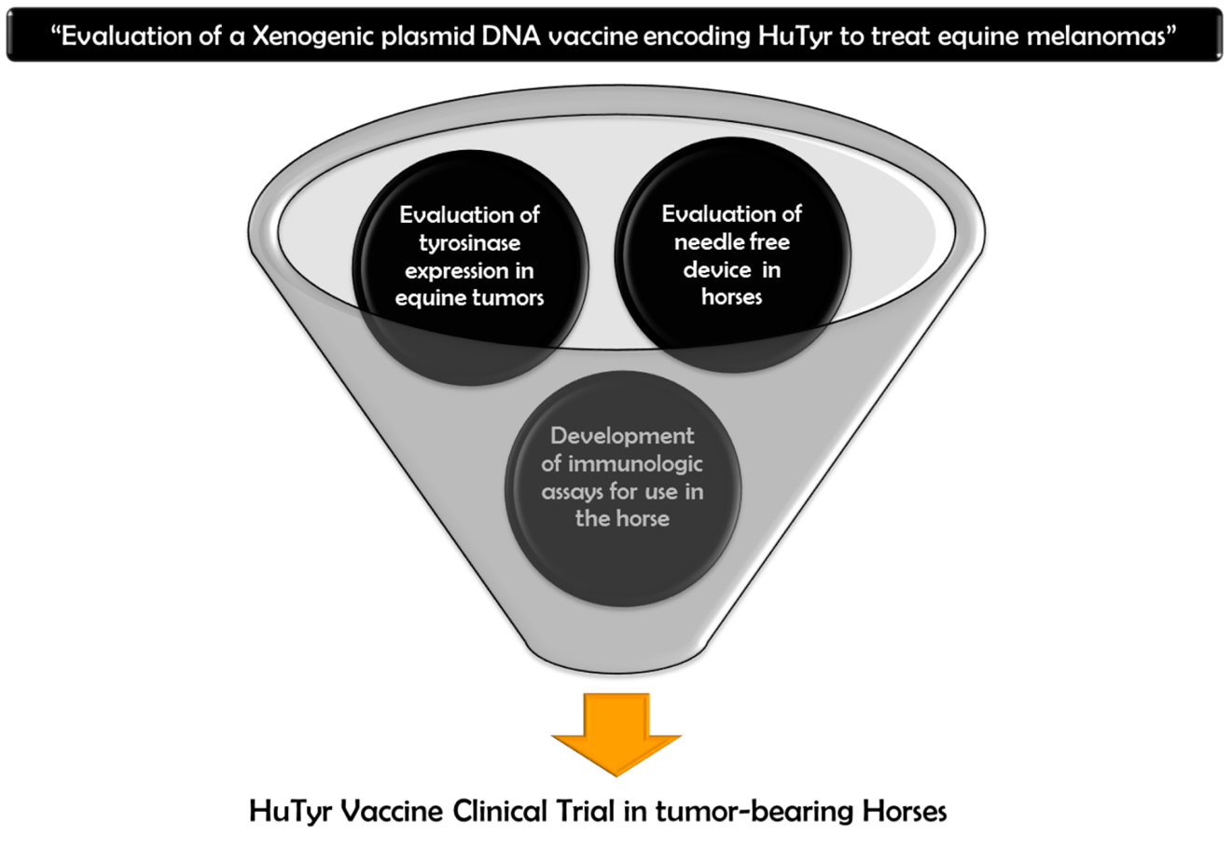
Figure 1.1. Simple funnel process chart graphing the three preliminary studies that were performed prior to the clinical trial of this novel immunotherapeutic.

: Literature Review

1. Malignant Melanoma

Melanocytes are dendritic cells derived from neuroectodermal melanoblasts that have migrated during embryogenesis to the epidermis, dermis, and other sites (e.g., eye, hair, inner ear, meninges, bones, heart). Through a process called melanogenesis, these cells produce the pigment melanin. The color of the melanin is dark and it absorbs all the UV-B light and it blocks it from passing the skin layer into the hypodermis, and so carrying out its purpose (and that of melanogenesis) of protecting it from the harmful effects of solar UV-A and B radiation (DNA photodamage) [1]
Melanomas on the other hand are neoplastic lesions that arise from the transformation of these once normal cells into their neoplastic variants in a multistep process, with initiation as the first event, followed by promotion, progression, and finally metastasis. Virtually nothing is known about initiation of most animal melanomas, but in as many as 65% of cutaneous melanomas in humans is reported to occur secondary to mutations generated by both UVA and UVB solar radiation (mainly by formation of anomalous pyrimidine dimers). [2,3] Breed and familial clustering in domestic animals suggest that genetic susceptibility may be critical to the initiation step. [4] In humans and in most domestic animals (with the exception of gray horses) initiation within benign, precursor lesions (e.g., melanocytic nevus) contributes to only a small percentage of melanoma cases and most are believed to arise de novo [4,5]. The next step in carcinogenesis requires promoting factors (e.g., chronic trauma, chemicals, burns) that stimulate proliferation of the mutated cell, allowing for amplification of the cell population, persistence of the mutation, and opportunities for additional mutations. [6]
This genetically or environmentally initiated DNA instability facilitates subsequent neoplastic transformation. Where the balance between the action of genes in charge of suppressing cell proliferation and the ones in charge of promoting it is lost, and eventually superseded by dysregulated growth factors or growth factor receptors (such as bFGF, PDGFa and MSH) and inhibitors of apoptosis [7-9]. Loss of function mutations involving several tumor suppressor genes have been implicated in the pathogenesis of melanomas, among them INK4, Waf-1, bcl-2 [8,10] and p53; although the significance of the latter remains inconclusive in human melanomas and especially in animal melanomas (where even overexpression of normal p53 has been detected in equine tumors). [11] On the opposite side the transformation of proto-oncogene to fully active oncogenes, such as c-myc, c-erbB-2, c-yes, c-kit, raf and ras, have been detected in melanomas both in vitro and in vivo. [2,7] Neoplastic transformation is followed by metastasis, another multistep process starting with detachment from the primary mass, movement through the endothelium, travel via blood or lymph, adhesion and exit through the endothelium, and attachment and proliferation within a secondary site; for which neoplastic cells must down-regulate and then up-regulate various adhesion molecules (e.g., cadherins, CD44). [12,13] Finally, at both primary and metastatic locations, the ability to call on angiogenesis is critical to survival and growth of any neoplasm regardless of its derivation, including melanomas, in order to support exponential tumor growth. [14] Evaluations of cultured melanoma cell lines, animal models, and clinical cases are helping in answering questions regarding both general tumor biology and melanoma pathogenesis. This disease is becoming one of the fastest growing human cancers worldwide, experimenting a consistent and dramatic increase in its incidence since the 1950s (increase which is paralleled by its animal counterpart). [2,15] These type of tumors also naturally occur in various domestic animal species, such as dogs, cats, angora goats, cattle, sheep, alpacas, swine and horses. [2]

2. An overview of equine melanoma

Melanocytic tumors have been recognized for centuries in horses and are among the most common skin tumors noted in this species; comprising between 3.8 and 15% of all skin tumors, second only to sarcoids. [16-19] According to some studies the incidence of these tumors in horses in North America may be increasing in parallel with the incidence of human melanoma.[15,20] A gender predisposition has been suggested, but not established. [18,21,22] In contrast, while melanomas have been diagnosed in horses of all colors a marked predisposition has been extensively reported in gray horses, with prevalence rates reaching as high as 80% in older animals.[18,21-24] Melanocytic tumors are seldom observed in gray horses less than 5 years of age and congenital tumors are rare.[21,25,26] Reports of breed predilection have suggested an increased risk for Arabian, Thoroughbred, Lipizzaner, Camargue and Percheron horses, but this association may simply reflect the higher number of gray horses in these breeds. [22,27-31] While melanomas clearly are more frequent in gray horses, they also occur in non-gray horses, where they are more likely to exhibit malignant behavior. [18]

2.1. Molecular genetic bases of equine melanoma

The increased incidence of melanomas in gray horses has been linked to the graying process these horses experience around 5 to 8 years of age when they start a gradual loss of follicular pigmentation while maintaining a dark skin (Figure2.1). [25,32] This graying process is an autosomal dominant trait that is associated with an increased risk of both melanoma and vitiligo.[25,32-34] Studies have been undertaken to elucidate the molecular basis of the graying process and associated melanocytic tumors as a comparative model for human melanoma.[34-36] Recent work has identified the genetic basis for the premature graying as a 4.6-kb duplication in intron 6 of the syntaxin 17 gene (STX17) which leads to the overexpression of STX17 and the neighboring gene NR4A3. [32] This duplication also appears to contain regulatory elements that have melanocyte-specific effects; transforming a weak enhancer to a strong melanocyte-specific enhancer that encodes binding sites for the microphthalmia-associated transcription factor (MITF). [37] MITF regulates melanocyte development and these binding sites within the STX17 gene provide a plausible explanation for the melanocyte-specific effects of the Gray allele, including hair graying, melanoma susceptibility and vitiligo. While the STX17 mutation is inherited in an autosomal dominant fashion, the risk for melanocytic tumor formation and the other traits associated with this mutation appear to be polygenic. [32,37]
The genetics underlying the malignant transformation of melanocytic tumors has also been investigated. For example, copy number expansion of the STX17 duplication has been identified within the tumor tissue of grey horse melanoma; the authors have speculated that the increasing copy number may be associated with tumor aggressiveness. [38] The Receptor for Activated C Kinase 1 (RACK1), a protein that serves as an anchoring point for protein kinase C and in this role likely plays a vital part in cellular signaling, has also been associated with melanocytic tumor transformation. Immunofluorescence studies suggest that RACK1 expression levels can be used to differentiate between benign and malignant melanocytic tumors. [39]
Mutations in melanocortin-1 receptor (MC1R) signaling have also been studied to determine their role in melanocytic tumor development. [40-42] Specifically, a single nucleotide polymorphism in MC1R (C901T) has been linked to chestnut coat color and resultant low risk of melanocytic tumor development. [41] A loss of function mutation (ADEx2) in the agouti signaling protein (ASIP), a known antagonist of MC1R, has been linked to black coat color and an increased risk of melanoma formation. [41] In addition to the upregulation of downstream genes such as tyrosinase, enhanced signaling through the MC1R pathway has also been shown to result in markedly increased expression of the NR4A nuclear receptor subgroup in melanocytic cells. [42] As pointed out previously, overexpression of NR4A3 has been found in gray horse melanomas; although it has not been directly associated with the development of melanocytic tumors in humans or horses. [32,38]

2.3. Pathology and natural behavior

Equine melanocytic tumors have been recognized for centuries as slow growing, low-grade neoplasms. While the majority of cutaneous melanomas are benign at initial presentation, if left untreated up to two thirds can progress to overt malignant behavior capable of extensive local invasion and widespread metastasis. [2,18,22] The most common external locations for melanocytic tumors include the perineal region, the ventral surface of the tail, the prepuce, the commissures of the lips, and the head/neck; while the parotid salivary gland, ears, eyelids, and limbs are less common sites (Figure 2.2). [18,19,22,43] From these primary locations metastasis may occur by either hematogenous or lymphatic spread to any region of the body, including lymph nodes and other cutaneous sites; [18,44] although there is an apparent predilection for the serosal surface of the spleen, liver and lungs (Figure 2.3). [20,22,43] Major blood vessels (including the aorta), and even the heart, appear to be other structures commonly associated with metastatic disease, [43,44] Other reported metastatic locations include the spinal cord, vertebrae, kidneys, adrenal glands and guttural pouches. [43-47] Rarely, melanomas may occur solely in visceral locations without any noticeable external disease sites. [43]

2.4. Tumor Classifications

The term melanocytic tumors encompass all histologic and clinical variants from the benign melanocytoma (nevus) to the more anaplastic malignant variants. [2] In non-gray horses these tumors include only benign and malignant variants. In gray horses, however, there seems to be a clinical continuum between benign and malignant tumors and the “melanocytic” disease process is further extended to include hyperpigmentation and infiltration of the dermis and epidermis resulting in plaque-like lesions rather than true masses or tumors. [22,47] Tumor histology typically reveals a mildly to moderately pleomorphic population of neoplastic melanocytes, with an epitheloid to spindle shape, euchromatic nuclei, rare binucleation, variable and often high cytoplasmic pigmentation, and occasional mitoses. [2] Tumors in gray horses are classified into distinct histologic subtypes based on a combination of tumor cell morphology and location within the cutaneous adnexa. Benign-appearing collections of melanocytes located in the superficial dermis or dermo-epidermal junction are classified as melanocytomas (melanocytic nevi). Tumors located within deep dermal locations comprised of well-differentiated melanocytes that exhibit dense cytoplasmic pigmentation and minimal malignant criteria are classified as dermal melanomas. Dermal melanomas are further subdivided clinically into those with few discrete nodules and those with a more disseminated variant with multiple, frequently confluent tumors (dermal melanomatosis) (Figure 2.2E). An alternate descriptive classification relies only on tumor cell morphology and traditional malignancy criteria to group tumors into either benign or malignant variants. Benign variants contain well-differentiated and heavily pigmented melanocytes that can exhibit a variable mitotic index and are often contained within a pseudo-capsule. Malignant tumors are characterized by increased pleomorphism, variable pigmentation, moderate to high mitotic rates, evidence of vascular and/or lymphatic invasion, epidermal invasion, and indistinct tumor margins. [2,18,22]

2.5. Overview of clinical presentation

Cutaneous melanocytic tumors tend to be easily recognizable as darkly pigmented nodules; however, depigmented areas can often be identified within tumors (Figure 2.2E). Furthermore, amelanotic or poorly pigmented tumors may occur in both gray and non-gray horses. Tumors can be localized in the deeper dermal tissues or may involve more superficial dermis and epidermal tissue. The latter will often ulcerate through the epidermis as they progressively enlarge (Figure 2.2F), which can also result in central portions becoming necrotic as they outgrow their blood supply. Clinical signs in affected animals are determined by tumor location. Signs can range from simple interference with bridle and saddle caused by cutaneous lesions (which can be further complicated by ulceration and infection) (Figure 2.2F) to more severe signs associated with the local invasion and the compressive effects caused by internal metastatic lesions.³³ Among the latter weight loss, constipation, impaction and even colic associated with serious obstructive lesions in the gastrointestinal tract have been reported. [29,43] Furthermore, neurologic signs including lameness, ataxia, and even paresis secondary to spinal cord compression by metastatic lesions, and less commonly Horner’s syndrome and unilateral sweating have also been reported. [43,45-50]

2.6. Diagnosis and workup

The diagnosis of melanoma in equine patients is usually made on the basis of signalment (gray horse) and the physical appearance of the tumors. In select cases, including non-gray horses and/or poorly pigmented tumors, biopsy can provide a definitive diagnosis. The differentiation between benign and malignant variants is typically made on the basis of all of these factors in addition to local growth pattern and the presence/absence of systemic involvement. [18,20,22,43] Molecular tests may also be useful; [2,38-51] however, their wide-scale reliability for differentiating benign from malignant tumors has not yet been demonstrated. Diagnostics such as blood work and imaging are rarely pursued unless specific signs are present that can’t be directly accounted for by visible tumor burden, such as weight loss, chronic colic, neurologic deficits, and lameness, amongst others. [43,46] Blood work findings are non-specific and may show elevated globulins, increased white cell count, thrombocytosis, or increased fibrinogen presumably attributed to the inflammatory effects of tumor burden. Diagnostic imaging can be used to determine the cause of clinical signs, although the limited number of effective treatment options for internal tumors limits their usefulness. Rectal palpation can also be useful, especially in patients with perianal melanomas to assess the extent of these lesions and determine if they may interfere with normal defecation or could do so in the future.

2.7. Treatment options

Treatment options can be divided into those therapies intended to treat the local tumor and those meant to treat and/or prevent systemic disease spread. Appropriate management of advanced cases, however, will require the combination of both approaches to achieve a successful outcome. Local therapies are used to treat solitary tumors or control loco-regional disease. Treatments are typically applied directly to the tumor or into the peri-tumoral tissue. Surgical resection is considered the mainstay of therapy and is often curative, especially for small benign lesions. In some patients, however, large tumor size or anatomic location (i.e. parotid region, etc.) may preclude surgery as a feasible option. Surgery can also be used to debulk more advanced tumors for palliation of symptoms and can be variably successful. [18,22,43,44,52,53] Radiation therapy is limited in applicability due to the difficulty in treating large and/or deeply seated tumors along with the limited availability of this modality in general for equine patients. [54] Another local therapy that is used very frequently in the case of these tumors is intra-tumoral chemotherapy, which involves the injection or placement of cytotoxic drugs directly into the tumor or peri-tumoral tissue. This approach has the advantage of delivering high drug concentrations to the tumor (higher than those obtained by systemic infusion of the same drug) in a cost effective manner while avoiding systemic drug side effects. Drugs that have been used effectively in horses include carboplatin and cisplatin. [3,18,44,55] Response rates for equine melanomas treated with intra-tumoral cisplatin have been reported as high as 81%, and are suggested as to be inversely related to tumor volume. [55] Chemotherapy can also be delivered into the tumor through the use of biodegradable drug-containing beads. [56] Other modalities, including hyperthermia and electrochemotherapy can also be used to increase tumor cell uptake of chemotherapy and thus improve clinical response (Figure 2.4). [57-63] Another important form of local treatment is intra-tumoral immunotherapy (which will be discussed more extensively in section 4.1: Immunotherapy of melanomas in Veterinary Medicine). A variety of other agents have been anecdotally used to treat melanocytic tumors. These compounds range from topical 5-Fluorouracil (5-FU) and Imiquimod 5% (Aldara®) creams to herbal compounds such as XXterra (Larson Labs, Fort Collins, CO) based in bloodroot powder. Cryotherapy can also be considered as a complementary measure to sterilize surgical wound beds or to treat small tumors; treatments can typically be performed in standing sedated horses. [3,18,20,35,53] In comparison to the wide variety of available local treatment options for horses with melanoma there are few effective systemic therapies available to treat/prevent disease spread. The only reported options are immunotherapeutics. Historically this treatment modality has consisted mainly in the use of the biological immune response modifier cimetidine (with inconsistent results) [64-69] and more rarely anti-cancer vaccines. [43,70,71] The systemic approach to equine melanoma with immunotherapeutics will be discussed more in depth further ahead.

2.8. Prognosis and comparative aspects

The clinical outcome in horses with melanoma(s) is mainly determined by initial tumor size and extent. [2,22] Histopathological classification and availability of treatment options also has some impact. [2] In general, melanomas in gray horses expand slowly or may show tumor dormancy for long periods, even years. If left untreated many will eventually acquire malignant clinical behavior with respect to both local growth and systemic spread. [18] Ultimately, the time from tumor appearance and/or diagnosis to the time that advanced loco-regional or systemic disease is diagnosed will vary from animal to animal and no formal survival time studies have been performed in the horse. In both humans and dogs, malignant melanomas may result in widespread life-threatening metastases; however, unlike in humans most horses will not die from metastatic disease but are euthanized due to local disease complications (e.g., large peri-anal melanomas that prevent normal defecation or rupture, get ulcerated, infected and painful). Systemic signs associated with advanced metastatic disease in both humans and horses are varied, including: chronic weight loss, neurologic symptoms, and respiratory signs amongst others. Some of the more common equine specific signs associated with advanced disease include colic symptoms from gastrointestinal invasion, difficulty defecating from obstructive lesions, nasal bleeding or neurologic signs from guttural pouch involvement. When such advanced symptoms are observed in horses they can be difficult to treat and will commonly be the cause of death or reason for euthanasia. The development of new local and systemic therapies, including advances in accessible radiotherapy and molecularly targeted therapies will prove useful in managing these challenging cases.

3. Main Concepts on Immunology of Melanocytic tumors

The immune system is not only capable of protecting us from foreign invaders, such as bacteria, parasites, viruses and other infectious agents; it also monitors for the appearance of more “internal aggressors”, from which neoplastic cells are the more infamous examples. The idea that the immune system may actively prevent and even eliminate the development of neoplasia is termed cancer immunosurveillance [72,73] and is the fundamental rationale for immunotherapy for cancer.[74] A long line of laboratory evidence support this hypothesis, including the findings that IFN-γ protects mice against the growth of tumors and that mice lacking IFN-γ receptor are more sensitive to chemically induced sarcomas and are more likely to spontaneously develop tumors.[75] Multiple lines of evidence support also role for the immune system in clinically managing cancer, including (1) spontaneous remissions in cancer patients without treatment; (2) the presence of tumor-specific cytotoxic T cells within tumors or draining lymph nodes; (3) the presence of monocytic, lymphocytic, and plasmacytic cellular infiltrates in tumors; (4) the increased incidence of some types of cancer in immunosuppressed patients; and (5) documentation of cancer remissions with the use of immunomodulators. [76-79]
But despite this constant surveillance, as we all know, tumors do occur in immunocompetent individuals. There are not only significant barriers to the generation of effective antitumor immunity by the host, but also many tumors evade surveillance mechanisms and so are able to grow in immunocompetent hosts, which is shown by the large numbers of people and animals succumbing to cancer. There are several ways in which tumors can do this: (1) by production of immunosuppressive cytokines (e.g. TGF-β and IL-10); (2) by impairing DC function, activationand/or maturation; (3) by induction of regulatory T cells, which can suppress tumor-specific CD4/CD8+ T cells [11]; (4) by promoting MHC I loss through structural defects, changes in B2-microglobulin synthesis, defects in transporter-associated antigen processing or actual MHC I gene loss; among many other mechanisms. [73,80,81]
Nonetheless with the tools of molecular biology and a greater understanding of mechanisms to harness the immune system, effective tumor immunotherapy is becoming a reality. [82] This new class of therapeutics offers a more targeted, and therefore precise, approach to the treatment of cancer. [83] It is likely that immunotherapy will eventually have a place alongside the classic cancer treatment triad components of surgery, radiation therapy, and chemotherapy. [84,85]

3.1. Are melanomas immunogenic tumors?

Melanoma is possibly the best example of an “immunogenic” tumor. Virtually all the major principles of “tumor immunology” have been experimentally established in this model (for reasons not entirely clear but perhaps because melanoma cells could be cultured with relative ease, a good deal of the work on tumor immunity was conducted in the melanoma model). [86] This tumor type exhibit a set of unique features strongly suggestive of “footprints” of host immune responses. Among the clinical features that have long been associated with melanoma and are suggestive of some form of host immune responses against this disease are: (1) primary melanomas at times spontaneously undergo partial or complete regression; (2) primary melanomas often exhibit strong lymphocytic infiltrations, both immunosuppressive (with regulatory T cells, associated with a worse prognosis) as well as immunepotentiating (with cytotoxic T cells, associated with a better prognosis); (3) nevi at times show a ring of depigmentation around them; (4) primary melanomas also often show areas of depigmentation; (5) development of vitiligo carries a good prognosis in patients with melanoma. Although these features, by themselves, do not prove that spontaneous regression, halos, depigmentation, or a relationship between vitiligo and good prognosis represent unequivocal evidence of host immune responses, the idea that human melanoma is an immunogenic tumor gets considerable support from laboratory observations that have shown (1) the infiltrating lymphocytes are mostly α/β T cells, custodians on cell-mediated immunity; (2) regressing melanomas show evidence of clonal amplification of T cells, in situ; and (3) T cells isolated from regressing melanomas exhibit cytolytic activity against autologous melanomas. [77-79,86]
It is now amply clear that melanoma cells display multiple antigens and peptide epitopes that are targetable by the host immune system and that patients with melanoma are capable of responding to these antigens and epitopes serologically (it has largely been shown that patients with melanoma are capable of producing IgM and IgG antibodies against cell surface–associated antigens on autologous melanoma cells [87]) as well as through the cell-mediated mechanisms (various experiments using microcytotoxicity assays and T-cell cloning technology, among other techniques have shown that melanoma-bearing hosts do indeed harbor a cytotoxic CD8 T cell population capable of selectively recognize and target for destruction autologous tumor cells expressing melanoma-associated antigens in a MHC-I manner [88], as well as a CD4 T cell population capable of recognizing melanoma-associated peptide epitopes processed and presented in an MHC class II–restricted manner by APCs, elaborate and secrete a number of inflammatory cytokines to help the expansion of the previously mentioned CD8+ T cells [89], and also a NK cell population capable of killing melanoma cells that have lost completely or partially MHC expression [90]).

3.2. Melanoma-Associated Antigens: The key elements for immune response

Among the tumor associated antigens that melanoma cells display the most widely studied in the context of tumor immunology and immunotherapy are melanocyte differentiation antigens (or MDA). [91] Differentiation antigens are proteins that distinguish a cell linage from another, and are typically expressed at specific stages of differentiation; in the case of melanocytes these are called melanocyte differentiation antigens and are mostly proteins logically involved in a process that only this cell type carries away: the synthesis of melanin (Figure 2.5). [92] And so these proteins are almost exclusively expressed by melanocytes (these can also be expressed in some CNS cells, with which they share the same neuroectodermal origin). [93] Moreover, although both normal and malignant melanocytes expressed these antigens, several studies (including our own in canine and equine melanomas) have shown that they are overexpressed in malignant tissue in comparison to normal tissue [70,93]. Amongst the most important melanocyte differentiation proteins are:
- Tyrosinase: a crucial enzyme that functions to catalyze the hydroxylation of tyrosine to dihydroxyphenylalanine (or DOPA) and subsequent oxidation of DOPA to DOPAquinone, the initial and rate limiting step in the cascade of reactions leading to melanin synthesis. This is also the tyrosinase family’s protomolecule, being that all other proteins in the family show a 50% homology to it. [94]
- Tyrosinase Related Protein 1: also known as TRP1 or gp75, part of the tyrosinase protein family, modulates tyrosinase catalytic activity, maintains melanosomal structure and to some degree even affects melanocyte proliferation and death. [95]
- Tyrosinase Related Protein 2: part of the tyrosinase protein family, also known as TRP2 or DOPAchrome tautomerase, being that it mediates the transformation of the pigmented intermediate DOPAchrome to DHICA (5,6-dihydroxyindole-2-carboxylic acid) rather than to DHI (5,6-dihydroxyindole), which would be generated spontaneously and so catalyzes the late step in eumelanin formation. [96]
- Melanomsomal membrane glycoprotein 100: also known as gp100 or PMEL; is a transmembrane glycoprotein enriched in melanosomes and involved in their maturation serving as a structural component of the melanosome fibrillar matrix upon which melanins are deposited. [97]
- Melanoma Antigen Recognized by T-cells: also known as MART-1 or Melan-A bounds to MHC class I complexes which present it to T cells of the immune system. These complexes can be found on the surface of melanoma cells (reason why they are also useful for the histopathologic diagnosis of melanocytic tumors). It also regulates melanosome fibril formation. [98]
These proteins are mostly melanosomal membrane surface proteins, which means that they are mostly expressed intracellularly [99], so making them a harder target for the immune system to home in in the context of cancer immunotherapy. TRP1 or gp75 serves as a good example of the intracellular distribution pattern these melanosomal proteins tend to follow. This protein is first synthesized in the endoplasmic reticulum, then transported through the Golgi complex (where it gets glycosylated), and finally sorted to the endosomal compartment and to melanosomes. Furthermore, it contains an intracellular retention signal that sorts it to the endosomal compartment, leading to stable intracellular retention. [100] And while one can understand how T cells can respond to intracellular proteins, based on cellular requirements for antigen processing and presentation (part of the normal monitoring to which all cellular inner-proteins are subjected via an MHC-1 associated immunosurvailance mechanism) [86], it is more difficult to understand how antibody responses to melanosomal proteins could lead to tumor rejection. However, a study by Takechi, et al. which tried to approach this problem surprisingly demonstrated that TRP1 can and is fact expressed on the cell surface as well as intracellularly in human and mouse melanomas. [101] In this study various melanoma cell lines, both murine (Bl6FlO) and human (SK-MEL-l9 and SK-MEL-23), were analyzed by MHA assays using a specific mAb and showed that this protein also reaches the plasma membrane, results which were further confirmed by flowcytometry. Other studies have also shown evidence that these proteins can also be expressed in some occasions and in low levels of expression at the cell surface. [102] Thus, despite the presence of an intracellular retention signal within the TRP1 protein, a proportion of it does reach the cell surface. If this co-localization pattern presents as well with other members of this family it can only be assumed so far and further studies are warranted.
Studies dealing with melanoma immunology and immunotherapy have shown over and over that the immune system can and does recognize these particular proteins and is able to mount a specific cellular and humoral response based on them [93,101,102]. Although, these melanocyte differentiation antigens are not likely implicated directly on malignant transformation, their exclusive expression pattern marks them as very useful potential targets usually used the immunotherapeutic treatment of melanomas in both human and veterinary medicine. [70,93]
Needless to mention, the list of melanoma antigens for CD8 T cells as well as for CD4 T cells continues to expand at a steady pace along with continued interest in melanoma immunotherapy. Melanoma immunology is no longer simply restricted to studying the topic at the bench. Virtually all the observations made at the bench have now been translated in the clinic and intense effort is under way to make cancer immunotherapy, in general, and melanoma immunotherapy, in particular, more effective [86].

4. Immunotherapy as a treatment option for melanomas

Due to the inherent immunogenicity associated with melanocytic tumors, the increasing knowledge accumulated over the years on melanoma-associated antigens and epitopes, the progress in methods of anti-cancer immunization techniques and technologies for generating melanoma antigen-specific T cells, and the fact that the bases of both general tumor immunology and immunotherapy are built around research performed in this particular tumor type it is not at all surprising the large number of immunotherapeutic strategies and drugs developed over the years in an attempt to harness and aim the power of the immune system at this tumor type. [84,86] Although these strategies have not been uniformly successful in all cases, durable complete regressions have been obtained in the past, this coupled with the most recent developments in monoclonal antibody-based immune modulation show reason for hope that continuing research in the field is likely to improve the outcome of melanoma immunotherapy: the ultimate goal of tumor immunology. [83-85,104]

4.1. Immunotherapy of melanomas: The human medicine side

Current cancer immunotherapy for melanoma in the context of human medicine consists of regimens involving IL-2, interferon, targeting of the inhibitory receptor CTLA‑4, or inhibiting the interaction of PD-1 ligand with its receptor. [83] IL-2 therapy has shown little improvement in overall patient survival; although interferon was shown to improve relapse-free and overall survival, it is also associated with an extensive set of side effects. [105] IFN treatment is the most studied and only approved adjuvant therapy for melanoma patients, as well as the first agent to show a significant benefit in relapse free survival and OS of high-risk melanoma patients. [106] Melanoma vaccines, although showing great promise, have so far failed to demonstrate a significant therapeutic effect. [107] Adoptive T-cell therapy, although quite complex, has shown strong clinical response rates. But this treatment is both cost-prohibitive and time-consuming, thus limiting its general applicability. [108] But it was not until 2010/2011 that, thanks to a more in-depth understanding of the molecular and immunological background of the disease, the next landmark in the treatment of melanoma was achieved; and after a very successful phase III trial the fully human cytotoxic T-lymphocyte-associated antigen-4 (CTLA-4) blocking monoclonal antibody Ipilimumab was approved for use in patients with refractory metastatic melanoma. [109,110] This new agent has resulted in a substantial improvement in the median overall survival in patients with previously treated melanoma. [111] Furthermore, on the same lines as Ipilimumab, treatment of the effector phase of the immune response, through PD-1 inhibition (Nivolumab), has resulted in high objective response rates in clinical trials and shows great promise for more general use. [112]

4.2. Immunotherapy of melanomas in Veterinary Medicine

As it can be seen, with the appearance and promising results obtained with monoclonal antibody-based immune modulation (Ipilimumab and Nivolumumab), as well as the also great results obtained with the BRAF kinase inhibitor Vemurafenib the management of human melanoma bearing patients is clearly tilting towards the use of small molecules and monoclonal antibodies, as it should. [109-113] But this type of therapy remains non-applicable in veterinary medicine for mainly two reasons: (1) all these monoclonal antibodies are design specifically for human patients (which would render them ineffective after the first doses in another species, when their immune systems starts elaborating nullifying antibodies to the drug) and currently there are no monoclonal antibodies designed for the treatment of this tumor type in veterinary patients; (2) all these drugs would be cost prohibited for the grand majority on pet owners.
Still, the necessity for effective systemic therapies for this disease in veterinary patients remains, specially taking in account that these tumors show a remarkable (both in human and veterinary patients) unresponsiveness to the more conventional forms of anti-cancer therapy, such as chemotherapy and radiotherapy. [114-116] Is in this context that immunotherapy rises up as a potential systemic therapeutic strategy for melanoma. Without a doubt almost all the work done in pet melanoma immunology and immunotherapy has been done in dogs primarily and in horses secondarily (both niches where this disease, due to its aggressiveness and high prevalence respectively, remains of particular importance). Immunotherapy strategies to date in canine melanoma have used autologous tumor cell vaccines (with or without transfection with immunostimulatory cytokines and/or melanosomal differentiation antigens), allogeneic tumor cell vaccines transfected with interleukin-2 or GM-CSF, liposomal-encapsulated nonspecific immunostimulators (eg, L-MTP-PE), intralesional Fas ligand DNA, bacterial superantigen approaches with granulocyte macrophage colony-stimulating factor or interleukin 2 as immune adjuvants, and last, canine dendritic cell vaccines loaded with melanosomal differentiation antigens. [117-122] Although these approaches have produced some clinical antitumor responses, the methodologies for the generation of these products are expensive, time-consuming, sometimes dependent on patient tumor samples being established into cell lines, and fraught with the difficulties of consistency, reproducibility, and other quality-control issues. [117,123]
The advent of DNA vaccination circumvents some of these previously encountered hurdles. And so, in 2007 the USDA conditionally approved the first anti-cancer vaccine ever designed and marketed to treat a malignancy in veterinary patients, in this case malignant melanoma in dogs. This conditional license was later granted full licensure in 2010. This vaccine is the final product of a long line of research in melanoma immunology and immunotherapy and of the strategic venture between two well renowned medical institutions: The Memorial Sloan-Kettering Cancer Center on the human medicine side and The Animal Medical Center on the veterinary side, both based in New York City. [123] Several studies performed since have ratified the effectiveness of this immunotherapeutic modality in canine patients with melanoma, for whom it has consolidated into the only effective systemic treatment for the management of this disease, considerably increasing patient’s survival time and revolutionizing how the disease is both approached and treated. [124-127]
In the particular case of horses suffering from melanocytic tumors, although considerable effort has been placed in the last three decades in trying to understand the hereditability and molecular basis of this disease [25-42,128] and although this understanding is definitely the base for the development of new therapies, few tangible advances have been made to date in matters of how to effectively treat this disease. Nonetheless, immunotherapeutic approaches have also been implemented in this species over the years in an attempt to control both the local and systemic components of their disease. Unfortunately most of these have failed to show significant or reproducible results. Local immunotherapy has mainly been limited to direct intra-tumoral injections with the biologic immune response modifier Bacillus Calmette-Guerin (BCG) [18] or with plasmids encoding the cytokines Il-12 and Il-18. [128,129] These cytokines have anti-tumor effects through the activation of cytotoxic T cells, the production of interferon-γ, and the induction of apoptosis in tumors cells. [130] Two studies evaluated the use of these agents in tumor-bearing gray horses. The first study involved the intra-tumoral injection of DNA plasmids encoding the human Il-12 gene in a cohort of 7 gray horses. [128] The other study involved the intra-tumoral injection of DNA plasmids containing either equine Il-12 or Il-18 in a cohort of 26 gray horses. [129] Shrinkage of the injected tumors was observed in the majority of horses from each study and the therapy appeared to be safe and well tolerated. Unfortunately, although these plasmids have shown activity, these treatments are not commercially available and their benefits appear to be limited to injected lesions (i.e. no systemic anti-tumor effects). Results from intratumoral injections of BCG in equine melanomas have been disappointing. [18] Attempts to try to control the systemic component of this disease have historically been limited to the use of the unspecific biologic immune response modifier cimetidine. Cimetidine is a well-known histamine (H2) receptor antagonist that may exert anti-tumor effects by several mechanisms including the inhibition of H2 receptors on tumor cells as well as the “immune stimulatory” effects of activating natural killer cells and the blocking of H2 receptor mediated activation of immunosuppressive regulatory T cells. [131-136] Although one small case series has described a clinical benefit in treated horses, [133] several larger clinical trials have failed to replicate these results62-64 and thus the clinical effectiveness of cimetidine immunotherapy remains questionable.
As it can be observed the treatment of melanomas in horses to this date remains mainly limited to attempts to control the local component of the disease (e.g., surgery, intratumoral chemotherapy); while its systemic aspect is left free to run unchecked and progress at its own pace; most of the time being approached by either a questionable therapy as cimetidine or most commonly by simple benign neglect.

5. Anti-melanoma Vaccines

Cimetidine, IL-12, IL-18 and BCG are all examples of non-specific tumor immunotherapy. This type of immunotherapy do not directly target tumor cells or tumor related antigens; rather they stimulate the immune system in a general way that may also result in increased activity against tumors. This less selective, more general, harnessing of the power of the immune system is logically associated with a higher risk of important adverse events and toxicity. Tumor-specific immunotherapy, on the other hand, refers to the selective modulation of the immune response so as to cause specific destruction of the malignancy with minimal systemic side effects and cross-reactivity to normal cellular components. In this immune anti-cancer approach specific tumor associated antigens (TAA), which are proteins that are preferentially expressed or overexpressed in tumor tissue, are directly targeted. This preferential expression may occur either in a temporal or spatial fashion and so allowing for the targeting of tumor tissue while sparing normal tissue. An example of temporally restricted expression is a tumor that expresses an embryologic antigen in an adult animal (Ex: CEA in human colon cancer). A spatially restricted protein is one where the expression is limited to tumor tissue with minimal to no expression in other tissues. And so these antigens are used to hone the immune system into attacking the cells that preferentially or abnormally express them with the ultimate goal of elicitating an antitumor immune response that results in clinical regression of a tumor and/or its metastases. [137,138]
Identification of these proteins allows for the creation of immunotherapeutics or “vaccines” designed to elicit specific immune responses against cells that contain them regardless of their location within the body. [107,123,137-139] At the start of the 20th century, encouraged by the success (high efficacy and low toxicity) in immunizing against infectious diseases such as smallpox, rabies, cholera, and anthrax, investigators and physicians began trying to immunize patients against cancer. This was done at the time with little understanding of the nature of malignancy or of the immune system. Over the past several decades, we have begun to unravel the complexities of the immune system, and his complicated relationship with cancer. [140] The earliest melanoma vaccines were formulated from autologous or allogeneic melanoma cells. Subsequently, molecularly defined vaccines made from proteins, peptides, or gangliosides were developed and, more recently, DNA-based vaccines started to be tested. A summary of the advantages and disadvantages of each type of vaccines are summarized in Table 2.1. [29,107,141] But regardless of type the ultimate goal of all “cancer vaccines” is the generation of an antitumor immune response that results in clinical regression of a primary tumor and any associated metastatic lesions. [139-141]
From all these types of cancer vaccines, by the time of this project, only one type have been specifically used for the treatment of equine melanoma; namely, whole-tumor cell autogenous vaccines [43,71] Autogenous vaccines are created by isolating cells from the excised tumor of an individual equine patient, which are then processed in vitro into a vaccine formulation, and then readministered to the same patient. There are two reports describing the use of authogenous vaccine in melanoma-bearing horses. [43,71] Tumor regressions and subjective improvement in well-being were reported in both studies. Unfortunately, the studies involved relatively small numbers of horses who were also treated with more than just the vaccine and thus the true benefit of these autogenous vaccines remains unknown.

6. DNA vaccines and Merial’s Ltd. Human Tyrosinase Oncept® DNA Vaccine

Unlike autogenous vaccines, DNA-based vaccines are created by first identifying an appropriate tumor associated antigen. These antigens are tumor-specific proteins whose DNA sequence is used to create the vaccine. The DNA sequence is typically cloned into a molecular vector that allows for the in vivo expression of the encoded protein. [140,141,142] Most molecular vectors also have immune stimulatory properties that improve the efficiency of the vaccine in generating an immune response against the expressed protein. [142,143] This molecular construct (i.e. DNA sequence cloned into vector) is often administered to the patient by intramuscular injection and thus resembles a “vaccination”; although may be more appropriately referred to as gene therapy. DNA vaccines possess many advantages over other vaccine types, being the main ones that the whole DNA sequence of a target protein can be inserted in the plasmid, which would lead to the expression of numerous epitopes (and not limited to just one as with peptide based vaccines), immunostimulatory sequence can also be inserted on the plasmid (which enhances immune response and reduces the need for adjuvants as in also the case of peptide vaccines), yet they remain relatively simple to prepare (Table 2.1). [29,107,141]
One logical tumor associated antigen that can be targeted in melanomas via a DNA-based vaccine is the melanocyte differentiation antigen tyrosinase glycoprotein; an enzyme crucial for melanin pigment synthesis, as mentioned before. Tyrosinase has the ideal characteristics for a tumor associated antigen because its expression is virtually limited to melanocytes. [94] Furthermore, in melanomas (including equine variants) the tyrosinase expression appears to be constitutively increased compared to normal melanocytes. [144] A USDA-approved xenogenic DNA vaccine encoding human tyrosinase (HuTyr) is available for treatment of canine melanoma (Oncept; Merial, Ltd. Athens, GA). [145] This vaccine exploits the close homology (92%) between human and canine tyrosinase to generate a tyrosinase-specific anti-tumor response and dramatically improves survival in treated dogs. [146] In comparison, the equine tyrosinase sequence shares 90% homology to the human sequence; based on this, cross reactivity of HuTyr DNA vaccine in the horse would be expected.

6.1. The road to a vaccine (Oncept®): from mice to men, to dogs and to horses

This tyrosinase xenogeneic DNA vaccine is the end product of a long line of research in human and animal melanoma immunology and immunotherapy. With most of the basic research (i.e., preliminary in vitro studies and trials using murine models of melanoma) that more directly paved the road that lead to the development of this vaccine being performed by Doctor Jedd Wolchok’s group at the Memorial Sloan-Kettering Cancer Center (MSKCC) in New York.
By 1998, in some of their earliest work, Doctor Wolchok’s group at the MSKCC utilizing a murine model of melanoma showed that tolerance to a melanocyte differentiation antigen or MDA (in this case GP75/TRP1) could be broken by using DNA from one species to vaccinate another one in an immunotherapeutic strategy known as “xenogeneic vaccination”. In this study a human GP75/TRP1 DNA vaccine was used for immunization. Here the induction of tumor immunity and autoimmunity (in the form of vitiligo-like areas of depigmentation) were associated with an increase in autoantibody levels. Furthermore, this study also hinted the advantages of another important immunotherapeutic strategy known as “prime and boosting”, entitling the combination of both xenogeneic (prime) and syngeneic (boost) vaccination consecutively in the same immunization schedule, a strategy used to help in breaking of immune tolerance. [147] The advantages of xenogeneic over syngeneic vaccination as a way of breaking immune tolerance to self-proteins, was also observed in a following study (1999) by the same group using the same murine model of melanoma and immunization method (xenogeneic DNA vaccination), but with a different MDA. This time the MDA used was human TRP2. In contrast to immunization against GP75/TRP1, both tumor immunity and autoimmunity to TRP2 required CD8+ T cells, but not antibodies. Thus, these two consecutive studies also helped to evidence that the immunity induced against two closely related autoantigens (TRP1 and 2), both highly conserved throughout vertebrate evolution, can involve qualitatively different mechanisms (i.e., antibody versus CD8+ T cell); but lead both to tumor immunity and identical phenotypic manifestations of autoimmunity. Furthermore, this latter study also hinted the usefulness of biologic adjuvants, in this case granulocyte-macrophage colony stimulating factor (GM-CSF), as means to further boost the strength of the elicited immune response. [148] This role of GM-CSF as a vaccine adjuvant for plasmid DNA vaccination was evaluated further in another subsequent study (2000) by this same group. In it the pretreatment with GM-CSF plasmid DNA before immunization with xenogeneic human GP75/TRP1 plasmid DNA not only notably accelerated the generation of antigen specific antibodies, but also considerably increased protection from tumor challenge in their murine melanoma model. In other similar studies this adjuvant was cloned onto the same DNA plasmid and co-express with the MDA (MAGE-1), effectively enhancing tumor immunity. [149] The necessity of vaccine adjuvants mainly resides in the poor immunogenicity that generally characterizes all self-proteins, such as these MDAs. Doctor Wolchok’s research team at the Memorial Sloan-Kettering Cancer Center would later in the same year (2000) corroborate once again the superiority of xenogeneic immunization over syngeneic immunization using their murine melanoma model and a plasmid DNA vaccine coding that time for gp100, another known MDA. [150]
With all this background knowledge and experience in laboratory murine models of melanoma and the treatment of their induced condition with MDA vaccines is that Doctor Wolchok’s group decides to finally make the jump from the artificial melanomas induced in mice to the natural occurring melanomas of dogs. This is a logical step if taken in account that no induce model of cancer will ever show the wide cellular, molecular and immunological heterogeneity that naturally occurring cancers have, which is of particular importance in the context of targeted therapy. And this is how in 2003 Doctor Wolchok’s group at the MSKCC pursued a strategic partnership with the veterinary oncology department at the Animal Medical Center (AMC), both very well renowned institutions in their field and both located in the New York city area. To this This partnership was immediately symbiotic, and took advantage of the fact that dogs were a far better model for human melanoma than mice on one side and that at the same time it could potentially provide a greatly needed systemic therapy for this disease in dogs.
By the time of the initiation of the veterinary canine melanoma studies in 2003, several decisions had already been made based on the previous murine studies. It was well established for example that a xenogeneic target antigen would be chosen over a syngeneic one and that a protein from the tyrosinase family would be used as a target. But despite the fact that most of Wolchok’s job was done using tyrosinase related proteins, either TRP1 or TEP2, it was tyrosinase, (the family’s protomolecule) the one selected for the job.
This protein was selected despite the fact that before our tyrosinase mRNA expression study in dogs and horses with melanoma [144], tyrosinase expression (least alone overexpression) had never truly been demonstrated in canine melanomas, [151] and that most work in the human field at the time was done using tyrosinase related proteins, especially TRP2, but not tyrosinase itself. [152,153] But at the same time this was still the family’s protomolecule and had a huge deal of research behind it supporting its homogeneous expression pattern in human melanomas. [154]
The first official work with this xenogeneic human tyrosinase plasmid DNA vaccine in canine tumor bearing patients was published in back in 2003 by a combined effort of Dr. Bergman’s group at the AMC and Dr. Wolchok’s group at the MSKCC. At this point in time in the development of this vaccine a third and key partner also had join this efforts: Merial Ltd, a pharmaceutical company with a large history and experience in developing immunotherapeutics, and especially vaccines. They developed and provided the pING plasmid vector that was used a vehicle to generate and deliver this vaccine (Figure 2.6). This first formal study described a phase I clinical trial using escalating doses of this vaccine on a small canine population with advanced melanoma. Overall these dogs experienced a median survival time of 389 days, which was a dramatic increase in the historical survival time for this disease in dogs (most dogs with advanced oral malignant melanoma had a median survival time of only 60-90 days with the therapies available at that time). Importantly too, this population did not experienced any important side effects from treatment. This study also described for the first time the usage of the needle-free injection device now widely used to administer this vaccine in veterinary medicine.[124] In 2006 the same group published went back to revise other potential vaccine immunotargets in a dose escalation study using plasmid DNA coding for several different molecular targets including xenogeneic tyrosinase DNA from two different sources, (murine and human), murine GP75, human GM-CSF or a combination of the last two to treat oral malignant melanoma in tumor bearing canine patients. In this study it was the dogs being treated with HuTyr the ones that appeared to have the longest median survival time (MST) of all the groups, a very significant increase over the historical MST for dogs suffering from this disease, making stronger the case for the selection of tyrosinase as the protein of choice for this immunotherapeutic in the making.[125] A later expansion of this work was published in the same year but in a different journal and investigated the characteristics of the antibody response elicited by this HuTyr vaccine in the tumor-bearing treated dogs. This report documented for the first time in canine patients the induction of tyrosinase-specific antibody responses, as well as the identification of cross-reactions with syngeneic canine tyrosinase, demonstrating the ability of this vaccine to overcome host immune tolerance and/or ignorance to or of "self" antigens. [155] The results of these trials performed up to this point had demonstrated that xenogeneic DNA vaccination in the context of canine oral malignant melanoma was: (1) safe, (2) leads to the development of anti-tyrosinase antibodies, (3) is potentially therapeutic, and (4) is an attractive candidate for further evaluation in an adjuvant, minimal residual disease Phase II setting for canine malignant melanoma. And so, as mentioned before, in 2007 the USDA conditionally approved this xenogeneic human tyrosinase DNA vaccine as the first anti-cancer vaccine ever designed and marketed to treat a malignancy in veterinary patients [145], in this case malignant melanoma in dogs. This conditional license was later granted full licensure in 2010.
Based on the success of this therapy in treating oral canine melanoma the same group decided to look also at digital melanoma, another common and also very aggressive form of these tumors in dogs. And so they conducted a retrospective study including 58 dogs suffering from this particular form of melanoma, and treated with a xenogeneic tyrosinase vaccine (in this case murine, not human DNA was used). The final paper was published in 2011 and showed this vaccine as being safe and effective when used in conjunction with local and regional disease control.[126]
A final study by scientists from all three collaborating institutions (The MKSCC, The AMC and Merial Ltd.) was published that same year. It had the objective of evaluating safety and clinical efficacy of this HuTyr vaccine to treat oral malignant melanomas in a bigger population of affected dogs (59 prospectively included dogs and 58 historical controls), at a standardized dose and vaccination schedule and in the proper context: advanced but locally controlled disease. This study once again showed a significant increase in survival time in dogs under therapy in comparison to historical controls, supporting the safety and efficacy of this immunotherapy in the context of canine oral malignant melanoma. [127] To this day this therapy also continues to be explored by Dr. Wolchok’s group as a viable treatment for human melanoma. [156] And so, although a most recent retrospective study failed to see a benefit from this treatment, this long line of research presented here greatly supports its usage. [157] And there is no doubt that this therapy has to this day greatly revolutionized how veterinarians approach and treat this disease in dogs, and hopefully at the end of the present study it will do the same for horses suffering from this disease.

6.2. Mechanism of action of DNA vaccines and Oncept®

To exert their action DNA vaccines have to first reach their site of action. Vaccinate is delivered to its selected site of action using a particular delivery mechanism. Among the mechanisms available to deliver DNA vaccinates are, among others, the use of gene guns, topical application, needle injection and in the case of Oncept® the use of a needle-free injector. Each one of these delivery methods introduce the vaccine to distinct areas of immune surveillance network and therefore prime the immune system in different ways. When comparing a simple needle injection with a needle-free injection, although the former is simpler it can only result in the uptake of the vaccinate by the cells in the vicinity of the inserted needle; while the use of a needle-free intramuscular injection device (like the one used to deliver the Oncept® HuTyr vaccine) allows for a painless injection with a wider distribution range of vaccinate. This wider distribution range increases the chances of this injectate to enter in contact with a larger number of antigen presenting cells and so increases the chances and intensity of an anti-tumor immune response to the vaccine. [159] Through the use of needle-free injection device vaccines can be selectively delivered to either the skin or muscle tissue, by varying some physical characteristics of the device itself (e.g., nozzle longitude, nozzle diameter, injection pressure, stand-off distance).[144,160]
Among the sites chosen for delivery of plasmid DNA vaccinates, the skin and the muscle are the most common selected target tissues, each one with its own sets of advantages and disadvantages. [159,161] While intradermal injection results in direct transfection (i.e., process of deliberately introducing nucleic acids into cells) of mainly skin fibroblasts and keratinocytes; intramuscular injection results in transfection of mainly myocytes. Nonetheless most of the extent of the protection elicited by these various modes of vaccine administration is determined most likely by the quality and quantity of the network of APCs residing in the target tissue. For example, the skin in comparison to the muscle not only exclusively contain Largenhans cells (very powerful APCs) but counts with more APCs altogether, so less DNA may be required to induce a response of the same magnitude in the former than the latter. Nonetheless, inoculation in different sites generates immune responses of different nature, greatly depending on the particular network of cells residing in the selected target tissue that will be able to present the vaccine antigen. And so, APCs and cells acting as APCs (e.g., keratinocytes in the skin and myocytes in the muscle) transfected at different locations seem to be functionally distinct and therefore prime the immune response uniquely. And so, it has been shown that while intradermal inoculation tends to result in the induction of a primarily humoral response or type Th2; intramuscular injections result in the induction of a strong cellular mediated response or type Th1 that primes antigen specific CTLs. In the context of anticancer vaccination it is now well accepted that it is the induction of a potent cellular immune response with the development of a CTL population specific for the TAA, more than a humoral response, which more importantly mediates tumor regression (especially for intracellular TAAs such as tyrosinase), and constitutes the end goal on any anticancer vaccine. Under this notion, the muscle was selected as the optimal injection site for the Oncept® anti-melanoma plasmid DNA vaccine in dogs and horses. [124-127,144]
Although there has been much speculation regarding the mechanisms underlying DNA vaccine function, these remain complex and have yet to be fully elucidated. In the case of Oncept® the injectate is delivered using a needle-free device into the muscle, once in there the plasmid DNA vector construct is going to be uptaken and transfected mainly by muscle cells. This will also occur in the resident professional APCs that are present at the injection site at the time of vaccination, but their number in this tissue is considerably smaller. Once inside the myocytes the intracellular transcription and translation of plasmid DNA are thought to mimic the replication of a virus during infection. The powerful viral promoter inserted into the plasmid DNA construct uses this somatic cell’s own translational machinery to encode the protein target specified on the transgene sequence (also inserted in the plasmid), in this case tyrosinase. This intracellularly synthesized plasmid product, as any intracellular peptide subject to immune surveillance, enters then to the endogenous MHC-I mediated antigen presentation pathway. Through it these peptide products are first transported, via the protein transporters associated with antigen processing (TAP)-dependent system, into the endoplasmic reticulum (ER) where are further trimmed by local aminopeptidases to produce peptides of 8–10 amino acids, and then associated with MHC-I molecules. These MHC-I/antigen complexes are then released from the ER and proceed to the Golgi complex for final processing and packaging to finally be set on their way to be presented at the cell surface to the immune cells. Furthermore, a percentage of this translated vaccine antigen product is instead secreted into the extracellular compartment, where APCs may proceed to phagocytize it. This way the vaccine antigen will gain entry into the exogenous MHC-II mediated antigen presentation pathway. And so, although plasmid-harboring somatic muscles cells are able to act as provisional APCs and present the antigen to the immune system on the context of MHC-I complexes, there most important role in priming the immune system relies on acting as low-level, antigen-producing “factories” secreting antigen to the extracellular compartment for long periods post-transfection. And so, like the viral proteins produced by a replicating virus, vaccine plasmid product may gain access to both pathways simultaneously (endogenous/MHC-I and exogenous/MHC-II), affecting its presentability to the immune system. DNA vaccination is able then to induce a strong both humoral and cellular immune response against the plasmid-encoded antigen. [159,162]
Although most of the cells transfected are muscle cells, these can only present the antigen to immune cells via MHC-I complex, as they are not actually professional antigen presenting cells and so lack the capacity to present antigens via MHC-II complexes and prime CD4+ helper cells, or transport these antigens to lymph nodes or to secrete the co-stimulatory molecules (e.g., GM-CSF, IFN-γ, IL-2, IL-12) necessary to activate an effective CD8+ T cell immune response and avoid anergy. This is why, despite their considerably lower numbers at the injection site professional APCs, such as DCs are held as the key inducers of immunity in genetic immunization, distinguishing them as the immunological bridge between somatic cells (such as muscle cells or keratinocytes) and naïve T lymphocytes cells by the trafficking of antigen between the site of delivery to secondary lymphoid organs. [159,162]
DCs prime the immune system to vaccine antigen in at least three distinct ways: (1) MHC-I restricted presentation by the small population of directly transfected tissue-resident professional APCs that uptake the DNA plasmid at the actual vaccination site. [159,163] Upon exposure with the plasmid DNA antigen these cells become highly activated, express, process, and present the antigen and then migrate to draining lymph nodes where they interact with naive T cells and are capable of inducing humoral and cell-mediated immune responses. [159] The significance of this extremely small number of resident DCs in genetic immunization has been demonstrated in transplantation studies that show the induction of a CTL response is restricted to the MHC haplotype of bone marrow-derived APCs and not to the haplotype of transfected somatic cells, following IM and gene gun administration of plasmid DNA. [162,164] (2) MHC-II restricted presentation to T cells of antigen captured from transfected muscle cells. This mechanism of inducing immunity relies on the phagocytic ability of DCs to capture secreted forms of the vaccine antigen expressed by plasmid-transfected muscle cells, which as stated before act as antigen “factories”. These are processed in the exogenous pathway and loaded onto MHC class II molecules. When these DCs receive the proper maturation signal, they up-regulate co-stimulatory molecules and then migrate to and communicate with antigen-specific CD4+ helper T cells, which are then induced to secrete Th2 cytokines. Usually, antibody responses occur only when antigen is secreted from cells. Although antigen secretion may help to augment the development of a strong humoral response, it has not been shown to induce CTLs and, therefore, cannot act independently from the other two mechanisms of immune system priming. [159] (3) MHC-I restricted “cross”-presentation of captured and processed exogenous vaccine antigen captured from transfected apoptotic muscle cells. Given the right conditions, including most likely the presence of a “danger” signal or a proinflammatory environment (such as the ones promoted by the physical microinjury that results from the vaccination act or by the immunostimulatory sequences present in the vaccine plasmid itself, in the case of Oncept®), a proportion of the transfected somatic muscles cells will enter apoptosis leaving behind (among other cellular debri) MHC-I/vaccine antigen cell membrane sections. APCs, under that context, may capture and phagocytize these antigen–loaded MHC-I apoptotic sections. This way, exogenous plasmid-encoded antigen, which would normally be handled by the exogenous pathway and presented to helper T cells via MHC-II complexes, is able to enter the endogenous pathway instead and be cross-presented to cytotoxic CD8+ T cells in the context of MHC-I molecules. Following migration to lymph nodes, cross-presenting DCs can expand (cross-prime) or delete (cross-tolerate) antigen-specific naïve CD8+ T cells in the periphery, depending on the environment in which the DC captured the antigen (i.e., the presence or not of “danger” signals). But the effective cross-priming of naive T cells to exogenous antigen requires also the active involvement of CD4+ helper T cells [165]; and so it is most likely that all of these mechanisms are necessary in genetic vaccination and must act in conjunction in order to evoke a potent humoral and cell mediated response.
But within the periphery, immature DCs exist in a highly phagocytic state, which although helps in their uptake of secreted or apoptotic antigen, it is also characterized by the low-level expression of MHC class I, MHC class II, and costimulatory molecules, rendering them poor initiators of immune responses. These immune cells in order to carry over their crucial role need to receive the proper maturation signal. DC maturation can be induced also by the method of plasmid delivery and by the immunostimulatory qualities of plasmid DNA. The act of injection during the administration of DNA plasmids are forms of physical microinjury that result in local irritation, which has been shown to stimulate the recruitment of non-transfected DCs to the injection site, as well as the migration of transfected DCs from there to the draining lymph nodes [166]. In this way, the physical stress associated with invasive DNA delivery acts as a type of immunological adjuvant. The plasmid construct of this DNA tyrosinase vaccine possess itself adjuvant qualities that are determined by the presence of immunostimulatory sequences within the DNA vector backbone. In there, repeated immunostimulatory unmethylated CpG motifs act to initiate the innate immune response, by promoting the secretion of pro-inflammatory cytokine mediators from macrophages (IFN-α, IL-12) and natural killer cells (IFN-γ, IL-18), thereby promoting the maturation of DCs (up-regulating the expression of MHC-II molecules), as well as promoting the differentiation of naive T cells to Th1 cells [159]. Once they receive the proper maturation signal vaccine antigen loaded DCs up-regulate costimulatory molecules and then migrate to regional lymphoid organs, where their numbers consequently increase because of influx or expansion from precursors [166] and communicate with antigen-specific naïve helper T cells, which are then induced them to secrete both Th1 and Th2 cytokines [159,162] promoting the initiation of humoral and cellular vaccine antigen specific immune responses. Furthermore, communication with CD4 cells induces the ability of the DCs to activate naïve CD8+ cells via CD4+ signaling [167] and also induces the establishment of vaccine antigen specific memory CD4+ and CD8+ T cells that are capable of long-life existence.

7. Evaluating response to anticancer immunotherapy: looking at more than just reductions in tumor size

Unlike radiotherapy and chemotherapy, wherein tumor regression is the standard for determining efficacy of treatment, immunotherapy has to be evaluated by the examination of several immunological aspects within patients, and not only clinical response. [168,169] That is why it is critically important to implement in vitro immunological assays that correlate with clinical outcome, for their use as monitoring tools in cancer patients undergoing immunotherapy as surrogate markers of vaccine efficacy and for helping in the optimization of these immunotherapeutic strategies before jumping to large scale randomized clinical trials. [168] In order to get a complete picture of this immune response mounted by the vaccine stimulation, both the humoral as well as the cellular arms of the immune system should be simultaneously evaluated. But if indeed the titer of circulating antigen-specific antibodies can serve directly as an indicator of the efficacy of a vaccination protocol in inducing a humoral response and antigen-specific ELISA can serve as a validate method to evaluate it, choosing the adequate method to evaluate the other arm of immunity, the cellular response is a little more complicated. And furthermore, the past notion that the antibody response is more important than the cellular response in the context of anticancer vaccination has not only been challenged but it has actually been proposed that the cellular arm is the one that most importantly mediates tumor regression through this treatment approach. [170,171] In this context, because tumor antigen-specific antitumor immunity depends on CD8+ cytotoxic and CD4+ helper T-cells assays that monitor their stimulation and function are of particular importance. In order to do accomplish this there is a plethora of in vitro antigen-specific assays that can be used, all with advantages and disadvantages. Among the assays that have been described in the literature them lymphoproliferation assays, detection of secreted cytokines by ELISA or ELISPOT, quantification of cytotoxic T-cell precursors by limiting dilution analysis, flowcytometry, and real time PCR are the most important. But some of these assays like the lymphoproliferation assays are only used as a screen tool to indicate whether any immune response to the vaccination has been induced before performing more informative assays. Other assays like cytokine detection ELISAs, which detects the presence of antigen-specific activated T-cells by measuring their bulk cytokine production after encountering the specific antigen during incubation, although being able of providing function information, fail in giving quantifying information about individual antigen-specific T-cells, and so has consequently been replaced by measures of individual cell cytokine release. ELISPOT is one of these measures, and so one of the best choices for quantifying T-cell responses in clinical trials. In fact it has been used in the past to evaluate cellular immune response in dogs after tyrosinase DNA vaccination. Although it does succeed detecting and enumerating individual cytokine producing antigen-specific activated T-cells, it suffers the cumbersome that it requires considerable expertise and rigorous attention to performance, especially in the counting phase. This human factor certainly interferes with reproducibility. Quantifying citotoxic T-cell precursors by limiting dilution analysis is an older type of assay that suffers the same limitations of being both labor intensive and extremely operator dependant. [172] The detection of cytokines secreted by antigen-specific activated T-cells using flowcytometry is another technique that has considerable utility and sensitivity, which in fact was tried in this study, but without providing reliable and reproducible results. Real time PCR, which works by evidencing and most of all relatively quantifying the cytokine response of specific-antigen stimulated T-cells by measuring the levels of gene transcripts in samples of mRNA, was the methodology chosen in this study to measure the cellular immune response mounted by the anticancer vaccination stimulation. This technique has many advantages, among them the biggest is its high flexibility, since it allows the study the genes of interest (virtually any gene for whom the sequence is known) in a broad range of samples with minimal amounts of material. Another crucial advantage is its very high sensitivity, being able to detect transcripts with very few amounts of product. This ability has been greatly improved by the relatively recent development of mRNA pre-amplification techniques, which allow for the quantitative analysis of genes with very low product yield while maintaining their proportional expression levels. [173,174] The cytokine chose to reflect anti-tumor specific T-cell activation in this case was INFg, which has the advantage over IL-2, IL-4 and IL-12, that is not secreted by unestimulated PBMC. [174] This particular approach had been previously reported with success in the literature in studies involving anticancer vaccination for, among other cancers, melanomas in humans and mouse models. [173,174] And it has been previously reported with an immunotherapeutic approach using IL-12 DNA plasmid constructs in horses with melanoma. [128]

References

- Agar N and Young AR. Melanogenesis: a photoprotective response to DNA damage? Mutat Res 2005;571:121–32.
- Smith SH, Goldschmidt MH, McManus PM. A comparative review of melanocytic neoplasms. Vet Pathol 2002;39:651-78.
- Green A, Neale R, Kelly R, et al. An animal model for human melanoma. Photochem Photobiol 1996;64:577–580.
- Goldschmidt MH. Benign and malignant melanocytic neoplasms of domestic animals. Am J Dermatopathol 1985;7(Suppl):203–12.
- Koh HK. Cutaneous melanoma. N Engl J Med 1991;325:171–182.
- Jerbi G, Boussen H, Ennaifer-Jerbi E, et al. Melanoma arising in burn scars: report of 3 observations and a literature review. Arch Dermatol 1999;135:1551–3.
- Bis S, Tsao H. Melanoma genetics: the other side. Clin Dermatol. 2013;31(2):148-55
- Brantley MA Jr, Harbour JW. Deregulation of the Rb and p53 pathways in uveal melanoma. Am J Pathol 2000;157:1795–1801.
- Bis S, Tsao H. Melanoma genetics: the other side. Clin Dermatol. 2013 Mar-Apr;31(2):148-55.
- Morales-Ducret CR, Van de Rijn M, LeBrun DP, et al. bcl-2 expression in primary malignancies of the skin. Arch Dermatol 1995;131:909–912.
- Roels S, Tilmant K, Van Daele A, et al. Proliferation, DNA ploidy, p53 overexpression and nuclear DNA fragmentation in six equine melanocytic tumours. J Vet Med A Physiol Pathol Clin Med 2000;47(7):439-48.
- Hsu MY, Meier FE, Nesbit M, et al. E-cadherin expression in melanoma cells restores keratinocyte-mediated growth control and down-regulates expression of invasion-related adhesion receptors. Am J Pathol 2000;156:1515–25.
- Guo Y, Ma J, Wang J, Che X, et al. Inhibition of human melanoma growth and metastasis in vivo by anti-CD44 monoclonal antibody. Cancer Res 1994;54:1561–1565.
- Mowlavi A, Malafa MP: Angiogenesis in primary tumor cells of metastatic and non-metastatic malignant melanoma. Plast Reconstr Surg 2000;106(2):514.
- Linos E, Swetter SM, Cockburn MG, et al. Increasing burden of melanoma in the United States. J Invest Dermatol. 2009;129(7):1666-74.
- McFadyean S. Equine melanomatosis. J Comp Med 1933;46:186–204.
- Cotchin E. Tumours in farm animals: a survey of tumours examined at the Royal Veterinary College, London, during 1950-60. Vet Rec 1960;72:816–823.
- Johnson PJ. Dermatologic tumors (excluding sarcoids). Vet Clin North Am Equine Pract 1998;14:625-58.
- Sundberg J, Burnstein T, Page E, et al. Neoplasms of equidae. J Am Vet Med Assoc 1977;170(2):150-52.
- Goetz TE, Long MT. Treatment of melanomas in horses. Compend Contin Educ Pract Vet 1993;15:608-10.
- Foley GL, Valentine BA, Kincaid AL. Congenital and acquired melanocytomas (benign melanomas) in eighteen young horses. Vet Pathol 1991;28:363.
- Valentine BA. Equine melanocytic tumors: A retrospective study of 53 horses (1988–1991). J Vet Intern Med 1995;9:291–297.
- Levine A. Equine melanotic disease. Tumor 1971;57:133–168
- Comfort A. Coat-colour and longevity in thoroughbred mares. Nature 1958;182;1531–32.
- Rodríguez M, García-Barona V, Peña L, et al. Gray horse melanotic condition: A pigmentary disorder. J. Eq. Vet. Sci 1997;17:677–81.
- Cox JH, DeBoes RM, Leipold HW. Congenital malignant melanoma in two foals. J Am Vet Med Assoc 1989;194:945-7.
- Mullowney PC. Dermatologic diseases of horses. Part IV. Environmental, congenital and neoplastic diseases. Compend Contin Educ Pract Vet 1985;7:S22-34.
- Seltenhammer MH, Simhofer H, Scherzer S, et al. Equine melanoma in a population of 296 gray Lipizzaner horses. Equine Vet J 2003;35:153-7.
- Fleury C, Bérard F, Leblond A, et al. The study of cutaneous melanomas in Camargue-type gray-skinned horses (2): epidemiological survey. Pigment Cell Res 2000;13:47-51.
- Schaffer PA, Wobeser B, Martin LE, et al. Cutaneous neoplastic lesions of equids in the central United States and Canada: 3,351 biopsy specimens from 3,272 equids (2000-2010). J Am Vet Med Assoc 2013;242:99-104.
- Valentine BA. Survey of equine cutaneous neoplasia in the Pacific Northwest. J Vet Diagn Invest 2006;18:123-6.
- Rosengren PG, Golovko A, Sundström E, et al. A cis-acting regulatory mutation causes premature hair graying and susceptibility to melanoma in the horse. Nat Genet 2008;40:1004-9.
- Curik I, Drumi T, Seltenhammer M, et al. Complex Inheritance of Melanoma and Pigmentation of Coat and Skin in Gray Horses. PLOS Genet 2013; 9:1-9.
- Rieder S, Stricker C, Joerg H, et al. A comparative genetic approach for the investigation of ageing gray horse melanoma. J Anim Breed Genet 2000;117:73–82.
- Tuthil RJ, Clark RH, Levene A. Equine melanotic disease: a unique animal model for human dermal melanocytic disease. Lab Invest 1982;46:85A.
- Teixeira RB, Rendahl AK, Anderson SM, et al. Coat color genotypes and risk and severity of melanoma in gray quarter horses. J Vet Intern Med. 2013 Sep-Oct;27(5):1201-8.
- Sundström E, Komisarczuk AZ, Jiang L, et al. Identification of a melanocyte-specific, microphthalmia-associated transcription factor-dependent regulatory element in the intronic duplication causing hair graying and melanoma in horses. Pigment Cell Melanoma Res 2012;25:28-36.
- Sundström E, Imsland F, Mikko S, et al. Copy number expansion of the STX17 duplication in melanoma tissue from Gray horses. BMC Genomics. 2012;2:13:365-77.
- Campagne C, Julé S, Bernex F, et al. RACK1, a clue to the diagnosis of cutaneous melanomas in horses. BMC Vet Res 2012;8: 95-103.
- Sturm RA, Duffy DL, Box NF, et al. The role of melanocortin-1 receptor polymorphism in skin cancer risk phenotypes. Pigment Cell Res 2003;16:266-72.
- Rieder S, Taourit S, Mariat D, et al. Mutations in the agouti (ASIP), the extension (MC1R), and the brown (TYRP1) loci and their association to coat color phenotypes in horses (Equus caballus). Mamm Genome 2001;12:450-5.
- Smith AG, Luk N, Newton RA, et al. Melanocortin-1 receptor signaling markedly induces the expression of the NR4A nuclear receptor subgroup in melanocytic cells. J Biol Chem 2008;283:12564-70.
- MacGillivray KC, Sweeney RW, Del Piero F. Metastatic melanoma in horses. J Vet Intern Med 2002;16:452-6.
- Pulley LT, Stannard AA. Melanocytic tumor. In: Moulton JE, editors. Tumors in Domestic Animals, 3rd edition. Los Angeles, CA: University of California Press; 1990. p. 75–87.
- Schott HC, Major MD, Grant BD, et al. Melanoma as a cause of spinal cord compression in two horses. J Am Vet Med Assoc 1990;196:1820–22.
- Kirker-Head CA, Loeffler D, Held JP. Pelvic limb lameness due to malignant melanoma in a horse. J Am Vet Med Assoc 1985;186:1215–17.
- Schöniger S, Summers BA. Equine skin tumours in 20 horses resembling three variants of human melanocytic naevi. Vet Dermatol 2009;20:165-73.
- Traver DS, Moore JN, Thornburg LP, et al. Epidural melanoma causing posterior paresis in a horse. J Am Vet Med Assoc 1977;170: 1400–3.
- Milne JC. Malignant melanomas causing Horner’s syndrome in a horse. Equine Vet J 1986;18:74–5.
- Murray MJ, Cavey DM, Feldman BF, et al. Signs of sympathetic denervation associated with a thoracic melanoma in a horse. J Vet Intern Med 1997;11:199–203.
- Seltenhammer MH, Heere-Ress E, Brandt S, et al. Comparative histopathology of gray-horse-melanoma and human malignant melanoma. Pigment Cell Res 2004;17:674-81.
- Rowe EL, Sullins KE. Excision as treatment of dermal melanomatosis in horses: 11 cases (1994-2000). J Am Vet Med Assoc 2004;225:94-6.
- Stannard AA. The skin. In: Catcott EJ, editors. Equine Medicine and Surgery, 2nd edition. Wheaton, IL: American Veterinary Publications, 1972. p. 395-6.
- Théon A. Radiation therapy the horse. Vet Clin North Am Equine Pract 1998;14(3):673-88.
- Théon AP, Wilson WD, Magdesian KG, et al. Long-term outcome associated with intratumoral chemotherapy with cisplatin for cutaneous tumors in equidae: 573 cases (1995-2004). J Am Vet Med Assoc 2007;230:1506-13.
- Hewes CA, Sullins KE. Use of cisplatin-containing biodegradable beads for treatment of cutaneous neoplasia in equidae: 59 cases (2000-2004). J Am Vet Med Assoc 2006;229:1617-22.
- Stauffer PR. Evolving technology for thermal therapy of cancer. International Journal of Hyperthermia 2005;21:731–44.
- Hoffman K, Krainer R, Shideler R. Radio-frequency current-induced hyperthermia for the treatment of equine sarcoid. Equine Practice 1983;5.
- Smrkovski O, Koo Y, Kazemi R., et al. Performance characteristics of a conformal ultra-wideband multilayer applicator (CUMLA) for hyperthermia veterinary patients. Vet Comp Oncol 2013;11:14-29.
- Cemazar M, Tamzali Y, Sersa G, et al. Electrochemotherapy in veterinary oncology. J Vet Intern Med 2008;22:826-31.
- Tamzali Y, Teissie J, Golzio M, et al. Electrochemotherapy of equids cutaneous tumors: A 57 case retrospective study 1999–2005 [abstract 155]. In: Jarm T, editors. IFBME Proceedings. New York: 2007, p. 610–13.
- Spugnini EP, D’ Alterio GL, Dotsinsky I, et al. Electrochemotherapy for the treatment of multiple melanomas in a horse. J. Eq. Vet. Sci 2011;31:430-3.
- Scacco L, Bolaffio C, Romano A, et al. Adjuvant electrochemotherapy increases local control in a recurring equine anal melanoma. J. Eq. Vet. Sci 2012 Article in press.
- Ogden BE, Hill HR. Histamine regulates lymphocyte mitogenic responses through activation of specific H1 and H2 histamine receptors. Immunology 1980;41:107-14.
- Brown AE, Badger AM, Poste G. The effect of cimetidine on immune cell functions and host response to tumors. In: Serrou B, Rosenfeld C, editors: Current Concepts in Human Immunology and Cancer Immunomodulation. Amsterdam: Elsevier; 1982. p. 513.
- Goetz TE, Ogilvie GK, Keegan KG, et al. Cimetidine for treatment of melanomas in three horses. J Am Vet Med Assoc 1990;196:449-52.
- Bowers JR, Huntington PJ, Slocombe RF. Efficacy of cimetidine for therapy of skin tumors in horses-10 cases. Aust Vet J 1994;12:30.
- Laus F, Cerquetella M, Paggi E, et al. Evaluation of Cimetidine as a therapy for dermal melanomatosis in gray horses. Israel J. Vet. Med 2010;65:48-52.
- Warnick LD, Graham ME, Valentine BA. Evaluation of cimetidine treatment for melanomas in seven horses. Equine Pract 1995;17:16-22.
- Lembcke LM, Kania SA, Blackford JT, et al. Development of Immunologic Assays to Measure Response in Horses Vaccinated with Xenogenic Plasmid DNA Encoding Human Tyrosinase. J. Eq. Vet. Sci 2012;32:607-15.
- Jeglum KA. Melanomas. In: Robinson NE, editors. Current Therapy in Equine Medicine, 4th edition. Philadelphia, PA: WB Saunders; 1997. p. 399-400.
- Schreiber RD, Old LJ, Smyth MJ. Cancer immunoediting: integrating immunity's roles in cancer suppression and promotion. Science. 2011 Mar 25;331(6024):1565-70.
- Dunn GP, Bruce AT, Ikeda H, et al., Cancer immunoediting: from immunosurveillance to tumor escape. Nat Immunol. 2002 Nov;3(11):991-8.
- Quezada SA, Peggs KS, Simpson TR, et al. Shifting the equilibrium in cancer immunoediting: from tumor tolerance to eradication. Immunol Rev. 2011 May;241(1):104-18
- Ikeda H, Old LJ, Schreiber RD. The roles of IFN gamma in protection against tumor development and cancer immunoediting. Cytokine Growth Factor Rev. 2002 Apr;13(2):95-109.
- Sengupta N, MacFie TS, MacDonald TT, et al. Cancer immunoediting and "spontaneous" tumor regression. Pathol Res Pract. 2010 Jan 15;206(1):1-8.
- Mackensen, I. Ferradini, I.G. Carcelain et al. Evidence for in situ amplification of cytolytic T-lymphocytes with antitumor activity in a human regressing melanoma. Cancer Res, 53 (1993), pp. 3569–3573
- I. Ferradini, A. Mackensen, C. Geneve et al. Analysis of T cell receptor variability in tumor-infiltrating lymphocytes from a regressive melanoma. J Clin Invest, 91 (1993), pp. 1183–1190
- A. Mackensen, S. Carcelain, S. Viels et al. Direct evidence to support the immunosurveillance concept in a regressive melanoma. J Clin Invest, 93 (1994), pp. 1397–1402
- Lakshmi Narendra B, Eshvendar Reddy K, et al. Immune system: a double-edged sword in cancer. Inflamm Res. 2013 Sep;62(9):823-34..
- Reiman JM, Kmieciak M, Manjili MH, et al. Tumor immunoediting and immunosculpting pathways to cancer progression. Semin Cancer Biol. 2007 Aug;17(4):275-87. Epub 2007 Jun 26.
- Aris M, Barrio MM, Mordoh J. Lessons from cancer immunoediting in cutaneous melanoma. Clin Dev Immunol. 2012;2012:192719.
- Ott PA, Hodi FS, Robert C. CTLA-4 and PD-1/PD-L1 Blockade: New Immunotherapeutic Modalities with Durable Clinical Benefit in Melanoma Patients. Clin Cancer Res. 2013 Oct 1;19(19):5300-9.
- Raaijmakers MI, Rozati S, Goldinger SM, et al. Melanoma immunotherapy: historical precedents, recent successes and future prospects. Immunotherapy. 2013 Feb;5(2):169-82.
- Zikich D, Schachter J, Besser MJ. Immunotherapy for the management of advanced melanoma: the next steps. Am J Clin Dermatol. 2013 Aug;14(4):261-72.
- Mukherji B. Immunology of melanoma. Clin Dermatol. 2013 Mar-Apr;31(2):156-65
- L.J. Old. Cancer immunology: the search for specificity. G. H. A. Clowes Memorial lecture. Cancer Res, 41 (1981), pp. 361–375
- Boon T, Coulie PG, Van den Eynde BJ. Human T cell responses against melanoma. Annu Rev Immunol 2006;24:175-208.
- Topalian SL. MHC class II restricted tumor antigens and the role of CD4+ T cells in cancer immunotherapy. Curr Opin Immunol 1994;91:741-5.
- P. Carrega, G. Pezzino, P. Queirolo. Susceptibility of human melanoma cells tom autologous natural killer (NK) cell killing: HLA-related effector mechanisms and role of unlicensed NK cells. PLoS One (2009), p. 4e8132
- Perales MA, Blachere NE, Engelhorn ME, et al. Strategies to overcome immune ignorance and tolerance. Semin Cancer Biol. 2002 Feb;12(1):63-71.
- Ando H, Kondoh H, Ichihashi M, et al. Approaches to identify inhibitors of melanin biosynthesis via the quality control of tyrosinase. J Invest Dermatol. 2007 Apr;127(4):751-61
- Engelhard VH, Bullock TN, Colella TA, et al. Antigens derived from melanocyte differentiation proteins: self-tolerance, autoimmunity, and use for cancer immunotherapy. Immunol Rev. 2002 Oct;188:136-46
- Wang N, Hebert D. Tyrosinase maturation through the mammalian secretory pathway: bringing color to life. Pigment Cell Res 2006;19:3-18.
- Sarangarajan R, Boissy RE (December 2001). "Tyrp1 and oculocutaneous albinism type 3". Pigment Cell Res. 14 (6): 437–44
- Tsukamoto K, Jackson IJ, Urabe K, et al. A second tyrosinase-related protein, TRP-2, is a melanogenic enzyme termed DOPAchrome tautomerase. EMBO J. 1992 Feb;11(2):519-26.
- Gelbart Y, Frankenburg S, Pinchasov Y, et al. Production and purification of melanoma gp100 antigen and polyclonal antibodies. Protein Expr Purif. 2004 Apr;34(2):183-9.
- Coulie PG, Brichard V, Van Pel A, et al (July 1994). "A new gene coding for a differentiation antigen recognized by autologous cytolytic T lymphocytes on HLA-A2 melanomas". J. Exp. Med. 180 (1): 35–42
- Raposo G, Marks MS. Melanosomes--dark organelles enlighten endosomal membrane transport. Nat Rev Mol Cell Biol. 2007 Oct;8(10):786-97.
- Vijayasaradhi S, Xu Y, Bouchard B, Houghton AN. Intracellular sorting and targeting of melanosomal membrane proteins: identification of signals for sorting of the human brown locus protein, gp75. J Cell Biol. 1995 Aug;130(4):807-20.
- Takechi Y, Hara I, Naftzger C, et al. A melanosomal membrane protein is a cell surface target for melanoma therapy. Clin Cancer Res. 1996 Nov;2(11):1837-42.
- Wang S, Bartido S, Yang G, et al. A role for a melanosome transport signal in accessing the MHC class II presentation pathway and in eliciting CD4+ T cell responses. J Immunol. 1999 Dec 1;163(11):5820-6.
- Dragoslav Zikich,, Jacob Schachter, Immunotherapy for the Management of Advanced Melanoma: The Next Steps. American Journal of Clinical Dermatology. August 2013, Volume 14, Issue 4, pp 261-272
- Wolchok JD, Kluger H, Callahan MK, et al. Nivolumab plus ipilimumab in advanced melanoma. N Engl J Med. 2013 Jul 11;369(2):122-33.
- Petrella T, Quirt I, Verma S et al. Single-agent interleukin-2 in the treatment of metastatic melanoma: a systematic review. Cancer Treat. Rev. 33(5), 484–496 (2007).
- Eggermont AM, Suciu S, Testori A et al. Long term results of the randomized Phase III trial EORTC 18991 of adjuvant therapy with pegylated interferon alfa-2b versus observation in resected stage III melanoma. J. Clin. Oncol. 30(31), 3810 (2012).
- Blanchard T, Srivastava PK, Duan F. Vaccines against advanced melanoma. Clin Dermatol. 2013 Mar-Apr;31(2):179-90.
- Dudley ME. Adoptive cell therapy for patients with melanoma. J. Cancer 2, 360–362 (2011).
- Wolchok J How recent advances in immunotherapy are changing the standard of care for patients with metastatic melanoma. Ann Oncol. 2012 Sep;23 Suppl 8:viii15-21.
- Gogas H, Polyzos A, Kirkwood J. Immunotherapy for advanced melanoma: Fulfilling the promise. Cancer Treat Rev. 2013 May 29. pii: S0305-7372(13)00091-1.
- Hodi FS, O’Day SJ, Mcdermott DF et al. Improved survival with ipilimumab in patients with metastatic melanoma. N. Engl. J. Med. 363(8), 711–723 (2010).
- Brahmer JR, Tykodi SS, Chow LQ et al. Safety and activity of anti-PD-L1 antibody in patients with advanced cancer. N. Engl. J. Med. 366(26), 2455–2465 (2012).
- Burgeiro A, Mollinedo F, Oliveira PJ. Ipilimumab and Vemurafenib: Two Different Routes for Targeting Melanoma. Curr Cancer Drug Targets. 2013 Jun 26.
- Rassnick KM, Ruslander DM, Cotter SM, et al. Use of carboplatin for treatment of dogs with malignant melanoma: 27 cases (1989-2000). J Am Vet Med Assoc. 2001 May 1;218(9):1444-8.
- Boria PA, Murry DJ, Bennett PF, et al. Evaluation of cisplatin combined with piroxicam for the treatment of oral malignant melanoma and oral squamous cell carcinoma in dogs. J Am Vet Med Assoc. 2004 Feb 1;224(3):388-94.
- Proulx DR, Ruslander DM, Dodge RK, et al. A retrospective analysis of 140 dogs with oral melanoma treated with external beam radiation. Vet Radiol Ultrasound. 2003 May-Jun;44(3):352-9.
- Bergman PJ. Canine oral melanoma. Clin Tech Small Anim Pract. 2007 May;22(2):55-60.
- A.N. Alexander, M.K. Huelsmeyer, A. Mitzey et al. Development of an allogeneic whole-cell tumor vaccine expressing xenogeneic gp100 and its implementation in a phase II clinical trial in canine patients with malignant melanoma. Cancer Immunol Immunother, 55 (4) (2006), pp. 433–442
- G.S. Hogge, J.K. Burkholder, J. Culp et al. Preclinical development of human granulocyte-macrophage colony-stimulating factor-transfected melanoma cell vaccine using established canine cell lines and normal dogs. Cancer Gene Ther, 6 (1) (1999), pp. 26–36
- E.G. Macewen, I.D. Kurzman, D.M. Vail et al. Adjuvant therapy for melanoma in dogs: results of randomized clinical trials using surgery, liposome-encapsulated muramyl tripeptide, and granulocyte macrophage colony-stimulating factor. Clin Cancer Res, 5 (12) (1999), pp. 4249–4258
- S.R. Bianco, J. Sun, S.P. Fosmire et al. Enhancing antimelanoma immune responses through apoptosis. Cancer Gene Ther, 10 (9) (2003), pp. 726–736.
- S.W. Dow, R.E. Elmslie, A.P. Willson et al. In vivo tumor transfection with superantigen plus cytokine genes induces tumor regression and prolongs survival in dogs with malignant melanoma. J Clin Invest, 101 (11) (1998), pp. 2406–2414
- Bergman PJ, Wolchok JK. Of mice and men (and dogs): development of a sengeneic DNA vaccine for canine oral malignant melanoma. Cancer Therapy 2008;6:817-826
- Bergman PJ, McKnight J, Novosad A, et al. Long-term survival of dogs with advanced malignant melanoma after DNA vaccination with xenogeneic human tyrosinase: a phase I trial. Clin Cancer Res. 2003 Apr;9(4):1284-90.
- Bergman PJ, Camps-Palau MA, McKnight JA, et al. Development of a xenogeneic DNA vaccine program for canine malignant melanoma at the Animal Medical Center. Vaccine. 2006 May 22;24(21):4582-5.
- Manley CA, Leibman NF, Wolchok JD, et al. Xenogeneic murine tyrosinase DNA vaccine for malignant melanoma of the digit of dogs. J Vet Intern Med. 2011 Jan-Feb;25(1):94-9.
- Grosenbaugh, et al. Safety and efficacy of a xenogeneic DNA vaccine encoding for human tyrosinase as adjunctive treatment for oral malignant melanoma in dogs following surgical excision of the primary tumor. AJVR 2011;72: 1631-1638
- Heinzerling LM, Feige K, Rieder S, et al. Tumor regression induced by intratumoral injection of DNA coding for human interleukin 12 into melanoma metastases in gray horses. J Mol Med (Berl) 2001;78:692-702.
- Müller J, Feige K, Wunderlin P, et al.Double-blind placebo-controlled study with interleukin-18 and interleukin-12-encoding plasmid DNA shows antitumor effect in metastatic melanoma in gray horses. J Immunother 2011;34:58-64.
- Trinchieri G. Interleukin-12: a proinflammatory cytokine with immunoregulatory functions that bridge innate resistance and antigen-specific adaptive immunity. Annu Rev Immunol 1995;13:251-76.
- Ogden BE, Hill HR. Histamine regulates lymphocyte mitogenic responses through activation of specific H1 and H2 histamine receptors. Immunology 1980;41:107-14.
- Brown AE, Badger AM, Poste G. The effect of cimetidine on immune cell functions and host response to tumors. In: Serrou B, Rosenfeld C, editors: Current Concepts in Human Immunology and Cancer Immunomodulation. Amsterdam: Elsevier; 1982. p. 513.
- Goetz TE, Ogilvie GK, Keegan KG, et al. Cimetidine for treatment of melanomas in three horses. J Am Vet Med Assoc 1990;196:449-52.
- Bowers JR, Huntington PJ, Slocombe RF. Efficacy of cimetidine for therapy of skin tumors in horses-10 cases. Aust Vet J 1994;12:30.
- Laus F, Cerquetella M, Paggi E, et al. Evaluation of Cimetidine as a therapy for dermal melanomatosis in gray horses. Israel J. Vet. Med 2010;65:48-52.
- Warnick LD, Graham ME, Valentine BA. Evaluation of cimetidine treatment for melanomas in seven horses. Equine Pract 1995;17:16-22.
- Bergman PJ. Cancer immunotherapy. Vet Clin North Am Small Anim Pract 2010;40:507-18
- Srinivasan R, Wolchok JD. Tumor antigens for cancer immunotherapy: therapeutic potential of xenogeneic DNA vaccines. J Transl Med. 2004 Apr 16;2(1):12
- Bergman PJ. Anticancer vaccines. Vet Clin North Am Small Anim Pract. 2007 Nov;37(6):1111-9
- Raaijmakers MI, Rozati S, Goldinger SM, et al. Melanoma immunotherapy: historical precedents, recent successes and future prospects. Immunotherapy. 2013 Feb;5(2):169-82.
- Chapman PB. Melanoma vaccines. Semin Oncol. 2007 Dec;34(6):516-23.
- Kowalczyk DW, Ertl HC. Immune responses to DNA vaccines. Cell Mol Life Sci. 1999 May;55(5):751-70.
- Roman M, Martin-Orozco E, Goodman JS, et al. Immunostimulatory DNA sequences function as T helper-1-promoting adjuvants. Nat Med. 1997 Aug;3(8):849-54.
- Phillips J.C. Lembcke L.M, et al. (2012) Evaluation of needle free injection devices for intramuscular vaccination in horses. J Equine Vet Sci,31, 738-43.
- USDA licenses DNA vaccine for treatment of melanoma in dogs. J AmVet Med Assoc 2010;236:495.
- Grosenbaugh DA, Leard AT, Bergman PJ, et al. Safety and efficacy of a xenogeneic DNA vaccine encoding for human tyrosinase as adjunctive treatment for oral malignant melanoma in dogs following surgical excision of the primary tumor. Am J Vet Res. 2011;72:1631-8.
- Weber LW, Bowne WB, Wolchok JD, et al. Tumor immunity and autoimmunity induced by immunization with homologous DNA. J Clin Invest. 1998 Sep 15;102(6):1258-64.
- Bowne WB, Srinivasan R, Wolchok JD, et al. Coupling and uncoupling of tumor immunity and autoimmunity. J Exp Med. 1999 Dec 6;190(11):1717-22.
- Hawkins WG, Gold JS, Dyall R, et al. Immunisation with DNA coding for gp100 results in CD4+ T-cell independent antitumour immunity. Surgery 2000; 128: 273–80.
- Perales MA, Fantuzzi G, Goldberg SM, et al. GM-CSF DNA induces specific patterns of cytokines and chemokines in the skin: implications for DNA vaccines. Cytokines Cell Mol Ther. 2002;7(3):125-33.
- Ramos-Vara JA, Beissenherz ME, Miller MA, et al. Retrospective study of 338 canine oral melanomas with clinical, histologic, and immunohistochemical review of 129 cases. Vet Pathol. 2000 Nov;37(6):597-608.
- Steitz J, Brück J, Steinbrink K, et al. Genetic immunization of mice with human tyrosinase-related protein 2: implications for the immunotherapy of melanoma. Int J Cancer. 2000 Apr 1;86(1):89-94.
- Bronte V, Apolloni E, Ronca R, et al Genetic vaccination with "self" tyrosinase-related protein 2 causes melanoma eradication but not vitiligo. Cancer Res. 2000 Jan 15;60(2):253-8.
- Chen YT, Stockert E, Tsang S, et al. Immunophenotyping of melanomas for tyrosinase: implications for vaccine development. Proc Natl Acad Sci U S A. 1995 Aug 29;92(18):8125-9.
- Liao JC, Gregor P, Wolchok JD, et al. Vaccination with human tyrosinase DNA induces antibody responses in dogs with advanced melanoma. Cancer Immun. 2006 Apr 21;6:8.
- Liao JC, Gregor P, Wolchok JD, et al. Vaccination with human tyrosinase DNA induces antibody responses in dogs with advanced melanoma. Cancer Immun. 2006 Apr 21;6:8.
- Wolchok JD, Yuan J, Houghton AN, et al. Safety and immunogenicity of tyrosinase DNA vaccines in patients with melanoma. Mol Ther. 2007 Nov;15(11):2044-50.
- Ottnod JM, Smedley RC, Walshaw R, et al. A retrospective analysis of the efficacy of Oncept vaccine for the adjunct treatment of canine oral malignant melanoma. Vet Comp Oncol. 2013 Sep;11(3):219-29.
- Shedlock DJ, Weiner DB. DNA vaccination: antigen presentation and the induction of immunity. J Leukoc Biol. 2000 Dec;68(6):793-806.
- Prausnitz MR, Mitragotri S, Langer R. Current status and future potential of transdermal drug delivery. Nat Rev Drug Discov 2004;3:115-24.
- Ginsberg BA, Gallardo HF, Rasalan TS, et al. Immunologic response to xenogeneic gp100 DNA in melanoma patients: comparison of particle-mediated epidermal delivery with intramuscular injection. Clin Cancer Res. 2010 Aug 1;16(15):4057-65.
- Howarth M, Elliott T. The processing of antigens delivered as DNA vaccines. Immunol Rev. 2004 Jun;199:27-39.
- Casares, S., Inaba, K., Brumeanu, T. D., et al. (1997) Antigen presentation by dendritic cells after immunization with DNA encoding a major histocompatibility complex class II-restricted viral epitope. J. Exp. Med. 186, 1481–1486.
- Corr, M., Lee, D., Carson, D. A., et al. (1996) Gene vaccination with naked plasmid DNA: mechanism of CTL priming. J. Exp. Med. 184, 1555–1560.
- Bennett, S. R. M., Carbone, F. R., Karamalis, F., Miller, et al. (1997) Induction of a CD81 cytotoxic T lymphocyte response by cross-priming requires cognate CD41 T cell help. J. Exp. Med. 186, 65–70.
- Porgador, A., Irvine, K. R., Iwasaki, A.,et al. (1998) Predominant role for directly transfected dendritic cells in antigen presentation to CD81 T cells after gene gun immunization. J. Exp. Med. 188, 1075–1082.
- Bennett, S. R. M., Carbone, F. R., Karamalis, et al. (1998) Help for cytotoxic-T-cell responses is mediated by CD40 signaling. Nature 393, 478–480.
- Wolchok JD, Hoos A, O'Day S, et al. Guidelines for the evaluation of immune therapy activity in solid tumors: immune-related response criteria. Clin Cancer Res. 2009 Dec 1;15(23):7412-20.
- Ribas A, Chmielowski B, Glaspy JA. Do we need a different set of response assessment criteria for tumor immunotherapy? Clin Cancer Res. 2009 Dec 1;15(23):7116-8.
- Shankar G, Salgaller ML. Immune monitoring of cancer patients undergoing experimental immunotherapy. Curr Opin Mol Ther 2000;2:66-73.
- Clay TM, Hobeika AC, Mosca PJ, et al. Assays for monitoring cellular immune responses to active immunotherapy of cancer. Clin Cancer Res 2001;7:1127-35.
- Nagorsen D, Scheibenbogen C, Thiel E, et al. Immunological monitoring of cancer vaccine therapy. Expert Opin Biol Ther 2004;4:1677-84.
- Housseau F, Lindsey KR, Oberholtzer SD, et al. (2002) Quantitative real-time RT-PCR as a method for monitoring T lymphocyte reactivity to full-length tyrosinase protein in vaccinated melanoma patients. J Immunol Methods, 266, 87-103.
- Kammula U., Marincola FM, Rosenberg SA., et al. (2000) Real-time quantitative polymerase chain reaction assessment of immune reactivity in melanoma patients after tumor peptide vaccination. J Natl Cancer Inst, 92, 1336-44.

Appendix of Tables and Figures

Table 2.1. Advantages and disadvantages of the different types of anti-cancer vaccines (table modified from: Wolchok JD, Livingston PO. Vaccines for melanoma: translating basic immunology into new therapies. Lancet Oncol. 2001 Apr;2(4):205-11).
 | Table 2.1
 | Types of anti-melanoma vaccines
 | Type of vaccine | Advantages | Disadvantages
 | Allogeneic cellular | Simple to prepare | Presents irrelevant 'allo' antigens
 |  | Presents broad spectrum of potential antigens | Difficult to precisely characterise components
 |  | Currently in phase II clinical trials | Requires adjuvant
 | Autologous cellular | Presents patient-specific unique antigens | Requires laborious individual vaccine production
 |  | Presents numerous antigens | Requires adjuvant
 | Heat shock protein | Presents patient-specific unique antigens | Requires laborious individual vaccine production
 |  | Presents numerous antigens | Unproven immunogenicity
 | Peptide | Simple to prepare | Requires adjuvant
 |  | Safety established in early trials | Only presents single epitope HLA-restricted
 | DNA | Simple to prepare | Little clinical data to date
 |  | Numerous epitopes presented
 |  | Immunostimulatory sequences in vector
 | Recombinant virus | Inherently immunogenic | Neutralising immunity to vector
 |  | Presents numerous epitopes

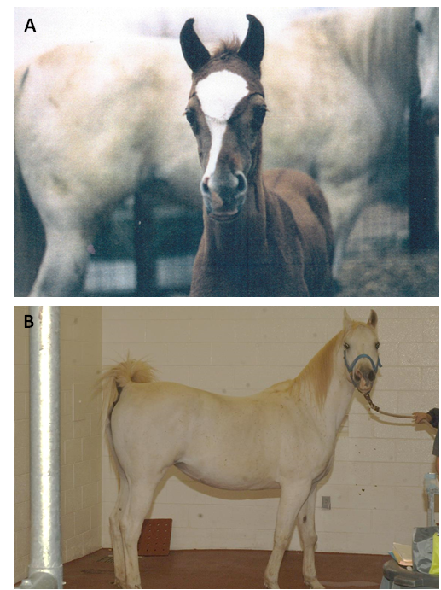
Figure 2.1. Figure showing comparative pictures of one of the melanoma-bearing gray horses in our clinical trial. (A) Younger picture showing the horse’s original coat colors. On the background of the picture appears her dam, already gray and also with history of melanomas. (B) The same horse by the time of enrolment in the clinical trial, completely gray by that point and with melanomas at multiple sites. (Picture on “A” courtesy of Dr. Karla Clark).
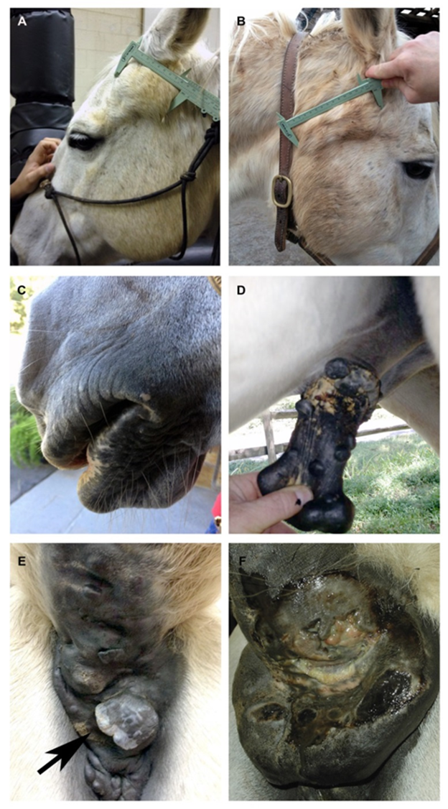
Figure 2.2. Classical presentations and locations of equine melanomas (A) Subcutaneous melanoma located in the temporal region. (B) Invasive melanoma associated with the parotid salivary gland. (C) Dermal melanoma located at the commissure of the lip. (D) Multiple dermal melanomas on the penis and prepuce. (E) Multiple confluent peri-anal melanomas (dermal melanomatosis), note areas of marked depigmentation within the tumors (arrow). (F) Large dermal melanoma at the ventral surface of the base of the tail, note further complication by ulceration and infection.
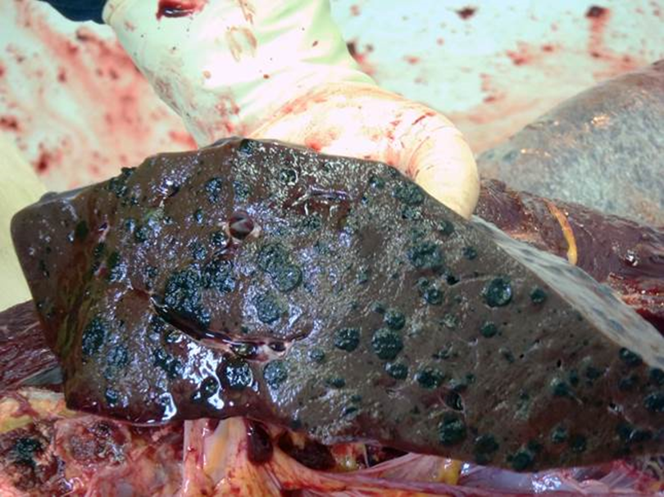
Figure 2.3. Image showing splenic parenchyma severely compromised by diffuse metastatic lesions. This image was obtained at necropsy of a gray horse that presented with a large necrotic dermal melanoma at the base of the tail (Courtesy of Dr. Karla Clark).

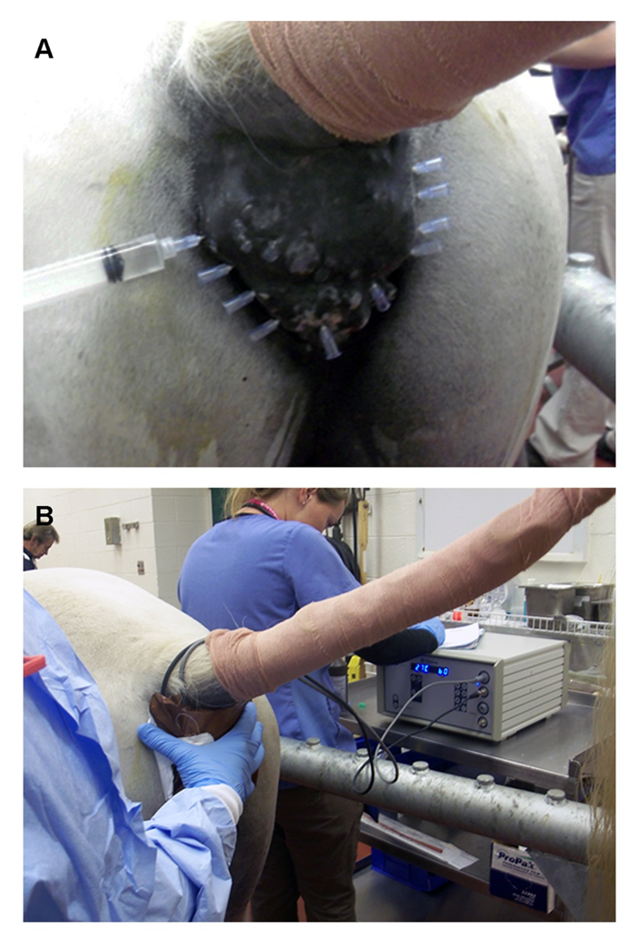
Figure 2.4. Illustration of intra-tumoral chemotherapy and hyperthermia administration. (A) Large perianal melanoma that is being treated with intra-tumoral injections of cisplatin. Needles are pre-placed evenly throughout tumor. (B) The tumor was then treated with local hyperthermia using a prototype microwave therapy unit (Thermofield® System, Parmenides, Inc.). Massive tumor shrinkage was achieved clinically in this patient.

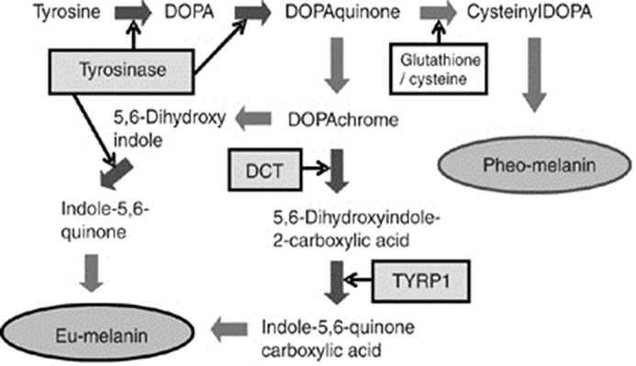
Figure 2.5. Melanin synthetic pathway and the involvement of melanogenic enzymes. Initial melanin synthesis is catalyzed by tyrosinase and is then divided into eumelanogenesis or pheomelanogenesis. The other melanogenic enzymes, L-3,4-dihydroxyphenylalanine (DOPA) chrome tautomerase (DCT) and tyrosinase-related protein 1 (TYRP1), are involved in eumelanogenesis (Source: Ando H, Kondoh H, Ichihashi M, et al. Approaches to identify inhibitors of melanin biosynthesis via the quality control of tyrosinase. J Invest Dermatol. 2007 Apr;127(4):751-61)

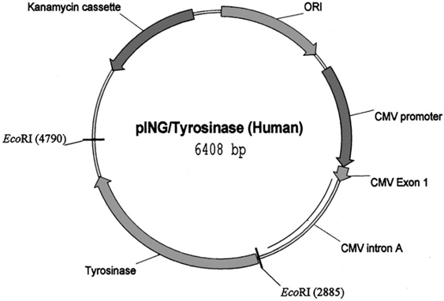
Figure 2.6. Plasmid map of pING plasmid used for generation of human tyrosinase DNA vaccine given to nine dogs with advanced malignant melanoma. (source: Bergman PJ, McKnight J, Novosad A, et al. Long-term survival of dogs with advanced malignant melanoma after DNA vaccination with xenogeneic human tyrosinase: a phase I trial. Clin Cancer Res. 2003 Apr;9(4):1284-90).

: Evaluation of Needle-free Injection Devices for Intramuscular Vaccination in Horses

CHAPTER III
Brief explanatory statement:
This chapter is a slightly revised version of a manuscript that has been published in the “Journal of Equine Veterinary Science” on December 2011, documenting the validation of a needle free injector as a proper tool to efficiently deliver a plasmid DNA construct vaccine to its site of action (muscle tissue) in the horse. It also included the identification of the pectoral muscles as the most adequate site for this plasmid DNA vaccine in this species.

Publication information:

Jeffrey C. Phillips, James T. Blackford, Luis M. Lembcke, Deborah A. Grosenbaugh, Timothy Leard. Evaluation of needle free injection devices for intramuscular vaccination in horses. Journal of Equine Veterinary Science 2012 Dec; 31(12):738-43.

Corresponding Author at:

Jeffrey C. Phillips, DVM, MSpVM, PhD
Department of Allied Health Sciences
College of Veterinary and Comparative Medicine
Lincoln Memorial University
6965 Cumberland Gap Pkwy
Harrogate, TN 37552.
Phone: (865) 221-3715
E-mail:jphill35@me.com

Description of tasks:

My contributions in this paper include (1) running experiments relevant to the paper, (2) analysis and interpretation of the data, (3) statistical analysis of all data, (4) photographic and graphic documentation of results, (5) manuscript writing. Co-authors contributions to this paper include study and experimental design, field work and writing editorial assistance by Dr. Phillips and Dr. Blackford.

Abstract

Needle-free injection devices have been approved for the delivery of biologics within herently low immunogenicity, such as plasmid DNA vaccines; however, no studies have described their use in equine patients. This article compares the use of two such devices (VitaJet-3 and Biojector2000) at typical vaccination sites in a cohort of six horses. After identifying the optimal device and vaccination site, a second cohort of five horses was used to document the biologic activity of a DNA plasmid vector delivered with the selected injector. Injector characteristics, including the amount of intramuscular drug deposition, residual skin dose, and pain responses, were evaluated following vaccination, with colored saline in the pectoral muscles and cervical region in six horses. The optimal device was then selected and used for intramuscular vaccination with the pING/tyrosinase plasmid vector in a group of five horses. Biological activity was measured through antibody response to the protein encoded by the plasmid on days 0, 14, 28, 42, and 56postvaccination. Optimal intramuscular dose delivery was obtained in the pectoral muscle site using the VitaJet-3. No significant pain responses were noted. Dependent edema was seen at vaccination sites 24 hours after therapy. Antibody responses to the protein encoded by the DNA plasmid vector significantly increased after vaccinations in all horses. The VitaJet-3 is easy to use and is effective for delivering intramuscular vaccinations with DNA plasmid vectors in horses. This device allows for vaccination with vectors that exhibit low immunogenicity and/or that require targeted delivery to specific tissue planes.

Introduction

Transdermal needle-free injection devices have been proposed as an alternative to traditional needle injections. The benefits of these devices include the ability to deliver to selected tissue planes both high- and low-dose injectates with minimal pain. Furthermore, the immune response generated after vaccination with needle-free devices seems to be superior to that elicited from traditional intramuscular injections [1]. Other potential benefits include reduced vertical transmission of blood-borne diseases, elimination of inadvertent needle sticks, ease of administration, reduced medical waste, and improved ability to vaccinate aggressive animals.
Needle-free injection devices work by delivering liquid medications (including vaccines) through a nozzle orifice under high pressure, thus generating a narrow stream that penetrates the skin [1]. The distribution of medication after it penetrates the skin is significantly wider than that obtained with traditional needle devices, thus allowing for a larger contact volume between vaccine and immune cells [1]. The specifications of different jet injectors vary by nozzle diameter, injection pressure, velocity, and stand-off distance; it is these factors, in conjunction with the skin characteristics that dictate the distribution of drug in tissue [2].
The use of these devices has been described in a variety of species, including human and nonhuman primates, dogs, cats, pigs, sheep, and other livestock [3-8]. Controlled clinical studies in humans suggest a somewhat higher rate of adverse local reactions compared with traditional needle devices, with pain generally less than, or similar to, needle-syringe injections [8]. However, studies regarding sheep, dogs, and cats, have demonstrated both ease of administration and a low rate of adverse local reactions [4-8].Furthermore, studies related to companion animals have demonstrated that these devices have a greater ability to deliver to selected tissue planes, and in some cases, to elicit a superior immunologic response [1,9]; these are important factors for biologics with relatively low immunogenicity such as plasmid DNA vaccines [10]. In fact, the only commercially available plasmid DNA vaccine for companion animals is licensed for administration using a needle-free injector [11].
Despite these perceived benefits, no studies have specifically assessed the use of needle-free injectors in horses. These devices will become important as novel, and in some cases poorly immunogenic, vaccine therapies are developed for the horse. Thus, the primary objective of this study was to evaluate two needle-free devices (which had previously been validated in the dog) for intramuscular drug delivery in the horse. Variables that were assessed included vaccination site, amount of intramuscular drug deposition, local site reaction, and pain response during vaccination. As a secondary objective, the optimal device was then chosen for use in a field study to confirm its ability to generate appropriate immune responses in horses vaccinated with the DNA plasmid vector pING/tyrosinase, the transcriptional activity of which requires specific delivery and uptake by muscle cells [10].

Materials and Methods

Institutional Animal Care and Use Committees, at both the University of Tennessee and at Merial Limited, reviewed and approved all husbandry practices and animal procedures used in this study.

Animals

A total of 11healthy adult horses (age: 8 to 12 years) were used in this study. Local site reactions and pain response were evaluated in all the horses. The horses were divided into two groups. The first group included six Thoroughbreds who were used to evaluate the characteristics of the two vaccination devices. These privately owned horses were donated to the University of Tennessee Veterinary Teaching Hospital for humane euthanasia immediately following vaccination. The second group of five adult Quarter horses belonged to the University of Tennessee College of Veterinary Medicine teaching herd. These horses were used to determine both immunologic response following vaccination and to evaluate local reactions after repeat vaccination.

Injection Devices

Two injection devices were evaluated: the VitaJet-3(VitaJet-3 is a registered property of Bioject, Inc) spring-activated device and the Biojector 2000 (BioJector 2000 is a registered property of Bioject, Inc) jet delivery device. TheVitaJet-3 is a spring-activated injection device designed to deliver medication intradermally, subcutaneously, or intramuscularly (IM). The device consists of the injector and disposable syringe that can deliver between 0.2 and 0.5mL of liquid. The B2000 is a CO2-powered, needle-free jet injection device designed to deliver medication or vaccine either subcutaneously, IM, or intradermally. It consists of an injector, disposable CO2 cartridges, and a disposable syringe that can deliver between 0.2 and 1.0 mL of liquid. Both devices function using a single-injection pressure of130 psi for the VitaJet-3 and 150 psi for the B2000 Nozzle size and stand-off distance determine the depth of penetration; in this study, both the devices used a 0.007-inchnozzle diameter and 1-mm stand-off distance designed for optimal intramuscular injections.

Comparison of Injection Devices

The two injection devices were compared with respect to the amount of intramuscular drug deposition, residual skin dose, effect of hair clipping, and local site reaction. To determine the amount of intramuscular drug delivered by each device, two injection sites were used in both the anterior superficial pectoral and lateral cervical regions of six horses in the first group (Figure 3.1). The sites to be injected were separated by a minimum of 5 cm, with one of the two sites clipped free of hair for each region. Injectate was composed of 0.9% sodium chloride, with tissue dye added for localization. For the VitaJet-3, 0.5 mL of injectate was administered into the haired and non-haired skin in the pectoral and cervical regions. For the B2000, 1.0 mL of injectate was given at similar locations. Residual skin injectate was documented schematically, and was measured by determining the area of the circle created on blotting paper held to the region. The horses were euthanized and the tissues were carefully dissected to visualize dye penetration. The amount of intramuscular drug deposition was determined subjectively by estimating the relative quantity of tissue dye deposited within the intramuscular plane and reporting it semi-quantitatively as either <33%, 33% to 66%, or >66% of the total visible dose. Observations including local site reaction, pain response, and the site/amount of injectate deposition were documented. The preferred injection device and anatomic site were selected on the basis of the analysis of these observations and used in the subsequent vaccine study.

Vaccination with Ping/Tyrosinase DNA Plasmid

The DNA plasmid pING/tyrosinase (Oncept® Merial Limited, Athens, GA, USA) is a United States Department of Agriculture-licensed vaccine for immunotherapy of canine melanoma. Activity of this vaccine requires specific delivery and uptake of the plasmid by muscle cells [10]. For evaluating the ability of needle-free injectors to effectively deliver this vaccine in horses, test vaccinations using the VitaJet-3 were given into a clipped location in the anterior superficial pectoral muscles of five horses. Vaccinate was composed of0.4mL (100 ug) of xenogenic DNA plasmid coding for human tyrosinase (Oncept®, Lot No. 30105). Each horse received a series of four biweekly vaccinations, alternating between right and left pectoral muscles for each vaccine. Initial observations including local site reaction, pain response, and residual skin injectate were documented in all horses. Local site reactions were assessed by visual observation of any changes at the injection site post-vaccination. Pain responses were evaluated subjectively using a previously described pain scoring system and through documentation of any observed behavioral changes [12]. Local site reaction and pain response (if any) were evaluated again in each of the five horses, 24 and 48 hours post-vaccination.
Immunologic response following vaccination was measured by documenting specific serum antibody response to the protein encoded by the plasmid vector (human tyrosinase).Therefore, serum samples were collected on day 0,14, 28, 42, and on day 56, 2 weeks following the final vaccination. Antibody responses were measured using the standard enzyme-linked immunosorbant assay technique, similar to those described previously [4,13]. Briefly, full length human tyrosinase protein (0.05 mg) was applied to each well of a 96-well microtiter plate. Plates were washed and patient serum was applied in triplicate using dilutions from 1:20 to 1:540. After 1-hour incubation, plates were washed again, and a secondary goat anti-horse IgG, labeled with horseradish peroxidase, a reporter molecule, was applied for 1 hour. A final wash was then performed, and the plates were developed by adding peroxidase substrate. Antibody responses were determined by measuring the absorbance of each well at a wavelength of 450 nm using the ELx800 Microplate reader instrument (BioTek Instruments, Limited, Winooski, VT, USA).

Statistical Analysis

The effects of hair clipping, vaccination site, and vaccination device on residual skin injectate and amount of intramuscular drug deposition were evaluated using the paired Student t-test to identify significance differences (P <.05) [14]. Semi-quantitative values for intramuscular drug deposition were given categorical “scores” of 1, 2, and 3(corresponding to <33%, 33% to 66%, >66%, respectively) for analysis, with higher scores suggesting increased total intramuscular drug deposition. Residual skin injectate was measured in surface area with values analyzed directly. All other device characteristics (local site reaction, visible pain response) are reported individually, as noted. Mean baseline antibody responses were used to determine a positivity threshold, defined as >2 standard deviations above the mean baseline value, above which immunologic responses were considered significantly positive, as reported previously [15]. Immunologic responses were further evaluated to determine the significance of any increases following vaccination. Data were first evaluated for normality using the Shapiro-Wilk normality test [14]. The data did not follow a normal distribution; therefore, the nonparametric sign test of matched pairs was used to compare the immunoreactivity values before and after vaccination [14]. All statistical analyses were performed using STATA 11.1 Data Analysis and Statistical Software (StataCorp LP, College Station, TX).

Results

Comparison of Injection Devices

Device characteristics for the VitaJet-3 and the B2000 were evaluated at both cervical and pectoral injection sites in the first group of six horses. When used in the pectoral region, both devices deposited the majority of the visible injectate IM following each injection. The median intramuscular drug deposition for the VitaJet-3 was 3 (range = 1 to 3, = 2.7, σ = 0.6), whereas the median for the B2000was 2 (range = 1 to 3, = 2.3, 2, σ = 0.8) (Fig. 3.2). Although there was a visible trend toward increasing intramuscular drug deposition using the VitaJet-3 in the pectoral location, no significant difference was noted between the devices using the categorical scores (P = .053). Tissue dissection of the cervical injection sites, however, showed relatively poor intramuscular drug deposition with either device. Visibly, the majority of injectate appeared to be localized to the subcutaneous region and between fascial planes for all injections (Fig. 3.2). For the cervical site, median intramuscular drug deposition for the VitaJet-3 was 2.0 (range = 1 to 2, = 1.5, σ = 0.5), whereas for the B2000 it was 1 (range = 1 to 2, = 1.4, σ= 0.5). No statistical difference was found in the amount of intramuscular deposition for the two devices in the cervical region (P = .44). Comparing results from both regions, we found that injection over the pectoral muscles resulted in significantly more intramuscular deposition of the drug than did injections made in the cervical region, for either device (P = .001).The effect of hair clipping on drug deposition and residual skin injectate was also evaluated. Intramuscular drug deposition at clipped pectoral site received a median score of 3 ( = 2.8, σ = 0.4) compared with 2 ( = 2.2, σ= 0.9) for non-clipped pectoral sites. No significant difference was noted in the depth or tissue localization of injectate at injection sites that had been either clipped or non-clipped prior to injection (P = .14). Residual skin amounts in both clipped and non-clipped pectoral injection sites, quantified by the surface area, varied between 0 and 49 mm2 for both devices, with a median values of 6.5mm² (σ= 19) for the VitaJet-3 and23mm² (σ= 20) for the B2000. No significant difference was found between residual injectate found on the skin surface for either device at either clipped or at non-clipped locations (P = .3). Similar results were found for the effects of hair clipping at cervical injection sites. Finally, no evidence of local site reactions or obvious pain responses (score) was observed in this first group, as determined by physical examination, behavioral, or postural changes. On the basis of these results, vaccination in the pectoral muscles using theVitaJet-3 was selected for evaluation in a field trial using the plasmid vector pING/tyrosinase.

Vaccination with the pING/Tyrosinase Plasmid and Immune Response

To evaluate the use of the VitaJet-3 in a small clinical field trial, the device was used to deliver a DNA plasmid vaccine to five horses. These horses were evaluated for acute pain responses, local site reactions, and immunologic response to the protein encoded by the DNA plasmid. No clear pain responses were seen in any of the horses; however, two horses appeared to be startled by the activation of the injection device. Similarly, no discernible physical changes (local site reactions) were observed immediately following vaccination. The delayed effects of vaccination and the effects of multiple vaccinations were evaluated at 24 and 48 hours post-vaccination. At 24 hours post-vaccination, all the horses exhibited mild dependent edema in the pectoral muscles immediately ventral to the vaccination site. Evaluation at 48 hours post-vaccination noted near-resolution in the amount of dependent edema in all the horses, with no other long-term local effects observed. Human tyrosinase-specific antibody titers for the five horses are shown in Figure 3.3. The immunoreactivity threshold was set at two standard deviations above the mean baseline value (= 0.13, σ = 0.02) at an Optical Density₄₅₀= 0.168. Positive immunoreactivity values were noted in all horses following completion of the vaccination protocol. As expected, these titers varied between patients but generally increased throughout the protocol. Overall, a significant (P =.03) increase was seen in humoral response that ranged from two- to threefold higher in the post-vaccination sera at day 56 compared with the pre-vaccination sera at baseline on day 0.

Discussion

Here we have demonstrated that both pneumatic and spring-actuated needle-free injection devices can be used to successfully deposit intramuscular medications in the pectoral region of horses; however, the spring-actuated device (VitaJet-3) was found to be superior. Further, although both cervical and pectoral locations are commonly used for “needle-based” intramuscular injections, the pectoral location was preferred for the needle-free devices, based on the improved intramuscular deposition of injectate. Cervical locations in the horse are characterized by fairly thin muscle planes separated by fascial planes and connective tissue [16]. These characteristics, along with the nozzle diameter and injection pressure, led to a large proportion of the dose being deposited within the fascial planes for cervical injections rather than in the desired intramuscular area. In contrast, pectoral locations have fairly deep muscle compartments and minimal connective tissue, ideally suited for the injection devices used herein. These tissue characteristics compare favorably to those seen in the dog, where the deep muscle compartment of the upper medial thigh was found to be the preferred location for intramuscular needle-free injections [9]. Evaluation for local site reactions and pain response was performed in all the horses. No significant acute local reactions or pain responses were noted. Localized ventral edema occurred in most horses 24 hours after vaccination, which resolved over the following 24 hours. The frequency and magnitude of these local site reactions were, in the authors’ opinion, comparable with those expected from intramuscular needle injections. Subjectively, pain responses appeared significantly less than with traditional needle vaccinations. A larger, comparative study would be required to definitively evaluate these local site reactions.
Detectable immune responses to the vaccine used herein require the successful intramuscular deposition of vaccinate, uptake of the plasmid by muscle cells, along with expression and presentation of the plasmid-encoded protein [10]. Previous work had already defined the stability of vaccines (both DNA-based vaccine and traditional vaccines) delivered through needle-free devices and their use for intramuscular injection [1,2,8,9]. Humoral responses were, therefore, determined as a further measure to validate the use of needle-free injection in horses. All horses developed two- to threefold tyrosinase-specific antibody increases, which were comparable in timing and magnitude to those seen in canine patients vaccinated using the same plasmid [4,13]. These values are reasonable given the low immunogenicity of the DNA plasmid vector [4,13]. Although other studies have suggested that needle-free devices elicit a superior immune response [1,9], this study was not designed to evaluate differences between traditional and needle-free devices in horses. Herein, we demonstrate that use of the VitaJet-3, along with 0.007-inch nozzles, seems to be safe for intramuscular drug delivery of aqueous solutions and may avoid some of the risks associated with traditional needle devices such as clostridial myositis and needle-stick accidents. [17] Further, detectable immune responses are developed to weakly immunogenic vectors such as DNA plasmid vectors, when using this device.

References

- Giudice E.L., et al. (2006) Needle-free vaccine delivery. Adv Drug Deliv Rev, 58, 68-89.
- Prausnitz M.R., et al. (2004) Current status and future potential of transdermal drug delivery. Nat Rev Drug Discov,3, 115-24.
- Rao S.S., et al. (2006) Comparative evaluation of three different intramuscular delivery methods for DNA immunization in a nonhuman primate animal model. Vaccine, 24, 367-73.
- Bergman P.J., et al. (2006) Development of a xenogeneic DNA vaccine program for canine malignant melanoma at the Animal Medical Center. Vaccine, 24, 4582-5.
- Grosenbaugh D.A., et al. (2004) Leard T, Pardo MC, Motes-Kreimeyer L, Royston M. Comparison of the safety and efficacy of a recombinant feline leukemia virus (FeLV) vaccine delivered transdermally and an inactivated FeLV vaccine delivered subcutaneously. Vet. Ther, 5, 258-62.
- Bergamin F., et al. (2007) Porcine B-cell activating factor promotes anti-FMDV antibodies in vitro but not in vivo after DNA vaccination of pigs. Vet Immunol Immunopath, 120, 115-23.
- Mousel M.R., et al. (2008) Technical Note: Comparison of traditional needle vaccination with pneumatic, needle-free vaccination for sheep. J. Anim. Sci, 86, 1468-71.
- Mitragotri S.,et al. (2006) Current status and future prospects of needle-free liquid jet injectors. Nat Rev Drug Discov, 5, 453–4.
- Goubier A., et al. (2008) Superiority of needle-free transdermal plasmid delivery for the induction of antigen-specific IFNgamma T cell responses in the dog. Vaccine, 26, 2186-90.
- Bergman P.J., et al. (2003) Long-term survival of dogs with advanced malignant melanoma after DNA vaccination with xenogeneic human tyrosinase: a phase I trial. Clin Cancer Res, 9, 1284-90.
- No authors listed. (2010) USDA licenses DNA vaccine for treatment of melanoma in dogs. J Am Vet Med Assoc, 1, 236:495.
- Wagner A. (2010) Effects of stress on pain in horses and incorporating pain scales for Equine practice. Vet Clin Equine, 26, 481-92
- Liao J.C., et al. (2006) Vaccination with human tyrosinase DNA induces antibody responses in dogs with advanced melanoma. Cancer Immun, 21, 6-8.
- Shapiro S.S., et al. (1965) An analysis of variance test for normality (complete samples). Biometrica, 52, 591-611.
- Housseau F, Lindsey KR, Oberholtzer SD, et al. (2002) Quantitative real-time RT-PCR as a method for monitoring T lymphocyte reactivity to full-length tyrosinase protein in vaccinated melanoma patients. J Immunol Methods, 266, 87-103.
- Boyd J.S., et al. (1987) Selection of sites for intramuscular injections in the neck of the horse. Vet Rec, 121, 197-200.
- Brown C.M., et al. (1989) Intramuscular injection techniques and the development of clostridial myositis or cellulitis in horses. J Am Vet Med Assoc, 193, 668-70.

Appendix of Tables and Figures

Figure 3.1..Demonstration of the correct way of performing an intramuscular (IM) injection in the pectoral muscles of a horse using the VitaJet-3 needle-free injection device. Note perpendicular angle to the muscle.

Figure 3.2..Results from IM injections (A) Results of injections into the pectoral muscles using the B2000 (left) and VitaJet-3 (right) needle-free injections; note the lack of discernible acute reaction and residual skin injectate. Arrows denote unclipped injection sites. (B) Distribution of injectate (blue) into the pectoral muscles using the VitaJet-3; note the majority of dose is deposited intramuscularly. (C) Distribution of injectate (blue) into cervical muscles using the VitaJet-3; note the majority of dose is deposited subcutaneously
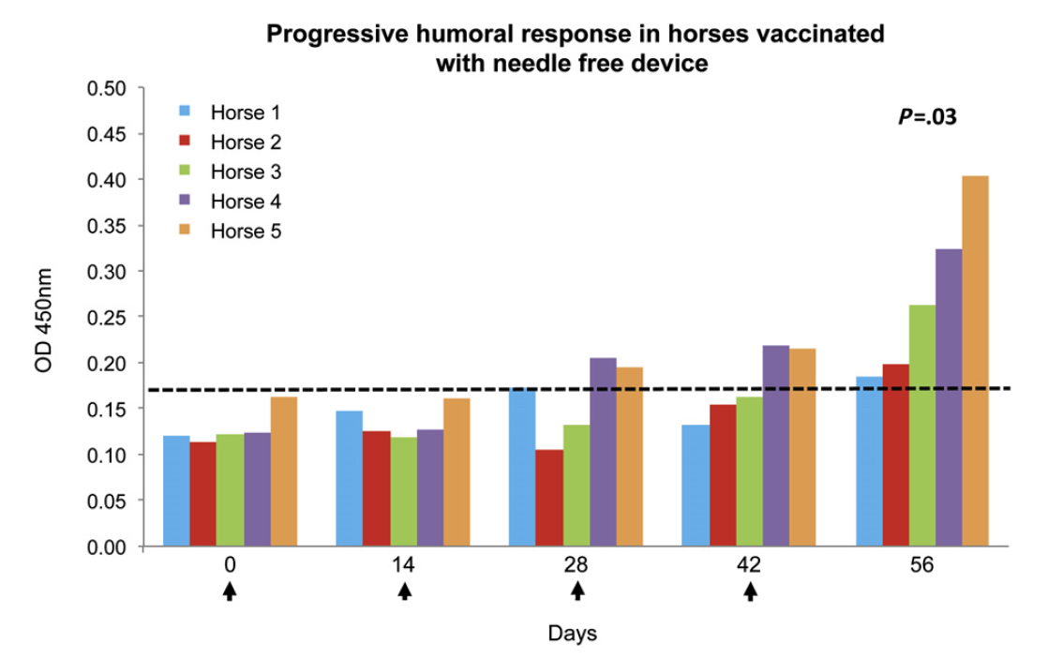
Figure 3.3. Specific IgG humoral immune responses to human tyrosinase vaccination with the VitaJet-3 needle-free injection device in horses. Positivity threshold, which was set at an OD₄₅₀= 0.168 corresponding to two times the standard deviations above the baseline mean of the group, is denoted by a dashed line. Arrows represent actual vaccination time points. A significant (P =0.03) increase in humoral response, ranging from a two- to threefold increase, was observed when comparing post-vaccination sera at day 56 with the pre-vaccination sera at baseline on day 0.

: Evaluation of Tyrosinase Expression in Canine and Equine Melanocytic Tumors

CHAPTER IV
Brief explanatory statement:
This chapter is a slightly revised version of a manuscript that has been published in the “American Journal of Veterinary Research” on February 2012. It documents the identification of the substantial overexpression of tyrosinase mRNA in equine melanoma tissue in comparison to equine normal skin tissue by Real-Time PCR. As tyrosinase is the immune-target of the melanoma vaccine tested in these studies this particular project provided a “proof of target” for this immunotherapeutic strategy in this species.

Publication information:

Jeffrey C. Phillips, Luis M. Lembcke, Cristina Noltenius, Shelly Newman S, James T. Blackford, Grosenbaugh DA, A. Timothy Leard. Evaluation of tyrosinase expression in canine and equine melanocytic tumors. American Journal of Veterinary Research 2012 Feb; 73(2):272-78.

Corresponding Author at:

Jeffrey C. Phillips, DVM, MSpVM, PhD
Department of Allied Health Sciences
College of Veterinary and Comparative Medicine
Lincoln Memorial University
6965 Cumberland Gap Pkwy
Harrogate, TN 37552.
Phone: (865) 221-3715
E-mail:jphill35@me.com

Description of tasks:

My contributions in this paper include (1) running experiments relevant to the paper, (2) analysis and interpretation of the data, (3) statistical analysis of all data, (4) photographic and graphic documentation of results, (5) manuscript writing. Co-authors contributions to this paper include experimental design and writing editorial assistance by Dr. Phillips, Dr. Blackford and Dr. Newman and running of several experiments relevant to the paper by Cristina Noltenius.

Abstract

The main objective of the present study was to determine the tissue-restricted expression pattern of tyrosinase mRNA in canine and equine melanocytic tumors and relative tyrosinase and major histocompatibility complex (MHC) I mRNA expression in variants of melanocytic tumors. For this purpose 39 canine and 8 equine tumor samples and 10 canine and 6 equine normal tissue samples were selected from the anatomical pathology archive of the University Of Tennessee College Of Veterinary Medicine. RNA was isolated from formalin-fixed paraffin-embedded tissues. Real-time PCR assays were designed to amplify canine and equine tyrosinase, S18 ribosomal RNA, and major histocompatibility complex I transcripts. Relative expression was determined by use of S18 as a reference gene and comparison with pigmented and non-pigmented normal tissues. High tyrosinase expression was found in all melanocytic tumors, compared with normal tissues, and expression had no correlation with presence or absence of tumor pigmentation. No significant difference in tyrosinase expression was found among histologic variants of melanocytic tumors. No correlation was found between MHC I and tyrosinase expression or tissue histologic classification. In the present study, the methods used were highly sensitive and specific for detection of tyrosinase expression in equine and canine tumors, and overexpression of this transcript in melanomas was detected. This suggested that a DNA vaccine developed for use in dogs with melanoma that targets tyrosinase may be considered for use in other affected species, such as horses.

Introduction

Tyrosinase is a copper-containing type I membrane glycoprotein essential for melanin synthesis. Tyrosinase catalyzes the hydroxylation of tyrosine to dihydroxyphenylalanine, which is considered the rate-limiting step in melanin production [1]. In humans, tyrosinase is expressed in epidermal melanocytes as well as the pigmented epithelia of the retina, iris, and ciliary body of the eye [2,3]. This expression appears to be tightly controlled both spatially and temporally through a variety of cis-acting and trans-acting elements [4]. In brief, tyrosinase expression is up-regulated in developing melanocytes and down-regulated in mature and quiescent melanocytes [1,4]. In contrast, in neoplastic tissues, tyrosinase expression appears constitutively increased in all malignant melanocytic tumors [4,5]. Because of the tight temporal and spatial regulation in normal tissues (and the high expression in tumor tissues), tyrosinase has proven to be a useful target for immunotherapeutic approaches in humans with melanocytic tumors [6].
Much of the information regarding tyrosinase expression has been derived from human and rodent cell lines and histologic samples [1–5]. Although a commercially available xenogenic tyrosinase vaccine for the treatment of dogs with melanoma has had encouraging results, minimal published information exists on the tissue-specific expression of canine or equine tyrosinase [7,8]. Gene and protein expression studies have identified detectable expression of tyrosinase in canine and equine tissues, respectively [9,10]. A genetic study has identified mutations associated with development of melanocytic tumors in gray horses; these mutations are thought to result in up-regulation of genes such as tyrosinase [11]. However, no large-scale or comparative tyrosinase gene expression has been described in either species. Further information on the expression of canine tyrosinase may be useful to understand the role of targeted immunotherapy in dogs with melanocytic tumors. Furthermore, data on the expression of tyrosinase in equine melanocytic tumors may support the use of this immunologic modality in a different species.
The MHC I gene complex is a component of the antigen-processing machinery that is commonly dysregulatedin tumor tissues [12]. Down-regulation of this gene may result in the development of resistance to targeted immunotherapies [12,13]. Correlations between MHC-I expression and tissue type may thus prove useful in further understanding the response to treatment in patients treated with tyrosinase-targeted immunotherapy. The primary objective of the study reported here was to determine the relative expression of tyrosinase mRNA in a series of canine and equine melanocytic tumors. The secondary objective was to determine the relative expression of antigen presentation gene MHC-I mRNA in this series of tissue samples.

Materials and Methods

Tumor samples

Canine and equine FFPE tumor samples were obtained from the University of Tennessee College of Veterinary Medicine pathology database. Samples were identified through a medical record search by use of the keywords melanoma, amelanotic melanoma, and melanomatosis. With the use of these search terms, 22 equine cases and 765 canine cases were identified between January 1, 2000, and December17, 2007; 70 canine and 8 equine cases were selected for further review on the basis of the availability of adequate FFPE tissue blocks. From these tissue blocks, individual cases were then reviewed for tumor histologic classification and complete medical record with diagnosis, treatment, and, in some cases, follow-up information.
Canine tumor histologic examination included sampling of both oral and non-oral melanomas. Non-oral locations included cutaneous benign melanomas, cutaneous malignant melanomas, and digital melanomas. Equine tumor histologic examination included benign cutaneous melanomas, malignant cutaneous melanomas, and melanomatosis (disseminated melanomas). Slides from all 78 tumors were reviewed by a board-certified pathologist (SJN). Ultimately, 39 canine and 8equine tumors remained that contained adequate and appropriate tissue for further analysis.

Control samples

Control tissue samples were isolated from animals necropsied at the University Of Tennessee College Of Veterinary Medicine with no evidence of melanocytic tumors. Canine control tissues included pigmented and non-pigmented normal cutaneous and oral tissue. In addition, 2 anaplastic sarcomas (melan-A and S100 negative via immunohistochemical analyses) were included as tumor control tissues. Equine control tissues included pigmented and non-pigmented cutaneous tissue from both gray and non-gray horses. These samples were FFPE by use of standard procedures. Histologic classification was confirmed by a pathologist (SJN).

RNA isolation

The RNA was isolated from FFPE tissues by use of a kit (SurePrep RNA Isolation kit, Fisher Scientific, Waltham, MA, USA) in accordance with the manufacturer’s instructions. Paraffin-embedded tumor sample blocks were selected by a pathologist (SJN). Five 20 μm sections were then cut from each tissue block by use of a microtome. Blocks and sections were manipulated to include only tumor tissues and carefully avoid overlying normal cutaneous tissues. Sections were transferred to a microcentrifuge tube and deparaffined with xylene. Tissue was then washed with ethanol and air-dried. Cellular lysates were prepared by use of digestion buffer with proteinase K. Binding solution and ethanol were added to the lysates. Lysates were applied to RNA-binding columns, washed, and eluted. Final RNA quality and concentrations were determined by evaluating absorbance at optical densities of 260 and280 nm. Although concentrations varied widely, typical values were > 300 μg/mL. Following RNA quantification, samples were stored at –80°C until analysis.

Gene expression assays

Tyrosinase and MHC-I mRNA expression were evaluated by use of custom-made
RT-PCR assays (TaqMan gene expression assays®, Applied Biosystems, Foster City, CA, USA) designed by use of the manufacturer’s online design software (TaqMan Custom Assay Design Tool®, Applied Biosystems, Foster City, CA, USA). The canine tyrosinase assay was based on the clone CF02626293_m1, with the probe centered on the exon 1-2 boundary. On the basis of this information, the software designed 72-bp assay. The equine assay was designed by use of the full-length equine tyrosinase mRNA sequence (XM_001492560) with the probe centered over the exon 1-2 boundary. On the basis of this information, the software designed a 73 bp assay. The canine MHC I assay was designed by use of the full-length canine MHC-I clone (NM_001014378.1) with the probe centered at the exon 3-4 boundary and an amplicon length of 97bp. The equine MHC I assay was designed by use of the full-length equine MHC I clone (NM_001082507.1) with the probe centered at the exon 4-5 boundary and an amplicon length of 64 bp. For an endogenous control, the eukaryotic 18S ribosomal RNA, which amplified a 69bp target centered on nucleotide 40 of clone Hs03003631_g1, was used.

Real Time PCR experiments

Quantitative RT-PCR assay was performed by use of a commercially available 1-step kit (TaqMan RNA-to-Ct 1-Step Kit®, Applied Biosystems, Foster City, CA, USA). In brief, reaction mixtures contained 6.375 μL of RNA template (approx. 1 μg), 0.375 μL of reverse transcriptase enzyme mix, 7.5 μL of RT-PCR mix, and 0.75 μL of the appropriate gene expression assay for a total volume of 15 μL. Reaction mixtures were assembled in a 96-well plate in duplicate. Reaction conditions were as follows: reverse transcription at 48°C for 15 minutes, activation of the DNA polymerase at 95°C for 10minutes, 60 cycles of PCR amplification consisting of denature at 95°C for 15 seconds, and annealing and extension at 60°C for 1 minute. Real-time PCR reactions were performed on a 96-well RT-PCR detection system (MyiQ Real-Time PCR Detection System®, BioRad, Berkeley, CA, USA). Assay efficiency (90% to 105%) and linearity (r2 = 0.980) were confirmed prior to analysis. Final reaction products were run on 2.0% agarose gels and stained with ethidium bromide for size verification.

Statistical and Data analysis

Gene expression analysis was performed by use of commercial software (iQ5 Real-time PCR Detection Optical System Software® version2.0, BioRad, Berkeley, CA, USA). Baseline and threshold detection limits were automatically assigned via the system software (STATA®, version 11.0, Data Analysis and Statistical Software, College Station, TX, USA). With their appropriate placement visually verified. Threshold cycle values for each sample were determined and normalized to the S18 reference gene Ct value to obtain ΔΔCt. Standard deviations were obtained from duplicate runs and normalized similarly. Tyrosinase expression was assayed in all samples by use of the eukaryotic 18S ribosomal RNA as the reference gene. For all samples, relative (normalized) tyrosinase expression was determined. Residual RNA samples were then used to assay MHC I expression by use of the eukaryotic 18S ribosomal RNA as the reference gene; however, not all samples contained adequate residual RNA to perform this assay. The mean tyrosinase signal in normal tissue control samples from each species was set to a baseline equal to 1 and then used to determine relative tyrosinase expression in tumor samples. Relative MHC I expression was obtained similarly by use of the mean control signal.
To evaluate the association between tumor histologic classification and relative tyrosinase or MHC-I expression (ΔΔCt), canine tumors were grouped into benign, malignant, amelanotic, and non-melanocytic categories by a pathologist (SJN). Similarly, equine tumors were grouped into benign, malignant, gray horse, and non-gray horse categories. For canine malignant melanomas, tumor anatomic location (oral vs. other) was also evaluated [14,15]. Normalized tyrosinase and MHC-I expression for histologic tumor variants were analyzed by use of an ordinary least squares regression. All values were evaluated for normality by use of the Shapiro-Wilk test. Non-normal distributions were logarithmically transformed prior to analysis. Factors found to be significant in univariate models were analyzed in a multivariate model. Tyrosinase or MHC I expression was described as the sole independent variable analyzed for each outcome. To assess for a significant correlation between the relative expression of tyrosinase and MHC I, a 2-step procedure was used. The data were first analyzed to document a normal distribution via the Shapiro-Wilk normality test. The Spearman correlation test was then used on the non-normally distributed sample to assess correlation. Values of P <0.05 were considered significant for all comparisons.

Results

Canine tumor samples

For descriptive purposes and tyrosinase expression analysis, canine melanocytic tumor samples were grouped into either primary oral or non-oral locations. Within each group, tumor samples were further classified as either pigmented or amelanotic. For non-oral locations, tumors were also classified as either benign or malignant on the basis of histologic analysis and mitotic index (mitotic figures/10 hpf ≥ 3). Twenty canine oral melanoma samples were identified for analysis and included 3 labial, 4 maxillary, 3 lingual, 6 mandibular, 2 soft palate, and 2 tonsillar locations. Histologic findings varied from low-grade tumors to anaplastic and high-grade tumors. Six tumors had either minimal or no obvious pigmentation and were thus classified as amelanotic; this was confirmed with immunohistochemical analysis for s100, vimetin, or melan-A. Age at diagnosis ranged from 7 to 16 years; mean age of onset was 11.1 years, and median age of onset was 12.0 years. Dogs included 12 males and 8females, and most were mixed breed.
Nineteen canine non-oral melanocytic tumor samples were selected, including 8 benign and 11 malignant samples. Benign melanocytic tumors included 7 cutaneous and 1 uveal locations. Malignant tumors included 2metastatic lymph node samples, 6 cutaneous (various locations) samples, and samples from 3 digital locations. Histologic findings in malignant tumors were consistent with high-grade (anaplastic) tumors with a mitotic index> 3 in all cases. Two of the malignant tumors (1 cutaneous and 1 digital) were further characterized as having minimal to no observable pigmentation and thus classified as amelanotic. Immunohistochemical analysis by use of combinations of S-100 or melan-A confirmed the diagnosis in poorly pigmented tumors. Age at diagnosis ranged from 1 to 13 years, mean age of onset was 8.7 years, and median age of onset was 10 years. Dogs included 8 males and 11 females, and most were mixed breed.
Control samples were obtained from 10 dogs (4female and 6 male) with no evidence of melanocytic tumors. Both oral and cutaneous normal tissues were collected. The oral samples included 3 non-pigmented oral (buccal) mucosa samples and 1 pigmented oral mucosa sample. The cutaneous samples included 2nonpigmented skin samples and 2 pigmented skin samples. Two additional control samples were included that represented non-melanocytic tumors (anaplastic sarcomas).These tumors were negative for both melan-A and S-100 but positive for vimentin immunoreactivity. Mean age of all control dogs was 9.1 years, with a median age of 9.0 years (range, 7 to 11 years).

Equine tumor samples

Eight equine tumor tissues were evaluated for tyrosinase expression. The tumor samples were identified from both gray and non-gray horses. The gray horse tumor samples included a uveal melanoma, 3 dermal melanomas (1 from a horse with multifocal disease), and a lymph node with metastases. The non-gray horse samples included 2 benign dermal melanomas and 1 morphologically malignant dermal melanoma. The age of the gray horses ranged from 8 to 20 years (mean, 15.2 years; median, 16 years).Three horses were female and 2 were male. Age of the non-gray horses ranged from 11 to 18 years (mean, 13.3years; median, 11 years). All 3 non-gray horses were male.
The control samples from normal equine tissues were obtained from gray and non-gray horses with no external evidence of melanocytic tumors. Six equine control tissues were collected from 3 horses. These included3 samples from pigmented skin (1 gray horse and 2 non-gray horses) and 3 samples from non-pigmented skin (1 gray and 2 non-gray horses).

Canine tumor tyrosinase expression

For canine oral melanomas, values ranged from 4.06-fold to 4,810.90-fold (mean, 629.44-fold; median, 170.22-fold) relative expression, compared with the mean control signal (1.0 ± 0.59). All tumors had high relative tyrosinase expression; the tumor with the lowest expression (4.06 ± 0.15) nevertheless had substantially higher expression than the control signal. This tumor was a low-grade oral melanoma located on the gingiva. The tumor itself consisted of a small population of melanocytes with minimal criteria of malignancy invasion. The highest tyrosinase expression for an oral melanoma (4,810.90 ± 71.55) was found in a sparsely pigmented oral tumor with extremely aggressive malignancy (Figure 4.1). Results of immunohistochemical analysis were positive for melan-A, confirming the diagnosis of amelanotic melanoma.
For canine non-oral melanocytic tumors, relative tyrosinase expression ranged from 21.65 to 2,135.32(mean, 338.34; median, 59.05), relative to the mean control signal. The lowest tyrosinase expression (21.65± 4.13) was detected in a benign uveal melanoma. The tumor had marked local invasion into the sclera; however, cellular morphology was most consistent with a benign tumor, and the mitotic index was extremely low (none observed). Highest expression was found in a malignant digital melanoma (2,135.32 ± 51.26) with a high mitotic index, marked bone invasion, and vascular invasion. Values are expressed as mean ± SEM.
Tyrosinase expression in all canine control samples was predictably low, regardless of degree of pigmentation or anatomic location (oral vs. cutaneous). Expression for all samples ranged from 0.34 ± 0.34 for non-pigmented oral mucosa to 2.28 ± 0.48 for an anaplastic periorbital sarcoma (mean, 1.07; median, 0.89). Relative expression of oral tumors ranged from 0.34 ± 0.34to 1.07 ± 0.31 and was not significantly different from cutaneous samples that ranged from 0.71 for a non-pigmented cutaneous sample to 2.28 for the anaplastic sarcoma. The remaining oral anaplastic sarcoma had a similarly low expression (0.46 ± 0.19).
Ordinary least squares regression was used to evaluate the relationship between tyrosinase expression and several covariates, including histologic classification (benign vs. malignant), location (oral vs. non-oral), degree of pigmentation (melanotic vs. amelanotic melanomas), and sample type (i.e., melanocytic tumors vs. control samples). No significant (P = 0.84) difference in tyrosinase expression was found between benign and malignant canine tumors. Similarly, there was no significant (P = 0.71) difference in tyrosinase expression between oral and non-oral tumor locations. No significant (P >0.84) difference in tyrosinase expression on the basis of the presence of pigmentation was found between malignant melanotic (i.e., heavily pigmented) and malignant amelanotic (non-pigmented) tumors. However, analysis of expression in melanocytic tumors, compared with control tissues, identified a significant difference between the groups. Melanocytic tumors had significantly (P <0.001) higher tyrosinase expression, compared with control tissues.

Equine tumor tyrosinase expression

All tumors, including benign, malignant, and multifocal tumors, had high relative tyrosinase expression ranging from8.29 ± 1.84 to 219.57 ± 13.21 (mean, 93.2; median, 61.29). The lowest expression was found in a sparsely pigmented (essentially amelanotic) melanoma from the ventral portion of the neck of a silver-colored horse. No special stains were performed on this tumor to confirm histologic classification. The 2 highest expressions were found in tumor samples obtained from gray horses with melanomatosis. Tyrosinase expression in control tissues was low in both gray and non-gray horses, regardless of pigmentation (mean, 1.0; median, 0.83).The lowest tyrosinase expression was found in skin from a chestnut horse (0.22 ± 0.08), and the highest(1.96 ± 0.63) was found in the pigmented (perirectal)skin of a chestnut horse.
Similar to dogs, an ordinary least squares regression was used to evaluate the relationship between tyrosinase expression and, for horses, the covariates of coat color and histologic classification. Horses were classified as gray or non-gray, and histologic classification was recorded as benign or malignant on the basis of mitotic index and morphology. Although the number of cases was small, no significant difference was found in relative tyrosinase expression attributable to either coat color (P= 0.13) or tumor histologic classification (P = 0.36). However, comparison of tyrosinase expression between tumor and control tissues identified the predictably higher tyrosinase expression in melanocytic tumors versus controls (P = 0.019).

MHC I expression

All samples with adequate residual RNA (following tyrosinase expression) were further assayed for MHC I expression. Canine tissue samples (n = 15) included 3 controls, 1 anaplastic sarcoma, 3 benign melanomas, and 8 malignant melanomas. Major histocompatibility complex I expression in the canine normal control tissues ranged from 0.4 ± 0.02 for a non-pigmented cutaneous sample to 2.15± 0.11 for a non-pigmented oral sample (mean, 1.0; median, 0.45). Expression in canine malignant tumor samples ranged from a low value of 0.02 ± 0.002 for a metastatic lymph node lesion to a high value of 8.88 ± 0.68 for an oral malignant melanoma (mean, 2.53; median, 0.67). Benign canine tumor samples had relatively low MHC-I expression, ranging from 0.40 ± 0.03 for an ocular tumor to 1.06 ±0.12 for a cutaneous tumor (mean, 0.67; median, 0.57).No significant associations were found between relative MHC-I expression and tumor histologic classification (benign vs. malignant; P = 0.77), tumor location (oral vs. other; P = 0.45), or sample type (control vs. tumor; P =0.11). Furthermore, to assess correlation between relative tyrosinase and MHC-I expression, a Spearman correlation test was performed. No significant (P = 0.61) correlation was detected between the expressions of these 2 genes in this canine sample population.
Equine tissue samples (n = 6) that were evaluated for relative MHC I expression included 3 control samples, 1 benign tumor, and 2 malignant tumors. Major histocompatibility complex I expression in the normal equine tissues ranged from 0.18 ± 0.04 for the pigmented skin in a gray horse to 1.72 ± 0.36 for the non-pigmented skin sample from a non-gray horse (mean, 1.0; median, 1.1). Relative expression in the tumor tissues differed widely, ranging from 1.42 ± 0.51 for a malignant cutaneous tumor in a non-gray horse to 1,990.7 ±49.8 for a benign cutaneous tumor in a non-gray horse. The small sample size and lack of values from gray horses precluded the evaluation of the relationships between MHC-I expression and the described covariates.

Discussion

The goal of this study was to measure tyrosinase expression in a series of canine and equine tumor samples obtained from the University of Tennessee College of Veterinary Medicine pathology tumor database. The sample included 39 canine and 8 equine tumor samples, including benign, malignant, pigmented, and non-pigmented variants. The RT-PCR method was chosen because a prior study8 and the present authors’ exhaustive efforts had both failed to detect tyrosinase protein antigen via immunohistochemical analysis by use of commercially available antibodies. The benefit of the RT-PCR method is that it is extremely sensitive and allows the use of FFPE tissues and fresh cytologic or histologic specimens to quickly determine both quantitative and relative tyrosinase expression [16,17]. Furthermore, unlike IHC analysis, RT-PCR assay can be used to determine the presence or absence of specific portions of target transcripts that may be immunogenic [18,19].
In the present study, RT-PCR assay and tyrosinase mRNA-specific gene expression assays were used to determine the presence or absence of appropriate targets in the samples. The canine and equine expression assays included the sequences orthologous to the human immunodominant region recognized by monoclonal antibodyT-311, and those sequences were thus detected by each assay [20]. Importantly, this immunodominant region is thought to be required to elicit an antitumor response against the tyrosinase tumor antigen [20–22]. In the present study, a modified RNA isolation method that is useful in isolating RNA from FFPE tissues was also used. This resulted in isolation of considerable amounts of high quality tumor RNA from each of the 48 tumors and 16 control samples. The RNA samples were quantified via spectrophotometry and assayed for quality via gel electrophoresis. Aliquots of each sample were then used for the tyrosinase-specific gene expression assays.
The RT-PCR assays revealed high tyrosinase expression for most tumor samples. Control tissues had extremely low tyrosinase expression. The high expression in melanoma tumors and the relative lack of expression in normal tissues suggests a tissue-restricted expression pattern for this gene in horses and confirms previous data in dogs [9,23,24]. On the basis of this information, tyrosinase-targeted immunotherapies may be considered in horses. However, future studies are needed to examine tyrosinase expression in additional control samples and other tumor types to more accurately define expression patterns. Furthermore, because of small sample size, the present study was not able to assess the prognostic importance of relative tyrosinase expression in melanocytic tumors. Evaluation of additional cases will be helpful to determine the prognostic importance of tyrosinase expression in general and in patients treated with the melanoma vaccine (Oncept® Merial Limited, Athens, GA, USA).
Identification of tyrosinase expression, specifically the immunodominant sequence of tyrosinase, provides proof of a target for immunotherapies targeting this protein in horses. The tyrosinase expression assays used in this project were designed to amplify the exon 1-2boundary of tyrosinase and thus ensure the detection of transcripts that have undergone appropriate splicing in this region. Importantly, this assay would not recognize the presumably nonfunctional canine splice variant that lacks this boundary [9]. The exon 1-2 region of the tyrosinase protein encodes the catalytically active domain required for tyrosinase function [1]. Inappropriate splicing or mutations within this region could lead to pigmentation defects through loss of function (i.e., amelanotic tumors) along with loss of the important immunodominant region. In fact, many humans with disorders of pigmentation have mutations in this critical region [25]. Interestingly, in the present study, no correlation was found between tyrosinase expression and the degree of tumor pigmentation (i.e., melanotic vs. amelanotic tumors). In other words, similar expression of the intact (and presumably) catalytically active (immunodominant) region of tyrosinase was detected in pigmented and non-pigmented melanomas. This suggests that mutations in other proteins involved in melanogenesis may be responsible for the lack of pigmentation in canine amelanotic tumors. Additionally, the presence of the immunodominant portion of the tyrosinase transcript in both melanotic and amelanotic tumor samples support the use of anti-tyrosinase immunotherapies regardless of degree of pigmentation.
Appropriate expression and function of the antigen-processing machinery are required to elicit an effective immunologic response against tumor-specific antigens [12,13]. Because deregulation of the antigen-processing machinery is common in tumors, we evaluated the expression of MHC I mRNA as a representative of the antigen-processing machinery [12,13] Reduced or absent expression of the MHC I transcript in these melanocytic tumors, compared with normal tissue, may suggest an impediment to immunotherapies targeting the tyrosinase tumor antigen [12,13]. In the present study, which had a small sample size, no consistent evidence was found of reduced or absent MHC I expression in either normal or tumor samples. Unfortunately, sufficient residual RNA was not available to assess expression in all samples. Furthermore, MHC I is only one portion of the entire antigen-processing machinery [12,13]. Other proteins and genes that appear to be commonly altered or deregulated in tumor cells include the TAP (transporter associated with antigen processing) gene and proteins, β-microglobulin, a variety of cellular chaperones, and other components of the antigen-processing machinery [12,13]. These genes and proteins were not assessed in the present study but would be logical candidates for subsequent studies. However, these initial data provide further support for tyrosinase as an immunologic target in dogs. Future research would be helpful to more fully assess the presence of expressional changes in genes or proteins involved in antigen processing.
Another potential use of this RT-PCR technology is to complement traditional staging tests (i.e., blood and lymph nodes can be screened for the presence of tyrosinase).In human medicine, one of the first RT-PCR tests used in tumor-bearing patients was designed to identify tyrosinase expression in the blood of patients with melanoma [26]. Many studies have evaluated the prognostic importance of tyrosinase expression in blood or lymph nodes and provided conflicting results [24,26–29]. In general, results of most studies suggest that either a single high expression or changes in tyrosinase expression found in the blood of patients with melanoma can provide important prognostic information related to the potential increased risk of metastatic spread rather than as a tumor burden marker [27]. In light of the availability of an immunotherapy that targets tyrosinase; further research is required to determine the prognostic importance of tyrosinase expression in the blood of tumor-bearing dogs and horses.

References

- Wang N., et al. (2006) Tyrosinase maturation through the mammalian secretory pathway: bringing color to life. Pigment Cell Res, 19, 3–18.
- Schraermeyer U., (2006) Tyrosinase biosynthesis in adult mammalian retinal pigment epithelial cells. Exp Eye Res, 83, 315–21.
- Hayasaka S., et al. (1986) Presence of tyrosinase activity in human ciliary body. Jpn J Ophthalmol, 30, 32–5.
- Ferguson C., et al. (1997) The regulation of tyrosinase gene transcription. Pigment Cell Res, 10, 127–38.
- Vourc’h-Jourdain M., et al. (2009) Melanoma gene expression and clinical course. Arch Dermatol Res, 301, 673–79.
- Ferguson A., et al. (2008) Strategies and challenges in eliciting immunity to melanoma. Immunol Rev, 222, 28–42.
- Bergman P.J., et al. (2003) Long-term survival of dogs with advanced malignant melanoma after DNA vaccination with xenogenic human tyrosinase: a phase I trial. Clin Cancer Res, 9, 1284–90.
- Ramos-Vara J.A., et al. (2000) Retrospective study of 338 canine oral melanomas with clinical, histologic, and immunohistochemical review of 129 cases. Vet Pathol, 37, 597–608.
- Stell A.J., et al. (2009) Evaluation of variants of melanoma-associated antigen genes and mRNA transcripts in melanomas of dogs. Am J Vet Res, 70, 1512–20.
- Seltenhammer M., et al. (2004) Comparative histopathology of grey-horse-melanoma and human malignant melanoma. Pigment Cell Res, 17, 674–81.
- Rosengren G., et al. (2008) A cis-acting regulatory mutation causes premature hair graying and susceptibility to melanoma in the horse. Nat Genet, 40, 1004–9.
- Seliger B. (2008) Molecular mechanisms of MHC class I abnormalities and APM components in human tumors. Cancer Immunol Immunother, 57, 1719–26.
- Garrido F., et al. (2010) The escape of cancer from T lymphocytes: immunoselection of MHC class I loss variants harboring structural-irreversible “hard” lesions. Cancer Immunol Immunother, 59, 1601–6.
- Proulx D.R., et al. (2003) A retrospective analysis of 140 dogs with oral melanoma treated with external beam radiation. Vet Radiol Ultrasound, 44, 352–9.
- Bostock D.E. (1979) Prognosis after surgical excision of canine melanomas. Vet Pathol, 16, 32–40.
- Bonin S., et al. (2010) Multicentre validation study of nucleic acids extraction from FFPE tissues. Virchows Arch 2010, 457, 309–17.
- Farragher S.M., et al. (2008) RNA expression analysis from formalin fixed paraffin embedded tissues. Histochem Cell Biol, 130, 435–45.
- Lee S.Y., et al. (2007) The reverse proteomics for identification of tumor antigens. J Microbiol Biotechnol, 17, 879–90.
- Jager D., et al. (2004) Identification of tumor antigens as potential target antigens for immunotherapy by serological expression cloning. Cancer Immunol Immunother, 53, 144–7.
- Jaanson N., et al. (2003) Identification of the immunodominant regions of the melanoma antigen tyrosinase by antityrosinase monoclonal antibodies. Melanoma Res, 13, 473–82.
- Chen Y.T., et al. (1995) Immunophenotyping of melanomas for tyrosinase: implications for vaccine development. Proc Natl Acad Sci USA, 92, 8125–9.
- Willers J., et al. (2005) Definition of antityrosinase MAb T311 linear determinant by proteome-based similarity analysis. Exp Dermatol, 14, 543–50.
- Cangul I.T., et al. (1999) Tyrosinase gene expression in clear cell sarcoma indicates a melanocytic origin: insight from the first reported canine case. APMIS, 107, 982–8.
- Catchpole B., et al. (2003) Development of a multiple-marker polymerase chain reaction assay for detection of metastatic melanoma in lymph node aspirates of dogs. Am J Vet Res, 64, 544–9.
- Oetting W.S. (2000) The tyrosinase gene and oculocutaneous albinism type 1 (OCA1): a model for understanding the molecular biology of melanin formation. Pigment Cell Res, 13, 320–5.
- Gradilone A, Cigna E, Agliano A, et al. Tyrosinase expression as a molecular marker for investigating the presence of circulating tumor cells in melanoma patients. Curr Cancer Drug Targets, 10, 529–38.
- Quaglino P., et al. (2007) Prognostic relevance of baseline and sequential peripheral blood tyrosinase expression in 200 consecutive advanced metastatic melanoma patients. Melanoma Res, 17, 75–82.
- Gkalpakiotis S., et al. (2010) Quantitative detection of melanoma-associated antigens by multimarker realtime RT-PCR for molecular staging: results of a 5 years study. Exp Dermatol, 19, 994–9.
- Arenberger P., et al. (2008) Early detection of melanoma progression by quantitative real-time RT-PCR analysis for multiple melanoma markers. Keio J Med, 57, 57–64.

Appendix of Tables and Figures

Figure 4.1..Photomicrograph of a section of a poorly pigmented amelanotic melanomain the oral mucosa of a dog; the tumor had high tyrosinase mRNA expression, and results of immunohistochemical analysis were positive for melan-A. H&E stain; bar =200 μm.

: Development of Immunologic Assays to Measure Response in Horses Vaccinated with Xenogeneic Plasmid DNA Encoding Human Tyrosinase.

CHAPTER V
Brief explanatory statement:
This chapter is a slightly revised version of a manuscript that has been published in the “Journal of Equine Veterinary Science” on October 2012. This is the third and final pre-clinical study before the testing of the tyrosinase anti-melanoma vaccine in its target population: melanoma-bearing horses. It documents a pre-clinical study with this vaccine in a small population of healthy horses and centers in reporting safety data and the induction of an antigen-specific immune response throughout vaccination; as well as the development of the proper immunoassays to evaluate and report this specific immune response.

Publication information:
Luis M. Lembcke, Stephen A. Kania, James T. Blackford, Dianne J. Trent, Agricola Odoi, Deborah A. Grosenbaugh, Darrilyn G. Fraser, Timothy Leard, Jeffrey C. Phillips. Development of Immunologic Assays to Measure Response in Horses Vaccinated with Xenogeneic Plasmid DNA Encoding Human Tyrosinase. Journal of Equine Veterinary Science, 2012 Oct:32(10):607-615.

Corresponding Author at:

Jeffrey C. Phillips, DVM, MSpVM, PhD
Department of Allied Health Sciences
College of Veterinary and Comparative Medicine
Lincoln Memorial University
6965 Cumberland Gap Pkwy
Harrogate, TN 37552.
Phone: (865) 221-3715
E-mail:jphill35@me.com

Description of tasks:

My contributions in this paper include (1) Experimental design (2) running all experiments relevant to the paper, (3) analysis and interpretation of the data, (4) statistical analysis of all data, (5) photographic and graphic documentation of results, (6) manuscript writing. Co-authors contributions to this paper include experimental design and writing editorial assistance by Dr. Phillips and Kania, veterinary assistance with the equine patients by Dr. Blackford, technical assistance by Dianne Trent and statistical analysis assistance by Dr. Odoi.

Abstract
Xenogeneic plasmid DNA constructs have been developed and optimized for immunotherapies targeting cancer in both humans and dogs. Specifically, plasmid vectors containing the tumor antigen tyrosinase have demonstrated immunoreactivity and clinical benefit in the treatment of melanocytic tumors in these species. Overexpression of tyrosinase has also been noted in equine melanocytic tumors, supporting its role as a valid tumor antigen in the horse. Vaccination with plasmid constructs containing tyrosinase may thus have translational immunoreactivity in the treatment of equine melanomas. Here, we describe a methodology that is highly sensitive and specific for the detection of both humoral and cell-mediated immunoreactivity against tyrosinase in equine patients. These antigen-specific immunoassays are used to measure the humoral and cell-mediated responses in a cohort of horses vaccinated with xenogeneic plasmid DNA encoding human tyrosinase. Serum humoral responses were measured using standard enzyme-linked immunosorbent assay technique against the full-length recombinant human tyrosinase protein. Peripheral blood mononuclear cells were collected from vaccinated horses and stimulated with tyrosinase-specific peptides. Cell mediated responses were then measured using a novel quantitative real-time polymerase chain reaction technique to determine resultant interferon-g expression. All horses developed significantly positive humoral and cell-mediated immune responses compared with their individual pre-vaccination values. No adverse reactions or signs of autoimmunity were detected. Vaccination with xenogeneic plasmid DNA expressing tyrosinase appears to elicit tumor antigen-specific reactivity and should be evaluated in a larger cohort of horses with melanocytic tumors.

Introduction

Melanomas are among the most common tumors noted in horses, comprising ~15% of all skin tumors, second only to sarcoids [1-3]. These occur in all breeds and colors but are most commonly seen in gray horses, reaching prevalence rates as high as 80% in older animals [2,3]. Tumors in affected horses are typically located in the perineal region, under the tail, along the ventrum or extremities, or in visceral locations, with metastases commonly noted at other cutaneous sites, lymph nodes, and viscera [4]. Overall, more than 90% of these tumors are benign at initial presentation, but up to two-thirds can progress to overt malignant behavior if left untreated [4]. Surgical resection is considered the mainstay of therapy, but curative surgery is rarely feasible because of location. Other treatment options include radiation therapy, chemotherapy, and immune therapy [1-4]. Prognosis is determined by initial tumor staging, histopathology, and treatment options [4].Because most horses present with locally advanced, non-resectable tumors, effective nonsurgical therapies are clearly needed to improve survival in these patients. Immunotherapy may prove to fill this role in equine patients; recent work has suggested that both local and systemic antitumor responses can be generated in tumor-bearing horses [5-7].
Studies have been undertaken to elucidate the molecular basis of equine melanoma as a comparative model for human melanocytic tumors. [8,9] For years, veterinarians have been aware of the increased risk for tumor formation associated with the loss of coat color due to graying. [10-13] Recent work has identified the genetic basis for this premature graying as a 4.6-kb duplication in intron 6 of the STX17 gene, which leads to the overexpression of STX17and the neighboring gene NR4A3 [14]. Mutations inmelanocortin-1 receptor (MC1R) signaling has also been studied to determine their role in melanocytic tumor development [15-17]. Specifically, a single nucleotide polymorphism in MC1R (C901T) has been linked to chestnut coat color and resultant low risk of melanocytic tumor development [18]. A loss of function mutation (ADEx2) in the agouti signaling protein, a known antagonist of MC1R, has been linked to black coat color and an increased risk of melanoma formation [18]. In addition to the up-regulation of downstream genes such as tyrosinase, enhanced signaling through the MC1R pathway has also been shown to result in markedly increased expression of the NR4A nuclear receptor subgroup in melanocytic cells. [19] As pointed out previously, overexpression of NR4A3has been found in melanomas of gray horse, although it has not been directly associated with the development of melanocytic tumors in humans or horses [20].
Understanding the role of melanogenic proteins in tumor formation allows for the development of molecularly targeted therapies to treat patients with melanocytic tumors, or in some cases, for prevention in those at risk for their development. A logical molecular target is the protein tyrosinase, an enzyme that functions to catalyze the hydroxylation of tyrosine to dihydroxyphenylalanine, a crucial step in melanin synthesis. In general, tyrosinase expression is tightly controlled both spatially and temporally. [21] In tumor tissue, however, tyrosinase expression appears to be constitutively increased [21-23]. Furthermore, gray horses at increased risk of tumor formation (ADEx2) would be expected to have elevated tyrosinase expression in their melanocytes due to enhanced signaling from theMC1R pathway [18,21,24]. A novel methodology that can be used to target this tumor-specific antigen is the use of DNA vaccines encoding tyrosinase [25,26]. These vaccines can be designed using xenogeneic DNA that is homologous to the molecular target. Studies have shown that by using this approach, an effective anti-tumoral response, greater than that observed with syngeneic vaccines, can be generated against the orthologous target [25,26]. In veterinary medicine, a United States Department of Agriculture-licensed xenogeneic DNA vaccine encoding human tyrosinase (HuTyr) is available for the treatment of canine melanoma.
This vaccine exploits the close homology of human and canine tyrosinase (92%) to generate a tyrosinase-specific antitumor response [27]. In comparison, the equine tyrosinase sequence shares 90% homology to the human sequence; based on this, cross-reactivity of HuTyr DNA vaccine in the horse would be expected [28]. Herein, we describe the first use of the HuTyr xenogeneic DNA vaccine in a cohort of normal horses and the development of antigen-specific immunologic assays to document humoral and cell-mediated responses to vaccination.

Materials and Methods

Institutional Animal Care and Use Committees reviewed and approved all husbandry practices and animal procedures in this study.

Animals
Five healthy non-tumor-bearing female horses aged between 8 and 9 years were used in this study and included two Quarter Horses and three Thoroughbred crosses. These horses were determined to be healthy based on comprehensive physical examinations performed by both an equine board-certified specialist (J.T. Blackford) and a certified veterinary oncologist (J.C.Phillips). Coat colors included bay (EQ-01 andEQ-02), chestnut (EQ-03), gray (EQ-04), and black (EQ-05).

Vaccination Protocol
Horses were vaccinated in the pectoral muscles with 0.4 mL (100 ug) of a xenogeneic plasmid DNA vaccine coding for HuTyr (Oncept®, Merial Limited, Athens, GA, USA), using the VitaJet-3® (Bioject Inc, Portland, OR, USA) needle-free injector device. The use of this device, for DNA plasmid intramuscular vaccinations, in horses has been previously demonstrated [29]. The vaccination protocol consisted of four biweekly injections on days 0, 14, 28, and 42. In one horse (EQ-01), a protocol extension was included with additional vaccinations on days 146 and 160. This horse was selected based on initial positive response and availability for repeat vaccination following completion of the initial series. Visual evaluations of the vaccination sites were performed daily over the 2 days following each vaccination to assess for possible local site reactions. Vaccine dosage and schedule were selected to be comparable with the currently recommended protocol for its use in dogs to treat malignant melanoma [25,27].

Sample Collection
Physical examinations and blood collections were performed on all patients before each vaccination, and 2 (day56) and 6 weeks (day 86) after the final vaccine. In EQ-01, additional examinations and collections were performed on days 146, 160, and 174. At each time point, 27 mL of blood was drawn into sodium heparin tubes (23 mL) for peripheral blood mononuclear cell (PBMC) isolation and into serum separator tubes (4 mL) for serum separation. In EQ-01, the horse analyzed for anamnestic response, an additional 3.5 L of blood was collected at day 56 for serum isolation. This serum was stored at -80°C to serve as a positive control (for equine anti-HuTyr antibodies) in future studies.

Measurement of Humoral Immune Response
Serum was separated by centrifugation at 1,200xg and stored at -20°C until use. Standard enzyme-linked immunosorbent assays were used to determine anti-HuTyr antibodies according to published methods [27]. In brief, Immulon® (Thermo Fisher Scientific, Pittsburgh, PA, USA) microtiter plates were coated overnight at 4°C with 50 mL/well (0.05 mg) of full-length recombinant HuTyr protein (Abnova Corporation, Jhongli City, Taiwan, China) and then washed with phosphate-buffered saline (PBS)/Tween (0.05%). Patient serum (50 mL/well) was added as serial dilutions from 1:20-1:540, incubated for 1 hour at 37°C, and then washed. A secondary horseradish peroxidase-conjugated goat anti-horse Immunoglobulin G (IgGT) or Immunoglobulin M (IgM) antibody (Bethyl Laboratories, Montgomery, TX, USA) was added (50 mL of a 1:500 dilution), incubated, washed, and then developed using a 3,3’,5,5”-tetramethylbenzidine (TMB) substrate solution (Thermo Fisher Scientific, Pittsburgh, PA, USA).Reactions were stopped after approximately 10 minutes by adding 50 mL/well of 0.18M H2SO4. The OD450 values were measured using theELx800® (Bio-Tek Instruments, Winooski, VT, USA) microplate reader instrument. Serum from EQ-01 was used as both an inner-plate positive control and to normalize between plates for all equine samples. For negative controls, primary antibody (serum) was not added. Reactions were run in triplicate with average (OD450) results reported, using negative controls as blanks.

Measurement of Cellular Immune Response
Isolation and Stimulation of PBMCs: Samples were diluted with equal volumes of PBS, overlaid in Ficoll-Paque (GE Healthcare, Piscataway, NJ, USA), and separated by density gradient centrifugation. The mononuclear layer was isolated and washed with sterile PBS. Cells were resuspended in Roswell Park Memorial Institute (RPMI) cell culture media (Cellgro, Mediatech, Manassas, VA, USA) containing 10% fetal bovine serum and antibiotics. Cells were then aliquoted (2 mL/well) into sterile cell culture plates (Costar, Corning Life Science, Corning, NY, USA) and placed in a CO2 incubator at 37°C. To determine cellular reactivity to HuTyr, PBMCs were incubated with synthetic peptides (NeoBioScience, Cambridge, MA, USA) encoding HuTyr. The full-length protein was divided into 35 peptides with each overlapping the neighboring sequence by five residues, as previously described [28].Peptide purity (>75%) was selected to include a mixture of 8mers to a maximum of 20mers. Lyophilized peptides were reconstituted in dimethyl sulfoxide/PBS and then run through a purifying column (PD-MiniTrap G-10®, GE Healthcare, Piscataway, NJ, USA). Three peptide pools were created (Tyr1, Tyr2, and Tyr3), each containing 11-12peptides and overlapping other pools by 20 amino acids (Figure 5.1). Aliquots (10 mg/2 mL well) from each peptide pool were added to separate wells in the cell culture plates containing PBMCs and incubated (37°C) for 16 hours (time optimized for interferon-g expression, data not shown).Positive controls were incubated with the nonspecific mitogen concanavalin A (GE Healthcare, Piscataway, NJ, USA) (4mg/2 mL well), whereas negative controls were incubated with a BLASTSM-queried random peptide sequence [30].
RNA Isolation: After incubation, cells were pelleted and washed with fresh media. Total RNA was isolated using the SV Total RNA Isolation Kit® (Promega, Madison, WI, USA) according to manufacturer’s specifications, which included a DNAse treatment step designed to substantially reduce genomic DNA contamination. The yield of total RNA was determined spectrophotometrically (NanoDrop ND-1000®, Wilmington, DE, USA) at 260 nm, whereas purity was estimated from the relative absorbance at 230, 260, and 280 nm (i.e., A260/A280and A260/A230). Samples were stored at -80°C pending analysis.
Gene Expression Assays: Cell-mediated reactivity to HuTyr epitope exposure was measured by determining IFN-γ mRNA production from stimulated cells. Values were normalized to total CD4 andCD8 mRNA expression to account for varying numbers of αβ T lymphocytes between samples. Preliminary work in our laboratory documented a linear correlation between CD8 mRNA expression and absolute number of CD8β cells. Similar results have been found for CD4 mRNA expression and absolute CD4 cell number (data not shown), as previously reported [31,32]. RT-PCR was performed using TaqMan gene expression assays® (Applied Biosystems, Foster City, CA, USA) designed by use of the manufacturer’s online design software (TaqMan Custom Assay Design Tool®, Applied Biosystems, Foster City, CA, USA). Target sequences included full-length equine IFN-γ (NM_001081949), CD4 (XM_001497051.2), and CD8β (XM_001497872) mRNA. Probes were centered at exon 3-4, 67, and 2-3 boundaries, respectively (Table 5.1).
Quantitative Real-Time PCR: RNA was reverse transcribed to cDNA using a commercial kit (High Capacity cDNA Reverse Transcription kit®, Applied Biosystems, Foster, CA, USA) and then pre-amplified using the TaqMan PreAmp Master Mix kit® (Applied Biosystems, Foster, CA, USA) according to the manufacturer’s specifications. Real Time PCR reactions (20 µL) were conducted on a 96-well RT-PCR detection system (MyiQ Real-Time PCR Detection System®, BioRad, Berkeley, CA, USA) and in brief included the following: 9 µL of diluted pre- amplified cDNA, 10 µL of TaqMan Gene Expression Master Mix® (Applied Biosystems, Foster, CA, USA), and 1 µL of the appropriate TaqMan gene expression assay® (Applied Biosystems, Foster, CA, USA). Standard curves were created using known amounts of cDNA for each run. Samples were run in duplicate for each gene. Cycling parameters were set at 50°C for 2 minutes, 95°C for 10minutes, followed by 40 cycles at 95°C for 15 seconds and60°C for 1 minute. Baseline and threshold detection levels were automatically assigned by the MyiQ software, and then visually verified. Data analysis was performed using the iQ5 Optical System Software® (iQ5 Real-time PCR Detection Optical System Software® version2.0, BioRad, Berkeley, CA, USA). Duplicate results (Ct values) were averaged and plotted on their corresponding standard curve to obtain a copy number. Assay efficiency (90%-105%) and linearity (r2 = 0.980) were confirmed before analysis. Final reaction products were run on 2.0% agarose gels and visualized with ethidium bromide for size verification.
Stimulation Index: For each sample, absolute IFN-γ mRNA copy number was normalized to total CD4 and CD8 mRNA copy numbers; results were reported in the form of a stimulation index(SI), as previously described [31,32]. The measure of SI for HuTyr reactivity (TyrSI) was calculated as the ratio of IFN-γ copy number when PBMCs were incubated with each of the three separate pools of HuTyr peptides (X_{Tyr} = ΣTyr1,Tyr2,Tyr3) divided by IFN-γ copy number when PBMCs were incubated with random peptides (Y_{NC}). In brief, TyrSI = XTyr/YNC.

Statistical Analyses
Data were first evaluated for normality using the Shapiro-Wilks normality test [33]. Data did not follow a normal distribution; therefore, the nonparametric sign test of matched pairs was used to compare the cellular and humoral immunoreactivity values before and after vaccination [34]. A significant difference was defined as P < 0.05.A positive immunological response threshold was then defined as greater than three standard deviations above the group’s baseline mean value. Similar methodology was used to determine whether there was a significant difference in the cellular reactivity in different peptide pools. The Simes method for multiple hypothesis testing was used to correct for multiple comparisons [35]. All statistical analyses were performed using STATA 11.1 Data Analysis and Statistical Software® (Statistical Analysis Systems Institute, Carey, NC, USA).

Results

Humoral Response
A gradually increasing response trend was noted in the antibody levels (IgG) of all horses in response to HuTyr vaccination, as measured by a tyrosinase-specific indirect enzyme-linked immunosorbent assay (Figure 5.2A). The humoral positivity threshold, above which observed values would be considered positive for the induction of a significant immune response, was set three standard deviations above the group’s baseline mean value (= 0.13, σ = 0.02) at OD₄₅₀= 0.18. Two of the horses (EQ-03 and EQ-04) showed a positive response as early as day 28, with the remaining horses having positive responses by the completion of the vaccination series (day 56). Overall, there were significant (P = 0.03) increases in humoral response that ranged from a two- to threefold increase in the post-vaccination sera at day 56 compared with the pre-vaccination sera at baseline on day 0. Additional humoral time-points were evaluated in EQ-01 to determine anamnestic response. The highest value (OD₄₅₀= 0.666) was noted 2 weeks after completion of the booster series, an approximate fivefold elevation over the baseline value (Figure 5.3A). HuTyr-specific IgM reactivity was also evaluated in EQ-01 showing, similar to IgG, a gradual increase throughout the initial vaccination protocol, with the maximal response (OD₄₅₀= 2.25) noted 2 weeks after completion of the initial vaccination series (day 56), an increase of 25% over the baseline value. Within a month (day 86), this value had decreased below the initial baseline value, as expected for an IgM primary antigen response (data not shown).

Cell-Mediated Response
Similar to humoral assays, a positivity threshold (TyrSI = 3.8) was set at three standard deviations above the group’s mean baseline value (= 2.2, σ = 0.53). Positive cellular reactivity was seen in three of the five vaccinated horses by day 28 and in four of the five horses by the fourth vaccination point (day 42). Two weeks after completion of the vaccination scheme (day 56), the remaining horse (EQ-05) also surpassed the threshold (Figure 5.2B). Analysis of EQ-01 anamnestic response noted a dramatic drop in immunoreactivity when vaccination stimuli stopped, with values below the threshold when evaluated at day 146. When vaccination was reinstituted (boosters), immunoreactivity values increased to near the threshold limit by day 160 and clearly above it by last recheck at day 174 (TyrSI = 7.6). Overall, the degree of HuTyr-specific cellular response seen in vaccinated horses ranged from 2- to 29-fold higher compared with pre-vaccination levels (with a mean fold increase of 8.9) (Figure 5.3B).These values represent a significant increase compared with pre-vaccination baseline value (P = 0.03).
To further describe the antigenicity of the different tyrosinase epitopes in horses, we examined the normalized IFN-γ expression in each of the three individual peptide pools at the end of the vaccination protocol (day 56). Results of this form of epitope mapping are shown in Fig. 5.4 for each individual horse. Peptide pool 1 (Tyr1) showed most reactivity in three of the five horses (EQ-01, EQ-02, EQ-05), whereas peptide pool 2 showed the highest reactivity in the remaining two horses (EQ-03, EQ-04). However, when comparing all five horses as a group, therewas no significant difference in the median IFN-γ expression between any of the peptide pools (Tyr1/Tyr2 = 0.239, Tyr1/Tyr3 = 0.449, andTyr2/Tyr3 = 0.044; critical P value = .017).

Discussion

Herein, we describe a pilot study evaluating the use of a tyrosinase-specific DNA plasmid xenogeneic vaccine in normal horses and the development of the appropriate surrogate assays needed for monitoring the specific immune response. This plasmid is designed to be taken up by muscle cells and then transcribed [36]. The processed protein would then be expected to generate a self-tolerant tyrosinase-specific immune response. Similar to previous reports evaluating this xenogeneic vaccine, the immunoreactivity measured was to the HuTyr protein and not to the orthologous equine protein [18,25,27]. Conceptually, the purpose of xenogeneic vaccination is to induce cross-reactive immune responses in tumor-bearing horses and/or overcome auto-regulatory mechanisms that have allowed tumors to escape immunosurveillance [37]. However, reactivity to the xenogeneic protein is routinely measured as an immunologic endpoint, and initial evidence suggests a correlation between these values and clinical outcome [25,27].
Vaccinated horses in this report were evaluated to assess local site reactions and to determine magnitude, timing, and persistence of both humoral and cell-mediated reactivity to HuTyr using specifically developed immunoassays. With respect to reactions at the vaccine site; although most horses experienced them, they appeared mild, consisting of dependent edema that resolved without therapy within 48 hours after vaccination. Furthermore, no appreciable pain response was seen in vaccinated horses; however, some appeared to be startled by the actuation of the device at the time of injection. Vaccination appeared to successfully elicit both humoral and cell-mediated reactivity to the HuTyr protein in this small cohort. Based on defined threshold values, all horses exhibited statistically significant positive humoral responses to vaccination (P =0.03). Maximal immunoreactivity was noted 2 weeks after completion of the vaccination protocol, with these levels falling below threshold by week 6 post-vaccination (day 86). Booster vaccination given to one horse (EQ-01) resulted in the predicted renewed rapid production of tyrosinase-specific antibodies. These results are consistent with an appropriate immune response to the (expected) transient expression of a plasmid vector. Because these patients were “healthy animals,” they lacked the presence of a consistent antigenic stimulus (i.e., tyrosinase expressing tumor) that may help to maintain elevated humoral and cellular responses. Alternatively, in tumor-bearing patients, it may actually be more difficult to break tolerance compared with healthy animals due to an altered immunologic status (tumor tolerance). However, Liao et al. evaluated the use of this tyrosinase-specific vaccine in tumor-bearing dogs and observed increasing levels of tyrosinase-specific antibody in a portion of the dogs up to 10 months post-vaccination, although not all tumor-bearing dogs developed a humoral response [27].Although a consistent antigenic stimulus may thus be important for maintaining humoral response, it is not the sole determinant of either its presence or initial magnitude.
Humoral-specific responses are relatively easy to measure; however, cellular immune responses are thought to be the most important mediator of tumor regression, especially for intracellular antigens such as tyrosinase. In this context, tumor-specific immunotherapies that depend on cytotoxic T-cell response require the development of assays to monitor their stimulation and tumor-specific reactivity [38-40]. The most common methodology used to document lymphocytic cell reactivity is the indirect measurement of cytokine production. In this approach, isolated PBMCs are exposed to peptide antigens and their recognition by T lymphocytes (mainly CD8+ and CD4+) results in the production of various cytokines that can be quantified as a measure of reactivity. IFN-γ is the most commonly measured marker of antitumor-specific T-cell activation and has an advantage over interleukin (IL)-2, IL-4,and IL-12 in that it is not secreted by non-stimulated PBMCs [31]. A variety of methods are available to measure T lymphocyte-mediated cytokine production, including enzyme-linked immunosorbent spot technique, intracellular cytokine staining with flowcytometric cellular enumeration, and RT-PCR. Although enzyme-linked immunosorbent spot is a sensitive technique and has been successfully used to evaluate cellular response to HuTyr in dogs, it is at best semi-quantitative and does not allow for enumeration of cell type [30]. In contrast, flowcytometry does allow for this enumeration and is generally less sensitive than other techniques. Our initial efforts to quantify cellular reactivity used flowcytometry to measure IFN-γ production. However, in our study, this technique lacked the sensitivity to produce reliable measurements (data not shown). RT-PCR works by detecting cytokine mRNA production and thus is a highly sensitive technique. Although it does not allow for cellular enumeration, results can be normalized using a variety of targets including CD4and CD8 mRNA expression [31,36-39]. Furthermore, the use of standard curves for calibration and other optimization techniques allows for consistency of assay results [31,32].
Cellular reactivity was therefore measured using RT-PCR detection of IFN-γ mRNA. Using this approach, all horses exhibited statistically significant cellular reactivity to HuTyr epitopes at the end of the vaccination protocol when compared with pre-vaccination levels (P =0.03). As expected, the variability of this response between patients was high; however, the variability within a specific patient was low. Patient-specific variability can be assessed using the standard deviation of duplicates and relative TyrSI values at different time points in the protocol. Figure 2b shows a TyrSI that is stable to increasing (between time points) and a low standard deviation of duplicates.
Wide variability in the immune response is an expected finding in studies of this nature due to both small sample size and the heterogeneity of outbred populations. Sample size is typically limited by the cost of the assays used to monitor the immune response, which is especially true when dealing with large animal patients, such as horses. Heterogeneous populations, however, can lead to important insights on the mechanism underlying immune response. For instance, the humoral (OD₄₅₀= 0.20) and cellular (TyrSI = 4.2) responses of one horse (EQ-05) were only marginally above the positive threshold by the end of the vaccination protocol. Although this horse was believed to be a non-pregnant mare, 5 months after completion of the vaccination series, she foaled a normal foal. Unfortunately, no information is available on the effect of pregnancy on either timing or magnitude of responses to immunotherapy in horses; although information suggests that the immune response of the mare may be significantly repressed during pregnancy [41,42]. Interestingly, the horse with the second lowest cellular response (EQ-04, TyrSI = 4.8) developed the second highest humoral response of the group (OD450 ¼ 0.32), providing further evidence of the variability that can be seen with plasmid-mediated immunotherapy.
By evaluating the SI in each of the individual epitope pools, our goal was to identify the most immunogenic pool. Sequence analysis would suggest that this would be peptide pool 2, based on the comparative number of sequence differences between human and equine tyrosinase (Figure 1). In humans, it is also known that this region of the tyrosinase sequence contains the immunodominant epitopes of the protein [43]. Our previous work had also documented the overexpression of the sequence within this pool in equine melanocytic tumors [23]. Statistical analysis, however, failed to identify a significant difference in immune reactivity between the three peptide pools. Given the outbred nature of the horse, further refinement of the equine-specific epitope of HuTyr would require a larger sample size and more refined peptide pools.
The etiology of melanoma in horses is unknown; however, information on some risk factors is available. Expressional changes in the genes STX17, NR4A3, and MC1Rhave been linked with increased risk for melanocytic tumor development in horses [14,18,24]. Although each of these changes is likely important, the deregulation of MC1R in particular results in the overexpression of genes such as tyrosinase. The overexpression and tumor-specificity of tyrosinase makes it an excellent candidate for targeted immunotherapies [23-27]. Traditional syngeneic vaccines targeting tumor-specific antigens result in relatively poor immunologic responses due to self-tolerance [37]. In contrast, the use of a xenogeneic HuTyr DNA vaccine can overcome self-tolerance by taking advantage of the close homology between the human and equine tyrosinase sequence and ultimately induce a strong tumor antigen-specific immune response.
A larger field study in horses with melanocytic tumors, however, is required to evaluate the clinical activity of this vaccine and to confirm whether tumor-specific immune responses occur. These studies could also evaluate changes in a wider cytokine profile (e.g., IL-2, IL-12, IL-10, and TGF-β) as well as analyze the local intratumoral changes (i.e., changes in the proportions and nature of the tumor infiltrating lymphocytic component) in response to vaccination.

References

- Sundberg J.P., et al. (1977) Neoplasms of equidae. J Am Vet Med Assoc,170, 150-2.
- Valentine B.A. (1995) Equine melanocytic tumors: a retrospective study of 53 horses (1988-1991). J. Vet Intern Med, 9, 291-7.
- Johnson P.J. (1998) Dermatologic tumors (excluding sarcoids). Vet Clin North Am Equine Pract, 14, 625-58.
- Smith S.H., et al. (2002) A comparative review of melanocytic neoplasms. Vet Pathol, 39, 651-78.
- Müller J., et al. (2011) Double-blind placebo-controlled study with interleukin-18 and interleukin-12-encoding plasmid DNA shows antitumor effect in metastatic melanoma in gray horses. J Immunother, 34, 58-64.
- Müller J.M., et al. (2011) In vivo induction of interferon gamma expression in grey horses with metastatic melanoma resulting from direct injection of plasmid DNA coding for equine interleukin 12. Schweiz Arch Tierheilkd, 153, 509-13.
- Finocchiaro L.M., et al. (2009) Cytokine-enhanced vaccine and suicide gene therapy as adjuvant treatments of metastatic melanoma in a horse. Vet Rec, 164, 278-9.
- Tuthil R.J., et al. (1982) Equine melanotic disease: a unique animal model for human dermal melanocytic disease. Lab Invest, 46, 85A.
- Seltenhammer M.H., et al. (2004) Comparative histopathology of grey-horse melanoma and human malignant melanoma. Pigment Cell Res, 17, 674-81.
- Comfort A. (1985) Coat-colour and longevity in thoroughbred mares. Nature, 182, 1531-2.
- Rieder S., et al. (2000) A comparative genetic approach for the investigation of ageing grey horse melanoma. J Anim Breed Genet, 117, 73-82.
- Fleury C., et al. (2000) The study of cutaneous melanomas in Camargue-type gray-skinned horses (2): epidemiological survey. Pigment Cell Res, 13, 47-51.
- Seltenhammer M.H., et al. (2003) Equine melanoma in a population of 296 grey Lipizzaner horses. Equine Vet J,35, 153-7.
- Rosengren P.G., et al. (2008) A cis-acting regulatory mutation causes premature hair graying and susceptibility to melanoma in the horse. Nat Genet, 40, 1004-9.
- Sturm R.A., et al. (2003) The role of melanocortin-1 receptor polymorphism in skin cancer risk phenotypes. Pigment Cell Res, 16, 266-72.
- Carlson J.A., et al. (2007) Melanocyte receptors: clinical implications and therapeutic relevance. Dermatol Clin, 25, 541-57.
- Williams P.F., et al. (2011) Melanocortin-1-receptor and risk of cutaneous melanoma: a meta-analysis and estimates of population burden. Int J Cancer, 129, 1730-40.
- Rieder S., et al. (2001) Mutations in the agouti (ASIP), the extension (MC1R), and the brown (TYRP1) loci and their association to coat color phenotypes in horses (Equus caballus). Mamm Genome, 12, 450-5.
- Smith A.G., et al. (2008) Melanocortin-1 receptor signaling markedly induces the expression of the NR4A nuclear receptor subgroup in melanocytic cells. J Biol Chem, 283, 12564-70.
- Zhao Z.Z., (2009) Polymorphisms in the syntaxin 17 gene are not associated with human cutaneous malignant melanoma. Melanoma Res, 19, 80-6.
- Wang N., et al. (2006) Tyrosinase maturation through the mammalian secretory pathway: bringing color to life. Pigment Cell Res, 19, 3-18.
- Vourc’h-Jourdain M., et al. (2009) Melanoma gene expression and clinical course. Arch Dermatol Res, 301, 673-9.
- Phillips J.C., Lembcke L.M., et al. (2012) Evaluation of tyrosinase expression in canine and equine melanocytic tumors. Am J Vet Res, 73, 272-8.
- Gibbs P., et al. (2002) The genes and genetics of malignant melanoma. J Cutan Med Surg, 6, 229-35.
- Bergman P.J., et al. (2003) Long-term survival of dogs with advanced malignant melanoma after DNA vaccination with xenogenic human tyrosinase: a phase I trial. Clin Cancer Res, 9, 1284-90.
- Meyer R.G., et al. (2005) A phase I vaccination study with tyrosinase in patients with stage II melanoma using recombinant modified vaccinia virus Ankara (MVA-hTyr). Cancer Immunol Immunother, 54, 453-67.
- Liao J.C., et al. (2006) Vaccination with human tyrosinase DNA induces antibody responses in dogs with advanced melanoma. Cancer Immun, 21, 6-8.
- Goubier A., et al. (2008) Superiority of needle-free transdermal plasmid delivery for the induction of antigen-specific IFNgamma T cell responses in the dog. Vaccine, 26, 2186-90.
- Phillips J.C. Lembcke L.M, et al. (2012) Evaluation of needle free injection devices for intramuscular vaccination in horses. J Equine Vet Sci,31, 738-43.
- Madden T.L., et al. (1996) Applications of network BLAST server. Methods Enzymol, 266, 131-41.
- Kammula U., et al. (2000) Real-time quantitative polymerase chain reaction assessment of immune reactivity in melanoma patients after tumor peptide vaccination. J Natl Cancer Inst, 92, 1336-44.
- Housseau F., et al. (2002) Quantitative real-time RT-PCR as a method for monitoring T lymphocyte reactivity to full-length tyrosinase protein in vaccinated melanoma patients. J Immunol Methods, 266, 87-103.
- Shapiro S.S., et al. (1965) An analysis of variance test for normality (complete samples). Biometrica, 52, 591-611.
- Snedecor G.H., et al. (1989) Shortcut and non-parametric methods. Statistical Methods. 8th ed. Iowa: Iowa State University Press.
- Simes R.J. (1986) An improved Bonferroni procedure for multiple test of significance. Biometrica, 73, 751-4.
- Heinzerling L.M., et al. (2001) Tumor regression induced by intratumoral injection of DNA coding for human interleukin 12 into melanoma metastases in gray horses. J Mol Med, 78, 692-702.
- Potebnya G., et al. (2010) Xenogenic cancer vaccines. Exp Oncol, 32, 61-5.
- Shankar G., et al. (2000) Immune monitoring of cancer patients undergoing experimental immunotherapy. Curr Opin Mol Ther, 2, 66-73.
- Clay T.M., et al. (2001) Assays for monitoring cellular immune responses to active immunotherapy of cancer. Clin Cancer Res, 7, 1127-35.
- Nagorsen D., et al. (2004) Immunological monitoring of cancer vaccine therapy. Expert Opin Biol Ther, 4, 1677-84.
- Gerber J.D., et al. (1977) Effect of age and pregnancy on the antibody and cell-mediated immune responses of horses to equine herpesvirus 1. Can J Comp Med, 41, 471-8.
- Morein B., et al. (2007) Immune responsiveness in the neonatal period. J Comp Pathol, 137 (suppl 1), S27-31.
- Jaanson N., et al. (2003) Identification of the immunodominant regions of the melanoma antigen tyrosinase by antityrosinase monoclonal antibodies. Melanoma Res, 13, 473-82.

Appendix of Tables and Figures

Table 5.1. TaqMan primers and probes used for qRT-PCR measurement of gene expression of both target and normalizer genes.
 | Table 5.1
 |  |  | Primers and |  |  |  | Amplicon
 | Gene name |  | probes |  | Sequence |  | length
 | Interferon gamma |  | E-IFNγ-F |  | 5’-AGCAGCACCAGCAAGCT-3’ |  | 76bp
 |  |  | E-IFNγ-R |  | 5’-CTTTGCGCTGGACCTTCAG-3’
 |  |  | E-IFNγ-P |  | 5’-(FAM)CAGATTCCGGTAAATGAT(TAMRA)-3’
 | CD4 |  | E-CD4-F |  | 5’-ACCAGAAGACACTGGTGTTCAACATAA-3’ |  | 82bp
 |  |  | E-CD4-R |  | 5’-AGTCTCTCGCACAGTCTATGCGAAAGAGGG-3’
 |  |  | E-CD4-P |  | 5’-(FAM)ACATCTTGGTGCTGGCTTTCCAGAA(TAMRA)-3’
 | CD8 |  | E-CD8-F |  | 5’-CTGACTTTCGGGACAGGAACTC-3’ |  | 59bp
 |  |  | E-CD8-R |  | 5’-CGGGCAGTGGTGGGAAA-3’
 |  |  | E-CD8-P |  | 5’-(FAM)ACATCAACCACACTTAGCC(TAMRA)-3’
 | F: Forward primer, R: Reverse primer, P: Taq-Man probe, FAM: 6-carboxy-fluorescein, TAMRA: tetramethylrhodamine.
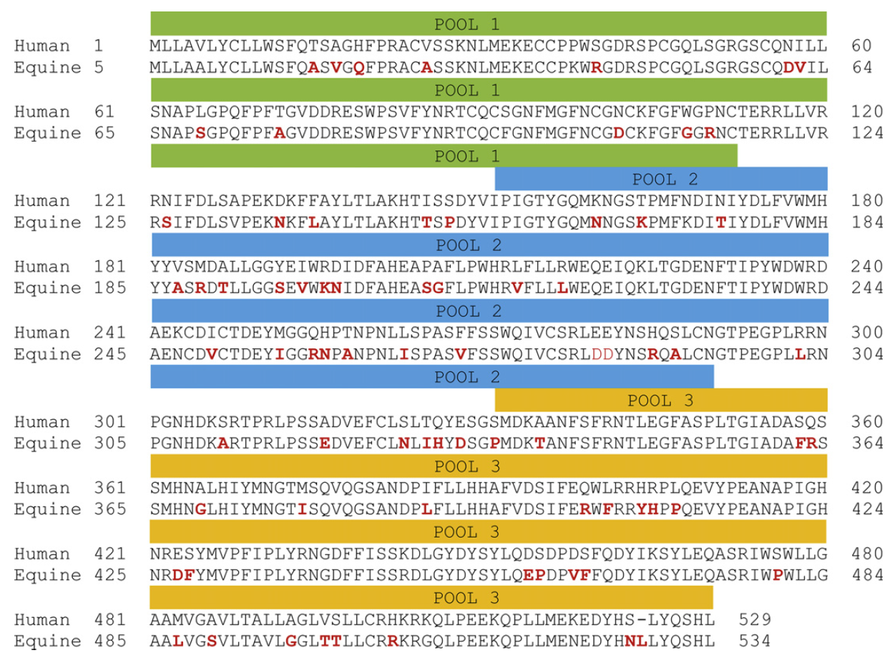
Figure 5.1. HuTyr pool scheme. Human tyrosinase protein sequence divided into 3 different peptide overlapping pools used for in vitro stimulation of isolated PBMCs (note that there is a 20-amino acid overlap from pool to pool). The comparative alignment and predicted tyrosinase protein sequences from human and equine are also shown. Equine sequence shows 90% predicted sequence homology to the human sequence. Deviations from the human sequence are noted in red.
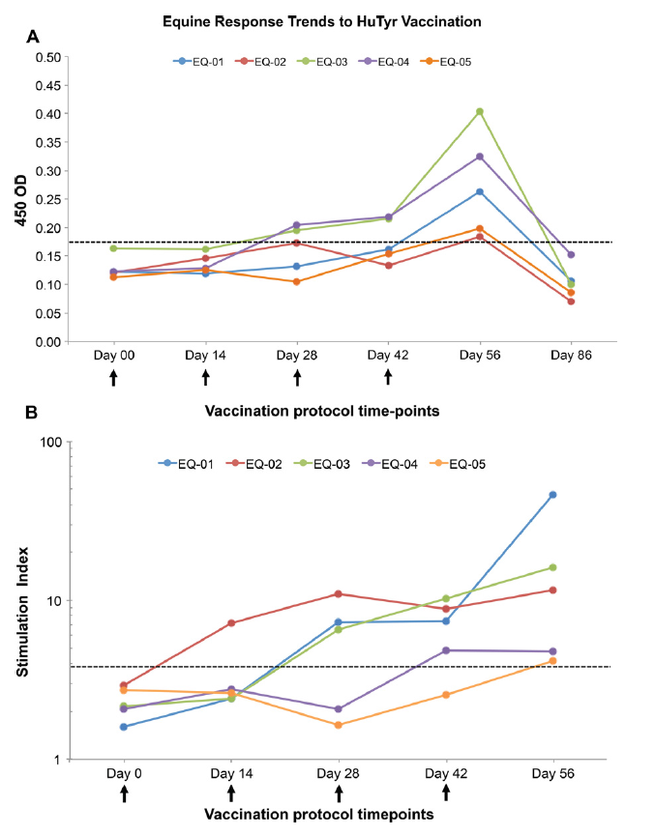
Figure 5.2. Immune response trends in horses treated with HuTyr vaccine. (A) IgG humoral response trends at 1:20 dilutions, positivity threshold (dashed line) was set at anOD450 = 0.18. (B) Cellular immune response trends; positivity threshold (dashed line) was set at a TyrSI= 3.8. Arrows represent vaccination days.

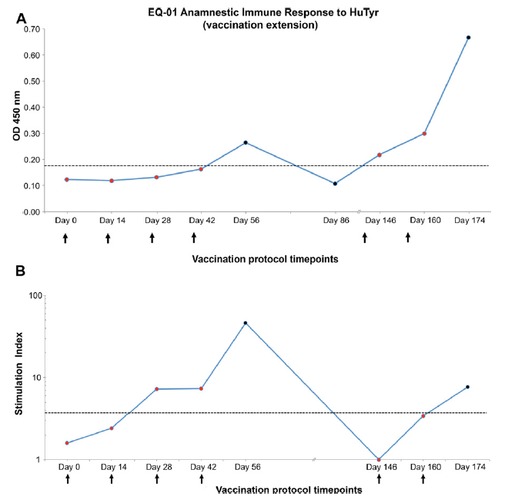
Figure 5.3. Anamnestic immune response trends in EQ-01. (A) Graph showing the anamnestic humoral response to HuTyr IgG response to HuTyr vaccination. (B) Graph showing the anamnestic cellular response to HuTyr vaccination. Positivity thresholds are denoted by dashed lines and are set at an OD450= 0.18 for humoral response and a TyrSI= 3.8 for cellular immune response. Arrows represent vaccination days.


Figure 5.4. Immunoreactivity to individual HuTyr peptide pools as measured at the end of the vaccination protocol on day 56 by IFN-γ expression normalized to CD4and CD8 expression in all horses. PC = positive control (ConA); NC = negative control (random peptide).

: Safety and Immunoreactivity of a Human Tyrosinase Anti-Melanoma Vaccine in Tumor-Bearing Horses

CHAPTER VI
Brief explanatory statement:
This chapter presents a manuscript describing the final step to which all the three previous pre-clinical studies were leading to, and the first formal clinical trial with this tyrosinase antigen specific gene immunotherapeutic (“vaccine”) to treat melanomas in a population of tumor-bearing equine patients.

Publication information:
Manuscript at the moment of the writing of this document had not yet been submitted for publication. A potential list of authors and article title is presented here:

Luis M. Lembcke, James T. Blackford, Deborah A. Grosenbaugh, Timothy Leard, Stephen A. Kania, Dianne J. Trent, Keith Prater, John Biggerstaff, Agricola Odoi, and Jeffrey C. Phillips. Safety and Immunoreactivity of a Human Tyrosinase Anti-Melanoma Vaccine in Tumor-Bearing Horses.

Potential corresponding author at:

Jeffrey C. Phillips, DVM, MSpVM, PhD
Department of Allied Health Sciences
College of Veterinary and Comparative Medicine
Lincoln Memorial University
6965 Cumberland Gap Pkwy
Harrogate, TN 37552.
Phone: (865) 221-3715
E-mail:jphill35@me.com

Description of tasks:

My contributions in this paper include (1) Experimental design (2) running all experiments relevant to the paper, (3) analysis and interpretation of the data, (4) statistical analysis of all data, (5) photographic and graphic documentation of results, (6) manuscript writing. Co-authors contributions to this paper included experimental design and writing editorial assistance by Dr. Phillips, Dr. Kania and Dr. Biggerstaff, veterinary assistance with the equine patients by Dr. Blackford, technical assistance by Kieth Prater and Dianne Trent and statistical analysis assistance by Dr. Odoi.

Abstract
Melanomas are among the most common skin tumors in horses, with prevalence rates reaching as high as 80% in adult gray horses. The great majority of melanocytic tumors are benign at initial presentation; however, if left untreated up to 2/3 can progress to overt malignant behavior, which can significantly affect the horse’s performance and eventually lead to death. Despite the wide availability of measures of local control, there are currently no systemic therapies that can effectively prevent spread, or treat metastatic or locally advanced/non-resectable melanoma in horses. Immunotherapy using plasmid DNA constructs encoding xenogeneic forms of the antigen tyrosinase, have demonstrated immunoreactivity and clinical benefit in the treatment of melanomas in humans and dogs. Our previous work established the scientific basis for the immunologic targeting of tyrosinase in equine melanoma, the optimal vaccination technique, the proper methodology to assess tyrosinase-specific immune response, and provided important data on safety and immunoreactivity of the vector. Here we describe the first dose escalation trial using a human tyrosinase plasmid DNA vaccine in tumor-bearing horses. The results of this trial documented that vaccination is able to induce a significant tyrosinase-specific systemic immune response, both humoral (p =0.001) and cellular (p =0.0004) in treated horses; as well as a significant local intratumoral immune response, as measured by significant increases in intratumoral CD8+ T cells (p <0.0001) and decreases in intratumoral regulatory T cells (p =0.002). Vaccine administration was associated with statistically significant tumor burden reductions (p <0.0001). No significant difference in clinical or immune responses was observed between dosing cohorts. No significant adverse events were observed, and the vaccine appeared safe and well tolerated in horses.

Introduction
Melanomas are among the most common tumors noted in horses, comprising ~15% of all skin tumors, second only to sarcoids. [1-3] This occur in all breeds and colors but are most commonly seen in gray horses, reaching prevalence rates as high as 80% in older animals. [2,3] The overwhelming majority of melanocytic tumors are benign at initial presentation; however, if left untreated up to 2/3 can progress to overt malignant behavior, which can significantly affect the horse’s performance and eventually lead to death, thus resulting in a considerable health and economic impact in the equine community. Despite the high frequency of these tumors, there is currently no systemic treatment that can effectively manage metastatic spread, hold on progression. Surgical resection is considered the mainstay of therapy, but curative surgery is rarely feasible because of location. Other treatment options include radiation therapy, chemotherapy, and immune therapy [1-4]. Prognosis is determined by initial tumor staging, histopathology, and treatment options [4]. Because most horses present with locally advanced, non-resectable tumors, effective nonsurgical therapies are clearly needed to improve survival in these patients. Immunotherapy may prove to fill this role in equine patients; recent work has suggested that both local and systemic antitumor responses can be generated in tumor-bearing horses [5-7].
Studies have been undertaken to elucidate the molecular basis of equine melanoma as a comparative model for human melanocytic tumors [8,9]. For years, veterinarians have been aware of the increased risk for tumor formation associated with the loss of coat color due to graying [10-13]. Recent work has identified the genetic basis for this premature graying as a 4.6-kb duplication in intron 6 of the STX17 gene, which leads to the overexpression of STX17 and the neighboring gene NR4A3 [14]. Mutations in melanocortin-1 receptor (MC1R) signaling have also been studied to determine their role in melanocytic tumor development [15-17]. Specifically, a single nucleotide polymorphism in MC1R (C901T) has been linked to chestnut coat color and resultant low risk of melanocytic tumor development [18]. A loss of function mutation (ADEx2) in the agouti signaling protein, a known antagonist of MC1R, has been linked to black coat color and an increased risk of melanoma formation [18]. In addition to the upregulation of downstream genes such as tyrosinase, enhanced signaling through the MC1R pathway has also been shown to result in markedly increased expression of the NR4A nuclear receptor subgroup in melanocytic cells [19]. As pointed out previously, overexpression of NR4A3 has been found in melanomas of gray horse, although it has not been directly associated with the development of melanocytic tumors in humans or horses [20].
Understanding the role of melanogenic proteins in tumor formation allows for the development of molecularly targeted therapies to treat patients with melanocytic tumors, or in some cases, for prevention in those at risk for their development. A logical molecular target is the protein tyrosinase. Tyrosinase is a prototypical melanocyte differentiation antigen which acts as an enzyme that functions to catalyze the hydroxylation of tyrosine to dihydroxyphenylalanine, a crucial and tightly controlled (both spatially and temporally) step in melanin synthesis. [21] In tumor tissue, however, tyrosinase expression appears to be constitutively increased [21-23]. Furthermore, gray horses at increased risk of tumor formation (ADEx2) would be expected to have elevated tyrosinase expression in their melanocytes due to enhanced signaling from the MC1R pathway [18,21,24]. Nonetheless, there is large evidence that this self-protein can be recognized by T cells from melanoma patients [25-27] and measurable CD8+ T-cell responses have been induced against individual TYR epitopes using synthetic peptides. [28,29]
Various methods for vaccination have been used to immunize against tyrosinase. And although peptide vaccines have shown some efficacy, these type of vaccines are mainly limited by the restriction that peptides of the selected protein/antigen can only be used individually; and so, often these vaccines require adjuvants (e.g., GM-CSF, Freund’s adjuvant) to elicit an important immune response in vaccinated patients. [28-31] Logically, the utilization of the full-length of the protein/antigen would be more advantageous than just using individual peptides because it has potential to present multiple epitopes. [28] Immunization with DNA instead allows to do precisely this, by presenting the full-length of the complementary DNA sequence which codes for the protein/antigen properly loaded in a plasmid. [29] Other markedly important advantages of DNA immunization are the ease of engineering a non-infectious vector, its relative efficiency, and low cost of manufacture as well as the presence of unmethylated CpG motifs (immunostimulatory sequences) in the vector backbone which stimulate the innate immune system through TLR9 ligation and so act as a potent immunological adjuvant. [28-32]
Multiple pre-clinical studies using B16 mouse models of melanoma have shown that immunization with xenogeneic (human) DNA encoding for melanocyte differentiation self-antigens of the tyrosinase family (e.g., tyrosinase, gp100, gp75, TRP-1, TRP-2) was an effective strategy for overcoming immunologic tolerance (which frequently constrains responses to poorly immunogenic self-proteins) and inducing cancer immunity that resulted in protection from syngeneic tumor challenge as well as rapid and extensive depigmentation of hair. [29,33-36] This same approach of using xenogeneic tyrosinase have also been implemented in human melanoma patients with promising results [28] And so, vaccines can be designed using xenogeneic DNA that is homologous to the molecular target. Studies have shown that by using this approach, an effective antitumoral response, greater than that observed with syngeneic vaccines, can be generated against the orthologous target [37,38].
In veterinary medicine, after a series of successful clinical trials [37,39,40], the United States Department of Agriculture licensed a xenogeneic DNA vaccine encoding human tyrosinase and delivered with a pING plasmid for the treatment of canine melanoma. The results from these clinical trials and several later studies evidenced a considerable increase in the survival time of vaccinated dogs, even in patients with already identified metastatic disease. [37,39,42] This vaccine exploits the close homology of human and canine tyrosinase (92%) to generate a tyrosinase-specific antitumor response [40]. In comparison, the equine tyrosinase sequence shares 90% homology to the human sequence; based on this, cross-reactivity of HuTyr DNA vaccine in the horse would be expected [41].
Over the past four years we have established the necessary groundwork for the evaluation of the pING-HuTyr vaccine in melanoma bearing horses. Our initial work evaluated the use of needle-free injectors for the intramuscular vaccination of horses. Vaccinations in the anterior pectoral muscles were determined to be a safe and effective approach for the delivery of DNA plasmid vaccinations. [43] Evaluation of tyrosinase expression in equine tissues was then performed to determine the tissue-specific expression of this transcript. [23] Tyrosinase was notably found to be overexpressed in all variants and locations of melanocytic tumors found in our study population. Furthermore, no detectable expression was found in normal skin or mucosal tissue regardless of base coat color or degree of pigmentation of mucosal tissue. [23] Lastly, in our final preclinical study, we evaluated the safety and immunoreactivity of the pING-HuTyr DNA plasmid vaccine in a cohort of normal non-tumor bearing horses; and developed the appropriate immunoassays to measure their specific immune response to this particular vaccine. [44] No signs of acute or late toxicity were noted in treated patients. Tyrosinase-specific humoral responses were seen in all patients. A novel methodology was designed to measure tyrosinase-specific cell mediated reactivity. This methodology was demonstrated to be highly sensitive with dynamic range that surpasses previous technology. Results were also found to be highly specific for measuring the immunologic response to defined epitopes. Cell-mediated responses were also seen in all patients.
In summary, we established the scientific basis for the immunologic targeting of tyrosinase in equine melanoma, the technique used to vaccinate patients, and the methodology used to determine response to vaccination. [23,43,44] It is with this acquired knowledge that we here consequently conducted a trial in equine melanoma-bearing patients. Herein, we utilize a combination of humoral and cell-mediated antigen specific immunoassays to document the immune response of these cohorts of tumor bearing horses. Finally, we also included in our analysis the intratumoral evaluation of potential changes in the tumor infiltrating lymphocyte population (especially in the cytotoxic CD8 T cell to regulatory T cell ratio) in response to vaccination, which resent studies have shown as prognostic for both immune and clinical responses in several tumor types, including melanomas. [45-51]

Materials and Methods

Institutional Animal Care and Use Committees from both The University of Tennessee and Lincoln Memorial University reviewed and approved all husbandry practices and animal procedures in this study.

Patient Population

10 melanoma-bearing grey horses age between 11 and 24 years (mean age of 16 years) were included in this study, from which 6 were males and 4 were females. Breeds included three Arabians, two Paso Finos, two Irish Draught Horses and one of each, Andalucian, Oldenburg and American Quarter Horse (Table 6.1). Patient inclusion criteria for the study included a clinical diagnosis of cutaneous melanoma at any given location/s (Figure 6.1) as performed by both an equine board-certified specialist (J.T. Blackford) and a certified veterinary oncologist (J.C. Phillips), measurable external tumor burden >3 cm to allow for serial biopsying, no other significant concurrent disease or history of immune-mediated disease, no concurrent anti-cancer treatment of any kind (including NSAIDs), and a written owner consent. Furthermore, patient tumor grade was defined according to a modified classification system on a scale from 1 to 5, as previously described. [52]

Vaccine Information

This xenogenic vaccine consists of human tyrosinase cDNA inserted in the pING plasmid vector, which contains a cytomegalovirus promoter and kanamycin resistance selection marker. [37] The vaccine, trade name Oncept® (Merial Limited, Athens, GA, USA), was produced and released from the manufacturer with permission from the United States Department of Agriculture.

Trial Design and Vaccination Protocol

Horses were separated into two cohorts of five horses each; the first cohort received a total dosage of 100 ug of human tyrosinase DNA vaccine while the second cohort received 300 ug of human tyrosinase vaccine. The lower dosage was based on the current dose recommendation used in dogs to treat melanoma and the higher dosage was determined arbitrarily by multiplying the former dose by three. The vaccination protocol consisted of four biweekly injections at days 0, 14, 28, and 42, and a booster vaccination 6 months after. Vaccine dosage and schedule were selected to be comparable with the currently recommended protocol for its use in dogs to treat malignant melanoma. [37,39,40,42] Horses were vaccinated in alternating pectoral muscles with 0.4 mL (100 ug) or 1.2 mL (300 ug) of vaccinate, using the VitaJet-3® (Bioject Inc, Portland, OR, USA) needle-free injector device. The validation of this device as a proper delivery tool for DNA vaccinations in this species (as well as the identification of the pectoral muscles as the ideal vaccination site), was previously described [43].

Sample Collection

Before each vaccination complete physical exams, tumor measurements and blood collections were performed on all patients. Furthermore, in order to investigate sustainability of tyrosinase-specific immune response blood samples were also collected on specific re-checks at days 56, 86, 146 (corresponding to 2 weeks, 1 month and 3 months after the last vaccine) and 250 (2 weeks after booster). At each time point, 34 mL of blood were drawn into sodium heparin tubes (30 mL) for peripheral blood mononuclear cell (PBMC) isolation and into serum separator tubes (4 mL) for serum separation. Furthermore, tumor biopsies were collected at days 00, 28 and 56 (corresponding to beginning/baseline, middle and end of the vaccination protocol) using 8 mm biopsy punch, local anesthesia and sedation when needed and immediately stored in liquid nitrogen. A summary of the study plan can be seen in Table 6.2

Measurement of Humoral Immune Response

Serum was separated by centrifugation at 1,200 x g and stored at -20°C until use. Standard enzyme-linked immunosorbent assays were used to determine both anti-HuTyr and anti-EqTyr antibodies according to published methods [40,44]. In brief, Immulon® (Thermo Fisher Scientific, Pittsburgh, PA, USA) microtiter plates were coated overnight at 4°C with 50 µl/well (0.05 ug) of full-length recombinant HuTyr (Abnova Corporation, Jhongli City, Taiwan, China) and then washed with phosphate-buffered saline (PBS)/Tween (0.05%). A solution of 2% milk/PBS (150 µl/well) was then added to each well with the objective of help avoiding unspecific binding, and after 1 hour incubation at 37°C plates were again washed. Patient serum (50 µl/well) was then added as serial dilutions from 1:20-1:540, incubated for 1 hour at 37°C, and then washed. A secondary horseradish peroxidase-conjugated goat anti-horse Immunoglobulin G (IgGT) antibody (Bethyl Laboratories, Montgomery, TX, USA) was added (50 µl/well of a 1:500 dilution), incubated for 45 minutes, washed, and then developed using 100 µl a 3,3’,5,5”-tetramethylbenzidine (TMB) substrate solution (Thermo Fisher Scientific, Pittsburgh, PA, USA). Reactions were stopped after approximately 10 minutes by adding 50 µl/well of 0.18 M H₂SO₄. The OD450 values were measured using the ELx800® (Bio-Tek Instruments, Winooski, VT, USA) microplate reader instrument. Positive anti-serum collected from fully vaccinated horse in a previous pre-clinical trial [44] was used as both an inner-plate positive control and to normalize between plates for all equine samples. The human GST protein (Abnova Corporation, Jhongli City, Taiwan, China) was used as a negative control. Reactions were run in triplicate with average (OD450) results reported, using negative controls as blanks.

Measurement of Cellular Immune Response

Isolation and Stimulation of PBMCs: Samples were diluted with equal volumes of PBS, overlaid in Ficoll-Paque (GE Healthcare, Piscataway, NJ, USA), and separated by density gradient centrifugation. The mononuclear layer was isolated and washed with sterile PBS. Cells were resuspended in Roswell Park Memorial Institute (RPMI) cell culture media (Cellgro, Mediatech, Manassas, VA, USA) containing 10% fetal bovine serum and antibiotics. Cells were then aliquoted (2 mL/well) into sterile cell culture plates (Costar, Corning Life Science, Corning, NY, USA) and placed in a CO2 incubator at 37°C. To determine cellular immune reactivity to tyrosinase, PBMCs were incubated with synthetic peptides (NeoBioScience, Cambridge, MA, USA) encoding HuTyr. The full-length of the HuTyr protein was used and divided into 35 individual 20 amino acid long peptides, each overlapping the neighboring sequence by five residues, as previously described. [41,44] The 35 individual peptides were separated in three pools (HT1, HT2 and HT3), each containing 11-12 peptides and overlapping each other by 20 amino acids, as as previously described. [44] Aliquots (10 µg/mL) from each peptide pool were added to separate 2mL wells in the cell culture plates containing PBMCs and incubated (37°C) for 16 hours as previously described [41,44]. Positive controls were incubated with the nonspecific mitogen concanavalin A (GE Healthcare, Piscataway, NJ, USA) (4mg/2 mL well), whereas negative controls were incubated with a BLASTSM-queried random peptide sequence [54], as previously reported. [41,44]
RNA Isolation: After incubation, cells were pelleted and washed with fresh PBS. Total RNA was isolated using a commercial kit (RNeasy Mini Kit®, Qiagen, Germantown, MD, USA) according to manufacturer’s specifications, which included a sample homogenization step (QIAshredder®, Qiagen, Germantown, MD, USA) and DNase treatment step designed to substantially reduce genomic DNA contamination (RNase-Free DNase Set®, Qiagen, Germantown, MD, USA). The yield of total RNA was determined by spectrophotometry (NanoDrop ND-1000®, Wilmington, DE, USA) at 260 nm, whereas purity was estimated from the relative absorbance at 230, 260, and 280 nm (i.e., A260/A280 and A260/A230). Samples were stored at -80°C pending analysis.
Gene Expression Assays: Cell-mediated reactivity to HuTyr and EqTyr epitope exposure was measured by determining IFN-γ mRNA production from stimulated cells. Values were normalized to total CD4 mRNA expression to account for varying numbers of these cells between samples, as previously described. [44,55,56] Previous work by our laboratory documented a linear correlation between CD4 mRNA expression and absolute number of CD4 cells [44]. RT-PCR was performed using TaqMan gene expression assays® (Applied Biosystems, Foster City, CA, USA) designed by use of the manufacturer’s online design software (TaqMan Custom Assay Design Tool®, Applied Biosystems, Foster City, CA, USA). Target sequences included full-length equine IFN-γ (NM_001081949) and CD4 (XM_001497051.2) mRNA. Probes were centered at exon 3-4 and 6-7 boundaries, respectively (Table 6.3).
Quantitative Real-Time PCR: RNA was reverse transcribed to cDNA using a commercial kit (High Capacity cDNA Reverse Transcription kit®, Applied Biosystems, Foster, CA, USA) and then pre-amplified (TaqMan PreAmp Master Mix kit®, Applied Biosystems, Foster, CA, USA) according to the manufacturer’s specifications. Real Time PCR reactions (10 µL) were conducted on ViiA™ 7 Real-Time PCR detection system with a 384-well block module (Applied Biosystems, Foster, CA, USA) and in brief included: 4.5 µl of diluted pre-amplified cDNA, 5 µl of TaqMan Gene Expression Master Mix, and 0.5 µl of the appropriate TaqMan® gene expression assay (Applied Biosystems, Foster, CA, USA); all which were loaded into qPCR plates using an automated pipetting system (epMotion 5070®, Eppendorf, Hauppauge, NY). Gene expression was measured by the absolute quantification method. Standard curves for absolute quantification analysis were created using 1:10 serial dilutions of known amounts of IFN-γ and CD4 Ultramer® DNA oligos (Integrated DNA Technologies, Coralville, IA, US) as templates. Cycling parameters were set at 50°C for 2 minutes, 95°C for 10 minutes, followed by 40 cycles at 95°C for 15 seconds and 60°C for 1 minute. Baseline and threshold detection levels were automatically assigned by the Real-Time PCR detection system’s software, and then visually verified. Data analysis of absolute quantification experiments was performed using the ViiA™ 7 Software v1.2.2 (Applied Biosystems, Foster, CA, USA); while the amplification efficiencies for individual reactions were calculated using the LinRegPCR Software v7.5 [57], as previously reported. [58-60] Assay efficiency (90%-105%) and linearity (r2 = 0.980) were also confirmed before analysis. Replicates for each sample (Ct values) were averaged and plotted on their corresponding standard curve to obtain a copy number. Final reaction products were run on 2.0% agarose gels and visualized with ethidium bromide for size verification.
Stimulation Index: For each sample, absolute IFN-γ mRNA copy number was normalized to absolute CD4 mRNA copy numbers; results were reported in the form of a stimulation index (SI), as previously described. [44,59,60] The measure of SI for HuTyr (or Tyr_{SI}) was calculated as the ratio of IFN-γ copy number when PBMCs were incubated with each of the three separate pools of HuTyr peptides (X_{HT}) including the known immunodominant region of the protein in humans [53], divided by IFN-γ copy number when PBMCs were incubated the random peptides (Y_{RP}). In brief, Tyr_{SI} = X_{HT}/Y_{RP}.

Measurement of intra-tumoral immune response

Tissue collection and cryosection: Tumor biopsies were collected before (day 00), during (day 28) and after (day 56) treatment. These 8mm biopsies were collected from the tumor/normal tissue boundary and immediately frozen in liquid nitrogen and stored at -80C. Frozen specimens were embedded with OCT compound (Tissue-Tek® O.C.T. Compound, Sakura® Finetek) into cryomolds and then sectioned to 20-25µm thick cryostat sections using a microtome-cryostat and finally mounted in Superfrost plus slides (Thermo Fisher Scientific, Pittsburgh, PA) and stored in -80C until staining.
Single and double immunofluorescence staining: For immunostaining of tumor infiltrating lymphocytes (TILs), single immunofluorescence of CD8 was performed for the identification of cytotoxic T cells, while dual immunofluorescence of FoxP3 (intracellular) and CD4 (cell surface) was performed for the identification of regulatory T cells. For this purpose cryostat sections were first gently washed with phosphate-buffered saline (PBS) and then fixated for 15 min with a 4% Paraformaldehyde (PFA) solution, all at room temperature. Sections were washed again with PBS and blocked with 100 µl of 10% fetal bovine serum for 1 hour at room temperature. Sections were washed and incubated for 1 hour with 1ug/sample of the primary antibodies diluted in PBS. These included the Mouse anti-Horse IgG₁ antibodies against the equine CD8 (HT14A) and CD4 (HB61A) lymphocyte surface markers (WSU Veterinary Monoclonal Antibody Center, Pullman, WA, USA) and the Rat anti-Mouse IgG antibody, reported to cross react with equine tissue [61,62], against the intracellular marker Foxp3 (FJK-16s) for specific staining of regulatory T lymphocytes (eBioscience, Inc., San Diego, CA, USA). Sections that were going to be stained for the Foxp3 intracellular marker where subjected also to a permeabilization step using 100 µl of a 0.1% Triton X solution for 30 min at room temperature. For isotypic controls 1ug/sample of the conjugated antibodies Goat anti-Mouse IgG2a-k + Alexa 647 and the Goat anti-Rat IgG + Texas Red (Beckman Coulter, Inc., USA). Tissue sections were then washed and incubated for 45 min at room temperature and protected from the light with 1ug/sample of the fluorescence tagged secondary antibodies. These included a Goat anti-Mouse Alexa Fluor® 647 for sections stained for CD8, a Goat anti-Rat Alexa Fluor® 647 for Foxp3 sections and Goat anti-Mouse Alexa Fluor® 488 for sections stained for CD4 (Jackson ImmunoResearch Labs, Inc., West Grove, PA, USA). Sections were then washed one last time with PBS and cover slipped using the antifade reagent Prolong® Gold (Life Technologies Corporation, Grand Island, NY, USA), and finally incubated at room temperature to cure overnight.
Confocal microscopy and quantification of tumor infiltrative lymphocytes: Immunostained sections were then examined using a Leica TCS SP2 laser scanning confocal microscope (Leica Microsystems, Inc., Buffalo Grove, IL, USA) at the Bio Imaging Facility at the University of Tennessee for simultaneous multicolor fluorescent imaging. Double fluorescence for green and red channels was imaged using the excitation of argone and diode laser at the wavelengths of 488 nm and 633 nm, respectively. Multichannel images were recorded by sequential excitation to avoid cross-talk. Tumor biopsy samples were scanned to ascertain the areas with the higher density of immunopositive TILs on each tissue, from these at least 5 high power fields using an immersion-oil Plan-Apochromat 40x objective (higher magnification was selected to allow for proper co-localization of dual markers in Tregs) where randomly selected, as previously reported [50,51,63]. For each selected field 3D Z series with a 4µm step size was obtained, these consisted each of 6 Z slices for each immune marker. Further identification and quantification of immunopositive TILs was performed on the collected digitalized maximum intensity projections images by using the NIS-Elements v3.0 software (Nikon Instruments, Inc., Melville, NY, USA). Positive cells for CD8 and CD4, and double positive cells for CD4/Foxp3 were identified and counted by two independent observers (Biggerstaff, Prater), with vast experience in the field, but without knowledge of any clinical information. The mean of immunopositive cells in at least five fields was selected for each analysis and lastly expressed as a ratio of cytotoxic T cells to regulatory T cells (CD8+ : Foxp3+/CD4+), as previously reported [46,47,50,51,64-69].

Evaluation of vaccine safety and toxicity

In order to assess for any signs of local toxicity the owners of the vaccinated animal were instructed to monitor and report to the investigators any vaccine site reaction in the form of noticeable localized inflammation and pendulous edema or any overall abnormal behavior in the vaccinated animal through the next 24 to 48 hours following the vaccination events. Furthermore, with the purpose of providing a more complete vaccine safety profile and to assess for signs of any possible systemic toxicity blood samples were collected at baseline at day 00 and at the end of the core vaccination protocol at day 56 and submitted for analysis at the UTCVM’s Clinical Pathology laboratory, including a complete blood count (CBC) and a serum chemistry panel (creatinine, BUN, AST, GGT, total bilirubin, CK, albumin, globulin, and glucose). The obtained pre- and post-treatment values were compared in order to assess for the appearance or worsening of one or more abnormal laboratory values at the end of the core vaccination protocol. Toxicities were graded according to the Veterinary Cooperative Oncology Group’s common terminology for adverse events (VCOG-CTCAE). [70] If any grade III or IV toxicities were noted during the study period, any horse experiencing them would immediately exit the study.

Evaluation of clinical response

Although the main objective of the study was to assess safety and to document vaccine-specific immune responses, anti-tumor clinical efficacy was also recorded in the form of changes in tumor size following vaccination. Consecutive tumor measurements were performed as following: From all tumors present in one single patient target and non-target lesions were selected at the day of enrollment. Target lesions were selected based on larger size (with tumors smaller than 10mm being excluded from consideration as target lesions, but potentially remaining as non-target lesions), ease of reliable repetitive measurements and on being representative of organs involved. Only superficial skin lesions or palpable lymph nodes able to be clinically measured with standard calipers were selected. When more than five melanomas were present in one single patient a maximum of 5 lesions total and a maximum of 2 lesions per location (i.e. ventral surface of the tail, forehead, perianal area) were selected as target lesions, as describe by the RECIST criteria. [71,72] All other melanomas present were identified as non-target lesions. These lesions were regularly assessed throughout the vaccination protocol for changes in both size and appearance (e.g., signs of depigmentation or necrosis). Clinical measurements were performed using standard calipers, reported as percentage changes in the tumor’s largest diameter (except in the case of metastatic lymph nodes, where the smaller diameter was reported) and documented when possible with color photography, as previously described by the RECIST guidelines for clinical measurements. [71-75] Objective anti-tumor responses for all individual lesions (target and non-target) in each patient were estimated by the comparison of pre and post-treatment measurements and reported using a modified RECIST criteria. The complete response (CR) of a single lesion was defined as its total disappearance. Partial response (PR) was defined as a minimum of 30% decrease in the longest diameter of the lesion. Progressive disease (PD) was defined as a minimal increase of 20% in the longest diameter of the lesion. Stable disease (SD) included lesions with neither sufficient shrinkage to qualify as a partial response nor sufficient increase to qualify for progressive disease. [71,72] In order to assess patients’ overall response or progression of disease, tumor burden was also estimated at baseline. This was calculated by adding the longest diameters of all target lesions in a patient at day 00 before treatment and reported as the baseline sum of longest diameters (SLD), as previously described [71,73,74,75]. This measure was used as a reference against which to compare subsequent responses throughout the study, including responses at the end of the core vaccination protocol at day 56 and at the end of the study.

Statistical Analysis

All statistical comparisons between pre-vaccination and post-vaccination immunoreactivity values in the three different types of immunoassays described herein, as well as the assessment of the potential effect of various population and clinicopathological variables (e.g., vaccine dose, tumor grade, sex, age and baseline tumor burden) on them, were performed using a multivariate analysis of variance (repeated measure MANOVA), to account for multiple comparisons of dependent variables. [76] A significant difference was defined as P < 0.05. For cellular and humoral immunoassays a positive immunological response threshold, above which values would be considered positive for the induction of a significant antigen-specific immune response, was set at three standard deviations above the group’s baseline mean value, as previously described. [44, 56] All statistical analyses were performed using SAS statistical software (version 9.4, SAS Institute Inc., Cary, NC).

Results

Evaluation of Humoral Immune Response

A gradually increasing trend in the antibody levels (IgG) of all but two horses (EQ-01 and EQ-06) was noted through the HuTyr vaccination protocol’s core period (day 00 to day 56), as measured by a tyrosinase-specific indirect enzyme-linked immunosorbent assay. A humoral positivity threshold, above which observed values would be considered positive for the induction of a significant immune response, was set three standard deviations above each cohort’s baseline mean value, at an OD450= 0.438 (= 0.35, σ = 0.03) for the first cohort and at an OD450= 0.370 (= 0.33, σ = 0.02) for the second, as previously described [44,56] and shown in Figure 6.2A and B. Most horses in both cohorts showed values above their respective cohort thresholds as early as by the day of the second vaccine (day 28). By the time of the first immunogenicity recheck (day 56) after the end of the protocol’s core period all but two horses (again EQ-01 and EQ-06) had reached and sustain antibody levels above these mentioned thresholds. Furthermore, most horses in the study continue to sustain increasing antibody levels by the time of the second immunogenicity recheck at day 86. These increments in humoral values from pre-vaccination to post-vaccination levels at the point of best overall immune response (either at day 56 or 86), ranged from two to fourfold increments over baseline and were statistically significant (p = 0.0037). Further analysis of the anamnestic period evidenced a dramatic drop in immunoreactivity values below threshold by the time of the 3 month recheck (day 146), reaching their all-study lowest points by the day of the 6 month recheck at day 236 in all patients. Day 236 was also the day all patients received a booster vaccination, two weeks after which (last immunogenicity recheck at day 250) all patients’ (but EQ-06) antibody levels rebounded and experienced their highest levels across the study. These increments ranged from an approximate two to fivefold elevation over the baseline values, and were also statistically significant (p < 0.0001). No significant difference in the degree of humoral response was observed among dosing cohorts (p = 0.1032).

Evaluation of Cellular Immune Response

Similar to humoral assays, a positivity threshold was also set at three standard deviations above each cohort’s baseline mean value, at a Tyr_{SI} = 5.5 ( = 3.3, σ = 0.7) for the first cohort and at a Tyr_{SI} = 2.7 (= 1.9, σ = 0.2) for the second, as previously described [44,56] and shown in Figure 6.3A-B. As it is expected with this type of immunoassays, the variability of responses between patients was high; however, the variability within a specific patient was low. [44,56,] Furthermore, some general common tendencies could be observed. All patients experienced a significant initial increase in immunoreactivity after the first vaccination; which allowed for the observation of positive cellular reactivity above threshold as early as by day 14 in all horses form the first cohort and in most from the second. The remaining two horses rose above threshold by the time of the next vaccine at day 28 (EQ-09) or considerably later by the time of the second immunogenicity recheck by day 86 (EQ-10), the latter even showed by then an almost fourfold increase over baseline. Following the end of the protocol’s core vaccination period most horses reached their peak in immunoreactivity at the first recheck at day 56, but some did so at the second immunogenicity recheck at day 86. These increments in immunoreactivity from pre-vaccination to post-vaccination at the point of best overall immune response (either at day 56 or 86), ranged from two to fourfold increments over baseline, and were statistically significant (p = 0.0004). Further analysis of anamnestic response showed a general drop in immunoreactivity values below threshold in most cases at the three and six month rechecks, just as if was seen with humoral assays. When vaccination was reinstituted (boosters), immunoreactivity values tend to observed a dramatic increase, which in the case of four horses in the first cohort and three in the second was enough to bounce their immunoreactivity values back above threshold levels (and in the case of one of them to finally set it above threshold for the first time). These increments represented values as high as six, fifteen and even a more than eighty fold increases over baseline. On the hand, the remaining three horses (EQ-01 from the first cohort and EQ-06 and 08 from the second) failed to show this increasing behavior, as measured at two weeks after re-vaccination. When compared to one another the two dosing cohorts did not show a significant difference in regarding their degree of cellular immune response (p = 0.4878).

Quantification of TIL and Evaluation of Local Immune Response

When intratumoral CD4+Foxp3+ regulatory T cells from biopsied specimens were subjected to double immunofluorescence staining with anti-CD4 and anti-Foxp3 antibodies, the former showed a cell membrane expression pattern while latter showed intracellular expression. In the case of intratumoral cytotoxic CD8+ cells the immune marker CD8 showed a membrane expression pattern, as it can be seen in Figure 6.4A–D). Although CD8+ and CD4+/Foxp3+ T cells were both identified in all tumor biopsies at all three key time-points (day 0/before treatment, day 28/during treatment and day 56/after treatment), clear changes in trends of individual TIL numbers and proportions could be observed during vaccine treatment. In the case of effector CD8+ cytotoxic T cells their intratumoral numbers experienced an increasing trend during treatment, as it can be observed in Figure 6.4E; This increment in the mean absolute number of intratumoral CD8+ cells from 14.4 cells/HPF (range 9.2-23.8 cells/HPF) at baseline to 24.5 cells/HPF (range 15.3-44.3 cells/HPF) by day 28 and to 49.3 cells/HPF (range 22.1-67.5 cells/HPF) by the end of treatment at day 56 was statistically significant (p < 0.0001). These CD8+ increases ranged from barely a twofold increase in EQ-01 to fivefold increases in EQ-03, 07 and 10 and even a sevenfold increase in EQ-02 during vaccination treatment. No significant difference was found between dosing cohorts in respect to these changes (p = 0.1621). On the other hand the intratumoral numbers of immunosuppressive CD4+/Foxp3+ regulatory T cells appeared to have experienced a decreasing trend during treatment, as it seen in Figure 6.4F. This decrease in the mean absolute number of intratumoral Tregs from 14.1 cells/HPF (range 1.7-36.0 cells/HPF) at baseline to 10.4 cells/HPF (range 1.3-29.3 cells/HPF) by day 28 and finally to 7.5 cells/HPF (range 0.3-20.0 cells/HPF) by the end of treatment at day 56 was also statistically significant (p = 0.0019). These decreases in Treg numbers ranged from a twofold decrease in EQ-01, 02, 04, 05, 06 and 08 to fivefold decreases in EQ-07 and 10 and even a sixfold decrease in EQ-03 during vaccination treatment. Finally, the ratio between these two individual TIL populations was also calculated for each tumor tissues during vaccination treatment. This ratio presented an increasing trend during treatment, as it can be observed in Figure 6.4G. Characterized by an increment in the ratio’s mean from 1.87 (range 0.31-6.20) at baseline to 4.49 (range 0.62-12.07) by day 28 and finally to 22.7 (range 1.10-138.35) by the end of treatment at day 56. These increments ranged from a fourfold increase in EQ-05, fivefold increases in EQ-01 and 06 to even a eleven, a fifteen, a eighteen and a higher than twenty fold increase in EQ-02, 10, 07 and 03, respectively. Nonetheless these were not statistically significant (p = 0.1461). And Just as with its individual components, no significant difference was either found between dosing cohorts in respect to changes in this TIL ratio (p = 0.4806)

Safety and Toxicity

No significant adverse events were observed. As described, from all these vaccination events, which total to 50 (with half of them entailing three injections per horse per event), only two episodes of vaccine site reactions were observed. These consisted of short incidents of mild pendulous edema localized to the injection site, which completely resolved without any treatment by the second day. These occurred in two separate patients, both from the low dose cohort and both after the third vaccine. Despite these isolated events, the two horses remained in the study and received two more vaccinations without experiencing any recurrence of these adverse reactions. No important systemic toxicity as assessed by physical examination, hematopathology, and serum chemistry was noted throughout the trial, as demonstrated in Tables 6.4 and 6.5. Only one grade 2 elevation of creatine kinase levels (in EQ-07) and two grade 1 elevations in serum total bilirubin (EQ-06 and EQ-09) were observed after completion of the four vaccinations. [70] Furthermore, two patients (EQ-01 and EQ-06) presented with abnormally elevated globulin levels before vaccination; these decreased (but without reaching normal levels) by the end of the vaccination protocol. None of these laboratory abnormalities were associated with noticeable clinical signs in these patients.

Preliminary Evaluation of Clinical Response

As previously stated the main goal of the present study was to evaluate safety and to document data on immune response, nonetheless clinical response in the form of reductions in tumor size was also evaluated as a secondary objective. A gradually decreasing trend in patients’ tumor burden was noted in all but one patient (EQ-01) during the vaccination protocol’s core period (day 00 to day 56); with patients reaching their best overall clinical response by day 56 (Figure 6.5A and B). [71,72] By this point in the study seven (four from the low dose cohort and 3 from the high dose cohort) patients had achieved enough tumor reduction to qualify as partial responses, with the rest sustaining stable disease, according to modified RECIST criteria for veterinary patients. [71,72] Furthermore, while this decrease in the baseline sum of longest diameters by day 56 was found to be statistically significant (p < 0.0001). Similarly, measurements obtained in the end of the anamnestic period (which included one extra booster vaccination) at day 250 were found to remain significantly different from the baseline sum of longest diameters collected at day 00 (p < 0.0001). No significant difference was found between both dose cohorts in respect to reductions in tumor size (p = 0.7188). By the end of the anamnestic period no complete responses were observed, but all the horses that had achieved partial response (PR) were able to sustain it. From the patients that showed only stable disease by day 56, one was able to able to achieve PR at the last recheck at day 250 (two weeks after the booster vaccination). The other two although experience some small degree of tumor burden reductions, these were gradually lost and by the end of the anamnestic period and their tumors had almost returned to their normal sizes. Nonetheless no patients experienced progressive disease under therapy. All horses where alive at the end of the study, which is expected given the slow progressive nature that characterizes this disease in horses, but by the time of preparation of this manuscript two patients had already been euthanized. This occurred shortly after the completion of the study due to disease progression (EQ-01) as well as to reasons not related to disease or treatment (EQ-04).

Discussion

Herein, we described the first pre-clinical dose escalation trial evaluating the use of a tumor antigen-specific immunotherapy to treat a malignancy in equine tumor-bearing patients. For this purpose we enrolled two cohorts of melanoma-bearing horses and assigned them scalating doses of a human tyrosinase DNA plasmid vaccine. Patients then went through a vaccination protocol that included four biweekly vaccinations (core protocol) and one 6-month booster vaccine. Both blood and tumor tissue samples were collected from each patient at set time-points during the protocol. These samples were used to adequately evaluate the presence, progress, magnitude, timing and anamnestic persistence of both humoral and cell mediated immune response to vaccination by the use of specially designed immunoassays optimized to measure immunoreactivty specific to the vaccine’s tumor-antigen target (tyrosinase).
This plasmid was designed to be uptaken by muscle cells and then transcribed [36]. The processed protein would be expected to generate a self-tolerant tyrosinase-specific immune response. Similar to previous reports evaluating this xenogeneic vaccine, the immunoreactivity measured was to the HuTyr protein and not to the orthologous equine protein [18,25,27]. Conceptually, the purpose of xenogeneic vaccination is to induce cross-reactive immune responses in tumor-bearing horses and/or overcome auto-regulatory mechanisms that have allowed tumors to escape immunosurveillance [37]. However, reactivity to the xenogeneic protein is routinely measured as an immunologic endpoint, and initial evidence suggests a correlation between these values and clinical outcome [25,27]. In this study clinical response, in the form tumor burden reductions, was also evaluated as secondary objective.
HuTyr vaccination appeared to successfully elicit both humoral and cell-mediated reactivity to the HuTyr protein in both cohorts. Based on defined threshold values, all horses but one horse per cohort, EQ-01 and 06, exhibited statistically significant positive humoral responses to vaccination at the end of the vaccination core period (p = 0.0037). And although antibody levels fell below threshold by the time of the three and six month post-vaccination rechecks the administration of a single booster vaccine quickly and dramatically reversed this trend, with most horses reaching their all-time highest immunoreactivity levels in the study (ranging from two to fivefold increases over baseline values). This rapid renewal in the production of tyrosinase-specific antibodies after the booster was expected, and mimics what we observed in the population of healthy horses vaccinated in our previous pre-clinical study. [44] Interstingly, EQ-01 and 06 were also the patients that responded the poorest to the booster stimuli and were barely capable of crossing the positivity threshold. These two patients represented the only two melanoma grade IV cases in the study, and so comprised the patients with the heaviest starting tumor burden. Overall, these results are consistent with an appropriate immune response to the (expected) transient expression of a plasmid vector. When evaluating cellular immune response a similar trend of overall increasing immunoreactivity levels could be observed. That being said, significant variability was observed through all individual reponses. Wide variability in the immune response is an expected finding in studies of this nature due to both small sample size and the heterogeneity of outbred populations. [56,57] Sample size is typically limited by the cost not only of the immunotherapeutic but also of the assays used to monitor the immune response (especially cellular immune response), which is particularly true when dealing with large animal patients, such as horses. This heterogeneous populations, however, represented a good sampling of the different presentations and grades of equine melanomas that are out there in the field, ranging from barely noticeable tumors (like in the case of EQ-10) to large necrotic and ulcerating confluent melanomas (like the cases of EQ-01 and EQ-06). Overall, the equine tumor-bearing population here vaccinated exhibited statistically significant positive cellular responses to vaccination at the end of the core period (p = 0.0004). The effect of the booster vaccine was similar to the one observed with humoral response, and brought the immunoreactivity values of most horses again over the positivity threshold (after these has dropped during the anamnestic period); except once again for EQ-01 and 06. Furthermore, vaccination immunotherapy was able to alter the lymphocyte dynamics inside the tumor itself in most patients, promoting both the recruitment of more cytotoxic T cells into the malignancy and reducing the proportions of regulatory immunosupresive T cells in the tumor, both in a statistically significant manner.
As mentioned before, the assessment of the degree of clinical response the patients may experience while on therapy was not a main objective of this study. Nevertheless, clearly decreasing trends in tumor burden where observed in almost all horses, with several being able to achieve partial responses (RECIST criteria) [71,72], that were sustained until the end of the study. Once again EQ-01 and EQ-06 (the horses with the higher initial tumor burden) were unable to move away from the stable disease category and were observed as the lowest responders of their cohorts in regard to clinical response too. Important to mention, that although no objective positive response was measured in EQ-01, a subjective and noticeable increase in appetite and weight was gradually seen in this horse through therapy. Similarly EQ-03, 07 and 10 experienced the higher percentage reductions in tumor burden qualifying as the higher responders in their cohorts. This mimics what was seen in the immunoassays, which hints of a correlation between immunoreactivity values and clinical outcome. Figure 6.6 shows an example of a melanocytic tumor in one of the study patients that had decreased in size during vaccination (tumor measurement at baseline and at the end of the vaccination core protocol are placed side to side for comparison).
As demonstrated in Table 6.4, no significant adverse events were observed through the duration of the study. Two patients experienced grade 1 toxicity associated to a mild rise over normal levels in total bilirubin values (with other liver function values within normal limits), patients were otherwise healthy and never manifested any signs of dysfunction. One patient experienced grade 2 toxicity associated with elevated levels of creatine kinsase at the end of the vaccination protocol. This patient belonged to the high dose cohort, and received three separate intramuscular shots at every vaccination event, if this was associated with the elevations observed in this marker of muscle injury was not determined and none of the other horses in the triple dose cohort experienced similar events. Finally two patients (EQ-01 and EQ-06) started the study with already elevated globulin levels, most likely associated to higher tumor burden (these were the only melanoma grade 5 subjects included in the study); interestingly enough this globulin levels where measured as closer to normal by the end of vaccination. No other laboratory abnormalities were observed. With respect to reactions at the vaccine site, only two (out of 100 vaccination events) were reported. These were mild episodes of edema at the site and resolved without treatment. Overall, the vaccine appears to be safe and well tolerated at the doses herein described.
Also regarding dosing, this appeared to have no effect in either immune or clinical response, as it is commonly observed with DNA based anti-cancer vaccines. Being that the lower dose seems just as effective as the higher dose in generating similar degrees of immune and clinical response, and taking in account other factors such as drug cost, the minimum effective dose (100ug of tyrosinase plasmid DNA) should be recommended. This dose corresponds to the same one being used in dogs to treat melanomas. [77]
The information produced in this project will be useful to the owners of horses at risk or diagnosed with melanomas. Demonstration of immunoreactivity of this vaccine will also be useful to veterinarians who are treating horses with melanomas by providing additional therapeutic options for their patients. Among the important details yet to be elucidated are the adequate timing of boosters, the identification of predictor factors that could early recognize which horses are going to respond well to this therapy and which ones are not (so far, subjectively advance age and initial higher tumor burden/grade appear to be inversely proportional to response, as expected) and the elucidation of strategies to improve response to this vaccine (e.g., xenogeneic prime/syngeneic booster strategy, co-expression of more than one protein target in the same plasmid, experimentation with other vectors, such as viral ones).

References

- Sundberg J.P., et al. (1977) Neoplasms of equidae. J Am Vet Med Assoc,170, 150-2.
- Valentine B.A. (1995) Equine melanocytic tumors: a retrospective study of 53 horses (1988-1991). J. Vet Intern Med, 9, 291-7.
- Johnson P.J. (1998) Dermatologic tumors (excluding sarcoids). Vet Clin North Am Equine Pract, 14, 625-58.
- Smith S.H., et al. (2002) A comparative review of melanocytic neoplasms. Vet Pathol, 39, 651-78.
- Müller J., et al. (2011) Double-blind placebo-controlled study with interleukin-18 and interleukin-12-encoding plasmid DNA shows antitumor effect in metastatic melanoma in gray horses. J Immunother, 34, 58-64.
- Müller J.M., et al. (2011) In vivo induction of interferon gamma expression in grey horses with metastatic melanoma resulting from direct injection of plasmid DNA coding for equine interleukin 12. Schweiz Arch Tierheilkd, 153, 509-13.
- Finocchiaro L.M., et al. (2009) Cytokine-enhanced vaccine and suicide gene therapy as adjuvant treatments of metastatic melanoma in a horse. Vet Rec, 164, 278-9.
- Tuthil R.J., et al. (1982) Equine melanotic disease: a unique animal model for human dermal melanocytic disease. Lab Invest, 46, 85A.
- Seltenhammer M.H., et al. (2004) Comparative histopathology of grey-horse melanoma and human malignant melanoma. Pigment Cell Res, 17, 674-81.
- Comfort A. (1985) Coat-colour and longevity in thoroughbred mares. Nature, 182, 1531-2.
- Rieder S., et al. (2000) A comparative genetic approach for the investigation of ageing grey horse melanoma. J Anim Breed Genet, 117, 73-82.
- Fleury C., et al. (2000) The study of cutaneous melanomas in Camargue-type gray-skinned horses (2): epidemiological survey. Pigment Cell Res, 13, 47-51.
- Seltenhammer M.H., et al. (2003) Equine melanoma in a population of 296 grey Lipizzaner horses. Equine Vet J,35, 153-7.
- Rosengren P.G., et al. (2008) A cis-acting regulatory mutation causes premature hair graying and susceptibility to melanoma in the horse. Nat Genet, 40, 1004-9.
- Sturm R.A., et al. (2003) The role of melanocortin-1 receptor polymorphism in skin cancer risk phenotypes. Pigment Cell Res, 16, 266-72.
- Carlson J.A., et al. (2007) Melanocyte receptors: clinical implications and therapeutic relevance. Dermatol Clin, 25, 541-57.
- Williams P.F., et al. (2011) Melanocortin-1-receptor and risk of cutaneous melanoma: a meta-analysis and estimates of population burden. Int J Cancer, 129, 1730-40.
- Rieder S., et al. (2001) Mutations in the agouti (ASIP), the extension (MC1R), and the brown (TYRP1) loci and their association to coat color phenotypes in horses (Equus caballus). Mamm Genome, 12, 450-5.
- Smith A.G., et al. (2008) Melanocortin-1 receptor signaling markedly induces the expression of the NR4A nuclear receptor subgroup in melanocytic cells. J Biol Chem, 283, 12564-70.
- Zhao Z.Z., (2009) Polymorphisms in the syntaxin 17 gene are not associated with human cutaneous malignant melanoma. Melanoma Res, 19, 80-6.
- Wang N., et al. (2006) Tyrosinase maturation through the mammalian secretory pathway: bringing color to life. Pigment Cell Res, 19, 3-18.
- Vourc’h-Jourdain M., et al. (2009) Melanoma gene expression and clinical course. Arch Dermatol Res, 301, 673-9.
- Phillips J.C., Lembcke L.M., et al. (2012) Evaluation of tyrosinase expression in canine and equine melanocytic tumors. Am J Vet Res, 73, 272-8.
- Gibbs P., et al. (2002) The genes and genetics of malignant melanoma. J Cutan Med Surg, 6, 229-35.
- Boon, T, Cerottini, JC, Van den Eynde, B, et al. (1994) Tumor antigens recognized by T lymphocytes. Annu Rev Immunol 12:,337–65.
- Brichard, V, Van Pel, A, Wolfel, T, et al. (1993) The tyrosinase gene codes for an antigen recognized by autologous cytolytic T lymphocytes on HLA-A2 melanomas. J Exp Med 178: 489–95.
- Wolfel, T, Van Pel, A, Brichard, V, et al. (1994). Two tyrosinase nonapeptides recognized on HLA-A2 melanomas by autologous cytolytic T lymphocytes. Eur J Immunol 24: 759–64.
- Wolchok JD, Yuan J, Houghton AN, et al Safety and immunogenicity of tyrosinase DNA vaccines in patients with melanoma. Mol Ther. 2007 Nov;15(11):2044-50.
- Wolchok JD, Livingston PO Vaccines for melanoma: translating basic immunology into new therapies. Lancet Oncol. 2001 Apr;2(4):205-11.
- Liu, MA, Wahren, B and Karlsson Hedestam, GB (2006). DNA vaccines: recent developments and future possibilities. Hum Gene Ther 17: 1051–1061.
- Klinman DM, Yi AK, Beaucage SL, et al. CpG motifs present in bacteria DNA rapidly induce lymphocytes to secrete interleukin 6, interleukin 12, and interferon gamma. Proc Natl Acad Sci USA 1996; 93: 2879–83.
- Sato Y, Roman M, Tighe H, et al. Immunostimulatory DNA sequences necessary for effective intradermal gene immunisation. Science 1996; 273: 352–54
- Goldberg, SM, Bartido, SM, Gardner, et al. (2005). Comparison of two cancer vaccines targeting tyrosinase: plasmid DNA and recombinant alphavirus replicon particles. Clin Cancer Res 11: 8114–8121.
- Bowne WB, Srinivasan R, Wolchok JD, et al. Coupling and uncoupling of tumour immunity and autoimmunity. J Exp Med 1999; 190: 1717–22.
- Hawkins WG, Gold JS, Dyall R, et al. Immunisation with DNA coding for gp100 results in CD4+ T-cell independent antitumour immunity. Surgery 2000; 128: 273–80.
- Weber LW, Bowne WB, Wolchok JD, et al. Tumour immunity and autoimmunity induced by immunisation with homologous DNA. J Clin Invest 1998; 102: 1258–64.
- Bergman P.J., McKnight J, Novosad A, et al. (2003) Long-term survival of dogs with advanced malignant melanoma after DNA vaccination with xenogenic human tyrosinase: a phase I trial. Clin Cancer Res, 9, 1284-90.
- Meyer R.G., et al. (2005) A phase I vaccination study with tyrosinase in patients with stage II melanoma using recombinant modified vaccinia virus Ankara (MVA-hTyr). Cancer Immunol Immunother, 54, 453-67.
- Bergman, PJ, Camps-Palau, MA, McKnight, et al. (2006). Development of a xenogeneic DNA vaccine program for canine malignant melanoma at the Animal Medical Center. Vaccine 24: 4582–5
- Liao, JC, Gregor, P, Wolchok, JD, Orlandi, F, Craft, D, Leung, C et al. (2006). Vaccination with human tyrosinase DNA induces antibody responses in dogs with advanced melanoma. Cancer Immun 6: 8
- Goubier A., et al. (2008) Superiority of needle-free transdermal plasmid delivery for the induction of antigen-specific IFNgamma T cell responses in the dog. Vaccine, 26, 2186-90.
- Grosenbaugh, Leard AT, Bergman PJ, et al. Safety and efficacy of a xenogeneic DNA vaccine encoding for human tyrosinase as adjunctive treatment for oral malignant melanoma in dogs following surgical excision of the primary tumor. AJVR 2011;72: 1631-8
- Phillips JC, Blackford JT, Lembcke LM, et al. Evaluation of needle free injection devices for intramuscular vaccination in horses. Journal of Equine Veterinary Science, 2011 Dec;31(12):738-43.
- Lembcke LM, Kania SA, Blackford JT, et al. Development of Immunologic Assays to Measure Response in Horses Vaccinated with Xenogenic Plasmid DNA Encoding Human Tyrosinase. Journal of Equine Veterinary Science, 2012 Oct:32(10):607-615.
- Hodi FS, Dranoff G. The biologic importance of tumor-infiltrating lymphocytes. J Cutan Pathol. 2010 Apr;37 Suppl 1:48-53.
- Sato E., Olson S.H., Ahn J., et al. Intraepithelial CD8 tumor-infiltrating lymphocytes and a high CD8+/regulatory T cell ratio are associated with favorable prognosis in ovarian cancer. Proc Natl Acad Sci USA 2005 102, 18538-43.
- Song S, Zhang K, You H, et al. Significant anti-tumour activity of adoptively transferred T cells elicited by intratumoral dendritic cell vaccine injection through enhancing the ratio of CD8(+) T cell/regulatory T cells in tumour. Clin Exp Immunol. 2010 Oct;162(1):75-83.
- Knight DA, Ngiow SF, Li M, et al. Host immunity contributes to the anti-melanoma activity of BRAF inhibitors. .J Clin Invest. 2013 Mar 1;123(3):1371-81
- Simpson TR, Li F, Montalvo-Ortiz W, et al. Fc-dependent depletion of tumor-infiltrating regulatory T cells co-defines the efficacy of anti-CTLA-4 therapy against melanoma. J Exp Med. 2013 Jul 29.
- Quezada SA, Peggs KS, Curran MA, et al. CTLA4 blockade and GM-CSF combination immunotherapy alters the intratumor balance of effector and regulatory T cells. J Clin Invest. 2006 Jul;116(7):1935-45.
- Biggerstaff J., Weidow B., Amirkhosravi A. and Francis J.L. (2006) Enumeration of leukocyte infiltration in solid tumors by confocal laser scanning microscopy. BMC Immunol. 21, 7:16.
- Curik I, Drumi T, Seltenhammer M, et al. Complex Inheritance of Melanoma and Pigmentation of Coat and Skin in Gray Horses. PLOS Genet 2013; 9:1-9.
- Jaanson N., et al. (2003) Identification of the immunodominant regions of the melanoma antigen tyrosinase by antityrosinase monoclonal antibodies. Melanoma Res, 13, 473-82
- Madden T.L., et al. (1996) Applications of network BLAST server. Methods Enzymol, 266, 131-41.
- Kammula U., et al. (2000) Real-time quantitative polymerase chain reaction assessment of immune reactivity in melanoma patients after tumor peptide vaccination. J Natl Cancer Inst, 92, 1336-44.
- Housseau F., et al. (2002) Quantitative real-time RT-PCR as a method for monitoring T lymphocyte reactivity to full-length tyrosinase protein in vaccinated melanoma patients. J Immunol Methods, 266, 87-103.
- Ramakers C, Ruijter JM, Deprez RH, et al. Assumption-free analysis of quantitative real-time polymerase chain reaction (PCR) data Neurosci. Lett., 339 (2003), pp. 62–66
- Adams AA, Horohov DW. The effect of an immunomodulator (parapoxvirus ovis) on cell-mediated immunity (CMI) in abruptly weaned foals. Vet Immunol Immunopathol. 2013 May 15;153(1-2):118-22
- Liu C, Cook FR, Cook SJ, et al. The determination of in vivo envelope-specific cell-mediated immune responses in equine infectious anemia virus-infected ponies. Vet Immunol Immunopathol. 2012 Aug 15;148(3-4):302-10.
- Beekman L, Tohver T, Dardari R, et al. Evaluation of suitable reference genes for gene expression studies in bronchoalveolar lavage cells from horses with inflammatory airway disease. BMC Mol Biol. 2011 Jan 28;12:5
- Steinbach F, Bischoff S, Freund H, et al. Clinical application of dendritic cells and interleukin-2 and tools to study activated T cells in horses--first results and implications for quality control. Vet Immunol Immunopathol. 2009 Mar 15;128(1-3):16-23.
- Heimann M, Janda J, Sigurdardottir OG, et al. Skin-infiltrating T cells and cytokine expression in Icelandic horses affected with insect bite hypersensitivity: a possible role for regulatory T cells. Vet Immunol Immunopathol. 2011 Mar 15;140(1-2):63-74.
- Sinicrope FA, Rego RL, Ansell SM, et al. Intraepithelial effector (CD3+)/regulatory (FoxP3+) T-cell ratio predicts a clinical outcome of human colon carcinoma. Gastroenterology. 2009 Oct;137(4):1270-9.
- Watanabe Y, Katou F, Ohtani H, et al. Tumor-infiltrating lymphocytes, particularly the balance between CD8(+) T cells and CCR4(+) regulatory T cells, affect the survival of patients with oral squamous cell carcinoma. Oral Surg Oral Med Oral Pathol Oral Radiol Endod. 2010 May;109(5):744-52.
- Gao Q, Qiu SJ, Fan J, et al. Intratumoral balance of regulatory and cytotoxic T cells is associated with prognosis of hepatocellular carcinoma after resection. J Clin Oncol 2007;25:2586-93.
- Jacobs JF, Nierkens S, Figdor CG Regulatory T cells in melanoma: the final hurdle towards effective immunotherapy? Lancet Oncol. 2012 Jan;13(1):e32-42. doi: 10.1016/S1470-2045(11)70155-3.
- Kaufman HL, Kim DW, DeRaffele G, et al. Local and distant immunity induced by intralesional vaccination with an oncolytic herpes virus encoding GM-CSF in patients with stage IIIc and IV melanoma. Ann Surg Oncol. 2010 Mar;17(3):718-30.
- Badoual C, Hans S, Rodriguez J, Peyrard S, et al. Prognostic value of tumor-infiltrating CD4+ T-cell subpopulations in head and neck cancers. Clin Cancer Res. 2006 Jan 15;12(2):465-72.
- Wu MY, Kuo TY, Ho HN. Tumor-infiltrating lymphocytes contain a higher proportion of FOXP3(+) T lymphocytes in cervical cancer. J Formos Med Assoc. 2011 Sep;110(9):580-6.
- Veterinary Cooperative Oncology Group. Common terminology criteria for adverse events (VCOG-CTCAE) following chemotherapy or biological antineoplastic therapy in dogs and cats. Vet Comp Oncol 2004;2:194–213.
- Eisenhauer EA, Therasse P, Bogaerts J et al. New response evaluation criteria in solid tumours: revised RECIST guideline (version 1.1). European Journal of Cancer 2009; 45: 228–247.
- Nguyen SM, Thamm DH, Vail DM, London CA. Response evaluation criteria for solid tumours in dogs (v1.0): a Veterinary Cooperative Oncology Group (VCOG) consensus document. Vet Comp Oncol. 2013 Mar 28. Published online ahead of print.
- Nishino M, Giobbie-Hurder A, Gargano M, et al. Developing a common language for tumor response to immunotherapy: immune-related response criteria using unidimensional measurements. Clin Cancer Res. 2013 Jul 15;19(14):3936-43.
- Mahvi DM, Henry MB, Albertini MR, et al. Intratumoral injection of IL-12 plasmid DNA--results of a phase I/IB clinical trial. Cancer Gene Ther. 2007 Aug;14(8):717-23. Epub 2007 Jun 8.
- Lane AM, Egan KM, Harmon D, et al. Adjuvant interferon therapy for patients with uveal melanoma at high risk of metastasis. Ophthalmology. 2009 Nov;116(11):2206-12.
- Bray, J. H., & Maxwell, S. E. (1985). Multivariate analysis of variance. Newbury Park, CA: Sage Publications.
- Grosenbaugh, Leard AT, Bergman PJ, et al. Safety and efficacy of a xenogeneic DNA vaccine encoding for human tyrosinase as adjunctive treatment for oral malignant melanoma in dogs following surgical excision of the primary tumor. AJVR 2011;72: 1631-8

Appendix of Tables and Figures

Table 6.1. Description of important characteristics of the study population. ª Modified grading system for equine melanomas (Curik, et al. 2013). ^{b} Dermal melanomas: melanomas located within deep dermal locations . Dermal melanomatosis: multiple, disseminated and confluent dermal melanomas. ^{c} Low dose vaccinations were performed using 100ug of human tyrosinase, while high doses used 300ug. ^{d} Intratumoral chemotherapy with platinum compounds (either carboplatin or cisplatin).

 | Study | Breed | Age | Gender | Reproductive | Tumor | Tumor | Dosing | Previous
 | ID |  | (years) |  | staus | gradeª | clasification^{b} | cohort^{c} | therapies
 | EQ-01 | American Paso Fino | 24 | Male | intact | V | dermal melanomatosis | Low | chemotherapy^{d} + hyperthermia
 | EQ-02 | Andalucian | 16 | Male | neutered | IV | dermal melanomatosis | Low | chemotherapy^{d}
 | EQ-03 | Arabian | 14 | Female | intact | II | dermal melanomas | Low | surgery
 | EQ-04 | Arabian | 21 | Male | neutered | II | dermal melanomas | Low | cimetidine
 | EQ-05 | Irish Draught Horse | 18 | Male | neutered | III | dermal melanomas | Low | none
 | EQ-06 | Irish Draught Horse | 16 | Male | neutered | V | dermal melanomatosis | High | cimetidine, surgery + cryotherapy
 | EQ-07 | Arabian | 14 | Female | intact | II | dermal melanomas | High | surgery
 | EQ-08 | American Paso Fino | 13 | Male | neutered | IV | dermal melanomatosis | High | chemotherapy^{d}
 | EQ-09 | American Quarter horse | 12 | Female | intact | IV | dermal melanomatosis | High | none
 | EQ-10 | Oldenburg | 11 | Female | intact | I | dermal melanomas | High | none

Table 6.2. Study schedule.
 | Vaccine core protocol |  |  |  | Immunogenicity rechecks |  |  | Booster
 | Vac #1 | Vac #2 | Vac #3 | Vac #4 | Recheck | Recheck | Recheck | Vac #5 | Recheck
 | Day 00 | Day 14 | Day 28 | Day 42 | Day 56 | 1 month | 3 months | 6 months | Day 236
HuTyr vaccination | X | X | X | X |  |  |  | X
Physical examination | X | X | X | X | X | X | X | X | X
Tumor measurements | X | X | X | X | X | X | X | X | X
Blood collection | X | X | X | X | X | X | X | X | X
Biopsy collection | X |  | X |  | X
CBC/chemistry | X |  |  |  | X
CBC: complete blood count

Table 6.3. Equine TaqMan® primers and probes used for RT-PCR measurement of gene expression of both target and normalizer genes. F for forward primer, R for reverse primer and P for probe. FAM: 6-carboxy-fluorescein, probe fluorophore. TAMRA: tetramethylrhodamine, probe quencher.

Gene name | Primers and probes | Sequence | Amp. length
Interferon gamma | E-IFNγ-F | 5’-AGCAGCACCAGCAAGCT-3’ | 76bp
 | E-IFNγ-R | 5’-CTTTGCGCTGGACCTTCAG-3’
 | E-IFNγ-P | 5’-(FAM)CAGATTCCGGTAAATGAT(TAMRA)-3’
CD4 | E-CD4-F | 5’-ACCAGAAGACACTGGTGTTCAACATAA-3’ | 82bp
 | E-CD4-R | 5’-AGTCTCTCGCACAGTCTATGCGAAAGAGGG-3’
 | E-CD4-P | 5’-(FAM)ACATCTTGGTGCTTTCCAGAA(TAMRA)-3’

Table 6.4. Hematological evaluation: comparisson between complete blood cell counts and serum chemistry values at the beginning (day 00) and end of vaccination (day 56). WBC: white blood cell count; RBC: red blood cell count, AST: aspartate aminotransferase; GGT: gamma-glutamyl transpeptidase; BUN: blood urea nitrogen; CK: creatine kinase.
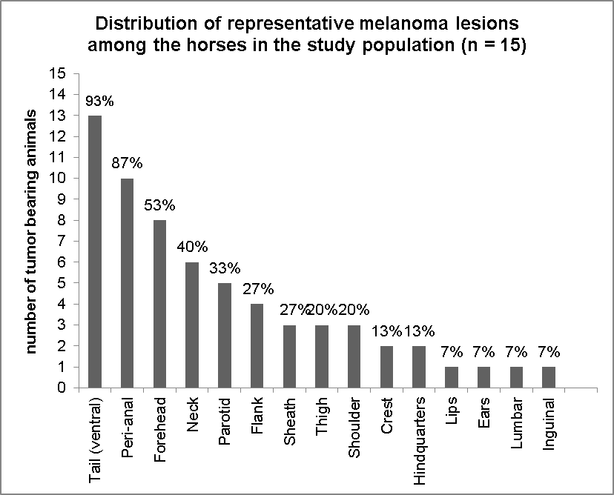
Figure 6.1. Tumor distribution in the study population.

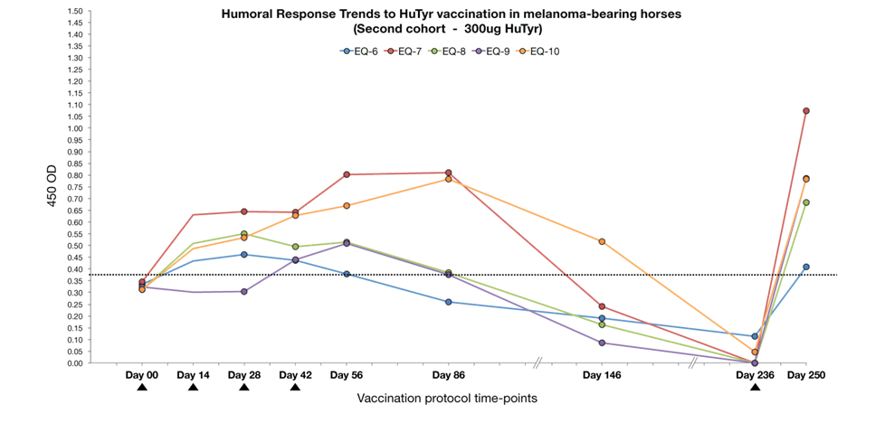
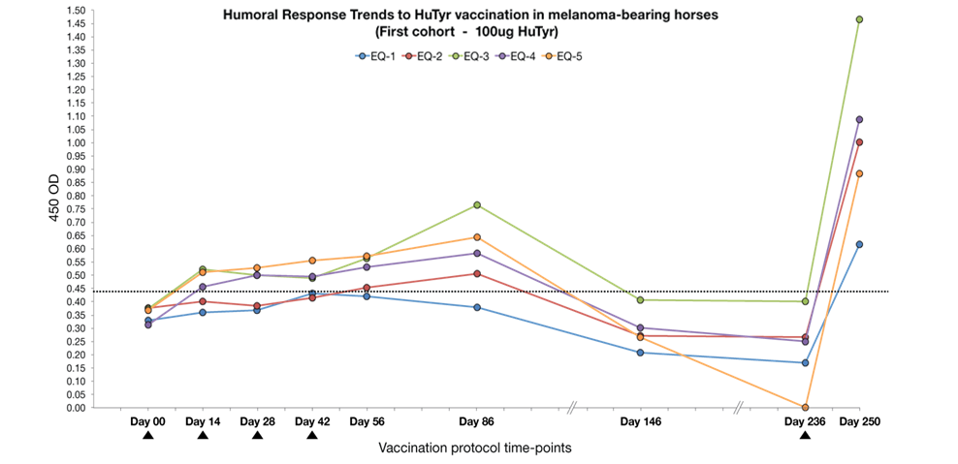
A
B
Figure 6.2. Humoral immune response trends through time in horses treated with HuTyr vaccine. (A) IgG humoral response trends at 1:20 dilutions for horses in the Low Dose cohort. The positivity threshold, above which values are consider positive for the induction of a significant specific immune response was set at an OD450= 0.438, and is denoted by a dashed line. (B) IgG humoral response trends at 1:20 dilutions for horses in the High Dose cohort. The positivity threshold was set at an OD450= 0.450. Arrows represent actual vaccination days.
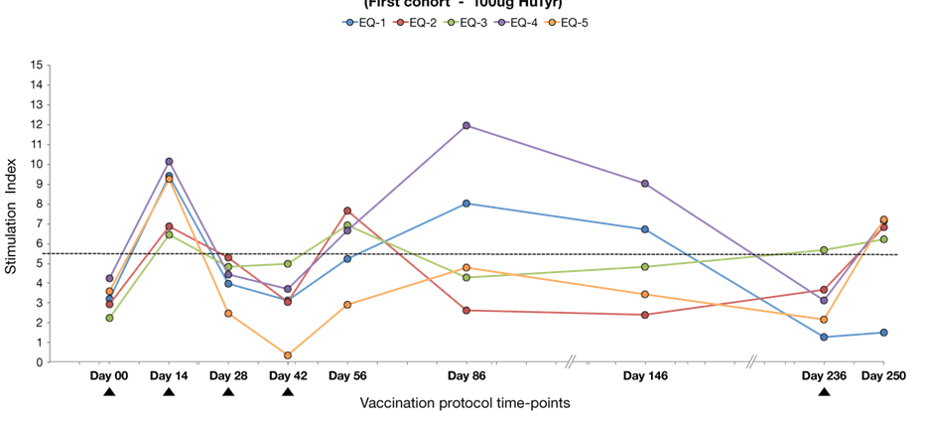
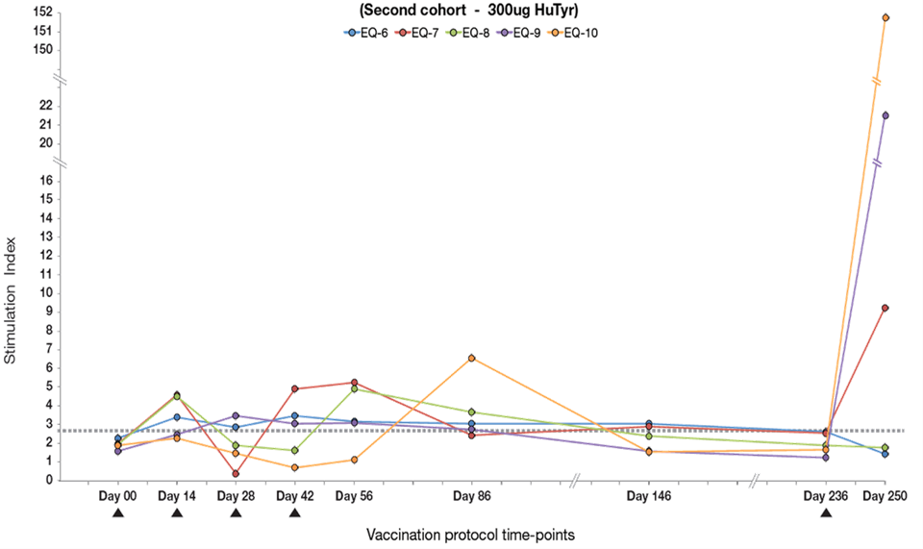

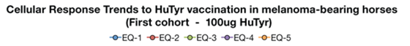
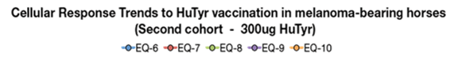
Figure 6.3. Cellular immune response trends through time in horses treated with HuTyr vaccine. (A) TyrSI cellular respond trends for horses in the Low Dose cohort. The positivity threshold, above which values are consider positive for the induction of a significant specific immune response was set at a TyrSI = 5.5, and is denoted by a dashed line. (B) TyrSI cellular response trends for horses in the High Dose cohort. The positivity threshold was set at a TyrSI = 2.7. Arrows represent actual vaccination days.
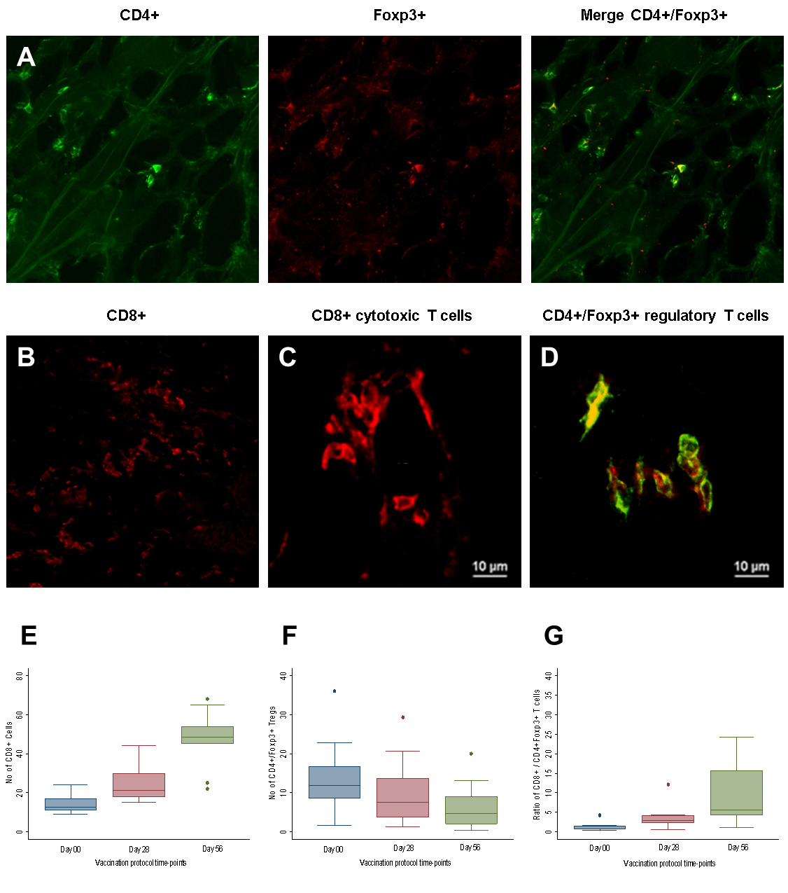
Figure 6.4. (A-D) Characterization of equine tumor infiltrating lymphocytes by single a double staining immunofluorescence and confocal microscopy. (A) Left and middle, results of simple immunofluorescence acquisition with each individual antibody (CD4+ green cell surface staining pattern, Foxp3+ red intracellular pattern); right, double immunofluorescence acquisition with yellow staining representing antibody co-localization (B) Immunofluorescence staining using the equine CD4+ antibody (red) showing characteristic cell surface staining pattern.(C) High magnification of typical CD8+ Cytotoxic T cells (630x) (D) High magnification of typical CD4+/Foxp3+ regulatory T cells (630x). (E-G) Box plots showing changes during HuTyr vaccination treatment in the population numbers of intratumoral CD8+ cytotoxic and CD4+/FOXP3+ regulatory T cells, as well as in the ratio between this two TIL populations. The box shows the 25th to 75th percentile, the horizontal line represents the median; the whiskers extend to the 10th and 90th percentiles, and the individual circles represent outliers.
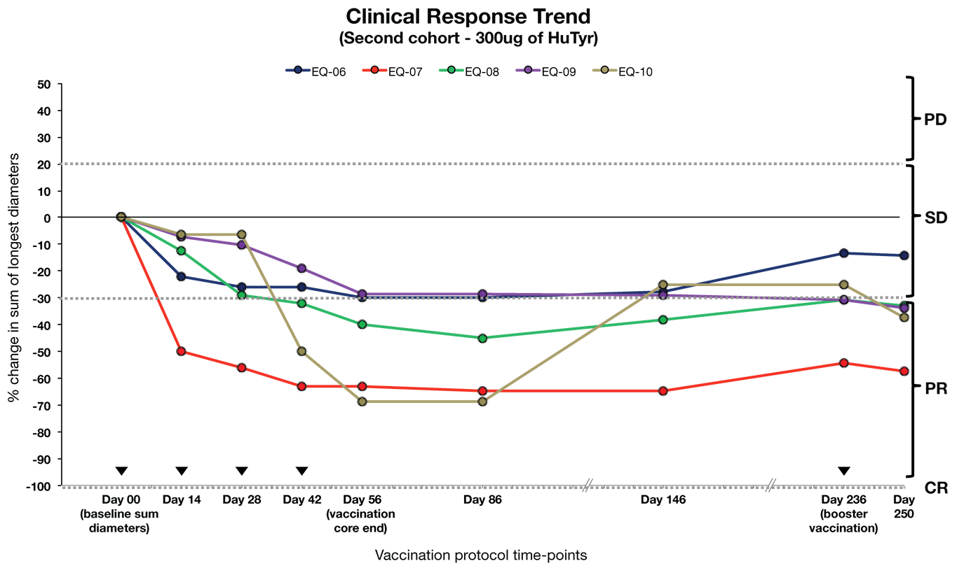
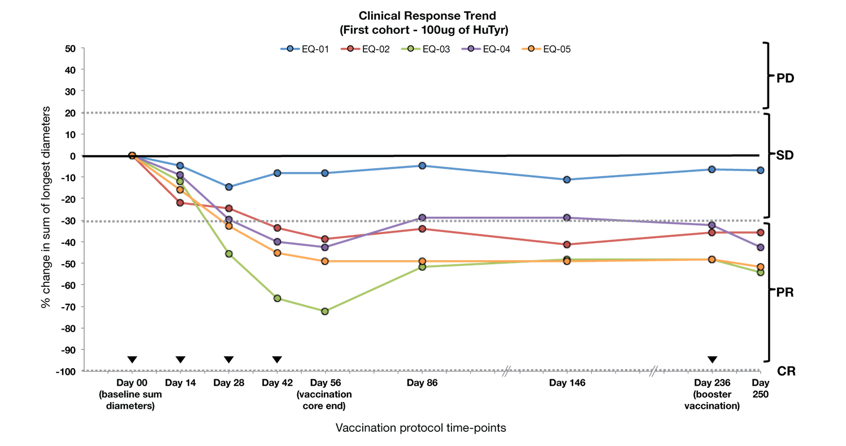

Figure 6.5. Changes in melanoma tumor burden during HuTyr vaccine treatment, expressed as percentage changes in the sum of the longest diameters of target lesions for Low Dose (A) and High Dose (B) cohorts. Higher horizontal dotted line, set at 20% increase over baseline tumor measurements, represents the limit between stable disease (SD) and progressive disease (SD); while dotted line set at -30% decrease below baseline represents the limit between SD and partial response (PR), according to a modified RECIST criteria. Arrows indicate actual vaccination points.
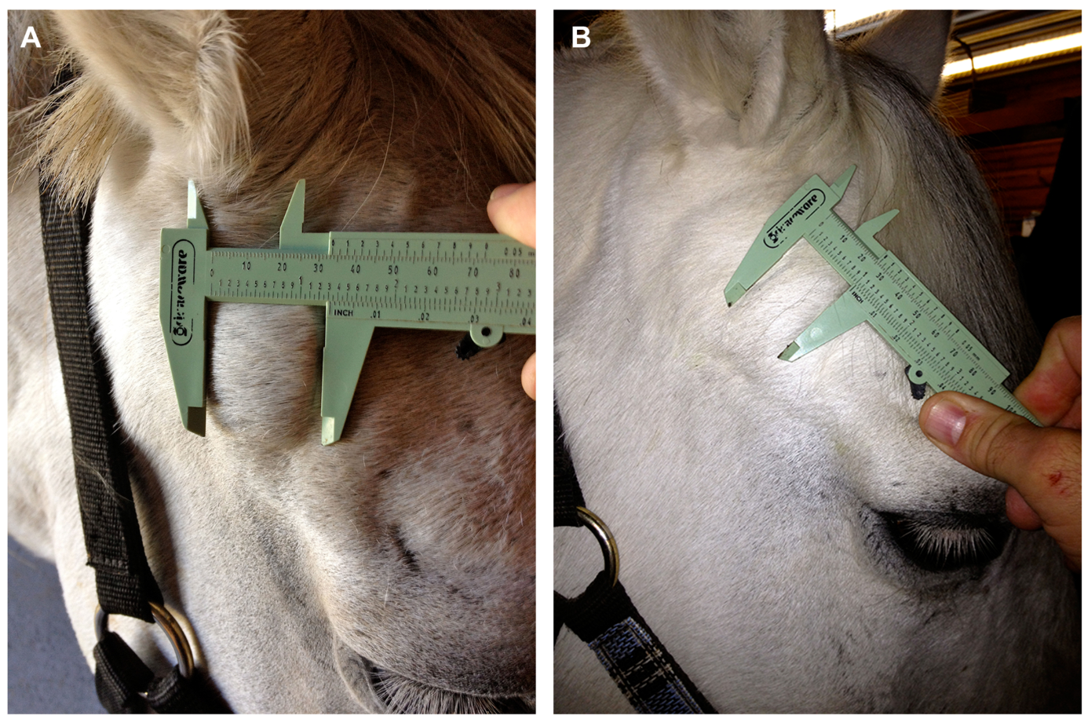
Figure 6.6. Example of clinical response during treatment. Dermal melanoma being treated with the Oncept melanoma vaccine (Merial, Ltd, Athens, GA). (A) Tumor before treatment. (B) Results after treatment with four doses of vaccine, note reduction in tumor size and volume (tumor appears significantly flatter also).

: Final Discussion and Conclusions

Final Discussion and Conclusions

Tyrosinase, a glycoprotein essential for melanin synthesis, and the target antigen used in the anti-cancer vaccine evaluated herein, is significantly overexpressed in equine melanoma tissue in comparison to normal equine skin tissue; this provides “proof of target” for the use of anti-melanoma vaccines targeting this antigen in this species
The VitaJet-3 needle free injector was identified as the optimal device for delivering a plasmid DNA vector such as the pING/tyrosinase into the muscle tissue of horses. The pectoral muscles were identified as the optimal (for the horse and the operator) vaccination site using the VitaJet-3 needle free injector in the horse. Clipping the hair at the vaccination site prior to vaccination does not appear to be necessary for adequate vaccine deposition; however it does improve visualization of the site and it is highly recommended (especially in horses with thicker coats).
This plasmid based xenogeneic DNA vaccine was able to induce significant tyrsosinase specific immune responses (both cellular and humoral) in healthy horses, as well as tumor-bearing equine patients. Increases in dose, however, do not appear to have a significant impact on response, either immunological or clinical (at least as far as with the dosages used in this study); this correlates with what has been reported for similar human studies using DNA vaccines to treat cancer. Although evaluating clinical response was not the primary objective of this study, vaccine administration was associated with measurable tumor burden reductions in treated patients.
This xenogeneic DNA vaccine appears to be safe and well tolerated in horses, based on over 150 vaccinations performed in these preclinical studies, and the very low incidence of observed adverse events and the absence of signs of systemic of toxicity.
Future steps should include the implementation of larger studies with this immunotherapeutic (small sample size constituted an important limitation of the studies presented herein), as well as to continue the follow up of the patients already enrolled in this study. Most importantly, future projects should include the search for new strategies to improve the effectiveness of this vaccine (both in intensity and duration of response). Among these strategies, some that merit further investigation are “prime/boosting” vaccination (using xenogeneic followed by syngeneic vaccination), the evaluation of new delivery vectors (e.g., viral vectors), and the co-expression of more than one transgene immune target into an existent plasmid vector (e.g., more than TAA per vector and/or the inclusion of adjuvant transgene sequences, such as of GM-CSF or IL-2 or IL-12).
Finally, the information produced in this project will be useful to the owners of horses at risk or diagnosed with melanomas. Demonstration of immunoreactivity of this vaccine will also be useful to veterinarians who are treating horses with melanomas by providing additional therapeutic options for their patients. At the same time the general approach and methodology taken in this study could be applied to the design and evaluation of new tumor-antigen based immunotherapeutics for the treatment of different cancers, not only in the horse but in other veterinary species as well.

VITA
Luis Miguel Lembcke Perez-Prieto was born, first son of Mr. Luis Lembcke Diez and Mrs. Cristina Perez-Prieto, on May 19th 1981 in the capital city of Lima, Peru. In March 2003, Luis enrolled at the College of Veterinary Medicine at the Cientifica del Sur University in Lima Peru; and in 2008 he graduated with honors with the degree of Doctor in Veterinary Medicine and Animal Husbandry. During his studies at the mentioned educational institution Luis was inducted as one of two students allowed to be members of the Interdisciplinary Cancer Research Group; he also took responsibilities as a teaching assistant in the courses of Pathology, Biophysics, Anesthesia & Analgesia and Internal Medicine. After graduating Luis pursued further training in veterinary medicine by undertaking several externships at the veterinary teaching hospitals of the Ohio State University and The University of Tennessee, and The Animal Medical Center in New York. Moreover, he also pursued to further his training in cancer research by taking on an internship position at the Cancer Genetics Laboratory at the National Institute of Neoplastic Diseases and the and Molecular Biology Laboratory of the National Molecular Biology Institute in Lima-Peru.
In the summer of 2009, Luis was admitted as a Ph.D. student in Comparative and Experimental Medicine at the University of Tennessee under the supervision of Dr. Jeffrey Phillips. He presented their work in several local and national symposiums and conferences throughout his program. He was also inducted in several honor societies, including: The Agricultural Honor Society of The University of Tennessee, The Veterinary Honor Society of Phi Zeta. On November 2013, he received his doctoral degree with a dissertation entitled “Safety and Immunoreactivity of a DNA plasmid Vaccine encoding Human Tyrosinase in Melanoma-Bearing Horses.”

