Adaptive Control for Power System Voltage and Frequency Regulation

A Dissertation Presented for the
Doctor of Philosophy
Degree
The University of Tennessee, Knoxville

Yao Xu
November 2014
DEDICATION

I dedicate my work to my beloved parents, my dear husband Quan Yuan, and my so loved son Elvis Xu Yuan.

ACKNOWLEDGEMENTS

First and the foremost, I would like to thank my advisor, Dr. Fangxing Li, for his continuous guidance and support for this and all other research and course works during my PhD study at the University of Tennessee.
I would also appreciate my committee members: Dr. Leon Tolbert, Dr. Kevin Tomsovic, Dr. Mingzhou Jin for their precious time and valuable comments on my work. In addition, I want to thank all students in UT CURENT Lab, including the former alumni from the UT Power Lab. Their efforts and help make my research life colorful here.
Last but not the least, I am greatly indebted to my parents and my husband, for their unconditional love and support which made it possible for me to finish this work.

ABSTRACT
Variable and uncertain wind power output introduces new challenges to power system voltage and frequency stability. To guarantee the safe and stable operation of power system, the control for voltage and frequency regulation is studied in this work.
Static Synchronous Compensator (STATCOM) can provide fast and efficient reactive power support to maintain power system voltage stability. In the literature, various STATCOM control methods have been discussed including many applications of proportional–integral (PI) controllers. However, these previous works obtain the PI gains via a trial and error approach or extensive studies with a tradeoff of performance and applicability. Hence, control parameters for the optimal performance at a given operating point may not be effective at a different operating point. To improve, this work proposes a new control model based on adaptive PI control, which can self-adjust the control gains during disturbance such that the performance always matches a desired response, regardless of the change of operating condition. Moreover, a new method, called the flatness-based adaptive control, for STATCOM voltage regulation is also proposed. The simulation results show that the STATCOM with proposed control methods has consistent excellence response under various operating conditions.
Except the voltage stability, frequency stability is also very important for power system stability. Automatic generation control (AGC) is used to maintain power system frequency stability in power system. Various control methods have been discussed in order to design control gains and obtain a good frequency response performance. However, the control gains obtained by existing control methods are usually fixed and designed for specific scenarios in the studied power system. The desired response may not be obtained when variable wind power is integrated into power systems. To address these challenges, a dynamic gain tuning control (DGTC) for AGC is proposed. By the proposed control method, PI control gains can be dynamically self-adjusted to reach the desired performance. The simulation results show that the proposed control provides better AGC response with less deviation of system frequency and tie line flow under variable wind power.

TABLE OF CONTENTS
CHAPTER 1 Introduction and General Information 1
1.1. Power System Stability 1
1.1.1 Definitions and Classification of Power System Stability 1
1.1.2 Voltage Stability 3
1.1.3 Frequency Stability 4
1.2. Power system voltage and frequency regulation 5
1.1.4 Power system voltage regulation 5
1.1.5 Power system Frequency Regulation 6
1.3. Contribution of this Work 8
1.4. Organizations of the Dissertation 11
CHAPTER 2 Literature Review 13
2.1. Chapter Introduction 13
2.2. Voltage Control of STATCOM Review 13
2.2.1. Linear quadratic regular (LQR) control 14
2.2.2. Fuzzy PI control method 15
2.2.3. Flatness based control 17
2.2.4. Adaptive control by previous work 19
2.2.5. Summary 21
2.3. Frequency Control of AGC Review 21
2.3.1 Differential Evolution 23
2.3.2 Particle swarm optimization 25
2.3.3 Bacteria forging scheme 27
2.3.4 Decentralized Sliding Mode Load Frequency Control 29
2.3.5 Summary 30
2.4. Scope of this Work 31
CHAPTER 3 Adaptive PI Control of STATCOM 34
3.1. Chapter Introduction 34
3.2. STATCOM Model and Control 34
3.2.1. System Configuration 34
3.2.2. STATCOM Dynamic Model 35
3.3. Adaptive PI Control for STATCOM 37
3.4.1. Concept of the proposed adaptive PI control method 37
3.4.2. Derivation of the key equations 40
3.4.3. Flow charts of the adaptive PI control procedure 43
3.4. Simulation Results 45
3.4.1. System Data 45
3.4.2. Response of the original model 47
3.4.3. Change of Kp and Ki 50
3.4.4. Change of Load 53
3.4.5. Change of Transmission Network 56
3.4.6. Two consecutive disturbances 59
3.4.7. A Severe Disturbance 61
3.5. Conclusions 63
CHAPTER 4 Flatness-based adaptive control of STATCOM 64
4.1. Chapter Introduction 64
4.2. STATCOM Model and Control for Flatness based Adaptive Control 64
4.3. Flatness-Based Control for STATCOM 67
4.3.1. Flatness-based Control Design for STATCOM 67
4.3.2. Flat Output 68
4.4. Control Law for Flatness-based Adaptive Control 69
4.5. Simulation Results 73
4.5.1. System data 73
4.5.2. Change of Reactive Load 74
4.5.3. Change of Transmission Network 77
4.5.4. Change of Transmission Network and Load 81
4.6. Conclusions 85
CHAPTER 5 Adaptive Gain-Tuning Control Method for AGC with Effects of Wind Resources 86
5.1. Chapter Introduction 86
5.2. AGC Model and Control 86
5.3. Gain Design for AGC 89
5.5.1. Initial gains setting 89
5.5.2. Control gain design during the disturbance 90
5.5.3. Flow Chart 91
5.4. Wind Power Model 93
5.5. Simulation Results 94
5.5.1. Studied System 94
5.5.2. Integrated Wind Power in Areas 1 and 3 97
5.5.3. Integrated Wind Power in Areas 1 and 2 100
5.5.4. Integrate Wind Power in All Areas 103
5.6. Conclusions 106
CHAPTER 6 CONCLUSIONS AND RECOMMENDATIONS 107
6.1. Summary of Contributions 107
6.2. Future Works 108
6.2.1. Develop the general used control method 108
6.2.2. Tested in the hardware testbed 109
APPENDIX 120
Publications: 121
VITA 122

LIST OF TABLES

Table 4.1 Performance comparison for change of reactive load 75
Table 4.2 Performance comparison for change of transmission network 80
Table 4.3 Performance comparison for change of transmission network and load. 82
Table 5.1 System Parameters 95
Table 5.2 Wind Speed Data 96
Table 5.3 Initial PI control gains 97

LIST OF FIGURES
Figure 1.1 Electricity generation by fuel, 1990-2040 (trillion kilowatt hours) [1] 2
Figure 1.2 Classification of power system stability 3
Figure 2.1 Direct-Output-Voltage with Fuzzy Control 16
Figure 2.2 Membership functions of fuzzy variables 16
Figure 2.3 Flatness based control block 19
Figure 2.4 Adaptive control of the voltage regulation 20
Figure 2.5 Adaptive control of the voltage regulation 24
Figure 2.6 The flowchart of the standard PSO algorithm 25
Figure 2.7 Flow chart for bacterial foraging algorithm 29
Figure 3.1 Equivalent circuit of STATCOM. 34
Figure 3.2. Traditional STATCOM PI control block diagram. 37
Figure 3.3 Adaptive PI control block for STATCOM. 39
Figure 3.4 Reference voltage curve. 39
Figure 3.5 Adaptive PI control algorithm flow chart. 44
Figure 3.6 The studied system. 47
Figure 3.7 Results of the voltages using the same network and loads. 48
Figure 3.8 Results of the output reactive power using the same network and loads. 49
Figure 3.9 Results of a using the same network and loads. 49
Figure 3.10 Voltages with changed K_{p} and K_{i} in the original control. 52
Figure 3.11 Output reactive power with changed K_{p} and K_{i} in the original control. 52
Figure 3.12 Results of α with changed K_{p} and K_{i} in the original control. 53
Figure 3.13 Results of measured voltage with change of load. 54
Figure 3.14 Results of output reactive power with change of load. 55
Figure 3.15 Results of α with change of load. 55
Figure 3.16 Results of measured voltage with change of transmission network. 57
Figure 3.17 Results of output reactive power with change of transmission network. 58
Figure 3.18 Results of α with change of transmission network. 58
Figure 3.19 Results of measured voltage in two consecutive disturbances. 59
Figure 3.20 Results of output reactive power in two consecutive disturbances. 60
Figure 3.21 Results of α in two consecutive disturbances. 60
Figure 3.22 Results of measured voltage in a severe disturbance. 61
Figure 3.23 Results of output reactive power in a severe disturbance. 62
Figure 3.24 Results of α in a severe disturbance. 62
Figure 4.1 STATCOM Model. 65
Figure 4.2 A typical double-loop control block of STATCOM 66
Figure 4.3 Flatness-based control block 68
Figure 4.4 Implementation of the adaptive control module 72
Figure 4.5 The test system for simulation study 73
Figure 4.6 Results of V with change of Rs and Ls 75
Figure 4.7 Results of Q with change of Rs and Ls 76
Figure 4.8 Results of I_{d} with change of Rs and Ls 76
Figure 4.9 Results of I_{q} with change of Rs and Ls 77
Figure 4.10 Results of V with change of transmission network. 78
Figure 4.11Results of Q with change of transmission network. 78
Figure 4.12 Results of I_{d} with change of transmission network. 79
Figure 4.13 Results of I_{q} with change of transmission network. 79
Figure 4.14 Results of V with extended simulation time 80
Figure 4.15 Results of V with change of load. 83
Figure 4.16 Results of Q with change of load. 83
Figure 4.17 Results of I_{d} with change of load. 84
Figure 4.18 Results of I_{q} with change of load. 84
Figure 4.19 Results of V with extended simulation time 85
Figure 5.1 Three-area power system 87
Figure 5.2 AGTC block for area i 88
Figure 5.3 DGTC algorithm flow chart. 92
Figure 5.4 IEEE 39 bus system 95
Figure 5.5 Wind Power Profile 97
Figure 5.6 Results of frequency deviation 98
Figure 5.7 Results of tie power deviation 98
Figure 5.8 Results of K_{P} 99
Figure 5.9 Results of K_{I} 99
Figure 5.10 Results of frequency deviation 101
Figure 5.11 Results of tie power deviation 101
Figure 5.12 Results of K_{P} 102
Figure 5.13 Results of K_{I} 103
Figure 5.14 Results of frequency deviation 104
Figure 5.15 Results of tie power deviation 104
Figure 5.16 Results of K_{P} 105
Figure 5.17 Results of K_{I} 105

Introduction and General Information

Power System Stability

Definitions and Classification of Power System Stability
The renewable energy resources have been significantly increased in power system recently. Renewable energy provides 19% of electricity generation worldwide. Renewable power generators are spread across many countries [1]. The report on annual energy outlook in [2] shown in Figure 1.1 points out that the share of U.S. electricity generation from renewable sources (including conventional hydropower) grew from 9% in 2000 to 12% in 2012, and will continually grow to 16% in 2040. Unfortunately, renewable energy, especially wind, tends to be variable and uncertain because the wind depends on natural and meteorological conditions [3-4], which introduces lots of new challenges for power system frequency stability. For example, voltage stability, frequency stability and inter-area oscillations have become greater concerns than before. Therefore, it is very necessary to give the specific definition and classification of power system stability.
Based on the literature [3-4], the precise definitions of stability are shown as follows. “Power system stability is the ability of an electric power system, for a given initial operating condition, to regain a state of operating equilibrium after being subjected to a physical disturbance, with most system variables bounded so that practically the entire system remains intact”.

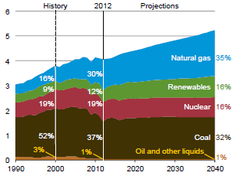
Figure 1.1 Electricity generation by fuel, 1990-2040 (trillion kilowatt hours) [1]
The power system is a highly nonlinear system. Operation conditions such as loads, generator outputs, key operating parameters, etc. are continually changing. Therefore, lots of small and large disturbances are occurred in power systems from time to time. An unstable system condition will lead to outages and shutdown of the power system. Therefore, power systems must be able to keep stable in the changing load and other small disturbances. Also, power systems have to be able to survive numerous disturbances of a severe nature, such as a short circuit on a transmission line or loss of a large generator [3-4].
Based on the physical nature of the resulting mode of instability, the size of the disturbance and the devices, processes and the time span, the power system stability can be classified as rotor angle stability, voltage stability and frequency stability. The detail classifications are shown in Figure 1.1[3-4].
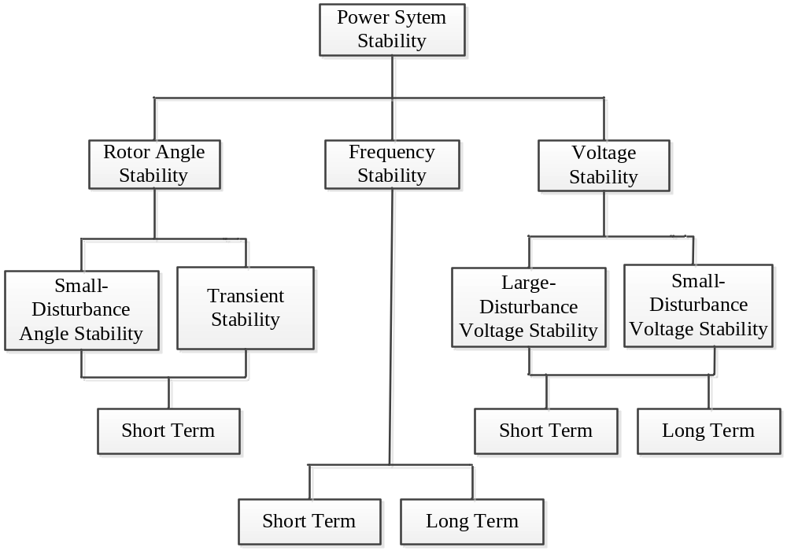
Figure 1.2 Classification of power system stability
In this work, the voltage and frequency regulation will be focused. Therefore, only voltage stability and frequency stability will be discussed here.

Voltage Stability
Voltage stability is the ability of a power system to remain steady voltages at all buses in the power system when subjected to a disturbance from a given initial operating condition. The capability to maintain the equilibrium between the load demand and supply in power systems will determine the voltage stability. Voltage instability will result in loss of load in some areas, tripping of transmission lines and other elements by the protective systems and also can lead to cascading outages. The voltage stability can be divided as the following two categories [3-4]:
- Large-disturbance voltage stability: is an ability of power system to maintain steady voltages when the severe disturbances such as system faults, loss of the generations or circuit contingencies occurred in power system. Large-disturbance voltage stability is determined by the system and load characteristics and the corresponding controls and protections. The study period of large disturbance voltage stability may extend from a few seconds to tens of minutes.
- Small-disturbance voltage stability: is an ability of power system to maintain steady voltages when the small disturbances such as incremental changes in system load occurred in power system. Small-disturbance voltage stability is affected by the characteristics of loads, controls at a given instant of time.
As discussed above, the time frame of interest for voltage stability problems may vary from a few seconds to tens of minutes. Therefore, voltage stability may be either a short-term or a long-term phenomenon as shown in Figure 1.1.

Frequency Stability
Frequency stability is an ability of power system to maintain steady frequency when there is a significant imbalance between generation and load. Frequency stability depends on the ability to maintain equilibrium between system generation and load, with minimum unintentional loss of load.
Frequency deviations are caused by a mismatch between power supply and demand on power network. If the power system supply is insufficient to meet the demand, the power system frequency will decrease; if the power system supply exceeds the demand, the system frequency will increase. Small power mismatches will result in small frequency deviations, which can be easily handled. However, large frequency deviations will be the problems leading to equipment damage and even blackouts. Frequency instability will result in frequency swings and generating units and loads tripping. During frequency excursions, the characteristic times of the processes and devices that are activated will range from fraction of seconds to several minutes. Therefore, as identified in Figure 1.1, frequency stability could be a short-term phenomenon or a long-term phenomenon [5].

Power system voltage and frequency regulation
Power system is a large and complex interconnected network which consists of thousands of buses and hundreds of generators. With increasing need for electrical energy, new installations of power generating stations and transmission lines are required and also the existing infrastructures operations are extended to their limits. The installation of new lines and generations imposes many environmental and economic constraints [7]. Moreover, renewable energies such as wind energy and PV sources are widely installed in power systems recently, which make the power system much more unstable than in the past. As a result, power systems are easily lost stability by the disturbances. It was found that the voltage and frequency instability are the main reasons for the recent North American blackout in August 2003 [7]. In this section, the general concept of voltage and frequency regulation will be discussed.

Power system voltage regulation
If power voltage becomes unstable, the system voltage will be decreased to a very low level which is unacceptable and is impossible to be recovered. Then, the interruption of the power supply will be occurred in power systems. Therefore, voltage regulation or reactive compensation is an important subject in power system. Also, it is the utilities’ responsibility to keep the customer voltage within specified tolerances [6]. The only way to regulate system voltage is to reduce the reactive power load or install the reactive generation devices at the weak voltage points in power systems to increase the voltage at these points [7].
The recent development and use of Flexible Alternating Current Transmission Systems (FACTS) in power system has led to many applications such as Thyristor Controlled Series Compensator (TCSC), Static Synchronous Series Compensator (SSSC), Static VAR Compensator (SVC) and Static Synchronous Compensator (STATCOM) [7]. These devices are not only able to improve the voltage stability but also are able to provide flexible operation capabilities. However, with the development of industry and economy, the demands of lower power losses, faster response to system parameter change, and higher stability of system have become increasing importance, STATCOMs are becoming the most population device for voltage regulation because of their constant current characteristics when the voltage is low/high over the limits,
STATCOM is a power electronic based synchronous voltage generator that generates a three-phase voltage from a dc capacitor. By controlling the magnitude of the STATCOM voltage, the reactive power exchanges between the STATCOM and the transmission line and hence the amount of shunt compensation in the power system can be controlled [8-9]. Therefore, the system voltage will be kept in the allowable range. In this work, the control of STATCOM will be studied.

Power system Frequency Regulation
The imbalance between the generation and the load will degrade power system performance and sometimes will make power system unstable. The power system frequency is sensitive to power system loads and losses [10, 11]. In an interconnected power system, area load changes and abnormal disturbances will lead to mismatches in frequency and scheduled power interchanges between areas. These mismatches can be corrected by Load Frequency Control (LFC) [10]. LFC, a very important component in power system operation and control, is designed to minimize the deviations in frequency and tie-line power and reduce steady-state errors to zero when there is a disturbance in power systems. Thus, LFC is essential for supplying sufficient and reliable electric power [12, 13].
In power system, LFC can be divided to three levels [14, 15]:
- Primary control is a local automatic control that adjusts the active power generation of the generators and the consumption of controllable loads to restore the balance between the load and the generation and eliminate frequency variations. Primary control is indispensable for the stability of the power system, and is performed by the speed governors of the dedicated power generation units. With primary control, if a variation in power system frequency is greater than the dead band of the speed governor, a change in unit’s generation will be occur. At this time, generators are required to participate in the control by setting the droop according to specifications by the TSO (Transmission System Operator). Transient time for primary control is around seconds.
- Secondary control is a centralized automatic control that adjusts the active power production of the generators to restore the frequency and the interchanges with other systems to their target values. In other words, if primary control can not stop frequency excursions, secondary control will bring the frequency back to its target value usually set as 60Hz in USA. Contrary to primary frequency control, frequency secondary control is not indispensable. Frequency control is thus not implemented in some power systems where the frequency is regulated using only automatic primary and manual tertiary control. However, secondary frequency control is used in all large interconnected systems because manual control does not remove overloads on the tie lines quickly enough. Within the UCTE, secondary frequency control is also called load-frequency control (LFC), while the term automatic generation control (AGC) is preferred in North America. Transient time for secondary control is in the order of minutes.
- Tertiary control is to manual changes in the dispatching and commitment of generators. Tertiary control is used to restore the primary and secondary frequency control reserves, to manage congestions in the transmission network, and to bring the frequency and the interchanges back to their target value when the secondary control is unable to perform this last task.
In this work, the control of AGC will be studied.

Contribution of this Work
In power system, Proportional-integral (PI) controllers have been designed for STATCOM to obtain satisfactory dynamic responses [16]. In traditional PI control methods, the control gains in these controllers are tuned for a case-by-case study or trial-and-error approach. It is a time-consuming job for utility engineers to perform trial-and-error studies to find suitable parameters. Moreover, conventional PI controllers with fixed control gains are designed for one specific operating condition. A fixed controller, optimal in one specific operating condition, may not be suitable in another operation condition and large oscillations may occur in the power system.
The motivation of this work is to propose a control method that can ensure a quick and consistent desired response when the system operation condition varies. In other words, the change of the external condition will not have a negative impact, such as slower response, overshoot, or even instability, to the performance.
Base on this fundamental motivation, an adaptive PI control of STATCOM for voltage regulation is presented in this work. By this adaptive PI control method, the PI control parameters can be self-adjusted automatically and dynamically under different disturbances in a power system. When a disturbance occurs in the system, the PI control parameters for STATCOM can be computed automatically in every sampling time period and can be adjusted in real time to track the reference voltage. Different from other control methods, this method will not be affected by the initial gain settings, changes of system conditions, and the limits of human experience and judgment. This will make the STATCOM a “plug-and-play” device. In addition, this research work demonstrates a fast, dynamic performance of STATCOM in various operating conditions.
Moreover, a flatness-based adaptive control method is also proposed and applied to STATCOM for voltage control in this work. By flatness-based control, the trajectories of all system variables can be directly estimated by flat output and its derivatives without solving differential equations. By adaptive control, the control gains can be dynamically tuned to satisfy the time-varying operation condition requirement. Different from other flatness-based control methods, the proposed control method is robust to various system operating conditions and will not be affected by the limits of human experience and judgment. Even if the system operation condition has a drastic change, the flatness-based adaptive control method can consistently achieve a fast, dynamic performance of STATCOM.
Except the voltage regulation discussed above, the frequency regulation is also very important. In power system, droop control strategies have been proposed in previous AGC study. Although droop control is widely applied for AGC, its limitations should be noted. In one hand, existing droop controllers are designed based on the small signal model of the power transfer mechanisms, the acceptable results for small load variation can be obtained. However, if large load variations occured, the damping active powers required to stabilize the frequency are limited. Therefore, the droop control will make the system more oscillatory, and eventually instable. In the other hand, the droop slopes in droop control are tuned for a case-by-case study or trial-and-error approach. It is a time-consuming job for utility engineers to perform trial-and-error studies to find suitable droop slopes. Moreover, conventional droop controllers with fixed droop slopes are designed for one specific operating condition. A fixed controller, optimal in one specific operating condition, may not be suitable in another operation condition and instability may occur in power system. To solve this problem, the adaptive control of AGC is also proposed. By this control method, the PI control parameters can be automatically and dynamically calculated during different disturbances in a power system. In the proposed method, the initial gains will be calculated first. Then, high penetration of wind energy are integrated in power systems, the PI control parameters for AGC can be computed automatically and can be adjusted in real time based on the area control error (ACE) signal to keep the frequency stable. Moreover, the proposed method will not be affected by changes of the system conditions and the limits of human experience and judgment.

Organizations of the Dissertation
The literature review is given in Chapter 2.
Chapter 3 addresses the challenge of the traditional PI control methods to obtain the optimal response with changeable power system operation conditions. Also, this chapter proposes a new control model based on adaptive PI control, which can self-adjust the control gains during disturbance such that the performance always matches a desired response, regardless of the change of operating condition. Finally, the conventional STATCOM control with tuned, fixed PI gains will be compared with the proposed method in simulation part.
Chapter 4 introduces the flatness based control for STATCOM. Since flatness based control with fixed control gains cannot satisfy the requirement of the changeable power system operation conditions, a new method, called the flatness-based adaptive control, for STATCOM voltage regulation is proposed in this chapter. By this method, the nonlinear STATCOM variables can be easily and exactly controlled by controlling flat output without solving differential equations. Further, the control gains can dynamically self-adjust during the voltage regulation after a disturbance. In the simulation part, the conventional PI control with tuned, fixed PI gains, the flatness based control and the flatness based adaptive control will be compared.
Chapter 5 introduced a dynamic gain-tuning control (DGTC) for AGC with effects of wind resources is presented in this paper. By this control method, the PI control parameters can be automatically and dynamically calculated during different disturbances in a power system. In the proposed method, the initial gains will be calculated first. Then, the wind energy with actual wind speed are integrated in power systems, the PI control parameters for AGC can be computed automatically and can be adjusted in real time based on the area control error (ACE) signal to regulate the system frequency. Moreover, the proposed method will not be affected by changes of the system conditions and the limits of human experience and judgment. The proposed method is tested in an IEEE 39 bus system with wind resources and compared with conventional control approach with well-tuned gains in the simulation. The simulation results show that the proposed control provides better AGC response with less deviation of system frequency and tie line flow under changeable wind power.
In Chapter 6, the conclusion regarding the whole work is given and the future work for the adaptive control is also discussed.

Literature Review

Chapter Introduction
This chapter briefly presents the review of the past and on-going research findings relevant to the control of STATCOM and AGC.

Voltage Control of STATCOM Review
Voltage regulation is a critical consideration in improving the security and reliability of power systems. The Static Compensator (STATCOM), a popular device for reactive power control based on gate turn-off (GTO) thyristors, has gained much interest in the last decade for improving power system stability [17].
In the past, various control methods have been proposed for STATCOM control. For instance, nonlinear optimal control to STATCOM is introduced in [18-20]. A synchronous frame voltage regulator is presented in [21] to control system voltage by using separate regulation loops for positive and negative sequence components of the voltage. PI structures with feed forward are proposed in [22] to improve STATCOM performance. A STATCOM damping controller is introduced in [23-24] to offset the negative damping effect and to enhance system oscillation stability. A modified non-linear damping controller is presented in [25] to provide an improved transient performance over the whole operating range. These previous works mainly focus on the control design rather than exploring how to set PI control gains.
In many STATCOM models, the control logic is implemented with the Proportional-integral (PI) controllers. The control parameters or gains play a key factor in STATCOM performance. Presently, few studies have been carried out in the control parameter settings. In the previous research works [26-28], the PI controller gains are designed in a case-by-case study or trial-and-error approach with tradeoffs in performance and efficiency. Generally speaking, it is not feasible for utility engineers to perform trial-and-error studies to find suitable parameters when a new STATCOM is connected to a system. Further, even if the control gains have been tuned to fit the projected scenarios, performance may be disappointing when a considerable change of the system conditions occurs, such as, when a line is upgraded or retires from service [29-30]. The situation can be even worse if such transmission topology change is due to a contingency. Thus, the STATCOM control system may not perform well when mostly needed.
A few, but limited previous works in the literature discussed the STATCOM PI controller gains in order to better enhance voltage stability and to avoid time-consuming tuning. For instance, in [15-17], linear optimal controls based on the linear quadratic regular (LQR) control are proposed. In [18], a new STATCOM state feedback design is introduced based on a zero set concept. In [19-21], a fuzzy PI control method is proposed to tune PI controller gains. In subsection 2.2.1 to 2.2.4, the control methods in existing literatures for control gains tuning will be discussed in detail.

Linear quadratic regular (LQR) control
In [31-33], linear optimal controls based on the linear quadratic regular (LQR) control are proposed. Linear Quadratic Regulator (LQR) is an optimal control method and is also a pole placement method. This method determines the feedback gain matrix that minimizes the cost function in order to achieve the optimal tradeoff between the use of control effort, the magnitude and the speed of response. The detail of this method is shown below.
Assume a linear system:
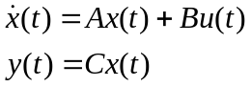 (2.1)
where x(t) is the system’s state, u(t) is the system input and y(t) is the output. In order to design an optimum controller namely u(t)=Kx(t), the performance index function J, selected with regard to the multi-input and multi-output system, is shown as follows:
$J=\int_{0}^{∝}{\left(x^{T}Qx+u^{T}Ru\right)dt}$ (2.2)
where the weighting matrices Q and R are positive semi-definite. By optimizing the given performance index J, the feed-back gain matrix K can be obtained. From the discussion before it is easily found that in the LQR control problem, the effectiveness of the control depends on the choice of the weighting matrices Q and R, thus the optimal parameters may depend on the designer’s experience.

Fuzzy PI control method
In [35-36], a fuzzy PI control method is proposed to tune PI controller gains. The control block is shown in Figure 2.1. In the Figure 2.1, the fuzzy adjustor is used to adjust the parameters of proportional gain K_{P} and integral gain K_{I} based on the error e and the change of error Δe. The control gains are determined by:
$K_{P}=K_{P}^{*}+∆K_{P}$ (2.3)
$K_{I}=K_{I}^{*}+∆K_{I}$ (2.4)
where $K_{P}^{*}$ and $K_{I}^{*}$are the reference values of fuzzy-PI-based controllers. In this paper, $K_{P}^{*}$ and $K_{I}^{*}$ are calculated offline based on the Ziegler–Nichols method.
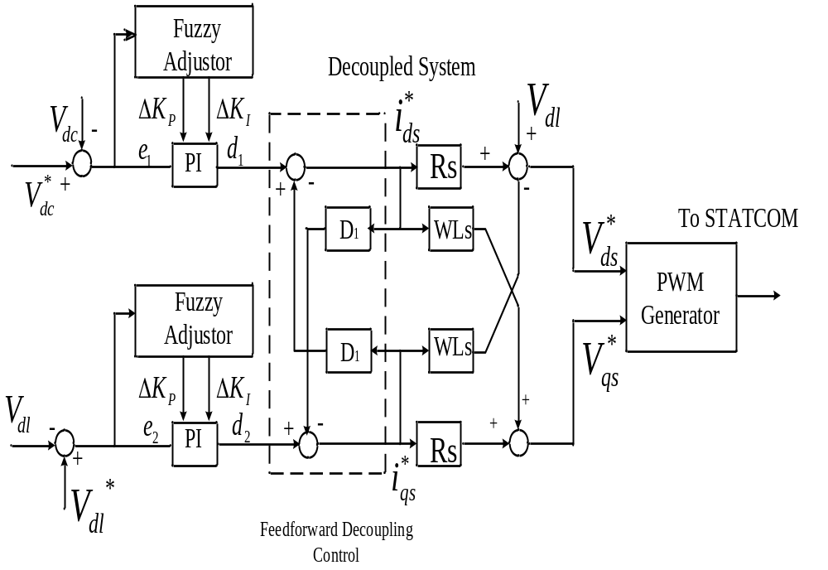Figure 2.1 Direct-Output-Voltage with Fuzzy Control
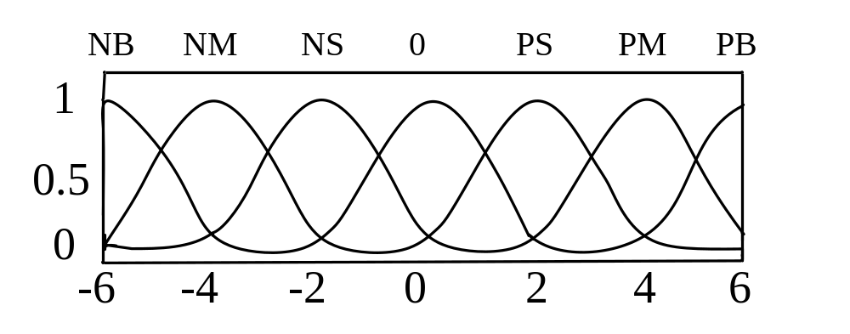Figure 2.2 Membership functions of fuzzy variables
By fuzzy control, numeric values of error e and the change of error Δe need to be translated into a linguistic value with a membership grade. The membership function is shown in Figure 2.2. In the figure, the following seven fuzzy sets are chosen: negative big (NB), negative medium (NM), negative small (NS), zero (ZE), positive small (PS), positive medium (PM), and positive big (PB).
The design process of fuzzy control rules involves defining the rules that relate the input variables to the output model properties. In the [], ΔK_{P} and ΔK_{I} are determined by the following rules:
- For large value of |e|, a large ΔK_{P} is required, and vice versa.
- For e*Δe>0, a large ΔK_{P} is required, and vice versa.
- For the large values of |e| and |Δe|, ΔK_{I} is set to zero, which can avoid control saturation.
- For small value of |e|, ΔK_{I} is effective, and ΔK_{I} is larger when |e| is smaller, which is better to decrease steady-state error.
Therefore, the controller core is the fuzzy control rules which are mainly obtained from intuitive feeling and experience. The fuzzy control method essentially gives “fuzzy” recommendation and it is still up to the designer to choose the actual, deterministic gains. Therefore, again, the designer’s experience may affect the final results.

Flatness based control
Flatness-based control, is proposed and applied in STATCOM [40-42]. Flatness is a mathematical property of a system described by a set of differential equations. With flatness-based control, a nonlinear flat system is equivalent to a linear controllable system, and the trajectories of all system variables can be directly estimated by flat output and its derivatives [43-45]. Flat systems are subset of nonlinear systems; in other words, some nonlinear systems may demonstrate the characteristic of flatness. The flatness feature can be utilized for motion planning, trajectory generation, and stabilization. Theoretically, a flat system could be feedback linearized, which is, however, not a better choice than the flat control approach. Further, flatness is a feature independent of coordinate choice which is critical to the linearization in nonlinear control. That is, choosing a different coordinate system may not convert the nonlinear system to a linear one. However, coordinate choice is irrelevant in flatness-based control [46-47].
Consider a general nonlinear system of the form:
$\dot{x}=f\left(x\right)+g\left(x\right)u$ (2.5)
$x={\left[x_{1}, x_{2},…x_{n}\right]}^{T}$ $xϵR^{n}$ (2.6)
$u={\left[u_{1}, u_{2},…u_{m}\right]}^{T}$ $uϵR^{m}$ (2.7)
where x is the state variable, u is the vector of input variables, and $\left(n, m\right)∈N$. If the state variable x can be parameterized by output y and its derivatives, the system is said to be differentially flat and admits the flat output y=[y₁, y₂ ,…, y_{m}]^{T} [43-45]. Then, the state variables and control variables can be written as follows:
$x=ϕ\left(y,\dot{y},…,y^{\left(β\right)}\right)$ (2.8)
$u=ϕ\left(y,\dot{y},…,y^{\left(β+1\right)}\right)$ (2.9)
where β is the finite numbers of derivative. By this process, a nonlinear flat system can be equivalent to a linear controllable system as described in References [43-45], the control block shown as Figure 2.3.
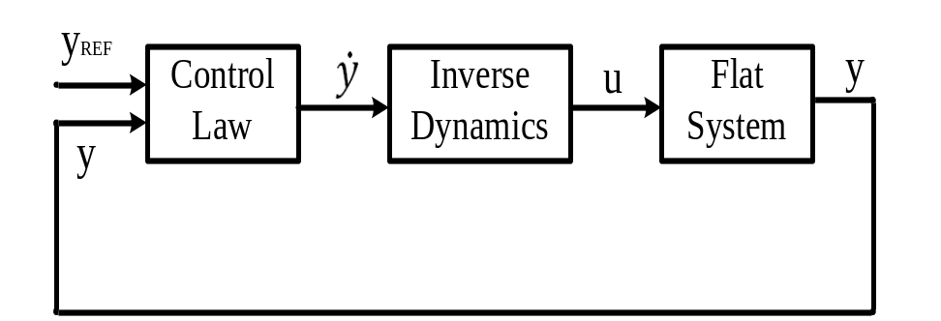
Figure 2.3 Flatness based control block
In the flatness-based control methods [40-42], the control laws are normally designed by the pole-placement method. By this method, the final results will also be affected by the designer’s experiences. Moreover, even if the control gains have been tuned to fit the projected scenarios, it may not perform the same well as initially expected when a considerable change of the system condition occurs such as a transmission line is upgraded or retires from service. The situation can be even worse if such transmission topology change is due to a contingency. Thus, the STATCOM control system may not perform well when mostly needed. Therefore, this issue leads to exploration of an improved flatness based control.

Adaptive control by previous work
In [29-30], adaptive voltage regulation with DERs is proposed. In the paper, an adaptive voltage regulation method is developed with a PI feedback controller. The control diagram is shown in Figure 2.4. The PCC voltage v_{t} (or terminal voltage), is measured and its RMS value V_{t} is calculated. The V_{t} is then compared to the voltage reference $V_{t}^{*}$ (which could be a utility specified voltage schedule and possibly subject to adjustment based on load patterns like daily, seasonally, on-and-off peak, etc.). The error between the actual voltage V_{t} and reference voltage $V_{t}^{*}$ is fed back to adjust the reference compensator output voltage $v_{c}^{*}$, which is the reference for generating pulse-width modulation (PWM) signals to drive the inverter. The compensator output voltage $v_{c}^{*}$ is controlled to regulates V_{t} to the reference $V_{t}^{*}$. The expression for $v_{c}^{*}$ can be obtained by:
$v_{c}^{*}=v_{t}\left(t\right)\left[1+K_{P}\left(V_{t}^{*}\left(t\right)-V_{t}\left(t\right)\right)+K_{I}\int_{0}^{t}{\left(V_{t}^{*}\left(t\right)-V_{t}\left(t\right)\right)dt}\right]$ (2.10)
Based on previous research, if the control gains K_{P} and K_{I} are not chosen appropriately, the system response may be poor and even cause instability. So it is very important to design the control gains. [] proposed an adaptive PI design that can dynamically adjust the PI controller in real-time based on the system behavior and configuration. The proposed adaptive PI control method include three procedures:
- Determine the DC source voltage of the DE.
- Set the initial controller values.
- Adjust the controller parameters according to the real-time system conditions.
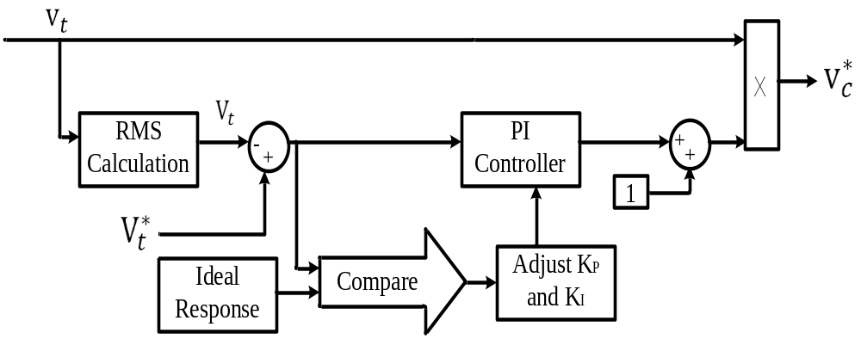
Figure 2.4 Adaptive control of the voltage regulation
From Figure 2.4, in each step, the actual voltage deviation which is the voltage error between the measured voltage and the reference voltage will be compared with the desired voltage deviation which is the voltage error between the defined exponential voltage curve and the reference voltage. The PI control gains will be adjusted based on the scaling factor r_{v}=actual voltage deviation/ideal voltage deviation. However, by this method, the initial control gains are still empirically determined.

Summary
Based on the discussion above, the gains in LQR control depend on the designer’s choice of weighting matrix, the optimal parameters may depend on the designer’s experience. The fuzzy control method essentially gives “fuzzy” recommendation and it is still up to the designer to choose the actual, deterministic gains. Therefore, again, the designer’s experience may affect the final results. The initial control gains choosing of previous adaptive control are still based on the experiences. Therefore, different from these previous works, the motivation of this work is to propose a control method that can ensure a quick and consistent desired response when the system operation condition varies. In other words, the change of the external condition will not have a negative impact, such as slower response, overshoot, or even instability, to the performance.

Frequency Control of AGC Review
The power system frequency is sensitive to power system loads and losses [10, 11]. In an interconnected power system, area load changes and abnormal disturbances will lead to mismatches in frequency and scheduled power interchanges between areas. All generators are equipped with speed governor system, but during sudden and big load change, zero frequency deviation may not be obtained. In this case, the mismatches can be corrected by Load Frequency Control (LFC) or automatic generation control (AGC) [10]. AGC, a very important component in power system operation and control, is designed to minimize the deviations in frequency and tie-line power and reduce steady-state errors to zero when there is a disturbance in power systems. Thus, its implementation is essential for supplying sufficient and reliable electric power [12, 13].
The commonly used technique for LFC [12-13] is based on the Area Control Error (ACE) which is a linear combination of tie line error and frequency deviations. The main objectives of the LFC are to minimize the transient errors of the frequency and tie-line power, and to ensure zero steady-state errors of these quantities. Droop control strategies have been proposed for traditional AGC [10-11]. Since existing droop controllers are designed for small load change, to improve, other classical control methods such as proportional-integral (PI), integral-derivative (ID), proportional-integral-derivative (PID) and integral-double derivative (IDD) controllers is investigated in [48]. The flatness-based controls for automatic generation control (AGC) of a multi-machine system are proposed in [49-50]. However, the control gains in these controllers are designed by trial and error method, which is time consuming. Moreover, the fixed control gains used in these controllers are designed for a specific operation condition, which can not guarantee the optimal control response in changeable power system operation conditions.
In order to obtain a better frequency response, the pole placement method is proposed in literatures [8-9]. Since the gains by this method depend on the designer’s choice of the pole, the optimal parameters may depend on the designer’s experience. Therefore, the designer’s experience may affect the final results. To improve, intelligent controllers are proposed to AGC to obtain fast and good dynamic response for load frequency control. Many intelligent techniques such as genetic algorithm, bacteria foraging, particle swarm optimizations, etc. are being used extensively in isolated as well as interconnected power systems [10-18]. The detail of these previous control methods will be discussed in subsection 2.3.1 to 2.3.5.

Differential Evolution
Differential Evolution (DE) algorithm is a population-based stochastic optimization algorithm. Advantages of DE are: simplicity, efficiency and real coding, easy use, local searching property and speediness. [] proposed the application of differential evolution algorithm in load frequency control for controller parameters tuning. DE works with two populations; old generation and new generation of the same population. The size of the population is adjusted by the parameter N_{P}. The population consists of real valued vectors with dimension D which is equal to the number of design parameters/control variables. The population is randomly initialized within the initial parameter bounds. The optimization process is conducted by means of three main operations: mutation, crossover and selection. In each generation, individuals of the current population become target vectors. For each target vector, the mutation operation produces a mutant vector, by adding the weighted difference between two randomly chosen vectors to a third vector. The crossover operation generates a new vector, called trial vector, by mixing the parameters of the mutant vector with those of the target vector. If the trial vector obtains a better fitness value than the target vector, then the trial vector replaces the target vector in the next generation. The flow chart of the differential evolution is shown as Figure 2.5.
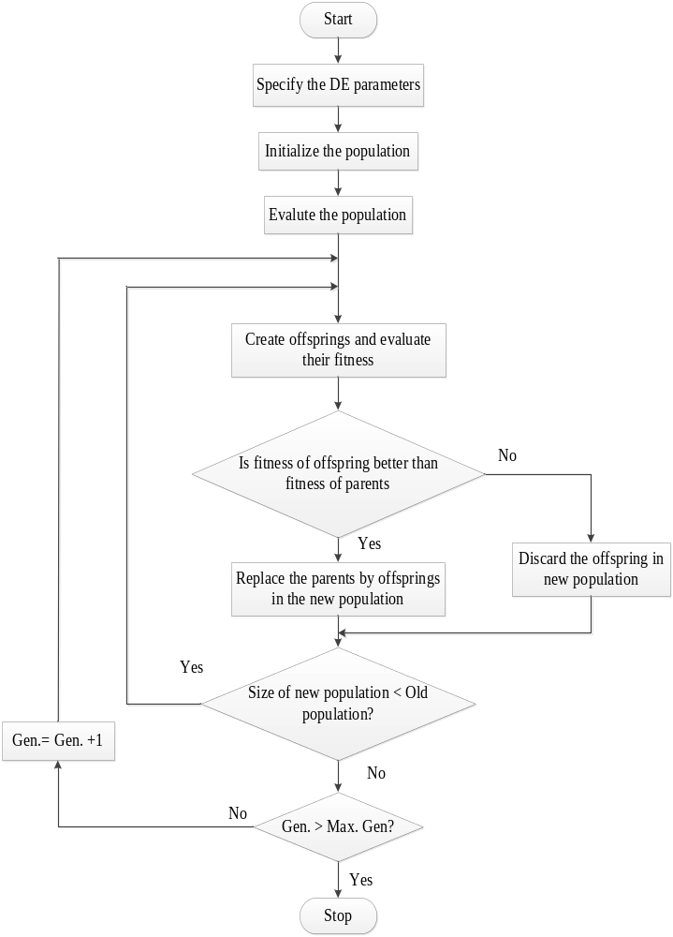
Figure 2.5 Adaptive control of the voltage regulation
Implementation of DE requires the determination of some fundamental issues like: mutation strategy, DE step size function also called scaling factor (F), crossover probability (CR), the number of population (N_{P}), initialization, termination and evaluation function. The success of DE is dependent on setting of control parameters such as population size N_{P}, DE step size F and crossover probability of CR. Therefore, when applying DE, the strategy and control parameters should be carefully chosen for the successful implementation of the algorithm. Usually, the control parameters of DE algorithm are tuned by carrying out multiple runs of algorithm for each control parameter variation.

Particle swarm optimization
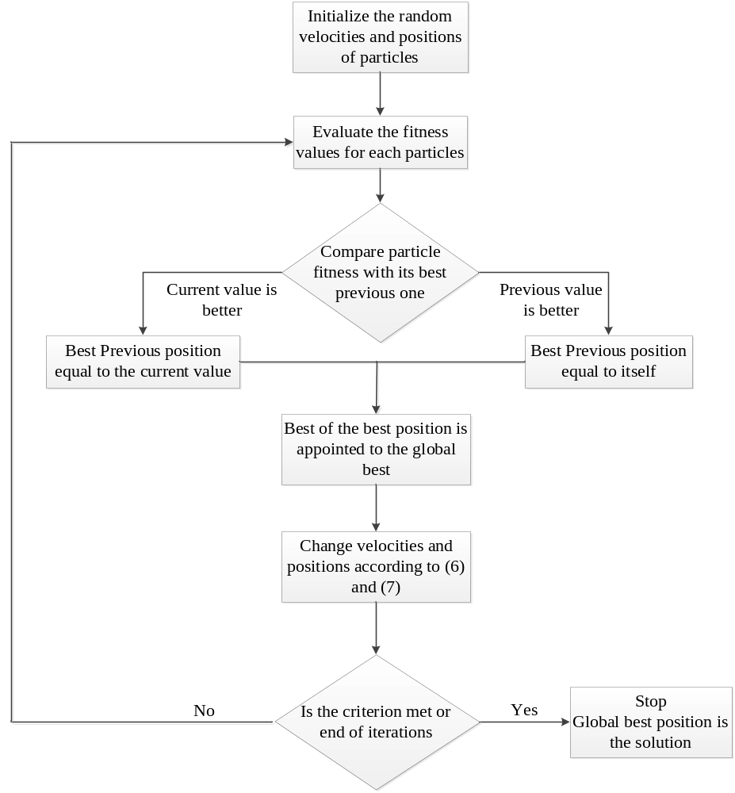
Figure 2.6 The flowchart of the standard PSO algorithm
[] proposed a new gain scheduling PI control strategy for AGC based on particle swarm optimization. Particle swarm optimization is a population based optimization algorithm which can be obtained high quality solutions within shorter calculation time and stable convergence characteristics by PSO than other stochastic methods such as genetic algorithm. PSO uses particles which represent potential solutions of the problem. Each particles fly in search space at a certain velocity which can be adjusted in light of preceding flight experiences. The projected position of i_{th} particle of the swarm x_{i}, and the velocity of this particle v_{i} at (t+1)_{th} iteration are defined and updated as the following two equations:
$v_{i}^{t+1}=v_{i}^{t}+c_{1}r_{1}\left(p_{i}^{t}-x_{i}^{t}\right)+c_{2}r_{2}\left(g_{i}^{t}-x_{i}^{t}\right)$ (2.11)
$x_{i}^{t+1}=x_{i}^{t}+v_{i}^{t+1}$ (2.12)
where i = 1,…, n and n is the size of the swarm, c₁ and c₂ are positive constants, r₁ and r₂ are random numbers which are uniformly distributed in [0, 1], t determines the iteration number, p_{i} represents the best previous position (the position giving the best fitness value) of the i_{th} particle, and g represents the best particle among all the particles in the swarm. At the end of the iterations, the best position of the swarm will be the solution of the problem. It cannot be always possible to get an optimum result of the problem, but the obtained solution will be an optimal one. The flow chart of PSO applied in AGC control is shown in Figure 2.6.
The object of the obtaining optimal solutions of control inputs is taken as an optimization problem, and the proposed PSO algorithm is being used to tune the gains of the controllers and cost function weights w₁, w₂ and w₃. In AGC system, in order to convergence to optimal solution, two different cost functions in (2.13) and (2.14)are derived. While one of the cost functions is derived through the frequency deviations of the control areas and tie-line power changes, the rates of changes in these deviations according to time are used in the other one.
$J=\int_{0}^{t}{t\left[{\left(ω_{1}\frac{d∆f_{1}}{dt}\right)}^{2}+{\left(ω_{2}\frac{d∆f_{2}}{dt}\right)}^{2}+{\left(ω_{3}\frac{d∆P_{tie}}{dt}\right)}^{2}\right]}dt$ (2.13)
$J=\int_{0}^{t}{t\left[{\left(ω_{1}∆f_{1}\right)}^{2}+{\left(ω_{2}∆f_{2}\right)}^{2}+{\left(ω_{3}∆P_{tie}\right)}^{2}\right]}dt$ (2.14)
The proposed PSO algorithm can prevent the swarm from being trapped in local minimum, which would cause a premature convergence and lead to fail in finding the global optimum

Bacteria forging scheme
A recent evolutionary computation technique, called bacteria forging (BF) scheme has been proposed by Passino [14], [15] in which the number of parameters that are used for searching the total solution space is much higher compared to those of GA. To overcome the possibility of being trapped in local minima, in GA only two operations (crossover and mutation) between the chromosomes are adopted. In BF, the foraging (methods of locating, handling, ingesting food) behavior of E.coli bacteria present in our intestine is mimicked. The control system of these bacteria that dictates how foraging should proceed can be subdivided into four sections namely Chemotaxis, Swarming, Reproduction, and Elimination and Dispersal. These operations among the bacteria are used for searching the total solution space. Thus the possibility of avoiding local minimum and achieving faster convergence is higher than GA.
In BF technique we assign each bacterium with a set of variables to be optimized and are assigned with random values (Δ) within the universe of discourse defined through upper and lower limit between which the optimum value is likely to fall. In our case they are K_{Ii}, R_{i}, and B_{i} (i=1,2,3). Each bacterium is allowed to take all possible values within the range and the objective function which is ISE defined by the following is minimized:
$J=\int_{0}^{T}{\left\{{\left(∆f_{i}\right)}^{2}+{\left(∆P_{tiei-j}\right)}^{2}\right\}dt}$ (2.15)
where T is the simulation time. The flow chart of BF is shown in Figure 2.9. In the figure, N_{c} is the number of iteration to be undertaken in a chemotactic loop. N_{re} is the maximum number of reproduction to be undertaken. N_{ed} is the maximum number of elimination and dispersal events to be imposed over bacteria. S is number of bacteria.

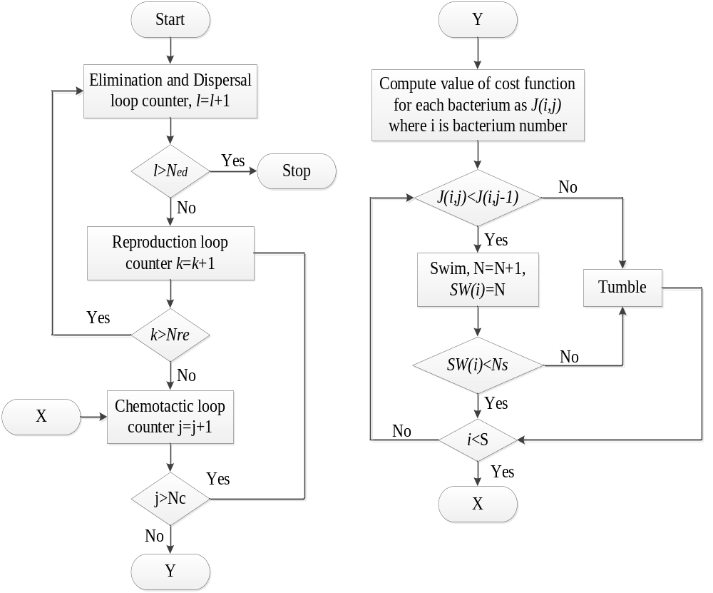Figure 2.7 Flow chart for bacterial foraging algorithm

Decentralized Sliding Mode Load Frequency Control
Sliding mode control (SMC) [28]–[32] has been proven to be an effective robust control strategy for nonlinear systems and incompletely modeled systems. The SMC utilizes a discontinuous control to force the system state trajectories to some predefined sliding surfaces on which the system has desired properties such as stability, disturbance rejection capability, and tracking ability. The traditional SMC design includes the two relatively independent parts of the sliding mode surface for the desired performance and the controller law to drives the system trajectory to the surface and to maintain motion on it.
To improve the dynamic performance and robustness during the reaching phase against the matched and unmatched perturbations, where and are constant matrices. Matrix is selected to assure that matrix is nonsingular. Matrix is designed through pole assignment such that the eigenvalues of matrix are less than zero. When the dynamic trajectory reaches the sliding mode, the switching function satisfies the following conditions: the PI switching surface [32] is selected as
$σ_{i}\left(t\right)=G_{i}x_{i}\left(t\right)-\int_{0}^{t}{G_{i}\left(A_{i}^{'}-B_{i}^{'}K_{i}\right)}x_{i}\left(τ\right)dτ$ (2.16)
where G_{i} and K_{i} are constant matrices. Matrix G_{i} is selected to assure that matrix ${G_{i}B}_{i}^{'}$ is nonsingular. Matrix K_{i} is designed through pole assignment such that the eigenvalues of matrix $\left(A_{i}^{'}-B_{i}^{'}K_{i}\right)$ are less than zero. When the dynamic trajectory reaches the sliding mode, the switching function satisfies the following conditions.
$σ_{i}\left(t\right)=0 and {\dot{σ}}_{i}\left(t\right)=0$ (2.17)

Summary
Based on the discussion from 3.2.1 to 3.2.4, the continually changeable power system operation condition has not been considered in the paper. Moreover, the control gains in this control method are designed for different operation conditions, but during the disturbance, the control gains are kept the same. This makes the optimal response not necessarily always achieved when a high penetration of wind power is integrated in a power system. The wind power outputs are continuously varying when the wind turbines operate in partial load region [23-24]. In this case, the control gains in PI controllers are required to continuously change to meet the requirement of the optimal response.

Scope of this Work
As discussed in 2.2, the traditional PI control methods for STATCOM use try and error methods to calculate the control gains, which are time-consuming. Moreover, the fixed control gains may obtain the optimal response in a specific condition, when there is a considerable change of the system conditions, such as, when a line is upgraded or retires from service, performance may be disappointing. To improve, some new control methods such as pole placement and fuzzy control methods are proposed, these methods are affected by the designer’s experience which make the optimal response can not be always obtained. Moreover, some population-based search technique are presented, however, these methods usually take long time to calculate the control gains.
Therefore, an adaptive PI control of STATCOM for voltage regulation is presented in this work.
By this adaptive PI control method, the PI control parameters can be self-adjusted automatically and dynamically under different disturbances in a power system. When a disturbance occurs in the system, the PI control parameters for STATCOM can be computed automatically in every sampling time period and can be adjusted in real time to track the reference voltage. Different from other control methods, this method will not be affected by the initial gain settings, changes of system conditions, and the limits of human experience and judgment. This will make the STATCOM a “plug-and-play” device. In addition, this research work demonstrates a fast, dynamic performance of STATCOM in various operating conditions.
Moreover, since the existing flatness based control can not satisfy the requirements of the changeable power system operation conditions. A flatness-based adaptive control method is proposed and applied to STATCOM for voltage control in this work. By this method, the nonlinear STATCOM variables can be easily and exactly controlled by controlling flat output without solving differential equations. Further, the control gains can dynamically self-adjust during the voltage regulation after a disturbance. Thus, the performance from the flatness-based adaptive control will consistently match a desired response, regardless of the change of operating conditions.
As discussed in 2.3, Automatic generation control (AGC) is very important to regulate power system frequency. A number of control methods have been discussed in order to design control gains for proportional-integral (PI) controllers in AGC and obtain a good frequency response performance. However, the existing methods are either time consuming or are affected by the designer’s experience. Moreover, the control gains obtained by existing control methods are usually fixed and designed for specific scenarios in the studied power system. The desired response may not be obtained when variable wind power is integrated into power systems. To address these challenges, a dynamic gain tuning control (DGTC) for AGC is proposed in this paper. The actual wind speed recordings are used in the simulation and wind power model is built. By the proposed control method, PI control gains can be dynamically self-adjusted to reach the desired performance. The proposed method is tested in an IEEE 39 bus system with wind resources and compared with conventional control approach with well-tuned gains in the simulation. The simulation results show that the proposed control provides better AGC response with less deviation of system frequency and tie line flow under changeable wind power.

Adaptive PI Control of STATCOM

Chapter Introduction
This chapter presents an adaptive PI control of STATCOM for voltage regulation. By this adaptive PI control method, the PI control parameters can be self-adjusted automatically and dynamically under different disturbances in power system.

STATCOM Model and Control

System Configuration
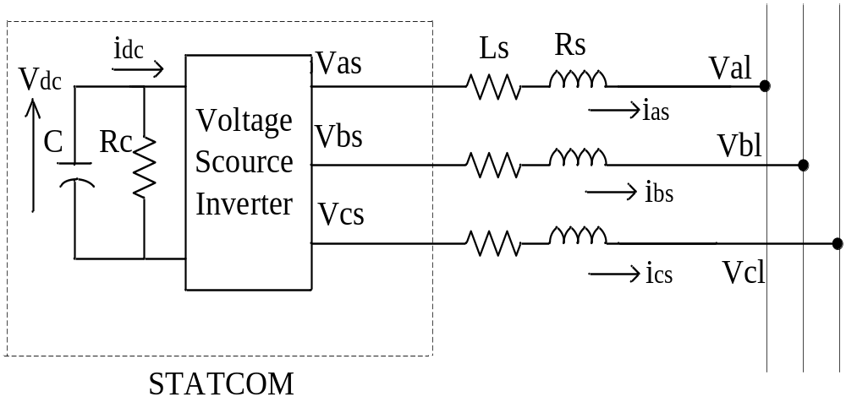
Figure 3.1 Equivalent circuit of STATCOM.
The equivalent circuit of the STATCOM is shown in Figure 3.1. In this power system, the resistance R_{s} in series with the voltage source inverter represents the sum of the transformer winding resistance losses and the inverter conduction losses. The inductance L_{s} represents the leakage inductance of the transformer. The resistance R_{c} in shunt with the capacitor C represents the sum of the switching losses of the inverter and the power losses in the capacitor. In Figure 3.1, V_{as}, V_{bs}, and V_{cs} are the three-phase STATCOM output voltages; V_{al}, V_{bl}, and V_{cl} are the three phase bus voltages; i_{as}, i_{bs}, and i_{cs} are the three-phase STATCOM output currents [31].

STATCOM Dynamic Model
The three-phase mathematical expressions of the STATCOM can be written in the following form [31]:
$L_{s}\frac{di_{as}}{dt}=-R_{s}i_{as}+V_{as}-V_{al}$ (3.1)
$L_{s}\frac{di_{bs}}{dt}=-R_{s}i_{bs}+V_{bs}-V_{bl}$ (3.2)
$L_{s}\frac{di_{cs}}{dt}=-R_{s}i_{cs}+V_{cs}-V_{cl}$ (3.3)
$\frac{d}{dt}\left(\frac{1}{2}CV_{dc}^{2}\left(t\right)\right)=-\left[V_{as}i_{as}+V_{bs}i_{bs}+V_{cs}i_{cs}\right]-\frac{V_{dc}^{2}\left(t\right)}{R_{c}}$ (3.4)
In order to conveniently analyze the balanced three-phase system, the three-phase voltages and currents are converted to synchronous rotating frame by abc/dq transformation. By this rotation, the control problem is greatly simplified since the system variables become DC values under the balanced condition. Further, multiple control variables are decoupled such that the use of classic control method is possible. The transformation from phase variables to d and q coordinates is given as follows:
$\left[\begin{matrix}i_{ds} \\ i_{qs} \\ 0\end{matrix}\right]=\left[C\right]\left[\begin{matrix}i_{as} \\ i_{bs} \\ i_{cs}\end{matrix}\right]=\frac{2}{3}\left[\begin{matrix}1 & -\frac{1}{2} & -\frac{1}{2} \\ 0 & \frac{\sqrt{3}}{2} & -\frac{\sqrt{3}}{2} \\ \frac{1}{\sqrt{2}} & \frac{1}{\sqrt{2}} & \frac{1}{\sqrt{2}}\end{matrix}\right]\left[\begin{matrix}i_{as} \\ i_{bs} \\ i_{cs}\end{matrix}\right]$ (3.5)
$\left[\begin{matrix}V_{ds} \\ V_{qs} \\ 0\end{matrix}\right]=\left[C\right]\left[\begin{matrix}V_{as} \\ V_{bs} \\ V_{cs}\end{matrix}\right]=\frac{2}{3}\left[\begin{matrix}1 & -\frac{1}{2} & -\frac{1}{2} \\ 0 & \frac{\sqrt{3}}{2} & -\frac{\sqrt{3}}{2} \\ \frac{1}{\sqrt{2}} & \frac{1}{\sqrt{2}} & \frac{1}{\sqrt{2}}\end{matrix}\right]\left[\begin{matrix}V_{as} \\ V_{bs} \\ V_{cs}\end{matrix}\right]$ (3.6)
where i_{ds} and i_{qs} are the d and q currents corresponding to i_{as}, i_{bs}, and i_{cs}; V_{ds} and V_{qs} represent the d and q voltages corresponding to V_{as}, V_{bs}, and V_{cs}.
The output voltage of the STATCOM can be expressed as:
$V_{ds}=KV_{dc}\cos\left(α\right)$ (3.7)
$V_{qs}=KV_{dc}\sin\left(α\right)$ (3.8)
where K is a factor that relates the DC voltage to the peak phase-to-neutral voltage on the AC side; V_{dc} is the DC-side voltage; α is the phase angle which the STATCOM output voltage leads the bus voltage.
By using the abc/dq transformation, the equations from (3.1) to (3.4) can be rewritten as:
$\frac{d}{dt}\left[\begin{matrix}i_{ds} \\ i_{qs} \\ V_{dc}\end{matrix}\right]=\left[\begin{matrix}-\frac{R_{s}}{L_{s}} & ω & \frac{K}{L_{s}}\cos{α} \\ -ω & -\frac{R_{s}}{L_{s}} & \frac{K}{L_{s}}\sin{α} \\ -\frac{3K}{2C}\cos{α} & -\frac{3K}{2C}\sin{α} & -\frac{1}{R_{c}C}\end{matrix}\right]\left[\begin{matrix}i_{ds} \\ i_{qs} \\ V_{dc}\end{matrix}\right]-\frac{1}{L_{s}}\left[\begin{matrix}V_{dl} \\ V_{ql} \\ 0\end{matrix}\right]$ (3.9)
where ω is the synchronously rotating angle speed of the voltage vector; V_{dl} and V_{ql} represent the d and q axis voltage corresponding to V_{al}, V_{bl}, and V_{cl}. Since V_{ql} =0, based on the instantaneous active and reactive power definition, (3.10) and (3.11) can be obtained as follows [23-24]:
$p_{l}=\frac{3}{2}V_{dl}i_{ds}$ (3.10)
$q_{l}=\frac{3}{2}V_{dl}i_{qs}$ (3.11)
Based on the above equations, the traditional control strategy can be obtained, and the STATCOM control block diagram is shown in Figure 3.2 [26-27].
As shown in Figure 3.2, the phase locked loop (PLL) provides the basic synchronizing signal which is the reference angle to the measurement system. Measured bus line voltage V_{m} is compared with the reference voltage V_{ref} and the voltage regulator provides the required reactive reference current I_{qref}. The droop factor, K_{d}, is defined as the allowable voltage error at the rated reactive current flow through the STATCOM. The STATCOM reactive current I_{q} is compared with I_{qref}, and the output of the current regulator is the angle phase shift of the inverter voltage w.r.t. the system voltage. The limiter is the limit imposed on the value of control with the consideration of the maximum reactive power capability of the STATCOM.
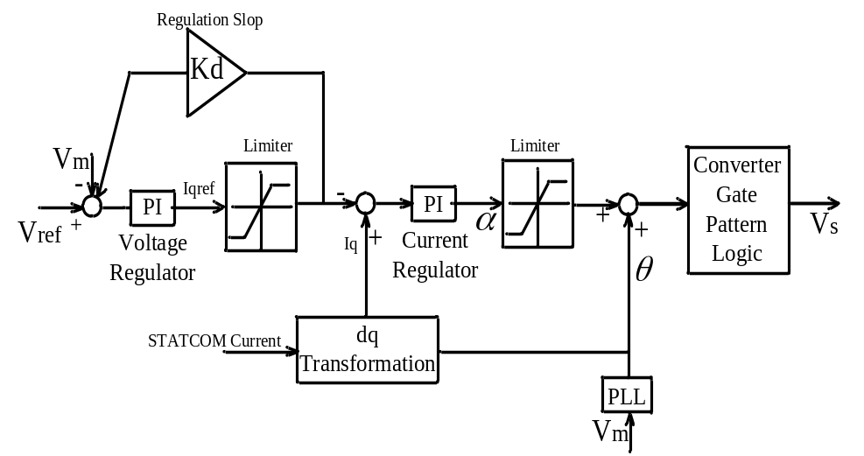
Figure 3.2. Traditional STATCOM PI control block diagram.

Adaptive PI Control for STATCOM

Concept of the proposed adaptive PI control method
The STATCOM with fixed PI control parameters may not reach the desired and acceptable response in power system when the power system operating condition (e.g., loads or transmissions) changes. An adaptive PI control method is presented in this section in order to obtain the desired response and to avoid performing trial-and-error studies to find suitable parameters for PI controllers when a new STATCOM is installed in a power system. With this adaptive PI control method, the dynamical self-adjustment of PI control parameters can be realized.
An adaptive PI control block for STATCOM is shown in Figure 3.3. In Figure 3.3, the measured voltage V_{m}(t) and the reference voltage V_{ref}(t), the q-axis reference current I_{qref} and the q-axis current I_{q} are in per unit values. The proportional and integral parts of the voltage regulator gains are denoted by K_{p_V} and K_{i_V}, respectively. Similarly, the gains K_{p_I} and K_{i_I} represent the proportional and integral parts, respectively, of the current regulator. In this control system, the allowable voltage error K_{d} is set to 0. The K_{p_V}, K_{i_V}, K_{p_I} and K_{i_I} can be set to an arbitrary initial value such as simply 1.0. One exemplary desired curve is an exponential curve in terms of the voltage growth, shown in Figure 3.4, which is set as the reference voltage in outer loop. Other curves may also be used than the depicted exponential curve so long as the measured voltage returns to the desired steady state voltage in desired time duration. The process of adaptive voltage control method for STATCOM is described as follows:
- The bus voltage V_{m}(t) is measured in real time.
- When the measured bus voltage over time $V_{m}\left(t\right)≠$V_{ss} , the target steady-state voltage (which is set to 1.0 per unit (p.u.) in the discussion and examples), the measured voltage is compared with V_{ss}. Based on the desired reference voltage curve, K_{p_V} and K_{i_V} are dynamically adjusted in order to make the measured voltage match the desired reference voltage, and the q-axis reference current I_{qref} can be obtained.
- In the inner loop, I_{qref} is compared with the q-axis current I_{q}. Using the similar control method like the one for the outer loop, the parameters K_{p_I} and K_{i_I} can be adjusted based on the error. Then, a suitable angle can be found and eventually the DC voltage in STATCOM can be modified such that STATCOM provides the exact amount of reactive power injected into the system to keep the bus voltage at desired value.
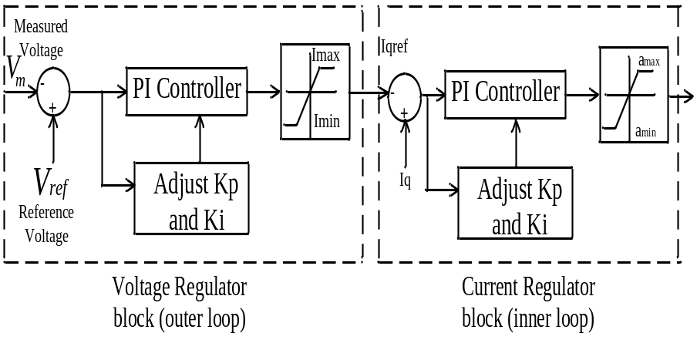
Figure 3.3 Adaptive PI control block for STATCOM.
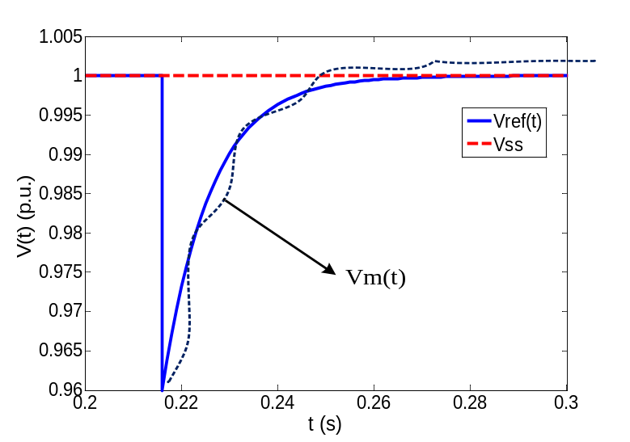
Figure 3.4 Reference voltage curve.
It should be noted that the current I_{max} and I_{min} and the angle α_{max} and α_{min} are the limits imposed with the consideration of the maximum reactive power generation capability of the STATCOM controlled in this manner. If one of the maximum or minimum limits is reached, the maximum capability of the STATCOM to inject reactive power has been reached. Certainly, as long as the STATCOM sizing has been appropriately studied during planning stages for inserting the STATCOM into the power system, the STATCOM should not reach its limit unexpectedly.

Derivation of the key equations
Since the inner loop control is similar to the outer loop control, the mathematical method to automatically adjust PI controller gains in the outer loop is discussed in this section for illustrative purpose. Similar analysis can be applied to the inner loop.
Here the measured bus voltages of three phases are denoted by V_{al}(t), V_{bl}(t), and V_{cl}(t), respectively. Then, V_{dl}(t) and V_{ql}(t) can be computed with d-q transformation.
$\left[\begin{matrix}V_{dl}\left(t\right) \\ V_{ql}\left(t\right) \\ 0\end{matrix}\right]=\frac{2}{3}\left[\begin{matrix}1 & -\frac{1}{2} & -\frac{1}{2} \\ 0 & \frac{\sqrt{3}}{2} & -\frac{\sqrt{3}}{2} \\ \frac{1}{\sqrt{2}} & \frac{1}{\sqrt{2}} & \frac{1}{\sqrt{2}}\end{matrix}\right]\left[\begin{matrix}V_{al}\left(t\right) \\ V_{bl}\left(t\right) \\ V_{cl}\left(t\right)\end{matrix}\right]$ (3.12)
Then, we have
$V_{m}\left(t\right)=\sqrt{V_{dl}^{2}\left(t\right)+V_{ql}^{2}\left(t\right)}$ (3.13)
Based on V_{m}(t), the reference voltage V_{ref}(t) is set as:
$V_{ref}\left(t\right)=V_{SS}-\left(V_{ss}-V_{m}\left(t\right)\right)e^{-\frac{t}{τ}}$ (3.14)
In (3.14), V_{ss} is the target steady-state voltage (which is set to 1.0 per unit (p.u.) in the discussion and examples); V_{m}(t) is the measured voltage; τ=0.01s. The curve in Fig.3.4 is one of the examples for V_{ref}(t).
If the system is operating in the normal condition, then V_{m}(t)=1 p.u., and thus, V_{ref}(t)=1 p.u. This means that K_{p_V} and K_{i_V} will not change and the STATCOM will not inject or absorb any reactive power to maintain the voltage meeting the reference voltage. However, once there is a voltage disturbance in the power system, based on $V_{ref}\left(t\right)=V_{SS}-\left(V_{ss}-V_{m}\left(t\right)\right)e^{-\frac{t}{τ}}$, K_{p_V} and K_{i_V} will become adjustable and the STATCOM will provide reactive power to increase the voltage. Here, the error between V_{ref}(t) and V_{m}(t) is denoted by ∆V(t) when there is a disturbance in the power system. Based on the adaptive voltage control model, at any arbitrary time instant t, the following equation can be obtained:
$∆V\left(t\right)K_{p_V}\left(t\right)+K_{i_V}\left(t\right)\int_{t}^{t+T_{s}}{∆V\left(t\right)dt}=I_{qref}\left(t+T_{s}\right)$ (3.15)
where T_{s} is the sample time, which is set to 2.5×10⁻⁵ second here as an example .
In this system, the Discrete-Time Integrator block in place of the Integrator block is used to create a purely discrete system, and the Forward-Euler method is used in the Discrete-Time Integrator block. Therefore, the resulting expression for the output of the Discrete-Time Integrator block at t is
$y\left(t\right)=y\left(t-T_{s}\right)+K_{i_V}\left(t-T_{s}\right)×T_{s}×∆V\left(t-T_{s}\right)$ (3.16)
where$y\left(t\right)=K_{i_V}\left(t\right)\int_{t}^{t+T_{s}}{∆V\left(t\right)dt}$; $y\left(t-T_{s}\right)=K_{i_V}\left(t-T_{s}\right)\int_{t-T_{s}}^{t}{∆V\left(t-T_{s}\right)dt}$.
Considering $y\left(t-T_{s}\right)=I_{qref}\left(t\right)$, we can rewrite (3.15) as follows:
$∆V\left(t\right)K_{p_V}\left(t\right)+K_{i_V}\left(t\right)\int_{t}^{t+T_{s}}{∆V\left(t\right)dt}-K_{i_V}\left(t-T_{s}\right)…$
$\int_{t-T_{s}}^{t}{∆V\left(t-T_{s}\right)dt}=I_{qref}\left(t+T_{s}\right)-I_{qref}\left(t\right)$ (3.17)
Over a very short time duration, we can consider $K_{i_V}\left(t\right)=K_{i_V}\left(t-T_{s}\right)$. Hence, (3.17) can be rewritten as:
$∆V\left(t\right)K_{p_V}\left(t\right)+K_{i_V}\left(t\right)\int_{t}^{t+T_{s}}{Adt}{=I}_{qref}\left(t+T_{s}\right)-I_{qref}\left(t\right)$ (3.18)
where A=$∆V\left(t\right)-∆V\left(t-T_{s}\right)$.
Based on (3.16), if we can determine in ideal response the radio $\frac{I_{qref}\left(t+T_{s}\right)-I_{qref}\left(t\right)}{∆V\left(t\right)}$ and the ideal ratio $\frac{K_{i_V}\left(t\right)}{K_{p_V}\left(t\right)}$, the desired K_{p_V}(t) and K_{i_V}(t) can be solved.
Assuming at the ideal response, we have
$I_{qref}\left(t+T_{s}\right)-I_{qref}\left(t\right)=R×∆V\left(t\right)$ (3.19)
Since the system is expected to be stable, without losing generality, we may assume that the bus voltage will come back to 1 per unit in 5τ, where 5τ is the delay defined by users as shown in Figure 3.4.. Since I_{qref}(t₀)=0 based on (3.15) and (3.19), (3.15) can be rewritten as:
$∆V\left(t_{0}\right)K_{p_V}\left(t_{0}\right)+K_{i_V}\left(t_{0}\right)\int_{t_{0}}^{t_{0}+5τ}{∆V\left(t\right)dt}=R×∆V\left(t_{0}\right)$ (3.20)
where t₀ is the time that the system disturbance occurs.
Set K_{i_V}(t₀⁻)=0, then we have
$K_{p_V}\left(t_{0}\right)=R$ (3.21)
Set K_{p_V}(t₀⁻)=0, then we have
$K_{i_V}\left(t_{0}\right)=\frac{∆V\left(t_{0}\right)×R}{\int_{t_{0}}^{t_{0}+5τ}{∆V\left(t\right)dt}}$ (3.22)
Now the ratio $m_{V}=\frac{K_{i_V}\left(t_{0}\right)}{K_{p_V}\left(t_{0}\right)}$ can be considered as the ideal ratio of the values of K_{p_V}(t) and K_{i_V}(t) after disturbances.
Thus, (3.19) can be rewritten as
$I_{qref}\left(t+5τ\right)-I_{qref}\left(t\right)=k_{V}×∆V\left(t_{0}\right)$ (3.23)
Here k_{V} can be considered as the steady and ideal ratio$\frac{I_{qref}\left(t+T_{s}\right)-I_{qref}\left(t\right)}{∆V\left(t\right)}$.
Based on the system bus capacity and the STATCOM rating, ΔV_{max} can be obtained, which means any voltage change greater than ΔV_{max} cannot come back to 1 per unit. Since we have -1≤I_{qref}(t) ≤1, we have the following equation:
$\frac{∆V\left(t_{0}\right)}{∆V_{max}}=k_{V}×\frac{∆V\left(t_{0}\right)K_{p_V}\left(t_{0}\right)+K_{i_V}\left(t_{0}\right)\int_{t_{0}}^{t_{0}+5τ}{∆V\left(t\right)dt}}{R}$ (3.24)

Based on (3.20), (3.23) and (3.24), k_{v} can be calculated by:
$k_{V}=\frac{R×∆V\left(t_{0}\right)}{\left(K_{p_V}\left(t_{0}\right)∆V\left(t_{0}\right)+K_{i_V}\left(t_{0}\right)\int_{t_{0}}^{t_{0}+5τ}{∆V\left(t\right)dt}\right)×∆V_{max}}$ (3.25)
In order to exactly calculate the PI controller gains, based on (3.18), we can derive:
$∆V\left(t\right)K_{p_V}\left(t\right)+m_{V}K_{p_V}\left(t\right)\int_{t}^{t+T_{s}}{Adt}=k_{V}×∆V\left(t\right)$ (3.26)
Therefore, K_{p_V}(t) and K_{i_V}(t) can be computed by the following equations:
$K_{p_V}\left(t\right)=\frac{k_{V}×∆V\left(t\right)}{\left(∆V\left(t\right)+m_{V}×\int_{t}^{t+T_{s}}{Adt}\right)}$ (3.27)
$K_{i_V}\left(t\right)=m_{V}×K_{p_V}\left(t\right)$ (3.28)
Therefore, based on (3.27) and (3.28), K_{p_V}(t) and K_{i_V}(t) can be adjusted dynamically.
Using similar process, the following expressions for current regulator PI gains can be obtained:
$K_{p_I}\left(t\right)=\frac{k_{I}×∆I_{q}\left(t\right)}{\left(∆I_{q}\left(t\right)+m_{I}×\int_{t}^{t+T_{s}}{Bdt}\right)}$ (3.29)
$K_{i_I}\left(t\right)=m_{I}×K_{p_I}\left(t\right)$ (3.30)
where ΔI_{q}(t) is the error between I_{qref} and I_{q}; k_{I} is the steady and ideal ratio$\frac{α\left(t+T_{s}\right)-α\left(t\right)}{∆I_{q}\left(t\right)}$ and α(t) is the angle that phase shift of the inverter voltage with respect to the system voltage at time t; m_{I} is the ideal ratio of the values of K_{p_I}(t) and K_{i_I}(t) after disturbances; and B is equal to ΔI_{q}(t)- ΔI_{q}(t-T_{S}).
Note that the derivation from Equations (3.14) to (3.30) is fully reversible so it ensures that the measured voltage curve can follow the desired ideal response, as defined in Eq. (3.14).

Flow charts of the adaptive PI control procedure
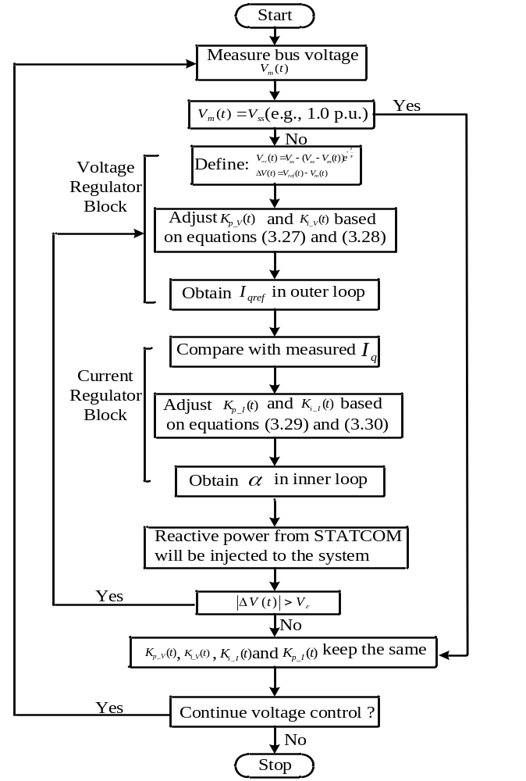
Figure 3.5 Adaptive PI control algorithm flow chart.
Figure 3.5 is an exemplary flowchart of the proposed adaptive PI control for STATCOM for the block diagram of Figure 3.5.
The adaptive PI control process begins at Start. The bus voltage over time V_{m}(t) is sampled according to a desired sampling rate. Then, V_{m}(t) is compared with V_{ss}, the desired steady-state voltage. If V_{m}(t)=V_{ss}, then, there is no reason to change any of the identified parameters: K_{p_V}(t), K_{i_V}(t), K_{i_I}(t) and K_{p_I}(t). The power system is running smoothly. On the other hand, if $V_{m}\left(t\right)≠$ V_{ss}, then adaptive PI control begins.
The measured voltage is compared with V_{ref}(t), the reference voltage defined in Figure 3.5. Then, K_{p_V}(t) and K_{i_V}(t) are adjusted in the voltage regulator block (outer loop) based on Eqs. (3.27) and (3.28), which leads to an updated I_{qref} via a current limiter as shown in Figure 3.3.
Then, the I_{qref} is compared with the measured q-current, I_{q}. The control gains K_{p_I}(t) and K_{i_I}(t) are adjusted based on Eqs. (3.29) and (3.30). Then, the phase angle α is determined and passed through a limiter for output, which essentially decides the reactive power output from the STATCOM.
Next, if |ΔV(t)| is not within a tolerance threshold, V_{ε}, which is a very small value such as 0.0001 p.u., the voltage regulator block and current regulator blocks are reentered until the change is less than the given threshold V_{ε}. Thus, the values for K_{p_V}(t), K_{i_V}(t), K_{i_I}(t) and K_{p_I}(t) are maintained.
If it is needed to continuously perform the voltage control process which is usually the case, then the process returns to measured bus voltage. Otherwise, the voltage control process stops, i.e., the STATCOM control is deactivated.

Simulation Results

System Data
In the system simulation diagram shown in Figure 3.6, a +/-100 MVAR STATCOM is implemented with a 48-pulse VSC and connected to a 500kV bus. This is the standard sample STATCOM system in Matlab/Simulink library, and all machines used in the simulation are dynamical models [26-28]. Here, the attention is focused on the STATCOM control performance in bus voltage regulation mode. In the original model, the compensating reactive power injection and the regulation speed are mainly affected by PI controller parameters in the voltage regulator and the current regulator. The original control will be compared with the proposed adaptive PI control model.
Assumes the steady-state voltage, V_{ss}=1.0 per unit. In subsection IV-B, C and F, a disturbance is assumed to cause a voltage drop at 0.2 sec from 1.0 to 0.989 per unit at the source (substation A). Here, the 0.989 p.u. voltage at the substation is the lowest voltage that the STATCOM system can support due to its capacity limit. The third simulation study in subsection IV-D assumes a voltage drop from 1.0 to 0.991 under a changed load. The fourth simulation study in subsection IV-E assumes a disturbance at 0.2 sec causing a voltage rise from 1.0 to 1.01 per unit at the substation under a modified transmission network. When there is a severe voltage sag (i.e. to 60% of the rated voltage), the voltage will be corrected to the maximum of STATCOM’s capability (i.e., injecting the highest reactive current). When the fault clears, the voltage should get back to 1.0 per unit or very close. This case is studied in substation IV-G. In all simulation studies, the STATCOM immediately operates after the disturbance with the expectation of bringing the voltage back to 1.0 p.u.

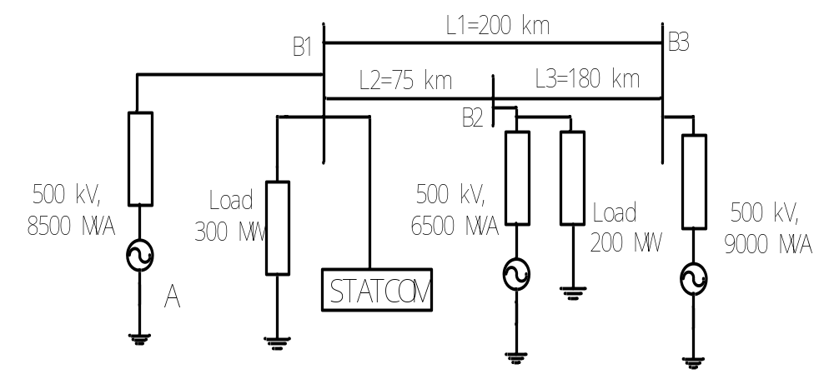
Figure 3.6 The studied system.

Response of the original model
In the original model, K_{p_V}=12, K_{i_V}=3000, K_{p_I}=5, K_{i_I}=40. Here, we keep all the parameters unchanged. The initial voltage source, shown in Fig.3.6, is 1.0 p.u., with the voltage base being 500kV. In this case, if we set R=1, then we have the initial m_{v} calculated as:
$m_{V}=\frac{K_{i_V}\left(t_{0}\right)}{K_{p_V}\left(t_{0}\right)}=770.8780$
Since in this case ΔV(t₀)=ΔV_{max} and k_{V} =84.7425, based on (3.27) to (3.30), we have
$K_{p_V}\left(t\right)=\frac{84.7425×∆V\left(t\right)}{\left(∆V\left(t\right)+770.8780×\int_{t}^{t+T_{s}}{Adt}\right)}$ (3.31)
$K_{i_V}\left(t\right)=770.8480×K_{p_V}\left(t\right)$ (3.32)
$K_{p_I}\left(t\right)=\frac{57.3260×∆I_{q}\left(t\right)}{\left(∆I_{q}\left(t\right)+2.3775×\int_{t}^{t+T_{s}}{Bdt}\right)}$ (3.33)
$K_{i_I}\left(t\right)=2.3775×K_{p_I}\left(t\right)$ (3.34)
Based on (3.31) to (3.34), the adaptive PI control system can be designed and the results of original control method and the adaptive PI control method are shown in Figures 3.7, 3.8 and 3.9 respectively. Observations are summarized in Table 3.1.
From the results, it is obvious that the adaptive PI control can achieve quicker response than the original one. The needed reactive power amount is the same while the adaptive PI approach runs faster, as the voltage does.
Set ωt = α + θ, where α is the output angle of the current regulator, θ is the reference angle to the measurement system. In the STATCOM, it is ωt that decides the control signal. Since θ is a very large value (varying between 0 to 2π), the ripples of α in the scale shown in Figure 3.9 will not affect the final simulation results.

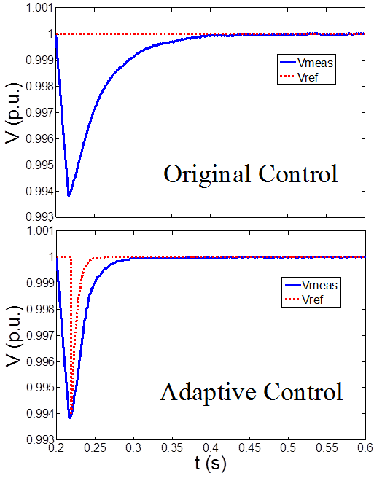
Figure 3.7 Results of the voltages using the same network and loads.
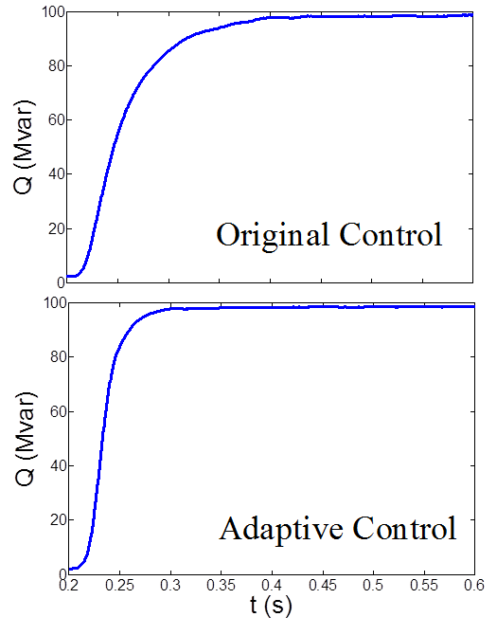
Figure 3.8 Results of the output reactive power using the same network and loads.
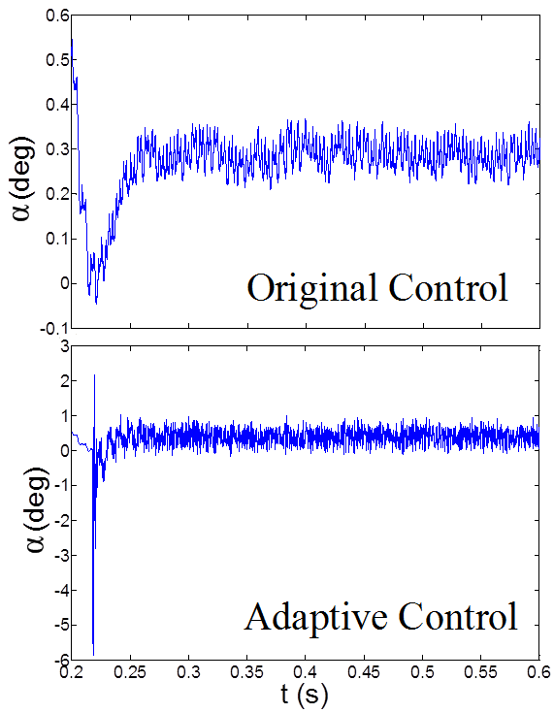
Figure 3.9 Results of a using the same network and loads.
Table 3.1 Performance comparison for the original system parameters
 | Original Ctrl. | Adaptive Ctrl.
Lowest Voltage after disturbance | 0.9938 p.u. | 0.9938 p.u.
Time (sec) when V=1.0 | 0.4095 sec | 0.2983 sec
∆t to reach V=1.0 | 0.2095 sec | 0.0983 sec
Var Amount at steady state | 97.76 MVar | 97.65 MVar
Time to reach steady state Var | 0.4095 sec | 0.2983 sec
Note, there is a very slight difference of 0.12 MVar in Var amount at steady state in Table I, which should be caused by computational round-off error. The reason is that the sensitivity of dVAR/dV is around 100MVar/0.011 p.u. of voltage. For simplicity, we may assume the ∆Var/∆V sensitivity is a linear function. Thus, when the voltage error is 0.00001 p.u., ∆Var is 0.0909 MVar which is in the same range as the 0.12 MVar mismatch. Thus, it is reasonable to conclude that the slight Var difference in Table I is due to round-off error in the dynamic simulation which always gives tiny ripples beyond 5th digits even in the final steady state.

Change of Kp and Ki
In this scenario, the other system parameters remain unchanged while the PI controller gains for the original control are changed to: K_{p_V}=1, K_{i_V}=1, K_{p_I}=1, K_{i_I}=1.
The dynamic control gains, which are independent of the initial values before the disturbance but depending on the post-fault conditions, are given as:
$K_{p_V}\left(t\right)=\frac{80.1632×∆V\left(t\right)}{\left(∆V\left(t\right)+732.3115×\int_{t}^{t+T_{s}}{Adt}\right)}$ (3.35)
$K_{i_V}\left(t\right)=732.3115×K_{p_V}\left(t\right)$ (3.36)
$K_{p_I}\left(t\right)=\frac{47.4959×∆I_{q}\left(t\right)}{\left(∆I_{q}\left(t\right)+1.8232×\int_{t}^{t+T_{s}}{Bdt}\right)}$ (3.37)
$K_{i_I}\left(t\right)=1.8232×K_{p_I}\left(t\right)$ (3.38)
Based on (3.35) to (3.38), the adaptive PI control model can be designed and the results of original and the adaptive PI control methods are shown in Figures 3.10, 3.11 and 3.12 respectively.
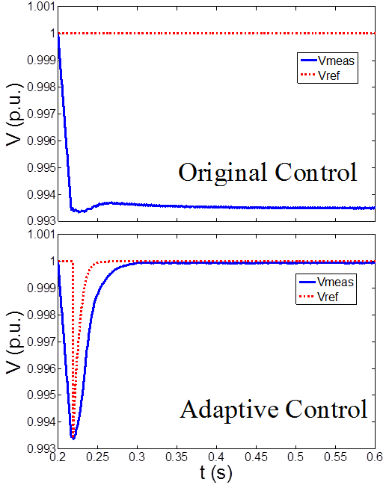
Figure 3.10 Voltages with changed K_{p} and K_{i} in the original control.
From Figure 3.10, it can be observed that when K_{p} and K_{i} are changed to different values, the original control model cannot make the bus voltage get back to 1.0 p.u. and the STATCOM has a poor response. The reactive power cannot be increased to a level to meet the need. However, by the adaptive PI control, the STATCOM can response to disturbance perfectly as desired, and the voltage can get back to 1.0 p.u. quickly within 0.1 sec. Figure 3.11 also shows that the reactive power injection cannot be continuously increased in the original control to support voltage, while the adaptive PI control performs as desired.
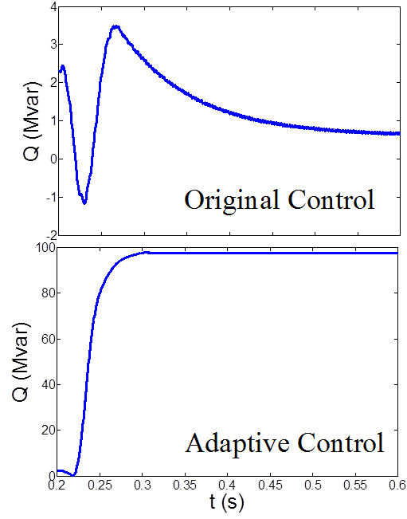
Figure 3.11 Output reactive power with changed K_{p} and K_{i} in the original control.
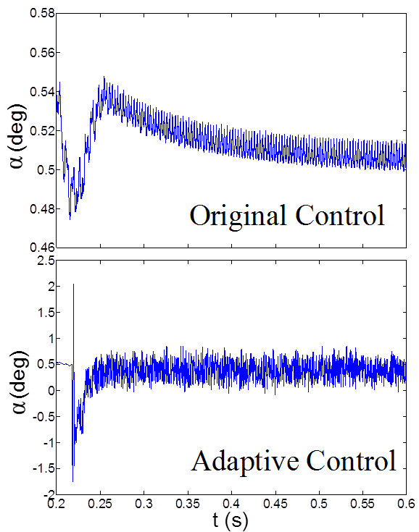
Figure 3.12 Results of α with changed K_{p} and K_{i} in the original control.

Change of Load
In this case, the original PI controller gains are kept, which means K_{p_V}=12, K_{i_V}=3000, K_{p_I}=5 and K_{i_I}=40. However, the load at Bus B1 is changed from 300MW to 400MW.
In this case, we have the dynamic control gains given by:
$K_{p_V}\left(t\right)=\frac{93.3890×∆V\left(t\right)}{\left(∆V\left(t\right)+187.5579×\int_{t}^{t+T_{s}}{Adt}\right)}$ (3.39)
$K_{i_V}\left(t\right)=187.5579×K_{p_V}\left(t\right)$ (3.40)
$K_{p_I}\left(t\right)=\frac{8.1731×∆I_{q}\left(t\right)}{\left(∆I_{q}\left(t\right)+13.1652×\int_{t}^{t+T_{s}}{Bdt}\right)}$ (3.41)
$K_{i_I}\left(t\right)=13.1652×K_{p_I}\left(t\right)$ (3.42)
Based on (3.39) to (3.42), the adaptive PI control model can be designed for automatic reaction to change in loads. The results from the original and the adaptive PI control methods are shown in Figures 3.13, 3.14 and 3.15. Table 3.2 shows a few key observations of the performance.
Table 3.2 Performance comparison with a change of load.
 | Original Ctrl. | Adaptive Ctrl.
Lowest Voltage after disturbance | 0.9949 p.u. | 0.9949 p.u.
Time (sec) when V=1.0 | 0.4338 sec | 0.3125 sec
∆t to reach V=1.0 | 0.2338 sec | 0.1125 sec
Var Amount at steady state | 93.08 MVar | 92.72 MVar
Time to reach steady state VAr | 0.4338 sec | 0.3125 sec
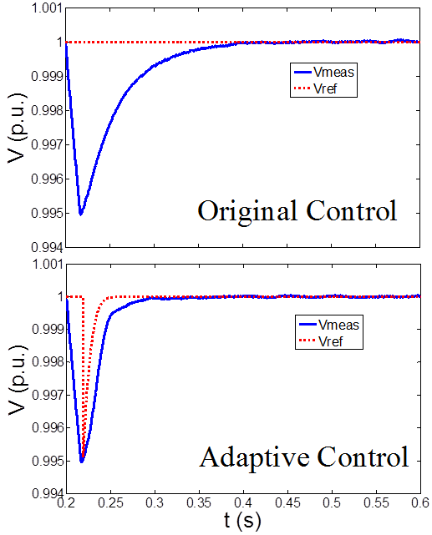
Figure 3.13 Results of measured voltage with change of load.
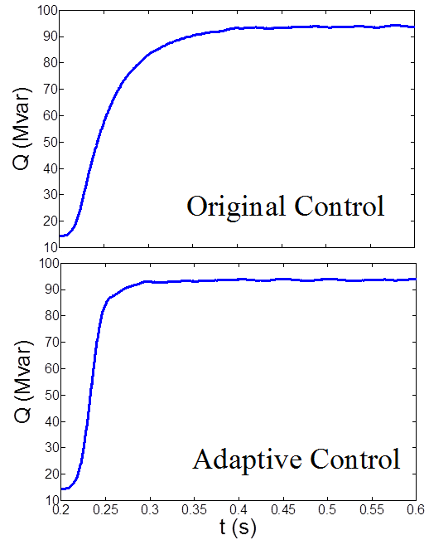
Figure 3.14 Results of output reactive power with change of load.
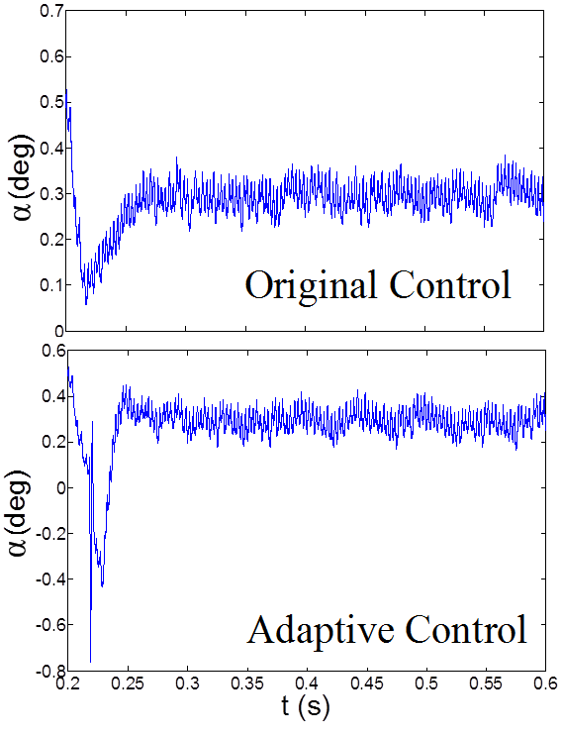
Figure 3.15 Results of α with change of load.
From the data shown in Table 3.2 as well as Figures 3.13 and 3.14, it is obvious that the adaptive PI control can achieve quicker response than the original one.

Change of Transmission Network
In this case, the PI controller gains remain unchanged, as in the original model. However, line 1 is switched off at 0.2 sec to represent a different network which may corresponds to scheduled transmission maintenance. Here, we have
$K_{p_V}\left(t\right)=\frac{18.3245×∆V\left(t\right)}{\left(∆V\left(t\right)+286.9512×\int_{t}^{t+T_{s}}{Adt}\right)}$ (3.43)
$K_{i_V}\left(t\right)=286.9512×K_{p_V}\left(t\right)$ (3.44)
$K_{p_I}\left(t\right)=\frac{41.4360×∆I_{q}\left(t\right)}{\left(∆I_{q}\left(t\right)+412.0153×\int_{t}^{t+T_{s}}{Bdt}\right)}$ (3.45)
$K_{i_I}\left(t\right)=412.0153×K_{p_I}\left(t\right)$ (3.46)
Based on (3.43) to (3.46), the adaptive PI control model can be designed to automatically react to changes in transmission network. The results from the original and the adaptive PI control methods are shown in Figures 3.16, 3.17 and 3.18. Key observations are summarized in Table 3.3.
Note the STATCOM absorbs VAR from the system in this case. Here, the disturbance is assumed to give a voltage rise at the source (substation) from 1.0 to 1.01 p.u.; meanwhile, since the system has a transmission line removed which tends to lower the voltages. The overall impact leads to a voltage rise to higher than 1.0 at the controlled bus in the steady state if the STATCOM is not activated. Thus, the STATCOM needs to absorb VAR in the final steady-state to reach 1.0 p.u. voltage at the controlled bus. Also note that the initial transients immediately after 0.2 sec lead to an over-absorption by the STATCOM, while the adaptive PI control gives a much smoother and quicker response, as shown in Figures 3.16 and 3.17.
Table 3.3 Performance comparison with changed transmission
 | Original Ctrl. | Adaptive Ctrl.
Lowest Voltage after disturbance | 0.9954 p.u. | 0.9954 p.u.
Time (sec) when V=1.0 | 0.4248 sec | 0.2744 sec
∆t to reach V=1.0 | 0.2248 sec | 0.0744 sec
Var Amount at steady state | -84.92 MVar | -85.02 MVar
Time to reach steady state Var | 0.4248 sec | 0.2744 sec

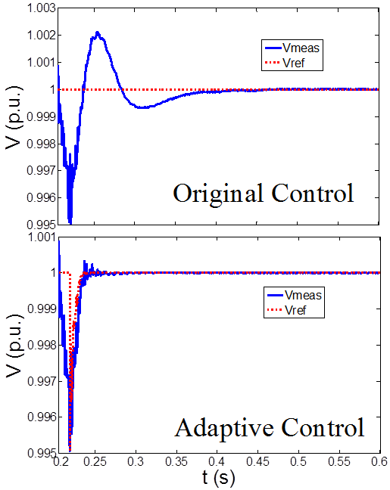
Figure 3.16 Results of measured voltage with change of transmission network.
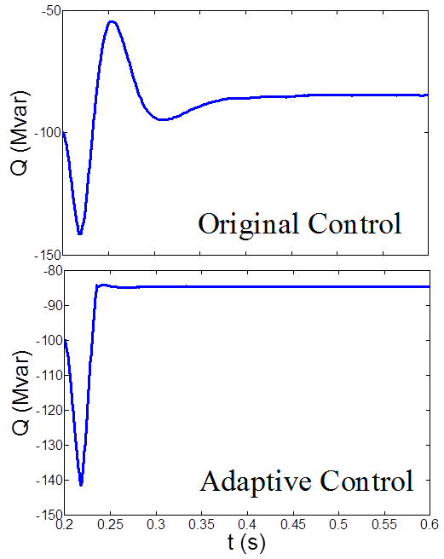
Figure 3.17 Results of output reactive power with change of transmission network.
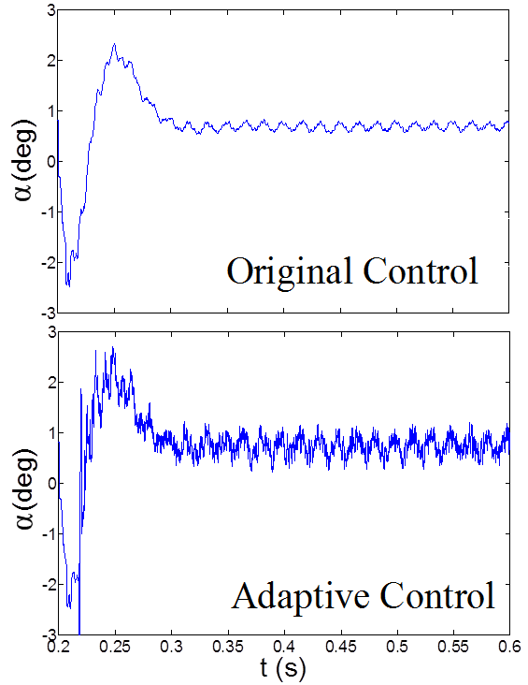
Figure 3.18 Results of α with change of transmission network.

Two consecutive disturbances
In this case, a disturbance at 0.2 sec causing a voltage decrease from 1.0 to 0.989 p.u. occurs at the substation. After that, line 1 is switched off at 0.25 sec. The results from the original and the adaptive PI control methods are shown in Figures 3.19, 3.20 and 3.21. From Figures. 3.19 and 3.20, it is apparent that the adaptive PI control can achieve much quicker response than the original one, which makes the system voltage drop much less than the original control during second disturbance. Note, in Figure. 3.19, the largest voltage drop during the second disturbance event (starting at 0.25 sec) with the original control is 0.012 p.u., while it is 0.006 p.u. with the proposed adaptive control. Therefore, the system is more robust in responding consecutive disturbances with adaptive PI control.
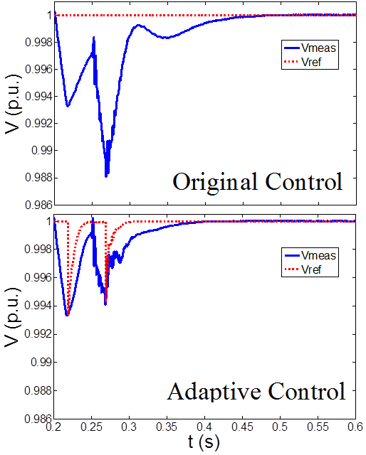
Figure 3.19 Results of measured voltage in two consecutive disturbances.
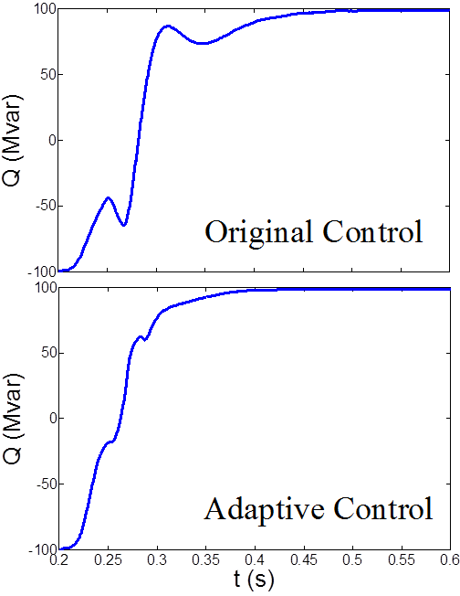
Figure 3.20 Results of output reactive power in two consecutive disturbances.
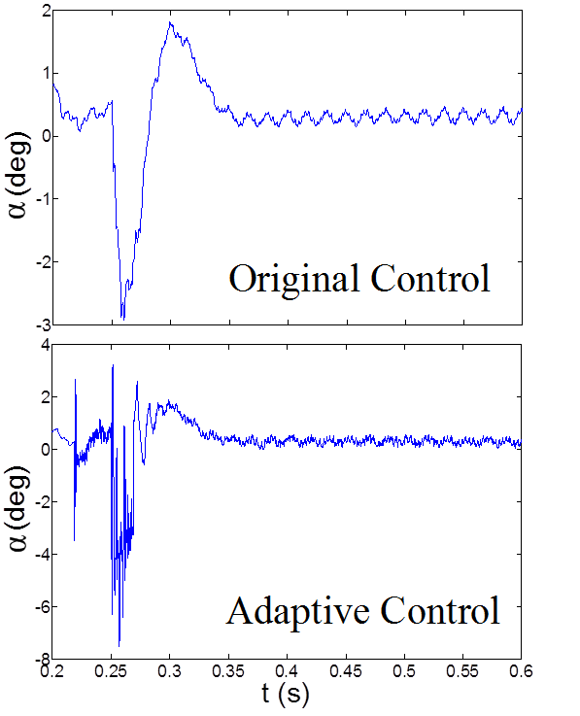
Figure 3.21 Results of α in two consecutive disturbances.

A Severe Disturbance
In this case, a severe disturbance at 0.2 sec causing a voltage decrease from 1.0 to 0.6 p.u. occurs at the substation. After that, the disturbance is cleared at 0.25 sec. The results from the original and the adaptive PI control methods are shown in Figure 3.22, 3.23 and 3.24.
Due to the limit of the STATCOM capacity, the voltage cannot get back to 1.0 p.u. when there is a severe voltage drop from 1.0 p.u. to 0.6 p.u.. After the disturbance is cleared at 0.25 sec, from Figure 3.22 and Figure 3.23, it is obvious that the adaptive PI control can bring the voltage back to 1.0 p.u. much quicker and smoother response than the original one.
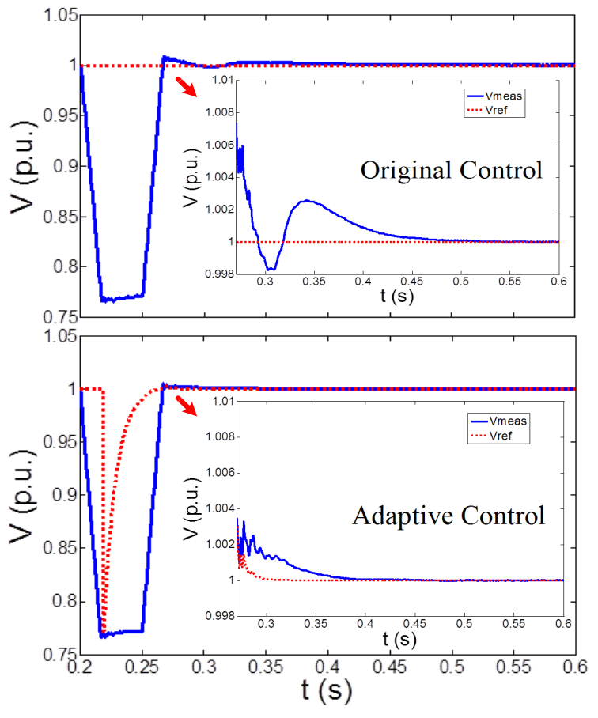
Figure 3.22 Results of measured voltage in a severe disturbance.
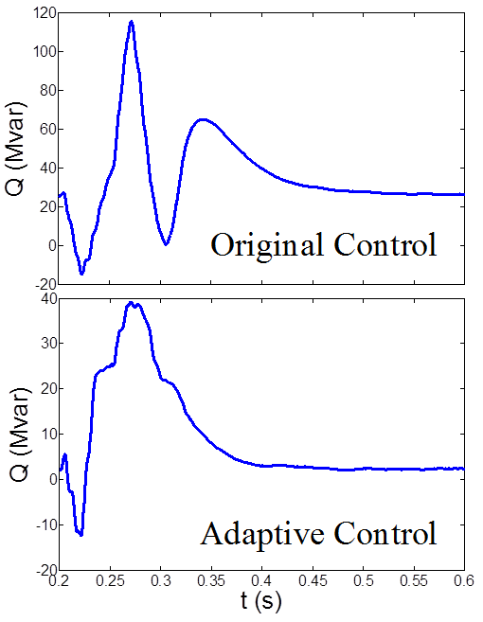
Figure 3.23 Results of output reactive power in a severe disturbance.
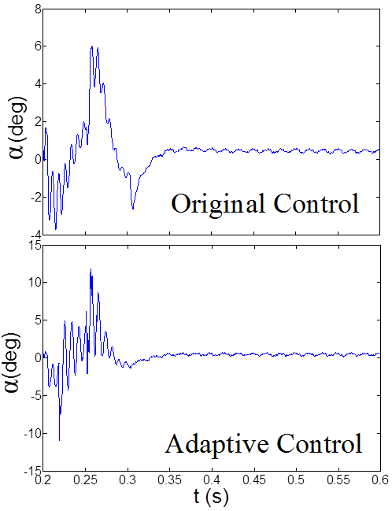
Figure 3.24 Results of α in a severe disturbance.

Conclusions
From the above six case studies shown in subsections 3.4.2 to 3.4.7, it is evident that the adaptive PI control can achieve faster and more consistent response than the original one. The response time and the curve of the proposed adaptive PI control is almost identical under various conditions such as a change of (initial) control gains, a change of load, a change of network topology, consecutive disturbances and a severe disturbance. In contrast, the response curve of the original control model varies greatly under a change of system operating condition and worse, may not correct the voltage to the expected value.
The advantage of the proposed adaptive PI control approach is expected because the control gains are dynamically and autonomously adjusted during the voltage correction process, therefore, the desired performance can be achieved. However, the original fixed PI controller may be well tuned for the given operating condition, but may be inefficient or incapable to correct voltage under other operating conditions.

Flatness-based adaptive control of STATCOM

Chapter Introduction
In this chapter, a flatness-based adaptive control method is proposed and applied to STATCOM for voltage control. By the flatness-based control, the trajectories of all system variables can be directly estimated by the flat output and its derivatives without solving differential equations. By the adaptive control, the control gains can be dynamically tuned to satisfy the time-varying operation condition requirement.

STATCOM Model and Control for Flatness based Adaptive Control
The equivalent circuit of the STATCOM is shown in Figure 4.1. In this power system, the equivalent connecting impedance consists of R_{s} and L_{s} in series with the voltage source inverter. Here, the equivalent resistance R_{s} accounts for the sum of the transformer winding losses and the inverter conduction losses, and the equivalent inductance L_{s} represents the transformer leakage inductance. C represents the capacitance of the dc side capacitor. In Figure 4.1, V_{al}, V_{bl} , and V_{cl} are the three-phase STATCOM output voltages; V_{as}, V_{bs} , and V_{cs} are the three phase bus voltages; and i_{as}, i_{bs} , and i_{cs} are the three-phase currents [31, 66].

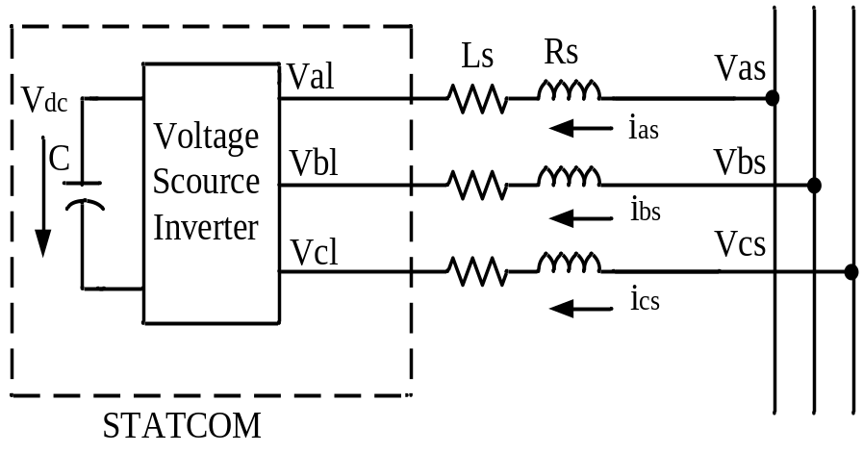
Figure 4.1 STATCOM Model.
The three-phase mathematical expressions of the STATCOM can be written similar like (3.1) to (3.4). By using the abc/dq transformation, the mathematical expressions can be rewritten as:
$\left\{\begin{matrix}L_{s}\frac{di_{ds}}{dt}=-R_{s}i_{ds}+ωL_{s}i_{qs}+V_{ds}-V_{dl} \\ L_{s}\frac{di_{qs}}{dt}=-R_{s}i_{qs}-ωL_{s}i_{ds}+V_{qs}-V_{ql} \\ \frac{d}{dt}\left(\frac{1}{2}CV_{dc}^{2}\right)=\frac{3}{2}\left(V_{dl}i_{ds}+V_{ql}i_{qs}\right)\end{matrix}\right.$ (4.1)
$V_{dl}=\frac{1}{2}V_{dc}m_{α}cosδ$ (4.2)
$V_{ql}=\frac{1}{2}V_{dc}m_{α}sinδ$ (4.3)
where $ω$ is the synchronously rotating angle speed of the voltage vector; i_{ds} and i_{qs} are the d and q axis currents corresponding to i_{as}, i_{bs}, and i_{cs}; V_{ds} and V_{qs} represent the d and q axis voltages corresponding to V_{as}, V_{bs} , and V_{cs}; V_{dl} and V_{ql} represent the d and q axis voltage corresponding to V_{al}, V_{bl} , and V_{cl}; m_{a} is the ratio between the peak amplitude of the phase converter voltage to dc voltage; and $δ$ is the STATCOM voltage vector position in the d-q frame.
Based on the above equations, the traditional control strategy can be obtained, and the STATCOM control block diagram is shown in Figure 4.2 [35, 66].
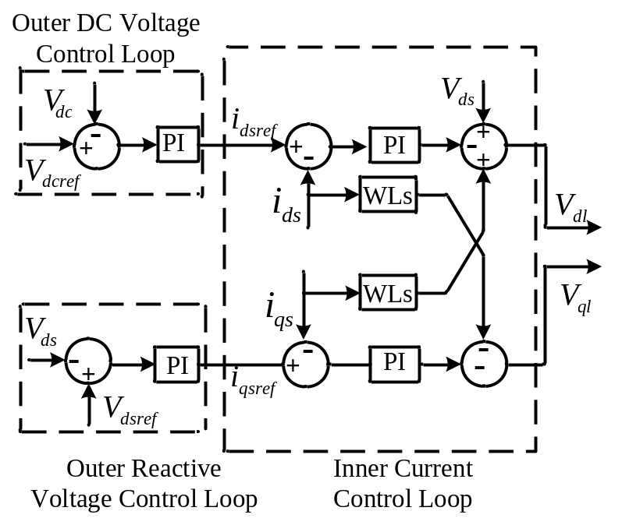
Figure 4.2 A typical double-loop control block of STATCOM
In Figure 4.2, a typical double-loop control strategy is used in STATCOM. The outer loop forms the desired active and reactive current references to maintain the voltages at the point of common coupling (PCC), and the inner loop is to control inverter currents with zero steady-state errors. This control strategy needs four PI controllers in its control systems; therefore, it can be a tedious and time-consuming work for utility engineers to perform trial-and-error studies to find suitable parameters when a new STATCOM is connected or when the system operating condition has significant changes to demand new tuning of STATCOM control parameters. Moreover, this control system has a coupling relationship between the active current and the reactive current, and thus, it is hard to maintain the voltages at the PCC with small effects on the dc-link voltage. These are potential difficulties for a large-scale utilization of STATCOM. Therefore, the flatness-based adaptive control method is proposed in this chapter.

Flatness-Based Control for STATCOM

Flatness-based Control Design for STATCOM
To realize flatness-based control in STATCOM, we set the state variable as: x=(x₁, x₂, x₃)^{T}=(i_{ds}, i_{qs}, V_{dc})^{T}, and the input control variable as: u=(u₁, u₂)^{T}=(m_{a}cosδ, m_{a}sinδ) ^{T}. Neglecting the inductance and converter losses and the change in the energy stored in the inductance [19, 39], we can rewrite (4.1) in standard form $\dot{x}=f\left(x\right)+g\left(x\right)u$ as follows:
$\left\{\begin{matrix}{\dot{x}}_{1}=-\frac{R_{s}}{L_{s}}x_{1}+ωx_{2}+\frac{V_{ds}}{L_{s}}-\frac{x_{3}u_{1}}{2L_{s}} \\ {\dot{x}}_{2}=-\frac{R_{s}}{L_{s}}x_{2}-ωx_{1}+\frac{V_{qs}}{L_{s}}-\frac{x_{3}u_{2}}{2L_{s}} \\ {\dot{x}}_{3}=\frac{3}{2Cx_{3}}\left(x_{1}V_{ds}\right)\end{matrix}\right.$ (4.4)
Since all system variables can be determined if we know I_{q} and V_{dc}. Therefore, the flat output in this system can be set as:
$\left\{\begin{matrix}y_{1}=x_{2} \\ y_{2}=x_{3}\end{matrix}\right.$ (4.5)
Based on (4.4) and (4.5), the following equation can be derived:
$\left\{\begin{matrix}{\dot{y}}_{1}={\dot{x}}_{2} \\ {\dot{y}}_{2}={\dot{x}}_{3} \\ {\ddot{y}}_{2}=\frac{3\left({\dot{x}}_{1}x_{3}V_{ds}-{\dot{x}}_{3}x_{1}V_{ds}\right)}{2Cx_{3}^{2}}\end{matrix}\right.$ (4.6)
Using y and y’s derivative to express x=(x₁, x₂, x₃)^{T} and u=(u₁, u₂)^{T}, we have:
$\left\{\begin{matrix}x_{1}=\frac{2C}{3V_{ds}}{\dot{y}}_{2}y_{2} \\ x_{2}=y_{1} \\ x_{3}=y_{2}\end{matrix}\right.$ (4.7)
$\left\{\begin{matrix}u_{1}=\frac{2}{y_{2}}\left(-L_{S}\frac{2C}{3V_{ds}}\left(y_{2}{\ddot{y}}_{2}+{\dot{y}}_{2}^{2}\right)+ωL_{S}y_{1}-R_{S}\frac{2C}{3V_{ds}}y_{2}{\dot{y}}_{2}+V_{ds}\right) \\ u_{2}=\frac{2}{y_{2}}\left(-L_{S}{\dot{y}}_{1}-ωL_{S}\frac{2C}{3V_{ds}}y_{2}{\dot{y}}_{2}-R_{S}y_{1}+V_{qs}\right)\end{matrix}\right.$ (4.8)
Then the following equations can be obtained as (4.9) and (4.10).
$m_{a}=\sqrt{u_{1}^{2}+u_{2}^{2}}$ (4.9)
$δ=arctan\frac{u_{2}}{u_{1}}$ (4.10)
Based on (4.4)-(4.10), the flatness-based control can be implemented with the control block shown in Figure 4.3.
In Figure 4.3, y_{1ref} and y_{2ref} are defined by the system desired initial and final conditions. As shown in Figure 4.3, the nonlinear STATCOM system can be equivalent to a linear system, and the trajectories of all system variables can be directly estimated by flat output and its derivatives without solving differential equations. This is the advantage of flatness-based control when applied to STATCOM control.

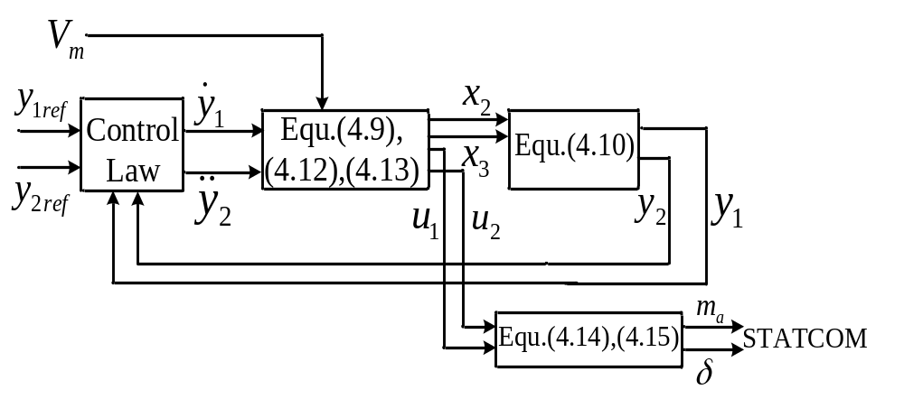
Figure 4.3 Flatness-based control block

Flat Output
Assume that the initial disturbance occurs at time t₀; the final time instant of the dynamic study is t₁; the desired initial states are I_{q}(t₀) (or simply I_{q}(0)) and V_{dc}(t₀) (or simply V_{dc}(0)); and the final states are I_{q}(t₁) and V_{dc}(t₁).
The initial and final conditions are modeled as follows:
$\left\{\begin{matrix}\begin{matrix}y_{1ref}\left(t_{0}\right)=I_{q}\left(t_{0}\right) \\ y_{1ref}\left(t_{1}\right)=I_{q}\left(t_{1}\right)\end{matrix} \\ \begin{matrix}y_{2ref}\left(t_{0}\right)=V_{dc}\left(t_{0}\right) \\ y_{2ref}\left(t_{1}\right)=V_{dc}\left(t_{1}\right)\end{matrix}\end{matrix}\right.$ (4.11)
$\left\{\begin{matrix}\begin{matrix}{\dot{y}}_{1ref}\left(t_{0}\right)=0 \\ {\dot{y}}_{1ref}\left(t_{1}\right)=0\end{matrix} \\ \begin{matrix}{\dot{y}}_{2ref}\left(t_{0}\right)=0 \\ \begin{matrix}{\dot{y}}_{2ref}\left(t_{1}\right)=0 \\ \begin{matrix}{\ddot{y}}_{2ref}\left(t_{0}\right)=0 \\ {\ddot{y}}_{2ref}\left(t_{0}\right)=0\end{matrix}\end{matrix}\end{matrix}\end{matrix}\right.$ (4.12)
In order to satisfy Eqs. (4.11) and (4.12), the desired trajectory for flat output can be expressed as:
- 0<t<t₀
$$\left\{\begin{matrix}y_{1ref}\left(t\right)=I_{q}\left(0\right) \\ y_{2ref}\left(t\right)=V_{dc}\left(0\right)\end{matrix}\right.$$
- t₀≤t≤t₁
$\left\{\begin{matrix}y_{1ref}\left(t\right)=I_{q}\left(0\right)+\left(I_{q}\left(t_{1}\right)-I_{q}\left(0\right)\right)×{dd}_{1} \\ y_{2ref}\left(t\right)=V_{dc}\left(0\right)+\left(V_{dc}\left(t_{1}\right)-V_{dc}\left(0\right)\right)×{dd}_{2}\end{matrix}\right.$
Without losing generality, in order to make the output curve as smooth as possible, we may set:
$$\left\{\begin{matrix}y_{1ref}\left(t\right)=\sum_{j=0}^{N}{\frac{a_{j}}{j!}}{\left(t-t_{0}\right)}^{j} \\ y_{2ref}\left(t\right)=\sum_{j=0}^{N}{\frac{b_{j}}{j!}}{\left(t-t_{0}\right)}^{j}\end{matrix}\right.$$
Based on (4.11) and (4.12), dd₁ and dd₂ can be obtained as follows:
$$\left\{\begin{matrix}{dd}_{1}=\left(4×{\left(\frac{t-t_{0}}{t_{1}-t_{0}}\right)}^{2}-4×{\left(\frac{t-t_{0}}{t_{1}-t_{0}}\right)}^{3}+{\left(\frac{t-t_{0}}{t_{1}-t_{0}}\right)}^{4}\right) \\ {dd}_{2}=\left(9×{\left(\frac{t-t_{0}}{t_{1}-t_{0}}\right)}^{3}-12×{\left(\frac{t-t_{0}}{t_{1}-t_{0}}\right)}^{4}+{3×\left(\frac{t-t_{0}}{t_{1}-t_{0}}\right)}^{5}+{\left(\frac{t-t_{0}}{t_{1}-t_{0}}\right)}^{6}\right)\end{matrix}\right.$$
- t>t₁
$$\left\{\begin{matrix}y_{1ref}\left(t\right)=I_{q}\left(t_{1}\right) \\ y_{2ref}\left(t\right)=V_{dc}\left(t_{1}\right)\end{matrix}\right.$$

Control Law for Flatness-based Adaptive Control
The differential parameterization of the control input u=(u₁,u₂)^{T} can be expressed by 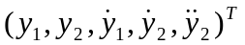. Also, the proposed flat output trajectory tracking is to control 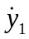 and 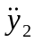. This can be accomplished by the following linear feedback control law:
$\left\{\begin{matrix}{\dot{y}}_{1}={\dot{y}}_{1ref}-\left(y_{1}-y_{1ref}\right)K_{11} \\ {\ddot{y}}_{2}={\ddot{y}}_{2ref}-K_{11}\left({\dot{y}}_{2}-{\dot{y}}_{2ref}\right)+K_{21}\left(y_{2}-y_{2ref}\right)\end{matrix}\right.$ (4.13)
In the previous work [44], the choice of the coefficients K₁₁, K₂₁ and K₂₂ is to guarantee the satisfaction of the Hurwitz polynomial condition (namely, to guarantee that the roots are located in the left part of the complex plane). Thus, the asymptotic exponential stability to zero of the tracking error is guaranteed.
However, the constant gains cannot ensure an optimized and consistently efficient performance for various external conditions. In order to achieve a control method that can ensure a fast and desirable response when the system operation condition varies, an adaptive control scheme is combined with flat control. Here, the flat control gains are dynamically and adaptively adjusted based on the external condition. Thus, the proposed control method is termed flatness-based adaptive control (FBAC).
Set err₁(t)=y₁(t)-y_{1ref}(t), err₂(t)=y₂(t)-y_{2ref}(t), and ${\dot{err}}_{2}(t)={\dot{y}}_{2}(t)-{\dot{y}}_{2ref}(t)$. The process of adaptive control design is described as follows with different scenarios of the error value.
Based on the system bus capacity and the STATCOM rating, ΔV_{max} can be obtained, which means any voltage change greater than ΔV_{max} cannot come back to 1 per unit. Based on [3], the sensitivity of di_{qs}/dV is around 1 p.u. /0.034 p.u. of voltage in this paper. For simplicity, we may assume the ∆i_{qs}/∆V sensitivity is a linear function. When the voltage error is $ε_{2}=0.0001$ p.u., ∆i_{qs} is $ε_{1}=0.003$ p.u.. If the system voltage error is less than $ε_{2}$ p.u., the system is considered as stable and control gains are kept the same. Otherwise, the control gains need to be tuned to make system voltage get back to 1 p.u.. Since y₁=i_{qs}, err₁ is considered. If $\left|{err}_{1}\left(t\right)\right|<ε_{1}$, the system is considered as stable, and K₁₁(t) can be set as initial values (such as 1). If $\left|{err}_{1}\left(t\right)\right|>ε_{1}$, the following approach is employed to tune control gains.
- When $0<t<t_{0}$: y_{1ref}(0)≠0 and y₁(t) needs to be increased to y_{1ref}(t) as quickly as possible (i.e., in one sampling cycle Δt ) to ensure err₁=0. Without losing of generality, we can assume y₁(t)=y_{1ref}(t) after Δt. Thus, we have $K_{11}\left(t\right)=\frac{1}{∆t}$.
- When $t_{0}≤t≤t_{1}$: since the final ideal state${\dot{y}}_{1}\left(t\right)=0$, based on (22), we can obtain:
$0={\dot{y}}_{1ref}\left(t\right)-\left(y_{1}\left(t\right)-y_{1ref}\left(t\right)\right)K_{11}\left(t\right)$ (4.14)
Therefore:
$K_{11}\left(t\right)=\left|\frac{{\dot{y}}_{1ref}\left(t\right)}{{err}_{1}\left(t\right)}\right|$ (4.15)
- When $t>t_{1}$: y₁(t) needs to be increased to y_{1ref}(t) as quickly as possible to ensure err₁=0. Since we consider y₁(t)=y_{1ref}(t) after Δt, we have $K_{11}\left(t\right)=\frac{1}{∆t}$
Next, err₂(t) is considered in a similar yet different way. Based on [3], ∆V_{dc} and the system voltage error are in the same range. Therefore, If $\left|{err}_{2}\left(t\right)\right|<ε_{2}$, K₂₁(t) and K₂₂(t) can be set as initial values (such as 1). If $\left|{err}_{2}\left(t\right)\right|>ε_{2}$, the following approach is employed to tune control gains.
- In the ideal state, ${\ddot{y}}_{2}\left(t\right)={\ddot{y}}_{2ref}\left(t\right)$. Without losing generality, we can set K₂₂(t)=K(t)K₂₁(t). Then, we have $K\left(t\right)=\left|\frac{e{rr}_{2}(t)}{\dot{e{rr}_{2}}(t)}\right|$.
- When $0<t<t_{0}$or$t>t_{1}$: ${\ddot{y}}_{2}\left(t\right)$ needs to be decreased to ${\ddot{y}}_{2ref}\left(t\right)$ as quickly as possible (i.e., in one sampling cycle Δt) to ensure err₂=0. Therefore, we have $K_{21}\left(t\right)=\left|\frac{{\dot{err}}_{2}\left(t\right)/Δt}{{err}_{2}\left(t\right)+K\left(t\right){\dot{err}}_{2}\left(t\right)}\right|$ and $K_{22}\left(t\right)=K\left(t\right)\left|\frac{{\dot{err}}_{2}\left(t\right)/Δt}{{err}_{2}\left(t\right)+K\left(t\right){\dot{err}}_{2}\left(t\right)}\right|$.
- When $t_{0}≤t≤t_{1}$: the ideal state${\ddot{y}}_{2}\left(t\right)=0.$ Set tt=t-Δt, and in a very short time control gains stay the same, such as K₂₁(t)= K₂₁(tt) and K₂₂(t) = K₂₂(tt). if the system stable, we have:
$0={\ddot{y}}_{2ref}\left(t\right)-K_{22}\left(t\right)\dot{e{rr}_{2}}\left(t\right)-K_{21}\left(t\right)e{rr}_{2}(t)$ (4.16)
$0={\ddot{y}}_{2ref}\left(tt\right)-K_{22}\left(t\right)\dot{e{rr}_{2}}\left(tt\right)-K_{21}\left(t\right)e{rr}_{2}(tt)$ (4.17)
Based on (23) and (24), the following equation can be obtained:
$K\left(t\right)=\left|\frac{{\ddot{y}}_{2ref}\left(t\right){err}_{2}\left(tt\right)-{\ddot{y}}_{2ref}\left(tt\right){err}_{2}\left(t\right)}{{\dot{err}}_{2}\left(t\right){\ddot{y}}_{2ref}\left(tt\right)-{\dot{err}}_{2}\left(tt\right){\ddot{y}}_{2ref}\left(t\right)}\right|$ (4.18)
$K_{21}\left(t\right)=\left|\frac{{\ddot{y}}_{2ref}\left(t\right)}{{err}_{2}\left(t\right)+K\left(t\right){\dot{err}}_{2}\left(t\right)}\right|$ (4.19)
K₂₂(t)=K(t)K₂₁(t) (4.20)
Based on the proposed control law, the FBAC can be implemented as shown in Figure 4.4. This module is the “Control Law” block in Figure 4.3 which shows the FBAC diagram.
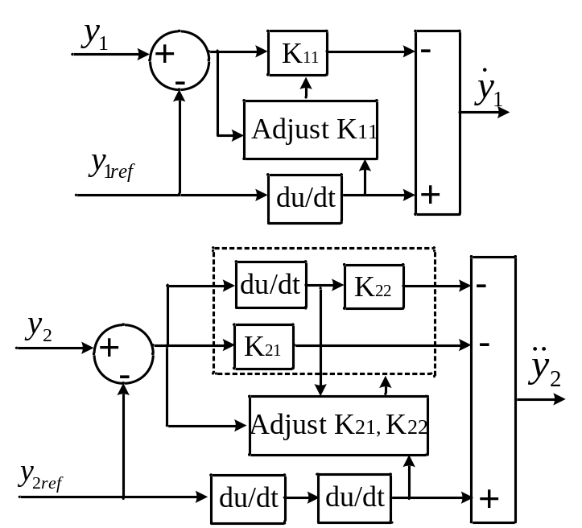
Figure 4.4 Implementation of the adaptive control module
Based on the flatness-based control logic and the adaptive control module shown in Figure 4.3 and Figure 4.4, respectively, the flatness-based adaptive control can be designed and implemented. Next, in Section 4.5, the simulation results from the original control, the flatness-based control and the flatness-based adaptive control will be discussed and compared.

Simulation Results

System data
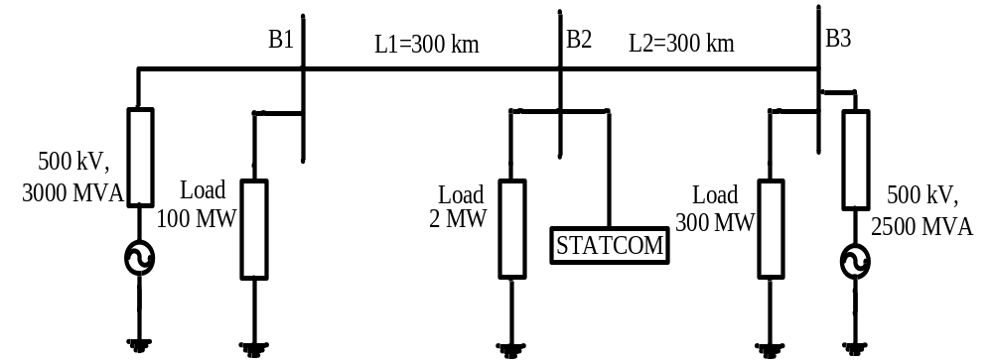
Figure 4.5 The test system for simulation study
In the system simulation diagram shown in Figure 4.3, The STATCOM is used for Bus B2 voltage regulation on a 500 kV transmission line. The power grid consists of two 500 kV equivalents (3000 MVA and 2500 MVA, respectively) connected by a 600-kilometer transmission line. In this study system, the STATCOM has a rating of +/- 100MVA. It is a phasor model of a typical three-level PWM STATCOM. DC link nominal voltage is 40 kV with an equivalent capacitance of 375 uF. The transformer leakage reactance and the phase reactor of the IGBT bridge of an actual PWM STATCOM are 0.22 p.u. on 100 MVA in this system [65].
In the original model, the control system is realized by four PI controllers and referred to as the original control in this section. Note, the original control gains shown in literature [3] are well tuned. In the flatness-based control (FBC), which is elaborated in section 4.3, the control gains K₁₁, K₂₁ and K₂₂ are also well tuned based on the trial and error approach for the first case study (i.e., Subsection 4.5.2 below) and are set at 1.6, 0.9 and 0.9, respectively. In the proposed flatness-based adaptive control (FBAC), which is a combined model of sections 4.3 and 4.4, the initial control gains are set to 1’s, and then the gains are dynamically adjusted based on the method described in section 4.4. The original control, the FBC and the FBAC are compared in this section. In the simulation, the reference voltage at Bus B2, shown in Figure 4.5, is 1.0 p. u. at the beginning, with the voltage base being 500 kV. Assume the initial disturbance occurs at t₀=0.2 sec; and the system is expected to reach back the desired normal state at t₁=0.3 sec.

Change of Reactive Load
Here, we keep all the parameters unchanged, as in the original studied system. At t₀=0.2 sec, a new reactive load of 80 MVar is added at B2 as a disturbance. The results of Bus B2 voltage (V), STATCOM reactive power output (Q), the d and q axis currents are shown in Figure 4.6 to Figure 4.9 respectively. Observations are summarized in Table 4.1.
From the results, it is obvious that the FBC and the proposed FBAC can achieve quicker response than the original control. The needed reactive power, i_{ds}, and i_{qs} are the same while the FBC and the FBAC perform much faster to bring the voltage back to 1.0. Note, as previously mentioned, the control gains K₁₁, K₂₁ and K₂₂ in the FBC are well tuned based on this case using the trial and error approach and are set at 1.6, 0.9 and 0.9, respectively. Since the parameters are well tuned for this case, the FBC can give desirable responses very close to the response of the proposed FBAC in this case.
Table 4.1 Performance comparison for change of reactive load
 | Original Ctrl. | Flatness based Ctrl. (FBC) | Flatness based adaptive Ctrl. (FBAC)
Lowest Voltage after disturbance | 0.9713 p.u. | 0.9713 p.u. | 0.9713 p.u.
Time (sec) when V=1.0 | 0.4293 sec | 0.3001 sec | 0.2895 sec
∆t to reach V=1.0 | 0.2293 sec | 0.1001 sec | 0.0895 sec
Var Amount at steady state | -0.83 p.u. | -0.83 p.u. | -0.83 p.u.

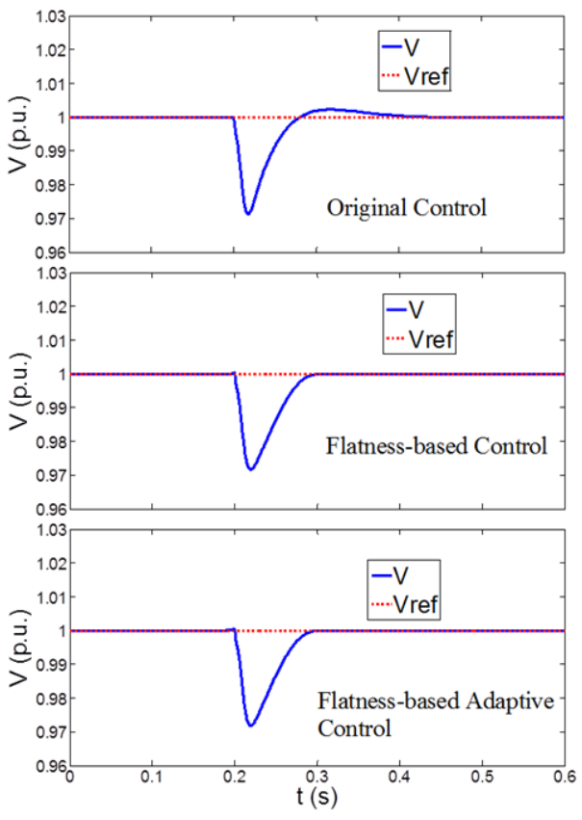
Figure 4.6 Results of V with change of Rs and Ls
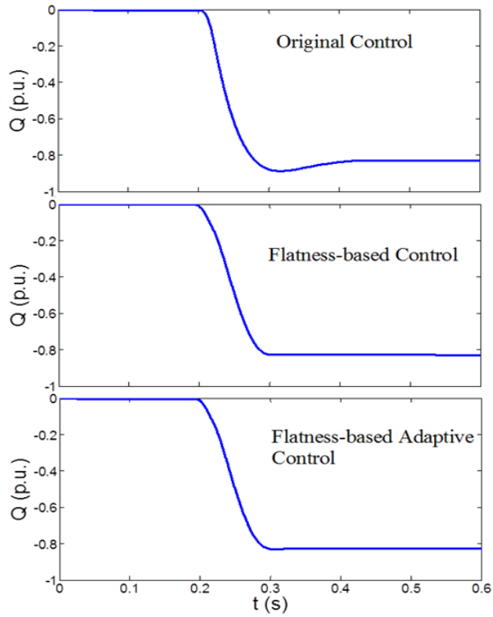
Figure 4.7 Results of Q with change of Rs and Ls
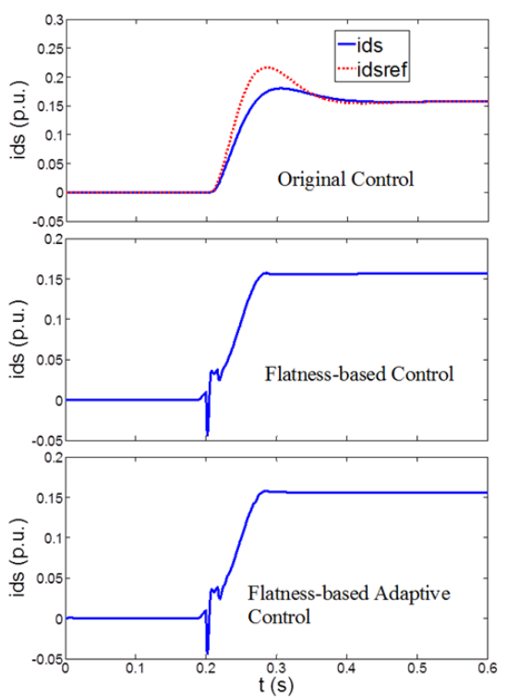
Figure 4.8 Results of I_{d} with change of Rs and Ls
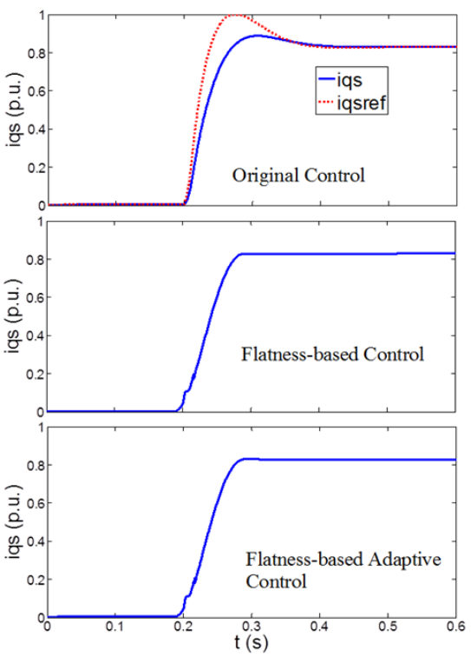
Figure 4.9 Results of I_{q} with change of Rs and Ls

Change of Transmission Network
In this case, the original system parameters are kept. However, a new Line L3 of 125 km is added between bus B2 and B3 at the system to mimic a new operation topology. Then, Line L3 is switched off at t₀=0.2 sec to mimic a disturbance.
The results from the original control, the FBC and the proposed FBAC are shown in Figure 4.10 to Figure 4.14. Observations are summarized in Table 4.2.
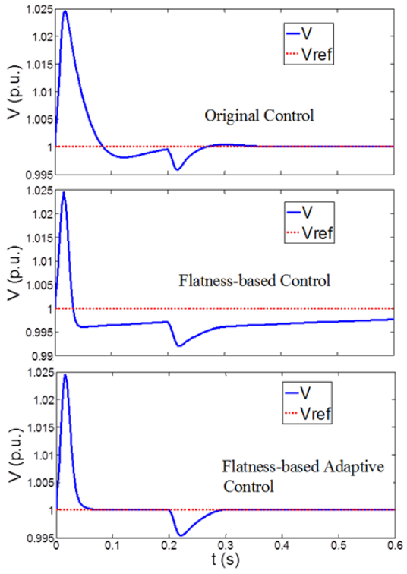
Figure 4.10 Results of V with change of transmission network.
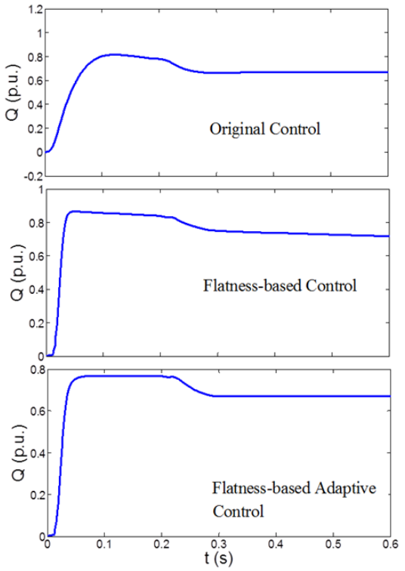
Figure 4.11Results of Q with change of transmission network.

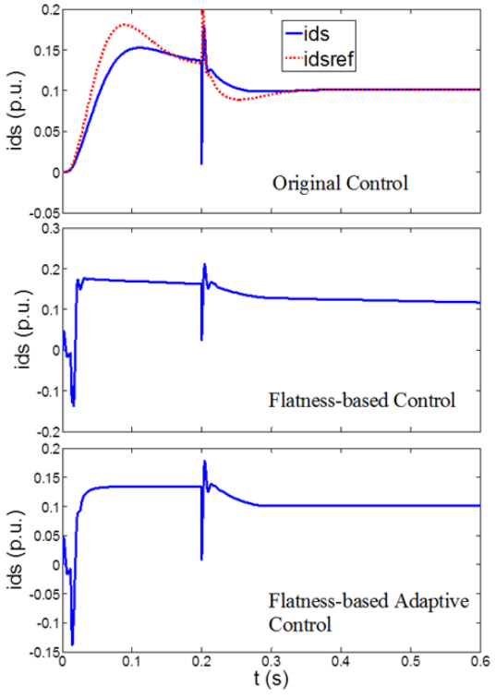
Figure 4.12 Results of I_{d} with change of transmission network.
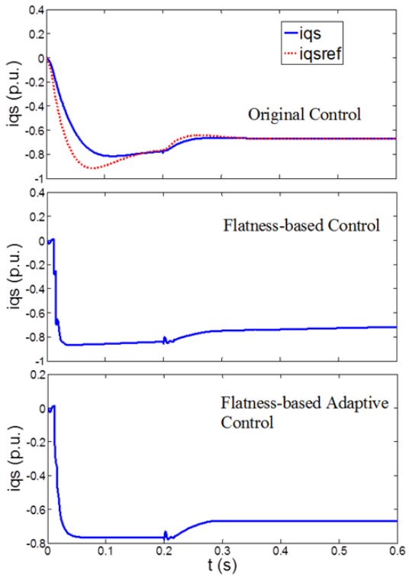
Figure 4.13 Results of I_{q} with change of transmission network.
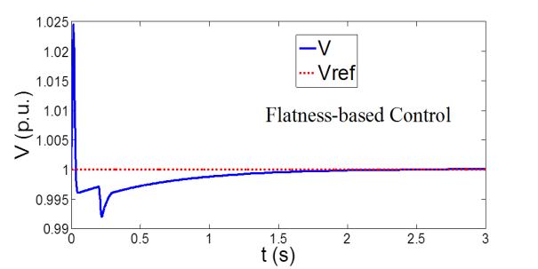
Figure 4.14 Results of V with extended simulation time
Table 4.2 Performance comparison for change of transmission network
 | Original Ctrl. | Flatness based Ctrl. (FBC) | Flatness based adaptive Ctrl. (FBAC)
Highest Voltage after change of transmission network | 1.0245 | 1.0245 | 1.0245
Time (sec) when V=1.0 after change of transmission network | N/A | N/A | 0.0765
Lowest Voltage after disturbance | 0.9955 p.u. | 0.992 p.u. | 0.9955
Time (sec) when V=1.0 after disturbance | 0.3824 sec | 2.2863 | 0.2914 sec
∆t to reach V=1.0 after disturbance | 0.1824 sec | 2.0863 | 0.0914 sec
Var Amount at steady state | 0.67 p.u. | 0.67 p.u. | 0.67 p.u.
From the results, we can find out that when the transmission network changes, the original control and the FBC cannot bring the system voltage back to 1 p.u. even during the initialization stage before the disturbance occurs at 0.2 sec. This also implies that the gains in the original PI control and FBC must be manually re-turned to achieve a satisfying performance under a new topology.
After the disturbance (switching off Line L3) occurs at 0.2 sec, the FBC cannot make the system reach its steady-state voltage within 0.6 sec. Note, a separate diagram in Figure 4.14 with extended simulation time shows that the voltage eventually reaches back to 1 p.u. at t=2.2863 sec, or 2.0863 sec after the disturbance of topology change. This is also shown in Table 4.2. The original control performs better, reaching 1.0 p.u. in 0.1824 sec after the topology change. However, this is still much slower than the proposed FBAC which brings the system voltage back to 1 p.u. in 0.0914 sec after the disturbance, as shown in Table 4.2.
The response time (i.e., ∆t to reach V=1.0) of the FBAC is only 50% of the original control and 4.3% of the FBC. In other words, the FBAC shortens the response time by 0.1 sec and 2.0 sec respectively, as opposed to the original control and the FBC. Since 0.1 sec can be significant in modern STATCOM control and makes a big difference in STATCOM performance [21], the improved performance with FBAC is considerable. Therefore, the proposed FBAC can achieve a response quicker than the original control and even much quicker than the FBC. Thus, the control gains K₁₁, K₂₁ and K₂₂ in the original control and the FBC are not optimal under this new topology. Some form of gain tuning of K₁₁, K₂₁ and K₂₂ must be performed to achieve the same response as the proposed FBAC. Apparently, the tuning-free FBAC has an advantage over the other two controls.

Change of Transmission Network and Load
In this case, the original system parameters are kept. However, a 125km new Line L3 is added between bus B2 and B3 at the system to mimic the new operation system. Line 1 is switched off and a new load 200MW is added at B2 at 0.2 sec as a large disturbance. The results of three controls are shown in Figure 4.15 to Figure 4.19. Again, it should be noted that the initial dynamics in these figures are due to the change of transmission network. Observations are summarized in Table 4.3.
Table 4.3 Performance comparison for change of transmission network and load.
 | Original Ctrl. | Flatness based Ctrl. (FBC) | Flatness based adaptive Ctrl. (FBAC)
Highest Voltage after change of transmission network | 1.0245 | 1.0245 | 1.0245
Time (sec) when V=1.0 after change of transmission network | N/A | N/A | 0.0619
Lowest Voltage after disturbance | 0.9698 p.u. | 0.9652 p.u. | 0.97 p.u.
Time (sec) when V=1.0 after disturbance | 0.4166 sec | 1.9082 | 0.3025 sec
∆t to reach V=1.0 after disturbance | 0.2166 sec | 1.7082 | 0.1025 sec
Var Amount at steady state | -0.02 p.u. | -0.02 p.u. | -0.02 p.u.
From the results, the FBAC response remains unchanged under this disturbance, while the original control method gives slower response and the FBC cannot bring the voltage back to steady-state in 0.6 sec. Note, a separate diagram in Figure 4.19 with extended simulation time shows that the voltage eventually reaches back to 1 p.u. at t=1.9082 sec, or 1.7082 sec after the disturbance. This is also shown in Table III.
The observation is similar to the previous case. The response time (i.e., ∆t to reach V=1.0) of the FBAC is only 47% of the original control and 6% of the FBC. Hence, similar to the previous case, the advantage of the proposed FBAC method is clearly demonstrated again.
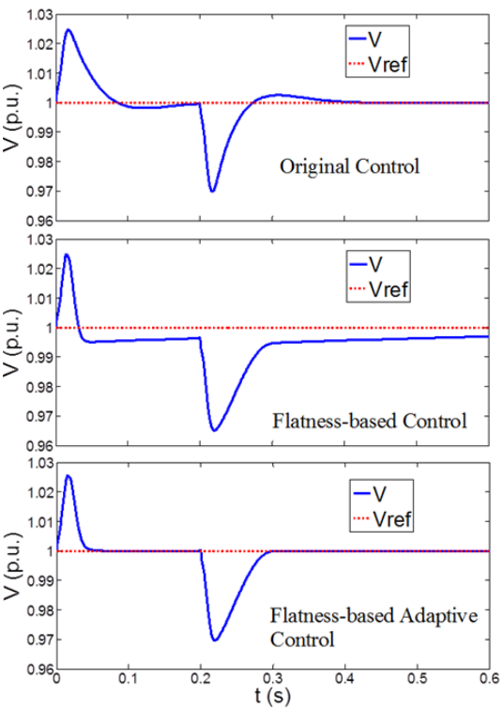
Figure 4.15 Results of V with change of load.
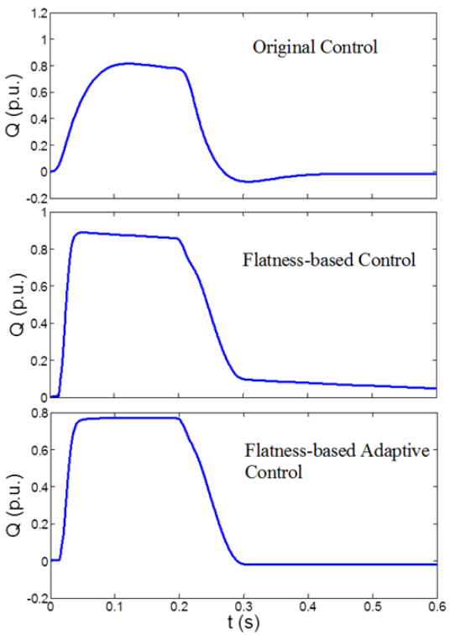
Figure 4.16 Results of Q with change of load.
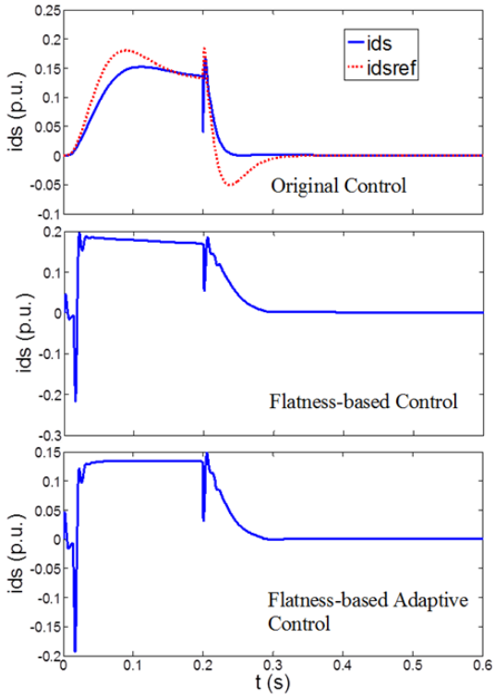
Figure 4.17 Results of I_{d} with change of load.
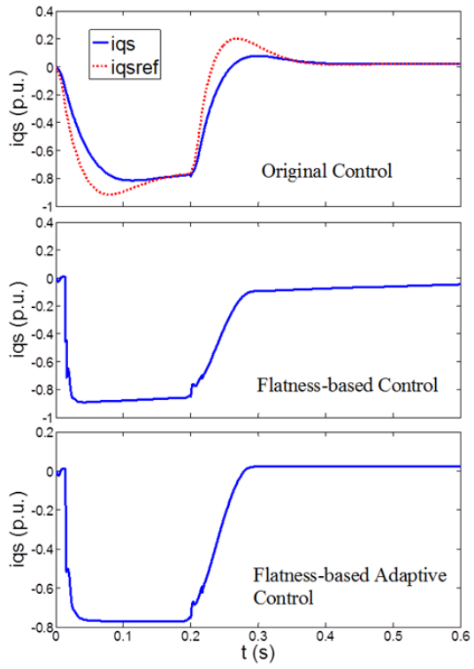
Figure 4.18 Results of I_{q} with change of load.
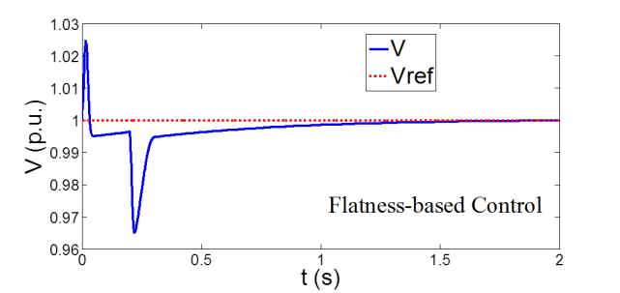
Figure 4.19 Results of V with extended simulation time

Conclusions
The three case studies in Subsections 4.5.2 to 4.5.4 show the advantage of the proposed FBAC over the original control and the FBC. The original control and the FBC models may have a desirable response in a specific system. However, when system operating condition changes, the FBC gains and tradition PI control gains need to be redesigned or re-tuned to obtain satisfying responses; otherwise, the original control and the FBC may be subject to slower response, as demonstrated in Subsections 4.5.3 to 4.5.4. However, the proposed FBAC can consistently achieve fast, smooth, and desirable responses under various changes of system operating conditions such as a change of load and a change of network, and the response curves are almost identical in all cases. Thus, it achieves the tuning-free and plug-and-play characteristic.

Adaptive Gain-Tuning Control Method for AGC with Effects of Wind Resources

Chapter Introduction
In this chapter, the wind power model on partial load area is built in this chapter. An automatic gain-tuning control (AGTC) for AGC with effects of wind resources is presented. By this control method, the PI control parameters can be automatically and dynamically calculated during different disturbances in a power system. In the proposed method, the initial gains will be calculated first. Then, high penetration of wind energy are integrated in power systems, the PI control parameters for AGC can be computed automatically and can be adjusted in real time based on the area control error (ACE) signal to keep the frequency stable.

AGC Model and Control
A large, interconnected power system is usually divided into several control area for efficient operation and control. The control areas are connected by the tie-lines. In each control area, an automatic generation controller (AGC) monitors the system frequency and tie-line flows. To maintain stable operation of the system, both constant frequency and constant tie-line power exchange should be ensured. Also, area control error (ACE) for each area will be calculated and kept in a low range. Therefore, ACE, which is defined as a linear combination of power net-interchange and frequency deviations, is generally taken as the controlled output of AGC. As the ACE is driven to zero by the AGC, both frequency and tie-line power errors will be forced to zeroes [5-6]. Figure 5.1. shows the studied n-area power system.
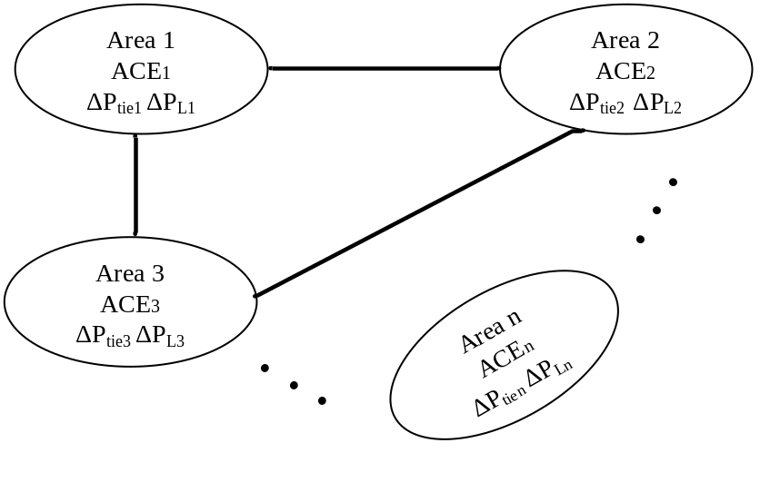
Figure 5.1 Three-area power system
The parameters for the three area power system are shown as follows:
${ACE}_{i}={ΔP}_{tiei}+B_{i}Δω_{i}$ the area control errors for area i;
ΔP_{tiei} = tie line flow for area i;
ΔP_{Li} = load changes for area i;
Δω_{i}= the angular frequency deviations for area i;
$B_{i}=D_{i}+\frac{1}{R_{i}}$ frequency bias factors for area i;
R_{j}= the speed regulations for generator j;
D_{j} = damping constant for generator j;
H_{j}= inertia constants for generator j;
τ_{gj} = governor time constants for generator j;
τ_{Tj}= turbine time constants for generator j;
i=1, 2, 3,…, n; and
j=1, 2, 3,…, m;
m=the total number of generators;
In the original AGC control, the proportional integral (PI) controllers are used. The control gains are usually designed by:
- Trial and error approach;
- Pole placement method; or
- Population based search techniques.
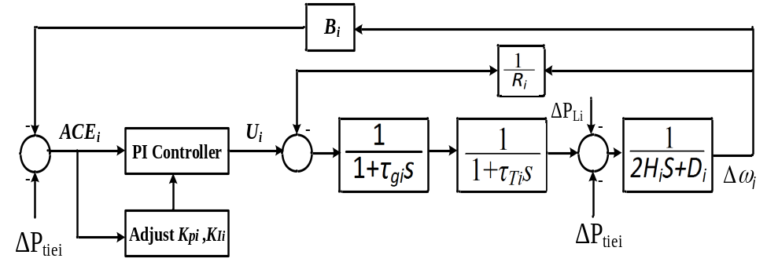
Figure 5.2 AGTC block for area i
The first method is very time-consuming and the second method is easily affected by the designer’s experience. All these methods with fixed control gains may not obtain the desired response when the power system operation conditions change, especially when power systems operate with variable wind power. To improve this, a dynamic gain-tuning control method (DGTC) is presented in order to obtain the desired response for the AGC with wind power. A key feature of the proposed DGTC method is the dynamic self-adjustment of control parameters to continuously follow the desired response which is set to be ACE_{i}=0 in this work. The DGTC block for AGC in the area i is shown in Figure 5.2. In the figure, U_{i} is the output of the PI controller. K_{Pi}, K_{Ii} are PI controller gains for area i (i=1~n). The parameters K_{Pi}, K_{Ii} will be dynamically adjusted based on ACE_{i}. In this work, steam turbine with no heat type is modeled to realize the DGTC. The control gains in the system with steam turbine of reheat type and hydraulic turbine can be designed in a similar way.
On one hand, larger values of K_{Pi} and K_{Ii} may induce the oscillation; on the other hand, smaller values of K_{Pi} and K_{Ii} may lead the slow response. These effects are also mentioned and analyzed in [20]. Therefore, the proper control parameters are highly important to achieve better AGC responses. In the next section, the PI control gain design will be introduced.

Gain Design for AGC

Initial gains setting
Under the initial condition, we may assume that ΔP_{tiei}=0, and Δω₁ =Δω₂ =Δω₃=…=Δω_{n}. Based on Figure 5.2, the closed-loop transfer function of the area i can be obtained [6].
$-\frac{∆ω_{i}\left(s\right)}{∆P_{Li}\left(s\right)}=\frac{\left(1+τ_{gi}s\right)\left(1+τ_{Ti}s\right)s}{\left(2H_{i}S+D_{i}\right)\left(1+τ_{gi}s\right)\left(1+τ_{Ti}s\right)s+B_{i}\left(K_{Pi}s+K_{Ii}\right)+\frac{s}{R_{i}}}$ (5.1)
Then, the characteristic polynomial equation for each area can be shown as:
$a_{4}s^{4}+a_{3}s^{3}+a_{2}s^{2}+a_{1}s+a_{0}s^{0}=0$ (5.2)
where:
$a_{4}=2H_{i}τ_{gi}τ_{Ti}$ (i=1~3)
$a_{3}=\left(2H_{i}τ_{gi}+2H_{i}τ_{Ti}+D_{i}τ_{gi}τ_{Ti}\right)$
$a_{2}=\left(2H_{i}+D_{i}τ_{gi}+D_{i}τ_{Ti}\right)$
$$a_{1}=\left(D_{i}+B_{i}K_{pi}+\frac{1}{R_{i}}\right)$$
$a_{0}=B_{i}K_{Ii}$
Based on the Routh-Hurwitz criterion, if the system is stable, then we have
$\left\{\begin{matrix}a_{4}>0 \\ a_{3}>0 \\ \begin{matrix}b_{31}>0 \\ \begin{matrix}b_{41}>0 \\ a_{0}>0\end{matrix}\end{matrix}\end{matrix}\right.$ (5.3)
where $b_{31}=\frac{a_{2}a_{3}-a_{4}a_{1}}{a_{3}}$ ; $b_{32}=a_{0}$ ; and $b_{41}=\frac{b_{31}a_{1}-b_{32}a_{3}}{b_{31}}$ .
Since K_{Pi}>0, and K_{Ii}>0, we can obtain that a₄>0, a₃>0 and a₀>0. If the system is stable, the following equations need to be satisfied.
$\left\{\begin{matrix}a_{2}a_{3}-a_{4}a_{1}>0 \\ b_{31}a_{1}-b_{32}a_{3}>0\end{matrix}\right.$ (5.4)
Based on (5.4), the initial value for K_{Pi} and K_{Ii} (i=1~3) can be obtained.

Control gain design during the disturbance
At arbitrary time instant t=t₁, set t₂=t₁-τ, in which τ is set to be 0.1 sec. PI control gains stay the same within 0.1s, such that K_{Pi}(t₁)= K_{Pi}(t₂) = K_{Pi}(t₀); K_{Ii}(t₁)= K_{Ii}(t₂)= K_{Ii}(t₀). Under normal conditions, each area can carry out its control obligation, and steady-state corrective action of AGC is confined to the area that the deficit or excess generation occurs [5-6], [27-28]. Therefore, when the system is stable, we can obtain:
$U_{i}\left(t_{1}\right)=A_{1i}K_{Pi}\left(t_{0}\right)+B_{1i}K_{Ii}\left(t_{0}\right)$ (5.5)
$U_{i}\left(t_{2}\right)=A_{2i}K_{Pi}\left(t_{0}\right)+B_{2i}K_{Ii}\left(t_{0}\right)$ (5.6)
where U_{i}(t₁), U_{i}(t₂), A_{1i}, B_{1i}, A_{2i} and B_{2i} are known variable. K_{Pi}(t₀) and K_{Ii}(t₀) are unknown variables. U_{i}(t₁) and U_{i}(t₂) are equal to corresponding load changes at area i, namely U_{i}(t₁)=|ΔP_{Li}(t₁)| and U_{i}(t₂)=|ΔP_{Li}(t₁)| (here, |ΔP_{Li}(t₁)| >0 |ΔP_{Li}(t₂)| >0).
$${A_{1j}=ACE}_{j}\left(t_{1}\right)$$
$${A_{2j}=ACE}_{j}\left(t_{2}\right)$$
$$B_{1j}=\int_{t_{0}}^{t_{1}}{{ACE}_{j}\left(t\right)}dt$$
$$B_{2j}=\int_{t_{0}}^{t_{2}}{{ACE}_{j}\left(t\right)}dt$$
In case that (5.5) and (5.6) are singular, we can simply assume K_{Pi}(t₀)=K_{Ii}(t₀) to reach a solution. Based on (5.5), we can obtain:
$K_{Pi}\left(t_{0}\right)=\frac{U_{i}\left(t_{1}\right)}{A_{1i}+B_{1i}}$ (5.7)
Based on (5.6) and (5.7), the following equations can be obtained.
$K_{Ii}\left(t_{0}\right)=\frac{U_{i}\left(t_{2}\right)-A_{2i}K_{Pi}\left(t_{0}\right)}{B_{2i}}$ (5.8)
$K_{Pi}\left(t_{0}\right)=\frac{U_{i}\left(t_{1}\right)-B_{1i}K_{Ii}\left(t_{0}\right)}{A_{1i}}$ (5.9)

Flow Chart
Figure 5.3 is an exemplary flowchart of the proposed DGTC method for AGC.
The dynamic gain-tuning control (DGTC) process begins at Start. The initial PI control gains are calculated. The tie line flow ΔP_{tiei} and the angular frequency deviations Δω_{i} (i=1~n) is sampled according to a desired sampling rate and${ACE}_{i}$ is calculated. If |ΔACE_{i}|<ε₁, (the tolerance threshold, ε₁, which is a very small value such as 0.0001 p.u.). Then, there is no reason to change any of the identified parameters: K_{Pi}(t) and K_{Ii}(t) (i=1~n) and the power system is under normal state. On the other hand, if |ΔACE_{i}|>ε₁, DGTC begins to work. Then, K_{Pi}(t) and K_{Ii}(t) are adjusted based on Eqs. (5.7), (5.8) and (5.9).
After obtaining the PI control gains, K_{Pi}(t) and K_{Ii}(t) need to be substituted to (5.4) to check whether the PI control gains satisfy the Routh-Hurwitz criterion. If satisfied, the PI control gains will be updated based on the calculated control gains; otherwise, the initial control gains will be selected instead of the calculated control gains to avoid system frequency oscillation.
After checking the Routh-Hurwitz criterion, ACE_{i} will be checked again to see whether it is within the tolerance threshold ε₁. If it is not within the threshold, the PI control gains need to be recalculated until the ACE_{i} is less than the given threshold ε₁. When ACE_{i} is less than ε₁, the algorithm stops and the control gains remain the same.
Since it is necessary to continuously perform the frequency control process, the process returns to the block of measuring load changes.
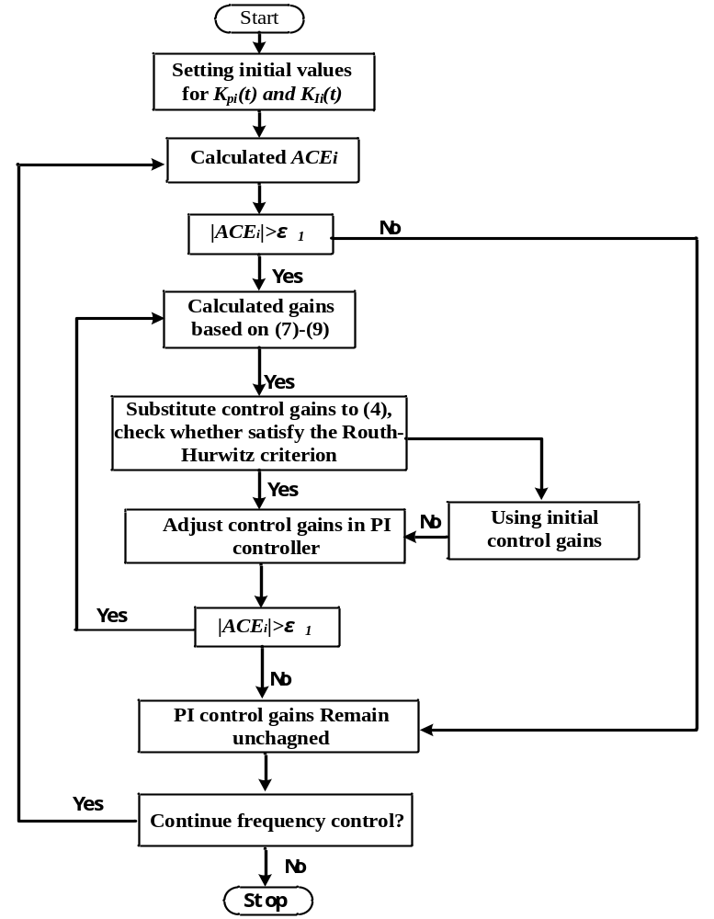
Figure 5.3 DGTC algorithm flow chart.

Wind Power Model
The wind energy tends to be variable and uncertain because of the effects of the natural and meteorological conditions. Based on the previous works [3, 24], wind speed can be modeled as (5.10) to mimic the real time wind speed.
$V\left(t\right)=V_{m}\left(t\right)+V_{e}\left(t\right)$ (5.10)
A normal distribution is applied to the wind speed forecast error in this paper. The model is written as follows:
$V_{e}\left(t\right)=N\left(μ_{e}\left(t\right), σ_{e}^{2}\left(t\right)\right)$ (5.11)
where
V_{m}(t)=forecast wind speed
V_{e}(t)= wind speed forecast error at time t;
N denotes normal distribution;
μ_{e}(t)= mean value of V_{e}(t);
$σ_{e}^{2}\left(t\right)$= variance of V_{e}(t);
Then, the wind power output of the aerodynamic system can be expressed as equation as following,
$P_{t}=C_{p}\left(λ,β\right)\frac{ρπR^{2}}{2}{V\left(t\right)}^{3}$ (5.12)
where, P_{t} is the mechanical output power of the wind turbine; C_{p} is the performance coefficient of the wind turbine; ρ is the air density; R is the radius of wind turbine blades; V(t) is real time the wind speed; λ is the tip speed ratio of the rotor blade tip speed to wind speed, $λ=\frac{Rω_{t}}{V\left(t\right)}$ in which ω_{t} is the speed of the low-speed shaft; and β is the blade pitch angle.
A generic equation is used to model${ C}_{p}\left(λ,β\right)$:
${ C}_{p}\left(λ,β\right)=0.5176\left(\frac{116}{λ_{i}}-0.4β-5\right)e^{-\frac{21}{λ_{i}}}+0.0068λ$ (5.13)
with
$\frac{1}{λ_{i}}=\frac{1}{λ+0.08β}-\frac{0.035}{β^{3}+1}$ (5.14)
Therefore, with given wind speed, the wind power output can be calculated. In this work, the wind energy conversion system (WECS) operating in partial load region is considered since this region contains considerable wind power variation. A maximum power point tracking (MPPT) algorithm is used in WECS such that the energy conversion efficiency is maximized in the partial load region. ${ C}_{p}\left(λ,β\right)$can be chosen as 0.45 and the other wind turbine system parameters are chosen in accordance with [23].

Simulation Results

Studied System
In this section, the dynamic gain-tuning control (DGTC) is tested on the IEEE 39-bus system with 3 areas, 10 machines and 3 wind farms as shown in Figure 5.4. The studied system is simulated based on Matlab software. The intra-area lines are considered in the power flow calculation, and the tie-line flows are used for control studies. The simulation result is compared with the original control. The system parameters are shown in Table 5.1[4, 26].

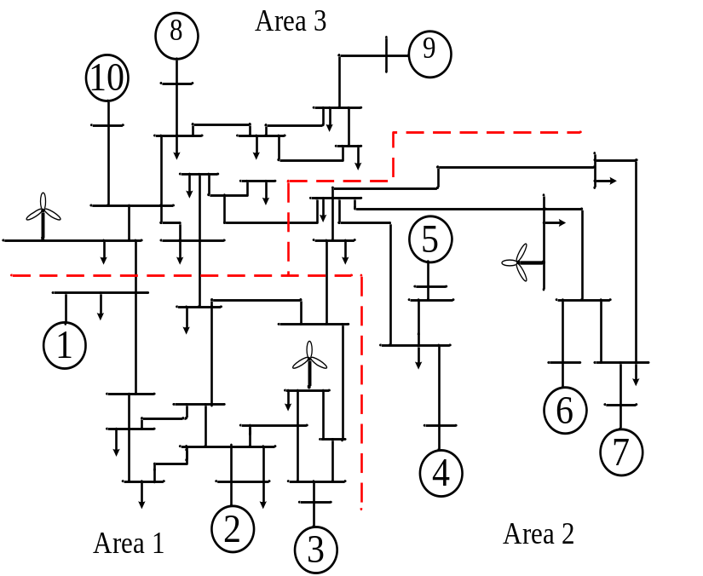
Figure 5.4 IEEE 39 bus system
Table 5.1 System Parameters
Area | Gen. | H | R | D | τ_{g} | τ_{T}
1 | 1 | 70.0 | 0.05 | 1 | 0.08 | 0.04
1 | 2 | 30.3 | 0.05 | 1 | 0.08 | 0.04
1 | 3 | 35.8 | 0.05 | 1 | 0.08 | 0.04
2 | 4 | 28.6 | 0.05 | 1 | 0.08 | 0.04
2 | 5 | 26 | 0.05 | 1 | 0.08 | 0.04
2 | 6 | 34.8 | 0.05 | 1 | 0.08 | 0.04
2 | 7 | 26.4 | 0.05 | 1 | 0.08 | 0.04
3 | 8 | 24.3 | 0.05 | 1 | 0.08 | 0.04
3 | 9 | 34.5 | 0.05 | 1 | 0.08 | 0.04
3 | 10 | 20.0 | 0.05 | 1 | 0.08 | 0.04

In the simulation, the wind speeds at area 1, area 2 and area 3 are obtained from actual operational data at National Wind Technology Center M2 Meter on Mar. 27th 2014 [25]. The wind speed shown in Table 5.2 was measured per minute. The measured wind speed is considered as forecast wind speed V_{m}(t). The mean value of the wind speed forecast error μ_{e}(t) is set at 0 and the deviation of the wind speed forecast error $σ_{e}^{2}\left(t\right)$ is set at 0.05V_{m}(t). In the simulation, the wind speed is sampled every second. The rated wind power output for areas 1, 2 and 3 is 150 MW each. Figure 5.5 shows the wind power profiles. In the system, the original control is conventional PI controller with fixed control gains. In this part, the proposed control method will be compared with the original control with wind energy sources in different areas. The initial PI control gains are shown in Table 5.3. Note, the initial gains shown in Table 5.3 are one of many choices from the solution scope. All the initial control gains satisfying the conditions in Section 5.3.1 can be chosen. However, in order to avoid possible overshooting, smaller control gains satisfying (4) are chosen for the PI controllers. The original control with fixed control gains in Table 5.3, tuned based on the trial and error approach, are the same control gains used in [4].
Table 5.2 Wind Speed Data
Time (min) | Area 1(m/s) | Area 2(m/s) | Area 3(m/s)
1 | 7.1368 | 8.1652 | 5.7231
2 | 6.8243 | 7.5242 | 5.5949
3 | 5.5789 | 12.516 | 5.3815
4 | 5.5942 | 14.156 | 5.6022
5 | 5.0617 | 10.113 | 5.5912
6 | 5.6466 | 11.407 | 5.4507
7 | 5.2773 | 11.683 | 5.5002
8 | 5.6786 | 11.138 | 5.6437
9 | 5.0952 | 10.335 | 5.7857
10 | 5.3341 | 13.044 | 5.742
11 | 4.9394 | 11.198 | 5.9416
12 | 5.4907 | 8.8389 | 6.4208
13 | 5.466 | 10.234 | 6.4463
14 | 5.3939 | 12.642 | 6.4113
15 | 4.2183 | 9.3247 | 6.5934

Table 5.3 Initial PI control gains
Area | PI  Controller | DGTC  (Initial Gains) | Original  (Well Tuned)
1 | K_{P} | 0.05 | 0.15
1 | K_{I} | 0.05 | 0.15
2 | K_{P} | 0.07 | 0.15
2 | K_{I} | 0.07 | 0.15
3 | K_{P} | 0.1 | 0.15
3 | K_{I} | 0.1 | 0.15

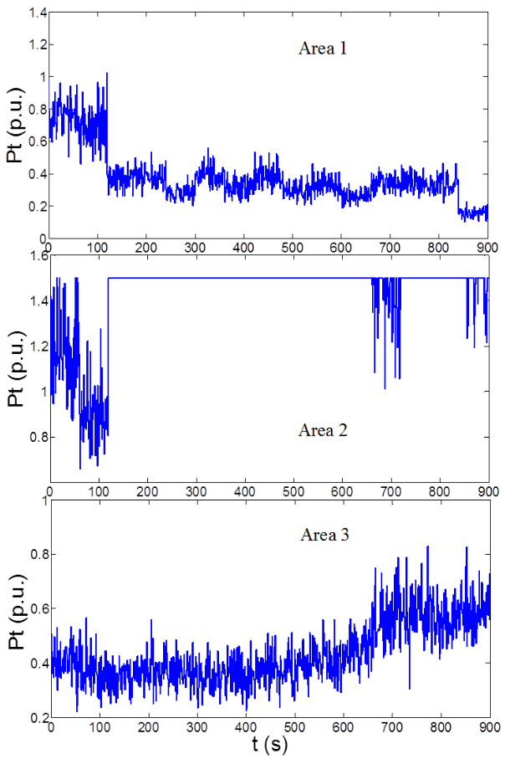
Figure 5.5 Wind Power Profile

Integrated Wind Power in Areas 1 and 3
All the parameters are kept unchanged. The wind power is added in Areas 1 and 3. The results of the original control method and the proposed DGTC method are shown in Figures 5.6 and 5.7.

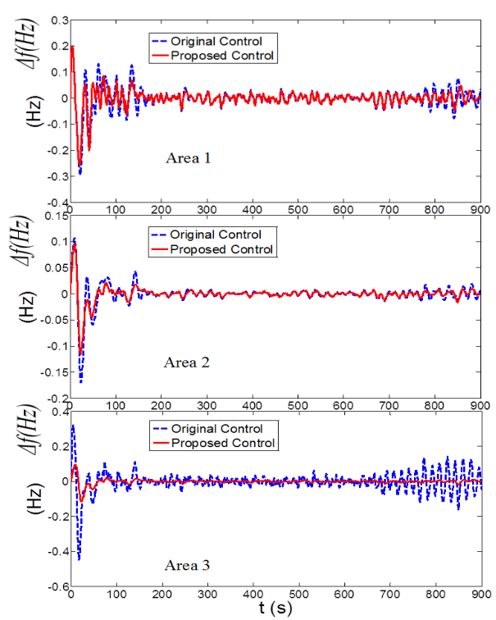
Figure 5.6 Results of frequency deviation
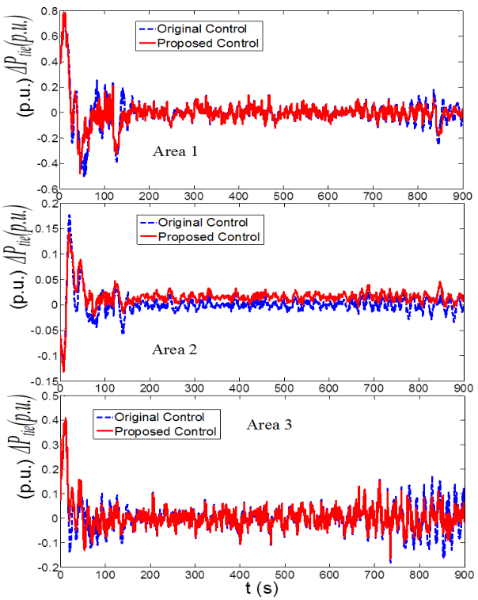
Figure 5.7 Results of tie power deviation
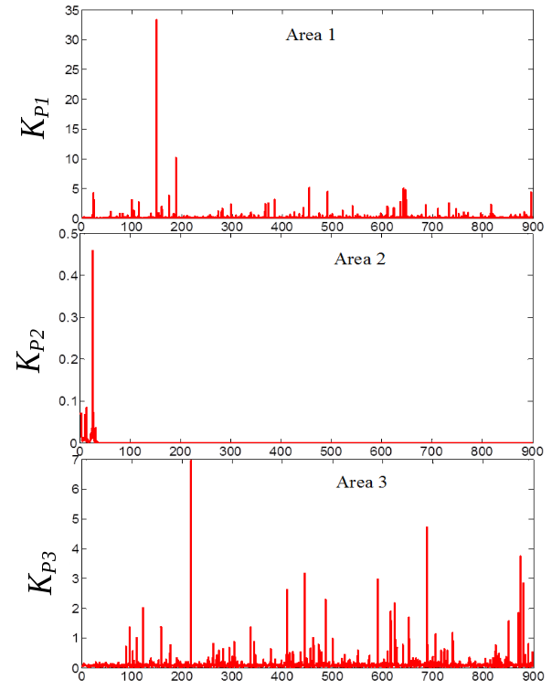
Figure 5.8 Results of K_{P}
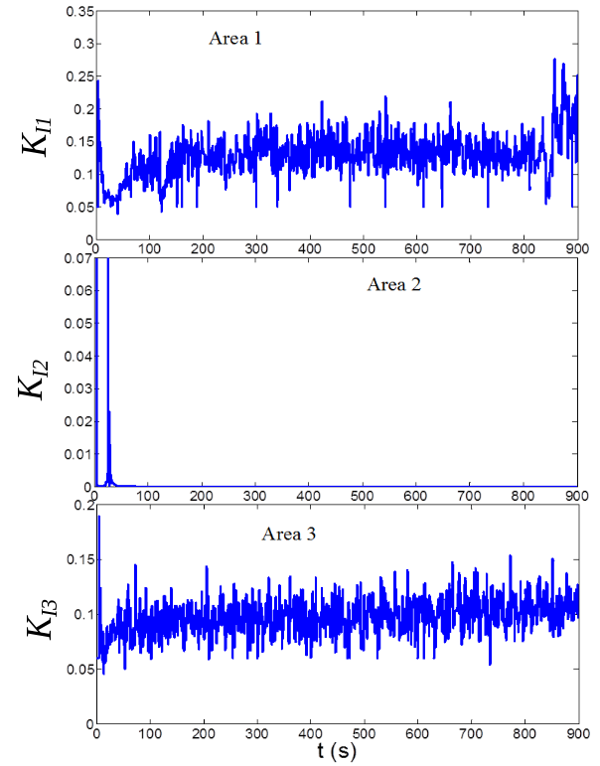
Figure 5.9 Results of K_{I}
Figures 5.6 and 5.7 show the frequency deviations, Δf, and the tie line flow deviation, ΔP_{tie}, in each area, respectively. From the results, it is evident that the proposed DGTC can achieve a better and smoother response than the original PI control which has well-tuned control gains. With DGTC, both frequency deviation and tie line flow deviation are smaller if compared with the original control. More important, with DGTC, the system frequency in area 3 can avoid the oscillation. The reason is that the fixed PI control gains cannot guarantee the desirable response during variable wind power. However, with DGTC, the PI control gains are continually self-adjusted to meet the requirement of varying power system operation condition.
The PI control gains of the proposed control are also shown in Figures 5.8 and 5.9. It can be observed that with the proposed DGTC, the PI control parameters are no longer fixed under different wind speed over the studied time duration. They are dynamically self-adjusted in real time to keep system frequency at 60Hz under different wind speed. Also, with the proposed control method, the control parameter adaption is immediate and can be considered as no delay, because the computing time is around milliseconds which can be ignored and the hardware delay is also negligible.

Integrated Wind Power in Areas 1 and 2
All the parameters are kept unchanged in this case study. The wind power is added in Areas 1 and 2. The results of the original control method and the proposed DGTC method are shown in Figure 5.10 and Figure 5.11.
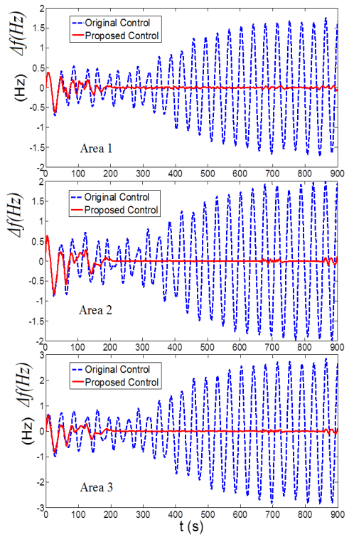
Figure 5.10 Results of frequency deviation

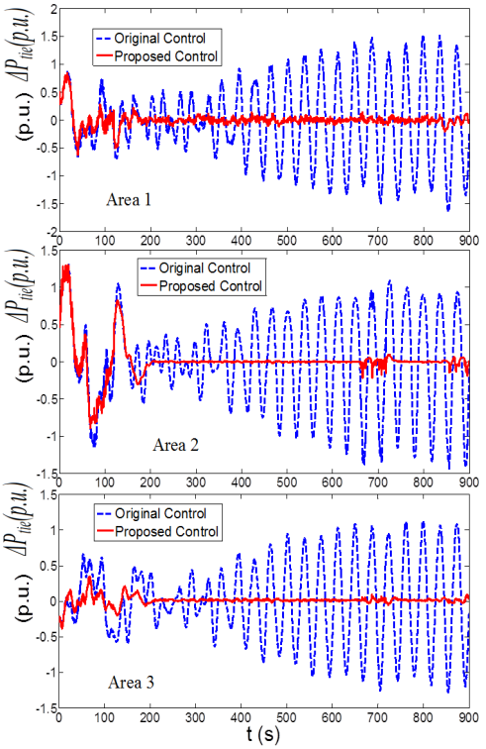
Figure 5.11 Results of tie power deviation
Figure 5.10 and Figure 5.11 illustrate the frequency deviations Δf and the tie line flow deviation ΔP_{tie} in each area. From the results, it is evident that the proposed DGTC can achieve much more desirable response than the original method with the well-tuned control gain. Because the fixed control gains cannot satisfy the requirements of the varying wind power, the AGC with original control has poor response and the system frequency oscillation occurs. However, with DGTC, both frequency deviation and tie line flow deviation are dramatically reduced.
The PI control gains of the proposed control approach for each area are shown in. Figure 5.12 and Figure 5.13. Similar to the study in the previous sub-section B, with the proposed DGTC, the PI control parameters can be automatically and dynamically adjusted under different wind speed during the disturbance to keep system frequency at 60Hz under different wind speed.

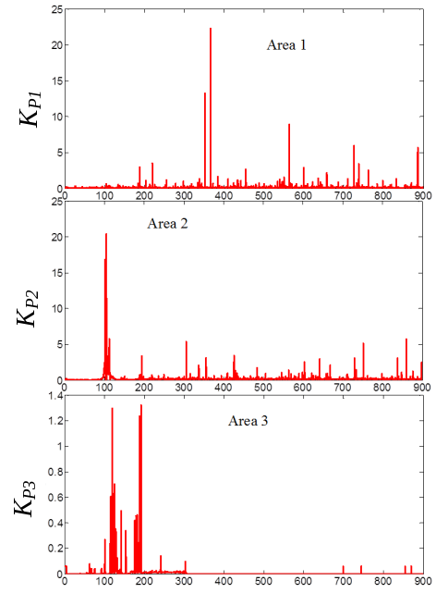
Figure 5.12 Results of K_{P}
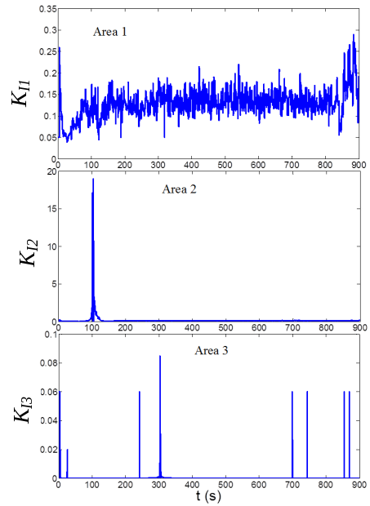
Figure 5.13 Results of K_{I}

Integrate Wind Power in All Areas
In this simulation study, all the parameters are kept unchanged from the original one. The wind power sources are added in areas 1, area 2 and area 3. The results of original control method and the proposed DGTC are shown in Figs. 14 and 15, which illustrate the frequency deviation Δf and the tie line flow deviation ΔP_{tie} in each area. From the results, it is evident that the proposed DGTC can avoid the system frequency oscillation. Since the fixed control gains cannot satisfy the requirements of the varying wind power, the AGC with original control cannot bring system frequency back to 60 Hz and the AGC has very poor response. However, with DGTC, both frequency deviation and tie line flow deviation are dramatically reduced.
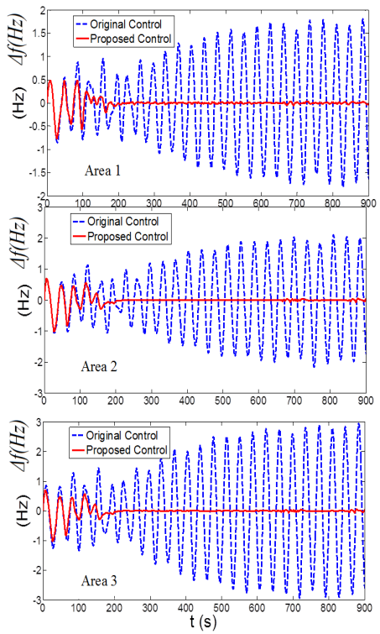
Figure 5.14 Results of frequency deviation
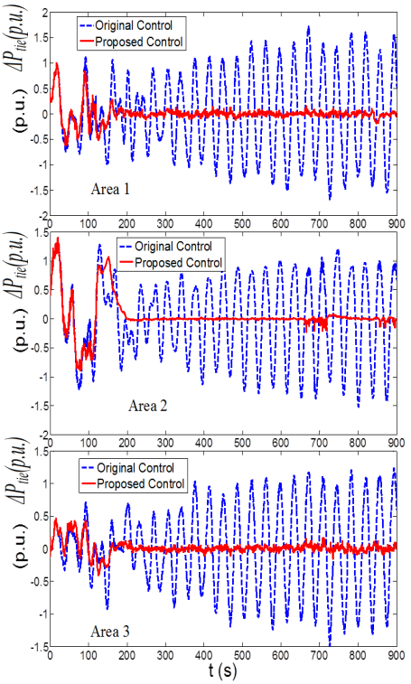
Figure 5.15 Results of tie power deviation
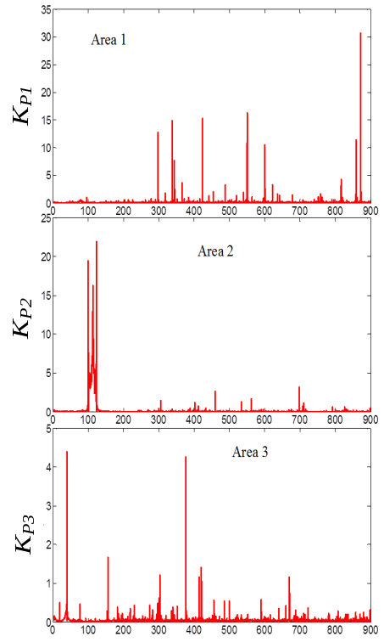
Figure 5.16 Results of K_{P}
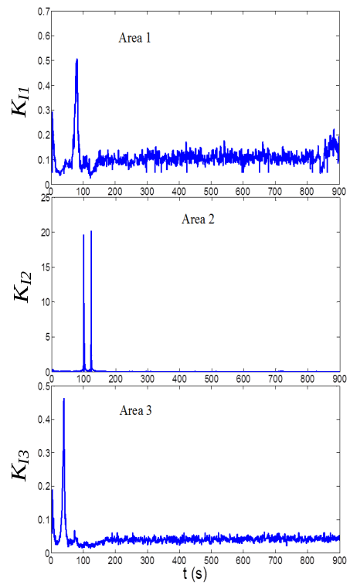
Figure 5.17 Results of K_{I}
The PI control gains of the proposed control for each area are shown in Figure 5.16 and Figure 5.17. Similar to the study in the previous sub-section B, with the proposed DGTC, the PI control parameters can be automatically and dynamically adjusted under different wind speed over the 900-second duration such that the control gains can be always dynamically adjusted and the AGC has much better response.

Conclusions
The above AGC studies show convincing results that the proposed DGTC can achieve a better and more consistent response than the original control. With the proposed DGTC, the initial PI control gains are calculated in advance and kept the same for the specific area AGC control. Then, the PI control gains will be dynamically and autonomously adjusted during the frequency control process based on the area control error (ACE) for area 1, area 2 and area 3, respectively. Therefore, a much better response for frequency regulation in real-time can always be obtained with the dynamic PI gains, and the desired performance can be achieved. However, the original fixed-gain controller, which is well tuned for a specific given operating condition, may be inefficient or incapable of regulating the frequency under other continuously varying operating conditions. Other simulation cases are also tested to demonstrate similar results as shown in Subsections 5.5.2 and 5.5.4. Due to the limits of the pages, the other simulation cases showing similar conclusions are not shown in the paper.

CONCLUSIONS AND RECOMMENDATIONS

Summary of Contributions
Various STATCOM control methods have been discussed including many applications of PI controllers. However, these previous works obtain the PI gains via a trial and error approach or extensive studies with a tradeoff of performance and applicability. Hence, control parameters for the optimal performance at a given operating point may not be always effective at a different operating point.
To address the challenge, this work proposes a new control model based on adaptive PI control, which can self-adjust the control gains dynamically during disturbance such that the performance always matches a desired response, regardless of the change of operating condition. Since the adjustment is autonomous, this gives the “plug-and-play” capability for STATCOM operation.
In the simulation study, the proposed adaptive PI control for STATCOM is compared with the conventional STATCOM control with pre-tuned fixed PI gains to verify the advantages of the proposed method. The results show that the adaptive PI control gives consistently excellent performance under various operating conditions such as different initial control gains, different load levels, change of transmission network, consecutive disturbances and a severe disturbance. In contrast, the conventional STATCOM control with fixed PI gains may perform acceptable in the original system, but may not perform as efficient as the proposed control method when there is a change of the system conditions.
Moreover, this work also proposes the flatness-based adaptive control method for STATCOM voltage regulation. By this method, the nonlinear STATCOM system is equivalent to a linear system, and the trajectories of all system variables can be directly and easily controlled by controlling flat output and its derivatives without solving differential equations. Further, the control gains can dynamically self-adjust during the voltage regulation after a disturbance. Thus, the performance from the flatness-based adaptive control always gives a consistent match to a desired response, regardless of the change of operating conditions. However, the original PI control and the flatness-based control, even if well-tuned for the given operating condition, may be inefficient or incapable to correct voltage when there is a change of the operating conditions.
Finally, a dynamic gain-tuning control (DGTC) for AGC with effects of wind resources is presented in this paper. By this control method, the PI control parameters can be automatically and dynamically calculated during different disturbances in a power system. In the proposed method, the initial gains will be calculated first. Then, the wind energy with actual wind speed are integrated in power systems, the PI control parameters for AGC can be computed automatically and can be adjusted in real time based on the area control error (ACE) signal to regulate the system frequency. Moreover, the proposed method will not be affected by changes of the system conditions and the limits of human experience and judgment.

Future Works
The following directions may be considered as future works of this dissertation.

Develop the general used control method
- The proposed adaptive gaining tuning control method may be applied to a power system with multiple STATCOMS since interaction among different STATCOM may affect each other.
- Also, extension to other power system control problems such as DFIG can be explored.
- More research work can focus on developing a generally used control approach with plug-and-play feature from the proposed method.

Tested in the hardware testbed
- Develop the hardware testbed, and use in the real system.

LIST OF REFERENCES
- Y. Xu, Q. Hu, and F. Li, “Probabilistic model of payment cost minimization considering wind power and its uncertainty,” IEEE Trans.Sustain. Energy, vol. 4, no. 3, pp. 716-724, July 2013.
- S. Dahal, N. Mithulananthan, T. Saha, “Investigation of small signal stability of a renewable energy based electricity distribution system,” IEEE PES General Meeting, Minneapolis, Minnesota, 2010.
- P.Kundur, Power System Stability and Control. New York: McGraw-Hill, 1994.
- P. Kundur, J. Paserba, V. Ajjarapu, G. Andersson, A. Bose, C. Canizares, N. Hatziargyriou, D. Hill, A. Stankovic, C. Taylor, T. V. Custem, and V. Vittal, “Definition and classification of power system stability,” IEEE Trans. Power Syst., vol. 19, no. 2, pp. 1387–1401, May 2004.
- Maria Hanley, Jovan Ilic, “Frequency Instability Problems in North American Interconnections,” DOE/NETL-2011/1473, Jun 2011
- N. Mithulananthan, M. M. A. Salama, C. A. Can˜izares and J. Reeve, "Distribution system voltage regulation and var compensation for different static load models," International Journal of Electrical Engineering Education, vol. 37, pp. 384-395, 2000.
- S Musunuri, G Dhenavi “Comparison of STATCOM, SVC, TCSC, and SSSC Performance in Steady State Voltage Stability Improvement”, NAPS, 2010.
- Mehrdad Ahmad, Mostafa Alinezhad, "Comparison of SVC and STATCOM in Static Voltage Stability Margin Enhancement", Proceedings of World Academy of Science, Engineering and Technology, Vol. 38, Feb. 2009.
- A.H.M.A. Rahim, E.P. Nowicki, and J.M. Bakhashwain, “Fuzzy STATCOM Control Strategies for Power System Stabilization,” ICGST International Journal on Automatic Control and Systems Engineering, ACSE, pp.41-48, Feb. 2006.
- H. Saadat, Power System Analysis, 2nd Edition, McGraw-Hill, 2004.
- N. Jaleeli, L. S. VanSlyck, D. N. Ewart, L. H. Fink, and A. G. Hoffmann, “Understanding automatic generation control,” IEEE Trans. Power Syst., vol. 7, no. 3, pp. 1106–1122, Aug. 1992.
- J. Tlaq and F. Al-Basri, “Adaptive fuzzy gain scheduling for load frequency control,” IEEE Trans. Power Syst., vol. 14, no. 1, pp. 145–150, Feb. 1999.
- Pan, C. T., and Liaw, C. M., “An Adaptive Controller for Power System Load-Frequency Control,” IEEE Trans. Power Sys., Vol. 4, No. 1, pp 122-128, 1989.
- UCTE, UCTE Operation Handbook, v 2.5E, Jul. 20, 2004. [Online].
- Y. G. Rebours, D. S. Kirschen, M. Trotignon, and S. Rossignol, “A survey of frequency and voltage control ancillary services—Part I: Technical features,” IEEE Trans. Power Syst., vol. 22, no. 1, pp.350–357, Feb. 2007.
- C.-H. Liu and Y.-Y. Hsu, “Design of a self-tuning PI controller for a STATCOM using particle swarm optimization,” IEEE Trans. Ind. Electron.,vol. 57, no. 2, pp. 702–715, Feb. 2010.
- F. Li, J. D. Kueck, D. T. Rizy, T. King, “A preliminary analysis of the economics of using distributed energy as a source of reactive power supply,” Oak Ridge National Laboratory First Quarterly Report for Fiscal Year 2006, Oak Ridge, TN, April 2006.
- A. Jain, K. Joshi, A. Behal, and N. Mohan, “Voltage regulation with STATCOMs: Modeling, control and results,” IEEE Trans. Power Del., vol. 21, no. 2, pp. 726–735, Apr. 2006.
- D. Soto and R. Pena, “Nonlinear control strategies for cascaded multilevel STATCOMs,” IEEE Trans. Power Del., vol. 19, no. 4, pp.1919–1927, Oct. 2004.
- F. Liu, S. Mei, Q. Lu, Y. Ni, F. F. Wu, and A. Yokoyama, “The nonlinear internal control of STATCOM: Theory and application,” Int. J. Elec. Power & Energy Syst., vol. 25, no. 6, pp. 421–430, 2003.
- C. Hochgraf and R. H. Lasseter, “STATCOM Controls for Operation with Unbalanced Voltage,” IEEE Trans. Power Del., vol. 13, no. 2, pp.538–544, Apr. 1998.
- G. E. Valdarannma, P. Mattavalli, and A. M. Stankonic, “Reactive power and unbalance compensation using STATCOM with dissipativity based control,” IEEE Trans. Control Syst. Technol., vol. 19, no. 5, pp. 598–608, Sep. 2001.
- Wang, H.F., “Phillips-Heffron model of power systems installed with STATCOM and applications,” IEE Proc.-Gener. Transmi. Distib., vol. 146, no 5, pp. 521-527, Sep. 1999.
- H.F. Wang, "Applications of damping torque analysis to statcom control", I. J. of Elec. Pwr & Energy Sys., vol. 22, pp. 197-204, 2000.
- Y. Han, Y.O. Lee and C.C. Chung, “Modified non-linear damping of internal dynamics via feedback linearization for static synchronous compensator”, IET Gener. Transm. Distrib., 2011, 5, (9), pp. 930–940.
- A. H. Norouzi and A. M. Sharaf, “Two control schemes to enhance the dynamic performance of the STATCOM and SSSC,” IEEE Trans. Power Del., vol. 20, no. 1, pp. 435–442, Jan. 2005.
- M. S. E. Moursi and A. M. Sharaf, “Novel controllers for the 48-pulse VSC STATCOM and SSSC for voltage regulation and reactive power compensation,” IEEE Trans. Power Syst., vol. 20, no. 4, pp. 1985–1997, Nov. 2005.
- http://www.mathworks.com/help/toolbox/physmod/powersys/ug/f8-8531.html, last access in Feb. 2012.
- H. Li, F. Li, J. D. Kueck, and D. T. Rizy “Adaptive Voltage Control with Distributed Energy Resources: Algorithm, Theoretical Analysis, Simulation and Field Test Verification,” IEEE Transactions on Power Systems, vol. 25, no. 3, pp. 1638-1647, August 2010.
- H. Li, F. Li, Y. Xu, D.T. Rizy and S. Adhikari, “Autonomous and Adaptive Voltage Control using Multiple Distributed Energy Resources,” IEEE Transactions on Power Systems, vol. 28, no. 2, pp. 718-730, May 2013.
- Pranesh Rao, M. L. Crow, and Zhiping Yang, “STATCOM Control for Power System Voltage Control Applications,” IEEE Trans. Power Del., vol. 15, no.4, pp.1311-1317, Oct. 2000.
- W. L. Chen and Y. Y. Hsu, “Controller design for an induction generator driven by a variable speed wind turbine,” IEEE Trans. Energy Convers., vol. 21, no. 3, pp. 625–635, Sep. 2006.
- Keyou Wang, and Mariesa L. Crow, “Power System Voltage Regulation via STATCOM Internal Nonlinear Control,” IEEE Trans. Power Syst., vol . 26, no. 3, pp.1252-1262, Aug. 2011.
- V. Spitsa, A. Alexandrovitz, and E. Zeheb, “Design of a robust state feedback controller for a STATCOM using a zero set concept,” IEEE Trans. Power Del., vol. 25, no. 1, pp. 456–467, Jan. 2010.
- An Luo, Ci Tang, Zhikang Shuai, Jie Tang, Xian Yong Xu, and Dong Chen, “Fuzzy-PI-Based Direct-Output-Voltage Control Strategy for the STATCOM Used in Utility Distribution Systems, ” IEEE Trans. Ind. Electron., vol. 56, no. 1, pp. 2401-2411, July 2009.
- L. O. Mak, Y. X. Ni, and C. M. Shen, “STATCOM with fuzzy controllers for interconnected power systems,” Elect. Power Syst. Res., vol. 55, pp. 87–95, 2000.
- A. Gensior, H. Sira-Ramírez, J. Rudolph, and H. Güldner, “On some nonlinear current controllers for three-phase boost rectifiers,” IEEE Trans. Ind. Electron., vol. 56, no. 2, pp. 360–370, Feb. 2009.
- Q. Song, W. Liu, and Z. Yuan, “Multilevel optimal modulation and dynamic control strategies for STATCOMs using cascaded multilevel inverters,” IEEE Trans. Power Del., vol. 22, no. 3, pp. 1937–1937, Jul. 2007.
- D.-C. Lee, G.-M. Lee, and K.-D. Lee, “DC-bus voltage control of three phase ac/dc PWM converters using feedback linearization,” IEEE Trans. Ind. Applicat., vol. 36, pp. 826–833, May 2000.
- E. Song, “Experimental validation of a flatness-based control for a voltage source converter,” M.S. thesis, Dept. Elect. Comput. Eng., Univ. Alberta, Edmonton, AB, Canada, 2006.
- E. Song, A. F. Lynch, and V. Dinavahi, “Experimental validation of nonlinear control for a voltage source converter,” IEEE Trans. Control Syst.Technol., vol. 17, no. 5, pp. 1135–1144, Sep. 2009.
- A. Gensior, J. Rudolph, and H. Güldner, “Flatness based control of three-phase boost rectifiers,” 11th Eur. Conf. Power Electron. Appl. Rec. (EPE), Dresden, Germany, Sep. 2005.
- M. Fliess, J. Lévine, P. Martin, and P. Rouchon, “Flatness and defect of non-linear systems: Introductory theory and applications,” Int. J. Control, vol. 61, pp. 1327–1361, 1995.
- H. Sira Ramírez and S. K. Agrawal, Differentially Flat Systems. New York: Marcel Dekker, 2004.
- P. Thounthong, S. Pierfederici, and B. Davat, “Analysis of differential flatness-based control for a fuel cell hybrid power source,” IEEE Trans. Energy Convers., vol. 25, no. 3, pp. 909–920, Sep. 2010.
- P. Martin, R. M. Murray, and P. Rouchon, “Flat systems, equivalence and trajectory generation,” Ecole des Mines de Paris, Technical report, April 2003.
- M. van Nieuwstadt and R. Murray. “Real-time trajectory generation for differentially at systems.” Int. Journal of Robust and Nonlinear Control, 8(11):995-1020, 1998.
- J. Nanda, S. Mishra, P. G. Mishra, and K. V. Sajith, “A novel classical controller for automatic generation control in thermal and hydrothermal systems,” in Proc. 2010 Joint Int. Conf. Power Electronics, Drives and Energy Syst. (PEDES) & 2010 Power India, pp. 1–6.
- Maryam Hassani Variani, Kevin Tomsovic, “Distributed Automatic Generation Control Using Flatness-Based Approach for High Penetration of Wind Generation,” IEEE Trans. Power Sys., in press, 2013.
- E. C. Anene, U. O. Aliyu, J. Levine, and G. K. Venayagamoorthy, “Flatness-based feedback linearization of a synchronous machine model with static excitation and fast turbine valving,” in Proc. IEEE Power Eng. Soc. General Meeting, pp.1–6, Jun. 2007.
- E. Rakhshani and J. Sadeh, “Reduced-order estimator with prescribed degree of stability for two-area LFC system in a deregulated environment,” in Proc. IEEE Power Systems Conference and Exposition, 2009,pp. 1–8.
- Y. Oguz, H. Erdal, and S. Taskin, “Design and simulation of a LQG robust controller for an electrical power system,” Journal of Electrical and Electronics Engineering, vol. 8, no. 2, pp. 693–698, 2008.
- X. Yang and O. Marjanovic, “LQG control with extended Kalman filter for Power Systems with unknown time-delays,” in Proc. 18th IFAC World Congress, 2011, pp. 3708–3713.
- C. S. Chang and W. H. Fu, “Area load frequency control using fuzzy gain scheduling of PI controllers,” Elect. Power Syst. Res., vol. 42, no. 2, pp. 145–152, 1997.
- G. A. Chown and R. C. Hartman, “Design & experience of fuzzy logic controller for automatic generation control (AGC),” IEEE Trans. Power Syst., vol. 13, no. 3, pp. 965–970, Aug. 1998.
- P.K. Dash, A.C. Liew, and B.R. Mishra, “An adaptive PID stabilizer for power systems using fuzzy logic,” Electric Power Systems Research, vol. 44, pp.213–222, 1998.
- Ibhan Kocaarslan, Ertugrul Cam, “Fuzzy Logic Controller In Interconnected Electric Power Systems For Load-Frequency Control”, Electrical Power and Energy Systems, vol. 27, pp. 542-549, 2005.
- K.R.M. Vijaya Chandrakala, S. Balamurugan, K. Sankaranarayanan, “Variable structure fuzzy gain scheduling based load frequency controller for multi source multi area hydro thermal system,” Electrical Power and Energy Systems, vol. 53, pp. 375–381, 2013.
- F. Beaufays, Y. Abdel-Magid, and B. Widrow, “Application of neural network to load frequency control in power systems,” Neural Netw., vol. 7, no. 1, pp. 183–194, 1994.
- M. Djukanovic, M. Novicevic, D. J. Sobajic, and Y. P. Pao, “Conceptual development of optimal load frequency control using artificial neural networks and fuzzy set theory,” Int. J. Eng. Intell. Syst. Elect. Eng. Commun., vol. 3, no. 2, pp. 95–108, 1995.
- M. A. Abido, “Optimal design of power-system stabilizers using particle swarm optimization,” IEEE Trans. Energy Convers., vol. 17, no.3, pp. 406–413, Sep. 2002.
- S. P. Ghoshal, “Optimizations of PID gains by particle swarm optimizations in fuzzy based automatic generation control,” Electric Power Syst. Res., vol. 72, no. 3, pp. 203–212, Dec. 2004.
- Panda S, Yegireddy NK. “Automatic generation control of multi-area power system using multi-objective non-dominated sorting genetic algorithm-II,” Int J Electr Power Energy Syst, vol.53, pp.54–63, 2013.
- L. Nanda, S. Mishra, and L.C. Saikia, "Maiden Application of Bacterial Foraging-Based Optimization Technique in Multiarea Automatic Generation Control," IEEE Trans. Power systems, vol. 24, pp. 602 - 609, May 2009.
- http://www.mathworks.com/help/physmod/powersys/examples/statcom-phasor-model.html, last access in Apr. 2012.
- C. Schauder and H. Mehta, “Vector analysis and control of the advanced static VAr compensators,” Proc. Inst. Elect. Eng., Gen., Transm., Distrib., vol. 140, no. 4, pp. 299–306, Jul. 1993.

APPENDIX

Publications:

Journal
- Yao Xu, Qinran Hu and Fangxing Li, “Probabilistic Model of Payment Cost Minimization Considering Wind Power and its Uncertainty,” IEEE Transactions on Sustainable Energy, 2013.
- Yao Xu and Fangxing Li, “Adaptive Control of STATCOM for Voltage Regulation,” IEEE Transactions on Power Delivery, vol. 29, no. 3, pp. 1002-1011, Jun. 2014.
- Yao Xu and Fangxing Li, “Flatness-based Adaptive Control of STATCOM,” submitted to Electric Power Systems Research.
- Yao Xu and Fangxing Li, “Dynamic Gain-Tuning Control (DGTC) Approach for AGC with Effects of Wind Power,” submitted to IEEE Transactions on Power System.

Patent
- Fangxing Li, Yao Xu and Kevin Tomsovic, “Adaptive Controller for STATCOM to Enhance Voltage Stability,” U.S. Patent (8,836,163), issued on 09/16/2014.

VITA

Yao Xu joined The University of Tennessee at Knoxville in August 2010 to pursue a Ph.D. degree in Electrical Engineering. She received the B.S. and M.S. degrees in electrical engineering from Changsha University of Science and Technology, China, in 2006 and 2009, respectively. And she received the Min Kao Graduate Fellowship in Electrical Engineering. Her research interests include utility application of power electronics, power system control, and power markets.

