Condition of the United States Infrastructure, Potential Solutions, and International Comparisons
University of Tennessee-Knoxville
James W. McDonald
24 April 2013

Faculty Advisor: Dr. Ken Baker has been my advisor in writing this thesis report. Dr. Baker is a professor in the Haslam College of Business Administration at the University of Tennessee-Knoxville, teaches classes in economics and international business, and serves as leader of the economics club of the school. His insight into the economic issues surrounding the infrastructure of the United States, specifically in the areas of government intervention in private sectors, areas in which the United States could learn from other countries, and the practicality of some of my more naïve ideas has proven essential for the completion of this report. Dr. Baker deserves a special thank you for all of his help.

Abstract: Simply put, currently the U.S. infrastructure system is in absolutely terrible shape. If major investments are not made in the near future, the country could face serious consequences, from a slowing of the economy to a loss of lives, and everything in between. Infrastructure plays a critical role in the movement and flow of people, labor, resources, final products, electricity and energy, food and waste. Every shipment for any company relies on a strong and sound infrastructure and without this the U.S. will simply not be able to compete in the global marketplace. We, as a country, need to act efficiently, effectively and quickly to ensure that we meet this challenge.
Lack of investment into infrastructure is easily witnessed from recent disasters, such as Katrina and the Minneapolis bridge collapse that cost human lives. But it can also be seen in rising costs of doing business, leading to rising prices, and a slowing of the economy. However, given the proper amount of funding, promising solutions do exist. The U.S. can learn a great deal by researching how other countries meet their own infrastructure challenges, and comparing alternative mechanisms of funding and maintaining a well-functioning system. There is much work to be completed for American infrastructure, but it is a problem that we must address head-on and with force if it is to be tackled.

Table of Contents
- Introduction
- The Problem – Infrastructure Deficiencies
  - Airports
  - Bridges
  - Dams
  - Levees
  - Pipelines
  - Ports
  - Power Grids
  - Public Transit
  - Rail
  - Roads
- The Costs – What a Lack of Funding and Supervision Can Do
  - Recent Disasters
  - Overcrowding Roads
  - Increased Shipping Costs
- International Benchmarking – How Do Other Countries Manage Infrastructure?
  - Mature Economies
    - Japan
    - United Kingdom
  - Emerging Economies
    - India
    - China
- Potential Solutions – What Can America Do?
  - Increased Investment
  - Infrastructure Leadership
  - Price Floor on Gasoline
  - Privatization of Major Infrastructure Establishments
- Conclusion
- Appendix
- Works Cited

- Introduction
We live in an incredible time period. In today’s world, customers get angry when it takes a delivery more than a few days to get to its destination, where it would take a month or perhaps more only a few generations ago. Americans have become accustomed to being able to walk into a store and find everything they need exactly when they want it. Furthermore, if the store doesn’t have the item in stock, it is perfectly acceptable for the customer to complain and potentially receive a future discount. This kind of customer service has become the standard for today’s businesses. For a supply chain manager, it can seem a very daunting task to keep this kind of spoiled customer happy, especially with American businesses outsourcing more and more of their production to foreign countries in Asia, Latin America and South America.
So far, the American economy has survived this globalization and lengthening of supply chains due to a massive investment in its infrastructure system during the 1950’s and 1960’s. However, these investments are aging and it is starting to show across the country. Newsweek recently highlighted just how lenient some of the government departments in charge of America’s infrastructure have become, and the disasters this laziness and lack of regulation has caused (Johnston, 2012). Johnston states that America has “scrimped on taking care of the public furniture” for decades, which is not only harmful to the economy, but puts people’s lives in danger. In 2005, Hurricane Katrina caused “around 1,800 casualties and flooded 80% of [New Orleans]” (Johnston, 2012, pg 40), as well as incredible amounts of looting, crime and starvation. This massive storm also devastated the economy, with economic damages estimated at $250 billion (Amadeo, 2012). Unfortunately, much of this damage might have been reduced if the levees in New Orleans had been properly maintained. Several reports state that the levees failed not because of the storm size, but rather design flaws and lack of upkeep (“Overview Of New Orleans Levee Failures,” 2008, pg 5).
Only two years later in 2007, an eight-lane bridge in Minneapolis, I-35, literally collapsed over the Mississippi during rush hour, sending around 100 cars into the river, killing thirteen people and injuring another 150. This disaster too might have been averted, given that the federal government gave the bridge a rating of “structurally deficient” due to “significant corrosion in its bearings” seventeen years earlier, in 1990 (Stawicki, 2007). Therefore, Minnesota officials knew that the bridge was potentially dangerous for over fifteen years and did nothing. These incidents are unfortunately not as rare as one might think. For example, in San Bruno California, a pipeline ruptured in 2010 and sent a giant fireball into the sky that killed eight people and destroyed thirty-eight homes. In turns out that utility workers put in a bad pipe in 1956, skipping “half the welds and either not inspecting the finished product or grossly misinterpreting the results” (Wald, 2011). Somehow, inspection crews went fifty-four years without discovering this deficiency.
These recent disasters are just the tip of the iceberg when it comes to infrastructure failures. The American Society of Civil Engineers issues a report every four years outlining the state of U.S. infrastructure on sixteen different forms of infrastructure, their most recent report released in March of 2013. They gave the overall system a grade of “D+,” including eleven “D’s,” four “C’s,” and only one “B.” The American government must do something about these problems or we will face severe economic consequences. This essay will uncover the different areas where infrastructure needs repair, what may happen if nothing is done, examine some more infrastructurally sound countries from around the world to see how they manage their challenges, and finish by exploring some potential solutions for America’s current problems. This essay will combine research from several different sources from different fields of study in the hopes of discovering creative solutions to the looming problem that the United States faces today and into the future.

II. The Problem – Infrastructure Deficiencies
A nation’s infrastructure includes the basic facilities, services, and installations needed for the functioning of the nation. While this broad definition can include things such as schools, prisons, and post offices, this report will only focus on the physical infrastructure of the United States. Physical infrastructure includes everything that is necessary for the successful transportation of people, products, and energy. This section will describe specifically the most important parts of America’s physical infrastructure and the sprawling number of problems that these areas are currently facing.

A. Airports
In today’s world, it is becoming increasingly important to have one or even two efficient airports in a major city. Without them, it is nearly impossible to attract large-scale businesses or major amounts of tourism. Furthermore, airports are the gateway to billions of pounds of freight each year on which companies depend. The traffic coming through our airports has been dramatically increasing. The Federal Aviation Administration (FAA) estimates that U.S. airports will have to accommodate 1 billion passengers by 2024, up from around 800 million in 2012 (Sirkin, 2012). However, the U.S. has only built one major airport in the last twenty years, Denver International, and has no plans to build another one of that size.
The Airports Council International-North America states that the U.S. will need to invest more than $80 billion on new runways, terminals and other facilities to meet the growth in demand. Given that it can take five to eight years to build a new terminal and more than ten years for a new runway, America must essentially start today to meet the estimated demand of 2024. Yet today, there is very little being invested. The 2013 Report Card for America’s Infrastructure grades U.S. aviation a “D” (Infrastructure Report Card, 2013).

B. Bridges
According to the American Society of Civil Engineers (ASCE), more than one out of every four of the nation’s bridges are either structurally deficient or functionally obsolete (Infrastructure Report Card, 2013). Furthermore, they estimate that a $17 billion investment is needed each year to maintain them, yet currently only $10 billion is being spent. America’s bridges received a “C+” grade (Infrastructure Report Card, 2013),

C. Dams
There are over 85,000 dams in the U.S., with an average age of 51 years. The number of deficient dams is over 4,000, with 2,000 of these classified as ‘high hazard dams’ according to the ASCE. The nation’s dams received a grade of “D” (Infrastructure Report Card, 2013).

D. Levees
There are levees in every state and the District of Columbia, and some estimates state “more than half of Americans reside in counties that contain levees or other types of flood control and protection systems” (Garofalo, 2013). With this many Americans living in proximity to levees, it should be very concerning that 326 levees covering more than 2,000 miles have been found to need urgent repairs (Garofalo, 2013). The ASCE gave America’s levees a grade of “D-“ (Infrastructure Report Card, 2013).

E. Pipelines
There are over 2.5 million miles of pipeline in the United States. Unfortunately, more than half of these pipelines are over fifty years old (Groeger, 2012). Furthermore, only a fraction of these pipelines are federally inspected regularly. While pipelines are generally a safer mode of transportation for fuel and gas than trucks, there are still “hundreds of pipeline accidents that occur every year” (Groeger, 2012). America’s pipeline system received a grade of “D+” (Infrastructure Report Card, 2013). Figure 2 in the appendix shows the miles of pipeline in the United States.

F. Ports
Set to be completed in 2015, the Panama Canal is currently undergoing a major expansion that will allow for much larger ships, about the size of three and half football fields, to pass through its locks. This will completely change ocean freight shipping and the major ports of the world must adjust to accommodate the larger ships. In order to do so, engineers must undergo a process called “dredging” which involves digging existing ports deeper, in many cases purchases larger cranes, and make many other miscellaneous process improvements to get the products to flow off the large ships and onto trains or trucks.
However, most American ports have not started dredging or are extremely behind schedule. In fact, the ports of Norfolk and Baltimore are the only ports on the East Coast that are large enough to accommodate the new ships (Whitefield, 2012). And even though the port of Baltimore is large enough, it still has several logistical issues such as “transportation bottlenecks” that need fixing before it is ready for the larger ships in 2015 (Whitefield, 2012). America’s ports received a “C” from the ASCE (Infrastructure Report Card, 2013).

G. Power Grids
The problem with the nation’s power grids, as with many other areas of the infrastructure, is that the grids are extremely aged. When the grids were built fifty to sixty years ago, electricity was a luxury that not everybody enjoyed. Now that everybody has access electricity, the same grids that were built to serve only a fraction of the population are running at full pressure twenty-four hours a day (Spak, 2012). Energy companies try to keep up with the rising demand but with such an old grid there is only so much they can do. The nation’s power grids received a grade of “D+” on the report card (Infrastructure Report Card, 2013).

H. Public Transit
Public transportation is an area where the United States has fallen behind. Other areas of the world have sprawling transit systems that allow nearly all of their citizens to move about freely, while in the United States only 45% of Americans have access to public transportation and millions of those that ride are on deteriorating buses and train lines’ (Infrastructure Report Card, 2013). The ASCE gave the nation’s public transit system a “D” on the report card (Infrastructure Report Card, 2013).

I. Rail
There lies a great deal of potential in America’s rail system. However, as with most other areas of infrastructure, heavy investments must be made in order to keep up with the rise in demand for freight shipping and passenger transportation. Amtrak, essentially the nation’s only passenger train line, had over 30 million customers in 2011, their highest amount ever (Amtrak, 2013). While overall this is a good thing for the nation’s infrastructure because it decreased highway overcrowding and consumes far less energy compared with automobile travel, the problem lies when coupling this expansion with the growth of freight lines. America’s freight lines are among the best in the world, but will be stressed if some proposed passenger lines are built.
California has been pushing hard to connect San Diego, Los Angeles, San Francisco and Sacramento by high-speed passenger rail by 2020. They have asked the federal government for financial help, and President Obama has agreed. However, within city limits they will have to share lines with existing freight lines (The Economist, 2010). This puts stress into the system because in order to meet demand, freight lines do not run on a regular schedule. In addition, they run about 3 times slower than the proposed passenger train. The combination of the two very different train lines on the same rail could be detrimental to the freight companies. This, combined with an estimated $200 billion investment over the next 20 years necessary to meet demand growth, resulted in a grade of “C+“ by the ASCE (Infrastructure Report Card, 2013). Figure 1 in the appendix shows a map of the freight and passenger lines in America.

J. Roads
The American interstate system has long been considered a modern marvel of sorts, connecting every city together and allowing both travelers and truckers quick access to any hub in the nation. However, there have been no major investments to these roads since they were originally built by the Eisenhower administration, and it is beginning to show. The ASCE estimates that one-third of America’s major roads are in poor or mediocre condition, and 45% of major highways are overly congested. While it has been estimated that the country would need to invest around $186 billion on roads to properly maintain them, in 2012 the U.S. spent only around $73 billion (Hargreaves, 2013). In his State of the Union Address, President Obama asked for an additional $50 billion to put towards road maintenance, but it remains to be seen if this will occur. American roads received a “D“ by the ASCE (Infrastructure Report Card, 20013).

Figure 4 in the appendix shows the ASCE’s estimated total investment needs for all of the areas discussed in this section of the report.

III. The Costs – What a Lack of Funding and Supervision Can Do
So far, this report has outlined the current condition of the most important areas of the nation’s infrastructure. There are obviously many strides to be made and much work to be done in order to solve the infrastructure crisis in the United States. This section will discuss the consequences America will face if the necessary changes are not made, what it will mean for the economy, and the challenges American businesses will face.

A. Recent Disasters
The introduction to this report noted the levee failures of Hurricane Katrina in New Orleans in 2005, the interstate collapse in Minneapolis in 2007, and the pipeline rupture in San Bruno, California in 2010. Yet, these are only a few of the recent disasters that have been caused by infrastructure failures. In 2007, a Manhattan steam pipe constructed in 1924 exploded and sent debris as high as the skyline for nearly two hours, killing one person and injuring 30 more (Barron, 2007). This was New York City’s twelfth pipeline explosion in the last twenty years, and sent a fear of asbestos throughout the area around the explosion. To make matters worse, the pipeline was inspected that morning and officials stated that there was no indication anything was amiss (Barron, 2007).
Furthermore, during the past two decades, the number of major blackouts (those affecting at least 50,000 people) has increased 124% - increasing from 41 between 1991 and 1995 to 92 between 2001 and 2005 (Patterson, 2010). The worst of these was the Northeast blackout of 2003 that affected an estimated 50 million people (“Biggest Blackout In U.S. History,” 2009). Two years after that blackout, in 2005, the Taum Suk Dam in Southeast Missouri failed and billions of gallons of water rushed down Proffitt Mountain and overwhelmed the east fork of the Black River and the lower ground of Johnson’s Shut-In Park. It is estimated that the water was flowing at 150,000 cubic feet per second, which is the equivalent of the Mississippi River flowing at a rate that would put St. Louis under seven feet of water (Witt III, 2005). While the damage was limited due to Southeast Missouri’s rural surroundings, if this sort of failure occurred in a metropolitan area the damages would be devastating.
While these are certainly not the only major infrastructure failures that have occurred recently in the United States, these examples show the damage that a poor infrastructure can cause.

B. Overcrowding Roads
When the National Highway System was originally built, it was considered a modern marvel of transportation. However, this original investment has run its course and the United States is starting to see the consequences of a crumbling and overcrowded highway system.
Figure 3 in the appendix shows the current level of congestion of the highway system and what the future holds if no changes are made.
The problem is only getting worse. In 1982, 35% of the major roads in America were congested. Today this number has grown to 60% (U.S Department of Transportation, 2008). Furthermore, the Texas A&M Transportation Institute came out with highway congestion trends from 1982 to 2011 that shows a sharp increase in wasted travel time amongst very large cities, large cities, medium cities, and small cities alike, suggesting that a trip that would have taken 20 minutes in 1982 will now take over 30 minutes in 2013 (Congestion Trends – Wasted Time, 2013).

C. Increased Shipping Costs
The real threat of overcrowded roads is not simply the inconvenience of longer travel times, but rather the rising cost of transporting products due to increased fuel consumption during longer hauls. As stated in section B, overcrowded roads are becoming all too common and this congestion decreases the fuel economy of the vehicles traveling the roads. In fact, stop-and-go traffic can increase a vehicle’s fuel consumption by as much as 40% (“Fuel-Efficient Driving,” 2012).
However, much of the increased shipping costs are coming from ocean freight shipping. The deteriorating state of the nation’s ports have not helped this issue. Most ports are at or over capacity which forces incoming freighters to wait for days, weeks, or even months at sea to be unloaded (Mongelluzzo, 2013). From July of 2009 to July of 2010, the spot rate to ship a 40-foot container from Hong Kong to Los Angeles rose from $871 to $2,624 (Clifford, 2010). If this trend continues, the United States consumers could be facing an extreme rise in prices of everyday products such as gas and food in the near future.

There are many other consequences of not having an up-to-date infrastructure, however these are three areas that will harm the economy and American businesses the most.

IV. International Benchmarking – How Do Other Countries Manage Infrastructure?
Today’s economy is truly a global one, with every country depending on each other for economic growth. In this arena of global shipping and trade, it would be detrimental for a country to have an insufficient infrastructure as products coming from foreign countries, as well as products coming out of the home country, would have serious problems reaching their destinations. It should come as no surprise that one of the most often cited reasons that global businesses have not taken hold in Central Africa is due to the lack of infrastructure (Mbaku, 2013). Without the proper ports, roads, and aviation facilities, it is a huge challenge, if not impossible in many cases, to get products to certain areas of the world.
In this new age of globalization, the United States can much more easily benchmark themselves against the other major global economic players in terms of infrastructure than ever before. This report will cover two mature economies (Japan and The United Kingdom) and two emerging economies (India and China) in relation to their infrastructure spending. This is a good exercise to see where the United States stands against the nations that will start taking America’s share of global GDP should the country’s infrastructure fail. There are lessons to be learned by looking at America’s peers. The United States GDP is currently at roughly $14.99 trillion (GDP (Current US$), 2013), and spends an estimated 2.4% of its GDP on infrastructure investments (Thomasson, 2013).

A. Mature Economies
i. Japan
As one of the United States’ main trading partners, Japan has the third largest economy in the world with a GDP of over $5.8 trillion (GDP (Current US$), 2013). Twenty-five years ago, Japan faced many of the infrastructure problems that America faces today. Realizing that their economy could not survive the economic downturn caused by the bursting of the Japanese real estate bubble in the late 1980s with an unsatisfactory infrastructure, the government took action and pumped roughly $2.1 trillion into construction-related public projects between 1991 and 1995 in an economy that is roughly half the size of the United States economy (Fackler, 2009).
This investment has largely paid off for the Japanese, who now have sound roads, bridges, and airports all over the country with room to grow. The Obama administration’s proposed infrastructure investment plan is just shy of $1 trillion. David Weinstein, a professor of Japanese economics at Columbia University stated, “Japan’s lesson is that, if anything, the current U.S. [infrastructure] stimulus will not be enough,” (Fackler, 2009). The United States can learn from Dr. Weinstein’s advice and the Japanese investment and should hope to emulate their success.
In the height of their spending in 1996, Japan invested roughly 6.2% of their GDP into their infrastructure. Today, the Japanese are investing about 3.0% for maintenance of the infrastructure they built throughout the 1990s, which is still more than the United States is currently investing (Fackler, 2009). Figure 6 in the appendix compares Japanese and American infrastructure investments over the last thirty years.

ii. The United Kingdom
A long time friend and ally of the United States, the United Kingdom has the 7th largest economy in the world with a GDP of $2.44 trillion (GDP (Current US$), 2013). The UK is in many ways facing the same infrastructure problems of which the United States is dealing. Looking toward the future, the government has called for an increase in infrastructure investment, but as in the United States the problem lies with the funding. The UK has a program called the Private Finance Initiative (PFI), which allows for private investors to purchase certain public infrastructure items. However, this system has largely run its course and most of the things that the government is willing to sell have been sold off, and there is still work to be done.
The UK has fallen under much criticism in its allocation of infrastructure spending. While local road construction and maintenance is desperately needed, funding has gone to other areas such as the 2012 London summer Olympics which cost a whopping $15 billion to host (Clarke, 2012). Coupled with the massive and arguably unnecessary Olympics spending is the argument that the government is biased towards infrastructure investments in London and isn’t investing nearly enough money in the North. The Economist published an article that claims, “86% of the government’s spending on big transport projects is in London,” (Montgomerie, 2012). High-speed rail passages to connect several Northern cities continue to be pushed back, while projects such as a London Crossrail continue to move forward (Urban Land Institute, 2012).
The United Kingdom only spends around 1% of its GDP towards infrastructure improvements (“UK Public Spending Since 1963,” 2013). The UK is largely in the same boat as the United States, with many improvements needing to be made but not enough money to complete them. Going into the future, the United States needs to keep a watchful eye on what the United Kingdom does to improve its infrastructure, emulate what they do well, and avoid what they do wrong.

B. Emerging Economies
i. India
As one of the BRIC (Brazil, Russia, India, and China, the largest emerging economies in the world) countries, the southern Asian country of India has seen a steady growth in GDP over the last two decades, and now sits as the 10th largest economy with a current GDP of about $2.19 trillion (GDP (Current US$), 2013). Coupled with this growth in GDP is the need for an updated infrastructure, and the Indian government has faced this issue head-on. With large projects such as a $2.5 billion expansion of the Mumbai subways, construction of a $3.6 billion Hyderabad Metro Rail system, a $500 million highway upgrade between Jammu and Udhampur, and a $173 million toll-road expansion from Ahmedabad to Godhra, India is well on its way to meeting the infrastructure challenges the country faces (Urban Land Institute, 2012).
However, India is largely playing catch-up with the other major global economic powers, as population and poverty issues are still largely prevalent as the nation attempts to reinvent itself in the 21st century. Although they are headed in the right direction, there is still a huge lack of infrastructure, which has caused severe consequences. For example, estimates suggest that nearly 40% of the country’s fruit and vegetable production fails to reach the markets because of compromised supply chains, and the nation is missing out on an estimated additional 2% of annual growth because of infrastructure deficiencies (Urban Land Institute, 2012).
India is currently devoting 8% of their GDP to infrastructure investments, which is much higher than the United States (Urban Land Institute, 2012). While India still has many issues with their infrastructure, they have recognized these challenges and are investing large sums of money towards solving their supply chain woes. The United States is not in as bad of shape as India, but India has done a much better job of addressing their issues than the United States.

ii. China
For the last twenty years, economists have kept a close eye on China, as they now own the world’s second largest economy with a GDP of $7.3 trillion (GDP (Current US$), 2013). The sprawling country has the world’s largest population and has attracted a huge number of businesses with their low labor costs and lax labor laws. Much like India, China has seen many challenges, as their infrastructure must grow along with their GDP. However, China is advancing at a much faster rate than India. For example, the largest infrastructure project in the world is in China: a massive $150 billion project that will bring water from the Yangtze River to the growing cities in the north such as Beijing (Kurtenbach, 2010). This project alone is more expensive than America’s top five infrastructure improvement projects, which total $65 billion (Kurtenbach, 2010). China is spending large amounts of money in other infrastructure improvement projects such as high-speed rail passage as Figure 7 in the appendix shows, and aviation expansion as they are set to add 56 new airports in the next five years, expand 91 airports, and relocate 16 airports (Sirkin, 2012). Beijing’s new Daxing International Airport, when completed in 2015, is expected to be “roughly the size of Bermuda,” and will be the world’s busiest airport handling an expected 370,000 passengers a day.
However, China’s massive infrastructure spending has fallen under some criticism. Recently, the Ministry of Transport announced that work on twelve major Chinese national highways were completed 13 years ahead of schedule (Urban Land Institute, 2012). This seems like a good thing on paper, but due to a July high-speed train crash that killed 40 people, a Shanghai subway line crash that injured nearly 300 people, and a multi-day 60 mile long traffic jam in Beijing last summer, some people are saying that the Chinese are rushing to finish their infrastructure projects and not inspecting them properly (Urban Land Institute, 2012). China has come a long way in the last twenty years, but as an emerging economy they still have some work left to do.
China spends an estimated 15% of their GDP on infrastructure investments (Urban Land Institute, 2012), which is almost six times what the United States is spending. As the largest threat to the American economy, the Chinese are preparing themselves much better for the future than the United States.

Figure 8 in the appendix shows the percentage of GDP that the United States and several comparable countries are spending on infrastructure improvements.

V. Potential Solutions – What Can America Do?
There is no arguing that America is not where it needs to be in terms of its infrastructure. This report has discussed the areas with major problems, the consequences going into the future if nothing changes, and other countries around the world that have more sound infrastructures than that of the United States. This section will discuss what America can do to fix these problems and secure a solid infrastructure for generations to come.

A. Increased Investment
As Figure 4 in the appendix shows, the United States has a lot of work to do when it comes to investing in its infrastructure. Most people think of spending on infrastructure as an expense, when it truly is an investment. Putting money towards a solid infrastructure now will pay off in huge dividends in the future. President Obama has proposed the “Rebuild America Partnership” plan, which calls for an increase in infrastructure investment by $14 billion (“Rebuild America Partnership,” 2013). While this is a good start, the current dismal state of the nation’s infrastructure needs a substantially larger investment. There simply has not been a major investment in the nation’s infrastructure since the construction of the interstate system. In fact, as previously stated, public infrastructure investment is currently at 2.4% of the nation’s GDP, which is half of what it was fifty years ago (Thomasson, 2013).
While deals such as the American Recovery and Reinvest Act passed in 2010 are a good start, Figure 5 in the appendix shows that the estimated investment for transportation and water infrastructure will actually decrease over the next decade. If more money isn't spent, the United States will lose an estimated $1 trillion a year in lost business sales as well as 3.5 million jobs (Infrastructure Report Card, 2009). This report has focused a lot on the ASCE’s Infrastructure Report Card, but it is not just the civil engineers that see the gap in infrastructure investment. In fact, the National Surface Transportation Financing Commission estimates that the United States needs has an annual gap of $172 billion to maintain the current existing transportation infrastructure, and $214 billion to improve system performance (“Paving Our Way,” 2009). Additionally, the Miller Center of Public Affairs at the University of Virginia estimate that an additional $134 billion to $262 billion must be spent per year through 2035 to rebuild and improve the nation’s road, rail, and air transportation systems (Miller Center of Public Affairs, 2010). Instead of spending incredible amounts of time debating trivial social issues such as gay marriage, gun control, and abortion laws, Congress needs to start thinking about how to establish a true foundation for the nation’s future.

B. Infrastructure Leadership
Currently, there is no central organization in charge of regulating private companies in charge of several areas of the nation’s infrastructure. For example, the reason for many of the recent pipeline explosions in America can be pointed to the fact that only seven percent of natural gas lines and 44 percent of all hazardous liquid lines are regularly inspected (Groeger, 2012). This is simply an unacceptable number. President Obama has called for the creation of an independent National Infrastructure Bank, which will partner with private firms to help finance infrastructure improvement projects (“Rebuild America Partnership,” 2013). This is a good start at the federal level and more changes like this need to happen.
However, there needs to be a member on the President’s cabinet that is directly in charge of and responsible for the areas of physical infrastructure outlined in this report. With nobody at the head of infrastructure improvement, it is likely that no substantial improvements will be made until it is too late. Paul Anderson, chief executive of the Jacksonville Part Authority, argued for more funding for America’s ports from Congress in 2011. He stated:
“The typical American gives little thought to how products move to the shelf at their local supercenter or mega-grocery or mom and pop, how the item we need is ready for purchase as we dash in to grab that container or coffee or computer part…I shudder to think of the outcry should our consumer products get stuck on the docks because we no longer have the infrastructure to move them” (Whitefield, 2012).
Yet, Mr. Anderson did not receive the funding he sought. If there was somebody in Washington in charge of the rebuilding of America’s infrastructure maybe Mr. Anderson and others like him that know the looming dangers of a compromised infrastructure would be able to receive the funding they need, as the head of infrastructure would be held directly responsible if consumer products were no longer available on the shelves as Mr. Anderson suggests.

C. Price Floor On Gasoline
While this would be a hard sell to the rational consumer, in the grand scheme of America’s infrastructure, instituting a price floor on unleaded gasoline would help to clear up the nation’s highways, increase the call for better public transit systems, and help fund the reconstruction of the infrastructure as a whole. If a price floor was set at $4 a gallon for gasoline, the difference between the market value and the $4 mark could go directly into a fund to establish public transportation for more Americans. Once the public transportation system is improved, people would be more willing to use it given that driving a personal vehicle is more expensive. This would in turn help to clear up the overcrowding highways across the country. This is not a new concept, as several articles, including Washington Post columnist Charles Krauthammer and University of California energy expert Severin Borenstein in 2004 and 2008 respectively, have been published explaining the benefits of a price floor on gasoline (Dawid, 2012).
Most people would be extremely opposed to this idea citing too much government interference, but the infrastructure is something that affects every American whether they know it or not. What people don’t understand is that if a person lives in Oklahoma, the availability of that person’s consumables do not just depend on the infrastructure of Oklahoma, but rather the quality of the ports in California, road conditions on the East Coast, and airport runway space in the Midwest. The nation’s infrastructure is extremely interdependent, with several seemingly unrelated areas working together to create a system that allows for the successful transportation of products and energy across the country. Too often does America’s infrastructure fall victim to the economic theory of the “Tragedy of the Commons,” which in essence states that what is commonly used by a great number of people will have the least amount of care bestowed upon it (De Young, 1999). Americans must recognize this problem and be willing to enact sweeping changes such as a price floor if they ever want to see a dependable infrastructure in the United States.

D. Privatization of Major Infrastructure Establishments
While the nation’s infrastructure is indeed a single unit, there are certain areas that would benefit from being watched over by a private eye rather than the government. One of the areas that privatization could really affect in a positive way is that of the roads and highways. Today’s roads are in an almost perpetual state of repair and construction that slows traffic, making it more difficult for trucks and products to reach their destinations on time, which can potentially cause shipping costs to rise. This is because today’s roads are not built to last, but rather extremely cheap and inefficient. Yet, there are roads in Europe being used that were built during the Roman Empire (Stolyarov, 2007). How is this possible given their age?
With roads currently under the government’s control, a politician can be elected into office, and cheaply build new roads. Then, five years later when that politician is out of office, the roads he/she built need maintenance, which costs the taxpayers more money. What the Romans figured out centuries ago is simple: build the roads more effectively the first time so they don’t have to be repaired as often. However, a road that is built to last has a higher overhead cost and looks unattractive to the public when a cheaper option is available. This is where a private company could excel. If a private company built a new road, they would invest much more heavily into the initial construction and eliminate much of the road maintenance we see today. These private companies would innovate new ways to clean roads of debris with minimal traffic disruption as well, as a customer would stop paying to drive on a road that is always full of traffic and would find a different route (Stolyarov, 2007). Of course this option would not work everywhere, but in many places in the country it would be extremely successful.
There are also economic benefits to privatization. In selling their roads to private companies, the states would receive large sums of cash, which they could reinvest back into their infrastructure in other areas besides road construction and maintenance such as building new airports, repairing failing dams and levees, or ensuring that their pipelines don’t leak or explode. One of the biggest problems with the country’s infrastructure is the lack of investment, and the privatization of roads would help to solve this problem.
But why stop at roads? In 2009, America’s best-known investor, Warren Buffett, invested heavily in the railroad industry by purchasing Burlington Northern, one of the nation’s largest industrial rail companies (“Buffett Bets Big on Railroad’s Future,” 2009). The rail lines in the United States are privately built and maintained, which is one of the reasons Buffett and countless other economists believe that railroads are the future of America. This is a proven example of where privatization works, and these principles could be applied to several areas of the infrastructure.

VI. Conclusion
The United States has its work cut out for them over the next twenty years. If the past two decades of increased infrastructure failures, rising shipping costs, and decreased investment continues, America will find themselves in huge hole and it will be extremely hard to climb out. With no major infrastructure investments since the 1950’s, Congress must act soon to pass sweeping legislation to help solve this problem.
The infrastructure deficiencies outlined in this report are very real problems. The United States has started to see the effects of a crumbling infrastructure and these problems will only continue to plague the economy and American businesses. In comparison to the rest of the world, America has a lot of catching up to do. The developed economies of the world are investing more at a faster rate, and the emerging economies are actively building their foundation for the future, while the United States remains stagnant in its investing. The solutions presented in this outline are a good start in fixing the problem, but more changes must be made.
The problems can be fixed if the nation acts quickly, efficiently, and effectively. The current interest rates in the U.S. are low so now is a great time for the nation to borrow in order to invest in infrastructure. The government and the population of the United States must recognize the condition of their infrastructure, realize the consequences if nothing is done, and start working to fix the effects of a lack of investment and leadership as soon as possible. It is impossible to keep the high standard of living that Americans have come to enjoy without a sound infrastructure, and even more challenging to compete as a leader in a quickly globalizing economy. America should be aware, alert, and concerned about the future of its infrastructure.

VII. Appendix
A. Figure 1 – Major Rail Lines
This is a map of the major rail lines in the United States. The red lines are freight lines, the solid blue lines are passenger lines, and the dotted blue lines are high-speed passenger lines. As shown by the map, there are obviously very few passenger lines and even fewer high-speed lines.
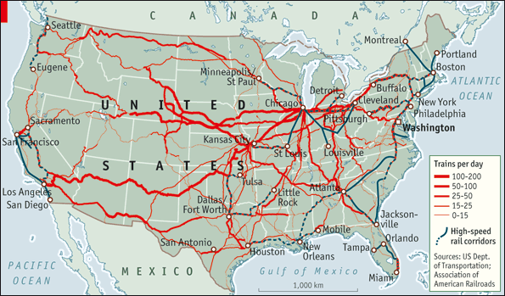
Source: “American Railways: High-Speed Railroading.” The Economist. June 22, 2010. Web.

B. Figure 2 – Miles of Pipeline
This figure shows all of the major pipelines in the United States. The hazardous liquid lines are in red, and the gas transmission lines are in blue. As shown, these pipelines travel directly under major cities such as Chicago, New Orleans, and Houston. With hundreds of leaks happening every year, a pipeline explosion in one of those areas would be devastating.
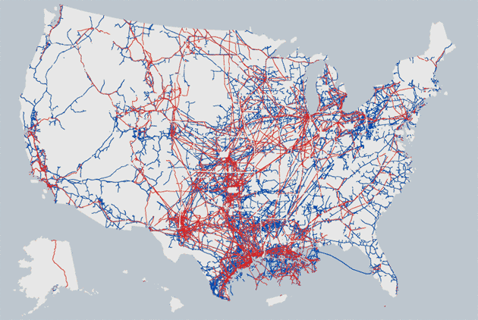
Source: Groeger, Lena. “Pipelines Explained: How Safe Are America’s 2.5 Million Miles of
Pipelines?” ProPublica. November 15, 2012. Web.

C. Figure 3 – Highway Congestion
The following three maps show the level of highway congestion in the United States. The first map is from 2007 and the next is a projection for the year 2040. A “congested” highway (those in yellow) is considered to have reduced traffic speed by 75%-95%. A “highly congested” highway (those in red) is considered stop-and-go traffic with speeds reduced over 95%. If there are no changes made to the current highway system, 37% of the National Highway System will be “highly congested” in 2040 compared with 11% in 2007 (Freight Facts and Figures 2012, 2012).
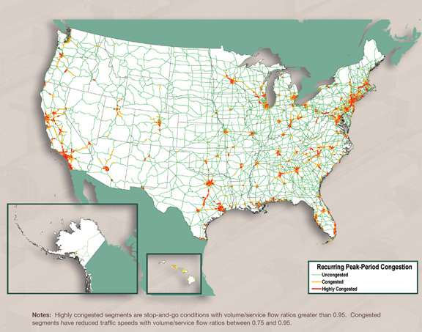
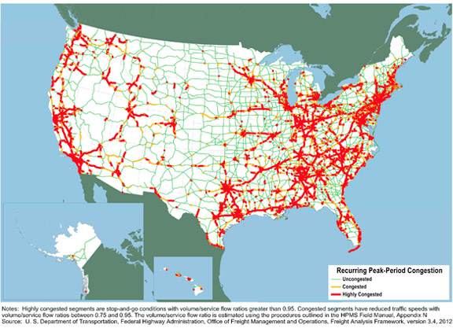
Source: “Freight Facts and Figures 2012.” U.S. Department of Transportation: Federal Highway
Administration. January 9, 2013. Web.

D. Figure 4 – Estimated Investments Table
This is the ASCE’s table from their 2009 Infrastructure Report Card. The 5-year actual spending numbers are based on the most recent available spending at all levels of government and not indexed for inflation.
ESTIMATED 5-YEAR INVESTMENT NEEDS IN BILLIONS OF DOLLARS
 | 5-YEAR NEED (BILLIONS) | ESTIMATED ACTUAL SPENDING | 5-YEAR SHORTFALL
Airports | 87 | 45 | 42
Dams | 12.5 | 5 | 7.5
Levees | 50 | 1.13 | 48.87
Ports | 50 | 25 | 25
Public Transit | 265 | 66.5 | 198.5
Rail | 63 | 42 | 21
Roads/Bridges | 930 | 351.5 | 578.5
TOTALS | 1457.5 | 536.13 | 921.37
Source: “2009 Report Card for America’s Infrastructure.” American Society of Civil Engineers.
2009.

E. Figure 5 – Estimated Transportation and Water Infrastructure Investments For the Next Decade
Infrastructure outlays for transportation and water projects made available through the American Recovery Act of 2009 (ARRA) peaked in 2010. The Congressional Budget Office expects cumulative spending for infrastructure under ARRA to total $54 billion in 2013, leaving less than $8 billion in stimulus funding to be spent over the next seven years.
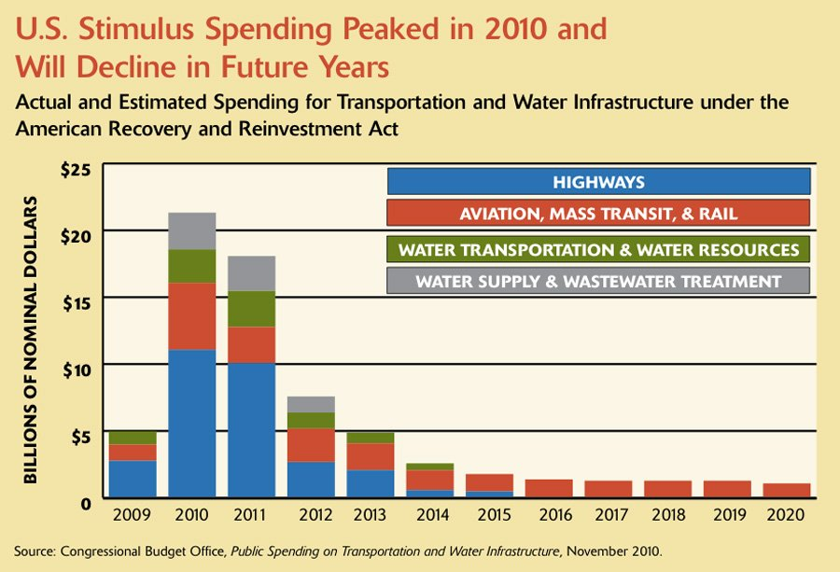

F. Figure 6 – Japanese Vs. American Infrastructure Investment as a Percentage of GDP
When the Japanese real estate bubble burst in the late 1980s, the nation spent large sums of money to repair their failing infrastructure and help save their economy. It paid off for Japan and large strides were made, but as the graph below shows, the United States has remained relatively stagnant in infrastructure investments.

Source: Fackler, Martin. “Japan’s Big-Works Stimulus Is Lesson.” The New York Times.
February 5, 2009. Web.

G. Figure 7 – China’s Investment Into High-Speed Rail
China plans to spend at least $1 trillion over the next five years to overhaul the nation’s transit, water supply, and electricity networks. Included in that hefty sun is a 10,000-mile high-speed rail network to be completed by 2020. The country currently spends about 9% of its GDP on infrastructure.
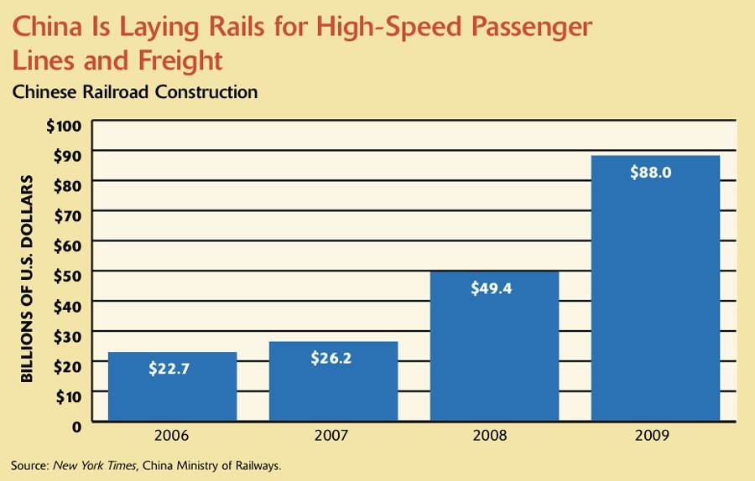

H. Figure 8 – Percentage of GDP Spent on Infrastructure Improvements In the United States and Comparable Countries
The United States is falling behind in the amount of money it is investing into its infrastructure. As the chart below shows, America is below the world average in amount invested and lagging behind not only the emerging economies like the BRIC countries that must build up their infrastructure quickly, but also the mature economies such as Australia, the European Union, and Canada.

Sources:
Aris, Ben. “Russia Makes Huge Investment In Transport Networks.” Business New Europe.
January 4, 2011. Web.
“Building America’s Future: Falling Apart and Falling Behind.” Transportation Infrastructure
Report 2011. 2011. Web.
Klein, Ezra. “Brazil Facts.” The Washington Post. August 7, 2012. Web.
“OECD Countries Spend 1% of GDP On Road and Rail Infrastructure on Average.”
International Transport Forum. June 2012. Web.
Spector, Dina. “CHARTS: The Alarming Collapse of US Infrastructure Spending.” Business
Insider. November 4, 2011. Web.
Urban Land Institute. “Infrastructure 2012: Spotlight On Leadership.” Ernst & Young. 2012.
Web.
“US Infrastructure Lagging Far Behind Europe.” Homeland Security News Wire. 2 May 2011.
Web.

VIII. Works Cited
“2009 Report Card for America’s Infrastructure.” American Society of Civil Engineers. 2009.
“2013 Report Card for America’s Infrastructure.” American Society of Civil Engineers. 2013.
Web.
Amadeo, Kimberly. “How Much Did Hurricane Katrina Damage the U.S. Economy?”
About.com: U.S. Economy. October 31, 2012. Web.
“American Railways: High-Speed Railroading.” The Economist. June 22, 2010. Web.
Aris, Ben. “Russia Makes Huge Investment In Transport Networks.” Business New Europe.
January 4, 2011. Web.
Barron, James. “Steam Blast Bolts Midtown, Killing One.” New York Times. July 19, 2007.
Web.
“Biggest Blackout In U.S. History.” CBSNews. February 11, 2009. Web.
“Buffett Bets Big on Railroads’ Future.” DealBook. November 4, 2009. Web.
“Building America’s Future: Falling Apart and Falling Behind.” Transportation Infrastructure
Report 2011. 2011. Web.
China Ministry of Railways. “High-Speed Rail Lines.” New York Times. 2009.
Clarke, John. “How Much Will the London Olympics Cost? Too Much.” Forbes. March 28,
2012. Web.
Clayton, Mark. “Problem Dams on the Rise in US.” Christian Science Monitor. September
13, 2007. Web.
“Congestion Trends – Wasted Time (Travel Time Index, 1982 to 2011).” Texas A&M
Transportation Institute. 2013. Web.
Dawid, Irvin. “Auto Dealers Seek ‘Gas Price Floor’.” Planetizen. August 15, 2012. Web.
De Young, Raymond. “Tragedy of the Commons.” Encyclopedia of Environmental Science.
Kluwer Academic Publishers. 1999.
Fackler, Martin. “Japan’s Big-Works Stimulus Is Lesson.” The New York Times. February 5,
2009. Web.
“Freight Facts and Figures 2012.” U.S. Department of Transportation: Federal Highway
Administration. January 9, 2013. Web.
“Fuel Efficient Driving.” Eartheasy. 2012. Web.
“GDP (Current US$)” The World Bank Group. 2013. Web.
Groeger, Lena. “Pipelines Explained: How Safe Are America’s 2.5 Million Miles of
Pipelines?” ProPublica. November 15, 2012. Web.
Hargreaves, Steve. “The High Cost of America’s Roads and Bridges.” CNNMoney. February
13, 2013. Web..
Johnston, David Cay. “Danger! Exploding Pipelines. Bursting Dams. Massive Blackouts.”
Newsweek. p. 38-43. September 10, 2012.
Klein, Ezra. “Brazil Facts.” The Washington Post. August 7, 2012. Web.
Kurtenbach, Elaine. “U.S. Infrastructure Spending Falling Far Behind China, Emerging
Economies.” Huffington Post. December 20, 2010. Web.
Mbaku, John Mukum. “Building Opportunities: Addressing Africa’s Lack of Infrastructure.”
Brookings. January 2013. Web.
Miller Center of Public Affairs. “Infrastructure Report.” University of Virginia. October 2010.
Mongelluzzo, Bill. “West Coast Ports Building – Overcapacity?” The Journal of Commerce.
February 22, 2013. Web.
Montgomerie, Tim. “We Still Don’t Have Enough Friends in the North.” ToryDiary. September
14, 2012. Web.
National Railroad Passenger Corporation. “Amtrak National Facts.” Amtrak. 2013. Web.
“OECD Countries Spend 1% of GDP On Road and Rail Infrastructure on Average.”
International Transport Forum. June 2012. Web.
“Paving Our Way: A New Framework for Transportation Finance.” National Surface
Transportation Infrastructure Financing Commission. February 2009.
Patterson, Thom. “U.S. Electricity Blackouts Skyrocketing.” CNNTech. October 15, 2010. Web.
“Public Spending on Transportation and Water Infrastructure.” Congressional Budget Office.
November 2010. Web.
“The ‘Rebuild America Partnership’: The President’s Plan to Encourage Private Investment in
America’s Infrastructure.” Office of the Press Secretary. March 29, 2013. Web
Sills, G.L., Vroman, N.D., Wahl, R.E., Schwanz, N.T. “Overview of New Orleans Levee
Failures: Lessons Learned and Their Impact on National Levee Design and Assessment.”
Journal of Geotechnical and Geoenvironmental Engineering. May 2008.
Sirkin, Harold L. “Airport Capacity: Failure to Launch.” Bloomberg Businessweek. July 6,
2012. Web.
Spak, Kevin. “Aging US Power Grid Is Failing.” Newser. August 2, 2012. Web
Spector, Dina. “CHARTS: The Alarming Collapse of US Infrastructure Spending.” Business
Insider. November 4, 2011. Web.
Stawicki, Elizabeth. “Why Did the Bridge Collapse?” MPRNews. Minnesota Public Radio.
August 2, 2007. Web.
Stolyarov II, G. “The Necessity of Road Privatization.” Yahoo! Voices. April 7, 2007. Web.
Thomasson, Scott. “Encouraging U.S. Infrastructure Investment.” Council on Foreign Relations.
2013. Web.
“UK Public Spending Since 1963.” The Guardian. 2013. Web.
Urban Land Institute. “Infrastructure 2012: Spotlight On Leadership.” Ernst & Young. 2012.
Web.
“US Infrastructure Lagging Far Behind Europe.” Homeland Security News Wire. 2 May 2011.
Web.
Wald, Matthew L. “Management Blamed for Bay Area Gas Disaster.” New York Times.
August 30, 2011. Web.
Whitefield, Mimi. “Competition Heats Up as U.S. Ports Prepare For Panama Canal Expansion.”
The Miami Herald. November 18, 2012. Web.
Witt III, Emit C. “December 14th, 2005 Taum Sauk Dam Failure at Johnson’s Shut-In Park in
Southeast Missouri.” National Weather Service Weather Forecast Office. 2005. Web.

