Investigating Freshwater Mussel Disease and Mortality in the Clinch River Within a Population Ecology Framework.

A Dissertation Presented for the

Doctor of Philosophy

Degree

The University of Tennessee, Knoxville

Jeronimo Gomes Da Silva Neto
May 2025
Copyright © 2025 by Jeronimo Gomes Da Silva Neto.
All rights reserved.

DEDICATION
“If I have seen further than others, it is by standing upon the shoulders of giants.” – Sir Isaac Newton, 1675.
This work is dedicated to the giants in my life, who knowingly or unknowably have provided a shoulder for me to stand on.

ACKNOWLEDGEMENTS

First and foremost, I want to thank my wife, Erica, whose love, strength, and unwavering support made this journey possible. She has been an endless source of encouragement, and a true partner in every sense. I am deeply grateful for her, for her steadfast belief in me, and for the life we continue to build together.
I am incredibly thankful to my advisors Drs. Michelle Dennis and Augustin Engman, and my committee members Gerry Dinkins and Dr. Mark Wilber, for their guidance, patience, trust, encouragement, and enthusiasm towards tackling complex research challenges. I am especially thankful for their ability to manage my excitement, which can be overwhelming to most mortals. Our discussions and their constructive feedback have been instrumental in shaping my growth as a scientist and academic. A special thank you to Dr. Dennis for teaching me everything I know about mussel histology and guiding me through the world of disease diagnostics. Thank you to Dr. Engman for mentoring me through the intricacies of population dynamics and for helping strengthen my scientific writing. Thank you to Dr. Wilber for helping me navigate the world of complex disease ecology modeling and statistics. Finally, I extend a heartfelt thanks to Gerry for instilling in me a love for freshwater mussels. Gerry’s knowledge and passion for these animals is unmeasurable, yet tangible. Working in the Mollusk Collection at the McClung Museum under Gerry’s supervision was wholly unplanned, but this small deviation may have altered my whole career, or life, or both. A lot can be said by the fact that I now get more excited about mussels than hellbenders!
There are so many people I want to thank for their support in the field, in the lab, in the office, and behind the scenes. Special thanks are in order to Julianna Jett, Katie Riese, and Riley Rines who spent hundreds of hours in the field with me and were brave enough to conduct winter surveys when temperatures were near freezing. I really appreciate their commitment to this project. Your companionship, our conversations, and your positive attitude made field days enjoyable and memorable. Next, I want to thank members of the UT Fisheries Lab, Caleb Moses, Brittany Graham, Lexie Scott, and Adam Bajo-Walker for being amazing colleagues and friends, and creating a supportive and nourishing lab environment. You all made my time at UT special! I am grateful for the staff at the McClung Museum of Natural History and Culture, especially Ryan England and Clara Winn for the great laughs and conversations, and Claudio Gomez Papic and Becca Styers for looking after me when life took a few unexpected turns. I also would like to thank the members of Dr. Rick Gerhold’s lab who have adopted me into their lab group and provided an engaging environment that supported personal and professional growth. I would like to also acknowledge the extraordinary support from Dr. Agricola Odoi and Morgan Tolbert, who do an absolutely outstanding job at running the CEM program and creating a nourishing environment where students can thrive.
This work would not have been possible without key collaborations and partnerships beyond my committee, which were instrumental to the successful completion of each chapter in this dissertation. In Chapter 2, I thank Dr. Jordan Richard for conceptual guidance, as well as Rose Agbalog, Andrew Henderson, Justin Wolbert, Devin Henever, Cameron Mitchell, and Merrie Urban for field assistance. I thank Sujata Argawal for technical assistance with qPCR, and Veronica Brown for technical assistance with 16S library preparation and sequencing. I also thank the staff of the Aquatic Wildlife Conservation Center of the Virginia Department of Wildlife Resources for rearing and providing control mussels deployed to silos, a critical component of Chapters 2 and 3. Additionally, I thank the Clinical Pathology, Histology, and Bacteriology laboratory staff for their technical assistance and Emily Ford for editing and formatting support. I am also grateful for Eric Leis’ assistance in reviewing amplification protocols for this chapter. In Chapter 3, I thank the Tennessee Wildlife Resource Agency and the University of Tennessee for providing funding for laboratory equipment. I deeply appreciate the partnership with the U.S. Geological Survey and Tennessee State University, particularly Dr. Tom Byl and Kristi Hill, whose collaboration was essential in bringing this work to fruition. In Chapter 4, I thank Julianna Jett for measuring shells and extend my appreciation to all the surveyors who collected shells from the Clinch River between 2016 and 2020, including Steve Ahlstedt, Charles Saylor, Craig Walker, Don Hubbs, Stephanie Chance, Charles Howard, and Hugh Faust. I am also deeply grateful to Caitlin Carey and Tim Lane for generously sharing their monitoring data, which was essential for the analyses undertaken in this chapter and the next. In Chapter 5, I extend my sincere gratitude to Dr. Wendell Haag and Mickey Bland at the U.S. Forest Service for generously sharing their expertise on preparing thin sections and aging mussel shells. Their training was instrumental in completing this chapter and has profoundly influenced my perspective on mussel natural history and research. I also thank Dr. Rebecca Bergee for statistical analysis support. These acknowledgments highlight just a few of the many individuals who have directly or indirectly contributed to this work. I am truly grateful for their time, support, and dedication.
I would like to thank the departments, agencies, and organizations that supported my position through funding and access to laboratory space and equipment. Funding for my assistantship was provided by the McClung Museum of Natural History and Culture and the Comparative and Experimental Medicine Program at the University of Tennessee College of Veterinary Medicine. Additional research funding was provided by the One Health Initiative, The Morris Animal Foundation, and the University of Tennessee’s School of Natural Resources and the Graduate School. Travel to professional conferences was made possible by various grants awarded by the Freshwater Mollusk Conservation Society, the UT Graduate Student Senate, and the Comparative and Experimental Medicine program at UTCVM. Each of these entities provided the backbone that made this work possible, and I am thankful for their continued trust and support.
When I look back on my career, what I treasure most are the relationships I’ve built and the friendships I’ve gained along the way. I am eternally grateful for the network of colleagues and friends from previous years who continue to be a source of inspiration and mentorship. Dr. Bill Sutton, Dr. Rebecca Hardman, Dr. Cathy Jachowski, Dr. Michael Freake, Dr. Tom Boyd, Kat Diersen, and many others have been a constant source of encouragement, moral support, and guidance. Their friendship and shared passion for our work remain a bright light in my life.
Last but not least, I have the deepest gratitude to my parents Jose Jeronimo Gomes da Silva and Lilian Maria Muller, for their unconditional love and support through every chapter of my life. I am sincerely grateful to Jim Williams, Matthew Huffman, and Lisa McClellan for their familial support, which has played an immeasurable role in my life. I must also acknowledge the incredible humans I am honored to call friends and chosen family. I could easily write an entire dissertation describing the tangible and intangible ways you make me feel loved, supported, and grounded in what really matters: the human experience. You all make life significantly more pleasant just by being who you are.
I would be remiss if I didn’t put into words my deep gratitude for the incredible natural landscapes that have offered me a sanctuary where I can find solace, peace, and comfort. The mountains and streams of Tennessee are truly extraordinary, providing a sanctuary that grounds me amidst all of the noise of deadlines and daily tasks. These places remind me of the very reason I chose this path, and of the beauty that exists beyond the rush of responsibilities. I am profoundly grateful that life has brought me here and for the gift of experiencing these wild and wonderful places.

PREFACE

This dissertation follows a multipart dissertation format, in which each chapter, aside from the Introduction and Conclusion, is structured as a standalone scientific manuscript intended for publication. As a result, there is some repetition across chapters, particularly in the abstract, introduction, and method sections. While efforts were made to reduce redundancy where possible, some overlap was necessary to ensure clarity and completeness for readers engaging with individual manuscripts independently.

ABSTRACT

Freshwater mussels (order Unionida) play an important role in aquatic ecosystems, providing essential ecosystem services to humans and wildlife. The United States harbors the highest diversity of mussels globally, yet nearly 70% of known species are considered imperiled. The Clinch River, a major biodiversity hotspot for mussels in the Unites States, has experienced recent mass mortality events (MMEs) dramatically affecting multiple species. Studying MMEs is inherently challenging due to their unpredictability and the frequent scarcity of reference data on mortality dynamics of affected populations. In this dissertation, we fill knowledge gaps by elucidating patterns, processes, and factors influencing mortality within mussel populations in the Clinch River. We use a combination of pathological, toxicological, microbiological, and ecological assessments to identify potential causal agents, detect environmental risk factors, and characterize demographic structure of affected individuals. We also apply epidemiological concepts to analyze archived shells and gain etiological insights into past MMEs. This research provides critical insights into the disease and mortality dynamics influencing mussel populations. Lastly, we discuss lessons learned from historical mortality events and propose strategies to enhance response to future MMEs.

TABLE OF CONTENTS
Chapter 1 Introduction to freshwater mussel ecology, conservation challenges, and the Clinch River 1
References 12
Chapter 2 Multisystemic inflammatory disease in Pheasantshell (Unionidae, Actinonaias pectorosa) associated with Yokenella regensburgei infection at sites experiencing seasonal mass mortality events 19
Abstract 20
Introduction 22
Materials and Methods 25
Results 34
Discussion 54
References 65
Chapter 3 Investigating the occurrence and concentration of cyanotoxin in water and Pheasantshell (Actinonaias pectorosa) tissue at two sites in the upper Clinch River, USA 75
Abstract 76
Introduction 76
Materials and Methods 79
Results 87
Discussion 93
References 100
Chapter 4 Using shells to gain insights into freshwater mussel mass mortality events: A case-study from the Clinch River, USA 112
Abstract 113
Introduction 114
Materials and Methods 118
Results 121
Discussion 127
References 142
Chapter 5 Using N-mixture modeling and age-length structure analysis to quantify and assess mortality patterns of Pheasantshell (Actinonaias pectorosa) in the Clinch River, USA 156
Abstract 157
Introduction 157
Materials and Methods 161
Results 170
Discussion 177
References 187
Chapter 6 Conclusion 195
Appendices 204
Appendix A: Supporting Information for Chapter 2 205
Appendix B: Supporting Information for Chapter 3 210
Appendix C: Supporting Information for Chapter 4 213
Appendix D: Supporting Information for Chapter 5 217
Appendix E: Parasites and mortality in the endangered Fluted Kidneyshell (Ptychobranchus subtentus) from the Clinch River, Tennessee 223
Abstract 223
Introduction 224
Materials and Methods 226
Results 236
Discussion 246
References 255
Appendix F: Abstract of relevant co-authored publications 262
VITA 264

LIST OF TABLES
Table 2.1: Microscopic lesions observed in Pheasantshell (Actinonaias pectorosa) during histological assessment per clinical presentation (case vs control). Samples were collected from 2021 – 2023 across two sites in Virginia (Speers Ferry and Sycamore Island) and one site in Tennessee (Kyles Ford). Numbers in parentheses represent percentages of the respective sample size. 38
Table 2.2: Indicator Operational Taxonomic Units (OTUs) associated with each analysis group and their respective observed indicator value (IndVal) and significance value (pvalue), as identified by the indicator species analysis. Samples consisted of hemolymph and digestive gland tissue collected from Pheasantshell (Actinonaias pectorosa) sampled from two sites in Virginia (Speers Ferry and Sycamore Island) and one site in Tennessee (Kyles Ford). Analysis groups include Control-Absent (n = 62 DG and 6 HL), Case-Absent (n = 4 DG and 1 HL; individuals not presenting hemocytic nodulation and necrosis associated with gram-negative bacilli), and Case-Present (n = 11 DG and 6 HL; individuals presenting hemocytic nodulation and necrosis associated with gram-negative bacilli). A high IndVal suggests an association between taxonomic groups and analysis groups. 53
Table 2.3: Comprehensive table of sampling date, culture results, qPCR results, and prevalence of hemocytic nodulation and necrosis with bacilli for 21 case Pheasantshell (Actinonaias pectorosa) collected at two sites (SI = Sycamore Island, SF = Speers Ferry) in Virginia. 55
Table 3.1: Monthly average microcystin concentration (ng/g) in Pheasantshell (Actinonaias pectorosa) tissue at Kyles Ford (Tennessee) and Sycamore Island (Virginia) per year and clinical presentation 88
Table 3.2: Monthly average daily microcystin (MC) concentrations (ng/g/day), as well as average total concentrations (ng/g) over all deployment days measured using Solid Phase Adsorption Toxin Tracking (SPATT) samplers at Kyles Ford (Tennessee) and Sycamore Island (Virginia). The table also includes the monthly average deployment duration and the sample size, representing the number of SPATT samplers deployed each month. 90
Table 3.3: Monthly average microcystin (MC) concentration in water (ng/mL) in 2021 and 2023 at both Kyles Ford (Tennessee) and Sycamore Island (Virginia). No samples were collected in 2022 due to high river discharge. Sample size indicates the number of individual water samples collected each month. 91
Table 3.4: Results from correlation analyses among microcystin concentrations in river water, Pheasantshell (Actinonaias pectorosa) tissue, and Solid Phase Adsorption Toxin Tracking (SPATT) samplers, as well as various environmental parameters, for Sycamore Island (Virginia) and Kyles Ford (Tennessee) in the Clinch River. Parameters analyzed include dissolved oxygen, conductivity, water temperature, river discharge, and mussel length. Kendall’s rank correlation was used for all relationships, except those marked with an '*', which were assessed using Pearson’s correlation. Significant correlations between sample types or parameters are noted with a “ ^ ” where applicable. 92
Table 4.1: Characteristics of freshwater mass mortality events (MMEs) that can be inferred from the collection of shell of dead freshwater mussels within a descriptive epidemiological context. These components collectively allow researchers to understand patterns of disease, identify trends, and hypothesize causes for further investigation. 117
Table 4.2: Total yearly counts of individuals per species (34 species in total) collected during suspected mass mortality events at 14 sites in the Clinch River across Virginia and Tennessee between 2016 – 2020. The table includes Federal statuses as established by the United States Fish and Wildlife Service, updated as of February 2024. E = endangered, T = threatened, and P = petitioned. These counts represent individuals collected with a shiny nacre indicative of recent mortality. 122
Table 5.1: Summary of length of live and dead Pheasantshell (Actinonaias pectorosa) at Kyles Ford (Tennessee) and Sycamore Island (Virginia) along with estimated abundance of live individuals based on quadrat surveys. 171
Table 5.2: N-mixture model output summary. 178
Table A.2.1: Total number of Pheasantshell (Actinonaias pectorosa) sampled by clinical presentation (case vs control) from two sites in Virginia (Speers Ferry and Sycamore Island) and one site in Tennessee (Kyles Ford). 206
Table A.2.2: Pheasantshell (Actinonaias pectorosa) sampled by sex and clinical presentation from two sites in Virginia (Speers Ferry and Sycamore Island) and one site in Tennessee (Kyles Ford). 207
Table A.2.3: Total number of individuals with trematode larvae per clinical presentation (case and control) identified in Pheasantshell (Actinonaias pectorosa) sampled from 2021–2023 across from two sites in Virginia (Speers Ferry and Sycamore Island) and one site in Tennessee (Kyles Ford), and total trematode count per site. We also identified trematode life stage and hemocyte response per clinical presentation across all three sites. 208
Table A.2.4: Average relative abundance of indicator Operational Taxonomic Units (OTUs) per sample type and analysis-group. Samples consisted of hemolymph and digestive gland tissue collected from Pheasantshell (Actinonaias pectorosa) sampled from the Clinch River at two sites in Tennessee and Virginia. Analysis groups include Control-Absent (n = 62 DG and 6 HL), Case-Absent (n = 4 DG and 1 HL ; individuals not presenting hemocytic nodulation and necrosis associated with gram-negative bacilli), and Case-Present (n = 11 DG and 6 HL; individuals presenting hemocytic nodulation and necrosis associated with gram-negative bacilli). Values in bold highlight the highest relative abundance per group. 209
Table A.3.1: Monthly average concentrations of anatoxin (ng/g) and saxitoxin (ng/g) in Pheasantshell (Actinonaias pectorosa) tissue (n = 28) by clinical presentation (case vs control). Mussels were collected at Kyles Ford (Tennessee) and Sycamore Island (Virginia) on the Clinch River in 2023. 210
Table A.3.2: Monthly average, minimum, and maximum daily concentrations (ng/g/day), as well as total concentrations (ng/g) of anatoxin, cylindrospermopsin, and saxitoxin measured using Solid Phase Adsorption Toxin Tracking (SPATT) samplers deployed in 2023 at Kyles Ford (Tennessee) and Sycamore Island (Virginia) on the Clinch River. The table also includes the monthly average deployment duration and sample sizes, indicating the number of SPATT samplers deployed each month. 211
Table A.4.1: Observed and expected counts of dead Pheasantshell (Actinonaias pectorosa) individuals across length classes at Sycamore Island in 2019 and Kyles Ford between 2017 and 2018. Residuals indicate deviations from expected counts. Residuals greater than +2 indicate that observed mortality is significantly higher than expected and residuals less than -2 indicate that observed mortality is significantly lower than expected. 214
Table A.4.2: Yearly counts of freshwater mussels collected during suspected mass mortality events at 14 sites in the Clinch River across Virginia (n = 3) and Tennessee (20) between 2016 – 2020. Sites noted with “◊” were located in Virginia. All other sites were located in Tennessee. These counts represent shells collected with a shiny nacre indicative of recent mortality. 215
Table A.5.1: Percent monthly mortality estimates of Actinonaias pectorosa per year at Kyles Ford (Tennessee) and Sycamore Island (Virginia) in the Clinch River, along with the number of surveys conducted. N̂ = estimated abundance based on quadrat surveys; $D$ = number of dead individuals observed; $Dadj$ = adjusted number of dead individuals corrected for detection probability ($p)$ of 76.7%; $PMnaive$ = naïve monthly percent mortality (i.e., unadjusted for detection probability); $PMcorr$= corrected percent monthly mortality accounting for detection probability ($p)$. See the Methods section for details on how values were calculated. Estimates of dead individuals were rounded to the nearest whole number. 217
Table A.5.2: Length-at-age of dead Actinonaias pectorosa collected at Kyles Ford (Tennessee) and Sycamore Island (Virginia) in the Clinch River. Sample size (n) refers to the number of observations for each age. Ages not observed are marked with a “-“. 219
Table A.5.3: Observed and expected counts of dead Actinonaias pectorosa individuals across length classes at Sycamore Island and Kyles Ford between 2021 and 2023. Residuals indicate the degree of deviation from expected counts (significant deviations are noted with “ * ”). Residuals less than -2 indicate that observed mortality is significantly lower than expected and greater than +2 indicate that observed mortality is significantly higher than expected. 220
Table A.1: Larval trematode forms (sporocysts and metacercariae) observed in 7 freshly-dead (i.e., cases) Fluted Kidneyshell (Ptychobranchus subtentus) collected between October 2021 and December 2023 at Kyles Ford, Clinch River, Tennessee. The table also presents tissue type used for polymerase chain reaction (PCR) from each mussel and corresponding PCR results for trematode amplification using UnivTrem, 18S-ITS1, CFwd and Arev, ITS2.2 and 3S, and GoJe primers. Results are shown in the following 232
Table A.2: A review of primers used to amplify trematode sequences in freshwater mussels in the family Unionidae. 235

LIST OF FIGURES
Figure 2.1: Map demonstrating the location of the Clinch River HUC8 watershed and the counties it overlaps. Our three sampling sites are in Scott County, Virginia, and Hancock County, Tennessee. This map was created using ArcGIS® software by Esri. ArcGIS® and ArcMap™ are the intellectual property of Esri and are used herein under license. 27
Figure 2.2: A–E Microscopic lesions in control Pheasantshell (Actinonaias pectorosa) maintained in silos at sites impacted by seasonal mortality events in the Clinch River. A. Diffuse infiltrative hemocytosis within the gill connective tissue. Note the expansion of connective tissue at the base of lamellae by granular hemocytes (arrows), H&E stain. B. Rickettsia-like organisms (arrows) within the epithelium of digestive gland tubules (d), H&E stain. C. Encysted digenean trematode metacercaria within mixed hemocytic encapsulation, H&E stain. D. Encysted degenerate digenean trematode larvae (asterisks) bordered by mixed hemocytic encapsulation (arrows), H&E stain. E. Hemocytic encapsulation with primarily granulocytic hemocytes and containing a profile of a vermiform metazoan consistent with nematode (square, inset), H&E stain. F. Hemocytic nodulation in a case mussel centered on mite fragments (arrows, inset) as indicated by the refractile brown cuticle. Note the abundance of hemocytes with brown cytoplasmic pigment, H&E stain. 36
Figure 2.3: Gross lesions in case mussels (i.e., wild moribund Pheasantshell (Actinonaias pectorosa)) sampled at sites impacted by seasonal mortality events in the Clinch River. A. Gravid marsupium (m) discolored by brown foci; f–foot. B-D. Anomalous right shell valve characterized by recession of mantle at the posterior shell margin (B, arrow), which once removed, reveals an elevated thin layer of nacre with a hole (C, arrowhead) which covers a chamber filled with thin flocculent fluid containing green debris (D). 40
Figure 2.4: Microscopic lesions in case mussels (i.e., wild moribund Pheasantshell (Actinonaias pectorosa)) sampled at sites impacted by seasonal mortality events in the Clinch River. A. Hemocyte nodulation and necrosis within the submucosa (arrow) and lumen (arrowhead) of the intestine (i), H&E stain. B. Necrotic hemocytes center on slender bacilli (arrow) that are gram negative (inset, Hucker-Conn Gram stain), H&E stain. C. Hemocyte nodulation and necrosis beneath the epithelium (e) covering the visceral mass. Note vacuolation of the epithelium, H&E stain. D. Higher magnification of C, with necrotic hemocytes centered on slender bacilli (arrow) that are gram negative (inset, Hucker-Conn Gram stain), H&E stain. Basophilic granules (asterisk) are mineral concretions normally observed in connective tissues of freshwater mussels, H&E stain. E. Foci of hemocyte nodulation and necrosis (arrow) efface digestive gland acini (d), H&E stain. F. Foci of hemocyte nodulation and necrosis within the hemolymphatic spaces of the gill (arrows), similarly centered on bacilli (arrowhead), H&E stain. 42
Figure 2.5: Microscopic lesions in case mussels (i.e., wild moribund Pheasantshell (Actinonaias pectorosa)) sampled at sites impacted by seasonal mortality events in the Clinch River. A. Luminal hemocytic aggregates (arrow) in the heart, H&E stain. B. Hemocytic nodulation and necrosis in a hemolymphatic space of the marsupium (arrow); g–glochidia, H&E stain. C. Glochidial necrosis (asterisks) within the marsupium, H&E stain. D. vacuolation of intestinal epithelium with intracytoplasmic bacilli (arrow), H&E stain. E. Early hemocytic encapsulation (en) adjacent to hemocytic nodulation and necrosis centered on bacilli (arrow), H&E stain. F. Necrosis of digestive gland acini, H&E stain. 44
Figure 2.6: Microscopic lesions in case mussels (i.e., wild moribund Pheasantshell (Actinonaias pectorosa)) sampled at sites impacted by seasonal mortality events in the Clinch River. A. Severe renal lipofuscinosis as indicated by the cytoplasm of nearly all nephron epithelium being distended with coarse brown granules (inset), H&E stain. B. Gonadal duct (d) filled with mature oocytes containing numerous intracytoplasmic microsporidia (insets), H&E stain. The capsule of mature spores stain blue (gram positive; upper inset; Hucker-Conn Gram stain). Note depletion of ovarian acinus (o), H&E stain. C. Ciliate protist (arrow) infestation of mantle, H&E stain. D. Hemolymph smear containing numerous elongate bacilli in pairs and long chains (arrows) with predominance of agranular hemocytes (black arrowhead) over granular hemocytes (white arrowhead), Wright-Giemsa stain. 47
Figure 2.7: A Non-Metric Multidimensional Scaling (NMDS) plot representing similarities and dissimilarities between analysis groups (Control-Absent; Case-Absent; Case-Present) and sample type (hemolymph and digestive gland). Each point represents an individual sample. Samples consisted of hemolymph and digestive gland tissue collected from Pheasantshell (Actinonaias pectorosa) sampled at sites impacted by seasonal mortality events in the Clinch River. Analysis groups include Control-Absent (individuals presenting no pathology; n = 62 DG and 6 HL), Case-Absent (individuals not presenting hemocytic nodulation and necrosis associated with gram-negative bacilli; n = 4 DG and 1 HL), and Case-Present (individuals presenting hemocytic nodulation and necrosis associated with gram-negative bacilli; n = 11 DG and 6 HL). 51
Figure 2.8: Relative abundance of Operational Taxonomic Units (OTUs) per sample type and analysis group. Samples consisted of hemolymph (n = 13) and digestive gland tissue (n = 77) collected from Pheasantshell (Actinonaias pectorosa) sampled at sites impacted by seasonal mortality events in the Clinch River. Analysis groups include Control-Absent (individuals presenting no pathology; n = 62 DG and 6 HL), Case-Absent (individuals not presenting hemocytic nodulation and necrosis associated with gram-negative bacilli; n = 4 DG and 1 HL), and Case- Present (individuals presenting hemocytic nodulation and necrosis associated with gram-negative bacilli; n = 11 DG and 6 HL). Animal IDs are shown across the X axis and associated hemolymph and digestive gland samples linked. 52
Figure 3.1: Map of our sampling sites at the Clinch River, Kyles Ford (Tennessee) and Sycamore Island (Virginia). 80
Figure 3.2: Average microcystin concentration in Pheasantshell (Actinonaias pectorosa) tissue (ng/g) categorized by clinical presentation (case vs control), as well as daily average microcystin concentration (ng/g/day) measured in Solid Phase Adsorption Toxin Tracking (SPATT) samplers deployed at Kyles Ford (Tennessee) and Sycamore Island (Virginia) in the Clinch River between 2021 and 2023. 87
Figure 3.3: Microcystin concentration in Pheasantshell (Actinonaias pectorosa) tissue per year and clinical presentation (control vs case) collected at Kyles Ford (Tennessee) and Sycamore Island (Virginia) in the Clinch River between 2021 and 2023. Outliers above 100 ng/g are not shown in the graph (n = 5). 89
Figure 4.1: Sampling sites across Virginia and Tennessee in upper Clinch River, USA. 118
Figure 4.2: Boxplots showing median, lower quartile, and upper quartile shell length of females and males from four mussel species collected in upper Clinch River across Virginia and Tennessee between 2016 and 2020. *** = significant difference in mean length (p < 0.001). A = Epioblasma brevidens, B = Epioblasma capsaeformis, C = Epioblasma triquetra, D = Lemiox rimosus. 125
Figure 4.3: Total count of females and males from four mussel species collected in upper Clinch River across Virginia and Tennessee between 2016 and 2020. *** = significant overrepresentation (p < 0.001). Error bars represent standard error. Species abbreviations: EBRE = Epioblasma brevidens, ECAP = Epioblasma capsaeformis, ETRI = Epioblasma triquetra, LVAN = Leaunio vanuxemensis, LRIM = Lemiox rimosus. 126
Figure 5.1: Map of our sampling sites at the Clinch River, Kyles Ford (Tennessee) and Sycamore Island (Virginia). 162
Figure 5.2: Monthly percent mortality of Pheasantshell (Actinonaias pectorosa) at Kyles Ford (Tennessee) and Sycamore Island (Virginia) in the Clinch River between 2021 and 2023. Percent mortalities were calculated by dividing the corrected abundance of dead individuals by the annual abundance estimate of live individuals. See Material and Methods for calculations. 172
Figure 5.3: Box plots of length for dead and live Pheasantshell (Actinonaias pectorosa) collected at Kyles Ford (Tennessee) and Sycamore Island (Virginia) from the Clinch River. Dead mussels were collected between 2021-2023. Length from live mussels were acquired during monitoring efforts conducted by state agencies during the same years. White triangles represent mean lengths, and solid black circles represent outliers. 174
Figure 5.4: Box-plots representing length-at-age from 192 dead Pheasantshell (Actinonaias pectorosa) collected at Kyles Ford (Tennessee) and Sycamore Island (Virginia) in the Clinch River between 2021-2023. 175
Figure 5.5: Proportion of dead Pheasantshell (Actinonaias pectorosa) by age category at Kyles Ford (Tennessee) and Sycamore Island (Virginia) in the Clinch River. Dead mussels were collected between 2021-2023. 176
Figure 6.1: Factors that influence freshwater mussel health (modified from Karr et. 1986 “Assessing biological integrity in running waters: A method and its rationale”). 196
Figure A.2.1: Cytological examination of tissues of case mussels (i.e., wild moribund Pheasantshell (Actinonaias pectorosa)) sampled at sites impacted by seasonal mortality events in the Clinch River. A. Wet-mounted impression of discolored marsupium with brown-tinged mucus and glochidia having poorly defined tissues (inset). B. Impression smear of discolored marsupium with abundant brown-granules (arrows) and agranular hemocytes (arrowhead) within a background of mucus containing abundant bacilli (inset right) and glochidia with poorly discerned tissues (inset left), modified Wright-Giemsa stain. C. Impression smear of normal-colored area of the same marsupium as B, comparatively more mucus (m), intact ciliated epithelium (arrow) and hemocytes (arrowhead), and glochidia with discernable inner tissues (inset), modified Wright-Giemsa stain. D. Smear of fluid within the chamber of an anomalous shell consisting of amorphous acellular and crystalline debris, with scattered brown granules (black arrowhead), diatoms (arrow, inset upper), and cyanobacteria (white arrowhead, inset lower), modified Wright-Giemsa stain. 205
Figure A.4.1: Relative abundance per length class of dead and live Pheasantshell (Actinonaias pectorosa) collected from the Clinch River at A = Sycamore Island (Virginia) and B = Kyles Ford (Tennessee). Dead individuals were collected at Sycamore Island in 2019 and at Kyles Ford in 2018 and 2019. Data on live individuals was collected during the same years as part of a long-term monitoring effort at both sites. 213
Figure A.4.2: Framework of response to mussel MMEs based on descriptive epidemiological concepts. 216
Figure A.5.1: Monthly mean temperature per year for both Kyles Ford (A; Tennessee) and Sycamore Island (B, Virginia) on the Clinch River, USA. Error bars represent temperature ranges. 221
Figure A.5.2: Average monthly discharge per year for both A = Kyles Ford (Tennessee) and B = Sycamore Island (Virginia) on the Clinch River, USA. Error bars represent discharge ranges. 222
Figure A.1: Study area Kyle’s Ford in the Clinch River (rivermile 189.6), Hancock County, Tennessee. 227
Figure A.2: Phyllodistomum sp. (Gorgoderidae) sporocysts in mantle of Ptychobranchus subtentus. A: Motile white sporocyst within the mantle. B: Unstained sporocysts (immature sporocysts and cercariae internally) from image A. C: Sporocysts from B stained with methylene blue (MB). D: MB stained immature sporocyst with single cercaria inside. E: Unstained sporocyst with cercaria internally. F: Same sporocyst in E stained with MB, with cercaria internally (annotations for cercarial structures, not sporocysts). os=oral sucker, ac=acetabulum, fo=longitudinal folds, ct=corrugated tail, tas=tail attachement site. 237
Figure A.3: Phyllodistomum sp. (Gorgoderidae) immature cercariae from sporocysts in the visceral mass of Ptychobranchus subtentus. A: Unstained cercaria with narrowing at the attachment site of the rhopalocercous tail. B: Cross section of rhopalocercous corrugated tail broken from cercarial body. C: Corrugated tail inflation of intact cercaria (left) and higher mag of detached tail (right) stained with methylene blue (MB). D: Histological section of gonad showing complete gonad effacement; HE stain. E: Histological section of gonad showing effacement of gametogenic acini (arrowheads) by sporocysts that have epithelial tegument (arrows), and contain developing cercariae; HE stain. F: Higher magnification of sporocysts in E highlighting the rhopalocercous cercaria with corrugated tail and epithelial tegument (arrows) in gonad; HE stain. os=oral sucker, ac=acetabulum, fo=longitudinal folds, ct=corrugated tail, tas=tail attachement site. 238
Figure A.4: Homalometron sp. metacercariae in visceral mass and gonad of Ptychobranchus subtentus. A: Many metacercariae in dissected visceral mass (arrows). B: Higher magnification of metacercariae in tissue (arrow). C: Metacercaria unstained. D: Metacercaria stained with methylene blue (MB). E: Histological section of gonad containing metacercaria within hyaline cyst wall (arrow); HE stain. F: Excised metacercaria. ac=acetabulum, ph=pharynx, os=oral sucker, hw=hyaline cyst wall. 240
Figure A.5: Histological sections of Cotylaspis insignis (Aspidogastridae) and Aspidogaster conchicola (Aspidogastridae) in Ptychobranchus subtentus; HE stain. A: A. conchicola in kidney with rugated ventral adhesive disk. B: C. insignis in mantle cavity. C: Water tubes containing C. insignis adults gravid with eggs (arrows). D: Higher magnification of box from C with epithelial erosion (arrow) and cell debris (arrowhead). vd=ventral disk. 242
Figure A.6: Histological sections of gonad in Ptychobranchus subtentus infected with Pseudonosema-like gonadotropic microsporidia; HE stain. A: Ovarian acinus containing mature oocytes (arrows) filled with intracytoplasmic spores of the microsporidium. Note presence of extracellular spores within hemolymphatic spaces of surrounding connective tissue (arrowhead, inset). B: Higher magnification of A showing intracytoplasmic microsporidial spores (arrows). 244

LIST OF ATTACHMENTS
Growth data for control Pheasantshell (Actinonaias pectorosa) kept in silos between May 2021 and December 2022 (Silo_Growth_Data_May21_Dec22.xlsx)
Growth data for control Pheasantshell (Actinonaias pectorosa) kept in silos between June 2022 and December 2023 (Silo_Growth_Data_June22_Dec23.xlsx)

Introduction to freshwater mussel ecology, conservation challenges, and the Clinch River

Freshwater mussels are bivalve mollusks classified within the order Unionida, which is composed of mussels exclusively adapted to freshwater environments inhabiting lakes, ponds, rivers, and streams worldwide, with the exception of Antarctica and the Pacific Oceanic Islands (Bogan 2008; Haag 2012). Among the six families comprising Unionida (Unionidae, Margaritiferidae, Hyriidae, Inridinidae, Mycetopodidae, and Etheriidae), Unionidae is the most speciose family with approximately 700 species (Haag 2012). North America has historically harbored the greatest mussel species richness with approximately 300 species across 50 genera belonging to the families Margaritiferidae and Unionidae (Haag 2012). The southeastern United States is particularly significant as a global hotspot for mussel diversity, with Alabama and Tennessee harboring approximately 170 and 140 species, respectively (Williams et al. 2008; Gerald Dinkins, unpublished data). Unless stated otherwise, the term "mussel" in this dissertation will generally refer to North American mussels in the families Margaritiferidae and Unionidae.
Mussels have an intricate relationship with riverine ecosystems, where they play vital roles in maintaining ecological function. As benthic filter feeders they provide essential ecological services, including biofiltration, nutrient cycling, and habitat structuring, benefiting entire aquatic communities (Vaughn 2018). For instance, their filtration activity helps remove bacteria and particulate matter, improving water quality, while their shells contribute to substrate stabilization and habitat complexity (Vaughn et al. 2008). Beyond their ecological importance, mussels hold cultural significance. Indigenous peoples across the United States historically used mussels as a food source and for tools and ornaments (Parmalee 1974). More recently, from the early 1900s to the mid 1960s, mussels were heavily harvested for their pearls and shells for the button industries, further emphasizing their historical and economic value (Williams et al. 2008; Haag 2012).
These animals exhibit remarkable diversity in reproductive strategies, with some species living only a few years and others exceeding 100 years (Ziuganov et al. 2000; Haag and Rypel 2011; Haag 2013). Their complex life cycle includes a parasitic larval stage (glochidia) that must attach to the gills or fish hosts to complete development before dropping into the benthos (Strayer 2008; Haag 2012; Modesto et al 2018). To achieve this, mussels employ various host infection strategies. Some species have evolved mantle lures, where modified mantle tissue mimics prey, attracting predatory fish (Barnhart et al. 2008; Haag 2012). When the fish strikes, the female mussel releases glochidia into the fish’s gills. Other species package their glochidia into small packets (conglutinates) which resemble macroinvertebrates (Barnhart et al. 2008; Haag 2012). When ingested by fish, these packets rupture, releasing glochidia and infecting the host fish. The natural history of mussels underscores their deep connection to aquatic ecosystems and is an essential consideration in later sections of this dissertation, particularly when I discuss threats and conservation status.
The Tennessee River drainage is the most diverse river system for mussels in the United States, spanning seven southeastern states (Haag 2012). Among its tributaries, the Clinch River stands out as a biodiversity hotspot (Ahlstedt 1984; Ahlstedt et al. 2005; Jones et al. 2014). The river originates near Tazewell, Virginia, and flows southwest into northeast Tennessee, where it eventually empties into Norris Reservoir. The first record of mussels from the Clinch Rive dates back to 1897 documented by Pilsbry and Rhoads, which was followed by a more extensive assessment conducted between 1912 and 1915 by A.E. Ortmann (Ortmann 1918). Based on current taxonomy, these effort documented 58 species from 26 sites spanning the river’s headwaters to its confluence with the Tennessee River (Jones et al. 2014). Additional collections were made between 1915 and 1973, however no focused conservation strategies were in place at that time (Ahlstedt 1984). After the passing of the Endangered Species Act in 1973 there was a new surge of interest in the Clinch River, which set the foundation for the last 50 years of management and research in the watershed (Stansbery 1973; Bates 1978; Ahlstedt 1984, 1986; Dennis 1989; Eckert 2008; Ahlstedt et al. 2016; Jones et al. 2014). Currently, the Clinch River remains one of the most important strongholds for mussels, supporting at least 46 mussel species, including four species endemic to the Clinch and Powell watersheds (Jones et al. 2014; Zipper et al. 2014). Approximately 50% of these species are federally listed, accounting for 25% of all federally listed mussel species in the United States. Beyond its ecological significance, the Clinch River also serves an essential resource for local communities, providing drinking water and recreational opportunities, further underscoring its importance (USEPA 2015).
The Clinch River has not been immune to ecological degradation associated with anthropogenic activities. Between the 1920s and 1950s, region-wide dam construction significantly altered the Tennessee River drainage (Ahlstedt 1984). A total of 29 large dams were built along the mainstem and tributaries, including the Clinch River, which was impounded by Norris Dam. These impoundments drastically altered aquatic habitats, making large portions of the mainstem and tributaries unsuitable for mussels (Ahlstedt 1984). This caused widespread extirpations, drove some species to extinction, and confined many populations to free-flowing sections of the tributaries (Ahlstedt 1984). In addition to impacts from dam construction, the upper section of the river, particularly in Virginia, has been affected by agriculture, urban development, coal mining, untreated wastewater inputs, and catastrophic spills of caustic wastewater from a fly-ash pond and sulfuric acid in the late 1960s and early 1970s (Crossman 1973; Krstolic et al. 2013; Zipper 2014). These activities have been linked to significant reduction in mussel abundance, particularly in a 68-km section of the river in Virginia (Jones et al. 2014; Johnson et al. 2014; Zipper 2014).
These declines reflect a broader challenge in mussel conservation. In the United States, nearly 70% of mussel species are classified as endangered, threatened, or of special concern (Haag and Williams 2014). Approximately 30 out of 300 species have gone extinct within the last 100 years, and several others are at the brink of extinction (Haag and Williams 2014). While many declines are linked to well-documented factors such as region-wide dam construction, the causes of widespread faunal declines remain unclear (Haag 2012; Haag and Williams 2014; Haag 2019). The mystery lies in common species experiencing long-term declines even in presumably healthy systems, with no apparent degradation in habitat or water quality (Haag 2019). Additionally, unexplained mass mortality events (MMEs) have been increasingly reported in major river systems, yet many remain understudied or undocumented (Neves 1987; Hastie and Toy 2008; Thomas 2008; Haag 2019; Richard et al. 2023). This trend is not confined to the United States. In Europe, 65% of recognized mussel species are classified as threatened or near threatened (Lopes-Lima et al. 2017; Lopes Lima et al. 2023; Sousa et al. 2023). The freshwater pearl mussel (Margaritifera margaritifera), once widespread, is now nearly extinct in many areas (Young et al. 2001; Geist 2010). This global decline makes mussels one of the most threatened animal groups on Earth and raises concerns about novel or overlooked factors affecting populations.
Despite declines in mussel abundance in the Virginia sections of the Clinch River , assemblages in Tennessee were considered healthy based on the presence of many adult cohorts and evidence of recruitment (Jones et al. 2014; Zipper et al. 2014). However, in 2016 biologists observed an unusual abundance of dead mussels at several monitoring sites along a 40-mile segment of the Clinch River in Tennessee (Richard 2018; Richard et al. 2020). These mortality events impacted only mussels, while other macroinvertebrates, fish, and vegetation seemed to be unaffected. Anecdotal reports suggest that these events occurred seasonally over multiple consecutive years, exhibited an upstream progression, and disproportionately affected certain species. Notably, the abundance of Pheasantshell (Actinonaias pectorosa), a common species at these sites, declined by up to 80% in some reaches (Richard et al. 2020). This species is endemic to the Cumberland and Tennessee River drainages in southern Kentucky, northern Alabama, Tennessee, and southwestern Virginia (Isom and Yokley 1973; Parmalee and Bogan 1998; Williams et al 2008; Haag and Cicerello 2016). However, it is now restricted to the upper Clinch and Powell Rivers in Tennessee and Virginia (G. Dinkins, unpublished data). Given the apparent species selectivity, exclusive impact on mussels, and spatial pattern of spread, researchers hypothesized that infectious disease outbreaks may have contributed to these events (Richard et al. 2020, 2021). Subsequent studies have investigated this hypothesis, identifying bacteria associated with moribund mussels and disease in A. pectorosa (Leis et al. 2019; Richard et al. 2020, 2021; Leis et al. 2023; Da Silva Neto et al. 2024). Although studies using multidisciplinary frameworks have begun to explore these factors, many questions remain unanswered and many aspects of these MMEs remain unresolved.
Over the past decade, numerous federal and state agencies, research institutions, and conservation organizations have collaborated to study MMEs in the Clinch River. In parallel, state agencies have dedicated significant effort toward mussel conservation in the region. Much of my work builds on the information shared by researchers and conservation practitioners working in this system. This dissertation emerged from those partnerships and the ongoing need to assess the status of mussel assemblages within the watershed. Particularly, there was a need to further understand risk factors, mortality patterns, and demographic structure of dead mussels at sites experiencing historical MMEs. Addressing these knowledge gaps requires an interdisciplinary approach that integrates disease ecology, toxicology, epidemiology, and population dynamics to investigate the factors contributing to mussel mortality. In this dissertation, I aim to untangle the factors associated with mussel mortality in the Clinch River through a combination of intensive laboratory and field-based research. My approach incorporates disease diagnostics, epidemiological concepts, ecotoxicology, and shell analysis to investigate risk factors associated with mussel mortality. In three out of four studies I focus specifically on A. pectorosa, a species of concern due to the significant impact of MMEs on its Clinch River population. Field work was conducted mainly at two sites in the Upper Clinch River. For over 20 years, these study sites have served as a critical source of broodstock for A. pectorosa and several other species as part of restoration efforts in the upper Tennessee River drainage. Understanding the factors influencing mortality at these sites is essential for guiding future conservation and management strategies.
In Chapter 2, my co-authors and I assess the role of bacteria in A. pectorosa mortality between May 2021 and December 2023 through a multiyear case-control study, combining in-situ experiments, field surveys, histology, bacterial isolation, and high-throughput sequencing. Our findings reveal a significant association between Yokenella regensburgei and severe multisystemic and multifocal infiltrative hemocytosis with necrosis, consistent with sepsis. Lesions associated with yokenellosis were of sufficient severity and physiological significance to explain mortality in infected hosts. Although our study does not explain the cause of these infections, it confirms that mussels at the study sites are ultimately dying from an infectious disease and that Y. regensburgei can be pathogenic in free-living mussels.
In Chapter 3, my co-authors and I investigate the potential role of cyanotoxins in A. pectorosa mortality. We described the occurrence and measured the concentration of microcystin in water and A. pectorosa tissue at historical mussel mortality sites. Using a case-control design, we compared toxin levels between apparently healthy (control) and moribund/fresh dead (case) mussels using an Enzyme-Linked Immunosorbent Assay (ELISA). To capture environmentally relevant toxin dynamics, we collected discrete water samples and deployed Solid Phase Adsorption Toxin Tracking (SPATT) samplers. While Pheasantshell accumulated microcystin, sometimes at higher levels in control than case mussels, this was not linked to acute toxicosis. We also detected anatoxin, cylindrospermopsin, and saxitoxin in 2023 samples. Although cyanotoxins are unlikely to be a direct cause of mortality, they may pose sublethal risks to mussels.
In Chapter 4, my co-authors and I analyze over 5,000 shells from historical MMEs in the Clinch River and characterize species, length, and sex composition of affected mussels. We found that 34 mussel species of various sizes and sexes, including many federally endangered species, may have been impacted during these events. The broad scope of mortality suggests that if an infectious agent was involved, it was likely a generalist pathogen with a wide host range. Alternatively, mass mortality may have resulted from a complex, multifactorial process involving interactions between multiple pathogens and environmental stressors, leading to taxa-wide impacts. Finally, we propose strategies to improve MME response efforts, enhancing our ability to investigate and contextualize future events. To our knowledge, this is the first effort to summarize shell data collected during MMEs in the Clinch River, contributing to the growing body of literature describing mass mortality in mussels.
In Chapter 5, we assess mortality patterns of A. pectorosa between 2021 and 2023 at two Clinch River sites with historical MMEs, applying an N-mixture modeling approach to estimate abundances of dead mussels and evaluate the effects of Julian Day, water temperature, and river discharge on mortality. Dead mussels were generally larger than live mussels, with differences in the age structure of dead individuals observed between sites. Our detection probability was 76.7%. Julian Day was the strongest predictor of mortality, with the abundance of dead mussel increasing later in the year, suggesting a seasonal component to mortality. Interestingly, this pattern is consistent with seasonal mortality as observed in previous years, although of uncertain magnitude of difference. These findings provide reference mortality data to help investigate potential causes and contextualize future mortality epidemics.
In Chapter 6, I summarize key findings in each Chapter and place them within a broader ecological and conservation context. I discuss how these results enhance our understanding of mussel mortality, inform conservation strategies, and contribute to ongoing efforts to protect imperiled mussel populations more broadly. Additionally, I highlight some knowledge gaps that have caught my attention and propose future research directions.
Lastly, in Appendices A through D I provide supporting information for Chapters 2 to 5. In addition, Appendices E and F include information on two parallel studies I conducted along with the core chapters, which offer additional insights relevant to mussel conservation in the Clinch River and beyond. Appendix E presents a full manuscript documenting previously unreported parasite-host relationships in the endangered Fluted Kidneyshell (Ptychobranchus subtentus), using morphological, histological, and molecular techniques. This information serves as essential reference for assessing the impact of parasitism on conservation efforts. Appendix F contains an abstract summarizing a manuscript led by an undergraduate student that evaluated muskrat (Ondatra zibethicus) predation impacts on the mussel assemblage at one my study sites based on shells I collected from muskrat mounds. We documented predation on 2,370 individual mussels from 26 species, including several federally listed and candidate species, over a 100-day period. These findings highlight the necessity for further research into predation and its long-term implications for mussel populations. Both studies have been submitted for publication in scientific journals.

References
Ahlstedt, S.A., 1986. Cumberlandian Mollusk Conservation Program. Activity 1: Mussel distribution surveys (No. TVA/ONRED/AWR-86/15). Tennessee Valley Authority, Norris (USA). Div. of Services and Field Operations.
Ahlstedt, S.A., M.T. Fagg, R.S. Butler, and J.F. Connell, 2005. Longterm Trend Information for Freshwater Mussel Populations at Twelve Fixed-Station Monitoring Sites in the Clinch and Powell Rivers of Eastern Tennessee and Southwestern Vir-ginia, 1979-2004. Final Report, U.S. Fish and Wildlife Service,Cookeville, Tennessee, 38 pp.
Ahlstedt, S.A., Fagg, M.T., Butler, R.S., Connell, J.F. and Jones, J.W., 2016. Quantitative monitoring of freshwater mussel populations from 1979–2004 in the Clinch and Powell Rivers of Tennessee and Virginia, with miscellaneous notes on the fauna. Freshwater Mollusk Biology and Conservation, 19(2), pp.1-18
Bates, J.M. and Dennis, S.D., 1978. The mussel fauna of the Clinch River, Tennessee and Virginia. Sterkiana, 69(1).
Barnhart, M.C., Haag, W.R. and Roston, W.N., 2008. Adaptations to host infection and larval parasitism in Unionoida. Journal of the North American Benthological Society, 27(2), pp.370-394.
Bogan, A.E., 2008. Global diversity of freshwater mussels (Mollusca, Bivalvia) in freshwater. Freshwater animal diversity assessment, pp.139-147.
Crossman, J.S., J. Cairns, Jr., and R.L. Kaesler, 1973. Aquatic Invertebrate Recovery in the Clinch River Following Hazardous Spills and Floods. Virginia Water Resource Center 63, Virginia Tech,Blacksburg, Virginia, 56 pp
Dennis, S.D., 1989. Status of the freshwater mussel fauna Pendleton Island Mussel Preserve, Clinch River, Virginia. Sterkiana, 72, pp.19-27.
Eckert, N.L., Ferraro, J.J., Pinder, M.J. and Watson, B.T., 2008. Freshwater Mussel and Spiny Riversnail Survey of Slant, Clinch River, Virginia: Augmentation Monitoring Site–2005. Final Report: Virginia Department of Game and Inland Fisheries, Richmond. 36p.
Geist, J., 2010. Strategies for the conservation of endangered freshwater pearl mussels (Margaritifera margaritifera L.): a synthesis of conservation genetics and ecology. Hydrobiologia, 644(1), pp.69-88.
Haag, W.R. and Rypel, A.L., 2011. Growth and longevity in freshwater mussels: evolutionary and conservation implications. Biological Reviews, 86(1), pp.225-247.
Haag, W.R., 2012. North American freshwater mussels: natural history, ecology, and conservation. Cambridge University Press.
Haag, W.R. and Williams, J.D., 2014. Biodiversity on the brink: an assessment of conservation strategies for North American freshwater mussels. Hydrobiologia, 735, pp.45-60.
Haag W.R. and Cicerello R.R. 2016. A Distributional Atlas of the Freshwater Mussels of Kentucky. Scientific and Technical Series Number 8. Kentucky State Nature Preserves Commission.
Haag, W.R., 2019. Reassessing enigmatic mussel declines in the United States. Freshwater Mollusk Biology and Conservation, 22(2), pp.43-60.
Hastie, L.C. and Toy, K.A. 2008. Changes in density, age structure and age‐specific mortality in two western pearlshell (Margaritifera falcata) populations in Washington (1995–2006). Aquatic Conservation: Marine and Freshwater Ecosystems, 18(5), pp.671-678.
Isom B.G. and Yokley P. Jr. 1973. The Mussel Fauna of the Elk River Basin in Alabama and Tennessee. Tennessee Valley Authority.
Johnson, G.C., J.L. Krstolic, and B.J.K. Ostby. 2014. Influences of water and sediment quality and hydrologic processes on mussels in the Clinch River. Journal of the American Water Resources Association, 50(4):878–897.
Jones, J., S. Ahlstedt, B. Ostby, B. Beaty, M. Pinder, N. Eckert, R. Butler, D. Hubbs, C. Walker, S. Hanlon, J. Schmerfeld, and R. Neves. 2014. Clinch River freshwater mussels upstream of Norris Reservoir, Tennessee and Virginia: A quantitative assessment from 2004 to 2009. Journal of the American Water Resources Association, 50(4):820–836.
Krstolic, J.L., G.O. Johnson, and B.J.K. Ostby. 2013. Water Quality, Sediment Characteristics, Aquatic Habitat, Geomorphology, and Mussel Population status of the Clinch River, Virginia and Tennessee, 2009-2011. U.S. Geological Survey Data Series 802, 5 p.; 2 Appendices.
Leis, E., Erickson, S., Waller, D., Richard, J. and Goldberg, T., 2019. A comparison of bacteria cultured from unionid mussel hemolymph between stable populations in the Upper Mississippi River basin and populations affected by a mortality event in the Clinch River. Freshwater Mollusk Biology and Conservation, 22(2), pp.70-80.
Leis, E.M., Dziki, S., Richard, J., Agbalog, R., Waller, D., Putnam, J., Knowles, S. and Goldberg, T., 2023. Further bacteriological analysis of annual Pheasantshell (Actinonaias pectorosa) mussel mortality events in the Clinch River (Virginia/Tennessee), USA, reveals a consistent association with Yokenella regensburgei. Freshwater Mollusk Biology and Conservation, 26(1), pp.1-10.
Lopes‐Lima, M., Sousa, R., Geist, J., Aldridge, D.C., Araujo, R., Bergengren, J., Bespalaya, Y., Bódis, E., Burlakova, L., Van Damme, D. and Douda, K., 2017. Conservation status of freshwater mussels in Europe: state of the art and future challenges. Biological reviews, 92(1), pp.572-607.
Lopes-Lima, M., Reis, J., Alvarez, M.G., Anastácio, P.M., Banha, F., Beja, P., Castro, P., Gama, M., Gil, M.G., Gomes-dos-Santos, A. and Miranda, F., 2023. The silent extinction of freshwater mussels in Portugal. Biological Conservation, 285, p.110244.
Modesto, V., Ilarri, M., Souza, A.T., Lopes‐Lima, M., Douda, K., Clavero, M. and Sousa, R., 2018. Fish and mussels: importance of fish for freshwater mussel conservation. Fish and Fisheries, 19(2), pp.244-259.
Neves, R.J., 1987. Proceedings of the Workshop on Die-offs of Freshwater Mussels in the United States.
Ortmann, A.E., 1918. The nayades (freshwater mussels) of the upper Tennessee drainage. With notes on synonymy and distribution. Proceedings of the American Philosophical Society, 57(6), pp.521-626.
Parmalee, P.W. and Klippel, W.E., 1974. Freshwater mussels as a prehistoric food resource. American antiquity, 39(3), pp.421-434.
Parmalee P.W. and Bogan A.E. 1998. Freshwater mussels of Tennessee. University of Tennessee Press.
Richard, J., 2018. Clinch River mussel die-off. Ellipsaria, 20, pp.1-3.
Richard, J.C., Leis, E., Dunn, C.D., Agbalog, R., Waller, D., Knowles, S., Putnam, J. and Goldberg, T.L., 2020. Mass mortality in freshwater mussels (Actinonaias pectorosa) in the Clinch River, USA, linked to a novel densovirus. Scientific reports, 10(1), p.14498.
Richard, J.C., Campbell, L.J., Leis, E.M., Agbalog, R.E., Dunn, C.D., Waller, D.L., Knowles, S., Putnam, J.G. and Goldberg, T.L., 2021. Mussel mass mortality and the microbiome: evidence for shifts in the bacterial microbiome of a declining freshwater bivalve. Microorganisms, 9(9), p.1976.
Richard, J.C., Leis, E.M., Dunn, C.D., Harris, C., Agbalog, R.E., Campbell, L.J., Knowles, S., Waller, D.L., Putnam, J.G. and Goldberg, T.L., 2022. Freshwater mussels show elevated viral richness and intensity during a mortality event. Viruses, 14(12), p.2603
Richard, J.C., Blevins, E., Dunn, C.D., Leis, E.M. and Goldberg, T.L., 2023. Viruses of Freshwater Mussels during Mass Mortality Events in Oregon and Washington, USA. Viruses, 15(8), p.1719.
Sousa, R., Zając, T., Halabowski, D., Aksenova, O.V., Bespalaya, Y.V., Carvalho, F., Castro, P., Douda, K., Da Silva, J.P., Ferreira‐Rodríguez, N. and Geist, J., 2023. A roadmap for the conservation of freshwater mussels in Europe. Conservation Biology, 37(2), p.e13994.
Stansbery, D.H., 1973. A preliminary report on the naiad fauna of the Clinch River in the southern Appalachian Mountains of Virginia and Tennessee (Mollusca: Bivalvia: Unionoida). Bulletin of the American Malacological Union, 1972, pp.20-22.
Strayer, D.L., 2008. Freshwater mussel ecology: a multifactor approach to distribution and abundance (Vol. 1). Univ of California Press.
Thomas, A.C. 2008. Investigation of western pearlshell mussel (Margaritifera falcata) mortality in Bear Creek, King County, Washington: a disease ecology approach (Doctoral dissertation, University of Washington).
USEPA. U.S. Environmental Protection Agency. (2015). Clinch and Powell Rivers Watershed Healthy Watershed Protection Project Final Report. [EPA Report]. U.S. Environmental Protection Agency. https://www.epa.gov/sites/default/files/2015-11/documents/150813cp_hwp_final_report_508.pdf
Vaughn, C.C., 2018. Ecosystem services provided by freshwater mussels. Hydrobiologia, 810, pp.15-27.
Vaughn, C.C., Nichols, S.J. and Spooner, D.E., 2008. Community and foodweb ecology of freshwater mussels. Journal of the North American Benthological Society, 27(2), pp.409-423.
Watters, G.T., 2001. The evolution of the Unionacea in North America, and its implications for the worldwide fauna. In Ecology and evolution of the freshwater mussels Unionoida (pp. 281-307). Berlin, Heidelberg: Springer Berlin Heidelberg.
Williams, J.D., Bogan, A.E. and Garner, J.T., 2008. Freshwater mussels of Alabama and the mobile basin in Georgia, Mississippi and Tennessee.
Young, M.R., Cosgrove, P.J. and Hastie, L.C., 2001. The extent of, and causes for, the decline of a highly threatened naiad: Margaritifera margaritifera. Ecology and evolution of the freshwater mussels Unionoida, pp.337-357.
Zipper, C.E., B. Beaty, G.C. Johnson, J.W. Jones, J.L. Lrstolic, R.J.K. Ostby, W.J. Wolfe, and P. Donovan. 2014. Freshwater mussel population status and habitat quality in the Clinch River, Virginia and Tennessee, USA: A featured collection. Journal of the American Water Resources Association. 50(4):807–819.
Ziuganov, V., San Miguel, E., Neves, R.J., Longa, A., Fernández, C., Amaro, R., Beletsky, V., Popkovitch, E., Kaliuzhin, S. and Johnson, T., 2000. Life span variation of the freshwater pearl shell: a model species for testing longevity mechanisms in animals. Ambio: A journal of the Human Environment, 29(2), pp.102-105.

Multisystemic inflammatory disease in Pheasantshell (Unionidae, Actinonaias pectorosa) associated with Yokenella regensburgei infection at sites experiencing seasonal mass mortality events
A version of this chapter was originally published by Da Silva Neto et al 2024 in PLOSOne:
Da Silva Neto, J.G., Hardman, R.H., Engman, A.C., Dinkins, G.R., Lane, T.W., Fry, M.M., Rines, C.R., Bisenieks, A.L., Rajeev, S., and Dennis, M.M., 2024. Multisystemic inflammatory disease in Pheasantshell (Unionidae, Actinonaias pectorosa) associated with Yokenella regensburgei infection at sites experiencing seasonal mass mortality events. Plos one, 19(8), p.e0301250.
Author contributions are as follows: J. G. Da Silva Neto: conceptualization, data acquisition and curation, formal analysis, writing original draft, review and editing. R.H. Hardman: conceptualization, data curation, formal analysis, writing original draft. A.C. Engmann: conceptualization, supervision, review and editing. Gerald Dinkins: conceptualization, supervision, review and editing. T.W. Lane: conceptualization, data curation, review and editing. M.M. Fry: conceptualization, data curation, formal analysis, review and editing. M.M., Rines and C.R., Bisenieks: data curation, review and editing. A.L. Rajeev: data curation, formal analysis, investigation, review and editing. and Dennis, M.M., 2024: conceptualization, supervision, data curation, formal analysis, writing original draft, review and editing.

Abstract
Freshwater mussels are integral components of riverine ecosystems, influencing water quality, nutrient cycling, and habitat characteristics. Enigmatic mussel declines, often characterized by sudden mass mortality events, pose significant challenges to conservation efforts. The Clinch River, a freshwater biodiversity hotspot in Virginia and Tennessee, USA, has experienced several enigmatic mass mortality events since 2016. Studies have reported bacteria associated with moribund Pheasantshell (Actinonaias pectorosa) during mortality events in the Clinch River, specifically Yokenella regensburgei. Despite reports of bacterial infection, little is known about their role as pathogens. Through a multiyear case-control study, combining in-situ experiments, field surveys, histology, bacterial isolation, and high-throughput sequencing, we assessed the role of bacteria in A. pectorosa mortality at three sites in the Clinch River. Between May 2021 and December 2023, we collected 21 wild moribund free-living A. pectorosa and 68 hatchery-reared A. pectorosa maintained in silos at the same sites and investigated differences in pathology and microbiology between groups. No silo mussels presented clinical signs of disease, or gross or microscopic lesions associated with pathological conditions leading to mortality. Our findings reveal a significant association between Yokenella regensburgei and severe multisystemic and multifocal infiltrative hemocytosis with necrosis, consistent with sepsis. Lesions associated with yokenellosis were of sufficient severity and physiological significance to explain mortality in infected hosts. Although our study does not explain the cause of these infections, it confirms that mussels at our study sites are ultimately dying with an infectious disease and that Y. regensburgei can be pathogenic in free-living mussels. Our results underscore the importance of considering bacterial diseases in wild mussel populations and emphasize the need for further research to elucidate the epidemiology and pathogenicity of Y. regensburgei. Overall, our study highlights the importance of integrated approaches combining pathology, microbiology, and epidemiology in mussel conservation efforts.

Introduction
Freshwater mussels play an essential role in riverine ecosystem functioning. Mussels are benthic filter feeders that consume zooplankton, phytoplankton, and fine particulate matter from the water column, which influences water quality nutrient availability and cycling, algal and pollutant concentrations, and benthic productivity (Howard and Cuffey 2006; Vaughn 2018). In addition, mussels are considered habitat modifiers whose influence on the physical and chemical habitat characteristics of streams positively affect other freshwater fauna such as fish and macroinvertebrates (Sansom et al. 2018; DuBose 2020; Hopper et al. 2019).
Despite their ecological importance, mussel species richness in North America has been declining since the early 1900s at the alarming rate of 1.2% per decade (Ricciardi and Rasmussen 1999). Unionid mussels are arguably the most threatened group of freshwater fauna in North America with at least 27 of the 300 recognized species declared extinct and 65% of the remaining fauna considered imperiled (Ricciardi and Rasmussen 1999; IUCN 2017; Ferreira-Rodríguez 2019). Habitat alteration, loss, and degradation, declines in water quality, presence of invasive species, and disease are suspected of causing population declines (Haag and Williams 2014; Haag 2019). Although some population declines are attributed to degradation of habitat quality or exposure to pollutants, others have no clear cause (Haag 2019). These enigmatic declines have been reported across the globe for over 40 years, often in otherwise healthy systems lacking significant human impact that could explain mussel mass mortality, while other aquatic fauna (e.g., fish, snails, and crayfish) appear unaffected (Haag 2019; Aldridge et al. 2023). Sudden mortality events, where hundreds or thousands of sick or dead mussels are observed, can be a component of enigmatic declines, and have been documented across south, central, and western United States (Neves 1987; Hastie and Toy 2008; Thomas 2008; Haag 2019; Richard et al. 2023). These events can cause rapid declines in biodiversity and ecosystem services and can trigger long-term changes in community composition and widespread faunal collapse (DuBose et al. 2019b).
Despite the grave impacts, logistical and financial constraints often prevent the early detection of mass mortality events, which are typically reported incidentally to other monitoring efforts (Waller and Cope 2019). Therefore, they are seldom subjected to comprehensive diagnostic investigation and are poorly understood. The Clinch River watershed is a threatened mussel diversity hotspot. Located in the upper Tennessee River drainage of Virginia and Tennessee, the Clinch River contains 46 extant mussel species, over 20 of which are listed as federally endangered (Zipper et al. 2014; Jones et al. 2014). The Clinch River is a model system for exploring the potential causes of mass mortalities. Annual mussel mass mortality events have occurred in the river reach at the Tennessee/Virginia border since 2016 (Richard 2018). In the Clinch River mortality events, large numbers of dead or moribund mussels have been observed between late September and November (Richard et al. 2021). Consistent with enigmatic declines observed elsewhere, this reach is considered healthy and only mussels seem to be impacted. First reported in Tennessee, mortality events have progressed upstream. At first, these mortality events appeared to affect all mussel species (Richard 2018), but it became evident that Pheasantshell (Actinonaias pectorosa) exhibited greater mortality compared to other species (Richard et al. 2020). Pheasantshell are endemic to the Tennessee and Cumberland River drainages and historically were especially abundant in the Clinch River comprising over 50% of the Clinch River’s mussel biomass (Jones et al. 2014). However, between 2016–2019, Pheasantshell populations declined 50–90% in some monitoring sites due to annual mass mortality events (Richard et al. 2020).
The disproportional loss of a single species and the upstream progression of the mortality events prompted research into the role of infectious microorganisms. These studies reported the presence of a densovirus (Clinch densovirus 1) and bacteria (i.e., Salmonella enterica and Aeromonas salmonicida) associated with moribund Pheasantshell collected from the Clinch River during mortality events (Richard et al. (2020, 2021), as well as high prevalence of bacteria (Yokenella regensburgei) associated with moribund mussels collected from the Clinch River in November during an active mortality event (Leis et al. 2019, 2023). However, the role of these viruses and bacteria in causing disease is uncertain, and there are no studies linking their detection to host pathology.
Here, we report the results of a multiyear case-control study conducted at two sites affected by mass mortality events in the Clinch River in Virginia and Tennessee. We used a combination of in-situ experiments, histology, conventional bacterial isolation, and high-throughput sequencing to assess the presence and etiological role of bacteria in the mortality of Pheasantshell. Our objective was to describe differences in pathology and associated bacteria between moribund and apparently healthy Pheasantshell. In addition, we provide a comprehensive morphological description of lesions associated with Yokenella regensburgei infection in order to establish a case definition for yokenellosis in Pheasantshell. Collectively, assessments of pathology and associated bacterial assemblages will help researchers and managers better understand how disease contributes to mass mortality events and overall mussel population declines in the Clinch River.

Materials and Methods
Study area
Our study area consisted of three sites (Speers Ferry, Sycamore Island, and Kyles Ford) in the Upper Clinch River in Virginia and Tennessee. We selected these sites because they have experienced annual mortality events since 2016 and have a robust mussel community dominated by Pheasantshell. This species is endemic to the Cumberland and Tennessee River drainages in southern Kentucky, northern Alabama, Tennessee, and southwestern Virginia (Parmalee and Bogan 1998, Williams et al. 2008, Haag and Cicerello 2016). In the Cumberland River drainage, Pheasantshell is sporadic to occasional in the lower parts of the drainage and occasional in tributaries throughout the middle and upper parts and rare in the mainstem (Haag and Cicerello 2016). In the middle and lower Tennessee River drainage, Pheasantshell was never common and was last seen in Alabama in the Paint Rock River in 1965 (Isom and Yokely 1973). In the upper Tennessee River drainage, Pheasantshell was widespread but historically uncommon, occurring in most major tributaries; however, it is now restricted to the upper Clinch and Powell Rivers in Tennessee and Virginia (G. Dinkins, unpublished data). For over 20 years, these sites have been the source of broodstock for Pheasantshell and several other species as part of restoration efforts in the upper Tennessee River drainage.
Speers Ferry (36.649057, -82.749051, Virginia) is located approximately 4 river miles upstream of Sycamore Island (36.621061, -82.818235, Virginia), while Kyles Ford (36.564620, -83.041392) is located approximately 17 river miles downstream of Sycamore Island (Figure 2.1). All three sites are in the Upper Clinch River watershed (U.S. Geological Survey Hydrologic Unit Code 06010205), an area of approximately 1,960 ${mi}^{2}$ (5,100 ${km}^{2}$) which encompasses approximately 500 linear miles (327 km) of the Clinch River. Land cover in the Upper Clinch HUC8 watershed is composed predominantly of deciduous, evergreen, or mixed forest (69%), followed by pasture/hay (17%), and urban development (8%; https://modelmywatershed.org/). Stream characteristics are similar at all three sites, except Kyles Ford has a greater channel width (120m) and substrate composed primarily of boulders and cobbles compared to Sycamore Island and Speers Ferry, which have a narrower channel width (~ 60m) and substrate composed primarily of pebbles/cobbles. For field surveys, we selected smaller sampling units (20m x 60m) within the larger sites. We selected these survey units based on data previously gathered by numerous State and Federal agencies to encompass the greatest concentration of Pheasantshell in the area, thereby increasing our probability of encountering wild moribund mussels.
Figure 2.1: Map demonstrating the location of the Clinch River HUC8 watershed and the counties it overlaps. Our three sampling sites are in Scott County, Virginia, and Hancock County, Tennessee. This map was created using ArcGIS® software by Esri. ArcGIS® and ArcMap™ are the intellectual property of Esri and are used herein under license.

Study design
We designed a control-case study that combined an in-situ experiment and field surveys. For the control group, we acquired 100 Pheasantshells (mean length = 13 mm) raised at the Virginia Department of Wildlife Resources’ Aquatic Wildlife Conservation Center. In May 2021 we deployed ten silos at Kyles Ford and ten silos at Sycamore Island (n = 20), and in each silo we placed five mussels. Silos are flow-through, dome-shaped concrete structures with hollow chambers often used to monitor hatchery-reared mussels in natural habitats (Kyle at el. 2017, Haag et al. 2019; Skorupa et al. 2024). We collected 68 mussels from silos by randomly removing five mussels from each site once a month between July 2021 to December 2021 and September 2022 to December 2022. We did not collect mussels from silos between January 2022 and August 2022 because river discharge made sampling unsafe. During that period, 32 mussels in silos died due to sedimentation associated with high river discharge. If any mussels in silos showed signs of morbidity (i.e., gaping shell, flaccid foot, and diminished response to tactile stimulation), they were harvested even if not randomly selected to be harvested.
For the case group, we collected wild moribund Pheasantshells (n = 21) during field surveys at Kyles Ford, Sycamore Island, and Speers Ferry. We used a systematic sampling approach to sample wild moribund mussels occasionally between August 2021 – December 2021, and weekly between August 2022 – December 2022. We surveyed each sampling unit (20 m x 60 m) twice with two researchers for 30 minutes. During each survey, we positioned two researchers on opposite sides of the stream at the downstream end of the sampling unit. Starting from each side, researchers navigated to the midpoint of the river, walked upstream 1m and then proceeded away from the middle of the stream parallel to the initial direction. This pattern was repeated for 30 minutes until both researchers reached the upstream end of the sampling unit. Then, researchers would switch sides and conduct a second pass. During each pass, researchers collected any Pheasantshells that were displaying signs of morbidity (i.e., positioned unburied on the benthos, gaping shell, flaccid foot, and diminished response to tactile stimulation). We collected all samples under permit #2944 issued by the Tennessee Wildlife Resources Agency and permit #071064 issued by the Virginia Department of Wildlife Resources. The use of invertebrates in research does not require approval from the Institutional Animal Care and Use Committee (IACUC).
For each control or case mussel collected, we measured the long axis of each shell to the nearest millimeter using hand-held calipers and collected hemolymph in the field through aspiration of the anterior adductor muscle. Hemolymph samples were used for cytological assessment and bacterial 16S rRNA gene amplicon high-throughput sequencing analysis (16S sequencing hereafter). We collected 50–400 µL of hemolymph depending on mussel size. For each hemolymph sample, we aliquoted 50 µL into 1.5 mL sterile microcentrifuge tubes for 16S sequencing, 100 µL into 1.5 mL sterile microcentrifuge tubes pre-filled with 100 µL of L-cysteine (50mg/mL, pH 8) and stored any remaining hemolymph into a 1.5mL sterile microcentrifuge tube. L-cysteine has been used in hemolymph samples to reduce clumping and improve cytological assessment (Burkhard et al. 2009). Hemolymph samples for 16S sequencing were transported in dry ice and then placed in a -80°C freezer for future processing. Mussels were transported to the University of Tennessee Johnson Animal Research and Teaching Unit (JARTU) in coolers containing river water and aerators and placed in tanks with chlorine-free water to purge for 24h, which facilitated histological processing.
Post-mortem examination and histopathology

After 24h we conducted autopsies on each mussel and prepared samples for histology. During autopsies, we opened each mussel by severing the adductor muscles. We used sterile equipment to remove a portion of the digestive gland for bacterial 16S sequencing and fixed the remaining tissue in 10% neutral-buffered formalin. Digestive gland samples collected for 16S sequencing were stored in a -80°C freezer until processing. We allowed tissue to be fixed for at least 48h, trimmed representative sections of all organs using a scalpel, and placed them in tissue cassettes which were submitted to the University of Tennessee College of Veterinary Medicine (UTCVM) Histology Laboratory for processing. Paraffin blocks were sliced in 5 µm sections and stained with hematoxylin and eosin (H&E). When indicated by pathology, slides were stained with a Hucker-Conn Gram stain to assess bacteria presence associated with lesions. We used a chi-square test of independence to assess the association between microscopic lesions observed across all sites and clinical presentation (case vs control). The significance level for the analysis was set at alpha = 0.05.
Hemolymph analysis

Once mussels were harvested, hemolymph was collected by aspiration of the anterior adductor mussel as previously described (Gustafson et al. 2005a) and was transported chilled in microcentrifuge tubes. We supplemented hemolymph with L-cysteine, stained hemocytes with trypan blue and used a hemocytometer to count hemocytes (Burkhard et al. 2009). For hemocytologic examination, we prepared cytocentrifuge smears stained with Wright’s Giemsa stain and examined each slide to assess hemocyte type and morphology. All hemolymph assessment was conducted at the UTCVM Clinical Pathology Laboratory.
Bacterial 16S amplicon high-throughput sequencing

All samples were immediately placed on dry ice or in the freezer after collection and stored at -80°C until processing. We extracted DNA from samples using ZymoBIOMICSTM DNA Miniprep Kits (Zymo Research Corporation, Irvine, CA, USA). We sent DNA aliquots to the University of Tennessee Genomics Core for 16S rDNA amplicon library preparation of a 250 bp section of the bacterial 16S v4 using primers 515F/806R (Caporaso et al. 2011) and high-throughput sequencing on the MiSeq platform (v2 2 x 250; Illumina, Inc). For quality control for each sequencing run we had at least one extraction control, PCR blank, and extraction community standard (product # D6300, ZYMO Research Corporation).
Bioinformatic preparation of the resulting sequence data was performed in the program MOTHUR (Schloss et al. 2009) following the MiSeq standard operating procedure using operational taxonomic units (OTUs). OTUs were given taxonomic classification to genus based on the SILVA v132 reference database. We performed all subsequent cleanup and analyses using R Statistical Software (v1.2.5019; R Core Team 2021). To evaluate only top contributing OTUs only from the abundance matrix, we removed OTUs with less than 500 total sequence reads across all samples. We also removed samples with less than 200 sequences (9/86 DG and 34/47 HL samples) based on rarefaction curves performed in package vegan (Oksanen et al. 2015). To compare relative OTU abundance, we used a 100-sequence subsample from all samples. Due to low sequence yield and sample size for most hemolymph samples, these samples were removed from statistical analysis but were still included in plots for visual comparison. For digestive gland bacterial assemblages, we compared differences in presence of potential bacterial pathogens based on disease status (e.g., case vs control), and presence/absence of hemocytic nodulation and necrosis associated with gram-negative bacilli noted histologically. This lesion was absent in the control group. Therefore, we had three analysis groups: Control-Absent, Case-Absent, and Case-Present. We performed permutational multivariate analysis of variance (PERMANOVAs) to compare bacterial assemblages between groups via the ‘adonis2’ function in vegan and ‘pairwise.adonis’ function in package pairwiseAdonis (Arbizu 2017) using both Sorenson Index and Morisita-Horn dissimilarity matrices previously created from an average of 1000 iterations of 100-sequence subsamples. We graphically displayed community differences between groups of both hemolymph and digestive gland samples using non-numeric multidimensional scaling (NMDS) ordination via packages vegan and ggplot2 (Wickham 2016).
We identified significant indicator OTUs for each comparison group via the indicspecies package (De Caceres and Legendre 2009) using the ‘multipatt’ function with ‘IndVal’ setting, considering top indicator OTUs with a p value < 0.05. Using the package phyloseq (McMurdie and Holmes 2013), we compared across analysis groups and graphed for both digestive gland and hemolymph samples the percent relative abundance of all OUT’s that were deemed an indicator species for any of the three analysis groups.
Bacterial isolation and Yokenella quantitative PCR (qPCR)

As a post-hoc procedure, we collected representative samples of hemolymph and digestive gland from four case individuals for aerobic culture. These samples were processed by the UTCVM Bacteriology Lab and all the bacteria isolated were identified using MALDI-TOF mass spectrometry. The isolates identified as Yokenella were confirmed by 16s sequencing. Based on post-hoc analysis from bacterial isolation and 16S sequencing indicating a strong association of Yokenella regensburgei with cases, we surveyed hemolymph and digestive gland DNA samples from 13 case and 17 control mussels using quantitative PCR (qPCR) to assess the association of disease with Yokenella regensburgei. We followed the protocol described by Leis at el. (2023). Briefly, we used RxnReady™ Primer Pools for forward and reverse primers, PrimeTime™ qPCR probe with FAM - ZEN / Iowa Black™ FQ reporter dye - quencher combination and the PrimeTime™ Gene Expression Master Mix (Integrative DNA Technologies Inc., Coralville, IA, USA) with final concentrations matching the published protocol in a final reaction volume of 15 µL. We also used 217 bp synthetic gBlocks™ gene fragments (Integrative DNA Technologies Inc., Coralville, IA, USA) as listed in Leis et al. (2023) which included the 100bp target region of the Yokenella pheS gene as a positive control and for assay validation via standard curve. Standard curves were created from gBlocks™ reconstituted to 1 x 10¹⁰ copies/ µL with 10-fold serial dilutions down to 1 x 10⁰ copies/µL. We performed all assays in triplicate using the QuantStudio 6 (Applied Biosystems) at the University of Tennessee Institute for Agriculture (UTIA) Genomics Hub. Finally, we used Fisher exact test to evaluate the association between positive qPCR results for Yokenella regensburgei and lesions associated with gram-negative bacilli observed during histological assessment.

Results
Field sampling
We sampled control mussels at Kyles Ford (n =28) and Sycamore Island (n = 40) eight times in this study (see Appendix A, Table A.2.1). During the summer of 2022, 32 control mussels died due to sedimentation induced smothering, caused by unusual high-water levels which made checking and cleaning silos impossible during that period. The remaining 68 control mussels did not present any signs of morbidity during the study period (See Attachment Silo_Growth_Data_May21_Dec22 for growth data on control mussels). Although most controls were sexually immature (n = 35), we identified 13 males and one female and were unable to identify the sex of 19 individuals due to their small size and absence of gonad in histological sections (see Appendix A, Table A.2.2). At the time of silo deployment (May 2021) the median length of control mussels was 13.1 mm (ranging from 7.8–22.3 mm, SD = 2). The median length of control mussels sampled from silos was 24 mm (with a range of 16–34 mm, SD = 4 mm) at Sycamore Island, and 24 mm (ranging from 16–26 mm, SD = 5 mm) at Kyles Ford during the duration of the experiment (May 2021 – November 2022).
We collected a total of 21 case mussels at Sycamore Island (n = 18), and Speers Ferry (n = 3; see Appendix A, Table A.2.1) over 24 surveys during October and November 2021 (n = 5), September – December 2022 (n = 15), and April and May 2023 (n = 4; see Appendix A, Table A.2.1). We did not find case mussels at Kyles Ford. The sex ratio of cases was nearly equal, with 10 males, 9 females, and 2 hermaphrodites (both were male-dominant hermaphrodites with both ovarian and testicular gametogenic acini; see Appendix A, Table A.2.2). The median size of case mussels was 81 mm (ranging from 60–109 mm, SD = 13mm) at Sycamore Island and 102 mm (ranging from 84–104 mm, SD = 11 mm) at Speers Ferry.
Pathology
Controls
We examined 68 control mussels for pathology and did not observe any abnormalities grossly. Histologically, we frequently observed diffuse infiltrative hemocytosis (55/68, 81%; Figure 2.2, frame A), hemocytic nodulation without histologically-evident infectious organisms (6/68, 9%), intracytoplasmic rickettsia like organisms within epithelium of digestive gland (29/67, 43%; Figure 2.2, frame B), digenean trematode metacercaria (23/68, 34%; Figure 2.2, frames C and D), and nematodes (3/68, 4%; Table 2.1). Diffuse infiltrative hemocytosis affected the digestive gland (12/55, 18%), gonad (11/55, 20%), stomach (28/55, 52%), intestine (31/55, 46%), mantle (8/55, 12%), and gill (16/55, 23%). We observed hemocyte nodulation without associated necrosis or identified microorganisms (6/68), in the kidney (1/2, 50%) and intestinal lumen (1/2, 50%), and within the hemolymphatic spaces of the foot (1/4, 25%), gill (1/4, 25%),
Figure 2.2: A–E Microscopic lesions in control Pheasantshell (Actinonaias pectorosa) maintained in silos at sites impacted by seasonal mortality events in the Clinch River. A. Diffuse infiltrative hemocytosis within the gill connective tissue. Note the expansion of connective tissue at the base of lamellae by granular hemocytes (arrows), H&E stain. B. Rickettsia-like organisms (arrows) within the epithelium of digestive gland tubules (d), H&E stain. C. Encysted digenean trematode metacercaria within mixed hemocytic encapsulation, H&E stain. D. Encysted degenerate digenean trematode larvae (asterisks) bordered by mixed hemocytic encapsulation (arrows), H&E stain. E. Hemocytic encapsulation with primarily granulocytic hemocytes and containing a profile of a vermiform metazoan consistent with nematode (square, inset), H&E stain. F. Hemocytic nodulation in a case mussel centered on mite fragments (arrows, inset) as indicated by the refractile brown cuticle. Note the abundance of hemocytes with brown cytoplasmic pigment, H&E stain.

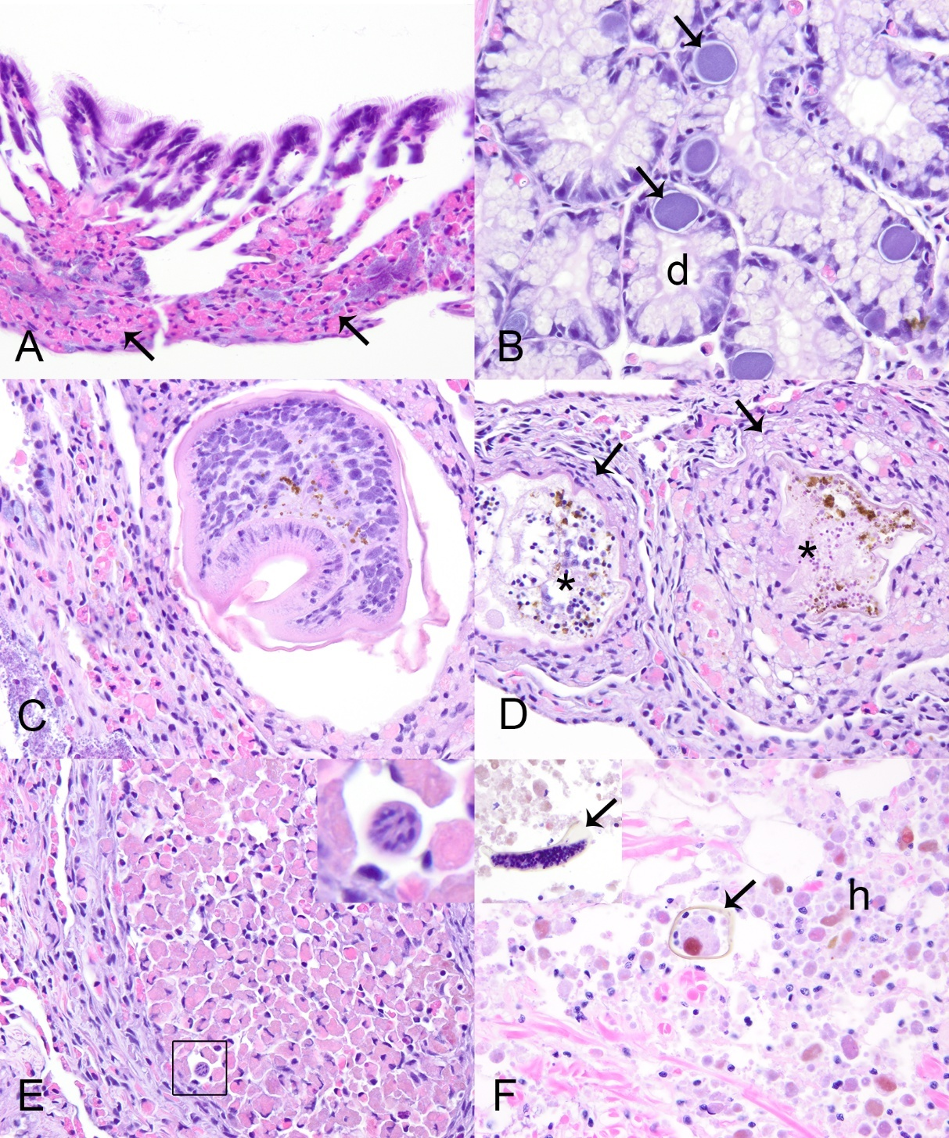

Table 2.1: Microscopic lesions observed in Pheasantshell (Actinonaias pectorosa) during histological assessment per clinical presentation (case vs control). Samples were collected from 2021 – 2023 across two sites in Virginia (Speers Ferry and Sycamore Island) and one site in Tennessee (Kyles Ford). Numbers in parentheses represent percentages of the respective sample size.
 | Case ª |  |  |  | Control ^{b}
Site | Speers Ferry | Sycamore Island | Kyles Ford | Total | Sycamore Island | Kyles Ford | Total
Sample size (n) | 3 | 18 | 0 | 21 | 40 | 28 | 68
Hemocytic nodulation and necrosis with gram-negative bacilli* | 3 (100) | 14 (78) | - | 17 (81) | 0 | 0 | 0
Diffuse infiltrative hemocytosis | 0 | 11 (61) | - | 11 (53) | 32 (80) | 23 (82) | 55 (81)
Hemocytic nodulation^ | 0 | 2 (11) | - | 2 (9) | 5 (12) | 1(4) | 6 (9)
Severe renal lipofuscinosis | 0 | 3 (17) | - | 3 (14) | 0 | 0 | 0
Gonadotropic microsporidiosis | 0 | 6 (33) | - | 6 (29) | 0 | 0 | 0
Intracytoplasmic  rickettsia-like organism | 1 (33) | 3 (17) | - | 4 (19) | 21 (52) | 8 (29) | 29 (43)
Digenean trematode larvae | 0 | 9 (50) | - | 9 (43) | 11 (27) | 12 (43) | 23 (34)
Nematodes | 0 | 0 | - | 0 | 1 (2) | 2 (7) | 3 (4)
Mite encapsulation | 0 | 3 (17) | - | 3 (14) | 0 | 0 | 0
Ciliate protists | 0 | 2 (11) | - | 2 (10) | 0 | 0 | 0
No lesions | 0 | 1 (5) | - | 1 (5) | 2 (5) | 1 (3) | 3 (4)
ª wild moribund individual displaying clinical signs of disease.
^{b} hatchery raised Pheasantshell kept in silos.
*lesions associated with Yokenella regensburgei isolation.
^No associated microscopically-evident etiologic agents.

mantle (1/4, 25%), heart (1/4, 25%), and kidney (1/4, 25%; Table 2.1). Digenean trematode larvae, included encysted metacercaria in 22 control mussels (Figure 2.2, frame C) and one that was too degenerated to determine larval stage in another control mussel (Figure 2.2, frame D). In all instances metacercariae were in low number and hemocytic response was focal and mild. Hemocyte encapsulation (2/23, 9%), nodulation (10/23, 43%), or focal hemocytic infiltration (1/23, 5%) were associated with trematode larvae (Figure 2.2, frame C), while 8/23 (24%) individuals showed no response and 2/23 (9%) showed multiple congruent responses (see Appendix A, Table A.2.3). Nematodes were 10-20 µm diameter vermiform metazoan (Figure 2.2, frame E); two were within the digestive gland, and one was in the connective tissue at the base of the gill. Each had associated mild focal hemocytic nodulation with granulocytes predominating.
Cases
We examined 21 case mussels for pathology. Grossly, we observed discrete multifocal dark brown to black streaks or patches in the marsupium of 3/7 (43%) gravid mussels (Figure 2.3, frame A). One mussel had retraction of mantle at the posterior shell margin which covered anomalous shell, characterized by a fluid-filled, nacre-covered pocket (Figure 2.3, frames B-D). Microscopic examination of wet-mounted impressions of discolored marsupium revealed nonmoving glochidia with variably distinct internal tissue structure within brown-tinged mucus (see Appendix A, Figure A.2.1, frame A). When similar preparations stained with modified Wright-Giemsa (Diff-Quik®) were examined microscopically, discolored areas contained brown pigment, agranular hemocytes, and

.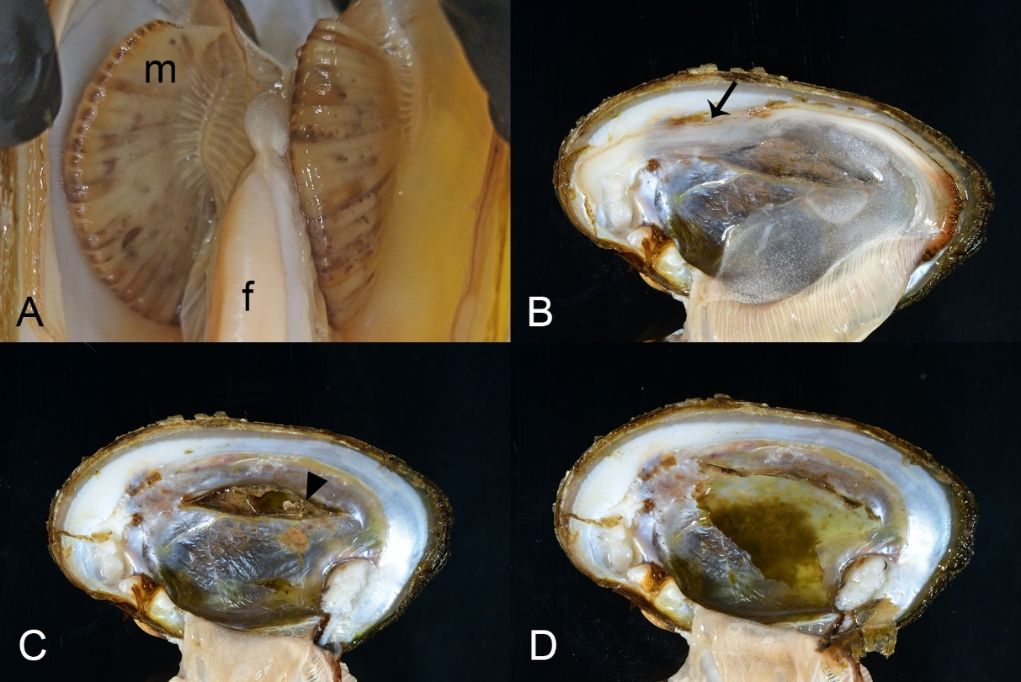
Figure 2.3: Gross lesions in case mussels (i.e., wild moribund Pheasantshell (Actinonaias pectorosa)) sampled at sites impacted by seasonal mortality events in the Clinch River. A. Gravid marsupium (m) discolored by brown foci; f–foot. B-D. Anomalous right shell valve characterized by recession of mantle at the posterior shell margin (B, arrow), which once removed, reveals an elevated thin layer of nacre with a hole (C, arrowhead) which covers a chamber filled with thin flocculent fluid containing green debris (D).

glochidia lacking internal cellular detail, within a background of mucus, cellular debris, and bacilli (see Appendix A, Figure A.2.1, frame B).
In contrast, non-discolored areas had glochidia with preserved cellular detail, more mucus and ciliated cells, and fewer brown granules and bacteria (see Appendix A, Figure A.2.1, frame C). Microscopic examination of the fluid within the anomalous shell failed to reveal parasitic agents. Cytological examination of modified Wright-Giemsa preparations of the shell fluid revealed the presence of crystalline and acellular amorphous debris, containing golden-brown granules, a variety of diatoms, bacilli, and cyanobacteria (Figure 2.3, frame D).
Histologically, 81% (17/21) of case mussels were affected by severe multi-organ hemocytic nodulation and necrosis associated with gram-negative bacilli (later identified as Yokenella using MALDI-TOF mass spectrometry and 16S rRNA gene amplification and sequencing), including all those with brown-black marsupium discoloration (Table 2.1). Affected mussels had multifocal aggregates of hemocytes within hemolymphatic spaces of many organs, most predominant in the connective tissue just beneath gastrointestinal tract (15/17, 88%; Figure 2.4, frames A and B) and integument surface of the visceral mass (15/17, 88%; Figure 2.4, frame C and D), as well as in digestive gland (9/13, 69%; Figure 2.4, frame E), gonad (9/17, 53%), gill (15/16, 94%; Figure 2.4, frame F), mantle (12/17, 71%), foot (12/17, 71%), kidney (11/16, 69%), heart (7/12, 58%; Figure 2.5, frame A), and marsupium (4/6, 67%; Figure 2.5, frames B-D). Hemocytes in these aggregates were a mixture of predominantly agranular hemocyte

Figure 2.4: Microscopic lesions in case mussels (i.e., wild moribund Pheasantshell (Actinonaias pectorosa)) sampled at sites impacted by seasonal mortality events in the Clinch River. A. Hemocyte nodulation and necrosis within the submucosa (arrow) and lumen (arrowhead) of the intestine (i), H&E stain. B. Necrotic hemocytes center on slender bacilli (arrow) that are gram negative (inset, Hucker-Conn Gram stain), H&E stain. C. Hemocyte nodulation and necrosis beneath the epithelium (e) covering the visceral mass. Note vacuolation of the epithelium, H&E stain. D. Higher magnification of C, with necrotic hemocytes centered on slender bacilli (arrow) that are gram negative (inset, Hucker-Conn Gram stain), H&E stain. Basophilic granules (asterisk) are mineral concretions normally observed in connective tissues of freshwater mussels, H&E stain. E. Foci of hemocyte nodulation and necrosis (arrow) efface digestive gland acini (d), H&E stain. F. Foci of hemocyte nodulation and necrosis within the hemolymphatic spaces of the gill (arrows), similarly centered on bacilli (arrowhead), H&E stain.

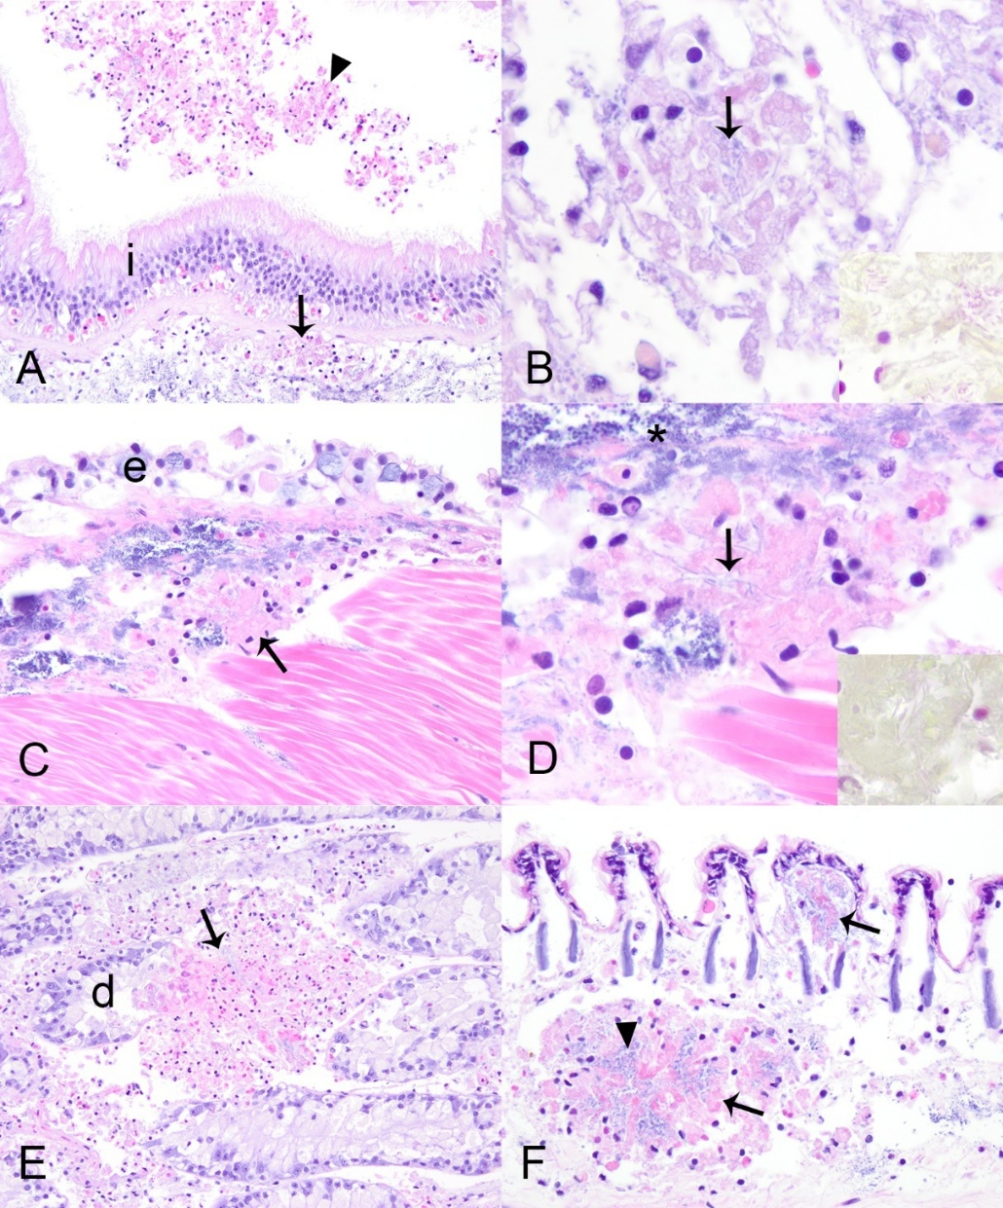

Figure 2.5: Microscopic lesions in case mussels (i.e., wild moribund Pheasantshell (Actinonaias pectorosa)) sampled at sites impacted by seasonal mortality events in the Clinch River. A. Luminal hemocytic aggregates (arrow) in the heart, H&E stain. B. Hemocytic nodulation and necrosis in a hemolymphatic space of the marsupium (arrow); g–glochidia, H&E stain. C. Glochidial necrosis (asterisks) within the marsupium, H&E stain. D. vacuolation of intestinal epithelium with intracytoplasmic bacilli (arrow), H&E stain. E. Early hemocytic encapsulation (en) adjacent to hemocytic nodulation and necrosis centered on bacilli (arrow), H&E stain. F. Necrosis of digestive gland acini, H&E stain.

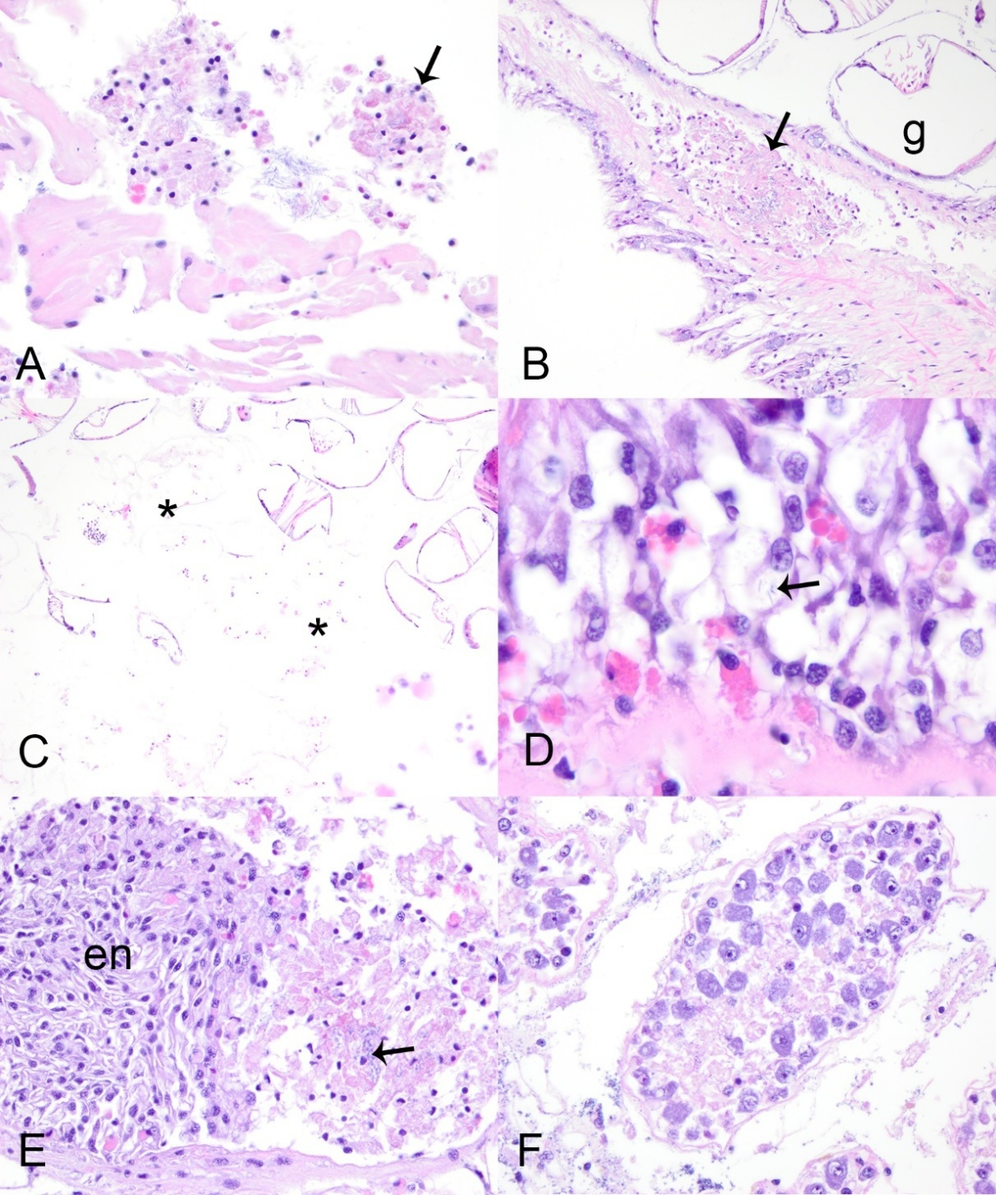

(hyalinocytes) and fewer granulocytes. Centrally, they were necrotic as indicated by cytoplasmic hypereosinophilia, loss of cellular detail, and nuclear pyknosis or karyolysis.
In all instances necrotic hemocytes were centered on intra- and extra-cellular slender long gram-negative bacilli in chains (Figure. 2.4, frames B and D). Most mussels with multi-organ hemocytic nodulation and necrosis had some degree of epithelial cytoplasmic vacuolation associated with cell sloughing or erosion in the gastrointestinal tract or integument of the visceral mass. This change was often close to foci of hemocytic nodulation and sometimes contained similar bacteria (Figure 2.4, frame C; Figure 2.5, frame D). Hemocytic nodulation and necrosis occasionally involved the integument epithelium (3/17, 18%) or gastrointestinal epithelium or lumen (5/17, 29%; Figure 2.4, frame A). In two mussels, hemocytic infiltrates also had features of encapsulation associated with the bacteria (Figure 2.5, frame E). Additionally, some mussels with yokenellosis also had digestive gland epithelial necrosis (5/13, 38%; Figure 2.5, frame F), as indicated by cellular dissociation, cytoplasmic hypereosinophilia, and loss of cell detail. Few mussels also had short gram-negative bacilli (n = 4), or large gram-positive bacilli (n = 4) within their tissues, but not localized to hemocytic infiltrate, and these were interpreted as perimortem opportunists.
Apart from the lesions attributed to yokenellosis, case mussels also had diffuse infiltrative hemocytosis (11/21, 53%), severe renal lipofuscinosis (3/21, 14%; Figure 2.6, frame A), gonadotropic microsporidiosis (6/21, 29%; Figure 2.6, frame B), intracytoplasmic rickettsia like organisms within epithelium of digestive gland (4/21,

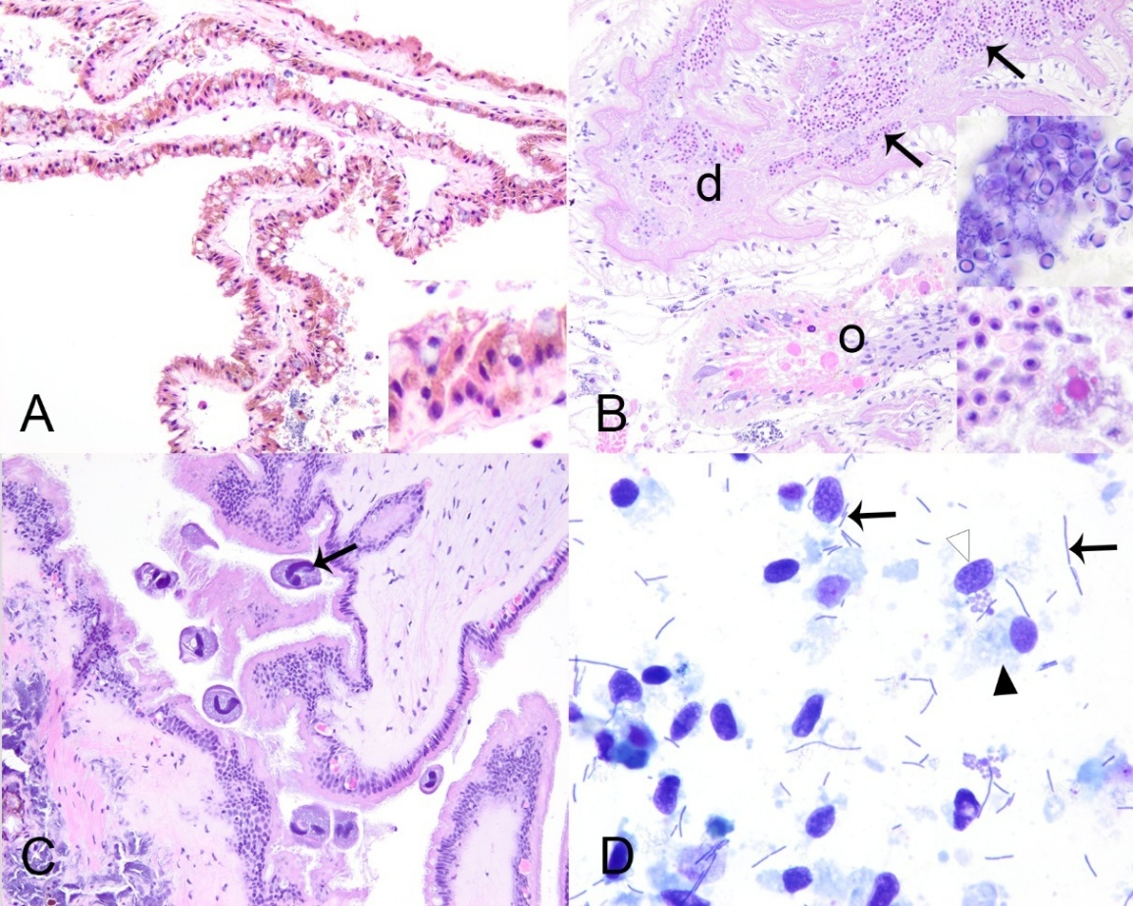
Figure 2.6: Microscopic lesions in case mussels (i.e., wild moribund Pheasantshell (Actinonaias pectorosa)) sampled at sites impacted by seasonal mortality events in the Clinch River. A. Severe renal lipofuscinosis as indicated by the cytoplasm of nearly all nephron epithelium being distended with coarse brown granules (inset), H&E stain. B. Gonadal duct (d) filled with mature oocytes containing numerous intracytoplasmic microsporidia (insets), H&E stain. The capsule of mature spores stain blue (gram positive; upper inset; Hucker-Conn Gram stain). Note depletion of ovarian acinus (o), H&E stain. C. Ciliate protist (arrow) infestation of mantle, H&E stain. D. Hemolymph smear containing numerous elongate bacilli in pairs and long chains (arrows) with predominance of agranular hemocytes (black arrowhead) over granular hemocytes (white arrowhead), Wright-Giemsa stain.

19%), digenean trematode metacercaria (9/21, 43%), mite encapsulation (3/21, 14%; Figure 2.2, frame F), and ciliates (2/21).
Diffuse infiltrative hemocytosis affected the connective tissue around the stomach (11/20, 55%), intestine (7/21, 33%), mantle (1/21, 5%), ganglia (1/11, 9%), or gonad (1/21, 5%). We observed hemocyte nodulation, without associated necrosis or identified microorganisms (2/21, 9%) in the gill (1/2) and adductor muscle (1/2). Trematode metacercariae had either hemocyte encapsulation (1/9, 11%), nodulation (3/9, 33%), or no cellular response to infection (5/9, 55%; see Appendix A, Table A.2.3). Our chi-square test revealed an association between clinical presentation and diffuse infiltrative hemocytosis (p = 0.02), and no significant association with hemocytic nodulation, infection with digenean trematode, and intracytoplasmic rickettsia-like organism. Ciliated protists were located in the gill (1/2) and mantle (1/2; Figure 2.6, frame C). These were of one morphological type, consistent with mobile peritrichs: around 30µm diameter, dome to saucer shaped, with a dense lobed to horseshoe-shaped macronucleus, sparse somatic ciliature, and a refractile curvilinear structure (presumptive denticulate ring) bearing ciliary wreaths. In each case, they were in low numbers (<5) and not associated with pathology in the affected tissue.
Only four case mussels did not have lesions of yokenellosis. These mussels had severe gonadotropic microsporidiosis (n = 2, including the mussel with the anomalous shell), hemocytic encapsulation of degenerate mite fragments (n = 3; Figure 2.2, frame F), and one had no lesions to explain morbidity (n = 1) except for hemocytic nodulation without associated necrosis or identified microorganisms in the gills.
One of the mussels with ovarian microsporidiosis (Figure 2.6, frame B) had diffuse marked infiltrative hemocytosis of the visceral mass with intra-hemocytic microsporidia.
Hemolymph cytology
Sufficient hemolymph was collected to allow cytological examination of 32 mussels, including 14 cases and 18 controls. One case mussel with yokenellosis produced very cloudy, white tinged, hemolymph. Hemocyte preservation was poor to fair in 26/32 samples and presented low cellularity in 7/32. We observed hemocyte clumping on 8/32 samples and diatoms in 14/32 samples. Lastly, we identified long unevenly stained bacilli, present as individuals, pairs, or filaments, in the hemolymph smears of 9/9 cases with yokenellosis (Figure 2.6, frame D), in high (n = 7) or low (n = 2) numbers. Similar bacteria were not observed in the hemolymph smears of any cases without hemocytic nodulation and necrosis associated with gram-negative bacilli (n = 4), or control mussels (n = 18).
Bacterial 16S amplicon high-throughput sequencing
Sequences used for this article are available in the NCBI SRA repository, [PRJNA1135241, http://www.ncbi.nlm.nih.gov/bioproject/1135241]. We recovered 1,732,870 sequences representing 6,232 OTUs from 133 samples comprising 87 digestive glands (n = 68 control, 19 cases), and 46 hemolymph samples (n = 19 control, 13 cases).
After quality control removal of low abundance OTUs (<500 seqs), removal of low sequence yield samples (<200 seqs), there remained for analysis: 85 OTUs from 77 digestive glands, and 13 hemolymph samples. Hemolymph samples were included in general descriptive results and graphs for visual representation but were not used in statistical analysis.
We had three analysis groups: case group with multi-organ hemocytic nodulation and necrosis associated with gram-negative bacilli (Case-Present, n = 11 digestive glands and 6 hemolymph samples), cases without hemocytic nodulation and necrosis associated with gram-negative bacilli (Case-Absent, n = 4 digestive glands and 1 hemolymph samples), and controls (Control-Absent, n = 62 digestive glands and 6 hemolymph samples). PERMANOVA and NMDS plots (Figure 2.7 and 2.8) revealed a significant effect of analysis group on digestive gland bacterial assemblage with only the pairwise comparison of Control-Absent vs Case-Present being significant for both Sorensen and Morisita-Horn indices (p = 0.001 and 0.019, respectively). Indicator species analysis revealed three OTUs indicative for Case-Present, seven OTUs for Case-Absent, and only one for the Control-Absent group (Table 2.2). The top two indicator OTUs for Case-Present mussels were OTU02 (a Yokenella/Salmonella sp.; p = 0.003) and OTU03 (Aeromonas sp.; p = 0.008). Relative abundance for these two OTUs was very high across both digestive gland and hemolymph samples from Case-Present and comparatively relatively low for both sample types of the other two groups. See Appendix A, Table A.2.4 for entire list of indicator OTUs, with average relative abundance listed by analysis group and sample type (hemolymph and digestive gland). Note amplicon sequences were only 250 bp which was not a large enough segment within the v4 region to distinguish Yokenella from Salmonella species, but we recorded OTU02 as Yokenella given supporting matched culture results.

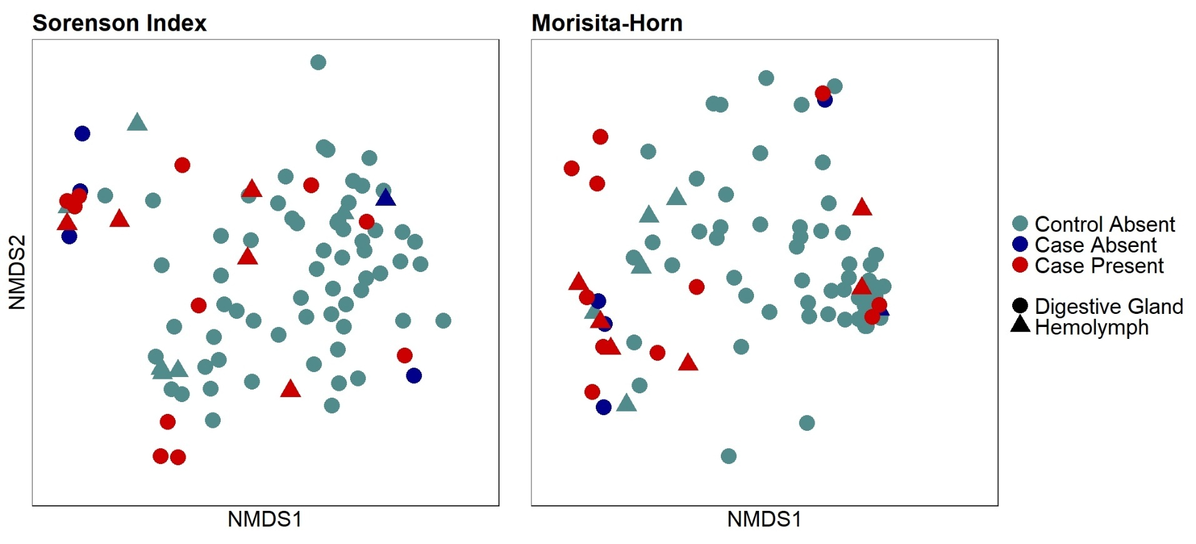
Figure 2.7: A Non-Metric Multidimensional Scaling (NMDS) plot representing similarities and dissimilarities between analysis groups (Control-Absent; Case-Absent; Case-Present) and sample type (hemolymph and digestive gland). Each point represents an individual sample. Samples consisted of hemolymph and digestive gland tissue collected from Pheasantshell (Actinonaias pectorosa) sampled at sites impacted by seasonal mortality events in the Clinch River. Analysis groups include Control-Absent (individuals presenting no pathology; n = 62 DG and 6 HL), Case-Absent (individuals not presenting hemocytic nodulation and necrosis associated with gram-negative bacilli; n = 4 DG and 1 HL), and Case-Present (individuals presenting hemocytic nodulation and necrosis associated with gram-negative bacilli; n = 11 DG and 6 HL).

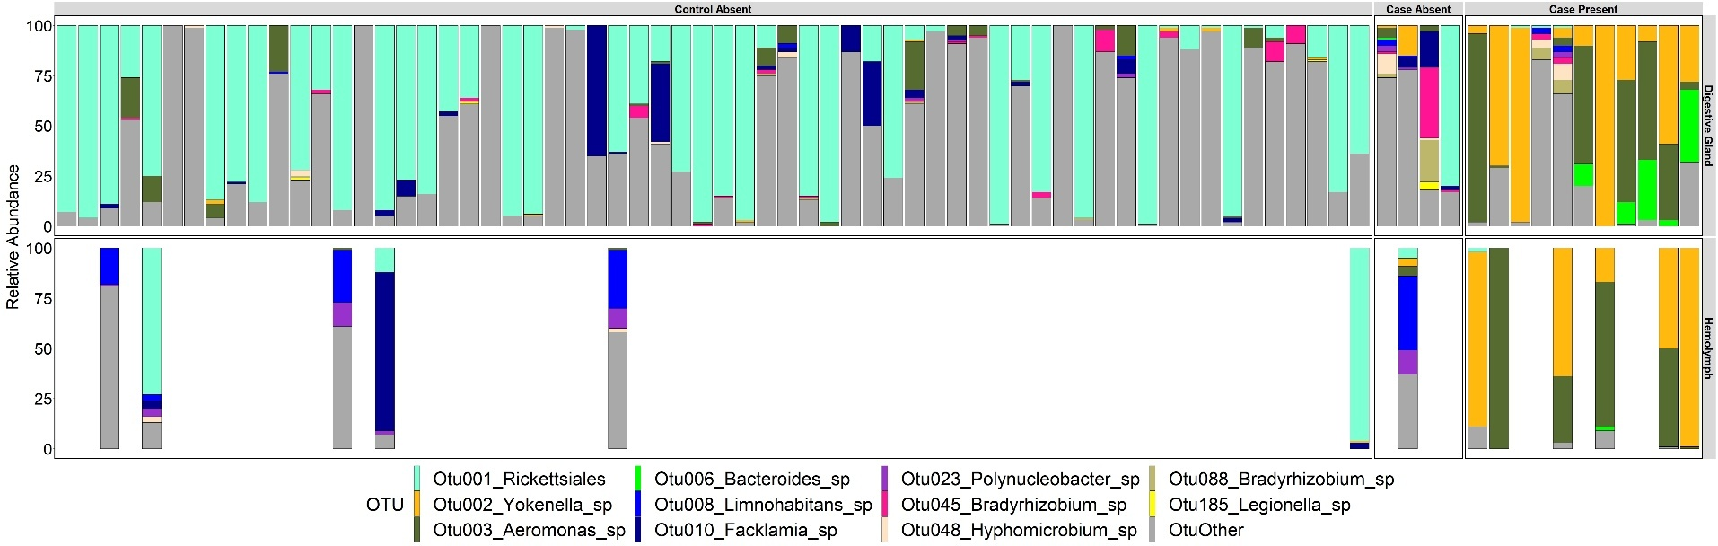
Figure 2.8: Relative abundance of Operational Taxonomic Units (OTUs) per sample type and analysis group. Samples consisted of hemolymph (n = 13) and digestive gland tissue (n = 77) collected from Pheasantshell (Actinonaias pectorosa) sampled at sites impacted by seasonal mortality events in the Clinch River. Analysis groups include Control-Absent (individuals presenting no pathology; n = 62 DG and 6 HL), Case-Absent (individuals not presenting hemocytic nodulation and necrosis associated with gram-negative bacilli; n = 4 DG and 1 HL), and Case- Present (individuals presenting hemocytic nodulation and necrosis associated with gram-negative bacilli; n = 11 DG and 6 HL). Animal IDs are shown across the X axis and associated hemolymph and digestive gland samples linked.

Table 2.2: Indicator Operational Taxonomic Units (OTUs) associated with each analysis group and their respective observed indicator value (IndVal) and significance value (pvalue), as identified by the indicator species analysis. Samples consisted of hemolymph and digestive gland tissue collected from Pheasantshell (Actinonaias pectorosa) sampled from two sites in Virginia (Speers Ferry and Sycamore Island) and one site in Tennessee (Kyles Ford). Analysis groups include Control-Absent (n = 62 DG and 6 HL), Case-Absent (n = 4 DG and 1 HL; individuals not presenting hemocytic nodulation and necrosis associated with gram-negative bacilli), and Case-Present (n = 11 DG and 6 HL; individuals presenting hemocytic nodulation and necrosis associated with gram-negative bacilli). A high IndVal suggests an association between taxonomic groups and analysis groups.
Group | IndVal | p-value | OTU | Phylum | Class | Order | Family | Genus
Control-Absent | 0.724 | 0.034 | Otu001 | Proteobacteria | Alphaproteobacteria | Rickettsiales | Rickettsiales_  unclassified | Rickettsiales_  unclassified
Case-Absent | 0.806 | 0.006 | Otu045 | Proteobacteria | Alphaproteobacteria | Rhizobiales | Bradyrhizobiaceae | Bradyrhizobium
 | 0.711 | 0.021 | Otu010 | Firmicutes | Bacilli | Lactobacillales | Aerococcaceae | Facklamia
 | 0.640 | 0.024 | Otu088 | Proteobacteria | Alphaproteobacteria | Rhizobiales | Methylocystaceae | Methylocystis
 | 0.611 | 0.025 | Otu023 | Proteobacteria | Betaproteobacteria | Burkholderiales | Burkholderiaceae | Polynucleobacter
 | 0.587 | 0.034 | Otu048 | Proteobacteria | Alphaproteobacteria | Rhizobiales | Hyphomicrobiaceae | Hyphomicrobium
 | 0.555 | 0.038 | Otu008 | Proteobacteria | Betaproteobacteria | Burkholderiales | Comamonadaceae | Limnohabitans
 | 0.488 | 0.045 | Otu185 | Proteobacteria | Gammaproteobacteria | Legionellales | Legionellaceae | Legionella
Case-Present | 0.904 | 0.003 | Otu002 | Proteobacteria | Gammaproteobacteria | Enterobacteriales | Enterobacteriaceae | Salmonella/  Yokenella
 | 0.794 | 0.008 | Otu003 | Proteobacteria | Gammaproteobacteria | Aeromonadales | Aeromonadaceae | Aeromonas
 | 0.664 | 0.017 | Otu006 | Bacteroidetes | Bacteroidia | Bacteroidales | Bacteroidaceae | Bacteroides

Bacterial isolation and Yokenella qPCR
Multiple bacteria were isolated from the digestive gland of four (IDs: W24, W25, W26, W27) and hemolymph of three (IDs: W24, W25, W26; Table 2.3) case mussels. Three out of four (W24, W26, W27) individuals had multi-organ hemocytic nodulation and necrosis associated with bacilli on histological examination and one (W25) had other lesions. Yokenella regensburgei was isolated from the hemolymph (1/3) and digestive gland (3/3) of all three individuals (W24, W26, W27) with multi-organ hemocytic nodulation and necrosis but was not isolated from the one individual (W25) without pathology associated with bacilli.
We had 13 digestive gland DNA extraction samples from case mussels available for qPCR. We detected Yokenella regensburgei in 11/13 (85%) samples from cases and did not detect it in 17 randomly selected controls (Table 2.3). Although we were able to consistently amplify gBlock standards, our 10⁰ -standard failed to amplify completely on all of our plates. Therefore, we considered our limit of quantification (LOQ) to be 10 copies/ µL. Severe multi-organ hemocytic nodulation and necrosis with gram-negative bacilli was associated with positive qPCR results for Yokenella regensburgei (Fisher exact test; p = 0.02).

Discussion
In this study we investigated and described differences in pathology and microbiology between cases (i.e., wild moribund Pheasantshell) and controls (i.e., apparently-healthy hatchery-sourced Pheasantshell reared in silos) from a multi-year case-control study in the Clinch River. Most importantly, we use several methods to evaluate the role of
Table 2.3: Comprehensive table of sampling date, culture results, qPCR results, and prevalence of hemocytic nodulation and necrosis with bacilli for 21 case Pheasantshell (Actinonaias pectorosa) collected at two sites (SI = Sycamore Island, SF = Speers Ferry) in Virginia.

Sampling Date | Site | Mussel ID | Culture Results - Hemolymph | Culture Results - Digestive Gland | Yokenella qPCR result | Hemocytic nodulation and necrosis with bacilli^
5/20/2021 | SI | A | NA | NA | Positive | Yes
5/20/2021 | SI | B | NA | NA | Positive | Yes
8/30/2021 | SI | W5 | NA | NA | Not detected | No
8/30/2021 | SI | W6 | NA | NA | Not detected | No
10/19/2021 | SF | W7 | NA | NA | Not detected | Yes
10/19/2021 | SF | W8 | NA | NA | Positive | Yes
10/19/2021 | SF | W9 | NA | NA | NA | Yes
10/19/2021 | SI | W11 | NA | NA | Positive | Yes
10/25/2021 | SI | W15 | NA | NA | Positive | Yes
11/2/2021 | SI | W16 | NA | NA | Not detected | No
11/2/2021 | SI | W17 | NA | NA | Not detected | Yes
11/2/2021 | SI | W18 | NA | NA | Not detected | Yes
11/2/2021 | SI | W19 | NA | NA | Not detected | Yes
11/9/2021 | SI | W20 | NA | NA | Positive | Yes
11/9/2021 | SI | W21 | NA | NA | Positive | Yes
11/9/2021 | SI | W22 | NA | NA | Positive | Yes
11/9/2021 | SI | W23 | NA | NA | Positive | Yes
10/10/2022 | SI | W24 | Aeromonas veronii  Aeromonas hydrophila | Aeromonas veronii  Aeromonas hydrophila  Yokenella regensburgei | NA | Yes
Table 2.3 Continued

10/31/2022 | SI | W25 | Aeromonas bestiarum  Aeromonas sobria  Lacrimispora algidixylanotica  Rhodococcus sp | Buttiauxella noackiae  Flavobacterium anhuiense  Flavobacterium oncorhynchi  Enterobacter asburie | Not detected | No
11/9/2022 | SI | W26 | Aeromonas veronii  Yokenella regensburgei | Aeromonas veronii  Aeromonas hydrophila  Buttiauxella sp.  Yokenella regensburgei | Positive | Yes
11/9/2022 | SI | W27 | NA | Aeromonas veronii  Citrobacter gillenii  Yokenella regensburgei | Positive | Yes
^ = Microscopic lesions associated with yokenellosis.

bacteria in morbidity. Although our study cannot establish causation of mortality events, it provides the first robust evidence of a bacterium associated with pathology in wild mussels. Specifically, our results indicate that Yokenella regensburgei can be a pathogenic bacterium in free-living Pheasantshell at our study sites, and that infectious disease is likely a significant factor for at least part of the mortality observed in the Clinch River.
In our study, we found that 81% of cases were affected by a characteristic lesion (multi-organ hemocytic nodulation and necrosis), that consistently had intra- and extra-cellular slender long gram-negative bacilli in chains typical of Enterobacteriaceae. Yokenella regensburgei was consistently isolated from mussels with this lesion when bacterial culture was undertaken, but not from those lacking this lesion, indicating the identity of intralesional bacteria. Additionally, relative abundance of a Yokenella/Salmonella sp. OTU was very high across both digestive gland and hemolymph samples from cases with hemocytic nodulation and necrosis compared to controls or cases without this lesion (<5% for both across both sample types). We also successfully detected Y. regensburgei in 69% of individuals with these lesions via qPCR compared to 0 detections in individuals without. Previous studies using culturing and sequencing techniques have detected Yokenella regensburgei at low prevalence in the tissue homogenate of moribund Ebonyshell (Fusconaia ebena) and at high prevalence in the hemolymph of moribund Pheasantshell from mass mortality events in the Tennessee River, Alabama, and in the Clinch River, Tennessee, respectively (Starliper et al. 2011; Leis 2019; Richard et al. 2021). Despite these reports of Y. regensburgei infection in mussels, the present study is the first to link the pathogen to pathology in the infected host. The lesion descriptions provided by this study can serve as a resource for those investigating mussel mortality. Specifically, yokenellosis is a primary differential for foci of hemocytic nodulation and necrosis containing bacilli. Moreover, the associated lesions are of sufficient severity and physiological significance to explain mortality in infected hosts. Taken together, these findings indicate Yokenella regensburgei can be a significant pathogen in Pheasantshell. Its role in causing mortality would ultimately require confirmation via experimental infection trials. Despite the inherent challenges, such as recreating and maintaining a representative and conducive aquatic environment and maintaining healthy but susceptible hosts in an aquarium setting, these trials are essential for meeting Koch’s postulates and should be conducted in the future. Additionally, multifactorial causal models that account for enabling and predisposing factors, such as environmental interactions and microbial dysbiosis, should also be considered to establish etiology in infectious invertebrate diseases (Rothman 1976; Vonaesch et al. 2018).
To the authors’ knowledge, bacterial diseases have not yet been described in wild mussels (Knowles et al., 2023). This finding is remarkable because bacterial diseases in bivalves more broadly are largely limited to aquaculture, particularly hatchery-reared juvenile stages, facilitated by various artificial conditions (Paillard and Borrego 2004; Travers et al. 2015). Multi-organ hemocytic nodulation and necrosis, the primary lesion of moribund mussels, is consistent with lesions observed in septic diseases of other mollusks (Terio et al. 2018; De Vico and Carella 2012). Findings indicating chronic infection or debilitation such as emaciation or mantle retraction were absent in cases. The presence of a developing encapsulation-type hemocytic response in two mussels suggests infection may not necessarily be acute and rapidly-progressing, but this should be confirmed by clinical observations. If bacterial infection was an opportunistic terminal event, we did not identify any other pathological conditions that might have predisposed individuals to infection. However, some etiologies might not induce significant microscopic changes and could remain undetected, for example, certain toxicities or viral infections.
Curiously, previous histological evaluations of Pheasantshell from the Clinch River did not reveal similar lesions. Henley et al. (2019) examined 10 visibly unhealthy mussels (gaping shell, poor ability to retract foot) from Kyles Ford in October 2016, and described putative cocci, but not associated lesions, and a variety of hemocytic infiltrates (termed aggregations, vesicular occlusions, or granulocytomas) not clearly associated with necrosis or gram-negative bacilli. Knowles et al. (2022) examined 8 moribund mussels from Kyle’s Ford and Speer’s Ferry in October 2018, 4 of which were infected with a gonadotropic microsporidian, Knowlespora clinchi (Bojko 2022). In that study, the observed site-specific mortality patterns did not correlate with the prevalence of K. clinchi, suggesting that mortality did not appear to be the result of K. clinchi. Moreover, lesions similar to those attributed to yokenellosis in our study were not identified (personal communication, S. Knowles). The failure of these studies to document hemocytic nodulation and necrosis with bacilli may reflect differences in timing of sampling relative to disease or mortality occurrence or may indicate that yokenellosis is one of multiple problems leading to Pheasantshell mortality, supported by a minority of our case mussels having pathological conditions other than yokenellosis, such as microsporidiosis, or shell disease. Consistent with this view, multi-pathogen mortality events are increasingly recognized in aquatic invertebrates, particularly where driven by a complex interplay of environmental stressors (Bower et al. 1994; Austin and Austin 2012; Carella et.al 2023). Our surveys in Kyle’s Ford did not yield moribund mussels, limiting comparisons to these studies. However, Leis et al. (2019) isolated Y. regensburgei from mussels during a mortality event in Kyle’s Ford, November 2018, but histology was not undertaken by that study and the pathological significance of Y. regensburgei was undetermined at that time. This scenario emphasizes the value of a paired sampling approach, where multiple tests can be completed on a single mussel in parallel to facilitate interpretation of test results.
Hemolymph assessment has been used to evaluate the health of mussels and shows value as a non-lethal method for disease surveillance and diagnostics in mussels (Gustafson et al. 2005a,b; Burkhard et al. 2009). We identified bacilli in all hemolymph smears of case mussels with yokenellosis (Figure 2.6, frame D). Bacterial 16S sequencing and culture results from hemolymph were also informative, highlighting differences in abundance of Yokenella and other bacteria taxa between cases and controls. Changes in hemolymph color from transparent to a cloudy, white tinged color may be a gross indicator of bacterial infection. In this case, microscopic assessment should be conducted to confirm the diagnosis. Overall, hemolymph assessment can be a non-lethal tool to study and diagnose yokenellosis in endangered wild mussels.
Yokenella regensburgei is a gram-negative bacillus and the only species in its genus. In humans, it is an opportunistic pathogen that rarely causes disease, infecting a wide variety of tissues in almost exclusively immunosuppressed individuals (Lo et al. 2011; Balamayooran et al. 2022). Apart from mussels, Yokenella regensburgei has been isolated from firebugs (Pyrrhocoris apterus) in Germany and grass snakes (Natrix natrix) in Poland without associated pathology (Kosako et al. 1984; Pawlak et al. 2020). Its only documentation in animal disease involves a recent report of fatal pneumonia and septicemia in a population of farmed American alligators (Alligator mississippiensis) in Louisiana (Balamayooran et al. 2022). Yokenella regensburgei’s presence in the environment is unknown. The source of infection or route of transmission were not identified in our study or by Balamayooran et. al (2002). Some infected mussels had lesions involving gill, integument, alimentary tract, or kidney, providing a route for bacterial entry, or shedding in the water column. Conditions which would predispose mussels to infection were similarly unclear. There were a variety of other lesions (not associated with bacteria) observed at similar prevalences in case and control mussels, contributing to a broader understanding of “background” (non-mortality-associated) lesions in mussels (Burcham et al 2023; Knowles et al. 2023). Gonadotropic microsporidia were unique to case mussels, potentially reflecting immunosuppression, or simply predilection for larger (sexually mature) mussels.
Our control group never developed disease while wild Pheasantshell did. We hypothesize that differential disease occurrence may be explained by superior health status and resiliency of controls, smaller mussels being less vulnerable to infection, silos protecting from exposure to etiologic agents in the substrate, or low prevalence of disease more broadly. Although our control group was genetically related to wild mussels from the Clinch River, they were raised in a hatchery, in a stable environment with controlled climate, flow and abundant food, and consequential robust health status could explain resistance to infection once translocated. This possibility is supported by our data where control mussels did not show signs of disease despite some with low abundance of the Yokenella sp. OTU. It is also possible to this cohort did not have long enough exposure to unknown environmental stressors required to facilitate disease. In addition, keeping mussels in silos with limited contact with the substrate may have reduced exposure to etiologic agents in the benthos through burying or pedal feeding. Finally, there is still little known regarding the epidemiology of the mortality events observed in the Clinch River; the failure to observe disease in control mussels may simply indicate disease prevalence is <1% (and therefore may not be detected when examining only 68 individuals), or that disease preferentially affects mussels of a larger size. We were unable to harvest apparently healthy size matched wild Pheasantshell for our control group due to regulatory constraints. Given the growing uncertainty around the representativeness of hatchery-derived or silo-maintained controls, it is important that access to apparently healthy wild mussels is expediated for those undertaking diagnostic investigations of unusual mortality events in mussels.
Microbial assemblage showed an overall significant difference between analysis groups. This was driven by the overwhelming abundance of Yokenella sp. and Aeromonas sp. OTUs that represented the majority of sequences in both hemolymph and digestive gland yokenellosis samples. Aeromonas spp. are commonly found in aquatic environments and are generally accepted as opportunistic invaders (Wiklund et al. 1998; Harikrishnan et al. 2005; Austin and Austin 2012). Like with Yokenella, Aeromonas was in very low relative abundance from cases without yokenellosis (Figure 2.8; Case-Absent) and controls (Figure 2.8; Control-Absent). Our results are supported by other studies that have observed co-occurrence of Aeromonas and Yokenella in moribund mussels (Leis et al. 2019, Richard et al. 2021, Leis et al. 2023). Species of this genus may be facultative pathogens to mussels that proliferate in the right conditions, such as in the presence of already damaged tissue or weak/stressed host, commonly co-infecting mussels with yokenellosis. Cooperative polymicrobial infections are a common feature among Aeromonas sp. infection in other host species and have similarly been documented in vibriosis of marine bivalves (Lemire et al. 2015; Fernández-Bravo and Figueras 2020; Cantillo et al. 2023). However, a third bacterial OTU, a Bacteroides sp, was also preferentially abundant in these animals and significantly associated with this group (Case-Present) via indicator species analysis. The abundance of this OTU within the yokenellosis group was still highly variable and likely the reason behind why NDMS plots do not show a complete separate grouping of yokenellosis cases from others. It is unclear if this Bacteroides sp. plays a role in pathology. The source of this OTU and its relative abundance in the environment should therefore be further explored alongside Yokenella.
Interestingly, in contrast to cases with yokenellosis, controls and cases without yokenellosis had a dominant digestive gland OTU belonging to the order Rickettsiales. This OTU was especially abundant in controls representing nearly half (45%) of all recovered sequences in those digestive glands, and was the only OTU significantly associated with this group via indicator species analysis. Rickettsia-like organisms have been sporadically reported via histological examination of the digestive gland of mussels previously (Mioduchowska et al. 2020; Burcham et al. 2023) and could represent an important commensal in healthy tissue. This rickettsial OTU was also found with high relative abundance in the hemolymph of controls while lower in hemolymph of both case groups (Case-Present, Case-Absent) and warrants further investigation for use as a potential indicator of mussel health. Finally, indicator species analysis also revealed presence of a Limnohabitans sp. in the digestive gland of cases without yokenellosis (Case-Absent). Like Bacteroides, understanding the role of Limnohabitans in the health of mussels could provide valuable insights and warrant further investigation.
Overall, our study provides background information and description of normal and abnormal cell and tissue anatomy of mussels, which is generally lacking (Knowles et al. 2023; McElwain and Bullard 2014). Most importantly, we provide a comprehensive pathological description of lesions associated with Y. regensburgei and address its pathogenicity (Leis et al. 2023). Although our study does not explain the cause of these infections, it confirms that mussels at two of our study sites are ultimately dying with an infectious disease and that Y. regensburgei can be pathogenic in free-living mussels. Our study reveals the importance of pairing pathology with other diagnostic tests when investigating invertebrate disease and mortality. It also highlights the need for epidemiological investigations that identify environmental and host factors conducive to bacterial disease epidemics and for experimental trials with Y. regensburgei to further investigate its pathogenicity.

References

Aldridge, D.C., Ollard, I.S., Bespalaya, Y.V., Bolotov, I.N., Douda, K., Geist, J., Haag, W.R., Klunzinger, M.W., Lopes‐Lima, M., Mlambo, M.C. and Riccardi, N., 2023. Freshwater mussel conservation: A global horizon scan of emerging threats and opportunities. Global Change Biology, 29(3), pp.575-589.
Atkinson, C.L. and Forshay, K.J., 2022. Community patch dynamics governs direct and indirect nutrient recycling by aggregated animals across spatial scales. Functional Ecology, 36(3), pp.595-606.
Arbizu, P. M., 2017. pairwiseAdonis: Pairwise Multilevel Comparison using Adonis. R package version 0.4.1
Austin, B., Austin, D.A. and Munn, C.B., 2012. Bacterial fish pathogens: disease of farmed and wild fish, 6th ed. Springer-Praxis: Chichester, UK
Balamayooran, G., Cooper, C., Paul, N.C., Ferro, P.J., Rice, L., Gomez, G. and Díaz-Delgado, J., 2022. Yokenella regensburgei, a novel pathogen in farmed American alligators. Veterinary Pathology, 59(3), pp.476-481.
Bojko, J., 2022. Systematic identity and phylogenetic analysis of Knowlespora clinchi (Knowles et al. 2022) gen. et comb. nov. From pheasantshell mussels (Actinonaiais pectorosa). Journal of Invertebrate Pathology, 194, p.107817.
Bower, S.M., McGladdery, S.E. and Price, I.M., 1994. Synopsis of infectious diseases and parasites of commercially exploited shellfish. Annual Review of Fish Diseases, 4, pp.1-199.
Burcham, G.N., Fisher, B. and Boedeker, N., 2023. Histopathologic survey of free-living populations of 2 species of freshwater mussels in Indiana. Veterinary Pathology, 60(5), pp.628-639.
Burkhard, M.J., Leavell, S., Weiss, R.B., Kuehnl, K., Valentine, H., Thomas Watters, G. and Wolfe, B.A., 2009. Analysis and cytologic characterization of hemocytes from freshwater mussels (Quadrula sp.). Veterinary Clinical Pathology, 38(4), pp.426-436.
Carella, F., Palić, D., Šarić, T., Župan, I., Gorgoglione, B., Prado, P., Andree, K.B., Giantsis, I.A., Michaelidis, B., Lattos, A. and Theodorou, J.A., 2023. Multipathogen infections and multifactorial pathogenesis involved in noble pen shell (Pinna nobilis) mass mortality events: Background and current pathologic approaches. Veterinary Pathology, 60(5), pp.560-577.
Cantillo Villa, Y., Triga, A. and Katharios, P., 2023. Polyinfection in Fish Aeromoniasis: A Study of Co-Isolated Aeromonas Species in Aeromonas veronii Outbreaks. Pathogens, 12(11), p.1337
Caporaso, J.G., Lauber, C.L., Walters, W.A., Berg-Lyons, D., Lozupone, C.A., Turnbaugh, P.J., Fierer, N., and Knight, R. 2011. Global patterns of 16S rRNA diversity at a depth of millions of sequences per sample. Proc Natl Acad Sci U S A. 108(Suppl 1), pp.4516-4522.
Cope, W.G., Bergeron, C.M., Archambault, J.M., Jones, J.W., Beaty, B., Lazaro, P.R., Shea, D., Callihan, J.L. and Rogers, J.J., 2021. Understanding the influence of multiple pollutant stressors on the decline of freshwater mussels in a biodiversity hotspot. Science of the Total Environment, 773, p.144757.
DuBose, T.P., Atkinson, C.L., Vaughn, C.C. and Golladay, S.W., 2019. Drought-induced, punctuated loss of freshwater mussels alters ecosystem function across temporal scales. Frontiers in Ecology and Evolution, 7, p.274.
DuBose, T.P., Ashford, K. and Vaughn, C.C., 2020. Freshwater mussels increase survival of largemouth bass (Micropterus salmoides) in drying pools. Ecology of Freshwater Fish, 29(2), pp.220-229.
Fernández-Bravo, A. and Figueras, M.J., 2020. An update on the genus Aeromonas: Taxonomy, epidemiology, and pathogenicity. Microorganisms, 8(1), p.129.
Ferreira-Rodríguez, N., Akiyama, Y.B., Aksenova, O.V., Araujo, R., Barnhart, M.C., Bespalaya, Y.V., Bogan, A.E., Bolotov, I.N., Budha, P.B., Clavijo, C. and Clearwater, S.J., 2019. Research priorities for freshwater mussel conservation assessment. Biological Conservation, 231, pp.77-87.
Gustafson, L.L., Stoskopf, M.K., Bogan, A.E., Showers, W., Kwak, T.J., Hanlon, S. and Levine, J.F., 2005a. Evaluation of a nonlethal technique for hemolymph collection in Elliptio complanata, a freshwater bivalve (Mollusca: Unionidae). Diseases of Aquatic Organisms, 65(2), pp.159-165.
Gustafson, L.L., Stoskopf, M.K., Showers, W., Cope, G., Eads, C., Linnehan, R., Kwak, T.J., Andersen, B. and Levine, J.F., 2005b. Reference ranges for hemolymph chemistries from Elliptio complanata of North Carolina. Diseases of Aquatic Organisms, 65(2), pp.167-176.
Haag, W.R., 2012. North American freshwater mussels: natural history, ecology, and conservation. Cambridge University Press.
Haag, W.R. and Williams, J.D., 2014. Biodiversity on the brink: an assessment of conservation strategies for North American freshwater mussels. Hydrobiologia, 735, pp.45-60.
Haag, W.R. and Cicerello, R.R. 2016. A Distributional Atlas of the Freshwater Mussels of Kentucky. Scientific and Technical Series Number 8. Kentucky State Nature Preserves Commission.
Haag, W.R. 2019. Reassessing enigmatic mussel declines in the United States. Freshwater Mollusk Biology and Conservation, 22(2), pp.43-60.
Haag, W.R., Culp, J.J., McGregor, M.A., Bringolf, R. and Stoeckel, J.A., 2019. Growth and survival of juvenile freshwater mussels in streams: Implications for understanding enigmatic mussel declines. Freshwater Science, 38(4), pp.753-770.
Harikrishnan, R. and Balasundaram, C., 2005. Modern trends in Aeromonas hydrophila disease management with fish. Reviews in Fisheries Science, 13(4), pp.281-320.
Hastie, L.C. and Toy, K.A. 2008. Changes in density, age structure and age‐specific mortality in two western pearlshell (Margaritifera falcata) populations in Washington (1995–2006). Aquatic Conservation: Marine and Freshwater Ecosystems, 18(5), pp.671-678.
Henley, W.F., Beaty, B.B. and Jones, J.W., 2019. Evaluations of organ tissues from Actinonaias pectorosa collected during a mussel die-off in 2016 at Kyles Ford, Clinch River, Tennessee. Journal of Shellfish Research, 38(3), pp.681-696.
Hernández‐Gómez, O., Kimble, S.J.A., Briggler, J.T., Williams, R.T. 2017. Characterization of
the cutaneous bacterial communities of two giant salamander subspecies. Microbial Ecology, 73, pp.445-54.
Hopper, G.W., Gido, K.B., Vaughn, C.C., Parr, T.B., Popejoy, T.G., Atkinson, C.L. and Gates, K.K., 2018. Biomass distribution of fishes and mussels mediates spatial and temporal heterogeneity in nutrient cycling in streams. Oecologia, 188, pp.1133-1144.
Howard, J.K. and Cuffey, K.M., 2006. The functional role of native freshwater mussels in the fluvial benthic environment. Freshwater Biology, 51(3), pp.460-474.
Ismaeil, M., Yoshida, N., Katayama, A. 2018. Bacteroides sedimenti sp. nov., isolated from a chloroethenes-dechlorinating consortium enriched from river sediment. J Microbiol., 56(9), pp.619-627.
Isom, B.G. and Yokley, P., Jr. 1973. The Mussel Fauna of the Elk River Basin in Alabama and Tennessee. Tennessee Valley Authority.
IUCN, 2017. The IUCN Red List of Threatened Species. International Union for Conservation of Nature, Gland, Switzerland. http://www.iucnredlist.org, Access date: 6 December 2023.
Jones, J., Ahlstedt, S., Ostby, B., Beaty, B., Pinder, M., Eckert, N., Butler, R., Hubbs, D., Walker, C., Hanlon, S. and Schmerfeld, J., 2014. Clinch River freshwater mussels upstream of Norris Reservoir, Tennessee and Virginia: a quantitative assessment from 2004 to 2009. JAWRA Journal of the American Water Resources Association, 50(4), pp.820-836.
Kasalický, V., Jezbera, J., Hahn, M.W. and Šimek, K., 2013. The diversity of the Limnohabitans genus, an important group of freshwater bacterioplankton, by characterization of 35 isolated strains. PloS one, 8(3), p.e58209.
Knowles, S., Dennis, M., McElwain, A., Leis, E. and Richard, J., 2023. Pathology and infectious agents of unionid mussels: A primer for pathologists in disease surveillance and investigation of mortality events. Veterinary Pathology, p.03009858231171666.
Kosako, Y., Sakazaki, R. and Yoshizaki, E. 1984. Yokenella regensburgei gen. nov., sp. nov.: a new genus and species in the family Enterobacteriaceae. Japanese Journal of Medical Science and Biology, 37(3), pp.117-124.
Kyle, R., Reid, N., O'Connor, N. and Roberts, D. 2017. Development of release methods for captive‐bred freshwater pearl mussels (Margaritifera margaritifera). Aquatic Conservation: Marine and Freshwater Ecosystems, 27(2), pp.492-501.
Leis, E., Erickson, S., Waller, D., Richard, J. and Goldberg, T., 2019. A comparison of bacteria cultured from unionid mussel hemolymph between stable populations in the Upper Mississippi River basin and populations affected by a mortality event in the Clinch River. Freshwater Mollusk Biology and Conservation, 22(2), pp.70-80.
Leis, E.M., Dziki, S., Standish, I., Waller, D., Richard, J., Weinzinger, J., Harris, C., Knowles, S. and Goldberg, T., 2023. A Bacteriological Comparison of the Hemolymph from Healthy and Moribund Unionid Mussel Populations in the Upper Midwestern USA Prompts the Development of Diagnostic Assays to Detect Yokenella regensburgei. Microorganisms, 11:1068.
Lemire, A., Goudenège, D., Versigny, T., Petton, B., Calteau, A., Labreuche, Y. and Le Roux, F., 2015. Populations, not clones, are the unit of vibrio pathogenesis in naturally infected oysters. The ISME journal, 9(7), pp.1523-1531.
Lo, Y.C., Chuang, Y.W. and Lin, Y.H., 2011. Yokenella regensburgei in an immunocompromised host: a case report and review of the literature. Infection, 39, pp.485-488.
McElwain, A. and Bullard, S.A., 2014. Histological atlas of freshwater mussels (Bivalvia, Unionidae): Villosa nebulosa (Ambleminae: Lampsilini), Fusconaia cerina (Ambleminae: Pleurobemini) and Strophitus connasaugaensis (Unioninae: Anodontini). Malacologia, 57(1), pp.99-239.
McMurdie, P. J., Holmes, S., 2013. phyloseq: An R package for reproducible interactive analysis and graphics of microbiome census data. PLoS ONE 8(4):e61217.
Mioduchowska, M., Katarzyna, Z., Tadeusz, Z. and Jerzy, S., 2020. Wolbachia and Cardinium infection found in threatened unionid species: a new concern for conservation of freshwater mussels?. Conservation Genetics, 21, pp.381-386.
Neves, R.J., 1987. Proceedings of the Workshop on Die-offs of Freshwater Mussels in the United States.
Oksanen, J., et al. 2022. vegan: Community Ecology Package. R package version 2.6-4. https://CRAN.R-project.org/package=vegan
Paillard, C., Le Roux, F. and Borrego, J.J., 2004. Bacterial disease in marine bivalves, a review of recent studies: trends and evolution. Aquatic living resources, 17(4), pp.477-498.
Parmalee, P.W. and Bogan, A.E. 1998. Freshwater mussels of Tennessee. University of Tennessee Press.
Pawlak, A., Morka, K., Bury, S., Antoniewicz, Z., Wzorek, A., Cieniuch, G., Korzeniowska-Kowal, A., Cichoń, M. and Bugla-Płoskońska, G. 2020. Cloacal gram-negative microbiota in free-living grass snake Natrix natrix from Poland. Current Microbiology, 77, pp.2166-2171.
R Core Team (2021). R: A language and environment for statistical computing. R Foundation
for Statistical Computing, Vienna, Austria. URL https://www.R-project.org/
Ricciardi, A. and Rasmussen, J.B., 1999. Extinction rates of North American freshwater fauna. Conservation biology, 13(5), pp.1220-1222.
Richard, J., 2018. Clinch River mussel die-off. Ellipsaria, 20, pp.1-3.
Richard, J.C., Leis, E., Dunn, C.D., Agbalog, R., Waller, D., Knowles, S., Putnam, J. and Goldberg, T.L., 2020. Mass mortality in freshwater mussels (Actinonaias pectorosa) in the Clinch River, USA, linked to a novel densovirus. Scientific reports, 10(1), p.14498.
Richard, J.C., Campbell, L.J., Leis, E.M., Agbalog, R.E., Dunn, C.D., Waller, D.L., Knowles, S., Putnam, J.G. and Goldberg, T.L., 2021. Mussel mass mortality and the microbiome: evidence for shifts in the bacterial microbiome of a declining freshwater bivalve. Microorganisms, 9(9), p.1976.
Richard, J.C., Blevins, E., Dunn, C.D., Leis, E.M. and Goldberg, T.L. 2023. Viruses of Freshwater Mussels during Mass Mortality Events in Oregon and Washington, USA. Viruses, 15(8), p.1719.
Rothman KJ. Causes. American journal of epidemiology. 1976 Dec 1;104(6):587-92.
Schloss, 2009. MOTHUR
Sansom, B.J., Atkinson, J.F. and Bennett, S.J., 2018. Modulation of near-bed hydrodynamics by freshwater mussels in an experimental channel. Hydrobiologia, 810, pp.449-463.
Skorupa, A.J., Roy, A.H., Hazelton, P.D., Perkins, D., Warren, T. and Cheng, B.S. 2024. Food, water quality, and the growth of a freshwater mussel: Implications for population restoration. Freshwater Science, 43(2), pp.107-123.
Spooner, D.E. and Vaughn, C.C., 2006. Context‐dependent effects of freshwater mussels on stream benthic communities. Freshwater Biology, 51(6), pp.1016-1024.
Steinagel, A.C., Burkhard, M.J., Kuehnl, K.F., Thomas Watters, G., Rajala‐Schultz, P.J., Valentine, K.H. and Wolfe, B.A., 2018. Hematological and biochemical assessment of two species of freshwater mussels, Quadrula quadrula and Amblema plicata, following translocation. Journal of Aquatic Animal Health, 30(2), pp.119-129.
Teixeira, P., Dias, D., Costa, S., Brown, B., Silva, S., Valério, E., 2020. Bacteroides spp. and traditional fecal indicator bacteria in water quality assessment – An integrated approach for hydric resources management in urban centers, Journal of Environmental Management, 271, pp.110989
Terio, K.A., McAloose, D. and Leger, J.S. eds., 2018. Pathology of wildlife and zoo animals. Academic Press.
Thomas, A.C. 2008. Investigation of western pearlshell mussel (Margaritifera falcata) mortality in Bear Creek, King County, Washington: a disease ecology approach (Doctoral dissertation, University of Washington).
Travers, M.A., Miller, K.B., Roque, A. and Friedman, C.S., 2015. Bacterial diseases in marine bivalves. Journal of invertebrate pathology, 131, pp.11-31.
Vaughn, C.C., 2018. Ecosystem services provided by freshwater mussels. Hydrobiologia, 810, pp.15-27.
Vaughn, C.C. and Hoellein, T.J., 2018. Bivalve impacts in freshwater and marine ecosystems. Annual Review of Ecology, Evolution, and Systematics, 49, pp.183-208.
De Vico, G. and Carella, F., 2012. Morphological features of the inflammatory response in molluscs. Research in veterinary science, 93(3), pp.1109-1115.
Vonaesch, P., Anderson, M. and Sansonetti, P.J., 2018. Pathogens, microbiome and the host: emergence of the ecological Koch's postulates. FEMS microbiology reviews, 42(3), pp.273-292.
Waller, D.L. and Cope, W.G., 2019. The status of mussel health assessment and a path forward. Freshwater Mollusk Biology and Conservation, 22(2), pp.26-42.
Wickham, H., 2016. ggplot2: Elegant Graphics for Data Analysis. Springer-Verlag New York.
Wiklund, T. and Dalsgaard, I., 1998. Occurrence and significance of atypical Aeromonas salmonicida in non-salmonid and salmonid fish species: a review. Diseases of aquatic organisms, 32(1), pp.49-69.
Williams, J.D., Bogan, A.E., and Garner, J.T. 2008. Freshwater Mussels of Alabama and the Mobile Basin in Georgia, Mississippi, and Tennessee. University of Alabama Press.
Yeager, M.M., Cherry, D.S. and Neves, R.J., 1994. Feeding and burrowing behaviors of juvenile rainbow mussels, Villosa iris (Bivalvia: Unionidae). Journal of the North American Benthological Society, 13(2), pp.217-222.
Zipper, C.E., Beaty, B., Johnson, G.C., Jones, J.W., Krstolic, J.L., Ostby, B.J., Wolfe, W.J. and Donovan, P., 2014. Freshwater mussel population status and habitat quality in the Clinch River, Virginia and Tennessee, USA: A featured collection. JAWRA Journal of the American Water Resources Association, 50(4), pp.807-819.

Investigating the occurrence and concentration of cyanotoxin in water and Pheasantshell (Actinonaias pectorosa) tissue at two sites in the upper Clinch River, USA

Abstract
Cyanotoxins, toxic compounds produced by certain species of cyanobacteria and microalgae, are a potential threat to freshwater mussels, one of the most imperiled animal groups globally. Starting in 2016, mussel mass mortality events (MMEs) were reported at several sites in the Clinch River, a mussel diversity hotspot. These events drastically reduced the abundances of some species, such as the Pheasantshell (Actinonaias pectorosa). The role of cyanotoxins in these events remains unknown. In this pilot study, we evaluated microcystin occurrence in water and its accumulation in A. pectorosa at two sites with documented MMEs. Toxin levels were compared between control (apparently healthy) and case (moribund/freshly dead) mussels to assess associations with clinical presentation. To monitor temporal variation in water, we used Solid Phase Adsorption Toxin Tracking (SPATT) samplers and discrete surface grabs. Enzyme-linked immunosorbent assay (ELISA) was used to measure microcystin in mussel tissue, water, and SPATTs. Additionally, we measured anatoxin, cylindrospermopsin, and saxitoxin in tissue and SPATTs collected in 2023. Microcystin concentrations in water and tissue varied across years and clinical presentation (case vs control), with generally higher levels in control mussels than case mussels. A. pectorosa accumulated multiple cyanotoxins, though not at levels expected to cause acute toxicity. While cyanotoxins are unlikely to be a direct cause of mortality, their potential role as a sublethal stressor remains uncertain. This study provides comparative data to inform future research on cyanotoxins and their impact on mussel health.

Introduction
Cyanotoxins are a group of natural toxins produced by certain cyanobacteria and microalgae (Hudnell 2008,2010). These toxic compounds illicit adverse effects, including mortality on a wide range of biota (Landsberg 2002; Wiegand and Pflugmacher 2005; Wiley et al., 2007; Havens et al., 2008; Lopez et al., 2008; Southard et al., 2010; Anderson et al., 2021). Among cyanotoxins, microcystin is particularly prevalent in freshwater systems and has been linked to acute toxicity on aquatic fauna, wildlife, pets, and even humans when present in reservoirs or recreational waters (Carey et al., 2012; O’Neil et al., 2012; Paerl and Paul 2012). Cyanotoxins can also accumulate in the tissues of exposed organisms, potentially leading to long-term effects on physiology (Landsberg 2002; Ibelings and Havens 2008). High concentrations of these toxins are often associated with harmful algal blooms (HABs), which are caused by certain anthropogenic activities and eutrophic conditions. Overall, the prevalence and severity of HABs is predicted to increase worldwide, increasing exposure of humans and wildlife to cyanotoxins (Carey et al., 2012; O’Neil et al., 2012; Paerl and Paul 2012).
Among the freshwater fauna potentially affected by cyanotoxins in the United States, unionid freshwater mussels are of particular concern. This group plays a critical role in maintaining riverine ecosystem health and are considered ecosystems engineers due to their capability to filter large volumes of water, improve aquatic habitat, and support nutrient cycling (Vaughn 2018). Despite their ecological importance, numerous mussel species are declining rapidly across many river systems (Haag 2012; Zipper et al., 2014). The Clinch River, flowing from southwestern Virginia into northeastern Tennessee, exemplifies this trend. In addition to historical declines associated with anthropogenic impacts, mass mortality events (MMEs) have been reported in the river since 2016 (Richard 2019; Cope et al., 2021). These events have caused substantial loss of mussel abundance for some species, such as the Pheasantshell (Actinonaias pectorosa), which declined by more than 80% at some sites (Richard et al., 2020). As filter-feeders, mussels may be especially vulnerable to cyanotoxins. Several studies have investigated the role of pathogens, pollutants, and other environmental stressors on mussel declines in the Clinch River (Augspurger et al., 2003; Mummert et al., 2003; Wang et al., 2007; Cope et al., 2008; Cope et al., 2021; Da Silva Neto et al., 2024). However, the potential role of cyanotoxins in mass mortality events remains largely unexplored.
Freshwater and marine mussels accumulate cyanotoxins, but are generally considered resistant, in some instances accumulating high concentrations without overt health effects (Eriksson et al., 1989; Amorim and Vasconcelos 1998; Yokoyama and Park, 2002; Saker et al., 2004). However, sublethal effects may include protein and lipid damage, oxidative stress, hepatopancreatic damage, and disrupted immune functions (Juhel et al., 2006a,2006b; Martin et al., 2009; Sabatini et al., 2011; Mello et al., 2013; Gélinas et al., 2014; Juhel et al., 2015; Kim et al., 2017; González and Puntarulo 2020; Zhang et al., 2023). Most studies assessing the impact of cyanotoxins on mussels have been conducted in controlled laboratory settings, lakes, reservoirs, or areas not experiencing mass mortality events (Eriksson et al., 1989; Yokoyama et al., 2002; Wood et al., 2006a; Ferrão-Filho and Kozlowsky-Suzuki 2011). The potential for acute or chronic effects of cyanotoxins on mussels in stream systems, particularly in the context of MMEs, remains largely unexplored. In the case of the Clinch River MMEs, no systematic investigation of cyanotoxin occurrence or concentration has been conducted at mortality sites.
This study served as a pilot investigation into the occurrence and concentration of microcystin in water and mussel tissue between 2021 and 2023 at two sites experiencing historical mass mortality events in the Clinch River. Given that A. pectorosa was reported to be disproportionately affected during past events, we selected this species as our focal organism and implemented a case-control study design to compare microcystin concentrations in mussel tissue between control (i.e., apparently healthy) and case individuals (i.e., moribund or freshly dead). To capture environmentally relevant toxin dynamics, we collected water samples for discrete microcystin measurements and deployed Solid Phase Adsorption Toxin Tracking (SPATT) passive samplers to monitor temporal variations. Enzyme-linked immunosorbent assay (ELISA) tests were used to quantify microcystin in mussel tissue, water, and SPATTs. We then evaluated the relationship between these concentrations and various water quality parameters. Additionally, in a post hoc assessment, we quantified anatoxin, cylindrospermopsin, and saxitoxin in various tissue and SPATT samplers collected in 2023. Our goals were to (1) characterize the temporal occurrence and concentration of cyanotoxins at our study sites and (2) describe the extent to which A. pectorosa accumulate these toxins. We also aimed to generate hypotheses about the potential effect on cyanotoxins on mussel health, assess the feasibility of using SPATT samplers as a monitoring tool, and explore methods for quantifying microcystins and other cyanotoxins in mussel tissue. As a pilot study, our findings offer preliminary insights into the potential role of cyanotoxins in mussel declines and provide essential data to fill gaps in the scientific record on their occurrence at mortality sites.

Materials and Methods
Study area
We conducted our study at Kyles Ford (Tennessee) and Sycamore Island (Virginia) in the Clinch River, which is a tributary of the Tennessee River located primarily in the Ridge and Valley ecoregion (Figure 3.1). The river originates in southwest Virginia and flows unimpeded for approximately 280 miles through northeast Tennessee into Norris Reservoir. Historically, the Clinch River has held an incredible diversity of mussels, and as of 2014 it harbored approximately 46 species, including federally protected and threatened species (Jones et al., 2014).

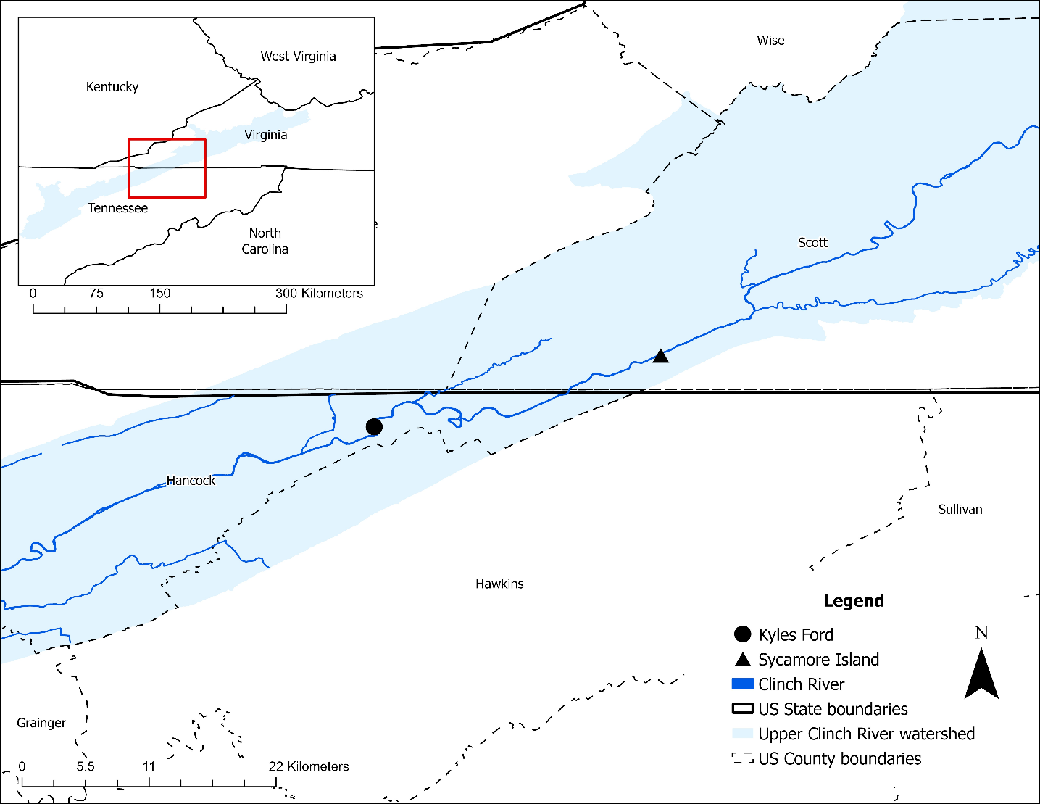
Figure 3.1: Map of our sampling sites at the Clinch River, Kyles Ford (Tennessee) and Sycamore Island (Virginia).

Field methods
Case-control study design
Mussels collected during this study were part of a larger investigation aimed at elucidating the role of bacteria in mussel mass mortality events in the Clinch River. Our study design was extensively described by Da Silva Neto et al. (2024). Our initial control group was comprised of 260 apparently healthy A. pectorosa raised at the Virginia Department of Wildlife Resources’ Aquatic Wildlife Conservation Center (AWCC). These mussels were maintained at our study sites in silos, which are concrete structures commonly used in in-situ studies of mussel health, growth, and survival (Kyle at el. 2017, Haag et al. 2019; Skorupa et al. 2024). We deployed silos in two phases. In the first phase, we deployed ten silos at Kyles Ford and ten silos at Sycamore Island (n = 20 total) in May 2021, placing five A. pectorosa in each silo (n = 100; mean length = 13 mm). In the second phase, we deployed ten additional silos at each site in May 2022, placing eight A. pectorosa in each silo (n = 160; mean length = 18.4 mm). Between 2021 and 2023, we checked silos and harvested control mussels thirteen times at Sycamore Island and six times at Kyles Ford. We randomly collected five to fifteen silo mussels during each sampling event. During our study, we lost 92 silo mussels due to accumulation of sediment inside of silos associated with high flow events. Therefore, our final control group was comprised of 168 mussels. See Attachment Silo_Growth_Data_May21_Dec22 and Silo_Growth_Data_June22_Dec23 for growth data on control mussels.
The case group consisted of 48 wild, freshly dead (n = 33) or moribund (n = 15) A. pectorosa displaying clinical signs of disease collected during field surveys following a systematic timed transect sampling approach (see Da Silva Neto et al., 2024). We did not conduct silo checks or field surveys from January to June in 2021 and 2022, and from January to April in 2023, due to unsafe sampling conditions caused by low water temperatures and increased river discharge.
SPATT and water sampling
We deployed a total of 100 Solid Phase Adsorption Toxin Tracking (SPATT) samplers at both Kyles Ford (n = 49) and Sycamore Island (n = 51) between August 2021 and December 2023, with an average deployment time of 20 days (see Appendix B, Table A.3.2). These passive sampling devices, which can adsorb cyanotoxins directly from the water column, are widely used for the detection and quantification of cyanotoxins in marine and freshwater systems (Howard et al., 2008). An extensive review of the technology is provided by Roué et al. (2018), and we provide detailed assemblage instructions in Appendix B. SPATTs were deployed in pairs and secured to silos at the same location grab samples were collected to decrease sample bias due to spatial variation. In addition, we collected a total of 50 water samples at both Kyles Ford (n = 25) and Sycamore Island (n = 25; see Appendix B, Table A.3.3) in 2021 and 2023. Grab samples were collected in pairs by dipping 50 mL polypropylene centrifuge tubes (Thermo Scientific, catalog # 12-565-270) into the water surface. We stored each sample in a regular freezer (0° C) until processed.
During each site visit we used a YSI ProSolo ODO/CT Handheld Meter (Xylem, USA; #626650) equipped with dissolved oxygen and conductivity probes to measure dissolved oxygen (% saturation) and conductivity (µS/cm). At the start of the study, we attached two HOBO Pendant MX water temperature data loggers (HOBO, part # MX2201) to silos at each site and programmed it to continuously record water temperature in one-hour increments. Finally, we gathered average river discharge data (May 2021 to December 2023) from United States Geological Survey gages located in the Clinch River near Looney’s Gap, Tennessee (ID #03527220) and at Speers Ferry, Virginia (ID# 03527000).
Laboratory Methods
A. pectorosa tissue collection
We conducted autopsies on each mussel using sterile equipment and collected tissue samples from the digestive gland, mantle, gill, and foot. Control mussels were part of a separate, larger diagnostic project, and therefore, we sampled only residual tissue remaining after other diagnostic tests had been performed. As a result, and due to their small size, we were often unable to collect enough tissue (1 g) to meet the weight requirement for ELISA testing kits. Consequently, we batched tissue samples based on their collection dates (19 total samples). We placed each sample in a 2 mL microcentrifuge tube and stored it in a standard freezer (0 °C) until processed.
Case mussels provided sufficient tissue for individual processing, so batching was not required. However, during the early stages of protocol development, we batched 16 case mussels into 5 samples and left the remaining 32 as single samples. Therefore, we had 37 total case samples (32 individual case mussels plus 5 batched samples). From each case mussel, we collected 1 g of tissue by cutting through the visceral mass, targeting the digestive gland region. For batched samples, we collected a total of 1 g of tissue across all individuals. We placed each sample in a Whirl-Pak® bag and stored it in a freezer (0 °C) until processed.
Cyanotoxin extraction
We were primarily interested in microcystins. We used ABRAXIS Microcystins/Nodularins ADDA enzyme-linked immunoassay (ELISA) Kit (Gold Standard Diagnostics Horsham, Inc., Product N0. 520011) to quantify microcystin concentration. The detection limit range for the essay based on MC-LR was 0.15 - 5.0 ng/mL. Microcystin variants measured by the kit included LR, LW, LY, YR, LF, MCLY, RR, LA, nodularins, and ADDA.
Prior to ELISA testing, we lysed all mussel tissue, SPATT, and water samples. We used a modified ABRAXIS protocol for extraction of microcystin in soil samples to lyse mussel tissue. First, we thawed and weighed each sample, with a minimum of 1 g of tissue required per extraction (induvial or batched samples). Subsequently, we transferred each sample into individual 20 mL disposable culture tubes (Fisherbrand – Cat. No. 14-961-30). Then, we performed a 1:5 dilution using acidified 75% methanol (consisting of 75 mL methanol, 25 mL deionized water, and 0.6 mL 0.1M glacial acetic acid) followed by sonication in a water bath (Branson 5510 ultrasonic cleaner) at 25 °C for 25 minutes, and centrifugation (Thermos Scientific CL2 Centrifuge, catalog # 004260F) at 1,000 RPM for 10 minutes. Finally, we transferred the supernatant to new individual 20 mL disposable culture tubes and placed them on a drying rack (Organomation Associates Multivap 113 Nitrogen Evaporator Model 11116) at 23 – 25 °C in a laminar flow hood. We let samples evaporate under a gentle stream of filtered air for 1 – 3 days. We reconstituted samples by adding 5 mL or 10 mL of ultra pure HPLC water prior to running ELISA tests. Ultra pure HPLC water samples were also added to the ELISA test as a blank sample.
For SPATT extractions, we followed a similar protocol to that described for mussel tissue. First, we performed three freeze-thaw cycles at 0 °C and 25 °C, respectively. For each SPATT sampler, we removed the resin and transferred it into an Erlenmeyer flasks, where we conducted an extraction using 15 mL of 50% methanol solution (1:1 ratio of pure methanol and ultra purified HPLC water). We then left all Erlenmeyer flasks in a hood overnight to extract the toxin adsorbed onto the resin into solution. The following day, we filtered each sample using glass funnels lined with a 90mm (1um pore size) Whatman microfiber glass into individual 20 mL disposable borosilicate culture tubes to filter the resin from the extractant for analysis. We set aside filters containing resin, allowing the resin to dry for a minimum of 48 hours before weighing total resin mass for toxin concentration calculations. Finally, we placed all disposable culture tubes in a laminar flow hood until the solution evaporated down to 2 ml. We reconstituted any samples that fully evaporated prior to the ELISA step. We stored extracted samples in the fridge until they were run on an ELISA test kit, this was typically within a day of resin extractions. We lysed water samples by performing three freeze-thaw cycles at 0 °C and 25 °C, respectively. Because water samples were free of large, suspended particles, we did not filter samples prior to running ELISA tests.
In addition to microcystins, anatoxin, cylindrospermopsin, and saxitoxin are additional cyanotoxins that can also be found in freshwater systems and are known to negatively affect wildlife and humans (Ibelings and Havens 2008). As a post-hoc assessment, we used ABRAXIS Anatoxin-a, Cylindrospermopsin, and Saxitoxins ELISA kits (Gold Standard Diagnostics Horsham, Inc., Product #. 520060, 522011, and 52255B, respectively) to quantify toxins in various SPATT and tissue samples collected in 2023 following manufacturer protocols.
Statistical methods
We evaluated relationships between microcystin concentrations in water, mussel tissue, and SPATTs and various environmental parameters (e.g., dissolved oxygen, conductivity, temperature, and river discharge), as well as mussel length. Microcystin concentration in a few samples fell below the limit of detection (LOD; 0.15 ng/ml) and were classified as “invalid/not detected”. However, these values should not be ignored in statistical analysis (Gochfeld et al., 2005). Therefore, we substituted non-detects with LOD/√2, an approach that is recommended when few values fall below LOD (Glass and Gray 2001). It provides a simple yet effective way to minimize error in statistical analyses by approximating the likely value of undetected measurements (Glass and Gray 2001; Verbovšek 2011). All samples were evaluated for normality and the presence of outliers using the Shapiro-Wilk test, Q-Q plots and boxplots. Microcystin concentration in water and dissolved oxygen were normally distributed, whereas all other variables had outliers and were not normally distributed. Kendall’s rank correlations were calculated for all non-normal data across the three years for both sites and each individual site using the Kendall R package (v2.2.1; McLeod A 2022). Pearson’s correlations were calculated otherwise.
We used a weighted generalized least squares (GLS) analysis of variance to evaluate differences in microcystin concentrations in mussel tissue based on clinical presentation (control vs. case), year, site, and the interaction between clinical presentation and year. Variance weights were applied by batch using the “varIdent” function, and the analysis was conducted using the “gls” function from the nlme package in R (v3.1-164; Pinheiro and Bates 2023). Normality of residuals were evaluated for the model using the Shapiro-Wilk test and Q-Q plots. Equality of variance and outliers were evaluated using Levene’s test for equality of variance, boxplots, and studentized residual diagnostics. After heterogeneous between-group variance structures (Littell 2007) were incorporated to adjust for unequal group variances, all statistical assumptions were met for the model. Tukey-Kramer p-value adjustments were applied to post-hoc tests. A p-value less than 0.05 was considered significant. All statistical analyses were performed in R Statistical Software (v4.3.3;R Core Team 2024).

Results
Microcystin concentration in A. pectorosa tissue
Microcystin concentration in tissue samples varied within and between years and clinical presentation. In 2021, control mussels display the highest average concentration of microcystin overall, with a notable peak in October in case mussels (Figure 3.2; Table 3.1). In 2022, concentrations decline compared to 2021, with a notable peak in October in control mussels (Figure 3.2; Table 3.1). In 2023, concentrations were low in both control and case mussels with several peaks between June–December (Figure 3.2; Table 3.1). Control mussels generally showed a higher concentration of microcystin than case mussels across all sites and years. However, case mussels displayed greater variability (Figure 3.3).

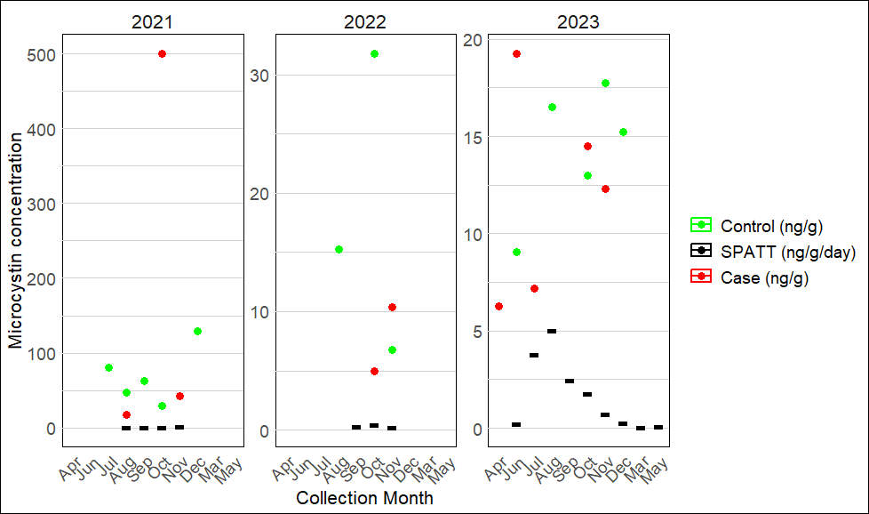

Figure 3.2: Average microcystin concentration in Pheasantshell (Actinonaias pectorosa) tissue (ng/g) categorized by clinical presentation (case vs control), as well as daily average microcystin concentration (ng/g/day) measured in Solid Phase Adsorption Toxin Tracking (SPATT) samplers deployed at Kyles Ford (Tennessee) and Sycamore Island (Virginia) in the Clinch River between 2021 and 2023.

Table 3.1: Monthly average microcystin concentration (ng/g) in Pheasantshell (Actinonaias pectorosa) tissue at Kyles Ford (Tennessee) and Sycamore Island (Virginia) per year and clinical presentation
 |  | Control | Case
Collection Year | Collection Month | Average microcystin concentration (ng/g) (range)
2021 | Jul | 80.6 (54 – 107.2), n = 2 | -
 | Aug | 47.1 (43.8 – 50.4), n = 2 | 17.06
 | Sep | 62.41 (60.5 – 64.3), n = 2 | -
 | Oct | 29.5 (25.1 – 33.9), n = 2 | 369.26 (3.43 – 763.45), n = 4
 | Nov | - | 42.30 (36.50 – 48.10), n = 2
 | Dec | 128.88 (51.25 – 206.5), n=2 | -
2022 | Aug | 15.27 (14.9 – 15.6), n = 2 | -
 | Oct | 31.80 | 6.44 (2.26 – 11.48), n = 6
 | Nov | 6.75 | 11.02 (3.47 – 27.65), n = 15
2023 | Apr | - | 6.26 (5.29 – 7.23), n =2
 | Jun | 9.07 | 19.28
 | Jul | - | 7.20
 | Aug | 16.49 | -
 | Oct | 13.01 | 14.49
 | Nov | 17.73 | 12.33 (8.24 – 15.88), n = 4
 | Dec | 15.23 | -

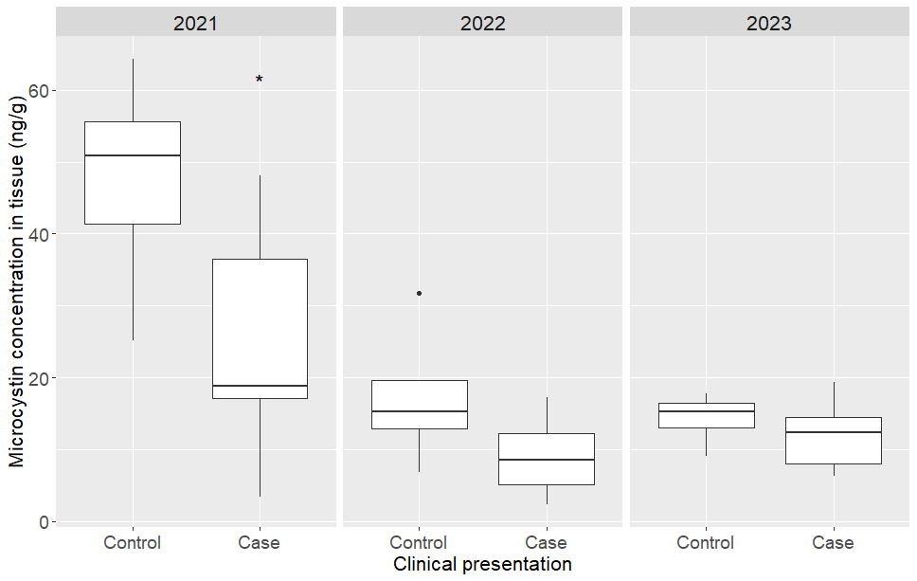
Figure 3.3: Microcystin concentration in Pheasantshell (Actinonaias pectorosa) tissue per year and clinical presentation (control vs case) collected at Kyles Ford (Tennessee) and Sycamore Island (Virginia) in the Clinch River between 2021 and 2023. Outliers above 100 ng/g are not shown in the graph (n = 5).

Microcystin concentration in SPATTs
Microcystin concentrations in SPATTs remained close to zero in 2021, with peak values occurring in November (Table 3.2). The monthly averages show a small, but consistent increase in concentration from August to November (Table 3.2). In 2022, concentrations vary but remain low, with a notable peak in September and October and with a slight decline in concentration in November (Table 3.2; see Appendix B, Figure A.3.1;). In 2023, spikes in concentration occur in July and August and decline sharply between October–December (Table 3.2; see Appendix B, Figure A.3.1)
Microcystin concentration in water samples
Microcystin concentration in water samples remained close to zero in 2021 and 2023 and were often below the detection limit of the ELISA test (Table 3.3).

Table 3.2: Monthly average daily microcystin (MC) concentrations (ng/g/day), as well as average total concentrations (ng/g) over all deployment days measured using Solid Phase Adsorption Toxin Tracking (SPATT) samplers at Kyles Ford (Tennessee) and Sycamore Island (Virginia). The table also includes the monthly average deployment duration and the sample size, representing the number of SPATT samplers deployed each month.

Year | Month | Average deployment length (days) | Average MC concentration  (ng/g/day) (range) | Average total MC concentration  (ng/g) (range) | Sample Size
2021 | Aug | 14 | 0.04 (0.01 - 0.09) | 0.56 (0.11 - 1.18) | 8
 | Sep | 16 | 0.02 (0.01 - 0.04) | 0.29 (0.12 - 0.7) | 4
 | Oct | 19 | 0.02 (0.01 - 0.03) | 0.29 (0.18 - 0.44) | 8
 | Nov | 16 | 0.48 (0.02 - 1.32) | 7.27 (0.28 - 19.76) | 8
2022 | Sep | 27 | 0.25 (0.14 - 0.35) | 6.54 (3.98 - 9.11) | 2
 | Oct | 21 | 0.42 (0.03 - 0.83) | 6.79 (0.85 - 14.09) | 6
 | Nov | 18 | 0.19 (0.09 - 0.3) | 3.22 (1.26 - 5.53) | 8
2023 | Mar | 81 | 0.02 (0.01 - 0.03) | 1.24 (0.54 - 2.7) | 4
 | May | 14 | 0.05 (0.02 - 0.12) | 0.72 (0.32 - 1.62) | 4
 | Jun | 23 | 0.16 (0.04 - 0.35) | 3.15 (1.02 - 6.29) | 6
 | Jul | 18 | 3.74 (0.02 - 7.84) | 63.71 (0.42 - 125.41) | 8
 | Aug | 17 | 4.97 (1.5 - 9.58) | 81.29 (20.95 - 134.09) | 8
 | Sep | 20 | 2.41 (0.21 - 4.53) | 48.21 (4.19 - 90.64) | 4
 | Oct | 15 | 1.72 (0.24 - 3.86) | 24.47 (3.61 - 54.02) | 8
 | Nov | 18 | 0.6 (0.05 - 1.35) | 10.56 (0.88 - 24.45) | 6
 | Dec | 14 | 0.23 (0.11 - 0.34) | 3.25 (1.42 - 6.1) | 8

Table 3.3: Monthly average microcystin (MC) concentration in water (ng/mL) in 2021 and 2023 at both Kyles Ford (Tennessee) and Sycamore Island (Virginia). No samples were collected in 2022 due to high river discharge. Sample size indicates the number of individual water samples collected each month.

Year | Month | Average MC concentration (ng/mL) (range) | Sample size
2021 | Aug | 0.12 (0.1 - 0.14) | 2
 | Sep | 0.08 (0.06 - 0.09) | 2
 | Oct | 0.12 (0.1 - 0.15) | 4
 | Nov | 0.08 (0.06 - 0.1) | 4
2023 | Jul | 0.06 (0.02 - 0.11) | 6
 | Aug | 0.08 (0.02 - 0.11) | 4
 | Sep | 0.07 (0.02 - 0.11) | 4
 | Oct | 0.09 (0.01 - 0.11) | 8
 | Nov | 0.08 (0.02 - 0.11) | 8
 | Dec | 0.10 (0.07 - 0.11) | 8

Statistical analysis
A negative correlation was found between microcystin concentration in water and SPATTs ( τ(30) = –0.32, p<.05; Table 3.4). Microcystin concentration in tissue had a positive correlation with water samples (τ(8) = 0.69, p<.01; Table 3.4), and a negative correlation with dissolved oxygen (τ(17) = –0.35, p<.05; Table 3.4), although effect sizes varied. There was a marginally negative correlation between mussel length and microcystin concentration in tissue (τ(29) = –0.25, p = 0.05; Table 3.4). Additionally, microcystin concentration in SPATT and river discharge were weakly negatively correlated (τ(52) = –0.25, p<.01; Table 3.1).
We observed a significant difference in mean microcystin concentration in mussel tissue between cases and control for health status (F(1, 32)=9.02, p<.001) and year (F(2, 32)=15.45, p<.001; Figure 3.2). Post hoc tests revealed that in 2021 control mussels had higher mean microcystin concentration compared to case mussels (p<.01), but in 2022 and 2023 that were no differences in microcystin concentration among health statuses (Figure 3.2).

Table 3.4: Results from correlation analyses among microcystin concentrations in river water, Pheasantshell (Actinonaias pectorosa) tissue, and Solid Phase Adsorption Toxin Tracking (SPATT) samplers, as well as various environmental parameters, for Sycamore Island (Virginia) and Kyles Ford (Tennessee) in the Clinch River. Parameters analyzed include dissolved oxygen, conductivity, water temperature, river discharge, and mussel length. Kendall’s rank correlation was used for all relationships, except those marked with an '*', which were assessed using Pearson’s correlation. Significant correlations between sample types or parameters are noted with a “ ^ ” where applicable.

Sample type | Sample type/ environmental parameters | n | p-value | Correlation coefficient
Water | SPATTs^ | 32 | 0.01^ | -0.32
Water | dissolved oxygen* | 20 | 0.10 | 0.56
Water | conductivity | 20 | 0.34 | 0.16
Water | water temperature | 31 | 0.22 | -0.16
Water | river discharge | 32 | 0.90 | 0.02
Tissue | water^ | 10 | 0.008^ | 0.69
Tissue | dissolved oxygen^ | 19 | 0.039^ | -0.35
Tissue | conductivity | 19 | 0.67 | 0.08
Tissue | water temperature | 37 | 0.34 | 0.11
Tissue | river discharge | 37 | 0.84 | -0.02
Tissue | mussel length^ | 31 | 0.05^ | -0.25
SPATT | tissue | 17 | 0.07 | -0.34
SPATT | dissolved oxygen | 38 | 0.47 | -0.08
SPATT | conductivity | 38 | 0.57 | 0.06
SPATT | water temperature | 52 | 0.14 | 0.14
SPATT | river discharge^ | 53 | 0.008^ | -0.25

Post-hoc assessment of Saxitoxin, Cylindrospermopsin, and Anatoxin
In mussel tissue, saxitoxin concentrations remained consistently low, while anatoxin concentrations were notably higher, particularly in control mussels compared to cases (see Appendix B, Table A.3.1). In SPATTs, we found consistently low concentration of saxitoxin and cylindrospermopsin (see Appendix B, Table A.3.2). Anatoxin was the most variable and abundant toxin in this group, with notable spikes between October and December (see Appendix B, Table A.3.2). Generally, these toxins exhibited higher concentrations in late Summer and Fall in both mussel tissue and SPATTs.

Discussion
Although we observed concentrations of microcystin in water well below the recommended levels for drinking (0.3 ng/mL) and recreational (0.8 – 20 ng/mL) waters set by the U.S. Environmental Protection Agency and several States (USEPA 2017), our results indicate that mussels at these sites accumulated microcystin at various concentrations. Interestingly, toxin concentration did not directly correlate with mortality/moribund status, similar to other studies that did not observe overt health impacts for cyanotoxin accumulation in mussels (Eriksson et al., 1989; Amorim and Vasconcelos 1998; Yokoyama and Park, 2002; Saker et al., 2004). In Unio douglasiae and Anodonta grandis, microcystin-LR tissue concentrations were 119,000–290,000 ng/g and 310–587 ng/g, respectively (Prepas et al. 1997; Saker et al., 2004), whereas we observed microcystin concentrations ranging from 6.75 ng/g to 206.5 ng/g in control mussels, approximately three orders of magnitude lower than those reported for Unio douglasiae and well below concentrations reported in Anodonta grandis. Notably, we observed a concentration of 763.45 ng/g in one case mussel. This lack of relationship between higher microcystin concentration and cases suggests that acute toxicosis was unlikely to be the primary cause of mortality in sampled A. pectorosa. However, long-term and sublethal cyanotoxin effects comprise an important environmental stressor which may contribute to mortality at our study site. Further research is needed to measure sublethal effects on mussel health and explore potential interactions with other environmental stressors to drive mortality. A scenario in which cyanotoxins play a sublethal role by affecting host physiology and weakening immune function aligns with a multicausal disease model, where multiple stressors contribute to conditions that facilitate fatal bacterial infections at one of our study sites (Da Silva Neto et al., 2024).
The higher microcystin concentrations in control mussels compared to case mussels may reflect the influence of size on toxin uptake and processing. Case mussels were longer and larger than controls and we observed a weak negative correlation between mussel length and microcystin concentration. Larger mussels would generally be expected to contain greater toxin concentrations due to increased bioaccumulation associated with size (Paldavičienė et al. 2015). Our unexpected result could be explained by physiological differences between small and large mussels such as metabolic rate, gill surface area, and feeding rates (Payne et al., 1995; Lei et al., 1996; Vaughn and Hakenkamp 2001; Ibarrola et al., 2022). Bivalves purge toxins through excretion of pseudofeces and rapidly eliminate toxins from their tissues via high filtration rates (Amorim and Vasconcelos 1998; Yokoyama and Park 2003; Pereira 2004; Saker et al., 2004; Zhang et al., 2022). Larger mussels, having higher gill surface and filtration and depuration rates may eliminate toxins faster than smaller mussels (Vaughn and Hakenkamp 2001; Vaughn and Hoellein 2018). In addition, their greater body mass may also dilute toxins, reducing concentration per unit of tissue (Saker et al., 2004; Chen and Xie 2005, 2007).
The lack of association between microcystin concentration and morbidity or mortality may suggest that A. pectorosa has developed some tolerance to microcystin exposure and accumulation, similar to other unionid mussels (Burmester et al., 2012). Notably, a recent study on feeding preferences of five unionid species found that A. pectorosa consumed more bacteria than the other species (Maggard et al., 2024). Interestingly, the study used Clinch River water and mussels of similar size and raised in the same facility as our control group. Understanding adaptation mechanisms to cyanotoxins requires more detailed physiological investigations.
It is important to highlight that cyanotoxin concentrations measured in chronically ill or dead mussels may not reflect earlier exposure levels that could have contributed to morbidity or mortality. Sublethal toxin exposure, bacterial infection, or other stressors may have led to physiological changes that induced morbidity while reducing feeding and depuration rates and toxin accumulation before death (Spooner and Vaughn 2008). This could explain why dead/moribund mussels (cases) had lower microcystin concentrations than apparently healthy mussels (controls) with fully functional physiology. In addition, differences in tissue sampling for large and small mussels is a confounding factor in our study since cyanotoxins can accumulate at various concentrations across different tissues (Saker et al., 2004; Chen and Xie 2005, 2007). Future research should investigate size-dependent toxin accumulation across species and further explore the temporal dynamics of toxin exposure and clearance while using more robust toxin quantification methods to complement the ELISA-based approach.
Microcystin and anatoxin levels peaked during late fall, particularly in October, which is coincidentally the same period when mussel mass mortality events were first reported at our study sites in 2016 (Richard 2019). Cyanotoxins can peak at different times of the year depending on site-specific factors (Loftin et al., 2016). The occurrence and persistence of cyanotoxins are influenced by a complex interaction of environmental conditions (e.g., temperature, light availability, and nutrient levels), biological dynamics (e.g., species composition and cyanobacterial physiology), and chemical processes (e.g., pH, oxidative conditions; Graham et al., 2004; Loftin et al., 2016; Beaver et al., 2018). Site-specific, long-term data are needed to determine whether environmental factors contribute to increased cyanotoxin levels during these months, creating periods of higher exposure. Further research should focus on the relationship between temporal changes in cyanotoxin concentrations, environmental factors, and mussel mortality to identify seasonal and environmental windows of increased health risk for mussels.
Potential sublethal or synergistic effects between toxins should not be overlooked, as we observed anatoxin-a, saxitoxin, and cylindrospermopsin in water and/or mussel tissue. Anatoxin-a is a potent neurotoxin that acts as a neuromuscular blocker, causing rapid paralysis and death by respiratory arrest in vertebrates (Christensen and Khan 2020). However, little is known about its impact on bivalves. This toxin rapidly degrades aquatic environments, with half-life ranging from hours to a few days depending on environmental conditions such as light and temperature (USEPA 2015). Despite its short persistence, our results indicate that mussels are bioaccumulating this toxin at various levels. Long-term monitoring and experimental studies are needed to assess seasonal variability, identify thresholds for toxicity, and evaluate potential interactions with other environmental factors that may affect mussel health. The consistently low concentration of cylindrospermopsin and saxitoxin suggests that these toxins are likely not a major contributor to mussel toxicity in this system. Notably, cylindrospermopsin has not been quantified in water using HP20 Diaion resin, which we used in our SPATTs (Howard et al., 2018). Therefore, cylindrospermopsin concentrations reported here should be interpreted with caution.
Although cyanotoxins did not seem to be the primary driver of mortality, their potential sublethal effects, bioaccumulation in mussels, and presence in the water underscore the need for monitoring efforts. Integrating periodic cyanotoxin assessments with mussel health and population monitoring could help clarify their relevance to mussel health and conservation. When assessing risks to mussels, managers and researchers should consider not only toxin concentrations but also the frequency, duration, and timing of exposure. Aquatic ecosystems are complex, and multiple toxins may interact synergistically, affecting mussel health in ways that are not yet fully understood. Overall, our results underscore the importance of broad cyanotoxin testing in environmental monitoring programs to capture the full range of potential risk factors to mussel health. By integrating environmental data on cyanotoxin persistence with tissue analysis and ecological observations, future studies could provide a clearer understanding of the potential role of cyanotoxins in mussel mass mortality events.
While SPATTs alone appear insufficient for assessing microcystin bioaccumulation in A. pectorosa, they offer significant advantages for environmental monitoring. We found no correlation between microcystin concentrations in SPATTs and mussel tissue, differing from results from marine systems where SPATTs were effective proxies for biotoxin accumulation in bivalves (MacKenzie et al., 2004). However, this method consistently detected low levels of microcystins and allowed for continuous toxin monitoring over extended periods, even when free-floating toxins in water samples were minimal. This demonstrates the value of SPATT as a passive sampling approach for early detection of harmful algal blooms and for investigating chronic exposure risks (MacKenzie et al., 2004; MacKenzie 2010; McCarthy et al., 2014; Bouma-Gregson et al. 2015; Roué et al., 2018). However, challenges such as inconsistent deployment protocols, variable toxin extraction methods, and the lack of adsorption calibration complicate data interpretation (MacKenzie 2010; Roué et al., 2018). Standardizing SPATT deployment and extraction practices is essential to improving reliability. Future research should integrate SPATTs with other monitoring tools, such as tissue analysis and water sampling, to better understand toxin dynamics and ecological impacts on mussels. These efforts are crucial for informing conservation and regulatory frameworks aimed at protecting vulnerable aquatic species.
Overall, we show mussels in a mortality-impacted area concentrate multiple cyanobacterial toxins, some of which peak with mortality, but are not at levels expected to be overtly detrimental to the host. The lack of an association with moribund/dead status makes it unlikely mussels are dying with acute cyanotoxicosis but does not rule out a role in chronic illness or environmental stress. This study produces comparative data that will enlighten other studies similarly monitoring cyanotoxins in the context of mussel health. Further research is needed to better determine the role of accumulated cyanotoxins in declining mussel populations and multifactorial mortality events.

References
Amorim, Á. and Vasconcelos, V., 1999. Dynamics of microcystins in the mussel Mytilus galloprovincialis. Toxicon, 37(7), pp.1041-1052.
Anderson, D.M., Fensin, E., Gobler, C.J., Hoeglund, A.E., Hubbard, K.A., Kulis, D.M., Landsberg, J.H., Lefebvre, K.A., Provoost, P., Richlen, M.L. and Smith, J.L., 2021. Marine harmful algal blooms (HABs) in the United States: History, current status and future trends. Harmful Algae, 102, p.101975.
Augspurger, T., Keller, A.E., Black, M.C., Cope, W.G. and Dwyer, F.J., 2003. Water quality guidance for protection of freshwater mussels (Unionidae) from ammonia exposure. Environmental Toxicology and Chemistry: An International Journal, 22(11), pp.2569-2575.
Beaver, J.R., Tausz, C.E., Scotese, K.C., Pollard, A.I. and Mitchell, R.M., 2018. Environmental factors influencing the quantitative distribution of microcystin and common potentially toxigenic cyanobacteria in US lakes and reservoirs. Harmful Algae, 78, pp.118-128.
Bouma-Gregson, K. and Higgins, P., 2015. Cyanobacteria and cyanotoxins in the Eel River, 2013–2014. University of California, Berkeley, California.(Available from: http://www. eelriverrecovery. org/documents/ERRP_CyanoReport_18Aug2016_v2. pdf).
Burmester, V., Nimptsch, J. and Wiegand, C., 2012. Adaptation of freshwater mussels to cyanobacterial toxins: Response of the biotransformation and antioxidant enzymes. Ecotoxicology and Environmental Safety, 78, pp.296-309.
Carey, C.C., Ibelings, B.W., Hoffmann, E.P., Hamilton, D.P. and Brookes, J.D., 2012. Eco-physiological adaptations that favour freshwater cyanobacteria in a changing climate. Water research, 46(5), pp.1394-1407.
Chen, J. and Xie, P., 2005. Seasonal dynamics of the hepatotoxic microcystins in various organs of four freshwater bivalves from the large eutrophic lake Taihu of subtropical China and the risk to human consumption. Environmental Toxicology: An International Journal, 20(6), pp.572-584.
Chen, J. and Xie, P., 2007. Microcystin accumulation in freshwater bivalves from Lake Taihu, China, and the potential risk to human consumption. Environmental Toxicology and Chemistry: An International Journal, 26(5), pp.1066-1073.
Christensen, V.G. and Khan, E., 2020. Freshwater neurotoxins and concerns for human, animal, and ecosystem health: A review of anatoxin-a and saxitoxin. Science of the Total Environment, 736, p.139515.
Cope, W.G., Bringolf, R.B., Buchwalter, D.B., Newton, T.J., Ingersoll, C.G., Wang, N., Augspurger, T., Dwyer, F.J., Barnhart, M.C., Neves, R.J. and Hammer, E., 2008. Differential exposure, duration, and sensitivity of unionoidean bivalve life stages to environmental contaminants. Journal of the North American Benthological Society, 27(2), pp.451-462.
Cope, W.G., Bergeron, C.M., Archambault, J.M., Jones, J.W., Beaty, B., Lazaro, P.R., Shea, D., Callihan, J.L. and Rogers, J.J., 2021. Understanding the influence of multiple pollutant stressors on the decline of freshwater mussels in a biodiversity hotspot. Science of the Total Environment, 773, p.144757.
Da Silva Neto, J.G., Hardman, R.H., Engman, A.C., Dinkins, G.R., Lane, T.W., Fry, M.M., Rines, C.R., Bisenieks, A.L., Rajeev, S. and Dennis, M.M., 2024. Multisystemic inflammatory disease in Pheasantshell (Unionidae, Actinonaias pectorosa) associated with Yokenella regensburgei infection at sites experiencing seasonal mass mortality events. Plos one, 19(8), p.e0301250.
Eriksson, J.E., Meriluoto, J.A. and Lindholm, T., 1989. Accumulation of a peptide toxin from the cyanobacterium Oscillatoria agardhii in the freshwater mussel Anadonta cygnea. Hydrobiologia, 183, pp.211-216.
Ferrão-Filho, A.D.S. and Kozlowsky-Suzuki, B., 2011. Cyanotoxins: bioaccumulation and effects on aquatic animals. Marine drugs, 9(12), pp.2729-2772.
Gélinas, M., Fortier, M., Lajeunesse, A., Fournier, M., Gagnon, C., Barnabé, S. and Gagné, F., 2014. Responses of freshwater mussel (Elliptio complanata) hemocytes exposed in vitro to crude extracts of Microcystis aeruginosa and Lyngbya wollei. Ecotoxicology, 23, pp.260-266.
Glass, D.C. and Gray, C.N., 2001. Estimating mean exposures from censored data: exposure to benzene in the Australian petroleum industry. Annals of occupational hygiene, 45(4), pp.275-282.
Gochfeld, M., Burger, J. and Vyas, V., 2005. Statistical analysis of data sets with values below detection limits. Consortium for Risk Evaluation with Stakeholder Participation, 3.

González, P.M. and Puntarulo, S., 2020. Possible role of seasonality and harmful algal blooms (HAB) on the oxidative and nitrosative metabolisms in hemocytes. Comparative Biochemistry and Physiology Part C: Toxicology & Pharmacology, 232, p.108744.
Graham, J.L., Jones, J.R., Jones, S.B., Downing, J.A. and Clevenger, T.E., 2004. Environmental factors influencing microcystin distribution and concentration in the Midwestern United States. Water research, 38(20), pp.4395-4404.
Haag, W.R., 2012. North American freshwater mussels: natural history, ecology, and conservation. Cambridge University Press.
Haag, W.R., Culp, J.J., McGregor, M.A., Bringolf, R. and Stoeckel, J.A., 2019. Growth and survival of juvenile freshwater mussels in streams: Implications for understanding enigmatic mussel declines. Freshwater Science, 38(4), pp.753-770.
Havens, K.E., 2008. Cyanobacteria blooms: effects on aquatic ecosystems. Cyanobacterial harmful algal blooms: state of the science and research needs, pp.733-747.
Howard, M.D., Kudela, R., Caron, D., Smith, J. and Hayashi, K., 2018. Standard Operating Procedure for Solid Phase Adsorption Toxin Testing (SPATT) Assemblage and Extraction of HAB Toxins.
Hudnell, H.K. ed., 2008. Cyanobacterial harmful algal blooms: state of the science and research needs.
Hudnell, H.K., 2010. The state of US freshwater harmful algal blooms assessments, policy and legislation. Toxicon, 55(5), pp.1024-1034.
Ibarrola, I., Arranz, K., Markaide, P. and Navarro, E., 2022. Metabolic size scaling reflects growth performance effects on age-size relationships in mussels (Mytilus galloprovincialis). Plos one, 17(9), p.e0268053.
Ibelings, B.W. and Havens, K.E., 2008. Cyanobacterial toxins: a qualitative meta–analysis of concentrations, dosage and effects in freshwater, estuarine and marine biota. Cyanobacterial harmful algal blooms: state of the science and research needs, pp.675-732.
Jones, J., Ahlstedt, S., Ostby, B., Beaty, B., Pinder, M., Eckert, N., Butler, R., Hubbs, D., Walker, C., Hanlon, S. and Schmerfeld, J., 2014. Clinch River freshwater mussels upstream of Norris Reservoir, Tennessee and Virginia: a quantitative assessment from 2004 to 2009. JAWRA Journal of the American Water Resources Association, 50(4), pp.820-836.
Juhel G., Davenport J., O'Halloran J., Culloty S., O'Riordan R.M., James K.F. et al. (2006a) Impacts of microcystins on the feeding behaviour and energy balance of zebra mussels, Dreissena polymorpha: a bioenergetics approach. Aquatic Toxicology, 79, 391–400.
Juhel G., Davenport J., O'Halloran J., Culloty S., Ramsay R., James K. et al. (2006b) Pseudodiarrhoea in zebra mussels Dreissena polymorpha (Pallas) exposed to microcystins. The Journal of Experimental Biology, 209, 810–816.
Juhel, G., Ramsay, R.M., Davenport, J. and Culloty, S.C., 2015. Effect of the microcystin-producing cyanobacterium, Microcystis aeruginosa, on immune functions of the zebra mussel Dreissena polymorpha. Journal of Shellfish Research, 34(2), pp.433-442.
Kim, Y.D., Kim, W.J., Shin, Y.K., Lee, D.H., Kim, Y.J., Kim, J.K. and Rhee, J.S., 2017. Microcystin-LR bioconcentration induces antioxidant responses in the digestive gland of two marine bivalves Crassostrea gigas and Mytilus edulis. Aquatic Toxicology, 188, pp.119-129.
Kudela, R.M., 2017. Passive sampling for freshwater and marine algal toxins. In Comprehensive Analytical Chemistry (Vol. 78, pp. 379-409). Elsevier.
Kyle, R., Reid, N., O'Connor, N. and Roberts, D. 2017. Development of release methods for captive‐bred freshwater pearl mussels (Margaritifera margaritifera). Aquatic Conservation: Marine and Freshwater Ecosystems, 27(2), pp.492-501.
Landsberg, J.H., 2002. The effects of harmful algal blooms on aquatic organisms. Reviews in fisheries science, 10(2), pp.113-390.
Lei, J., Payne, B.S. and Wang, S.Y., 1996. Filtration dynamics of the zebra mussel, Dreissena polymorpha. Canadian journal of fisheries and aquatic sciences, 53(1), pp.29-37.
Littell RC, Milliken G., Stroup WW, Schabenberger O. SAS for mixed models. 2nd ed. SAS institute; 2007
Loftin, K.A., Clark, J.M., Journey, C.A., Kolpin, D.W., Van Metre, P.C., Carlisle, D. and Bradley, P.M., 2016. Spatial and temporal variation in microcystin occurrence in wadeable streams in the southeastern United States. Environmental toxicology and chemistry, 35(9), pp.2281-2287.
Lopez, C.B., Jewett, E.B., Dortch, Q.T.W.B., Walton, B.T. and Hudnell, H.K., 2008. Scientific assessment of freshwater harmful algal blooms.
MacKenzie, L., Beuzenberg, V., Holland, P., McNabb, P. and Selwood, A., 2004. Solid phase adsorption toxin tracking (SPATT): a new monitoring tool that simulates the biotoxin contamination of filter feeding bivalves. Toxicon, 44(8), pp.901-918.
MacKenzie, L.A., 2010. In situ passive solid-phase adsorption of micro-algal biotoxins as a monitoring tool. Current Opinion in Biotechnology, 21(3), pp.326-331.
Maggard, I.J., Deel, K.B., Etoll, T.W., Sproles, R.C., Lane, T.W. and Cahoon, A.B., 2024. Freshwater mussels prefer a diet of stramenopiles and fungi over bacteria. Scientific Reports, 14(1), p.11958.
Martins, J.C., Leao, P.N. and Vasconcelos, V., 2009. Differential protein expression in Corbicula fluminea upon exposure to a Microcystis aeruginosa toxic strain. Toxicon, 53(4), pp.409-416.
McCarthy, M., van Pelt, F.N., Bane, V., O'Halloran, J. and Furey, A., 2014. Application of passive (SPATT) and active sampling methods in the profiling and monitoring of marine biotoxins. Toxicon, 89, pp.77-86.
McLeod A (2022). _Kendall: Kendall Rank Correlation and Mann-Kendall Trend Test_. R package version 2.2.1,<https://CRAN.R-project.org/package=Kendall>.
Mello, D.F., da Silva, P.M., Barracco, M.A., Soudant, P. and Hegaret, H., 2013. Effects of the dinoflagellate Alexandrium minutum and its toxin (saxitoxin) on the functional activity and gene expression of Crassostrea gigas hemocytes. Harmful Algae, 26, pp.45-51.
Mummert, A.K., Neves, R.J., Newcomb, T.J. and Cherry, D.S., 2003. Sensitivity of juvenile freshwater mussels (Lampsilis fasciola, Villosa iris) to total and un‐ionized ammonia. Environmental Toxicology and Chemistry: An International Journal, 22(11), pp.2545-2553.
O’Neil, J.M., Davis, T.W., Burford, M.A. and Gobler, C.J., 2012. The rise of harmful cyanobacteria blooms: the potential roles of eutrophication and climate change. Harmful algae, 14, pp.313-334.
Paerl, H.W. and Paul, V.J., 2012. Climate change: links to global expansion of harmful cyanobacteria. Water research, 46(5), pp.1349-1363.
Paldavičienė, A., Zaiko, A., Mazur-Marzec, H. and Razinkovas-Baziukas, A., 2015. Bioaccumulation of microcystins in invasive bivalves: a case study from the boreal lagoon ecosystem. Oceanologia, 57(1), pp.93-101.
Payne, B.S., Miller, A.C., Hubertz, E.D. and Lei, J., 1995. Adaptive variation in palp and gill size of the zebra mussel (Dreissena polymorpha) and Asian clam (Corbicula fluminea). Canadian Journal of Fisheries and Aquatic Sciences, 52(5), pp.1130-1134.
Pereira, P., Dias, E., Franca, S., Pereira, E., Carolino, M. and Vasconcelos, V., 2004. Accumulation and depuration of cyanobacterial paralytic shellfish toxins by the freshwater mussel Anodonta cygnea. Aquatic toxicology, 68(4), pp.339-350.
Pinheiro, J., and Bates, D., R Core Team (2023). _nlme: Linear and Nonlinear Mixed Effects Models_. R package version 3.1-164, <https://CRAN.R-project.org/package=nlme>.
Prepas, E.E., Kotak, B.G., Campbell, L.M., Evans, J.C., Hrudey, S.E. and Holmes, C.F., 1997. Accumulation and elimination of cyanobacterial hepatotoxins by the freshwater clam Anodonta grandis simpsoniana. Canadian Journal of Fisheries and Aquatic Sciences, 54(1), pp.41-46.
R Core Team (2024). _R: A Language and Environment for Statistical Computing_. R Foundation for Statistical Computing, Vienna, Austria. <https://www.R-project.org/>.
Richard, J., 2018. Clinch River mussel die-off. Ellipsaria, 20, pp.1-3.
Richard, J.C., Leis, E., Dunn, C.D., Agbalog, R., Waller, D., Knowles, S., Putnam, J. and Goldberg, T.L., 2020. Mass mortality in freshwater mussels (Actinonaias pectorosa) in the Clinch River, USA, linked to a novel densovirus. Scientific reports, 10(1), p.14498
Roué, M., Darius, H.T. and Chinain, M., 2018. Solid phase adsorption toxin tracking (SPATT) technology for the monitoring of aquatic toxins: A review. Toxins, 10(4), p.167.
Sabatini, S.E., Brena, B.M., Luquet, C.M., San Julián, M., Pirez, M. and de Molina, M.D.C.R., 2011. Microcystin accumulation and antioxidant responses in the freshwater clam Diplodon chilensis patagonicus upon subchronic exposure to toxic Microcystis aeruginosa. Ecotoxicology and environmental safety, 74(5), pp.1188-1194.
Saker, M.L., Metcalf, J.S., Codd, G.A. and Vasconcelos, V.M., 2004. Accumulation and depuration of the cyanobacterial toxin cylindrospermopsin in the freshwater mussel Anodonta cygnea. Toxicon, 43(2), pp.185-194.
Skorupa, A.J., Roy, A.H., Hazelton, P.D., Perkins, D., Warren, T. and Cheng, B.S. 2024. Food, water quality, and the growth of a freshwater mussel: Implications for population restoration. Freshwater Science, 43(2), pp.107-123.
Southard, G.M., Fries, L.T. and Barkoh, A., 2010. Prymnesium parvum: the Texas experience 1. JAWRA Journal of the American Water Resources Association, 46(1), pp.14-23.
Spooner, D.E. and Vaughn, C.C., 2008. A trait-based approach to species’ roles in stream ecosystems: climate change, community structure, and material cycling. Oecologia, 158, pp.307-317.
U.S. Environmental Protection Agency. 2015. Health Effects Support Document for the Cyanobacterial Toxin Anatoxin-a (EPA 820R15104). Office of Water.
USEPA. U.S. Environmental Protection Agency. 2017. Guidelines and recommendations. Retrieved from https://19january2017snapshot.epa.gov/nutrient-policy-data/guidelines-and-recommendations_.html
Vaughn, C.C. and Hakenkamp, C.C., 2001. The functional role of burrowing bivalves in freshwater ecosystems. Freshwater Biology, 46(11), pp.1431-1446.
Vaughn, C.C., 2018. Ecosystem services provided by freshwater mussels. Hydrobiologia, 810, pp.15-27.
Vaughn, C.C. and Hoellein, T.J., 2018. Bivalve impacts in freshwater and marine ecosystems. Annual review of ecology, evolution, and systematics, 49(1), pp.183-208.
Verbovšek, T., 2011. A comparison of parameters below the limit of detection in geochemical analyses by substitution methods. RMZ-Materials and Geoenvironment, 58(4), pp.393-404
Wang, N., Ingersoll, C.G., Hardesty, D.K., Ivey, C.D., Kunz, J.L., May, T.W., Dwyer, F.J., Roberts, A.D., Augspurger, T., Kane, C.M. and Neves, R.J., 2007. Acute toxicity of copper, ammonia, and chlorine to glochidia and juveniles of freshwater mussels (Unionidae). Environmental Toxicology and Chemistry: An International Journal, 26(10), pp.2036-2047.
Wiley, F.E., Wilde, S.B., Birrenkott, A.H., Williams, S.K., Murphy, T.M., Hope, C.P., Bowerman, W.W. and Fischer, J.R., 2007. Investigation of the link between avian vacuolar myelinopathy and a novel species of cyanobacteria through laboratory feeding trials. Journal of wildlife diseases, 43(3), pp.337-344.
Wiegand, C. and Pflugmacher, S., 2005. Ecotoxicological effects of selected cyanobacterial secondary metabolites a short review. Toxicology and applied pharmacology, 203(3), pp.201-218.
Wood, S.A., Holland, P.T. and MacKenzie, L., 2011. Development of solid phase adsorption toxin tracking (SPATT) for monitoring anatoxin-a and homoanatoxin-a in river water. Chemosphere, 82(6), pp.888-894.
Yokoyama, A. and Park, H.D., 2002. Mechanism and prediction for contamination of freshwater bivalves (Unionidae) with the cyanobacterial toxin microcystin in hypereutrophic Lake Suwa, Japan. Environmental Toxicology: An International Journal, 17(5), pp.424-433.
Yokoyama, A. and Park, H.D., 2003. Depuration kinetics and persistence of the cyanobacterial toxin microcystin‐LR in the freshwater bivalve Unio douglasiae. Environmental Toxicology: An International Journal, 18(1), pp.61-67.
Zhang, J., Yu, M., Gao, Y., Zhang, M., Dong, J., Li, M. and Li, X., 2023. Feeding behavior, microcystin accumulation, biochemical response, and ultramicrostructure changes in edible freshwater bivalve Corbicula fluminea exposed to Microcystis aeruginosa. Environmental Science and Pollution Research, 30(5), pp.13560-13570.
Zipper, C.E., Beaty, B., Johnson, G.C., Jones, J.W., Krstolic, J.L., Ostby, B.J., Wolfe, W.J. and Donovan, P., 2014. Freshwater mussel population status and habitat quality in the Clinch River, Virginia and Tennessee, USA: A featured collection. JAWRA Journal of the American Water Resources Association, 50(4), pp.807-819.

Using shells to gain insights into freshwater mussel mass mortality events: A case-study from the Clinch River, USA

Abstract
Mass mortality events (MMEs) are a major concern for conservation and management of freshwater mussels due to their unpredictability and capacity to cause significant population declines. Identifying and quantifying these events is inherently difficult, leaving many of them unassessed or understudied, limiting our understanding of driving factors. Unlike other taxa where carcasses decompose or disappear rapidly, mussel shells persist long after mortality events, offering a unique opportunity to evaluate population-level impacts. In 2016, suspected MMEs were reported along a 40-mile stretch of the upper Clinch River, a mussel diversity hotspot. While monitoring data revealed significant declines in mussel abundance at some sites, the absence of demographic data on affected mussels limits our ability to evaluate potential etiological factors. To address this, we analyzed over 5,000 shells collected during suspected MMEs to characterize the species, size, and sex composition of affected mussels, following a descriptive epidemiological framework. Our results suggest these events may have impacted 34 mussel species of various sizes and sexes, including many federally endangered species. The broad scope of mortality suggests that if an infectious agent was involved, it was likely a generalist pathogen with a wide host range. Alternatively, disease may have resulted from complex interactions between multiple commensal pathogens and environmental stressors. Lastly, we propose strategies to enhance field investigation and quantification of MMEs, improving our ability to contextualize and understand future events.

Introduction
Freshwater mussels are among the most imperiled animal groups, experiencing steep declines worldwide (Ricciardi and Rasmussen 1999; Haag and Williams 2014; Vaughn and Hoellein 2018). In North America and Europe, these declines have been documented since the early 1900s (Haag 2019; Lopes-Lima et al. 2018a,b). As part of this trend, mass mortality events (MMEs) have become increasingly frequent drivers of population decline across many taxa, including mussels (Neves 1987; Sousa et al. 2012; Fey et al. 2015; Wengström et al. 2019; Richard et al. 2020, 2023). In the United States, mussel MMEs have been sporadically documented since the mid-1970s and continue to be reported (Neves 1987; Sparks et al. 1990; Richard et al. 2020, 2021, 2022, 2023). While some of these events have been linked to known factors, such as algal blooms (Marchowski et al. 2023), droughts (Sousa et al. 2018; Nogueira et al. 2021), or chemical spills (USFWS and Virginia DEQ 2004; Leppänen et al. 2020), the majority remain unexplained. MMEs are inherently difficult to study due to their unpredictability, delayed detection, and lack of reference data for comparison. Determining causation is further complicated by multiple potential drivers, including infectious agents, environmental factors, and their interactions (Morner et al. 2002; Fey et al. 2015, 2019; Haag 2019). Given the potential for mussel MMEs to cause significant shifts in ecosystem function (Carpenter 1990; DuBose et al. 2019; Williams et al. 2021) or cause local extinction (Stokstad 2014; Fey et al. 2019; Fisher and Garner 2020), further research is needed to investigate their causes and improve response strategies.
MMEs have impacted multiple mussel species in a freshwater biodiversity hotspot along the Virginia-Tennessee border. In 2016, biologists began observing an unusual abundance of shells of recently-deceased mussels along a 40-mile segment of the upper Clinch River (Richard 2018; Richard et al., 2020). These events appeared to exclusively affect mussels and followed a pattern of upstream progression. Furthermore, Pheasantshell (Actinonaias pectorosa), an abundant species at these sites, seemed to be disproportionally impacted. Given the exclusive impact on mussels, apparent species selectivity, and pattern of spread, researchers hypothesized that infectious disease outbreaks may have been a contributing factor (Richard et al. 2020, 2021). Recent studies have addressed this hypothesis, identifying bacteria associated with moribund mussels and disease in A. pectorosa (Leis et al., 2019; Richard et al., 2020, 2021; Leis et al., 2023; Da Silva Neto et al. 2024). However, many details about the populations affected during these MMEs remain unclear, limiting etiological investigation.
Descriptive epidemiology provides a systematic framework for investigating disease and mortality in animal populations by addressing four key aspects: who (susceptible populations), what (magnitude of event, type of illness involved), when (temporal distribution), and where (geographical distribution; Thrusfield 2018; Lesko et al. 2022). Data on these four key aspects are typically collected during initial field investigations of newly observed disease patterns (such as an MME) because they are valuable for generating hypotheses about why the event is happening and its potential impacts (Thrusfield 2018). In the case of MMEs in the Clinch River, descriptive epidemiological data has not been reported, leaving investigators to rely upon assumptions from anecdotal observations.
Mussel MMEs are particularly difficult to detect and document (Southwick and Loftus 2017). Unlike fish kills, which are easier to identify due to floating carcasses, mussel mortality is far less visible (Meyer and Barclay 1990; Southwick and Loftus 2017). The logistical challenges of underwater sampling, especially in deep water, and the fact that dead mussels often remain slightly buried or on the substrate make documenting mussel mortality events difficult. However, mussel shells persist in the environment after death, providing evidence of mortality despite decomposition and scavenging of the host’s tissues (Marchowski et al. 2024). In this way, shells provide a unique history that could be analyzed to address the descriptive epidemiology of mussel MMEs.
Between 2016 and 2020, researchers opportunistically collected thousands of shells in the Clinch River across sites where MMEs were suspected of occurring. In this study, we evaluate this composite collection to characterize the species, size, and sex composition of dead mussels. We also examine sex ratios in sexually dimorphic species and assess mortality within A. pectorosa length classes at two sites where length data for live mussels was available. We demonstrate the utility of shells to address key descriptive epidemiological questions regarding MMEs (Table 4.1), discuss the challenges in using such data, and propose strategies to overcome these limitations in future research. Lastly, we emphasize the need for standardized survey techniques to accurately quantify mortality, establish reference values, and facilitate broader-scale assessments of MME
Table 4.1: Characteristics of freshwater mass mortality events (MMEs) that can be inferred from the collection of shell of dead freshwater mussels within a descriptive epidemiological context. These components collectively allow researchers to understand patterns of disease, identify trends, and hypothesize causes for further investigation.

Inference level | Major questions | Informative metrics | Data required | Can shells alone address major questions?
1: Basic | Who is affected and what are the demographic characteristics? | - Species presence£  - Demographic characteristics  - Mortality count* | - Taxonomic data  - Length, age, sex¤ data  - Count of dead individuals | Yes, if species, length, sex, and age is recorded. Shells alone can help detect an MME≠ but not quantify it.
2: Intermediate | What is the event and the scale of mortality? | - Mortality risk#  - Mortality rate^ | - Abundance and demographic data on the population within the affected area | No. Population-level data is required to calculate these metrics.
3: Advanced | When is mortality happening and what is the pattern? | - Epidemic curve  - Seasonal curve | - Mortality count over consistent time intervals. | No. Extensive temporal data is required.
4: Complex | Where is mortality happening and what is the pattern? | - Longitudinal distribution  - Watershed-level distribution | - Location and associated mortality count over consistent time intervals. | No. Extensive spatial data is required.
£the number of species collected.
*the number of dead individuals.
¤if sexually dimorphic
≠mortality count data collected prior to the suspected event must be available.
#the number of dead individuals divided by the size of the population at risk. This can be calculated at the population level or within specific demographic categories but requires abundance estimates.
^the number of dead individuals divided by the size of the population at risk over a defined time period. This can be calculated at the population level or within specific demographic categories but requires abundance estimates.

impacts on mussel populations. To our knowledge, this is the first effort to summarize shell data collected during MMEs in the Clinch River, contributing to the growing body of literature describing mass mortality in mussels.

Materials and Methods

Study area and collections
The study area consists of 14 sites within the Upper Clinch River, which begins in southwest Virginia, flows through northeast Tennessee and into Norris Reservoir near Tazewell (Figure 4.1). As of 2014, the upper Clinch River harbored 46 mussel species, including over 20 federally endangered or threatened species, making it a priority watershed for conservation (Jones et al., 2014).
Mussel shells were collected during qualitative and semi-quantitative surveys that involved walking along the river gathering mussel shells to document suspected MMEs. Participants included experts from multiple organizations, and survey techniques varied across sampling events. Between 2016 and 2020, surveyors collected a total of 5,531 shells over 35 sampling days, which were stored at the McClung Museum of Natural History and Culture at the University of Tennessee Knoxville, the U.S. Fish and Wildlife Service Abingdon Field Office, and University of Wisconsin-Madison.
Shell processing and data collection
For each specimen, we recorded the genus and species based on the nomenclature currently recognized by the Freshwater Mollusk Conservation Society (FMCS; https://molluskconservation.org/), along with associated collection information such as river mile, collector, and date. Unpaired shells were matched when possible, and single
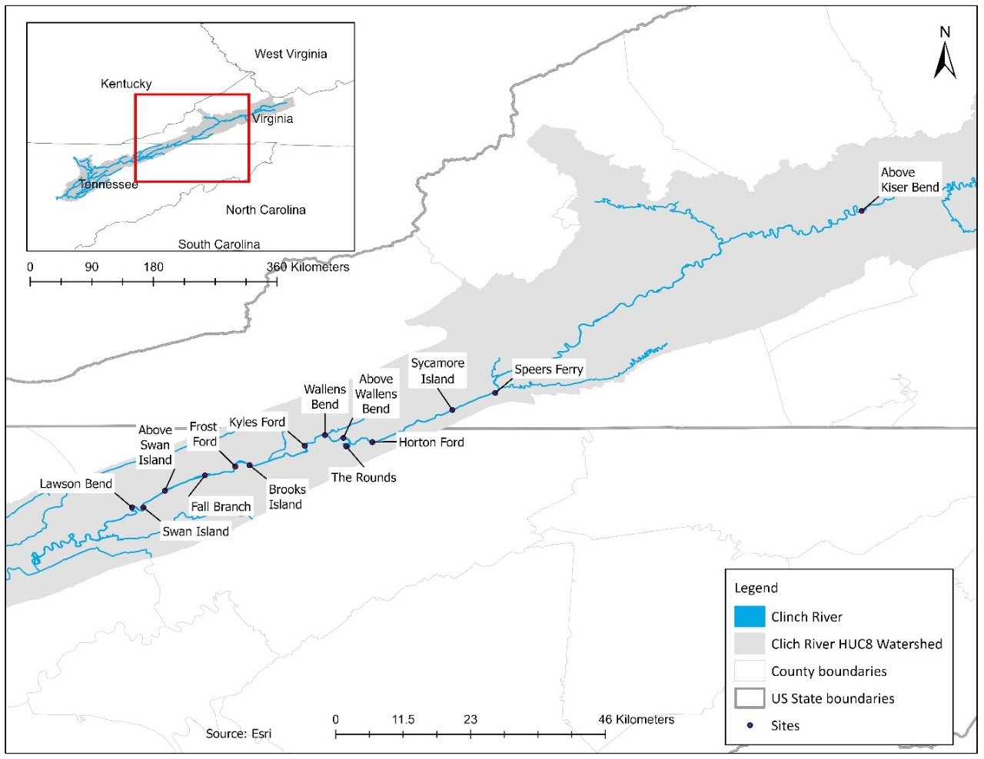
Figure 4.1: Sampling sites across Virginia and Tennessee in upper Clinch River, USA.

valves or broken shells were noted. We measured the length of the longest axis for each shell to the nearest millimeter. To more accurately quantify mortality, we excluded weathered shells from the analysis, focusing only on those with a shiny nacre, which indicated recent mortality at the time of collection.
Statistical analysis
Sex ratio analysis
We determined sex for five species, Epioblasma brevidens, Epioblasma capsaeformis, Epioblasma triquetra, Leaunio vanuxemensis, and Lemiox rimosus. However, only five L. vanuxemensis were collected in total, so we removed this species from the analysis. We evaluated differences in length between males and females of the remaining four species. We used the Shapiro-Wilk and Levene's tests to assess normality and variance homogeneity, respectively. Since the data violated parametric test assumptions for all four species, we used the Mann-Whitney U test to compare mean lengths between males and females.
We used a chi-squared goodness-of-fit test (Gotelli and Ellison 2004) to assess whether a specific sex was overrepresented (α = 0.05). Due to damage during transport and storage, length data could not be collected for several E. capsaeformis shells. As a result, this analysis included 293 of the 364 females and 522 of the 540 males. All analyses were conducted in R Statistical Software v4.4.2 (R Core Team 2024)
Mortality across A. pectorosa length classes
Length data was available for live A. pectorosa sampled at Kyles Ford from 2018 to 2023 and for Sycamore Island from 2017 to 2023. This data was collected by the Virginia Department of Wildlife Resources (Tim Lane; unpublished data) and the Conservation Management Institute (Caitlin Carey; unpublished data) using systematic random quadrat sampling. This allowed us to assess proportional mortality across length classes at both sites during years when live and dead mussel data overlapped. All individuals under 30 mm were excluded from the analysis due to underrepresentation (only one dead individual was collected under 30 mm). Length classes were consolidated into six groups (0–60 mm, 60–70 mm, 70–80 mm, 80–90 mm, 90–100 mm, and 100+ mm), with wider bins at the lower and upper ends due to small sample sizes for individuals <60 mm and >100 mm. Since Kyles Ford only contained individuals up to 100 mm, it had five length groups, with the largest being 90–100 mm. We used a chi-square goodness-of-fit test (a = 0.05; Gotelli and Ellison, 2004) and analyzed residuals to identify length classes with disproportionately high (values greater than +2) or low (values less than -2) mortality (Haberman 1973).

Results
Shell count and species composition
Out of 5,531 shells, 746 were weathered, resulting in a total of 4,785 fresh shells of 34 species, including 15 federally endangered, two threatened, and two petitioned species (Table 4.2). The most abundant species were E. capsaeformis, E. brevidens, A. pectorosa, and Dromus dromas, respectively (Table 4.2). The least abundant species with less than five recorded individuals were Lampsilis ovata, Lasmigona costata, Obovaria subrotunda, Pleuronaia barnesiana, Ligumia recta, Cumberlandia monodonta, and Pleuronaia dolabelloides (Table 4.2).

Table 4.2: Total yearly counts of individuals per species (34 species in total) collected during suspected mass mortality events at 14 sites in the Clinch River across Virginia and Tennessee between 2016 – 2020. The table includes Federal statuses as established by the United States Fish and Wildlife Service, updated as of February 2024. E = endangered, T = threatened, and P = petitioned. These counts represent individuals collected with a shiny nacre indicative of recent mortality.
 | Species | Federal status | 2016 | 2017 | 2018 | 2019 | 2020 | Total (male, female) | Average length in mm (range), sample size (n)
1 | Actinonaias ligamentina | ­ | 108 | 53 | 12 | 6 | ­ | 179 | 61 (35 – 119), n = 179
2 | Actinonaias pectorosa | ­ | 61 | 171 | 63 | 238 | 1 | 534 | 80 (22 – 110), n = 483
3 | Alasmidonta marginata | ­ | 5 | ­ | ­ | ­ | ­ | 5 | 53 (49 – 56), n = 5
4 | Cumberlandia monodonta | E | ­ | 1 | ­ | ­ | ­ | 1 | 182, n = 1
5 | Cumberunio iris | ­ | 32 | 4 | 2 | 8 | 1 | 47 | 54 (38 – 68), n = 45
6 | Cyclonaias pustulosa | ­ | 46 | 14 | 2 | ­ | ­ | 62 | 38 (27 – 54), n = 62
7 | Cyclonaias tuberculata | ­ | 40 | 13 | 1 | 1 | ­ | 55 | 50 (37 – 84), n = 55
8 | Cyprogenia stegaria | E | 82 | 40 | ­ | 4 | ­ | 126 | 38 (28 – 51), n = 126
9 | Dromus dromas | E | 299 | 128 | ­ | 9 | ­ | 436 | 52 (27 – 74), n = 436
10 | Epioblasma brevidens ^{SD} | E | 421 | 141 | 11 | 10 | ­ | 583 (314,269) | 49 (28 – 64), n = 583
11 | Epioblasma capsaeformis ^{SD} | E | 399 | 37 | 6 | 440 | 23 | 905 (540,364)* | 39 (20 – 56), n = 815
12 | Epioblasma triquetra ^{SD} | E | 54 | 19 | ­ | 1 | ­ | 74 (59,14)¤ | 42 (32 – 57), n = 74
13 | Eurynia dilatata | ­ | 96 | 33 | 9 | 23 | 1 | 162 | 60 (35 – 81), n = 159
14 | Fusconaia cor | E | 5 | 1 | 1 | 1 | ­ | 8 | 37 (25 – 50), n = 8
15 | Fusconaia cuneolus | E | 10 | 18 | 2 | 4 | 2 | 36 | 47 (23 – 62), n = 35
16 | Fusconaia subrotunda | T | 44 | 11 | 1 | 2 | ­ | 58 | 52 (31 – 84), n = 58
17 | Hemistena lata | E | 46 | 65 | 2 | 7 | ­ | 120 | 61 (46 – 78), n = 113
18 | Lampsilis fasciola | ­ | 51 | 22 | 2 | 20 | ­ | 95 | 51 (38 – 65), n = 90
19 | Lampsilis ovata | ­ | 3 | 1 | ­ | ­ | ­ | 4 | 77 (68 – 86), n = 4
20 | Lasmigona costata | ­ | 3 | ­ | ­ | ­ | ­ | 3 | 76 (63 – 100), n = 3
21 | Leaunio vanuxemensis ^{SD} | ­ | 4 | 4 | ­ | ­ | ­ | 8 (2,3)§ | 46 (38 – 58), n = 8
22 | Lemiox rimosus ^{SD} | E | 62 | 20 | 4 | 16 | 3 | 105 (52,36)^ | 33 (23 – 45), n = 105
 | Table 4.2 Continued
23 | Ligumia recta | ­ | 2 | ­ | ­ | ­ | ­ | 2 | 68 (63 – 732), n = 2
24 | Medionidus conradicus | P | 105 | 15 | ­ | 169 | 8 | 297 | 41 (28 – 52), n = 285
25 | Obovaria subrotunda | T | ­ | 3 | ­ | ­ | ­ | 3 | 54 (44 – 62), n = 3
26 | Plethobasus cyphyus | E | 215 | 37 | ­ | 2 | ­ | 254 | 57 (36 – 84), n = 254
27 | Pleurobema plenum | E | 93 | 12 | 1 | 3 | ­ | 109 | 46 (23 – 69), n = 109
28 | Pleurobema sintoxia | ­ | 12 | 5 | ­ | 1 | ­ | 18 | 47 (35 – 62), n = 18
29 | Pleuronaia barnesiana | P | 2 | 1 | ­ | ­ | ­ | 3 | 44 (42 – 47), n = 3
30 | Pleuronaia dolabelloides | E | 1 | ­ | ­ | ­ | ­ | 1 | 51 (1)
31 | Ptychobranchus fasciolaris | ­ | 67 | 13 | 1 | 15 | 1 | 97 | 65 (28 – 105), n = 97
32 | Ptychobranchus subtentus | E | 161 | 44 | 95 | 74 | 3 | 377 | 73 (37 – 112), n = 373
33 | Strophitus undulatus | ­ | 5 | 3 | ­ | ­ | ­ | 8 | 60 (49 – 68), n = 8
34 | Theliderma cylindrica | E | 6 | 1 | 2 | 1 | ­ | 10 | 57 (28 – 74), n = 10
 | Total | - | 2540 | 930 | 217 | 1055 | 43 | 4785 | 4610
SD = sexually dimorphic species that with identified sex
*,¤ = sex was unknown for one individual
§ = sex was unknown for three individuals
^= sex was unknown for seventeen individuals

Length and Sex structures
We measured length from 4,610 shells since 175 of the 4,785 fresh shells were damaged and could not be measured. Among individuals with a sample size greater than one, A. pectorosa had the greatest mean length followed by L. ovata, L. costata, and Ptychobranchus subtentus (Table 4.2). Lengths also varied widely within the four sexually dimorphic species examined. In E. brevidens, E. triquetra, and L. rimosus, males were generally longer than females (Figure 4.2). Differences in mean length between sexes were observed in E. brevidens and E. triquetra (p < 0.01 for both; Figure 4.2). In contrast, no differences in mean length were found between males and females of E. capsaeformis (p = 0.669) or L. rimosus (p = 0.112; Figure 4.2).
Males were more abundant than females in most length classes (Table 4.2). While there was no strong evidence of unequal representation of males and females for E. brevidens (p = 0.06) or L. rimosus ( p = 0.09), males were overrepresented for E. capsaeformis ( p < 0.001) and E. triquetra ( p < 0.001; Figure 4.3).
Mortality across A. pectorosa length classes
Live A. pectorosa at Kyles Ford and Sycamore Island exhibited a broad size range, with larger individuals more frequently represented among dead specimens (see Appendix C, Figure A.4.1). There were significant differences in the distribution of dead and live individuals across length classes at both Sycamore Island $(x^{2}=98.62, p= <0.01)$ and Kyles Ford $(x^{2}=65.01, p= <0.01)$. At both sites, mortality was disproportionately lower among small-to-medium length classes and higher among the largest length classes (see Appendix C, Table A.4.1).
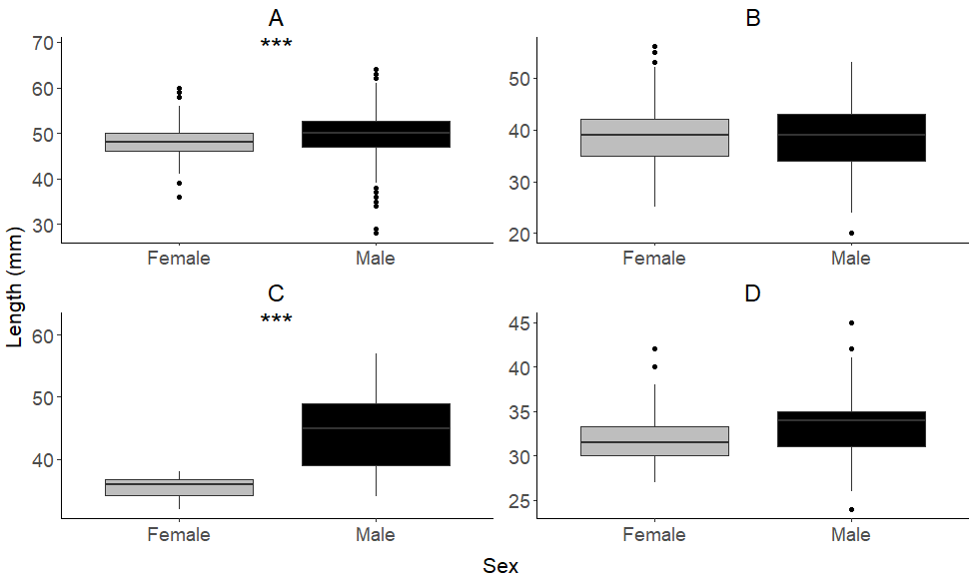
Figure 4.2: Boxplots showing median, lower quartile, and upper quartile shell length of females and males from four mussel species collected in upper Clinch River across Virginia and Tennessee between 2016 and 2020. *** = significant difference in mean length (p < 0.001). A = Epioblasma brevidens, B = Epioblasma capsaeformis, C = Epioblasma triquetra, D = Lemiox rimosus.

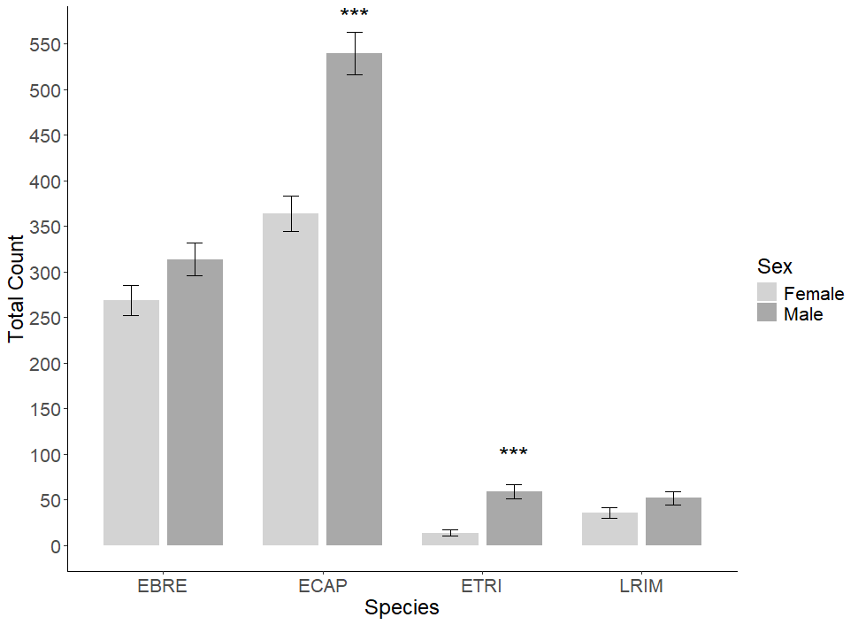
Figure 4.3: Total count of females and males from four mussel species collected in upper Clinch River across Virginia and Tennessee between 2016 and 2020. *** = significant overrepresentation (p < 0.001). Error bars represent standard error. Species abbreviations: EBRE = Epioblasma brevidens, ECAP = Epioblasma capsaeformis, ETRI = Epioblasma triquetra, LVAN = Leaunio vanuxemensis, LRIM = Lemiox rimosus.

Survey Timing and Site Coverage
The number and frequency of surveys varied across sites between 2016 and 2020. The greatest number of shells was collected in 2016 across eight sites over five survey events, while the least number was collected in 2020 during a single sampling event at one site. Although 2017 had the most sampling events, surveys in 2018 spanned the greatest number of months. Fall Branch and Frost Ford had the highest shell counts and were the most frequently surveyed sites, whereas 10 of the 14 sites were sampled only once or twice over four years (see Appendix C, Table A.4.2).

Discussion
When large numbers of dead mussels are observed, the immediate question is: why has mortality occurred? A common initial response is to collect specimens to document affected individuals, with the hope of identifying the underlying cause later. This study is the first to assess what information can be gained from shells collected in the Clinch River during suspected MMEs between 2016 and 2020. Using an epidemiological framework, we examine the who, what, where, and when of these events to derive general etiological insights and address knowledge gaps that persist nearly a decade after their initial reports.
Who was affected: Species, size, and sex
The results suggest that these MMEs may have impacted a substantial proportion of the mussel species richness in the upper Clinch River, with 74% of the 46 extant species reported by Jones et al. (2014) represented in the collection. We did not observe Alasmidonta viridis, Amblema plicada, Elliptio crassidens, Epioblasma aureola, Lampsilis abrupta, Lasmigona holstonia, Pegias fabula, Pleurobema cordatum, Pleurobema oviforme, Potamilus alatus, Theliderma sparsa, and Truncilla truncata. Their absence in the data does not necessarily indicate they were unaffected by MMEs. Rather, they may have either been absent from the sampling sites or were affected but not detected. Species distribution is non-uniform along the river because it is influenced by local habitat characteristics (Haag 2012). Additionally, some unobserved species are very rare, making detection less likely (Jones et al. 2014). To accurately assess species susceptibility to MMEs, researchers should compare mortality proportions among species to determine if certain taxa are disproportionately affected. Future studies should also aim to establish species-specific mortality rates in the absence of an MME, providing a reference point to detect unusual mortality spikes, determine if MMEs are occurring, and assess if certain species are disproportionately affected.
Demographic information can be used to understand disease selectivity (Härkönen et al. 2007; McDonald et al. 2014; Kailing et al. 2023), helping refine hypothesis about potential causative agents. For example, the results suggest sex as a risk factor. Sex ratios of impacted E. brevidens, E. capsaeformis, E. triquetra, and L. rimosus were skewed toward males, and for E. capsaeformis and E. triquetra, male prevalence was statistically significant. While mechanisms behind this trend remains unclear, potential explanations include sex-specific physiological vulnerabilities. This hypothesis aligns with findings in other studies examining sex-based differences in mussel populations. For instance, a study on metal residues in Elliptio complanata and Lampsilis radiata radiata from the St. Lawrence River found differences in metal uptake between sexes, with male specimens displaying less variability than females (Metcalfe‐Smith et al. 1994). Additionally, research on trematode infection rates in Anodonta anatina indicated that mussel sex was among the parameters influencing infection rates, with older females having higher rates of infection (Müller et al. 2015). It is important to note that sex-ratio of both E. brevidens and E. capsaeformis in the Clinch River has been reported to fluctuate over time (Lane et al., 2021). Therefore, to assess whether sex is a risk factor for mortality during an active MME would require a standardized collection approach to ensure representative sampling of dead individuals, followed by comparing sex ratios of dead mussels to the live population (i.e., sex-specific mortality risk) while accounting for differences in sex-ratios.
In contrast, we found no evidence that length was a risk factor within sexually dimorphic species. Although, males of E. brevidens and E. triquetra were larger than females, this size difference is expected due to naturally occurring length dimorphism between sexes, with males being on average longer than females (Williams et al. 2008). To further investigate whether mortality is length-selective, future research should compare the length-frequency distributions of dead and live individuals across multiple sites and over time using standardized, repeated surveys.
Scale of mortality
Although over 4,000 shells were collected, this number is not an estimate of the true number of dead individuals, and it remains unclear whether the observed mortality represents significant proportions of local populations. Interpreting the true impact of these mortality events requires population-level abundance data for both live and dead mussels (Marchowski et al., 2024), which is currently lacking for several sites. However, if shell material were collected in a standardized way, relative abundances could still be estimated, providing insight into the relative magnitude of mortality across species and locations. In addition, without abundance estimates, we were unable to calculate mortality risk, rate, and proportional mortality for each species and demographic category (Marchowski et al., 2024). Future responses to MMEs should focus on quantifying the abundance of both dead and live individuals simultaneously, providing essential data for assessing mortality risk. Nonetheless, our findings establish a valuable reference point for future investigations into similar events and highlight the importance of collecting abundance data during suspected MMEs, if such data are not already available.
Our analysis of mortality across A. pectorosa length classes underscores the importance of size-structure for contextualizing mortality patterns. At both sites, shorter mussels were underrepresented among the dead group, while longer mussels were overrepresented. This pattern suggests that mortality may be disproportionately lower among shorter length classes and higher among longer length classes. However, this pattern may also be influenced by collection bias towards larger individuals and greater difficulty detecting smaller individuals (Strayer and Smith 2003). Without available long-term reference data on the length structure of the live population for most of these sites, it remains unclear whether these patterns reflect actual differences in susceptibility or mortality risk. Future monitoring efforts should aim at describing the length structure of dead mussels, particularly at locations with known abundance and length data. Comparing length structure between live and dead individuals over time could reveal whether certain size classes are consistently more vulnerable, helping to distinguish between selectivity and historical shifts in population structure.
Temporal and spatial mortality patterns
MMEs were historically reported at several sites, with a suspected upstream progression (Richard 2019). However, we were unable to confirm which sampling sites were affected or determine the full extent of their longitudinal distribution. Our ability to draw conclusions from the available data was limited by differences in survey frequency and timing, site selection, sampling methods, and the level of accompanying documentation. In many cases, records included only basic information such as location, date, and collector name. Contextual information, including survey objectives, effort, timeframe, and area covered, was rarely documented, limiting our ability to make robust inferences.
Etiological insights.
Given the apparent upstream progression and mussel-specific impact of these mortality events, infectious disease has been hypothesized as a primary cause of MMEs in the Clinch River (Richard et al. 2018, 2020, 2021). Information on affected species, as well as the size and sex composition of dead individuals, provides an opportunity to refine hypotheses about potential etiological agents. Here, we consider three possible scenarios: (1) a single pathogen group acted as the primary driver of mortality, (2) mortality was caused by a single opportunistic pathogen, triggered under favorable environmental conditions, and (3) multiple opportunistic pathogens contributed to mortality, triggered under favorable environmental conditions.
In other wildlife systems, large-scale mortality is most often caused by highly virulent viruses in naïve or immunocompromised populations, such as cetacean morbillivirus (Van Bressem et al. 2009) or piscine herpesviruses (Hedrick et al. 2000). Some viruses, such as highly pathogenic avian influenza (HPAI) and West Nile virus (WNV), have caused MMEs across multiple host species, including birds, mammals, and reptiles (Komar 2003; Kuiken et al. 2005; Bevins et al. 2022). Fungal pathogens like chytrid (Batrachochytrium dendrobatidis) in amphibians (Skerratt et al. 2007) and white-nose syndrome (Pseudogymnoascus destructans) in bats (Frick et al. 2010) can have broad host ranges but are typically easy to detect during diagnostics. If similar agents were responsible here, we would likely have observed more consistent signs across species and investigations. A broad range of microorganisms and parasites including viruses, protists, trematodes, mites, and bacteria, have been documented in mussels and, in some cases, suggested as potential contributors to disease (Grizzle and Brunner 2009; McElwain 2019; Goldberg et al. 2019; Wengström et al. 2019; Richard et al. 2020; Alfjorden et al. 2021; Brian et al. 2021a,b; Chapurina et al. 2021; Knowles et al. 2022, 2023; Alfjorden et al. 2024). A single primary pathogen would need to be highly transmissible and capable of infecting multiple species across sex and size classes. Notably, no known pathogen affecting mussels exhibits such characteristics. For instance, Hyriopsis cumingii plague virus (HcPV), associated with MMEs in farmed mussels, is highly species-specific and has not been documented in wild populations (Zhong et al. 2011, 2016; Knowles et al. 2023). Similarly, Clinch densovirus 1 has been detected in association with MMEs of wild A. pectorosa (Richard et al. 2020), but its role remains unclear. Similarly, the bacterium Yokenella regensburgei has been associated with fatal disease in A. pectorosa (Da Silva Neto et al. 2024), yet its host range, transmissibility, and lethal potential remain unknown. Other proposed pathogens including ciliates, fungi, nematodes, and mites are also typically host-specific and lack the traits required to drive broad-scale MMEs (Brian et al. 2019, 2022; Knowles et al. 2023). Although a single pathogen cannot be ruled out, there is currently no strong candidate with the requisite epidemiological characteristics.
Unlike primary pathogens, which often demonstrate specificity for a species, sex or length classes (Härkönen et al. 2007; McDonald et al. 2014; Kailing et al. 2023), opportunistic pathogens are particularly plausible agents in these events given the broad host range. A single opportunistic pathogen, such as a bacterium present in the microbiota of multiple mussel species, could have become pathogenic under favorable environmental conditions. Opportunistic pathogens are capable of infecting diverse hosts, especially when environmental stress impairs immune function (Robinson et al. 2019; Wu et al. 2021). This scenario is consistent with mass mortality events in other systems, such as hemorrhagic septicemia in saiga antelope caused by Pasteurella multocida following climatic anomalies (Kock et al. 2018). However, MMEs caused by bacteria are rare. In the Clinch River, a single opportunistic pathogen scenario would require environmental stressors to be severe and synchronous enough to suppress immune function across individuals from 34 species. Given the diversity in life history traits among affected mussel species (Haag 2012), which likely influence pathogen exposure, immune response, and stress tolerance, such widespread, synchronized susceptibility would be highly unusual.
An alternative hypothesis is that mortality resulted from a multifactorial process involving multiple environmental stressors and perhaps one or a few opportunistic pathogens that further compromised host immunity, allowing other opportunistic organisms to infect hosts. For instance, Pacific oyster mortality syndrome (POMS) in Pacific oyster (Crassostreae gigas) is caused by an initial infection with Ostreid herpesvirus type 1 μVar (OsHV-1 μvar), which facilitates secondary colonization of opportunistic bacteria that ultimately lead to mortality (Petton et al. 2021). Furthermore, the collapse of noble pen shell (Pinna nobilis) populations in the Mediterranean has been attributed to co-infections facilitated by environmental stress, where initial infections may have impaired immune responses and enabled secondary pathogens to contribute to mortality (Carella et al. 2020, 2023). These examples reflect an increasing recognition that disease is a multifactorial process (Kane and Morley 1999; Stephen 2002; Stolk 2008; Tompkins et al. 2011; Tompkins et al. 2011) and morbidity and mortality in aquatic animals often arises from interactions between multiple environmental stressors and multiple pathogens (Carella et al. 2023; Montenegro and González 2025). While well-documented examples of simultaneous multi-pathogen MMEs are relatively rare, this hypothesis warrants consideration given the patterns of mortality observed in the Clinch River. Variation in life history traits among mussel species (Haag 2012) likely influences how different taxa respond to stressors and pathogens. This hypothesis could help explain why multiple species were affected, why some species may have been disproportionally impacted, and why no single pathogen has been consistently identified. However, direct evidence for immunosuppression or pathogen succession in affected mussels is limited, and further research is needed to evaluate this possibility.
Future efforts should integrate molecular, histopathological, and microbiological approaches to screen for pathogens (similar to study design used by Da Silva Neto et al. 2024) while simultaneously evaluating environmental co-factors that may contribute to host susceptibility (Carella et al. 2023). Additionally, long-term health monitoring of both affected and unaffected populations is critical for establishing reference benchmarks that can use to detect early disease emergence.
Strategies to enhance response to mussel MMEs
If the ultimate goal is to understand mussel MMEs, researchers must move beyond ad hoc qualitative or semi-quantitative field investigation and prioritize rigorous standardized quantitative surveying methods. It is crucial to identify study goals and an intentional sampling design prior to implementation, as this will determine the information that can be inferred from the data. In the following paragraphs, we outline general recommendations for investigating mass mortality events (MMEs) using descriptive epidemiological concepts (see Appendix C, Figure A.4.2). These steps can be addressed sequentially or concurrently, depending on study objectives and data availability.
Our aim is to support the characterization of unusual mortality events that may constitute an MME similar to work described by Marchowski et al. (2024). An event may be considered unusual if the cause and circumstances are unknown and not associated with direct anthropogenic impacts (e.g., chemical spills) that cause significant kills over extended areas. Our recommendations are not intended as guidance for assessing large-scale mortality events linked to pollution, chemical contamination, or other acute disturbances as comprehensive manuals for such investigations are available (see Meyer and Barclay 1990; Southwick and Loftus 2017). Similarly, our guidance is not meant to replace established methods for mussel sampling (see Strayer and Smith 2003) or diagnostic investigation of mussel MMEs (see Cossey et al. 2024), which should be referenced as appropriate based on study goals. Instead, our focus is on enhancing the broader epidemiological understanding of MMEs by providing structured approaches to describe their scope, scale, and demographic structure of affected group, as recommended by Cossey et al. 2024.
Surveying and identifying who is affected
Once a suspected MME is identified, the main objectives are to 1) quantify the total number of dead individuals, 2) identify affected species, and 3) characterize the demographic structure of the affected group. This data provides the foundation for all subsequent analysis. If collecting all dead individual is not feasible, a representative sample should be collected that allows for the extrapolation of the total number of dead individuals (Marchowski et al., 2024). Researchers should focus on counting fresh empty shells representative of ongoing mortality, while avoiding relic or weathered shells that may inflate counts by including individuals that died prior to the event of interest.
Implementing standardized, quantitative surveys that increase the likelihood of collecting a representative sample of all size classes is critical for distinguishing true mortality patterns from sampling bias, which can falsely indicate mortality selectivity. Quantitative sampling methods such as transects and quadrats ensure through examination of the sampling area, reducing bias towards larger individuals and increasing the likelihood of detecting smaller or rare species (Strayer and Smith 2003; Marchowski et al. 2024; Szlauer-Łukaszewska 2023). Careful consideration of the number, placement, and spacing of transects and quadrats is essential, given that each system may require tailored survey designs. Whenever possible, repeated surveys at the same locations should be conducted to account for detection probabilities and improve estimates of actual abundance of dead individuals (see Chapter 5). Lastly, survey efforts should be recorded, including the number of people involved, time spent searching, and specifying the area covered (Meyer and Barclay 1990; Southwick and Loftus 2017). Information on survey effort allows for the extrapolation of mortality counts over broader areas and facilitates comparison between sites with varying levels of sampling effort
Mortality counts can help identify the occurrence of MME without abundance estimates by comparing it with mortality counts recorded prior to the suspected event. For example, researchers studying marine mammals use stranding records as a monitoring tool by comparing the number of stranded carcasses during an event to stranding frequencies typically observed (ten Doeschate et al., 2017). Without either population-level metrics or reference mortality data, it is virtually impossible to quantitatively confirm an MME. In these situations, one must rely on anecdotal observations, which may be insufficient to inform complex management efforts.
When collecting shells, proper handling and storage are critical for preserving the integrity of the specimens for subsequent data collection and analysis. Poor storage practices, such as keeping shells in plastic bags, can lead to breakage which limits the collection of essential data, such as length measurements. Across all species, we were unable to collect length data from 175 shells due to breakage. Fragile, thin-shelled species like Hemistena lata and E. capsaeformis (especially females) are particularly susceptible to breakage during improper storage and transportation. This disproportional damage can skew data for certain species, length classes, and sexes. For instance, in our shell collection 19.5% (71/364) of female E. capsaeformis broke during storage and transport compared to only 3.3% (18/540) of male E. capsaeformis. Finally, surveyors collecting shells during MMEs should prioritize cleaning and processing shells for long-term storage. Efforts should be made to ensure that both valves of each shell are kept together and that shells are verified as recent mortalities (not relics) to avoid confounding data with specimens from previous events. During transportation and storage, shells should be packaged appropriately, using material that cushions and protects them from damage and breakage.
Confirming MME and quantifying the scale of mortality
At this level of inference, the main objectives are 1) to confirm the occurrence of an MME, and 2) quantify the scale of mortality. The ideal approach to confirming an MME is to quantify the proportion of a population that died during a single event (Reed et al. 2003; Fey et al. 2014; Ameca y Juárez et al. 2022) and confirm that mortality affected a significant portion of the population. Mortality metrics often include mortality risk, rate, and demographic-specific mortality (Rothman and Greenland 1998). These are especially important to identify unusual mortalities because it allows us to compare risk and rate among sites over time, allowing us to identify when these metrics are above typical levels (Szlauer-Łukaszewska et al. 2023). Mortality risk is calculated by dividing the total number of dead individuals by the population at risk (i.e., abundance of live individuals). Mortality rate is calculated by dividing the number of dead individuals by the total population at risk over a specific time period. These metrics can be calculated for each group of interested such as population, length class, or sex (Rothman and Greenland 1998). As our study demonstrates, abundance estimates of live individuals may not be available at sites where MMEs occur, especially for sites that are not closely monitored. In that case, a random systematic quadrat sampling approach should be used to quantify density and abundance of dead and live animals simultaneously at the affected site. This approach provides species-specific density and abundance data as well as demographic information on the population (Strayer and Smith 2003) that can be used to confirm and quantify the scale of mortality within populations and demographic groups.
Assessing temporal and spatial trends
At this level of inference, our main objectives are to 1) identify the spatial distribution of MMEs and 2) determine their timing. If a suspected MME is ongoing and the immediate goal is to assess its space extent and timing, we recommend conducting consistent, interval-based shell counts and abundance surveys both upstream and downstream of suspected mortality hotspots (Marchowski et al., 2024). The scale of these surveys should be tailored to the river system and the distance of potentially affected populations from the presumed outbreak epicenter.
Beyond immediate event assessment, a broader objective should be to establish mortality rates over time, providing essential reference data for detecting unusual mortality events (Morner et al. 2002; Jurgens et al. 2015). Conducting mortality surveys at consistent intervals over extended periods allows researchers to develop epidemic curves and assess seasonal mortality patterns (Hénaux et al. 2013; Iverson et al. 2016). These data can help determine whether mortality is acute or prolonged, cyclical or sporadic, and linked to specific environmental conditions such as temperature fluctuations, hydrological changes, or seasonal biological processes. It also supports epidemiological analyses by spatially and temporally tracking outbreaks and identifying high-risk areas. Achieving this over an extensive area requires coordinated, systematic, and replicable efforts. To facilitate implementation, we strongly recommend integrating standardized mortality surveys with long-term monitoring.
Overall, our analysis highlights how these parameters collectively contextualize MMEs. The ability to prepare for and respond effectively to MMEs depends on prior knowledge and a comprehensive understanding of these events (Morner et al., 2002). This case study emphasizes the critical importance of comprehensive data collection, standardized methodologies, and meticulous specimen handling. While shells collected during MMEs can provide valuable insights, the absence of reference and contextual data significantly limits the conclusions that can be drawn. Challenges encountered in our study, such as the inability to estimate total mortality accurately, underscore the need for well-defined survey objectives and standardized sampling protocols. This approach not only supports replication and long-term monitoring but also improves the ability to identify risk factors associated with MMEs. Looking ahead, integrating these best practices into future surveys will be vital for advancing our understanding of mussel mortality events and developing effective conservation strategies to protect these critical components of aquatic ecosystems.

References
Alfjorden, A., Onut‐Brännström, I., Wengström, N., Kristmundsson, A., Jamy, M., Persson, B.D. and Burki, F., 2024. Identification of a new gregarine parasite associated with mass mortality events of freshwater pearl mussels (Margaritifera margaritifera) in Sweden. Journal of Eukaryotic Microbiology, 71(3), p.e13021
Ameca y Juárez, E.I.A., Mace, G.M., Cowlishaw, G. and Pettorelli, N., 2012. Natural population die-offs: causes and consequences for terrestrial mammals. Trends in ecology & evolution, 27(5), pp.272-277.
Bevins, S.N., Shriner, S.A., Cumbee Jr, J.C., Dilione, K.E., Douglass, K.E., Ellis, J.W., Killian, M.L., Torchetti, M.K. and Lenoch, J.B., 2022. Intercontinental movement of highly pathogenic avian influenza A (H5N1) clade 2.3. 4.4 virus to the United States, 2021. Emerging infectious diseases, 28(5), p.1006.
Brian, J.I. and Aldridge, D.C., 2019. Endosymbionts: An overlooked threat in the conservation of freshwater mussels?. Biological Conservation, 237, pp.155-165.
Brian, J.I., Dunne, S.E., Ellis, C.L. and Aldridge, D.C., 2021a. Population‐level effects of parasitism on a freshwater ecosystem engineer, the unionid mussel Anodonta anatina. Freshwater Biology, 66(12), pp.2240-2250.
Brian, J.I., Ollard, I.S. and Aldridge, D.C., 2021b. Don't move a mussel? Parasite and disease risk in conservation action. Conservation Letters, 14(4), p.e12799.
Brian, J.I., Reynolds, S.A. and Aldridge, D.C., 2022. Parasitism dramatically alters the ecosystem services provided by freshwater mussels. Functional Ecology, 36(8), pp.2029-2042
Carella, F., Antuofermo, E., Farina, S., Salati, F., Mandas, D., Prado, P., Panarese, R., Marino, F., Fiocchi, E., Pretto, T. and De Vico, G., 2020. In the wake of the ongoing mass mortality events: co-occurrence of Mycobacterium, Haplosporidium and other pathogens in Pinna nobilis collected in Italy and Spain (Mediterranean Sea). Frontiers in Marine Science, 7, p.48.
Carella, F., Palić, D., Šarić, T., Župan, I., Gorgoglione, B., Prado, P., Andree, K.B., Giantsis, I.A., Michaelidis, B., Lattos, A. and Theodorou, J.A., 2023. Multipathogen infections and multifactorial pathogenesis involved in noble pen shell (Pinna nobilis) mass mortality events: Background and current pathologic approaches. Veterinary Pathology, 60(5), pp.560-577.
Carpenter, R.C., 1990. Mass mortality of Diadema antillarum: I. Long-term effects on sea urchin population-dynamics and coral reef algal communities. Marine Biology, 104, pp.67-77.
Chapurina, Y.E., Bolotov, I.N., Vidrine, M.F., Vikhrev, I.V., Lunn, Z., Chan, N., Win, T., Bespalaya, Y.V., Aksenova, O.V., Gofarov, M.Y. and Kondakov, A.V., 2021. Taxonomic richness and host range of tropical Asian mussel‐associated mite assemblages (Acari: Unionicolidae) with a description of a new subgenus and species of parasitic mite from freshwater pearl mussels (Unionida: Margaritiferidae). Journal of Zoological Systematics and Evolutionary Research, 59(3), pp.613-634.
Cossey, D.A., Dennis, M.M., Richard, J., Della Torre, C., McElwain, A., Waller, D.L., Knowles, S., Brian, J.I., Leis, E., Burioli, E.A. and Aldridge, D.C., 2025. Sampling mass mortality events to enable diagnoses: A protocol using freshwater mussels. Methods in Ecology and Evolution.
Da Silva Neto, J.G., Hardman, R.H., Engman, A.C., Dinkins, G.R., Lane, T.W., Fry, M.M., Rines, C.R., Bisenieks, A.L., Rajeev, S. and Dennis, M.M., 2024. Multisystemic inflammatory disease in Pheasantshell (Unionidae, Actinonaias pectorosa) associated with Yokenella regensburgei infection at sites experiencing seasonal mass mortality events. Plos one, 19(8), p.e0301250.
DuBose, T.P., Atkinson, C.L., Vaughn, C.C. and Golladay, S.W., 2019. Drought-induced, punctuated loss of freshwater mussels alters ecosystem function across temporal scales. Frontiers in Ecology and Evolution, 7, p.274.
Frick, W.F., Pollock, J.F., Hicks, A.C., Langwig, K.E., Reynolds, D.S., Turner, G.G., Butchkoski, C.M. and Kunz, T.H., 2010. An emerging disease causes regional population collapse of a common North American bat species. Science, 329(5992), pp.679-682.
Fey, S.B., Siepielski, A.M., Nusslé, S., Cervantes-Yoshida, K., Hwan, J.L., Huber, E.R., Fey, M.J., Catenazzi, A. and Carlson, S.M., 2015. Recent shifts in the occurrence, cause, and magnitude of animal mass mortality events. Proceedings of the National Academy of Sciences, 112(4), pp.1083-1088.
Fey, S.B., Gibert, J.P. and Siepielski, A.M., 2019. The consequences of mass mortality events for the structure and dynamics of biological communities. Oikos, 128(12), pp.1679-1690.
Fisher, M.C. and Garner, T.W., 2020. Chytrid fungi and global amphibian declines. Nature Reviews Microbiology, 18(6), pp.332-343.
Goldberg, C.B., Rawski, S.L. and Perry, E.L., 2019. The direct and indirect effects of organizational tolerance for sexual harassment on the effectiveness of sexual harassment investigation training for HR managers. Human Resource Development Quarterly, 30(1), pp.81-100.
Gotelli, N.J. and Ellison, A.M., 2004. A primer of ecological statistics (Vol. 1, pp. 1-640). Sunderland: Sinauer Associates.
Grizzle, J.M. and Brunner, C.J., 2009. Infectious diseases of freshwater mussels and other freshwater bivalve mollusks. Reviews in Fisheries Science, 17(4), pp.425-467.
Haag, W.R., 2012. North American freshwater mussels: natural history, ecology, and conservation. Cambridge University Press.
Haag, W.R. and Williams, J.D., 2014. Biodiversity on the brink: an assessment of conservation strategies for North American freshwater mussels. Hydrobiologia, 735, pp.45-60.
Haag, W.R., 2019. Reassessing enigmatic mussel declines in the United States. Freshwater Mollusk Biology and Conservation, 22(2), pp.43-60.
Haberman, S.J., 1973. The analysis of residuals in cross-classified tables. Biometrics, pp.205-220.
Härkönen, T., Harding, K., Rasmussen, T.D., Teilmann, J. and Dietz, R., 2007. Age-and sex-specific mortality patterns in an emerging wildlife epidemic: the phocine distemper in European harbour seals. PLoS One, 2(9), p.e887.
Hedrick, R.P., Gilad, O., Yun, S., Spangenberg, J.V., Marty, G.D., Nordhausen, R.W., Kebus, M.J., Bercovier, H. and Eldar, A., 2000. A herpesvirus associated with mass mortality of juvenile and adult koi, a strain of common carp. Journal of Aquatic Animal Health, 12(1), pp.44-57.
Hénaux, V., Parmley, J., Soos, C. and Samuel, M.D., 2013. Estimating transmission of avian influenza in wild birds from incomplete epizootic data: implications for surveillance and disease spread. Journal of Applied Ecology, 50(1), pp.223-231.
Iverson, S.A., Gilchrist, H.G., Soos, C., Buttler, I.I., Harms, N.J. and Forbes, M.R., 2016. Injecting epidemiology into population viability analysis: avian cholera transmission dynamics at an arctic seabird colony. Journal of Animal Ecology, 85(6), pp.1481-1490.
Jones, J., Ahlstedt, S., Ostby, B., Beaty, B., Pinder, M., Eckert, N., Butler, R., Hubbs, D., Walker, C., Hanlon, S. and Schmerfeld, J., 2014. Clinch River freshwater mussels upstream of Norris Reservoir, Tennessee and Virginia: a quantitative assessment from 2004 to 2009. JAWRA Journal of the American Water Resources Association, 50(4), pp.820-836.
Jurgens, L.J., Rogers-Bennett, L., Raimondi, P.T., Schiebelhut, L.M., Dawson, M.N., Grosberg, R.K. and Gaylord, B., 2015. Patterns of mass mortality among rocky shore invertebrates across 100 km of northeastern Pacific coastline. PLoS One, 10(6), p.e0126280.
Kailing, M.J., Hoyt, J.R., White, J.P., Kaarakka, H.M., Redell, J.A., Leon, A.E., Rocke, T.E., DePue, J.E., Scullon, W.H., Parise, K.L. and Foster, J.T., 2023. Sex-biased infections scale to population impacts for an emerging wildlife disease. Proceedings of the Royal Society B, 290(1995), p.20230040.
Kane, A.J. and Morley, P.S., 1999, December. How to investigate a disease outbreak. In Proceedings of the Annual Convention of the AAEP (Vol. 45, pp. 137-141).
Knowles, S., Leis, E.M., Richard, J.C., Cole, R., Agbalog, R.E., Putnam, J.G., Goldberg, T.L. and Waller, D.L., 2022. A novel gonadotropic microsporidian parasite (Microsporidium clinchi n. sp.) infecting a declining population of pheasantshell mussels (Actinonaias pectorosa)(Unioinidae) from the Clinch River, USA. Parasitologia, 2(1), pp.1-12.
Knowles, S., Dennis, M., McElwain, A., Leis, E. and Richard, J., 2023. Pathology and infectious agents of unionid mussels: A primer for pathologists in disease surveillance and investigation of mortality events. Veterinary Pathology, 60(5), pp.510-528.
Kock, R.A., Orynbayev, M., Robinson, S., Zuther, S., Singh, N.J., Beauvais, W., Morgan, E.R., Kerimbayev, A., Khomenko, S., Martineau, H.M. and Rystaeva, R., 2018. Saigas on the brink: Multidisciplinary analysis of the factors influencing mass mortality events. Science advances, 4(1), p.eaao2314.
Komar, N., 2003. West Nile virus: epidemiology and ecology in North America. Advances in virus research, 61, pp.185-234.
Kuiken, T., Holmes, E.C., McCauley, J., Rimmelzwaan, G.F., Williams, C.S. and Grenfell, B.T., 2006. Host species barriers to influenza virus infections. Science, 312(5772), pp.394-397.
Leis, E., Erickson, S., Waller, D., Richard, J. and Goldberg, T., 2019. A comparison of bacteria cultured from unionid mussel hemolymph between stable populations in the Upper Mississippi River basin and populations affected by a mortality event in the Clinch River. Freshwater Mollusk Biology and Conservation, 22(2), pp.70-80.
Leis, E.M., Dziki, S., Richard, J., Agbalog, R., Waller, D., Putnam, J., Knowles, S. and Goldberg, T., 2023. Further bacteriological analysis of annual Pheasantshell (Actinonaias pectorosa) mussel mortality events in the Clinch River (Virginia/Tennessee), USA, reveals a consistent association with Yokenella regensburgei. Freshwater Mollusk Biology and Conservation, 26(1), pp.1-10.
Leppänen, J.J., Leinikki, J. and Väisänen, A., 2020. NiSO4 spill inflicts varying mortality between four freshwater mussel species (including protected Unio crassus Philipsson, 1788) in a western Finnish river. Environmental Pollution, 256, p.113402.
Lesko, C.R., Fox, M.P. and Edwards, J.K., 2022. A framework for descriptive epidemiology. American journal of epidemiology, 191(12), pp.2063-2070.
Lane, T., Jones, J., Ostby, B. and Butler, R., 2021. Long-term monitoring of two endangered freshwater mussels (Bivalvia: Unionidae) reveals how demographic vital rates are influenced by species life history traits. PLoS One, 16(8), p.e0256279.
Lopes-Lima, M., Bolotov, I.N., Aldridge, D.C., Fonseca, M.M., Gan, H.M., Gofarov, M.Y., Kondakov, A.V., Prié, V., Sousa, R., Varandas, S. and Vikhrev, I.V., 2018a. Expansion and systematics redefinition of the most threatened freshwater mussel family, the Margaritiferidae. Molecular Phylogenetics and Evolution, 127, pp.98-118.
Lopes-Lima, M., Burlakova, L.E., Karatayev, A.Y., Mehler, K., Seddon, M. and Sousa, R., 2018b. Conservation of freshwater bivalves at the global scale: diversity, threats and research needs. Hydrobiologia, 810, pp.1-14.
Marchowski, D., Szlauer-Łukaszewska, A., Ławicki, Ł., Engel, J., Drewniak, E. and Ciężak, K., 2024. Methods of quantifying a mass mortality event in freshwater wildlife within the river ecosystem. MethodsX, 12, p.102567.
McDonald, J.L., Smith, G.C., McDonald, R.A., Delahay, R.J. and Hodgson, D., 2014. Mortality trajectory analysis reveals the drivers of sex-specific epidemiology in natural wildlife–disease interactions. Proceedings of the Royal Society B: Biological Sciences, 281(1790), p.20140526.
McElwain, A., 2019. Are parasites and diseases contributing to the decline of freshwater mussels (Bivalvia, Unionida)?. Freshwater Mollusk Biology and Conservation, 22(2), pp.85-89.
Metcalfe‐Smith, J.L., 1994. Influence of species and sex on metal residues in freshwater mussels (family Unionidae) from the St. Lawrence River, with implications for biomonitoring programs. Environmental Toxicology and Chemistry: An International Journal, 13(9), pp.1433-1443.
Meyer, F.P. and Barclay, L.A. eds., 1990. Field manual for the investigation of fish kills (No. 177). US Department of the Interior, Fish and Wildlife Service.
Montenegro, D. and González, M.T., 2025. Impact of multiple-factors on health and infections in marine mussels (Perumytilus purpuratus) inhabiting contaminated sites in the Humboldt Current System. Scientific Reports, 15(1), p.6333.
Morner, T., Obendorf, D.L., Artois, M. and Woodford, M.H., 2002. Surveillance and monitoring of wildlife diseases. Revue Scientifique et Technique-Office International des Epizooties, 21(1), pp.67-76.
Müller, T., Czarnoleski, M., Labecka, A.M., Cichy, A., Zając, K. and Dragosz-Kluska, D., 2015. Factors affecting trematode infection rates in freshwater mussels. Hydrobiologia, 742, pp.59-70.
Neves, R.J., 1987. Proceedings of the Workshop on Die-offs of Freshwater Mussels in the United States.
Nogueira, J.G., Lopes-Lima, M., Varandas, S., Teixeira, A. and Sousa, R., 2021. Effects of an extreme drought on the endangered pearl mussel Margaritifera margaritifera: a before/after assessment. Hydrobiologia, 848(12), pp.3003-3013.
Petton, B., Destoumieux-Garzón, D., Pernet, F., Toulza, E., De Lorgeril, J., Degremont, L. and Mitta, G., 2021. The Pacific oyster mortality syndrome, a polymicrobial and multifactorial disease: state of knowledge and future directions. Frontiers in immunology, 12, p.630343.
R Core Team (2024). R: A Language and Environment for Statistical Computing. R Foundation for Statistical Computing, Vienna, Austria. <https://www.R-project.org/>.
Reed, D.H., O'Grady, J.J., Ballou, J.D. and Frankham, R., 2003, May. The frequency and severity of catastrophic die-offs in vertebrates. In Animal conservation forum (Vol. 6, No. 2, pp. 109-114). Cambridge University Press.
Ricciardi, A. and Rasmussen, J.B., 1999. Extinction rates of North American freshwater fauna. Conservation biology, 13(5), pp.1220-1222.
Richard, J. C. 2018. Clinch River mussel die-off. Ellipsaria 20, p.1-3
Richard, J.C., Leis, E., Dunn, C.D., Agbalog, R., Waller, D., Knowles, S., Putnam, J. and Goldberg, T.L., 2020. Mass mortality in freshwater mussels (Actinonaias pectorosa) in the Clinch River, USA, linked to a novel densovirus. Scientific reports, 10(1), p.14498.
Richard, J.C., Campbell, L.J., Leis, E.M., Agbalog, R.E., Dunn, C.D., Waller, D.L., Knowles, S., Putnam, J.G. and Goldberg, T.L., 2021. Mussel mass mortality and the microbiome: evidence for shifts in the bacterial microbiome of a declining freshwater bivalve. Microorganisms, 9(9), p.1976.
Richard, J.C., Leis, E.M., Dunn, C.D., Harris, C., Agbalog, R.E., Campbell, L.J., Knowles, S., Waller, D.L., Putnam, J.G. and Goldberg, T.L., 2022. Freshwater mussels show elevated viral richness and intensity during a mortality event. Viruses, 14(12), p.2603
Richard, J.C., Blevins, E., Dunn, C.D., Leis, E.M. and Goldberg, T.L., 2023. Viruses of Freshwater Mussels during Mass Mortality Events in Oregon and Washington, USA. Viruses, 15(8), p.1719.
Robinson, S., Milner‐Gulland, E.J., Grachev, Y., Salemgareyev, A., Orynbayev, M., Lushchekina, A., Morgan, E., Beauvais, W., Singh, N., Khomenko, S. and Cammack, R., 2019. Opportunistic bacteria and mass mortality in ungulates: lessons from an extreme event. Ecosphere, 10(6), p.e02671.
Rothman, K.J. and Greenland, S., 1998. Measures of disease frequency. In: K.J. Rothman and S. Greenland, eds. Modern Epidemiology. 2nd ed. Philadelphia: Lippincott-Raven, pp. 29–46.
Sanz-García, F., Gil-Gil, T., Laborda, P., Ochoa-Sánchez, L.E., Martínez, J.L. and Hernando-Amado, S., 2021. Coming from the wild: multidrug resistant opportunistic pathogens presenting a primary, not human-linked, environmental habitat. International Journal of Molecular Sciences, 22(15), p.8080.
Skerratt, L.F., Berger, L., Speare, R., Cashins, S., McDonald, K.R., Phillott, A.D., Hines, H.B. and Kenyon, N., 2007. Spread of chytridiomycosis has caused the rapid global decline and extinction of frogs. EcoHealth, 4(2), pp.125-134.
Stephen, C. (2022). Causation in Wildlife Population Health. In: Stephen, C. (eds) Wildlife Population Health. Springer, Cham. https://doi.org/10.1007/978-3-030-90510-1_6
Strayer, D.L., and Smith, D.R., 2003. A guide to sampling freshwater mussel populations. American Fisheries Society Monograph, 8, p.1.
Stokstad, E. (2014). Death of the stars. Science, 345(6202), 376-378
Stolk, R.P., Rosmalen, J.G., Postma, D.S., de Boer, R.A., Navis, G., Slaets, J.P., Ormel, J. and Wolffenbuttel, B.H., 2008. Universal risk factors for multifactorial diseases: LifeLines: a three-generation population-based study. European journal of epidemiology, 23, pp.67-74.
Sousa, R., Ferreira, A., Carvalho, F., Lopes-Lima, M., Varandas, S. and Teixeira, A., 2018. Die-offs of the endangered pearl mussel Margaritifera margaritifera during an extreme drought.
Sousa, R., Varandas, S., Cortes, R., Teixeira, A., Lopes-Lima, M., Machado, J. and Guilhermino, L., 2012. Massive die-offs of freshwater bivalves as resource pulses. In Annales de Limnologie-International Journal of Limnology (Vol. 48, No. 1, pp. 105-112). EDP Sciences.
Southwick, R.I. and Loftus, A.J. eds., 2017. Investigation and monetary values of fish and freshwater mollusk kills. American Fisheries Society.
Sparks, R. E., Blodgett, K. D., Durham, L., and Horner, R., 1990. Determination Whether the Causal Agent for Mussel Die-offs in the Mississippi River is of Chemical or Biological Origin. Final Report, ILENR/RE-WR 90/09, Illinois Department of Energy and Natural Resources, Springfield, IL.
Szlauer-Łukaszewska, A., Ławicki, Ł., Engel, J., Drewniak, E., Ciężak, K. and Marchowski, D., 2024. Quantifying a mass mortality event in freshwater wildlife within the Lower Odra River: Insights from a large European river. Science of The Total Environment, 907, p.167898.
Thrusfield, M., 2018. Veterinary epidemiology. John Wiley & Sons.
ten Doeschate, M.T., Brownlow, A.C., Davison, N.J. and Thompson, P.M., 2017. Dead useful; methods for quantifying baseline variability in stranding rates to improve the ecological value of the strandings record as a monitoring tool. Journal of the Marine Biological Association of the United Kingdom, 98(5), pp.1205-1209.
Tompkins, D.M., Dunn, A.M., Smith, M.J. and Telfer, S., 2011. Wildlife diseases: from individuals to ecosystems. Journal of Animal Ecology, 80(1), pp.19-38.
USFWS and Virginia DEQ (U.S. Fish and Wildlife Service, & Virginia Department of Environmental Quality). 2004. Final restoration plan and environmental assessment for the Certus Chemical Spill: Clinch River, Tazewell County, Virginia. U.S. Fish and Wildlife Service. Retrieved from https://www.cerc.usgs.gov/orda_docs/DocHandler.ashx?ID=513&task=get
Vaughn, C.C. and Hoellein, T.J., 2018. Bivalve impacts in freshwater and marine ecosystems. Annual review of ecology, evolution, and systematics, 49(1), pp.183-208.
Van Bressem, M.F., Raga, J.A., Di Guardo, G., Jepson, P.D., Duignan, P.J., Siebert, U., Barrett, T., de Oliveira Santos, M.C., Moreno, I.B., Siciliano, S. and Aguilar, A., 2009. Emerging infectious diseases in cetaceans worldwide and the possible role of environmental stressors. Diseases of aquatic organisms, 86(2), pp.143-157.
Zhong, L., Xiao, T.Y., Huang, J., Dai, L.Y. and Liu, X.Y., 2011. Histopathological examination of bivalve mussel Hyriopsis cumingii Lea artificially infected by virus. Acta Hydrobiol, 35(4):666–671.
Zhong, L., Xu, B., Yan, D., Xiao, T. and Liu, Q., 2016. Pathogen isolation and pathologic observation on explosive epidemics of Hyriopsis cumingii Lea. Turkish Journal of Fisheries and Aquatic Sciences, 16(4), pp.935-945.
Wengström, N., Söderberg, H., Höjesjö, J. and Alfjorden, A., 2019. Mass mortality events in freshwater pearl mussel (Margaritifera margaritifera) populations in Sweden: an overview and indication of possible causes. Freshwater Mollusk Biology and Conservation, 22(2), pp.61-69.
Williams, J.D., Bogan, A.E. and Garner, J.T., 2008. Freshwater Mussels of Alabama and the Mobile Basin in Georgia, Mississippi, and Tennessee. Tuscaloosa: University of Alabama Press.
Williams, J.P., Claisse, J.T., Pondella II, D.J., Williams, C.M., Robart, M.J., Scholz, Z., Jaco, E.M., Ford, T., Burdick, H. and Witting, D., 2021. Sea urchin mass mortality rapidly restores kelp forest communities. Marine Ecology Progress Series, 664, pp.117-131.
Wu, Y., Wang, Y., Yang, H., Li, Q., Gong, X., Zhang, G. and Zhu, K., 2021. Resident bacteria contribute to opportunistic infections of the respiratory tract. PLoS Pathogens, 17(3), p.e1009436.

Using N-mixture modeling and age-length structure analysis to quantify and assess mortality patterns of Pheasantshell (Actinonaias pectorosa) in the Clinch River, USA

Abstract
Freshwater mussels are declining globally, even in systems considered healthy, yet the mechanisms driving these declines remain unknown. Declines are further exacerbated by mass mortality events (MMEs), but these events are often understudied, and their causes remain unknown. Identifying mechanisms behind both background mortality and MMEs is hindered by the lack of reference data on mortality frequency, the demographics of dead individuals, and challenges in quantifying mortality due to imperfect detection. We applied an N-mixture modeling approach to assess mortality patterns of Pheasantshell (Actinonaias pectorosa) at two Clinch River sites where MMEs have been reported, and to evaluate the effects of Julian Day, water temperature, and river discharge on mortality. We also examined length and age structure among dead individuals and assessed mortality within length classes. Dead individuals were generally larger than live ones and dead mussels were significantly older at Sycamore Island than Kyles Ford. Our detection probability was 76.7%. Julian Day was the strongest predictor of mortality, with the abundance of dead mussel increasing later in the year, suggesting a seasonal component to mortality. Overall, we provide reference data on A. pectorosa mortality that can be used to further investigate mortality mechanisms and associated environmental factors and serve as a reference for contextualizing MMEs elsewhere.

Introduction
Freshwater mussels are among the most imperiled faunal groups globally (Aldridge et al., 2023; Lopes-Lima et al. 2023; Nakamura and Mesquita-Joanes 2023). In the United States, mussel population declines have been reported since the early 1900s, and as of 2013 an estimated 65% of the known species were considered imperiled (Haag 2012; Haag and Williams 2014). A large portion of this loss was driven by pollution and extensive river impoundments in the mid-1900s. However, declines persisted into the late 20th century, even in systems where water and habitat quality were considered healthy. The faunal collapse in these systems is not well understood, in part due to how population trends are assessed. Monitoring efforts typically focus on tracking changes in density and abundance over time and space (Haag 2019), often leaving gaps in our understanding of which groups were affected, the rate and scale of mortality, and the age and length structure of dead individuals. This information is essential to identify the mechanisms affecting population viability and environmental factors influencing mortality (Mortensen et al. 2016; Carroll et al. 2019).
Our understanding of this faunal collapse is further hindered by unpredictable mass mortality events (MMEs) that can cause rapid and severe population declines. Mussel MMEs have been reported across the United States since the 1970s, with more recent events occurring in the mid-2000s across south, central, and western United States (Hastie and Toy 2008; Thomas 2008; Richard et al. 2023). From 2016, biologists documented potential MMEs in the Clinch River, a mussel biodiversity hotspot in the southeastern United States (Richard 2018). These events were not linked to obvious major changes in habitat or water quality and appeared to affect only mussels, with other macroinvertebrates and fish remaining unaffected. Actinonaias pectorosa was reported to be disproportionately affected, with some sites experiencing over an 80% decline in abundance (Richard et al. 2018). Additionally, subjective observations suggest that the amount of dead shells increased between October and December, indicating a potential seasonal component. Due to the conservation importance of the Clinch River, several studies have attempted to identify an etiologic agent causing mortality (Leis et al. 2019; Richard et al. 2020, 2021, 2022; Da Silva Neto et al. 2024). However, the overall impact on mussel assemblages remains unclear, partly because mortality assessments were conducted post hoc, and available data are largely anecdotal aside from density, abundance, and demography of live mussels from monitoring surveys. The absence of temporal data further limits our ability to confirm seasonal mortality patterns. Without these data and background (i.e., pre-mortality event) mortality metrics (e.g., mortality count or rate), it is difficult to contextualize these events, determine whether they deviate from natural mortality patterns, or identify potential environmental drivers or possible etiologies.
Mortality is a natural process in wildlife populations, varying in intensity from continuous background levels to catastrophic mortality epidemics. Quantifying mortality in mussel populations is challenging because researchers are rarely present at the exact time and location when mortality occurs, particularly during mortality epidemics. As a result, mortality in bivalves is often indirectly inferred from shell remains. However, detecting these remains can be difficult, as shells may become partially buried, hidden beneath substrate or rocks, or camouflaged in their environment, all contributing to imperfect detection. Thus, accurately estimating mortality from shell counts requires methods that explicitly account for these sources of uncertainty. One solution is to use a N-mixture modeling approach, which has been widely applied in wildlife monitoring to estimate the abundance of live animals while accounting for detection probability and assessing factors influencing abundance (Royle 2004; Kéry et al. 2009; Huso et al. 2017; Ficetola et al. 2018; Kidwai et al. 2019; Manica et al. 2019; Mimnagh et al. 2022). Several studies have adapted this approach to quantify wildlife mortality based on carcass searches (Huso 2011; Bernardino et al., 2013; Bispo et al. 2013; Korner-Nievergelt et al. 2013; Péron et al. 2013). However, this approach has never been used to quantify mortality in mussels, particularly using shell count data.
In this study, we quantify the abundance of dead A. pectorosa and assess the age and length structure of dead individuals at two Clinch River sites where MMEs have been reported. Given that A. pectorosa has been suggested to be disproportionately affected in past MMEs, we selected it as a model species. We conducted repeated sampling and applied an N-mixture modeling approach to accurately estimate the abundance of dead mussels observed on the substrate. Using the same model, we examined seasonal mortality trends and investigated the potential effects of temperature and discharge on the abundance of dead individuals. To our knowledge, this is the first study to apply an N-mixture modeling approach to assess mortality trends in a mussel population. We compare the counts of dead individuals with population abundance data to estimate mortality rates and evaluate whether these populations are still experiencing MMEs. Additionally, we compare length and age structure between sites and determine whether certain length classes are disproportionately represented among dead individuals. By employing a novel, intensive, and standardized approach, this study represents the first comprehensive effort to quantify mortality of A. pectorosa and provides foundational data to contextualize future mortality within these populations. Our approach provides a framework for quantifying mortality and assessing mortality patterns in mussel populations, which are essential to establish reference mortality data and inform potential risk factors and mortality mechanisms.

Materials and Methods
Study area
The Clinch River flows approximately 350 miles through southwest Virginia and Tennessee into Norris Reservoir. The free-flowing section of the river harbors a rich mussel diversity with over 40 extant species. The Clinch River is critical for mussel conservation, serving as a last stronghold for many species and providing broodstock to support hatchery programs and reintroduction efforts. Our study areas were located within Kyles Ford and Sycamore Island, located in Tennessee and Virginia, respectively (Figure 5.1). These sites were selected because they were historically impacted by poorly understood mortality events (Richard et al. 2020). These river sections are characterized by a mix of shallow riffles, gravel, cobble, and boulder substrates, along with slower-moving pools. Mussel abundance at both sites have been monitored annually since 2016. At each site, we selected a 20 m x 60 m study area which surveys identified as having the highest concentration of Pheasantshell within the shoal.
Abundance and length structure of live individuals
Densities and abundance estimate of live A. pectorosa were quantified annually by Virginia Department of Wildlife Resources (Tim Lane; unpublished data) and the Conservation Management Institute (Caitlin Carey; unpublished data) between 2021 and
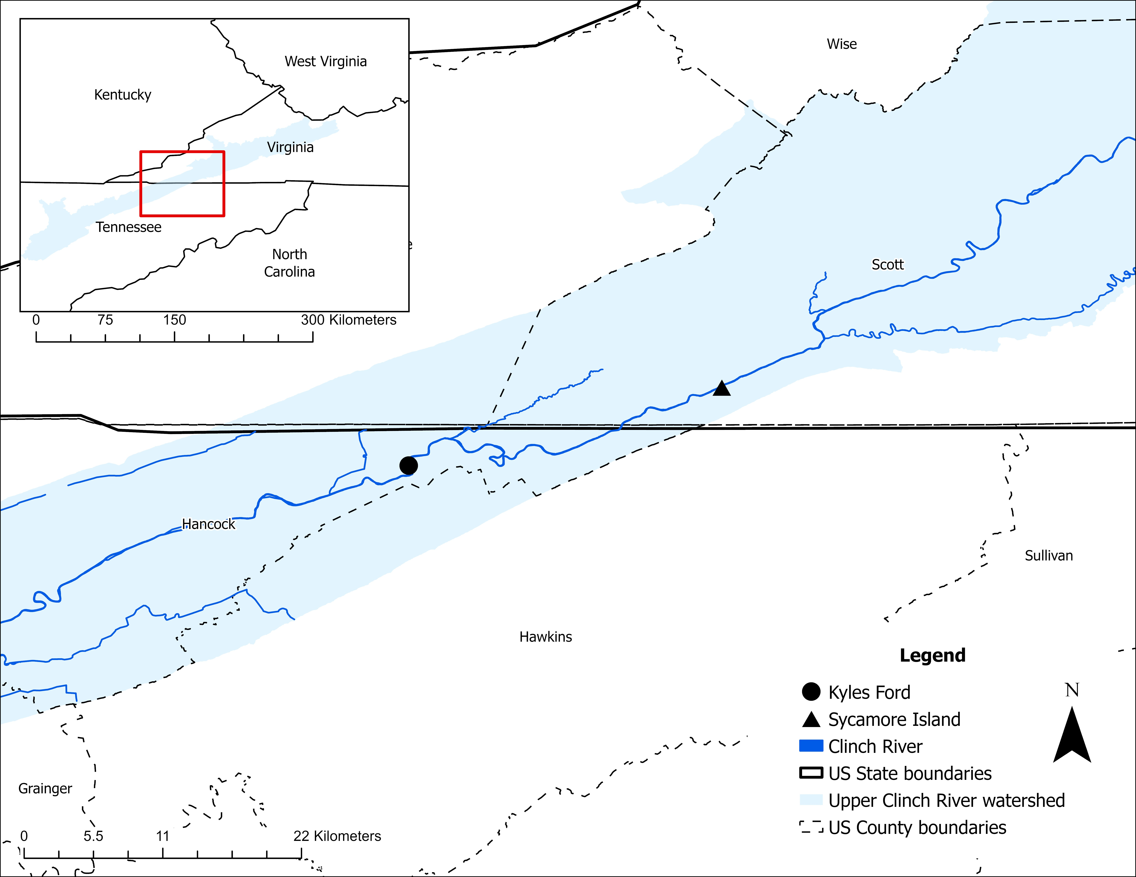
Figure 5.1: Map of our sampling sites at the Clinch River, Kyles Ford (Tennessee) and Sycamore Island (Virginia).

2023 using a random quadrat sampling approach. During each survey several 0.25 m² sampling quadrats were randomly deployed across the study area. Each quadrat was hand-excavated to a depth of 6 inches, and all mussels were identified to species, sexed if sexually dimorphic, and measured for length before being returned to the substrate. Abundances were calculated by multiplying the number of individuals found in each quadrat by the total number of quadrats excavated within the study area. A detailed example of this methodology is described by Lane et al., 2021.
Abundance and length structure of dead individuals
Between May 2021 and December 2023, we conducted 53 bi-weekly to monthly surveys at two sites: Kyles Ford (n = 22) and Sycamore Island (n = 31). Two survey methods were used to quantify mortality and collect shells for aging. From May 2021 and October 2022, we conducted 30-minute timed searchers where researchers systematically walked the study site to collect all fresh empty shells, recently deceased individuals, and any mussels displaying signs of morbidity (i.e., unburied on the benthos, gaping shell, flaccid foot, or diminished response to tactile stimulation). From October 2022 to December 2023, we implemented a structured, repeated survey design to support estimation of detection probability using an N-mixture model. During each repeated survey, two passes were conducted. At the start of each pass, two researchers positioned themselves on opposite stream banks at the downstream end of the sampling unit. From their starting positions, they navigated toward the midpoint of the stream, walked upstream 1 meter, and then returned to the streambank parallel to their previous path. This pattern was repeated for 30 minutes, with both researchers gradually progressing upstream until they reached the upper boundary of the sampling unit. The researchers then switched sides and conducted the second pass using the same method. All individuals collected were measured to the nearest millimeter using a field caliper.
Age structure of dead individuals
We examined shell thin sections to determine the age of a representative sample of dead A. pectorosa collected during field surveys. We randomly selected a total of 192 shells for aging (Kyles Ford: 78; Sycamore Island: 114). Shells were divided into 10 mm length strata, and up to 10 individuals were randomly selected from each stratum. Following a modified protocol described by Haag and Commens-Carson (2008), we prepared thin sections using an IsoMet Low Speed Saw (Buehler, part #11-1280-160) equipped with a 5-inch diamond wafering blade (Buehler, part #11-4215) and a wafer chuck (Buehler, part #11-1186). The right valve of each shell was sectioned diagonally through from the umbo to the ventral margin. We selected the anterior end of the resulting halves, and wet-sanded the cut surface through a series of progressively finer wet-dry sandpaper (300, 400, 600, 1500 grit). We then attached the cut surface to a full-frosted microscope slide (Fisherbrand, catalog no. 12-550-401) using liquid adhesive (JB Weld ClearWeld epoxy) and left to dry overnight. The following day, the slides were attached to the wafer chuck using paraffin wax. This was achieved by heating the chuck on a hot plate, melting a paraffin bar onto the chuck, and securing the slide into the melted wax until it solidified (Haag and Commens-Carson 2008). The chuck was then mounted onto the saw, and the remaining shell was sectioned with the micrometer dial set to 17.15 µm, yielding a thin section. Finally, the thin sections were wet-sanded again following the same grit progression to prepare them for interpretation. Two trained observers read each shell thin section independently and recorded their annuli count. Discrepancies in age estimates were resolved by re-reading the sections together, and if consensus could not be reached, the shell was removed from the study.
Water temperature and discharge data
At the start of the study, we attached two HOBO Pendant MX water temperature data loggers (HOBO, part # MX2201) to silos at each site and programmed it to continuously record water temperature in one-hour increments. We retrieved average daily river discharge data (January 2021 to December 2023) from United States Geological Survey gages located in the Clinch River near Looney’s Gap, Tennessee (ID #03527220) and at Speers Ferry, Virginia (ID# 03527000)
Statistical analysis
Length and age comparisons
A series of statistical analyses were conducted to examine differences in mussel length and age between sites, and between live and dead individuals. We performed separate Kruskal-Wallis tests to compare mussel length and age between sites for live, dead, and all mussels (i.e., dead and live mussels combined). We assessed normality and homogeneity of variance using the Shapiro-Wilk test and Levene’s test for all models. Tukey’s post-hoc tests were used to identify significant pairwise differences. Analyses were conducted in R Statistical Software v4.4.2 (R Core Team 2024).
Length-based mortality and age structure of dead mussels
A chi-square goodness-of-fit test (Gotelli and Ellison, 2004) was used to identify length classes with disproportionately high or low mortality (a = 0.05). Length was grouped into 7 classes (0–50 mm, 50–60 mm, 60–70 mm, 70–80 mm, 80–90 mm, 90–100 mm, and 100+ mm), with wider bins at the lower and upper ends due to small sample sizes for individuals <60 mm and >100 mm. Since Kyles Ford only contained individuals up to 100 mm, it had six classes with the largest being 90–100 mm. Standardized residuals were examined to identify specific length classes with significant deviations from expected values, providing insight into differences between live and dead mussels.
We used a chi-square test to evaluate whether the distribution of dead mussels across age categories differed between sites. First, we used k-means clustering to identify optimal grouping where ages shared minimal length overlap. Based on those results, we grouped mussels into four age classes: 1-5, 6-8, 9-16, and 17+ years. Standardized residuals from the chi-square test were examined to identify which age classes contributed most to differences between sites. Additionally, we used a Kruskal-Wallis test to assess whether the median age of dead mussels differed between sites. Analyses were conducted in R Statistical Software v4.4.2 (R Core Team 2024).
N-Mixture model
We used an adapted N-mixture modeling approach to estimate the number of dead A. pectorosa (i.e., abundance of dead individuals) while accounting for imperfect detection (Royle 2004). This model approach was originally designed to estimate population size using count data when the probability of detection was imperfect, which is inherent in all animal surveys. Detection probability in these models is derived from repeated counts performed at the same locations over time and is influenced by ecological factors affecting organism presence (i.e., the ecological process) and observation factors influencing detectability (i.e., the observation process). The standard model is structured as follows:
$$Abundance process=N_{i}\sim Poisson(λ_{i})$$
$$Observation process = C_{ij}\sim Binomial(N_{i},p)$$
Where,
$N_{i}$ = true abundance at site $i$, which is the actual number of individuals present
$C_{ij}$ = observed count at site $i$ during survey $j$, which is a function of both true abundance and detection probability.
$p$ = detection probability, which is the likelihood of detecting an individual
Our adaptation uses repeated count data from moribund/dead A. pectorosa, and freshly empty shells found on the substrate surface. We consider abundance $( N_{i} )$ the actual number of dead individuals available to be detected (i.e., represented by shells), observed count $(C_{ij}$) as the as the number of shells observed during surveys, and $p$ as a constant detection probability. Because shells are physically removed once detected during each pass, our observed counts $(C_{ij}$) depend not only on imperfect detection but also on the removal of shells from previous passes. To address this, we adjusted the standard N-mixture framework by incorporating cumulative detection/removal into the observation model, allowing us to explicitly account for both imperfect detection and the progressive removal of shells over successive surveys. To model abundance of dead individuals, we selected Julian Day, discharge, and temperature as predictors based on ecological relevance, as mortality may exhibit seasonal variation (Julian Day), temperature fluctuations could directly affect mussel mortality, and high discharge may physically remove shells from the sampling area. Our model assumes (1) a closed population, where no new shells are added to the survey area between repeated surveys due to sequential sampling; (2) no double-counting, as shells are physically removed once detected; and (3) independent detection, where the detection of one shell does not influence the detection of another. The adjusted models are structured as follows:
- Abundance process:
$$N_{i}\sim Poisson\left(λ_{i}\right)$$
$$\log\left(λ_{i}\right)=γ_{0}+γ_{1}*L_{i}+γ_{2}*JD_{i}+γ_{3}*T_{i}+ γ_{4}*D_{i}$$

$$i=site, Sycamore Island or Kyles Ford$$
$$N_{i}=latent abundance state at site i \\ λ_{i}= expected abundance state at site i \\ L_{i}=location or site i \\ JD_{i}=standardized Julian Day at site i \\ T_{i}=standardized average temperature between surveys at site i \\ D_{i}=standardized average river discharge between surveys at site i$$
Priors:
$$γ_{0}\sim Normal(2, 1.5) \\ γ_{1}\sim Normal(0, 1) \\ γ_{2}\sim Normal(0, 3) \\ γ_{3}\sim Normal(0, 3) \\ γ_{4}\sim Normal(0, 3)$$
- Observational process:
$$C_{ij}|N_{i}\sim Binomial\left(N_{i}-\sum_{k=1}^{j-1}{C_{ik}}, p\right)$$
$$\operatorname{logit}\left(p\right)=β_{0}$$
$$C_{ij}= count at site i during survey j \\ C_{ij-1}=count at site i during survey j-1$$
$$N_{i}=latent abundance state at site i \\ p=detection probability$$
Priors:
$$β_{0}\sim Normal(0, 3)$$
The model was implemented in Stan via CmdStan (v2.36.0) and CmdStanR (v0.8.1), with analyses conducted in R Statistical Software v4.4.2 (R Core Team 2024). We used normal weakly informative priors for the mode. Seed was set to “1234” and posterior estimation was performed using Markov Chain Monte Carlo (MCMC) with 4 chains and 3,000 iterations per chain (1,000 warmup + 2,000 sampling). Model convergence was assessed using R-hat values and Effective Sample Size (ESS) values.
Percent Mortality
First, we quantified the total number of dead A. pectorosa collected per month. Then, we calculated naïve monthly percent mortality (i.e., unadjusted for detection probability), denoted as ${PM}^{naive},$using the following formula:
$${PM}^{naive}= ( \frac{D}{\hat{N}} )× 100$$
where: $D$ ​ = number of dead individuals observed and $\hat{N}$ = abundance estimates from quadrat surveys. To estimate corrected monthly percent mortality, we incorporated detection probability ($p$) from our N-mixture model. First, we calculated the adjusted number of dead individuals:
$$D^{adj}= \frac{D}{ p}$$
Then, we calculated corrected monthly percent mortality ${PM}^{corr}$ as:
$${PM}^{corr}=( \frac{D^{adj}}{\hat{N}} )× 100$$
Total percent mortality for each year was calculated by summing monthly percent mortalities, providing an estimate of cumulative mortality over the survey year.

Results
Abundance of live individuals and percent mortality
A total of 70 live A. pectorosa were collected at Kyles Ford and 453 at Sycamore Island between 2021 and 2023 using quadrat surveys (Table 5.1). Estimated abundance of A. pectorosa at Sycamore Island ranged from 4,545 in 2021 to 6,400 in 2023. At Kyles Ford, the estimated abundance ranged from 4,004 in 2022 to 8,825 in 2023 (Table 5.1).
We collected a total of 431 dead A. pectorosa individuals at both sites (Table 5.1). At Kyles Ford, the total number of dead individuals per year corresponded to a naïve percent mortality of 0.52%, 2.42%, and 0.69% of the estimated annual A. pectorosa abundance for 2021, 2022, and 2023, respectively (Figure 5.2; Appendix D, Table A.5.1). At Sycamore Island, the naïve percent mortality corresponded to 1.03% in 2021, 2.83% in 2022, and 0.77% in 2023. Monthly percent mortality varied throughout the study period but never exceeded 1.49%. The highest percent mortality was observed in 2022 and lowest in 2023. The highest monthly values were observed in October and November of both 2022 and 2023 (Figure 5.2; Appendix D, Table A.5.1).
After adjusting for detection probability ($p = 0.767)$, corrected percent mortality increased for all months and years. In 2022, corrected mortality reached approximately 3% of the estimated population at Kyles Ford and 3.5% at Sycamore Island. In comparison, corrected percent mortality estimates for 2021 and 2023 ranged from 0.64% to 1.28% (Figure 5.2; Appendix D, Table A.5.1).

Table 5.1: Summary of length of live and dead Pheasantshell (Actinonaias pectorosa) at Kyles Ford (Tennessee) and Sycamore Island (Virginia) along with estimated abundance of live individuals based on quadrat surveys.

 | Kyles Ford |  |  |  |  | Sycamore Island
 | Dead |  | Live |  |  | Dead |  | Live
Year | Mean length (range, mm) | n | Mean length (range, mm) | n | Estimated abundance (95% CI) | Mean length (range, mm) | n | Mean length (range, mm) | n | Estimated abundance (95% CI)
2021 | 78 (64 – 98) | 40 | 62 (7 – 89) | 31 | 7,750 (2,939– 20,436) | 86 (57 – 104) | 47 | 64 (13 – 112) | 169 | 4,545 (3,569 – 5,787)
2022 | 73 (46 – 92) | 97 | 61 (28 – 91) | 14 | 4,004 (1,325– 12,103) | 78 (40 – 109) | 137 | 58 (11 – 115) | 134 | 4,845 (3,737 – 6,283)
2023 | 73 (41 – 98) | 61 | 73 (44 – 97) | 25 | 8,825 (9,702– 110,972) | 85 (54 – 109) | 49 | 62 (22 – 101) | 150 | 6,400 (5,028 – 8,147)
Total | - | 198 | - | 70 | - | - | 233 | - | 453 | -

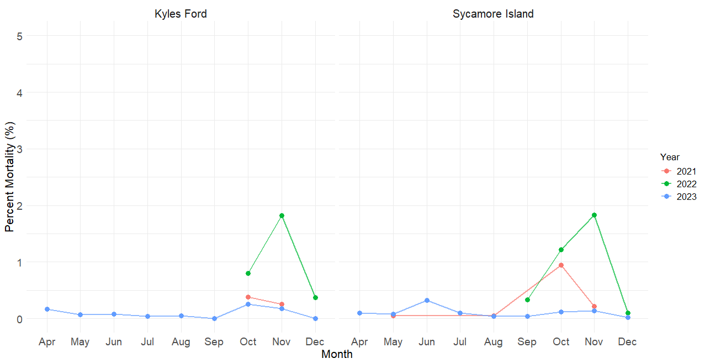
Figure 5.2: Monthly percent mortality of Pheasantshell (Actinonaias pectorosa) at Kyles Ford (Tennessee) and Sycamore Island (Virginia) in the Clinch River between 2021 and 2023. Percent mortalities were calculated by dividing the corrected abundance of dead individuals by the annual abundance estimate of live individuals. See Material and Methods for calculations.

Length and age structure
The length of live individuals varied broadly at Kyles Ford and Sycamore Island, although mean length did not differ between sites (p = 0.3627). Live individuals were on average shorter than dead individuals across sites (p < 0.001; Figure 5.3). Dead individuals at Sycamore Island exhibiting greater mean length than those at Kyles Ford (Table 5.1, Figure 5.3).
Age of dead A. pectorosa ranged from 3–17 years at Kyles Ford and 3–34 years at Sycamore Island (Figure 5.4; see Appendix D, Table A.5.2). We observed a growth asymptote around age 8 or 9 (Figure 5.4). There were minimal length overlaps between 3-year-olds and older age classes, as well as between 4-year-olds and individuals aged 7 years and older, and between 5-year-olds and those aged 9 years and older (Figure 5.4). Significantly more older individuals were observed at Sycamore Island compared to Kyles Ford (p = 0.01; Table 2, Figure 5.5). At Sycamore Island, we observed no difference in the proportion of mussels across age groups, whereas at Kyles Ford, the distribution was different among age groups (χ², p < 0.001), with individuals aged 6–8 years being the most prevalent and those aged 17+ years the least prevalent (Figure 5.5). When comparing between sites, the proportions of individuals in the 6–8 and 17+ age categories differed between Sycamore Island and Kyles Ford.
Mortality among length classes
There were significant differences in the distribution of dead and live individuals across length classes at both Sycamore Island ($x^{2}=149.49, p= <0.001$) and Kyles Ford ($x^{2}=77.98, p= <0.001)$. Mortality was disproportionately lower among 0-60 mm length classes at both sites, higher among the 70 – 90 mm length class at Kyles Ford and for all length classes above 70 mm at Sycamore Island (see Appendix D, Table A.5.3).

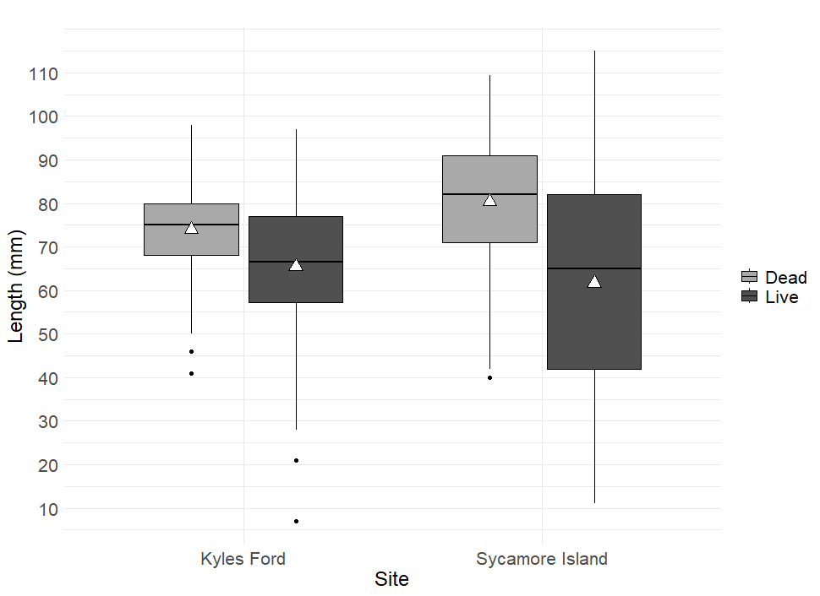
Figure 5.3: Box plots of length for dead and live Pheasantshell (Actinonaias pectorosa) collected at Kyles Ford (Tennessee) and Sycamore Island (Virginia) from the Clinch River. Dead mussels were collected between 2021-2023. Length from live mussels were acquired during monitoring efforts conducted by state agencies during the same years. White triangles represent mean lengths, and solid black circles represent outliers.

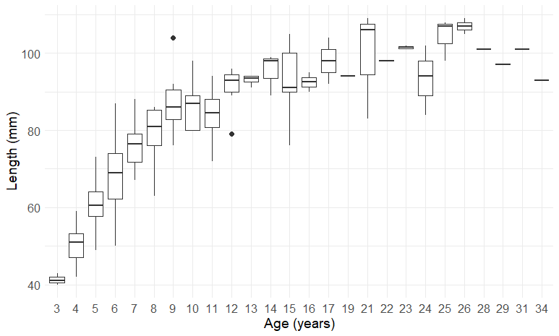
Figure 5.4: Box-plots representing length-at-age from 192 dead Pheasantshell (Actinonaias pectorosa) collected at Kyles Ford (Tennessee) and Sycamore Island (Virginia) in the Clinch River between 2021-2023.

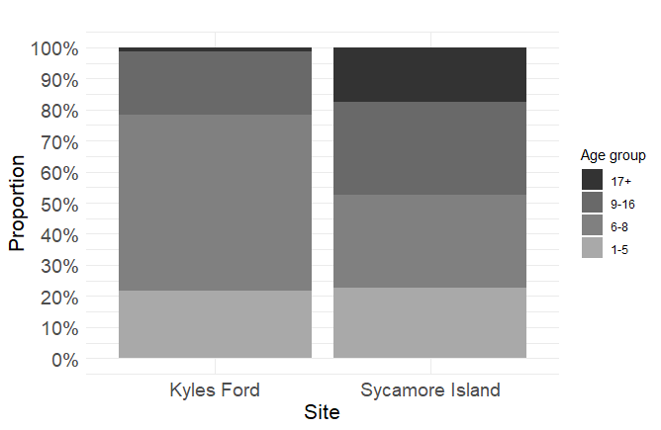
Figure 5.5: Proportion of dead Pheasantshell (Actinonaias pectorosa) by age category at Kyles Ford (Tennessee) and Sycamore Island (Virginia) in the Clinch River. Dead mussels were collected between 2021-2023.

Water temperature and discharge
Water temperatures ranged from 0.04°C to 28.9°C between 2021 and 2023, with highest temperatures recorded in June and July and lowest temperatures recorded in December and January (see Appendix D, Figure A.5.1). Discharge ranged from 123 ft³/s to 25,900 ft³/s with notable peaks over 15,000 ft³/s in March of 2021, February and July of 2022, and February of 2023 (see Appendix D, Figure A.5.2).
N-mixture model results
A total of 318 (Kyles Ford = 161; Sycamore Island = 157) A. pectorosa were collected over 42 sampling days during repeated surveys and were used to inform our N-mixture model. The results revealed a detection probability of 76.7% (95% CI: 69.2 – 83.0%). After correcting for detection probability, we estimated a total of 355 individuals died, representing a mortality frequency of 8.44 individuals per day. The mean expected abundance of dead individuals per survey was 7.39 individuals (95% CI: 6.36 – 8.58). Kyles Ford had slightly higher expected abundance of dead individuals than Sycamore Island, but the credible interval overlapped zero, suggesting weak evidence for a location effect (Table 5.2).
Julian Day was the strongest predictor of abundance of dead individuals, where for every standard deviation increase (~79 days), abundance increased by 37.42%. Temperature had a moderate negative effect, corresponding to a 19.6% decrease per standard deviation increase (6.9°C). Discharge had a weak negative effect, where for every standard deviation increase (4,611 cfs), the abundance of dead individuals decreased by 2.1% (Table 5.2).

Discussion
Mortality and seasonal patterns
Mortality of A. pectorosa at our sites during the study period was low but consistent over time,
Table 5.2: N-mixture model output summary.

Parameter | Mean Estimate  (95% Credible Interval) | Standard deviation | Back transformed
Detection Probability (β0) | 1.19 (0.808 – 1.58) | - | 0.767 (0.692 – 0.830)
Baseline Abundance (γ0) | 1.97 (1.82 – 2.11) | - | 7.39 ( 6.37 – 8.57)
Location Effect (γ1) | 0.136 (-0.056 – 0.326) | - | 10.15 (-8.91 – 33.59)
Julian Day Effect (γ2) | 0.306 (0.161 – 0.459) | 78.81 | 37.42 (18.68 – 59.93)
Temperature Effect (γ3) | -0.218 (-0.346 – -0.0858) | 6.97 | -20.49 (-30.15 - -9.53
Discharge Effect (γ4) | -0.0247 (-0.165 – 0.105) | 4,611 | -2.07 (-15.18 – 11.28)

rather than concentrated over a short period. Mortality was detected in every month of the year at
either Sycamore Island or Kyles Ford. Though proportions varied, monthly percent mortality did not exceed 1.49% of the estimated abundance of A. pectorosa at either site. In 2023, when we had the greatest monthly coverage, percent mortality from April through December represented less than 1% of the estimated abundance at both sites. Given that we sampled 9 of 12 months, annual percent mortality for 2023 is unlikely to deviate significantly from these estimates. In comparison to other species, these values are lower than previously reported annual mortality rates from quadrat sampling for Epioblasma brevidens (6.2%), Epioblasma capsaeformis (7.5%), and Lampsilis fasciola (6.0%) in the Clinch River between 2004 and 2008 (Jones and Neves 2011).
To our knowledge, no studies have quantified seasonal background mortality in stable mussel populations. As a result, it is difficult to determine whether the mortality we observed represents background seasonal mortality in stable population or a pattern of significant elevated. Both sites showed a seasonal increase in mortality during the fall, and while the scale of mortality was not catastrophic, it may still represent a biologically meaningful pulse that would go unnoticed without standardized surveys. Recurring periods of elevated mortality could contribute to population decline over time, and long-term data are needed to determine whether fall mortality is a consistent seasonal pattern and whether the observed levels are high enough to drive long-term declines. Interestingly, although mortality peaked in the fall, we detected Yokenella regensburgei in moribund A. pectorosa at Kyles Ford during both low and high mortality months (May, August, October, and November of 2021; October and November of 2022; see Chapter 2), suggesting that its presence alone does not fully explain elevated mortality in the fall. If mortality is truly seasonal, peaking in fall, then previous diagnostic investigations conducted outside that time frame may have missed the agents associated with elevated mortality, instead detecting background infections and disease. This could help explain why Yokenella was not consistently observed histologically in previous studies. Our findings emphasize the value of pairing standardized, seasonal field investigations with diagnostic tests to contextualize pathogen presence in relation to observed mortality patterns. This integrated approach strengthens our ability to interpret diagnostic results, improves the likelihood of identifying relevant host-pathogen-environment interactions, and allows for the identification of elevated mortality events that may go unnoticed yet still impact population structure and viability.
The methods we used likely underestimate total mortality because they are limited to individuals on the substrate surface and do not account for mussels that die and remain buried. However, while not formally documented for all species, mussels are generally observed emerging onto the substrate when moribund (Richard et al. 2020; Cossey et al. 2025). This behavior is commonly relied upon during field-based mortality investigations to locate and collect individuals for diagnostic tests (Cossey et al. 2025). With an average detection probability of 76%, we believe our estimates, while conservative, provide a reasonable approximation of mortality during the study period at our sites. Importantly, this study establishes a refence values for evaluating mortality patterns over time and assessing whether future observed patterns remain stable, intensify, or shift in timing or magnitude.
We observed a clear seasonal pattern in mortality, with the abundance of dead mussels increasing later in the year. This pattern aligns with anecdotal observations that historical MMEs peaked in the fall (Richard 2018). In our model Julian Day was the strongest predictor. However, Julian Day itself is not a direct driver of mortality but rather serves as a proxy for environmental and biological processes that change seasonally. For example, as the year progresses, water temperature and discharge decreases, both of which may influence mussel health and food availability (Atkinson et al. 2009, 2011). Additionally, biological processes such as reproduction are tied to seasonal cues and could contribute to increased physiological stress or energy demands later in the year (Haag 2012; Zając et al. 2025). While the abundance of dead mussels was negatively associated with temperature and discharge, these relationships were weak, suggesting that neither of those variables explains the pattern on their own. Instead, mortality is likely influenced by a confluence of factors, including environmental conditions and intrinsic biological processes that co-occur and intensify in the latter part of the year.
Higher abundances of dead individuals in the fall may reflect the cumulative impact of shifting thermal regimes, temperature stress, reproductive energy demands, and seasonal changes in food availability (Haag 2012). It is possible that A. pectorosa at our sites are stressed by high water temperatures in the summer, but actual death is delayed. Water temperatures in the Clinch River ranged from 0.04°C – 29.26°C during our study period, with all temperatures exceeding 26.6°C occurring in June, July, and August when mortality proportions were not notably high in 2023. Therefore, it is unlikely that the majority of the mortality observed in A. pectorosa was due to high temperatures. However, we observed high temperatures at our sites that have been shown to harm different life stages of other species (Pandolfo et al. 2010; Hopper et al. 2023; Fogelman et al. 2023; Mildenberger et al. 2025), although that seems to be common in several river systems with high mussel richness and abundance (Pandolfo et al. 2024). Prolonged exposure to temperature thresholds may induce metabolic changes and sublethal stress, increasing susceptibility to mortality later in the season (Ganser et al. 2015; Payton et al. 2016). Thermal tolerance varies across mussel species and life stages (Pandolfo et al. 2010; Fogelman et al. 2023). Adult lethal temperature resulting in 5% (LT05) and 50% (LT50) mortality in various species have been reported to range from 19.8 °C – 37.22 °C and 31.1 °C – 39 °C, respectively (Hopper et al. 2023; Fogelman et al. 2023; Mildenberger et al. 2025). While the thermal tolerance of A. pectorosa is unknown, it is likely to fall within reported ranges since many species with documented thresholds belong to the same tribe and share similar life history traits, suggesting comparable physiological responses (Haag 2012; Moore et al. 2021; Hopper et al. 2023). Future studies should aim at using long-term mortality monitoring to assess thermal tolerances of mussel populations in situ, which is rarely done (Pandolfo et al. 2024).
Reproduction and brooding may also impose significant energetic demands (Zając et al. 2025) that contribute to delayed mortality. As long-term brooders, male A. pectorosa spawn in late summer to early fall (Williams et al. 2008). This reproductive effort coincides with seasonal shifts in temperature and food availability, which may limit their ability to replenish energy reserves and maintain physiological function later in the fall (Haag 2012). Similarly, females are gravid from September through May (Williams et al. 2008) and in the fall they may be in a post-reproductive recovery phase or initiating a new brooding cycle. These energetically demanding reproductive processes combined with shifting environmental conditions may further compound physiological stress (Zając et al. 2025). Together, these biological and environmental pressures combined could reduce physiological resilience and make individuals more susceptible to disease such as yokenellosis. More research is needed to investigate the role of reproductive energy costs in seasonal mortality patterns (Zając et al. 2025), which could be achieved by implementing similar methods used in this study on sexually dimorphic species.
Seasonal variation in food availability may also contribute to mortality. Food composition and availability are widely recognized as critical components of mussel population health, influencing physiological processes such as growth, reproduction, immune function, and energy allocation (Raikow and Hamilton 2001; Vaughn and Hakenkamp 2001; Atkinson 2009, 2011; Tran and Ackerman 2011). Seasonal shifts in bacterial and algal communities, driven by changes in temperature, light, and nutrient input, can alter both the quantity and quality of food available to mussels (Atkinson et al. 2009, 2011). These fluctuations, especially when occurring alongside other stressors, may reduce physiological resilience. For instance, if energy demands are high but food resources are limited, mussels may experience energetic deficits that compromise immune function and increase susceptibility to disease (Vaughn and Hakenkamp 2001). It is important to recognize that riverine ecosystems are highly dynamic, with many biotic and abiotic processes varying seasonally (Minshall et al. 1985; Álvarez-Cabria et al. 2016; Hughes et al. 2019). In addition to temperature and discharge, other elements such as dissolved oxygen, nutrient input, sediment dynamics, and biotic interactions also change throughout the year and may influence mussel health and survival (Haag et al. 2019). While these factors were not directly measured in this study, they likely contribute to the broader seasonal context in which mortality occurs.

Age and length mortality patterns
Observed age and length patterns among dead mussels strongly support the conclusion that the 2016 MME had a lasting impact on population structure, particularly through the loss of older individuals. Notably, larger individuals were apparently disproportionally affected during the 2016 MMEs, particularly at Kyles Ford (Jordan Richard and Caitlin Carey, personal communication). Among the dead mussels in our study, individuals that were 17+ years old in 2021–2023 would have been at least 8 years old at the time of the 2016 MME, while individuals in the 6 – 10-year-old class were either not born yet or were only up to five years old. In stable populations, older age classes tend to dominate the assemblage of dead individuals, reflecting age-related mortality (Haag 2012). The reduced presence of these older age classes at Kyles Ford, compared to Sycamore Island, therefore suggests a demographic disturbance consistent with a substantial mortality event that removed older individuals from the population leading to fewer surviving members in subsequent years.
Interestingly, mortality at our study sites appears to follow a length-based pattern, with larger individuals disproportionately represented among the dead and smaller individuals underrepresented. This pattern aligns with our previous findings that smaller A. pectorosa did not appear to be affected by diseases impacting larger individuals (Da Silva Neto et al. 2024) or by microcystin accumulation (Chapter 2). This pattern is not unique to A. pectorosa, as higher survival in younger mussels is has been reported in Epioblasma capsaeformis, Epioblasma brevidens, Lampsilis fasciola, and Cambarunio iris found in the Clinch River (Jones and Neves 2011). A commonly proposed explanation for the underrepresentation of small individuals is that they are harder to detect or more likely to wash away, reducing the likelihood of being recovered (Strayer and Smith 2003). To address this, we employed a robust qualitative method that combined timed and transect surveys, ensuring systematic coverage of the entire stream channel (Strayer and Smith 2003). Similar methods have been shown to improve the detection of rare and small-bodied species (Smith 2006). In addition, consistently low discharge between surveys makes it unlikely that shells were displaced outside the sampling area. Our detection of smaller-bodied species, including Medionidus conradicus and Corbicula fluminea, further supports the effectiveness of our survey approach and suggests that smaller mussel shells were not preferentially lost due to flow conditions. Taken together, these findings suggest that the observed size-based mortality pattern likely reflects true differences in susceptibility rather than sampling artifacts.
Our results extended the known maximum age of A. pectorosa (21 years reported by Scott 1994 at Kyles Ford) to 34 years from an individuals at Sycamore Island. This lifespan places A. pectorosa in the category of moderately long-lived unionid species. Longer lived species tend to occur in more stable environments (Haag 2012), indicating that Sycamore Island may be a stable shoal. While not as long-lived as some species that can exceed 50–100 years (e.g., Cyclonaias pustulosa, Margaritifera margaritifera), this longevity suggests that individuals may contribute to reproduction over multiple decades (Haag 2012). As with other long-lived mussels, this extended lifespan is likely paired with delayed maturity and episodic recruitment (Haag 2012), which may make populations particularly vulnerable to recurring adult mortality events.
Conservation implications and future directions
We recommend sampling designs that are compatible with N-mixture modeling to quantify mussel mortality and environmental drivers, particularly in systems with low and variable shell counts. These models account for imperfect detection (Royle 2004), addressing the common issue that not all moribund mussels, carcasses, or freshly dead shells are detected. They also allow assessment of covariates influencing detection and mortality patterns over time (Kéry et al. 2009).
Our field methods also provide a rapid and extensive quantitative assessment of mortality with high shell detection. While quadrat sampling with excavation may provide a more precise estimate of mortality abundance (Strayer and Smith 2003), such intensive methods are often impractical or impossible due to logistical or regulatory constraints, particularly when rapid response is needed to investigate mortality events. For instance, frequent quadrat digging may not be permitted in areas with threatened and endangered species. Our approach overcomes these limitations and allows simultaneous collection of valuable demographic data associated with mortality. Lastly, the observed seasonality in mortality has important implications for monitoring efforts. If mortality surveys are conducted primarily in the fall, they may overestimate the abundance of dead individuals while missing key seasonal variations in mortality, providing limited insight into mortality drivers.
While the methods described here can be used to assess MMES, they are not designed exclusively for rapid response. The primary purpose of our approach is to quantify background mortality under normal conditions. We recommend that managers implement these methods in stable or at-risk populations as part of long-term monitoring, to characterize natural variation in mortality and improve the ability to detect deviations from typical levels. With repeated use, this framework can help identify timing and extent of background mortality and contextualize MMEs.
It is important to not that applying a single survival estimate to the entire Clinch River population may obscure important spatial variation in mortality. Therefore, adopting site-specific conservation and management strategies are critical for sustaining long-term population viability. This recommendation is supported by observed differences in age-class structure between Kyles Ford and Sycamore Island indicate that each site may experience distinct mortality dynamics. These findings emphasize that mortality and survival are not homogenous throughout the river system and are consistent with previous observations by Jones and Neves (2011), who reported environmentally driven, site-specific variation in mussel mortality.
If the goal is to better understand patterns of age-specific mortality and generate hypotheses about underlying mechanisms, future research should prioritize aging dead individuals. Length-based analyses are commonly used in population assessments because length data are easy to collect, whereas estimating age from shell annuli is not possible in live individuals (Haag 2012). However, size becomes an increasingly unreliable predictor of age in older individuals as shell growth slows and approaches an asymptote with age (Haag 2012). As a result, older mussels of similar length can differ in age by a decade or more, making it impossible to determine whether mortality is affecting younger, middle-aged, or older cohorts without direct age estimates. Periodic aging of dead individuals can reveal selective mortality among juveniles or adults and inform how environmental factors affect age classes. Age-specific mortality data is also useful for population viability analyses (PVA), which are usually conducted for endangered species but rarely for more common species (Berg et al. 2008). Yet, studying common species like A. pectorosa can provide a valuable opportunity for more comprehensive assessments that inform broader conservation strategies.

References
Aldridge, D.C., Ollard, I.S., Bespalaya, Y.V., Bolotov, I.N., Douda, K., Geist, J., Haag, W.R., Klunzinger, M.W., Lopes‐Lima, M., Mlambo, M.C. and Riccardi, N., 2023. Freshwater mussel conservation: A global horizon scan of emerging threats and opportunities. Global Change Biology, 29(3), pp.575-589.
Atkinson, C.L., Golladay, S.W., Opsahl, S.P. and Covich, A.P., 2009. Stream discharge and floodplain connections affect seston quality and stable isotopic signatures in a coastal plain stream. Journal of the North American Benthological Society, 28(2), pp.360-370.
Álvarez-Cabria, M., Barquín, J. and Peñas, F.J., 2016. Modelling the spatial and seasonal variability of water quality for entire river networks: Relationships with natural and anthropogenic factors. Science of the Total Environment, 545, pp.152-162.
Berg, D.J., Levine, T.D., Stoeckel, J.A. and Lang, B.K., 2008. A conceptual model linking demography and population genetics of freshwater mussels. Journal of the North American Benthological Society, 27(2), pp.395-408.
Bernardino, J., Bispo, R., Costa, H. and Mascarenhas, M., 2013. Estimating bird and bat fatality at wind farms: a practical overview of estimators, their assumptions and limitations. New Zealand Journal of Zoology, 40(1), pp.63-74.
Bispo, R., Bernardino, J., Marques, T.A. and Pestana, D., 2013. Modeling carcass removal time for avian mortality assessment in wind farms using survival analysis. Environmental and Ecological Statistics, 20, pp.147-165.
Carroll, C., Lacy, R.C., Fredrickson, R.J., Rohlf, D.J., Hendricks, S.A. and Phillips, M.K., 2019. Biological and sociopolitical sources of Uncertainty in population Viability Analysis for endangered species Recovery planning. Scientific Reports, 9(1), p.10130.
Cossey, D.A., Dennis, M.M., Richard, J., Della Torre, C., McElwain, A., Waller, D.L., Knowles, S., Brian, J.I., Leis, E., Burioli, E.A. and Aldridge, D.C., 2025. Sampling mass mortality events to enable diagnoses: A protocol using freshwater mussels. Methods in Ecology and Evolution.
Da Silva Neto, J.G., Hardman, R.H., Engman, A.C., Dinkins, G.R., Lane, T.W., Fry, M.M., Rines, C.R., Bisenieks, A.L., Rajeev, S. and Dennis, M.M., 2024. Multisystemic inflammatory disease in Pheasantshell (Unionidae, Actinonaias pectorosa) associated with Yokenella regensburgei infection at sites experiencing seasonal mass mortality events. Plos one, 19(8), p.e0301250.
Ficetola, G.F., Barzaghi, B., Melotto, A., Muraro, M., Lunghi, E., Canedoli, C., Lo Parrino, E., Nanni, V., Silva-Rocha, I., Urso, A. and Carretero, M.A., 2018. N-mixture models reliably estimate the abundance of small vertebrates. Sci Rep 8: 10357 [online]
Fogelman, K.J., Archambault, J.M., Irwin, E., Walsh, M., Brewer, S. and Stoeckel, J.A., 2023. A review of lethal thermal tolerance among freshwater mussels (Bivalvia: Unionida) within the North American faunal region. Environmental Reviews, 31(2), pp.278-297.
Ganser, A.M., Newton, T.J. and Haro, R.J., 2015. Effects of elevated water temperature on physiological responses in adult freshwater mussels. Freshwater Biology, 60(8), pp.1705-1716.
Gotelli, N.J. and Ellison, A.M., 2004. A primer of ecological statistics (Vol. 1, pp. 1-640). Sunderland: Sinauer Associates.
Guy, C.S. and Brown, M.L. eds., 2007. Analysis and interpretation of freshwater fisheries data. American Fisheries Society.
Haag, W.R. and Commens-Carson, A.M., 2008. Testing the assumption of annual shell ring deposition in freshwater mussels. Canadian Journal of Fisheries and Aquatic Sciences, 65(3), pp.493-508.
Haag, W.R., 2012. North American freshwater mussels: natural history, ecology, and conservation. Cambridge University Press.
Haag, W.R. and Williams, J.D., 2014. Biodiversity on the brink: an assessment of conservation strategies for North American freshwater mussels. Hydrobiologia, 735, pp.45-60.
Haag, W.R., 2019. Reassessing enigmatic mussel declines in the United States. Freshwater Mollusk Biology and Conservation, 22(2), pp.43-60.
Haag, W.R., Culp, J.J., McGregor, M.A., Bringolf, R. and Stoeckel, J.A., 2019. Growth and survival of juvenile freshwater mussels in streams: Implications for understanding enigmatic mussel declines. Freshwater Science, 38(4), pp.753-770.
Hastie, L.C. and Toy, K.A. 2008. Changes in density, age structure and age‐specific mortality in two western pearlshell (Margaritifera falcata) populations in Washington (1995–2006). Aquatic Conservation: Marine and Freshwater Ecosystems, 18(5), pp.671-678.
Hopper, G.W., Bucholz, J.R., DuBose, T.P., Fogelman, K.J., Keogh, S.M., Kubala, M.E., Lodato, M.B., Nichols, D.H., Sánchez González, I., Pfeiffer, J.M. and Stoeckel, J.A., 2023. A trait dataset for freshwater mussels of the United States of America. Scientific Data, 10(1), p.745.
Hughes, R.M., Infante, D.M., Chen, K., Wang, L. and de Freitas Terra, B. eds., 2019. Advances in understanding landscape influences on freshwater habitats and biological assemblages. Bethesda: American Fisheries Society.
Huso, M., Dalthorp, D. and Korner-Nievergelt, F., 2017. Statistical principles of post-construction fatality monitoring. Wildlife and Wind Farms, Conflicts and Solutions. Exeter, UK: Pelagic Publishing.
Huso, M.M., 2011. An estimator of wildlife fatality from observed carcasses. Environmetrics, 22(3), pp.318-329.
Jones, J., Ahlstedt, S., Ostby, B., Beaty, B., Pinder, M., Eckert, N., Butler, R., Hubbs, D., Walker, C., Hanlon, S. and Schmerfeld, J., 2014. Clinch River freshwater mussels upstream of Norris Reservoir, Tennessee and Virginia: a quantitative assessment from 2004 to 2009. JAWRA Journal of the American Water Resources Association, 50(4), pp.820-836.
Jones, J.W. and Neves, R.J., 2011. Influence of life-history variation on demographic responses of three freshwater mussel species (Bivalvia: Unionidae) in the Clinch River, USA.
Jones, J.W., Neves, R.J. and Hallerman, E.M., 2012. Population performance criteria to evaluate reintroduction and recovery of two endangered mussel species, Epioblasma brevidens and Epioblasma capsaeformis (Bivalvia: Unionidae). Freshwater Mollusk Biology and Conservation, 15(1), pp.27-44.
Kéry, M., Dorazio, R.M., Soldaat, L., Van Strien, A., Zuiderwijk, A. and Royle, J.A., 2009. Trend estimation in populations with imperfect detection. Journal of Applied Ecology, 46(6), pp.1163-1172.
Kidwai, Z., Jimenez, J., Louw, C.J., Nel, H.P. and Marshal, J.P., 2019. Using N-mixture models to estimate abundance and temporal trends of black rhinoceros (Diceros bicornis L.) populations from aerial counts. Global Ecology and Conservation, 19, p.e00687.
Korner-Nievergelt, F., Brinkmann, R., Niermann, I. and Behr, O., 2013. Estimating bat and bird mortality occurring at wind energy turbines from covariates and carcass searches using mixture models. PloS one, 8(7), p.e67997.
Lane, T., Jones, J., Ostby, B. and Butler, R., 2021. Long-term monitoring of two endangered freshwater mussels (Bivalvia: Unionidae) reveals how demographic vital rates are influenced by species life history traits. PLoS One, 16(8), p.e0256279.
Leis, E., Erickson, S., Waller, D., Richard, J. and Goldberg, T., 2019. A comparison of bacteria cultured from unionid mussel hemolymph between stable populations in the Upper Mississippi River basin and populations affected by a mortality event in the Clinch River. Freshwater Mollusk Biology and Conservation, 22(2), pp.70-80.
Lopes-Lima, M., Reis, J., Alvarez, M.G., Anastácio, P.M., Banha, F., Beja, P., Castro, P., Gama, M., Gil, M.G., Gomes-dos-Santos, A. and Miranda, F., 2023. The silent extinction of freshwater mussels in Portugal. Biological Conservation, 285, p.110244.
Manica, M., Caputo, B., Screti, A., Filipponi, F., Rosà, R., Solimini, A., della Torre, A. and Blangiardo, M., 2019. Applying the N‐mixture model approach to estimate mosquito population absolute abundance from monitoring data. Journal of Applied Ecology, 56(9), pp.2225-2235.
Mildenberger, D.P., Bonner, T.H., Corbett, T., Robertson, C.R., Lopez, R.R. and Randklev, C.R., 2025. Evaluating lethal thermal tolerances and vulnerability of three east Texas freshwater mussels. Freshwater Science, 44(1), pp.000-000.
Minshall, G.W., Cummins, K.W., Petersen, R.C., Cushing, C.E., Bruns, D.A., Sedell, J.R. and Vannote, R.L., 1985. Developments in stream ecosystem theory. Canadian Journal of Fisheries and Aquatic Sciences, 42(5), pp.1045-1055.
Mimnagh, N., Parnell, A., Prado, E. and Moral, R.D.A., 2022. Bayesian multi-species N-mixture models for unmarked animal communities. Environmental and Ecological Statistics, 29(4), pp.755-778.
Moore, A.P., Galic, N., Brain, R.A., Hornbach, D.J. and Forbes, V.E., 2021. Validation of freshwater mussel life‐history strategies: A database and multivariate analysis of freshwater mussel life‐history traits. Aquatic Conservation: Marine and Freshwater Ecosystems, 31(12), pp.3386-3402.
Mortensen, J.L. and Reed, J.M., 2016. Population viability and vital rate sensitivity of an endangered avian cooperative breeder, the white-breasted thrasher (Ramphocinclus brachyurus). PloS one, 11(2), p.e0148928.
Nakamura, K., Sousa, R. and Mesquita-Joanes, F., 2023. Collapse of native freshwater mussel populations: Prospects of a long-term study. Biological Conservation, 279, p.109931.
Pandolfo, T.J., Cope, W.G., Arellano, C., Bringolf, R.B., Barnhart, M.C. and Hammer, E., 2010. Upper thermal tolerances of early life stages of freshwater mussels. Journal of the North American Benthological Society, 29(3), pp.959-969.
Pandolfo, T.J., Cope, W.G., Weaver, D.M. and Kwak, T.J., 2024. Thermal threats to freshwater mussels: an empirical stream assessment. Diversity, 16(1), p.37.
Payton, S.L., Johnson, P.D. and Jenny, M.J., 2016. Comparative physiological, biochemical and molecular thermal stress response profiles for two unionid freshwater mussel species. Journal of Experimental Biology, 219(22), pp.3562-3574.
Péron, G., Hines, J.E., Nichols, J.D., Kendall, W.L., Peters, K.A. and Mizrahi, D.S., 2013. Estimation of bird and bat mortality at wind-power farms with superpopulation models. Journal of Applied Ecology, pp.902-911.
R Core Team (2024). R: A Language and Environment for Statistical Computing. R Foundation for Statistical Computing, Vienna, Austria. <https://www.R-project.org/>.
Raikow, D.F. and Hamilton, S.K., 2001. Bivalve diets in a midwestern US stream: a stable isotope enrichment study. Limnology and Oceanography, 46(3), pp.514-522.
Richard, J., 2018. Clinch River mussel die-off. Ellipsaria, 20, pp.1-3.
Richard, J.C., Leis, E., Dunn, C.D., Agbalog, R., Waller, D., Knowles, S., Putnam, J. and Goldberg, T.L., 2020. Mass mortality in freshwater mussels (Actinonaias pectorosa) in the Clinch River, USA, linked to a novel densovirus. Scientific reports, 10(1), p.14498.
Richard, J.C., Campbell, L.J., Leis, E.M., Agbalog, R.E., Dunn, C.D., Waller, D.L., Knowles, S., Putnam, J.G. and Goldberg, T.L., 2021. Mussel mass mortality and the microbiome: evidence for shifts in the bacterial microbiome of a declining freshwater bivalve. Microorganisms, 9(9), p.1976.
Richard, J.C., Leis, E.M., Dunn, C.D., Harris, C., Agbalog, R.E., Campbell, L.J., Knowles, S., Waller, D.L., Putnam, J.G. and Goldberg, T.L., 2022. Freshwater mussels show elevated viral richness and intensity during a mortality event. Viruses, 14(12), p.2603.
Richard, J.C., Blevins, E., Dunn, C.D., Leis, E.M. and Goldberg, T.L. 2023. Viruses of Freshwater Mussels during Mass Mortality Events in Oregon and Washington, USA. Viruses, 15(8), p.1719.
Royle, J.A., 2004. N-mixture models for estimating population size from spatially replicated counts. Biometrics, 60(1), pp.108-115.
Smith, D.R., 2006. Survey design for detecting rare freshwater mussels. Journal of the North American Benthological Society, 25(3), pp.701-711.
Scott, J.C., 1994. Population demographics of six freshwater mussel species (Bivalvia: Unionidae) in the upper Clinch River, Virginia and Tennessee (Doctoral dissertation, Virginia Tech).
Strayer, D.L., and Smith, D.R., 2003. A guide to sampling freshwater mussel populations. American Fisheries Society Monograph, 8, p.1.
Thomas, A.C. 2008. Investigation of western pearlshell mussel (Margaritifera falcata) mortality in Bear Creek, King County, Washington: a disease ecology approach (Doctoral dissertation, University of Washington).
Tran, K. and Ackerman, J.D., 2019. Mussels partition resources from natural waters under flowing conditions. Science of the total environment, 696, p.133870.
Vaughn, C.C. and Hakenkamp, C.C., 2001. The functional role of burrowing bivalves in freshwater ecosystems. Freshwater Biology, 46(11), pp.1431-1446.
Zając, T.A. and Zając, K., 2025. Spawning in a threatened freshwater mussel shifts to earlier dates as a result of increasing summer mortality. Scientific Reports, 15(1), p.7733.

Conclusion

Understanding freshwater mussel mortality requires a holistic, systematic approach that integrates multiple disciplines to capture the full complexity of the factors influencing their health. As sessile benthic filter-feeders, mussels are affected by a complex interplay of biotic and abiotic factors, including disease, parasitism, reproduction, and competition, as well as chemical habitat variables such as dissolved oxygen, pH, and physical habitat structure like temperature, channel sinuosity, and channel morphology (Figure 6.1). These factors often do not act in isolation. For example, precipitation and water withdrawal influence flow regime, which influence temperature, siltation, food availability, and filtration efficiency. In turn, these regulate physiological processes, including feeding, reproduction, and immune function which affect disease susceptibility. These factors are dynamic and interact in complex and often unpredictable ways, making it challenging to pinpoint specific drivers of mortality.
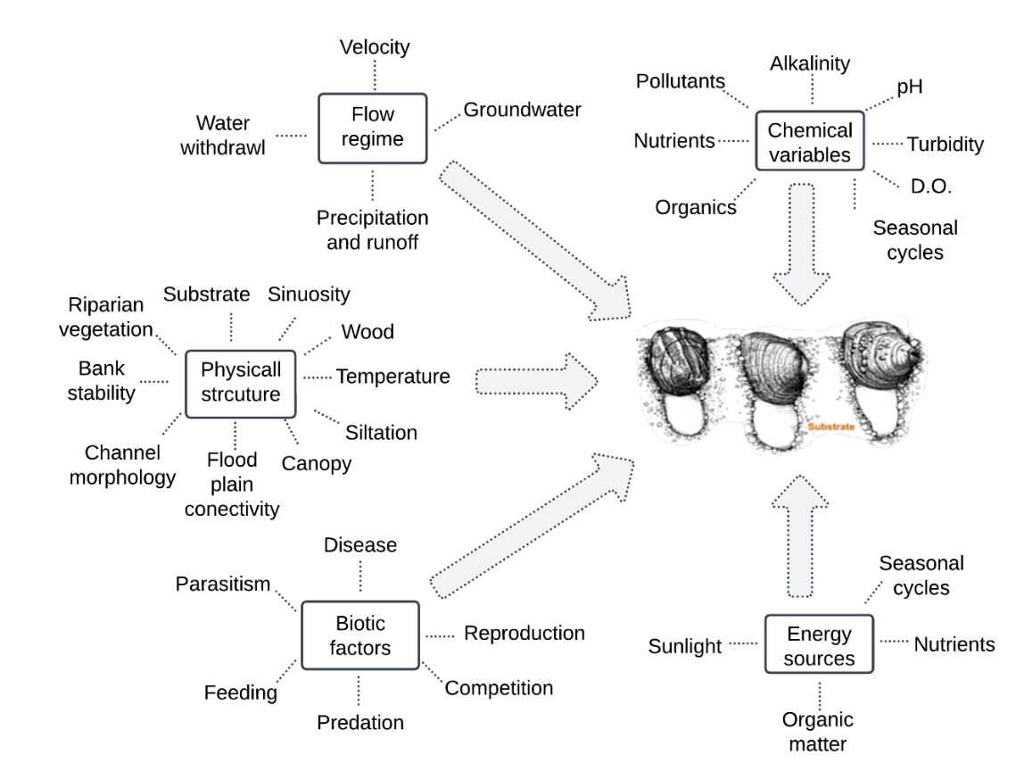
Figure 6.1: Factors that influence freshwater mussel health (modified from Karr et. 1986 “Assessing biological integrity in running waters: A method and its rationale”).

To address this complexity and untangle how each factor influences mortality, a multidisciplinary approach is necessary, combining disease diagnostics, disease ecology, population dynamics, environmental monitoring, and ecological modeling. Disease diagnostic approaches including histopathology, microbiology, and molecular techniques help identify pathogens and their physiological impacts, while disease ecology examines how these infections interact with environmental conditions and other stressors to culminate in disease and mortality. A population dynamics approach investigates length, sex, and age-class structure of dead individuals, revealing long-term trends in mortality and potential demographic susceptibility. Environmental assessments of water quality, flow regimes, and temperature provide critical context for understanding why certain populations are more vulnerable than others and what environmental factors may influence mortality. These diverse disciplines must work together to hopefully move beyond simple correlations and begin identifying the causative mechanisms driving mussel declines. If we ever hope to manage population declines, we must first understand the mechanisms of mortality, not just in isolation but as part of an interconnected system. There are many contributing factors, but by connecting these pieces, we can begin to solve the puzzle of mussel declines and develop more effective conservation strategies.
In Chapter 2, I provided detailed pathological descriptions of lesions in moribund A. pectorosa associated with Yokenella regensburgei, supporting its role as a pathogen in wild populations. This study established a clear link between Yokenella regensburgei infection and severe multisystemic inflammatory disease which causes tissue damage severe enough to explain mortality. Control mussels exhibited low-level inflammatory responses (e.g., hemocytosis, parasites, and rickettsia-like organisms), but did not develop necrotizing lesions or systemic infections. This distinction is crucial because it shows that while some level of hemocyte response is normal, the inflammatory disease observed in wild mussels is pathological and likely fatal. This refines our understanding of what constitutes "normal" versus "pathogenic" conditions in A. pectorosa, which may be applicable to other mussels. Overall, this Chapter underscores the importance of routine health assessments and the urgency for comprehensive epidemiological studies of wild and captive reared mussels.
In Chapter 3, I document the presence and concentration of cyanotoxins in A. pectorosa tissue and water, including microcystins, anatoxins, saxitoxins, and cylindrospermopsin. Although these toxins were detected, their accumulation was not associated with acute mortality or morbidity. In fact, concentrations were often higher in apparently healthy individuals. These findings suggest that acute cyanotoxicosis is unlikely to be the primary driver of die-offs. While cyanotoxins may not directly cause acute mortality, their potential role as sublethal stressors warrants further investigation. This study provides valuable reference data for future research and underscores the need to incorporate cyanotoxin screening into mussel health assessments. As harmful algal blooms continue to increase globally in both frequency and intensity, cyanotoxins may represent an emerging conservation concern for mussels.
In Chapter 4, I analyzed shells collected during historical MMEs in the Clinch River to evaluate the species, size, and sex composition of affected mussels using a descriptive epidemiological framework. The results offer valuable insight into the demographic and taxonomic extent of these events, challenging the assumption that MMEs were limited to only a few species or demographic groups. The broad range of affected taxa suggests that mortality was likely driven by a multifactorial process rather than a single pathogen. This analysis demonstrates the utility of shells as forensic tools for assessing MMEs and highlights the need for pre-planned standardized collection methods and improved documentation in future investigations aimed at descriptive epidemiology and identifying etiological factors. Overall, this study presents the most comprehensive characterization of mussels associated with Clinch River MMEs to date, providing reference data to contextualize future events. Lastly, I provided a recommendations that would ultimately enhance our response and assessment of MMEs and improve the identification of risk factors.
In Chapter 5, I applied a quantitative framework to assess background and seasonal mortality patterns in Actinonaias pectorosa in the Clinch River. I combined N-mixture modeling, a statistical method that accounts for imperfect detection, with age and size structure analyses to estimate monthly percent mortality and evaluate mortality patterns. Results indicate that A. pectorosa populations at our study sites were not experiencing MMEs between 2021 and 2023, and that mortality was low but consistent over time, rather than concentrated over a short period. I also provide strong evidence that MMEs in 2016 likely removed older individuals from Kyles Ford, influencing the current age distribution. Seasonality emerged as a strong predictor of mortality, with the abundance of dead individuals increasing in late fall, aligning with previous anecdotal reports. Julian Day was the strongest predictor in the model, serving as a proxy for biological or environmental processes such as changes in temperature, food availability, and reproductive investment. This study provides the first robust estimates of mortality in A. pectorosa and the first known application of N-mixture modeling to estimate mortality in mussels using shell-based survey data. Repeating these methods over time enables quantification of mortality magnitude, allowing not only the detection of mortality epidemics but also the identification of elevated mortality that may go unnoticed yet still impact population structure and persistence.
.
The chapters in this dissertation address some of the complexities of mussel mortality by applying a multidisciplinary approach grounded in disease diagnostics, disease ecology, toxicology, environmental monitoring, and population dynamics. Collectively, these chapters highlight the importance of integrating disciplines, methodologies, and approaches to move beyond associations and toward identifying the mechanisms driving mussel disease, mortality, and declines. While my work contributes to the growing body of knowledge on mussels, it also underscores the many remaining knowledge gaps. In the next paragraphs, I outline potential directions for future research to build on my work and support more informed and effective conservation strategies for imperiled mussel populations.
Future research
Further research is needed to determine how Y. regensburgei is transmitted between mussels and whether vectors, environmental reservoirs, or direct contact play a role in its spread. Controlled challenge studies are necessary to confirm the pathogenicity of Y. regensburgei, determine its infectious dose, and explore species-specific susceptibility. Broader diagnostic screening across multiple species and sites is needed to determine whether Y. regensburgei is unique to A. pectorosa or has broader impacts across mussel assemblages. If a broader impact is observed, we need to investigate how environmental variables (e.g., temperature, nutrient loading, seasonal changes) influence the onset or severity of yokenellosis. In a broader sense more work in needed to understand immune response in mussels. Studying immune-related gene expression or cellular responses in affected vs. unaffected mussels could elucidate host-pathogen interactions and susceptibility factors.
Further investigation is needed into the occurrence and concentration of cyanotoxins in water and wild mussels as well as their role in mussel health. Experimental studies should explore how chronic, low-level exposure to microcystins and other cyanotoxins impacts mussel immune function, reproduction, and physiology. Integrated studies should investigate whether toxin exposure predisposes mussels to opportunistic infections. Additionally, year-round toxin surveillance across multiple sites is needed to help improve our understanding of when and where mussels are most at risk of exposure at low and acute concentrations. Most importantly, we must determine whether other mussel species accumulate toxins similarly and whether there are comparable physiological effects across species. This is imperative for improving management strategies in the future as HABs become more frequent and intense.
As natural resource managers and mussel biologists, we should enhance our ability to rapidly and effectively respond to mussel MMEs. This could be done mainly through the development and maintenance of a coordinated response framework at the local, state, or regional level, and by collecting certain critical data from priority populations prior to MMEs occurring. Because MMEs are unpredictable and time-sensitive, it is critical that researchers and natural resource managers are prepared in advance. This includes establishing predefined goals, objectives, and decision trees for data collection, diagnostics, and communication. A successful response requires having clear protocols in place, such as standard procedures for shell collection, documentation, triage of moribund individuals, and preservation for downstream analyses (e.g., histopathology, microbiology, toxicology). Importantly, these efforts depend on maintaining strong, open communication channels among agencies, academic researchers, hatchery staff, and field biologists. Future work should formalize these collaborations by creating pre-identified response/task teams with assigned roles and responsibilities. Having stakeholders agree in advance on who will do what, and how data and samples will be shared, will ensure that efforts are not duplicated or delayed, and that surveys and assessments are meeting goals and objectives. Just as importantly, response frameworks should be adaptable, allowing teams to respond dynamically as the scope and nature of an MME becomes clear. Developing and refining these plans, and adopting them as standard operating procedures, will ensure the mussel conservation community is ready to act swiftly and effectively when the next event occurs.
Moving forward, it is critical that mussel conservation research expands beyond event-based mortality assessments and begins to routinely quantify mortality in mussel populations in addition to quantifying changes in abundance. I acknowledge that this is difficult to accomplish and there are several logistical limitations. However, without this data there is a tangible shortcoming in our ability to understand mechanisms of mortality and explain declines. Future studies should implement standardized, repeated mortality surveys, ideally year-round and across multiple sites, to establish typical mortality rates, seasonal patterns, and demographic trends. Establishing mortality benchmark values across species, size classes, and seasons will provide critical reference points that allow for detection of significant mortality and mortality epidemics. If done at scale and over time, this approach can help determine whether patterns represent localized stressors or broader watershed-level processes. Shell-based methods, particularly when paired with statistical models like N-mixture frameworks, offer a practical and scalable way to monitor mortality while accounting for imperfect detection. These data will support the development of mortality thresholds or benchmarks that can be used to trigger more intensive diagnostic or conservation responses if an unusual mortality or MME is suspected. Long-term data will also enable researchers to investigate temporal trends in mortality and assess the influence of environmental stressors. Most importantly, it allows researchers to identify elevated levels of mortality that are not severe enough to be classified as MMEs and might otherwise go unnoticed, yet may still contribute to population declines over time.
Hopefully, as more researchers, managers, and institutions adopt some of these approaches, we will continue to collectively piece together the puzzle of mussel declines, uncovering patterns and mechanisms that no single study could resolve alone. My hope is that ultimately, we will shift mussel conservation from reactive crisis response toward predictive management that is better equipped to detect and mitigate stressors before they cause widespread losses.

Appendices

Appendix A: Supporting Information for Chapter 2
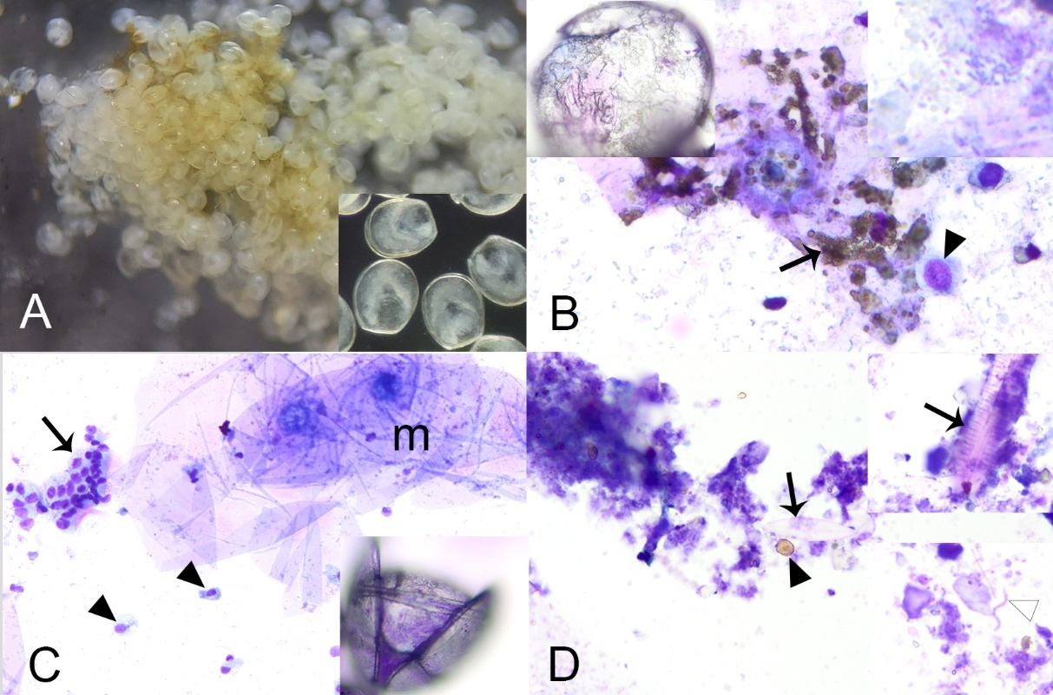

Figure A.2.1: Cytological examination of tissues of case mussels (i.e., wild moribund Pheasantshell (Actinonaias pectorosa)) sampled at sites impacted by seasonal mortality events in the Clinch River. A. Wet-mounted impression of discolored marsupium with brown-tinged mucus and glochidia having poorly defined tissues (inset). B. Impression smear of discolored marsupium with abundant brown-granules (arrows) and agranular hemocytes (arrowhead) within a background of mucus containing abundant bacilli (inset right) and glochidia with poorly discerned tissues (inset left), modified Wright-Giemsa stain. C. Impression smear of normal-colored area of the same marsupium as B, comparatively more mucus (m), intact ciliated epithelium (arrow) and hemocytes (arrowhead), and glochidia with discernable inner tissues (inset), modified Wright-Giemsa stain. D. Smear of fluid within the chamber of an anomalous shell consisting of amorphous acellular and crystalline debris, with scattered brown granules (black arrowhead), diatoms (arrow, inset upper), and cyanobacteria (white arrowhead, inset lower), modified Wright-Giemsa stain.

Table A.2.1: Total number of Pheasantshell (Actinonaias pectorosa) sampled by clinical presentation (case vs control) from two sites in Virginia (Speers Ferry and Sycamore Island) and one site in Tennessee (Kyles Ford).
 |  | Speers Ferry | Sycamore Island | Kyles Ford | Total
Case ª | 2021 | 3 | 14 | 0 | 17
Case ª | 2022 | - | 4 | 0 | 4
Case ª | Total | 3 | 18 | 0 | 21
Control ^{b} | 2021 | - | 24 | 24 | 48
Control ^{b} | 2022 | - | 16 | 4 | 20
Control ^{b} | 2023 | - | - | - | -
Control ^{b} | Total | - | 40 | 28 | 68
ª wild moribund Pheasantshell displaying clinical signs of disease
^{b} hatchery raised Pheasantshell kept in silos

Table A.2.2: Pheasantshell (Actinonaias pectorosa) sampled by sex and clinical presentation from two sites in Virginia (Speers Ferry and Sycamore Island) and one site in Tennessee (Kyles Ford).
 | Male | Female | Immature | Hermaphrodite | Undetermined ª | Total
Case | 10 | 9 | 0 | 2 | 0 | 21
Control | 13 | 1 | 35 | 0 | 19 | 68
ª gonad not histologically evaluated

Table A.2.3: Total number of individuals with trematode larvae per clinical presentation (case and control) identified in Pheasantshell (Actinonaias pectorosa) sampled from 2021–2023 across from two sites in Virginia (Speers Ferry and Sycamore Island) and one site in Tennessee (Kyles Ford), and total trematode count per site. We also identified trematode life stage and hemocyte response per clinical presentation across all three sites.
 |  | Case |  |  |  |  | Control
 | Site | Speers Ferry | Sycamore Island | Kyles Ford | Total |  | Sycamore Island | Kyles Ford | Total
 | Sample size (n) | 3 | 18 | 0 | 21 |  | 40 | 28 | 68
 | # of individuals with trematode larvae (%) | 0 | 9 (50) | - | 9 (43) |  | 11 (27) | 12 (43) | 23 (34)
Trematode life stage | metacercaria | - | 9 (100) | - | 9 (100) |  | 10 (91) | 12 (100) | 22 (96)
Trematode life stage | degenerate | - | 0 | - | 0 |  | 1 (9) | 0 | 1 (4)
Hemocyte response | none | - | 5 (56) | - | 5 (56) |  | 5 (46) | 3 (25) | 8 (35)
Hemocyte response | encapsulation | - | 1 (11) | - | 1 (11) |  | 1 (9) | 1 (8) | 2 (9)
Hemocyte response | nodulation | - | 3 (33) | - | 3 (33) |  | 4 (36) | 6 (50) | 10 (43)
Hemocyte response | focal hemocytic infiltration | - | 0 | - | 0 |  | 0 | 1 (8) | 1 (4)
Hemocyte response | multiple responses | - | 0 | - | 0 |  | 1 (9) | 1 (8) | 2 (9)

Table A.2.4: Average relative abundance of indicator Operational Taxonomic Units (OTUs) per sample type and analysis-group. Samples consisted of hemolymph and digestive gland tissue collected from Pheasantshell (Actinonaias pectorosa) sampled from the Clinch River at two sites in Tennessee and Virginia. Analysis groups include Control-Absent (n = 62 DG and 6 HL), Case-Absent (n = 4 DG and 1 HL ; individuals not presenting hemocytic nodulation and necrosis associated with gram-negative bacilli), and Case-Present (n = 11 DG and 6 HL; individuals presenting hemocytic nodulation and necrosis associated with gram-negative bacilli). Values in bold highlight the highest relative abundance per group.
OTU | Digestive Gland |  |  | Hemolymph
 | Control-Absent | Case-Absent | Case-Present | Control-Absent | Case-Absent | Case-Present
Otu001_Rickettsiales | 45.2 | 20.0 | 0.3 | 30.2 | 5.0 | 0.3
Otu002_Yokenella_sp | 0.2 | 4.0 | 37.1 | 0.2 | 4.0 | 52.8
Otu003_Aeromonas_sp | 2.4 | 2.0 | 29.1 | 0.3 | 5.0 | 42.5
Otu006_Bacteroides_sp | 0.0 | 0.3 | 8.3 | 0.0 | 0.0 | 0.3
Otu008_Limnohabitans_sp | 0.1 | 1.0 | 0.5 | 12.7 | 37.0 | 0.0
Otu010_Facklamia_sp | 3.0 | 6.3 | 0.0 | 14.3 | 0.0 | 0.0
Otu023_Polynucleobacter_sp | 0.1 | 1.0 | 0.3 | 4.8 | 12.0 | 0.0
Otu045_Bradyrhizobium_sp | 0.9 | 9.3 | 0.5 | 0.0 | 0.0 | 0.0
Otu048_Hyphomicrobium_sp | 0.1 | 2.8 | 1.1 | 0.8 | 0.0 | 0.0
Otu088_Bradyrhizobium_sp | 0.1 | 5.8 | 1.2 | 0.0 | 0.0 | 0.0
Otu185_Legionella_sp | 0.0 | 1.0 | 0.0 | 0.0 | 0.0 | 0.0
Otu Other | 47.8 | 46.8 | 21.6 | 36.7 | 37.0 | 4.0

Appendix B: Supporting Information for Chapter 3
Table A.3.1: Monthly average concentrations of anatoxin (ng/g) and saxitoxin (ng/g) in Pheasantshell (Actinonaias pectorosa) tissue (n = 28) by clinical presentation (case vs control). Mussels were collected at Kyles Ford (Tennessee) and Sycamore Island (Virginia) on the Clinch River in 2023.
 | Average toxin concentration (ng/g) (range)
 | Anatoxin |  | Saxitoxin
Month | Case | Control | Case | Control
Apr | - | 21.1 (17.61 - 24.59), n = 2 | - | 0.03 (0.02 - 0.03), n = 2
Jun | 6.51 | 3.49 | - | -
Jul | - | 10.74 (4.39 - 17.08), n = 2 | - | 0.03 (0.02 - 0.04), n = 2
Aug | 19.11 | - | 0.01 | -
Oct | 21.99 | 1.62 | 0.03 | -
Nov | 14.61 (11.8 - 17.42), n = 2 | 9.71 (0.52 - 19.78), n = 4 | 0.02 (0.01 - 0.04), n = 2 | 0
Dec | 18.73 (14.62 - 22.84), n = 2 | - | 0.01 (0.01 - 0.02), n = 2 | -

Table A.3.2: Monthly average, minimum, and maximum daily concentrations (ng/g/day), as well as total concentrations (ng/g) of anatoxin, cylindrospermopsin, and saxitoxin measured using Solid Phase Adsorption Toxin Tracking (SPATT) samplers deployed in 2023 at Kyles Ford (Tennessee) and Sycamore Island (Virginia) on the Clinch River. The table also includes the monthly average deployment duration and sample sizes, indicating the number of SPATT samplers deployed each month.
 |  | Anatoxin |  |  | Cylindrospermopsin |  |  | Saxitoxin
Month | Deployment length (average days) | Average concentration (ng/g/day)  (range) | Average total  concentration  (ng/g)  (range) | n | Average concentration (ng/g/day)  (range) | Average total  concentration (ng/g)  (range) | n | Average concentration (ng/g/day)  (range) | Average total  concentration  (ng/g) )  (range) | n
Mar | 81 | 0.02  (0.01 - 0.02) | 1.29  (1.2 - 1.37) | 2 | - | - |  | 0 | 0.01  (0.01 - 0.01) | 2
May | 14 | 0.06  (0.05 - 0.07) | 0.83  (0.75 - 0.91) | 2 | - | - |  | 0 | 0.01  (0 - 0.01) | 2
Jun | 23 | 0.09  (0.06 - 0.11) | 1.9  (1.58 - 2.5) | 3 | - | - |  | - | -
Jul | 17 | 0.2  (0.16 - 0.26) | 3.44  (2.84 - 4.24) | 6 | 0.03  (0.02 - 0.03) | 0.46  (0.32 - 0.53) | 5 | 0 | 0.02  (0.02 - 0.02) | 1
Aug | 15 | 0.29  (0.13 - 0.57) | 4.26  (1.77 - 7.94) | 5 | 0.04  (0.03 - 0.04) | 0.54  (0.45 - 0.62) | 4 | 0 | 0.03  (0.01 - 0.04) | 2
Sep | 20 | 0.24  (0.07 - 0.42) | 4.74  (1.48 - 8.31) | 4 | 0.02  (0.01 - 0.03) | 0.35  (0.1 - 0.6) | 2 | 0 | 0.02  (0.01 - 0.03) | 2
Oct | 14 | 0.52  (0.18 - 0.98) | 7.44  (2.71 - 13.76 | 8 | 0.02  (0.01 - 0.03) | 0.3  (0.19 - 0.38) | 5 | 0.02  (0 - 0.05) | 0.23  (0.01 - 0.66) | 3
Nov | 18 | 1.37  (0.22 - 2.61) | 24.58  (4.25 - 49.66) | 6 | 0.02  (0.02 - 0.02) | 0.37  (0.35 - 0.37) | 3 | 0 | 0.02  (0.01 - 0.03) | 2
Dec | 13 | 0.67  (0.36 - 1.2) | 9.1  (3.55 - 21.57) | 7 | - | - |  | 0 | 0.02  (0.01 - 0.02) | 7

Solid Phase Adsorption Toxin Tracking (SPATT) assemblage instructions
We followed protocols established by Howard et al. (2018) for assembling “tea-bag” shaped SPATTs. We made minor adjustments including using milk filter sock (Shwartz Tuffy Milk Filter Sock) as the packet material and staples rather than heat to seal each sampler. Briefly, we cut two pieces of milk filter sock to the desired size, folded, and stapled three sides to create a pouch, then we filled it with 1 – 3.4 g of Diaion HP-20 resin (Supelco, Sigma-Aldridge CAS-No: 9052-95-3). In the last assembly step, we folded the remaining open side, placing an 8cm long cotton twine in the folded side, and stapling it closed. We used cotton twine to attach SPATTs to silos. A review of SPATTs technology and application is provided by MacKenzie (2004, 2010) and Kudela (2017).

Appendix C: Supporting Information for Chapter 4

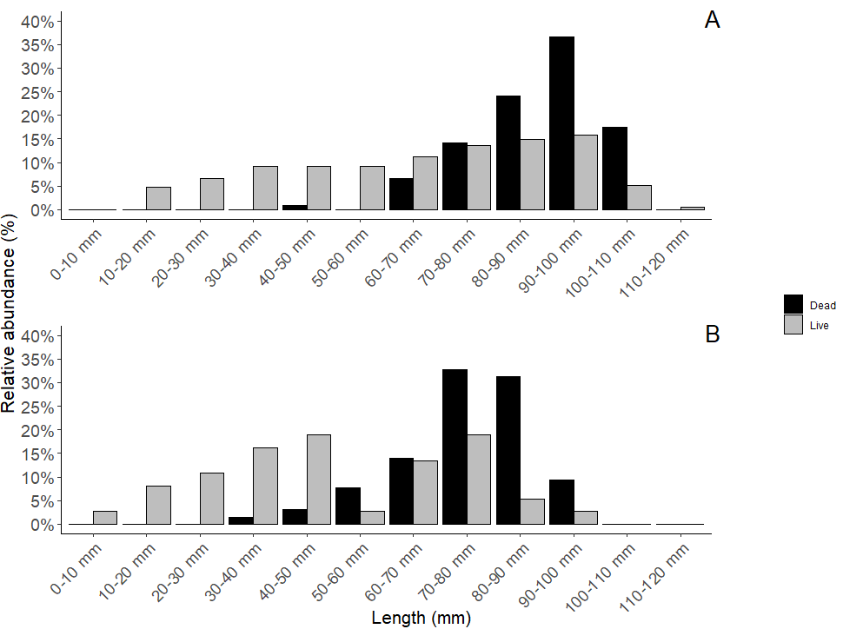
Figure A.4.1: Relative abundance per length class of dead and live Pheasantshell (Actinonaias pectorosa) collected from the Clinch River at A = Sycamore Island (Virginia) and B = Kyles Ford (Tennessee). Dead individuals were collected at Sycamore Island in 2019 and at Kyles Ford in 2018 and 2019. Data on live individuals was collected during the same years as part of a long-term monitoring effort at both sites.

Table A.4.1: Observed and expected counts of dead Pheasantshell (Actinonaias pectorosa) individuals across length classes at Sycamore Island in 2019 and Kyles Ford between 2017 and 2018. Residuals indicate deviations from expected counts. Residuals greater than +2 indicate that observed mortality is significantly higher than expected and residuals less than -2 indicate that observed mortality is significantly lower than expected.
Sycamore Island |  |  |  |  |  | Kyles Ford
Length class (mm) | Live count | Dead count | Live proportion | Expected dead | Residuals | Live count | Dead count | Live proportion | Expected dead | Residuals
30-40 | 66 | 0 | 0.09 | 11 | -3.54 | 6 | 1 | 0.21 | 13 | -3.78
40-50 | 69 | 1 | 0.10 | 12 | -3.32 | 7 | 1 | 0.24 | 15 | -4.22
50-60 | 77 | 0 | 0.11 | 13 | -3.86 | 1 | 4 | 0.03 | 2 | 1.23
60-70 | 84 | 8 | 0.12 | 14 | -1.81 | 5 | 9 | 0.17 | 11 | -0.67
70-80 | 104 | 14 | 0.15 | 18 | -0.99 | 5 | 21 | 0.17 | 11 | 3.30
80-90 | 117 | 28 | 0.17 | 20 | 1.93 | 4 | 20 | 0.14 | 9 | 4.05
90-100 | 127 | 46 | 0.18 | 22 | 5.72 | 1 | 8 | 0.03 | 2 | 3.97
100-110 | 46 | 23 | 0.07 | 8 | 5.55 | 0 | 0 | - | - | -
110-120 | 8 | 0 | 0.01 | 1 | -1.18 | 0 | 0 | - | - | -

Table A.4.2: Yearly counts of freshwater mussels collected during suspected mass mortality events at 14 sites in the Clinch River across Virginia (n = 3) and Tennessee (20) between 2016 – 2020. Sites noted with “◊” were located in Virginia. All other sites were located in Tennessee. These counts represent shells collected with a shiny nacre indicative of recent mortality.
 |  | 2016 |  |  | 2017 |  |  |  | 2018 |  |  |  |  | 2019 |  | 2020
 | Months | Sept | Oct | Nov | Feb | Oct | Nov | Dec | Jan | Aug | Sept | Oct | Nov | Sept | Oct | Jul
Sites | # of surveys | 1 | 3 | 3 | 1 | 3 | 3 | 1 | 1 | 1 | 1 | 3 | 2 | 4 | 6 | 1 | Total
Lawson Bend | 170.6 | ∙ | ∙ | ∙ | ∙ | ∙ | ∙ | 84 | ∙ | ∙ | ∙ | ∙ | ∙ | ∙ | ∙ | ∙ | 84
Swan Island | 172.2 | ∙ | 64 | ∙ | ∙ | ∙ | 39 | ∙ | ∙ | ∙ | ∙ | ∙ | ∙ | ∙ | ∙ | ∙ | 103
Above  Swan Island | 174.8 | ∙ | 195 | ∙ | ∙ | ∙ | ∙ | ∙ | ∙ | ∙ | ∙ | ∙ | ∙ | ∙ | ∙ | ∙ | 195
Fall Branch | 178.5 | ∙ | ∙ | ∙ | ∙ | ∙ | 84 | ∙ | ∙ | ∙ | ∙ | ∙ | ∙ | ∙ | ∙ | ∙ | 84
Fall Branch | 178.7 | ∙ | 295 | 495 | 329 | 64 | ∙ | 62 | ∙ | ∙ | ∙ | ∙ | ∙ | ∙ | ∙ | ∙ | 1245
Frost Ford | 181.3 | 533 | 348 | 214 | ∙ | 136 | 25 | ∙ | 11 | ∙ | ∙ | ∙ | ∙ | 77 | 643 | ∙ | 1987
Frost Ford | 182.3 | ∙ | ∙ | ∙ | ∙ | ∙ | ∙ | ∙ |  | ∙ | ∙ | ∙ | ∙ | ∙ | 1 | ∙ | 1
Brooks Island | 183.4 | ∙ | ∙ | 105 | ∙ | ∙ | ∙ | ∙ | ∙ | ∙ | ∙ | ∙ | ∙ | ∙ | ∙ | ∙ | 105
Brooks Island | 183.7 | ∙ | 266 | ∙ | ∙ | ∙ | ∙ | 28 | ∙ | ∙ | ∙ | ∙ | ∙ | ∙ | ∙ | ∙ | 294
Kyles Ford | 189.6 | ∙ | 3 | ∙ | ∙ | 79 | ∙ | ∙ | 54 | 27 | 9 | 36 | ∙ | 30 | ∙ | ∙ | 238
Kyles Ford | 190.6 | ∙ | ∙ | ∙ | ∙ | ∙ | ∙ | ∙ | ∙ | ∙ | ∙ | 1 | ∙ | ∙ | ∙ | ∙ | 1
Wallens Bend | 191.6 | ∙ | ∙ | ∙ | ∙ | ∙ | ∙ | ∙ | ∙ | ∙ | ∙ | 1 | ∙ | ∙ | ∙ | ∙ | 1
Wallens Bend | 192.5 | ∙ | ∙ | ∙ | ∙ | ∙ | ∙ | ∙ | 73 | ∙ | ∙ | ∙ | ∙ | 44 | 52 | 43 | 212
Above  Wallens Bend | 193.6 | ∙ | ∙ | ∙ | ∙ | ∙ | ∙ | ∙ | ∙ | ∙ | ∙ | 1 | ∙ | ∙ | ∙ | ∙ | 1
Above  Wallens Bend | 194.6 | ∙ | ∙ | ∙ | ∙ | ∙ | ∙ | ∙ | ∙ | ∙ | ∙ | 1 | ∙ | ∙ | ∙ | ∙ | 1
The Rounds | 195.5 | ∙ | ∙ | 10 | ∙ | ∙ | ∙ | ∙ | ∙ | ∙ | ∙ | ∙ | ∙ | ∙ | ∙ | ∙ | 10
The Rounds | 195.6 | ∙ | ∙ | ∙ | ∙ | ∙ | ∙ | ∙ | ∙ | ∙ | ∙ | 1 | ∙ | ∙ | ∙ | ∙ | 1
The Rounds | 196.6 | ∙ | ∙ | ∙ | ∙ | ∙ | ∙ | ∙ | ∙ | ∙ | ∙ | ∙ | 1 | ∙ | ∙ | ∙ | 1
Horton Ford | 198.6 | ∙ | ∙ | ∙ | ∙ | ∙ | ∙ | ∙ | ∙ | ∙ | ∙ | ∙ | 1 | ∙ | ∙ | ∙ | 1
Horton Ford | 199 | ∙ | ∙ | 12 | ∙ | ∙ | ∙ | ∙ | ∙ | ∙ | ∙ | ∙ | ∙ | ∙ | ∙ | ∙ | 12
Sycamore Island◊ | 207 | ∙ | ∙ | ∙ | ∙ | ∙ | ∙ | ∙ | ∙ | ∙ | ∙ | ∙ | ∙ | 57 | 83 | ∙ | 140
Speers Ferry◊ | 211 | ∙ | ∙ | ∙ | ∙ | ∙ | ∙ | ∙ | ∙ | ∙ | ∙ | ∙ | ∙ | 4 | ∙ | ∙ | 4
Above  Kiser Bend◊ | 269 | ∙ | ∙ | ∙ | ∙ | ∙ | ∙ | ∙ | ∙ | ∙ | ∙ | ∙ | ∙ | 64 | ∙ | ∙ | 64
 | Total | 533 | 1171 | 836 | 329 | 279 | 148 | 174 | 138 | 27 | 9 | 41 | 2 | 276 | 779 | 43 | 4785

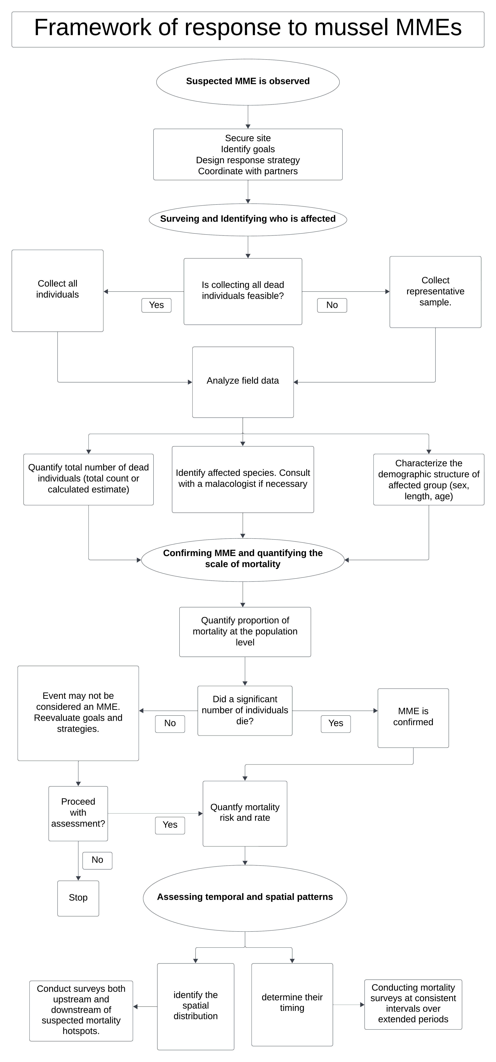
Figure A.4.2: Framework of response to mussel MMEs based on descriptive epidemiological concepts.

Appendix D: Supporting Information for Chapter 5
Table A.5.1: Percent monthly mortality estimates of Actinonaias pectorosa per year at Kyles Ford (Tennessee) and Sycamore Island (Virginia) in the Clinch River, along with the number of surveys conducted. N̂ = estimated abundance based on quadrat surveys; $D$ = number of dead individuals observed; $D^{adj}$ = adjusted number of dead individuals corrected for detection probability ($p)$ of 76.7%; ${PM}^{naive}$ = naïve monthly percent mortality (i.e., unadjusted for detection probability); ${PM}^{corr}$= corrected percent monthly mortality accounting for detection probability ($p)$. See the Methods section for details on how values were calculated. Estimates of dead individuals were rounded to the nearest whole number

 |  | Kyles Ford |  |  |  | Sycamore Island
Year | Month | # surveys | $D$ ($D^{adj})$ | $${PM}^{naive} ({PM}^{corr})$$ | Year | # surveys | $D$ ($D^{adj})$ | $${PM}^{naive} ({PM}^{corr})$$
2021  N̂= 7,750 | May | - | - | - | 2021  N̂ = 4,545 | 1 | 2 (2) | 0.04 (0.05)
2021  N̂= 7,750 | Aug | - | - | - | 2021  N̂ = 4,545 | 1 | 2 (2) | 0.04 (0.05)
2021  N̂= 7,750 | Oct | 1 | 24 (30) | 0.31 (0.38) | 2021  N̂ = 4,545 | 2 | 35 (43) | 0.77 (0.95)
2021  N̂= 7,750 | Nov | 1 | 16 (20) | 0.21 (0.25) | 2021  N̂ = 4,545 | 2 | 8 (10) | 0.18 (0.22)
2021  N̂= 7,750 | Total | 2 | 40 (50) | 0.52 (0.64) | 2021  N̂ = 4,545 | 6 | 47 (57) | 1.03 (1.28)
2022  N̂ = 4,004 | Sept | - | - | - | 2022  N̂ = 4,845 | 2 | 13 (16) | 0.27 (0.33)
2022  N̂ = 4,004 | Oct | 1 | 26 (32) | 0.65 (0.80) | 2022  N̂ = 4,845 | 2 | 48 (59) | 0.99 (1.22)
2022  N̂ = 4,004 | Nov | 4 | 59 (73) | 1.47 (1.82) | 2022  N̂ = 4,845 | 4 | 72 (89) | 1.49 (1.83)
2022  N̂ = 4,004 | Dec | 1 | 12 (15) | 0.30 (0.37) | 2022  N̂ = 4,845 | 1 | 4 (5) | 0.08 (0.10)
2022  N̂ = 4,004 | Total | 6 | 97 (120) | 2.42 (2.99) | 2022  N̂ = 4,845 | 9 | 137 (169) | 2.83 (3.49)
2023  N̂ = 8,825 | April | 2 | 12 (15) | 0.14 (0.17) | 2023  N̂ = 6,400 | 2 | 5 (6) | 0.08 (0.10)
2023  N̂ = 8,825 | May | 1 | 5 (6) | 0.06 (0.07) | 2023  N̂ = 6,400 | 1 | 4 (5) | 0.06 (0.08)
2023  N̂ = 8,825 | June | 1 | 6 (7) | 0.07 (0.08) | 2023  N̂ = 6,400 | 3 | 17 (21) | 0.27 (0.33)
2023  N̂ = 8,825 | July | 2 | 3 (4) | 0.03 (0.04) | 2023  N̂ = 6,400 | 2 | 5 (6) | 0.08 (0.10)
2023  N̂ = 8,825 | Aug | 2 | 4 (5) | 0.05 (0.06) | 2023  N̂ = 6,400 | 2 | 2 (2) | 0.03 (0.04)
2023  N̂ = 8,825 | Sept | 1 | 0 | 0 | 2023  N̂ = 6,400 | 1 | 2 (2) | 0.03 (0.04)
2023  N̂ = 8,825 | Oct | 2 | 18 (22) | 0.20 (0.25) | 2023  N̂ = 6,400 | 2 | 6 (7) | 0.09 (0.12)
2023  N̂ = 8,825 | Nov | 2 | 13 (16) | 0.15 (0.18) | 2023  N̂ = 6,400 | 2 | 7 (9) | 0.11 (0.13)
2023  N̂ = 8,825 | Dec | 1 | 0 | 0 | 2023  N̂ = 6,400 | 1 | 1 (1) | 0.02 (0.02)
2023  N̂ = 8,825 | Total | 14 | 61 (75) | 0.69 (0.85) | 2023  N̂ = 6,400 | 16 | 49 (59) | 0.77 (0.94)

Table A.5.2: Length-at-age of dead Actinonaias pectorosa collected at Kyles Ford (Tennessee) and Sycamore Island (Virginia) in the Clinch River. Sample size (n) refers to the number of observations for each age. Ages not observed are marked with a “-“.

 | Kyles Ford |  | Sycamore Island
Age | n = 78 | Mean length (range, mm) |  | n = 114 |  | Mean length (range, mm)
1 | 0 | - | 0 |  | -
2 | 0 | - | 0 |  | -
3 | 1 | 41 | 2 |  | 42 (40 - 43)
4 | 3 | 50 (46 - 53) | 9 |  | 51 (42 - 59)
5 | 13 | 60 (50 - 70) | 15 |  | 61 (49 - 73)
6 | 22 | 70 (50 - 87) | 16 |  | 67 (54 - 76)
7 | 12 | 78 (68 - 88) | 8 |  | 74 (67 - 79)
8 | 10 | 79 (63 - 86) | 10 |  | 80 (73 - 86)
9 | 2 | 88 (85 - 92) | 6 |  | 87 (76 - 100)
10 | 3 | 83 (80 - 89) | 6 |  | 88 (80 - 98)
11 | 4 | 83 (72 - 94) | 4 |  | 85 (80 - 91)
12 | 2 | 92 (91 - 93) | 5 |  | 91 (79 - 96)
13 | 0 | - | 4 |  | 93 (91 - 94)
14 | 1 | 98 | 2 |  | 94 (89 - 99)
15 | 3 | 85 (76 - 90) | 6 |  | 98 (90 - 100)
16 | 1 | 90 | 1 |  | 95
17 | 1 | 92 | 1 |  | 100
18 | 0 | - | 0 |  | -
19 | 0 | - | 1 |  | 94
20 | 0 | - | 0 |  | -
21 | 0 | - | 3 |  | 99 (83 - 110)
22 | 0 | - | 1 |  | 98
23 | 0 | - | 2 |  | 100 (100 - 100)
24 | 0 | - | 3 |  | 93 (84 - 100)
25 | 0 | - | 3 |  | 100 (98 - 110)
26 | 0 | - | 2 |  | 110 (100 - 110)
27 | 0 | - | 0 |  | -
28 | 0 | - | 1 |  | 100
29 | 0 | - | 1 |  | 97
30 | 0 | - | 0 |  | -
31 | 0 | - | 1 |  | 100
32 | 0 | - | 0 |  | -
33 | 0 | - | 0 |  | -
34 | 0 | - | 1 |  | 93

Table A.5.3: Observed and expected counts of dead Actinonaias pectorosa individuals across length classes at Sycamore Island and Kyles Ford between 2021 and 2023. Residuals indicate the degree of deviation from expected counts (significant deviations are noted with “ * ”). Residuals less than -2 indicate that observed mortality is significantly lower than expected and greater than +2 indicate that observed mortality is significantly higher than expected.

.Sycamore Island |  |  |  |  |  | Kyles Ford
Length class (mm) | Live count | Dead count | Live proportion | Expected dead | Residuals | Live count | Dead count | Live proportion | Expected dead | Residuals
0-50 | 153 | 6 | 0.338 | 78.7 | -10.1* | 10 | 2 | 0.143 | 28.3 | -5.34*
50-60 | 49 | 15 | 0.108 | 25.2 | -2.15* | 12 | 11 | 0.171 | 33.9 | -4.33*
60-70 | 51 | 34 | 0.113 | 26.2 | 1.61 | 18 | 53 | 0.257 | 50.9 | 0.34
70-80 | 72 | 50 | 0.159 | 37.0 | 2.32* | 18 | 77 | 0.257 | 50.9 | 4.24*
80-90 | 60 | 58 | 0.132 | 30.9 | 5.24* | 8 | 46 | 0.114 | 22.6 | 5.22*
90-100 | 57 | 51 | 0.126 | 29.3 | 4.28* | 4 | 9 | 0.057 | 11.3 | -0.71
100+ | 11 | 19 | 0.024 | 5.66 | 5.68* | - | - | - | - | -

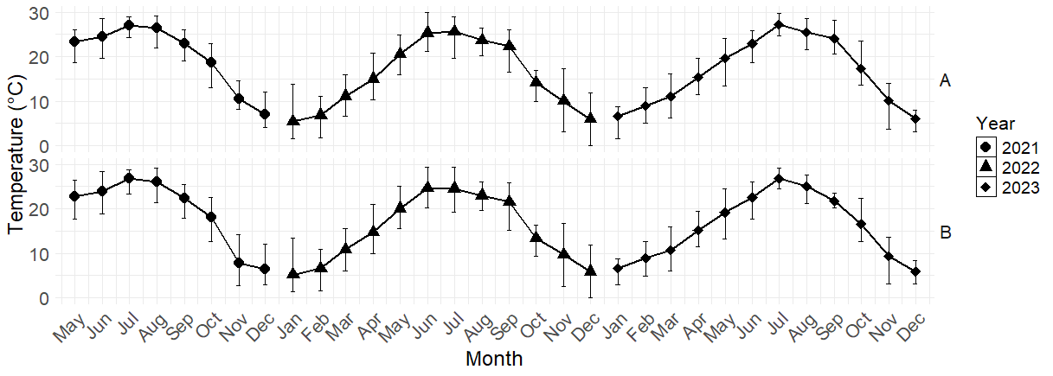
Figure A.5.1: Monthly mean temperature per year for both Kyles Ford (A; Tennessee) and Sycamore Island (B, Virginia) on the Clinch River, USA. Error bars represent temperature ranges.

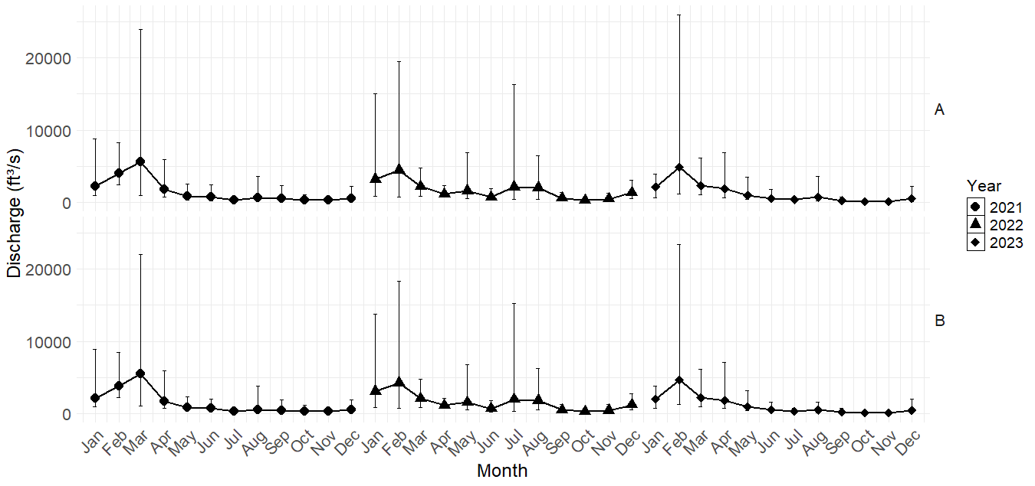
Figure A.5.2: Average monthly discharge per year for both A = Kyles Ford (Tennessee) and B = Sycamore Island (Virginia) on the Clinch River, USA. Error bars represent discharge ranges.

Appendix E: Parasites and mortality in the endangered Fluted Kidneyshell (Ptychobranchus subtentus) from the Clinch River, Tennessee
At the time of dissertation submission, a version of this manuscript was under review in Diseases of Aquatic Organisms.
Authors: Jeronimo G. Da Silva Neto, Eliza Baker, Heidi M. Wyrosdick, Gerald R. Dinkins, Jordan C. Richard, Richard W. Gerhold, Augustin C. Engman, and Michelle M. Dennis

Author contributions are as follows: J. G. Da Silva Neto: conceptualization, data acquisition and curation, formal analysis, writing original draft, review and editing. R.H. Hardman: conceptualization, data curation, formal analysis, writing original draft. A.C. Engmann: conceptualization, supervision, review and editing. Gerald Dinkins: conceptualization, supervision, review and editing. T.W. Lane: conceptualization, data curation, review and editing. M.M. Fry: conceptualization, data curation, formal analysis, review and editing. M.M., Rines and C.R., Bisenieks: data curation, review and editing. A.L. Rajeev: data curation, formal analysis, investigation, review and editing. and Dennis, M.M., 2024: conceptualization, supervision, data curation, formal analysis, writing original draft, review and editing.

Abstract
The Fluted Kidneyshell (Ptychobranchus subtentus) is an endangered freshwater mussel that, as of 2012, had experienced nearly 70% decline from its historical range in the Cumberland and Tennessee River drainages of the southeastern United States. Understanding the factors contributing to morbidity and mortality is essential for the long-term conservation of the species and the development of effective recovery plans. In this study, we incorporated morphological, histological and molecular techniques to identify and describe parasites and associated lesions in 18 P. subtentus collected from the Clinch River, USA in 2018 and 2021-2023. We identified several parasites, including metacercariae of Homalometron sp. (Homalometridae; 6/7 case mussels, 7/11 controls), sporocysts of putative Phyllodistomum sp. (Gorgoderidae; 4/7 case mussels, 2/11 controls), adult Aspidogastridae, and gonadotropic microsporidia (2/7 case mussels, 6/11 controls). Notably, this is the first report of P. subtentus as the first intermediate host for Phyllodistomum sp. and second intermediate host for Homalometron sp. Additionally, we report the first documentation of Unionicola sp. mites and gonadotropic microsporidia in P. subtentus. Our findings contribute to the understanding of parasites in mussel populations and emphasize the need for further research on the role of parasitism in mussel mortality, especially in endangered species.

Introduction
Fluted Kidneyshell (Ptychobranchus subtentus) is an endangered freshwater mussel in the family Unionidae (Parmalee and Bogan 1998, Williams et al. 2008) that inhabits shallow shoals in medium to large rivers with moderate to fast currents (Davis and Layzer 2012). This species can live up to 26 years and is a long-term brooder (bradytictic), where males spawn in late summer into fall and females brood until the following spring into summer (Davis and Layzer 2012). The species is endemic to the upper Cumberland and Tennessee River drainages, historically occurring in the mainstem and over 37 tributaries of these drainages (USFWS 2021). However, populations have been extirpated from approximately 70% of known historical streams, including the mainstem of the Tennessee and Cumberland Rivers. As of 2012, the distribution of the species is limited to 12 tributaries, with the largest population occurring in the Upper Clinch River watershed (HUC 06010205, USFWS 2021). Due to the range-wide decline and continuing threats, this species was federally listed under the Endangered Species Act in 2013 (USFWS 2021). Although species recovery potential across the range is considered high, existing populations still face significant threats (USFWS 2021).
Similar to other mussel species in the United States, P. subtentus populations have declined due to loss of habitat throughout their range (Haag 2012, USFWS 2021). Historically, the construction of large dams throughout Tennessee and Cumberland Rivers inundated the main channel and several tributaries, making shoal habitats unsuitable and fragmenting numerous reaches occupied by the species (Haag 2012, USFWS 2021). Currently, watershed development, agriculture, and natural resource extraction, including coal mining, continue to threaten P. subtentus populations (USFWS 2021). Anthropogenic impacts are widely accepted as drivers of mussel species extirpation (Haag 2012), but the role of pathogens in mussel morbidity and mortality events is not well understood. Two experimental stress studies in the freshwater bivalve Anodonta anatina demonstrated increased mortality with Rhipidocotyle sp. infections (Jokela et al. 2005, Taskinen et al. 2022) associated with long- and short-term stress and temperature variations.
Mussels are hosts to a variety of parasites (Grizzle and Brunner 2009, McElwain et al. 2019, Brian and Aldridge 2019, Taskinen et al. 2020, Knowles et al. 2023). Parasites have been reported to cause negative effects in both marine and freshwater bivalves (Taskinen 1998, Coen and Bishop 2015, McElwain et al. 2019, Katsanevakis et al. 2019, Brian et al. 2021a, Brian et al. 2022). In particular, parasitism in mussels can alter host filtration rate and overall ecology (Brian et al. 2022). Castrating parasites have also been reported in mussels, which can reduce reproductive capacity and recruitment (Brian and Aldridge 2021b). Despite reports of parasites in several mussel species, it is estimated that over 60% of parasite richness in mussels are undescribed, especially host-specific groups (Brian and Aldridge 2022). Integration of classical and molecular pathogen diagnostics is warranted in the efforts of developing effective long-term recovery plans for P. subtentus as well as numerous other endangered aquatic species. This study identifies the various parasites infecting P. subtentus by integrating the aforementioned techniques and describes associated pathology. Collectively, these data are essential for illuminating aquatic parasite life cycles and further investigating host-parasite interactions

Materials and Methods
Study area and sampling methods
Our study sites were located at Kyles Ford (river mile 189.6, Hancock County, Tennessee) and Sycamore Island (river mile 206.8, Scott County, Virginia) in the Upper Clinch River HUC8 watershed (Figure A.1). During normal flow levels, the channel at Kyles Ford is approximately 120 m wide with a substrate composed mainly of boulders and cobbles. The channel at Sycamore Island is approximately 60 m wide with a substrate composed mainly of cobbles and pebbles.
From 2016, seasonal mussel mass mortality events were observed at Kyles Ford, as indicated by an abnormal abundance of shells of recently-deceased mussels accumulating along the shoreline (Richard 2018). To investigate these events, we surveyed shoal habitats at Sycamore Island and Kyles Ford in 2018, as part of an effort to collect apparently healthy mussels that could serve as reference controls for pathological investigation. At Sycamore Island, we snorkeled once over the main channel from downstream to upstream, collecting five apparently healthy P. subtentus. Similarly, at Kyles Ford, we conducted several passes over the main channel, collecting six apparently healthy P. subtentus. Individuals collected during these surveys were considered healthy, as they were properly buried in substrate and showed a normal valve closure response upon handling. These control specimens were preserved in 10% neutral-
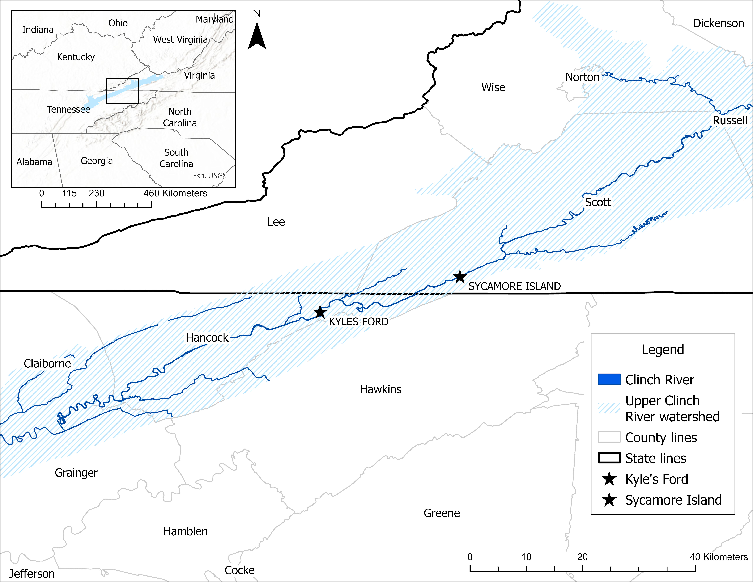
Figure A.1: Study area Kyle’s Ford in the Clinch River (rivermile 189.6), Hancock County, Tennessee.

buffered formalin and kept at the United States Fish and Wildlife Service office in Abingdon, Virginia. Live P. subtentus used in this study were collected under a Native Endangered Species Recovery Permit (Number TE74767C-0) issued to Jordan Richard.
Between 2021 and 2023, we continued our surveys of the mussel community at Sycamore Island and Kyles Ford as part of a larger investigation of the mass mortality events in the Clinch River (Da Silva Neto et al. 2024). At each site we surveyed a 20 m x 60 m sampling unit within the main channel. We conducted 21 surveys between October 2021 and December 2023, and during each survey, we performed a double-pass. In each pass, we snorkeled upstream within the sampling unit in a transect pattern, covering opposite sides of the channel until reaching the upstream end of the unit (approximately 30 minutes). During each pass, we collected any freshly-dead mussels on the benthos. A mussel was considered freshly-dead if it exhibited one or more of the following characteristics: gaping shell, flaccid foot showing no response to tactile stimulation, and mostly intact body showing no gross signs of decomposition (e.g., tissue emphysema/bloat, putrid smell, discoloration of viscera, or sloughing of epithelial surfaces). We avoided surveying near any muskrat mounds along the streambanks to ensure that any dead individuals found had not been killed by predators. Over two years, we collected seven freshly-dead P. subtentus at Kyles Ford but found no freshly-dead P. subtentus at Sycamore Island. Each specimen collected was immediately sealed in a Whirl-Pak® bag, placed on ice, and transported to the College of Veterinary Medicine at the University of Tennessee, where postmortem exams and histology were conducted. Individuals collected during these surveys served as the case group in this study. Freshly-dead P. subtentus were collected under a state Scientific Collection Permit (Number 2944) and a Native Endangered Species Recovery Permit (Number ES069754) issued to Gerald Dinkins.
Postmortem exam and histology
Postmortem exams were conducted on case mussels (n=7) and representative sections of organs were placed into histology cassettes and processed for histology using routine methods. Paraffin-embedded tissue blocks were sectioned at 5 µm thickness and stained with hematoxylin and eosin. In 2021, the initial histological examinations of our first three specimens revealed trematode sporocysts and metacercariae within the visceral mass. Subsequently, all other specimens were dissected with the aid of a stereoscope, and fresh tissues containing any suspected trematode stages were excised for further morphological examination (see cytologic morphology section below) and molecular testing prior to preservation in formalin and histological processing. Attempts at morphological examination and molecular testing of the first three preserved specimens were inconclusive due to formalin fixation.
Subgross examination and cytologic morphology
Dissection and cytologic morphology were not conducted on control mussels, as their collection preceded the discovery of sporocysts and metacercariae in histological examinations, which later justified the need for more detailed examination. However, we examined case mussels for trematode sporocysts, metacercariae and cercariae. Specimens with no grossly obvious trematode stages were dissected and pieces of the visceral mass were “squeezed” into glycerol or 70% ethanol on a slide and a cover slip added, referred to herein as a squeeze preparation. Lugol’s Iodine or methylene blue were added for staining to some of the slide preparations prior to examination. Grossly visible sporocysts moving within the mantle (Figure A.2, frame A) of one specimen (mussel #6) were excised to create a compression preparation in saline and methylene blue. Any obviously visible metacercariae were excised from tissue sections during dissection in the lab. Live metacercariae were placed on slides in glycerol with light coverslip pressure and ethanol-fixed metacercariae were placed in lactophenol for clearing and then placed in alcohol solution on a slide and stained by adding a drop of methylene blue or iodine with enough coverslip pressure to rupture the metacercarial wall but leaving the internal metacercaria intact, referred to herein as a compression preparation. Finally, a non-destructive method for sampling bivalves via fine needle aspirate was attempted on one of the specimens (mussel #4) as described by Brian and Aldridge (2021b). All preparations were examined by light microscopy. Microscopic photographs were taken on an Olympus BH2 microscope using the DP27 or UC90 camera system. Dissection photographs were taken with an iPhone camera with the aid of a Nikon C-DS stereoscope.
Molecular identification of parasites
When fresh tissue was available (mussel #4 - 7, Table A.1), DNA was extracted from 25mg of mussel tissue using Qiagen DNeasy Blood and Tissue kits following manufacturer’s instructions. DNA was also extracted from paraffin scrolls (mussel #1 – 4; Table A.1) using the same kits when fresh tissue was not available or when fresh tissue sequencing was not successful. DNA was extracted directly from the metacercariae when they were grossly visible in a specimen (n = 1, mussel #3). The cyst wall of the metacercaria was punctured using a 25G needle, and the metacercaria was extracted using a 3mL syringe and 25G needle using repeat suction and discharge. In addition, DNA was extracted from a live sporocyst extracted from the mantle of one case mussel (mussel #6). A negative extraction control was performed in all cases.
Polymerase chain reaction (PCR) was performed using a variety of primers targeting various portions of the 18S rRNA gene, 28S, and the ITS1 and ITS2 regions (Table A.2). Initially, DNA was tested only with the 18S-ITS1 primers as described in Curran et al. (2023). However, several mussels were PCR negative despite significant histological evidence of infection, likely due to DNA cross-linking from formalin-fixation. To improve the amplification success of formalin-fixed samples, we developed primers that amplify a 286bp region of the 18S rRNA gene. To accomplish this, sequences from a variety of mussel trematodes were downloaded from GenBank and aligned in BioEdit. Areas of high conservation within the sequence were noted, and primers were designed that targeted a 286bp section of the 18S gene using The National Institute of Health primer designing tool (Ye et al. 2012).
To improve genetic analysis, we performed additional PCR targeting the 28S, ITS, and 5.8S regions using a variety of PCR primers as previously described (Tkach et al. 1999; Petkevičiūtė et al. 2020; Routtu et al. 2014). Combined, these primers amplify a significant portion of the 18S, ITS1, 5.8S, ITS2, and 28S DNA. Both negative PCR and negative extraction controls were used in all cases.
The PCR products were visualized on a 1.5% agarose gel. Products were purified with ExoSAP-IT PCR Product Cleanup Reagent (Thermo Fisher Scientific, Waltham, MA), sequenced with Sanger sequencing at a commercial facility (Eurofins Genomics), and analyzed in Sequencher v. 5.4.6 (Gene Codes Corporation, Ann Arbor, MI). Nonspecific binding amplifying mussel DNA occurred in two cases (mussel #3 and mussel #4). These sequences were cloned using the pGEM-T Easy Vector System (Promega Corporation, Madison, WI) following manufacturer’s instructions. Plasmids were purified using MiniPrep Plasmid Purification kits (Thermo Fisher Scientific, Waltham, MA) following manufacturer’s instructions, and four colonies were sequenced from each cloned sample. Representatives of each unique sequence were deposited in GenBank (see Table A.1 for respective accession numbers). Sequences were aligned using the MAFFT algorithm with default parameters and manually trimmed to equivalent lengths. Phylogenetic trees were generated with MegaX (v10.1.7), and substitution models were chosen using the Akaike Information Criterion. The Generalized Time Reversible model with gamma distribution was selected, and trees were generated using the Maximum Likelihood method and 1000 bootstrap replicates.

Table A.1: Larval trematode forms (sporocysts and metacercariae) observed in 7 freshly-dead (i.e., cases) Fluted Kidneyshell (Ptychobranchus subtentus) collected between October 2021 and December 2023 at Kyles Ford, Clinch River, Tennessee. The table also presents tissue type used for polymerase chain reaction (PCR) from each mussel and corresponding PCR results for trematode amplification using UnivTrem, 18S-ITS1, CFwd and Arev, ITS2.2 and 3S, and GoJe primers. Results are shown in the following
format: percent similarity, species name, and respective accession number in parentheses of the closest match in GenBank. GenBank accession number for the newly generated sequence is in bold.

 | Mussel 1 | Mussel 2
Sporocysts* | numerous | numerous
Metacercariae* | few | few
Other parasites | none | Aspidogastrea
Tissue tested | tissue in paraffin | tissue in paraffin
18S (UnivTrem and 18S-ITS1) | 94.8-96% Xystretum sp. (AJ287588),  PP956826 and PP956832 | 96% Xystretum sp. (AJ287588), PP956827
5.8S (GoJe and Cfwd) | 90.1% Phyllodistomum duplicatum (PP748525);  PP956823 | no amplification
ITS2.2 | 92.3% Cercaria duplicata (KJ740492);  PP956814 | no amplification
28S | no amplification | no amplification
 | Mussel 3 | Mussel 4
Sporocysts* | many | not seen
Metacercariae* | many | many
Other parasites | Mite nymph appendages | Aspidogastrea
Tissue tested | tissue in paraffin;  formalin-fixed metacercaria | fresh tissue
18S (UnivTrem and 18S-ITS1) | Cloned metacercaria:  97.6% - 99.3% Homalometron armatum (AY22130);  PP956828 and PP956829 | 99.3% - 99.6 Homalometron armatum (AY222130);  PP956830, PP956831
5.8S (GoJe and Cfwd) | 98.4% Homalometron armatum (HM038045);  PP956824 and PP956820 | no amplification
ITS2.2 | Metacercaria extraction:  98.9% Homalometron sp. A (H. currani) (KC710978),  PP956815.  Paraffin extraction:  93% Cercaria duplicata (KJ740492),  PP956816 | no amplification

Table A.1 Continued  28S | Metacercaria extraction:  98.2% Homalometron sp. B (H. microlophi) (KC710975);  PQ675706 | no amplification
 | Mussel 5** | Mussel 6
Sporocysts* | not seen | many
Metacercariae* | few | few
Other parasites | Aspidogastrea; gonadotropic microsporidia
Tissue tested | fresh tissue | fresh tissue
18S (UnivTrem and 18S-ITS1) | 99.5% Aspidogaster conchicola (DQ482608);  PP956833 | 94.8% Xystretum sp. (AJ287588); PP956834
5.8S (GoJe and Cfwd) | no amplification | 89.9-93.9% Phyllodistomum duplicatum (PP748525);  PP956821 and PP956825
ITS2.2 | no amplification | 92.1% Cercaria duplicata (KJ740492); PP956817
28S | no amplification | 95.7% Phyllodistomum duplicatum (PP061384);  PQ675705
 | Mussel 7**
Sporocysts* | not seen
Metacercariae* | not seen
Other parasites | Gonadotropic microsporidia
Tissue tested | fresh tissue
18S (UnivTrem and 18S-ITS1) | No amplification
5.8S (GoJe and Cfwd) | 98.36% Homalometron armatum (HM38045);  PP956822
ITS2.2 | No amplification
28S | no amplification
*identified by dissection/cytology and/or histological examination
**severely decomposed mussel

Table A.2: A review of primers used to amplify trematode sequences in freshwater mussels in the family Unionidae.
Primer Name | Sequence | Gene Target | Length | Annealing Temperature | Citation
UnivTrem | F: 5’-CTCATTAAATCAGCTATGGTTCCT-3’;  R: 5’-CCCGTTACCCGTTATCACCA-3’ | 18S rRNA | 286bp | 50 | This paper
18S-ITS1 | F: 5’-CCGTCGCTACTACCGATTGAA-3’;  R: 5’-CGCAATGTGCGTTCAAGATGTC-3’ | 18S (ITS and 5.8) | ~750bp | 54 | Curran et al. 2013
C Fwd and A Rev | F: 5’-ATGGCTCATTAAATCAGCTAT-3’;  R: 5’-TGCTTTGAGCACTCAAATTTG-3’ | 18S rRNA | ~800bp | 60 | Routtu, J., et al. 2014
GoJe | F: 5′-CTTGCAATTGTTCCCCGTGA-3’;  R: 5′-CTGTTCACTCGCCGTTACTG-3′ | 18S rRNA | ~1100bp | 52 | Petkevičiūtė, et al. 2020
3S and ITS 2.2 | F: 5′-CGGTGGATCACTCGGCTCGTG-3′;  R: 5′-CCTGGTTAGTTTCTTTTCCTCCGC-3′ | ITS2 | ~500bp | 55 | Petkevičiūtė, et al. 2020
Digl2 and L0 | F: 5’-AAGCATATCACTAAGCGG-3’;  R: 5’-GCTATCCTGAG(AG)GAAACTTCG-3’ | 28s | 1330bp | 50-56 | Tkach et al. 1999

Results
Larval trematode descriptions
Compression and squeeze preparations of visceral mass were successful in liberating trematode larval stages for microscopic examination better than simple dissection (3/7), or by fine needle aspiration (Brian and Aldridge, 2021b). Most case mussels (6/7) had larval trematodes, exhibiting two morphologically distinct stages. The first trematode form consisted of elongate sporocysts filled with cercariae (Figures A.2 and A.3), identified in 4/7 case mussels. These blended into the mussel tissue and made gross identification obscure, with the exception of mussel #6 that had actively motile large sporocysts in the mantle (Figure A.2, frames A - F). These actively motile sporocysts contained rhopalocercous cercariae with the corrugated tail that were a morphological and histological match to Phyllodistomum spp. (Figure A.3, frames A - F), with a length range of 766-848 µm (x̄ = 798 µm) and width of 328-373 µm (x̄ = 351) (Kudlai & Yanovich 2013). The cercaria lacked a pharynx but featured a ventral sucker with a size range of 99-113 X 82-102 µm (x̄ = 106.4 X 92.8 µm), an oral sucker with a size range of 93-117 X 78-107 µm ( x̄ =107.8 X 96.2 µm), and a club-like, heavily corrugated tail that narrows at the attachment site (Figure A.3). The tail of the cercarial stages was extremely fragile and was often found detached from the cercarial body (Figure A.3, frame B). Tails sizes ranged from 298 X 88 µm to 481 X 157 µm (x̄ = 389.4 X 116.6 µm). Diameter measurements of the oval-shaped tail were 85-97 X 61-66 µm ( x̄ =91 X 63.5 µm).

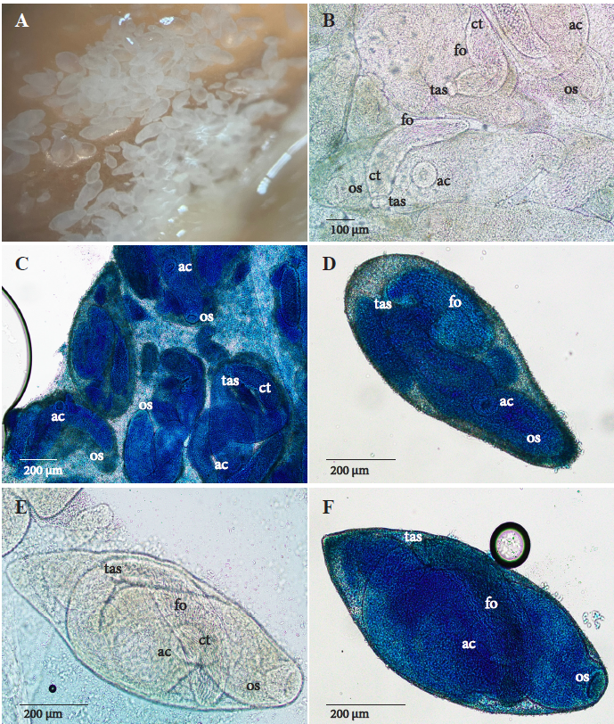
Figure A.2: Phyllodistomum sp. (Gorgoderidae) sporocysts in mantle of Ptychobranchus subtentus. A: Motile white sporocyst within the mantle. B: Unstained sporocysts (immature sporocysts and cercariae internally) from image A. C: Sporocysts from B stained with methylene blue (MB). D: MB stained immature sporocyst with single cercaria inside. E: Unstained sporocyst with cercaria internally. F: Same sporocyst in E stained with MB, with cercaria internally (annotations for cercarial structures, not sporocysts). os=oral sucker, ac=acetabulum, fo=longitudinal folds, ct=corrugated tail, tas=tail attachement site.

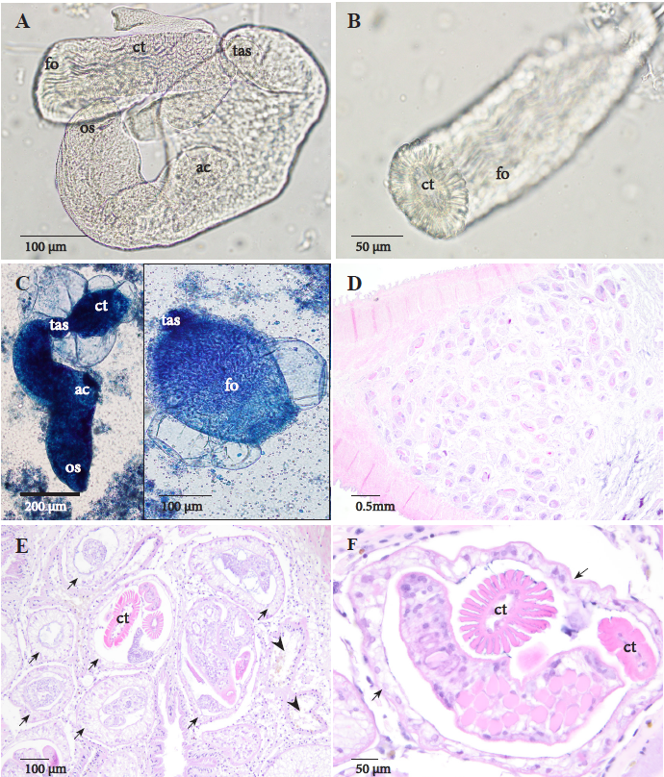
Figure A.3: Phyllodistomum sp. (Gorgoderidae) immature cercariae from sporocysts in the visceral mass of Ptychobranchus subtentus. A: Unstained cercaria with narrowing at the attachment site of the rhopalocercous tail. B: Cross section of rhopalocercous corrugated tail broken from cercarial body. C: Corrugated tail inflation of intact cercaria (left) and higher mag of detached tail (right) stained with methylene blue (MB). D: Histological section of gonad showing complete gonad effacement; HE stain. E: Histological section of gonad showing effacement of gametogenic acini (arrowheads) by sporocysts that have epithelial tegument (arrows), and contain developing cercariae; HE stain. F: Higher magnification of sporocysts in E highlighting the rhopalocercous cercaria with corrugated tail and epithelial tegument (arrows) in gonad; HE stain. os=oral sucker, ac=acetabulum, fo=longitudinal folds, ct=corrugated tail, tas=tail attachement site.
The second trematode form consisted of encysted metacercariae (Figure A.4, frames A - F), observed histologically in 6/7 but grossly visible in only 2/7 (Figure A.4, frame E) case mussels. Parasitological examination of the metacercariae showed a cyst wall width range of 7.59-8.73 µm (x̄ = 8.11 µm) and a total cyst diameter of mature specimens (Figure A.4, frames C - E) of 748-1,011 X 741-896 µm (x̄ = 891 X 836 µm) and of immature specimens of 563-654 X 525-606 µm (x̄ = 599 X 567.8 µm). The oral sucker size ranged 175-236 X 150-201 µm (x̄ = 204.75 X 177.5 µm), the acetabulum measuring a range of 245-260 X 224-249 µm (x̄ = 250 X 238 µm) and the well-defined pharynx had a range of 73-101 X 61-92 µm (x̄ = 88.8 X 81.8 µm; Figure A.4, frame F). These measurements (although of young stages excised from cyst wall and not adults) are most consistent with the description of adult H. microlophi from freshwater fish in Texas (Barger and Wellenstein 2015). Measurements of the metacercariae freed from the cyst with slight coverslip pressure ranged from 1,048 to 1,602 µm (x̄ = 1,321 µm) in length. The variation in length could be due to coverslip pressure differences, growth stages of the metacercariae, or could potentially represent different species. Measurements of the metacercarial cysts in histology matched the morphologic measurements.
Pathological findings
We examined 11 control and 7 case mussels. Despite being freshly dead at time of sampling, severe decomposition in case mussels limited histological analysis in 2/7 specimens. Larval trematodes of two forms, sporocysts and metacercariae (described in more detail in the following section), were histologically evident in 6/7 case mussels, and 7/11 control mussels (Table A.1).
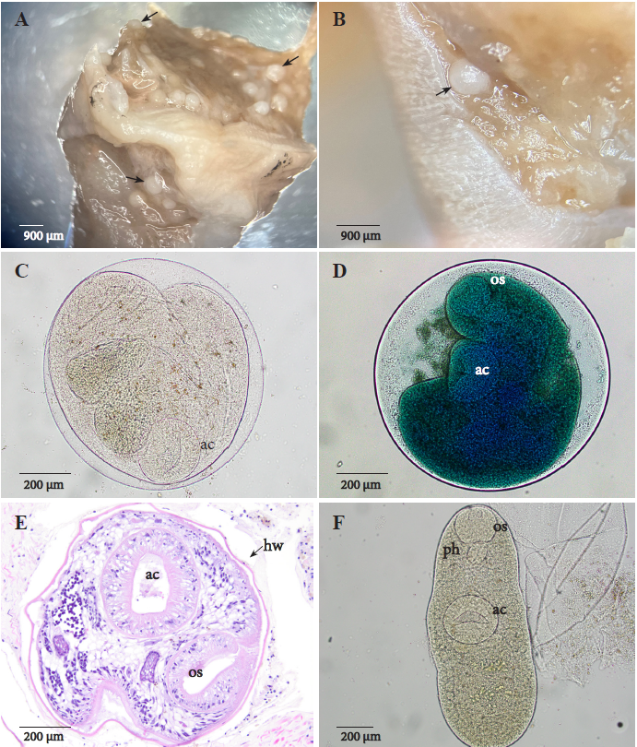
Figure A.4: Homalometron sp. metacercariae in visceral mass and gonad of Ptychobranchus subtentus. A: Many metacercariae in dissected visceral mass (arrows). B: Higher magnification of metacercariae in tissue (arrow). C: Metacercaria unstained. D: Metacercaria stained with methylene blue (MB). E: Histological section of gonad containing metacercaria within hyaline cyst wall (arrow); HE stain. F: Excised metacercaria. ac=acetabulum, ph=pharynx, os=oral sucker, hw=hyaline cyst wall.
Histologically, the Phyllodistomum sp. sporocysts had an outer tegument of simple cuboidal epithelium with pale, vacuolated cytoplasm (Figure A.3, frames D - F). These contained cercariae with prominent tails distinguished by longitudinal cuticular folds (Figure A.3, frames E and F). In case mussels, these trematode larvae were present in greatest numbers in the gonad (n = 4), with fewer within the mantle (n = 3), digestive gland (n = 2), and kidney (n = 1). Sporocysts in the gonad were numerous in every case, consistently involving 80-100% of the tissue, and associated with complete absence of mature gametes in 3/4 cases, suggestive of parasitic castration (Figure A.4, frame D). Cellular response was generally absent, but 3/4 mussels had focal hemocytic nodulation around variably degenerate or ruptured sporocysts. Despite the small sample size, the odds of mortality across study mussels were 6 times higher in mussels with sporocysts compared to those without, although not statistically significant (OR = 6.00, 95% CI [0.704–51.102], χ² = 1.432, p = 0.20). In control mussels, sporocysts were histologically evident in 2/11 individuals and were present at lower levels, affecting 40-70% of the gonad, and mature gametes were present in both cases. These sporocysts were also rarely present in the mantle (n = 1), and kidney (n = 1) while lacking hemocytic response.
Histologically the Homalematron sp. metacercariae were within a thin hyaline membrane (Figure A.4, frame E), were often folded in a C-shape, and were present within gonad (n = 5), digestive gland (n = 5), mantle (n = 5), and gill (n = 2). Histological sections of metacercariae ranged from few (n = 4) to many (n = 2). Hemocytic response was limited to degenerate metacercariae or empty/collapsed cyst walls. Metacercariae were commonly histologically identified in control mussels (7/11), ranging from few (n=5) to many (n=2), and similarly predominantly involving tissues of the visceral mass.
Aspidogastridae (Figure A.5, frames A - D) infected 3/7 case mussels, including gill, water tubes, or mantle cavity (n = 3; consistent with Cotylaspis insignis), and kidney (n = 1, consistent with Aspidogaster conchicola). These were microscopically distinguished by a rugated ventral adhesive disk (Figure A.5, frames A, C - D). These were not associated with hemocytic response or tissue injury apart from mild epithelial erosion. Aspidogastridae were present in 3/11 control mussels, involving gill (C. insignis) or kidney (A. conchicola).
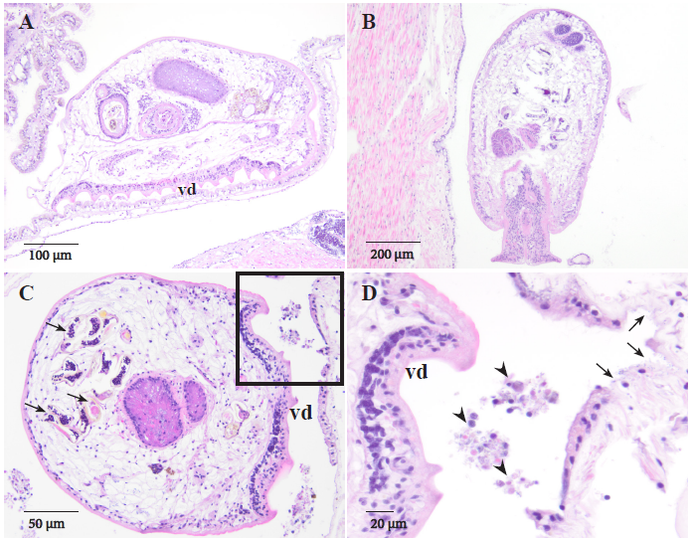
Figure A.5: Histological sections of Cotylaspis insignis (Aspidogastridae) and Aspidogaster conchicola (Aspidogastridae) in Ptychobranchus subtentus; HE stain. A: A. conchicola in kidney with rugated ventral adhesive disk. B: C. insignis in mantle cavity. C: Water tubes containing C. insignis adults gravid with eggs (arrows). D: Higher magnification of box from C with epithelial erosion (arrow) and cell debris (arrowhead). vd=ventral disk.

Gonadotropic microsporidia infected 2/7 case mussels, the only two that were female as indicated by gonad histology. Spores were oval, slightly refractile and 3-4 µm, morphologically similar to gonadotropic microsporidia described in mussels (Knowles et al. 2022; Knowles et al. 2024). They were encysted within oocyte cytoplasm or were free within lumina of ovarian acini and gonadal ducts (Figure A.6, frames A and B). Both affected mussels had depleted ovarian acini with occasional infiltrative hemocytosis in acini lumina or surrounding connective tissue, but in contrast to heavy sporocysts infections, mature gametes were still present in all cases. Moreover, all histologically female control mussels were similarly affected (6/11).
Cuticular fragments consistent with remnants of appendages of acari with hemocytic nodulation were histologically evident in 1/7 case mussels and no control mussels. A single mite was retrieved from an uncertain anatomic location during the squeeze preparation of the visceral mass cross section on mussel #4 and morphology of the mite as examined with a stereoscope was consistent with Unionicola sp. This specimen had long, spider-like legs compared to the body and had large pedipalps as previously described by Vasquez et al. (2020) and Chapurina et al. (2022). Apart from depleted gonads (2/11 controls, 4/7 case mussels), there were no additional significant pathologic observations.
Molecular identification of parasites
A total of seven case mussels were tested with PCR, and all seven had at least one species of trematode present (Table A.1). We detected DNA of three different trematode species: larval Phyllodistomum sp. and Homalometron sp. and adult A. conchicola. All sequences were compared to those in GenBank.
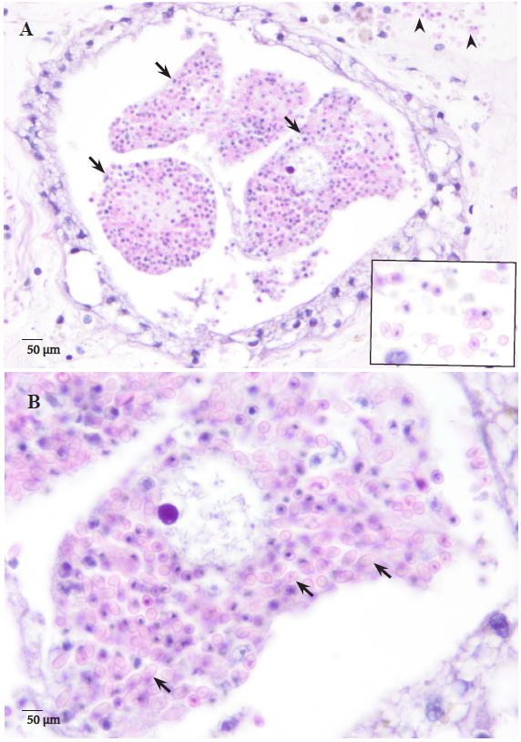
Figure A.6: Histological sections of gonad in Ptychobranchus subtentus infected with Pseudonosema-like gonadotropic microsporidia; HE stain. A: Ovarian acinus containing mature oocytes (arrows) filled with intracytoplasmic spores of the microsporidium. Note presence of extracellular spores within hemolymphatic spaces of surrounding connective tissue (arrowhead, inset). B: Higher magnification of A showing intracytoplasmic microsporidial spores (arrows).

The primers developed for paraffin DNA extraction (UnivTrem) amplified trematode DNA in four mussels. Tissue sequence from two samples (mussel #1 and #2) were identical to each other, showing 96.0% similarity to a Xystretum sp. sequence (AJ287588) and 93.9% similarity to a Phyllodistomum staffordi sequence (KM538149.1), respectively, both with 100% query coverage. The sequences from metacercaria and paraffin tissue of mussel 3 and fresh tissue of mussel 4 were poor quality and therefore were cloned. The resultant cloned sequences from mussel #3 showed 97.6 - 99.3% similarity to an H. armatum sequence (AY222130) with 99% query coverage, while those from mussel #4 showed 99.3 - 99.6% similarity to an H. armatum sequence (AY222130) with 81% query coverage.
The 18S-ITS1 primers amplified trematode DNA in three cases. Tissue sequence from mussel #1 and tissue and sporocyst sequences from #6 were 94.8% similar to a Xystretum sp. sequence (AJ287588), while mussel #5 was 99.5% similar to an A. conchicola sequence (DQ482608), both with 100% query coverage. The partial ITS1 region and 5.8S gene were amplified using the Cfwd and GoJe primer pairs. Mussel #1 produced a sequence 90.1% similar to a P. duplicatum sequence in GenBank (PP748525) with 99% query coverage. Amplification of the tissue extraction from mussel #3 was unsuccessful with these primers, but amplification of the individual metacercaria was successful, and the sequence was 98.4% similar to an H. armatum sequence (HM038045) with 100% query coverage. Tissue extraction from mussel #7 was 98.4% similar to this same sequence. The tissue and sporocyst sequences from mussel #6 were 89.9-93.9% similar to a P. duplicatum sequence (PP748525), with 100% query coverage. Finally, amplified DNA from mussel #5 was 99.5% similar to an Aspidogaster conchicola sequence (DQ482608).
The ITS2 primers amplified trematode DNA in four mussels. Tissue sequence from mussel #1 and tissue and sporocyst sequence from mussel #6 were 92.3% and 92.1% similar to a Cercaria duplicata sequence (KJ740492), respectively. The sequence from the individually extracted metacercaria from mussel #3 was 98.9% similar to an H. currani (previously H. armatum) sequence (KC710978), while the sequence from tissue paraffin extraction was 93% similar to a Cercaria duplicata sequence (KJ740492). Query coverage was 100% for all ITS2 sequences.
The 28S primers amplified trematode DNA in two mussels. The metacercaria extraction from mussel #3 resulted in a sequence 98.2% similar to H. microlophi (previously H. armatum) with 100% query coverage, and the sequence from both the tissue extraction and the sporocyst from mussel #6 was 95.7% similar to a P. duplicatum sequence in GenBank (PP061384).

Discussion
This study describes parasites and associated disease observed in P. subtentus, a federally endangered species, including digenean metacercariae of Homalometron sp., sporocysts of Phyllodistomum sp, adult Aspidogastridae, and gonadotropic microsporidia. To our knowledge, this is the first documentation of gonadotropic microsporidia and description of Homalometron sp. and Phyllodistomum sp. infections in P. subtentus, representing diverse parasite fauna within a rare and endangered host species at a site experiencing seasonal mortality. Two of these, Phyllodistomum sp. and microsporidia, have the potential for negative impacts on reproduction and recruitment. The impact of digenean larval trematodiasis on bivalve mortality is understudied, although the negative consequences of parasitism to bivalve physiology and reproduction are well recognized (Jokela et al. 2005, Gangloff et al. 2008, Grizzle and Brunner 2009, McElwain 2019, Taskinen et al. 2022). We describe mortality and pathology accompanied by these parasites.
Larval Trematodes of Phyllodistomum
Sporocysts of Phyllodistomum sp. (Gorgoderidae) were identified morphologically and molecularly in four of the seven (57%) case mussels (Figures A.2 and A.3). The histological and cytological morphology of these sporocysts are consistent with previous reports of Phyllodistomum sp. (Müller et al. 2015; Gosho et al. 2024). The Phyllodistomum sp. larval stages found in this study was a close morphological match to Phyllodistomum duplicatum and a Phyllodistomum sp. both found in bivalves in Lithuania (Stunžėnas et al. 2024: Kudlai and Yanovich 2013). The balloon-like inflation of the rhopalocercous, deeply corrugated cercarial tail observed in this study matches what is known of the life cycle for Phyllodistomum sp. (Figure A.3, frames A - C) up to the metacercarial stage (Fischthal 1951; Kudlai and Yanovich 2013; Stunžėnas et al. 2024). The definitive host remains unknown for many species in the Phyllodistomum genus (Gosho et al. 2024; Kudlai and Yanovich 2013).The taxonomy surrounding the genus Phyllodistomum, and closely related genera, has been debated for over 70 years, and the need for divisions within this genus has been suggested (Fischthal 1951, Orecchia et al. 1975, Cribb 1987, Kudlai and Yanovich 2013, Petkeviciute et al. 2014, Stunžėnas et al. 2017, Petkeviciute et al. 2020). Sequences from the ITS, 5.8S, and partial 28S region in positive mussels in our study were between 90-96% similar to Phyllodistomum duplicatum or Cercaria duplicata sequences in GenBank (Table A.1). Recent work has demonstrated that Cercaria duplicata and Phyllodistomum duplicatum are conspecific (Stunžėnas et al. 2024). The low 18S sequence identity to Phyllodistomum spp. is likely due to the lack of 18S P. duplicatum sequences in GenBank. Collectively, these molecular results indicate that the species in our study belongs to the currently recognized genus Phyllodistomum.
The 18S gene is highly conserved across species, with novel species often differing by less than 2% at this locus. Therefore, with the closest species match at only 94% similar at the 18S gene and 96% similar at the 28S gene, it is likely that this represents a previously unrecognized Phyllodistomum species. However, further work is required to confirm this assertion. The length and quality of our sequences were limited by the nature of the collection. Many specimens had already been formalin-fixed at the time of analysis, leading to inconsistent amplification and limiting the resultant sequence lengths. Future work assessing a greater number of fresh specimens is warranted to fully sequence the 28S gene or conduct whole genome sequencing, allowing for more definitive identification. This study reports a new Unionidae first intermediate host species for the genus Phyllodistomum and highlights the importance of integrating morphological, histological and molecular diagnostics, rather than relying solely on molecular methods, to ensure comprehensive and accurate identification of trematodes (Scholz 2024).
Heavy infections of the gonad with trematode larvae can result in parasitic castration of the mussel host, interfering with the production of glochidia, and reducing energy resources available for reproduction (Jokela and Taskinen 1993, Taskien and Valtonen 1995, Brian et al. 2021b). Parasitic castration of unionids is reported from a number of trematode families, including Gorgoderidae, but is best described for Bucephalidae (Grizzle and Brunner 2009), which are morphologically distinguished by the presence of bifurcate tails (Laruelle et al. 2002), and lacking longitudinal cuticular folds as seen in some Phyllodistomum sp. Our histological analysis revealed gonadal effacement and loss of mature gametes in some P. subtentus heavily infected with Phyllodistomum sp. sporocysts, findings that strongly suggest potential for reduction in fecundity or even parasitic castration. Definitive confirmation of parasitic castration would require demonstration of complete or near-complete reproductive failure in infected compared to uninfected individuals (Lafferty and Kuris 2009).
Sporocysts in P. subtensus were often within other organs with more vital functions (such as digestive gland, kidney and mantle) in heavily infected mussels. Infection of these organs may be particularly harmful to the host, as suspected in duck mussels (Anodonta anatina) infected with bucephalid trematode larvae (Taskinen et al. 1997). Similarly, experimental infection with Rhipidocotyle campanula was linked to increased mortality in the same species (Jokela et al. 2005), and mussels releasing Rhipidocotyle cercariae experienced higher mortality under elevated temperatures (Taskinen et al. 2022). Notably, the severity and prevalence of sporocysts were higher among our case mussels relative to apparently healthy specimens. These findings, combined with a lack of alternative lesions to explain death, suggest heavy infections may play a role in mortality. Apart from gonadal effacement (Figure A.3, frames D - E), Phyllodistomum sp. sporocysts in this study were not associated with significant pathology, only occasionally having hemocytic nodulation, a common mussel response to encysted larval trematodes (Knowles et al. 2023). These findings suggest that the mechanism of death for heavily infected mussels would likely not be related to inflammatory response, but rather metabolic impact, or dysfunction of other infected tissues more vital than gonad (Taskinen et al. 1997). It is important, however, to interpret the association between mortality and the occurrence of sporocysts with caution, given the weak statistical support. It may be that factors driving mortality in mussels also predispose to parasitism (Saarinen and Taskinen 2005), or that mortality is a culmination of multi-organism infections, confounding identification of causal relationships. The level of risk Phyllodistomum sp. poses for P. subtentus mortality should be clarified by larger scale studies, or potentially experimental infection trials. Achieving larger sample sizes to facilitate statistical comparisons is challenged by the regulatory limits on lethal sampling of apparently healthy endangered species and the difficulty in identifying fresh mortalities of uncommon mussel species.
Larval Trematodes of Homalometron spp.
Homalometron armatum has recently been split into three species, H. currani, H. microlophi, and H. armatum (Barger and Wellenstein 2015). Morphological identification of the metacercariae was difficult due to limited descriptions of this stage of Homalometron spp. (Family Apocreadiidae) in the literature. Descriptions of adult Homalometron microlophi are consistent with sizes of the larger Homalometron sp. metacercarial stages excised from cysts in mussel #3 in this study, and the 28S sequence from this mussel was also most consistent with H. microlophi, though only 98.2% identical (Barger and Wellenstein 2015). In our study, two distinct sequences of Homalometron sp. were found at the 18S locus, with one aligning >99% and the second aligning 97.6-98.4% with H. armatum sequences. With the high conservation of the 18S gene, it is possible that the latter sequence represents a unique species within the Homalometron genus, though further morphologic and molecular analyses would be required to fully assess this possibility. There are limited sequences available at the 18S gene to differentiate between H. currani, H. microlophi, and H. armatum, limiting our analysis. Only one sequence was found at the ITS or 28S regions, with our ITS sequence most similar to H. currani, and the 28S sequence most similar to H. microlophi. Both sequences were >1% different from sequences in GenBank, further suggesting this may be a unique species within the Homalometron genus. Four mussels had only a few metacercariae identified histologically, and these were PCR negative for Homalometron sp., potentially due to low DNA concentrations and competitive binding to the other, more prevalent trematode species.
Homalometron sp. DNA was detected without histological confirmation in one mussel. Mussel # 7 was severely decomposed at the time of necropsy, showing no evidence of metacercaria on histology or cytologic morphology. However, 18S PCR analysis of mussel tissue disclosed a 98.4 % identity to an adult H. armatum (HM038045) found in Freshwater Drum (Aplodinotus grunniens) in Reelfoot Lake, TN (Parker et.al 2010). Interestingly, A. grunniens are molluscivorous (i.e., feed on mussels) and occur in the Upper Clinch River Watershed (VDWR 2023), which may explain how Homalometron spp. are present in both species. Short and long 18S sequences from this mussel gave >99% and 98.4% matches to adult H. armatum (AY222130) from Redear Sunfish (Lepomis microlophus) in the Pascagoula River, Wilkerson’s Ferry, Mississippi (Olson et al. 2003). Similar to A. grunniens, L. microlophus are also molluscivorous and occur in the Upper Clinch River watershed. No morphological descriptions of the metacercarial stages were provided in any of the comparative studies mentioned above with molecular matches to this study. This is the first report of Homalometron sp. metacercariae in P. subtentus.
The only pathology associated with Homalometron sp. metacercariae was occasional hemocytic nodulation representing a response to degenerate or ruptured cysts. The lack of substantial associated pathology, combined with the lower tissue loads compared to Phyllodistomum sporocysts, and the similar prevalence and numbers of Homalometron sp. metacercariae in cases and controls, suggest that these trematode larvae are incidental findings unrelated to mortality. However, in blue mussels (Mytilus edulis) sampled off the coast of Netherlands, metacercariae of Renicola roscovita encysted in the gills and palps reduced clearance rates and overall mussel body mass index (Stier et al. 2015). Such observations emphasize that deleterious effects on physiology, even without substantial tissue pathology, could comprise contributory factors for morbidity and mortality in stressed populations.
Aspidogastrea
Aspidogastrea are primitive trematodes commonly observed in mussels, and as supported by this study, are generally considered innocuous incidental findings unless present in high numbers (Grizzle and Brunner 2009, Knowles et al. 2023). From this regard, our observations add to our understanding of so-called background lesions and microbiota, which are commonly present to some extent in apparently healthy or stable mussel populations (Burcham et al. 2023).
Gonadotropic microsporidia
This is the first instance of gonadotropic microsporidia in P. subtentus, and the first instance of their documentation in a listed species. Knowlespora clinchi were the first microsporidia described infecting another unionid, the Pheasantshell (A. pectorosa) also in the Clinch River (Bojko 2022, Knowles et al. 2022). Recently, another novel gonadotropic microsporidian, Hirsutonosema embarrassi, was found in the ovaries of 50 - 100% of mucket (Actinonaias ligamentina), plain pocketbook (Lampsilis cardium), and fatmucket (Lampsilis siliquoidea) assessed in Wisconsin (Knowles et al. 2024). Heavy infections of ova lead to the hypothesis of reduced fecundity and recruitment (Knowles et al. 2022), and therefore these pathogens are potentially important threats for endangered mussel species. All females we histologically evaluated were heavily infected, regardless of presentation (case or control). The whole genome sequencing of the organisms observed in P. subtentus would be useful to determine if these are in fact undescribed species. Further research is needed to better understand the diversity and impact of microsporidia on mussel health and reproduction.
Overall conclusions
Accounting for the role of pathogens, including parasites, is crucial in the conservation of mussels (Brian et al. 2021a,b,c). We describe several parasites in natural mortalities of P. subtentus in a region impacted by seasonal mortality events. Further research is needed to determine the impact of Phyllodistomum sporocysts and gonadotropic microsporidia on reproduction, recruitment, morbidity and mortality of P. subtentus. It is unclear whether the degree of parasitism observed represents normal parasite pressure in a relatively non-degraded, biodiverse ecosystem (where host species are abundant), or increasing parasite pressure associated with ecosystem stress. Better linkages among descriptive epidemiology and diagnostic investigations are needed to disentangle these relationships. While P. subtentus is an endangered species impacted by historical declines, populations at both study sites are recruiting according to long term monitoring data from the United States Fish and Wildlife Service (J. Richard unpubl. data). However, the prevalence of these parasites and temporal trends in the host abundance are currently unknown and continued monitoring is warranted.
This study demonstrates the value in undertaking traditional steps of a diagnostic investigation to understanding possible causal factors for mortality (Cossey et al. 2025). Mussels that are found dead are typically not ideal for diagnostic investigation due to the rapid rate of postmortem decomposition in the aqueous environment (Waller and Cope 2019; Knowles et al. 2023). However, this study shows that ‘freshly-dead’ mussels (i.e. those that have been dead for a short time as indicated by the lack of putrid smell, emphysematous tissues, or sloughing integumentary surfaces), can still have diagnostic value, particularly for assessing parasitism. While they are expected to have lesser diagnostic value than live mussels and should only be sampled over live mussels as a last resort, this may be the only option when dealing with endangered species or a rapidly progressing mortality event.
Translocation of wild mussels within or between rivers is commonly used by natural resource agencies to support the reintroduction of mussels to areas of extirpation or to augment declining populations (Brian et al. 2021c). Our results and others indicate that this conservation and restoration approach should be used with caution because parasites may be moved with translocated individuals, potentially affecting parasite-host dynamics at both the source and recipient sites. In 2012, Davis and Layzer reported that since 2004 over 4,000 adults P. subtentus have been translocated from Kyles Ford to restore the populations of three other rivers. The probability of a pathogen being translocated from the source population to the recipient population increases rapidly with translocation size and pathogen prevalence (Brian et al. 2021c). Although the prevalence of these parasites in the P. subtentus is known, there is a high probability that they have been translocated to other sites unknowingly, given the large number of individuals translocated. Because trematodes and gonadotropic microsporidians can disrupt reproductive capabilities of host mussels, the introduction of either group of parasites into a population can further increase recovery challenges. Therefore, integrating rigorous and standardized health assessments including baseline measurements of pathogen and parasite prevalence and diversity into mussel conservation strategies may improve the probability of their success.

References
Barger M, Wellenstein D (2015) Morphological confirmation of Homalometron (Trematoda: Apocreadiidae) species in freshwater fishes in southeastern Texas, USA, with description of two species. Comp Parasitol. 82(2):248-53.
Bojko J (2022) Systematic identity and phylogenetic analysis of Knowlespora clinchi (Knowles et al. 2022) gen. et comb. nov. from pheasantshell mussels (Actinonaiais pectorosa). J Invertebr Pathol 194:107817.
Brian JI, Aldridge DC (2019) Endosymbionts: An overlooked threat in the conservation of freshwater mussels? Biol Conserv 237:155–165.
Brian JI, Dunne SE, Ellis CL, Aldridge DC (2021a) Population‐level effects of parasitism on a freshwater ecosystem engineer, the unionid mussel Anodonta anatina. Freshw Biol 66:2240–2250.
Brian JI, Aldridge DC (2021b) A rapid, non‐destructive method for sampling castrating parasites in endangered bivalve molluscs. Aquat Conserv: Mar Freshw Ecosyst 31:729–735.
Brian JI, Ollard IS, Aldridge DC (2021c) Don't move a mussel? Parasite and disease risk in conservation action. Conserv Lett 14.
Brian JI, Reynolds SA, Aldridge DC (2022) Parasitism dramatically alters the ecosystem services provided by freshwater mussels. Funct Ecol 36:2029–2042.
Burcham GN, Fisher B, Boedeker N (2023) Histopathologic survey of free-living populations of 2 species of freshwater mussels in Indiana. Vet Pathol 60:628–639.
Chapurina YE, Konopleva ES, Vidrine MF, Lemenkova P, Sabitova ZA, Abramov AV (2022) New molecular-based phylogeny of mussel-associated mites reveals a new subgenus and three new species representing an example of a host-driven radiation in Indochina and confirms the concept of division of the genus Unionicola Haldeman, 1842 (Acari: Unionicolidae) into numerous subgenera. Diversity 14:848.
Coen LD, Bishop MJ (2015) The ecology, evolution, impacts and management of host–parasite interactions of marine molluscs. J Invertebr Pathol 131:177–211.
Cossey DA, Dennis MM, Richard J, Della Torre C, McElwain A, Waller DL, Knowles S, Brian JI, Leis E, Burioli EA, Aldridge DC. (2025) Sampling mass mortality events to enable diagnoses: A protocol using freshwater mussels. Methods Ecol Evol. 16:250-268.
Cribb TH (1987) Studies on gorgoderid digeneans from Australian and Asian freshwater fishes. J Nat Hist 21:1129–1153.
Curran SS, Tkach V, Overstreet RM (2013) Molecular evidence for two cryptic species of Homalometron (Digenea: Apocreadiidae) in freshwater fishes of the southern United States. Comp Parasitol 80:186–195.
Da Silva Neto JG, Hardman RH, Engman AC, Dinkins GR, Lane TW, Fry MM, Rines CR, Bisenieks AL, Rajeev S, Dennis MM (2024) Multisystemic inflammatory disease in Pheasantshell (Unionidae, Actinonaias pectorosa) associated with Yokenella regensburgei infection at sites experiencing seasonal mass mortality events. Plos One. 27;19(8):e0301250.
Davis VM, Layzer JB (2012) Life history of the Fluted Kidneyshell Ptychobranchus subtentum. Am Midl Nat 167:79–95.
Fischthal JH (1951) Rhopalocercariae in the trematode subfamily Gorgoderinae. Am Midl Nat 46:395.
Gangloff MM, Lenertz KK, Feminella JW (2008) Parasitic mite and trematode abundance are associated with reduced reproductive output and physiological condition of freshwater mussels. Hydrobiologia 610:25–31.
Gosho M, Itsukushima S, Collins MH, Dalton IT, Rosen RB, Urabe M (2024) Molecular phylogenetic position and the life cycle of Phyllodistomum cyprini Feng et Wang, 1995 in Japan, with a note of a larval Phyllodistomum sp. from unionid mussels in North America. Parasitol Int. 98:102807.
Grizzle JM, Brunner CJ (2009) Infectious diseases of freshwater mussels and other freshwater bivalve mollusks. Rev Fish Sci 17:425–467.
Haag WR (2012) North American freshwater mussels: natural history, ecology, and conservation. Cambridge University Press.
Jokela J, Uotila L, Taskinen J (1993) Effect of the castrating trematode parasite Rhipidocotyle fennica on energy allocation of freshwater clam Anodonta piscinalis. Funct Ecol 7:332–338.
Jokela, J., Taskinen, J., Mutikainen, P. and Kopp, K. 2005. Virulence of parasites in hosts under environmental stress: experiments with anoxia and starvation. OIKOS 108:156-164.
Katsanevakis S, Tsirintanis K, Tsaparis D, Poursanidis D, Tsiamis K, Doukas D, Sini M, Crocetta F, Deidun A, Trajanovski S, Markovic O (2019) The cryptogenic parasite Haplosporidium pinnae invades the Aegean Sea and causes the collapse of Pinna nobilis populations. Aquat Invasions 14:2.
Knowles S, Leis EM, Richard JC, Boley B, Dennis M, Anderson KB, Khan E, Meyers AM, Adair A, Leisner S, Johnson NS, Schill WB, Ericson EG, Collins J, Lorch JM (2022) A novel gonadotropic microsporidian parasite (Microsporidium clinchi n. sp.) infecting a declining population of pheasantshell mussels (Actinonaias pectorosa) (Unionidae) from the Clinch River, USA. Parasitologia 2:1–12.
Knowles S, Dennis M, McElwain A, Mayberry C, Taylor AT, Schilling E, Sickel JB, Hicks M, Leis EM, Camarota FC, Khan E, Ferguson J, Schrimpf ME, Bonar SA (2023) Pathology and infectious agents of unionid mussels: a primer for pathologists in disease surveillance and investigation of mortality events. Vet Pathol 60:510–528.
Knowles S, Leis EM, Richard JC, Denhart M, Enzenbacher D, Rogers S, Adams E, Pires DA, Henry MA, Homan M, Allen JE, Hubler S, Stauffer KR, Ahlstedt S, Jones J, Snelson KM, Chan MS, Johnson ND, Cooper RA, Alexander R, Finn CB, Hazelton M, Woodrow I, Byrd S, Mayers A, Haislip NA, Pitt C, Horton AA, DeWitt T, Pierce CL, Washburne AC, Schill WB (2024) Hirsutonosema embarrassi n. gen. n. sp. (Phylum Microsporidia) in the ovary of mucket (Actinonaias ligamentina), plain pocketbook (Lampsilis cardium), and fatmucket (Lampsilis siliquoidea) (Unionidae) from the Embarrass River, Wisconsin, USA. Parasitologia 4:184–198.
Kudlai OS, Yanovich LN (2013) Larval stages of Phyllodistomum sp. (Digenea, Gorgoderidae) from the duck mussels Anodonta anatina in Ukraine. Vestn Zool 47:37–42.
Lafferty KD, Kuris AM (2009) Parasitic castration: the evolution and ecology of body snatchers. Trends Parasiol 25(12):564-572.
Laruelle F, Molloy DP, Roitman VA (2002) Histological analysis of trematodes in Dreissena polymorpha: their location, pathogenicity, and distinguishing morphological characteristics. J Parasitol 88:856–863.
McElwain A (2019) Are parasites and diseases contributing to the decline of freshwater mussels (Bivalvia, Unionida)? Freshw Mollusk Biol Conserv 22:85–89.
Müller T, Czarnoleski M, Labecka AM, Lewandowski K, Ożgo M, Bonisławska M, Adamczyk M (2015) Factors affecting trematode infection rates in freshwater mussels. Hydrobiologia 742:59–70.
Olson PD, Cribb TH, Tkach VV, Bray RA, Littlewood DTJ (2003) Phylogeny and classification of the Digenea (Platyhelminthes: Trematoda). Int J Parasitol 33:733–755.
Orecchia P, Paggi L, Castagnolo L, Della Seta G, Minervini R (1975) Ricerche sperimentali sul ciclo biologico di Phyllodistomum elongatum Nybelin, 1926 (Digenea: Gorgoderidae Looss, 1901). Parassitologia 17:95–101.
Parker J, Curran S, Overstreet R, Tkach V (2010) Examination of Homalometron elongatum Manter, 1947 and description of a new congener from Eucinostomus currani Zahuranec, 1980 in the Pacific Ocean off Costa Rica. Comp Parasitol 77:154–163.
Parmalee PW, Bogan AE (1998) The freshwater mussels of Tennessee. University of Tennessee Press.
Petkevičiūtė R, Zhokhov AE, Zubchenko AV, Stunžėnas V, Sokolov SG, Lebedeva D (2020) Phyllodistomum kupermani n. sp. from the European perch, Perca fluviatilis L. (Perciformes: Percidae), and redescription of Phyllodistomum macrocotyle (Lühe, 1909) with notes on the species diversity and host specificity in the European Phyllodistomum spp. (Trematoda: Gorgoderidae). Parasit Vectors 13:1–12.
Richard, J., 2018. Clinch River mussel die-off. Ellipsaria, 20, pp.1-3.
Routtu J, Grunberg D, Izhar R, Ben-Ami F (2014) Selective and universal primers for trematode barcoding in freshwater snails. Parasitol Res 113:2535–2540.
Saarinen M. and Taskinen J. (2005) Long-lasting effect of stress on susceptibility of a freshwater clam to copepod parasitism. Parasitology 130: 523-529.
Scholz T (2024) Gaps in parasitological research in the molecular era. Trends Parasitol 40:283-291
Stier T, Drent J, Thieltges DW (2015) Trematode infections reduce clearance rates and condition in blue mussels Mytilus edulis. Mar Ecol Prog Ser 529:137–144.
Stunžėnas V, Stanevičiūtė G, Frolov MV, Jankauskienė R, Petkevičiūtė R (2017) Host specificity, molecular phylogeny and morphological differences of Phyllodistomum pseudofolium Nybelin, 1926 and Phyllodistomum angulatum Linstow, 1907 (Trematoda: Gorgoderidae) with notes on Eurasian ruffe as final host for Phyllodistomum spp.. Parasites Vectors. 10:286.
Stunžėnas V, Petkevičiūtė R, Zając K, Dołęga J, Łuszczek-Trojnar E, Stanevičiūtė G (2024) Discovery of adults of the gorgoderid trematode Cercaria duplicata with first morphological description, molecular identification and notes on host specificity. Sci Rep. 14(1):22085. doi: 10.1038/s41598-024-72921-y
Taskinen J, Valtonen ET (1995) Age-, size-, and sex-specific infection of Anodonta piscinalis (Bivalvia: Unionidae) with Rhipidocotyle fennica (Digenea: Bucephalidae) and its influence on host reproduction. Can J Zool 73:887–897.
Taskinen J, Mäkelä T, Valtonen ET (1997) Exploitation of Anodonta piscinalis (Bivalvia) by trematodes: parasite tactics and host longevity. Annales Zoologici Fennici 34: 37-46.
Taskinen, J. 1998. Influence of trematode parasitism on the growth of a bivalve host in the field. International Journal for Parasitology 28: 599-602.
Taskinen, J., Choo, J.M., Mironova, E. and Gopko, M. 2022. Contrasting temperature responses in seasonal timing of cercariae shedding by Rhipidocotyle trematodes. Parasitology. 149(8): 1045-1056. https://doi.org/10.1017/S0031182022000518
Tkach, V., et al. "Molecular and morphological evidence for close phylogenetic affinities of the genera Macrodera, Leptophallus, Metaleptophallus and Paralepoderma (Digenea, Plagiorchiata)." (1999): 170-179.
USFWS (U.S. Fish and Wildlife Service) (2021) Species Status Assessment Report for the Ptychobranchus subtentus (Ptychobranchus subtentum (=subtentus)), Version 1.0. February 2021. Atlanta, GA.
Vasquez AA, Carmona-Galindo V, Qazazi MS, Marín-Díaz B, Rodríguez V, Fisher NR, Zúñiga RE, Enriquez JB, Wolfram A (2020) Water mite assemblages reveal diverse genera, novel DNA barcodes and transitional periods of intermediate disturbance. Exp Appl Acarol 80:491–507.
VDWR (Virginia Department of Wildlife Resources) (2023) Clinch River fisheries management report, 2023. Virginia Department of Wildlife Resources, Richmond, VA. Available at: https://dwr.virginia.gov/wp-content/uploads/media/Clinch-River-Fisheries-Management-Report-2023.pdf (accessed 8/13/2024).
Waller DL, Cope WG (2019) The status of mussel health assessment and a path forward. Freshw Mollusk Biol Conserv 22:26–42.
Williams JD, Bogan AE, Garner JT (2008) Freshwater mussels of Alabama and the Mobile Basin in Georgia, Mississippi, and Tennessee. University of Alabama Press, Tuscaloosa, AL
Ye, J., Coulouris, G., Zaretskaya, I. et al. Primer-BLAST: A tool to design target-specific primers for polymerase chain reaction. BMC Bioinformatics 13, 134 (2012). https://doi.org/10.1186/1471-2105-13-134

Appendix F: Abstract of relevant co-authored publications

At the time of dissertation submission, a version of this manuscript was under review in Food Webs.
Authors: Brileigh V. Hicks , Augustin C. Engman, Jeronimo G. Da Silva Neto, Caitlin S. Carey, Julianna J. Jett , and Gerald R. Dinkins

Author’s contributions are as follows: Jeronimo Silva: Conceptualization, data curation, formal analysis, investigation, methodology, supervision, writing – original draft, review & editing. Augustin Engmann: Conceptualization, data curation, formal analysis, methodology, supervision, writing – original draft, review & editing. Gerald Dinkins: Data curation, formal analysis, investigation, methodology, writing – original draft, review & editing. Brileigh Hicks: Data curation, formal analysis, investigation, , data curation, writing – original draft, review & editing. Julian Jett: data curation, investigation, writing – review and editing. Caitlin Carey: formal analysis, investigation, methodology, writing – original draft, review & editing.
Abstract

Many freshwater mussel species are experiencing significant declines across the United States, particularly in the Southeast where most of the diversity in this animal group occurs. In this study, we evaluated the impact of muskrat (Ondatra zibethicus) predation on the mussel assemblage at Kyles Ford, a well-studied reach of the Clinch River, Tennessee. We compared quantitative estimates of abundance and size structure of live populations with shells that accumulated in muskrat middens between September and December 2023. We used a sampling approach that censused all shells deposited by muskrats at this site during the study and allowed us to quantify predation rates and size-and species-selectivity of muskrat predation. In total, we documented the predation of 2,370 individual mussels of 26 species, including 14 federally listed species and one candidate species. The mean predation rate was 20 mussels per day and muskrats exhibited preference for larger individuals. The Shannon-Wiener Diversity Index from species collected in the middens indicated medium species diversity (H’ = 1.7), and the Chesson’s Alpha index confirmed significant species selectivity coinciding with endangered species. These findings underscore the need for further research into the seasonal and environmental variability of muskrat predation and its long-term effects on mussel populations. Additionally, our results suggest that muskrat middens may serve as a valuable tool for monitoring mussel species occurrences.

VITA

Jeronimo Gomes Da Silva Neto was born in Sao Paulo, Brazil. He earned his Bachelor of Science in Wildlife Sciences from Virginia Tech in 2013 and his Master of Science in Agricultural Sciences from Tennessee State University in 2018. He completed his doctoral studies in Comparative and Experimental Medicine at the University of Tennessee's College of Veterinary Medicine in 2025.
Throughout his academic and professional career, Jeronimo has collaborated extensively with researchers and conservation managers across the Southeastern United States, working with various ecosystems and taxa, including endangered species. His work includes field and laboratory research on species distribution, habitat selection, disease ecology, population dynamics, environmental toxicology, parasitology, and applied conservation, with a particular focus on aquatic habitat restoration and strategic conservation planning. His research has been presented at regional, national, and international conferences and published in peer-reviewed scientific journals. He is an active member of professional societies including The Wildlife Society, the Wildlife Disease Association, and the American Fisheries Society.
After completing his PhD, Jeronimo plans to continue research on freshwater biodiversity, disease dynamics, and conservation management in aquatic ecosystems.

