SIMULATING MICROBIAL ELECTROLYSIS FOR RENEWABLE HYDROGEN PRODUCTION INTEGRATED WITH SEPARATION IN BIOREFINERY

A thesis
Presented to
The Academic Faculty

By

Christian James Wilson

In Partial Fulfillment
of the Requirements for the Degree
Master of Science in the
College of Chemical and Biomolecular Engineering

University of Tennessee Knoxville

July, 2017

ACKNOWLEDGEMENTS

TABLE OF CONTENTS

ACKNOWLEDGEMENTS
CHAPTER

- INTRODUCTION
  - Problem Statement
  - Overview
  - Baseline Biorefinery Process
  - Steam Reforming
  - Microbial Electrolysis
    - Concept of MEC
    - Current status of technology
    - Literature review of MEC process models and economic analysis
  - Stage Fractionation Process
  - Integrated Biorefinery Process

- NATURAL GAS REFORMING
  - Process Design
  - Results
  - Mass and Energy Balance
  - Comparison to Process Design Report PNNL-23053

- MICROBIAL ELECTROLYSIS
(Assimilation to whole process given feedstock simulated conversion of main components and hydrogen production)
  - Biorefinery process stream to be fed to MEC / substrate – BOAP, describe its contents and give basic reactions of how they are converted into Hydrogen in MEC
  - Hydrogen needs in biorefinery
  - MEC conversion model in Excel

- INTEGRATED STAGE FRACTIONATION PROCESS AND MICROBIAL ELECTROLYSIS CELL
  - Process Design
    - Bio-oil Stage fractionation
    - MEC system components
  - Results
  - Mass and Energy Balance
  - Comparison of Separation Results with ISU Process

- MODIFICATION OF PNNL-23053 FLOWSHEET WITH STAGE FRACTIONATION PROCESS AND MEC
(will mostly be results)
  - Comparison of feed streams
  - Changes in process model for biorefinery integration
  - Key results related to fractionation streams and hydrogen production

- INTEGRATION OF REFORMING STAGE FRACTIONATION AND MEC
  - Process Design
  - Mass and Energy Balance
  - Techno-economic Analysis
- CONCLUSIONS AND RECOMMENDATIONS

APPENDIX
REFERENCES

CHAPTER 1

INTRODUCTION

  - Problem Statement

A foundation for the industrial scale production of hydrogen gas has been uniquely fostered in the systematic design of the biorefinery. Efforts to improve efficiency, decrease operating and capital costs as well as greenhouse gas emissions within this bioenergy production system have been considered and encouraged by the scientific community for decades. We find ourselves adding to the large bank of innovative additions to this process. Within the context of industry, economic incentive for innovation oftentimes speaks louder than possible environmental risk. It is thus our job to conduct and communicate a techno-economic analysis (TEA) of any such innovation that we may consider to make a meaningful and/or credible addition. We seek to integrate a baseline biorefinery process with a modern biotechnological apparatus called a microbial electrolysis cell (MEC). Using resources such as this and many more including Aspen simulation software and Microsoft Excel we have conducted a TEA for our proposed design.
1.2 Overview
The innovative use of an established alternative energy source is the beginning of the conversation of this study. Determining how to make alternative sources of energy competitive with more commonly used sources begins with noting modern energy demands. It is at this point that the challenge of meeting these demands in a cost effective way can be undertaken. A report of a simulated biorefinery process serves as a basis for the conversion of biomass to hydrocarbon fuel. This basis provides extensive mass balance, process operation, and economic analysis data for the production of gasoline and diesel fuel at a competitive rate that is shown by establishing a minimum fuel selling price. Through the analysis of this report, we have found sections where innovations in upstream processes of fuel production can be implemented and capital and utility cost data was lacking. This innovation to the baseline biorefinery is the integration of a MEC with a bio-oil stage fractionation process (SF) downstream of the fast pyrolysis section. This coupled process serves to utilize condensed pyrolysis vapor that can be used within an MEC for hydrogen production. MECs have been shown to produce hydrogen gas at a large scale (Escapa, Mateos, Martínez, & Blanes, 2016). This is of particular importance to fuel production within a biorefinery because the steam reforming section functions to produce hydrogen gas for downstream bio-oil upgrading and hydrocracking. Typically, off-gases from the overall biorefinery that are used to produce hydrogen through the steam reforming process are not sufficient to meet the demands necessary for these downstream processes. Thus, a supplemental natural gas source is used to meet these demands. However, the increased production of hydrogen gas from the MEC-SF process is great enough to make up for any losses in hydrogen production from the removal of this natural gas. Energy balance and detailed capital and utility cost data for the pyrolysis and hydrogen production sections were not included in the baseline biorefinery report. Thus, the integration of our process resulted in filling the gaps of information not presented in the report. The design, implementation, and cost analysis of the MEC-SF process with the baseline biorefinery is the work of this thesis.

1.3 Baseline Biorefinery Process
We utilize a report containing a vast amount of data from a well-defined large-scale simulation of a biorefinery (including but not limited to mass and energy balances, costing data, unit operation data, and reaction mechanism information) for our study (Jones, Meyer, Snowden-swan, et al., 2013). The report, PNNL-23053, authored by the Pacific Northwest National Laboratory (PNNL), the National Renewable Energy Laboratory (NREL), and the Idaho National Laboratory (INL) served as our source for a baseline biorefinery process. Their approach to developing a techno-economic analysis followed a systematic process that is commonly used, see Figure below.
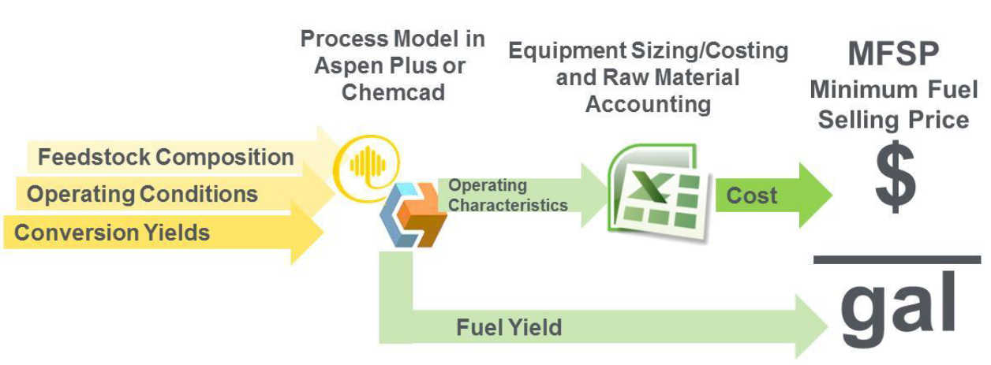

It begins with establishing feedstock composition, operating conditions, and conversion yields; all of which are determined based on an extensive literature review and relevant assumptions. This data is then evaluated using process model software, in this case specifically Aspen Plus and CHEMCAD, where the material and energy balance information is obtained. From there, equipment costing and sizing is then estimated based on the specific characteristics of each process and is typically neatly represented using Microsoft Excel. Finally, a minimum fuel selling price (MFSP) is established using a discounted cash flow analysis. The simulated biorefinery itself is broken up into five sections and can be seen below.

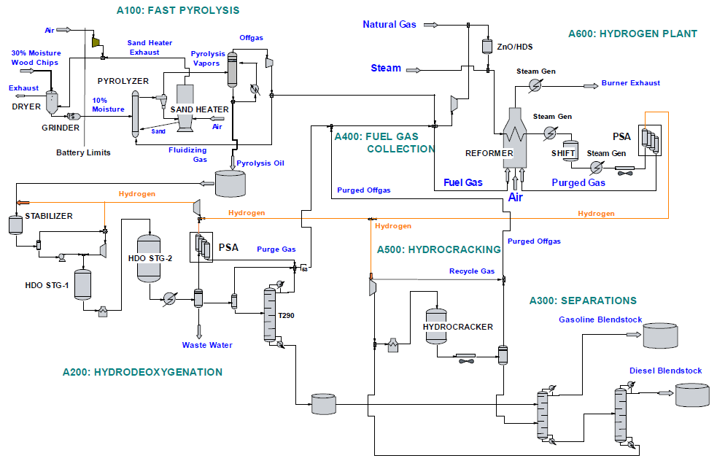
The biorefinery begins with a fast pyrolysis process where biomass feedstock enters, is dried out, grinded, converted to pyrolysis vapor, condensed to bio-oil then sent to a hydrotreating section where it is upgraded. Non-condensable off-gas product from fast pyrolysis is simultaneously sent to the hydrogen production plant. In this section, this off-gas along with off-gas from hydrocracking and additional natural gas is used to produce hydrogen via catalytic steam reforming. The bio-oil from fast pyrolysis is upgraded in two stages using fixed bed reactors and sent to a hydrocracking stage. Here, the upgraded heavy fraction bio-oil is cracked to produce additional fuel before final separation into gasoline and diesel product. The fuel is then sent to a collection pool and shipped out.

1.4 Steam Reforming
Dependence on fossil fuels coupled with high CO₂ emissions and their effect on global climate change have become the impelling causes for the research and development of sustainable alternative energy sources over the last few decades. Biomass has proven to be such a source for alternative energy as it can be converted to a wide variety of useful products. However, to meet the fuel demands of today’s economy, biomass must be processed at an industrial scale by the means of a biorefinery. Efforts to optimize the conversion of raw biomass feedstock to produce fuel at an industrial scale began over 100 years ago (Rødsrud, Lersch, & Sjöde, 2012). Since then, a systematic method of achieving this goal has been established that includes an intermediate step called steam reforming.
One of the many products that can be produced from biomass by catalytic and thermochemical processes is synthesis gas. Steam reforming is the process of producing CO and H₂ by reacting hydrocarbons and steam at high temperatures. The steam reforming reaction (CH₄ + H₂O ⇌ CO + 3H₂) is reversible, and thus catalysts are typically added to push the reaction to the right to maximize H₂ production. Additionally, a water gas shift reaction (CO + H₂O ⇌ CO₂ + H₂) is usually coupled with this process downstream to further convert CO from the reforming reaction.

  - Microbial Electrolysis

1.5.1 Concept of MECMECs

This decomposition reaction follows the general stoichiometry seen below.

CxHyOz → CO2+H++ e-
A MEC is an electrochemical cell, consisting an anode containing straininoculum , a cathode and a membrane separating the two electrodes. The two half reactions at the anode and the cathode can be described as follows :

Anode: $C_{x}H_{y}O_{z} → {CO}_{2}+H^{+}+ e^{-}$
Cathode: 2H++ 2e-→ H2
The cathode can use a biological or a chemical catalyst to produce hydrogen. A MEC requires an applied voltage of 0.3 V or higher across the cell to produce hydrogen (Logan et al., 2008),a MEC requires an applied voltage of 0.3 V or higher across the cell to produce hydrogen (Borole & Mielenz, 2011).
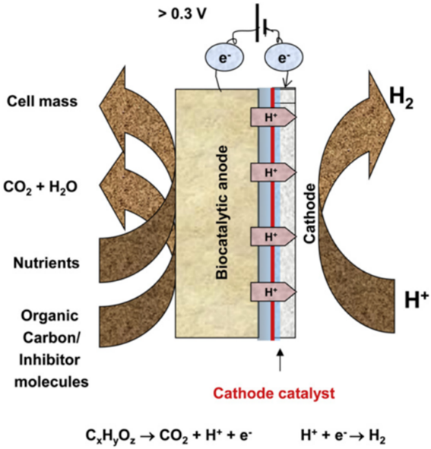
Fig. 1 A schematic of a generic microbial electrolysis cell. (Borole & Mielenz, 2011)

MEC is essentially an electrochemically assisted microbial production of hydrogen. This concept was first introduced in 2005 (Liu, H., Grot, S. and Logan, Liu, Grot, & Logan, 2005). The production of hydrogen from various types of waste materials by means of a MEC has been proposed. Essentially, a MEC acts as a reaction vessel for the electrohydrogenesis reaction, where the decomposition of organic matter takes place using bacteria to produce electrons that are then combined with hydrogen ions to make the hydrogen gas in the cathode
The finer details of MEC design have been greatly researched over the past decade and have been largely influenced by the standard microbial fuel cell (MFC) design (Kadier et al., 2016). Unlike a MEC, a MFC’s main product is electricity rather than hydrogen. However, both cells typically undergo a similar reaction at the anode mediated by microorganisms requiring a large surface area electrode, which can be made up of carbon cloth, carbon paper, graphite felt, and other simpler material. Membrane selection can vary based on experimental intent, however, charge transfer is essential in both systems. In order to separate the anode and cathode electrochemically as well as hydraulically, ion exchange membranes have been used (Figure xx). Either anion exchange membrane (AEM) or cation exchange membrane (CEM) may be used to enable charge transfer (Daud, Kim, Ghasemi, & Daud, 2015).
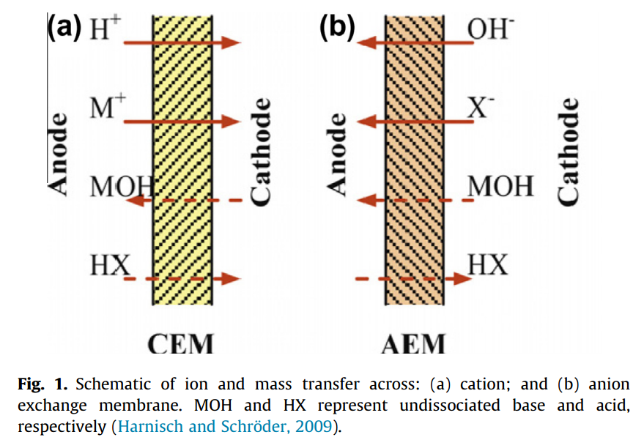
Source for image above: (Harnisch & Schröder, 2010)

1.5.2 Current Status of Technology
There have been many advancements in MEC technology over the last decadeMuch work has been done to determine the best suited cathode material and catalysts for hydrogen generation (Kundu, Sahu, Redzwan, & Hashim, 2013). It has been shown that combined together, these two components make up roughly 47% of the total capital costs for MECs, thus they have become a target for reducing overall costs for the system (Rozendal, Hamelers, Rabaey, Keller, & Buisman, 2008). Platinum (Pt) is a commonly used catalyst in electrochemical systems and has shown low overpotential when accompanied with a buffer for hydrogen evolution reactions (HER) as seen below (Jeremiasse, 2009).
$$2H^{+}+2e^{-} → H_{2}$$
$$2H_{2}O+2e^{-} → H_{2}+2OH^{-}$$
However, platinum catalyst tendscatalysts tend to be more expensive than alternatives and has beenhave shown to be poisoned by chemicals such as sulfide, which is often found in wastewater (Logan et al., 2008). Wastewater has been established as an abundant and cheap source for energy recovery by MECs and MFCs (Escapa et al., 2016). Alternatives include biocathodes which are cathodes catalyzed by microorganisms (Jafary et al., 2015). First row transition metals such as nickel and stainless steel alloys which have shown to be stable, abundant, low cost, and low toxicity to living organisms (H. Hu, Fan, & Liu, 2009). Tungsten carbide, lower performance than platinum, but benefits from a low price and insensitivity towards catalyst poisons such as sulfide and carbon dioxide (Harnisch, Schröder, Quaas, & Scholz, 2009). Despite its high cost, Pt catalysts with carbon paper, felt or cloth are still commonly used as a baseline for other variable changes in the MEC design.
Recent developments in MEC design have taken innovative steps that give us an informative look at how they can be scaled-up (Kadier et al., 2016). One of the first innovative steps included the development of a high performance MEC with an AEM separating anode from cathode, graphite granules pretreated with high temperature ammonia gas (increases current density) and carbon cloth as a surface for microbe growth, a Pt catalyst placed in the cathode chamber as designed by Cheng and Logan (Cheng & Logan, 2007). This design resulted in a hydrogen production rate of 1.1 m³ H₂/m³d with an overall energy efficiency of 288% based on an applied voltage of 0.6 V. Other design modifications include a concentric tubular MEC, enrichment of MEC bio-cathodes from sediment MFC bio-anodes, a single chambered MEC with a brush anode and flat carbon cathode, continuous flow MECs, and MEC-MFC coupled systems for hydrogen production (Kadier et al., 2016; Kyazze et al., 2010; Pisciotta, Zaybak, Call, Nam, & Logan, 2012).

1.5.3 Literature Review of MEC Process and Economic Analysis
The use of wastewater as source of biomass for conversion into bioenergy and biochemicals whilst simultaneously treating local wastewater has been well documented (Angenent, Karim, Al-dahhan, Wrenn, & Domı, 2004). The practical use of MEC technology in a scaled-up manufacturing process has been previously explored (Escapa, Gómez, Tartakovsky, & Morán, 2012). In this case study, a wastewater treatment plant in Andalucía, Spain was used as a basis for design specifications. A consensus on the design of the MEC for best implementation on a large-scale has yet to be reached however; the straightforward understanding begins with minimizing costs and maximizing hydrogen gas production. In fact, the commercial viability of MECs for wastewater treatment and hydrogen production has been a topic for discussion in recent years (Escapa et al., 2016). Still the former study concludes that high capital costs associated with MECs are the main barrier for commercialization.
Throughout the literature, it is clear that MECs used at a larger scale are often used in conjunction with wastewater treatment facilities. Such facilities provide an abundant consortium of bacteria from a digester sludge feed. The first pilot-scale study of a winery wastewater facility used with a MEC showed to have COD removal of 62±20% from wastewater (Cusick et al., 2011).
Life cycle assessment
1.6 Stage Fractionation Process
Biomass pyrolysis is a reaction that results in the production of three main products: bio-oil, bio-char and non-condensable gas. Such.S reactions occur in a vessel known as a pyrolyzer, wheredecomposition of organic material takes place at very high temperatures with a residence time of only a few seconds. The exact composition of the products varies from case to case depending on the parameters defining the process such as feed type, reactor conditions, and residence time. Determining this composition is usually achieved by the commonly used techniques such as gas chromatography and mass spectroscopy. Oftentimes, the primary goal of the pyrolyzer is to produce bio-oil as an energy product. Since pyrolysis reactions occur at such high temperatures, the recoverable products are usually in a vapor phase aside from undesired solid phase products such as char, sand, and ash. The bio-oil is recoveredThis recovery through separation of the pyrolysis exhaust into the aforementioned three products. An advanced separation method may be used to fractionate the liquid stream into bio-oil and other higher value products. One such separation process has been developed by Iowa State University called stage fractionation process (SF) (Pollard, Rover, & Brown, 2012). After removing solids from the exhaust via a cyclone separator, the gases are passed through a series of five unit operations.
recoverable products Pyrolysis functions primarily to produce biofuel that is later upgraded downstream to produce gasoline and diesel fuel. beingEssentially, this process separates the pyrolysis vapors into five liquid fractions and a stream ofnon-condensable gases. This is practically achieved using three heat exchangers to condense vapors and two electrostatic precipitators to recover aerosols (W. Hu, 2016)..

1.7 Baseline Biorefinery Process and Integration
A biorefinery process for conversion of biomass to biofuels via the pyrolysis route has been designed and simulated using Aspen program (ref). This process design report is used as the basis for our study. The report provides a comprehensive techno-economic analysis (TEA) of the biorefinery process beginning with a 2000 metric ton per day biomass feed and concluding with the determination of minimum fuel selling price (MFSP) of gasoline and diesel fuel products (Jones, Meyer, Snowden-Swan, et al., 2013). This report authored by the Pacific Northwest National Laboratory (PNNL), will be referred to as One of our goals is to convert the water-soluble products within the pyrolysis vapor into hydrogen downstream in the PNNL report, henceforthMEC. The SF process recovers these products and feeds them into the MEC. Thus, appropriately integrating this SF-MEC coupled process into the baseline biorefinery process requires an analysis of the upstream and downstream process to establish our new design.
The PNNL report describes the full biorefinery process including but not limited to feedstock type, moisture content, ash percentage in feedstock, organic yield and their effects on downstream processes including fast pyrolysis, hydrotreating, product separation, fuel gas collection, hydrocracking, and steam reforming (Figure 2). The method of TEA relies on process flow diagrams (PFDs) and simulation software Aspen Plus and CHEMCAD. Results from these simulations such as heat and material balances are used to determine capital and operating costs, which are then used to establish a cash flow analysis.
A complete mass balance is provided by the simulation software of all seven parts of the full process along with general and detailed PFDs. Nearly all relevant unit operation conditions are accounted for as support data for the techno-economic analysis that is preformed and model compounds for all compound groups are specified within each section of the process.
One of our goals is to convert the water-soluble products within the pyrolysis vapor into hydrogen downstream in the MEC. The SF process recovers these products and feeds them into the MEC. Thus, appropriately integrating this SF-MEC coupled process into the baseline biorefinery process requires an analysis of the upstream and downstream process to establish our new design.

CHAPTER 2
STEAMSTEAMSTEAM REFORMING OF HYDROCARBON GASES
2.1 Process Design
SteamSteam is an essential process within a biorefinery’s systematic design. It functions to produce hydrogen to support the hydrotreating and hydrocracking stages downstream by utilizing natural gas and off-gases produced in other processes within the biorefinery. The design for our steam reforming process is similar to that in PNNL-23053 with various exceptions and technical changes. Within the next two sections, a description of ourour process design forfor natural gas and off-gas reforming simulated in Aspen Plus V8.8 will be discussed. One of the main goals of simulating this hydrogen production process was to investigate the effect of changing feedstock conditions on hydrogen production. For example, one question we would like to answer is the effect of using off-gases alone, without natural gas input, on the production of hydrogen. In addition, this model would allow investigations of the effect of other process conditions and parameters.
2.1.1 Natural Gas Reforming
The process begins with off-gas from an upstream pyrolysis process (Stream 170) and a downstream hydrocracking process (Stream 600) entering the hydrogen production section of the biorefinery. The off-gas from pyrolysis consists mostly of CO and CO₂ while the hydrocracking off-gas contains additional non-condensable gases (CH₄, C₂H₄, C₃H₈, C₄H₁₀, and C₅H₁₂). The off-gas from hydrocracking is split 5.6:1 where the larger portion is mixed with the pyrolysis off-gas and then compressed to 405 psia (Stream 609). This compressed gas is then mixed with an additional natural gas feed (Stream 650) that serves to supplement the NCG for hydrogen production to meet the hydrogen demand for the plant (44.5 MMscfd) (Jones, Meyer, Snowden-swan, et al., 2013). The supplemental natural gas feed stream is mostly methane gas (87.8 wt %). The natural gas/off-gas mixture is the feed source to later be converted to hydrogen downstream. A general block diagram of inlet and outlet streams can be seen below and a full process flow diagram can be found in the Appendix.
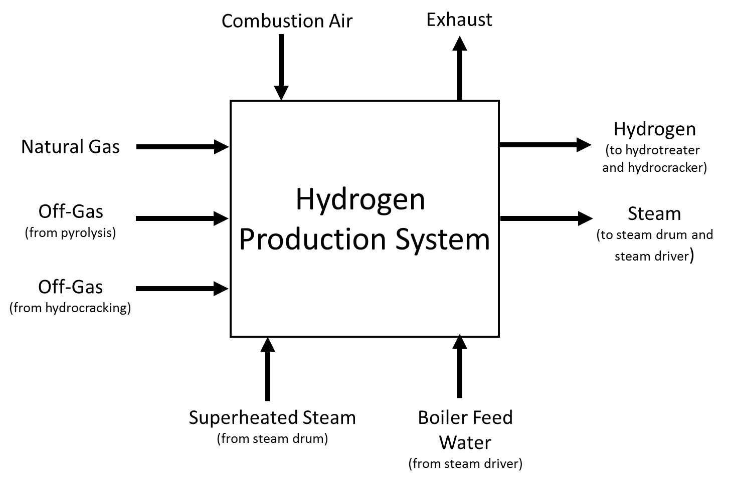
The natural gas/off-gas mixture (Stream 651) is then mixed further with a portion of superheated steam (Stream S3) that is a stream fed (Stream 730) from the plant’s steam drum. Prior to mixing with the natural gas/off-gas mixture, the superheated steam is split 1.3:1 where the larger portion is recycled back to the steam driver.
The only remaining feed to the hydrogen production section of the biorefinery is an inlet air stream (Stream 610) that serves to support a combustion reaction downstream. This air is compressed (B19) to 18 psia prior to being heated (E4) to 131˚F before entering the combustion reactor (modeled as a Gibbs reactor, B8). The smaller portion of the hydrocracking off-gas split (Stream 601) also enters the combustor along with a recycled NCG stream (Stream 682) from a downstream pressure swing adsorption process, see diagram below.
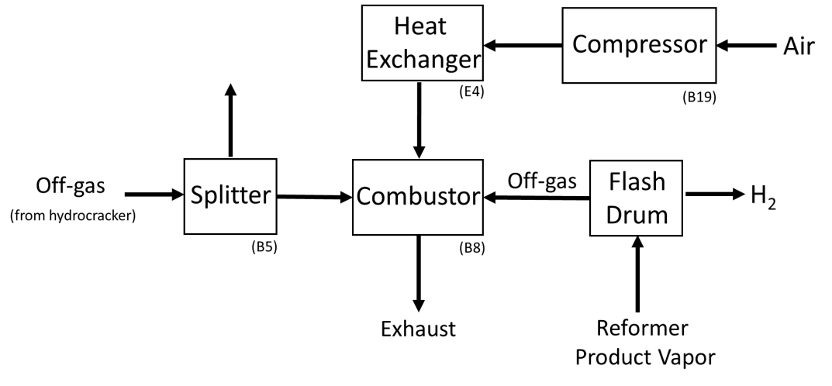
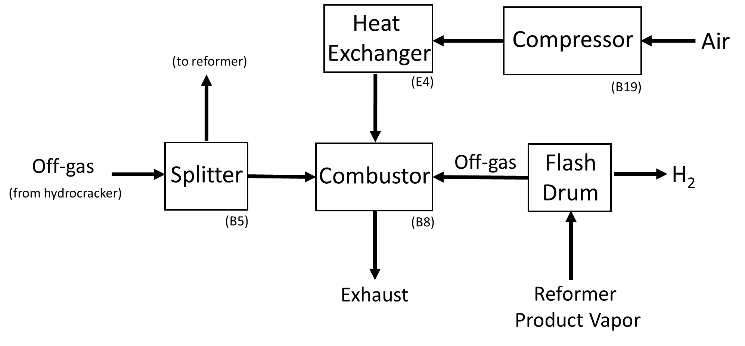
The combustion reactor essentially serves as a heat catalyst to drive the methane reforming reaction where the reformer reactor (R-600) is effectively jacketed by the combustor (B8) by an outlet heat stream (S2) leaving B8 and entering R-600. Before entering the reformer, the natural gas/off-gas/superheated steam mixture (Stream S10) is heated by the exhaust of the combustion reaction to 1110˚F.
The combustor is modeled as a Gibbs reactor that requires a temperature and pressure of operation (1950˚F and 14 psia), reaction stoichiometry (see table below), and can be specified to determine the heat of the reactions given reference components and temperatures.
Rxn No. | Specification Type | Stoichiometry
1 | Frac. conversion | CH₄ + 2 O₂ $→$ CO₂ + 2 H₂O
2 | Frac. conversion | 2 C₂H₄ + 7 O₂ $→$ 4 CO₂ + 6 H₂O
3 | Frac. conversion | C₃H₈ + 5 O₂ $→$ 3 CO₂ + 4 H₂O
4 | Frac. conversion | 2 C₃H₈ + 13 O₂ $→$ 8 CO₂ + 10 H₂O
5 | Frac. conversion | 2 C₅H₁₂ + 16 O₂ $→$ 10 CO₂ + 12 H₂O

Methane, ethane, propane, n-butane, and n-pentane were all specified to form carbon dioxide and water, each with a fractional conversion of 100%. The reaction temperature was estimated based on the combustion temperature of methane gas.

The products of this exothermic combustion reaction, henceforth to be referred to as exhaust, are then used as a heating source for intersectingintersecting streams throughout the hydrogen production section of the biorefinery.
To simulate a practical heat exchangeexchange with these intersecting streams, we have modeled the heat transfer of reaction heat to these streams in an order that allows for the steady temperature reduction of the combustion exhaustion. Thus, the order in which we exchange heat with the intersecting streams begins with the intersecting stream with the highest inlet temperature (natural gas/off-gas mixture) and ends with the intersecting stream with the lowest inlet temperature (compressed air). This allows a reasonable temperature exchange between the combustion exhaust and intersecting streams by maintaining a ΔT of at least 20°F. A diagram of the overall combustion exhaust heat exchanger process can be seen below.
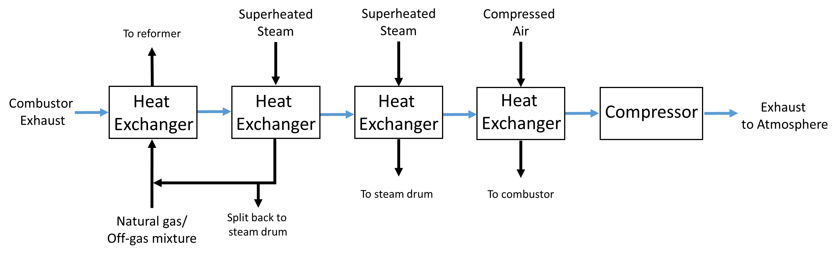
For designing each heat exchanger, we specified the cold stream outlet temperature as to match PNNL-23053. Each model fidelity was selected as “short cut” and the short cut flow direction was selected as “countercurrent”. After the fourth and final heat exchanger (E4), the resulting stream (Stream S22) is compressed and released into the atmosphere (Stream 630).

The reformer (R-600) is modeled as a Gibbs reactor as well. Phase equilibrium and chemical equilibrium were calculated based on the operating temperature and pressure, 1562˚F and 314 psia. The heat duty was specified based on the heat stream (S2) leaving the combustion reactor and entering the reformer. In our final version of each simulation, the unit operation was set so that it identified possible products (water, hydrogen, nitrogen, carbon monoxide, carbon dioxide, methane, and hydrogen sulfide). The possible products we selected were based on the only products formed within PNNL-23053 in Stream 667 with the exception of hydrogen sulfide. In order for the Gibbs reactor to converge, hydrogen sulfide had to be added as a possible product to balance the sulfur compound specifically which is found in the inlet Stream 662; however no hydrogen sulfide is generated by the reforming reaction. Aspen Plus is capable of determining products based on this information and physical properties specified alone, though for the sake of clarity we have included the reactions of the components that are largely converted, see below.
Table: Gases Converted via Combustion and Conversion Reactions for Catalyzing Reformer
Rxn No. | Gas Converted | Stoichiometry
1 | Methane | CH₄ + H₂O $→$ CO + 3H₂
2 | Ethane | C₂H₆ + 2H₂O $→$ 2CO + 5H₂
3 | Propane | C₃H₈ + 3H₂O $→$ 3CO + 8H₂
4 | N-Butane | C₄H₁₀ + 4H₂O $→$ 4CO + 9H₂
5 | N-Pentane | C₅H₁₂ + 5H₂O $→$ 5CO + 11H₂

We also previously modeled the reformer as a stoichiometric reactor (RStoic), which requires an operating temperature, pressure, stoichiometry, and fractional conversion of each component for convergence. Results of these alternative designs will be discussed in Section 2.2.
A series of boiler feed water streams (Streams 706, 752, and 752-0) from the steam driving section of the biorefinery are used as a product-cooling agent via three separate heat exchangers (E-674, E-676, and E-670), see diagram below.

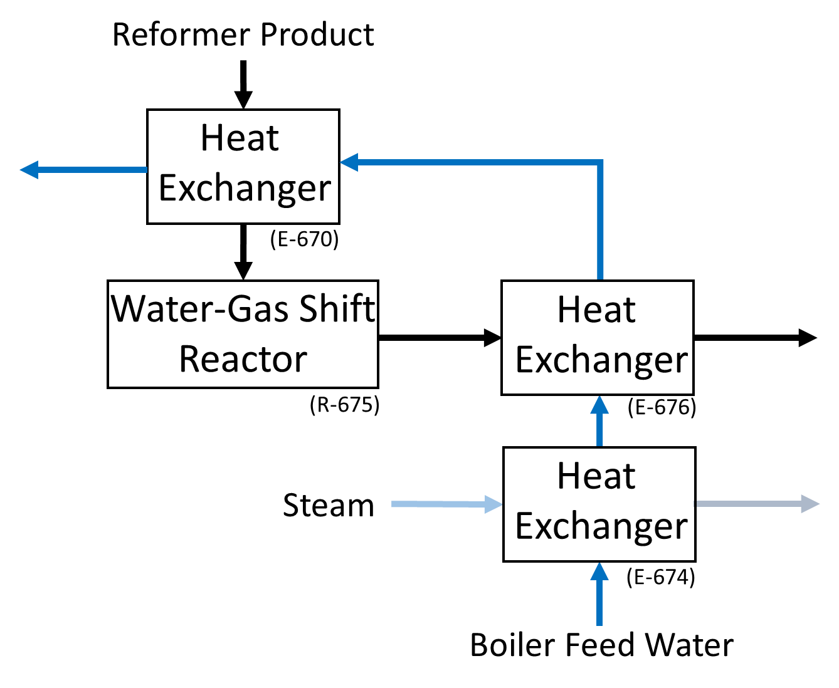

The reformer products (Stream 667) exit the reactor and are cooled by an inlet of boiler feed water (Stream 752-0) prior to entering the water-gas shift reactor((R-675). Here, the water-gas shift reactor serves to maximize hydrogen productivity by converting the remaining steam from the reforming reaction into hydrogen as seen in the reaction below.
CO+H2O ⇌CO2+ H2
R-675 was also modeled as a Gibbs reactor and was operated at 500˚F and 311 psia. The above reaction stoichiometry was specified as the only reaction occurring within the vessel.
The boiler feed water (Stream 752) then further cools the resulting products (Stream 672). The products are then cooled to 250˚F by a heat exchanger modeled as a heater (E-677) before final separation. Finally, the remaining vapor is fed into a system of two flash drumsdrums (B11 and PSA) that function to recover pure hydrogen. Subsequently, a liquid stream from B11 (Stream 681) is sent to the stream driver and a liquid stream from PSA (Stream 682) is recycled back into the combustion reactor. The pure hydrogen (Streams 250 and 532) is sent to the hydrotreating and hydrocracking sections of the biorefinery, respectively.

2.1.2 Off-Gas Reforming

When considering simulating hydrogen production without supplemental natural gas, our process flow diagram is the exact same with only one exception. Stream 650 (natural gas) is omitted, thus Stream 609 (pyrolysis vapor/hydrocracking off-gas split) alone is mixed with the superheated steam (Stream S3). Despite this change, no operating conditions were changed within the simulation for any unit operation. However, the removal of supplemental natural gas had many downstream effects in terms of results which will be discussed in Section 2.2.

2.2 Results

We have designed and simulated two separate hydrogen production systems that differ by the addition of supplemental natural gas. Here, we will discuss a more detailed breakdown of our simulated hydrogen production process in Aspen Plus with particular interest to reaction information, exhaust cooling, and comparison of natural gas removal results.
The resulting heat duty given off by the combustion reactor was simulated to be -31,456,460.9 Btu/hr. This informs us as to what the maximum heat transfer is between the combustor (jacket) and the reformer (jacketed). The exhaust from the from the combustion reaction exits the system, but not before exchanging heat with intersecting streams within the hydrogen production system. The order in which these streams are heated (see order below) is important due to the exhaust progressively cooling before exiting the system (Stream 630). Thus, appropriately, a series of heat exchangers are used to model the exchange of heat between intersecting streams (cold streams) and the progressive cool down of the exhaust.

Combustion Exhaust Heat Exchangers: Temperature Changes With Natural Gas
Order Number | Unit Operation | Cold Inlet Temp. (˚F) | Cold Outlet Temp. (˚F) | Exhaust Inlet Temp (˚F) | Exhaust Outlet Temp ˚(F)
1 | E1-B20 | 977.145 | 1110 | 1950 | 1849.692
2 | E2-B15 | 499 | 12321232 | 1849.692 | 1030.748
3 | E3-B22 | 499 | 500 | 1030.748 | 1029.937
4 | E4 | 130.5746 | 131 | 1029.937 | 1029.695

Combustion Exhaust Heat Exchangers: Temperature Changes Without Natural Gas
Order Number | Unit Operation | Cold Inlet Temp. (˚F) | Cold Outlet Temp. (˚F) | Exhaust Inlet Temp (˚F) | Exhaust Outlet Temp ˚(F)
1 | E1-B20 | 1034.8 | 1110 | 1950 | 1893.54
2 | E2-B15 | 499 | 1232 | 1893.54 | 1018.03
3 | E3-B22 | 499 | 500 | 1018.03 | 1017.16
4 | E4 | 130.575 | 131 | 1017.16 | 1016.90

We also ran the simulation considering all components as products and had very similar results in terms of overall hydrogen production.
We used the stoichiometry seen above and set the fractional conversion of all gases to 0.80 and still had similar results.
There is a noticeable tradeoff in composition of the reformer feed stream between the simulations with and without a natural gas feed. For the simulation with natural gas, the stream entering the reformer (Stream 662), is 67% steam andand 8% methane, while the stream without natural gas (140024a flow rate of 6,997 lb/hr less) is 70% steam and 4% methane. A breakdown of the converted components for each simulation can be seen below.

Table: Stream 662 (Reformer Feed) Mass Fraction Composition With and Without Natural Gas
 | WW/ Natural Gas | W/O Natural Gas
Component | Mass Fraction | Mass Fraction
Water (steam) | 0.67 | 0.70
Hydrogen | 0.01 | 0.01
Carbon Monoxide | 0.04 | 0.04
Carbon Dioxide | 0.11 | 0.11
Methane | 0.08 | 0.04
Ethane | 0.03 | 0.03
Propane | 0.02 | 0.02
N-Butane | 0.02 | 0.02
N-Pentane | 0.02 | 0.02

TheWith the removal of supplemental natural gas, hydrogen and carbon monoxide, the main products of the steam reforming reaction, resulted in a 17% decrease in hydrogen and a 23.6% decrease in carbon dioxide production prior to the , respectively. Additionally, water and carbon monoxide, the main reactants of the downstream water-gas shift reaction, saw an 8% increase and 1% decrease in production, respectively. Naturally, with less methane to be converted, there was a 51% decrease in methane production.
Steam Reformer Exit Stream Results
 | W/ Natural Gas | W/O Natural Gas | Percent Change
Component | Mass Flow (lb/hr) | Mass Flow (lb/hr) | (%)
Water | 64790.77 | 69942.69 | 8%
Hydrogen | 9783.045 | 8129.108 | -17%
Nitrogen | 114 | 0 | -100%
Carbon Dioxide | 32607.84 | 24902.57 | -24%
Carbon Monoxide | 35024.86 | 34731.25 | -1%
Methane | 4683.009 | 2300.906 | -51%
Hydrogen Sulfide | 17.703 | 17.703 | 0%

Detailed results of capital and utility costs of the hydrogen production process were not included in PNNL-23053, thus determining individual unit operation costs was another goal for us to better understand the economic feasibility of the system. Equipment cost and utility cost of a unit operation are subject to change with adjustment of any specification as simple as temperature or pressure. The calculation methods used in Aspen Plus V8.8 are based on physical and chemical property data of all compounds used in a simulation. This data is then used in conjunction with equations of state to calculate output conditions of any given unit operation. Thus, on a case by case basis this information is used within the context of reactors, heat exchangers, compressors, etc.

2.3 Mass and Energy Balance

The essential purpose of the steam reformer is to utilize off-gas from integrated sections of the overall biorefinery to produce hydrogen gas. The more efficient this process is the less dependency there is on supplementary reforming gases i.e. natural gas. Ideally, a supplemental source of gas would not be necessary if off-gases used from within the overall system were capable of being reformed to sufficiently meet hydrogen demand. Thus, analyzing the efficiency of the hydrogen production system from mass and energy balance data aids in determining if the purpose of this process is appropriately fulfilled. At the same time, this sheds light on where and how deficiency in hydrogen production can be recovered.

2.4 Comparison to Process Design Report PNNL-23053
The difference between our simulated model for the hydrogen production process compared to the PNNL-23053 process is one of the fundamental points of our research. The main difference asks the question: Can the hydrogen gas produced by the bio-oil separation process coupled with the MEC make up for the decrease in hydrogen production in the steam reforming process if the additional natural gas input is removed? Essentially, our design does not include a supplemental natural gas stream in the steam reforming process to meet the hydrogen production requirements within their report. The desulfurization and pre-reforming unit operations found in PNNL-23053 are omitted from our design as reactor coking issues are beyond the scope of our research. Additionally, these operations are negligible as far as overall hydrogen production comparison is concerned.
The PNNL-23053 process utilizes the exhaust vapor of the reformer heating process as source of heat transfer for various intersecting streams. We effectively model this process using a heat exchanger network where each intersecting stream is met by a heat exchanger unit operation. The PNNL-23053 process can be seen below.
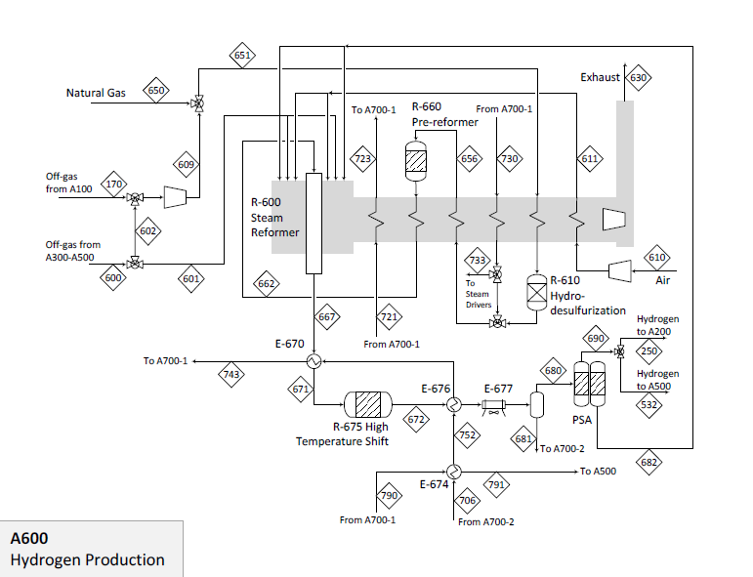

After the water-gas shift and pressure swing adsorption in the hydrogen production plant, a total of 9841 pounds per hour of hydrogen gas is produced.

It is important to note that we omitted the pre-reformer and hydro-desulfurization reactor from our model as coking issues are beyond the scope of our work and hardly effect hydrogen production rates overall.

CHAPTER 3
MICROBIAL ELECTROLYSIS
3.1 Process Design

In a lab setting, there are many things to consider when designing an MEC. Typically, system design, biological, and operating parameters are the focus for variable adjustment and investigation. Our consideration for such aspects of MEC parameters were limited based upon a desired hydrogen production rate. Essentially, determining the theoretical amount of hydrogen produced by a MEC can be calculated using the decomposition reaction chemistry of organic matter.
CxHyOz → CO2+H++ e-
Thus, to make this calculation, the composition and mass flow rate of organic matter fed to the MEC (bio-oil) must be known and then converted to a mass flow rate of hydrogen using stoichiometry. See example calculation below.
g CxHyOzday×molg CxHyOz×e-mol CxHyOz× e-CxHyOz e-H2×g H2mol=g H2day
These calculations were carried out using Excel while another model for MEC production was simulated in Aspen Plus. The two models serve different purposes for the scope of our study. The Excel modeled MEC provides a reactor volume based on a desired hydrogen production rate of 20 L/L-day, current estimated MEC price calculations, and component chemistry. The Aspen modeled MEC acts as a simulated placeholder for the integration of a MEC in the context of a full biorefinery and is modeled as a stoichiometric reactor. Essentially, the Excel model provides more accurate costing information as Aspen cannot simulate the many unique aspects of a MEC. However, the Aspen model does allow us to consider the upstream and downstream unit operations that would be necessary within the context of biorefinery integration.
A feed production basis was established to be 2000 metric tons per day of biomass feedstock. Due to various experimental data concerning ash content, the authors selected pine wood as the specific feedstock source. Through a simulated fast pyrolysis model, a set of water-soluble and water-insoluble pyrolysis compound groups were predicted as products and model compounds were used to represent them.
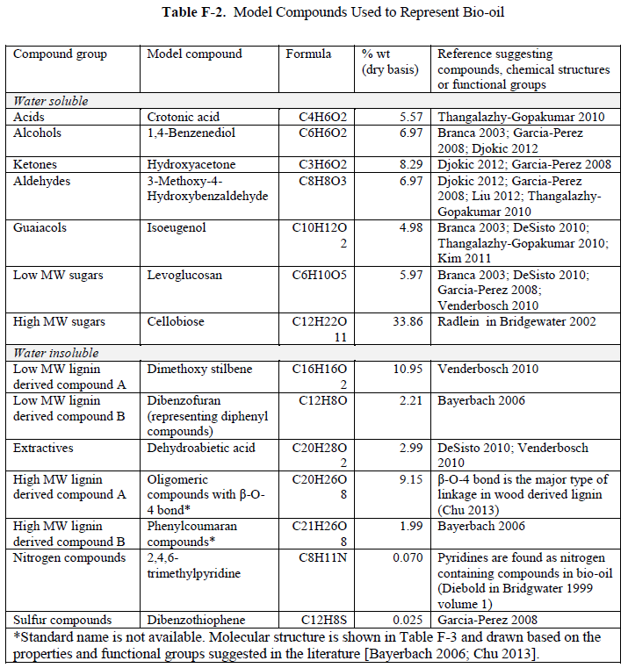
These products function as bio-oil within the biorefinery and are a key component to modeling the MEC.

3.2 MEC Feed and Conversion

3.3 Hydrogen Need in Biorefinery
Within the biorefinery, hydrogen gas is required for upgrading bio-oil and hydrocracking. In the traditional biorefinery as developed in PNNL-23053, the source for all hydrogen production comes from steam methane reforming. In our design, a supplemental source is produced by the MEC enough to make up for the removal of supplemental natural gas requiredfor sufficient hydrogen production for hydrotreating and hydrocracking. Thus, determining the decrease in hydrogen is production by removing supplemental natural gas informed us as to how much hydrogen needed to be produced by the MEC.
In PNNL-23053, the hydrotreating process requires nearly 9 times as much hydrogen gas as the hydrocracking process at 8846 pounds per hour and 995 pounds per hour, respectively. The hydrocracking process primarily serves to generate additional fuel by cracking heavy end bio-oil prior to final conversion into gasoline and diesel.

CHAPTER 4

STAGE FRACTIONATION

4.1 Process Design

4.1.1 Bio-Oil Stage Fractionation

The evaluation of chemical reactions that occur within a larger network of unit operations is a fundamental part of process design for chemical engineers. It is the first step of the critical thinking process that is necessary for creating an efficient, safe, and practical design. The physical and chemical properties of fast pyrolysis products is often the basis for the design of the bio-oil separation. As discussed in Chapter 1, the many products of fast pyrolysis can be effectively utilized throughout the biorefinery if separated appropriately.
Our simulated design is based on the fractionating bio-oil recovery system developed at Iowa State University’s BioCentury Research Farm (Pollard et al., 2012). Their design is based on many practical assumptions, the most pertinent of which we will discuss here. Firstly, their design was created around the idea that fast pyrolysis creates vapors and aerosols, where vapors are assumed to be carbohydrate polymers and aerosols are non-volatile, lignin-derived oligomers. Essentially, condenser stages were designed to recover vapors based on their dew point temperatures and electrostatic precipitators (ESP) to recover aerosols, see figure below. Because of this approach the temperature of the vapor going from condenser to ESP decreases as well as the bio-oil exiting each respective unit.

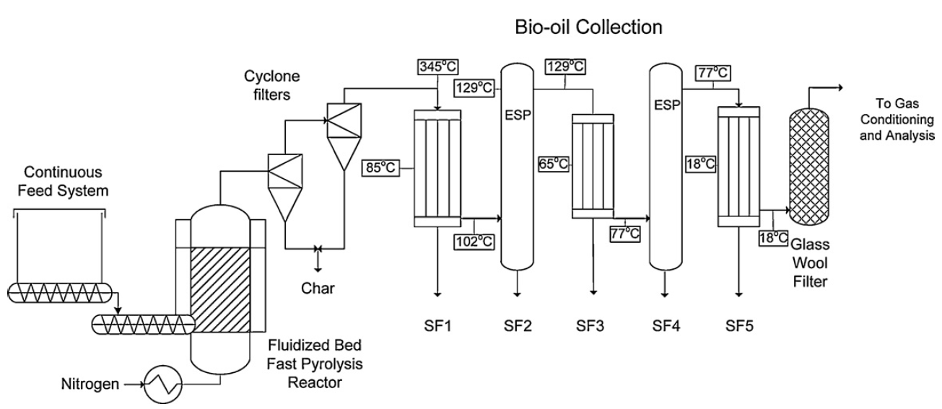

The figure above shows a flow diagram of the bio-oil collection process along with relevant upstream processes. First, a continuous stream of biomass feedstock (in this case red oak) enters a gravimetric feeder connected in conjunction with a fluidized bed pyrolyzer. In this section, the biomass is reduced from the original solid structure matter to a more granular mixture before being fluidized. At 500˚C, the mixture is fluidized in the fast pyrolysis reactor and purged with nitrogen. The resulting exit stream is a high temperature pyrolysis vapor, aerosol, and solid mixture. Due to the catalytic effects solids have on the bio-oil downstream and potential equipment damage (blockage, erosion, etc.), they are removed by a series of two cyclone filters before entering the fractionation process.
From there, the bio-oil enters the first condenser, a shell-and-tube heat exchanger where the pyrolysis vapors enter on the tube side and the coolant on the shell side. The coolant water used in the heat exchanger is fed at 85˚C which allowed the now condensed bio-oil flow by gravity to the collection pot at the bottom of the condenser and exit as SF1 (Pollard et al., 2012). The remaining vapor leaves the first condenser at 102˚C and enters the first ESP where aerosols from pyrolysis and the first heat exchanger are removed. This ESP is operated at 129˚C to prevent condensation of remaining vapors. The two proceeding heat exchangers and ESP are operated in such a way to achieve a desired separation.
Theoretically, the “heavy ends” are separated in SF1 and contain most of the oligomeric compounds. The “middle cuts” come out in SF2 through SF4 and contain most of the phenolic and furan compounds. The “light oxygenates” come out in SF5 and are also referred to as the aqueous phase, as this collection contains the highest liquid moisture by weight percent. Additionally, non-condensable gases (NCG) generated from pyrolysis can be recovered from the final heat exchanger after being separated from the remaining aerosols in the glass wool filter. Various analysis techniques were used such as gas chromatography, mass spectroscopy, and many more to determine the effectiveness of this separation technique. Moisture content, water-soluble content, solids content, and kinematic viscosity of the bio-oil in each stage fraction were determined.
We implement a series of water-cooled heat exchangers to lower the temperature of the pyrolysis vapor then proceed to condensing the vapor using five flash drum vessels effectively separating the bio-oil into five stage fractions. To achieve the desired separation of the condensed bio-oil in the five stage fractions, the drums were set at flash temperatures to match the ratio of each component separated as in Pollard. Thus, we ultimately sought to recover bio-oil from stage fraction 1 (SF1) and stage fraction 5 (SF5) to be used downstream in the MEC and recycle the NCG to be used to cool down the pyrolysis vapor entering the SF process. Stage fractions 2 through 4 are ultimately sent to the hydrotreating section of the biorefinery. The flow diagram from our simulation can be seen below.

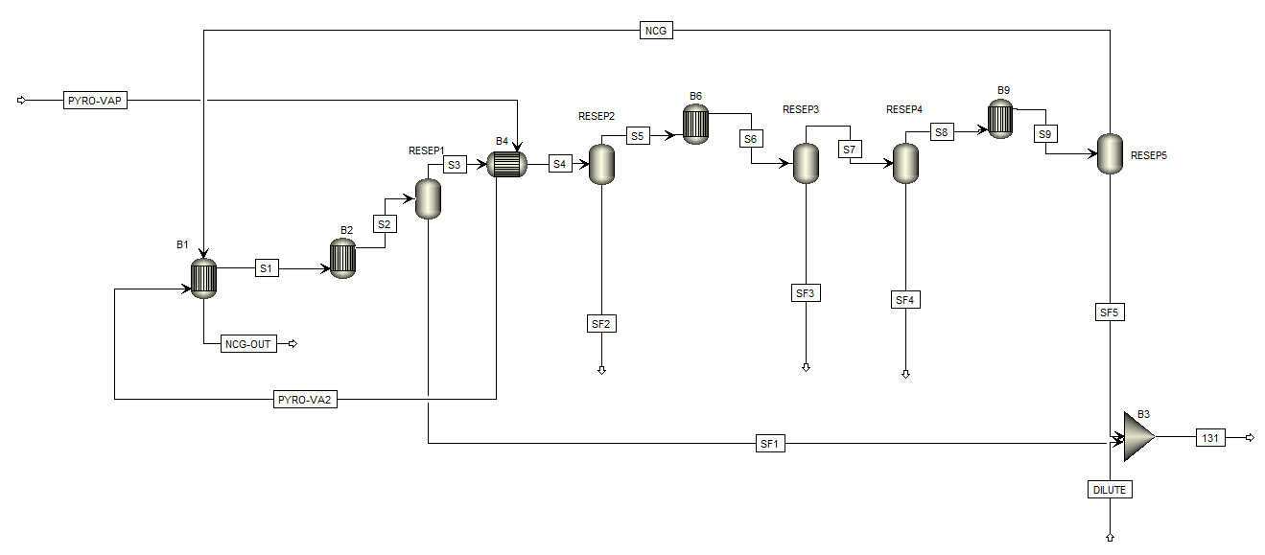

Integrating our fractionation process into the PNNL-23053 biorefinery design required us to appropriately investigate many upstream and downstream conditions. This of course began with post-pyrolysis reaction conditions. Major differences between the process reported by PNNL-23053 and our integrated process design and results will be further discussed in Chapter 5. However, here we will discuss the finer details of the above process.
The pyrolysis vapor enters the fractionation process at 433.8˚C and 1.22 bar. The pyrolysis vapor consists of 24 different components (full list of components can be found in the Appendix). This stream is progressively cooled using three heat exchangers before any stage fraction is removed. The coolant for the first heat exchanger is the intermediate vapor stream between RESEP1 and RESEP 2 (the first and second stage fractionators, flash drums). The coolant for the second heat exchanger is a recycled NCG stream from the tail end of the fractionation system. The final heat exchanger before entering the first fractionator reduces the temperature of the pyrolysis vapor from 353˚C to 140˚C using a water coolant.
The temperatures at which each flash drum is operated within our model is based on matching the ratio of components within each respective SF stream and the ratio of each respective SF total determined by Pollard. Again, the temperature at which the modeled condensers are set are based on dew point temperature. Also, here it is important to note that the bio-oil recovery system was designed to operate above the dew point for acetic acid such that it is absorbed from the gas flow by water condensing in stage 5 (Pollard et al., 2012). The pyrolysis vapor then enters RESEP1, a fractionator modeled as a flash drum. The drum is operated at 102˚C and 1.01 bar with a liquid entrainment in the vapor stream of 0.5. SF1 (condensed bio-oil) and S3 (remaining vapor are the resulting streams following the first flash drum. S3 is then heated by heat exchanger B4 from 102˚C to 129˚C. Within the model program, B4 essentially closes the loop of the incoming pyrolysis vapor and is referred to as the default “nesting block” with Aspen Plus.
After this heat exchanger block, the remaining vapor enters RESEP2, which is operated at 102˚C and 1.01 bar with a liquid entrainment in the vapor stream of 0.2. SF2 (condensed bio-oil) and S5 (remaining vapor) are the resulting streams following this flash drum. S5 is then cooled from 102˚C to 90˚C before enter RESEP3 and RESEP4. These next two flash drums are operated at the same temperature, pressure, and liquid entrainment in the vapor stream being 80˚C, 1.01 bar, and 0. RESEP3 results in SF3 (condensed bio-oil) and S7 (remaining vapor), the latter being fed into RESEP4 which results in SF4 (condensed bio-oil) and S8 (remaining vapor). S8 is then cooled from 102˚C to 50˚C before entering the final flash drum RESEP5, operated at 40˚C, 1.01 bar, and a liquid entrainment in the vapor stream of 0. This final flash drum results in SF5 (condensed bio-oil) and a NCG stream. The NCG stream is recycle to the front of the bio-oil fractionation system and is used as a coolant for the second heat exchanger in cooling the pyrolysis vapor stream. 2% of this stream is spilt out and sent to the steam reformation process and the rest is recycled by being mixed with the initial incoming pyrolysis vapor stream closing the loop. SF5 is mixed with SF1 and a dilution stream then sent to the MEC Component System.

4.1.2 MEC Component System

The design of our MEC had to be developed not only within the context of a full biorefinery, but with special consideration of the upstream bio-oil stage fractionation process. The mixture of SF1, SF5, and the dilute stream leaves the bio-oil fractionation process and enters the MEC system at a higher temperature than is suitable for the desired conditions of our MEC reactor. It is thus cooled down from 67˚C to 57˚C using an air-cooled heat exchanger similar to how the bio-oil leaving the first quench column after pyrolysis in PNNL-23053 is cooled. This cooled stream is then mixed with a recycle stream of non-reacted bio-oil and is then pumped into the MEC reactor, seen below modeled as a stoichiometric reactor.

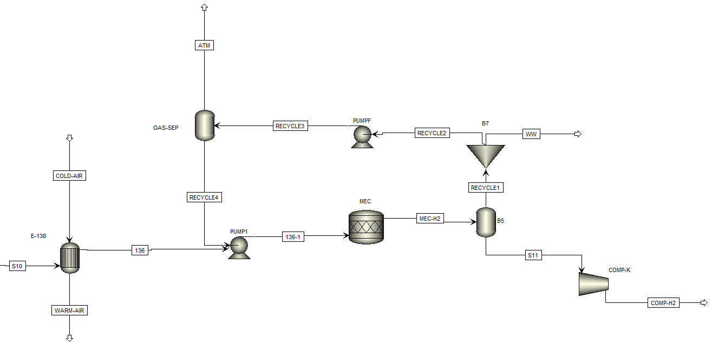

The reactor itself converts components within the incoming bio-oil stream (crotonic acid, vanillin, acetol, hydroquinone, isoeugenol, levoglucosan, cellobiose) that we have designated will be consumed by the bacteria into carbon dioxide and hydrogen gas. From there, the hydrogen gas must be separated from the remaining unconverted bio-oil. This is achieved via a flash drum operated 150˚F and 300 psia where 99.9% of this gas is separated and then condensed. Meanwhile, 90% of the remaining stream exits as wastewater and the other 10% is split removing NCG to the atmosphere. The cycle is complete with combination of this final stream with the cooled bio-oil stream.
4.2 Results

4.3 Mass and Energy Balance

4.4 Comparison of Separation Results with ISU Process

A paper published in December of 2015 used the design from the Pollard paper to explore the techno-economic feasibility of biofuel, biochemical, and hydrocarbon chemicals product pathways from a biomass fast pyrolysis biorefinery (W. Hu, 2016). Their work was all simulated and began with a similar basis as in PNNL-23053 with a biomass feedstock of 2000 dry metric tons per day, in this case red oak instead of pinewood. The upstream process, biomass conversion, prior to bio-oil fractionation is slightly different from the PNNL-23053 and Pollard processes, seen below.

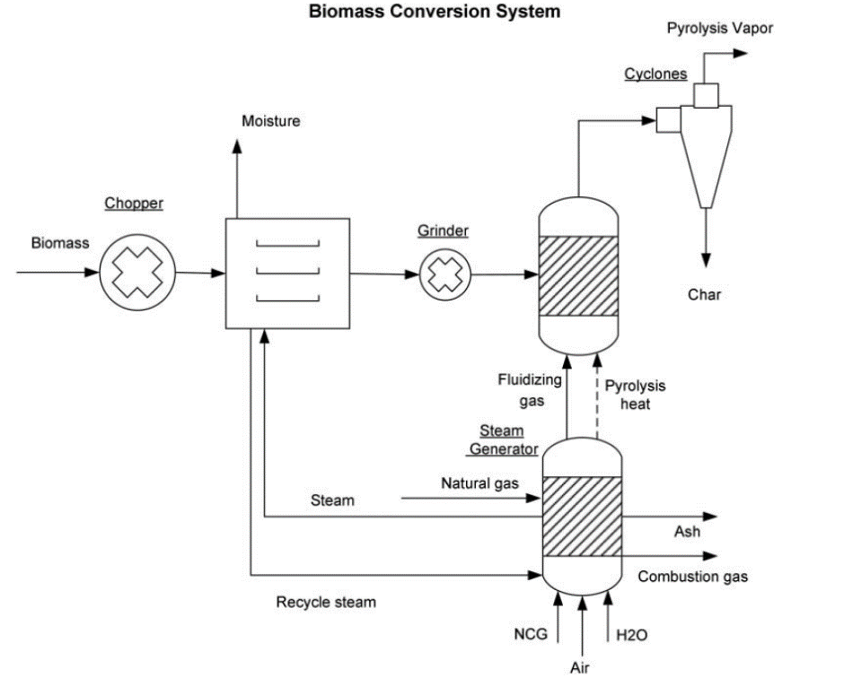

Here, biomass is feed into a chopper then dried in an oven reducing the moisture content to less than 7 wt.%. A steam generator provides the heat for this process and the pyrolysis reaction along with fluidizing gas. After being dried out the remaining substance goes through a grinder and is then fed into the fluidized bed reactor, where fast pyrolysis take place. The product stream of this process is then fed into a cyclone similar to PNNL-23053 where the resulting streams are pyrolysis vapor and char. This leads straight into the bio-oil fractionation process which is more or less the same as Pollard, see below.
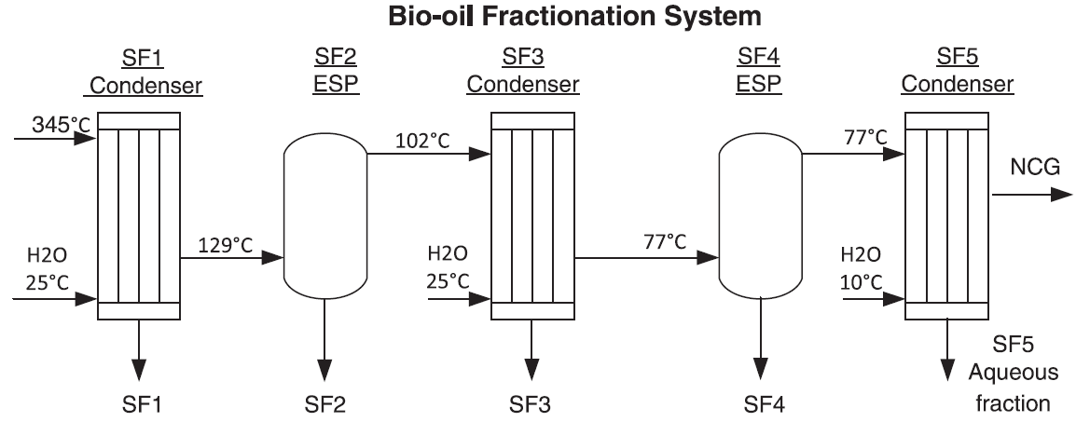

Their process was simulated using Aspen Plus to calculate stage fraction yields. This result information gave us insight into how the biomass was being distributed in SF1-SF5, NCG, and char. As mentioned in Chapter 1, feedstock information from our process comes from PNNL-23053

CHAPTER 5
MODIFICATION OF PNNL-23053 FLOWSHEET WITH STAGE FRACTIONATION PROCESS AND MEC

A more simplified block diagram than what was shown Section 1.3 of the overall can be seen below.

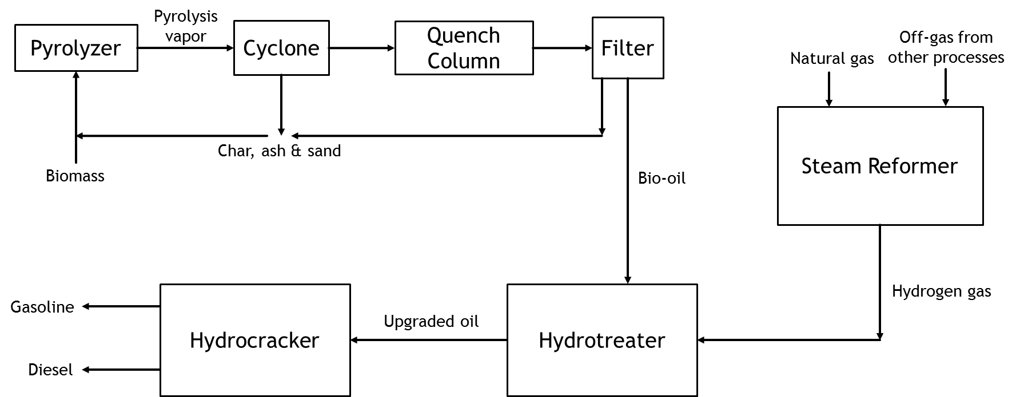
The diagram below displays the essential sections of the biorefinery that are effected by the integration of the bio-oil stage fractionation process and the MEC.
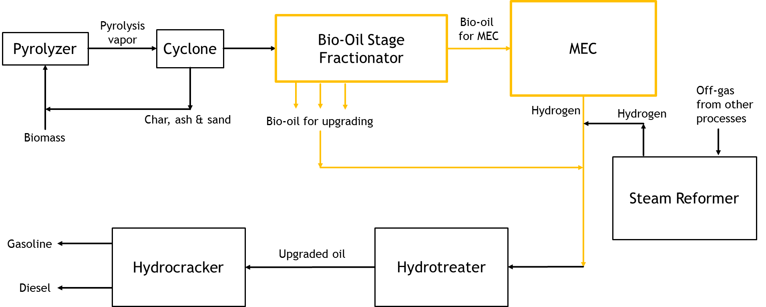

REFERENCES
Angenent, L. T., Karim, K., Al-dahhan, M. H., Wrenn, B. A., & Domı, R. (2004). Production of bioenergy and biochemicals from industrial and agricultural wastewater, 22(9). https://doi.org/10.1016/j.tibtech.2004.07.001
Borole, A. P., & Mielenz, J. R. (2011). Estimating hydrogen production potential in biorefineries using microbial electrolysis cell technology. International Journal of Hydrogen Energy, 36(22), 14787–14795. https://doi.org/10.1016/j.ijhydene.2011.03.152
Cheng, S., & Logan, B. E. (2007). Sustainable and efficient biohydrogen production via electrohydrogenesis. Proceedings of the National Academy of Sciences, 104(47), 18871–18873. https://doi.org/10.1073/pnas.0706379104
Cusick, R. D., Bryan, B., Parker, D. S., Merrill, M. D., Mehanna, M., Kiely, P. D., … Logan, B. E. (2011). Performance of a pilot-scale continuous flow microbial electrolysis cell fed winery wastewater. Applied Microbiology and Biotechnology, 89(6), 2053–2063. https://doi.org/10.1007/s00253-011-3130-9
Daud, S. M. ariam, Kim, B. H. ong, Ghasemi, M., & Daud, W. R. amli W. (2015). Separators used in microbial electrochemical technologies: Current status and future prospects. Bioresource Technology, 195, 170–179. https://doi.org/10.1016/j.biortech.2015.06.105
Escapa, A., Gómez, X., Tartakovsky, B., & Morán, A. (2012). Estimating microbial electrolysis cell (MEC) investment costs in wastewater treatment plants: Case study. International Journal of Hydrogen Energy. https://doi.org/10.1016/j.ijhydene.2012.09.157
Escapa, A., Mateos, R., Martínez, E. J., & Blanes, J. (2016). Microbial electrolysis cells: An emerging technology for wastewater treatment and energy recovery. from laboratory to pilot plant and beyond. Renewable and Sustainable Energy Reviews, 55, 942–956. https://doi.org/10.1016/j.rser.2015.11.029
Harnisch, F., & Schröder, U. (2010). From MFC to MXC: chemical and biological cathodes and their potential for microbial bioelectrochemical systems. Chemical Society Reviews, 39(11), 4433. https://doi.org/10.1039/c003068f
Harnisch, F., Schröder, U., Quaas, M., & Scholz, F. (2009). Electrocatalytic and corrosion behaviour of tungsten carbide in near-neutral pH electrolytes. Applied Catalysis B: Environmental, 87(1–2), 63–69. https://doi.org/10.1016/j.apcatb.2008.08.016
Hu, H., Fan, Y., & Liu, H. (2009). Hydrogen production in single-chamber tubular microbial electrolysis cells using non-precious-metal catalysts. International Journal of Hydrogen Energy, 34(20), 8535–8542. https://doi.org/10.1016/j.ijhydene.2009.08.011
Hu, W. (2016). Comparative techno-economic analysis of advanced biofuels, biochemicals, and hydrocarbon chemicals via the fast pyrolysis platform. https://doi.org/10.1080/17597269.2015.1118780
Jafary, T., Daud, W. R. W., Ghasemi, M., Kim, B. H., Md Jahim, J., Ismail, M., & Lim, S. S. (2015). Biocathode in microbial electrolysis cell; Present status and future prospects. Renewable and Sustainable Energy Reviews, 47, 23–33. https://doi.org/10.1016/j.rser.2015.03.003
Jeremiasse, A. W. (2009). The use of biocompatible buffers to reduce the concentration overpotential for hydrogen evolution Adriaan W. Jeremiasse, 43(17), 6–8.
Jones, S., Meyer, P., Snowden-Swan, L., Padmaperuma, A., Jacobson, J., & Cafferty, K. (2013). Process Design and Economics for the Conversion of Lignocellulosic Biomass to Hydrocarbon Fuels NOTICE. Retrieved from http://www.osti.gov/bridge:
Jones, S., Meyer, P., Snowden-swan, L., Tan, E., Dutta, A., Jacobson, J., & Cafferty, K. (2013). Process Design and Economics for the Conversion of Lignocellulosic Biomass to Hydrocarbon Fuels Fast Pyrolysis and Hydrotreating. PNNL Report, PNNL-23053(March), 97. https://doi.org/PNNL - 23053 NREL/TP - 5100 - 61178
Kadier, A., Simayi, Y., Abdeshahian, P., Farhana, N., Chandrasekhar, K., & Sahaid, M. (2016). REVIEW A comprehensive review of microbial electrolysis cells ( MEC ) reactor designs and configurations for sustainable hydrogen gas production. Alexandria Engineering Journal, 55(1), 427–443. https://doi.org/10.1016/j.aej.2015.10.008
Kundu, A., Sahu, J. N., Redzwan, G., & Hashim, M. A. (2013). An overview of cathode material and catalysts suitable for generating hydrogen in microbial electrolysis cell. International Journal of Hydrogen Energy, 38(4), 1745–1757. https://doi.org/10.1016/j.ijhydene.2012.11.031
Kyazze, G., Popov, A., Dinsdale, R., Esteves, S., Hawkes, F., Premier, G., & Guwy, A. (2010). Influence of catholyte pH and temperature on hydrogen production from acetate using a two chamber concentric tubular microbial electrolysis cell. International Journal of Hydrogen Energy, 35(15), 7716–7722. https://doi.org/10.1016/j.ijhydene.2010.05.036
Liu, H., Grot, S. and Logan, B. E., Liu, H., Grot, S., & Logan, B. E. (2005). E lectrochemically assisted microbial production of hydrogen from acetate. Environ. Sci. Technol., 39(11), 4317–4320. https://doi.org/10.1021/es050244p
Logan, B. E., Call, D., Cheng, S., Hamelers, H. V. M., Sleutels, T. H. J. A., Jeremiasse, A. W., & Rozendal, R. A. (2008). Microbial Electrolysis Cells for High Yield Hydrogen Gas Production from Organic Matter Critical Review Microbial Electrolysis Cells for High Yield Hydrogen Gas Production from Organic Matter. Environ. Sci. Technol, 42(23), 8630–8640. https://doi.org/10.1021/es801553z
Pisciotta, J. M., Zaybak, Z., Call, D. F., Nam, J. Y., & Logan, B. E. (2012). Enrichment of microbial electrolysis cell biocathodes from sediment microbial fuel cell bioanodes. Applied and Environmental Microbiology, 78(15), 5212–5219. https://doi.org/10.1128/AEM.00480-12
Pollard, A. S., Rover, M. R., & Brown, R. C. (2012). Characterization of bio-oil recovered as stage fractions with unique chemical and physical properties. Journal of Analytical and Applied Pyrolysis. https://doi.org/10.1016/j.jaap.2011.10.007
Rødsrud, G., Lersch, M., & Sjöde, A. (2012). History and future of world’s most advanced biorefinery in operation. Biomass and Bioenergy, 46, 46–59. https://doi.org/10.1016/j.biombioe.2012.03.028
Rozendal, R. A., Hamelers, H. V. M., Rabaey, K., Keller, J., & Buisman, C. J. N. (2008). Towards practical implementation of bioelectrochemical wastewater treatment. Trends in Biotechnology. https://doi.org/10.1016/j.tibtech.2008.04.008

APPENDIX

Mass and Energy Balance: Hydrogen Production via Steam Reforming w/ Natural Gas

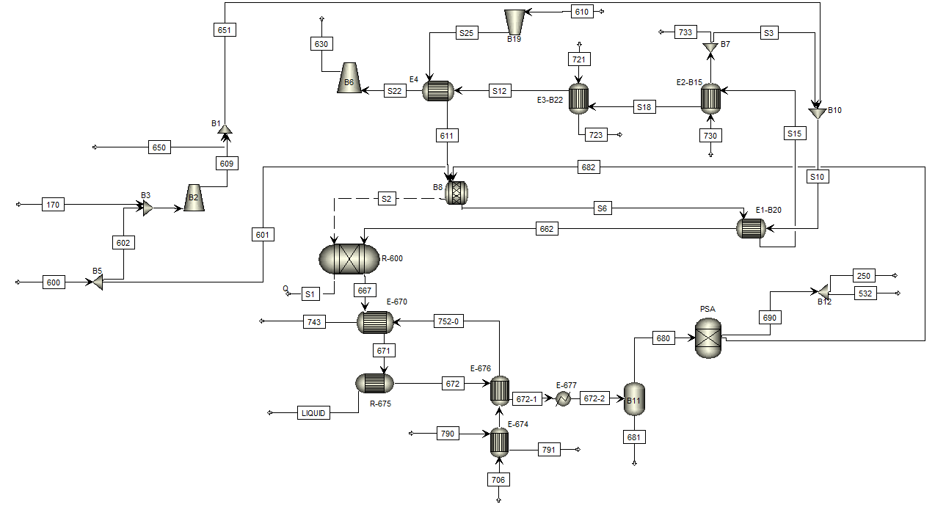
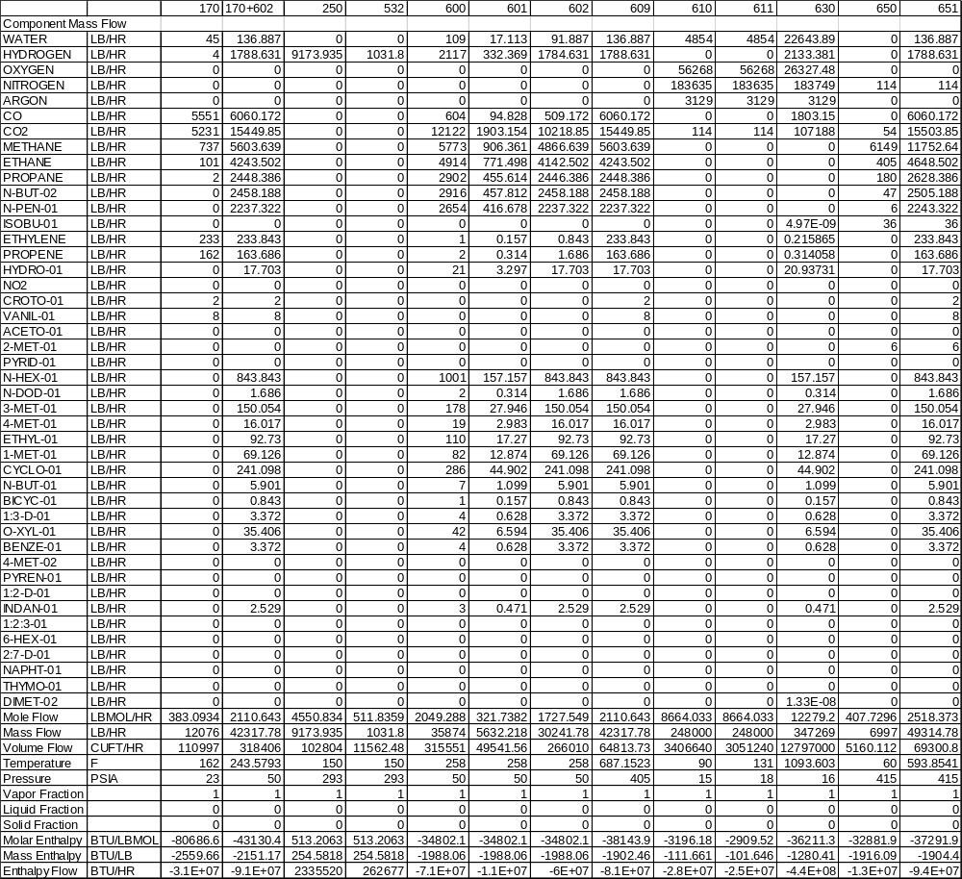

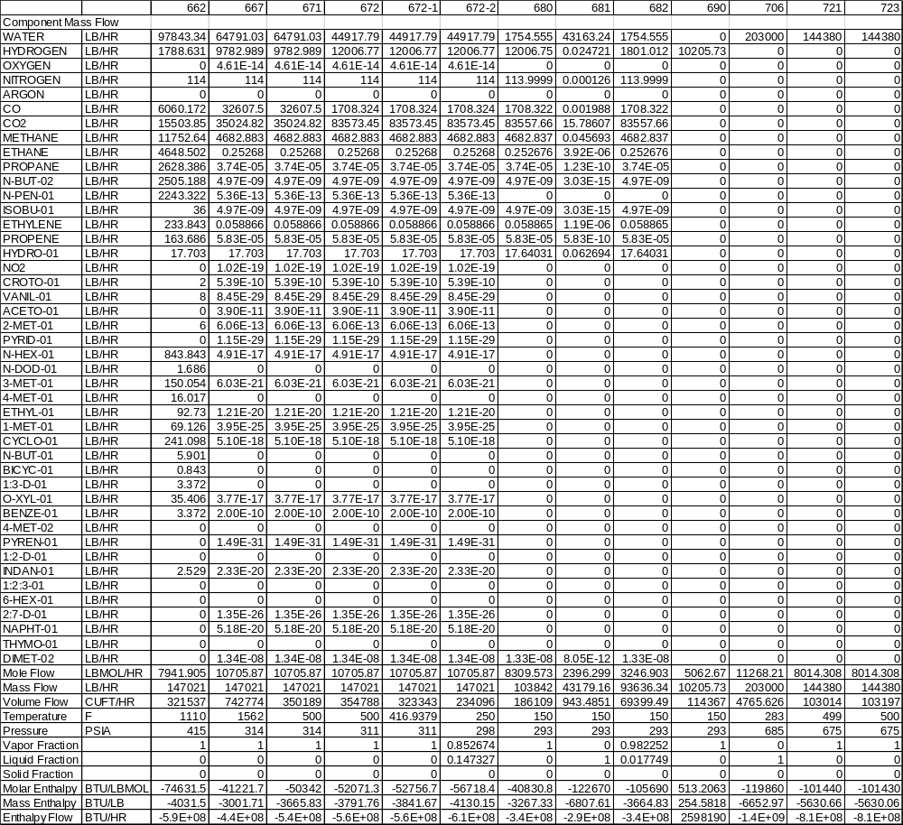

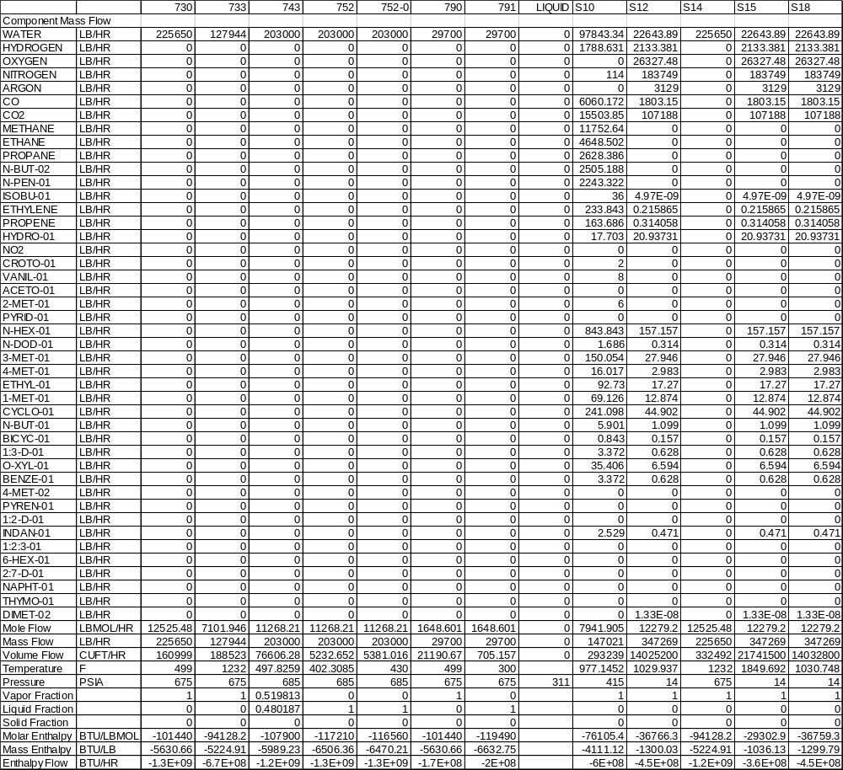

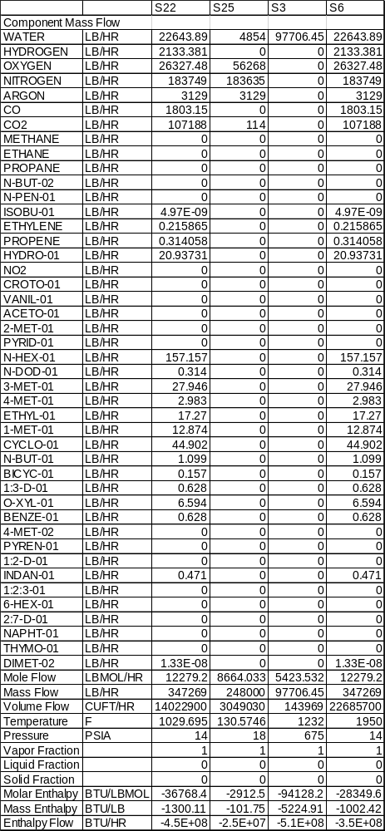

Mass and Energy Balance: Hydrogen Production via Steam Reforming w/o Natural Gas

