Final Report

Additive Manufacturing Power Consumption Measurement System

IE 422
Senior Design Capstone Team

Class Team Members:
Robin Graves
Michel Hisaeda
Parker McCullough
Daniel Webb

High School STEM Team Member:
Lizzy Noon





Revised: 5/9/2016

Table of Contents
1.0 Executive Summary 1
2.0 Conceptual Design 1
2.1 Introduction 1
2.2 Background 1
2.3 Possible Future of Additive Manufacturing 2
2.4 Need Identification 2
2.5 Advanced Systems Planning 3
2.6 Feasibility Analysis 3
2.7 Operations Requirement Development 4
2.8 Maintenance and Support Requirement Analysis 4
2.9 Technical Performance Measures (TPM) 5
2.10 Functional Analysis 6
2.11 Conceptual Design Review 8
3.0 Detail Design 9
3.1 Introduction 9
3.2 Type B-E Specifications 9
3.3 Trade-Off Studies and Evaluation of Alternatives 9
3.4 Future State 9
3.5 Design Features 10
3.6 Economic Analysis 10
3.7 Detail Design Review 10
4.0 Test, Evaluation, and Validation 11
4.1 Introduction 11
4.2 Validation Methodology 11
4.3 Conclusion 12
5.0 Analysis of Data 12
5.1 Initial Results 12
5.2 Future Testing Scenarios 14
5.3 Opportunities for Improvement 14
6.0 Thanks 14
7.0 References 15
8.0 Appendix 16
8.1 Appendix A: Bill of Materials 16
8.2 Appendix B: Type B Specifications 17
8.3 Appendix C: Type C Specifications 18
8.4 Appendix D: Type D and E Specifications 19

1.0 Executive Summary
This project was commissioned first to create a device to read and record the power consumption of various additive manufacturing machines. This idea was generated with the hope of using this data to compare additive manufacturing of parts to conventional manufacturing of parts. The project team was tasked with the research and design of this project. The systems engineering design process was followed, as described by Blanchard in the textbook used for the senior design capstone course. Details pertaining to this process, including conceptual design, detail design, production, construction, operation, and analysis are detailed in this report.

2.0 Conceptual Design

2.1 Introduction
Beginning in September of 2015, the project team, which consisted of four undergraduate industrial engineering students and one high school senior, collaborated with the Electric Power Research Institute and the Manufacturing Demonstration Facility to design a device to collect power consumption data on the MDF’s additive manufacturing machines. The Project Team set forth to follow the systems engineering design process and to produce the conceptual design during the fall semester. A large portion of the fall semester was spent planning and organizing at this phase. It is known that careful planning in the conceptual design phase of a system design project positively impacts the performance of a system. These potential impacts include reduced costs and time as well as lowered confusion among the parties involved. The conceptual design phase is the first and most critical stage of the systems engineering design process. This section of the report covers the steps involved in the conceptual design, beginning with need identification and ending with conceptual design review.

2.2 Background
The Manufacturing Demonstration Facility has a need to better understand the power consumption of its metal additive manufacturing (AM) machines. With assistance from the University of Tennessee, the MDF hopes to increase its working knowledge of exactly how much power goes into the creation of any one additive manufacturing part. This project will provide the foundation for future studies that will analyze the power consumption and determine if there is any correlation between power consumption, energy efficiency, and the quality of the additive manufacturing process. The Project Team will carry out this project with funding from EPRI.
To achieve this purpose, the Project Team will create a power consumption measurement system to observe the energy consumption factors and acquire and store data. The ARCAM, ExOne M-Flex, Renishaw and DM3D additive manufacturing machines at MDF were candidates for this project. Initial priority was given to the ExOne M-Flex machine. Later, the team has potential to analyze the data and determine if there are any correlations between the energy consumption and quality factors.

2.3 Possible Future of Additive Manufacturing
Currently additive manufacturing is used mostly for prototyping. The ability of 3D printers to make very complex geometries and the ability to reduce the weight of products has manufacturers considering from switching from CNC type machines to additive manufacturing. Additive manufacturing has already proven that the strength and properties of the parts made either meet or exceed the existing conventional made parts. Knowing the life cycle cost of these parts will help to complete the picture for additive manufacturing and help move it from prototyping to mainstream production (Huang and Riddle).

2.4 Need Identification
When attempting a project, it is critical to identify customer needs clearly. In the case of the AMPCMS project, the customer needs were conveyed through concerns voiced by a joint relationship between the University of Tennessee and the Manufacturing Demonstration Facility. This customer entity was unique in that it was created for research purposes, rather than business endeavors. Because of this, student members of the Project Team were required to contact multiple sources for information.
It was made clear to the Project Team that MDF was unable to monitor the amount of power consumption for its additive manufacturing machines, such as those shown in Figure 2.4. Data collection for power consumption was needed to determine the true cost of the additive manufacturing process and provide grounds for further research, particularly life cycle cost. This was identified as the most critical need and led to the development of the project mission statement.

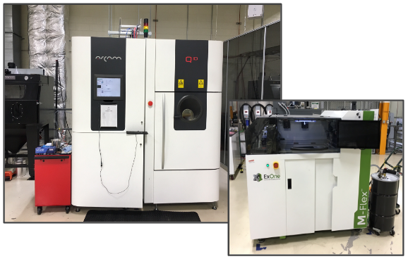
Figure 2.4: Arcam Q10 AM Machine (Left) and M-Flex ExOne AM Machine (Right)

2.5 Advanced Systems Planning
Following need identification, the project team began advanced systems planning. Advanced systems planning includes taking into account the project requirements and developing a project management plan (PMP), System Specification, and System Engineering Management Plan (SEMP). The PMP serves as an organizational tool by which all other actions of the project are driven. The System Specification defines the conceptual design clearly for use in preliminary and detail design, and the SEMP defines how these aspects of design are to be managed. The System Specification and SEMP work together to create a functional baseline for subsequent stages of design.
The project team created and submitted the PMP, System Specification, and SEMP documents during the fall semester. Figure 2.5 shows the Gantt chart used in the PMP to document the progress of the project. All stages of the project are denoted on the left column with their planned and actual durations located on the right. This chart guided the project team through the project and helped the team adhere to schedule. The project team met and updated this chart on a weekly basis.

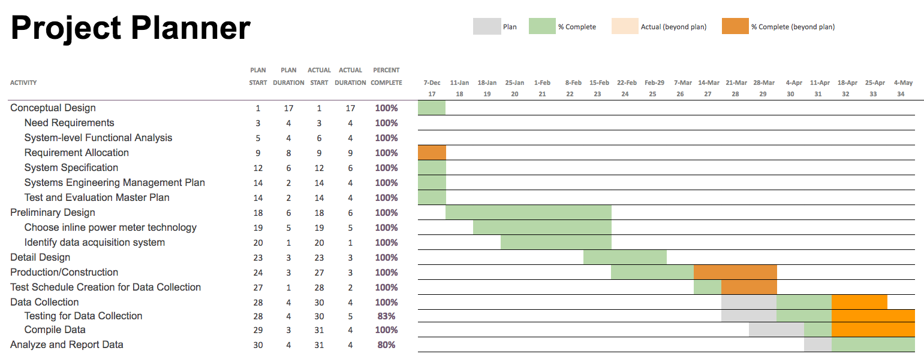
Figure 2.5: Gantt Chart for AMPCMS Project

The System Specification included all Type A specifications for the project. This document included system definition, system characteristics, design and construction provisions, as well as logistics information. The Type A specifications corresponded closely with the technical performance measures shown in Section 2.9. The SEMP included requirements analysis, functional analysis, synthesis, and management methods. Both documents guided the resulting design phases of the project.

2.6 Feasibility Analysis
Before the project team could begin to create technical performance parameters as guidelines for any builds, they had to determine if the basic idea behind the project was at all feasible. This required a meeting with ORNL personnel to check if there has been a similar project attempted in the past at the MDF. The project team soon learned that EPRI employees actually came to the MDF sometime in 2015 to check the electrical power consumption traits of several of the additive manufacturing machines. Since the EPRI sponsors actually performed a study in the past, the project team decided to emulate their approach, but focus on making the ease of use for the machine to be an important functional parameter.

2.7 Operations Requirement Development
This section outlines the AMPCMS Operational Requirements, including a system need summary, mission and performance statement, deployment and distribution methodology, and life cycle vision.

2.7.1 Mission, Performance and Motivators
The mission of the AMPCMS is to deliver a system capable of successfully monitoring, storing, and analyzing the power consumption behavior of MDF additive manufacturing machines during the 3D-printing process. The data collected should be usable for later research. Later research possibilities include linking power consumption data trends to physical material quality characteristics and analyzing life cycle costs associated with additive manufacturing technology.

2.7.2 Deployment, Operational Distribution and Utilization
The AMPCMS will consist of one operable equipment system for use in MDF. The AMPCMS will be used under the jurisdiction of the project team throughout the duration of the University of Tennessee Industrial Engineering senior design capstone course beginning August 2015 and ending on May 14, 2016. The project team worked jointly under the supervision of the University of Tennessee Industrial Engineering Department and MDF. In May 2016, the ownership and operation of AMPCMS will transfer to the Manufacturing Demonstration Facility.

2.7.3 Life Cycle
Due to the research and development nature of the AMPCMS, the life cycle horizon is indeterminable. However, the project team plans for the system to be usable for a minimum of two years. With additive manufacturing technology rapidly evolving, it is difficult to determine if the system will remain adequate for future machines.

2.8 Maintenance and Support Requirement Analysis
In order for systems engineering to be fully beneficial, it is crucial to analyze all components of the system; it is important to define the maintenance and support requirements for each element of the system to ensure the correct function over the lifecycle. The original design of the AMPCMS was composed of non-integrated custom parts present in excess stock at the MDF facility, which would make repairs more manageable due to the presence of redundant parts, but due to challenges affecting the operability, the team changed the design to its current version.
The current design uses a COTS (commercial-off-the-shelf) Yokogawa CW240. Even though this option is more costly, the current design works with success. To keep the maintainability and support of the system at a low cost, there are still spare parts available for the other components. There are various levels of maintenance that have been considered for the new system, including both corrective and preventive maintenance actions. Corrective actions take place after a problem has surfaced, while preventive maintenance focuses on forecasting problems that have not occurred yet.
In order to fix corrective issues, there are available parts at the MDF facility, and the current staff is also qualified to make small repairs in the order of mechanical and electrical problems. If the problem is within the new Yokogawa system, customer support is available. To sustain an effective collection of data and to avoid downtime, preventive maintenance will be performed every month, and the calibration of the Yokogawa system will be performed by a third-party company every year.

2.9 Technical Performance Measures (TPM)
The AMPCMS was evaluated according to the technical performance measures described in Table 1. The Project Team set forth these expectations after deliberating with team members and project sponsors. Table 1 illustrates the TPMs, corresponding metrics, and status of the project compared to these metrics.

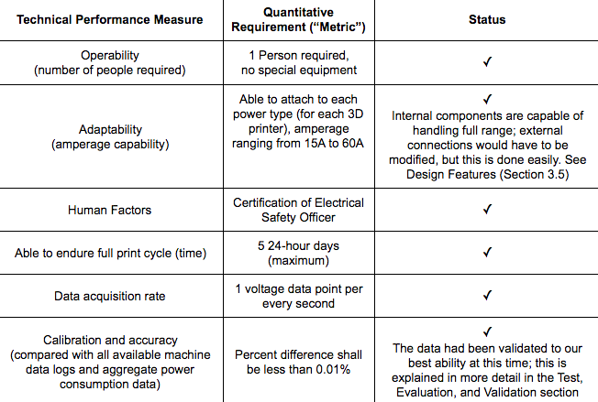
Table 2.9: Technical Performance Measures and Status for AMPCMS Project
The project team created a house of quality to compare these TPMs with customer expectations and wants. The house of quality was used to gage customer interest level for the measurements and to determine which measurements were the most important. The house of quality is shown in Figure 2.9. This figure illustrates how safety was most important to the customer, followed by operability and adaptability, data acquisition, and efficiency.

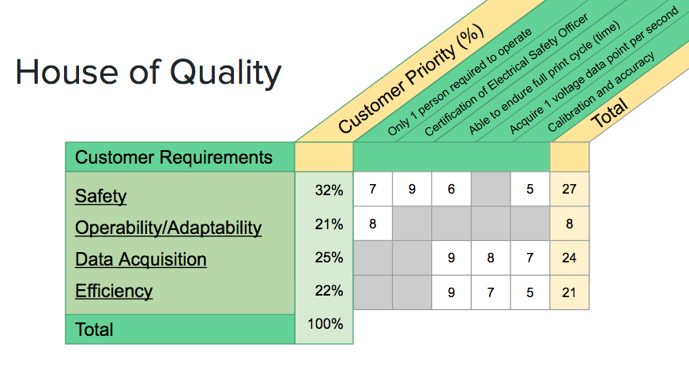
Figure 2.9: House of Quality for AMPCMS Project

2.10 Functional Analysis
Once the project team had TPMs to consult, they started work on the functional analysis. The team allocated functions to particular machines, sensors, and processes to meet the aforementioned technical performance measures. The initial design called for LEM CV3-500 voltage sensors and LEM LF 250-5 current flux sensors. There are one of each of the sensors for each of the three phases. These sensors broadcast scaled signals to a National Instruments data acquisition device, which is used by a computer with LabVIEW software to analyze data. The original design can be seen below in Figure 2.10a.
For reasons that are explained in section 2.11 (Trade-Off Analysis), the Project Team decided to change this base design and go with another sensor system. The LEM type sensors were disconnected, but left in the chassis for use in the future. A Yokogawa CW240 clamp on power meter replaces all of the LEM sensors, as it has three pairs of current and voltage sensors. The Yokogawa version of the AMPCMS can be seen below in Figure 2.10b. As can be seen in Figure 2.10c, the functional breakdown to collect data is very straightforward, both for the Project Team and the additive manufacturing operators.

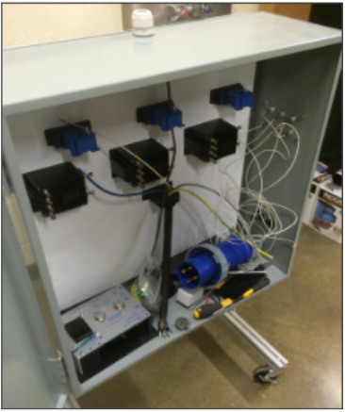
Figure 2.10a: Original AMPCMS Design, Internal Components

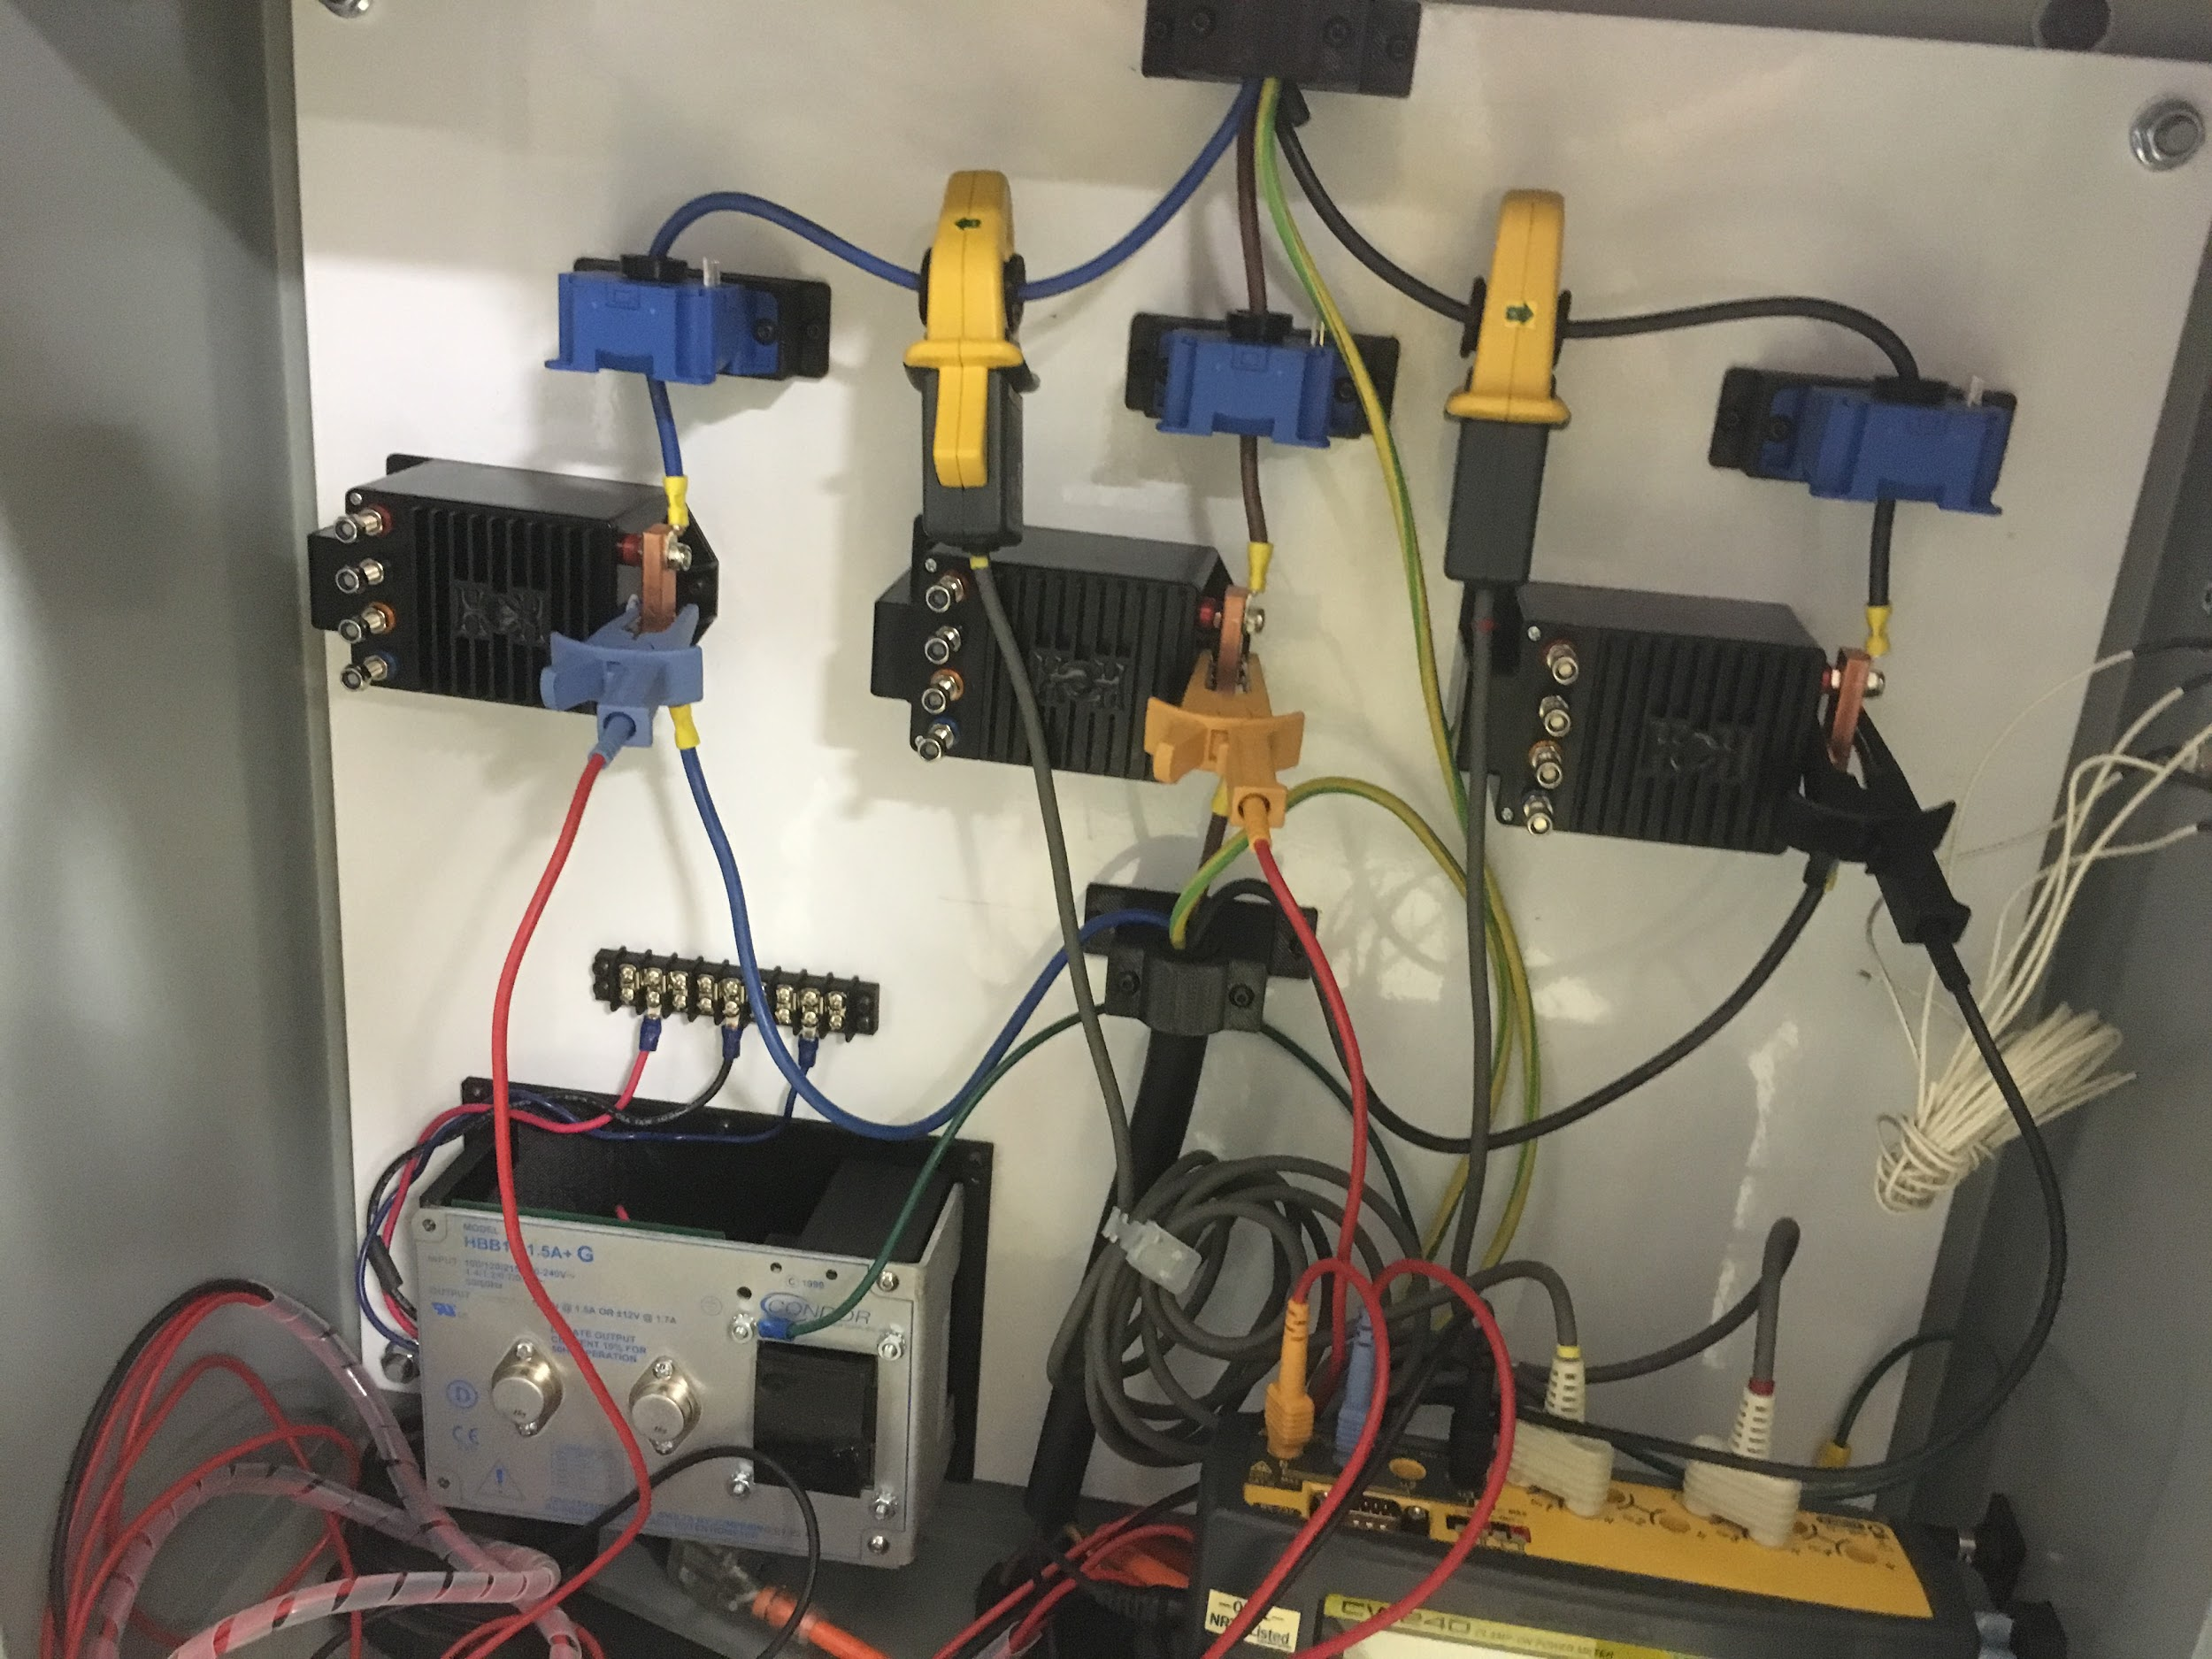
Figure 2.10b: Current AMPCMS Design, Internal Components
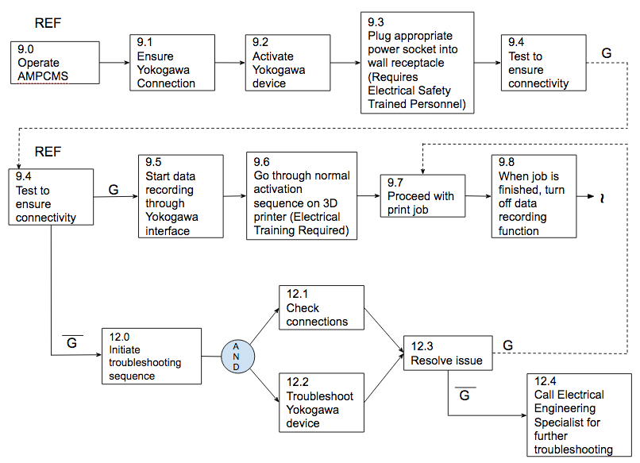
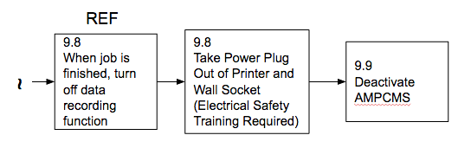
Figure 2.10c: Functional Allocation of AMPCMS, Operational Flow

2.11 Conceptual Design Review
The conceptual design review was held at the conclusion of the fall semester. The conceptual design review serves to ensure all stakeholders are in agreement and that transition to later design phases is smooth. Following the review of submitted work, EPRI proposed to the project team to consider a more commercial-off-the-shelf (COTS) type of design concept. The stakeholders felt the team was expending resources on creating content that could be more easily bought. In many ways, this review helped the team shift direction in their approach. Though the team did not fully scrap the original design idea, they began considering options to integrate more COTS items internally in place of existing components. This changed the outcome of the project to be more successful and is further described in Section 3.0.

3.0 Detail Design

3.1 Introduction
The Project Team began working on the detail design phase of the project in January of 2016. Detail design involves trade-off studies, verification of engineering design, production planning, and development of test and evaluation methods. The project team spent approximately half of the spring semester on this phase of the project, continuing throughout the remainder of the semester with the production, construction, and operational use stages. The project team encountered several challenges during the detail design phase of the project, and these challenges as well as the methods used to address this phase of the project are discussed in this section of the report.

3.2 Type B-E Specifications
Type B-E specifications were determined during this phase of the project. This required the project team to analyze the system requirements through a top-down approach. The project team decided on the specifications denoted in Appendices B-D. See these appendices for the allotment and explanation of these requirements and their corresponding descriptions.

3.3 Trade-Off Studies and Evaluation of Alternatives
After the functional allocation was complete, the Project Team observed that the original build design had inherent flaws in several of the components: The three phase power was flowing as designed, but the current sensors were not correctly reading the current values when initial tests were conducted. This was a major flaw that had to be address, so the Project Team reviewed several different ways to proceed. It was decided to go with a Commercial Off The Shelf (COTS) option: the Yokogawa PW240.
The Yokogawa unit was much more expensive than the previous, non integrated option. It came in at an extra $1250. The previous iteration was much less expensive, but the team did not think they could repair the malfunctioning current units in time. Therefore, it was decided to leave the non-integrated unit inside the chassis for future use, but to use the Yokogawa exclusively for the time being (Cox).

3.4 Future State
With the ease of use and initial success of the Yokogawa controller this method will be used in the future. The initial power monitoring unit was cheaper but with the failure of the unit this design will only be revisited as a backup to the Yokogawa controller. Since the Yokogawa uses clamps to measure voltage and current it is easy to place inside most control panels for data collection. As more data is needed a controller could be placed inside each printer to allow for data collection for every build. This would create a large database that then could be used for life cycle cost, reliability and maintainability, and quality.

3.5 Design Features
The final iteration of the AMPCMS had several useful features for data acquisition and analysis. The Yokogawa power meter easily handled the workload of capturing the three phase power data. Each phase of the power cable had a current and a voltage to record, and the meter automatically calculated power from those values. The data was then stored on a memory card, so that any data could be conveniently moved to a computer for statistical analysis and graphical plotting.
One of the best features of the AMPCMS was that it was very easy and intuitive for 3D printing personnel to connect their printers to the chassis and then the wall receptacle to the chassis. If the plug needs to be changed, for a 30A plug or any other type, then a properly trained electrical professional just has to replace the top and bottom plug with the proper type. This is a straightforward process, and an electrician could change out both plugs in about 15 minutes (Cox).

3.6 Economic Analysis
As mentioned earlier, the earlier iteration of the power consumption measurement system was comprised of three units each of the LEM CV 3-500 voltage sensors and the LEM LF 250s current sensors inside of a NEMA X1 enclosure. These sensors would send a scaled signal to a National Instruments data acquisition module. The total cost of this build was $2500. Since the current sensors of this version were not broadcasting any signals, the team had to go into a different route.
It was decided that while the individual sensor method would be more cost effective, the broken current sensors forced the team to consider other methods. The engineer in charge of the data acquisition found an idle Yokogawa PW 240 three phase power measurement unit that would be perfect for the team’s purposes. While the Yokogawa sensor was free for the team to use, cost data was still collected to provide a good estimate of the total cost of the measurement system. The new grand total is $3670, raising the cost by $1170.
While this new method was more expensive, the Yokogawa power sensor proved to be extremely reliable, and it met all of the team’s data acquisition needs. The team believes that involving the sensor was justified, since it was technically purchased for an earlier project and the sensor was much more reliable than the earlier build. See Appendix A for a detailed bill of materials.

3.7 Detail Design Review
The detail design review consisted of interaction between the project team and the project sponsors. Careful consideration was given to the validity of the design and its potential. The trial and error experienced in the iterations of the build process were discussed and explained, and all parties agreed to proceed with the operation of the device as designed. It was emphasized that test, evaluation, and validation were to become the primary focus of the project during the remaining time of the semester.

4.0 Test, Evaluation, and Validation

4.1 Introduction
After the system became fully operational and created its first energy consumption data set, the Project Team was met with an important question: How does the team know that the data the AMPCMS creates is valid in the first place? Since this is a new field in the power monitoring world, the team does not have any literature to double-check any data that is collected. Therefore, the sensors that actually accumulate the information must be reasonably trustworthy with their data acquisition abilities. The team created several guidelines to check any sensor’s credibility. These guidelines include external calibration, data checks for anomalies, multiple measurements, and testing a known load.

4.2 Validation Methodology
The first method to ensure high data fidelity is regular calibration of all sensor equipment. ORNL has an annual contract with a third party calibration company who expertly calibrates any sensitive data acquisition technology. The lab just had to send the sensors to the calibration lab and they connected it to a certified load. If adjustments were needed, the specialists changed any parameters until the sensor was thoroughly correct in all of its readings. The calibration specialists then placed a large sticker over the casing separation of the instrument. There is no way to open up a calibrated instrument without destroying the sticker. This shows that the instrument cannot be tampered with and staff not find out about it. The Yokogawa power measurement unit was one of those certified calibrated units, so ORNL staff felt confident it would accurately report the data (Cox).
However, this calibration did not take into account any possible drops or shocks that the instrument might take on a daily basis. If a strong force knocks the instrument for any reason, the delicate circuitry inside might be compromised. Staff could not tell this just by the state of the calibration sticker, so other methods of validation need to be used.
Another method to validate the data was to spot check it throughout the process and see is the data actually made sense. In essence, it was a sanity check for the sensor readouts. The team could check the voltage and see if it was running within reason of the proper voltages. For example, if the voltage was supposed to be 270V, then a readout of 277V was well within reason. A voltage of 370V or 70V would raise a red flag about the credibility of our sensor (Cox).
The next test took place after the data had been collected. The Project Team looked at the individual voltages and current measurements coming off of each of the three phases. They multiplied the two values together and then summed the products to get a cumulative power throughput. Then they compared it to the value the sensor recorded. The two values were identical, coming in at 10.3 kWh. The identical values lead the team to believe that the Yokogawa sensor was correctly reading the power consumption values (Cox).
The last method to validate the test results would be to connect the Yokogawa to a known load of some sort, like a motor. The motor would be left to run for a period of time, and the measurements taken from the Yokogawa would be compared to the known values taken from the machine. If there were no discrepancies, the sensor would be credible enough for further testing. The team did not attempt this method, as there was not enough time to find a motor of known capability at the MDF site. The team wants to find a motor in the future to further validate the Yokogawa sensor (Cox).

4.3 Conclusion
The team believes the Yokogawa sensor is credible in its function to record voltage, current, and power readings from three phase power supplies. However, further validation of the sensor should always be kept in mind in the spirit of due diligence and continuous improvement.

5.0 Analysis of Data

5.1 Initial Results
The initial results from the AMPCMS were very interesting. They showed the entire energy consumption data set of an ExOne additive manufacturing machine. This particular ExOne build was a diesel engine valve block, which is shown in Figure 5.1a. It was started on April 18, 2016 at 9:31 AM and ended on April 19 2016 at 6:27 AM. Therefore the total build took around 21 hours. The block was 32.4 pounds of stainless steel. At initial inspection the measurement system did not affect the effectiveness of the printer.

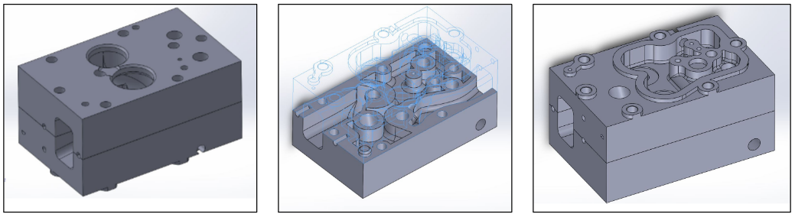
Figure 5.1a: Partial Build of Diesel Engine Valve Block, CAD Drawings

According to the Yokogawa measurement unit, the ExOne build used 10.3 kWh of energy to finish that build. It used an average of 493 W of power of the duration of the build. The max voltages and currents encountered were 208V and 10A, respectively. To put those numbers in context, an average American household uses 911 kWh per month (EIA). Therefore, if this printer ran during an entire month, it would use about as much power as an average household of four.
An interesting trend can be seen in the cumulative kWh plot of the build, which can be seen below in Figure 5.1b. The rate of energy accumulation has a sudden shift, decreasing in intensity. A question some might ask is why did that sudden decrease in energy consumption occur? The change in accumulation makes sense when compared to a plot of the instantaneous power values, which can be seen below in Figure 5.1c. The instantaneous power rates dropped considerably around 6:00 PM on the 18th. Something in the build must have changed to require the power levels to drop that low in relation to the earlier output. A comparison of the log file to the power consumption file would give an idea why the power levels dropped so significantly at that time.

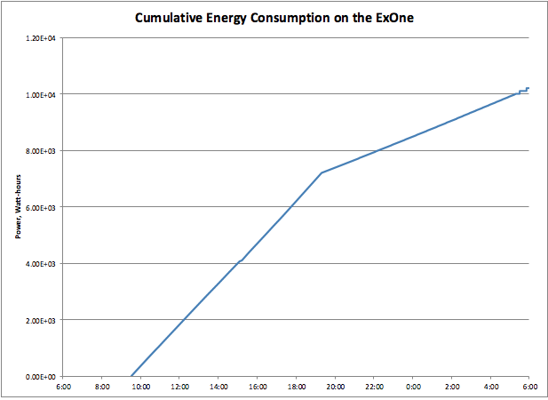
Figure 5.1b: Cumulative Energy Consumption on the ExOne AM Machine for Partial Build

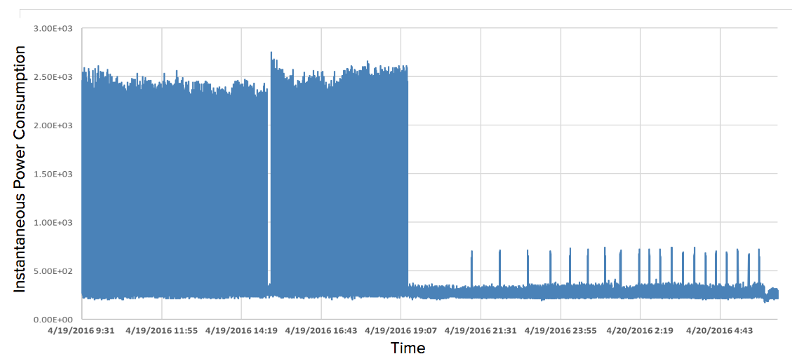
Figure 5.1c: Instantaneous Power Consumption on the ExOne AM Machine for Partial Build

5.2 Future Testing Scenarios
The AMPCMS has the potential for many other useful tests and experiments at the MDF. One future test that could occur would be to attach the sensor through the power input of the small oven that the ExOne uses to sinter its products. This sintering process strengthen the chemical bonds of the metal materials that are built in the ExOne, and is an essential step that was not measured in the initial data recording session. After the AMPCMS captures this data, operators would have a much better understanding of exactly how much power goes into creating a single part through the ExOne.
Another possible test would be to use the AMPCMS on the A10 additive manufacturing machine. This printer also uses a 60A plug, so the measurement system does not have to be changed in any way for data collection. Late in 2015, EPRI printed a part and measured the power statistics on the A10. If the A10 performed the same build and the AMPCMS recorded the data, then a comparison could be made between the EPRI data and the Project Team’s measurement. If there are any significant differences, then the team would have reason to believe that the AMPCMS has serious flaws in its data acquisition abilities.

5.3 Opportunities for Improvement
The next round of testing has several opportunities for the AMPCMS to improve its data acquisition mission. The first change that needs to be implemented is creating a quick change mechanism for the top and bottom electrical plugs. This will allow non electrical trained personnel to change the plugs, cutting down the downtime required to change the plug types. Of course, electrical work qualified personnel still have to connect to the wall receptacle and activate the device.
Another improvement would be to fix whatever is prohibiting the non integrated current modules from sending out a current signal. If this problem was fixed, it would give the AMPCMS a degree of redundancy, which will increase its overall reliability.

6.0 Thanks
The Senior Design Project Team would like to express our appreciation to the people that made this project possible. Thanks to Drs. Jin and Kobza for providing instruction and advice throughout the duration of the project. Thanks to Nelson Granda-Marulanda for dealing with our day to day problems, ideas, and concerns. Thanks to Daryl Cox for building an excellent power measurement system and providing the team with the finer points of high voltage power measurement. Finally, thanks to Baskar Vairamohan and EPRI for funding the project.

7.0 References
Blanchard, Benjamin S., and W. J. Fabrycky. Systems Engineering and Analysis. Boston: Prentice Hall, 2011. Print.
Cox, Daryl. Discussion On The Additive Manufacturing Power Consumption Measurement System. 2016. In person.
Huang, Runze and Matthew Riddle. "Energy And Emissions Saving Potential Of Additive Manufacturing: The Case Of Lightweight Aircraft Components". ORNL. N.p., 2015. Web. 4 May 2016.
"How Much Electricity Does An American Home Use? - FAQ - U.S. Energy Information Administration (EIA)". Eia.gov. N.p., 2016. Web. 4 May 2016.

8.0 Appendix

8.1 Appendix A: Bill of Materials

Part # | Model | Description | Qty | Unit | Price (est) | Source
779013-01 | NI 9201 with Screw Terminals | NI 9201 Screw Term, +/-10 V, 12-Bit, 500 kS/s, 8-Ch AI Module | 1 | ea | $ 416.00 | National Instruments
782715-01 | NI 9927 Strain relief | NI 9927, Strain Relief and Operator Protection | 1 | ea | $ 30.00 | National Instruments
781157-01 | cDAQ-9174 | cDAQ-9174, CompactDAQ chassis (4 slot USB) | 1 | ea | $ 800.00 | National Instruments
763000-01 | United States 120VAC | Power Cord, AC, U.S., 120 VAC, 2.3 meters | 1 | ea | $ 9.00 | National Instruments
779473-01 | NI 9901 Desktop Mounting Kit | NI 9901 Desktop Mounting Kit | 1 | ea | $ 53.00 | National Instruments
93365A142 | Brass heat-set insert; 8-32 X 0.312" |  | 1 | pack (50) | $ 14.25 | McMaster
92160A123 | Insert tip | Insert Tip for Soldering Iron, Installation Tip, #8 & M4 Internal Thread | 1 | ea | $ 15.02 | McMaster
7662A696 | Soldering Iron | 40W soldering iron for installing heat-set inserts | 1 | ea | $ 26.36 | McMaster
97763A177 | Cap screw | Black-Oxide 18-8 Stainless Steel; 8-32 X 3/8"; | 2 | box (50) | $ 5.53 | McMaster
96765A120 | Washer | Black-Oxide 18-8 Stainless Steel; No. 8; 0.375 OD | 1 | box (100) | $ 3.87 | McMaster
7561K64 | NEMA 1 enclosure | 24X24X8 | 1 | ea | $ 246.45 | McMaster
7561K351 | Panel |  | 1 | ea | $ 57.26 | McMaster
7085K751 | Fuse | 1.25A; 1/4" diameter glass tube; 3AG; Fast Acting | 1 | pkg (5) | $ 2.72 | McMaster
51864-1 | Ring connectors | TERMINAL, RING TONGUE, #8, CRIMP, BLUE | 50 | ea | $ 9.10 | Newark
97C6516 | Ring connectors | TERMINAL, RING TONGUE, #10, CRIMP, BLUE | 50 | ea | $ 11.50 | Newark
 | Plug | Leviton 460P9-W | 1 | ea | $ 240.91 | Kendall Electric
 | Receptacle | Leviton 460R9-W | 1 | ea | $ 225.70 | Kendall Electric
N/A | Clamp on Power Meter | PW240 3 Phase Power Meter | 1 | ea | $ 1,250.00 | Yokogawa
 | Stand | Connectors/Braces | 1 | ea | $ 253.15
Total |  |  |  |  | $ 3,669.82

8.2 Appendix B: Type B Specifications
1.0 Type B Specifications: Development
1.1 Equipment Specification (Type B)
1.1.1 Physical Requirements (Unit A)
The Unit A shall require only one person to operate. The Unit A shall physically connect to the printing device at the point of power intake to measure the amount of power consumed.
1.1.2 Data Acquisition (Unit A)
The Unit A shall collect and store data in the format of time versus power consumption, with at least one data point acquired per second.
1.1.3 Computer (Unit B)
The Unit B shall be capable of analyzing the collected data.
1.1.4 Data Storage/Transmission (Unit B)
The Unit B shall transmit and read the data collected by Unit A.
1.2 Software Specification (Type B)
1.2.1 Analysis Capability (Unit B)
The software component of the system is used exclusively to manipulate and analyze the statistical data that is recorded on a compact flash disk. The data acquisition is handled by a completely separate unit, the Yokogawa power meter, which then records the data to the compact flash disk.The team uses both Excel and the R programming language to perform statistical analysis on the data. These two software packages can handle extremely large data sets (Excel limits users to just over 1 million rows), so there will not be a memory problem concerning our data sets. The team performs several tests on the data, including F-tests to see if any changes in experiments are significant to the overall outcome. Graphical representation of the data is required to better communicate if there are any trends apparent in the data. R is very well equipped to handle any graphical data, and can export it to any regular medium.
1.3 Test Equipment Specification (Type B)
1.3.1 Data Collection (Unit A)
The Yokogawa power meter records instantaneous voltage and current values. Therefore, power can be found using a simple calculation. Also, the data is saved with a corresponding time stamp. This instrument records the data every second, giving the team more than enough samples for tests. The meter saves the data on a compact flash disk, so a special adapter is needed for a modern computer to read the information saved within.
1.3.1 Data Comparison for Validation
This is covered in the Test and Evaluation (Section 4.0) of the final report.

8.3 Appendix C: Type C Specifications
2.0 Type C Specifications: Product
2.1 Outer Box Parts Specification (Unit A) (Type C)
The outer box has to be UL listed, a NEMA 1 enclosure from McMaster meets this requirement with a cost of $246.45. A Leviton 460P9-W plug and a 460R9-W receptacle are needed for the connections, these plugs are capable of 60A and 250V at a cost of $240.91 and $225.70 respectively. The corresponding power cord is a US 120VAC at 2.3 m at a cost of $9.00. The stand is made from 80/20 with the necessary hardware has a cost of $253.15.
2.2 Inner Box Parts Specification (Unit A) (Type C)
All inner box components must be UL listed. For internal power 2 linear power supplies are needed with +/- 15V and 1.5A capability at a total cost of $82.00. Six panel mount BNCs with a total cost of $18.08. Three burden resistors are needed at a cost of $54.14. A 10μF with a tantalum electrolyte at 15V cost $11.76 for 6. Three voltage and five current transducers are needed for a cost of $1,290.00 and $350.00 respectively. The Yokogawa CW240 power meter was determined the best method for tracking power consumption data because of its reliability. The Yokogawa costs $1250.00 retail. Other methods attempted by the team did not produce usable data; therefore, the Yokogawa was the feasible choice.
2.3 Computer Product Specification (Unit B) (Type C)
The team requires a typical workstation computer, with at least 2GB of memory, a 32GB hard drive, and a respectable processor. Office Suite software should be a free download from the university Servers. The team recommends purchase of a laptop for use in this project and future senior design projects of similar caliber.
2.4 Computer Programs Specification (Unit B) (Type C)
The computer should have several software packages installed. The most important individual packages are the Microsoft Office Suite and the R language package. Microsoft Office can be downloaded for free from the university servers, while R is open source and free to download from the Internet. These two packages will provide all of the utilities needed by our experiment’s computer.
2.5 Data Transmission Specification with Card Reader (Unit B) (Type C)
The Yokogawa power meter measures the voltage and current of the 3D printer’s power input, and saves the data to a compact flash disk. In order for a computer to analyze the data, it needs a compact flash disk reader, which are not usually built into modern laptops. This is simple to work around, since compact flash to USB adapters are inexpensive. This item was requested for purchase by the department.

8.4 Appendix D: Type D and E Specifications
3.0 Type D Specifications: Process
3.1 Process Requirements (Type D)
Only ORNL personnel with the proper electrical safety credentials shall handle the power cables that connect the electrical distribution panel to the power measurement machine and to the 3D printers. Students shall not handle any of the connectors while they are live, and they shall only touch the inside of the machine when it is offline. Students shall wait until the machine is de-energized to remove the compact flash disk for statistical analysis.
4.0 Type E Specifications: Material
4.1 Materials Needed to Complete Task: Printing Matter (Type E)
To complete the task of printing our samples, several materials can be used, ranging from plastics and powders to resins and specific materials, such as Titanium, but due to the high cost of printing materials in Titanium, a more affordable option should be iron or stainless steel.
4.2 Materials Needed to Complete Task: Time on Machines (Type E)
The process of printing 3D pieces is very time consuming, therefore the availability of machinery should impact the time to complete the task; other than that, depending on the size of the part being printed, the machine should be reserved for the process for 6 to 24 hours.
4.3 Materials Needed to Complete Task: Labor Resources (Type E)
The machinery should be operated by certified ORNL operators, following the safety rules established by ORNL.

