The Design and Computational Validation of a Mach 3 Wind Tunnel Nozzle Contour

A Thesis Presented for the
Master of Science
Degree
The University of Tennessee, Knoxville

Sarah Elizabeth Adams
December 2016

Copyright © 2016 by Sarah Adams.
All rights reserved.

ACKNOWLEDGEMENTS

I would like to thank Dr. Trevor Moeller for his guidance throughout my brief time at UTSI and his willingness to serve as my committee chair. I would also like to extend my thanks to Dr. John Schmisseur and Dr. Steve Brooks for agreeing to serve on my committee. Many thanks to Stu Steen, whose help has been paramount, for sharing lessons learned about CONTUR and Fortran and for having a great deal of patience in answering my many questions. I would also like to express my gratitude to Adam Croft, Nehemiah Williams, and Seth Katz for helping me produce usable CFD results. I would also like to recognize Stefen Lindörfer for reminding me to be proud of my work, for trying to teach me his impressive CFD knowledge, and for being such a friend during my time at UTSI. Lastly, I would like to thank my husband, Ryan, whose support and encouragement made this all possible.

….
ABSTRACT

The objective of this effort was to design and validate a Mach 3 wind tunnel nozzle contour. The nozzle will be used for an existing facility, replacing a Mach 2.3 nozzle. The nozzle contour was design using the widely-distributed CONTUR code developed by Sivells. The program uses a combination of analytical solutions and the method of characteristics in order to calculate a nozzle contour. A nozzle contour adhering to the existing geometry requirements was achieved through an iterative process. The flowfield of the finalized nozzle contour was solved using ANSYS fluent. The solution results were analyzed for flow uniformity.

TABLE OF Contents
Chapter One Introduction 1
1.1 Introduction to Nozzles 1
1.2 Background 1
1.3 Scope of Work 2
Chapter Two Method of characteristics 3
2.1 Prandtl-Meyer Waves 3
2.2 Characteristic Lines 5
2.3 The Compatibility Relation 9
2.4 Application of the MOC 10
2.5 Initial Value Line 13
2.6 Types of Nozzles 14
2.6.1 Minimum Length versus Gradual Expansion 14
2.6.2 Axisymmetric versus Planar 16
2.7 Boundary Layer Correction 17
2.8 The Works of Puckett and Foelsch 19
2.8.1 Puckett’s Method 19
2.8.2 The method of Foelsch 20
Chapter Three Mach 3 nozzle contour design 22
3.1 Design Parameters 22
3.2 CONTUR by Sivells 22
3.3 Mach 3 Nozzle Contour Design 27
Chapter Four Nozzle Contour design validation 32
4.1 Simulation Software 32
4.2 Simulation Set-up and Meshing 33
4.3 Results 36
4.3.1 Grid Independence 36
4.3.2 CFD Solutions 36
Chapter Five Conclusion and recommendations 48
List of References 49
APPENDIX 52
Gas dynamics of nozzle flow 53
Flow Regimes and Compressibility 53
Governing Equations 54
Isentropic Flow of an Ideal Gas 56
Vita 59

LIST OF FIGURES
Figure 1. UTSI's Mach 2.3 Wind Tunnel Nozzle and Test Section UTSI’s 2
Figure 2. Gradual expansion (top) and abrupt expansion (bottom) of supersonic flow [5] 4
Figure 3. Streamline Geometry [6] 8
Figure 4. Characteristic Curves [6] 9
Figure 5. Characteristic Regions [5] 11
Figure 6. Characteristics of Internal Flow (left) and Flow at a Wall (right) [5] 11
Figure 7. Throat Characteristics and Sonic Line [5] 13
Figure 8. Minimum Length Nozzle (top) versus A Gradual Expansion Nozzle (bottom) 15
Figure 9. Parallel Wall Boundary Layer Thickness [9] 17
Figure 10. Boundary Layer Velocity Profile [10] 18
Figure 11. Viscous Correction [10] 19
Figure 12. Puckett’s Nozzle Design [13] 20
Figure 13. Foelsch’s Radial Flow Nozzle [11] 21
Figure 14. Properties of the Throat Region Utilized in CONTUR [16] 23
Figure 15. Design Method of CONTUR [3] 24
Figure 16. Sample Nozzle Input Cards [16] 25
Figure 17. Mach 4 Sample Design 26
Figure 18. Modified Input Deck 27
Figure 19. CONTUR Input 29
Figure 20. Mach 3 Nozzle Contour from CONTUR 29
Figure 21. Mach 3 Nozzle Contour 31
Figure 22. Contour (top) and Contour Derivatives (bottom) 31
Figure 23. Two-Dimensional Nozzle Geometry 34
Figure 24. Meshing 35
Figure 25. Grid Independence Study of Exit Temperature 38
Figure 26. Grid Independence Study of Mach Number 39
Figure 27. Mach Number Contour 40
Figure 28. Centerline Mach Number 41
Figure 29. Centerline Pressure Ratio P/P0 42
Figure 30. Centerline Temperature Ratio T/T0 43
Figure 31. Percent Deviation of Temperature at the Nozzle Exit 44
Figure 32. Percent Deviation of Pressure at the Nozzle Exit 45
Figure 33. Percent Deviation of Density at the Nozzle Exit 46
Figure 34. Percent Deviation of the Velocity at the Nozzle Exit. 47
Figure 35. Quasi-One-Dimensional Flow [1] 54

NOMENCLATURE
a | Speed of Sound
C | Characteristic Line
K | Riemann Invariant
M | Mach Number
m | Slope of a Line
N | Speed Factor
U | Velocity
u | x-component of Velocity
v | y-component of Velocity
y0 | Throat Half-Height
γ | Ratio of Specific Heats
δ | Boundary Layer Thickness
δ* | Boundary Layer Displacement Thickness
θ | Inflection Angle
μ | Mach Angle
ν | Prandtl-Meyer Function
ρ | Density
Φ | Velocity Potential

Introduction

Introduction to Nozzles
The field of aerodynamics is a discipline based on experimentation [1]. The wind tunnel is the means by which such experimentation can be done without the risks associated with flight testing. At the heart of the wind tunnel is the nozzle, which channels flow to the test section, accelerating such flow to some design speed and condition. Nozzles are not used exclusively for wind tunnels; they are also utilized quite effectively for propulsive efforts. Although their uses are many, the primary focus of nozzles discussed in this work is for the use of wind tunnels.

1.2 Background
The most basic idea of a supersonic nozzle is to expand a stagnant or subsonic gas to a speed greater than that of sound, thus reaching the supersonic flow regime. Supersonic flow is often characterized by the presence of shock waves, which are thin regions that cause discontinuous flow property and streamline changes [2]. For the purpose of aerodynamic testing, it is imperative that the flow entering the test section is uniform, parallel, and continuous. The uniformity and Mach number of the flow within the test section depends greatly on the design of the nozzle contour. For this reason, the contour design a critical aspect of wind tunnel design. A supersonic nozzle contour for the purpose of wind tunnel testing must be designed such that there are minimal flow disturbances.
In an effort to expand the University of Tennessee Space Institute’s (UTSI) research facilities, a 2014 study concerning the feasibility of building a Mach 2.3 wind tunnel was led by Dr. Trevor Moeller. The proposed effort included the design of a Mach 2.3 blow down tunnel with the capability of obtaining Mach 3 flow through the exchange of a nozzle block. The proposal resulted in the fabrication and installation of a Mach 2.3 wind tunnel with a 6 x 6 inch square test section. The wind tunnel was designed with modular blocks assembled with bolts so that multiple testing configurations could be implemented. Furthermore, the tunnel was outfitted with five windows for optical diagnostics and two test sections. A schematic of the UTSI blow down tunnel nozzle and test sections with the modular blocks is depicted in Figure 1. The Mach 2.3 effort was completed in the spring of 2016 with a projected air-on date in July of 2016. In order to produce the desired Mach 3 flow capabilities an additional nozzle contour, to be exchanged with the Mach 2.3 nozzle, is needed.

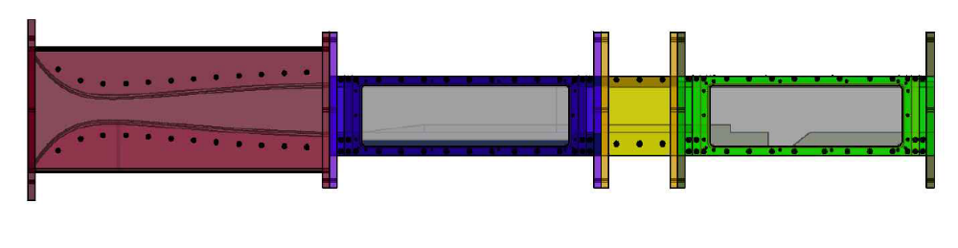
Figure 1. UTSI's Mach 2.3 Wind Tunnel Nozzle and Test Section UTSI’s

1.3 Scope of Work
This thesis details the design and computational validation of a planar Mach 3 nozzle contour. The nozzle contour was designed within the geometric constraints dictated by the existing Mach 2.3 facility which is a common practice within the testing community. The convergent-divergent nozzle contour detailed herein was designed using a method of characteristics (MOC) FORTRAN legacy code. The code, CONTUR, utilized in this effort was written by J.C. Sivells. For the purpose of this thesis, the designed nozzle contour was validated using Computational Fluid Dynamics (CFD) with the software ANSYS FLUENT. The goal of this effort was to produce a nozzle contour with Mach 3 flow at the nozzle exit and the flow uniformity within the test section required for sound supersonic wind tunnel testing. The computational validation included the confirmation of Mach 3 flow at the exit of the nozzle, the prediction of the boundary layer thickness, and an assessment of the nozzle exit flow quality.

Method of characteristics
There are two categories in which most nozzle contour techniques can be placed: direct design or design by analysis [3]. The direct design technique is a numerical procedure in which the nozzle contour is the output. Design by analysis entails the optimization of a known nozzle contour. Of the direct design techniques, the method of characteristics is the most frequently utilized technique for the purpose of nozzle contour design. The method of characteristics is a graphical solution of a flowfield, and it was first developed by Ludwig Prandtl and Adolf Busemann in 1929 [4]. The basis of the method of characteristics (MOC) in regard to nozzle design lies in the expansion of steady supersonic flow through Mach waves.

2.1 Prandtl-Meyer Waves
When supersonic flow encounters a convex corner, it passes through a series of Mach lines or infinitely weak normal shock waves. The series of Mach lines originating from a corner are referred to as Prandtl-Meyer waves and are characterized by a leading or forward Mach wave, a trailing or rearward Mach wave, and an unbounded number of Mach waves between the two. Prandtl-Meyer waves can be present through a gradual expansion or an abrupt expansion such as a sharp corner as illustrated in Figure 2 with μ₁ and μ₂ representing the Mach angle of the leading Mach wave and trailing Mach wave, respectively. The Mach angle μ is defined as
 | $$μ=\sin^{-1}{\frac{1}{M}}$$ | (2-1)
When supersonic flow encounters a Mach wave, its properties and flow direction change by an infinitesimal amount [5]. When applied to a full Prandtl-Meyer expansion wave, the flow properties change infinitesimally more with the passing of each Mach wave such that the Mach number exiting the expansion fan is greater than the Mach number of the flow entering the expansion fan. Conversely, pressure, temperature, and density decreases through a Prandtl-Meyer expansion fan.
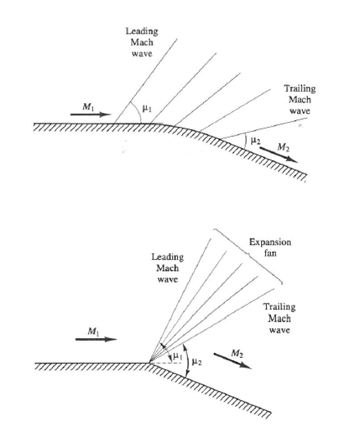
Figure 2. Gradual expansion (top) and abrupt expansion (bottom) of supersonic flow [5]

Because the flow properties change through the continuous series of Mach waves in which the change in entropy is zero, the expansion is isentropic [6]. In order to determine the Mach number that results from supersonic flow encountering an expansion fan, the following Prandtl-Meyer function was derived:
 | $$ν\left(M\right)=\int{\frac{\sqrt{M^{2}-1}}{1+\frac{γ-1}{2}M^{2}}}\frac{dM}{M}$$ | (2-2)
The integral form of the Prandtl-Meyer function represented in equation 2-2 can be simplified to an algebraic form by arbitrarily choosing a constant of integration such that a Prandtl-Meyer function of zero corresponds to sonic flow [7]. After integrating, the Prandtl-Meyer function becomes
 | $$ν\left(M\right)=\sqrt{\frac{γ+1}{γ-1}}\tan^{-1}{\sqrt{\frac{γ-1}{γ+1}(M^{2}-1)}}-\tan^{-1}{\sqrt{M^{2}-1}}$$ | (2-3)

The incoming and outgoing Mach numbers of an expansion fan are related through this function and the deflection angle through the following relationship:
 | $$ν\left(M_{2}\right)=θ_{2}+ν(M_{1})$$ | (2-4)
where θ₂ represents the deflection angle. When a one-dimensional flow encounters a Prandtl-Meyer expansion fan, it gains a second velocity component thereby becoming two-dimensional [5]. Thus, the Prandtl-Meyer function provides a method of analysis for this simple two-dimensional flow. Prandtl-Meyer expansion fans deserve discussion within the scope of the method of characteristics because of the value their Mach lines have in regards to tracking and quantifying the properties of more complex supersonic flow fields.

2.2 Characteristic Lines
A characteristic line is a particular line in which flow variables are continuous and their derivatives are indeterminate or even discontinuous [6]. In order to determine the characteristic lines, the nonlinear equations of motion must be solved. The equations of motion for a two-dimensional inviscid irrotational flow are
 | $$\left(u^{2}-a^{2}\right)\frac{∂u}{∂x}+uv\left(\frac{∂u}{∂y}+\frac{∂v}{∂x}\right)+\left(v^{2}-a^{2}\right)\frac{∂v}{∂y}$$ | (2-5)
 | $$\frac{∂v}{∂x}-\frac{∂u}{∂y}=0$$ | (2-6)
where equation 2-6 represents the irrotationality condition. The irrotationality condition is such that the curl of the velocity, which is known as the vorticity, is zero or approximately so. Substituting equation 2-5 into equation 2-6 and dividing the result by the negative square of the speed of sound gives
 | $$\left(1-\frac{u^{2}}{a^{2}}\right)\frac{∂u}{∂x}-2\frac{uv}{a^{2}}\frac{∂u}{∂y}+\left(1-\frac{v^{2}}{a^{2}}\right)\frac{∂v}{∂y}=0$$ | (2-7)
Equation 2-7 is the two-dimensional velocity potential equation; the velocity potential is widely denoted as Φ. The two-dimensional velocity potential can be written as a function of x and y where the following relations hold
 | $${\frac{∂Φ}{∂x}=Φ}_{x}=u \frac{∂Φ}{∂y}=Φ_{y}=v$$ | (2-8)
When the velocity potential derivatives are substituted into equation 2-7, the equation becomes a second-order partial differential equation. Because there is no general closed-form solution of the equation, a solution can be obtained through exact numerical solutions, transformation of variables, or linearized solutions [6]. The method of characteristics is an example of a solution through an exact numerical method. The solution of the velocity potential equation allows for the entire flowfield to be established. In the case of the method of characteristics, the velocity potential solutions help identify the characteristic lines within the flowfield.
The two-dimensional velocity potential equation and the derivatives of the x and y components of velocity can be written as a system of equations of the variables Φ_{xx}, Φ_{yy}, and Φ_{xy}. This system of equations is as follows
 | $$\left(1-\frac{u^{2}}{a^{2}}\right)Φ_{xx}-\frac{2uv}{a^{2}}Φ_{xy}+\left(1-\frac{v^{2}}{a^{2}}\right)Φ_{yy}=0$$ | (2-9)
 | $$dxΦ_{xx}+dyΦ_{xy}=du$$ | (2-10)
 | $$dxΦ_{xy}+dyΦ_{yy}=dv$$ | (2-11)
In matrix form, equations 3-9 through 3-11 become
 | $$\left[\begin{matrix}\begin{matrix}1-\frac{u^{2}}{a^{2}} & -\frac{2uv}{a^{2}} & 1-\frac{v^{2}}{a^{2}} \\ dx & dy & 0 \\ 0 & dx & dy\end{matrix}\end{matrix}\right]\left[\begin{matrix}\begin{matrix}Φ_{xx} \\ Φ_{xy} \\ Φ_{yy}\end{matrix}\end{matrix}\right]=\left[\begin{matrix}0 \\ du \\ dv\end{matrix}\right]$$ | (2-12)
This system of linear equations can be solved using Cramer’s Rule which allows for the solution of one variable to be identified without requiring the solution of the entire system of equations. Using Cramer’s Rule, the solution for the variable Φ_{xy} is
 | $$Φ_{xy}=\frac{∂u}{∂y}=\frac{\left|\begin{matrix}1-\frac{u^{2}}{a^{2}} & 0 & 1-\frac{v^{2}}{a^{2}} \\ dx & du & 0 \\ 0 & dv & dy\end{matrix}\right|}{\left|\begin{matrix}1-\frac{u^{2}}{a^{2}} & -\frac{2uv}{a^{2}} & 1-\frac{v^{2}}{a^{2}} \\ dx & dy & 0 \\ 0 & dx & dy\end{matrix}\right|}$$ | (2-13)
The definition of a characteristic requires that the derivative be indeterminate, but there is a physical limitation of finiteness. In regards to equation 2-13, the characteristic condition and physical limitation implies that both the numerator and denominator are zero. Setting the denominator to zero and arranging into a quadratic form gives
 | $$\left(1-\frac{u^{2}}{a^{2}}\right){\left(\frac{dy}{dx}\right)}^{2}+\frac{2uv}{a^{2}}\left(\frac{dy}{dx}\right)+\left(1-\frac{v^{2}}{a^{2}}\right)=0$$ | (2-14)
Using the quadratic equation, the slope of the characteristic line represented in equation 2-14 is
 | $$\frac{dy}{dx}=\frac{-\frac{uv}{a^{2}}±\sqrt{\frac{u^{2}+v^{2}}{a^{2}}-1}}{1-\frac{u^{2}}{a^{2}}}$$ | (2-15)
The equation of the slope of a characteristic line presented in equation 2-15 is characterized by the relationship contained within the radical which can be reduced to
 | $$M^{2}-1$$ | (2-16)
For supersonic flow, the equation is hyperbolic; that is, the relation is satisfied by the coefficients of its highest-order derivatives, and two characteristic curves exist as the solution. [7]. Sonic flow results in a parabolic partial differential equation which is characterized by one solution or characteristic curve. For subsonic flow, the resulting equation is elliptic and the characteristics are imaginary. Because of this, the method of characteristics is not the most appropriate method for solving a subsonic flowfield. In order to understand the physical significance of the characteristic lines in a flowfield, it is most convenient to write equation 2-15 in terms of streamline geometry. Figure 3 presents an illustration of two-dimensional flowfield streamline geometry.

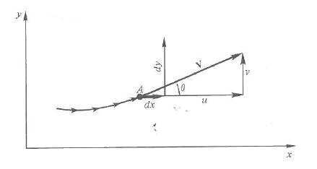
Figure 3. Streamline Geometry [6]

Using the geometric relationships illustrated in Figure 3, the slopes of the characteristic line can be written as
 | $$\frac{dy}{dx}=\frac{-M^{2}\cos{θ\sin{θ}}±\sqrt{M^{2}-1}}{1-M^{2}\cos^{2}{θ}}$$ | (2-17)
Through trigonometric substitution and the substitution of the Mach number and the Mach angle relationship of equation 2-1, the characteristic equation becomes
 | $$\frac{dy}{dx}=\tan{(θ∓μ)}$$ | (2-18)
The great significance of this derivation is that the characteristics lines present in supersonic flowfields are Mach lines. The characteristic inclined at an angle θ + μ is called the left-running characteristic while the characteristic line of the angle θ – μ is a right-running characteristic. Figure 4 illustrates the streamline geometry along with the characteristic curves. The characteristic denoted as C⁺ is known as the right-running characteristic while C⁻ is the left-running characteristic. The categorization of the characteristic curves as right running or left running corresponds to the direction in which the wave is moving.
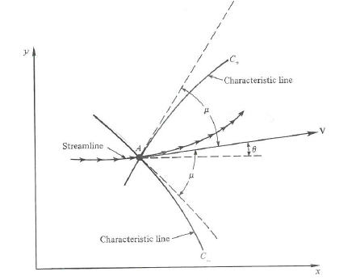
Figure 4. Characteristic Curves [6]

2.3 The Compatibility Relation
While equation 2-18 identifies the characteristics lines of a supersonic flowfield as Mach lines, it does not offer any indication of the behavior of the flow properties along the characteristic lines. The theory of hyperbolic equations indicates that there exists a compatibility relation between the angle of inclination, θ, and the Prandtl-Meyer function, ν, on the characteristic lines [7]. The derivation of the equation that describes the compatibility, which is referred to as the compatibility equation, lies within the physical limitation discussed in the preceding section that the solution of the velocity potential, Φ_{xy}, is both indeterminate and finite. That is, the numerator of equation 2-13 is zero. The solution along a characteristic line becomes
 | $$\frac{dv}{du}=\frac{-\left(1-\frac{u^{2}}{a^{2}}\right)}{1-\frac{v^{2}}{a^{2}}}\frac{dy}{dx}$$ | (2-19)
Equation 2-17 can be substituted in to equation 2-19 to give
 | $$\frac{dv}{du}=\frac{-\left(1-\frac{u^{2}}{a^{2}}\right)}{1-\frac{v^{2}}{a^{2}}}\left(\frac{-\frac{2uv}{a^{2}}±\sqrt{\frac{u^{2}+v^{2}}{a^{2}}-1}}{1-\frac{u^{2}}{a^{2}}}\right)$$ | (2-20)
Using the streamline geometry illustrated in Figure 4 and the definition of Mach number, equation 2-20 can be written in terms of the inclination angle, Mach number, and velocity. Through substitution and algebraic manipulation, equation 2-20 becomes
 | $$dθ=∓\sqrt{M^{2}-1}\frac{dV}{V}$$ | (2-21)
Equation 2-21 represents the compatibility relation, describing the flow properties along a characteristic line. It is also the governing differential equation for flow encountering a Prandtl-Meyer expansion fan. When integrated, equation 2-21 becomes
 | $$θ+ν\left(M\right)=constant=K^{-}$$ | (2-22)
 | $$θ-ν\left(M\right)=constant=K^{+}$$ | (2-23)
The compatibility equations of 2-22 and 2-23 are constant meaning that the K⁻ value is constant along the C₋ characteristic and the K⁺ value is constant along the C₊ characteristic. The constants, K⁻ and K⁺, are referred to as the Riemann invariants of the solution. The two types of characteristics, left and right running, and their corresponding Riemann invariants are grouped into families [5].

2.4 Application of the MOC
Employing the method of characteristics to solve a flowfield is a unit process. That is, the solution of the flowfield is obtained through a marching process that consists of moving point to point within the network of characteristics, calculating the flow properties and directions at each point. This process is an artifact of the hyperbolic nature of a supersonic flowfield [6]. There are three types of characteristic regions present in supersonic flow: uniform, simple, and nonsimple. An illustration of a centered Prandtl-Meyer fan which contains the uniform, simple, and nonsimple regions is presented in Figure 5.

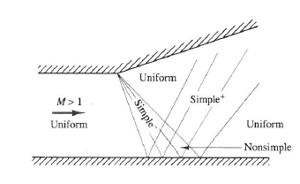
Figure 5. Characteristic Regions [5]

The illustration contained in Figure 5 represents the characteristic regions that are present when supersonic flow encounters an expansion corner. The uniform region is characterized by parallel flow. The simple region can be comprised of either right-running or left running characteristics; thus, the simple region is a region consisting of one family of characteristics which are straight but not parallel [5]. The nonsimple region is the region in which the characteristic families intersect. The characteristics of the nonsimple region are curved. For the application of nozzle contour design, the method of characteristics is solved for internal flow and flow at a wall, examples of which are presented in Figure 6.

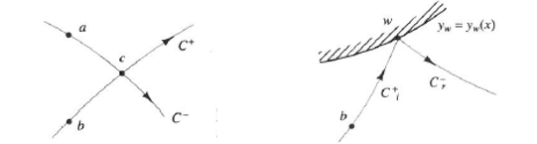
Figure 6. Characteristics of Internal Flow (left) and Flow at a Wall (right) [5]

For the case of internal flow, as illustrated in Figure 6 (left), the properties and location of the point c can be determined using the known properties and locations of points a and b. It has been proven that the Riemann invariants are constant along the characteristic of the same family, so the following relationships hold
 | $$K_{a}^{-}=K_{c}^{-}=θ_{c}+ν_{c}(M)$$ | (2-24)
 | $$K_{b}^{+}=K_{c}^{+}=θ_{c}-ν_{c}(M)$$ | (2-25)
Solving this system of equations for the angle of inclination and Prandtl-Meyer angle gives
 | $$θ_{c}=\frac{1}{2}\left(K_{c}^{-}+K_{c}^{+}\right)$$ | (2-26)
 | $$ν_{c}\left(M\right)=\frac{1}{2}\left(K_{c}^{-}-K_{c}^{+}\right)$$ | (2-27)
Using the isentropic relations, the calculated Prandtl-Meyer function at point c, and the known properties at points a and b, the flow properties at the intersection of the C⁺ and C⁻ characteristics can be calculated. In order to determine the location of point c, it is common practice to approximate the characteristic segments as straight lines even though the characteristics of the nonsimple region are curved. Similarly, the angles between the characteristic segments and the horizontal axis are approximated as the averages of the characteristic angles at each point [5]. These approximations result in the calculation of the slopes of the characteristic segments. For the case represented in Figure 6 (left), the characteristic segment slopes are
 | $$m_{ac}=\tan\left(\frac{1}{2}\left({\left(θ-μ\right)}_{a}+{\left(θ-μ\right)}_{c}\right)\right)$$ | (2-28)
 | $$m_{bc}=\tan\left(\frac{1}{2}\left({\left(θ+μ\right)}_{b}+{\left(θ+μ\right)}_{c}\right)\right)$$ | (2-29)
Using the slope-intercept form of the equation for a line passing through two points, a system of equations can be constructed to solve for the coordinates of point c. The procedure for the calculation of a characteristic encountering a wall, as depicted in Figure 6 (right), is slightly different although the basic characteristic principles remain. The properties and location of the point at which the C⁺ characteristic coincides with the wall, denoted as point ‘w’, can be determined using the known wall shape and known properties of the incident characteristic. Because the shape of the wall is known, the flow direction at the wall is also known considering that the flow must be tangent to the wall. The Prandtl-Meyer function for the intersection of the characteristic with the wall is calculated as
 | $$ν_{w}\left(M\right)=θ_{w}-K_{i}^{+}=θ_{w}-θ_{b}-ν_{b}(M)$$ | (2-30)
The example of the method of characteristics at a wall included in this discussion is of an upper wall. The process for a lower wall is the same with the exception that the incident characteristic would be a C⁻ characteristic.

2.5 Initial Value Line
As described in the previous section, the method of characteristic is a process in which the properties of a point in the flow can be calculated using the known properties of the adjacent points, forming a network of characteristics. In order to solve for an unknown flowfield, the method of characteristics must start at an initial value line. The very nature of a supersonic nozzle is to expand stagnant flow through a sonic condition at the throat to supersonic flow. The method of characteristics is an appropriate method of solution for supersonic flow but not necessarily subsonic or sonic flow. Because the method of characteristics is a hyperbolic equation solution, the process must begin in a region of supersonic flow. Physically, supersonic flow conditions are reached just downstream of the sonic line. The sonic line is the line, with a Mach number of one, which separates subsonic and supersonic flow. Figure 7 presents an illustration of the sonic line and characteristics present in the throat.

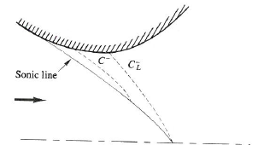
Figure 7. Throat Characteristics and Sonic Line [5]

There is a right-running characteristic, C⁻, immediately downstream of the sonic line. Because this characteristic intersects the sonic line, it cannot be used for the initial value line. This characteristic, which carries information about the wall shape, influences the sonic line and, in turn, affects the subsonic region of the flow [5]. Instead, the MOC calculations must begin at or downstream of the limiting characteristic, which is denoted as $C_{L}^{-}$. The limiting characteristic is the most downstream characteristic to intercept the sonic line [5].

2.6 Types of Nozzles
Supersonic nozzles may be categorized in two ways. They can be categorized based on their means of expansion and their overall shape. The categories of nozzle shape and degree of expansion are noncompeting in that a nozzle of any shape can be expanded though a number of degrees of expansion. Within the subject of nozzle design, the choice of nozzle design, whether it be minimum length or gradual expansion and planar or axisymmetric, is critical given the intended use of the nozzle.

2.6.1 Minimum Length versus Gradual Expansion
The contour of a supersonic nozzle can be achieved through an abrupt expansion of the flow or a gradual flow expansion. Nozzle contours designed through an abrupt expansion are shorter than their counterpart; thus, they are called minimum length nozzles. A gradual expansion nozzle expands the flow through an expansion section instead of a sharp convex corner at the throat as in the case of the minimum length nozzle. A comparison of the geometry and characteristics of a minimum length nozzle and gradual expansion nozzle is provided in Figure 8. The expansion of flow in a minimum length nozzle is accomplished through two centered Prandtl-Meyer expansion fan, one originating from the upper contour and one originating from the lower contour. There are no Mach wave reflections in a minimum length nozzle, so a fluid element in such a nozzle only encounters the Prandtl-Meyer fans [5]. A gradual expansion nozzle, however, consists of a series of Mach waves and their reflections. A fluid element moving through a gradual expansion nozzle accelerates continually with each expansion wave [5]. A gradual expansion nozzle is generally comprised of an expansion section and a straightening section while a minimum length nozzle contains only a straightening section. The straightening section is a region of decreasing wall angle with the purpose of creating flow that is parallel to the nozzle centerline. The straightening section creates flow that is parallel to the centerline by preventing the further reflection of Mach waves.

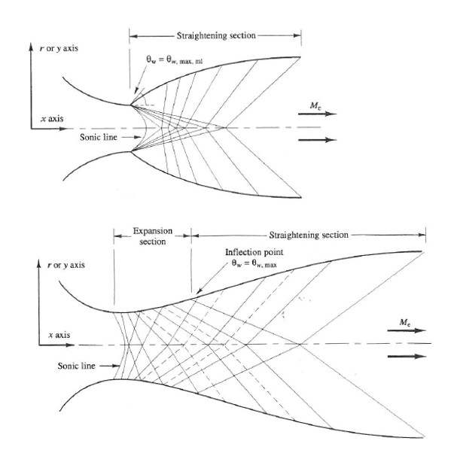
Figure 8. Minimum Length Nozzle (top) versus A Gradual Expansion Nozzle (bottom)

The point at which the straightening section begins is the inflection point. Physically, the inflection point represents the nozzle’s maximum wall angle. The inflection point in a gradual expansion nozzle is located at the transition between the expansion section and the straightening section. In a minimum length nozzle, the inflection point is located at the sharp corner in the throat. Using a straight sonic line approximation, the maximum wall angle of a minimum length nozzle has been proven to be half of the Prandtl-Meyer function corresponding to the exit Mach number, which can be written as
 | $$θ_{max}=\frac{1}{2}ν(M_{e})$$ | (2-31)
Minimum length nozzles are not capable of producing the level of flow uniformity that gradual expansion nozzles produce. Because of this, minimum length nozzles are not appropriate for applications which require highly parallel and uniform flow. Nozzles used for supersonic wind tunnel testing are typically very long in order to produce high quality flow. Minimum length nozzles are more appropriate for application in which the nozzle length and weight are severe constraints, and flow quality is secondary or unimportant as in the case of rocket nozzles

2.6.2 Axisymmetric versus Planar
The second and most prominent method of nozzle classification is axisymmetric or planar. This characterization refers to nozzle cross section. An axisymmetric nozzle is symmetric about its axis: that is, it is three-dimensional. A planar nozzle is two-dimensional with expansion in one plane [VARNER]. Planar nozzles typically consist of two contoured walls, the upper and lower wall, and two parallel walls. Early nozzle designs were of the planar configuration due to the ease of machinability in comparison to the axisymmetric nozzle. Once the focus of aerodynamic research began to reach the hypersonic flow regime, some of the consequences of the planar design led to the development of the more complicated axisymmetric nozzle. The high stagnation pressure and temperature requirements of producing hypersonic flow led to dimensional stability problems in the throat of the planar nozzle. Nozzles intended for supersonic flow, or Mach numbers less than five, may be of the planar design without significant dimensional stability problems [8]. The dimensional stability problems present in high Mach number planar nozzles are due to high thermal and pressure stresses in the throat region. The throat region of a planar nozzle is critically sensitive to its geometry and configuration [9]. The high pressure and temperature conditions required for high Mach number flow lead to the possibility of throat distortion thereby degrading the nozzle’s stability. In addition to the dimensional stability problems of the throat associated with high Mach number planar nozzles, a large degree of nonuniform boundary layer distribution is possible. In the case of the planar nozzle, transverse pressure gradients lead to the development of strong secondary boundary layer flows [9]. This phenomenon effectively reduces the boundary layer thickness on the contoured walls and increases the thickness towards the center of the parallel walls [9]. The thickening of the boundary layer at the centerline of the flat plates at Mach numbers 2 and 5 is illustrated in Figure 9, which was observed in a 1950 experiment. This effect increases with Mach number which indicates that the planar design is a poor choice for a high Mach number nozzle.

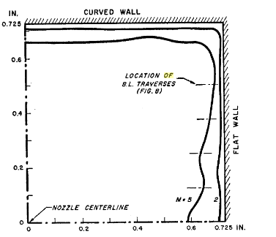
Figure 9. Parallel Wall Boundary Layer Thickness [9]

2.7 Boundary Layer Correction
Although supersonic nozzle flow is largely considered inviscid, there is an area of viscous flow directly adjacent to the walls of the nozzle which produces a deficiency of mass flow. This area of viscous flow is contained in the boundary layer and is generally a small fraction of the distance from the wall to the nozzle centerline [10]. An illustration of the velocity profile of a nozzle wall boundary layer is given in Figure 10. At the nozzle wall, the velocity is zero, defining the no slip condition. It is common practice to approximate the edge as the distance at which the velocity is 99% of the local freestream velocity.

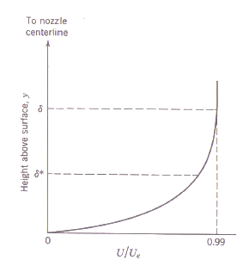
Figure 10. Boundary Layer Velocity Profile [10]

Because the assumption of inviscid flow was used for the development of the method of characteristics, a viscous correction must be applied in order to capture and account for the physical presence of the viscous boundary layer. A viscous, or boundary layer, correction refers to shifting the inviscid nozzle contour by the boundary layer thickness, which increases along the length of the nozzle. The effects of the boundary layer on a supersonic nozzle are most noticeable at the nozzle exit [11]. If the boundary layer is not treated properly, the Mach number at the exit of the nozzle will be less than intended. Without a viscous correction, the flow through the supersonic nozzle will not expand sufficiently due to the lack of proper exit sizing. An illustration of a viscous correction, accounting for boundary layer growth along the nozzle wall, is presented in Figure 11. The displacement thickness indicated in Figure 11 is the extra space required to account for the boundary layer losses. The displacement thickness can be calculated through the following integration:
 | $$δ^{*}=\int_{0}^{δ}{\left(1-\frac{ρU}{ρ_{e}U_{e}}\right)dy}$$ | (2-32)

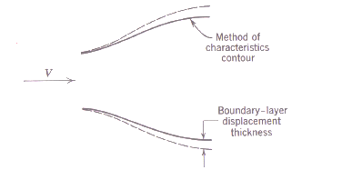
Figure 11. Viscous Correction [10]

2.8 The Works of Puckett and Foelsch
Prandtl and Busemann were the first to use the method of characteristics to design the contours of nozzles in 1929, the subject was cultivated by the works of A.E. Puckett, Kuno Foelsch, and I. Irving Pinkel. Each of these pioneers employed the method of characteristics to the development of a supersonic nozzle with the intent of achieving high quality flow at the exit, that is, flow which is parallel, uniform, and shock-free [12].

2.8.1 Puckett’s Method
The basic process utilized by Prandlt and Busemann began with the assumption of an initial curve and ended with curve terminating at the exit of the nozzle [11]. Puckett introduced a modified version of Busemann’s process in which he began the calculations at the point of maximum expansion or the inflection point. Puckett considered the nozzle shape up to the maximum expansion to be arbitrary and governed by the continuity requirements of a subsonic contraction [11]. A unique feature of Puckett’s method is the use of a so called speed index, N. Although Puckett does not explain the necessity of the speed index, he states that it is “connected with the more rigorous mathematical development of the method” [13]. Puckett defines the speed index as twice the Prandtl-Meyer function, which is a function of Mach number. An example of a supersonic nozzle contour design using Puckett’s method is presented in Figure 12.
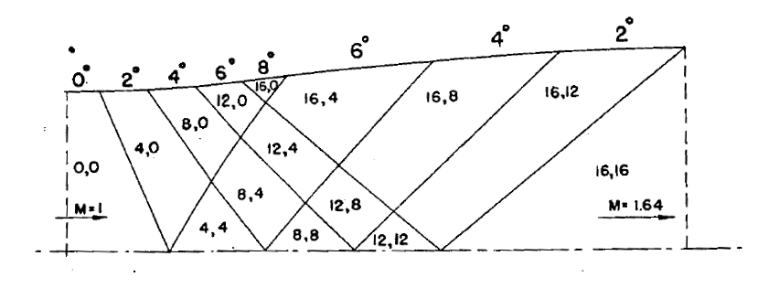
Figure 12. Puckett’s Nozzle Design [13]

In order to design the nozzle illustrated in Figure 12, Puckett first suggests determining the speed index which is most closely related to the desired exit Mach number. For the exit Mach number of 1.630, the corresponding speed index is 32. Using the mathematical description of the maximum wall angle represented in equation 3-31 and his definition of the speed index, Puckett determines the maximum wall angle to be
 | $$θ_{max}=\frac{N}{4}$$ | (2-33)
Puckett then suggests choosing a curve connecting the nozzle throat to the inflection point and dividing it into straight segments [13]. For the nozzle represented in Figure 12, Puckett designed the portion of the nozzle upstream of the inflection point such that the maximum wall angle is accomplished in four expansion waves with the nozzle contour angle increasing 2° with each expansion wave. The design of the portion of the nozzle downstream of the contour is such that the expansion waves are cancelled.

2.8.2 The method of Foelsch
Foelsch introduced a method for the design of a supersonic nozzle similar to that of Puckett with the exception that Foelsch’s is analytic [11]. In his method, Foelsch considers the flow in the divergent section of the nozzle to be of a two-dimensional source flow with an origin upstream of the throat [14]. Foelsch’s method of nozzle design is the result of two analytical closed form equations which convert radial flow to uniform flow. The equations derived by Foelsch calculate the coordinates of the streamlines in the transitional flow region or the region in which the radial flow transitions into parallel flow. An illustration of the formulation of Foelsch’s method is provided in Figure 13.
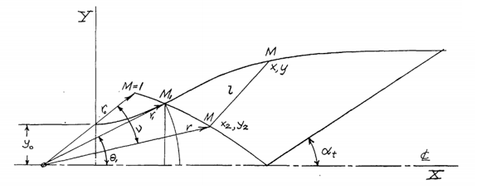
Figure 13. Foelsch’s Radial Flow Nozzle [11]

His source flow assumption leads to the condition that the velocity vectors originating from the source coincide with the Mach line that intersects the inflection point. The velocity vectors emanating from the source form an arc that intersects the inflection point perpendicularly. Foelsch’s method asserts that the Mach number in the region contained by the source vector arc and inflection point Mach line is a function of only the radius from the radial flow source. Foelsch calculates the nozzle contour coordinates as functions of test section conditions and inflection point conditions by varying the Mach number along a curve from the inflection point to the exit. While his method is less graphically strenuous, it produces a discontinuous axis velocity gradient which propagates to the contour [15]. Any discontinuities on the nozzle’s contour have the ability to degrade the flow quality or even led to the formation of shocks within the nozzle itself.

Mach 3 nozzle contour design

3.1 Design Parameters
The Mach 3 nozzle contour detailed herein was designed for an existing facility which was previously designed for the simulation of Mach 2.3 flow. The design of a nozzle block for an existing facility must be completed under hard geometric constraints; that is, the space available for the new nozzle dictates its design. Care must be taken so that the nozzle will fit the existing space without forfeiting flow quality. The Mach 2.3 wind tunnel was designed to have a 6 x 6 inch test section with an inlet to exit length of 40 inches. The inlet half-height of the nozzle is 8.33 inches.

3.2 CONTUR by Sivells
CONTUR is a FORTRAN code developed by J.C. Sivells which utilizes a combination of the method of characteristics, analytical solutions, and centerline distributions [14]. CONTUR can be used for the design of axisymmetric or planar nozzles capable of producing supersonic flow. The program, which is provided in the appendix of reference 16, operates under the ideal gas assumption. CONTUR uses seven user-defined input cards describing the flow conditions of the desired nozzle and runs through a series of 16 subroutines in order to calculate the appropriate nozzle contour.
The program begins the nozzle design process with the transonic solution, which is the solution of the flowfield at the nozzle throat. In his program, Sivells employs an analytical series solution in order to construct the throat [3]. CONTUR borrows the small perturbation transonic solution developed by Hall in reference 17. Hall’s transonic solution includes expansions of the inverse powers of the ratio of the radius of curvature of the throat to the throat half-height to give normalized velocity components. Hall shows that his method of calculation of the flow in the throat of a converging-diverging nozzle gives a valid approximate solution by comparing the variation of the flow direction along the branch line with the exact characteristic equation. In addition to Hall’s method, Sivells included a substitution introduced by Kliegel and Levine [18] to account for lower values of the radius of curvature ratio. One of the noted advancements of CONTUR relative to earlier design methods is the elimination of the gap between the throat location and the branch line in the transonic region. The branch line is a left-running characteristic which coincides with the sonic line at the nozzle centerline. Prior to CONTUR, nozzle contour design methods were unable to resolve the area between the location of the throat and the intersection of the branch line with the contour. This proved to be somewhat problematic in the design of nozzles with large throat curvatures because the area between the throat and branch line/contour intersection scales with throat curvature. Sivells resolved the area between the throat and branch line by introducing a right-running characteristic originating at the throat and intersecting the centerline. He refers to this characteristic as the throat characteristic. An illustration of the characteristic throat properties utilized in CONTUR is presented in Figure 14.

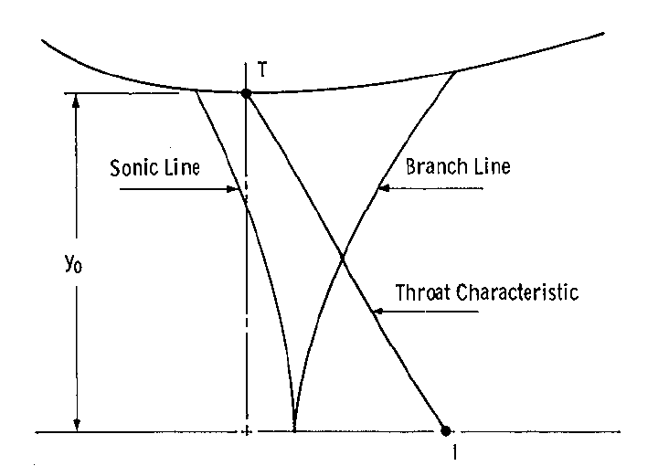
Figure 14. Properties of the Throat Region Utilized in CONTUR [16]

The throat characteristic effectively fills the gap between the throat and branch line that is present in the preceding design methods. Downstream of the throat region, CONTUR allows the user the option to include a radial flow region like that of Foelsch. If the user chooses to include a radial flow region, the program uses the method of characteristics to calculate the flowfield and, thus, nozzle contour on either side of the region of radial flow. If a radial region is not desired, the user may choose the centerline distribution of velocity or Mach number. A depiction of the design methods used by CONTUR is presented in Figure 15.

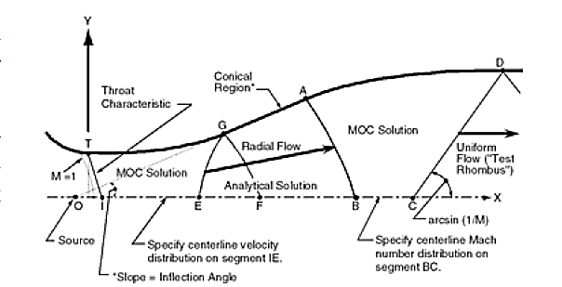
Figure 15. Design Method of CONTUR [3]

The intention of Sivells’s inclusion of a radial flow region was to reduce the required computational work, because such resources were limited at the time [3]. The radial flow region does not require the method of characteristics; it instead relies on an analytical solution in which the flow is described by
 | $${\left(\frac{r}{r^{*}}\right)}^{σ+1}=\frac{1}{M}{\left(\frac{2}{γ+1}\left(1+\frac{γ-1}{2}M^{2}\right)\right)}^{\frac{γ+1}{2(γ-1)}}$$ | (3-1)
where r is the point along the nozzle centerline measured from the point source, normalized by r* which is the distance from the point source to the sonic line. For the inviscid case, the radial flow region physically equates to flow in a conical section of a half-angle equal to the inflection angle [3]. In an axisymmetric nozzle design (σ = 1) the flow areas utilized in equation 5-1 are spherical caps; for a planar design (σ = 0), the flow areas are circular arcs. [3] With the computational resources that are available today, the inclusion of the radial flow region is not necessary; although, the inclusion of a radial flow region allows the user to have more control over the overall design by varying the centerline distributions on either side of the radial flow region. Without the radial flow region, CONTUR uses the method of characteristics to connect the throat characteristic to the test rhombus. The centerline velocity or Mach number distributions are used to ensure continuous curvature over the length of the nozzle by matching their polynomial derivatives to the test section characteristic and throat characteristic [16]. Sivells completes his program with the addition of a boundary layer correction which adds the boundary layer thickness to the inviscid contour through the integration of the von Karman momentum equation.
As a reference, Sivells included the input cards and output file of a sample nozzle design using CONTUR in his report. For the sample nozzle, Sivells proposes a Mach 4 axisymmetric nozzle. He indicates that he chose the main parameters to be the inflection angle, the ratio of curvature, and the Mach number at point B. The ratio of curvature refers to the ratio of the throat radius of curvature to the throat radius. Point B, which is illustrated in Figure 15, is the point on the nozzle’s centerline, corresponding to the inflection point, at which the MOC solution is initiated downstream of the radial flow region. The input cards of Sivells’s sample nozzle design are provided in Figure 16. Detailed descriptions of the card inputs can be found in Appendix C of reference 15.

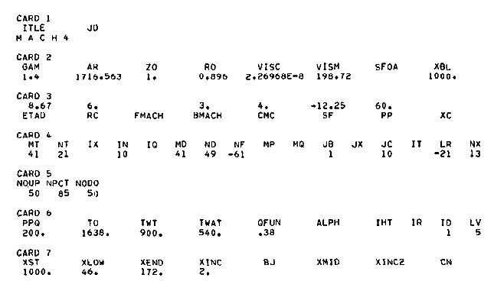
Figure 16. Sample Nozzle Input Cards [16]

The Mach 4 sample nozzle was designed to have an inflection angle of 8.67° and a curvature ratio of 6. The Mach number at point B was computed by the program to be 3.0821543. The resulting nozzle is approximately 133 inches from throat to nozzle exit. The portion of the nozzle contour that is downstream of the radial flow region was designed such that the centerline Mach number distribution is a fourth-degree polynomial. The upstream portion of the nozzle was designed with a cubic velocity distribution. The centerline distribution serves as boundary condition for the method of characteristics with one in between the throat and radial flow region and the other from the end of the radial flow region to the nozzle exit. In order to ensure a high degree of continuity, derivatives of various order of the centerline distribution polynomials are matched to the test rhombus and the throat region [19]. Increasing the degree of the centerline distribution polynomial matches higher order derivatives [19]. The output nozzle contour values were plotted to give the nozzle illustrated in Figure 17.

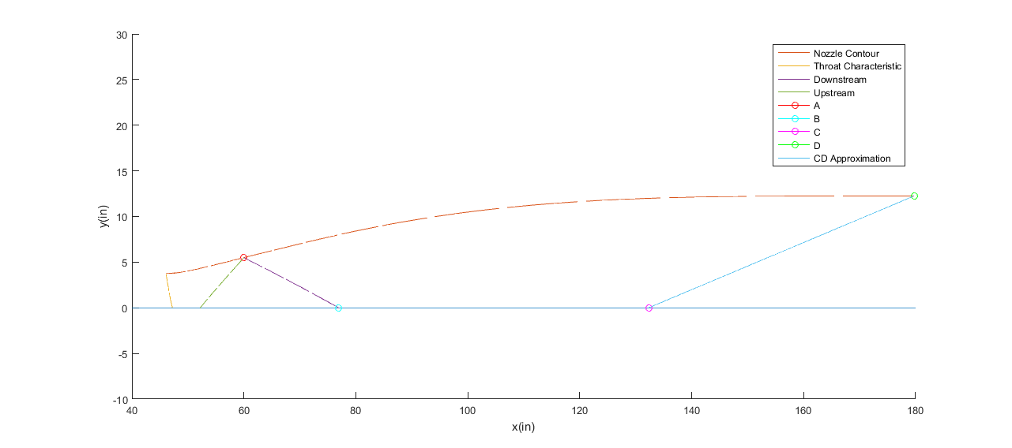
Figure 17. Mach 4 Sample Design

The line contained by points A and B represents the end of the radial flow region of the nozzle. Downstream of the characteristic line AB, the program used the method of characteristics to calculate the contour. The contour contained in area between the lines labeled as the ‘Throat Characteristic’ and ‘Upstream’ was also calculated using the method of characteristics. The characteristic line CD represents the beginning of the test rhombus which is the area of the design Mach number and flow uniformity.

3.3 Mach 3 Nozzle Contour Design
The Mach 3 nozzle contour was design using a modified version of Sivells’s CONTUR detailed in the previous section. The modification was completed by Dr. Steven Schneider [20]. While the code has undergone numerous minor modifications, the most significant was the restructuring of the code to a more user friendly form. As a result, the input file of the modified version of CONTUR is automatically generated with the answers to a few simple questions. Some of the input parameters were modified so that they were built in to the program while others were presented as user-defined prompts. Figure 18 illustrates the structure of the input file that is built with the modified version of CONTUR.

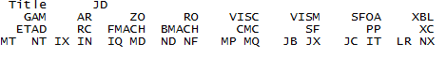
Figure 18. Modified Input Deck

A Mach 3 nozzle with moderate stagnation conditions does not necessitate the complexity of an axisymmetric nozzle contour, so the nozzle geometry chosen for the contour is of a planar design. Within the Sivells’s code, there exists one input that allows for the direct control of the nozzle geometry. Sivells describes the primary function for the input SF as a scale factor by which the nondimensional coordinates of the nozzle may be multiplied to give the nozzle dimensions in inches; however, if the user chooses a negative value for SF, the exit half-height of the nozzle will be the absolute value of SF. In the modified version of the code, SF was not presented as a user input, rather it was built into the input file such that the nozzle would have a throat radius of one. In order to set one of the geometric constraints for the design of the Mach 3 nozzle contour, the SF input was set to a value of -3, corresponding to an exit half-height of 3 inches. The ratio of the throat radius of curvature to the throat radius was chosen to be 6 as in the sample nozzle design. It is suggested that flow quality increases with the radius of curvature and that the minimum for machining purposes is 1. One of the recommendations made by Sivells is in regards to the centerline distributions. Sivells recommends that the upstream centerline be of a cubic velocity distribution and the downstream centerline be of a quartic Mach number distribution. The centerline distributions can only vary if the radial flow region is included. His recommendation was included in the design process of the Mach 3 nozzle contour such that the contour is a cubic-radial-quartic design. The single centerline design with no radial flow region produces the shortest variation of the nozzle design, but the nozzles designed with the radial flow region contained by two centerline distributions produces the higher quality flow [19]. If the user chooses to include a radial flow region, CONTUR gives the option of setting the centerline distributions to polynomials of degree 3-5. The higher the degree of the polynomial that defines the centerline distribution results in the matching of more boundary conditions thereby increasing the ability of designing a shock-free nozzle; however, as stated in reference 19, the quantic polynomial does not guarantee a nozzle in which the Mach number increases monotonically downstream. One of the critical design components of nozzle contours is the inflection angle, which Sivells allows the user to control directly. Nozzles that produce high quality flow are typically long with small inflection angles, but there is not a universally accepted standard for inflection angle. For the design of the Mach 3 nozzle, an inflection angle of 12° was used as the maximum. In reference 4, Shope indicates, based solely on experience, that inflection angles less than about 12° yield uniform flow. Another user-defined parameter utilized for the design of the nozzle contour is the Mach number at point B, which is the point at which the downstream method of characteristics solution is initiated. It was recommended in reference 4 to keep the Mach number at point B less than or equal to 80% of the design Mach number. During the design process, it was discovered that the viscous corrections included in Sivells’s original program had been removed and the resulting nozzle contour was of a completely inviscid design. The most technically rigorous manner in which to account for the boundary layer and subsequent losses is to add the boundary layer thickness to the contour coordinates; however, because of the strict geometric constraints, the boundary layer of the Mach 3 nozzle was accounted for by increasing the design Mach number to 3.15.
The nozzle contour was designed through the manual iteration of the code. The values representing the radius of curvature and the inflection angle were altered until a solution matching the desired nozzle geometry was obtained. To account for the boundary layer, designs of Mach numbers 3.08, 3.10, and 3.15 were simulated using the computational fluid dynamics software Fluent. The finalized nozzle design was built using the input deck illustrated in Figure 19.

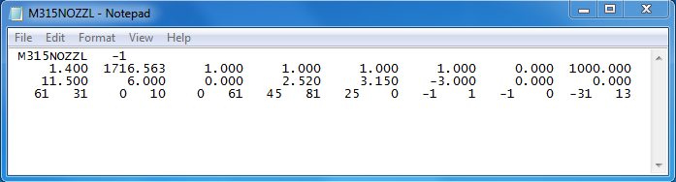
Figure 19. CONTUR Input

The input file indicates that the design Mach number of the nozzle is 3.15 with a Mach number at point B of 2.52, which aligns with the 80% recommendation. The radius of curvature ratio is 6 with an inflection angle of 11.5°. Per the geometric constraints, the designed nozzle has an exit half –height. The throat to exit length was designed to be 28.908 inches. One of the inputs that was iterated upon is the input ND. The value input for ND (45) represents the number of points on the axis BC with a maximum possible value of 150. Smaller values of ND resulted in Mach contours with too few coordinates. Likewise, the input MP (25) was iterated upon. MP is the input which assigns the number of points on the conical section GA. The Mach 3 contour is represented in Figure 20.

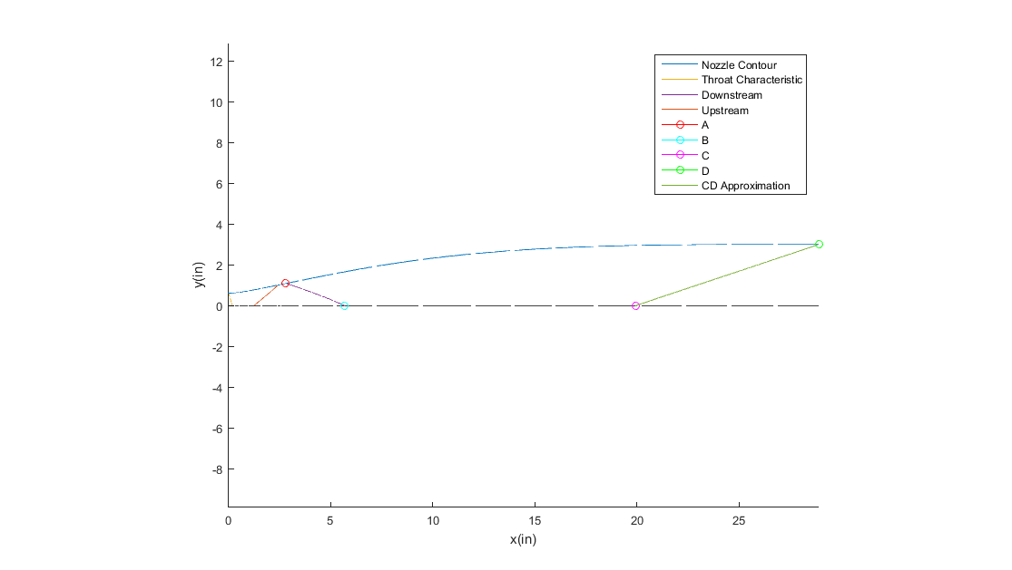
Figure 20. Mach 3 Nozzle Contour from CONTUR

The contour output from Sivells’s code begins at the approximate throat location. In order to resolve the contour shape upstream of the throat, Dr. Schneider and Mr. Alcenius included a Hopkin-Hills calculation to the Sivells code modifications [21]. Hopkins and Hill solved the transonic region of the nozzle contour through an inverse approach; that is, the boundary geometry is found through the solution of a known velocity distribution along a reference line [22]. With a known velocity distribution, the Hopkins-Hill method matches the streamlines to the real nozzle boundary. The integration of the transonic solution into Sivells’s code occurs through the matching of the streamline computed through CONTUR with the Hopkins-Hill streamline. The original integration of the Hopkins-Hill method worked under the assumption that the throat radius is unity. In order to match the throat streamline of the Mach 3 nozzle designed herein, the code required manual manipulation.
The nozzle contour that is calculated through the program does not contain the necessary number of points for modeling. In this case, the resulting nozzle contour was designed through a series of 210 points from the throat to the exit. The Hopkins-Hill transonic solutions appended only 30 points upstream of the throat resulting in a total of 240 points. In order to obtain a finer contour without altering the nozzle geometry, the number of x coordinates were increased from 240 to 4096 linearly spaced values. The corresponding values of y were then interpolated at each x coordinate through a cubic spline. To smooth the resulting x and y coordinates, a 5 point moving average filter was applied. With the smoothing of the nozzle contour, the x and y coordinates can be imported into any design software. A two-dimensional representation of the nozzle contour modeled in SolidWorks is presented in Figure 21. The resulting nozzle contour derivatives were checked independently from the Sivells code. The first and second derivatives are presented in Figure 22. One of the recommendations on the evaluation a nozzle designed using CONTUR is that the slope of the nozzle contour should increase monotonically from the throat to the inflection point and decrease monotonically from the inflection point to the nozzle exit [3]. The monotonic nature of the designed contour is demonstrated in Figure 22.

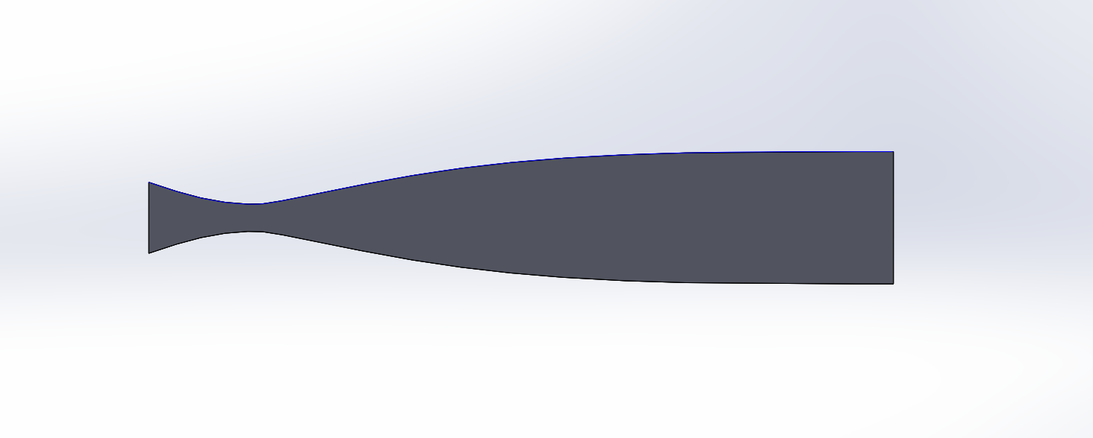
Figure 21. Mach 3 Nozzle Contour

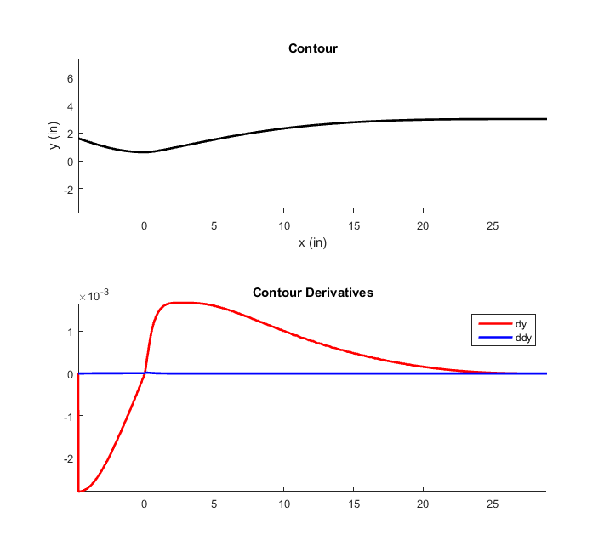
Figure 22. Contour (top) and Contour Derivatives (bottom)

Nozzle Contour design validation

4.1 Simulation Software
The nozzle contour designed herein was validated using the academic version of the software ANSYS Fluent 17.1. ANSYS Fluent employs a control-volume-based technique consisting of the division of the domain into discrete control volumes, the integration of the governing equations on the control volumes to provide discretized equations, and the linearization of such equations to provide solutions of the linear equations system [23]. Throughout this process, Fluent solves the governing integral equations of the conservation of mass, momentum, and energy.
Fluent allows its users to choose between two solvers: a pressure-based solver or a density-based solver. The pressure-based solver solves the governing equations separately and sequentially. The density based solver solves the equations simultaneously because they are coupled. For the simulation of Mach 3 flow in a nozzle, it is most appropriate to use the density-based solver so that the effects of compressibility can be modeled sufficiently. The density-based solver must loop through several solution iterations before convergence is reached. The density-based solution solves the coupled equations of continuity, momentum, and energy through a coupled-explicit or coupled-implicit formulation [23]. The implicit or explicit formulation refers to the way in which the coupled equations are linearized. The implicit formulation, which was most appropriate for the problem described herein, computes the unknown value in each cell using relationships between the values, known and unknown, of the neighboring cells. The explicit formulation only utilizes the relations of known values. The program user must also specify a turbulence model. The turbulence models included in the software package are of three variations: Reynolds averaged Navier-Stokes (RANS), filtered Navier-Stokes, and hybrid RANS-large eddy simulation (LES). RANS turbulence models, which are based on the concept of eddy viscosity, separate the exact Navier-Stokes equations into mean and perturbed components. The Reynolds-averaged Navier-Stokes equations are in the same form as the exact Navier-Stokes equations but with additional values representing the Reynolds stresses [23]. The Reynolds stress can be considered the turbulent contribution to shear stress. The filtered Navier-Stokes equations, also known as large eddy simulations (LES), filter the time-dependent components of the equations using either a Fourier space or physical space [23]. The time-dependent filtering results in the modeling of the turbulent largest eddies such that all the turbulent dissipation occurs in the subgrid scale. Like the RANS formulation, the LES formulation introduces additional terms to the Navier-Stokes equations in the form of subgrid-scale stresses. The hybrid RANS-LES formulation is one in which has the ability to switch from RANS to LES turbulence modeling by lowering the eddy viscosity without changing the Navier-Stokes equations [23].

4.2 Simulation Set-up and Meshing
The flow through the Mach 3 nozzle contour was simulated in two-dimensional form using a RANS solution formulation. While a three-dimensional simulation is preferred in order to capture a more complete picture of the nozzle fluid dynamics, the simulations were restricted to the computational capabilities of a typical desktop computer. A two-dimensional rendering of the nozzle, including a complete upstream region, was modeled using SolidWorks by importing the nozzle coordinates. Two inches of the tunnel stilling chamber were added to the nozzle inlet in order to offset some potential simulation problems resulting from the sharp inlet geometry. The inlet was assigned a pressure inlet boundary condition; likewise, the outlet was assigned a pressure outlet boundary condition. The pressure inlet boundary condition can be used when the inlet pressure is known, as in the case of this simulation. In the case of supersonic outflow, the pressure outlet boundary condition extrapolates the gauge pressure at the outlet from the upstream conditions [23]. The wall boundary condition is utilized at the upper and lower nozzle contour as it defines the fluid/solid boundary. At the wall boundaries, the no-slip condition is initiated such that the velocity at the wall is zero which is typical of the viscous flow contained in the boundary layer. The walls of the contour were modeled as adiabatic by setting the heat flux of the wall boundary conditions to zero. The stilling chamber conditions for the simulation were calculated using estimated test section conditions that were considered from the design of the wind tunnel. The test section conditions previously calculated for the wind tunnel operating at Mach 3.15 were a temperature of 173 R and a pressure of 1.079 psi. These test section conditions were used in this Mach 3 simulation. Considering only the nozzle and the isentropic flow relations that govern its conditions, the stilling chamber pressure was calculated to be 39.6 psi, and the stilling chamber temperature was calculated to be 486 R. The shear stress transport k-omega (SST k-ω) turbulence model was chosen for this simulation. This turbulence model is a two-equation eddy viscosity model that utilizes the k-ω model near the wall in the boundary layer but switches to the k-ε model in the freestream. The k-ω model is capable of modeling turbulence down to the viscous sub-layer in the boundary layer and incorporates compressibility effects and shear flow spreading. The k-ω model, however, does have freestream sensitivity; thus the SST k-ω model will utilize the k-ε turbulence model in the farfield to avoid these sensitivity problems. The k-ε model is a semi-empirical model based on model transport equations for both k and ε [23]. The two-dimensional nozzle geometry and corresponding boundary conditions used for the flowfield simulations are presented in Figure 23.

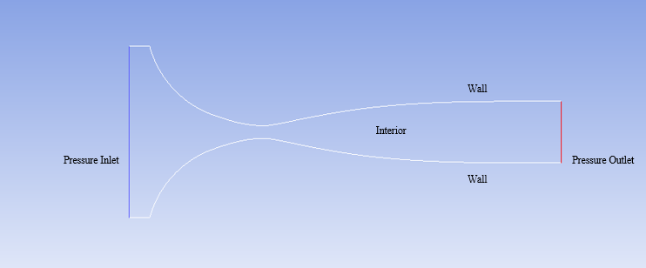
Figure 23. Two-Dimensional Nozzle Geometry

The nozzle geometry was meshed using the built-in meshing capabilities of ANSYS Fluent. The interior of the nozzle contour was meshed using the all triangles method along with inflation layers. The inflation layers were added to the upper and lower contour walls in order to resolve the boundary layer. Early simulations were used to calculate the boundary layer thickness, and the inflation layers of the subsequent simulations were adjusted so that all of the boundary layer is contained in the inflation layers. An example of the meshing initialized for the simulations is depicted in Figure 24.

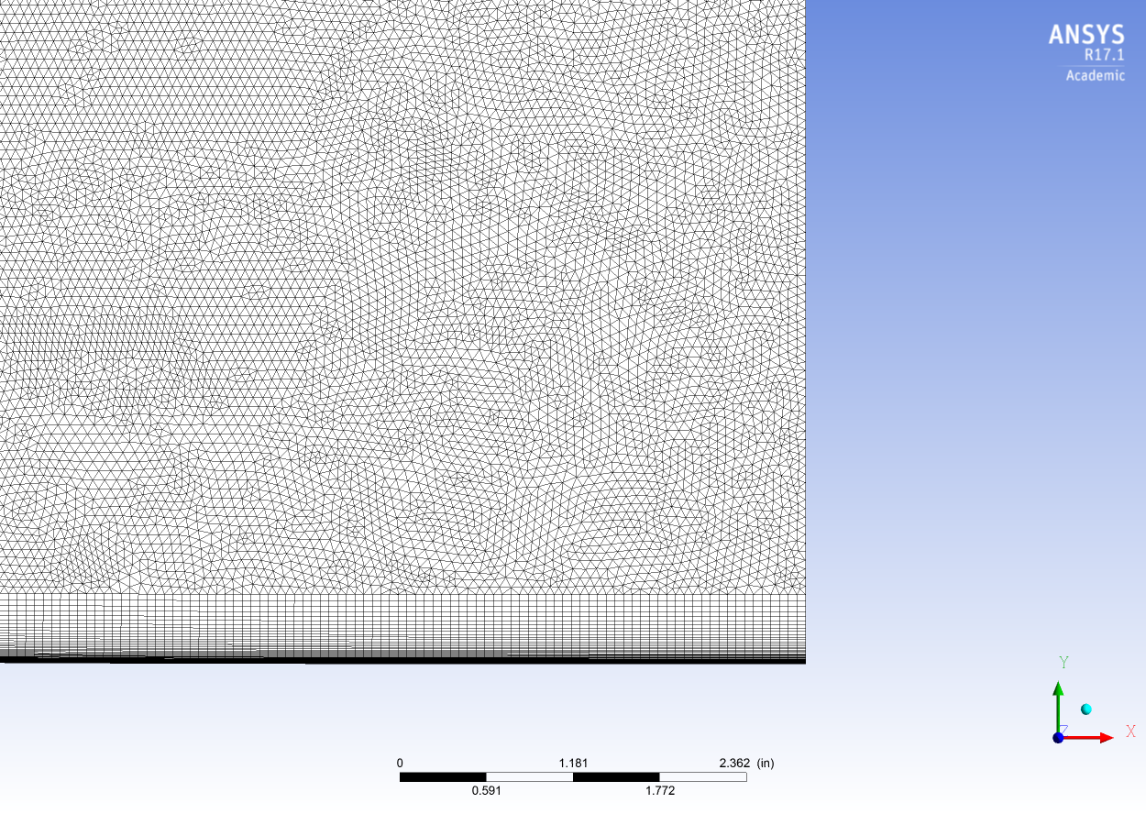
Figure 24. Meshing

4.3 Results

4.3.1 Grid Independence
As in any CFD simulation, a grid independence study was conducted to ensure the validity of the resulting solutions. In order for a solution to be grid independent, it must be shown that the solution does not alter with mesh size. The grid independence study for this simulation was conducted by comparing the results from a fine, medium, and course mesh. The course mesh was on the order of 60,000 cells while the medium mesh consisted of about 230,000 cells. The fine mesh was constructed to contain approximately 910,000 cells. Through a comparison of the solution results between the three cases, it was determined that a valid solution was reached using the course mesh and that the solution varied negligibly when the number of cells was increase by a factor of 15. Comparisons of the exit temperature and exit Mach number produced by the course, medium, and fine meshes are presented in Figures 25 and 26, respectively. Because the three cases proved to produce results that are independent of grid size, the results from the 230,000 cell case will be presented.

4.3.2 CFD Solutions
The two-dimensional CFD results indicate that the exit Mach number for the nozzle contour is 3.11. The Mach number along the centerline increases uniformly and follows the isentropic theory. The Mach number contour and centerline Mach number distribution are presented in Figures 27 and 28, respectively. The nozzle centerline pressure ratios and temperature ratios are presented in Figures 29 and 30. Like the Mach number distribution, the pressure and temperature ratio curves match the expected isentropic curves. The boundary layer thickness of the solution was calculated using the 99% definition [24]:
 | $$\frac{u}{U}=0.99$$ | (4-1)

where U is the freestream velocity and u is the local velocity in the axial direction. The freestream velocity was considered to be at the centerline of the nozzle exit. Using this method, the boundary layer was calculated to be 0.428 inches thick. One of the primary interests of the nozzle flowfield simulation is flow uniformity. For aerodynamic evaluations, a flowfield is considered uniform if the deviations of all of the properties are within 0.25 % (and 2% for aeropropulsion evaluations) [19]. In order to establish a measure of the CFD predicted flow uniformity of the Mach 3 nozzle, the percent deviation of the properties from the centerline to the edge of the boundary layer at the nozzle exit were calculated. The percent deviation was calculated through the following definition:
 | $$\% Deviation= \frac{\left|Experimental-Mean\right|}{Theoretical}*100$$ | (4-2)
The theoretical value was considered to be the property value at the centerline of the nozzle exit. The experimental value was the local property value at each cell across the nozzle exit, and the mean was calculated as the average of the property values at the nozzle exit from the centerline to the edge of the boundary layer. The boundary layer was not included in the calculation because of the potential for the boundary to skew the calculated average. Unless a boundary layer study is being conducted, a vast majority of aerodynamic testing occurs in the freestream. The percent deviation was calculated for temperature, pressure, density, and velocity. The deviation of each property at the nozzle exit fell within the 0.25% uniformity limit. Plots of the percent deviation of temperature, pressure, density, and velocity are presented in Figures 31-34.
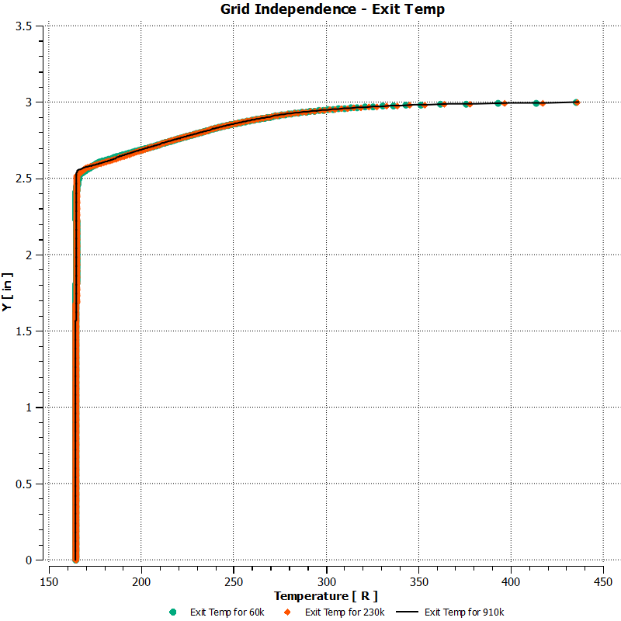
Figure 25. Grid Independence Study of Exit Temperature

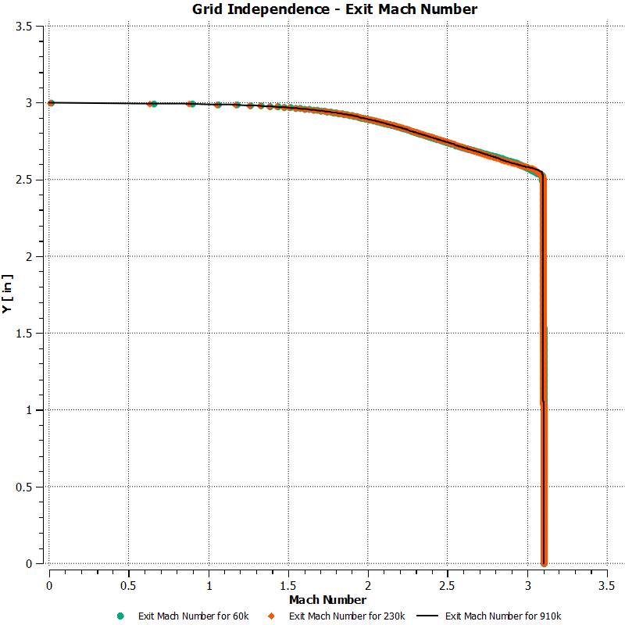
Figure 26. Grid Independence Study of Mach Number

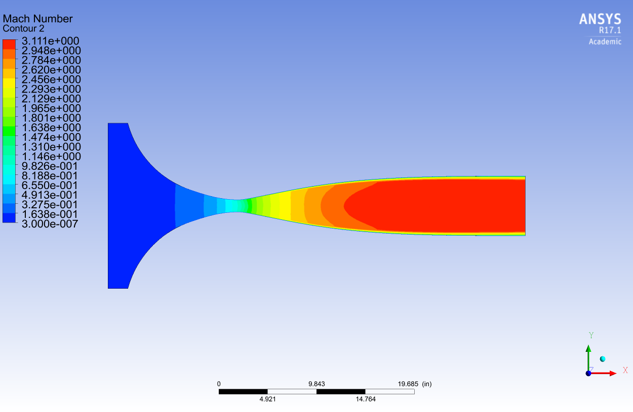
Figure 27. Mach Number Contour

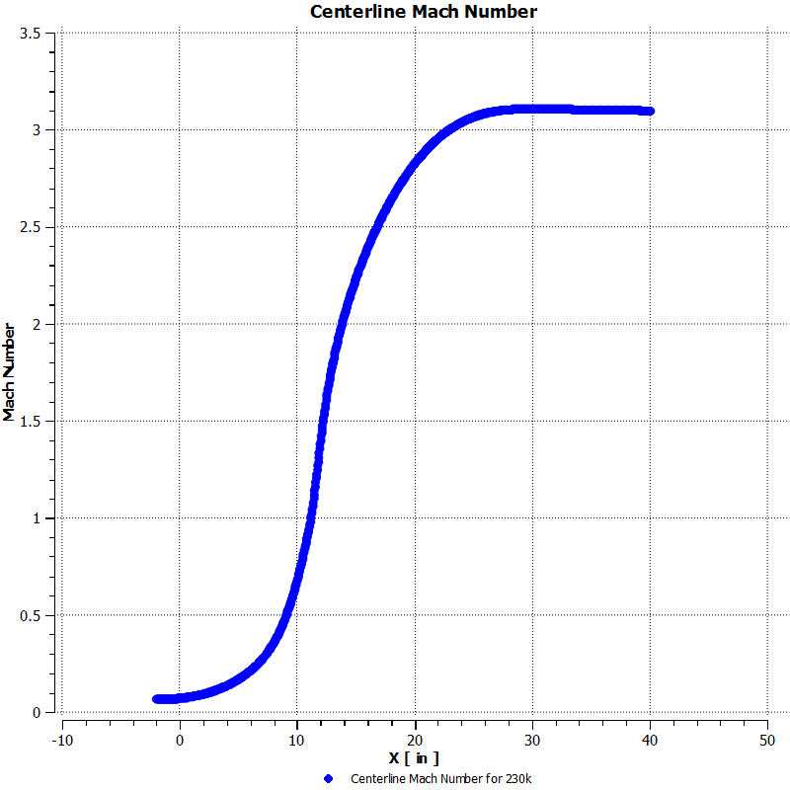
Figure 28. Centerline Mach Number

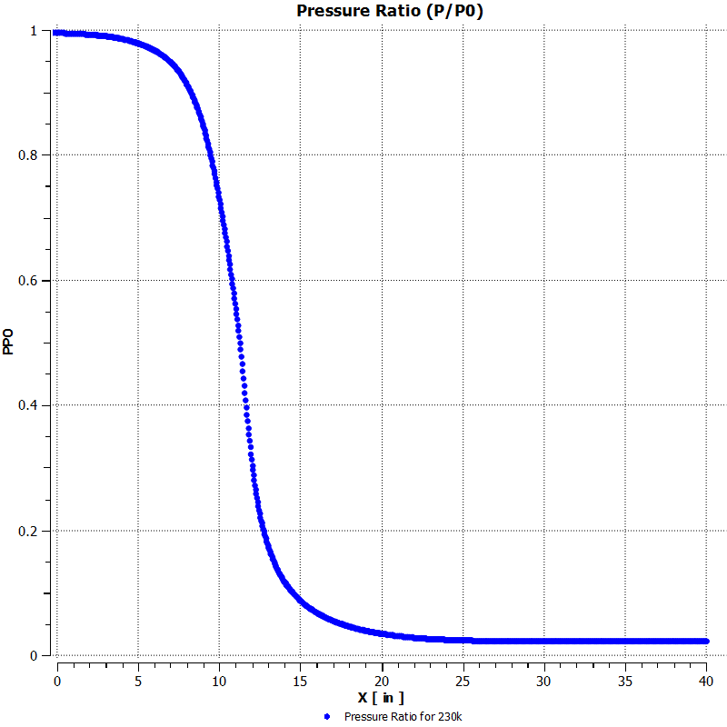
Figure 29. Centerline Pressure Ratio P/P0

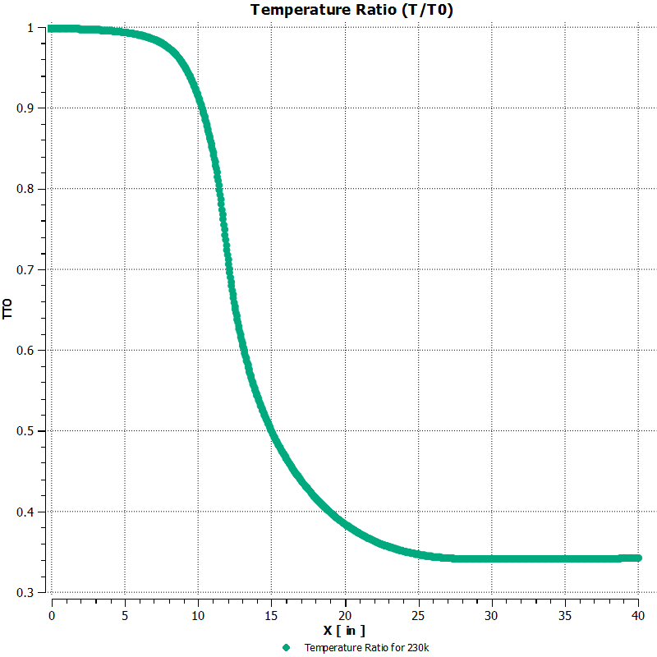
Figure 30. Centerline Temperature Ratio T/T0

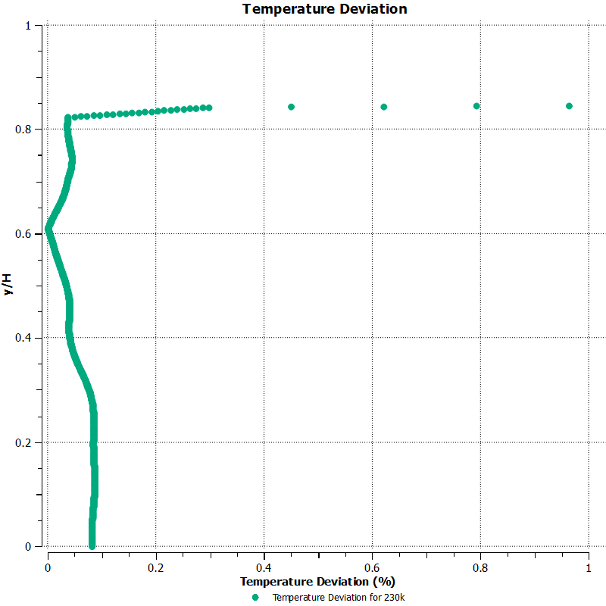
Figure 31. Percent Deviation of Temperature at the Nozzle Exit

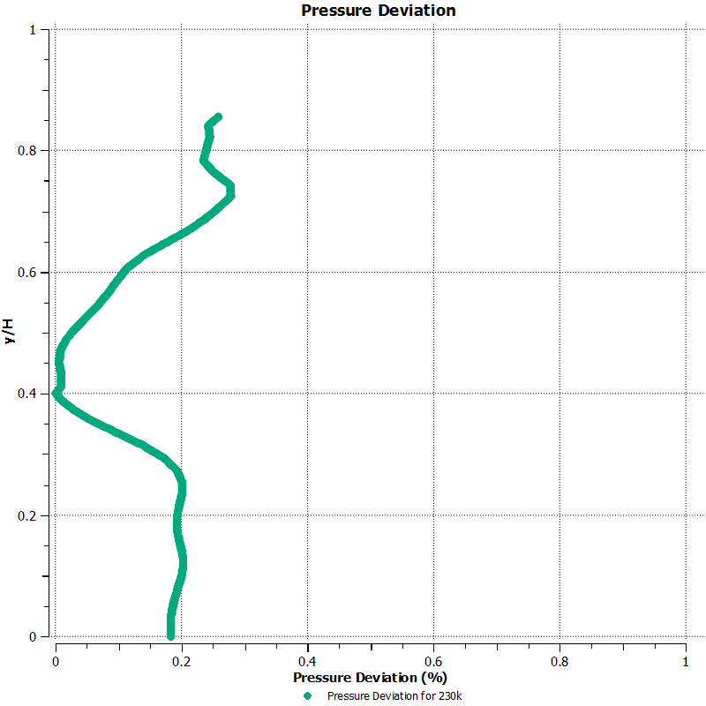
Figure 32. Percent Deviation of Pressure at the Nozzle Exit

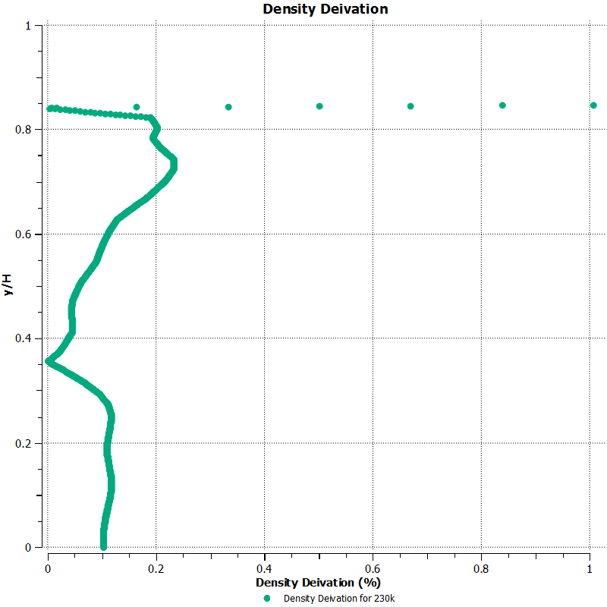
Figure 33. Percent Deviation of Density at the Nozzle Exit

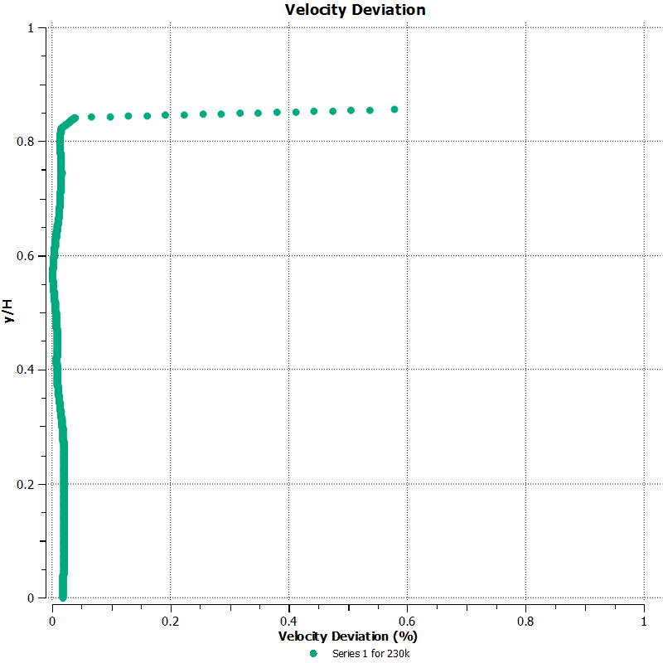
Figure 34. Percent Deviation of the Velocity at the Nozzle Exit.

Conclusion and recommendations
The wind tunnel nozzle contour resulting from the efforts detailed herein meets the standard for aerodynamic and aeropropulsion uniformity. The Mach 3 nozzle was designed with care so that it may replace the nozzle of an existing facility. The design was accomplished using an internationally recognized program which uses a combination of analytical solutions and the method of characteristics. The program contains no input for a viscous geometry, so the author accomplished the design through an iterative process in which certain known flow quality limits were respected. Although accounting for viscous effects through the over-design of the inviscid nozzle is not considered best practice, it produced a nozzle contour capable of reaching the design Mach number.
In this instance, computational capabilities limited the CFD to two-dimensional simulations. It is recommended that three-dimensional simulations are carried out in order to capture the complete flowfield of the nozzle with an emphasis of the corner flow. The flow uniformity at the nozzle exit was quantified from the nozzle centerline to the contour, but without three-dimensional simulations, the flow uniformity from the centerline to the parallel wall could not be established. The CFD simulations detailed herein only concerned the nozzle contour. The boundary conditions that were implemented in the simulations did not take into account the possibility of a normal shock at the nozzle exit or in the test section. It would be advantageous, assuming the availability of greater computational power, to produce some simulations modeling the physical facility in conjunction with the Mach 3 nozzle contour. Such simulations could give insight into possible unstart conditions. The inputs with which this Mach 3 nozzle contour was designed are certainly not the only combination of design variables lending to a uniform flowfield. It is possible that the design could be optimized to produce even higher quality flow under the same geometric constraints. A design optimization study could prove useful for this design as well as future nozzle block contours.

List of References

[1] Anderson, John D., Introduction to Flight, 6th ed., McGraw Hill, New York, 2008.
[2] Anderson, John D., Fundamentals of Aerodynamics, 5th ed., McGraw Hill, New York, 2011.
[3] Shope, Fredrick L., “Contour Design Techniques for Super/Hypersonic Wind Tunnel Nozzles”, AIAA-2006-3665, 24th Applied Aerodynamics Conference, 5-8 June 2006, San Francisco, California.
[4] Krehl, Peter O.K., History of Shock Waves, Explosions and Impact, Springer, Berlin, 2009.
[5] Hodge, B.K., and Koenig, Keith, Compressible Fluid Dynamics with Personal Computer Application, Prentice Hall, New Jersey, 1995.
[6] Anderson, John D., Modern Compressible Flow with Historical Perspectives, 3rd ed., McGraw Hill, New York, 2003.
[7] Liepmann, H.W., and Roshko, A., Elements of Gas Dynamics, John Wiley & Sons, Inc., 1957.
[8] Varner, M.O., Summers, W.E., Davis, M.W., “A Review of Two-Dimensional Nozzle Design Techniques”, AIAA 12th Aerodynamic Testing Conference, 22-24 March 1982, Williamsburg, Virginia.
[9] Lukasiewicz, J., “Experimental Investigation of Hypervelocity Flight”, Advances in Aeronautical Sciences Vol.1 Proceedings of the First International Congress in the Aeronautical Sciences, Pergamon Press, 1958. Ed. T. von. Karman.
[10] Pope, Alan, and Goin, Kennith L., High-Speed Wind Tunnel Testing, Robert E. Krieger Publishing Company, New York, 1978.
[11] Crown, J. Conrad, “Supersonic Nozzle Design”, Moffett Field, California, National Advisory Committee for Aeronautics, June 1948, NACA TN No. 1651.
[12] Yen, Joseph C., and Martindale, William R., “An Inviscid Nozzle Design Approach to Perfect Flow Uniformity for Wind Tunnel Applications”, AIAA-2008-7059, 26th Applied Aerodynamics Conference, 18-21 August 2008, Honolulu, Hawaii.
[13] Puckett, A.E., “Supersonic Nozzle Design”, Journal of Applied Mechanics, vol. 13, no. 4, Dec. 1946, pp. A265-270.
[14] Foelsch K. “ A New Method of Designing Two Dimensional Laval Nozzles for a Parallel and Uniform Jet”, Report NA-46-235-1, North American Aviation, Inc., Downey, California, March 1946.
[15] Yu, Y.-N., “A Summary of Design Techniques for Axisymmetric Hypersonic Wind Tunnels”, AGARDograph 35, Nov 1958.
[16] Sivells, J.C., “A Computer Program for the Aerodynamic Design of Axisymmetric and Planar Nozzles for Supersonic and Hypersonic Wind Tunnels”, AEDC-TR-78-63, Dec. 1978.
[17] Hall, I.M., “Transonic Flow in Two-Dimensional and Axially-Symmetric Nozzles”, The Quarterly Journal of Mechanics and Applied Mathematics, Vol. 15, Pt. 4, November 1962, pp. 487-508.
[18] Kliegel, J.R., Levine, J.N., “Transonic Flow in Small Throat Radius of Curvature Nozzles”, AIAA Journal, Vol. 7, No. 7, July 1969, pp. 1375-1378.
[19] Shope, F. L., “Design Optimization of Hypersonic Test Facility Nozzle Contours Using Splined Corrections”, AEDC-TR-04-2, March 2005.
[20] Schneider, S.P., “Development of Quiet-Flow Supersonic Wind Tunnels for Laminar-Turbulent Transition Research”, NASA CR 197286, December 1994.
[21] Alcenius, T., Schneider, S.P., “Development of a Code for Wall Contour Design in the Transonic Region of Axisymmetric and Square Nozzles”, NASA CR 194857, Sep. 1992 – Jan. 1994.
[22] Hopkins, D.F., Hill, D.E., “Effect of Small Radius of Curvature on Transonic Flow in Axisymmetric Nozzles”, AIAA Journal, Vol. 4, No. 8, August 1966, pp.1337-1343.
[23] ANSYS, Inc., “ANSYS Fluent Theory Guide”, Release 15.0, 2013.
[24] White, F.M., Viscous Fluid Flow, 3rd ed., McGraw Hill, New York, 2006.

APPENDIX

Gas dynamics of nozzle flow

Flow Regimes and Compressibility
Within the study of aerodynamics and fluid dynamics, the Mach number exists as a nondimensional metric of great importance. The Mach number relates the speed of sound, which is a function of temperature, and velocity through the following equation
 | $$M= \frac{V}{a}$$ | (A-1)
Mach number is used to describe free stream flow conditions and local flow conditions which can vary point to point. The significance of Mach number lies within its use as an identifier for the three flow regimes. Subsonic flow is defined as having a Mach number less than one at every point. Supersonic flow is considered when the Mach number is greater than one at every point within the flow field. Hypersonic flow is much less concrete in its definition and is usually considered at Mach numbers greater than five or when the flow velocity is such that the gas dissociates and the flow energy large enough to warrant special attention. In addition to these three flow regimes, there exists a regime that is neither wholly subsonic nor supersonic. This regime, which is referred to as the transonic regime, is characterized by areas of mixed region flow. Each of the flow regimes is marked by some degree of flow compressibility which is simplistically defined as variable density flow. As a rule of thumb, compressible flow is considered when density changes 5% or more [3]. Fluid compressibility is defined in Equation 2 and is expressed in terms of density in Equation 3.
 | $$τ= -\frac{1}{v}\frac{dv}{dp}$$ | (A-2)
 | $$dρ= ρτdp$$ | (A-3)

That is, flows with high values of compressibility, τ, and sufficiently strong pressure gradients lead to density changes large enough to warrant the characterization of compressible flow. As a rule of thumb, low subsonic flows with Mach numbers less than 0.3 experience negligible density changes and are therefore considered incompressible; however, high subsonic and supersonic flows are governed by the effects of compressibility.

Governing Equations
Fluid mechanics is defined by three critical governing equations. The conservation of mass and energy along with the momentum equation are considered to be the equations that describe the physics of fluid motion. The physical principle of the continuity equation is that mass cannot be created nor destroyed [3]. The integral form of the continuity equation is as follows:
 | $$-∯_{S}^{ }{ρV∙dS=\frac{∂}{∂t}∰_{V}^{ }{ρdV}}$$ | (A-4)
That is, the net mass flowing into a control volume equals the rate of increase of mass within the control volume [3]. This form of the continuity equation is applicable to all fluid flows. When the time rate of change of the fluid within a control volumes is zero (i.e. when the flow is steady) and the flow is compressible, the continuity equation can be simplified to
 | $$ρ_{1}A_{1}u_{1}=ρ_{2}A_{2}u_{2}$$ | (A-5)
where the subscripts 1 and 2 refer to various positions in the control volume. The form of the continuity equation represented in equation 2-5 is valid in what is known as quasi-one-dimensional flow. Quasi-one-dimensional flow refers to flow in which properties vary in one direction. For the purpose on nozzle design, the variables, including area, vary along the x-axis as illustrated in Figure 35.

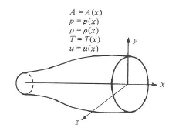
Figure 35. Quasi-One-Dimensional Flow [1]

The momentum equation is a general form of Newton’s second law [3]. Physically, the momentum equation states that the rate of change of momentum flowing through a control volume equals force exerted on the fluid inside the control volume. When applied to fluid mechanics, the momentum equation for inviscid fluid flows becomes
 | $$∯_{S}^{ }{\left(ρV∙dS\right)V+∰_{V}^{ }{\frac{∂(ρV)}{∂t}dV=∰_{V}^{ }{ρfdV-∯_{S}^{ }{pdS}}}}$$ | (A-6)
An inviscid fluid flow is one which is not dominated by viscous effects. The flow through a wind tunnel is largely considered inviscid except for the region of flow closest to the walls. This region is known as the boundary layer and it is considered a viscous fluid flow region. The form of the momentum equation represented in equation 2-6 can be simplified assuming steady flow and no body forces. The steady, inviscid, compressible, quasi-one-dimensional momentum equation with no body forces is as follows:
 | $$p_{1}A_{1}+ρ_{1}u_{1}^{2}A_{1}+\int_{A_{1}}^{A_{2}}{p_{x}dA}=p_{2}A_{2}+ρ_{2}u_{2}^{2}A_{2}$$ | (A-7)
where the subscript “x” denotes the x-component of pressure.
The energy equation is a mathematical example of the first law of thermodynamics; that is, energy cannot be created nor destroyed. When applied to an inviscid fluid flow, the energy equation becomes
 | $$∰_{V}^{ }{\dot{q}ρdV-}∯_{S}^{ }{pV∙dS+}∰_{V}^{ }{ρ(f∙V)dV}=∰_{V}^{ }{\frac{∂}{∂t}[ρ\left(e+\frac{V^{2}}{2}\right)]dV}+∯_{S}^{ }{ρ\left(e+\frac{V^{2}}{2}\right)V∙dS}$$ | (A-8)
The energy equation asserts that energy is conserved. In terms of fluid dynamics, this equation states that the rate of heat addition to a fluid in addition to the rate of work done on a fluid is equal to the rate of change of energy of the fluid flowing through a control volume [3]. The integral form of the energy equation expressed in equation 2-8 can be reduced under the assumption of steady adiabatic flow with no body forces. The assumption of adiabatic flow refers to a system in which heat is neither added nor taken away from the system. This is typically a valid assumption to make in reference to nozzle design. Using the continuity equation and the mathematical definition of enthalpy, the energy equation for steady adiabatic quasi-one-dimensional flow with no body forces can be reduced to the following form:
 | $$h_{1}+\frac{u_{1}^{2}}{2}=h_{2}+\frac{u_{2}^{2}}{2}$$ | (A-9)
An important result from equation 2-9 is that total enthalpy, h, is constant in steady adiabatic quasi-one-dimensional flow.
Equations 2-4 through 2-9 are the equations that describe the physical characteristics of fluid flow. When the differential forms of the governing equations are combined, substituted, and rearranged an important relationship between velocity and area results. The area-velocity relation of isentropic flow is the foundation of supersonic nozzle design. The term “isentropic” refers to a process which is both adiabatic and reversible. The following equation is the mathematical expression of the quasi-one-dimensional area-velocity relationship and is a product of a combination of the governing equations:
 | $$\frac{dA}{A}=(M^{2}-1)\frac{du}{u}$$ | (A-10)
The only requirement of the area-velocity relation is isentropic flow. For subsonic flow, the relation dictates that an increase in area will result in a decrease in velocity, but the most interesting results of the area-velocity relation are obtained under sonic and supersonic conditions. For supersonic flow, the area and velocity have a direct relationship which means that velocity increases with area. When the Mach number is unity or sonic, the relation indicates a minimum or maximum area distribution. Because a maximum area distribution is not realistic, this area is considered a minimum. The results from the area-velocity relation for subsonic, sonic, and supersonic flow provide the basic mathematical model of a converging-diverging supersonic nozzle. With the derivation of the area-velocity relation, the characteristic elements of a supersonic nozzle are defined. A supersonic nozzle consists of a converging section of subsonic flow followed by a minimum area section known as the throat. The flow accelerates from stagnation or a near-stagnant conditions to Mach number unity at the throat. The nozzle then diverges to further accelerate the flow to the supersonic flow regime.

Isentropic Flow of an Ideal Gas
The assumption of an ideal gas is one of the most basic concepts leading to the development of a nozzle. A perfect gas is considered when the intermolecular forces between particles, which influence the properties of a gas, are negligible. Compressible flow theory is associated with ideal gases because the particles are so far apart that the intermolecular forces can be discounted [3]. An important result of the perfect gas assumption is the equation of state. The equation of state is as follows
 | $$p=ρRT$$ | (A-11)
The assumption of an ideal gas is valid for the flow within a nozzle until the hypersonic flow regime is considered. The intermolecular forces between particles in the hypersonic flow regime cannot be neglected as they are too significant. A phenomenon associated with the hypersonic flow regime is the disassociation of the air molecules which is a result of the high energy collisions between the molecules. Such collisions led to appreciable changes in the ratio of specific heats, γ. As described in the previous section, isentropic flow is one which is both adiabatic and reversible. A process is considered adiabatic when there is no heat addition or reduction, and a process is reversible when there are no dissipative effects. Some examples of dissipative processes that a flow field might experience are viscosity, thermal conductivity, and mass diffusion [3]. Because the flow in a nozzle outside of the boundary layer is inviscid and typically adiabatic, it is considered to be isentropic. When the assumptions of perfect gas and isentropic flow are combined, important compressible flow relations are derived. The isentropic flow relations relate the pressure, temperature, and density of two points in a flow field and are only valid for a calorically perfect gas where the ratio of specific heats is constant. They are summarized below:
 | $$\frac{p_{2}}{p_{1}}={\left(\frac{ρ_{2}}{ρ_{1}}\right)}^{γ}={\left(\frac{T_{2}}{T_{1}}\right)}^{\frac{γ}{γ-1}}$$ | (A-12)
Similarly, equation 2-12 can also be written in terms of total conditions which are the flow conditions when a fluid is isentropically brought to rest, represented by
 | $$\frac{p_{0}}{p}={\left(\frac{ρ_{0}}{ρ}\right)}^{γ}={\left(\frac{T_{0}}{T}\right)}^{\frac{γ}{γ-1}}$$ | (A-13)
where the ratio of total temperature to static temperature is
 | $$\frac{T_{0}}{T}=1+\frac{γ-1}{2}M^{2}$$ | (A-14)
Using equations 2-1, 2-5, and the isentropic relations, the area-Mach number relation can be derived. The area-Mach number relation is another critical concept in nozzle design. The relation asserts that the Mach number at a location in a nozzle is a function of the ratio of the nozzle area at that location to the area of the throat. The area-Mach number relation is as follows:
 | $${\left(\frac{A}{A^{*}}\right)}^{2}=\frac{1}{M^{2}}{\left[\frac{2}{γ+1}\left(1+\frac{γ-1}{2}M^{2}\right)\right]}^{\frac{γ+1}{γ-1}}$$ | (A-15)
This relation provides a geometric design condition that can be used to relate the nozzle’s design Mach number to the throat and exit areas. Although area-Mach number relation provides nozzle designers a means of determining the areas of the throat or exit of a nozzle, it is not sufficient for the complete design of a uniform flow nozzle contour.

Vita
Sarah was born and raised in Dothan, Alabama where she attended Dothan High School. She obtained a Bachelors of Science in Aerospace Engineering from Auburn University. Upon graduation, she accepted a position as an Air Force Palace Acquire at Arnold Air Force Base in Tullahoma, TN. After her completion of her first year of OJT, she entered the Aerospace Engineering department of the University of Tennessee Space Institute as a full-time Masters student. Upon completion of the program, Sarah will return to her position in the Test and Evaluation Branch as a Flight Systems Analyst.

