Polymer Nanocomposite Analysis and Optimization for Renewable Energy and Materials

A Dissertation Presented for the
Doctorate of Philosophy Degree
The University of Tennessee, Knoxville

Nathan Walter Henry
August 2011

Table of Contents
Chapter 1 - Introduction 1
1.1 Preface 1
1.2 Lignin Compatibilizers 4
1.2.1 Physics of Polymer Blending 8
1.2.2 Polymeric Compatibilizers 10
1.2.3 Lignin research description 13
1.3 Organic Photovoltaics Introduction 13
1.3.1 Organic Semiconductors 14
1.3.2 Bulk Heterojunction Organic Photovoltaics 17
1.3.3 OPV mechanism 18
1.3.3 Importance of Morphology 19
1.3.4 BHJ design 20
1.3.5 Morphology ambiguities 22
1.3.6 Organic Photovoltaic Chemistry 24
1.3.7 OPV research description 27
1.4 Cellulose Nanowhisker Introduction 27
1.4.1 Cellulose Nanowhiskers 30
1.4.2 Cellulose Nanowhisker Compatibilization 31
1.4.3 Cellulose Nanowhisker research description 33
Chapter 2 – Experimental Section 35
2.1 Analysis techniques 35
2.1.1 Neutron Reflectivity 35
2.1.2 Scanning Electron Microscopy 43
2.1.3 Atomic Force Microscopy 46
2.1.4 Differential Scanning Calorimetry 48
2.1.5 Ellipsometry 51
2.2 Lignin-Composite Experimental 53
2.2.1 Poly(styrene-ran-4-vinyl phenol) synthesis scheme 55
2.2.2 Polymer characterization 57
2.2.3 Lignin-copolymer composite analysis 62
2.2.4 Lignin-copolymer interface analysis 63
2.3 Organic Photovoltaic Experimental 65
2.4 Cellulose Nanowhisker Experimental 67
2.4.1 Cellulose Nanowhisker Synthesis 67
2.4.2 Cellulose nanowhiskers atomic force microscopy 72
2.4.3 Cellulose neutron reflectivity 73
Chapter 3 – Lignin Composite Compatibilizers 74
3.1 Lignin Project Summary 74
3.1.1 Organosolv lignin structure and compatibilizer hydrogen bonding 74
3.1.2 Results and discussion outline 75
3.2 Lignin Research Results 76
3.2.1 Scanning Electron Microscopy 76
3.2.2 Differential Scanning Calorimetry 78
3.3.3 Neutron Reflectivity 83
3.3 Discussion 90
3.4 Conclusions 94
Chapter 4 – Organic Photovoltaics 97
4.1 OPV Project Summary 97
4.2. Qualitative Neutron Reflectivity Results 101
4.3 Quantitative Neutron Reflectivity Results 104
4.4 Discussion 109
4.4.1 Electronic Consequences 111
4.5 Conclusions 114
Chapter 5 – Cellulose Nanowhisker Composites 116
5.1 Cellulose Nanowhisker Project Introduction 116
5.2 Experimental Overview 118
5.3 Atomic Force Microscopy Results 120
5.3 Neutron Reflectivity Results 125
5.3.1 CNW monolayer analysis 125
5.3.2 CNW bilayer analysis 131
5.3.3 Modified CNW bilayer NR analysis 138
5.4 Discussion 141
5.4.1 Bilayer sample structure and evolution 141
5.4.2 Solubility and percolation 145
5.5 Conclusions 150
Chapter 6 – Conclusion and Future Work 152
6.1 Conclusion 152
6.2 Future Work 156
6.2.1 Lignin copolymer compatibilizers 156
6.2.2 Organic photovoltaics 157
6.2.3 Cellulose nanowhisker composites 158

Table of Figures
Figure 1 Lignin monolignol structure. 6
Figure 2 Illustrative lignin structure segment composed of four coupled monolignols 6
Figure 3 Polymer chain entanglement 10
Figure 4 Polymer cushioning effect 12
Figure 5 (A) polyacetylene p-orbitals (B) π electron delocalization 17
Figure 6 Electron energy diagram for donor-acceptor photovoltaic cells 19
Figure 7 General bulk heterojunction organic photovoltaic morphology 20
Figure 8 Phase separation of BHJ cell 22
Figure 9 Organic semiconductor materials 25
Figure 10 Regioregular Poly(3-Hexylthiophene) synthesis mechanism 26
Figure 11 Cellulose structure showing intrachain hydrogen bonding 29
Figure 12 Electron micrograph of cellulose nanowhiskers 30
Figure 13 CNW Hydrolysis 31
Figure 14 Reflected and refracted beams 37
Figure 15 Interference from multiple interfaces 39
Figure 16 Schematic neutron reflectivity data 41
Figure 17 Scanning electron microscopy beam geometry diagram 44
Figure 18 Secondary electron emissions from an object 46
Figure 19 Atomic force microscope (AFM) schematic 48
Figure 20 AFM tip path error when encountering objects 48
Figure 21 Schematic DSC heatflow plot 50
Figure 22 Ellipsometry wave geometry 53
Figure 23 Polystyrene-ran-4 vinyl phenol synthesis scheme 56
Figure 24 Polystyrene-ran-4 acetoxy styrene proton resonance asignments 58
Figure 25 Polystyrene-ran-4 acetoxy styrene 1D-¹H NMR representative spectrum 58
Figure 26 Polystyrene-ran-4 acetoxy styrene 1D-¹H NMR acetoxy peak 60
Figure 27 Polystyrene-ran-4 acetoxy styrene monomer-polymer feed ratio 61
Figure 28 Cellulose polymer structure 68
Figure 29 Cellulose acylation reaction 69
Figure 30 Triply acetylated cellulose monomer 70
Figure 31 Acylated cellulose 1D-NMR spectra 71
Figure 32 Illustration of lignin hydrogen bonding with 4-vinyl phenol monomer 75
Figure 33 SEM micrographs of lignin composite cross sections. 77
Figure 34 Polyethylene-lignin blends with and without compatibilizer 78
Figure 35 Illustrations of polymer blend phase possibilities 79
Figure 36 Homopolymer DSC heat flow versus temperature data. 80
Figure 37 Plot of observed versus Fox changes in the glass transition temperature 81
Figure 38 Sample bilayer experimental data and calculated model fit curve. 85
Figure 39 Depth-normalized NR composition profile model for 50% 4VPh bilayer. 86
Figure 40 Example hyperbolic tangent model fit to the layer model f. 88
Figure 41 Depth profile layer and hyperbolic tangent fit parameters. 89
Figure 42 Poly(2,3-dimethyl butadiene-ran-4 vinyl phenol) and poly(ethylene-ran-vinyl acetate) copolymers used in Coleman and Painter et al hydrogen bonding study. 92
Figure 43 Conformational hindering due to chain connectivity 93
Figure 44 Screening effect enhancing intra-copolymer hydrogen bonding 94
Figure 45 C₆₀-P3HT and PCBM-P3HT bilayer sample geometry 101
Figure 46 C₆₀-P3HT bilayer and P3HT-PCBM bilayer reflectivity data 103
Figure 47 C₆₀ bilayers and PCBM bilayers with P3HT before and after annealing, showing differences in fullerene dispersion.. 104
Figure 48 C₆₀-P3HT and PCBM-P3HT bilayer models 107
Figure 49 C₆₀-P3HT bilayer and P3HT-PCBM volume fraction models. 109
Figure 50 BHJ phase separation schematic, contrasting solubility 111
Figure 51 Electron conduction through donor domain 112
Figure 52 Schematic structure of polymer-fullerene intermixing across the interface. 114
Figure 53 Secondary charge carrier pathways. 114
Figure 54 Illustration of percolation of cylindrical rod particles through the bulk 117
Figure 55 Cellulose glycopyran ring structure 119
Figure 56 AFM height image of separated DS0 CNW nanoparticles 120
Figure 57 AFM height images of CNW films 123
Figure 58 Representative AFM micrograph of the largest CNW agglomerations 124
Figure 59 Pictorial Illustration of cellulose nanowhisker agglomerations 124
Figure 60 Neutron reflectivity data and fits of the CNW monolayers. 126
Figure 61 NR models of CNW 129
Figure 62 Neutron reflectivity data and fits for DS0 132
Figure 63 Neutron reflectometry data for DS 0.61 bilayers, 133
Figure 64 Neutron reflectivity data for DS 0.98 bilayers 134
Figure 65 NR model for DS0 bilayer 136
Figure 66 CNWs penetrating the PMMA-d8 and the trapping of void space 138
Figure 67 Neutron reflectivity models for DS0.61 bilayers 140
Figure 68 Neutron reflectivity models for DS0.98 bilayers 140
Figure 69 Lateral redistribution of PMMA causing changes in CNW orientation 143
Figure 70 Cellulose-Poly(methyl methacrylate) hydrogen bonding 144
Figure 71 Hansen solubility parameters for cellulose acetate. 148

Chapter 1 - Introduction

1.1 Preface
Composites are one of the cornerstones of the modern world; a host of materials are made up of combinations of substances that we have been familiar with since antiquity. Concrete, the literal foundation of our society, is a composite of stone, sand and cement that yields a single material that is both strong and easy to process. Wood, perhaps the first building material used by man, is a composite of chemically and mechanically different biopolymers that individually are poor materials but complement each other to form a single material of great utility. Soft proteins and brittle mineral solids give shape to most animal life by producing the strong but light weight substances bone and shell.
In today’s effort to become a more sustainable society, we must to learn how to design the materials that comprise our world, and make energy that powers it more efficiently while reducing our environmental burden. For this to be accomplished, new materials must avoid compromising material performance or adding undue costs. New materials, especially those sustainably sourced, can substitute or even surpass nonrenewables in performance, cost, or added utility. Such materials are of significant interest to the materials science community and importance to our future. Composites of both new and old materials can fulfill these goals, but their creation requires both the application of rational design from developed theoretical and experimental tools to bring them into use.
Polymers, as a class of materials, have become ubiquitous in modern life; they are light weight, durable, and simple to process. Polymers also have a wide range of thermomechanical properties, low cost feedstock, and chemical resistance making them extremely useful across an array of applications. However, the great majority of polymers today are synthesized from non-renewable fossil hydrocarbons sources natural gas. And although a wide of properties are available, there are many applications where polymers need a set of qualities which require costly development of a new chemistry tailored to the application, if available at all. A single approach, compositing or blending, can help address both issues: through the blending of polymers with disparate properties, a single material with tailored properties can be produced. Alternately, renewably sourced polymers with otherwise unusable properties could displace nonrenewable ones in many applications if combined with other polymers.
Incompatibility is one the main barriers to polymer composite blends; they will resist mixing and retain discrete phases, rather than intimately mixing and entangling with one another. Phase separation is undesirable as load transfer through the macroscopic bulk of the material is interrupted across the interface, between the microscopically dispersed component phases. Without the benefit of contiguous entanglement or strong cross-phase interfacial adhesion, blends often have poor mechanical properties. The first project presented in this work details an effort to overcome the difficulties of blending a renewable biopolymer with other common polymers, producing partially “green” composites.
Nanomaterials, materials with units that have persistent dimensions smaller than 100nm, hold great promise as some of these particles have exceptional or unique physical properties. However, translating the properties of the nanoscopic particle to the macroscopic scale of a material has been an ongoing challenge. The combination of nanoparticles with polymers provides a route to accessing these properties to produce materials, making them available to a wide variety of old and new applications.
Work on a new application is presented in the second project, utilizing the high electrical conductivity of soluble carbon nanoparticles to create pathways for electron transfer throughout the bulk of organic, solution-processable solar cells. Such cells, with sufficient performance, could lower the prohibitive cost and increase the ease of deployment for clean solar electricity. To realize this, the role of, and precise characteristics, of the ideal morphology must be clarified and methods to tune the morphology tailored and understood.
A more traditional application of nanoparticles from a renewable source is studied in the third project, imparting the crystalline fragments of dissolved cellulose derived from plants as reinforcement to conventional polymers. In addition to being sustainably sourced from biomass and capable of enhancing thermomechanical properties, such composites can be optically transparent due to the small size of the nanoparticles.
The common thread in these seemingly disparate projects is the need to characterize and control the morphology of the composite at the interface between the components to produce useful and effective materials. In polymer blends, maximizing the adhesion and mixing across the interface is critical to success. In organic photovoltaic devices, precise control of the morphology between phases is crucial to the performance and practicality of the cells. And, in cellulose nanoparticle composites, the dispersion of the nanoparticles into the matrix is needed to impart their strength to materials.
Polymer blends tend to phase separate into micron-scale dispersions, and nanoparticles by their nature are even smaller when dispersed. Accessing these small length scales to characterize their morphology, particularly when the constituents are chemically similar, is a challenge for engineering polymer multi-component materials. All the materials used in the three projects, particularly in the field of renewable materials, are also composed of carbon-rich organic compounds, between which only subtle chemical and electronic differences exist. Given these dual problems, few options exist to elucidate the structure of the interface and morphology needed to provide data for the iterative understanding and rational development of materials for targeted applications.
Neutron scattering techniques, such as reflectivity used throughout this work, is one of these options. Neutron-based techniques offer very high spatial resolution thanks to the short DeBroglie wavelength from the high mass of the neutron. Secondly, it takes advantage of the unusually strong interaction between ¹H versus other elements common in organic materials, making chemical contrast available through inherent isotopic differences or isotopic substitution.

1.2 Lignin Compatibilizers
Lignin is an amorphous, irregularly branched biopolymer that serves to bind together the cellulose fibers in all plant matter and is yielded as a byproduct in huge quantities from cellulose extraction in the paper industry. 70 million tons of lignin is generated annually from the paper pulp industry, 98% of which is simply burned as a fuel for process heat. Large quantities of lignin will also be a byproduct of the emerging cellulosic ethanol industry. In the materials field, lignin has seen some use as a feedstock for resins, surfactants, and in polyurethanes, but remains an under-utilized resource.,,, If even a small fraction of lignin could be diverted to displace non-renewable materials, significant quantities of petrochemicals could be saved instead of incorporated into polymers.
Lignin, unlike most common synthetic polymers, has a complex and irregular polymer structure due to the coupling at multiple possible sites of the lignin monomer units. The “monolignols” that make up lignin are based on simple aromatic alcohols, in some types with adjacent pendant methoxy groups, bearing an unsaturated side chain terminated with a hydroxyl group (Figure 1). The overall structure of the lignin is comprised of an assortment of monolignols bonded to different sites, the ratio of their type and bonding varying according to source plant species, and can be further changed during the lignin extraction process.,,, Therefore, the exact structure of lignin varies, and escapes simple characterization (Figure 2).
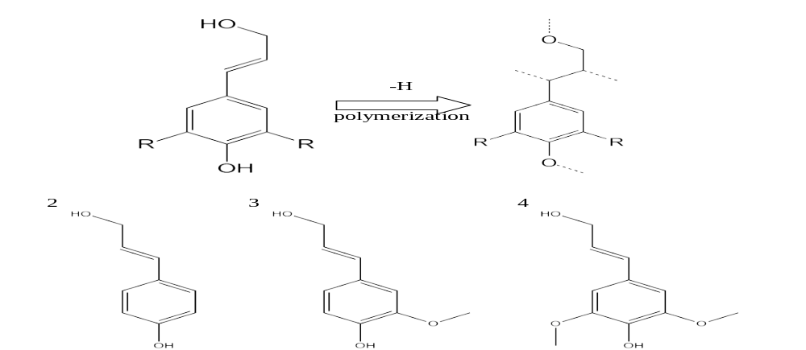
Figure 1 Lignin monolignol structure and indicated polymer bonding sites. R = H or OCH₃.
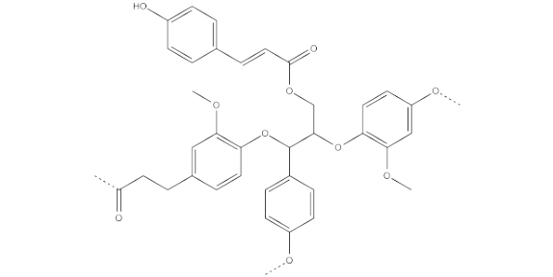
Figure 2 Illustrative lignin structure segment composed of four coupled monolignols
Lignin exists as a lightly crosslinked polymer within the plant tissue structure, bearing covalent bonds between itself and to the celluloses that the lignin reinforces. All methods which extract lignin therefore cause chemical change by breaking some of these bonds to liberate macromolecules with molar masses generally between 1,000-20,000g/mol. Several lignin extraction methods are available, such as the alkali hydrolysis “soda” process, the sulfite and Kraft processes, and others. The different processes have different effects on lignin, such as extensive oxidation of soda lignin, increased crosslinking and incorporation of sulfites in the sulfite process, and aliphatic thiols in Kraft lignin. One relatively new process of note uses organic solvents, such as ethanol or methanol, to replace lignin ether and ester bridges with ethoxy or methoxy groups as well as dissolving the cleaved lignin macromolecules. Organosolv lignin contains no sulfur, low amounts of water soluble impurities, and good processability.,
In addition to being an abundant renewably sourced material, it is biodegradable, unlike many synthetic polymers, its potential has been demonstrated as an anti-oxidant additive for rubber, plus it imparts flame retardant properties to composites. Useful composites that can displace traditional synthetic materials must incorporate significant amounts of without excessive negative impact to physical properties or processability that may limit lignin’s successful use.
The compatibility of lignin with the matrix polymer is one of the primary factors in whether a lignin composite is successful or not. Soluble blends with synthetic polymers bearing up to 85% lignin have been demonstrated by Li and Sarkanen and Y Xu et al using soluble strongly hydrogen bonding or low molecular weight synthetic polymers, but the lack of compatibility with most hydrophobic high molecular weight commodity polymers limits wider use., Pucciariello, Villani, and coauthors demonstrated a correlation between the poorly miscibility in lignin blends of polyethylene or polystyrene and poor mechanical properties: they produced electron micrographs that showed a very inhomogeneous fracture surface, indicative of strong phase separation, and demonstrated a significant decrease in mechanical properties with increased lignin loading. However, with few exceptions, lignin loadings above approximately 40% (w/w) have not been demonstrated without significant embrittlement of the composite. ,

1.2.1 Physics of Polymer Blending
The thermodynamic basis for the poor solubility of most polymer blends arises from the poor entropic benefit of mixing two polymers: absent significant intermolecular interaction, the weak increase in entropy (ΔS_{mix}<<ΔH_{mix}) is unable to overcome the typically endothermic enthalpy of mixing (ΔH_{mix} > 0) resulting in phase separation of the great majority of polymer blends. The entropic gain (ΔS_{mix}) in mixing two polymers is often very low as the randomness and freedom of polymer chain conformation is not generally increased significantly by the presence of other polymers. The enthalpy of mixing (ΔH_{mix}) is almost universally endothermic, due to the more favorable interaction between identical molecules than unlike ones. This is a rule and not universal between all polymer blends, but barring specific electronic interactions beyond simple dispersion or weak dipole forces, this is generally the case.
These effects are quantified by the Flory-Huggins equation (equation 1.1) for the free energy of mixing of polymers (ΔG_{mix}), which uses the volume fraction of each polymer (ϕ), the molecular weight (M), and the Flory-Huggins interaction parameter χ, which describes the enthalpic change attraction between the pair. Most polymer pairs are insoluble: a high molecular weight lowers the favorable entropic contribution to the free energy compared to small molecules., The remaining term χ is generally positive or endothermic, and is commonly large for the large majority of polymer blends. The enthalpic unfavorability of mixing cannot overcome the weak entropic terms and makes ΔG_{mix} a positive value.
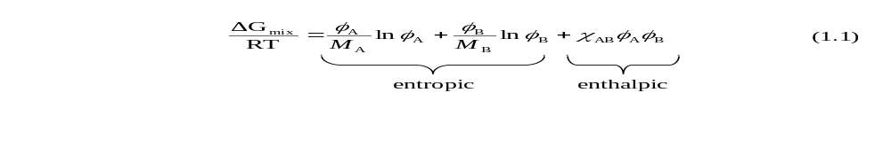
The soluble blends noted previously either had a strong enthalpic attraction with lignin or incorporated low molecular weight polymers, which would serve to lower the enthalpic parameter (smaller χ_{AB}) or the entropic terms (smaller M), reducing ΔG_{mix} and making the blend soluble. The blends made by Pucciariello using polyethylene or polystyrene do not have strong enthalpic attraction for the lignin, and have too high of a molar mass to reach a thermodynamically favorable free energy of mixing.
To make useful composites, the enthalpic intermolecular interactions between lignin and the matrix polymer must be strong to produce composites with good mechanical properties: this would result in either the bulk of the composite becoming completely miscible with a negative ΔG_{mix}, or an intermediate case where limited interdiffusion occurs but an interface is retained. In the latter case, if a polymer chain of sufficient length extends and entangles across the interface (Figure 3A), it will also increase adhesion due to the covalent bonds bridging the interface.

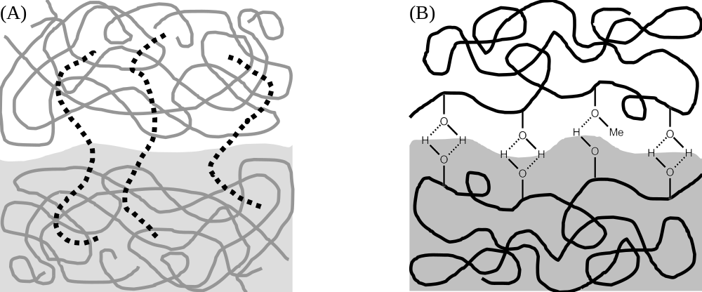
(b)
Figure 3 Polymer chain entanglement (A) and hydrogen bonding (B) across the interface, which enhance interfacial adhesion

1.2.2 Polymeric Compatibilizers
Previous research has taken advantage of the abundant oxygen-bearing groups present on the lignin structure to introduce intermolecular hydrogen bonding with a matrix polymer bearing compatible groups, such as hydroxyl groups. This approach has shown some success, as noted previously in the use by Li and Sarkanen with hydrogen bond participating polymers, and other researchers such as Kubo and Kadla reporting evidence for lignin intermolecular association with polyvinyl alcohol.
While relatively successful, this strategy imposes significant limitations and added expense to the matrix polymer the lignin is blended with: the requirement that its chemistry must be selected for lignin compatibility and not for low cost or performance reduces its attractiveness. An alternative to increase the compatibility of lignin blends without modifying the matrix polymer is to use a ternary “compatibilizer” surfactant; this could act on the interface and serve to mitigate the problems of incompatible lignin composites in an efficient and customizable fashion. With such a compatibilizer as an additive, lignin could be incorporated with a wider range of polymers that are otherwise incompatible, and perhaps at higher loading.
Compatibilizers would enhance lignin composites in two ways: by increasing interfacial adhesion and mitigating interfacial tension. However, a polymeric compatibilizer could offer additional advantages over a small molecule compatibilizer. A polymer, due to its macromolecular nature, can assist in stabilizing dispersed droplets and may avoid plasticization of the composite blend. The first two effects arise in the same way as the previously discussed enthalpically favorable binary blend, excepting that the compatibilizer would have an affinity for the synthetic polymer in addition to lignin.
Such a polymer compatibilizer, in a blend of an incompatible polymer with lignin, would have a strong affinity for both materials is induced to lie at the interface.35 A unique property of polymeric compatibilizers is that they can present an entropic “cushion” that retards melt coalescence: in order for two droplets of like polymer surrounded by compatibilizer to coalesce, the chains of the compatibilizer must be pushed out of the way. This would require that the compatibilizer chains be compressed, hindering their conformational freedom and decreasing their entropy (Figure 4).

Figure 4 Polymer cushioning effect, showing chain compression acting against droplet coalescence
Polymeric compatibilizers are not a new approach, and have been investigated by our group and many others in purely synthetic systems., Alexy, Košíková, et al. demonstrated the efficacy of a poly(ethylene-ran-vinyl acetate) copolymer compatibilizer to enhance blends of polyethylene and lignin, succeeding in significantly increasing both tensile strength and break elongation, but required high compatibilizer loading.
Two papers written by Lv and Di, use a slightly different approach, using small amounts of polyolefin-maleic anhydride block copolymers that covalently bond with lignin to improve solubility. These block copolymers essentially graft lignin onto their chains to form a polyolefin-maleic anhydride-graft lignin ternary copolymer in situ to associate with the lignin. These copolymers improved the dispersion of lignin within the composite and enhanced mechanical properties at low loadings. Of interest to the field of lignin-based composites is optimizing the copolymer compatibilizer structure to maximize its effectiveness.
A previous study by Kulasekere, Russell, et al. on copolymer compatibilizers for polystyrene and polymethyl methacrylate using poly(styrene-ran-methyl methacrylate) copolymers clearly showed that the effectiveness of interfacial strengthening correlates to an ideal intermediate proportion of interacting monomers in the copolymer. Li and Sarkanen note that the mechanical properties of lignin-polyethylene terephthalate composites may also be strongly influenced by the density of ester groups. Therefore, the distribution of monomers within the copolymer that interacts with lignin must be optimized for the compatibilizer to work most efficiently.

1.2.3 Lignin research description
In this project, the optimization of the density of hydrogen bonding groups on a polystyrene-based polymeric compatibilizer for lignin as a model system was investigated. By altering the density, insight into the structural effects on compatibilizer performance can be gained and rationally optimized.
The compatibility of this lignin-styrenic pair was characterized by neutron reflectivity, thermal behavior, and domain size with varying the hydroxyl content of the copolymer. Scanning electron microscopy (SEM) offers the micron-scale spatial resolution needed to observe phase separation by imaging of blend interior to gauge how hydroxyl content affects the morphology. Analysis of blend thermal behavior by differential scanning calorimetry (DSC) detects temperature-specific transitions affected by the degree of the solubility. Neutron reflectivity (NR) characterizes the interface, quantifying interfacial width and intermixing between phases.
With information of interfacial width, droplet dispersion and solubility as a function of hydroxyl content in the styrenic polymer, the composition which produces maximum compatibility, and hence optimum properties, with lignin can be determined. Polystyrene-lignin blends using such a copolymer with this composition should provide the highest performance at the lowest compatibilizer loading.

1.3 Organic Photovoltaics Introduction
Solar energy directly harvested for electricity by photovoltaic cells has long been one the leading technologies in the pursuit of reliable, environmentally-friendly energy for our world. Solar energy is also one of the few sources that could be scaled to provide a significant portion of our energy needs: A 2010 report published by the US National Academy of Sciences, National Research Council, and National Academy of Engineers estimates that the daily average solar energy falling over the entire land mass of the United States is 1.84 million gigawatts, only one quarter of one percent of which could completely fulfill all projected energy needs by 2050. In the long term, collecting even a tiny fraction of the available solar energy would be a huge source of clean energy. In the nearer term as noted in the report, covering all feasible building rooftops with 10% conversion efficiency solar collectors could generate up to 2,000 gigawatts.
The main bottleneck holding back the widespread deployment of solar power is the high manufacturing and deployment costs of the primary solar energy collection technology, silicon-based photovoltaic cells. The most widely used type of photovoltaic cell is based on semiconductor silicon, which as of 2007 comprised 88% of cells annually produced by power output.⁴⁶ They are also rigid and brittle; making packaging and installation more difficult and completed devices more mass intensive.

1.3.1 Organic Semiconductors
An alternative technology, subject to significant current interest, is photovoltaic devices based on π-conjugated semiconducting organic materials instead of inorganic semiconductors dubbed organic photovoltaic devices (OPVs). Photovoltaic devices based on inorganic materials such as silicon were first developed by Bell Laboratories in the 1950s, and while a proven technology such cells have drawbacks of high material and fabrication costs and are mechanically brittle, requiring robust packaging to withstand exposure to the weather and limiting easy portability. OPVs are a new technology that could overcome these issues. These devices made from organic semiconductors, which could be readily produced and processed via low-energy solution methods, could be fabricated on large scales by contemporary spraying or printing techniques.,,,,
Organic semiconductors often have very high volume absorption coefficients and thus can be made very thin. If cells were fabricated on light weight and flexible substrates, new classes of easily portable cells that are also flexible and can resist impact are possible. While these advantages would likely make organic photovoltaic devices (OPVs) less expensive per area than traditional silicon cells, the efficiency and lifetime of OPV devices is not yet high enough to compete on cost per watt of power produced: the best single-junction crystalline silicon cells convert 24% of incident light to electricity, while OPVs have only reached ~7% in laboratory examples.,,, It is estimated that in order to become a competitive energy source, mass produced OPV cells must reach at least 10% conversion efficiency., The lifetime of organic solar cells in the ambient environment is also fairly short, since ultraviolet light, oxygen, and water will degrade most organic compounds over fairly short times compared to a decade for silicon cells which last for decades. Some of the more long-lived devices lose half of their performance within six months even under vacuum to eliminate contamination.
The confirmation of photovoltaic properties of organic materials were first reported by Kallmann and Pope in 1959 using an active layer of monocrystalline anthracene, which demonstrated photovoltaic activity, but only had an efficiency of 0.05% at a tiny 200mV voltage. The anthracene molecules could behave as semiconductors since crystallization oriented the molecules so that the aromatic p-orbitals were aligned and in close enough proximity to overlap. This orbital overlap is the basis of organic semiconductors, and polymers that incorporate photovoltaic activity is the subject of intense research.
One of the most promising organic semiconducting chemistries is semiconducting polymers. The classic example of organic polymeric semiconductors is polyacetylene, the conductive properties of which earned Shirakawa, Heeger, MacDiarmid and Chiang the 2000 Nobel Prize in chemistry. In polyacetylene, every carbon atom is sp²+p hybridized, and the remaining unhybridized p-orbital can overlap with other p-orbitals of neighboring atoms (Figure 5A), along multiple monomer units (Figure 5B). The close proximity enforced by the σ-bonding backbone in organic polymers brings the p-orbitals close together, and in appropriate confirmations they can align, leading to conjugation of these orbitals. Polymers can be designed so that p-orbital conformational alignment is further promoted, such as rigid two-dimensional monomer repeat units which stack together in the solid state.
This delocalization forms a filled highest occupied molecular orbital (HOMO) bonding π band and an empty lowest unoccupied molecular orbital (LUMO) antibonding π* band, making such polymers semiconducting. Electrons in these bands can travel along the chain relatively freely, as opposed to the valence electrons in the hybridized bonding orbitals which are fixed in their respective bonding systems. These materials can be electrically conductive across macroscopic distances via electron tunneling between lengths of conjugated p-orbitals on the same or to other polymer chains.
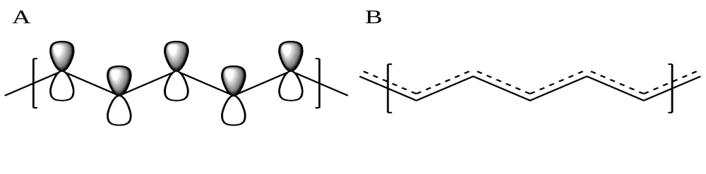
Figure 5 (A) polyacetylene p-orbitals (B) π electron delocalization

1.3.2 Bulk Heterojunction Organic Photovoltaics
Organic bulk heterojunction (BHJ) cells were first produced by Yu, Heeger and coworkers by spin-casting a solution containing donor and acceptor materials that are soluble in a common solvent but not in each other, leaving a composite film.⁷⁹ These cells reached an efficiency of 2.9%, and a great deal of research has subsequently been conducted into optimizing cells by attempting to tune the morphology using a variety of processing methods,, donor-acceptor loadings, and post-deposition annealing techniques,,, and thus far the best cells have up to ~7% conversion efficiency.
A significant breakthrough in OPV design was the introduction of a donor-acceptor junction design to the field by CW Tang in 1986, with cells that reached 1% efficiency versus the 0.05% of the Kallmann and Pope donor-only based devices. This very large increase in performance was obtained by placing a second separate semiconductor material in contact with a photovoltaic material, which changed the mechanism in which the cells operate. Since the introduction of donor-acceptor cells, all types of OPV devices have been designed with some variation of this basic mechanism in mind.

1.3.3 OPV mechanism
The mechanism that allows donor-acceptor OPVs to generate an electric current is a multistep process and is illustrated in Figure 6. The process starts when a photoactive electron donor absorbs a photon and promotes an electron to the π* band, generating an excited electron and leaving a vacancy dubbed a hole in the π band (Figure 6, #1). Holes are “virtual” particles: while only existing as the absence of an electron, they can be treated as a positive charge carrier particle for most intents and purposes. This excited electron and accompanying hole remain paired as an exciton (abbreviated herein Ex), a neutrally charged energy carrier that can diffuse together through the cell via available delocalized bands.
In the second step, the exciton diffuses to an interface with another material that has a conduction band at a lower energy, to which the electron is transferred and results disassociation of the exciton. This second material promotes the rapid transfer of an electron to a lower energy π* band of the electron acceptor (Figure 6, #2) and is more efficient at conducting electrons than the donor. Finally, the liberated electron is conducted to the cathode via the electron acceptor and the hole is carried to and neutralized at the anode via the electron donor to complete the circuit (Figure 6, #3). This mechanism differs somewhat from that of silicon cells, where generated excitons need not diffuse to the donor-acceptor interface to be disassociated, as the binding energy of the exciton is considerably lower than in OPV devices.
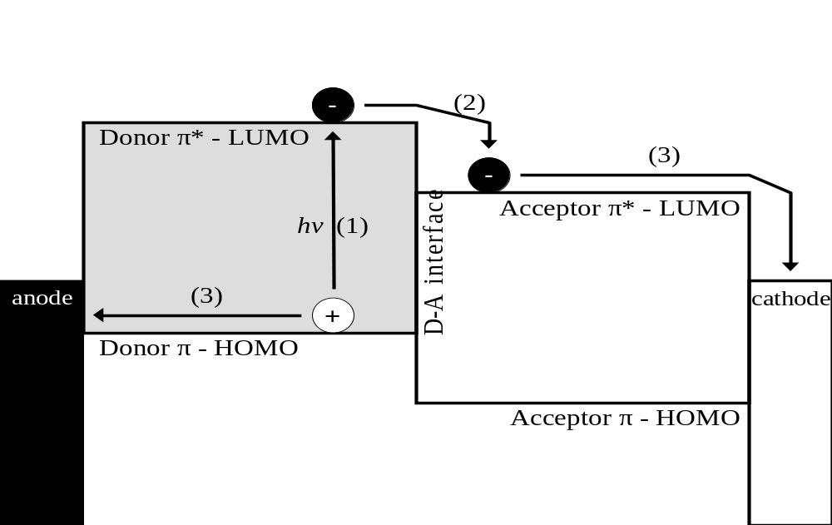
Figure 6 Electron energy diagram for donor-acceptor photovoltaic cells

1.3.3 Importance of Morphology
A limitation in OPV devices that limited early cells, and is of primary concern in device morphology design, is the short distance that excitons can diffuse through the organic active layer before recombining; this lengthscale is typically no more than ~10nm: disassociation of the exciton cannot occur except in very close proximity to the interface, and so if they fail to reach the interface their energy cannot be converted to useful current, instead being wasted as either thermal energy or fluorescent emission.,,
This theoretically limits the portions of the active layer that are actually effective in producing electricity to the region within the ~10nm from a donor-acceptor interface., While the optical depth of OPV materials is high, they must still be on the order of 100+ nanometers thick to absorb all the light from the sun: therefore cells cannot simply be made the ~10nm thickness to match the length scale of exciton diffusion.,, A second major factor that dictates the ideal morphology of OPVs is that the paths disassociated electrons and holes must travel through the bulk to the electrodes should be as contiguous and efficient in conduction as possible, with a minimum of breaks or jumps to maximize conductivity.

1.3.4 BHJ design
Perhaps the most promising cell morphology design is the bulk heterojunction (BHJ): the two semiconductor materials are randomly dispersed throughout the bulk as a percolated, partially co-continuous biphasic mixture with morphology on a similar lengthscale to that of exciton diffusion (Figure 7). Within such an ideal morphology, most or all the volume of the photoactive material would be close enough for excitons to reach a donor-acceptor interface, and largely continuous pathways for electrons and holes to the electrodes would be available.

Figure 7 General bulk heterojunction organic photovoltaic morphology, with interpenetrating domains of electron donor and acceptor materials
The morphological tuning is important to achieving higher performance, but what the ideal target morphology is has been somewhat ambiguous: theoretically there are two competing morphology concerns for any organic donor-acceptor OPV; the need to have relatively pure and ideally contiguous domains of donor and acceptor materials to efficiently carry charge through the active layer. Secondly, the size of the donor and acceptor domains must be small enough so that excitons can find a donor-acceptor interface before decaying.
As summarized in a review article by Venkataraman, Serkan and coauthors, the overall morphology must strike a balance between optimizing donor-donor and acceptor-acceptor versus donor-acceptor electron transport properties. A well-dispersed BHJ mixture may have donor-acceptor interfaces close enough together to maximize exciton disassociation, but lack the pure donor/acceptor domains needed to transport the generated electrons and holes. Conversely, a strongly phase separated system may conduct holes and electrons efficiently, but have domains too large to capture excitons generated throughout the photovoltaic material. Clearly some degree of microscopic, but not macroscopic, phase segregation is necessary to produce efficient cells.
When the composite layer is initially cast from solvent, the components are generally well dispersed, and the resultant cell does not reach high efficiency without the use of thermal or solvent vapor annealing to modify the BHJ morphology.,,
However, it was found that as the amount of annealing increased, the device performance decreased, possibly due to phase coalescence or changes in the interfacial structure. Thus, by allowing the kinetically hindered mixture to undergo phase separation, the initially homogeneous film reached some optimum partially phase separated morphology that balanced electron-hole transport with exciton disassociation, then proceeded to an excessive degree of phase separation that reduced exciton collection efficiency. TEM imagery of the progression of this phase separation in a model BHJ system in a work by Hoppe and Sariciftci is shown in Figure 8.⁸⁰
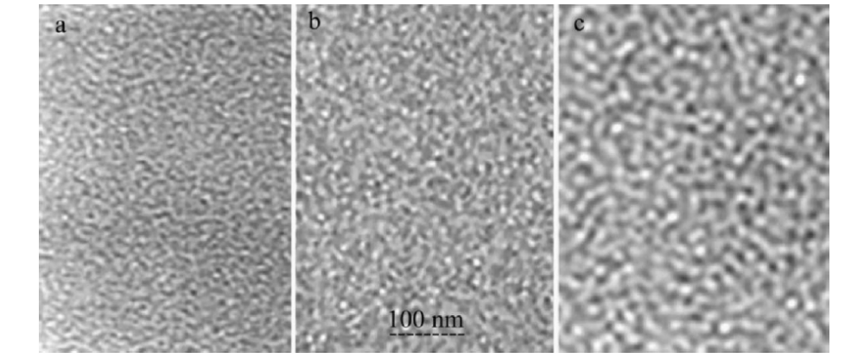
Figure 8 Phase separation of BHJ cell

1.3.5 Morphology ambiguities
Knowledge of what the optimum characteristics of OPV phase morphology are is thus important to making efficient devices, specifically the sharpness of the interface, composition and length scales of phase separated domains. A particular ambiguity about the BHJ morphology is the structure of the donor-acceptor interface and its relationship to device performance: it is known micro-phase separated active layers do have higher performance, but the effect of the structure of the donor-acceptor interface and the amount of intermixing on performance is poorly understood.
Unfortunately, the analysis of these characteristics is difficult to access experimentally: The small scale of ideal phase segregation is thought to be on the order of ~10nm, well beyond the limits of simple techniques like optical microscopy to resolve. Many techniques that can resolve features below this length scale rely on differences in elemental identity, not readily available in carbon-rich organic composites. Past efforts have relied on techniques that have limited ability to distinguish between OPV materials, leading to ambiguity in understanding morphology-performance relationships.
Probe techniques that rely on the short wavelengths of X-rays and electron beams with the resolution required for the phase separation regime, such as X-ray scattering or reflectivity,, and transmission electron microscopy (TEM),, cannot easily distinguish between carbon-rich organic materials. For instance, TEM can distinguish between a crystalline semiconducting polymer and an organic nanoparticle electron acceptor material, but not between the amorphous polymer and the acceptor. X-ray scattering contrast arises from the difference in atomic number of the analyte atoms, and so scattering contrast is often poor between carbon-rich organic materials. Also applied to elucidate morphology, atomic force microscopy has been used to study active layers, but can only probe the surface and does not distinguish materials except when their physical properties vary considerably.
Neutron scattering techniques offer the same very short wavelengths and high resolution available from X-ray or electron beams, but overcome this lack of contrast due to the strongly different scattering strength from the nucleus of the ¹H proton and the nuclei of other light elements common in organic materials. Contrast in model devices or in a sample comprised of semiconducting materials is available from differences in proton density between the compounds used. X-rays and electrons particularly lack this scattering contrast from hydrogen atoms since they interact with electrons rather than the nucleus, and hydrogen atoms have low electron density.

1.3.6 Organic Photovoltaic Chemistry
The polymer studied in this experiment is regioregular alkylthiophene poly(3-hexyl thiophene) (hereafter P3HT), a conjugated polymer based on a cyclic thioether diene ring with a pendant alkyl group. The architecture of the polymer used for OPV purposes has a high head-to-tail regioregularity, which is important as it allows for more ordering and crystallinity (Figure 9A). Higher ordering leads to less steric torsion of the monomer ring units, so that more can lay coplanar to each other, facilitating the alignment of π-orbitals to increase conjugation: without the π-orbitals being co-aligned, electron delocalization and transport is retarded. The crystallinity in turn is desirable because it aids in charge transfer throughout the polymer domain, beyond individual conjugated chain segments.
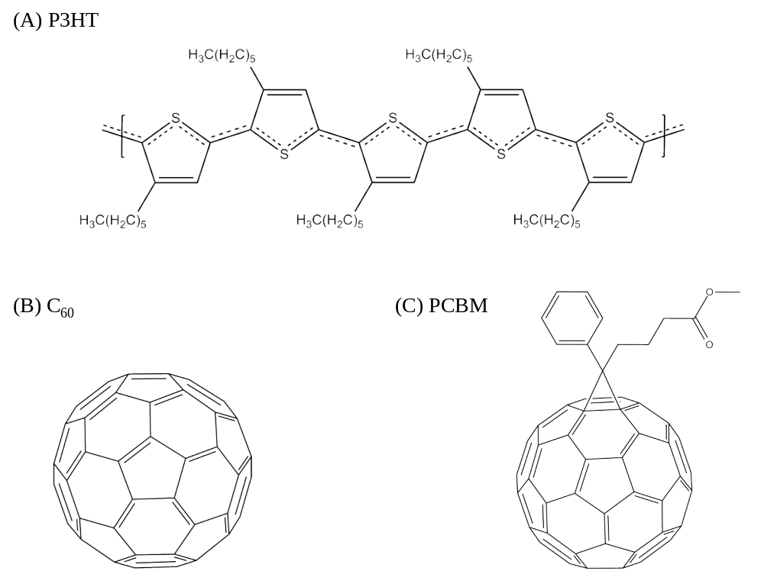
Figure 9 (A) P3HT conjugation (B) carbon-60 fullerene (C) Phenyl-C61-butyric acid methyl ester (PCBM)
The polymer can be produced by a number of synthetic routes; early routes include the cationic polymerization of substituted thiophene monomers initiated via chemical oxidation with an aqueous suspension of iron (III) chloride or electrochemical polymerization. To achieve the high regioregularity desired, orientation specific methods involving organometallic coupling reactions catalyzed with nickel, first developed by McCullough, and Rieke are used., More recently, McCullough applied Grignard metathesis polymerization (GRIM) to the synthesis, and has been able to create well defined and highly regular P3HT with >95% regioregularity. This is possible due to a living step-growth mechanism of the reaction with the exchange of nickel catalyst from the site of coupling to the chain end.,
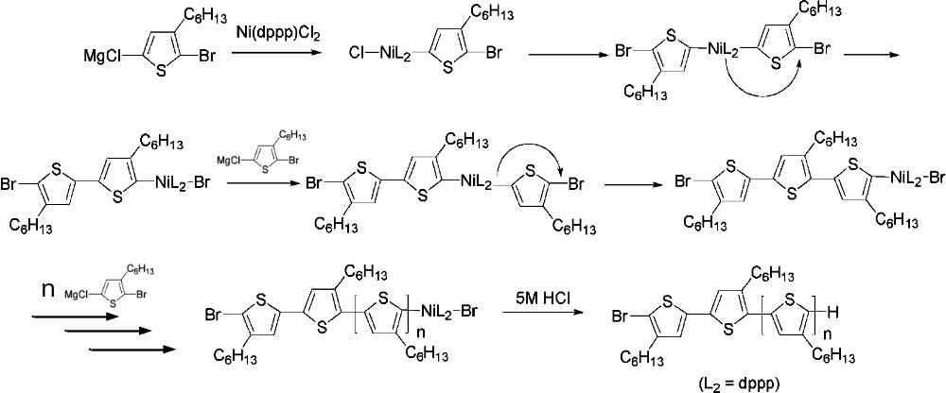
Figure 10 Regioregular Poly(3-Hexylthiophene) synthesis mechanism¹⁰⁴
Fullerenes are spherical carbon molecules discovered by HW Kroto, RE Smalley et al. in 1985 in the vapor of laser ablated graphite. Every atom of the fullerene cluster is a sp²+p hybrid much like those in a single layer of graphite, which gives fullerenes electrical conductivity. Under appropriate reaction conditions, useful quantities of the most stable fullerenes, such as C₆₀ (Figure 9B), can be produced with relatively high selectivity by plasma arc discharge in the presence of helium. The resulting fullerenes can be extracted from the resulting soot, a mixture of amorphous carbon, graphite and carbon nanoparticles, by taking advantage of the high C₆₀ solubility in organic solvents.
Modified fullerenes with covalently attached organic groups have been synthesized to enhance the fullerene solubility in solvents and ease dispersion in polymers. The presence of side groups produces stronger enthalpic interactions between polymers and fullerenes as well as reducing the tight crystalline packing that encourages unwanted agglomeration. The most commonly used modified fullerene is [6,6]-phenyl-C₆₁-butyric acid methyl ester (PCBM, Figure 9C), first synthesized by JC Hummelen, BW Knight and coauthors in 1995 by reacting the organic side chain bearing an azide linker with C₆₀ fullerenes in solution.

1.3.7 OPV research description
The purpose of this work is to probe the interfacial structure of a proven BHJ OPV system based on a conjugated polymer electron donor (P3HT) and carbon fullerene nanoparticle electron acceptor (PCBM), with the intent to correlate interfacial structure and bulk solubility to performance. To help ensure the results are realistic, unmodified fullerenes were also compared, which should have a lower solubility and a sharper interface relative to the modified fullerenes.
Using neutron reflectivity, the OPV interface was probed by taking advantage of high resolution due to the short DeBroglie wavelength of neutrons and high contrast generated from the ¹H proton rich organic polymer and the ¹H poor fullerene materials. Via thermal annealing, the interface was allowed to evolve and phase separation monitored as the system moves closer to an equilibrium state. With direct access to the width and definition of the interface, experimental insight into the characteristics of the ideal BHJ morphology can be elucidated.

1.4 Cellulose Nanowhisker Introduction
There is growing interest in environmentally friendly materials that can displace nonrenewable petroleum based or traditional low performance materials to enhance the sustainability of society. Composites of polymers with nanoscale particles as reinforcing agents, hold significant potential for materials to enhance mechanical properties,, in some cases offering superior performance to composites with larger reinforcing fillers., Nanoscale fillers based on biological materials are attractive for their environmentally friendly sourcing and relative abundance, the plant-based material cellulose being the most abundant and offering attractive properties.
The percentage of cellulose dry mass in plants ranges from approximately 50% for wood to above 80% for more fibrous plants like flax and cotton which is extremely abundant with an estimated 100-180 billion tons generated annually in nature.,, Cellulose is a linear carbohydrate polymer of 1-4-β-Glucose sugar rings linked with molar masses ranging up to 3.2x10⁶g/mol from some source species., The glucose ring units are triply hydroxyl-functionalized and participate in extensive intra- and inter-chain hydrogen bonding, which has significant effects on the properties of the polymer and resultant materials that may not be immediately obvious from its chemical chain structure.
Within the same chain, the positioning of one of the hydroxyl groups permits hydrogen bonding with the oxygen atom on a neighboring ring, hindering rotation of the ring about the ether backbone bond and resulting in a relatively rigid pseudo ladderane backbone (Figure 11). Between separate chains, this stiffness and the hydrogen bonding of the two free hydroxyl groups to a neighboring chains creates strong intermolecular attractive forces and a significant degree of order, which results in cellulose having a relatively high crystallinity.

Figure 11 Cellulose structure showing intrachain hydrogen bonding

The crystallinity and strong intermolecular forces in cellulose induces it to self assemble into fibers that form a significant structural component of the plant. These partially crystalline fibers vary in size depending on source species. For instance, flax fibers are 25mm long and 20μm wide, have very high aspect ratios, and reasonable physical properties with Young’s moduli between ~40-60GPa. However, the crystalline regions of the fibers are far smaller as well as far stronger: these crystal structures are approximately 5-10nm by 200-300nm long and have Young’s moduli estimated near 140GPa and tensile strengths up to 1.7GPa, values comparable to high performance polyaramid fibers. ,,,,,

1.4.1 Cellulose Nanowhiskers
By using only these cellulose nanocrystals to reinforce composites, significantly higher performance can be achieved. These rod-like cellulose nanoparticles are often dubbed nanowhiskers (cellulose nanowhiskers, or CNWs hereafter) for their rigidity and relatively high aspect ratios as seen in the transmission electron micrograph of purified CNWs in Figure 12. Their high crystallinity is displayed by an essentially perfect electron microdiffraction pattern (insert). Composites with nanowhiskers can also be nearly optically transparent due to the small particle size.,,

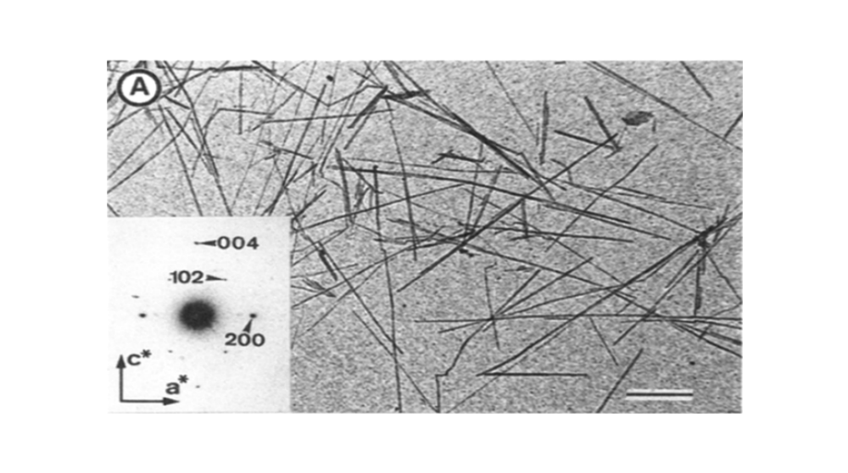
Figure 12 Electron micrograph of cellulose nanowhiskers (scale bar 500nm)¹²⁷

The cellulose fibers can be broken down into nanowhiskers by a number of methods, the most common being chemically via hydrolysis with mineral acids, preferentially cleaving the backbone bonds of the more vulnerable and porous amorphous regions of the cellulose fibers. With moderate hydrolysis, the fibers are broken down into highly crystalline fragments without extensive damage to their structure (Figure 13).

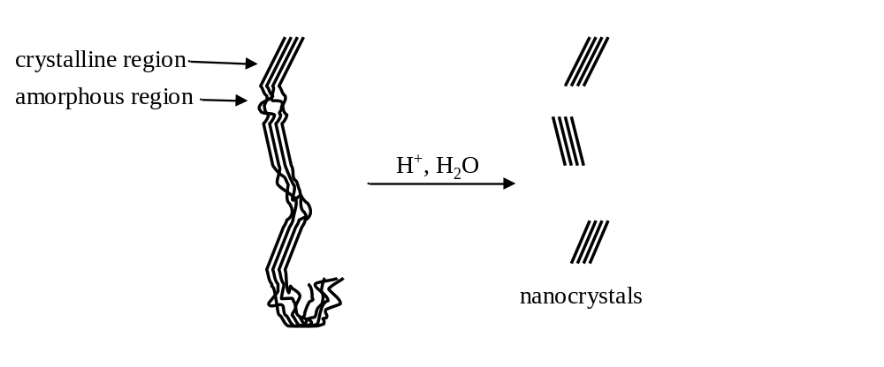
Figure 13 CNW Hydrolysis
These nanowhiskers have been shown to improve the thermal stability and mechanical properties of composites they are dispersed in. However, cellulose nanowhiskers do present some drawbacks due to being strongly hydrophilic, making them incompatible with most common hydrophobic polymer matrices and unable to effectively disperse into and reinforce the polymer.^{,,133} This poor compatibility with commodity hydrophobic polymers could be a primary barrier to the practicality of cellulose nanowhisker composites, and must be addressed.

1.4.2 Cellulose Nanowhisker Compatibilization
There are two general approaches to overcoming the problem of cellulose nanowhiskers incompatibility in polymer composites: the first is the addition of a third material that lies at the surface of the nanowhiskers and intercedes between them and the hydrophobic matrix. This third material can be either a small molecule surfactant or a polymer of intermediate polar character. These physical modifiers have been found to be somewhat successful, including blending a commercial small molecule surfactant into nanowhiskers-polylactic acid blends by Bondeson and Oksman. A polycaprolactone compatibilizer was also demonstrated by Lee, Teramoto, and Endo in enhancing the elastic modulus of polypropylene, but required high loading. However, these and other surfactants, can interfere with the overall physical properties of the composite, such as inducing plasticization, and tend to require high compatibilizer loading.¹³⁶
The second approach is chemical, rather than physical, modification of the nanowhisker surface to reduce their hydrophilicity and increase matrix compatibility. Siqueira, Bras and Dufresne showed in a recent paper the effectiveness of this method, reacting linear octadecyl isocyanate (C₁₈H₃₇NCO) with the cellulose nanowhiskers, which significantly improved composite dispersion and mechanical properties. Other surface modification chemistries include the use of anhydrides,, and silanes,, to moderate the hydrophilic character of the nanowhiskers.
Another method of chemical surface modification, acetylation of CNWs with vinyl acetate, is the focus of this project: the reaction is relatively simple to accomplish under mild conditions, and also replaces the pendant hydroxyl groups responsible for most of CNWs hydrophilicity with low polarity acetoxy groups. The degree of acetylation can be controlled by the duration of the reaction, replacing only some of pendant hydroxyl groups. This is important as complete acetylation may decrease compatibility, since the acetoxy group can only serve as an acceptor in hydrogen bonding, and without some degree of intra-cellulose hydrogen bonding within the CNW, the ladderane and order of the particle structure could be disrupted. Too much acetylation of the exposed nanowhiskers surface may also simply make them so hydrophobic they are not compatible with the matrix polymer.

1.4.3 Cellulose Nanowhisker research description
Studying the relationship between the degree of acetylation and improvement in dispersion of CNWs into a matrix polymer is difficult to accomplish, with the small size of the nanowhiskers and the chemical similarity with other organic polymers. Optical microscopy or absorption techniques lack the ability to easily detect and quantify objects appreciably smaller than the wavelength of light like CNWs due to diffraction, therefore a probe radiation with a much shorter wavelength is needed to study morphology on these length scales. Electron beam, X-ray, and neutron scattering techniques have the short wavelength, to observe the extent of diffusion of CNWs into a polymer matrix.
The techniques using X-rays and electron beams are dependent on the difference in electron density of analyte atoms to produce contrast, and thus produce weak contrast between organic materials. Neutron scattering is instead dependent on the interaction of neutrons with the nuclei, which varies widely between isotopes, and so via isotopic labeling strong contrast between CNWs and the polymer is made available without changing the chemistry of the system.
The matrix polymer selected for study is the commodity acrylic polymethyl methacrylate, widely used as an alternative to glass in many applications, in a perdeuterated isotopically labeled form to provide the neutron contrast to the hydrogenated CNWs. Neutron reflectivity was employed to study the diffusion of thin homogeneous bilayers of neat and acylated CNWs with deuterated PMMA. Using the scattering characteristics of each material, quantitative measurements of the interdiffusion of PMMA into CNWs upon thermal annealing can be monitored. With the degree of acetylation of CNWs known from ¹H-NMR and the percent diffusion from neutron reflectivity, the effect of varying levels of acetylation on interdiffusion can be clearly resolved.
Cellulose nanowhiskers offer a combination of attractive physical properties as composite filler, where it can reinforce composites and improve their thermal tolerance, plus they are a sustainably sourced and abundant material. Effective dispersion of the nanowhiskers is crucial to their use as filler, and poses a problem since many common polymers are hydrophobic, like polystyrene and polyolefins, while the nanoparticles are strongly hydrophilic. Compatibility can be enhanced and the variety of matrix polymers broadened by the chemically modifying the nanowhiskers, thus improving composite performance and utility.

Chapter 2 – Experimental Section
This chapter details the experimental background for each of the projects presented in this work and is divided into two sections, the first (2.1.1-5) being an introduction into the techniques and instrumentation used in the various projects. The second section details the experimental procedures used to prepare and analyze samples in each project and the parameters used in their analysis (2.2-2.5).

2.1 Analysis techniques

2.1.1 Neutron Reflectivity
Neutron reflectivity (NR) is a scattering technique common to the study of each of the composite systems in this work, and can provide a great deal of information about the structure of the interface in polymer composites. The technique takes advantage of the wave nature of matter: while neutrons are certainly particles with a definite rest mass and kinetic energy, they also behave as a wave and offer very short de Broglie wavelengths. The length scales of structures in polymer blends and nanoparticle composites are often in the range of nanometers, and so probe radiation must have a wavelength on the order of this length scale to offer the proper resolution. Neutrons with wavelengths of several angstroms that resolve nanometer-scale features are accessible from contemporary moderated neutron sources.
A second advantageous characteristic of neutron radiation is that, for non-magnetic materials, the uncharged neutron interacts with the atomic nucleus rather than electrons as X-ray or electron beam based methods do. The scattering density of electron based techniques varies directly with electron density, and hence atomic number, making scattering and contrast weak between elementally similar organic materials. Neutron scattering however is dependent instead on nuclear character, which varies between different elements and their isotopes but does not vary proportionately with atomic number. An especially fortunate difference between the isotopes of hydrogen exists, where neutrons interact much more with ¹H protons than with ²H deuterons or many other nuclei common in organic materials. The scattering length densities for ¹H, ²H and ¹²C, for instance, are -3.842x10⁻⁵Å, 6.671x10⁻⁵Å and 6.651x10⁻⁵Å respectively, so materials that are ¹H proton rich and poor have distinct contrast irrespective of their chemistries.
This makes large scattering contrast variations possible by varying the density of ¹H protons between the materials of interest in a composite: this difference can be afforded from the differing elemental nature of the components, or can be produced between hydrogen rich compounds by isotopic labeling of one component through substituting ¹H protons with ²H deuterons. The electronic, and thus chemical, characteristics of the two isotopes are nearly identical, allowing contrast modification without substantially affecting chemical properties of polymers. Plus, the generally weak interaction and absorption of the uncharged neutrons with matter make them highly penetrative and non-destructive.
NR is a depth profiling technique, which provides information about the depth, width and compositional variation across an interface between thin layers, generally totaling no more than 2000Å, of materials with different scattering length density. With information about the interfaces in a sample, a clear picture of the interdiffusion between layers can provide a measure of solubility and the degree of interpenetration. The technique offers very high resolution, often less than 1nm, and can provide high compositional sensitivity across interfaces. NR works by reflecting a collimated beam of neutrons from a nanoscopically smooth substrate coated with thin films of the sample material. Neutron waves follow similar laws of optics as other forms of radiation, refracting or reflecting from an interface, and can be treated in a similar way (Figure 14).
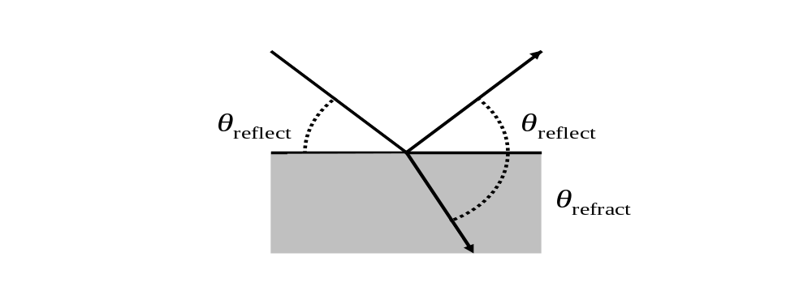
Figure 14 Reflected and refracted beams

When a wave crosses an interface it can be reflected or refracted, provided the refractive indices of the media are different: both electromagnetic and neutron waves have a critical angle or “critical edge” (θ_{c}), an angles of incidence below which all of the coherent wave is reflected and none is refracted into the second medium. Below, or more acute, this angle the wave is split into a reflecting and refracting component. Snell’s Law (equation 2.1) describes the physical relationship which predicts what the angles of reflection and refraction are with different real refractive indices of the media (n): when the angle of incidence is so shallow that its sine is greater than unity, Snell’s Law fails, and at this angle and below the entire beam is reflected.
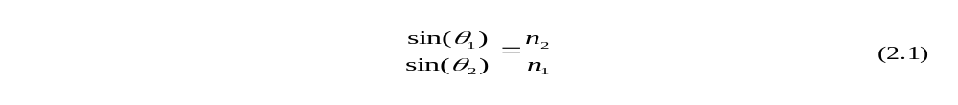
Neutron waves behave in a similar manner as electromagnetic waves, except that neutrons instead interact with the nucleus of the sample atoms and not with the electrons, which give rise to refractive indices for electromagnetic radiation. Neutrons waves are however affected by an analogous property called scattering length density (SLD), which is dependent on the identity and density of isotope nuclei within a given volume. Fortunately since neutrons are weakly interacting with matter, they are only weakly absorbed with few exceptions, and so the imaginary component of refractive index can largely be ignored in organic materials.
In the case of higher angles of incidence, where the incident beam is split into reflected and refracted components, the refracted beam can be reflected by a second buried interface. The multiple reflected waves can interfere with each other in such a way that the pattern generated contains information about the interfaces. This interference is analogous to Bragg scattering between scattering centers, except in reflectivity it is interference between planes: the reflected wave can experience a shift in the phase as it passes through the layer, which leads to constructive or destructive interference with the wave that did not pass through (Figure 15). Constructive interference, and the preservation of reflected intensity from buried interfaces, occurs only when the distance between the interfaces (d) is equal to an integer multiple of the wavelength (λ) (Equation 2.2).
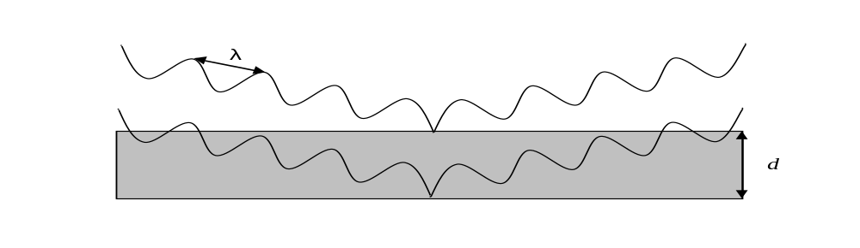
Figure 15 Interference from multiple interfaces
The pattern generated is an inverse space representation of the scattering structure of the sample, and so the intensity of the beam is monitored as a function of distance q (Equation 2.2) and replaces d in the Bragg equation (Equation 2.3). In NR experiments, the reflected intensity (R_{(q)}) as a function of q is measured: R_{(q)} is the ratio of reflected intensity at a given q to the intensity at total reflection. This R_{(q)} vs q scattering profile is the Fourier transform of the scattering length density profile (ρ), which contains the complete scattering structure of the sample, where this relationship is shown in Equation 2.4. The scattering profile therefore details the scattering length density profile, and hence composition, as a function of depth.
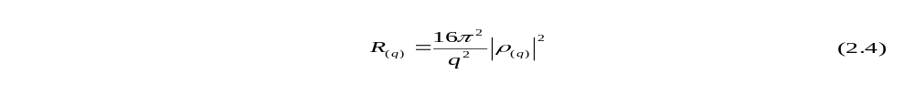
Unfortunately, the reflectivity and scattering profile are related by the square of the density profile (Equation 2.4), and so there is no unique scattering profile that matches the reflectivity as the phase or “sign” information of the transform is lost. Because of this, it is not possible to directly extract complete information about the scattering structure, and hence complete information, of a sample directly from the reflectivity data.
Reflectivity experiments vary either the wavelength or the angle in order to vary q-space: the intensity of reflection from a single interface decays in a uniform way with q⁻⁴ with increasing angle, but the reflected intensity increases for samples with multiple interfaces when Bragg’s Law is satisfied. When q is swept through Bragg conditions repeatedly, these maxima of intensity form repeating fringes in the reflectivity profile, commonly called Kiessig fringes (Figure 16). Roughness of the interface, the distance across which SLD variation occurs between materials, also strongly affects the reflectivity profile: roughness results in variation of distance between scattering sites on the top and bottom of a film, which broadens and dampens these oscillations.
Despite the inability to directly extract complete sample structure from the data, some information about monolayers can be derived from careful analysis using optical laws. In a single layer sample, spacing of the Kiessig fringes (Δq) is inversely proportional to the thickness of that layer, as defined in Equation 2.2. Also, the SLD at the top of the sample can be calculated from equation 2.4: at the maximum q where R(q) is unity is the critical edge (q_{c}) where total reflection gives way to partial refraction, is controlled by the SLD (ρ_{(q)}) of the material the beam first encounters.
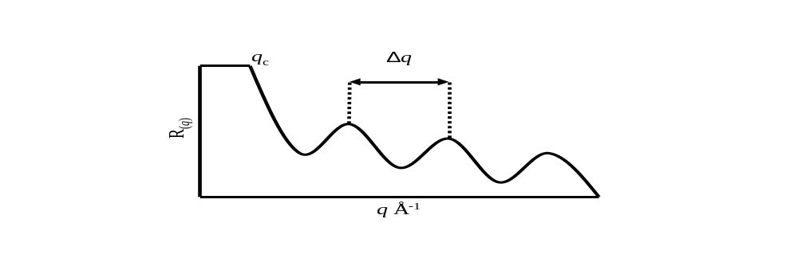
Figure 16 Schematic reflectivity data with extractable variables

To circumvent the limitation of lost phase information to extract a depth profile, a theoretical depth profile structure can be constructed which describes the depth, roughness and definition of interfaces within a sample from which a hypothetical synthetic reflectivity profile can be calculated. This synthetic reflectivity profile is then compared to the experimental profile, and the depth model iteratively refined until the calculated and experimental reflectivity profiles match. With some foreknowledge of the sample structure, the scattering characteristics of its components and suitable constraints imposed to maintain a physically realistic system, the fitting often provides a unique result that accurately reflects the structure of the sample. Fit quality is judged using χ² statistical comparison between experimental and synthetic curves (Equation 2.5).

Fabricating duplicate monolayers to derive experimental starting points for fitting is a good approach to generate accurate models. One of the difficulties in modeling multi-layer samples is that there are multiple possible models which would produce identical reflectivity curves: to mitigate the uncertainty in the modeling, particularly between models of the same bilayer as it is annealed, applying external constraints to ensure the modeling is physically realistic is important.
Mass balancing of the bilayers helps to accomplish this by constraining the models so that the scattering volume, defined as the product of volume and SLD (Equation 2.6), is similar to that defined by the sum of component monolayers, and should remain constant for all models of the same sample. The latter component of mass balancing is valid for all solid, nonvolatile materials as no material which contributes to scattering is gained or lost from the sample. Since specular neutron reflectivity only has resolution in the depth axis (d_{Z}), the depth of each layer is used as a proxy for volume, and SLD intrinsic to each material is used to differentiate each contributor to the profile.


2.1.2 Scanning Electron Microscopy
As with neutron scattering, electron beams offer very short wavelengths, complementary to resolutions of very small length scales of interest. It is relatively easy to generate an intense electron beam that can be focused or deflected with electromagnetic fields in much the same manner as optical lenses. Scanning Electron Microscopy (SEM) is also particularly useful in imaging rough surfaces as it has a wide depth-of-field, where the image generated can simultaneously resolve features over a wide range of depths. Electrons also strongly interact with matter, and at moderate kinetic energies (~10keV) penetrate only to a shallow depth in organic materials, thus rendering thick sample specimens (>100nm) largely opaque. This is beneficial for studying surfaces, since this eliminates contributions from the deeper bulk of the sample.
To generate an image, a scanning electron microscope uses a tightly focused electron beam (<1μm) that is rastered over the surface of a sample; the amount of electrons ejected from the sample is detected, and then used to map the pixels for an image. To adjust the magnification of the microscope, the area where the beam is rastered is confined to smaller dimensions, making imaging across an extremely wide range of magnifications possible, from approximately ~10¹-10⁵X⃰.
By rastering the electron beam and detecting a generated response, a wide depth of field is available: as illustrated in Figure 17, this is due to the high ratio of the working distance between the beam aperture and the sample (W), typically several millimeters, which is much greater than the diameter of the area illuminated (A), this results in the beam being essentially a nearly perfect cylindrical probe over relatively long vertical distances.
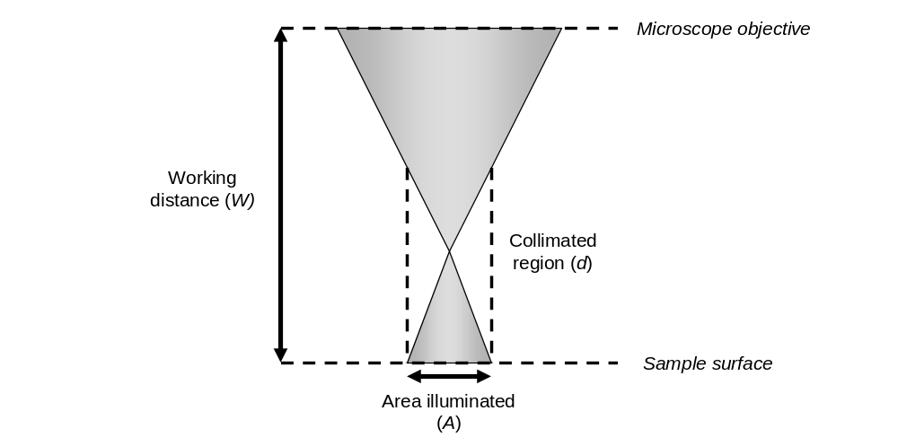
Figure 17 SEM beam geometry diagram

Electron interactions with a sample result in the release of a number of different types of detectable radiation as a response to the electron beam, though the two types considered for use in these experiments are backscattered and secondary electrons: the former being from electrons that elastically scatter back in the direction of the impinging beam at similar energies and an approximately reciprocal angle, and the latter being ejected due to ionization of sample atoms in all directions and which have much lower energies (typically <50eV).
Backscattered electron intensity contrast arises between substances with different elemental composition; the intensity of the scattering is proportional to the atomic number of the atoms irradiated, due to the increasing charge of the nucleus which is responsible for the scattering. Unfortunately, since most organic materials are composed of elements with similar nuclear charge, backscattering does not easily provide sufficient contrast to distinguish such materials. Also, since the electrons are scattered back in the direction of the beam, their yield does not change appreciably with sample topology, thus limiting their ability to elucidate three dimensional surface structures.
Secondary electrons, on the other hand, are largely insensitive to chemical composition but unlike backscattered electrons they are ejected from the surface in all directions. As electrons cannot penetrate deeply nor readily escape the bulk without high kinetic energies, the electron yield is strongly depth-dependent. So, secondary electron yield is low when little surface area is exposed (Figure 18A) rather than near an edge (Figure 18B). Greater or fewer electrons are collected from one side of the edge greatly enhancing the “topological contrast” of the microscope.
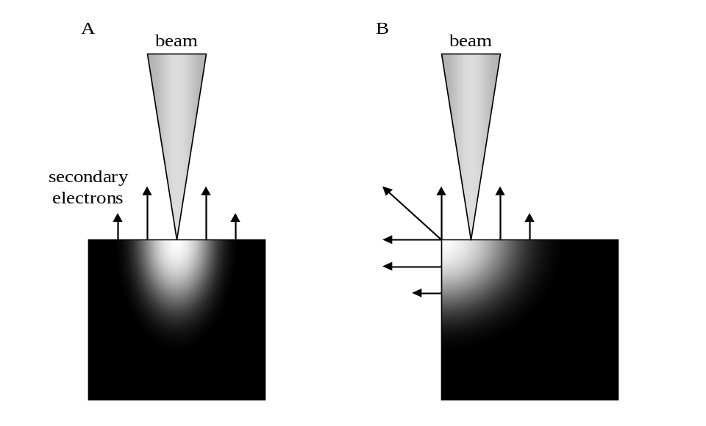
Figure 18 Secondary electron emissions from an object

2.1.3 Atomic Force Microscopy
Atomic force microscopy is another imaging technique with a resolving power well beyond that of optical microscopes, and is readily capable of resolving features on the order of 1-10nm and in ideal circumstances less. A wide variety of AFM hardware and modes of operation are available, but all work by rastering a nanoscopically sharp solid probe or “tip,” typically 5-50nm in diameter at its point, over the surface and measuring a response as the sample interacts with it. This response can be mechanical, electrical, thermal, and magnetic depending on the experiment performed, but mechanical forces normal to the surface with an oscillating tip is most commonly used to study organic materials.
In this type of AFM, the tip is mounted on the end of a flexible piezoelectric cantilever, and so forces acting on the tip are transferred into deformation of the cantilever. The flexing of the cantilever is easily detected by the reflection of a laser from the cantilever to a position sensitive detector. The cantilever is mounted so that it can be scanned in X, Y and Z axes with respect to the sample surface, and in the very common “tapping mode” the tip is oscillated by applying a current to the cantilever piezo. Tapping mode is preferred for organic materials, as the tip only momentarily contacts the sample as it is rastered across the surface, thus minimizing the application of significant lateral forces which can damage the surface being studied.
Tapping mode, illustrated in Figure 19, generates three-dimensional height maps by oscillating the “tip” vertically near its resonant frequency and the change in amplitude (A) is measured as the tip traverses the surface. The cantilever height (Z-axis) is adjusted rapidly during scanning to maintain constant amplitude in a continuous feedback loop, and the distance of this displacement serves as a proxy for the height of the sample features. Changes in the frequency or shifts in its phase as a function of the oscillatory force placed on the cantilever is also used to map changes in attractive or repulsive forces between the tip and sample. This phase mapping, which can be collected simultaneously with the height mapping, can offer contrast between materials with differing mechanical properties.
When feature size approaches the diameter of the tip (~15nm), the aspect ratio of the tip fineness becomes a factor and influences the path the tip travels. This is not a trivial source of error, since the width of the tip prevents the point from reaching the edge of small features, making them appear wider than they are. This effect is illustrated in Figure 20, with the tip path shown as the dashed line as it encounters the short dimension of a spherical particle, where the angle of the path is limited by the angle that the tip widens, with the erroneous additional width added noted as d_{e}.

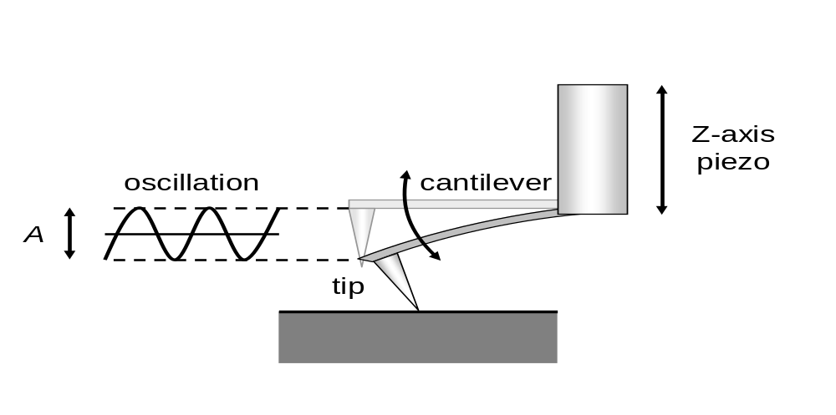
Figure 19 Atomic force microscope schematic

Figure 20 AFM tip path error when encountering objects

2.1.4 Differential Scanning Calorimetry
Differential scanning calorimetry (DSC) is a thermal analysis technique that measures heat flow, the amount of energy needed to raise the temperature of a sample as a function of temperature. DSC works by applying heat energy to a sample and an empty cell, and measuring the differential in heat flow needed to raise both to a target temperature. The difference in heat flow is therefore due to the difference in heat capacities of the sample. DSC experiments performed in this work are primarily concerned with the temperature at which changes in heat flow occur: DSC is useful in polymer blends since it can detect changes in temperature-dependent kinetic transitions. DSC was used in this work to monitor the glass transition temperature (Tg), where a polymers changes from a glassy to a rubbery state, and is the temperature at which the polymer have sufficient thermal energy to enable chain segment motion. This transition causes an increase in free volume and a decrease in the heat capacity of polymers, as chain segments are freed to move, thus requiring less energy to increase their vibrational motion.
Tg is derived from the midpoint of onset and endset temperatures of the discontinuity in the heatflow response curve, illustrated in Figure 21. These onset and endset temperatures (o and e) are defined by the intercept between the tangent of the heatflow midpoint (d) and respective baselines (b_{o} and b_{e}). Uncertainty in the glass transition temperature calculation can arise from defining the baseline above and below the discontinuity and the resolution of the heatflow. For the purposes of this study, the baselines were plotted across a minimum of 10°C in increments of 0.167°C, and a minimum total change in heatflow of 2mW across the transition region.
To minimize error from unrelieved stress in the bulk structure, called “thermal history,” within the polymer samples, each DSC experiment was performed a minimum of three times to ensure that the glass transition was detected and exceeded. This will erase the thermal history of the sample and make measurements more consistent. In all cases, the samples were rerun until the heatflow curve was reproduced consistently, and error calculated between the final measurement and the previous one to minimize selection bias.
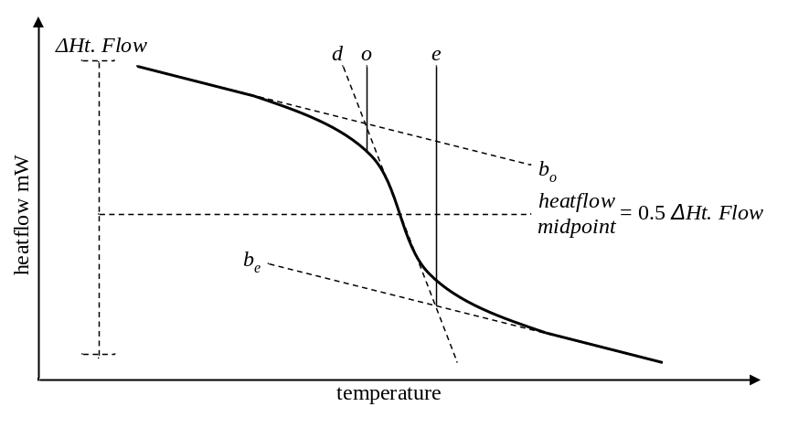
Figure 21 Schematic DSC heatflow plot. The solid curve is the heatflow response of the sample that varies across the scanned temperature range by ΔHt. Flow.

The Tg of polymer blends can be used as a relative measure of polymer solubility. According to the Fox equation (Equation 2.7), when polymers are completely miscible, then a blend will exhibit a single glass transition temperature at a weight fraction averaged intermediate between the respective homopolymer transition temperatures. As solubility increases, the two respective Tg transitions will shift until coalescing into a single transition, and so the degree of which the observed Tg of blend components deviate from the temperature predicted in the Fox equation can be used to measure the relative solubility of partially miscible polymer blends.
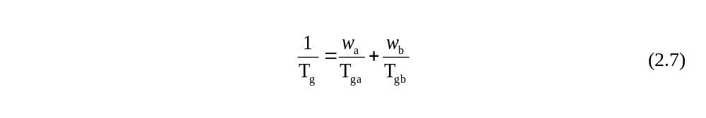

2.1.5 Ellipsometry
Ellipsometry is an optical technique that takes advantage of the polarization of light to probe the thickness and refractive index of thin films. Light waves are composed of two parallel (s) and perpendicular (p) wave components, which are defined in relation to the plane of incidence as illustrated in Figure 22. When the two parts of the wave are in phase, the light is linearly polarized, or when out of phase is termed elliptically polarized. The terms linear and elliptical come from the average vector between the amplitude maxima of the two waves perpendicular to the axis of propagation. If the two maxima are in phase, the average vector remains at a fixed angle between the wave components dependent on their relative amplitude, or when out of phase the angle rotates around the axis of propagation, tracing out an ellipse. When light reflects from an interface, the components parallel or perpendicular to the incident plane are not propagated in the same way since they interact with the surface differently, resulting in a shift in amplitude and phase. Ellipsometry utilizes the phenomenon to gather information about the material the wave reflects from.
In a simple ellipsometry experiment (Figure 22C), a linearly polarized light beam impinges upon the sample being studied, and is both partially reflected from its surface (interface ab) as well as refracted through the film and again reflected from the substrate (interface bc). This enables the characterization about the layer between the interfaces. All the reflected waves are subsequently collected and net changes in intensity and polarization recorded. The average amplitude of two components of the light wave from each interface (R, Equation 2.8) is a function of the intensity of each reflected wave component (r) from each interface. The intensity and phase of these wave components contain information about the film refractive index depth profile and thickness.
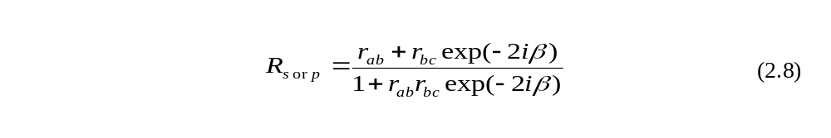
Ellipsometry measures two physical quantities of the reflected beam, the phase change (Δ) and relative intensity (Ψ) between the total s and p intensities of the reflected wave. The Drude equation (2.9) correlates Ψ and Δ to the intensity of the reflected waves from the various interfaces of the sample. The optical response of the intervening material between interfaces ab and bc, the sample film, can be also used to extract the imaginary component of reflection β of refractive index (Equation 2.10) by fitting the ellipsometry data to the Drude equation. Thus with a known refractive index n and light wavelength λ, and angle the thickness d can be measured with an angstrom-scale resolution for any one layer of the sample.

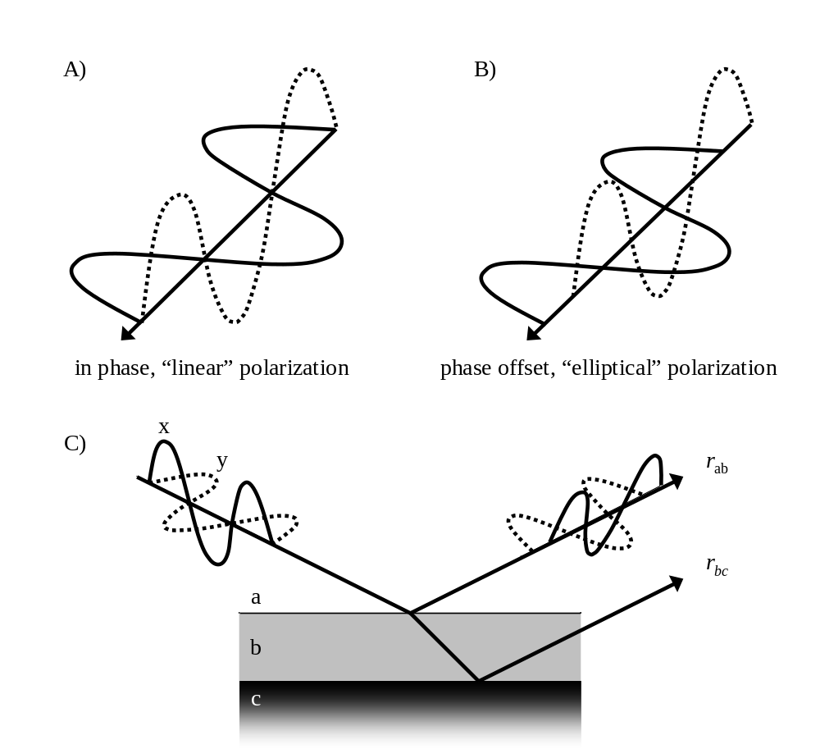
Figure 22 Ellipsometry

2.2 Lignin-Composite Experimental
The purpose of the experiments is the design, optimization, and characterization of a polymeric compatibilizer that yields a morphology which maximizes the favorable phase behavior and adhesion of polystyrene composite blends. As a model compatibilizer, Poly(styrene-ran-4-vinyl phenol) (PS-r-4VPh) was selected for this purpose and synthesized with varying quantities of the phenol to modulate its chemical character. The lignin selected is organic solvent-soluble wood lignin, which should have minimal changes or degradation from the extraction process.
To characterize the relative effectiveness of the copolymer as an interfacial modifier, experiments followed two primary avenues, the analysis of bulk phase behavior characteristics in a composite of the copolymer and lignin, and the characterization of the interfacial structure between domains of the two components. This sturdy is similar to ones performed previously by Kulasekere, Russell et al.⁴⁴ or Li and Sarkanen:⁴⁵ a series of poly(styrene-ran-4 vinyl phenol) copolymers were synthesized with amounts of vinyl phenol ranging between 10-50%, to determine the optimum composition.
The lignin-copolymer interface characterization was approached in the same fashion as Guckenbiehl, Stamm and Springer or Kulasekere, Kaiser and coauthors who studied the interfacial structure between bilayers of polymers with varying strengths of enthalpic interaction, and was conducted in a similar fashion: bilayer samples to study the lignin-copolymer interface were assembled using six deuterium-labeled poly(styrene-d8-ran-4 vinyl phenol) (PSd8-r-4VPhh8) copolymer compatibilizers and natural lignin. Neutron reflectivity was used to study the interfacial structure of polymers: NR provides a chemical depth profile of thin films with sub-nanometer resolution, which covers the length scale of interfacial width of most polymer blends. In NR, the scattering power between ¹H protons is significantly different than ²H deuterons, so NR can probe buried interfaces between otherwise chemically similar materials by isotopic labeling. Contrast between layers was obtained by selectively deuterating the synthetic styrene based polymers while the natural lignin remains protonated.
To study the bulk phase behavior, composites of copolymer and lignin were
melt-mixed and analyzed by thermal analysis using differential scanning calorimetry (DSC) and morphology is analyzed by imaging the fracture surfaces using scanning electron microscopy. To probe the interface between the copolymer and lignin, neutron reflectivity was performed on thin film bilayers to characterize the distribution of copolymer and lignin to monitor polymer interdiffusion. NR can also provide complimentary information about the solubility of the components by measuring the composition change across the interface.

2.2.1 Poly(styrene-ran-4-vinyl phenol) synthesis scheme
Two similar series of copolymer compatibilizers were synthesized in our laboratory using a standard free radical solution technique with a range of 4-vinyl phenol mole fractions varying from ~10-50%, with one set being labeled with deuterium bearing monomers. The non-labeled set of copolymers was synthesized first and the monomer ratio measured to establish the relationship between monomer feed ratio and incorporation in the copolymer to prepare the monomer mixture for the labeled copolymers.
Because of the high stability of the phenolic radical, 4-vinyl phenol cannot be polymerized directly using free radical chemistry, since any phenol radical would not propagate polymerization. A two-step method was employed to avoid this problem where polystyrene-ran-4-acetoxystyrenes were first produced and then subsequently hydrolyzed with hydrazine hydrate to cleave the acetoxy bond to yield the pendant hydroxyl (Figure 23).
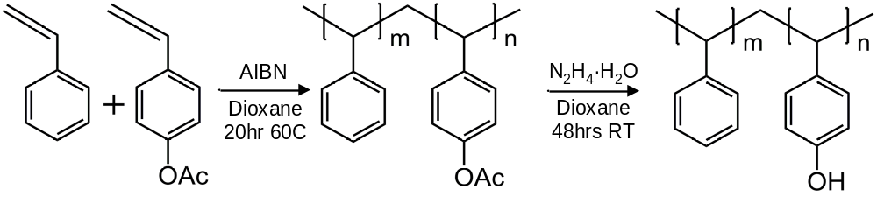
Figure 23 PS-r-4VPh Synthesis scheme
Gram quantities of protonated PS-r-4VPh were synthesized by loading a round bottom flask with varying amounts of styrene monomer, 4-acetoxystyrene monomer and
1,4-dioxane solvent. Solvent was mixed in a 1:2 solvent-monomer volume ratio and with small amounts of 2,2’-azobisisobutyronitrile radical initiator in a 1:400 monomer-initiator mass ratio to the monomer. The mixture was degassed by freezing with liquid nitrogen and evacuating for 30min to remove oxygen from the solution. These solutions were then reacted for 20hrs at 60°C under an inert argon atmosphere, and finally the copolymers were precipitated in cold methanol and dried for 48hrs in a vacuum oven at 80°C.
These polystyrene-ran-4-acetoxystyrenes were then redissolved in a 15% (v/v) mixture of 1,4-dioxane and hydrazine hydrate and then stirred for 48hrs at room temperature to convert the pendant acetoxy to hydroxyl groups. The polystyrene-ran-4-vinyl phenols were then precipitated in cold methanol (10-20% 4VPh) or hexanes (30-50% 4VPh) and dried for 24hrs under vacuum at 60°C. The differing precipitation solvent was necessitated by the relatively high solubility of high-4VPh copolymers in methanol.
Small quantities of deuterium labeled copolymers were also produced by a similar route with several exceptions: deuterated styrene-d8 monomer was used rather than the protonated form, the solvent was reduced to a 1:1 volume ratio, and the initiator reduced to maintain a similar concentration. Polymerization solutions were instead charged into 15mL glass ampoules, freeze-thawed, and finally evacuated before sealing with a glass torch. Hydrogenated monomers, AIBN initiator, and hydrazine hydrate were obtained commercially from the Sigma-Aldrich company, and deuterium-labeled styrene-d8 was purchased from Polymer Source Inc for use in synthesizing the polystyrene-ran-4-vinyl phenols.

2.2.2 Polymer characterization
All polymer material molecular weights were determined with size exclusion chromatography using a Polymer Labs GPC-20 equipped with a refractive index detector and Mixed-C 5μm PLGel columns using tetrahydrofuran as the eluent (Table 1), where M_{n} is the number average molecular weight, M_{w} is the weight average molecular weight, and PDI is the polydispersity index. Samples were run at 20°C and calibrated to polystyrene narrow standards. The ratio of styrene to 4-vinyl phenol in the polymer as a function of the monomer feed ratio was monitored with the protonated copolymers by performing ¹H-NMR on the polystyrene-ran-4-acetoxystrene intermediates dissolved in CDCl₃. Integration of the resonances of the methyl (CH₃-) of the acetoxy group at 2.2ppm (3H, singlet) and the phenyl ring protons at 6.2-7.2ppm (4-5H, multiplet) was used to measure the composition in the synthesis. Structural assignments are noted in Figure 24 and a sample spectrum is included in Figure 25 showing the indicated resonances.
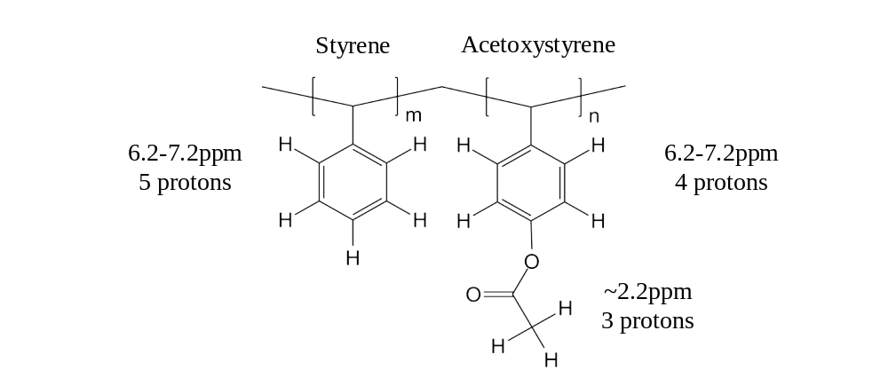
Figure 24 PS-r-PSOAc proton resonance asignments
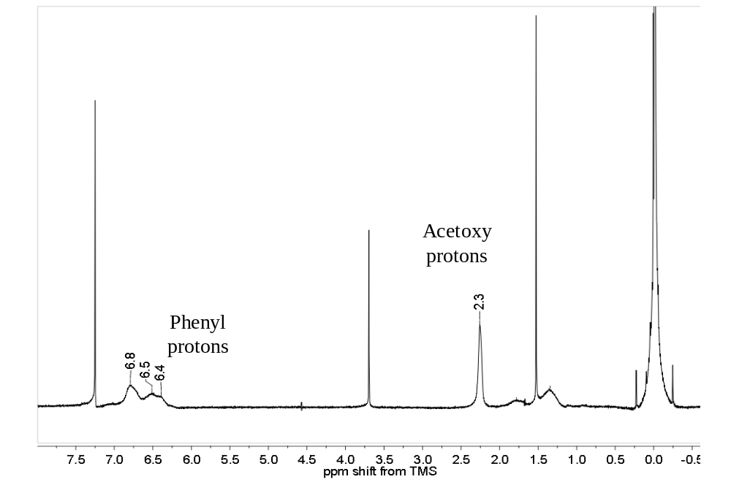
Figure 25 PS-r-PSOAc 1D-¹H NMR representative spectrum
Peak assignment and the method used to calculate the amount of 4-acetoxystyrene in the copolymer as described by Coleman and Painter was used. The acetoxy resonance at 2.2ppm is normalized to the number of contributing protons, which corresponds to the relative amount of acetoxystyrene monomers (Equation 2.11). This is then used to subtract the acetoxystyrene phenyl protons from the total, and so the remaining phenyl protons belong to the five protons of the styrene monomer (Equation 2.12). With the known contribution of the acetoxystyrene and styrene monomers to the NMR resonance, the ratio between them can be calculated (Equation 2.13). The copolymer composition is plotted as a function of monomer feed in Figure 27, and was used to guide the synthesis of the deuterium-labeled copolymers. Conversion of the acetoxy to hydroxyl groups was also verified by the disappearance of the acetoxy group resonance, as illustrated in before and after hydrolysis spectra superimposed in
Figure 26.

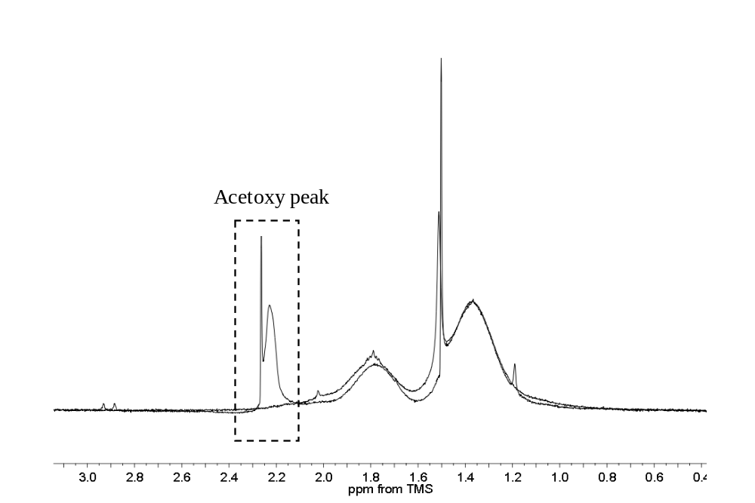
Figure 26 PS-r-PSOAc 1D-¹H NMR acetoxy peak

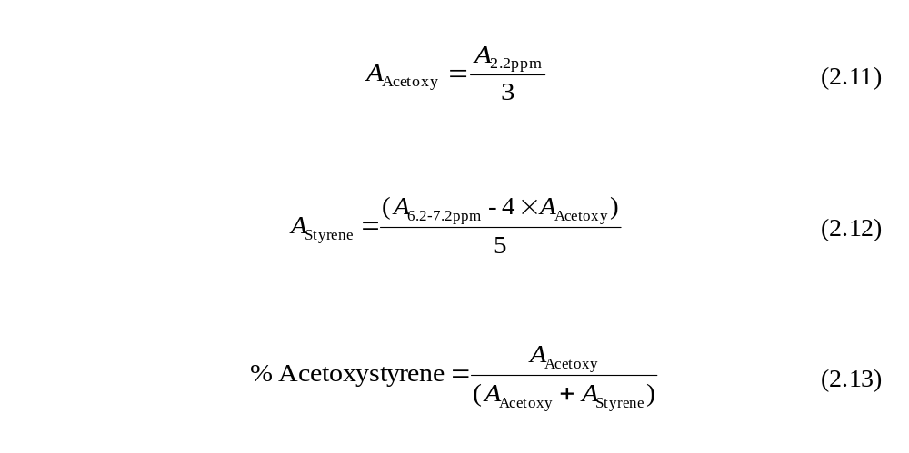
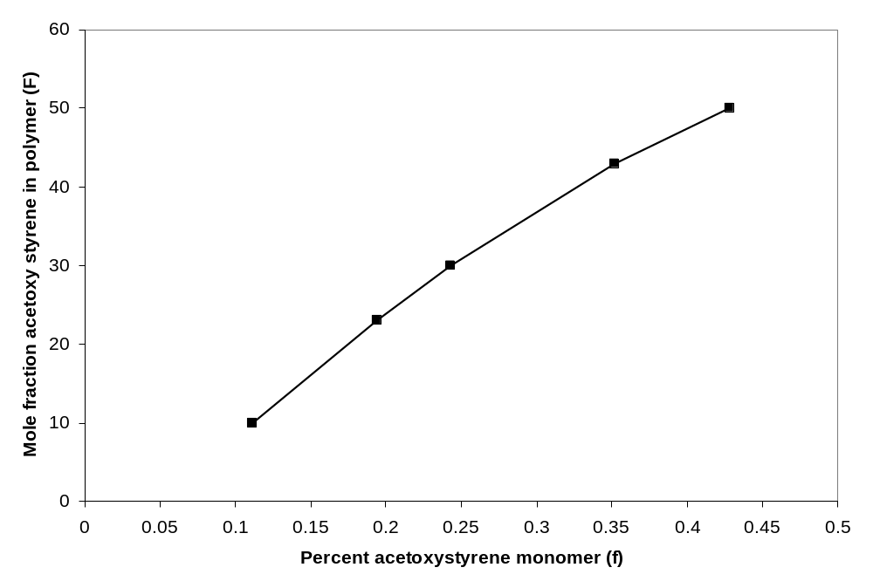
Figure 27 PSh8-ran-PSOAc monomer-polymer feed ratio
Table 1 Polystyrene-ran-4 vinyl phenol molecular weights
Name | Mole % 4VPh | M_{n} | M_{w} | PDI
Protonated
0% 4VPh | 0 | 77.3 | 196 | 2.54
10% 4VPh | 10 | 94.8 | 186 | 1.96
23% 4VPh | 23 | 88.0 | 151 | 1.72
30% 4VPh | 30 | 94.3 | 178 | 1.89
43% 4VPh | 43 | 67.6 | 114 | 1.69
50% 4VPh | 50 | 75.8 | 125 | 1.65
Deuterated
0% 4VPh | 0 | 111 | 125 | 1.13
10% 4VPh | 10 | 52.3 | 88.9 | 1.70
20% 4VPh | 20 | 62.8 | 99.2 | 1.58
30% 4VPh | 30 | 64.5 | 101 | 1.56
40% 4VPh | 40 | 70.7 | 111 | 1.57
50% 4VPh | 50 | 80.1 | 124 | 1.55
All molar masses are 10³ g/mol

2.2.3 Lignin-copolymer composite analysis
Small quantities of copolymer-lignin blends for this study were made to observe the phase behavior and internal morphology. Blends composed of 80% (w/w) copolymer and 20% (w/w) lignin were combined by melt mixing at 165°C for 15min under an argon blanket in an Atlas LMM single-screw cup melt mixer at 60rpm, extruding and reloading once half way through mixing time to maximize homogeneity. The short mixing time, low temperature, and inert atmosphere was used to limit lignin crosslinking and thermal decomposition⁴.
To observe the change in thermal properties with blending on the glass transition temperature of pure polystyrene, copolymer powders and pieces of composite, fractured similarly as with the SEM samples were studied. Samples weighing 10-20mg were examined using a Mettler-Toledo 821e differential scanning calorimeter (DSC) between 25-150°C at a ramp rate of 10°C per minute under a blanket of nitrogen gas to preclude oxidation. The Tg of pure lignin was measured after annealing under vacuum for 15min at 160°C to expose it to the same potential thermal degradation as lignin in the copolymer-lignin blends. The DSC was calibrated using indium metal as a standard (mp 156.6°C, heat of fusion 28.45 J/g). To image the internal morphology of the bulk composite samples, pieces of the composite blends were sectioned by cryofracturing with liquid nitrogen and sputter-coated with a thin layer (~10nm by built in quartz crystal microbalance) of gold metal to dissipate electrostatic charging. These fractured samples were then imaged with a LEO-1525 field emission scanning electron microscope at 5,000X magnification and 10kV acceleration.

2.2.4 Lignin-copolymer interface analysis
Neutron reflectivity (NR) was employed to characterize the interface between the polystyrene-ran-4-vinyl phenol copolymers and the lignin biopolymer. To take advantage of the nuclei-sensitive capability of NR, the synthetic copolymer was isotopically labeled by the use of a perdeutereated styrene monomer to provide contrast with the otherwise chemically similar lignin.
To ensure commonality with the lignin-copolymer blends, the lignin used for NR was likewise heated to 165°C under vacuum, redissolved, and reprecipitated so it had the same thermal history of lignin used in blends examined by SEM and DSC. In place of protonated polystyrenes used in the composites, deuterated polystyrenes were used instead. All NR samples were prepared on silicon wafers cleaned by immersion in a 3:1 (v/v) mixture of concentrated sulfuric acid and 30% hydrogen peroxide for 30min followed by rinsing with copious volumes of high purity water, having an 18MΩ resistivity and filtered with activated carbon and an 0.22μm particulate filter, then dried under a stream of nitrogen gas.
Lignin films were deposited by spin coating onto the cleaned wafers from 1% (w/w) solution of tetrahydrofuran at 2500rpm, likewise the polymer films were formed from 1% (w/w) solutions of toluene (0-10% 4VPh), methylethyl ketone (20% 4VPh), or tetrahydrofuran (30-50% 4VPh) on polished monoliths of sodium chloride. The different solvents were needed due to differences in copolymer solubility. The thicknesses of the copolymers were monitored using a DRE GmbH model ELX-02C ellipsometer with a 632nm laser at a 70° angle of incidence on duplicate copolymer films similarly spun-cast onto silicon wafers.
The copolymer could not be cast directly onto the lignin as the solvent would swell the lignin and may allow interdiffusion that would not otherwise occur thermodynamically. Therefore these films were then assembled into bilayers in intimate contact with one another by floating the copolymer onto the surface of high purity water: the copolymer coated sodium chloride monoliths were gently scored around the edges with a razor blade and slowly immersed at an angle into a container of water, in which the sodium chloride immediately below the copolymer film would dissolve and the copolymer film floats on the surface of the water by surface tension.
Sodium chloride monoliths were used rather than glass or silicon because the copolymer affinity for these surfaces made separating the copolymer from these substrates impossible. The lignin-coated silicon wafers were then submerged in the same container and used to capture the floating copolymer film. Water was removed by air drying followed by a final drying under vacuum for 24hrs.
To give the rigid, mechanically stacked lignin and copolymer films mobility to enable interdiffusion, the films were vapor annealed for 24hrs using a saturated vapor of tetrahydrofuran as in the work of Thompson and McDonald et al.. THF is a common solvent for both the copolymers and lignin. This method was chosen over thermal annealing to avoid further thermal degradation or crosslinking of the Lignin. Samples were measured in air using the Liquids Reflectometer at the Oak Ridge National Laboratory Spallation Neutron Source with an effective q-range of 0.002-0.075Å⁻¹.

2.3 Organic Photovoltaic Experimental
The morphology and solubility of OPV composites is critical to their efficiency and practicality, so experiments were performed to determine interfacial structure and solubility of an archetypical OPV. To accomplish this, neutron reflectivity was used, taking advantage of its high resolution and contrast sensitivity between ¹H proton-rich polymer and proton-poor carbon fullerenes. OPV composites are comprised of regioregular conjugated organic polymer poly(3-hexylthiophene) (P3HT) and either pure carbon-60 fullerenes (C₆₀) or the modified fullerene phenyl-C₆₁-butyric acid methyl ester (PCBM).
Neutron reflectivity bilayer samples were prepared on silicon wafers cleaned in a similar fashion as described previously for the lignin-styrenic reflectivity samples. C₆₀ fullerenes were purchased from BuckyUSA Inc and both regioregular poly(3-hexylthiophene) (M_{N} 47,600g/mol, PDI 2.1) and modified phenyl-C₆₁-butyric acid methyl ester were purchased from Sigma-Aldrich company. All OPV materials were used as received. Samples were made in two ways, one where C₆₀ was deposited over a layer of P3HT and another where P3HT was deposited over a layer of PCBM. Ideally, all of these materials would be dissolved or suspended in a solvent and spun-cast, but in the case of C₆₀ fullerenes, spin-casting resulted in an inhomogeneous layer of large “fullerite” agglomerations unsuitable for reflectivity. To avoid this problem and create a uniform layer, the C₆₀ fullerenes were coated by thermal vapor deposition, which is possible because of the very high thermal stability of the unmodified carbon fullerenes. Dr Kai Xiao performed the C₆₀ coating for this experiment at the Oak Ridge National Laboratory Center for Nanophase Materials Sciences.
C₆₀-bearing bilayers were made by spin-casting a 1% (w/w) solution of P3HT from chloroform at 2500rpm for 30sec onto a cleaned silicon wafer, followed by evaporation of a thin (~20nm) film of the C₆₀ fullerenes. PCBM-bearing bilayers were made by spin-casting a 1% (w/w) solution of PCBM from toluene at 2500rpm onto H₂SO₄/H₂O₂ cleaned silicon and a 1% (w/w) solution of P3HT from chloroform onto pre-cleaned glass slides. The latter P3HT film was then float-coated onto the PCBM-coated wafer in the same fashion as described for the lignin-styrenic bilayers. Duplicate monolayers of all materials were produced on silicon wafers via their respective deposition parameters. The samples were measured using the liquids reflectometer at the Oak Ridge National Laboratory Spallation Neutron Source, with an effective q-range between 0.002-0.100Å⁻¹. To observe the diffusion of the materials, samples were run repeatedly after annealing times of 0, 5 and 180min at 150°C under vacuum.

2.4 Cellulose Nanowhisker Experimental

2.4.1 Cellulose Nanowhisker Synthesis
The dispersion of cellulose nanowhiskers is important to the final performance and practicality of composites that use them, and to this end neutron reflectivity was employed in an attempt to characterize the interface and measure the miscibility of chemically modified nanowhiskers with poly(methyl methacrylate) (PMMA). To characterize the nanoparticles, one dimensional nuclear magnetic resonance spectrometry (NMR) was used to determine the extent of chemical modification and atomic force microscopy was used to measure the shape and size of individual or agglomerations of nanowhiskers.
Avicel© microcrystalline cellulose used as the raw material for the nanowhiskers was purchased from Fluka, and concentrated sulfuric acid used to yield the nanowhiskers was purchased from Fischer Scientific. Vinyl acetate, organic solvents and potassium carbonate for nanowhisker acetylation were purchased from Sigma-Aldrich. Perdeuterated atactic polymethylmethacrylate-d8 M_{w} 123K and PDI 1.1, was purchased from Polymer Source Inc and used as received. All chemicals were used as received without purification. Cellulose nanowhiskers synthesis was performed by Dr Philipe Tingaut, who created them by acid digestion of the microcrystalline cellulose, which causes the partial hydrolysis of the cellulose ether bonds in the polymer backbone (Figure 28).
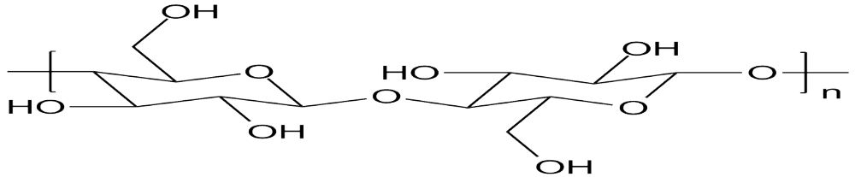
Figure 28 Cellulose polymer structure
Cellulose nanowhiskers were prepared by acid hydrolysis of suspended Avicel cellulose powder with concentrated sulfuric acid: 10g of the powder is first mixed with 49g of high purity water and stirred for 10min to yield a 17% (w/w) suspension, and hydrolyzed with 94 g of concentrated sulfuric acid by dropwise addition. The temperature was monitored and did not exceed 20°C during addition of the acid by cooling the mixture in an ice bath. After the addition was complete, the suspension was heated to 44°C for 3hr under rapid stirring to digest the cellulose. Excess sulfuric acid was then removed by repeated centrifugation (10 min, 4400 rpm) and rinsing with water until the supernatant became turbid. The final suspension of nanowhiskers was sonicated overnight (Branson 2510) at 10°C to ensure maximum dispersion and then freeze-dried to yield loose white powder of nanowhiskers.
Nanowhiskers were then subsequently acylated by transesterification with vinyl acetate (Figure 29), which exchanges the protons on the cellulose for the acetyl group, yielding volatile acetaldehyde as a product. The acetaldehyde is removed continuously during the reaction due to its high vapor pressure (BP 20.2°C) and nitrogen gas purging.
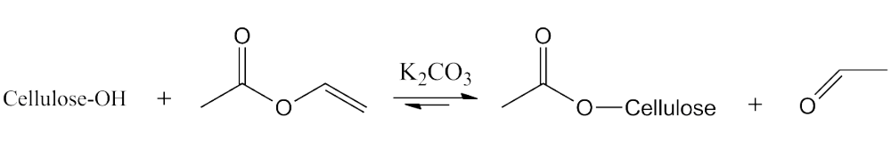
Figure 29 Cellulose acylation reaction
A typical acetylation reaction involves mixing 0.3 g of cellulose nanowhiskers with a reagent solution consisting of 10mL of DMF, 1.0mL of vinyl acetate, and 0.1g K₂CO₃. The reaction is then carried out at 94°C under reflux under dried nitrogen gas atmosphere with stirring. The degree of acetylation is varied by the length of reaction time, typically 1-24hrs. After reaction, the modified nanowhiskers were separated by filtration with a 4μm Isopore© polycarbonate membrane filter and slowly rinsed with 50mL of hot water (60°C), then with 45mL of a hot toluene/ethanol/acetone solvent mixture (4:1:1 by vol, at 90°C). Samples were finally dried at 80°C under vacuum for 16h to remove remaining solvent.
For cellulose nanowhisker diffusion experiments, the unmodified nanowhiskers were tested against two acylated nanowhiskers provided by Dr Tingaut with varying degrees of acetylation. The amount of acetylation is quantified by the fraction of the three hydroxyl groups of the cellulose ring that are acylated, hereafter called the degree of substitution (DS). For instance, peracetylated cellulose would have a DS of 3.0, as illustrated in Figure 30.

Figure 30 Triply acetylated cellulose monomer
To determine the degree to which the cellulose nanowhiskers were acylated, ¹H-NMR was employed. 10mg of acylated cellulose nanowhiskers were suspended in 750μL of perdeuterated dimethyl sulfoxide (DMSO-d6) by ultrasonication (Branson 2510) for 1h, and loaded into 5mm NMR tubes. A Bruker AC250 NMR spectrometer was used and data was collected over 128 scans and was calibrated to the DMSO-h6 solvent peak (2.53ppm). Data reduction and workup was handled with the MestReNova 6.1.1 software using its default automatic processing settings.
To calculate DS, the acetoxy (2.0ppm) and cellulose ring (3.5ppm) resonances were integrated, as shown in Figure 31, where it is also assumed that the cellulose hydroxyl protons do not contribute to either resonance. Therefore, the ratio of the acetoxy to glucose ring resonances normalized for the number of protons gives a measure of average DS using the following equation (Equation 2.14).

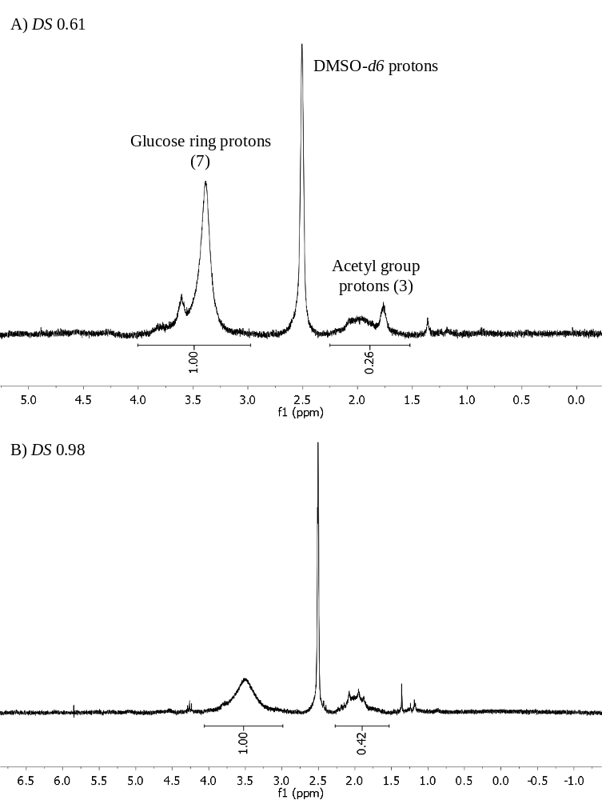
Figure 31 Acylated cellulose 1D-NMR spectra
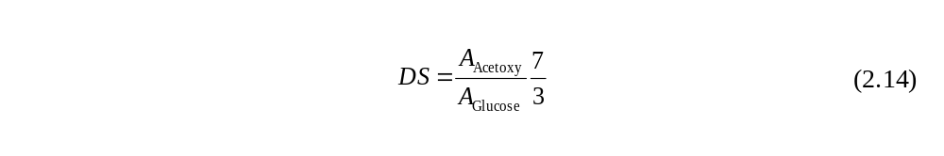

2.4.2 Cellulose nanowhiskers atomic force microscopy
Atomic force microscopy (AFM) was employed to monitor the size of the individual cellulose nanowhiskers and to map the topology of films spun-cast from their suspensions. A Digital Instruments Nanoscope© IIIa multimode scanning probe microscope, mounted on a vibration isolation table, was used for the experiment. All measurements were performed at room temperature in tapping mode using silicon scanning probe tips having a nominal spring constant of 20–80N/m and a resonance frequency of approximately 300 kHz at a scan rate of 1 line/s.
For analyzing the dimensions of individual nanowhiskers, a 5x10⁻⁶% (w/w) suspension of unmodified (in water) or acylated (in tetrahydrofuran) nanowhiskers was sonicated overnight at 10°C. One drop of this suspension was then deposited on a freshly cleaned 1x1cm silicon wafer substrates and allowed to dry in air for 24h. For neutron reflectivity measurement involving nanowhiskers films, identical parameters were used, with the exception that 1% (w/w) suspensions were spun-cast at 2500rpm for 30s, yielding much denser deposition and larger quantities of nanowhiskers.
The size of the nanowhiskers was measured by section analysis of discrete nanowhiskers, which showed no signs of agglomeration, and averaging the length and diameter of ten particles per sample. For diameter, the height of the nanowhisker above the substrate was used and assumed to be equal to the width: the width could not be accurately measured due to edge convolution with the tip, which could not clearly resolve the edges with its nontrivial diameter.

2.4.3 Cellulose neutron reflectivity
Neutron reflectivity samples were produced to determine the diffusion of acylated CNWs into PMMA-d8. Films of these materials were deposited on the same type of silicon wafers and cleaned in the same manner as described in previous NR experiments. A series of 1% (w/w) suspensions of cellulose nanowhiskers in high purity water for the unmodified or tetrahydrofuran for the acylated nanowhiskers were created by ultrasonication for 1hr and subsequently spun-cast onto silicon wafers at 2500rpm for 30sec. To assemble bilayer samples, a 100nm thick film of perdeuterated PMMA-d8 was spun-cast similarly from toluene after filtration with a 0.45μm PTFE membrane onto the nanowhisker coated silicon wafers, and the samples were subsequently dried under vacuum for 24hrs.
Samples were then measured using the liquids reflectometer at the Oak Ridge National Laboratory Spallation Neutron Source across an effective q-range of 0.002-0.100Å⁻¹. Diffusion and interface evolution were monitored by determining the depth profile of the bilayer samples as cast and after 12 and 24hr of annealing at 150°C under vacuum, to exceed the Tg of PMMA. The density profile of the nanowhiskers normal to the surface was also obtained by performing reflectivity on duplicate nanowhiskers monolayers.

Chapter 3 – Lignin Composite Compatibilizers

3.1 Lignin Project Summary
This chapter presents an experimental study of the development of a model polymeric compatibilizer for organosolv lignin containing blends, with the goal of creating a system that will increase the practical loading and enhance the performance of composites incorporating lignin. As introduced in Chapter 1 and detailed in Chapter 2, a series of polystyrene-based polymeric compatibilizers were synthesized bearing varying amounts of hydroxyl groups randomly distributed along the chain. These groups provide an opportunity to create hydrogen bonds between the copolymer and lignin, a strong enthalpic attraction, which will improve compatibility. The density and spacing of these hydroxyl groups on the polymer chain has a strong influence on its effectiveness, and is the focus of this experiment.

3.1.1 Organosolv lignin structure and compatibilizer hydrogen bonding
The lignin selected for study in this experiment was extracted from plant tissue using the organosolv process, which has extensive ether and limited ester functionality with perhaps small amounts of remnant hydroxyl groups. The 4-vinyl phenol group generally serves as the proton donor to associate with these lignin groups to create hydrogen bonds that enhance enthalpic interaction between the components (Figure 32). By varying the density of 4-vinyl phenol groups, on the linear polystyrene chain, the number and distance separating them can be modulated.
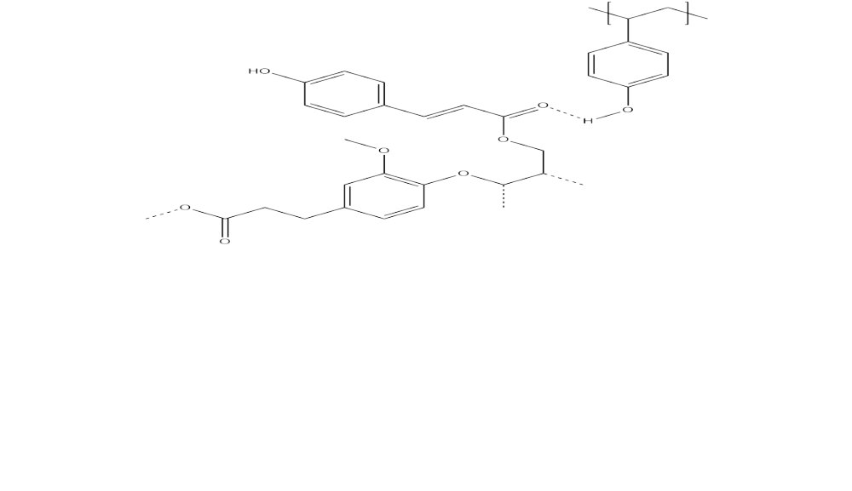
Figure 32 Illustration of lignin hydrogen bonding with 4-vinyl phenol monomer

3.1.2 Results and discussion outline
In the first half of this chapter, the experimental results are presented: first, blends of lignin with copolymers with different amounts of hydroxyl functionality were examined. Electron microscopy was used to document the dispersion of the blends and thermal analysis was used to gauge blend solubility. The effect of copolymer architecture on the interfacial structure between lignin and the styrenic copolymer was determined by performing neutron reflectivity. The second half of the chapter is devoted to a discussion of the nature of the optimal composition of the copolymer, and the competing physical principles that cause it.

3.2 Lignin Research Results

3.2.1 Scanning Electron Microscopy
The scanning electron micrographs displayed in Figure 33 are of the fracture surfaces of the six composite blend pairs of lignin with polystyrene or one of the five PS-r-4VPh copolymers. The bulk morphology revealed in the polystyrene blend (0% 4VPh) shows the presence of large micron-scale droplets protruding from the surface, or depressions in the polymer matrix where they were pulled out, when the sample was fractured. Similar features are not plainly visible with the 10% 4VPh and 23% 4VPh, but the morphology appears somewhat coarser with the 23% 4VPh. It is possible that droplets are present, but are too small to discern at this magnification. Droplet features in the blends made with the three copolymers with higher vinyl phenol are much larger with the reappearance of large, distinctly defined feature boundaries.
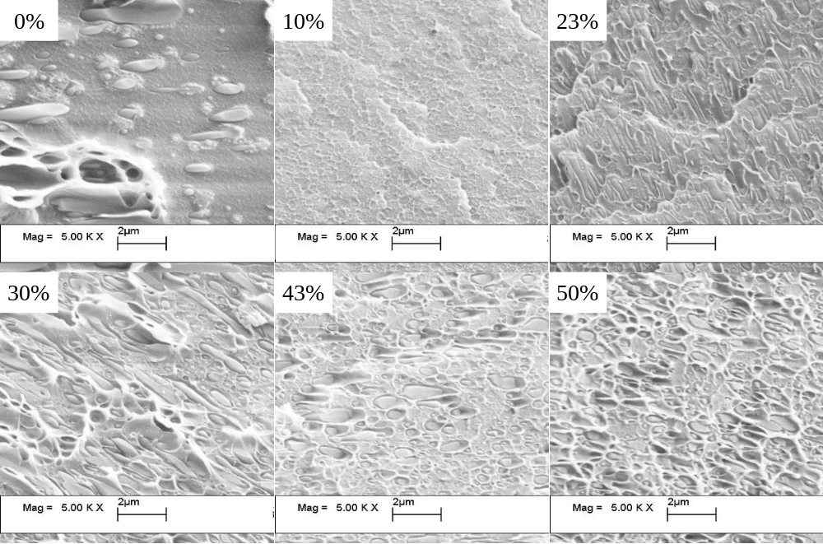
Figure 33 SEM micrographs of composite cross sections at 5000X magnification.
These droplets seen in the imagery are clear evidence of phase separation, and are composed predominantly of lignin imbedded in the copolymer matrix since the lignin is the minor component of the blends. The lack of visible droplets in the 10 and 23% VPh samples indicates either significant solubility between polymers, minimizing the chemical and mechanical difference between phases, or that surface tension between the phases in these blends is very low, resulting in a more finely dispersed mixture. In either case, these morphology characteristics are consistent with improved performance in polymer blends.
In addition, the images clearly show the pullout of the roughly elliptical lignin droplets rather than being cleaved parallel to the fracture surface indicates the easy fracture of the lignin-styrenic polymer interface. This behavior is particularly evident in the polystyrene and 30% 4VPh copolymer blends, and indicates an interfacial structure that limits the conduction of the force used to cleave the sample through the droplets. This behavior is characteristic of poor interfacial adhesion, a key reason that composites of incompatible materials often have poor mechanical properties. Given these results, the presence of hydroxyl groups on the copolymer can clearly improve the compatibility, but appears to be optimal when the vinyl phenol content is limited to ~10-23% mole percent.
Similar electron microscopy results of lignin-polymer blends gathered by Lv and Di,^{42,43} which show a much smoother fracture surface in lignin-polyethylene blends with the addition of the polyethylene-b-maleic anhydride compatibilizer (Figure 34). The blends with the compatibilizer were stronger and much stiffer, having approximately one third of the fracture elongation and tensile strength increased twenty percent with 25% (w/w) loading of lignin.
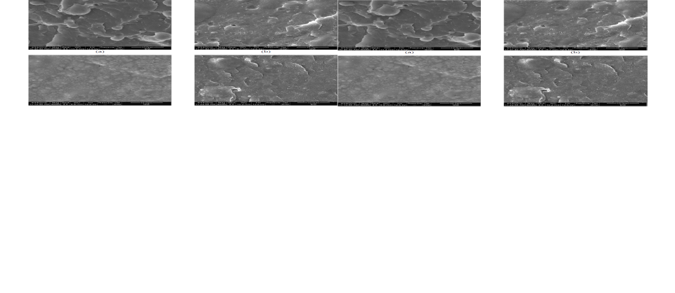
Figure 34 Polyethylene-lignin blends without (left) and with (right) polyethylene-b-maleic anhydride compatibilizer

3.2.2 Differential Scanning Calorimetry
Differential scanning calorimetry (DSC) was used to examine the effect of the vinyl phenol content of the copolymer on lignin miscibility. The glass transition temperature (Tg) of polymer blends can be used as a measure of polymer solubility: the Tg of a miscible blend ideally varies in a systemic fashion described by the Fox equation (3.1). According to this equation, a miscible blend of polymers will exhibit a single intermediate glass transition temperature (Tg) that is dependent on the respective homopolymer glass transition temperatures (Tg_{a} and Tg_{b}) and on the blend mass fractions (w_{a} and w_{b}).
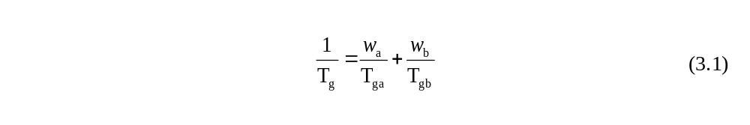
While a polymer blend that is miscible will have a single glass transition temperature, partially miscible polymers will instead form a mixture of two separate phases that each contains some quantity of both polymers. Figure 35 illustrates the differences in phase behavior with polymer pairs of different solubility: (A) is a completely insoluble mixture of black and white components, (B) is a partially miscible mixture where some intermixing has occurred, and (C) represents a completely miscible pair that forms a single homogeneous phase.
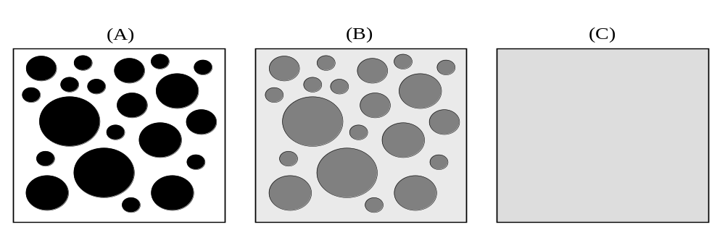
Figure 35 Illustrations of polymer blend phase possibilities: (A) shows no solubility, (B) represents some solubility, and (C) is a completely soluble blend.

As solubility increases, the amount of the opposing polymer that dissolves into each phase increases, and by measuring the Tg of these phases and utilizing the Fox equation, the composition of the two phases can be determined. In this experiment, the glass transition of the copolymer-rich phase was monitored, since this was the majority component in the blend, with an easily detectable Tg. Lignin has a higher Tg than any of the copolymers (126°C), and so as lignin mixes into the polymer-rich phase, the glass transition temperature should increase. This positive shift in Tg is used to qualitatively monitor the solubility of the polymers.
The Tg data recorded from the DSC experiments is shown in (Figure 36) Its analysis is presented below in Table 2 and plotted in Figure 37: the first and second columns denote the Tg of the pure polymers (Tg Polymer) and the Tg of the blend copolymer-rich phase (Tg Blend). The third column (ΔTg DSC) is the difference in measured Tg of the blend major phase and the pure styrenic polymer Tg. The fourth column is the difference in Tg predicted by the Fox equation (ΔTg Fox) if the blend were completely miscible using the measured Tg from the styrenic polymer, Tg of lignin (126°C), and blend ratio (0.80 polymer/0.20 lignin).
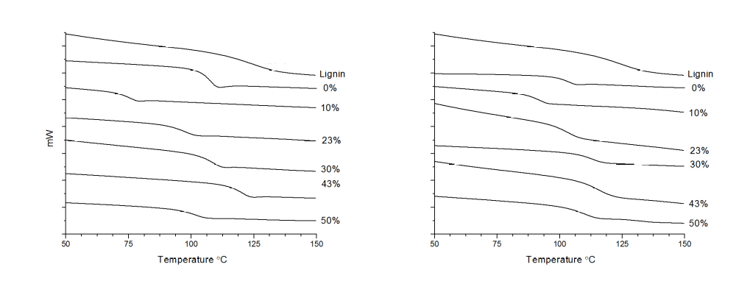
Figure 36 Homopolymer (left) and lignin blend (right) DSC heat flow versus temperature data. The midpoint of the discontinuity is taken as the glass transition temperature. Lignin homopolymer is included in both plots for comparison.

Table 2 Lignin composite differential scanning calorimeter thermal analysis data. (all temperatures °C)

Copolymer | Tg Polymer | Tg Blend | ΔTg DSC | ΔTg Fox
Polystyrene | 107 | 101 | -6 | +3
PS-r-4VPh 10% | 76 | 91 | +15 | +7
PS-r-4VPh 23% | 99 | 104 | +5 | +4
PS-r-4VPh 30% | 110 | 116 | +6 | +3
PS-r-4VPh 43% | 120 | 118 | -2 | +1
PS-r-4VPh 50% | 103 | 109 | +6 | +5

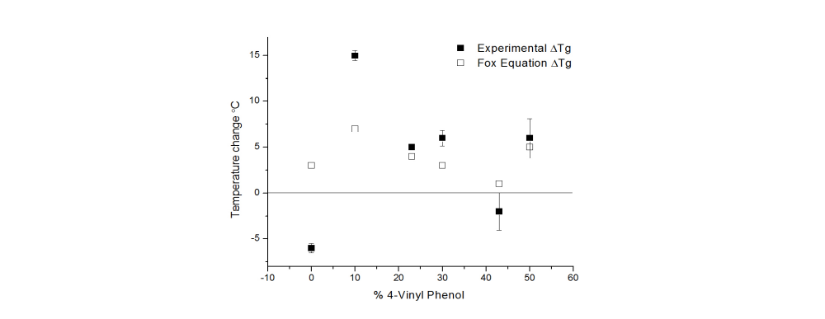
Figure 37 Plot of observed versus Fox predicted changes in the glass transition temperature of the blend when mixed with lignin as a function of styrenic copolymer composition.

Of the copolymers studied, the 10% 4VPh copolymer exhibits the largest increase in Tg of +15°C, a significantly larger absolute or relative increase than the other copolymers, which suggests the highest solubility with lignin. This thermal behavior is similar to lignin-polymer blends tested by Li and Sarkanen, which also show a significant increase in Tg in compatible blends of alkylated Kraft lignin and polytrimethylene adipate of +25°C at similar loading levels. Furthermore, they also attribute this behavior to favorable interaction. Although most of the copolymers display a positive shift, the 43% 4VPh does not appear to follow this trend. This is caused by the copolymer Tg being only slightly lower than that of the lignin, which would make any change small and more sensitive to experimental error.
The Tg of the polystyrene blend decreases significantly by -6°C: this was unexpected, since any of the high-Tg lignin dissolving into the polystyrene should increase the blend Tg, or if the pair were completely insoluble the Tg of the polystyrene phase should not be affected. The decrease in blend Tg could be due to plasticization from small molecule products produced by thermal decomposition of the lignin during melt blending. In any case, given the absence of an increase in blend Tg and the identical melt blending protocols of all the polymers, the unfunctionalized polystyrene must have low solubility with lignin, in agreement with the electron microscopy results.
An additional observation is that all but one of the copolymer blends display Tg values which exceed what the Fox equation predicts (ΔTg Fox) if the blend were fully miscible: the predicted blend Tg assumes random mixing of the polymers with no change in mobility compared to the unmixed components. However, copolymer-lignin hydrogen bond formation will result in decreased copolymer chain freedom compared to the unmixed material, and this decreased conformational freedom apparently increases the blend Tg beyond that which the Fox equation predicts.
This is beneficial in that lignin-copolymer hydrogen bonding is a favorable characteristic of the copolymer compatibilizer, and this characteristic can be correlated to the difference between the measured Tg and that which is predicted by the Fox equation. In fact, the 10% 4VPh copolymer blend shows the largest difference between measured Tg and Fox-predicted Tg, suggesting that this copolymer attains the most hydrogen bonding with lignin.
In summary, the DSC results show that the PS-r-4VPh copolymers exhibit improved solubility with lignin compared to the polystyrene homopolymer, and that the 10% 4VPh shows the highest degree of solubility and enthalpic interaction with the lignin, which is consistent with the SEM imagery that shows the morphology indicative of strongest lignin-copolymer interaction.

3.3.3 Neutron Reflectivity
While electron microscopy provides information about morphology and thermal analysis provides information about phase behavior, neutron reflectivity (NR) offers the spatial and chemical resolution needed to characterize the interface between copolymers and lignin. NR measures two pertinent parameters of the interface: the chemical difference between layers, or miscibility, and the width of the transition across the interface between the copolymer and lignin. Both parameters have a strong influence on the performance of composites, making the technique a useful way to monitor how polymer composition relates to the potential for compatibilization. By comparing these characteristics for each polymer-lignin pair, the optimum copolymer composition to mix with lignin can be determined.
NR provides a one dimensional depth profile of scattering length density (SLD) of a thin film, a measure of material scattering strength unique to each material, as a function of depth. With prior knowledge of the SLD of pure materials, chemical composition versus depth can be derived from the SLD depth profile. Six thin-film bilayers comprising the five deuterium-labeled copolymers or deuterated polystyrene and lignin were made, which serve as well-defined model lignin-polymer interfaces of dispersed droplets. By characterizing composition versus depth of these bilayers, the structure of the interface was elucidated.
Unfortunately, the reflectivity data contain information on all interfaces present convoluted together, such as the substrate-lignin or polymer-air, with the lignin-polymer interface. Therefore, it is not generally practical to directly invert the reflectivity curve of a multilayer sample and separate the individual interface reflectivity contributions into a real space depth profile. To overcome this, possible configurations of the SLD depth profiles are modeled to calculate hypothetical reflectivity profiles. These models were iteratively refined until the calculated and experimental reflectivity profiles matched.
To guide building the initial models, neutron reflectivity and ellipsometry measurements on duplicate monolayers of all materials were performed to obtain SLD and thickness of the individual films to use as starting points for modeling. The thickness of the lignin monolayer was determined by NR instead of ellipsometry, as the lignin refractive index was unknown and thus simple ellipsometry was unreliable. Additionally, the SLDs derived from neutron reflectivity of the monolayers were compared to the calculated SLDs of the materials from the stoichiometric composition using the Layers software as a test for self-consistency and were found to be in agreement.
The model depth profiles were assembled by defining the SLD, thickness, and interfacial width between each layer and iteratively refined using REFLfit software until the experimental and calculated reflectivity curves converged, for example in the polystyrene bilayer shown in Figure 38. Mass balance was maintained for each sample to help ensure the models reflect a physically plausible composition profile. Mass balancing was performed by constraining the total scattering volume discussed in Chapter 2, integrated over the depth of all the layers, to within 1% of the sum of the separate scattering volumes of each monolayer. The volume of material modeled in the bilayers is constrained to be similar to the component monolayers, maintaining physicality using information which was not modeled.

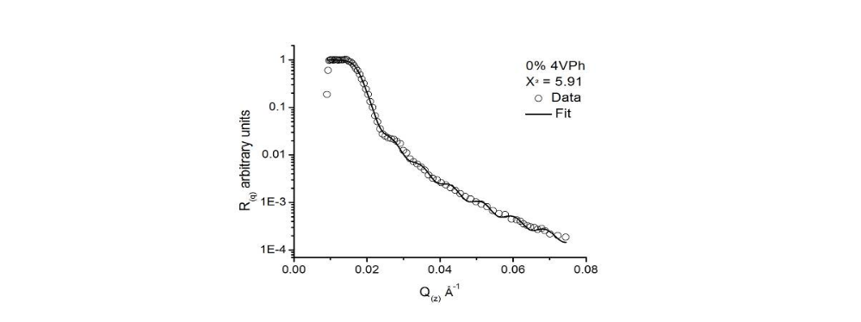
Figure 38: Bilayer experimental data and calculated model fit curve for polystyrene showing the fit converging with the data. Some interlacing data points are omitted for clarity.
The quality of all reflectivity curves calculated from the SLD models was gauged using χ² statistics, described in Chapter 2, and a fit quality threshold of 15.0 was imposed which ensured the structure of the interface was extracted with reasonable accuracy. With these SLD models fit to the data and mass balanced, the models are a good approximation of the actual SLD depth profile of the bilayers.
Figure 39 shows a representative composition depth profile, calculated from the SLD profile for the 50% 4VPh copolymer, which has been depth-normalized for simplicity: the SLD profile was converted to a composition profile using equation 3.3, which takes advantage of the unique SLDs of each material. The interface between layers is evident in the depth profile by the drop in copolymer volume fraction (ϕ_{PS(z)}), centered at approximately 60% of the depth, transitioning from the polymer-rich layer near the surface to the polymer-poor one near the substrate. All six bilayers were assembled with the styrenic polymer on top of the lignin, and so the depth profile follows the same general shape as the one shown in Figure 39. A transition with a large drop in copolymer concentration over a short distance is characteristic of a sharp and well-defined interface.
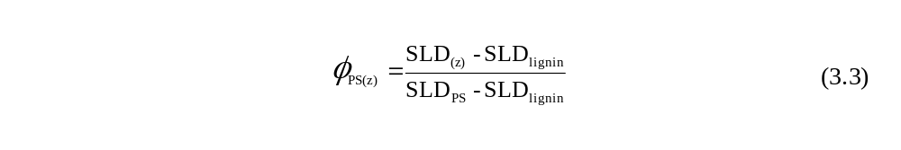
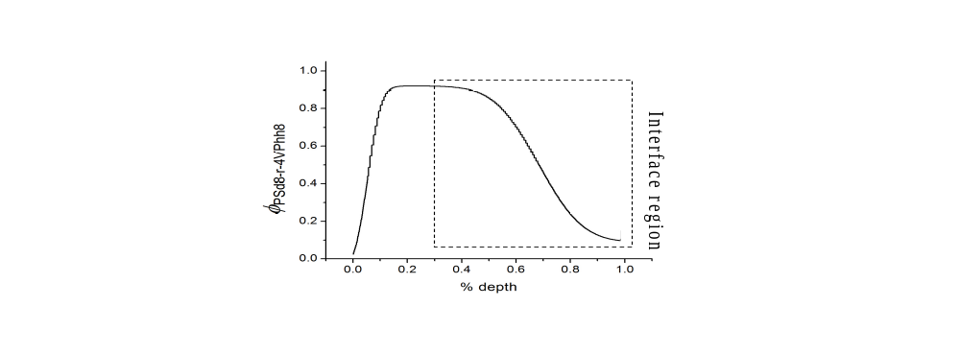
Figure 39 Depth-normalized NR composition profile model for 50% 4VPh bilayer with the interfacial region highlighted.
Further confidence in the physicality of the models can be built by comparing theoretical polymer blend behavior to the modeled interfacial structure. Schubert, Stamm and Muller performed a set of experiments to characterize polymer-polymer interface structure, and used a mean field application of Flory-Huggins theory to create theoretical models describing the shape of an insoluble polymer-polymer interface. Their study shows that the interface follows a hyperbolic tangent curve.,,,, By comparing the hyperbolic tangent models from theory to the reflectivity models offers another way to ensure the modeling is physically realistic.
Hyperbolic tangent models of depth-dependent composition were generated with equation 3.4, where the shape of the interface is defined by the variable Δϕ, which is the degree of phase separation, and w_{I} the width of the interface. The d_{I} value sets the depth of the center of the interface, and the ϕ_{I} variable sets the midpoint composition of the interface. Finally, the equation is set to be negative, as the models are in terms of copolymer concentration ϕ_{(z)} which begins at a high value and declines as depth increases for all samples.
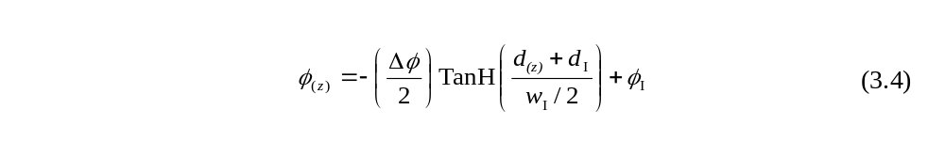
The interfacial region of the reflectivity derived composition profile were fit to a hyperbolic tangent model with Origin 8.0 using χ² statistics, and were generally found to be in agreement with excellent accuracy. However, the 30% 4VPh bilayer has an interfacial width that may approach or even exceed the total thickness of the sample, which may make a fit to the hyperbolic tangent curve for this sample inapplicable. An example of the fit to the hyperbolic tangent is shown in Figure 40, with the hyperbolic tangent curve overlaid on the reflectivity derived profile for the polystyrene-lignin bilayer.
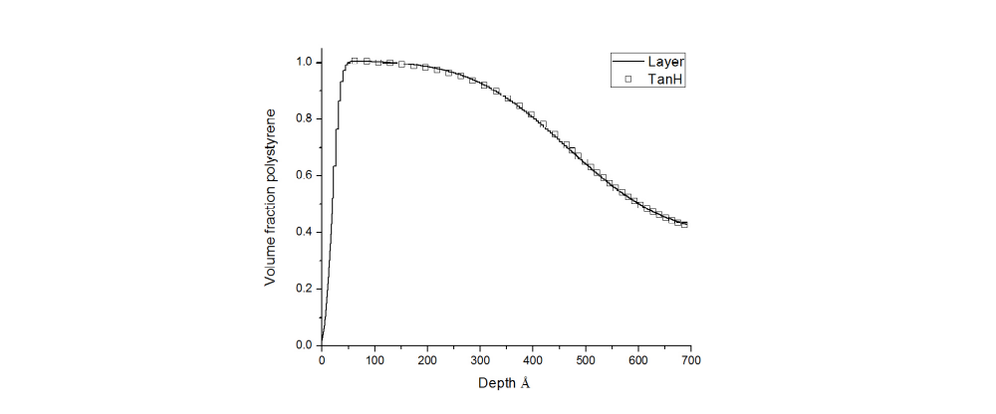
Figure 40 Example hyperbolic tangent model fit to the layer model for the 0% 4VPh bilayer.

A plot (Figure 41) and table (Table 3) of the values for interfacial width (w_{I}) and degree of phase separation (Δϕ) of reflectivity derived profiles and corresponding hyperbolic tangent-fits are presented below. Fit quality was quite good, with χ2 universally being less than 1.0 and absolute error smaller than the diameter of the plot data point. The phase separation (Δϕ) between the two layers shows a definite minimum with the 20% 4VPh copolymer indicating only a small difference in composition across the interface (~21%), meaning this copolymer is significantly miscible with lignin. Δϕ for the 30% 4VPh is not described consistently by hyperbolic and layer models, but the 20% 4VPh is still considerably lower. Higher solubility results in a material that is more homogeneous and combines physical properties of its components better.
The interfacial width (w_{I}) between lignin and the 30% 4VPh copolymer (~1000 Å) is much broader than with the other copolymers, several times as wide as polystyrene, 10-20%, and 50% 4VPh polymers. A wider interface results in more surface area between the two polymers, increasing the potential for cross-interface entanglement, imparting superior interfacial adhesion enhances composite break strength.
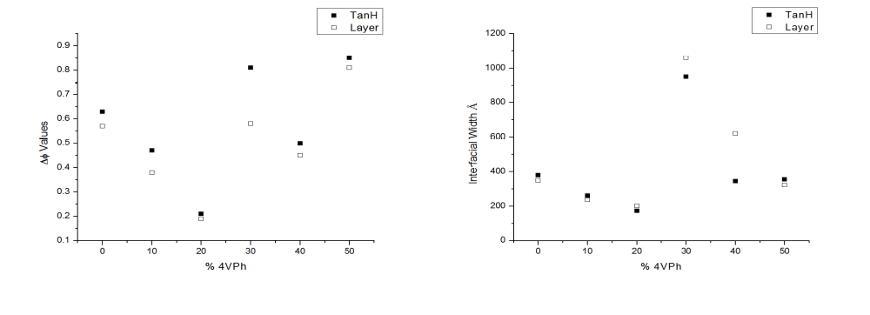
Figure 41 Composition depth profile layer-based and hyperbolic tangent-based fit parameters showing the degree of phase separation (left) and interfacial width (right). Phase separation is minimized using 20% 4VPh and interfacial width maximized with 30% 4VPh copolymers.

Table 3 Lignin-copolymer model interfacial structure parameters
Copolymer | w_{I} layers | w_{I} TanH | Fit error | Δϕ layers | Δϕ TanH | Fit error
Polystyrene-d8 (0%) | 348Å | 380Å | 1.318 | 0.57 | 0.63 | 0.00133
PSd8-r-4VPhh8 10% | 236Å | 260Å | 3.532 | 0.38 | 0.47 | 0.0053
PSd8-r-4VPhh8 20% | 202Å | 172Å | 2.316 | 0.19 | 0.21 | 0.00151
PSd8-r-4VPhh8 30% | 1060Å | 950Å | 8.018 | 0.58 | 0.81 | 0.00543
PSd8-r-4VPhh8 40% | 621Å | 345Å | 2.635 | 0.45 | 0.50 | 0.00246
PSd8-r-4VPhh8 50% | 323Å | 355Å | 1.215 | 0.81 | 0.85 | 0.00127

The NR results show that an intermediate density of hydrogen bonding groups is superior for a styrenic copolymer compatibilizer; where the interface shows a distinct widening at approximately 30% 4VPh, and maximum miscibility of lignin with the 20% 4VPh copolymer. These characteristics correlate relatively well with the SEM and DSC results though suggest a slightly higher optimal 4VPh content in the copolymeric compatibilizer. The weak phase separation of lignin with the 20% 4VPh copolymer would produce smaller domains through a decrease in surface tension, in agreement with the 10% and 23% 4VPh blend SEM imagery showing reduced droplet size. The high solubility at 20% 4VPh from NR is similar to the optimum miscibility of the 10% 4VPh found in the blend DSC study. Also, the wider interface of the 30% 4VPh copolymer as indicated by reflectivity improves interfacial adhesion between phases, reducing pullout of the lignin droplets as observed in the 23% 4VPh blend SEM image. While the results do not correlate exactly, these results are consistent with an optimal compatibilizer containing intermediate vinyl phenol content.

3.3 Discussion
The results from these three experiments show the favorable effect of an intermediate density of hydrogen bonding hydroxyl groups on the ability of a copolymer to compatibilize a lignin-polystyrene interface, improving the dispersion, miscibility, and interfacial structure of blends with lignin. The compatibilizer introduces enthalpic interactions with lignin by employing its hydroxyl groups to form non-covalent hydrogen bonds, introduces strong attractive forces between the otherwise incompatible materials.
The optimum composition of the PS-r-4VPh compatibilizer appears to be near ~20% 4VPh, with experimental results indicating a value in a window between 10-30% 4VPh content: blend dispersion and adhesion appear optimized in electron microscopy between 10-23% in agreement with blend solubility measured by thermal analysis, and the mixing and interfacial width measured by neutron reflectivity are maximized at 20 and 30% 4VPh.
The 10% lower bound of this window can be readily explained in that copolymers with fewer hydroxyl groups have insufficient density of vinyl phenol groups, with accessible lignin hydrogen bonding sites remaining unutilized, leading to weaker enthalpic interaction between the copolymer and lignin. With more vinyl phenol groups, more inter-polymer hydrogen bonds are formed, and blend enthalpic interaction further improved.
The mechanism whereby blend compatibility decreases with copolymers above ~20% 4VPh content is more complex, and occurs due to a number of reasons which will comprise the remainder of this discussion. This behavior has been previously researched by a number of researchers, most prominently by Coleman and Painter: who used infrared spectroscopy to quantify the extent of hydrogen bonding between poly(2,3-dimethyl butadiene-ran-4 vinyl phenol) and poly(ethylene-ran-vinyl acetate) copolymers shown in Figure 42 (A and B respectively). In these blends the 4-vinyl phenol spacing was varied by modulating the dimethyl butadiene content, while the spacing of the ethylene-vinyl acetate copolymer was held constant. The polyethylene-ran-vinyl acetate serves a similar role as the lignin as the hydrogen bond accepting substrate.
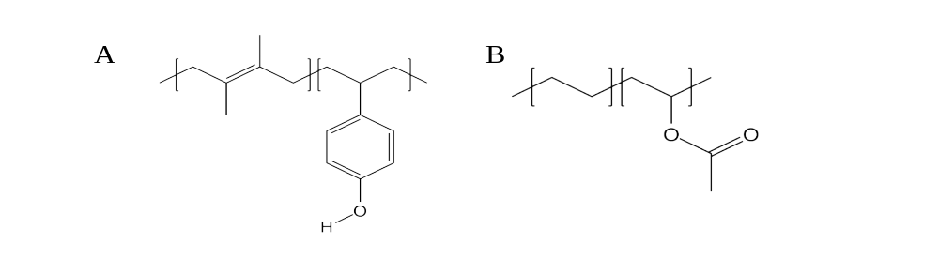
Figure 42 Poly(2,3-dimethyl butadiene-ran-4 vinyl phenol) and poly(ethylene-ran-vinyl acetate) copolymers used in Coleman and Painter et al¹⁶⁶ hydrogen bonding study.

The hydrogen bonding of the 4-vinyl phenol with the vinyl acetate copolymer ester group or with other vinyl phenol hydroxyl groups is monitored in the blend by examining the intensities of hydroxyl and carbonyl absorption peaks in the infrared spectra. With this method, the effect of modulating the spacing of the vinyl phenol groups on inter- and intra-hydrogen bonding was quantified. Unfortunately, this analysis is not feasible for blends of hydroxyl-bearing copolymers with lignin, such as PS-r-4VPh used in this project, since lignin may have residual hydroxyl in addition to carbonyl functionality: in our system, inter and intra- molecular hydrogen bonding cannot be distinguished.
Coleman and Painter’s results showed that as the 4VPh content increased from 18% to 70% mole percent, the relative amount of desirable inter-polymer hydrogen bonding decreased: a primary reason they cited is conformational hindrance of 4-vinyl phenol groups that are crowded too closely together along the polymer chain to form hydrogen bonds with the other polymer. If hydroxyl groups are in close proximity to each other on the same copolymer chain and a hydrogen bond forms, this bonding partially pins the chain at that point. Nearby unbound groups therefore lack the conformational freedom to find another accessible site to properly orient for hydrogen bonding. This concept is illustrated in Figure 43, where the free 4VPh monomer in the center of the upper chain segment is limited in its movement and is unable to form an intermolecular hydrogen bond.
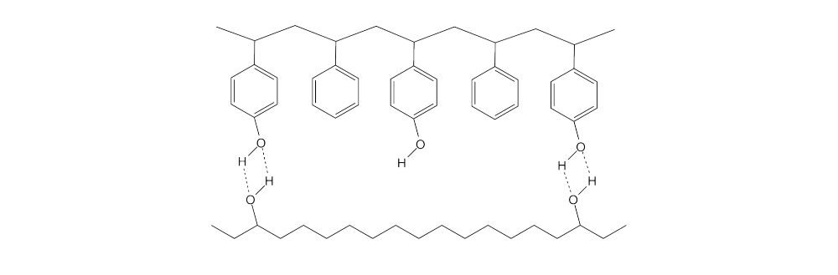
Figure 43 Conformational hindering due to chain connectivity preventing the center hydroxyl group from finding hydrogen bonding sites on a hypothetical polyalcohol.

Furthermore the segments of polymer chains that form intra-polymer hydrogen bonds prevent adjacent groups from freely mixing through the bulk, “screening” these nearby monomer units from diffusing to find inter-polymer hydrogen bonding opportunities. This can promote further unfavorable intra-polymer bonding when hydroxyl groups hydrogen bond on each other: as illustrated in Figure 44, where an initial bond formed between chain segments (A) causes more hydrogen bonds to form with adjacent groups (B) due to chain connectivity. This explains why the compatibility between opposing polymer types not only ceases to improve but decreases with increasing density of hydroxyl groups beyond the intermediate amount in lignin-4-vinyl phenol results.
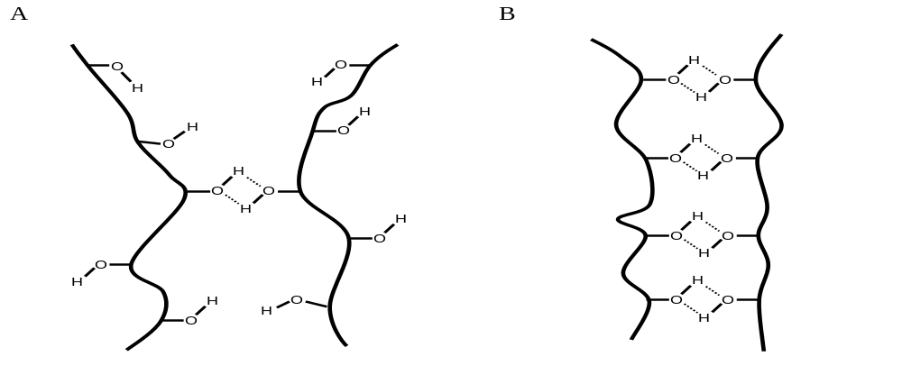
Figure 44 Screening effect enhancing intra-copolymer hydrogen bonding between like polymer chains.

3.4 Conclusions
In this work the design of a copolymer compatibilizer between organosolv lignin and polystyrene was investigated using polystyrene-ran-4-vinyl phenol copolymers as a model system to increase the interfacial adhesion, enhance dispersion and improve miscibility. Copolymers containing 0-50% 4VPh were prepared and their performance as a compatibilizer was analyzed by electron microscopy, thermal analysis and neutron reflectivity.
The study of the blend morphology and thermal behavior shows that a copolymer with approximately 10-23% 4VPh yields a much finer dispersion and matrix glass transition temperatures more strongly shifted than copolymers with little or high 4VPh density, indicative of good interfacial adhesion, higher miscibility, and stronger enthalpic interaction. Characterization of the interfacial structure between films of lignin and copolymer with neutron reflectivity shows a maximum of mixing with copolymers of 20% 4VPh and a maximum interfacial width at 30% 4VPh. Lower 4VPh content may not provide sufficient hydrogen bonding to maximize compatibility, while above ~30% 4VPh the crowding of copolymer functional groups and intra-copolymer hydrogen bonding prevents additional hydroxyl groups from interacting with the lignin, reducing improvement.
These results underscore the potential of a compatibilizer to enhance the miscibility, dispersion and interfacial width in lignin composite blends. These characteristics are known to strongly influence blend performance and limit the composition range of composites. The careful design of this compatibilizer is important to achieving the strong enthalpic or electronic interactions with lignin to mitigate the problems posed by the incompatibility with other polymers. For such composites to be effective and efficient, the overall macromolecular design and not simply the selection of ideal interacting monomers of the compatibilizer are both important. The results of the experiments in this work show that the proper design is crucial, and a poorly designed compatibilizer leads to blend behavior that suggests it would not enhance performance.
Designed properly, polymeric compatibilizers can make it practical to blend different polymers and make composites with desirable combinations of physical or chemical properties in a controllable fashion and enable composites of low value feedstock like lignin or recycled polymers, yielding new materials that add value while reducing waste.

Chapter 4 – Organic Photovoltaics

4.1 OPV Project Summary
Organic photovoltaic devices incorporating the modified carbon fullerene Phenyl-C₆₁-butyric acid methyl ester (PCBM) have been demonstrated to produce efficient OPV devices with good conversion efficiency.^{57,,} The experiments described in this chapter aim to resolve unknown details of their structure in order to better understand how they operate and the ideal cell morphology. The performance of organic photovoltaic (OPV) cells in large part hinges on charge carrier mobility, which is strongly influenced by the electron donor-acceptor (D-A) morphology of the cell active layer.
To understand why morphology is important, the mechanism of OPV cells must be introduced: photons absorbed by the organic photoactive material excite electrons into a high energy state while vacating lower energy orbitals, commonly dubbed holes. Due in part to the poor conductivity of organic photoactive materials, the excited electron remain bound in close proximity to the empty orbital (i.e hole) to form an exciton that is composed of the electron and hole. To harness the energy from the absorbed photon, the excitons must find a D-A interface to disassociate, after which the electrons and holes are conducted to their respective electrodes to establish an electric current.
Unlike traditional inorganic photovoltaic cells like those based on silicon, exciton disassociation only occurs in very close proximity to a donor-acceptor interface or electrode. These excitons remain paired together as a unit within the photoactive material, and while they have some mobility to diffuse, their short lifetime permits them to travel only a very limited the distance, ~10nm, before undergoing unproductive recombination.,,, Also, while most OPV active layers strongly absorb light, they must still be >100nm thick to capture a large fraction of the intensity from sunlight. The short exciton diffusion length and the much larger minimum useful thickness of OPV active layers present two conflicting characteristics for OPV design.,,
However, once disassociated, the separated electrons and holes can travel much longer distances through their respective donor or acceptor material to the electrodes, assuming sufficiently effective pathways exist. The bulk heterojunction (BHJ) morphology takes all of these requirements into account by taking advantage of the nanoscale phase separation of a blend of donor and acceptor materials, which can yield short domain spacing with large interfacial areas. An ideal BHJ morphology for the OPV active layer minimizes the distance that photo-generated excitons must travel from the site of excitation to a D-A interface to within their diffusion length while allowing devices to be much thicker by establishing a network of D-A domains throughout the cell to allow charge transport to the electrodes.
BHJ films are typically made by blending donor and acceptor materials in a common solvent and then creating the cell active layer by solvent casting the mixture with subsequent treatment to allow phase separation. One of the unresolved key questions about BHJ morphology-performance relationships is the role of intermixing and the structure of the interface between donor and acceptor materials. The model BHJ morphology consists of a co-continuous network of phase separated donor-acceptor materials with length scales of tens of nanometers, however the fine structure of the interface and the degree of phase separation in efficient cells is unknown, and so work in optimizing morphology has largely been empirical.
Electron microscopy by Hoppe and Sariciftci provided critical evidence of the general connection between phase separation and enhanced performance, but to date the exact nature of donor-acceptor domain composition and interfacial structure have been lacking due to the difficulty in obtaining both the high resolution and chemical contrast required. It is difficult to characterize the BHJ morphology experimentally, as common techniques that have the necessary resolution do not have sufficient contrast between most conjugated polymers and fullerenes, for instance electron microscopy, and X-ray scattering.^{80,,}
This is because this contrast depends on differences in electron density, and the electron density is similar between most hydrocarbon based OPV donor and acceptor materials On the other hand, neutron based techniques derive contrast from the nuclear character of the atom, where there is particular contrast between protons and other light nuclei. The magnitude of this contrast fortuitously differs significantly between proton-rich polymers and proton-poor fullerenes that are used as D-A materials in high performance OPV devices. This chapter details results and analysis of probing the D-A interface with a neutron scattering based technique.
Mackay, Majkrzak and coworkers produced estimates for the contrast of electron and neutron scattering techniques between the OPV materials P3HT and PCBM that illustrate the contrast advantage of neutrons: the calculated average electron density of PCBM is 4.0x10²³ e⁻/mL and for P3HT 3.6x10²³ e⁻/mL, yielding a difference of only ~10%. The authors also calculated and experimentally confirmed neutron scattering length densities (SLDs) of 3.76x10⁻⁶Å⁻² and 0.67x10⁻⁶Å⁻² for PCBM and P3HT, respectively, a difference of ~70%.
Neutron reflectivity was employed to study the structure of the interface and measure the mixing between two carbon fullerene electron donors, C₆₀ and PCBM, with regioregular poly(3-hexyl thiophene) (P3HT) electron donor photovoltaic polymer, which are common in organic opto-electronics. By characterizing the interfacial structure with NR, insight can be gained into the fine structure of high performance BHJ cells.
Multi-cm² thin film bilayers of C₆₀ or PCBM and P3HT were made to serve as model BHJ interfaces, then the depth profile of each bilayer was determined with reflectivity and annealed sequentially to observe how the polymer-fullerene interface evolves with annealing time. The C₆₀-P3HT bilayer was assembled by vapor deposition of C₆₀ on a monolayer of P3HT (Figure 45A), and the PCBM-P3HT bilayer was assembled by float-coating the polymer onto a previously spin-cast PCBM layer (Figure 45B). The difference in assembly techniques was due to the tendency of C₆₀ to crystallize from concentrated solutions, rendering a spin-cast film too rough to perform reflectivity. PCBM on the other hand formed a uniform layer from solution, but the organic side chain could be damaged at the high temperatures required for vapor deposition. Measurements were performed on duplicate monolayers of all three materials and on the two bilayers as cast and after a short (5min) and a long (3hr) annealing time at 150°C. A detailed listing of experimental parameters can be found in chapter 2.
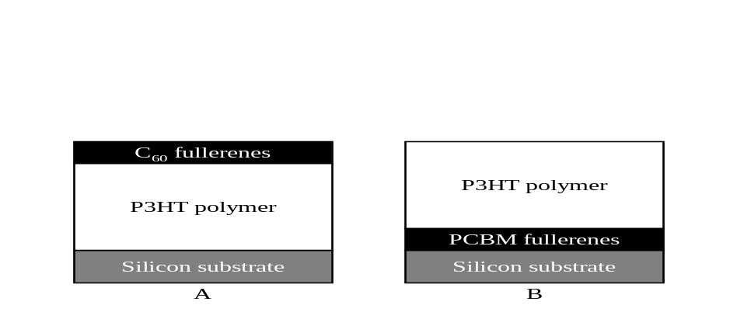
Figure 45 A) C₆₀-P3HT bilayer and B) PCBM-P3HT bilayer sample geometry schematic, showing the inverse configuration.

4.2. Qualitative Neutron Reflectivity Results
The reflectivity curves of the two bilayers, as cast and annealed are shown in Figure 46. Inspection of this figure shows that the response to heating is different for the two bilayers: in the case of the C₆₀ bilayer (Figure 46A), the strong fringe arising from the C₆₀-P3HT interface centered near 0.060Å⁻¹ is attenuated but retained with annealing, where neither its position nor shape significantly changes. This indicates that the bilayer structure did not significantly change with heating, and it can be inferred that only a small increase in C₆₀-P3HT interfacial roughness or a small amount of intermixing occurred. Either of these processes would reduce the definition of the interface to attenuate the fringe intensity.
The PCBM bilayer in contrast radically changes after five minutes of annealing (Figure 46B), but does not change further with longer annealing. The rapid loss of the fringe centered near 0.055Å⁻¹ makes it clear that the P3HT-PCBM interface that existed as cast was lost with heating: this occurs if the PCBM and P3HT layers inter-diffused, eliminating the interface which created the fringe. The qualitative difference in behavior between the two fullerenes is dramatic, with PCBM quickly dissolving into the polymer while C₆₀ does not.
A simple experiment was conducted to corroborate these results. In this experiment, bilayers were assembled with similar configurations as the reflectivity samples on small silicon chips and annealed. C₆₀ and PCBM were spin-cast onto a silicon wafer, and pieces of P3HT film were subsequently float-coated on top of them. The C₆₀ fullerenes were spin-cast in this experiment, as the film produced need not be as smooth as those employed in the reflectivity experiments. These chips were then annealed at 150°C and the color change monitored after 15min of annealing. The C₆₀-P3HT bilayer remained visibly unchanged (Figure 47 A and B), while the PCBM-P3HT bilayer changes to a deep purple color (Figure 47 C and D). The color change in the PCBM-P3HT bilayer is notable for two reasons, the first that the two bilayers have such markedly different behavior is indicative of significantly different mixing behavior of the bilayers. Secondly, fullerenes have a distinct purple color when dispersed, as is observed in the annealed PCBM-P3HT bilayer in Figure 47D and in the solutions in Figure 47E. The color of the annealed PCBM-P3HT bilayer and its absence in the C₆₀-P3HT bilayer is the result of the PCBM fullerenes dispersing into the polymer while C₆₀ fullerenes do not, which is in overall agreement with the neutron reflectivity results.

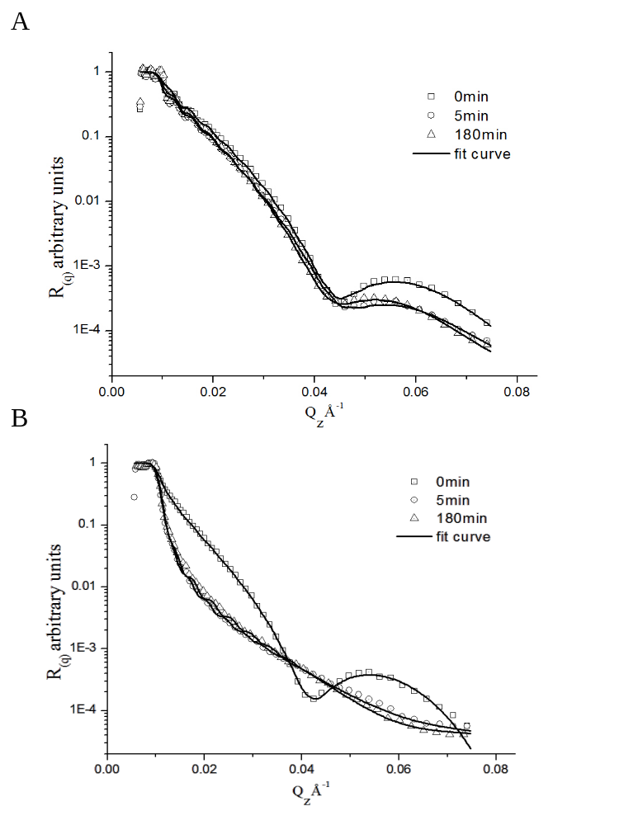
Figure 46 A) C₆₀-P3HT bilayer and B) P3HT-PCBM bilayer reflectivity data curves (interleaving data points omitted for clarity).
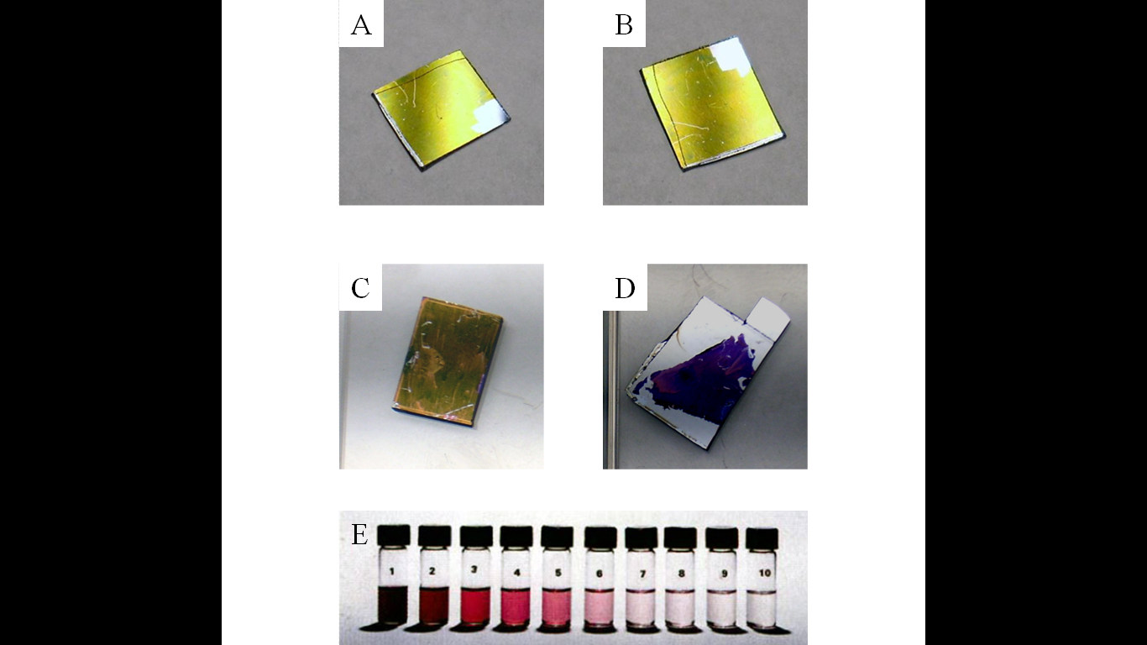
Figure 47 A-B) C₆₀ bilayers and (C-D) PCBM bilayers with P3HT before and after annealing, showing differences in fullerene dispersion. E) A series of different concentration C₆₀ solutions in dichloromethane showing the color of dispersed fullerenes.

4.3 Quantitative Neutron Reflectivity Results
Neutron reflectivity also offers quantitative information about the bilayer structure and mixing of the materials. To elucidate this information, the experimentally determined reflectivity is compared and fit to the theoretical reflectivity curves of model depth profiles of the bilayer. This fitting was performed using REFLfit software, where the SLD vs d_{(z)} depth profile models were made by assembling layers from prior knowledge of layer thickness and scattering length density. The starting points for the SLDs of each material were calculated from the known stoichiometry, bulk density, and atomic scattering parameters and were found to be in agreement with the SLD of the as-cast bilayers.
The calculated reflectivity curves of these models were then fit to the experimental reflectivity curves. Fit quality is judged using χ² statistics as defined in Chapter 2, with a threshold value of ~10. A mass balance was maintained in this fitting procedure to verify the physical realism of the models by first ensuring that the area under the SLD depth profile of the annealed samples is generally in agreement with those of the un-annealed bilayers; some variation was observed, as deposition techniques employed do not deliver precisely consistent thicknesses or SLDs, but was not considered significant. Second, between models of the same bilayer, the integrated area under the SLD profile was constrained to remain constant within 1% of an average. The fact that no material is lost between NR measurements makes this a useful guideline, since the total mass of material defined in the model remained constant.
The resultant scattering length density depth profiles of the two bilyares are shown in Figure 42. In this figure, the high SLD C₆₀ fullerene layer between 0~300Å sits on top of the low SLD P3HT layer running from 300~1800Å for the un-annealed C₆₀-P3HT bilayer (Figure 48A). As the bilayer is annealed, no significant change is observed in depth profile, the interfacial width remains relatively constant at approximately 6nm, with a small reduction in the C₆₀ layer SLD and increase in P3HT SLD. This indicates only limited mixing, and the interface between layers remains sharp and well defined.
The inverted configuration of the as–cast PCBM-P3HT bilayer, shows the thick layer of low SLD P3HT from 0~1500Å lying on top of a thinner high SLD PCBM layer from 1500~1750 Å (Figure 48B). Significant changes in the P3HT-PCBM models depth profile occurs after annealing: a considerably higher SLD layer covering the majority of the depth and the absence of the PCBM layer is consistent with the PCBM dispersing into the P3HT homogeneously. A second layer below this one, between 1500- (5min) or 1700- (3hr) and 1750Å, with a low SLD also exists in this sample. The SLD of this layer is similar value to that of pure P3HT, and is attributed to the growth of a crystalline layer of the polymer. The low value of the SLD indicates that very little of the high-SLD PCBM resides in this layer. The crystallization of the polymer can exclude the PCBM fullerenes, which would account for the high purity of the layer.

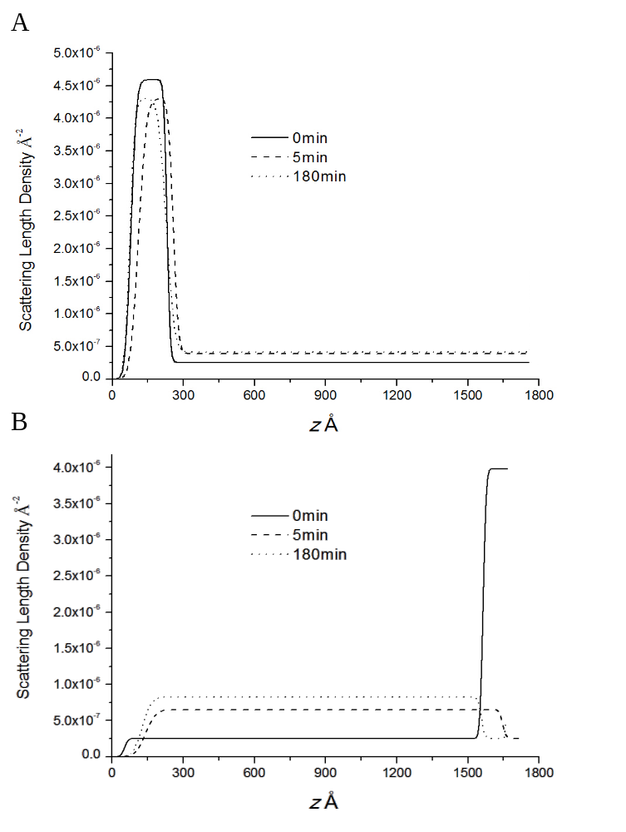
Figure 48 A) C₆₀-P3HT and B) PCBM-P3HT bilayer models
The degree of intermixing between materials in each layer is calculated from the SLD profiles using equations 4.1 and 4.2 to yield the P3HT volume fraction as a function of depth (z). In the equations, the volume fraction at depth (ϕ_{(z)}) is calculated as a function of scattering length density (SLD_{(z)}) using the scattering length densities of the P3HT and C₆₀ or PCBM (SLD_{X}). SLD values for these calculations were taken from the top and bottom of the un-annealed bilayer models, which have each material discretely deposited. Plots of the P3HT concentration profiles of the as-cast and annealed samples that are derived from this analysis are shown in Figure 49.

These depth profiles show that only a small amount of C₆₀ fullerenes (~3%) diffused into the P3HT layer. The value provides an approximate solubility limit for C₆₀ fullerenes in P3HT, as the fullerene layer is maintained and remains effectively unchanged after additional annealing. This is consistent with the retention of sharp interface in the bilayer and a indicates the poor solubility of C₆₀ with the polymer
The solubility of PCBM in P3HT is observed to be much higher than that of C₆₀ by the rapid interdiffusion and homogeneous distribution of PCBM within the P3HT layer. An analysis of this depth profile shows that PCBM concentration of ~12% in this mixed layer. This value should be viewed as a lower limit for the solubility of PCBM in P3HT, since the entire volume of the PCBM was incorporated into the polymer layer: if the solubility limit of PCBM were reached, at least a portion of the PCBM layer would be retained at some depth regardless of the amount of annealing. No model that incorporated a PCBM-enriched layer was found to produce a reasonable fit to the reflectivity data.
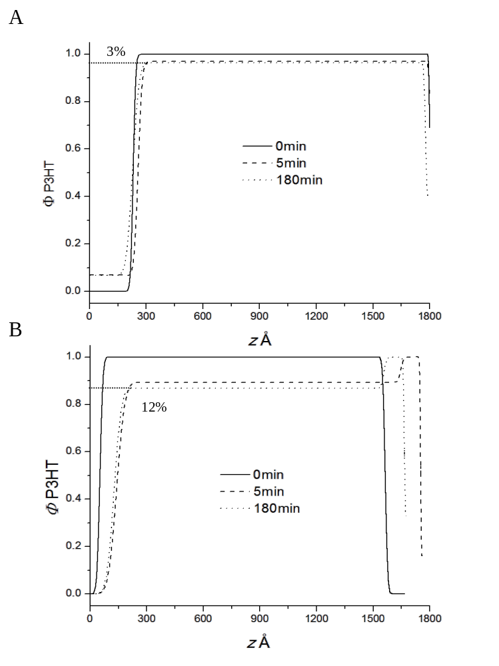
Figure 49 (A) C₆₀-P3HT bilayer and (B) P3HT-PCBM bilayer models with fullerene volume fraction marked after 3hrs of annealing.

4.4 Discussion
The picture of the BHJ morphology-performance relationship is made clearer from characterizing the structure of the donor-acceptor interface; while some degree of phase separation has been demonstrated as an important component of efficient device morphology, the neutron reflectivity shows that a significant degree of intermixing is also a desirable characteristic in the morphology of a high-performance OPV donor-acceptor pair.
PCBM fullerenes are very compatible with the P3HT polymer as revealed by the complete diffusion of the PCBM layer into the P3HT layer by the rapid loss of the interface separating bilayers of the two materials. The interfacial width with PCBM could not be measured in the annealed bilayer as none of the fullerene layer was retained. Had a thicker film of PCBM had been used in the experiment, the solubility limit within the underlying polymer film may have been reached, and a PCBM-enriched layer would persist. However, it is reasonable to speculate that the highly compatible PCBM would form a wide interface. The neutron reflectivity models also set a lower limit of PCBM solubility in P3HT at a ~12% volume fraction.
Even though the PCBM-rich phase was lost in the experiment, which would persist in phase separated BHJ cells, changes to the ideal morphology can be theorized from these results; a wider interface and significant intermixing enhances performance of BHJ type devices. An illustration of this structural change is provided in Figure 50 with well phase separated BHJ morphology (A) compared to a partially mixed one (B).
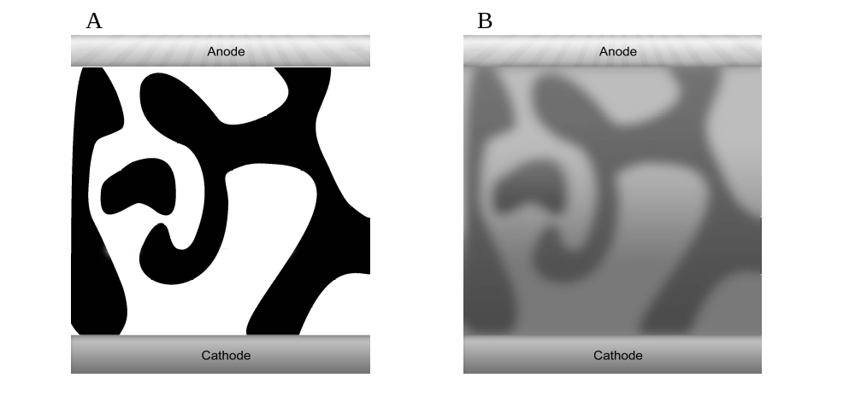
Figure 50 BHJ phase separation schematic, contrasting poor solubility (A) with good solubility (B)

4.4.1 Electronic Consequences
These proposed additions to the ideal BHJ morphology have several implications to the electronic behavior of OPV cells: the new morphology suggested by these results implies that the donor-acceptor phases need not be sharply defined for excitons to be disassociated with acceptable efficiency, and that a significant amount of donor-acceptor interdiffusion is in fact desirable.
A possible benefit of the fullerenes being dispersed within the polymer is that it improves electron transport efficiency of the polymer-rich phase, as P3HT and most photoactive OPV candidates have relatively poor electron conductivity. Compared to inorganic semiconductors, such as TiO₂, CdSe and carbon nanoparticles, organic polymers have approximately two orders of magnitude poorer electron transport properties., Furthermore, in real BHJ devices, charge carrier pathways are not likely to be direct or continuous throughout, and so electrons must occasionally conduct through the polymer to reach the electrode to be harvested, as illustrated in Figure 51.
Enhancing the ease of this transport with dispersed carbon fullerenes within the P3HT phase could thus improve charge carrier mobility considerably and improve device efficiency. The high performance demonstrated in devices using the soluble PCBM electron acceptor is likely thanks to this, and it can be predicted that similar devices using unmodified C₆₀ fullerenes in place of PCBM would yield devices with inferior performance due to its much lower solubility. The NR experiments showed that PCBM has at minimum a four-fold higher solubility than in P3HT C₆₀, with a measured volume fraction of 12% versus 3%, and may be considerably higher.
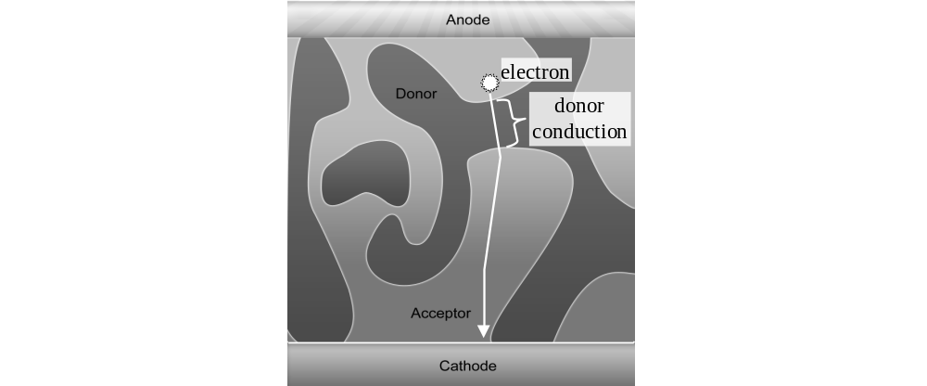
Figure 51 Electron conduction through donor domain
Another implication is that a broad donor-acceptor interfacial width is possibly beneficial, or at least not significantly detrimental to the operation of BHJ cells: devices with wide interfacial widths would have finely divided agglomerations or even individual D-A molecules in intimate contact across the interface, as illustrated in Figure 52. The interfacial width measured in the experiment with the less compatible C₆₀ fullerenes is approximately six nanometers, so the ideal domain size in BHJ devices of tens of nanometers would likely be of similar order to the interfacial width with PCBM. Therefore, a large fraction of the total active layer would be contained within the interface volume.
The combination of a wide interface with small domain size could also enhance cell efficiency by introducing secondary charge carrier pathways into opposing domains. Molecules penetrating deeply into unlike domains could transport electrons or holes to purer primary conductor domains that better transport the respective particle. A conceptual example is shown in Figure 53, with molecules of the black domain penetrating into the white domain, to form effective pathways for electrons or holes. Efficient conduction of charge carriers is critical to device performance and a broad interface, possibly with these secondary pathways, could help extract the charge carriers from the site of exciton disassociation and convey them to domains of the respective conductor type. Unfortunately, specular neutron reflectivity used in this experiment lacks lateral resolution to characterize the structure parallel to the interface.
With or without invoking discrete secondary charge carrier pathways, it can again be assumed that high efficiency BHJ devices take advantage of a wider, rougher interface as would likely be produced by the highly soluble PCBM tested in this experiment, while the sharp interface between P3HT and C₆₀ fullerenes would not likely benefit as much with the reduced contact between donor-acceptor materials.
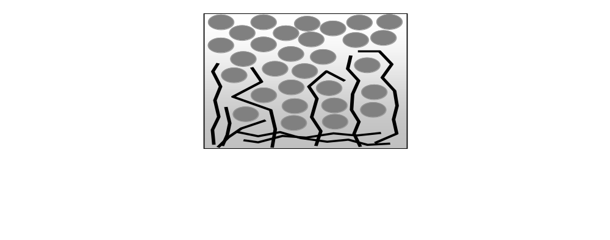
Figure 52 Schematic structure of polymer-fullerene intermixing across the interface, with black lines representing polymer chains and gray circles representing fullerenes.

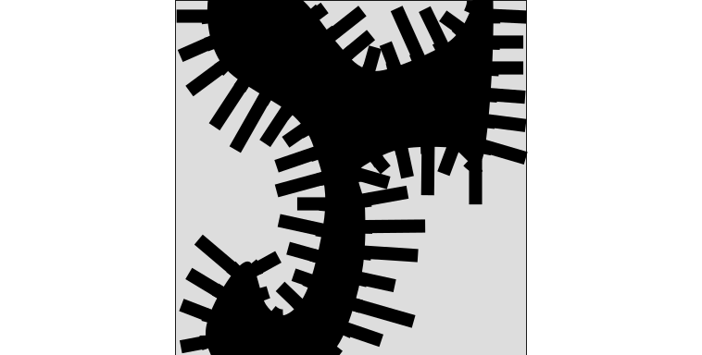
Figure 53 Protruding black molecules forming secondary charge carrier pathways for the black domain.

4.5 Conclusions
In this work, a clearer picture of the ideal BHJ morphology is proposed based on neutron reflectivity measurements that provide high spatial and chemical resolution of the interfacial structure of bilayers composed of P3HT and different types of carbon fullerenes. These bilayers are model interfaces of high efficiency BHJ devices, and by exploring the interface and miscibility between the fullerenes and P3HT, a correlation between the observed interfacial width and solubility characteristics of the components to device performance can be inferred. These characteristics were found to be that the dispersion of materials across a wider interface or diffusion into the bulk of the donor-acceptor domains is desirable for high performance.
The electronic mechanisms for how these characteristics improve device performance are also proposed. This explanation invokes the benefit of charge carrier transport throughout the cell from a broader interface and higher miscibility of conductive carbon fullerenes in the photoactive polymer matrix. First, because dispersing fullerenes throughout the polymer enhances its ability to carry electrons, which is important since the charge carrier pathways may not be perfectly bicontinuous, necessitating conduction through the poorly conductive polymer to reach the electrode. Second, because a roughening of the interface may add secondary charge carrier pathways that direct electrons and holes to the primary pathways of the donor-acceptor domains. With new insight how devices operate, the goal of producing OPV efficient cells that can reduce the cost of deploying solar power generation and a significant new clean energy industry is brought closer to being realized.

Chapter 5 – Cellulose Nanowhisker Composites

5.1 Cellulose Nanowhisker Project Introduction
Cellulose is a semicrystalline biopolymer found in all plant life that self-organizes into fibers, and is the most abundant renewable biomaterial on Earth. Cellulose fibers offer excellent mechanical properties, but their poor solubility and low decomposition temperature makes them impractical in many processes. The amorphous segments of the cellulose fibers are, however, vulnerable to hydrolysis, which opens an opportunity for converting cellulose polymer into another useful material.
The hydrolysis of cellulose fibers degrades the amorphous portions of the polymer preferentially, leaving only the crystalline portion of the original material. The resulting long crystalline cellulose fragments, dubbed cellulose nanowhiskers (CNWs), can be extracted from the digested polymer. CNWs can be used as a renewable reinforcing material to produce cost-effective polymer nanocomposites, with excellent mechanical properties., An additional attractive property of the sub-micron size of the nanowhiskers is their potential to form optically transparent nanocomposites with the nanoparticles. However, successful composites can only succeed if agglomeration is minimized and the nanowhiskers are well dispersed.
Unfortunately, the strongly hydrophilic particles are incompatible with many hydrophobic polymers, which the majority of low cost commodity plastics and rubbers are.,, To overcome this problem, the nanowhiskers can be chemically modified to reduce their hydrophilicity and tendency to agglomerate. This straight forward method to improve their compatibility in composites expands their utility as low-cost renewable reinforcing filler. Cellulose nanowhiskers in insufficiently compatible CNW-polymer pairs can agglomerate if their loading is beyond the solubility limit. Agglomeration must be minimized to realize successful composites, since agglomerations do not effectively transmit force through the bulk.
This is especially important for an additional reason: a significant discontinuity in physical properties with increasing CNW loading has been shown, which is believed to be due to the nanowhiskers reaching a volume fraction threshold needed to establish a percolated network throughout the bulk of the composite., Therefore, an important consideration in CNW nanocomposites is whether the nanowhiskers form such networks, which is dependent on the CNW shape, size, and loading., CNWs that still retain hydroxyl groups can undergo hydrogen bonding with other nanowhiskers. In this way, force can be transferred long distances through networks of CNWs, stiffening the structure. An illustration of percolation is provided in Figure 54.
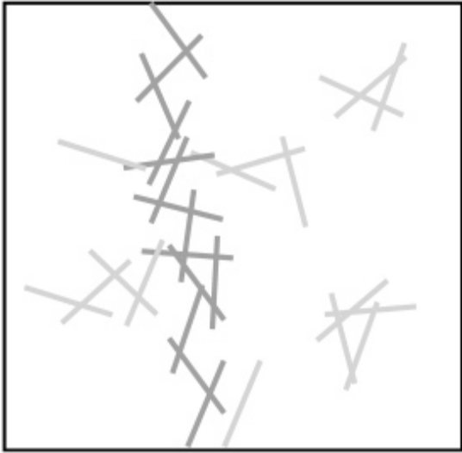
Figure 54 Illustration of percolation of cylindrical rod particles through the bulk.¹⁹⁸

Therefore, the impact of chemically modifying cellulose nanowhiskers on their compatibility in poly(methyl methacrylate) (PMMA) is examined. The chemical modification employed replaces hydroxyl moieties with acetate groups, with the goal of improving their dispersion in PMMA. The degree of substitution (DS) of the cellulose denotes the average number of acetate groups on a given ring, and was varied in this study. The impact of this chemical modification on the diffusion of cellulose into PMMA is monitored using neutron reflectivity (NR). In this NR experiment, thin films of CNWs with different DS were capped with a layer of PMMA. The depth profile of these initial bilayers as a function of annealing time at elevated temperature provides insight into the affinity of the two components. The NR experiment also yields information about the limits of CNW bulk solubility in the polymer. Atomic force microscopy (AFM) was also used to verify the physical dimensions of the CNWs and the topography of the CNW layers.

5.2 Experimental Overview
The degree of substitution (DS) of the three CNW hydroxyl groups was measured using nuclear magnetic resonance spectroscopy (NMR): the structure of cellulose is well known (Figure 55), and from this structure and ¹H-NMR, the DS of modified cellulose is determined. A DS value of 3.0 indicates that all three hydroxyl groups on a given glycopyran ring are substituted with an acetate functional group. The dimensions of the CNWs were characterized with (AFM). The production and modification of CNWs and the experimental details of AFM, NMR and NR analyses are discussed in depth in Chapter 2. The interpenetration of the PMMA and CNW layers with thermal annealing was monitored for three different CNWs with varying substitution with acetoxy groups, designated DS0 (unmodified), DS0.61 and DS0.98.
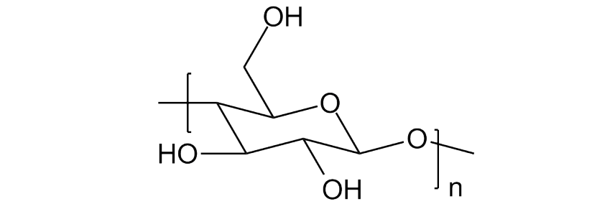
Figure 55 Cellulose glycopyran ring structure

Layers of CNWs were fabricated from suspensions produced by ultrasonication of nanowhiskers in water (DS 0) or tetrahydrofuran (DS 0.61 and 0.98) and then deposited by solvent casting via air drying or spin casting, respectively. To monitor the change in bilayer structure as a function of annealing time, a ~100nm PMMA-d8 film was deposited over the CNWs by spin-casting from a solution with toluene, an “orthogonal” solvent that was found to be a non-solvent for the cellulosic nanoparticles. Deuterium-labeled PMMA was used in the neutron reflectivity experiments to produce neutron scattering contrast between the polymer and the protonated cellulose, which furnishes excellent composition sensitivity. These bilayers were then annealed at 150°C for 12 or 24hrs to provide polymer chain mobility, and the interpenetration of the d-PMMA and CNWs is monitored.

5.3 Atomic Force Microscopy Results
AFM was used to monitor two sets of cellulose nanowhiskers films: the first set was formed form depositing dilute suspensions of nanowhiskers by evaporation in air to create a layer of isolated particles so that their dimensions can be measured. The second set of CNW films are duplicates of films used in the neutron reflectivity experiments. These samples were analyzed to determine the approximate thickness and gain a qualitative understanding of the surface coverage of these films. This second set was produced with a much more concentrated suspension of CNWs and was deposited via spin casting as with the NR experiments.
The AFM images of the samples formed from the dilute suspensions show both individually dispersed CNWs and “bundled” agglomerations of several particles lying parallel to one another. These structures are shown in Figure 56, which is a representative micrograph for these samples. The length and diameter of the nanowhiskers were obtained by the average of the parallel and perpendicular sections of ten isolated particles.
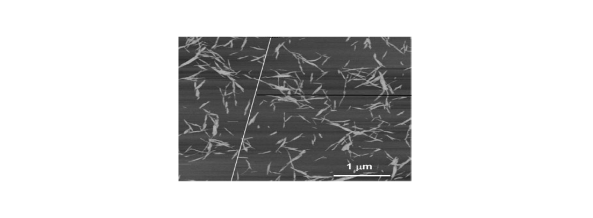
Figure 56 AFM height image of separated DS0 CNW nanoparticles
To avoid error from the nontrivial curvature of the tip when measuring the diameter, discussed in Chapter 2, the height of the CNWs above the surface is used instead of the horizontal dimension. The averaged length and diameter were found to be 311±69nm and 7±1nm respectively, resulting in an L/D ratio of ~38-63.
AFM height map imagery of the three different CNW films deposited from the high concentration suspensions are shown in Figure 57. Inspection of this figure shows that the samples display heterogeneous topography with several notable features. First, the nanowhiskers in the films are clearly not close-packed or contiguous despite the fact that they were formed from solutions with higher concentration. In the case of the CNWs with DS 0 and DS 0.98, and to a lesser extent with the DS 0.61 nanowhiskers, the films exhibit large areas of the substrate that are completely uncovered as evidenced by the very smooth surface of the polished silicon wafer substrate. Second, surfaces of all three films are partially covered with agglomerations of CNWs of varying size and degrees of dispersion. Some of these agglomerations are large enough to introduce error from spurious tip vibration from collision during AFM rastering, appearing as extremely “deep” regions depicted in black extending horizontally from the largest objects, which caused the AFM tip to lose alignment in the lower half of the image in Figure 57E.
The size of the agglomerates appears to be roughly bimodal, with a majority of the substrate covered by small, loosely packed agglomerates and a minority of larger objects. The height of the smaller agglomerates reach a maximum of approximately 40nm for DS 0 CNWs and 50nm for the DS 0.61 and DS 0.98 CNWs. The height of a minority of the large agglomerates can be much greater that this average, with some measuring taller than 200nm, as shown in the 3D height map image in Figure 58. This image is also illustrative of the disparity of agglomeration sizes, with the smallest agglomerations barely perceptible at the large z-axis range needed to encompass the larger ones.
This height of these large agglomerations would correspond to the CNWs axis standing approximately normal to the surface, conceptually illustrated in Figure 59. These AFM results are important to the interpretation of the following neutron reflectivity study. These images clearly indicate that the CNW nanoparticle films have significant amount of void space, unlike most glassy polymer or other contiguous films. The presence of these voids significantly influences the neutron scattering potential of the layer. While AFM cannot accurately quantify surface coverage or void space within CNW agglomerations, it does provide qualitative insight to the height and global topography of the film that can be used as a guide for NR modeling.
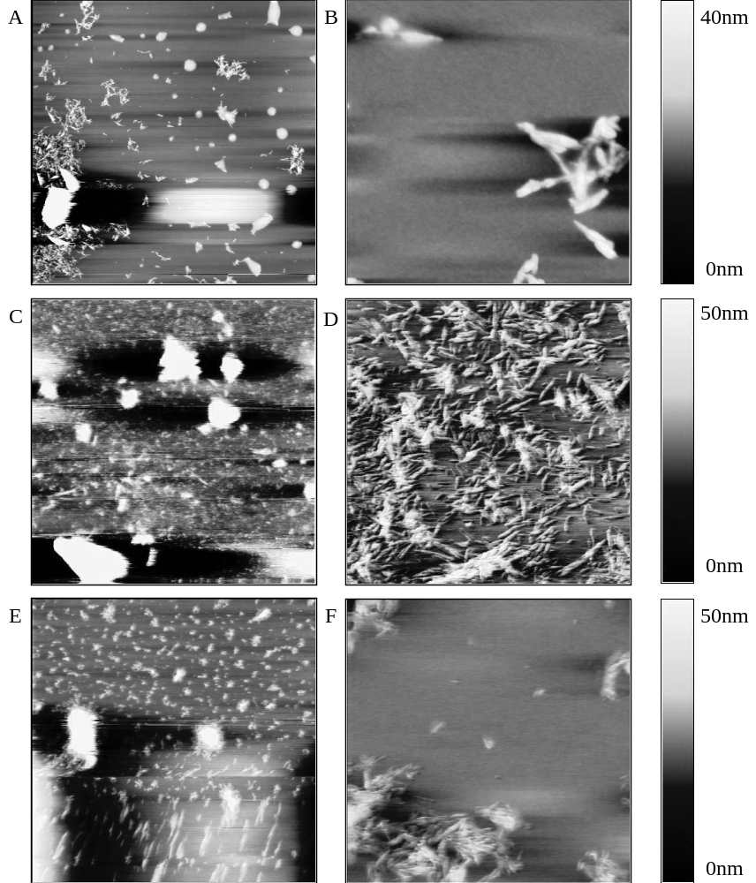
Figure 57 AFM height images of 1% CNW films, A&B from DS 0, C&D from DS 0.61 and E&F from DS 0.98. Height images show the presence of CNW agglomerations dispersed across the sample surfaces. Image scales are 20x20μm for A/C/E and 2x2μm for B/D/F.

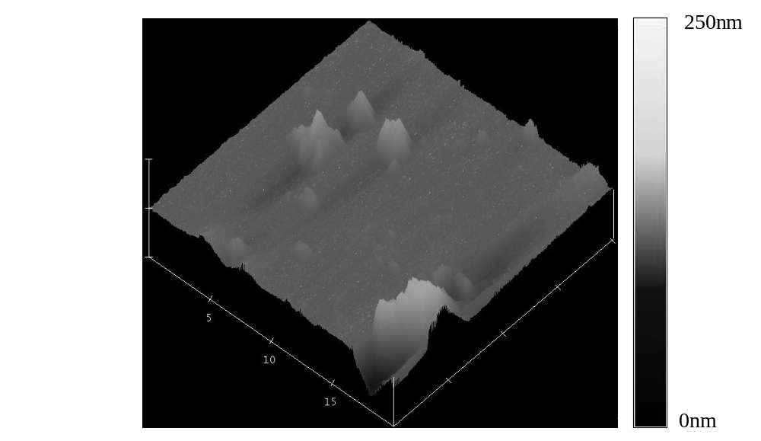
Figure 58 Representative AFM micrograph of the largest CNW agglomerations that approach 200nm in height.

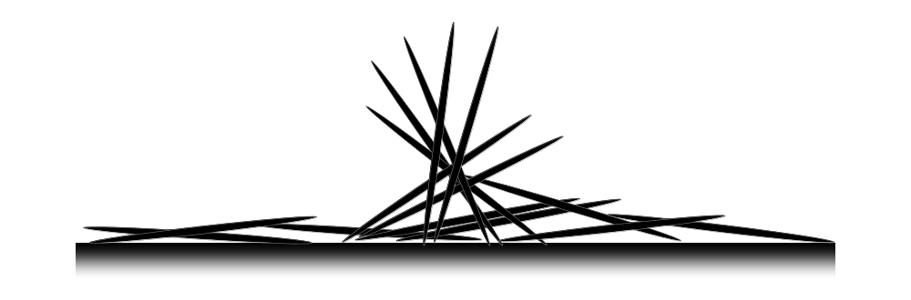
Figure 59 Pictorial Illustration of cellulose nanowhisker agglomerations

5.3 Neutron Reflectivity Results
Neutron reflectivity was performed on monolayers of the three CNWs and corresponding bilayers that consist of duplicate CNW films coated with per-deuterated PMMA-d8. The samples were measured as cast and after 12 and 24hrs of annealing under vacuum at 150°C. This thermal annealing is above the glass transition temperature of the PMMA-d8, providing molecular mobility. Interpretation of the reflectivity data relies heavily on modeling, where a plausible picture of the complex structure and a realistic narrative of the evolution via annealing can be confidently presented through careful consideration.

5.3.1 CNW monolayer analysis
AFM clearly shows that the CNW thin films are not contiguous, and exhibit inhomogeneity parallel to the film surface. This inhomogeneity manifests itself in fairly featureless reflectivity curves (Figure 60), from which only a limited amount of information can be extracted. The lack of a fringe structure indicative of reflection from smooth interfaces indicates that the layers are very rough, which is expected since the AFM imagery showing that the CNWs are deposited as agglomerations rather than a smooth film.
Due to this roughness, the thickness and scattering length density of the CNWs cannot be extracted from the reflectivity data of the CNW monolayers. From contiguous thin films, the scattering length density of a substance can be extracted from a monolayer film using optical laws of specular reflection, as described in Chapter 2. However, as the surface of the CNW thin film is not completely covered with CNWs, this method cannot be applied. This is because neutrons reflect over the area that the neutron beam impinges upon, which is large (>1cm²). Since the CNW film is not contiguous over the surface, the inherent averaging also captures contribution from exposed substrate. Therefore, the SLD extracted from a non-uniform surface will have contributions from both CNW and surrounding void. Without a precise measure of the CNW surface coverage, the SLD of the CNW portion cannot be extracted from this reflectivity data.
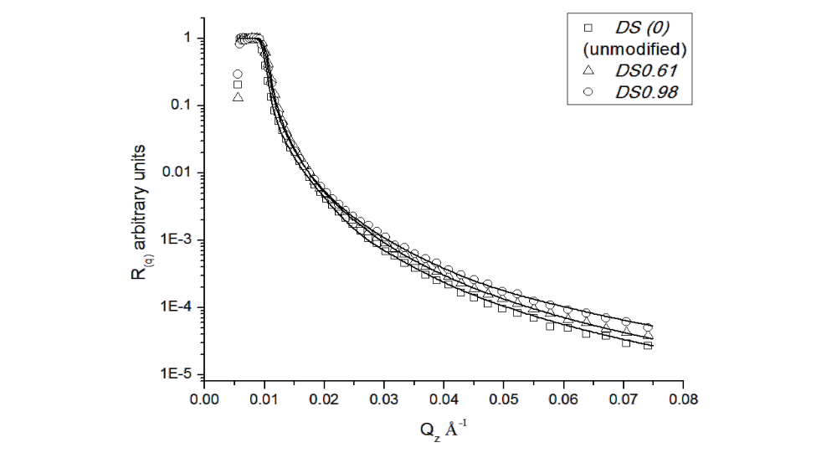
Figure 60 Neutron reflectivity data and fits of the CNW monolayers. No fringe structure is present, indicating the high roughness of the CNW layers.

To characterize the structure of the CNW films, the experimental data is fit to a model thin film, guided by the AFM topography. AFM topography information is not used directly to build models, but useful general parameters of the CNW structure can be extracted. Past works by Koening and Singh used AFM to compliment and inform NR to model complex organic and inorganic film structures. Likewise, the height of the CNW monolayers and the general disposition of the nanowhiskers are used as modeling guidelines.
The CNW monolayer films were modeled as two layers, where the thickness of the first is ~40nm for DS0 and ~50nm for DS0.61 or DS0.98 CNWs. This film is based on the maximum height of the smaller agglomerates that covered much of the surface of the samples as observed with AFM. A second layer with an initial thickness of 10nm was added below the first one, which represents a thin layer of better-dispersed CNWs that are oriented parallel to the substrate. The 10nm thickness was selected as the approximate lower bound for individually dispersed CNWs, based on their diameter.
The SLDs of these two layers may be markedly different despite being made from the same material, as their lateral densities across the surface should be considerably different. The poorly dispersed aggregates will result in an SLD that is substantially lower than that of the better dispersed CNWs near the surface. This is again because NR averages across the plane of the surface, so the SLD at any depth in the film will be an average of the CNWs and the air between them, with air having an effective SLD of zero. Therefore the presence of voids manifests itself in the modeling as a lower SLD, with the resulting SLD of CNWs extracted from the fitting procedure being directly proportional to the surface coverage.
Modeling of the SLDs depth profile was performed by maintaining the SLD of the thinner layer at approximately three times the SLD of the thicker layer, based on AFM surface coverage. The SLDs were then varied until a rough agreement between the calculated reflectivity curve and experimental data was obtained. Then the SLD, thicknesses, and the roughness of the layers were iteratively refined further until a close fit to the experimental data was reached. Fit quality was judged using χ² statistics, detailed in Chapter 2, with a fit quality threshold of χ² < 10.
The addition of a third layer with low SLD and ~200nm thickness, to represent the largest agglomerations detected in the AFM, did not improve the quality of the fit: the relative scarcity of these largest agglomerations seen in AFM coupled with the low SLD of ¹H proton-rich organic material would result in the SLD of this layer being low. Reflection from this layer would be weak since the difference in SLD versus that of air (SLD ~0) is small, providing poor contrast, which may cause the signal arising from this layer to be below practical detection limits. A plot of the SLD depth profiles that model the CNW monolayers is provided in Figure 61. The insert highlights the SLD depth profile of the region closest to the substrate depicting the thinner layer.
The total thicknesses of the final fits are consistent with the AFM results, with a high amount of roughness at the air interface consistent with the inhomogeneous surface. The presence of the higher SLD thinner layer and a low degree of roughness is consistent with a layer representing two or three CNWs lying flat, giving a uniform height that covers much more of the surface than the larger agglomerates. The thicker layer of each model has a reasonably uniform SLD depth profile, which indicates that the CNW aggregates do not taper significantly for lengths of 20-30nm.
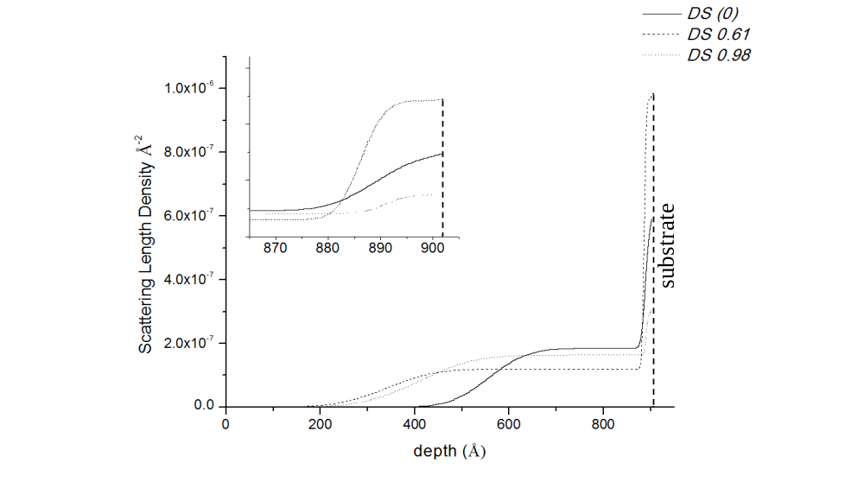
Figure 61 NR models of CNW monolayers with CNW-substrate interface region inset showing a thin high density nanowhisker layer

Using the modeled SLDs of the monolayers and theoretical SLDs of perfectly uniform CNW films, the surface coverage of the monolayers can also be estimated. The SLD of the nanowhiskers could not be experimentally extracted from the data as the monolayers are not homogeneous, but the SLD can be estimated from its stoichiometry and density. The stoichiometry was derived from the degree of substitution and the stoichiometry of the cellulose polymer using Equation 5.1. The mass density of CNWs for microcrystalline cellulose has been reported to be 1.60g/cm³ for cellulose crystals, which is likely similar to the density of CNWs, so SLD calculations were performed using densities between 1.5-1.7g/cm³. SLD is calculated by dividing the known scattering contribution of the component elements by the material molar volume, which is density dependant (Equation 5.1). In this experiment, the Layers software provided by the Oak Ridge National Laboratory was used to perform these calculations.


Surface coverage can then be calculated by dividing the SLD of the CNW monolayer and dividing by the estimated SLD. The calculation was performed using different estimates for pure CNWs of different bulk densities. These estimated SLDs, the experimental monolayer SLDs, and corresponding calculated coverage fractions are presented in Table 4.
Table 4 Cellulose nanowhisker SLDs and monolayer surface overages
(All SLDs x10⁻⁶Å⁻²) |  | DS0 | DS0.61 | DS0.98
Modeled max SLD |  | 0.593 | 0.978 | 0.306
Calculated SLD | 1.5g/cm³ | 1.64 | 1.77 | 1.78
 | 1.6g/cm³ | 1.76 | 1.90 | 1.91
 | 1.7g/cm³ | 1.99 | 2.15 | 2.16
Coverage | 1.5g/cm³ | 36.2% | 55.2% | 17.2%
 | 1.6g/cm³ | 33.7% | 51.5% | 16.0%
 | 1.7g/cm³ | 29.8% | 45.5% | 14.2%

The coverage calculated for each CNW layer is qualitatively consistent with the AFM data, in that only a portion of the substrate is covered with nanowhiskers, and qualitatively parallels AFM imagery. For instance, the DS0.61 sample covers the surface more completely and the DS0.98 sample less completely than the DS0 CNW covers the surface.
The relative SLD of the top and bottom layers of each sample also indicates that the DS0.61 is better dispersed than the other CNWs: the larger differential between the thinner and thicker layer indicates more nanowhiskers lying singly or in small agglomerates parallel to the substrate. This qualitative trend also is in agreement with the AFM results.

5.3.2 CNW bilayer analysis
Inspection of the NR data from the bilayer that consists of PMMA-d8 topping the unmodified DS0 CNWs thin film is shown in Figure 62. The fringes in this data indicate a relatively smooth interface between the two layers. A d-spacing of the bilayer film can be extracted from the width of the fringes, which corresponds to ~63nm, as discussed in Chapter 2. This could correspond either to the PMMA-d8 layer, if it were thinner than the 100nm target thickness, but also roughly matches the approximate thickness of the CNW layer if it were somewhat thicker than the 40nm estimated from AFM. The data curves do not appreciably change from annealing, which indicates that the structure of the bilayer must not change significantly with thermal annealing. This indicates that the PMMA and CNW do not mix appreciably upon heating.
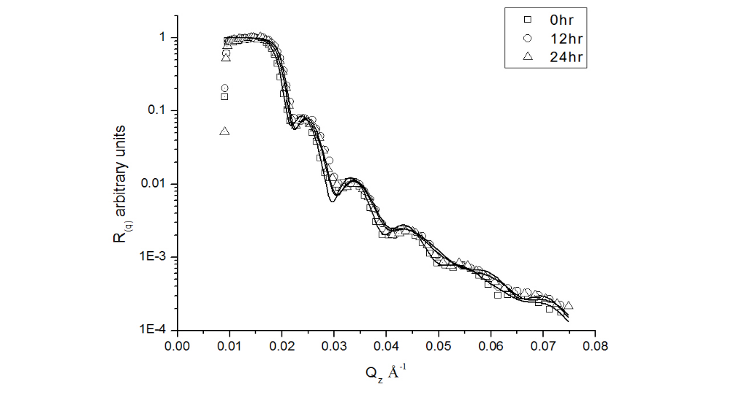
Figure 62 Neutron reflectivity data and fits for DS0 bilayer, showing a relatively smooth layer persisting through each annealing.

The NR data for the DS0.61 and DS0.98 bilayers are shown in Figure 63 and Figure 64. These curves show an absence of strong fringes that were present in the DS0 bilayer and with the exception weak fringes in data at 24hrs; there is no clear vertical structure to the data for both samples. This means that these samples do not form bilayers with sharp interfaces, and no reliable fringe spacing could be extracted as with the DS0 bilayer. Nevertheless, change in the structure is evident when both the modified CNW bilayers are annealed by comparison to the DS0 bilayer, showing that some mixing must be occurring.
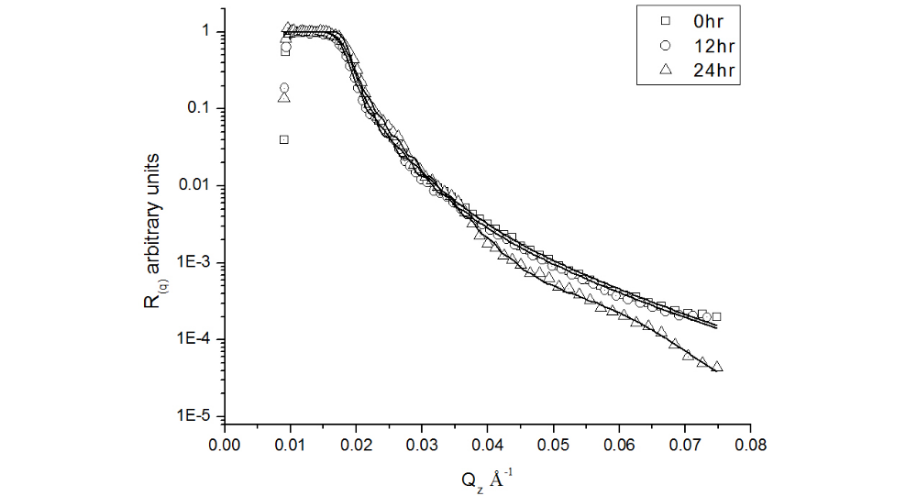
Figure 63 Neutron reflectometry data for DS 0.61 bilayers, the lack of fringe structure indicates high layer roughness
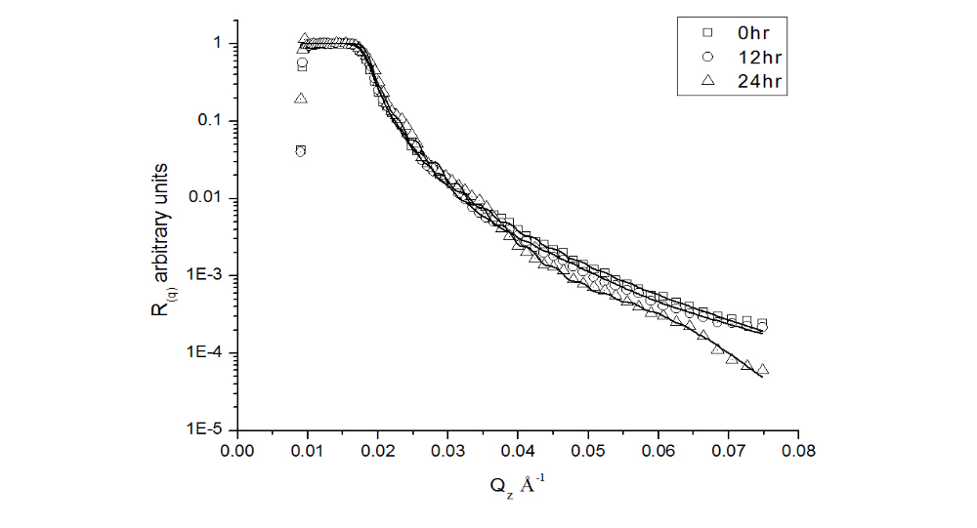
Figure 64 Neutron reflectivity data for DS 0.98 bilayers, the lack of fringe structure indicates high layer roughness

Further careful modeling of the bilayers using reasonable assumptions yields the structures of the as-cast sample and their evolution with thermal annealing. From these models, the effect of the degree of substitution on the interpenetration of CNWs and poly(methyl methacrylate) can be evaluated.
Construction of NR models generally requires some quantitative inputs to yield a realistic model, since multiple models may produce a good fit to the data. With the exception of a thickness measurement of an unidentified layer in the DS0 bilayer and the known SLD of PMMA-d8, no exact measurements are available. As a means of mitigating this problem, a mass balance of the materials in the bilayer was used throughout the modeling to provide a quantitative and physically realistic fitting target in parallel to matching the hypothetical and experimental reflectivity curves. By refining the models to fit to the reflectivity data and maintaining a mass balance, the results are much more likely to accurately reflect the sample structure.
Ideally, a mass balance of the bilayer would use the SLD and thickness of the component layers to determine the total scattering volume the entire bilayer sample should occupy. Unfortunately the lack of homogeneity of the CNW monolayers and uncertainty in the thickness of the PMMA-d8 film made this calculation difficult. However, a mass balance can be retained for a given sample for each annealing time to impose a realistic physical constraint: this was done by integrating the scattering volume of each bilayer model, and ensuring that the scattering volume of each sample remained within 5% of this value with thermal annealing. This ensures that the total amount of material remains a constant.
Initial models for the as cast bilayers began with three layers, the top being 100nm thick, which was approximately that of a PMMA-d8 monolayer that was spin-cast on a clean substrate as determined by ellipsometry. This layer has an SLD equal to that of of PMMA-d8, 7.0x10⁻⁶ Å⁻². The second and third layers were modeled with thickness and SLD similar to that of the respective CNW monolayer models. The thickness, SLD, and roughness of the three layers of each sample were then refined until the corresponding calculated reflectivity curve matched the experimental curve as judged by χ² statistics, as noted in Chapter 2, with a threshold value under 15 and the mass balance of each layer fell within 5% of the as-cast sample.
The SLD depth profiles that model the DS0 bilayer are presented in Figure 62, with the corresponding model for the DS0 monolayer overlaid in the lower right corner as a solid line. It is clear that the thickness extracted from the reflectivity curve fringe periodicity, 63nm or 630Å, is describing the PMMA-d8 rich layer that dominates the scattering volume of the bilayer. It is unclear why the polymer layer is thinner than the ~100nm that identical fabrication would produce on a clean substrate.
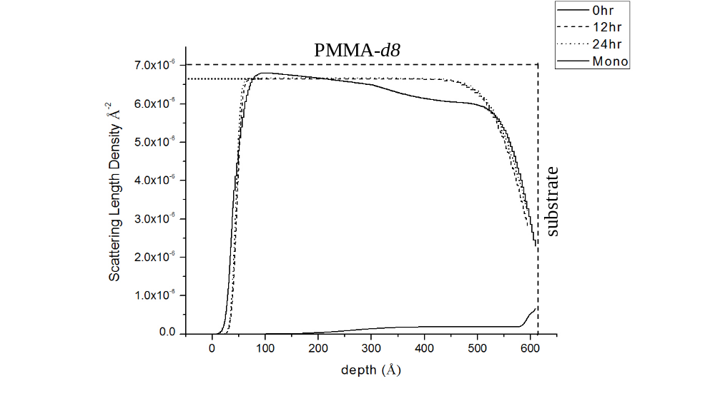
Figure 65 NR model for DS0 bilayer with corresponding monolayer at bottom-right and maximum bilayer SLD marked

The SLD profile contains a number of notable features that detail a complex structure and implies an interesting evolution when the sample is annealed. The SLD at the substrate of the DS0 bilayer is much lower than the polymer but higher that the CNW layer. This can be attributed to the presence of PMMA-d8 throughout the sample, all the way down to the Si substrate. This structure is observed in the as-cast sample prior to annealing, implying that this structure is not due to the interpenetration of PMMA-d8 CNWs. Clearly, the PMMA-d8 is filling in some of the voids in the CNW bottom layer.
The deposition of PMMA-d8 into the spaces between CNWs is also indicated by the SLD of the middle layer of the bilayer, which is lower than that of pure PMMA-d8, which is noted by the dashed line at the top of plot. This can be attributed to CNW agglomerates penetrating through the polymer, slightly reducing the SLD, since protonated CNWs have a lower SLD than the perdeuterated PMMA-d8. This behavior is also found in the top most layer of the as-cast model, suggesting the CNW agglomerations penetrate all the way through the film. These agglomerations remain present through annealing, where the top and middle layers coalesce into a single layer. The uniformity of the SLD in this layer would again necessitate the CNWs be standing vertically, which is again unlikely to be the case, but is a reasonable approximation of the sample structure and fulfills fit quality thresholds.
Another notable conclusion from the fitting of the experimental data is that the SLD of the bilayer at the substrate is less than that of the PMMA-d8 or CNWs. The most plausible explanation is that these samples also contain void space trapped beneath the polymer film between the CNW agglomerations, reducing the SLD due to the lateral averaging inherent in NR. The picture of this bilayer that emerges from this analysis is illustrated in Figure 66. This structure is further supported by the retention of these features even after annealing, which would not occur if the voids were replaced with solvent as it would have been driven off. Vacuum has an SLD of zero and the low density of air yields a negligible SLD, so void space suppresses SLD. The presence of void space will not influence the mass balancing of the bilayers since the amount of material on the sample, and so the calculated scattering volume, is not changed by the presence of absence of empty space.

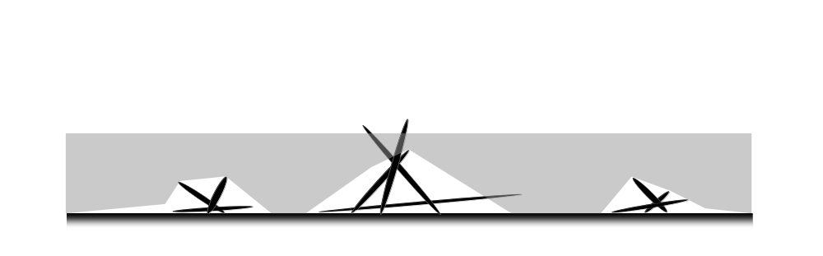
Figure 66 CNWs (black) penetrating the PMMA-d8 (gray) and the trapping of void space (white)

The bilayer structure evolves when annealed, as shown by a decrease in SLD between 0-300Å and an increase in SLD between ~300-450Å, suggesting that the PMMA-d8 is being redistributed out of the upper layer and entering the intermediate layer. The void space is clearly disappearing in the intermediate region. After 24hrs of annealing, the layer between 0-450Å is homogeneous, the uniformity of which may suggest that the SLD is due to the presence of only two components, the PMMA-d8 and the CNWs.

5.3.3 Modified CNW bilayer NR analysis
The bilayers made with acetylated CNWs share similar general structure and behavior as the unmodified bilayer, but have some notable differing characteristics. The SLD depth profiles that model these bilayers are shown in Figure 67 and Figure 68: both sets show the PMMA-d8 layer is far thicker than the DS0 bilayer sample, averaging ~2000-2500Å. It is not clear why this is the case, but it may be due to the presence of more extremely tall CNW agglomerations leading to more retention of the PMMA-d8 solution during spin casting, resulting in more polymer being deposited. This is supported by the large void space that exists in both samples between 0-1800Å for DS0.61 and 0-2200Å for DS0.98 nanowhisker bilayers. The SLD depth profile of the nanowhisker monolayers are also overlaid in these plots for comparison.
The evolution of the bilayers on annealing appears to be similar to that of the DS0 bilayer, with the void space at lower depths decreasing to yield a homogeneous layer resting atop a layer that is predominantly CNW/void space. This is reinforced by the significant thickness decrease of this lower layer for each sample. This decrease is by 250Å and 500Å for the DS0.61 and DS0.98 samples, respectively, again showing that the polymer is redistributing to fill void space. The as-cast structure of the DS0.61 bilayer differs slightly from the other two in that the SLD at the as-cast air interface is higher than for the other bilayer, and matches the SLD of PMMA-d8, indicating that this sample is pure PMMA-d8 at this depth.

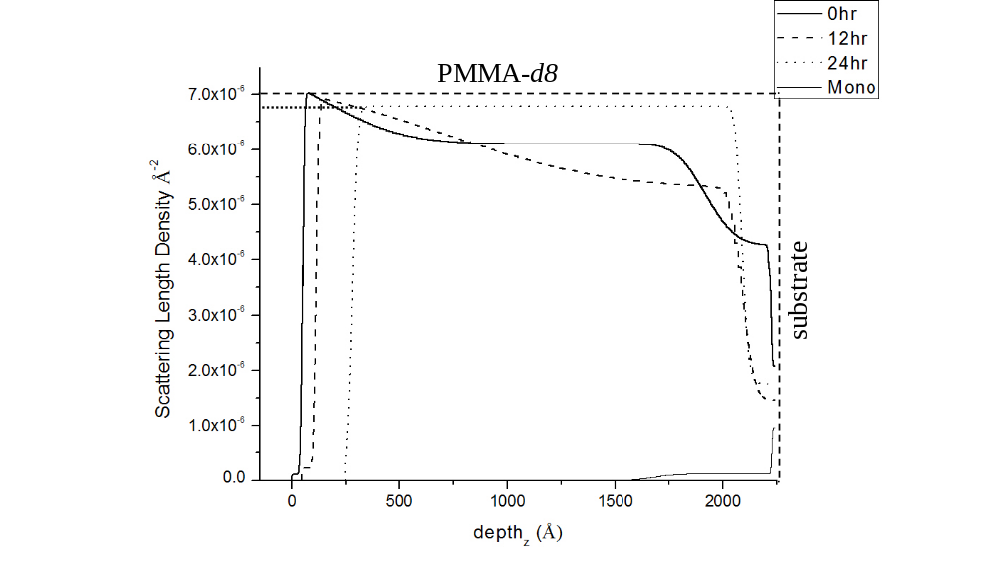
Figure 67 Neutron reflectivity models for DS0.61 bilayers with corresponding monolayers at bottom-right and maximum bilayer SLD marked

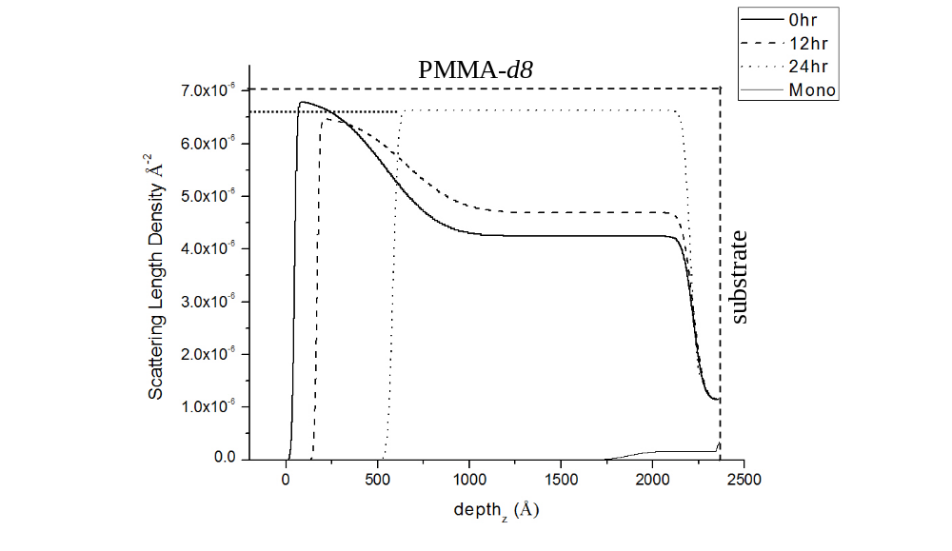
Figure 68 Neutron reflectivity models for DS0.98 bilayers with corresponding monolayers at bottom-right and maximum annealed bilayer SLD marked

The PMMA-d8 layer is suspended by the CNW agglomerations above the substrate, with only a small minority of the polymer film area in direct contact. When the polymer is annealed and given the mobility to flow, it detaches from the substrate to form a flatter layer. This is due to the surface tension at the bottom of the polymer layer, driving the film to form a smoother more contiguous surface, overcoming the attractive forces to the silicon wafer substrate.

5.4 Discussion

5.4.1 Bilayer sample structure and evolution
Atomic force microscopy reveals that suspended cellulose nanowhiskers deposit as a partially dispersed mat of particles surrounded by open areas and punctuated with numerous small and large agglomerations, yielding a complex three-dimensional structure. Neutron reflectivity models, guided by this AFM imagery and known chemical traits of the CNWs, were created that successfully incorporate the average shape of the nanowhiskers film and were used to calculate the surface coverage of the particles. Models were also made of bilayers of these CNW films and the polymer PMMA, constructed from qualitative insight from both AFM and NR models of the CNW monolayers, which show the porous, rough topology of the CNW surface and reveal a complex structure containing void spaces. Through physically consistent modeling of sequential thermal annealing, the evolution of this structure was detailed, which yielded quantitative information about the limits of CNW bulk solubility.
The model depicting the formation and evolution of the bilayer sample structure begin from the rapid deposition and drying of a PMMA-d8 solution that significantly, but not completely, percolates between the CNWs in the thin film. The incomplete penetration is likely because the surface tension of the solution prevents it from rapidly penetrating between gaps in the nanowhiskers. The sudden evaporation of solvent during spin casting locks the solidified polymer into place and arrests further flow, leaving air spaces and incomplete wetting of the deposited CNWs, particularly near the substrate.
Upon annealing above its glass transition temperature, the polymer can flow into the voids that are formed by the supported CNWs. This “mixing” is seen especially in the bilayers that contain modified CNW. The key behavior occurring in the bilayers is the flow of polymer to partially fill voids in the sample. This narrative is depicted in the SLD depth profiles by the depression in SLD upon annealing: a monolayer of PMMA-d8 has a high scattering length density that could only be reduced by the incorporation of low-SLD CNWs or voids. The large reduction in the SLD of the layer below that of pure PMMA-d8 confirms the presence of significant void space.
This conclusion is supported by the reduction in thickness of the modified CNW bilayers with annealing, signaling the redistribution of PMMA-d8 into the void space. Void space must be present for the polymer to move into, since neither the PMMA-d8 nor CNWs should degrade or evaporate. Secondly, the length of the nanowhiskers is similar to and likely exceeds the thickness of the bilayer, which makes significant redistribution of the particles unlikely compared to redistribution of the polymer.
While the CNW particles are quite long, the models do suggest that some movement does occur with annealing: in all three bilayers, the SLD at the top air-bilayer interface decreases, indicating an increase in CNWs or void space at this depth. Since the void space is being reduced below these depths, it is reasonable to assume much of the SLD change is due to the movement of CNWs to the interface. A likely process can be visualized for this to occur, as illustrated in Figure 69, a change in nanowhisker orientation to stand more normal to the substrate due to the lateral movement of polymer, resulting in an increased amount of CNW at the surface.
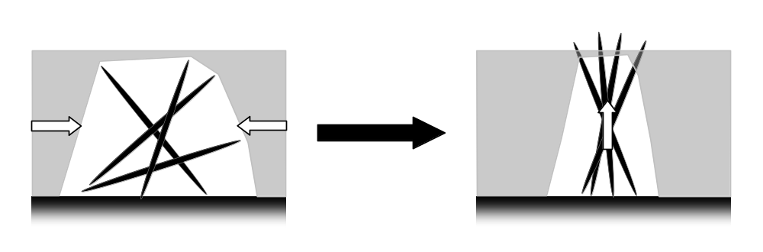
Figure 69 Lateral redistribution of PMMA causing changes in CNW orientation
Although there is some motion of the nanowhiskers, the redistribution of the PMMA-d8 polymer is the predominant change occurring when the bilayers are thermally annealed. Two forces drive this redistribution when the polymer is permitted to flow, the surface tension of the glassy PMMA-d8 polymer and its affinity for the cellulose nanowhiskers.
The first force is the surface tension of the softened polymer, which will flow to form a smooth, contiguous film to minimize the unfavorable polymer-air surface area. A similar system which has been studied extensively is latex film formation, where a close packed array of sub-micron polymer spheres coalescence to form a contiguous film free of pores when heated. Latex film formation is also driven primarily by surface tension, where a smooth film has much less surface area than small spheres surrounded by gaps and pores.,,, This manifests in all three of the bilayer samples by the reduction in void space, since the pores introduced by CNW agglomerations must have significant surface area.
The second force is the attraction between the PMMA-d8 and the CNWs, which draws the polymer into contact with the particles. Poly(methyl methacrylate) contains a polar ester group and can participate in hydrogen bonding with cellulose hydroxyl groups, as illustrated in Figure 70, so strong adhesive forces are possible between the two materials. The wetting of the nanowhiskers also contributes to the redistribution of polymer, and can promote closure of the void space by flowing around the CNWs. The lack of significant movement of PMMA-d8 in the DS0 bilayer may be due to weaker attractive forces, supporting the conclusion that adhesive interactions are improved by chemical modification of the CNWs.
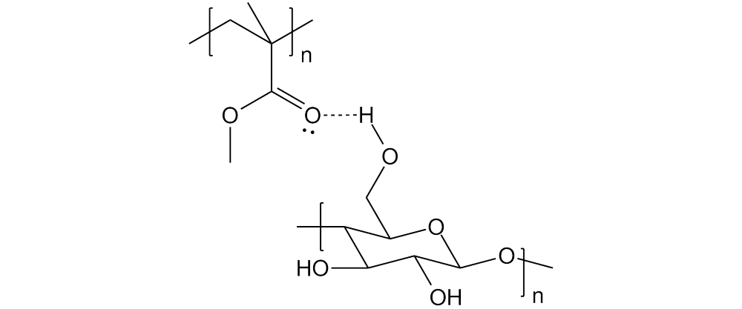
Figure 70 Cellulose-Poly(methyl methacrylate) hydrogen bonding

5.4.2 Solubility and percolation
Quantitative estimates of nanowhisker solubility in PMMA-d8 are extracted from the SLD depth profiles of the samples, using the known SLD of PMMA-d8 and the CNWs. The SLD at the top of the bilayer samples is high, indicating that this depth contains little or no void space. To calculate these solubility estimates, three assumptions are made: first, the void space at this depth does not increase, which would reduce the SLD and make the solubility of the low-SLD CNWs erroneously high. In all bilayer models, it is reasonable to conclude that the void space through the majority of the sample depth is reduced when annealed, so void space should not significantly increase at the top air-bilayer surface.
Secondly, the presence of CNWs at the air surface is limited by their solubility in PMMA-d8, which would conversely limit the amount of polymer that would flow into the nanowhiskers. A third assumption is that the bilayer system approximates an equilibrium state after 24hrs of annealing, where no more mixing will occur with further annealing since the solubility limit has been reached. The SLD is modeled to be uniform throughout the top layer after the 24hr annealing time supports these assumptions.
The volume fraction of PMMA-d8, and simultaneously the volume fraction of CNWs (ϕ_{CNW}) in this layer, is readily calculated when both of their SLDs are known: by subtracting away any contribution from low-SLD nanowhiskers, the remaining SLD is solely from the polymer. The ratio of this remainder to the SLD of pure PMMA-d8 provides a measure of the PMMA-d8 volume fraction at this depth. Equation 5.2 shows this calculation and the results are tabulated in Table 5. The SLD estimates of each nanowhiskers type at density of 1.5, 1.6, and 1.7g/cm³ are calculated with the Layers software since no experimental values are available.

Table 5 CNW solubility calculations
(All SLD x10⁻⁶Å⁻²) |  | DS 0 | DS 0.61 | DS 0.98
Max SLD as cast |  | 6.80 | 7.00 | 6.79
Max SLD at 24hr |  | 6.67 | 6.79 | 6.64
Calculated SLD  of CNWs | 1.5g/cm³ | 1.64 | 1.77 | 1.78
Calculated SLD  of CNWs | 1.6g/cm³ | 1.76 | 1.90 | 1.91
Calculated SLD  of CNWs | 1.7g/cm³ | 1.99 | 2.15 | 2.16
 | 1.5g/cm³ | 2.5% | 4.0% | 3.0%
ϕ_{CNW} | 1.6g/cm³ | 2.6% | 4.1% | 3.1%
 | 1.7g/cm³ | 2.7% | 4.3% | 3.3%

The results show that a moderate degree of acetylation is most beneficial in enhancing CNW solubility, with replacement of 20% of the cellulose hydroxyl groups (DS0.61) nearly doubling the nanowhisker loading in PMMA-d8 from ~2.5% to 4%. The DS0.61 CNWs have the higher solubility by balancing hydrophilicity between the nanowhiskers and the polymer, resulting in the strongest attractive forces and thus highest compatibility. By comparison, further acetylation to replace one third of the hydroxyl groups (DS0.98) reduces the compatibility by a quarter from ~4% to ~3%, possibly striking an unfavorable balance of hydrophilicity or by reducing hydrogen bonding, thus decreasing attractive forces. Acetate groups, unlike hydroxyl groups, cannot form hydrogen bonds with the ester group of polymethyl methacrylate.
Hansen solubility parameters for the cellulose nanowhiskers and polymethyl methacrylate were calculated to corroborate these results. Solubility parameters are useful tools to predict the solubility between materials, which are a measure of attractive forces between like molecules. Unlike molecules are more soluble with each other when the cohesive forces are balanced, which is reflected in the tendency of mixtures to dissolve when their solubility parameters are similar. Hansen solubility parameters encompass three types of intermolecular forces, dispersion (δ_{d}), permanent dipole (δ_{p}), and hydrogen bonding (δ_{hb}).
These parameters were calculated using the group contribution method devised by Stefanis and Panayiotou, which incorporates theoretical forces from the organic functional groups and important factors of molecule shape. The structure of the PMMA and Cellulose repeat units were used for the structure, with appropriate changes to the group contribution of the CNWs for acetylation. The calculated solubility parameters for the CNWs are plotted in Figure 71 and for PMMA in Table 6, including experimentally derived parameters from literature for comparison.,,,
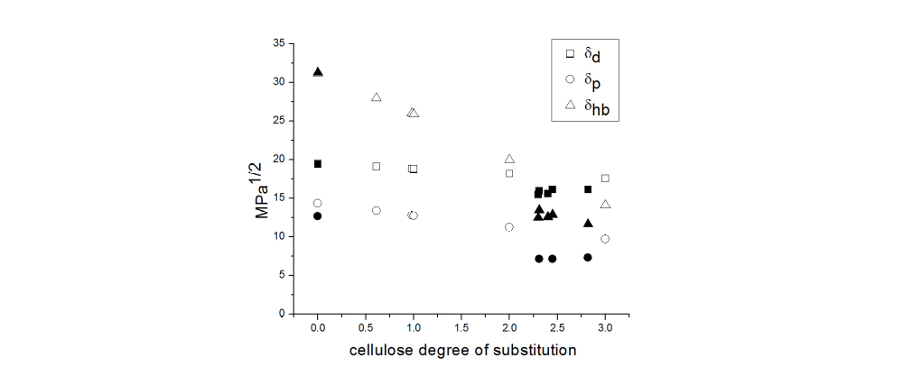
Figure 71 Hansen solubility parameters for cellulose acetate. Calculated values are noted in white and experimental literature values in black.

Table 6 Hansen solubility parameters for polymethyl methacrylate
 | δ_{d} | δ_{p} | δ_{hb}
Calculated | 16.5 | 7.0 | 8.8
Experimental | 18.6 | 10.5 | 7.5
 | 19.4 | 10.6
 | 19.4 | 7.6

Calculated Hansen solubility parameters for unacetylated cellulose are in excellent agreement with experiment, coinciding closely, but overestimate the solubility parameter somewhat at high degrees of acetylation. A general trend can be seen, with the dispersion force δ_{d} remaining largely constant, the dipole force (δ_{p}) decreasing slightly, and the hydrogen bonding force (δ_{hb}) decreasing significantly with substitution. Solubility parameters for PMMA calculated with this method are also in general agreement with experimentally obtained values. In comparison between the cellulose comprising the nanowhiskers used in this experiment and the polymer matrix, the dispersion and dipole forces are somewhat lower and the hydrogen bonding force is much lower than either of the celluloses.
These calculations predict some of the behavior observed in the neutron reflectivity solubility calculations, that modified celluloses have solubility parameters closer to those of the PMMA, making the attractive forces between the two components more balanced. They do not however predict the decrease in nanowhiskers solubility with increasing acetylation beyond that of the DS0.61: an explanation for this discrepancy between experiment and theory is that the Hansen parameter for hydrogen bonding does not take into account the reduced intermolecular hydrogen bonding due to the loss of hydroxyl groups on the cellulose. With the PMMA and cellulose acetate groups bearing carbonyl groups, neither one can donate the hydrogen atom to form a hydrogen bond.
The loading of CNWs in the composite must reach a threshold quantity before percolation can be established, which can be predicted by a statistical geometry model first conceived by Hammersley¹⁹⁸ and refined into a simple approximation by Favier¹⁹⁹ (equation 5.3). This approximation simplifies particles as uniform cylindrical rods, and predicts the volume fraction required to enable bulk percolation (ϕ_{perc}) given their aspect ratio (L/d). Using the aspect ratios calculated from the AFM imagery of cellulose nanowhiskers used in this study (L/d ~38-63), the minimum loading of nanowhiskers to form a percolated structure falls between ~1.1-1.8%. While all nanowhiskers tested exceeded this range, this threshold assumes the particles are completely dispersed in the bulk, and so the actual threshold likely is larger. Therefore, the higher loadings possible with the modified nanowhiskers may be required to reach the percolation volume fraction and maximize the physical properties of composites.


5.5 Conclusions
This chapter describes research on enhancing the compatibility of cellulose nanowhiskers with the commodity polymer poly(methyl methacrylate) by chemically modifying the cellulose particles. The effect of acetylating the nanowhiskers on its compatibility with PMMA was tested by performing neutron reflectivity on PMMA-CNW bilayers made with unmodified or modified CNWs with differing degrees of acetylation. Neutron reflectivity shows that when thermally annealed, the PMMA flows into spaces between the modified nanowhiskers, but very little is taken up into the unmodified nanowhiskers layer, showing that the modification significantly enhances compatibility. However, the results also show excess chemical modification decreases compatibility, possibly because too many hydroxyl groups are replaced, degrading the opportunities for hydrogen bonding.
Cellulose nanowhiskers as a reinforcing composite filler show significant promise with their good mechanical properties, potential optical transparency, and abundant renewable sourcing from plant matter. Useful composites can only be realized if the nanowhiskers are well dispersed and loadings reach high levels, particularly high enough to create a percolating network throughout the bulk. Simple chemical modification of the cellulose particles can enhance compatibility with the polymer matrix, making a step towards fulfilling the promise of nanowhiskers composites.

Chapter 6 – Conclusion and Future Work

6.1 Conclusion
Three different research projects were presented through the course of this dissertation, detailing efforts to further new opportunities to make our society a more sustainable one, and is the overarching motivation of this work. Increased generation of clean renewable energy and wider use of lighter weight, more environmentally sound materials are two important sectors of research in pursuit of this important goal that these projects are a part of.
The first project focuses enabling the utilization of lignin, which is renewably sourced and biodegradable, as a component in low cost composite blends. Polymer blending is often thermodynamically hindered, resulting in most blends being incompatible and yield composites with inferior mechanical properties. This research centered on the rational design of a model copolymer compatibilizer to increase compatibility, by incorporating functional groups to participate in hydrogen bonding with the lignin, a strong adhesive force, and investigated the effect of modulating the architecture.
The compatibility of polystyrene-based copolymers bearing 0-50% 4-vinyl phenol with lignin was explored using a variety of techniques, including electron microscopy to gauge the dispersion of lignin droplets, calorimetry and neutron reflectivity to judge intermixing, and the use of neutron reflectivity to measure the width of the copolymer-lignin interface. Through these experiments, a random copolymer incorporating approximately 20% 4-vinyl phenol groups was found to be most compatible with lignin. The nature of this value was also discussed, including the geometric hindrance and the balancing of inter- and intra-polymer hydrogen bonding.
The second project presented seeks to aid the development of polymer-based organic photovoltaic devices for low cost, easily deployed solar energy. Semiconducting polymers that absorb visible light have been synthesized, but the short diffusion length of their excited electrons demands that the electron acceptor junction be very close to the site of excitation. Composite OPV devices with high performance have been fabricated by blending carbon fullerene nanoparticles into the semiconducting polymer. It has been established that phase separation, to create very closely spaced but discrete donor-acceptor junctions at the domain interface, is critical to creating effective charge carrier pathways necessary for reaching high efficiency. However, the exact structure of this phase separation is unclear, and is difficult to access experimentally due to the small size and similar electron densities of the two materials.
The experiment performed in this work seeks to use neutron reflectivity, a scattering technique that is instead sensitive to difference in ¹H proton densities, to resolve the structure of the interface and quantify the degree of intermixing in efficient devices composed of P3HT polymer and PCBM fullerenes or unmodified C₆₀ fullerenes for comparison. It was found that the PCBM fullerenes are quite soluble in P3HT, much more so than C₆₀ fullerenes, and could be reasonably assumed to have a broad interfacial width in phase separated OPV devices. The possible effects of high solubility in yielding high efficiency was discussed, that the strong tendency to intermix may present extremely high donor-acceptor junction surface areas, improve the poor electrical conductivity of the P3HT, and create secondary charge carrier pathways from interpenetration into opposing domains. With knowledge of the efficient blend morphology, which strongly influences performance, effective cells can be rationally developed.
The third project details the conversion and modification of cellulose, the most abundant biomass on Earth, into a form that is both easier to process and is more compatible with polymer matrices. The strongly hydrogen bonded and semicrystalline cellulose polymer offers very attractive mechanical properties, but is also too difficult to process to use as a thermosetting or thermoplastic material. The crystalline portions of the cellulose fiber structure can be extracted by hydrolysis of the amorphous segments, yielding high aspect ratio nanoparticles or “nanowhiskers” (CNWs) that retain many of the attractive properties of the host polymer. Unfortunately, the particles are strongly hydrophilic, making them incompatible with most hydrophobic commodity plastics and rubbers.
These nanowhiskers were chemically modified by replacing some of their hydroxyl functional groups with acetate groups with the aim to reduce the CNWs hydrophilic character and enhance their dispersion in a polymer matrix. The nanowhiskers were characterized chemically with NMR and their dimensions analyzed with atomic force microscopy on dispersed nanoparticles. Neutron reflectometry was performed on dense CNW-PMMA bilayers that were annealed to permit the materials to mix in order to gauge the compatibility of the polymer with nanowhiskers of differing degrees of modification. Using AFM topography maps of duplicate dense CNW monolayers and mass balancing a guide, depth profiles generated from neutron reflectivity qualitatively and quantitatively showed that the modified nanowhiskers were more compatible, but excess acetylation could deter dispersion. The improved compatibility was attributed to balancing the hydrophilic character of the CNWs and the PMMA, while the effect of excess acetylating was ascribed to unbalancing of this pairing or disrupting hydrogen bonding with the polymer.
Besides the fact that all three projects deal with polymer nanocomposites, the common theme between these projects is the importance of characterization and control of the composite structure to developing mechanically and functionally useful materials or devices. Without knowledge of the composite morphology, development often relies more on empirical methodology or incomplete theory, which can hinder progress and design.
The experimental work in this dissertation displays how different characterization techniques, in particularly the powerful and versatile technique of neutron reflectivity, can help piece together the morphology of polymer nanocomposites or answer important questions about their fine structure. With the knowledge of the nanocomposite structure, the iteration of theory and experiment can continue and new materials and technologies realized.
Also, the power of chemical modification to alter the characteristics of nanocomposites across a diverse range of research fields was demonstrated, the modulation of copolymer architecture effects on compatibility with lignin, the substantial differences in phase behavior of modified carbon fullerenes in composite OPVs, and the promise of enhanced dispersion of cellulose nanowhiskers as reinforcing filler. These results show that chemistry will continue to play a key role in polymer composites for a more sustainable world.

6.2 Future Work

6.2.1 Lignin copolymer compatibilizers
Further development of effective lignin composites that would follow the results detailed in Chapter 3 would be to explore parameters and test polymer-lignin composite blends modified with the compatibilizer. Parameters of interest would be to test the effect of the loading of a ~20% PS-r-4VPh compatibilizer on the dispersion and mechanical properties of a polystyrene-lignin blend. This could be accomplished by melt blending, as was performed in this work, of the three blend components. They could then be studied by analyzing the dispersion with scanning electron microscopy, and mechanical properties tested by tensile and dynamic mechanical analysis (DMA).
A second parameter of interest is the effect of lignin loading on blend mechanical and processing properties: knowing the relationship between loading and performance would serve as a starting point for maximizing the amount of lignin in composite blends without compromising minimum mechanical properties or the ability to process them into parts and objects. Ideally, lignin incorporation should be as high as possible to displace the synthetic polymer matrix to make the overall blend as renewable as is practical. Mechanical testing would also be accomplished my melt blending the composites and subjecting them to tensile and DMA testing, while a melt-flow experiment would provide ease of processing information.

6.2.2 Organic photovoltaics
A characteristic of P3HT-PCBM based OPV devices that was not measured in the neutron reflectivity experiments was the interfacial width between domains of the materials. Because the volume fraction of PCBM was well below the solubility limit in P3HT, no PCBM-enriched layer remained. A bilayer using a much larger amount of PCBM, which would be achieved by increasing the PCBM layer thickness relative to the P3HT, should result in the retention of an interface that could be readily measured.
Also, the rate of diffusion of PCBM into the P3HT was not captured because the mixing occurred very rapidly at the annealing temperature used and the limited number of annealing steps performed. A similar experiment could explore the kinetics of diffusion by significantly reducing the time between annealing steps or lowering the temperature of annealing to the point where the diffusion front could be monitored. With knowledge of diffusion kinetics, the phase separation and morphology of OPV devices can be controlled in a more carefully tailored and rational fashion to achieve maximum performance.
A complimentary technique, small angle neutron scattering (SANS) was recently employed by our group to characterize the domains of P3HT-PCBM blend films, which yields information about the size, shape, and crystallinity of the BHJ morphology to complete the picture how high performance OPV devices are formed and structured. Thick blend films were cast from solution or built up from multiple thin films stacked by float coating to fabricate the appropriate samples and thermally annealed to permit phase separation to occur.

6.2.3 Cellulose nanowhisker composites
Follow on experiments for CNWs would be to test the effectiveness and consequence of different loading levels on PMMA nanocomposites. Nanowhiskers and PMMA could be combined by melt blending or solution cast from a common solvent to fabricate samples for tensile strength and DMA testing. DMA testing would also be used to gauge the effect of loading on the thermal properties of the nanocomposites, to observe softening and glass transition temperature changes caused by the presence of the CNWs. These experiments would be performed with the existence of a percolation threshold in mind, which may be an important minimum loading level for such composites.
A similar study as was performed in this work using another polymer that cannot participate in hydrogen bonding, such as polyvinyl chloride, could clarify the role of this attractive force on the relationship between nanowhiskers acetylation and the degree of substitution that was not resolved in these experiments. If hydrogen bonding is an important participant in compatible CNW nanocomposites, this would affect the choice of matrix polymers and the tuning of nanowhisker modification.
Finally, the effect of agglomeration and dispersion characteristics of the nanoparticles in the bulk could be investigated with small angle neutron scattering as a compliment to the results from the neutron reflectivity performed in Chapter 5. Again, a deuterated matrix polymer would be employed to provide the neutron contrast, and the effect of CNW loading level on the size and shape of agglomerations could be obtained. This would yield insight into the relationship between dispersion and thermomechanical properties.

References

C Koning, MV Duin et al. Progress in Polymer Science. 23, 707 1998.
AM Boudet, S Kajita et al. Trends in Plant Science 8, 576 2003.
D Peter and DS Mitchell. US Patent 4740591. April 1988.
B Kamm, PR Gruber and M Kamm.Biorefineres-Industrial Processes and Products, Wiely-VCH Verlag GmbH & Co KGaA. Vol 2 p169. Weinheim, Germany 2006.
S Kubo and JF Kadla. Journal of Applied Polymer Science. 98, 1437 2005.
BD Solomon, JR Barnes and KE Halvorsen. Biomass and Bioenergy 31, 416 2007.
WC Senyo, AW Creamer, L Wu and JH Lora. ACS Symposium Series 397. 546, 1989.
WG Glasser and S Sarkanen. ACS Symposium Series 397. 546, 1989. 2002.
JH Lora and WG Glasser. Journal of Polymers and the Environment. 10(1-2), 29,
OH Hsu and WG Glasser. Applied Polymer Symposia 28. 297, 1975.
WG Glasser, SS Kelley. Encylopedia of Polymer Science and Engineering. 8, 795 1987.
HJ Chum, SK Parker et al. SERI/TR. 231, 1 1985.
JD Gargulak and SE Lebo. ACES Symposium Series 742. 304, 2000.
WG Glasser. Encylopdia of materials: Science and technology. Elsevier Science, Oxford UK 2001.
WH Glasser, CA Barnett and Y Sano. Applied Polymer Symposium. 37, 441 1983.
WOS Doherty, P Mousavioun, and CM Fellows. Industrial Crops and Products. 33, 259 2011.
A Abackerli. Method for precipitation of aromatic polymers from alkaline wastewater from pulping. Patent, WO 9842912, 1998.
R Alen. Basic chemistry of wood delignification: papermaking science and technology. 3, 58 2000.
GA Smook. Handbook for Pulp and Paper Technologies, 3rd edition. Angus Wilde Publications Inc. Vancouver BC 2002.
JH Lora, WG Glasser. Journal of Polymers and the Environment. 10, 39 2002.
JJ Bozell et al. Biomass and Bioenergy. 1, 2011.
N Tudorach, CN Cascaval and M Rusu. Journal of Polymer Engineering. 20(4) 287, 2000.
A Gregorova, B Kosikova and R Moravcik. Polymer Degradation and Stability. 91, 229 2006.
M Canetti, F Bertini et al.. Polymer Degradation and Stability. 91, 494 2006.
Y Li and S Sarkanen. Macromolecules. 38, 2296 2006.
Y Xu, SJ Zeng, HF Zhou, and Q Shen. Xianweisu Kexue Yu Jishu. 15(36), 44 2007.
Y Li, J Mlynar, and S Sarkanen. Journal of polymer science part b, polymer physics. 35, 1899 1997.
R Pucciariello, V Villani et al.. Polymer. 45, 4189 2004.
SS Kelley, WG Glasser and TC Ward. Lignin: Properties and Materials. WG Glasser and S Sarkenen Eds. ACS Symposium Series #397, ACS. Washington, DC 1989.
H Yoshida, R Morck et al.. Journal of Applied Polymer Science.40, 1819, 1989.
PJ Flory. Principles of Polymer Chemistry. Cornell University Press, Ithaca, New York, 1953.
PJ Flory. Journal of Chemical Physics. 10, 51 (1942)
ML Huggins. Journal of the American Chemical Society. 64, 1712 1942.
D Feldman. Journal of Macromolecular Science Part A. 42(5), 587 2005.
E Eastwood, MD Dadmun et al.. Polymer. 46(12), 3957 2005.
JF Kadla and S Kubo. Composites Part A. 34, 395 2004.
S Kubo and JF Kadla. Biomacromolecules. 4, 561 2003.
S Lyu, CW Macosko et al.. Macromolecules. 35, 7845 2002.
E Eastwood and MD Dadmun. Polymer. 43, 6707 2002.
EA Eastwood and MD Dadmun. Macromolecules. 35(13), 5069 2002.
P Alexy, B Kosikova et al.. Journal of Applied Polymer Science. 94, 1855 2004.
X Lv, Y Zhang, and M Di. Advanced Materials Research. 194, 1476 2011.
X Lv, Q Liu, Y Zhang, and M Di. Advanced Materials Research. 181, 88 2011.
R Kulasekere, TP Russell et al.. Macromolecules. 29, 5493 1996.
Y Li and S Sarkanen. Macromolecules. 35, 9707 2002.
Electricity from Renewable Resources – Status, Prospects and Impediments. National Academic Press. Washington DC, 2010.
SS Sun and NS Sariciftci. Organic Photovoltaics: Mechanisms materials and devices. Taylor and Francis Group. Boca Raton, FL 2005.
DM Chapin, CS Fuller and GL Pearson. Journal of Applied Physics. 25, 676 1954.
SE Shaheen, R Radspinner et al.. Applied Physical Letters. 79, 2996 2001.
G Gustafsson, Y Cao et al.. Nature. 357, 477 1992.
FC Krebs, J Alstrup, M Biancardo, H Spanggaard. Large area polymer solar cells. Proceedings of SPIE – The International Society for Optical Engineering. 5938, 2005.
T Aernouts, P Vanlaeke, W Geens, J Poortmans, P Heremans, S Borghs, R Mertens, R Andriessen, L Leenders. Thin Solid Films. 451-2, 22 2004.
G Dennler, C Lugenschmied, H Neugebauer, NS Sariciftci, A Labouret. Journal of Materials Research. 20, 3224 2005.
PWM Blom, LJA Koster et al.. Advanced Materials. 19, 1551 2007.
MA Green, K Emery et al.. Progress in Photovoltaics. 13, 49 2005.
HY Chen, G Li et al.. Nature Photonics. 3, 649 2009.
Y Liang, Z Xu et al.. Advanced Materials. 22, 1 2010.
S Cho, AJ Heeger. Nature Photonics. 3, 297 2009.
JY Kim et al.. Science. 317, 222 2007.
G Dennier, MC Scharber et al.. Advanced Materials. 21, 1323 2009.
MC Scharber, CJ Brabec et al.. Advanced Materials. 18, 789 2001.
M Jordensen, K Norrman, and FC Krebs. Solar Energy Materials & Solar Cells. 92, 686 2008.
FC Krebs and K Norman. Progress in photovoltaics: research and applications.15, 697 2007.
H Kallman and M Pope. Journal of Chemical Physics. 30, 585 1959.
H Shirakawa, EJ Louis, AG MacDiarmid. Journal of the American Chemistry Society, Chemical Communications. 16, 579 1977.
L Li, X Yang. Journal of Materials Chemistry. 18, 1984 2008.
J Liu, Y Han et al.. Organic Electronics. 11, 775 2010.
R Radbeh et al.. Nanotechnology. 21, 035201 2010.
SS van Bavel, J Loos. Advanced Functional Materials. 20, 1458 2010.
G Li, Y Yang et al.. Advanced Functional Materials. 17, 1636 2007.
HJ Kim JJ Kim et al.. Macromolecules Rapid Communication. 30, 1269 2009.
D Motaung, DJ Knoesen. Materials Science. 44, 3192 2009.
CW Tang. Analytical Physics Letters. 48(2), 12 1986.
BA Gregg. Materials Research Society Bulletin. 30, 20 2005.
L Tsakalakos. Nanotechnology for Photovoltaics. Taylor and Francis, Boca Raton FL 2010.
A Pivrikas, R Osterbacka. Progress in Photovoltaic Research – Applied. 15, 667 2007.
CJ Brabec, JC Hummelen. Advanced Functional Materials. 11, 374 2001.
P Peumans, SR Forrest. Journal of Applied Physics. 93, 3693 2003.
G Yu, AJ Heeger. Science. 270(5243), 1789 1995.
H Hoppe and NS Sariciftci. Journal of Materials Chemistry. 16, 45 2006.
K Yoshino, T Ohnishi et al.. Japanese Journal of Applied Physics Part 2. 32, L357 1993.
JJM Halls, AB Holmes. Applied Physical Letters. 68, 3120 1996.
A Haugender, J Feldmann et al.. Physical Review Letters B. 59, 15346 1999.
D Venkataraman, Y Serkan et al.. The Journal of Physical Chemistry, Letters. 1, 947 2010.
BC Thompson, JMJ Frechet. Angew Chemie International Edition. 47, 58 2008.
RAJ Janssen, JC Hummelen and NS Saricifti. MRS Bulletin. 30, 33 2005.
X Yang, J Loos. Macromolecules. 40, 1353 2007.
J Kim, CD Frisbie. Journal of Chemical Physics C. 112, 17726 2008.
YM Chiu, KH Wei et al.. Advanced Materials. 20(13), 2573 2008.
HJ Kim, JJ Kim. Macromolecules Rapid Communications. 30, 1269 2009.
M Brinkmann, JC Wittmann. Advanced Materials. 18(7), 860 2006
W Ma, C Yang and A Heeger. Advanced Materials. 19, 1387 2007.
C Brabec, NS Sariciftci and JC Hummelen. Advanced Functional Materials. 11, 15 2001.
J Penfold and RK Thomas. Journal of Physics, Condensed Matter. 2, 1369 1990.
YJ Cheng, SH Yang and CS Hsu. Chemical Review. 109, 5868 2009.
MR Andersson, D Selse et al.. Macromolecules. 27, 6503 1994.
RM Souto Maior, F Wudl et al.. Macromolecules. 23, 1268 1990.
RD McCullough and RD Lowe. Journal of the American Chemical Society, Chemical Communications. 70, 1992.
RD McCullough, DL Anderson et al.. Journal of Organic Chemistry. 58, 904 1993.
TA Chen, RD Rieke. Journal of the American Chemical Society. 114, 10087 1992.
TA Chen, RD Rieke et al.. Journal of the American Chemical Society. 117, 233 1995.
RS Loewe, RD McCullough et al.. Advanced Materials. 3, 250 1999.
RS Loewe, RD McCullough et al.. Macromolecules. 34, 4324 2001.
A Yokoyama, R Miyakoshi and T Yolozawa. Macromolecules. 37, 1169 2004.
R Mizkoshi, A Yokoyama and T Yokozawa. Journal of the American Chemical Society. 127, 17542 2005.
HW Kroto, RE Smalley et al.. Nature. 318(14), 162 1985.
RC Haddon and AF Hebard et al.. Nature. 350(6316), 320 1991.
DR Huffman, W Kratschmer et al.. Nature. 347(27), 354 1990.
JC Hummelen, BW Knight et al.. Journal of Organic Chemistry.60, 532 1990.
JK Pandey, RP Singh et al.. Journal of Nanoscience and Nanotechnology. 5, 497 2005.
A Espert, F Vilaplana and S Karisson. Composites Part A. 35, 1267 2004.
D Bondeson, A Mathew and K Oksman. Cellulose. 13, 171 2006.
A Samir, F Alloin and A Dufresne. Biomacromolecules. 6, 612 2005.
JF Robyt. Essentials of Carbohydrate Chemistry. Springer-Verlag, New York 1998.
FA Bovey EH Windslow. An Introduction to Polymer Science. Academic Press, New York NY. 518 1981.,
H Krassig, W Albrecht et al.. Ullman’s Encyclopedia of Organic Compounds,” 5th edition. VCH, New York NY. A5, 325 1986.
J Engelhardt. Carbohydrate Europe. 12, 5 1995.
AG Walton, J Blackwell. Biopolymer. Academic Press, New York NY. 446 1973.
DG Coffey, DA Bell and A Henderson. Food Polysaccharides and Their Applications. AM Stephen Ed. Marcel Dekker, New York NY. 124 1995.
WE Morton, JWS Hearle. Physical properties of textile fibers. William Heinemann Limited, London 1075.
DH Page and F EL-Hosseiny. Journal of Pulp Paper Science. 9, 99 1983.
L Sakurada, T Ito et al.. Journal of Polymer Science. 57, 651 1962.
SA Waintright, JM Gosline et al.. Mechanical Design in Organisms. Princeton University Press, Princeton NJ. 1982.
A Sturcova, GR Davies and SJ Eichorn. Biomacromolecules. 6, 1055 2005.
YC Hiseh, SJ Eichorn et al.. Cellulose. 15, 2507 2008.
L. Lundquist, B Marque et al.. Compos. Science and Technology. 63, 137 2003.
V Favier, H Chanzy and JY Cavaille. Macromolecules. 28, 6365 1995.
H Yano, K Handa et al.. Advanced Materials. 17, 153 2005.
M Nogi, H Yano et al.. Applied Physical Letters. 89, 233123 2006.
S Ifuku, H Yano et al.. Biomacromolecules 8, 1973 2007.
M deSouza Lima, R Borsali. Macomolecular Rapid Communications. 25, 771 2004.
N Lis, A Dufresne et al.. Cellulose. 13, 261 2006.
L Petersson, I Kvien and K Oksman. Composites Science and Technology. 67, 2535 2007.
D Bondeson, K Oksman. Composite Interfaces. 14(7-9), 617 2007.
SH Lee, Y Teramoto and T Endo. Composites: Part A. 42, 151 2010.
L Heux, C Chauve and C Bonini. Langmuir. 16, 8210 2000.
N Ljungberg, JY Cavaillé et al.. Biomacromolecules. 6, 2732 2005.
G Siqueira, J Bras and A Dufresne. Biomacromolecules. 10, 425 2009.
JF Sassi and H Chanzy. Cellulose. 2, 111 1995.
JY Cavaillé, H Chanzy et al.. US Patent 6117545, 1997.
DY Kim, Y Nishiyama ad S Kuga. Cellulose. 9, 361 2002.
C Goussé, H Chanzy et al.. Polymer. 43, 1645 2002.
C Goussé, H Chanzy et al.. Polymer. 45, 1769 2004
M Andresen, LS Johansson et al.. Cellulose. 13, 665 2006.
NS Çetin, Gilles Sèbe et al.. Macromolecus Bioscience. 9, 997 2009.
JR Lu, RK Thomas. Nuclear Instrumentation Methods Physics Research, Section A. 354, 149 1995.
O Olibisi, LM Roberson, MT Shaw. Polymer-Polymer Miscibility. Academic San Diego, California 1979
HG Tompkins. A Users Guide to Ellipsometry. Academic Press Inc, San Diego, CA. 1993.
TE Jenkins. Journal of Physics D: Applied Physics. 32, R45 1999.
B Guckenbiehl, M Stamm and T Springer. Physica B. 198, 127 1994.
R Kulasekere, H Kaiser et al.. Physica B. 221, 306 1996.
TP Russell. Materials Science Report. 5, 171-271 1990.
M Stevens. Polymer Chemistry - An Introduction, Oxford University Press New York, New York 1999.
A Ledwidth, M Rahnema, PK Sengupta. Journal of Polymer Science. 8, 2239 (1980)
Coleman, M. M.; Painter, P. C. Fundamentals of Polymer Science, 2nd ed.; Technomic Publishing Co.: Lancaster, PA 198
RL Thompson, M T McDonald, J T Lenthall, L R Hutchings. Macromolecules, 38 (10), 4339-4344 (2005)
O Olibisi, LM Roberson, MT Shaw. Polymer-Polymer Miscibility. Academic San Diego, California 1979
Y Li and Sarkanen. Macromolecules. 35, 9707 2002.
PA Kienzle, KV O'Donovan, JF Ankner, NF Berk, CF Majkrzak. http://www.ncnr.nist.gov/reflpak. 2000-2006
R Schnell and M Stamm. Macromolecules. 31, 2284 1998.
DW Schubert, M Stamm et al.. Polymer Engineering and Science. 39(8), 1999.
M Stamm and DW Schubert. Annual Review of Material Science. 25, 325 1995.
K Binder. Advanced Polymer Science. 112, 181 1994.
DW Schubert. Bestimmung der Grenzfltiche zwischen unvertraglichen Polymeren mit Neutronenreflexion. Shaker Verlag. Aachen, Germany 1996.
E Helfand and AM Sapse. Journal of Chemical Physics. 62, 1327 1975.
MM Coleman, PC Painter et al.. Macromolecules. 29, 6820 1996.
PC Painter, MM Coleman et al.. Macromolcules. 30(4), 932 1997.
JY Kim, AJ Heeger et al.. Science. 317, 222 2007.
S Cho, AJ Heeger. Nature Photonics. 3, 297 2009.
BA Gregg. Materials Research Society Bulletin. 30, 20 2005.
A Pivrikas, R Osterbacka. Progress in Photovoltaic Research – Applied. 15, 667 2007.
CJ Brabec, JC Hummelen. Advanced Functional Materials. 11, 374 2001.
P Peumans, SR Forrest. Journal of Applied Physics. 93, 3693 2003.
Pivrikas, A.; Sariciftci, N. S.; Juška, G.; Österbacka, R. Progress in Photovoltaics: Research and Applications 2007, 15, 677.
K Yoshino, T Ohnishi et al.. Japanese Journal of Applied Physics Part 2. 32, L357 1993.
JJM Halls, AB Holmes. Applied Physical Letters. 68, 3120 1996.
A Haugender, J Feldmann et al.. Physical Review Letters B. 59, 15346 1999.
D Venkataraman, Y Serkan et al.. The Journal of Physical Chemistry, Letters. 1, 947 2010.
H Hoppe and NS Sariciftci. Journal of Materials Chemistry. 16, 45 2006.
Brinkmann, M.; Wittmann, J. C. Advanced Materials 2006, 18, 860.
Ma, W.; Yang, C.; Heeger, A. Advanced Materials 2007, 19, 1387.
Chiu, M. Y.; Jeng, U. S.; Su, C. H.; Liang, K. S.; Wei, K. H. Advanced Materials 2008, 20, 2573.
Kim, H. J.; Lee, H. H.; Kim, J. J. Macromolecular Rapid Communications 2009, 30, 1269.
JW Kiel, CF Majkrzak et al.. Journal of Chemical Physics. 133, 074902 2010.
J Catalan, JL Saiz et al.. Angew Chemie Int’l Edition. 34(1), 105 1995.
PA Kienzle, KV O'Donovan, JF Ankner, NF Berk, CF Majkrzak. http://www.ncnr.nist.gov/reflpak. 2000-2006
L Tsakalakos. Nanotechnology for Photovoltaics. Taylor and Francis, Boca Raton FL 2010.
H Sirringhaus, PJ Brown et al.. Nature. 401, 685 1999.
JK Pandey, RP Singh et al. Journal of Nanoscience and Nanotechnology. 5, 497 2005.
A Espert, F Vilaplana and S Karisson. Composites Part A. 35, 1267 2004.
D Bondeson, A Mathew and K Oksman. Cellulose. 13, 171 2006.
A Samir, F Alloin and A Dufresne. Biomacromolecules. 6, 612 2005.
N Lis, A Dufresne et al. Cellulose. 13, 261 2006.
L Petersson, I Kvien and K Oksman. Composites Science and Technology. 67, 2535 2007.
D Bondeson, K Oksman. Composite Interfaces. 14(7-9), 617 2007.
MA Samir, F Alloin and A Dufresne. Biomacromolecules. 6, 612 2005
G Siqueira, J Bras and A Dufresne. Biomacromolecules. 10,425 2009.
JM Hammersley. Cambridge Philosophical Society. 53, 642 1957.
V Favier, R Dendievel et al. Acta Materials. 45(4), 1557 1997.
BW Koenig, K Gawrisch et al. Langmuir. 12, 1343 1996.
S Singh, S Basu, and SK Ghosh. Applied Surface Science. 255, 5910 2009.
J Sugiyama, R Vuong and H Chanzy. Macromolecules. 24, 4168 1991.
RE Dillon, LA Matheson, and EB Bradford. Journal of Colloid Science. 6, 108 1951.
WA Henson, DA Tabor, and EB Bradford. Industrial Engineering and Chemistry. 45, 735 1953.
E Perez and J Lang. Langmuir. 16, 1874 2000.
E Perez and J Lang. Macromolecules. 32, 1626 1999.
CM Hansen. Hansen Solubility Parameters, a User’s Handbook. CRC Press. Boca Raton, FL.
E Stefanis and C Panayiotou. Interational Journal of Thermophysics. 29, 568 2008.
MHV Mulder, F Kruitz, and CA Smolders. Journal of Membrane Science. 11, 349 1982.
T Matsuura, P Blais, and S Sourirajan. Journal of Applied Polymer Science. 20, 1515 1976.
CM Hansen. Journal of Paint Technology. 39, 104 1967.
JW Van Dyk, HL Frisch, and DT Wu. Industrial Engineering Chemistry Product Research and Development. 24, 473 1985.

